UNIVERSITY OF OKLAHOMA GRADUATE COLLEGE

THE TRIANGULAR MODEL FOR
MULTI-ACTOR RELATIONAL DYNAMICS:
RESTAURANT CHAINS AND THEIR PUBLICS

A THESIS SUBMITTED TO THE GRADUATE FACULTY
in partial fulfillment of the requirements for the Degree of
MASTER OF ARTS

By
YGAL KAUFMAN, Norman, Oklahoma, 2021

THE TRIANGULAR MODEL FOR
MULTI-ACTOR RELATIONAL DYNAMICS:
RESTAURANT CHAINS AND THEIR PUBLICS

A THESIS APPROVED FOR
GAYLORD COLLEGE OF JOURNALISM AND MASS COMMUNICATION
BY THE COMMITTEE CONSISTING OF

Dr. Jeong-Nam Kim, Chair
Dr. Yoon-Hi Sung
Dr. Angela Zhang

© Copyright by Ygal Kaufman, 2021. All Rights Reserved.
Table of Contents

Page Number

Abstract _____________________________________________________________ v

Introduction _________________________________________________________ 1

Literature Review ____________________________________________________ 3

Hypotheses __________________________________________________________ 22

Method ______________________________________________________________ 25

Results ______________________________________________________________ 29

Discussion ___________________________________________________________ 37

References ___________________________________________________________ 46

Figures and Tables ____________________________________________________ 52

Abstract
Organizational relationships with external publics are mostly perceived in the context of two-way interactions. In networked digital media platforms, employees or investors who are internal stakeholders and publics engage in communicative interactions with external stakeholders. Some employees in poor relationships with their working companies become expressive in online communities. They may blow whistles, leak, exaggerate problems, exaggerate severity of consequences, or collaborate with external publics against management (e.g., negative megaphoning). Such negative content, once generated and distributed by internal publics, could earn higher credibility with online information seekers.
This study tests a new model of multi-actor relational dynamics in a triangular frame. The strategic value of employee relationships is demonstrated through an inspection of their communicative actions. Using a design of two experimental surveys– one of employees of fast-food restaurants and the other of customers of the same four restaurants– two sides of the triangular model are presented and measured to see how relationship moderates the valence and receptiveness to information from an organization’s internal publics (employees or investors) directly to their external publics (customers). Thus, two sides of the triangle are measured to make inferences about the third. The key concepts being measured are relationship quality and symmetrical communications, so see if they have the predicted effect on communicative action and acceptance of that information.
Results support that positive organization-public relationship (OPR) and symmetrical communications with publics have a direct positive relationship with the effects of employees’ communicative behavior, as well as the credence customers give to that information and their likelihood to further share that information.

Keywords: Communicative action, Employees, External publics, Issues management, Megaphoning, Relationships, Triangular model, Fast-food restaurants, Symmetrical communication, Relationship, OPR

Introduction
Historically, an organization’s relationships with its external publics have been described and understood as two-way interactions between the organization and its customers or its activist publics. In networked digital media platforms, such as Facebook, Twitter and Reddit, which have been recently heavily debated in traditional media, employees or investors (internal publics) have for some time now had the ability to simultaneously engage in communicative interactions directly with external stakeholders and with their own organization (Kim & Rhee, 2011). This communication from internal publics directly to external, without the sanction of the organization, known as megaphoning (Kim & Rhee, 2011), raises the potential for three-way communications that could change the ways we have previously conceptualized other mass communication theories. Built on well-researched theories such as publics, balance theory, credibility theory and others. James Grunig’s work from the 1960s through today has established the concept of two-way symmetrical communication, the open and responsive give-and-take of information between an organization and a public as well as their shared goals, as the normative state of strategic communications and the public relations practice most likely to lead to excellence (Gruing & Kim, 2021; Kenny, 2016).
The reality that organizations must now understand that their communications sometimes actually exist in a three-way structure, and yet strive to remain symmetrical to achieve excellence (Dozier, Grunig & Grunig, 2013) would represent a paradigmatic shift to a new way of thinking about strategic communications and the role of the public relations department in an organization. This shift is potentially important because, among other reasons, critiques of the Grunig models have often focused on an assumed lack of realistic application (Kenny, 2016). The idea of two-way symmetrical communications between an organization and its external publics is itself often somewhat cynically viewed as somewhat unrealistic, so the addition of a third dimension would likely be greeted with similar skepticism. Adding a third communicator to that model might be assumed to further complicate it, however, it also can serve to make the model more optimal than ever, due to the technological realities of the Internet. The triangular model discusses not so much three-way symmetrical communication as it does two-way symmetrical communication unfolding on three planes in real time.
This thesis attempts to use such a model for three-way communications in the form of a triangle, previously proposed by Kaufman and Kim (2020), and to highlight the role the relationship between the different parties at the nodes of the triangle plays in mediating those communications. To do this, we must first explore the history of theories that propose effects observable in communicative actions unfolding on networked digital platforms and their effect on the practice of public relations. The purpose of this thesis’ goal is to further develop burgeoning theory in the exploration of three-way symmetrical communication as a public relations concept and to give direction to future research. The existence of Grunig’s models of public relations gives us theory that explains many phenomena in the public relations and strategic communications realm, but we also have a new phenomenon, three-way communicative interactions, that requires some new way to explain how it works. This necessitates the creation of a new model.
Illustration of this new model requires an exploration of Heider’s balance theory, which will help with concepts of credibility and relationship between three parties. Additionally, theories that have previously been associated with Grunig’s four models of public relations could be re-evaluated and applied to networked digital platforms. The role relationship plays, as a context of all the interactions that occur between an organization and its publics, as well as relationship’s distinction from reputation, are important factors in the new model. Most importantly perhaps, is the integration of the theories put forth by Kim, Rhee and others (e.g., megaphoning), exploring the phenomena of communicative actions undertaken by internal publics and their influences on external publics. These are the essential functions undertaken by internal publics, which can dictate the disposition of issues, crisis and the relationships that exist between the organization and its publics.
Literature Review
Symmetrical Communication and Asymmetrical Communication
The view of public relations as a management function of an organization’s communications with its publics (Grunig & Hunt, 1984) underlies the assumptions of this research. Their research and subsequent research by Grunig showed that the way to achieve best outcomes in communication with publics is to employ symmetrical communication methods (Grunig & Grunig, 1992; Grunig & Kim, 2021). Symmetrical communications are characterized by synergistic, holistic, and interdependent communications postures (Huang, 2004), a somewhat vague description. To be precise, symmetrical communications differ from asymmetrical communications, chiefly in their goals or purpose or intent of communication. Symmetrical communications seek to find the best outcome for both the organization and their publics, while asymmetrical communications aim chiefly to persuade the public, and change or re-enforce an attitude (Grunig & Grunig, 1992). Symmetrical communications in this conception, are more symmetric in their goals and intention of communication (e.g., adjust interests of relational actors), than they are in their measure of communications. Symmetrical communications are not marked by a roughly even amount of communication, but by symmetricity in the goals and interests of the communicating parties (Huang, 2004). Grunig’s models for public relations further explored the use of symmetrical communications for strategic communications goals.
Grunig’s Models
Grunig’s four models of public relations include press agentry and public information on the craft/journalism side of the spectrum and on the strategic communications side, two-way asymmetrical and two-way symmetrical communication (Grunig & Kim, 2021). Press agentry, based on the saying, often attributed to P.T. Barnum (Grunig & Hunt, 1984), that there’s “no such thing as bad publicity,” or even Oscar Wilde’s version of it, “there is only one thing in life worse than being talked about and that is not being talked about,” (Wilde, 1890) encapsulates the former’s vision that having public talking about the organization or its product, even negatively, is valuable for the organization. Public information models of public relations seek to persuade, transfer information to and cause attitudes changes on the part of the organization’s publics (Dozier, Grunig & Grunig, 2013; Grunig & Kim, 2021). Those two models represent the more crude, purely one-way, persuasion-based models that have shown increasingly limited effects over time (Dozier, Grunig & Grunig, 2013; Grunig & Grunig, 1992).
On the other side of the spectrum are the models based on two-way communications, where the organization not only listens, but considers the goals, interests and issues that concern their publics. In this normative view, an organization’s best interests are served when they consider the interests and goals of their publics (Grunig & Grunig, 1992). Two-way symmetrical communication has been identified through previous research to be the most ethical and effective model of public relations practice (Dozier, Grunig & Grunig, 2013). Press agentry is essentially associated with propaganda and public information with journalism, which was the classic role of a public relations practitioner; as an in-house journalist (Dozier, Grunig & Grunig, 2013).
Grunig’s model of two-way symmetrical communications involves not just speaking and listening, but doing so in an approximately symmetrical manner, where views, concerns and issues raised by the public are not just heard by the organization but considered in decision making (Grunig & Kim, 2021).
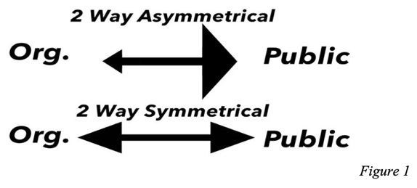
While Grunig’s research suggests the two-way symmetrical model as most ethical and effective theoretical manner in which to practice public relations, it is not the only school of thought on public relations management and practice. Organizations have normatively subscribed to the other three models, and many organizations use the approaches and assumptions of different models during different situations and with different publics (Grunig & Kim, 2021). The two-way model has the limitation of not countenancing a split in the nature of the publics. The organization no longer communicates with solely one public at a time, they now find themselves in tripartite communications (something Grunig et al. did foresee) however, not just with external publics or internal publics, but with both simultaneously.
The triangular model proposed in this thesis separates the organization, previously viewed somewhat monolithically, into its constituent parts, management, and internal publics. It then assesses communicative actions between the three nodes of a triangle (including external publics) across different time periods, as opposed to viewing those actions as occurring strictly between organization and external publics directly. In this digital era of three-way communication potential, new and different information gathering techniques may be necessary to prepare for issues and crisis scenarios, and to conduct communications with publics in a symmetrical manner.
Employee Communication Behavior: Scanning, Scouting and Megaphoning
Employees of companies with which they have poor relationships may express their discontent online. They may blow whistles, leak information, exaggerate problems or the severity of their consequences, or otherwise collaborate with external publics against their companies’ management. This phenomenon has been described in previous research as megaphoning (Kim & Rhee, 2011). Lauzen (1997) conceptualized environmental scanning as being in part “the first two steps in the issues management process: issue identification and issue monitoring” (p. 70). In short, scanning the environment, which now of course includes copious internet content including social media, is a fundamental part of the process to foresee and avoid, or at least not exacerbate, oncoming issues and crises. This activity was previously the part of the purview of public relations managers, but has now become a formal and informal activity, also known as scouting, which may be undertaken by anyone within the organization (Kim & Rhee, 2011).
Environmental scanning would necessarily require a significant makeover in the era of networked digital platforms and social media (Yang, Li, & Kiang, 2011). The act of members of an organization keeping an ear to the ground to sense changes in the environment and head off coming crises has a clearer window in the digital era, with social media displaying these potential crises for all the world to see, but a much shorter fuse with which to work before a crisis blooms, due to the viral and highly networked nature of the communications on social media platforms.

Perceived Organizational Ethics

Organizational-public relations (OPR) are built on a variety of different factors, but as previously stated, trust is a major factor in positive relationships. Ethics have been shown to be integral to trust and positively related to quality of organizational public relationships (Bowen, Hung-Baesecke, & Chen, 2016). Trust, which is greatly contributed to by perception of organizational ethics, is strongly linked to employee satisfaction and loyalty as well (Matzler & Renzl, 2007, as cited in Bowen, Hung-Baesecke, & Chen, 2016). Of the OPR dimensions already identified and measurable, organizational ethics presents a good candidate for measurement and subjection to experimental manipulation (in the form of vignettes) with a good chance for useful results.
“Ethics is a core, foundational concept of organizations,” (Bowen, Hung-Baesecke, & Chen, 2016, p. 10). This was one of the main two findings of the study by Bowen, Hung- Baesecke and Chen (citation), and it points to the reason it is being used as an independent variable for research in this study. Perceived organizational ethics and a team-oriented organization environment have been found to foster better job satisfaction among internal publics (Elçi & Alpkan, 2009). Thus, this study looks to measure the effects perceived organizational ethics might have from both the employee and customer standpoints.
Conspiratorial Thinking

Conspiracy is defined as “an effort to explain some event or practice by reference to the machinations of powerful people, who have also managed to conceal their role,” (Sunstein & Vermeule, 2008, p. 4). Conspiratorial thinking also has a positive correlation with pro-social behavior and acceptance of scientifically presented information (van der Linden, 2015). In times of higher anxiety, conspiratorial thinking increases (Grzesiak-Feldman, 2013). This might be

more pronounced effect on internal publics in times of issue or crisis, than external, as external publics are less likely to view a crisis for the organization as an existential crisis for themselves, because their livelihood isn’t connected to the organization’s functioning in the same way as an employee. There isn’t a wealth of research into the effects of conspiratorial thinking on relationship, but a review of what does exist suggests conspiratorial thinking is damaging to relationships, trust and healthy communications between an organization and its publics (Sunstein & Vermeule, 2008).
Issues and Crisis

In the triangular model, the working definition of organizational crisis is taken primarily from Coombs’ research. It identified these characteristics: 1) “a major occurrence with a potentially negative outcome affecting an organization, company, or industry, as well as its publics, products, services, or good-name” (Coombs, 1999, p. 2). 2) “a major unpredictable event that has potentially negative results. The event and its aftermath may significantly damage an organization and its employees, products, services, financial condition, and reputation” (Coombs, 1999, p.2). 3) “if stakeholders believe an organization is in crisis, a crisis does exist, and stakeholders will behave as if a crisis exists” (Coombs, 1999, p. 3). When in an acute scenario, if stakeholders find their beliefs about the organization’s goals and identity to be made invalid by action of the organization or unexpected occurrence, and if this dissonance is severe enough,
then a crisis is present, which creates unwanted environmental consequences for both the organization and its publics (Coombs, 2012, as cited in Zhang & Borden, 2017).
Issues that are always present and simmering, may flare into crises, given a variety possible triggers, such as specific events or environmental changes (Coombs, 2007). These crises will be carried by active and aware publics but exacerbated and driven into the organization’s

view by hot-issue publics, a group that may not hold the same level of knowledge or personal involvement with an issue that active publics do, but nonetheless is highly motivated to be involved in an issue or crisis space (Aldoory & Grunig, 2012). In networked digital platforms like social media, when a hot issue public arises, they may have been activated by a leak of information from an internal public, and/or may be spurred on to continued activism by further informational leaks, in the form of megaphoning (Kim & Rhee, 2011). Recent examples of this are the variety of megaphoning efforts employees of the mobile stock trading app, Robinhood, in response to what they saw as opaqueness and underhanded behavior by their own organization in the face of the GameStop stock frenzy crisis (Popper, Browning, & Griffith, 2021).
Notably, for its effect on the triangular model used in the research presented here, previous experimental studies have found support for the idea that previous relationship can tell researchers a great deal about how publics will react in times of crisis. Specifically, Coombs and Holladay (2001) gave a name for this, the velcro effect, to reflect the relative stickiness of memories of antecedent relationship that publics hold onto. The velcro effect described the fact that negative relationship in the past (and only negative relationship) could cause publics to hold those past relational outcomes against the organization in times of crisis, damaging reputation and increasing the share of responsibility for the crisis attributed to the organization (Coombs & Holladay, 2001). That relationship history can provide a very stable positive effect for the organization in times of issue and crisis. “The stability may serve to deflect and reduce the negatives generated by a crisis from attaching themselves to the organization. A favorable relationship history acts as a buffer against crisis damage” (Coombs & Holladay, 2001, p. 324). This study seeks to test whether a similar effect to velcro effect, and the halo effect of stability, might occur in the case of positive relationship and symmetrical communications between the

organization and its internal publics. Thus, the positive antecedent relationship with internal publics might yield similar effects on the organization’s relationships with external publics and the interaction of all three parties in times of issues and crisis.
In complex networked digital platforms, especially with larger multinational corporate structures enveloping smaller organizations and spanning the globe, it is nearly impossible not to create issues, crises and negative relational outcomes between an organization and its many publics. In the current era of networked digital platforms, relationships between customers or other external publics and employees or internal stakeholders of an organization— communicating without the express authorization of the organization, or megaphoning—play out in real-time, and often before the eyes of the world on social media. This necessitates a new model to both describe what is happening on networked digital platforms, also to potentially prescribe solutions and strategies, or move toward a normative theory for a 5th model of public relations using Grunig’s frameworks.
Balance Theory

An application of the principles of an excellent public relations program (as outlined by the research of Dozier, Grunig and Grunig, 2013, into the four models of public relations) has been previously shown to improve the relationships between organizations and their publics, as well as helping them to avoid conflict (Dozier, Grunig, & Grunig, 2013). This is a rather instinctive result, in that one would naturally expect a relationship to benefit from an even and respectful mutual-gains based approach to problem solving (Susskind & Field, 1996). This approach would be one where an organization takes responsibility for its faults and holds the interests of the various publics they interact with on the same level as their own (Susskind & Field, 1996). And it stands to reason that publics would feel more trust and a more positive

relationship with such an organization. This effectiveness, which would include involvement of the public relations chief practitioner in the dominant decision-making coalition of the organization, would also rely heavily on environmental scanning (Dozier, 1992) to identify potential conflicts and issues before they become crises, and to use public relations to head off those crises (Grunig & Huang, 2013).
Balance theory (Heider, 1946, 1948) provides a model by which we might measure the importance of the issue/crisis at hand to the publics, thereby finetuning the accuracy of the triangular model. Additionally, this theory provides a similar conceptual visual identity which we might translate to a triangular model. In the view of balance theory Heider gives a P-O-X framework, where P and O represent actors in a scenario and X represents the issue or object of “debate.” If P and O share the same view of the issue, and P has a positive view of O, then their shared views on X will foster a cognitively balanced outcome and will strengthen their relationship. However, if P and O disagree about X, then the relative importance of X to P will dictate whether or not P can maintain a positive view of O. Using P as a representation of the external publics of the organization and O the organization itself, X may represent a crisis or issue unfolding, the relative salience of which to P and O might dictate the level of activism of P (the publics) against O (the organization), as well as the form the response or apology from O might take (Yang & Bentley, 2017).
Balance theory is not a straight line of development away from the triangular model, but it provides some insight into the interactions that will take place between the parties at nodes of the triangle. This study uses balance theory as a conceptual backdrop for which it theorizes about how two publics’ views of an organization in issues or crisis, might affect their views of each other, in a sense, bringing the triangular model into balance in a manner similar to Heider’s

triangle. When internal publics megaphone to external publics, their individual views of the organization in crisis might dictate whether the external publics give more credence to negative megaphoning from the internal publics, or conversely, less credibility to their positive megaphoning on behalf of the organization.
Credibility

Credibility is traditionally viewed as coming from three sources: audience characteristics, message characteristics and source characteristics (Self, 1996). Source credibility and trustworthiness are particularly important to the overall credibility of a message (Hovland & Weiss, 1951). Based in the works of Plato and Aristotle, the source credibility is the oldest and most instinctive to the lay thinker (Self, 1996). This is a major reason why organizations should be thinking about the interactions that go on between their internal and external publics on social media without their sanction. If the message being carried by the internal public is a negative one, it may enjoy increased salience and credibility with the audience because of the inherent credibility and assumed expertise of whistleblowers (Cassematis & Wortley, 2013). In a sense, this is what megaphoners are: whistleblowers who have eschewed all formalities of press, official reporting, and personal safety to report directly to external publics (Kim & Rhee, 2011). In this view of credibility, reputation of the source would seem to be of high importance, but this is not necessarily the case with megaphoning from the internal publics of an organization. Their affiliation and expertise alone may be enough to make the information stick with the audience (Hovland & Weiss, 1951).
Organization Public Relationship

Reputation was a once the most prized intangible possession an organization could have and was believed to be essentially the same as a relationship, however research in the past 20

years has gone a long way to separating the two concepts (Grunig & Hung-Baesecke, 2015). Importantly, while many organizations still chase reputation (just as many still use somewhat outdated modes of public relations like press agentry) positive relationship is not only different from positive reputation; it’s also more important (Grunig & Hung-Baesecke, 2015). Positive and negative are terms that work well for the measure of relationships because morality is not necessarily a factor, though ideally the relationship would be based on morally righteous motives. Good relationships that incorporate optimal trust levels in each other include not just trust, but a modicum of distrust, or healthy skepticism, in each other as well (Wicks, Berman, & Jones, 1999). However, achieving optimal trust with all publics will be an enormously difficult, if not impossible task. In some scenarios, negative relationships with publics—even a large one like a national population—are predicated on morally courageous decisions that create new activist publics from populations that fundamentally view the problem differently. This is in part due to the nature of communications between publics and organizations (Grunig & Kim, 2017). “Communication should not be treated as a constant as is common in microeconomic theories of decision making” (Kim & Krishna, 2014, p. 72). Sometimes organizations can create crises inadvertently out of issues where they are making a morally “right” decision, where no communicative interaction was previously taking place, which leads to a negative effect on their relationships with publics (Coombs, 2007). There is also research that suggests that positive long-term relationships with key publics, created and maintained by public relations, will boost organizational effectiveness (Huang, 2001). This all informs the functions of the different sides of the triangle in the model for three-way symmetrical communications.
It should be fairly obvious that the ideal three-way triangular relationship model for public relations would be positive, positive and positive on all sides. In other words, the firm has

a positive relationship with two of their most crucial stake-holding publics, their customers (external) and their employees or investors (internal), but also the customers and employees have a good relationship between them as well. Every party in that triangular model would be satisfied, and this would lead to increased organizational effectiveness (Dozier et al. 2013).
While this may not happen as often as people might desire, it is certainly possible, if for short periods of time. The size of an organization, as well as its goals, mission and/or products, are certainly linked to the plausibility of such a scenario (Payne & Mansfield, 1973). It might be quite easy for a small organization to keep their relationships with their employees and investors positive, while also pleasing their customer publics with a quality product and avoiding activist publics by not negatively impacting their environment. In that case, there would be few conceivable reasons for internal stakeholders to communicate to publics independently or some other way negatively affect the other two relationship structures. With nothing to complain about and no reason to be upset, any communication between the internal and external stakeholders would be of a positive or neutral nature. This would reflect a more classical two-way model of communications, because the third communication channel, between internal and external stakeholders may not meaningfully develop without a negative element in the first two channels (Grunig & Kim, 2021).
The key dimensions of OPR that have been thus far identified and studied, from a public relations or relations management standpoint, are trust, control mutuality, commitment, satisfaction, involvement, openness and investment (Grunig & Huang, 2000; Hon & Grunig, 1999; Huang, 2001, as cited in Bowen, Hung-Baesecke, & Chen, 2016). These are distilled to the outcomes of control mutuality, which references the level of situational control each party feels they have in the relationship; commitment the relationship as a going concern; satisfaction

between the parties on returns for the tangible and intangible investments made in the relationship; and trust between the organization and its public in their relationship (Hon & Grunig, 1999; Grunig & Huang, 2000). All the factors defined by Hon, Grunig (1999) and Huang (2000) have an element of symmetricity to them, which fuels the mutual benefits of the relationship. The triangular models posit a key variable relationship occurs there between symmetrical communications as a way the organization might foster this symmetricity which permeates the elements of a quality OPR.
OPRA: Relationship Measures

OPR is not only at the heart of public relations and the thrust of much of its research over the past few decades (Grunig & Huang, 2000), it’s also instrumental to the function and measure of the triangular model. Fostering and maintaining these positive relationships between an organization and its publics has also been demonstrated to be a key function of the public relations department for an organization (Dozier, Grunig & Grunig, 1995). A measure for this relationship was provided by Huang (2001) called Organization-Public Relationship Assessment (OPRA). The measure is built on four dimensions—trust, control mutuality, relationship satisfaction, and relationship commitment—OPRA views as fundamental to relationship based on the previous research into organizational relationships (Grunig & Huang, 2000). Trust is viewed as hewing to the lay definition of trust in a relationship; not as specifically one devoid of mistruth, but one of comfort in opening oneself to the other party (Hon & Grunig, 1999). Control mutuality, with its base in the work of Stafford and Canary (1991), is taken to mean the amount of perceived control each party has in decision making. This can be conceptualized very closely with symmetry in the communications between the organization and its publics (Hon & Grunig, 1999). Satisfaction, perhaps the most subjective factor on the scale, is based on the concept of

satisfaction as a favorable response to the resolution of one’s expectations regarding interaction (Hon & Grunig, 1999, as cited in Huang, 2001) and the “relational rewards” are substantial enough to be worth the cost (Stafford & Canary, 1991, as cited in Huang, 2001). Commitment takes its roots from Aldrich (1975, 1979, as cited in Huang, 2001), who viewed “formalization, intensity, reciprocity and standardization” (p. 8) as forms of commitment in the organization- public relationship. Commitment is largely seen as the amount an individual believes the other party is willing to invest in the relationship.
Based on these four factors, OPRA provides “…a concise multiple-item scale with good reliability and validity that an organization can use to better understand its publics’ perceptions toward their relationship quality and thus improve public relations practice” (Huang, 2001, p.
22).
The Model
Using the balance theory as guidance, the triangular model essentially visualizes this interaction in a way that can be stretched across time periods. In this adaptation, the model uses balance theory, but replaces the issue of debate, X, with a third party, whose communications’ credibility is the issue at hand. Thus, P is generally always perceived as the organization, however in this model, O is the internal publics (employees, contractors, and investors) of the organization and X is external publics (customers, activists, etc.). In this minor twist on Heider’s original conception, the same key concept applies, being that the pre-existing relationship between two parties, P & O (organization and employees) will affect their view of issue X (being brought in this case, by external publics). And this may flow in the other direction as well, though the models unfold in a singular direction over time, with the differing views on X affecting the relationship between P & O.
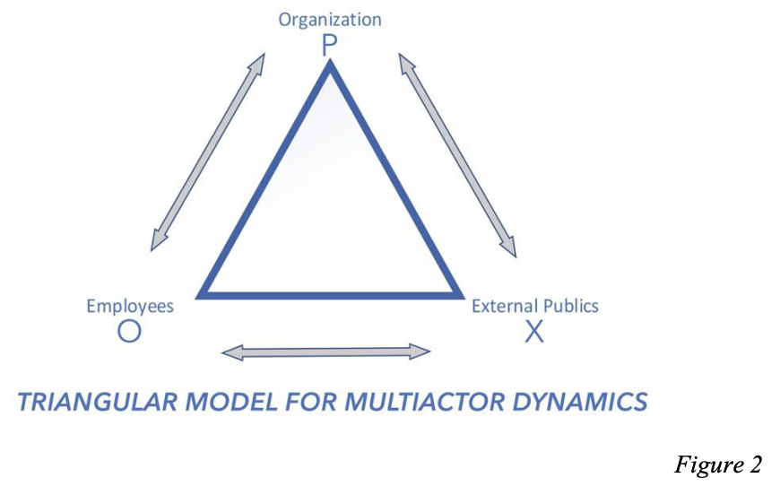
In descriptive terms of what happens on networked digital platforms, this is the simplest view of the triangular model. The organization (P), employees (O, or the internal public) and external publics (X, who may be customers or activists) all exist at the same time, able to communicate freely across social media. The relationship between the organization and their internal publics will moderate how those internal publics choose to communicate with external publics. For instance, an organization with internal issues causing unhappy employees (therefore a negative relationship between P and O), will cause those employees to look more favorably on the point of view of external publics, particularly if that view is contrary to the organization (if P and O are in conflict, and P and X are in conflict, than O and X will align) (Heider, 1948). This is a potential sea change in the way we look at public relations, if only for the distinction between the organization and its internal publics as different voices with potentially access to the same information. This information can be of high salience to external publics who may be happy or upset in their relationship with the organization, though it’s unlikely the organization would have any desire to stop communicative actions by their internal publics that spread a pro-organization message, so chiefly the concern is the opposite.
This negative megaphoning by internal publics effects the disposition of the relationship with external publics, in addition to possibly creating new issues and crises, and new publics along with them (Kim & Rhee, 2011). For a symmetrical communication to happen in three directions, the organization must engage in scouting and environmental scanning, as well as paying close attention to their relationship with internal publics as well as external, as these two groups are now more in contact than ever before. Management of the organization, which in this framework will have elevated need to have public relations departments involved in dominant coalition decision making, must conduct these scouting and relational improvement activities with two sets of publics, in order to prevent those publics from reinforcing each other’s negative relations with the organization.

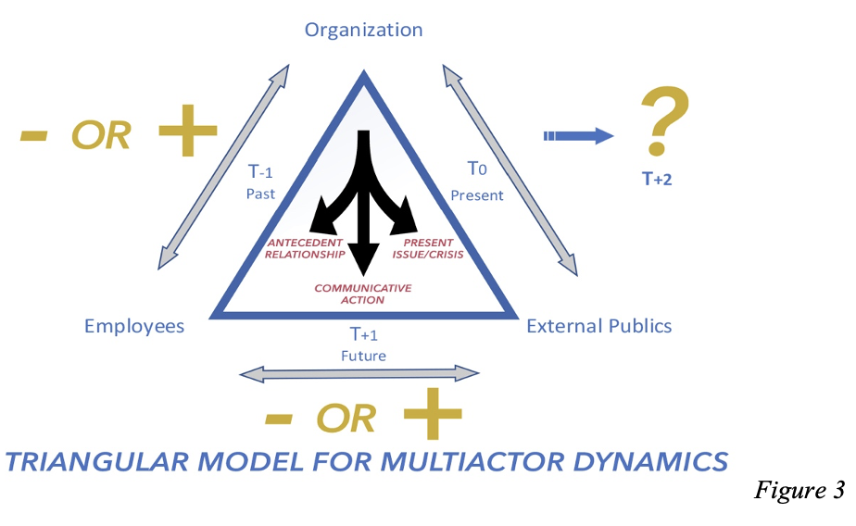

While the three-way communications envisioned in this model can in some ways said to be happening simultaneously, for indeed they are on social media platforms, the forces that inform the relational positioning that is occurring on each side of the triangle represents a different time frame. These frames might actually be of varying length and proximity to each other, for instance, the past (T₋₁) relationship might be largely defined by a single incident that occurred as recently as yesterday, or it might be the accumulated relationship from decades of interaction between organization and their employees/investors. The present (T₀) issues/crisis is of course unfolding in the present, but it could be a hot issue that flares up and dies down relatively quickly, or an ongoing issue that represents the new normal for the organization. The future (T₊₁) could more specifically called the immediate future, however the immediacy of it is rather undefined. It represents the reaction to issues/crisis unfolding in the present by internal publics, informing whether they may be more inclined to negatively megaphone in opposition of the organization’s interests, or potentially positively megaphone to defend or further enhance the organization’s relationship with external publics. This leads to the future situation (T₂) which is highly mediated by the three sides of the triangle.
If the pre-existing relationship with the internal publics (employees) is more positive, in the left side of the triangular model, it is proposed they will be less likely to negatively megaphone against their organization and more likely to engage in pro-organization scouting and defending on social media. In present scenarios where an organization is experiencing issues or crisis that is causing publics to antagonize them on networked digital platforms—the right side of the triangle—a positive relationship with external publics will be proposed to reduce the amount those external publics heed or interact with negatively megaphoned content in networked digital platforms, and perhaps reduce the credibility they award to internal publics who leak negative information about the organization. In the immediate future, or the bottom side the triangular model, the frequency and valence of leaked content by internal publics will be proposed to be strongly mediated by the other two sides of the triangle. The more positive the other two relationships, the more favorable this interaction between internal and external publics will be.
The model is, in its current state, a descriptive one that can be used to reflect the reality of three-way interactions in networked digital platforms, which are occurring so frequently now, it will continue to grow as a share of the work required of public relations departments in the near future. By applying Grunig’s concept of symmetrical two-way communications between each pair of nodes on the triangle, three-way symmetrical communication might be said to take place, and a normative model for public relations practice could come with it.
Testing the Triangular Model: Study Design and Hypotheses
The triangular model, which captures three-way interactions between organization, employees, and external publics, are to be examined in a two-sequence experimental design. The focus of this thesis is on how internal interactions such as relationships and symmetrical communication between management and employees might influence employees’ assessments or perceptions about their organization and further increase their (employees) communicative actions (megaphoning). Their assessment/perception such as ethical management or managerial conspiracy could determine the valence and magnitude of employee megaphoning (positive or negative). Most importantly, employees’ perceptions and communicative actions will create content the organization’s external publics encounter. In other words, employees’ megaphoned content—good or bad—will create information environments for external publics (e.g., customers). Further, external publics in varying conditions of informational environment will assess the organization’s performance (e.g., management, products/service) and develop similar assessments (e.g., organizational ethics) and communicative actions (e.g., customer megaphoning and reception to employee megaphoning) to the employees.
Study 1, therefore, is to examine employees’ assessments and communicative actions from interactions with their working organization. Specifically, if employees’ relationship quality with their organization, and their perceived managerial communication strategies (e.g., symmetrical communication) indeed influence their perceptions of organizational ethics, managerial conspiracy, and the direction and magnitude of their (employee) megaphoning.
Study 2, then, is to examine if employees’ megaphoned contents which become the information environment influencing external publics’ (customers) assessments (e.g., organizational ethics) and communicative actions (megaphoning) change in line with those of employees. Specifically, this thesis hypothesizes that customers will follow similar perceptions and communication behaviors as employees of the organization and amplify the business environment (favorably/negatively). Customers will also interact with employee’s evaluation (positive/negative) so as to amplify or lessen their assessment and communicative actions about management and the organization. Figure 4 summarizes the two studies.

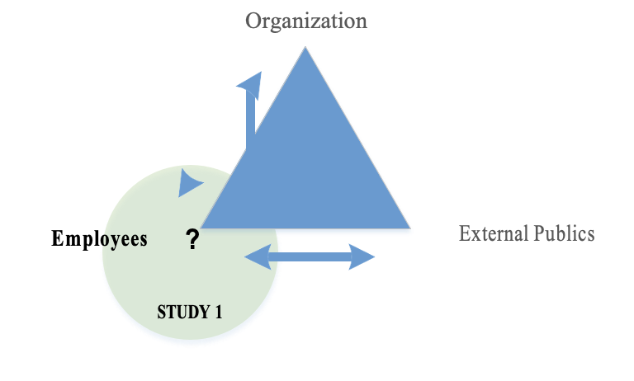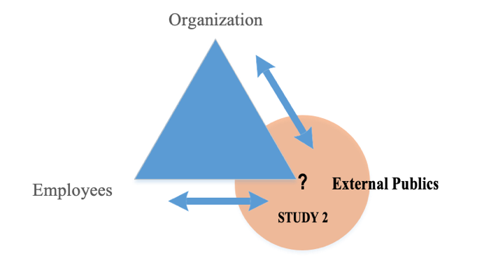
Figure 4. Study Design Summary

Hypotheses
Study 1: Internal Public (Employee)

Main Effect of Symmetrical Communication - Observed
H1a: The more symmetrical the perceived communications are between the organization and an internal public, the more likely the internal public will be to engage in positive megaphoning on behalf of the organization.
H1b: The more symmetrical the perceived communications are between the organization and an internal public, the higher the perception of organizational ethics will be for the internal public.
Main Effect of Asymmetrical Communication - Observed
H1c: The more asymmetrical the perceived communications are between the organization and an internal public, the more likely the internal public will be to engage in negative megaphoning against the organization.
H1d: The more asymmetrical the perceived communications are between the organization and an internal public, the more likely the internal public will be to engage in conspiratorial thinking against the organization.
Main Effect of Employee-Organization Relationship Quality (Observed)
H1e: The more positive the relationship between the organization and an internal public, the more likely the internal public will be to engage in positive megaphoning on behalf of the organization.
H1f: The more positive the relationship between the organization and an internal public, the more likely the internal public will be to view the organization as ethical.
Main Effect of Business Environment (Positive vs. Negative vs. Neutral) (Manipulated)

H2a: A positive (vs. negative vs. neutral) business environment will increase (decrease) an internal public’s positive (vs. negative) megaphoning.
H2b: A positive (vs. negative vs. neutral) business environment will increase (decrease)
internal publics’ perception of organizational ethics.
H2c: A positive (vs. negative vs. neutral) business environment will decrease (increase)
internal publics’ conspiracy attribution.
Interaction Effects
H3a: There will be an interaction of management communication strategy (symmetrical vs. asymmetrical) and business environment (positive vs. neutral vs. negative). For symmetrical communication there will be no differences in employees’ positive megaphoning, perception of managerial ethics, and managerial conspiracy attribution, regardless of the business environment. For asymmetrical communication, there will tend to be greater negative megaphoning and managerial conspiracy attribution and lesser perceived managerial ethics, but for a positive business environment there will be little difference in external public’s assessment and communicative actions (i.e., megaphoning, leaking, rumor mongering).
H3b: There will be an interaction of employee-organization relationship quality (high vs. low) and external business environment (positive vs. neutral vs. negative). For higher relationship quality, there will be no difference in employees’ positive megaphoning, perception of managerial ethics and managerial conspiracy attribution, regardless of the business environment. For lower relationship quality, there will be a greater negative megaphoning and managerial conspiracy attribution and lesser perceived managerial ethics, but for positive business environment, there will be little difference in external public’s assessment and communicative actions (i.e., megaphoning, leaking, rumor mongering).
Study 2: External Public (Customer)
Main Effect of Employee-Created Information Environment (Advocational vs. Adversarial) (Manipulated)
H4a: Advocational (vs. adversarial) employee information will increase (decrease) external public’s positive megaphoning.
H4b: Advocational (vs. adversarial) employee information will decrease (increase) external public’s negative megaphoning.
H4c: Advocational (vs. adversarial) employee information will increase (decrease) external public’s perception of organizational ethics.
H4d: Advocational (vs. adversarial) employee information will decrease (increase) external public’s conspiratorial thinking against the organization.
Main Effect of Business Environment (Positive vs. Negative) (Manipulated)
H5a: A positive (vs. negative) issue environment will increase (decrease) external public’s positive megaphoning.
H5b: A positive (vs. negative) issue environment will decrease (increase) external public’s negative megaphoning.
H5c: A positive (vs. negative) issue environment will increase (decrease) external publics’ perception of organizational ethics.
H5d: A positive (vs. negative) issue environment will decrease (increase) external public’s conspiratorial thinking against the organization.
Main Effect of Customer Relationship Quality (Observed, Covariate)
H6a: Positive relationship between the organization and an external public will increase (decrease) external public’s positive (negative) megaphoning.
H6b: Positive relationship between the organization and an external public will increase
external public’s perception of organizational ethics.
H6c: Positive relationship between the organization and an external public will decrease external public’s conspiratorial thinking against the organization.
Interaction Effects
H7: There will be an interaction of employee-created information environment (advocational vs. adversarial) and external business environment (positive vs. negative). For a negative business environment, the adversarial employee communications will result in greater negative megaphoning credence given by customers and conspiracy attribution and lesser positive megaphoning credence and perception of organizational ethics, but for a positive business environment, there will be little difference in an external public’s assessment and communicative actions (i.e., megaphoning, leaking, rumor mongering).
Method
This research utilized a mixed design vignette structure (Atzmüller & Steiner, 2010) for two online survey experiments. This means there are different vignettes presented to different groups within the sample population (Atzmüller & Steiner, 2010). One survey will examine the attitudes, relationships with an organization and communicative behaviors of internal publics, or employees of the top four US fast-food restaurants that specialize in hamburgers, and the other will look at external publics, or the customers. These four companies are McDonald’s, Burger King, Wendy’s, and Sonic. Fast-food restaurants were chosen because they are suitable for both the research questions in this study, which address questions of relationship between employees and their company (in both surveys), and because they present a large and easily accessible pool of potential respondents. Additionally, this population of respondents is highly diverse in all demographic categories, providing a good data set that reflects the general population. A total of 300 participants were collected for each survey, yielding results with sufficient significance and standard of error to make inferences about the population. The sample was recruited on the Amazon Mechanical Turk (MTurk) platform, with a filter inserted to collect respondents with a proven history of providing viable responses to surveys. The respondents were incentivized with a $1 payment for taking the survey, which immediately used question routing to weed out respondents who had either not been employed at one of the four restaurants in the study or had never been a customer. By presenting an experimental stimulus to the respondents, the study can achieve the important features of correlation, sequential relation, and randomness of the sample, to allow a causal influence to be established by the experimental stimuli (Ellett & Ericson, 1983).
Study 1 looked at the employees’ interactions with the organization, depicted in the left side of the triangular model. This study employed a 3 (issue environment situation: positive vs. neutral vs. negative) $×$ 2 (relationship: high vs. low quality) between-subject factorial design to depict the left side of the triangular model. The hypotheses are that relationship (high vs. low quality) influences the likelihood of positive or negative megaphoning, the perception of organizational ethics and conspiratorial thinking, particularly in the expected positive direction (positive relationship leads to positive megaphoning and negative leads to negative). Further, it can tell us if the organization with a problematic relationship would foster a greater tendency in employees to undertake communicative actions which in turn trigger a hostile or favorable informational environment with external publics.
The respondents were first presented with OPRA questions (Table 1) assessing the state of their relationship with the organization, on a seven-point Likert scale, as well as their perceptions of the organization’s use of symmetrical or asymmetrical communications. Then, through a Qualtrics survey randomizer to ensure a random and roughly equal distribution, respondents were exposed to one of three possible experimental stimuli (Table 2); a fictitious situation of a service-related issue regarding food safety and hygiene, with either positive, negative, or neutral implications. Respondents were then presented another set of questionnaire blocks (Table 3) to measure their likelihood to engage in a variety of communicative activities (i.e., megaphoning, leaking, rumor mongering) and their perceptions of the organization’s ethics and their likelihood to traffic in conspiracy and rumor. This presents the base condition of the three-way communicative interactions, the left side of the triangular model, that is, the antecedent relationship between the organization and its internal publics, which will inform the disposition of the other two sides. A manipulation check was also inserted, asking respondents to rate the perceived strength of the experimental stimuli. Additionally, a short vignette and set of unrelated questions were inserted as a mental palate cleanser in between the relationship measures and the experimental stimuli.
The second experimental study was to illustrate and examined the right side of the triangular model. Specifically, Kaufman and Kim (2020) proposed and illustrated how external members of a public could use and get greater influences from the information that an internal public disseminates (e.g., issue-related information from employee’s megaphoning) when they have problematic situations. Further, the information from employees, positive or negative, could accentuate the state of ongoing relationships that external publics have in the issue/crisis situations. The nature of active publics when they have problems/issues, is they tend to seek out information from many sources (Kim & Rhee, 2011). External publics can find and use the megaphoned (positive/negative) information from employees, and hot-issue publics are likely to weigh such information more heavily from internal publics (Kim & Rhee, 2011). This proposed effect captures and illustrates how two-way relationships and communicative interactions become triangular or three-way communicative interactions based on relational dynamics. The respondents in this experiment were customers of the same four popular fast-food restaurants from which the employee respondents were recruited. Participants (customers) had their current relationships, satisfactions, and brand loyalty tested using the OPRA metric. The first experimental condition split the respondents into two relationship quality groups (high vs. low relationship quality with the brand). Then, participants were exposed to a fictitious scenario for a food safety issue (vs. a scenario of neutral situation as a comparison condition). Following this, participants will read another fictitious scenario of employees’ anonymously megaphoned online content (advocating vs. accusatorial information related to the safety issues). This study employed a 2 (issue situation: positive vs. negative) $×$2 (valence of employee-generated information: advocational vs. accusatory) between-subject factorial design, using the OPRA measure of relationship quality as a covariate.
Respondents were first presented with OPRA questions (Table 4) assessing the state of their relationship with the organization, on a seven-point Likert scale, as well as their perceptions of the organization’s use of symmetrical or asymmetrical communications. Then, through a Qualtrics survey randomizer to ensure a random and roughly equal distribution, respondents were exposed to one of two possible experimental stimuli (Table 5); a fictitious scenario of crisis for the organization where employees either engaged in negative or positive megaphoning. Then respondents were presented a second experimental stimulus, also randomized, which presented the organization in a positive or negative issues scenario (Table 6). Respondents were then presented another set of questionnaire blocks (Table 7) to measure their likelihood to give credence to a variety of communicative activities and their perceptions of the organization’s ethics and their likelihood to traffic in conspiracy and rumor. This presents second stage of the three-way communicative interactions, the present-issues scenario and relationship between the organization and its external publics, which will inform the disposition of the third side, the communications that unfold between internal and external publics, the bottom side of the triangular model.
The full questionnaires are provided in the appendices. Questions in the OPRA scale have been used as designed by Grunig & Huang (2000) for the organization-internal public relationship in the research presented here, while the questions used for customers have been slightly modified for use.
Results
Results of the study were manifold and showed strong significance for the main hypotheses of the thesis. For the first study, with the respondent pool containing current or former employees of the four restaurants, an analysis of variance (ANOVA) technique was used to look at the mean differences between respondents. ANOVA provides the best method to analyze the data, as it provides the proper answers to the research questions we are proposing, by providing analysis of the variance in mean data (Rutherford, 2011). The survey questions (other than demographics and identification, were presented as 1-7 scales with 1 being the negative pole, 7 being the positive pole and 4 representing a neutral position on the statement presented to respondents.
Study 1
The first hypothesis set regarded symmetrical communications and the asymmetrical communications as the independent variables (IV) and positive megaphoning and perceived organizational ethics as the dependent variables (DV). ANOVA was conducted to test H1, in which the continuous variable involvement was translated to a categorical variable using a median split (Table 8). For the independent variable of symmetrical communication, there was a pronounced, significant variance discovered, with F = 140.191 (1, 270), p < .001, M = 5.912, SD = .099 for employees who viewed communications with the organization as more symmetrical and M = 4.248, SD = .098 for those who saw it as less so. Thus, employees viewed symmetrical communication as positively related to their positive megaphoning, and H1a is supported. Using the same ANOVA and mean tables to look at the effects on perceived organizational ethics as the next dependent variable (Table 9). Again, the effect of the independent variable, symmetrical communication had a significant effect, with F = 102.670, (1, 270), with p < .001, and a mean difference of 1.284 between the responses from those who viewed the communications as more symmetrical (M = 5.889, SD = .088) and those who viewed it as less so (M = 4.604, SD = .089). Thus, H1b is supported.
Using ANOVA to analyze the data from the questions regarding asymmetrical communication and both negative megaphoning and conspiracy attribution, the results are similar to the results for symmetrical communication in the same expected direction (Table 10). Asymmetrical communication had a large mean difference and significant reaction on both dependent variables, F = 90.939 (1, 270), significant at p < .001. When asymmetrical communications were seen as high by internal publics, so was the level of negative megaphoning against the organization (M = 5.480, SD = .117, versus M = 3.807 and SD = .129 for negative megaphoning) when asymmetrical communications were viewed as lower. This is a uniquely strong effect, given that when the asymmetrical communications are seen as lower, employees are more than just neutral about negative megaphoning, they’re actively negative on it (M = 3.807, or on the unlikely side). A similar strength of effect was seen with the level of conspiratorial attribution (Table 11) given to the organization with F = 96.861 (1, 270) and M = 5.745, SD = .112 versus M = 4.242, SD = .102 for conspiracy when asymmetrical communications were viewed as lower. Significance was at p < .001 for both dependent variables. Thus, H1c and H1d are supported.
The analysis of variance on the independent variables of organization-public relationship (OPR) as rated by the internal publics (employees) (Table 12), against the dependent variables of positive megaphoning and perceived organizational ethics. Relationship was shown to have a significant effect, with F = 156.025 (1, 270), p < .001, and a mean difference between good and bad relationship of 1.744 (M = 5.954, SD = .097 for positive megaphoning when the relationship is viewed as good, and M = 4.211, SD = .097 when relationship is viewed as low). Meaning the prior relationship as rated by the employees was a strong sign of their propensity to positively megaphone on behalf of the organization. Relationship has a similarly pronounced effect on the perception of organizational ethics the employees hold (Table 13), F = 108.21 (df = 1), with significance (p < .001), M = 5.914, SD = .088, when relationship is viewed as good, and M = 4.590, SD = .089, when relationship is viewed poorly. Thus, H1e and H1f are supported.
External Experimental Condition
Hypothesis 2a’s results (Table 8) show there was significance to the variance in mean among the three external conditions, confirming the directional relationship hypothesized, F = 140.191 (1, 270), p < .05, M = 5.071, SD 1.20 for likelihood to positively megaphone in times of positive external business environment, M = 5.293, SD .117 in neutral business conditions and M = 4.876, SD .120 in times of external negative condition. Thus, H2a is supported. Looking at Table 13, the results are similarly borderline in significance of effect for the external condition, , F = 108.120 (1, 270), p = .052, and a similarly small mean variance between the negative condition (M = 5.112, SD = .107), the positive condition (M = 5.459, SD = .105), and the neutral condition (M = 5.185, SD = .107). Again, the direction of the relationship is as expected, thus, H2b is supported. The external conditions presented did not have a significant effect on the dependent variable, conspiracy attribution. Thus, H2c is not supported.
Interaction Effects
The next set of hypotheses dealt with interaction effects. The data reveals an interaction effect between the three variables, symmetrical communication, external business condition and perceived organizational ethics (Figure 4). When symmetrical communication is high, perceived organizational ethics are also stable and high across all three external conditions presented as experimental stimuli. When symmetrical communication is low, the organization’s perceived ethics are highest in the neutral condition. They show up as higher in the positive condition than the negative, as expected in the hypotheses, however the effect of a neutral issue environment is interesting. One explanation might be a spite or cynicism effect that is activated in positive environments (De Vreese, 2005), causing internal publics to be less likely perceive the organization as having achieved their success ethically, whereas in the negative condition they view the organization as having earned that negative environment through low ethical behavior, and the neutral condition where they’re least likely to believe unethicality on the part of the organization, a sort of “no news is good news” type of effect. Thus, H3a is supported.
The effect of the external experimental condition presented in the study, while not as pronounced as the effect of relationship, still registered a significant effect on variance in the responses to the questions regarding positive megaphoning and perceived organizational ethics, and there are very interesting interaction effects between the three variables (with both dependent variables, perceived organizational ethics, and positive megaphoning). When the external experimental condition was positive, the effect on both positive megaphoning and perceived organizational ethics was a rather mild one, though significant at roughly (p = .05), in the expected positive direction, with a higher mean value than when the situation presented was negative. However, both were lower than when the external experimental situation was neutral, depicted in the three-way interactions below (Figures 5 & 6). These interaction effects suggest that, as expected, when relationship is in high quality between the organization and its internal publics, regardless of the external issues environment, those internal publics will be much more likely to positively megaphone and view the organization as ethical, than when relationship is viewed as low. However, when the relationship is poorly rated by the internal publics, they are significantly more likely (p < .05) to both positively megaphone, and see the organization as ethical, when the external situation is neutral, than either when it is positive or negative. This suggests a similar interaction effect to H3a, wherein a neutral external business condition is less likely to cause megaphoning or ethical perception change on the part of internal publics when the antecedent relationship is viewed as a negative one. If, however, the business condition externally should change for either the better or worse, that could cause positive megaphoning to decrease, as well as perception of ethics, thus once again supporting the underlying assumptions regarding the importance of relationship with internal publics to the triangular communication model. Thus, H3b is supported.
Study 2

The results of Study 2, a 2x2 between subject factorial design, which focuses on the second side of the triangle and the relationship between organization and its external publics, in this case customers of the fast-food restaurants, were analyzed using analysis of covariance (ANCOVA) which combines the analysis of variance with regression to explain more about the individual factors of the triangular model by controlling for the covariate of relationship (Rutherford, 2011).
First analyzed is the main effect of employee-created informational environment, in the form of a manipulated experimental condition (some issue between the organization and its employees), either adversarial or advocational. The amount external publics will give credence to positive megaphoning by internal publics does appear to be causally influenced in a positive direction by the valence of employee megaphoned messages in an internal issues environment the organization finds itself in (Table 14). The internal scenario had an effect only on the border of significance F = 3.782 (1, 286), p = .053, however showed the expected positive relationship with ambassadorial communicative actions by the employees. M = 5.030 and SD = .062 for the negative internal issues scenario and M = 5.202 and SD = .062. Thus, H4a is supported. The external experimental condition returned significant results F = 10.827, (2, 286) and M = 5.260, SD = .062 for the positive external condition and M = 4.972, SD = .062 for negative, showing a causal influence in a positive direction on the credence customers are likely to give to megaphoning by employees during times of external business issues (either negative or positive). Thus, H5a is supported.
The amount external publics will view the organization as ethical also appears to be causally influence in a positive direction with the valence of employee megaphoned messages in internal issues (Table 15). The internal scenario showed significance F = 6.864 (1, 286), p < .01) and the expected positive relationship with ambassadorial communicative actions by the employees. M = 5.272, SD = .081 for ambassadorial internal conditions and M = 4.969, SD = .081 for adversarial. Thus, H4b is supported. For the external experimental condition given to the respondents, the data returned very close numbers to the internal employee environment, with F = 6.958 (1, 286), p <.01, and M = 5.275, SD = .081 for the positive external business issue, and M = 4.966, SD = .081 for the negative, showing the external experimental condition had almost identical significance and direction as the internal issues environment, also having a positive relationship with the credence customers will give to employee megaphoning. Thus, H5b is supported.
The amount external publics will give credence to negatively megaphoned content by internal publics again shows a causal influence in a positive direction with the valence of employee megaphoned messages in the internal environment the organization finds itself in (Table 16). The internal scenario showed significance F = 4.374 (1, 286) and p < .05) to suggest that when the internal scenario with employees is an adversarial one (M = 5.281, SD = .069), customers will be more inclined to give credence to negative megaphoning by internal publics than an ambassadorial condition (M = 5.076, SD = .069). Thus, H4c is supported. The external experimental condition did not return a significant result (M = 5.237, SD = .069 for the negative condition and M = 5.119, SD = .069 for the positive condition, p > .05). Thus, H5c is not supported.
Conspiracy attribution was the only dependent variable which did not seem to experience a direct effect from the experimental stimuli, which is to say, no significant movement occurred to the amount of conspiracy attribution would be ascribed by the external publics when the covariate of relationship, a strongly significant driver, is controlled for (Table 17). Thus, H4d and H5d are not supported.
Both the external business condition and symmetrical communications registered a significant effect on positive megaphoning when controlled for the covariate of relationship between the organization and its external publics (Table 18), which had again, by far the strongest effect. The external condition had F = 10.818 (1, 286) and p < .001, M = 4.941, SD = .061 for the negative external condition and M = 5.225, SD = .061 for the positive condition. Symmetrical communication had a stronger effect, F = 19.354 (1, 286), significant at p < .001, with M = 4.827, SD = .078 for the customers who rated the communications of the organization as low in symmetry, versus M = 5.338, SD = .066, for those who viewed the organization as symmetrical in their communications.
Asymmetrical communication had the same effect in the expected direction, on the credence customers will lend to negative megaphoning by employees, as symmetrical communication had on positive megaphoning, with similarly strong significance (Table 19). F = 38.776 (1, 286), p < .001, M = 5.542, SD = .074 for negative megaphoning credence on the part of customers when asymmetrical communication is viewed as high, versus M = 4.864, SD = .068 when asymmetrical communication is viewed as lower, with OPRA again registering a stronger effect with significance p < .001, as covariate. Thus, H6a is supported.
Perceived organizational ethics as a dependent variable showed a significant reaction to the external condition, F = 7.498 (1, 286) p < .01, which when positive got an M = 5.270 mean score for ethics of the organization in the perception of customers, SD = .083, versus M = 4.950, SD = .083 (Table 20). Symmetrical communications didn’t show an effect on the external publics when controlled for relationship. Thus, H6b was supported

The relationship covariate also has the expected effect on external publics’ conspiracy attribution(Table 21). Controlled for the relationship positivity between the organization and external publics, customers are much more likely to attribute negative effects to shadowy figures and be open to conspiracy and rumor mongering, particularly from internal publics, F = 72.037 (1, 286), p<.001, (M = 5.525, SD = .098) when asymmetrical communications of the organization are viewed to be high, while there was much less attribution to conspiracy when asymmetrical communications were viewed as being low (M = 4.315, SD = .089). Thus, H6c is supported.
Interaction Effects
H7 predicted there would be an interaction of the employee-created information environment (advocational vs. adversarial) and external business environment (positive vs. negative). For negative business environment the adversarial employee witnessing would have greater negative megaphoning, conspiracy attribution and lesser positive megaphoning and perceived organizational ethics, but for positive business environment there is little difference in external public’s assessment and communicative actions.
The interaction effect of both experimental stimuli and the conspiratorial thinking of external publics was interesting and on the border of significance, as shown in Figure 7. Meaning, when the external condition is negative and the internal issue is one of adversarial communicative actions by internal publics, external publics will be most likely to ascribe to conspiracy and rumor. When the internal issue is one of the internal publics communicating positively in defense of the organization, conspiracy is at its lowest, but interestingly, as the external situation improves, so does the cynicism and lack of trust external employees seem to place in the communicative actions of internal publics. No other interaction effects of significance were observed. Thus, H7 is partially supported.
Discussion
The research questions posed by this study, primarily ask what the effects of relationship, symmetrical communications, asymmetrical communications, and the experimental stimuli of hypothetical communicative scenarios are on the communicative actions that occur between an organization, its employees and its customers. These dependent variables, as explored in this study, are positive megaphoning, negative megaphoning, perceived organizational ethics and conspiracy attribution. Using employees and customers of the four largest US fast-food chains, this study used the OPRA measure (Grunig & Huang, 2000; Hong & Grunig, 1999; Huang, 2001) to assess the relationship between the organization and its publics before manipulating those publics with experimental vignettes followed by OPRA questions regarding the dependent variables to see what effect the independent variables have on the megaphoning and valence of that megaphoning, on the part of employees, and the credence given to those communications on the part of the customers.
The hypotheses of this study were generally as follows; H1; that symmetrical communication between an organization and its publics is positively related to positive megaphoning and perceived organizational ethics, that asymmetrical communications have a positive relationship with negative megaphoning, and conspiratorial thinking and that relationship between the organization and has a positive relationship with positive megaphoning and perceived organizational ethics. These hypotheses stem from the combination of the research into the symmetricity of communication, models of public relations, OPR, communicative behaviors, and issues management. Symmetrical communication is linked to excellent public relations practice (Grunig & Grunig, 1992), while the two-way symmetrical model of public relations is the best method to achieve this excellence in a state of communications with publics (Dozier, Grunig & Grunig, 2013). Work into the organizational-public relationship guides the importance relationship will have on communicative actions. Organizations that maintain positive relationships with their publics can expect those publics to recall those relationships when communicating in times of issue and/or crisis (Hong & Grunig, 1999). The communicative behaviors undertaken by internal publics, such as megaphoning, are inclined to occur based on a relational disposition with the organization (Kim & Rhee, 2011) and the management of issues and crisis has a basis in the antecedent relationships that underly the issue at hand (Coombs & Holladay, 2001). H2; that a positive external business environment scenario involving the organization and its public (provided in the form of experimental stimuli) will have a causal influence in a positive direction with positive megaphoning, perceived organizational ethics and in a negative direction with negative megaphoning and conspiratorial attribution. This follows the theoretical underpinning of Kim and Rhee’s work on megaphoning (2011). Their findings, that internal publics are likely to base their megaphoning valence on their relationship with the organization, suggests that external scenarios can also affect this relationship and/or communicative action valence.
H3 holds that an interaction effect of management communication strategy (symmetrical vs. asymmetrical) and business environment (positive vs. neutral vs. negative), as well as between organization-employee relationship (high vs. low) and the business environment (positive vs. neutral vs. negative). This follows the theoretical bases provided by Hon and Grunig (1999), Grunig and Huang (2000) and Huang (2001). That an organization-public relationship is based on different dimensions, which might be individually measured to create a composite of the relationship, which then may be used to learn other things about the communicative nature of publics. This leads directly to the most robustly supported findings of this research, that relationship is the main driver of future communicative actions between publics. Those were the hypotheses for the internal publics study, of which H1a-f were all supported, as were H2a and H2b, though H2c (linking the external business environment to conspiracy attribution by publics) did not find support. H3a and H3b, the hypotheses regarding interaction effects both were supported. Strongest among the results was the antecedent relationship (OPR) between the organization and its internal publics in being key to positively affecting the outcomes of issues and crisis by having a positive moderating effect on the megaphoning done by internal publics.
H4 hypotheses regard the internal informational environment created by employee megaphoning and how it affects the four dependent variables (positive megaphoning, negative megaphoning, perceived organizational ethics and conspiracy attribution) as they are recorded from the external public point of view. In this study, that environment was simulated through experimental vignettes given to the respondents. These hypotheses are conceptually drawn from Kim and Rhee’s 2011 research into megaphoning. Their work posited that internal publics in negative relationships will be inclined to leak information against the organization to external publics. The only dependent variable that did not find support in the data for a significant effect was conspiracy attribution (H4d).
H5 hypotheses investigated the external experimental condition’s effects on the same four dependent variables. This time, neither perceived organizational ethics (H5c) nor conspiracy attribution (H5d) registered significant effects, while the other two did (H5a and H5b). H6 hypotheses predicted the effects of the covariate relationship effects the four dependent variables. This hypothesis stems from the same research that led to H1, primarily Huang’s work on OPR (2001). All H6 hypotheses found support in the data with significance at p < .001, as relationship was discovered to be the strongest driver of the communicative actions. H7 was the final hypothesis in the study, regarding the interaction effects between the two experimental conditions and the dependent variables. Only conspiracy attribution registered an interaction effect with the two experimental variables.
Interaction Effects
The interaction effects detected among the data were of particular interest and could themselves lead to new strains of research. The variables of symmetrical communication and organization public relationship both had very similar and pronounced interaction effects with the external experimental condition and perceived organizational ethics. OPR also had the interaction effect with positive megaphoning. In all three cases, as the external experimental condition went from negative to neutral to positive, when the symmetrical communication or OPR was high, the organizational ethics or positive megaphoning was relatively high and stable. But for both organizational ethics and symmetrical communication, a neutral external issues scenario yielded the highest perceived organizational ethics and positive megaphoning from internal publics. This both confirms the research hypotheses and suggests some other effects are at play, such as the already referenced velcro effect (Coombs & Holladay, 2001), or some spite effect, such as spiral of cynicism (De Vreese, 2005).
Implications of the Triangular Model in Research
The triangular models for multi-actor relational dynamics are a first attempt to capture a natural phenomenon that has evolved from the emergence of new communications technologies. There is still much to be learned about how these scenarios unfold and what public relations practitioners must do to navigate these situations. Two-way symmetrical communication has only recently, with the mainstreaming of digital networked platforms, become a functional reality for many organizations. However, just as soon as those new avenues for excellence in public relations presented themselves, new challenges materialized in the form of three-way communication paradigms unfolding in digital networked spaces. Thus, public relations as a field finds itself with a theoretical foundation that no longer describes precisely what is happening in real life (or at least mediated and simulated life on networked digital platforms), as well as a new phenomenon and a need for a way to explain it, in the form of three-way communications that unfold on these platforms and all over the internet.
The three-way model presented in the form of a triangle is a useful way for capturing the value of relationships with internal publics (employees), and their role in effective issues management. So long as organizations view their communications with internal and external publics strictly in terms of separate two-way communications and don’t visualize them as three simultaneous interactions between groups, there will be missed opportunities for mitigation, resolution and repair of crisis management outcomes.
The three timeframes are versatile in illustrating a variety of conditions in relationship dynamics. Issues and crisis environments are built on antecedent relationships between an organization and its publics. Viewing the triangular model across differen frames opens many testable ideas. Among those are the operationalization of variables and the quantitative study of the change in relationship and sentiment between an organization and its publics. Additionally, qualitative research into the nature of applications of the models and the reality of megaphoning and its effects on relationships during issues and crisis management. Surveys which ask open-eneded questions exploring the perceptions of internal publics, both investors and employees, as well as the perceptions of external publics, including customers and activists, on the credibility of megaphoning internal publics, the antecedents that spur them to action, as well as the perceived credibility and effectiveness of public relations strategies meant to mitigate damage in those situations.
This research explores all three sides of the triangular model by straddling the two poles of employee and customer interactions. On the left side of the triangular model is the relationship between the organization and their employees. The chief findings of this research show that relationship and symmetrical communications, as expected, have a strong effect on the communicative disposition of publics. This is the essence of the three way model.
The implications for the future of public relations management and theorization regarding its professional practice are myriad. Chief among them is a refocusing of PR management priorities on symmetrical communications and relationship-building with internal publics. Traditional views, particularly on the first two models of public relations (press agentry and public information) focus on communications with external publics almost exclusively, while even the models that specify two-way communication forms have also been looked at more from the side of the external publics than internal. This research’s chief findings, and the ones that suggest future research and management foci, are that the communication symmetricity and relationship, fostered by an organization with its internal publics, can have important downstream effects when the organization is faced with issues or crises with external publics. Relationship and symmetrical communication with internal publics can help an organization predict how those internal publics will communicate with external publics in issues scenarios and help accentuate or attenuate the outcomes of those issues. This should be explored in depth in future research with other populations and methods to find ways to generalize the finidngs to a new normative theory of public relations.
Limitations
Shortcomings of such the triangular model are similar to the ones often cited by critics of Grunig’s models. Chief among them is the charge that symmetrical communications are rarely possible/desirable by organizations, and exists only as a utopian normative fairytale (Kenny, 2016). Similarly, these criticisms will inevitably be levied against a three-way model as well. However, in its purely descriptive form, leaving out the desired symmetrical nature of the communications and interactions between nodes of the triangle, the model has potential to continue the research tradition and ideas of Grunig’s four models.
This research also has some limitations of note. The relative strength of effect of the experimental stimuli may not have been as potent as it could be. In order to craft an effective viugnette without creating additional confounding variables, the subject of the experimental stimuli was something rather non-controversial, though likely to peak interest in terms of health and safety, which is the food safety theme of the fictional stimuli. While the avoidance of an additonal confouncing variable such as a hot button issue like race may have been wise, it maye have resulted in tepid stimulus. The manipulation check inserted in the study of internal publics returned a mean score of 4.522, on a seven-point Likert scale reflecting not a very strong effect from the stimuli. An additional weakness is a lack of a manipulation check in the external publics study. Another potential weakness of this study is the use of a median split in the analysis of the data. A process analysis might be a preferred way to go, and some have questioned the validity of median split data and the accuracy of their significance (Maxwell & Delaney, 1993).
Surveys already suffer from the issue of relying on self-report to analyze how much elements of the research (for instance, a manipulation check) are working. Future forays into this same subject might focus on social media data collection and analysis to come to some of the same conclusions and move the theoretical ball forward.
Future Research
The same research should be replicated with other industries than fast-food. While useful for participant recruiting, the sample might have other specific limitations which make it undesirable for such a study. The underlying research which inspired this thesis, the work of Kim and Rhee (2011) into megaphoning and Kaufman and Kim work (2020) on the triangular model, deals with the concept of networked digital platforms being the key to three way communications models and ideally, three way symmetrical communications models. Other industries might be better suited to seeing the actions on a networked digital platform like social media. It might be useful to explore OPR and symmetrical communication and how they unfold in a social network. This would also necessitate network anaylsis and other conceptual additions to that which girds this research.
Future research might focus on the ways in which public relations departments of an organization currently deal with megaphoning, and creating a mixed methods approach to building the theory of three-way symmetrical communications. The models chiefly represent the three-way interactions that unfold across networked digital platforms, and thus might be applied to different scenarios, time frames and variables across the spectrum of relational antecedents. A major potential font of new research into the potential of three-way models would be the application of principles from Grunig and Kim’s Situational Theory of Problem Solving, which uses Grunig’s Situational Theory of Publics to explain communciative actions and how publics perceie and react to them, introducing a new variable, situational motivation in problem solving, that is similar to the concepts at play in the three-way model, and may help explain inteeractions therein (Kim & Grunig, 2011). Of primary importance is that the communications that unfold are viewed in a more complex environment than the traditional goal of two-way symmetrical communications. It would also be valuable to explore corporate social responsibility and the mechanics of activist and hot-issue publics to see how they play into the triangular model. If indeed three-way symmetrical communications are one day possible, a new model of excellent public relations management will develop as well.

References
Aldoory, L., & Grunig, J. E. (2012). The rise and fall of hot-issue publics: Relationships that develop from media coverage of events and crises. International Journal of Strategic Communication, 6(1), 93-108.
Aldrich, H. E. (1975). An organization–environment perspective on cooperation and conflict between organizations in the manpower training system. In A. R. Negandhi (Ed.), Interorganizational theory (pp. 49–70). Kent, OH: Kent State University Press.
Aldrich, H. E. (1979). Organizations and environments. Englewood Cliffs, NJ: Prentice Hall.

Atzmüller, C., & Steiner, P. M. (2010). Experimental vignette studies in survey research. Methodology.

Bowen, S. A., Hung-Baesecke, C. J. F., & Chen, Y. R. R. (2016). Ethics as a precursor to organization–public relationships: Building trust before and during the OPR model. Cogent Social Sciences, 2(1), 1141467.

Burgoon, J., & Hale, J. (1984). The fundamental topoi of relational communication. Communication Monographs, 51(3), 193–214.

Burgoon, J., & Hale, J. (1987). Validation and measurement of the fundamental themes of relational communication. Communication Monographs, 54(1), 19–41.

Cassematis, P. G., & Wortley, R. (2013). Prediction of whistleblowing or non-reporting observation: The role of personal and situational factors. Journal of business ethics, 117(3), 615-634.
Coombs, W. T. (2007). Protecting organization reputations during a crisis: The development and application of situational crisis communication theory. Corporate reputation review, 10(3), 163-176.
Coombs, W.T. (2012), Ongoing Crisis Communication: Planning, Managing, and Responding, (3rd edn), Sage, Thousand Oaks, CA.
Coombs, W. T. (2014). Ongoing crisis communication: Planning, managing, and responding. Sage Publications.
Coombs, W. T., & Holladay, S. J. (2001). An extended examination of the crisis situations: A fusion of the relational management and symbolic approaches. Journal of public relations research, 13(4), 321-340.
De Vreese, C. H. (2005). The spiral of cynicism reconsidered. European journal of communication, 20(3), 283-301.
Dozier, D. M. (1992). The organizational roles of communications and public relations practitioners. Excellence in public relations and communication management, 327-355.
Dozier, D. M., Grunig, L. A., & Grunig, J. E. (2013). Manager's guide to excellence in public relations and communication management. Routledge.
Elçi, M., & Alpkan, L. (2009). The impact of perceived organizational ethical climate on work satisfaction. Journal of business ethics, 84(3), 297-311.
Ellett, F. S., & Ericson, D. P. (1983). The logic of causal methods in social science. Synthese, 57(1), 67-82.
Grunig, J. E., & Grunig, L. A. (1992). Models of public relations and communication. Excellence in public relations and communication management, 1992, 285-325.
Grunig, J. E., & Huang, Y. H. (2000). From organizational effectiveness to relationship indicators: Antecedents of relationships, public relations strategies, and relationship outcomes. Public relations as relationship management: A relational approach to public relations, 23-54.
Grunig, J. E. & Hunt, T. (1984). Managing Public Relations (Holt, Rinehart, Winston, New York).
Grunig, J. E. & Kim, J.-N. (2017). Publics approaches to segmentation in health and risk messaging. In Encyclopedia of Health and Risk Message Design and Processing, Roxanne Parrott (Ed.). New York: Oxford University Press.
Grunig, J. E., & Kim, J.-N. (2021). The four models of public relations and their research legacy. In C. Valentini (Ed.), Handbook of public relations (pp. 277-311). De Gruyter Mouton.
Grzesiak-Feldman, M. (2013). The effect of high-anxiety situations on conspiracy thinking. Current Psychology, 32(1), 100-118.
Heider, F. (1946). Attitudes and cognitive organization. Journal of Psychology, 21, 107–112.
Heider, F. (1958). The psychology of interpersonal relations. New York: Wiley.
Hill, R. (1998). What sample size is “enough” in internet survey research. Interpersonal Computing and Technology: An electronic journal for the 21st century, 6(3-4), 1-12.
Hon, L. C. & Grunig, J. E. (1999, October). Measuring relationship in public relations. Paper presented to the Institute for Public Relations, Gainesville, FL.
Huang, Y. H. (2001). Values of public relations: Effects on organization-public relationships mediating conflict resolution. Journal of Public Relations Research, 13(4), 265-301.
Huang, Y. H. (2004). Is symmetrical communication ethical and effective? Journal of business ethics, 53(4), 333-352.
Jaques, T. (2007). Issue management and crisis management: An integrated, non-linear, relational construct. Public relations review, 33(2), 147-157.
Kaufman, Y., & Kim. J.-N. (2020, September 17). A Triangular Model Illustration for Multi-Actor Relational Dynamics: Spillover Effects of Employee Relationship on Organization-External Public Relations via Megaphoning. Corporate Communication International, Milan, Italy.
Kent, M. L. (2010). What is a public relations “crisis”? Refocusing crisis research. The handbook of crisis communication, 705-712.
Kim, J.-N., & Grunig, J. E. (2011). Problem solving and communicative action: A situational theory of problem solving. Journal of Communication, 61(1), 120-149.
Kim, J.-N., Hung-Baesecke, C. J. F., Yang, S. U., & Grunig, J. E. (2013). A strategic management approach to reputation, relationships, and publics: The research heritage of the excellence theory. The handbook of communication and corporate reputation, 197-212.
Kim, J.-N., & Krishna, A. (2014). Publics and lay informatics: A review of the situational theory of problem solving. Annals of the International Communication Association, 38(1), 71-105.
Kim, J.-N., & Rhee, Y. (2011). Strategic thinking about employee communication behavior (ECB) in public relations: Testing the models of megaphoning and scouting effects in Korea. Journal of Public Relations Research, 23(3), 243-268.
Lauzen, M. (1997). Understanding the Relation Between Public Relations and Issues Management. Journal of Public Relations Research, 9(1), 65-82
Matzler, K., & Renzl, B. (2007). Assessing asymmetric effects in the formation of employee satisfaction. Tourism Management, 28, 1093–1103.
Maxwell, S. E., & Delaney, H. D. (1993). Bivariate median splits and spurious statistical significance. Psychological bulletin, 113(1), 181.
Park, H., & Reber, B. H. (2011). The organization-public relationship and crisis communication: The effect of the organization-public relationship on publics' perceptions of crisis and attitudes toward the organization. International Journal of Strategic Communication, 5(4), 240-260.
Payne, R., & Mansfield, R. (1973). Relationships of Perceptions of Organizational Climate to Organizational Structure, Context, and Hierarchical Position. Administrative Science Quarterly, 18(4), 515-526. doi:10.2307/2392203
Rutherford, A. (2011). ANOVA and ANCOVA: a GLM approach. John Wiley & Sons.
Self, C. (1996). In An Integrated Approach to Communication Theory and Research.
Stacks, D. and Salwen, M. (eds.) Hillsdale, N.J.: Lawrence Erlbaum, pp 421-441.
Stafford, L. & Canary, D. J. (1991). Maintenance strategies and romantic relationship type, gender and relational characteristics. Journal of Social and Personal Relationships, 8, 217–242.
Susntein, C. R., & Vermeule, A. (2008). Conspiracy theories. University of Chicago Law School, Law & Economics Research Paper Series, Paper No. 387.
Susskind, L., Lawrence Susskind, S., & Field, P. (1996). Dealing with an angry public: The mutual gains approach to resolving disputes. Simon and Schuster.
van der Linden, S. (2015). The conspiracy-effect: Exposure to conspiracy theories (about global warming) decreases pro-social behavior and science acceptance. Personality and Individual Differences, 87, 171-173.
van der Meer, T. G., & Verhoeven, P. (2013). Public framing organizational crisis situations: Social media versus news media. Public Relations Review, 39(3), 229-231.
Wicks, A. C., Berman, S. L., & Jones, T. M. (1999). The structure of optimal trust: Moral and strategic implications. Academy of Management review, 24(1), 99-116.
Wilde, O. (1890, 2012). The picture of Dorian Gray and other writings. Bantam Classics.
Yang, A., & Benley J. (2017). A balance theory approach to stakeholder network and apology strategy. Public Relations Review, 43(2017), 267-277
Zhang, X. A., & Borden, J. (2017). Linking issue management, corporate social responsibility and crisis communication: applying balance theory in crisis and issue management. Journal of Contingencies and Crisis Management, 25(4), 209-222.

Appendix

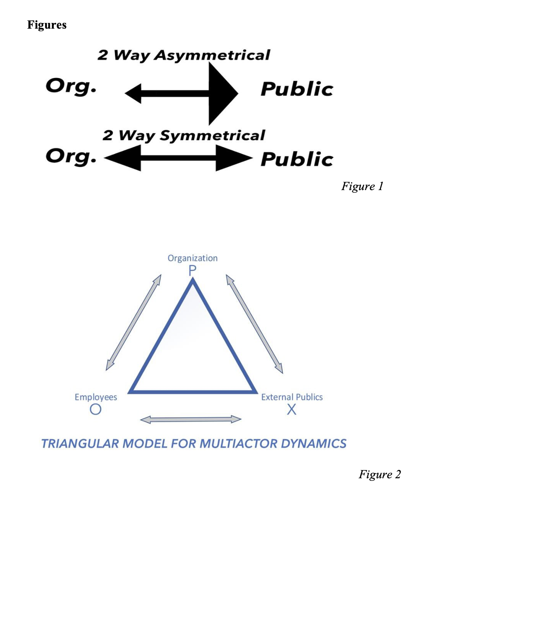

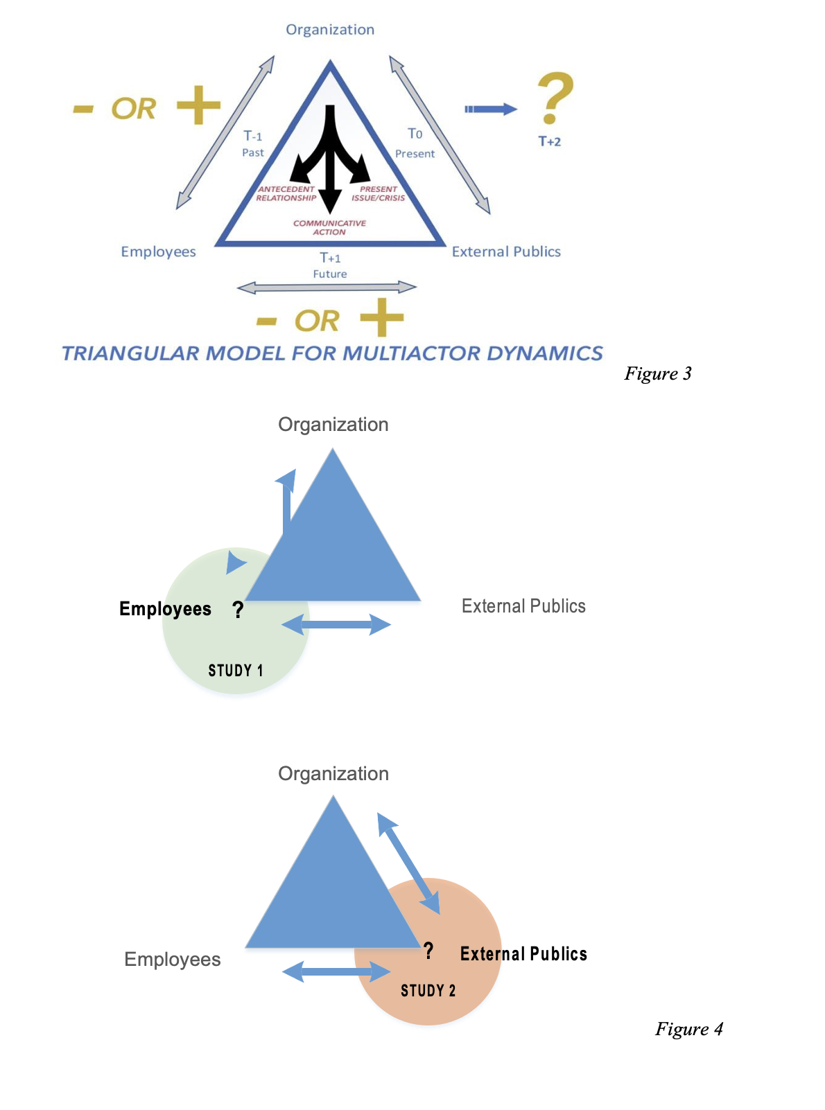

Tables

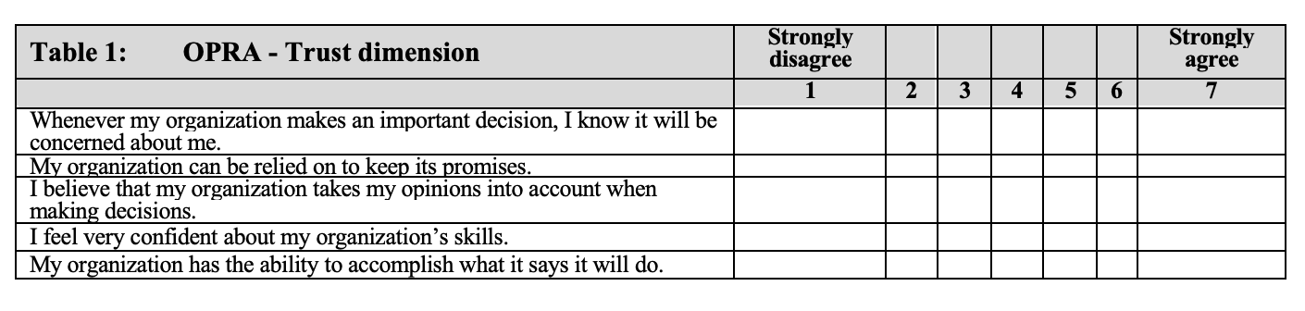

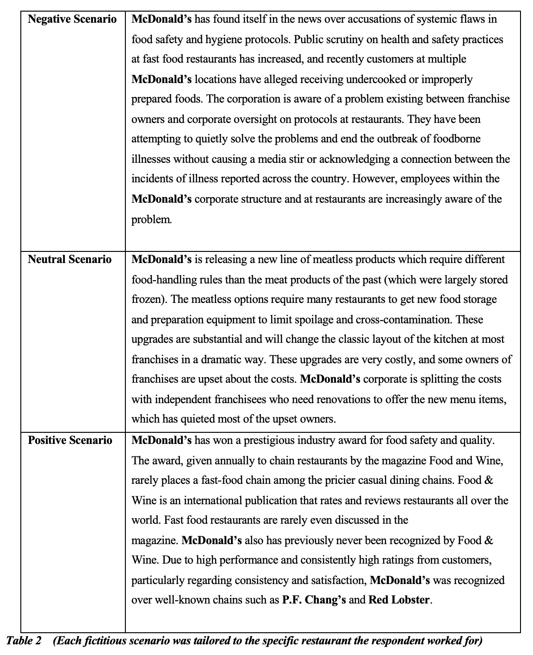
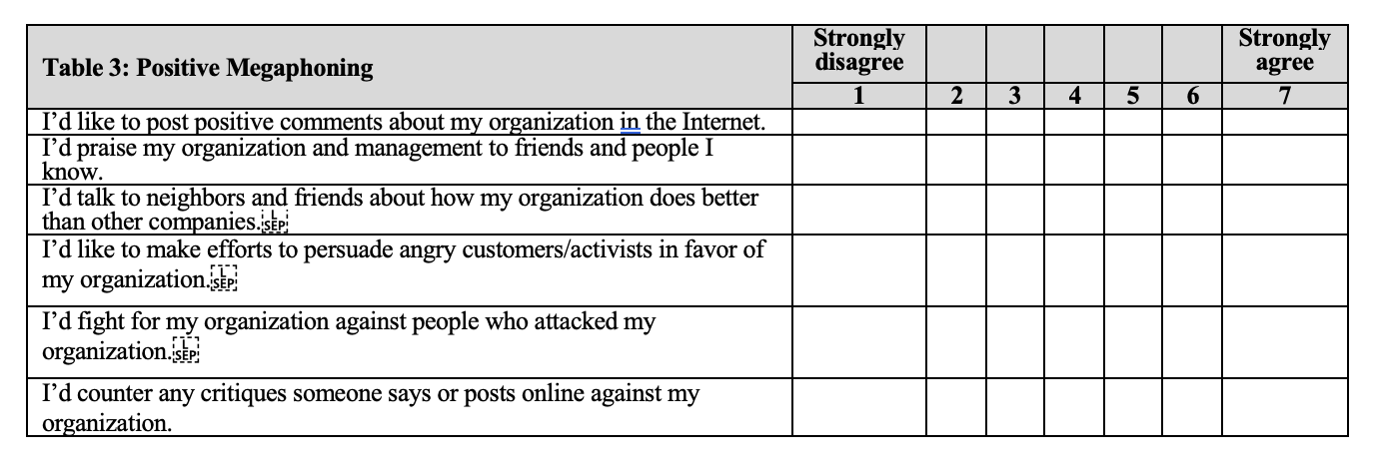

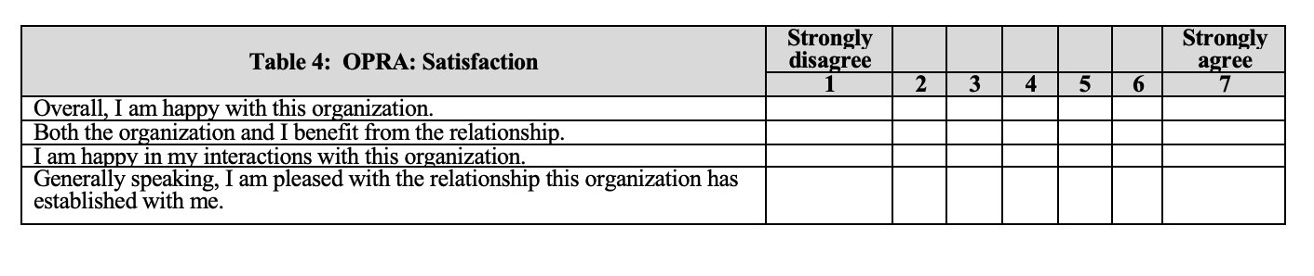

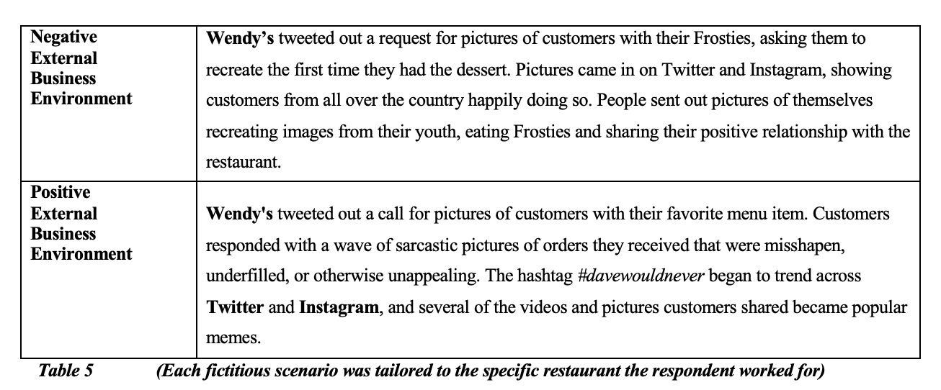

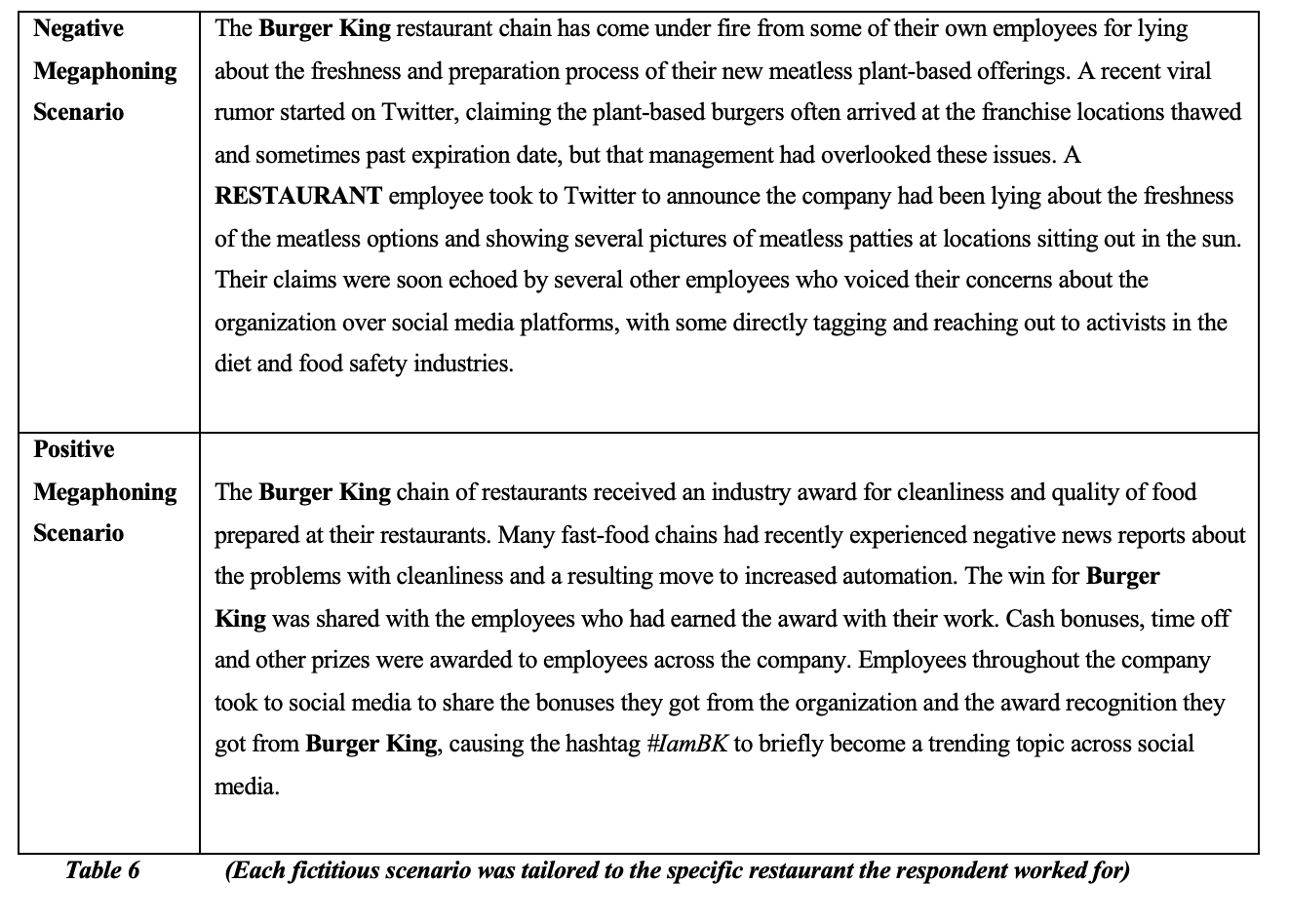

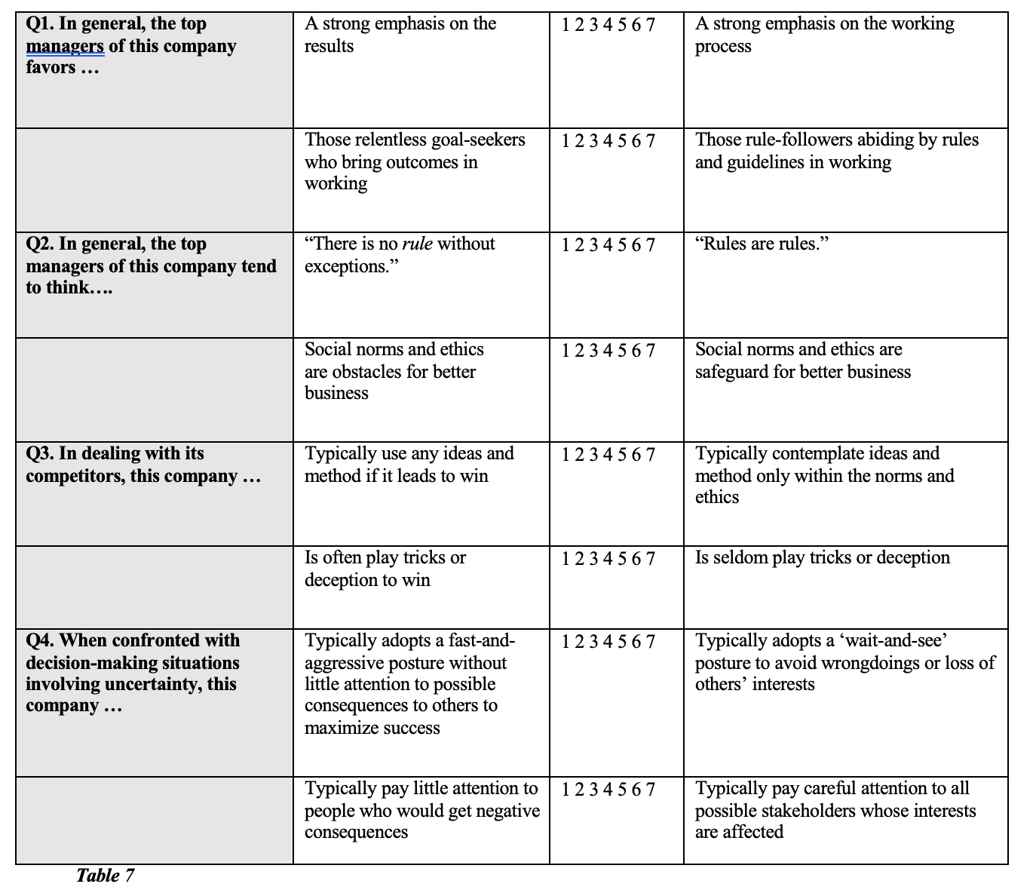
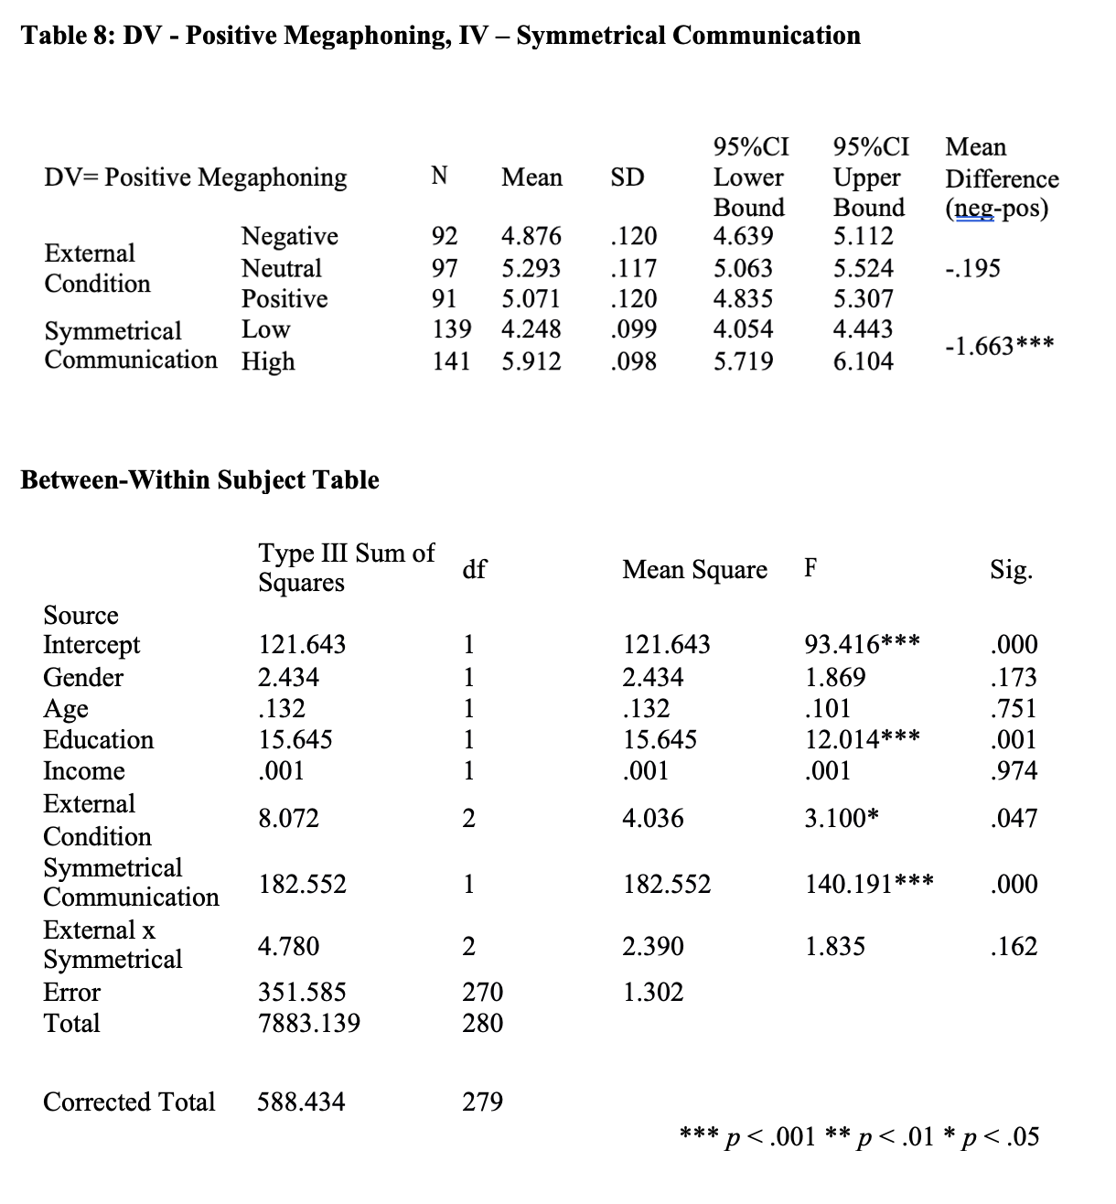

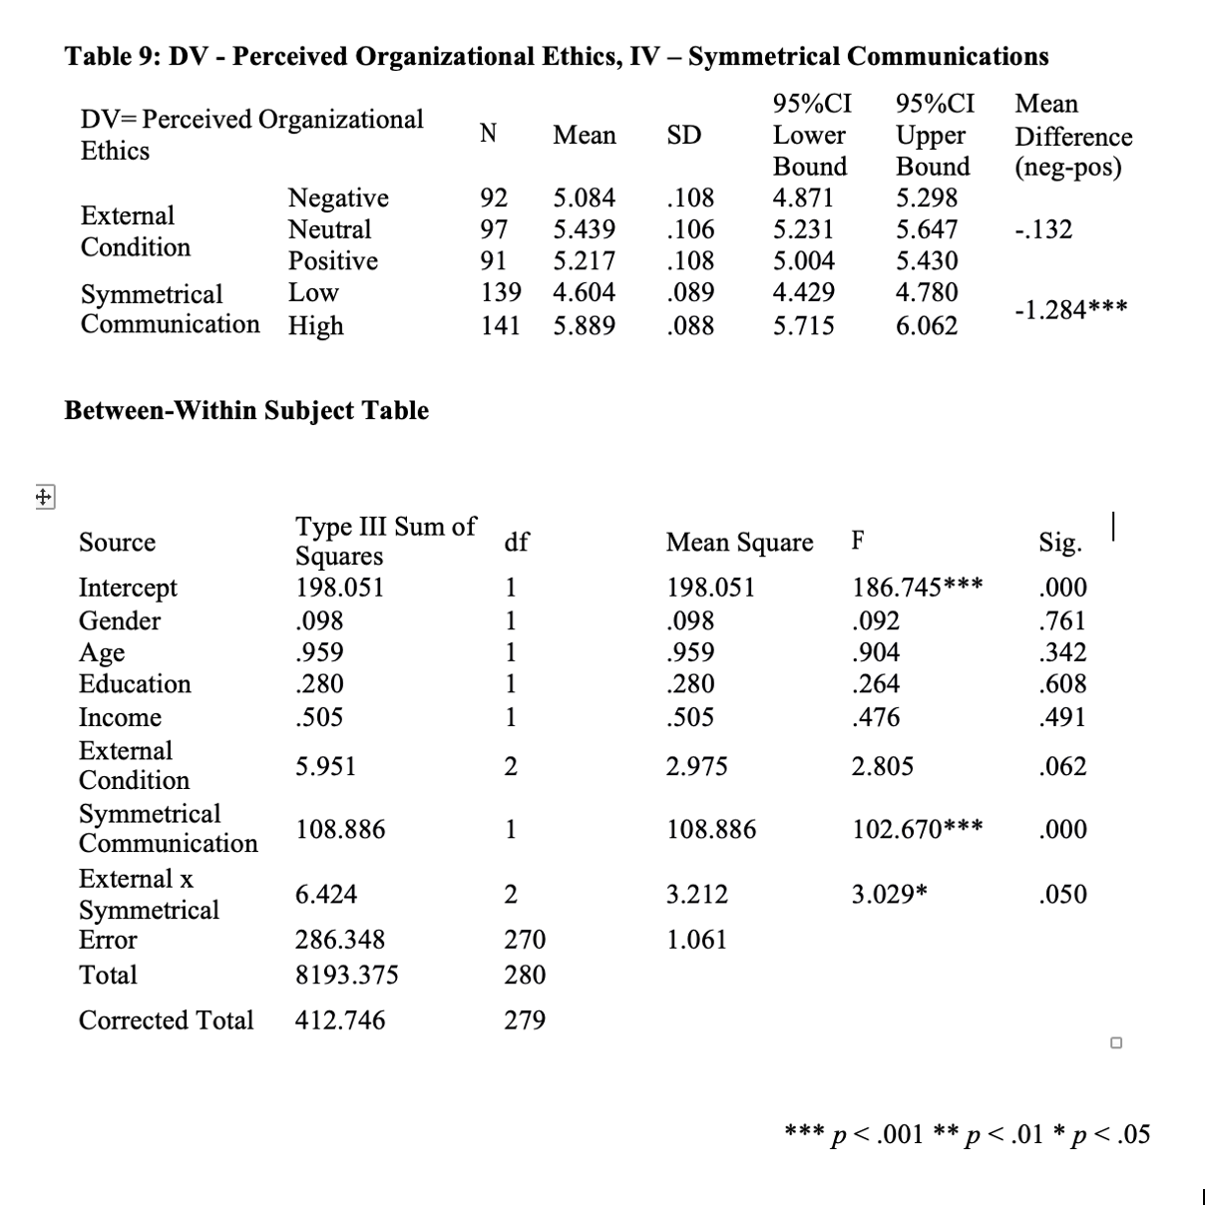

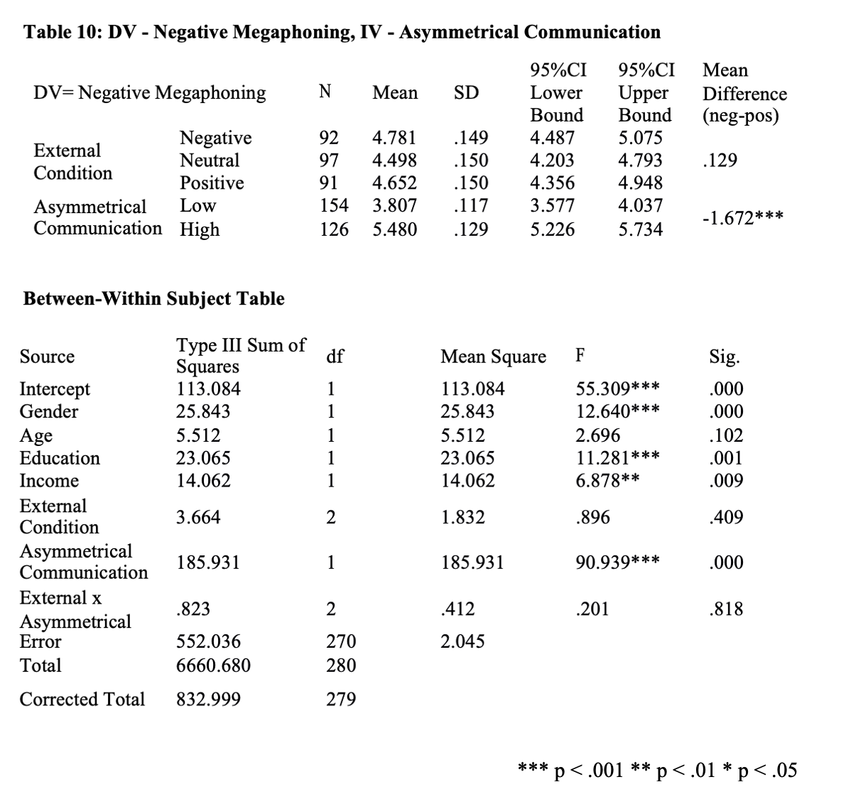

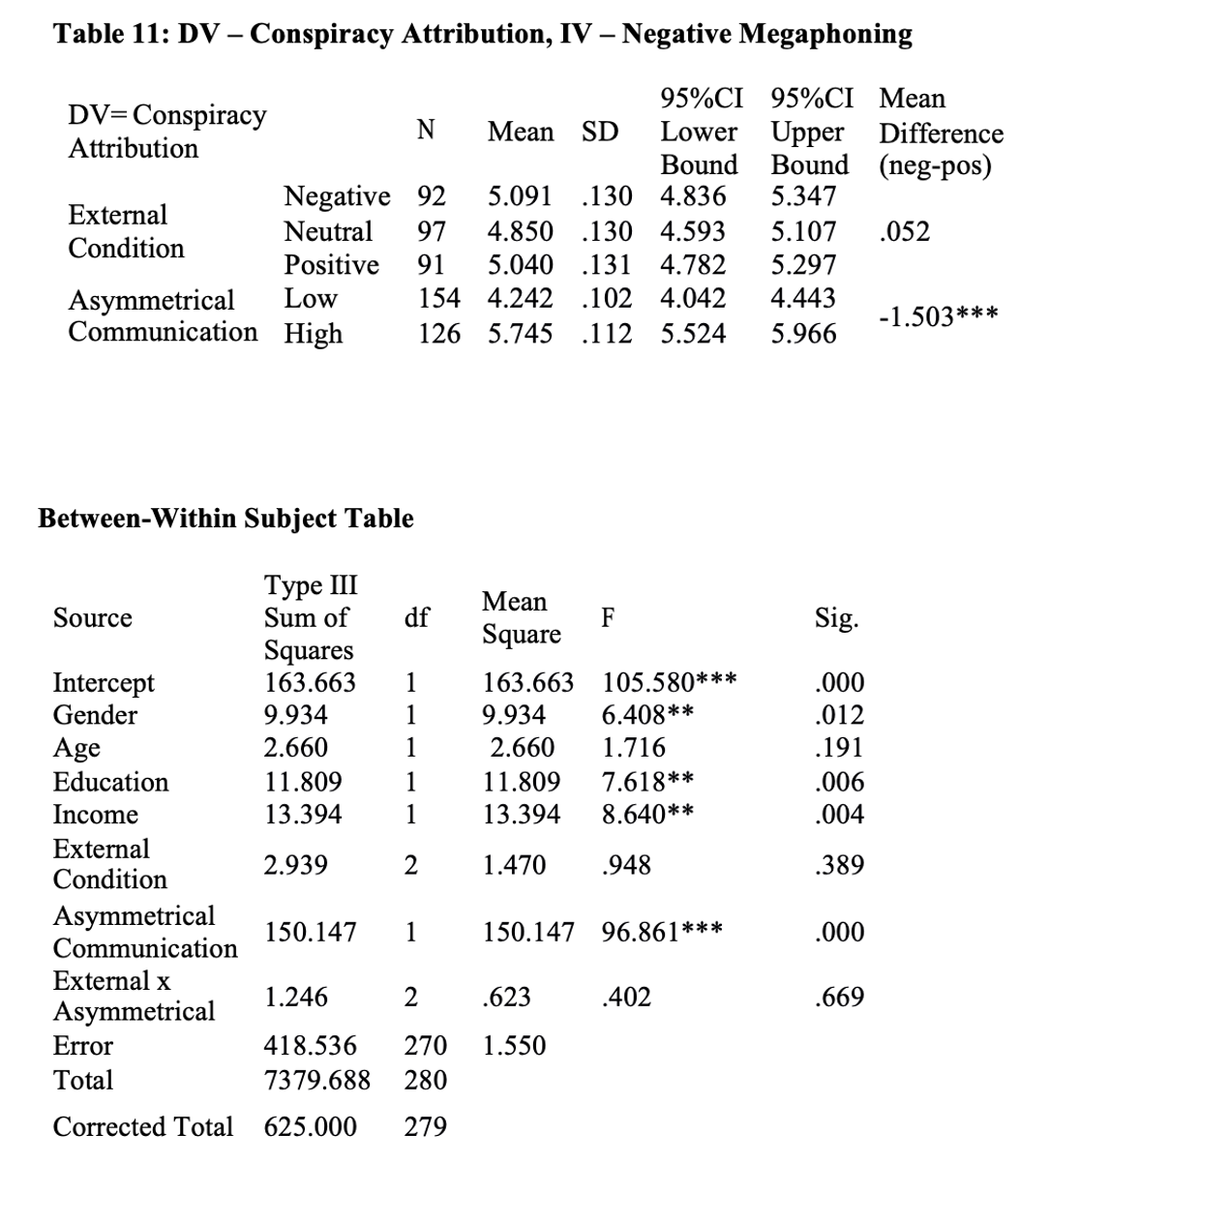

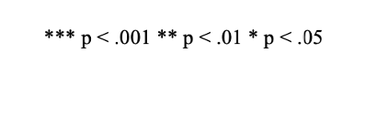

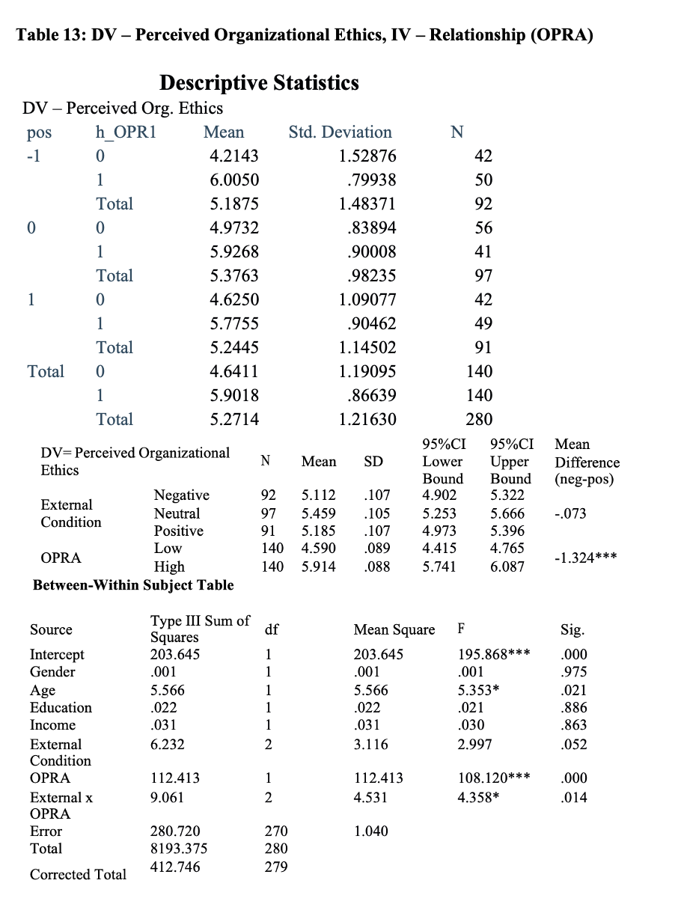
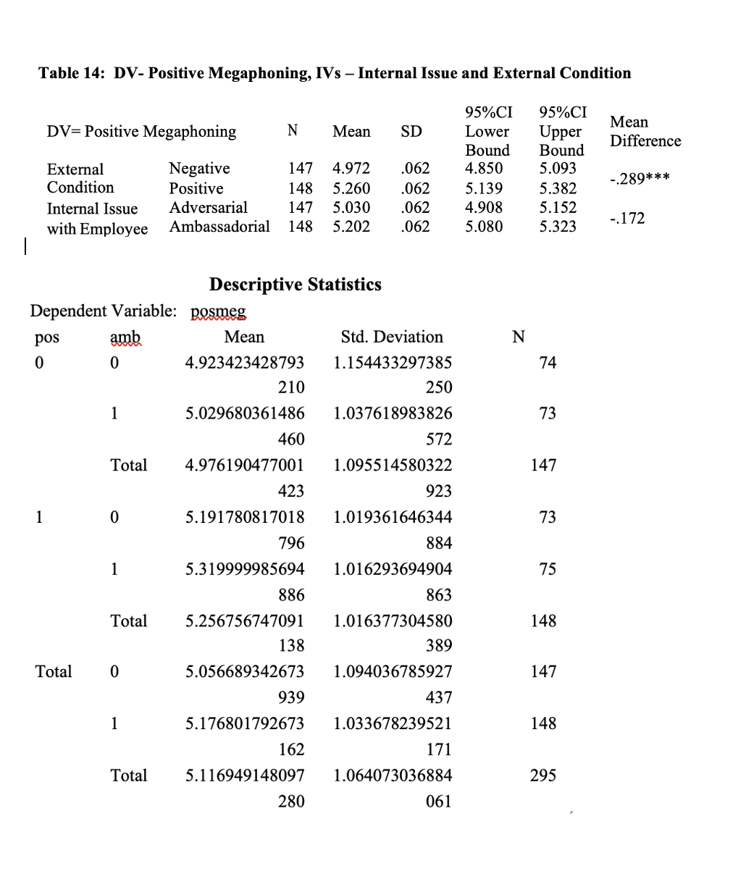
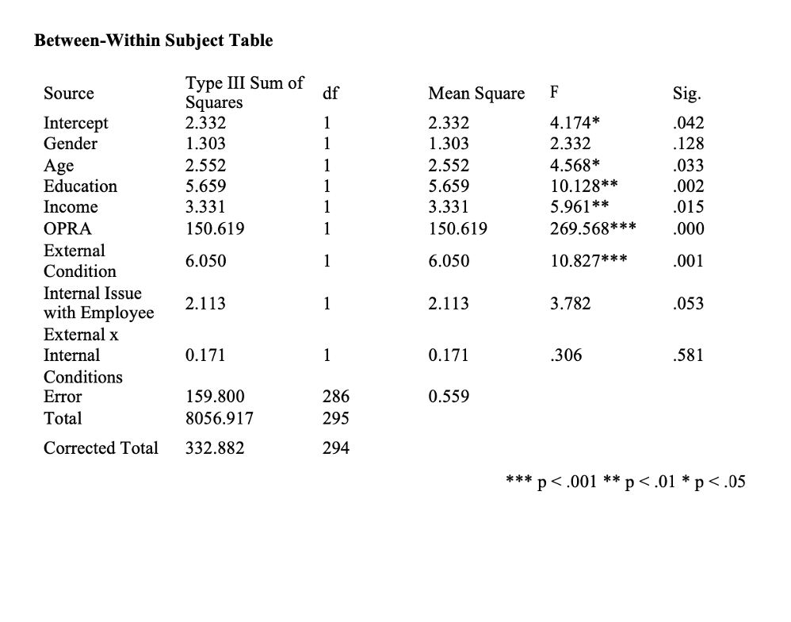

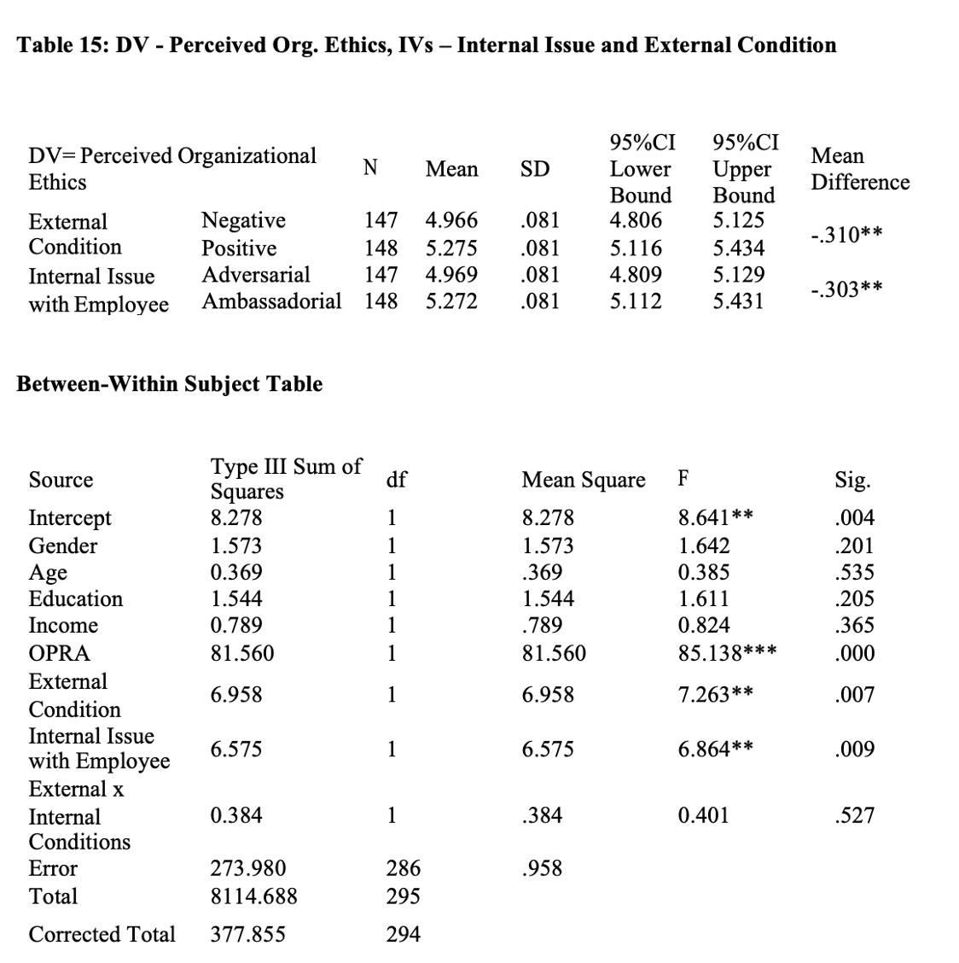

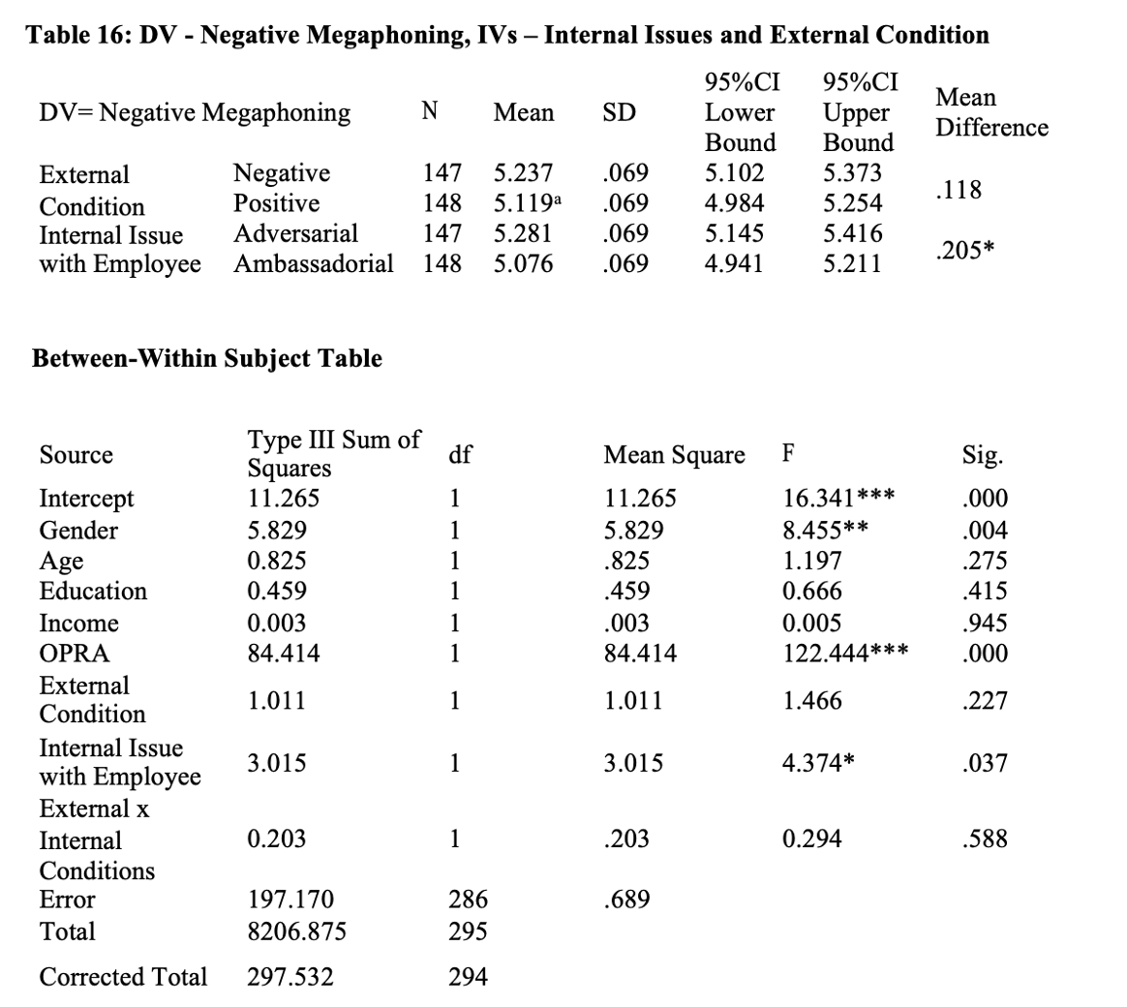

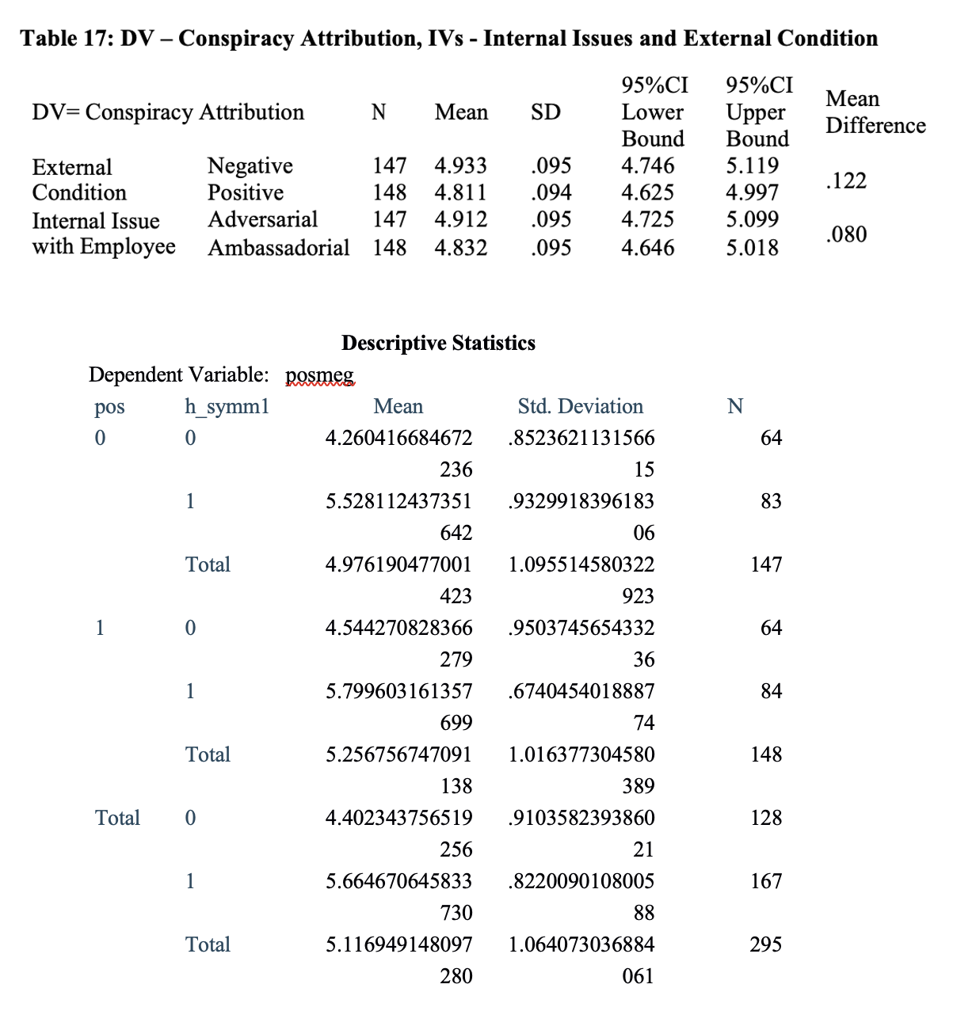

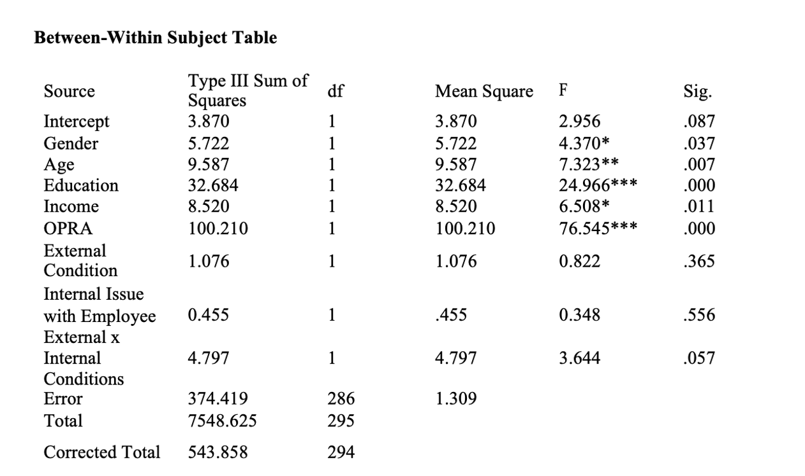

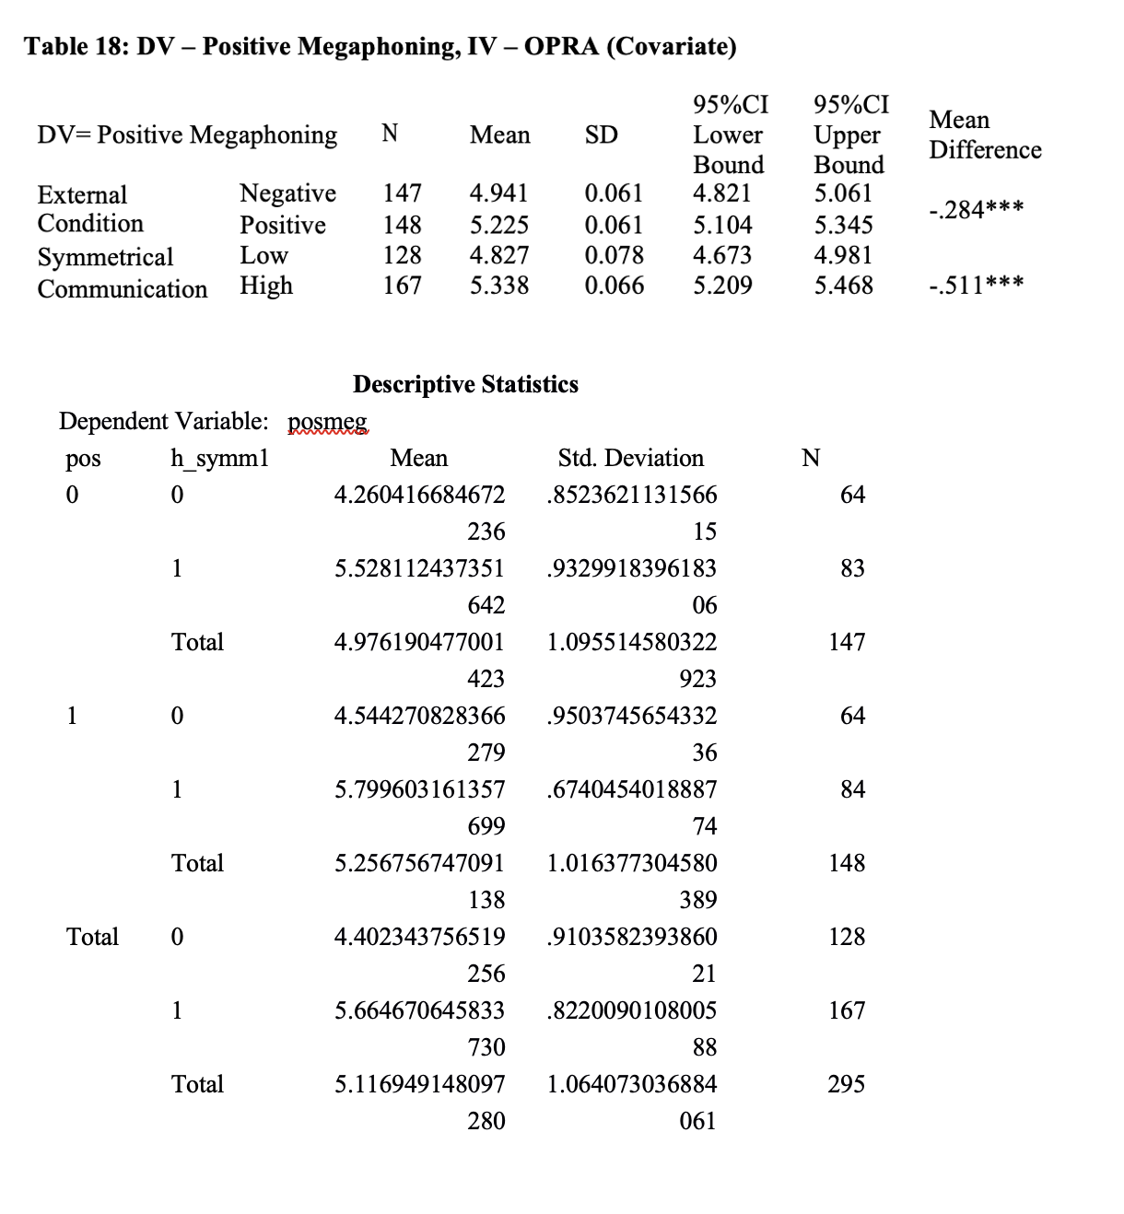

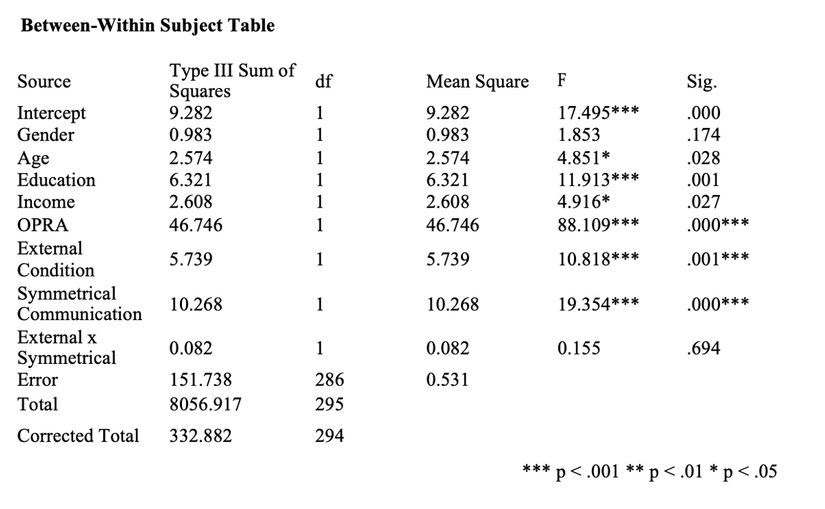

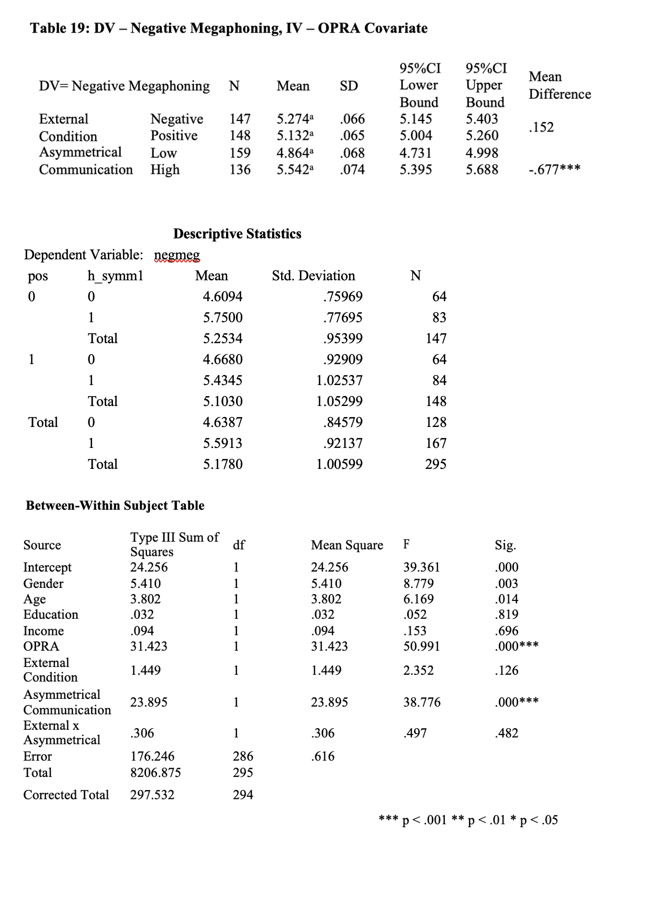
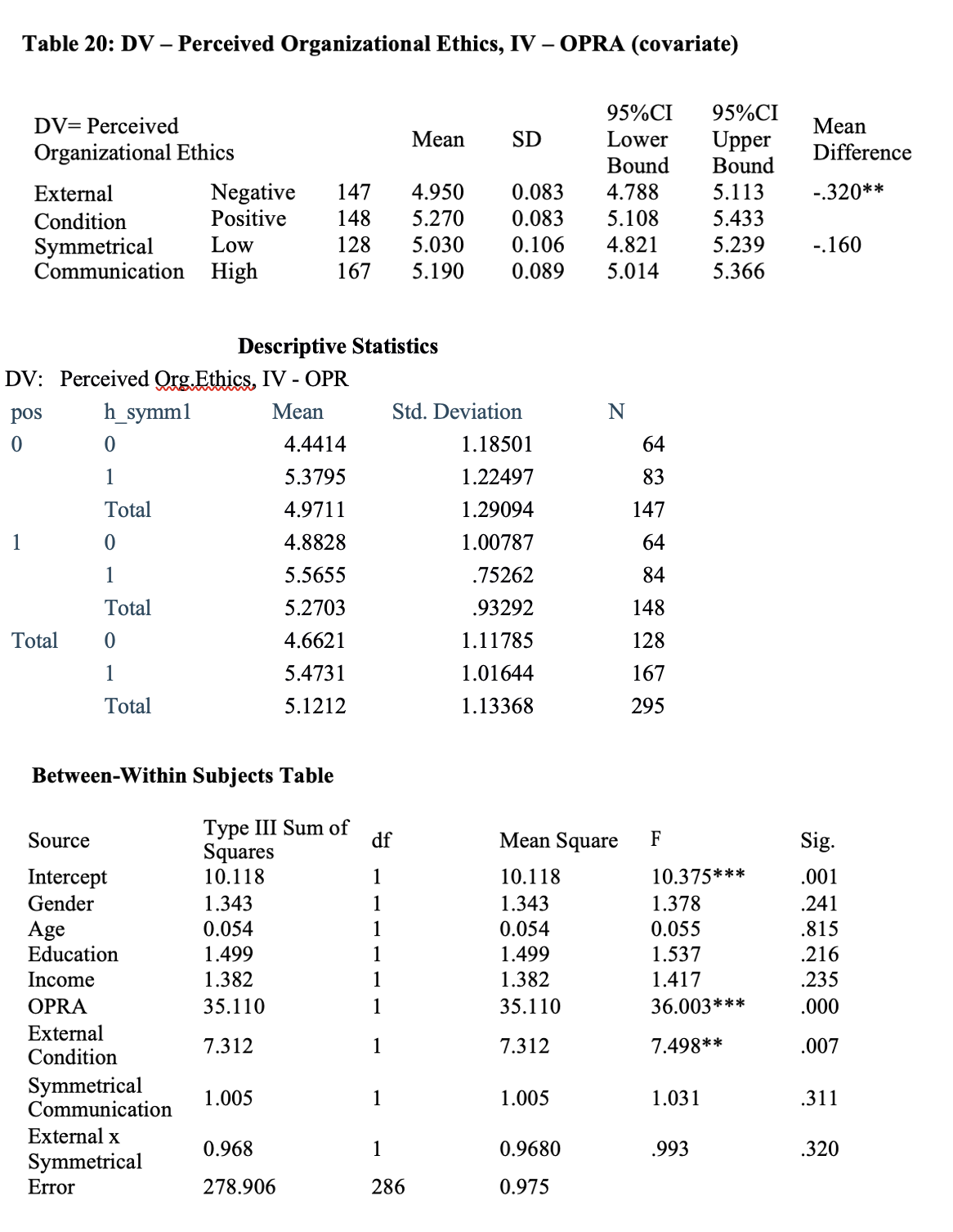*** p < .001 ** p < .01 * p < .05

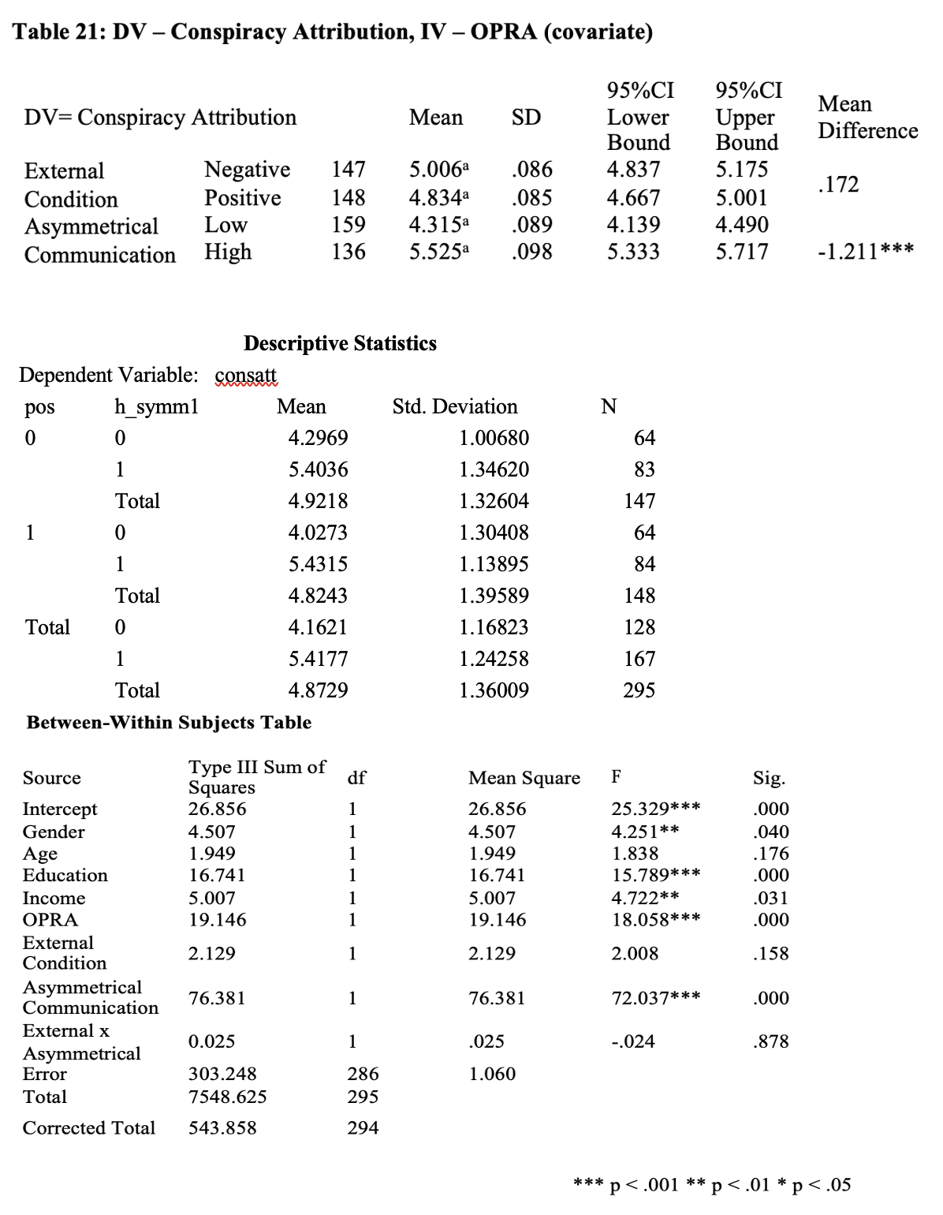
Survey Materials

Vignettes
The following are the vignette stimuli presented to participants in the research. Study 1 focused on internal publics (employees) of the 4 restaurants.
Negative Scenario

Please read the following vignette before proceeding to the next section. Burger King has found itself in the news over accusations of systemic flaws in food safety and hygiene protocols. Public scrutiny on health and safety practices at fast food restaurants has increased, and recently customers at multiple Burger King locations have alleged receiving undercooked or improperly prepared foods. The corporation is aware of a problem existing between franchise owners and corporate oversight on protocols at restaurants. They have been attempting to quietly solve the problems and end the outbreak of foodborne illnesses without causing a media stir or acknowledging a connection between the incidents of illness reported across the country. However, employees within the Burger King corporate structure and at restaurants are increasingly aware of the problem.

Neutral Scenario

Burger King is releasing a new line of meatless products which require different food-handling rules than the meat products of the past (which were largely stored frozen). The meatless options require many restaurants to get new food storage and preparation equipment to limit spoilage and cross-contamination. These upgrades are substantial and will change the classic layout of the kitchen at most franchises in a dramatic way. These upgrades are very costly, and some owners of franchises are upset about the costs. Burger King corporate is splitting the costs with independent franchisees who need renovations to offer the new menu items, which has quieted most of the upset owners.

Positive Scenario

Burger King has won a prestigious industry award for food safety and quality. The award, given annually to chain restaurants by the magazine Food and Wine, rarely places a fast-food chain among the pricier casual dining chains. Food & Wine is an international publication that rates and reviews restaurants all over the world. Fast food restaurants are rarely even discussed in the magazine. Burger King also has previously never been recognized by Food & Wine. Due to high performance and consistently high ratings from customers, particularly regarding consistency and satisfaction, Burger King was recognized over well-known chains such as P.F. Chang’s and Red Lobster.

The stimuli were input identically for all four restaurants with only the name of the restaurant changed. Each participant only saw the stimuli regarding the restaurant they work/worked for.

The following unrelated stimulus was presented with a set of questions regarding the unrelated information. It was presented to the participants in between answering OPRA relationship measure but before the presentation of the experimental stimuli in the study.

Please read the following passage and answer the questions.
Let’s assume that you own about 1000 stocks for a consumer goods manufacturer named HUMAN-TECH. Please read the following information about the company and answer the questions.
Successful market performance of HUMAN-TECH
HUMAN-TECH has grown continuously over the last 10 years and the business growth allowed the stock value to increase about 30% every year due to global market demands. Because the firm’s services and products are of higher quality and more reasonably priced than competitors, the company will be likely to boast an increasing sales record in the coming 3-5 years.
However, HUMAN-TECH has been criticized for making contracts with factories in developing countries with poor working conditions, exploiting cheap overseas labor. Employees in those factories have to work excessive overtime and are forced to stand for 24 hours. Also, it is claimed that the firm’s suppliers allegedly wrongly dispose of hazardous waste, and two explosions last year killed four people while injuring more than 150.

The following are the vignette stimuli presented to participants in the research. Study 2 focused on external publics (customers) of the 4 restaurants. They were presented two sets of experimental stimuli, again, identical save for the name of the restaurant. The first was adversarial or ambassadorial conditions, followed by negative or positive external issues scenario.

Adversarial Condition

Recently, several corporate mid-management employees at Burger King started a Reddit page where they disclosed secrets of what they call “a culture of lying.” The page disclosed a number of embarrassing, purportedly true accounts of meetings of Burger King executives talking about fooling customers and being dishonest about the products. The Burger King employees thread was very popular both among employees and customers, and attracted a sizable group of participants.

Ambassadorial Condition
After a social media post went viral accusing Burger King of being racist for forcing employees of color at some locations to wear hairnets, several employees at those locations and corporate employees of color sounded off on social media. They claimed that the pictures were taken out of context, that all employees at those locations are required to wear hairnets—not just the people of color—and furthermore, that Burger King has always fostered a positive environment focused on diversity.

Negative Scenario
The Burger King restaurant chain has come under fire from some of their own employees for lying about the freshness and preparation process of their new meatless plant-based offerings. A recent viral rumor started on Twitter, claiming the plant-based burgers often arrived at the franchise locations thawed and sometimes past expiration date, but that management had overlooked these issues. A Burger King employee took to Twitter to announce the company had been lying about the freshness of the meatless options and showing several pictures of meatless patties at locations sitting out in the sun. Their claims were soon echoed by several other employees who voiced their concerns about the organization over social media platforms, with some directly tagging and reaching out to activists in the diet and food safety industries.

Positive Scenario

The Burger King chain of restaurants received an industry award for cleanliness and quality of food prepared at their restaurants. Many fast-food chains had recently experienced negative news reports about the problems with cleanliness and a resulting move to increased automation. The win for Burger King was shared with the employees who had earned the award with their work. Cash bonuses, time off and other prizes were awarded to employees across the company. Employees throughout the company took to social media to share the bonuses they got from the organization and the award recognition they got from Burger King, causing the hashtag #IamBK to briefly become a trending topic across social media.

The following unrelated stimulus was presented with a set of questions regarding the unrelated information. It was presented to the participants in between answering OPRA relationship measure but before the presentation of the experimental stimuli in the study.

Please read the following passage and answer the questions.
Let’s assume that you own about 1000 stocks for a consumer goods manufacturer named HUMAN-TECH. Please read the following information about the company and answer the questions.
Successful market performance of HUMAN-TECH
HUMAN-TECH has grown continuously over the last 10 years and the business growth allowed the stock value to increase about 30% every year due to global market demands. Because the firm’s services and products are of higher quality and more reasonably priced than competitors, the company will be likely to boast an increasing sales record in the coming 3-5 years.
However, HUMAN-TECH has been criticized for making contracts with factories in developing countries with poor working conditions, exploiting cheap overseas labor. Employees in those factories have to work excessive overtime and are forced to stand for 24 hours. Also, it is claimed that the firm’s suppliers allegedly wrongly dispose of hazardous waste, and two explosions last year killed four people while injuring more than 150.

Survey Questions

INTERNAL PUBLICS – STUDY 1
OPRA: Trust
Questions | Strongly  disagree |  |  |  |  |  | Strongly  agree
Questions | 1 | 2 | 3 | 4 | 5 | 6 | 7
Whenever my organization makes an important decision, I know it will be concerned about me.
My organization can be relied on to keep its promises.
I believe that my organization takes my opinions into account when making decisions.
I feel very confident about my organization’s skills.
My organization has the ability to accomplish what it says it will do.
My organization treats people like me fairly and justly.

OPRA: Control Mutuality
Questions | Strongly  disagree |  |  |  |  |  | Strongly agree
Questions | 1 | 2 | 3 | 4 | 5 | 6 | 7
My organization and I are attentive to what the other says.
My organization believes my opinions are legitimate.
My organization really listens to what I have to say.
The management of my organization gives people like me enough say in the decision-making process.

OPRA: Commitment
Questions | Strongly  disagree |  |  |  |  |  | Strongly agree
Questions | 1 | 2 | 3 | 4 | 5 | 6 | 7
I feel that my organization is trying to maintain a long-term commitment to me.
I can see that my organization wants to maintain a relationship with me.
There is long-lasting bond between my organization and me.
Compared to other organizations, I value my relationship with this organization more.

OPRA: Satisfaction
Questions | Strongly  disagree |  |  |  |  |  | Strongly agree
Questions | 1 | 2 | 3 | 4 | 5 | 6 | 7
Overall, I am happy with my organization.
Both my organization and I benefit from the relationship.
I am happy in my interactions with my organization.
Generally speaking, I am pleased with the relationship my organization has established with me.

Acquisitive Relationship (Organizations & Publics)
Questions | Strongly disagree |  |  |  |  |  | Strongly agree
Questions | 1 | 2 | 3 | 4 | 5 | 6 | 7
My organization offer favors only when it can get something in return from its employees.
My organization generally consider its own interests over its employees’ welfare.
My organization is nice to its employees only when it knows it can get something in return.

Communal Relationship (Organizations and Publics)
Questions | Strongly disagree |  |  |  |  |  | Strongly agree
Questions | 1 | 2 | 3 | 4 | 5 | 6 | 7
My organization takes care of its employees even when doing so brings few returns.
I feel that my organization cares for me without calculation.
I feel cared for by my organization unconditionally.

Symmetrical communication
Questions | Strongly  disagree |  |  |  |  |  | Strongly  agree
Questions | 1 | 2 | 3 | 4 | 5 | 6 | 7
Most communication between managers and other employees in our company can be said to be two-way communication.
The purpose of communication in our company is to help managers to be responsive to the problems of other employees.
Supervisors encourage employees to express differences of opinion.
Employees are usually informed about major changes in policy that affect our job before they take place.
Employees are not afraid to speak up during meetings with supervisors and managers.

The following questions are about the communication with company. Please read the statement and answer how much you agree with the statement.

Asymmetrical communication

Questions | Strongly  disagree |  |  |  |  |  | Strongly  agree
Questions | 1 | 2 | 3 | 4 | 5 | 6 | 7
The purpose of communication in our company is to get employees to behave in the way top management wants us to behave.
Employees seldom get feedback when we communicate to managers.
In our company, management uses communication to control employees.
Managers here are not interested in hearing employee suggestions regarding ways to improve company performance.

Job satisfaction
Questions | Strongly  disagree |  |  |  |  |  | Strongly  agree
Questions | 1 | 2 | 3 | 4 | 5 | 6 | 7
Generally speaking, I am very satisfied with this job.
I am generally satisfied with the kind of work I do in this job.
Most people in this job are very satisfied with the job.

Q32-1. The following statements ask about your opinion regarding the above case. Please indicate if you agree or disagree with the following statements.
Questions | Strongly  disagree |  |  |  |  |  | Strongly agree
Questions | 1 | 2 | 3 | 4 | 5 | 6 | 7
I feel the company HUMAN-TECH has no reason to worry about the critics of its management as long as it continues its success.
I believe it is more important for a business to be concerned with successful outcomes than the means to achieve those outcomes.
I feel that successful managerial outcomes are the most important aspect by which to judge a corporation.
I think ethical business is mainly based on market success for the greatest good for the greatest number.
Based on my moral standard, the company HUMAN-TECH is an ethical business.
In order to turn profits, ethical managerial process can be compromised at times.
I think an ethical business should not inflict a loss on investors by all means.

EXPERIMENTAL STIMULI APPLIED

Positive Megaphoning
Questions | Strongly  disagree |  |  |  |  |  | Strongly agree
Questions | 1 | 2 | 3 | 4 | 5 | 6 | 7
I’d like to post positive comments about my organization in the Internet.
I’d praise my organization and management to friends and people I know.
I’d talk to neighbors and friends about how my organization does better than other companies.
I’d like to make efforts to persuade angry customers/activists in favor of my organization.
I’d fight for my organization against people who attacked my organization.
I’d counter any critiques someone says or posts online against my organization.

Negative Megaphoning
Questions | Strongly  disagree |  |  |  |  |  | Strongly agree
Questions | 1 | 2 | 3 | 4 | 5 | 6 | 7
I have posted negative notes/reviews about my company on the Internet.
I have criticized my company and management to friends and people I know.
I talk to neighbors and friends about how my company does poorer than other companies.
In the recent past, I have agreed and seconded with negative opinions about my company.
I would rather be silent even if someone attacks my company with inaccurate information.

Whistleblowing
Questions | Strongly  disagree |  |  |  |  |  | Strongly agree
Questions | 1 | 2 | 3 | 4 | 5 | 6 | 7
I’d criticize my company’s bad business practices to people I trust.
I’d like to talk about my organization’s bad business practices.
I’d criticize wrongdoings of my organization to friends and people I know.
I feel like whistleblowing about troubling business practices committed by our management.
I’d tell my friends and people I know about the problems of my organization and management.

Leakage
Questions | Strongly  disagree |  |  |  |  |  | Strongly agree
Questions | 1 | 2 | 3 | 4 | 5 | 6 | 7
I’d not care whether I slip my tongue revealing some secret business information to friends/family.
I feel not sorry even if I share important business information with others.
I would not feel sorry even if I pass along confidential corporate news to friends/family.
I’d not care even if I share new innovative products/service that our management kept as a business secret.
I’d not feel sorry even if I talk about competitive business information that our company keeps confidential.

Ethical orientation
The following questions are about your company. Please read the statement and answer.
Q1. In general, the top managers of my company favor… | A strong emphasis on the results | 1 2 3 4 5 6 7 | A strong emphasis on the working process
 | Those relentless goal-seekers who bring outcomes by working | 1 2 3 4 5 6 7 | Those rule-followers abiding by rules and guidelines in working
Q2. In general, the top managers of my company tend to think… | “There is no rule without exceptions.” | 1 2 3 4 5 6 7 | “Rules are rules.”
 | Social norms and ethics are obstacles to better business | 1 2 3 4 5 6 7 | Social norms and ethics are safeguard of better business
Q3. In dealing with its competitors, my company… | Typically uses any ideas and methods if they lead to wins | 1 2 3 4 5 6 7 | Typically contemplates ideas and methods only within norms and ethics
 | Often play tricks or deceives to win | 1 2 3 4 5 6 7 | Seldom play tricks or deceives
Q4. When confronted with decision-making situations involving uncertainty, my company … | Typically adopts a fast-and-aggressive posture with little attention to possible consequences to others to maximize success | 1 2 3 4 5 6 7 | Typically adopts a ‘wait-and-see’ posture to avoid wrongdoings or loss to others’ interests
 | Typically pays little attention to people who would get negative consequences | 1 2 3 4 5 6 7 | Typically pay careful attention to all possible stakeholders whose interests are affected

Conspiracy
Questions | Strongly  disagree |  |  |  |  |  | Strongly agree
Questions | 1 | 2 | 3 | 4 | 5 | 6 | 7
People in power will use shadowy means to gain profit or an advantage, rather than lose it.
There are always powerful groups plotting to sway the outcomes of elections.
Nothing in politics or world affairs happens by accident or coincidence.
Many major events have behind them the actions of a small group of influential people.
There are people with power who will do anything to hide the truth from public scrutiny.
In recent major corporate events that happened in my company, a small group of influential managers secretly plotted actions behind the scenes.
I feel that a small group of influential people carefully conspired to bring about recent changes in my company.
I feel the supervisor (team leader) secretly plotted to make the recent changes in my team, excluding most members.
I think my employer discounts the real risks and troubles of Coronavirus to get more business.
The management of my company hides actual risks and falsely reports safety in workplace.

This is last part of our survey. The following questions are asking about your demographic information.

Q41. What is your gender?
1. Male 2. Female

Q42. What is your age?
_________ years

Q43. What is your highest level of school you have completed or the highest degree you have received?
1. High school incomplete
2. High school graduate or GED (includes technical/vocational training that doesn’t count towards college credit)
3. Some degree (some community college, associate's degree)
4. Four year college degree/bachelor's degree
5. Some postgraduate or professional schooling, no postgraduate degree
6. Postgraduate or professional degree, including mater's, doctorate, medical or law degree

Q44. Which of following describes your race?
1. White
2. Black or African-American
3. Asian or Asian-American
4. Native American/American Indian/Alaska native
5. Native Hawaiian/Other Pacific Islanders
6. Some other race, specify: ______

Q45. Last year, that is in 2017, what was your total family income from all sources, before taxes?
1. Less than $15,000
2. $15,000 to less than $30,000
3. $30,000 to less than $45,000
4. $45,000 to less than $60,000
5. $60,000 to less than $75,000
6. $75,000 to less than $90,000
7. $90,000 to less than $105,000
8. $120,000 to less than $135,000
9. $135,000 to less than $150,000
10. $150,000 or more

EXTERNAL PUBLICS – STUDY 2

OPRA: Trust
Questions | Strongly  disagree |  |  |  |  |  | Strongly  agree
Questions | 1 | 2 | 3 | 4 | 5 | 6 | 7
When this company makes decisions, they seem to have the customer’s best interests in mind
This company can be trusted to keep its promises.
I believe that this company takes my opinions into account when making decisions.
I feel very confident about this company’s ability to deliver what it advertises.
This company has the ability to accomplish what it says it will do.
This company treats people like me fairly and justly.

OPRA: Control Mutuality
Questions | Strongly  disagree |  |  |  |  |  | Strongly agree
Questions | 1 | 2 | 3 | 4 | 5 | 6 | 7
This company and I pay attention to what each other says.
This company believes my opinions are legitimate.
This company really listens to what I have to say.
The management of this company gives people like me enough say in the decision-making process.

OPRA: Commitment
Questions | Strongly  disagree |  |  |  |  |  | Strongly agree
Questions | 1 | 2 | 3 | 4 | 5 | 6 | 7
I feel that this company is trying to maintain a long-term commitment to me.
I can see that this company wants to maintain a relationship with me.
I have a long-lasting bond with this company.
I value my relationship with this company more than most companies.

OPRA: Satisfaction
Questions | Strongly  disagree |  |  |  |  |  | Strongly agree
Questions | 1 | 2 | 3 | 4 | 5 | 6 | 7
Overall, I am happy with this company.
Both the company and I benefit from our relationship.
I am happy with my interactions with this company.
Generally speaking, I am pleased with the relationship this company has established with me.

Acquisitive Relationship (Organizations & Publics)
Questions | Strongly disagree |  |  |  |  |  | Strongly agree
Questions | 1 | 2 | 3 | 4 | 5 | 6 | 7
This company only does things that improve my experience when it can make more money.
This company generally consider its own interests over its customers’ satisfaction.
This company is kind to its customer only when it knows they will buy something.

Communal Relationship (Organizations and Publics)
Questions | Strongly disagree |  |  |  |  |  | Strongly agree
Questions | 1 | 2 | 3 | 4 | 5 | 6 | 7
This company takes care of its customers even when doing so doesn’t increase profits.
I feel that this company cares for me regardless of money.
I feel cared for by this company unconditionally.

The following questions are about the communication with company. Please read the statement and answer how much you agree with the statement.

Symmetrical comm
Questions | Strongly  disagree |  |  |  |  |  | Strongly  agree
Questions | 1 | 2 | 3 | 4 | 5 | 6 | 7
Most communication between this company and customers can be said to be two-way communication.
The purpose of communication in this company is to help managers to be responsive to the problems of customers.
Management in this company encourages customers to express their disappointments and suggest alternatives.
Customers are usually informed about major changes in policy that affect the product they buy before the changes take place.
Customers are not afraid to speak up regarding problems with service or products the company delivers.

Asymmetrical comm
Questions | Strongly  disagree |  |  |  |  |  | Strongly  agree
Questions | 1 | 2 | 3 | 4 | 5 | 6 | 7
The purpose of communication in this company is to get customers to behave in the way top management wants us to behave.
Customers rarely get feedback when they contact the company.
In this company, management uses communication to control customers.
Managers at this company are not interested in hearing customer suggestions regarding ways to improve company performance.

Satisfaction
Questions | Strongly  disagree |  |  |  |  |  | Strongly agree
Questions | 1 | 2 | 3 | 4 | 5 | 6 | 7
Overall, I am happy with this company.
I am happy in my interactions with this company.
I find the quality of the products to be worth the cost
I find the service to be of generally high quality.
I believe the company treats its employees fairly.
I believe the company acts generally out of interest for profit.
I believe all other things being equal, the company will act in a generally moral way.
I believe there’s no amount of profit too small to make the company act in an immoral way to earn more.

Q32-1. The following statements ask about your opinion regarding the above case. Please indicate
if you agree or disagree with the following statements.
Questions | Strongly  disagree |  |  |  |  |  | Strongly agree
Questions | 1 | 2 | 3 | 4 | 5 | 6 | 7
I feel the company HUMAN-TECH has no reason to worry about the critics of its management as long as it continues its success.
I believe it is more important for a business to be concerned with successful outcomes than the means to achieve those outcomes.
I feel that successful managerial outcomes are the most important aspect by which to judge a corporation.
I think ethical business is mainly based on market success for the greatest good for the greatest number.
Based on my moral standard, the company HUMAN-TECH is an ethical business.
In order to turn profits, ethical managerial process can be compromised at times.
Questions | Strongly  disagree |  |  |  |  |  | Strongly agree
Questions | 1 | 2 | 3 | 4 | 5 | 6 | 7
I feel the company HUMAN-TECH is a bad business even
though it continues its success.
I believe the successful outcomes cannot justify the means
to those outcomes.
I believe that following moral obligations in managerial
process is the most important aspect by which to judge a corporation.
Based on my idea of fairness, the Company HUMAN-TECH
is an unethical business.
I think this company is unethical because it has little ethical concerns in labor rights.
I think the company should abide by law in order to be an
ethical company rather than to avoid criticism.
Although the company did not directly hire the overseas
labor workers, the company should be responsible for the
poor working conditions.
I think an ethical business should not inflict a loss on investors by all means.

EXPERIMENTAL STIMULI APPLIED

Positive Megaphoning
Questions | Strongly  disagree |  |  |  |  |  | Strongly agree
Questions | 1 | 2 | 3 | 4 | 5 | 6 | 7
I give credence to positive comments about the organization made by employees on the Internet.
When I read something positive about the organization written by an employee, I tend to think it reflects well on the organization.
I talk to neighbors and friends, or share social media content, about how the employees of the organization say positive things, or things in defense of the organization.
When I read something positive about the organization written by an employee, I find it persuasive.

Negative Megaphoning
Questions | Strongly  disagree |  |  |  |  |  | Strongly agree
Questions | 1 | 2 | 3 | 4 | 5 | 6 | 7
I give credence to negative comments about the organization made by employees on the Internet.
When I read something negative about the organization written by an employee, I tend to think it reflects poorly on the organization.
I talk to neighbors and friends, or share social media content, about how the employees of the organization say negative things or point our problems.
When I read something positive about the organization written by an employee, I find it persuasive.

Ethical orientation
The following questions are about this company. Please read the statement and answer how
you feel about the management and the business they run.

Q1. In general, the top managers of this company favor… | A strong emphasis on the results | 1 2 3 4 5 6 7 | A strong emphasis on the working process
 | Those relentless goal-seekers who bring outcomes by working | 1 2 3 4 5 6 7 | Those rule-followers abiding by rules and guidelines in working
Q2. In general, the top managers of this company tend to think… | “There is no rule without exceptions.” | 1 2 3 4 5 6 7 | “Rules are rules.”
 | Social norms and ethics are obstacles to better business | 1 2 3 4 5 6 7 | Social norms and ethics are safeguard of better business
Q3. In dealing with its competitors, this company… | Typically uses any ideas and method that lead to wins | 1 2 3 4 5 6 7 | Typically contemplate ideas and method only within the norms and ethics
 | Often play tricks or deceives to win | 1 2 3 4 5 6 7 | Seldom play tricks or deceives
Q4. When confronted with decision-making situations involving uncertainty, this company… | Typically adopts a fast-and-aggressive posture to maximize success, with little attention to possible consequences to others | 1 2 3 4 5 6 7 | Typically adopts a ‘wait-and-see’ posture, to avoid wrongdoings or loss to others’ interests
 | Typically pays little attention to people who would get negative consequences | 1 2 3 4 5 6 7 | Typically pays careful attention to all possible stakeholders whose interests are affected

Conspiracy
Questions | Strongly  disagree |  |  |  |  |  | Strongly agree
Questions | 1 | 2 | 3 | 4 | 5 | 6 | 7
People in power will use shadowy means to gain profit or an advantage.
There are always powerful groups plotting to sway the outcomes of elections.
Nothing in politics or world affairs happens by accident or coincidence.
Many major events have behind them the actions of a small group of influential people.
There are people with power who will do anything to hide the truth from public scrutiny.
For this company, I feel there is a small group of influential managers secretly plotting actions behind the scenes.
For this company, I feel a small group of influential people carefully conspired in the current situation.
I think this company discounts the real risks and troubles of food safety to get more business.
The management of this company hides actual risks and falsely reports food safety for its customers.

CAPTCHA Question

My Favorite item at Burger King to eat is:
Burgers
Chicken Sandwiches
Salads
Plant-based Meatless Sandwiches
Deserts

Demographics Section

This is last part of our survey. The following questions are asking about your demographic information.
Q41. What is your gender?
1. Male 2. Female

Q42. What is your age?
_________ years

Q43. What is your highest level of school you have completed or the highest degree you have received?
1. High school incomplete
2. High school graduate or GED(includes technical/vocational training that doesn’t count towards college credit)
3. Some degree (some community college, associate's degree)
4. Four year college degree/bachelor's degree
5. Some postgraduate or professional schooling, no postgraduate degree
6. Postgraduate or professional degree, including mater's, doctorate, medical or law degree

Q44. Which of following describes your race?
1. White
2. Black of African-American
3. Asian or Asian-American
4. Native American/American Indian/Alaska native
5. Native Hawaiian/Other Pacific Islanders
6. Some other race, specify: ______

Q45. Last year, that is in 2017, what was your total family income from all sources, before taxes?
1. Less than $15,000
2. $15,000 to less than $30,000
3. $30,000 to less than $45,000
4. $45,000 to less than $60,000
5. $60,000 to less than $75,000
6. $75,000 to less than $90,000
7. $90,000 to less than $105,000
8. $120,000 to less than $135,000
9. $135,000 to less than $150,000
10. $150,000 or more

