UNIVERSITY OF OKLAHOMA
GRADUATE COLLEGE

SPATIAL COMPARISONS AMONG STREAM BIOTA
AT NATIONAL AND REGIONAL LEVELS

A THESIS
SUBMITTED TO THE GRADUATE FACULTY
In partial fulfillment of the requirements for the
Degree of
Master of Science

By
STEVEN M. BITTNER
Norman, Oklahoma
2021
SPATIAL COMPARISONS AMONG STREAM BIOTIA
AT NATIONAL AND REGIONAL LEVELS

A THESIS APPROVED FOR THE
DEPARTMENT OF BIOLOGY

BY THE COMMITTEE CONSISTING OF

Dr. Elizabeth Bergey, Chair

Dr. Keith Gido

Dr. Michael Patten

© Copyright by Steven M. Bittner 2021
All Rights Reserved.

ACKNOWLEDGEMENTS
I would like to thank my advisor, Dr. Elizabeth Bergey for her mentorship and guidance. Dr. Bergey helped me through difficult times and has shown me what a true mentor should be. Her passion for stream ecology is quite infectious and has helped shape the way I approach science. This work would not have been possible if not for her constant support and encouragement. Thank you to my committee members Dr. Keith Gido and Dr. Michael Pattern for their guidance, kindness, and advice. Thank you to Dr. Susan Walden for her incredible support during my early years here.
Thank you to my past mentors and lab mates who helped me get to where I am today and whose support and friendship did not falter no matter the distance: Dr. Allison Roy, Dr. Adrian Jordaan, Matt Devine, Steve Mattocks, and Anthony Dangora.
I would like to thank the folks who helped contributed to field work and lab work. Amanda Doan, Vivian Taylor, Isabelle Cunitz, Sydney Vu, T.J. Holder, and Juan Ramos. Their diligent work during data collection and processing has made an invaluable contribution to this degree. Michelle Busch, thank you for your friendship and for helping us feel a bit less “un poco loco” during our many hours spent dragging our canoe up riffles and boulders. Thank you to the many landowners and friendly folks encountered in the field, your kindness and eagerness to help was an important part of field collections.
I gratefully acknowledge the funding received towards my degree from the Louis Stokes Alliances for Minority Participation Bridge to Doctorate fellowship and to the NSF Research Traineeship fellowship.
Thank you to some special folks and friends in my life for supporting me always and through tough times. Patricia Murphy, Tanner Gibson, Javier Cordova Jr., Giovanni Tolentino Ramos, Ramiro Patino, Julián Guevara Orrego, and Amanda Doan. My most important thank you goes to Nicholas “Smoochie” Mucci, you are my person and have been a guiding light in my life – I am so grateful for you. Thank you to my family for their unconditional love and support.

TABLE OF CONTENTS
ACKNOWLEDGMENTS............................................................................................................. iv
LIST OF TABLES...................................................................................................................... viii
LIST OF FIGURES....................................................................................................................... ix
LIST OF APPENDICES............................................................................................................... 77
ABSTRACT................................................................................................................................. xii
CHAPTER 1: Variation in community stability among biotic groups in streams ........................ 1
INTRODUCTION ............................................................................................................. 1
METHODS......................................................................................................................... 4
RESULTS........................................................................................................................... 7
DISCUSSION..................................................................................................................... 9
LITERATURE CITED..................................................................................................... 17
TABLES........................................................................................................................... 27
FIGURES......................................................................................................................... 28
CHAPTER 2: Consideration in selection of reference streams for biomonitoring ..................... 34
INTRODUCTION ........................................................................................................... 34
METHODS....................................................................................................................... 38
RESULTS......................................................................................................................... 41
DISCUSSION................................................................................................................... 46
LITERATURE CITED..................................................................................................... 50
TABLES........................................................................................................................... 56
FIGURES.......................................................................................................................... 67
APPENDICES.................................................................................................................. 77

LIST OF TABLES
CHAPTER 1
Table 1. Results from Generalized Additive Models for fish, macroinvertebrate, and diatom communities with explanatory variables effects on community stability ……………………… 27
CHAPTER 2.
Table 1. Names and descriptions of selected level 3 and 4 ecoregions that encompass our study sites in Southeast Oklahoma……………………………………………………………………. 56
Table 2. List of variables used to characterize watersheds and ecoregions with the associated codes and descriptions………………………………………………………………………..… 58
Table 3. Sørensen similarity values (mean + sd) of 29 stream fish and macroinvertebrate communities for each watershed or ecoregion………………………………………………….. 61
Table 4. Index of Biotic Integrity (IBI) values, richness, and abundance (mean + sd) fish and macroinvertebrate communities for each grouping…………………………………………..… 62
Table 5. Results from SIMPER analysis showing only species or variables that contributed to ~50% dissimilarity in fish communities. ………………………….…………………………… 63
Table 6. Results from SIMPER analysis showing only species or variables that contributed to ~50% dissimilarity in macroinvertebrate communities. ………………………….……………. 64
Table 7. Results from SIMPER analysis showing only species or variables that contributed to ~50% dissimilarity in physical characteristics ………………………….……………………… 65

LIST OF FIGURES
CHAPTER 1
Figure 1. Locations of NAWQA study sites …………………………………………………... 28
Figure 2. Map of sites detailing temporal average richness for each community……………... 29
Figure 3. Linear regression of average temporal richness and longitude for each community... 30
Figure 4. Results from stability analysis for each taxa group …………………………………. 30
Figure 5. Results from generalized additive models for fish communities ………………….... 31
Figure 6. Results from generalized additive models for macroinvertebrates communities …… 32
Figure 7. Results from generalized additive models for diatom communities ……………...… 33
CHAPTER 2
Figure 1. Maps of study area in Southeast Oklahoma. ………………………….…………..… 67
Figure 2. Comparison of fish communities in 29 stream sites relative to two watersheds……. 68
Figure 3. Comparison of fish communities in 29 stream sites relative to two level 3 ecoregions……………………………………………………………………….……… 69
Figure 4. Comparison of fish communities in 29 stream sites relative to level 4 ecoregions……...………………………….………………………….……………….... 70
Figure 5. Comparison of macroinvertebrate communities in 29 stream sites relative to two watersheds………………………….………………………….………………………... 71
Figure 6. Comparison of macroinvertebrate communities in 29 stream sites relative to two level 3 ecoregions………………………….………………………….……………………… 72
Figure 7. Comparison of macroinvertebrate communities in 29 stream sites relative to level 4 ecoregions………………………….………………………….……………….……….. 73
Figure 8. Comparison of physical characteristics in 29 stream sites relative to two watersheds…..………………………………….……………………………………….. 74
Figure 9. Comparison of physical characteristics in 29 stream sites relative to two level 3 ecoregions………………………………………….………………………….……...… 75
Figure 10. Comparison of physical characteristics in 29 stream sites relative to level 4 ecoregions…………………………….………………….……………………………... 76
LIST OF APPENDICES
CHAPTER 2
Appendix 1. Macroinvertebrate community composition (abundance) from 16 stream sites in the Glover River Watershed and 13 sites in the Middle Little River Watershed. Also included are the values used to calculate IBI…………………………….………………….…………………… 77
Appendix 2. Fish community composition with raw abundance values……………………….. 97
Appendix 3. Details of which species are associated with the 8 criteria used for the calculation of Index of Biotic Integrity based on fish communities…...………………………….……..... 100
Appendix 4. Sites rankings of component categories for Index of Biotic Integrity……...…... 103
Appendix 5. Macroinvertebrate community IBI, # species used for IBI calculations, and total abundance for 29 stream sites……………………….………………………………….……... 105
Appendix 6. Fish community IBI, # species used for IBI calculations, and total abundance for 29 stream sites……………………….………………………………….……………...…….... 107

ABSTRACT
Streams are subjected to multiple anthropogenic stressors and will continue to be, far into the future. Biological monitoring is an important method for analyzing the effects of impacts on stream health and biotic communities, and to plan effective management and conservation actions. We used national monitoring data and regional data to assess the impact of geographical and environmental factors on the stability of stream communities and the selection of stream monitoring sites, respectively.
For the first study, we used National Water Quality Assessment biotic community data from the United States Geological Survey to determine factors that influence the stability of stream communities. We used multiple taxa groups (i.e., fish, macroinvertebrates, and diatoms) to assess within-site community stability and used generalized additive modeling with environmental, physical, temporal, and other biologically relevant data to indicate the relative importance of factors associated with the stability of each community group. We found that turnover time was associated with comparative stability across fish, macroinvertebrate, and diatom communities, and found that the weak influence of other factors was likely clouded by the large geographic scale of our study.
For the second study, we investigated criteria useful in selecting reference streams for biomonitoring when we have no previous monitoring information. We used fish, macroinvertebrate, and environmental data from 29 streams across two watersheds and three ecoregions in southeast Oklahoma to indicate factors that should be considered in reference site selection. Data were analyzed using multiple multivariate methods and an Index of Biotic Integrity. We found that ecoregions and watersheds should be considered when selecting reference site and demonstrated that using a variety of taxa and analysis methods could better describe possible impacts.
Together, these two studies supplement current knowledge of how environmental, physical, and geographical factors influence multiple biotic groups in stream communities.

CHAPTER 1: Variation in community stability among biotic groups in streams
ABSTRACT
Uncovering broad patterns in community stability is important for conservation and management in our changing world. Interannual compositional stability is an important measure of community stability that is often overlooked. We used summer-collected NAWQA river and stream monitoring data to compare community stability of fish, macroinvertebrates, and diatoms across the United States, and used generalized additive models to determine factors (i.e., richness, environmental variability, time, and network position) associated these patterns. Community stability was highest for fish communities, intermediate for macroinvertebrate communities, and lowest for diatom communities. Differences in community stability corresponded to the different typical generational times of each community. For example, the high turnover rate of diatom communities results in greater year-to-year variation (lower stability) than communities of the much longer-lived fish (higher stability). The lack of strong patterns of factors influencing stability were also clouded by the wide spatial scale of our study. Further research using finer environmental metrics and focusing on multiple regional spatial scales may yield more generalized patterns of and factors enhancing community stability.
INTRODUCTION
A thorough knowledge of the processes that influence stability of communities is a central goal of ecology (MacArthur 1955; Paine 1969; Kefi et al. 2019) and is important for informing management and conservation in our rapidly changing world (Hooper et al. 2005; Lewis & Maslin, 2015). Most studies have investigated stability measured as variability in abundance or biomass while ignoring the stability of community composition (Myrka et al. 2011), and these studies are mainly focused on terrestrial taxa or simple mesocosm experiments (Lehman and Tilman 2000; Tilman et al. 2006; Narwani and Mazumder 2012; Duncan et al. 2015). Compositional community stability is a better measure of species presence and absence and changes in abundances compared to aggregate community stability that is based on total raw abundance. A fair number of studies have investigated the influence of factors like community properties (e.g., richness) and environmental characteristics like environmental variability and network structure on turnover of aquatic communities (Bradley & Ormerod, 2001; Scarsbrook, 2002; Mykra, Heino & Muotka, 2008); however, many most studies have not explicitly detailed how they influence the temporal compositional similarity of communities (Mykra et al. 2011).
Previous studies have indicated factors that might influence compositional community stability. Often examined are specific community properties such as richness (MacArthur 1955; Elton 1958; Cottingham, Brown & Lennon, 2001; Biggs et al, 2020) or temporal extent (Kummerer 1996; Walkovich et al, 2014; Ross et al. 2021), and studies are increasingly including a variety of environmental characteristics (Johnson et al, 1996; McNaughton, 1977; Townsend et al, 1987; Korhonen et al, 2010) that might affect the stability of communities. The stability-diversity debate is longstanding in ecology and predicts that high richness or diversity results in high stability (reviewed in Biggs et al, 2020). This theory considers that communities are stabilized by species richness, as high richness can buffer communities from community changes by providing a wider species pool that can reduce extinction rates and permit species recolonization after a disturbance, thereby reducing the amount of community compositional variation (Mouquet et al. 2005). Similarly, richness buffers stability by providing functional redundancy, whereby if a species is lost, another species can fill its functional role and buffer community from change (McCann 2000). Environmental variability is increasingly viewed as a major determinant of community stability (Johnson et al, 1996), where environmental variation is often negatively related to community stability (Paller 2002; Mykra et al, 2011; Kuczynski et al, 2018). This is often attributed to greater loss of species with higher environmental variability and the ability of a community to return to a pre-disturbance state (Gelwick 1990). Like above, theory predicts that higher diversity can buffer communities from disturbances, thereby maintaining stability.
Our goal was to use multiple communities with contrasting life histories to seek patterns about within-site stability (measured as compositional similarity across time) and both community (richness) and environmental properties (e.g., temperature, rainfall and stream discharge), and temporal factors that might influence stability. If there are similar patterns in what influences different communities (fish, macroinvertebrates, and diatoms), we may more easily work to manage and conserve riverine ecosystems without having to target a single community (Hansen and Carey 2015). To answer this question, we used publicly available monitoring data to compare community stability in river networks across the United States for three separate taxa groups: fishes, macroinvertebrates, and diatoms. We expected that stability, measured as among-year similarity in community composition, would increase with richness. We further tested the relationship of environmental variation to community stability and expected that higher environmental variation would result in decreased community stability due to more intense disturbances. We predicted that larger catchment area would result in higher stability because larger habitats hold more species (higher richness), and larger habitats can buffer and reduce the intensity of disturbances (Schlosser & Ebel, 1989) and provide more refugia for organisms, thereby reducing species loss. Finally, we tested whether network position and temporal extent were associated with stability.

METHODS
Samples & Identification
Our data come from the National Water Quality Assessment (NAWQA) Program within the U.S. Geological Survey (http://water.usgs.gov/nawqa) (USGS, 2011; Version # 16.1). The NAWQA program documents national patterns in biological communities and associated stressors over time. NAWQAs target communities (fish, inverts, diatoms) were sampled in the summer (June to August) starting in 1990 and continue today. We used data from 1990 to 2018 and our study includes at least 50 sites for each of the target communities. Criteria for sites included at least three years of collections of at least one of the target communities and there was some variation in laboratory methods, so the sites we used had similar methods. Further, we removed sites where we were unable to compute explanatory metrics. Target communities were not always sampled at the same time, leading to unequal sample sizes for each community. Fish communities were sampled using complementary seining and electrofishing methods in all habitats (riffle, pool, run). The reach is sampled by electrofishing in two separate passes then with three seine hauls or kicks which are combined prior to enumeration and identification. Diatom communities were sampled by scrubbing/scraping hard surfaces at the “richest targeted habitat”, which were rocks, wood, or macrophytes in riffles or runs with relatively fast current. A standardized area of substrate was sampled in five replicates in at least 5 locations within the site. Diatom slides were prepared for identification and enumeration by oxidizing organic material with nitric acid in a laboratory microwave and then were mounted in Naphrax and enumerated by counting a standardized 600 valves per sample. Invertebrate communities were also sampled at the “richest targeted habitat”, which was sampled according to priority of riffles (coarse grained streams), woody snags (fine grained streams), or macrophyte beds if riffles and woody snags were not present at the site. Macroinvertebrates were sampled using a slack sampler with 5 pooled collections (total area = 1.25 m², mesh = 500 μm) and preserved in 10% formalin. In the lab, 300-800 individuals were sorted from the samples and identified to the lowest possible taxonomic level. All revised sampling and analysis protocols can be found at https://pubs.er.usgs.gov/publication/ofr2002150.
Local community stability
The response variable, community stability, was calculated using the function multivariate_difference from the codyn R package (Hallett et al. 2018). This function creates a Bray-Curtis distance matrix for each individual site then computes pairwise compositional differences between centroids of each time point within the site. We used the average of the temporal compositional differences to yield an average temporal compositional variability metric. Finally, local community stability was calculated, for each site, as 1 minus the average temporal compositional variability. The response variable is then bounded between 0 and 1, where 1 is high stability and 0 is low stability. This metric is unitless, so can be compared among datasets.
Environmental and other explanatory data
The remaining variables were calculated with the StreamNetworkTools Package (https://github.c om/dkopp3/StreamNetworkTools_git), which makes use of the NHDPlusV2 and StreamCat datasets. Catchment area was used as a proxy for habitat size and defined as the area (in km²) of delineated local catchment. Three variables related to environmental variability were used: flow variability, precipitation variability, and temperature variability, defined as the coefficient of variation (CV) of mean monthly discharge, mean monthly precipitation and mean monthly air temperature, respectively.
The number of years sampled differed among sites so the ‘number of temporal replicates’ was used as an explanatory variable. The range of time between which samples were taken also differed among sites, so the ‘average time between samples’ which was calculated as the entire temporal extent divided by the number of temporal replicates. Temporal average richness (number of taxa present at a site) was calculated as the average richness among time points across the ‘number of sampling events’ (years sampled.
Network metrics
Spatial theory provides methods to analyze complex spatial landscapes like branching river networks and graph theory is an extension of spatial theory that provides tools for analyzing a network and easily comparing among networks. To characterize network position, we used graph theory to create networks in which sampling sites were defined as nodes and the stream corridors connecting them as edges, and calculated two network metrics, closeness and betweenness centrality. Closeness Centrality represents how close (or clumped) a node is in relation to all the other nodes in a graph. Betweenness Centrality indicates the centrality of a node in the network and, high BC values represent a more central “steppingstone” in the dispersal network. Each network was built at the HUC12 level (local sub-watershed level that captures tributary systems) using GRASS GIS (version 7.1svn, GRASS Development Team, 2012) and the R packages ‘shp2graph’ (Lu and Lu 2018) and iGraph (Csardi 2013). Each metric was normalized for the number of nodes within a given network.

Statistical Analysis
Generalized Additive Modeling (GAM) was used to explain variance in stability among sites. GAMs are an extension of GLMs and can model both linear and non-linear relationships. Bootstrap analysis showed that temporal extent heavily influenced community stability so, to account for this effect of sample extent we chose to use the number of temporal replicates as a covariate in the GAM model. The addition of a covariate allows us to reduce the error left in the model so we can better identify significant predictors. To implement in-model variable selection, we added an additional penalty by using select=T in the GAM formula. GAMs were modeled were created using the ‘mgcv’ (Wood 2015) package in R.
We measured variable importance using the function “varimp” from the R package ‘caret’ (Kuhn et al. 2020) to deconstruct the overall model adjusted R². For GAMs, this method extracts p-values for each associated smooth variable and uses those as a proxy of variable importance.
RESULTS
The final numbers of sites per community were 72 fish communities, 61 macroinvertebrate communities, and 50 diatom communities (Figure 1). Sites were characterized by Strahler stream order values ranging from 1 to 7 with a median of 4. The number of temporal replicates ranged from 3 to 19 replicates with a mean of ~8 replicates (years sampled).
Temporal average richness ranged from 1 to 34 for fish, 17 to 67 for macroinvertebrates, and 18 to 74 for diatoms. Richness significantly decreased with longitude (Figures 2 and 3), specifically, from east to west for fish (R²=0.22, p < 0.001) and macroinvertebrates (R²=0.23, p < 0.001), with a sharp decline at ~105 degrees longitude for fish (Figure 2 A), and there was no pattern with diatom richness (R²=0.02, p = 0.30).
Relative importance of factors influencing stability
Fish
Fish communities had higher stability (range 0.28 - 0.82, mean 0.56, Figure 4) compared to the other communities. Temperature variability and precipitation variability explained significant variation for fish community stability (temperature F=3.478, p=0.0001, R²=0.158; precipitation F=3.332, p=0.0001, R²=0.12), however discharge variability did not. These relationships were non-linearly correlated with stability (Figure 5). Average temporal taxonomic richness was significantly negatively correlated with stability for fish communities (F=0.892, p=0.026, R²=0.05). Richness was positively correlated with catchment area/habitat size fish communities (linear regression of richness with log transformed catchment area; p=0.02, R²=0.07). There were no significant effects of habitat size on fish community stability. The number of temporal replicates was significantly related to fish community stability with a sinuous non-linear pattern and sharp decline at higher values of replicate number (F=2.6, p=0.036, R²=0.046). Fish community stability also had a significant negative relationship with the average time between samples. Fish community stability was significantly correlated with closeness (F=1.337, p=0.009, R²=0.065) and betweenness (F=1.799, p=0.005, R²=0.072).
Benthic macroinvertebrates
Invertebrate communities were rather unstable (range 0.13 - 0.61, mean 0.35, Figure 4). Discharge variability was negatively correlated with stability (F=1.398, p=0.006, R²=0.066) whereas precipitation variability was positively correlated with stability (F=3.361, p=0.001, R²=0.111). Habitat size was related to community stability of macroinvertebrates (F=1.193, p=0.02, R²=0.049) with a nonlinear pattern, specifically negatively correlated with habitat size at the highest values of habitat size but positively related at the lower values. There was no relationship between stability and average temporal richness and richness was not correlated to habitat size. There was no relationship between stability and either network metric (closeness and betweenness) for macroinvertebrates and stability was not influenced by the number of temporal replicates or average time between samples (Figure 6).
Diatom results
Diatom communities were relatively unstable (range 0.08 - 0.54, mean 0.33, figure 4. Habitat size was positively related to community stability of diatoms (F=1.701, p=0.02, R²=0.064). This pattern was nonlinear, and the relationship was negatively related to stability at lower values of habitat size but positive at higher values (Figure 7). Diatom community stability also experienced a weak positive relationship with the number of temporal replicates (F=2.44, p=0.06, R²=0.044). There were no significant relationships with stability and environmental variability metrics. Average temporal richness was not significantly related to diatom community stability and richness was not related to catchment area. There were no significant relationships with either network metric.
DISCUSSION
Inherent generational times
We provide a comparative insight into the stability of fish, benthic macroinvertebrate, and diatom communities in freshwater rivers and streams across the United States. Most studies to date focus on one community in a single locality or region but not to the wide spatial (contiguous USA) and temporal (3 to 19 years) extent of this study.
Stability decreased with the increasing turnover rates of the three studied communities; that is, the long-lived fish community had the highest compositional stability whereas the rapidly turning over diatoms had the lowest stability. Fish are long-lived and highly mobile, and some small fish like minnows can spawn multiple cohorts within a year, compared to larger fish which can take many years to turnover. Relative to macroinvertebrates and diatom communities, fish communities turn over slowly and thus exhibit a relatively high compositional stability (Korhonen et al. 2010). Benthic macroinvertebrates are more likely to be localized and, compared to fish, have relatively long lifespans and semi-rapid reproduction rates. On the other hand, diatoms have rapid asexual reproduction rates and quick turnover leading to higher susceptibility to seasonal (within year) differences in community structure in addition to full inter-annual changes. Studies have documented the differences in temporal turnover between taxa groups and localities and have often found that the wide range of turnover rates were due to differences in taxa-specific generation times and the scales at which they experience disturbance. For example, a disturbance can be defined as an unusual event (Resh et al. 1988) however, what constitutes a disturbance is relative to an individual organism’s experience (Tothmeresz 2013). Every spate can be a disturbance to rapidly turning over diatoms, but spates may not be a disturbance for fish, unless it is an extremely large spate. Since there were significantly different turnover times among our taxa groups, we would expect that they would be subject to different driving factors (Beisner et al. 2006), which is demonstrated by this study.
We created separate models for each community and found stability, model performance, and factor importance were unique to each group. The best performing model among groups was that for fish, which produced the highest variance explained and the highest number of significant predictor variables. Fish had the highest stability compared to the other communities, and this stability was nonlinearly associated with precipitation variability (U-shaped), temperature variability (∩-shaped), and negatively associated with richness. The macroinvertebrate model had the second highest variance explained and number of significant predictors. Macroinvertebrate communities were negatively associated with discharge variability and non-linearly associated with precipitation variability (U-shaped) and diatoms were positively associated with habitat size and temporal extent. Our results suggest that these communities act at different spatio-temporal scales and will likely exhibit unique responses to dynamic changes in their ecosystems.
Temperature and Precipitation Variability as primary correlates of fish community stability
Temperature variability and precipitation variability were the primary correlates of fish community stability; a result similar to that of other studies. However, the direction of the relationships in our study both support and contradict the results of these other studies. The ∩-shaped pattern of temperature variability and U-shaped pattern of precipitation variability demonstrate non-linear patterns in stability along a gradient of environmental variability. In contrast, several studies have shown linear patterns with environmental variability negatively related to fish community stability (Winemiller, 1996; Kuczynski et al. 2018) or positively related to fish community stability (Ngor et al. 2018a). More specifically, both Paller (2002) and Matthews (1990) found lower fish community stability in streams with streams susceptible to high temperature variation.
Variation in fish community stability with environmental variation may be related, in part, to variation in susceptibility to disturbance among the component taxa. Fish communities typically experience environmental disturbance (e.g., floods or droughts) within a generation but may rapidly return to a pre-disturbance state (Gelwick 1990; Harvey 1987; Matthews 1990). Smaller-bodied fish (like cyprinids) may be less prone to disturbance impacts because they can use smaller flow refugia that may be more accessible than larger refugia. Larger fish will feel those disturbances first, but may have fewer flow refugia, with the result that minnows may be abundant during droughts and larger fish are present in larger rivers. Thus, the relative body-size of fish in a community is likely to cause disproportionate effects on community stability, with smaller fish sometimes being the prominent source of community variability, although this can be context-dependent upon the system (Ngor et al. 2018b).
Richness as a secondary correlate of fish community stability
There is a long-standing debate about the relationship between diversity and stability - with evidence supporting positive, negative, or no relationship between the two. We found a weak negative relationship between richness and fish community stability, which was contrary to our hypothesis that richness and stability should increase together. A possible reason might be sampling effects, in that fish communities with higher richness might also have more rare species – and these rare species may not always be detected during sampling, leading to greater variation in richness among samplings and thus an apparent negative richness-stability relationship. Angermeier and Schlosser (1989) and Hitt and Angermeier (2011) found that total abundance and species richness were positively related, which they attributed to greater abundance causing a potential sampling effect on richness. An alternative explanation is that the high functional redundancy in aquatic systems might prevent a strong richness-stability relationship. Biggs et al. (2020) conducted a meta-analysis of 423 publications investigating the relationship between functional redundancy and stability and found a general positive relationship between the two. If there truly is high functional redundancy within the communities, we might not expect a loss of biodiversity to equate to a loss of functional diversity and will contribute to high resilience and high stability (Biggs et al. 2020) in fish and macroinvertebrate communities.
Discharge and Precipitation Variability as primary correlates of macroinvertebrate community stability
Our finding of decreasing stability of macroinvertebrate communities with increasing discharge variability is a pattern commonly found (Townsend et al. 1987). Cid et al. (2017) found that interannual macroinvertebrate community stability was lower in rivers with high flow variability, which was attributed to stark seasonal differences in community structure with unique taxa present within different hydrological seasons. However, both the intensity and areal extent of high discharge events (McCabe and Gotelli 2000) and seasonality (Gallardo et al. 2014; Wang et al. 2020) may be important in characterizing disturbance and how this influences the rate of change in macroinvertebrate communities. This is possibly mediated through changes in seasonal hydrological connectivity and resulting organism dispersal limitations that act to limit colonization and immigration of new species or individuals into the community (Westveer et al. 2018).
The non-linear pattern of stability (U-shaped) and precipitation variability both agrees with and contradicts other studies. For example, Mouton et al. (2020) found that high precipitation variability resulted in low stability of macroinvertebrate communities in New Zealand rivers, which they attributed to loss of species and recomposition of functional traits. In contrast, Lawrence et al. (2010) found that high precipitation variability was related to high stability of EPT communities, however, they did not speculate on specific mechanisms driving the relationship. One reason for differences in patterns may be variation in the relationship between rainfall and discharge. Physical characteristics like soil type, vegetation, and slope affect the correlation between rainfall and discharge. Thus, rainfall and discharge variability can have different overall associations with stability. For example, streams in dry areas tend to be flashy sandy soils and forests can reduce runoff and consequently stream discharge.
Catchment area and Number of Years sampled as primary correlates of diatom community stability
Ecological stability may increase as the spatial scale increases because of hypothesized positive associations between habitat size (catchment area) and species richness, and between species richness and stability. The relationship between habitat size and diatom community stability did not act through richness. Increasing habitat size equates to higher stream order and increasing stream order is associated with habitat changes that affect community composition (River Continuum Concept) and possibility community stability in diatoms. Using the example of rivers that have their beginning in mountainous terrain, upland sites (with small habitat size) have more unpredictable and flashy discharge, factors that would reduce apparent year-to-year community stability in diatoms, which are heavily impacted by discharge disturbances, but also quickly recover. With increasing habitat area (higher order streams in larger catchments), the greater volume of water and the multiple sources of water from many tributaries and springs and greater interaction with the aquifer can reduce the disturbance from spates, especially when rainfall does not cover the entire catchment, leading to increasing stability with increasing habitat area, without an intermediary change in taxonomic richness.
The temporal extent of studies has been shown to influence community stability. Diatom community stability increased with increasing temporal extent across years. Other studies have shown this to be important for diatoms (Soininen and Eloranta 2003), and other communities (Buckley et al. 2018):- prokaryotes (Kara and Shade 2009), plants (Kardol et al. 2013). It is often suggested that stability should be monitored on longer timescales to produce the most useful measures of stability (Hoffman thesis 2016). There is a consensus that we must use the length of time it takes a community to make at least one complete turnover in order to produce meaningful estimates of stability (Connell and Sousa 1983). Additionally, using a wider temporal extent allows for investigating more climatic effects as opposed to seasonal or, as in our study, over a few years (Shaver et al. 2000; Perez-Ramon et al. 2017). We believe that comparing a wide breadth of temporal scales is important to understanding the importance of time and environmental variability on community stability as these factors apply to different compositional communities.
The examined metrics of environmental variability may be off-scale for diatom communities. Our measures captured variability on a coarse scale (annual variability) relative to the turnover rate of diatoms (often only a few days) and do not give a picture of local environmental conditions relative to diatom communities. The diatoms respond more rapidly to changes than macroinvertebrates or fish because diatoms reproduce rapidly and can adjust to changing conditions – resulting in a pattern of low inter-annual stability for diatoms. Diatoms recover quickly and are very localized, so they may not produce a consistent stability-environmental variability pattern. Disturbances are defined as “unusual events” but with the rapid turnover of community abundance and composition of diatoms, a much finer resolution of metrics to describe of environmental variability is needed.
Possible effects of using sites covering a wide geographical extent
Our use of sites covering a broad geographical extent has the potential to blur overall patterns of community stability because of regional and site-specific factors (Grman et al. 2010; Thibaut and Connolly 2013). In particular, patterns of local environmental variability (CV discharge, CV temperature, CV precipitation) may reflect climate gradients spanning the continental United States. Environmental variability and the effects of regional climate in determining local environmental variability are key to understanding dynamics in a broad range of ecological systems (White & Hastings 2019).
Although climate gradients may be important, they are not fully concurrent with biographical regions. Biogeographic regions act as historical factors (e.g., valleys, mountains, rivers, oceans) with pre-determined histories (priority effects). Environmental factors will influence the dynamics of communities; however, the geographic patterns will be the base explanations and set the stage for community structure and richness (McGlynn 2010). The geographical extent also might affect the relationship between catchment area and richness, and by extension, richness and stability. Habitat size is akin to the ‘carrying capacity’ for richness (Seyfer and Wilhm, 1977), again however, the historically biogeographic-determined patterns in richness can obscure this relationship (Stenger-Kovacs et al. 2014) and cascade to influence stability patterns. For example, macroinvertebrates and fish are less diverse west of the Rocky Mountains than east of the Rocky Mountains (Longitudinal Diversity Gradient) and fishes in the West USA have lower species richness, but higher numbers of rare or endemic species. We confirmed that richness in our study decreased from east to west for fish and macroinvertebrates with a decline at west of the Rocky Mountains. With this, we expect that at large spatial scales, historical factors are likely to explain geographic patterns better than environmental conditions (Vyerman et al. 2007). Understanding relationships between biodiversity, biogeography, and environmental or climatic gradients is important to establish general patterns which must be consistent among taxa and space.

LITERATURE CITED
Angermeier, P. L., and I. J. Schlosser. 1989. Species-Area Relationship for Stream Fishes. Ecology 70:1450–1462.

Beisner, B. E., P. R. Peres-Neto, E. S. Lindström, A. Barnett, and M. L. Longhi. 2006. The role of environmental and spatial processes in structuring lake communities from bacteria to fish. Ecology 87:2985–2991.

Benincà, E., B. Ballantine, S. P. Ellner, and J. Huisman. 2015. Species fluctuations sustained by a cyclic succession at the edge of chaos. Proceedings of the National Academy of Sciences 112:6389–6394.

Biggs, C. R., L. A. Yeager, D. G. Bolser, C. Bonsell, A. M. Dichiera, Z. Hou, S. R. Keyser, A. J. Khursigara, K. Lu, A. F. Muth, B. Negrete, and B. E. Erisman. 2020. Does functional redundancy affect ecological stability and resilience? A review and meta‐analysis. Ecosphere 11.

Bradley, D. C., and S. Ormerod. 2001. Community persistence among stream invertebrates tracks the North Atlantic Oscillation. Journal of Animal Ecology 70:987–996.

Cid, N., N. Bonada, S. Carlson, T. Grantham, A. Gasith, and V. Resh. 2017. High Variability Is a Defining Component of Mediterranean-Climate Rivers and Their Biota. Water 9:52.

Connell, J. H., and W. P. Sousa. 1983. On the Evidence Needed to Judge Ecological Stability or Persistence. The American Naturalist 121:789–824.

Cottingham, K. L., B. L. Brown, and J. T. Lennon. 2001. Biodiversity may regulate the temporal variability of ecological systems. Ecology Letters 4:72–85.

Csardi, M. G. 2013. Package ‘igraph.’

Duncan, A. B., A. Gonzalez, and O. Kaltz. 2015. Dispersal, environmental forcing, and parasites combine to affect metapopulation synchrony and stability. Ecology 96:284–290.

Elton, C. S. 1958. The Ecology of Invasions by Animals and Plants. Springer US, Boston, MA.

Gallardo, B., S. Dolédec, A. Paillex, D. B. Arscott, F. Sheldon, F. Zilli, S. Mérigoux, E. Castella, and F. A. Comín. 2014. Response of benthic macroinvertebrates to gradients in hydrological connectivity: A comparison of temperate, subtropical, Mediterranean and semiarid river floodplains. Freshwater Biology 59:630–648.

Gelwick, F. P. 1990. Longitudinal and Temporal Comparisons of Riffle and Pool Fish Assemblages in a Northeastern Oklahoma Ozark Stream. Copeia 1990:1072–1082.

GRASS Development Team. 2012. Geographic resources analysis support system (GRASS) software. Open Source Geospatial Foundation, Vancouver, Canada.

Hallett, L., M. Avolio, I. Carroll, S. Jones, A. MacDonald, D. Flynn, and M. Jones. 2018. codyn: Community dynamics metrics. R package version 2.0.

Hansen, G. J. A., and C. C. Carey. 2015. Fish and Phytoplankton Exhibit Contrasting Temporal Species Abundance Patterns in a Dynamic North Temperate Lake. PLOS ONE 10:e0115414.

Harvey, B. C. 1987. Susceptibility of young‐of‐the‐year fishes to downstream displacement by flooding. Transactions of the American fisheries society 116:851–855.

Hastings, A., C. L. Hom, S. Ellner, P. Turchin, and H. C. J. Godfray. 1993. Chaos in ecology: Is mother nature a strange attractor? Annual review of ecology and systematics 24:1–33.

Hitt, N. P., and P. L. Angermeier. 2011. Fish community and bioassessment responses to stream network position. Journal of the North American Benthological Society 30:296–309.

Hooper, D. U., F. S. Chapin, J. J. Ewel, A. Hector, P. Inchausti, S. Lavorel, J. H. Lawton, D. M. Lodge, M. Loreau, S. Naeem, B. Schmid, H. Setälä, A. J. Symstad, J. Vandermeer, and D. A. Wardle. 2005. Effects of biodiversity of ecosystem functioning: A consensus of current knowledge. Ecological Monographs 75:3–35.

Johnson, K. H., K. A. Vogt, H. J. Clark, O. J. Schmitz, and D. J. Vogt. 1996. Biodiversity and the productivity and stability of ecosystems. Trends in Ecology & Evolution 11:372–377.

Kara, E., and A. Shade. 2009. Temporal Dynamics of South End Tidal Creek (Sapelo Island, Georgia) Bacterial Communities. Applied and Environmental Microbiology 75:1058–1064.

Kardol, P., L. Souza, and A. T. Classen. 2013. Resource availability mediates the importance of priority effects in plant community assembly and ecosystem function. Oikos 122:84–94.

Kéfi, S., V. Domínguez‐García, I. Donohue, C. Fontaine, E. Thébault, and V. Dakos. 2019. Advancing our understanding of ecological stability. Ecology Letters 22:1349–1356.

Korhonen, J. J., J. Soininen, and H. Hillebrand. 2010. A quantitative analysis of temporal turnover in aquatic species assemblages across ecosystems. Ecology 91:508–517.

Kuczynski, L., P. Legendre, and G. Grenouillet. 2018. Concomitant impacts of climate change, fragmentation and non-native species have led to reorganization of fish communities since the 1980s. Global Ecology and Biogeography 27:213–222.

Kuhn, M., J. Wing, S. Weston, A. Williams, C. Keefer, A. Engelhardt, T. Cooper, Z. Mayer, B. Kenkel, and R. C. Team. 2020. Package ‘caret.’ The R Journal 223.

Kümmerer, K. 1996. The ecological impact of time. Time & Society 5:209–235.

Lawrence, J. E., K. B. Lunde, R. D. Mazor, L. A. Bêche, E. P. McElravy, and V. H. Resh. 2010. Long-term macroinvertebrate responses to climate change: Implications for biological assessment in mediterranean-climate streams. Journal of the North American Benthological Society 29:1424–1440.

Lehman, C. L., and D. Tilman. 2000. Biodiversity, stability, and productivity in competitive communities. The American Naturalist 156:534–552.

Lewis, S. L., and M. A. Maslin. 2015. Defining the Anthropocene. Nature 519:171–180.

Lu, B., and M. B. Lu. 2018. Package ‘shp2graph.’

MacArthur, R. 1955. Fluctuations of animal populations and a measure of community stability. Ecology 36:533–536.

Marcel Holyoak, M. A. L. R. D. H., M. Holyoak, M. A. Leibold, R. D. Holt, E. S. of America, and E. S. of A. Meeting. 2005. Metacommunities: Spatial Dynamics and Ecological Communities. University of Chicago Press.

Matthews, W. J. 1990. Fish community structure and stability in a warmwater midwestern stream.
McCabe, D. J., and N. J. Gotelli. 2000. Effects of disturbance frequency, intensity, and area on assemblages of stream macroinvertebrates. Oecologia 124:270–279.

McNaughton, S. J. 1977. Diversity and Stability of Ecological Communities: A Comment on the Role of Empiricism in Ecology. The American Naturalist 111:515–525.

Moulton, S. R., J. Kennen, R. M. Goldstein, and J. A. Hambrook. 2002. Revised protocols for sampling algal, invertebrate, and fish communities as part of the National Water-Quality Assessment Program. 2331–1258, Geological Survey (US).

Mouton, T. L., J. D. Tonkin, F. Stephenson, P. Verburg, and M. Floury. 2020. Increasing climate‐driven taxonomic homogenization but functional differentiation among river macroinvertebrate assemblages. Global Change Biology 26:6904–6915.

Mykrä, H., J. Heino, and T. Muotka. 2008. Concordance of stream macroinvertebrate assemblage classifications: How general are patterns from single-year surveys? Biological Conservation 141:1218–1223.

Mykrä, H., J. Heino, J. Oksanen, and T. Muotka. 2011. The stability–diversity relationship in stream macroinvertebrates: Influences of sampling effects and habitat complexity. Freshwater Biology 56:1122–1132.

Narwani, A., and A. Mazumder. 2012. Bottom-up effects of species diversity on the functioning and stability of food webs: Bottom-up effects of species diversity. Journal of Animal Ecology 81:701–713.

Ngor, P. B., P. Legendre, T. Oberdorff, and S. Lek. 2018a. Flow alterations by dams shaped fish assemblage dynamics in the complex Mekong-3S river system. Ecological Indicators 88:103–114.

Ngor, P. B., T. Oberdorff, C. Phen, C. Baehr, G. Grenouillet, and S. Lek. 2018b. Fish assemblage responses to flow seasonality and predictability in a tropical flood pulse system. Ecosphere 9:e02366.

Paine, R. T. 1969. A Note on Trophic Complexity and Community Stability. The American Naturalist 103:91–93.

Paller, M. H. 2002. Temporal variability in fish assemblages from disturbed and undisturbed streams. Journal of Aquatic Ecosystem Stress and Recovery 9:149–158.

Pérez-Ramos, I. M., R. Díaz-Delgado, E. G. de la Riva, R. Villar, F. Lloret, and T. Marañón. 2017. Climate variability and community stability in Mediterranean shrublands: The role of functional diversity and soil environment. Journal of Ecology 105:1335–1346.

R Development Core Team. 2016. R: A Language and Environment for Statistical Computing. Vienna, Austria, Vienna, Austria.

Resh, V. H., A. V. Brown, A. P. Covich, M. E. Gurtz, H. W. Li, G. W. Minshall, S. R. Reice, A. L. Sheldon, J. B. Wallace, and R. C. Wissmar. 1988. The Role of Disturbance in Stream Ecology. Journal of the North American Benthological Society 7:433–455.

Ross, S. R. P. ‐J., Y. Suzuki, M. Kondoh, K. Suzuki, P. Villa Martín, and M. Dornelas. 2021. Illuminating the intrinsic and extrinsic drivers of ecological stability across scales. Ecological Research.

Scarsbrook, M. R. 2002. Persistence and stability of lotic invertebrate communities in New Zealand: Stream community persistence and stability. Freshwater Biology 47:417–431.

Schlosser, I. J., and K. K. Ebel. 1989. Effects of Flow Regime and Cyprinid Predation on a Headwater Stream. Ecological Monographs 59:41–57.

Shaver, G. R., J. Canadell, F. S. Chapin, J. Gurevitch, J. Harte, G. Henry, P. Ineson, S. Jonasson, J. Melillo, L. Pitelka, and L. Rustad. 2000. Global Warming and Terrestrial Ecosystems: A Conceptual Framework for Analysis. BioScience 50:871.

Thibaut, L. M., and S. R. Connolly. 2013. Understanding diversity–stability relationships: Towards a unified model of portfolio effects. Ecology Letters 16:140–150.

Tilman, D., P. B. Reich, and J. M. H. Knops. 2006. Biodiversity and ecosystem stability in a decade-long grassland experiment. Nature 441:629–632.

Tonkin, J. D. 2014. Drivers of macroinvertebrate community structure in unmodified streams. PeerJ 2:e465.

Tothmeresz, B. 2013. Diversity. University of Debrecen, Debrecen, Hungary.

Townsend, C., A. Hildrew, and K. Schofield. 1987. Persistence of stream invertebrate communities in relation to environmental variability. The Journal of Animal Ecology 597–613.

U.S. Department of the Interior, U. S. G. S. National Water-Quality Assessment (NAWQA) Program. [Washington, D.C.] : USGS NAWQA, c1999.

Vitousek, P. M. 1990. Biological Invasions and Ecosystem Processes: Towards an Integration of Population Biology and Ecosystem Studies. Oikos 57:7.

Wang, J., J. Hu, T. Tang, J. Heino, X. Jiang, Z. Li, and Z. Xie. 2020. Seasonal shifts in the assembly dynamics of benthic macroinvertebrate and diatom communities in a subtropical river. Ecology and Evolution 10:692–704.

Westveer, J. J., H. G. van der Geest, E. E. van Loon, and P. F. M. Verdonschot. 2018. Connectivity and seasonality cause rapid taxonomic and functional trait succession within an invertebrate community after stream restoration. PLOS ONE 13:e0197182.

Winemiller, K. 1996. Factors driving spatial and temporal variation in aquatic floodplain food webs. Chapman and Hall, New York.

Wolkovich, E. M., B. I. Cook, K. K. McLauchlan, and T. J. Davies. 2014. Temporal ecology in the Anthropocene. Ecology Letters 17:1365–1379.

Wood, S. 2015. Package ‘mgcv.’ R package version 1.

Table 1. Results from Generalized Additive Models for fish, macroinvertebrate, and diatom communities with explanatory variables effects on community stability.
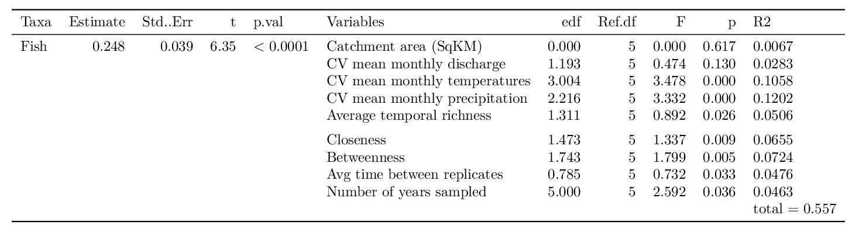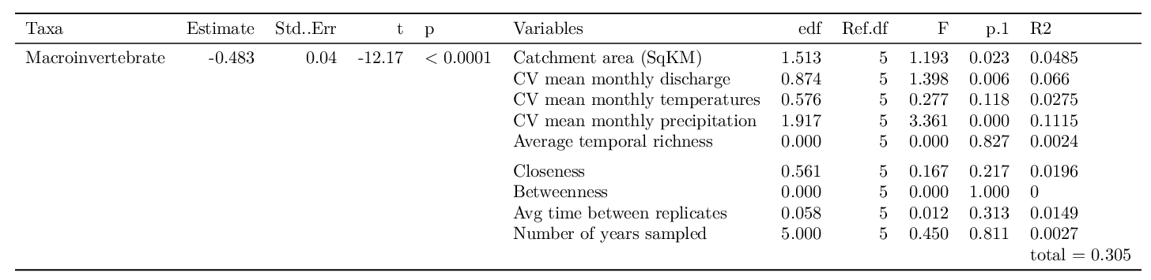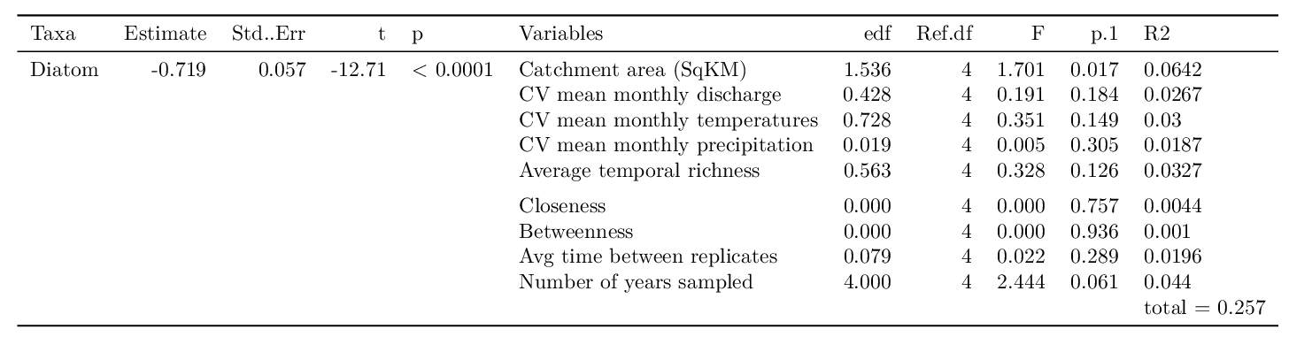

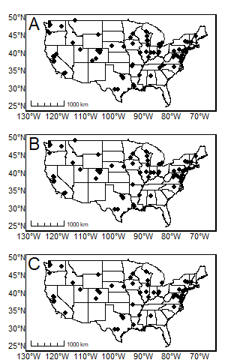
Figure 1. Locations of NAWQA study sites for (A) fish communities (n=72), (B) macroinvertebrate communities (n=61), and (C) diatom communities (n=50)
Figure 2. Map of sites detailing temporal average richness for each community. (A) fish communities, (B) macroinvertebrate communities, and (C) diatom communities.
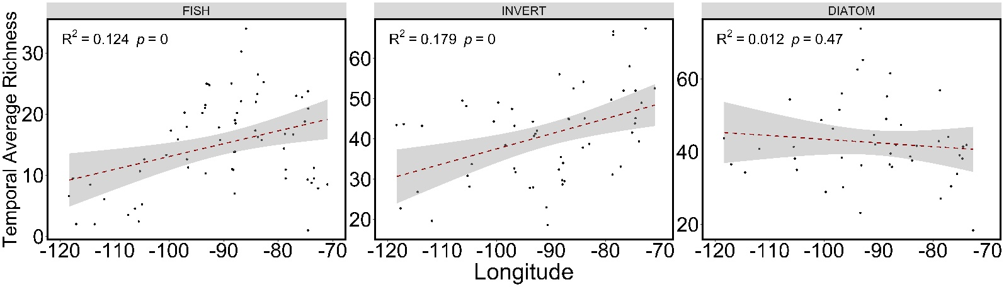
Figure 3. Linear regression of average temporal richness and longitude for each community. Shaded area represents the 0.95% confidence interval.
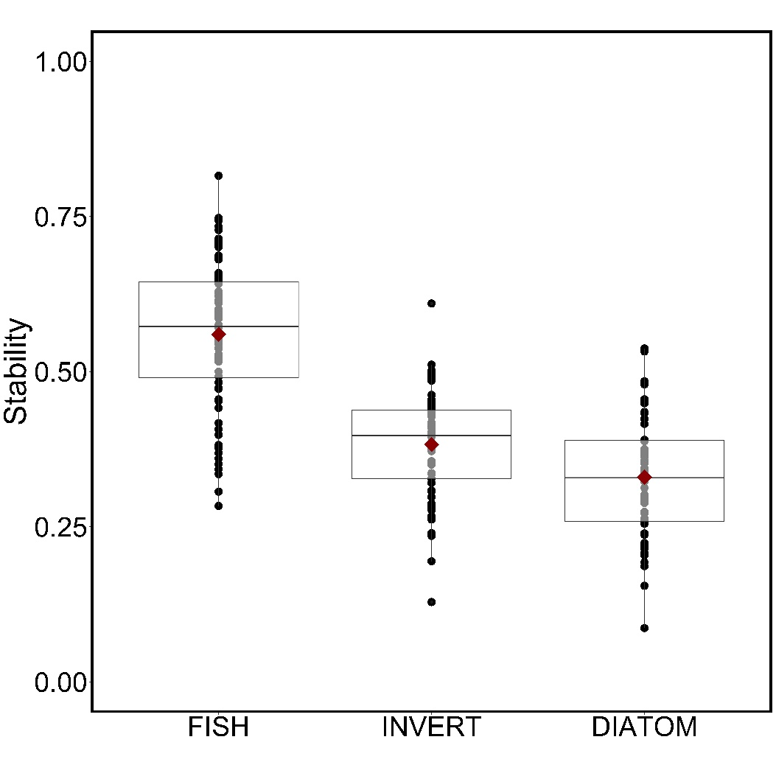
Figure 4. Results from stability analysis for each taxa group (fish-diatom p<0.001, fish-invert p<0.0001, diatom-invert p<0.0001). The red point is the mean value of that taxa group. (fish=0.56, macroinvertebrate=0.38, and diatom=0.33).
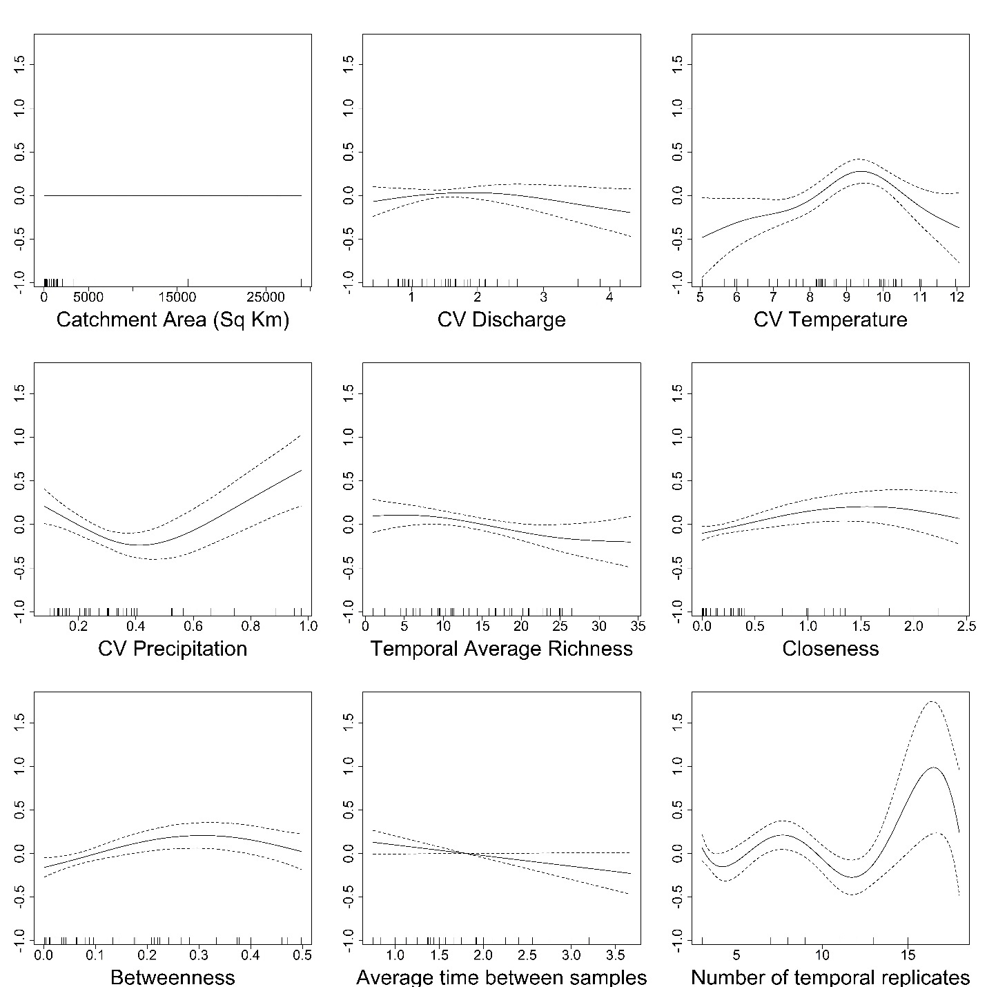
Figure 5. Results of generalized additive models for fish communities plotted as the relationship between community stability (y-axis) and the predictor variables (x-axis).

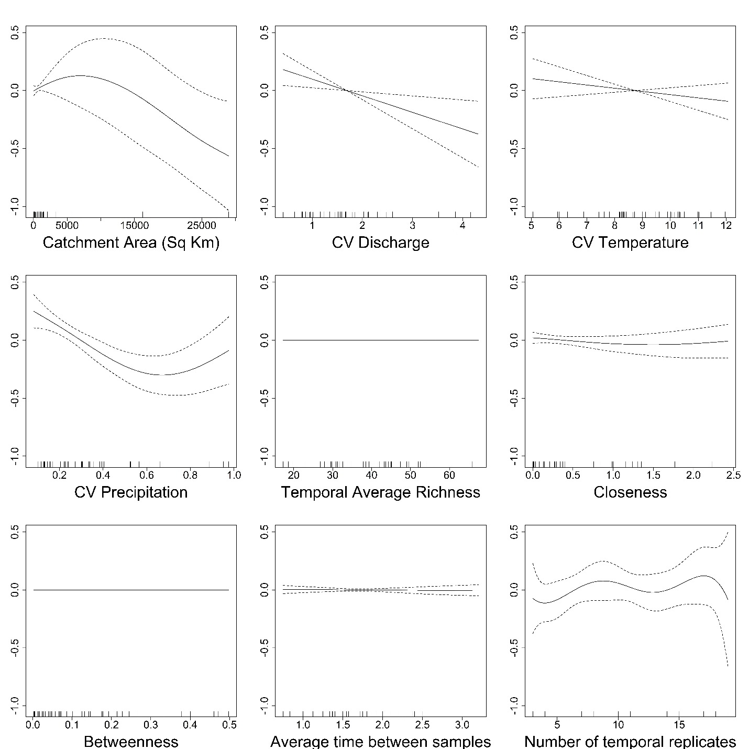
Figure 6. Results of generalized additive models for macroinvertebrate communities plotted as the relationship between community stability (y-axis) and the predictor variables (x-axis).
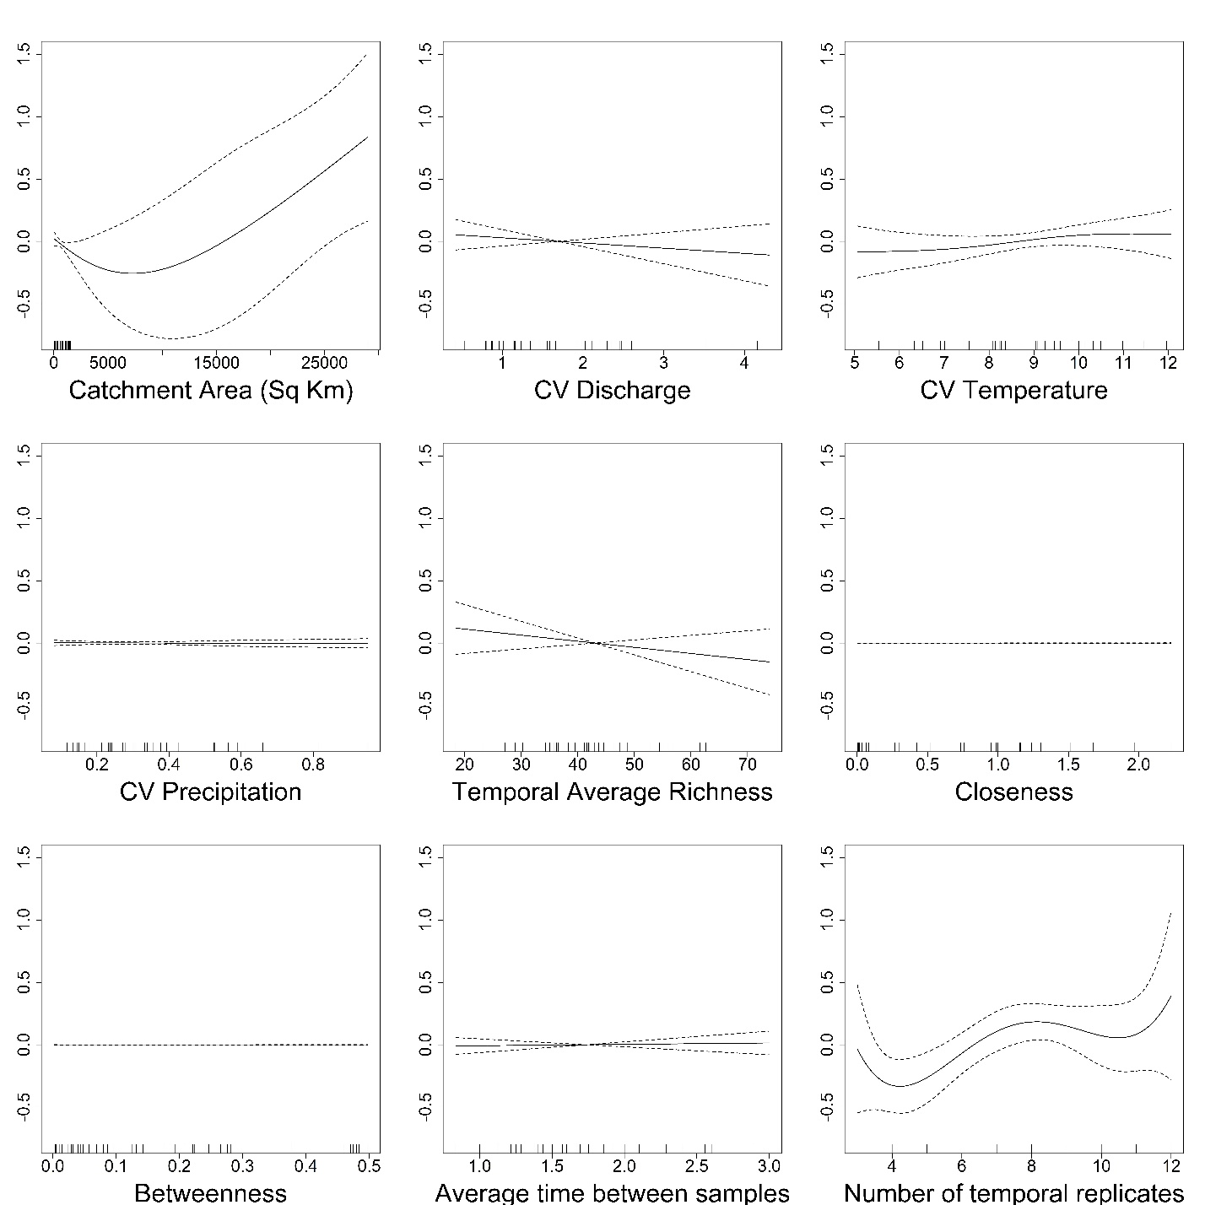
Figure 7. Results of generalized additive models for diatom communities plotted as the relationship between community stability (y-axis) and the predictor variables (x-axis).

CHAPTER 2. Considerations in the selection of reference streams for biomonitoring.

ABSTRACT
Biomonitoring of streams is important for tracking biological changes and assessing anthropogenic impacts within streams. Many biomonitoring approaches include a comparison between an impacted stream and an unimpacted reference stream. Selection of an appropriate reference stream can be problematic. To determine factors that might influence the selection of reference sites, we used a snapshot approach to assess biological and physical similarity among sites in 29 streams based on fish and macroinvertebrate communities, physio-chemical characteristics, and consideration of the effects of different watersheds and ecoregions. We found that streams experienced similarity in biological and physical characteristics, but there were differences that should be considered when selecting potential reference streams. For example, fish were more distinct among watersheds and ecoregions than were macroinvertebrates, which shows that fish are more affected by larger-scale environmental conditions whereas macroinvertebrates are likely more indicative of local conditions. We recommend that reference and impacted sites ideally should be within the same watershed and ecoregion, and that including multiple taxa groups in biomonitoring should be used to comprehensively interpret the effects of impacts on stream health.
INTRODUCTION
Monitoring programs are frequently used to assess the impacts of environmental and anthropogenic stressors on stream health. For example, monitoring programs often assess the impact of assumed negative impacts of stressors like pollution, urbanization, agriculture, water abstraction, invasive species, or intense natural disturbances like droughts (Karr 1987). These monitoring programs are often aligned with governmental programs or regulations. Monitoring programs also permit informed planning or assessment of restoration or management interventions to improve stream integrity (Meyer 1997; Bae et al. 2005).
Stream monitoring that integrates physical and chemical characteristics, and biological communities can effectively be used to evaluate system health and biological integrity (Resh et al. 1995). Aquatic organisms integrate stressors over time, which allows for observation of the effects of pollutants on organism health instead of solely focusing on time series of chemical measurements (Schlosser 1990). Monitoring of macroinvertebrate and fish communities can be used to assess stream health and any impacts of pollutants and stressors. Benthic macroinvertebrates are good indicators of local or site-specific conditions due to their sedentary lifestyle or having relatively limited movement patterns, meaning they cannot easily escape or avoid pollution. These communities are indicators of short-term variation in the environment due to their moderately-short life cycles (Mangadze et al. 2016). Macroinvertebrates are also comprised of multiple trophic levels, and thus integrate any stressors from lower trophic levels, and certain taxa are easily identified as tolerant or intolerant of pollution, so their presence or absence in a stream can be a good indicator of stream health. An advantage of using macroinvertebrates is that many first and second order streams are fishless, and macroinvertebrates are present in every stream habitat (Richardson and Danehy 2007; Meyer et al. 2007). Fish are used as indicators for long-term effects and broad habitat conditions due to their relatively long lifespan and high mobility. These communities take longer to respond to environmental stressors and have the ability to move to less-impacted sites (Scholosser 1990). The structure of fish communities also reflects stream health because they are composed of multiple trophic levels and integrate effects of lower trophic levels.
There are different approaches used for biomonitoring impacts or changes in streams. These approaches typically use one or more of the following comparisons: before-after, upstream-downstream, and reference (= control)-impacted (Resh et al. 1995). Both timing and spatial considerations influence the type of monitoring design used. For example, when there is a planned restoration or a known future impact, a design including before-after sampling is appropriate, or for a downstream point-source pollutant or restoration project, an upstream-downstream monitoring approach is often used (Plafkin 1995). However, there are situations when including a separate reference stream is beneficial. Examples where reference streams are especially appropriate include stream-wide impacts, an incoming tributary just upstream of the impact site or where upstream and impacted sites have environmental differences (e.g., the impacted portion is within a different ecoregion from upstream sites, or upstream and downstream areas have different land use). Use of a reference stream is also beneficial because the upstream and reference stream are expected to behave the same, which reinforces the likelihood of successfully identifying an impact or assessing mitigation outcomes (Sanchez-Montoya 2009). BACI (Before-After-Control-Impact) designs are an often-employed type of monitoring that compares control (reference or upstream) and impacted stream sites before and after an impact. These types of designs work well if there is either a well-established monitoring program in place or if monitoring can be started before a known impact starts. Regular, regional-scale biological assessments are frequently included by governmental biomonitoring initiatives. These programs take snapshots surveys of a suite of streams. These surveys can provide ‘before’ data in advance of any subsequent impacts, including an unexpected impact, at or near these study sites. In many cases, however, survey and impact sites do not coincide, but these surveys may be useful in selecting reference streams.
In the event of an unexpected impact (e.g., forest fire, chemical spill, or mudslide) in a stream without previous biomonitoring data, how do we select an appropriate reference stream on a short timescale?
Without previous biological data, site selection will rely heavily on environmental factors. Natural landscape scale features are known determinants of community composition and other biological metrics (Gibson and Barbour 1996). Depending on the scale of the impact, nearby streams or adjacent watersheds may be considered. For areas near ecoregion borders, ecoregions become a critical part of reference site selection that can help determine site comparability in regard to regional variability. Ecoregions are determined by characteristics of physical features like geology, soils, vegetation, land use, and climate. Streams of different sizes are likely to produce different communities, to account for this we considered catchment area (a proxy for stream size) in this study. Although ecoregions are determined mostly by terrestrial variables, similar terrestrial lands are likely to produce similar streams and rivers. One reason for using terrestrial ecoregions in place of freshwater ecoregions is that the size of freshwater ecoregions is too coarse – only one freshwater ecoregion covers our entire study area. Their boundaries are determined by the distributions of fish species and leave out any environmental characteristics and distributions of other aquatic organisms (Abell et al. 2008), providing a limited characterization of streams.
One approach to determine suitable reference sites is by taking a snapshot of many candidate sites and assessing biological and physical similarity among these sites. We used this approach to test whether regional streams could be interchangeably used as reference streams should an impact occur. Our study area included two adjacent watersheds in southeastern Oklahoma and a total of 29 streams ranging from first to fourth order. These streams are found in two, level 3 ecoregions that bisect the two watersheds and include three level 4 ecoregions. We investigated similarity/dissimilarity of fish and benthic macroinvertebrate communities, and a suite of relevant physio-chemical characteristics, as well as the effects of watersheds and ecoregions (at both levels 3 and 4) to identify factors that might affect selection of potential reference sites for monitoring future impacts on stream ecosystem health.
METHODS
Description of study area
We studied stream tributaries in two adjacent watersheds; 16 streams in the Glover River watershed and 13 streams in the Middle Little River watershed. Pine Creek Reservoir is on the mainstem in the Middle Little River watershed (Figure 1, A - C); the Glover River is free-flowing. Our sites were scattered across McCurtain, Pushmataha, and Choctaw Counties, which are enveloped by the two, level 3 ecoregions Ouachita Mountains and the South Central Plains. The three, level 4 ecoregions are the Western Ouachita and Central Mountain Ranges (in the Ouachita Mountains level 3 ecoregion), and Cretaceous Dissected Uplands (in the South Central Plains level 3 ecoregion). This region of Oklahoma is primarily forest, dominated by native oak-pine forests, with planted pine plantations (Franco et al. 1993). Logging is prevalent in this area, for example, in 2009 the total roundwood output in Southeastern Oklahoma was 76,262 thousand cubic feet and with 16 sawmills within the three counties (Johnson 2005).
Delineations of ecoregions followed the methods described by Omerick (1987, 1995). Ecoregions are determined by comparing biotic and abiotic characteristics like geology, physiography, vegetation, landuse, soils, climate, biotic communities, and hydrology. Descriptions of each level 3 and 4 ecoregion follow in Table 1.
Field collections
We conducted biological community collections from the end of August to middle of September 2019. We sampled fish communities at each site with a seine (3.0 m long x 1.2 m deep with a 0.5 cm mesh size) seine for 60-90 minutes of effort over a 100–meter defined reach. Juvenile sportfish and any threatened or endangered species were released, and individuals of other species (and adult sportfish) were preserved for other studies. We sampled benthic macroinvertebrate communities at each site with a D-net (area: 0.10 m², mesh size: 250 µm), which allowed sampling in small sites and sites with low flow. The D-net was held against the bottom of the stream and the upstream area was agitated, with displaced organisms caught in the net. We collected three macroinvertebrate samples from representative habitats at each site, elutriated them in the field by disturbing the substrate above the net, placed the substrate into a bucket, repeatedly elutriated, and washed through a 250-µm mesh sieve, and preserved the elutriated samples with 95% ethanol. Macroinvertebrates were sorted under magnification and identified to the lowest possible taxonomic level, and data were pooled within sites to calculate macroinvertebrate abundance.
Physical Data Collection
We calculated a suit of ecoregionally relevant characteristics of landcover, soil composition and chemistry, lithology, vegetation, and climate variables for use as explanatory data. A list of variables and descriptions can be found in Table 2. These calculations were done using the StreamNetworkTools package in R.
Data analysis
We used multivariate methods to compare community structure, species composition, and physical characteristics among streams and within ecoregions and watersheds using the vegan package in R (version 4.1.2) (Oskansen et al. 2013). We standardized our community datasets with a log (x + 1) transformation on abundances. We calculated Bray-Curtis dissimilarity matrices for use in non-metric multidimensional scaling (NMDS) to visually assess differences among sites in ordination space, including between watersheds and among ecoregions. We then used permutational multivariate analysis of variance (PERMANOVA) based on Bray-Curtis dissimilarities to test for differences in community composition between watersheds and ecoregions, and computed beta-dispersion (BETADISPER) to test for multivariate homogeneity of group dispersions (variances) to assess the amount of within group variation in stream sites, which provides insight into the similarity and potential interchangeability of candidate reference sites. Lastly, we used SIMPER to calculate the contribution of individual species to overall Bray-Curtis dissimilarity. We used the same analyses for physical characteristics with the only differences being use of a Euclidean dissimilarity matrix (versus Bray-Curtis) and variables in place of species in the SIMPER analysis.
To easily compare similarities of streams with ecoregions and watersheds we computed Sørensen similarity matrices, based on presence/absence data, to give a single metric of similarity among sites. We calculated Indices of Biotic Integrity (IBI) for both fish and macroinvertebrate communities (Appendices 3, 4 & 1). Macroinvertebrate tolerance values were based first on Lenat (1993) (mostly for genus-level determinations). If Lenat values were not available, Hilsenhoff's values (Hilsenhoff 1988) were used (most at the family level). Taxa with no tolerance values were not used in IBI calculations (e.g., most Hemiptera, worms, etc.). Fish IBI values were calculated with slight changes to the categories set by Karr et al. (1986) and the EPA Rapid Bioassessment Protocols (Barbour et al. 1999). We left out two criteria: “% hybrids” and “% diseased individuals” because we found very few hybrids and did not document any diseases or deformities in individuals (Appendix 2).
All collections were in accordance with Oklahoma Department of Wildlife Conservation scientific collection permit (#5739002) and IACUC of the University of Oklahoma.
RESULTS
Fish communities
Fish were diverse, with 42 identified taxa (Appendix 2). The majority of taxa (76.2% or 32 taxa) were found at 5 or fewer of the 29 sites whereas only 3 taxa were found at over 50% of sites (14 or more sites). Lepomis megalotis, Notropis boops, and were found at over 20 sites (22, and 21 sites, respectively). Cyprinidae (minnows; 12 of 42 taxa), Centrarchidae (sunfishes; 10 taxa), Percidae (perches; 5 taxa) collectively comprised 57 % of all taxa.
Fish community structure was relatively dissimilar among stream sites (mean Sørensen similarity = 0.37; Table 3). Differences in community structure were similarly explained by watersheds and level 4 ecoregions. Fish community structure showed little overlap between watersheds (PERMANOVA: R² = 0.145, p = 0.001) and were distinct (Figure 2-A). There was a significant difference between watersheds for within-group dispersion/variance to the means (anova, p > 0.01), meaning that streams in the Middle Little watershed had higher mean distance and a wider range of distances to the center of the centroid than did the streams in the Glover River watershed (Figure 2-C). With respect to watersheds, Sørensen similarity (Table 3) indicated that community structure was more similar within the Glover River (mean Sørensen similarity = 0.50) and less similar in the Middle Little (mean Sørensen similarity = 0.32), thus, supporting dispersion analyses and reflecting the more compacted Glover sites in the NMDS compared to the highly spread Middle Little sites.
Ecoregion level 3 explained slightly less variation than did watersheds (R² = 0.11, p = 0.002) and experienced some overlap between the two ecoregions (Figure 3-A). Dispersion was significantly different between level 3 ecoregions (anova, p = 0.02); the Ouachita Mountains had the highest range of dispersions but a lower mean than the South Central Plains (Figure 3-C). This pattern was present but difficult to see in the NMDS, but was supported by Sørensen similarities showing higher similarity in the Ouachita Mountains (Sørensen similarity = 0.41) than the South Central Plains (Sørensen similarity = 0.30).
Level 4 ecoregions and watersheds explained a similar amount of variation in fish community structure. There was some overlap between the Cretaceous Dissected Uplands and Central Mountain Ranges, and moderate amount of overlap of both ecoregions with the Western Ouachitas ecoregion (PERMANOVA: R² = 0.154, p = 0.003, Figure 4-A). There was a significant difference in the within-group dispersion between level 4 ecoregions (anova, p=0.05) (Figure 4-C), although, this relationship was driven by the Western Ouachitas and Cretaceous Dissected Uplands (Tukey post-hoc test; p = 0.048), the Western Ouachitas experienced the lowest mean dispersion and the largest range of dispersion values. Again, NMDS and Sørensen similarities reflect these differences in within group dispersion (Figure 4-A; Table 3; Figure 4-C).
Although community structure showed differences among potential reference streams, there were no significant differences in IBI (anova, p > 0.05), richness (anova, p > 0.05), or abundance (anova, p > 0.05) among watersheds or ecoregions (Table 4; Appendix 6), thereby opposing the dissimilarities in composition indicated by MNDS, PERMANOVA and dispersion analyses. Species contributing to ~50% between-group dissimilarity were highly redundant among each group pairing (Table 5), further supporting that similarity. Species that consistently contributed the most to dissimilarity were Notropis boops (average % contribution ranged from 10 to 14 %), then Lepomis macrochirus and Lepomis megalotis. Labidesthes sicculus, Notropis ortenburgeri, and Campostoma anomalum also contributed to dissimilarity among watersheds and among ecoregions.
Macroinvertebrate communities
Macroinvertebrates were diverse, with 116 identified taxa (Appendix 1). The majority of taxa (62.1% or 72 taxa) were found at 5 or fewer of the 29 sites whereas only 12 taxa were found at over 50% of sites (14 or more sites). Chironomids (both subfamilies Chironominae and Tanypodinae) and the mayfly Caenis sp. were found at over 20 sites (29, 26, and 27 sites, respectively). Insects dominated (101 of 116 taxa). Ephemeroptera (mayflies; 25 taxa), Plecoptera (stoneflies; 3 taxa) and Trichoptera (caddisflies; 14 taxa) comprised 41.6% of insect taxa, with Coleoptera, Diptera, Odonata and Hemiptera collectively contributing 53 taxa (19, 13, 11, and 10, taxa respectively).
Overall macroinvertebrate community structure was relatively dissimilar when comparing among all potential reference streams (mean Sørensen similarity = 0.40; Table 3). This low similarity is contrary to the NMDS plots, which show that macroinvertebrate community structure experienced overlaps within each grouping (Figures 5-A, 6-A, and 7-A), much more so than did fish. Similar to fish communities, macroinvertebrate community structure was explained equally by watersheds and level 4 ecoregions, however the amount of variation explained was smaller for each grouping.
Macroinvertebrate community structure showed overlap between watersheds (PERMANOVA: R² = 0.09, p = 0.002) and were not very distinct (Figure 5-A). There were no significant differences between watersheds for within-group dispersion/variance to the means, meaning that streams in the Middle Little watershed and Glover River watershed had a similar mean distance and range of dispersions (Figures 5-B,C). Patterns in the NMDS and dispersion values were clearly supported by the watershed Sørensen similarity values being closer to each other and closer to the overall mean Sørensen value (Table 3).
As in the fish communities, ecoregion level 3 explained less variation (R² = 0.05, p = 0.08) than level 4 ecoregions and experienced strong overlap in the two ecoregions (Figure 6-A). Dispersion was not significantly different between level 3 ecoregions (p = 0.30; Figures 6-B,C). Similar to fish communities, this pattern was present but difficult to see in the NMDS, however was supported by Sørensen similarities showing similar similarity values in the Ouachita Mountains (mean Sørensen similarity = 0.42) than the South Central Plains (mean Sørensen similarity = 0.35).
Level 4 ecoregions explained a similar amount of variation in macroinvertebrate community structure to watersheds. There was strong overlap of Cretaceous Dissected Uplands with both and Central Mountain Ranges and Western Ouachitas, however there was little overlap between the Central Mountain Ranges and the Western Ouachitas (PERMANOVA: R² = 0.08, p = 0.10, Figure 7-A). There was no significant difference in the within-group dispersion between level 4 ecoregions (Figure 7-B,C). These similarities are reflected in the NMDS and Sørensen similarities reflect these differences in within group dispersion (Figure 7-A; Table 3; Figure 7-C).
Support for differences in macroinvertebrate communities among potential reference sites came from significant differences in IBI and richness (Table 4; Appendix 5). There were significant differences in IBI between watersheds (p = 0.04). The species that contributed the most to between-watershed dissimilarity were EPT (Ephemeroptera, Plecoptera and Trichoptera; or mayflies, stoneflies and caddisflies) taxa and Coleoptera (beetles), which were more abundant in the Glover River watershed, and non-insect taxa which were more abundant in the Middle Little watershed. Similar patterns of dissimilarity occurred between level 3 ecoregions, and similarly in the level 4 ecoregions (Table 6). However, the patterns in species contribution to between-group dissimilarity were unclear between the Central Mountain Ranges and Western Ouachitas level 4 ecoregions (Table 6).There was a consistent pattern of either highly abundant Stenelmis sp. (Elmidae; Coleoptera) or highly abundant Naidae (Oligochaeta) within each grouping and a high contribution to dissimilarity between most groupings (Table 6).
Physical characteristics
Overall physical characteristics were relatively dissimilar among groups of potential reference streams. Variation in stream physical characteristics was better explained by ecoregions [ecoregion 4 (PERMANOVA: R² = 0.20, p=0.003) and ecoregion 3 (R² = 0.166, p = 0.001)] than watersheds (R² = 0.066, p = 0.09). There was no significant difference between dispersions for any grouping (Figures 8, 9, and 10; B,C). Stream sites demonstrated strong overlap in physical characteristics between the two watersheds (Figure 8-A), leading to a lack of differences in physical characteristics (R² = 0.066, p = 0.095). There was greater distinction in physical characteristics between level 3 ecoregions (Figure 9-A) than between watersheds, which coincided with more variation explained by ecoregion level 3 (R² = 0.166, p = 0.001). The overlap of the Western Ouachitas and Cretaceous Dissected Uplands level 4 ecoregions showed a similar pattern to the level 3 ecoregions, however, the Central Mountain Ranges level 4 ecoregion showed no overlap with the other ecoregions (Figure 10-A,B). The level 4 ecoregions explained a slightly larger amount of variation (R² = 0.20, p = 0.003) than the level 3 ecoregions (R² = 0.166, p = 0.001). Variables that frequently contributed the most to average dissimilarity between each grouping were the percent of colluvial and alluvial sediment in each catchment. However, when we compared the Central Mountain Ranges and Western Ouachitas, percent alluvial sediment was the most distinguishing factor. Other important metrics for groupings were landscape and agricultural chemical characteristics (Table 7).
DISCUSSION
Because the 29 streams being located relatively close to each other in adjacent watersheds, sharing a historically forested location, and being low-order streams, we anticipated finding similar biotas among sites, but both the macroinvertebrate and fish communities were only moderately similar. Both fish and macroinvertebrate communities were collectively taxonomically diverse but the sampled biota in individual streams were much less diverse with a few widespread taxa (fish: Notropis boops, Leopomis macrochirus, Lepomis megalotis; macroinvertebrates: chironomids and Caenis sp.) and many less frequently collected taxa. The patchy distribution of most taxa contributed to the apparent biotic dissimilarity among sites and indicates that single-site sampling may be inadequate for these streams.
Macroinvertebrate communities and physical characteristics were similar between the two watersheds. A confounding factor was that ecoregions transversed the watersheds, meaning there was considerable variation in ecosystem-related features (including physical characteristics) within watersheds. In contrast, fish were more distinct among watersheds and ecoregions than were macroinvertebrates, likely because while ecoregions approximate distributional patterns of fish communities, as fish distributions are generally correlated with watersheds (Omernik and Bailey 1997). Macroinvertebrates are difficult to identify to species compared to the easy identification of fish to species level, leading to differences in taxonomic resolution. The taxonomic resolution of macroinvertebrates can influence similarities due to higher diversity at the species level compared to the genus level, which leads to higher variation. Another possible reason is that many macroinvertebrates can disperse over land, which may lead to more similarity in macroinvertebrate communities compared to fish due to dispersal limitations of fish.
Physical characteristics that might influence localized fish communities, like landcover, lithology, benthic substrate, and vegetation, are associated with ecoregions. Ecoregions are relevant to the physical characteristics and landscape characteristics that set the stage for the biotic components. Ecoregions define relatively homogenous areas and correspond better than watersheds to landscape landcover. Even further, studies have demonstrated that water quality and quantity is similar within ecoregions (Whittier et al. 1988) and that ecoregions are better descriptors of regional environmental and water quality conditions than are watersheds (Bryce et al. 1999). Studies attempting to relate community structure of fish or macroinvertebrates or physical characteristics to ecoregions have shown obvious but weak correlations with more coarse ecoregions (Lyons 1989; Spindler 1996).
Although overall macroinvertebrate communities were not different among watersheds, the IBI scores for macroinvertebrates indicated better stream conditions within the Glover watershed than within the Middle Little watershed. This is consistent with the SIMPER results in which the two taxa that contributed the most to dissimilarity were Stenelmis sp. (Elmidae; Coleoptera) and Naididae (Oligochaeta). Stenelmis are found in rocky streams with good water quality (i.e., the Glover watershed, which is largely forested) whereas Naididae are found in streams with sand or silt substrates that may have lower water quality (i.e., in the Middle Little watershed, which has more agricultural development). This pattern was paralleled across the ecoregions that transverse the two watersheds. These findings are congruent with the assumption that ecoregions are general descriptors of physical characteristics (and water quality), which are often used as criteria for the selection of reference streams because of the need for similar stream environments for comparing tolerances of the macroinvertebrates (Lenat 1993).
Our results indicate that fish communities are more affected by larger-scale environmental conditions (watersheds and ecoregions) whereas macroinvertebrates may be more indicative of local conditions (e.g., substrate type or tolerance). These results are in agreement with Resh (2008) that macroinvertebrates might be locally restricted whereas fish monitoring efforts are more applicable to larger areas. Consequently, the use of more than one biological community (e.g., fish and macroinvertebrates) should be considered in selecting reference sites.
Our goal was to determine whether the 29 sampled streams were interchangeable as potential references streams. Although there were many similarities in community structure among sites and similarity in physical site characteristics, the stream biotas also showed considerable differences that reflect considerations in reference stream selection. Based on our results, we make the following four recommendations:
(1) Both watersheds and ecoregions were associated with variation in fish communities, indicating that reference and ‘impacted’ sites should be within the same watershed and ecoregion, where possible.
(2) Inclusion of both fish and macroinvertebrates in biomonitoring increases the range of comparisons and aids in interpretation of impact effects. There were differences between these taxa with effects of ecoregions and watersheds because they experience their environment at different scales and will likely exhibit different responses to different environmental impacts. Although we used only these two taxa groups, inclusion of additional groups (e.g., algae or microbes) should be considered.
(3) The IBI was useful for comparisons of macroinvertebrate communities among sites, despite using taxon-specific tolerance values developed in North Carolina and Wisconsin, which likely need adjustment to be fully applicable in Oklahoma (e.g., Lenat 1993). Developing local IBI scores would increase the usefulness of this index.
(4) The high percentage of infrequently collected fish and macroinvertebrates among our samples may indicate inadequate sampling, such that more than one site per reference or impacted stream section should be sampled during targeted biomonitoring programs.
LITERATURE CITED
Abell, R., M. L. Thieme, C. Revenga, M. Bryer, M. Kottelat, N. Bogutskaya, B. Coad, N. Mandrak, S. C. Balderas, W. Bussing, M. L. J. Stiassny, P. Skelton, G. R. Allen, P. Unmack, A. Naseka, R. Ng, N. Sindorf, J. Robertson, E. Armijo, J. V. Higgins, T. J. Heibel, E. Wikramanayake, D. Olson, H. L. López, R. E. Reis, J. G. Lundberg, M. H. Sabaj Pérez, and P. Petry. 2008. Freshwater Ecoregions of the World: A New Map of Biogeographic Units for Freshwater Biodiversity Conservation. BioScience 58:403–414.

Bae, Y. J., H. K. Kil, and K. S. Bae. 2005. Benthic macroinvertebrates for uses in stream biomonitoring and restoration. KSCE Journal of Civil Engineering 9:55–63.

Barbour, M. T., J. Gerritsen, B. D. Snyder, and J. B. Stribling. 1999. Rapid bioassessment protocols for use in streams and wadeable rivers: Periphyton, benthic macroinvertebrates and fish. US Environmental Protection Agency, Office of Water Washington, DC.

Bryce, S. A., J. M. Omernik, and D. P. Larsen. 1999. Environmental review: Ecoregions: A geographic framework to guide risk characterization and ecosystem management. Environmental Practice 1:141–155.

Conquest, L. L. 2000. Analysis and interpretation of ecological field data using BACI designs: Discussion. Journal of Agricultural, Biological, and Environmental Statistics 293–296.

Franco, P. A., P. E. Miller, and A. J. Hartsell. 1993. Forest statistics for Southeast Oklahoma counties-1993. Resour. Bull. SO-176. New Orleans, Louisiana: US Department of Agriculture, Forest Service, Southern Forest Experiment Station. 38 p. 176.

Gibson, G. R., and M. T. Barbour. 1996. Biological Criteria: Technical guidance for streams and small rivers. US Environmental Protection Agency, Office of Science and Technology, Health.

Johnson, T. G. 2005. Oklahoma’s Timber Industry: An Assessment of Timber Product Output and Use, 2002. United States Department of Agriculture, Forest Service, Southern Research.

Karr, J. R. 1986. Assessing biological integrity in running waters: A method and its rationale. Special publication/Illinois Natural History Survey (USA).

Karr, J. R. 1987. Biological monitoring and environmental assessment: A conceptual framework. Environmental Management 11:249–256.

Lenat, D. R. 1993. A biotic index for the southeastern United States: Derivation and list of tolerance values, with criteria for assigning water-quality ratings. Journal of the North American Benthological Society 12:279–290.

Lyons, J. 1989. Correspondence between the distribution of fish assemblages in Wisconsin streams and Omernik’s ecoregions. American Midland Naturalist 163–182.

Mangadze, T., T. Bere, and T. Mwedzi. 2016. Choice of biota in stream assessment and monitoring programs in tropical streams: A comparison of diatoms, macroinvertebrates and fish. Ecological indicators 63:128–143.

Meyer, J. L. 1997. Stream health: Incorporating the human dimension to advance stream ecology. Journal of the North American Benthological Society 16:439–447.

Meyer, J. L., D. L. Strayer, J. B. Wallace, S. L. Eggert, G. S. Helfman, and N. E. Leonard. 2007. The contribution of headwater streams to biodiversity in river networks. JAWRA Journal of the American Water Resources Association 43:86–103.

Omernik, J. M., and R. G. Bailey. 1997. Distinguishing between watersheds and ecoregions 1. JAWRA Journal of the American Water Resources Association 33:935–949.

Plafkin, J. L. 1989. Rapid bioassessment protocols for use in streams and rivers: Benthic macroinvertebrates and fish. United states Environmental protection Agency, Office of Water.

Resh, V. H., R. H. Norris, and M. T. Barbour. 1995. Design and implementation of rapid assessment approaches for water resource monitoring using benthic macroinvertebrates. Australian Journal of Ecology 20:108–121.

Richardson, J. S., and R. J. Danehy. 2007. A synthesis of the ecology of headwater streams and their riparian zones in temperate forests. Forest Science 53:131–147.

Sánchez-Montoya, M., M. Vidal-Abarca, T. Puntí, J. Poquet, N. Prat, M. Rieradevall, J. Alba-Tercedor, C. Zamora-Muñoz, M. Toro, and S. Robles. 2009. Defining criteria to select reference sites in Mediterranean streams. Hydrobiologia 619:39–54.

Schlosser, I. J. 1990. Environmental variation, life history attributes, and community structure in stream fishes: Implications for environmental management and assessment. Environmental Management 14:621–628.

Soininen, J., and P. Eloranta. 2004. Seasonal persistence and stability of diatom communities in rivers: Are there habitat specific differences? European journal of phycology 39:153–160.

Spindler, P. 1996. Using ecoregions for explaining macroinvertebrate community distribution among reference sites in Arizona, 1992. Hydrologic Support and Assessment Section, Water Quality Division, Arizona.

Townsend, C., A. Hildrew, and K. Schofield. 1987. Persistence of stream invertebrate communities in relation to environmental variability. The Journal of Animal Ecology 597–613.

Whittier, T. R., R. M. Hughes, and D. P. Larsen. 1988. Correspondence between ecoregions and spatial patterns in stream ecosystems in Oregon. Canadian journal of fisheries and aquatic sciences 45:1264–1278.

Table 1. Names and descriptions of selected level 3 and 4 ecoregions that encompass our study sites in Southeast Oklahoma. (Continued on next page)
Ouachita Mountains  (Level 3) | Consists of folded sandstone, shale, and chert leading to varied topography including ridges, hills, and valleys. The historically-dominant vegetation is oak-hickory-pine forest while dominant land uses are logging, recreation, and pasture and hay lands. Most vegetation is now loblolly and shortleaf pine due to commercial logging. Streams generally have good water quality and are made up of gravel, cobble, boulders, and bedrock.
Central Mountain Ranges  (Level 4) | Subregion of the Ouachita Mountains and are dominated by sandstone and chert with a rugged and steep landscape with abundant ridges. The historically-dominant vegetation is the same forest as the Ouachita Mountains, however an abundance of springs and seeps foster diverse vegetation. Logging and farm land use are not as common in this area. The low presence of large-scale logging and farming lands may be a contributor to the good water quality in this area.
Western Ouachitas  (Level 4) | Subregion of the Ouachita Mountains consisting of slightly more mountainous topography and fewer ridges. The lithology is mostly sandstone and shale with the distinction of absence of chert. Both pine and oak-hickory-pine are dominant forests in this area. This ecoregion has one of the largest concentrations of imperiled species in the region.
South Central Plains  (Level 3) | Distinct from the more mountainous ecoregions due to the forested plains and shallow valleys. Historically, prairies were common in this area, although the area is now dominated by forests consisting of loblolly pine, shortleaf pine, oaks and hickories. This lower part of this ecoregion is dominated by floodplain forests and wetlands. The area along major rivers are dominated by croplands, thus, water quality is distinct between the top and bottom areas of this region. This area also suffers from stream drying and low flow conditions more than the above ecoregions.
Cretaceous Dissected Uplands  (level 4) | Subregion of the South Central Plains ecoregion consisting of lithologically-distinct composition of sands, clays, and gravels. The dominant natural vegetation is oak-hickory-pine with large amounts of pasturelands. Water quality is good within forested watersheds and is poor downstream of croplands, and overall has higher alkalinity, suspended solids, and turbidity than the above ecoregions.

Table 2. List of variables used to characterize watersheds and ecoregions with the associated codes and descriptions.(Continued on next page)
Variable groups | Variables
Landcover & Landuse (catchment)
% agricultural land | % open water land cover
% forest | % urbanized
% Forest cover loss (Tree canopy cover change) | % woody wetland land cover
% grassland/herbaceous land cover | Density of roads-stream intersections (crossings/square km)
% herbaceous wetland land cover | Density of roads (km/square km)
Imperviousness of anthropogenic surfaces
Precipitation & temperature-based (catchment)
mean annual air temperature (deg C) | Baseflow Index Catchment
cumulative mean annual runoff (mm) | Mean Annual EROM discharge
cumulative mean annual precipitation (mm) | Hydrologic connectivity component score catchment
minimum mean monthly discharge

Habitat & environmental (local)
% Aquatic macrophyte cover | Average pH
Percent canopy cover | Average water temperature
% Riparian cover | Turbidity of water
Average conductivity
Geomorphic
Catchment Area | Slope
Elevation (m) | Sinuosity
Network flowlines (km)
Lithology & Geology (catchment)
% of lithological potassium oxide (K2O) | organic matter content (% by weight) of soils
% of lithological sodium oxide (Na2O) | % sand content of soils
% of lithological nitrogen (N) | Depth (cm) to bedrock of soils
% of lithological sulfur (S) | Permeability (cm/hour) of soils
% of lithological phosphorous oxide (P2O5) | Seasonal water table depth (cm) of soils
% of lithological silicon dioxide (SiO2) | % alluvium and fine-textured coastal zone sediment
% colluvial sediment
Nutrients & Pollutants (catchment)
Soil erodibility | Wet deposition for nitrate ion concentration (kg of NO3/ha/yr)
Manure application to agricultural land | Wet deposition for ammonium ion concentration (kg of NH4/ha/yr)
Pesticide use (kg/km2) | Wet deposition for average sulfur & nitrogen (kg of S+N/ha/yr)

Table 3. Sørensen similarity values (mean + sd) of 29 stream fish and macroinvertebrate communities for each watershed or ecoregion.
 |  | Fish |  | Macroinvert.
 |  | mean | sd | mean | sd
All sites |  | 0.37 | ± 0.16 | 0.4 | ± 0.13
Watersheds | Glover River | 0.5 | ± 0.13 | 0.46 | ± 0.15
 | Middle Little | 0.32 | ± 0.14 | 0.37 | ± 0.12
Ecoregions – level 3 | Ouachita Mtns | 0.41 | ± 0.16 | 0.42 | ± 0.14
 | S. Central Plains | 0.3 | ± 0.13 | 0.35 | ± 0.10
Ecoregions – level 4 | Western Ouachita | 0.4 | ± 0.16 | 0.43 | ± 0.13
 | Central Mtn Ranges | 0.5 | ± 0.13 | 0.34 | ± 0.16
 | Cretaceous Dissected Upl. | 0.3 | ± 0.13 | 0.35 | ± 0.10

Table 4. Index of Biotic Integrity (IBI) values, richness, and abundance (mean + sd) fish and macroinvertebrate communities for each grouping.
 |  |  |  |  | Fish |  | Macroinv.
 |  |  |  | Metric | mean | sd | mean | sd
Watershed | Glover River |  | Abundance |  | 62.6 | 29.7 | 5.4 | 1.0
 |  |  | IBI |  | 34.4 | 5.8 | 26.2 | 9.0
 |  |  | Richness |  | 6.8 | 2.4 | 309.9 | 231.1
 | Middle Little |  | Abundance |  | 48.1 | 21.9 | 6.2 | 0.4
 |  |  | IBI |  | 32.0 | 5.4 | 15.6 | 4.8
 |  |  | Richness |  | 6.7 | 2.5 | 211.8 | 146.1
Ecoregion 3
 | Ouachita Mountains |  | Abundance |  | 58.3 | 27.3 | 5.7 | 1.0
 |  |  | IBI |  | 33.7 | 5.5 | 23.3 | 9.1
 |  |  | Richness |  | 6.7 | 2.2 | 283.1 | 209.6
 | South Central Plains |  | Abundance |  | 47.7 | 26.3 | 5.9 | 0.5
 |  |  | IBI |  | 32.0 | 6.6 | 14.2 | 3.9
 |  |  | Richness |  | 7.0 | 3.2 | 197.6 | 162.5
Ecoregion 4
 | Central Mountain Ranges |  | Abundance |  | 44.0 | 33.4 | 5.7 | 1.5
 |  |  | IBI |  | 34.4 | 6.2 | 19.8 | 10.9
 |  |  | Richness |  | 6.6 | 3.4 | 179.8 | 160.4
 | Cretaceous Dissected Uplands |  | Abundance |  | 47.7 | 26.3 | 5.9 | 0.5
 |  |  | IBI |  | 32.0 | 6.6 | 14.2 | 3.9
 |  |  | Richness |  | 7.0 | 3.2 | 197.6 | 162.5
 | Western Ouachitas |  | Abundance |  | 62.2 | 25.1 | 5.7 | 0.8
 |  |  | IBI |  | 33.4 | 5.4 | 24.2 | 8.7
 |  |  | Richness |  | 6.7 | 2.0 | 311.8 | 216.3

Table 5. Results from SIMPER analysis showing only species or variables that contributed to ~50% dissimilarity in fish communities. Numbers presented are average abundance values listed for each species within a watershed or ecoregion.
 | Watersheds |  | Ecoregions – level 3 |  | Ecoregions – level 4
Taxon | Glover River | Middle Little | Ouachita Mtns | S. Central Plains | Western Ouachita | Central Mtn Ranges | Cretaceous Dissected Upl.
Notropis boops | 32.9 | 10.2 | 26.2 | 9.7 | 28.9 | 16.4 | 9.7
Lepomis megalotis | 7 | 4.1 | 6.5 | 2.5 | 4.8 | 12.8 | 2.5
Labidesthes sicculus | 4.1 | 4.3 | 5 | 0.8 | 6.4
Campostoma anomalum | 3.9 | 0.7 | 2.8 | 1.3 | 3.1
Lepomis macrochirus | 0.1 | 6.4 | 0.4 | 12.3 |  |  | 12.3
Notropis ortenburgeri | 2.1 | 3.6 | 1.8 | 6.3 |  | 0.6 | 6.3
Lythrurus umbratilis | 0 | 5.8
Fundulus olivaceous |  |  | 1.1 | 1.5 |  | 1.4 | 1.5
Pimephales notatus |  |  |  |  | 1.5 | 2.6 | 0
Etheostoma radiosum |  |  |  |  | 0.7 | 1.6

Table 6. Results from SIMPER analysis showing only species or variables that contributed to ~50% dissimilarity in macroinvertebrate communities . Numbers presented are average abundance values listed for each species within a watershed or ecoregion.
 | Watersheds |  | Ecoregions – level 3 |  | Ecoregions – level 4
Taxon | Glover River | Middle Little | Ouachita Mtns | S. Central Plains | Western Ouachita | Central Mtn Ranges | Cretaceous Dissected Upl.
Caenis | 48.4 | 33.8 | 44.5 | 31.0 | 46.2 | 38.6 | 31.0
Chironominae | 50.1 | 75.8 | 57.9 | 75.8 | 66.6 | 26.4 | 75.8
Stenelmis | 24.6 | 3.8 | 17.4 | 7.6 | 18.5 | 13.6 | 7.6
Naididae | 1.8 | 24.2 | 7.3 | 30.0 | 9.1 | 1.2 | 30.0
Maccaffertium | 12.4 | 1.8 | 9.3 | 1.2 | 10.2 | 6.2 | 1.2
Tanypodinae | 12.8 | 11.1
Stenonema | 9.5 | 0.6 | 6.9 | 0.0 | 8.2
Procloeon | 12.1 | 5.2 | 11.0 | 0.6 | 13.8
Amphipoda | 4.4 | 8.5 | 7.5 | 0.0 | 9.2
Leucrocruta | 8.4 | 1.2 | 6.3 | 1.0 | 5.3 | 9.6 | 1.0
Corbicula | 3.8 | 5.0 | 3.3 | 8.8 |  | 0.8 | 8.8
Dubiraphia | 9.8 | 3.7 | 8.6 | 0.4 | 10.7
Psephenus | 9.5 | 0.3 | 6.7 | 0.4 | 6.1 | 9.0 | 0.4
Lumbriculidae | 3.1 | 5.3 | 3.4 | 7.0 | 3.6 | 3.0 | 7.0
Orthocladinae | 4.3 | 4.5 | 4.3 | 4.6 | 4.9 | 2.2 | 4.6
Choroterpes | 5.4 | 0.5 |  |  | 3.4 | 5.4 | 1.0
Neoperla | 10.6 | 0.2 |  |  | 7.5
Planorbis | 2.5 | 0.8
Microcylleopus | 14.7 | 1.5
Enchytraeidae |  |  | 1.5 | 3.8
Tricorythedes |  |  | 1.9 | 2.6 |  | 3.2 | 2.6
Tanypodinae |  |  |  |  | 13.9 | 11.6 | 5.8
Isopoda |  |  |  |  | 1.1 | 2.8 | 0.0
Argia |  |  |  |  | 1.6 | 8.6 | 0.2

Table 7. Results from SIMPER analysis showing only species or variables that contributed to ~50% dissimilarity in physical characteristics among sites .
 | Watersheds |  | Ecoregions – level 3 |  | Ecoregions – level 4
Variables | Glover River | Middle Little | Ouachita Mtns | S. Central Plains | Western Ouachita | Central Mtn Ranges | Cretaceous Dissected Upl.
Colluvial sediment (%) (C) | 69.9 | 45.8 | 72.4 | 8.2 | 76.1 | 58.8 | 8.2
Alluvial sediment (%) (C) | 25.4 | 15.7 | 23.4 | 12.2 | 22.6 | 25.9 | 12.2
Catchment Area | 80.2 | 22.8 | 63.7 | 18.9 | 76.7
Manure agricultural application (kg N/ha/yr) (C) | 5.5 | 7.6 | 3.9 | 16.2 |  | 0.4 | 16.2
Forest cover loss (% Tree canopy cover change) (C) | 26.8 | 26.4 | 29.4 | 15.9 | 31.1 | 23.2 | 15.9
Total length of network flowlines (km) | 42.2 | 13.0 |  |  | 41.3
Grassland/herbaceous land cover (%) (C) | 7.0 | 10.9 |  |  | 10.8
Mean Annual EROM discharge | 60.2 | 17.8 |  |  | 57.8
Synthetic nitrogen fertilizer agricultural application (kg N/ha/yr) (C) |  |  | 1.5 | 6.6 |  | 0.1 | 6.6
Lithological hydraulic conductivity content (um per sec) (C) |  |  | 1.9 | 4.2 |  | 0.1 | 4.2
Pesticide use (kg/km2) in yr. 1997 (C) |  |  | 1.0 | 5.0 |  | 0.4 | 5.0

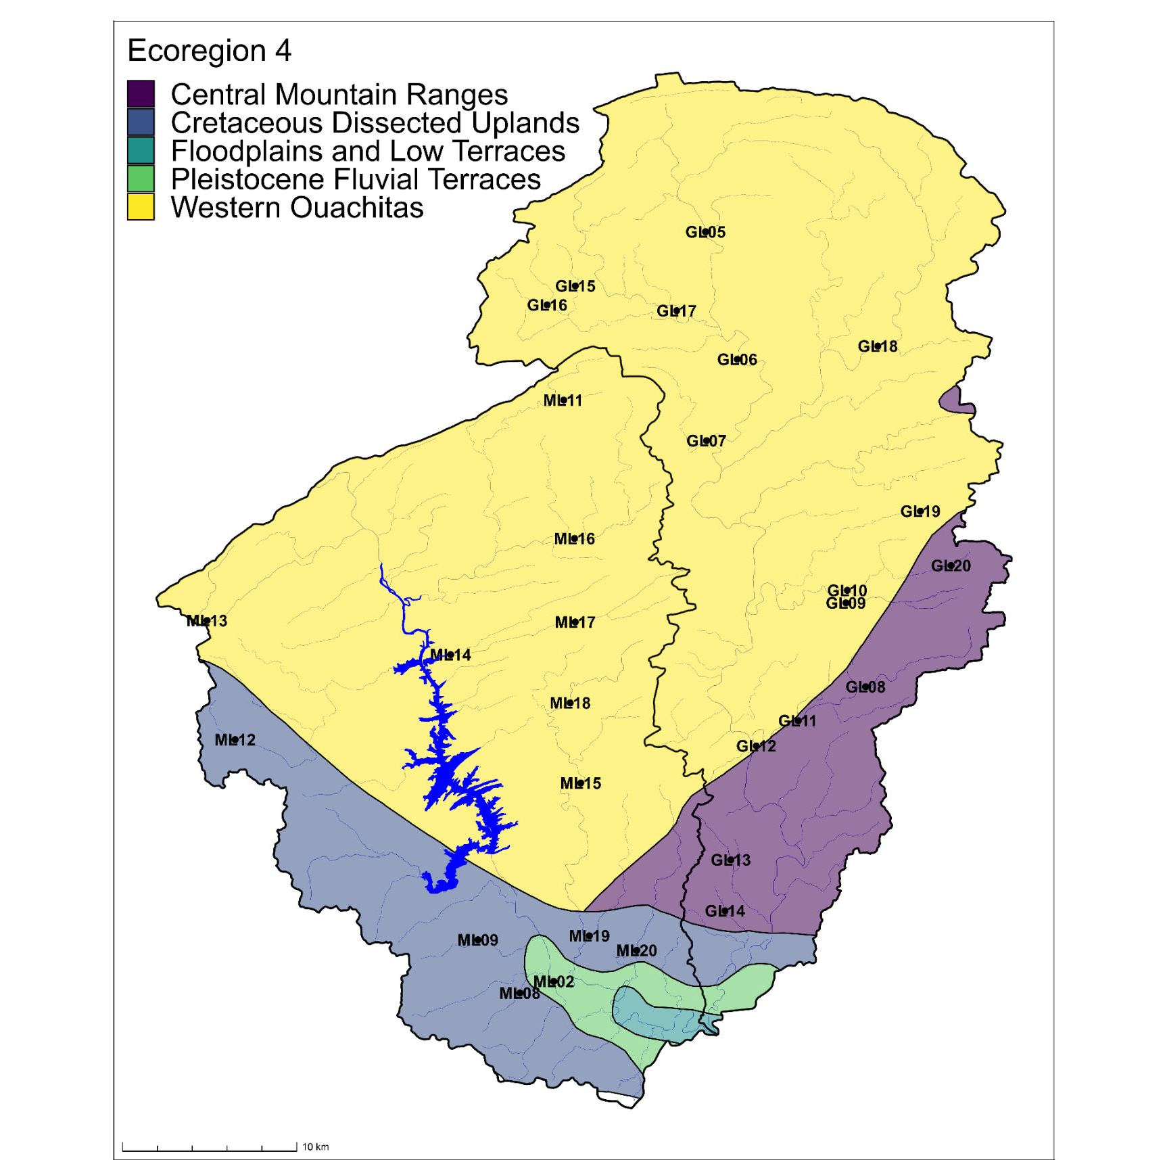
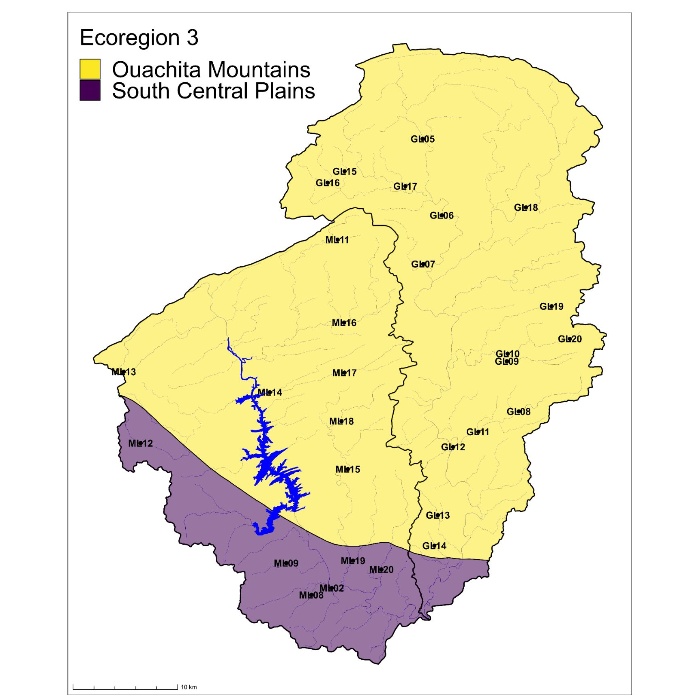
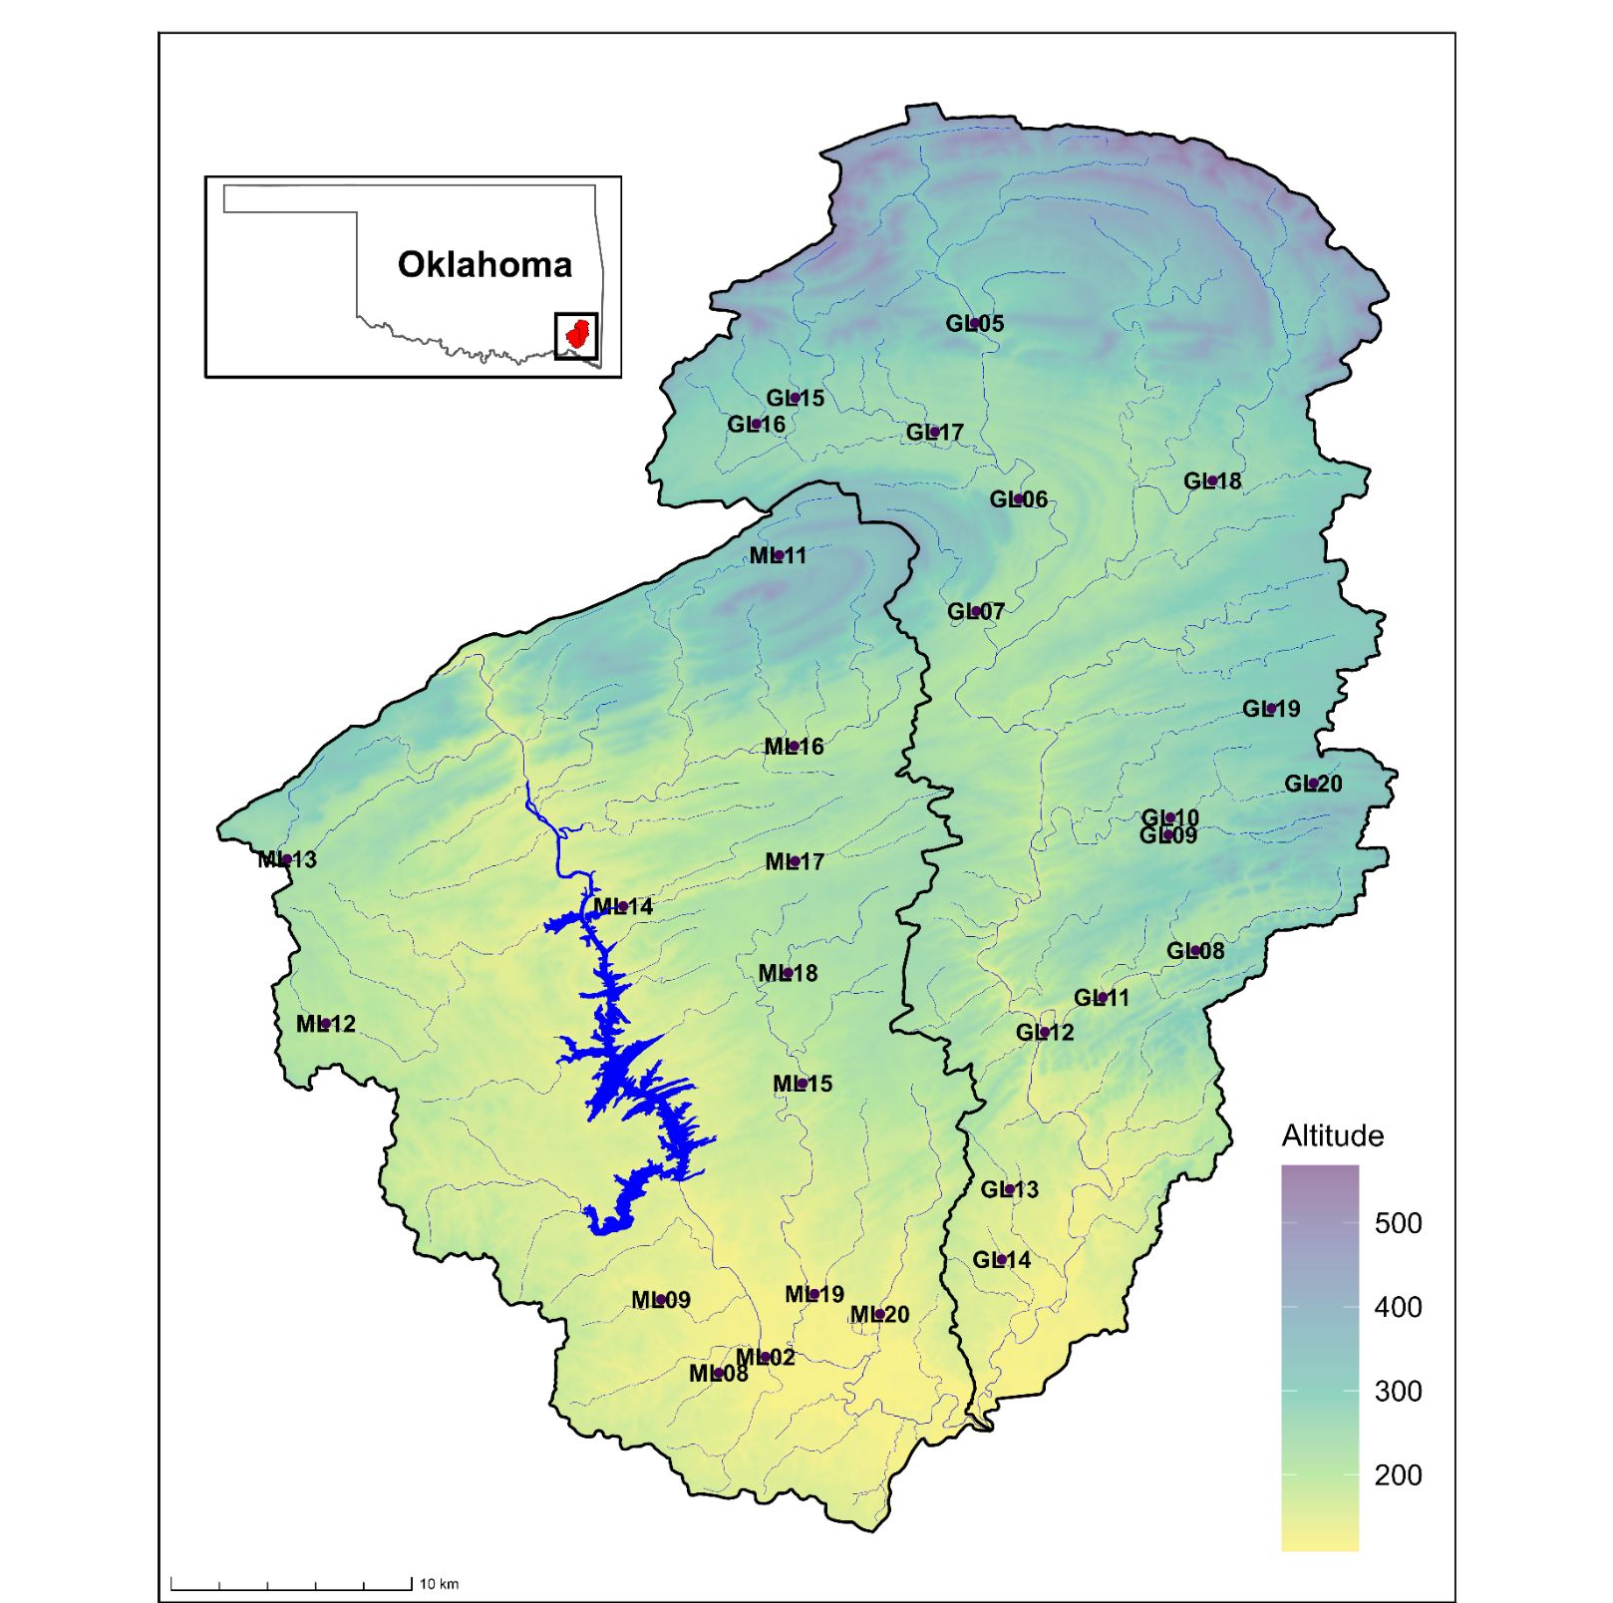
C
A
B

Figure 1. Maps of study area in Southeast Oklahoma. (A) Sites with altitude and inset map (B) Level 4 ecoregions (C) Level 3 ecoregions.

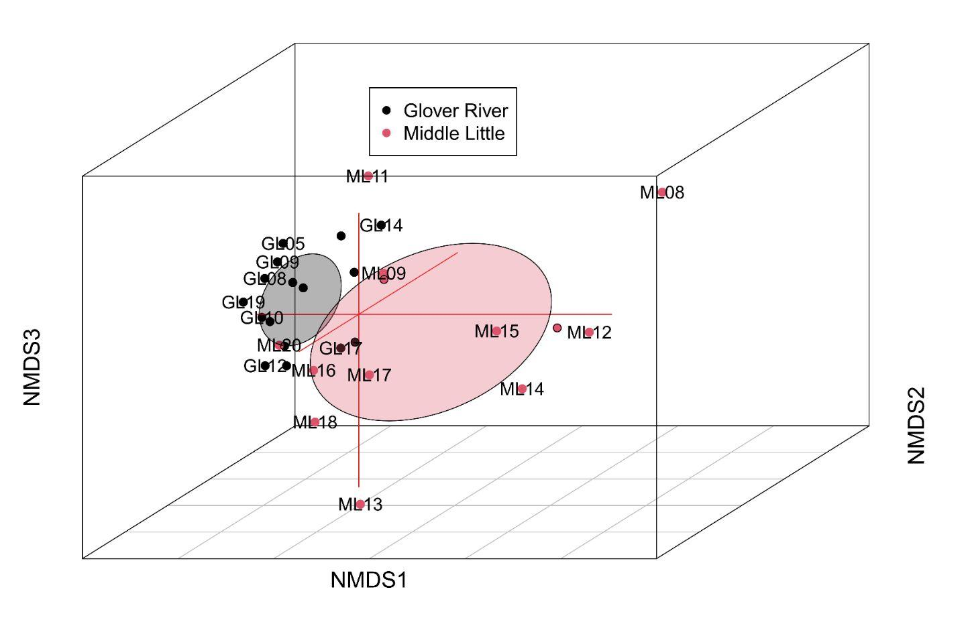

A

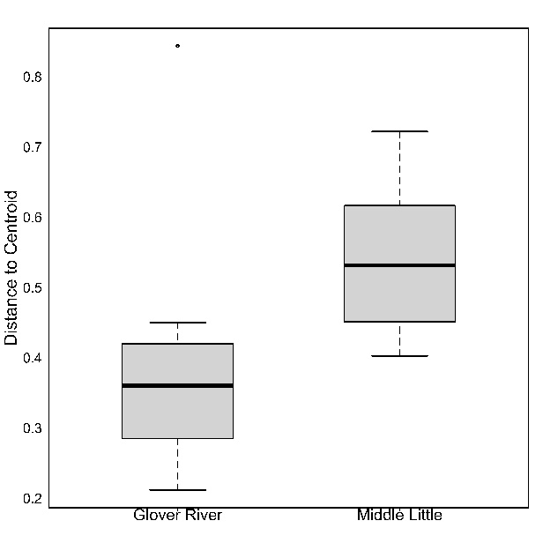
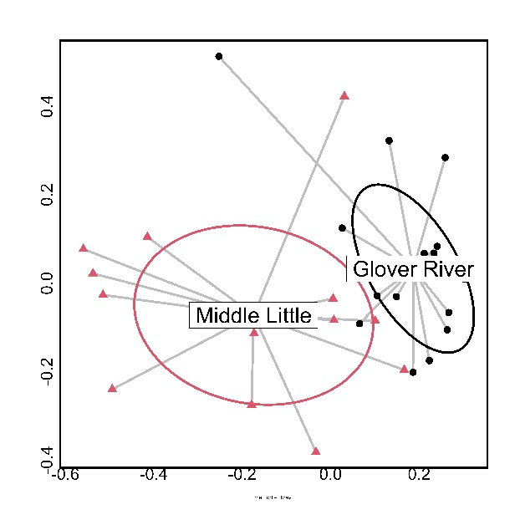
C
B
*

*v

Figure 2. Comparison of fish communities in 29 stream sites relative to two watersheds: the Middle Little watershed and the Glover River watershed. (A) NMDS plot, (B) beta-dispersion plot, and (C) box plot of dispersion values.

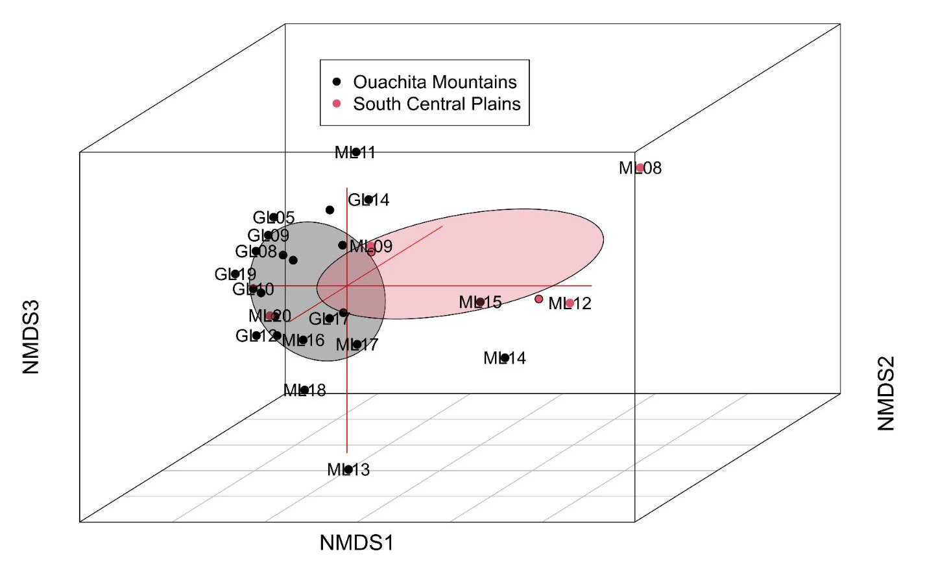

A

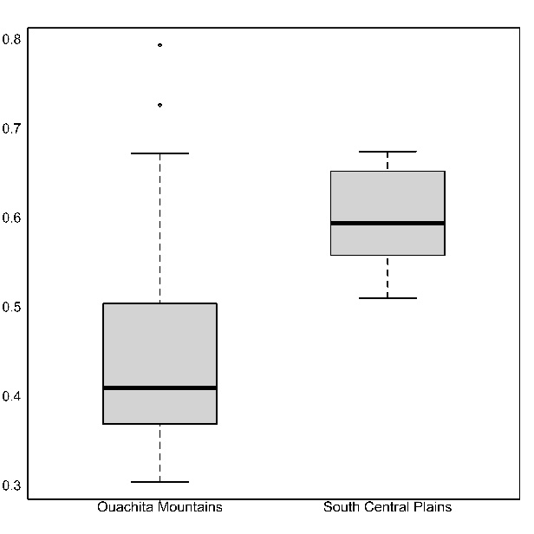
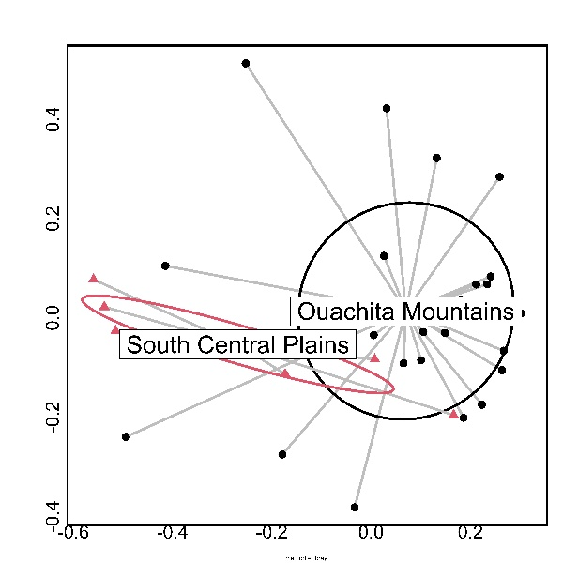
C
B
*
*

Figure 3. Comparison of fish communities in 29 stream sites relative to two level 3 ecoregions: the Ouachita Mountains and the South Central Plains. (A) NMDS plot, (B) beta-dispersion plot, and (C) box plot of dispersion values.
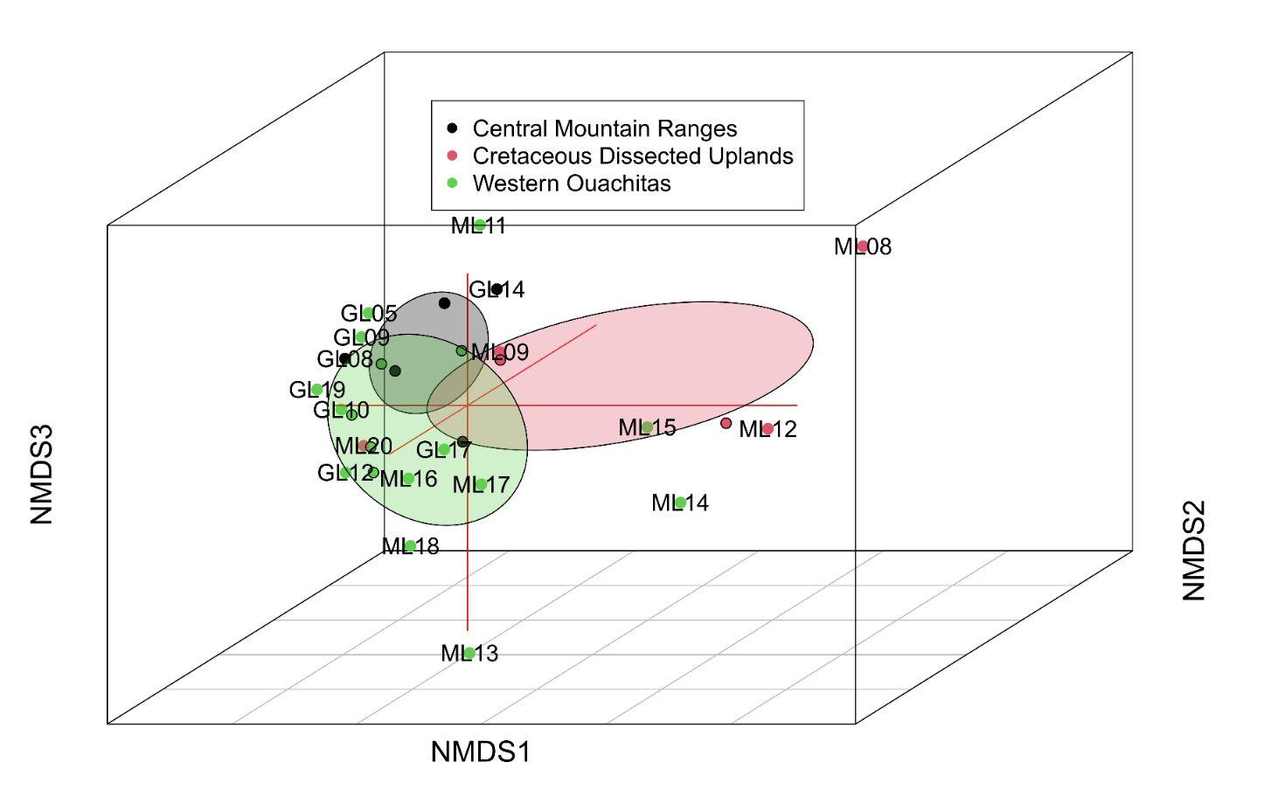
A
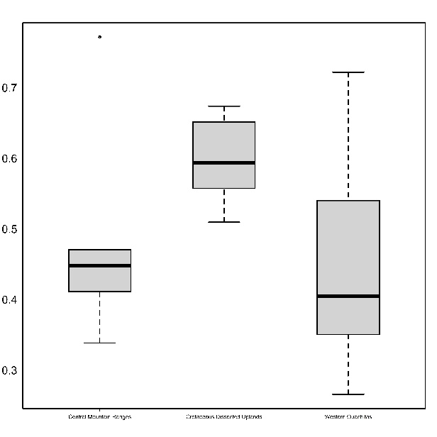
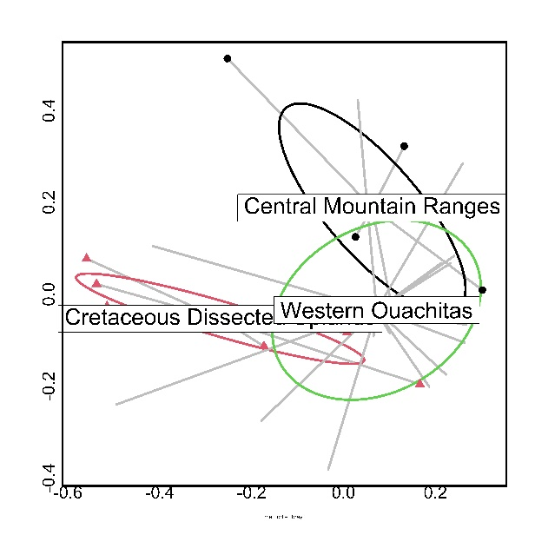
*
C
B
*

Figure 4. Comparison of fish communities in 29 stream sites relative to level 4 ecoregions: the Central Mountain Ranges, Cretaceous Dissected Uplands, and the Western Ouachitas. (A) NMDS plot, (B) beta-dispersion plot, and (C) box plot of dispersion values.
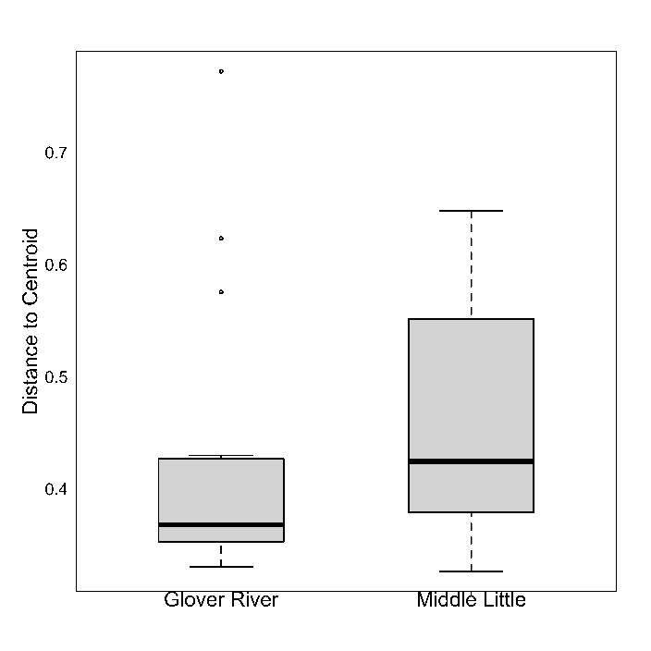
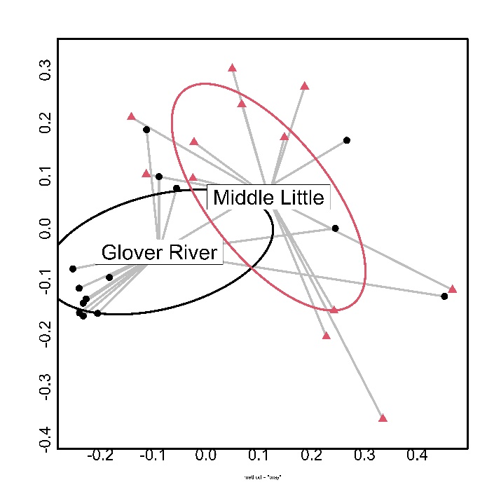
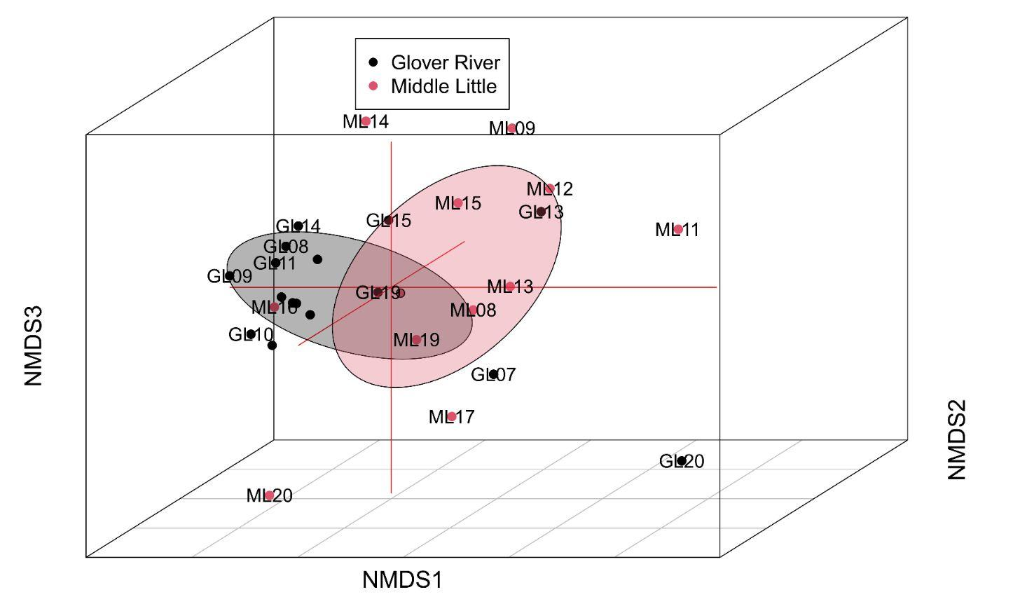
C
B
A

Figure 5. Comparison of macroinvertebrate communities in 29 stream sites relative to two watersheds: the Middle Little watershed and the Glover River watershed. (A) NMDS plot, (B) beta-dispersion plot, and (C) box plot of dispersion values.
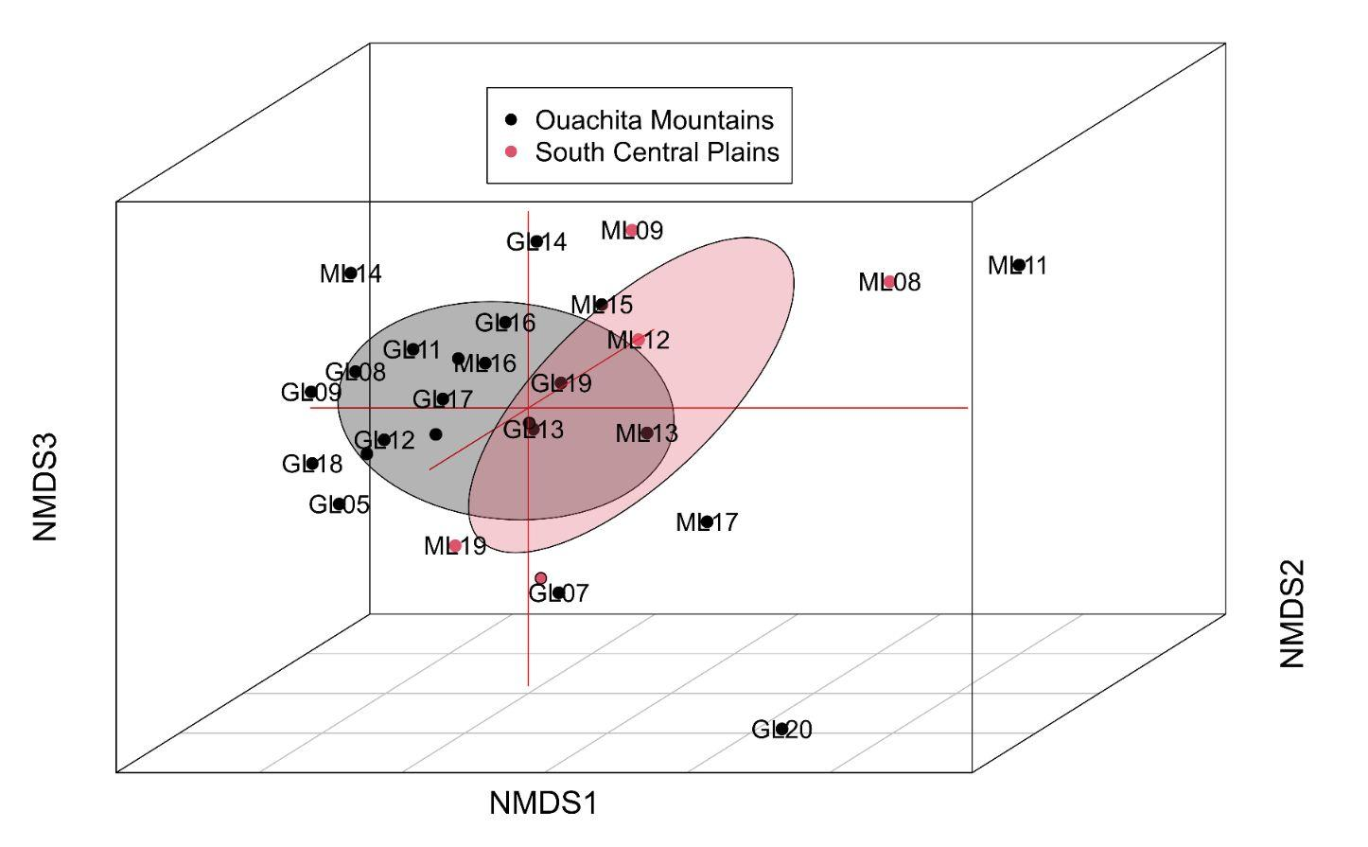

A

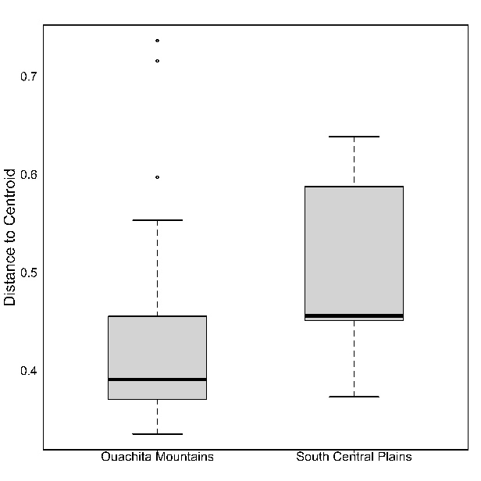
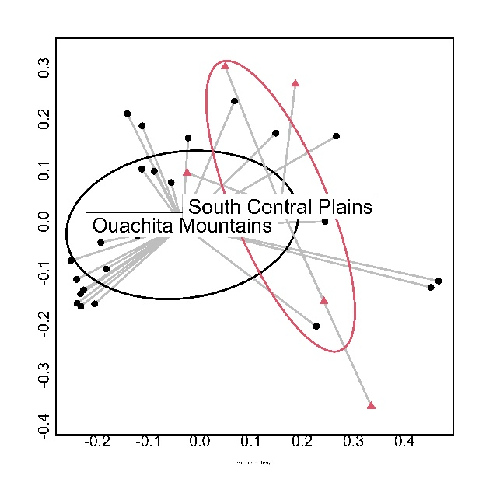
C
B

Figure 6. Comparison of macroinvertebrate communities in 29 stream sites relative to two level 3 ecoregions: the Ouachita Mountains and the South Central Plains. (A) NMDS plot, (B) beta-dispersion plot, and (C) box plot of dispersion values.
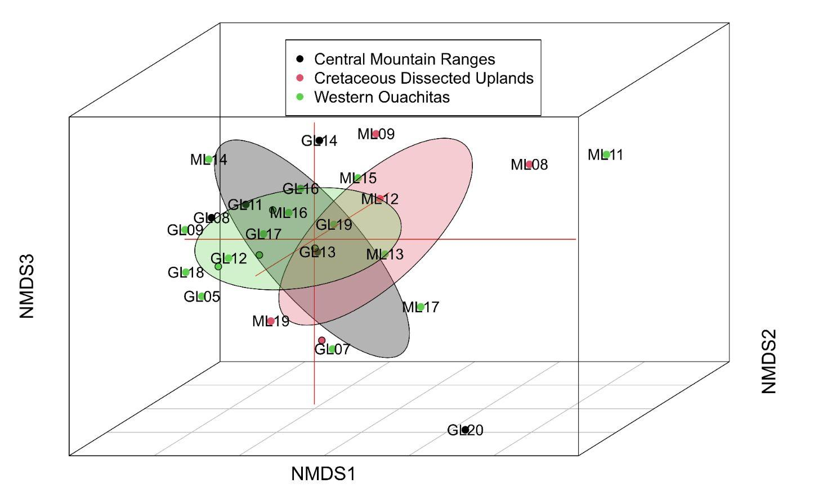

A

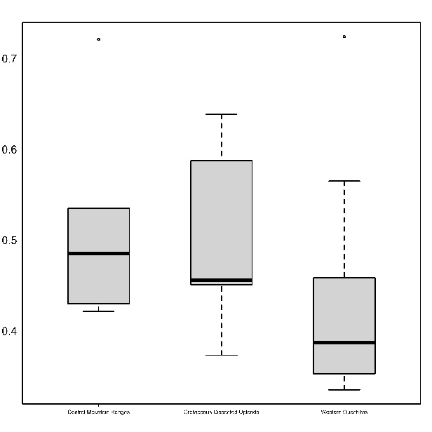
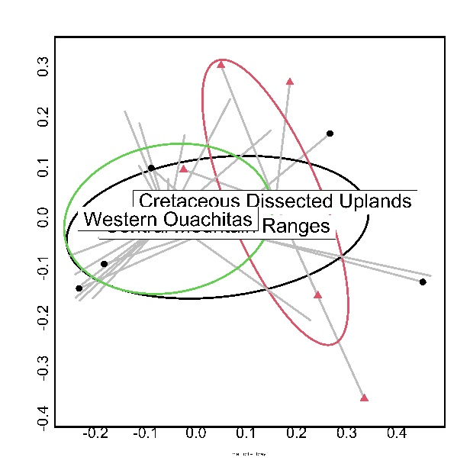
C
B

Figure 7. Comparison of macroinvertebrate communities in 29 stream sites relative to level 4 ecoregions: the Central Mountain Ranges, Cretaceous Dissected Uplands, and the Western Ouachitas. (A) NMDS plot, (B) beta-dispersion plot, and (C) box plot of dispersion values.
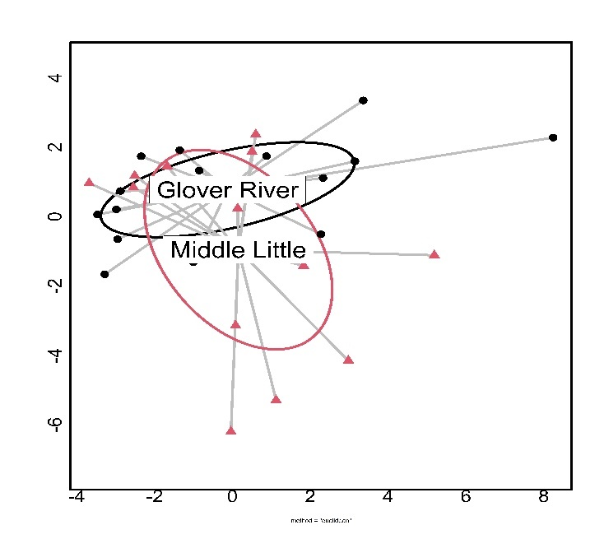
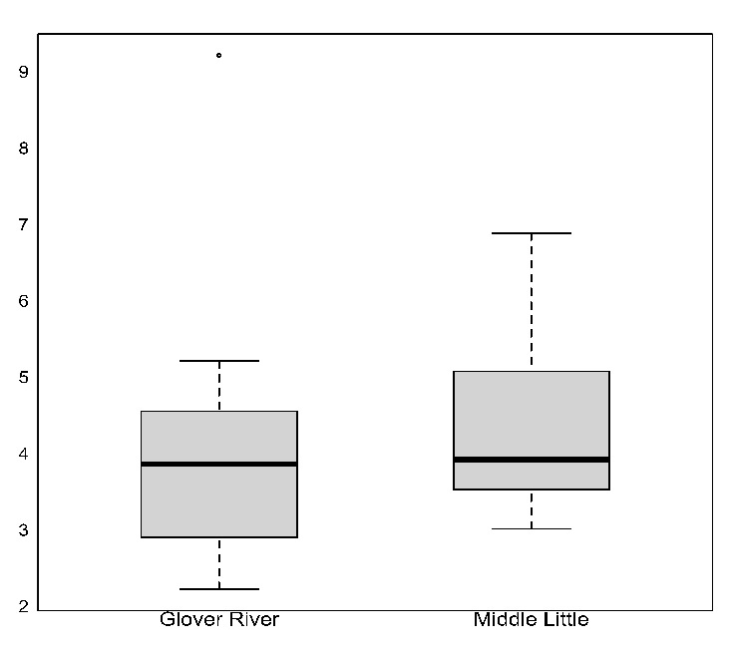
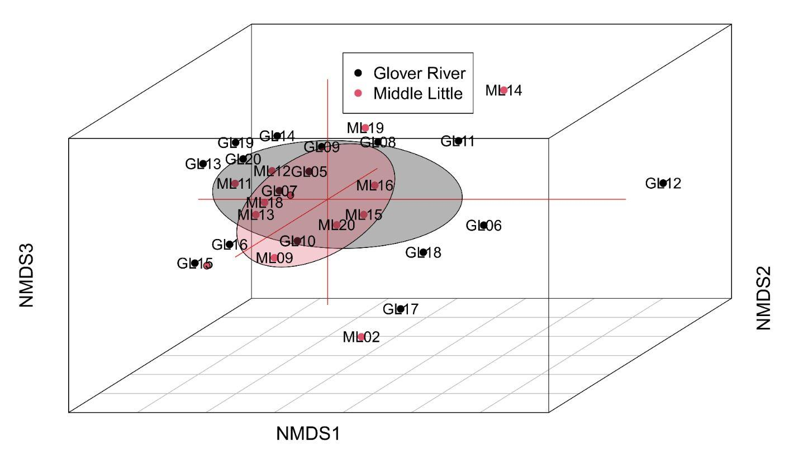
C
B
A
Figure 8. Comparison of physical characteristics in 29 stream sites relative to two watersheds: the Middle Little watershed and the Glover River watershed. (A) NMDS plot, (B) beta-dispersion plot, and (C) box plot of dispersion values.

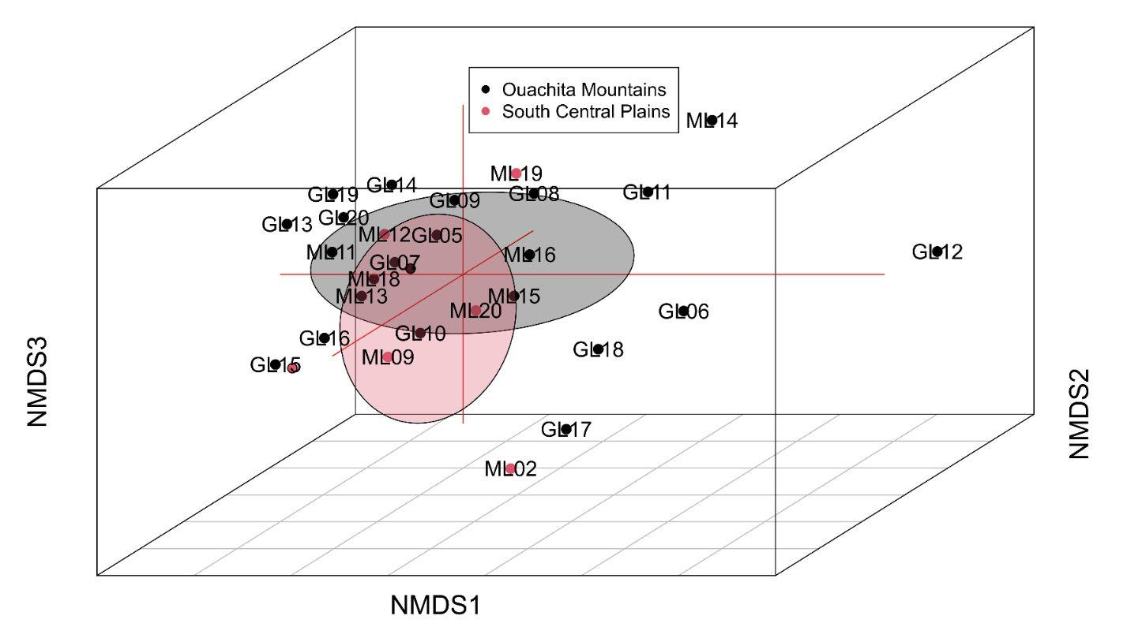
A
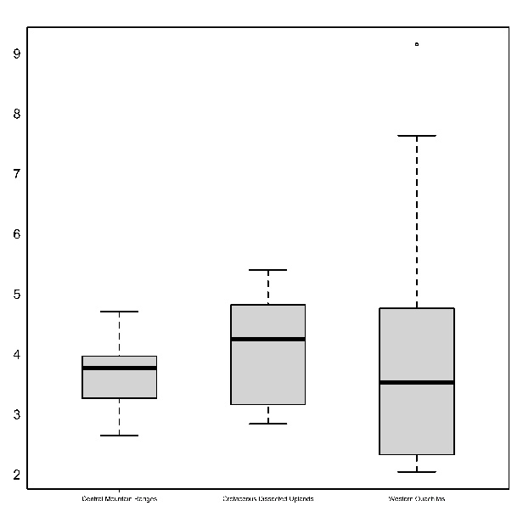
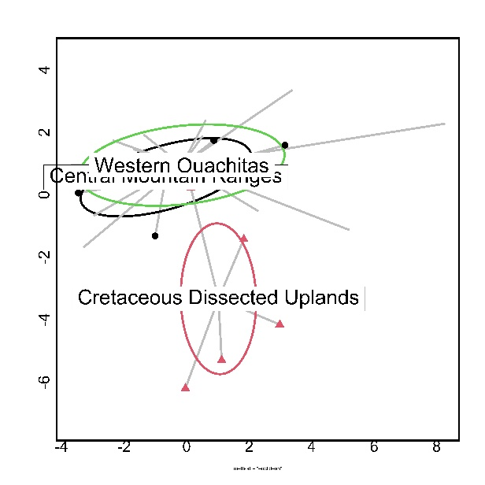
C
B

Figure 9. Comparison of physical characteristics in 29 stream sites relative to two level 3 ecoregions: the Ouachita Mountains and the South Central Plains. (A) NMDS plot, (B) beta-dispersion plot, and (C) box plot of dispersion values.
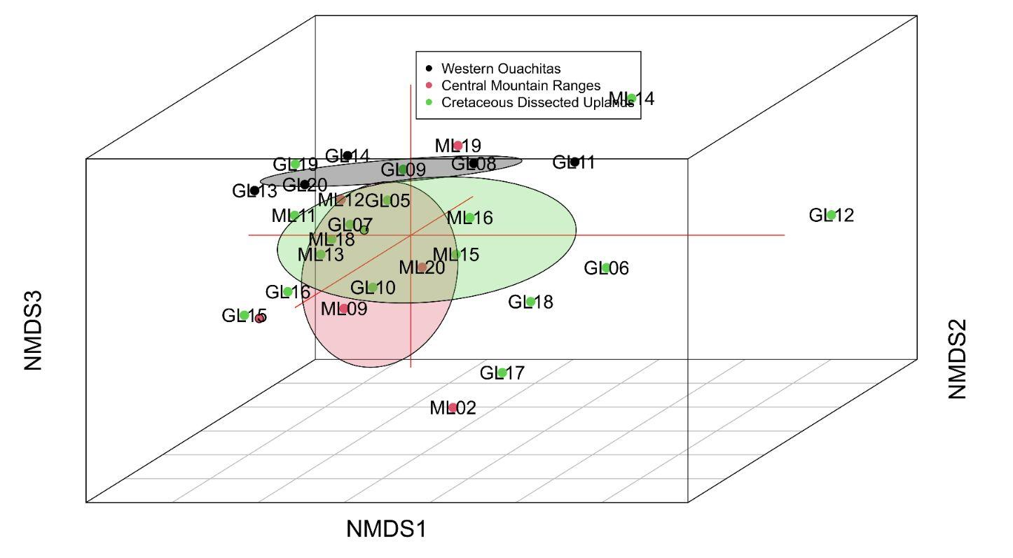

A

C
B

Figure 10. Comparison of physical characteristics in 29 stream sites relative to level 4 ecoregions: the Central Mountain Ranges, Cretaceous Dissected Uplands, and the Western Ouachitas. (A) NMDS plot, (B) beta-dispersion plot, and (C) box plot of dispersion values.
Appendix 1. Macroinvertebrate community composition (abundance) from 16 stream sites in the Glover River Watershed and 13 sites in the Middle Little River watershed. Also included are the values used to calculate IBI. Tolerance values were based first on Lenat (mostly for genus-level determinations) (North Carolina Biotic Index). If Lenat values weren't available, Hilsenhoff's values were used (most at the family level) (WIBI: Wetlands Index of Biotic Integrity). Taxa with no tolerance values were not used in IBI claculations (e.g., most Hemiptera and worms). Number (#) of taxa are the number used to determine IBI. (Continued on next 19 pages).
 | NCBI | WIBI | GL05 | GL06 | GL07 | GL08 | GL09 | GL10 | GL11 | GL12 | GL13 | GL14 | GL15 | GL16 | GL17 | GL18 | GL19 | GL20
Amphipoda
Amphipoda (Hyalella) | 7.9 |  |  | 16 | 1 |  |  | 1 |  |  |  |  |  | 21 | 21 | 3 | 1 | 7
Isopoda
Isopoda (Lirceus) | 7.7 |  |  |  |  | 2 |  |  | 6 | 2 | 2 | 4 |  |  |  |  | 13
Cladocera
Daphniidae
Daphnia |  |  |  |  |  |  |  |  |  |  |  |  |  | 3 |  |  | 30
Decapoda
Cambaridae
Cambaridae (Orconectes) | 2.7 |  | 4 |  |  |  | 1 |  |  |  | 1 |  | 2 |  |  |  | 1 | 1
Clitellata
(Hirudinea)
Unidentified leeches |  |  |  |  |  |  |  |  |  |  |  |  |  |  |  |  | 1
Trombidiformes
Hydrachnidiae
Hydracarina | 5.7 |  |  | 3 |  | 4 |  |  | 1 | 3 |  |  | 1 |  | 2 | 2
Coleoptera
Dytiscidae
Bidessonotus
Heterosternuta |  |  |  |  |  |  |  |  |  |  | 1
Laccophilus | 10.0 |  |  |  |  |  |  |  |  |  |  |  |  |  |  |  | 3
Neoporus
Elmidae
Ancyronyx | 6.9 |  |  |  |  |  |  |  |  |  |  |  |  |  | 2
Dubiraphia | 6.4 |  | 2 | 75 | 2 |  |  | 4 |  | 1 |  | 5 | 5 | 8 | 5 | 49
Heterelmis |  | 4 |  |  |  |  |  |  |  |  |  |  |  | 5
Microcylleopus | 2.1 |  | 2 | 187 |  | 1 |  |  | 7 | 7 |  |  |  | 1 | 26 | 4
Optioservus | 2.7 |  |  |  |  |  |  |  |  | 36 |  |  |  |  |  |  | 1
Stenelmis | 5.4 |  | 22 | 126 | 3 | 12 | 15 | 7 | 56 | 86 |  |  |  | 9 | 41 | 15 | 2
Gyrinidae
Dineutus | 5.5 |  |  |  |  |  |  |  |  |  |  |  |  |  |  |  | 3
Gyrinidae |  |  |  |  |  |  |  |  |  |  |  | 1
Gyrinus | 6.3
Haliplidae
Haliplus |  |  |  |  | 1 |  |  |  |  |  |  |  | 1
Peltodytes | 8.5 |  |  |  |  |  |  |  |  |  |  | 1
Hydrophilidae
Laccobius | 8.0
Tropisternus | 9.8
Hydroporinae
Neoporus
Psephenidae
Ectopria | 4.3 |  |  |  |  |  |  | 1 | 1 | 1 |  |  |  |  |  | 4
Psephenus | 2.5 |  | 38 | 9 |  | 22 | 40 | 5 | 23 | 1 |  |  |  |  | 1 | 13
Scirtidae
Scirtidae
Diptera
Athericeridae
Athericeridae | 2.1 |  |  |  |  | 1 |  |  |  | 3
Ceratopogonidae
Ceratopogoninae |  | 6 |  |  | 2 |  | 1 |  |  |  |  | 1 | 11 |  | 1 |  | 1
Chironominae
Chironominae |  | 6 | 30 | 33 | 4 | 15 | 32 | 29 | 18 | 40 | 4 | 94 | 206 | 34 | 160 | 64 | 37 | 1
Culicidae
Culicidae (Culex) | 10.0 |  | 1 |  |  |  | 2 |  |  |  |  |  |  |  |  | 1
Epihydridae
Epihydridae |  | 6
Limoniidae
Hexatoma | 4.7 |  |  |  |  |  | 2
Limoniidae |  | 3 | 3 |  | 1 | 1 |  |  |  |  |  |  |  |  |  | 1
Tipulidae
Limoniidae |  | 3 |  |  |  | 1
Tipulidae |  | 3 |  |  |  |  | 1
Orthocladinae
Orthocladinae |  | 6 | 6 | 4 | 1 | 5 | 4 |  | 4 | 1 | 2 |  | 1 | 3 | 20 | 17
Stratiomyidae
Stratiomyidae |  |  |  |  |  |  |  |  |  |  |  |  |  | 1
Tabanidae
Tabanidae |  | 6 |  |  |  |  | 1 |  |  | 2 |  | 1 |  |  |  | 1
Tanypodinae
Tanypodinae |  | 6 | 27 | 3 | 10 | 18 | 5 | 8 | 7 | 3 | 2 | 31 | 28 | 17 | 17 | 13 | 16
Ephemeroptera
Baetidae
Acentrella | 3.6 |  |  |  |  |  |  | 2 |  |  |  |  |  |  |  | 9
Acerpenna | 3.7 |  | 1 |  |  | 1 | 10 |  | 2 |  |  |  | 3 | 1 |  | 4 | 8
Baetis |  | 4 |  |  |  | 2 | 13 | 4 |  | 17 |  |  |  | 2 | 3
Baetis intercalaris | 5.8 |  | 1 |  |  |  |  | 1 | 1 | 14
Baetis tricaudatis | 1.8 |  | 3
Centroptilum | 6.3 |  |  |  |  | 3 |  |  |  |  |  |  |  | 1
Fallceon |  | 4
Heterocloeon | 3.6 |  |  | 1 |  |  | 1 | 1 |  | 2
Neocloeon |  | 4 | 4 | 8 | 1 |  | 4 | 1 |  | 43 |  |  |  |  | 1 | 2 | 3
Paracloedes | 8.7 |  | 2
Procloeon |  | 4 |  | 2 |  | 1 | 63 | 7 | 2 | 85 |  | 1 | 5 | 3 | 12 | 9 | 3
Caenidae
Caenis | 7.6 |  | 10 | 52 | 2 | 6 | 7 | 73 | 34 | 61 | 1 | 151 | 82 | 44 | 142 | 37 | 71 | 1
Sparbarus |  | 7 |  | 1
Ephemeridae
Hexagenia | 4.7 |  |  |  |  |  |  |  |  |  |  |  |  | 1 | 1
Heptageniidae
Afghanurus |  | 4 |  | 2 |  |  |  |  | 5 | 6
unidentified |  | 4 |  |  |  |  |  |  | 6 |  |  |  | 1
Leucrocruta | 0.0 |  | 7 | 6 |  | 2 | 3 | 8 | 43 | 15 |  | 3 | 21 | 7 | 12 | 7 | 1
Maccaffertium |  | 4 | 8 | 11 |  | 10 | 7 | 22 | 18 | 69 | 1 | 2 | 7 | 7 | 2 | 19 | 16
Stenocron |  | 4 | 3 | 2 |  |  | 4 | 2 | 6 | 32 |  |  |  | 3 | 1 | 4
Stenonema |  | 4 | 9 | 8 |  | 2 | 2 | 14 | 4 | 68 |  | 5 | 10 | 4 | 7 | 7 | 12
Isonychiidae
Isonychia | 3.8 |  |  | 4 |  |  |  |  |  | 5
Leptohyphidae
Tricorythodes | 5.4 |  |  | 11 | 1 |  |  |  | 15 | 1 | 1 |  |  |  |  | 5
Leptophlebiidae
Choroterpes |  | 2 | 2 | 1 |  | 7 | 9 | 3 | 11 | 37 |  | 9 |  | 1 |  |  | 7
Neochoroterpes |  | 2 | 2 |  |  | 2 | 5 | 6 | 1 | 1 |  | 1 |  |  |  | 2 | 3
Potamanthidae
Anthopotamus | 1.6 |  |  |  |  |  |  |  |  | 7
Hemiptera
Belostomatidae
Belostomatidae (Belostoma) | 9.8 |  |  |  |  |  |  |  |  |  |  |  |  |  |  |  |  | 2
Corixidae
Corixidae
Hesperocorixa | 9.0 |  |  |  |  |  |  |  |  |  |  |  |  |  | 2
Neonecta | 9.0 |  |  |  |  |  |  |  |  |  |  |  |  |  |  |  |  | 1
Palmacorixa | 9.0 |  |  |  |  |  |  |  |  |  |  |  | 1
Gerridae
Limnoporus
Trepobates |  |  |  | 2 |  |  |  |  | 1 |  |  | 2 |  | 1 | 20 |  | 2
Nepidae
Ranatra fusca | 7.5
Veliidae
Mesovelia |  |  |  |  |  |  |  |  |  |  |  |  |  |  | 1 | 3
Rhagovelia |  |  |  | 8 |  |  | 1 |  |  | 2 |  |  |  |  | 8 | 3
Lepidoptera
Crambidae
Petrophila | 1.8 |  |  |  |  |  |  |  |  |  |  |  |  |  |  | 1
Megaloptera
Corydalidae
Corydalidae (Corydalus) | 5.6 |  |  |  |  |  | 1 | 1 |  |  |  |  |  |  |  | 2
Sialidae
Sialis | 7.5 |  | 3 |  |  | 1 | 3 |  | 1
Neuroptera
Sisyridae
Sisyra
Odonata
Aeshnidae
Basiaeschna | 7.7 |  |  |  |  |  |  |  |  |  |  |  |  |  |  |  |  | 1
Coenagrionidae
Argia | 8.7 |  | 5 |  |  |  |  |  | 3 |  |  | 40 | 3 | 12 | 5
Enallagma | 9.0 |  |  | 1 |  | 1 | 1 |  |  |  |  | 3 |  |  | 3
Ischnura | 9.4 |  |  |  | 3 |  |  |  |  |  |  |  |  | 2
Gomphidae
Gomphidae |  | 1 | 4 |  |  |  |  |  |  |  |  |  |  |  |  |  |  | 2
Gomphus | 6.2 |  |  | 1 |  |  |  |  |  |  |  |  |  | 3 |  |  | 1
Hagenius | 4.0 |  |  |  | 1
Phanogomphus ('Gomphus') | 6.2 |  |  |  |  |  | 1 |  |  |  |  | 1 | 4 | 1
Progomphus | 8.7
Lestidae
Lestis |  | 9 |  |  |  |  |  |  |  |  |  |  | 1
Macromiinae
Macromiidae (Macromia) | 6.7 |  | 5 |  |  |  |  |  |  |  |  | 1 |  |  | 5
Plecoptera
Perlidae
Acroneuria |  | 1 |  |  |  |  |  |  |  | 1 |  |  |  |  |  | 2
Neoperla | 1.6 |  | 8 | 61 |  | 13 | 11 | 1 | 23 | 50 |  |  |  |  | 1 | 1
Paragnetina |  | 1 |  |  |  |  |  |  |  |  |  |  |  |  |  | 1
Trichoptera
Glossomatidae
Glossomatidae (Glossosoma) | 1.5
Helicopsychidae
Helicopsyche | 0.0 |  | 6 | 10 |  | 17 |  |  | 3 |  |  |  | 1 | 5 | 1 | 12
Hydropsychidae
Cheumatopsyche | 6.6 |  | 1 | 31 |  |  | 4 | 2 | 2 | 6 |  |  |  |  | 6
Diplectrona | 2.2 |  |  | 1 |  |  |  |  |  |  |  |  |  |  | 1
Hydropsyche |  | 4 | 2 | 12 |  |  |  |  |  | 9 |  |  | 1 |  | 14 | 5
Hydropsychidae1 |  | 4 |  |  |  | 1 |  |  |  |  |  |  |  |  | 1
Hydroptilidae
Oxyethira |  | 4 |  |  |  |  |  |  |  |  |  |  |  |  |  | 5
Hydroptilidae |  | 4 |  |  |  |  |  |  |  |  |  |  |  |  | 1
Leptoceridae
Ceraclea |  | 4 |  |  | 1
Ocetis | 5.7 |  |  |  |  |  |  |  |  |  |  |  |  |  |  | 1
Philopotamidae
Chimarra | 2.8 |  | 2 | 27 |  | 4 |  | 3 |  | 13 |  |  | 1 |  | 15 | 1
Polycentropoididae |  | 6 |  |  |  |  |  |  | 2
Polycentropoididae3
Polycentropoididae2 |  | 6 |  |  |  |  |  |  | 1 |  |  |  |  |  | 1 |  | 1
Psychomyiidae
Psychomyia |  | 2 |  |  |  |  |  |  | 1
Haplotaxids
Enchytraeidae
Enchytraeidae | 10 |  |  | 3 | 1 |  |  |  |  | 3 |  |  | 6 |  | 1 | 2 | 10
Lumbriculidae
Lumbriculidae
Lumbriculidae | 7.3 |  | 9 |  | 1 | 4 |  | 1 | 6 | 11 |  |  | 5 | 4 |  |  | 4 | 5
Naididae
Naididae |  |  |  | 4 |  | 3 |  | 1 |  | 2 | 3 |  | 5 |  | 3 | 2 | 6
Unionoida
Unionidae
Unionidae |  |  |  |  |  |  |  |  |  |  |  | 1
Venerida
Cyrenidae
Corbicula | 6.3 |  |  | 31 |  |  |  |  | 1 | 4 |  | 3 |  | 3 | 8 |  | 11
Mollusca
Physidae
Physella | 9.1 |  | 2 | 11 |  |  |  |  | 2 | 15 | 3 | 1 | 3 |  | 2 |  | 1
Planorbidae
Planorbella |  |  |  |  |  |  |  |  |  |  |  |  |  |  |  |  |  | 4
Planorbidae
Planorbis |  |  |  | 3 | 2 |  |  |  | 4 |  | 4 | 4 | 5 | 7 | 6 |  | 5
Total Site Abundance |  |  | 34 | 771 | 38 | 162 | 254 | 208 | 321 | 765 | 25 | 366 | 420 | 214 | 582 | 333 | 274 | 25

 | NCBI | WIBI | ML08 | ML09 | ML10 | ML11 | ML12 | ML13 | ML14 | ML15 | ML16 | ML17 | ML18 | ML19 | ML20 | Total Species Abundance
Amphipoda
Amphipoda (Hyalella) | 7.9 |  |  |  | 25 |  |  |  |  | 28 | 54 |  | 20 |  |  | 198
Isopoda
Isopoda (Lirceus) | 7.7 |  |  |  |  |  |  | 4 |  |  |  |  |  |  |  | 33
Cladocera
Daphniidae
Daphnia |  |  |  |  |  |  |  |  |  |  |  |  | 42 |  |  | 75
Decapoda
Cambaridae
Cambaridae (Orconectes) | 2.7 |  |  |  |  |  | 6 | 2 |  |  |  | 1 |  |  |  | 19
Clitellata
(Hirudinea)
Unidentified leeches |  |  | 12 |  |  |  |  | 4 |  |  |  | 3 | 2 |  |  | 22
Trombidiformes
Hydrachnidiae
Hydracarina | 5.7 |  |  |  | 2 |  |  |  | 4 |  |  |  | 1 |  |  | 23
Coleoptera
Dytiscidae
Bidessonotus |  |  |  |  | 2 |  |  |  |  |  |  |  |  |  |  | 2
Heterosternuta |  |  |  |  |  |  |  |  |  |  |  |  |  |  |  | 1
Laccophilus | 10.0 |  |  |  |  |  |  |  | 1 |  |  |  |  |  |  | 4
Neoporus |  |  |  |  |  |  | 1 |  | 6 |  |  |  |  |  |  | 7
Elmidae
Ancyronyx | 6.9 |  |  |  |  |  |  |  |  |  |  |  |  |  |  | 2
Dubiraphia | 6.4 |  |  |  |  |  |  |  |  | 1 | 40 | 1 |  |  | 2 | 200
Heterelmis |  | 4 |  |  |  |  |  |  |  |  |  |  |  |  |  | 5
Microcylleopus | 2.1 |  | 1 |  |  |  |  |  |  |  | 17 |  |  |  |  | 253
Optioservus | 2.7 |  |  |  |  |  |  |  |  |  |  | 2 |  |  |  | 39
Stenelmis | 5.4 |  | 25 |  | 1 |  |  |  |  |  | 2 | 4 | 1 | 12 | 1 | 439
Gyrinidae
Dineutus | 5.5 |  |  |  |  | 2 | 1 |  |  |  |  |  |  |  |  | 6
Gyrinidae |  |  |  |  |  |  |  |  |  |  |  |  |  |  |  | 1
Gyrinus | 6.3 |  | 1 |  |  | 1 | 2 |  |  |  |  | 7 |  |  |  | 11
Haliplidae
Haliplus |  |  |  |  |  |  |  |  |  |  |  |  |  |  |  | 2
Peltodytes | 8.5 |  | 1 |  | 1 |  |  |  |  |  |  |  |  |  |  | 3
Hydrophilidae
Laccobius | 8.0 |  |  |  | 4 |  |  |  |  |  |  |  |  |  |  | 4
Tropisternus | 9.8 |  |  |  |  |  |  |  | 4 |  |  |  |  |  |  | 4
Hydroporinae
Neoporus |  |  |  |  |  |  |  |  | 1 |  |  |  |  |  |  | 1
Psephenidae
Ectopria | 4.3 |  |  |  |  |  |  |  |  |  | 3 |  |  |  | 1 | 11
Psephenus | 2.5 |  |  |  |  |  |  |  |  |  |  | 1 | 1 | 1 | 1 | 156
Scirtidae
Scirtidae |  |  |  |  | 4 |  |  |  |  |  |  |  |  |  |  | 4
Diptera
Athericeridae
Athericeridae | 2.1 |  |  |  | 1 |  | 2 | 2 |  |  |  |  |  | 1 |  | 10
Ceratopogonidae
Ceratopogoninae |  | 6 |  |  | 5 |  | 7 |  |  |  | 1 |  | 1 |  |  | 31
Chironominae
Chironominae |  | 6 | 1 | 183 | 7 | 7 | 91 | 37 | 140 | 48 | 160 | 2 | 136 | 101 | 3 | 1,717
Culicidae
Culicidae (Culex) | 10.0 |  |  |  |  |  |  |  |  |  |  |  |  | 1 |  | 5
Epihydridae
Epihydridae |  | 6 |  |  |  |  |  |  |  |  | 1 |  |  |  | 1 | 2
Limoniidae
Hexatoma | 4.7 |  |  |  |  |  |  |  |  |  |  |  |  |  |  | 2
Limoniidae |  | 3 |  |  |  |  | 6 |  |  |  |  |  |  |  |  | 12
Tipulidae
Limoniidae |  | 3 |  |  |  |  |  |  |  |  |  |  |  |  |  | 1
Tipulidae |  | 3 |  |  |  |  |  |  |  |  |  |  |  | 2 |  | 3
Orthocladinae
Orthocladinae |  | 6 |  | 6 |  | 1 | 14 | 6 | 8 | 5 | 4 |  | 7 | 3 |  | 122
Stratiomyidae
Stratiomyidae |  |  |  |  |  |  |  |  |  |  |  |  |  |  |  | 1
Tabanidae
Tabanidae |  | 6 |  |  |  |  | 2 |  | 8 | 3 |  |  |  |  |  | 18
Tanypodinae
Tanypodinae |  | 6 | 1 | 14 | 15 |  | 2 | 4 | 8 | 20 | 23 | 8 | 41 | 12 |  | 353
Ephemeroptera
Baetidae
Acentrella | 3.6 |  |  |  |  |  |  |  | 3 |  |  |  |  |  |  | 14
Acerpenna | 3.7 |  |  |  |  |  |  |  | 12 | 1 |  |  |  |  |  | 43
Baetis |  | 4 |  | 1 |  |  |  |  | 4 |  | 2 |  |  |  |  | 48
Baetis intercalaris | 5.8 |  |  |  |  |  |  |  |  |  |  |  |  |  |  | 17
Baetis tricaudatis | 1.8 |  |  |  |  |  |  |  |  |  |  |  |  |  |  | 3
Centroptilum | 6.3 |  |  |  |  |  |  |  |  |  |  |  |  |  |  | 4
Fallceon |  | 4 |  | 3 |  |  |  |  |  |  |  |  |  |  |  | 3
Heterocloeon | 3.6 |  |  |  |  |  |  |  | 8 |  |  |  |  |  |  | 13
Neocloeon |  | 4 |  |  |  |  |  | 2 |  |  |  |  |  | 1 |  | 70
Paracloedes | 8.7 |  |  |  |  |  |  |  |  |  |  |  |  |  |  | 2
Procloeon |  | 4 |  | 3 |  |  |  |  | 12 | 2 | 43 |  | 2 |  |  | 255
Caenidae
Caenis | 7.6 |  |  | 99 | 9 |  | 3 | 19 | 29 | 75 | 86 | 19 | 22 | 49 | 4 | 1,188
Sparbarus |  | 7 |  |  |  |  |  |  |  |  |  |  |  |  |  | 1
Ephemeridae
Hexagenia | 4.7 |  |  |  |  |  |  |  |  |  |  | 1 |  |  |  | 3
Heptageniidae
Afghanurus |  | 4 |  |  |  |  |  |  | 1 |  |  |  |  |  |  | 14
unidentified |  | 4 |  |  |  |  |  |  | 1 |  |  |  |  |  |  | 1
Leucrocruta | 0.0 |  |  |  |  |  |  | 1 | 4 |  | 2 | 1 | 1 | 4 | 1 | 149
Maccaffertium |  | 4 |  |  |  |  | 3 |  | 4 | 3 |  |  | 9 | 3 |  | 221
Stenocron |  | 4 |  |  |  |  |  |  |  |  |  |  | 2 |  |  | 59
Stenonema |  | 4 |  |  |  |  |  | 2 |  |  | 2 | 2 | 1 |  |  | 159
Isonychiidae
Isonychia | 3.8 |  |  |  |  |  |  |  |  |  |  | 1 |  |  |  | 10
Leptohyphidae
Tricorythodes | 5.4 |  |  | 6 | 2 |  | 3 |  | 8 |  | 1 |  |  | 4 |  | 58
Leptophlebiidae
Choroterpes |  | 2 |  |  |  |  |  |  |  |  | 1 |  |  | 2 | 3 | 93
Neochoroterpes |  | 2 |  |  |  |  |  |  |  |  | 1 |  |  |  |  | 24
Potamanthidae
Anthopotamus | 1.6 |  |  |  |  |  |  |  |  |  |  |  |  |  |  | 7
Hemiptera
Belostomatidae
Belostomatidae (Belostoma) | 9.8 |  |  |  |  |  |  |  |  |  |  |  |  |  |  | 2
Corixidae
Corixidae |  |  |  | 3 | 2 |  | 1 |  |  |  |  |  |  |  |  | 6
Hesperocorixa | 9.0 |  | 1 |  | 3 |  |  |  |  |  |  |  |  |  |  | 6
Neonecta | 9.0 |  |  |  |  |  |  | 3 |  |  |  |  |  |  |  | 4
Palmacorixa | 9.0 |  |  |  |  | 1 |  | 2 |  |  |  |  |  |  |  | 4
Gerridae
Limnoporus |  |  |  |  | 1 |  |  |  |  |  |  |  |  |  |  | 1
Trepobates |  |  | 1 |  |  |  |  |  | 2 |  |  |  | 3 |  |  | 32
Nepidae
Ranatra fusca | 7.5 |  |  |  |  |  |  |  | 2 |  |  |  |  |  |  | 2
Veliidae
Mesovelia |  |  |  |  |  | 1 |  |  |  | 2 |  |  |  |  |  | 7
Rhagovelia |  |  | 1 |  |  | 3 |  |  |  |  |  | 4 |  |  |  | 30
Lepidoptera
Crambidae
Petrophila | 1.8 |  |  |  |  |  |  |  |  |  |  |  |  |  |  | 1
Megaloptera
Corydalidae
Corydalidae (Corydalus) | 5.6 |  |  |  |  |  |  |  |  |  |  |  |  |  |  | 4
Sialidae
Sialis | 7.5 |  |  |  | 1 |  |  |  |  |  |  |  |  |  |  | 9
Neuroptera
Sisyridae
Sisyra |  |  |  |  | 2 |  |  |  |  |  |  |  |  |  |  | 2
Odonata
Aeshnidae
Basiaeschna | 7.7 |  |  |  | 7 |  |  |  |  |  |  |  |  |  |  | 8
Coenagrionidae
Argia | 8.7 |  |  |  | 1 |  |  |  | 4 |  |  |  |  |  | 1 | 74
Enallagma | 9.0 |  |  |  |  |  |  |  |  |  | 1 |  |  |  |  | 10
Ischnura | 9.4 |  |  |  | 24 |  |  |  |  |  |  |  | 1 |  |  | 30
Gomphidae
Gomphidae |  | 1 |  |  |  |  |  |  |  |  |  |  |  | 1 | 1 | 8
Gomphus | 6.2 |  |  |  |  |  |  |  |  | 1 |  |  |  |  | 1 | 7
Hagenius | 4.0 |  |  |  |  |  |  |  |  |  |  |  |  |  |  | 1
Phanogomphus ('Gomphus') | 6.2 |  |  | 2 | 2 |  |  |  |  |  |  |  |  |  |  | 11
Progomphus | 8.7 |  |  | 6 |  |  |  |  |  |  |  |  |  |  |  | 6
Lestidae
Lestis |  | 9 |  |  |  |  |  |  |  |  |  |  |  |  |  | 1
Macromiinae
Macromiidae (Macromia) | 6.7 |  |  |  | 11 |  | 1 | 1 | 3 |  |  |  | 2 |  |  | 29
Plecoptera
Perlidae
Acroneuria |  | 1 |  |  |  |  |  |  |  |  |  |  |  |  |  | 3
Neoperla | 1.6 |  |  |  |  |  |  |  | 2 |  |  |  |  |  |  | 171
Paragnetina |  | 1 |  |  |  |  |  |  |  |  |  |  |  |  |  | 1
Trichoptera
Glossomatidae
Glossomatidae (Glossosoma) | 1.5 |  |  |  |  |  |  |  |  |  |  |  |  | 1 |  | 1
Helicopsychidae
Helicopsyche | 0.0 |  |  |  |  |  |  |  |  |  |  |  |  |  |  | 55
Hydropsychidae
Cheumatopsyche | 6.6 |  |  |  |  |  |  |  |  |  | 1 |  |  |  |  | 53
Diplectrona | 2.2 |  |  |  |  |  |  |  |  |  |  | 1 |  |  |  | 3
Hydropsyche |  | 4 |  |  |  |  |  |  |  |  |  |  |  | 1 |  | 44
Hydropsychidae1 |  | 4 |  |  |  |  |  |  |  |  |  |  |  |  |  | 2
Hydroptilidae
Oxyethira |  | 4 |  |  |  |  |  |  |  |  |  |  |  |  |  | 5
Hydroptilidae |  | 4 |  |  |  |  |  |  |  |  |  |  |  |  |  | 1
Leptoceridae
Ceraclea |  | 4 |  |  |  |  |  |  |  |  |  |  |  |  |  | 1
Ocetis | 5.7 |  |  |  |  |  |  |  |  |  |  |  |  |  |  | 1
Philopotamidae
Chimarra | 2.8 |  |  |  |  |  |  |  |  |  |  |  |  |  |  | 66
Polycentropoididae |  | 6 |  |  |  |  |  |  |  |  |  |  |  |  |  | 2
Polycentropoididae3
Polycentropoididae2 |  | 6 |  |  |  |  |  |  |  |  | 1 |  |  |  |  | 4
Psychomyiidae
Psychomyia |  | 2 |  |  |  |  |  |  |  |  |  |  |  |  |  | 1
Haplotaxids
Enchytraeidae
Enchytraeidae | 10 |  |  | 13 |  | 1 | 1 |  |  |  |  | 1 | 6 | 5 |  | 53
Lumbriculidae
Lumbriculidae
Lumbriculidae | 7.3 |  | 3 | 27 | 5 |  | 4 | 6 | 3 | 5 |  | 2 | 13 | 1 |  | 115
Naididae
Naididae |  |  |  | 12 |  |  | 136 | 103 | 10 | 8 | 15 |  | 4 | 2 |  | 319
Unionoida
Unionidae
Unionidae |  |  |  |  |  |  |  |  |  |  |  |  |  |  |  | 1
Venerida
Cyrenidae
Corbicula | 6.3 |  | 2 | 33 | 3 | 5 | 5 | 4 |  | 5 | 2 |  |  |  | 4 | 124
Mollusca
Physidae
Physella | 9.1 |  |  |  |  |  |  | 8 |  |  |  | 1 |  |  |  | 49
Planorbidae
Planorbella |  |  |  |  |  | 2 |  |  |  |  |  | 14 |  |  |  | 20
Planorbidae |  |  |  |  |  |  |  |  |  |  | 1 |  |  |  |  | 1
Planorbis |  |  |  |  |  |  |  | 1 |  | 1 |  |  | 2 | 3 | 2 | 49
Total Site Abundance |  |  | 50 | 411 | 140 | 24 | 291 | 211 | 292 | 208 | 464 | 76 | 320 | 210 | 26 | 7,715

Appendix 2. Fish community composition with raw abundance values. (Continued on next 2 pages)
Family | Species | GL05 | GL06 | GL07 | GL08 | GL09 | GL10 | GL11 | GL12 | GL13 | GL14 | GL15 | GL16 | GL17 | GL18 | GL19 | GL20 | ML02 | ML08 | ML09 | ML11 | ML12 | ML13 | ML14 | ML15 | ML16 | ML17 | ML18 | ML19 | ML20
Aphredoderidae | Aphredoderus sayanus |  |  |  |  |  |  |  |  |  |  |  |  |  |  |  |  |  |  |  |  | 1
Atherinopsidae | Labidesthes sicculus |  | 3 | 6 |  |  | 1 |  | 4 |  |  |  |  | 39 | 12 |  |  |  |  |  |  |  | 4 | 5 | 1 | 12 | 13 | 16 |  | 5
Catostomidae | Moxostoma carinatum |  |  |  |  |  |  |  |  |  |  |  |  |  |  |  |  |  |  |  |  |  |  | 1 |  | 1
 | Moxostoma duquesni |  |  | 5
 | Moxostoma erythurum |  |  |  |  |  |  |  |  |  |  |  |  |  |  |  |  |  |  |  |  | 1
 | Erimyzon claviformis |  |  | 1 | 1
Centrarchidae | Centrarchus macropterus |  |  |  |  |  |  |  |  |  |  |  |  |  |  |  |  |  |  |  |  |  |  |  |  | 1 |  |  |  | 1
 | Lepomis cyanellus | 4 | 1 | 2 | 1 | 2 |  |  |  |  | 4 |  | 2 | 1 | 1 |  |  |  |  |  | 10 |  |  |  |  |  |  |  |  | 1
 | Lepomis humilus |  |  |  |  |  |  |  |  |  |  |  |  |  |  |  |  |  |  |  |  |  | 1
 | Lepomis macrochirus |  |  |  |  | 1 |  |  |  |  |  |  |  |  |  |  |  | 1 | 60 |  |  | 13 |  | 8 | 1
 | Lepomis megalotis | 3 | 5 | 6 | 17 | 3 | 5 | 26 | 2 |  | 17 | 3 | 10 | 6 | 3 | 2 | 4 |  |  | 5 | 25 |  |  |  | 2 | 2 | 9 |  | 2 | 8
 | Lepomis microlophus |  |  |  |  |  |  |  |  |  |  |  |  |  |  |  |  | 2
 | Lepomis hybrid |  | 1
 | Micropterus dolomieu |  |  |  |  |  |  |  | 1 |  |  |  |  |  | 1 |  |  |  |  |  |  |  |  | 1
 | Micropterus punctulatus | 1 |  |  |  |  |  | 3 |  |  |  |  |  | 1 |  |  |  | 2 |  |  |  |  |  | 3 |  |  |  | 2
 | Micropterus salmoides | 1 |  | 1 |  |  |  |  |  |  |  | 1 |  |  |  |  |  |  |  |  |  |  |  |  |  |  |  |  | 1
Cyprinidae | Campostoma anomalum | 14 |  | 14 | 3 | 11 | 1 |  | 2 |  | 3 |  | 4 |  | 1 | 8 | 2 |  |  |  |  | 1 |  |  |  | 1 |  |  |  | 7
 | Cyprinella venusta |  |  |  |  |  |  |  |  |  |  |  |  |  |  |  |  | 20 |  |  |  |  |  |  |  |  |  |  |  | 3
 | Cyprinella whipplei |  |  |  |  |  |  | 1 | 20 |  |  |  |  |  | 2 |  |  |  |  |  |  |  |  | 7 |  | 2 |  |  |  | 6
 | Luxilus chrysocephalus |  |  |  |  |  |  |  |  |  |  |  |  |  |  |  |  |  |  |  |  |  | 12 |  |  |  |  |  | 8 | 1
 | Lythrurus umbratilis |  |  |  |  |  |  |  |  |  |  |  |  |  |  |  |  |  |  |  |  | 11 | 2 |  | 37 |  | 24 | 1
 | Notemigonus crysoleucas |  |  |  |  |  |  |  |  |  |  |  |  |  |  |  |  |  |  |  |  | 4 |  |  |  |  |  |  | 1
 | Notropis atrocaudalis |  |  |  | 1 | 2 |  |  |  |  |  |  |  |  |  | 1
 | Notropis boops | 11 | 24 | 21 | 63 | 44 | 95 | 12 | 43 |  | 5 | 26 | 22 | 25 | 48 | 86 | 2 |  |  | 13 |  |  | 2 |  |  | 60 | 6 | 7 |  | 45
 | Notropis ortenburgeri |  |  |  | 3 |  |  |  |  |  |  |  |  | 24 |  | 6 |  |  |  | 4 |  |  |  |  |  |  |  | 9 | 17 | 17
 | Notropis sp. |  | 38
 | Notropis suttkusi |  |  |  |  |  |  |  |  |  |  |  |  |  |  |  |  |  |  |  |  |  |  | 1
 | Pimephales notatus |  | 3 | 3 |  |  |  |  |  | 8 |  |  | 10 | 3 |  |  | 5 |  |  |  | 1 |  |  |  | 2 | 4 | 1
Esocidae | Esox americanus americanus |  |  |  |  |  |  |  |  |  | 2
 | Esox americanus vermiculatus |  |  |  |  |  |  |  |  |  |  |  |  |  |  |  |  |  |  |  | 1
Fundulidae | Fundulus blairae |  |  |  |  |  |  |  |  |  |  |  |  |  |  | 1
 | Fundulus notatus |  | 4 |  | 2 |  |  | 5 |  |  |  |  |  |  |  |  |  |  |  |  |  |  |  |  |  |  |  | 5
 | Fundulus olivaceus |  |  |  |  |  |  |  |  |  | 7 |  |  | 3 |  |  |  | 4 |  | 2 |  | 1 |  | 9 | 5 | 1 |  |  | 2
Ictaluridae | Ameiurus melas |  |  |  |  |  |  | 1
 | Noturus eleutherus |  |  |  |  |  |  |  |  |  |  |  |  | 1 |  |  | 2
Percidae | Ammocrypta vivax |  |  |  |  |  |  |  |  |  |  |  |  |  |  |  |  | 3
 | Etheostoma asprigene |  |  |  |  |  |  |  |  |  |  |  |  |  |  |  |  |  |  | 1 |  | 2
 | Etheostoma collettei |  |  | 2 |  |  |  |  |  |  |  |  |  |  |  |  |  |  |  |  |  |  |  |  |  |  |  |  |  | 1
 | Etheostoma radiosum | 4 | 1 |  | 2 | 6 |  | 1 | 1 |  | 2 |  |  |  | 1 |  | 3 |  |  |  |  |  |  |  |  |  |  |  | 1
 | Percina sciera |  |  |  |  |  |  |  |  |  |  |  |  |  |  |  |  |  |  |  |  |  |  |  |  |  |  |  |  | 1
Poeciliidae | Gambusia affinis |  |  |  |  |  |  | 1 |  |  | 10 | 4 |  |  |  |  |  |  | 1 | 5 |  |  |  | 17 | 4
Sciaenidae | Aplodinotus grunniens |  |  |  |  |  |  |  |  |  | 1 |  |  |  |  |  |  |  |  | 1

Appendix 3. Details of which species are associated with the 8 criteria used for the calculation of Index of Biotic Integrity based on fish communities. (Continued on next 2 pages)
Family | Species | Darter | Sunfish | Sucker | Tolerance | Green Sunfish | Omnivore | Insectivorous cyprinid | Top carnivore
Aphredoderidae | Aphredoderus sayanus |  |  |  | Moderate
Atherinopsidae | Labidesthes sicculus |  |  |  | Moderate
Catostomidae | Moxostoma carinatum |  |  | X | Intolerant
 | Moxostoma duquesni |  |  | X | Intolerant
 | Moxostoma erythurum |  |  | X | Moderate
 | Erimyzon claviformis |  |  | X | Moderate |  | X
Centrarchidae | Centrarchus macropterus |  | X |  | Intolerant |  | X
 | Lepomis cyanellus |  | X |  | Tolerant | X | X
 | Lepomis humilus |  | X |  | Moderate
 | Lepomis macrochirus |  | X |  | Moderate
 | Lepomis megalotis |  | X |  | Moderate
 | Lepomis microlophus |  | X |  | Moderate
 | Lepomis hybrid |  |  |  | NA
 | Micropterus dolomieu |  | X |  | Intolerant |  |  |  | X
 | Micropterus punctulatus |  | X |  | Moderate |  |  |  | X
 | Micropterus salmoides |  | X |  | Moderate |  |  |  | X
Cyprinidae | Campostoma anomalum |  |  |  | Moderate
 | Cyprinella venusta |  |  |  | Moderate |  |  | X
 | Cyprinella whipplei |  |  |  | Moderate |  |  | X
 | Luxilus chrysocephalus |  |  |  | Moderate |  |  | X
 | Lythrurus umbratilis |  |  |  | Moderate |  |  | X
 | Notemigonus crysoleucas |  |  |  | Tolerant |  | X | X
 | Notropis atrocaudalis |  |  |  | Intolerant |  |  | X
 | Notropis boops |  |  |  | Intolerant |  | X | X
 | Notropis ortenburgeri |  |  |  | Intolerant |  |  | X
 | Notropis sp. |  |  |  | NA
 | Notropis suttkusi |  |  |  | Intolerant |  |  | X
 | Pimephales notatus |  |  |  | Tolerant |  | X | X
Esocidae | Esox americanus americanus |  |  |  | Moderate |  |  | X | X
 | Esox americanus vermiculatus |  |  |  | Moderate |  |  |  | X
Fundulidae | Fundulus blairae |  |  |  | Moderate
 | Fundulus notatus |  |  |  | Moderate
 | Fundulus olivaceus |  |  |  | Intolerant
Ictaluridae | Ameiurus melas |  |  |  | Tolerant |  | X
 | Noturus eleutherus | X |  |  | Intolerant
Percidae | Ammocrypta vivax | X |  |  | Intolerant
 | Etheostoma asprigene | X |  |  | Intolerant
 | Etheostoma collettei | X |  |  | Intolerant
 | Etheostoma radiosum | X |  |  | Intolerant
 | Percina sciera | X |  |  | Intolerant
Poeciliidae | Gambusia affinis |  |  |  | Tolerant
Sciaenidae | Aplodinotus grunniens |  |  |  | Tolerant

Appendix 4. Sites rankings of component categories for Index of Biotic Integrity. Fish IBI equals the sum of rankings within a site. Maximum IBI value is 50. (Continued on next page)
Site | Richness | Number of darters | Number of sunfish | Number of suckers | Number intolerant species | % Green sunfish | % Omnivores | % Insectivorous cyprinids | % Top carnivores | CPUE (catch / stream order) | IBI
GL05 | 3 | 3 | 5 | 1 | 3 | 3 | 1 | 1 | 5 | 1 | 36
GL06 | 1 | 1 | 1 | 1 | 1 | 3 | 3 | 1 | 1 | 1 | 32
GL07 | 5 | 3 | 5 | 5 | 3 | 3 | 3 | 1 | 3 | 3 | 44
GL08 | 5 | 3 | 3 | 3 | 5 | 3 | 3 | 3 | 1 | 5 | 44
GL09 | 1 | 1 | 3 | 1 | 1 | 3 | 1 | 1 | 1 | 1 | 32
GL10 | 1 | 1 | 1 | 1 | 1 | 1 | 1 | 1 | 1 | 3 | 26
GL11 | 1 | 1 | 1 | 1 | 1 | 1 | 1 | 1 | 3 | 1 | 30
GL12 | 1 | 1 | 1 | 1 | 1 | 1 | 1 | 1 | 3 | 1 | 30
GL13 | 1 | 1 | 1 | 1 | 1 | 1 | 5 | 5 | 1 | 1 | 28
GL14 | 5 | 3 | 3 | 1 | 3 | 3 | 1 | 1 | 3 | 3 | 36
GL15 | 1 | 1 | 3 | 1 | 1 | 1 | 1 | 1 | 5 | 1 | 28
GL16 | 3 | 1 | 3 | 1 | 1 | 5 | 3 | 3 | 1 | 3 | 36
GL17 | 1 | 1 | 3 | 1 | 3 | 3 | 3 | 3 | 3 | 3 | 44
GL18 | 1 | 1 | 3 | 1 | 1 | 3 | 5 | 1 | 3 | 1 | 38
GL19 | 3 | 1 | 1 | 1 | 3 | 1 | 1 | 3 | 1 | 5 | 32
GL20 | 3 | 5 | 1 | 1 | 3 | 1 | 3 | 3 | 1 | 1 | 34
ML02 | 1 | 1 | 1 | 1 | 1 | 1 | 1 | 1 | 3 | 1 | 32
ML08 | 1 | 1 | 1 | 1 | 1 | 1 | 1 | 1 | 1 | 3 | 24
ML09 | 3 | 3 | 1 | 1 | 5 | 1 | 1 | 1 | 1 | 1 | 30
ML11 | 1 | 1 | 3 | 1 | 1 | 5 | 3 | 1 | 5 | 1 | 32
ML12 | 3 | 3 | 1 | 3 | 3 | 1 | 1 | 1 | 1 | 1 | 30
ML13 | 3 | 1 | 1 | 1 | 1 | 1 | 1 | 3 | 1 | 1 | 28
ML14 | 1 | 1 | 3 | 3 | 3 | 1 | 1 | 1 | 5 | 1 | 38
ML15 | 1 | 1 | 1 | 1 | 1 | 1 | 1 | 1 | 1 | 1 | 26
ML16 | 1 | 1 | 1 | 3 | 3 | 1 | 3 | 3 | 1 | 3 | 38
ML17 | 1 | 1 | 1 | 1 | 1 | 1 | 3 | 3 | 1 | 1 | 30
ML18 | 3 | 1 | 1 | 1 | 3 | 1 | 1 | 3 | 3 | 3 | 32
ML19 | 3 | 3 | 3 | 1 | 3 | 1 | 1 | 3 | 3 | 1 | 32
ML20 | 5 | 5 | 5 | 1 | 5 | 3 | 1 | 3 | 1 | 5 | 44
Appendix 5. Macroinvertebrate community IBI, # species used for IBI calculations, and total abundance for 29 stream sites. (Continued on next page)
Site | Watershed | Ecoregion 3 | Ecoregion 4 | IBI | # species used in IBI | Abundance
GL08 | Glover River | Ouachita Mountains | Central Mountain Ranges | 3.92 | 28 | 162
GL11 | Glover River | Ouachita Mountains | Central Mountain Ranges | 4.16 | 33 | 321
GL13 | Glover River | Ouachita Mountains | Central Mountain Ranges | 6.49 | 9 | 25
GL14 | Glover River | Ouachita Mountains | Central Mountain Ranges | 6.84 | 20 | 366
GL20 | Glover River | Ouachita Mountains | Central Mountain Ranges | 6.97 | 9 | 25
GL05 | Glover River | Ouachita Mountains | Western Ouachitas | 4.57 | 33 | 234
GL06 | Glover River | Ouachita Mountains | Western Ouachitas | 4.43 | 33 | 771
GL07 | Glover River | Ouachita Mountains | Western Ouachitas | 6.28 | 16 | 38
GL09 | Glover River | Ouachita Mountains | Western Ouachitas | 4.17 | 29 | 254
GL10 | Glover River | Ouachita Mountains | Western Ouachitas | 5.48 | 25 | 208
GL12 | Glover River | Ouachita Mountains | Western Ouachitas | 4.35 | 38 | 765
GL15 | Glover River | Ouachita Mountains | Western Ouachitas | 5.97 | 24 | 420
GL16 | Glover River | Ouachita Mountains | Western Ouachitas | 6.11 | 26 | 211
GL17 | Glover River | Ouachita Mountains | Western Ouachitas | 5.94 | 36 | 582
GL18 | Glover River | Ouachita Mountains | Western Ouachitas | 5.17 | 35 | 333
GL19 | Glover River | Ouachita Mountains | Western Ouachitas | 6.25 | 25 | 244
ML11 | Middle Little | Ouachita Mountains | Western Ouachitas | 6.43 | 7 | 24
ML13 | Middle Little | Ouachita Mountains | Western Ouachitas | 6.56 | 16 | 211
ML14 | Middle Little | Ouachita Mountains | Western Ouachitas | 5.81 | 23 | 292
ML15 | Middle Little | Ouachita Mountains | Western Ouachitas | 6.86 | 13 | 208
ML16 | Middle Little | Ouachita Mountains | Western Ouachitas | 6.16 | 22 | 464
ML17 | Middle Little | Ouachita Mountains | Western Ouachitas | 6.17 | 17 | 76
ML18 | Middle Little | Ouachita Mountains | Western Ouachitas | 6.30 | 18 | 278
ML08 | Middle Little | South Central Plains | Cretaceous Dissected Uplands | 5.76 | 9 | 50
ML09 | Middle Little | South Central Plains | Cretaceous Dissected Uplands | 6.64 | 13 | 411
ML12 | Middle Little | South Central Plains | Cretaceous Dissected Uplands | 5.75 | 17 | 291
ML19 | Middle Little | South Central Plains | Cretaceous Dissected Uplands | 6.14 | 19 | 210
ML20 | Middle Little | South Central Plains | Cretaceous Dissected Uplands | 5.27 | 13 | 26

Appendix 6. Fish community IBI, # species used for IBI calculations, and total abundance for 29 stream sites. (Continued on next page)
Site | Watershed | Ecoregion level 3 | Ecoregion level 4 | IBI | Richness | Abundance
GL08 | Glover River | Ouachita Mountains | Central Mountain Ranges | 44 | 9 | 93
GL11 | Glover River | Ouachita Mountains | Central Mountain Ranges | 30 | 8 | 50
GL13 | Glover River | Ouachita Mountains | Central Mountain Ranges | 28 | 1 | 8
GL14 | Glover River | Ouachita Mountains | Central Mountain Ranges | 36 | 9 | 51
GL20 | Glover River | Ouachita Mountains | Central Mountain Ranges | 34 | 6 | 18
GL05 | Glover River | Ouachita Mountains | Western Ouachitas | 36 | 7 | 38
GL06 | Glover River | Ouachita Mountains | Western Ouachitas | 32 | 9 | 80
GL07 | Glover River | Ouachita Mountains | Western Ouachitas | 44 | 10 | 61
GL09 | Glover River | Ouachita Mountains | Western Ouachitas | 32 | 7 | 69
GL10 | Glover River | Ouachita Mountains | Western Ouachitas | 26 | 4 | 102
GL12 | Glover River | Ouachita Mountains | Western Ouachitas | 30 | 7 | 73
GL15 | Glover River | Ouachita Mountains | Western Ouachitas | 28 | 4 | 34
GL16 | Glover River | Ouachita Mountains | Western Ouachitas | 36 | 5 | 48
GL17 | Glover River | Ouachita Mountains | Western Ouachitas | 44 | 9 | 103
GL18 | Glover River | Ouachita Mountains | Western Ouachitas | 38 | 8 | 69
GL19 | Glover River | Ouachita Mountains | Western Ouachitas | 32 | 6 | 104
ML11 | Middle Little | Ouachita Mountains | Western Ouachitas | 32 | 4 | 37
ML13 | Middle Little | Ouachita Mountains | Western Ouachitas | 28 | 5 | 21
ML14 | Middle Little | Ouachita Mountains | Western Ouachitas | 38 | 9 | 52
ML15 | Middle Little | Ouachita Mountains | Western Ouachitas | 26 | 7 | 52
ML16 | Middle Little | Ouachita Mountains | Western Ouachitas | 38 | 9 | 84
ML17 | Middle Little | Ouachita Mountains | Western Ouachitas | 30 | 5 | 53
ML18 | Middle Little | Ouachita Mountains | Western Ouachitas | 32 | 6 | 40
ML02 | Middle Little | South Central Plains | Cretaceous Dissected Uplands | 32 | 6 | 32
ML08 | Middle Little | South Central Plains | Cretaceous Dissected Uplands | 24 | 2 | 61
ML09 | Middle Little | South Central Plains | Cretaceous Dissected Uplands | 30 | 7 | 31
ML12 | Middle Little | South Central Plains | Cretaceous Dissected Uplands | 30 | 8 | 34
ML19 | Middle Little | South Central Plains | Cretaceous Dissected Uplands | 32 | 7 | 32
ML20 | Middle Little | South Central Plains | Cretaceous Dissected Uplands | 44 | 12 | 96

