University of Oklahoma

Graduate College

Predictions of Critical Gas Rates in Horizontal and Deviated Wells

A Dissertation

submitted to the Graduate Faculty

in partial fulfillment of the requirements for the

Degree of

Doctor of Philosophy

By

YOUNESS EL FADILI
Norman, Oklahoma
2014

Predictions of Critical Gas Rates in Horizontal and Deviated Wells

A Dissertation approved for the
Mewbourne School of Petroleum and Geological Engineering

By

______________________________
Dr. Subhash Shah, Chair

______________________________
Dr. Randy Keller

______________________________
Dr. Maysam Pournik

______________________________
Dr. Rouzbeh Moghanloo

______________________________
Dr. Mashhad Fahes

© Copyright by YOUNESS EL FADILI 2014
All Rights Reserved.
Dedication

To my parents, children, and grandparents

Acknowledgements

Thank you God first and foremost.
I would like to thank Dr. Subhash Shah, my academic advisor, for his guidance, support, and motivation throughout the years even when I doubted myself. Dr. Shah, your leadership taught more than academics, so I am grateful for that.
I would like to thank my parents, Ahmed and Khadija, for their support and belief in me. My parents and family were the motivation I needed to endure the challenges faced to complete this work.
Many thanks to every instructor I had throughout the years. Special thanks to the committee members, Dr. Maysam Pournik, Dr. Randy Keller, Dr. Mashhad Fahes, and Dr. Rouzbeh Moghanloo for their valuable time and suggestions.
I am also grateful to the University of Oklahoma especially, the Petroleum Engineering department for the opportunity to accomplish this work.
Thanks to the organizations that hired me and trusted in my skills and leadership. The experience I have accumulated in the oil and gas industry during the years of work helped me improve and become the engineer that I am today.
Last but not least, I would like to thank my children, Yasmin and Ilias, and wife for standing by me and cheering me up.

Table of Contents

Acknowledgements iv
List of Tables viii
List of Figures ix
Abstract xv
Chapter 1: Introduction 1
1.1. Problem Statement 1
1.2. Dissertation Outline 4
Chapter 2: Critical Velocity 6
2.1. Critical Velocity Theory 6
2.2. Overview of Artificial Lift Methods 9
Chapter 3: Litterature Review 14
3.1. Vertical Models 14
3.2. Horizontal Models 30
Chapter 4: New Model Developement 38
4.1. BUR Definition 38
4.2. Effects of Geometry on Flow Stream 40
4.3. Effective Velocity Derivation 43
4.4. Example Using the New Model 46
Chapter 5: New Model Comparison Using Litterature Data 49
5.1. Horizontal Wells 49
5.1.1. Comparison at 20º/100 ft 49
5.1.2. Comparison at 12º/100 ft 53
5.1.3. Comparison at Different Buildup Rates 55
5.2. Vertical Wells 57
Chapter 6:Experimental Setup 64
6.1. First Setup 64
6.2. Second Setup 70
6.3 Operational Issues and Solutions 73
6.3.1. Compressor Down on Maximum Discharge Pressure 73
6.3.2. Compressor Down on Low Suction Pressure 74
6.3.3. Monitoring Pressure 74
Chapter 7: Experimental Results 76
7.1 Horizontal Well 1 78
7.2 Horizontal Well 2 81
Chapter 8: Liquid Holdup 84
8.1. Pressure Traverse and Liquid Holdup 84
8.1.1. The Friction Componenet 85
8.1.2. The Hydrostatic Componenet 87
8.2. Liquid Holdup Adjustment 87
8.3. The Effect of H_{Lnew} on Flow Correlations 93
8.4. Example Using Horizontal Wells 1 and 2 95
8.4.1. Horizontal Well 1 95
8.4.2. Horizontal Well 2 100
Chapter 9: Conclusions and Recomendations 105
9.1. Conclusions 105
9.2. Recommendationd for Future Research 106
Nomenclature 108
References 110
Appendix A 114
Appendix B 119
List of Tables

Table 3.1. Turner et al. critical gas rate predictions compared to actual observed rates 16
Table 3.2. Average absolute relative error from the Guohua et al. model using Coleman et al. data, as compared to Li and Turner models, Guohua et al. (2012) 29
Table 3.3. Comparison of the Belfroid model in the form of Turner Ratio to actual field data, Belfroid et al. (2008) 36
Table 5.1. Absolute average deviation using Veeken et al. data at 20º/100 ft. 51
Table 5.2. Absolute average deviation using Veeken et al. data at 12º/100 ft. 51
Table 5.3. Belfroid et al. (2008) data 52
Table 5.4. Comparing different models using Belfroid et al. data at 20º/100 ft. 53
Table 5.5. Absolute average deviation using Veeken et al. data at 12º/100 ft 54
Table 5.6. Absolute average deviation using rates less than 10 MMscf/d from Veeken et al. data at 12º/100 ft 55
Table 5.7. Comparing different models using Belfroid et al. data at 12º/100 ft. 55
Table 5.8. New model versus Coleman model predictions using Coleman data. 59
Table 5.9. Absolute average percent deviation comparison for Coleman’s 56 wells. 60
Table 6.1. Typical gas analysis needed for compression design and selection. 72
Table 7.1. Data from Horizontal Wells 1 and 2. 77
Table 7.2. Horizontal Well 1 production data. 78
Table 7.3. Observed critical gas rates and percent deviation for Horizontal Well 1 80
Table 7.4. Horizontal Well 2 production data. 81
Table 7.5. Observed critical gas rates and percent deviation for Horizontal Well 2 83
Table B1. Comparing different models using Veeken et al. data 20º/100 ft 119
Table B2. Comparing different models using Veeken et al. data at 12º/100 ft. 122
Table B3. New model versus Turner model predictions using Turner data. 125
Table B4. Horizontal Well 1 deviation survey showing H_{L} variation with BUR 130
Table B5. Horizontal Well 2 deviation survey showing H_{L} variation with BUR 133

List of Figures

Figure 1.1. Liquid loading occurs when the gas rate is no longer sufficient to maintain an upward movement of entrained liquid droplets throughout the wellbore 2
Figure 1.2. Succession of flow type leading to a loaded condition, Brill (2005). 3
Figure 2.1. Force balance on a liquid droplet flowing in a gas stream 6
Figure 2.2. Drag coefficients of different particle shapes as function of N_{Rep} 8
Figure 3.1. Rates from the adjusted Turner model compared to the actual Turner observations, Turner et al. (1969). 18
Figure 3.2. Rates from the Nosseir model compared to actual Turner observations, Nosseir et al. (2000). 20
Figure 3.3. Shape of entrained drop movement in high-velocity gas, Li et al. (2002). 21
Figure 3.4. The minimum flow rate calculated using Guo et.al method mapped against the test flow rate, Guo et al. (2006). 23
Figure 3.5. Encountering two liquid droplets in turbulent gas stream, Zhou et al. (2010) 25
Figure 3.6. Application of the Zhou et al. model to Coleman et al. data, Zhou et al. (2010) 26
Figure 3.7. Zhou et al. model versus the Turner Model, Zhou et al. (2010) 27
Figure 3.8. Rollover of the flat-shaped droplets in the process of rising, Wei et al. (2007) 28
Figure 3.9. Critical gas flow rates comparison between different models, Awolusi (2005) 28
Figure 3.10. Comparison of the different models using Coleman et al. data, Guohua et al. (2012). 30
Figure 3.11. The Turner Ratio as function of observed critical rate, Veeken et al. (2009) 32
Figure 3.12. Liquid loading point made dimensionless with the Turner criterion, as function of reservoir parameter A, Veeken et al. (2009) 33
Figure 3.13. Liquid holdup as function of time for high reservoir parameter A, Belfroid et al. (2008) 34
Figure 3.14. Liquid holdup as function of time in low reservoir parameter A, Belfroid et al. (2008) 34
Figure 3.15. Critical gas velocity as function of inclination angle, Belfroid et al. (2008) 35
Figure 3.16. Comparison between experiment and model predictions, Belfroid et al. (2008) 35
Figure 4.1. Change of BUR versus measure depth (MD) in horizontal and deviated wells 39
Figure 4.2. BUR effect on particle rebound after impact 41
Figure 4.3. Fractional loss of energy suffered by a bouncing drop during impact as function of the angle of impact, Jayaratne et al. (1964) 42
Figure 4.4. Power law fit of the fractional loss of energy suffered by a bouncing drop during impact as a function of the angle of impact 43
Figure 5.1. Veeken model versus the new model using observed Veeken et al. data at 20º/100 ft BUR 50
Figure 5.2. Veeken model versus the new model using observed Veeken et al. data at 12º/100 ft BUR 54
Figure 5.3. Veeken model versus the new model with observed Veeken et al. data at different º/100 ft BUR 56
Figure 5.4. Veeken model versus the new model with observed Veeken et al. data less than 10 MMscf/d at different º/100 ft BUR 57
Figure 5.5. Belfroid model versus the new model with observed Veeken et al. data at different º/100 ft BUR 58
Figure 5.6. New model versus conventional models predictions using observed Coleman data 61
Figure 5.7. The new model versus the Turner model predictions using observed Turner data. 62
Figure 5.8. Turner model missed data compared to observed Turner data. 63
Figure 5.9. New model missed data compared to observed Turner data. 63
Figure 6.1. The first experimental setup. 68
Figure 6.2. The control valve used for pressure and rate control, Courtesy of Kimray .. 69
Figure 6.3. Cutaway of the control valve, Courtesy of Kimray.. 69
Figure 6.4. Electro-pneumatic transducer, current to pressure (I2P), Courtesy of Fisher 69
Figure 6.5. High-speed 3-stage compressor, Courtesy of NGSG 70
Figure 6.6. Second experimental setup. 71
Figure 6.7. Compressor performance curves 73
Figure 7.1. Critical gas rate for the Horizontal Well 1 78
Figure 7.2. Critical gas rate for the Horizontal Well 2 81
Figure 8.1. Moody friction factor diagram for pipes 86
Figure 8.2. Change of inclination versus MD in horizontal and deviated wells 88
Figure 8.3. The effect of BUR on liquid holdup 90
Figure 8.4. Conventional models for critical gas rate prediction coupled with H_{L} from the Gray correlation, Horizontal Well 1 96
Figure 8.5. New model for critical gas rate prediction coupled with H_{L} from the Gray correlation, Horizontal Well 1 97
Figure 8.6. Conventional models for critical gas rate prediction coupled with H_{Lnew} from the adjusted Gray correlation, Horizontal Well 1 97
Figure 8.7. New model for critical gas rate prediction coupled with H_{Lnew} from the adjusted Gray correlation, Horizontal Well 1 98
Figure 8.8. Tubing placement and its effects on H_{L} using the new model for critical gas rate prediction coupled with H_{Lnew} the adjusted Gray correlation, Horizontal Well 1 99
Figure 8.9. Overlay showing differences between H_{L} and H_{Lnew} using the new model for critical gas rate, Horizontal Well 1 99
Figure 8.10. Conventional models for critical gas rate prediction coupled with H_{L} from the Gray correlation, Horizontal Well 2 100
Figure 8.11. New model for critical gas rate prediction coupled with H_{L} from the Gray correlation, Horizontal Well 2 101
Figure 8.12. Conventional models for critical gas rate prediction coupled with H_{Lnew} from the adjusted Gray correlation, Horizontal Well 2 101
Figure 8.13. New model for critical gas rate prediction coupled with H_{Lnew} from the adjusted Gray correlation, Horizontal Well 2 102
Figure 8.14. Tubing placement and its effects on H_{L} using the new model for critical gas rate prediction coupled with H_{Lnew} the adjusted Gray correlation, Horizontal Well 2 104
Figure 8.15. Overlay showing differences between H_{L} and H_{Lnew} using the new model for critical gas rate, Horizontal Well 2 104

Abstract

The author’s intent through this work is to shed light on the current methods of predicting the onsets of liquid loading and to clarify that there is a difference in critical gas rate predictions between horizontal and vertical wells.
A new model that predicts the critical gas rates for horizontal and deviated wells is presented. Literature data comprised of 69 horizontal and deviated wells reported in various studies in addition to experimental data from two horizontal wells are used to test the accuracy of the model and compare it to currently available models.
Results using literature data show that the new model is capable of predicting the critical gas flow rates in horizontal wells within 15.7% of the actual values, a 2–6% improvement over the currently available horizontal well models, and 8–20% improvement over the currently available vertical well models. Results from the experiment tend to support the finding from literature comparison with a deviation of 5% from actual observed rates, an 18-24% improvement over the current horizontal well models, and 23-35% improvement over the current vertical well models. The New model yield best results for rates less than 10,000 Mscf/d and BUR’s between 4 and 30º/100 ft. The Conventional models (such as the Turner and Coleman) are not suitable for usage in horizontal wells and should only be used for vertical wells. The new model accounts for the effect of geometry on flow especially particle impact with the flow conduit wall as a result of change in geometry present in horizontal wells. When this effect is accounted for, as in the new model, the estimation of the critical gas rate is more accurate and yields optimized production performance from horizontal wells.

CHAPTER I
Introduction

1.1 Problem statement
Multiple wells are drilled and put on production each year, with the majority flowing a multiphase gas and liquids mixture. Initially, a multiphase gas dominated well has sufficient energy to flow naturally. Wallis (1969) stated that at very high velocities, the liquid film thickness approaches zero and all liquids are entrained in the gas stream, and as the gas velocity decreases, fluids accumulate to form a thicker film surrounding a gas core with entrained droplets. However, as production continues for a certain flow period, the well starts to lack the necessary energy to move liquids out of the wellbore (Fig. 1.1). The latter creates conditions conducive for the entrained liquid droplets to fall and accumulate and therefore, the formation of a hydrostatic column in the wellbore causes the well to flow at lesser than capacity rate or to load up and eventually cease to flow.
Multiple drawbacks are associated with wells flowing below the critical rate. These drawbacks are not limited to the loss of production, but are also extended to affect reservoir deliverability through the possible change of relative permeability, which in turn damages the formation. Loading also causes the well to veer off its natural decline, hence undermining the economic model that approved and justified the viability of the well in terms of reserves and return on investment.

Figure 1.1: Liquid loading occurs when the gas rate is no longer sufficient to maintain an upward movement of entrained liquid droplets throughout the wellbore

In terms of the bigger picture, having multiple wells that exhibit loading problems and remain unattended to has significant effects on natural gas supply and demand. The latter can be a major driving mechanism behind gas price instability and the continuous need to drill for new prospects to maintain production profiles that can keep up with the continually rising demand. In the United States, for example, competitive market aggressiveness of companies drilling and marketing natural gas, along with a significant lack and availability of qualified manpower, are the main drivers behind continuous drilling programs. Each company has to achieve its production target goals within their budget capabilities. Therefore the drilling model, whether efficient or not, has been a model of necessity rather than a model of choice to achieve production targets because in most cases, it realizes acceptable returns on investments. The aggressive drilling model is not a permanent solution; however, it can be very efficient if used as a way to tend to existing wells. If given enough attention to either optimize production or restore production, the majority of wells can contribute a fair amount of production to the bottom line. An increase of few Mscf/d and few BOPD from each well can have a significant impact on how the world manages its energy balance and evaluates supply and demand, which in turn affects market stability. Since the vertical models do not accurately predict the critical gas rate, usually under-predict it, it is suspected that the change in geometry in horizontal wells causes an effect that is not accounted for by the vertical models. The hypothesis is that the droplets entrained in the gas stream impact the wall of the flow conduit due to continuous change in the build rate throughout the curved section which causes the droplets to lose a fraction of their energy. If the hypothesis is true, then there should be an increase in the required velocity to keep the droplets from falling and accumulating in the wellbore. Accounting for this effect will yield better prediction of the critical gas rate. Chronologically, the transformation of flow regime goes from the initial annular mist flow to churn flow, to slug flow, to bubble flow, and finally, to a non-flowing well (see Fig. 1.2). For well production management purposes, it is important to benchmark each well with its critical rate to respond appropriately prior to the well reaching its critical rate and starting to load up.
Bubble Flow Slug Flow Churn Flow Annular Mist Flow
Figure 1.2: Succession of flow type leading to a loaded condition, Brill (2005)
1.2 Dissertation outline
This research studies the critical gas rate needed to maintain well flow, with an emphasis on horizontal and deviated wells. Although extensive research and development have been performed in this general area, most of the focus has been on vertical wells. Recently, with the emergence of horizontal drilling, more efforts are oriented to tending to these types of wells.
This work includes the following aspects:
- Conduct a literature review and understand the status quo with its advantages and disadvantages.
- Examine and understand the underlying causes of liquid loading in horizontal and deviated wells.
- Provide a model that helps predict the critical gas rate for horizontal and deviated wells.
- Test the model against other available models using data from the literature.
- Set up a practical experiment to observe and identify the critical gas rate for horizontal and deviated wells.
- Test the model predictions of the critical gas rate against the observed rates.
This dissertation is outlined as follows:
- Chapter 2 defines the critical gas velocity concept and its importance. It also discusses common methods of artificial lift currently used to combat liquid loading.
- Chapter 3 presents an extensive literature review which starts with the original work by Turner et al. (1969), considered to be the foundation of the critical gas rate prediction theory.
- Chapter 4 introduces the effect of impact and rebound on flowing droplets and used this concept to derive the new model for predicting the critical gas rate in horizontal and deviated wells.
- Chapter 5 uses literature data from current horizontal models and tests the new model using their data. A total of 69 horizontal wells and 162 vertical wells data were used for comparison.
- Chapter 6 describes the experimental setup and how it works in addition to offering solutions to some of the issues encountered during its operation.
- Chapter 7 compares the observed critical gas rate from two horizontal wells with the predicted critical gas rate from the new model. A comparison with other models from the literature is also presented in this chapter.
- Chapter 8 discusses the effect of geometry on liquid holdup and offers a proposal for how to adjust the liquid holdup calculation for horizontal and deviated wells. It also discusses the effect of the adjusted holdup on tubing design and placement within the wellbore.
- Chapter 9 provides conclusions and recommendations for further investigation of the critical gas flow rate in horizontal and deviated wells.

CHAPTER II
Critical velocity

2.1 Critical velocity theory
Numerous papers have been published regarding critical gas velocity, and several of them addressed the issue of liquid loading in the wellbore. The main reason liquid loading occurs is because the gas velocity becomes no longer sufficient to keep liquid droplets present in the stream suspended and moving upward. It is important to predict when the latter condition occurs in order to take appropriate measures. The most common method of calculating that velocity is the Turner equation. The theoretical work lies mainly on the required velocity of the streaming gas to offset the terminal velocity of a spherical liquid droplet with a diameter d_{p} (see Fig 2.1). The velocity where the particle becomes stationary is called the critical velocity below which the particle would settle further and above which the particle will start moving upward. The critical velocity at which the forces are balanced is derived by equating the gravitational force, buoyancy, and the drag force.
$\overset{→}{F_{b}}$
Droplet with diameter d_{p}
$$\overset{→}{F_{d}}$$

$$\overset{→}{F_{g}}$$
Figure 2.1: Force balance on a liquid droplet with diameter d_{p} flowing in a gas stream
In Fig. 2.1, F_{d} is the drag force exerted on the droplet by the flowing gas, F_{b} is the buoyancy force action on the droplet, and F_{g} is the force of gravity.
The droplet is subjected to different forces, when these forces are equal, the droplet becomes stationary and the force balance is expressed as follows:
$F_{g}={F_{b}+F}_{d}$ (2.1)
where, for a spherical liquid droplet with density ρ_{l} in a gas stream with density ρ_{g}:
$F_{d}=\frac{1}{{2g}_{c}} ρ_{g} C_{d }Ad{ V}_{c}^{2}$ (2.2)
$F_{b}={}_{g }π \frac{d_{p}^{3}}{6}$ (2.3)
and
$F_{g}={}_{l} π \frac{d_{p}^{3}}{6}$ (2.4)
Replacing Eq. 2.2 through 2.4 into Eq. 2.1 and rearranging leads to
$\left({}_{l}-ρ_{g}\right) π \frac{d_{p}^{3}}{6}=\frac{1}{{2g}_{c}} g Cd Ad V_{c}^{2}$ (2.5)
Solving for V_{c,} Eq. 2.5 can be written as:
$V_{c}=\sqrt{\frac{4}{3} g \frac{\left({}_{l}-ρ_{g}\right)}{ρ_{g}} \frac{d_{p}}{C_{d}}}$ (2.6)
where, ρ_{l} is liquid density, ρ_{g} is gas density, C_{d} is the drag coefficient, d_{p} the droplet diameter, and g is the acceleration of gravity.
Equation 2.6 represents the required gas velocity to offset the droplet terminal velocity.
Because the particle diameter is unknown, Turner used the Webber number (We) from Hinze (1949) to represent the change in diameter as function of velocity. The Webber number measures the ratio of inertia to surface tension; while inertia tries to break up the droplet, the surface tension keeps it together.
$We=\frac{ρ_{g }d_{p}{ V}_{c}^{2} }{σ{×g}_{c}}$ (2.7)
where, σ is the surface tension, and g_{c} is gravitational factor 32.17 lbm-ft/lbf-sec.
Re-arranging Eq. 2.7 to represent the droplet diameter leads to:
$d_{p}=\frac{We σ g_{c}}{ρ_{g}×V_{c}^{2}}$ (2.8)
Replacing d with its value allows Eq. 2.6 to be re-written as:
$V_{c}=\sqrt{\frac{4}{3} g \frac{\left({}_{l}-ρ_{g}\right)}{ρ_{g}} \frac{1}{C_{d}} \frac{We σg_{c}}{ρ_{g}×V_{c}^{2}}}$ (2.9)
Turner elected the use the highest value of the Webber number, 30, to represent the biggest particle diameter. Later, he revised that number to 60 to better fit the observed data. Turner reported the flowing condition of the wells to be in the turbulent region where the drag coefficient C_{d} for a solid spherical particle is constant at 0.44 (see Fig. 2.2).
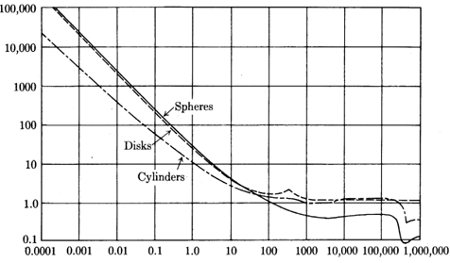
Particle Reynolds Number (N_{Rep})
C_{d}

Figure 2.2: Drag coefficient of different particle shapes as function of N_{Rep}
Replacing We, C_{d} and converting σ from lb_{f}/ft=6.852 10⁻⁵ dyne/cm, Eq. 2.9 can be expressed as follows:
$V_{c}=1.593{\left(\frac{\left(ρ_{l}-ρ_{g}\right)}{{ρ_{g}}^{2}}σ\right)}^{\frac{1}{4}}$ (2.10)
Equation 2.10 is the Turner equation expressed as function of liquid density ρ_{l} in lbm/ft³, gas density ρ_{g} in lbm/ft³, and σ surface tension in dynes/cm.
Because it is common to express production in terms of flow rates and not velocity, the critical velocity can be converted to the critical rate at standard conditions for a given pressure, P, and tubular dimensions using the following equation:
$q_{C}=\frac{V_{c} A}{B_{g}}$ (2.11)
where B_{g} is the gas formation volume factor defined as follows:
$B_{g}=\frac{Z T{ P}_{std}}{P×{ T}_{std}}$ (2.12)
Substituting for standard conditions, pressure P_{std} = 14.65 psi and temperature T_{std} = 520 ºR, Eq. 2.11 can be written as:
$q_{c}=\frac{3.067 P A V_{c}}{T×Z}$ (2.13)
where V_{c} is critical gas velocity in ft/sec, A is the flow conduit cross sectional area in ft², P is the pressure at the evaluation point in psi, T is the temperature at the evaluation point in ºR, and Z is the gas compressibility factor.

2.2 Overview of artificial lift methods
Artificial lift (AL) techniques are used to maintain well flow status, and they can be divided into two major categories. The first category manages to use the well’s own energy to keep it flowing, i.e., by using plunger lifts, intermitters, or velocity strings. The second category adds external energy to the system, mechanical or non-mechanical, i.e., in gas lift, ESP, or compression. Hybrid methods of AL are also available and typically include a mixture of both categories. The selection of the appropriate AL method is based on numerous factors ranging from well type to economics. Following is a brief description of different methods of AL that are commonly used in the oil and gas industry.

    - Managed energy AL methods
- Velocity string
Velocity string is smaller internal diameter (ID) tubing, or coil tubing, used to reduce the required critical gas velocity to lift liquids. The main advantage of using this method is that there is no additional associated operating cost, and it is relatively maintenance free. Some of the drawbacks are the initial installation cost and the additional friction, a potential scaling associated with the decreased tubing ID. Velocity string can also be a hybrid form of lift.
- Plunger lift
A plunger lift consists of a plunger, bottom hole assembly or bumper spring, lubricator, plunger catcher, arrival sensor, control valve, and the control logic. This method can only be applied to wells that satisfy certain conditions related to the well own ability to build pressure and the gathering system for available pressure. Plunger lift, once optimized, can be operated at low cost and minimum maintenance. While running, the plunger can also maintain the tubing clean of scale, paraffin, or other causes of restriction. On the other hand, the shut-in period associated with this operation means deferred production unless a bypass plunger can also be run. Also, plunger lift is not preferable for high fluid volume wells, especially deep wells, wells with a low gas to liquid ratio (GLR), and wells with high deviations. Plunger lift can also be a hybrid form of lift.
- Chemicals
Chemicals, especially foamers, are used to lighten the hydrostatic column in the well and reduce the water surface tension. The foaming agent is introduced to the system either in a solid form (soap sticks) or a liquid form by means of a chemical pump that discharges it downhole through a capillary string. Periodic batch treatment is also used if needed. This is a low cost method that is readily available and easy to use. However, care has to be taken to ensure that the chemicals will dissolve and will not form a residue downhole that could act as an obstruction to the flow. Also, in the case of capillary string application, access to the wellbore becomes limited.
Chemicals can also be a hybrid from of lift.

    - Added energy AL methods
- Swabbing
This is a quick method to mechanically remove the liquid column that is causing back pressure on the formation. Swabbing is the easiest, quickest, and most convenient method to resume production from a completely loaded non-flowing well. On the other hand, this operation has an associated cost, requires a low pressure environment, and does constitute a permanent solution for liquid loading. Swabbing is not a hybrid form of lift.
- Electric Submersible Pumps (ESP)
This is a downhole pump used to lift high liquid rate wells by means of a centrifugal force created by the rotation of impellers. A typical ESP consists of downhole motor, intake, pump with lift stages, electric cable, and power drive. Multiple other components can be added if necessary for the better handling of gas or solids. The ESP keeps fluid always moved out of the wellbore, ensuring low bottom hole flowing pressure (BHFP). Some of the drawbacks of an ESP are poor gas and solid handling capacity and high cost; they also require electricity and stringent design criteria.
- Rod pumping
This is the most widely used form of lift. The energy from the electric or natural gas fired prime mover is transferred to the up-and-down-movement of the rod string and pump to mechanically move fluids from the wellbore. This operation is simple, effective, and well-understood. On the other hand, installing a rod pump requires a relatively higher initial cost, especially for electric units. Rod pump efficiency is reduced at higher depths and higher deviations; also, they do not operate well in the presence of both solids and gas. From a safety standpoint, having moving parts can constitute a danger while operating.
- Gas lift (GL)
During gas lift operations, a desired amount of gas is added to the well through the mean of injection to lighten the hydrostatic head caused by liquid accumulation in the wellbore; this allows the formation to continue producing at a lower BHFP and the liquid to move outside the wellbore. The advantage of gas lift is its capacity for handling both gas and solids in addition to the absence of downhole moving parts that can restrict the flow from the reservoir. Disadvantages include requiring a compressor at the surface, a reliable supply gas source, and installation cost.
Gas lift can be either conventional or unconventional. Conventional GL requires the installation of a packer set below a series of gas lift valves spaced along the tubing to act as ports for gas entry. Unconventional GL only requires open-ended tubing where the end of tubing is considered to be the injection point, and gas is allowed to enter and lift fluid from that depth. Unconventional GL is also referred to in the industry as continuous gas circulation (CGC).
In this study, CGC was used to add gas to the well to identify the effective gas rate for horizontal and deviated wells.

CHAPTER III
Literature review
  - Vertical well models
Turner et al. (1967; 1969) pioneered the effort to understand the causes of liquid loading. In their work, they pursued both a film model and a droplet model and concluded that the film model was not adequate because it did not fit their data. However, the droplet model, when compared to the 106 wells included in their data set, had a good fit after adjusting it by a certain factor. Turner suggested increasing the Webber number to 60 to better fit the observed data. This increase resulted in, as mentioned earlier, approximately 20% upward adjustment to the derived Eq. 2.10. Turner believed that the increase compensates for the assumptions made while deriving the equation, such as:
- The use of the drag coefficient for solid spheres.
- The effect of natural gas on the Webber number as opposed to air as developed by Heinz (1949).
- Assuming the particle becomes stationary when the critical condition is satisfied.
Therefore, the adjusted Turner equation is as follows:
$V_{c}=1.912{\left(\frac{\left(ρ_{l}-ρ_{g}\right)}{{ρ_{g}}^{2}}σ\right)}^{\frac{1}{4}}$ (3.1)
where, V_{c} is critical gas velocity, ft/sec, ρ_{l} is the liquid density, lbm/ft³, ρ_{g} is the gas density, lbm/ft³, and σ is the surface tension, dynes/cm. Turner further simplified his equation by using standard values for gas specific gravity, temperature, and the Z factor to calculate gas density, ρ_{g}, from the real gas law in addition to assuming a constant water density and surface tension.
The gas density is obtained from the real gas law as follows:
$ρ_{g}=2.715 γ_{g} \frac{P}{\left(T+460\right) Z}$ (3.2)
where γ_{g} is the gas specific gravity, T is the evaluating point temperature in ºF, P is the evaluating point pressure in psia, and Z is the Gas Deviation Factor.
Substituting γ_{g}$=$0.6, T=60 ºF, Z= 0.9 into Eq. 3.2 and simplifying, we get:
$ρ_{g}=0.0031P$ (3.3)
Equation 3.1 can then be re-written using Eq. 3.3 and the typical values of water density ρ_{w}= 67 lbm/ft³, oil density ρ_{o} = 45 lbm/ft³, water surface tension σ_{w} = 60 dynes/cm, and oil surface tension σ_{o} = 20 dynes/cm as follows:
Therefore, for condensate, the equation is:
$V_{c}=\frac{{4.043 \left(45-0.0031P\right)}^{\frac{1}{4}}}{({0.0031P)}^{1/2}}$ (3.4)
and for water:
$V_{c}=\frac{{5.321 \left(67-0.0031P\right)}^{\frac{1}{4}}}{({0.0031P)}^{1/2}}$ (3.5)
Equations 3.4 and 3.5 are the simplified version of the Turner equation for both condensate and water. They yield approximate values. However, for more accuracy, it is advised to use the appropriate correlations for PVT calculations or, if available, to use actual values as described in the original equations. If both phases, oil and water, are produced, it is recommended to use the water equation to account for the heavier phase. Turner used surface as the evaluation point and therefore, did not account for the effects of pressure and temperature changes with depth, or changes in tubular dimensions on the critical velocity. Turner et al. calculated the critical gas rate for the 106 vertical wells included in their data set.
The results from the calculation were compared to the well status to check if the Turner model predicts the actual well flow condition. For example, if the calculated Turner value was higher than the actual flow rate while the well status shows it to be unloaded, then the model did not predict the well condition, and “F” for a false prediction was recorded in the column. On the other hand, if the calculated Turner value was higher than the actual flow rate while the well status shows it to be loaded, then the model was able to predict the well condition, and “T” for a true prediction was recorded in the column. However, if the calculated Turner value was lower than the actual flow rate while the well status show that the well was loaded, then the model was not able to predict the well condition, and “F” for a false prediction was recorded in the column. Finally, if the calculated Turner value was lower than the actual flow rate while the well status show that the well is unloaded, then the model was able to predict the well condition and “T” for a true prediction was recorded in the column. Table 3.1 summarizes the comparison method used by Turner et al.
Table 3.1: Turner et al. critical gas rate predictions compared to actual observed rates
Q_{Turner} vs. Q_{actual} | Well Status | Prediction
Q_{Turner} > Q_{actual} | Loaded | T
Q_{Turner} > Q_{actual} | Unloaded | F
Q_{Turner} < Q_{actual} | Loaded | F
Q_{Turner} < Q_{actual} | Unloaded | T
Coleman et al. (1991) presented a series of papers discussing liquid loading onset for low pressure wells, i.e., less than 500 psi. Their study included 56 data points. They conducted 17 tests in wells that would normally have stable gas rates are above the critical rate. They continuously changed the wellhead flowing pressure (WHFP) of these wells until showing signs of liquid loading. Then they obtained the remaining 39 data points from other gas wells showing a similar trend to determine their critical gas rates. Coleman et al. (1991) then compared the Turner equation to all 56 wells and concluded that the 20% adjustment suggested by Turner is not necessary for wells flowing at less than 500 psi. They also proposed, like Turner, that the water equation should always be used, even if only condensate is produced. This is because water vapor is always present due to water condensation throughout the wellbore length as both pressure and temperature drop. Coleman et al. (1991) stated that liquid load up effects can be far more severe than a mere drop in daily production rate and may cause a reduction of reservoir deliverability. They also stated that, in some cases, water condensation can cause formation damage in formations that contain swelling clays.
Hence, the Turner Eq. 2.10 should stay unchanged (without the 20% upward adjustment). Therefore, for condensate, the equation is:
$V_{c}=\frac{{3.369 \left(45-0.0031P\right)}^{\frac{1}{4}}}{({0.0031P)}^{1/2}}$ (3.6)
and for water,
$V_{c}=\frac{{4.434 \left(67-0.0031P\right)}^{\frac{1}{4}}}{({0.0031P)}^{1/2}}$ (3.7)
Coleman et al. (1991) mentioned that temperature, gas and liquid specific gravities, and interfacial tension do not have as significant effect on critical velocity as tubular dimension and flowing pressure. They stated that the surface conditions can be used as a control point to determine the critical rate. However, if the end of the tubing is set at a significant distance from the producing interval, the larger diameter should be used for the calculation.

Nosseir et al. (2000) noted that the turbulent flow regime assumed by Turner, 10⁴ < N_{Rep} < 2x10⁵, is not necessarily true in all cases. In addition, in some low flow rate wells, the flow regime is rather transitional. In the latter case, the use of Allen’s method, Eq. 3.8, for the purpose of calculating the critical gas velocity is more appropriate. The proposed equation is as follows:
$V_{c}=14.6 σ^{0.35}\frac{{\left(ρ_{l}-ρ_{g}\right)}^{0.21}}{μ^{0.134}{{×ρ}_{g}}^{0.426}}$ (3.8)
where, density ρ_{l} in lbm/ft³, gas density ρ_{g} in lbm/ft³, and σ surface tension in dynes/cm, and viscosity μ in lbm/ft/sec..
Nosseir et al. (2000) calculated the particle Reynolds number (N_{Rep}) for Turner’s data and another set of data provided by Exxon. They found that the Reynolds number for the Turner data exceeded the 200,000 value and for those conditions, the drag coefficient is 0.2 (see Fig. 2.2). However, for Exxon’s data, the calculated N_{Rep} fell within the Turner assumed region and, in that case, the drag coefficient was indeed 0.44. The results from incorporating the calculation of N_{Rep} causes the estimation of the critical gas velocity to increase by 5% compared to the method proposed by Turner et al. The new proposed equation is as follows:
$V_{c}=21.3{ σ}^{0.25} \frac{{\left(ρ_{l}-ρ_{g}\right)}^{0.25}}{{ρ_{g}}^{0.5}}$ (3.9)
Their results showed that while the Turner model had a 23.5% error and the adjusted Turner model had an 11.5% error, their model, on the other hand, was able to reduce the error to 8.3% (see Figs. 3.1 and 3.2). Nosseir et al. (2000) also recommended that the calculations be carried out at the wellhead because that is where gas slippage and velocity is at its maximum value. Furthermore, the water properties should be used to account for the denser phase.
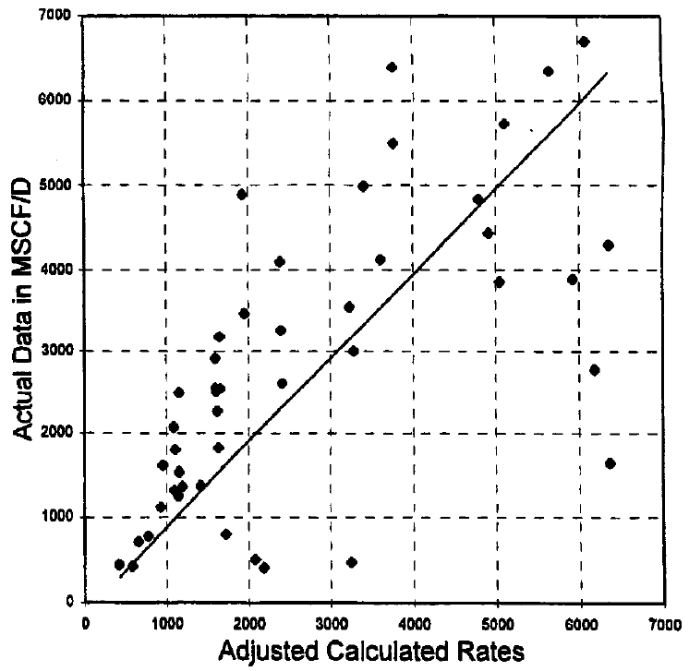
Figure 3.1: Rates from the adjusted Turner model compared to the actual Turner observations, Turner et al. (1969)

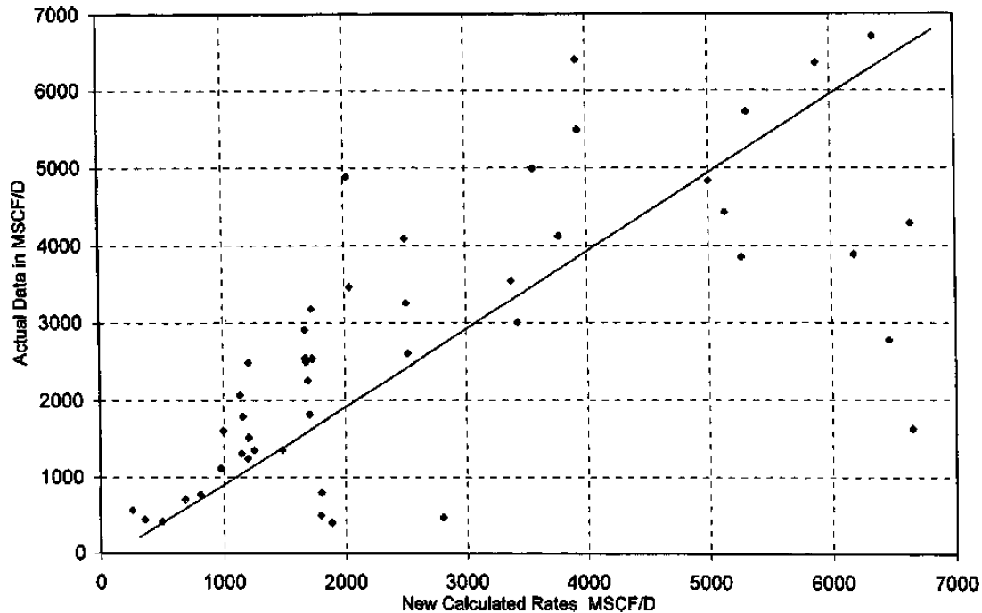
Figure 3.2: Rates from the Nosseir model compared to actual Turner observations, Nosseir et al. (2000)

Li et al. (2002) showed that a liquid droplet entrained in a high velocity gas stream will experience a pressure difference between its fore and aft regions, causing it to deform and flatten to a convex bean shape with unequal sides (see Fig. 3.3). This deformation affects the drag on the droplet as the spherical form has a lower surface area compared to flat shapes, and which requires a reduced drag to counter the force of gravity.
$V_{c}=\sqrt[4]{\frac{4 \left(ρ_{l}-ρ_{g}\right)}{{{C_{D×}ρ}_{g}}^{2}}×g×σ}$ (3.10)
Based on the new shape, Li et al. (2002) suggested that a disk-shaped curve be used on the drag coefficient chart (Fig. 2.2) for the applicable N_{Rep} range that Turner suggested. Therefore, the drag coefficient will be close to 1. Substituting C_{d} = 1 and g = 9.8 m/sec² into Eq.3.10 which is referred to as the Li equation, we get:
$V_{c}=2.5× \sqrt[4]{\frac{\left(ρ_{l}-ρ_{g}\right)}{{ρ_{g}}^{2}} σ}$ (3.11)
where, density ρ_{l} in Kg/m³, gas density ρ_{g} in Kg/m³, and σ surface tension in N/m.
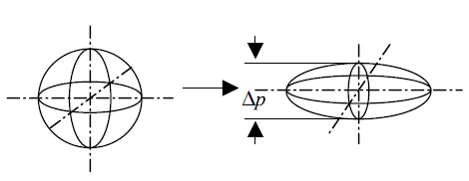
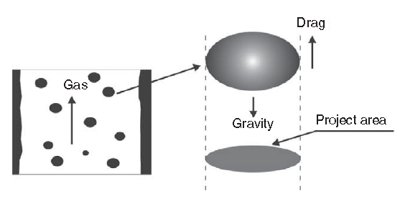
Figure 3.3: Shape of entrained drop movement in high-velocity gas, Li et al. (2002)
They also presented a simplified form of the equation in the same manner as Turner et al. that is based on fixed values of gas specific gravity, temperature, Z factor, water density, and surface tension. Li et al. (2002) compared data from 16 wells to the Turner model and concluded that the latter overestimates the critical rate while their approach has a better match which, in their view, might explain why some wells are still operating at the sub-Turner critical rate.

Unlike Li et al.’s (2002) view that Turner equation overestimates the critical gas rate, Guo et al. (2006) stated that the Turner equation underestimates the minimum critical gas rate. They presented a 4-phase kinetic energy model to estimate the minimum gas lift energy needed to maintain continuous liquid removal from the well. They started with the Turner equation and used the kinetic energy formula to arrive to the following:
$E_{k}=\frac{ρ_{g}{ × V}_{c}}{2{ g}_{c}}$ (3.12)
Equation 3.12 represents the minimum kinetic energy required to keep liquid droplets from falling. Guo et al. (2006) substituted the Turner critical velocity in Eq. 3.12 and used 0.44 as the value of the drag coefficient. They neglected the effect of gas density; therefore, the equation was reduced to:
$E_{k}=0.04 \sqrt{σρ_{l}}$ (3.13)
where, density ρ_{l} in lbm/ft³and σ surface tension in dynes/cm.
By assuming values for water-gas and condensate-gas interfacial tensions to be 60 and 20 dynes/cm respectively, and water and condensate densities to be 65 and 45 lbm/ft³ respectively, Guo et al. (2006) stated that the minimum kinetic energy value for gas wells producing water should be 2.5 lbf-ft/ft³ and for condensate, to be 1.2 lbf-ft/ft³. Guo et al. (2006) subsequently deduced that the 20% adjustment proposed by Turner is the velocity needed to transport the particle from stagnation. Therefore, he proposed the following equation as the minimum kinetic energy needed to transport liquid droplets:
$E_{km}=0.0576 \sqrt{σρ_{l}}$ (3.14)
Thus, Guo et al. (2006) proposed that the minimum required kinetic energy value for gas wells producing water to be 3.6 lbf-ft/ft³ and for condensate, only to be 1.73 lbf-ft/ft³. They calculated gas kinetic energy from any given gas well as compared to the minimum required kinetic energy to determine the loading status of the well. To evaluate the kinetic energy of a given well, Guo et al. (2006) proposed substituting the gas density by using the ideal gas law and refined the gas kinetic energy as follows:
$E_{k}=6.46×{10}^{-13} \frac{γ_{g}×T×{q_{g}}^{2}}{A^{2} × P}$ (3.15)
where, γ_{g} is the gas specific gravity, q_{g} is gas rate in scf/day, A is the flow conduit cross-sectional area in ft², and P is the pressure in psia, and T is temperature in ºR.
Equation 3.15 indicates that the controlling conditions for liquid loading calculations are bottom hole, which is contrary to Turner et al.’s view that surface conditions are in most cases the controlling point.
Guo et al. (2006) proposed a correlation to calculate pressure variation along the wellbore and used it for the critical rate calculation. Then they compared their method to the 106 data points in Turner’s paper and found that their method predicted 6 loaded points in the unloaded region, as compared to 9 from the Turner method (Fig. 3.4). Therefore, they concluded that their method is more accurate in estimating the required minimum gas flow rates.
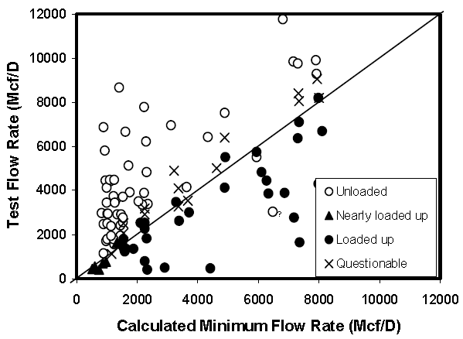
Figure 3.4: The minimum flow rate calculated using Guo et.al method mapped against the test flow rate, Guo et al. (2006)

Wang and Liu (2007) presented the shape of the liquid droplet as a disk rather than a sphere, with N_{Rep} ranging from 10⁴ to 10⁶, and the Morton number (a dimensionless number used to distinguish droplet shape) for the low viscosity liquid in gas wells as possibly between 10⁻¹⁰ and 10⁻¹². The corresponding drag coefficient for these conditions is approximately 1.17. They presented their version of the critical velocity calculation as follows:
$V_{c}=0.5213{\left(\frac{\left(ρ_{l}-ρ_{g}\right)}{{ρ_{g}}^{2}}σ\right)}^{\frac{1}{4}}$ (3.16)
where, density ρ_{l} in Kg/m³, gas density ρ_{g} in Kg/m³, and σ surface tension in N/m.
Needless to say, their method predicts critical values significantly lower than the Turner method. Therefore, caution needs to be taken while using this method.

In 2010, Zhou et al. investigated the effect of liquid amount on the critical velocity calculation. They stated that the Turner model, even after the 20% adjustment, still underestimates the critical velocity, causing wells with liquid loading issues to continue to be loaded up. Zhou et al. (2010) stated that there is a threshold value of liquid amount in gas-liquid mixtures, above which liquid loading might appear even if the critical gas velocity of the well is higher than the calculated values by the Turner model. They stated that in high velocity gas wells, the flow is turbulent and the droplet may move irregularly in all directions, which might cause droplets to coalesce and start falling, only to break and be repeatedly picked up again by the gas stream (see Fig. 3.5).
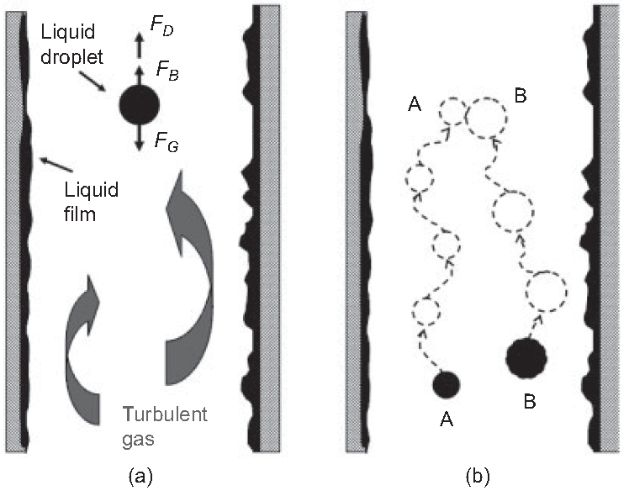
Figure 3.5: Encountering two liquid droplets in turbulent gas stream, Zhou et al. (2010)

Zhou et al. (2010) used both Turner et al. (1969) and Coleman et al. (1991) data to calculate the β_{z} factor as the droplet concentration and set the threshold value of 0.01. They also relied on Barnea’s (1987) work, which states that the flow regime changes from mist flow to a slug or churn flow pattern when the liquid holdup value is higher than 0.24. Zhou et al. (2010) defined H_{L} as follows:
$H_{L}=\frac{V_{sl}}{{V_{sg}+V}_{sl}}$ (3.17)
where, V_{sl} is superficial liquid velocity, and V_{sg} is superficial gas velocity.
Therefore, they stated that the Turner equation should be used when H_{L} is less than or equal to 0.24, and their equation should be used at values higher than 0.24. Their proposed equation included an additional term to the original Turner equation (also referred to as the Coleman equation) as follows:
$V_{C-N}=V_{C-Turner}+ln\left(\frac{H_{L}}{β_{z}}\right)+α_{z}$ (3.18)
where β_{z} = 0.01, and α_{z} = 0.6, as estimated from Turner’s data. β_{z}, as mentioned earlier, is the GLR, and alpha is a curve fitting constant.
While comparing their model to Coleman’s data, all calculated β_{z} values were less than the threshold (Fig. 3.6). Therefore, the model prediction is the same as the Turner model which, in turn, is better than the adjusted Turner model. The latter conclusion was similar to the conclusion that Coleman deduced. However, when using the original Turner et al. data, the Zhou et al. (2010) model showed an improvement in prediction from both Turner and adjusted Turner models. The Zhou model had 12 incorrectly predicted wells, as opposed to 24 from the Turner model and 13 from the adjusted Turner model (see Fig. 3.7).
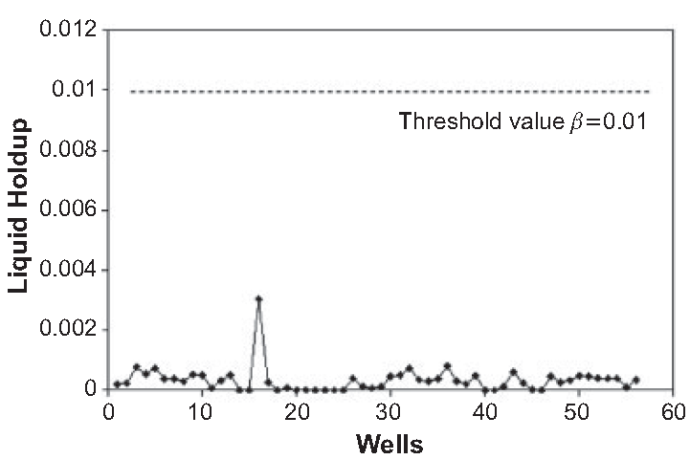
Figure 3.6: Application of the Zhou et al. model to Coleman et al. data, Zhou et al. (2010)

Figure 3.7: Zhou et al. model versus the Turner Model, Zhou et al. (2010)

Guohua et al. (2012) introduced an energy loss factor. To arrive at their conclusion, they started with Li’s equation and relied on both Wei et al.’s (2007) experiment with high speed photographic techniques (Fig. 3.8) and Awoulsi’s (2005) laboratory data (Fig. 3.9). They concluded that the reason why Turner equation over predicts the critical velocity is because Turner does not account for droplet deformation in low pressure conditions. They also invalidated Li’s model, citing that it under predicts the critical gas rates because it does not take into account the rollover of the flat shaped droplet, which causes it to have a reduced bearing area. Guohua presented the following equation:
$V_{CS}=V_{C,Li}+S×(V_{C,Turner}-V_{C, Li})$ (3.19)
Equation 3.19 reduces to Li’s equation when the loss factor, S, is equal to zero, and the larger the S factor, the closer the model is to the Turner model.
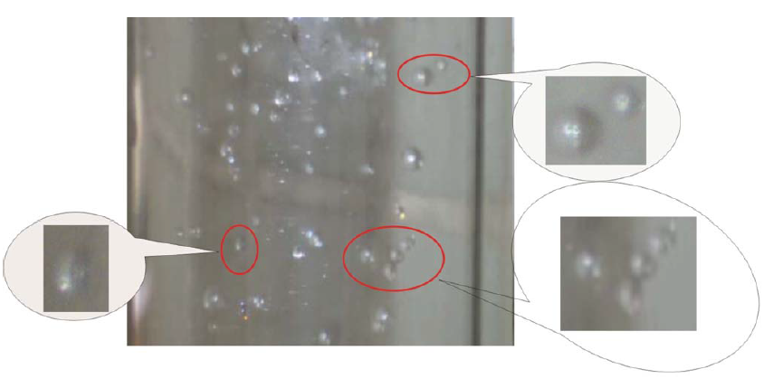
Figure 3.8: Rollover of the flat-shaped droplets in the process of rising, Wei et al. (2007)
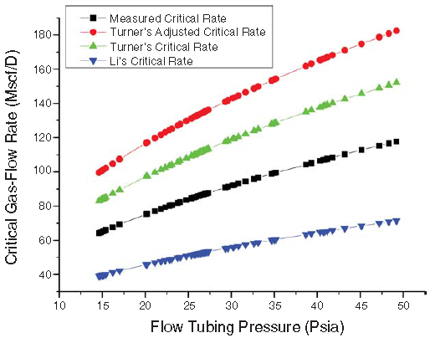
Figure 3.9: Critical gas flow rates comparison between different models, Awolusi (2005)
To determine the value of the S factor in Eq. 3.19, Guohua et al. (2012) used data from 300 wells to estimate the loading condition. They fitted their model to actual data by changing the S factor value. Their results showed that the S factor ranges from 0.75 to 0.83. Therefore, they used the upper limit of the S factor for their model as follows:
$V_{CS}=V_{C,Li}+0.83*(V_{C,Turner}-V_{C, Li})$ (3.20)
When Guohua et al. (2012) used Coleman’s data to compare their model predictions to Coleman et al.’s (1991) results (Fig. 3.10), they found that their model’s average absolute relative error (Table 3.2) is 0.2553, which is less than both Coleman, 0.2806, and Li, 0.4945. Therefore, they concluded that their model is more suitable for critical velocity prediction in low pressure gas wells less than 500 psi.
Table 3.2: Average absolute relative error from the Guohua et al. model using Coleman et al. data, as compared to Li and Turner models, Guohua et al. (2012)

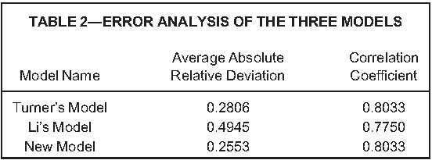

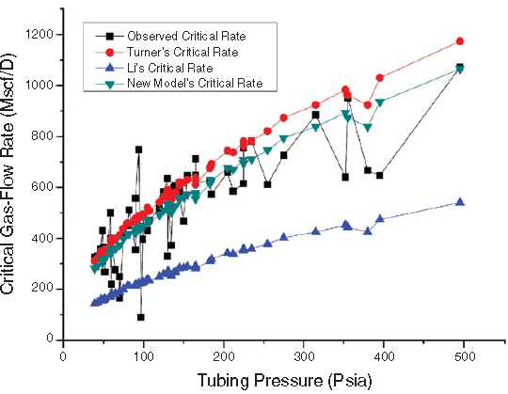
Figure 3.10: Comparison of the different models using Coleman et al. data, Guohua et al. (2012)

3.2 Horizontal well models
Veeken et al. (2009) investigated the influence of reservoir parameters and well parameters on the critical rate value. They found that the strongest correlation exists between the Turner Ratio (TR) and the observed critical rate (q_{c}) by using a quadratic fitting (Fig. 3.11). The Turner Ratio is expressed as follows:
$TR=\frac{q_{c}}{q_{Turner}}$ (3.21)
They proposed a new equation to identify the relationship between the critical rate and the calculated Turner critical rate as follows:
$q_{c}=\frac{\left\{\left(1-bQ_{Turner}\right)-{\left[{\left(bQ_{Turner}-1\right)}^{2}+4a.c.{Q_{Turner}}^{2}\right]}^{0.5}\right\}}{2a.Q_{Turner}}$ (3.22)
where, a = -2.17x10⁻⁶, b = 3.09x10⁻³, and c = 1.02.
Equation 3.22 is referred to as modified Turner and is limited to q_{Turner} less than 300x10³ m³/d (both q_{c} and q_{Turner} are in 10³m³/d).
Based on their study, they stated that inflow performance has no significant effect on liquid loading, while deviation has limited influence, a 15% increase in critical rate at 30–35 degree inclination. They also concluded that the outflow performance is not affected by larger internal diameter (ID) if the length is less than 10% the total well length. Veeken’s multiphase study using the modified Gray (1978) equation for BHFP calculation agreed with the modified Turner critical rate calculation and showed that the rate increase is not necessary for low gas rate wells, which is in line with the Coleman finding for low pressure wells. Lastly, based on both flow loop testing and transient multiphase flow modeling, Veeken et al. (2009) concluded that liquid loading is not controlled by droplet flow reversal, as conventionally understood, but is rather triggered by liquid film flow reversal.

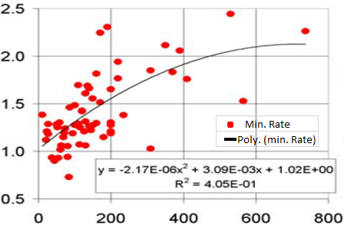
q_{c} (10³ m³/d)
TR
Figure 3.11: The Turner Ratio as function of observed critical rate, Veeken et al. (2009)
Belfroid et al. (2008) stated that steady state models, like Turner, underestimated the critical rate of gas wells. They discussed the effects of hole inclination, flow regime transition, and the interaction between the tubing outflow and reservoir performance on liquid loading. They used the work by C.A.M. Veeken NAM (2009) (Fig. 3.12) and the definition of the Turner Ratio (Eq. 3.21) to compare the calculated critical rate to the actual rate. They defined a reservoir parameter function, A, as a proxy of reservoir permeability and reported that high permeability wells (low reservoir parameter A) do not respond well to dynamic disturbances and may require twice the Turner criterion, while high A parameter wells seem to cope better with dynamic conditions.
Subsequently, they conducted an experiment where they subjected both high and low A parameter type wells to multiple GLR changes and then measured the liquid holdup over time. Their results showed that the high A parameter wells were able to move the liquid up the tubing while for the low A parameter wells, liquid dropped and accumulated at the bottom of the well. The latter wells could not restart or reverse this trend, which caused them to cease flowing (Figs. 3.13 and 3.14).
As far as the influence of the inclination angle (Fig. 3.15), Belfroid et al. (2008) believed that the influence of gravity diminishes as the well moves towards a horizontal geometry. They stated that for a horizontal well, no liquid loading can occur because of the absence of forces on the liquid that can counter the gas flow. They also mentioned that the change from horizontal stratified flow to vertical distributed flow driven by inclination allows for the liquid film to be progressively thicker at the bottom compared to the top of the tube. Therefore, both the diminishing effects of gravity and the film thickening affect the critical gas rate such that it increases with medium inclination as a proxy to increased film thickness, while the lower effect of gravity is sensed at higher inclinations (Fig. 3.16). The maximum required rate is identified to occur at a 50º inclination, at which the critical velocity required is 40% higher than that predicted by vertical models.
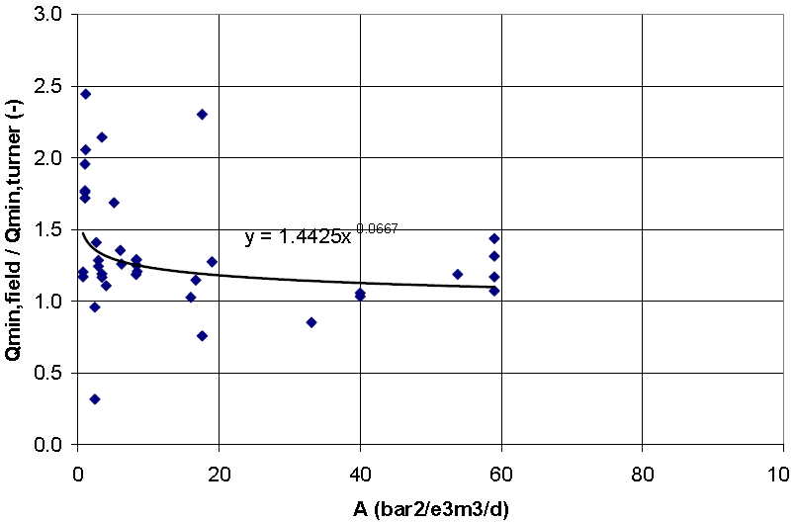Figure 3.12: Liquid loading point made dimensionless with the Turner criterion, as function of reservoir parameter A, Veeken et al. (2009)
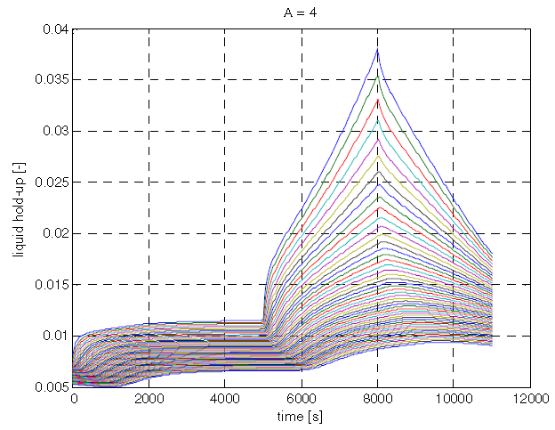Figure 3.13: Liquid holdup as function of time for high reservoir parameter A, Belfroid et al. (2008)
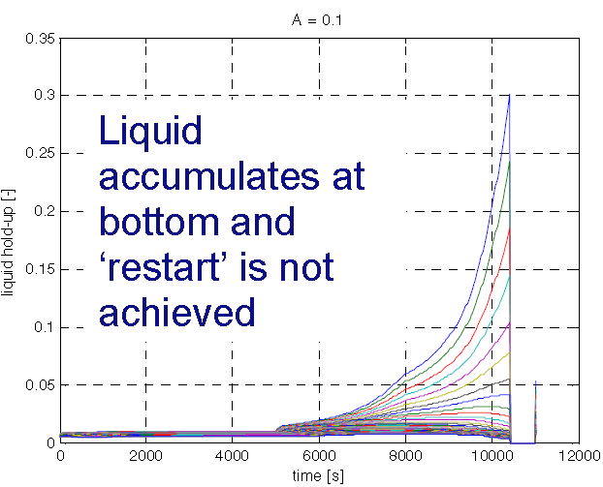Figure 3.14: Liquid holdup as function of time in low reservoir parameter A, Belfroid et al. (2008).
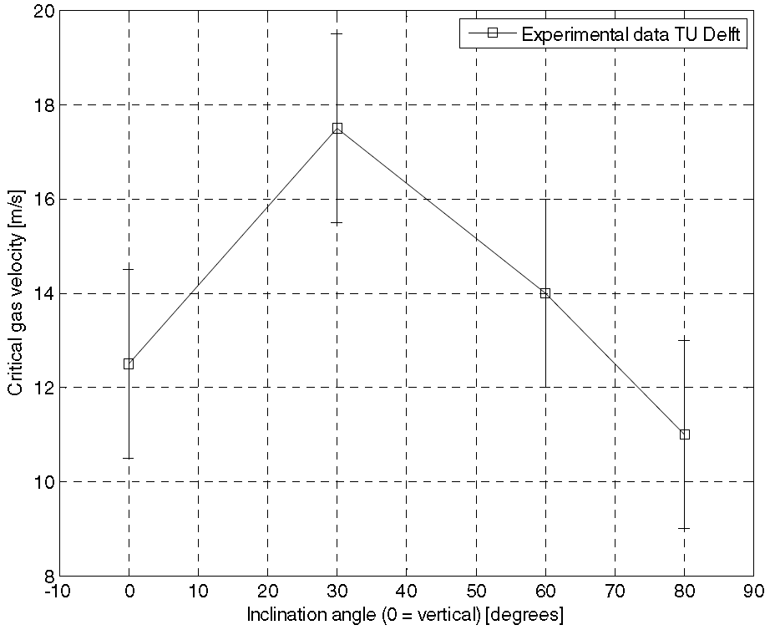
Figure 3.15: Critical gas velocity as function of inclination angle, Belfroid et al. (2008)
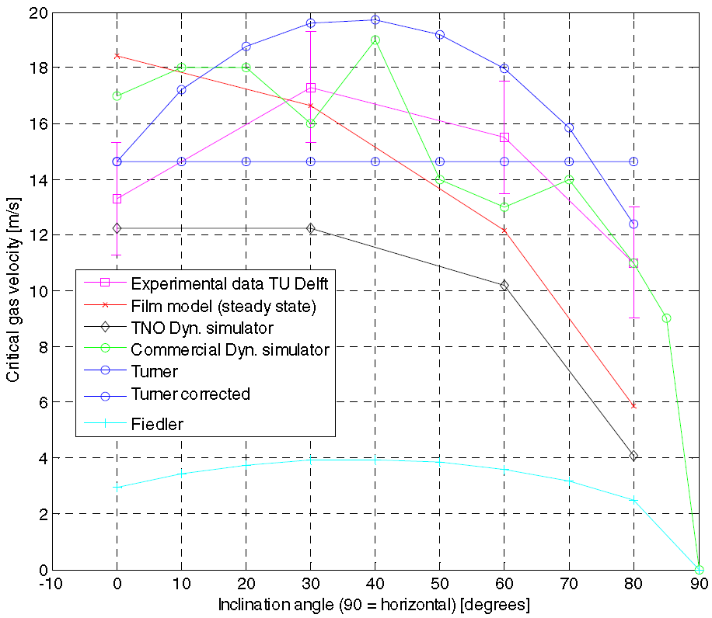
Figure 3.16: Comparison between experiment and model predictions, Belfroid et al. (2008)
In order to incorporate the inclination dependency, Belfroid et al. turned to the Fiedler shape function from flooding experiments because it captures the dependence on the inclination angle, ω. They concluded that a modified Turner model that incorporates the Fiedler shape function would be better at predicting the critical rate in deviated wells. The resulting equation is as follows:
$V_{c}=1.593{\left(\frac{\left(ρ_{l}-ρ_{g}\right)}{{ρ_{g}}^{2}}σ\right)}^{\frac{1}{4}}×\frac{{\left(sin \left(1.7ω\right)\right)}^{0.38}}{0.78}$ (3.23)
Finally, predictions from Eq. 3.23 were compared to the experimental results from their air-water experiment and two gas wells. They found that the equation predicts the observed loading point within 20% accuracy (see Table 3.3).

Table 3.3: Comparison of the Belfroid model in the form of Turner Ratio to actual field data, Belfroid et al. (2008)
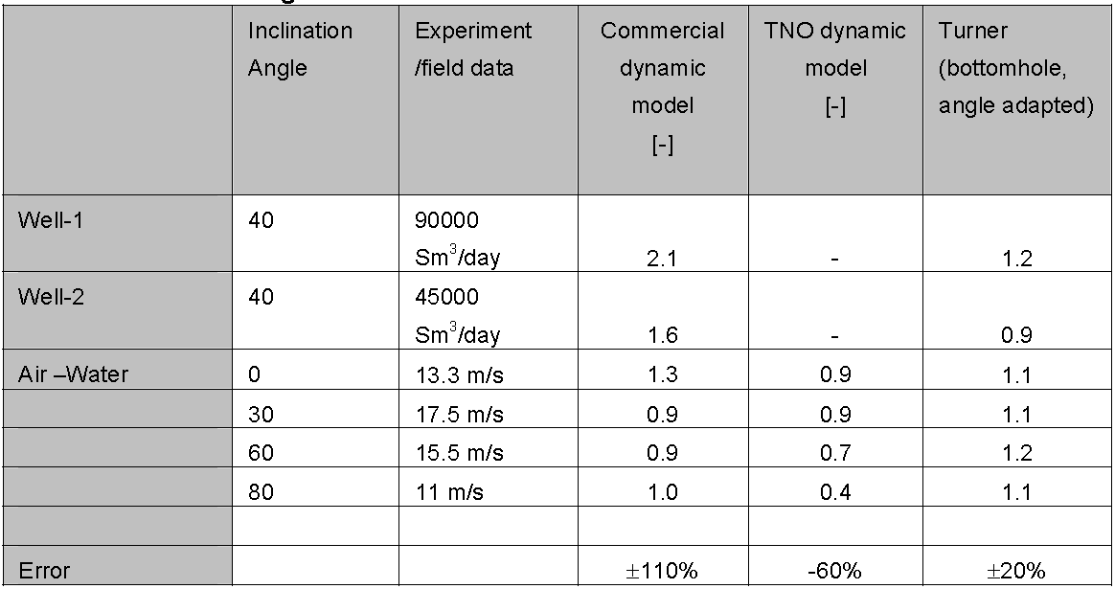

Among all literature discussed earlier, only Belfroid et al. (2008) and Veeken et al. (2009) work specifically is focused on dealing with horizontal and deviated wells. For this study, in addition to our experimental data and the data from both of these authors will be evaluated using our method and compared to the Turner model. The change of parameters such as density, surface tension, and the Z factor with respect to pressure and temperature is significant and should be taken into account when attempting to calculate the critical rate. Therefore, this study will not rely on static values for these parameters and will instead use the Sutton et al. (2010) recommended practice of using appropriate correlations to calculate each of these components.

This study will propose a new model for critical gas rate predictions in horizontal and deviated wells and demonstrate that vertical well models should not be used in horizontal and deviated cases.

CHAPTER IV
New model development

4.1 BUR definition
Before discussing the flow in horizontal wells, it is important to understand how the geometry of this kind of wells is achieved. The subsequent discussion is a high level summary of how the curved section of a well is constructed.

Horizontal wells require drilling a curved section that connects the vertical section of the wellbore to the horizontal section where the desired reservoir is targeted. Normally, deviation does not present an issue in the vertical section (in pad drilling, deviation can present lift issues due to shallow nudges moving the well to the desired interval). However, during the drilling of the curved section, a succession of variable buildup rates (BUR) is utilized to achieve the desired horizontal target. The BUR is the rate of change in angle or deviation in the drilling path, and it is normally measured in degrees/100 ft (see Fig. 4.1). The measurement while drilling tool, MWD, is deployed as part of the drilling bottom hole assembly at a close proximity to the drill bit to provide an inclination and azimuth that, among other things, allows the real-time tracking of the well path and helps the drillers stay on course with the planned well trajectory. The degree of buildup depends on the final desired geometry and should consider both completion and production requirements to maximize the life of the well. Three types of well profiles are:
- Short radius, 5 to 10º /3 ft
- Medium radius (most common), from 6 to 35º /100 ft
- Long radius, 2 to 6º /100 ft

Figure 4.1: Change of BUR versus measure depth (MD) in horizontal and deviated wells
As drilling of the curved section continues, alternating between sliding, using an oriented bent downhole mud motor, and rotating, using the rotation of the entire drill string without directional orientation, allows an average BUR or dog leg severity (DLS) over a given interval. In addition to providing the three-dimensional survey data to track the wellbore progress, the MWD tool transmits the bit’s orientation to the surface. Orienting the motor in a particular direction allows for steering the drill bit while in slide mode to stay on target or adjusting it to get back on target. In rotation, the bit is allowed to drift freely in any particular direction. Therefore, the desired BUR is attained by controlling the ratio of sliding to rotating. Motors can have different bend angles, and 100% sliding gives a uniform BUR for that particular bend setting. However, rotation frequency and duration will control and adjust that theoretical 100% slide BUR down to a lower BUR due to the tangent or uncontrolled well path during that rotation period. Therefore, a 100-ft survey showing 10º /100 ft does not necessarily mean a uniform BUR. It means that on an average, the BUR is 10º /100 ft—part of that section could be 15º /100 ft while sliding and 5º /100 ft while rotating, hence, an average of 10º /100 ft.

4.2 Effects of geometry on flow stream
The deviation and change in the wellbore geometry will affect the flow because the gas and entrained droplets stream do not react to the change in geometry until it is affected by it; in other words, the stream does not know that there is a change in geometry coming up ahead, it will only react to it once it is in it. In addition, not all the droplets in a given surface area are going to be directly affected by the change in geometry. Some droplets will be in direct contact with the wall or film, causing a series of impacts and rebounds with a restitution velocity, V_{b}, and then change direction (see Fig. 4.2). The latter will create a region with slower droplets positioned in the direct path of upcoming streams, which triggers other series of impacts that cause slowdowns of impinging droplets and their reorientation, allowing the whole stream to adjust to the new geometry.
BUR 1
BUR 2
Stream
Stream
Stream
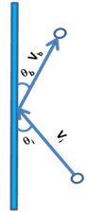
θ_{i} is the incidence angle
θ_{b} is the rebound angle
V_{i} is the particle initial velocity
V_{b} is the particle rebound velocity

Figure 4.2: BUR effect on particle rebound after impact

Jayaratne et al. (1964) studied the coalescence and bouncing of water droplets at an air/water interface. Their experimental work indicated that for uncharged drops, regardless of the droplet diameter, the fractional energy loss increases with an increasing angle of incidence. For droplets impacting at normal incidence, the fractional energy loss converges to a limiting percentage of approximately 95% (see Fig. 4.3).
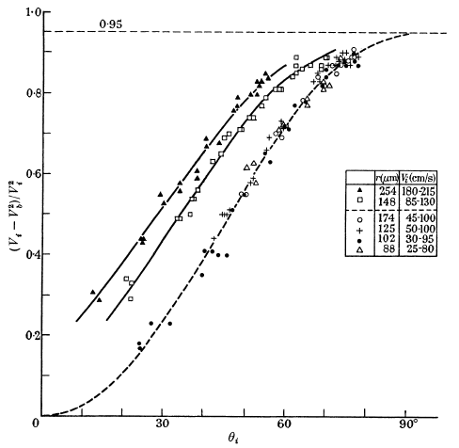
θ_{i}
(V_{i}²-V_{b}²)/V_{i}²
Figure 4.3: Fractional loss of energy suffered by a bouncing drop during impact as function of the angle of impact, Jayaratne et al. (1964)

Jayaratne et al. (1964) also conducted an experiment where the droplets were allowed to impinge almost tangentially on a water surface to simulate low impact angles and concluded that the fractional energy loss is smaller for low impact angles because less energy is consumed to deform the impacted surface. Data for the largest droplet used in their experiment will be used for this study to account for maximum impact. Jayaratne et al. (1964) data are fitted with a power regression model to correlate the fractional energy loss as function of the angle of incidence. Figure 4.4 shows the curve fit with R² of 0.98 indicating very good and adequate representation of the data. Therefore, the fractional energy loss at different angles of incidence can be calculated and used to determine the effect of geometry changes on particle movement post impact.

Figure 4.4: Power law fit of the fractional loss of energy suffered by a bouncing drop during impact as a function of the angle of impact

4.3 Effective velocity derivation
At the critical condition, gas is flowing at a critical velocity of V_{g} = V_{c} that allows the particles to be suspended with V_{p} = 0. To understand the effect of impact and rebound, the particle will be allowed to travel at a velocity, V_{g}, while the gas is stationary. When the particle experiences an impact and rebound, it will slow down and have a restitution velocity that is lower than V_{g}. At this new condition, a stationary particle will experience a drag from the gas that is representative of the restitution condition that is lower than the critical condition; in which case will cause the particle to settle. Therefore, to offset this effect, there should be an "expandable drag" built-in to the initial condition such that the drag will still allow for the critical condition to exist should an impact occur. Failure to maintain the critical condition will cause the droplet to settle and accumulate.
During the impact process, it is assumed that the droplet does not endure a physical change that affects the force of gravity, i.e.
$F_{g, before}= F_{g, after}$ (4.1)
To determine the extra energy needed to maintain the critical condition, the following steps should be taken:
- The critical gas rate should be calculated using the Turner method (Eq. 2.10). The calculated V_{c} will subsequently be used to calculate the effective velocity as follows:
$V_{eff}= V_{c}+V_{mup}$ (4.2)
where, V_{eff} is the effective lift velocity (ft/sec), V_{c} is the critical velocity as expressed by Turner’s derivation (ft/sec), and V_{mup} is the additional velocity above the critical velocity necessary to maintain the critical condition after a rebound (ft/sec).
- The maximum BUR or DLS is obtained from the survey. Most surveys will have DLS.
- The fractional energy loss at the maximum BUR or DLS is determined using Jayaratne et al. data, either graphically (Fig. 4.4) or numerically using the power fit equation as follows:
$\frac{\left(V_{c}^{2}-V_{b}^{2}\right)}{V_{c}^{2}}=0.0406×θ_{i}^{0.7537}$ (4.3)
Note that the maximum fractional energy loss is set to an upper limit of 0.95. The latter occurs at high impact angles, θ_{i}>70º, which is not a typically encountered BUR in horizontal wells.
- The restitution velocity is determined from the fractional energy loss
$\frac{V_{b}}{V_{c}}=α or V_{b}=α×V_{c}$ (4.4)
- The drag on the particle under the new condition is then determined:
$F_{d,after}=\frac{1}{{2g}_{c}} ρ_{g} C_{d }Ad {(αV_{c})}^{2}$ (4.5)
Simplifying,
$F_{d,after}=\frac{α^{2}}{{2g}_{c}} ρ_{g} C_{d }Ad{ V}_{c}^{2}$ (4.6)
or,
$F_{d,after}=α^{2}×F_{d,before}$ (4.7)
- The makeup drag, which is the result of the initial drag and the post impact drag that is needed to offset the fractional energy loss, can then be determined.
${ F}_{d,mup}=F_{d,before}-F_{d,after}=(1-α^{2}){ F}_{d,before}$ (4.8)
- The makeup velocity is then obtained from the makeup drag.
$V_{mup}^{2}=\left(1-α^{2}\right) V_{C}^{2}$ (4.9)
$V_{mup}=β{×V}_{C}$. (4.10)
where β is the effective velocity factor.
$β=\sqrt{(1-α^{2})}$ (4.11)
- Finally, by substituting Eq. 4.10 into Eq. 4.2, the effective velocity is calculated to incorporate the makeup velocity in the critical velocity.
$V_{eff}= V_{c}+βV_{C}$ (4.12)
or,
$V_{eff}= \left(1+β\right){×V}_{C}$. (4.13)
Equation 4.13 represents the critical velocity needed to offset the effect of geometry that is present in horizontal and deviated wells. Note that in vertical case where the BUR, in theory, should be or is close to zero, the model collapses back to the Turner model and no further adjustments are needed.

4.4 Example using the new model
The example presented in this section shows the steps mentioned earlier for a medium-radius horizontal well with a maximum BUR of 20°/100 ft. The droplets in their path out of the wellbore will then face that buildup section and will impact and rebound. Applying Eq. 4.3, the particle will experience a loss of 38.8% of its initial energy.
$\frac{\left(V_{c}^{2}-V_{b}^{2}\right)}{V_{c}^{2}}=0.0406×{\left(20\right)}^{0.7537}=0.388$ (4.14)
or,
$V_{b}=0.78 V_{c}$. (4.15)
The impinging droplet is then rebounded with an effective coefficient of restitution of about 0.78.
The drag on the rebounded droplet reduces after impact; this change can be expressed as:
$F_{d,after}=α^{2}F_{d,before}$ (4.16)
or,
$F_{d,after}={\left(0.78\right)}^{2}F_{d,before}$ (4.17)

Simplifying,
$F_{d,after}=0.608F_{d,before}$ (4.18)
The needed makeup drag to reinstate the critical condition is:
${ F}_{d,mup}=F_{d,before}-F_{d,after}=0.392F_{d,before}$ (4.19)

Hence,
$V_{mup}^{2}=0.392V_{C}^{2}$ (4.20)
${or, V}_{mup}=0.6258V_{C}$. (4.21)
Therefore, Eq. (4.2) becomes:
$V_{eff}= V_{c}+0.6258V_{c}$ (4.22)
$V_{eff}= 1.6258V_{c}$. (4.23)
Substituting Eq. 2.10 into Eq. 4.23 leads to:
$V_{eff}=1.625×\left[1.593{\left(\frac{\left(ρ_{l}-ρ_{g}\right)}{{ρ_{g}}^{2}}σ\right)}^{\frac{1}{4}}\right]$ (4.24)
Thus,
$V_{eff}=2.589{\left(\frac{\left(ρ_{l}-ρ_{g}\right)}{{ρ_{g}}^{2}}σ\right)}^{\frac{1}{4}}$ (4.25)
Finally,
$q_{c}=\frac{3.067×P×A{×V}_{eff}}{T×Z}$ (4.26)
In Eq. 4.26, V_{eff} is the effective gas velocity in ft/sec, ρ_{l} is the liquid density in lbm/ft³, ρ_{g} is the gas density in lbm/ft³, σ is the surface tension in dynes/cm, A is the conduit cross sectional area in ft², P is the pressure at the evaluation point in psi, T is the temperature at the evaluation point in ºR, and Z is the gas compressibility factor.
It is noteworthy to mention that a particle, when it falls in a vertical geometry, will go an ample distance before it reaches the bottom. The case is different for horizontal and deviated geometries because, after the impact and rebound, the particle reaches the bottom very quickly. The latter case can create favorable conditions of coalescence either with other particles to start forming a film or as a part of the existing film.

Coalescence occurs if the impact exceeds the force required to expel the thin air film acting as a barrier between the two colliding droplets. Jayaratne and Mason (1964) observed in their study that as the droplet size increases, the critical velocity and impact angle required for coalescence decrease. It is not desirable for coalescence to occur because it significantly affects the force balance for the critical condition, therefore causing a large change in the required critical velocity. For example, in the case of two identical droplets coalescing, the mass of the resulting droplet is double the original droplet, which in turn causes the force of gravity to double. On the other hand, because the newly formed droplet will have a higher volume and, by default, a larger surface area than the original droplet, the drag force will only increase by a factor of 2^{2/3}, which is not quite as much of an increase on the gravity force, assuming a direct relationship between the two forces. This imbalance would allow the force of gravity to dominate and cause the droplet to fall.

CHAPTER V
New model comparison using literature data
5.1 Horizontal wells
As discussed in the literature review, two authors, Belfroid et al. (2008) and Veeken et al. (2009), have presented data from horizontal wells and the observed critical flow rates associated with them. In this section, the predictions of the effective flow rate from the new model are presented and compared to the critical rate of other models available from the literature.

5.1.1 Comparison at 20º/100 ft
The first set of data used was taken from the Veeken et al. (2009) paper. They provided 67 data points, including well parameters and their observed critical rates. The new model was applied to data sets of each well. Table B1 in Appendix B shows the wells’ data and the calculated predicted critical rates, along with a comparison to the observed critical rates. Conventional vertical models were also used to test their validity in horizontal and deviated wells.
Figure 5.1 shows the deviation of the new model and the Veeken model from the actual observed data. The new model appears to have closer predictions to the observed data with an overall deviation of 19% compared to Veeken model which has 21% deviation. The latter observation is especially true for gas rates less 10,000 Mscf/d where the new model shows even better performance and a reduced deviation of 17.5% from actual. However, For rates higher than 10,000 Mscf/d , the Veeken model shows less deviation from the observed data than the new model. Under the latter condition, the absolute deviation from the new model is 34% versus 25% for the Veeken model.
The underlying cause behind the shift above 10,000 Mscf/d rate can be due to the fact that at higher flowing gas rates the droplets are broken down and become very small that the effect of gravity becomes minimal and therefore, even after impact and rebound the drag force can still outweighs the gravity force.

Figure 5.1: Veeken model versus the new model using observed Veeken et al. data at 20º/100 ft BUR

Table 5.1 summarizes the critical gas rate predictions in the form of absolute average percent deviation that each model yields for all 67 wells provided by Veeken et al. (2009). While Table 5.2 shows the results only using wells flowing below 10,000 Mscf/d. The new model is shown to more accurately predict the critical gas rates in both cases compared to all other models. It is also demonstrated that the conventional models, Turner and Coleman, both under-predict the critical gas rate and respectively have 26% and 39% deviation while using all data, and 24% and 36% deviation while using only data less 10,000 Mscf/d. Therefore, these conventional models are unfit for usage in horizontal and deviated wells.
Table 5.1: Absolute average deviation using all Veeken et al. data at 20º/100 ft
 | Turner | Coleman | New model | Veeken
Absolute Average Percent Deviation % | 26 | 39 | 19 | 21

Table 5.2: Absolute average deviation using rates less than 10 MMscf/d from Veeken et al. data at 20º/100 ft
 | Turner | Coleman | New model | Veeken
Absolute Average Percent Deviation % | 24 | 36 | 17.5 | 21

The second set of data is obtained from the Belfroid et al. (2008) paper. They observed and reported the critical gas rates for two gas wells and provided their own predicted critical rates in a dimensionless form as a ratio of the observed critical gas rate and their predicted critical gas rate. They referred to the ratio as a modified Turner Ratio, bottom hole angle adapted by using the Fiedler shape function. For the first well they reported a TR of 1.2, and for the second well they reported 0.9. These ratios translate to a predicted critical gas rate of 2,648 Mscf/d for Well 1 and 1,766 Mscf/d for Well 2. Table 5.3 shows the reported data of the two wells included in the Belfroid et al. (2008) paper, including well parameters, fluid parameters, and the observed critical gas rate. These data were used to calculate the predicted critical gas rate for each well using the new model. Table 5.4 shows the comparative results between the new, Belfroid, and Turner models prediction for both wells. For Well 1, the new model predicts a model TR of 1.0, while both the Belfroid and Turner models predict a TR of 1.2. For Well 2, both the new model and Belfroid model predict a TR of 0.9, while the Turner model predicts a ratio of 1.1. These results indicate that the new model has better prediction capabilities of the critical gas rates than the Belfroid model, and the Turner model has the lowest prediction accuracy of the three models. Thus, based on the comparison of data from both Veeken et al. (2009) and Belfroid et al. (2008), it is clear that the new model shows an improvement in predicting the critical gas rates in horizontal and deviated wells.
Table 5.3: Belfroid et al. data (2008)
 | Well 1 | Well 2
Inner Diameter [m] | 0.112 | 0.074
Length [m] | 3743 | 3545
Inclination Angle [°] | Variable | Variable
Gas [glmole] | 18.6 | 17.5
Wellhead Pressure [bara] | 14 | 21
Wellhead temperature [°C] | 45 | 30
Reservoir temperature [°C] | 120 | 110
Water density [kg/rn³] | 1020 | 1050
Gas Rate [m³] | 90000 | 45000

Table 5.4: Comparing different models using Belfroid et al. data at 20º/100 ft
 | Turner Ratio, TR
 | New model | Belfroid | Turner
Well 1 | 1.0 | 1.2 | 1.2
Well 2 | 0.9 | 0.9 | 1.1

5.1.2 Comparison at 12º/100 ft
To enforce the conclusion from the previous comparison at 20º/100 ft, the model was also tested at a different condition. This time, a BUR of 12º/100 ft was used to predict the critical gas rate for the 67 wells from Veeken’s work and the two wells from Belfroid’s work. Table B2 in Appendix B shows the well data and the calculated predicted critical rates, along with a comparison of the predicted and observed critical rates.
Figure 5.2 shows the deviation of the new model and the Veeken model from the actual observed data. Once again, the new model appears to have closer predictions to the observed data with an overall deviation of 18% compared to Veeken model which has 21% deviation. The latter observation is especially true for gas rates less 10,000 Mscf/d where the new model shows even better performance and a reduced deviation of 15.7% from actual.

Figure 5.2: Veeken model versus the new model with observed Veeken et al. data using 12º/100 ft BUR

Table 5.5 summarizes the critical gas rate predictions using a BUR of 12º/100 ft in the form of absolute average percent deviation that each model yields for all 67 wells provided by Veeken et al. (2009). Table 5.6 shows the results using only wells flowing below 10,000 Mscf/d. In both cases the new model is shown to more accurately predict the critical gas rates when compared to all other models.
Table 5.5: Absolute average deviation using all Veeken et al. data at 12º/100 ft
 | Turner | Coleman | New model | Veeken
Absolute Average Percent Deviation % | 26 | 39 | 18 | 21
Table 5.6: Absolute average deviation using rates less than 10 MMscf/d from Veeken et al. data at 12º/100 ft
 | Turner | Coleman | New model | Veeken
Absolute Average Percent Deviation % | 24 | 36 | 15.7 | 21

The comparison of the new model predictions with the Belfroid et al. (2008) model in Table 5.7 shows that for Well 1, the new model predicts a ratio of 1.1, while both the Belfroid and Turner models predict a ratio of 1.2. In the meanwhile, for well 2, both the new model and Belfroid model predict a ratio of 0.9, while the Turner model predicts a ratio of 1.1. Again, the new model shows that it has better prediction capabilities of the critical gas rates than both the Belfroid model and the Turner model.
Table 5.7: Comparing different models using Belfroid et al. data at 12º/100 ft
 | Turner Ratio
 | New model | Belfroid | Turner
Well 1 | 1.1 | 1.2 | 1.2
Well 2 | 0.9 | 0.9 | 1.1

5.1.3 Comparison at different buildup rates
In order to determine the extent of improvement and usage range, the new model was applied to a range of BUR from 3 to 30 º/100 ft. Figure 5.3 shows the results of the comparison of the new model’s critical gas rate predictions to the Veeken model. The model appears to have better performance from 4 to 29 º/100 ft, while Veeken’s model is better at less than 4 º/100 ft and more than 29 º/100 ft.

Figure 5.3: Veeken model versus the new model with observed Veeken et al. data at different º/100 ft BUR

For flow rates less than 10 MMscf/d, Fig. 5.4 shows that the model performance significantly outperforms Veeken’s model throughout the investigated range of BUR from 3 to 30 º/100 ft. The possible underlying cause behind the improved performance of the new model at rates less than 10 MMscf/d was discussed earlier.

Figure 5.4: Veeken model versus the new model with observed Veeken et al. data less than 10 MMscf/d at different º/100 ft BUR

Similar to the comparison with Veeken’s model, Fig. 5.5 shows the result of the comparison of the new model critical gas rate predictions to the Belfroid model. The new model appears to have better performance from 4 to 30 º/100 ft, while Belfroid’s model is more accurate at less than 4 º/100 ft.
Therefore, it is recommended to use the new model only within BUR range values of 4 to 30 º/100 ft. This range covers most of the medium radius wells, which are the most common type of wells currently drilled. Thus, based on the comparison of data from both Veeken et al. (2009) and Belfroid et al. (2008), it is clear that the new model shows an improvement in predicting the critical gas rates in horizontal and deviated wells.

Figure 5.5: Belfroid model and the new model versus observed Belfroid et al. data at different º/100

5.2 Vertical wells
In vertical wells, the new model collapses to the Coleman model. However, it was desired to compare the model results with a 20 º/100 ft BUR to the vertical case. In other words, it is desired to predict what the critical gas rate should be if the same vertical well were horizontal. This can occur if a sidetrack program is started in a vertical well’s field. Understanding the critical gas rates needed prior to sidetracking a vertical well’s field is important when planning to upgrade the infrastructure, especially if gas lift will be implemented. Both Coleman and Turner presented data sets for vertical wells in their work. Table 5.8 shows the data from the 56 wells presented by Coleman et al. (1991), and Table 5.9 shows the deviation of the new model compared to both the Coleman and Turner models. It is clear that both traditional vertical models show better predictions than the new model for vertical wells (see Fig. 5.6).
Table 5.8: New model versus Coleman model predictions using Coleman data
 |  | Critical Rate (Mscf/d)
Test | WHFP (psia) | Observed | Coleman | Turner | New model
1 | 275 | 726 | 874 | 977 | 1017
2 | 205 | 660 | 744 | 844 | 867
3 | 212 | 585 | 737 | 858 | 859
4 | 150 | 468 | 618 | 722 | 720
5 | 185 | 573 | 691 | 802 | 806
6 | 145 | 593 | 619 | 710 | 723
7 | 145 | 617 | 619 | 710 | 723
8 | 70 | 250 | 412 | 494 | 481
9 | 140 | 607 | 580 | 698 | 675
10 | 138 | 600 | 575 | 693 | 670
11 | 130 | 635 | 586 | 673 | 684
12 | 125 | 583 | 563 | 660 | 657
13 | 165 | 649 | 628 | 758 | 732
14 | 395 | 647 | 1,031 | 1169 | 1199
15 | 255 | 612 | 821 | 941 | 957
16 | 355 | 952 | 962 | 1109 | 1119
17 | 105 | 430 | 520 | 605 | 605
18 | 99 | 396 | 494 | 587 | 577
19 | 70 | 164 | 410 | 494 | 481
20 | 43 | 329 | 323 | 387 | 377
21 | 52 | 267 | 356 | 426 | 416
22 | 352 | 640 | 983 | 1104 | 1143
23 | 225 | 615 | 780 | 884 | 909
24 | 495 | 1072 | 1,174 | 1307 | 1363
25 | 94 | 748 | 488 | 572 | 571
26 | 65 | 276 | 395 | 476 | 460
27 | 59 | 500 | 371 | 454 | 432
28 | 50 | 366 | 348 | 418 | 407
29 | 39 | 324 | 311 | 369 | 364
30 | 97 | 90 | 484 | 581 | 565
Test | WHFP (psia) | Observed | Coleman | Turner | New model
31 | 60 | 220 | 389 | 457 | 454
32 | 90 | 355 | 478 | 560 | 556
33 | 50 | 338 | 341 | 418 | 397
34 | 60 | 401 | 398 | 457 | 464
35 | 80 | 450 | 460 | 528 | 537
36 | 107 | 471 | 508 | 610 | 591
37 | 135 | 372 | 553 | 686 | 644
38 | 131 | 518 | 590 | 675 | 688
39 | 130 | 330 | 562 | 673 | 654
40 | 82 | 511 | 460 | 535 | 536
41 | 90 | 558 | 461 | 560 | 537
42 | 100 | 493 | 491 | 590 | 572
43 | 183 | 627 | 676 | 798 | 789
44 | 120 | 518 | 542 | 646 | 632
46 | 47 | 358 | 349 | 405 | 407
46 | 315 | 885 | 924 | 1045 | 1075
47 | 165 | 712 | 638 | 758 | 743
48 | 75 | 408 | 438 | 511 | 511
49 | 380 | 666 | 924 | 1147 | 1072
50 | 155 | 648 | 630 | 734 | 734
51 | 145 | 564 | 608 | 710 | 710
52 | 235 | 781 | 782 | 903 | 910
53 | 225 | 755 | 764 | 884 | 890
54 | 165 | 620 | 610 | 758 | 710
55 | 49 | 430 | 335 | 413 | 392
56 | 59 | 397 | 372 | 454 | 434

Table 5.9: Absolute average percent deviation comparison for Coleman’s 56 wells
Absolute Percent Deviation %
Coleman | Turner | New model
28 | 45 | 77
Figure 5.6: New model versus conventional models predictions using observed Coleman data

In the case of Coleman’s 56 data points, the absolute average percent deviation for the new model is 77%, while Coleman is 28% and Turner is 45% (see Table 5.9). Coleman data represents low pressure wells, i.e. less than 500 psi. This finding agrees with Coleman’s statement that the 20% adjustment suggested by Turner is not necessary. Similar conclusions as those from the Coleman comparison are drawn when comparing the new model with the Turner model using Turner et al. data. Figure 5.7 and Table B3 in Appendix B show the data from the comparison. Out of 106 data points, 16 were reported by Turner as questionable, while 6 were reported as near loaded, 30 as loaded up, and 54 as unloaded. If the questionable data are disregarded from the comparison, the Turner model missed 26 data points out of 90 (see Fig. 5.8). On the other hand, the new model missed 34 out of 90, with most predictions being overestimated (see Fig. 5.9).

Figure 5.7: The new model versus the Turner model predictions using observed Turner data

These results show that the Turner model has better prediction capabilities than the new model in vertical wells. The reason why both traditional vertical models outperform the new model is because, when using a deviation, the new model overestimates the gas critical rate. Also, it is important to note that the tested wells are all vertical in which the effects of geometry are quasi-absent.
In conclusion, vertical well models are suitable for vertical wells only and the new model collapsing back to the vertical models in vertical well cases is appropriate. However, if a vertical well geometry is changed, i.e. sidetrack, the new model will provide better solution to account for the required increase in gas volumes and plan the appropriate infrastructure to account for the changed condition.
Figure 5.8: Turner model missed data compared to observed Turner data
Figure 5.9: New model missed data compared to observed Turner data

CHAPTER VI
Experimental setup

To identify the critical rate needed to maintain continuous production from the wells, experimental work on two horizontal wells operating at an intermittent state below the critical gas rate was conducted. Overall, two different types of setups were used depending on different factors, including usability, availability, and proximity of the source gas, compressor type and availability, line pressure, and economics. The objective, however, remained the same—to know the total gas rate at which these wells will start flowing continuously in a stable condition. This is accomplished by using continuous gas circulation techniques. In the latter operation, compressed gas is injected down the tubing-casing annulus through open-ended tubing, preferably set just above the producing interval, where the injected gas will assist formation gas in lifting the liquids. The increased Gas Liquid Ratio (GLR) reduces the hydrostatic backpressure on the formation and allows more reservoir contribution therefore, helping lift the liquids. The injection gas rate is then varied until a total gas rate that causes the production rate to stabilize is identified. That rate is then considered to be the critical rate.

6.1 First setup
The setup shown in Fig. 6.1 consists of a gas makeup source connected through a poly pipe to the inlet of a gas-powered compressor where the supply gas goes through three stages of compression to obtain the desired discharge pressure before exiting through the compressor discharge line to the casing–tubing annulus. The desired injection rates and pressures are controlled and automated using equal percentage motor valves (see Figs. 6.2 and 6.3) through the SCADA system that uses an Electro-Pneumatic Transducer, current to pressure (I2P) (Fig. 6.4). The discharge, in this case, has a bifurcation where the first line is connected to the casing tubing annulus, referred to as the backside or injection line, and the second line is connected to the sales line. A rate controlled valve is set on the injection line to allow the desired flow through the gas injection meter. For example, if the desired injection rate is 500 Mscf/d, the valve will provide a flow area large enough to allow that gas volume to flow through it, and if the rate becomes increasingly higher, the valve will automatically adjust and reduce the flow area to reduce the flow rate back to the desired rate. The pressure control valve was installed to maintain the desired discharge pressure from the compressor. This was necessary to allow continuous operation above the line pressure, which was routinely high, i.e., more than 600 psi. Both I2P controlled valves have bypass in case of malfunction. The bypass allowed for manual control over the operation by means of a choke. This, however, is not ideal because the rate through the choke cannot be maintained constant and will fluctuate with pressure. A valve was set downstream of the separator and upstream of the sales line to act as a relief valve to the sales line in case the gas intake was higher than the desired suction pressure in the compressor.

66
Figure 6.1: The first experimental setup

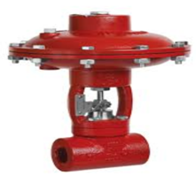
Figure 6.2: The control valve used for pressure and rate control, Courtesy of Kimray
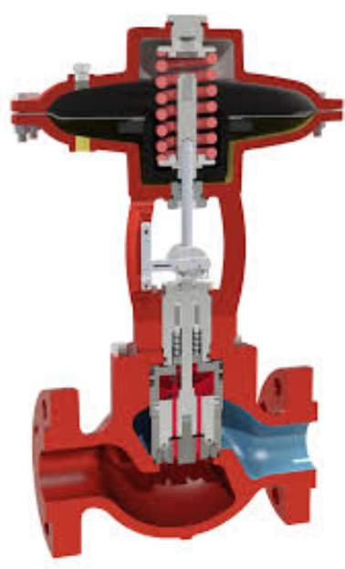
Figure 6.3: Cutaway of the control valve, Courtesy of Kimray
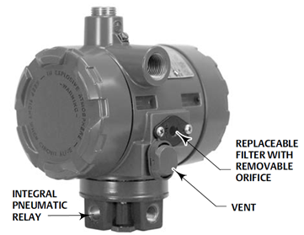
Figure 6.4: Electro-pneumatic transducer, current to pressure (I2P), Courtesy of Fisher

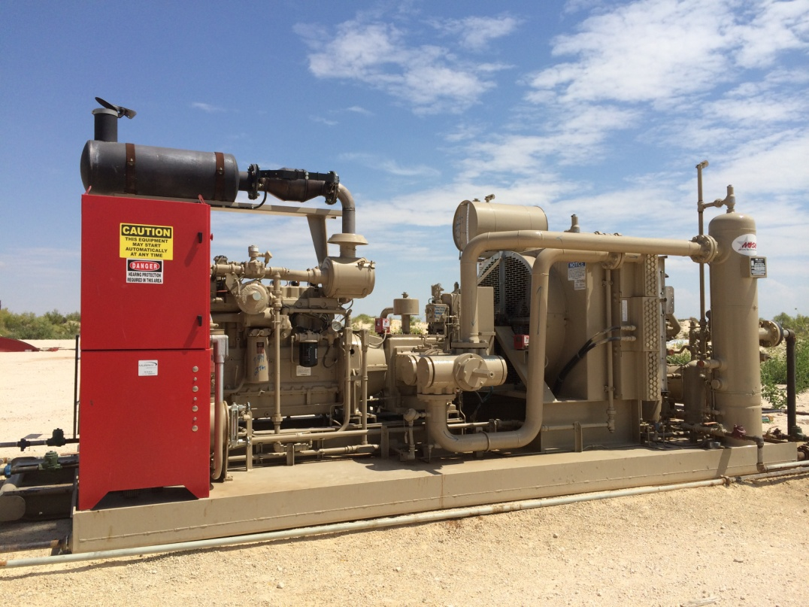
Figure 6.5: High-speed 3-stage compressor, Courtesy of NGSG

All piping is 2 inches ID schedule 80. The installation of the pulsation plate helped to reduce the vibration on the line caused by the compressor, especially with the sensitive telemetry equipment at proximity of the discharge line. This setup enabled better and more accurate control over the operation because it ensured a stable rate and pressure with minimum operational fluctuations. On the other hand, it required good telecommunication infrastructure in addition to reliable equipment.
The compressor used in this case was a 3-stage reciprocating high speed compressor (Fig. 6.5). Injection gas came in from the supply source through the poly pipe, and its pressure was regulated down to the desired suction pressure using the suction controller valve. The reduced pressure gas then entered the suction scrubber to dry off by knocking off as much liquid as possible. The stripped liquids were dumped from the bottom of the scrubber to the producing tanks while the dry gas exited the top of the scrubber towards the first stage of compression. The dual reciprocating piston compressed the gas until it reached the discharge pressure from the first stage. The hot compressed gas was sent towards the cooler to go through series of heat exchangers to dissipate the heat from first compression stage. As the gas temperature dropped, it reached the dew point and started dropping liquids. This is not desired, and therefore, the gas was sent to a second scrubber where these liquids were accumulated at the bottom of the vessel and sent to the producing tanks while the dryer gas once again exited at the top of the scrubber and flowed towards the second stage of compression. The gas entered the compression chamber at a higher pressure than the in first stage and was compressed further until it reached the discharge pressure of the second stage.
At this point, the gas was flowing at a higher pressure and temperature than the inlet pressure at the second stage. Following the second stage of compression, the gas was sent towards the cooler again to reduce its temperature and then continued, along with the dropped liquids, towards the scrubber for the third stage. The remaining liquids were again accumulated at the bottom of the scrubber and dumped into the producing tanks, while the gas exited at the top and continued flowing towards the third stage of compression where it was further compressed until it reached the final desired discharge pressure. At this point, the gas was hotter and was flowing at higher pressure than the first and second stages. This high pressure gas exited the compressor skid towards the well and was injected down the tubing-casing annulus.
The set up is build to handle the occasional high line pressure through the use of flaring system that is activated when line pressure reaches s certain threshold. Gas is re-routed to the flare system to avoid venting it to atmosphere.
Also, there might be periods of low gas supply towards the compressor. In the latter case, the fuel recycle valve will open and continues supplying fuel gas to the compressor engine in order to keep it from shutting down until the gas supply reached its normal level once again. If supply gas levels remain low for an extended time period, the compressor engine temperature will continue rising and will eventually reach high enough level that will force the compressor to shut down. Safe guards to protect the compressor from exceedingly high temperatures that can damage it are put in place and will be triggered if such event occurs.

6.2 Second setup
The second setup, as shown in Fig. 6.6, is more basic and did not have the injection meter or the rate and pressure control valve as part of the installation. In this case, supply gas came from an offset well where it went through compression to reach higher pressure; then it was discharged to the injection well tubing-casing annulus to assist in the lifting operation.

71

Figure 6.6: Second experimental setup
NB: BPV: back pressure valve; BV: ball valve; MV: motor valve; and CV: check valve. With the exception of the 3” poly pipe suction line, all piping was 2” Schedule 80.

Not all types of gas can be used for injection. There are stringent specs of gas that need be met before it is suitable (see Table. 6.1). The source gas has to be sweet gas, that is, it has to contain less than 50 ppm of H₂S. Gas at higher concentrations than that will cause damage to the engine. Also, it is preferable that the gas heating value is less than 1400 BTU; otherwise, residue will be deposited from inefficient burning of the rich gas.
Table 6.1: Typical gas analysis needed for compression design and selection
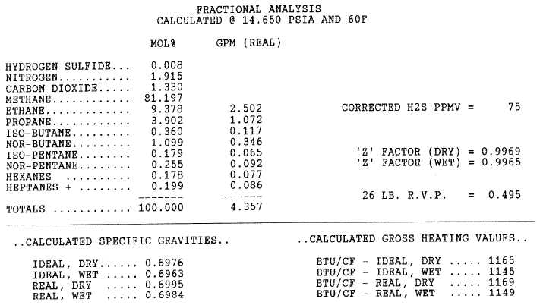
The supply of gas from the offset well will eventually phase away and be used only for restart operations. Because the well-produced liquids and both formation and injection gas, the total stream was taken to a 2-phase separator where the liquids dropped to the bottom of the vessel and were sent to the central tank battery. The gas was taken out of the outlet of the scrubber and plumbed back to the suction line where the pressure was regulated before it entered the compressor. Another line was laid from the separator to carry the excess gas to the sales line to avoid backups due to higher than anticipated gas volumes that exceeded the compressor capacity or unplanned shut downs and upsets of the compressor. In absence of automation, the injection rate was inferred from the compressor performance curves and was manipulated by varying suction and discharge pressures. Figure 6.7 shows the compressor performance curve used in this experiment (Courtesy of Compresco Partners L.P.).
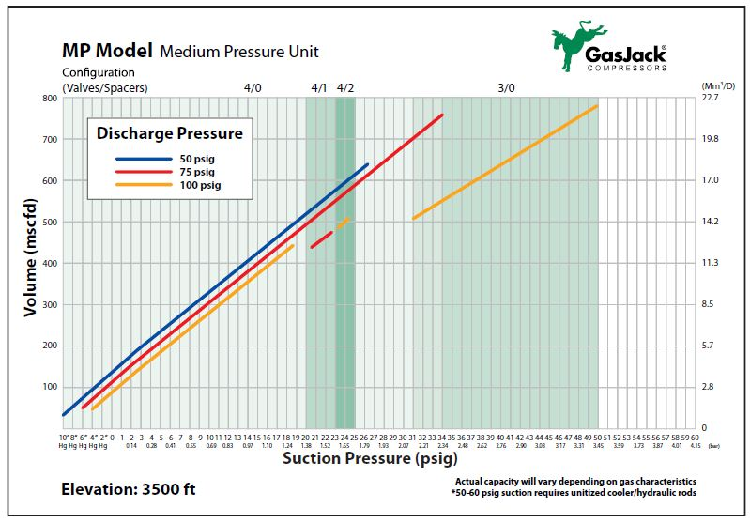 Figure 6.7: Compressor performance curves
6.3 Operational issues and solutions
Few issues can arise during this operation. They could be surface or bottom hole related. Following is a list of potential problems and solutions to rectify them.
6.3.1 Compressor down on maximum discharge pressure
In case the compressor repeatedly goes down on high discharge, the following causes should be investigated. The volume of liquid accumulated in the wellbore may be high. This can be resolved by reducing the liquid volume in the well before starting the compressor injection, which can be done either by swabbing the well or using the compressor injection down both the casing annulus and tubing to push the fluid level back to the reservoir. This could also be caused by the lifting point in the wellbore being too deep; in which case, it is necessary to move the injection point to a shallower depth by introducing new tubing perforations. This solution is not optimal because it still leaves the section below the injection point exposed to the potential of liquid loading. If this issue keeps occurring, then conventional gas lift might be a better solution. Other causes could be as simple as a malfunctioning discharge valve can. In that case, a routine check and maintenance of the valve to ensure proper functioning would suffice.
6.3.2 Compressor down on low suction pressure
Issues such as low gas supply to the compressor or a malfunctioning suction valve will cause the compressor to continuously go down on low suction. To avoid these interruptions to the operation, it is important to keep the supply gas steady by adding a recirculation line or gas buyback meter in addition to having a maintenance program to routinely check the suction control valve to ensure proper functioning. Hydrate formation, especially in cold weather conditions, will cause an interruption in supply gas or freeze the controls of the valve. In the latter case, heat tracing the lines and valves and/or injecting methanol will help the lines stay clear and ensure that the valve functions normally.
6.3.3 Monitoring pressure
Monitoring casing and tubing pressure was also used to evaluate the effectiveness of the process. The following are some observations noted during the operation:
- Equalized casing and tubing pressures
- Equalized or quasi-equalized volume of both injection and produced gas
- Low to no fluid production observed at the surface
- Low fluid level in the well, confirmed by a pressure gradient survey or fluid shot.
The combination of the conditions described above is typically an indication of reduced inflow performance due to either “in-reservoir conditions” such as low reservoir deliverability caused by depletion or skin, or “in-wellbore conditions” caused by blockage due to scaling from incompatible water sources, paraffin, or sand from the fracturing treatment or formation. lowering the tubing to reach a new fluid level or cleaning the well out and/or re-stimulating it to re-establish reservoir deliverability are all potential solutions to resolve the low deliverability issue. Another issue that can be encountered, especially after the initial startup, is climbing casing and tubing pressures. The latter issue is mainly caused by higher injection volume and discharge pressure than necessary and/or the presence of restrictions causing back pressure. To resolve this issue, it is recommended to reduce the injection volume or reduce the discharge pressure. The latter can be done if a back pressure valve is set downstream from the compressor discharge. The restrictions and/or pressure drop points could also be reduced, i.e. by opening the choke and reducing elbows. Low casing and tubing pressures can also occur, especially in the presence of a thief zone or injection line leaks. Typically, raising the tubing above the thief zone or inserting circulating holes above it while reducing the discharge pressure and/or injection rate can resolve the low pressure problem. As for injection line leaks, implementing routine maintenance and visual inspections is the first line of defense to resolve the issue.
CHAPTER VII
Experimental results

The previous chapter described the experimental setup and equipment used in order to execute the procedure to identify the effective lift rate. In this chapter, data gathered from the experiment are analyzed and compared to the predictions from the critical gas rate models including the new model, the horizontal well models, Veeken model and Belfroid model, and the conventional vertical well models, Turner model and Coleman model. As discussed in the literature review chapter, Belfroid’s model is a merger between the Turner model and the Fiedler shape function which attaches a dependency of the model to the deviation angle ω. The latter dependence results in a maximum of 35% rate increase over the critical gas rate calculated using the Turner model and this peak increase occurs at 53º inclination. At the latter inclination, the Belfroid model critical gas rate prediction is almost similar to the new model. However, the error from the Belfroid model can have a large range depending on the inclination angle of the evaluation point. For example in Horizontal Well 1, the range is from zero to 37%, and for Horizontal Well 2, it is from 5 to 41%. For the purpose of this work, the maximum build up angle of each of the two horizontal wells is implemented when using the Belfroid model. Table 7.1 shows the properties of the two horizontal wells. The actual production data from these wells were recorded and only days with valid data were used. Valid data means data collected for days when the wells did not experience any problems and had 100% run time without compressor problems, such as mechanical problems, gas supply issues, or freezing due to weather conditions. Also, after the injection rate was changed, the well was allowed to become stable before the data were recorded so that the results were not skewed by unsteady state conditions.
Table 7.1: Data from Horizontal Wells 1 and 2
 |  | Horizontal Well 1 | Horizontal Well 2
Production Data | q_{o} (BO/d) | 2.39 | 61.50
Production Data | q_{w} (BW/d) | 19.52 | 2.00
Production Data | q_{g} (Mscf/d) | 273 | 181
Production Data | FTP (psia) | 110 | 92
Production Data | T_{surface} (ºF) | 80 | 60
Production Data | T_{formation} (ºF) | 223 | 130
Production Data | OGR (bbls/MMscf) | 3.3 | 90
Production Data | WGR (bbls/MMscf) | 27 | 3
Production Data | WOR | 8.18 | 0.03
Tubular Data | Tubing OD (in.) | 2.875 | 2.875
Tubular Data | d (in.) | 2.441 | 2.441
Tubular Data | Casing OD (in.) | 5.5 | 7
Tubular Data | Casing ID (in.) | 4.892 | 6.276
Tubular Data | Liner Top (ft) | 12,950 | 8,177
Tubular Data | Liner OD (in.) | 3.5 | 4.5
Tubular Data | Liner ID (in.) | 2.992 | 4
Tubular Data | Absolute roughness (in.) | 0.0006 | 0.0006
Tubular Data | Depth (ft) | 12,863 | 8,306
Tubular Data | Max BUR º/100 ft | 12.34 | 18.34
PVT | API | 65 | 40
PVT | N₂ Mol % | 0 | 1.686
PVT | CO₂ Mol % | 0 | 0.843
PVT | H₂S Mol % | 0 | 0.003
PVT | Specific gas gravity | 0.65 | 0.7
PVT | Specific water gravity g_{w} | 1.02 | 1.02
PVT | Specific oil gravity g_{o} | 0.72 | 0.83

7.1 Horizontal Well 1
The recorded production data for the first horizontal well are captured and presented in Table 7.2. Figure 7.1 depict the data in graphical form showing Well 1 response to the different injection rates applied to determine the gas rate needed to keep it unloaded.
Figure 7.1: Critical gas rate for the Horizontal Well 1
Table 7.2: Horizontal Well 1 production data
Days | Oil (BOPD) | Gas (Mscf/d) | Water (BWPD) | Casing Pressure (psia) | Tubing Pressure (psia) | Injected Gas (Mscf/d) | Total Gas (Mscf/d)
1 | 1.7 | 257 | 13 | 637 | 111 | 250 | 507
2 | 2.5 | 256 | 13 | 631 | 111 | 250 | 506
3 | 1.7 | 254 | 13 | 637 | 112 | 250 | 504
4 | 1.7 | 252 | 12 | 643 | 114 | 250 | 502
5 | 2.5 | 250 | 13 | 637 | 114 | 250 | 500
6 | 2.5 | 262 | 12 | 540 | 120 | 350 | 612
7 | 2.5 | 255 | 12 | 562 | 120 | 350 | 605
Days | Oil (BOPD) | Gas (Mscf/d) | Water (BWPD) | Casing Pressure (psia) | Tubing Pressure (psia) | Injected Gas (Mscf/d) | Total Gas (Mscf/d)
8 | 0.8 | 254 | 15 | 566 | 120 | 350 | 604
9 | 0.0 | 263 | 13 | 551 | 116 | 350 | 613
10 | 1.7 | 264 | 17 | 542 | 116 | 350 | 614
11 | 1.7 | 261 | 13 | 542 | 118 | 350 | 611
12 | 0.1 | 261 | 15 | 542 | 118 | 350 | 611
13 | 0.0 | 256 | 10 | 543 | 118 | 350 | 606
14 | 2.6 | 256 | 16 | 557 | 118 | 350 | 606
15 | 5.8 | 258 | 9 | 883 | 116 | 350 | 608
16 | 0.8 | 261 | 10 | 781 | 116 | 350 | 611
17 | 1.7 | 261 | 13 | 802 | 116 | 350 | 611
18 | 1.7 | 259 | 16 | 802 | 114 | 350 | 609
19 | 2.5 | 266 | 16 | 473 | 120 | 400 | 666
20 | 1.7 | 266 | 15 | 467 | 120 | 400 | 666
21 | 1.7 | 267 | 14 | 457 | 120 | 400 | 667
22 | 1.7 | 268 | 14 | 452 | 120 | 400 | 668
23 | 2.5 | 268 | 13 | 452 | 120 | 400 | 668
24 | 1.7 | 266 | 13 | 452 | 120 | 400 | 666
25 | 1.7 | 265 | 14 | 495 | 120 | 400 | 665
26 | 2.5 | 264 | 13 | 491 | 120 | 400 | 664
27 | 2.5 | 264 | 13 | 485 | 120 | 400 | 664
28 | 1.7 | 262 | 13 | 493 | 120 | 400 | 662
29 | 1.7 | 265 | 13 | 493 | 120 | 400 | 665
30 | 1.7 | 263 | 13 | 496 | 120 | 400 | 663
31 | 0.8 | 259 | 12 | 491 | 120 | 400 | 659
32 | 1.7 | 278 | 16 | 412 | 120 | 450 | 728
33 | 2.5 | 278 | 13 | 403 | 114 | 450 | 728
34 | 0.0 | 279 | 14 | 393 | 118 | 450 | 729
35 | 0.8 | 284 | 14 | 301 | 120 | 450 | 734
36 | 1.7 | 277 | 14 | 305 | 114 | 450 | 727
37 | 1.7 | 284 | 14 | 299 | 116 | 450 | 734
38 | 0.8 | 279 | 13 | 305 | 114 | 450 | 729
39 | 0.8 | 283 | 14 | 280 | 99 | 449 | 732
40 | 1.7 | 282 | 14 | 293 | 114 | 450 | 732

An initial total rate of 500 Mscf/d (250 Mscf/d sold and 250 Mscf/d injected) did not help stabilize the well, and the production rate showed a continuous decline. The rate was increased to 610 Mscf/d (260 Mscf/d sold and 350 Mscf/d injected). At this rate, the wells started cycling, as is evident in both the water and gas rates. Note that at day 13, the gas rate dropped, followed by a drop in water production the following day; then at day 14, a surge in water production was followed by an increase in gas rate. The heading behavior was indicative of the well operating below its critical rate. The total rate was increased again to 670 Mscf/d (270 Mscf/d sold and 400 Mscf/d injected). At that rate, the cycling effect started to wane; however, the total production trend was still descending. The latter observation indicates that the critical rate condition was almost achieved. Therefore, the total rate was further increased to 730 Mscf/d (280 Mscf/d sold and 450 Mscf/d injected). At this rate, the production started to show signs of stability for both water and gas. Therefore, a total rate of 730 Mscf/d was considered to be the critical rate.
Table 7.3: Observed critical gas rates and percent deviation for Horizontal Well 1
Actual Lift Rate, Mscf/ d | 730 | Absolute Percent Deviation, %
Coleman CR, Mscf / d | 455 | 38
Turner, Mscf / d | 541 | 26
New model, Mscf / d | 692 | 5
Belfroid, Mscf / d | 495 | 32
Veeken, Mscf / d | 579 | 21

Table 7.3 shows the calculated critical rates and deviations with respect to the actual observed critical rate from both conventional vertical and horizontal models. Compared to the vertical models, Coleman (455 Mscf/d and 38% deviation), Turner (541 Mscf/d and 26% deviation), it is clear that the new model shows better prediction of the critical rate. Also, when compared to the horizontal models, Veeken (579 Mscf/d and 21% deviation) and Belfroid (495 Mscf/d and 32% deviation), the new model (692 Mscf/d and 5% deviation) clearly outperforms both in predicting the critical rate.
7.2 Horizontal Well 2
A similar process to that described for Horizontal Well 1 was applied to the second horizontal well. The production data is presented in Fig. 7.2 and Table 7.4.
Figure 7.2: Critical gas rate for Horizontal Well 2
Table 7.4: Horizontal Well 2 production data
Days | Gas (Mscf/d) | Oil (BOPD) | Water (BWPD) | Fluid (BFPD) | Injection Rate (Mscf/d) | Total Gas (Mscf/d) | Avg Csg (psi) | Avg Tbg (psi)
1 | 190 | 44 | 25 | 69 | 509 | 699 | 419 | 94
2 | 174 | 62 | 0 | 62 | 503 | 678 | 420 | 91
3 | 187 | 69 | 0 | 69 | 503 | 690 | 416 | 94
4 | 172 | 59 | 0 | 59 | 501 | 673 | 412 | 91
5 | 184 | 48 | 13 | 61 | 504 | 688 | 411 | 92
6 | 181 | 56 | 6 | 61 | 498 | 679 | 406 | 91
7 | 194 | 54 | 0 | 54 | 588 | 782 | 393 | 99
8 | 157 | 60 | 0 | 60 | 587 | 745 | 397 | 98
9 | 182 | 60 | 0 | 60 | 610 | 791 | 394 | 101
10 | 157 | 68 | 0 | 68 | 588 | 745 | 392 | 96
11 | 148 | 59 | 0 | 59 | 588 | 736 | 393 | 96
12 | 137 | 60 | 0 | 60 | 611 | 748 | 391 | 99
13 | 150 | 51 | 1 | 52 | 432 | 582 | 390 | 83
14 | 141 | 52 | 0 | 52 | 429 | 570 | 391 | 72
15 | 154 | 49 | 1 | 50 | 430 | 584 | 385 | 78
16 | 165 | 53 | 2 | 55 | 434 | 599 | 387 | 74
17 | 162 | 51 | 1 | 52 | 454 | 616 | 381 | 79
18 | 158 | 50 | 1 | 51 | 451 | 609 | 382 | 81
19 | 160 | 40 | 4 | 44 | 411 | 571 | 387 | 24
20 | 189 | 55 | 4 | 59 | 535 | 724 | 382 | 84
21 | 155 | 52 | 2 | 54 | 576 | 731 | 371 | 90
22 | 125 | 55 | 0 | 55 | 520 | 645 | 363 | 80

The initial total rate of 684 Mscf/d (181 Mscf/d sold and 503 Mscf/d injected) yielded an average of 64 BFPD with a Flowing Tubing Pressure (FTP) of 92 psi. Increasing the injection rate to a total rate of 758 Mscf/d (162 Mscf/d sold and 595 Mscf/d injected) did not yield an increase in production; in fact, it reduced the total average liquid rate to 60 BLPD. This was an indication of over-injection, which is also evident in the increase in FTP to 98 psig. The injection rate was subsequently dropped to simulate lower total gas closer to the predicted flow rates from vertical models. The production response at a rate of 590 Mscf/d (156 Mscf/d sold and 434 Mscf/d injected) was not favorable and dropped to an average liquid rate of 51 BFPD, a loss of 13 BOPD and 26 Mscf/d. To verify the reversibility of the production drop and the dependence of production rate on total gas rate, the injection rate was subsequently increased. The production response was clear and swift, as the liquid rate increased back up to 55 BFPD, which is clear evidence that at lower gas rates, the liquid drop inside the wellbore is due to low lift force as a proxy to the lack of critical gas velocity. This confirms Wallis (1969) work, which states that at very high velocities the liquid film thickness approaches zero and all liquids are entrained in the gas stream. As the gas velocity decreases, fluids accumulate to form a thicker film surrounding a gas core with entrained droplets. If the latter condition continues or worsens, the well will eventually load up.
Based on the results discussed earlier, a total rate of 684 Mscf/d is considered to be the critical rate. Table 7.5 shows the calculated critical rates and deviations with respect to the actual observed critical rate from both conventional vertical models and two horizontal models. Compared to the vertical models, Coleman (404 Mscf/d and 41% deviation), and Turner (481 Mscf/d and 30% deviation), it is clear that the new model shows better predictions of the critical rate. Also, when compared to the horizontal models, Veeken (512 Mscf/d and 25% deviation) and Belfroid (506 Mscf/d and 26% deviation), the new model (648 Mscf/d and 5% deviation) clearly outperforms both in predicting the critical rate.
In conclusion, it is recommended that the conventional models of Turner and Coleman not be used outside the vertical application and the new model presented here should be applied for horizontal and deviated wells.
Table 7.5: Observed critical gas rates and percent deviation for Horizontal Well 2
Actual Lift Rate, Mscf / d | 684 | Absolute Percent Deviation, %
Coleman CR, Mscf / d | 404 | 41
Turner, Mscf / d | 481 | 30
New model, Mscf / d | 648 | 5
Belfroid, Mscf / d | 506 | 26
Veeken, Mscf / d | 512 | 25

CHAPTER VIII
Liquid holdup theory

8.1 Pressure traverse and liquid holdup
Liquid holdup, H_{L}, refers to the fraction of liquid present in a cross sectional area of a pipe. Multiple correlations are currently used by the industry to calculate the liquid holdup. Some of these correlations consider slippage and some do not. Brill et al. (1999) classified the current empirical pressure gradient correlations into three categories:
- Category a: no slip, no flow pattern
- Category b: considers slip, but no flow pattern
- Category c: considers both slip and flow pattern
Slippage occurs because there are differences in flowing velocities between the different flowing phases. Therefore, the H_{L} is typically different from the input liquid fraction. The liquid fraction at a given depth is defined as follows:
$H_{L}=\frac{A_{L}}{A}$ (8.1)
where A_{L} is the cross-sectional area occupied by the liquid phase, and A is the total cross-sectional area of the pipe.
It is important to determine the liquid holdup because it is used to compute the pressure gradient throughout the wellbore and to define how the flow patterns should be mapped. The governing equation for the pressure gradient is determined by applying the concepts of conservation of mass and conservation of linear momentum for steady state flow. The resulting mechanical energy balance is as follows:
${∆P}_{Total}={∆P}_{Hydrostatic}+{∆P}_{Friction}+{∆P}_{acceleration}$ (8.2)
Equation 8.2 has three components—the friction pressure loss component, the hydrostatic pressure component, and an acceleration component. The friction and hydrostatic components are the most influential, with gravity being the dominant player, while the acceleration component is typically negligible.

8.1.1 The friction component
The friction component is a function of the friction factor, fluid density and velocity, and conduit diameter and is defined in psi using the Fanning friction factor as follows:
${∆P}_{friction}=\frac{2fρ_{n}V_{m}^{2}h}{g_{c}d}$ (8.3)
where f is the Fanning friction factor, ρ_{n} is the non-slip mixture density, V_{m} is the mixture velocity, h is the elevation, g_{c} is gravitational correction factor constant, and d is the flow conduit inside diameter.
The single phase flow friction factor, for gas or liquid, is determined either graphically or numerically. Figure 8.1 shows the Moody diagram used to determine the Moody friction factor for a given N_{Re} and pipe relative roughness. Note that the Moody friction factor is four times the Fanning friction factor.
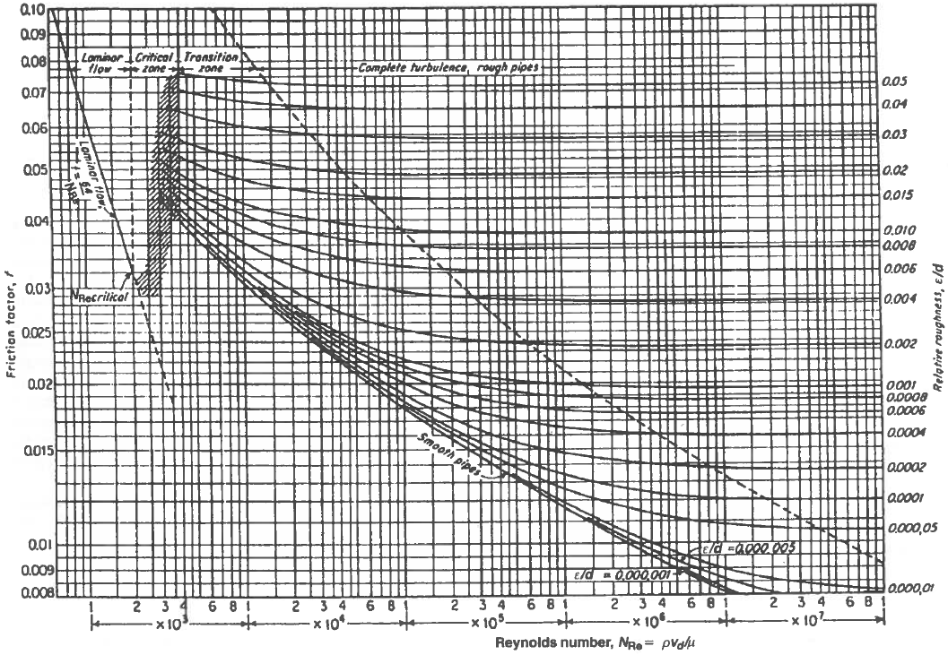
Figure 8.1 Moody friction factor diagram for pipes
An empirical equation to compute the Fanning friction factor was presented by Chen (1979) as follows:
$\frac{1}{\sqrt{f}}=-4\log\left[0.2698\left(\frac{k}{d}\right)-\frac{5.0452}{N_{Re}}\log\left\{0.3539{\left(\frac{k}{d}\right)}^{1.1098}+\frac{5.8506}{N_{Re}^{0.8981}}\right\}\right]$ (8.4)
where, f is the Fanning friction factor, k is the pipe absolute roughness, k/d is the relative roughness, and N_{Re} is the Reynolds number, defined as follows:
$N_{Re}=\frac{ρVd}{μ}$ (8.5)
where, ρ is the mixture density, V_{m} is the mixture velocity, d is the flow conduit inside diameter, and µ is the mixture viscosity.
For multiphase flow cases, the single phase friction factor is still adapted. This adaptation differs from one correlation to another. For example, Gray (1978) uses a pseudo-wall-roughness to incorporate the effect of H_{L} on friction loss, while Hagedorn and Brown (1965) uses a two-phase N_{Re} to determine the friction factor.

8.1.2 The hydrostatic component
The hydrostatic component is a function of the fluid density and the change in elevation. It is defined as follows:
${∆P}_{Hydrostatic}=ρ_{m}gh$ (8.6)
where, h is the elevation, ρ_{m} is the mixture density, and g is acceleration of gravity.
For multiphase flow cases, the mixture density is obtained after H_{L} is identified, which represents the in-situ condition. The no-slip density is not used in this case because it represents the input condition, not the in-situ. The mixture density is identified as follows:
$ρ_{m}=ρ_{L}H_{L}+ρ_{g}\left(1-H_{L}\right)$ (8.7)
where, H_{L} is the in-situ liquid volume fraction (liquid holdup), ρ_{m} is the mixture density, ρ_{L} is the liquid density, and ρ_{g} is the gas density.
8.2 Liquid holdup adjustment
The effect of buildup rate (BUR) and dog leg severity (DLS) is manifested through a change in the liquid holdup. As droplets exit one section of the pipe towards a new section with a different BUR, they will experience an impact and rebound that positions them in the way of upcoming droplets. That situation will cause droplets to collide with each other and change direction, resulting in gradual reorientation of all droplets to the new geometry. The latter process will be repeated throughout the build section as the BUR changes until the vertical section above the kick off point is reached. At that point, the changes in BUR are usually insignificant, typically less than 3 degree deviation (see Fig. 8.2).

Figure 8.2: Change of inclination versus MD in horizontal and deviated wells

The effect of impact and rebound is more stringent in horizontal and deviated wells, especially at the curve or build section, than it is in vertical wells. This can be explained by the available distance the droplet has to travel downward before it reaches a rest surface, i.e., wall or plug back true depth. In vertical wells, that distance can be significant, tens to thousands of feet. The case is different for horizontal and deviated wells because of the very limited time and space the droplet might have before it can reach a rest surface, typically inches to tens of feet.

To illustrate the influence of the BUR, Fig. 8.3 shows the lowest portion of the cross sectional area at the pivot point where change in geometry occurs. The reduction of the droplets’ velocity at these locations makes these areas act as a collection ground for droplets. If the droplet collection process continues, it will eventually gather enough liquid to fill up the pivot point and use it as a liquid buildup base. Having water occupying that portion of the pipe affects the liquid holdup. Therefore, a new liquid holdup that takes into account the presence of a watered out portion of the cross sectional area will need to be considered.
A few steps are taken to determine the new H_{L}:
- Identify the portion of the cross sectional area that is submerged under liquid. That area, A_{α}, is a direct function of the BUR angle α and can be computed from the deviation survey.
- Compute the liquid holdup using one of the many available correlations. For this study, the Gray correlation (1978) was used.
- Finally, the calculated H_{L} is adjusted to account for the liquid accumulation, and a new H_{L}, referred to as H_{Lnew}, is computed.

BUR 2
BUR 1
Stream
Stream
Stream

Figure 8.3: The effect of BUR on liquid holdup
In order to determine A_{α}, first we need to determine the height, L₁, of the cross sectional area that is filled up with water. For any given α, using one projection of the flow conduit diameter, d, L₁ is calculated as follows:
$L_{1}=d×sinα$ (8.8)
L₂ is the length difference between the flow conduit radius and the wet chord peak L₁ defined as follows:
$L_{1}+L_{2}=\frac{d}{2}$ (8.9)
or,
$L_{2}=\frac{d}{2}-L_{1}$ (8.10)
Once L₁ is identified, the area A_{α} can be computed as the resultant of the internal flow conduit area and twice the area of the triangle A_{t} defined as $\left(b\hat{θ}\left(d/2\right)\right)$ as follows:
$A_{α}=(\frac{2θ}{2π}×\frac{π}{4}d^{2})-2A_{t}$ (8.11)
or,
$A_{α}= \left( \frac{θ}{4}×d^{2}\right)-2 A_{t}$ (8.12)
where,
$Cos θ=\frac{L2}{d/2}=1-\frac{2L1}{d}$ (8.13)
Replacing Eqs. 8.8 and 8.10 into Eq. 8.13 and solving for θ leads to:
$θ=Acos\left(1-2sinα\right)$ (8.14)
The area of the triangle A_{t} is defined as:
$A_{t}=\frac{1}{2}b×L_{2}$ (8.15)
The Pythagorean Theorem can be used to calculate b as follows:
$b^{2}+L_{2}^{2}={\left(\frac{d}{2}\right)}^{2}$ (8.16)
Rearranging, and replacing Eq. 8.10 into Eq. 8.16 we get:
$b=\sqrt{dL_{1}-L_{1}^{2}}$ (8.17)
Replacing b with its value from Eq.8.17 and L₂ with its value from Eq. 8.10 into Eq. 8.15 leads to:
$2A_{t}=\left(\frac{d}{2}-L_{1}\right)\sqrt{dL_{1}-L_{1}^{2}}$ (8.18)
Substituting Eqs. 8.8, 8.14, and 8.18 into Eq. 8.12, we get:
$A_{α}=\frac{d^{2}}{2}\left[\left(\frac{Acos\left(1-2sinα\right)}{2}\right)- {\left(\left(1-2sinα\right)(sinα(1-sinα\right)}^{\frac{1}{2}}\right]$ (8.19)
Therefore, the liquid fraction that should be added to compensate for liquid accumulation, H_{La}, is calculated as follow:
$H_{La}=\frac{A_{α}}{A_{d}}$ (8.20)
Finally, the adjusted liquid holdup, H_{Lnew}, is obtained as follow:
$H_{LNew}=H_{LOld}+H_{La}$ (8.21)
where,
$L_{1}$ = the height of the area affected by the change in BUR in ft;
$L_{2}$ = droplet radius minus $L_{1}$ in ft;
$d$ = droplet diameter in ft;
$b$ = the chord of the area affected by the change in BUR in ft;
$α$ = the BUR angle in deg;
$A_{α}$ = the area affected by the change in BUR in ft²;
$A_{t}$ = the volume of the triangle with the chord as a base and the sides as droplet radius in ft³;
$H_{La}$ = additional H_{L} normalized to the flow conduit area;
$H_{LNew}$ = the adjusted new holdup value
$H_{LOld}$ = the holdup calculated using any given correlation i.e. the Gray correlation

8.3 The effect of H_{Lnew} on flow correlations
This section demonstrates how the BUR is used to modify the method implemented to compute H_{L}. As an example, the Gray correlation is used to illustrate this effect. Gray (1978) used 108 well test data to develop a pressure drop correlation for two-phase flow in vertical wet gas wells. The resulting equation is as follows:
$\frac{dp}{dL}=ρ_{s}g+\frac{fρ_{n}V_{m}^{2}}{2d}$ (8.22)
Currently, modifications of the Gray correlation allow its usage in horizontal wells, mainly by changing the manner in which the hydrostatic and friction components are computed. The Gray correlation considers slippage and uses dimensionless numbers when calculating the liquid holdup; this H_{L} will be subject to modification using the effect of the BUR as explained earlier. The modified H_{L} will be referred to as H_{Lnew} and will be compared to the original H_{L}.
$H_{L}=1-\frac{1-e^{\left\{\left.-2.314{\left[N_{v}\left(1+\frac{205}{N_{D}}\right)\right]}^{B}\right\}\right.}}{R+1}$ (8.23)
As described by the Eq. 8.23, H_{L} depends on the three dimensionless numbers—N_{v}, N_{D}, and B, and the ratio of the superficial velocity of the liquid and gas. The dimensionless numbers require a good estimation of the PVT and flow conduit data and are defined as follows:
$N_{v}=\frac{ρ_{n}^{2}V_{m}^{4} }{gσ_{l}\left(ρ_{l}-ρ_{g}\right)}$ (8.24)
$N_{D}=\frac{gd^{2}\left(ρ_{l}-ρ_{g}\right)}{σ_{l}}$ (8.25)
$B=0.0814\left[1-0.0554\ln\left(1+\frac{730R}{R+1}\right)\right]$ (8.26)
The superficial velocity ratio is defined as follows:
$R_{v}=\frac{V_{sl}}{V_{sg}}$ (8.27)
where,
$V_{sl}=\frac{q_{l}}{A_{d}}=\frac{q_{o}B_{o}+\left(q_{w}-W_{cond}*q_{g}\right)B_{w}}{π/4d^{2}}$ (8.28)
and,
$V_{sg}=\frac{q_{g}}{A_{d}}=\frac{\left(q_{g}-q_{o}R_{s}\right)B_{g}}{π/4d^{2}}$ (8.29)
Once the H_{L} is identified, the well’s deviation survey is used to correct for the effect of the BUR.
$H_{Lnew}=\left[1-\frac{1-e^{\left\{\left.-2.314{\left[N_{v}\left(1+\frac{205}{N_{D}}\right)\right]}^{B}\right\}\right.}}{R+1}\right]+0.6367\left[\left(\frac{Acos\left(1-2sinα\right)}{2}\right)- {\left(\left(1-2sinα\right)(sinα(1-sinα\right)}^{\frac{1}{2}}\right]$ (8.30)
where V_{sl} is the superficial liquid velocity, V_{sg} is the superficial gas velocity, V_{m} is the mixture velocity, W_{cond} is the water of condensation, q_{o} oil production, q_{W} is water production, q_{g} is gas production, q_{L} is total liquid production, B_{o} is the oil formation volume factor, B_{W} is the water formation volume factor, B_{g} is the gas formation volume factor, R_{S} is the solution gas/oil ratio, ρ_{g} is the gas density, ρ_{l} is the liquid, and σ is the gas / liquid surface tension.
Equation 8.30 is referred to as the adjusted liquid holdup and should be used to calculate H_{Lnew} for any given BUR.
The H_{Lnew} value is used to identify areas throughout the wellbore that are prone to carry higher liquid fractions and cause a transition outside the mist flow region. Barnea (1986; 1987) stated that the flow regime changes to a slug or churn flow pattern when the liquid holdup value is higher than 0.24. The proposed H_{L} adjustment is not unique to the Gray model and can also be expanded to other pressure traverse models.

8.4 Example using Horizontal Wells 1 and 2
8.4.1 Horizontal Well 1
Table B4 in Appendix B shows the calculated H_{L} distribution along the wellbore using the Gray correlation and the adjust Gray correlation, H_{Lnew}, coupled with the conventional models and the new model for critical gas rate predictions for Horizontal Well 1.
Using the conventional models, Turner and Coleman, coupled with the H_{L} from the Gray correlation (Fig. 8.4) suggests that the well is supposed to be flowing in the mist flow region and no liquid accumulation is occurring, as suggested by an H_{L} of 0.13. The same is shown when using the new model for critical gas rate predictions, coupled with the H_{L} from Gray (Fig. 8.5). The new model shows better H_{L} distribution along the wellbore than the conventional models with a maximum H_{L} of 0.10. Using the adjusted H_{Lnew}, coupled with either the conventional models or the new model for critical rate predictions shows the emergence of an area around the curved section from 12,681 to 12,808 ft as having liquid holdup values higher than 0.24 (see Figs. 8.6 and 8.7). Therefore, the latter identified area is the location that is prone to liquid accumulation and should be taken into account when planning to run production equipment.

Figure 8.4: Conventional models for critical gas rate prediction coupled with H_{L} from the Gray correlation, Horizontal Well 1
Figure 8.5: New model for critical gas rate prediction coupled with H_{L} from the Gray correlation, Horizontal Well 1
Figure 8.6: Conventional models for critical gas rate prediction coupled with H_{Lnew} from the adjusted Gray correlation, Horizontal Well 1

Figure 8.7: New model for critical gas rate prediction coupled with H_{Lnew} from the adjusted Gray correlation, Horizontal Well 1

Once the problem areas in the wellbore are identified, designing the tubing, both sizing and placement, becomes clear and provides a good solution for resolving liquid accumulation in these areas. Figure 8.8 shows the H_{L} distribution for 2 7/8” tubing coupled with the new model’s critical gas rate prediction value calculated for Horizontal Wells 1 and the adjusted H_{Lnew}. The latter combination shows a good distribution of liquid holdup throughout the wellbore, with all values below 0.24 and a maximum value of 0.19. Figure 8.9 shows the overlay of all models and the progressive improvement of the well liquid holdup when moving away from conventional models and the Gray H_{L} towards the new model and the adjusted Gray H_{L}. For the same method of critical gas rate prediction, both the Gray and adjusted Gray holdup models overlap in the vertical section of the wellbore; however, in the curved and horizontal sections, the Gray correlation projects a constant value for TD, while H_{Lnew} shows variation as function of deviation. The latter is what leads to the identification of areas along the wellbore that are more likely to be triggers of liquid loading.
Figure 8.8: Tubing placement and its effects on H_{L} using the new model critical gas rate prediction coupled with H_{Lnew} the adjusted Gray correlation, Horizontal Well 1
Figure 8.9: Overlay showing differences between H_{L} and H_{Lnew} using the new model for critical gas rate, Horizontal Well 1
8.4.1 Horizontal Well 2
Similar to Horizontal Well 1, Table B5 in Appendix B shows the calculated H_{L} distribution along the wellbore using the Gray correlation and the adjusted Gray correlation, H_{Lnew}, coupled with the conventional models and the new model for critical gas rate predictions for Horizontal Well 2. Using the conventional models, Turner and Coleman, coupled with the H_{L} from the Gray correlation (see Fig. 8.10) suggests that the well is supposed to be flowing in the mist flow region, and no liquid accumulation is occurring (according to a maximum calculated H_{L} of 0.22). The same is shown when using the new model for critical gas rate predictions coupled with the H_{L} from Gray (see Fig. 8.11). The new model shows better H_{L} distribution along the wellbore than the conventional models, with a maximum H_{L} of 0.18. All models show a drop in H_{L} starting at the top of the liner because of the change in casing size from 7” to 4.5” OD.

Figure 8.10: Conventional models for critical gas rate prediction coupled with H_{L} from the Gray correlation, Horizontal Well 2
Figure 8.11: New model for critical gas rate prediction coupled with H_{L} from the Gray correlation, Horizontal Well 2
Figure 8.12: Conventional models for critical gas rate prediction coupled with H_{Lnew} from the adjusted Gray correlation, Horizontal Well 2

Figure 8.13: New model for critical gas rate prediction coupled with H_{Lnew} from the adjusted Gray correlation, Horizontal Well 2

Using the adjusted H_{Lnew} coupled with either the conventional models or the new model for critical rate predictions shows the emergence of an area around the curved section from 7,590 to 8,689 ft as having liquid holdup values higher than 0.24 (see Figs 8.12 and 8.13). Therefore, the latter identified area is the location that is prone to liquid accumulation and should be taken into account when planning to run production equipment. Once again, the emergence of these zones as prone to liquid loading is completely missed by the Gray method estimation of liquid holdup, especially when coupled with the conventional critical rate models.
Thus, the area identified earlier is the ideal location to place the end of tubing. Results with the 2 7/8” tubing (Fig. 8.14) show that the well now has better H_{L} distribution along the wellbore. The majority of the wellbore sections have gas velocities above the critical rate and therefore are able to keep the liquid droplets moving upward with H_{L} less than 0.24. There are only three points showing H_{L} values higher than 0.24 which is a tremendous improvement over the other models.
This is in agreement with the experimental data which proves that coupling the new model for critical gas rate calculation with H_{Lnew} provides the best chance in keeping the wells following at high enough rates to keep liquid droplets from settling and accumulating in the wellbore therefore, interfering with the wells true production potential.
Figure 8.15 shows the overlay of all models and the progressive improvement of the liquid holdup distribution along the wellbore. Moving away from the conventional critical gas rate and the standard H_{L} models towards the new critical gas rate and the adjusted H_{Lnew} clearly yields better performance.
The results from the two horizontal wells indicate the importance of using the correct models while preparing to produce a well. If the inappropriate models are used, there will be discrepancies between how the well should be performing and how it is actually performing. Using the new critical gas rate prediction model coupled with the adjusted liquid holdup method will help improve planning and producing horizontal wells therefore, resolving the disconnection between the modeling expectation and reality typically encountered in this type of wells.
Figure 8.14: Tubing placement and its effects on H_{L} using the new model for critical gas rate prediction coupled with H_{Lnew} from the adjusted Gray correlation, Horizontal Well 2
Figure 8.15: Overlay showing differences between H_{L} and H_{Lnew} using the new model for critical gas rate, Horizontal Well 2
CHAPTER IX
Conclusions and Recommendations

This chapter is composed of two sections. The first section consists of conclusions that are deduced from the theoretical and experimental work to identify the effective gas rate to lift horizontal and deviated wells. The second section proposes future work to improve the understanding of liquid loading in horizontal and deviated wells.

9.1 Conclusions
Critical gas rate in horizontal and deviated wells was studied through theoretical and experimental means. A predictive model was established and proposed as the model to use by the industry to ensure proper planning for horizontal and deviated wells. The following conclusions are made:
- The new model accounts for the effects of wellbore geometry on liquid loading and predicts the critical rate for horizontal and deviated wells.
- The new model accuracy of predicting the critical gas rates was tested with data set comprised of 67 wells from literature. Results showed that the new model prediction is within 15.7% from actual which outperforms the horizontal well models, Veeken model and Belfroid model, and the conventional vertical models, Turner model and Coleman model.
- Experimental work using two horizontal wells supports the finding from the literature comparison and confirms the superiority of the new model. The results showed the new model prediction to be within 5% from actual which, when compared to the horizontal models, represents an improvement of 24% over Belfroid model and 18% over Veeken model. On the other hand, when compared to the conventional vertical model, the improvement is 23% over Turner model and 35% over Coleman model.
- The new model yields best results for gas rates less than 10,000 Mscf/d and for BUR’s between 4º and 30º/100 ft.
- In vertical wells, the new model collapses to Coleman model.
- Conventional vertical models should not be used for horizontal and deviated wells.
- An adjusted liquid holdup, H_{LNew} was proposed to help identify the best location for tubing placement in order to prevent areas prone to liquid accumulation from causing the well to load up.

9.2 Recommendations for future research
Simplification and assumptions have been adopted to solve the liquid loading problem. As a result, there are discrepancies between the predictive critical gas rate models and the actual observed rates. Improvements can be made by building a mechanistic model based on laboratory apparatus that mimic the continuous change in geometry from the horizontal section through the curved section to the vertical section. This will allow obtaining actual in-situ real time sampling and measurement of the rate of accumulation of liquid as function of the geometry change along the wellbore and its effect on the critical gas rate.
Finally, it is recommended that the effect of undulations in the horizontal section on different well layouts be investigated, i.e., toe up, toe down, or flat geometries. It is believed that these undulations act as traps for liquids and can block the perforations laying at the bottom part of the casing from contributing, especially in low pressure toe down wells, thus impairing both reservoir and production efficiency.

Nomenclature

A = conduit cross sectional area, ft²
A_{χ} = adjusted liquid holdup areas, ft²
BHFP = bottom hole flowing pressure, psia
BFPD = barrels of fluid per day
B_{g} = gas formation volume factor
B_{o} = oil formation volume factor
B_{w} = water formation volume factor
BUR = build up rate, º/100 ft
CP = casing pressure, psia
C_{d} = drag coefficient
DLS = dogleg severity, º/100 ft
d_{d} = droplet diameter, in.
E_{k} = kinetic energy function defined by Guo el al., lbf-ft/ft³
f = Fanning friction factor
FTP = flowing tubing pressure, psia
F_{d,after} = drag force on particle after impact
F_{d,before} = drag force on particle prior to impact
F_{d,mup} = difference in drag before and after impact
H_{L} = liquid hold up
g = acceleration of gravity 32.17 ft/sec², or 9.8 m/sec²
g_{c} = gravitational conversion factor 32.17 lbm-ft/lbf-sec²
GOR = gas oil ratio, scf/bbl
N_{Re} = pipe Reynolds number
N_{Rep} = particle Reynolds number
P = pressure at the evaluation point, psia
q_{c} = critical gas rate, Mscf/d
q_{o} = oil rate, BOPD
q_{w} = water rate, BWPD
S = Guoua et al. energy loss factor
T = temperature at the evaluation point, ºR
TR = Turner Ratio
V_{b} = particle restitution velocity, ft/s
V_{c} = critical velocity as expressed by Turner’s derivation, ft/s
V_{eff} = effective lift velocity, ft/s
V_{i} = particle Initial velocity, ft/s
V_{mup} = additional velocity above the critical velocity necessary to maintain the critical condition post rebound, ft/s
V_{sg} = superficial gas velocity, ft/s
V_{sl} = superficial liquid velocity, ft/s
R = superficial velocity ratio
We = Webber number
Z = gas compressibility factor

Greek Symbols
α = angle of deviation, degrees
α_{z} = Zhou et al. (2010) constant for liquid rate calculation
β = effective velocity factor
β_{z} = Zhou et al. (2010) concentration thereshold
ρ_{l} = liquid density, lbm/ft³
ρ_{m} = mixture density, lbm/ft³
ρ_{s} = slip density, lbm/ft³
ρ_{ns} = non-slip density, lbm/ft³
ρ_{g} = gas density, lbm/ft³
σ = surface tension, dynes/cm
θ_{i} = incidence angle in degrees
θ_{b} = the rebound angle in degrees
γ_{g} = gas specific gravity
μ = viscosity, lbm/ft/sec
ω = inclination angle from the Belfroid model

References

- Awolusi, 0. 2005. Resolving discrepancies in predicting critical rates in low pressure stripper gas wells. MS thesis, Texas Tech University, Lubbock, Texas.
- Barnea, D. 1986. Transition from annular flow and from dispersed bubble flow—unified models for the whole range of pipe inclinations. International Journal of Multiphase Flow 12 (5), pp. 733-744.
- Barnea, D. 1987. A unified model for predicting flow-pattern transitions for the whole range of pipe inclinations. International Journal of Multiphase Flow 13 (1): 1-12.
- Belfroid, S.P.C., Schiferli, W., Alberts, G.J.N., Veeken, C.A.M. and Biezen, E. 2008. Prediction onset and dynamic behaviour of liquid loading gas wells. Paper SPE 115567 presented at the SPE ATCE, Denver, CO, USA, 21-24 September.
- Brill, J.P., Mukherjee H. 1999. Multiphase flow in wells, Vol. 17. Richardson, Texas: Monograph Series, SPE.
- Coleman, S.B., Clay, H.B., McCurdy, D.G., and Norris HI, L.H. 1991b. A new look at predicting gas-well load up. J. Pet Tech 43 (3): 329-333. SPE-20280-PA.
- Coleman, S.B., Clay, H.B., McCurdy, D.G., and Norris HI, H.L. 1991c. Understanding gas-well load-up behavior. J. Pet Tech 43 (3): 334-338. SPE-20281-PA.
- Coleman, S.B., Clay, H.B., McCurdy, D.G., and Norris HI, H.L. 1991a. Applying gas-well load-up technology. J. Pet Tech 43 (3): 344-349. SPE-20283-PA.
- Daas, M., Golczynski, T., and Msikenny, H. 2012. Minimum flow rate to unload gas wells: dynamic multiphase modeling to validate existing correlations. Paper SPE 152597 presented at the SPE Offshore Latin American and Caribbean Petroleum Engineering Conference, Mexico, 16-18 April.
- Dousi, N., Veeken, C.A.M. Currie, P.K. 2005. Numerical and analytical modeling of the gas-well liquid-loading process. SPE Prod & Operations 21 (4): 475-482. SPE-95282-PA.
- Engineering Data Book, 12th edition. 2004. Gas processors suppliers association, Tulsa, Ok.
- Fiedler, S. and Auracher. H.2004. Experimental and theoretical investigation of reflux condensation in an inclined small diameter tube. International Journal of Heat and Mass Transfer 47 (19–20): 4031-4043.
- Ghuo, B. and Ghalambor, A. 2005. A systematic approach to predicting liquid loading in gas wells. Paper SPE 94081 presented at the SPE Prod. and Ops. Symposium, Oklahoma City, OK, 17-19 April.
- Gray H.E., 1978. User’s Manual for API 114B, SSCSV Sizing Computer Program, Appendix B pp. 38-41.
- Guohua, L., Shunli, H. 2012. A new model for the accurate prediction of liquid loading in low pressure gas wells. J. Cdn. Pet. Tech 51 (6): 493-498. SPE-158385-PA.
- Hagedorn, A.R. and Brown, K.E. 1965. Experimental study of pressure gradient occurring during continuous two-phase flow in small diameter vertical conduit. J. Pet Tech 17 (4) 475. SPE-940-PA
- Jayaratne, O. W., Mason B. J. 1964. The coalescence and bouncing of water drops at an air/water interface. Proceeding of the Royal Society of London. Series A, Mathematical and Physical Sciences, 280 (1383): 545-565.
- Lea, J. F. and Nickens, H.V. 2003. Gas well deliquification, Massachusetts: Elsevier Burlington.
- Li, M., Li, S.L., and Sun, L.T. 2002. New view on continuous-removal liquids from gas wells. SPE Prod & Fac 17 (1): 42-46. SPE-75455-PA.
- Nosseir, M.A., Darwich, T.A., Sayyouh, M.H., and Sallaly, M.E.2000. A new approach for accurate prediction of loading in gas wells under different flowing conditions. SPE Prod. & Facilities, 15, ( 4): 241-246. SPE-66540-PA
- Oudeman, P 1990. Improved prediction of wet-gas-well performance. SPE Prod. Eng pp. 212-216.
- Sutton, R.P., Cox, S.A., Williams, E.G. Jr., Stoltz, R.P., and Gilbert, J.V. 2003. Gas well performance at subcritical rates. Paper SPE 80887 presented at the SPE Production and Operations Symposium, Oklahoma City, Oklahoma, USA, 23-25 March.
- Sutton, R.P. 2005. Fundamental PVT calculations for associated and gas/condensate natural-gas systems. Paper SPE 97099 presented at the ATCE, Dallas, TX, USA, 9 -12 October.
- Sutton, R.P. 2009. An improved model for water-hydrocarbon surface tension at reservoir conditions. Paper SPE 124968 presented at the SPE ATCE, New Orleans, LA, USA, 4-7 October.
- Sutton, R.P., Cox, S.A., Lea, J.F. and Rowlan, O.L.2009. Guidelines for the proper application of critical velocity calculations. SPE paper 120625 presented at the SPE Prod and Ops Symp., Oklahoma City, OK, 4-8 April.
- Turner, R.G., Hubbard, M.G., and Dukler, A.E. 1969. Analysis and prediction of minimum flow rate for the continuous removal of liquids from gas wells. J. Pet Tech 21 (11): 1475-1482. SPE-2198-PA
- Van 't Westende, J.M.C, Kemp H.K., Belt R.J., Portela L.M., Mudde R.F., Oliemans R.V.A. R.2007. On the role of droplets in cocurrent annular and churn-annular pipe flow. International Journal of Multiphase Flow, 33(6), pp 595-615.
- Veeken, K., Bakker, E. and Verbeek, P. 2003. Evaluating liquid loading-field data and remedial measures. Presented at the Gas Well Deliquification Workshop, Denver, 3-4 March.
- Veeken, K., Hu, B. and Schiferli, W. 2009. Transient multiphase flow modeling of gas-well liquid loading. Paper SPE 123657 presented at the SPE Offshore Europe Oil & Gas Conference & Exhibition, Aberdeen, UK, 8-11September.
- Wallis, G.B. 1969. One dimensional two phase flow. McGraw Hill., New York City.
- Wei, N., Li, Y.C., and Li, Y.Q. 2007. Visual experimental research on gas well liquid loading. Drilling & Production Technology 30 (3): 43-45.
- Zhou, D. and Yuan, H. 2010. New model for gas well loading prediction. Paper SPE 120580 presented at the SPE Prod and Ops Symp, Oklahoma City, OK, 4-8 April.

Appendix A

This work did not rely on static values for calculations. Instead, the recommended correlations to compute the dynamic values for input parameters were adopted. This appendix presents the algorithm used for computation of parameters used by the new critical gas rate model and the adjusted liquid holdup using the Gray (1978) correlation as an example.

New Model Algorithm for critical gas Rate predictions in horizontal and deviated wells
Function CRa(p, t, g, N2, Co2, H2S, gw, d, MaxDLS)
Zf = z(p, t, g, N2, Co2, H2S)
sigmaW = SigmaWater(p, t, g, N2, Co2, H2S, gw)
rhoWater = rhoW(gw, p, t)
rhogas = rhog(p, t, g, N2, Co2, H2S)
If MaxDLS = 0 Then
veff = 1.593 * (sigmaW * (rhoWater - rhogas) / (rhogas ^ 2)) ^ 0.25
End If
M = (0.0406 * MaxDLS ^ 0.7537)
If M > 0.95 Then M = 0.95
End If
K = (1 - M) ^ 0.5 ' K is obtained from Jayaratne and Mason (1964), 1st read value x at given angle, 2nd 1-X gives (Vi2-Vb2)/Vi2 or 1-(Vb2/Vi2), '3rd take ^0.5 of 3rd is the current drag velocity, 4th is 3rd^2 is current drag, 5th is (1-4th) is makeup drag, 6th is 5th^0.5 is make up velocity, 7th is Turner*6th is Veffective
q = (1 + (1 - K ^ 2) ^ 0.5)
veff = q * 1.593 * (sigmaW * (rhoWater - rhogas) / (rhogas ^ 2)) ^ 0.25
qt = 3.067 * p * Ap(d) * veff / ((t + 460) * Zf)
CRa = qt * 10 ^ 3
End Function

Adjusted Holdup Algorithm: using the Gray Correlation
Function HLNew(qo, qw, qg, p, t, API, g, gws, Absroughness, d, N2, Co2, H2S, angle, dls)
Rs = StandingRs(p, t, API, g)
bo = StandingBo(Rs, t, API, g)
Bgas = Bg(p, t, g, N2, Co2, H2S)
Bw = McCainBw(p, t)
gw = gws / Bw
qoR = qo * bo * cfpb() / spd() 'this is oil rate in ft^3/sec
qlR = (qo * bo + qw * Bw) * cfpb() / spd() 'this is liquid rate in ft^3/sec
qgr = ((qg * 10 ^ 3) - (qo * Rs)) * Bgas / spd() 'this is gas rate in ft^3/sec
ilf = qlR / (qlR + qgr)
vsl = qlR / ((WorksheetFunction.Pi() / 4) * (d / 12) ^ 2)
vsg = qgr / ((WorksheetFunction.Pi() / 4) * (d / 12) ^ 2)
vm = vsl + vsg 'calculate mixture velocity vm use eq.3-12
R = vsl / vsg
Cl = vsl / vm ' input liquid volume fraction
igf = vsg / vm ' input gas volume fraction
fo = qoR / qlR
fw = 1 - fo
sigmaO = OilTension(p, t, API) * 0.00220462
sigmaW = WaterTension(p, t) * 0.00220462
'sigmaL = (((fo * sigmaO) + (0.617 * fw * sigmaW)) / (fo + 0.617 * fw)) 'sigmal is in lbf/s^2. Hence multiplying sigmaL by 0.00220462 dynes/cm=1lbf/sec^2
sigmaL = GrayInterfacialTension(wor) * 0.00220462
If qo = 0 Then
rhol = rhoW(gw, p, t)
mul = McCainmuw(p, t)
Else
If qw = 0 Then
rhol = DensityOil(p, t, API, g)
mul = BeggsRobinsonmuo(p, t, API, g)
Else
wor = qw / qo
rhol = fw * rhoW(gw, p, t) + DensityOil(p, t, API, g) * fo
mul = fw * McCainmuw(p, t) + BeggsRobinsonmuo(p, t, API, g) * fo
End If
End If
mugas = viscosityGas(p, t, g, N2, Co2, H2S)
rhogas = rhog(p, t, g, N2, Co2, H2S)
rhon = rhol * Cl + rhogas * (1 - Cl) 'Calculate non slip mixture density rhon use eq. 3.23
muMix = mul * Cl + mugas * (1 - Cl)
Nv = rhon ^ 2 * vm ^ 4 / (gr() * sigmaL * (rhol - rhogas))
ND = gr() * (rhol - rhogas) * (d / 12) ^ 2 / sigmaL
w = 0.0554 * WorksheetFunction.Ln(1 + (730 * R / (R + 1)))
b = 0.0814 * (1 - w)
HL = 1 - ((1 - Exp(-2.314 * (Nv * (1 + (205 / ND))) ^ b)) / (R + 1))
dlsradiant = (dls * WorksheetFunction.Pi / 180)
Theta = WorksheetFunction.Acos(1 - (2 * Sin(dlsradiant)))
La = (d / 12) * Sin(dlsradiant)
Lb = ((d / 12) / 2) - La
At = (1 / 2) * Lb * (((d / 12) * La) - La ^ 2) ^ 0.5
Area = ((Theta / 4) * (d / 12) ^ 2) - (2 * At)
HLa = 1 * Area / ((WorksheetFunction.Pi() / 4) * (d / 12) ^ 2)
HLn = HL + HLa
HLNew = HLn
End Function
Function WetArea(d, dls)
dlsradiant = (dls * WorksheetFunction.Pi / 180)
Theta = WorksheetFunction.Acos(1 - (2 * Sin(dlsradiant)))
La = (d / 12) * Sin(dlsradiant)
Lb = ((d / 12) / 2) - La
At = (1 / 2) * Lb * (((d / 12) * La) - La ^ 2) ^ 0.5
Area = ((Theta / 4) * (d / 12) ^ 2) - (2 * At)
WetArea = Area
End Function

Appendix B
Table B1: Comparing different models using Veeken et al. data 20º/100 ft
 |  |  |  |  |  |  | Critical Rate (Mscf/d)
Completion ID (in) | Reservoir ID (in) | Dev (deg) | SG | q_{Turner} (10³m³/d) | Pressure (psia) | FTHT (F) | q_{c} | q_{Turner} | q_{Coleman} | q_{Model} | q_{Veeken}
4.41 | 6.28 | 20 | 0.59 | 40 | 58 | 61 | 1306 | 1412 | 1136 | 1844 | 1636
4.96 | 4.41 | 20 | 0.59 | 50 | 58 | 61 | 1589 | 1766 | 1437 | 2332 | 2114
2.81 | 2.35 | 24 | 0.59 | 19 | 79.75 | 61 | 742 | 671 | 542 | 879 | 726
2.87 | 2.36 | 21 | 0.59 | 20 | 87 | 61 | 918 | 706 | 590 | 958 | 767
2.99 | 4.42 | 0 | 0.59 | 22 | 87 | 61 | 918 | 777 | 641 | 1040 | 849
2.99  119 | 6.28 | 23 | 0.59 | 22 | 87 | 61 | 918 | 777 | 641 | 1040 | 849
2.87 | 2.35 | 14 | 0.59 | 20 | 79.75 | 61 | 847 | 706 | 565 | 917 | 767
3.96 | 6.88 | 27 | 0.59 | 39 | 87 | 61 | 1766 | 1377 | 1124 | 1823 | 1590
4.89 | 4.42 | 22 | 0.59 | 60 | 87 | 61 | 2154 | 2119 | 1714 | 2781 | 2622
4.89 | 4.42 | 15 | 0.59 | 60 | 87 | 61 | 2401 | 2119 | 1714 | 2781 | 2622
4.89 | 4.42 | 20 | 0.59 | 60 | 87 | 61 | 2507 | 2119 | 1714 | 2781 | 2622
4.89 | 4.42 | 29 | 0.59 | 60 | 87 | 61 | 3072 | 2119 | 1714 | 2781 | 2622
2.99 | 6.88 | 27 | 0.59 | 22 | 87 | 61 | 918 | 777 | 641 | 1040 | 849
1.75 | 2.44 | 16 | 0.59 | 8 | 87 | 61 | 388 | 282 | 219 | 356 | 295
4.89 | 6.88 | 21 | 0.59 | 60 | 87 | 61 | 1942 | 2119 | 1714 | 2781 | 2622
4.89 | 4.42 | 17 | 0.59 | 60 | 87 | 61 | 2225 | 2119 | 1714 | 2781 | 2622
4.89 | 4.42 | 30 | 0.59 | 60 | 87 | 61 | 2507 | 2119 | 1714 | 2781 | 2622
4.89 | 4.42 | 47 | 0.59 | 60 | 87 | 61 | 2613 | 2119 | 1714 | 2781 | 2622
4.89 | 6.88 | 19 | 0.59 | 60 | 87 | 61 | 2225 | 2119 | 1714 | 2781 | 2622
3.96 | 2.06 | 42 | 0.59 | 42 | 101.5 | 61 | 1871 | 1483 | 1215 | 1971 | 1729
Completion ID (in) | Reservoir ID (in) | Dev (deg) | SG | q_{Turner} (10³m³/d) | Pressure (psia) | FTHT (F) | q_{c} | q_{Turner} | q_{Coleman} | q_{Model} | q_{Veeken}
4.41 | 6.09 | 13 | 0.63 | 67.4 | 217.5 | 144 | 3531 | 2380 | 1932 | 3135 | 3018
4.28 | 6 | 37 | 0.63 | 84.5 | 348 | 113 | 4237 | 2984 | 2402 | 3897 | 4006
6.09 | 3.83 | 18 | 0.63 | 125 | 217.5 | 163 | 7768 | 4414 | 3595 | 5834 | 6763
4.41 | 3.92 | 20 | 0.63 | 123 | 667 | 120 | 4590 | 4343 | 3529 | 5727 | 6613
4.41 | 3.92 | 20 | 0.63 | 165 | 1189 | 115 | 7062 | 5826 | 4802 | 7793 | 10039
4.28 | 6 | 22 | 0.63 | 65 | 217.5 | 129 | 3884 | 2295 | 1852 | 3006 | 2888
6.09 | 6.09 | 31 | 0.63 | 302 | 1174.5 | 138 | 10946 | 10664 | 8773 | 14236 | 22475
4.28 | 3.83 | 0 | 0.59 | 168 | 1421 | 122 | 7062 | 5932 | 5024 | 8153 | 10303
4.28 | 3.83 | 0 | 0.59 | 157 | 1232.5 | 122 | 7062 | 5544 | 4677 | 7589 | 9346
4.28 | 3.83 | 0 | 0.59 | 112 | 725 | 163 | 6003 | 3955 | 3369 | 5467 | 5813
4.28  120 | 3.83 | 0 | 0.59 | 157 | 1232.5 | 122 | 6356 | 5544 | 4677 | 7589 | 9346
6.09 | 4.28 | 15 | 0.61 | 217 | 667 | 167 | 18714 | 7662 | 6408 | 10399 | 14825
6.09 | 4.28 | 15 | 0.61 | 190 | 493 | 156 | 13771 | 6709 | 5575 | 9046 | 12297
6.09 | 6 | 39 | 0.61 | 233 | 739.5 | 154 | 14477 | 8227 | 6868 | 11144 | 16331
6.09 | 6 | 39 | 0.61 | 202 | 565.5 | 160 | 13065 | 7133 | 5949 | 9654 | 13414
6.09 | 6 | 39 | 0.61 | 168 | 391.5 | 162 | 10946 | 5932 | 4926 | 7993 | 10303
6.09 | 6 | 39 | 0.61 | 166 | 319 | 108 | 12359 | 5861 | 4756 | 7717 | 10127
4.28 | 6.09 | 63 | 0.61 | 118 | 667 | 109 | 5297 | 4167 | 3424 | 5556 | 6244
4.28 | 6.09 | 63 | 0.61 | 99 | 478.5 | 115 | 4590 | 3496 | 2864 | 4647 | 4925
4.28 | 6.09 | 63 | 0.61 | 84 | 319 | 91 | 4943 | 2966 | 2400 | 3894 | 3976
4.41 | 3.92 | 43 | 0.65 | 64 | 174 | 109 | 6003 | 2260 | 1773 | 2878 | 2834
4.41 | 3.92 | 35 | 0.65 | 80 | 282.75 | 120 | 4767 | 2825 | 2239 | 3633 | 3736
4.41 | 3.83 | 30 | 0.65 | 111 | 522 | 108 | 4943 | 3919 | 3120 | 5063 | 5742
4.41 | 3.83 | 30 | 0.65 | 92 | 348 | 100 | 4061 | 3249 | 2556 | 4147 | 4472
Completion ID (in) | Reservoir ID (in) | Dev (deg) | SG | q_{Turner} (10³m³/d) | Pressure (psia) | FTHT (F) | q_{c} | q_{Turner} | q_{Coleman} | q_{Model} | q_{Veeken}
4.41 | 3.83 | 30 | 0.65 | 85 | 304.5 | 104 | 3884 | 3001 | 2375 | 3853 | 4036
4.41 | 3.83 | 30 | 0.65 | 80 | 261 | 97 | 3354 | 2825 | 2215 | 3595 | 3736
4.41 | 3.83 | 30 | 0.65 | 79 | 290 | 138 | 3531 | 2789 | 2216 | 3597 | 3677
6.09 | 441 | 40 | 0.63 | 170 | 365.4 | 132 | 8298 | 6003 | 4863 | 7892 | 10481
6.18 | 3.83 | 18 | 0.63 | 121 | 174 | 131 | 7062 | 4273 | 3442 | 5585 | 6464
6.09 | 3.83 | 26 | 0.63 | 114 | 174 | 153 | 7768 | 4025 | 3255 | 5282 | 5955
4.41 | 3.92 | 30 | 0.64 | 124 | 638 | 104 | 5650 | 4378 | 3506 | 5689 | 6688
4.41 | 6 | 21 | 0.64 | 119 | 652.5 | 133 | 5120 | 4202 | 3405 | 5525 | 6317
4.41 | 4.28 | 19 | 0.63 | 84 | 355.25 | 158 | 4237 | 2966 | 2432 | 3947 | 3976
4.28 | 4.28 | 26 | 0.63 | 82 | 391.5 | 163 | 6709 | 2895 | 2390 | 3879 | 3855
4.28  121 | 4.28 | 26 | 0.63 | 97 | 522 | 154 | 5297 | 3425 | 2799 | 4542 | 4793
4.28 | 4.28 | 26 | 0.63 | 81 | 362.5 | 151 | 4590 | 2860 | 2336 | 3790 | 3796
4.28 | 6.09 | 32 | 0.65 | 154 | 1261.5 | 140 | 7062 | 5438 | 4425 | 7180 | 9090
4.41 | 3.83 | 29 | 0.61 | 76 | 275.5 | 145 | 6003 | 2684 | 2209 | 3584 | 3502
4.41 | 3.83 | 31 | 0.66 | 85 | 275.5 | 77 | 2825 | 3001 | 2323 | 3769 | 4036
4.28 | 4.28 | 48 | 0.59 | 88 | 362.5 | 100 | 5650 | 3107 | 2572 | 4173 | 4221
4.67 | 4.67 | 62 | 0.58 | 115 | 391.5 | 72 | 2966 | 4061 | 3340 | 5419 | 6027
2.88 | 2.88 | 49 | 0.56 | 45 | 435 | 90 | 2048 | 1589 | 1329 | 2157 | 1871
4.28 | 4.28 | 64 | 0.6 | 104 | 449.5 | 68 | 4449 | 3672 | 2983 | 4840 | 5259
3.92 | 3.92 | 56 | 0.58 | 77 | 336.4 | 61 | 2860 | 2719 | 2210 | 3585 | 3560
4.41 | 4.41 | 46 | 0.6 | 105 | 449.5 | 95 | 3990 | 3708 | 3047 | 4945 | 5327
6.18 | 4.28 | 30 | 0.66 | 370 | 1609.5 | 127 | 19950 | 13065 | 10577 | 17163 | 27564
6.09 | 6.18 | 15 | 0.65 | 326 | 1319.5 | 127 | 26023 | 11511 | 9351 | 15174 | 24392

Table B2: Comparing different models using Veeken et al. data at 12º/100 ft
 |  |  |  |  |  |  | Critical Rate (Mscf/d)
Completion ID (in) | Reservoir ID (in) | Dev (deg) | SG | q_{Turner} (10³m³/d) | Pressure (psia) | FTHT (F) | q_{c} | q_{Turner} | q_{Coleman} | q_{Model} | q_{Veeken}
4.41 | 6.28 | 20 | 0.59 | 40 | 58 | 61 | 1306 | 1412 | 1136 | 1720 | 1636
4.96 | 4.41 | 20 | 0.59 | 50 | 58 | 61 | 1589 | 1766 | 1437 | 2176 | 2114
2.81 | 2.35 | 24 | 0.59 | 19 | 79.75 | 61 | 742 | 671 | 542 | 820 | 726
2.87 | 2.36 | 21 | 0.59 | 20 | 87 | 61 | 918 | 706 | 590 | 893 | 767
2.99 | 4.42 | 0 | 0.59 | 22 | 87 | 61 | 918 | 777 | 641 | 970 | 849
2.99 | 6.28 | 23 | 0.59 | 22 | 87 | 61 | 918 | 777 | 641 | 970 | 849
2.87 | 2.35 | 14 | 0.59 | 20 | 79.75 | 61 | 847 | 706 | 565 | 855 | 767
3.96  122 | 6.88 | 27 | 0.59 | 39 | 87 | 61 | 1766 | 1377 | 1124 | 1701 | 1590
4.89 | 4.42 | 22 | 0.59 | 60 | 87 | 61 | 2154 | 2119 | 1714 | 2594 | 2622
4.89 | 4.42 | 15 | 0.59 | 60 | 87 | 61 | 2401 | 2119 | 1714 | 2594 | 2622
4.89 | 4.42 | 20 | 0.59 | 60 | 87 | 61 | 2507 | 2119 | 1714 | 2594 | 2622
4.89 | 4.42 | 29 | 0.59 | 60 | 87 | 61 | 3072 | 2119 | 1714 | 2594 | 2622
2.99 | 6.88 | 27 | 0.59 | 22 | 87 | 61 | 918 | 777 | 641 | 970 | 849
1.75 | 2.44 | 16 | 0.59 | 8 | 87 | 61 | 388 | 282 | 219 | 332 | 295
4.89 | 6.88 | 21 | 0.59 | 60 | 87 | 61 | 1942 | 2119 | 1714 | 2594 | 2622
4.89 | 4.42 | 17 | 0.59 | 60 | 87 | 61 | 2225 | 2119 | 1714 | 2594 | 2622
4.89 | 4.42 | 30 | 0.59 | 60 | 87 | 61 | 2507 | 2119 | 1714 | 2594 | 2622
4.89 | 4.42 | 47 | 0.59 | 60 | 87 | 61 | 2613 | 2119 | 1714 | 2594 | 2622
4.89 | 6.88 | 19 | 0.59 | 60 | 87 | 61 | 2225 | 2119 | 1714 | 2594 | 2622
3.96 | 2.06 | 42 | 0.59 | 42 | 101.5 | 61 | 1871 | 1483 | 1215 | 1838 | 1729
4.41 | 6.09 | 13 | 0.63 | 67.4 | 217.5 | 144 | 3531 | 2380 | 1932 | 2924 | 3018
4.28 | 6 | 37 | 0.63 | 84.5 | 348 | 113 | 4237 | 2984 | 2402 | 3635 | 4006
Completion ID (in) | Reservoir ID (in) | Dev (deg) | SG | q_{Turner} (10³m³/d) | Pressure (psia) | FTHT (F) | q_{c} | q_{Turner} | q_{Coleman} | q_{Model} | q_{Veeken}
6.09 | 3.83 | 18 | 0.63 | 125 | 217.5 | 163 | 7768 | 4414 | 3595 | 5442 | 6763
4.41 | 3.92 | 20 | 0.63 | 123 | 667 | 120 | 4590 | 4343 | 3529 | 5342 | 6613
4.41 | 3.92 | 20 | 0.63 | 165 | 1189 | 115 | 7062 | 5826 | 4802 | 7269 | 10039
4.28 | 6 | 22 | 0.63 | 65 | 217.5 | 129 | 3884 | 2295 | 1852 | 2804 | 2888
6.09 | 6.09 | 31 | 0.63 | 302 | 1174.5 | 138 | 10946 | 10664 | 8773 | 13279 | 22475
4.28 | 3.83 | 0 | 0.59 | 168 | 1421 | 122 | 7062 | 5932 | 5024 | 7605 | 10303
4.28 | 3.83 | 0 | 0.59 | 157 | 1232.5 | 122 | 7062 | 5544 | 4677 | 7079 | 9346
4.28 | 3.83 | 0 | 0.59 | 112 | 725 | 163 | 6003 | 3955 | 3369 | 5099 | 5813
4.28 | 3.83 | 0 | 0.59 | 157 | 1232.5 | 122 | 6356 | 5544 | 4677 | 7079 | 9346
6.09 | 4.28 | 15 | 0.61 | 217 | 667 | 167 | 18714 | 7662 | 6408 | 9700 | 14825
6.09  123 | 4.28 | 15 | 0.61 | 190 | 493 | 156 | 13771 | 6709 | 5575 | 8438 | 12297
6.09 | 6 | 39 | 0.61 | 233 | 739.5 | 154 | 14477 | 8227 | 6868 | 10395 | 16331
6.09 | 6 | 39 | 0.61 | 202 | 565.5 | 160 | 13065 | 7133 | 5949 | 9005 | 13414
6.09 | 6 | 39 | 0.61 | 168 | 391.5 | 162 | 10946 | 5932 | 4926 | 7455 | 10303
6.09 | 6 | 39 | 0.61 | 166 | 319 | 108 | 12359 | 5861 | 4756 | 7199 | 10127
4.28 | 6.09 | 63 | 0.61 | 118 | 667 | 109 | 5297 | 4167 | 3424 | 5183 | 6244
4.28 | 6.09 | 63 | 0.61 | 99 | 478.5 | 115 | 4590 | 3496 | 2864 | 4334 | 4925
4.28 | 6.09 | 63 | 0.61 | 84 | 319 | 91 | 4943 | 2966 | 2400 | 3633 | 3976
4.41 | 3.92 | 43 | 0.65 | 64 | 174 | 109 | 6003 | 2260 | 1773 | 2684 | 2834
4.41 | 3.92 | 35 | 0.65 | 80 | 282.75 | 120 | 4767 | 2825 | 2239 | 3389 | 3736
4.41 | 3.83 | 30 | 0.65 | 111 | 522 | 108 | 4943 | 3919 | 3120 | 4723 | 5742
4.41 | 3.83 | 30 | 0.65 | 92 | 348 | 100 | 4061 | 3249 | 2556 | 3868 | 4472
4.41 | 3.83 | 30 | 0.65 | 85 | 304.5 | 104 | 3884 | 3001 | 2375 | 3594 | 4036
4.41 | 3.83 | 30 | 0.65 | 80 | 261 | 97 | 3354 | 2825 | 2215 | 3353 | 3736
4.41 | 3.83 | 30 | 0.65 | 79 | 290 | 138 | 3531 | 2789 | 2216 | 3355 | 3677
Completion ID (in) | Reservoir ID (in) | Dev (deg) | SG | q_{Turner} (10³m³/d) | Pressure (psia) | FTHT (F) | q_{c} | q_{Turner} | q_{Coleman} | q_{Model} | q_{Veeken}
6.09 | 441 | 40 | 0.63 | 170 | 365.4 | 132 | 8298 | 6003 | 4863 | 7361 | 10481
6.18 | 3.83 | 18 | 0.63 | 121 | 174 | 131 | 7062 | 4273 | 3442 | 5210 | 6464
6.09 | 3.83 | 26 | 0.63 | 114 | 174 | 153 | 7768 | 4025 | 3255 | 4927 | 5955
4.41 | 3.92 | 30 | 0.64 | 124 | 638 | 104 | 5650 | 4378 | 3506 | 5306 | 6688
4.41 | 6 | 21 | 0.64 | 119 | 652.5 | 133 | 5120 | 4202 | 3405 | 5153 | 6317
4.41 | 4.28 | 19 | 0.63 | 84 | 355.25 | 158 | 4237 | 2966 | 2432 | 3682 | 3976
4.28 | 4.28 | 26 | 0.63 | 82 | 391.5 | 163 | 6709 | 2895 | 2390 | 3618 | 3855
4.28 | 4.28 | 26 | 0.63 | 97 | 522 | 154 | 5297 | 3425 | 2799 | 4236 | 4793
4.28 | 4.28 | 26 | 0.63 | 81 | 362.5 | 151 | 4590 | 2860 | 2336 | 3535 | 3796
4.28 | 6.09 | 32 | 0.65 | 154 | 1261.5 | 140 | 7062 | 5438 | 4425 | 6697 | 9090
4.41  124 | 3.83 | 29 | 0.61 | 76 | 275.5 | 145 | 6003 | 2684 | 2209 | 3343 | 3502
4.41 | 3.83 | 31 | 0.66 | 85 | 275.5 | 77 | 2825 | 3001 | 2323 | 3516 | 4036
4.28 | 4.28 | 48 | 0.59 | 88 | 362.5 | 100 | 5650 | 3107 | 2572 | 3892 | 4221
4.67 | 4.67 | 62 | 0.58 | 115 | 391.5 | 72 | 2966 | 4061 | 3340 | 5055 | 6027
2.88 | 2.88 | 49 | 0.56 | 45 | 435 | 90 | 2048 | 1589 | 1329 | 2012 | 1871
4.28 | 4.28 | 64 | 0.6 | 104 | 449.5 | 68 | 4449 | 3672 | 2983 | 4515 | 5259
3.92 | 3.92 | 56 | 0.58 | 77 | 336.4 | 61 | 2860 | 2719 | 2210 | 3344 | 3560
4.41 | 4.41 | 46 | 0.6 | 105 | 449.5 | 95 | 3990 | 3708 | 3047 | 4613 | 5327
6.18 | 4.28 | 30 | 0.66 | 370 | 1609.5 | 127 | 19950 | 13065 | 10577 | 16009 | 27564
6.09 | 6.18 | 15 | 0.65 | 326 | 1319.5 | 127 | 26023 | 11511 | 9351 | 14154 | 24392

Table B3: New model versus Turner model predictions using Turner data
WHP (psia) | Tubing ID (in) | Tubing OD (in) | Casing ID (in) | Cond. Yield | Water. Yield | API | Depth (ft) | Status | q_{c} (Mscf/d) | q_{Turner} (Mscf/d) | q_{Model} (Mscf/d) | T. Model Prediction | New Model Prediction
725 | 2.441 | 2.375 | 4.95 | 6 | 0 | 63.8 | 6404 | Near LU. | 775 | 779 | 1841 | Loaded Up | Loaded Up
400 | 1.995 |  |  | 18 | 1.995 | 0 | 6739 | Near LU. | 417 | 583 | 957 | Loaded Up | Loaded Up
108 | 2.041 |  |  | 96 | 12.4 | 64.3 | 6529 | Near LU. | 568 | 306 | 516 | Unloaded | Unloaded
540 | 1.995 |  |  | 10.5 | 10.5 | 70.8 | 6700 | Near LU. | 712 | 661 | 1116 | Unloaded | Loaded Up
450 | 1.995 |  |  | 11.3 | 0 | 61 | 6770 | Near LU. | 442 | 419 | 1016 | Unloaded | Loaded Up
3607 | 1.995 |  |  | 37.4 | 0 | 61 | 11200 | Loaded Up | 1525 | 1156 | 2707 | Unloaded | Loaded Up
3434 | 1.995 |  |  | 37.4 | 0 | 61 | 11200 | Unloaded | 2926 | 1160 | 2668 | Unloaded | Unloaded
3773 | 1.995 |  |  | 36.8 | 0 | 58 | 11340 | Questionable | 2494 | 1158 | 2741 | Unloaded | Loaded Up
3660  125 | 1.995 |  |  | 36.8 | 0 | 58 | 11340 | Unloaded | 3726 | 1142 | 2718 | Unloaded | Unloaded
3340 | 2.992 |  |  | 130.8 | 0 | 56.4 | 11416 | Loaded Up | 2611 | 2412 | 5949 | Unloaded | Loaded Up
3295 | 2.992 |  |  | 130.8 | 0 | 56.4 | 11416 | Questionable | 3264 | 2401 | 5923 | Unloaded | Loaded Up
3280 | 2.992 |  |  | 130.8 | 0 | 56.4 | 11416 | Questionable | 4095 | 2395 | 5915 | Unloaded | Loaded Up
3540 | 2.441 |  |  | 113.5 | 0 | 56.4 | 11417 | Loaded Up | 1814 | 1635 | 4030 | Unloaded | Loaded Up
3330 | 2.441 |  |  | 113.5 | 0 | 56.4 | 11417 | Questionable | 2915 | 1600 | 3956 | Unloaded | Loaded Up
3525 | 1.995 |  |  | 106.9 | 0 | 55 | 11426 | Unloaded | 1792 | 1108 | 2689 | Unloaded | Loaded Up
3472 | 1.995 |  |  | 106.9 | 0 | 55 | 11426 | Questionable | 2572 | 1085 | 2676 | Unloaded | Loaded Up
3338 | 2.441 |  |  | 117.6 | 0 | 55 | 11355 | Unloaded | 2261 | 1623 | 3959 | Unloaded | Loaded Up
3245 | 2.441 |  |  | 117.6 | 0 | 55 | 11355 | Loaded Up | 2503 | 1610 | 3923 | Unloaded | Loaded Up
3092 | 2.441 |  |  | 117.6 | 0 | 55 | 11355 | Questionable | 3351 | 1574 | 3861 | Unloaded | Loaded Up
3556 | 1.995 |  |  | 104.3 | 0 | 55 | 11390 | Unloaded | 2069 | 1091 | 2696 | Unloaded | Loaded Up
3455 | 1.995 |  |  | 104.3 | 0 | 55 | 11390 | Loaded Up | 2769 | 1082 | 2672 | Unloaded | Unloaded
WHP (psia) | Tubing ID (in) | Tubing OD (in) | Casing ID (in) | Cond. Yield | Water. Yield | API | Depth (ft) | Status | q_{c} (Mscf/d) | q_{Turner} (Mscf/d) | q_{Model} (Mscf/d) | T. Model Prediction | New Model Prediction
3665 | 2.441 |  |  | 68.3 | 0 | 80 | 8690 | Unloaded | 2542 | 1860 | 4071 | Unloaded | Loaded Up
3644 | 2.441 |  |  | 68.3 | 0 | 60 | 8690 | Loaded Up | 3182 | 1654 | 4064 | Unloaded | Loaded Up
3615 | 2.441 |  |  | 68.3 | 0 | 60 | 8690 | Questionable | 3890 | 1648 | 4055 | Unloaded | Loaded Up
3212 | 2.441 |  |  | 54.8 | 0 | 60 | 8840 | Unloaded | 2547 | 1604 | 3910 | Unloaded | Loaded Up
3025 | 2.441 |  |  | 54.8 | 0 | 60 | 8840 | Questionable | 3517 | 1569 | 3833 | Unloaded | Loaded Up
8215 | 2.441 |  |  | 10.8 | 0 | 67.5 | 11850 | Unloaded | 3472 | 1956 | 4762 | Unloaded | Loaded Up
7950 | 2.441 |  |  | 10.8 | 0 | 67.5 | 11850 | Loaded Up | 4896 | 1941 | 4740 | Unloaded | Unloaded
7405 | 2.441 |  |  | 10.8 | 0 | 67.5 | 11850 | Questionable | 6946 | 1930 | 4692 | Unloaded | Unloaded
2335 | 1.995 |  |  | 17.9 | 0 | 65 | 6995 | Unloaded | 1116 | 936 | 2318 | Unloaded | Loaded Up
2226 | 1.995 |  |  | 17.9 | 0 | 65 | 6995 | Unloaded | 1959 | 910 | 2271 | Unloaded | Loaded Up
2182  126 |  | 4.5 | 6.184 | 2.5 | 0 | 70 | 5725 | Loaded Up | 5501 | 3767 | 11454 | Unloaded | Loaded Up
2175 |  | 4.5 | 6.184 | 2.5 | 0 | 70 | 5725 | Questionable | 6405 | 3757 | 11438 | Unloaded | Loaded Up
2169 |  | 4.5 | 6.184 | 2.5 | 0 | 70 | 5725 | Unloaded | 7504 | 3747 | 11424 | Unloaded | Loaded Up
1590 | 3.958 |  |  | 13.1 | 0 | 65 | 5515 | Loaded Up | 3009 | 3281 | 7638 | Loaded Up | Loaded Up
1550 | 3.958 |  |  | 13.1 | 0 | 65 | 5515 | Questionable | 3551 | 3233 | 7543 | Unloaded | Loaded Up
1520 | 3.958 |  |  | 13.1 | 0 | 65 | 5515 | Unloaded | 4150 | 3196 | 7470 | Unloaded | Loaded Up
1245 |  | 2.875 | 6.184 | 10.3 | 0 | 67 | 6180 | Loaded Up | 4441 | 4920 | 3564 | Loaded Up | Unloaded
1184 |  | 2.875 | 6.184 | 10.3 | 0 | 67 | 6180 | Loaded Up | 4843 | 4793 | 3473 | Unloaded | Unloaded
1117 |  | 2.875 | 6.184 | 10.3 | 0 | 67 | 6180 | Unloaded | 5513 | 4649 | 3371 | Unloaded | Unloaded
1958 |  | 2.875 | 6.184 | 24.8 | 0 | 62.5 | 6031 | Loaded Up | 8185 | 5931 | 4452 | Unloaded | Unloaded
1938 |  | 2.875 | 6.184 | 24.8 | 0 | 62.5 | 6031 | Questionable | 9039 | 5902 | 4431 | Unloaded | Unloaded
1913 |  | 2.875 | 6.184 | 24.8 | 0 | 62.5 | 6031 | Unloaded | 9897 | 5857 | 4405 | Unloaded | Unloaded
2040 |  | 2.875 | 6.184 | 31.8 | 0 | 65 | 5962 | Loaded Up | 6702 | 6082 | 4537 | Unloaded | Unloaded
WHP (psia) | Tubing ID (in) | Tubing OD (in) | Casing ID (in) | Cond. Yield | Water. Yield | API | Depth (ft) | Status | q_{c} (Mscf/d) | q_{Turner} (Mscf/d) | q_{Model} (Mscf/d) | T. Model Prediction | New Model Prediction
1993 |  | 2.875 | 6.184 | 31.8 | 0 | 65 | 5962 | Questionable | 8210 | 6015 | 4489 | Unloaded | Unloaded
1953 |  | 2.875 | 6.184 | 31.8 | 0 | 65 | 5962 | Unloaded | 9289 | 5957 | 4447 | Unloaded | Unloaded
2284 |  | 3.5 | 6.184 | 15.1 | 0 | 67.5 | 5905 | Loaded Up | 7109 | 5590 | 7067 | Unloaded | Unloaded
2271 |  | 3.5 | 6.184 | 15.1 | 0 | 67.5 | 5906 | Questionable | 8406 | 5559 | 7050 | Unloaded | Unloaded
2256 |  | 3.5 | 6.184 | 15.1 | 0 | 67.5 | 5906 | Unloaded | 9747 | 5535 | 7030 | Unloaded | Unloaded
2352 |  | 3.5 | 6.184 | 37 | 0 | 70 | 5934 | Loaded Up | 6361 | 5641 | 7156 | Unloaded | Loaded Up
2338 |  | 3.5 | 6.184 | 3.7 | 0 | 70 | 5934 | Questionable | 8057 | 5671 | 7138 | Unloaded | Unloaded
2223 |  | 3.5 | 6.184 | 3.7 | 0 | 70 | 5934 | Unloaded | 9860 | 5485 | 6985 | Unloaded | Unloaded
2003 |  | 3.3 | 6.184 | 3.7 | 0 | 70 | 5934 | Unloaded | 1767 | 5212 | 5928 | Loaded Up | Loaded Up
2042  127 |  | 4.5 | 6.184 | 26.7 | 0 | 65 | 6850 | Loaded Up | 4124 | 3613 | 11120 | Unloaded | Loaded Up
1818 |  | 4.5 | 6.184 | 26.7 | 0 | 65 | 6850 | Questionable | 4998 | 3412 | 10535 | Unloaded | Loaded Up
1600 |  | 4.5 | 6.184 | 26.7 | 0 | 65 | 6850 | Unloaded | 6423 | 3199 | 9904 | Unloaded | Loaded Up
1835 | 1.995 |  |  | 27.8 | 0.4 | 52.7 | 7346 | Unloaded | 8672 | 1239 | 2080 | Unloaded | Unloaded
2421 | 1.995 |  |  | 27.8 | 0.4 | 52.7 | 7346 | Unloaded | 6654 | 1407 | 2353 | Unloaded | Unloaded
2705 | 1.995 |  |  | 27.8 | 0.4 | 52.7 | 7346 | Unloaded | 5136 | 1467 | 2459 | Unloaded | Unloaded
2834 | 1.995 |  |  | 27.8 | 0.4 | 52.7 | 7346 | Unloaded | 3917 | 1502 | 2502 | Unloaded | Unloaded
5056 | 1.995 |  |  | 7.5 | 1.4 | 43.9 | 8963 | Unloaded | 3376 | 1770 | 2938 | Unloaded | Unloaded
4931 | 1.995 |  |  | 7.5 | 1.4 | 43.9 | 8963 | Unloaded | 4830 | 1732 | 2923 | Unloaded | Unloaded
4786 | 1.995 |  |  | 7.5 | 1.4 | 43.9 | 8963 | Unloaded | 6221 | 1705 | 2905 | Unloaded | Unloaded
4575 | 1.995 |  |  | 7.5 | 1.4 | 43.9 | 8963 | Unloaded | 7792 | 1659 | 2876 | Unloaded | Unloaded
1902 | 1.995 |  |  | 30.9 | 0 | 71 | 5294 | Unloaded | 1138 | 851 | 2115 | Unloaded | Loaded Up
1737 | 1.995 |  |  | 3 | 0 | 71 | 5294 | Unloaded | 1712 | 814 | 2026 | Unloaded | Loaded Up
1480 | 1.995 |  |  | 0.9 | 0 | 71 | 5294 | Unloaded | 2473 | 750 | 1873 | Unloaded | Unloaded
WHP (psia) | Tubing ID (in) | Tubing OD (in) | Casing ID (in) | Cond. Yield | Water. Yield | API | Depth (ft) | Status | q_{c} (Mscf/d) | q_{Turner} (Mscf/d) | q_{Model} (Mscf/d) | T. Model Prediction | New Model Prediction
1246 | 1.995 |  |  | 0.9 | 0 | 71 | 5294 | Unloaded | 2965 | 686 | 1717 | Unloaded | Unloaded
1895 | 1.995 |  |  | 54.1 | 0 | 71.7 | 5234 | Unloaded | 1797 | 875 | 2112 | Unloaded | Loaded Up
1861 | 1.995 |  |  | 54.1 | 0 | 71.7 | 5234 | Unloaded | 2502 | 859 | 2094 | Unloaded | Unloaded
1784 | 1.996 |  |  | 54.1 | 0 | 71.7 | 5234 | Unloaded | 3460 | 832 | 2054 | Unloaded | Unloaded
1680 | 1.996 |  |  | 54.1 | 0 | 71.7 | 5234 | Unloaded | 4439 | 803 | 1996 | Unloaded | Unloaded
2814 | 1.75 |  |  | 3.3 | 1 | 53.5 | 7639 | Unloaded | 1596 | 1216 | 1920 | Unloaded | Loaded Up
2582 | 1.75 |  |  | 3.3 | 1 | 33.5 | 7639 | Unloaded | 2423 | 1176 | 1858 | Unloaded | Unloaded
2104 | 1.75 |  |  | 3.3 | 1 | 53.5 | 7639 | Unloaded | 3598 | 1070 | 1705 | Unloaded | Unloaded
1575 | 1.75 |  |  | 3.3 | 1 | 53.5 | 7639 | Unloaded | 4410 | 918 | 1486 | Unloaded | Unloaded
2783 | 1.75 |  |  | 3.4 | 0 | 52.4 | 7475 | Unloaded | 2939 | 834 | 1912 | Unloaded | Unloaded
2655  128 | 1.75 |  |  | 3.4 | 0 | 52.4 | 7475 | Unloaded | 4140 | 817 | 1878 | Unloaded | Unloaded
2406 | 1.75 |  |  | 3.4 | 0 | 52.4 | 7475 | Unloaded | 5820 | 770 | 1806 | Unloaded | Unloaded
2205 | 1.75 |  |  | 3.4 | 0 | 52.4 | 7475 | Unloaded | 6871 | 746 | 1740 | Unloaded | Unloaded
2574 | 1.75 |  |  | 4.1 | 0.6 | 52.2 | 7546 | Unloaded | 1943 | 899 | 1856 | Unloaded | Unloaded
2224 | 1.75 |  |  | 4.1 | 0.6 | 52.2 | 7546 | Unloaded | 2910 | 833 | 1747 | Unloaded | Unloaded
1839 | 1.75 |  |  | 4.1 | 0.6 | 52.2 | 7546 | Unloaded | 3742 | 755 | 1602 | Unloaded | Unloaded
1509 | 1.75 |  |  | 4.1 | 0.6 | 52.2 | 7546 | Unloaded | 4485 | 683 | 1455 | Unloaded | Unloaded
2611 | 1.995 |  |  | 5.5 | 0 | 52.6 | 7753 | Unloaded | 3436 | 1082 | 2425 | Unloaded | Unloaded
2527 | 1.995 |  |  | 5.5 | 0 | 52.6 | 7753 | Unloaded | 4471 | 1058 | 2394 | Unloaded | Unloaded
2556 | 1.995 |  |  | 7.7 | 0 | 36.7 | 8162 | Unloaded | 1550 | 1026 | 2405 | Unloaded | Loaded Up
2415 | 1.995 |  |  | 7.7 | 0 | 56.7 | 8162 | Unloaded | 1804 | 996 | 2351 | Unloaded | Loaded Up
2149 | 1.995 |  |  | 7.7 | 0 | 56.7 | 8162 | Unloaded | 2385 | 941 | 2236 | Unloaded | Unloaded
1765 | 1.995 |  |  | 7.7 | 0 | 56.7 | 8162 | Unloaded | 2949 | 856 | 2042 | Unloaded | Unloaded
WHP (psia) | Tubing ID (in) | Tubing OD (in) | Casing ID (in) | Cond. Yield | Water. Yield | API | Depth (ft) | Status | q_{c} (Mscf/d) | q_{Turner} (Mscf/d) | q_{Model} (Mscf/d) | T. Model Prediction | New Model Prediction
2862 |  | 2.375 | 4.974 | 5 | 0 | 52.2 | 7810 | Unloaded | 3024 | 5098 | 3558 | Loaded Up | Loaded Up
2823 |  | 2.375 | 4.974 | 5 | 0 | 52.2 | 7810 | Loaded Up | 3863 | 5045 | 3540 | Loaded Up | Unloaded
760 | 2.441 |  |  | 46.1 | 45.1 | 54.9 | 7531 | Loaded Up | 1247 | 1148 | 1992 | Unloaded | Loaded Up
704 | 2.441 |  |  | 31.6 | 40.8 | 54.9 | 7531 | Loaded Up | 1313 | 1099 | 1915 | Unloaded | Loaded Up
822 | 2.441 |  |  | 26.7 | 26.3 | 54.9 | 7531 | Loaded Up | 1356 | 1197 | 2075 | Unloaded | Loaded Up
1102 | 2.441 |  |  | 26.1 | 23.8 | 54.9 | 7531 | Loaded Up | 1365 | 1419 | 2413 | Loaded Up | Loaded Up
552 | 2.441 |  |  | 25.1 | 22.3 | 54.9 | 7531 | Near LU. | 1607 | 958 | 1690 | Unloaded | Loaded Up
315 | 7.386 |  |  | 10 | 0 | 30 | 3278 | Loaded Up | 5740 | 5093 | 11612 | Unloaded | Loaded Up
422 | 7.386 |  |  | 10 | 0 | 50 | 3278 | Loaded Up | 3890 | 5923 | 13481 | Loaded Up | Loaded Up
459  129 | 7.386 |  |  | 10 | 0 | 50 | 3278 | Loaded Up | 2780 | 6186 | 14073 | Loaded Up | Loaded Up
484 | 7.386 |  |  | 10 | 0 | 50 | 3278 | Loaded Up | 1538 | 6359 | 14461 | Loaded Up | Loaded Up
500 |  | 2.375 | 4.974 | 14 | 0 | 50 | 5080 | Loaded Up | 400 | 2184 | 1520 | Loaded Up | Loaded Up
500 |  | 2.375 | 4.052 | 0 | 5 | 0 | 7200 | Loaded Up | 800 | 1726 | 1520 | Loaded Up | Loaded Up
660 |  | 2.375 | 6.276 | 0 | 3.5 | 0 | 6776 | Loaded Up | 4300 | 6367 | 1754 | Loaded Up | Unloaded
280 |  | 2.375 | 4.974 | 0 | 28 | 0 | 3077 | Loaded Up | 500 | 2083 | 1131 | Loaded Up | Loaded Up
210 |  | 2.375 | 6.276 | 0 | 24 | 0 | 2250 | Loaded Up | 470 | 3248 | 977 | Loaded Up | Loaded Up

Table B4: Horizontal Well 1 deviation survey showing H_{L} variation with BUR
Depth (ft) | TVD (ft) | Angle (degrees) | BUR  (º/100 ft) | H_{LGray} Coleman | H_{LGray} Turner | H_{Lnew} Coleman | H_{Lnew} Turner | H_{LGray} New Model | H_{Lnew} New Model | H_{Lnew} New Model w/ 2.875 Tubing
0 | 0 | 0.00 | 0.0 | 0.09 | 0.08 | 0.09 | 0.08 | 0.06 | 0.06 | 0.01
840 | 840 | 0.20 | 0.0 | 0.09 | 0.08 | 0.09 | 0.08 | 0.07 | 0.07 | 0.02
1151 | 1151 | 0.20 | 0.1 | 0.09 | 0.08 | 0.09 | 0.08 | 0.07 | 0.07 | 0.02
1947 | 1947 | 0.20 | 0.0 | 0.10 | 0.09 | 0.10 | 0.09 | 0.07 | 0.07 | 0.02
2514 | 2514 | 0.30 | 0.1 | 0.10 | 0.09 | 0.10 | 0.09 | 0.07 | 0.07 | 0.02
11865 | 11864 | 1.75 | 0.1 | 0.13 | 0.12 | 0.13 | 0.12 | 0.10 | 0.10 | 0.03
12149 | 12148 | 1.86 | 0.1 | 0.13 | 0.12 | 0.13 | 0.12 | 0.10 | 0.10 | 0.03
12180 | 12179 | 1.85 | 0.2 | 0.13 | 0.12 | 0.13 | 0.12 | 0.10 | 0.10 | 0.03
12212 | 12211 | 1.72 | 0.4 | 0.13 | 0.12 | 0.13 | 0.12 | 0.10 | 0.10 | 0.03
12243  130 | 12242 | 2.39 | 3.7 | 0.13 | 0.12 | 0.16 | 0.15 | 0.10 | 0.13 | 0.06
12275 | 12274 | 4.24 | 6.3 | 0.13 | 0.12 | 0.19 | 0.18 | 0.10 | 0.16 | 0.09
12306 | 12305 | 6.59 | 7.7 | 0.13 | 0.12 | 0.21 | 0.20 | 0.10 | 0.18 | 0.11
12338 | 12337 | 9.05 | 7.7 | 0.13 | 0.12 | 0.21 | 0.20 | 0.10 | 0.18 | 0.11
12369 | 12367 | 11.47 | 7.8 | 0.13 | 0.12 | 0.21 | 0.20 | 0.10 | 0.18 | 0.12
12401 | 12398 | 13.99 | 8.0 | 0.13 | 0.12 | 0.22 | 0.20 | 0.10 | 0.19 | 0.12
12432 | 12428 | 16.53 | 8.4 | 0.13 | 0.12 | 0.22 | 0.21 | 0.10 | 0.19 | 0.12
12464 | 12459 | 19.03 | 8.1 | 0.13 | 0.12 | 0.22 | 0.21 | 0.10 | 0.19 | 0.12
12496 | 12489 | 21.30 | 7.6 | 0.13 | 0.12 | 0.21 | 0.20 | 0.10 | 0.18 | 0.11
12528 | 12518 | 23.68 | 7.9 | 0.13 | 0.12 | 0.22 | 0.20 | 0.10 | 0.19 | 0.12
12555 | 12543 | 25.62 | 7.4 | 0.13 | 0.12 | 0.21 | 0.20 | 0.10 | 0.18 | 0.11
12587 | 12571 | 27.97 | 7.5 | 0.13 | 0.12 | 0.21 | 0.20 | 0.10 | 0.18 | 0.11
Depth (ft) | TVD (ft) | Angle (degrees) | BUR  (º/100 ft) | H_{LGray} Coleman | H_{LGray} Turner | H_{Lnew} Coleman | H_{Lnew} Turner | H_{LGray} New Model | H_{Lnew} New Model | H_{Lnew} New Model w/ 2.875 Tubing
12618 | 12598 | 30.36 | 7.7 | 0.13 | 0.12 | 0.21 | 0.20 | 0.10 | 0.18 | 0.11
12650 | 12626 | 32.87 | 8.0 | 0.13 | 0.12 | 0.22 | 0.21 | 0.10 | 0.19 | 0.12
12681 | 12651 | 36.32 | 11.2 | 0.13 | 0.12 | 0.27 | 0.26 | 0.10 | 0.24 | 0.17
12713 | 12676 | 40.20 | 12.2 | 0.13 | 0.12 | 0.29 | 0.28 | 0.10 | 0.26 | 0.19
12745 | 12700 | 44.14 | 12.3 | 0.13 | 0.12 | 0.29 | 0.28 | 0.10 | 0.26 | 0.19
12776 | 12722 | 47.96 | 12.3 | 0.13 | 0.12 | 0.29 | 0.28 | 0.10 | 0.26 | 0.19
12808 | 12742 | 51.36 | 10.6 | 0.13 | 0.12 | 0.26 | 0.25 | 0.10 | 0.23 | 0.16
12839 | 12761 | 53.82 | 7.9 | 0.13 | 0.12 | 0.22 | 0.20 | 0.10 | 0.19 | 0.12
12871 | 12780 | 55.67 | 5.8 | 0.13 | 0.12 | 0.19 | 0.17 | 0.10 | 0.16 | 0.09
12902 | 12797 | 57.82 | 6.9 | 0.13 | 0.12 | 0.20 | 0.19 | 0.10 | 0.17 | 0.10
12934 | 12813 | 59.87 | 6.4 | 0.13 | 0.12 | 0.19 | 0.18 | 0.10 | 0.17 | 0.10
12966  131 | 12829 | 60.88 | 3.2 | 0.13 | 0.12 | 0.15 | 0.14 | 0.10 | 0.12 | 0.06
12997 | 12844 | 62.32 | 4.7 | 0.13 | 0.12 | 0.17 | 0.16 | 0.10 | 0.14 | 0.07
13029 | 12858 | 65.00 | 8.4 | 0.13 | 0.12 | 0.22 | 0.21 | 0.10 | 0.20 | 0.13
13060 | 12870 | 67.62 | 8.7 | 0.13 | 0.12 | 0.23 | 0.22 | 0.10 | 0.20 | 0.13
13092 | 12882 | 70.40 | 8.7 | 0.13 | 0.12 | 0.23 | 0.22 | 0.10 | 0.20 | 0.13
13123 | 12892 | 72.46 | 7.2 | 0.13 | 0.12 | 0.21 | 0.19 | 0.10 | 0.18 | 0.11
13186 | 12909 | 75.81 | 5.3 | 0.13 | 0.12 | 0.18 | 0.17 | 0.10 | 0.15 | 0.08
13218 | 12916 | 77.61 | 5.7 | 0.13 | 0.12 | 0.18 | 0.17 | 0.10 | 0.15 | 0.08
13249 | 12923 | 78.88 | 4.2 | 0.13 | 0.12 | 0.17 | 0.15 | 0.10 | 0.14 | 0.07
13281 | 12928 | 80.12 | 3.9 | 0.13 | 0.12 | 0.16 | 0.15 | 0.10 | 0.13 | 0.06
13312 | 12933 | 81.31 | 3.8 | 0.13 | 0.12 | 0.16 | 0.15 | 0.10 | 0.13 | 0.06
Depth (ft) | TVD (ft) | Angle (degrees) | BUR  (º/100 ft) | H_{LGray} Coleman | H_{LGray} Turner | H_{Lnew} Coleman | H_{Lnew} Turner | H_{LGray} New Model | H_{Lnew} New Model | H_{Lnew} New Model w/ 2.875 Tubing
13344 | 12938 | 82.52 | 3.8 | 0.13 | 0.12 | 0.16 | 0.15 | 0.10 | 0.13 | 0.06
13375 | 12941 | 84.07 | 5.0 | 0.13 | 0.12 | 0.18 | 0.16 | 0.10 | 0.15 | 0.08
13407 | 12944 | 85.19 | 4.0 | 0.13 | 0.12 | 0.16 | 0.15 | 0.10 | 0.13 | 0.06
13439 | 12947 | 86.61 | 4.7 | 0.13 | 0.12 | 0.17 | 0.16 | 0.10 | 0.14 | 0.07
13470 | 12948 | 88.28 | 5.4 | 0.13 | 0.12 | 0.18 | 0.17 | 0.10 | 0.15 | 0.08
13501 | 12949 | 90.22 | 6.3 | 0.13 | 0.12 | 0.19 | 0.18 | 0.10 | 0.16 | 0.09
13533 | 12948 | 92.16 | 6.1 | 0.13 | 0.12 | 0.19 | 0.18 | 0.10 | 0.16 | 0.09
13565 | 12946 | 93.70 | 4.8 | 0.13 | 0.12 | 0.17 | 0.16 | 0.10 | 0.14 | 0.07
16971 | 12934 | 88.80 | 0.9 | 0.13 | 0.12 | 0.14 | 0.12 | 0.10 | 0.11 | 0.04
17003 | 12935 | 89.01 | 0.9 | 0.13 | 0.12 | 0.14 | 0.12 | 0.10 | 0.11 | 0.04
17034 | 12935 | 89.38 | 1.3 | 0.13 | 0.12 | 0.14 | 0.13 | 0.10 | 0.11 | 0.04
17096  132 | 12936 | 89.38 | 0.0 | 0.13 | 0.12 | 0.13 | 0.12 | 0.10 | 0.10 | 0.03

Table B5: Horizontal Well 2 deviation survey showing H_{L} variation with BUR
Depth (ft) | TVD (ft) | Angle (degrees) | BUR  (º/100 ft) | H_{LGray} Coleman | H_{LGray} Turner | H_{Lnew} Coleman | H_{Lnew} Turner | H_{LGray} New Model | H_{Lnew} New Model | H_{Lnew} New Model w/ 2.875 Tubing
0 | 0 | 0 | 0 | 0.109 | 0.099 | 0.109 | 0.099 | 0.082 | 0.082 | 0.014
1758 | 1758 | 2.17 | 0 | 0.140 | 0.128 | 0.140 | 0.128 | 0.109 | 0.109 | 0.026
1882 | 1882 | 2.2 | 0.19 | 0.142 | 0.130 | 0.142 | 0.131 | 0.111 | 0.112 | 0.027
1976 | 1975 | 2.2 | 0.03 | 0.143 | 0.132 | 0.143 | 0.132 | 0.113 | 0.113 | 0.028
2071 | 2070 | 1.3 | 0.95 | 0.145 | 0.133 | 0.148 | 0.137 | 0.114 | 0.118 | 0.032
7304 | 7303 | 0.6 | 0.11 | 0.217 | 0.201 | 0.216 | 0.200 | 0.175 | 0.174 | 0.071
7399 | 7398 | 0.7 | 0.12 | 0.218 | 0.202 | 0.217 | 0.201 | 0.176 | 0.175 | 0.072
7477 | 7476 | 0.5 | 0.27 | 0.218 | 0.203 | 0.218 | 0.202 | 0.177 | 0.176 | 0.073
7493 | 7492 | 0.4 | 0 | 0.219 | 0.203 | 0.218 | 0.202 | 0.177 | 0.176 | 0.073
7559 | 7558 | 1.8 | 2.6 | 0.219 | 0.203 | 0.235 | 0.219 | 0.177 | 0.193 | 0.089
7590  133 | 7589 | 3.8 | 6.45 | 0.220 | 0.204 | 0.281 | 0.265 | 0.178 | 0.239 | 0.136
7622 | 7621 | 6.2 | 7.52 | 0.220 | 0.204 | 0.297 | 0.281 | 0.178 | 0.255 | 0.152
7653 | 7652 | 8.5 | 7.54 | 0.220 | 0.204 | 0.298 | 0.282 | 0.178 | 0.256 | 0.152
7685 | 7683 | 10.2 | 6.17 | 0.221 | 0.205 | 0.278 | 0.262 | 0.178 | 0.236 | 0.133
7716 | 7714 | 12 | 6.13 | 0.221 | 0.205 | 0.278 | 0.262 | 0.179 | 0.236 | 0.132
7748 | 7745 | 13.4 | 4.39 | 0.221 | 0.205 | 0.256 | 0.240 | 0.179 | 0.214 | 0.110
7779 | 7775 | 14.8 | 4.52 | 0.222 | 0.206 | 0.258 | 0.242 | 0.179 | 0.216 | 0.112
7811 | 7806 | 17.2 | 7.76 | 0.222 | 0.206 | 0.303 | 0.287 | 0.179 | 0.261 | 0.157
7842 | 7835 | 19.9 | 8.97 | 0.222 | 0.206 | 0.323 | 0.307 | 0.180 | 0.281 | 0.177
7873 | 7864 | 21.7 | 5.82 | 0.223 | 0.206 | 0.276 | 0.260 | 0.180 | 0.233 | 0.129
7905 | 7894 | 22.6 | 2.85 | 0.223 | 0.207 | 0.241 | 0.225 | 0.180 | 0.199 | 0.095
Depth (ft) | TVD (ft) | Angle (degrees) | BUR  (º/100 ft) | H_{LGray} Coleman | H_{LGray} Turner | H_{Lnew} Coleman | H_{Lnew} Turner | H_{LGray} New Model | H_{Lnew} New Model | H_{Lnew} New Model w/ 2.875 Tubing
7936 | 7922 | 23.8 | 3.92 | 0.223 | 0.207 | 0.253 | 0.237 | 0.181 | 0.210 | 0.106
7968 | 7951 | 26.5 | 8.73 | 0.224 | 0.207 | 0.321 | 0.304 | 0.181 | 0.278 | 0.174
8000 | 7980 | 28.7 | 7.03 | 0.224 | 0.208 | 0.295 | 0.278 | 0.181 | 0.252 | 0.148
8010 | 7988 | 29.2 | 5.55 | 0.224 | 0.208 | 0.274 | 0.258 | 0.181 | 0.231 | 0.127
8020 | 7997 | 29.6 | 5.27 | 0.224 | 0.208 | 0.270 | 0.254 | 0.181 | 0.227 | 0.123
8032 | 8008 | 30.4 | 6.98 | 0.224 | 0.208 | 0.294 | 0.278 | 0.181 | 0.251 | 0.147
8063 | 8034 | 33.7 | 11.47 | 0.225 | 0.208 | 0.370 | 0.353 | 0.181 | 0.327 | 0.223
8094 | 8059 | 36.8 | 10.55 | 0.225 | 0.208 | 0.353 | 0.337 | 0.182 | 0.310 | 0.206
8126 | 8084 | 39.1 | 7.49 | 0.225 | 0.209 | 0.303 | 0.287 | 0.182 | 0.260 | 0.156
8158 | 8109 | 40.9 | 5.63 | 0.225 | 0.209 | 0.277 | 0.260 | 0.182 | 0.233 | 0.129
8189 | 8132 | 42.9 | 6.47 | 0.164 | 0.148 | 0.227 | 0.211 | 0.124 | 0.186 | 0.141
8220  134 | 8154 | 46.6 | 12.11 | 0.165 | 0.149 | 0.322 | 0.306 | 0.124 | 0.281 | 0.236
8252 | 8175 | 51.2 | 14.8 | 0.165 | 0.149 | 0.377 | 0.361 | 0.124 | 0.336 | 0.290
8283 | 8193 | 55.9 | 16.11 | 0.165 | 0.149 | 0.405 | 0.389 | 0.124 | 0.364 | 0.318
8314 | 8210 | 61.1 | 18.34 | 0.165 | 0.149 | 0.455 | 0.439 | 0.124 | 0.414 | 0.369
8346 | 8224 | 65.5 | 14.64 | 0.165 | 0.149 | 0.374 | 0.358 | 0.124 | 0.333 | 0.287
8377 | 8236 | 68.4 | 9.36 | 0.165 | 0.149 | 0.274 | 0.258 | 0.124 | 0.233 | 0.187
8408 | 8247 | 70.7 | 7.44 | 0.165 | 0.149 | 0.243 | 0.227 | 0.124 | 0.202 | 0.157
8424 | 8252 | 72.2 | 9.54 | 0.165 | 0.150 | 0.277 | 0.261 | 0.124 | 0.236 | 0.191
8469 | 8265 | 74.3 | 4.67 | 0.166 | 0.150 | 0.205 | 0.189 | 0.125 | 0.164 | 0.118
8500 | 8273 | 77.5 | 10.37 | 0.166 | 0.150 | 0.292 | 0.276 | 0.125 | 0.251 | 0.205
8530 | 8278 | 81 | 13.54 | 0.166 | 0.150 | 0.352 | 0.336 | 0.125 | 0.311 | 0.311
8561 | 8283 | 82.9 | 9.81 | 0.166 | 0.150 | 0.282 | 0.266 | 0.125 | 0.241 | 0.241
Depth (ft) | TVD (ft) | Angle (degrees) | BUR  (º/100 ft) | H_{LGray} Coleman | H_{LGray} Turner | H_{Lnew} Coleman | H_{Lnew} Turner | H_{LGray} New Model | H_{Lnew} New Model | H_{Lnew} New Model w/ 2.875 Tubing
8593 | 8286 | 83.9 | 6.95 | 0.166 | 0.150 | 0.237 | 0.220 | 0.125 | 0.195 | 0.195
8625 | 8289 | 85.7 | 5.84 | 0.166 | 0.150 | 0.221 | 0.205 | 0.125 | 0.179 | 0.179
8657 | 8291 | 87.7 | 6.62 | 0.166 | 0.150 | 0.232 | 0.216 | 0.125 | 0.190 | 0.190
8689 | 8292 | 89.9 | 7.21 | 0.166 | 0.150 | 0.240 | 0.224 | 0.125 | 0.199 | 0.199
8721 | 8291 | 91.3 | 5.97 | 0.166 | 0.150 | 0.223 | 0.207 | 0.125 | 0.181 | 0.181
9985 | 8304 | 88 | 5.32 | 0.166 | 0.150 | 0.214 | 0.198 | 0.125 | 0.173 | 0.173
10009 | 8305 | 87.8 | 4.66 | 0.166 | 0.150 | 0.206 | 0.190 | 0.125 | 0.164 | 0.164
10050 | 8306 | 87.8 | 0 | 0.166 | 0.150 | 0.167 | 0.151 | 0.125 | 0.126 | 0.126
135

