UNIVERSITY OF OKLAHOMA

GRADUATE COLLEGE

EVOLUTION AND TAXONOMY OF THE DRYADOIDEAE

A THESIS

SUBMITTED TO THE GRADUATE FACULTY

in partial fulfillment of the requirements for the

Degree of

Master of Science

By

Leann Monaghan
Norman, Oklahoma
2024

EVOLUTION AND TAXONOMY OF THE DRYADOIDEAE

A THESIS APPROVED FOR THE
SCHOOL OF BIOLOGICAL SCIENCES

BY THE COMMITTEE CONSISTING OF

Dr. Abigail Moore, Chair

Dr. Richard Lupia

Dr. Lara Souza

© Copyright by LEANN MONAGHAN 2024
This work is licensed under Attribution-NonCommercial-NoDerivatives 4.0 International. To view a copy of this license, visit https://urldefense.com/v3/__http://creativecommons.org/licenses/by-nc-nd/4.0/__;!!GNU8KkXDZlD12Q!-uTDjpQ3hNKWyuX2D3YW7orkV0FZFGgaecySC4hRNZb5BxYBGBf5Hcq5VC0SMSh_CY0b18aCzE1x_ekQ11bYhhKs$ [creativecommons[.]org]
Table of Contents
Abstract…………………………………………………………………….. vi
Introduction………………………………………………………………… 1
Methods…………………………………………………………………….. 3
Sampling……………………………………………………………. 3
DNA Extraction…………………………………………………….. 3
Library Preparation……………………………………………….… 4
Hybridization………………………………………………….……. 4
Genetic Analysis…………………………………………………..... 4
Scanning Electron Microscopy……………………………………... 5
Morphological Data………………………………………………… 5
SEM Analysis………………………………………………………. 7
Results…………………………………………………………………….… 7
Genetic Data………………………………………………………… 7
Phylogenetics………………………………………………………... 8
Astral IQTree………………………………………………………... 8
Astral RAxML………………………………………………………. 8
SVDquartetes………………………………………………………... 9
RAxML Concatenation…………………………………………….... 9
Morphological………………………………………………………. 10
SEM………………………………………………………………… 10
Dendrograms………………………………………………………... 11
Discussion……………………………………………………………...…… 12
Phylogenetics……………………………………………………….. 12
Morphology………………………………………………………… 14
Conclusions………………………………………………………… 15
Future Directions…………………………………………………… 15
Figures……………………………………………………………………… 17
Appendix…………………………………………………………………… 35
Literature Cited……………………………………………………………... 40
Acknowledgements……………………………………………………….… 46

Abstract
Dryadoideae is one of three subfamilies within Rosaceae (the rose family) whose genera largely preside in the western part of North America. It contains mountain mahogany (Cercocarpus), mountain misery (Chamaebatia), cliff-rose (Purshia), and mountain avens (Dryas); many of these taxa house nitrogen-fixing bacteria belonging to the genus Frankia. There is also a long fossil record of these plants dating back to the Tertiary period. Morphological variation within Cercocarpus is of particular interest due to the presence of many high-quality leaf fossils. The precise relationships among and within the genera within Dryadoideae are not well-understood due to limitations in previous genetic data used and their conflicting phylogenetic hypotheses. The aim of this study is to resolve phylogenetic relationships within the subfamily, with an emphasis on Cercocarpus and Purshia, using hundreds of highly conserved and low-copy nuclear loci through target-capture (HybSeq) sequencing using the Angiosperm 353 baits and to morphologically compare leaves of extant and extinct species of Cercocarpus. Overall, in both genetic and morphological analyses, C. mojadensis and C. pringlei are most closely related. The subfamily Dryadoideae is strongly supported, and Purshia, Cercocarpus, and Chamaebatia were monophyletic. More data is needed to parse out how exactly the species in both Cercocarpus and Purshia are related. The morphological analyses offer some insight on how the Cercocarpus species relate to each other morphologically but would benefit from increased sampling
Introduction
The family Rosaceae, or the rose family, is a family that contains many economically important plants, from the roses planted in gardens to foods such as almonds, apples, and cherries. Rosaceae is divided into three subfamilies: Amygdaloideae, Rosoideae, and Dryadoideae (Xiang et al. 2017), the last being the focus of my thesis. Botanists still debate how exactly these subfamilies are related (Potter 2007, Xiang et al. 2017, Zhang et al. 2017). There are multiple fruit types in the Rosaceae. The Dryadoideae has achenes or aggregates of achenes and are a part of monophyletic, actinorhizal plant group, comprised of the orders Cucurbitales, Fagales, and Rosales (Chase et al. 2016), whose roots have nodules that house the nitrogen-fixing bacteria Frankia (Swensen et al. 1997).
The subfamily Dryadoideae contains four genera. The genus Dryas, a small sub shrub, is found in arctic and alpine regions of Europe, Asia, and North America. It is used as fossil indicator of both the Younger Dryas and Older Dryas geological stages. The shrub Chamaebatia is an aromatic endemic of California and Baja California. Purshia, also a shrub, is found from British Columbia south throughout the western United States and into Mexico. The shrub Cercocarpus is found throughout the western United States and into Mexico. Cercocarpus and Purshia are highly valued as forage for large herbivores both domestic and wild.
The relationships within the Dryadoideae remain unresolved, but the subfamily itself is well supported (Xiang et al. 2017, Zhang et al. 2017, Chen et al. 2020). Several groups have looked at it, but they have come to different conclusions. While looking into the relationships in all of Rosaceae using complete chloroplast sequence data Zhang et al. (2017) found Purshia and Cercocarpus to be sister to each other, with Chamaebatia sister to them and Dryas sister to the rest of the subfamily (all relationships, including Dryadoideae as a whole supported with 100% bootstrap support).
Xiang et al. (2017), using transcriptomes, could not resolve the relationships between Cercocarpus, Chamaebatia, and Purshia. They also found Dryas sister to the rest of the genera (with Dryadoideae as a whole and Dryadoideae without Dryas supported with 100% bootstrap support and the other relationships not supported). Chen et al. (2020), using 12 chloroplast regions, found Cercocarpus and Chamaebatia sister to each other and Purshia sister to both of them. Dryas, again, was found to be sister to the rest in the group (all relationships supported with 100% bootstrap support and posterior probabilities of 1.0).
The genus Cercocarpus itself has also been subject to much debate on how many species there are and how those are related. Martin (1950) believed there to be six species and 11 varieties based on morphological characteristics. Rydberg believed there to be 21 species (Rydberg, 1913) and Hendrickson et al. (2014) in The Flora of North America recognized eight species and six varieties.
Cercocarpus has been studied in detail by Vanden Heuvel and Linder (2001) using the Internal (ITS) and External (ETS) Transcribed Spacers of the nuclear ribosomal DNA. ITS proved not to be useful in delimiting the species as it was not variable enough, so they used ETS for their analyses. ETS, however, also had problems, as there were multiple copies of ETS found and even within copies the species were not monophyletic. Overall, none of the species which they sampled multiple individuals for were monophyletic.
Some work has been done to look at the genus Cercocarpus morphologically (Lis, 1992; Vanden Heuvel, 2002). Velasco de León and Cevallos-Ferriz (2000) compared some extant species with fossil species including the species they described, † C. mixteca, as well as † C. eastgatensis, † C. antiquus, and † C. ovatifolius.
The objectives of this study are to: 1) Use targeted sequence capture with the Angiosperm353 kit (Johnson et al., 2018) to look at how all the genera in the Dryadoideae are related and to look at relationships between species of Cercocarpus and Purshia. 2) Compare current and extinct species of Cercocarpus with morphological analysis.

Methods
Sampling
A total of 34 plants were used for this project: 18 plants collected from the field, 3 from a botanical garden, and 13 from herbarium loans. A total of eight species and three varieties (Hendrickson et al. 2014) of the accepted species of Cercocarpus ,all five accepted species of Purshia and one debated species, one of three Dryas species, and one of two Chamaebatia species (Appendix 1). Outgroup genetic information was downloaded from NCBI SRI (https://www.ncbi.nlm.nih.gov/sra) (Appendix 1).
DNA Extraction
About 0.1g of dried leaf material was ground in a SPEX SamplePrep Genogrinder (Thomas Scientific, Swedesboro, NJ, USA). To break down more robust leaves like those of Purshia, sometimes a mortar and pestle were used. DNA was extracted from the ground leaves with a Qiagen Plant DNeasy Mini Kit (Qiagen Inc., Valencia, CA, USA). The manufacturer’s instructions were followed with the following modifications: In step two, RNase was not added and tubes were incubated for 1 hour at 65 °C and vortexed every 20 min. In step four, tubes were centrifuged for seven minutes. For steps eight and nine, 450 μL of AW2 buffer was added and then tubes were centrifuged for one minute. Tubes were then centrifuged for two minutes at 14,000 rpm to dry the membrane. Samples were eluted with 50 μL of buffer AE followed by an overnight incubation in a refrigerator. After the first elution, 50 μL of buffer AE was added again and the tubes were incubated at room temperature for 10 minutes.
Library Preparation
For library preparation, we used the NEB Next FS DNA Library Prep Kit (New England Biolabs, Ipswich, MA, USA) following the manufacturer’s protocol. The NEBNext® Multiplex Oligos for Illumina® (96 Index Primers) were used. During the library preparation, for inputs with adaptor ligated DNA greater than or equal to 100 ng the first bead selection was performed with 30 μL of beads and the second with 15 μL. The only changes to the protocol were that the beads were not allowed to dry after bead washes. For inputs with less than 100 ng of DNA the adaptor was diluted by 1:10. Polymerase chain reactions (PCR) were run for 16 cycles.
Hybridization
The myBaits Expert Angiosperms-353 v1 (Johnson et al., 2018; Daicel Arbor Biosciences, Ann Arbor, MI, USA) probe set was used. The manufacturer’s protocol was followed. Hybridization temperature chosen was 65° C and PCR was run for 16 cycles. Samples were pooled together and then cleaned using a MinElute PCR Purification Kit (Qiagen, Hilden, Germany) following the manufacturer’s protocol. Samples were then sent to the Oklahoma Medical Research Facility (OMRF, Oklahoma City, OK, USA) for sequencing.
Genetic analysis
Sequences were uploaded to the OU OSCER supercomputer. Trimmomatic version 0.39 was used (Bolger et al., 2014) to remove low quality base pairs and adapter sequences. HybPiper version 2.1.6 (Johnson et al., 2016) was used to map the reads to the target sequences from Angiosperm 353 and to obtain sequences of those regions from each individual. These sequences were then aligned with MAFFT version 7.429 (Katoh et al. 2002) and the alignments were pruned with trimAl version 1.2 (Capella-Gutierrez et al. 2009). Gene trees were made with RAxML version 8.2.11 (Stamatakis et al. 2014) and IQ-TREE version 2.2.2.6 (Minh et al. 2020) and coalescent trees were made with ASTRAL version 5.7.8 (Rabiee et al. 2019) using both RAxML and IQ-TREE gene trees. Concatenated alignments were made in Genius Prime 2024.0.4 (www.geneious.com) and RAxML was used to reconstruct concatenated trees, using 10000 bootstrap replicates. SVDquartets (Chifman & Kubatko, 2014, 2015) was run in PAUP version 4 3.99.169.0 (Swofford, 2003) with 10000 random quartets, a multispecies coalescent model, and 100 bootstrap replicates. Trees were viewed in FigTree (http://tree.bio.ed.ac.uk/software/figtree/).
Scanning Electron Microscopy
One leaf from each species and variety of Cercocarpus sampled for genetic analyses was used for a total of 12 leaves. Leaf samples were mounted with carbon tape (Electron Microscopy Sciences, Hatfield, PA, USA), coated with iridium in a Quorum Q 150VES plus (Quorum, Laughton, East Sussex, England) sputter coater, and grounded with graphite conductive adhesive (Electron Microscopy Sciences, Hatfield, PA, USA). Leaves were then put under low vacuum in a TPS Quattro S environmental scanning electron microscope (ThermoFisher Scientific, Waltham, MA USA). Pictures were taken of both the adaxial and abaxial surfaces of the leaves.
Morphological Data
Characters were based on Velasco de León and Cevallos-Ferriz (2000) and my personal observations of the variation in trichomes and leaves between the different species (Appendix 2). Quantitative characters include leaf length, width, and length to width ratio. Binary characters include shape, margin type, apex type, base type, for both adaxial and abaxial: presence of substantially longer trichomes and shorter trichomes, if trichomes are short (0.3mm or less), long (0.3mm or more), straight, or curly (Figure 1). Leaf length was measured from the base to the apex using a small ruler to measure in millimeters. Width was measured at the widest point of the leaf. Length to width ratio was the length divided by the width. Shape was classified as linear, ovate, rhombic, obovate, lanceolate, or oblanceolate. Margin was marked as crenate, entire, or serrate. Apex was classified as obtuse, acute, or acuminate. Base was classified as cuneate or acuminate. Straight or curly was based off of human hair curl types. Anything in types one or two was considered straight and any trichome that would be classified in types three or four was considered curly (https://www.goodhousekeeping.com/beauty/hair/a32733411/curl-hair-types/) (Figure 2). ImageJ (Rasband, 2018) was used to measure the trichomes. Three to five trichomes were measured, and the mean was taken of those measurements. The presence of substantially longer and shorter trichomes on the leaf was also recorded. Characteristics from fossil species were taken from the pictures published of them from Velasco de León and Cevallos-Ferriz (2000).
Herbarium specimens and leaves given from botanical gardens were observed for morphological data. SEM images were used to gather information on the trichomes. For each species, five random leaves were observed for each specimen. Each leaf was analyzed separately in the UPGMA analysis. A one was given to a trait if it was present and a zero if it was absent. Traits in a given category were not mutually exclusive to account for morphological variability within each individual.
SEM analysis
A distance matrix was created from the morphology matrix to compare traits and variables between the species in R version 4.3.1 (R Core Team, 2018). This was accomplished by following the R script tutorial (Neto 1012). First, variables were defined as either binary or quantitative. The ade4 package version 1.7-22 (Chessel et al., 2007; Dray & Dufour, 2007) was used to create the distance matrix. To create a dendrogram to visualize the relationships between the species, the package clue version 0.3-65 (Hornik, 2023) was used. The tree was then changed into a .phylo file with the package picante version 1.8.2 (Kembel et al., 2010). The .phylo files were then changed into nexus files using the phytools version 2.1-1 (Revell, 2024) package and visualized with FigTree (http://tree.bio.ed.ac.uk/software/figtree/). Dendrograms were created with this data with the following combinations: fossil and extant species using only binary data; extant species using only binary data; extant species using all data; and extant and extinct species using all data with quantitative characters coded as missing for the fossils. This was done to see if the addition of fossil species changed the relationships between the extant species.
Results
Genetic Data
Of the 34 plants sampled, 20 of them had good enough material to be sequenced. Total number of reads varied with the highest from Dryas with 58866047 and the lowest from Cercocarpus betuloides with 588. The number of reads that mapped to the targets also varied with the most from C. montanus at 35001201 and the lowest from Purshia mexicana with 22. Dryas also had the highest number of genes with 345 and P. mexicana had zero. The highest number of paralogs found was 29 from Pyrus regelii, but the majority of samples had zero to four (Appendix 1).
Phylogenetics
Astral: IQTree
The Astral analysis of 351 gene trees reconstructed with IQTree (Figure 3) showed that all genera were monophyletic and Dryadoideae as a whole was supported with quartet score of one. Dryas was sister to the rest of the genera in the subfamily with a quartet score of 0.74. Between the other three genera it showed that Chamaebatia and Cercocarpus were sister with a 0.76 quartet score. In the genus Cercocarpus, C. montanus was sister to the rest of the species (0.84). Cercocarpus pringlei and C. traskiae were the most closely related (0.76). In the genus Purshia, P. stansburyana was the unsupported (0.41) sister to the other species. One individual of Purshia subintegra was more closely related to an individual of P. tridentata from Oregon than the other P. subintegra. Purshia ericifolia was sister to this group of P. subintegra and Oregon P. tridentata. ChamaebatiaCA2 and ChamaebatiaCA3 were the same specimen and were most closely related to one another. The Amygdaloideae subfamily group containing Prunus, Pyrus, and Crataegus was well supported with a quartet score of 1 and was sister to the Dryadoideae. Pyrus and Crataegus, which are both in the tribe Maleae of the Amygdaloideae, were each other’s closest relatives with a quartet score of one. Artocarpus and Parartocarpus from the Moraceae were each other’s closest relatives (1) and Moraceae was sister to Rosaceae.
Astral: RAxML
For the Astral analysis of gene trees reconstructed with RAxML (Figure 4), all genera were monophyletic and Dryadoideae as a whole was supported with a quartet score of one. Dryas was sister to the rest of the genera (1). The genera Cercocarpus and Chamaebatia were sister, but with only a quartet score of 0.45. For Cercocarpus, C. pringlei and C. mojadensis were sister with a quartet score of one. Cercocarpus montanus and C. traskiae were sister, but with only with a quartet score of 0.42. Both individuals of Purshia subintegra were sister with a quartet score of 0.61. Both individuals of Purshia tridentata were not each other’s closest relatives. Amygdaloideae was sister to Dryadoideae with a quartet score of one and the tribe Maleae was supported with a quartet score of one within that. Moraceae was sister to Rosaceae with a quartet score of one.
SVDquartets
The SVDquartets analysis of the concatenated data showed all genera were monophyletic (Figure 5). Dryadoideae as a whole was supported with a bootstrap value of 100. Cercocarpus was supported with a bootstrap value of 72, Purshia with 100, and Chamaebatia with 71. Cercocarpus and Purshia were sister with a bootstrap value of 47. Cercocarpus traskiae and C. montanus were sister, but only with a bootstrap value of 38. Cercocarpus pringlei and C. mojadensis were each other’s closest relatives, but only with a bootstrap value of 66. Chamaebatia was sister to the other three genera with a bootstrap value of 100. Both individuals of Purshia subintegra were not each other’s closest relatives. The same was true with both individuals of P. tridentata. Amygdaloideae was sister to Dryadoideae with a bootstrap value of 100 and the tribe Maleae was supported with a bootstrap value of 100 within that. Moraceae was sister to Rosaceae with a bootstrap value of 50.
RAxML Concatenation
The RAxML analysis of the concatenated data showed that all genera were monophyletic with Purshia being sister to the other genera (100) and Dryadoideae as a whole being supported with a 100 bootstrap value (Figure 6). Dryas and Cercocarpus were sister with a bootstrap value of 100. Within Cercocarpus, C. mojadensis and C. pringlei were most closely related to each other (100) and C. montanus was sister to the other three species (100). In Purshia, both individuals of Purshia subintegra were not each other’s closest relatives. The same is true with both individuals of P. tridentata. Amygdaloideae was sister to Dryadoideae with a bootstrap value of 100 and the tribe Maleae was supported with a bootstrap value of 100 within that. Moraceae was sister to Rosaceae with a bootstrap value of 100.
Morphological
SEM
Overall, the adaxial surfaces of Cercocarpus leaves have lower trichome density than the abaxial surfaces. In the Cercocarpus fothergilloides, C. mojadensis, and C. pringlei group (based on the morphological dendrograms) (Figure 7), trichomes are intensely coiled on the abaxial side. The trichomes on the veins on this side are also intensely coiled for both C. pringlei and C. mojadensis, while C. fothergilloides has straight trichomes on the veins. All the trichomes on the abaxial sides in these species are curly.
Between C. breviflorus var. breviflorus (Figure 8b) and C. breviflorus var. eximius (Figure 8a), the leaves are virtually indistinguishable from each other except for the presence of long and short trichomes on the abaxial side of C. breviflorus var. breviflorus. Both have straight trichomes on the adaxial side, and both straight and curly trichomes on the abaxial side. All trichomes are long. Cercocarpus montanus (Figure 9b) has long, straight trichomes on both sides and short trichomes only on the abaxial side. Cercocarpus minutiflorus and C. macrophyllus have short, straight trichomes on both sides (Figure 9a and c). The abaxial side of C. macrophyllus species is particularly interesting with the presence of densely pubescent pits. Cercocarpus ledifolius (Figure 10a) has long, curly trichomes on the abaxial side and short, curly trichomes on the adaxial side. Cercocarpus intricatus (Figure 9b) has short trichomes on the abaxial side and both short and long trichomes on the adaxial side. Cercocarpus betuloides (Figure 11b) has short, straight trichomes on the adaxial side. On the abaxial side trichomes, were short and straight and the long trichomes were curly. On the abaxial side, Cercocarpus traskiae (Figure 11a) has long straight, and curly, short trichomes. The adaxial side the trichomes are long and bot straight and curly.
Dendrograms
Using fossil and extant species using all binary data (Figure 12) all taxa are monophyletic except C. breviflorus var. breviflorus, C. breviflorus var. eximius, C. minutiflorus, and Cercocarpus fothergilloides, C. mojadensis, and C. pringlei cluster together. Cercocarpus breviflorus vars. breviflorus and eximius cluster together. Cercocarpus minutiflorus clusters with C. betuloides and C. traskiae and † C. eastgatensis cluster with † C. mixteca. Cercocarpus macrophyllus and C. montanus cluster together and C. intricatus and C. ledifolius cluster together.
Looking at extant species using all binary data, all taxa are monophyletic. Species cluster similarly to the dendrogram with the fossils included except Cercocarpus macrophyllus which was closer to C. minutiflorus, C. betuloides, and C. traskiae (Figure 13).
Using extant species using all data, all taxa were monophyletic and species that clustered together were the same as the other two dendrograms, except for C. ledifolius, C. montanus, C. macrophyllus, and C. intricatus. Cercocarpus intricatus was sister to the rest of the species and C. ledifolius was closer to C. minutiflorus, C. betuloides, and C. traskiae. (Figure 14)
Using extant and extinct species using all data, with the length/width characters coded as missing for the fossil species (Figure 15), all taxa were monophyletic except C. minutiflorus, which contained † C. ovatifolius. Species clustered similarly to all other analyses, except for C. montanus and C. macrophyllus, which were in clades by themselves. Cercocarpus intricatus clustered with † C. antiquus and † C. eastgatensis clustered with † C. mixteca.
Discussion
Phylogenetics
In the genus Cercocarpus, C. mojadensis and C. pringlei are sister in all analyses except for the Astral tree made with IQTree gene trees. This relationship is supported by the fact that C. pringlei is sometimes considered to be a variety of C. mojadensis (Schneider 1905, Rydberg 1913). Cercocarpus mojadensis is found as far north as Chihuahua and as far south as Oaxaca with the type locality in Coahulia. Cercocarpus pringlei is found only in the southern portion of the same range with it being as far south as Oaxaca and as far north as Querétaro with the type locality in Oaxaca. Both only occur as far west as Durango and Guerro.
Cercocarpus montanus and C. traskiae are sister in two of the four trees, but with low support values. Cercocarpus traskiae is sometimes considered to be a variety of C. montanus (Martin, 1950) and sometimes a variety of C. betuloides (Dunkle 1940).
For all trees, the two Purshia tridentata accessions were not sister. In all but one tree, the P. tridentata collected in Oregon was most closely related to P. subintegra. In three of the four trees, P. ericifolia was sister to the clade formed by P. subintegra and P. tridentata from Oregon. There is evidence of hybridization between P. tridentata and P. stansburyana (Stutz, 1964). Their ranges overlap in the state of Utah, Nevada, Colorado, New Mexico, Arizona, and California . Purshia tridentata occurs at slightly lower elevations than P. stansburyana, but can be found in the same places. The specimen of P. tridentata from Utah that was used for genetic analyses could, in fact, be a hybrid, which would explain why it is close to P. stansburyana in all of the phylogenetic trees.
All trees fully supported the monophyly of Chamaebatia australis. ChamaebatiaCA2 and ChamaebatiaCA3 were from DNA extracted from the same individual and are sister in all trees. In three of the four analyses, Chamaebatia is sister to Cercocarpus.
The genus Dryas is sister to the other genera in two of the four trees with quartet scores of 0.74 and 0.72. Other literature supports this idea (Chen et al. 2020, Xiang et al .2017, Zhang et al. 2017). In the SVDquartets tree, it is sister to Purshia and Cercocarpus with a bootstrap value of 70 and in the concatenation RAxML tree it is sister to only Cercocarpus with a bootstrap value of 100.
Two samples from Moraceae, were used to root the Rosaceae. Members from the other two subfamilies of Rosaceae, Amygaloideae and Rosoideae, were used to provide sufficient outgroups relative to Dryadoideae. Though, the Dryadoideae as a whole has a long branch, so that does make its’ relationship to the rest of Rosaceae hard to determine. The extant Dryadoideae samples analyzed were strongly-supported as monophyletic from ASTRAL, RAxML, and SVDquartet analyses as previously inferred (Chen et al. 2020, Xiang et al. 2017, Zhang et al. 2017). Within Dryadoideae, Dryas was recovered as sister to the other genera in all anakyses, except the concatenated RAxML analysis. It showed that Chamaebatia, was sister to the other three genera. As the Dryas sample has a particularly long branch length, its position between the coalescent and concatenation analyses may have shifted due to the difficulty in placing samples with highly divergent sequences.
For the genus of Cercocarpus the Astral analysis of the IQTree gene trees gave a 0.76 quartet score and the Astral analysis of the RAxML gene trees gave a quartet score of 0.45. The Concatenation RAxML anaysis had a bootstrap value of 66. The SVDquartets analysis shows Cercocarpus sister to Purshia, but also with poor suport a 47 bootstrap value. Zhang et al. (2017) found Purshia and Cercocarpus sister to each other. Chen et al. (2020) and Xiang et al. (2017) found that Cercocarpus and Chamaebatia were sister to each other. Overall all genera were monophyletic and well supported.
Morphology
In all dendrograms, C. pringlei and C. mojadensis clustered together and C. pringlei, C. mojadensis, and C. fothergilloides all cluster together. This lends support to the idea that C. pringlei could be a variety of C. mojadensis (Schneider, 1905 & Rydberg, 1913). Cercocarpus brevifolius var. breviflorus and C. brevifolius var. eximius always clustered together. One tree had the individual leaves of C. brevifolius vars. eximius and breviflorus intermixed. Cercocarpus betuloides and C. traskiae always grouped together. Somethimes Cercocarpus traskiae is sometimes considered either a variety of C. betuloides (Dunkle, 1940) or of C. montanus (Martin, 1950). Cercocarpus minutiflorus never clusters with C. montanus even though it is sometimes considered a variety of C. montanus (Martin, 1950). Cercocarpus intricatus is closest to C. ledifolius in two of the four trees. There is also evidance of hybridization between the two (Walker and Turley, 1999). Cercocarpus intricatus has been considered a variety of C. ledifolius (Jones, 1880). Yet, in the other two trees C. ledifolius clustered with C. minutiflorus, C. betuloides, and C. traskiae.
In the dendrograms that contained the fossil specimens, both † C. eastgatensis and † C. mixteca clustered together. † Cercocarpus antiquus moved arround, being closer to C. ledifolius in one and clustered with C. minutiflorus, C. traskiae, and C. betuloides in others. † Cercocarpus ovatifolius was within C. minutiflorus. The phenogram created by Velasco de León and Cevallos-Ferriz (2000) was quite different. Their analysis showed that † C. eastgatensis and † C. ovatifolius clustered together and † C. mixteca clustered with C. montanus and C. fothergilloides. They also found that C. mojadensis clustered together with C. minutiflorus and C. traskiae and that C. pringlei and C. macrophyllus clustered together. Velasco de León and Cevallos-Ferriz (2000) examined some additional characters: number of secondary veins, angle of secondary veins, and type of leaf areols. In addition, they did not use length to width ratio or data on trichomes.
Conclusions
Overall, in both genetic and morphological analyses, C. mojadensis and C. pringlei are most closely related. The subfamily Dryadoideae is very well supported and all genera are monophylletic. More data is needed to parse out how exactly the species in Cercocarpus and Purshia are related to each other. The morphological analyses offer some insight on how the Cercocarpus species relate to each other morphologically, but more data is also recommended.
Future Directions
The next step is to sequence the remaining species of Cercocarpus and Chamaebatia. Many of the samples did not give good enough results to be used in the analyses, so they need to be resequenced. The species Purshia plicata was sampled, but did not give good enough genetic data also needs to be redone and added to genetic analyses. Although Dryas is a complex genus and not the focus of the study, there is whole-genome sequencing data available in the NCBI Sequence Read Archive, which could allow the target loci to be extracted and more species to easily be included.
The morphological analyses would also benefit from the addition more individuals per species and the addition of more morphological characters, such as the angle of the leaf vein used in Mortensen (1973) and Velasco de León and Cevallos-Ferriz (2000).

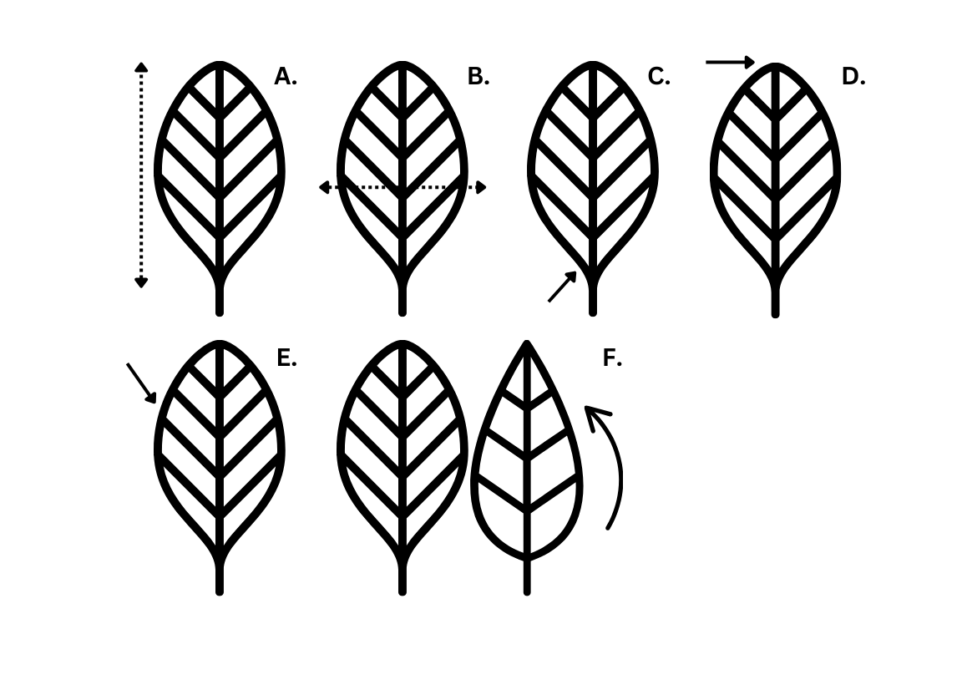
Figure 1. Diagram showing leaf characters. A) Length; B) Width; C) Base; D) Apex; E) Margin or Serration; F) Shape.
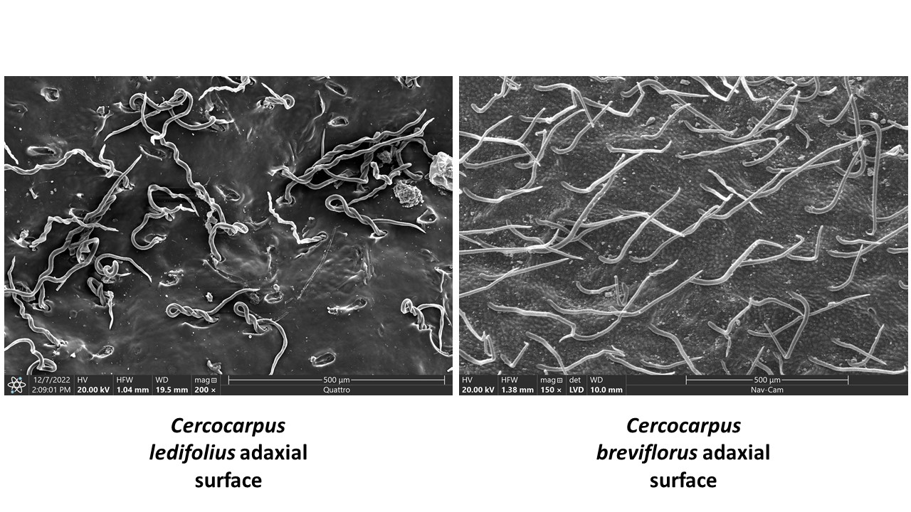
Figure 2. SEM pictures of C. ledifolius and C. breviflorus var. breviflorus adaxial surfaces showing curly and straight trichomes respectively.

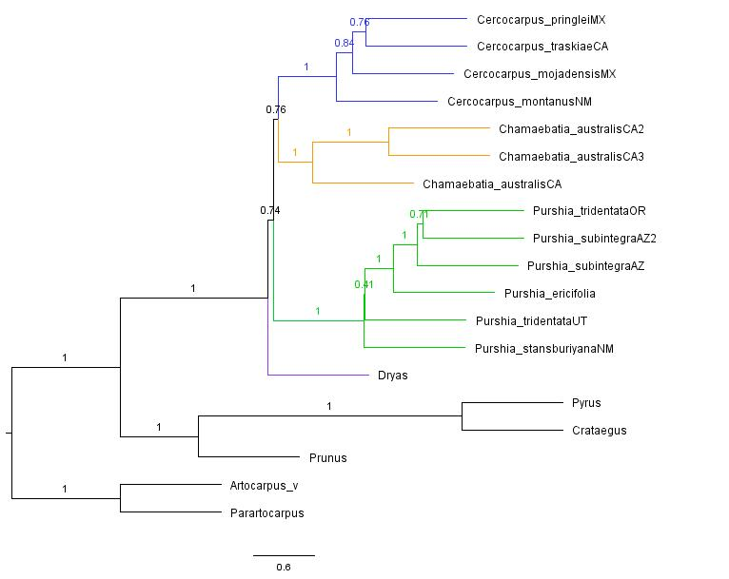
Figure 3. Astral analysis of IQTree gene trees. Numbers on the nodes signify quartet scores.

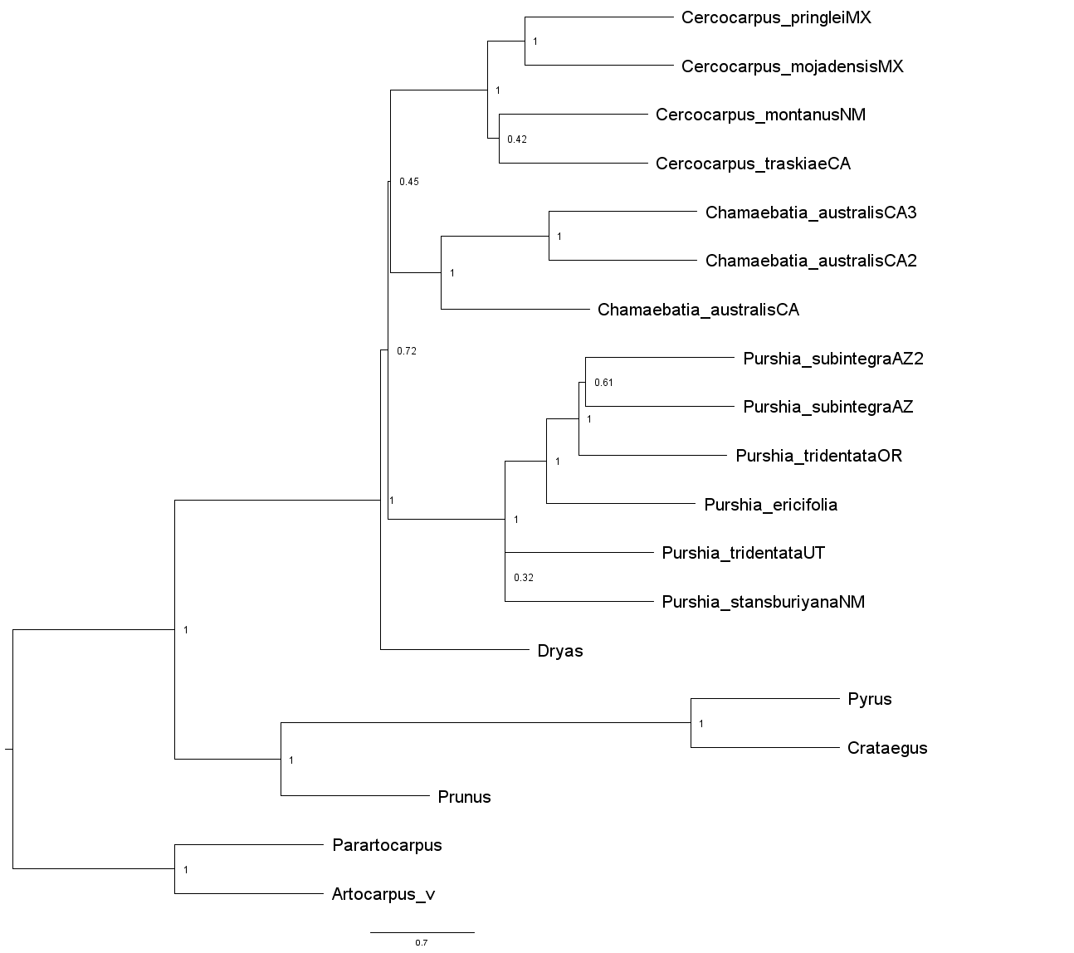
Figure 4. Astral analysis of RAxML gene trees. Numbers on the nodes signify quartet scores.

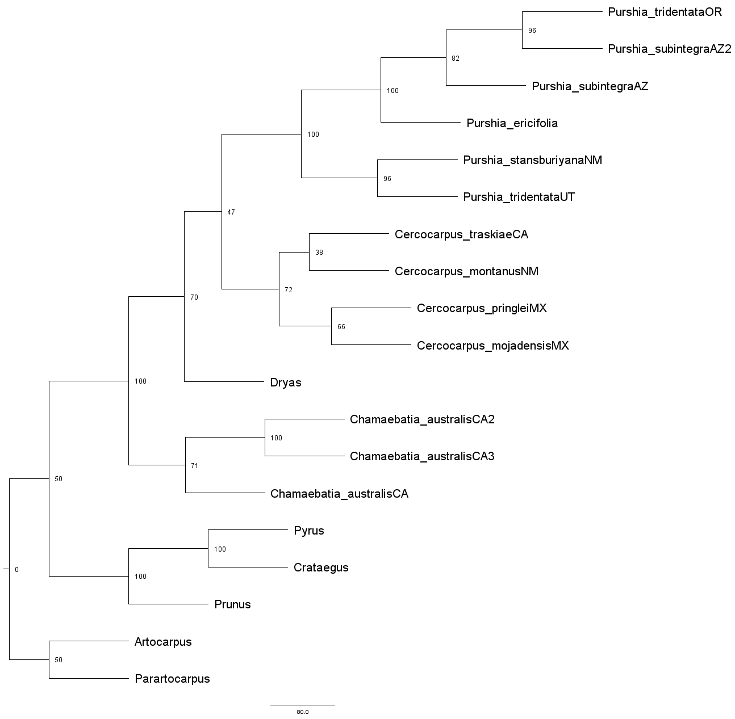
Figure 5. SVDquartets tree from concatenated data. Numbers at the nodes signify bootstrap values.

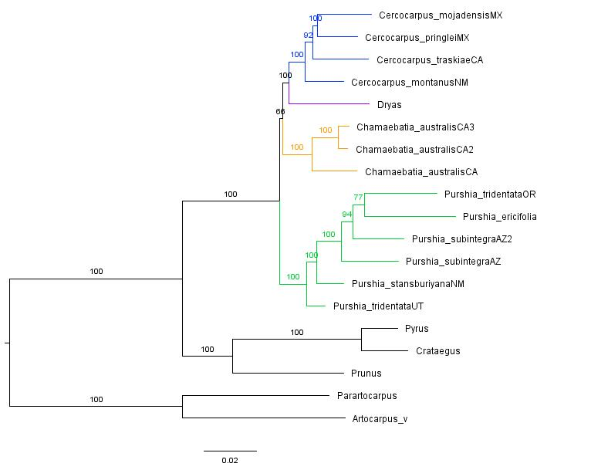
Figure 6. RAxML tree from concatenated data. Numbers at nodes indicate bootstrap support values.

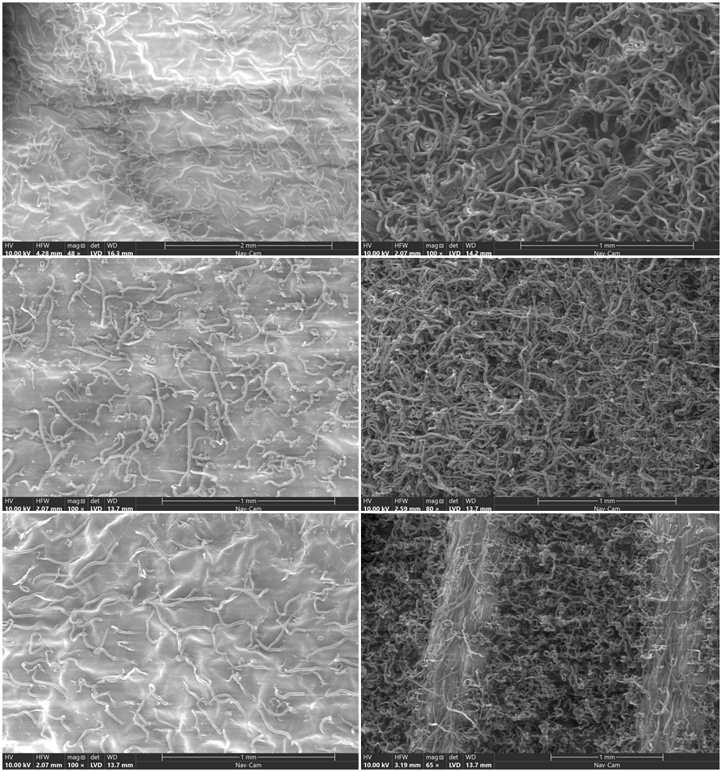
Figure 7. SEM images of (top to bottom) Cercocarpus pringlei, C. mojadensis, and C. fothergilloides. Images on the left are of the adaxial leaf surface and the right is abaxial surface.
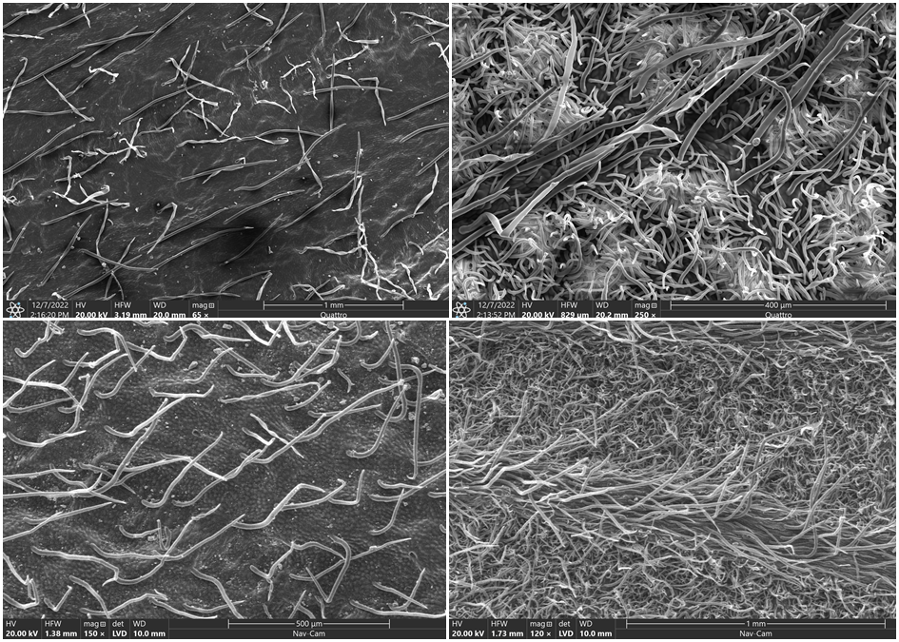
Figure 8. SEM images of leaf surfaces of C. breviflorus var. eximius (top) and C. breviflorus var. breviflorus (bottom). Images on the left are of the adaxial leaf surface and the right is abaxial surface.

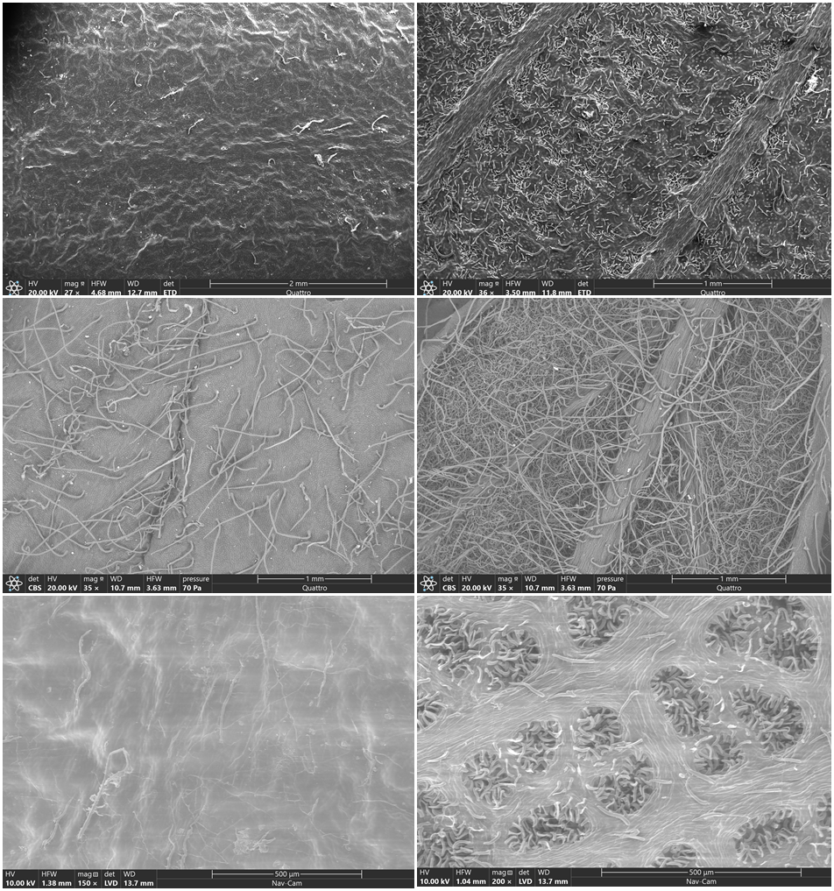
Figure 9. SEM images of leaf surfaces of (top to bottom) C. minutiflorus, C. montanus, and C. macrophyllus. Images on the left are of the adaxial leaf surface and the right is abaxial surface.

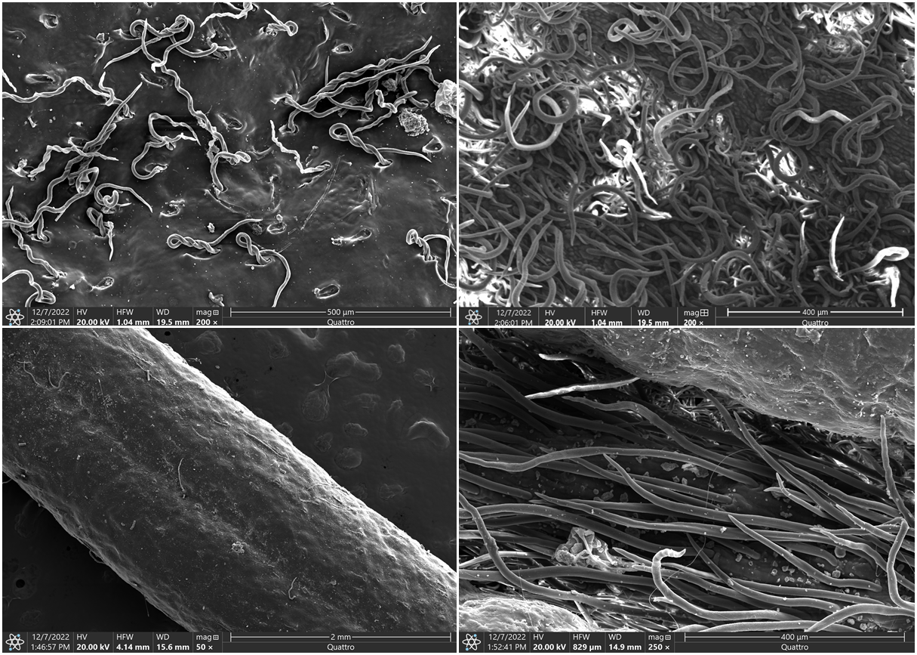
Figure 10. SEM images of leaf surfaces of C. ledifolius (top) and C. intricatus (bottom). Images on the left are of the adaxial leaf surface and the right is abaxial surface.
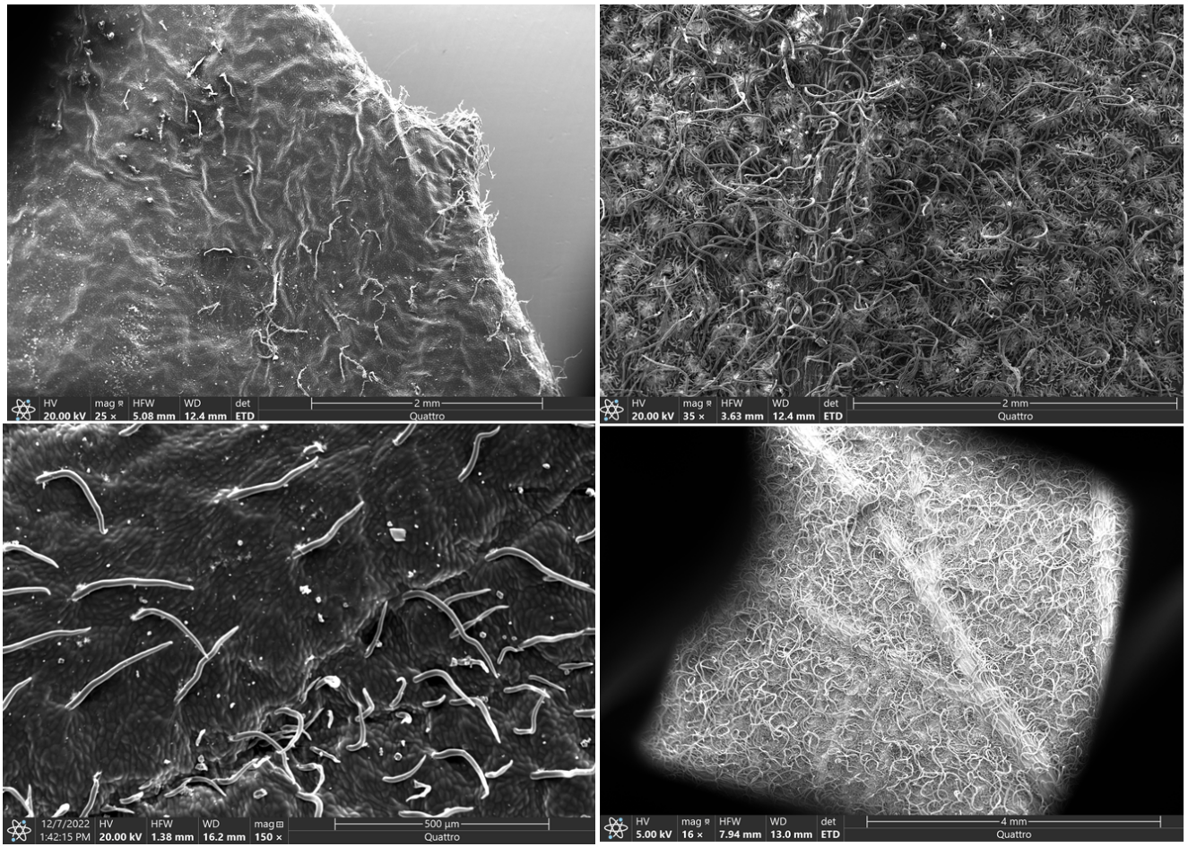
Figure 11. SEM images of leaf surfaces of C. traskiae (top) and C. betuloides (bottom). Images on the left are of the adaxial leaf surface and the right is abaxial surface.

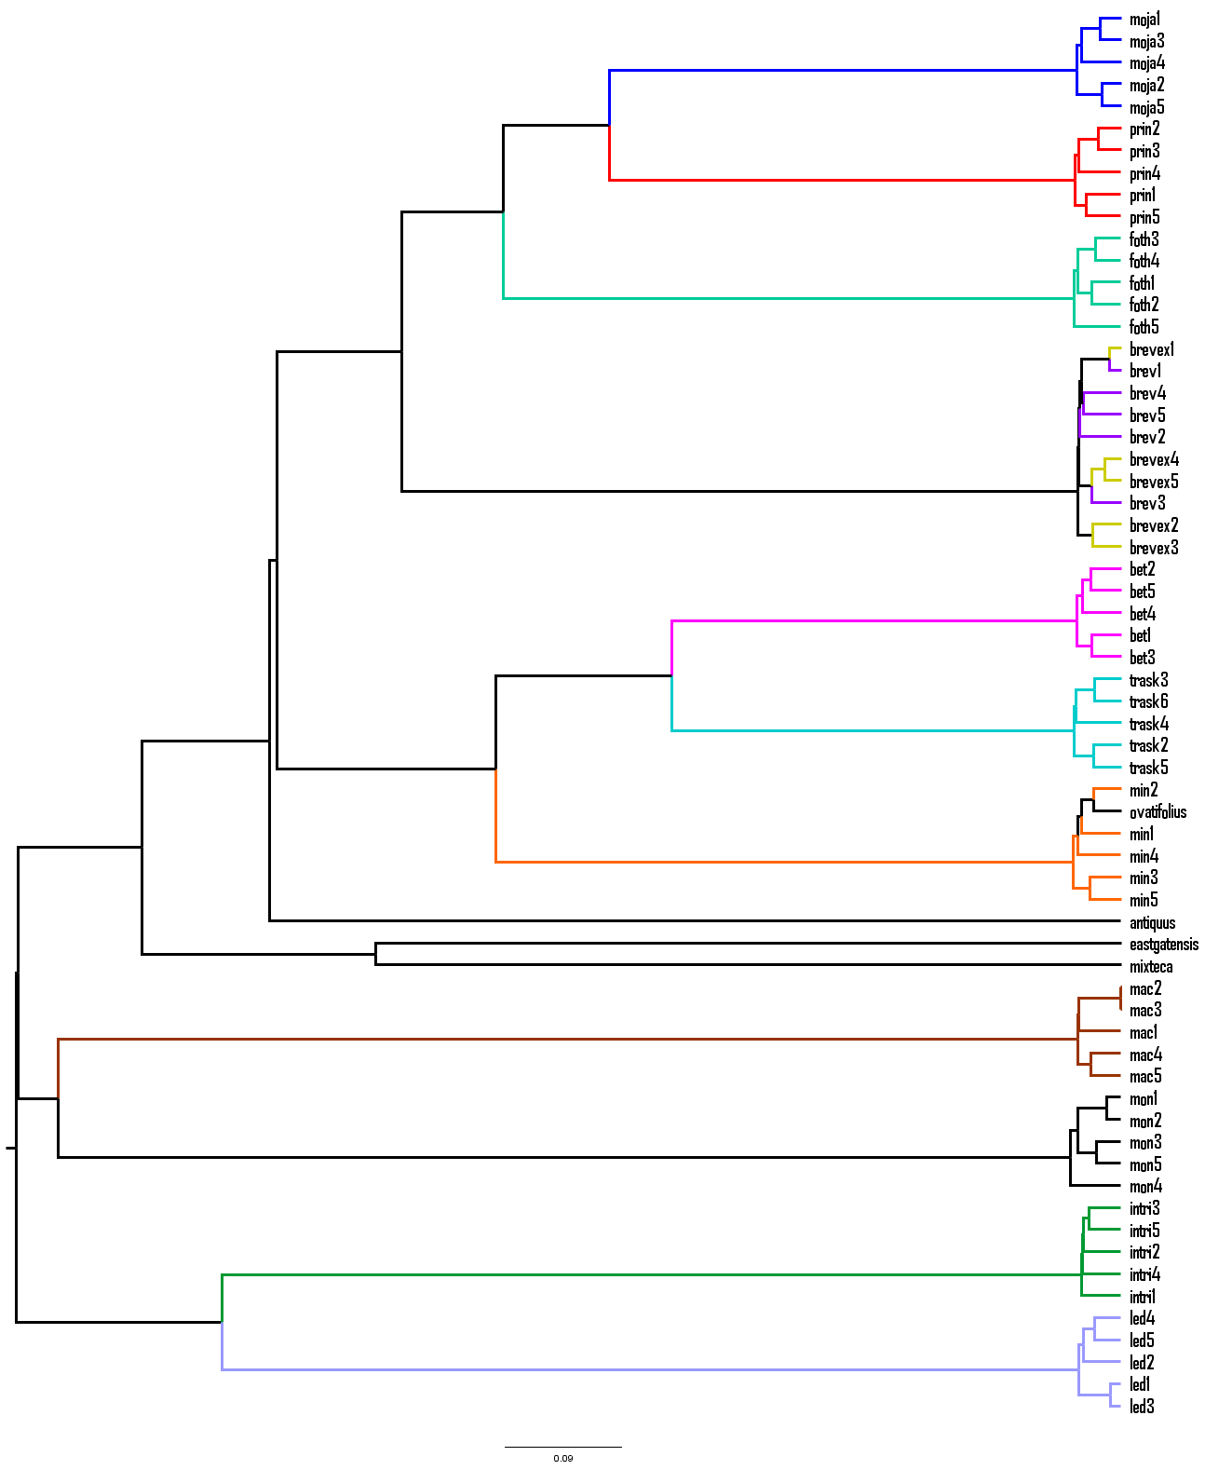
Figure 12. A UPGMA dendrogram including both fossil and extant species and binary characters only (excluding length, width, and length-width ratio). Leaves are named by an abbreviation of the species name and then their individual number. moja= Cercocarpus mojadensis. prin = C. pringlei. foth = C. fothergilloides. brevex = C. breviflorus var. eximius. brev = C. breviflorus var. breviflorus. bet = C. betuloides. trask = C. traskiae. min = C. minutiflorus. ovatifolius= † C. ovatifolius. antiquus = † C. antiquus. eastgatensis = † C. eastgatensis. mixteca = † C. mixteca. mac = C. macrophyllus. mon = C. montanus. intri = C. intricatus. led = C. ledifolius.

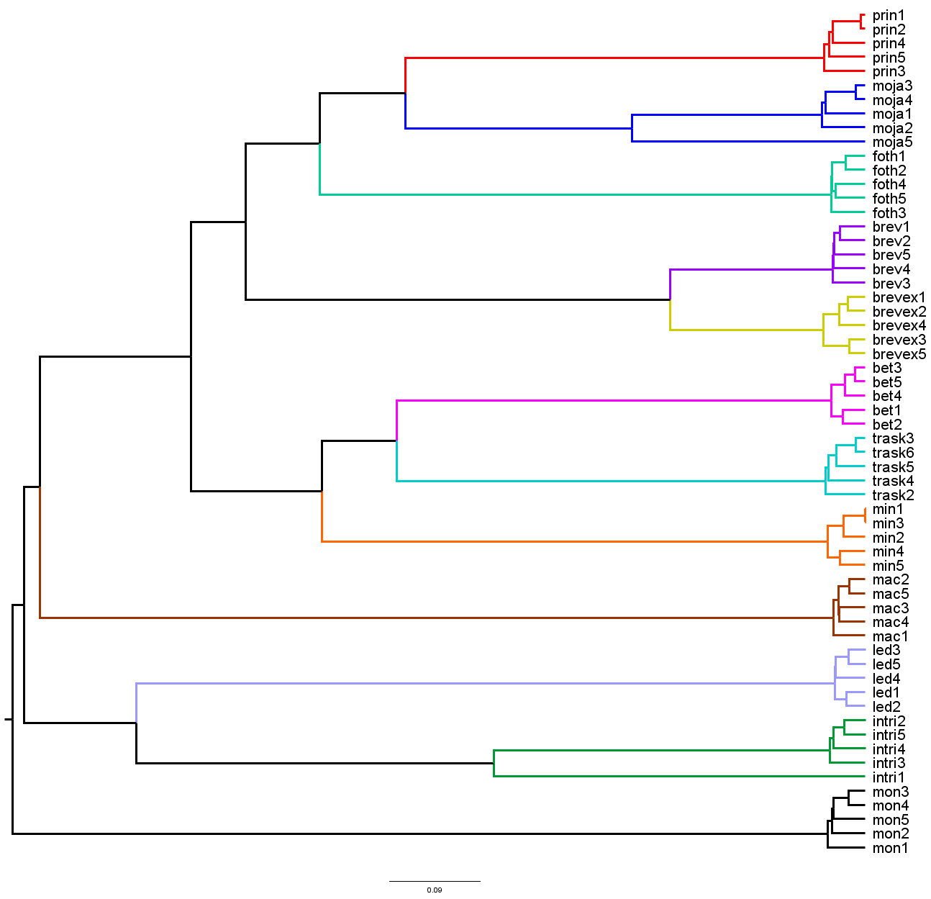
Figure 13. UPGMA dendrogram showing relationships between extant species using only binary data (all data except length, width, and length-width ratio). Leaves are named by an abbreviation of the species name and then their individual number. moja= Cercocarpus mojadensis. prin = C. pringlei. foth = C. fothergilloides. brevex = C. breviflorus var. eximius. brev = C. breviflorus var. breviflorus. bet = C. betuloides. trask = C. traskiae. min = C. minutiflorus. ovatifolius= † C. ovatifolius. antiquus = † C. antiquus. eastgatensis = † C. eastgatensis. mixteca = † C. mixteca. mac = C. macrophyllus. mon = C. montanus. intri = C. intricatus. led = C. ledifolius.
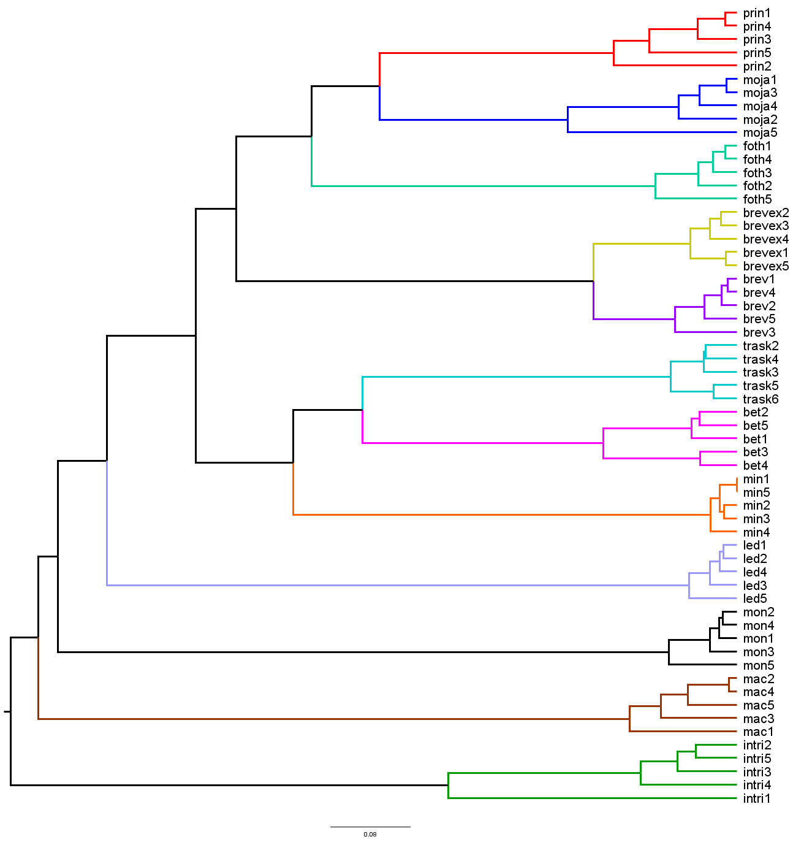
Figure 14. UPGMA dendrogram showing relationships between extant species using all data. Leaves are named by an abbreviation of the species name and then their individual number. moja= Cercocarpus mojadensis. prin = C. pringlei. foth = C. fothergilloides. brevex = C. breviflorus var. eximius. brev = C. breviflorus var. breviflorus. bet = C. betuloides. trask = C. traskiae. min = C. minutiflorus. ovatifolius= † C. ovatifolius. antiquus = † C. antiquus. eastgatensis = † C. eastgatensis. mixteca = † C. mixteca. mac = C. macrophyllus. mon = C. montanus. intri = C. intricatus. led = C. ledifolius.

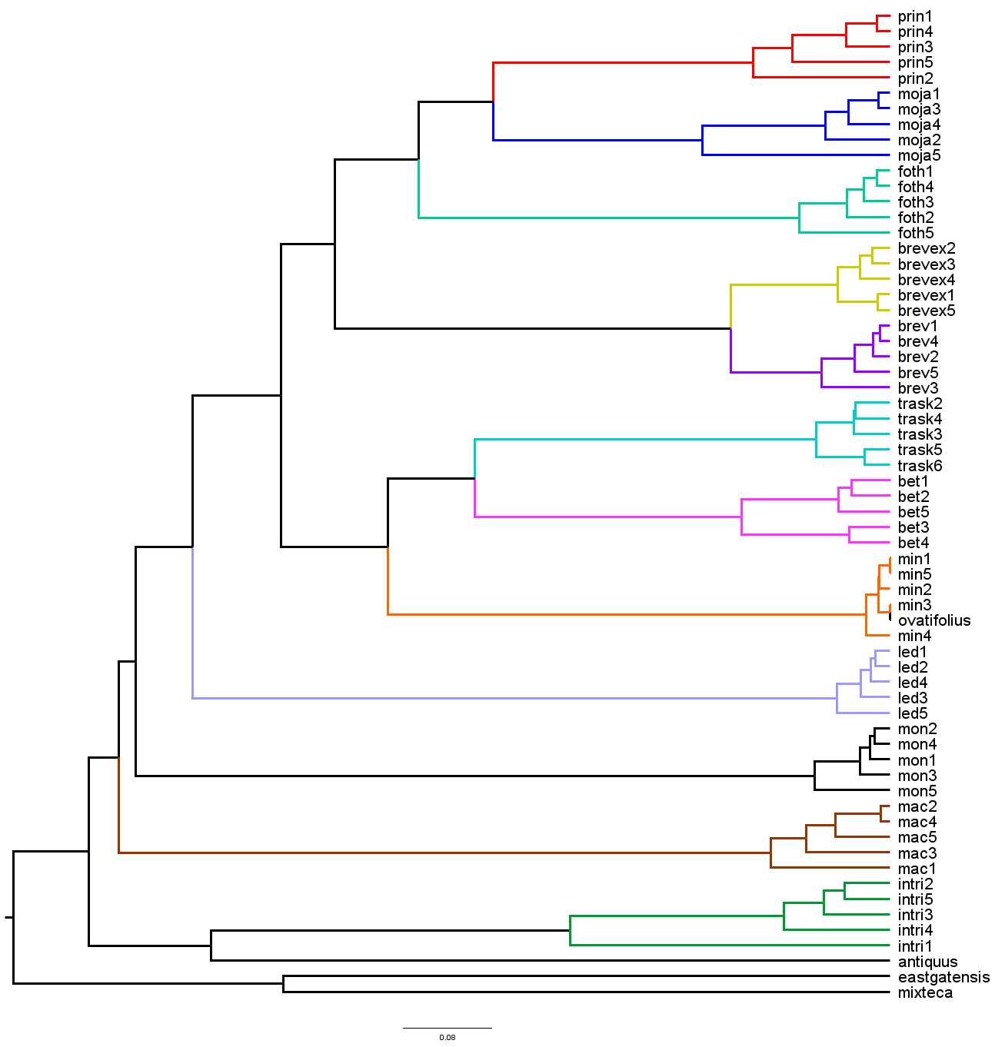
Figure 15. UPGMA dendrogram showing relationships between extant and extinct species using all data (with length, width, and length/width ratio coded as missing for fossil taxa). Leaves are named by an abbreviation of the species name and then their individual number. moja= Cercocarpus mojadensis. prin = C. pringlei. foth = C. fothergilloides. brevex = C. breviflorus var. eximius. brev = C. breviflorus var. breviflorus. bet = C. betuloides. trask = C. traskiae. min = C. minutiflorus. ovatifolius= † C. ovatifolius. antiquus = † C. antiquus. eastgatensis = † C. eastgatensis. mixteca = † C. mixteca. mac = C. macrophyllus. mon = C. montanus. intri = C. intricatus. led = C. ledifolius.

Appendix 1. Voucher table.

Appendix 2a. Morphology Matrix

Appendix 2b. Morphology Matrix continued

Literature Cited
Baker W.J, Bailey P., Barber V., Barker A., Bellot S., Bishop D., Botigué L.R., et al. 2021. A comprehensive phylogenomic platform for exploring the Angiosperm Tree of Life. Systematic Biology 71: 301–319.
Baker W.J., Dodsworth S., Forest F., Graham S.W., Johnson M.G., McDonnell A., Pokorny L., et al. 2021. Exploring ANGIOSPERMS353: An open, community toolkit for collaborative phylogenomic research on Flowering plants. American Journal of Botany 108: 1059–1065.
Bolger A.M., Lohse M., Usadel B. 2014. Trimmomatic: a flexible trimmer for Illumina sequence data. Bioinformatics. Aug 1;30(15):2114-20. doi: 10.1093/bioinformatics/btu170. Epub 2014 Apr 1. PMID: 24695404; PMCID: PMC4103590.
Capella-Gutierrez S., Silla-Martinez J.M, Gabaldon T. Bioinformatics 2009 25: 1972-1973. http://trimal.cgenomics.org/publications

Chase M.W., Christenhusz M.J.M., Fay M.F., Byang J.W., Judd W.S., Soltis D.E., Mabberly D.J., et al. 2016. An update of the Angiosperm Phylogeny Group classification for the orders and families of flowering plants: APG IV. Botanical Journal of the Linnean society 181(1): 1-20.
Chen X., Li J., Cheng T., Zhang W., Liu Y., Wu P., Yang X., et al. 2020. Molecular systematics of Rosoideae (Rosaceae). Plant Systematics and Evolution 306.
Dunkle, M. B. 1940. A Revision of the Channel Islands Forms of Cercocarpus. Bulletin of the Southern California Academy of Sciences 39(1): 2.
Chifman, J., L. Kubatko. 2014. Quartet inference from SNP data under the coalescent, Bioinformatics 30(23): 3317-3324.
Chifman, J., L. Kubatko. 2015. Identifiability of the unrooted species tree topology under the coalescent model with time-reversible substitution processes, site-specific rate variation, and invariable sites. Journal of Theoretical Biology 374: 35-47.
Chessel D., Dufour A., Thioulouse J. 2004. The ade4 Package – I: One-Table Methods. R News 4(1): 5–10. https://cran.r-project.org/doc/Rnews/.
Dray S., Dufour A. (2007). The ade4 Package: Implementing the Duality Diagram for Ecologists. Journal of Statistical Software: 22(4): 1–20. doi:10.18637/jss.v022.i04.
Hendrickson J., Vanden Heuvel B.D., American Journal of Botany Editorial Committee. 2014. Cercocarpus. In Flora of North America, 332–338. Oxford University Press, New York City, New York.
Hornik K., 2023. clue: Cluster Ensembles. R package version 0.3-65. https://CRAN.R- project.org/package=clue.
Johnson M.G., Gardner E. M., Liu Y., Medina R., Goffinet B., Shaw A.J., Zerega N.J.C., Wickett N.J. 2016. HybPiper: Extracting Coding Sequence and Introns for Phylogenetics from High-Throughput Sequencing Reads Using Target Enrichment. Applications in Plant Sciences. 4(7).
Johnson M.G., Pokorny K., Dodsworth S., Botigué L.R., Cowan R.S., Devault A., Eiserhardt W.L., et al. 2018. A universal probe set for targeted sequencing of 353 nuclear genes from any flowering plant designed using K-medoids clustering. Systematic Biology 68: 594–606.
Jones M. E. 1880. Botanical Gazette A Paper of Botanical Notes. Botanical Gazette 5(12): 154.
Katoh K., Misawa K., Kuma K., Miyata T. 2002. MAFFT: a novel method for rapid multiple sequence alignment based on fast Fourier transform. Nucleic Acids Research 30(14): 3059-66.
Kembel S., Cowan P., Helmus M., Cornwell W., Morlon H., Ackerly D., Blomberg S., Webb C. 2010. Picante: R tools for integrating phylogenies and ecology. Bioinformatics 26: 1463– 1464.
Lis, R.A. 1992. Leaf architectural survey of Cercocarpus (Rosaceae) and its systematic significance. International Journal of Plant Sciences 153: 258–272.
Martin, F.L. 1950. A revision of Cercocarpus. Brittonia 7: 91.
Mortenson T. 1973. Ecological variations in the leaf anatomy of selected species of Cercocarpus. Aliso 8: 19–48.
Minh B.Q., Schmidt H.A., Chernomor O., Schrempf D., Woodhams M.D., Von Haeseler A., Lanfear R. 2020. IQ-TREE 2: New models and efficient methods for phylogenetic inference in the genomic era. Molecular Biology and Evolution 37:1530-1534.

Neto J., 2012, Gower's Distance Modification (Generalization of Gower's distance). R Functions. Website. https://rfunctions.blogspot.com/2012/07/gowers-distance-modification.html.
Potter D., Eriksson T., Evans R.C., Oh S., Smedmark J.E., Morgan D.R, Kerr M., et al. 2007. Phylogeny and classification of Rosaceae. Plant Systematics and Evolution 266: 5–43.
R Core Team. 2023. R: A Language and Environment for Statistical Computing. R Foundation for Statistical Computing, Vienna, Austria. <https://www.R-project.org/>.
Rabiee M., Sayyari E., Mirarab S. 2019. Multi-Allele Species Reconstruction Using ASTRAL. Molecular Phylogenetics and Evolution 130: 286–96.
Rasband W.S., ImageJ, U. S. National Institutes of Health, Bethesda, Maryland, USA, https://imagej.net/ij/, 1997-2018.
Revell L. 2024. phytools 2.0: an updated R ecosystem for phylogenetic comparative methods (and other things). PeerJ 12.
Rydberg A. 1913. North American flora. vol. 22: Part 5: Rosales. The New York Botanical Garden, New York, NY.

Schneider C. 1905. Illustriertes Handbuch der Laubholzkund. vol. 1: Part 3. 530. 1905.
Stamatakis A. 2014. RAxML version 8: a tool for phylogenetic analysis and post-analysis of large phylogenies. Bioinformatics 30(9):1312-3.
Stutz H.C., Thomas L.K. 1964. Hybridization and introgression in Cowania and Purshia. Evolution 18: 183.
Swensen S.M., Mullin B.C. 1997. The impact of molecular systematics on hypotheses for the evolution of root nodule symbioses and implications for expanding symbioses to new host plant genera. Plant and Soil. 194 (1/2): 185–192.
Swofford, D. L. 2003. PAUP*. Phylogenetic Analysis Using Parsimony (*and Other Methods). Version 4 3.99.169.0. Sinauer Associates, Sunderland, Massachusetts.
Vanden Heuvel, 2002, Molecular Systematics of Cercocarpus H.B.K. (Rosaceae), Dissertation for University of Texas at Austin
Vanden Heuvel B.D., Linder C.R. 2001. A Molecular Phylogeny for Cercocarpus H.B.K. (Rosaceae) Using the External Transcribed Spacer of the Nuclear Ribosomal Repeat. USDA Forest Service Proceedings.
Ufimov R., Zeisek V., Píšová S., Baker W.J., Fér T., Van Loo M., Dobeš C., Schmickl R. 2021. Relative performance of customized and universal probe sets in target enrichment: A case study in subtribe Malinae. Applications in Plant Sciences 9.
Velasco de León, P., Cevallos-Ferriz S.R.S. 2000. Leaves of Cercocarpus Mixteca n. sp. (Rosaceae) from Oligocene sediments, near Tepexi de Rodrı́guez, Puebla. Review of Palaeobotany and Palynology 111: 285–294.
Walker S.C., Turley D. 1999. Characteristics of Mountain Mahogany (Cercocarpus) Species and Hybrids in Utah Hybrid Zone. USDA Forest Service Proceedings RMRS-P-11.
Wickham H. 2016. ggplot2: Elegant Graphics for Data Analysis. Springer-Verlag New York. ISBN 978-3-319-24277-4, https://ggplot2.tidyverse.org.
Xiang Y. Huang C.H., Hu Y., Wen J., Li S., Yi T., Chen H., et al. 2017. Evolution of Rosaceae fruit types based on nuclear phylogeny in the context of geological times and genome duplication. Molecular Biology and Evolution 34: 1026–1026.
Zhang S., Jin J., Chen S., Chase M.W., Soltis D.E., Li H. Yang J., et al. 2017. Diversification of Rosaceae since the late cretaceous based on plastid phylogenomics. New Phytologist 214: 1355–1367.

Acknowledgements
Microscopy data collection was performed at the Samuel Roberts Noble Microscopy Laboratory with the help of Dr. Preston Larson.
Thank you to Dr. Abby Moore, Dr. Rick Lupia, and Dr. Lara Souza for help developing my thesis and for guiding me along the way
Help in the field: Marisa Szubryt, Mary Monaghan, Jackie Dougan
Help in the lab: Marisa Szubryt, Maddie Medina
Help with morphological analyses: Claire Curry, Rick Lupia
[Some of] The computing for this project was performed at the OU Supercomputing Center for Education & Research (OSCER) at the University of Oklahoma (OU).
Sources of specimens: The Robert Bebb Herbarium (OKL), University of California Riverside Herbarium (UCR), UC Botanical Garden at Berkeley, The Arizona State University Vascular Plant Herbarium (ASU), Billie L. Turner Plant Resources Center at University of Texas at Austin (TEX-LL), Stanley L. Welsh Herbarium at Brigham Young University (BRY), and the University of Arizona Herbarium (ARIZ)

