University of Oklahoma

Graduate College

An archaeological study of the earspools of the arkansas river valley and surrounding regions

A thesis

submitted to the Graduate Faculty

in partial fulfillment of the requirements for the

Degree of

Master of Arts

By

Denise RenÉe erickson
Norman, Oklahoma
2018

An archaeological Study of the earspools of the arkansas river valley and surrounding regions

A thesis approved for the
Department of Anthropology

By

______________________________
Dr. Patrick Livingood, Chair

______________________________
Dr. Scott Hammerstedt

______________________________
Dr. Marc Levine

© Copyright by Denise renÉe erickson 2018
All Rights Reserved.

Acknowledgements

The completion of this thesis and my master’s degree fulfills a personal goal many years in the making, and could not have been achieved without the support of multiple individuals. I would first like to that my graduate committee chair Patrick Livingood, and committee Scott Hammerstedt, and Marc Levine, for their encouragement, support, and continual patience in guiding me during my research.
I would like to extend my gratitude to the Caddo Nation of Oklahoma and Wichita and Affiliated Tribes for granting me permission to examine the collections. I would also like to thank Susie Fisher-Armstrong of the Sam Noble Oklahoma Museum of Natural History, Laura Bryant of the Gilcrease Museum, Mary Suter of the Arkansas Archeological Survey, and Matt Reed from the Oklahoma Historical Society who provided assistance in accessing the collections at their institutions.
Finally, I would like to express my gratitude toward friends and family who supported me throughout my studies and research, and whose constant encouragement allowed me to reach this goal.

Table of Contents
Acknowledgements…………………………………………………………………….. iv
Table of Contents……………………………………………………………………...... v
List of Tables………………………………………………………………………….. vii
List of Figures………………………………………………………………………… viii
Abstract……………………………………………………………………………….. xiii
Chapter 1: Introduction…………………………………………………………………. 1
Research Goals and Questions……………………………………………………… 2
What are earspools?………………………………………………………………… 3
Thesis Chapters Outline…………………………………………………………….. 8
Chapter 2: Theoretical Approaches to Earspool Analysis……………………………… 9
Previous Earspool Studies and Interpretations of Use…………………………….. 10
Personal Adornment……………………………………………………………….. 13
Gradations of Value……………………………………………………………….. 17
Chapter 3: Regional Background and Cultural History……………………………….. 21
A Brief History of the Caddo……………………………………………………… 21
Regional Background……………………………………………………………... 22
Pre-Contact Caddo and Mississippian Traditions…………………………………. 23
Social and Political Relationships…………………………………………………. 23
Settlement Patterns and Social Organization…………………………………….... 24
Subsistence Practices……………………………………………………………… 26
Regional Relationships……………………………………………………………. 27
Archaeological Background of Sites………………………………………………. 27
Harlan 34CK6……………………………………………………………...….. 28
Brackett 34CK43……………………………………………………………..... 28
Reed 34DL1-11, and 14……………………………………………………….. 29
Spiro 34LF35-59……………………………………………………………..... 30
Eufaula 34MI45……………………………………………………………….. 31
Hughes 34MS4………………………………………………………………… 31
Norman 34WG2……………………………………………………………..… 32
Mineral Springs 3HO1………………………………………………………... 32
Foster Place 3LA27…………………………………………………………… 33
Bowman 3LR50…...………………………………………………………….... 34
Crenshaw 3MI16…………………………………………………………….... 34
Paul Mitchell 41BW4………………………………………………………..… 35
Smith Mound 3CL162…………………………………………………………. 35
Arthur Gaither 3CL220………………………………………………………... 36
Bluffton 3YE15………………………………………………………………… 36
Conway County………………………………………………………………... 36
Johnson County………………………………………………………………... 37
Garland County……………………………………………………………….. 37
Washington County……………………………………………………………. 38
Summary………………………………………………………………………. .38
Cultural Chronology………………………………………………………………. 38
Evans Phase or Spiro IA, IB (AD 950-1000)………………………………….. 41
Harlan Phase or Spiro II Grave Period (AD 1000-1250)…………………….. 42
Norman Phase or Spiro III Grave Period (AD 1250-1350)…………………... 43
Spiro Phase or Phase IV-IVC Grave Periods (AD 1350-1450)……………..... 43
Conclusion……………………………………………………………………...…. 44
Chapter 4: Methodology…………………………………………………………….… 45
Attributes of the Earspools………………………………………………………… 47
Composition of the Earspools……………………………………………………... 49
Typology…………………………………………………………………………... 50
Earspool Types…………………………………………………………………….. 53
Design Motifs……………………………………………………………………… 68
Conclusion………………………………………………………………………… 68
Chapter 5: Descriptions of Earspools………………………………………………….. 71
Types of Earspools………………………………………………………………… 71
Stylistic Attributes of Earspools…………………………………………………... 72
Material Type………………………………………………………………….. 73
Earspool Diameter…………………………………………………………….. 77
Perforation…………………………………………………………………….. 82
Copper…………………………………………………………………………. 85
Decorative Motifs……………………………………………………………… 88
Summary……………………………………………………………………….. 92
Distribution of Earspools by Site………………………………………………….. 92
Spiro Assemblage……………………………………………………………… 92
Norman Assemblage…………………………………………………………… 95
Harlan Assemblage……………………………………………………………. 98
Reed Assemblage……………………………………………………………... 100
Hughes Assemblage………………………………………………………….. 103
Eufaula Assemblage………………………………………………………….. 104
Brackett Assemblage…………………………………………………………. 107
Guffy, State #4 & #5 Assemblage…………………………………………….. 107
Bowman Assemblage…………………………………………………………. 109
Crenshaw Assemblage……………………………………………………….. 110
Mineral Springs Assemblage…………………………………………………. 111
Foster Assemblage…………………………………………………………… 112
Paul Mitchel Assemblage…………………………………………………….. 112
Arthur Gaither Assemblage………………………………………………….. 113
Bluffton Assemblage………………………………………………………….. 113
Smith Mound Assemblage……………………………………………………. 114
Conway County Assemblage…………………………………………………. 115
Garland County Assemblage…………………………………………………. 116
Johnson County Assemblage…………………………………………………. 116
Conclusion………………………………………………………………………... 117
Chapter 6: Analysis of Earspools for Research Questions…………………………… 118
Geographic Variation in Earspools………………………………………………. 118
Northern and Southern Caddo Regions……………………………………… 120
Temporal Variation of Earspools………………………………………………… 125
Spiro II……………………………………………………………………….. 129
Spiro III………………………………………………………………………. 130
Spiro IV……………………………………………………………………..... 130
Summary……………………………………………………………………… 135
Individual Variation of Earspools……………………………………………...… 136
Conclusions………………………………………………………………………. 140
Chapter 7: Discussion and Interpretations………………………………………….... 141
Regional Variation……………………………………………………………….. 143
Temporal Variation………………………………………………………………. 143
Individual Variation……………………………………………………………… 144
Future Research…………………………………………………………………... 145
References…………………………………………………………………………..... 147
Appendix A: Earspool Photographs………………………………………………….. 161
Appendix B: Earspool Attributes Tables…………………………………………….. 262
Appendix C: Burials and AFOs Tables………………………………………………. 282

List of Tables
Table 4.1: Total number of earspools recovered from each site, northern and southern site distribution………………………………………………… 47
Table 4.2: Alternative Decorative Motifs (adapted from Baerreis 1943, 1957)……. 69
Table 4.3: Additional Alternative Decorative Features (adapted from Baerreis 1943, 1957)……………………………………………………...……..... 70
Table 5.1: Types and percentages of earspools in the assemblage………………..... 72
Table 5.2: Earspool Material Types……………………………………………….... 73
Table 5.3: Percentage of Perforation Presence by Site……………………………... 84
Table 5.4: Perforation Presence by Period………………………………………….. 85
Table 5.5: Total number of earspools with evidence of copper…………………...... 87
Table 5.6: Presence of Copper by Period…………………………………………… 88
Table 5.7: Types of motif designs and number of earspools possessing each motif.. 90
Table 5.8: Spiro Site Earspool Types……………………………………………….. 94
Table 5.9: Norman Site Earspool Types…………………………………………..... 96
Table 5.10: Harlan Site Earspool Types……………………………………………… 99
Table 5.11: Reed Site Earspool Types…………………………………………….... 102
Table 6.1: Rarefaction analysis of all earspools. The values are the number of categories found in the south, and the simulated values in the north if it was restricted to having the same sample size as the south, plus or minus a standard………………………………………………...…........ 124
Table 6.2: Rarefaction analysis of earspools excluding the Spiro collection…....… 124
Table 6.3: Cultural Phases by Sites (adapted from Hammerstedt and Savage 2017)...…………………………………………………………………. 127
Table 6.4: Spiro Site Earspools per Period (adapted from Brown 1996:148)……... 132
Table 6.5: Major Mound Site Earspools per Period (adapted from Brown 1996:148)………………………………………………………………..133

List of Figures

Figure 1.1: Collection of earspools obtained from Spiro (Thoburn 1931:57)………… 4
Figure 1.2: Effigy pipes depicting individuals wearing L-shaped plugs (left) (Courtesy of the Sam Noble Museum) and god masks (right) (Courtesy of the Arkansas Archeology Survey).…………………………………….. 4
Figure 1.3: Repousse profile in copper (left) (Courtesy of the Oklahoma Historical Society) and Birdman image on shell (right) (Courtesy of the National Museum of the American Indian)..………………………….……….….... 6
Figure 1.4: Map of sites where earspools included in this research were recovered (adapted from Perttula 2012a: Figure 1-2)...…………………………........ 7
Figure 2.1: Gradations of Value Chart based on Lesure 1999………………………. 19
Figure 3.2: Terán map of 1691–1692. (Courtesy of the J. P. Bryan Map Collection, CT0108, the Center for American History at the University of Texas at Austin) (Girard 2012: Figure 9-2)………………………………………. 24
Figure 3.2: Regional Chronology (adapted from Brown 1996; Rogers 2011)………. 41
Figure 4.3: Map of sites where earspools included in this research were recovered. Adapted from Perttula 2012a: Figure 1-2……………...………………… 46
Figure 4.4: Descriptive Terminology (adapted from Baerreis 1943, 1957)…………. 49
Figure 4.5: Earspool Types A–Perforated, B-Non-Perforated, C–Recessed, D-Central Boss, E-Pulley Ring, F-Foster (adapted from Baerreis 1943, 1957)…………………………………………………………………….. 51
Figure 4.6: Structural Alternative Features of Earspool Types A-Channeled, B-Funnel, C-Notched Inner Flange (adapted from Baerreis 1943, 1957)……………………………………………………………………... 51
Figure 4.5: Perforated Pulley Type Earspool Type A (adapted from Baerreis 1943, 1957)……………………………………………………………………... 53
Figure 4.6: Figure 4.6: Perforated Pulley (Type A) Earspool 34LF40/LfCrI1 B9-15A/6125.14214A (Courtesy of the Gilcrease Museum, photograph by the author).……………………………………..………………………… 53
Figure 4.7: Unperforated Type Earspool (Type B) (adapted from Baerreis 1943, 1957)…………………………………………………………………….. 54
Figure 4.8: Unperforated Pulley Type Earspool 34LF40/6125.3012 1254 (Courtesy of the Gilcrease Museum, photograph by the author).………………….. 54
Figure 4.9: Recessed Type Earspool (Type C) (adapted from Baerreis 1943, 1957)... 55
Figure 4.10: Recessed Type Earspool 34LF40/LfCrI1 B36-26 6339 (Courtesy of the Oklahoma History Center, photograph by the author).…………………. 55
Figure 4.11: Central Boss Type Earspool (TypeD) (adapted from Baerreis 1943, 1957)…………………………………………………………………….. 56
Figure 4.12: Central Boss Type Earspool 34Lf40/ LfCrI D-16 1296.1 (Courtesy of the Sam Noble Museum, photograph by the author).…………………… 56
Figure 4.13: Pulley Ring Type Earspool (Type E) (adapted from Baerreis 1943, 1957)…………………………………………………………………….. 57
Figure 4.14: Pulley Ring Type Earspool 34DL0/218.XL (Courtesy of the Oklahoma History Center, photograph by the author).……………………………... 57
Figure 4.15: Foster Type Earspool (Type F) (adapted from Baerreis 1943, 1957)…… 58
Figure 4.16: Foster Type Earspool 3LA27/6125.3552b (Courtesy of the Gilcrease Museum, photograph by the author).……………………………………. 58
Figure 4.17: Channeled Type Earspool (Structural Alternative Feature A of Earspool Types) (adapted from Baerreis 1943, 1957).……………………………. 59
Figure 4.18: Channeled Type Earspool 34WG2/179 (Courtesy of the Sam Noble Museum, photograph by the author).……………………………………. 59
Figure 4.19: Funnel Type Earspool (Structural Alternative Feature B of Earspool Types) (adapted from Baerreis 1943, 1957).……………………………. 60
Figure 4.20: Funnel Type Earspool 34DL0/b (Courtesy of the Oklahoma History Center, photograph by the author).……………………………………… 60
Figure 4.21: Nesting Half Type Earspool (adapted from Brown 1996)………………. 61
Figure 4.22: Nesting Halves Type Earspool 34CK6/5219.5 (Courtesy of the Sam Noble Museum, photograph by the author).………………………….…. 61
Figure 4.23: Flanged Ring Type Earspool (adapted from Brown 1996)……………… 62
Figure 4.24: Flanged Ring Type Earspool 34Lf40/120.8 (Courtesy of the Sam Noble Museum, photograph by the author)….…………………………………. 62
Figure 4.25: Hollow Cylinder Type Earspool (adapted from Brown 1996)………….. 63
Figure 4.26: Hollow Cylinder Type Earspool 34CK6/373-1 (Courtesy of the Sam Noble Museum, photograph by the author).…………………………….. 63
Figure 4.27: Grooved Cylinder Type Earspool (adapted from Brown 1996)………… 64
Figure 4.28: Grooved Cylinder Type Earspool 34CK6/369 (Courtesy of the Sam Noble Museum, photograph by the author).…………………………….. 64
Figure 4.29: Composite Type Earspool (adapted from Brown 1996)………………… 65
Figure 4.30: Composite Type Earspool 34Lf40/6329.3 (Courtesy of the Oklahoma History Center, photograph by the author).…………………..…………. 65
Figure 4.31: Small Inner Nub/Trimmed Flange Type Earspool (adapted from Baerreis 1943, 1957)…………………………………………………….. 66
Figure 4.32: Small Inner Nub/Trimmed Flange Type Earspool 34Lf40/6125.3011 1112 (Courtesy of the Gilcrease Museum, photograph by the author).…. 66
Figure 4.33: Plug Type Ear Ornament………………………………………………… 67
Figure 4.34: Plug Type Ear Ornament 34DL0/18 (Courtesy of the Sam Noble Museum, photograph by the author).………………...………………….. 67
Figure 4.35: Decorative Motifs of Earspools (adapted from Baerreis 1943, 1957)....... 69
Figure 4.36: Additional Decorative Features of Earspools (adapted from Baerreis 1943, 1957)……………………………………………………………… 70
Figure 5.1: Distribution of earspool types within sample…………………………… 72
Figure 5.2: Distribution of earspool material types by site …………………………. 74
Figure 5.3: Box and whicker plots of the earspools by earspool type showing the variation in exterior face diameter………………………………………. 78
Figure 5.4: Box and whicker plots of the earspools by site showing the variation in exterior face diameter…………………………………………………… 79
Figure 5.5: Box and whisker plots of Pulley earspools by site showing the variation in exterior face diameter………………………………………………… 80
Figure 5.6: Box and whicker plots of the earspools by Grave Period showing the variation in exterior face diameter………………………………………. 81
Figure 5.7: Total number of earspool with perforations present or absent………….. 83
Figure 5.8: Types of earspools possessing copper…………………………………… 86
Figure 5.9: Presence of copper by site……………………………………………….. 88
Figure 5.10: Decorative motifs by site………………………………………………… 91
Figure 5.11: Pulley Ring type earspool (34Lf40/6125.6108) from Spiro Site (Courtesy of the Gilcrease Museum, photograph by author).…………… 93
Figure 5.12: Distribution of earspool types at the Spiro Site………………………….. 93
Figure 5.13: Distribution of material types at the Spiro Site………………………….. 94
Figure 5.14: Notched back Recessed earspool (34Wg2/244) from the Norman Site (Courtesy of the Sam Noble Museum, photograph by the author)……… 95
Figure 5.15: Distribution of earspool types at the Norman Site………………………. 96
Figure 5.16: Small earspool (34Wg2/C11-1) from the Norman Site (Courtesy of the Sam Noble Museum, photograph by the author)…………….………….. 97
Figure 5.17: Four Human Heads earspool (34Wg2/237) from the Norman Site (Courtesy of the Sam Noble Museum, photograph by the author)……… 97
Figure 5.18: Distribution of motif types at the Norman Site………………………….. 98
Figure 5.19: Distribution of earspool types at the Harlan Site………………………… 99
Figure 5.20: Earspool 34Ck6/613a&b from the Harlan Site (Courtesy of the Sam Noble Museum, photograph by the author)……………………………. 100
Figure 5.21: Distribution of earspool types at the Reed Site………………………… 102
Figure 5.22: Earspools from the Reed Site a) 5219.4 with two-lined cross and a circle in each quadrant motif (Courtesy of the Oklahoma History Center, photograph by the author) and b) 6125.4276a with woven motif (Courtesy of the Gilcrease Museum, photograph by the author).……… 102
Figure 5.23: Earspools a) 6125.3978B with five point repeating star motif (Courtesy of the Gilcrease Museum, photograph by the author), b) 46a&222 with three line cross with circles in each quadrant motif, c) 6125.3977B with vortex motif, and d) 46a Plug type from the Hughes Site (Courtesy of the Sam Noble Museum, photograph by the author).…………..……… 104
Figure 5.24: Earspools 6125.3979a&b from the Eufaula Site (Courtesy of the Gilcrease Museum, photograph by the author)……………………….... 105
Figure 5.25: Sketches of earspools recovered from the Eufaula Site adapted from Orr 1940……………………………………………………………………. 106
Figure 5.26: Earspools a) 34CK43/109 three-line cross motif, b) 34CK43/75 two line cross motif, c) 34CK43/113 undecorated from the Brackett Site (Courtesy of the Sam Noble Museum, photograph by the author)…….. 107
Figure 5.27: Pulley earspools 34ZDL67/165 (left) from State #4 and 34DL68/1 (right) from State #5 (Courtesy of the Sam Noble Museum, photograph by the author)…………………………………………………………... 108
Figure 5.28: Recessed earspool from the Guffy Site 34DL57/552 (Courtesy of the Gilcrease Museum, photograph by the author).………………………... 108
Figure 5.29: Earspools 3LR50 81-71-76a&b from Bowman Site (Courtesy of the Arkansas Archeology Survey, photograph by the author).…………….. 109
Figure 5.30: One of two identical earspools from the Bowman Site, a) back and b) front (Shantleff 1981)…………………………………………………... 109
Figure 5.31: Earspools 9025.24a&b collected from the Crenshaw Site (Courtesy of the Gilcrease Museum, photograph by the author)………..………........ 110
Figure 5.32: Earspool 3MI6/55-1-63a a) front, b) back collected from the Crenshaw Site (Courtesy of the Arkansas Archeology Survey, photograph by the author)………………………………………………………………….. 110
Figure 5.33: Earspools 3HO1/460 a) front b) back from the Mineral Springs Site (Courtesy of the Arkansas Archeology Survey, photograph by the author)…………………………………………………………….……. 111
Figure 5.34: Earspool a) 3HO1/163 back and profile (Courtesy of the Arkansas Archeology Survey, photograph by the author) b) 3HO1/B21a&b from the Mineral Springs Site (Bohannon 1973).…………………………… 111
Figure 5.35: Earspool 6125.3552b a) front b) back from the Foster Site (Courtesy of the Gilcrease Museum, photograph by the author)…………………….. 112
Figure 5.36: 41BW4/55-40-146a&b from the Paul Mitchell Site (Courtesy of the Arkansas Archeology Survey, photograph by the author)……………... 113
Figure 5.37: Earspool AGA-17 a) front b) back from the Arthur Gaither Site (Courtesy of the Arkansas Archeology Survey, photograph by the author)………………………………………………………………….. 113
Figure 5.38: Earspool 6125.2160 a) front b) back from the Bluffton Site (Courtesy of the Gilcrease Museum, photograph by the author)………………….. 114
Figure 5.39: Earspools 5425.5788a&b a) front b) back from the Smith Mound Site (Courtesy of the Gilcrease Museum)....................................................... 114
Figure 5.40: Earspools 6125.3549a&b a) front b) back from the Smith Mound Site (Courtesy of the Gilcrease Museum)....................................................... 115
Figure 5.41: Earspools 3CN0/6125.2162 & 3CN0/6125.2163 from Conway County (Courtesy of the Gilcrease Museum, photograph by the author)………. 115
Figure 5.42: Earspools 3CN0/6125.2165 & 3CN0/6125.2166 from Conway County (Courtesy of the Gilcrease Museum, photograph by the author)………. 115
Figure 5.43: Earspools 3GA0/6125.3554 E-22, 3GA0/6125.3558a E-35 ½, 3GA0/6125.3551a E-12 from Garland County (Courtesy of the Gilcrease Museum, photograph by the author)……………….………... 116
Figure 5.44: Earspool 6125.3557 (front) from Johnson County (Courtesy of the Gilcrease Museum, photograph by the author)……………………........ 116
Figure 6.1: Earspool Types by Site………………………………………………… 119
Figure 6.2: Distribution of earspools type by northern and southern region……….. 121
Figure 6.3: Sample of decorative motif present in the Northern and Southern Caddo Region………………………………………………………….. 122
Figure 6.4: Material types present in earspools from the Northern and Southern Caddo Regions………………………………………………………..... 123
Figure 6.5: Distribution of earspools by Grave Period…………………………...… 128
Figure 6.6 Earspool Types by Spiro Grave Period………………………………… 133
Figure 6.7: Exterior Face Diameter by Spiro Grave Period………………………... 134
Figure 6.8 Earspool Material Type by Spiro Grave Period………………………... 134
Figure 6.9: Motif distribution across Spiro Grave Periods…………………………. 135
Figure 6.10: Earspools with variations of star motif. Not to scale…………………... 138
Figure 6.11: Earspools with 2 Lines Cross motif. Not to scale…………………….... 139

Abstract

Earspools dating from the Mississippi Period are found throughout the Southeast region of North America. Some of these artifacts were recovered from sites in the Arkansas and Red River Valley regions which share similarities with those from other Mississippian sites in form, material type, size, and decorative motifs. The variability suggests that not all earspools were intended to be identical. They may have been constructed to communicate different information about the individual who wore them and to the intended audience who viewed them. Differences in stylistic attributes also provide insight into regional difference, changes in cultural practices over time, and individual identity.

Chapter 1: Introduction

Earspools dating from the Mississippi Period are found throughout the Southeast region of North America (Brown, Kerber, and Winters 1990:264). Some of these artifacts were recovered from sites in the Arkansas and Red River Valley regions which share similarities with those from other Mississippian sites in form, material type, size, and decorative motifs. Several major studies on Arkansas Valley earspools exist (Baerreis 1943, 1957; Brown 1996) although intensive research into earspool variation and how they compare regionally and temporally has not been conducted.
The two most significant studies on Arkansas Valley earspools are the works by Baerreis (1957) and Brown (1996). Baerreis created a typology in 1943 of earspools from seven sites in the Arkansas River Valley and used these earspools in conjunction with other mortuary items to discuss the regional participation of Spiroan sites in greater southeastern cultural practices. In his work on the Spiro Ceremonial Center, Brown (1996) expanded upon the research by Baerreis and provided a comprehensive review of the earspools from the Spiro site. He also briefly discussed earspools of similar types recovered from additional sites in the Southeast. Arkansas Valley earspools have been referenced in other research, but a more in-depth analysis of these artifacts will be useful in order to address more challenging questions about their role as an item of personal ornamentation. The purpose of this thesis is to describe variability in the types and styles in a sample from Arkansas and Red River Valley earspools, and investigate the ways in which this variation is related to regional and temporal divisions or related to the individual identity of the wearer.

Research Goals and Questions
This thesis focuses on the differences found within a sample of earspools recovered from sites in the Arkansas and Red River Valley region. This analysis first identified the different types of earspools in the sample using the categories defined by Baerreis and expanded upon by Brown, followed by a description of the stylistic attributes of these types. This thesis then asks several questions using these typological and stylistic data.
- Current research of the Caddo region suggests a cultural divide between the northern and southern region based on differences in mortuary traditions, pottery style, and architectural design (Brown 1984; Lambert 2017; Perttula 1996, 2009; Perttula et al. 2011; Story 1990; Walters 2016). Does distribution and variability of earspool styles correspond to archaeologically defined northern and southern Caddo regions?
- Cultural phases in the Arkansas River Valley defined by changes in social, political, and ritual practices continue to be refined with new research (Cranford 2007; Hammerstedt and Savage 2012). Changes in material culture such as ceramic types and structure forms mark chronological transitions. What chronological variation is present in the earspools? Does the difference in the earspools compliment the changes in phases, or does the variation differ from the current position on chronology? Are certain earspool types diagnostic of cultural phases? Do earspool styles change in tandem with other types of material culture used as chronological markers? New thinking about the temporal assignments of some Arkansas Valley components and the uncertain provenience of many of the earspools make these questions worth investigating.
- Finally, decorative elements and motifs such as incised geometric shapes, raised nodes, and engraved patterns appear on some of the earspools. These distinct features occur repeatedly, but still retain a level of diversity within the interpretation in their design. According to the literature discussing personal adornment, uniformity in ornamentation might suggest these objects signaled affiliation with shared social categories, such as membership in a common group, gender, kinship, status, or role (Lesure 1999). Conversely, the pervasiveness of unique items could also suggest that the wearer is communicating individual identity (Carballo 2009:493; Pancake 1996:54). What does the degree of diversity and standardization of earspools with decorative features indicate about the nature of these items of personal adornment in the Arkansas River Valley?

In order to address these questions, this research provides a brief overview of the current positions on the divisions between the northern and southern Caddo regions during the Mississippi period. Then, a discussion of the most recent research on the chronological shifts in cultural practices will provide a foundation for the analysis of temporal changes in earspool styles. Finally, this thesis will discuss the concept of personal adornment and how it can contribute to the understanding of the use of earspools as ornamentation that defines an individual. A description of earspools provides the initial foundation for the thesis.

What are earspools?
Similar to contemporary ear gauges, earspools from the Mississippi period were usually circular objects worn in the earlobes (Figure 1.1). This type of earspool is different from other types of ear ornamentation such as long and short nose god masks, and L-shaped plugs or spikes (Figure 1.2). Earspools from other regions may also be referred to as earplugs, ear flares, or ear-tubes depending upon the shape of the object, origin of the artifact, or the preference of the researcher (Brown 1996; Diaz-Granados et al. 2015; Reilly 2015; Richter 2017).

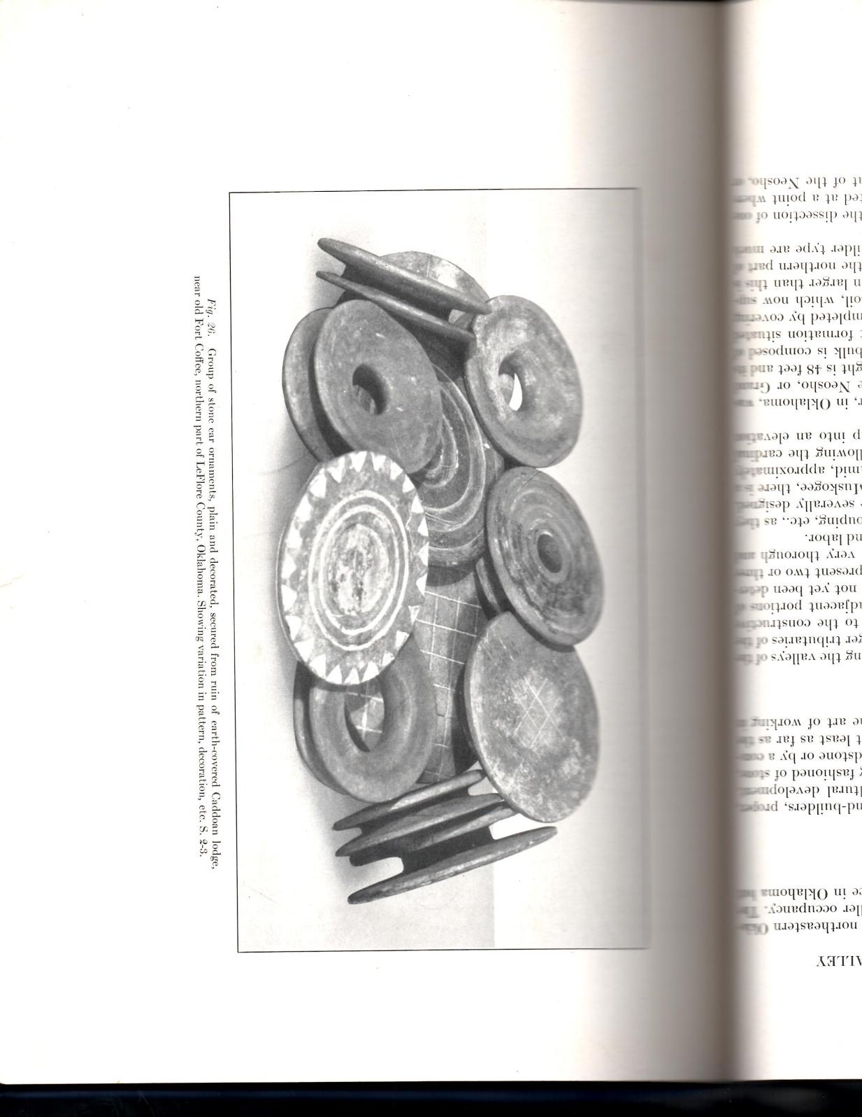
Figure 1.1: Collection of earspools obtained from Spiro (Thoburn 1931:57).

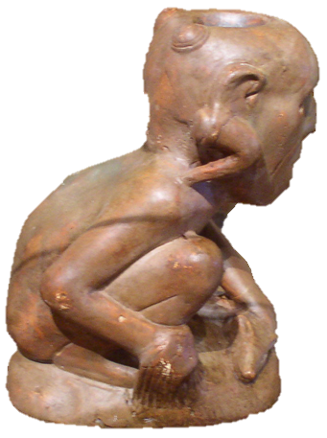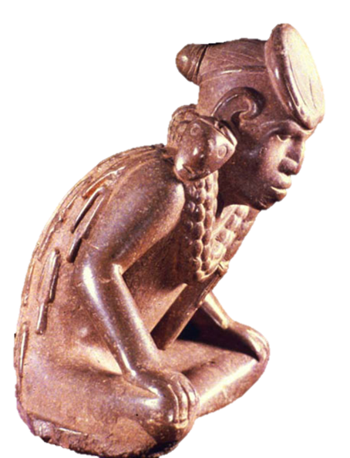
Figure 1.2: Effigy pipes depicting individuals wearing L-shaped plugs (left) (Courtesy of the Sam Noble Museum) and god masks (right) (Courtesy of the Arkansas Archeological Survey).

Made of a variety of materials including stone, copper, wood, shell, ceramic, or a combination of several materials, earspools also varied in size ranging from one centimeter to 10 centimeters or larger in diameter. Decorative elements such as incising or excising of various patterns differ in many of the earspools, while some have little to no ornamentation at all. Some of the earspools have solid faces that are plain or display simple to intricate designs. Other pieces have perforations through the center which also range greatly in size and shape. Some earspools retain copper coverings or show evidence of copper from staining or residue. The construction and size of the interior and exterior surfaces also vary.
Depictions of individuals wearing earspools appear on artifacts recovered from archaeological sites throughout the Southeast including those in the Arkansas and Red River Valley regions. Representations of individuals wearing earspools are found on artifacts such as human effigy pipes, copper plates, and shell gorgets, suggesting that they were worn, despite the fact that some are rather large and heavy (Brown 1996:561). An immense assemblage of shells from the Spiro Mounds site contains iconographic depictions of individuals adorned in a variety of articles of personal ornamentation including earspools (Phillips and Brown 1978:69). Copper plates recovered from sites in the region also depict individuals wearing earspools and other elaborate regalia (Mitchem 2008) (Figure 1.3). Some earspools found in the archaeological record were recovered in close proximity to the head of the interred individual (Brown 1996:561) which suggest that some people were buried wearing earspools.
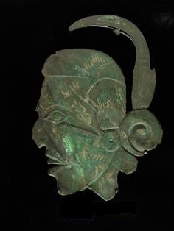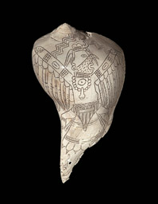
Figure 1.1: Repousse profile in copper (left) (Courtesy of the Oklahoma Historical Society) and Birdman image on shell (right) (Courtesy of the National Museum of the American Indian).

Stylistic variation appears in the earspools regionally and temporally throughout the Arkansas and Red River Valley during the Mississippi period. This thesis examines a sample of 331 earspools from sites in Oklahoma, Arkansas, and Texas, in order to begin to understand the variability in these types of personal ornamentation, and how they can be used as indicators of change over time, differences between regions, and personal affiliation. The earspools included in this study come from nine sites in Oklahoma, eleven in Arkansas, and one in Texas. The Oklahoma sites include Spiro, Norman, Harlan, Hughes, Reed, Brackett, Guffy, Eufaula, and State #4, and State #5 sites. The sites in Arkansas include Crenshaw, Foster, Bowman, Mineral Springs, Arthur Gaither, Smith Mound, and Bluffton. Earspools lacking an exact provenience were also included from unknown locations in Conway County and Johnson County. These earspools are included in this research to display the regional distribution of the earspools in this sample throughout central and western Arkansas. One set of earspools is from the Paul Mitchell site in Texas (Figure 1.4).
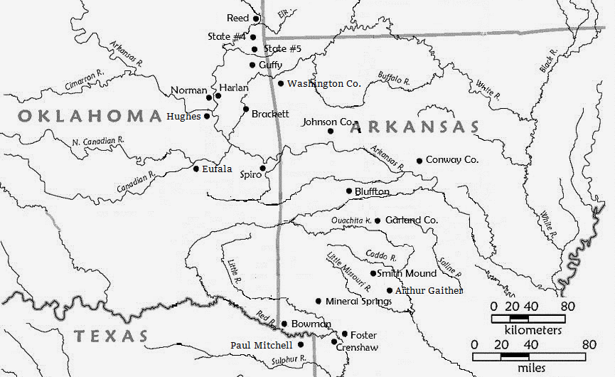
Figure 1.2: Map of sites where earspools included in this research were recovered. Adapted from Perttula 2012a: Figure 1-2.

The earspools examined in this thesis are (n=331) housed at four institutions, the Sam Noble Museum in Norman, Oklahoma; the Gilcrease Museum, in Tulsa, Oklahoma; the Oklahoma History Center in Oklahoma City; and the Arkansas Archaeological Survey in Fayetteville, Arkansas. Therefore, this sample does not include all known earspools from the region, nor does it include all of the earspools known from the sites used in this study. Future research will include the examination of additional collections. The research included examining each of the earspools, recording quantitative data on each piece, and photographing each of the artifacts in order to provide a visual compliment to the descriptions and a resource for future research.

Thesis Chapters Outline
This thesis consists of seven chapters, beginning with a brief description of earspools and the goals of this thesis. Chapter 2 examines theoretical approaches to personal adornment and ornamentation for examining variation in the use of earspools. Next, Chapter 3 provides a brief history of the Caddo and how their cultural practices based on ethnohistoric evidence relate to the interpretation of earspool use. Then Chapter 4 discusses the methodological approach used to analyze the earspools. Chapter 5 provides descriptions of the earspools including the types present in the sample, their stylistic attributes, and their archaeological context, if available. Chapter 6 discusses the results of the analysis which illustrate diachronic and regional variability of earspools through a comparison of form and attributes. Finally, Chapter 7 provides concluding thoughts regarding the use of earspools as items of personal adornment, their change through time, and regional differences, in addition to future research goals.

Chapter 2: Theoretical Approaches to Earspool Analysis

Archaeologists have recovered ear ornaments from sites throughout the Americas and found evidence of their use in representations depicted on such artifacts as stone pipes, copper plates, shell cups and gorgets (Diaz-Granados 2015; Emerson et al. 2003; Fundaburk and Foreman 2001; Orr and Looper 2014; Phillips and Brown 1978). Terms used to describe these ear ornaments include earspools, ear plugs, ear buttons, and ear flares. The descriptions of the ornaments seem to be dependent on the region where they were collected or the shape of the object. The focus of this research is to document variation in those ear ornaments described as earspools found in the Arkansas and Red River Valleys and determine if there is diachronic change or variability across space. This thesis then discusses what the variation can potentially reveal about shifts between Spiro Grave Periods and differences in the northern and southern Caddo regions, and what the degree of diversity and standardization among earspools with decorative features suggest about the nature of these items of personal adornment.
In order to address variability in the earspools, this thesis utilizes several theoretical approaches including personal adornment and gradation of values. Earspools examined as items of personal adornment provide a reflection of the individual who possessed them. Applying gradation of values offers a way to begin to interpret the meanings behind the earspools, and what they communicated about the individual who wore them. A review of prior discussions of earspools in North America provides background on previous interpretations of earspool use and a platform from which to discuss this analysis.

Previous Earspools Studies and Interpretations of Use
Earspools have been recovered from sites throughout the southeastern region of North America and Mesoamerica (Albert 2000; Baerreis 1943, 1957; Bell 1972, 1984; Blomster, 2014; Brown 1996; Burnett 1915; Carr 2005; Finkelstein 1940; Follensbee 2017; Hamilton 1952; Kusnierz 2016; Lewis 1946; Logan 2017; Orr 1940, 1942; Ruhl 1992, 2005; Scher 2017; Wingfield 2017). Earspools are also represented on a variety of other types of material culture such as shell cups, gorgets, copper plates, and statuary. Archaeologists have interpreted the use and meaning behind earspools from various regions and periods in multiple ways, including but not limited to indicators of elite status, membership in sodalities, or recognition of accomplishments (Carr 2005).
Archaeologists have sometimes interpreted earspools as prestige items and markers of elite status when they were recovered from burial locations such as mounds, and were accompanied by other items considered to be indicators of high status such as ceramic bottles, conch-shell vessels, ceremonial celts, and copper headdresses (Herndon 2015:20). In their study of the Moundville site, Peebles and Kus (1977) cited the presence of copper covered earspools in mortuary contexts as evidence supporting a broader argument that this was a ranked society. Their analysis of 2,053 burials excavated at Moundville provided evidence for an increase in the complexity of mortuary ritual. The multi-tiered system shows that copper earspools are only present in the second highest ranked of 11 clusters, (IB), indicating a representation of elite status. Anderson et al. (2002) argued that elaborate Hopewellian burials containing non-local grave goods including copper earspools, panpipes, prismatic blades, galena, and mica were considered to represent wealth or status and acted as prestige items for important people. Earspools recovered from burials along with other funerary offerings, such as Olivella shell beads, conch shell beads, ceramics, and pipes were thought to represent elite burials at the Nagle site (Brooks and Cox 2011).
Archaeologists have also argued that earspools were sometimes status markers. Representations of earspools on ceramic burial offerings in West Mexican Cape from the late formative suggest that they were considered symbols of status (Logan 2017:156). Duncan and Diaz-Granados (2000) argued that figures wearing ear ornaments called god masks depicted on cultural material remains such as copper plates, shell gorgets, statuary, and in petroglyphs, are linked to oral traditions describing significant characters such as Morning Star or Red Horn and the Hero Twins. Individuals buried wearing earspools may have been affiliated with these characters and been members of elite groups with elevated status. Representations of earspools along with other elaborate costume pieces on artifacts such as shell gorgets and the copper Rogan Plates have also been described as indicators of elite status for such individuals as combat soldiers or warriors (Follensbee and Buford 2017).
Earspools recovered from households can be used to examine status differentiation based on accoutrements of domestic life. Carballo (2009) looked at household status in Central Mexico through analysis of multiple practices including variability of domestic assemblages. One assemblage was personal adornment and included clay earspools. By utilizing gradation of values by Lesure (1999), Carballo looked at material type, form, surface treatment, and dimensions to interpret vertical social relations such as status. He concluded that earspools along with other items of personal adornment suggest a mix of vertical and horizontal relations.
Perino (1971) speculated that the scarcity and level of craftsmanship of unusual artifacts, including earspools, from the Schild Site, a Mississippian site close to Cahokia, suggest that they were possibly status symbols. Personal ornaments requiring great labor, knowledge, or expertise for their construction may distinguish people and groups from one another (White 1993). The use of local or exotic materials reflects the availability of these items to specific individuals. Items that are more difficult to acquire would have been considered more valuable and thus limited to fewer individuals (Helms 1993). Value assigned to an object can be a result of the material used in its construction, the individual who created it, or a meaning attributed to it. The rarity of certain objects would give the individuals who wore them an elevated level of significance. The skill necessary to create certain items also contribute to their importance.
In addition to markers of exalted status, archaeologists have proposed that earspools could have served additional functions. According to Carr (2005), earspools along with breastplates found in burials from multiple sites in the Scioto region were symbols of membership or achieved status in one of two sodalities in the Hopewell culture. Clark and Colman (2014) examined Mesoamerican human figurines and sculptures to argue that earspools could have been accents to beauty, indicators of authority, and symbols of divine connections (2014:145). Earspools in some cultures may have also been used as indicators of gender. Follensbee (2017:90) suggested that earspools depicted in Olmec stone imagery were gender neutral, while earspools depicted in Moche art may have been restricted to males or extremely limited to only highly adorned woman (Scher 2017:455). Unfortunately, information on the sex of individuals associated with the earspools included in this research is not available, and therefore discussions on gender are not included at this time.
In addition to indicators of individual identities, archaeologists have speculated that earspools could have been used as funerary offerings. A large number of clay earspools discovered in refuse pits at the Aztalan Site in Wisconsin, which dates from the 12th century AD (Zych 2013), were interpreted as possible ceremonial offerings due to the quantity of earspools recovered, and the accompanying artifacts (Maxwell 1952:63). Carr (2005) discusses a similar situation in Hopewell Mound 25 where a large number of prestige items were recovered. He argued that such an elaborate display of ceremonial materials was evidence of a ritualized destruction of the artifacts, an example of competitive gifting, or a cooperative display, rather than indicators of the social position of the individual or their personal possessions. Burials not associated with individuals and containing large numbers of ceremonial artifacts including earspools may represent ceremonies performed to express competition or build solidarity within and among groups in Ohio as part of the Hopewell culture (Ruhl 2005:709).

Personal Adornment
Artifacts referred to as “personal adornment” are those items worn by people that reflect individual identity or group affiliations (White 2008). This class of material culture has the potential to assist in deciphering the meanings behind symbolic representations which communicate information about social constructions within a community. When recovered archaeologically, items of personal adornment can be used to interpret the ways in which people created and displayed information about their individual and group identities.
Archaeologists have examined how we might analyze and interpret the use of personal adornment, which encompasses a wide range of objects and includes any addition to the body, both tangible ornamentation and modifications to the body (White 2002). Some of these items were important enough in life to be included with the owner in death. The artifacts recovered from a burial context are associated with one specific individual, and presumably considered valuable by the person who wore them or the people who interred them. The act of burial reflects practices of the living and can be examined through the physical remains together with material signifiers of individual experiences and identities in life (Gillespie 2001, Hodder 2000, Meskell 1996). Evidence of group membership and identity may be seen through the survival of personal ornamentation (Bayman 2002:70).
Personal adornment, including ornaments or body modifications, may indicate the participation of an individual in specific groups. Krutak (2016) examined the use of tattooing as an indicator of group membership or social status, and a mark of accomplishment. He also argued that tattoos existed as meaningful conduits for the expression of esoteric knowledge and projection of supernatural powers rather than simply decorative elements. Tattoos indicate shared beliefs and experience in their visual representations which may contain encoded messages.
The act of creating a form of artistic expression worn on the body communicates elements of personal and social culture (Deter-Wolf et al. 2013). The use of personal ornaments on the body assists in communicating these ideas. Grosz (1995) argued that ideas of a society are reflected in what is inscribed on the body of an individual. Fisher and Loren (2003) discussed the use of presentations on the body to project membership and self-identification in different social and special interest groups. Adornment is a way in which information may be communicated including the performance of identities (White 2005). The body is an important venue for transmitting information related to social categories including age, gender, and status (Strathern 1981:15, Blomster 2014:82). Joyce (2005) discussed the ability of body ornaments to convey identity through symbolic communication. Foucault (1979) stated, “the body is directly involved in the political field; power relations have an immediate hold over it; they invest it, mark it, train it, torture it force it to carry out tasks, to perform ceremonies, to emit signs”.
A variety of social messages and meanings can be communicated through personal adornment. Vanhearen (2005) discussed how personal adornment has inherent symbolic meaning which provides information on social organization and individual roles. He provided categories of different functions of personal adornment including aesthetic expression to promote personal beautification; courtship to attract another individual; community membership to preserve cultural identity; a social indicator to define lineage, wealth, gender, age, biological maturation, or relationship status; an individual marker to indicate a unique social status; a ritual object to be used only during ceremonial occasions; an offering for spiritual or ancestral purposes; an amulet or talisman as protection or to invoke power; a medicinal piece to provide recovery from illness; an item to reinforce social ties through trade; a possession to symbolize a link with ancestors; a communication system to store or transfer information; and as a counting device to keep track of items.
Pancake (1996) provided a discussion of apparel worn by individuals which has the ability to visually communicate ideas as well as personal and cultural values about the individual who created and wore the attire. She focused specifically on Guatemalan dress including both textiles and accessories, and argued that apparel possesses multiple levels of communicative imagery which provide locative, social, and personal information. Specifically, locative information includes ethnicity, linguistic region and sub region, community, and sub community. Status information includes gender, marital status, age group, socioeconomic position, membership in community groups, and ceremonial roles. Personal information includes family affiliation, personal aesthetics, technical skills, and progressiveness and self-expressiveness.
The subtle differences in the use of design motifs and slight variation in techniques of apparel manufacturing have the potential to distinguish individuals from one another and reflect personal attitudes, taste, and judgement. Researchers are able to potentially interpret explicit information based on the personal style expressed by the wearer of the garments which includes aesthetics and social occasion. Changes over time due to tastes and material availability can be seen through modification, adaption and refinement detailing when change was introduced, where it gained popularity, and how it replaced previous preferences. Social parameters or codes governing dress including unofficial dress codes are also expressed. Patterns are known within the community at large, but may not be recognized outside the local community.
Personal adornment is an addition to the body used to communicate information about the individual or their affiliations within broader groups. Earspools are one from of personal adornment that provide information which may indicate social status, membership in groups, and or personal or group accomplishments. Earspools are items of personal adornment and were worn to communicate information about the individual who wore them.

Gradations of Value
While many archaeologists have focused on how personal adornment may reflect individual status, Lesure (1999) proposed looking beyond artifacts as indicators of elite or non-elite status. His approach utilizes strategies of identifying gradations of values of objects to explore social relationships. There are three dimensions to the investigation technique which includes the kinds of social relationships, scales of social relationships, and degree of alienability (Figure 2.1). The spatial distribution of objects contributes to identifying the social uses. By applying this approach, we can begin to explore the meaning attributed to earspools.
The kinds of social relationships described by Lesure include two different types, vertical and horizontal. Vertical relationships are represented by high levels of differentiation, and would be restricted or carefully controlled, reflecting hierarchical social relationships such as elites and commoners (Brandt 1994; Earle 1982; Lesure 1999; Schachner 2001). Horizontal relationships are characterized by low levels of differentiation and have a wide distribution indicating social relations such as clans, families, or individuals.
The scales of social relationships occur on one of three levels, small, medium, or large. On a small scale, the relationships reflect personal identity with such categories as age, gender, and or marital status. Individual personal possessions on a small scale would have been worn on a daily basis and placed with the owner at death (Thomas 1991:73). Intermediate or medium scale goods represent clans, lineages, or sodalities. Patterns of distribution would be seen within a site and in burial groupings or residential areas (O’Hanlon 1989:86-89). Ornamentation used in large scale social relationships would be common throughout a site. These valuables would indicate broad sociopolitical memberships such as tribal or ethnic affiliations (Boas 1966:85).
The degree of alienability comprises the third dimension of gradation of values and is made up of two categories, inalienable and alienable. Inalienable objects are heirlooms not widely circulated, which provide validation of lineage or hierarchical status and may be associated with ritual events (Weiner 1985, 1992). Alienable objects are intended for exchange. They are not restricted, and are discarded if broken (Lesure 1999).
The aforementioned framework is useful for beginning to think about the earspools in the sample. As will be presented in the following chapters, multiple variations of motifs are present and the high level of differentiation between the motifs suggests that they may have represented horizontal relationships that reflect personal and individual identities. Repeating patterns may indicate common relationships such as subgroups within the region or individual roles within the community. The wide distribution of earspools made of sandstone also suggests horizontal relationships through the low level of differentiation of material type.
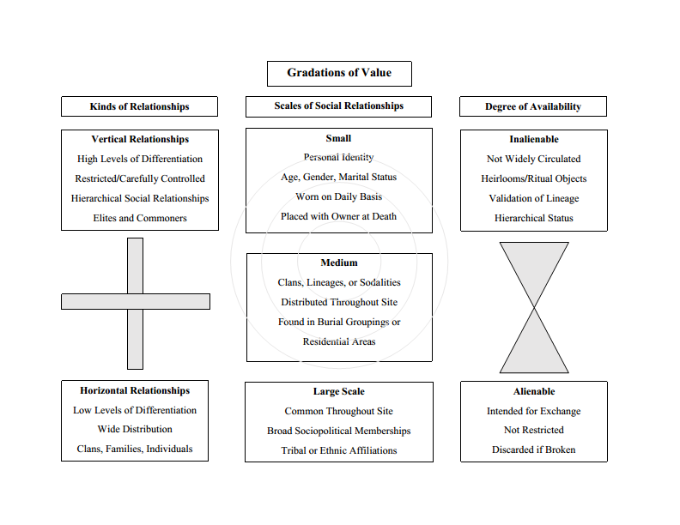
Figure 2.1: Gradations of Value Chart based on Lesure 1999.
The presence of multiple pairs of earspools in single burials implies that some of the earspools were personalized items of adornment, and not intended to be considered heirlooms or part of burial regalia. The absence of earspools from the majority of burials at certain sites suggests that some of the ornaments did not represent large scale social relationships. With regard to alienable objects, earspools that do not conform to chronological patterns may represent inalienable heirloom pieces, while earspools made of unique material not found frequently in the collections such as the slate earspool, suggest that it may have been an inalienable item acquired through exchange.
Through the examination of earspools from the Arkansas River and Red River Valleys as items of personal adornment, we can begin to interpret the purpose of their use. Earspools were worn to communicate information about the wearer to those who viewed them. The application of gradation of values assists in interpreting patterns within the earspool assemblage. The frequency of earspool types and motifs suggests the kind of relationships an individual may have had with the community.

Chapter 3: Regional Background and Cultural History

This chapter provides a regional and cultural history of the Caddo to facilitate a better understanding of regional and temporal variation in earspools, and their use as personal adornments. A discussion of the pre-contact Caddo and Mississippi traditions provide the background necessary to begin to understand the use of earspools as ornamentation. Examining the archaeological record of the sites included in this study, and the current research on the cultural chronology throughout the region, also offers a foundation for interpreting the use of earspools as personal adornment, regional differences, and their change through time.

A Brief History of the Caddo
According to French and Spanish explorers who encountered native peoples in 1600s and 1700s, the Caddo resided in an area now encompassing southwestern Arkansas, southeastern Oklahoma, northwestern Louisiana, and northeastern Texas (Carter 1995; Rogers and Sabo 2004; Swanton 1942; Webb and Gregory 1986). Archaeological evidence in the form of earthworks such as mounds and artifacts including Holly Engraved, Spiro Engrave, Crockett Curvilinear Incised, and Pennington Punctated Incised pottery further supports the occupation of the Caddo in these regions (Perttula 2011:242; Girard, et al. 2014:40). Within the larger population, several subgroups of communities existed and are defined as confederations or alliances. Those residing in eastern Texas were referred to as the Hasinai, the people in northwest Louisiana were called the Natchitoches, and the Kadohadacho inhabited the Red River region (Girard, et al. 2014). Though they were all part of the Caddo culture as a whole, there were differences in their ritual practices, material culture manufacture, architectural construction, and language dialects (Early 2000; Rogers and Sabo 2004; Swanton 1942).

Regional Background
Within the larger region, the Caddo interacted with one another and shared similar settlement patterns, mound building practices, and iconographic imagery (Kusnierz 2016). Distinct practices suggest two subgroups existed dividing the Caddo into northern and southern areas (Perttula 1996:302). The northern Caddo region includes settlements in the Arkansas River Valley and Ozark Highlands (Rogers 1989a:115), while the groups located along the Red River, in the Gulf Coastal Plain, and in the Ouachita Mountains encompass the southern Caddo area. The variations between the northern and southern Caddo regions are expressed in the production of pottery, architectural design of structures, and certain mortuary practices. Shell tempered pottery was first used in the northern Caddo region around AD 1300, and not until AD 1500 in the southern Caddo region (Pertulla 2011:258). The shape of certain structures also varied regionally from circular to square or rectangular. Circular structures were prevalent in the southern Caddo region, while square or rectangular structures were found mostly in the northern region (Perttula 2009). Differences in mortuary practices include the use of shaft tombs in the southern Caddo region, and charnel houses in the northern Caddo region (Perttula 1996; Story 1990). Variability in earspool types, discussed below, also exist between the two regions, further supporting the differences between cultural practices in the northern and southern Caddo areas.

Pre-Contact Caddo and Mississippian Traditions
The Mississippi period, which dates from approximately AD 750-1450 depending upon the region, was characterized by an increase in monumental construction, hierarchical social inequality, and maize agriculture (Smith 1990). During this period, the Caddo incorporated practices into their culture similar to those of the broader southeastern world including the use of flat-topped mounds, shell-tempered pottery, and exotic trade items, while excluding some distinctly Mississippian practices such as nucleated arrangements of settlements, palisades, and some distinct iconographic designs (Perttula 1996:296; Regnier et al.. 2014:103). Personal regalia used throughout the southeast during the Mississippi period included earspools, illustrating another shared cultural practice between the Caddo and the greater southeastern region (Knight 2010:66). Earspools are grouped into multiple types defined by distinct characteristics and stylistic interpretations. These variations suggest the participation in larger regional cultural practices with local distinctions.

Social and Political Relationships
Complex and hierarchically ranked societies developed in the Caddo region between approximately AD 800 – 900. These communities exhibited characteristics similar to the Mississippian region and included ceremonial centers, mortuary rituals and practices, and extensive interregional trade. Despite all of their similarities, the Caddo had different characteristics from the Mississippian world (Girard et al. 2014:31).

Settlement Patterns & Social Organization
According to Rogers and Sabo (2004), when Europeans first encountered the Caddo in the 17th century, there was a prevalence of small hamlets with no fortification. The villages were located near cultivable land and water resources. Early Spanish and French explorers described examples of this dispersed arrangement with the Hasinai hamlets in east Texas (Story and Creel 1982:22). Though this model may not be indicative of the entire Caddo region, a map produced by Domingo Teran de los Rios (Figure 3.1) provides some indication of the arrangement of villages in the late 1600s along the Red River (Perttula 1992:159). A centrally located open area is depicted with beehive shaped domestic residences covered with thatch that potentially housed multiple families. Arbor type structures were possibly used for elevated storage and potentially work areas. This arrangement of the hamlets may have been specific to the Red River region (Story and Creel 1982).
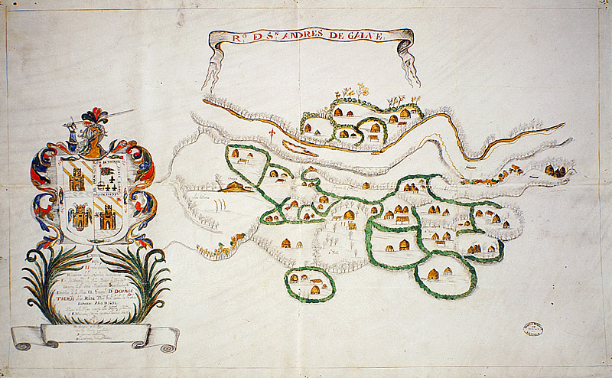
Figure 3.1: Terán map of 1691–1692. (Courtesy of the J. P. Bryan Map Collection, CT0108, the Center for American History at the University of Texas at Austin) (Girard 2012: Figure 9-2).
According to 17th and 18th century accounts of the Hasinai, a Caddoan speaking group who resided in eastern Texas along the Sabine and Trinity rivers (Bolton 1987), there were certain individuals within the Caddo communities who held different offices (Wykoff and Baugh 1980). The governing elites included the xinesi, caddi, and canahas. The head priest, known as the xinesi, resided outside of the villages where they maintained the temple fires and oversaw important rituals. The village leaders or caddi, performed multiple functions which included making important decisions within the community, settling disputes, overseeing events, and speaking with individuals from outside the community. The caddi were assisted by subordinates called the chaya. An additional decision-making body was the canahas, comprised of village elders who were assisted by tanmas who executed orders (Hatcher 1927:216). Shaman or medicine men called conna functioned as healers, oversaw the construction of houses and provided blessings upon them, predicted the weather, and assisted in the naming of infants (Livingood 2016). The warriors who achieved status through victories during war were known as amayxoya. One individual from the anayxoya was elected war chief and maintained command over the group.
Evidence exists for the possible presence of elite residences or ceremonial structures (Swanton 1942:170). Casanas (Hatcher 1927), described one community as including a headman residence consisting of three buildings located some distance away from domestic areas. These accommodations also included houses for the elders and attendants. The xinesi residence consisted of a large fire temple and two buildings which housed a pair of supernatural twin children or coninisi who served as intermediaries between the xinesi and the principle deity Caddi Ayo (Bolton 1987). The most predominate feature of some Caddo communities was the mound complex, which may have included a single mound or multiple mounds. These earthen mounds were conical or flat-topped in design and some had both ancient burials and more recent burials in shaft tombs. The separation between residential and communal, or ritual structures, suggests a social divide between individuals within the community.

Subsistence Practices
During the Mississippi period, maize along with many other types of domesticates were consumed throughout the eastern United States (Girard et al. 2014). The consumption of maize was not as prevalent with the Caddo as it was with the rest of the Mississippian region, nor did it peak at the same time (Wilson and Perttula 2013). Between the northern and southern Caddo regions, there were also differences in maize consumption in relation to protein. These differences become significant when placed in the context of food consumption beyond the need for sustenance. Food may have meaning and reflect cultural practices related to economics, the environment, or historical connections (Sahlins 1972).
According to Sabo and Rogers, (2004) cultivation and distribution of crops were based on a hierarchical structure within the community; family groups provided for themselves and contributed a portion to civic and religious leaders (Swanton 1942:127-139; Griffith 1954:48). Eating certain types of food, prepared in specific ways, and served at designated times, to selected individuals, suggests a level of status differentiation within the community (Jackson and Scott 1995:105). The methods of food distribution further suggest a hierarchical social structure within Caddo communities.

Regional Relationships
Trade involving a variety of goods ensured amicable relationships with neighboring groups. Exchange networks in the Caddo region began as early as AD 900 and extended to the Midwest, Southeast, and Southwest. Evidence of trade with these regions appears in mound burials of high status individuals and include items such as copper, conch shell, and galena (Cranford 2007; Hammerstedt and Savage 2013). Items that the Caddo exported included salt and bois d’arc bows (Girard et al. 2014). Ethnographic evidence indicates that the Caddo had alliances and trade relationships with their neighbors, but also enemies including the Nabiti, Nondacau, Hauydix, Osage, Tunica, Quapaw, Kitsai, Tonkawa, Kiowa, Lipan, and Wichita (Swanton 1942; Rogers and Sabo 2004).

Archaeological Background of Sites
Earspools were not found at all sites in the Arkansas River Valley and surrounding regions. Summaries of the sites where earspools were collected and available for analysis are discussed here. Sites with formal excavation histories provide the best background, while sites with limited information can at least contribute valuable insights regarding the distribution of specific earspool types within the larger region. Sites with little to no published information, were researched through what few primary sources were available, such as field and excavation notes. In the section below, brief histories of each site included in the analysis are provided in chronological order by site trinomial with Oklahoma sites discussed first.

Harlan 34CK6
Located on the west bank of Fourteen Mile Creek, the Harlan site is eight miles southwest of Hubert in Cherokee County and dates to the Harlan (AD 1000-1250) and Norman (AD 1250-1350) phases (Hammerstedt and Savage 2012). The site once extended across sixty-acres and contained seven mounds. Harlan was excavated in 1949 as part of a salvage effort to gather as much information about the site as possible prior to the construction of the Fort Gibson Reservoir. Under the supervision of Robert Bell, students from the University of Oklahoma carried out excavations at four mounds and two areas around the village (Bell 1972).
The site was divided into seven units; Unit 1 encompassed three small mounds which contained 123 burials. The burials contained both single and multiple individuals. There was an assorted variety of artifacts excavated from burials including pottery, projectile points, galena, celts, beads, earspools, shell beads, undecorated conch shells, stone pipes, flint, knives, copper pieces, and other items. Thirty-three earspools, were among the artifacts recovered from the Harlan site. Only thirteen of the earspools were recovered from burial contexts.

Brackett 34CK43
The Brackett site is located in what is now Lake Tenkiller in Cherokee County and dates to the Harlan and Norman Phases AD 1040-1265 (Kusnierz 2016:125). In 1939, the WPA began excavations under the direction of Lynn Howard, Kenneth Orr, and the University of Oklahoma. Charles Bareis presented a report in the 1955 edition of the Oklahoma Anthropological Society Bulletin which described the single mound site and a village component with a burial area. Research conducted by Kusnierz (2016:146), suggested that Brackett was a site reserved for ritual activities, containing special purpose structures and areas for mortuary ceremonialism. Burials at the Brackett site included a number of different types of funerary objects such as ceramics, lithics, pipes, and earspools (Kusnierz 2016:174). Five earspools were recovered from Brackett and are included in this study.

Reed 34DL1-11, and 14
Located in Delaware County, in the far northeast corner of Oklahoma, the Reed site was once situated near the Neosho/Grand River, but is now submerged under the Grand Lake O’ the Cherokees. This multi-mound site had twelve different areas excavated resulting in multiple site numbers. The features include such areas as a platform mound (DL1), burial mound (DL4), midden (DL9), and a surrounding area that contained structures for habitation (Hammerstedt and Savage 2012; Purrington 1971). Reed dates to the Harlan (AD 1000-1250) and Norman (AD 1250-1350) phases (Hammerstedt and Savage 2012).
In 1922, a crew from the Geological Survey explored the site, followed by unscientific digging performed by Alfred Reed, the land owner. The Oklahoma Historical Society conducted excavations under the direction of Joseph Thoburn in 1925. In 1937, David Baerreis directed formal excavations under the WPA prior to the construction of Grand Lake. Documentation of the excavations is sparse and rather unclear. The collection of earspools from the Reed site included in this study contains 34 artifacts.

Spiro 34LF35-59
The Spiro site is located in Leflore County along the Arkansas River in the far eastern portion of Oklahoma. Spiro is known as a possible religious center with mounds and elaborate artifacts suggesting a culture which included extensive trade networks and political systems. Spiro is one of the most significant sites located in the Southeastern United States (Brown 1996). The site dates from approximately AD 900-1500 and contained as many as twelve mounds situated on an upper and lower terrace. The Craig mound is comprised of three lobes and is located on the lower terrace along with two smaller mounds, Ward 1 and 2. The Brown, Copple, and Dollop mounds are platform mounds located on the upper terrace with additional adjacent house mounds (Brown 1996:13).
Formal excavations were conducted at Spiro in the 1930s and 1940s by the WPA after severe looting at the site had already occurred. As early as 1916, looters began digging into Craig mound (Thorburn 1929) resulting in the discovery of remarkable artifacts which attracted destructive pothunters until professional archaeologists could begin formal excavations (Girard et al. 2014). Unfortunately, the magnitude of damage inflicted on the site resulted in the inability to calculate an accurate number of burials. Some scholars believe several hundred burials were disturbed when the enormous trove of artifacts was pillaged from the site (Vogel 2005:370).
Known for the enormous number of exquisite artifacts, Craig mound was the largest mound by volume in the region (Vogel 2005:369). The artifacts contained within the mound included such items as pottery, stone tools, multiple items made of shell such as beads and cups, copper items, and textiles (Brown 1996:79). One hundred and sixty-three earspools from the Spiro site were available for analysis and most were recovered from the Craig mound. Thirty-seven were recovered from burial contexts. Additional earspools are included in Brown’s work and information on their funerary objects associated with them are included in this research. The collection of earspools from the Spiro site contains the most variety of types and stylistic variations.

Eufaula 34MI45
The Eufaula site is situated in the Ouachita Mountains along the Canadian River and includes one burial mound with a surrounding village area. Kenneth Orr supervised a WPA excavation of Eufaula in 1940 after extensive looting occurred leaving only 139 burials intact. Associated funerary objects included such items as ceramics, shell, and copper. Orr (1940) recorded 27 earspools during the excavation, but none were available for analysis. Two earspools recovered from the Eufaula site are included in the A. Hall collection from the Gilcrease Museum, but were unavailable for full analysis. A photograph of the two earspools was provided allowing for inclusion in this research.

Hughes 34MS4
Located approximately four miles north of Muskogee, Oklahoma, the Hughes site was positioned above the intersection of three major river ways, the Verdigris, Grand, and Arkansas (Rohrbaugh 1992). The site was composed of one mound and village component that contained eighteen burials. Hughes was originally excavated by the WPA in 1938 (Brown 1996:172), but no formal report was ever published. Bell (1974) provided information regarding the complete removal of the large platform mound and the discovery of houses, storage pits, and burials. Rohrbaugh (1982) suggested that small mounds may have covered what appeared to be mortuary floors containing burials and grave goods including a Spiro Engraved bottle, copper rods, discoidals, arrow points, and earspools, 34 of which were included in this analysis. Orr (1946) argued that the Hughes site has a Harlan phase component, while current research suggests it dates as late as the Spiro III Period (AD 1250-1350).

Norman 34WG2
The Norman site was initially excavated during 1934 and 1935 by the University of Oklahoma under the direction of Forrest Clements and J. Joe Finkelstein. Excavations occurred again in the summer of 1948. The site is located approximately seven miles southeast of Wagoner, and sat on the upper terraces of the Neosho/Grand River. The site included a large village and three mounds, two lobed and one platform. Surrounding the mound area was evidence of extensive habitation. The primary mound, Unit II was multilobed, consisting of two sections, one larger than the other. Intrusive burials contributed to difficulty in determining the sequence of construction of both mounds. The large mound, II-1 contained 71 burials, while the smaller mound, II-2 only had 9 burials (Finkelstein 1940). Several of the burials were cremations, and some were categorized as single burials, but many were in such a poor state of preservation that they were classified as unknown. A total of 39 earspools were collected from the Norman site, and all are included in this analysis.

Mineral Springs 3HO1
The Mineral Springs site is located along Mine Creek in the southwestern region of Arkansas in Howard County. The site dates to AD 1200-1400 or the Middle Caddo period (Perttula 2011). Mineral Springs originally consisted of eleven mounds and several borrow pits before it was excavated by Mark Harrington in the early 1900s. In 1953 work on the site was also conducted by Lynn Howard of the University of Arkansas, Clarence Webb, a physician from Louisiana, and Glen Kizzia, an amateur archaeologist from Texas. The National Park Service oversaw further excavations at Mineral Springs in 1962 under the Inter-Agency Archaeological Salvage Program for the Millwood Reservoir project.
There appears to have been a shift in burial types during the occupation of the Mineral Springs Site. Early burials consisted mostly of single individuals, and during the later periods multiple burials appeared (Bohannon 1973:40). The addition of multi-individual burials also coincided with an increase in artifacts accompanying the deceased. Earspools, shell gorgets, shell beads, and shell discs appeared in later burials (Bohannon 1973:43). The collection of earspools available for analysis from the Mineral Springs Site contains only three of the seven recorded to have been recovered from the site during excavations. The location of the additional four earspools are unknown at this time.

Foster Place 3LA27
Located along the Red River outside Garland in southeastern Arkansas, the Foster Place site extended over approximately one square mile. In 1912, C.B. Moore conducted excavations at the site and described two pair of limestone ear ornaments. Information regarding a later excavation of this site is sparse, only a few documents exist describing a test trench dug by Glenn Martin, a collector from Texarkana (Miroir 1946). The excavation revealed a burial containing three broken pottery vessels. Detailed studies have yet to be conducted on material from the site to determine exact dates of occupation, but it may date as early as the Late Archaic period and extend until the Late Caddo (Weinstein 2003). Moore indicated that he had recovered multiple earspools during his excavations, but only two were available for analysis. These earspools are part of the Harry Lemley collection, a Judge and collector from Hope, Arkansas, and were possibly collected in 1938 after floodwaters exposed several burials (Weinstein 2003).

Bowman 3LR50
The Bowman site is located approximately one mile from the Red River in the Southwest section of Little River County in Arkansas, and had seven mounds. The site was excavated in June of 1965 by Thomas Shurtleff and Chance Thomas under the supervision of Michael Hoffman. Bowman dates to the Haley Phase (Hoffman 1971:809), which corresponds to Spiro III, AD 1200 to 1400 (Wyckoff 1974). Field notes indicate that fourteen earspools were recovered from the site during excavation, but only seven were available for this analysis.

Crenshaw 3MI16
The Crenshaw site is located in Miller County along the Red River in the southwestern corner of Arkansas. The site consisted of six large mounds. Crenshaw was initially excavated in 1932 by Glenn Martin on behalf of Harry Lemley. Frank Schambach carried out formal archaeological excavations in the 1960s and 1970s. According to Samuelsen (2014), material remains from the site indicate a possible occupation over multiple archaeological phases including the Crenshaw Phase which dates from AD 700-900, the Lost Prairie Phase AD 900-1200, and the Haley Phase AD 1200-1500. His research also confirmed the occupation and use of the site during the Fourche Maline culture which dates to the early Woodland period BC 1000 - AD 1000. A Fourche Maline mass grave was located under Mound F and radiocarbon dating indicates that the construction of the mound occurred in the late 900s. These dates suggest a distinct separation of the mound from the remainder of the site. Four earspools from the Crenshaw site were available for analysis.

Paul Mitchell 41BW4
Located in the northeastern corner of Texas along the Red River in Bowie County, the Paul Mitchell site was excavated professionally and by amateur archaeologists in the 1930s, and in the 1940s by the University of Texas and the WPA (Pertulla 2014:1). Prior to the expansion and development of the Bowie County Levee, an archaeological survey was conducted by Cliff in 1996.
In 1946, an avocational archaeologist Peter Miroir, identified three burials. Burial 2 contained a single pair of ceramic earspools, which are included in this study, in addition to five ceramic vessels and a long-stemmed pipe (Miroir 1946). The burial dates to the Late Caddo Period (ca. AD 1350–1450) or Spiro III/IV, and IV (Pertulla 2014:35).

Smith Mound 3CL162
The exact location of this mound site is unclear, but early excavation records suggest it was situated on a bluff above a tributary of Moore Creek in Clark County, Arkansas. In 1934, Harry J. Lemley and Dorris Dickson led excavations resulting in the discovery of two single burials and three multiple burials. An additional excavation conducted in 1938 by Wayne Roberson revealed seventeen more burials, but information is limited on the excavation (Notes from University of Arkansas Museum). Four earspools from the Smith Mound are part of the Lemley collection and are included in this analysis.

Arthur Gaither 3CL220
This single, possibly double, mound site is located east of Bell Creek and south of Caddo Creek, which are tributaries of the Ouachita River in Clark County Arkansas. The site was excavated in 1934 by Samuel Dellinger revealing a possible burned and buried structure (Trubitt 2009). Radiocarbon dating of predominately shell-tempered sherds and vessels indicate a range of AD 1320-1640 (Perttula 2011). One earspool was included in the analysis; no others are known from the site.

Bluffton 3YE15
The Bluffton site is a two-mound site located along Gafford Creek in Yell County, Arkansas. In 1928, four earspools were collected from a burial along the Fourche Lafave River, but only two were available for analysis. More formal excavations were conducted in 1933 by the University of Arkansas Museum under the direction of the director, Samuel Dellinger (Vogel 2005:314). Several burials were excavated along with artifacts including potsherds and evidence of a basket (Notes from University of Arkansas Museum, 33-17). Detailed studies have yet to be conducted on the site to determine dates of occupation.

Conway County
Located north of the Arkansas River, and in the eastern most Arkansas County included in this study is Conway County. Four earspools were collected in the area and include one matching pair and two that are of different types. Only one of these earspools has any additional provenience information beyond the county. According to the Gilcrease Museum catalog database, the aforementioned earspool was collected from the farm of the Henry James Estate, which was located approximately 3 miles east of the Arkansas River on Point Remove Creek. Further research is needed to determine if this area was part of the Point Remove site.

Johnson County
Only one earspool included in this analysis was recovered from Johnson County, Arkansas and information is limited regarding its exact origin. According to notes written on the earspool itself, it was found in a grave in Bull Frog Valley on Big Piney Creek, which flows into the Arkansas River. Multiple earspools that are part of the Lemley collection are marked with an “E” followed by a number; this artifact possesses this type of label and presumably was collected for Lemley also.

Garland County
Five earspools from homesteads in Garland County are included in the analysis. These artifacts are part of the E series collected for Lemley in the late 1920s, and provenience information is limited to the names of the landowners. Additional research would be required to determine the exact location where the earspools were recovered, and if these locations are associated with documented sites. One earspool was collected at the “Sumpter Place” on the north side of Ouachita River at the mouth of Blakely Creek; another was found at “J.H. Scrubb’s Place” which was south of Buckville on the Ouachita River. Two earspools were recovered from a mound on “Jim Williamson’s Place” north of the Ouachita River, and one from a burial context at Kimes Place on the south bank of Ouachita River, west of Buckville, Arkansas.

Washington County
One earspool from Washington County, Arkansas is included in the analysis. The only information regarding the exact origin of the artifact is a description of its recovery from a rock shelter near Fayetteville, Arkansas.

Summary
The sample of earspools included in this analysis was collected from twenty-two sites in the Arkansas and Red River Valleys. Only a limited number of earspools were known to be excavated from burial contexts. The majority were recovered from disturbed contexts or have limited provenience information. Earspools along with other artifacts and data collected from burials provide detailed information which can be used to determine time periods for further interpretations. Several of the earspools were found by collectors or commercial diggers and have limited information regarding their exact origin. Available information such as county locations or farmsteads contributes and understanding of the regional distribution of earspools.

Cultural Chronology
In order to examine how change in earspools occurred over time, an understanding of the chronology of the region is needed. One of the questions in this research asks if change in earspools occur concurrently with shifts in chronological periods. Some of the sites included in this research are in areas with their own dating terminology, requiring an explanation in order to observe correlations between cultural units. Additionally, changes in approaches to determining cultural units expanded beyond trait lists to include uses of space (Girard et al. 2014) resulting in modification to previously accepted cultural chronologies.
In the late 1940s and early 1950s, Orr created the first taxonomic system for Caddo archaeology with aspects and foci. In 1951, Bell and Baerreis created a new taxonomic system to replace the previous system. Archaeologists later accepted the idea that the use of space contributed to variation in archaeological traits, expanding how cultural units are defined (Girard et al. 2014). While researching Spiro, new information led Brown (1976) to create an updated series of phases which include the Fourche Maline, Evans, Harlan, and Spiro which were based on changes in construction and ceramic styles. In 1984, Bell published a work on the prehistory of Oklahoma which built upon previous conclusions about chronology and included the addition of the Wister phase (Galm 1984).
In 1996, based on additional seriation data gathered from mortuary analysis at Spiro, Brown reconsidered his previous conclusions and created a new cultural chronology. His new interpretation assisted in determining the characteristics of certain phases based on ceramic attributes and house forms. Brown argued for a distinct transitional phase between the Harlan and Spiro phases which he defined as the Norman phase.
The modern borders of Texas, Louisiana, Arkansas, and Oklahoma, complicate the creation of a cohesive cultural history of the Caddo. Archaeologists working in each state have created their own terminologies resulting in conflicting phase designations. Changes in cultural practices including patterns of settlement and subsistence, variation in technological and stylistic traditions, and diverse political and economic practices have generated a variety of criteria for the shifts in chronology.
The cultural phases presented by Brown (1996) include the Evans Phase (AD 1000-1100), the Harlan Phase (AD 1100-1250), the Norman Phase (AD 1250-1350), the Spiro Phase (AD1350-1450), and the Fort Coffee Phase (AD 1450-1500). Bruseth (1998) expands these phases and offers detailed descriptions in his writings. Today, the periods include the Formative Caddo (AD 900-1050), Early Caddo (AD1050-1200), Middle Caddo (AD 1200-1400), Late Caddo (AD 1400-1680), and Historic Caddo (AD 1680-1840) (Girard et al. 2014).
These time periods are further divided into several phases based on region and include the Haley phase (AD 1200-1400 or 1500), Texarkana phase (AD 1300-1700), and McCurtain phase (AD 1300-1700) in the Great Bend region of southwest Arkansas, and the Bossier phase (AD 1200-1500) and Belcher phase (AD 1500-1700) in areas located in northwest Louisiana and southwest Arkansas. In the eastern region of Oklahoma, the Sanders phase (AD 1100-1300) and the early McCurtain phase (AD 1300-1500) phases are included in the Middle Caddo period.
The cultural phases of eastern Oklahoma have been defined by evidence of changes in social, political, and ceremonial practices. Additional research and archaeological discoveries have resulted in the revision of these phases. Publications by Wyckoff (1980), Bell (1984), and Brown (1996) have been the major sources for defining the cultural phases of prehistoric Oklahoma. Current research continues to refine the chronological sequence which includes Evans Phase or Spiro IA, IB (AD 950-1000), Harlan Phase or Spiro II Grave Period (AD 1000-1250), Norman Phase or Spiro III Grave Period (AD 1250-1350), and Spiro Phase (AD 1350-1450). The catalyst for change between these phases provides a foundation for analysis of the variation in the earspools.
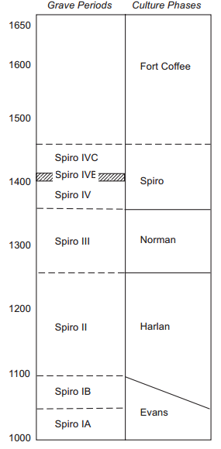
Figure 3.2: Regional Chronology (adapted from Brown 1996; Rogers 2011).

Evans Phase or Spiro IA, IB (AD 950-1000)
Expanded trade relations and the appearance of elaborate mortuary practices marked the beginning of the Evans Phase in the Arkansas River Basin (Rogers 2011:2, Cranford 2007:35). Ceramic styles resembling Coles Creek and Plum Bayou also act as a signifier of this period (Girard et al. 2014:41). Originally coined by Orr (1952) to describe early mortuary traditions at Crenshaw, Brown created Spiro IA and IB Grave Periods based on Evans Phase characteristics, and identifying the beginning of a distinct Spiroan tradition (Brown 1996:162). No earspools from the Evans Phase are included in this analysis, but according to Brown (1996) earspools from the George C. Davis and Gahagan sites were recovered in early burials.

Harlan Phase or Spiro II Grave Period (AD 1000-1250)
Based on the interpretations of excavations conducted at the Harlan site, the Harlan Phase was defined by Bell (1984) and Brown (1996). Characteristics indicative of the phase include mound construction, mortuary structures, burial types, and domestic structures. Structures were characterized by square construction with an elongated entryway and containing four posts located in the center, some of which had a mortuary function (Hammerstedt and Savage 2013). Mound centers served their local and regional communities, and were supported by surrounding villages or residential hamlet areas (Bell 1984:228). Some sites had multiple mounds, while others had none. The separation of ceremonial areas with residential areas indicates a deliberate effort to segregate the two components of the centers (Rogers 2011:4).
The presence of non-local materials and artifact types such as copper, conch shells, galena, and pottery suggest a continued participation in long distance exchange (Cranford 2007:37; Hammerstedt and Savage 2013). Ceramic types indicative of the Harlan Phase include Coles Creek Incised variations, Crockett Curvilinear Incised, Davis Incised, Hickory Fine Engraved, Holly Fine Engraved, LeFlore Plain, Pennington Punctate Incised, Sanders Plain, Spiro Engraved, Williams Plain, and Woodward Plain (Bell 1984:231; Hammerstedt and Savage 2013:2; Phillips and Brown 1978:172). Projectile points were mainly smaller in size, though some larger points and bifaces were present. Lithic artifacts were constructed of local and imported cherts including Ozark varieties, Alibates, and Florence-A (Hammerstedt and Savage 2013:2). Funerary objects included stone and wood earspools of multiple types but lacking design motifs, stone celt, stone and clay T-shaped pipes, shell disk beads, undecorated whelk shell, copper, galena, and hematite (Hammerstedt and Savage 2013:2).

Norman Phase or Spiro III Grave Period (AD 1250-1350)
Defined by Brown (1996), this phase was named after the Norman site due to its distinct ceramic types, the incorporation of shell temper in the pottery, and a shift in construction characteristics of buildings. The ceramic types include Braden Punctate, Poteau Plain, Poteau Engraved, Sanders Engraved, and Woodward Appliqué (Phillips and Brown 1978). Structures changed from containing four center posts to two center posts, and were reduced in size and shape. Harlan phase buildings were large and square, while Norman phase buildings became smaller and more rectangular (Rogers 1995). The Norman Phase also saw the introduction of elaborate decorative motifs on earspools.

Spiro Phase or Spiro IV-IVC Grave Periods (AD 1350-1450)
Bell (1984) argued that the Spiro phase represented a zenith in cultural and ritual complexity. The construction and repeated reuse of the Great Mortuary occurred between AD 1200-1400 and was followed by the Spirit Lodge around AD 1400 in the Craig Mound, located in the Spiro complex occurred during this phase (Brown 1996, 2012, 2014; Sabo and Brown 2014). This phase also saw the intensification of trade over long distances resulting in an increase of rare and exotic materials which were included along with other items as funerary objects. There was also an increase in ceramic and earspool diversification.

Conclusion
This study includes 331 earspools from multiple sites throughout the Arkansas River Valley and surrounding regions. Earspools were recovered from each of these locations indicating a shared practice of wearing ear ornamentation across the region over an extended period of time. Cultural histories of the sites and regions provide the foundation for interpreting variation in the earspools. Analysis of the earspools, identification of temporal changes, and variations geographically assist in understanding regional differences between communities, shifts in practices over time, and the use of personal adornment to communicate information about individual and group identity.

Chapter 4: Methodology

This chapter addresses the methods used to compare the assemblages of earspools recovered from sites along the Arkansas River Valley and surrounding regions. The chapter begins with a discussion of the methodology used in this research, followed by a review and critique of past research conducted on earspools in region. Then the chapter presents the typology used in the analysis, followed by an examination of the form of the earspools describing the attributes and variables.
This study compares a sample of earspools obtained from sites in Oklahoma, Arkansas, and Texas which are housed in four institutions. These institutions include the Sam Noble Oklahoma Museum of Natural History (SNOMNH) in Norman, the Gilcrease Museum in Tulsa, the Oklahoma Historical Society in Oklahoma City, and the Arkansas Archaeological Survey in Fayetteville, Arkansas. These collections were chosen to provide a representation of earspools from sites throughout the research focus area. Additional earspools from the region may be found in museum collections across the United States, but were not included in this analysis due to budgetary and logistical limitations. Future research will incorporate additional assemblages of earspools.
This study includes 331 earspools obtained from 22 sites in eastern Oklahoma, Texas, and central and western Arkansas (Figure 4.1; Table 4.1). Earspools from the northern Caddo area were recovered from sites located along the Arkansas River or its tributaries, and in the Ouachita Mountains. Earspools from the southern Caddo region were acquired from sites along the Red River and the Ouachita Mountain region. The sites in the northern region include Harlan (34CK6), Brackett (34CK43), Reed (34DL4), Guffy (34DL57), State #4 (34DL67), State #5 (34DL68), Spiro (34LF40), Eufaula (34MI45), Norman (34WG2), Hughes (34MS4), Bluffton (3YE15), and unknown locations in Johnson, Washington, and Conway Counties, Arkansas. The sites in the southern Caddo region include Smith Mound (3CL162), Arthur Gaither (3CL220), Mineral Springs (3HO1), Foster (3LA27), Crenshaw (3MI6), Bowman (3LR50), Paul Mitchell (41BW4), and locations in Garland County, Arkansas.
Figure 4.1: Map of sites where earspools included in this research were recovered. Adapted from Perttula 2012a: Figure 1-2.

Table 4.1: Total number of earspools recovered from each site, and northern and southern site distribution.
Site | Name | n | Region
34LF40 | Spiro | 166 | N
34WG2 | Norman | 39 | N
34CK6 | Harlan | 35 | N
34DL4 | Reed | 34 | N
34MS4 | Hughes | 11 | N
3LR50 | Bowman | 7 | S
34CK43 | Brackett | 5 | N
3GA0 | Garland Co.* | 5 | S
3CN0 | Conway Co.* | 4 | N
3MI6 | Crenshaw | 4 | S
3HO1 | Mineral Springs | 3 | S
34MI45 | Eufaula | 2 | N
3CL162 | Smith Mound | 4 | S
3LA27 | Foster | 2 | S
3YE15 | Bluffton | 2 | N
41BW4 | Paul Mitchell | 2 | S
34DL57 | Guffy | 1 | N
34DL67 | State #4 | 1 | N
34DL68 | State #5 | 1 | N
3CL220 | Arthur Gaither | 1 | S
3JO0 | Johnson Co.* | 1 | N
3WA0 | Washington Co.* | 1 | N
Total |  | 331
*No Site Provenience Available

Attributes of the Earspools
The earspools in the sample possess a variety of attributes which were recorded following the previous research conducted by Baerreis (1943, 1957), Brown (1997), and Ruhl (1992, 1998, and 2005) to maintain consistency and uniformity. These include measurements of specific characteristics such as diameter of the exterior and interior faces, thickness, and perforations when present. The research techniques involved visual examination, and measurements. Measurements were recorded to the tenth millimeter using digital calipers. Certain traits are recorded as present or absent, including perforations and design motifs. The terminology used to describe the types of design motifs was created by Baerreis (1943) and is discussed below. The types of materials used in the production of the earspools were determined by visual analysis. Each earspool was also photographed.
The earspools types are based on the formal typology created by Baerreis (1943) and later expanded upon by Brown (1996). The types include Pulley, Recessed, Channeled, Funnel, Central Boss, Composite, Foster, Pulley-ring, Notched, Nested Half, Flanged Ring, Hollow Cylinder, Grooved, and Trimmed Inner Flange. It should be noted that not all researchers have followed this exact terminology consistently. For example, Bell (1972) refers to earspool 34CK613a&b as “compound” since it has two parts. Yet this earspool is classified as “Nested Half” in current research. Earspools described by type should be further researched by physical examination when possible to determine their actual characteristics. Further research will examine difference within the typology of earspools and challenges these differences present.
The attributes recorded include the presence of perforation, perforation diameter, presence of copper or copper staining, presence of design, diameter of exterior face, diameter of interior face, total thickness, weight, and the design motifs. Material types identified included stone, wood, copper, shell, and ceramic. Types of stone were categorized by visual identification as limestone, sandstone, or stones previously identified by Brown (1996). The percentage of copper covering the exterior face of each of the earspools was recorded based on estimated visual calculations using a scale of 1%, 25%, 50%, 75%, or 99%. Earspools identified as possessing 100% copper indicate a single piece of copper covering. Copper, when present, was usually affixed to one side of the earspool, presumably the exterior side in order to display the material. When decorative motifs were present, the copper was attached to that side. Any unusual features, damage, or missing parts were also noted.

Composition of the Earspools
Form contributes to the composition of an earspool. The form of the ornament is dictated by specific qualities adhered to by social expectations. The earspools are round, have a center portion, and both internal and external segments. Baerreis (1943) provided specific terminology for the parts of an earspool including the core which refers to the center of the earspool, both inner and outer flanges when present, the perforation, and the outer and inner face (Figure 4.2).
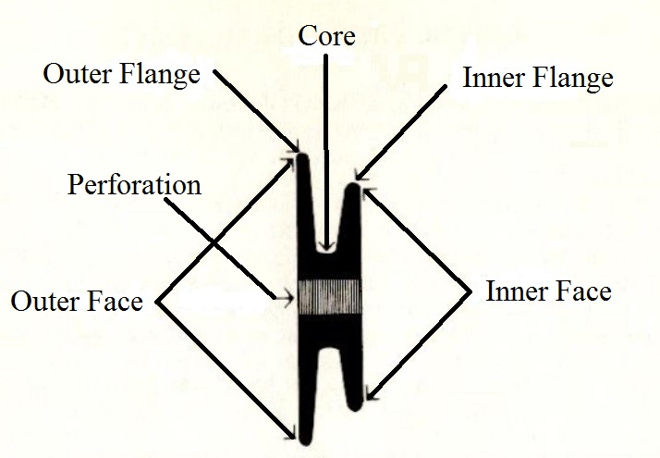
Figure 4.2: Descriptive Terminology (modified from Baerreis 1943, 1957).
A variety of decorative motifs are found on some earspools, while many have little to no ornamentation at all. The skill of craftsmanship ranges from rather crude to highly detailed. Slight regional variations occur within the execution of the motifs, but the essence of the image is maintained. The function of the earspool includes the projection of an image which possesses meaning that could be interpreted by those who observe it and what a common understanding of the designs used.

Typology
Baerreis (1943) argued that there was a need for more detailed descriptive techniques that would allow artifacts to be grouped and analyzed. By creating a more precise typology, researchers could then more thoroughly compare relationships between sites and cultures with similar artifact types (Kidder 1936). The descriptive techniques used to determine a typology included an examination of morphological, functional, and stylistic feature including material, method of manufacture, and shape or design. This work provided the first comprehensive earspools typology for Arkansas River Valley earspools.
Baerreis initially identified six types of earspools which he termed A through F, based on construction techniques and formal features of an earspool (Figure 4.3). He also created three sub-types which he described as alternative structural features (Figure 4.4).
Type A, or Perforated, have a central perforation through the core. Type B, or Unperforated, lack any perforation. Type C earspools contain a recessed area on the exterior face which may have originally contained an inlay and are defined as Recessed. Earspools with a large dome shaped protrusion extending out of the center of the face and with shallow flanges are designated Type D or Central Boss. Type E earspools have a convex outer face with a continuous curve into the perforation and are identified as Pulley-Ring. Earspools with a space separating the inner flange into two sections or split flange are Type F also known as Foster. Alternative forms are also defined by the presence of distinct attributes. These forms include a Funnel Faced, a Notched Inner Flange, and a Channeled Face, which is a small rise in the center of a concave design.
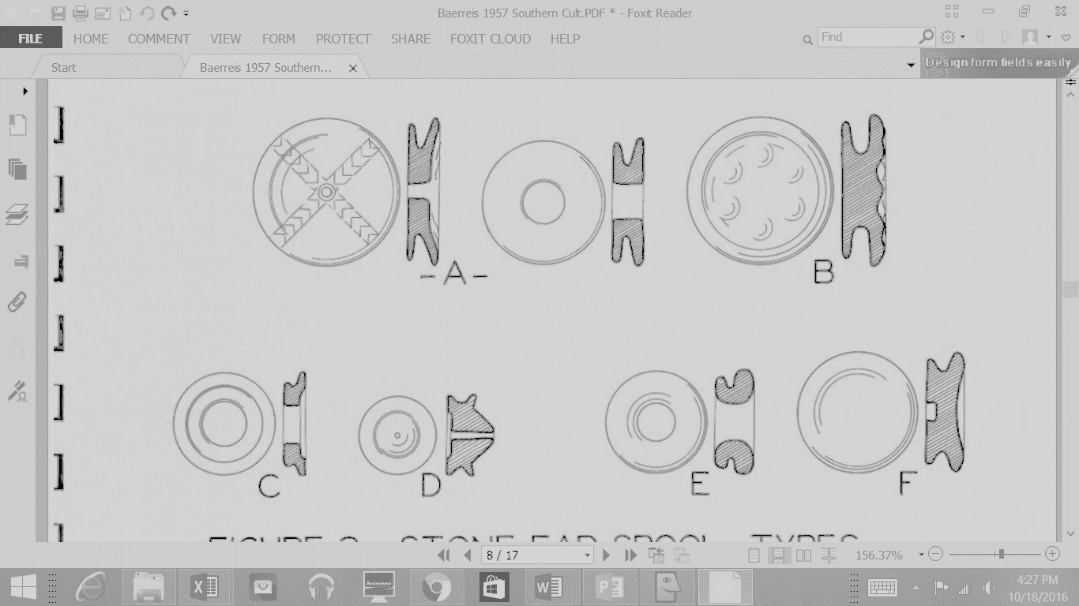
Figure 4.3: Earspool Types A–Perforated, B-Non-Perforated, C–Recessed, D-Central Boss, E-Pulley Ring, F-Foster (adapted from Baerreis 1943, 1957).
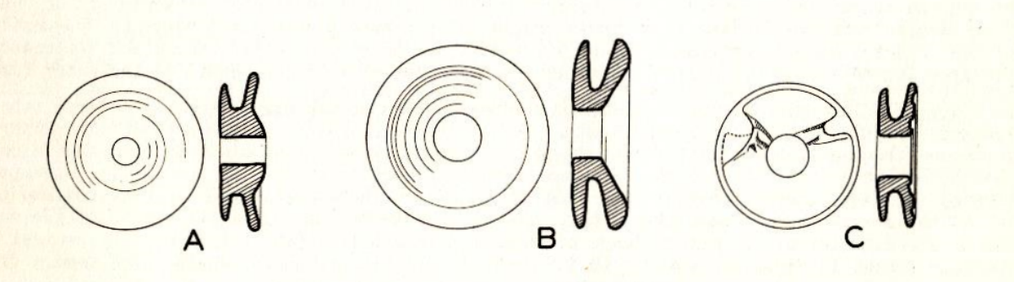
Figure 4.4: Structural Alternative Features of Earspool Types A-Channeled, B-Funnel, C-Notched Inner Flange (adapted from Baerreis 1943, 1957).

Brown (1996) expanded the typology with the addition of Perforated Pulley-Shaped, Unperforated Pulley-Shaped, Central Boss, Effigy-Faced, Foster, Pulley-Ring, Nesting Halves, Flanged Ring, Hollow Cylinder, Grooved Cylinder, Stud-Shaped Plug, Knobbed Plug, Biconical Plug, Long-Nosed God Maskettes, Composite, Wooden Composite Ear Disc, and Simple Shell Discs. Brown’s typology provides a clearer representation of the characteristics of the earspools and is used for this analysis. For this study, Channeled Face and Funnel Face are grouped as their own distinct type rather than a variation on a perforated earspool. Notched inner flange is considered a modification to the original type of earspool, not a specific type, due to the crude and unfinished appearance of the alteration. The Small Inner Nub type earspools, referred to as Trimmed Flange in some cases, appear to have been originally constructed with smaller inner portion rather than deliberately modified from an original design. Not all of these types are present in the sample analyzed for this study. Only the types present in the sample are discussed in this research (Table 5.1).

Earspool Types
- Perforated Pulley (Figures 4.5, 4.6): flat face, parallel flanges, and a central perforation, corresponds to Baerreis type A. (Baerreis 1957:28; Brown 1996:564).

Figure 4.5: Perforated Pulley Type Earspool (Type A) (adapted from Baerreis 1943, 1957).

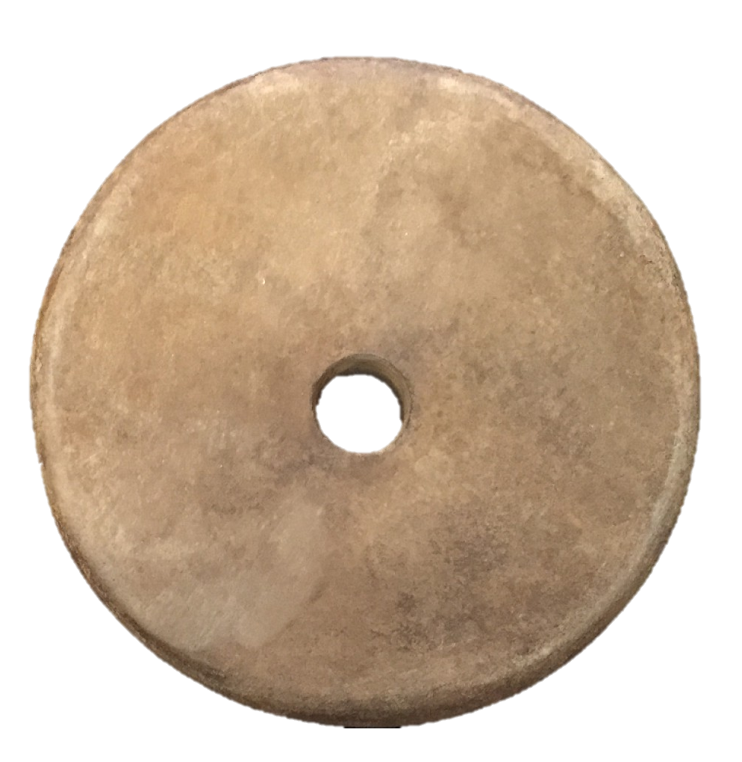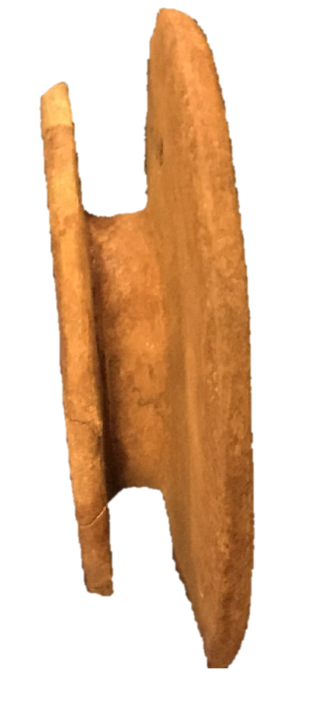

Figure 4.6: Perforated Pulley Type Earspool 34LF40/LfCrI1 B9-15A/6125.14214A (Courtesy of the Gilcrease Museum, photograph by the author).
- Unperforated Pulley (Figures 4.7, 4.8): flat face, parallel flanges, without a central perforation and usually with a decorative motif, corresponds to Baerreis type B. (Baerreis 1957:30; Brown 1996:567).

Figure 4.7: Unperforated Type Earspool (Type B) (adapted from Baerreis 1943, 1957).

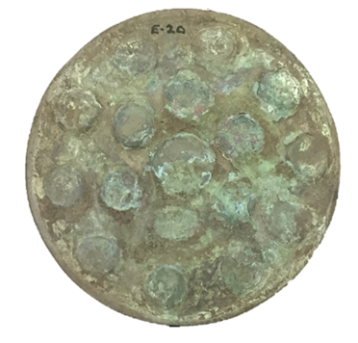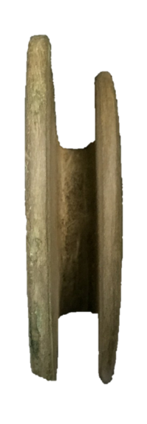

Figure 4.8: Unperforated Pulley Type Earspool 34LF40/6125.3012 1254
(Courtesy of the Gilcrease Museum, photograph by the author).

- Recessed (Figures 4.9, 4.10): outer face with a routed-out area possibly intended to hold an inlay, corresponds to Baerreis type C. (Baerreis 1957:30).

Figure 4.9: Recessed Type Earspool (Type C) (adapted from Baerreis 1943, 1957).

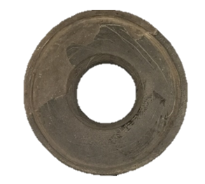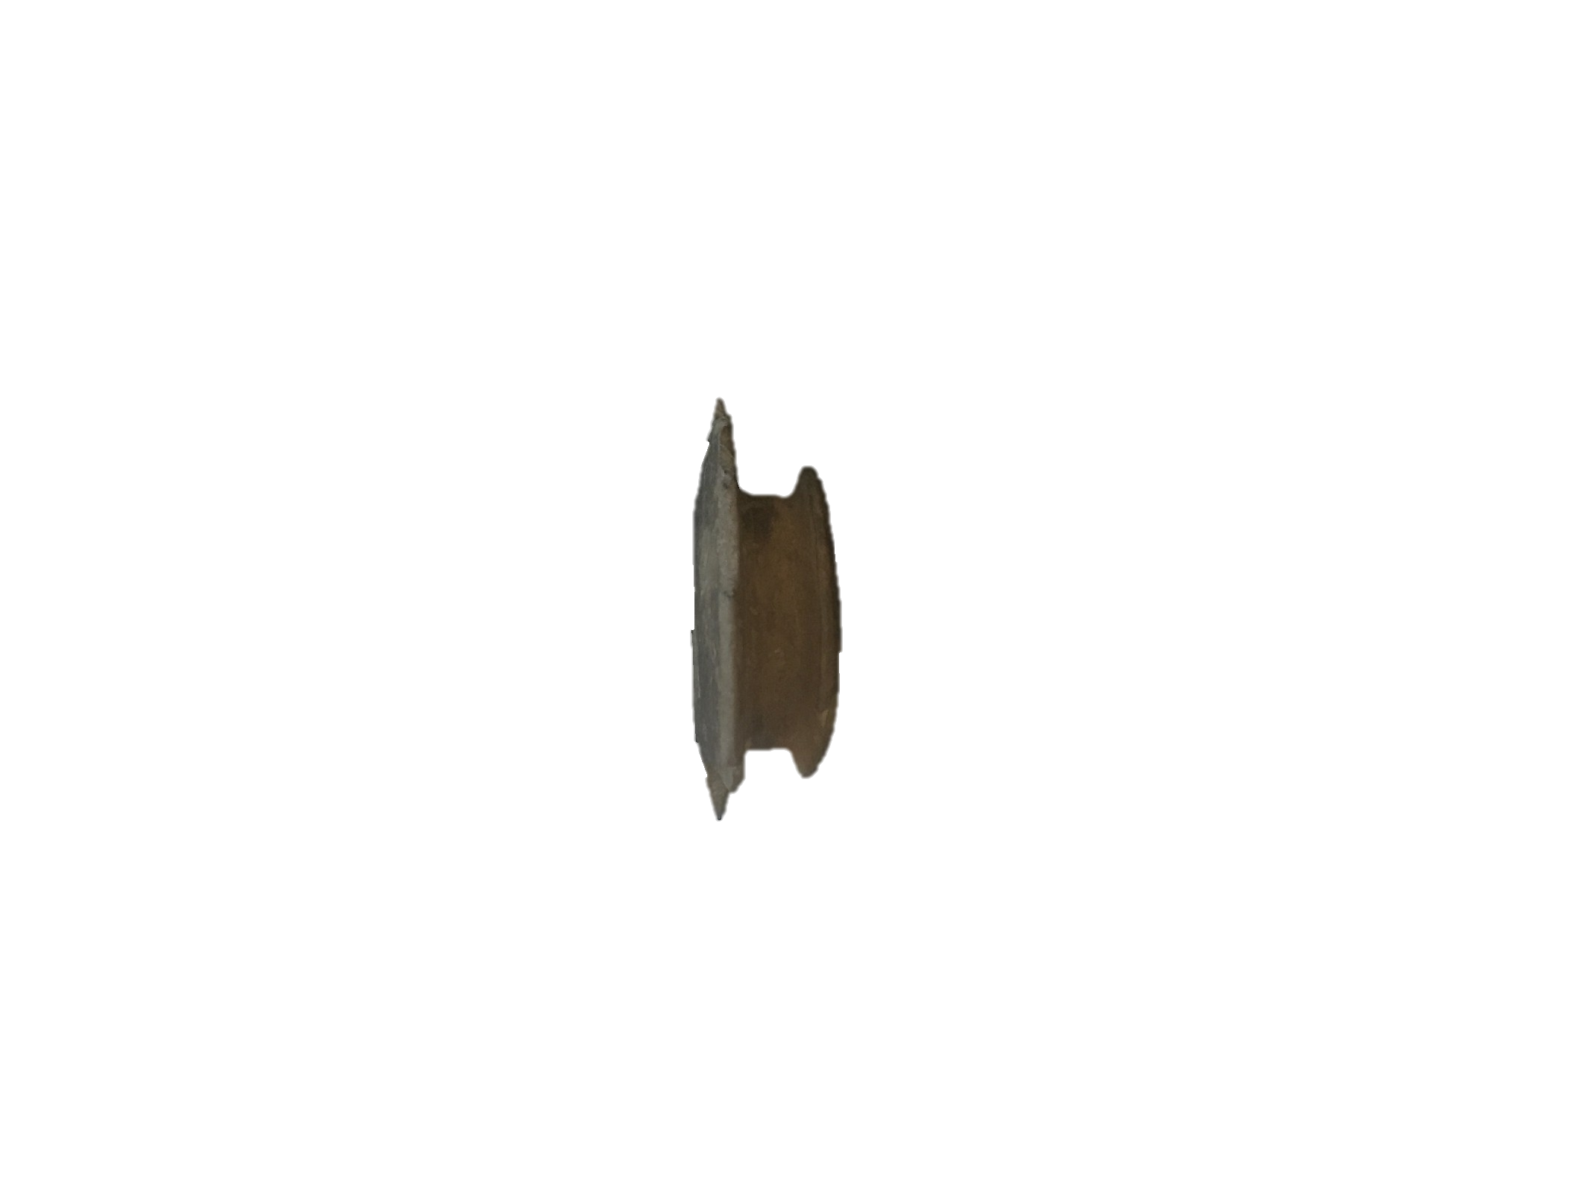

Figure 4.10: Recessed Type Earspool 34LF40/LfCrI1 B36-26 6339 (Courtesy of the Oklahoma History Center, photograph by the author).

- Central Boss (Figures 4.11, 4.12): pulley shaped with a raised conical structure in the center of the outer face, corresponds to Baerreis type D. (Baerreis 1957:30; Brown 1996:567).

Figure 4.11: Central Boss Type Earspool (TypeD) (adapted from Baerreis 1943, 1957).

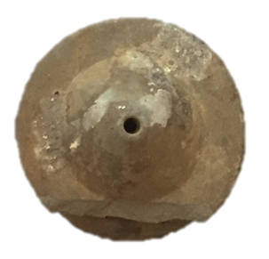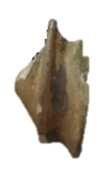

Figure 4.12: Central Boss Type Earspool 34Lf40/ LfCrI D-16 1296.1 (Courtesy of the Sam Noble Museum, photograph by the author).
- Pulley-Ring (Figures 4.13, 4.14): proportionately large perforation which forms a continuous curve from the inner to the outer face, corresponds to Baerreis type E. (Baerreis 1957:32; Brown 1996:569).

Figure 4.13: Pulley Ring Type Earspool (Type E) (adapted from Baerreis 1943, 1957).

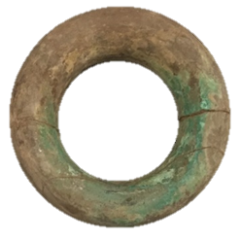

Figure 4.14: Pulley Ring Type Earspool 34DL0/218.XL (Courtesy of the Oklahoma History Center, photograph by the author).

- Foster (Figures 4.15, 4.16): slightly concave outer face with a split inner face forming two separate parts, corresponds to Baerreis type F. (Baerreis 1957:32; Brown 1996:569).

Figure 4.15: Foster Type Earspool (Type F) (adapted from Baerreis 1943, 1957).

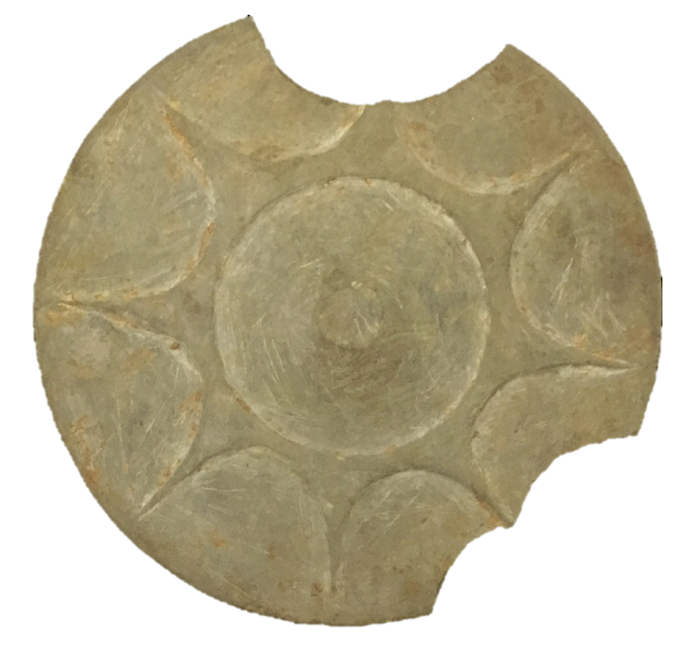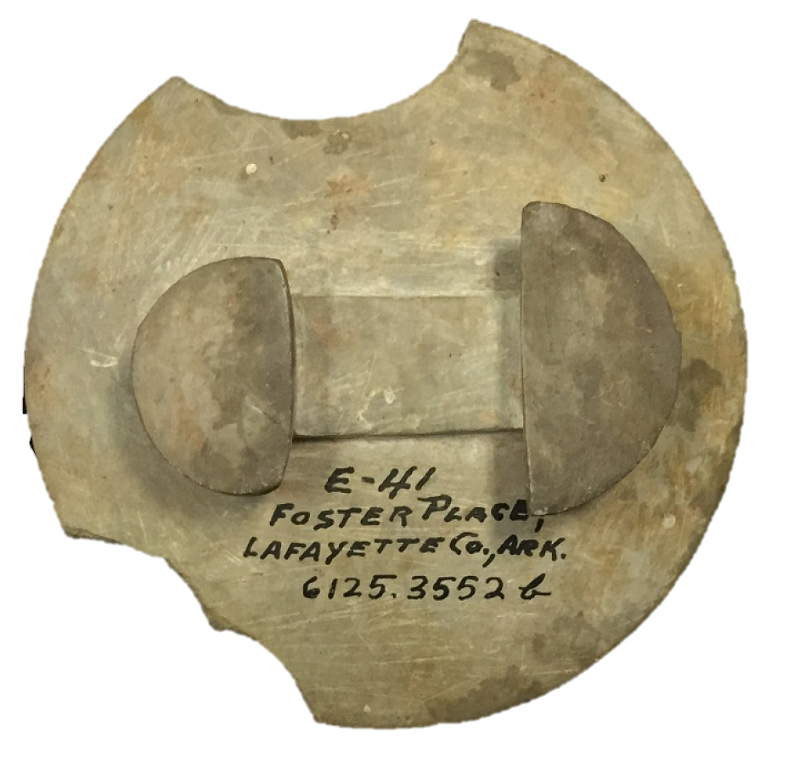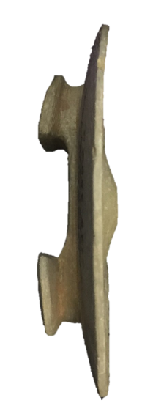

Figure 4.16: Foster Type Earspool 3LA27/6125.3552b (Courtesy of the Gilcrease Museum, photograph by the author).

- Channeled (Figures 4.17, 4.18): a concave groove surrounds a small peak in the center of the outer face, corresponds to Baerreis structural alternative features type A. (Baerreis 1957:28)

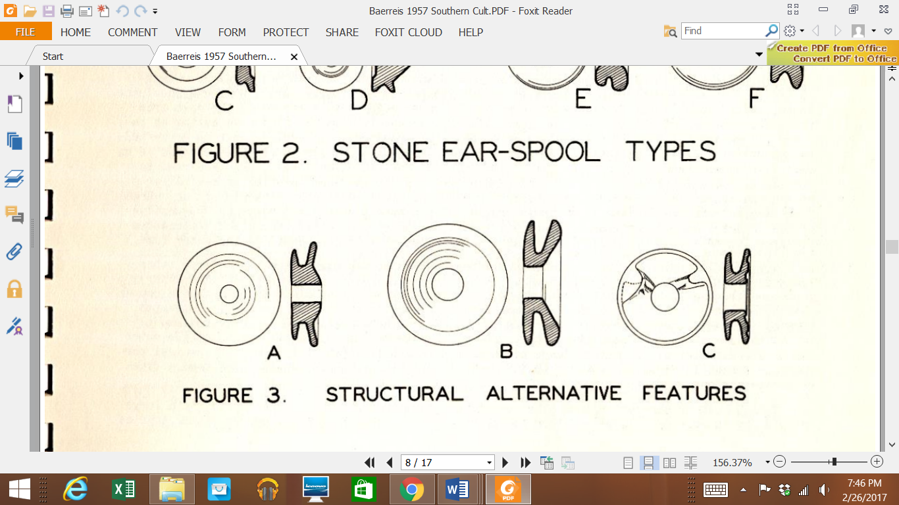
Figure 4.17: Channeled Type Earspool (Structural Alternative Feature A of Earspool Types) (adapted from Baerreis 1943, 1957).

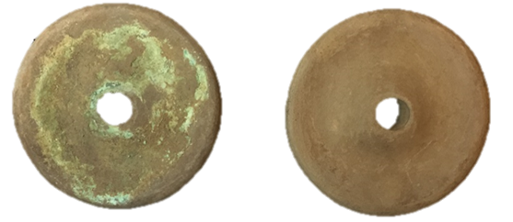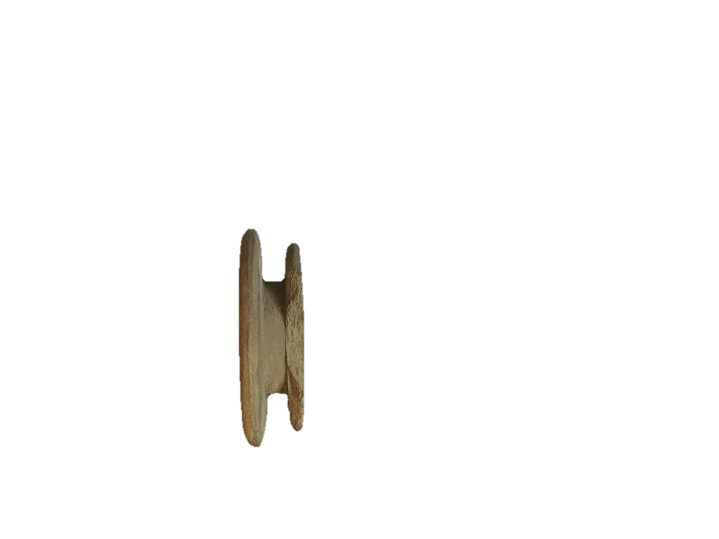

Figure 4.18: Channeled Type Earspool 34WG2/179 (Courtesy of the Sam Noble Museum, photograph by the author).

- Funnel (Figures 4.19, 4.20): a sloped depression extends into the perforation, corresponds to Baerreis structural alternative features type B. (Baerreis 1957:28)

Figure 4.19: Funnel Type Earspool (Structural Alternative Feature B of Earspool Types) (adapted from Baerreis 1943, 1957).

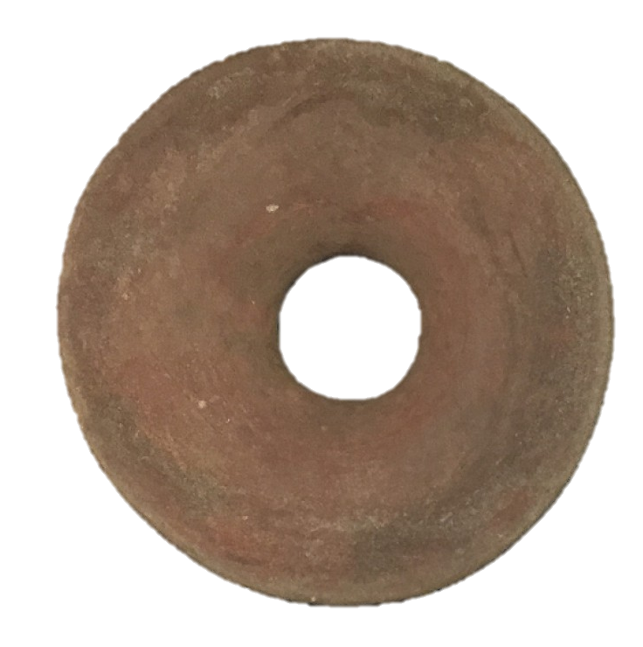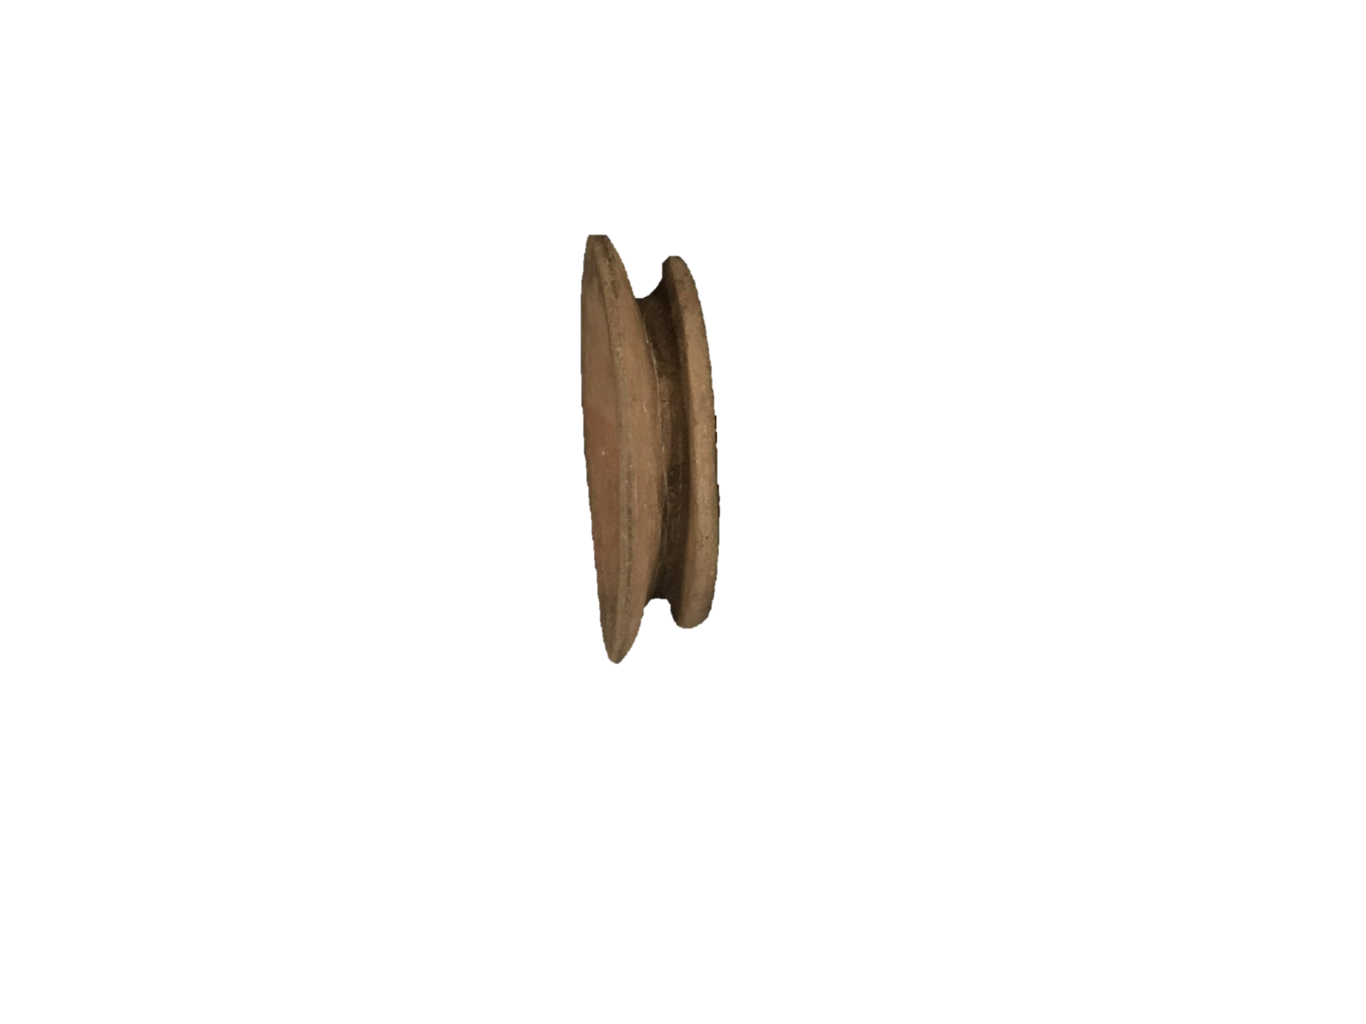

Figure 4.20: Funnel Type Earspool 34DL0/b (Courtesy of the Oklahoma History Center, photograph by the author).

- Nesting Halves (Figures 4.21, 4.22): two separate pieces that fit together at the core (Brown 1996:570).

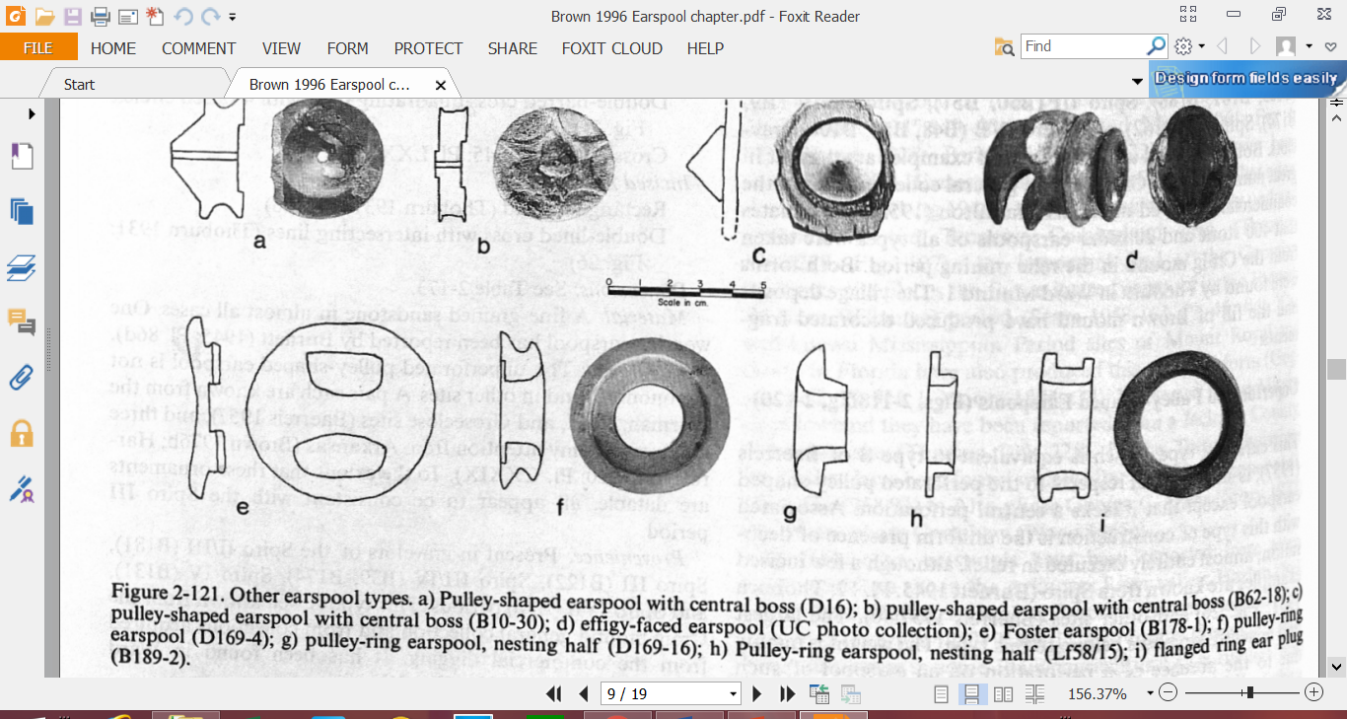

Figure 4.21: Nesting Halves Type Earspool (adapted from Brown 1996).

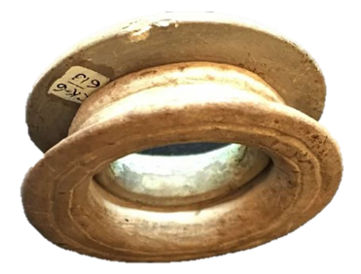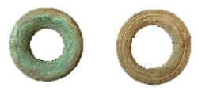

Figure 4.22: Nesting Halves Type Earspool 34CK6/5219.5 (Courtesy of the Sam Noble Museum, photograph by the author).

- Flanged Ring (Figures 4.23, 4.24): large perforation in proportion to the diameter forming a ring with shallow flanges (Brown 1996:570).

Figure 4.23: Flanged Ring Type Earspool (adapted from Brown 1996).

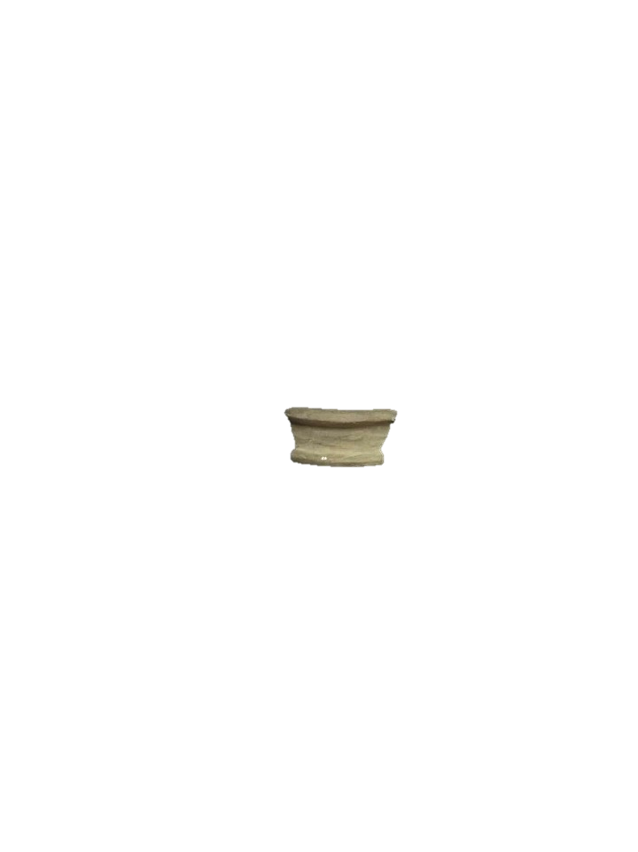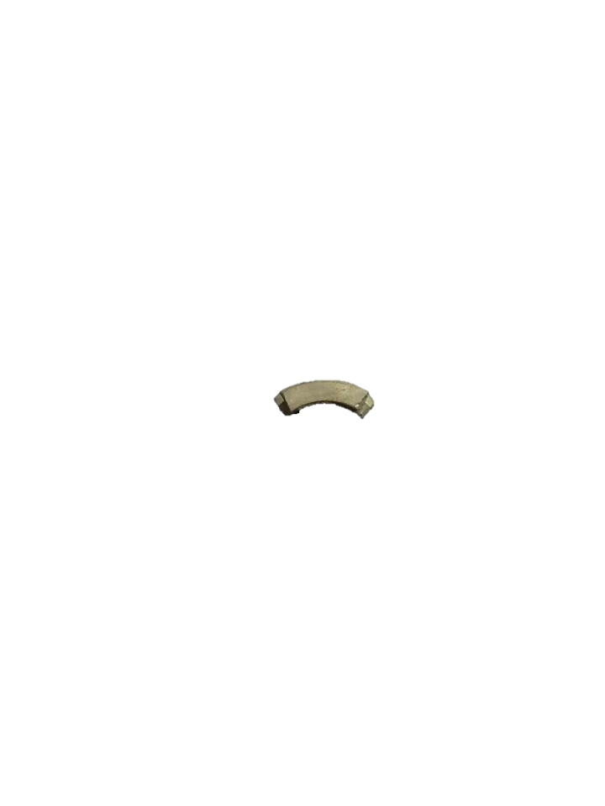

Figure 4.24: Flanged Ring Type Earspool 34Lf40/120.8 (Courtesy of the Sam Noble Museum, photograph by the author).

- Hollow Cylinders (Figures 4.25, 4.26): tube shaped with slight convex outer edge (Baerreis 1957:28; Brown 1996:564).


Figure 4.25: Hollow Cylinder Type Earspool (adapted from Brown 1996).

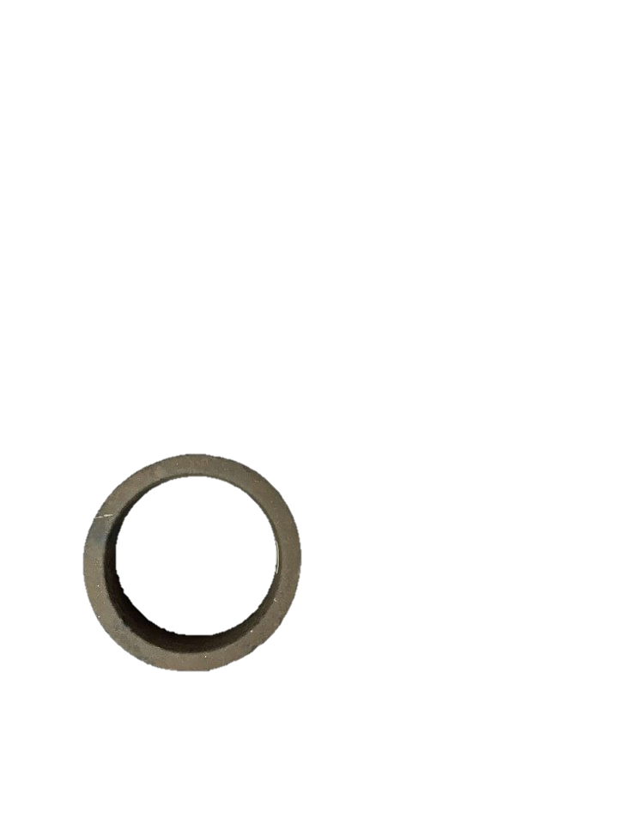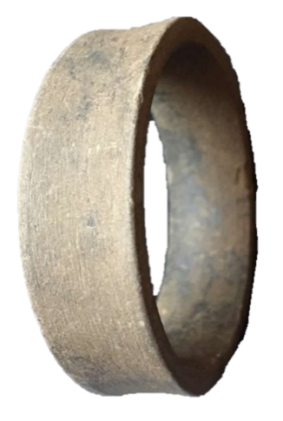
Figure 4.26: Hollow Cylinder Type Earspool 34CK6/373-1 (Courtesy of the Sam Noble Museum, photograph by the author).

- Grooved (Figures 4.27, 4.28): a shallow v shaped indention is carved into the exterior edge of a solid cylinder. (Brown 1996:570).

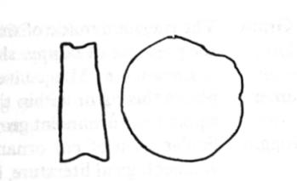

Figure 4.27: Grooved Cylinder Type Earspool (adapted from Brown 1996).

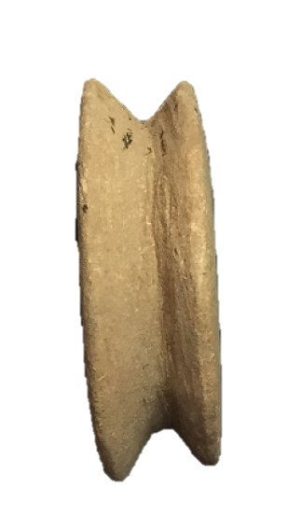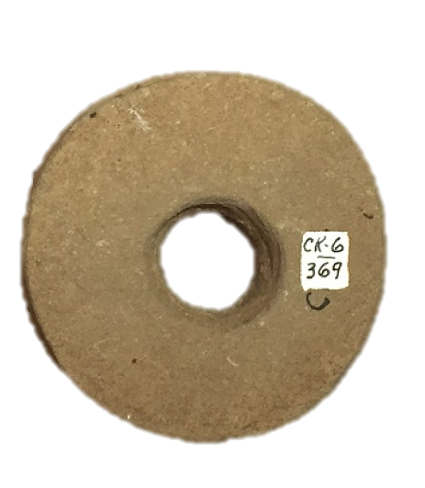

Figure 4.28: Grooved Cylinder Type Earspool 34CK6/369 (Courtesy of the Sam Noble Museum, photograph by the author).

- Composite Ear Discs (Figures 4.29, 4.30): comprised of multiple materials such as stone, shell, wood, or copper. Exterior ring typically of shell surrounding a center portion of wood or stone that may be covered in copper. (Brown 1996:572).


Figure 4.29: Composite Type Earspool (adapted from Brown 1996).

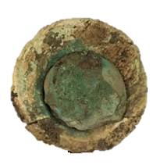

Figure 4.30: Composite Type Earspool 34Lf40/6329.3 (Courtesy of the Oklahoma History Center, photograph by the author).

- Small Inner Nub/Trimmed Flange (Figures 4.31, 4.32): significantly smaller inner flange. (Brown 1996:562).
(Trimmed inner refers to earspools with rough modifications to the inner flange presumably to reduce the size, while small inner nub refers to what appears to be a deliberate structural detail.)

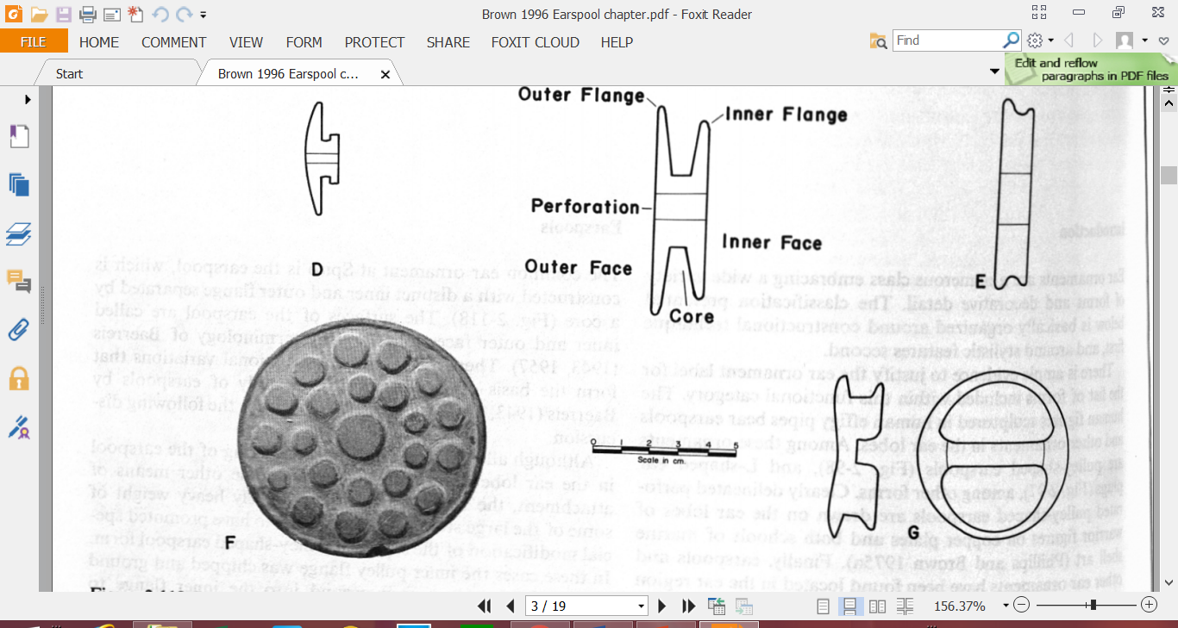

Figure 4.31: Small Inner Nub/Trimmed Flange Type Earspool (adapted from Baerreis 1943, 1957).

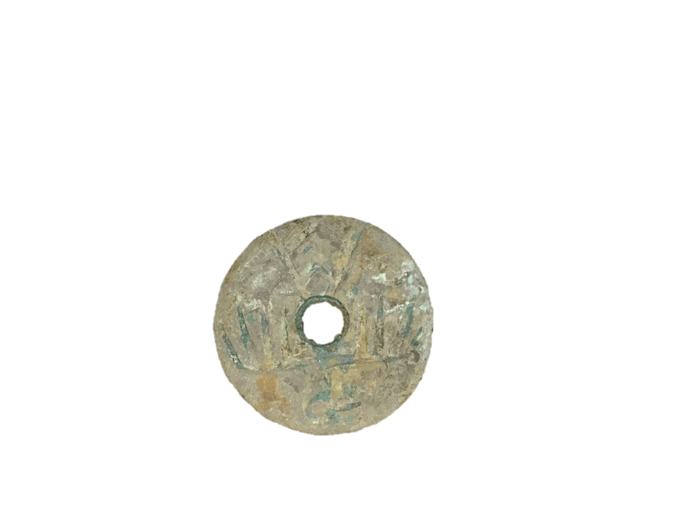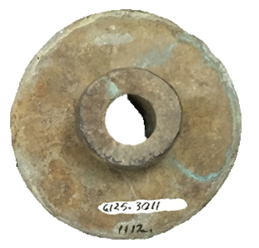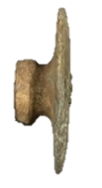

Figure 4.32: Small Inner Nub/Trimmed Flange Type Earspool 34Lf40/6125.3011 1112 (Courtesy of the Gilcrease Museum, photograph by the author).

- Plug (Figures 4.33, 4.34): ends are convex with one end broader and flatter than the other, also described as knobbed ear plug (Brown 1996:570).

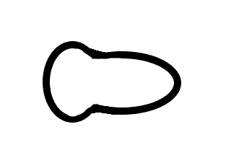

Figure 4.33: Plug Type Ear Ornament.

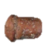

Figure 4.34: Plug Type Ear Ornament 34DL0/18 (Courtesy of the Sam Noble Museum, photograph by the author).

Design Motifs
Many earspool types exhibit design motifs that are incised or excised on what is presumably the outer face. These designs include a variety of motifs ranging from geometric patterns to abstract representations. There are 109 earspools in this study with one of 43 different motifs. The decorative motifs include variations of lined crosses (Figure 4.35, A, F, K), multi-point stars (Figure 4.35, H; Figure 4.34, C), concentric circles (Figure 4.35, J, O), nodes (Figure 4.36, I, J), vortexes (Figure 4.35, B; Figure 4.36, D), human figures (Figure 4.35, E), and combinations of each (Baerreis 1943, 1957:33, Brown 1996:566, 567). Using the presence of design motifs as possible temporal indicators will be discussed below.

Conclusion
This chapter presented the methodology for the earspool analyze. Differences in types and attributes may provide insight into temporal and geographic variations. Similarities between the earspools may indicate a shared tradition between regions, while differences may reflect individual identities. The following chapter will discuss the analysis of the earspools. Differences and similarities between sites are then presented.
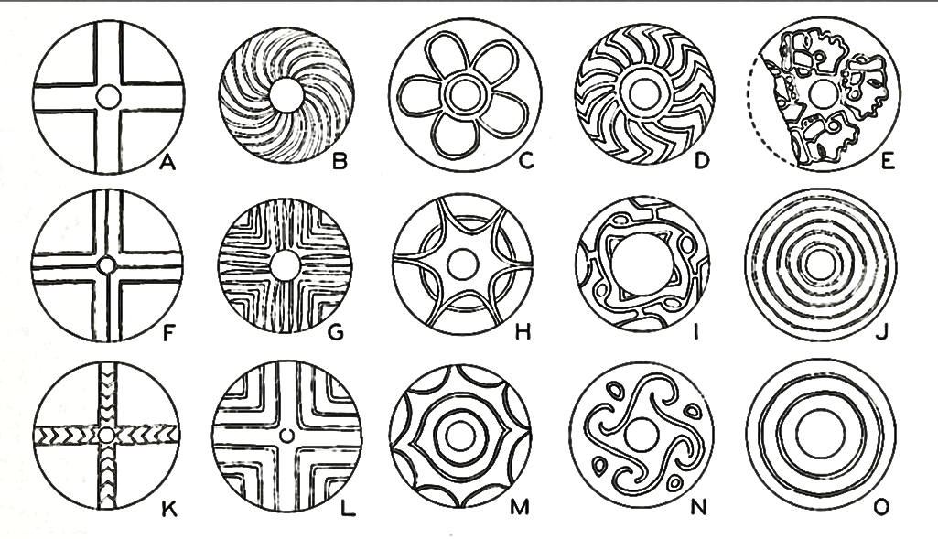
Figure 4.35: Decorative Motifs of Earspools (adapted from Baerreis 1943, 1957).

Table 4.2: Alternative Decorative Motifs (adapted from Baerreis 1943, 1957).
A | Two Line Cross
B | Spiral Lines
C | Five Lobed “flower” or Petaloid
D | Check Spiral
E | Human Heads
F | Three Line Cross
G | Multiline Line Cross
H | Six-Pointed Star and Circle
I | Running Scroll
J | Five Concentric Circle
K | Two Line Cross with Chevrons
L | Multiple Line Cross
M | Six Point Star and Eye
N | Interlocking Scroll
O | Two Concentric Circles

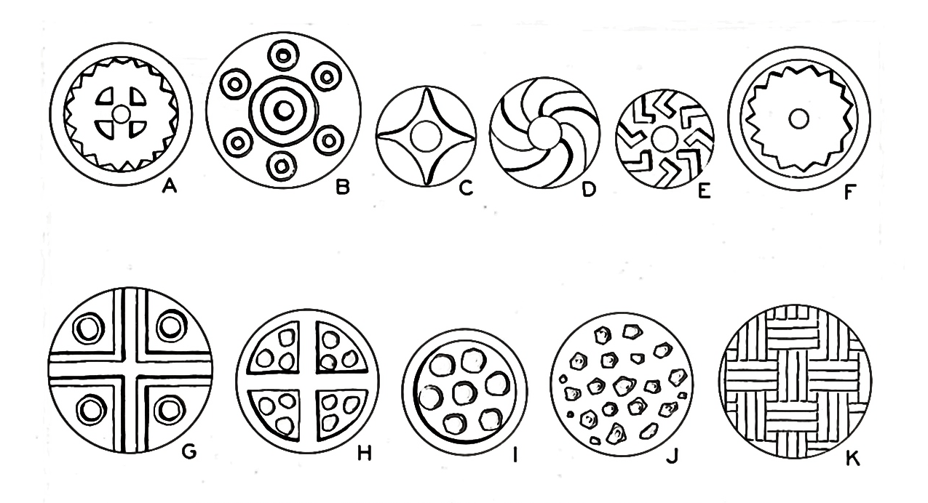
Figure 4.36: Additional Decorative Motifs of Earspools (adapted from Baerreis 1943, 1957).

Table 4.3: Additional Alternative Decorative Features.
A | Multi Pointed Star and Cross
B | Series Concentric Circles
C | Four-Pointed Star
D | Spiral
E | Chevron
F | Multi Pointed Star
G | Cross and Circles
H | Nodes and Cross
I | Nodes in Two Circles
J | Truncated Nodes (17 in 3 circles)
K | Twill Plaiting Weave

Chapter 5: Descriptions of Earspools

This chapter presents a discussion of the collected data of 331 earspools from twenty-two sites across the Arkansas and Red River Valley regions. This chapter will focus on describing these data, especially as aspects of material type, size, and decorative motif vary by site, region, and time period. In the following chapter, the observations noted in this chapter will be built upon to address the three main research questions of this thesis.

Types of Earspools
Using the types originally defined by Baerreis (1943) and Brown (1996), there are fourteen different types of earspools represented in the sample (Figure 5.1). These types include the Pulley, Recessed, Central Boss, Pulley-Ring, Foster, Channeled, Funnel, Nesting Halves, Flanged Ring, Hollow Cylinder, Grooved, Composite, and Small Inner Nub. By identifying the various types of earspools in the collection, this research then examines variability within types to determine if these variations have regional significance, changed over time, and indicate individual preference.
Pulley earspools are the most common type in the sample, with the remaining earspool types representing less than 10% of the sample. The Composite, Nesting Half, and Foster types have a slightly larger presence in the collection. The remaining types constitute 1% or less of the sample. Not only is there a large number of earspool types within the sample, but there is a significant number of certain types that occur more frequently than others. Examining the percentage of earspool types in the sample reveals preferences of certain types over others. These preferences may then be examined to determine if they are regionally or site specific.
Table 5.1: Types and Percentages of Earspools in the Assemblage.
Earspool Types | n | %
Pulley | 237 | 72%
Composite | 21 | 6%
Nested Half | 14 | 4%
Foster | 13 | 4%
Recessed | 8 | 3%
Grooved | 6 | 2%
Small Inner Nub | 6 | 2%
Funnel Faced | 6 | 2%
Flanged Ring | 4 | 1%
Pulley Ring | 4 | 1%
Central Boss | 2 | 1%
Plug | 2 | 1%
Hollow Cylinder | 2 | 1%
Channeled | 2 | 1%
Unknown* | 4 | 1%
Total | 331 | 100%
*4 wooden fragments of unknown type

Figure 5.1: Distribution of earspool types within sample.

Stylistic Attributes of Earspools
Considerable stylistic variation is present in the attributes of the earspool types. The differences may be examined to determine the presence of patterns over time, between regions, and between individual earspools of similar types. Attributes addressed in this research include material type, size or diameter of the earspool, and decorative features.

Material Type
Through the examination of material types, patterns may suggest regional preferences for certain materials, changes in the use of certain materials over time, or preferences for specific materials for making specific types of earspools. The earspools in the assemblage are made from a variety of materials such as stone, ceramic, wood, or a combination of stone, wood, shell, or copper (which defines the Composite type) (Table 5.2). These materials are not used in every type of earspool or found at each of the sites included in this research (Figure 5.2), nor are they present in each of the phases discussed.
Table 5.2: Earspool Material Types.
Material Type | n | %
Sandstone | 274 | 82.87
Stone/Shell/Wood/Copper | 21 | 6.12
Limestone | 19 | 5.81
Wood | 11 | 3.36
Bauxite | 2 | 0.61
Ceramic | 2 | 0.61
Slate/Shale | 2 | 0.60
Total | 331 | 100.00
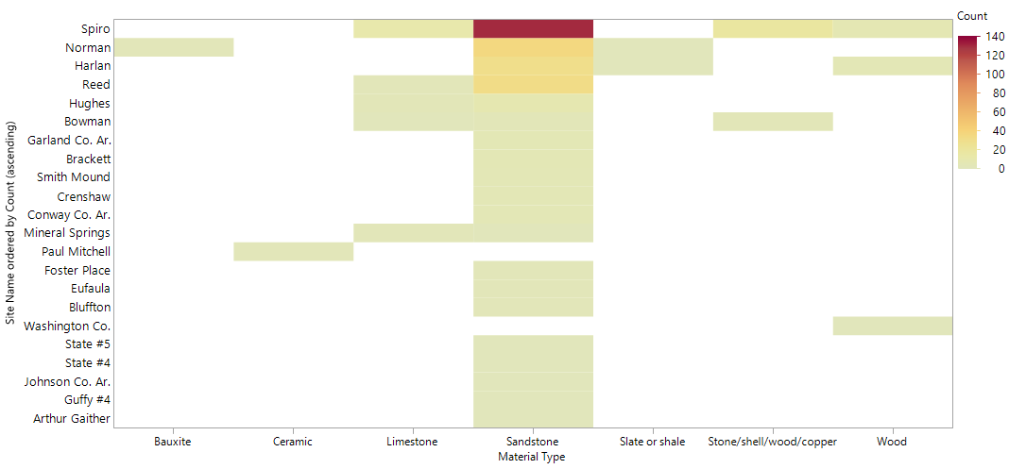
Figure 5.2: Distribution of earspool material types by site.
Stone. Several different types of stone are present in the sample including sandstone, limestone, bauxite, and slate or shale. The majority of the earspools are made of a gray sandstone, totaling 84% of the sample. The other types of stone appear in more limited numbers. A single earspool made of bluish slate or shale was excavated from the Harlan site. Only one pair of earspools in the sample is made from bauxite and were recovered from the Norman site. Limestone earspools are relatively rare but appeared at multiple sites in both the Arkansas and Red River Valleys. The soft limestone was not a locally available material in the greater Spiro area, but can be found in the Red River region (Brown 1976a:278). Earspools made of stone were collected from each site except the Paul Mitchell site, which only had two earspools that were made of ceramic. The prevalence of sandstone earspools suggests a regional preference for this material type. It is likely due to its regional availability and ease of workability. Stone earspools appeared during all cultural phases discussed in this research.
Stone/Shell/Wood/Copper. Earspools containing elements of stone, shell, wood, and copper are defined as Composite. Those artifacts lacking one or more component, but with characteristics indicating a probability of originally containing a combination of each, are grouped together in this material type. The outer rings of the Composite earspools are commonly made of shell with an interior core covered with copper. The core of some of the earspools is made of stone while others are made of wood. There are only twenty-one Composite earspools in the sample and they were recovered from just two sites. Nineteen were collected from the Spiro site, and two from the Bowman site. These earspools date from the Spiro II, III, and IV phases.
Wood. A small number of the earspools were constructed of wood, possibly cedar (Hamilton 1952). Given the dense forests located in the region (Bell 1984:19, 22), one might expect more wooden earspools, but their rarity may be the result of poor preservation (Brown 1996:563).
Thirteen wooden earspools were available for this analysis, six from Spiro (Brown 1996:274), four from Harlan (Bell 1972:243), and two from Smith Mound. All of the wooden earspools from Spiro are Pulley type. The poor condition of the earspools from Harlan prohibits a definitive type assignment. The Smith Mound site is the only site with Foster type wooden earspools.
Two pairs of wooden ear ornaments from the Spiro site, not available for this study, but worth mentioning, are carved into the shape of raptor like bird head and the head of a dog (Brown 1996:569). The elaborate nature of these ear ornaments, and others included in this analysis, suggests that wood earspools could have been fairly prevalent and often ornate.
The wooden earspools were recovered from burials dating from Spiro II through Spiro IV, indicating the use of wood for earspools over an extended period of time. Four earspools date from the Spiro II period, one pair from the Spiro site and the other from the Harlan site. Harlan is the only site with wooden earspools from the Spiro III period. Only two earspools date from the Spiro IV period and both were found at the Spiro site.
Ceramic. Only one pair of ceramic earspools is present in the sample, and both were recovered from the Paul Mitchell site (41BW4) located on the Red River. The earspools were recovered from burial M2 which dates from AD 1200–1400, and corresponds to the Norman Phase (Pertulla 2014:82). These pieces provide the only evidence in the sample of the use of this type of material for the construction of earspools. These ceramic artifacts are crudely made in contrast to some of the earspools made of stone or wood, which display masterful execution in their detail and symmetrical construction. These ceramic earspools suggest the possible absence of controlled manufacture through their lack of uniformity with other earspools. They also suggest the efforts of individuals to possess and display personal ornamentation constructed with the materials and skills available to them.
Summary. The vast majority of the earspools are constructed of sandstone, which is most likely the result of the availability and workability of this material (Brown 1996:563). The remaining materials make up only a small percentage of the collection. The small sample size of wooden earspools may be a preservation issue, since wood is prevalent throughout the region. The use of multiple types of materials in the construction of earspools reflects the local availability of certain materials in addition to indicating which artifacts were made from non-local materials. Earspools made from non-local material were either made from imported materials or brought into the community through trade or accompanying individuals from outside the region. The limited number of material types other than sandstone do not provide significant evidence for exclusive use regionally or a shift in use temporally.

Earspool Diameter
When examining earspools, one of the most obvious differences between artifacts is their size, or diameter. The overall size is determined by measuring the diameter of the exterior surface. Some of the earspools have a uniformity in the size of the interior and exterior surfaces, while other earspools exhibit a drastic difference between the two faces. Thickness and weight can also be factors in defining the size of an earspool, but for the purposes of this analysis, size refers to the diameter of the exterior face. Earspool diameter ranges from 24.9 mm to 97.8 mm. This variation in size may be significant in multiple capacities such as reflection of type, regional preference, change through time, or personal preference.
Figure 5.3 compares the diameter of the exterior face of different types of earspools. Aside from the Pulley type, the diameter of the earspools may to relate to certain types. The Pulley type has the largest range of diameters, while the Composite, Foster, and Nested Half tend to fall into specific diameter ranges.
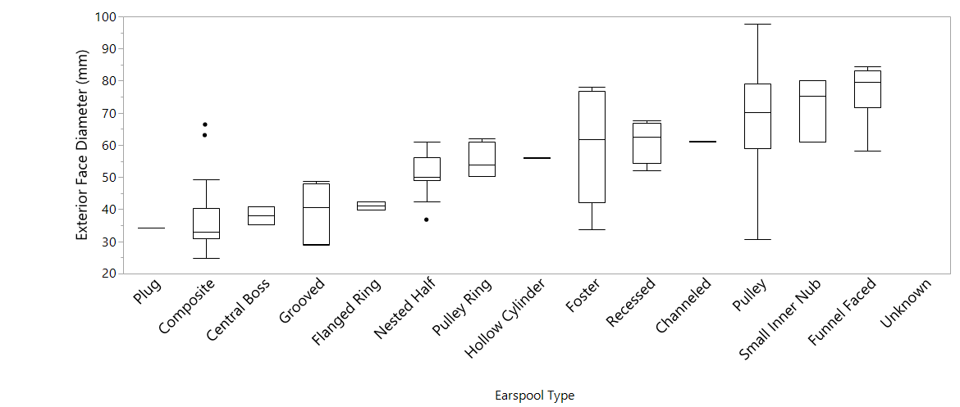
Figure 5.3: Box and whicker plots of the earspools by earspool type showing the variation in exterior face diameter.

The diameter of the outer faces of the earspools in the sample also varies between the sites. Figure 5.4 compares the diameter of the earspools from each site. Some of the sites have a relatively even distribution of diameter sizes, while several have more skewed distribution toward smaller diameters. The exception is Brackett, whose distribution is skewed toward larger diameters, which is most likely the result of the sample size of only five earspools. The medians also vary between the sites, and the spread of the exterior face diameters is very large in several of the collections. The Norman site has the most even distribution and smallest spread considering the larger sample size, which may have chronological implications. The ranges also vary considerably and may also be the result of a chronological effect. The low quantity of earspools in several of the collections hinders further statistical comparisons.
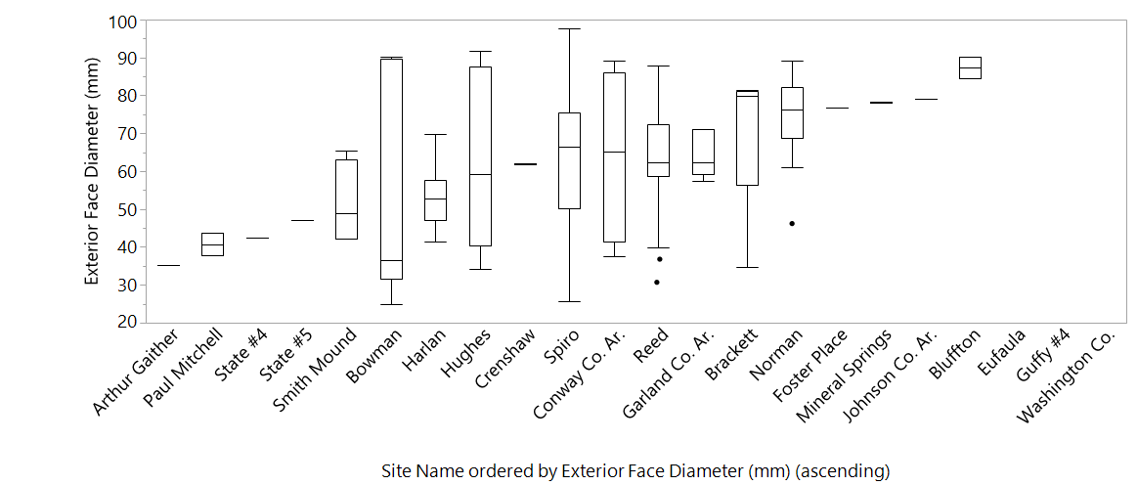
Figure 5.4: Box and whicker plots of the earspools by site showing the variation in exterior face diameter.

When only the Pulley type earspools are compared, any change in distribution between sites is negligible (Figure 5.5). The distribution is relatively normal with the median slightly skewed to the upper end of the range when only Pulley type earspools are examined from the Harlan site. The median of the Hughes site assemblage also shifts to the upper end of the range when only pulley type earspools are examined, suggesting that Pulley type earspools have a larger exterior face diameter at the Harlan and Hughes sites. The distribution of only Pulley type earspools for the remaining site assemblages remains relatively unchanged. The Norman assemblage has the smallest degree of variability of the exterior earspool face diameter, in addition to one of the largest diameters.
Figure 5.5: Box and whisker plots of Pulley earspools by site showing the variation in exterior face diameter.

One hundred and twenty-four earspools in the sample analyzed are assigned to specific burial phases (Figure 5.6). Of these earspools, the vast majority date to the Spiro III period and are from the Spiro (n=19), Harlan (n=14), Reed (n=34), and Norman (n=29) sites. Nineteen earspools date to the Spiro II period and are from the Spiro (n=9), Bracket (n=5), Harlan (n=3), and Norman (n=2) sites. Only nine earspools are assigned to the remaining Grave Periods, and all were recovered from the Spiro site. There are 5 earspools from the Spiro III/IV period, 3 from the Spiro IV period, and one from the IVB period. The limited number of artifacts from the later periods hinders significant statistical comparisons.
N= 19 96 5 3 1
Figure 5.6: Box and whicker plots of the earspools by Grave Period showing the variation in exterior face diameter.

The size of specific earspools such as plugs may indicate the age of an individual or their level of status within society. The earspools with the smallest exterior diameters include earplugs. These pieces may have been used by subadults or individuals who were beginning the process of expanding the earlobe to accommodate larger earspools. The physical characteristics of the body will dictate the size of certain items used as adornment. Smaller individuals such as children would require ornaments to be proportional to their size. In the case of earspools, the diameter would need to be small enough to accommodate the earlobes. Time would be required to allow for the earlobes to expand in order for the earspools to be inserted (Joyce 2000). The presence of these types of personal ornamentation accompanying individuals of various ages would also suggest the importance of younger members of the community wearing earspools. These subadults potentially belonged to the same groups as the adult members of the community who also wore earspools. Studies conducted at sites outside this research area, offer evidence of the relationship between earspool size and age. In their work on Hiwassee Island, Lewis and Kneberg (1946:130), discussed the presence of small ear ornaments associated with subadults. None of the earspools recovered from burials described as youth or subadult were available for analysis. The two earspools included in this research lack information regarding the age of the individual that they accompanied. Further research is needed to explore this concept.
Summary. The size or diameter of the exterior face of the earspools varies throughout the sample. The differences in the sizes may be due to multiple factors such expanding the earlobe or changes over time. The earspools from the Norman site are fairly uniform in diameter compared to the other sites. There is a slight increase in the diameter sizes of the earspools from the Spiro II and Spiro III Grave Periods. Evidence of size as a signifier of age is inconclusive. The vast array of sizes may be the result of individual preference or a shift in uniform diameters over time.
Several different earspool features are defined as decorative elements and provide analytical information for interpreting geographic and temporal distribution, as well as an expression of individual identity. The elements addressed in this research include perforations, motifs, and copper coverings.

Perforation
A large percentage of the earspools in the sample have a perforation which is a circular hole drilled through the center of the core of an earspool. Perforations may be a characteristic of the earspool type or an additional decorative feature. The presence of perforations may also have chronological significance. Of the earspools analyzed, 269 have some version of a perforation, while 62 lack a perforation (Figure 5.7).

Figure 5.7: Total number of earspool with perforations present or absent.
The ratio of present to absent perforations extends to the collections from each site (Table 5.8). The majority of the earspools from each site have a perforation, and all of the earspools from the Harlan (n=35), Brackett (n=5), Crenshaw (n=4), Conway Co. (n=4), Eufaula (n=2), Paul Mitchel (n=2), Bluffton (n=2), Johnson Co. (n=1), and sites have perforations. The limited number of earspools from several of the sites may contribute to the absence of perforated earspools, and should be considered. The sites where perforations are present include sites in both the northern and southern Caddo regions, suggesting that there is not a regional preference for perforations.

Table 5.3: Percentage of Perforation Presence by Site.
Site | N |  | Y |  | Total
 | n | % | n | % | n
Arthur Gaither | 1 | 100% | 0 | 0% | 1
Bluffton | 0 | 0% | 2 | 100% | 2
Bowman | 4 | 57% | 3 | 43% | 7
Brackett | 0 | 0% | 5 | 100% | 5
Conway Co. Ar. | 2 | 50% | 2 | 50% | 4
Crenshaw | 0 | 0% | 4 | 100% | 4
Eufaula | 0 | 0% | 1 | 100% | 1
Foster Place | 2 | 100% | 0 | 0% | 2
Garland Co. Ar. | 0 | 0% | 5 | 100% | 5
Guffy #4 | 0 | 0% | 1 | 100% | 1
Harlan | 0 | 0% | 35 | 100% | 35
Hughes | 1 | 9% | 10 | 91% | 11
Johnson Co. Ar. | 0 | 0% | 1 | 100% | 1
Mineral Springs | 3 | 100% | 0 | 0% | 3
Norman | 2 | 5% | 37 | 95% | 39
Paul Mitchell | 0 | 0% | 2 | 100% | 2
Reed | 4 | 12% | 30 | 88% | 34
Smith Mound | 4 | 100% | 0 | 0% | 4
Spiro | 38 | 23% | 127 | 77% | 166
State #4 | 0 | 0% | 1 | 100% | 1
State #5 | 1 | 100% | 0 | 0% | 1
Washington Co. | 0 | 0% | 1 | 100% | 1

Earspools with perforations appear in each of the Spiro Grave Periods, with a significant increase in the number of earspools with perforations from the Spiro II period to the Spiro III period. The absence of earspools with no perforations in the Spiro III/IV, IV, and IVB periods may be due to the sample size.

Table 5.4: Perforation Presence by Period.
Count  Row % | N |  | Y |  | Total
 | n | % | n | % | n
Spiro II | 4 | 21% | 15 | 79% | 19
Spiro III | 19 | 20% | 77 | 80% | 96
Spiro III/IV | 0 | 0% | 5 | 100% | 5
Spiro IV | 1 | 33% | 2 | 67% | 3
Spiro IVB | 0 | 0% | 1 | 100% | 1
Unassigned | 37 | 18% | 168 | 82% | 205

Copper
Copper is an exotic, non-local material thought to indicate a level of prestige or elite status (Brown 1990:260), since its rarity made it highly valued. There are no earspools in the sample made entirely of copper. Evidence of copper is present on many of the earspools in the sample, some of which retain a copper patina or remnants of the metal that still adhere to the artifact. Some of the earspools have a covering over the exterior face, while the Composite earspools have copper covering only the center core. The two solid copper artifacts included in the sample are most likely examples of these coverings.
Each type of earspool represented in the sample shows evidence of copper covering except Hollow Cylinder (n=2) and Pulley Ring (n=4). The absence of copper on these earspool types may be the result of the small sample size. The frequent use of copper on every other type of earspool suggests an affinity for copper regardless of earspool type. The largest concentration of copper occurs on the Pulley type earspools, which may be due to the large sample size, since the Pulley type dominates the sample (Figure 5.8).
Copper appears on earspools with and without decorative motifs. Remnants of the material suggest that copper covered the exterior faces of earspools with designs. The deteriorated condition of most of the copper that remains on the earspools inhibits the ability in most cases to determine if a design motif was present on the copper covering.
Copper on several of the earspools maintains remnants or impressions of organic material. Remains of woven pieces, possibly basketry or matting, suggest that the earspools were originally placed in the burial adjacent to or contained within woven artifacts. Horton and Sabo (2011) discussed the different unique woven designs on baskets recovered from the Great Mortuary in the Craig Mound at Spiro. The baskets contained a variety of ceremonial objects and regalia including woven fabric, ceremonial headdresses, hair ornaments, shell beads, and earspools. The earspools with distinct designs, with little duplication and not found in a burial context, including one example with a basketry motif from Reed, may correspond to these unique baskets, and may have been part of a grouping of ritual regalia.
Figure 5.8: Types of earspools possessing copper.
Copper covered earspools are present in the assemblages from each site which is evident by either remnants of the material still adhered to the earspool, or verdigris staining where copper was once in contact with the earspool (Figure 5.9). The Spiro and Harlan sites have the largest percentages of copper present. The absence of copper covered earspools from several of the sites may be the result of sample size. The site report for Eufaula (34MI45), indicated the presence of nine earspools with copper coverings (Orr 1940), but only two of these artifacts (6125.3979a&b) housed at the Gilcrease, were available for analysis. Both have evidence of copper.
The earspools which have been assigned to a Spiro Grave Period show a prevalence of copper use (Table 5.5). Only one datable earspool lacks evidence of copper embellishment, and dates to the Spiro II period.
Table 5.5: Total Number of Earspools with Evidence of Copper.
Site | N |  | Y |  | Evidence of Copper
 | n | % | n | % | n
Bluffton | 0 | 0% | 2 | 100% | 2
Bowman | 5 | 71% | 2 | 29% | 7
Brackett | 3 | 60% | 2 | 40% | 5
Conway Co. Ar. | 2 | 50% | 2 | 50% | 4
Crenshaw | 1 | 25% | 3 | 75% | 4
Eufaula | 0 | 0% | 2 | 100% | 2
Garland Co. | 3 | 60% | 2 | 40% | 5
Harlan | 13 | 37% | 22 | 63% | 35
Hughes | 4 | 36% | 7 | 64% | 11
Johnson Co. | 0 | 0% | 1 | 100% | 1
Mineral Springs | 1 | 33% | 2 | 67% | 3
Norman | 24 | 62% | 15 | 38% | 39
Reed | 16 | 47% | 18 | 53% | 34
Smith Mound | 1 | 25% | 3 | 75% | 4
Spiro | 82 | 49% | 84 | 51% | 166
Total | 155 | 48% | 168 | 52% | 323

Figure 5.9: Presence of copper by site.
Table 5.6: Presence of Copper by Period.
Count  Row % | N | Y | Total
Spiro II | 6% | 94% | 18
Spiro III |  | 100% | 67
Spiro III/IV |  | 100% | 2
Spiro IV |  | 100% | 3
Spiro IVB |  |  | 0

Decorative Motifs
The decorative motifs present on the earspools include a variety of patterns and images such as geometric shapes, raised elements, and engraved designs. As presented in chapter 3, there are 109 earspools in the sample that have one of 43 different motifs (Table 5.7). Baerreis (1957) identified different decorative motifs which include lined crosses, multi-point stars, concentric circles, nodes, vortexes, human figures, and combinations of each. Certain patterns appear on multiple earspools, while examples of other motifs are only present on one pair. The different motifs suggest a deliberate effort to communicate information about the role of an individual within the community, membership in a group, or an expression of individuality.
The most common motifs are the two-lined cross, two and three concentric circles, five-pointed star with repeating lines, nine nodes, and the vortex pattern. The two-lined cross is present in the collections from Brackett, Norman, and Spiro. The concentric circle pattern with two circles is found in the Harlan, Norman, and Spiro collections, while the three concentric circles were found at Spiro and sites along the Ouachita and Red Rivers. The vortex pattern is present in the Hughes and Spiro collections.
Some sites have more of a variety of motifs on their earspools, while others have a limited number of motifs or none at all. Figure 5.10 illustrates the distribution by site of earspools that have a design element. The lack of earspools with motif in the smaller site collections may be the result of a sampling bias. The largest collection (n=167), which is from the Spiro site, contains the most earspools with designs (n=77), and the greatest variety of motifs (n=36). The collections from the Harlan (n=35), Reed (n=34), and Norman (n=39) sites are comparable in size but vary in the number of earspools with motifs and the types of designs present. Only one earspool from Harlan has a design element. Two pairs of earspools from the Reed site have two different types of motifs. The Norman site has the largest collection of designs next to the Spiro site; there are 13 earspools which exhibit 7 different design motifs.

Table 5.7: Types of motif designs and number of earspools possessing each motif. See Figures 4.35 and 4.36 for images.
Motif Design | N
Check | 1
Chevron | 1
Con Circles 1 | 3
Con Circles 2 | 8
Con Circles 2 Vortex | 1
Con Circles 3 | 11
Con Circles 4 | 3
Con Circles 5 | 3
Con Circles 7 | 1
Con Circles Vortex | 1
Cross 2 Line | 14
Cross 2 Line on Circle | 1
Cross 2 Line w/4 Quad Circles | 2
Cross 2 Line w/Chevron | 1
Cross 3 Lines | 2
Cross 3 Lines Circles | 1
Cross 3 Lines Quad Con Circles | 1
Cross Multi-Lined | 2
Cross Quad 3 Nodes | 1
Cross Recessed Circles | 1
Grid | 1
Human Heads | 1
Interlocking Scroll | 2
Nodes 17 Flattened | 3
Nodes 19 | 1
Nodes 20 | 2
Nodes 7 | 4
Nodes 9 | 4
Petaloid | 1
Quad 3 Line Cross w/2 Con Circle | 1
Quad Cross 2 Circles w/Grid | 1
Quad Cross 3 Nodes | 2
Star 4 Points | 2
Star 5 Points Repeating | 4
Star 6 Point | 4
Star 8 Point | 2
Sunburst | 3
Sunburst w/Concentric Circles | 2
Thunderbird | 1
Vortex | 4
Vortex Etched | 1
Vortex Multi-Lined | 2
Woven | 2
Total | 109

Figure 5.10: Decorative motifs by site.

Summary
Several different decorative elements are present on the earspools in the sample. In addition to an assortment of earspools types and stylistic attributes, earspools may have decorative features including a perforation, copper covering, or decorative motifs. Earspools with perforations dominate the collections from most of the sites and do not appear to be regionally specific. The increase in the number of earspools with perforations over time suggest chronological changes, but may actually be the result of the overall increase in earspool use. Evidence of copper coverings is apparent on each type of earspool and during each Spiro Grave Period. There is a significantly large number of motif designs present in the sample. Several of the patterns are unique, while others repeat or have slight alternations in their composition.

Distribution of Earspools by Site
By examining the earspools recovered from individual sites, patterns appear suggesting site specific and regionally specific characteristics. These variations address questions regarding differences between the northern and southern Caddo regions, temporal shifts in styles, and expressions of individuality. This section presents descriptions of the earspools from each site in the analysis, followed by a discussion of the variation between the sites.

Spiro Assemblage
The Spiro assemblage is the largest in the sample analyzed and contains 163 earspools. Several hundred additional earspools were collected from the site and are either part of private collections or housed at other institutions, and not included in this study. Of the 163 earspools analyzed, only 37 were recovered from known burials. Additional earspools not physically available for analysis, but mentioned in the work by Brown (1996), do have burial proveniences which allow for dating, and are included in the discussion on accompanying burial objects.
The earspools in the Spiro assemblage have the most variation, including the only examples of the Pulley Ring type (Figure 5.11). All but four of the fourteen earspool types in the sample are represented in the Spiro assemblage. The Channeled, Foster, Hollow Cylinder, and Plug types are not present in the collection analyzed from Spiro. The Pulley type earspool is the most common type present (Figure 5.12).
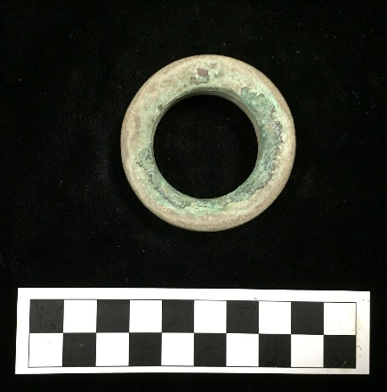
Figure 5.11: Pulley Ring type earspool (34Lf40/6125.6108) from Spiro site (Courtesy of the Gilcrease Museum, photograph by author).

Figure 5.12: Distribution of earspool types at the Spiro Site.

Table 5.8: Spiro Site Earspool Types.
Spiro Earspool Types | N
Central Boss | 1
Composite | 18
Flanged Ring | 1
Funnel Faced | 1
Grooved | 2
Nested Half | 6
Pulley | 121
Pulley Ring | 2
Recessed | 7
Small Inner Nub | 4
Total | 163

Figure 5.13: Distribution of material types at the Spiro site.
The material types found in the Spiro assemblage include sandstone, limestone, wood, and a combination of stone, shell, wood, and/or copper (Figure 5.13). The majority of the earspools are made of sandstone. The diameter of the exterior faces of the earspools range from 28.8 mm to 97.8 mm, which includes the largest and smallest earspools in the overall sample. There are 42 different motifs found on the earspools in the sample, 30 of which are present in the Spiro assemblage. The earspools found at the site indicate a wide range of types preferred by the individuals at the site, or the gathering of earspools from the surrounding regions.

Norman Assemblage
The earspool assemblage from the Norman site represents the second largest collection and includes 39 earspools. There are 15 matching pairs and nine individual specimens. Several additional earspools were recovered during the excavation and mentioned in the field notes, but were not available for this analysis. These unavailable earspools include a pair of perforated Pulley type, a pair of plain earspools, a pair with 7 nodes, and a single multi-lined vortex perforated earspool.
The majority of the earspools in the collection from Norman are Pulley type, with examples of Funnel Faced, Channeled, and Recessed types also represented. The Norman assemblage contains only one Recessed type earspool, and unlike Recessed earspools from other sites, this example has a notched inner face (Figure 5.14). Channeled type earspools are only present in the Norman assemblage. All of the Funnel Faced earspools are also from the Norman site except one which is from the Spiro site.
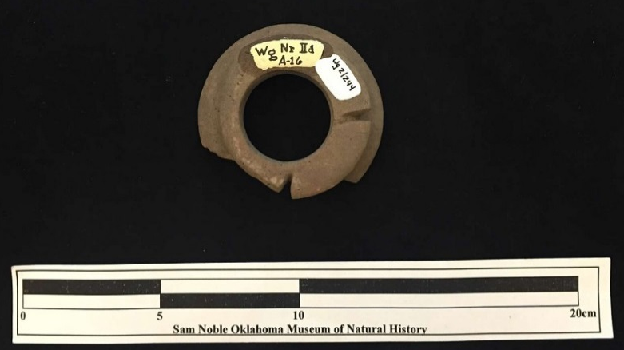
Figure 5.14: Notched back Recessed earspool (34Wg2/244) from the Norman Site. (Courtesy of the Sam Noble Museum, photograph by the author).

Figure 5.15: Distribution of earspool types at the Norman Site.
Norman Earspool Types | N
Pulley | 31
Funnel Faced | 5
Channeled | 2
Recessed | 1
Total | 39
Table 5.9: Norman Site Earspool Types.

The exterior diameter of most of the earspools ranges in size from 61.1 mm to 89.1 mm. The Pulley types have the largest difference in diameters ranging from 63.4 mm to 89.1 mm, the Funnel Faced range from 76.2 mm to 84.4 mm, the Channeled range from 61.1 mm to 61.4 mm, and the single Recessed earspool is 67.6 mm. Only one artifact (Figure 5.15) falls outside the range and is significantly smaller, with a diameter of 46.2 mm. This earspool was found within the fill from a cache pit in Unit IV. The earspool has an unfinished appearance or lacks the refined quality of some of the more finely executed pieces in the sample.
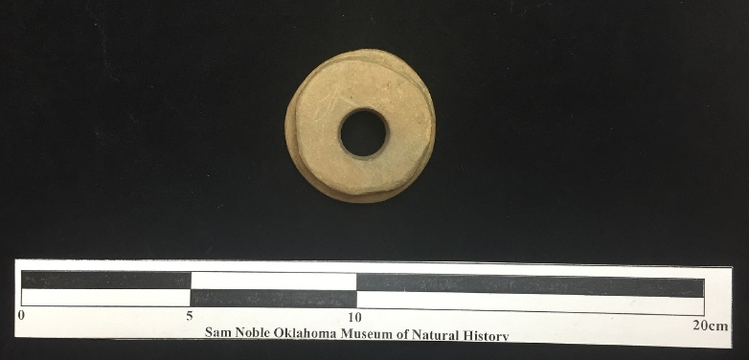
Figure 5.16: Small earspool (34Wg2/C11-1) from the Norman Site. (Courtesy of the Sam Noble Museum, photograph by the author).

In the Norman assemblage, decorative motifs only appear on Pulley type earspools. Twelve (26%) of the Norman assemblage have decorative motifs, and include the multi-lined vortex, 9 nodes pattern, two-lined cross, a “check” spiral, spiral lines with a circle, 4 human heads (Figure 5.16), two concentric circles, and two lined cross (Figure 5.17).
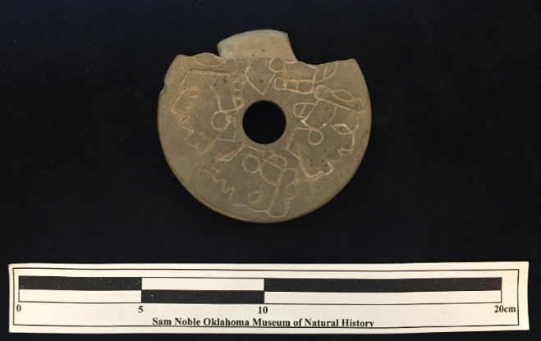
Figure 5.17: Four Human Heads earspool (34Wg2/237) from the Norman Site. (Courtesy of the Sam Noble Museum, photograph by the author).

Figure 5.18: Distribution of motif types at the Norman Site.
The Norman assemblage includes examples of certain types of earspools that only appear at this site. The majority of the earspools are Pulley type and made of several different types of stone. The range of the diameters of the exterior faces is smaller indicating a more uniform and larger earspool size within the site. Certain motifs are only present at the Norman site. The Norman earspools are all made of stone, including the only examples of bauxite and slate or shale.

Harlan Assemblage
The assemblage from the Harlan Site is another large collection consisting of 35 earspools including several pairs and non-matching pieces. The Harlan assemblage contains the second largest array of types in the sample next to the Spiro assemblage. As with the majority of the sites, the Pulley type is the most common type found at Harlan, with limited examples of additional types including Foster, Pulley-Ring, Hollow Cylinder, Grooved cylinder, Nested Half, Pulley Ring Nested Half, and Flange-Ring (Figure 5.18). The site report describes certain earspools as Composite, but they are defined as Nested Half in this study. Composite are categorized in this study as those comprised of multiple materials such as copper, shell, stone, and wood.

Figure 5.19 Distribution of earspool types at the Harlan Site.
Harlan Earspool Types | N
Flanged Ring | 2
Foster | 1
Grooved | 2
Hollow Cylinder | 2
Nested Half | 4
Pulley | 20
Unknown | 4
Total | 35
Table 5.10: Harlan Site Earspool Types.

The earspools from the Harlan site are made of multiple types of materials and have a wide range of diameters. The majority are made of sandstone. According to the site report, six wooden earspools were recovered from the site, but only two were available for this study. One artifact appears to be the copper covering that may have once attached the wooden portion of a Composite earspool. The diameter of the exterior faces range from 41.4 mm to 69.9 mm, Pulley type earspools representing the largest and the smallest diameters. One Flanged Ring earspool measures 42.4 mm in diameter. There was not enough material remaining of the other example of a Flanged Ring earspool to obtain an accurate measurement, as was the case with the Foster type earspool. The range of diameters of the Grooved earspools is 47.6 mm to 48.8, the Hollow Cylinder is 55.8 mm to 56.3 mm, and the Nested Half is 48.8 mm to 51.6 mm.
The only examples with a decorative motif in the Harlan assemblage is a Nested Half with evidence of copper covering on one piece and a design on the other piece (Figure 5.19). It is unique in that the motif is incised on one surface, and has evidence of a copper on the opposite surface. No other earspools in the sample have this characteristic. Earspools with both decorative motifs and copper coverings exhibit these characteristics on one surface. The motif consists of two concentric circles with a multi-line vortex pattern and the edge of the flange, and lacks the skilled craftsmanship found in many of the other examples of detailed incising on earspools from other sites. This earspool dates to the Spiro III Phase but may be an heirloom piece that represents an earlier time prior to the incorporation of decorative motifs on earspools.
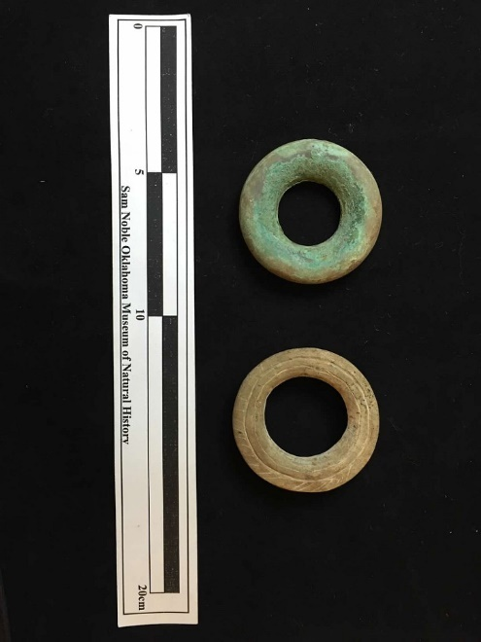
Figure 5.20: Earspool 34Ck6/613a&b from the Harlan Site. (Courtesy of the Sam Noble Museum, photograph by the author).

The Harlan site assemblage is not only one of the larger collections in the analysis, but also has one of the largest varieties of earspool types. Different types of materials are also represented. The range of diameters of the exterior faces is broad. Even with all of the variation present in the collection, only one earspool has a decorative motif.

Reed Assemblage
The assemblage of earspools from the Reed site available for analysis includes 34 artifacts. This collection contains earspools from the Thoburn eastern Oklahoma collection and the Culbertson collection. Only 8 earspools at the Oklahoma Historical Center were attributed to the Reed site, but an additional 19 are part of the Alfred Reed collection and were presumably acquired from the Reed site. None of these specimens have recorded burial associations. Field notes and photos from the 1937 excavations indicated additional earspools recovered from the site, but they were not available for analysis at the time of this research. They are probably in private collections.
There are four earspool types in the Reed collection, the majority of which are Pulley type (Figure 5.20). The collection also includes 4 Nested Half type earspools, and one example each of a Flanged Ring and Plug type earspool. Two are made of limestone, while the remainder are sandstone. A ceramic earspool containing shell temper from Reed 11 was recorded along with two additional earspools, one gray sandstone and the other limestone, but these artifacts were not available for analysis (Purrington 1971:236). The exterior faces range in diameter from 30.7 mm to 87.9 mm. Two pairs of earspools have a design motif, one pair has a two-lined cross and a circle in each quadrant also containing a cross, and the others have a woven pattern (Figure 5.21).

Figure 5.21: Distribution of earspool types at the Reed Site.

Reed Earspool Types | N
Flanged Ring | 1
Nested Half | 4
Plug | 1
Pulley | 28
Total | 34
Table 5.11: Reed Site Earspool Types.

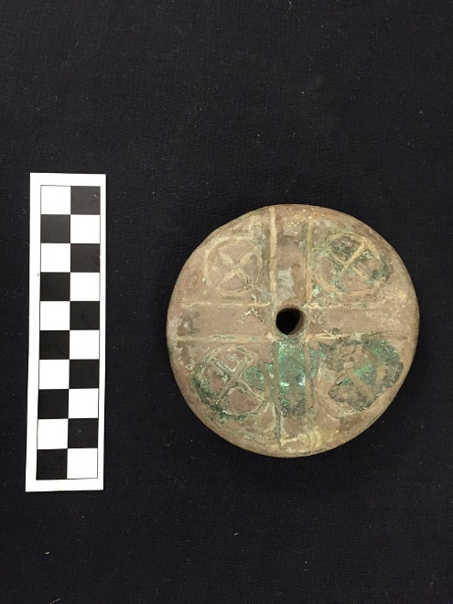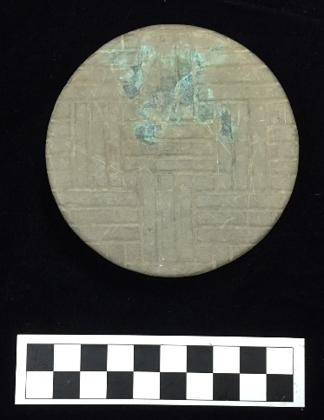
Figure 5.22: Earspools from the Reed site a) 5219.4 with two-lined cross and a circle in each quadrant motif (Courtesy of the Oklahoma History Center, photograph by the author) and b) 6125.4276a with woven motif (Courtesy of the Gilcrease Museum, photograph by the author).

Although there are 34 earspools in the Reed site assemblage, only a small number of types and material are represented. The range of diameters of the exterior faces is large, and only a small percentage of earspools have decorative motifs.

Hughes Assemblage
The Hughes Site assemblage contains thirteen earspools. Twelve are Pulley type, and one is classified as a Plug type due to its small size and shape. This earspool is unique in that it has a bulbous interior flange. Three are made of limestone, while the remainder are sandstone. The exterior diameter ranges from 34.2 mm to 91.7 mm.
Decorative motifs are present on four complete earspools, and one fragment (Figure 5.22). The fragment has a design motif and is included in the analysis to show the presence of the concentric circle pattern at the Hughes site. The other designs include a 3-lined cross with a circle in each quadrant present, a repeating five-point star, and a multi-lined vortex connected to a central circle.
The collection of earspools from the Hughes site is small, but significant in its representation of several unique motif patterns. Only two material types are present in the sample. The range of sizes of the diameters of the earspools is large. There are four different decorative motifs present in the collection.

a 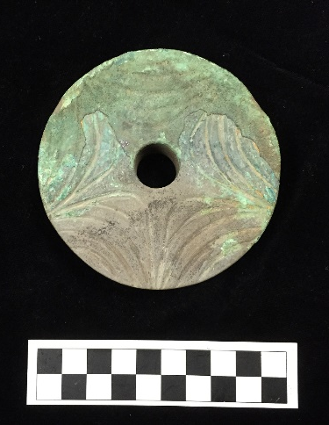 b 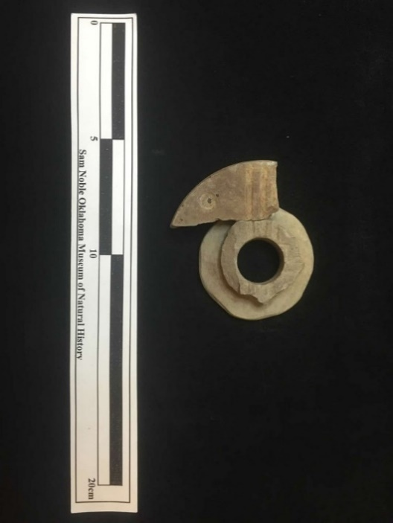

c 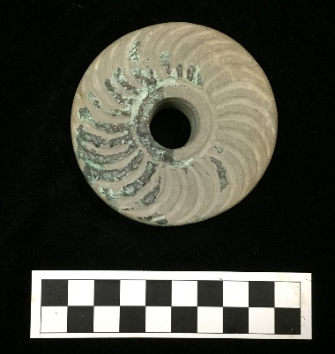 d 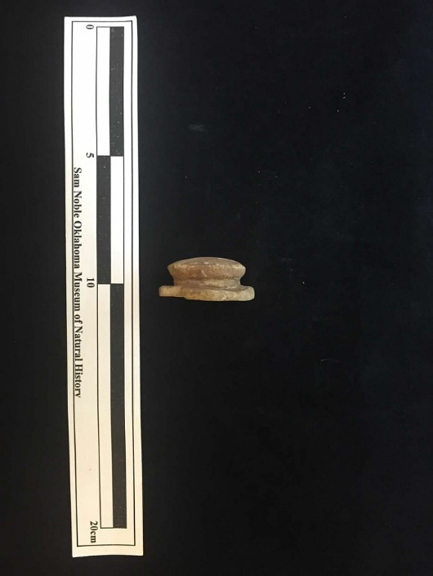
Figure 5.23: Earspools a) 6125.3978B with five point repeating star motif (Courtesy of the Gilcrease Museum, photograph by the author), b) 46a&222 with three line cross with circles in each quadrant motif, c) 6125.3977B with vortex motif, and d) 46a Plug type from the Hughes site (Courtesy of the Sam Noble Museum, photograph by the author).

Eufaula Assemblage
The Eufaula Site earspools were not available for analysis but a photo of one pair (Figure 5.23) from the Hall collection and detailed descriptions of those excavated by Orr are available in the site report (Orr 1940). Twenty-seven earspools were recovered during the 1940 excavation overseen by Orr. At least an additional 3 earspools were collected by Albert Hall, though only two have been photographed.
Orr (1940) provides a detailed description of the earspool types recovered from the site the field report on the Eufaula mound (Figure 5.24). His terminology varies slightly from what Baerreis created, and also includes additional forms. The four parts that make up an earspool according to Orr include the outer and inner facet, axis, and perforation. The forms are further broken down into single and double facets. The single facet earspools have three different types of axis which are described as “cylindrical”, “hemi-hyperbolic”, and “cylindro-hemispheroid”. The double facet earspools are either equal in diameter or have a smaller inner facet diameter. The features of the earspools are further broken down. The axis perforations are defined as cylindrical, hyperbolic, or solid. The outer facets are either flat or concave. Several different designs are described, all of which are incised on the earspools. These designs types are concentric circles, circles concentric to the perforation, ridge on circumference, and curvilinear.
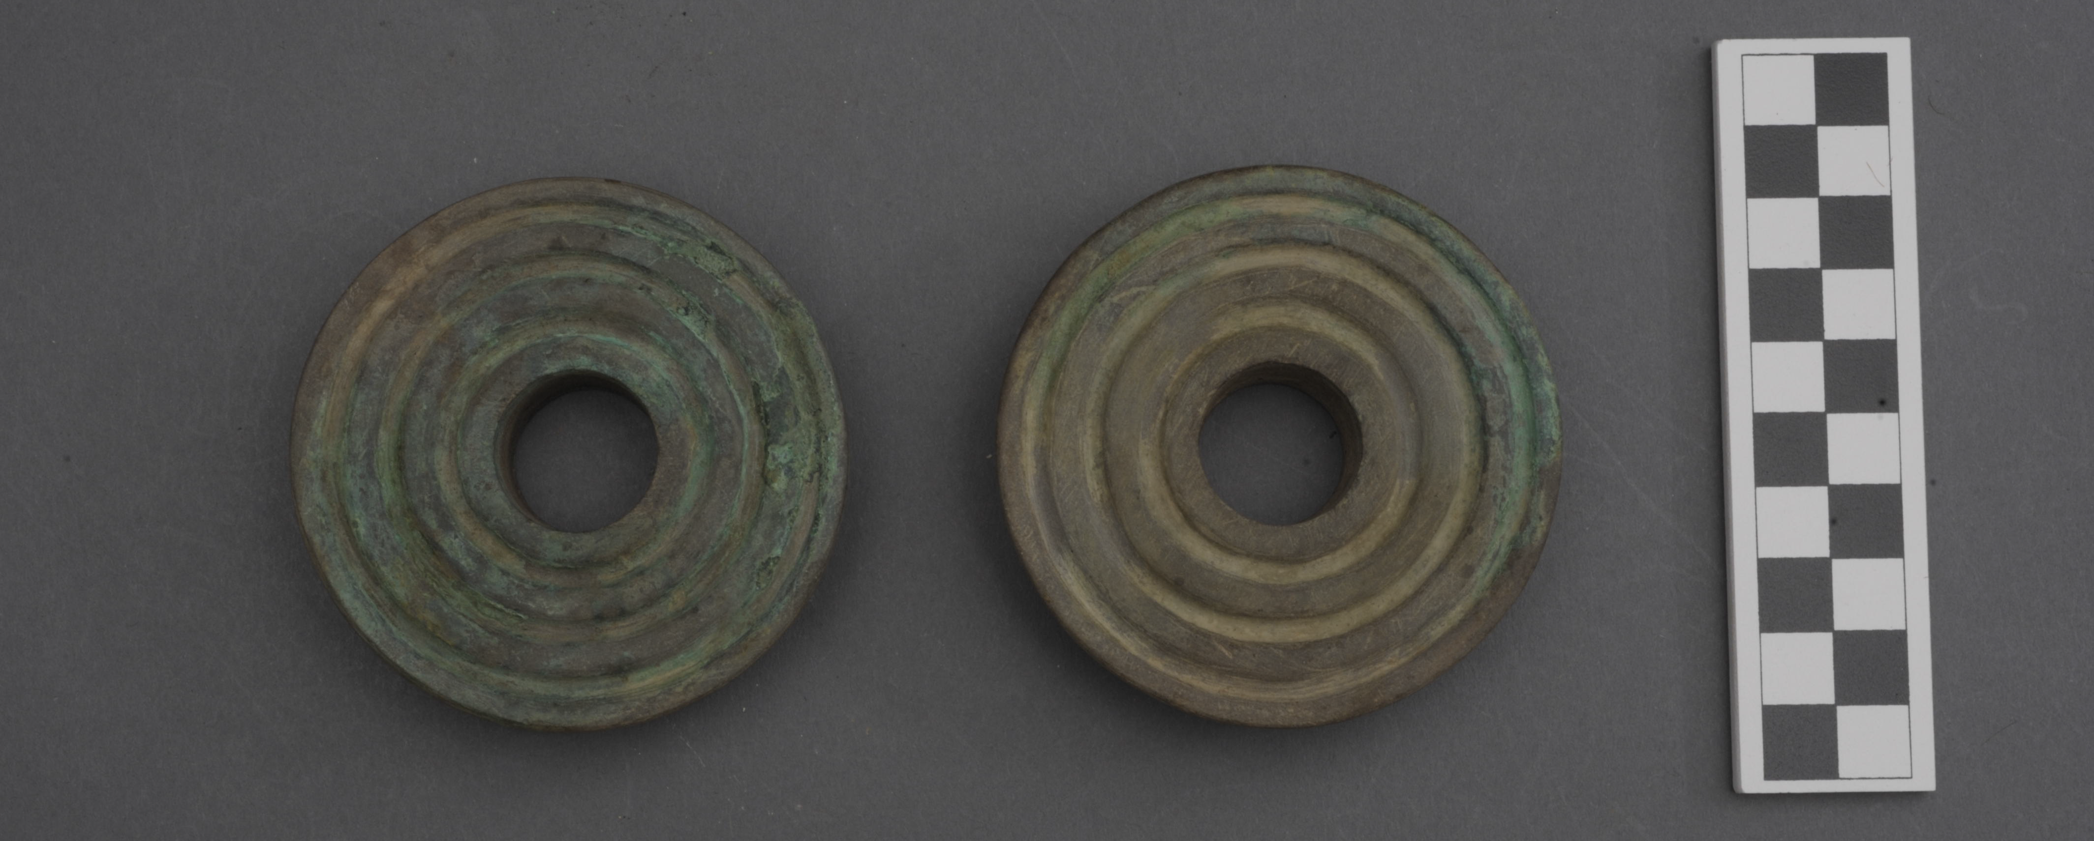
Figure 5.24: Earspools 6125.3979a&b from the Eufaula site (Courtesy of the Gilcrease Museum, photograph by the author).
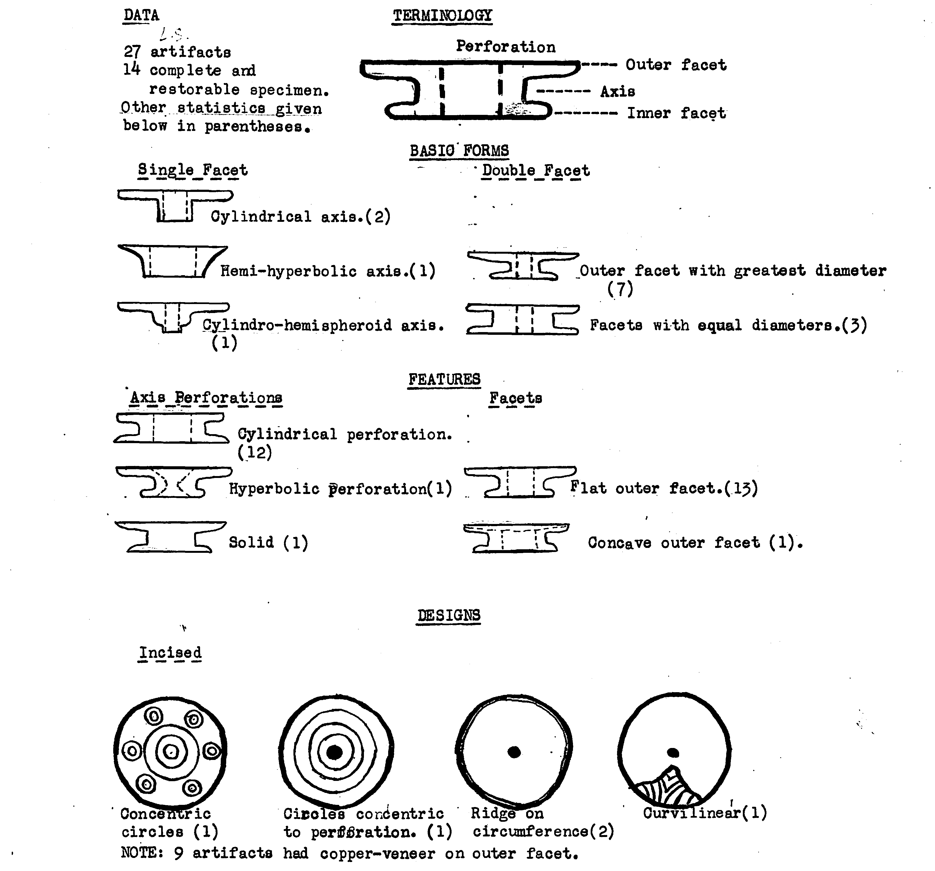
Figure 5.25: Sketches of earspools recovered from the Eufaula site (adapted from Orr 1940).

The assemblage contained multiple types of earspools including Pulley and what appear to be Nested Half, which Orr defined as single facet. All of the artifacts are described as being made of ground stone except 6125.2977a, which lacks a description or photograph to indicate its material type. The earspools ranged in size from 38 mm to 90 cm, and several have motifs including 3 concentric circles, repeating star or what Orr (1940) described as curvilinear, and a concentric circle pattern unique to the site. The earspools described as possessing a ridge on the circumference may have been Recessed type, but limited information inhibits a definitive type assignment.

Brackett Assemblage
The Brackett Site assemblage includes five Pulley type earspools with perforations made of sandstone. One matching pair has a three-line cross motif, and the second matching pair has a less refined two-line cross motif. The third is much smaller and lacks decoration (Figure 5.25). The small earspool has an exterior face diameter of 34.8 mm, while the two matching pairs range in size from 77.9 mm to 81.5 mm.
a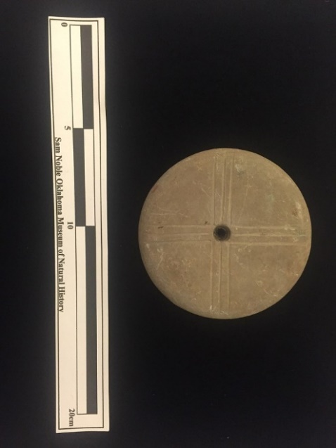 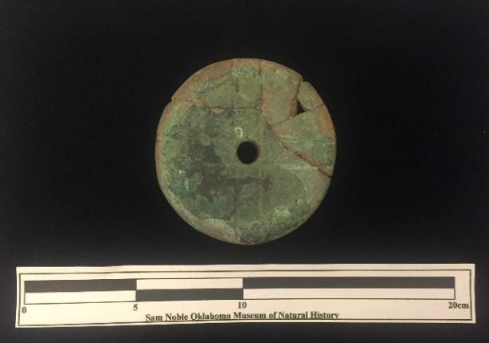 b
c 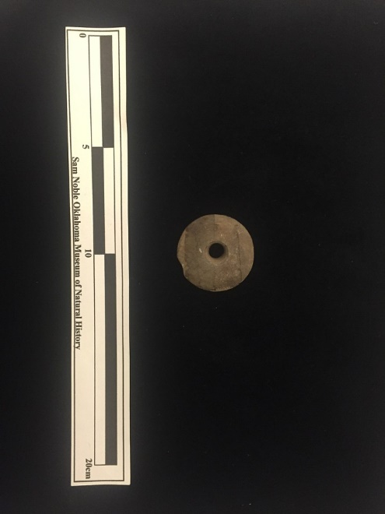
Figure 5.26: Earspools a) 34CK43/109 three-line cross motif, b) 34CK43/75 two line cross motif, c) 34CK43/113 undecorated from the Brackett site (Courtesy of the Sam Noble Museum, photograph by the author).

Guffy, State #4 & #5 Assemblages
The assemblage from the Guffy, State #4, and State #5 sites includes one earspool from each site. McHugh (1963) describes two stone earspool fragments from the Guffy site, but these were not available for analysis. These sites were located within a mile of one another and initially excavated in the late 1930s and early 1940s. The earspools were collected in 1940 from the State sites and are both Pulley type (Figure 5.26), while the earspool from the Guffy Site is Recessed (Figure 5.27). The Guffy earspool is one of nine Recessed types in the sample, with the other examples found at the Spiro and Norman sites. Each of the three earspools are made of sandstone. The earspool from State #4 site is 42.5 mm and the one from State #5 is 47.2 mm in diameter, while the earspool from the Guffy site is much larger measuring approximately 70 mm across the exterior face. None of the earspools have a decorative motif.
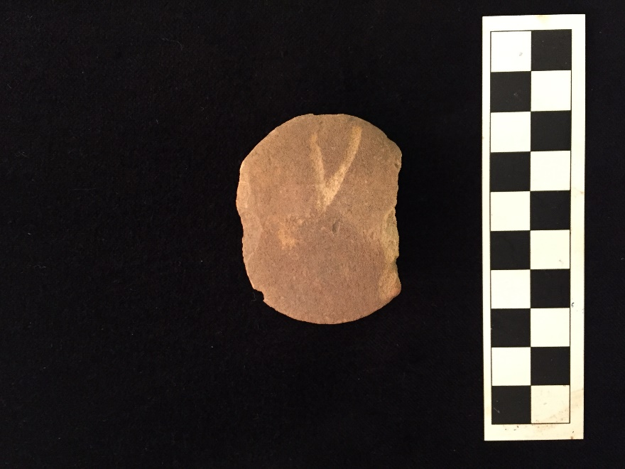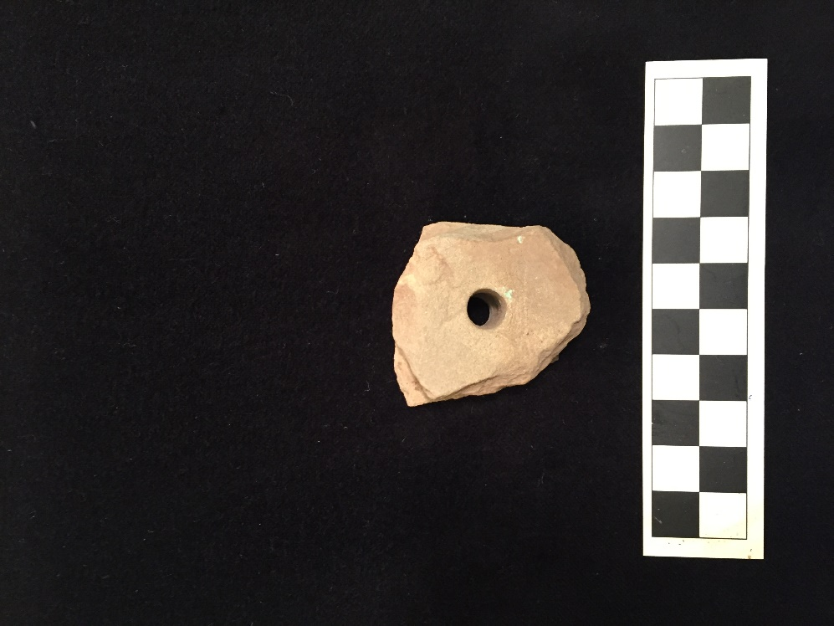
Figure 5.27: Pulley earspools 34DL67/165 (left) from State #4 and 34DL68/1 (right) from State #5 (Courtesy of the Sam Noble Museum, photograph by the author).

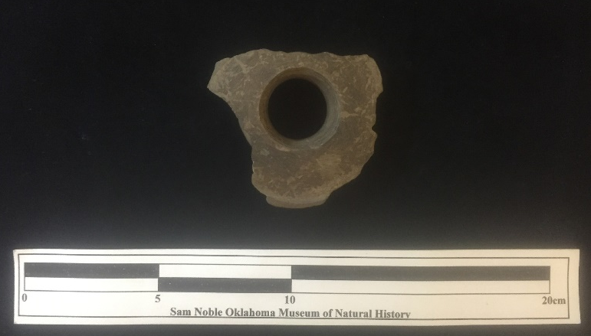
Figure 5.28: Recessed earspool from the Guffy site 34DL57/552 (Courtesy of the Gilcrease Museum, photograph by the author).

Bowman Assemblage
The collection analyzed from the Bowman Site contains seven earspools. The field notes from the excavation indicate that at least fourteen were found during excavation, but not all were available for this research. The assemblage includes three Composite earspools, two Foster type, and two Pulley type. One of the Foster type earspools is made of limestone, and the other is made of sandstone or possibly red flint clay (Figure 5.28). Both Pulley type earspools are made of sandstone. The earspools range in size from 24.9 mm to 90.1 mm; the largest are the Pulley type. None of the earspools available for analysis are decorated, but a sketch of one of a pair of earspools illustrates a unique interlocking scroll pattern (Figure 5.29).
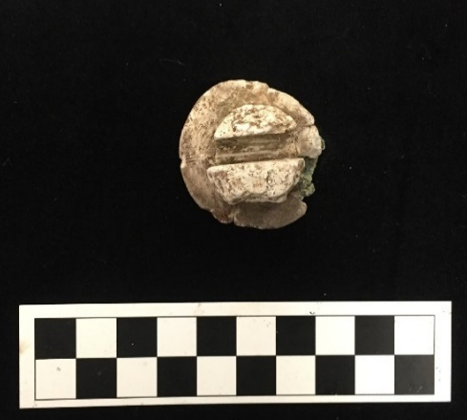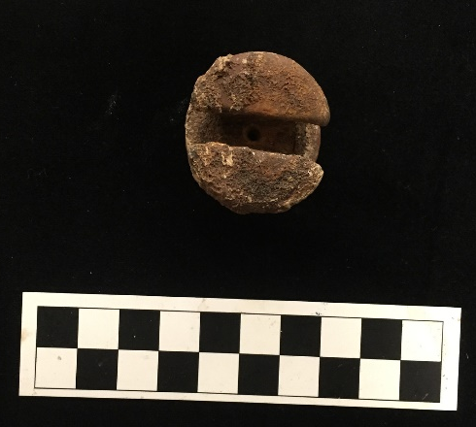
Figure 5.29: Earspools 3LR50 81-71-76a&b from Bowman Site (Courtesy of the Arkansas Archeology Survey, photograph by the author).
ab
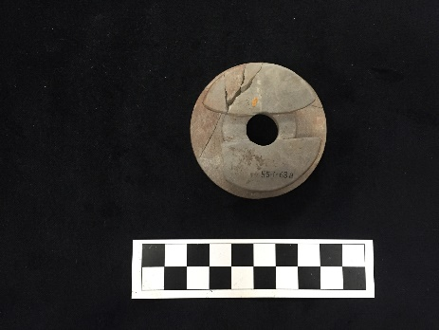
Figure 5.30: One of two identical earspools from the Bowman Site, a) back and b) font (Shantleff 1981).

Crenshaw Assemblage
The Crenshaw Site assemblage contains four sandstone earspools, two of which were not available for analysis. One pair is a small inner nub type (Figure 5.30), and the other pair is Pulley type (Figure 5.31). The field notes from the 1941 fieldwork describe the earspools as Plugs. One of the Pulley type earspools has a split or Foster type back, unlike its mate. The Pulley type earspools are 53.1 mm and 53.9 mm in diameter, and the small inner nub type are larger with an exterior face diameter of approximately 80 mm. The larger earspools lack any decorative motif, but have remnants of a copper covering. The smaller earspools have a concentric circle motif with four rings.
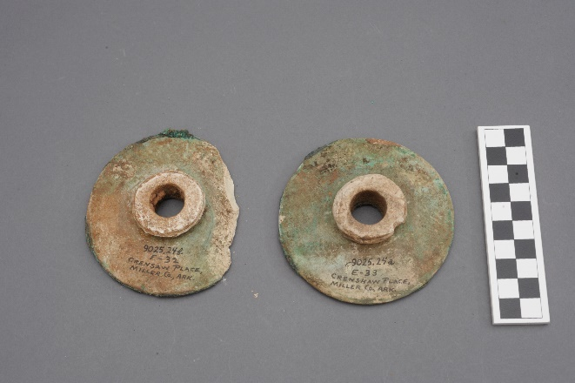
Figure 5.31: Earspools 9025.24a&b collected from the Crenshaw Site (Courtesy of the Gilcrease Museum).
a b 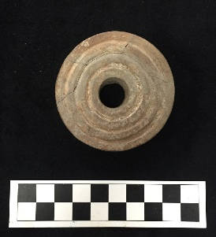
Figure 5.32: Earspool 3MI6/55-1-63a a) front, b) back collected from the Crenshaw Site (Courtesy of the Arkansas Archeology Survey, photograph by the author).

Mineral Springs Assemblage
Seven earspools were recovered from Mineral Springs, five Foster type and two Recessed type. Only three were available for analysis including two limestone Foster type earspools and one much smaller Foster type earspool made of fine grained brown sandstone (Figure 5.32 & 5.33). The large Foster type limestone earspools have exterior faces of 78.1 mm and 78.2 mm and evidence of a copper covering. The smaller sandstone Foster type earspools are approximately 30 mm in diameter. There is no metric data for the Recessed type earspools. None of the earspools have any decorative motifs.
a 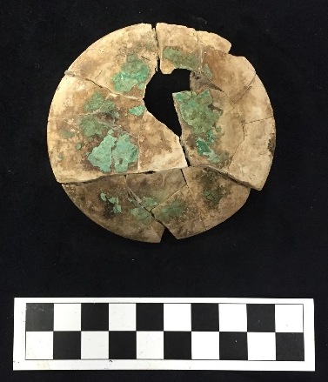 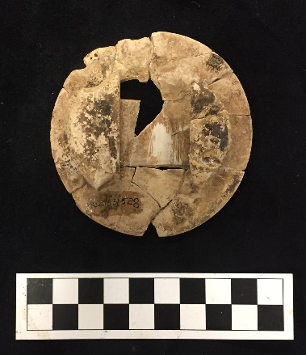 b
Figure 5.33: Earspools 3HO1/460 a) front b) back from the Mineral Springs Site (Courtesy of the Arkansas Archeology Survey, photograph by the author).

a 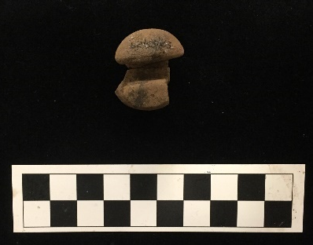 b
Figure 5.34: Earspool a) 3HO1/163 back and profile (Courtesy of the Arkansas Archeology Survey, photograph by the author) b) 3HO1/B21a&b from the Mineral Springs Site (Bohannon 1973).

Foster Assemblage
The Foster Site assemblage includes only two earspools (Figure 5.34), though additional earspools were recovered from the site by C.B. Moore in the early 1900s (C.B. Moore 1912:600-601). Their location was unknown at the time of this research. The earspools are Foster type, named for the site, and made of sandstone. The exterior face on each of the earspools is thin with a large diameter measuring 76.8 mm. Each earspool included in the analysis has a decorative motif pattern which includes an eight-point star surrounding a Central Boss.
C.B. Moore recorded three pairs of earspools of different types. These types include Composite, Central Boss (with Foster type lugs on the interior flanges), and Foster with a Central Boss surrounded by an eight-pointed star, similar to the earspools analyzed. Mentioning multiple types of earspools present at the Foster site expands the known types and does not limit analysis to only those available.
a 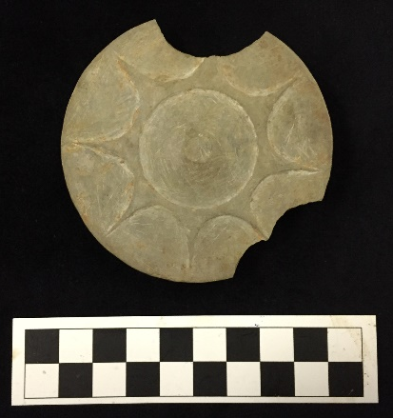 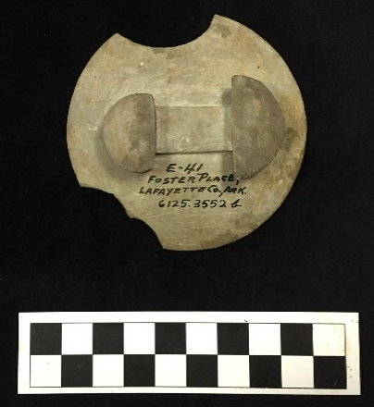 b
Figure 5.35: Earspool 6125.3552b a) front b) back from the Foster Site (Courtesy of the Gilcrease Museum, photograph by the author).

Paul Mitchell Assemblage
The Paul Mitchell Site assemblage includes two earspools (Figure 5.35). These are the only examples in the sample of earspools made of ceramic. They are grog tempered, Grooved type, and show evidence of possible burning. The earspools are 37.7 mm and 43.7 mm in diameter, and are undecorated.
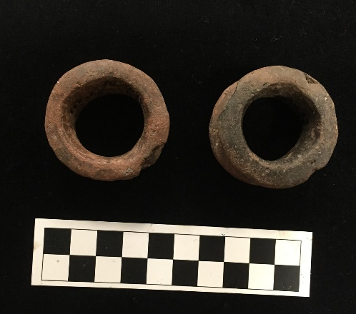
Figure 5.36: 41BW4/55-40-146a&b from the Paul Mitchell Site (Courtesy of the Arkansas Archeology Survey, photograph by the author).

Arthur Gaither Assemblage
Only one earspool is associated with the Arthur Gaither site. This earspool (Figure 5.36) is the only example of a Central Boss type with a Foster type or split interior flange. It is made of sandstone and has an exterior face diameter of 35.3 mm. There are no decorative motifs present.
a 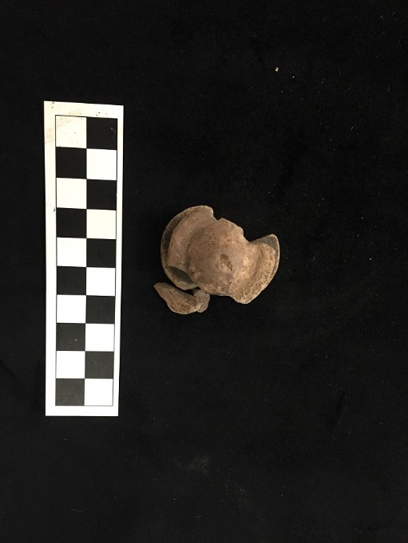 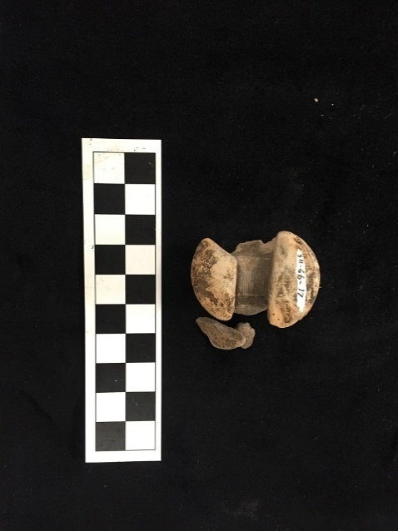 b
Figure 5.37: Earspool AGA-17 a) front b) back from the Arthur Gaither Site (Courtesy of the Arkansas Archeology Survey, photograph by the author).

Bluffton Assemblage
The Bluffton Site assemblage includes two earspools. Both are the Pulley type with smaller perforations and made of sandstone (Figure 5.37). They have no decorative motifs, but do have evidence of copper covering. These earspools have large exterior face diameters measuring 84.5 mm and 90.2 mm. Four earspools were originally recovered from the site, but only two were available for analysis.
a 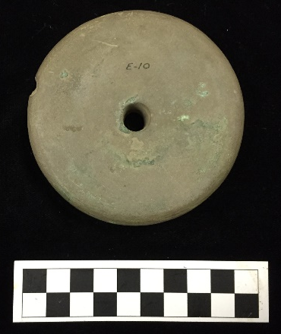 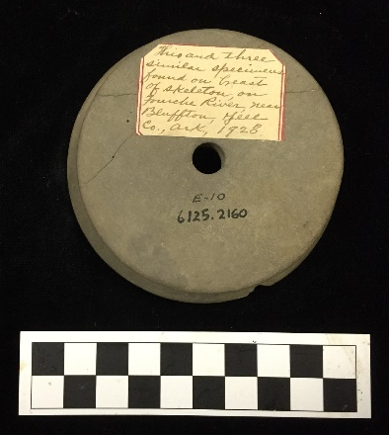 b
Figure 5.38: Earspool 6125.2160 a) front b) back from the Bluffton Site (Courtesy of the Gilcrease Museum, photograph by the author).

Smith Mound Assemblage
The Smith Mound Site assemblage consists of four earspools. Both sets are Foster type, but one pair is made of brown sandstone (Figure 5.38), while the other is made of limestone (Figure 5.39). The diameter of the exterior faces of the sandstone earspools are 42.1 mm and 42.3 mm, and the limestone pieces are 55.7 mm and 65.5 mm. None have decorative motifs, but do have evidence of copper covering.
a 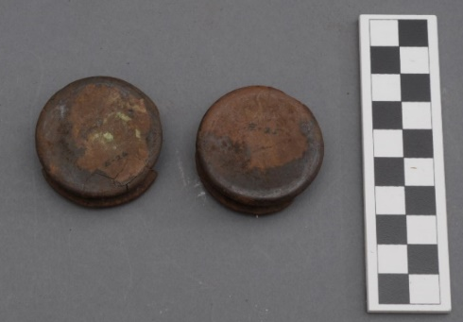 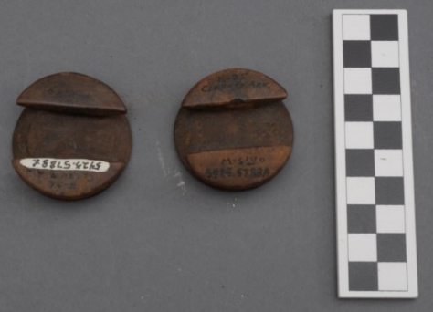 b
Figure 5.39: Earspools 5425.5788a&b a) front b) back from the Smith Mound Site (Courtesy of the Gilcrease Museum).
a 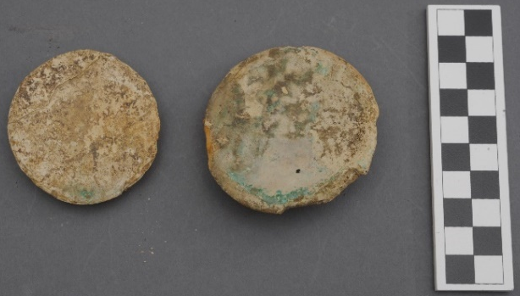 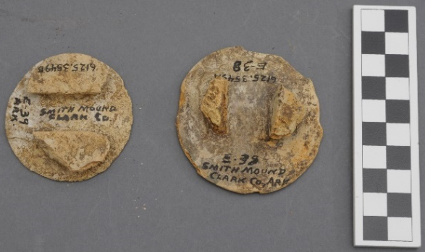 b
Figure 5.40: Earspools 6125.3549a&b a) front b) back from the Smith Mound Site (Courtesy of the Gilcrease Museum).

Conway County Assemblage
The Conway County assemblage contains four earspools, all of which are Pulley type and made of sandstone. The earspools vary in size with exterior face diameters ranging from 37.5 mm to 89.1 mm. The size of the perforations also varies significantly, and not proportionately (Figure 5.40). One pair of earspools has a flattened node motif with seventeen nodes and shows evidence of copper covering (Figure 5.41).
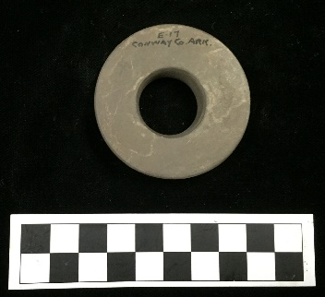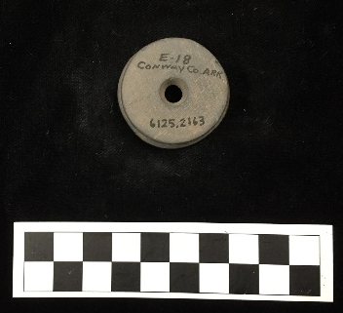
Figure 5.41: Earspools 3CN0/6125.2162 & 3CN0/6125.2163 from Conway County (Courtesy of the Gilcrease Museum, photograph by the author).

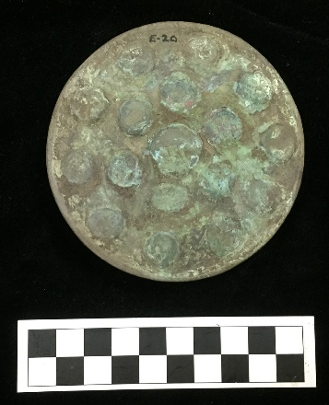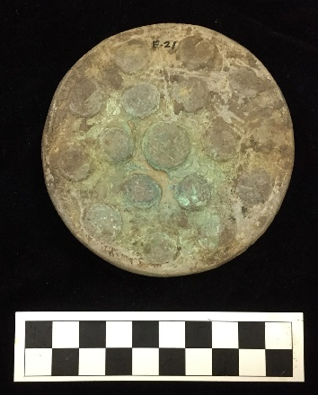
Figure 5.42: Earspools 3CN0/6125.2165 & 3CN0/6125.2166 from Conway County (Courtesy of the Gilcrease Museum, photograph by the author).

Garland County Assemblage
The Garland County assemblage contains five earspools acquired from multiple areas throughout the county. All five are Pulley type and made of sandstone. They range in diameter from 57.3 mm to 71.0 mm. Each has a decorative motif, all variations of the concentric circle pattern (Figure 5.42).
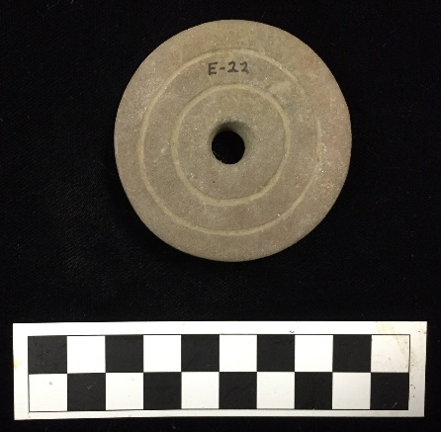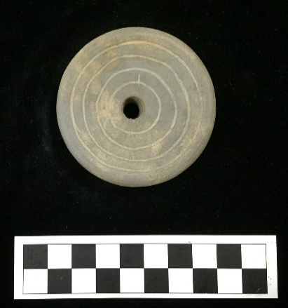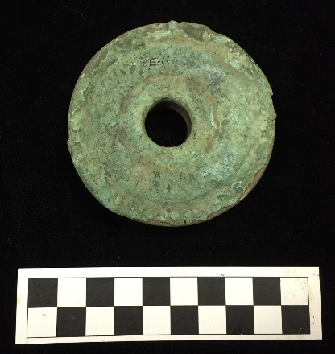
Figure 5.43: Earspools 3GA0/6125.3554 E-22, 3GA0/6125.3558a E-35 ½,
3GA0/6125.3551a E-12 from Garland County (Courtesy of the Gilcrease Museum, photograph by the author).

Johnson County Assemblage
One earspool from Johnson County was analyzed. The earspool is Pulley type and made of sandstone (Figure 5.43). The earspool is an example of a larger ornament with an exterior face diameter of 79.1 mm. There is no evidence of any decorative motif present on the earspool, though it does appear to show evidence of modern repair.
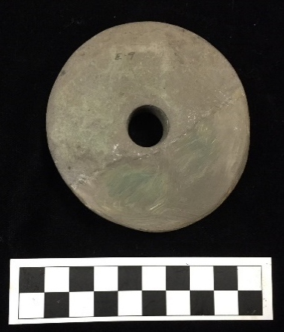
Figure 5.44: Earspool 6125.3557 (front) from Johnson County (Courtesy of the Gilcrease Museum, photograph by the author).

Conclusion
The sample analyzed include 331 earspools representing fourteen different formal types. The earspools are from over twenty sites in the Arkansas and Red River Valley regions, suggesting their importance throughout the Caddo region. The earspools vary in material types, exterior face diameters, and decorative motifs within and between sites, regions, and time periods. The variation in attributes indicates a deliberate intention to differentiate the individual who was buried with the artifacts from other people. The variation also suggests that the differences may have been intended to convey different meanings. Changes over time in attributes may have been the result of shifts in cultural practices. Additional information such as weight and perforation diameter were gathered on each earspool and will be addressed in future research.

Chapter 6: Analysis of Earspools for Research Questions

This thesis asks if the variation in earspools supports the cultural divide between the northern and southern Caddo regions. Is there chronological variation in the earspools and does it correspond with the current position on chronology by paralleling changes in other cultural markers? Does the degree of variation in the decorative motifs found on some of the earspools suggest affiliations with social categories, or could they represent expressions of individual identity? To address these questions, this chapter begins with a discussion of the differences in earspools between sites, followed by differences observed when the sites are grouped regionally. Then the research addresses the temporal variations found within the sample. Finally, an analysis of the decorative motifs demonstrates the range of stylistic variability in the sample.

Geographic Variation in Earspools
The earspools in this study demonstrate variability between sites (Table 6.2) which may be due to multiple issues including, but not limited to the function of the sites, population at the sites, duration of occupation, or sampling bias. Earspools from twenty-two different sites are included in the analysis, with the vast majority n=163 obtained from the Spiro site. The assemblages from most of the sites contain less than ten earspools, and several site assemblages contain only one earspool.
The Pulley type earspool is the most prevalent in the sample, and was recovered from all but five of the sites in the study. The majority of the Pulley type earspools are from Spiro (Figure 6.1). The remaining types appear less frequently, and some of the sites have only one type of earspool in their assemblage. There are only Pulley type earspools present in the collections from the Brackett and Eufaula sites. The majority of the Composite earspools are found at Spiro with a small sample in the Bowman site collection. Nested Half earspools were only recovered from Spiro, Harlan, Eufaula, and Reed. The Foster type earspools were found at the Harlan and Smith Mound sites, as well as sites along the Red River. The Recessed type has a larger representation at the Spiro site, but are also found in the Norman and Eufaula collection. The Grooved earspools have an even distribution between the Spiro, Harlan, and Paul Mitchell sites with only two earspools from each site. Earspools with small inner nubs are included in the collections from the Spiro and Crenshaw sites. Funnel Faced earspools only occur at the Spiro and Norman sites. Flanged Ring earspools were recovered from the Spiro, Harlan, and Reed sites. Central Boss examples are evenly distributed between the Spiro and the Arthur Gaither sites. The Pulley Ring type of earspool is only found in the Spiro collection. Plugs were found at two sites, Reed and Hughes. Hollow Cylinder type earspools are only included in the collection from Harlan. Channeled earspools were also only recovered from one location, the Norman site. In summary, the Pulley type earspools dominate the regional distribution, while the other earspool types vary significantly at each of the sites.
Figure 6.1: Earspool Types by Site.
The sites with the largest number of earspools Spiro (n=86), Norman (n=24), Reed (n=15), and Harlan (n=14) have the most variation in earspool types. The earspools in the Spiro assemblage include the only examples of the Pulley Ring type. All fourteen types are represented in the Spiro assemblage except the Channeled, Foster, Hollow Cylinder, and Plug. The Harlan site also has a significant variety of earspool types represented compared to the remaining sites. The types present include the Flanged Ring, Foster, Grooved, Hollow Cylinder, Nested Half, and Pulley. The Harlan site is the only collection to include Hollow Cylinder type earspools, though one Hollow Cylinder earspool from Spiro was mentioned by Brown (1996), but this artifact was unavailable for this analysis. Only four earspool types are present in the Norman and Reed site assemblages. The Norman site collection has the only example of a Channeled type earspool, and includes Funnel Faced, Recessed, and Pulley type earspools. The Reed site assemblage contains Flanged Ring, Nested Half, Plug, and Pulley type earspools. The remaining assemblages in the study consist of five or fewer earspools and therefore have few types represented. Examining the different types of earspools from each site provides information indicating which types are specific to the northern and southern regions.

Northern and Southern Caddo Regions
As previously discussed, the Caddo region has been divided into northern and southern regions based on differences in material culture and architectural features. This research includes earspools from 22 sites, 14 located in the northern region and 8 in the southern region. The collections from the northern and southern regions appear to have distinct characteristics.
All fourteen types of earspools were recovered from sites in the northern Caddo region, while only six types were found at sites in the southern region (Figure 6.2). The types of earspools found at the southern sites include the Pulley (n=8), Composite (n=3), Foster (n=12), Small Inner Nub (n=2), Grooved (n=2), and Central Boss (n=1). The Foster type is more common than the Pulley type in the southern region, unlike the northern region where the Pulley type is the most prevalent. The Foster type is represented in the collection from the northern region by only one earspool, which was recovered from the Harlan site.
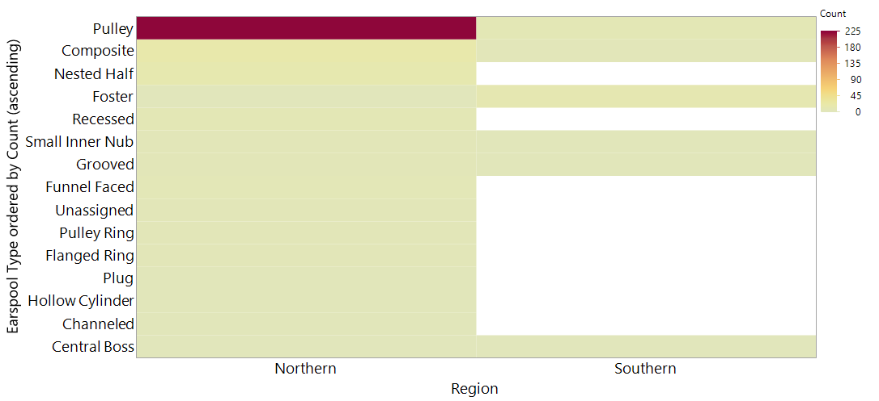
Figure 6.2: Distribution of earspools type by northern and southern region.
There are 43 different types of decorative motif designs represented in the sample (Figure 6.3). Of the 113 earspools with known proveniences from the northern or southern Caddo regions that have a motif, 105 are from the northern area, and 8 are from the southern area. The Concentric Circle and Star patterns are the only motifs found in the collection of earspools from the southern region.
In addition to the multiple types of motifs, there are variations within the motif types. For example, the number of circles in the Concentric Circle pattern ranges from one to seven. Similarly, the star motif ranges from six to eight points.
Figure 6.3: Sample of decorative motif present in the northern and southern Caddo region.

Different types of materials were used to manufacture earspools recovered from sites in the Northern and Southern Caddo regions, but sandstone is most common in both regions (Figure 6.4). Limestone and Composite earspools made of a combination of stone, shell, wood, and/or copper are also present in both areas. Several material types are absent from the southern region collection. The absence of wood may have been a preservation issue or the result of collection methods (Brown 1996). Earspools made of ceramic material are only present in the Southern region collection, but due to the small sample size, it may not be a meaningful difference. With an understanding of the regional and site distribution of the earspool types, fluctuations over time may then be examined.
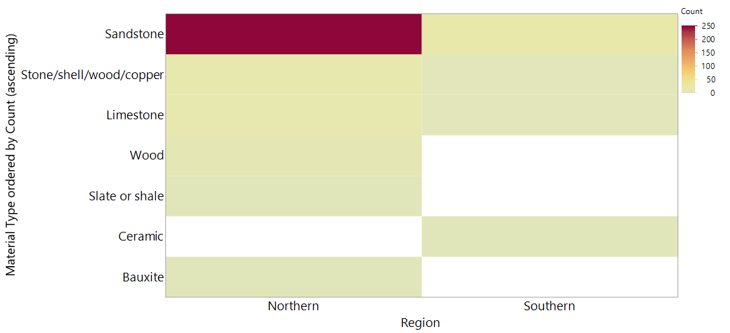
Figure 6.4: Material types present in earspools from the northern and southern Caddo regions.

It is tempting to say that the northern region has a greater diversity of earspools based on the larger number of types, motifs, and materials present. However, there is a great discrepancy in sample size, with 303 earspools from the north and just 28 from the south, measures of richness are highly influenced by sample size. In order to control for sample size, a rarefaction analysis was run which simulates how many categories we would expect to find in the south if we had discovered the same number of earspools as was found in the north. When the sample sizes vary greatly, rarefaction reduces or rarifies the larger sample by drawing a random subsample in order to produce a smaller, more comparable sample size (Lyman 2008; Sanders 1968; Tipper 1979). Table 6.2 shows that when we control for sample size, type, and material represented have a similar richness. The richness of motifs, however, is substantially higher at the sites in the northern region. Spiro is a unique case, and could heavily influence measures of diversity. Therefore, a separate rarefaction analysis was conducted excluding the Spiro earspools (Table 6.3). The results are consistent between both analyses.
Table 6.1: Rarefaction analysis of all earspools. The values are the number of categories found in the south, and the simulated values in the north if it was restricted to having the same sample size as the south, plus or minus a standard error.
 | Northern | Southern
Type | 5.9 ± 1.4 | 6
Motif | 20.7 ± 1.8 | 4
Material | 3.6 ± .9 | 4

Table 6.2: Rarefaction analysis of earspools excluding the Spiro collection.
 | Northern | Southern
Type | 6.2 ± 1.5 | 6
Motif | 16.6 ± .5 | 4
Material | 3.1 ± .9 | 4

This analysis shows that the northern Caddo region has a statistically much larger number of decorative motifs, but that both regions have similar diversity in types and materials. There are five times as many designs present in the collections from the northern Caddo region as in the southern collections. The diversity is present even when excluding the large number of earspools from Spiro.
In review, several significant cultural practices have been documented previously between the northern and southern Caddo, creating a regional division. These differences are:
Northern Caddo Region:
- Earlier use of shell tempered pottery
- Square or rectangular structural designs in architecture
- Charnel houses

Southern Caddo Region:
- Later use of shell tempered pottery
- Circular design in structural architecture
- Shaft Tombs

To this, we can add observations about earspools:
Northern Caddo Region:
- Strong preference for Pulley type and Sandstone material
- Use of more decorative motifs

Southern Caddo Region:
- Large proportion of Foster type
- Few decorative motifs on earspools

The pulley type earspool is the most frequent type in the northern Caddo region. The sample from the northern area contained 303 earspools with 14 types represented, 228 of the earspools are pulley type. In the southern region, the Foster type earspool is the most common. In the sample of 28 earspools, there are only six types present, 12 of which are Foster type. Of the 44 different motifs in the sample, 42 are present in the assemblages from the northern Caddo area and only four are present in the assemblages from the southern Caddo area, three of which are variations in the Concentric Circle pattern. The distinct difference in the number of motif designs on earspools found in the northern and southern Caddo region, combined with pottery production practices, architectural structure design, and mortuary practices, contributes to a division between groups based on cultural practices.

Temporal Variation of Earspools
Variations in earspools may be the result of changes in types and styles over time. Chronological periods have been defined by differences in types of artifacts combined with additional temporal evidence such as carbon dating. The goal of this discussion is to determine if the changes in earspools in the analyzed sample can be attributed to changes over time, and if those changes correspond with current research on cultural phases.
Determining the exact chronology of some of the earspools in this analysis is difficult due to the lack of provenience information. Most of the sites were excavated by the Works Projects Administration (WPA) and have poorly understood chronologies (Hammerstedt and Savage 2012). Only collections from sites with known chronologies are discussed. The most recent research by archaeologists provides a timeline sequence of the major mound sites in Oklahoma along the Arkansas River. Hammerstedt and Savage (2013) present their current understanding of the chronology of the Spiro, Harlan, Reed, and Norman Sites (Table 6.4). This chronology is used to interpret potential changes in earspool types, sizes, and material use over time.

Table 6.3 Cultural Phases by Sites (adapted from Hammerstedt and Savage 2013).
Cultural Phase | Spiro Grave Period | Phases Represented at Each Site
 |  | Spiro | Harlan | Reed | Norman Mound II-1 | Norman Mound II-2
Spiro  (AD 1350-1450) | Spiro III/IV, IV | Spiro |  |  | Phase IV, VI, Final | Middle, Final
Norman  (AD 1250-1350) | Spiro III | Norman | Late | Upper, destroyed portion | Phase III | Initial, Middle, Final
 | Spiro II/III | Harlan | Late | Upper, destroyed portion | Initial, Phases I & II
Harlan  (AD 1000-1250) | Spiro II | Harlan | Middle | Layers 1 & 2
 | Spiro I/II | Harlan | Early Initial
Evans  (AD 950-1000) | Spiro IA, IB, I | Evans

The dates of site occupation are determined by several lines of information including burial treatments, stratigraphic position, and funerary objects such as ceramics, projectile points, pipes, and beads (Brown 1996:133). The Spiro Grave Periods assigned by Brown (1996) were created by considering funerary objects in conjunction with radiocarbon dated material (Brown 1996:133, 153). Analysis of the sample of earspools will provide data to determine if differences in the earspools correspond with the changes in phases or fit the variation different from the current position on chronology.
A limited number of earspools in the sample are associated with specific burials. The sites included in this study with burials known to contain earspools are Brackett, Harlan, Norman, Reed, Eufaula, and Spiro. A total of 283 earspools are associated with 72 burials from these sites, though only 88 were available for analysis. Current research has assigned these burials to Spiro II through Spiro IV periods (Brown 1996; Hammerstedt and Savage 2017). Sample sizes from each period vary significantly with the largest percentage of earspools dating from the Spiro III period (Figure 6.5). The information about all the earspools recovered from the burials and their descriptions provide additional data for assessing changes between the Grave Periods.

Figure 6.5: Distribution of earspools by Grave Period.
The items that accompanied individuals in traditional burials were included to provide necessary goods and materials beyond death (Swanton 1942:204). Items such as weapons, trophies, and domestic goods reflected the roles of the deceased and the positions they held within the community (Story and Creel 1982:23). An analysis of funerary objects which accompany individuals with earspools offers insight into changes in the use of mortuary accoutrements over time.
There is significant variation in the types of associated funerary objects found in the burials from each of the sites. This analysis includes 93 categories, which comprises consolidated categories defined by Brown (1996). The artifacts most frequently found accompanying the burials include projectile points, sherds, and shell in the form of beads and cups. The increased use of these artifact types in the burials suggests a shift in their importance over time. Through the examination of each period, changes in additional funerary objects are apparent.

Spiro II
A small number of earspools in the sample are dated to the Spiro II period. The four sites included in this research that have burials dating to this period are Brackett, Harlan, Norman, and Spiro. Four additional burials from Spiro are grouped in the transitional phase of Spiro II/III. The majority of the Spiro II burials are from the Spiro site and include an assortment of earspool types. The most prevalent type is the perforated Pulley, along with several examples of Central Boss, Discs, Flanged Ring, and Nested Halves. Interestingly, eight earspools from the Spiro II period have decorative motifs which, according to Brown (1996:563), are seen more frequently during the Spiro III period. Four of the earspools are from three burials from the Spiro site, one matching pair has a Quad Cross 3 Nodes motif, one has a Star with 4 Points motif, and the other has a Cross with 2 Lines and Chevrons motif. The other four earspools are from two burials from the Brackett site, two have the Cross with 3 Lines motif, and the other two have the Cross with 2 Lines motif. Unfortunately, a large majority of the earspools from recorded burials was not available for analysis and have limited descriptions, which may include type but not additional descriptive information such as motifs. From the artifacts available for analysis, there is a wide range of sizes of the exterior faces, and multiple types of construction materials are present.

Spiro III
The largest sample of earspools dates from the Spiro III period. Harlan, Reed, Spiro, and Norman each have Spiro III components. The artifacts associated with the burials at the Harlan, Reed, and Spiro sites during the Spiro III period show a similar distribution in the number and types of additional funerary objects to the Spiro II period burials. The Norman site, however, had considerably fewer additional funerary objects included with its burials and only one burial (B51) that contained shell beads. Burial 51 also had a considerably large number of additional funerary objects compared to the other burials. All of the earspools recovered from the Norman site are primarily Pulley type, but have structural variations classifying them in different typological groups including Channeled and Funnel Faced. Norman is the only site where Channeled earspools were found. Burials at the Harlan site during the Spiro III period show a variety of earspool types including Nested Half and Hollow Cylinder in addition to perforated Pulley types. The earspools from known burials at the Reed site are perforated Pulleys with one example of a Recessed type. Two of the Perforated Pulley type earspools, which were not available for analysis but pictured in field photos from an excavation at Reed, have a Concentric Circles decorative motif.
In additional to the increase in types of earspools dating from the Spiro III period, this period also had the largest variety of material types and the widest range of sizes. Many earspools also have a variety of decorative elements.

Spiro IV
Only burials from the Spiro site are dated to the Spiro IV phases, and include the transitional phase between III, as well as IV, IVB, and IVC. The combine data from this research with data from Brown (1996) suggests a change in earspool types used during the Spiro IV burials. Examples of Hollow Cylinder, Pulley, and Composite type earspools are present, along with the reintroduction of the Central Boss type earspools and the first appearance of Foster type earspools. There are no examples of Channeled, Funnel Faced, Nested Half, or Recessed type earspools. There was also a substantial increase in the variation of motifs present on the earspools. The variety and quantity of additional funerary objects increased substantially in the burials dating to the Spiro IV phases. This is specifically evident in the quantity of shell items including beads and cups. There was an increase in the occurrence of shell and items made of shell such as beads and cups, during the later periods. There is also an increase in the number of sherds present in the burials. However, the quantity of projectile points found in the burials decreased.
Previous researchers have discussed changes in the characteristics of earspools over time, such as an increase in the diameter of the exterior faces, the reduced presence of perforations, and the incorporation of decorative motifs. Bell (1972:238) suggested a chronological component to the increase in diameter of the earspools at the Harlan site. This research suggests that the larger diameter earspools found at the Norman site could possibly indicate a later occupation. The lack of decorative motifs may also have chronological significance. Brown (1996:563), indicated that during the Spiro I period, earspools were absent from burials. During Spiro II a large variety of types of earspools appeared including perforated Pulley, Central Boss, Pulley-Ring, Nested Half, and Flanged Ring. Unperforated earspools were introduced during the Spiro III period, and typically have a decorative feature on the exterior surface.
Brown (1996) discussed the shift in types of earspools present at the Spiro site from the Spiro II period through the later periods. He argued that Pulley-shaped earspools emerged during the Spiro II period, and from the data presented here it is evident that this type was continually utilized throughout all periods at all of the sites. The Spiro site saw a decline in the variety of earspool types into the later periods, with an increase in decorative elements on perforated and unperforated earspools. These later periods also saw the introduction of the Foster type earspool (Brown 1996:143).
Brown (1996) provided a chronology of earspool types within Spiro Grave Periods (Table 6.5). Though not all of these earspools were available for analysis, they suggest a shift in types over time. The perforated Pulley type earspools are present during each period suggesting the frequency of use for this type of earspool regardless of increase or decrease in use of other types. The Spiro III Grave Period exhibits the greatest variety of earspool types implying a shift in cultural practices due to outside influences or internal changes.
Table 6.4: Spiro Site Earspools per Period (adapted from Brown 1996:148)
Types | Spiro II | Spiro II/III | Spiro III | Spiro III/IVª | Spiro IV^{b} | Spiro IVB^{c} | Total
Pulley Perf. | 6 | 5 | 6 | 4 | 1 | 7 | 29
Pulley UnPerf. | - | 1 | 2 | 1 | 1 | 1 | 6
Central Boss | 3 | - | 1 | - | - | 3 | 7
Foster | - | - | 1 | 1 | - | - | 2
Nested Halves | 1 | - | - | - | - | - | 1
Flanged Ring | - | - | 1 | - | - | - | 1
Hollow Cylinder | - | - | - | - | 1 | - | 1
Composite | 2 | 1 | 1 | 1 | 3 | 3 | 11
Total | 12 | 7 | 12 | 7 | 6 | 14 | 58

The earspools analyzed for this research which were recovered from known burial contexts, follow a similar trend as the Spiro earspools analyzed by Brown. There is a larger number of earspools from the Spiro III Grave Period at each site suggesting an increased use of earspools during this time (Table 6.6). In addition to an increased number of earspools present, the types of earspools represented also vary significantly (Figure 6.6). The Pulley type earspools dominates the assemblage for the Spiro III Grave Period, indicating a preference for this type, along with the continued use of a variety of other types.
Table 6.5: Major Mound Site Earspools per Period (adapted from Brown 1996:148).
Sites | Spiro II | Spiro III | Spiro III/IV | Spiro IV | Spiro IVB | Total
Spiro | 8 | 19 | 5 | 3 | 1 | 36
Norman | 2 | 27 | - | - | - | 29
Harlan | 3 | 14 | - | - | - | 17
Brackett | 5 | - | - | - | - | 5
Total | 18 | 60 | 5 | 3 | 1 | 87

Figure 6.6 Earspool Types by Spiro Grave Period.
The data collected from the analysis of the entire assemblage also suggests that the exterior face diameter and material type of the earspools also change through time. There is a more uniform distribution in the diameter of the earspools from the Spiro III Grave Period, than from the Spiro II Period, suggesting an effort to create a standardization of diameter sizes (Figure 6.7).
Figure 6.7: Exterior Face Diameter by Spiro Grave Period.
The variety of material types used in the construction of the earspools increased slightly with the introduction of bauxite and slate or shale (Figure 6.8). Sandstone is still the dominate type of material used suggesting a continued preference for the material or a greater availability over other material types.
Figure 6.8 Earspool Material Type by Spiro Grave Period.

Figure 6.9: Motif distribution across Spiro Grave Periods.

Summary
According to Brown (1996:148), ear ornaments did not make an appearance in a burial context at Spiro until the Spiro II Grave Period, suggesting a shift in cultural practices of personal adornment or inclusion of earspools in burials. In the collection he analyzed, undecorated Pulley-shaped earspools, Hollow Cylinder earspools, Flanged Ring earspools, and Nested Halves are the earliest types of earspools which appeared during the Harlan phase (Brown 1996:564). In this analysis, both perforated Pulley and Composite earspools were the most common and recovered from burials that dated from Spiro II through Spiro IV. The prevalence of both types implies an emphasis in maintaining a continuum in wearing those types. Unperforated Pulley earspools, though smaller in number, were not present during Spiro II, but found in burials from each of the other phases. This research suggests that non-perforated earspools were a new type introduced during a later cultural phase. The Boss type, similar in representation to the unperforated Pulley type, had a sporadic representation appearing during Spiro II, Spiro III, and Spiro IV, with absences during the transitional phases. The remaining types have minimal representation in artifacts and phases. The Foster type dates from Spiro III, III/IV; Nested Halves were only found in Spiro II, Flanged Ring date form Spiro III, and Hollow Cylinder types were found in Spiro IV phase. The infrequent occurrence of several types suggests the possibility of outside influences, trade, or heirloom pieces.

Individual Variation of Earspools
Based on the work of Lesure (1999) and Pancake (1996), there is an argument that great uniformity in ornamentation of personal adornment might suggest that those objects functioned as indicators of shared social identities, such as membership in a common group, gender, kinship, status, or role. Conversely the pervasiveness of unique items is associated with communicating individual identity. Lesure stated that by looking at the scale of the distribution of various markers, we could infer how they were used. For example, that ornamentation used in large scale social relationships, such as tribal or ethnic affiliation, would be found throughout a site. That personal adornment with more intermediate distribution would represent clans, lineages, or sodalities. And that the smallest scales would reflect personal identities.
Lesure further argued that we can examine horizontal and vertical relationships with personal adornment. Vertical relationships are represented by high levels of differentiation, with elites carefully restricting access to certain symbols. Horizontal relationships are characterized by low levels of differentiation and have a wide distribution indicating social relations such as clans, families, or individuals.
Pancake (1996) discussed the use of communicative symbolism to provide locative, social, and personal information about the attire worn by an individual and who created it. Apparel has the ability to be a visual means of communicating ideas and values of the community and individuals. Subtle differences in the use of design motifs and slight variations in techniques have the potential to distinguish individuals from one another and reflect personal attitudes, tastes, and judgement in their creation. The presence of variation in the details of personal adornment reflect the individual.
This research argues that the earspools from the Arkansas River Valley and surrounding regions show a great deal of variability in decorative motifs. There are 43 different types of decorative motifs, with substantial variation within the designs. The high level of differentiation between the motifs suggests that they may have represented the smallest level of variation defined by Lesure and individual preferences discussed by Pancake. The variation in designs may thus be linked to personal and individual identities rather than to broadly shared ones.
The variation in decorative designs throughout the sample is pervasive. For example, the star motif, which is present on twelve earspools in the sample (Figure 6.10) illustrates the multiple choices of interpretation of the star motif with regards to the number of points of the stars and in the execution of the design. There are 4, 5, 6, and 8-point star motifs. The 4 and 8-point star only appear on one pair of earspools. Two pairs of earspools have the 5 and 6-point star design.
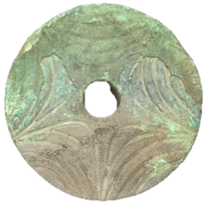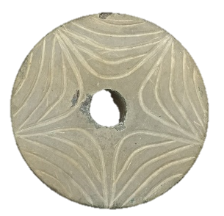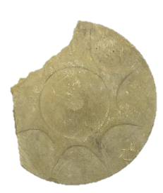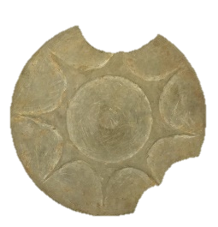
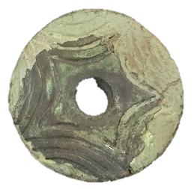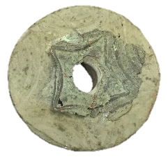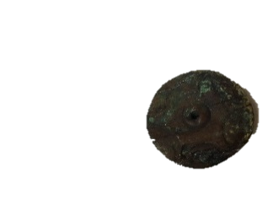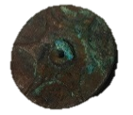
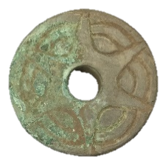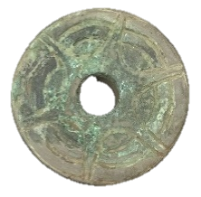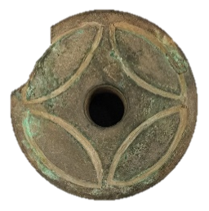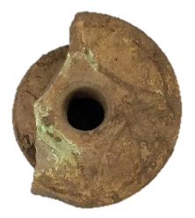
Figure 6.10: Earspools with variations of star motif. Not to scale.
Not only is the number of points of the stars different, the execution of their representation also differs between the earspools. The 4-pointed star motif is surrounded by a circle bordering the edge of the earspool, which is not present on any of the other earspools with a star motif. The two pair of earspools with a 5-point star motif differs in the incising of the design. One pair has smaller stars in the center of the earspools with proportioned repeating star patterns extending out, while the arms of the stars on the other pair extend to the edge of the earspool similar to one of the 6-point star motifs. The repeating star pattern also appears more in the background. One of the pair of earspools with the 6-point star motif has two curved concentric circles incised behind the star. The other earspools displaying a 6-point star differ in material type and the details of the design. One pair is made of wood and has a perforation, while the other is made of sandstone. The wooden earspools have a raised central boss in the center, similar to the earspools with the 8-point star motif. Another unique difference between the earspools is the pair with the 8-point star motif that is Foster type, unlike the others which are all Pulley type. The high levels of differentiation in the decorative motifs may indicate a level of restriction or careful control, reflecting hierarchical social relationships.
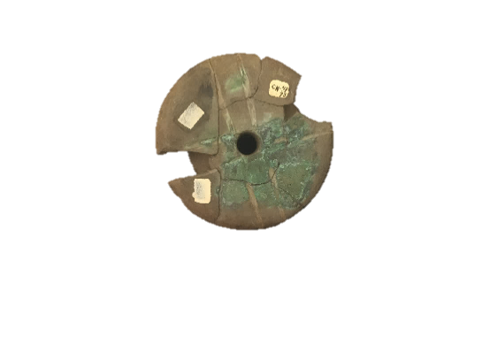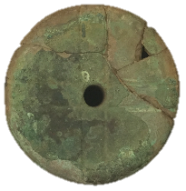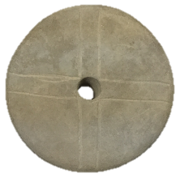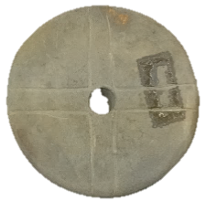
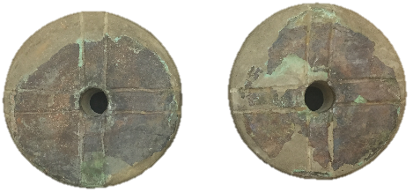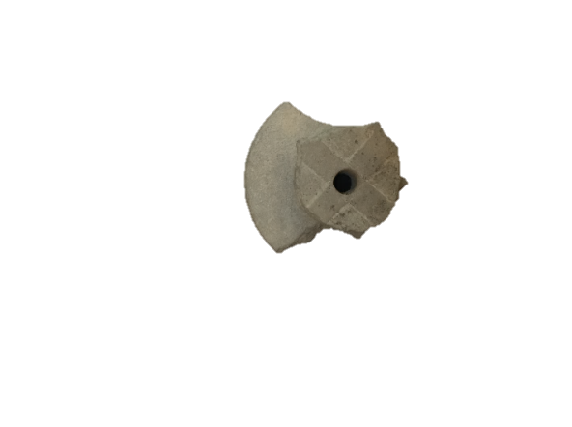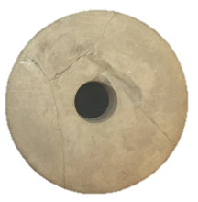
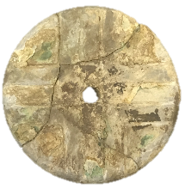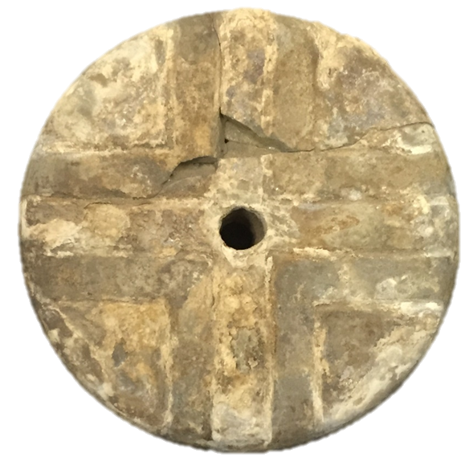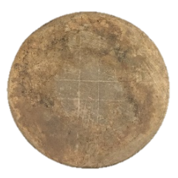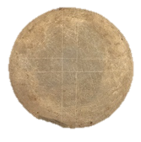
Figure 6.11: Earspools with 2 Lines Cross motif. Not to scale.
Another example is the Cross with 2 Lines (Figure 6:11), which is the most common motif in the assemblage, with twelve examples present. Similarities are apparent in the design, although the execution of some differs significantly. Three of the earspools have lines that appear extremely faint and almost seem unfinished. Three of the earspools show the motif in relief. The two earspools with the most similar design have evidence of copper covering and are from two different sites. Using the framework of Lesure and Pancake, it is possible that the repetition of this motif may indicate broader social relationships.

Conclusions

The decorative motifs on material culture are intended to communicate information. As discussed previously, designs can be used to reflect individual or group identities. Certain patterns that occur frequently suggest membership in a group, while unique patterns that are not repeated may represent a single individual. The sample analyzed in this research contains evidence of both repeating and unique motifs. As presented above, multiple earspools have the star motif. Additional patterns that are found on multiple earspools are the concentric circles and nodes. These motifs are repeated but retain levels of uniqueness. Examples of designs that appear in only one instance are the Human Heads, Interlocking Scroll, Grid, Check, Petaloid, and Thunderbird. The unique motifs that only appear on one pair of earspools may indicate a specific individual or single role within society, while repeating motifs suggest membership in a social group. Further research is needed to determine the frequency of these motifs on other items of material culture.

Chapter 7: Discussion and Interpretations

Previous studies on earspools from the Arkansas River Valley and the surrounding regions have been brief and only focused on only form. Additional research beyond a typology has not been conducted until now. This study has illustrated the potential for earspools to contribute to research on the Caddo region and Mississippi period. Earspools are an important category of personal adornment that have not been adequately researched to reveal their potential for providing information about the practices and inhabitants of the Arkansas and Red River Valley regions. This thesis includes a comprehensive analysis of the sample of earspools providing a foundation for further the research needed to understand the importance of earspools as geographic and temporal markers, in addition to the meaning they may embody. By expanding upon the perception of earspools as only indicators of elite status, this research explores a more in-depth meaning behind the use of personal adornment. Through recognition of the immense variation exhibited on the earspools in the sample, this thesis suggests that differences in the earspools may be used to research regional differences, shifts in cultural practices over time, and meaning behind personal regalia.
This chapter discusses the interpretation of the earspool analysis based on the research questions posed in this thesis. The goals of the research were to determine:
- Do the distribution and variability of earspool styles correspond to archaeologically defined northern and southern Caddo regions?

- What chronological variation is present in the earspools?

- Does the difference in the earspools compliment the changes in phases, or does the variation differ from the current position on chronology?

- Are certain earspool types diagnostic of cultural phases?

- Do earspool styles change in tandem with other types of material culture used as chronological markers?

- What does the degree of diversity and standardization among earspools with decorative features indicate about the nature of these items of personal adornment in the Arkansas and Red River Valleys?

The analysis focused on earspool types, distribution of earspools by site and region, and the stylistic attributes of the earspools including material type, diameter, and decorative motifs in order to address the research questions. The thesis focused on viewing the earspools as items of personal adornment and utilized gradations of value to suggest the use of ornamentation as a way to reflect individual identity or group affiliations. This research begins the discussion of using Caddo earspools as more than indicators of elite status.
Identifying variation within the sample of earspools assists in interpreting their significance in the Caddo region and over time. Earspools were prevalent throughout the northern and southern Caddo area suggesting the importance of this type of ornamentation. The research focuses on the differences between the earspools in order to understand why those variations exist.
Personal adornment was an important part of the lives of the people residing in the Arkansas and Red River Valley regions during the Mississippi period. Archaeologists have recovered items of ornamentation such as beads, headdresses, capes, and earspools from multiple archaeological sites, and representations of earspools appear on multiple types of artifacts including shell cups and copper plates. The presence of these similar items of personal adornment illustrate a shared tradition throughout the region. The variation in the types and styles of personal ornaments such as earspools are significant in interpreting regional differences, chronological shifts in cultural practices, and individual identity.

Regional Variation
Earspools recovered from sites throughout the Caddo region exhibit several similar traits, but also have regional differences. The Caddo region is divided into northern and southern sections based on current research into differences in material culture and practices. A limited number of earspools were available from the southern region compared to the northern region, but analysis shows similarities in earspool types and material use, with significant differences in number of decorative motifs.
The northern and southern regions have statistically similar numbers of earspool types and similar diversity in the material used for their construction. There is a significant difference in the number of motifs found on earspools from the northern and southern Caddo region. Earspools from sites in the northern region have nearly 5 times the number of motif designs. Understanding the reason for such a significant difference in decorative motifs on earspools between the northern and southern Caddo region will be a topic for future research.

Temporal Variation
The shifts in cultural phases in the Arkansas River Valley are marked by changes in social, political, and ritual practices as evident from material remains such as pottery and structures. Changes in earspools types and stylistics attributes can be seen over the Spiro Grave Periods. The multiple types of earspools that appeared in Spiro II, lessened in Spiro III and IV. There is a reduced number of earspools with perforations in the later periods and an increase in the number and variety of motifs. A large number of earspools date to the Spiro III period suggesting an increase in the use of earspools. The catalyst for the change in earspools over time combined with an increase in artifacts made from shell may indicated a shift in cultural practices and an increase in trade, but are unclear at this time and will be explored in further research.

Individual Variation
The degree of diversity and lack of standardization with regard to the decorative features in the sample of earspools suggest that some of these items of adornment may have been created for specific individuals. The variation in stylistic interpretations also suggests that earspools were not mass produced by a single individual or group of individuals regionally or locally. The variation in types, repeated patterns, and attributes, indicate a lack of adherence to specific standards. Instead, the variation suggests that some of the earspools were created for a specific individual or for a specific purpose.
The vast array of decorative motifs demonstrates a personalization of some of the earspools. The variations in the decorative features suggest the intention of the individual who wore them to differentiate themselves from others. Repeating patterns suggest multiple individuals communicating information regarding their common membership in a social group within the community, while non-repeating patterns may suggest a single individual. Certain patterns appear at multiple sites, while others are only found at one site, implying a reference to subgroups within the region or individual roles within the community.
The degree of stylistic variation supports interpretations that the choice of earspools suggests the use of these artifacts as items of personal adornment to communicate information about the individual. Stylistic interpretations of earspool types including size, material type, and decorative motif may have meanings that can reflect the functions beyond ornamentation. This thesis argues that earspools as items of personal adornment have the potential to function in multiple capacities suggesting differences in regional cultural practices, changes in cultural practices over time, and the role of individuals within societies. The analysis of the sample supports a separation between the northern and southern Caddo region, changes corresponding with Spiro Grave Periods, and personalization of earspools.

Future Research
The thesis creates a foundation for more in-depth research of earspools and rebuts previously held beliefs of their limited research value. Earspools have great potential interpretive value for archaeologists studying material cultures across time and space. As items of personal ornamentation, earspools offer insight into the way in which people adorned themselves, and how personal regalia may assist in interpreting the roles of individuals and activities in which they participated in the Arkansas and Red River Valleys.
The sample examined in this research is not a comprehensive collection of all known earspools from the area. Further studies should include the examination of additional earspools in the Caddo region, as well as the Southeast. Additional earspool assemblages may exhibit a similarly broad assortment of attributes, with unusual and different characteristics that may contribute to further research on the use of personal regalia.
The research conducted generated additional areas of interest for future studies. Such areas of inquiry include the way in which copper was adhered to the earspools, and why copper was used to cover other materials. Material sourcing, especially of the earspools made of materials other than sandstone, may provide insight into trade or regional connections. Iconographic studies on the motifs in relation to other mediums possessing similar representations may contribute to current research on the meaning of the images. Earspools have the potential to provide insight into their meaning, group practiced individual roles within the Caddo and other cultures through further research.

References
Albert, Lois E.
2000 The Norman Site: Descriptions. Caddoan Archeology 11(1–2):23-59.

Bareis, Charles John
1955a The Brackett Site, 34Ck-43, Of Cherokee County, Oklahoma. Unpublished Master's Thesis, Department of Anthropology, University of Oklahoma, Norman, Oklahoma.

1955b The Brackett Site, CK-43, of Cherokee County, Oklahoma. Oklahoma
Anthropological Society Bulletin (3):1-52.

Baerreis, David A.
1943 A Typological Method in Archaeology and Its Application. Master's Thesis, Department of Anthropology, University of Anthropology, Norman.

1957 The Southern Cult and the Spiro Ceremonial Complex. Oklahoma
Anthropological Society Bulletin (5):23-38.

Baugh, Timothy G.
1998 Regional Polities and Socioeconomic Exchange: Caddoan and Pueblo Interaction. In The Native History of the Caddo: Their Place in Southeastern Archeology and Ethnohistory, edited by D. A. Story, T. K. Perttula and J. E. Bruseth. Texas Archeological Research Laboratory, University of Texas Austin.

Bayman, James M.
2002 Hohokam Craft Economies and the Materialization of Power. Journal of
Archaeological Method and Theory 9: 69-95.

Bell, Robert E.
1972 Harlan Site, Ck-6, a Prehistoric Mound Center in Cherokee County, Eastern Oklahoma.

1984 Arkansas Valley Caddoan: The Harlan Phase. In Prehistory of
Oklahoma, edited by R. E. Bell, pp. 221-240. Academic Press, Orlando.

Blomster, Jeffrey P.
2014 The Naked and the Ornamented: Embodiment and Fluid Identities in Early Formative Oaxaca. In Wearing Culture: Dress and Regalia in Early Mesoamerica and Central America, edited by Heather Orr and Matthew G. Looper, pp. 115-144. University Press of Colorado.

Bohannon, Charles F.
1973 Excavations at the Mineral Springs site, Howard County, Arkansas. Fayetteville, Arkansas Archeological Survey.

Bohannon, Teresa Kaye
1989 The structure and organization of community education related to the recreation and leisure needs of special populations in Oklahoma. The structure and organization of community education related to the recreation and leisure needs of special populations in Oklahoma, ProQuest Dissertations and Theses.

Brooks, Robert L. and James E. Cox
2001 The Allcorn and Nagle Sites The Allcorn (34ML1) and Nagle (34OK4) Sites in Central Oklahoma and Their Relationships to the Arkansas River Caddoan Area. Plains Anthropologist, 56(218) pp. 93-113.

Brown, James A.
1976 Artifacts. Spiro Studies. Norman: University of Oklahoma Press.

1984a Arkansas Valley Caddoan: The Spiro Phase. In Prehistory of Oklahoma, edited by R. E. Bell, pp. 241-263. Academic Press, Orlando.

1996 The Spiro Ceremonial Center: The Archaeology of Arkansas Valley Caddoan Culture in Eastern Oklahoma. No. 29. Museum of Anthropology, University of Michigan.

1997 The archaeology of ancient religion in the Eastern Woodlands. Annual Review of Anthropology, 26, p.465.

2012 Spiro Reconsidered: Sacred Economy at the Western Frontier of the Eastern Woodlands. In The Archaeology of the Caddo, edited by T. K. Perttula and C. P. Walker, pp. 117-138. University of Nebraska Press, Lincoln.

2014 The Spiro Hollow Chamber Reconsidered, Unpublished manuscript in possession of the author.

Brown, James A., Richard A. Kerber and Howard D. Winters
1990 Trade and the Evolution of Exchange Relations at the Beginnings of the Mississippian Period. In The Mississippian Emergence, edited by B. D. Smith, pp. 251-280. Smithsonian Institution Press, Washington, D.C.

Bruseth, James E.
1998 The Development of Caddoan Polities along the Middle Red River Valley of Eastern Texas and Oklahoma. In The Native History of the Caddo: Their Place in Southeastern Archeology and Ethnohistory, edited by D. A. Story, T. K. Perttula and J. E. Bruseth, pp. 47-68. Texas Archeological Research Laboratory, University of Texas Austin.

Burnett, E.K. and Clements, Forrest E.
1915 The Spiro Mound Collection in the Museum, Historical Sketch of the Spiro Mound, Contributions from the Museum of the American Indian, Heye Foundation. Museum of the American Indian, Heye Foundation.

Carr, Christopher and D. Troy Case
2005 Gathering Hopewell (Interdisciplinary Contributions to Archaeology). Boston, MA: Springer US.

Carballo, David M.
2009 Household and Status in Formative Central Mexico: Domestic Structures, Assemblages, and Practices at La Laguna, Tlaxcala. Latin American Antiquity 20(3) pp. 473-501.

Carter, Cecile Elkins
1995 Caddo Indians, Where We Come From. University of Oklahoma Press, Norman.

Clayton, L., Vernon J. Knight, and Edward C. Moore
1993 The De Soto chronicles : the expedition of Hernando de Soto to North America in 1539-1543, Tuscaloosa: University of Alabama Press.
Clements, Forrest E.
1938 Preliminary General Report on Archaeological Work in Oklahoma Sponsored by the University of Oklahoma as a Works Progress Administration Project. On file at University of Oklahoma Western History Collections, WPA Archaeological Survey Project Collection, Box 1, Folder 1(2), Norman, Oklahoma.

Cranford, David J.
2007 Political Dynamics of Closely Spaced Mississippian Polities in Eastern Oklahoma: The Harlan (34Ck6) and Norman (34Wg2) Sites. Master's Thesis, Department of Anthropology, University of Anthropology, Norman.

Dorsey, George Amos
1905 Traditions of the Caddo. U of Nebraska Press.

Deter-Wolf, A., and Carol Diaz-Granados
2013 Drawing with Great Needles: Ancient tattoo traditions of North America (First ed.). Austin: University of Texas Press.

Diaz-Granados, Carol, and James R. Duncan
2000 The Petroglyphs and Pictographs of Missouri. University of Alabama Press.

Early, Ann M.
2000 The Caddos of the Trans-Mississippi South. In Indians of the Greater Southeast, edited by B. G. McEwan, pp. 122-141. University Press of Florida, Gainesville.

Finkelstein, J. Joe
1940 The Norman Site Excavations Near Wagoner, Oklahoma. Oklahoma
Prehistorian 3(3):2-15.

Fisher, Genevieve and Diana DiPaolo Loren
2003 Embodying Identity in Archaeology, Cambridge Archaeological Journal 13:2, 225–30.

Fundaburk, E. L. and M. D. F. Foreman
2001 Sun Circles and Human Hands: The Southeastern Indians Art and Industries. Tuscaloosa: The University of Alabama Press.

Follensbee, Billie J. A. and Katie McElfresh Bulford
2017 The Rogan Plates, Sex and Gender Representation, and the Bird- Human: A Case of Obscuring the Overt. In Dressing the part: power, dress, gender, and representation in the Pre-Columbian Americas. University Press of Florida.

Galm, Jerry R. and Robert E. Bell
1984 Arkansas Valley Caddoan Formative: the Wister and Fourche Maline Phases. In Prehistory of Oklahoma. pp. 199-219: Academic Press

Girard, Jeffery S., Timothy K. Perttula and Mary Beth Trubitt
2014 Caddo Connections: Cultural Interactions within and Beyond the Caddo
World. Rowman and Littlefield, Lanham.

Griffith, W.J.
1954 The Hasinai Indians of east Texas as seen by Europeans, 1687-1772.
Middle American Research Institute, Tulane University, Philological
and Documentary Studies 2(3).

Grosz, Elizabeth
1995 Space, time and perversion: The politics of bodies. Sydney: Allen and Unwin.

Hamilton, Henry W.
1952 Spiro Mound. Missouri Archaeologist. 14 (1): 1-5.
Hammerstedt, Scott W. and Sheila Bobalik Savage
2012 Late Prehistoric Mortuary Behavior in Northern Oklahoma: A View from the Reed Site. Paper presented at the The 69th meeting of the Southeastern Archaeological Conference, Baton Rouge, LA.

2013 Early Mississippian Mortuary Practices in the Arkansas River Drainage of Eastern Oklahoma. Paper presented at the The 70th meeting of the Southeastern Archaeological Conference, Tampa, FL.

Hammerstedt, Scott W., Amanda L. Regnier and Sheila Bobalik Savage
2015 The Use of Color in Burials from Spiro’s Great Mortuary. Paper presented at the 72nd Annual Southeastern Archaeological Conference, Nashville, Tennessee.

Hegmon, Michelle
1992 Archaeological Research on Style. Annual Review of Anthropology, Vol. 21:517-536.

Helms, Mary W.
1993 Craft and the Kingly Ideal: Art, Trade, and Power. Austin: Univ. of Texas Press.

Hodder, Ian
1990 Style as historical quality. In The uses of style in archaeology, edited by Conkey, M. and Hastorf, C. Cambridge University Press.

2000 Agency and individuals in long-term processes. In Agency in archaeology, edited by Marcia-Anne Dobres and John E. Robb, pp. 21–33. Routledge, London.

Hoffman, Michael
1971 A Partial Archaeological Sequence from the Little River Region, Arkansas. PhD dissertation. Department of Anthropology. Harvard University.

Jackson, H.E., S.L. Scott
2003 Patterns of elite faunal utilization at Moundville, Alabama. American Antiquity (68) pp. 552–573.

Kusnierz, Nicole
2016 Leadership and Social Dynamics at Brackett (34CK-43): An Archaeological Study of a Mississippi Period Mound Site in Eastern Oklahoma.

Knight, Vernon James Jr.
2010 Mound Excavations at Moundville: Architecture, Elites, and Social Order. Tuscaloosa, Ala., University of Alabama Press.

2013 Iconographic Method in New World Prehistory. Cambridge University Press, New York.

Knight, Vernon James Jr., James A. Brown and George P. Lankford
2001 On the Subject Matter of Southeastern Ceremonial Complex Art. Southeastern Archaeology 20:129-153.

Krutak, Deter-Wolf, and Galliot Robitaille
2016 The world's oldest tattoos. Journal of Archaeological Science: Reports, 5, 19-24.

Lesure, Richard G.
1999 On the Genesis of Value in Early Hierarchical Societies. In
Material Symbols: Culture and Economy in Prehistory, edited by
John E. Robb, pp. 23–55. Center for Archaeological Investigations,
Occasional Paper No. 26. Southern Illinois University, Carbondale.

Lewis, T., Lewis, Madeline D. Kneberg, and Charles H. Nash
1946 Hiwassee Island: An archaeological account of four Tennessee Indian peoples. Knoxville, Tenn.: The University of Tennessee Press.

Li, Zihao, Linda Cameron, and Lee Bartel
2010 Adolescent Male Dancers' Embodied Realities ProQuest Dissertations and Theses. Web.

Livingood, Patrick C.
2008 Recent Discussions in Late Prehistoric Southeastern Archaeology. Native South 1:1-26.

2011 Centering Mounds for the Red River Caddo. Paper presented at the 76th Meeting of the Society for American Archaeology, Sacramento, California.

2016 Leadership Specialization Among the Caddo and Their Neighbors. Paper presented a the 73rd Annual Meeting of the Southeastern Archaological Conference, Athens, Georgia.

Logan, Melissa K.
2017 The Cape, Status, and Gender in Late Formative West Mexico. In Dressing the part: power, dress, gender, and representation in the Pre-Columbian Americas. University Press of Florida.

Lovis, W.A. and I. Hodder
1990 The Meanings of Things: Material Culture and Symbolic Expression. American Antiquity, 55(3), pp.636–637.
Lyman, R. Lee
2008 Quantitative Paleozoology. Cambridge University Press.

Mattson, Hannah V.
2016 Ornaments as socially valuable objects: Jewelry and identity in the Chaco and post-Chaco worlds. Journal of Anthropological Archaeology, 42:122-139.

Meskell, Lynn
1996 The somatization of archaeology: Institutions, discourses, corporeality. Norwegian Archaeological Review 29:1–16.

Mills, Barbara J.
2002 Recent Research on Chaco: Changing Views on Economy, Ritual and Society. Journal of Archaeological Research 10: 65-117.

Mills, Barbara J., John M. Roberts, Jeffery J. Clark, W. Randall Haas, Deborah L. Huntley, and Meaghan A. Trowbridge
2012 A Method for Chronological Apportioning of Ceramic Assemblages. Journal of Archaeological Science 39.5:1513-520.
Miroir, P.
1946 Cemetery on the Runnels Farm. MS on file, Arkansas Archaeological Survey.

Mitchem, Jeffery M.
2008 Mississippian Copper Artifacts from Arkansas A paper presented at the 65th Annual Meeting of the Southeastern Archaeological Conference, Charlotte, November 13, 2008.

Moore, C.B.
1912 Some aboriginal sites on Red River, Philadelphia, Pa: P.C. Stockhausen.

Moore, C. B., R. A. Weinstein, D. H. Kelley, and J. W. Saunders
2003 The Louisiana and Arkansas Expeditions of Clarence Bloomfield Moore. Tuscaloosa: The University of Alabama Press.

Orr, Kenneth G.
1940 Field Report on the Eufaula Mound (Mi. Gr. I1.). MS on file, Sam Noble Museum of Natural History.

1942 The Eufaula Mound, Oklahoma: Contributions to the Spiro Focus. Unpublished Ph.D. Dissertation, Department of Anthropology, University of Chicago, Chicago, Illinois.
Pancake, Cherri M.
1996 Communicative Imagery In Guatemalan Indian Dress. In Textile Traditions of Mesoamerica and the Andes, edited by Margot Blum Schevill, Janet Catherine Berlo, and Edward B Dwyer, 45-62. Austin: University of Texas Press.

Peelo, Sarah
2011 Pottery-making in Spanish California: Creating Multi-scalar Social Identity Through Daily Practice. American Antiquity, Vol. 76, No.4:642-666.

Perttula, Timothy K.
1992 “The Caddo Nation”: Archaeological and Ethnohistoric Perspectives. University of Texas Press, Austin.

1996 Caddoan Area archaeology since 1990. Journal of Archaeological Research 4(4):295-348.

1997 "The Caddo Nation": Archaeological and Ethnohistoric Perspectives. University of Texas Press.

2005 1938-1939 WPA Excavations at the Hatchel Site (41BW3) on the Red River in Bowie County, Texas. Southeastern Archaeology 24(2):180-198.

2009 Extended entranceway structures in the Caddo archaeological area. Southeastern Archaeology:27-42.

Perttula, Timothy K., Mary Beth Trubitt and Jeffrey S. Girard
2011 The Use of shell-tempered pottery in the caddo area of the Southeastern United States. Southeastern Archaeology 30(2):242-267.

Perttula, Timothy K. and James E. Bruseth
1998 The Native History of the Caddo and Their Place in Southeastern Archaeology and Ethnohistory. In The Native History of the Caddo: Their Place in Southeastern Archeology and Ethnohistory, edited by D. A. Story, T. K. Perttula and J. E. Bruseth, pp. 1-8. Texas Archeological Research Laboratory, University of Texas Austin.

Phillips, Philip and James A. Brown
1978 Pre-Columbian Shell Engravings From the Craig Mound at Spiro, Oklahoma, Part 1. Harvard University, Cambridge

Regnier, Amanda L., Scott W. Hammerstedt and Nicholas H. Beale
2014 The Grobin Davis Site: Archaeogeophysics and Settlement Patterns at Caddo Mound Centers in Southeastern Oklahoma. Southeastern Archaeology 33(1):87-107.

Reilly, F. Kent III and James F. Garber
2007 Introduction. In Ancient Objects and Sacred Realms: Interpretations of Mississippian Iconography, edited by F. K. R. III and J. Garber, pp. 1-7. The University of Texas Press, Austin.

Rice, Prudence M.
2005 Pottery Analysis: A Sourcebook. University of Chicago, Chicago.

Rogers, J. Daniel and George Sabo
2004 Caddo. In Handbook of North American Indians edited by R. D. Fogelson and W. C. Sturtevant, pp. 616-631. vol. 14, Southeast. Smithsonian Institution, Washington, D.C.

Rogers, J. Daniel
1989a Context of a Regional Perspective. In Contributions to Spiro Archeology: Mound Excavations and Regional Perspectives, edited by J. D. Rogers, D. G. Wyckoff and D. A. Peterson, pp. 113-115.

1989b Settlement Contexts for Shifting Authority in the Arkansas Basin. In Contributions to Spiro Archeology: Mound Excavations and Regional Perspectives, edited by J. D. Rogers, D. G. Wyckoff and D. A. Peterson, pp. 159176. 16 vols. Oklahoma Archeological Survey, Norman, Oklahoma.

1995 Dispersed Communities and Integrated Households: A Perspective from Spiro and the Arkansas Basin. In Mississippian Communities and Households, edited by J. D. Rogers and B. D. Smith, pp. 81-98. University of Alabama Press, Tuscaloosa

2011 Spiro and the Development of a Regional Social System. In Artifacts
from Craig Mount at Spiro, Oklahoma, edited by A. K. Sievert and J. D. Rogers, pp. 1-12. Smithsonian Institution Scholarly Press, Washington, D.C.

Rogers, J.D. and Bruce D. Smith
1995 Mississippian communities and households, Tuscaloosa: University of Alabama Press.

Rohrbaugh, Charles Lawrence
1982 Spiro and Fort Coffee phases: changing cultural complexes of the
Caddoan area 1. University of Wisconsin--Madison.
Ruhl, K.C.
1992 Copper Earspools From Ohio Hopewell Sites. Midcontinental Journal of Archaeology, 17(1), pp.46–79.

2005 Hopewellian Copper Earspools from Eastern North America. In: Carr C., Case D.T. (eds) Gathering Hopewell. Interdisciplinary Contributions to Archaeology, pp. 696-713. Springer, Boston, MA

Ruhl, K.C. and M.F. Seeman
1998 The Temporal and Social Implications of Ohio Hopewell Copper Ear Spool Design. American Antiquity, 63(4), pp.651–662.

Sabo, George III and Ann M Early
1990 Prehistoric Culture History. In Human Adaptation in the Ozark and
Ouachita Mountains, edited by G. Sabo, A. M. Early, J. C. Rose, B. A. Burnett, L. Vogele Jr and J. P. Harcourt, pp. 34-120. Arkansas Archeological Research Series No. 31, Fayetteville, Arkansas.

Sabo, George III and James A. Brown
2014 New Assessments of the Craig Mound as a Framework for Current Research at the Spiro Ceremonial Center. Paper presented at the 72nd Annual Plains Anthropological Conference, Fayetteville, Arkansas.

Sackett, J. R.
1982 Approaches to style in lithic archaeology. Journal of Anthropology Archaeology 1:59-11 2.

Sahlins, Marshall
1972 Stone Age Economics. Aldine de Gruyter, New York.

Samuelsen, John
2014 AMS and Radiocarbon Dating of the Crenshaw Site (3MI6). The Arkansas Archaeologist 52:17-35.

2016 A reanalysis of strontium isotopes from a skull and mandible cemetery at the Crenshaw site: Implications for Caddo interregional warfare. Journal of Archaeological Science: Reports, 5, 119-134.

Sanders, H. L.
1968 Marine Benthic Diversity: A Comparative Study. American Naturalist
48:675–706.

Schambach, Frank F.
1982 "An Outline of Fourche Maline Culture in Southwest Arkansas." Arkansas Archeology in Review, Research Series 15:132-197.

Schechner, Richard
1988 Performance Theory. Rev. and Expanded ed. New York: Routledge.

Scher, Sarah E. M.
2017 High-Ranking Women and Masculine Imagery in Moche Art and Burial Ensembles. In Dressing the part: power, dress, gender, and representation in the Pre-Columbian Americas. University Press of Florida.

Shantleff, J., C. Thomas and Mike Hoffman
1981 Site Survey 3LR50. MS on file, Arkansas Archaeological Survey.

Smith, Bruce D.
1990 The Mississippian Emergence. Smithsonian Institution Press.

Strathern, A. and Stewart, P.
1998 Embodiment and communication. Two frames for the analysis of ritual. Social Anthropology, 6(2), 237-251.

Strathern Kirk and M. Andrew
1981 Man as art: New Guinea, New York: Viking Press.

Story, Dee Ann
1990 Culture History of the Native Americans In The Archaeology and Bioarchaeology of the Gulf Coastal Plain, edited by D. A. Story, J. A. Guy, B. A. Burnett, M. D. Freeman, J. C. Rose, D. G. Steele, B. W. Olive and K. J. Reinhard, pp. 163-366. vol. Research Series No. 38. Arkansas Archaeological Servey Fayetteville.

Story, D. A. and D. Creel, M.D.
1982 Cultural Setting. In: The DeShazo Site, Nacogdoches County, Texas. Vol. 2, pp. 53-60. Texas Antiquaitied Permit Series 7. Texas Antiwuities Committee, Austin.

Sullivan, Lynne P. and Robert C. Mainfort Jr.
2010 Mississippian Mortuary Practices and the Quest for Interpretation. In
Mississippian Mortuary Practices: Beyond Hierarchy and the
Representationist Perspective, edited by L. P. Sullivan and R. C. J. Mainfort, pp. 1-13. University Press of Florida, Gainesville.

Swanton, John Reed
1942 Source Material on the History and Ethnology of the Caddo Indians. University of Oklahoma Press.

Taylor, Allan R.
1963 "Comparative Caddoan." International Journal of American Linguistics: 113-131.

Thoburn, Joseph B.
1926 Oklahoma Archaeological Explorations In 1925-26. Chronicles of Oklahoma Volume 4, No. 2 June.

1929 Oklahoma; a History of the State and Its People. New York, Lewis Historical Pub. Co.

1931 The Prehistoric Cultures of Oklahoma. New Haven [Conn.], Pub. for the Department of Archaeology, Phillips Academy, Andover, Mass. by the Yale University Press.

Tipper, J. C.
1979 Rarefaction and Rarefiction – The Use and Abuse of a Method in Paleoecology. Paleobiology 5:423–434.

Trubitt, M.B.
2009 Site Survey 3CL220. MS on file, Arkansas Archaeological Survey

Vanearen, Marian, F. D'Errico, Lucinda Backwell, and Phillip V. Tobias
2005 From tools to symbols: From early hominids to modern humans; in honour of Professor Phillip V. Tobias. Johannesburg, South Africa: Witwatersrand University Press.

Vogel, Gregory
2005 A View from the Bottomlands: Physical and Social Landscapes and Late Prehistoric Mound Centers in the Northern Caddo Area. Unpublished Ph.D. Dissertation, University of Arkansas.

Wadley, L.
2001 What is Cultural Modernity? A General View and a South African Perspective from Rose Cottage Cave. Cambridge Archaeological Journal, 11(2): 201-221.

Walters, Michael C. H.
2016 Shaft Tombs in the Caddo World. Proceedings of the Poster presented at the 81st Annual Meeting of the Society for American Archaeology. Orlando, Florida.

Washburn, Dorothy K., Donald W. Crowe, and Richard V.N. Ahlstrom
2010 A symmetry analysis of design structure: 1,000 years of continuity and change in Puebloan ceramic design. (Report). American Antiquity, 75(4), pp.743–772.

Webb, Clarence H. and Hiram F. Gregory
1986 The Caddo Indian of Louisiana, Second Edition. Anthropological Study No. 2 Department of Culture, Recreation, and Tourism, Louisiana Archaeological Survey and Antiquities Commission, Baton Rouge.

White, Carolyn
2002 Constructing identities: Personal adornment from Portsmouth, New Hampshire, 1680–1820. Constructing identities: Personal adornment from Portsmouth, New Hampshire, 1680–1820, pp. ProQuest Dissertations and Theses.

White Randall
1989 Toward a contextual understanding of the earliest body ornaments. In The Emergence of Modern Humans: Biocultural Adaptations in the Later Pleistocene, ed. E Trinkhaus, pp. 211–31. Cambridge, UK: Cambridge Univ. Press.

1992 Beyond Art: Toward an Understanding of the Origins of Material Representation in Europe. Annual Review of Anthropology. 21:537–64.

1993 The Dawn of Adornment. (prehistoric ornaments and images) (How Did Humans Get That Way?). Natural History, 102(5), p.60.

Wilson, Diane and Timothy K. Perttula
2013 Reconstructing the Paleodiet of the Caddo through Stable Isotopes. American Antiquity, 78(4): 702-723.

Wiessner, P.
1990 Is there a unity to style? In Uses of Style in Archaeology, ed. M. Conkey and C. Hastorf, pp. 105-12. Cambridge University Press, Cambridge.

Wingfield, Laura M.
2017 Greenstone Axe to Gold Eagle Pendant: The Sex Change of Costa Rica’s Symbol of National Pride. In Dressing the part: power, dress, gender, and representation in the Pre-Columbian Americas. University Press of Florida.

Wobst H. M.
1977 Stylistic behavior and information exchange. In For the Director: Research Essays in Honor of James B. Griffin, ed. C Cleland, pp. 317–42. Ann Arbor: Museum of Anthropology, University of Michigan.

Wyckoff, Don G., Williams, Stephen, and United States. Indian Claims Commission.
1974 The Caddoan Cultural Area; an Archaeological Perspective. American Indian Ethnohistory. Plains Indians. New York: Garland Pub.

1980 Caddoan adaptive strategies in the Arkansas basin, eastern Oklahoma. Caddoan adaptive strategies in the Arkansas basin, eastern Oklahoma, pp. Proquest Dissertations and Theses.

Appendix A: Earspool Photographs
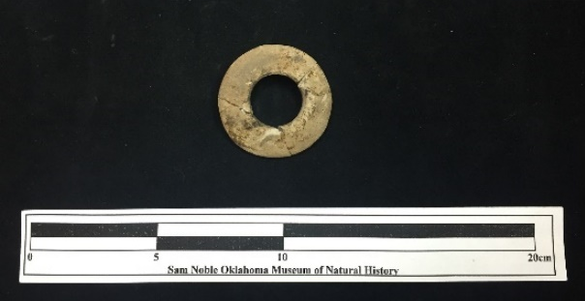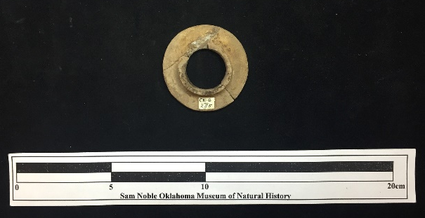
Site Number/Catalog Number: 34Ck0006/0255a
Site Name: Harlan
Additional Provenience Information: CK 1-C S21-R6
Earspool Type: Pulley
Material Type: Sandstone
Spiro Grave Period: Unassigned

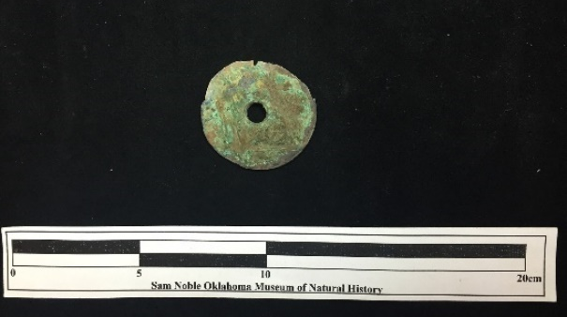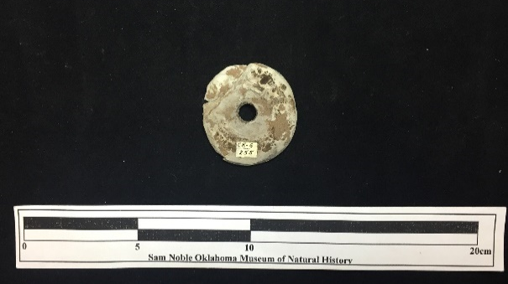
Site Number/Catalog Number: 34Ck0006/0255b
Site Name: Harlan
Additional Provenience Information: CK 1-C S21-R6
Earspool Type: Pulley
Material Type: Sandstone
Spiro Grave Period: Unassigned

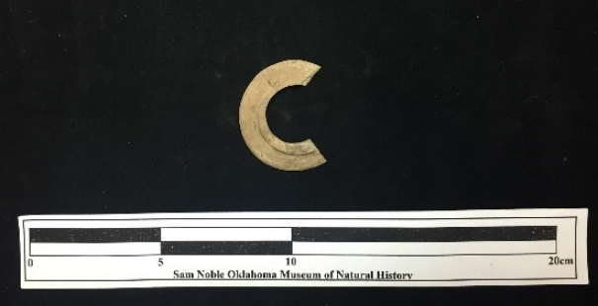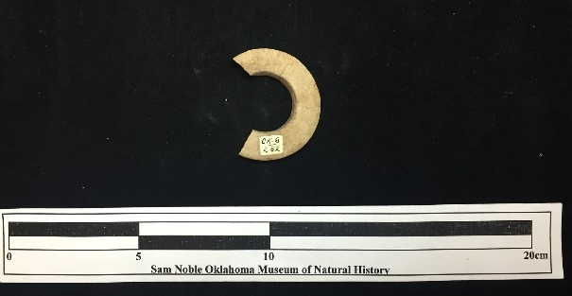
Site Number/Catalog Number: 34Ck0006/0262
Site Name: Harlan
Additional Provenience Information: CK 1-C S21-R5
Earspool Type: Flanged Ring
Material Type: Sandstone
Spiro Grave Period: Unassigned

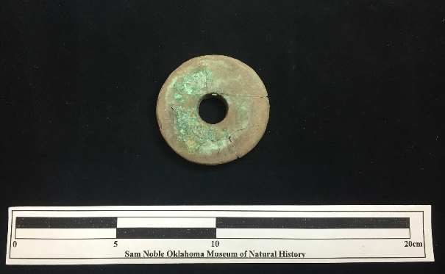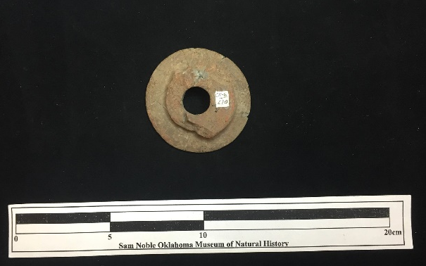
Site Number/Catalog Number: 34Ck0006/0270
Site Name: Harlan
Additional Provenience Information: CK 1-C S21-R7
Earspool Type: Pulley
Material Type: Sandstone
Spiro Grave Period: Unassigned

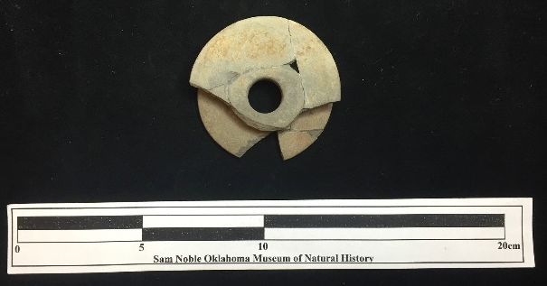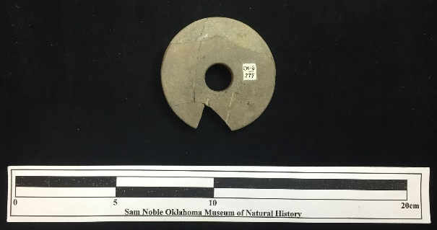
Site Number/Catalog Number: 34Ck0006/0274
Site Name: Harlan
Additional Provenience Information: CK 1-C S21-R5
Earspool Type: Pulley
Material Type: Sandstone
Spiro Grave Period: Unassigned

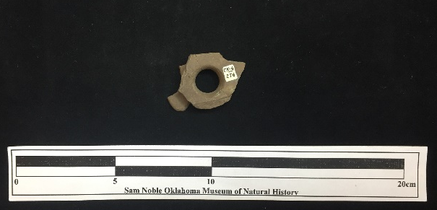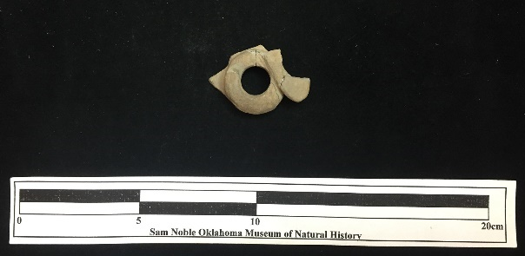
Site Number/Catalog Number: 34Ck0006/0276
Site Name: Harlan
Additional Provenience Information:
Earspool Type: Foster
Material Type: Sandstone
Spiro Grave Period: Unassigned

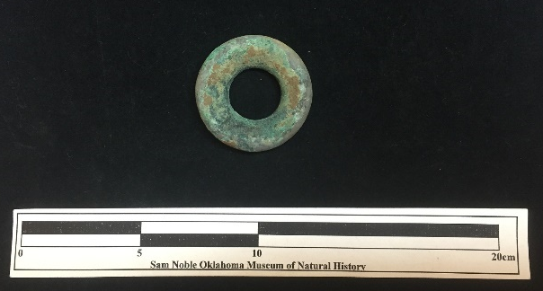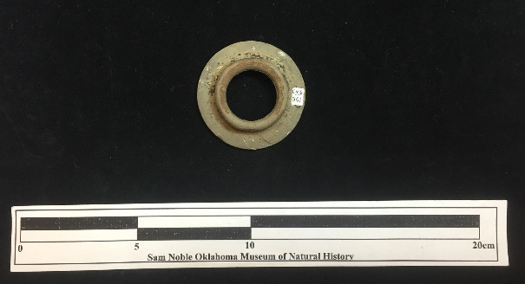
Site Number/Catalog Number: 34Ck0006/0361
Site Name: Harlan
Additional Provenience Information: CK 1-B S14-R5 (B37?)
Earspool Type: Nested Half
Material Type: Sandstone
Spiro Grave Period: Spiro III

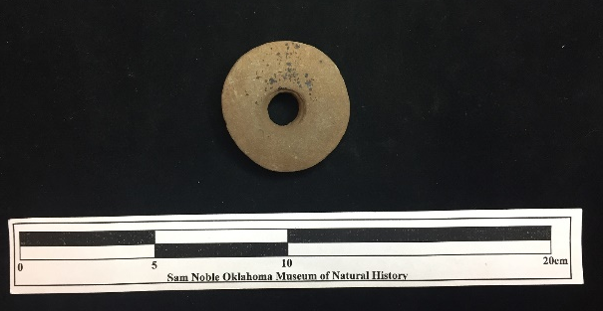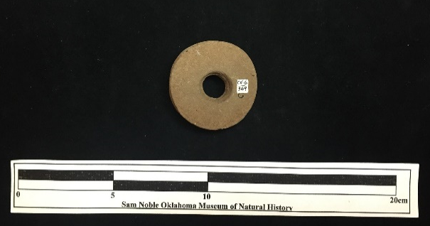
Site Number/Catalog Number: 34Ck0006/0369
Site Name: Harlan
Additional Provenience Information: CK 1-B S13-R5
Earspool Type: Grooved
Material Type: Sandstone
Spiro Grave Period: Unassigned

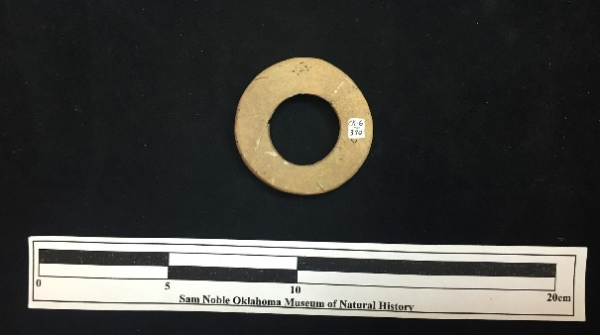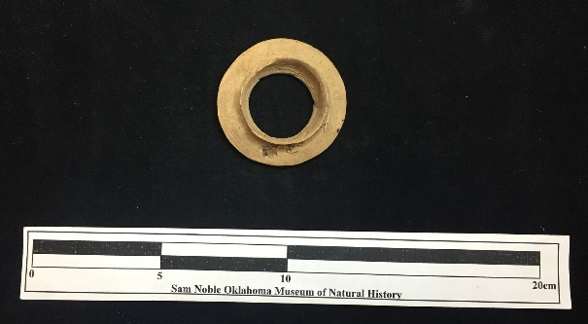

Site Number/Catalog Number: 34Ck0006/0370
Site Name: Harlan
Additional Provenience Information: CK 1-A S5-R4 or R5
Earspool Type: Nested Half
Material Type: Sandstone
Spiro Grave Period: Unassigned

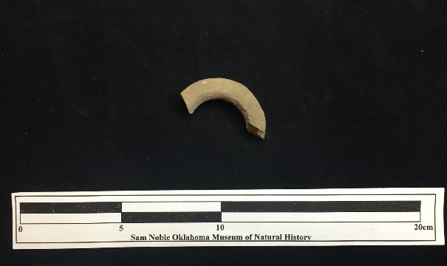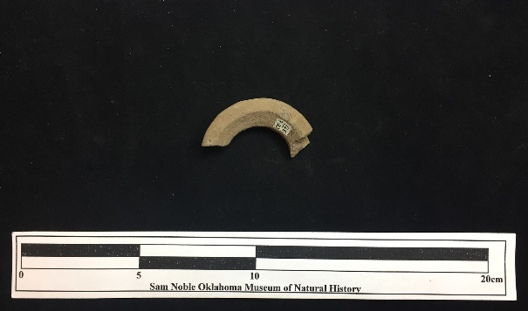
Site Number/Catalog Number: 34Ck0006/0371
Site Name: Harlan
Additional Provenience Information: CK 1-B S13-R5
Earspool Type: Flanged Ring
Material Type: Sandstone
Spiro Grave Period: Unassigned

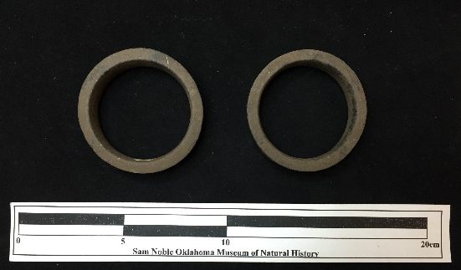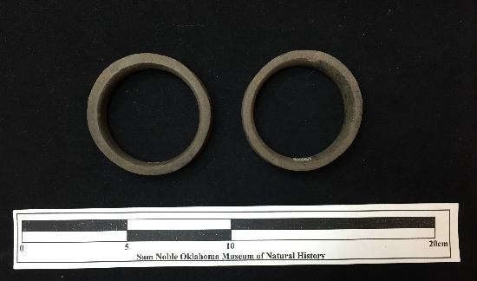
Site Number/Catalog Number: 34Ck0006/0373-1&2
Site Name: Harlan
Additional Provenience Information: : CK 1-B S13-R5 B41
Earspool Type: Hollow Cylinder
Material Type: Sandstone
Spiro Grave Period: Spiro III

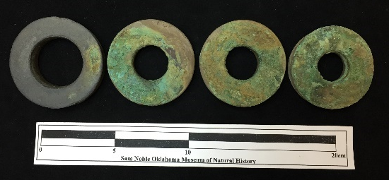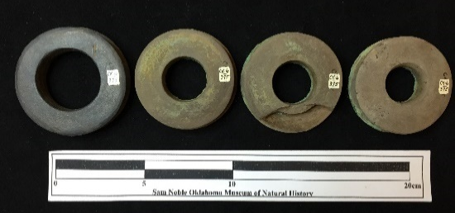
Site Number/Catalog Number: 34Ck0006/0375-a,b,c,d
Site Name: Harlan
Additional Provenience Information: Ck 1-C S20-R5 B105
Earspool Type: Pulley
Material Type: Slate or shale
Spiro Grave Period: Spiro III

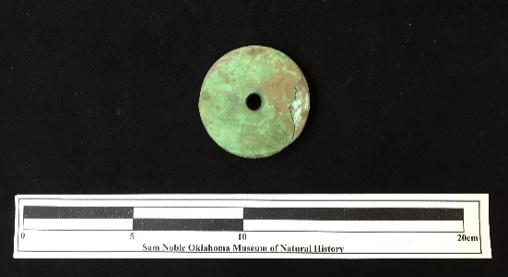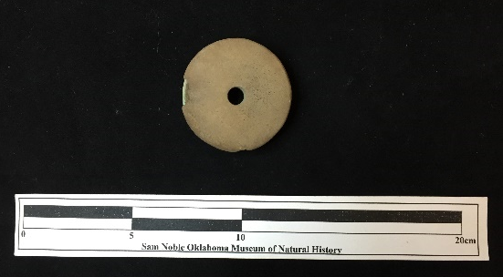
Site Number/Catalog Number: 34Ck0006/0397
Site Name: Harlan
Additional Provenience Information: Ck 1-B S12-R4 B114b
Earspool Type: Pulley
Material Type: Sandstone
Spiro Grave Period: Spiro II

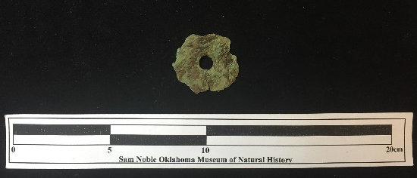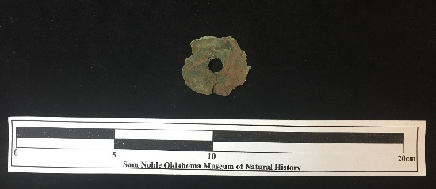
Site Number/Catalog Number: 34Ck0006/0409
Site Name: Harlan
Additional Provenience Information: Ck 1-A B26
Earspool Type: Unassigned
Material Type: Wood
Spiro Grave Period: Spiro III

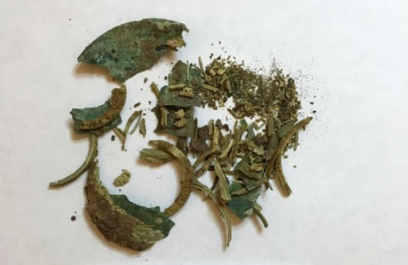
Site Number/Catalog Number: 34Ck0006/0410
Site Name: Harlan
Additional Provenience Information: CK 1-B S13-R4 B54
Earspool Type: Unassigned
Material Type: Wood
Spiro Grave Period: Spiro III

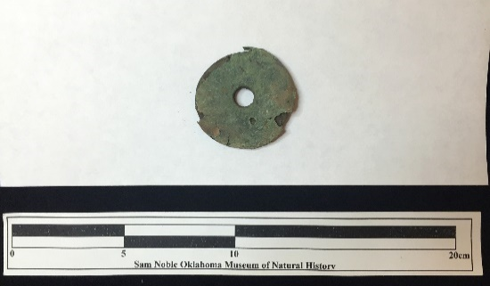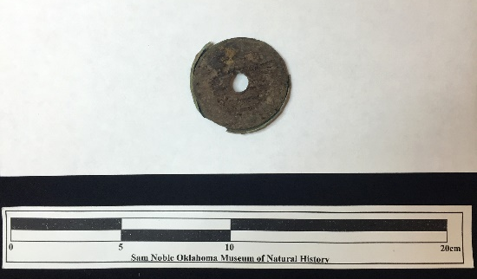
Site Number/Catalog Number: 34Ck0006/0414a
Site Name: Harlan
Additional Provenience Information: Ck 1-B S21-R7 B59
Earspool Type: Unassigned
Material Type: Wood
Spiro Grave Period: Spiro II

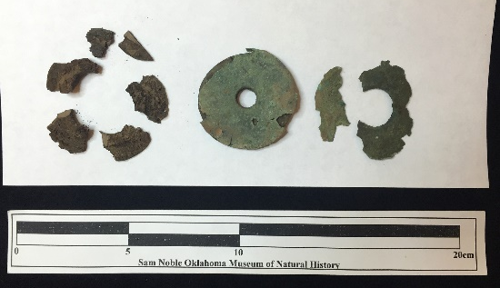
Site Number/Catalog Number: 34Ck0006/0414b
Site Name: Harlan
Additional Provenience Information: B59
Earspool Type: Unassigned
Material Type: Wood
Spiro Grave Period: Spiro II

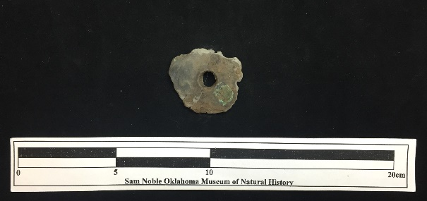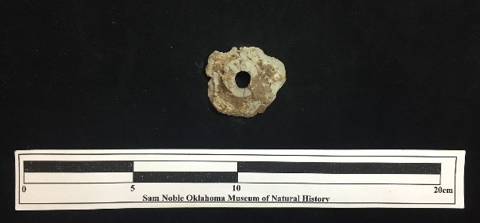
Site Number/Catalog Number: 34Ck0006/0416
Site Name: Harlan
Additional Provenience Information: CK 1-C S21-R6
Earspool Type: Pulley
Material Type: Sandstone
Spiro Grave Period: Unassigned

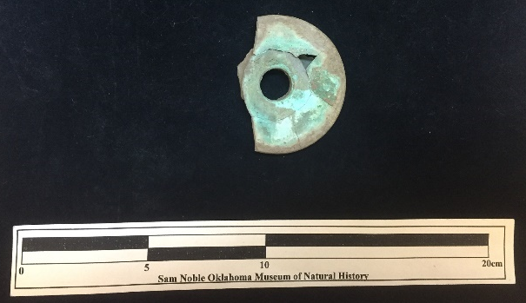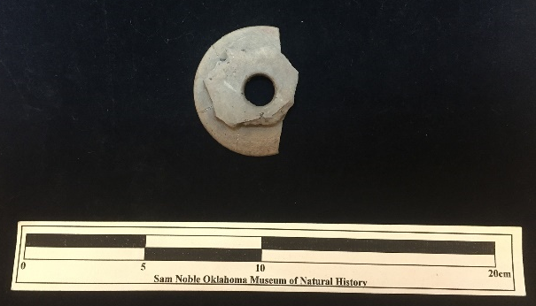
Site Number/Catalog Number: 34Ck0006/0418
Site Name: Harlan
Additional Provenience Information: CK 1-C S22-R5
Earspool Type: Pulley
Material Type: Sandstone
Spiro Grave Period: Unassigned

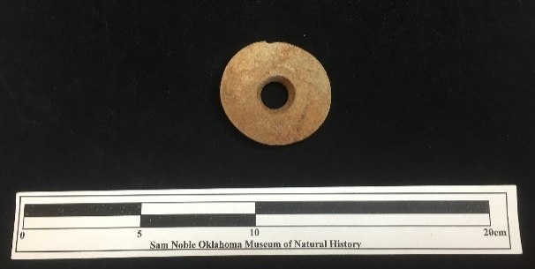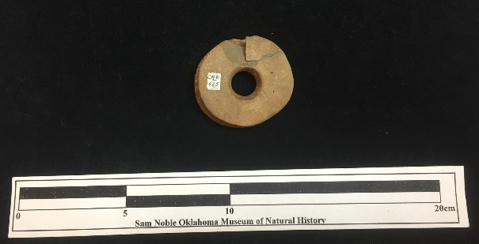
Site Number/Catalog Number: 34Ck0006/0425
Site Name: Harlan
Additional Provenience Information: CK 1-B S14-R5
Earspool Type: Grooved
Material Type: Sandstone
Spiro Grave Period: Unassigned

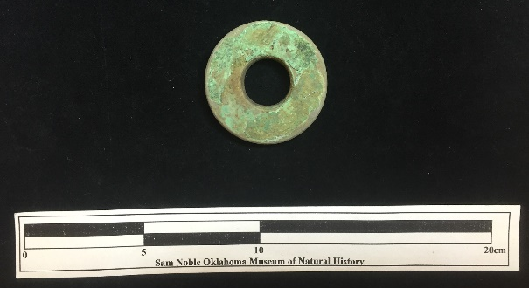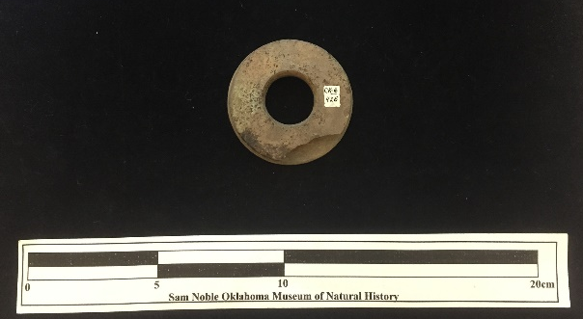
Site Number/Catalog Number: 34Ck0006/0426
Site Name: Harlan
Additional Provenience Information: CK 1-C S20-R5
Earspool Type: Pulley
Material Type: Sandstone
Spiro Grave Period: Unassigned

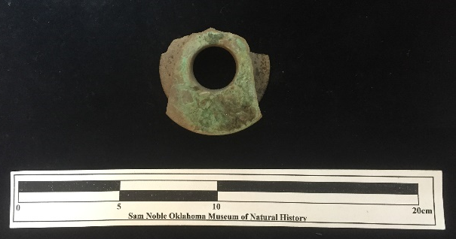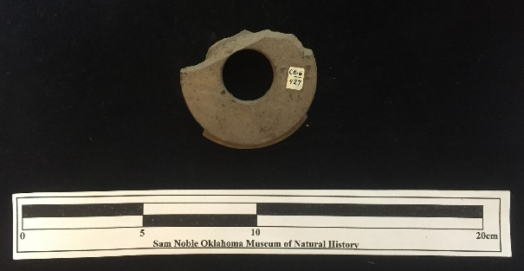
Site Number/Catalog Number: 34Ck0006/0427
Site Name: Harlan
Additional Provenience Information: CK 1-C S21-R6
Earspool Type: Pulley
Material Type: Sandstone
Spiro Grave Period: Unassigned

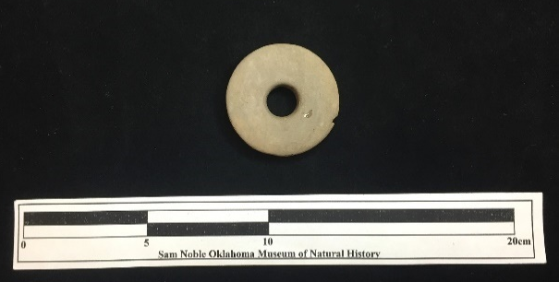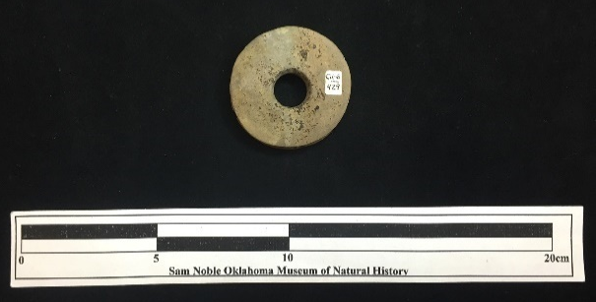
Site Number/Catalog Number: 34Ck0006/0429
Site Name: Harlan
Additional Provenience Information: CK 1-B S13-R5 or 17
Earspool Type: Pulley
Material Type: Sandstone
Spiro Grave Period: Unassigned

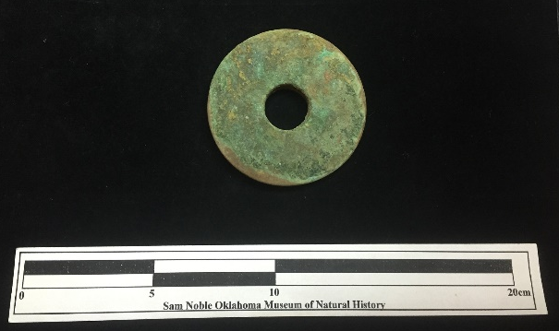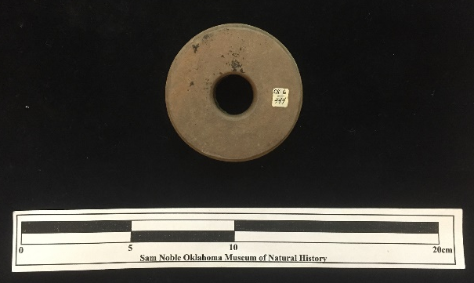
Site Number/Catalog Number: 34Ck0006/0444
Site Name: Harlan
Additional Provenience Information: CK 1-C S21-R7
Earspool Type: Pulley
Material Type: Sandstone
Spiro Grave Period: Unassigned

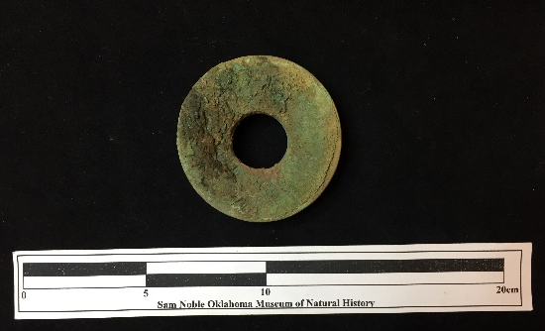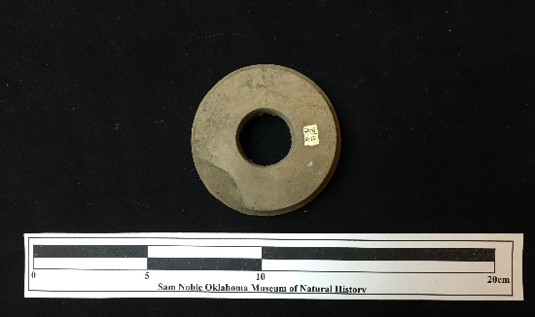
Site Number/Catalog Number: 34Ck0006/0612
Site Name: Harlan
Additional Provenience Information: Ck 1-C S20-R5 B105
Earspool Type: Pulley
Material Type: Sandstone
Spiro Grave Period: Spiro III

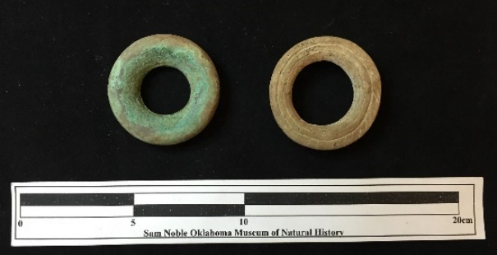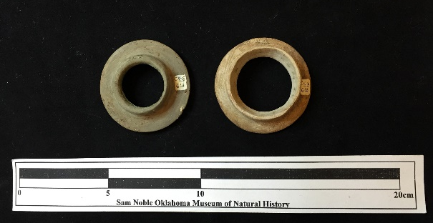
Site Number/Catalog Number: 34Ck0006/0613a&b
Site Name: Harlan
Additional Provenience Information: CK 1-B S14-R5 B37
Earspool Type: Nested Half
Material Type: Sandstone
Spiro Grave Period: Spiro III

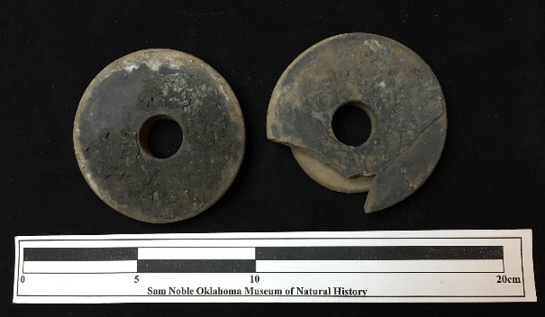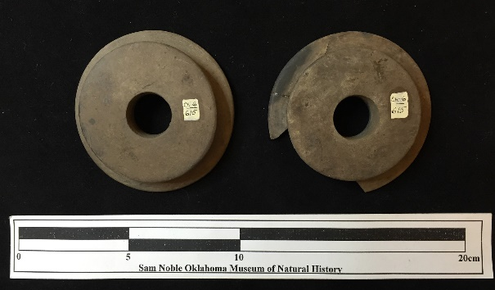
Site Number/Catalog Number: 34Ck0006/0615-a&b
Site Name: Harlan
Additional Provenience Information: CK 1-B S13-R5 B41
Earspool Type: Pulley
Material Type: Sandstone
Spiro Grave Period: Spiro III

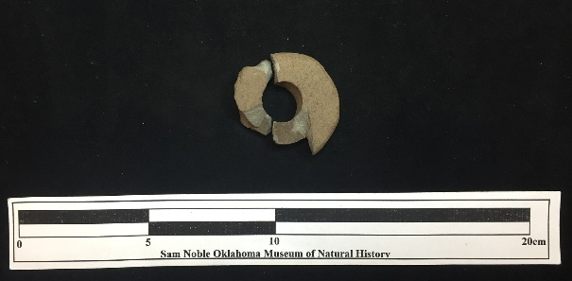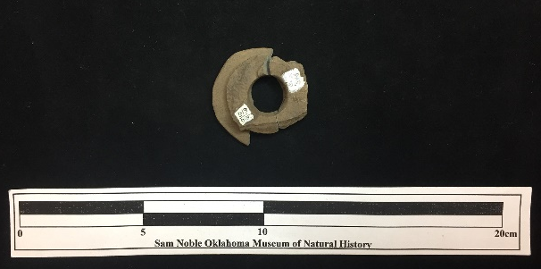
Site Number/Catalog Number: 34Ck0006/0616
Site Name: Harlan
Additional Provenience Information: CK 1-C S22-R6
Earspool Type: Pulley
Material Type: Sandstone
Spiro Grave Period: Unassigned

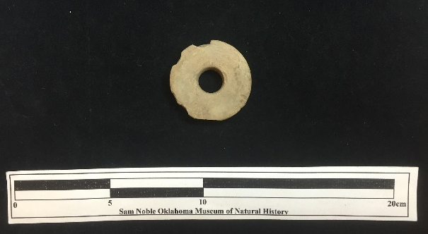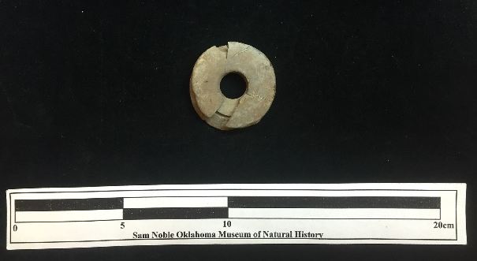
Site Number/Catalog Number: 34Ck0006/594
Site Name: Harlan
Additional Provenience Information: CK 1-B S13-R5 or 17
Earspool Type: Pulley
Material Type: Sandstone
Spiro Grave Period: Unassigned

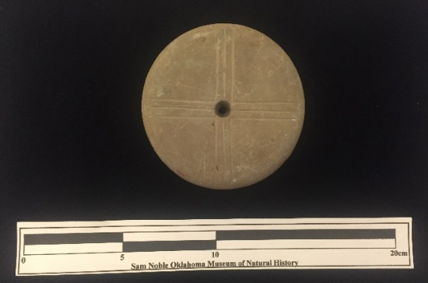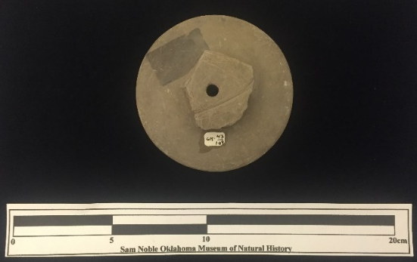
Site Number/Catalog Number: 34Ck43/109
Site Name: Brackett
Additional Provenience Information: B6-3
Earspool Type: Pulley
Material Type: Sandstone
Spiro Grave Period: Spiro II

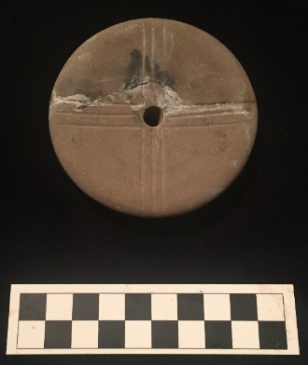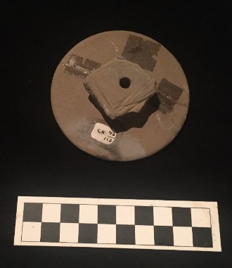
Site Number/Catalog Number: 34Ck43/113
Site Name: Brackett
Additional Provenience Information: B6
Earspool Type: Pulley
Material Type: Sandstone
Spiro Grave Period: Spiro II
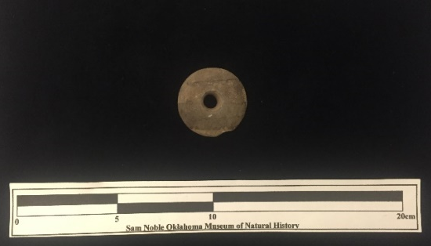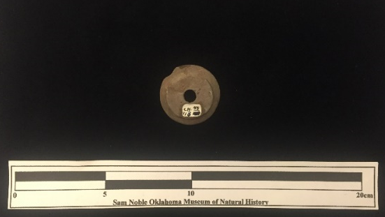
Site Number/Catalog Number: 34Ck43/113
Site Name: Brackett
Additional Provenience Information: B6
Earspool Type: Pulley
Material Type: Sandstone
Spiro Grave Period: Spiro II

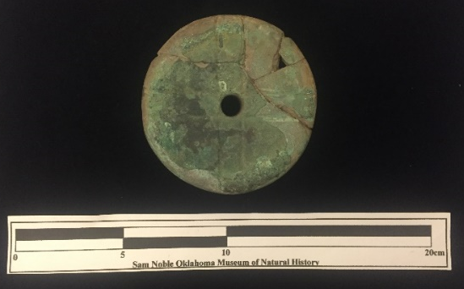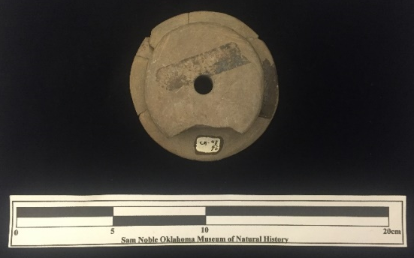
Site Number/Catalog Number: 34Ck43/430
Site Name: Brackett
Additional Provenience Information: B5
Earspool Type: Pulley
Material Type: Sandstone
Spiro Grave Period: Spiro II

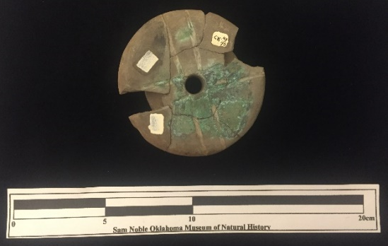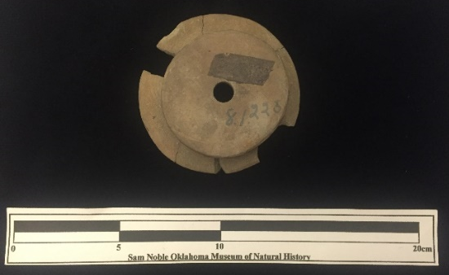
Site Number/Catalog Number: 34Ck43/75
Site Name: Brackett
Additional Provenience Information: B5
Earspool Type: Pulley
Material Type: Sandstone
Spiro Grave Period: Spiro II
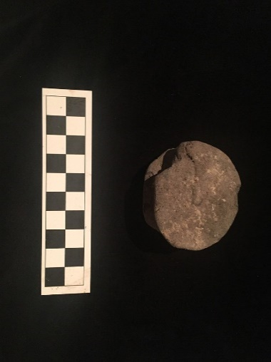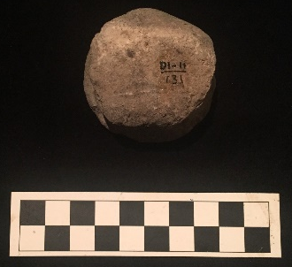

Site Number/Catalog Number: 34DL0/11/131
Site Name: Reed
Additional Provenience Information:
Earspool Type: Pulley
Material Type: Sandstone
Spiro Grave Period: Spiro III

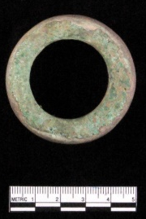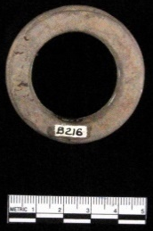

Site Number/Catalog Number: 34DL0/12
Site Name: Reed
Additional Provenience Information: DL0/12
Earspool Type: Flanged Ring
Material Type: Sandstone
Spiro Grave Period: Spiro III

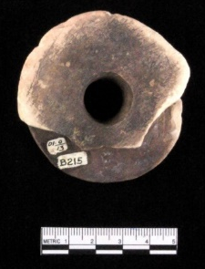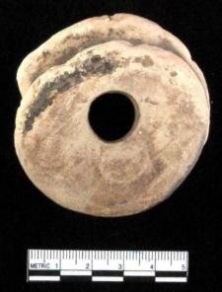

Site Number/Catalog Number: 34DL0/13
Site Name: Reed
Additional Provenience Information: DL0/13
Earspool Type: Pulley
Material Type: Sandstone
Spiro Grave Period: Spiro III

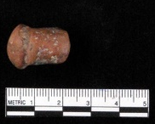
Site Number/Catalog Number: 34DL0/18
Site Name: Reed
Additional Provenience Information: DL0/18
Earspool Type: Plug
Material Type: Sandstone
Spiro Grave Period: Spiro III

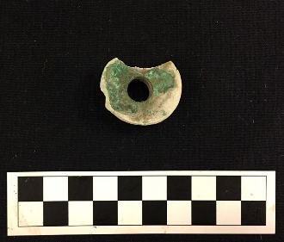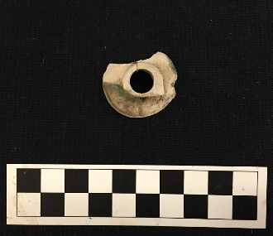
Site Number/Catalog Number: 34DL0/206.XL
Site Name: Reed
Additional Provenience Information:
Earspool Type: Pulley
Material Type: Limestone
Spiro Grave Period: Spiro III

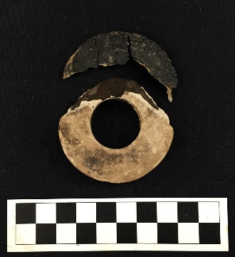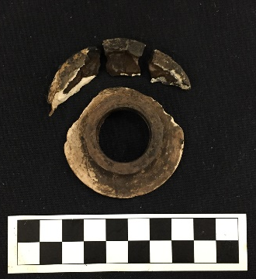
Site Number/Catalog Number: 34DL0/207.XL
Site Name: Reed
Additional Provenience Information:
Earspool Type: Nested Half
Material Type: Limestone
Spiro Grave Period: Spiro III
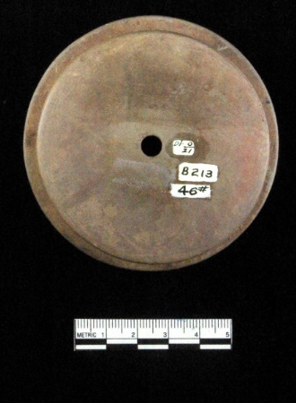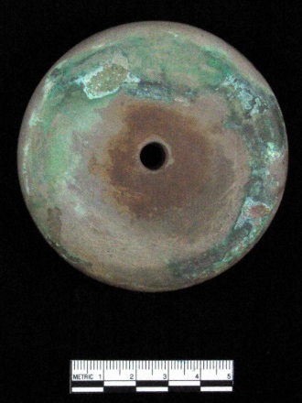
Site Number/Catalog Number: 34DL0/21
Site Name: Reed
Additional Provenience Information: B1-213
Earspool Type: Pulley
Material Type: Sandstone
Spiro Grave Period: Spiro III
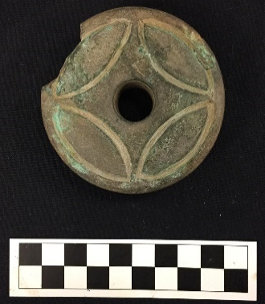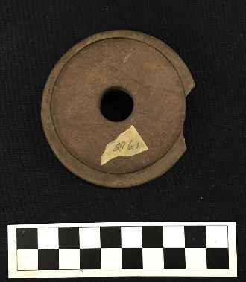
Site Number/Catalog Number: 34DL0/216.XL
Site Name: Reed
Additional Provenience Information:
Earspool Type: Pulley
Material Type: Sandstone
Spiro Grave Period: Spiro III
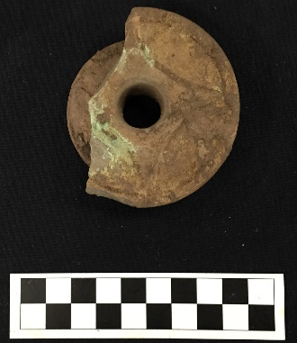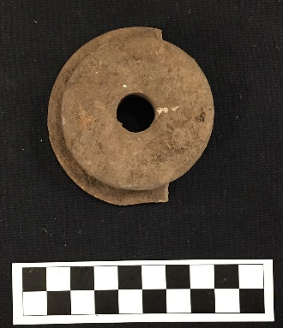
Site Number/Catalog Number: 34DL0/217.XL
Site Name: Reed
Additional Provenience Information:
Earspool Type: Pulley
Material Type: Sandstone
Spiro Grave Period: Spiro III
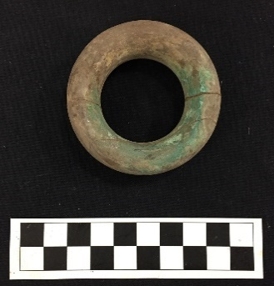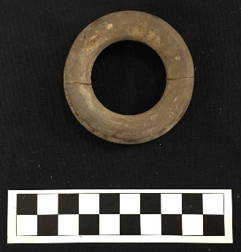
Site Number/Catalog Number: 34DL0/218.XL
Site Name: Reed
Additional Provenience Information:
Earspool Type: Pulley Ring
Material Type: Sandstone
Spiro Grave Period: Spiro III

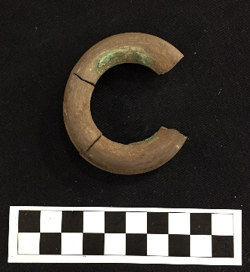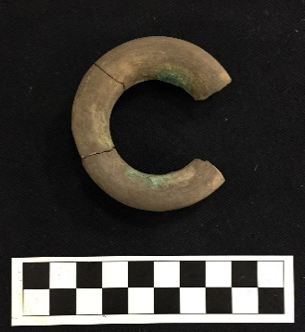
Site Number/Catalog Number: 34DL0/219.XL
Site Name: Reed
Additional Provenience Information:
Earspool Type: Pulley Ring
Material Type: Sandstone
Spiro Grave Period: Spiro III

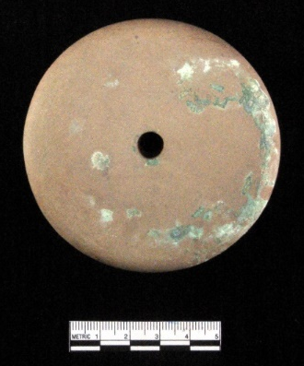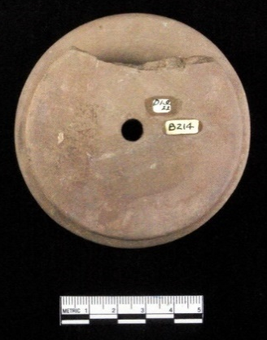
Site Number/Catalog Number: 34DL0/22
Site Name: Reed
Additional Provenience Information: B-214
Earspool Type: Pulley
Material Type: Sandstone
Spiro Grave Period: Spiro III
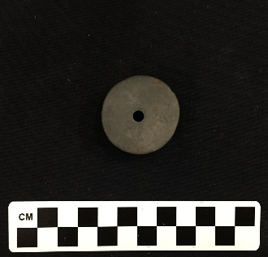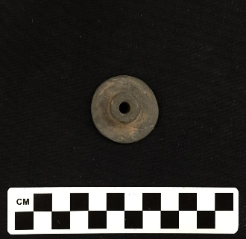
Site Number/Catalog Number: 34DL0/a
Site Name: Reed
Additional Provenience Information:
Earspool Type: Nested Half
Material Type: Sandstone
Spiro Grave Period: Spiro III

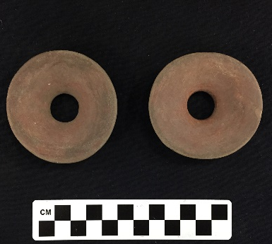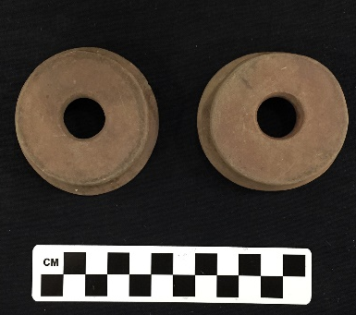
Site Number/Catalog Number: 34DL0/b&c
Site Name: Reed
Additional Provenience Information:
Earspool Type: Pulley
Material Type: Sandstone
Spiro Grave Period: Spiro III

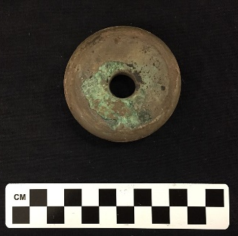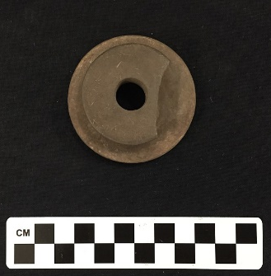
Site Number/Catalog Number: 34DL0/d
Site Name: Reed
Additional Provenience Information:
Earspool Type: Pulley
Material Type: Sandstone
Spiro Grave Period: Spiro III

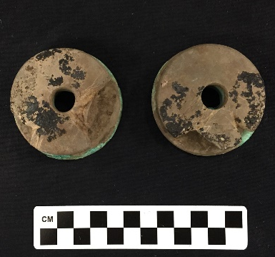
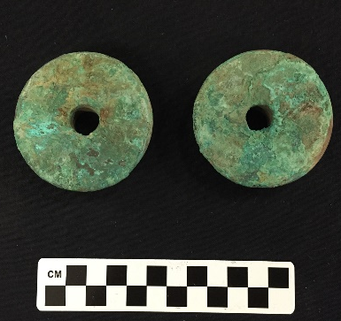
Site Number/Catalog Number:34DL0/e&f
Site Name: Reed
Additional Provenience Information:
Earspool Type: Pulley
Material Type: Sandstone
Spiro Grave Period: Spiro III

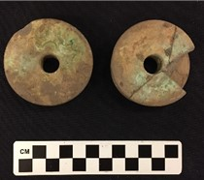
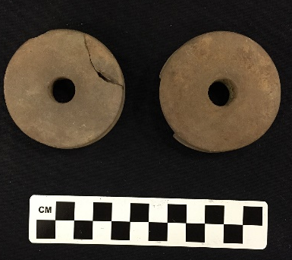
Site Number/Catalog Number: 34DL0/g&h
Site Name: Reed
Additional Provenience Information:
Earspool Type: Pulley
Material Type: Sandstone
Spiro Grave Period: Spiro III

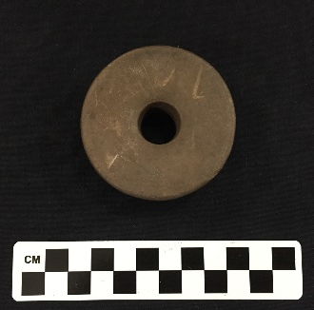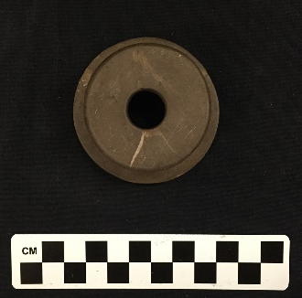
Site Number/Catalog Number: 34DL0/i
Site Name: Reed
Additional Provenience Information:
Earspool Type: Pulley
Material Type: Sandstone
Spiro Grave Period: Spiro III

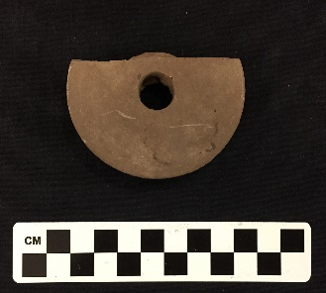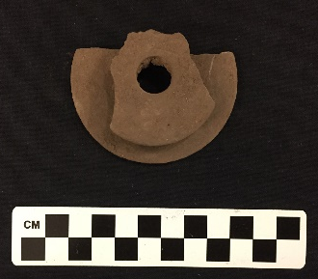
Site Number/Catalog Number: 34DL0/j
Site Name: Reed
Additional Provenience Information:
Earspool Type: Pulley
Material Type: Sandstone
Spiro Grave Period: Spiro III

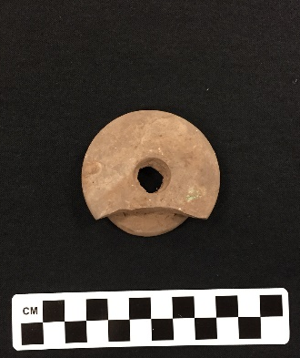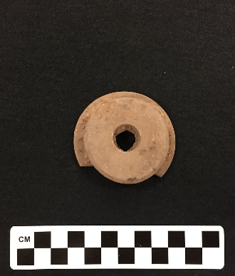
Site Number/Catalog Number: 34DL0/k
Site Name: Reed
Additional Provenience Information:
Earspool Type: Pulley
Material Type: Sandstone
Spiro Grave Period: Spiro III

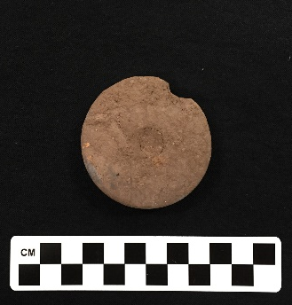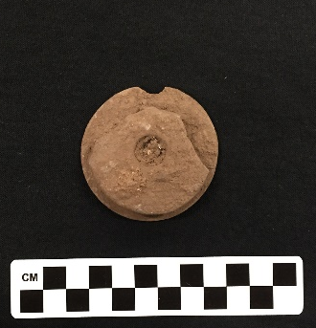
Site Number/Catalog Number: 34DL0/l
Site Name: Reed
Additional Provenience Information:
Earspool Type: Pulley
Material Type: Sandstone
Spiro Grave Period: Spiro III

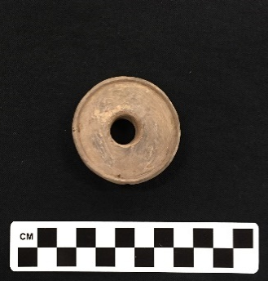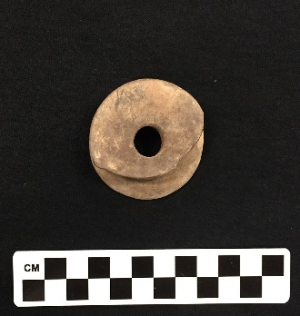
Site Number/Catalog Number: 34DL0/m
Site Name: Reed
Additional Provenience Information:
Earspool Type: Pulley
Material Type: Sandstone

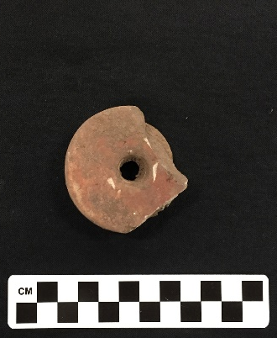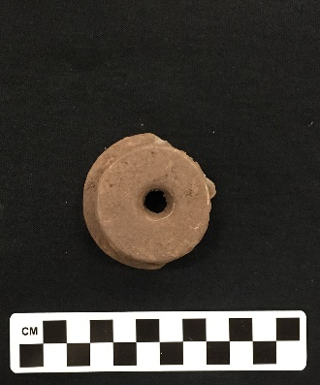
Site Number/Catalog Number: 34DL0/n
Site Name: Reed
Additional Provenience Information:
Earspool Type: Pulley
Material Type: Sandstone
Spiro Grave Period: Spiro III

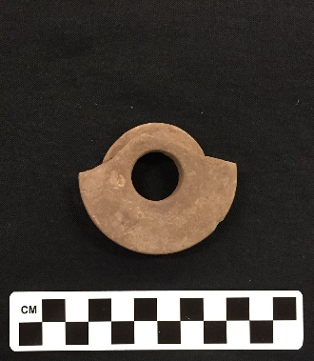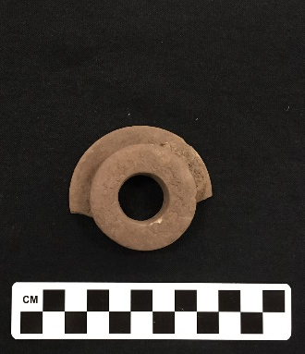
Site Number/Catalog Number: 34DL0/o
Site Name: Reed
Additional Provenience Information:
Earspool Type: Pulley
Material Type: Sandstone
Spiro Grave Period: Spiro III

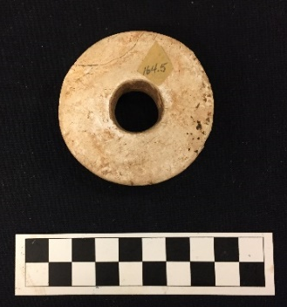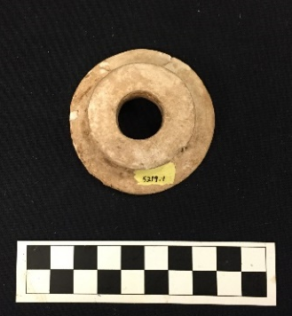
Site Number/Catalog Number: 34DL4/5219.1
Site Name: Reed
Additional Provenience Information:
Earspool Type: Pulley
Material Type: Sandstone
Spiro Grave Period: Spiro III

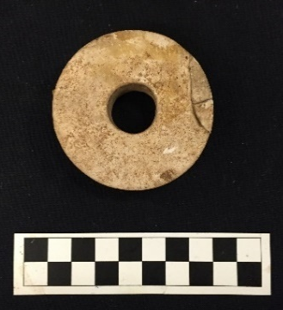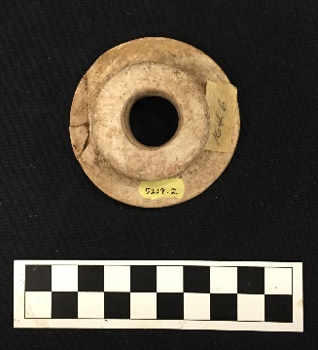
Site Number/Catalog Number: 34DL4/5219.2
Site Name: Reed
Additional Provenience Information:
Earspool Type: Pulley
Material Type: Sandstone
Spiro Grave Period: Spiro III
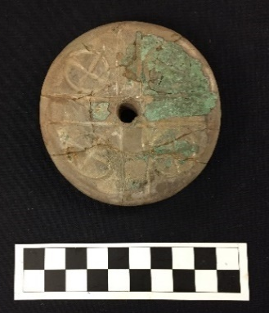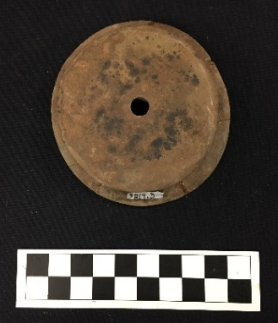
Site Number/Catalog Number: 34DL4/5219.3
Site Name: Reed
Additional Provenience Information:
Earspool Type: Pulley
Material Type: Sandstone
Spiro Grave Period: Spiro III
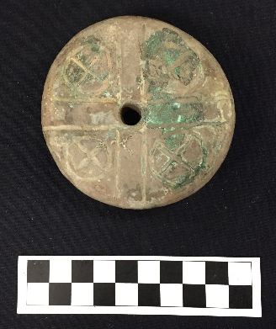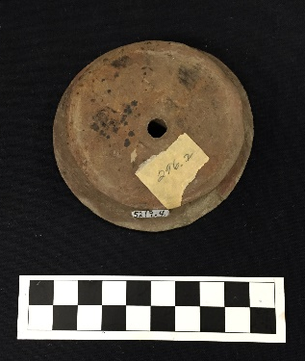
Site Number/Catalog Number: 34DL4/5219.4
Site Name: Reed
Additional Provenience Information:
Earspool Type: Pulley
Material Type: Sandstone
Spiro Grave Period: Spiro III

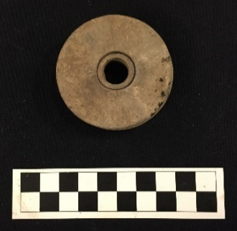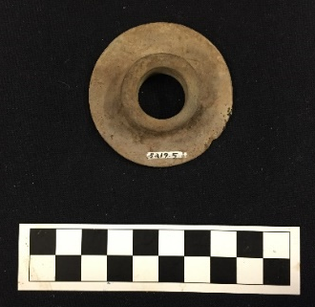
Site Number/Catalog Number: 34DL4/5219.5
Site Name: Reed
Additional Provenience Information:
Earspool Type: Nested Half
Material Type: Sandstone
Spiro Grave Period: Spiro III

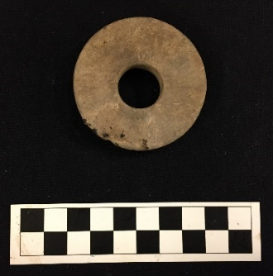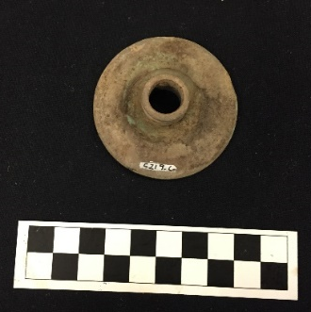
Site Number/Catalog Number: 34DL4/5219.6
Site Name: Reed
Additional Provenience Information:
Earspool Type: Nested Half
Material Type: Sandstone
Spiro Grave Period: Spiro III

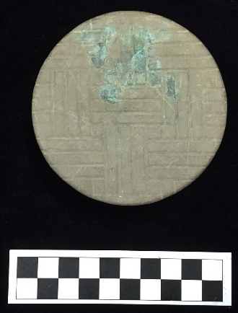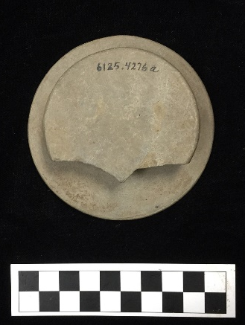
Site Number/Catalog Number: 34DL4/6125.4276a
Site Name: Reed
Additional Provenience Information:
Earspool Type: Pulley
Material Type: Sandstone
Spiro Grave Period: Spiro III
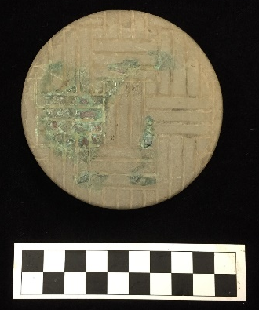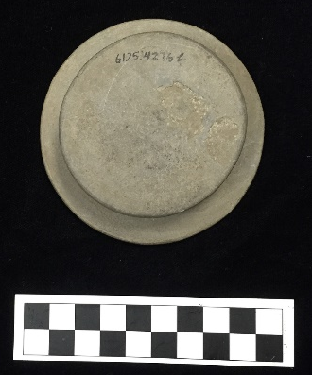
Site Number/Catalog Number: 34DL4/6125.4276b
Site Name: Reed
Additional Provenience Information:
Earspool Type: Pulley
Material Type: Sandstone
Spiro Grave Period: Spiro III
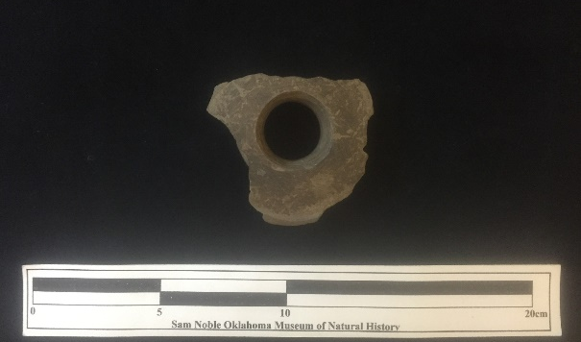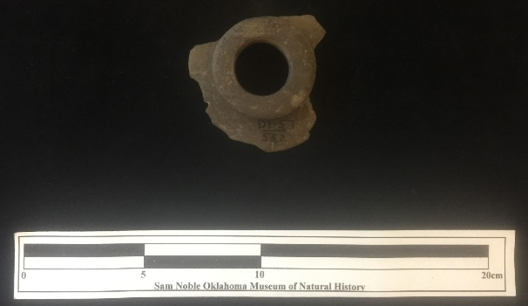
Site Number/Catalog Number: 34DL57/552
Site Name: Guffy #4
Additional Provenience Information:
Earspool Type: Recessed
Material Type: Sandstone
Spiro Grave Period: Unassigned
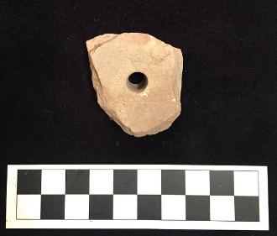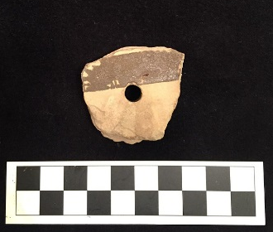
Site Number/Catalog Number: 34DL67/001
Site Name: State #4
Additional Provenience Information:
Earspool Type: Pulley
Material Type: Sandstone
Spiro Grave Period: Unassigned

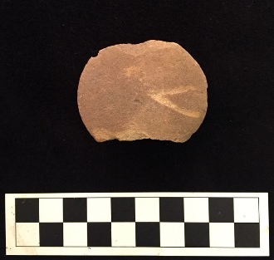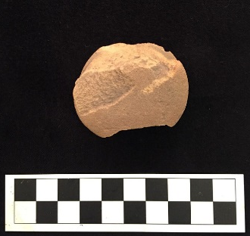
Site Number/Catalog Number: 34DL68/165
Site Name: State #5
Additional Provenience Information:
Earspool Type: Pulley
Material Type: Sandstone
Spiro Grave Period: Unassigned

No Photograph Available

Site Number/Catalog Number: 34Lf40/
Site Name: Spiro
Additional Provenience Information: B31-1B
Earspool Type: Pulley
Material Type: Sandstone
Spiro Grave Period: Spiro II
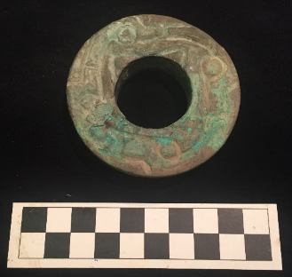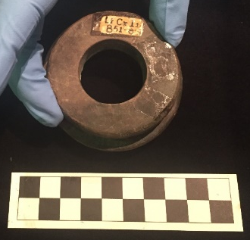
Site Number/Catalog Number: 34Lf40/
Site Name: Spiro
Additional Provenience Information: B51-84
Earspool Type: Pulley
Material Type: Sandstone
Spiro Grave Period: Spiro III

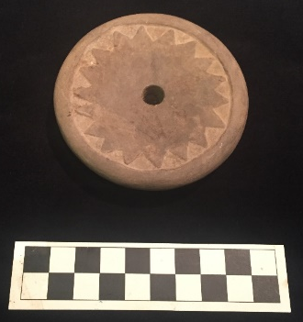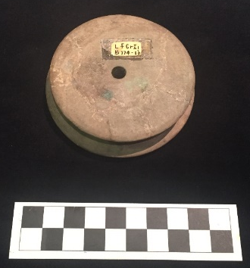
Site Number/Catalog Number: 34Lf40/
Site Name: Spiro
Additional Provenience Information: B174-1b
Earspool Type: Pulley
Material Type: Sandstone
Spiro Grave Period: Spiro III

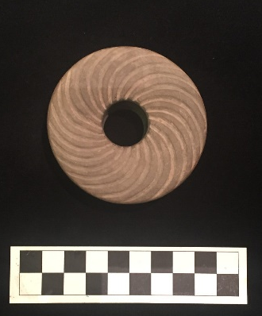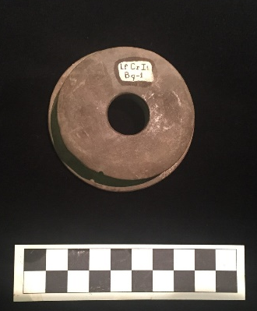
Site Number/Catalog Number: 34Lf40/
Site Name: Spiro
Additional Provenience Information: B9-1
Earspool Type: Pulley
Material Type: Sandstone
Spiro Grave Period: Spiro III/IV

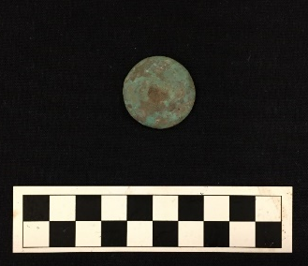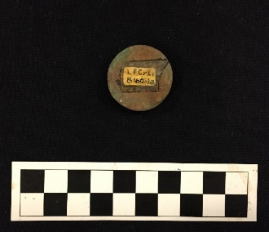
Site Number/Catalog Number: 34Lf40/
Site Name: Spiro
Additional Provenience Information: B160-1a
Earspool Type: Composite
Material Type: Stone/shell/wood/copper
Spiro Grave Period: Spiro IV

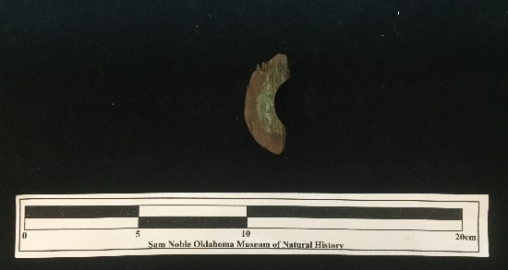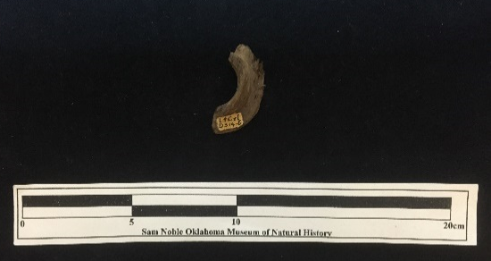
Site Number/Catalog Number: 34Lf40/ 2140.1
Site Name: Spiro
Additional Provenience Information: D314-6
Earspool Type: Pulley
Material Type: Wood
Spiro Grave Period: Unassigned

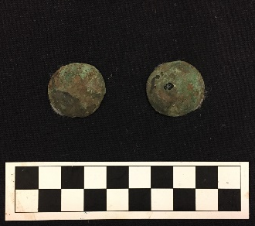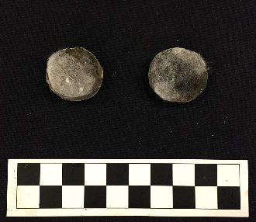
Site Number/Catalog Number: 34Lf40/ 6320a&b
Site Name: Spiro
Additional Provenience Information: B10-32
Earspool Type: Composite
Material Type: Stone/shell/wood/copper
Spiro Grave Period: Spiro II

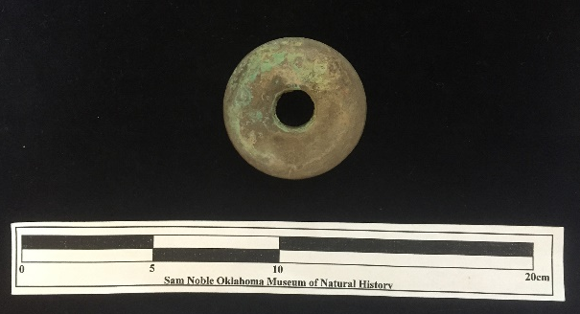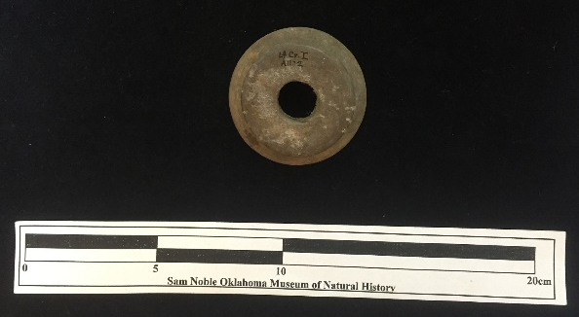
Site Number/Catalog Number: 34Lf40/1068.1
Site Name: Spiro
Additional Provenience Information: A1-02
Earspool Type: Pulley
Material Type: Sandstone
Spiro Grave Period: Unassigned

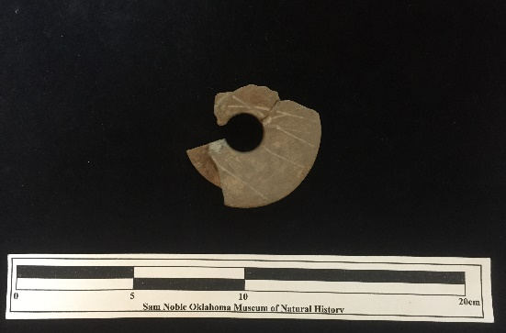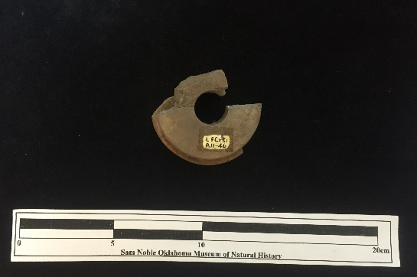
Site Number/Catalog Number: 34Lf40/1092.1
Site Name: Spiro
Additional Provenience Information: A11-46
Earspool Type: Pulley
Material Type: Sandstone
Spiro Grave Period: Unassigned

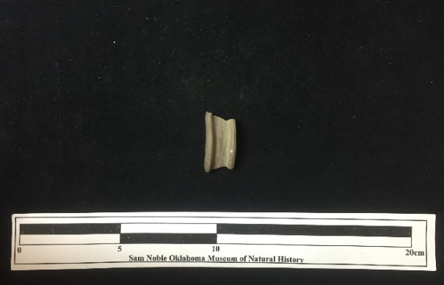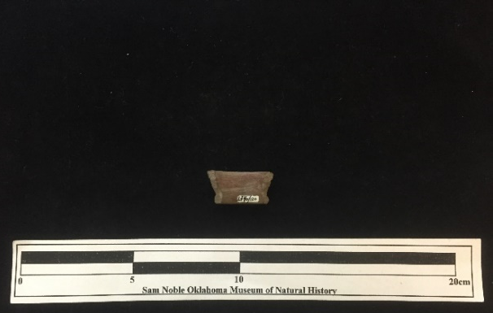
Site Number/Catalog Number: 34Lf40/120.8
Site Name: Spiro
Additional Provenience Information:
Earspool Type: Flanged Ring
Material Type: Sandstone
Spiro Grave Period: Unassigned

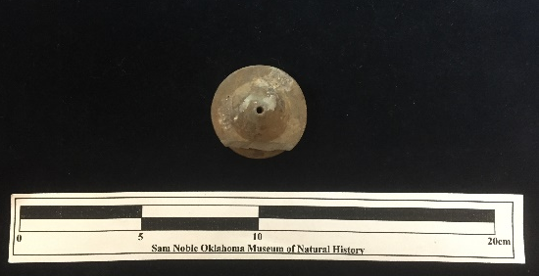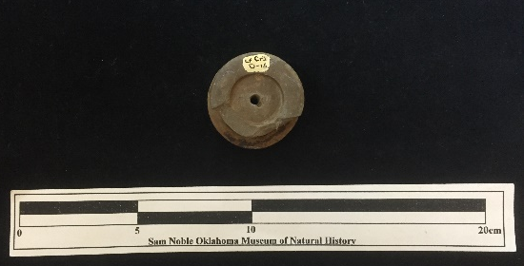
Site Number/Catalog Number: 34Lf40/1296.1
Site Name: Spiro
Additional Provenience Information: Lf Cr I D16
Earspool Type: Central Boss
Material Type: Sandstone
Spiro Grave Period: Unassigned

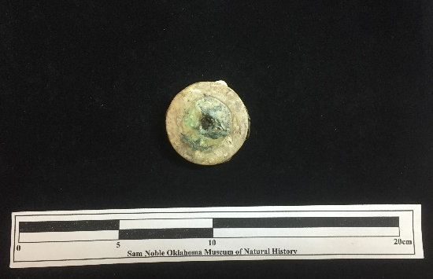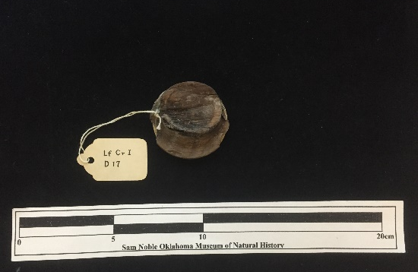
Site Number/Catalog Number: 34Lf40/1297.1
Site Name: Spiro
Additional Provenience Information: Lf Cr I D17
Earspool Type: Composite
Material Type: Stone/shell/wood/copper
Spiro Grave Period: Unassigned

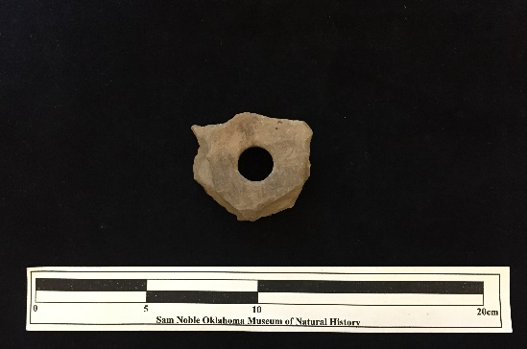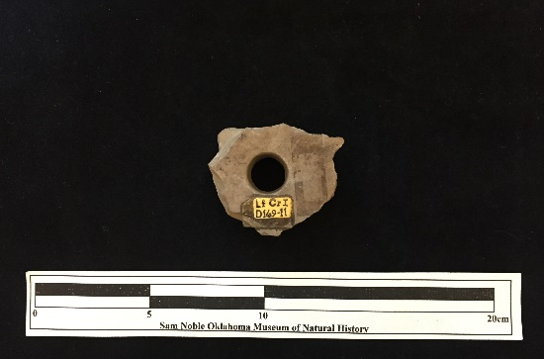
Site Number/Catalog Number: 34Lf40/1331.1
Site Name: Spiro
Additional Provenience Information: Lf Cr I D51
Earspool Type: Pulley
Material Type: Sandstone
Spiro Grave Period: Unassigned

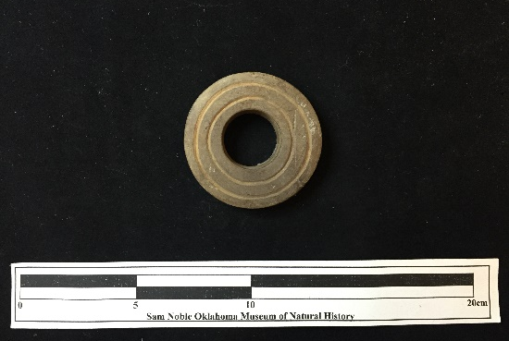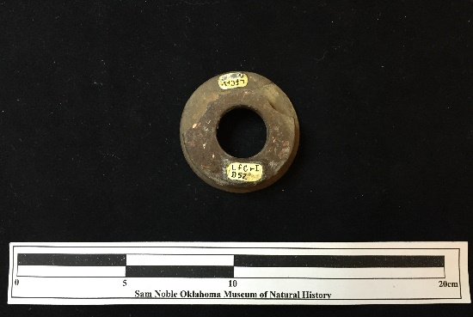
Site Number/Catalog Number: 34Lf40/1332.1
Site Name: Spiro
Additional Provenience Information: Lf Cr I D52
Earspool Type: Pulley
Material Type: Sandstone
Spiro Grave Period: Unassigned

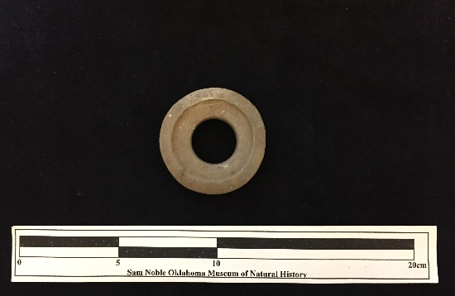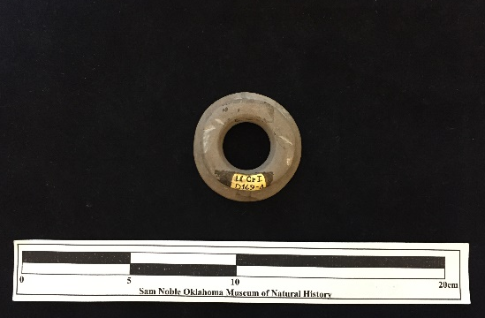
Site Number/Catalog Number: 34Lf40/1531.1
Site Name: Spiro
Additional Provenience Information: Lf CrI D169-04
Earspool Type: Recessed
Material Type: Sandstone
Spiro Grave Period: Unassigned

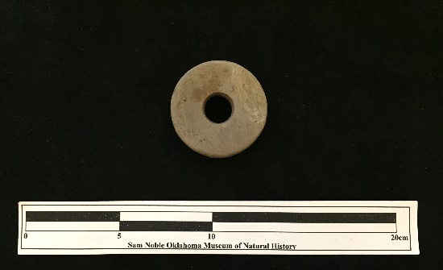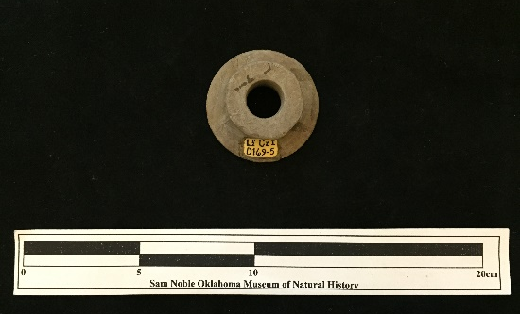
Site Number/Catalog Number: 34Lf40/1532.1
Site Name: Spiro
Additional Provenience Information: Lf CrI D169-05
Earspool Type: Nested Half
Material Type: Sandstone
Spiro Grave Period: Unassigned
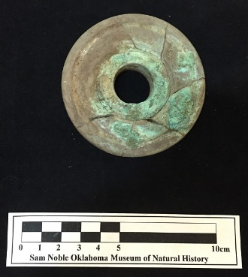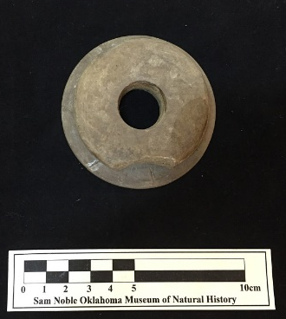
Site Number/Catalog Number: 34Lf40/1535.1
Site Name: Spiro
Additional Provenience Information: D169-8?
Earspool Type: Pulley
Material Type: Sandstone
Spiro Grave Period: Unassigned

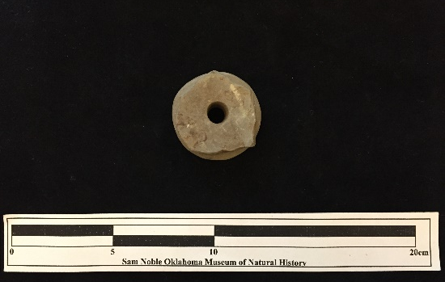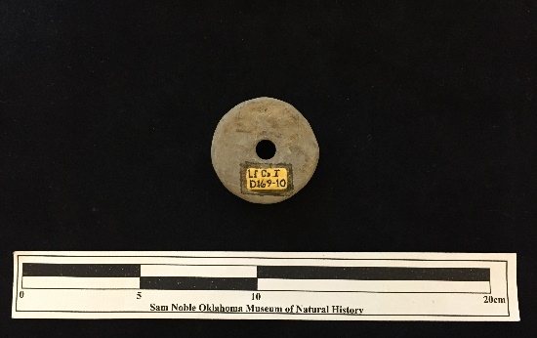
Site Number/Catalog Number: 34Lf40/1537.1
Site Name: Spiro
Additional Provenience Information: Lf CrI D169-10
Earspool Type: Pulley
Material Type: Sandstone
Spiro Grave Period: Unassigned

Site Number/Catalog Number: 34Lf40/1538.1
Site Name: Spiro
Additional Provenience Information: Lf CrI D169-11
Earspool Type: Pulley
Material Type: Sandstone
Spiro Grave Period: Unassigned

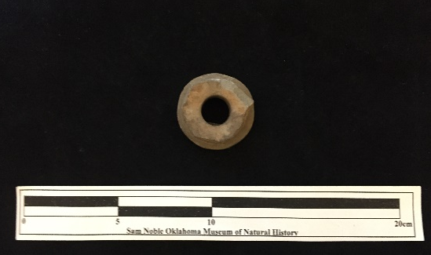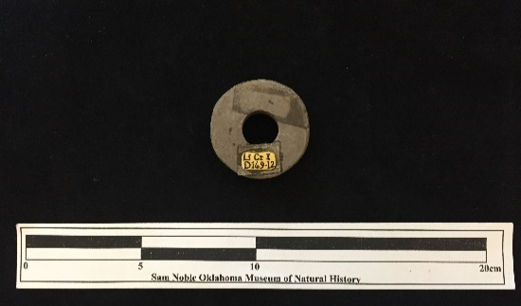
Site Number/Catalog Number: 34Lf40/1539.1
Site Name: Spiro
Additional Provenience Information: Lf CrI D169-12
Earspool Type: Pulley
Material Type: Sandstone
Spiro Grave Period: Unassigned

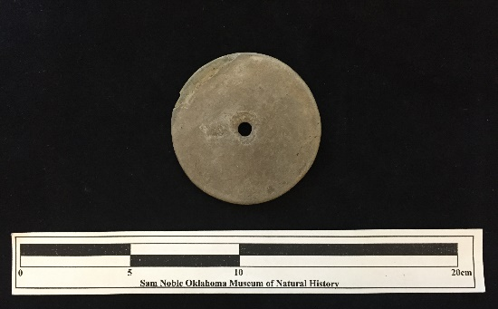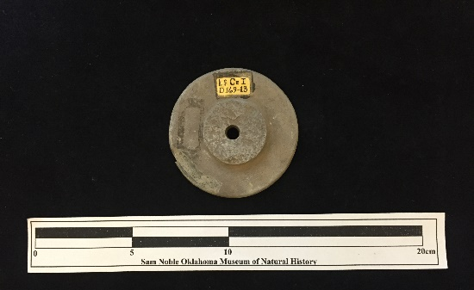
Site Number/Catalog Number: 34Lf40/1540.1
Site Name: Spiro
Additional Provenience Information: Lf CrI D169-13
Earspool Type: Pulley
Material Type: Sandstone
Spiro Grave Period: Unassigned

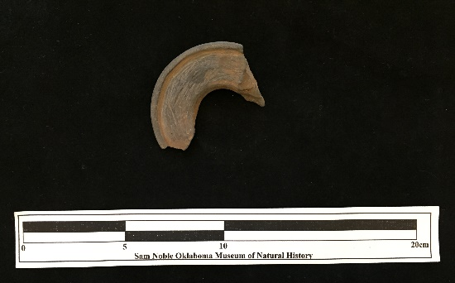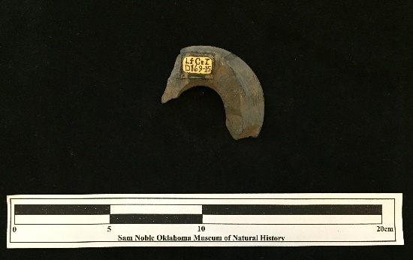
Site Number/Catalog Number: 34Lf40/1542.1
Site Name: Spiro
Additional Provenience Information: Lf CrI D169-15
Earspool Type: Recessed
Material Type: Sandstone
Spiro Grave Period: Unassigned

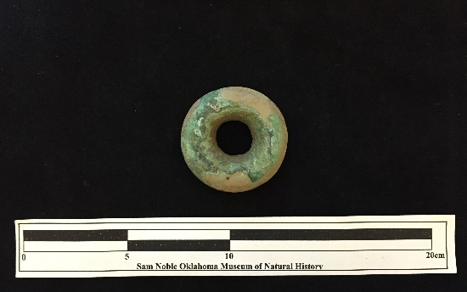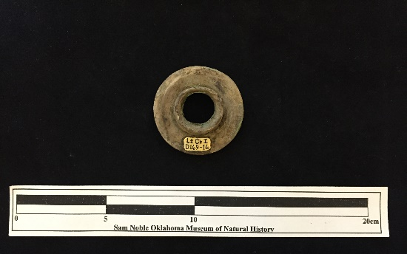
Site Number/Catalog Number: 34Lf40/1543.1
Site Name: Spiro
Additional Provenience Information: Lf CrI D169-16
Earspool Type: Nested Half
Material Type: Sandstone
Spiro Grave Period: Unassigned

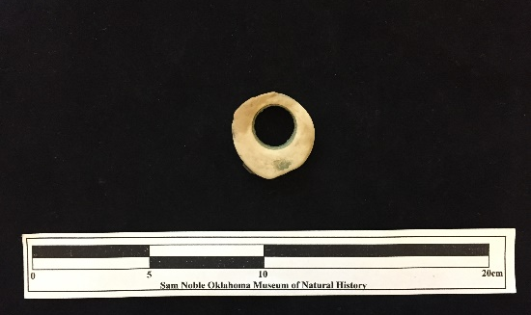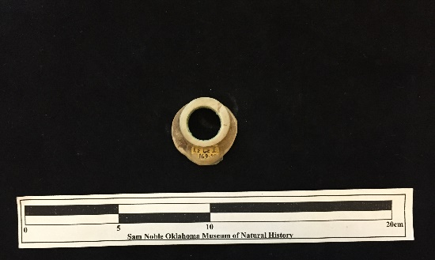
Site Number/Catalog Number: 34Lf40/1544.1
Site Name: Spiro
Additional Provenience Information: Lf CrI D169-17
Earspool Type: Pulley
Material Type: Limestone
Spiro Grave Period: Unassigned

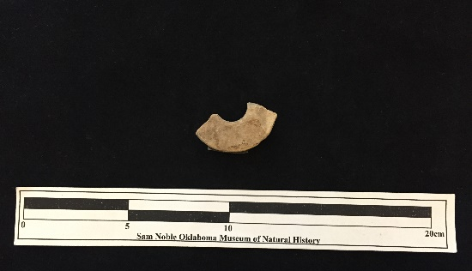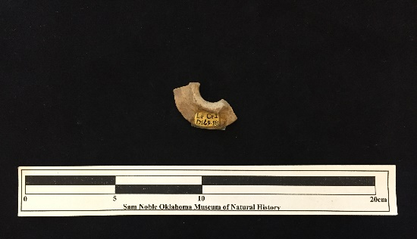
Site Number/Catalog Number: 34Lf40/1545.1
Site Name: Spiro
Additional Provenience Information: Lf CrI D169-18
Earspool Type: Nested Half
Material Type: Sandstone
Spiro Grave Period: Unassigned

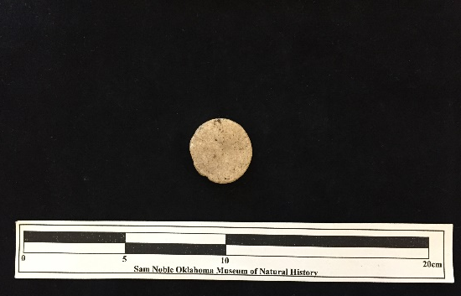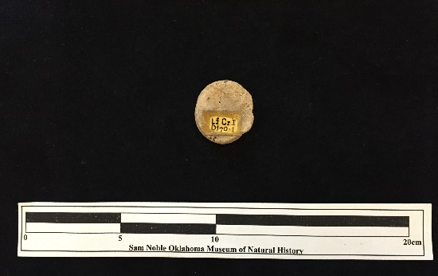
Site Number/Catalog Number: 34Lf40/1546.1
Site Name: Spiro
Additional Provenience Information: Lf CrI D170-1
Earspool Type: Grooved
Material Type: Sandstone
Spiro Grave Period: Unassigned

No Photograph Available

Site Number/Catalog Number: 34Lf40/1547.1
Site Name: Spiro
Additional Provenience Information: Lf CrI D170-2
Earspool Type: Grooved
Material Type: Sandstone
Spiro Grave Period: Unassigned

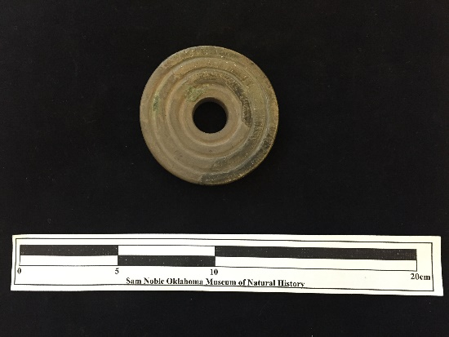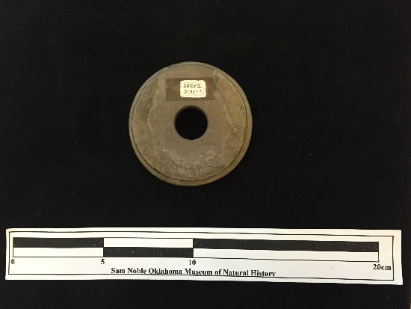
Site Number/Catalog Number: 34Lf40/1548.1
Site Name: Spiro
Additional Provenience Information: Lf CrI D171-1
Earspool Type: Pulley
Material Type: Sandstone
Spiro Grave Period: Unassigned

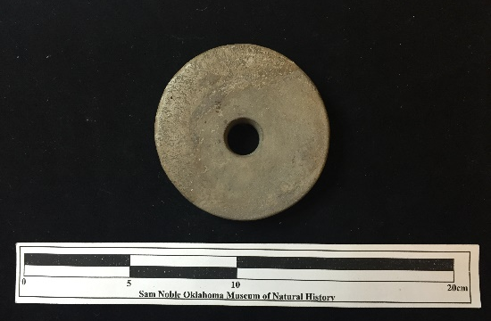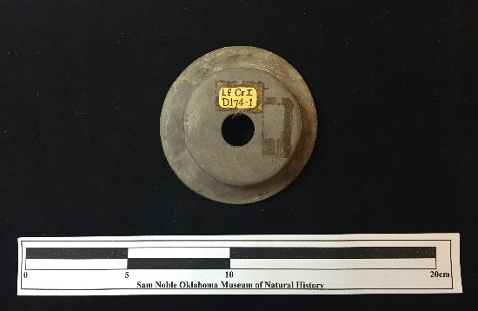
Site Number/Catalog Number: 34Lf40/1552.1
Site Name: Spiro
Additional Provenience Information: Lf CrI D174-1
Earspool Type: Pulley
Material Type: Sandstone
Spiro Grave Period: Unassigned

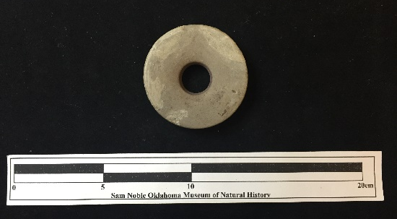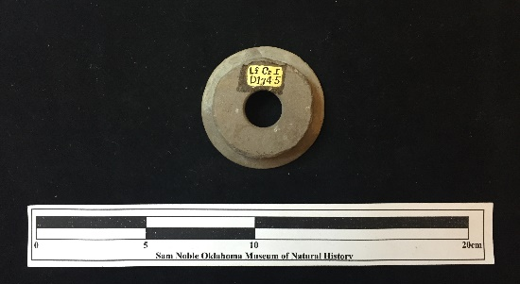
Site Number/Catalog Number: 34Lf40/1556.1
Site Name: Spiro
Additional Provenience Information: Lf CrI D174-5
Earspool Type: Pulley
Material Type: Sandstone
Spiro Grave Period: Unassigned

No Photograph Available

Site Number/Catalog Number: 34Lf40/1557.1
Site Name: Spiro
Additional Provenience Information: Lf CrI D174-6
Earspool Type: Recessed
Material Type: Sandstone
Spiro Grave Period: Unassigned

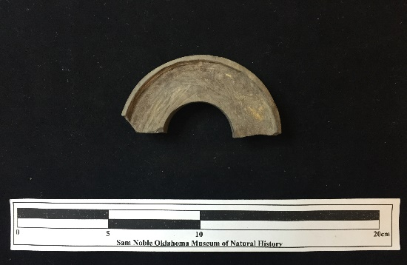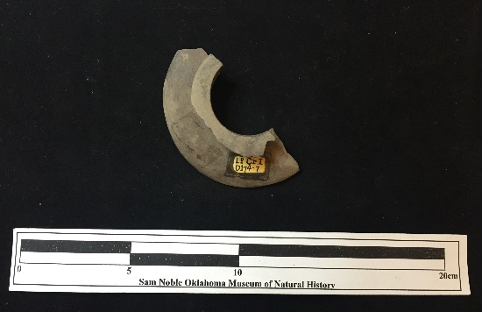
Site Number/Catalog Number: 34Lf40/1558.1
Site Name: Spiro
Additional Provenience Information: Lf CrI D174-7
Earspool Type: Recessed
Material Type: Sandstone
Spiro Grave Period: Unassigned

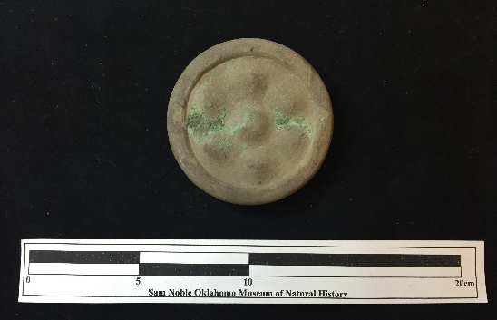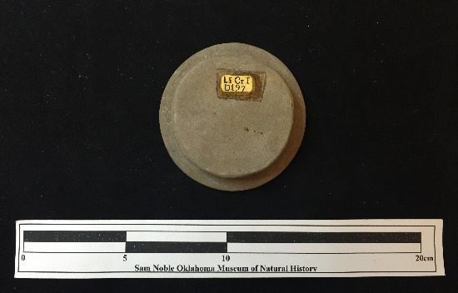
Site Number/Catalog Number: 34Lf40/1581.1
Site Name: Spiro
Additional Provenience Information: Lf CrI D197
Earspool Type: Pulley
Material Type: Sandstone
Spiro Grave Period: Unassigned
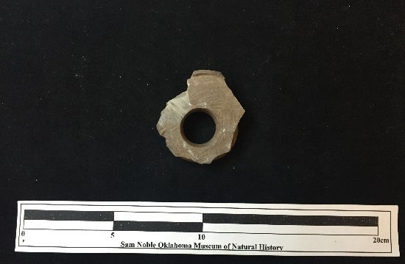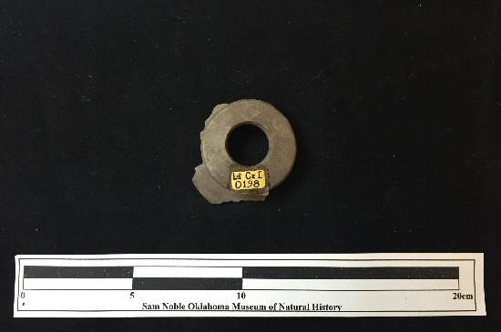
Site Number/Catalog Number: 34Lf40/1582.1
Site Name: Spiro
Additional Provenience Information: Lf CrI D198
Earspool Type: Pulley
Material Type: Sandstone
Spiro Grave Period: Unassigned

No Photograph Available

Site Number/Catalog Number: 34Lf40/1601.1
Site Name: Spiro
Additional Provenience Information: Lf CrI D216-1
Earspool Type: Composite
Material Type: Stone/shell/wood/copper
Spiro Grave Period: Unassigned

No Photograph Available

Site Number/Catalog Number: 34Lf40/1602.1
Site Name: Spiro
Additional Provenience Information: Lf CrI D216-2
Earspool Type: Composite
Material Type: Stone/shell/wood/copper
Spiro Grave Period: Unassigned
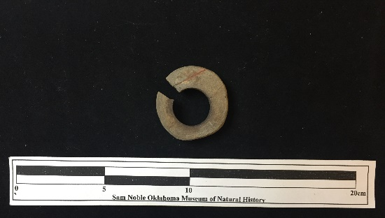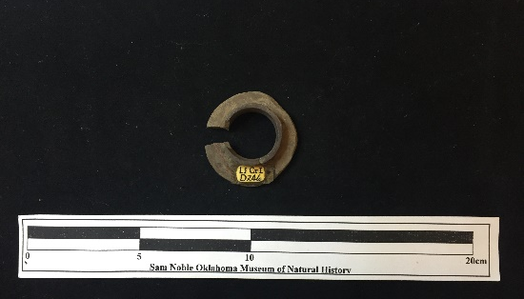
Site Number/Catalog Number: 34Lf40/1659.1
Site Name: Spiro
Additional Provenience Information: Lf CrI D246
Earspool Type: Nested Half
Material Type: Sandstone
Spiro Grave Period: Unassigned

No Photograph Available

Site Number/Catalog Number: 34Lf40/1660.1
Site Name: Spiro
Additional Provenience Information: Lf CrI D247
Earspool Type: Composite
Material Type: Stone/shell/wood/copper
Spiro Grave Period: Unassigned

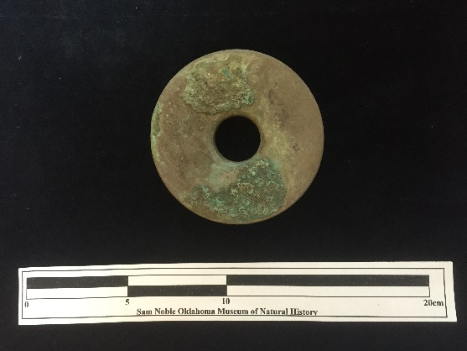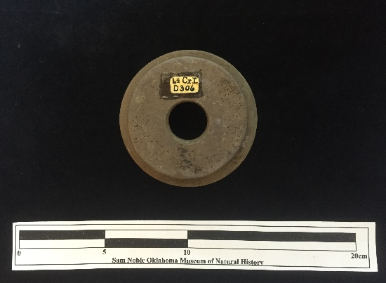
Site Number/Catalog Number: 34Lf40/2127.1
Site Name: Spiro
Additional Provenience Information: Lf Cr I D306
Earspool Type: Pulley
Material Type: Sandstone
Spiro Grave Period: Unassigned
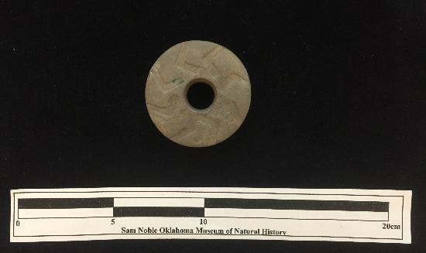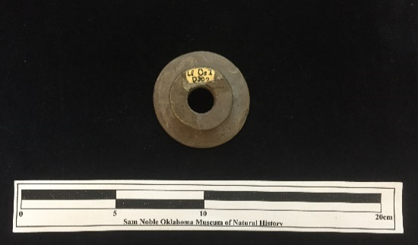
Site Number/Catalog Number: 34Lf40/2128.1
Site Name: Spiro
Additional Provenience Information: Lf Cr I D307
Earspool Type: Pulley
Material Type: Sandstone
Spiro Grave Period: Unassigned

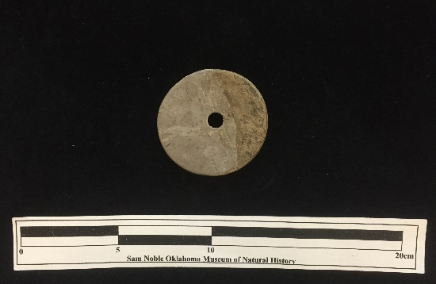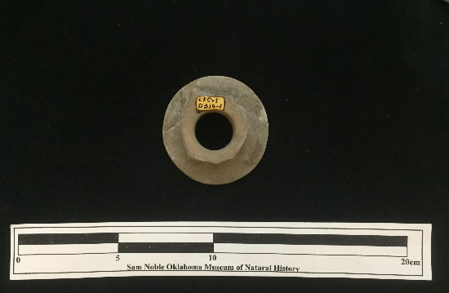
Site Number/Catalog Number: 34Lf40/2135.1
Site Name: Spiro
Additional Provenience Information: Lf Cr I D314
Earspool Type: Pulley
Material Type: Sandstone
Spiro Grave Period: Unassigned

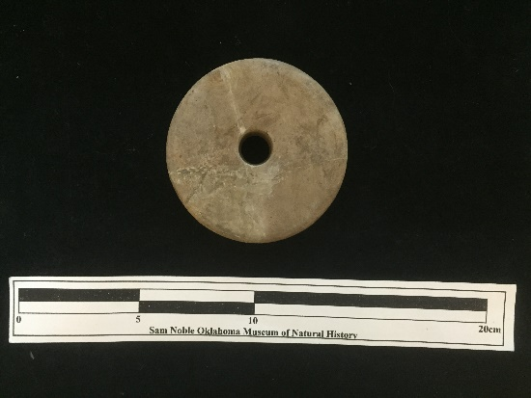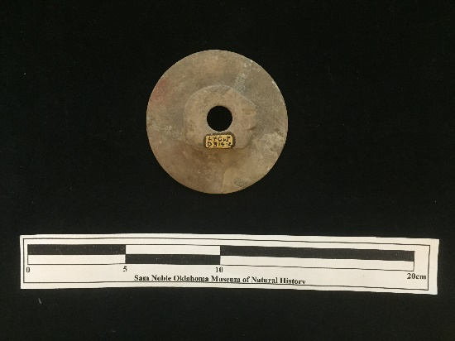
Site Number/Catalog Number: 34Lf40/2136.1
Site Name: Spiro
Additional Provenience Information: Lf Cr l D314-2
Earspool Type: Pulley
Material Type: Sandstone
Spiro Grave Period: Unassigned

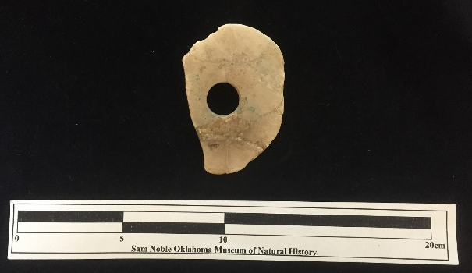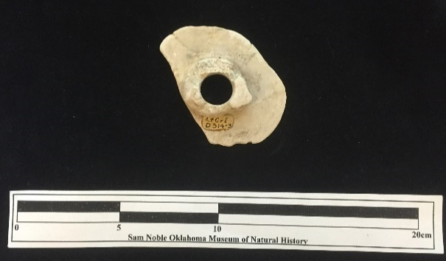
Site Number/Catalog Number: 34Lf40/2137.1
Site Name: Spiro
Additional Provenience Information: Lf Cr l D314-3
Earspool Type: Pulley
Material Type: Limestone
Spiro Grave Period: Unassigned
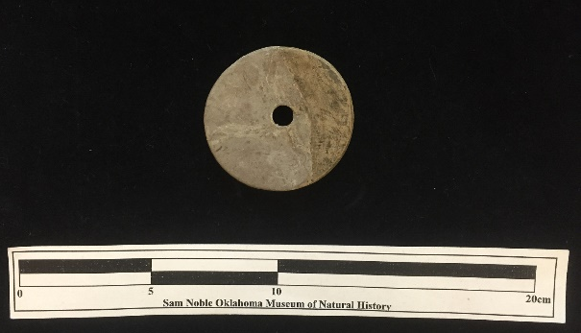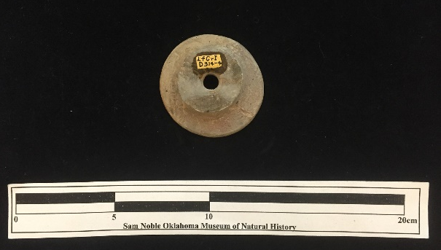
Site Number/Catalog Number: 34Lf40/2138.1
Site Name: Spiro
Additional Provenience Information: Lf Cr l D314-4
Earspool Type: Nested Half
Material Type: Sandstone
Spiro Grave Period: Unassigned

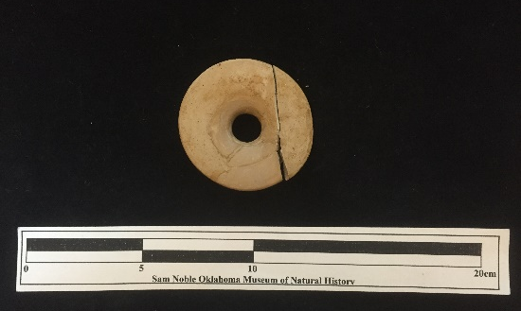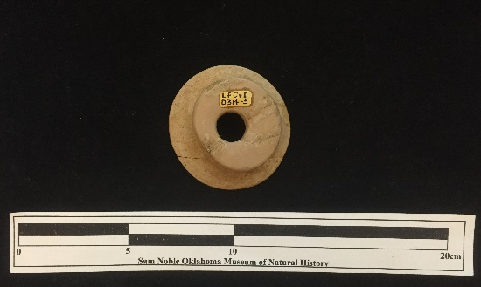
Site Number/Catalog Number: 34Lf40/2139.1
Site Name: Spiro
Additional Provenience Information: Lf Cr l D314-5
Earspool Type: Funnel Faced
Material Type: Sandstone
Spiro Grave Period: Unassigned

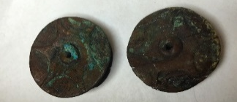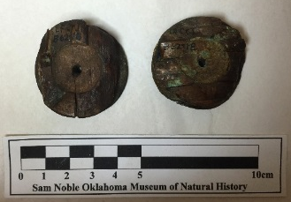
Site Number/Catalog Number: 34Lf40/3119
Site Name: Spiro
Additional Provenience Information: B62-18&19
Earspool Type: Pulley
Material Type: Wood
Spiro Grave Period: Spiro IV

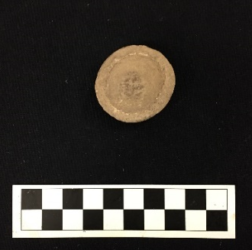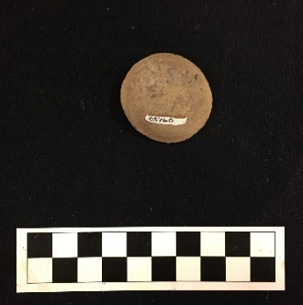
Site Number/Catalog Number: 34Lf40/5160
Site Name: Spiro
Additional Provenience Information:
Earspool Type: Composite
Material Type: Stone/shell/wood/copper
Spiro Grave Period: Unassigned

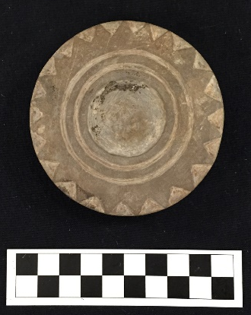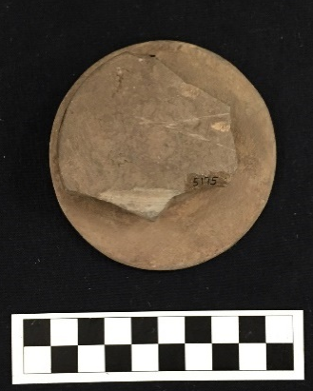
Site Number/Catalog Number: 34Lf40/5175.003
Site Name: Spiro
Additional Provenience Information:
Earspool Type: Pulley
Material Type: Sandstone
Spiro Grave Period: Unassigned

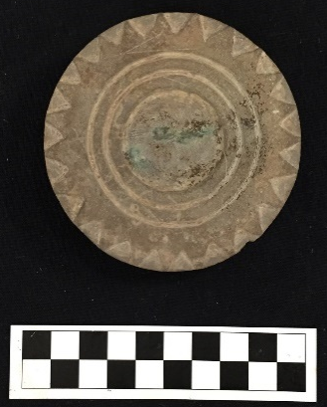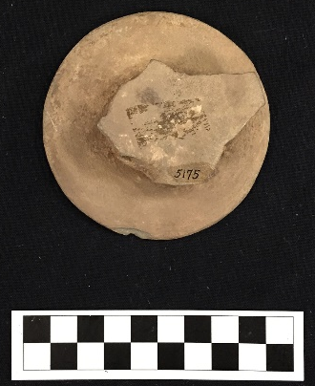
Site Number/Catalog Number: 34Lf40/5175.004
Site Name: Spiro
Additional Provenience Information:
Earspool Type: Pulley
Material Type: Sandstone
Spiro Grave Period: Unassigned
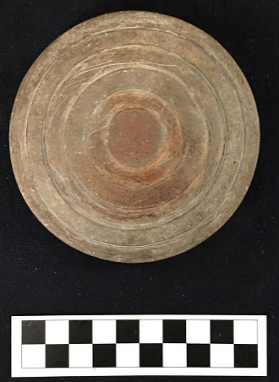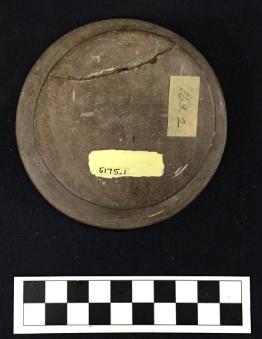
Site Number/Catalog Number: 34Lf40/5175.1
Site Name: Spiro
Additional Provenience Information: 163.2
Earspool Type: Pulley
Material Type: Sandstone
Spiro Grave Period: Unassigned
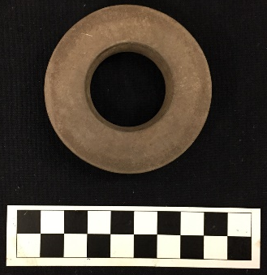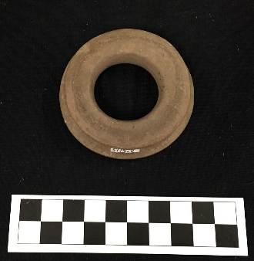
Site Number/Catalog Number: 34Lf40/5175.11
Site Name: Spiro
Additional Provenience Information:
Earspool Type: Pulley
Material Type: Sandstone
Spiro Grave Period: Unassigned
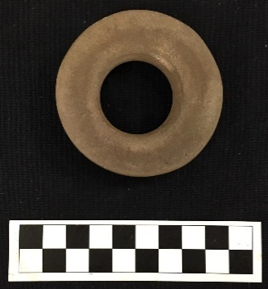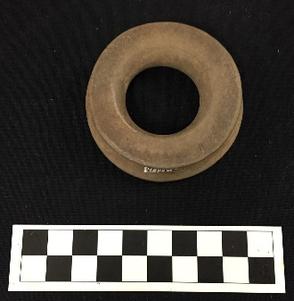
Site Number/Catalog Number: 34Lf40/5175.12
Site Name: Spiro
Additional Provenience Information:
Earspool Type: Pulley
Material Type: Sandstone
Spiro Grave Period: Unassigned
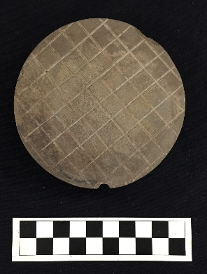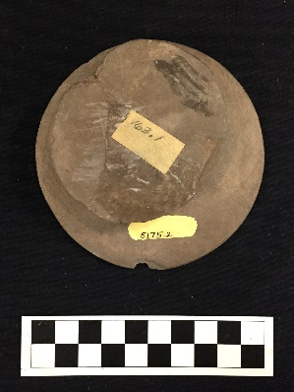
Site Number/Catalog Number: 34Lf40/5175.2
Site Name: Spiro
Additional Provenience Information:
Earspool Type: Pulley
Material Type: Sandstone
Spiro Grave Period: Unassigned
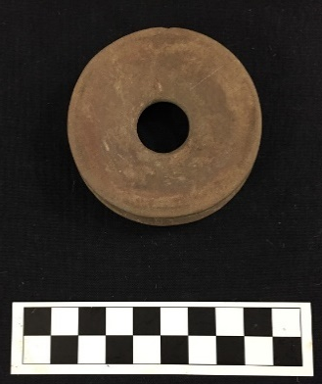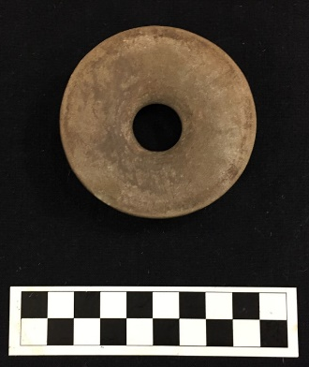
Site Number/Catalog Number: 34Lf40/5175.5
Site Name: Spiro
Additional Provenience Information:
Earspool Type: Pulley
Material Type: Sandstone
Spiro Grave Period: Unassigned
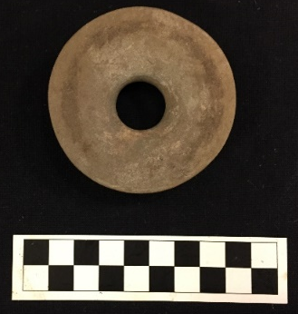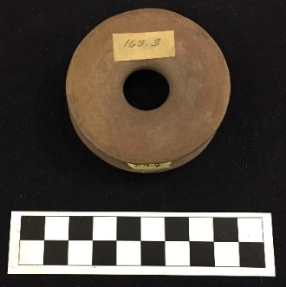
Site Number/Catalog Number: 34Lf40/5175.6
Site Name: Spiro
Additional Provenience Information:
Earspool Type: Pulley
Material Type: Sandstone
Spiro Grave Period: Unassigned
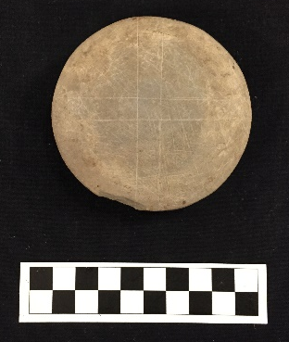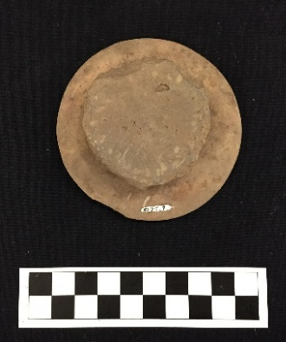
Site Number/Catalog Number: 34Lf40/5175.7
Site Name: Spiro
Additional Provenience Information:
Earspool Type: Pulley
Material Type: Sandstone
Spiro Grave Period: Unassigned
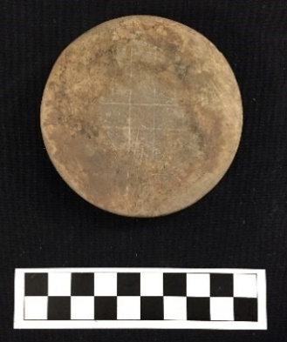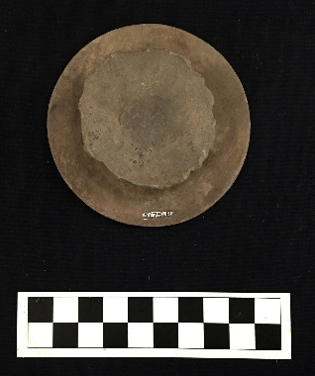
Site Number/Catalog Number: 34Lf40/5175.8
Site Name: Spiro
Additional Provenience Information:
Earspool Type: Pulley
Material Type: Sandstone
Spiro Grave Period: Unassigned

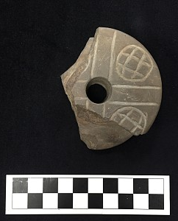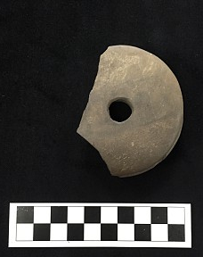
Site Number/Catalog Number: 34Lf40/54 50-152H
Site Name: Spiro
Additional Provenience Information:
Earspool Type: Pulley
Material Type: Sandstone
Spiro Grave Period: Unassigned

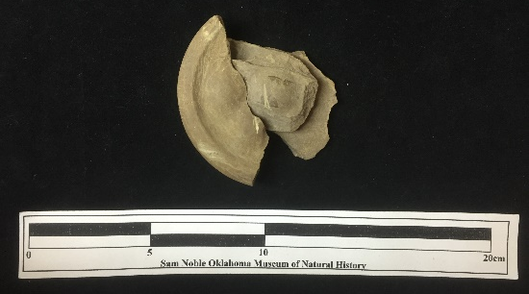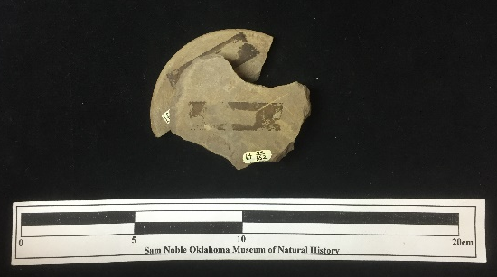
Site Number/Catalog Number: 34Lf40/552/339
Site Name: Spiro
Additional Provenience Information: Lf 40 552/339 Unit 10:3
Earspool Type: Pulley
Material Type: Sandstone
Spiro Grave Period: Unassigned

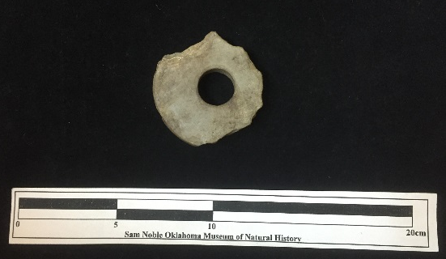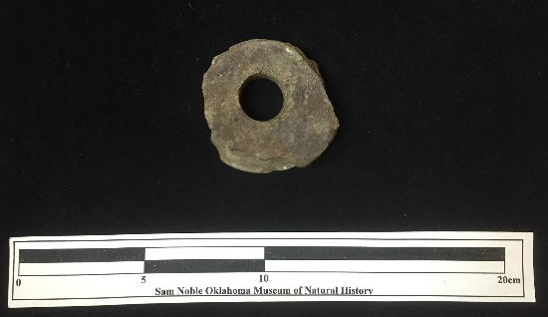
Site Number/Catalog Number: 34Lf40/554.2/1554.1
Site Name: Spiro
Additional Provenience Information: Stake 10:5
Earspool Type: Pulley
Material Type: Sandstone
Spiro Grave Period: Unassigned

No Photograph Available

Site Number/Catalog Number: 34Lf40/555.1
Site Name: Spiro
Additional Provenience Information: Unit 13:4
Earspool Type: Pulley
Material Type: Sandstone
Spiro Grave Period: Unassigned

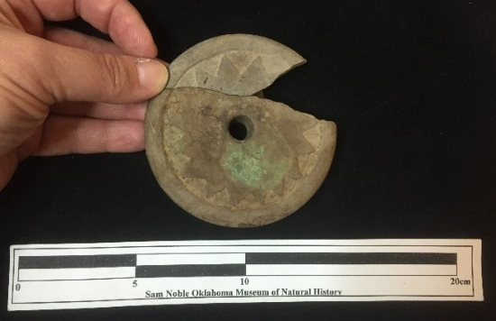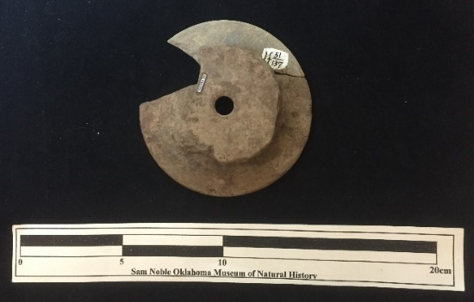
Site Number/Catalog Number: 34Lf40/556
Site Name: Spiro
Additional Provenience Information: with Lf 51/137 Pb I #311
Earspool Type: Pulley
Material Type: Sandstone
Spiro Grave Period: Unassigned

No Photograph Available

Site Number/Catalog Number: 34Lf40/5575.1
Site Name: Spiro
Additional Provenience Information:
Earspool Type: Pulley
Material Type: Sandstone
Spiro Grave Period: Unassigned
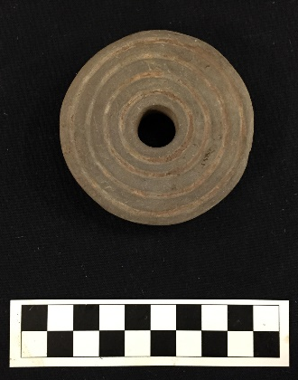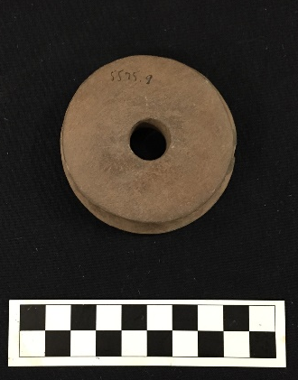
Site Number/Catalog Number: 34Lf40/5575.9
Site Name: Spiro
Additional Provenience Information:
Earspool Type: Pulley
Material Type: Sandstone
Spiro Grave Period: Unassigned
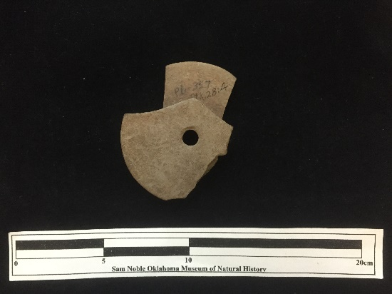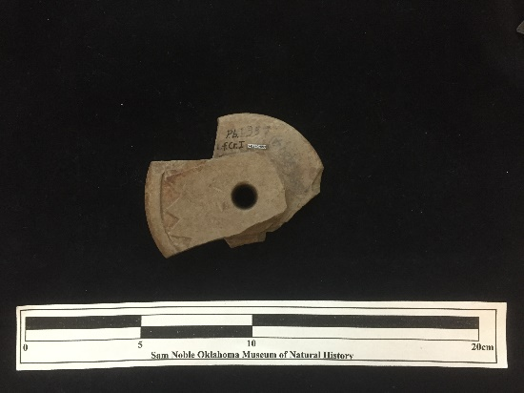
Site Number/Catalog Number: 34Lf40/559.2(357)
Site Name: Spiro
Additional Provenience Information: Lf Cr I Pb I 357 st:28:4
Earspool Type: Pulley
Material Type: Sandstone
Spiro Grave Period: Unassigned
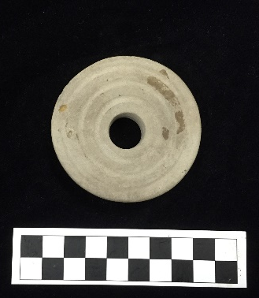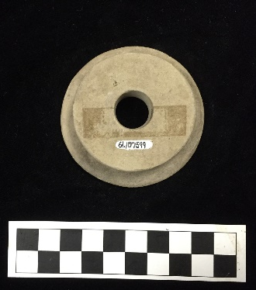
Site Number/Catalog Number: 34Lf40/61.107599
Site Name: Spiro
Additional Provenience Information:
Earspool Type: Pulley
Material Type: Sandstone
Spiro Grave Period: Unassigned
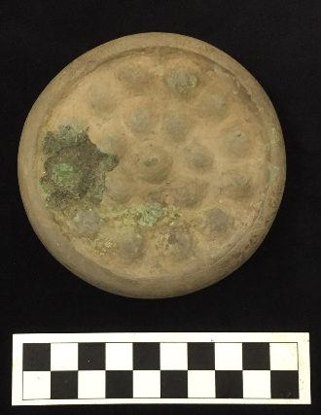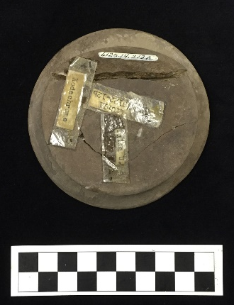
Site Number/Catalog Number: 34Lf40/6125.14.213A
Site Name: Spiro
Additional Provenience Information: B122-12b
Earspool Type: Pulley
Material Type: Sandstone
Spiro Grave Period: Spiro III
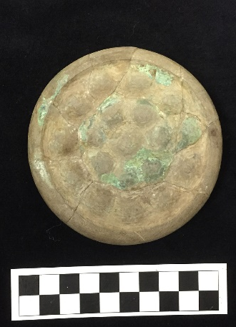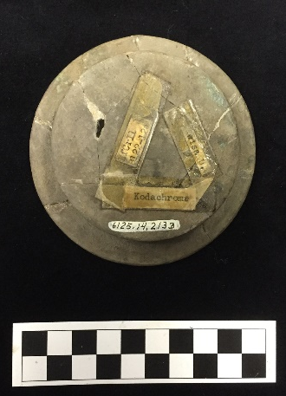
Site Number/Catalog Number: 34Lf40/6125.14.213B
Site Name: Spiro
Additional Provenience Information: B122-12a
Earspool Type: Pulley
Material Type: Sandstone
Spiro Grave Period: Spiro III
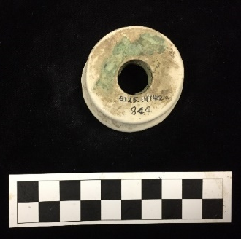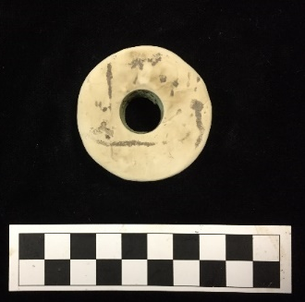
Site Number/Catalog Number: 34Lf40/6125.14142a 844
Site Name: Spiro
Additional Provenience Information:
Earspool Type: Pulley
Material Type: Limestone
Spiro Grave Period: Unassigned
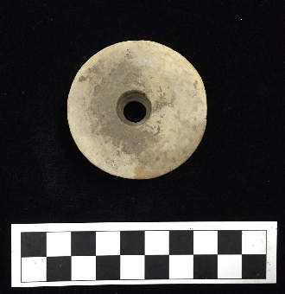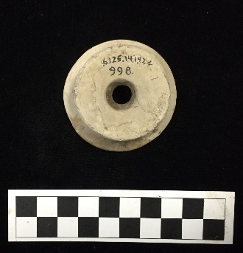
Site Number/Catalog Number: 34Lf40/6125.14142b 998
Site Name: Spiro
Additional Provenience Information:
Earspool Type: Pulley
Material Type: Limestone
Spiro Grave Period: Unassigned

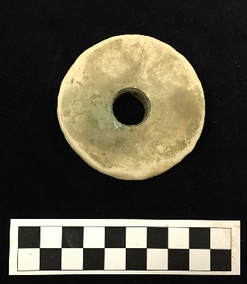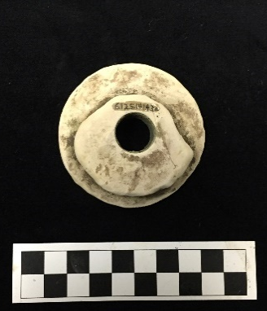
Site Number/Catalog Number: 34Lf40/6125.14143a
Site Name: Spiro
Additional Provenience Information:
Earspool Type: Pulley
Material Type: Sandstone
Spiro Grave Period: Unassigned

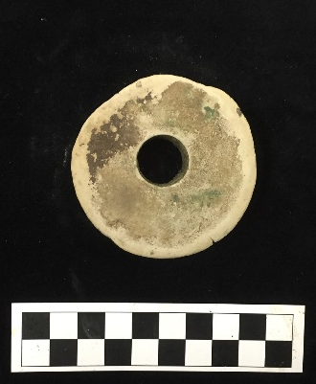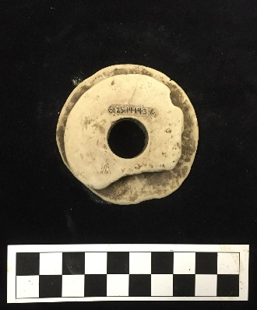
Site Number/Catalog Number: 34Lf40/6125.14143b
Site Name: Spiro
Additional Provenience Information:
Earspool Type: Pulley
Material Type: Sandstone
Spiro Grave Period: Unassigned
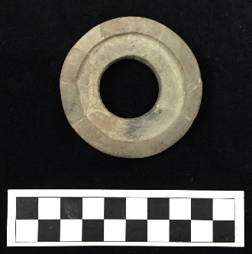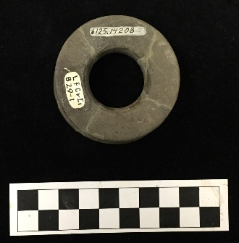
Site Number/Catalog Number: 34Lf40/6125.14208
Site Name: Spiro
Additional Provenience Information: B29-1
Earspool Type: Recessed
Material Type: Sandstone
Spiro Grave Period: Spiro III
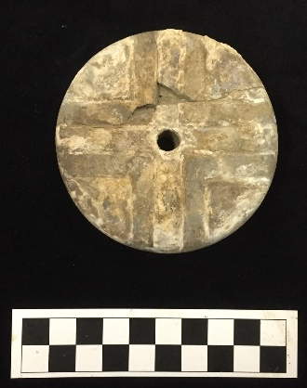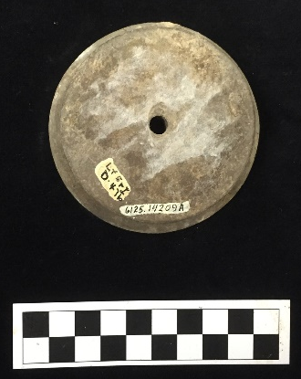
Site Number/Catalog Number: 34Lf40/6125.14209A
Site Name: Spiro
Additional Provenience Information: D47b
Earspool Type: Pulley
Material Type: Sandstone
Spiro Grave Period: Unassigned
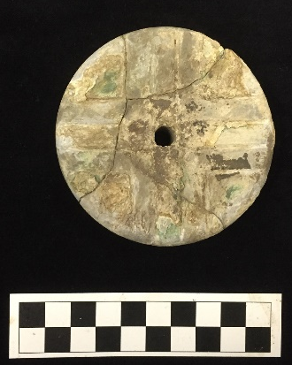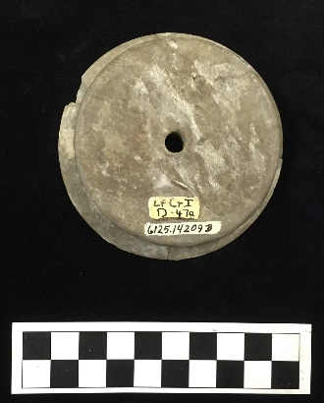
Site Number/Catalog Number: 34Lf40/6125.14209B
Site Name: Spiro
Additional Provenience Information: D47a
Earspool Type: Pulley
Material Type: Sandstone
Spiro Grave Period: Unassigned

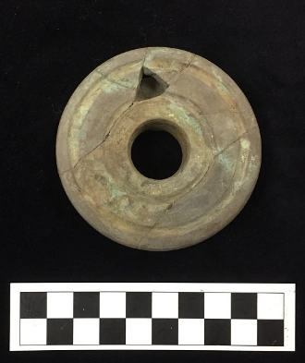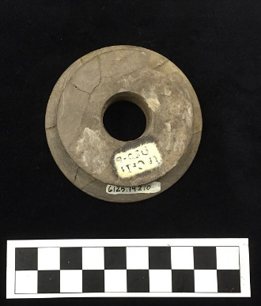
Site Number/Catalog Number: 34Lf40/6125.1421
Site Name: Spiro
Additional Provenience Information: D50-b
Earspool Type: Pulley
Material Type: Sandstone
Spiro Grave Period: Unassigned
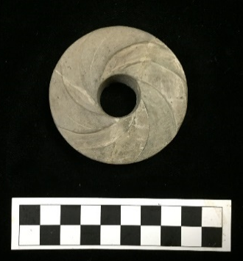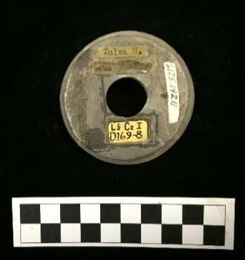
Site Number/Catalog Number: 34Lf40/6125.14211
Site Name: Spiro
Additional Provenience Information:
Earspool Type: Pulley
Material Type: Sandstone
Spiro Grave Period: Unassigned
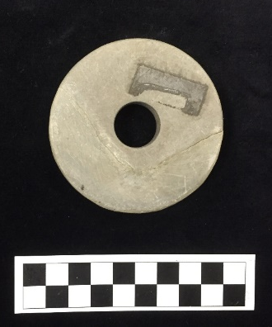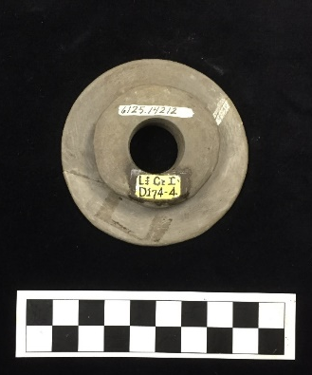
Site Number/Catalog Number: 34Lf40/6125.14212
Site Name: Spiro
Additional Provenience Information: D174-4
Earspool Type: Pulley
Material Type: Sandstone
Spiro Grave Period: Unassigned

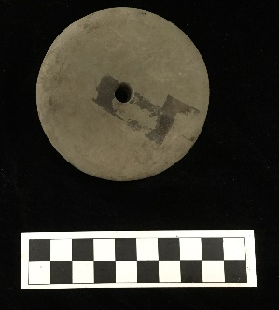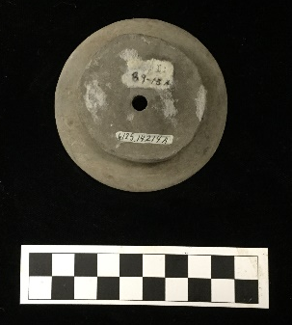
Site Number/Catalog Number: 34Lf40/6125.14214A
Site Name: Spiro
Additional Provenience Information: B9-13A
Earspool Type: Pulley
Material Type: Sandstone
Spiro Grave Period: Spiro III/IV

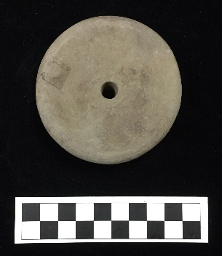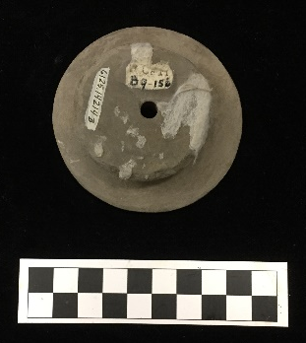
Site Number/Catalog Number: 34Lf40/6125.14214B
Site Name: Spiro
Additional Provenience Information: B9-15b
Earspool Type: Pulley
Material Type: Sandstone
Spiro Grave Period: Spiro III/IV

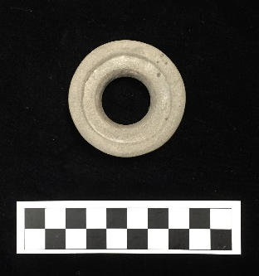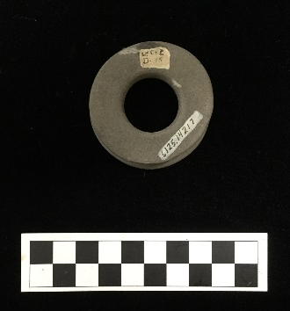
Site Number/Catalog Number: 34Lf40/6125.14217
Site Name: Spiro
Additional Provenience Information:
Earspool Type: Pulley
Material Type: Sandstone
Spiro Grave Period: Unassigned
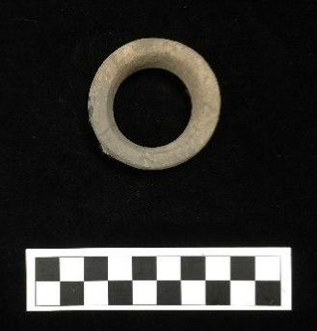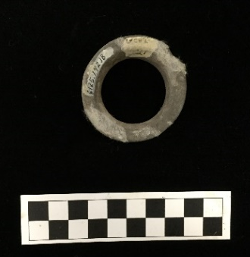
Site Number/Catalog Number: 34Lf40/6125.14218
Site Name: Spiro
Additional Provenience Information: D27
Earspool Type: Pulley Ring
Material Type: Sandstone
Spiro Grave Period: Unassigned

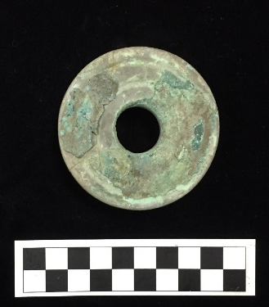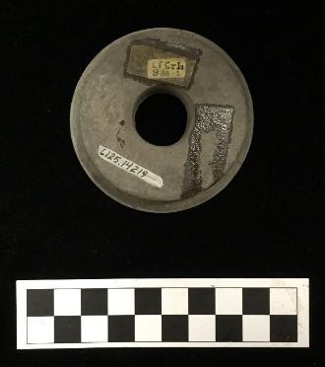
Site Number/Catalog Number: 34Lf40/6125.14219
Site Name: Spiro
Additional Provenience Information: B38-1
Earspool Type: Pulley
Material Type: Sandstone
Spiro Grave Period: Spiro III

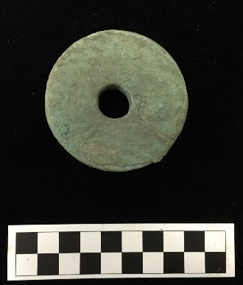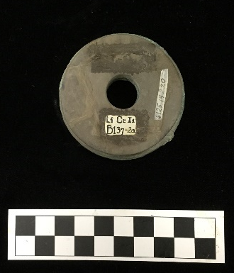
Site Number/Catalog Number: 34Lf40/6125.1422
Site Name: Spiro
Additional Provenience Information: B137-2a
Earspool Type: Pulley
Material Type: Sandstone
Spiro Grave Period: Spiro II
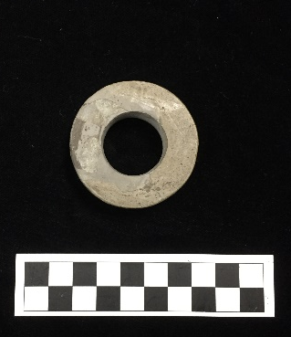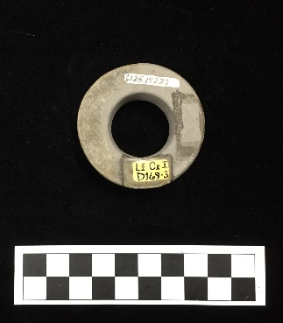
Site Number/Catalog Number: 34Lf40/6125.14222
Site Name: Spiro
Additional Provenience Information:
Earspool Type: Pulley
Material Type: Sandstone
Spiro Grave Period: Unassigned
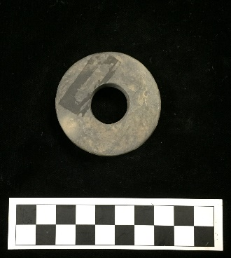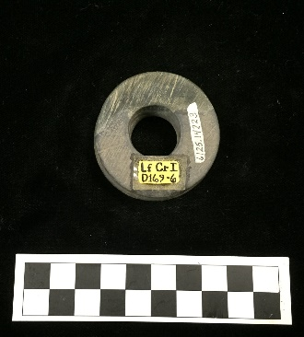
Site Number/Catalog Number: 34Lf40/6125.14223
Site Name: Spiro
Additional Provenience Information:
Earspool Type: Pulley
Material Type: Sandstone
Spiro Grave Period: Unassigned
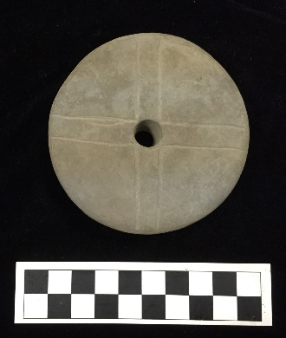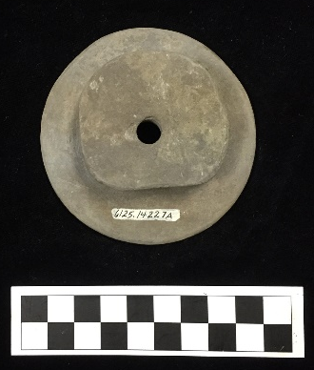
Site Number/Catalog Number: 34Lf40/6125.14227a
Site Name: Spiro
Additional Provenience Information:
Earspool Type: Pulley
Material Type: Sandstone
Spiro Grave Period: Unassigned

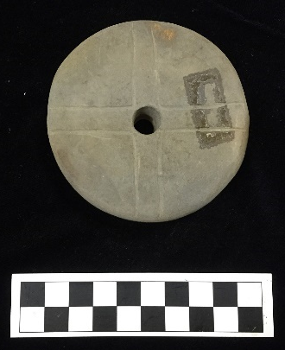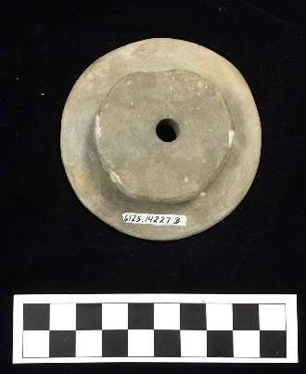
Site Number/Catalog Number: 34Lf40/6125.14227b
Site Name: Spiro
Additional Provenience Information:
Earspool Type: Pulley
Material Type: Sandstone
Spiro Grave Period: Unassigned
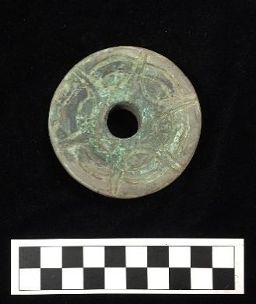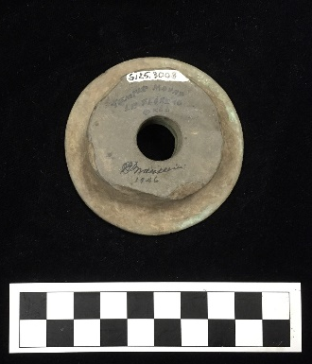
Site Number/Catalog Number: 34Lf40/6125.3008
Site Name: Spiro
Additional Provenience Information:
Earspool Type: Pulley
Material Type: Sandstone
Spiro Grave Period: Unassigned
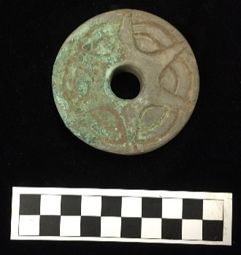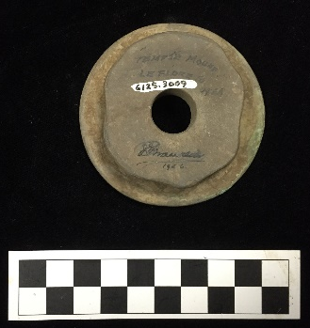
Site Number/Catalog Number: 34Lf40/6125.3009
Site Name: Spiro
Additional Provenience Information:
Earspool Type: Pulley
Material Type: Sandstone
Spiro Grave Period: Unassigned

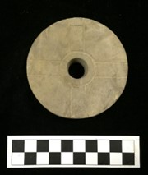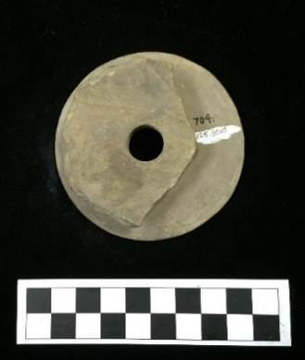
Site Number/Catalog Number: 34Lf40/6125.3010 704
Site Name: Spiro
Additional Provenience Information:
Earspool Type: Pulley
Material Type: Sandstone
Spiro Grave Period: Unassigned
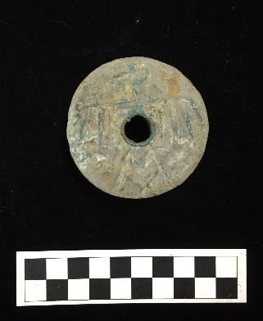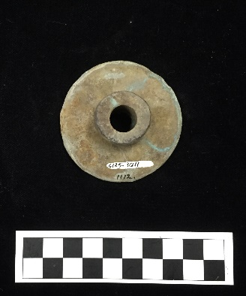
Site Number/Catalog Number: 34Lf40/6125.3011 1112
Site Name: Spiro
Additional Provenience Information:
Earspool Type: Small Inner Nub
Material Type: Sandstone
Spiro Grave Period: Unassigned
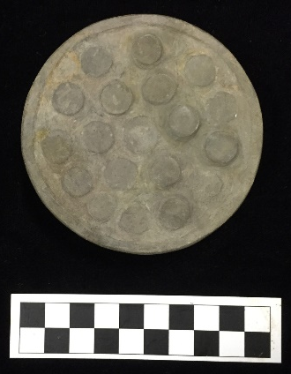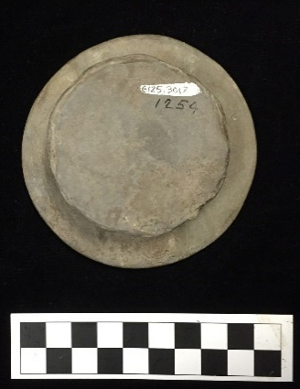
Site Number/Catalog Number: 34Lf40/6125.3012 1254
Site Name: Spiro
Additional Provenience Information:
Earspool Type: Pulley
Material Type: Sandstone
Spiro Grave Period:
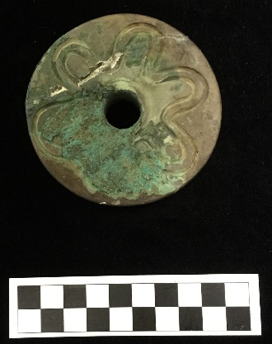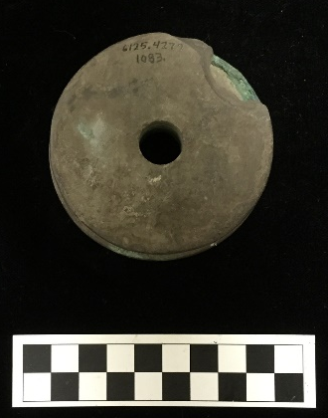
Site Number/Catalog Number: 34Lf40/6125.4277 1083
Site Name: Spiro
Additional Provenience Information:
Earspool Type: Pulley
Material Type: Sandstone
Spiro Grave Period: Unassigned
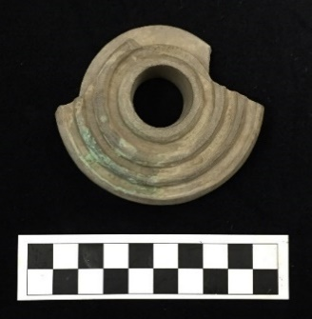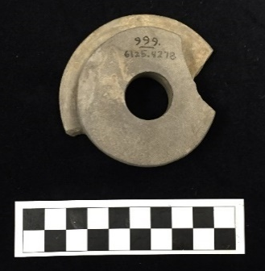
Site Number/Catalog Number: 34Lf40/6125.4278 999
Site Name: Spiro
Additional Provenience Information:
Earspool Type: Pulley
Material Type: Sandstone
Spiro Grave Period: Unassigned
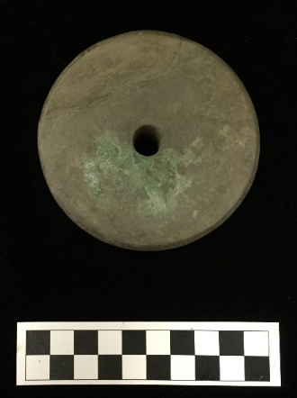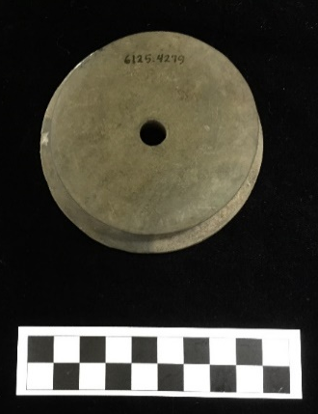
Site Number/Catalog Number: 34Lf40/6125.4279
Site Name: Spiro
Additional Provenience Information:
Earspool Type: Pulley
Material Type: Sandstone
Spiro Grave Period: Unassigned
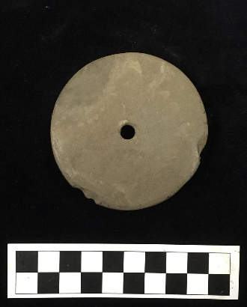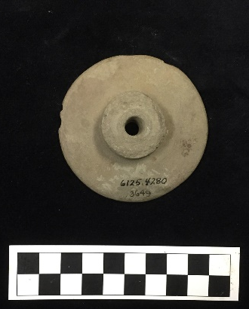
Site Number/Catalog Number: 34Lf40/6125.4280 3649
Site Name: Spiro
Additional Provenience Information:
Earspool Type: Pulley
Material Type: Sandstone
Spiro Grave Period: Unassigned
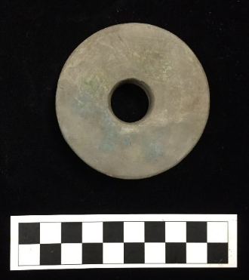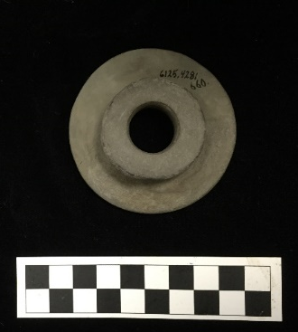
Site Number/Catalog Number: 34Lf40/6125.4281 660
Site Name: Spiro
Additional Provenience Information:
Earspool Type: Pulley
Material Type: Sandstone
Spiro Grave Period: Unassigned
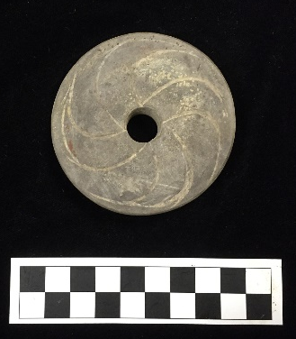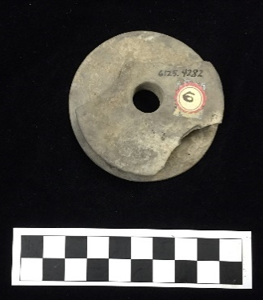
Site Number/Catalog Number: 34Lf40/6125.4282 3871 233
Site Name: Spiro
Additional Provenience Information:
Earspool Type: Pulley
Material Type: Sandstone
Spiro Grave Period: Unassigned

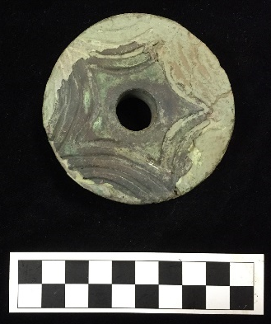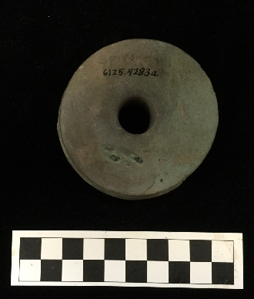
Site Number/Catalog Number: 34Lf40/6125.4283a
Site Name: Spiro
Additional Provenience Information:
Earspool Type: Pulley
Material Type: Sandstone
Spiro Grave Period: Unassigned
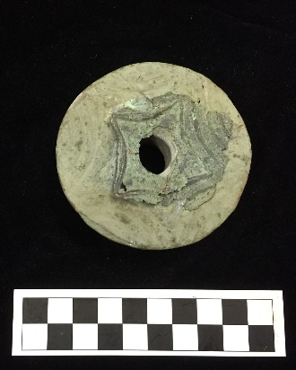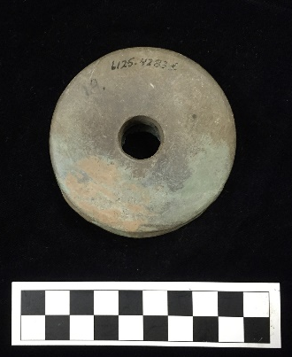
Site Number/Catalog Number: 34Lf40/6125.4283b
Site Name: Spiro
Additional Provenience Information:
Earspool Type: Pulley
Material Type: Sandstone
Spiro Grave Period: Unassigned
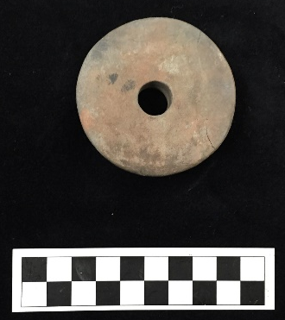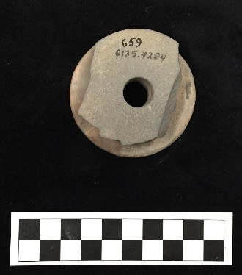
Site Number/Catalog Number: 34Lf40/6125.4284 659
Site Name: Spiro
Additional Provenience Information:
Earspool Type: Pulley
Material Type: Sandstone
Spiro Grave Period: Unassigned
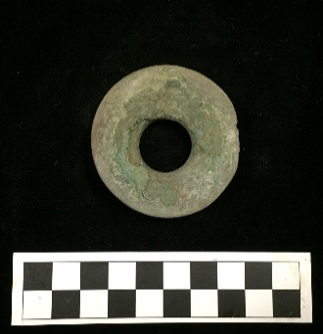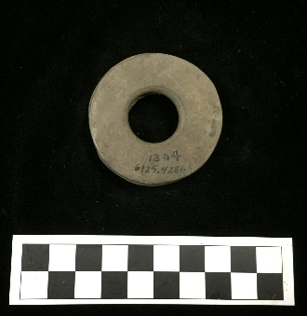
Site Number/Catalog Number: 34Lf40/6125.4286 1304
Site Name: Spiro
Additional Provenience Information:
Earspool Type: Pulley
Material Type: Sandstone
Spiro Grave Period: Unassigned

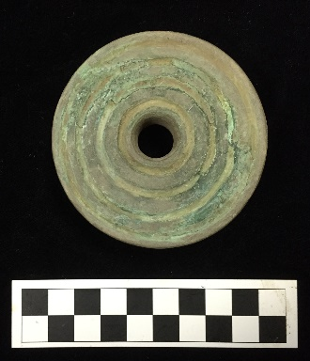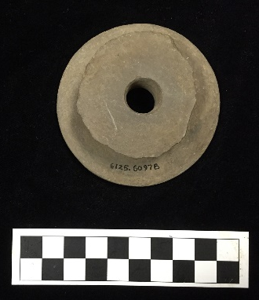
Site Number/Catalog Number: 34Lf40/6125.6097B
Site Name: Spiro
Additional Provenience Information:
Earspool Type: Pulley
Material Type: Sandstone
Spiro Grave Period: Unassigned

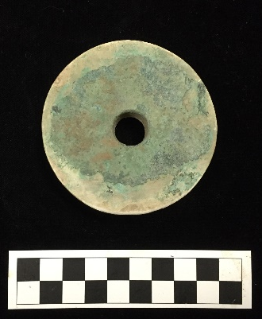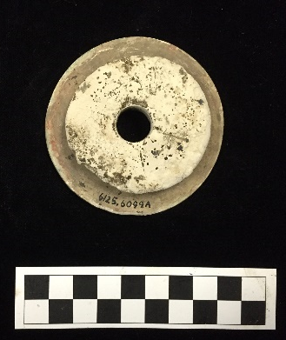
Site Number/Catalog Number: 34Lf40/6125.6099A
Site Name: Spiro
Additional Provenience Information:
Earspool Type: Pulley
Material Type: Limestone
Spiro Grave Period: Unassigned
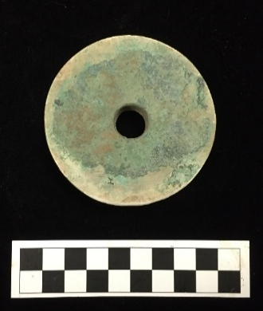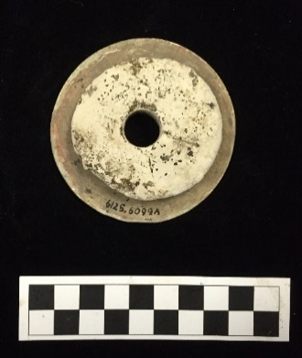
Site Number/Catalog Number: 34Lf40/6125.6099B
Site Name: Spiro
Additional Provenience Information:
Earspool Type: Pulley
Material Type: Limestone
Spiro Grave Period: Unassigned
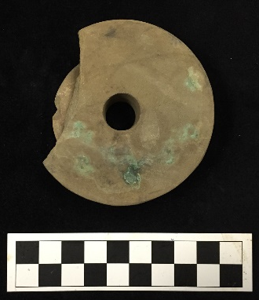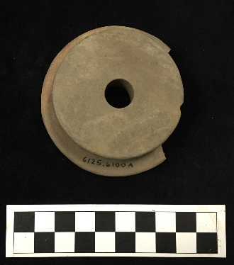
Site Number/Catalog Number: 34Lf40/6125.6100a
Site Name: Spiro
Additional Provenience Information:
Earspool Type: Pulley
Material Type: Sandstone
Spiro Grave Period: Unassigned
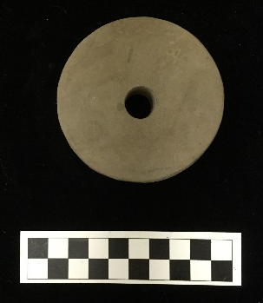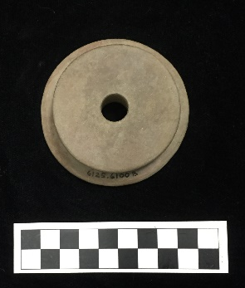
Site Number/Catalog Number: 34Lf40/6125.6100B
Site Name: Spiro
Additional Provenience Information:
Earspool Type: Pulley
Material Type: Sandstone
Spiro Grave Period: Unassigned

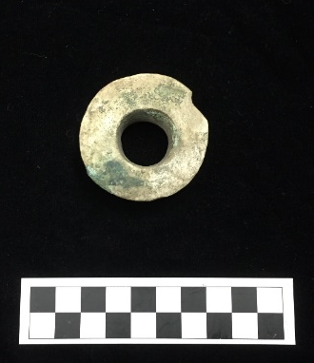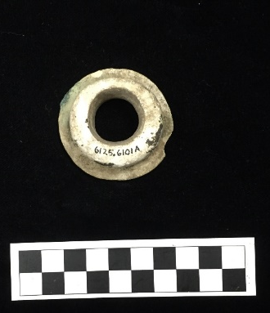
Site Number/Catalog Number: 34Lf40/6125.6101A
Site Name: Spiro
Additional Provenience Information:
Earspool Type: Pulley
Material Type: Limestone
Spiro Grave Period: Unassigned

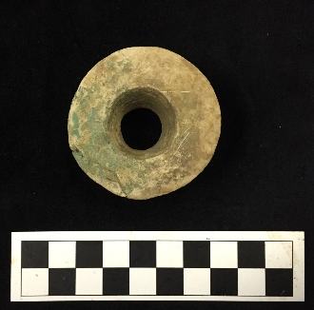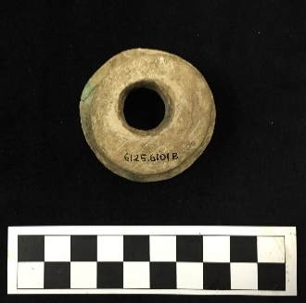
Site Number/Catalog Number: 34Lf40/6125.6101b
Site Name: Spiro
Additional Provenience Information:
Earspool Type: Pulley
Material Type: Limestone
Spiro Grave Period: Unassigned

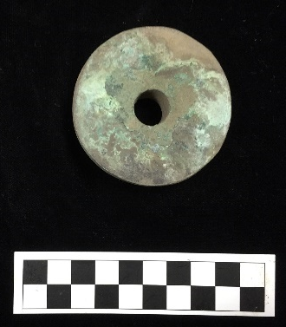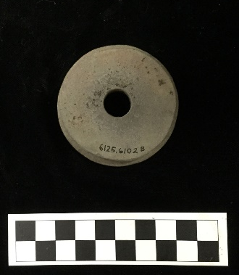
Site Number/Catalog Number: 34Lf40/6125.6102a
Site Name: Spiro
Additional Provenience Information:
Earspool Type: Pulley
Material Type: Sandstone
Spiro Grave Period: Unassigned
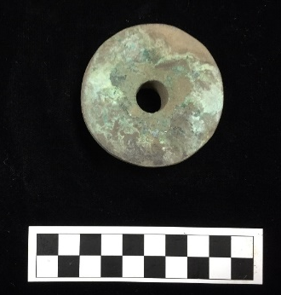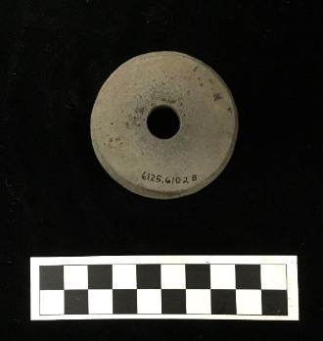
Site Number/Catalog Number: 34Lf40/6125.6102B
Site Name: Spiro
Additional Provenience Information:
Earspool Type: Pulley
Material Type: Sandstone
Spiro Grave Period: Unassigned

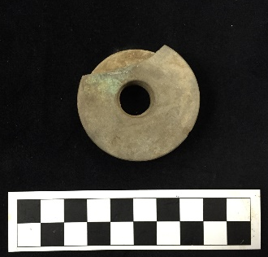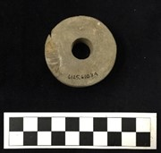
Site Number/Catalog Number: 34Lf40/6125.6103a
Site Name: Spiro
Additional Provenience Information:
Earspool Type: Pulley
Material Type: Sandstone
Spiro Grave Period: Unassigned

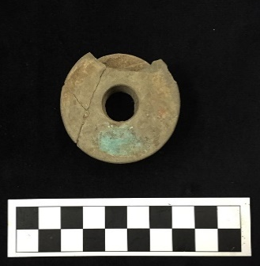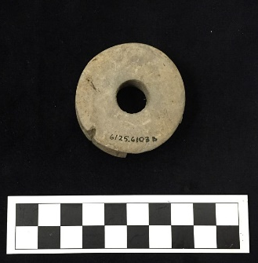
Site Number/Catalog Number: 34Lf40/6125.6103b
Site Name: Spiro
Additional Provenience Information:
Earspool Type: Pulley
Material Type: Sandstone
Spiro Grave Period: Unassigned

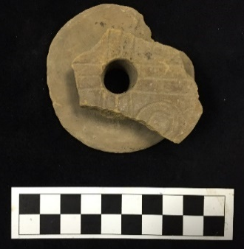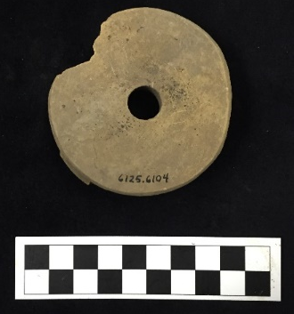
Site Number/Catalog Number: 34Lf40/6125.6104
Site Name: Spiro
Additional Provenience Information:
Earspool Type: Pulley
Material Type: Sandstone
Spiro Grave Period: Unassigned

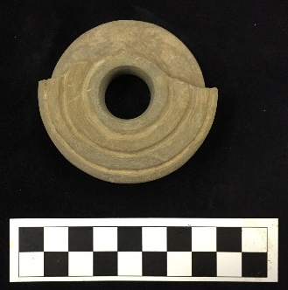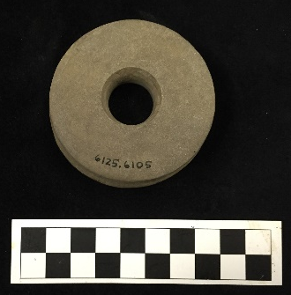
Site Number/Catalog Number: 34Lf40/6125.6105
Site Name: Spiro
Additional Provenience Information:
Earspool Type: Pulley
Material Type: Sandstone
Spiro Grave Period: Unassigned

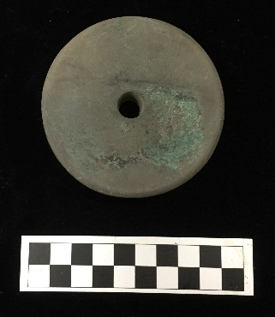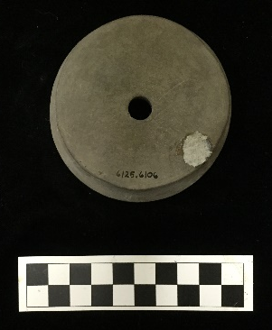
Site Number/Catalog Number: 34Lf40/6125.6106
Site Name: Spiro
Additional Provenience Information:
Earspool Type: Pulley
Material Type: Sandstone
Spiro Grave Period: Unassigned

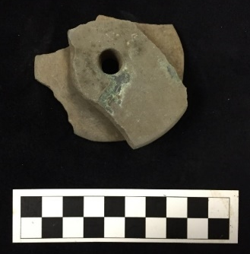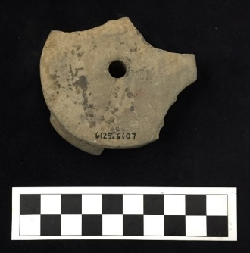
Site Number/Catalog Number: 34Lf40/6125.6107
Site Name: Spiro
Additional Provenience Information:
Earspool Type: Pulley
Material Type: Sandstone
Spiro Grave Period: Unassigned

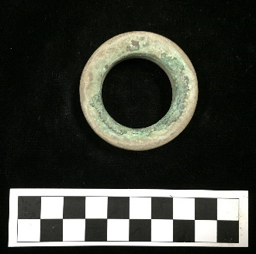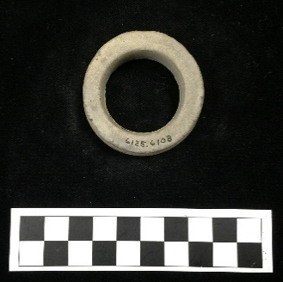
Site Number/Catalog Number: 34Lf40/6125.6108
Site Name: Spiro
Additional Provenience Information:
Earspool Type: Pulley Ring
Material Type: Sandstone
Spiro Grave Period: Unassigned

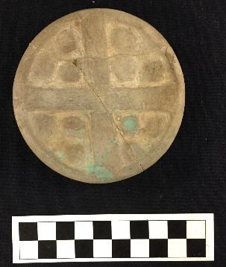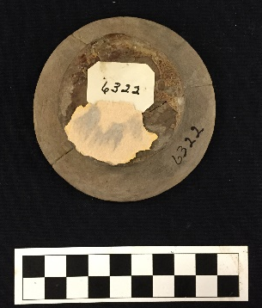
Site Number/Catalog Number: 34Lf40/6322.1
Site Name: Spiro
Additional Provenience Information: B31-4
Earspool Type: Pulley
Material Type: Sandstone
Spiro Grave Period: Spiro II

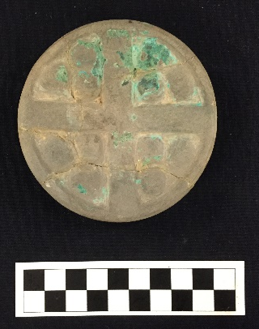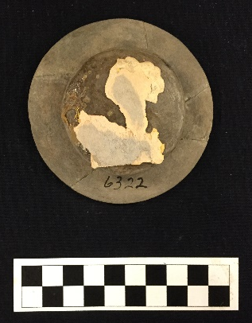
Site Number/Catalog Number: 34Lf40/6322.2
Site Name: Spiro
Additional Provenience Information: B31-4
Earspool Type: Pulley
Material Type: Sandstone
Spiro Grave Period: Spiro II

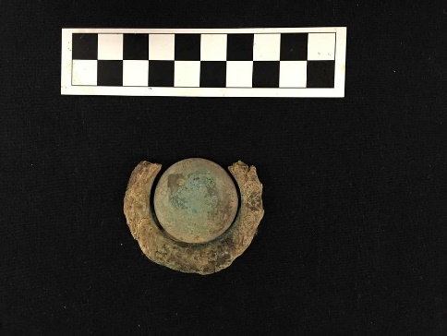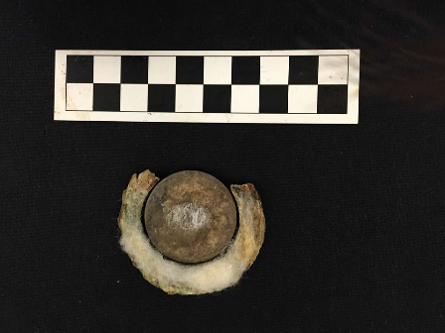
Site Number/Catalog Number: 34Lf40/6329.1
Site Name: Spiro
Additional Provenience Information: B51-40
Earspool Type: Composite
Material Type: Stone/shell/wood/copper
Spiro Grave Period: Spiro III

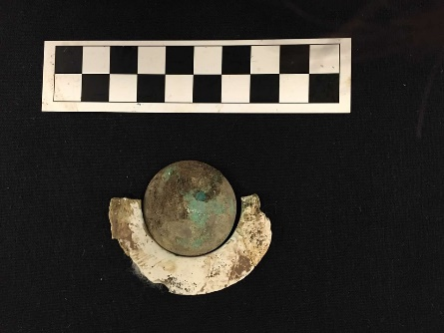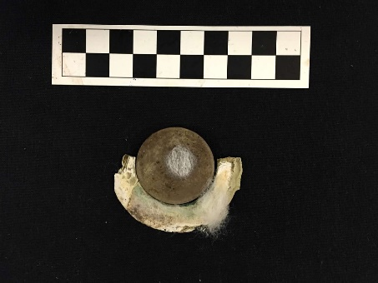
Site Number/Catalog Number: 34Lf40/6329.2
Site Name: Spiro
Additional Provenience Information: B51-40
Earspool Type: Composite
Material Type: Stone/shell/wood/copper
Spiro Grave Period: Spiro III

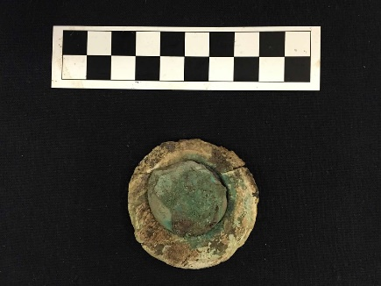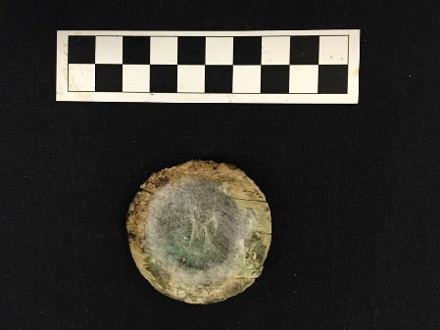
Site Number/Catalog Number: 34Lf40/6329.3
Site Name: Spiro
Additional Provenience Information: B51-40
Earspool Type: Composite
Material Type: Stone/shell/wood/copper
Spiro Grave Period: Spiro III

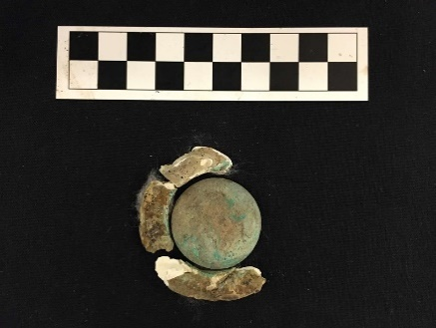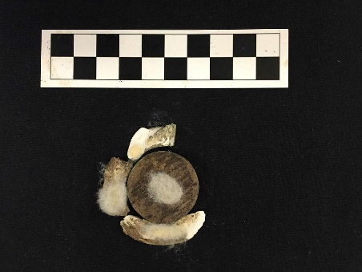
Site Number/Catalog Number: 34Lf40/6329.4
Site Name: Spiro
Additional Provenience Information: B51-40
Earspool Type: Composite
Material Type: Stone/shell/wood/copper
Spiro Grave Period: Spiro III

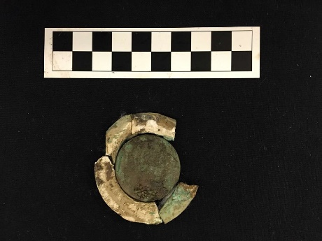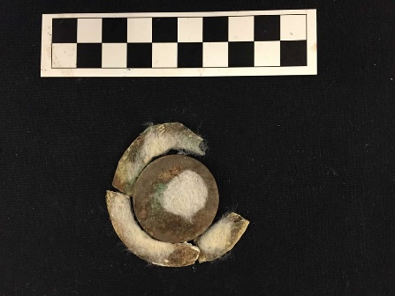
Site Number/Catalog Number: 34Lf40/6329.5
Site Name: Spiro
Additional Provenience Information: B51-40
Earspool Type: Composite
Material Type: Stone/shell/wood/copper
Spiro Grave Period: Spiro III

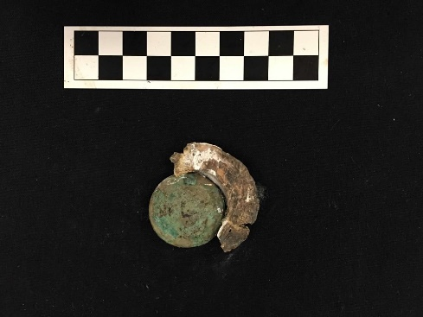
Site Number/Catalog Number: 34Lf40/6329.6
Site Name: Spiro
Additional Provenience Information: B51-40
Earspool Type: Composite
Material Type: Stone/shell/wood/copper
Spiro Grave Period: Spiro III

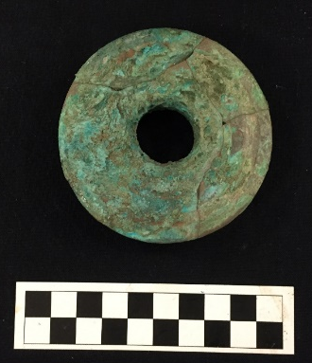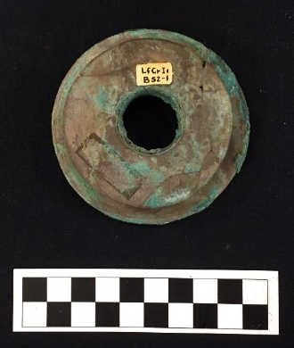
Site Number/Catalog Number: 34Lf40/6331.3
Site Name: Spiro
Additional Provenience Information: B52-1
Earspool Type: Pulley
Material Type: Sandstone
Spiro Grave Period: Spiro III/IV

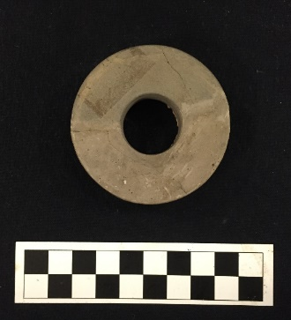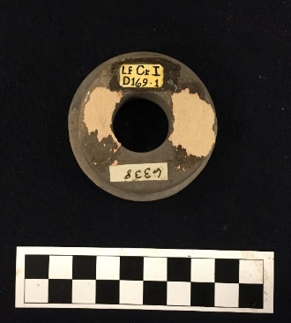
Site Number/Catalog Number: 34Lf40/6338/6358
Site Name: Spiro
Additional Provenience Information:
Earspool Type: Pulley
Material Type: Sandstone
Spiro Grave Period: Unassigned
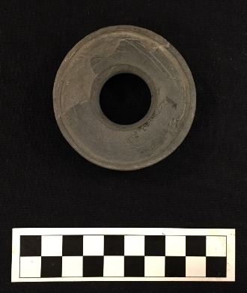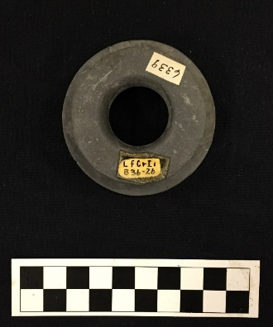
Site Number/Catalog Number: 34Lf40/6339
Site Name: Spiro
Additional Provenience Information: B36-2b
Earspool Type: Recessed
Material Type: Sandstone
Spiro Grave Period: Spiro IVB

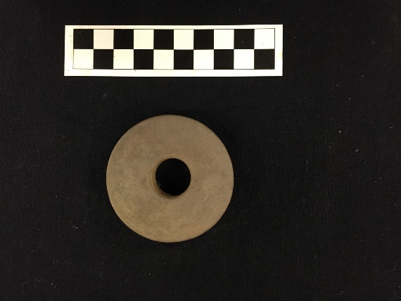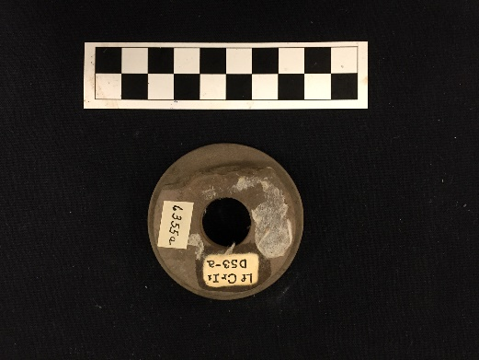
Site Number/Catalog Number: 34Lf40/6355a
Site Name: Spiro
Additional Provenience Information: D53-a
Earspool Type: Pulley
Material Type: Sandstone
Spiro Grave Period: Unassigned

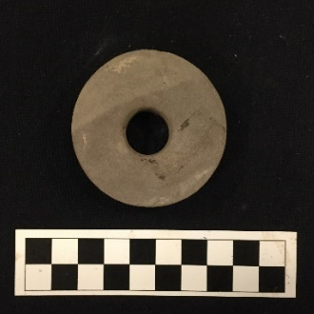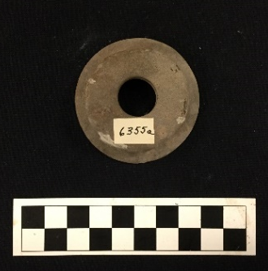
Site Number/Catalog Number: 34Lf40/6355a.2
Site Name: Spiro
Additional Provenience Information:
Earspool Type: Pulley
Material Type: Sandstone
Spiro Grave Period: Unassigned
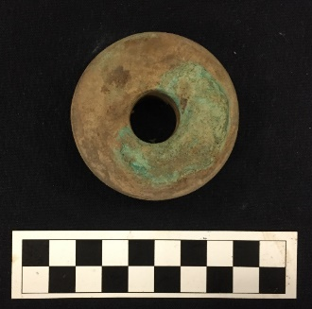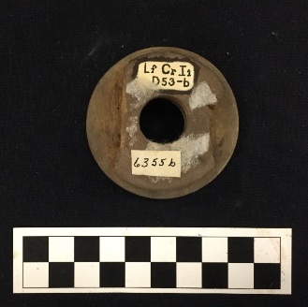
Site Number/Catalog Number: 34Lf40/6355b
Site Name: Spiro
Additional Provenience Information: D53-b
Earspool Type: Pulley
Material Type: Sandstone
Spiro Grave Period: Unassigned

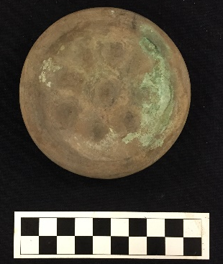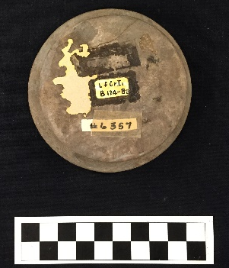
Site Number/Catalog Number: 34Lf40/6357a
Site Name: Spiro
Additional Provenience Information: B174-8a
Earspool Type: Pulley
Material Type: Sandstone
Spiro Grave Period: Spiro III

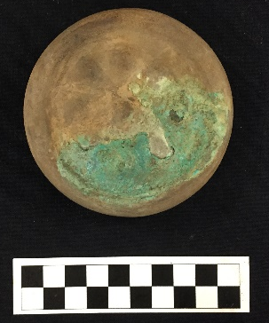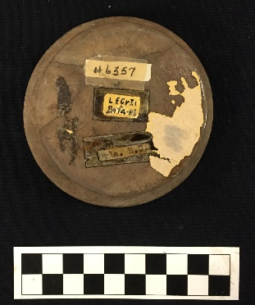
Site Number/Catalog Number: 34Lf40/6357b
Site Name: Spiro
Additional Provenience Information: B174-8b
Earspool Type: Pulley
Material Type: Sandstone
Spiro Grave Period: Spiro III
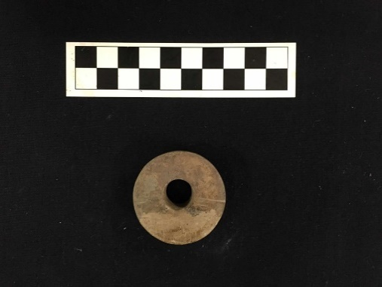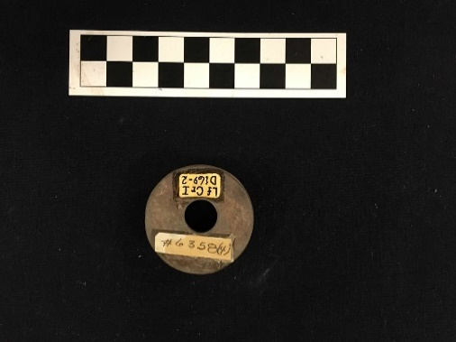
Site Number/Catalog Number: 34Lf40/6358(4)-2
Site Name: Spiro
Additional Provenience Information: D169-2
Earspool Type: Pulley
Material Type: Sandstone
Spiro Grave Period: Unassigned

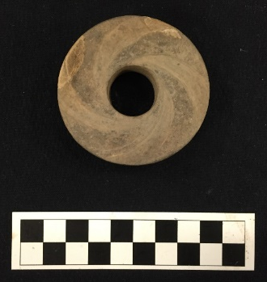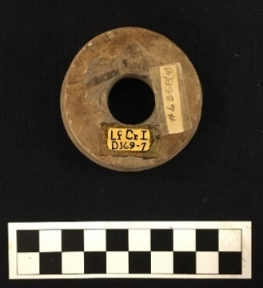
Site Number/Catalog Number: 34Lf40/6358(4)-7
Site Name: Spiro
Additional Provenience Information: D169-7
Earspool Type: Pulley
Material Type: Sandstone
Spiro Grave Period: Unassigned

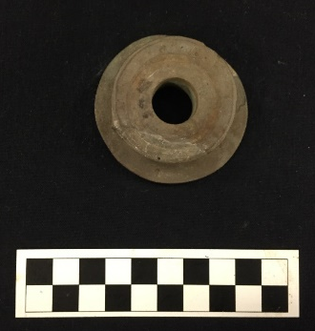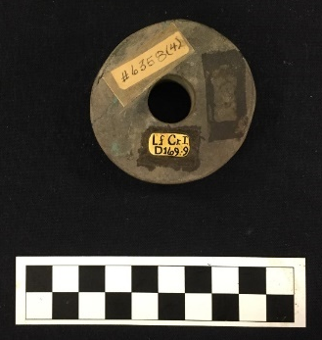
Site Number/Catalog Number: 34Lf40/6358(4)-9
Site Name: Spiro
Additional Provenience Information: D169-9
Earspool Type: Pulley
Material Type: Sandstone
Spiro Grave Period: Unassigned

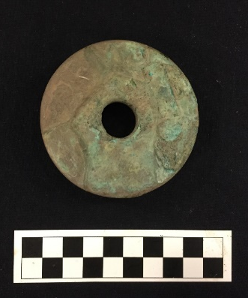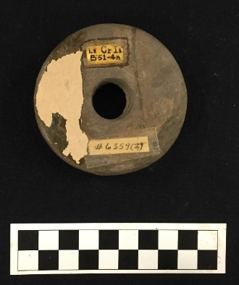
Site Number/Catalog Number: 34Lf40/6359(2)a
Site Name: Spiro
Additional Provenience Information: B51-4a
Earspool Type: Pulley
Material Type: Sandstone
Spiro Grave Period: Spiro III
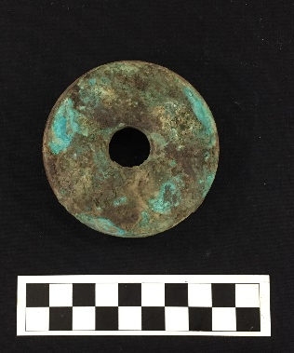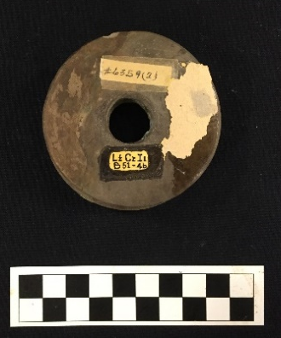
Site Number/Catalog Number: 34Lf40/6359(2)b
Site Name: Spiro
Additional Provenience Information: B51-4b
Earspool Type: Pulley
Material Type: Sandstone
Spiro Grave Period: Spiro III
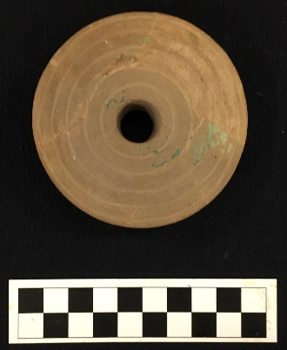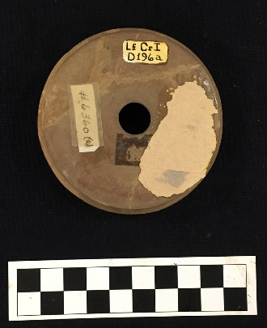
Site Number/Catalog Number: 34Lf40/6360(2)a
Site Name: Spiro
Additional Provenience Information: D196a
Earspool Type: Pulley
Material Type: Sandstone
Spiro Grave Period: Unassigned
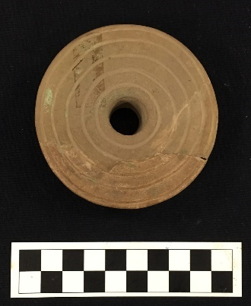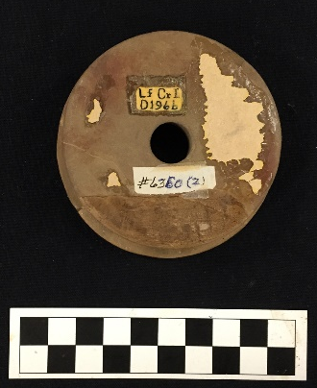
Site Number/Catalog Number: 34Lf40/6360(2)b
Site Name: Spiro
Additional Provenience Information: D196b
Earspool Type: Pulley
Material Type: Sandstone
Spiro Grave Period: Unassigned
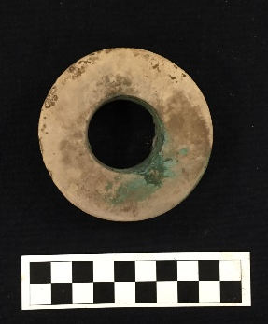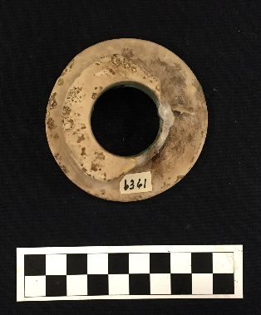
Site Number/Catalog Number: 34Lf40/6361
Site Name: Spiro
Additional Provenience Information:
Earspool Type: Pulley
Material Type: Limestone
Spiro Grave Period: Unassigned
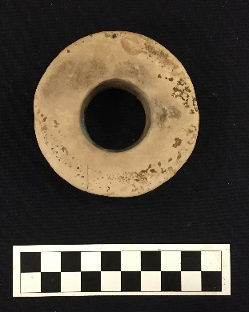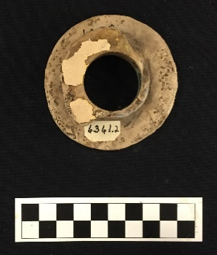
Site Number/Catalog Number: 34Lf40/6361.2
Site Name: Spiro
Additional Provenience Information: B36-2b
Earspool Type: Pulley
Material Type: Limestone
Spiro Grave Period: Spiro III/IV
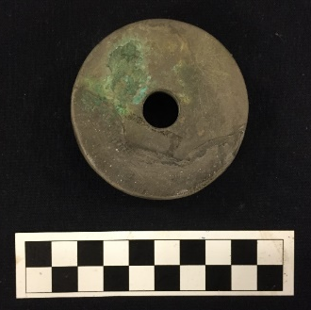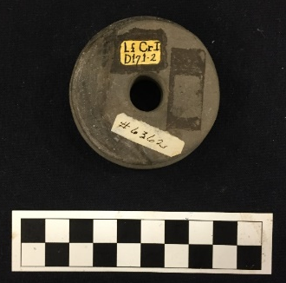
Site Number/Catalog Number: 34Lf40/6362
Site Name: Spiro
Additional Provenience Information: D171-2
Earspool Type: Pulley
Material Type: Sandstone
Spiro Grave Period: Unassigned

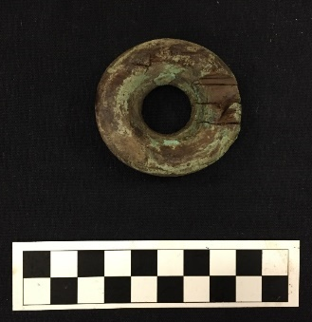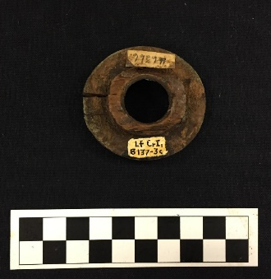
Site Number/Catalog Number: 34Lf40/6366.1
Site Name: Spiro
Additional Provenience Information: B137-3c
Earspool Type: Pulley
Material Type: Wood
Spiro Grave Period: Spiro II

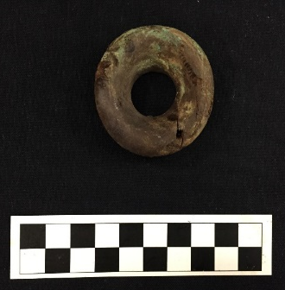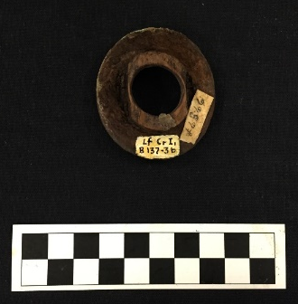
Site Number/Catalog Number: 34Lf40/6366.2
Site Name: Spiro
Additional Provenience Information: B137-3b
Earspool Type: Pulley
Material Type: Wood
Spiro Grave Period: Spiro II

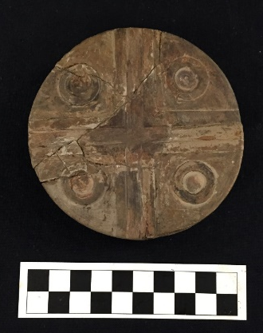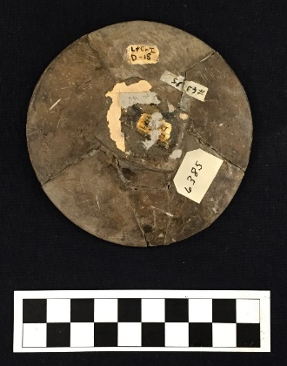
Site Number/Catalog Number: 34Lf40/6385
Site Name: Spiro
Additional Provenience Information: D-18
Earspool Type: Pulley
Material Type: Sandstone
Spiro Grave Period: Unassigned
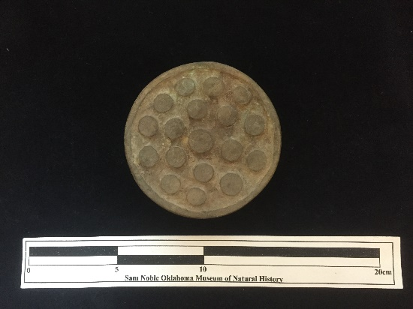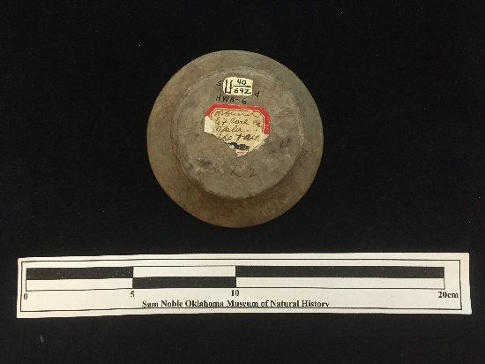
Site Number/Catalog Number: 34Lf40/692.0
Site Name: Spiro
Additional Provenience Information:
Earspool Type: Pulley
Material Type: Sandstone
Spiro Grave Period: Unassigned
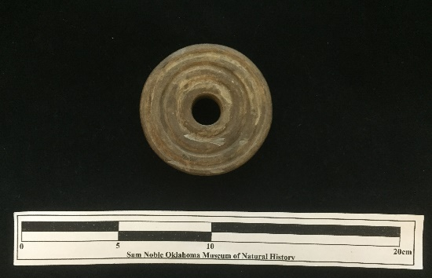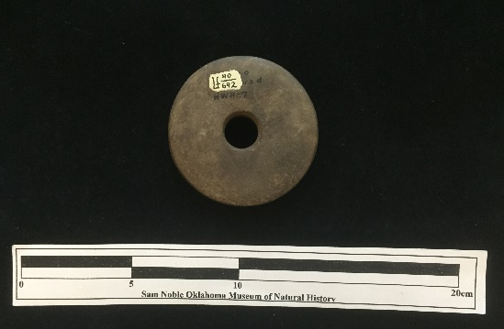
Site Number/Catalog Number: 34Lf40/692.91
Site Name: Spiro
Additional Provenience Information:
Earspool Type: Pulley
Material Type: Sandstone
Spiro Grave Period: Unassigned
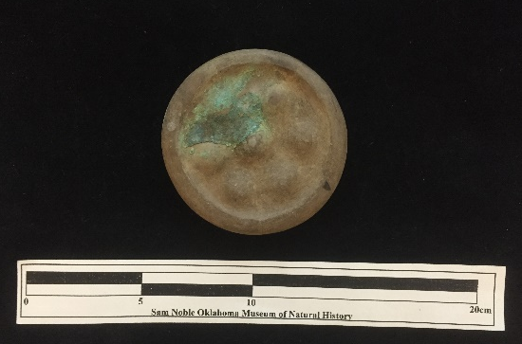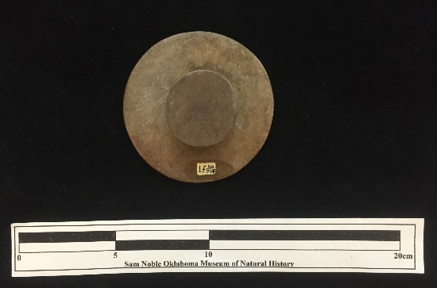
Site Number/Catalog Number: 34Lf40/704.1a
Site Name: Spiro
Additional Provenience Information:
Earspool Type: Small Inner Nub
Material Type: Sandstone
Spiro Grave Period: Unassigned

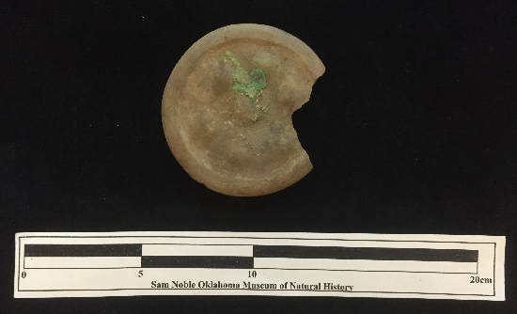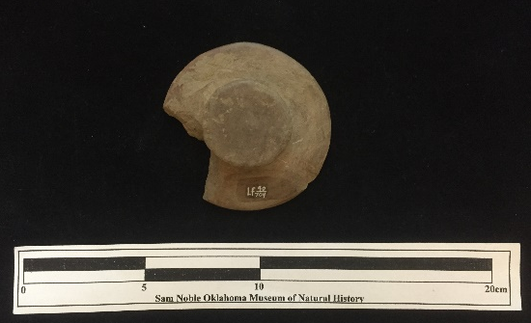
Site Number/Catalog Number: 34Lf40/704.1b
Site Name: Spiro
Additional Provenience Information:
Earspool Type: Small Inner Nub
Material Type: Sandstone
Spiro Grave Period: Unassigned

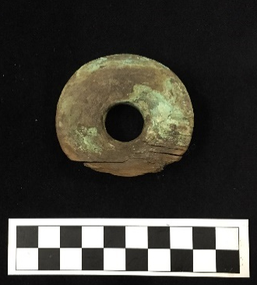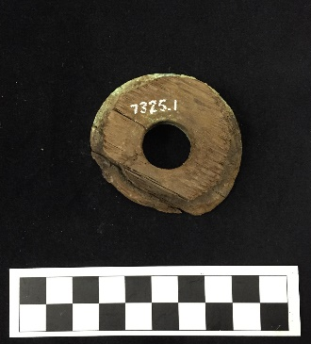
Site Number/Catalog Number: 34Lf40/7325.1
Site Name: Spiro
Additional Provenience Information:
Earspool Type: Pulley
Material Type: Wood
Spiro Grave Period: Unassigned

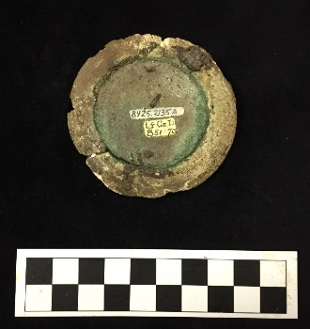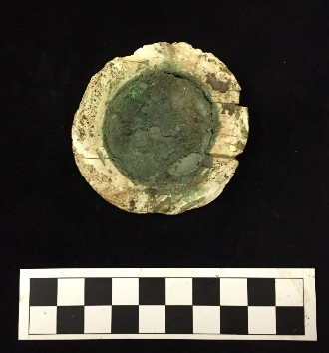
Site Number/Catalog Number: 34Lf40/8425.2135a
Site Name: Spiro
Additional Provenience Information: B51-70
Earspool Type: Composite
Material Type: Stone/shell/wood/copper
Spiro Grave Period: Spiro III

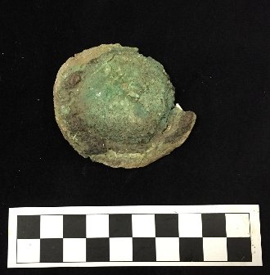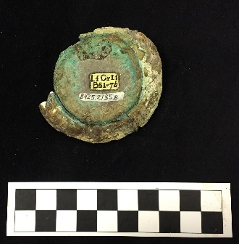
Site Number/Catalog Number: 34Lf40/8425.2135b
Site Name: Spiro
Additional Provenience Information: B51-7b
Earspool Type: Composite
Material Type: Stone/shell/wood/copper
Spiro Grave Period: Spiro III

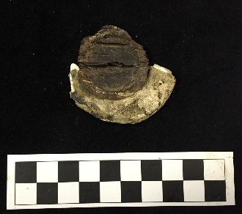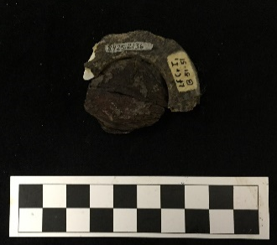
Site Number/Catalog Number: 34Lf40/8425.2136
Site Name: Spiro
Additional Provenience Information: B51-51
Earspool Type: Composite
Material Type: Stone/shell/wood/copper
Spiro Grave Period: Spiro III

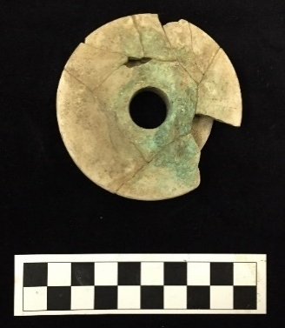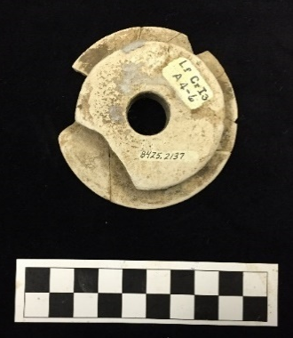
Site Number/Catalog Number: 34Lf40/8425.2137
Site Name: Spiro
Additional Provenience Information: A 4-6
Earspool Type: Pulley
Material Type: Limestone
Spiro Grave Period: Spiro II

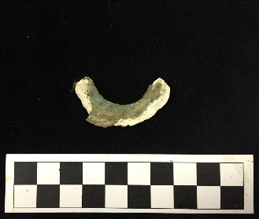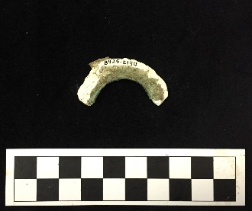
Site Number/Catalog Number: 34Lf40/8425.2140
Site Name: Spiro
Additional Provenience Information: D65-1b
Earspool Type: Composite
Material Type: Stone/shell/wood/copper
Spiro Grave Period: Unassigned

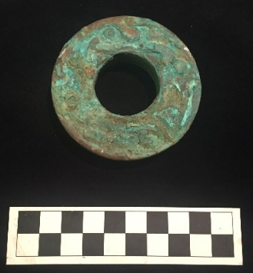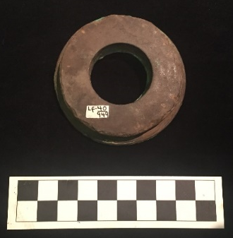
Site Number/Catalog Number: 34Lf40/949
Site Name: Spiro
Additional Provenience Information:
Earspool Type: Pulley
Material Type: Sandstone
Spiro Grave Period: Unassigned

No Photograph Available

Site Number/Catalog Number: 34Lf40/961.2
Site Name: Spiro
Additional Provenience Information:
Earspool Type: Pulley
Material Type: Sandstone
Spiro Grave Period: Unassigned

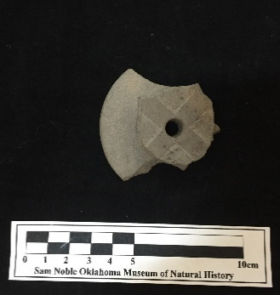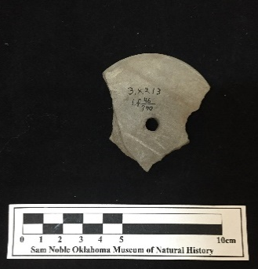
Site Number/Catalog Number: 34Lf46/740
Site Name: Spiro
Additional Provenience Information: 32.1 3.4.213
Earspool Type: Pulley
Material Type: Sandstone
Spiro Grave Period: Unassigned

No Photograph Available

Site Number/Catalog Number: 34Lf51/14.14
Site Name: Spiro
Additional Provenience Information: D22
Earspool Type: Pulley
Material Type: Sandstone
Spiro Grave Period: Unassigned
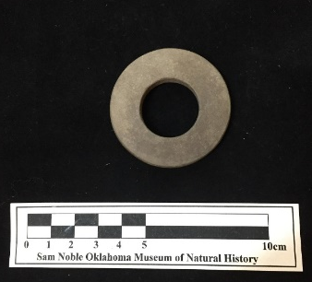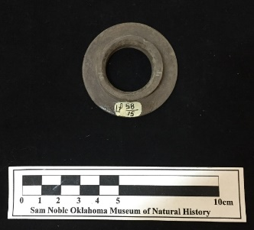

Site Number/Catalog Number: 34Lf58/15.1
Site Name: Spiro
Additional Provenience Information:
Earspool Type: Nested Half
Material Type: Sandstone
Spiro Grave Period: Unassigned

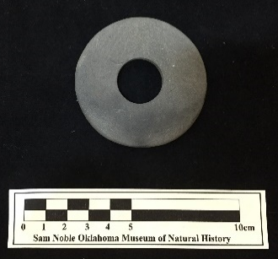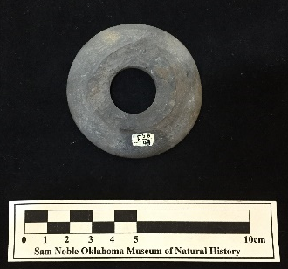
Site Number/Catalog Number: 34Lf58/43.1
Site Name: Spiro
Additional Provenience Information:
Earspool Type: Pulley
Material Type: Sandstone
Spiro Grave Period: Unassigned

Site Number/Catalog Number: 34MI45/6125.3979a&b
Site Name: Eufaula
Additional Provenience Information:
Earspool Type: Pulley
Material Type: Sandstone
Spiro Grave Period: Unassigned

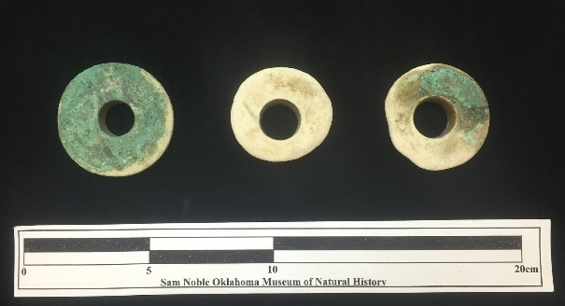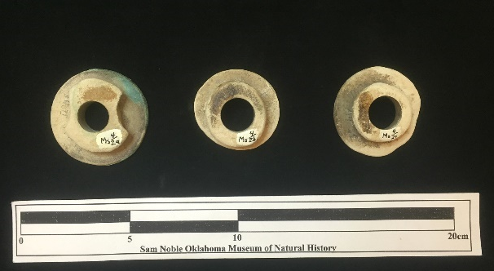
Site Number/Catalog Number: 34Ms4/002a,2b,3c
Site Name: Hughes
Additional Provenience Information: Ms HgII A4-3a
Earspool Type: Pulley
Material Type: Limestone
Spiro Grave Period: Unassigned

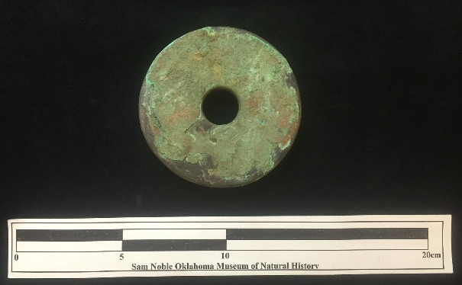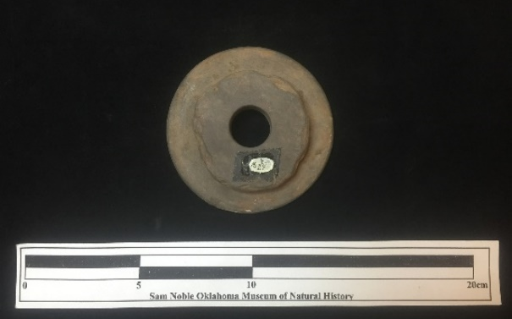
Site Number/Catalog Number: 34Ms4/024
Site Name: Hughes
Additional Provenience Information: Ms HgII 7.2.89 A-6
Earspool Type: Pulley
Material Type: Sandstone
Spiro Grave Period: Unassigned

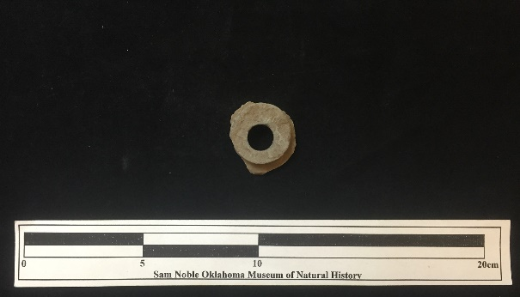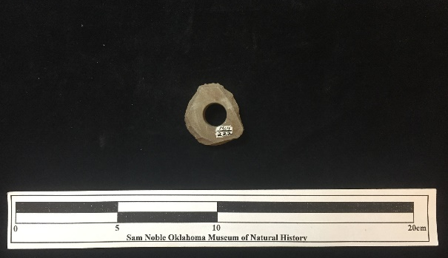
Site Number/Catalog Number: 34Ms4/222
Site Name: Hughes
Additional Provenience Information: Ms HgII 7.2.98
Earspool Type: Pulley
Material Type: Sandstone
Spiro Grave Period: Unassigned

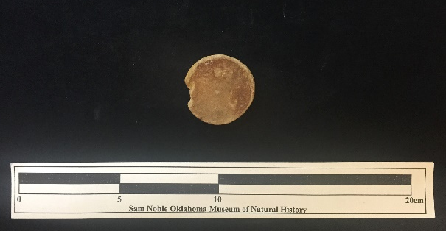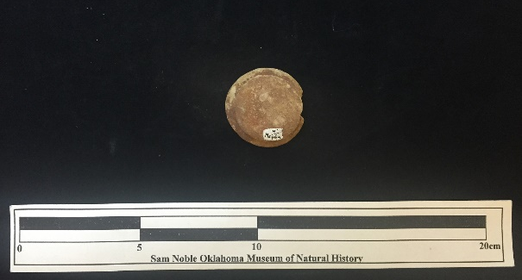
Site Number/Catalog Number: 34Ms4/46a
Site Name: Hughes
Additional Provenience Information: Ms HgII 7.2.289
Earspool Type: Pulley
Material Type: Sandstone
Spiro Grave Period: Unassigned
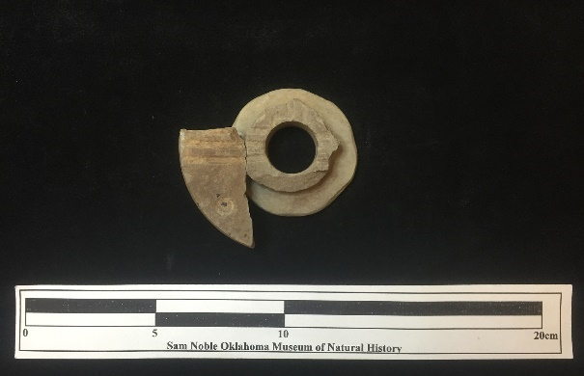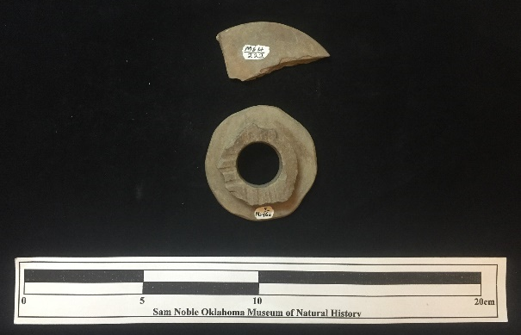
Site Number/Catalog Number: 34Ms4/222&46b
Site Name: Hughes
Additional Provenience Information:
Earspool Type: Plug
Material Type: Sandstone
Spiro Grave Period: Unassigned

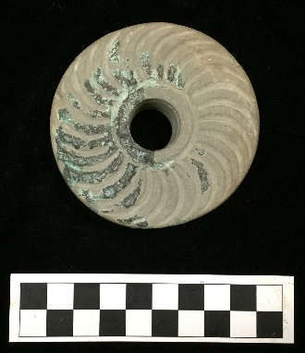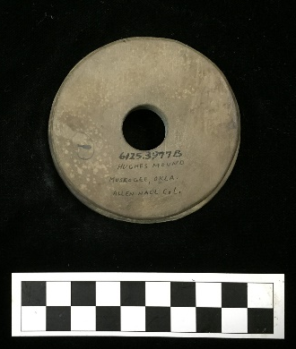
Site Number/Catalog Number: 34Ms4/6125.3977B
Site Name: Hughes
Additional Provenience Information:
Earspool Type: Pulley
Material Type: Sandstone
Spiro Grave Period: Unassigned

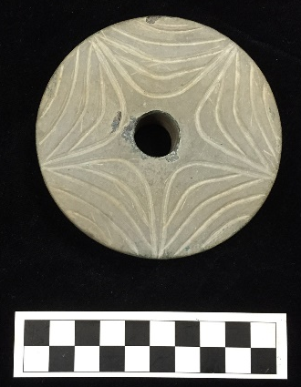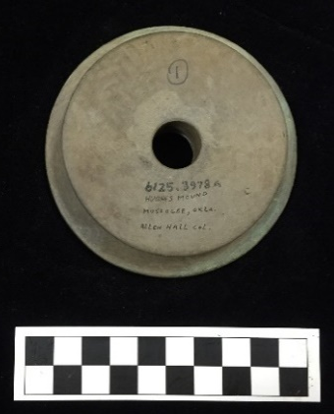
Site Number/Catalog Number: 34Ms4/6125.3978a
Site Name: Hughes
Additional Provenience Information:
Earspool Type: Pulley
Material Type: Sandstone
Spiro Grave Period: Unassigned
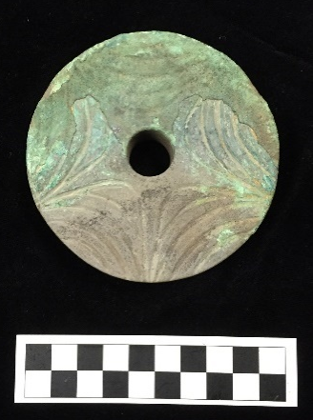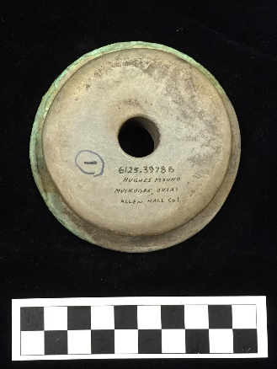
Site Number/Catalog Number: 34Ms4/6125.3978b
Site Name: Hughes
Additional Provenience Information:
Earspool Type: Pulley
Material Type: Sandstone
Spiro Grave Period: Unassigned
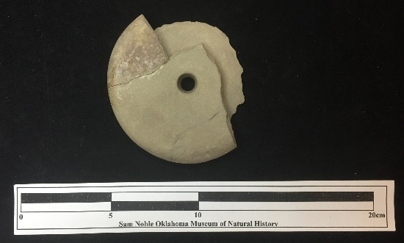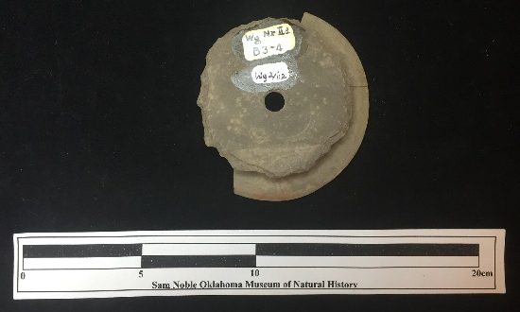
Site Number/Catalog Number: 34Wg0002/112
Site Name: Norman
Additional Provenience Information: B3-4
Earspool Type: Funnel Faced
Material Type: Sandstone
Spiro Grave Period: Spiro III
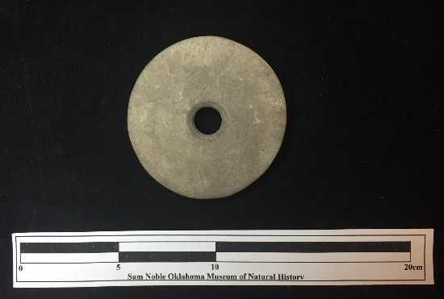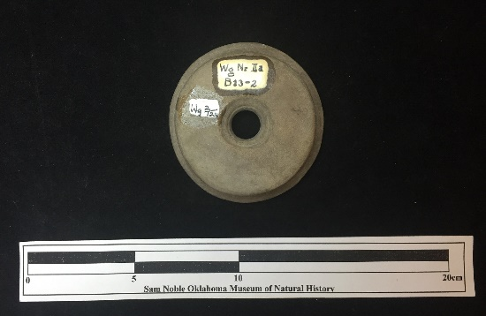
Site Number/Catalog Number: 34Wg0002/124
Site Name: Norman
Additional Provenience Information: B13-2
Earspool Type: Pulley
Material Type: Sandstone
Spiro Grave Period: Spiro III

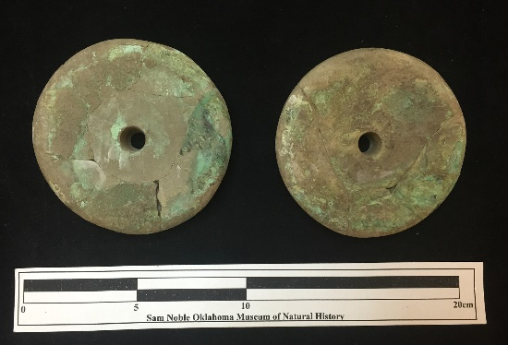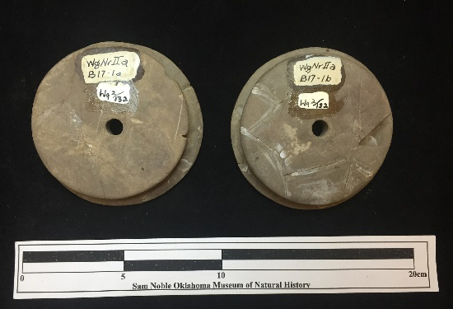
Site Number/Catalog Number: 34Wg0002/132
Site Name: Norman
Additional Provenience Information: B17-1a&b
Earspool Type: Pulley
Material Type: Sandstone
Spiro Grave Period: Spiro III
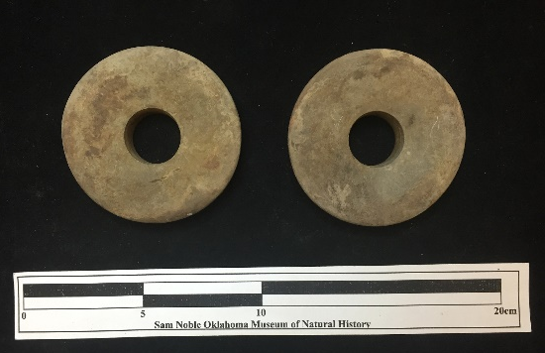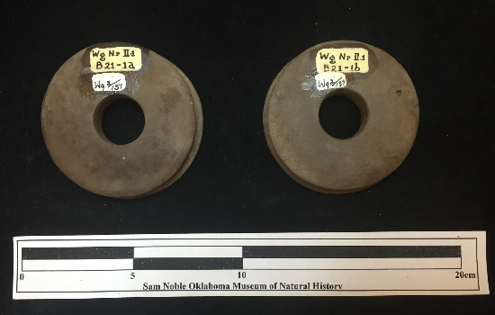
Site Number/Catalog Number: 34Wg0002/137
Site Name: Norman
Additional Provenience Information: B21-1a&b
Earspool Type: Pulley
Material Type: Sandstone
Spiro Grave Period: Spiro II

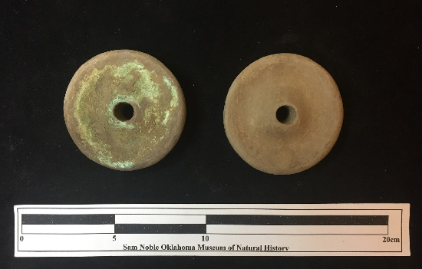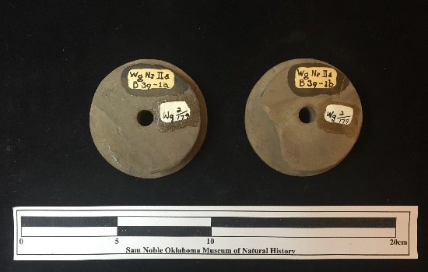
Site Number/Catalog Number: 34Wg0002/179
Site Name: Norman
Additional Provenience Information: B39-1a&b
Earspool Type: Channeled
Material Type: Sandstone
Spiro Grave Period: Spiro III

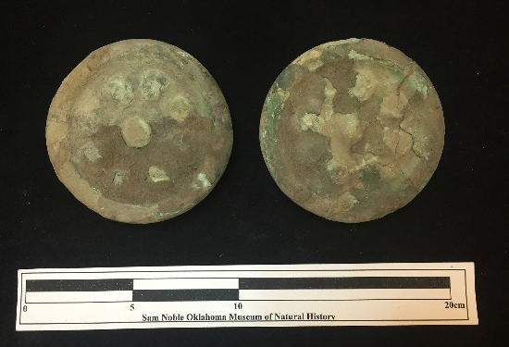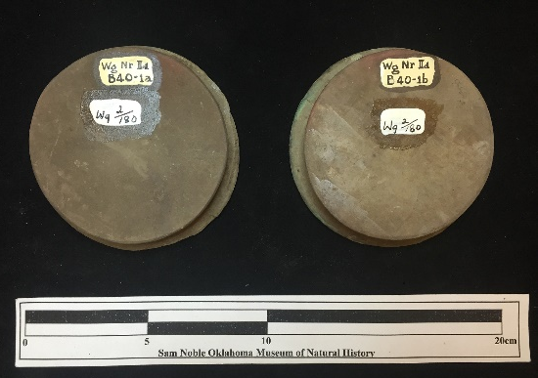
Site Number/Catalog Number: 34Wg0002/180
Site Name: Norman
Additional Provenience Information: B40-1a&b
Earspool Type: Pulley
Material Type: Sandstone
Spiro Grave Period: Spiro III

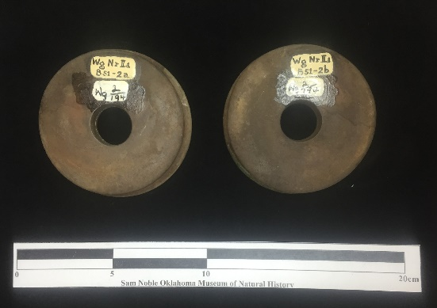
Site Number/Catalog Number: 34Wg0002/194
Site Name: Norman
Additional Provenience Information: B51-2a&b
Earspool Type: Funnel Faced
Material Type: Sandstone
Spiro Grave Period: Spiro III
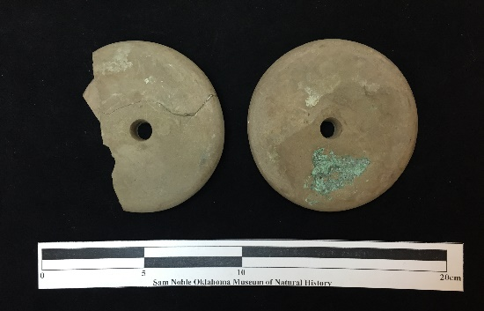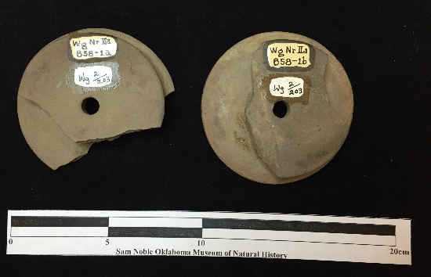
Site Number/Catalog Number: 34Wg0002/203
Site Name: Norman
Additional Provenience Information: B58-1a&b
Earspool Type: Funnel Faced
Material Type: Sandstone
Spiro Grave Period: Spiro III
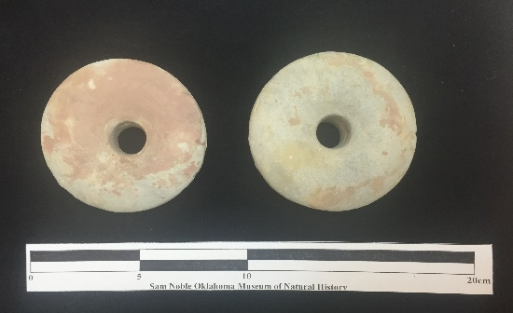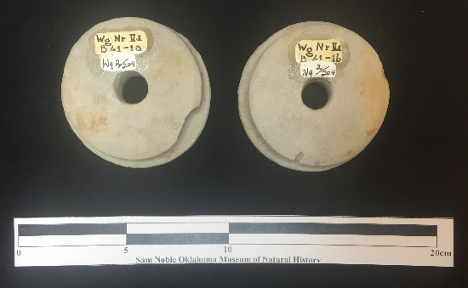
Site Number/Catalog Number: 34Wg0002/204
Site Name: Norman
Additional Provenience Information: B61-a&b
Earspool Type: Pulley
Material Type: Bauxite
Spiro Grave Period: Spiro III

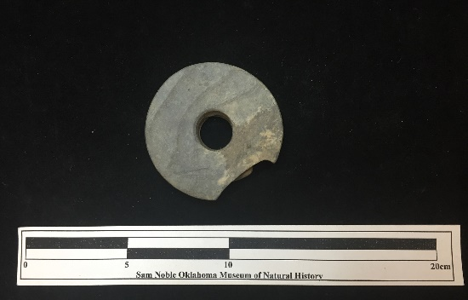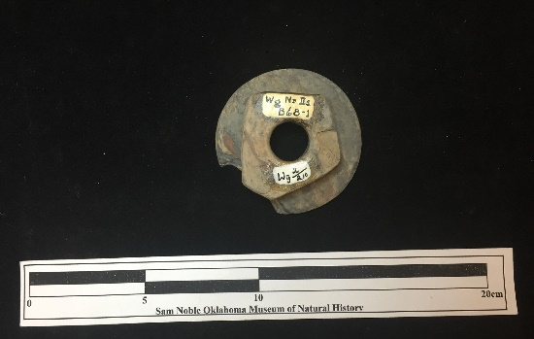
Site Number/Catalog Number: 34Wg0002/210
Site Name: Norman
Additional Provenience Information: B68-1
Earspool Type: Pulley
Material Type: Slate or shale
Spiro Grave Period: Spiro III

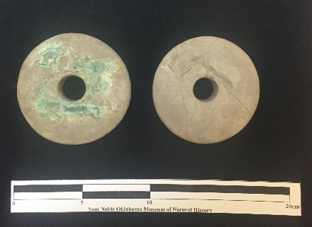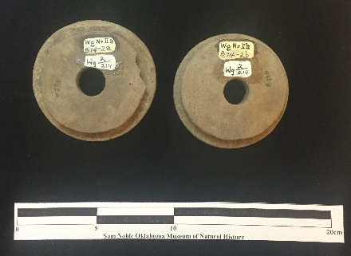
Site Number/Catalog Number: 34Wg0002/214
Site Name: Norman
Additional Provenience Information: B74-2a&b
Earspool Type: Pulley
Material Type: Sandstone
Spiro Grave Period: Spiro III
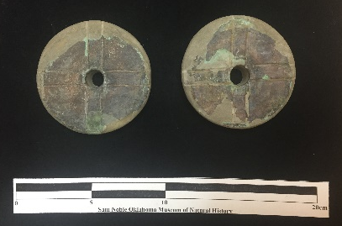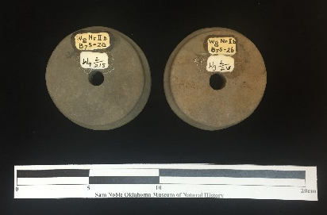
Site Number/Catalog Number: 34Wg0002/215
Site Name: Norman
Additional Provenience Information: B75-2a&b
Earspool Type: Pulley
Material Type: Sandstone
Spiro Grave Period: Spiro III

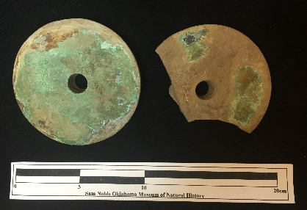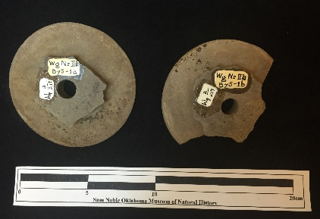
Site Number/Catalog Number: 34Wg0002/217
Site Name: Norman
Additional Provenience Information: B75-1a&b
Earspool Type: Pulley
Material Type: Sandstone
Spiro Grave Period: Spiro III
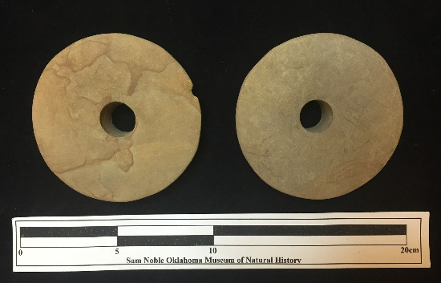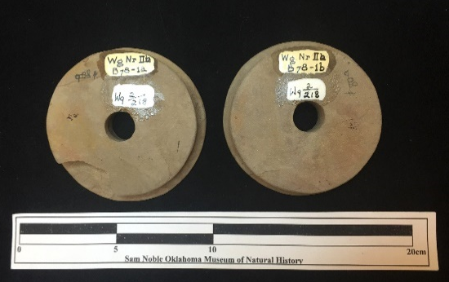
Site Number/Catalog Number: 34Wg0002/218
Site Name: Norman
Additional Provenience Information: B78-1a&b
Earspool Type: Pulley
Material Type: Sandstone
Spiro Grave Period: Spiro III

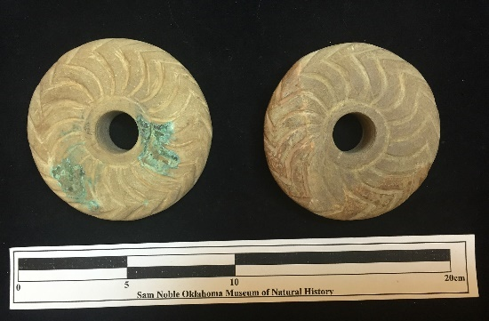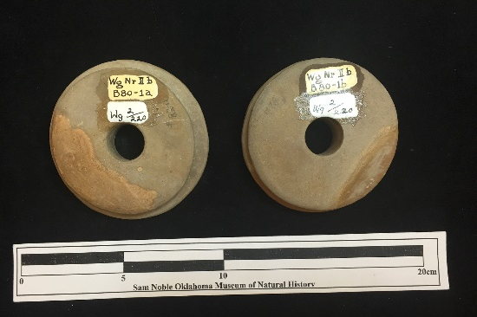
Site Number/Catalog Number: 34Wg0002/220
Site Name: Norman
Additional Provenience Information: B80-1a&b
Earspool Type: Pulley
Material Type: Sandstone
Spiro Grave Period: Spiro III

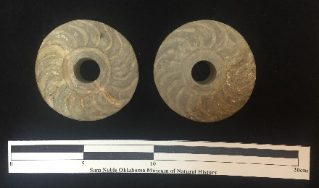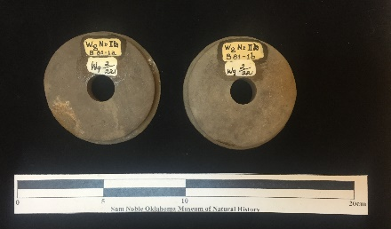
Site Number/Catalog Number: 34Wg0002/221
Site Name: Norman
Additional Provenience Information: B81-1a&b
Earspool Type: Pulley
Material Type: Sandstone
Spiro Grave Period: Spiro III

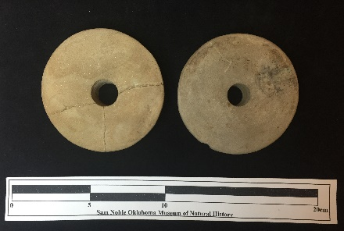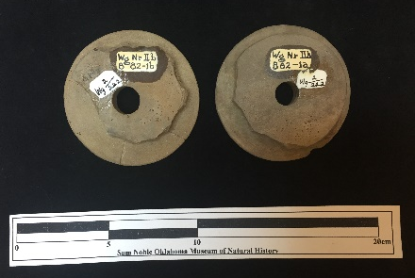
Site Number/Catalog Number: 34Wg0002/222
Site Name: Norman
Additional Provenience Information: B82-1a&b
Earspool Type: Pulley
Material Type: Sandstone
Spiro Grave Period: Spiro III

Site Number/Catalog Number: 34Wg0002/222
Site Name: Norman
Additional Provenience Information: B82-1b
Earspool Type: Pulley
Material Type: Sandstone
Spiro Grave Period: Spiro III

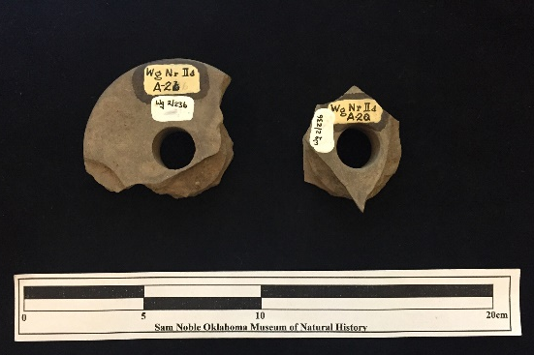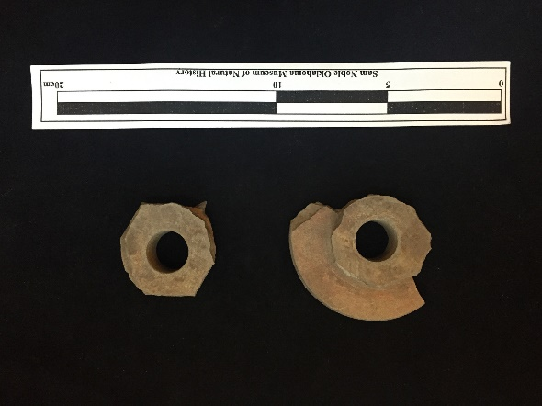
Site Number/Catalog Number: 34Wg0002/236a
Site Name: Norman
Additional Provenience Information: A-2a&b
Earspool Type: Pulley
Material Type: Sandstone
Spiro Grave Period: Unassigned
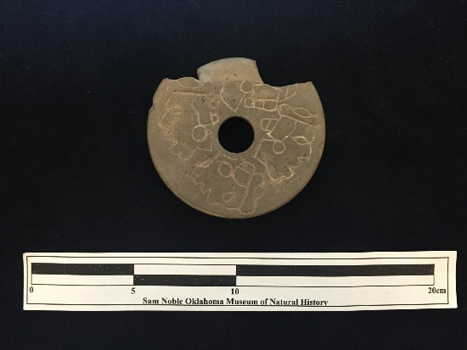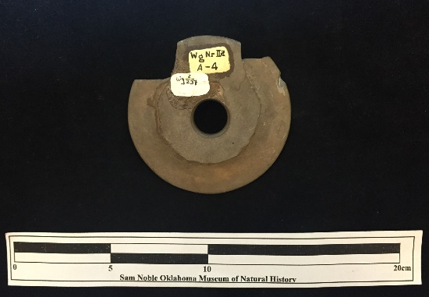
Site Number/Catalog Number: 34Wg0002/237
Site Name: Norman
Additional Provenience Information: A-4
Earspool Type: Pulley
Material Type: Sandstone
Spiro Grave Period: Unassigned

No Photograph Available

Site Number/Catalog Number: 34Wg0002/238
Site Name: Norman
Additional Provenience Information: A-5
Earspool Type: Pulley
Material Type: Sandstone
Spiro Grave Period: Unassigned

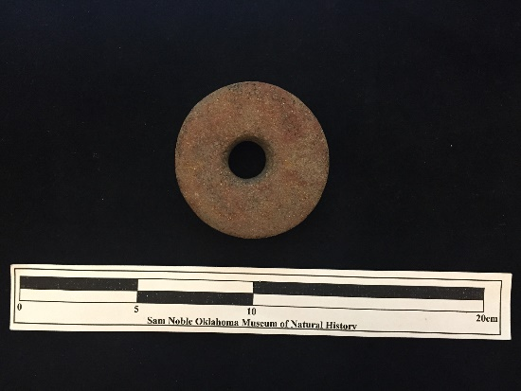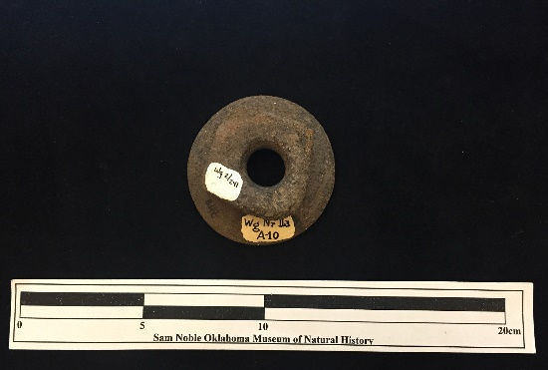
Site Number/Catalog Number: 34Wg0002/241
Site Name: Norman
Additional Provenience Information: A-10
Earspool Type: Pulley
Material Type: Sandstone
Spiro Grave Period: Unassigned
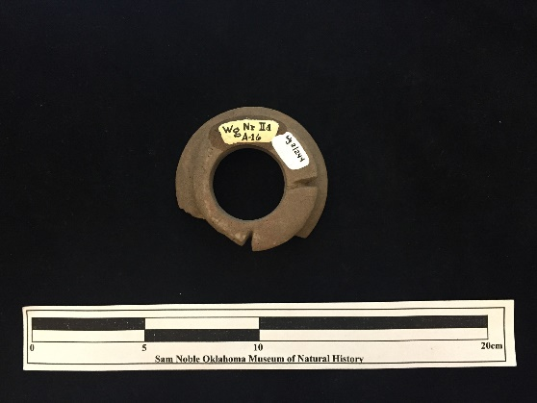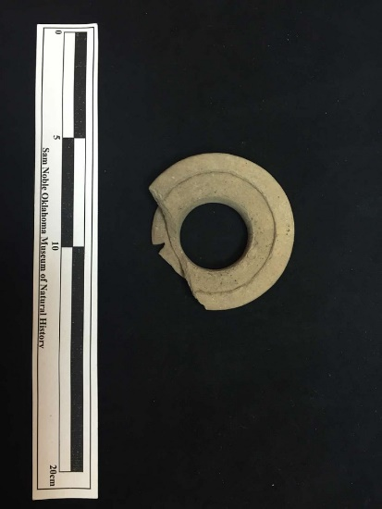
Site Number/Catalog Number: 34Wg0002/244
Site Name: Norman
Additional Provenience Information: A-16
Earspool Type: Recessed
Material Type: Sandstone
Spiro Grave Period: Unassigned

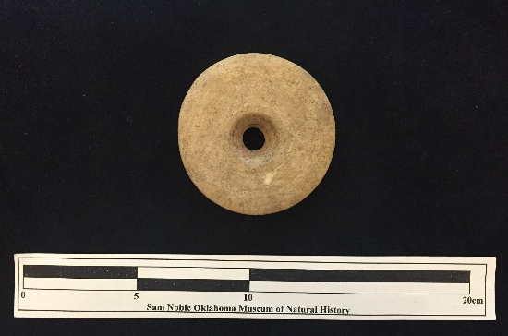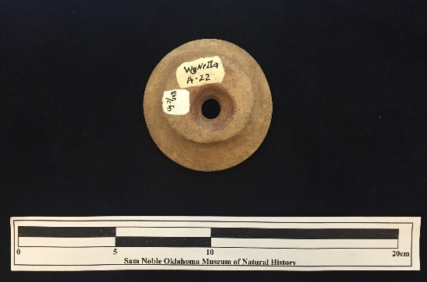
Site Number/Catalog Number: 34Wg0002/248
Site Name: Norman
Additional Provenience Information: A-22
Earspool Type: Pulley
Material Type: Sandstone
Spiro Grave Period: Unassigned

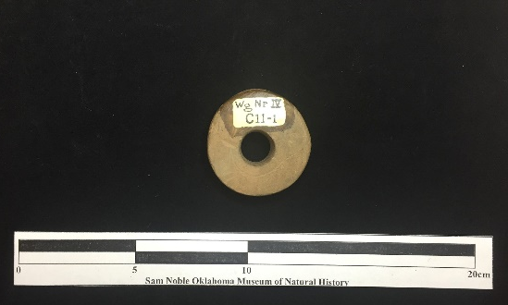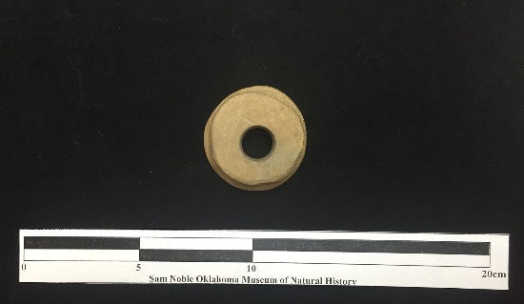
Site Number/Catalog Number: 34Wg2/C11-1
Site Name: Norman
Additional Provenience Information: C11-1
Earspool Type: Pulley
Material Type: Sandstone
Spiro Grave Period: Unassigned

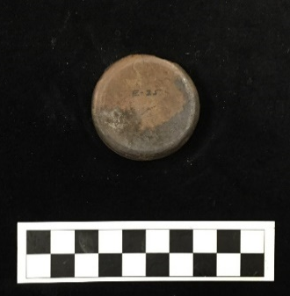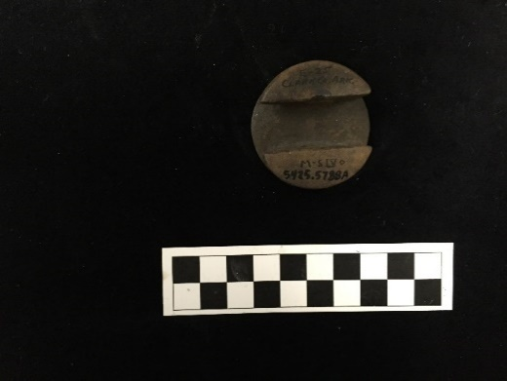
Site Number/Catalog Number: 3Cl162/5425.5788A E-25
Site Name: Smith Mound
Additional Provenience Information:
Earspool Type: Foster
Material Type: Sandstone
Spiro Grave Period: Unassigned

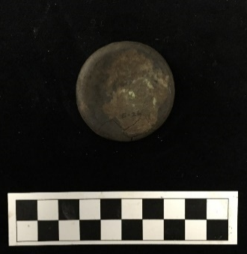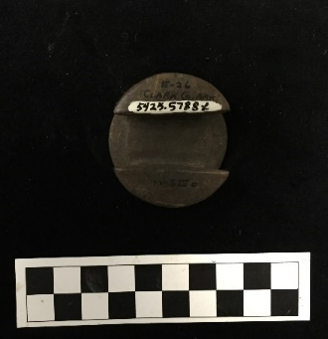
Site Number/Catalog Number: 3Cl162/5425.5788b E-26
Site Name: Smith Mound
Additional Provenience Information:
Earspool Type: Foster
Material Type: Sandstone
Spiro Grave Period: Unassigned

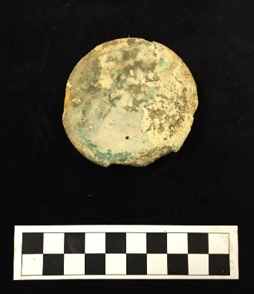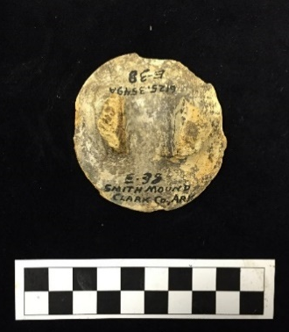
Site Number/Catalog Number: 3Cl162/6125.3549A E-38
Site Name: Smith Mound
Additional Provenience Information:
Earspool Type: Foster
Material Type: Sandstone
Spiro Grave Period: Unassigned
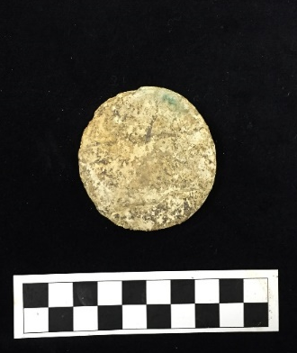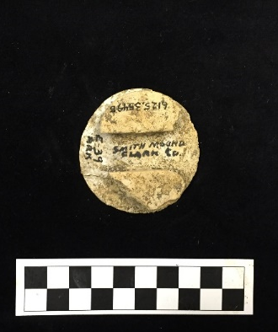
Site Number/Catalog Number: 3Cl162/6125.3549B E-39
Site Name: Smith Mound
Additional Provenience Information:
Earspool Type: Foster
Material Type: Sandstone
Spiro Grave Period: Unassigned
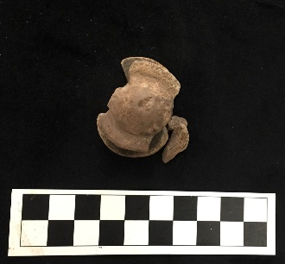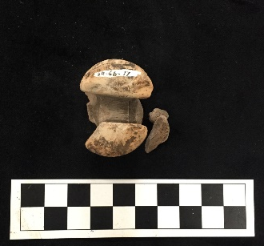
Site Number/Catalog Number: 3CL220/AGA-17
Site Name: Arthur Gaither
Additional Provenience Information:
Earspool Type: Central Boss
Material Type: Sandstone
Spiro Grave Period: Unassigned

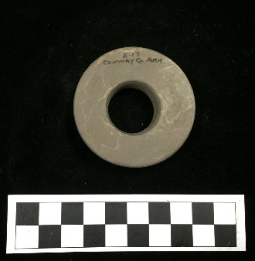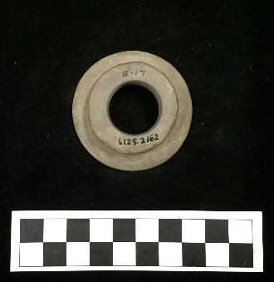
Site Number/Catalog Number: 3CN0/6125.2162 E-17
Site Name: Conway Co. Ar.
Additional Provenience Information:
Earspool Type: Pulley
Material Type: Sandstone
Spiro Grave Period: Unassigned

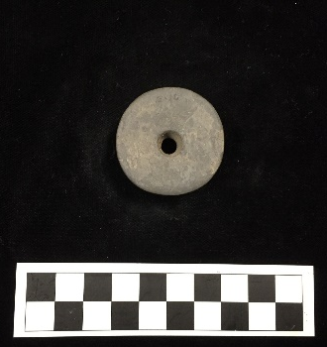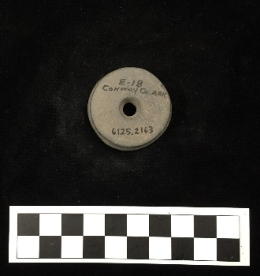
Site Number/Catalog Number: 3CN0/6125.2163 E-18
Site Name: Conway Co. Ar.
Additional Provenience Information:
Earspool Type: Pulley
Material Type: Sandstone
Spiro Grave Period: Unassigned
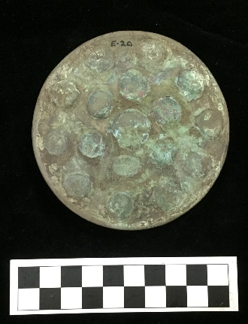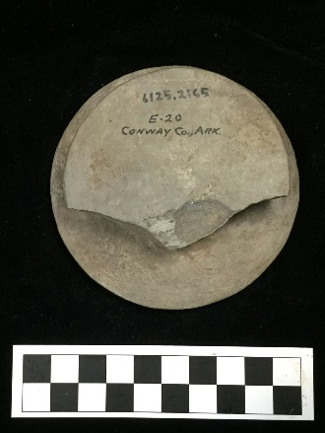
Site Number/Catalog Number: 3CN0/6125.2165 E-20
Site Name: Conway Co. Ar.
Additional Provenience Information:
Earspool Type: Pulley
Material Type: Sandstone
Spiro Grave Period: Unassigned
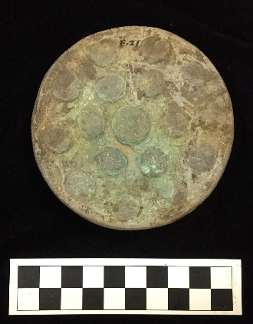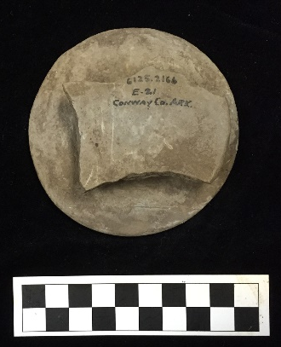
Site Number/Catalog Number: 3CN0/6125.2166 E-21
Site Name: Conway Co. Ar.
Additional Provenience Information:
Earspool Type: Pulley
Material Type: Sandstone
Spiro Grave Period: Unassigned
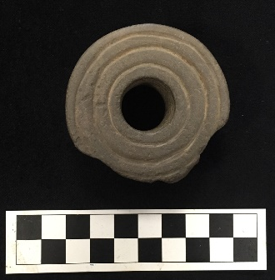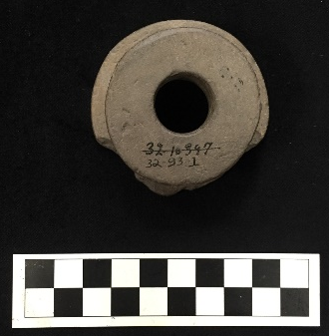
Site Number/Catalog Number: 3GA0/21-10397
Site Name: Garland Co. Ar.
Additional Provenience Information:
Earspool Type: Pulley
Material Type: Sandstone
Spiro Grave Period: Unassigned
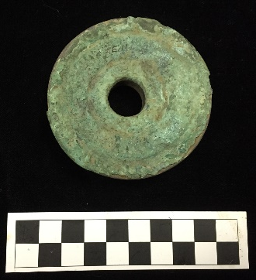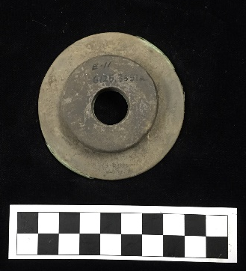
Site Number/Catalog Number: 3GA0/6125.3551a E-11
Site Name: Garland Co. Ar.
Additional Provenience Information:
Earspool Type: Pulley
Material Type: Sandstone
Spiro Grave Period: Unassigned

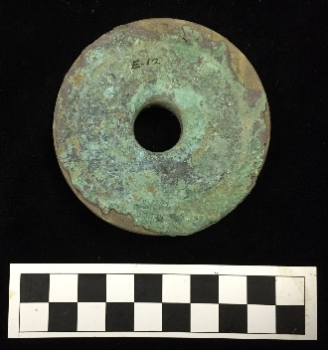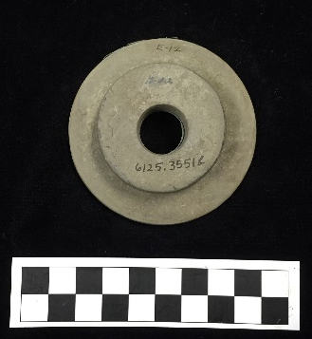
Site Number/Catalog Number: 3GA0/6125.3551b E-12
Site Name: Garland Co. Ar.
Additional Provenience Information:
Earspool Type: Pulley
Material Type: Sandstone
Spiro Grave Period: Unassigned

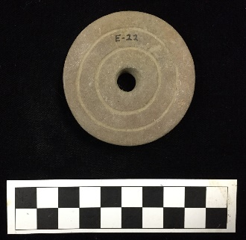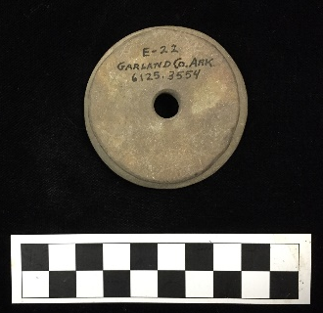
Site Number/Catalog Number: 3GA0/6125.3554 E-22
Site Name: Garland Co. Ar.
Additional Provenience Information:
Earspool Type: Pulley
Material Type: Sandstone
Spiro Grave Period: Unassigned

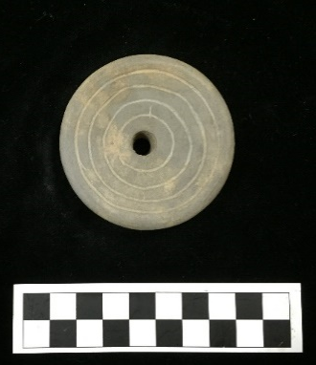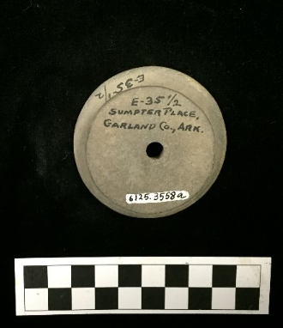
Site Number/Catalog Number: 3GA0/6125.3558a E-35 1/2
Site Name: Garland Co. Ar.
Additional Provenience Information:
Earspool Type: Pulley
Material Type: Sandstone
Spiro Grave Period: Unassigned

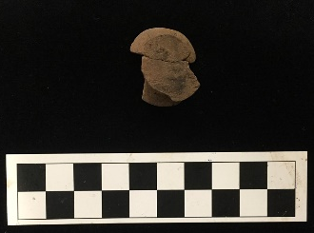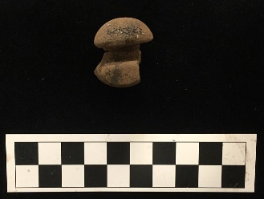
Site Number/Catalog Number: 3HO1/62-53-163
Site Name: Mineral Springs
Additional Provenience Information:
Earspool Type: Foster
Material Type: Sandstone
Spiro Grave Period: Unassigned

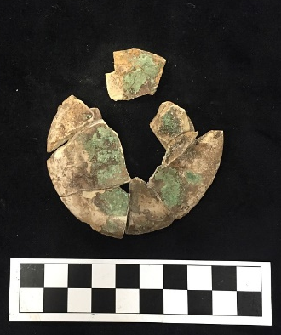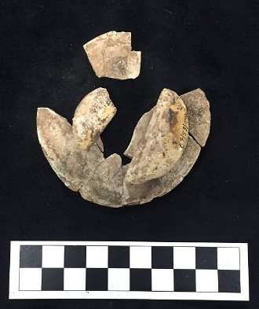
Site Number/Catalog Number: 3HO1/62-53-490
Site Name: Mineral Springs
Additional Provenience Information:
Earspool Type: Foster
Material Type: Limestone
Spiro Grave Period: Unassigned
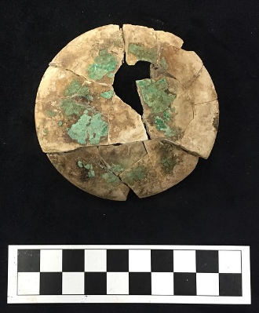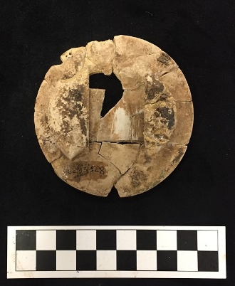
Site Number/Catalog Number: 3HO1/B-3-ES1 62-53-528
Site Name: Mineral Springs
Additional Provenience Information:
Earspool Type: Foster
Material Type: Limestone
Spiro Grave Period: Unassigned
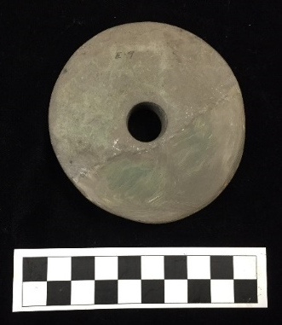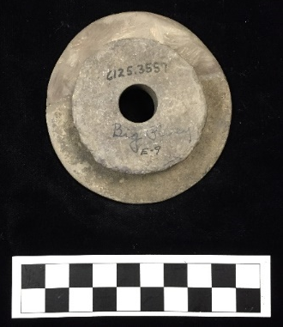
Site Number/Catalog Number: 3JO0/6125.3557 E-9
Site Name: Johnson Co. Ar.
Additional Provenience Information:
Earspool Type: Pulley
Material Type: Sandstone
Spiro Grave Period: Unassigned
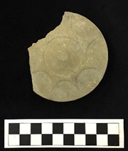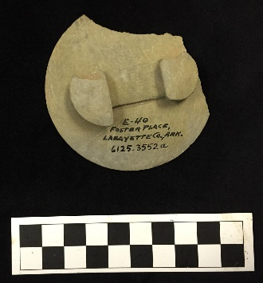
Site Number/Catalog Number: 3LA27/6125.3552a E-40
Site Name: Foster Place
Additional Provenience Information:
Earspool Type: Foster
Material Type: Sandstone
Spiro Grave Period: Unassigned

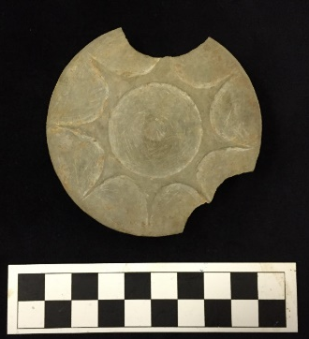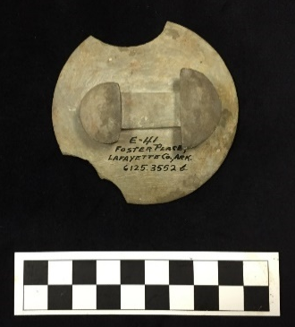
Site Number/Catalog Number: 3LA27/6125.3552b E-41
Site Name: Foster Place
Additional Provenience Information:
Earspool Type: Foster
Material Type: Sandstone
Spiro Grave Period: Unassigned
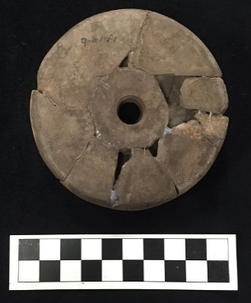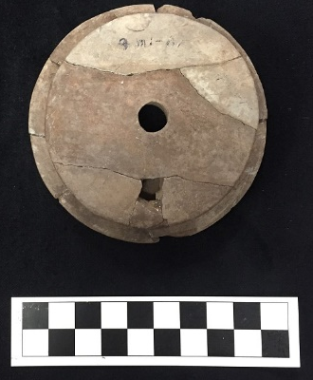
Site Number/Catalog Number: 3LR50/81-71-50a
Site Name: Bowman
Additional Provenience Information: 9 MI - Bl
Earspool Type: Pulley
Material Type: Sandstone
Spiro Grave Period: Unassigned
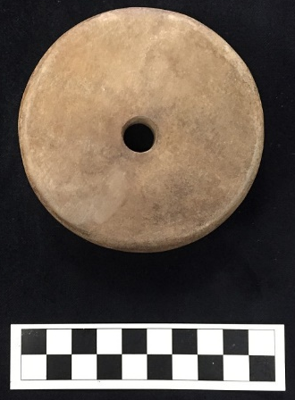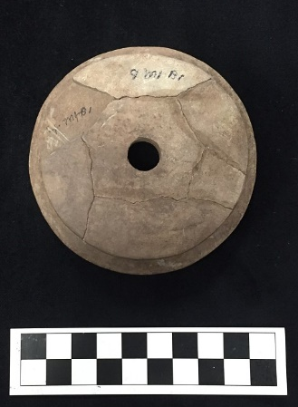
Site Number/Catalog Number: 3LR50/81-71-50b
Site Name: Bowman
Additional Provenience Information: 9 MI - Bl
Earspool Type: Pulley
Material Type: Sandstone
Spiro Grave Period: Unassigned
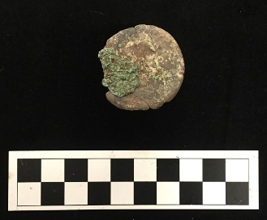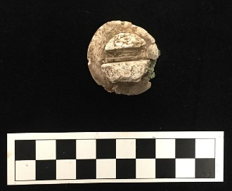
Site Number/Catalog Number: 3LR50/81-71-76a
Site Name: Bowman
Additional Provenience Information: M1 - B16
Earspool Type: Foster
Material Type: Limestone
Spiro Grave Period: Unassigned

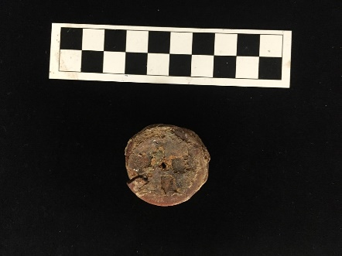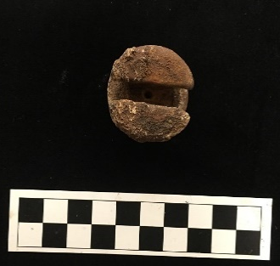
Site Number/Catalog Number: 3LR50/81-71-76b
Site Name: Bowman
Additional Provenience Information: M1 - B16
Earspool Type: Foster
Material Type: Sandstone
Spiro Grave Period: Unassigned

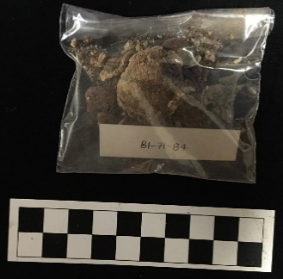
Site Number/Catalog Number: 3LR50/81-71-84
Site Name: Bowman
Additional Provenience Information: M1
Earspool Type: Composite
Material Type: Stone/shell/wood/copper
Spiro Grave Period: Unassigned

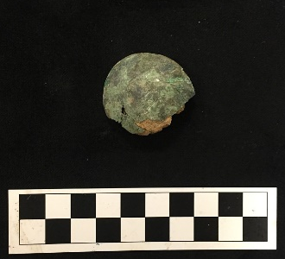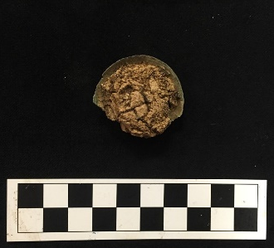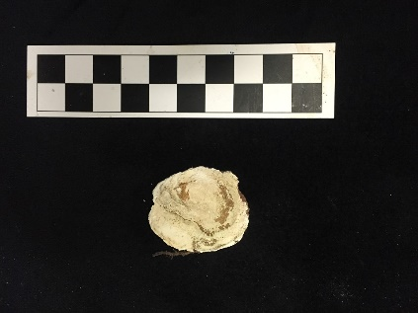
Site Number/Catalog Number: 3LR50/81-71-86a
Site Name: Bowman
Additional Provenience Information: M1 - B5
Earspool Type: Composite
Material Type: Stone/shell/wood/copper
Spiro Grave Period: Unassigned

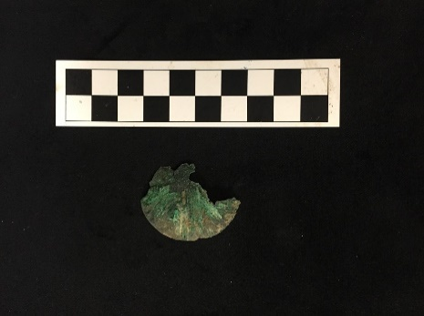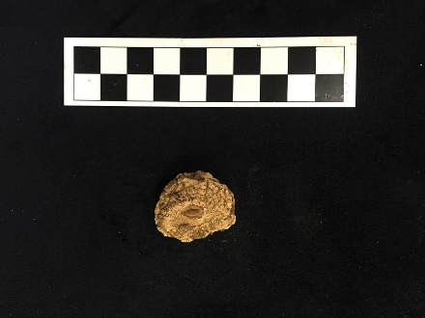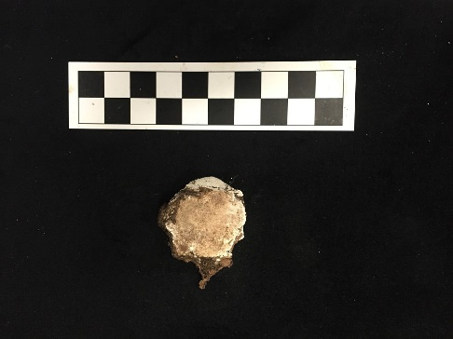
Site Number/Catalog Number: 3LR50/81-71-86b
Site Name: Bowman
Additional Provenience Information: M1 - B5
Earspool Type: Composite
Material Type: Stone/shell/wood/copper
Spiro Grave Period: Unassigned

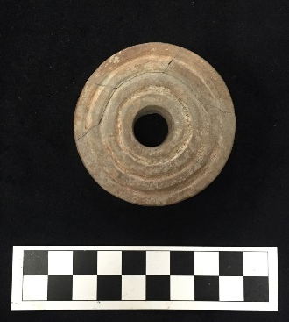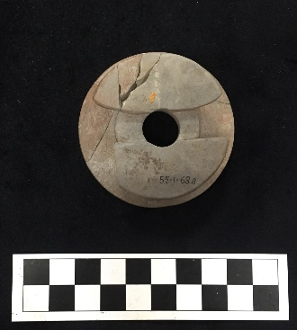
Site Number/Catalog Number: 3MI6/55-305-2 55-1-63a
Site Name: Crenshaw
Additional Provenience Information:
Earspool Type: Foster
Material Type: Sandstone
Spiro Grave Period: Unassigned

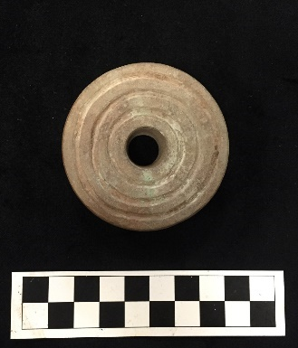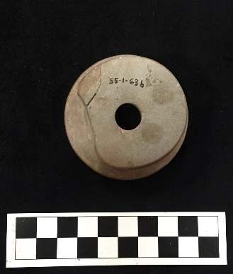
Site Number/Catalog Number: 3MI6/55-305-2 55-1-63b
Site Name: Crenshaw
Additional Provenience Information:
Earspool Type: Pulley
Material Type: Sandstone
Spiro Grave Period: Unassigned

Site Number/Catalog Number: 3MI6/9025.24a&b E-32&33
Site Name: Crenshaw
Additional Provenience Information:
Earspool Type: Small Inner Nub
Material Type: Sandstone
Spiro Grave Period: Unassigned

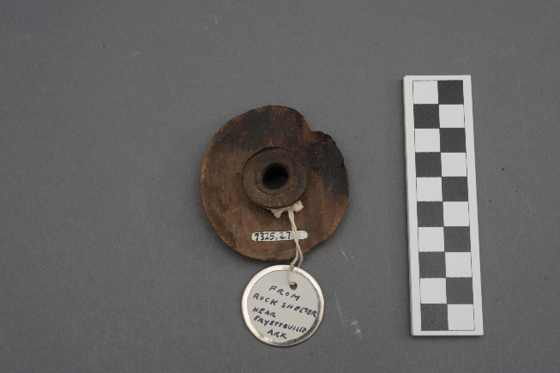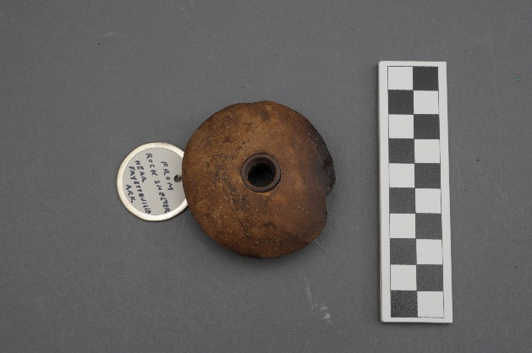
Site Number/Catalog Number: 3WA0/7325.27
Site Name: Washington Co.
Additional Provenience Information:
Earspool Type: Small Inner Nub
Material Type: Wood
Spiro Grave Period: Unassigned

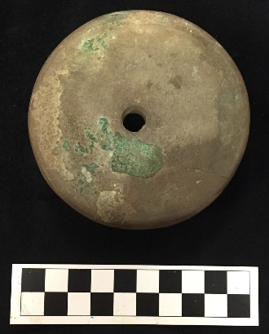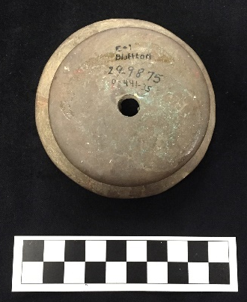

Site Number/Catalog Number: 3YE15/29-9875 0-441-35 E-7
Site Name: Bluffton
Additional Provenience Information:
Earspool Type: Pulley
Material Type: Sandstone
Spiro Grave Period: Unassigned

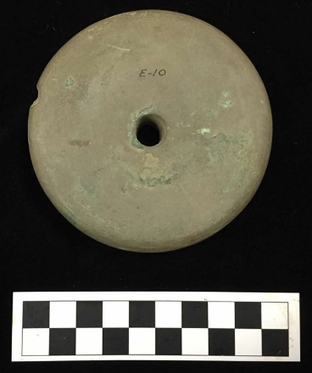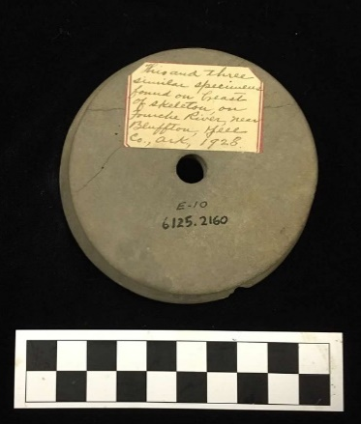

Site Number/Catalog Number: 3YE15/6125.2160 E-10
Site Name: Bluffton
Additional Provenience Information:
Earspool Type: Pulley
Material Type: Sandstone
Spiro Grave Period: Unassigned

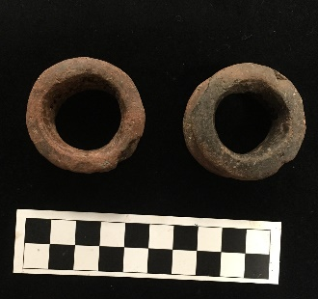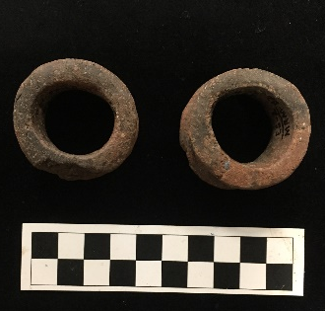
Site Number/Catalog Number: 41BW4/55-40-146a&b
Site Name: Paul Mitchell
Additional Provenience Information: 55-233
Earspool Type: Grooved
Material Type: Ceramic
Spiro Grave Period: Unassigned

Appendix B: Earspool Attributes Tables

Appendix C: Burials and AFOs Tables

