University of Oklahoma

Graduate College

Wister area Fourche Maline: A Contested Landscape

A DISSERTATION

submitted to the Graduate Faculty

in partial fulfillment of the requirements for the

Degree of

DOCTOR OF PHILOSOPHY

By

SIMONE BACHMAI ROWE
Norman, Oklahoma
2014

Wister area FOURCHE MALINE: a contested Landscape

A DISSERTATION APPROVED FOR THE
DEPARTMENT OF ANTHROPOLOGY

By

______________________________
Dr. Lesley Rankin-Hill, Co-Chair

______________________________
Dr. Don Wyckoff, Co-Chair

______________________________
Dr. Diane Warren

______________________________
Dr. Patrick Livingood

______________________________
Dr. Barbara Safiejko-Mroczka

© Copyright by SIMONE BACHMAI ROWE 2014
All Rights Reserved.

This work is dedicated to those who came before, including my mother Nguyen Thi Lac, and my Granny (Mildred Rowe Cotter) and Bob (Robert Cotter).

Acknowledgements
I have loved being a graduate student. It’s not an exaggeration to say that these have been the happiest years of my life, and I am incredibly grateful to everyone who has been with me on this journey.
Most importantly, I would like to thank the Caddo Nation and the Wichita and Affiliated Tribes for allowing me to work with the burials from the Akers site. A great big thank you to my committee members, Drs. Lesley Rankin-Hill, Don Wyckoff, Barbara Safjieko-Mrozcka, Patrick Livingood, and Diane Warren, who have all been incredibly supportive, helpful, and kind.
Thank you also to the Sam Noble Oklahoma Museum of Natural History, where most of this work was carried out. I am grateful to many of the professionals there, including Curator of Archaeology Dr. Marc Levine and Collections Manager Susie Armstrong-Fishman, as well as Curator Emeritus Don Wyckoff, and former Collection Managers Liz Leith and Dr. Elsbeth Dowd. Many of the photographs reproduced in this work are from museum archives are used courtesy of SNOMNH.
More thank yous to the Department of Anthropology, especially Wanda Downs, Keli Mitchell, and Drs. Susan Vehik and Asa Randall. Thank you also to Drs. Scott Hammerstedt, Amanda Regnier, and everyone at the Archaeological Survey.
Finally, my friends and peers Lauren Cleeland, Rachel Fauchier Tooman, and Matt Galloway were always there for a laugh, a cry, or a drink. And most of all, thank you to my husband Eric, who made this possible.

Table of Contents

Acknowledgements iv
Table of Contents v
List of Tables viii
List of Figures x
Abstract xii
Chapter 1: A Contested Landscape 1
Oklahoma Archaeology 2
NAGPRA 5
The Current Study 6
Chapter 2: Exploring Conflict and Nutrition in Archaeological Context 9
Conflict in the Archaeological Record 9
Dye – social complexity and conflict 10
Skeletal Trauma 12
Broken and Fractured Bone 14
Embedded Projectile Points and Pincushioning 20
Trophy Taking Behavior 21
Mass or Group Burials 23
Nutritional Status in the Archaeological Record 24
Prehistoric Health and the Advent of Agriculture 25
Chapter 3: The Wister Area and the Fourche Maline Mounds 40
Fourche Maline – History of a Concept 40
1930s and 1940s and the WPA Excavations 40
Culture History 44
Processualism and Ecological Adaptations 46
Beyond Processualism 48
The Study Area 49
Geologic History 53
The Ouachita Ecoregion 54
Soils and Minerals 57
Inhabitation 58
Wister phase (1500 BCE – 300 CE) 59
Fourche Maline phase (300 – 800/900 CE) 60
Harlan phase (900 – 1200 CE) 61
Spiro phase (1200 – 1400 CE) 62
Ft. Coffee phase (1400 – 1550) 63
The Fourche Maline Mounds 64
Wister area Fourche Maline Sites not in the study 84
Previous bioarchaeology in the Wister area 85
Chapter 4: Skeletal Trauma and Nutritional Status 88
from the Akers Site (34Lf32) 88
Methods and Materials 88
Prevalence rates 89
The Akers burial population 89
The Current Study Subsample 91
Age and Sex of the Study Population 92
Skeletal Trauma at the Akers Site 93
Results 94
Summary and Discussion of Skeletal Trauma 110
Nutritional Status at Akers 116
Results 118
Summary and Discussion of Nutritional Status at Akers 119
Akers Conclusions 121
Chapter 5: Conflict in the Wister Area 122
Methods and Materials 126
Sites 130
Results 132
Multiple Burials 132
Trophy taking behavior 136
Summary and Discussion 139
Chapter 6: Discussion and Conclusions 143
Wister Area Demography and Time Scale 143
Wister Area Demography 144
Wister Area Fourche Maline Health and Nutritional Status 147
Skeletal Trauma 148
Nutritional status 149
Wister Area Group Burials and Violent Death 152
Future Work 154
Conclusions 155
References 157

List of Tables
Table 1 Wister Area Chronology, following Galm (1978, 1984) 5
Table 2 Wister area Fourche Maline sites included in study 65
Table 3 Wister area Fourche Maline sites not included in study 84
Table 4 Wister area Fourche Maline sites with skeletal analysis 85
Table 5 Akers age distribution, adapted from Rowe 2009 90
Table 6 Adult male and female counts, adapted from Rowe 2009 91
Table 7 Age ranges of the study sample 92
Table 8 Adult male and female counts of the study sample 93
Table 9 Cranial trauma by age, sex, bone, trauma type, shape, and stage of healing 95
Table 10 Cranial Trauma (both blunt and sharp force) by age and sex 98
Table 11 Upper limb fractures by bone, burial, age, and sex 102
Table 12 Upper limb fractures by age and sex 104
Table 13 Lower limb fractures by bone and sex 106
Table 14 Lower limb fractures by age and sex 107
Table 15 Sharp force trauma to the limbs by age, sex, and bone 108
Table 16 Multiple fractures by burial, sex, age, and bone 113
Table 17 Porotic hyperostosis prevalence by sex 118
Table 18 Cribra orbitalia prevalence by sex 118
Table 19 Wister area Fourche Maline sites with mass burials (5 or more individuals) 125
Table 20 Multiple burials per site in the Wister Area 133
Table 21 Trophy skulls by site 137
Table 22 Male:Female ratio comparisons, adapted from Rowe 2009 145

List of Figures
Figure 1 Caddoan Homeland, adapted from texasbeyondhistory.net 4
Figure 2 Wister area archaeological sites, adapted from Galm 1978 43
Figure 3 Map of the Trans-Mississippi South, with approximate location of the Wister area indicated by square, adapted from Schambach 1998:xii 51
Figure 4 Geomorphological Provinces, adapted from maps.google.com 53
Figure 5 Summary pollen diagram from Ferndale Bog in Atoka County, Oklahoma, adapted from Holloway 1994 56
Figure 6 Burial 6 from the McCutchan-McLaughlin site 67
Figure 7 Manos and metates from the Hooks site 73
Figure 8 Burial Map for Williams I 76
Figure 9 Mass Burial from the Adams site 81
Figure 10 Burial 10 from the Akers site, with large point resting on cranium 96
Figure 11 Burial 157 from the Akers site, occipital view of the calvarium 97
Figure 12 Male cranial blunt force trauma from the Akers site 99
Figure 13 Female cranial blunt force trauma from the Akers site 100
Figure 14 Burial 9A from the Akers site, psuedoarthrosis of the right ulna 103
Figure 15 Burial 8, a triple burial from the Akers site 108
Figure 16 Burial 87 from the Akers site, consisting of two adult males with one skull 109
Figure 17 Burial 87 from the Akers site, close-up showing multiple projectile points as well as objects inserted into nasal cavity 110
Figure 18 The lambda region from Burial 155 of the Akers site 117
Figure 19 Shell gorgets from Spiro Mounds (left) and the Akers site (right) 123
Figure 20 Pottery from Spiro Mounds (left) and the Akers site (right) 123
Figure 21 Burial 9 from the Akers site, consisting of three likely non-associated individuals (arrows point to skulls) 128
Figure 22 Burial 45 from the Adams site (34Lf33) was an isolated skull surrounded 129
Figure 23 Biplot of the percentage of total number of individuals (x axis) by 134
Figure 24 Biplot of the total number of buried individuals (x axis) by the percentage of multiple burials (y axis) for the large sites Akers, Brewer, Mackey, and Williams I 135
Figure 25 Biplot of the percentage of multiple burials (x axis) by percentage of 138
Figure 26 Biplot of the percentage of total individuals per site (x axis) by 139

Abstract
The Wister area of southeastern Oklahoma was a contested landscape during the Fourche Maline (Late Woodland cultural period). This claim is supported by paleopathological evidence for high rates of skeletal trauma and bioarchaeological evidence for high rates of group and mass burials. Feuding appears to have been rampant with high levels of traumatic death (group burials) and trophy-taking behavior. The contested landscape impacted residents of the valley in multiple ways. In addition to loss of life for both adults and children and the physical trauma from fractured bones and projectile points, the residents of the valley suffered from probable significant, though intermittent, intergenerational nutritional stress. This nutritional stress is hypothesized to be the result of a restricted diet that resulted from constricted hunting and gathering territories that were the consequences of widespread local feuding.

Chapter 1: A Contested Landscape
The Wister area of southeastern Oklahoma was a contested landscape during the Fourche Maline (Late Woodland cultural period). This study demonstrates high rates of skeletal trauma and probable significant, though intermittent, intergenerational nutritional stress for the individuals interred at the Akers site (34Lf32), a large mound at the eastern end of the study area. Examination of bioarchaeological evidence for 13 small mounds in the study area documents high rates of group and mass burials. The area as a whole is suggested to have been the site of intense feuding, which led to high levels of traumatic death (group and mass burials), trophy taking behavior, physical trauma (high rates of broken bones and other injuries, and nutritional stress).
The major findings of this study (high rates of conflict and nutritional stress throughout the Wister area) were not anticipated. This work was originally conceived as a traditional paleopathological analysis of a single Fourche Maline site (the Akers site, 34Lf32) from the Wister area of southeastern Oklahoma. My previous work from this site (Rowe 2009) had yielded some surprising results. First, the burials were oddly skewed towards more females than males. Secondly, the subadults exhibited surprisingly high rates of cribra orbitalia, moderate rates of periostitis, and low rates of porotic hyperostosis, which was interpreted as evidence of nutritional deficiencies (particularly scurvy) in the subadults. Additionally, there appeared to be a surprisingly high number of healed fractures. There were also several group burials, some in unusual configurations (for instance a quadruple burial with two adults placed face down and two subadults placed in between them), as well as a mass burial of 11 individuals. Additionally, I was aware that at least one other site in the valley had a mass burial, and in browsing through the archives, I came across several other photographs of mass burials at other Wister area Fourche Maline sites. These disparate findings led to a focus on both conflict and nutritional status – first at the Akers site and then throughout the entire Wister area.
The results of this analysis, which uses multiple lines of archaeological and biological (osteological) evidence, are at odds with the few previous Wister area Fourche Maline bioarchaeological studies, which characterize the populations as healthy (e.g. McWilliams 1970, Powell and Rogers 1980). However these previous studies utilized much smaller sample sizes than the current study. For this work I examined 118 individuals from the Akers site for paleopathology and reviewed documentation for 1220 burials in the Wister area. I conclude that the Wister area was indeed a contested landscape during Fourche Maline times

Oklahoma Archaeology
Archaeology is concerned with the histories of earlier peoples and, as such, is never practiced in a void. Oklahoma is home to 39 federally recognized Indian or Native American tribes or nations. Most of these tribes were forcefully relocated to Oklahoma, and their histories in Oklahoma begin in the nineteenth or twentieth centuries. However modern day speakers of Caddoan languages are a significant exception. Oklahoma Caddoan language speakers consist of the Caddo Nation of Oklahoma, the Wichita and Affiliated Tribes (Wichita, Keechi, Waco and Tawakonie), and the Pawnee Nation of Oklahoma. A fourth Caddoan language speaking group, the Arikara of the Mandan Hidatsa Arikara Nation, make their home in North Dakota.
These four groups or tribes (Caddo, Wichita, Pawnee, and Arikara) speak a related language and have been grouped together by linguists since at least 1932 (Lesser and Weltfish 1932). In this sense, “Caddoan” is a linguistic construct derived from similarities in the four historic languages. The term is in regular use in linguistic and anthropologic scholarly writings, and is used here to denote the modern day descendants of a formerly very large group of language speakers.
The Caddoan homeland, consisting of parts of southeast Oklahoma, southwest Arkansas, northeast Texas, and northwest Louisiana (pictured in Figure 1), is a geographical or archaeological construct, derived from a series of archaeological sites with similar material culture. When used in this sense, most scholars agree that they are referring to these archaeological sites with material culture (i.e. artifacts) that are most likely ancestral to the modern day Caddo Nation (Bell 1980, 1984; Brown 1984; Bruseth 1998; Perttula 2012). However some researchers would include the modern day Wichita and Affiliated Tribes in this definition (e.g. Wyckoff 1980). Neither the Pawnee Nation nor the Arikara are usually included in this context.
Due to differences in settlement patterns, house styles, and pottery, Frank Schambach (1990) has argued that the northern Caddoan area, encompassing the Arkansas Valley (including Spiro Mounds) and the Ozarks were not Caddoan at all, but possibly Muskogeean. He further considered that Spiro Mounds, considered the heart and soul of Caddoan prehistory, was not Caddoan at all, but was built by a Mississippian group, possibly Tunica speakers. This view was forcefully countered by Dan Rogers, a long time scholar of Spiro Mounds (e.g. Rogers 1982, 1991a). Rogers responded that while there were some regional differences between the northern and southern Caddoan area, overall the northern and southern Caddoan areas were indeed one united cultural area, and furthermore, most decidedly demonstrating the evolution of Caddoan culture in situ. He further noted that the current paradigm of a united Caddoan area was far more parsimonious than Schambach’s proposal that incorporated three unexplained major migrations (Rogers 1990b).

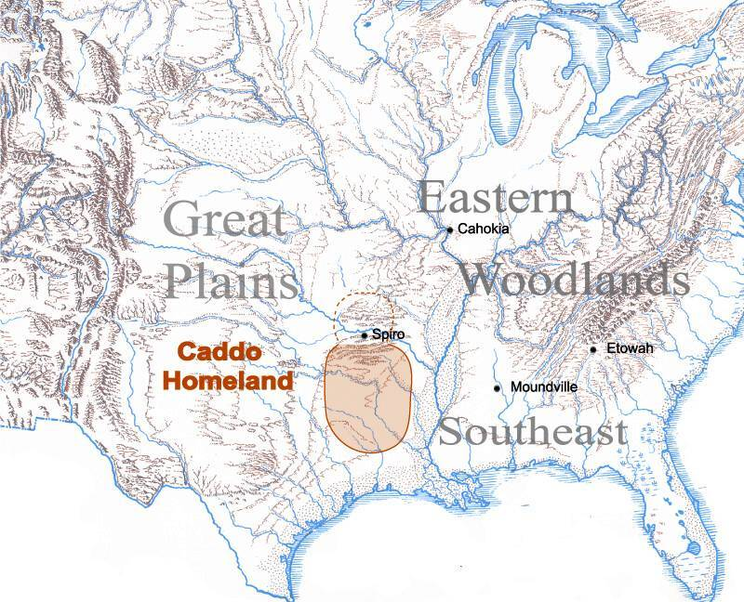
Figure 1 Caddoan Homeland, adapted from texasbeyondhistory.net

This work follows the view that Spiro Mounds represent Caddoan culture and that the Wister area Fourche Maline was an antecedent, ancestral manifestation of Caddoan culture (e.g. Bell 1980, 1984; Brown 1984; Bruseth 1998; Galm 1978, 1984; Perttula 2012; Rogers 1991a, 1991b; Wyckoff 1980). Table 1 situates the Wister area Fourche Maline in a larger North American context.

Table 1 Wister Area Chronology, following Galm (1978, 1984)

Time | North American Cultural Periods | Local Phases
1500 – Present | Historic | Historic
1400 – 1500 CE | Late Mississippian | Ft. Coffee
1200 – 1400 CE | Middle Mississippian | Spiro
1000 – 1200 CE | Early Mississippian | Harlan
500 - 1000 CE | Late Woodland | Fourche Maline
0 – 500 CE | Middle Woodland | Wister
1000 BCE – 0 | Early Woodland | Wister
6000-4000 BCE | Late Archaic | Late Archaic
8000-6000 BCE | Early Archaic | Early Archaic
13000 – 8000 BCE | Paleoindian | Paleoindian

NAGPRA
Oklahoma’s Spiro Mounds were the largest concentration of luxury and mortuary goods assembled in North America. The site and its accompanying material artifacts and skeletal remains are currently claimed by both the Caddo Nation and the Wichita and Affiliated Tribes. Given that the Fourche Maline mounds that are the focus of this study are considered ancestral to Spiro, permission was requested from both tribes before this study commenced, as required by the Native American Graves Protection and Repatriation Act (NAGPRA) of 1990. Both tribes graciously granted permission to study the burial material (both the skeletal remains and the associated artifacts) from the Akers mound (34Lf32). Per agreement with the tribes, this study was non-destructive and non-invasive.
Human remains are housed in a secure and secluded location at the University of Oklahoma’s (OU) Sam Noble Oklahoma Museum of Natural History (SNOMNH) in Norman, Oklahoma. This area has been seen and approved by representatives of both The Caddo Nation and The Wichita and Affiliated Tribes. The burials were examined in this secluded, designated area, which is not accessible to anyone without expressed permission. In agreement with The Caddo Nation and The Wichita and Affiliated Tribes, a light is left on in this area at all times. When not being directly worked with, the skeletal remains were always covered. All methods of examination were non-destructive per our agreement. The burials and associated materials were treated with great care and respect.

The Current Study
The Akers site (34Lf32) is the eastern-most of the Wister area sites under consideration and lies only 30 kilometers or so from Spiro Mounds, the westernmost site of what has been called the Southeastern Ceremonial Complex. Like Spiro, these Wister area sites were inhabited for thousands of years; indeed the two sites were probably inhabited by the same groups of peoples. Despite the physical and cultural closeness of Spiro and Fourche Maline periods, the earlier Fourche Maline period is much less well understood. Although several fine researchers have devoted their attention to Fourche Maline sites, the area as a whole remains under-theorized and poorly understood.
Many, perhaps all, fields of academic study are fraught with disagreements, feuds, and conflicting paradigms and interpretations. In examining conflict and nutritional stress during the Woodland Period (local Fourche Maline phase) of the Wister area, two issues with contradictory sets of interpretations must be addressed.
The first is the issue of identifying conflict in an archaeological context, particularly amongst pre-state or non-chiefdom level societies, and the problem of differentiating accidental trauma from deliberate, conflict based trauma in skeletal remains. The second set of topics is that of the nutritional status of hunter-gatherers and whether or not nutritional competence can be determined from prehistoric skeletal remains. Although hunger, famine, and nutritional stress are often studied in modern conflicts, they are less well-studied in archaeological populations. These issues (conflict and nutritional status in archaeological contexts) are explored in Chapter 2.
Chapter 3 discusses the history of the concept Fourche Maline and reviews previous Wister area Fourche Maline studies. The study area and the 14 main Fourche Maline mounds are discussed, collecting together archival information, grey literature, and graduate research, most of which has not been previously collected and reviewed.
Chapter 4 details evidence for skeletal trauma and nutritional stress at the Akers site (34Lf32), a Fourche Maline burial mound site from the Wister area of southeastern Oklahoma’s Ouachita Mountains. Results indicate that the inhabits of the Akers mound experienced widespread skeletal trauma and conflict, as well as persistent (though intermittent) intergenerational nutritional stress.
Chapter 5 examines the evidence for conflict in the Wister area as a whole, presenting the results of an archival research project. Group burials from 14 Wister area Fourche Maline mounds were examined in an attempt to infer rates of violent death and to explore patterns of conflict. Bioarchaeological evidence for pervasive and sustained conflict throughout the entire Wister area is presented, with group burials and trophy taking behavior explored in some detail.
This work concludes with a discussion of Wister area paleopathology and conflict in geographical and historical context. I conclude with an agenda for further research to further elucidate the Wister area Fourche Maline.

Chapter 2: Exploring Conflict and Nutrition in Archaeological Context
This chapter explores two sets of issues introduced in Chapter 1. First, the archaeological and osteological correlates of conflict in the archaeological record are considered. Next, the history of nutritional studies in paleopathology are reviewed before discussing the osteological correlates of nutritional status. While it might seem odd to discuss conflict or violence together with nutritional status, historically famine and violent conflict often go hand-in-hand. In 2005, the Human Security Report noted that in modern conflicts “(d)isease and hunger result in more deaths than trauma from actual war wounds” (Human Security Center 2005). Although the correlation between conflict and nutritional stress is clear historically, this concept is underexplored in archaeological and bioarchaeological studies. In this chapter the mortuary and skeletal evidence that can be assessed in order to examine conflict and nutritional stress in the archaeological record are reviewed.

Conflict in the Archaeological Record
It is tempting to think that today’s pervasive violence and conflict are recent phenomena and that past times were somehow simpler or less violent. However a comparative study of ethnographic literature found that foraging societies engaged in inter-group violence on average once every 2 years (Ember and Ember 1997:5). While this is lower than other types of subsistence strategies, it is still not particularly peaceful, and war every other year would accumulate injuries and casualties very quickly. Indeed, it has been estimated that about 25% of adult males in non-state level societies died from conflict well into the 20th century (Keeley 1996). Contrast this with World War II, which left an estimated 60 million dead (Lawler 2012:829). While that number is staggering, it was a mere 2.5% of the world’s population (at that time).
The archaeological record is replete with examples of prehistoric conflict. Traditionally, archaeological signs of increased conflict include settlement patterns, palisades, and warlike iconography (Milner et al. 1991). However settlement patterns are not known in some cases, and iconography in general is fairly scant before the Mississippian period, at least in the Eastern Woodland. Focusing on conflict in pre-state or pre-chiefdom societies requires a different approach. Although theories concerning reasons and motivations for conflict abound, most of these focus on state-level conflict. An exception is David Dye’s scheme that correlates patterns of violence and sociopolitical structure (Dye 1997).

Dye – social complexity and conflict
David Dye’s (1997) monogram on violence in the Eastern Woodland correlated patterns of violence with sociopolitical structure in the Eastern Woodland of North America. He delineated three broad sociopolitical categories and the types of violence that can be expected: simple hunter-gatherers and self-redress homicides, complex hunter-gatherers and feuding, and regional polities (chiefdoms) and warfare (Dye 1997).
In tribe and band level societies without strong lineage lines, the predominate form of lethal violence should be self-redress homicides, in which individuals settle disputes and avenge perceived wrong doings. Killing should be limited to one or two individuals at a time (Dye 1997:167). These societies presumably lacked the social organization to sustain conflict beyond the personal level. In a skeletal series, one would not expect to see many healed fractures, mass graves, mutilation, or trophy taking. Additionally, we would not expect to see much evidence for rodent and carnivore gnawing because burials would have happened shortly after death. Furthermore, most of the victims should be male (Dye 1997:171).
According to Dye, complex hunter-gatherers with strong lineage ties allowed a feuding type of conflict resolution to develop. Archaeological correlates may include territorial marking by mounds and cemeteries and the manufacture and exchange of symbolic weaponry, specifically exotic bifaces (Dye 2013:137-139). Burials should include small groups of violent deaths, skeletal trauma in the form of peri-mortem mutilation associated with trophy-taking, and burials of individuals with embedded projectile points and broken and fractured bones (Dye 1997:173). Feuding might have followed a homicide. Both the original perpetrator of violence as well as relatives were considered fair targets, including women and children; indeed work parties of women and children may have often been targeted.
Interestingly, Dye views increased violence, in the form of feuding, as a possible motivator in the increased ceremonialism of the Middle and Late Woodland. Elaborate mortuary ceremonialism “may have resulted from innovative ways of forming alliances and institutions of cooperation,” (Dye 1997:174).
Regional polities (which include chiefdoms and tribes bound together by linguistic, political, or social affiliations) were able to pursue policies of organized lethal aggression or warfare (Dye 1997:175). As defined here, warfare specifically excludes self-redress homicides and feuding; rather warfare is seen as organized, impersonal, and political. Ceremonial regalia, including pipes and symbolic weaponry, are interpreted as efforts at establishing peace (Dye:1997:176). The substantial cost of organized warfare is seen as funded by the storable surplus brought about by agriculture.
Under this model of conflict constrained by sociopolitical development, Fourche Maline complex hunter-gatherers of the Wister area most likely engaged in violence best characterized by feuding. Evidence for this hypothesis should be apparent in the burials. Specifically we should expect to see burials with skeletal trauma in the form of broken and fractured bones, embedded projectile points (including pin-cushioning burials in which an individual is shot full of arrows or darts) and trophy taking behavior (Dye 2013:139-141). Mass or group burials (i.e. a burial in which more than one individual was interred at the same time) should also be evident. Many of the mass or group burials may be the result of raiding parties (where a group of warriors targets a small group or work party) and thus small group burials of women and children should be expected (Dye 1997). While these correlates sound straightforward, discerning skeletal trauma and group burials is actually quite complex and requires further knowledge, theory, and methodology to differentiate conflict based trauma from mere accidents.

Skeletal Trauma
Interpreting trauma in the skeletal remains is of course a complex endeavor. Some researchers (e.g. Jurmain et al. 2009) emphasize that one may never be able to determine if an injury was accidental or purposeful. Other researchers are more optimistic, if cautiously so. Before any interpretation can be attempted, accurate and detailed description and recording (including, when possible, photographs, drawings, x rays, and microscopy) must be performed (Lovell 1997, 2008). Once that has been accomplished, it is necessary to determine if the trauma was caused before death (ante-mortem), right around the time of death (peri-mortem), or after death (post-mortem).
Trauma to bone after death is referred to as pseudopathology. Numerous chemical processes (e.g. decomposition), biological processes (e.g. fungus, roots), and physical processes (e.g. fire, pressure, water, dispersion by elements or animals) can alter or damage skeletal material (Aufderheide and Rodrigues-Martin 1998, Ortner 2003, White and Folkens 2003). Differentiating pseudopathology from peri-mortem fractures is often challenging; however there are some guidelines. Dry bone (post-mortem) tends to fracture along sharp or acute angles, and may resemble chalk dust or splinters, while live bone (peri-mortem) fractures are more rounded with fewer acute angles, and look like breaks in plastic, since living bone is highly resilient. Any sign of bone growth automatically marks the lesion as ante-mortem. Although bone repair begins almost immediately after an injury occurs, it may take two or three weeks to be visible, so some ante-mortem injuries may be indistinguishable from peri-mortem injuries. Further complicating interpretation, some clearly ante-mortem injuries may have contributed to death, especially if the injuries were extensive and/or severe and if infection had set in (the infection may or may not leave visible lesions).
Post-mortem animal gnawing can be particularly vexing when trying to interpret bone lesions. Both rodents and carnivores gnaw on bones. Indeed, it sometimes seems as if rodents are particularly drawn to periosteal lesions and their gnawing may obscure the signs of healing (bone growth) at the fracture site. Carnivores tend to target the ends of long bones as well as the face and buttocks (Milner and Smith 1989).
Bundle burials refer to remains that have been tightly “bundled,” usually in cloth. However burials that included only a few long bones in a pile are often referred to as “bundle burials,” especially in older literature. These remains should be examined for evidence of carnivore gnawing, because these burials may be the remains of an individual who died away from the group (probably the result of a raiding party) and who were later found and brought back for burial (Milner and Smith 1989). Some cultures routinely exposed the dead for a period of time, in which case interpretation must be adjusted.
Once bone lesions have been thoroughly described and documented, and psuedopathologies ruled out, assessment and interpretation of skeletal injuries can begin. Patterns of injuries must be examined, both at the individual level and at the population level.

Broken and Fractured Bone
A bone fracture can be defined as “any traumatic event that results in a partial or complete discontinuity of the bone,” (Ortner 2003:120) and broadly includes projectile wounds and surgical procedures. Fractures can be caused by acute trauma, repeated stress, or by an underlying disease condition that weakens the bone (Roberts and Mancheter 2005:90). Fractures due to osteoporosis may be more common than previously realized. One modern clinical study estimated that about 30% of fractures in men and 66% of fractures in women are potentially osteoporotic (Court-Brown and Caesar 2006).
The various types of fractures are well described in standard paleopathological textbooks (e.g. Aufderheide and Rodriguez-Martin 1998, Ortner 2003) and will not be reviewed here. Although many factors can affect the rate of healing, the process itself is well understood (see Ortner 2003 or Lovell 1997 for a review). In modern clinical studies, the frequency of skeletal fractures in different populations is highly variable. A recent comprehensive clinical review estimated that fracture incidence is anywhere from 9 to 22.8 per thousand individuals per year (Court-Brown and Caesar 2006).
Some researchers suggest that most long bone fractures (with the exception of parry fractures) are the result of accidental causes (Ortner 2003:143). Indeed, modern clinical literature “overwhelmingly indicates that most traumatic fractures are a result of daily activity rather than violence” (Lovell 1997:166). This should be kept in mind when working with skeletal series. Fractures based on anatomical regions are briefly reviewed below.

Upper body fractures
In modern populations, arm and hand injuries (usually caused by falls) are by far the most common fractures and cranial injuries are relatively rare (Court-Brown and Caesar 2006, Judd 2004, 2008). A distal radius fracture, or Colles fracture, is the most common fracture in adults, accounting for 17.5% of all fractures, and is nearly always caused by a fall (Court-Brown and Caesar 2006). The ulna is another commonly fractured bone in modern populations and, similarly, almost always is the result of a fall onto an outstretched hand (Judd 2008). Chronic sports injuries also cause many ulnar fractures (Judd 2008).
In bioarchaeological literature, rates for “parry fractures” are often reported. The term is used to describe a defensive wound where the ulna suffers a complete transverse fracture (Kimmerle and Baraybar 2008:173). The break occurs on the medial aspect of the diaphysis when an individual raises their arm to shield an incoming blow. However Lovell (1997) notes that modern clinical literature does not use the term “parry fracture,” and, given the ubiquity of ulna fractures, questions if this type of fracture really indicates a defensive wound. Lovell (1997, 2008) suggests that only mid-shaft ulna fractures that display a transverse (as opposed to oblique) fracture pattern should be considered parry fractures. However Walker (2001) stresses that even transverse fractures of the midshaft can happen with a fall (or other accident). Thus upper body injuries must be analyzed in context before assuming conflict.

Lower body fractures
Modern day lower limb fractures are frequently caused by motor vehicle accidents, sports accidents, or osteoporosis (Court-Brown and Caesar 2006). The femur and tibia are large bones that require a significant amount of force to fracture. According to modern clinical literature, the most common femoral fracture involves the femoral neck. Modern distal femur fractures have a bimodal distribution with younger men (about 20 years old, high energy traffic or sport accidents) and older women (about 70 years old, fall or osteoporosis related) (Court-Brown and Caesar 2006). Distal femur fractures are not common, about ten times less frequent than proximal femur fractures (Martinet et al. 2000).

Cranial fractures
Cranial injuries, particularly injuries of the face and nose are fairly rare, and when they do occur, are thought to be indicative of interpersonal conflict or assault (Walker 1997, Lovell 2008). Depressed skull fractures may be caused by a fall, but are also commonly caused by assault with a blunt weapon such as a club (Lovell 2008:351). Indeed, fractures of the cranium, ribs, or hands are considered more likely to indicate trauma from interpersonal violence than other fractures, including so called parry fractures (Lovell 2008:376). However most modern cases of interpersonal violence (assault) involve primarily soft tissue damage (Walker 1997), which will not be evident archaeologically except in very rare cases.
In the archaeological record, cranial trauma in general is thus often interpreted as evidence of interpersonal violence. For instance Judd’s 2004 study of skeletal remains from ancient Kerma (in current day Nubia) found that cranial injuries were the most common injuries, which were considered indicative of blunt force trauma, and interpreted as evidence of pervasive interpersonal trauma (Judd 2004). This was compared to modern samples where the most common injury was the ulna, and cranial injuries were rare. In both ancient and modern samples, injuries were most commonly found in adults aged 25-40 years (Judd 2004).
In contrast, a high incidence of neck and cranial injuries were found in a sample of Neanderthals (Berger and Trinkhaus 1995). The only modern group where head and neck injuries approached the level of the Neandertals was modern human rodeo riders, suggesting to the authors that Neandertals engaged in close-quarter ambush hunting. However more recent work suggests that multiple factors may have been at play, including, perhaps, spear throwing (Trinkhaus 2012). A diachronic study of fracture patterns of adults in ancient Thailand found that from the Neolithic through the Bronze Age, the hands, feet, forearm, and clavicle were the most commonly fractured bones (Domett and Tayles 2006).

Interpreting multiple fractures
Multiple but simultaneous fractures often indicate accidental trauma (Lovell 1997:166). However multiple injuries in different stages of healing are considered a good indication of abuse in both adults and children (Walker 1997, Wilkinson and Van Wagenen 1993). Multiple wounds (fractures) in various stages of healing, as well as signs that healing has been disrupted, indicate that the interpersonal violence was chronic or abusive (Lovell 2008, Walker 1997, 1989,).
Skeletal manifestations of battered child syndrome can include nutritional deficiencies and infectious diseases (Kimmerle and Baraybar 2008:39). Perhaps surprisingly, there have (so far) been no documented cases of child abuse from the archaeological record. Walker (1983) noted that although he had personally examined hundreds (if not thousands) of skeletons from archaeological contexts, he had never seen a juvenile skeleton that exhibited child abuse syndrome. He suggested that in small communities, pervasive abuse of a child could not be hidden and simply would not be tolerated. An alternative, if more cynical, interpretation is that abused children were not buried in the usual places, and the bodies were more likely to have been abandoned or hidden.

Sex differences in fracture patterns
Modern clinical studies show that males and females have very different patterns of fracture distributions (Court-Brown and Caesar 2006). Young males tend to have high rates of fractures, peaking at around age 20 and then declining until around age 60 when rates increase again. Women on the other hand tend to have very low rates of fractures during their adult lives until a sharp increase at and after menopause. In archaeological samples, we should similarly expect to see different male and female fracture patterns, reflecting both different lifestyles and biology.
Another difference in male and female fracture patterns may be seen in patterns of domestic violence. In both industrialized nations and developing countries, the most common form of domestic violence is that directed towards women by men (Lovell 2008:376). The World Health Organization estimates that 30% of women worldwide have experienced “either intimate partner violence or non-partner sexual violence in their lifetime” (WHO 2013). Violence directed against women is pervasive in all modern societies and should be considered possible in past populations as well.
Several skeletal biological studies have looked for evidence of female abuse. For example, in the La Plata River Valley of the American Southwest from 1000-1300 (CE) a three-fold increase in cranial injuries amongst adult females was found (Martin 1997). Most of these female had more than one injury. Furthermore, in every case of female cranial fracture, the individual was buried differently. While most burials were flexed or semi-flexed, the injured females were either buried in a careless sprawled position or only very loosely flexed. Because many (most) females did not show cranial injuries and were buried in a normal pattern, Martin suggests the women were targeted based on class differences, and that may have been laborers or servants.
Facial injuries, when assessed by sex, may be particularly revealing. Walker (1989, 1997) considered broken noses and other facial injuries by sex. When these occurred in women, he suggested gendered violence (although he considered that women may be the cause of some of the injuries to other women). When they occurred in men, he suggested a ritualized form of violence such as boxing.

Embedded Projectile Points and Pincushioning
While broken and fractured bones may or may not indicate conflict, embedded projectile points are difficult to attribute to anything other than purposeful violence. Violence in prehistoric North America may have been much more widespread than is currently recognized from skeletal studies. A study of records of 19th century arrow wounds from the United States western Indian Wars indicated that only one in three arrow wounds actually left an osteological mark and that up to half of the individuals with wounds lived for weeks or even months before succumbing to their injuries (Milner 2005). This study suggested that even a single in situ projectile point may indicate fairly widespread violence.
Pincushioning occurs when an individual is shot full of projectile points and indicates a vengeance killing (Dye 1997). Multiple projectile points are found either embedded in bone or in a position suggesting that they had lodged in body cavities. An example of pincushioning from the Wister area Fourche Maline is discussed in Chapter 4.

Trophy Taking Behavior
In North America, trophy taking involving human body parts can be traced back to the Archaic (Chacon and Mendoza 2007). The taking of human body parts as trophies has been considered a largely male wartime activity and has been compared to the taking of animal body parts as trophies when hunting (Mensforth 2001). However other researchers note that females also took part in mutilation and trophy-taking (Owsley et al. 2008). In Archaic settings, more missing trophies than recovered trophies have been found, which suggests that trophies were valued only for a short time and then discarded without reburial (Mensforth 2001).
The head is often regarded as “the seat of personhood, ancestorhood, or the soul” (Boganofsky 2011:3). As such it can be a powerful token of triumph. While scalping is perhaps the best-known trophy-taking behavior, trophies may also include human mandibles, cheekbones, individual teeth, entire heads, hands, feet, entire limbs, or individual fingers, as well as soft tissue parts such as ears and genitalia (Chacon and Dye 2008). In the Plains and Great Basin, several trophy necklaces made up of human finger and hand bones have been documented (Owsley et al. 2008).
Identification of trophy taking behavior ranges from relatively straightforward to complex. The Crenshaw site (3Mi6) in southwest Arkansas is an example of the more clear cut case where 369 individuals were represented “only by their heads (skulls with lower jaws attached), their agnathous heads (skulls without lower jaws), their mandibles (lower jaws), or just their teeth” (Schambach et al. 2011:39). These are interpreted as unambiguous examples of trophy taking (Schambach et al. 2011). However finding a burial with missing body pieces does not necessarily indicate trophy taking, especially if cut marks cannot be found at the missing extremities (e.g. on cervical vertebrae if the head is missing, or on wrist or ankle bones if the hands or feet are missing). In older excavations, especially, hands and feet were often missed by untrained excavators. Additionally, hands and feet are fairly easily dragged away by scavengers (Duday 2009). At the Akers site (34Lf32), hands were rarely included in the excavated burials. This is most parsimoniously explained by taphonomic processes such as those just described.
In the case of isolated extra crania that have been buried, another possibility is ancestor worship. However I have not been able to find a discussion on differentiating ancestor worship from trophy taking when an isolated skull is found. Cut marks would indicate only that the skull was intentionally removed, not the purpose of the removal. Although historic Caddoan language speakers strongly revered their forbearers, there is no ethnographic or historic suggestion of ancestor worship in the form of isolated crania as talismans. Ancestor worship is not considered a viable explanation in the case of missing or extra crania from the Wister area Fourche Maline burials.
Another common trophy was the taking of partial or complete scalps. Evidence for scalping include characteristic cut marks on the frontal and parietal bones. This pattern of cranial lesions has been fairly well documented and photographs of scalping wounds can be found in several textbooks (e.g. Aufderheide and Rodrigues-Martin 1998, Ortner 2003, White and Folkens 2000). At least some individuals survived scalping as demonstrated by the recovery of crania with healed or healing scalp wounds. Others may have survived the initial trauma of scalping only to succumb to infection.

Mass or Group Burials
Burials with more than one individual may be evidence of violent death including warfare, sacrifice, or even attempted genocide. Small group burials of mostly women and children may indicate the casualties of raiding parties (Dye 2007). While group burials may also indicate illness or accident, these are expected to be rare events. Furthermore small groups of mobile hunter-gatherers are not expected to have had the population numbers to sustain infectious epidemics.
A modern forensic investigation of mass graves in both Bosnia and Iraq found that “self” versus “other” mass burials were fairly easily differentiated (Komar 2008). “Self” burials (where the living buried dead of their own ethnic group) were distinguished by individuals who had been carefully placed and spaced. These individuals were never piled on top of each other. “Other” burials (where the living buried dead from another group they were actively fighting) were not buried with such care; rather they were often carelessly thrown in the grave, often face down, without careful spacing of the bodies, and sometimes piled on top of each other. The author suggests these distinctions may be universal and thus applicable to archaeological mass burials.
The bioarchaeological correlates of conflict at the Wister area Fourche Maline site of Akers (34Lf32) are reported in detail in Chapter 4. Trophy taking behavior, group and mass burials are quite common in the Wister area and are reviewed in Chapter 5.

Nutritional Status in the Archaeological Record
Although it is never easy or straightforward to tease nutritional deficiencies from archaeological skeletal remains, there has been an upsurge in attempts to do just that. Nutritional deficiencies are often the result of cultural practices rather than purely physical in cause and are rarely the results of a deficiency in a single dietary element (Lewis 2007:97). Additionally, most nutritional deficiencies do not leave any skeletal indicators - for instance, according to the World Health Organization, Vitamin A deficiency is the leading cause of non-congenital blindness in the world, but leaves no skeletal indicators (WHO 2014). However some nutritional deficiencies do leave skeletal markers, and making sense of those indicators is a complex task.
When it comes to paleonutrition, the major conflicting paradigm has been how the advent of agriculture and sedentism affected health and nutritional status. Is agriculture “the greatest mistake in history of humankind” as Jared Diamond (1987) infamously proclaims, or is it instead humanity’s savior? Studies of prehistoric populations have argued for both points of view, often using the same data to argue different sides of the debate. A secondary controversy surrounds two types of cranial lesions, porotic hyperostosis and cribra orbitalia, and just what (if anything) presence of these lesions indicates about nutritional status. Both of these issues will be discussed below.

Prehistoric Health and the Advent of Agriculture
Skeletal research on the burials from Dickson Mounds in Illinois documented that agricultural populations experienced significant increases in both nutritional deficiencies and infectious diseases compared to earlier foraging populations (e.g. Goodman et al. 1984, Lallo et al. 1980, Rose et al 1978). As explained in the preface to the 2013 reprint of Paleopathology at the Origins of Agriculture, this result was so unexpected that it engendered a 1982 symposium to consider case studies on the transition to agriculture and health changes in various parts of the world (Armelagos and Cohen 2013). The resulting edited volume (1984, eds Cohen and Armelagos) remains a watershed in biological anthropology. Case studies included two from Europe, two from the greater Levant, one from Asia, one from Africa, four from Central and South America, and nine studies in the United States. The studies detailed the many ways that health had declined with agriculture, including decreased stature, increased infection, increased injury, increased dental caries and abscesses, and increased rates of nutritional deficiencies.
In a critique not only of the book and its studies, but also of the very foundations of paleopathology and its methods, the 1992 article “The Osteological Paradox: Problems of Inferring Prehistoric Health from Skeletal Samples” challenged the idea that health decreased with the advent of agriculture (Wood et al. 1992). This critique rested upon claims that cemetery samples (i.e. skeletal or archaeological series) were biased due to nonstationarity, hidden heterogeneity, differential frailty, and selective mortality (Wood et al. 1992). The consequences of these assertions were that cemetery populations are unrepresentative of once living populations and that healthier skeletons do not necessarily reflect healthier people. “The Osteological Paradox” argued that an apparent increase in pathology could actually represent an improvement in health. Because farming populations were better nourished and longer-living, they were better able to record skeletal stresses. The argument further stated that hunter-gatherer skeletons were relatively free of pathology, not because they were actually healthier, but because they died before their skeletons could reflect any insults. Within this paradigm, the Dickson Mounds data was reinterpreted as evidence that low average ages of death and high frequencies of enamel hypoplasia actually reflected increased fertility and biological privilege (Wood et al. 1992).
Cohen (1994) quickly (in academic terms) responded with a rebuttal in the form of “The Osteological Paradox reconsidered,” arguing that changes in skeletal assemblages reflect real changes in health of once living populations. Cohen (1994) noted that epidemiological theory predicted increased infection and increased parasites with sedentism and increased group size, and that this occurs repeatedly in comparisons of historical and modern populations. He further argued that while heterogeneity, differential mortality, and selective mortality are real, they do not play as important a selective role in the creation of cemetery population as Wood and colleagues (1992) stated, and that samples in a population will always include both a selected and a random component. Effects of selection are usually a relatively minor statistical current against a background of competing factors and (except under very extreme selective conditions), a cemetery population is actually a relatively good sample of the living population (Cohen 1994).
A much-needed methodological advance occurred in 1994 with the publication of Standards for Data Collection from Human Skeletal Remains (Buikstra and Ubelaker 1994), which provided guidelines to standardize data collection. However inter-observer error remains an issue. Some scholars argue that comparison studies were most effective when the comparisons were between studies done in one area by one team, rather than cross regionally or by different teams (Danforth et al. 1993). While this may be sound, practicality limits the usefulness of this approach.
The Backbone of History (Steckel and Rose eds. 2002) presents the “Mark I Index” as a tool for comparing the overall health of skeletal populations. This methodological innovation has three features: use of multiple stress indicators, a measure of the severity of the lesions, and age adjustment. The index was applied to more than 12,500 individual skeletal remains from 65 sites in the Western Hemisphere, and the editors concluded that the rise of agriculture, government, and urbanization brought a concomitant rise in chronic conditions of ill health (Steckel and Rose 2002:563).
Ancient Health: Skeletal Indicators of Agriculture and Economic Intensification (Cohen and Crane-Kramer eds. 2007) is another massive compilation of comparative health studies (both Old and New World sites) through time. The editors note that while the data are very mixed, most health indicators indicate a “preponderance of downward trends” of health indicators through time (Cohen and Crane-Kramer 2007:342). However they also note that regional histories are often “idiosyncratic, reflecting variations in geography, politics, culture, population size and nucleation, domestication, population movements, and trade” (Cohen and Crane-Kramer 2007:343), and caution that that each area and population must be studied in context.
The overall consequences of the debates surrounding the so-called Osteological Paradox are two paradigm shifts (Armelagos and Cohen 2013). The first shift is the replacement of the idea that the “invention” of agriculture led to increased population size with the idea that demand (i.e. population size) created the need for agriculture. Secondly, the progressive idea of steadily improving health throughout history has been replaced with the concept of irregular, often declining health, including significant nutritional stress.

Famine, starvation, malnutrition
While hunter-gatherers may be less prone to famine than agricultural societies, in modern times famine occurs amongst all types of food producing societies (Dirks 1993). The International Committee of the Red Cross defines famine as “widespread death due to lack of food” and notes that, in times of war, it is usually caused by deliberate disrupted access to sources of food (Mourey 1991). Famines occur when available food supply is reduced to the point where starvation occurs.
Starvation is the point at which the body resorts to devouring its own material for protein and nutrients. Gross nutritional deficiencies can be categorized into primary and secondary malnutrition (Kumar et al. 2010). Primary malnutrition occurs when calories and protein are insufficient to meet metabolic needs, leading to a variety of specific nutrient deficiencies. It can also occur when calories/protein are sufficient, but the individual does not ingest enough of a specific nutrient, such as when Vitamin C deficiency leads to scurvy. Secondary malnutrition, on the other hand, occurs when ingestion should be sufficient, but some other factor prevents adequate utilization of one or more nutrients – examples include malabsorption syndromes, metabolic disorders, severe diarrhea or emesis, or even genetic defects.
When a person is starving, the body draws on its own reserves for energy. In children, this state of general starvation is soon manifested as kwashikor or marasmus; in adults, typically apathy and decreased endurance occurs before extreme weight loss, followed by edema and diarrhea (Scrimshaw 1987). As starvation progresses, the individual experiences severe anemia and a tendency to osteomalacia, which may produce spontaneous fractures accompanied by slow healing.
Starvation increases susceptibility to contagious diseases by undermining individual resistance on multiple levels (Scrimshaw 1987). The first level of defense against pathogens are physical, protective barriers, but a nutritionally compromised person will produce insufficient protein, causing skin and mucus membranes to lose integrity, and thus to fail as pathogen barriers. Once a pathogen makes it inside the body, the immune system is impaired in multiple ways and is unable to fight pathogens effectively. These impairments include reductions in cell-mediated immunity, phagocyte function, complement function, and specific humoral antibody production (Scrimshaw 1987:9). To compound the problem, disease defense increases nutritional demand on an already deficient system.
The physiological effects of semi-starvation have been clinically studied in volunteers. A group of volunteers who lost about 10.5% of their total weight over a four month period complained of general weakness and tiredness, weakness in the knees, poor tolerance to cold, and reduced endurance (Benedict et al. 1919). The “Minnesota Starvation Experiment” kept volunteers on a diet of about 1575 calories for six months, resulting in an average 24% reduction in body weight. The subjects complained of tiredness, muscle soreness, irritability, moodiness, depression, lack of drive, and loss of ambition, self-discipline, concentration, and sex drive. They showed a decreased physical ability to laugh, sneeze, or blush (Keys et al. 1950). Even after 12 weeks of rehabilitation, in which they were allowed unrestricted access to food, feelings of tiredness continued as well as a preoccupation with food.
It may be possible to see the effects of primary malnutrition in skeletal remains. Adult prisoners from both WWI and WWII were diagnosed with a syndrome that was named “hunger osteopathies.” This syndrome manifested as severe osteoporosis and spontaneous fractures (Ortner 2003:405). However osteoporosis can be caused by a variety of factors and it may be impossible to definitively diagnosis malnutrition in skeletal remains. Therefore a suite of paleopathological indicators that are not age-related must be identified and assessed in skeletal remains. If a syndrome of severe osteoporosis, periostitis, cribra orbitalia and porotic hyperostosis is seen in skeletal remains from an individual younger than 40 years of age, it is possible that malnutrition/starvation may be the cause (Ortner 2003:405).
In children, severe and prolonged malnutrition leads to a complete cessation of growth (Ortner 2003). Although there may be some “catch up” growth later, if adequate nutrition is restored, stunted growth, in the form of overall height reduction, is a well-known outcome of starvation in children. This is an observable and measureable metric assessed by individual long bone length.
Malnutrition is known to have a synergistic effect with infection. A body fighting off infection has increased need for several nutrients, and an already depleted body will have a difficult time with any new assault such as an infection. Therefore a combination of pathologies should be observable in the skeletal remains of individuals with seriously compromised nutritional status.

Infection and skeletal response
Infectious diseases rarely leave direct skeletal evidence (Ortner 2003:180). Furthermore infectious conditions that do affect the skeleton are often subacute chronic conditions that may be related to the immediate cause of death (Ortner 2003:181). However because bone is living tissue and responsive to inflammatory processes, different infectious diseases do sometimes leave useful diagnostic lesions.
Inflammation is a generalized reaction that can be triggered by a number of stimuli including trauma, cancer, or an infectious agent. Inflammation in bone is differentiated by which part of the bone is affected. Osteitis occurs in compact bone and can also be the result of trauma or infection. Osteomyelitis is the result of infectious processes that begin in the marrow space of the bone and primarily affects the endosteal surface (Ortner 2003:181). Usually osteomyelitis results from infection with pygogenic bacteria (usually Staphylococcus aureus). However some viruses, fungi, and multicelled parasites can also infect bone marrow. Osteomyelitis may be localized or systemic, acute or chronic, and in skeletal remains is usually diagnosed by the presence of one or more cloaca, or drainage pits.
Periostitis is an inflammation of the periosteum (outer blood rich sheath surrounding long bones) covering bone and leaves characteristic lesions on bone. (Ortner 2003:87-91). Ortner (2003) and White (2000) both refer to periostitis as simply a result of infection or trauma, and note that its ultimate cause may be impossible to verify. Recent studies have suggested that Vitamin C deficiency (further discussed below) may also trigger periostitis (Ortner et al. 2001). Despite its lack of specificity, rates of periostitis can still provide useful information on cumulative effects of stress on an archaeological population (Ortner 2003:209).

Anemia, scurvy, porotic hyperostosis and cribra orbitalia
Anemia is a general term that covers a host of processes that affect the ability of red blood cells to effectively carry oxygen (Kumar et al. 2010). Thalassemia and Sickle Cell Disease have been well studied clinically, and there are characteristic changes seen in the skull, especially the “hair on end” appearance of diploe (the hematopoietic or red blood cell generating tissue) as seen in radiographic images (discussed by Stuart-Macadam 1992). Porotic hyperostosis is a term used to describe proliferative lesions of the skull characterized by thickened bone structure and surface porosity (Ortner 2003:89). Porotic hyperostosis is distinguished by a widening of the blood producing diploe and a concomitant thinning of the outer cortical bone resulting in the typical “spongy” look of surface porosity (Goodman et al. 1984:29). Angel (1966) appears to have been the first to use the term “porotic hyperostosis” to describe these characteristic lesions of the skull.
In skeletal biology studies, iron deficiency anemia has long been linked with the cranial lesions porotic hyperostosis and cribra orbitalia (Cohen and Crane-Kramer 2007, Steckel and Rose 2002). For instance in A Health Index from Skeletal Remains, the authors begin confidently “Anemia (as indicated by cribra orbitalia and porotic hyperostosis)…” (Steckel et al. 2002:88).
In archaeological series, increased rates of porotic hyperostosis and cribra orbitalia tend to be correlated with an increase in agriculture. Therefore, diets high in carbohydrates but low in protein (and therefore iron) were assumed to be the cause of the lesions.
The reasoning for this association is fairly straightforward. In children hematopoiesis occurs primarily in the marrow of the long bones; in adults it occurs in the flat bones of the sternum, pelvis, and scapula (Kumar 2010). Both porotic hyperostosis and cribra orbitalia are portrayed as the result of an expanding diploe (hematopoietic material) that thins and ultimately destroys the overlaying cortical bone, leaving a lesion with a characteristic porous or spongy appearance. This proposed etiology of porotic hyperostosis is presented in many classic paleopathology texts (e.g. Aufderheide and Rodriguez-Martin 1998, Ortner 2003, Steele and Bramblet 1988, White 2000, etc.). The term “diploe” appears to be limited to anthropological literature at this point. I have not been able to find the term in clinical or medical literature after about 1969.
A major problem with this scenario (that a diet deficient in iron causes porotic hyperostosis and cribra orbitalia) is that multiple clinical studies have failed to demonstrate any correlation between iron intake and clinical levels of hemoglobin or hematocrit in modern populations (Wadsworth 1992:79-88). This lack of correlation is not surprising considering modern concepts of the disease process in which iron withholding or sequestering by the body is seen as a positive adaptation or defense against an invading pathogen. In this scenario, the body removes iron from the bloodstream and sequesters it, in order to deprive the invading pathogen of iron it needs in order to multiply (Weinberg 1992). Indeed, studies show that when modern programs in under-developed countries gave women with clinically low iron levels iron supplements, many women then actually showed an increase in infectious diseases (Weinberg 1992:119-121).
The human body is actually extraordinarily efficient at recycling iron and when iron levels do dip to very low levels, the body becomes even more efficient at extracting very small quantities from the gut (Wadsworth 1992:71). It would take many years to deplete the body of its iron. Very small amounts of intake are adequate to maintain iron levels, even in menstruating women who lose blood monthly (Wadsworth 1992:91).
Iron’s role in the body and iron deficiency anemia in prehistoric populations are finally being questioned in archaeological and skeletal biological literature. In the edited volume Diet, Demography, and New Perspectives on Disease (2004 eds. Stuart-Macadam and Kent), Stuart-Macadam, whose radiological studies had initially championed the link, cautioned that things were not so simple. More recently, Walker and colleagues (2009) published an article calling for a reexamination of the porotic hyperostosis and cribra orbitalia link with iron deficiency anemia. They argued that this hypothetical process simply did not make sense from a physiologic point of view and noted that an individual who is lacking the necessary iron to produce adequate red blood cells (RBCs) would be physiologically incapable of gearing up RBC production to the point of diploe hypertrophy. The lack of iron means that they would produce fewer RBCs, not more.
Walker noted that anemia can be caused by many processes, including blood loss from myriad sources. Perhaps, he suggested, porotic hyperostosis is the result of anemia from blood loss due to diarrhea or parasites, and porotic hyperostosis represents an individual with adequate iron stores trying to replace lost blood. Walker was not the first to suggest the parasite connection. Without going into physiological details, Kent (1986) had suggested that increased porotic hyperostosis seen in prehistoric populations of the US southwest was due to a high load of parasites. The populations she studied were known to be agriculturalists growing maize, beans, and squash. She noted that these are complementary proteins, and that even a diet that consisted solely of maize and beans (without any supplemental animal protein) would provide adequate protein and iron. The anemia, she reasoned, must come from another source, such as parasites. Although Ortner (2003) suggested that porotic hyperostosis be viewed as the parasite load of an individual, interpretation of this lesion is currently in flux.

Scurvy and cribra orbitalia
Porotic lesions in the orbital roof are called cribra orbitalia (Ortner 2003:89). They too have been traditionally associated with iron deficiency anemia. However, porotic hyperostosis and cribra orbitalia are not strongly correlated, which suggests different etiologies. Cribra orbitalia tends to be more common than porotic hyperostosis (Ortner 2003).
Recent research by Ortner and colleagues (Ortner and Erickson 1997, Ortner et al. 2001) considered cribra orbitalia to be highly indicative of scurvy, an interpretation strongly seconded by Walker and colleagues (2009). This interpretation is bolstered by modern studies of scurvy which indicate that clinical symptoms of scurvy include bleeding gums and ante-mortem tooth loss, hemoarthrosis (bleeding into the joints), bleeding from the eyes, and random bleeding at the slightest provocation due to weak blood vessels lacking collagen to strengthen them (Fain 2005).
Vitamin C is necessary for many bodily functions including proper functioning of the immune system, but from a skeletal point of view, its most important function is that it is necessary for the synthesis of collagen, which is the most abundant protein in the body (Brickley and Ives 2008). Not only is collagen present in bone and cartilage, it is necessary to properly strengthen blood vessels. An individual with an inadequate supply of Vitamin C will therefore have more fragile blood vessels (amongst other symptoms), which leads to increased bleeding (Pimentel 2003). Modern clinical studies have demonstrated that symptoms of scurvy will manifest between 29 and 90 days after cessation of Vitamin C intake (Pimentel 2003). Unlike most mammals, humans and other primates are unable to synthesize Vitamin C and must obtain it from their diet (Brickley and Ives 2008). Newborns and nursing infants are dependent upon mother’s milk for Vitamin C. However a Vitamin C deficient woman will produce Vitamin C deficient breast milk (Fain 2005).
Scurvy may have been far more common in prehistoric times than is currently accepted. In modern times it is frequently diagnosed in children who have died from infectious processes (Brickley and Ives 2008). Ortner and colleagues opine that it may have been a significant childhood disease in many Native American groups (Ortner et al. 2001).
In summary, cribra orbitalia is currently considered a strong indicator of scurvy (Ortner and Erickson 1997, Ortner et al. 2001, Walker et al. 2009). Periostitis of the long bones, especially at the joints, may also be symptomatic of scurvy. With the loss of blood that comes with scurvy, even porotic hyperostosis may result from Vitamin C deficiency. However Walker, Ortner, and many other researchers stress the difficulties in pinpointing Vitamin C deficiency as a cause for these skeletal lesions.
The picture of Vitamin C deficiency scurvy and iron deficiency anemia in archaeological populations is thus complex and only getting more so. To add to the difficulties in interpreting lesions, Vitamin C deficiency and iron deficiency anemia are often found together (in modern clinical populations). As things stand today, it is simply not possible to definitively determine that a skeletal lesion was caused specifically by Vitamin C deficiency scurvy or iron deficiency anemia or another cause altogether. Instead, the pattern of lesions over the entire skeleton must be considered. Vitamin C deficiency scurvy will likely leave multiple skeletal lesions. If anemia really does cause hypertrophy of the diploe, then hypertrophy of spongy tissue should be seen in other bones as well. Additionally, one must consider all archaeological evidence, such as whether or not diet can be reconstructed, or if the population was exposed to other environmental or cultural stressors.

Modern example of micronutrient deficiency
In March 2002, there were reports of a hemorrhagic fever outbreak in western Afghanistan. Emergency workers were sent in and found that hemorrhagic symptoms and increased mortality were actually due to scurvy (Cheung et al. 2003), which was found to be quite common, especially in the winter, when fresh foods were scarce. This study demonstrates that scurvy can occur in non-refugee or non-displaced populations, especially in the wintertime, and bolsters the idea that scurvy may have been quite common in prehistoric times.

Archaeological example of multiple health assaults combined with conflict
As an archaeological example, at the Norris Farms site in Ohio, it was found that in addition to evidence of violent death, many individuals suffered from health problems including infectious disease and nutritional deficiencies (Milner et al. 1991). Even a small number of adults killed in violent conflict can have serious repercussions for the entire community, especially if the violence is the result of raiding or feuding. In addition to losing the valuable labor of the killed, the remaining individuals may be reluctant to go on needed foraging/hunting trips for fear of attack. Subsistence activities may be dramatically curtailed for the entire group, resulting in decreased food procurement/intake and overall health status. This observation is particularly salient at the Akers site (34Lf32) and other Wister area sites and will be discussed in greater detail in the following chapters.

Chapter 3: The Wister Area and the Fourche Maline Mounds
Excavating the history of Fourche Maline thought requires a review of Caddoan and pre-Caddoan archaeology as seen through a critical lens. This chapter presents a history of the concept of Fourche Maline (and to a lesser extent Caddoan) archaeological studies, followed by a review of study area from a geological and ecological perspective. The chapter ends with detailed information on the Fourche Maline mounds included in this research study.

Fourche Maline – History of a Concept
Fourche Maline, which roughly translates from French as “bad crossing” or “bad fork” is the name of a small river, or large creek, that drains eastward from the San Bois Mountains to join the Poteau River near the modern community of Wister, Oklahoma in southeastern Oklahoma. In the archaeological literature, it has been used to denote a focus (as defined by McKern 1939), and archaeological area, a site component, a site complex, a site type, and most recently, a local cultural phase (as defined by Willey and Phillips 1958) developed by Galm (1978, 1981, 1984). The following section traces the evolving definitions and interpretations of Fourche Maline.

1930s and 1940s and the WPA Excavations
The beginning of Caddoan archaeology can be said to have begun with the publication Certain Caddo Sites in Arkansas (Harrington 1920). Based on pottery styles and site layout (dispersed sites, sometimes around a mound site), Harrington associated these sites with the Hasaini, a modern Caddoan group. The Caddoan Culture Area was defined in 1932 by Swanton, who synthesized information from the fields of linguistics, ethnology, and archaeology. This area encompasses portions of southeastern Oklahoma, northwest Texas, northwest Louisiana, and southwest Arkansas (see Figure 1).
The incipient field of Caddoan archaeology benefitted greatly from New Deal programs of the late 1930s and early 1940s. The federally funded Works Progress Administration (WPA) and Civilian Conservation Corps (CCC) employed many out-of-work individuals and a plethora of archaeological sites were excavated in the four state area (Arkansas, Louisiana, Texas, and Oklahoma) of the Caddoan homeland.
In Oklahoma, WPA projects included archaeological digs in areas under consideration for eventual reservoir construction. This work was supervised by Dr. Forest Clement of the University of Oklahoma. Clement had a particular interest in physical anthropology (Rogers 1978:2). The work thus targeted sites with large burial populations. This led to a very large collection of Oklahoma prehistoric skeletal remains, most of which are housed at the Sam Noble Oklahoma Museum of Natural History (SNOMNH) in Norman, Oklahoma. The vast majority of these collections have never been analyzed.
Archaeological work in the area first concentrated on the Spiro Mounds and adjacent areas. However by 1936, the WPA had turned its attention to the nearby Poteau-Fourche Maline drainage valley (Wister area) where workers excavated a series of smallish “black midden mounds” along Fourche Maline Creek and the Poteau River. Between 1938 and 1941, 24 major archaeological digs were undertaken in the Wister area of southeastern Oklahoma (Rogers 1978). Although Clement remained in charge, the actual fieldwork was supervised by a county wide supervisor (Rogers 1978:2). The work in LeFlore county was supervised by Phil J. Newkumet.
Newkumet (1940a) appears to have been the first to use the term “Fourche Maline” in an archaeological context, referring to a series of smallish mounds along Fourche Maline Creek (Figure 2). These sites were usually situated along the floodplain and consisted of very dark, organically enriched soil, which gave rise to the term “black midden mound.” A WPA quarterly report from March 1941 lumps four sites along Fourche Maline Creek together as a “black mound” complex with “a confusing mixture of apparently Woodland and Mississippi traits” (Newkumet 1941a). These mounds also contained many burials and occasionally grave goods. Newkumet hypothesized that a group arrived in the area with a “relatively simple” culture who later adopted or developed a Mississippian pottery complex after contact with a Mississippian group, thus explaining the mix of Archaic and Woodland traits found in these black mounds. “Fourche Maline black midden mound” has been used to described these mounds ever since.

Figure 2 Wister area archaeological sites, adapted from Galm 1978

Culture History
World War II interrupted most archaeological work in the United States, but by the late 1940s and early 1950s, archaeologists were once again pondering southeastern Oklahoma’s Fourche Maline mounds. Under the influence of Boasian anthropology and the cultural historical paradigm, Caddoan archaeologists in the 1950s through 1970s focused on culture history and developing local Caddoan sequences in Louisiana (Harrington 1920), Texas (Suhm and Krieger 1954), Oklahoma (Bell and Baerreis 1953), and Arkansas (Hoffman 1969). Fourche Maline mounds were therefore studied and classified according to where they fit into an evolutionary scheme of society.
In 1946 a small group of archaeologists met at the University of Oklahoma in Norman. This was the first Caddo Conference and was described in detail by Krieger (1946). In addition to local experts, there were representatives from Mesoamerican archaeology because the George C. Davis site (currently the Caddo Mounds State Historical site 41Ce19) in eastern Texas was at that time thought to be an early corn dependent chiefdom, and perhaps related to Mesoamerican cultures. (Both corn dependence and a close Mesoamerican relationship were later discounted). Working within a regional perspective, archaeologists from Oklahoma, Texas, Louisiana, and Arkansas attempted to define local variants of Caddoan (or pre Caddoan) culture and to work out local timelines. Although this proved very fruitful in some ways, it was problematic in other ways, as the focus on regions (which was often simply divided by state) generated a myriad of regional names, foci, traditions, and a confusing and ever growing terminology that has proven difficult to correlate across state lines. This first conference set the tone and agenda for Caddoan archaeology for decades to come.
Newkumet’s concept of Fourche Maline was accepted as an archaeological focus of eastern Oklahoma and characterized as a long lasting culture spanning the Archaic to Woodland transition (1500 BCE to CE 900 or 3500-1100 BP) (Bell and Baerreis 1953:19-27). Wister and Fourche Maline Phases were thus seen as local expressions of late Archaic and Woodland Period cultures, analogous to those of the Midwest and Southeast (Orr 1952), and fitting nicely into the cultural historical framework of the day. Similarly, Fourche Maline sites were soon described in Texas, Louisiana, and Arkansas, and incorporated into local cultural historical time schemes.
Fourche Maline sites were described as “…located along the stream banks and consist of large accumulations of village debris representing midden deposits… characterized by a black earth …” (Bell 1953:314). This description reinforced the concept that the mounds were simply trash deposits and downplayed the importance of the many burials also contained in the mounds. Bell’s opinion of the importance of the burials may perhaps be surmised by the fact that he assigned analysis of the skeletons from the Scott site to an undergraduate student as a class project in a lower division class. Bell published the results of this (rather questionable) study under his own name (Bell 1953) and it remains firmly in the literature today (e.g. Rose et al. 1999).
Bell attempted to refine the concept of Fourche Maline with his work at the Scott site (34Lf11) in the Wister area. He noted that the Fourche Maline concept was unwieldy and needed to be further defined, if not done away with altogether (Bell 1953). However the nature of the mounds made temporal refinement very difficult. The dark, mostly homogenous soil did not show stratigraphic layers. Even the burial pits were usually impossible to distinguish from the surrounding matrix.

Processualism and Ecological Adaptations
During the 1970s and 1980s, the Wister area was again the focus of considerable archaeological work conducted by the Oklahoma Archeological Survey and the University of Oklahoma’s Stovall Museum (now SNOMNH) (e.g. Galm 1978, 1981; Galm and Flynne 1978; Guilinger 1975; Powell and Rogers 1980; Wyckoff 1980). The predominant theoretical framework for Caddoan and pre-Caddoan archaeology reflected processual concerns and was the environmentally based concept of Adaptive Strategies or Adaptive Types. An often-cited synthesis of archaeological resources in the Ozark Mountain, Arkansas River, and Ouachita Mountains defines “adaption types” as resulting in “a series of models depicting each discrete human ecosystem type that can be abstracted from the available data” (Sabo and Early 1990:2). Adaptive types were often divided by time periods and/or ecological regions. For instance, the Ouachita Mountain, Arkansas River Valley, and Ozark Mountain region has been divided into “Early to Middle Holocene Adaptation,” Late Holocene Semisedentary Adaptation,” and “Late Holocene Sedentary (Dispersed) Adaptation,” with each time period further divided by region and archaeological phase (Rose et al. 1999). Wyckoff’s 1980 extensive study of Caddoan and pre-Caddoan archaeology similarly focuses on adaptive strategies.
Schambach, perhaps the most prolific writer on Fourche Maline, also favored environmentally and geographically driven research models (e.g. Schambach 1990, 1993, 1998, 2000). Schambach argued that Fourche Maline should be defined not only by artifact attributes but also by geographic boundaries (Schambach 1998), although this latter recommendation is not widely accepted.
An influential view of Archaic and Woodland burial mounds characterized them as cemeteries that signaled territoriality (Charles and Buikstra 1983, Buikstra and Charles 1999). Under this paradigm, the Fourche Maline mounds reflect sedentary villagers burying their dead and signaling territoriality. Some researchers thus interpreted the burials at Fourche Maline sites as sources of ancestral validation (Rogers 1991).
Attempts to refine Fourche Maline chronology continued. Bell had noted that the long-lasting Fourche Maline focus was “either not a single complex or … existed with some modifications over a long period of time from an Archaic prepottery period through early Woodland, and possibly longer” (Bell 1953:314). At the 1968 Caddo conference, five Caddoan periods (Caddo 1 through Caddo 5) were defined (Wyckoff 1980). Although this scheme was used by some writers (e.g. Davis 1970, Wyckoff 1974, 1980), other complained that it was too rigid to use throughout much of the Caddoan area (Prewitt 1974:77-78).
Galm and Flynn (1978) suggested dividing the very long Fourche Maline focus into the Wister Phase (for the Archaic portion) and using Fourche Maline for only the Woodland portion (defined as the widespread adoption of pottery). Although this was an improvement, it still left the Fourche Maline spanning approximately 600 years (CE 300 – 900).
An attempt to use variations of the Gary points, commonly found in the four state Caddoan region, as temporal markers (Schambach 1982) has been difficult to test in Oklahoma where dating mounds has proven a challenge. The dark, organically enriched soil of the Wister area Fourche Maline mounds obscures stratigraphy.

Beyond Processualism
By the 1990s, southeastern archaeologists were seeking explanations for changes in culture outside of strictly environmental causes. Within Caddoan and pre-Caddoan societies, Rogers (1991) noted that there was no evidence for environmental or demographic regional stresses so favored in processual models of change and emphasized that explanations for change and variability must be sought in internal variation within kinship structure and other social relations. One archaeological focus in the wake of post-processualism has been agency. However explicitly agency-oriented theoretical frameworks have been lacking in many Fourche Maline studies which (as discussed above) privileged environmental and ecological explanations, and where Fourche Maline mounds have been regarded more as accidental accumulations than as purposeful constructs.
Following a host of literature on other geographic areas of North America that recasts hunter-gather societies as far more complex than previously acknowledged, Leith (2011) portrayed Fourche Maline peoples as transegalitarian hunter-gatherers who were transitioning to horticulture. Leith attempted to trace when agriculture was adopted in the Wister area (Leith 2006, 2011). Leith had previously recast the single and double bitted “axes” recovered from Fourche Maline mounds as “hoes,” and he attempted to place the origins of Caddoan agriculture back to the Fourche Maline (Leith 2006, 2011).
Leith was also the first person to seriously reconsider the role of the “black midden” mounds and suggested that perhaps they were not simply middens. He argued that people were not living on the mounds, nor using them as campgrounds, and posited that villages were placed adjacent to the mounds, or perhaps surrounding them. He further proposed that the mounds be considered “houses of the dead” rather than middens (Leith 2011). His work concentrated on finding evidence for off-mound habitation and did not further problematize or theorize the mounds themselves.
As I have attempted to summarize, Caddoan archaeology has been thriving since at least 1920 and the Caddo Conference has been regularly held since 1946. The current study builds on earlier work and examines the Wister area Fourche Maline mounds not as middens, as they have previously been characterized, but as small, accretional (non-constructed) burial mounds or cemeteries.

The Study Area
This study discusses 14 small mounds in southeast Oklahoma’s Wister area. The Wister area, lying in an east-west direction, is the northern-most valley of the Ouachita Mountains, and includes the floodplains of both the Poteau River and Fourche Maline Creek. In 1949, the Wister Lake Reservoir, at the junction of Fourche Maline Creek and the Poteau River was completed, flooding several of the Wister area Fourche Maline mounds, most notably the Akers site (34Lf32), which is the focus of the skeletal analyses in this study (Chapter 4).
The Wister area is part of the “Trans-Mississippi South,” defined by Schambach (1998) and depicted in Figure 3 as the region west of the Lower Mississippi Valley and east of the Plains, bounded to the north by the Ozark Plateau and to the south by the Gulf Coast swamps. This area is an upland (rather than lowland) forest, which may have facilitated different adaptations and thus different artifact assemblages from more familiar eastern Woodland sites (Schambach 1982:136). Geographically, the area has been called “a long tongue of the Eastern Woodlands on the ‘wrong’ side of the Mississippi River … in semi-isolation west of the Lower Mississippi Alluvial Valley” (Schambach 1998:10). Wister area sites represent the largest body of Trans-Mississippian data available (Early 2004). Galm considered the Wister area (or Poteau Basin) the “core” of Fourche Maline Culture, reasoning that the Ouachita Mountains provided both geographic and cultural barriers between neighboring Red River and Arkansas drainage populations (Galm 1984:214).
The geologically complex Ouachita Mountains are made up of roughly east-west chains of mountains and valleys, composed of two principle geological groups, the Stanley and the Jackfork (Thornbury 1965). The mountain ridge tops are composed of resistant quartzitic sandstone while the intervening valley floors are more easily eroded shales (Banks 1990:33).

Figure 3 Map of the Trans-Mississippi South, with approximate location of the
Wister area indicated by square, adapted from Schambach 1998:xii

The Ouachita geomorphological province of eastern Oklahoma and western Arkansas stretches along an east-west area approximately 225 miles long by 100 miles wide, and can be divided into two sections: a northern section consisting primarily of lowlands, called the Arkansas Valley, and a southern section dominated by the Ouachita Mountains (Thornbury 1965). The Arkansas Valley section, which lies just north of the study area, is a transitional trough between the Boston Mountains to the north and the Ouachita Mountains to the south (Thornbury 1965). Directly south of the Arkansas Valley, the Ouachita Mountain section stretches for about 200 miles in an east-west direction from Atoka, Oklahoma, to nearly Little Rock, Arkansas (Thornbury 1965). The region is only about 50-60 miles wide, and is bordered on the south by the Gulf Coastal Plain. Thus the area of this study is fairly well-defined structurally and bordered geologically and ecologically.
Fourche Maline Creek originates near Wilburton, Oklahoma, and flows eastward. It is a meandering stream with a trellis drainage pattern stream that drains into (manmade) Lake Wister. At the eastern end of the Wister area, Fourche Maline Creek flows into the Poteau River, at which point the waterway makes an abrupt turn north. From there it flows northeast to the Arkansas River before joining the Mississippi River and finally the Gulf of Mexico. The study area is bounded to the north by the Sans Bois Mountains-Poteau Mountains. Further north is the Arkoma Basin and Arkansas River Valley, and the Ozark Uplift. South of the study area is the rugged Winding Stair Range of the Ouachita Mountains, which forms the southern boundary of the Poteau drainage basin. To the east is the eastern woodland and to the west is prairie or grassland (Figure 4).
Fourche Maline Creek has a (relatively) wide valley (approximately 4.2 miles) for its discharge volume. This is due to the underlying bedrock of easily eroded shales of the Atoka Formation (Guccione 1999). The valley narrows as it approaches the Poteau River due to the more resistant folded beds of sandstone, chert, and novaculite (Johnson 1998). The creek has apparently moved horizontally across the valley floor, switching channel positions and leaving abandoned meanders (Guiccione 1999). The floodplain is only about 7-8,000 years old.

Figure 4 Geomorphological Provinces, adapted from maps.google.com

Geologic History
From the late Cambrian through Early Pennsylvanian (515-315 million years ago), the central portion of the United States, including all of what is now Oklahoma, was covered by an inland sea (Thornbury 1965). The Ouachita Mountains are made up primarily of sandstones and shales, with lesser amounts of cherts and novaculite that were deposited under this inland sea. These deposits were then lifted and faulted. The resulting resistant beds of sandstone, chert, and novaculite now form a series of long, arching mountain ridges that rise above adjacent valleys formed of more easily eroded shales (Johnson 1998).
The Ouachita Mountains are thus the eroded remnant of an extremely old mountain range that was uplifted approximately 300 million years ago during the Pennsylvanian (Johnson 1998). They are an isolated segment of a much larger chain of mountains that include the Appalachian Mountains of the eastern United States and the Marathon Mountains of west Texas and northern Mexico (Thornbury 1965).

The Ouachita Ecoregion
The Wister area is part of the Ouachita Ecoregion, which encompasses parts of eastern Oklahoma and western Arkansas. Directly north is the Ozark Ecoregion (although the Ozark and Ouachita Mountains are often lumped together as the “Interior Highlands,” they have distinctly different geologic origins) and to the south is the Upper West Gulf Coastal Plain. To the east is the Mississippi River Alluvial Plain and to the West are the Crosstimbers and Southern Tallgrass Prairie Ecoregions.
As part of the Ouachita Biotic District, the Wister area today enjoys a humid subtropical climate with four distinct seasons, relatively high humidity, and a consistent water supply (Ouachita Mountains Ecoregional Assessment Team 2003). Warm moist air from the Gulf of Mexico dominates and controls the climate during the spring and summer, while cool dry air from the Central Plains dominates in the winter (Stroud and Handson 1981).
Summers thus tend to be hot and humid, and the winters cool with occasional snow, but usually no accumulation. While precipitation is well distributed throughout the year, moderate droughts do occur at 15-20 year intervals, with severe, multi-year droughts occurring even more infrequently (Ouachita Mountains Ecoregional Assessment Team 2003). Temperatures in the summer typically range from 21-32 degrees Celsius and dip to 4-10 degrees Celsius in the winter with occasional strong winter winds and sleet and freezing rain (Ouachita Mountains Ecoregional Assessment Team 2003).
A continuous pollen record for nearly 12,000 years was obtained from core samples taken at Ferndale Bog in Atoka County, Oklahoma, which lies in the southwestern corner of the Ouachita Mountains. The pollen record (summarized in Figure 5), documents that during the early Holocene, the Ouachita Mountains were dominated by grasslands (Poaceae), indicating that early hunter and gatherer occupants of the Wister area enjoyed a warmer and drier climate than today (Albert 1981). Around 3,000 years ago, grasses (Poaceae) declined while trees (Pinus, Quercus, and Carya) increased, indicating the beginning of a more modern climate and vegetation communities.
Early residents of the Wister area (prior to about 2,700 ya or ~750 BCE) would have experienced a warm and dry climate that possibly produced an oak savanna (Albert and Wyckoff 1984:38). The pollen record indicates a noticeable increase in tree pollen, especially pines, oaks, and hickory starting around 2,700 years ago, as shown in Figure 5. Both Archaic (Wister) and Woodland (Fourche Maline) residents of Wister area would have inhabited a densely wooded area filled with oak, hickory, and pine trees (Albert 1981). About 500 years ago, or approximately 1400 CE the pine pollen percentage began to shift rather dramatically, indicating periods of climatic (and probably resource) instability (Albert and Wyckoff 1984). An extensive list of flora for all biotic districts of Oklahoma can be found in Albert and Wyckoff (1984).

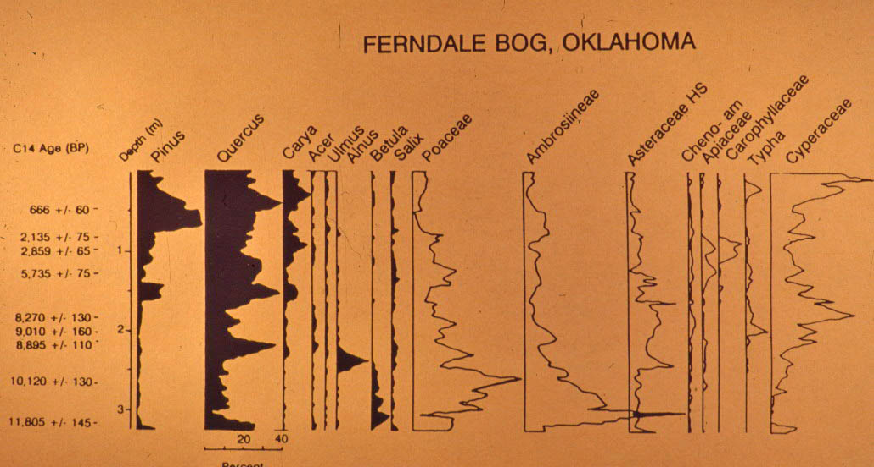
Figure 5 Summary pollen diagram from Ferndale Bog in Atoka County, Oklahoma, adapted from Holloway 1994

Wildlife in the area is varied, and includes river invertebrates, fishes, amphibians, reptiles, and a variety of birds and mammals. The faunal remains in archaeological context are dominated by white tailed deer (Odocoileus virginianus), although both buffalo (Bison bison) and eastern elk (Cervus canadensis) occasionally appear, suggesting that they may have been part of the local fauna (Galm 1978:17). Other local mammals include beaver (Castor canadensis), squirrel (Sciurus sp.), bobcat (Lynx rufus), coyote (Canis latrans), raccoon (Procyon lotor), gray and red foxes (Urocyon cinereoargenteus and Vulpes fulva), skunk (Mephitis mephitis), mink (Mustela vison), armadillo (Dasypus novemcinctus), cottontail and swamp rabbits (Sylvilagus floridanus and Sylvilagus aquaticus), woodchucks (Marmota monax), and opossum (Didelphis marsupialis).
Local game birds include quail, mourning dove, wild turkey, and a variety of waterfowl. Fishes currently found in Wister Lake include catfish, sucker, drum, carp, and gar and should have been available in larger rivers and streams prior to completion of the reservoir (Galm 1978:17). Invertebrate species include insects, gastropods, mollusks, and crustaceans. River mussels are common inclusions in archaeological remains. More extensive lists of lists of fauna for all biotic districts of Oklahoma can be found in Albert and Wyckoff (1984).

Soils and Minerals
The major soils mapped for the Fourche Maline Creek floodplain are the Neff-Rexor-Cupco series, described as “deep, nearly level and very gently sloping, moderately well drained to somewhat poorly drained loamy soils; on flood plains” (Brinlee and Wilson 1981:7). Guccione’s 1999 survey of Fourche Maline Creek geomorphology found both Neff and Cupco soils on the floodplain. These soils are Ultisols, which are moist soils with clay accumulation and tend to be of low fertility and not well suited to agriculture (Steila and Pond 1989). This low fertility is reflected in the fact that although Wister area residents practiced some degree of horticulture, they never depended on maize agriculture to the same extent as many of their Mississippian neighbors (Rogers 2011, Regnier 2013).
In the Ouachita Mountains, the largest quantity of lithic material suitable for knapping are the nearly unlimited quantities of quartzitic sandstone that make up the Stanley and Jackfork formations (Banks 1990:41). By contrast, in the Arkansas Valley, the primary knappable material is Webbers Falls siltstone or argillite of the Atoka formation. This material, which appears to be restricted to a fairly small area near Webbers Falls, OK was commonly used to create bifacially flaked hoes during the Fourche Maline and early Caddoan occupations (Banks 1990:30). Additionally, Ogallala chert cobbles, originating from the Ogallala formation (which extends from South Dakota to west-central Texas) are found in gravel bars of the Arkansas River (Wyckoff 2010).
Further north and east is the Ozark Plateau, containing the richest concentration of knappable stone in Oklahoma (Banks 1984:93). The major chert-producing group in this area is the Boone Formation, which includes the Keokuk, Reed Springs, Woodford, and Moorefield formations. Keokuk chert is characteristically light colored, while the Reed Springs and Woodford cherts are darker. The Moorefield formation produces a black, opaque, waxy lustered type of chert (Bayou Manard) in addition to the more characteristically light colored (Talequah) chert (Banks 1990:29).
Wister area lithics at Fourche Maline sites incorporate all of these material types, although quartzites tend to predominate. Attempts to distinguish changes in material type utilization through time have proven inconclusive due to the lack of good stratigraphy and difficulties in establishing firm dates at the Fourche Maline sites.

Inhabitation
Numerous small, scattered sites dating from 9500-6000 years ago, or the late Holocene, testify to a very long human occupation in the Ouachita Mountains (Wyckoff 2005). In the Wister area the oldest soils along Fourche Maline Creek are approximately 7000 years old (Guiccione 1999), suggesting that we would not expect to find archaeological sites any earlier than this. By about 4000 ya, the Wister area had stabilized enough for intensive human inhabitation (Albert and Wyckoff 1984:39).

Wister phase (1500 BCE – 300 CE)
By the Late Archaic, or Wister phase, the Wister area was extensively occupied. The occupants left behind small mounds containing stone and bone tools, particularly corner-notched contracting stem spear points, ground stone artifacts, bone tools, and shell ornaments, ash, charcoal, and human burials (Galm 1984). These small mounds, or middens were spaced every kilometer or so along the Fourche Maline Creek and Poteau River (Wykcoff 1984).
Base camps, utilized for nut collecting/processing, hunting, and harvesting of river resources occur frequently in the Wister area during the Wister Phase (Galm 1984:213). The seasonal base camp interpretation discussed above is strengthened by the dearth of evidence for permanent structures (Galm and Flynn 1978:90). However, large charcoal and ash concentrations at many sites have been interpreted as the remains of temporary hearths (Galm 1984). Some sites had large concentrations of mussel shells and animal bone which WPA investigators initially interpreted as evidence of feasting, but were re-interpreted as evidence of animal processing events (Galm and Flynn 1978:67). The sites were most likely frequented in different seasons and/or different years (Wyckoff 1984:152).
Wister phase people may have participated in long distance trade networks. For instance at the Poverty Point site in northwestern Louisiana, argillite (a form of siltstone) as well as cherts and sandstones from eastern Oklahoma have been recovered (Wyckoff 1984). Marine shells from the Gulf Coast have also been found in Wister phase sites (Wyckoff 1980).
Several sites include in this study have Wister phase dates (in addition to Fourche Maline dates). These sites are McCutchan-McLaughlin (34Lt11), Scott (34Lf11), Williams (34Lf 24), Wann (34Lf27), and Adams (34Lf33).

Fourche Maline phase (300 – 800/900 CE)
Pottery, typically thick, grog tempered vessels, marks the transition from Wister to Fourche Maline phases, as defined by Galm (Galm 1978:26, 1984:213-216). The addition of small corner-notched arrow points indicates adoption of bow and arrow technology. However other than these additions, these later people living in the area appear to have continued with a very similar lifestyle as artifact assemblages are very similar to the Wister Phase.
Fourche Maline populations are seen as semi-sedentary hunter-gatherers who may have lived in villages and who eventually developed into Caddoan language speaking groups (Galm 1984). Although they did use a basic, distinctive, grog tempered pottery, there appeared to be no indication of agriculture. However the presence of manos and metates suggest some form of plant gathering and processing and perhaps some basic horticulture. Their material culture was dominated by Gary points and other lithics such as boatstones and bannerstones, as well as bone tools (Galm 1984). Despite the addition of both pottery and arrow points, the material culture was seen as being remarkably static for many centuries.
Fourche Maline people buried their dead in small mounds that have been previously characterized as middens. Despite the high concentration of human burials in these mounds, they are routinely referred to as middens, or midden mounds. Some of these Fourche Maline mounds have hundreds of burials and associated grave goods. Given that the small Fourche Maline mounds with burials are almost certainly precursors to later large mound sites, including Spiro Mounds, it seems particularly surprising that Fourche Maline mounds have for so long been relegated to both the literal and figurative trash heap. Dismissing the Fourche Maline mounds as trash heaps is not only disrespectful, but impairs analysis and understanding by obfuscating their importance.

Harlan phase (900 – 1200 CE)
The Fourche Maline phase transitioned into the more complex Harlan phase. By Harlan times there was an increase in population (or perhaps simply an aggregation of people into more settled villages) and an increase in social complexity manifested by the development of a religious and political elite that was centered at major sites (Bell 1984). Between 700 – 1300 CE, at least 15 community centers were built in the Arkansas Basin (Wyckoff 1980). These sites included formal burial or temple mounds and houses for political-religious leaders to administer spiritual and governmental affairs.
Formal mortuary structures and mortuary mounds appear during the Harlan phase. Mortuary structures were built to house the dead; when the structure became full the remains were removed, the structure was burned, and a mound was constructed over the burned structure. The remains were then secondarily interred in a nearby mound (Bell 1984:229-231). At this point, burials begin to show some differentiation in terms of grave goods, with some burials containing more elaborate funerary objects.
Subsistence is thought to have been a mix of horticulture and hunting, gathering, and fishing. Horticulture is presumed to have been well-developed due to the presence of manos and metates (seed processing implements) as well as stone hoes. Increased trade is indicated by the presence of valued exotic goods. The presence of conch shell and copper items differentiates the Harlan Phase from earlier, formative periods (Bell 1984:228).

Spiro phase (1200 – 1400 CE)
The Spiro phase represents the climax of social and political complexity in the area (Brown 1984:241) and is exemplified by the Spiro Mounds site, located slightly north and east of the Wister area, on the Arkansas River. Spiro Mounds would have been just a short canoe ride away from the easternmost Wister area sites such as Akers (34Lf32). This community center was one of the largest civic and ceremonial sites in North America, and certainly contained the most elaborate, extensive, and exotic corpus of artifacts (Brown 1984, Rogers 1982).
Spiro Mounds was the westernmost manifestation of the Mississippian efflorescence, and a complex and stratified political and social structure was assumed to have accompanied this spectacular material corpus. The elaborate burials and accompanying grave goods were seen to represent ascribed status differences and chiefly aggrandization (e.g. Brown 1995, Rogers 1982, Wyckoff 1980). However more recent work has characterized the Great Mortuary as a geographic and cosmological monument, or a created and ritualized “center of the universe” (Brown 2012:117). In this view, such complex burials are not meant to glorify any one individual, but are seen as a theatrical performance meant to unify the community and create history and memory.
Adoption of intensive agriculture in the Caddo area lagged behind that of their Mississippian neighbors, but is well-established by the Spiro phase. Crops included squash, beans, sunflower, gourd, and at least some maize (Brown 1975). Although there is some evidence for squash as early as BCE. 550-50, maize does not seem to have been cultivated until ca. 800 CE, and beans not until 1250-1300 (Perttula 2008). Intensification of domesticated plant use is only apparent after ca 1300 CE, as shown by both archaeological remains (Perttula 2008, Regnier 2013) and isotope studies of dentition (Rogers 2011). However the amount of reliance on maize varied considerably by region (Wilson 2012).

Ft. Coffee phase (1400 – 1550)
After Spiro times, local populations seem to have crashed and/or dispersed, mound centers fell into disuse, and new mounds largely ceased to be built (Wyckoff 1980). The Ft. Coffee phase was seen as a decline both in terms of population size and sociopolitical complexity (Bell 1984). These changes may have been driven by climatic fluctuations, particularly drought. This interpretation is strengthened by the incorporation of Plains derived traits, more suitable for a dryer climate (Wyckoff 1980).
Confusingly, Rohrbaugh (1984) considered the Ft. Coffee focus to be contemporary with the Spiro phase. However most workers seem to use the term to represent a post-Spiro period, as described above.

The Fourche Maline Mounds
This study concentrates on 14 small mounds in the Wister area of southeastern Oklahoma. However three different types of mounds exist within this valley, so some clarification is necessary. Galm (1978) defined natural, or “pimple” mounds, constructional mounds, and midden mounds from the Wister area.
Natural, or “pimple” mounds “exhibited scatters of cultural debris,” (Galm 1978:33). These mound do not contain burials and are not addressed in this study. Constructional mounds were defined as “’loaded’ or culturally derived features,” (Galm 1978:33). Here Galm appears to be referring to the purposefully constructed temple mounds of later periods.
Of primary concern for this study are the “midden mounds” which “refer to the deep accumulations of cultural debris that form low, mounded deposits throughout the valley … the dark color of the deposits in the sites makes them easily distinguishable from the surrounding soils,” (Galm 1978:33). Note however that the primary features in these mounds are human burials, sometimes hundreds of individuals, and some with associated funeral objects. Trivializing the burials by referring to them as middens is not only disrespectful, but it severely limits archaeological analysis. If the burials are considered unintentional deposits of bodies, then a serious examination of the burials themselves becomes unimportant. In this study these mounds are called burial mounds.
Along Fourche Maline Creek, these small mounds are spaced every kilometer or so (Wyckoff 1980:234-235). This study concentrates on 14 mound sites (listed in Table 2). The Wister area sites were all located in the bottomland of Fourche Maline Creek or Poteau River and were subject to seasonal flooding and inundation, especially during the spring and fall (Galm and Flynn 1978). With their constant supply of fresh water and fertile soils, they were excellent habitation locations for early peoples (Wyckoff 1980). These sites were assigned to the Fourche Maline Phase based on their typical “black mound” appearance as well as the recovered material culture. However, many of these sites are thought to have been occupied for hundreds, if not thousands, of years and may also contain some Archaic (Wister Phase) burials, as well as burials that may post-date the Fourche Maline occupation. The uniform, black, organic substrate in these mounds obscures stratigraphy and makes relative dating very difficult. Analysis of these sites has proven quite challenging due to their complex nature.

Table 2 Wister area Fourche Maline sites included in study

34 | Co. | Site  # | Site Name | # Burials Excavated | Total Inds | Excavator
34 | Lt | 11 | McCutchan-McLaughlin | 32 | 47 | Wyckoff
34 | Lf | 11 | Scott | 25 | 25 | Bell
34 | Lf | 15 | Lee Redwine II | 6 | 18 | WPA
34 | Lf | 17 | DeHart II | 32? | 36 | WPA
34 | Lf | 18 | DeHart I | 30? | 35 | WPA
34 | Lf | 19 | Hooks | 80` | 93 | WPA
34 | Lf | 20 | Copeland | 78 | 88 | WPA
34 | Lf | 24 | Williams I | 122 | 210 | WPA
34 | Lf | 27 | Wann | 27 | 32 | WPA
34 | Lf | 28 | Sam | 61 | 73 | WPA
34 | Lf | 29 | Mackey | 160 | 165 | WPA
34 | Lf | 32 | Akers | 168 | 203 | WPA
34 | Lf | 33 | Troy Adams | 62 | 79 | WPA
34 | Lf | 39 | Brewer | 132 | 146 | WPA
Although Newkumet (1940b) defined Fourche Maline sites as black midden sites near creeks or streams, many of the sites are actually set some distance away from the streambed. Wister area Fourche Maline sites have considerably more variability than is often appreciated. Unfortunately, very little analysis has been carried out on the majority of these sites. Exceptions are 34Lt11 McCutchan-McLaughlin, 34Lf11 Scott, 34Lf19 Hooks, 34Lf24 Williams I, 34Lf27 Wann, 34Lf28 Sam, 34Lf29 Mackey, and 34Lf32 Akers, which will be discussed in some detail below.

34Lt11 McCutchan-McLaughlin
The McCutchan-McLaughlin site in Latimer County is the best known and best documented of the many archaeological sites along Fourche Maline Creek. It has been known to the professional archaeological community since 1965 when avocational archaeologist Dr. Sherman P. Lawton first reported the site (Wyckoff 1976). The site consists of a low mound with the typical dark organic soils of Fourche Maline sites. It is located on the east bank of Fourche Maline Creek, on a modern floodplain near the conjunction of Spring and Fourche Maline Creeks, at the foot of Little Ridge. This is the westernmost of the Fourche Maline sites excavated and the only site included in this study not in LeFlore County.
Approximately 10% of the mound was excavated by the University of Oklahoma Field Schools in Archaeology, directed by Dr. D. G. Wyckoff (then Oklahoma State Archeologist) during the summers of 1976 and 1977. At the time of excavation, the mound measured 34 m NS and 26 m EW, although the west side of the mound had been extensively eroded by Fourche Maline Creek (Wyckoff and Woody 1977). The excavations recovered lithic tools and debitage, as well as plant and animal remains, including mussel shells and carbonized nut fragments. Also recovered were 32 burials with 48 individuals. The skeletal material was analyzed by Mary Lucas Powell while Dan Rogers focused on the mortuary program (Powell and Rogers 1980). One of the notable features of the site is Burial 6. As pictured in Figure 6, the burial consisted of nine individuals, six of them with embedded projectile points (Powell and Rogers 1980).

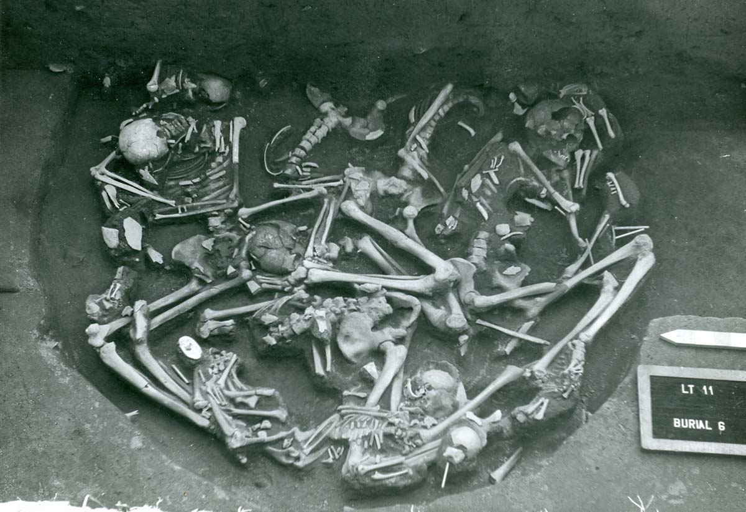
Figure 6 Burial 6 from the McCutchan-McLaughlin site

At the deepest portion of the mound, two major stratigraphic horizons were discernable. The upper component (15 cm and above) dates to ~600 CE or later and contains ceramics and arrow points. A sterile unit indicated that the site was abandoned for ~ 600 years (Wyckoff and Woody 1977), although recent artifact analysis suggests that the site was not totally abandoned as previously thought (Leith 2006:41). The lower component was dated to 300 BCE – 35 CE (Wister Phase) and was dominated by large corner-notched projectile points and lacked pottery or arrow points (Galm 1984). Additional radiocarbon dates confirm both Wister and Fourche Maline occupations (Baugh 1982, Galm 1984).
Despite radiocarbon dates, the burials have proven difficult to associate with upper or lower components due to “the uniformly dark midden matrix at the site” (Powell and Rogers 1980:5). All of the McCutchan-McLaughlin burials have been counted as Fourche Maline in later analyses (Burnett 1990, Rose et al. 1993). The outstanding feature at this site is Burial 6, a mass grave of nine individuals, both adults and children, six with associated dart points of distinctive Ozark chert lodged in bone or body cavities (Powell and Rogers 1980). Given that Ozark cherts made up less than 1% of the rest of the lithic assemblage, it was suggested that this group represented the casualties of a raiding party from north of the Arkansas River (Powell and Rogers 1980:57).
Two M.A. theses and a Ph.D. dissertation from the University of Oklahoma have been completed on the excavations from McCutchan-McLaughlin. Cherie Clark (1987) examined the deer remains in order to study subsistence intensification and Luther Leith (2006) looked at subsistence and the origins of agriculture. Leith also performed remote sensing studies in 2009, and oversaw an off-mound field excavation that uncovered a possible Fourche Maline structure (Leith 2011).
Because this site is so well studied and because it was excavated with modern techniques, including tightly controlled stratigraphic levels as well as soil samples for flotation, it serves as a useful comparison for other Wister area Fourche Maline sites. However it should be kept in mind that because approximately 10% of the site was excavated, we do not have a full picture of the McCutchan-McLaughlin site.

34Lf11 Scott
Located about midway through the valley, on the east bank of a major bend in Fourche Maline Creek, the Scott site is located immediately west of Horseshoe Lake, an old oxbow of the river. Although prone to seasonal flooding, the site is beyond the slackwaters of Wister Lake (Galm and Flynn 1978). The site was originally excavated in 1947 and 1948 by Dr. R.E. Bell of the University of Oklahoma (Bell 1953). The site was reexamined in 1976-1978 by the Oklahoma Archeological Survey (Galm 1978, Galm and Flynn 1978). Radiocarbon dates indicated a middle Archaic occupation with additional occupations in the Fourche Maline and Spiro phases (Galm 1984). Only about 7% of the Scott site was excavated (Galm and Flynn 1978). The mound was fairly deep, about 1.8 m, or nearly 6 feet deep (Galm and Flynn 1978).
Fifteen burials, in poor condition due to both poor preservation and rodent activity, were excavated by Bell. Despite the lack of prepared graves, most of the burials were placed in a semi-flexed position, indicating intentional burial. The skeletons were aged and sexed by H.D. Brighton for an undergraduate class and the results published under Bell’s name (Bell 1953). An additional ten burials were excavated during the 1977 excavations (Hammett 1978), but these burials do not appear to have been analyzed.
Of the 15 examined individuals, five were determined to be subadults (under the age of 15 years) and ten to be adults (Bell 1953:319). All adult skeletons were sexed, as were three of the subadults. It is unclear how much information can be drawn from the Scott site burials. While the burials have been considered Fourche Maline for analysis (Burnett 1990), they are not confidently associated with any of the radiocarbon dates. Given that this analysis was completed by an undergraduate (“A discertation (sic) on “The Skeletal Remains from the Scott Site” by Brighton, 1950) who felt confident aging and sexing skeletons, including subadults, in very poor condition, this site is ripe for a reanalysis of the burials.

34Lf15 Redwine
The Redwine site was located on both the north and south bank of Fourche Maline Creek, about one mile west of its conjunction with the Poteau River. At the time of excavation, the site had been under cultivation for many years, and had also suffered quite a bit of erosion. As a result the WPA only worked there for four days, digging test pits and small trenches. It is not clear how large the mound was at time of excavation or how much of the mound was excavated. Only six burials were excavated, however Burial 5 consisted of a well-defined pit covered with a thick layer of mussel shells and containing at least 11 bodies. The site also contained a triple burial. Neither the collected burials nor artifacts have been analyzed.

34Lf17 DeHart II
DeHart II was excavated in January of 1941 by the WPA. In addition to 31 human burials and at least 5 dog burials, there were three cache pits, two associated with burials, and four ash pits, one with burned mussel shells. A WPA summary or quarterly report or specific information about the mound itself was not found.
The artifacts and burials were analyzed by Rain Vehik “sometime in the 90s” (S. Vehik, personal communication). Although this analysis does not appear to have been published, there are summary tables in the files at SNOMNH pertaining to pottery, projectile points, and some paleopathological data. One chart shows frequency of points and pottery down to 72 inches, suggesting that this was a deep mound (6 feet deep).
Vehik’s tables reported an average cranial index of 74.2 for males and 76.2 for females (cranial index is unitless). Average male height was reported as 169.5 cm +/- 3.9 and average female height was 163.7 cm +/- 3.9, although there is no indication of which formulae were used for the calculations. He also reported an average of 1.4 caries per person, although again, no information on how this was assessed or calculated is available.

34Lf18 DeHart I
DeHart I was excavated in October and November of 1941 by the WPA. No WPA summary or quarterly report or any specific information about the mound itself was found. The files at SNOMNH contain excavation sheets, drawings, and photos for 32 burials, and a chart of projectile point types. The burials and artifacts have not been analyzed. Despite the paucity of information available, this site is included in the analysis because of the 32 documented burials. The burials, along with excavation records and photos, are stored at SNOMNH and await analysis.

34Lf19 Hooks
The Hooks site, located southwest of Fanshawe, Oklahoma, was excavated by the WPA in 1940. A single radiocarbon date for the site comes from bone in Feature A-1 in level 2 and dates to 1210 +/- 70 BP, or late Woodland (Burns 2007:166). However artifact analysis suggests occupations during the Archaic, Woodland, and Mississippian cultural periods (Burns 2007:169). Based on point typology, the primary occupation was Middle Archaic through Late Woodland (Burns 2007:170).
The major work on this site to date has been the M.A. thesis by Cassandra Burns of the University of Tulsa (Burns 2007). Burns examined the ceramics, chipped stone, ground stone, and faunal remains from the site. Burns noted the paucity of ground stone artifacts; however it appears from a WPA excavation photograph (Figure 7) that many ground stone artifacts were simply not collected. Although Burns was not entirely successful in her goal of refining temporality at Hooks, this thesis remains one of the more thorough examinations of artifacts from one of the Wister area Fourche Maline mounds.
The WPA excavated 80 burials from the Hooks site. The presence of Williams Plain sherds with some burials indicates that they are Fourche Maline phase or later (Burns 2007:171). The 80 burials from Hooks have not been examined. The burials are housed at SNOMNH, along with the original ADS sheets, excavation drawings and excavation photos, as well as a few “Physical Anthropology Laboratory Inventory Sheets” dated from the 1970s. Analysis of these burials would make an excellent M.A. thesis.
Figure 7 Manos and metates from the Hooks site

34Lf20 Copeland
Copeland was excavated by the WPA in 1941. It was located on the north side of Fourche Maline Creek, near its junction with Cedar Creek. The site was a wide, circular knoll, measuring 165 feet EW and 150 NS with a rise of 4 feet in the center at time of excavation. Twenty five post molds were determined to be a house pattern.
Two publications focus on the Copeland site. Rain Vehik (1989) published a description of a shell-tempered jar from the site, which is interesting for its comparison of shell tempered pottery across several Wister area Fourche Maline sites. In addition, Edwin Guilinger (1971) from the University of Oklahoma completed an M.A. thesis that examined the artifacts excavated from the Copeland site. Concentrations of ash were interpreted as hearths. Pottery sherds were determined to concentrate to the east and south of some of these “hearths.” Because ceramics were present in all layers, occupation was assessed as Fourche Maline and later periods (Gullinger 1971).
Guilinger (1971) also attempted a burial analysis based on WPA documentation, but did not examine the burials (skeletons) themselves. He noted the presence of extra skulls and presumed that they were war trophies. Because some burials were oriented towards the north, he suggested that they were aligned with the constellation of the Big Dipper (Copeland 1971:114). The 78 burials from Copeland, along with ADS sheets, sketches, and photos, are housed at SNOMNH and await bioarchaeological analysis.

34Lf24 Williams I
Excavated by the WPA in 1940, the Williams site was located three miles northeast of Summerfield on the north bank of Fourche Maline Creek, two and a half miles west of its junction with the Poteau River. The mound was within a small bend in the creek, on flat fertile bottom land, about fifty yards from the creek channel, and thus often subject to complete inundation. The mound was nearly circular in outline, measuring 150 x 130 feet, with an average center maximum height of four feet above the surrounding level (Newkumet 1940). The WPA noted evidence of former excavations by local relic hunters. They conducted extensive testing of the area around the mound, but found no indications of a village site or other features. The mound was completely excavated and the site is now under the waters of Lake Wister.
Williams I is one of the better documented sites in the area. The WPA excavated in 6” levels, instead of the 12” levels used at all other sites, and many of the artifacts were mapped in place. The WPA even produced a burial map (Figure 8). Newkumet published an early report in the 1940 edition of the Oklahoma Prehistorian (Newkumet 1940c). Two M.A. theses have been completed on the WPA excavations. Marilee Irvine (1980) of the University of Oklahoma examined the ceramics from the site, and Myra Giesen (1986) from Wichita State University looked at dental attrition and alveolar resorption. Additionally Leith (2011) examined pottery and chipped lithics from several non-burial squares. Williams I is the type site for Williams Plain pottery (Krieger 1947, Bell 1980). The artifacts excavated from Williams I await a complete analysis.
The WPA reported 122 burials (Newkumet 1940b) and “summary sheets” in the Williams files at SNOMNH indicated that over 150 individuals were recovered from Williams I, including at least 49 subadults. The summary sheets are dated from the 1970s. However the burials at Williams are in need of a bioarchaeological analysis. Given the better than usual documentation for Williams I, this site should be a priority for future Wister area Fourche Maline analysis.

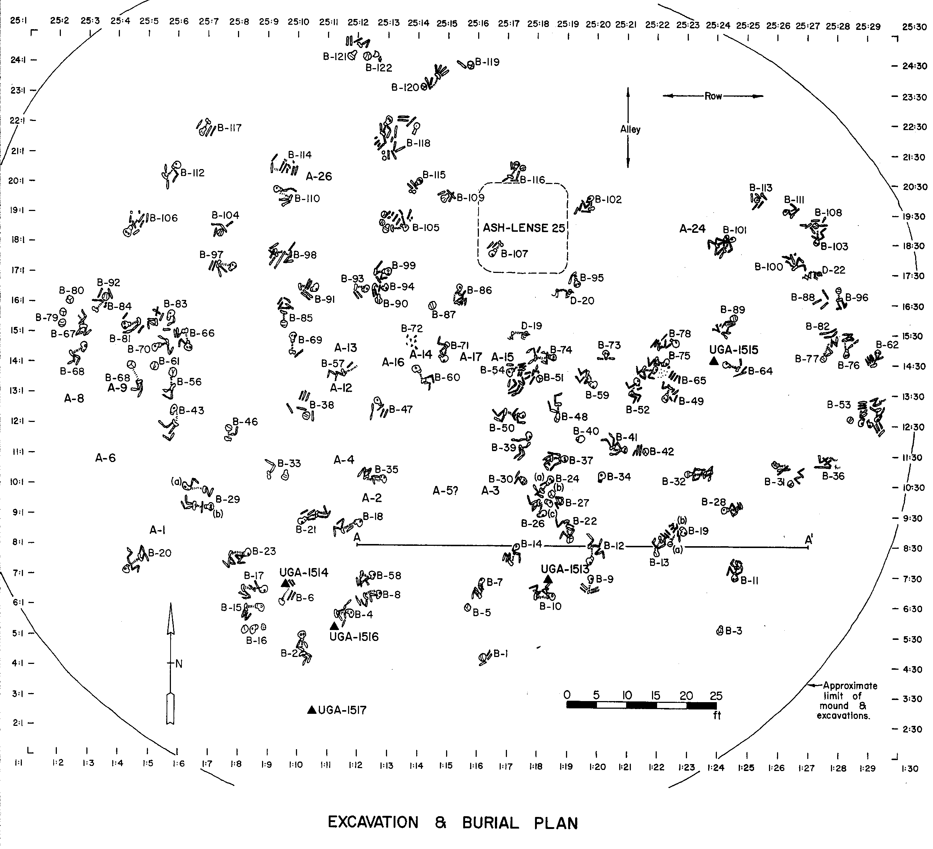
Figure 8 Burial Map for Williams I

34Lf27 Wann
The Wann site was excavated in 1940 by the WPA. The site is situated on the south bank of Fourche Maline Creek at the confluence of Holson and Fourche Maline Creeks, approximately 3.2 km NE of Summerfield, OK (Galm and Flynn 1978), and is subject to seasonal flooding. The site was reexamined by Galm and Flynn in 1977-1978. Radiocarbon dates for the Wann site span the Wister, Fourche Maline, and Harlan periods, with the majority of the dates falling into Fourche Maline (Galm 1984:211). Approximately 62% of the Wann site was excavated.
The WPA excavated 27 burials with 34 individuals, although only 32 skeletons were located for analysis (McWilliams 1978:105). The remains were initially examined by Sharrock (1960) and then later more thoroughly analyzed by McWilliams (1978). During his investigations of the Wister Lake locality in the 1970s Galm (1978) uncovered an additional three burials (two children and one adult).
In addition to Sharrock (1960) and McWilliams (1970), the primary publication regarding the Wann site is Galm and Flynn’s (1978) report. Analyses of Wann contain a couple of notable observations. The WPA observed that many burials were placed directly over large rocks/boulders that formed the base of the mound, and Galm and Flynn (1978:62) refer to persistent rock features “with no known purpose.” Indeed, at several of the Wister area Fourche Maline mounds, the local geology was incorporated into some of the burials. For instance, some burials were placed such that the head was “pillowed” on bedrock. Other burials were positioned into crevices in the bedrock, and still other burials were covered with large slabs of stone. Rock features were “evidently a part of a well-defined occupational pattern at midden deposits in the valley” (Galm and Flynn 1978:62).
Another common feature in all the Wister area Fourche Maline mounds is ashy concentrations. Although these have been interpreted as the remains of hearths, it should be noted that, at Wann, at least, there were “no instances of ashy concentration intercalcated with surrounding matrix or in association with oxidized soil” (Galm and Flynn 1978:50), which suggests that the ash deposits are secondary deposits rather than in situ cumulative features, such as hearths or processing stations. However Galm interpreted them as former occupation surfaces (Galm 1978:84).

34Lf28 Sam
Just one mile east of the Wann site, at the junction of Holston and Fourche Maline Creeks, the Sam site was excavated by the WPA in 1940. At the time of excavation, the mound was a long low ridge, elevated at its highest point about 3 feet above the topsoil (Newkumet 1940). Additional testing was completed in 1976-7, but no further work was recommended due to extensive erosion of the original mound and site (Galm 1978:85-88). The majority (approximately 74%) of the Sam site was excavated.
Several postmolds were found on the mound, which is unusual for these sites. In addition, there were 30 bowl-shaped and flat-bottomed cache pits found extending a few inches to two feet into the subsoil (Newkumet 1940). Additionally a house pattern was found about 315 feet east of the southeast corner of the main mound, on a ridge (Newkumet 1940). Proctor’s (1957) artifact analysis indicated that the site was occupied during the Wister and Fourche Maline continuing up through Harlan and Spiro periods
The WPA reported 61 burials with 70 individuals (Newkumet 1940). Fifty-two burials containing 73 individuals were analyzed by McWilliams (1978). The burials have not been confidently associated with any period, but are usually considered Fourche Maline for analytical purposes (Galm 1984:211).

34Lf29 Mackey
The Mackey site was excavated by the WPA in 1940. It was located on the north bank of a small intermittent streambed about one fourth of a mile east/southeast from Fourche Maline Creek. The site consisted of a large and deep mound that was “more or less completely excavated,” (Leader 1997:22). The mound at the Mackey site was unusually deep, about 305 cm (10 ft.). About 50 yards north of the site, a square pattern Caddoan house was uncovered that was radiocarbon dated to 1490 CE (Bell 1980). The Mackey site therefore represents a very long occupation, from Early Archaic through the Fort Coffee phase (Leader 1997). The site was retested in 1976-77 but only modern debris was found and no further work was recommended (Galm 1978:92).
Three M.A. theses from the University of Oklahoma have been completed on the WPA Mackey excavations. The chipped stone artifacts from excavation squares without burials were examined by Pam Leader (1997). In contrast to the McCutchan McLaughlin site (34Lt11), this study found a low, but persistent use of Ozark cherts (about 26%) (Leader 1997:68-73). A paleodemographic (age and sex) analysis of the recovered burials was completed by Stephanie Burns (1994). Finally, a partial dental analysis was undertaken by Kimberly Bowen (2011).
The WPA recovered 160 burials. Burns’ (1994) analysis found 197 individuals, 100 of which were complete enough for analysis. Burns separated out a “deep” and “shallow” segment, but was unable to assign ages to these levels (Burns 1994:69). “Deep” was defined as below 7 feet because no other Wister area Fourche Maline mound was deeper than 6 feet. The presumption is that the “deep” layer corresponded to the pre-ceramic Wister Phase burials and that the “shallow” layer to the pottery-bearing Fourche Maline Phase burials. However several features and artifacts from the Mackey site also correspond to the later Harlan and Spiro periods, and the house pattern was determined to be Ft. Coffee.
Unexpectedly, Mackey had an unusually high male:female ratio, with nearly twice as many adult males as adult females. The overall ratio is 1.55; it drops to 1.23 in the shallow layer and increases to 1.81 in the deep layer (Burns 1994). Mackey is also the only Wister area site to contain more than one mass burial (where mass is considered >5 individuals). The burials from Mackey are in need of a complete bioarchaeological analysis.

34Lf33 Adams
The Adams site was located about one half mile southwest of the Poteau River on a small, intermittent streambed, about one mile above its junction with Fourche Maline Creek. The site had been plowed for many years but appeared to have been unmolested by pothunters or commercial diggers. At time of excavation it was about four feet deep, although Newkumet (1940) thought it originally might have been twice as deep.
A brief report in the Oklahoma Prehistorian (Newkumet 1940) focused on some large bone “awls,” or hair ornaments appears to have been the only publication to focus on the Adams site. The site was re-surveyed in 1976-78 as part of the “Lf5 Complex” and was recommended for further tested and excavations (Galm 1978:51). However these excavations do not appear to have been carried out.
The WPA excavated 62 burials, including a mass burial with at least 11 individuals piled in a heap, face down (Figure 9). Face down burials are unusual in the Wister area, and suggest a burial of “other,” where the living buried dead from another group they were actively fighting (Komar 2008). “Self” burials (where the living buried dead of their own group) are distinguished by carefully placed and spaced individuals, and not piled on top of each other (Komar 2008). The burials have not been studied, and the Adams site would make an excellent thesis or dissertation.

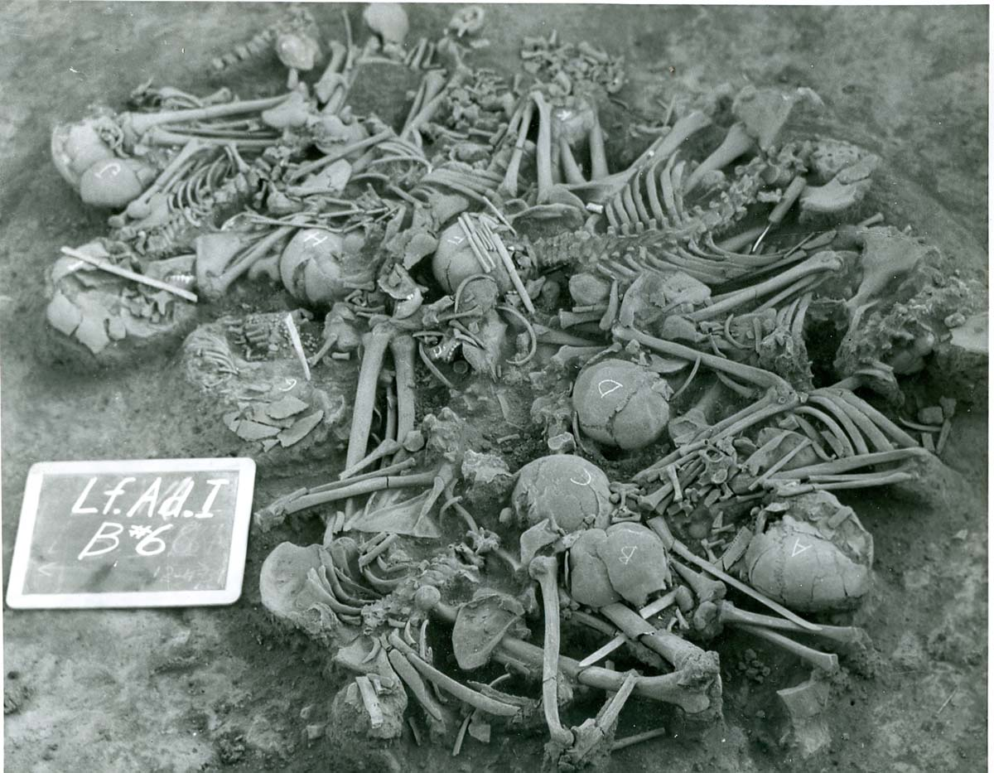
Figure 9 Mass Burial from the Adams site

34Lf39 Brewer
The Brewer site was a large black “midden” located on the southern slope of a ridge almost 20 feet above the bed of a small creek that emptied into the Poteau River. It lay in heavily wooded terrain that was subject to periodic overflows from the river. At the time of excavation, the top of the ridge had a large, recently abandoned coalmine, with a generator plant of the Oklahoma Gas and Electric Company. The mound had been prospected by a professional pot hunter from Poteau who found several burials and artifacts before the land owner requested that he desist. The mound was large but indefinite in outline, and a part of the southern portion had collapsed into the creek.
The WPA excavated 132 human burials as well as 9 dog burials and 8 ash pits. Burial 116 consisted of a mass grave with at least 11 individuals. Neither the burials nor the artifacts have been analyzed. The only publication appears to be a Quarterly Report from the 4th Quarter of 1941, presumably written by Newkumet.

34Lf32 Akers
The Akers site (occasionally and erroneously called Akins in some reports) is the most eastern Fourche Maline mound excavated, and was located by the Poteau River near the junction with Fourche Maline Creek. Excavated in 1940 by the WPA, this site is now permanently under water following flooding of Wister Reservoir. At time of excavation, the mound was large but shallow and elliptical in shape with maximum dimension of 285 feet (EW) x 140 feet (NS). The maximum thickness was only 40 inches and consisted of “rich, black loam” resting on yellow clay subsoil that included large sandstone rocks and boulders (Newkumet 1941b). The WPA appears to have excavated 100% of the mound, recovering over 200 individuals in the process.
This is one of the larger sites and was completely, or nearly completely, excavated by the WPA in 1941. It is now one of the better studied of the Wister area Fourche Maline sites as two recent M.A. theses from the University of Oklahoma have been completed on the WPA excavations from Akers. Rachel Fauchier (2009) examined burial associations and I completed a paleodemographic analysis (in Rowe 2009). Further skeletal analysis was undertaken for this dissertation. Although not reported here, lithic, faunal, and dental analyses are in progress and will be reported at a later date.
Three radiocarbon dates indicate a very long occupation at Akers. Two dates taken from shell-tempered pottery fragments indicate calibrated radiocarbon dates of 1290 and 1300 (CE) (Fauchier 2009:70). For this study, a third sample was sent, taken from a large ash concentration, which returned a calibrated date of 2780 +/- 30 BP, or 840 BCE. At least two more anomalies from Akers are worth mentioning. First, many more adult females than adult males were buried at Akers - nearly a 1:2 male:female ratio (Rowe 2009). This is opposite ratio of what was found at nearby Mackey. Secondly, the paleopathology of the subadults from Akers revealed unexpectedly high rates of cribra orbitalia, moderate rates of periostitis, and low rates of porotic hyperostosis (Rowe 2009), which were interpreted as evidence for scurvy.

Wister area Fourche Maline Sites not in the study
The WPA excavated several more Wister area Fourche Maline sites with burials that were not included in this study (Table 3). Although none of these sites have published analyses or summaries completed, that alone was not enough to disqualify them from this study.
Helfin (34Lf14), Connor (34Lf21), and Smith (34Lf23) were lacking photographic documentation on most of the burials, which meant they could not be included in the archival study of group burials (see Chapter 5). Peck (34Lf21), Williams II (34Lf21), and Monroe I (34Lf26) had 15 or fewer excavated burials and thus were not included.
Table 3 Wister area Fourche Maline sites not included in study

WPA  Designation | 34 | Co. | Site  # | Site Name | Burials Excavated | Excavator
He I | 34 | Lf | 14 | Heflin | 44 | WPA
Go I | 34 | Lf | 21 | Conner | 35 | WPA
Sm I | 34 | Lf | 23 | Smith | 28 | WPA
Pk I | 34 | Lf | 22 | Peck | 8 | WPA
Wi II | 34 | Lf | 25 | Williams II | 15 | WPA
Mn I | 34 | Lf | 26 | Monroe I | 8 | WPA

Additionally, it is unclear if the Peck site is actually Fourche Maline. There is no summary or Quarterly report available and the site does not appear to have been analyzed. The ADS sheets indicate that 8 burials were excavated and there are photos for most of these burials. However the ADS sheets also reference Mound 1, Mound 2, Mound 3, and Mound 4, so it is unclear what type of site Peck actually was. If a multi-mound site, then it would be a Harlan or Spiro period site instead of Fourche Maline. Due to this additional ambiguity, it is not included in the analysis.

Previous bioarchaeology in the Wister area
Only a few of these sites have any skeletal biology or paleodemography completed, as listed in Table 4. Previous studies (McWilliams 1970, Powell and Rogers 1980, Rose et al. 1983) based on non-metric traits of the skull, which are thought to be genetically controlled and thus indicate biological relatedness, have concluded that the Wister area sites of Sam (34Lf28), Wann (34Lf27), and McCutchan-McLaughlin (34Lt11) shared a common genetic heritage and could be viewed as a single breeding population. This conclusion of a common gene pool allows for assumptions of common resistance and susceptibility to disease processes and allows for intra-valley paleopathological comparisons. Additionally, because the sites are geographically close and all within the same valley of the Ouachita Mountains, they share similar ecological constraints and resources, as well as presumably similar cultural attributes, strengthening comparisons (Rose et al. 1999).

Table 4 Wister area Fourche Maline sites with skeletal analysis

Site | Site Name | References
34Lt11 | McCutchan-McLaughlin | Powell and Rogers 1980
34Lf11 | Scott | Bell 1953
34Lf17 | DeHart II | Unpublished summary data*
34Lf27 | Wann | Sharrock 1960  McWilliams 1970
34Lf28 | Sam | Proctor 1957  McWilliams 1970
34Lf29 | Mackey | Burns 1994
34Lf32 | Akers | Rowe 2009

*The burials from the DeHart II site were examined by students during a class taught by Dr. R. Vehik “sometime in the 90s” (Dr. S. Vehik, personal communication).

A dissenting opinion on the validity of Wister area Fourche Maline bioarchaeological data comes from Schambach who claims that comparisons of Fourche Maline site populations are “nonsensical” (Schambach 2002:103). His objections are based on the probability that the burials from these sites may range from the Archaic to Mississippian. This is a valid criticism, as some of these sites were indeed inhabited for very long time spans. Schambach is also convinced that a migrating group, possibly ancestral Tunica, made their way into the Arkansas (and possibly Wister) Valley, displacing or assimilating resident populations (Schambach 1990) and making later populations significantly different. This is a rather extraordinary supposition that requires extensive corroborating evidence. The far more parsimonious explanation, as Rogers (1991) points out, is the status quo explanation of in situ cultural development.
As this chapter has extensively detailed, these Fourche Maline black mound sites have long been recognized as forming a natural cluster both geographically and culturally (material assemblages). While some of these sites do contain a mix of Wister and Fourche Maline period spanning a very long time period, the inhabitants of the valley nevertheless followed a similar way of life, one where agriculture was presumably not a major source of caloric intake. Additionally, the stable artifact assemblages, which have proven so recalcitrant to temporal fine-tuning, support the idea of a very stable population. Thus inter-site comparisons do have validity.
Wister area sites are the largest body of Woodland era data in the Trans-Mississippi south (Early 2004). Previous work (see Table 4) casts these populations as well-adapted populations consuming a “nutritionally adequate diet that maintained a satisfactory level of health” (Early 2004:561). This interpretation is in keeping with modern theories about pre-agricultural societies. This research, however, challenges that view with data that supports intergenerational nutritional stress and widespread conflict. Rates of conflict, violence, and nutritional status may have varied considerably in the Wister area Fourche Maline and the following chapters explore these variations.

Chapter 4: Skeletal Trauma and Nutritional Status

from the Akers Site (34Lf32)

This project was first conceived as a general study of the paleopathology of the individuals at the Akers site (34Lf32). However it soon became clear that skeletal trauma was an outstanding feature of the Akers burials and that any examination needed to seriously consider the role of conflict in the lives of those buried at Akers. In addition to skeletal trauma affecting individual burials, Akers has a mass burial of 11 individuals, as well as multiple group burials (discussed in the following chapter).
This chapter will detail the skeletal evidence for conflict at the Akers site. First, cases of skeletal trauma are examined, including fractures and projectile point wounds, divided into cranial, upper limbs, and lower limbs, with particular attention to male/female and age differences. Finally, the nutritional status of the adults buried at Akers is considered. The chapter concludes with a summary and discussion.

Methods and Materials
As described in greater detail in Chapter 3, the Akers site (34Lf32) was excavated in 1941 by the WPA. It is the easternmost Fourche Maline mound in the Wister area. Unlike most of the other Wister area Fourche Maline sites, the mound was completely excavated, and over 200 individuals were recovered, making it an ideal candidate for an in-depth study.
The skeletal remains were reexamined visually and under magnification of up to 40x using a binocular dissecting microscope. Additional imaging was via the macro lens of a 3.3 megapixel DSC-F505V Sony digital camera. While modern forensic post-mortem examination begins with fluoroscopy or radiography (Kimmerle and Baraybar 2008:22), access to such technology was not available for this study.

Prevalence rates
In modern clinical literature, the frequency of a condition (e.g. disease, bone fracture, etc.) is usually presented as incidence data, which is the number of new cases of a certain condition in a defined population over a given period of time. Because this type of temporal control is usually lacking in skeletal samples, the frequency of pathological conditions are thus reported as prevalence rates (Lovell 2008). Prevalence data is reported in percentages and is calculated by the formula n/N x 100, where n is the number of affected individuals or elements and N is the number of observable individuals or elements (Lowell 2008:349).
In this work, prevalence rates refer to either the number of affected elements (bone) divided by the number of observable elements or the number of affected individuals divided by the number of observable individuals. In each instance, a clear definition will be provided.

The Akers burial population
The WPA reported that they excavated 168 burials containing 204 individuals, including 11 children (Newkumet 1941b). My thesis identified a minimum of 227 individuals, including 33 subadults (Rowe 2009:50). Standard methods of aging and sexing the remains are detailed in Rowe 2009 and will not be repeated here. Of the 222 analyzed individuals from the Akers site, 55, or 33% of the population, were too poorly preserved to assign even large age categories. Due to their size and general robusticity these individuals are assumed to be adult. The remaining 167 individuals were placed in relatively large age categories for statistical analysis. Subadults were 20% of the burial population, young adults 22%, middle adults 39%, and older adults 19%. The untransformed age distribution data is shown in Table 5.
Table 5 Akers age distribution, adapted from Rowe 2009

 | Age Range | N | f
Subadult | 0-15 years | 33 | 20
Young Adult | 16-29 years | 37 | 22
Middle Adult | 30-49 years | 65 | 39
Old Adult | 50+ years | 32 | 19
 | Total | 167 | 100

One of the more unusual aspects of the burials from the Akers site was the unequal sex ratio (Rowe 2009). Although 23% of the adults were too fragmented or fragmentary for confident sex assignment, the remaining adults had a preponderance of adult females. There were 90 adult females to 53 adult males (Table 6), giving a male:female Ratio of .6, instead of the expected ratio of close to 1. As the Akers mound was more or less completely excavated, it is unlikely that the excavators overlooked a section where the “missing” males were interred. Given the larger, more robust bone structure of adult males, it is also unlikely that the individuals too poorly preserved for sex determination were disproportionately male. The sex ratio of 0.6 should be taken as an accurate reflection of the burial population from the Akers site.
Table 6 Adult male and female counts, adapted from Rowe 2009

Sex | n
Male | 53
Female | 90
Indeterminate | 43
Total | 186

The Current Study Subsample
The condition and completeness of the skeletal remains from the Akers site varied enormously. Due to poor preservation and/or excavator error, very few vertebrae or ribs were collected. As a result, the vertebrae and ribs were not analyzed in this study. Similarly, few hand or wrist bones are in the collection, and these were not analyzed. There were more feet and ankle bones, and, when available, the talus and calcaneus were included in the analysis. Dental analysis is currently underway and will be reported at a later date. Paleopathology of the subadults has been previously reported in Rowe 2009. Other paleopathological conditions not reported in this research will be reported under separate cover at a later date.
Not all the individuals that were aged and sexed for the 2009 study were used in the current study. Due to the incomplete nature of most of the skeletons, three broad regions were evaluated: the crania, the upper limbs, and the lower limbs. In order for an individual to be included in the study, at least 50% of the region under consideration had to be available and in good condition for examination. One hundred eighteen of the best-preserved adult individuals met these criteria and underwent paleopathological analysis beyond previous aging and sexing (reported in Rowe 2009).

Age and Sex of the Study Population
All of the 118 individuals included in this study are aged as “Adult” (minimum 15 years skeletally). Due to general poor preservation and the inherent inaccuracies of aging adult skeletons, age categories are reported in very broad terms. Very Young Adults (VYA) are 15-19 years, Young Adults (YA) are 20-35 years, Middle Adults (MA) are 35-50 years, and Old Adults (OA) are 50+ years. Due to the small number of very young adults, for most of the analyses that follow, this group is collapsed into the young adult group. The untransformed age distribution data is presented in Table 7.

Table 7 Age ranges of the study sample

Age Categories | n | f
VYA = Very young adult 15 - 19 years | 5 | .04
YA = Young adult 20 – 35 years | 38 | .32
MA = Middle adult 35 – 50 years | 53 | .45
OA = Old Adult – 50+ years | 22 | .19
Total | 118 | 1.00

Although considerably more adult females than adult males were recovered from the Akers site (as discussed above), the ratio in this study subsample is somewhat more equal. Only the best preserved individuals were included in this study, and this skews the subsample towards larger and more robust skeletons which tend to be male. As shown in Table 8, 67 Females and Probable Females and 51 Males and Probable males (M/F = .76) were included in the study. Age at death survival rates by sex for the entire sample were reported in Rowe 2009 and will not be repeated here.

Table 8 Adult male and female counts of the study sample

Sex | n | Collapsed Sex | N | f
M | 19 | M | 51 | .43
M? | 32 | M | 51 | .43
F | 40 | F | 67 | .57
F? | 27 | F | 67 | .57
Total |  |  | 118 | 1.00

In summary, 118 of the best preserved adult individuals from the Akers site were used in this study. Only individuals that could be confidently aged and sexed were selected. These individuals underwent further paleopathological analysis. For ease of reporting and discussion, the results will be reported in three sections: skeletal trauma, inflammatory lesions, and nutritional status. In each of these sections, the results are further presented broken down by anatomical region: crania, upper limbs, and lower limbs. All of the results reported in this chapter refer only to burials excavated from the Akers site.

Skeletal Trauma at the Akers Site
This section concentrates on the discontinuities of bone caused by accidental or intentional trauma to long bones that result in what is commonly called a “broken bone,” as well as projectile wounds. Fracture rates in a population reflect both accidental and intentional injury. Modern clinical studies tell us that age and sex are strong determinants for many fracture patterns. Fractures patterns must therefore be interpreted carefully.

Results
For ease of reporting and discussion, skeletal trauma results will be discussed by anatomical section: crania, upper limbs, and lower limbs. Fractures are coded as peri-mortem (no healing or bone grown noted), healing (active bone growth or callus formation present), or healed (the fracture remnant can be seen, but bone is smooth and remodeled without active bone growth). No skeletal trauma was noted for subadults (Rowe 2009).

Cranial Trauma
The majority of the crania from Akers exhibited cultural modification (formerly referred to as cranial deformation). Due to the high percentage of modified crania, it was not possible to exclude these crania from analysis. Because multiple types of modification were observed, a separate study, to be published at a later date, will consider the types of cranial modifications and their implications at Akers.
Due to both preservation issues and excavation damage, most crania were missing both their maxilla as well as the basicrania. It was therefore unfortunately impossible to detail facial fractures. This section thus concentrates on trauma to the calvaria. A total of 90 adult individuals (40 male and 50 female) had at least 50% of their calvarium available for study and were included in the cranial analysis.
A total of 21 traumatic wounds to the calvarium affecting 18 individuals were observed (listed in Table 9). Both blunt force trauma (BFT) and sharp force trauma (SFT) wounds were observed. The majority of the cranial wounds were depressed fractures in various stages of healing. Depressed fractures to the skull are usually caused by blunt force trauma (Ortner 2003:121). Also present were wounds caused by sharp force trauma in the form of projectile point wounds and cut marks. Table 9 presents trauma to the calvarium by age group (VYA = very young adult 15-19 years; YA = young adult 20-35 years; MA = middle adult 35-50 years; OA = old adult, 50+ years), sex, bone, type of trauma (blunt force trauma or sharp force trauma), shape of the wound, and stage of healing. Male cranial injuries are grouped before female cranial injuries.

Table 9 Cranial trauma by age, sex, bone, trauma type, shape, and stage of healing

Burial |  | Age | Sex | Bone | Trauma Type | Shape | Status
9 | A | MA | M | L frontal | BFT | Point | Healed
12 | B | YA | M? | L frontal | BFT | Round | Peri-mortem
72 |  | YA | M | Frontal/glabella | BFT | Round | Healing
97 |  | MA | M? | R parietal | BFT | Round | Healing
128 |  | MA | M? | L parietal | BFT | Ovoid | Healing
10 |  | YA | F | Frontal (glabella) | BFT | Round | Healed
10 |  | YA | F | L parietal | BFT | Round | Healed
18 |  | MA | F? | R parietal/occipital | BFT | Round | Healed
68 |  | MA | F? | Frontal/glabella | BFT | Round | Healed
75 |  | OA | F? | L frontal/parietal | BFT | Round? | Healed
90 |  | MA | F | L parietal | BFT | Round | Healed
90 |  | MA | F | R parietal | BFT | Round | Healing
142 |  | YA | F | R frontal | BFT | Round | Healing
147 |  | OA | F | L frontal | BFT | Ovoid | Healing
158 | A | MA | F? | L parietal | BFT | Round | Healed
168 |  | MA | F? | L frontal | BFT | Round | Healed
10 |  | YA | F | L parietal | SFT (Penetrating) | Jagged | Peri-mortem
26 |  | YA | F | R frontal | SFT (Cut) | Curved | Peri-mortem
52 |  | YA | F | R frontal | SFT (Penetrating) | Jagged | Some healing
71 |  | VYA | F | R occipital | SFT (Cut/Projectile) | Linear | Peri-mortem?
144 | A | OA | F | L parietal | SFT (Cut/Projectile) | Linear | Peri-mortem

Males were observed with 5 cranial blunt force trauma wounds resulting in depressed fractures; 3 were to the frontal and 2 to the parietals. Only one of these depressed fractures appears to have been peri-mortem (without signs of healing). No sharp force trauma or penetrating wounds to the crania were observed in males.
The picture became more complex when female crania were examined. Overall 13 females suffered one or more cranial injuries. Blunt force trauma, resulting in 11 depressed fractures, affected 9 females. These wounds were on the frontal or parietals. Sharp force trauma, either cutting wounds or projectile wounds accounted for the remaining 5 wounds, affecting five individuals.
Two females had more than one cranial wound. Burial 90, a middle adult female, had depression fractures to both parietals in different stages of healing. Burial 10, a female young adult, had 3 cranial wounds. Two depressed fractures, one on the frontal (right on the glabella) and one on the left parietal, were both healed. A third wound was a penetrating sharp force trauma wound to the left parietal. The excavation photo (Figure 10) shows a large point resting on the left parietal, clearly the cause of death. The point fits perfectly into the wound, and was probably deeply embedded through the still intact scalp at time of death.
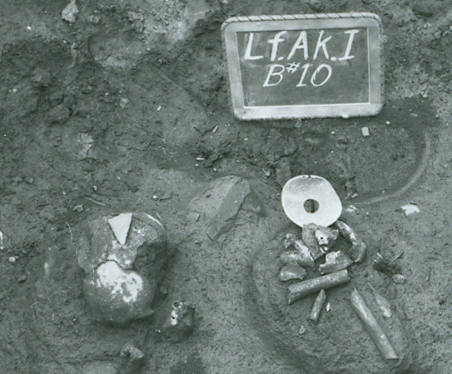
Figure 10 Burial 10 from the Akers site, with large point resting on cranium
There was only one case of possible scalping from the Akers site. This was Burial 157, an old adult male. Although there were no visible cut marks, the calvarium was highly reactive with a cap of bony overgrowth in a pattern suggestive of scalping. However it is also possible that this reactive growth was caused by infection or another type of trauma. Figure 11 shows an occipital view of the bony overgrowth. Because there are no visible cut marks and because it is possible that the bony growth may have been caused by a non-traumatic event (such as infection), this individual is not included in the above totals for cranial injuries.

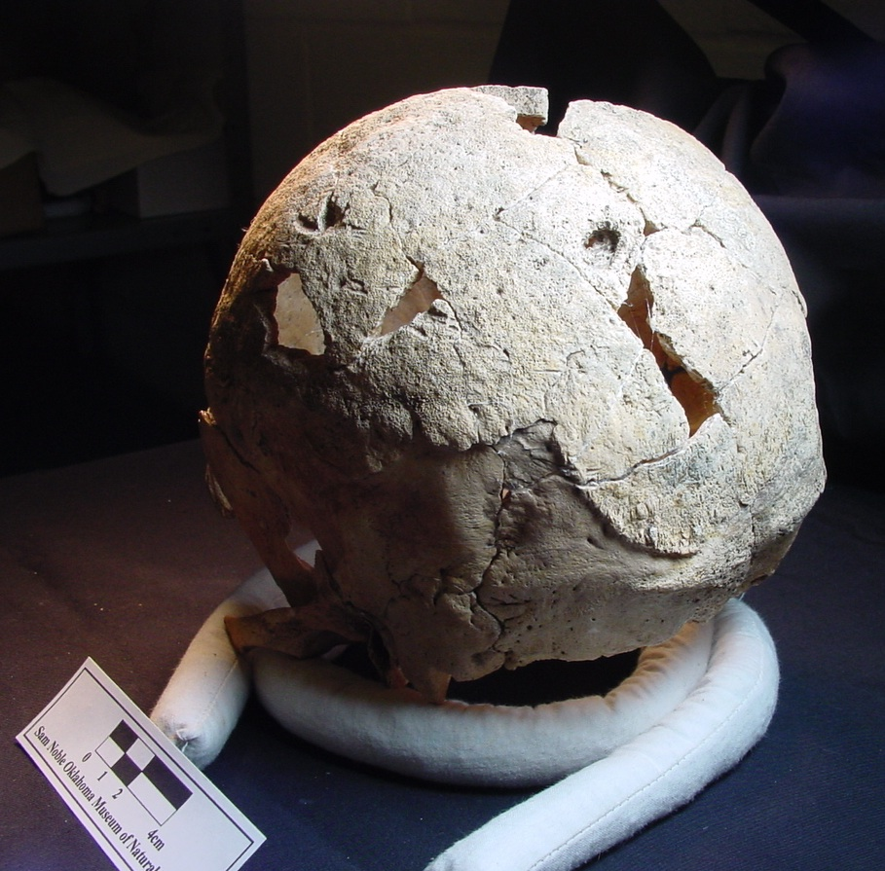

Figure 11 Burial 157 from the Akers site, occipital view of the calvarium

In order to observe the pattern of blunt force trauma to the head, these lesions were mapped by sex. In males (Figure 12), frontal injuries were 60% (3/5) of the blunt force trauma to the calvaria. In females (Figure 13), frontal injuries were 67% (6/9) of blunt force trauma to the calvaria. This difference is not statistically significant (p= .8, two-tailed probability, Fisher’s Exact Test).
Despite the lack of statistical significance regarding male/female differences in numbers or placement of cranial injuries, it should be noted that no male had more than one injury to the calvarium, but two females had multiple calvarium injuries. Additionally, only the females had evidence of sharp forced trauma.
Cranial trauma was then examined by age class. Table 10 presents combined blunt and sharp force trauma by sex and age class. For each age class the number of individuals with a cranial trauma is presented (+), the number of observable individuals (n), and the frequency (+/n). The table also presents p values from a two-tailed Fisher’s Exact Test for males and females in each age class.

Table 10 Cranial Trauma (both blunt and sharp force) by age and sex

 | YA  15-35 yrs |  |  | MA  35 – 50 yrs |  |  | OA  50+ yrs |  |  | Total
 | + | n | f | + | n | f | + | n | f | n | N | f
M | 2 | 7 | 29 | 3 | 23 | 13 | 0 | 10 | 0 | 5 | 40 | 13
F | 5 | 29 | 17 | 5 | 18 | 28 | 3 | 10 | 30 | 13 | 57 | 23
 |  |  | p=.6 |  |  | p=.4 | 3 |  | N/A |  |  | p=.3
Total | 7 | 36 | 19 | 8 | 41 | 20 | 3 | 20 | 15 | 18 | 97 | 19

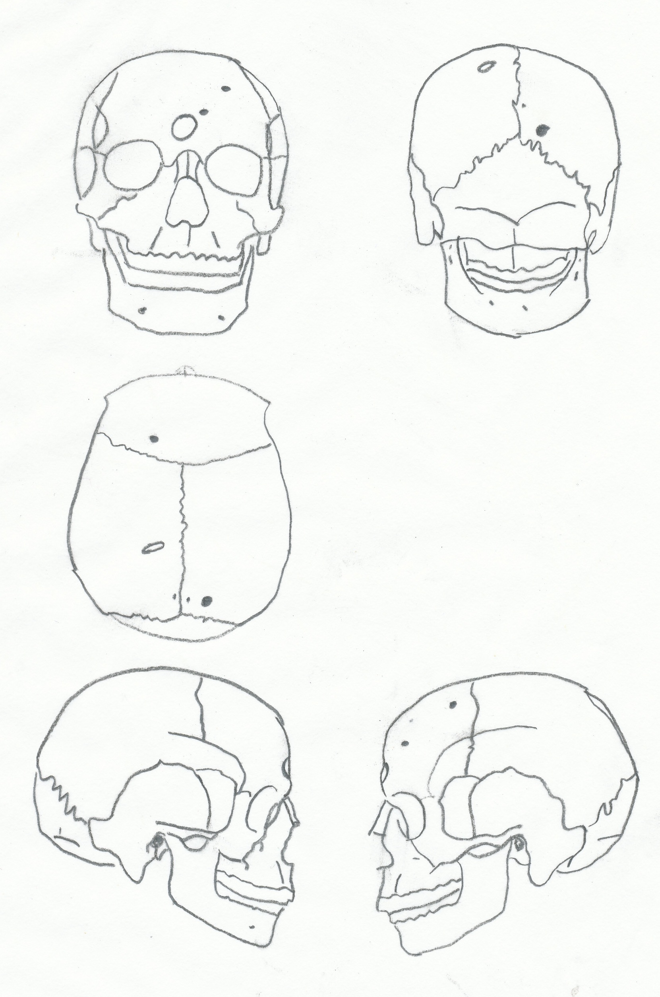
Figure 12 Male cranial blunt force trauma from the Akers site

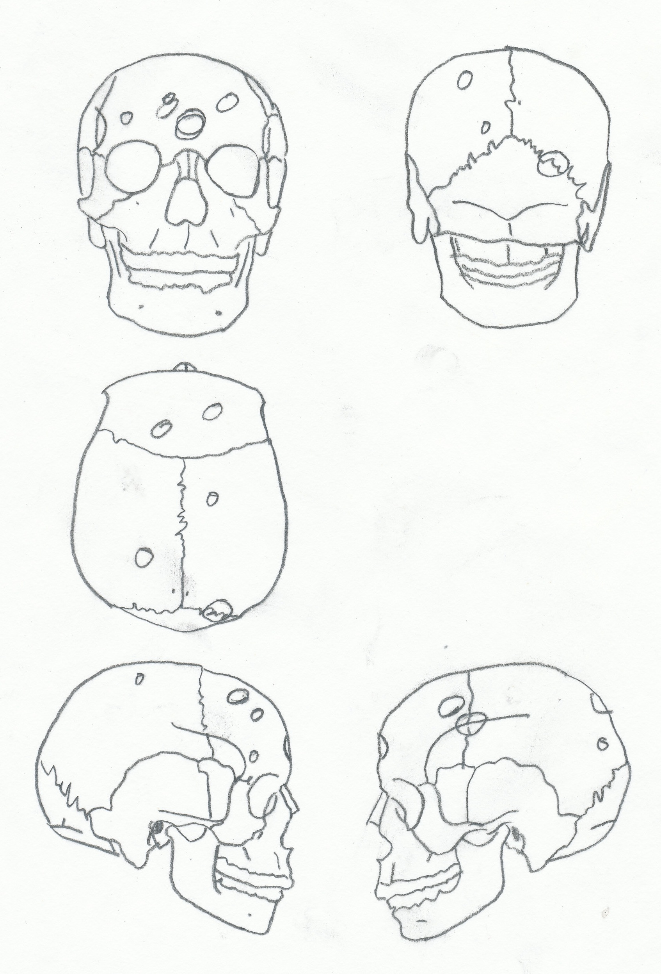

Figure 13 Female cranial blunt force trauma from the Akers site

Males experienced cranial trauma as both young adults and middle adults, but no old adult males were observed with a cranial trauma. By contrast, females experienced cranial trauma as young, middle, and old adults. While the p values reported in Table 10 indicate no significant male/female differences by age class, it may be noteworthy that old adult females had the highest frequency of cranial trauma (30%). Given that no old adult males observed with a cranial trauma, it is not possible to test if this is statistically significant. However, combined with the previously noted observations that only females experienced sharp force cranial trauma, and that only females had multiple cranial injuries, it is suggestive that females may have been more at risk than their male counterparts for cranial trauma.
Cranial trauma can be caused by falls, interpersonal violence, or self-inflicted injury (Walker 1989). However injuries to the frontal bone and parietals are often interpreted as indicating face-to-face encounters, or cases of interpersonal assault (Lovell 2008, Walker 1997). Females, while not accruing more cranial injuries per se, were the only ones to have more than one cranial injury, and the only ones to have had evidence of sharp force trauma to the crania. Old adult females in particular may have been more vulnerable to cranial trauma.

Upper Limb Fractures
A total of 78 (40 male and 38 female) individuals had at least 50% of their upper limbs available for study and were included in the upper limb analysis. The humerus, ulna, and radius were examined for fractures and other types of trauma. Due to the difficulty in distinguishing peri-mortem fractures from post-mortem and/or taphonomic breaks, it is possible that some peri-mortem fractures were not recognized.
Except for one individual with projectile point trauma to both humerii (B8A, discussed below), all other upper limb trauma was in the form of healed or healing fractures. Upper limb fractures consisted of two humerus fractures, six ulna fractures, and nine radius fractures, as detailed in Table 11. Results are reported by element (bone). For each element, males are reported before females. Note that the frequency rates (f) reported in Table 11 refers to element totals, and thus the overall frequency of 5% (17 fractures divided by 341 elements) upper limb fractures is much lower than the actual prevalence rate of 18%, which was calculated by dividing the total number of individuals with an upper limb fracture (14) by the total number of observable individuals (78).

Table 11 Upper limb fractures by bone, burial, age, and sex

Bone | n | N | f | Burial | Age | Sex | Comments
L Humerus | 1 | 66 | 2 | 161 | MA | M? | Healed, midshaft
R Humerus | 1 | 73 | 1 | 58 | YA | F | Healed, distal (also distal R radius)
L ulna | 0 | 54 | 0
R ulna | 6 | 56 | 11 | 9A  13  51  66  72  81 | MA  OA  MA  OA  YA  MA | M  M?  M?  M?  M  M? | Healed, midshaft (psuedoarthrosis)  Healed, midshaft  Healed, distal  Healing, distal  Healing, distal  Healing, distal
L Radius | 2 | 42 | 5 | 31  130B | MA  MA | M?  F | Healed, midshaft  Well-healed, distal (bilateral radii)
R Radius | 7 | 50 | 14 | 23  58  72  118A  130B  147  160 | MA  YA  YA  YA  MA  OA  MA | F  F  M  F  F  F  M? | Healed, distal  Healed, distal (also R hum)  Healing, distal  Healed, midshaft (also metacarpal)  Well-healed, distal (bilateral radii)  Healed, distal  Poorly healed, distal
Upper limb Totals | 17 | 341 | 5

The two humeral fractures were to one male and one female. There were no left ulnar fractures, but six right ulnar fractures, all to adult males. Of the nine radius fractures, two were left radius fractures (1 male and 1 female) and seven were right radius fractures (2 males and 5 females). The higher prevalence of right-sided forearm fractures may be due to most individuals being right-handed.
Burial 9A, a middle adult male, had an unusual midshaft ulna fracture with an articulating and well-healed pseudoarthrosis (shown in Figure 14). In a pseudoarthrosis, a bone experiences a complete transverse fracture and the ends are joined by connective tissue, but fail to mineralize properly due to a lack of osteoid (Ortner 2003:131). Although this type of malunion often causes severe functional problems, in this case, given both the degree of healing and the lack of atrophy in either the radius or ulna, it is likely that this individual retained quite a bit of function in this arm. As discussed in Chapter 3, this type of complete transverse fracture to the midshaft of the ulna is referred to as a parry fracture, and usually considered to be a defensive wound (Kimmerle and Baraybar 2008:173). Only males from the Akers site were observed with parry fractures.

Figure 14 Burial 9A from the Akers site, psuedoarthrosis of the right ulna

Upper limb fractures are presented by age class and sex in Table 12. For each age class, the number of individuals with an upper limb fracture is presented (+), the number of observable individuals (n), and the frequency (+/n). The table also presents p values from a two-tailed Fisher’s Exact Test for males and females in each age class. A total of 14 individuals, or 18% of the examined population was observed with an upper limb fracture, evenly split between males and females.

Table 12 Upper limb fractures by age and sex

 | YA  15-35 yrs |  |  | MA  35 – 50 yrs |  |  | OA = 50+ yrs |  |  | Total
 | + | n | f | + | n | f | + | n | f | n | N | f
M | 1 | 9 | 11 | 5 | 25 | 20 | 2 | 6 | 33 | 8 | 40 | 20
F | 3 | 19 | 16 | 2 | 11 | 18 | 1 | 8 | 13 | 6 | 38 | 16
 |  |  | p=1 |  |  | p=1 |  |  | p=.5 |  |  | p=.8
Total | 4 | 28 | 14 | 7 | 36 | 19 | 3 | 14 | 21 | 14 | 78 | 18

For males, the frequency of upper limb fractures increased with age class, however there is no significant difference between the lowest frequency (young adult males 11%) and the highest frequency (old adult males 33%) (p=.5 two-tailed Fisher’s Exact Test). For females, the frequency of upper limb fractures was about equal between age classes. There was no significant difference between males and females for any of the age classes (p values reported in Table 12).
One male had multiple upper body fractures. This was B72, a young adult with healing fractures to the right distal ulna and right distal radius. These injuries are consistent with a fall. Similarly one female had multiple upper limb fractures. This was B130, a middle adult with distal radius fractures bilaterally. These injuries are also consistent with a fall. As noted in Chapter 3, the majority of upper body fractures are most parsimoniously attributed to falls. However there were also two burials with classic parry fractures to the ulna (both male), which may indicate interpersonal violence (Kimmerle and Baraybar 2008:173).

Lower Limb Fractures
A total of 93 (47 male and 46 female) individuals had at least 50% of their lower limbs available for study and were included in the lower limb analysis. The femur, tibia, and fibula were examined for trauma. Both fractures and projectile point trauma were observed on these elements. This section reviews fractures and the following section covers sharp force trauma injuries.
Ten individuals, or 13% of the examined population, were observed with a lower limb fracture. This breaks down to five femur fractures, four tibia fractures, and six fibula fractures (detailed in Table 13), evenly distributed between left and right sides. Results are reported by element (bone). For each element, males are reported before females. Note that the frequency rates (f) reported in Table 13 refer to element totals, and thus the overall frequency of 3% (15 fractures divided by 469 elements) lower limb fractures is much lower than the actual prevalence rate of 13%, which was calculated by dividing the total number of individuals with a lower limb fracture (10) by the total number of observable individuals (78).
There were a total of 15 lower body fractures distributed amongst 10 individuals, most of them female. Only one lower body fracture was to a male; all other lower body fractures were to females. Six females experienced multiple lower body fractures. Burial 142 was notable for multiple fractures in various stages of healing (further discussed below).

Table 13 Lower limb fractures by bone and sex

 | n | N | f | Burial | Age | Sex | Comments
L femur | 3 | 90 | 3 | 15  19  142 | YA  YA  YA | F?  F  F | Healing with systemic osteomyelitis  Displaced healing with osteomyelitis  Healing but infected (multiple)
R femur | 2 | 91 | 2 | 130B  142 | MA  YA | F  F | Compression to R fem head  Healing but infected (multiple)
L tibia | 2 | 88 | 2 | 68  74A | MA  MA | F?  M? | Healing  Healing with osteomyelitis
R tibia | 2 | 88 | 2 | 112  142 | YA  YA | F?  F | Healed  Healing infected (multiple)
L fibula | 3 | 58 | 5 | 23  112  168 | MA  YA  MA | F  F  F? | Healed (bilateral)  Healing  Healed
R fibula | 3 | 54 | 6 | 14B  23  142 | MA  MA  YA | F  F  F | Healed (offset)  Healed (bilateral)  Healing (multiple fractures)
Lower limb totals | 15 | 469 | 3

Three lower body fractures were infected with osteomyelitis (two femurs and a tibia). It is probable that these were initially open fractures (where the fractured bone breaks through muscle, fat, and skin to protrude into the air), which allowed pathogen entry. Three additional fractures had periosteal reactions. It is difficult to tell if the periosteal reactions were infection or simply trauma related.
Lower limb fractures are presented by age class and sex in Table 14. For each age class, the number of individuals with a lower limb fracture is presented (+), the number of observable individuals (n), and the frequency (+/n). The table also presents p values from a two-tailed Fisher’s Exact Test for males and females in each age class. A total of 10 individuals, or 11% of the examined population was observed with a lower limb fracture.
Of the 10 individuals with a lower limb fracture (Table 14), only one was a male (middle adult). This sex difference is statistically significant (p=.01, two-tailed Fisher’s Exact Probability Test). Perhaps surprisingly, no older adults were observed with lower limb fractures. However young and middle adult females were equally likely to experience a lower limb fracture. Additionally, several females were observed with multiple lower limb fractures. These individuals are discussed in some detail below in the Summary and Discussion of Skeletal Trauma Section.

Table 14 Lower limb fractures by age and sex

 | YA  15-35 yrs |  |  | MA  35 – 50 yrs |  |  | OA  50+ yrs |  |  | Total
 | + | n | f | + | n | f | + | n | f | n | N | f
M | 0 | 11 | 0 | 1 | 28 | 4 | 0 | 8 | 0 | 1 | 47 | 2
F | 4 | 22 | 27 | 5 | 16 | 25 | 0 | 8 | 0 | 9 | 46 | 22
 |  |  | N/A |  |  | p=.02 |  |  | N/A |  |  | p=.01
Total | 4 | 33 | 12 | 6 | 44 | 14 | 0 | 16 | 0 | 10 | 93 | 11

Post-cranial sharp force trauma
Six individuals were observed with nine clear sharp force trauma wounds to the limbs. Due to the small numbers of sharp force trauma wounds, statistical analysis was not attempted.
Table 15 presents all sharp force trauma wounds to the limbs by burial, age, sex, and element (bone). Straight linear wounds were interpreted as cut marks; however it is possible that they were actually projectile wounds that hit at an angle. Such linear marks were observed on B69, B129, and B160. Small, deep wounds were interpreted as projectile point wounds and were observed on Burial 8A and Burials 87A and 87B.
Four males were observed with six sharp force trauma wounds, all to the lower limbs. Male young and middle adults (but no old adults) were observed with sharp force trauma wounds. Two females were observed with three sharp force trauma wounds. These wounds were all observed on middle adult females. The only upper limb sharp force trauma was to Burial 8A, a middle adult female, who had bilateral humerus wounds. This unusual burial consisted of two middle age adults, one male and one female, with a subadult buried between them, as seen in Figure 15. Although neither of the other individuals in the burial had clear evidence of sharp force trauma, it is reasonable to conclude that this group burial was the result of violence to all 3 individuals. As discussed in the previous chapter, only about one-third of individuals inflicted with a projectile point wound will show skeletal lesions (Milner 2005).

Table 15 Sharp force trauma to the limbs by age, sex, and bone

Burial | Sex | Age | Bone | Comments
8A | F | MA | L humerus  R humerus | Bilateral humerus wounds, buried face down
69 | F | MA | L femur | Posterior shaft with several short hatchmarks
129 | M? | MA | R femur | Proximal anterior shaft cut mark
160 | M? | MA | L tibia | Distal posterior shaft cut mark?
87A | M | YA | L tibia  R tibia | Body surrounded with multiple large projectile points
87B | M | YA | R femur  L tibia | Body surrounded with multiple large projectile points

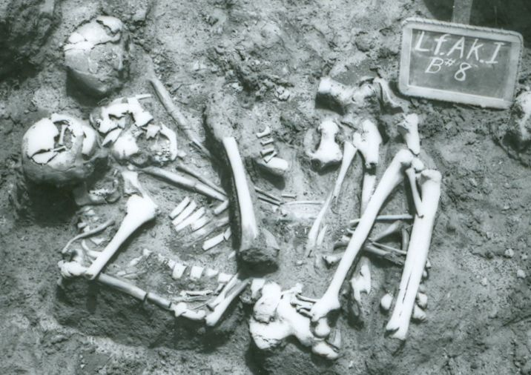

Figure 15 Burial 8, a triple burial from the Akers site
Four of the thirteen projectile wounds were in Burial 87. This burial is one of the most notable features from the Akers site and consisted of two well-articulated skeletons, positioned side by side in an extended position on their backs. Each body was surrounded with multiple large projectile points that had clearly been lodged in body cavities at time of death (Figure 16). These individuals are an example of “pin-cushioning” which is suggestive of a vengeance killing (Dye 2009). Note that while only four clear skeletal wounds were found, there were 23 large points with their bodies, several of which are highlighted in Figure 17.
It can also be seen that there is only one skull, and a close up reveals that something (possibly phalanges) had been inserted into the nasal cavity at the time of burial (Figure 17). However the objects had been removed by the time I was able to examine the burial. The missing skull is likely the result of trophy hunting, which was not uncommon in the Wister area Fourche Maline and is discussed in the following chapter.

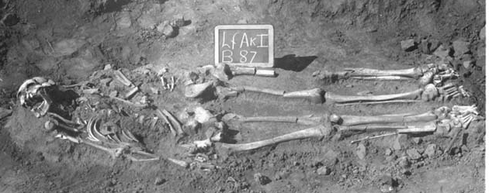

Figure 16 Burial 87 from the Akers site, consisting of two adult males with one skull

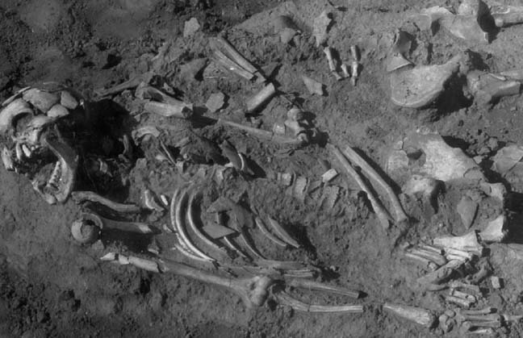

Figure 17 Burial 87 from the Akers site, close-up showing multiple projectile points as well as objects inserted into nasal cavity

Summary and Discussion of Skeletal Trauma
The above sections detailed each cranial, upper, and lower limb trauma for the adults at the Akers site. The results will be summarized and the individuals with multiple fractures will be considered in some detail.
Cranial trauma was the result of both blunt and sharp force trauma observed to the calvarium. The frequency of cranial trauma for females (23%) was higher than that for males (13%); however this difference was not found to be statistically significant (p=.3 two-tailed Fisher’s Exact Test). Despite the lack of statistical difference by sex, it was noteworthy that no male had more than one injury to the calvarium, whereas two females had multiple calvarium injuries. Additionally, only the females had evidence of sharp force cranial trauma. Finally, no old adult males were observed with a cranial trauma while 3 (30%) of the old adult females had a cranial trauma.
Upper limb fractures were observed on 18% of the adult population. The majority of these fractures were to the distal ulna or radius, suggesting falls, rather than interpersonal violence, although two possible parry fractures (both to males) were discussed. Sex differences for upper limb fractures were not statistically significant for any age class.
Lower limb fractures were observed on 11% of the population. These fractures were overwhelmingly to females, and the sex difference is statistically significant (p=.01 two-tailed Fisher’s Exact Test). No lower limb trauma was seen on older adults of either sex. This is somewhat surprising given that in modern societies, risk of femur fracture increases with age.
When cranial fractures are combined with limb fractures, a total of 15 adult males were observed with 17 fractures. Put another way, 29% of the adult male population was observed with at least one fracture. With the exception of one tibia fracture with complicating osteomyelitis (B74A), all other male fractures are to the upper body and calvarium, and the majority of the upper body fractures are to the right ulna. By contrast a total of 26 adult females were observed with 37 fractures, or 39% of the adult female population was observed with at least one fracture. This difference however, is not statistically significant (p=.3, two-tailed Fisher’s Exact Test).
Significant differences by sex do become apparent when individuals with multiple fractures are examined. Each individual with more than one fracture is listed in Table 16, with information regarding the burial number, sex, age, and element (bone) fractured. Males are listed first and then females. Males were observed with multiple fractures affecting the both calvarium and the upper limbs (but not lower limbs), while multiple fractures to females were observed on the calvarium as well as both upper and lower limbs.
As seen in Table 16, a total of 12 individuals had more than on fracture, or 10% of the population. This breaks down to two adult males with more than one fracture, and 10 adult females with more than one fracture. This difference is weakly statistically significant (p=.07 two-tailed Fisher’s Exact Test), signifying that multiple fractures should be examined more closely.
The two males with more than one observable bone fracture were Burial 9A and Burial 72. Burial 9A was a middle adult with a healed depression fracture to the frontal/glabella as well as the unusual and well-healed pseudoarthrosis described earlier (and pictured in Figure 14). Burial 72 was a young adult with a healing depressed fracture to the frontal/glabella and healing fractures to the distal right ulna and distal right radius. The injuries are in similar stages of healing which suggests that they occurred at the same time, although this cannot be determined for certain. The injuries to B72 are consistent with a fall, in which the individual broke both lower arm bones bracing a fall, and also hit their head at the same time. However the glabella fracture could also be interpreted as interpersonal violence. By contrast B9A’s pseudoarthrosis is a parry fracture, typically interpreted as a defensive wound. While B9A’s glabella fracture might be explained by a fall, the concomitant parry fracture makes interpersonal violence a reasonable explanation of both injuries. These male injuries were probably a mix of falls and interpersonal violence or combat.

Table 16 Multiple fractures by burial, sex, age, and bone

Burial | Sex | Age | Fracture | Comments
9A | M | MA | R ulna  Frontal | Healed pseudoarthrosis, possible parry  Healed depression fracture
72 | M | YA | R ulna  R radius  Frontal | Healing, distal, probable fall  Colles fracture  Healed depression fracture
10 | F | YA | Frontal  L parietal  L parietal | Healed depressed  Healed depressed  Peri-mortem penetrating wound
23 | F | MA | R radius  L fibula  R fibula | Healed, distal  Healed, distal  Healed, distal
58 | F | YA | R Humerus  R radius | Healing, both distal, fall?  Distal humerus uncommon
68 | F? | MA | Frontal  L tibia | Healed depressed  Healing L tibia
90 | F | MA | L parietal  R parietal | Healed depressed  Healing depressed
112 | F? | YA | R tibia  L fibula | Healed  Healing – 2 separate incidents?
130B | F | MA | L radius  R radius  R Femur | Well-healed distal (bilateral radii)  Colles fracture  Compression, head
142 | F | YA | Frontal  L femur  R femur  R tibia  R fibula | Healing depressed  Multiple, in multiple stages of healing. Battered woman syndrome?
147 | F | OA | L frontal  R radius | Healing depressed  Healed, distal, Colles fracture
168 | F? | MA | L frontal  L fibula | Healed depressed  Healed

There were 10 females with more than one fracture. Multiple trauma to the head accounted for two individuals (B10, B90), multiple trauma to limbs accounted for another 4 individuals (B23, B58, B112, B130B), and trauma to both head and limbs afflicted four individuals (B68, B142, B147, B168).
Of the 10 females with multiple skeletal injuries, four of them (B23, B58, B168) have injuries in approximately the same state of healing, judging by bone callus formation. This suggests that each individual experienced a single episode of trauma. However the amount of bone callus formation gives only an approximate estimate of the age of the injury, so timing of skeletal injuries is not precise. While some of these injuries may be the result of inter-personal violence or an assault (for instance B168 has a healed depressed fracture to the frontal bone as well a healed left fibula fracture), but they do not appear to indicate multiple instances of assault. Another female (B130B) had healed fractures to both radii (distal), which is consistent with a fall. She also had a compression fracture to the right femoral head, a somewhat unusual injury that may have occurred early in life (Lovell 2008:364). Despite three injuries that probably occurred at two separate times, this is probably not a case of abuse or assault since the injuries are easily explained by other mechanisms.
This leaves five female burials with multiple skeletal injuries in different stage of healing (B68, B90, B112, B142, B147). Some of these may represent both an accident and an assault. For instance B147 had a healed fracture to the right distal radius (most parsimoniously interpreted as a fall) as well as a healing depressed fracture to the left frontal (often interpreted as an assault). However B90, with two fractures to the cranial vault, in different stages of healing, may very well indicate a survivor of two separate assaults.
Burial 142 is the most dramatic example of multiple injuries in multiple stages of healing. Despite having a very gracile skeleton, this young adult female was quite complete. She was also found with neonatal bone fragments, indicating she was either pregnant or had just given birth at time of death. In addition to bilateral femur fractures, fractures to the right tibia and right fibula, and a depressed fracture to the frontal bone, she was also suffering from a systemic infection. The right femur fracture had a fresh callus, indicating that it had occurred not long before death. The left femur’s callus was still evident, but well-healed, and had occurred much earlier than the right femur. The depressed frontal fracture was also well healed and may have occurred around the same time as the left femur. The right tibia and right fibula fractures were infected, making it difficult to assess degree of healing and time of injury, but it may have been a third incident, occurring some time between the two episodes identified. Although delicate, she did not appear to suffer from osteomalacia, osteoporosis, or any other skeletal disease. It is difficult to escape the conclusion that this individual was severely beaten on at least two occasions and possibly three.
Why were the females more prone not only to fractured lower limbs and to multiple fractured bones than the males? The individual skeletons under consideration show no signs of osteomalacia or any other bone weakening disease. Barring spurious suggestions like “women are clumsier” or “women are more fragile,” it is reasonable to hypothesize that at least some of these multiple injuries were the result of repeated interpersonal trauma or abuse. It is possible that these women were captives.
Skeletal trauma indicates that conflict was clearly a pervasive part of life for the individuals who were buried at the Akers site. As previously established, even a few skeletons showing signs of skeletal trauma such as projectile wounds or healed fractures indicates that fighting was probably pervasive and had a noticeable impact on communities (Milner 2005). In addition to the broken bones and projectile wounds detailed above, some skeletons are missing their skulls and at least two cases of extra, isolated skulls were observed (discussed in the following chapter). Finally, Burial 87 (described above) is a good example of “pin-cushioning,” in which an individual has received multiple wounds. Pin-cushioning suggests a vengeance killing, and the overall pattern that includes pin-cushioning, trophy taking behavior, mass burials, broken and fractures bones, and embedded projectile points characterizes feuding (Dye 2009).

Nutritional Status at Akers
As discussed in the previous chapter, malnutrition and other nutritional deficiencies are often found during war or smaller conflicts in modern times. This section considers the skeletal evidence for nutritional deficiencies in the adults buried at the Akers site by examining the frequency of the cranial lesions porotic hyperostosis and cribra orbitalia. As previously noted, nearly all the crania from Akers were modified in some fashion. It is unclear if cranial modification significantly impacts cribra orbitalia or porotic hyperostosis frequencies.
The majority of calvaria had at least some porosity, especially over the lambda region, and many crania also looked mildly reactive (mild proliferative periosteal reactions). An example of this mild reactivity and generalized porosity is shown in Figure 18. This type of reaction was also noted on calvaria from the McCutchan-McLaughlin site (34Lt11) (Powell and Rogers 1980).

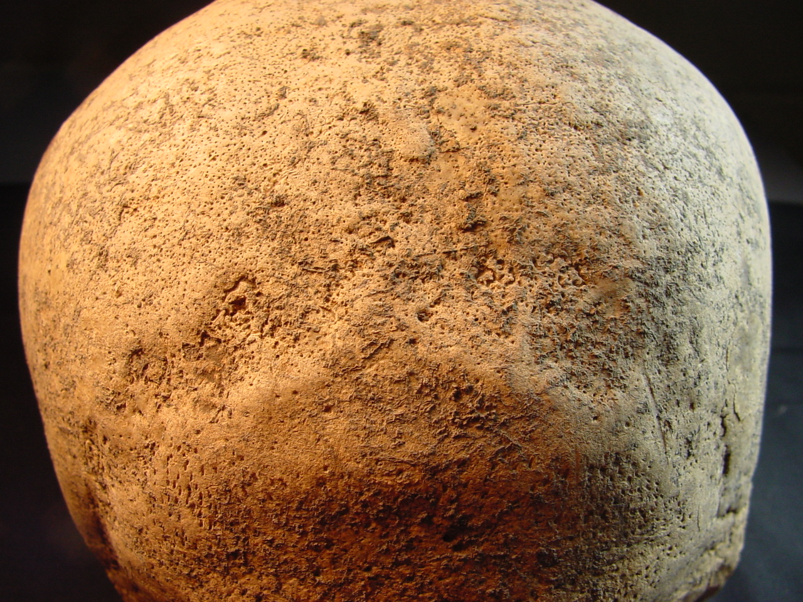
Figure 18 The lambda region from Burial 155 of the Akers site

Porotic hyperostosis lesions were thus scored quite conservatively, especially since radiography was unavailable to help distinguish the characteristic “hair on end” appearance of the diploe (Stuart-McAdams 1992). At least one parietal and/or side of the frontal had to be available to score for porotic hyperostosis. Porotic hyperostosis lesions were scored as Present or Absent. Cribra orbitalia lesions were scored as Active, Healed, or Absent. At least one eye orbit had to be available to score for cribra orbitalia.

Results
The prevalence of porotic hyperostosis amongst the adults at Akers was low. Out of 94 individual calvaria examined, only 6 displayed signs of porotic hyperostosis, for an overall frequency of 6%. Five of these were female, and only one was male (Table 17). Despite the higher frequency for females, this sex difference is not statistically significant (p=.4 two- tailed Fisher’s Exact Test). The frequency of porotic hyperostosis in the subadults was higher, at 21% (Rowe 2009:75).

Table 17 Porotic hyperostosis prevalence by sex

Lesion | Male  n/N | f | Female  n/N | f
Porotic hyperostosis | 1/37 | 3 | 5/57 | 9

Cribra orbitalia frequencies are reported in Table 18. Overall 18% of the adults in the study had active cribra orbitalia lesions. Although males had a higher prevalence (24%) than females (13%), this difference is not statistically significant (p=.3 two-tailed Fisher’s Exact Test). When healed cribra orbitalia lesions were included, the percentage rose to over 70% (72% of the males, 71% of the females). This high frequency is consistent with a frequency of 68% for the subadults (Rowe 2009).

Table 18 Cribra orbitalia prevalence by sex

Lesion | Males |  |  |  |  | Females
 | Active |  | Healed |  | Total | Active |  | Healed |  | Total
 | n | f | n | f | N | n | f | n | f | N
Cribra orbitalia | 7 | 24 | 14 | 48 | 29 | 6 | 13 | 26 | 58 | 45

Summary and Discussion of Nutritional Status at Akers
Teasing out nutritional deficiencies in archaeological populations is always complex. Nutritional deficiencies are often the result of cultural practices rather than purely environmental in cause, and are rarely the results of a deficiency in a single dietary element (Lewis 2007:97). Overall, both the adults and subadults from the Akers site were observed with low levels of porotic hyperostosis and higher levels of cribra orbitalia.
While interpretations of porotic hyperostosis lesions are in flux, cribra orbitalia lesions are currently considered to be a good indicator of scurvy, as discussed in detail in Chapter 2. The high rates of active and healed cribra orbitalia in both the subadults and the adults suggest that scurvy may have been a persistent, intergenerational problem.
I originally suggested that high rates of cribra orbitalia (and presumably scurvy) in subadults were due to an over-reliance on hickory nut mash for weanlings (Rowe 2009). The sites in this study provide evidence of reliance on hickory nuts in the form of thousands of charred hickory nuts shells found in Wister area Fourche Maline mounds (Wyckoff 1984:152). The mounds also yield an abundance of grinding stones, or manos, although they are not usually associated with burials (Brown 1995). Many manos were found at the Akers site, including at least three that were possibly associated with burials (Fauchier 2009:89). Hickory nuts seem to have been a significant portion of the diet for early Wister area residents. Ethnographic evidence indicates that when encountered by early European settlers, Caddoan Indians used nuts ground up into a “flour” to make “porridge” for children (Swanton 1942). It is reasonable to assume that hickory nut porridge was a major portion of the diet for subadults, especially weanlings.
Hickory nuts, while an excellent source of calories, protein, and fat, have almost no Vitamin C. According to the USDA nutrition database, one ounce of dried hickory nuts (edible portion only, not including shell) contains 186 kcal with 3.61 g of protein, 5.17 g of carbohydrate, and 18.25 g of fat. Hickory nuts are low in iron (0.6 mg) and low in Vitamin C (0.6 mg), but are a relatively good source of calcium (17 mg), magnesium (49 mg), phosphorus (95 mg), and potassium (124 mg). Therefore, a diet consisting primarily of hickory nut mush would provide plenty of calories in form of carbohydrates and fat as well as calcium, magnesium, phosphorus and potassium. This would decrease the likelihood of rickets, barring some congenital inability to synthesize Vitamin D. On the other hand, a diet consisting primarily of hickory nut mush would provide low amounts of protein and very little iron or Vitamin C.
I anticipated that adults would show much lower rates of cribra orbitalia once their diets expanded. While active cribra orbitalia rates in adults are indeed lower than that of subadults, the high rates of healed cribra orbitalia lesions suggest a continued restricted diet with persistent though episodic nutritional stress.
It is unclear why nutritional stress would be a problem in this area. River valleys tend to be resource rich areas, and Chapter 3 detailed the available flora and fauna in the study area. However the area is known to be subject to periodic droughts, which may have contributed to the pattern of nutritional stress seen at Akers. I suggest the high rates of skeletal trauma and nutritional stress are both a consequence of long-term, valley wide feuding.

Akers Conclusions
High rates of skeletal trauma and nutritional deficiencies at the Akers site have been demonstrated. I suggest that these findings are related. The nutritional deficiencies may be a consequence of a restricted diet due to an over-reliance on hickory nuts as outlined above. The reliance of hickory nuts for both subadults and adults may have been a consequence of a restricted hunting and foraging range due to intense feuding that occurred along the entire Wister area region. Evidence for such feuding is presented in the following chapter.
Additionally, adult females were more likely than their male counterparts to have experienced a fractured lower limb bone and also to have experienced multiple fractures. The high levels of stress that would accompany such feuding may have resulted in the more vulnerable members of the population (i.e. women) being targeted for domestic violence or abuse. An alternative explanation for the pattern of multiple fractures seen in some adult females is that these women may have been captives.
The following chapter presents evidence for widespread feuding in the Wister area. Although frequency of and severity of the feuding appears to have varied, it is clear that conflict was a persistent, valley-wide phenomenon, with lasting consequences for the health of those buried at the Akers site.

Chapter 5: Conflict in the Wister Area

The high levels of skeletal trauma for the Akers site (34Lf32) reported in the previous chapter led naturally to the question of whether or not this was typical for the Wister area Fourche Maline populations in general. Unfortunately, as previously mentioned, only a few sites in the Wister area have had any bioarchaeological analysis completed (detailed in Table 4). Furthermore, the other lines of evidence often used for analyzing violence in the archaeological record are also missing for this area and time period. As discussed in Chapter 3, evidence for conflict in the archaeological record is traditionally examined through three lines of evidence: 1) iconography, 2) architecture and/or site layout (e.g., defensive palisades), and 3) skeletal trauma (Milner 1999, Dye 2009).
Iconography is virtually nonexistent during the Wister area Fourche Maline. For instance, Figures 19 and 20 contrast shell gorgets and pottery from (later) Spiro times with typical similar objects from the Akers site (34Lf32) (the easternmost of the Wister area Fourche Maline sites in the study). The plain and undecorated nature of the Fourche Maline items means that analysis of iconography is simply not a useful tool for examining Wister area conflict.
The second criterion of architecture and/or site layout (e.g., defensive palisades) is also not useful for the Wister area. There is no evidence of fortification at any of the sites excavated; indeed there is very little evidence of any kind of Fourche Maline structures at all. The Fourche Maline region has flooded continuously during its 7,000 year existence (Guccione 1999) and it is possible that this is responsible for erasing or deeply burying evidence of fortifications. However no fortifications were uncovered during the Spiro excavations, and later day Caddoans do not seem to have built fortifications (Dye 2009). Although Leith (2011) looked for evidence of off-mound dwellings, we so far have no solid evidence of Fourche Maline dwellings or settlement patterns beyond the existence of the burial mounds themselves. The few structures on or near Fourche Maline mounds that have been uncovered have been dated to later time periods.

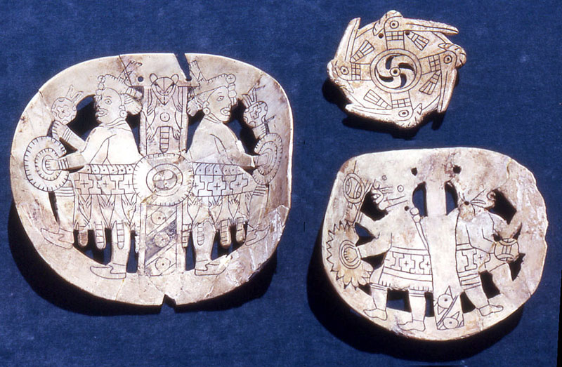 | 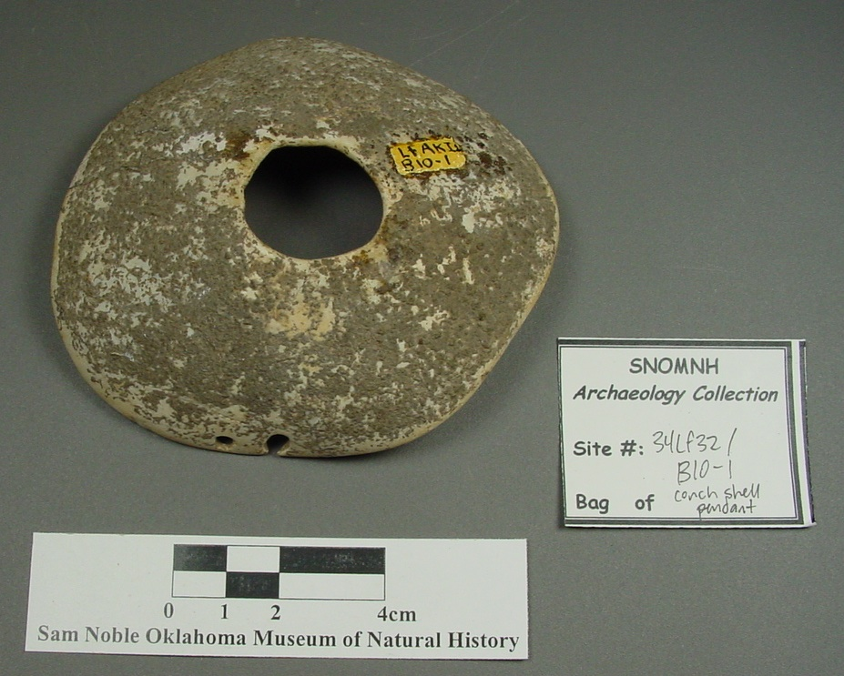

Figure 19 Shell gorgets from Spiro Mounds (left) and the Akers site (right)

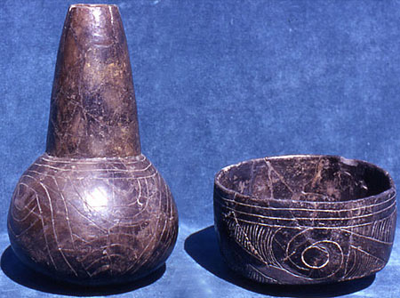 | 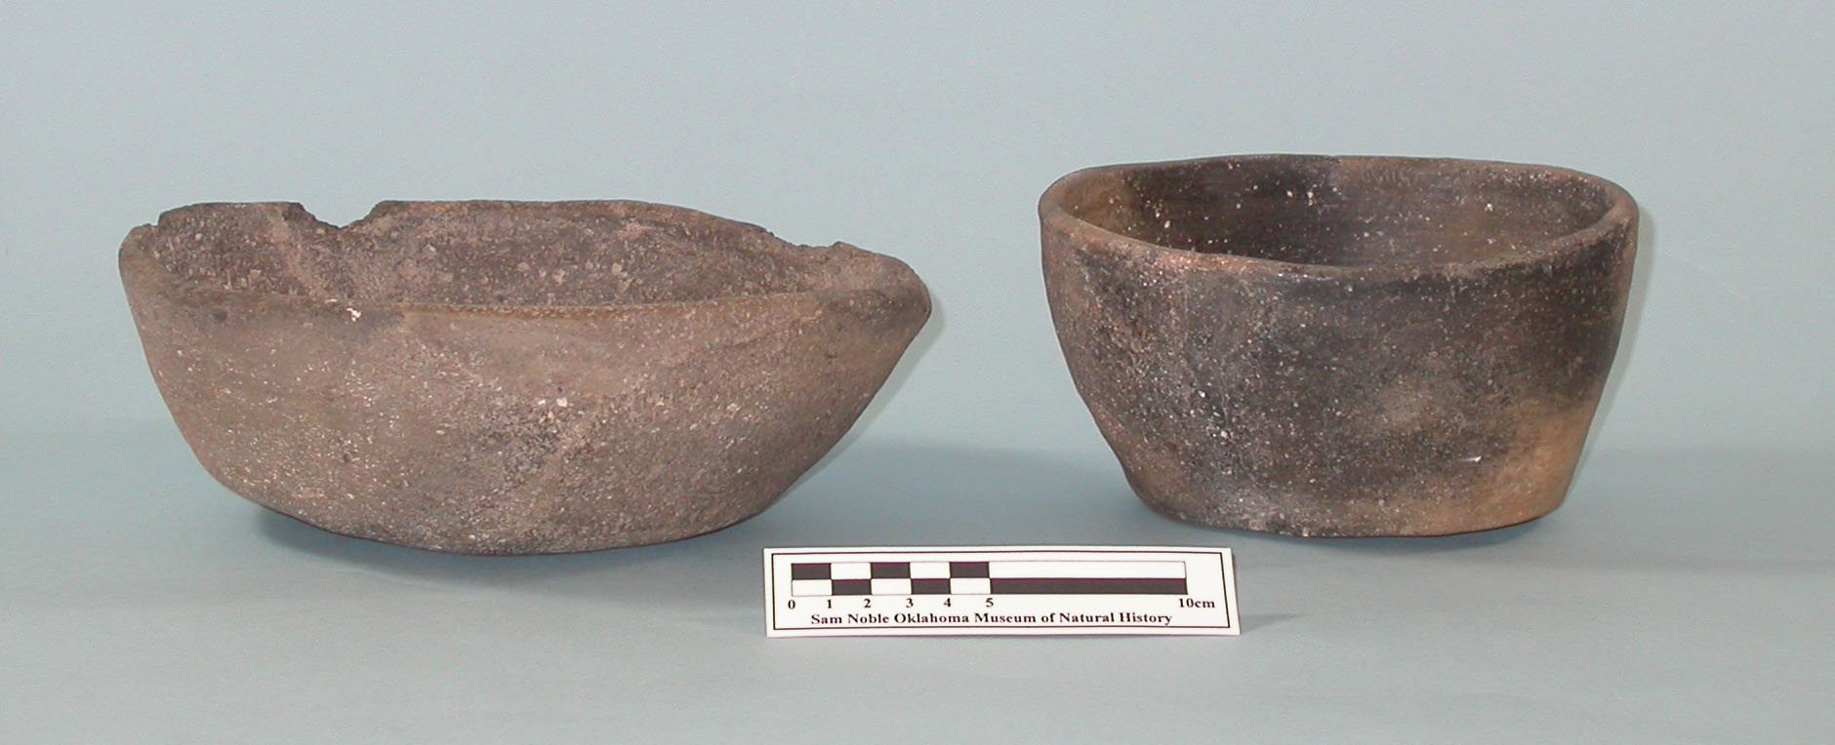

Figure 20 Pottery from Spiro Mounds (left) and the Akers site (right)

Thus the first two traditional lines of evidence used in archaeological studies of violence are not useful in examining conflict during the Wister area Fourche Maline. The third line of evidence, skeletal trauma, has more promise for this study, as over 1000 burials from the Fourche Maline of this region have been excavated (Rose et al. 1999), and most of these burials are housed at the Sam Noble Oklahoma Museum of Natural History. However, only a few of these sites have had bioarchaeological analyses completed, which limits the usefulness of this criterion as well.
Addressing the question of violence at Wister area Fourche Maline sites becomes important when one realizes that eight of these sites have at least one mass burial (where mass = more than 5 individuals). These sites are listed in Table 19. One site, Mackey (34Lf19) has three mass graves, two with five individuals, and one with six individuals. Additionally as detailed in the previous chapter, my work with the burials from the Akers site has documented skeletons with healed fractures, as well as skeletons with embedded projectile points. Even a few individuals with signs of skeletal trauma, such as projectile wounds or healed fractures, indicate that fighting was pervasive, with a noticeable impact on communities (Milner 2005). Additionally, some skeletons were missing their skulls and at least two cases of extra, isolated skulls were found at the Akers site. Finally, the Akers site provided a good example of “pin-cushioning,” in which an individual received multiple projectile wounds (pictured in Figures 16 and 17). Pin-cushioning suggests a vengeance killing (Dye 2009).
This overall pattern, encompassing pin-cushioning, trophy taking behavior, mass burials, broken and fractured bones, and embedded projectile points, characterizes feuding (Dye 2009, 2013). While feuding is typical of many Woodland societies, armed conflict varied greatly in the amount of planning, the numbers of combatants, and the numbers of casualties (Milner 1999:107), and this can be seen in the range of casualties from the Wister area (discussed in detail below).

Table 19 Wister area Fourche Maline sites with mass burials (5 or more individuals)

 | Site Name | # of Mass Graves | # of Inds in Grave | Total Inds
34Lf39 | Brewer | 1 | 7 | 146
34Lf20 | Copeland | 1 | 5 | 88
34Lf24 | Williams I | 1 | 5 | 210
34Lf32 | Akers | 1 | 11 | 206
34Lf33 | Adams | 1 | 11 | 79
34Lf27 | Wann | 1 | 5 | 32
34Lf29 | Mackey | 3 | 5, 5, 6 | 165
34Lf15 | Redwine | 1 | 11 | 18
 | Totals | 10 | 71 | 944

The frustrating lack of traditional data used for studying violence in the archaeological record has led to an attempt to utilize another line of evidence regarding the question of conflict in the Wister area. It has been argued that multiple burials (i.e. burials in which more than one person was interred in a single grave) may indicate violence, particularly sacrifice (Guilane and Zammit 2001:33-35). Multiple victims in a single grave “constitute good evidence for intergroup conflict” (Milner 1999:111). Burials of same sex individuals have been taken as evidence of ambush of task groups, for example, groups of women engaged in gathering activities (Dye 2009:9). Although illness is a possible explanation for multiple burials, all indications are that population levels in hunter-gatherer societies were not high enough to sustain infectious disease epidemics that might result in mass deaths/graves. Similarly, accidents involving multiple victims would have been quite rare. While not every single group burial will have been a violent death, and multiple burials are at best an approximation of the rates of trauma and conflict in a society, it is a measurable variable that does not require physical analysis of skeletal remains and can be used for intersite comparisons.
This chapter seeks to determine the number of group burials (taken as proxy evidence for peri-mortem trauma and conflict) in Wister area Fourche Maline sites. A second goal is to determine the number of extra and/or missing skulls, used as evidence for trophy taking behavior. Evidence for multiple burials (i.e. burials with >1 person), as well as extra and missing skulls, was examined for 13 Fourche Maline sites along Fourche Maline Creek and the Poteau River. Patterns of conflict are addressed in a valley-wide context.

Methods and Materials
The previously discussed WPA excavations (see Chapter 3) along Fourche Maline Creek in the Wister area resulted in a plethora of burials and artifacts, most of which are stored at SNOMNH. Also stored at SNOMNH are the associated original field notes, Archaeological Data Sheets (ADS), original field photographs, and excavation sketches of nearly every burial excavated in the Wister area. These archives were examined for evidence of multiple burials at 13 Wister area Fourche Maline sites.
Given that the predominant burial pattern at Fourche Maline sites was primary, single interments, all burials were considered to be single, primary interments unless there was visual evidence suggesting that more than one set of remains were interred together. Content analysis of field photographs, field sketches, inspection of field notes, Archaeological Data Sheets, and (when available) site burial maps revealed that some “multiple burials” were actually single burials either commingled or intruding upon other interments.
For instance, the ADS sheet for Burial 9 from the Akers site (34Lf32) states “compound, consists of 3 inds A, B, C.” However examination of the excavation photo (Figure 21) shows three individuals, in different states of preservation, who appear to have been interred somewhat randomly with no obvious relationship between them. Burial 9 was therefore considered to be three separate burials: Burial 9A (most complete, burial on the Left), 9B (middle burial, at a lower level, probably an older, intruded upon burial), and 9C (to the Right, skull and arm bones only, probably most recent and disturbed). The term “compound” in the original notes was therefore disregarded.
All burials deemed compound by the WPA were analyzed in this way. In order to count as a multiple burial for this analysis, two corroborating pieces of evidence had to be available. Field notes or excavation data sheets, as well as visual documentation such as a field photograph or field excavation drawing, were used to confirm (or dismiss) each instance of multiple burial.
The archival documentation was also examined for evidence of trophy taking in the form of both extra and missing skulls. Although hands and feet were also taken as trophies in this time period, very few feet and hand bones from these Fourche Maline sites were recovered. This is attributed to the fact that hand and feet bones are quite small and may have been easily overlooked by untrained WPA excavators. Trophy taking was thus addressed solely in terms of extra and missing skulls.

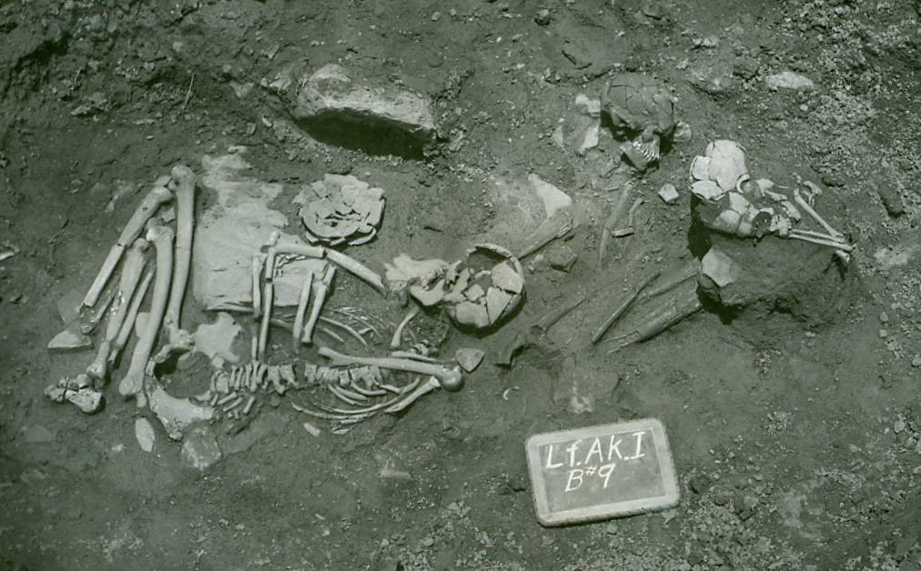
Figure 21 Burial 9 from the Akers site, consisting of three likely non-associated individuals (arrows point to skulls)

About half of the examined sites had multiple extra skulls that were initially interpreted as evidence of successful trophy hunting. For instance Burial 45 from the Adams site (34Lf33) is difficult to interpret as anything other than a trophy. As seen in Figure 22, an isolated skull was interred surrounded by small shells.
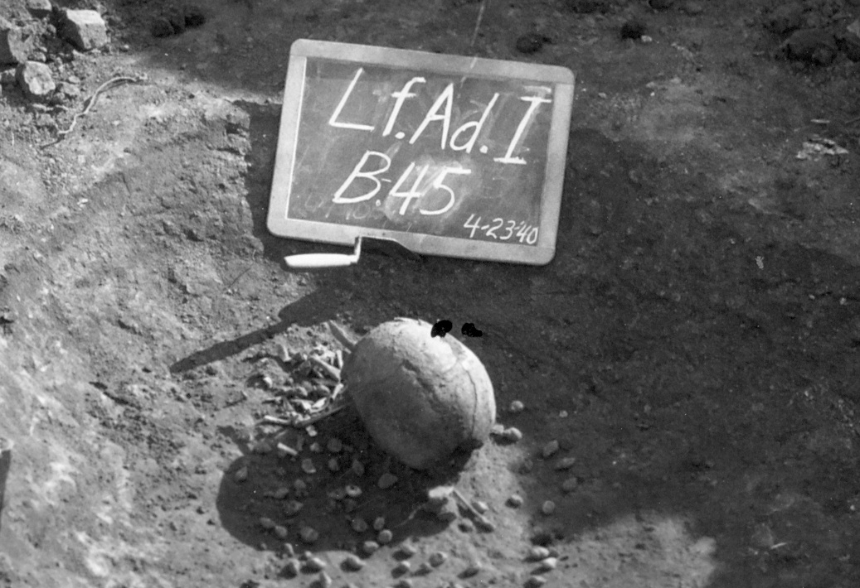
Figure 22 Burial 45 from the Adams site (34Lf33) was an isolated skull surrounded
by small shells

It was more difficult to ascertain when burials were missing skulls. From examining both burials and documentation at the Akers site (34Lf32), I knew that even when the documentation claimed there was no skull and the photograph and excavation sketch appeared to indicate a missing skull, fragments of crushed cranial bones and/or teeth were often found mixed in with the body bones. This is attributed to the normal taphonomic processes that can move or crush skulls (such as gravity or animals) after burial, making it difficult for the WPA workers to recognize that the skull was indeed still with the body. However in some cases, contextual analysis made it clear that the skull had probably been removed before burial as a trophy. For instance, Burial 87 from the Akers site (34Lf32), discussed in the previous chapter, and pictured in Figures 16 and 17, consisted of two well-articulated skeletons. It is clear from the photographs of this burial that one of the skulls was completely missing. This is considered evidence of trophy taking. This interpretation is strengthened by the fact that each body was surrounded with projectile points that had clearly been embedded in the bodies at the time of death. These individuals are also an example of “pin-cushioning” which is suggestive of vengeance killing (Dye 2009). Further, as can be seen in Figure 17, a close-up of the one remaining skull revealed that something (possibly phalanges) had been inserted into the nasal cavity.
The number of missing skulls was tabulated (to the best of my ability with the available documentation). However, due to the difficulty in ascertaining if a burial was indeed missing its skull, the degree to which Wister area residents may been the victims of such trophy taking is not addressed, nor is statistical analyses for the number of missing skulls performed.
To summarize, by examining archival evidence stored at SNOMNH for over 1,200 burials, I tabulated the number of multiple burials at 13 Wister area Fourche Maline sites. These multiple burials are used as a proxy measure for conflict. The number of extra skulls and missing skulls, taken to represent trophy hunting behavior, is also presented. Intersite comparison of the rates of violence and trophy taking patterns were examined in order to quantitatively address the degree of inferred peri-mortem trauma and violence at these Wister area Fourche Maline sites.

Sites
Thirteen Fourche Maline sites (listed in Table 20) along Fourche Maline Creek or the Poteau River in the Wister area were used in this portion of the study. More detail about each site can be found in Chapter 3. The following five criteria were used in choosing sites for this comparison:
- The site was located in the Wister area on Fourche Maline Creek or Poteau River.
- There was a burial mound that was at least partially excavated.
- The site was excavated by the WPA (with the exception of 34Lt11 the McCutchan McLaughlin site).
- Original WPA documentation existed and was archived at SNOMNH, including WPA quarterly reports, ADS sheets, field drawings, and field photographs (again with the exception of 34Lt11, the McCutchan McLaughlin site).
- The site was/is considered primarily “Fourche Maline.”

The larger mounds (Akers, Mackey, Williams, and Brewer) are undoubtedly multi-component mounds with burials from both the Wister and Fourche Maline phases, and possibly a few later burials as well. However all the mounds chosen are considered predominately Fourche Maline phase and fit into the original definition of “Fourche Maline.” Only a few of these sites have had the skeletal remains examined. McCutchan McLaughlin (34Lt11) (Powell and Rogers 1980) and Wann (34Lf27) and Sam (34Lf28) (McWilliams 1970) have a more or less complete bioarchaeology completed and published. The Mackey site (34Lf29) has only basic paleodemography completed (Burns 2009). The Akers site burials have both paleodemography (Rowe 2009) and basic paleopathological analysis completed (see Chapter 4).
In addition to the WPA excavated sites, the McCutchan-McLaughlin (34Lt11) site was included in this analysis. Although McCutchan-McLaughlin was not excavated by the WPA, it is by far the best studied Wister area Fourche Maline site and serves as a useful comparison. However, keep in mind that only about 10% of the mound (and presumably the burials) was excavated.

Results
The number of multiple burials and the number of extra skulls were tabulated for these thirteen Wister area Fourche Maline sites.

Multiple Burials
All of the thirteen sites had at least one multiple burial. One quarter (25%) of the individuals buried in the Wister area Fourche Maline sites were interred in group burials. This figure was calculated by dividing the total number of individuals in group burials by the total number of individuals excavated. Table 20 lists the sites and percent multiple burials, sorted from highest to lowest. The columns list the number of single, double, triple, quadruple, and mass burials for each site as well as the total number of individuals buried in multiple graves and the total number of individuals from each site. A mass burial is here defined, somewhat arbitrarily, as burial with 5 or more individuals. By this definition, 9 of these 14 sites had mass burials (previously listed in Table 19).
This average of 25% masks a large range from just 15% at the Brewer site (34Lf39) to 70% at the smallest site Redwine (34Lf15). Although all sites have group, or multiple burials, only the Mackey (34Lf29) site had more than one mass burial. As can be seen in Table 20, three mass burials were uncovered at the Mackey site; two of the mass burials contained five individuals each, and the third mass burial contained six individuals. Additionally, five sites contained very large burials of 9 or more individuals.

Table 20 Multiple burials per site in the Wister Area

Site # |  | Individuals per grave |  |  |  |  | Total Multiple Inds | Total Inds | % Mult
Site # | Site Name | 1 | 2 | 3 | 4 | 5+ | Total Multiple Inds | Total Inds | % Mult
34Lf39 | Brewer | 124 | 6 | 1 | 0 | 1 (7) | 22 | 146 | 15
34Lf20 | Copeland | 84 | 0 | 3 | 0 | 1 (5) | 14 | 88 | 16
34Lf24 | Williams I | 168 | 7 | 3 | 3 | 1 (5) | 39 | 210 | 19
34Lf18 | DeHart I | 28 | 2 | 1 | 0 | 0 | 7 | 35 | 10
34Lf32 | Akers* | 154 | 14 | 3 | 1 | 1 (11) | 52 | 206 | 25
34Lf19 | Hooks | 68 | 11 | 1 | 0 | 0 | 25 | 93 | 27
34Lf33 | Adams | 58 | 2 | 2 | 0 | 1 (11) | 21 | 79 | 27
34Lf17 | DeHart II | 26 | 5 | 0 | 0 | 0 | 10 | 36 | 28
34Lf28 | Sam | 38 | 9 | 1 | 0 | 0 | 21 | 73 | 29
34Lf27 | Wann | 21 | 1 | 1 | 0 | 1 (5) | 10 | 32 | 31
34Lt11 | McC-McL | 29 | 3 | 1 | 0 | 0 | 18 | 47 | 38
34Lf29 | Mackey* | 137 | 13 | 5 | 2 | 3 (5,5,6) | 65 | 165 | 39
34Lf15 | Redwine | 3 | 2 | 1 | 0 | 1 (11) | 7 | 10 | 70
 | Totals | 938 | 73 | 21 | 6 | 10 (71) | 311 | 1220 | 25

*In order to keep the comparisons consistent, the numbers for each site reflect what was tabulated via examination of archival photographs and other documentation, and not the numbers of individuals discovered during laboratory analysis.

It is reasonable to hypothesize that larger sites might have more people interred in group burials. In order to discern if there was any relationship between site size and multiple burials, the total number of individuals buried (x axis) versus the percent of individuals interred in a group burial (y axis) was plotted. As seen in Figure 23 a weak negative correlation (R=-.4) is apparent. However if the outlier site of Redwine (small site with suspiciously high percentage of group burial) is removed, the correlation is nonexistent (R=0). The number of individuals at each site therefore does not appear to have any significant relationship to how many people were interred in a multiple burial. However this analysis is compromised by the fact that most of the “small” sites were actually larger sites that were not completely excavated. For instance the McCutchan-McLaughlin (34Lt11) site, with its mass burial of 9 individuals, was only about 10% excavated (Wyckoff and Woody 1977). Similarly, the site with the highest percentage of mass burials, Redwine (34Lf15) was only partially excavated.

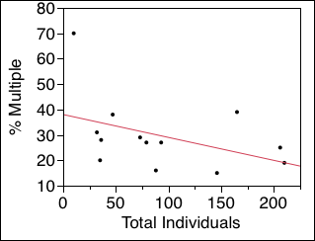

Figure 23 Biplot of the percentage of total number of individuals (x axis) by
the percentage of multiple burials (y axis) for all sites, with best fitted line
for all sites in the study

In an attempt to control for incomplete excavation, Akers (34Lf32), Brewer (34Lf39), Mackey (34Lf29), and Williams I (34Lf24) were selected for separate analysis. Each of these four sites had over 100 burials and, perhaps more importantly, all four sites were completely or nearly completely excavated. The sites range from 146 burials at Brewer, to 210 burials at Williams I, as detailed in Table 26. About 24% of the individuals at these four sites were interred in multiple graves, with a low of 15% at Brewer and a high of 39% at Mackey. A biplot of the percentage of individuals in multiple burials by total number of individuals (Figure 24) again fails to show a meaningful correlation; indeed the pattern appears quite random. Neither Brewer nor Williams I have any bioarchaeological analysis to help with interpretation. However both Akers and Mackey have demographic information available.

Figure 24 Biplot of the total number of buried individuals (x axis) by the percentage of multiple burials (y axis) for the large sites Akers, Brewer, Mackey, and Williams I

It can be seen from Table 26 that 39% of the individuals at Mackey (34Lf29) were in group burials, and 25% of the individuals from Akers (34Lf32) were in group burials. Mackey was the only site with a more than one mass burial (more than 5 individuals in a single grave), while Akers had only one mass burial. Mackey was the deepest of the excavated Wister area Fourche Maline mounds at nearly 10 feet at its maximum depth (Burns 1994), while Akers was quite shallow, only about 3 feet at its maximum depth (Rowe 2009).
At the Akers site, with about 25% of the individuals in multiple burials, and only one mass burial, there are nearly twice as many females as males (M:F ratio = 0.6) (Rowe 2009). With the exception of the incompletely excavated Redwine site (34Lf15), Mackey has the highest percentage of multiple burials as well as three mass burials. In contrast to Akers, Mackey had nearly twice as many adult males as females (M:F ratio = 1.6) (Burns 1994). It is reasonable to posit that the high percentage of male burials at the Mackey site may account for the also high percentage of multiple (violent death) burials. This conclusion would be strengthened if more sites had demographic information available.

Trophy taking behavior
Trophy taking behavior in the Eastern Woodlands is well-documented by Archaic times (Jacobs 2008, Milner 2005, Walker 2001) and continued well into historic times. As previously described, the number of extra skulls and the number of missing skulls for each of the thirteen Wister area Fourche Maline sites was tabulated. This data is presented in Table 27. The column labeled “+ Skull” represents the number of extra skulls, while the column labeled “- Skull” represents the number of missing skulls. Similarly “% +” is the percentage of extra skulls (extra skulls divided by total number of individuals per site) and “% -” is the percentage of missing skulls (missing skulls divided by total number of individuals per site). However the number of missing skulls is certainly under-represented for reasons reviewed earlier, and will not be further discussed.
As presented in Table 21, 7 of the 13 sites had extra skulls, which I interpret as evidence of successful trophy hunting. Additionally, at least 5 of the sites had skeletons with missing skulls. Overall, about 3% of the individuals interred in these mounds were skulls only, and about 1% were missing their skulls.

Table 21 Trophy skulls by site

Site # | Site Name | Total Multiple Inds | Total Inds | % Mult | +  Skull | %  + | - Skull | %  -
34Lf39 | Brewer | 22 | 146 | 15 | 5 | 3 | 3 | 2
34Lf20 | Copeland | 14 | 88 | 16 | 5 | 7 | 0 | 0
34Lf24 | Williams I | 39 | 210 | 19 | 0 | 0 | 0 | 0
34Lf18 | DeHart I | 7 | 35 | 10 | 6 | 17 | 0 | 0
34Lf32 | Akers* | 52 | 206 | 25 | 2 | 1 | 2 | 1
34Lf19 | Hooks | 25 | 93 | 27 | 9 | 10 | 3 | 3
34Lf33 | Adams | 21 | 79 | 27 | 5 | 6 | 0 | 0
34Lf17 | DeHart II | 10 | 36 | 28 | 0 | 0 | 3 | 3
34Lf28 | Sam | 21 | 73 | 29 | 0 | 0 | 0 | 0
34Lf27 | Wann | 10 | 32 | 31 | 0 | 0 | 0 | 0
34Lt11 | McC-McL | 18 | 47 | 38 | 0 | 0 | 0 | 0
34Lf29 | Mackey* | 65 | 165 | 39 | 4 | 4 | 1 | 1
34Lf15 | Redwine | 7 | 10 | 70 | 0 | 0 | 0 | 0
 | Totals | 311 | 1220 | 25 | 36 | 3 | 12 | 1

Sites either had 0 extra skulls (Williams I, DeHart II, Sam, Wann, McCutchan-McLaughlin, and Redwine) or 2 or more extra skulls (Brewer, Copeland, Dehart I, Akers, Hooks, Adams, and Mackey). Surprisingly, the site with the highest percentage of extra skulls (6 skulls, or 17% of the site’s excavated burial population) comes from the small site of DeHart I (34Lf18). These extra skulls do not appear to be clustered together. However, only a small portion of DeHart I was excavated, so the overall pattern of the burials is not clear.
A reasonable assumption is that sites with high levels of violence (i.e. percentage of group burials) would also have proportionally more extra skulls. This was examined by plotting the percentage of individuals in multiple graves (x axis) against the percentage of extra skulls (y axis). As seen in Figure 25, there is a weak negative correlation (R=-.34). This suggests that sites with more violence might actually have fewer extra skulls.

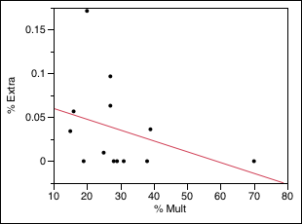
Figure 25 Biplot of the percentage of multiple burials (x axis) by percentage of
extra skulls (y axis) per site

In order to determine if site size had an effect on the number of extra skulls, the total number of individuals buried at each site (x axis) was plotted against the percentage of extra skulls (y axis). As can be seen in Figure 26, a clear negative correlation (R=-.87) can be seen, once the sites with no extra skulls are excluded. Larger sites actually have fewer extra skulls.
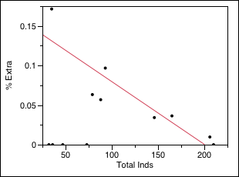
Figure 26 Biplot of the percentage of total individuals per site (x axis) by
the percentage of extra skulls (y axis) per site

Note that at Akers, the site with excess adult females, has only 2 extra skulls, while Mackey, the site with excess adult Males, has 6 extra skulls, again suggesting that the extra males at the Mackey site may be the reason for the extra skulls. Again, due to the lack of paleodemography at other sites, it is not possible to see if this pattern holds up through the study area.

Summary and Discussion
Group burials were found at all of the 13 Wister area Fourche Maline sites examined, and mass burials were found at 9 of the 13 sites, indicating widespread conflict throughout the area. However the varying rates of group burials (from 14% at Brewer to 70% at Redwine) suggests that the sites did not all participate in conflict equally.
The site with the highest rate of violence is Redwine (34Lf15), with 70% of the individuals at the site in a (single) group burial. Excavation notes are scanty, but the site was only worked for four days, and was probably not fully excavated. Nor has this site been analyzed, either in terms of burials or artifacts. Due to the lack of information it is impossible to speculate why Redwine had such a high rate of multiple burials. Although it is tempting to dismiss Redwine’s high rate of multiple burials as a statistical anomaly given the few excavated burials, the site does have a mass burial consisting of 11 individuals meaning that there was at least one significant event of violence at the site.
The two sites with the next highest rates of violence are Mackey (34Lf29) and McCutchan-McLaughlin (34Lt11). Although only about 10% of the mound at McCutchan McLaughlin was excavated, it is by far the best studied of these Fourche Maline mounds, not only in terms of C14 dates (Baugh 1982) and general archaeology (Leith 2006, 2009; Wyckoff 1976), but also in terms of mortuary analysis and bioarchaeology (Powell and Rogers 1980). These studies make clear that McCutchan-McLaughlin has both a Fourche Maline (Woodland) component as well as an older Wister (Archaic) component. Similarly the Mackey site was also divided into Wister (Archaic) and Fourche Maline (Woodland) components (Burns 1994). However researchers were not able to assign individual burials to either component for either site and they have all been considered Fourche Maline for bioarchaeological analysis (Rose et al. 1999). The great depth of the Mackey mound may suggest a longer or more intensive span of use than the other, shallower Fourche Maline mounds. The higher rate of violence at Mackey is most easily attributed to the higher number of males interred there. Since McCutchan-McLaughlin is only partially excavated, it is difficult to posit a reason for its (relatively) high level of violence.
Sites either had zero extra skulls (six sites) or a minimum of two extra skulls (seven sites). This division is perplexing and suggests that there may be two different groups of sites in the area. The largest percentage of extra skulls was from the small sites of Dehart I. There was a weak negative correlation between extra skulls and the percentage of multiple burials (violence), and a strong negative correlation between extra skulls and the overall size of the burial population. It is possible that some of these extra skulls are not actually trophies or representative of violent behavior. This may be a fruitful avenue for future research.
The initial question of weather or not the high rates of conflict seen at the Akers site was pervasive throughout the study area is an unqualified yes, given that all of the examined sites had multiple individuals in group burials. However the sites appear to have engaged in violent behavior in different ways – from low to high rates of group burials, and from no to high rates of possible trophy (extra) skulls.
While the lack of a consistent pattern of violence throughout the valley is frustrating, this is likely partially due to the mixed component nature of most of the sites. Additionally, as previously mentioned, Eastern woodland societies were prone to feuding, which matches well with the evidence that exists for the valley. Raiding parties, in which a small group of (usually) adult men attacked and killed isolated individuals or small groups are a common aspect of feuding groups (Milner 1999, 2005; Walker 2001). These raiding parties probably had a disproportionate effect on small societies. In addition to losing the subsistence activities of the adults killed or injured, the remaining adults might be less likely to venture very far in order to hunt or gather. The very high rates of nutritional deficiencies seen at the Akers site (discussed in the previous chapter) may be a direct result of feuding. The following chapter will discuss these Wister area findings in a broader context.

Chapter 6: Discussion and Conclusions
Chapter 4 reported evidence for skeletal trauma and nutritional stress at the Akers site, and Chapter 5 presented an analysis of group burials for 13 Wister area Fourche Maline mounds. In this chapter the data are further interpreted and discussed.

Wister Area Demography and Time Scale
Before discussing the health status of the Wister area, a brief overview of its paleodemography is in order. However radiocarbon dates indicate that the Wister area was occupied for a very long time period. The two dates from the Akers site alone span a period of over two thousand years (840 BCE – 1300 CE). Clearly the individuals buried in the Wister area mounds span a much longer time period than is usually appropriate for an examination of demography. As discussed in Chapter 3, Schambach (1990, 2002) opines that it is not appropriate to discuss the Wister Area Fourche Maline mounds as a single population due to both the very long time span involved and he is convinced that a migration group displaced or assimilated local residents.
The theory that a migrating group displaced or assimilated the local residents has not met with much support from other archaeologists. Rogers (1991) explicitly addressed Schambach’s (2002) migration theory, noting that there is no archaeological evidence for such a migration/displacement/assimilation and that the status quo explanation of in situ cultural development is a far more parsimonious scenario. Roger’s view is echoed by a host of other researchers (e.g. Bell 1980, 1984; Brown 1984; Bruseth 1998; Galm 1978, 1984; Perttula 2012; Rogers 1991a, 1991b; Wyckoff 1980). As previously stated, this work follows the view that the Wister area Fourche Maline was an antecedent, ancestral manifestation of Caddoan culture.
Previous studies of the Wister area populations (McWilliams 1970, Powell and Rogers 1980, Rose et al. 1983) based on non-metric traits of the skull, which are thought to be genetically controlled and thus are indicative of biological relatedness, have concluded that the Wister area sites shared a common genetic heritage and could be viewed as a single breeding population. This conclusion of a common gene pool allows for assumptions of common resistance and susceptibility to disease processes and allows for intra-valley comparisons.
Additionally, because the sites are geographically close and all within the same valley of the Ouachita Mountains, they share similar ecological constraints and resources, as well as presumably similar cultural attributes, strengthening comparisons (Rose et al. 1999). Furthermore, the stable artifact assemblages, which have stymied temporal fine-tuning, strongly support the idea of a stable population that lived a similar lifestyle for a very long period of time.
This study does not attempt temporal refinement, but takes a macro look at the Wister Area through a long term lens. Because the area is broad and the time span long, the documented anomalies are all the more striking.

Wister Area Demography
The numbers of adults from the six Wister area Fourche Maline sites with published data is presented in Table 22, along with M:F ratios. As previously reported, the M:F ratio at the Akers site was 0.6, or nearly twice as many adult females as adult males (Rowe 2009). The Akers site is not the only Wister area Fourche Maline site with an unusual M:F ratio. The Mackey site, situated only a few kilometers from Akers, had the opposite ratio, with nearly two times as many males as females (Burns 1994).
The unusual M:F ratios from the Akers and Mackey sites cannot be dismissed due to small sample size, nor to non-random sampling, as both mounds were completely, or nearly completely excavated. Both studies were overseen by the same experienced physical anthropologist (Dr. Lesley Rankin Hill of the University of Oklahoma Department of Anthropology). Therefore the M:F ratios presented should be considered a real representation of the burial populations at the Akers and Mackey sites. More females (nearly twice as many) were buried at the Akers site, and more males (again, nearly twice as many) were buried at the Mackey site.
Table 22 Male:Female ratio comparisons, adapted from Rowe 2009

Sex | Akers | Mackey | Scott | McC-  McL | Sam/  Wann | Total
Male | 53 | 45 | 8 | 13 | 33 | 150
Female | 90 | 29 | 7 | 14 | 36 | 176
Ratio | 0.6 | 1.6 | 1.1 | 0.9 | 0.9 | 0.9

The Sam and Wann sites were situated very close together along the northern bank of Fourche Maline Creek. Because of their proximity as well as small sample sizes, the skeletal data are often collapsed and analyzed as a single unit. If this is done, there are 31 adults males and 32 adult females for a M:F ratio of 0.86 or 0.9 from the Sam and Wann sites, which is close to the expected 1. The Scott and McCutchan-McLaughlin site ratios are also close to expectations of nearly equal numbers of male and female burials, although the Scott size is suspect due to low sample size as well as issues with the analysis itself. If all six sites are collapsed into a single metric, the results are close to the expected ratio of 1. Combined, the six sites yielded 150 adult males and 176 adult females for M:F ratio of 0.85 or 0.9. Taken as a single community, the sites in the Fourche Maline drainage display nearly equal numbers of adult males and females, as expected. However the Akers and Mackey sites strongly suggest that populational patterns and trends must be considered on a regional level in the Fourche Maline Valley, and that each mound should not be considered as a separate, discrete population. It may be noteworthy that, of this group, only Mackey and Akers were fully excavated, and it is possible that some of the remaining sites only appear to have equal male:female ratios due to sampling error from incomplete excavations.
One explanation for the high numbers of women at the Akers site and the high numbers of men at the Mackey site is that people preferentially (purposely) buried women at the Akers mound and men at the Mackey mound. However, if Wister area Fourche Maline peoples followed this sort of burial program, then other burial mound sites should also follow this pattern, not just Akers and Mackey.
A more parsimonious explanation (rather than a complex valley wide burial program) is that when a person died, they were laid to rest in the closest burial mound. This explanation requires that more women died close to the Akers site and that more men died close to the Mackey site. One natural way this could happen is if different sites were preferentially (but not exclusively) utilized for different purposes or tasks that may have often been performed by a certain group of people (e.g. sex-segregated activities). In this way it would be easy to accumulate more burials of men at a site where adult males congregated, or more women at a site where adult females congregated.
There is some evidence to support this idea that different sites may have been used for different purposes at least some of the time. For instance, as discussed in Chapter 3, excavations at the Hooks site uncovered literally hundreds of manos and metates (used for grinding nuts and seeds), as pictured in Figure 7. It is quite possible that the Hooks site was preferentially utilized for processing of plant material. Because the Hooks burials have not been analyzed, the paleodemographic profile is unknown.
It is currently unclear why the Akers site had a preponderance of females or the Mackey site a preponderance of males. Note however that the Mackey site, with its high proportion of adult males, is the only site in the Wister area Fourche Maline with more than one mass burial (see Chapter 5), suggesting that this site may have been preferentially (though not exclusively) used in times of conflict.

Wister Area Fourche Maline Health and Nutritional Status
When the skeletons of the people buried at the Akers site are compared to other analyzed Wister area Fourche Maline sites (McCutchan-McLaughlin, Mackey, Scott, Sam, and Wann), several differences are clear. The Akers burials had more than expected adult females, a high prevalence of broken and fractured bones, and both healed and active cribra orbitalia lesions.

Skeletal Trauma
Chapter 4 detailed skeletal trauma at the Akers site. When cranial and limb fractures were combined, 35% of the assessed population was observed with at least one fractured bone. The difference by sex (29% male, 39%) was not statistically significant. When patterns of fractures were compared by anatomical region, females were more likely to fracture their lower limbs than their male counterparts. Females were also more likely than m ales to have multiple bone fractures.
As suggested in Chapter 4, at least some of these multiple injuries to adult females may have been the result of repeated abuse. The most dramatic example is Burial 142, a young female found with neonatal bone fragments, indicating that she was either pregnant or had just given birth. At time of death she had bilateral femur fractures, fractures to the right tibia and right fibula, and a depressed fracture to the frontal bone. She was also suffering from a systemic infection. These injuries represent at least two, and possibly three separate traumatic incidents. It is difficult to escape the conclusion that this individual was severely beaten on at least two occasions, if not more.
Skeletal trauma from other Wister area Fourche Maline sites is negligible. At the McCutchan-McLaughlin site, only a single individual (an old adult male) was noted to have a healed fracture (Powell and Rogers 1980:19). Since there were 27 successfully aged and sexed adult individuals recovered from the site, this is about 4% of the population. The Wann and Sam sites produced a total of five fractured bones and 69 aged and sexed adults (McWilliams 1970), or about 7% of the population. The much higher rates of fractured bones from the Akers site are perplexing.

Nutritional status
As reported in Chapter 4, 6% of the adults examined at the Akers site were observed with signs of porotic hyperostosis. The frequency was higher in subadults, at 21% (Rowe 2009). As reviewed in Chapter 2, porotic hyperostosis interpretations are in flux. Although Ortner suggests they may be interpreted as parasite load, other researchers continue to refer to them as a symptom of anemia (e.g. Steckel and Rose eds. 2002, Cohen and Crane-Kramer eds. 2007).
While only 18% of the adults had active cribra orbitalia lesions, over half the adult population had healed cribra orbitalia lesions, for a total of 72% of the adults with either healed or active lesions. Subadults also had high rates of cribra orbitalia (68% active lesions) (Rowe 2009). Cribra orbitalia lesions are currently interpreted as good evidence for Vitamin C deficiency (Ortner et al. 2001, Walker et al. 2009).
Subadults at Akers displayed higher rates than adults for both indicators of nutritional stress. Subadult rates at Akers were 21% for porotic hyperostosis and 68% for (active) cribra orbitalia (Rowe 2009), suggesting that they were at higher risk of nutritional stress than the adults.
Once again, data from other Wister area Fourche Maline sites differs from the Akers results. At McCutchan-McLaughlin (34Lt11), there was one possible case of porotic hyperostosis (2%) and one possible case of cribra orbitalia (2%) (Powell and Rogers 1980:27). No cases of porotic hyperostosis or cribra orbitalia were reported from either Sam or Wann (McWilliams 1970). A summary table for the DeHart II site, presumably compiled by R. Vehik reports 45.5% of the subadults and 22.2 % of the adults had “osteoporotic pitting.” However it is not clear if this refers to porotic hyperostosis and/or cribra orbitalia, or the more general pitting found over the occipital region of many skulls at Akers and McCutchan-McLaughlin.
A 1980 summary of Wister area health and nutritional status, dismissed scurvy, iron deficiency anemia, and rickets as an issue for the McCutchan-McLaughlin site as well as the Sam and Wann sites (Powell and Rogers 1980:47). In addition, both parasitic infestation and fungal infections were thought to be uncommon for the Fourche Maline phase people of southeastern Oklahoma, based on the available data (Powell and Rogers 1980:46). Overall, the study concluded that the population had a diet “adequate in both calories and essential nutrients” (Powell and Rogers 1980:47) and that the health of the population was “generally good” (Powell and Rogers 1980:48). However this summary is somewhat at odds not only with the Akers data, but also with other Eastern Woodland summaries for similar time periods.
Both porotic hyperostosis and cribra orbitalia lesions are quite common in other North American pre-contact sites, although they do tend to be low in pre-agricultural skeletal series. For instance, in pre-contact, pre-agricultural sites at the Georgia bight (a long coastland area extending from North Carolina to Florida), cribra orbitalia rates were 5.7% overall (38.5% for Juveniles) (Larsen and Sering 2000). By contrast, cribra orbitalia lesions ranged from 23-63% for 13 maize dependent sites in Virginia and North Carolina (Lambert 2000:179). This general trend of lower rates of cribra orbitalia in pre-agricultural societies and higher rates in agriculture dependent groups is largely consistent (Cohen and Crane-Kramer 2007, Steckel and Rose 2002, etc.).
The higher rates of cribra orbitalia in both subadults and adults at the Akers site, where agriculture was not a significant factor, require explanation. I originally suggested that high rates of cribra orbitalia in subadults signaled Vitamin C deficiency and were due to an over-reliance on hickory nut mash for weanlings and children (Rowe 2009). Hickory nuts, while an excellent source of calories, protein, and fat, have almost no Vitamin C content. I anticipated that adults would have much lower rates of cribra orbitalia once their diets expanded.
Active rates of cribra orbitalia are indeed lower in adults. However the majority of adults also had healed cribra orbitalia lesions. Combined with the high subadult rate, this suggests that nutritional stress, particularly Vitamin C deficiency, was a persistent (though intermittent) problem at Akers. Hunger osteopathies (a syndrome of severe osteoporosis, periostitis, cribra orbitalia and porotic hyperostosis), as described by Ortner (2003:405) were not observed. Heights for the adults at Akers are not significantly lower than for other studied Wister area Fourche Maline sites (Rowe 2009). Both of these results suggest that actual famine was not the issue at Akers. Rather intermittent deficiency in Vitamin C was probably a persistent, intergenerational problem for the Akers residents.
This interpretation is consistent with what we know about Vitamin C deficiency. Recent evidence has demonstrated that scurvy can be a significant seasonal stressor even in non-displaced populations (Cheung et al. 2003). It is also possible that Akers was used more heavily in the winter, when fresh foods containing Vitamin C would be scarce. However the enduring Vitamin C shortages may also have been the consequence of a restricted hunting and foraging range due to intense feuding that occurred along the entire Fourche Maline-Poteau drainage valley, or Wister area.

Wister Area Group Burials and Violent Death
Conflict in the Wister area during the Fourche Maline was expected to manifest as feuding. Specifically, burials would be expected to show high rates of skeletal trauma, which was demonstrated at the Akers site (Chapter 4). Burials should also show evidence of mass graves and small group burials as well as trophy taking behavior (Dye 1997, 2013). These correlates were demonstrated for the Wister area Fourche Maline in Chapter 5.
Although frequency of and severity of the feuding appears to have varied, it is clear that conflict was a persistent, valley wide phenomenon. As detailed in Chapter 5, rates of group burial, taken as a proxy for violent death, varied from 15% at the Brewer site (34Lf9) to 70% at the Redwine site (34Lf5). For the entire Wister area Fourche Maline, 311 individuals, or 25% of those examined, were interred in group burials. Furthermore, 71 individuals, or 6% of the total number of individuals, were interred in mass graves (5 or more individuals).
A previous estimate for violent death in the Wister area Fourche Maline was 4% (Galm 1978:241). It is unclear how this number was calculated, although it appears to be a combination of mass graves and embedded projectile points. Clearly this early estimate is far too conservative, given that 25% of the Wister area Fourche Maline population was interred in group burials. Even if half of the group burials from the Wister area Fourche Maline are not the result of violent death, this early estimate is far too low.
Although the evidence for conflict may seem extreme in the study area, in truth it may not have been that unusual for its time. Ethnographic studies suggest that modern hunter-gatherers engage in violent conflict on average once every other year (Ember and Ember 1997:5) and that about 25% of adult males in non-state level societies died from violence well into the 20th century (Keeley 1996).
The Wister area is not unique archaeologically either. For instance at the Norris Farms #36 cemetery in the central Illinois River Valley, up to one-third of adults lost their life due to warfare (Milner et al. 1991). At the Dickson Mounds site in Ohio, 16% of the 264 individuals interred there were killed by others (Lallo, Rose, and Armelagos 1980).
Spontaneous conflicts over resources tend to arise even in resource-rich area such as river valleys (Dye 2013:135). These conflicts are between co-residents of an area who routinely hunt/gather together, and weapons are simply those carried for food procurement. Such conflict is the result not only of population density but also of resource availability, and the desire to secure resources without having to share them (Dye 2013:135-136).
Throughout eastern North America, the late Woodland period (ca 400-100 CE), roughly contemporaneous with the Fourche Maline, was characterized by population growth and increasing conflict (Anderson 2001:163). Both the archaeological and paleopathological evidence indicate that the Wister area Fourche Maline was a regional variant of this larger pattern.

Future Work
This work has demonstrated that the Wister area Fourche Maline was a contested landscape. Although this is clear at the regional level, further studies are needed in order to further understand the dynamics and health status of these ancestral Spiroans. Further biological (osteological) and material (artifacts, landscape studies) investigations are needed not only at Akers, but also throughout the Fourche Maline and Poteau stream valleys, or Wister area.
Analysis of the Akers site is ongoing. As previously mentioned, the majority of crania from Akers were culturally modified. Cranial analysis is in the final stages of assessment, and will detail the multiple types of modifications seen at Akers. This work will be reported in a separate publication. Paleopathological assessment of the dentition from Akers is limited due to the few maxilla recovered. However a number of relatively complete mandibles with dentition are available for analysis. This analysis will be completed at a later date.
Additionally, a collaborative analysis of the chipped stone lithic assemblage from the Akers site in in process. This study will compare the artifacts from burial squares with non-burial squares in order to be directly comparable with previous Wister area Fourche Maline lithic analyses (Burns 2007, Leader 1997). Analysis of the faunal remains from the Akers site has also begun.
Several sites in the study area deserve special mention as needing analysis. The Scott site burials were examined in the 1950s by an undergraduate student and require reanalysis. Although the Mackey site has had basic paleodemography completed, a thorough paleopathological assessment should be undertaken. The Adams site, which has a mass burial of nine individuals buried facedown, is an important site that needs bioarchaeological analysis. Williams I, the most carefully excavated of the WPA Wister area Fourche Maline sites, has over 200 unanalyzed burials and a large number of artifacts that also require careful assessment.
Additionally, several recurring themes at these sites need further investigation. For instance, most of these sites have dog burials, which would make a fascinating study in itself. All of the sites have ash deposits, many of them (possibly all of them) without evidence of in situ development. Secondary ash deposits are an interesting feature that requires theorization and analysis. Although this study has avoided issues of temporality, it may be possible to assign some of the Akers burials dates based on a combination of paleopathological and artifact data.
Finally, the mounds themselves require a more theoretical orientation than they have previously received. The mounds have been uncritically characterized as middens since the early 1940s, despite their predominate feature being human burials. If the artifacts in the mounds are reconceptualized as purposeful deposits rather than refuse, whole new areas of inquiry are possible, including theoretically and methodologically rich concepts such as feasting, ceremonialism, and ritual.

Conclusions
The Wister area during the Fourche Maline cultural phase was a contested landscape. Although overall violence in the valley varied considerably by site, 25% of the residents in the valley were interred in group or mass burials, suggesting widespread conflict. The previous chapters have demonstrated high rates of skeletal trauma, high rates of subadult nutritional deficiencies, and moderate rates of adult nutritional deficiencies at the Akers site (34Lf32), a large, completely excavated burial mound from the eastern end of the Wister area Fourche Maline complex. Examination of multiple Fourche Maline mounds has documented varying, but generally high rates, of group burials, which are taken as proxy evidence for violent death.
Because the Wister area Fourche Maline was a contested landscape, residents of the valley were affected in multiple ways, including compromised health status, as reflected by rates of skeletal trauma and decreased nutritional status. Both children and adults were at risk of violent death. However in addition to violence and periodic nutritional stress, there were no doubt attempts at conciliation, ceremony, and ritual. The Wister area Fourche Maline offers a rich arena for further exploration of these important issues.

References
Albert, Lois E.
1981 Ferndale Bog and Natural Lake: Five Thousand Years of Environmental Change in Southeastern Oklahoma: Oklahoma Archeological Survey, Studies in Oklahoma’s Past, Number 7.

Albert, Lois E., and Don G. Wyckoff
1984 Oklahoma Environments: Past and Present. In Prehistory of Oklahoma. R.E. Bell, ed. Pp. 1-43: Academic Press.
Altschul, Jeffrey, ed.
1983 Bug Hill: Excavation of a Multicomponent Midden Mound in the Jackforth Valley, Southeast Oklahoma: New World Research, Pollock Louisiana. US Army Corps Engineers, Tulsa.
Anderson, David G.
2001 Climate and culture change in prehistoric and early historic eastern North America. Archaeology of Eastern North America 20:143-186.
Angel, J. Lawrence
1966 Porotic Hyperostosis, Anemias, Malarias, and Marshes in the Prehistoric Eastern Mediterranean. Science 153(3737):760-763.
Altschul, Jeffrey, ed.
1983 Bug Hill: Excavation of a Multicomponent Midden Mound in the Jackforth Valley, Southeast Oklahoma: New World Research, Pollock Louisiana. US Army Corps Engineers, Tulsa.
Armelagos, George J., and Mark Nathan Cohen
2013 Preface to the 2013 Edition. In Paleopathology at the Origins of Agriculture. 2nd edition. M.N. Cohen and G.J. Armelagos, eds. Pp. xvii-xxxvi. Gainsville.: University Press of Florida.

Aufderheide, Author C., and Conrado Rodriguez-Martin
1998 The Cambridge Encyclopedia of Human Paleopathology. Cambridge University Press.
Banks, Larry D.
1984 Lithic Resources and Quarries. In Prehistory of Oklahoma. R.E. Bell, ed. Pp. 65-95. Orlando: Academic Press.
1990 From Mountain Peaks to Alligator Stomachs: A Review of Lithic Sources in the Trans-Mississippi South, the Southern Plains, and Adjacent Southwest: Memoir No. 4. Oklahoma Anthropological Society, Lawton.

Baugh, Susan Thomas
1982 Radiocarbon Dates from McCutchan-McLaughlin Site 34LT-11. Oklahoma Anthropological Society Newsletter 30(2):4-8.
Bell, Robert E.
1953 The Scott Site, Le Flore County, Oklahoma. American Antiquity 18(4):314-331.
1972 The Harlan site, Ck-6: A prehistoric mound center in Cherokee County, Eastern Oklahoma: Oklahoma Anthropological Society.
1980 Fourche Maline: An Archaeological Manifestation in Eastern Oklahoma. In Caddoan and Poverty Point Archaeology: Essays in Honor of C.H. Webb. Louisiana Archaeological Society Bulletin.
1984 Arkansas Valley Caddoan: The Harlan Phase. In Prehistory of Oklahoma. R.E. Bell, ed. Pp. 221-240. New York: Academic Press.
Bell, R.E., and D.A. Baerreis
1953 A Survey of Oklahoma Archaeology. Bulletin of the Texas Archaeological and Paleontological Society 22:7-100.
Benedict, Francis G., et al.
1919 Human Vitality and Efficiency Under Prolonged Restricted Diet: Carnegie Institution of Washington.
Berger, Thomas D., and Erik Trinkaus
1995 Patterns of Trauma among the Neandertals. Journal of Archaeological Science 22:841:852.
Bonogofsky, Michelle
2011 Contextualizing the Human Head: An Introduction. In The Bioarchaeology of the Human Head: Decapitation, Decoration, and Deformation. M. Bonogofsky, ed. Pp. 1-47. Gainsville: University Press of Florida.
Bonogofsky, Michelle, ed.
2011 The Bioarchaeology of the Human Head: Decapitation, Decoration, and Deformation. Gainsville: University Press of Florida.
Bowen, Kimberly M.
2011 Dental health at the Mackey site (34LF29) in LeFlore County Oklahoma. Unpublished M.A. Department of Anthropology, University of Oklahoma.
Brickley, Megan, and Rachel Ives

2008 Vitamin C Deficiency Scurvy. In The Bioarchaeology of Metabolic Bone Disease. Pp. 41-74: Academic Press.

Bridges, Patricia S., Keith P. Jacobi, and Mary Lucas Powell
2000 Warfare-Related Trauma in the Late Prehistory of Alabama. In Bioarchaeological Studies of Life in the Age of Agriculture: A View from the Southeast. P.M. Lambert, ed. Pp. 35-62. Tuscaloosa and London: The University of Alabama Press.
Brinlee, R. C., and R. Clay Wilson

1981 Soil Survey of Latimer County, Oklahoma. United States Department of Agriculture, Soil Conservation Service, in cooperation with Oklahoma Agricultural Experimental Station.

Brown, James, and David H. Dye
2008 Severed Heads and Sacred Scaplocks: Mississippian Iconographic Trophies. In The Taking and Displaying of Human Body Parts as Trophies by Amerindians. R.J. Chacon and D.H. Dye, eds. Pp. 278-298: Springer.

Brown, James A.
1975 Spiro Art and Its Mortuary Contexts. In Death and the Afterlife in Precolumbian America. E. Benson, ed. Pp. 1-32. Washington D.C.: Dumbarton Oaks Research Library.
1984 Arkansas Valley Caddoan: The Spiro Phase. In Prehistory of Oklahoma. R.E. Bell, ed. New York: Academic Press.
1995 The Spiro Ceremonial Center: the Archaeology of the Arkansas Valley. In Caddoan Culture in Eastern Oklahoma, Memoirs of the Museum of Anthropology. Vol. 2. Ann Arbor: University of Michigan.
2112 Spiro Reconsidered: Sacred Economy at the Western Frontier of the Eastern Woodland. In The Archaeology of the Caddo. T.K. Perttula and C.P. Walker, eds. Pp. 117-138. Lincoln and London The University of Nebraska Press.
Brues, Alice M.
1988 The Spiro Skeletal Material. In The Burials. J.B. Brown, ed. Norman: Oklahoma Research Institute.
Bruseth, James E.
1998 The Development of Caddoan Polities along the Middle Red River Valley of Eastern Texas and Oklahoma. In The Native History of the Caddo. T.K. Perttula and J.E. Bruseth, eds. University of Texas at Austin: Texas Archeological Research Laboratory, Studies in Archeology 30.
Buikstra, Jane E., and Douglas K. Charles
1999 Centering the Ancestors: Cemeteries, Mounds, and Sacred Landscapes of the Ancient North American Midcontinent. In Archaeologies of Landscape: Current Perspectives. W. Ashmore and A.B. Knapp, eds. Pp. 201-228. Oxford: Blackwell Publishers Inc.
Buikstra, Jane E., and Douglas Ubelaker, eds.
1994 Standards for Data Collection from Human Skeletal Remains. Fayetteville: Arkansas Archaeological Survey Research Series No. 44.
Burnett, Barbara A.
1990 The Bioarcheological Synthesis. In Human Adaptation in the Ozark and Ouachita Mountains. G.S. III, A.M. Early, J.C. Rose, B.A. Burnett, L.V. Jr., and J.P. Harcourt, eds. Pp. 193-220. Fayetteville: Arkansas Archeological Survey Research Series No. 31.

Burns, Cassandra
2007 An Investigation of the Hooks Site, LeFlore County, Oklahoma. Unpublished M.A. Department of Anthropology, The University of Tulsa.

Burns, Stephanie
1994 Bioarchaeology of the Mackey Site in Southeastern Oklahoma. Unpublished M.A. Department of Anthropology, University of Oklahoma.

Chacon, Richard J., and David H. Dye
2008 Introduction to Human Trophy Taking: An Ancient and Widespread Practice. In The Taking and Displaying of Human Body Parts as Trophies by Amerindians. R.J. Chacon and D.H. Dye, eds. Pp. 5-31. New York: Springer.
Chacon, Richard J., and David H. Dye, eds.
2008 The Taking and Displaying of Human Body Parts as Trophies by Amerindians. New York: Springer.
Chacon, Richard J., and Ruben G. Mendoza, eds.
2007 North American Indigenous Warfare and Ritual Violence. Tucson: The University of Arizona Press.
Charles, Douglas K., and Jane E. Buikstra
1983 Archaic Mortuary Sites in the Central Mississippi Drainage: Distribution, Structure, and Behavioral Implications. In Archaic Hunters and Gatherers in the American Midwest. J.L. Phillips and J.A. Brown, eds. Pp. 117-146. New York: Academic Press.
Cheung, E., et al.
2003 Malnutrition in complex emergencies. Food and Nutrition Bulletin 24(3):247-255.

Clark, Cherie
1987 Subsistence Intensification in Deer Resource Use at the McCutchan-McLaughlin (34Lt11) Site, Latimer County, Oklahoma. Unpublished M.A. Department of Anthropology, University of Oklahoma.

Cohen, Mark Nathan
1994 The Osteological Paradox Reconsidered. Current Anthropology 35(5):629-637.
Cohen, Mark N., and George J. Armelagos, eds.
1984 Paleopathology at the Origins of Agriculture. New York: Academic Press.
Cohen, Mark Nathan, and Gillian M.M. Crane-Kramer, eds.
2007 Ancient Health: Skeletal Indicators of Agricultural and Economic Intensification. Gainsville: University Press of Florida.

Cohen, Mark Nathan, and Gillian M.M. Crane-Kramer
2007 Editor's Summation. In Ancient Health: Skeletal Indicators of Agricultural and Economic Intensification. M.N. Cohen and G.M.M. Crane-Kramer, eds. Pp. 320-344: University Press of Florida.

Corbin, J. E., and J. P. Hart
1998 The Washington Square Mound Site: A Middle Caddo Mound Complex in South Central East Texas. Bulletin of the Texas Archeological Society 69:47-78.
Court-Brown, Charles M., Kate E. Bugler, Nicholas D. Clement, Andrew D. Duckworth, and Margaret M. McQueen
2012 The epidemiology of open fractures in adults. A 15-year review. Injury 43(6):891-897.

Court-Brown, Charles M., and Ben Caesar
2006 Epidemiology of adult fractures: A review. Injury 37:691-697.

Danforth, Marie Elaine, Keith P. Jacobi, Gabriel D. Wrobel, and Sara Glassman
2007 Health and the Transition to Horticulture in the South Central United States. In Ancient Health: Skeletal Indicators of Agriculture and Economic Intensification. M.N. Cohen and G.M.M. Crane-Kramer, eds. Pp. 67-79. Gainsville: University Press of Florida.

Davis, E. Mott
1970 Archaeological and historical assessment of the Red River basin in Texas. In Archaeological and Historical Resources of the Red River Basin, Research Series 1. Pp. 25-65.

Diamond, Jared
1987 The Worst Mistake in the History of the Human Race. Discover Magazine May:64:66.

Dirks, Robert
1993 Starvation and Famine. Cross-Cultural Research 27:28-69.
Domett, K. M., and N. Tayles

2006 Adult fracture patterns in prehistoric Thailand: a biocultural interpretation. International Journal of Osteoarchaeology 16:185:199.

Duday, Henri
2009 The Archaeology of the Dead: Lectures in Archaeothanatology. Oxford: Oxbow Books.

Durham, J.H., and M.K. Davis
1975 Report on Burials Found at Crenshaw Mound “C”, Miller County, Arkansas. Bulletin of the Oklahoma Anthropological Society 23:1-90.
1981 The Poole Site, 3GA3. The Arkansas Archaeologist 22:7-64.
Dye, David H.
2009 War Paths, Peace Paths: An Archaeology of Cooperation and Conflict in Native Eastern North America. Lanham, MD: AltaMira Press.
2013 Trends in Cooperation and Conflict in Native Eastern North America. In War, Peace, and Human Nature: The Convergence of Evolutionary and Cultural Views D.P. Fry, ed. Pp. 132-150: Oxford University Press.
Early, Ann M.

2004 Prehistory of the Western Interior After 500 B.C. In Southeast. R.D. Fogelson, ed. Pp. 560-573. Washington: Smithsonian Institution.

Ember, Carol R., and Melvin Ember
1997 Violence in the Ethnographic Record: Results of Cross-Cultural Research on War and Aggression. In Troubled Times: Violence and Warfare in the Past. D.L. Martin and D.W. Frayer, eds. Pp. 1-20. Newark, NJ: Gordon and Breach Publishers.

Fain, Olivier
2005 Musculoskeletal manifestations of scurvy. Joint Bone Spine 72(2):124-128.

Fauchier, Rachel
2009 Contextual Analysis of Burial Practices and Associations from a Shallow Fourche Maline Site: Akers 34Lf32. Unpublished M.A. thesis, Anthropology, University of Oklahoma.

Feldman, George Franklin
2008 Sons of the Morning Star - The Skidi Pawnee. In Cannibalism, Headhunting and Human Sacrifice in North America: A History Forgotten. Pp. 35-49. Chambersburg, PA: Alan C. Hood & Co., Inc.
Ferguson, Brian R.
1997 Violence and War in Prehistory. In Troubled Times: Violence and Warfare in the Past. D.L. Martin and D.W. Frayer, eds. Pp. 321-355. Newark, NJ: Gordon and Breach Publishers.
Frayer, David W.
1997 Ofnet: Evidence for a Mesolithic Massacre. In Troubled Times: Violence and Warfare in the Past. D.L. Martin and D.W. Frayer, eds. Pp. 181-216. Newark, NJ: Gordon and Breach Publishers.
Galm, Jerry. R.
1978 Archaeological Investigations at Wister Lake, Le Flore County, Oklahoma. Volume 1. Norman, Oklahoma: Archaeological Research and Management Center, The University of Oklahoma.
1981 Prehistoric Cultural Adaptations in the Wister Valley, East-Central Oklahoma. Unpublished PhD dissertation, Anthropology, Washington State University.
1984 Arkansas Valley Caddoan Formative: The Wister and Fourche Maline Phases. In Prehistory of Oklahoma. R.E. Bell, ed. Pp. 199-219. New York: Academic Press.

Galm, Jerry R., and Peggy Flynn
1978 The Cultural Sequence at the Scott (34Lf11) and Wann (34Lf27) Sites. In The Prehistory of the Wister Valley. Research Series No. 3. Norman, Oklahoma: Archaeological Research and Management Center, University of Oklahoma.

Gat, Azar
1999 The Pattern of Fighting in Simple, Small-Scale, Prestate Societies. Journal of Archaeological Research 55(4):563-583.

Giesen, Myra Jayne
1986 Dental Attrition and Alveolar Resorption: A Case Study of Williams I (34-Lf24). Unpublished M.A. thesis, Anthropology, The Wichita State University.
Goodman, Alan H., George J. Armelagos, and Jerome C. Rose
1984 The chronological distribution of enamel hypoplasias from prehistoric Dickson Mounds populations. American Journal of Physical Anthropology 65(3):259-266.
Guccione, Margaret J.
2008 Impact of the alluvial style on the geoarcheology of stream valleys Geomorphology 101(1-2):378-401.
1999 Geomorphology of the Poteau River and Fourche Maline Creek. In Guidebook, Aspects of Soil Geomorphology in Eastern Oklahoma: A Pleistocene Medley. Stillwater, OK: Oklahoma State University.

Guilaine, Jean, and Jean Zammit
2001 The Origins of War: Violence in Prehistory. M. Hersey, transl. Oxford: Blackwell Publishing.
Guilinger, Edwin L.
1971 The Archaeological Situation at the Copeland Site, A Fourche Maline Site in LeFlore County. Unpublished M.A. Department of Anthropology, University of Oklahoma.
Hammett, M.
1978 Burial Data from Phase II Investigations at the Scott (34LF11) and Wann (34LF27) Sites. In The Cultural Sequences at the Scott (34LF11) and Wann (34LF27) Sites and Prehistory of the Wister Valley. J. Galm and P. Flynn, eds. Norman: Archeological Research and Management Center, Research Series No 3.
Harrington, Mark R.

1920 Certain Caddo Sites in Arkansas: Miscellaneous Series No. 10. Museum of the American Indian, Indian Notes and Monographs, Miscellaneous Series No. 1(2). Heye Foundation, New York.
Hoffman, Michael P.

1969 Prehistoric developments in southwestern Arkansas. The Arkansas Archeologist 10:4-14.

Human Security Center
2005 Human Security Report. The University of British Columbia.

Irvine, Marilee
1980 Ceramic Analysis from the Williams I Site, 34Lf-24, Leflore County. Unpublished M.A. thesis, Oklahoma, Anthropology, The University of Oklahoma.
Jacobs, Keith P.
2008 Disabling the Dead: Human Trophy Taking in the Prehistoric Southeast. In The Taking and Displaying of Human Body Parts as Trophies by Amerindians. R.J. Chacon and D.H. Dye, eds. Pp. 299-338. NewYork: Springer.
Johnson, Kenneth S.
1998 Mountains, Streams, and Lakes of Oklahoma. Norman, Oklahoma: Oklahoma Geological Survey, Information Series #1.
Judd, Margaret A.
2004 Trauma in the City of Kerma: Ancient versus Modern Injury Patterns. International Journal of Osteoarchaeology 14:34-51.
Judd, Margaret A.
2008 The Parry Problem. Journal of Archaeological Science 35:1658-1666.

Jurmain, Robert, Eric J. Bartelink, Alan Leventhal, Viviana Bellifemine, Irina Nechayev, Melynda Atwood, and Diane DiGiuseppe
2009 Paleoepidemiological Patterns of Interpersonal Aggression in a Prehistoric Central California Population From CA-ALA-329. American Journal of Physical Anthropology 139:462-473.
Keeley, Lawrence H.
1996 War Before Civilization: The Myth of the Peaceful Savage. New York: Oxford University Press.
Kent, S.
1986 The influence of sedentism and aggregation on portotic hyperostosis and anemia: a case study. Man 21:605-636.
Keys, Ancel, Josef Brozek, Austin Henschel, Olaf Mickelsen, and Henry Longstreet Taylor
1951 The Biology of Human Starvation, Volume 1 and 2: University of Minnesota Press.
Kierszenbaum, Abraham L., and Laura L. Tres
2012 Histology and Cell Biology. Amsterdam: Elsevier.
Kimmerle, Erin H., and Jose Pablo Baraybar, eds.
2008 Skeletal Trauma: Identification of Injuries Resulting from Human Rights Abuse and Armed Conflict. Boca Raton, FL: CRC Press.
Komar, Debra

2008 Patterns of Mortuary Practice Associated with Genocide: Implications for Archaeological Research. Current Anthropology 49(1):123-133.
Krieger, A.D.

1946 The First Symposium on the Caddoan Archaeological Area. American Antiquity 13:198-207.
Kumar, Vinay, Neslon Fausto, and Jon C. Aster

2010 Robbins and Cotran Pathological Basis of Disease. Amsterdam: Elsevier.

Lallo, John, Jerome Carl Rose, and George J. Armelagos
1980 An Ecological Interpretation of Variation in Mortality Within Three Prehistoric American Indian Populations From Dickson Mounds. In Early Native Americans: Prehistoric Demography, Economy, and Technology. D.L. Browman, ed. Pp. 203-238. Berlin: Walter de Gruyter.
Lambert, Patricia M.
1997 Patterns of Violence in Prehistoric Hunter-gatherer Societies of Coastal Southern California. In Troubled Times: Violence and Warfare in the Past. D.L. Martin and D.W. Frayer, eds. Pp. 77-110. Newark, NJ: Gordon and Breach Publishers.
2000 Life on the Periphery: Health in Farming Communities of Interior North Carolina and Virginia. In Bioarchaeological Studies of Life in the Age of Agriculture: A View from the Southeast. P.M. Lambert, ed. Pp. 168-194. Tuscaloosa and London: The University of Alabama Press.
2002 The Archaeology of War: A North American Perspective. Journal of Archaeological Research 10(3):207-241.
Lambert, Patricia M., ed.
2000 Bioarchaeological Studies of Life in the Age of Agriculture: A View from the Southeast. Tuscaloosa and London: The University of Alabama Press.

Larson, Clark Spencer, and Leslie E. Sering
2000 Inferring Iron-Deficiency Anemia from Human Skeletal Remains: The Case of the Georgia Bight. In Bioarchaeological Studies of Life in the Age of Agriculture: A View from the Southeast. P.M. Lambert, ed. Pp. 116-153. Tuscaloosa and London: The University of Alabama Press.

Lawler, Andrew
2012 The Battle Over Violence. Science 336:829-830.

Leader, Pamela Marie
1997 Chipped Stone Artifacts from the Mackey Site, A Large Black Midden Mound in the Fourche Maline Valley, unpublished M.A. thesis, Anthropology, University of Oklahoma.

Leith, Luther
2006 The McCutchan-McLaughlin Site: A stratigraphic study of material culture change and possible adoption of agriculture. Unpublished M.A. Department of Anthropology, University of Oklahoma.
2011 A Re-concepualization of the Fourche Maline Culture: The Woodland Period as a transition in Eastern Oklahoma. Unpublished Ph.D. Department of Anthropology, University of Oklahoma.

Lesser, Alexander, and Gene Weltfish
1932 Composition of the Caddoan linguistic stock. Washington: Smithsonian Miscellaneous Collection 87.
Lewis, Mary E.
2007 The Bioarchaeology of Children: Perspectives from Biological and Forensic Anthropology. Cambridge: University Press.
Lovell, Nancy C.
1997 Trauma Analysis in Paleopathology. Yearbook of Physical Anthropology 40:139-170.
2008 Analysis and Interpretation of Skeletal Trauma. In Biological Anthropology of the Human Skeleton, Second Edition. M.A. Katzenberg and S.R. Saunders, eds. Pp. 341-386. Hoboken, NJ: John Wiley and Sons, Inc.
Martin, Debra L.
1997 Violence Against Women in the La Plata River Valley (A.D. 1000-1300). In Troubled Times: Violence and Warfare in the Past. D.L. Martin and D.W. Frayer, eds. Pp. 45-76. Newark, NJ: Gordon and Breach Publishers.
Martin, Debra L., and David W. Frayer, eds.
1997 Troubled Times: Violence and Warfare in the Past. Newark, NJ: Gordon and Breach Publishers.

Martinent, O., J. Cordey, Y. Harder, A. Maier, M. Buhler, and G.E. Barraud
2002 The epidemiology of fractures of the distal femur. Injury 31:S-C62-63.
McKern, Will Carleton

1939 The Midwestern Taxonomic Method as an aid to archaeological culture. American Antiquity 4(4):301-313.

McWilliams, Dick
1970 Two Fourche Maline Focus Archaic Sites in Eastern Oklahoma. Bulletin of the Oklahoma Anthropological Society XIX:101-136.
Mensforth, Robert P.
2001 Warfare and trophy taking in the Archaic period. In Archaic transitions in Ohio and Kentucky prehistory. O.H. Prufer, S.E. Peddle, and R.S. Meindl, eds. Pp. 110-138. Kent: Kent State University Press.
2008 Human Trophy Taking in Eastern North America During the Archaic Period: The Relationship to Warfare and Social Complexity. In The Taking and Displaying of Human Body Parts as Trophies by Amerindians. R.J. Chacon and D.H. Dye, eds. Pp. 222-277. New York: Springer.
Milner, George R.
1999 Warfare in Prehistoric and Early Historic North America. Journal of Archaeological Research 7(2):105-151.
2005 Nineteenth Century Arrow Wounds and Perceptions of Prehistoric Warfare. American Antiquity 70(1):144-156.

Milner, George R., Eve Anderson, and Virginia G. Smith
1991 Warfare in Late Prehistoric West-Central Illinois. American Antiquity 56(4):581-603.
Milner, George R., and Virginia G. Smith

1989 Carnivore alteration of human bone from a late prehistoric site in Illinois. American Journal of Physical Anthropology 79(1):43-9.

Mourey, Alain
1991 Famine and War. International Review of the Red Cross. http://www.icrc.org/eng/resources/documents/misc/57jmbj.htm, accessed February 14, 2014.
Newkumet, Phil J.
1940a Field Notebook, Works Project Administration. Norman: On file at the Sam Noble Museum of Natural History, University of Oklahoma.
1940b Preliminary Report of Excavations of the Williams Mound, LeFlore County, Oklahoma. The Oklahoma Prehistorian 3(2):2-6.
1940c Excavation of "Black Mound" Reveals Ornate Hair Pins. The Oklahoma Prehistorian 3(2):7-9.
1941a Quarterly Report - LeFlore County Unit, March 1941. In LeFlore County Archaeological Project: Manuscript on file, Western History Collection, University of Oklahoma, Norman Oklahoma.
1941b Quarterly Report - LeFlore County Unit, September 1941. In LeFlore County Archaeological Project: Manuscript on file, Western History Collection, University of Oklahoma, Norman Oklahoma.

Nielson, Axel E., and William H. Walker
2009 Introduction: The Archaeology of War in Practice. In Warfare in Cultural Context: Practice, Agency, and the Archaeology of Violence. A.E. Nielson and W.H. Walker, eds. Pp. 1-6. Tucson: The University of Arizona Press.
Orr, Kenneth G.
1946 The Archaeological Situation at Spiro, Oklahoma: A Preliminary Report. American Antiquity 11:228-256.
1952 Survey of Caddoan Area Archaeology. In Archeology of the Eastern United States. J.B. Griffin, ed. Pp. 239-259. Chicago: University of Chicago Press.
Ortner, Donald J.
2003 Identification of Pathological Conditions in Human Skeletal Material. New York: Academic Press.

Ortner, Donald J., and Whitney Butler, Jessica Cafarella, and Lauren Milligan
2001 Evidence of Probable Scurvy in Subadults from Archeological Sites in North America. American Journal of Physical Anthropology 113:343-351.

Ortner, Donald J., and Marcy Frances Ericksen
1997 Bone Changes in the Human Skull Probably Resulting from Scurvy in Childhood. International Journal of Osteoarchaeology 7:212-220.

Ortner, Donald J., and Simon Mays
1998 Dry-bone Manifestations of Rickets in Infancy and Early Childhood. International Journal of Osteoarchaeology 8:45-55.
Otterbein, Keith F.
2004 How War Began. College Station: Texas A&M University Anthropology Series.
Ouachita Mountains Ecoregional Assessment Team
2003 Ouachita Mountains Ecoregional Assessment. Nature Conservancy.
Owsley, Douglas W., Karin S. Bruwelheide, Laurie E. Burgess, and William T. Billeck
2008 Human Finger and Hand Bone Necklaces from the Plains and Great Basin. In The Taking and Displaying of Human Body Parts as Trophies by Amerindians. R.J. Chacon and D.H. Dye, eds. Pp. 124-166. New York: Springer.

Pangan, A. L., and D. Robinson
2004 Hemoarthrosis as initial presentation of scurvy. The Journal of Rheumatology 28(8):1923-1925.
Pauketat, Timothy R.
2009 Wars, Rumors of Wars, and the Production of Violence. In Warfare in Cultural Context: Practice, Agency, and the Archaeology of Violence. A.E. Nielson and W.H. Walker, eds. Pp. 244-261. Tucson: The University of Arizona Press.
Perttula, Timothy K.
2112 The Archaeology of the Caddo in Southwest Arkansas, Northwest Louisiana, Eastern Oklahoma, and East Texas: An Introduction to the Volume. In The Archaeology of the Caddo. T.K. Perttula and C.P. Walker, eds. Pp. 1-25. Lincoln and London The University of Nebraska Press.
Perttula, Timothy K., and Chester P. Walker, eds.
2112 The Archaeology of the Caddo. Lincoln and London The University of Nebraska Press.

Pimentel, Laura
2003 Scurvy: historical review and current diagnostic approach. The American Journal of Emergency Medicine 21(4):328-332.

Powell, Mary Lucas
1988 Status and Health in Prehistory: A Case Study of the Moundville Chiefdom. Washington and London: Smithsonian Press.
2000 Ancient Diseases, Modern Perspectives: Treponematosis and Tuberculosis in the Age of Agriculture. In Bioarchaeological Studies of Life in the Age of Agriculture: A View from the Southeast. P.M. Lambert, ed. Pp. 280. Tuscaloosa and London: The University of Alabama Press.

Powell, Mary Lucas, and J. Daniel Rogers

1980 The Bioarchaeology of the McCutchan-McLaughlin Site (34Lt-11): Biophysical and Mortuary Variability in Eastern Oklahoma. Volume 5. Norman, Oklahoma: Oklahoma Archeological Survey.

Prewitt, Terry
1974 Regional Interaction Networks and the Caddoan Area. Norman: University of Oklahoma Press.

Proctor, Charles
1957 The Sam Site, Lf-28, of LeFlore County, Oklahoma. Bulletin of the Oklahoma Anthropological Society 5:45-92.
Regnier, Amanda

2014 The Relationship between Becoming Caddo and Becoming Mississippian in Southeast Oklahoma. In Mississippian Beginnings. G. Wilson, ed. Gainesville: University of Florida Press.

Roberts, Charlotte, and Keith Manchester
2005 The Archaeology of Disease. Stroud, UK: Sutton Publishing.

Rogers, John Daniel
1978 Federally sponsored Archaeological Work in Oklahoma before WWII: Unpublished manuscript, University of Oklahoma, Norman Oklahoma.
1982 Social Ranking and Change in the Harlan and Spiro Phases of Eastern Oklahoma, unpublished M.A. thesis, Anthropology, University of Oklahoma.

1991a Patterns of Change on the Western Margin of the Southeast, A.D. 600-900. In Stability, Transformation, and Variation: The Late Woodland Southeast. M.S. Nassaney and C.R. Cobb, eds. Pp. 221-248. Plenum, New York.
1991b A Perspective on Arkansas Basin and Ozark Highland Prehistory. Caddoan Archeology 1(1):9-20.
2011 2011 Stable Isotope Analysis and Diet in Eastern Oklahoma. Southeastern Archaeology 30:96-107.
Rohrbaugh, Charles L.
1984 Arkansas Valley Caddoan: Fort Coffee and Neosho Foci. In Prehistory of Oklahoma. R.E. Bell, ed. Pp. 265-285. New York: Academic Press.

Rose, Jerome C., Barbara A. Burnett, Mark W. Blaeuer, and Michael S. Nassaney
1984 Paleopathology and Origins of Maize Agriculture in the Lower Mississippi Valley and Caddoan Culture Areas. In Paleopathology at the Origins of Agriculture. M.N. Cohen and G.J. Armelagos, eds. Pp. 393-424. New York: Academic Press Inc.

Rose, Jerome C., Barbara A Burnett, and James P Hartcourt
1999 Ouachita Mountains, Arkansas River Valley, and Ozark Mountains. In Bioarchaeology of the South Central United States. J.C. Rose, ed. Pp. 1-34: Arkansas Archeological Survey Research Series No. 55.

Rose, Jerome C., Murray K. Marks, and Earl Riddick
1983 Bioarchaeology of the Bug Hill Site. In Bug Hill: Excavation of a Multicomponent Midden Mound in the Jackforth Valley, Southeast Oklahoma. J. Altschul, ed: New World Research, Pollock Louisiana. US Army Corps Engineers, Tulsa.
Rowe, Simone B.
2009 Preliminary Bioarchaeology of a Fourche Maline Site: Akers 34Lf32. Unpublished M.A. thesis Department of Anthropology, University of Oklahoma.
Sabo, George, and Ann M. Early
1990 Introduction. In Human Adaptation in the Ozark and Ouachita Mountains. G.S. III, A.M. Early, and J.C. Rose, eds. Pp. 1-2. Fayetteville: Arkansas Archeological Survey Research Series No. 31.
Schambach, Frank F.
1982 An Outline of Fourche Maline Culture in Southwest Arkansas. In Arkansas Archeology in Review. N.L. Trubowitz and M.D. Jeter, eds. Pp. 187-230. Fayetteville: Arkansas Archeological Survey Research Series 15.
1990 The "Northern Caddoan Area" is Not Caddoan. Caddoan Archeology 1(4):2-6.
1993 Some New Interpretations of Spiroan Culture History. In Archaeology of Eastern North America: Papers in Honor of Stephen Williams. J.B. Stoltmann, ed. Pp. 187-230. Jackson: Archaeological Report No. 25, Mississippi Department of Archives and History.
1998 Pre-Caddoan Cultures in the Trans-Mississippi South: A Beginning Sequence: Arkansas Archeological Survey Research Series 53.
2000 Spiroan Traders, the Sanders Site, and the Plains Interaction Sphere: A Reply to Bruseth, Wilson, and Perttula. Plains Anthropologist 45(171):7-33.
2002 Fourche Maline: A Woodland Period Culture of the Trans-Mississippi South. In The Woodland Southeast. R.C.M. Jr. and D.G. Anderson, eds. Pp. 90-112. Tuscaloosa & London: University of Alabama Press.
Schambach, Frank, Melissa Zabecki, Jerome C. Rose, D. Glen Akridge, and John Samuelsen
2011 Determining the Cultural Affiliation of Detached Crania and Mandibles at the Crenshaw Site, Miller County, Arkansas. Fayetteville: Arkansas Archeological Survey.
Scrimshaw, Nevin S.
1987 The Phenomenon of Famine. Annual Review of Nutrition 7:1-21.
Sharrock, F.W.
1960 The Wann Site, Lf-27, of the Fourche Maline Focus. Bulletin of the Oklahoma Anthropological Society 8:17-47.
Stallings, Nancy A.
2008 Trophy Taking in the Central and Lower Mississippi Valley. In The Taking and Displaying of Human Body Parts as Trophies by Amerindians. R.J. Chacon and D.H. Dye, eds. Pp. 339-372. New York: Springer.

Steadman, Dawnie Wolfe
2008 Warfare Related Trauma at Orendorf, A Middle Mississippian Site in West-Central Illinois. American Journal of Physical Anthropology 136:51-64.
Steckel, Richard H., and Jerome C. Rose, eds.
2002 The Backbone of History: Health and Nutrition in the Western Hemisphere: Cambridge University Press.

Steckel, Richard H., and Jerome C. Rose
2002 Patterns of Health in the Western Hemisphere. In The Backbone of History: Health and Nutrition in the Western Hemisphere. R.H. Steckel and J.C. Rose, eds. Pp. 563-582. Cambridge: Cambridge University Press.

Steckel, Richard H., Paul W. Sciulli, and Jerome C. Rose
2002 A Health Index from Skeletal Remains. In The Backbone of History: Health and Nutrition in the Western Hemisphere. R.H. Steckel and J.C. Rose, eds. Cambridge: Cambridge University Press.

Steele, D. Gentry, and Claud A. Bramblett

1988 The Anatomy and Biology of the Human Skeleton. College Station: Texas A&M University Press.

Steila, Donald, and Thomas E. Pond

1989 Geography of Soils: Formation, Distribution, and Management. New York: Rowman and Litchfield.

Stroud, Hubert B., and Gerald T. Hanson
1981 Arkansas Geography: Physical landscape and the historical cultural setting. Torrance, CA: Rose Publishing Company.

Stuart-Macadam, Patricia
1992 Anemia in Past Human Populations. In Diet, Demography, and Disease: Changing Perspectives on Anemia. P. Stuart-Macadam and S. Kent, eds. Pp. 151-172. New York: Aldine De Gruyter.
Stuart-Macadam, Patricia, and Susan Kent, eds.
1992 Diet, Demography, and Disease: Changing Perspectives on Anemia. New York: Aldine De Gruyter.
Suhm, Dee Ann, and Alex D. Krieger
1954 An Introductory Handbook of Texas Archeology. Bulletin of the Texas Archeological and Paleontological Society 25.
Swanton, John R.
1932 Archaeological cultural areas. In National Research Council Conference on Southern Prehistory. Birmingham, Alabama.
1942 Source Material on the History and Ethnology of the Caddo Indians Smithsonian Institution, Bureau of American Ethnology, Bulletin 132.
Taylor, Allan R.
1963 The Classification of the Caddoan Languages. Proceedings of the American Philosophical Society 107(1):51-59.
Thornbury, William D.
1965 Regional Geomorphology of the United States. Hoboken, NJ: John Wiley and Sons, Inc.
Trinkhaus, Erik

2012 Neandertals, early modern humans, and rodeo riders. Journal of Archaeological Science 39(12):6691-3693.

Vehik, Rain
1982 The Archaeology of the Bug Hill Site (34Pu-116): Pushmataha County, Oklahoma. Norman: Archaeological Research and Management Center, Research Series No. 7, University of Oklahoma.

1989 Shell-Tempered Jar from the Copeland Site (34LF20). Oklahoma Anthropological Society Newsletter 37(2):5-6.
Wadsworth, G. R.
1992 Physiological, Pathological, and Dietary Influences on the Hemoglobin Level. In Diet, Demography, and Disease: Changing Perspectives on Anemia. P. Stuart-Macadam and S. Kent, eds. Pp. 64-104. New York: Aldine De Gruyter.
Walker, Phillip L.
1983 Is the battered child syndrome a modern phenomenon? Proceedings of the Tenth European Meeting of the Paleopathology Association.
1989 Cranial Injuries as Evidence of Violence in Prehistoric Southern California. American Journal of Physical Anthropology 80(3):313-323.
1997 Wife Beating, Boxing, and Broken Noses: Skeletal Evidence for Cultural Patterning of Violence. In Troubled Times: Violence and Warfare in the Past. D.L. Martin and D.W. Frayer, eds. Pp. 77-110. Newark, NJ: Gordon and Breach Publishers.
2001 A Bioarchaeological Perspective on the History of Violence. Annual Review of Anthropology 30:573-596.
Walker, Phillip L., Rhonda R. Bathurst, Rebecca Richman, Thor Gjerdrum, and Valerie A. Andrushko
2009 The Causes of Porotic Hyperostosis and Cribra Orbitalia: A Reappraisal of the Iron-Deficiency-Anemia Hypothesis. American Journal of Physical Anthropology 139:109-125.
Webb, Clarence H., Jesse David Jennings, Raymond H. Thompson, and William Duncan Strong.

1958 The Belcher Mound: A Stratified Caddoan Site in Caddo Parish, Louisiana. Volume 27: Society for American Archaeology.

Webb, Clarence H., and R. R. McKinney
1975 Mounds Plantation (16CD12), Caddo Parish, Louisiana. Louisiana Archaeology 2:39-127.
Weinberg, Eugene D.
1992 Iron Withholding in Prevention of Disease. In Diet, Demography, and Disease: Changing Perspectives on Anemia. P. Stuart-Macadam and S. Kent, eds. Pp. 105-150. New York: Aldine De Gruyter.
White, Tim D.
2000 Human Osteology. New York and London: Academic Press.

WHO
2013 Violence against women: Intimate partner and sexual violence against women, Fact sheet N° 239, Vol. 2013. http://www.who.int/mediacentre/factsheets/fs239/en/, accessed March 11, 2014, World Health Organization.
2014 Micronutrient deficiencies: Vitamin A deficiency, Vol. 2014. http://www.who.int/nutrition/topics/vad/en/, accessed March 11, 2014, World Health Organization.
Wilkinson, Richard G.
1997 Violence Against Women: Raiding and Abduction in Prehistoric Michigan. In Troubled Times: Violence and Warfare in the Past. D.L. Martin and D.W. Frayer, eds. Pp. 21-44. Newark, NJ: Gordon and Breach Publishers.
Willey, Gordon R., and Phillip Phillips

1958 Method and Theory in American Archaeology. Chicago: University of Chicago Press.

Wilson, Diane
2112 Bioarchaeological Evidence of Subsistence Strategies among the East Texas Caddo. In The Archaeology of the Caddo. T.K. Perttula and C.P. Walker, eds. Pp. 86-116. Lincoln and London The University of Nebraska Press.
Wood, James W., George R. Milner, Henry C. Harpending, and Kenneth M. Weiss
1992 The Osteological Paradox: Problems of Inferring Prehistoric Health from Skeletal Samples. Current Anthropology 33(4):343-370.
Wood, W. R.
1961 A Preliminary Report on the 1962 Excavations at the Crenshaw Site, 3MI6. In Arkansas Archaeology. C.P. McGimsey, ed. Pp. 1-14. Fayetteville: Arkansas Archaeological Survey.

Wrangham, Richard, and Dale Peterson
1996 Demonic Males: Apes and the Origins of Human Violence. Boston: Houghton Mifflin.
Wrangham, Richard W.
1991 Evolution of Coalitionary Killing. Yearbook of Physical Anthropology 42:1-30
Wyckoff, Don G.
1974 The Caddoan culture area: an archaeological perspective. In Caddoan Indians. Pp. 25-279. New York: Garland Publishing, Incorporated.
1976 Archaeological Field Word at the McCutchan-McLaughlin Site, Latimer County, Oklahoma. Oklahoma Anthropological Society Newsletter 24(8):1-8.
1980 Caddoan Adaptive Strategies in the Arkansas Basin, Eastern Oklahoma. Unpublished Ph.D. dissertation, Anthropology, Washington State University.
1981 Pollen, Plants and People: Some Archaeological Perspectives on Eastern Oklahoma Prehistory. In Ferndale Bog and Natural Lake: Five Thousand Years of Environmental Change in Southeastern Oklahoma. Oklahoma Archeological Survey, Studies in Oklahoma’s Past, Number 7, Pp 101-107.
1984 The Foragers: Eastern Oklahoma. In Prehistory of Oklahoma. R.E. Bell, ed. Pp. 119-160: Academic Press.
2005 A Site (34PU101) near Holly Creek: Clues to Early Holocene Occupations in the Ouachita Mountains. Oklahoma Archaeology: Journal of the Oklahoma Anthropological Society 53(4):29-40.
2010 Hunter-Gatherer Chert Use along the Southwest Flank of the Ozarks. The Missouri Archaeologist 71:77-110.

Wyckoff, Don G., and Linda Ragland Fisher
1985 Preliminary Testing and Evaluation of the Grobin Davis Archeological Site, 34Mc-253, McCurtain County, Oklahoma. University of Oklahoma, Norman: Oklahoma Archeological Survey, Archeological Resource Survey Report Number 22.

Wyckoff, Don G., and T. Van Woody
1977 1977 Field Work at Lt-11: The OAS Spring Dig and the University Field School. Oklahoma Anthropological Society Newsletter 25(8)1-13.

