UNIVERSITY OF OKLAHOMA
GRADUATE COLLEGE

EVALUATION OF SEAWATER INTRUSION USING ELECTRICAL
RESISTIVITY SURVEYS AND GEOCHEMICAL MEASUREMENTS IN
BRAZORIA COUNTY, TEXAS

A THESIS
SUBMITTED TO THE GRADUATE FACULTY
in partial fulfillment of the requirements for the
Degree of
MASTER OF SCIENCE

By
VANESSA RIOS PÉREZ
Norman, Oklahoma
2023

EVALUATION OF SEAWATER INTRUSION USING ELECTRICAL
RESISTIVITY SURVEYS AND GEOCHEMICAL MEASUREMENTS IN
BRAZORIA COUNTY, TEXAS

A THESIS APPROVED FOR THE
SCHOOL OF GEOSCIENCES

BY THE COMMITTEE CONSISTING OF

Dr. Kato T. Dee, Chair

Dr. Leah Jackson

Dr. Sina Saneiyan

© Copyright by VANESSA RIOS PÉREZ 2023
All Rights Reserved.
DEDICATION PAGE

To the One that loves more than I can understand, and is worthy of all glory and praise. Thank you, thank you, thank you God!

A mi familia: mami, papi, hermanito. Los amo.

ACKNOWLEDGEMENTS

There are countless people I want to recognize here because of how crucial they were throughout my entire graduate studies, but the most important group is my family, who supported me all the way from Colombia. Without their love, encouragement, videocalls, texts, gifts, and mere existence, I would not have made it this far. Muchas gracias desde el fondo de mi alma.
I am deeply thankful for the generosity of my advisor Dr. Kato Dee, and my co-advisor Dr. Leah Jackson. They believed in me and guided me through challenging situations, which not only made me a better scientist, but have also increased my love for water and hydrogeology! Dr. Dee, your willingness to share your knowledge and provide hands-on experience in the field, lab, and modeling programs has been invaluable. Thank you for pushing me to be my best. Leah, I cannot thank you enough for your incredible support and trust. You have become one of the most influential people in my life and have helped me grow both academically and personally. Your guidance has been instrumental in shaping me into the person I am today. I would also like to express my gratitude to Dr. Sina Saneiyan for introducing me to the fascinating world of environmental geophysics and encouraging me to expand my academic horizons.
I want to recognize Dr. Kyle Murray and Elizabeth Quiroga Jordan for their support and mentorship, and for inspiring me to be a hydrogeologist and use my skills for the benefit of humanity. In addition, I would like to thank Dr. Matthew Pranter and Dr. David Sabatini for guiding students with such excellence, as well as being wonderful professors and mentors.
Furthermore, I would like to extend my sincere thanks to the Oklahoma Geological Survey for their support and generous funding that made my graduate research possible. And special thanks to Isaac Woelfel for his invaluable assistance during the field work involved in this project.
Finally, I want to express my heartfelt gratitude to the friends I had the honor of making during these past two years. Your support, thoughtfulness, kindness, and mere presence were vital for me. I would like to extend a special thanks to Jiye Oh, Carolyne Tsuma, Juan Camilo Acosta, Soyeon Moon, Enju Wu, Whitney Mana, Ruth Schroeder, Sydney Newsom, Meng Ge, Gloria and Mitch Burrus, Karelia La Marca, Kyle Mattingly, Emily Jackson, Laura Ortiz, Luis Carlos Mendoza, Diana Salazar, Pamela Blanco, Diego Hernandez, Hussain Al Balushi, Alex Vera, Mario Ballinas, Camila Castillo, Camilo Mateus, Giann Solano, Alex Cordero, John McKnight, and Ganiyat Shodunke. Your friendship has been a true blessing in my life, and I am grateful for every moment we shared.

TABLE OF CONTENTS

INTRODUCTION 1
Coastal Hydrogeology and Coastal Aquifers 5
Seawater Intrusion in the United States 7
Hydrogeology of Gulf Coast aquifers in Brazoria County, Texas 13
Evangeline Aquifer 17
Chicot Aquifer 17
METHODS 19
Description of Study Site 19
Geophysical Data Collection 21
Inversion of Geophysical Data 24
Geochemical Data Collection and Analysis 25
RESULTS 28
Geophysical Results 28
Geochemical Results 30
DISCUSSION 36
Geochemical Measurements as an Indicator of Saline Intrusion 36
Electrical Resistivity Surveys as an Indicator of Saline Intrusion 39
Compliance with Drinking Water Standards 42
FUTURE WORK 43
CONCLUSIONS 44
REFERENCES 46
APPENDICES 55
Appendix A: Groundwater geochemistry 55
Appendix B: Comparison of constituents and properties to EPA standards 56

LIST OF FIGURES

Figure 1. Saltwater intrusion in coastal aquifers affected by groundwater extraction (a) and sea-level rise (b) including saltwater inundation. Modified from Ferguson and Gleeson (2012) 7
Figure 2. Well water elevations across the contiguous United States represented by points (on the center map), with a map focusing on the state of Texas (red-blue shades are interpolations of well water elevations and the interpolated surfaces follow the same color scale as point data in continent-wide map). Modified from Jasechko et al. (2020) 11
Figure 3. Geologic and hydrogeologic units of the Gulf Coast aquifer system in the study area and greater Houston-Galveston region, in Texas. Source: Braun et al. (2019) 15
Figure 4. Locations of the groundwater wells sampled and ERT lines in Brazoria County, Texas. Inset maps on top display the locations of the ERT lines from a closer view. 20
Figure 5. Map of the study area with locations of sampled wells. The inserted map of Texas shows the location of Brazoria County in red. 25
Figure 6. Inversion plots for conductivity of ERT 1, ERT 2, and ERT 3. 28
Figure 7. pH measurements, in standard units. 30
Figure 8. Measurements of Specific Conductance, in microsiemens per centimeter.. 30
Figure 9. Measured concentration of Magnesium, in ppm. 33
Figure 10. Measured concentration of Sodium, in ppm. 33
Figure 11. Measured concentration of Calcium, in ppm. 33
Figure 12. Measured concentration of Sulfur, in ppm. 34
Figure 13. Measured concentration of Potassium, in ppm. 34
Figure 14. Measured concentration of Chloride, in ppm. 35

ABSTRACT
Seawater intrusion is one of the world's leading causes of groundwater contamination in coastal aquifers. In the United States, relatively little research has been conducted in the Gulf Coast Region bordering the state of Texas, even though the coastal zones of this state have been rendered potentially vulnerable to seawater intrusion. Furthermore, most investigations of saltwater intrusion processes globally have focused on numerical modeling experiments and sand-tank experimentations, which highlight the need to acquire reliable geologic information about an aquifer system, and the potential saltwater-freshwater interfaces present in it. Field investigations from geophysical and geochemical approaches present a valid effort to provide an improved spatial understanding of seawater intrusion in coastal aquifers, and a scientific basis for decision-makers and groundwater stakeholders to take appropriate actions for the benefit of water resources and their direct impact on people’s lives.
This study applies electrical resistivity surveys to image the subsurface in Brazoria County, a site selected by analyzing available salinity data of water wells in Texas. Geophysical measurements were collected by using two transects covering the distance between a zone with wells that displayed high and low TDS in the study area, as well as an additional transect located in the surrounding area of a water well that was sampled for this study. Eight groundwater wells were sampled, and geochemical analyses were employed to calibrate and expand the results obtained with the electrical resistivity tomography (ERT). Geochemical indicators of seawater intrusion, such as elevated levels of SpC, sodium, and chloride concentrations were detected in the study area, especially in the regions closer to the coastline. Resistive and conductive structures were found at depth, demonstrating the effectiveness of ERT in characterizing the subsurface and assessing seawater intrusion.
This study provides an improved understanding of the spatial distribution of freshwater and saline water in the study area, which was unattainable with previously deployed techniques. However, further investigation is recommended to characterize the subsurface in this region by employing ERT in additional locations, counteracting the effects of spatial variability. The objective is to inform groundwater practitioners more accurately and take appropriate actions to protect and manage water resources.

INTRODUCTION

Groundwater systems are one of the largest reservoirs of freshwater, and constitute 30% of the global freshwater resource (Ajami, 2021). Even though groundwater extraction dates to the time of the earliest human civilization, groundwater exploration and use have increased in the last decades due to advances in geological knowledge, well drilling, pump technology, and rural electrification (Foster et al., 2013).
According to IGRAC, the International Groundwater Resources Assessment Centre (2018), groundwater provides approximately 50% of all drinking water worldwide; 40% of water for agriculture irrigation; and 33% of water required for industrial use. Groundwater is an important part of climate change adaptation and is often a solution for people without access to safe sources of surface water, especially in times of drought and in arid and semi-arid zones (Famiglietti, 2014).
Coastal aquifers located along coastal zones encompass the complex interface between land and sea and are a vital water resource for more than one billion people (Ferguson & Gleeson, 2012). Therefore, monitoring and assessing the water quality of coastal aquifers is essential for managing vital water resources for society (Michael et al., 2017). Groundwater in coastal regions is continuously subjected to surface–subsurface interaction, and salinization due to lateral intrusion of seawater into the aquifer, or seawater intrusion, one of the world's leading causes of groundwater contamination in coastal aquifers (Hussain et al., 2019).
The impact of saline intrusion on water quality in coastal aquifers can be severe. The high concentration of salt in seawater can make the groundwater unsuitable for drinking, irrigation, and industrial purposes. The saltwater can also corrode infrastructure, such as wells, pumps, and pipelines, which can lead to costly repairs and replacements. Moreover, the intrusion of saltwater into freshwater aquifers can have a significant impact on the local ecology. The increased salinity can alter the composition of the ecosystem and affect the survival of plants and animals that depend on freshwater sources. The saline water can also contaminate surface water and soil, which can have a cascading effect on the entire ecosystem.
Preventing seawater intrusion requires careful management of coastal aquifers and a clear understanding of the hydrogeology of the area. Strategies such as reducing groundwater pumping, implementing seawater barriers, and improving water use efficiency are commonly used to prevent the intrusion of saltwater into freshwater aquifers. Furthermore, monitoring and early detection of seawater intrusion can help to prevent further damage and enable effective response measures to be implemented. Hence, investigating seawater intrusion remains a critical issue for water supply systems.
In the United States, seawater intrusion studies have been conducted on coastal aquifers in numerous areas along the Atlantic Coast, the Pacific Coast, and the Gulf Coast (Krieger et al., 1957; Bruington et al., 1969; Konikow & Reilly, 1999; Barlow & Reichard, 2010). Jasechko et al. (2020) assessed the potential for seawater intrusion at a continental scale in the US. Results of the study indicated that roughly 23% of Gulf Coast freshwater well-water levels within 10 km of the coast lie below sea level, and at least half of all measured water elevations are below sea level near Houston (Texas), rendering these areas potentially vulnerable to seawater intrusion. Despite this alarming finding, especially in the face of increasing population booms within coastal cities (Neumann et al., 2015), most studies have been conducted in areas adjacent to the Gulf of Mexico and the Gulf Coast in neighboring states, thus neglecting the importance of additional research on seawater intrusion and saltwater encroachment into the coastal aquifers in the state of Texas.
To address this apparent research gap, this investigation will utilize geophysical and geochemical methods to develop a high-resolution seawater intrusion model, specifically focusing on the shallower and more heavily utilized Chicot aquifer, along the Gulf Coast in Brazoria County, Texas. Groundwater usage in Texas Legislature is evaluated by the modeled available groundwater (MAG), which describes the amount of water that the executive administrator determines may be produced on an annual basis to accomplish the expected demand or a desired future condition; the Brazoria County, in particular, has exceeded the MAG for several years without considering alternative water supplies (Brazoria County Desalination Water Supply Feasibility Study, 2021). With this in mind, and considering the 2022 State Water Plan adopted by the Texas Water Development Board (2021)—which is the fifth plan completed under the regional water planning process and serves as a guide to state water policy—planning for future use is a priority and it demands a current understanding of the seawater intrusion processes in the area (to realize the potential risks of water salinization). This non-invasive geophysical and geochemical approach is capable of mapping and characterizing the subsurface to evaluate the extent and impact of seawater intrusion.
The methodology used in this investigation can be applied in similar regions of the planet potentially vulnerable to seawater intrusion. Results from this research will be significant in assessing the vulnerability of coastal aquifers and updating the available information regarding seawater intrusion in the area, which negatively affects people and natural resources by decreasing freshwater storage, water quality, and water availability. Furthermore, saltwater intrusion would require desalination of drinking water, which is energy-intensive and might cause ecological problems due to the associated brine production. The results of this investigation will be important for scientific understanding of the extent of saltwater intrusion and will encourage future research on this topic. Additionally, the information gathered will provide decision-makers and groundwater stakeholders with the necessary information to promote timely adaptation and resilience to the impending challenges that may arise because of seawater intrusion.

Coastal Hydrogeology and Coastal Aquifers
Groundwater systems are one of the largest reservoirs within the hydrologic cycle, including all water below the water table in soils and fully saturated geological formations, and constituting 30% of the global freshwater resource (Ajami, 2021). In particular, groundwater provides around 50% of all drinking water worldwide as well as more than one-third of the water required for agriculture and industrial uses, as reported by the International Groundwater Resources Assessment Centre (2018). Groundwater abstraction dates to the time of the earliest human civilization, and groundwater exploitation and use have increased in the last decades due to major advances in geological knowledge, well drilling, pump technology, and rural electrification (Foster et al., 2013).
Gleeson et al. (2012) defined the groundwater footprint as the required area to sustain groundwater use and the groundwater-dependent ecosystem of a region of interest, such as an aquifer, watershed, or community. Their results revealed that the global groundwater footprint is about 3.5 times larger than the area of studied aquifers, indicating unsustainable groundwater use.
Coastal hydrogeology deals with the study of groundwater processes in aquifer systems connected to the sea, and it is a subfield within hydrology that incorporates aspects of geology, oceanography, engineering, biogeochemistry, and ecology (Michael et al., 2017). The foundations of coastal hydrogeology as a separate discipline are commonly attributed to the famous works of Badon Ghyben in 1888, and Baurat Herzberg in 1901 when the search for freshwater reserves revealed the need for a better understanding of groundwater processes near the coast (J. Bear et al., 1999; Post, 2005).
Coastal aquifers share common hydrogeological features, such as their flow being influenced by density gradients, the presence of distinct water quality patterns developing in mixing zones due to the composition of fresh and saltwater bodies, and the effect of long-term geological processes on the distribution of water types (Post, 2005). Conditions of land use, topography, groundwater pumping, fluctuating sea levels, and climate variations are variable processes that can also impact coastal hydrogeology. Furthermore, coastal aquifers are environments distinguished by their complexity and are characterized by transient water levels, variable salinity and water density distributions, and heterogeneous hydraulic properties. All of these characteristics can be impacted by the aforementioned processes and their relation to the distribution of dissolved salts through water density-salinity relationships (Werner et al., 2013).
Groundwater in coastal regions is essential for over one billion people living in those areas, including those in arid and semi-arid zones (Ferguson & Gleeson, 2012; Famiglietti, 2014). However, these coastal aquifers are also at high risk of salinization due to lateral intrusion of seawater into the aquifer (Hussain et al., 2019). Salinization of water resources has been linked to significant health issues such as maternal health, hypertension, and infant mortality in coastal populations, while also adversely impacting agriculture and incurring economic costs (Shammi et al., 2019; Tol, 2009). On the other hand, coastal aquifers are additionally subjected to growing populations and more pronounced climate change effects, specifically sea level rise, further affecting the quantity and quality of groundwater resources in a destructive way (Elshall et al., 2021). As such, protecting and taking appropriate actions regarding coastal aquifers is of immense importance.

Seawater Intrusion in the United States
Coastal aquifers serve as major sources of freshwater supply around the world, nevertheless, they are sensitive to disturbances that can be rooted in anthropogenic and natural forces, such as surface flooding and subsurface inundation due to sea-level rise. Inappropriate management of coastal aquifers may lead to their destruction as a source of fresh water, usually to a much greater degree than other aquifers that are not connected to the sea (Elshall et al., 2021). Seawater or saltwater intrusion (SI) remains the primary force behind this destruction, as the landward incursion of seawater will degrade the water quality of these groundwater systems and may cause abandonment of pumping wells and loss of freshwater reserves (Werner et al., 2013; Ajami, 2021; J. J. Bear & Cheng, 2010).
Seawater intrusion occurs when coastal aquifers are in hydraulic contact with seawater, resulting in the formation of a saltwater wedge, which can extend tens of meters to several kilometers beneath freshwater reserves in some types of systems (Ivkovic et al., 2012). Ferguson and Gleeson (2012) defined saltwater intrusion as the landward movement of the toe of the saltwater wedge, and saltwater inundation as the landward movement of the coastline, developing a conceptual model illustrated in Figure 1. Saltwater intrusion in coastal aquifers affected by groundwater extraction (a) and sea-level rise (b) including saltwater inundation. Modified from Ferguson and Gleeson (2012).

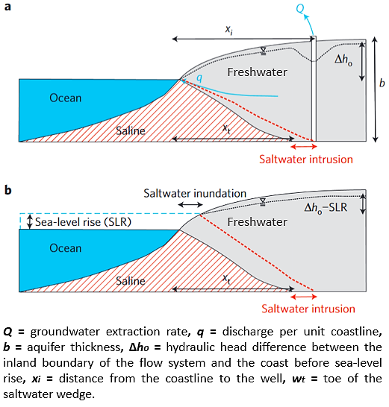
Figure 1. Saltwater intrusion in coastal aquifers affected by groundwater extraction (a) and sea-level rise (b) including saltwater inundation. Modified from Ferguson and Gleeson (2012)

Equally important, it should be noted that the vulnerability of coastal aquifers to SI is not only an area of concern in the present but will greatly impact future water reserves near coastlines. The increasing demands for freshwater in coastal areas and the anticipated impacts of climate change, such as the sea-level rise and variations in rainfall recharge, may result in increases in the incidence and severity of SI. For these reasons, an assessment is needed to address the vulnerability of coastal aquifers, along with improved awareness and understanding of the key drivers for SI which will benefit decision-makers and groundwater stakeholders (Werner & Simmons, 2009; Morgan et al., 2013).
Ferguson and Gleeson (2012) developed an analytical model to investigate the impacts of sea-level rise and groundwater extraction on coastal aquifers, in relation to seawater intrusion. The study found that while climate change effects will undoubtedly cause or aggravate water-related issues in coastal aquifers, increased groundwater extraction currently has and will have a much greater impact on freshwater availability in comparison to sea-level rise. The authors also suggested that excessive groundwater pumping can cause the saltwater wedge to advance, resulting in reduced drinking water supplies for both rural areas and medium to large cities experiencing an increase in water demand, due to growing coastal populations.
Studies on SI in coastal aquifers revealed complexities that necessitate individual case studies to examine regional influences and the nature of SI impact (Werner & Simmons, 2009; Morgan et al., 2013; Werner et al., 2013; Morgan & Werner, 2015). Post (2005) states that the best practice for a specific area depends on various socio-economic, legislative, environmental, and hydrogeological factors. Subsequently, hydrogeologists will perform a significant role in evaluating the feasibility and the impact of the measures that need to be taken. Barlow and Reichard (2010) and Werner et al. (2013) have reviewed most of the relevant work conducted on SI and they consider certain controlling factors involved in the process. These factors include aquifer mixing zone properties, hydrochemical processes, impacts of sea-level fluctuations, SI investigation and mitigation methods, and future challenges. Other reports have discussed the influence of climate change, population growth, and groundwater extraction and depletion. These reports argue that the aforementioned factors are a far larger threat to global water security than initially acknowledged in previous studies, highlighting the pressing issue of groundwater depletion along with the importance of monitoring and management (Vorosmarty et al., 2000; Famiglietti, 2014; Houben & Post, 2017; Jasechko et al., 2020).
Measuring SI requires temporal observations of salinity changes and other indicators such as hydraulic head trends and water chemistry characteristics that infer historical salt transport processes. Measurement of transient SI is difficult because it is a slow process typically and there is a lack of historic data, which is reflected in the absence of estimates of the global scale of SI problems (Werner et al., 2013). A multi-disciplinary approach is needed when dealing with coastal groundwater systems. For instance, Bear and Cheng (2010) state that conducting a geophysical survey that integrates the geophysical results with data obtained from direct water sampling is a recommended method for exploration of SI, combining the advantages of geophysical methods—simplicity, relatively low cost, large surface area coverage—with direct measurements obtained from water sampling and geochemical investigations.
Aquifer degradation can be difficult or even impossible to reverse when it is caused by SI, and this is why it is generally accepted that avoidance of this process should be the primary objective of coastal aquifer management strategies (Ivkovic et al., 2012). Restoration of water quality in a zone invaded by seawater is generally an expensive or ineffective plan because it requires a large amount of freshwater flushing for a long period; therefore, it is argued that a more effective way is prevention (J. Bear & Cheng, 1999).
The coastal areas in the United States (US) have been an important center of industry and population growth due to the access to ports; thus, those areas with abundant groundwater resources are also the areas where SI has become especially problematic (Konikow & Reilly, 1999). However, the current understanding of SI is founded on local-scale studies that do not cover the whole coastline continuously, or hydrologic models that have been used to estimate SI along contiguous coastlines in the US (Jasechko et al., 2020).
Several studies have assessed saline water occurrence in diverse geologic and hydrologic conditions in the United States (i.e., Krieger et al., 1957; Bruington et al., 1969; Konikow & Reilly, 1999). Barlow and Reichard (2010) reviewed saltwater intrusion along the Atlantic and Pacific coasts of Canada and the US, and coastal regions of Mexico. Specifically, evaluations of SI in New Jersey, Georgia, and Florida in the Atlantic Coast, and central and southern California in the Pacific Coast, describing the different modes of intrusion depending on the hydrogeologic settings, saline water distribution, and history of groundwater withdrawals. Other studies have used marine reflection seismic surveys and groundwater samples to identify vulnerable areas for SI in the Upper Floridan aquifer, and to describe the flow of freshwater and saltwater in various aquifer systems along the Atlantic Coast, including Massachusetts, Virginia, the Northern Atlantic Coastal Plain aquifer system, and the Floridan aquifer system (Barlow, 2003; Foyle et al., 2002). Similarly, chloride data analysis was used to study SI along the Pacific Coast, in Washington state (Dion & Sumioka, 1984). Further, several investigations have examined the coastline of the state of California to map the extent of SI by collecting samples from coastal monitoring wells (Hanson, 2003; Hanson et al., 2009), and using geophysical techniques to obtain electrical resistivity tomography and airborne electromagnetic data (Goebel et al., 2017, 2019).
Additionally, SI studies have been conducted on coastal aquifers in many areas adjacent to the Gulf of Mexico. These studies report the presence or severity of SI due to groundwater exploitation beyond the natural recharge of the aquifers in Louisiana, Alabama, Florida, and coastal aquifers in Mexico (Cardoso, 1993; Schmerge, 2001; Lovelace et al., 2004; Murgulet & Tick, 2008; Borrok & Broussard, 2016). Nevertheless, relatively little research has been conducted on SI and saltwater encroachment into coastal aquifers along the Gulf Coast Region of Texas.
Jasechko et al. (2020) assessed the potential for SI at a continental scale in the US, by collating and analyzing 250,000 groundwater well water observations made since the year 2000 in the Atlantic, Pacific, and Gulf Coasts. They identified coastal areas where most well water elevations lay below sea level, rendering these areas potentially vulnerable to SI. The results in the Gulf Coast showed that about 23% of well levels within 10 km of the coast lie below sea level, and at least half of all measured water elevations are below sea level near Houston (Texas), New Orleans (Louisiana), Gulfport (Mississippi), and northwest and west Florida.

Figure 2. Well water elevations across the contiguous United States represented by points (on the center map), with a map focusing on the state of Texas (red-blue shades are interpolations of well water elevations and the interpolated surfaces follow the same color scale as point data in continent-wide map). Modified from Jasechko et al. (2020) is presented to show the groundwater well measurements compiled in said study, representing the wells as points on the center map, signaling the water elevation measured more recently than January 1, 2000, with a specific color. Note, a 100 km by 100 km map on the bottom right illustrates the coastline along Galveston Bay in Texas where red-blue shades represent interpolations of well water elevations following the same color scale as the continent-wide map.

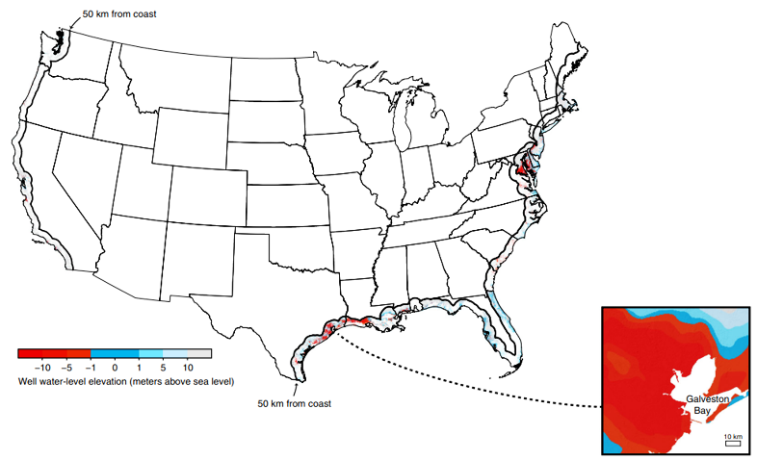
Figure 2. Well water elevations across the contiguous United States represented by points (on the center map), with a map focusing on the state of Texas (red-blue shades are interpolations of well water elevations and the interpolated surfaces follow the same color scale as point data in continent-wide map). Modified from Jasechko et al. (2020)

The results presented in Jasechko et al. (2020) suggest that because the Houston-Galveston area in Texas is susceptible to seawater intrusion, further investigation into the severity and extent of SI intrusion is necessitated.

Hydrogeology of Gulf Coast aquifers in Brazoria County, Texas
Brazoria County is located in the southeastern part of Texas. The county shares a northern border with Fort Bend and Harris Counties, an eastern border with Galveston County, a southern border with the Gulf of Mexico, and a western border with Matagorda County. The land surface is relatively flat but rises gently from the Gulf to a maximum altitude of about 60 feet in the northern and northwestern parts of the county (Follett, 1947).
Brazoria County is situated in the Houston-Galveston region of Texas, where groundwater has been the primary source of water for municipal supply, commercial and industrial use, and irrigation since the early 1900s (Braun et al., 2019). In Brazoria County, the Chicot and Evangeline aquifers are the sole hydrologic that bear fresh (less than 1,000 milligrams per liter dissolved solids) or slightly saline water (1,000-3,000 milligrams per liter dissolved solids) in the geologic units Goliad Sand, Willis Sand, Bentley Formation, Beaumont Clay, and the Quaternary alluvium (Error! Reference source not found.. These formations dip towards the Gulf at angles greater than the slope of the land surface, resulting in progressively greater depths and thicknesses in a gulfward direction (Sandeen & Wesselman, 1973).
The Chicot and Evangeline aquifers are composed of gravel, sand, silt, and clay of the Pliocene, Pleistocene, and Holocene ages. Sediments of the Gulf Coast aquifer in Texas were deposited under fluvial-deltaic to shallow-marine environments, and repeated sea-level changes and natural basin subsidence produced discontinuous beds of sand, silt, clay, and gravel (Chowdhury & Turco, 2006). Brazoria County is underlain by a thick sequence of unconsolidated sediments consisting mostly of sand and clay, which dip generally to the southeast but sediments near the surface have only a gentle dip (Follett, 1947).
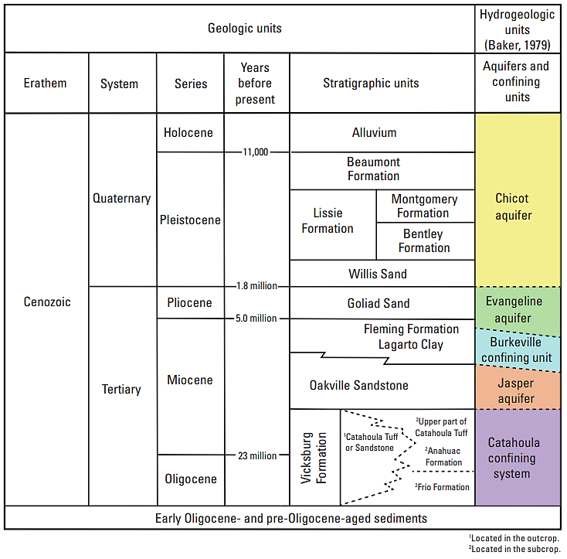
Faults are common in the area, particularly in the vicinity of salt domes that are marked by surface expressions such as hills or sinks. As for the geologic units, only the Beaumont Clay and the Quaternary alluvium crop out in the county. Most of the county is a nearly flat plain that rises to the northwest, and the surface of the plain is the top of the Beaumont Clay (Sandeen & Wesselman, 1973).
Figure 3. Geologic and Hydrogeologic Units of The Gulf Coast Aquifer System in the Study Area and Greater Houston-Galveston Region, In Texas. Source: Braun et Al. (2019)
According to Kreitler et al. (1977), coastal aquifers in the Greater Houston area are composed principally of fluvial-deltaic sediments, and specifically, the Beaumont Formation is a high percent mud unit that represents a coastal progression of delta-plain to delta-front facies. This formation is of Pleistocene age, and it is overlain by surficial deposits of alluvium, wind-blown sand, and silt in the valleys of the Brazos and St. Bernard Rivers and in a wide belt along the Gulf Coast. The Beaumont clay is underlain in downward succession by the Lissie formation, identified as Willis-Goliad sand, and older rocks that generally contain mineralized water. Areas notably near salt domes and along the coast of the Gulf of Mexico, have little or no fresh groundwater (Follett, 1947).
The principal groundwater reservoirs in the county are comprised of beds of sand or sand and gravel in the Willis-Goliad sand and younger deposits, confined between layers of clay and shale. As reported by Follet (1947), most wells draw water from surficial deposits or sands in the Beaumont Clay; a smaller number tap the Lissie formation, and only a few wells in the northern part of the county are known to draw from the Willis-Goliad sands. It was also reported that the majority of the wells encountered water under artesian pressure, which especially facilitated the flow from the deeper wells. However, large withdrawals of water in Galveston and Harris Counties, as well as in Brazoria County, caused a regional decline in pressure and most of the former wells ceased flowing.
The Gulf Coast aquifer system consists of several aquifers, including the Jasper, Evangeline, and Chicot aquifers, which are composed of discontinuous sand, silt, clay, and gravel beds of Miocene to Holocene age. Groundwater in Brazoria County is derived from the Evangeline and Chicot Aquifers of the Gulf Coast Aquifer System, with the shallower Chicot Aquifer providing the majority of the water for human consumption. Based on the hydrogeologic descriptions of (Braun et al., 2019; Carr et al., 1985; Sandeen & Wesselman, 1973)), the Chicot aquifer is the main focus in our investigation.

Evangeline Aquifer
The Evangeline aquifer is a sequence of sands and clays that thicken from about 2,000 ft at the northern edge of Brazoria County to more than 3,500 ft at the southern edge. Fresh water exists to depths of more than 1,800 feet below sea level, with as much as 415 feet of sand containing fresh water, which is primarily located within the upper beds of the aquifer in the northern part of the county. The average permeability is about 250 gpd (gallons per day) per square foot (Sandeen & Wesselman, 1973).

Chicot Aquifer
The Chicot aquifer is separated from the Evangeline aquifer by lithology, permeability, water level, and stratigraphic differences; and it includes all deposits from the land surface to the top of the Evangeline aquifer (Carr et al., 1985). This aquifer is subdivided into a lower unit and an upper unit. In Brazoria County, the upper unit is either a water-table or artesian aquifer holding less than 100 feet of freshwater sand at most locations and less than 50 ft in much of the county, and the lower unit is an artesian or leaky artesian aquifer containing 100 to 290 ft of freshwater sand in the northern part of the county. The maximum permeability for the sand in each unit exceeded 1,000 gpd per square foot; additionally, most of the tests showed field permeabilities over 600 gpd per square foot, ranging from twice to six times the average permeability assumed for the Evangeline aquifer (Sandeen & Wesselman, 1973).
Pumping in Harris and Galveston Counties has caused water movement toward the cones of depression in the lower unit of the Chicot and the Evangeline aquifers, and toward local cones of depression surrounding well fields in the county. A large cone of depression occurs in the water level surface as a result of pumping from the upper part of the Chicot in the Brazosport area of southern Brazoria County. Furthermore, land surface subsidence of more than 1.5 feet, attributed mostly to ground-water removal, has taken place in northeast Brazoria County (Sandeen & Wesselman, 1973).
The Texas Water Development Board (2018) established the modeled available groundwater (MAG) for Brazoria County as 50,417 acre-feet per year in 2020 and the report indicated that this would increase to 50,720 by 2070; however, the Brazosport Water Authority (2021) reported that existing groundwater usage in Brazoria County has exceeded the MAG for several years due to accelerated growth in water demand relative to supply. This corroborates that groundwater resources serve as a crucial source of water for large populations in the county.
Above all, vulnerability assessments of coastal aquifers and updated investigations on saltwater intrusion are necessary to provide a scientific basis for effective management of groundwater resources and to inform of future challenges that can negatively impact people and natural resources by decreasing freshwater storage, water quality, and water availability in the area.

METHODS

Description of Study Site
This study site is located within Brazoria County in the Gulf Coast region of Texas. The site was selected considering the potential for saltwater contamination, and the possible extent of a saltwater wedge as suggested by Jasechko et al. (2020). Suitable geophysical survey and groundwater sampling locations were selected by a combination of spatial analysis in ArcGIS Pro and using spatial data obtained from the Texas Water Development Board (Young et al., 2016). Specific criteria for the selection of wells included availability of total dissolved solids (TDS) and salinity measurements.
ArcGIS Pro was utilized to identify study tracts that had slightly saline and moderately saline groundwater (TDS concentrations of 1,000 to 10,000 mg/L). A preliminary study tract was created from the coastline to the land, a potential pathway of saltwater intrusion. The preliminary tract was adjusted in the field due to the lack of access or the need for maintenance in certain public wells. The final study area covered 102.73 mi² (266.08 km²), involving the cities of Freeport, Lake Jackson, Brazoria, and West Columbia, in addition to the community of Old Ocean.

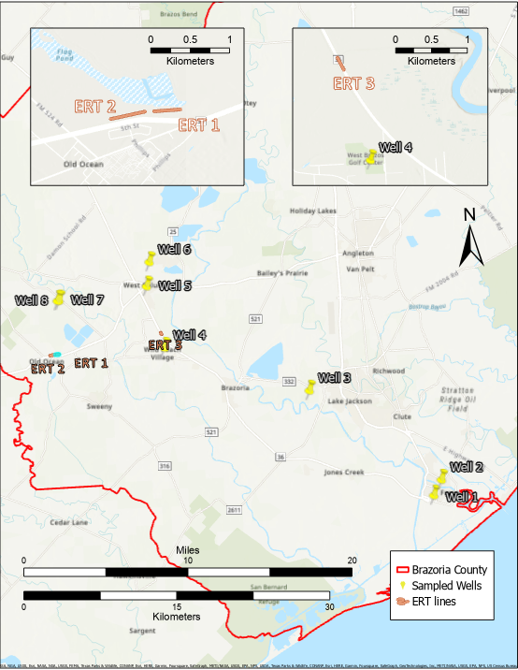
Figure 4. Locations of the sampled Groundwater Wells and ERT Lines in Brazoria County, Texas. Inset Maps on top display the locations of the ERT lines from a closer view.

Geophysical Data Collection
The electrical conductivity and resistivity of Earth materials and fluids are crucial parameters for understanding their electrical properties. The intrinsic electrical properties of a porous medium depend on the solid, liquid, and gas phases that constitute it, as well as the concentration and spatial arrangement of these phases (Binley & Slater, 2020). Conductivity is a measure of the ability of a material to conduct electric charge, and it is defined as the electrical conductivity (measured in siemens/metre, S/m). It is an intrinsic property of the material through which current is flowing and is related to the reciprocal of the electrical resistivity (measured in ohm m, Ωm).
To measure the conductivity or resistivity of Earth materials, the motion of charged particles in response to an electric field must be measured. The flow of charged particles forms an electric current, and the charge carriers can be electrons or ions, depending on the material. Groundwater conducts electrical current via ions; therefore, the conductivity of groundwater depends strongly on the total dissolved solids and the chemistry of the groundwater. Electrical resistivity methods utilize these electrical properties to investigate the subsurface. Through galvanic contact, electrical current is injected into the subsurface through the current electrodes (a positive and a negative electrode), and the resultant potential is measured between two or more additional electrodes (Singha et al., 2022). This can be explained with the aid of Ohm’s law, where the resistance R can be determined by the injected electric current I, that is directly proportional to the electric potential or voltage ∆V (Binley & Slater, 2020).
$$R=\frac{∆V}{I}$$ | (1)
The resistance is an extensive property; therefore, it is not characteristic of the material since it depends on the geometry or distance between the electrodes used for the measurement. Hence, using the knowledge of the electrode locations and the measured quantities of voltage and current, the resistance is converted to electrical resistivity, ρ, an intrinsic property of the material through which current is flowing (Lowrie, 2007; Singha et al., 2022). The reciprocal of resistivity is electrical conductivity, σ, and we prefer to use it in this investigation as it is directly related to properties used to describe transport of fluids as well as salinity.
Electrical resistivity surveys or electrical resistivity tomography (ERT) is the primary field method to image the subsurface and investigate the presence of saline features in this study. ERTs are known for their effectiveness in learning the spatial variation of the resistivity or conductivity of the subsurface by building a pattern of transfer resistances combining the potential difference between different pairs of electrodes and the knowledge of the injected current (Binley et al., 1996). The application of ERT, and surface resistivity methods overall, carries various advantages in saltwater intrusion investigations, because it reduces the need for intrusive techniques and direct sampling, it is relatively inexpensive and can be used for monitoring of large areas, and it measures electrical conductivity/resistivity which are intrinsic properties of groundwater chemistry that can be interpreted in terms of the degree of groundwater contamination (Sherif et al., 2006).
In this study, an ARES II unit, manufactured by GF instruments, was used for ERT’s data acquisition. ARES II is a well-equipped resistivity and IP (induced polarization) imaging system. It has a 10-channel receiver, capable of taking up to ten measurements in a single reading. The unit includes multi-core cables, switch boxes, stainless steel electrodes, and a PC software that can transfer data directly from the instrument to the computer for processing and quality control check.
ERT data collection occurred in July 2022, and it consisted of three lines with different lengths, electrode spacing, and number of electrodes (Table 1); characteristics that are directly related to the maximum penetration depth and data quality. The locations and main parameters of these profiles were chosen based on accessibility and available well data in the area, for calibration purposes. Data were collected using three array configurations: the dipole-dipole method commonly adopted when detecting horizontal changes, the Schlumberger array with a relative advantage when resolving vertical changes, and the Wenner array with a high signal-to-noise ratio and stable signal (Alwan, 2013; Binley & Slater, 2020; Falae et al., 2017). For the dipole-dipole and the Schlumberger arrays, normal and reciprocal measurements were collected for a more accurate inversion process.
Table 1. Main characteristics of survey lines.
 | ERT 1 | ERT 2 | ERT 3
Location | Old Ocean | Old Ocean | Between Brazoria and West Columbia
Electrode spacing (m) | 4 | 5 | 2
Number of electrodes | 56 | 64 | 40
Total length (m) | 220 | 315 | 78

The data acquisition scheme was selected to maximize our ability to accurately map conductive features translated into salinity variation within the area. The settings and parameters were the following: S-min, which refers to the minimum distance between the first and last used electrode, was set to 0 m to start from the surface; S-max corresponds to the maximum distance between first and last used electrodes, and the selected value was the total line length for each survey. Setting S-min as 0 m usually requires more measurement time, however it maximizes the measurements. To optimize the potential, the minimal requirement was set as 500 mV, with a minimum of 3 stacks and a maximum of 4 stacks to acquire data with a noise level below 2%, with a 200 ms dead time between measurements (pulse length). The maximum transmitter power was limited to 850 W. The quickest ERT acquisition resulted in 247 data points and the longest recorded 1,336 data points.

Inversion of Geophysical Data
The inversion process in ERT uses the apparent resistivity values to determine depths, locations and true resistivities of the buried targets in the subsurface. Singha et al. (2022) describe apparent resistivity, ρ_{a}, as the resistivity that the subsurface would have if it were homogeneous and isotropic. This value can be calculated using a geometric factor, K_{g}, which takes into account the electrode configuration, as shown in Equation 2:
$$ρ_{a}=K_{g}*\frac{∆V}{I}$$ | (2)
The resulting ERT datasets were processed and inverted using ResIPy, a geoelectrical modeling and inversion software that allows a non-linear workflow through various stages, including data import and filtering, mesh generation, and data inversion (Blanchy et al., 2020).
To approximate the distribution of resistivities, models of the subsurface were created. The topography of the surveyed area was recorded during data collection; thus, elevation points were entered in the software to aid in the generation of an accurate mesh for the models. In addition, data filtering and error modeling of resistivity were carried out to improve the inversion. A linear error model was selected as it was the best fit for the collected data.
The software estimated the depth of investigation (DOI) of the models using an algorithm developed by Oldenburg and Li (1999). This algorithm reruns the inversion with a background constraint, first with a normal background and then with a background that is 10 times more resistive, therefore, a sensitivity limit is computed from the two different inversions. This method is more intuitive and enables its adoption by real-world practitioners to assess the depth to which the data and models can be interpreted reliably (Nenna et al., 2013).

Geochemical Data Collection and Analysis
Groundwater wells sampled in this study in July 2022 are shown in Figure 5. Groundwater sampling occurred in July 2023, and samples were collected from 8 water wells, from productive and non-productive continuously pumped wells. At each well, in-situ pH and specific conductance (SpC) measurements were taken with a calibrated YSI EXO2 Multiparameter Sonde.
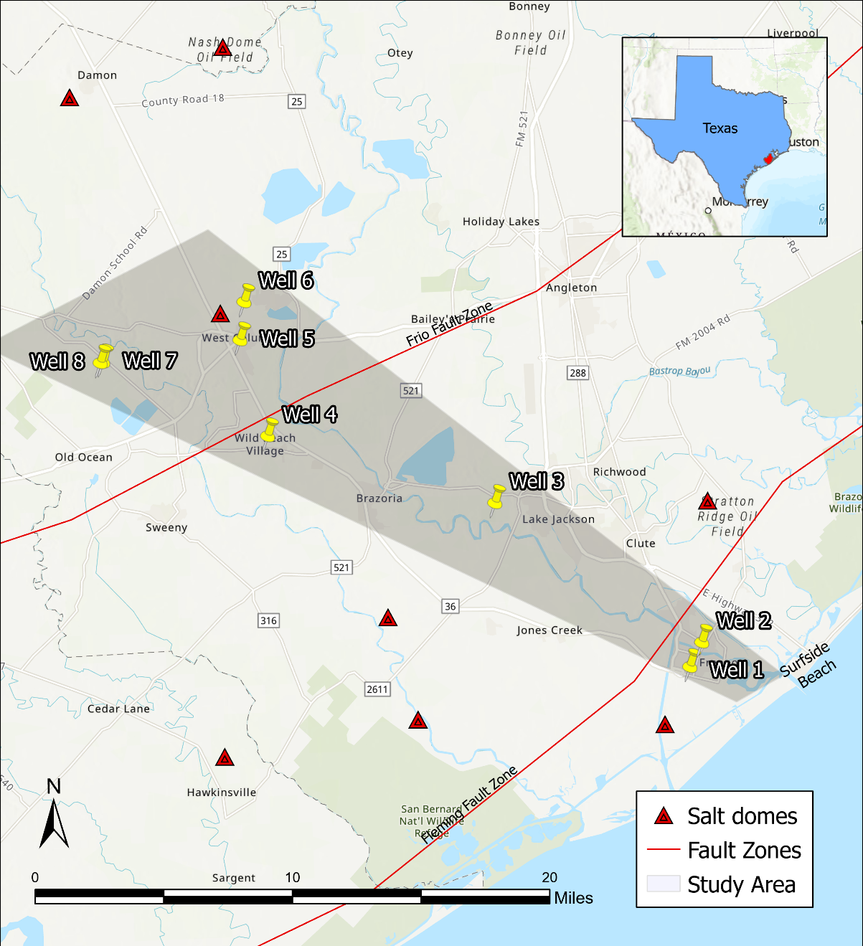
Water samples for laboratory analysis were filtered (0.45μm nominal pore size) into pre-cleaned (acid washed) 100 mL HDPE bottles. The cation and metals samples were preserved by adding approximately 0.5 mL trace metal grade nitric acid. Two samples were collected from each well: one for cation/metals and another one for anion analysis. A sea water sample from Surfside Beach, located near the starting point of the transect, was also collected in a 500 mL HDPE bottle for comparison with the groundwater found in the wells.
Figure 5. Map of the study area with locations of sampled wells. The inserted map of Texas shows the location of Brazoria County in red.
Metals and anion analysis were completed in the University of Oklahoma’s Aqueous Geochemistry Laboratory (AGL). The chloride (Cl−) and sulfate (SO42-) anions were measured by ion chromatography (Dionex Integrion High-Pressure Ion Chromatography) with an adjoined autosampler. Cations and trace metals were measured by ICP-OES (Thermo Scientific iCap Pro ICP-OES).
Moreover, with the intention of comparing the values to reference concentrations of sea water, the results of the groundwater chemistry were normalized to the sampled sea water as well as to the mineral makeup of sea water found in literature (Stanford University, 2008). This allowed an evaluation of the geochemical data considering the effects of sea water intrusion. The data was plotted using Microsoft Excel, and the resulting graphs were used to examine the concentrations of major components connected to salinity, such as concentrations of chloride, sodium, magnesium, sulfur, and calcium.

RESULTS

Geophysical Results
Electrical resistivity tomography (ERT) is a sensitive approach capable of giving direct measurements of the electrical properties of the Earth and pore fluids. The author aims to display the application of ERT in detecting saltwater intrusion (SI) in this region, and the importance of adopting continuous subsurface characterization methods to control and reverse SI or prevent it from occurring.
Considering the nature of this study, and the purpose of evaluating intrusion of sea water, which is highly conductive, the profiles of the three surveyed lines are presented in terms of conductivity, the inverse of resistivity. The main goal with this study is using ERT data to identify areas affected by salinity, and potentially a boundary between the saltwater and freshwater.
Figure 6 presents the distributions of conductivity from the lines surveyed in this study. The models shown were obtained through a joint inversion, an approach that simultaneously uses all data sets collected with different arrays at each location. ERT 1 and 2 were surveyed in Old Ocean, where the water level was reported as 6 m below ground surface. We note differences in conductivity, but the higher values are found above the water table for both lines.
The DOI for ERT 1 goes as deep as 30 m, and the profile presents an increase in conductivity towards the east, with the higher conductive values in the first 5 meters, ranging from 190 to 320 mS/m. ERT 2 presents conductivities lower than 250 mS/m overall, with a notable volume of results below 100 mS/m. The DOI for this inversion goes as deep as 40 m, and the conductivity values in the shallowest area range from 100 to 220 mS/m, apart from a highly conductive feature towards the east in the first 8 meters, with measurements exceeding 300 mS/m.
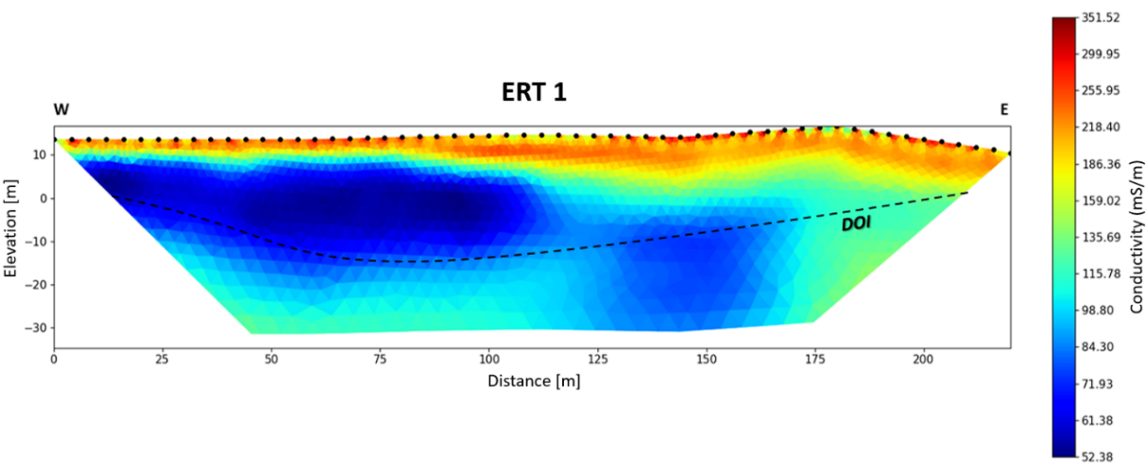
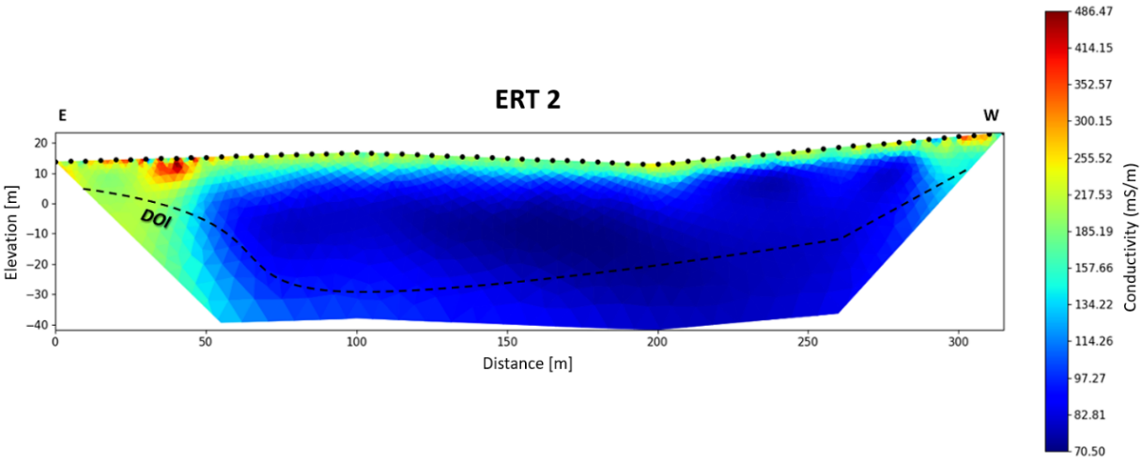
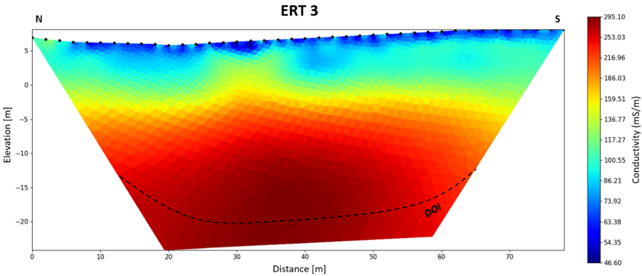
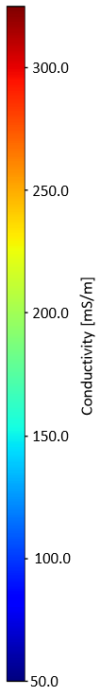
Figure 6. Inversion plots for conductivity of ERT 1, ERT 2, and ERT 3.
By contrast, the model produced from ERT 3, in a location closer to the coastline, showcase defined conductive features at higher depths, ranging from 190 to 270 mS/m. The maximum DOI for ERT 3 is 27 m, and the water levels recorded in driller’s well reports around the surveyed area go from 9 to 16 m below ground surface. The highest conductivities are found below 10 m in the resulting plot, which allows us to correlate the conductivity values to groundwater.
ERT 1 and ERT 2, the lines surveyed in Old Ocean and farther from the coastline, show an arrangement of conductivities with higher values at the shallowest depths (0-10 m) above the water table. ERT 3 was surveyed 10 km away (6.2 mi) in an area near Brazoria and West Columbia, closer to the coastline, and it exhibits higher conductivity levels from 10 to 25 m, below the water table. The conductive features present in ERT 1 and 2 are above the water levels recorded, while they are below the water table for ERT 3; thus, the presence of salinity is linked to groundwater in ERT 3.

Geochemical Results
Geochemical data is important to validate the interpretation of geophysical measurements such as ERT. Geochemical results from groundwater collected in the study area are shown in Figures 7-14. A more comprehensive data sat can be found in Appendix A: Groundwater geochemistry.
The in-situ measurements of pH and specific conductance (SpC) show some variability among the wells sampled in this study. Conductivity measurements ranged from 10,000 to 22,000 µS/cm (1,000 to 2,200 mS/m), and pH concentrations varied from 6.9 to 7.6. Wells 4 and 7 had the greatest conductivity (more than 20,000 µS/cm), whereas the other wells had much smaller conductivity. All wells in this study exceeded the recommended limit for drinking water in the United States of 1,500 µS/cm for conductivity measurements (Starrett, 2004; US EPA, 2015).
Figure 7. pH measurements, in standard units.
Figure 8. Measurements of Specific Conductance, in microsiemens per centimeter.
pH values ranged from 6.92 to 7.56, falling within acceptable levels since the EPA recommends that pH of drinking water spans from 6.5 to 8.5. The results show similarity in wells that are closer together, and no apparent relationship between pH values and depth of the wells.
Select major cation and trace metals results for groundwater and sea water are shown below in Appendix A: Groundwater geochemistry. In the water samples, the cations present in the highest to lowest order of abundance are sodium, magnesium, calcium, and sulfur. Sulfur is mainly found as sulfate ion, which is a part of naturally occurring minerals in soil and aquifers.
Subsequently, individual graphs illustrate the outcomes of the major cations identified in the sampled wells and their trends along the transect. The concentration of magnesium (Figure ) depicts a linear increase from Well 1 to Well 3, which are closer to the Gulf Coast, followed by a decrease in concentration, with Well 5 recording the lowest amount of this metal (1.5 ppm). Well 7 displays the maximum concentration among all sampled wells, being 2.5 times greater than the second-highest amount. Figure displays the concentration of sodium, with Well 2 and Well 7 exhibiting the highest concentrations above 350 ppm. In contrast, all other wells produced outcomes lower than 160 ppm, with Well 5 having less than 50 ppm of sodium.
Similarly, the behavior of calcium concentrations (see Figure ) along the transect portrays an initial increase, succeeded by a drop due to Well 5, which registers the lowest concentration of trace metals (6.1 ppm of calcium), and culminates in the concentration peak present in Well 7, along with an average value of trace metals for Well 8.
Figure 10. Measured concentration of Sodium, in ppm.
Figure 11. Measured concentration of Calcium, in ppm.
Figure 9. Measured concentration of Magnesium, in ppm.
Results for sulfur (Figure ) and potassium (Figure ) concentrations are distinctive. Although the values for sulfur are lower than 22 ppm overall, the most elevated concentrations are represented by Wells 3 and 4, while the rest of wells have concentrations that do not exceed 5 ppm. Potassium shows a decrease in concentration in in wells from the coastline towards further inland. In both cases, Well 5 displays the least amount of concentration.
Figure 12. Measured concentration of Sulfur, in ppm.

Figure 13. Measured concentration of Potassium, in ppm.
Chloride is the most abundant element in seawater, with an average concentration exceeding 18,000 ppm (Stanford University, 2008). Figure presents the results for chloride concentrations in the wells sampled for this study. The behavior shown is similar to the measured metals. Chloride is generally considered to have conservative behavior, and the sampled wells sampled contain significantly lower concentrations of chloride than seawater, with values ranging from 160 ppm to 382 ppm. The trend observed in the graph reflects the spatial variations in chloride concentrations between the sampled wells and their proximity to the coastline. Specifically, there is a decline in chloride concentrations from Well 1 to Well 2, followed by a subsequent rise, ultimately reaching levels comparable to those recorded in Well 1. Notably, Well 8 exhibits the lowest recorded concentration of the analyzed element. However, Well 7exhibits chloride concentrations that are nearly two-fold greater than the other wells likely due to contamination.
Figure 14. Measured concentration of Chloride, in ppm.

DISCUSSION

Evaluating seawater intrusion (SI) requires merging both subsurface geology with hydrogeochemical properties of groundwater. By successfully employing a two-pronged approach to evaluate the presence and extent of saline water in the Chicot aquifer in Brazoria County, Texas, this study demonstrates that the integration of geochemical and geophysical methods is crucial for understanding saltwater intrusion in coastal aquifers, particularly in regions experiencing declining water levels.

Geochemical Measurements as an Indicator of Saline Intrusion

Based on previous case studies in the Gulf Coast, the detection of saline water in the study was anticipated (Borrok & Broussard, 2016; Braun et al., 2019; Cardoso, 1993; Jasechko et al., 2020; Konikow & Reilly, 1999; Kreitler et al., 1977; Lovelace et al., 2004; Murgulet & Tick, 2008; Scanlon et al., n.d.; Young et al., 2016).
The groundwater chemistry results of elevated conductivity above the recommended limit 1,500 µS/cm and concentrations of chloride and sodium suggest presence of saline groundwater. (Starrett, 2004; US EPA, 2015; USGS, 2019).
A correlation with the available measurements of Total Dissolved Solids (TDS) in the study site can be used to classify the groundwater as fresh (less than 1,000 mg/L), slightly saline (1,000 to 3,000 mg/L), moderately saline (3,000 to 10,000 mg/L), very saline groundwater (10,000 to 35,000 mg/L), or brine (greater than 35,000 mg/L). Furthermore, according to the TDS values reported by Young et al. (2016), several groundwater wells in Brazoria County were classified as slightly saline to moderately saline, highlighting the potential for saltwater intrusion. This study supports that claim by identifying geochemical indicators as specific conductance, which can be correlated to TDS.
The data reports elevated concentrations of sodium, potassium, and chloride, constituents that can be related to ancient brines, industrial brines, and sea water (Sandeen & Wesselman, 1973). According to Kreitler et al. (1977), the TDS values of groundwater in Harris and Galveston counties could be related to meteoric or saline waters, and the ratio between sodium and chloride (Na/Cl) can be used as an indicator, with a range of 0.9 to 1 for saline waters. On the other hand, Klassen et al. (2014) imply that Na/Cl ratios are typically lower in wells intruded by seawater, suggesting that ratios lower than 0.9 may represent wells impacted by SI, and ratios greater than 1 are indicators of groundwater contaminated by anthropogenic sources. In this study, Na/Cl ratios ranged from 0.85 to 1.2 for most of the wells, excluding Well 2 with a concentration ratio of 4.1, and Well 5 with the lowest ratio of 0.2. Bear et al. (1999) explains that enrichment of calcium can indicate SI, reflected in Ca/Mg > 1. All the wells in this investigation had ratios greater than 1.
The data analysis reveals a significant positive correlation between the concentrations of trace metals, including sodium and calcium, and chloride, and the depth of the sampled groundwater wells. Particularly, the wells with higher concentrations of these elements were shallower in depth and closer in proximity to the coastline. This observation suggests a strong relationship between the depth of the wells and the salinity of the sampled groundwater. The depth of the wells was determined using available reports and logs publicly released by the Texas Water Development Board. These findings lend support to the hypothesis that the presence of saline water is prevalent in the shallow section of the Chicot aquifer.
The results of this study provide support for the hypothesis of saline water intrusion or contamination in Brazoria County. This is evidenced by the correlation between shallow wells and higher levels of salinity in the groundwater. This association is consistent with the theory that declines in water table conditions, resulting from increased groundwater consumption and rising sea levels, can lead to groundwater saline intrusion. The observed relationship between shallow wells and saline groundwater is noteworthy because it contradicts the previously held notion that fresher groundwater is always found further from the coastline. To increase the sample size for analysis, historical data was included for comparison with the measured wells.
The results of Well 7 are essential to the correlation between depth and salinity. This well displayed the highest concentrations of metals, anions, and conductivity; however, it was the second to farthest away from the Gulf Coast. Using the National Water Dashboard (U.S. Geological Survey, n.d.) and the groundwater data viewer from Texas (Texas Water Development Board, n.d.), historical data of the surrounding wells was accessed and analyzed. The findings suggest that the groundwater in the area is possibly mixed with saline water at depths of 150 to 180 ft. The water table for Well 7 is recorded at 30 ft below land surface and the well is screened at a depth of 170 ft in sand with an overlying layer of red clay. At the neighboring property, a groundwater well was plugged in August of 2022, with a reported total depth of 150 ft. Moreover, most water wells used for domestic supply in the nearby area of Well 7 are screened at greater depths from 350 and 600 ft in cleaner sand layers.
The results might suggest that increased salinity of groundwater is happening in the upper depths of the Chicot aquifer. Findings of geological studies in the area present the issue of land subsidence, which is frequently linked to increased saltwater intrusion into freshwater aquifers. In addition to decreasing the elevation of the land surface, subsidence can also cause the deformation of the aquifer system, which can lead to changes in groundwater flow patterns and further exacerbate saltwater intrusion. Since the withdrawal of groundwater from the Chicot and Evangeline aquifers was unregulated prior to 1975, water levels were declining annually (Braun et al., 2019; Carr et al., 1985; Kasmarek & Ramage, 2017). Sandeen and Wesselman (1973) stated that subsidence had taken place in the Freeport area. However, Braun et al. (2019) compared data from 1977 and 2019 and reported that only the northeastern part of Brazoria County experienced water-level changes, not including the area of interest for this study.
The results of this investigation suggest the existence of salinity in the study area, where the Gulf of Mexico is characterized by the presence of salt domes. However, a thorough examination of prior research (Kreitler et al., 1977; Sandeen & Wesselman, 1973; Young et al., 2016) combined with a spatial analysis of the salt domes distributed in the vicinity does not support the hypothesis that salinization caused by these geologic structures is a feasible explanation.

Electrical Resistivity Surveys as an Indicator of Saline Intrusion

Electrical resistivity surveys were employed to examine the subsurface, and conductive features were detected in Brazoria County, with conductivity related to presence of groundwater in the location surveyed closer to the coastline. This analysis is supported by the evaluation of water levels in the area and correlating them with the depth of investigation of the resulting geophysical models.
Geophysical and geochemical techniques were effective in the characterization of groundwater vulnerable to saltwater intrusion in Brazoria County, Texas. The inversion models suggest a delineation between the locations of ERT 1 and 2, and ERT 3. ERT 1 and 2, located near a refinery, indicate that a conductive layer above the water table with high clay content possibly exists. as suggested in similar soil moisture studies (de Jong et al., 2020; Foley et al., 2012; Friedman, 2005). Based on the evaluation of soil data and information produced by the National Cooperative Soil Survey (2018), the soils in the specific site are classified as rarely flooded silty loams and clays, with non-saline characteristics. Therefore, another plausible explanation can be related to the addition of cement or engineered materials due to the oil and gas pipelines buried in the subsurface of the site.
In contrast, ERT 3 shows conductive features below the water table likely related to the presence of saline water. These results agree with the established freshwater/saltwater boundary for fishing rules and regulations (Texas Parks & Wildlife Department, 2015), where ERT 1 and 2 correspond to freshwater and ERT 3 is located at the limit where all public waters start to be considered salt water.
These results and analyses build on existing evidence of salinity in the area corroborated by a feasibility study of desalination as a potential water supply for Brazoria County, centered in Brazosport, neighboring city of Freeport (Add reference). In this study, the Brazosport Water Authority (2021) reviews seawater desalination as a potential water supply and it compares it to other potential water sources.
While previous research in the area has focused on subsidence and water-level measurements, these results demonstrate that studies using ERT and geochemical analyses in conjunction are effective in locating areas impacted by seawater intrusion.
Increasing demands on water resources, and specifically coastal groundwater resources, require the development of effective resource management strategies to limit or prevent saltwater intrusion. A common strategy for acquiring such information is to drill sentinel wells; however, using ERT gets rid of the costs of installation and operation of sentinel wells, and has spatial coverage. Showing that ERT approaches are suitable for detailed spatial analyses where probe or sample-based methods are limited, and that updating the geochemical data of an area is essential to prevent and evaluate environmental threats, such as seawater intrusion.
Due to the lack of data on growth faults in the area, the results cannot confirm whether or not there is a structural pathway transmitting fresh or saline water around the region. The methodological choices were constrained by access to public and private wells, as well as private areas to perform ERT.
Further research is required to establish whether growth faults are a controlling factor in the groundwater quality in Brazoria County. Moreover, Barlow (2003) states that investigations should consider that chloride concentrations are naturally elevated near the boundary between freshwater and saltwater, consequently saltwater intrusion is more accurately indicated by increases in the chloride collected periodically over time, rather than by a single concentration measured at one point in time.

Compliance with Drinking Water Standards

The United States Environmental Protection Agency (EPA) enforces a Maximum Contaminant Level (MCL), that limits the amount of constituents and properties in water systems to ensure that the water is safe for consumption. In addition to the MCL, the EPA also provides National Secondary Drinking Water Regulations (NSDWR), which are guidelines for regulating contaminants in drinking water that are not enforceable. The standard for TDS is 500 mg/L (US EPA, 2015), and the U.S. Geological Survey (2019) suggests comparing the concentration of TDS in mg/L to specific conductance in microsiemens per centimeter (µS/cm) with a ratio expected to fall between 0.5 and 0.9. Using this ratio, it is possible to say that the recommended limit for conductivity is 555 to 1,000 µS/cm.
All wells in this study had conductivity measurements greater than 10,000 µS/cm, indicating that they are contaminated. The properties and constituents examined in this study were also compared to available EPA standards, with a summary provided in Appendix B: Comparison of constituents and properties to EPA standards. The high conductivity values are the main evidence of contamination in the sampled wells.
High salinity water has been proven to impact people’s health, maternal health, hypertension, and infant mortality in coastal populations (Shammi et al., 2019), as well as directly affect agriculture and carry economic costs (Tol, 2009). Evaluations of seawater intrusion can protect people’s health, agriculture, industries, and the environment.

FUTURE WORK
To better understand the implications of these results, future studies should take into account a temporal perspective, collecting groundwater samples with an interval, such as every 12 hours, to investigate the changes over time. In the same way, ERT can be used over time with its time-lapse variety and monitor the changes in the subsurface and its electrical properties. This way, changes can be studied over the change of seasons and evaluate the impact of more variables.
Avenues for future research include taking more survey lines around wells that are closer to the coastline. Above all, it is a desired result that the two-pronged methodology employed here will be used in future studies in similar regions experiencing SI issues.
Additional geochemical data and studies, such as isotope analysis, can offer a deeper insight into the origin of the saline contamination in the study area. This information can be valuable in identifying the source of the contamination and developing effective remediation strategies.

CONCLUSIONS
This study aimed to evaluate the presence and extent of indicators of seawater intrusion in Brazoria County, a region potentially susceptible to SI. The combined approach of using geophysical and geochemical methods was effective in delivering an improved understanding of the geology of an area and its relationship to salinization. The results indicate that the Chicot aquifer, a heavily utilized coastal aquifer in Brazoria County, shows signs of salinity at shallow depths and in proximity to the coastline.
Major geochemical indicators of saltwater intrusion are present, including high concentrations of chloride, sodium, magnesium, sulfur, calcium, and potassium. The main evidence of contamination of the wells of this study is observed in their conductivity values. All sampled wells had values greater than 10,000 µS/cm, exceeding the maximum recommended limit (1,500 µS/cm) for conductivity in drinking water.
It is pertinent to note that most available groundwater data from the area represents groundwater conditions from the 1960s to the 2000s (Texas Water Development Board, n.d.; U.S. Geological Survey, n.d.). As the impacts of climate change continue to intensify with each passing year, there is a need for an updated model that reflects the current conditions of the area. The geochemical data collected in this study was able to provide insights into the current state of the area. Furthermore, this study incorporated ERT data in a region where this technique had not been previously utilized to evaluate SI. The ERT data and the geochemical results improved our understanding of the hydrogeology in the area of interest. However, the generalizability of the geochemical results is limited by the spatial distance between the sampled wells and their dispersion pattern. Similarly, the geophysical results can be improved by conducting additional surveys at more locations.
ERT 1 and ERT 2 did not show evidence of conductive groundwater, while ERT 3 displayed conductive features below the water table indicating salinization. The results can be linked to the proximity of each site to the coastline, and they concur with the established freshwater/saltwater boundary for fishing rules and regulations (Texas Parks & Wildlife Department, 2015).
The results of this research provide valuable information for water authorities in the region and can inform management actions. However, the study also raises the question of understanding the pathway of the potential saltwater wedge and its relationship to growth faults in the region.
Based on these conclusions, practitioners should consider the methodology used in this investigation to characterize seawater intrusion at similar vulnerable regions of the planet. Additionally, this investigation can provide a scientific basis for decision-makers and groundwater stakeholders to take appropriate actions to protect water resources and address SI’s direct impact on people’s health and economy (Elshall et al., 2021; Famiglietti, 2014; Michael et al., 2017; Shammi et al., 2019; Tol, 2009; Vorosmarty et al., 2000).

REFERENCES

Ajami, H. (2021). Geohydrology: Groundwater. In D. Alderton & S. A. Elias (Eds.), Encyclopedia of Geology (Second Edition) (pp. 408–415). Academic Press. https://doi.org/10.1016/B978-0-12-409548-9.12388-7
Alwan, I. A. K. (2013). Comparison Between Conventional Arrays in 2D Electrical Resistivity Imaging Technique for Shallow Subsurface Structure Detection of the University of Technology. Engineering and Technology Journal, 31(10 Part (A) Engineering). https://www.iasj.net/iasj/article/82276
Barlow, P. M. (2003). Ground water in freshwater-saltwater environments of the Atlantic Coast (Circular 1262; p. 113). U.S. Geological Survey. https://pubs.er.usgs.gov/publication/cir1262
Barlow, P. M., & Reichard, E. G. (2010). Saltwater intrusion in coastal regions of North America. Hydrogeology Journal, 18(1), 247–260. https://doi.org/10.1007/s10040-009-0514-3
Bear, J., Cheng, A. H. D., Sorek, S., Ouazar, D., & Herrera, I. (Eds.). (1999). Seawater Intrusion in Coastal Aquifers—Concepts, Methods and Practices (1st ed., Vol. 14). Springer, Dordrecht. https://doi.org/10.1007/978-94-017-2969-7
Bear, J., & Cheng, A. H.-D. (1999). Introduction. In J. Bear, A. H.-D. Cheng, S. Sorek, D. Ouazar, & I. Herrera (Eds.), Seawater Intrusion in Coastal Aquifers—Concepts, Methods and Practices (pp. 1–8). Springer Netherlands. https://doi.org/10.1007/978-94-017-2969-7_1
Bear, J. J., & Cheng, H.-D. A. (2010). Seawater Intrusion. In J. Bear & A. H.-D. Cheng (Eds.), Modeling Groundwater Flow and Contaminant Transport (pp. 593–636). Springer Netherlands. https://doi.org/10.1007/978-1-4020-6682-5_9
Becker, C. (2006). Comparison of ground-water quality in samples from selected shallow and deep wells in the central Oklahoma aquifer, 2003-2005 (USGS Numbered Series No. 2006–5084; Scientific Investigations Report). U.S. Geological Survey. https://pubs.er.usgs.gov/publication/sir20065084
Binley, A., Henry-Poulter, S., & Shaw, B. (1996). Examination of Solute Transport in an Undisturbed Soil Column Using Electrical Resistance Tomography. Water Resources Research, 32(4), 763–769. https://doi.org/10.1029/95WR02995
Binley, A., & Slater, L. (2020). Resistivity and Induced Polarization: Theory and Applications to the Near-Surface Earth. Cambridge University Press. https://doi.org/10.1017/9781108685955
Blanchy, G., Saneiyan, S., Boyd, J., McLachlan, P., & Binley, A. (2020). ResIPy, an intuitive open source software for complex geoelectrical inversion/modeling. Computers & Geosciences, 137, 104423. https://doi.org/10.1016/j.cageo.2020.104423
Borrok, D. M., & Broussard, W. P. (2016). Long-term geochemical evaluation of the coastal Chicot aquifer system, Louisiana, USA. Journal of Hydrology, 533, 320–331. https://doi.org/10.1016/j.jhydrol.2015.12.022
Braun, C. L., Ramage, J. K., & Shah, S. D. (2019). Status of groundwater-level altitudes and long-term groundwater-level changes in the Chicot, Evangeline, and Jasper aquifers, Houston-Galveston region, Texas, 2019. In Status of groundwater-level altitudes and long-term groundwater-level changes in the Chicot, Evangeline, and Jasper aquifers, Houston-Galveston region, Texas, 2019 (USGS Numbered Series No. 2019–5089; Scientific Investigations Report, Vols. 2019–5089). U.S. Geological Survey. https://doi.org/10.3133/sir20195089
Brazoria County Desalination Water Supply Feasibility Study. (2021). CDM Smith, Brazosport Water Authority. https://brazosportwaterauthority.org/info/brazoria-county-desalination-water-supply-feasibility-study/
Bruington, A. E., Drescher, W. J., Sherwood, C. B., & Null, N. (1969). Saltwater Intrusion in the United States. Journal of the Hydraulics Division, 95(5), 1651–1669. https://doi.org/10.1061/JYCEAJ.0002155
Cardoso, P. R. (1993). Saline Water Intrusion in Mexico. WIT Press, 2, 7. https://doi.org/10.2495/WP930051
Carr, J. E., Meyer, W. R., Sandeen, W. M., McLane, I. R., & U.S. Geological Survey. (1985). Digital Models for Simulation of Ground-Water Hydrology of the Chicot and Evangeline Aquifers Along the Gulf Coast of Texas (No. 289; p. 27). Texas Department of Water Resources.
Chowdhury, A. H., & Turco, M. J. (2006). Geology of the Gulf Coast Aquifer, Texas (No. 365; Aquifers of the Gulf Coast of Texas, pp. 23–51). Texas Water Development Board.
de Jong, S. M., Heijenk, R. A., Nijland, W., & van der Meijde, M. (2020). Monitoring Soil Moisture Dynamics Using Electrical Resistivity Tomography under Homogeneous Field Conditions. Sensors, 20(18), Article 18. https://doi.org/10.3390/s20185313
Dion, N. P., & Sumioka, S. S. (1984). Seawater intrusion into coastal aquifers in Washington, 1978 [Technical Report]. Washington: Government Printing Office. https://ttu-ir.tdl.org/handle/2346/64775
Elshall, A. S., Castilla-Rho, J., El-Kadi, A. I., Holley, C., Mutongwizo, T., Sinclair, D., & Ye, M. (2021). Sustainability of Groundwater. In Reference Module in Earth Systems and Environmental Sciences. Elsevier. https://doi.org/10.1016/B978-0-12-821139-7.00056-8
Falae, P., Kanungo, D., Chauhan, P., & Dash, R. (2017). Recent Trends in Application of Electrical Resistivity Tomography for Landslide Study.
Famiglietti, J. S. (2014). The global groundwater crisis. Nature Climate Change, 4(11), Article 11. https://doi.org/10.1038/nclimate2425
Ferguson, G., & Gleeson, T. (2012). Vulnerability of coastal aquifers to groundwater use and climate change. Nature Climate Change, 2(5), Article 5. https://doi.org/10.1038/nclimate1413
Foley, J., Greve, A., Huth, N., & Silburn, D. (2012). Comparison of soil conductivity measured by ERT and EM38 geophysical methods along irrigated paddock transects on Black Vertosol soils.
Follett, C. R. (1947). Ground-Water Resources of Brazoria County, Texas (p. 103). Texas Board of Water Engineers.
Foster, S., Chilton, J., Nijsten, G.-J., & Richts, A. (2013). Groundwater—A global focus on the ‘local resource.’ Current Opinion in Environmental Sustainability, 5(6), 685–695. https://doi.org/10.1016/j.cosust.2013.10.010
Foyle, A. M., Henry, V. J., & Alexander, C. R. (2002). Mapping the threat of seawater intrusion in a regional coastal aquifer–aquitard system in the southeastern United States. Environmental Geology, 43(1), 151–159. https://doi.org/10.1007/s00254-002-0636-6
Friedman, S. P. (2005). Soil properties influencing apparent electrical conductivity: A review. Computers and Electronics in Agriculture, 46(1), 45–70. https://doi.org/10.1016/j.compag.2004.11.001
Gleeson, T., Wada, Y., Bierkens, M. F. P., & van Beek, L. P. H. (2012). Water balance of global aquifers revealed by groundwater footprint. Nature, 488(7410), Article 7410. https://doi.org/10.1038/nature11295
Goebel, M., Knight, R., & Halkjær, M. (2019). Mapping saltwater intrusion with an airborne electromagnetic method in the offshore coastal environment, Monterey Bay, California. Journal of Hydrology: Regional Studies, 23, 100602. https://doi.org/10.1016/j.ejrh.2019.100602
Goebel, M., Pidlisecky, A., & Knight, R. (2017). Resistivity imaging reveals complex pattern of saltwater intrusion along Monterey coast. Journal of Hydrology, 551, 746–755. https://doi.org/10.1016/j.jhydrol.2017.02.037
Groundwater overview—Making the invisible visible. (2018). IGRAC. https://www.unwater.org/publications/groundwater-overview-making-the-invisible-visible/
Hanson, R. T. (2003). Geohydrology of Recharge and Seawater Intrusion in the Pajaro Valley, Santa Cruz and Monterey Counties, California. In Geohydrology of Recharge and Seawater Intrusion in the Pajaro Valley, Santa Cruz and Monterey Counties, California (USGS Numbered Series No. 044–03; Fact Sheet, Vols. 044–03). https://doi.org/10.3133/fs04403
Hanson, R. T., Izbicki, J. A., Reichard, E. G., Edwards, B. D., Land, M., & Martin, P. (2009). Comparison of groundwater flow in Southern California coastal aquifers. In Special Paper of the Geological Society of America (Vol. 454, p. 29). https://doi.org/10.1130/2009.2454(5.3)
Houben, G., & Post, V. E. A. (2017). The first field-based descriptions of pumping-induced saltwater intrusion and upconing. Hydrogeology Journal, 25(1), 243–247. https://doi.org/10.1007/s10040-016-1476-x
Hussain, M., Abd-Elhamid, H., Javadi, A., & Sherif, M. (2019). Management of Seawater Intrusion in Coastal Aquifers: A Review. Water, 11(12). https://doi.org/10.3390/w11122467
Ivkovic, K., Dixon-Jain, P., Marshall, S. K., Sundaram, B., Clarke, J. D. A., Wallace, L., & Werner, A. D. (2012). A national-scale vulnerability assessment of seawater intrusion. Literature review, data review and method development. Geoscience Australia.
Jasechko, S., Perrone, D., Seybold, H., Fan, Y., & Kirchner, J. W. (2020). Groundwater level observations in 250,000 coastal US wells reveal scope of potential seawater intrusion. Nature Communications, 11(1), 3229. https://doi.org/10.1038/s41467-020-17038-2
Kasmarek, M. C., & Ramage, J. K. (2017). Water-level altitudes 2017 and water-level changes in the Chicot, Evangeline, and Jasper Aquifers and compaction 1973–2016 in the Chicot and Evangeline Aquifers, Houston-Galveston region, Texas. In Water-level altitudes 2017 and water-level changes in the Chicot, Evangeline, and Jasper Aquifers and compaction 1973–2016 in the Chicot and Evangeline Aquifers, Houston-Galveston region, Texas (USGS Numbered Series No. 2017–5080; Scientific Investigations Report, Vols. 2017–5080, p. 44). U.S. Geological Survey. https://doi.org/10.3133/sir20175080
Klassen, J., Allen, D. M., & Kirste, D. (2014). Chemical Indicators of Saltwater Intrusion for the Gulf Islands, British Columbia. 43.
Konikow, L. F., & Reilly, T. E. (1999). Seawater Intrusion in the United States. In J. Bear, A. H.-D. Cheng, S. Sorek, D. Ouazar, & I. Herrera (Eds.), Seawater Intrusion in Coastal Aquifers—Concepts, Methods and Practices (pp. 463–506). Springer Netherlands. https://doi.org/10.1007/978-94-017-2969-7_13
Kreitler, C. W., Guevara, E., Granata, G., & McKalips, D. (1977). Hydrogeology of Gulf Coast Aquifers, Houston-Galveston Area, Texas. GULF COAST ASSOCIATION OF GEOLOGICAL SOCIETIES, 18.
Krieger, R. A., Hatchett, J. L., & Poole, J. L. (1957). Preliminary survey of the saline-water resources of the United States. In Preliminary survey of the saline-water resources of the United States (USGS Numbered Series No. 1374; Water Supply Paper, Vol. 1374, p. 174). U.S. Government Printing Office. https://doi.org/10.3133/wsp1374
Lovelace, J. K., Fontenot, J. W., & Frederick, C. P. (2004). Withdrawals, water levels, and specific conductance in the Chicot aquifer system in southwestern Louisiana, 2000-03. In Scientific Investigations Report (No. 2004–5212). U.S. Geological Survey. https://doi.org/10.3133/sir20045212
Lowrie, W. (Ed.). (2007). Earth’s age, thermal and electrical properties. In Fundamentals of Geophysics (2nd ed., pp. 207–280). Cambridge University Press. https://doi.org/10.1017/CBO9780511807107.005
Michael, H. A., Post, V. E. A., Wilson, A. M., & Werner, A. D. (2017). Science, society, and the coastal groundwater squeeze. Water Resources Research, 53(4), 2610–2617. https://doi.org/10.1002/2017WR020851
Morgan, L. K., & Werner, A. D. (2015). A national inventory of seawater intrusion vulnerability for Australia. Journal of Hydrology: Regional Studies, 4, 686–698. https://doi.org/10.1016/j.ejrh.2015.10.005
Morgan, L. K., Werner, A. D., & Carey, H. (2013). A national-scale vulnerability assessment of seawater intrusion: Seawater intrusion vulnerability indexing—Quantitative (Commonwealth of Australia). Geoscience Australia and National Centre for Groundwater Research and Training. https://www.ga.gov.au/about/projects/water/a-national-scale-vulnerability-assessment-of-seawater-intrusion
Murgulet, D., & Tick, G. (2008). The extent of saltwater intrusion in southern Baldwin County, Alabama. Environmental Geology, 55(6), 1235–1245. https://doi.org/10.1007/s00254-007-1068-0
Nenna, V., Herckenrath, D., Knight, R., Odlum, N., & McPhee, D. (2013). Application and evaluation of electromagnetic methods for imaging saltwater intrusion in coastal aquifers: Seaside Groundwater Basin, California. GEOPHYSICS, 78(2), B77–B88. https://doi.org/10.1190/geo2012-0004.1
Neumann, B., Vafeidis, A. T., Zimmermann, J., & Nicholls, R. J. (2015). Future Coastal Population Growth and Exposure to Sea-Level Rise and Coastal Flooding—A Global Assessment. PLOS ONE, 10(3), e0118571. https://doi.org/10.1371/journal.pone.0118571
Oldenburg, D. W., & Li, Y. (1999). Estimating depth of investigation in dc resistivity and IP surveys. GEOPHYSICS, 64(2), 403–416. https://doi.org/10.1190/1.1444545
Post, V. E. A. (2005). Fresh and saline groundwater interaction in coastal aquifers: Is our technology ready for the problems ahead? Hydrogeology Journal, 13(1), 120–123. https://doi.org/10.1007/s10040-004-0417-2
Sandeen, W. M., & Wesselman, J. B. (1973). Ground-water resources of Brazoria County, Texas. In Ground-water resources of Brazoria County, Texas (State or Local Government Series No. 163; Report, Vol. 163, p. 40). Texas Water Development Board. http://pubs.er.usgs.gov/publication/70047603
Scanlon, B. R., Reedy, R., Strassberg, G., Huang, Y., & Senay, G. (n.d.). Estimation of Groundwater Recharge to the Gulf Coast Aquifer in Texas, USA. 128.
Schmerge, D. (2001). Distribution and origin of salinity in the surficial and intermediate aquifer systems, southwestern Florida (No. 01–4159; Water Resources Investigations, p. 41). U.S. Geological Survey. https://fl.water.usgs.gov/publications/Abstracts/wri01_4159_schmerge.html
Shammi, M., Rahman, Md. M., Bondad, S. E., & Bodrud-Doza, Md. (2019). Impacts of Salinity Intrusion in Community Health: A Review of Experiences on Drinking Water Sodium from Coastal Areas of Bangladesh. Healthcare, 7(1), 50. https://doi.org/10.3390/healthcare7010050
Sherif, M., El Mahmoudi, A., Garamoon, H., Kacimov, A., Akram, S., Ebraheem, A., & Shetty, A. (2006). Geoelectrical and hydrogeochemical studies for delineating seawater intrusion in the outlet of Wadi Ham, UAE. Environmental Geology, 49, 536–551. https://doi.org/10.1007/s00254-005-0081-4
Singha, K., Johnson, T. C., Day-Lewis, F. D., & Slater, L. D. (2022). Electrical Imaging for Hydrogeology. The Groundwater Project. https://books.gw-project.org/electrical-imaging-for-hydrogeology/
Soil Survey Staff. (2018). Web Soil Survey (Natural Resources Conservation Service) [Map]. United States Department of Agriculture. http://www.nrcs.usda.gov/resources/data-and-reports/web-soil-survey
Stanford University. (2008). MINERAL MAKEUP OF SEAWATER. https://web.stanford.edu/group/Urchin/mineral.html
Starrett, G. (2004). Electrical Conductivity/Salinity Fact Sheet, FS-3.1.3.0(EC) (The Clean Water Team Guidance Compendium for Watershed Monitoring and Assessment, Version 2.0). Division of Water Quality, California State Water Resources Control Board (SWRCB).
Technical Memorandum—5th Cycle of Regional Water Plan Development. (2018). Texas Water Development Board. https://www.twdb.texas.gov/waterplanning/rwp/planningdocu/2021/doc/current_docs/project_docs/techmemo/RegionH_TechMemo.pdf
Texas Parks & Wildlife Department. (2015). Freshwater/Saltwater Boundary. https://tpwd.texas.gov/regulations/outdoor-annual/fishing/general-rules-regulations/freshwater-saltwater-boundaries
Texas Water Development Board. (n.d.). Groundwater Data Viewer | Texas Water Development Board. Water Data Interactive. Retrieved January 20, 2023, from https://www3.twdb.texas.gov/apps/WaterDataInteractive/GroundwaterDataViewer
Tol, R. S. J. (2009). Economics of Sea Level Rise. In J. H. Steele (Ed.), Encyclopedia of Ocean Sciences (Second Edition) (pp. 197–200). Academic Press. https://doi.org/10.1016/B978-012374473-9.00774-8
US EPA, O. (2015, September 3). Drinking Water Regulations and Contaminants [Collections and Lists]. https://www.epa.gov/sdwa/drinking-water-regulations-and-contaminants
U.S. Geological Survey. (n.d.). USGS | National Water Dashboard [Map]. Retrieved March 11, 2023, from https://dashboard.waterdata.usgs.gov
USGS. (2019). Chapter A6.3. Specific Conductance. In Book 9, Handbooks for Water-Resources Investigations (Vols. 9-A6.3). U.S. Geological Survey. https://doi.org/10.3133/tm9A6.3
Vorosmarty, C., Green, P., Salisbury, J., & Lammers, R. (2000). Global Water Resources: Vulnerability from Climate Change and Population Growth. Science, 289, 284. https://doi.org/10.1126/science.289.5477.284
Water for Texas—2022 State Water Plan. (2021). Texas Water Development Board. https://www.twdb.texas.gov/waterplanning/swp/2022/index.asp
Werner, A. D., Bakker, M., Post, V. E. A., Vandenbohede, A., Lu, C., Ataie-Ashtiani, B., Simmons, C. T., & Barry, D. A. (2013). Seawater intrusion processes, investigation and management: Recent advances and future challenges. Advances in Water Resources, 51, 3–26. https://doi.org/10.1016/j.advwatres.2012.03.004
Werner, A. D., & Simmons, C. T. (2009). Impact of Sea-Level Rise on Sea Water Intrusion in Coastal Aquifers. Groundwater, 47(2), 197–204. https://doi.org/10.1111/j.1745-6584.2008.00535.x
Young, S., Jigmond, M., Deeds, N., Blainey, J., Ewing, T., & Banerj, D. (2016). Identification of Potential Brackish Groundwater Production Areas—Gulf Coast Aquifer System (p. 664).

APPENDICES

Appendix A: Groundwater geochemistry
Appendix A, Table 1. Major cation and trace metals in ppm. Concentrations of Sampled Seawater and Stanford Seawater are included.
 | Measured concentrations (ppm)
ID | Na | Mg | S | Ca | K | Sr | Si
Well 1 | 131.6 | 7.9 | 5.1 | 25.3 | 4.2 | 0.2 | 5.3
Well 2 | 354.1 | 15.5 | 3.3 | 26.0 | 3.4 | 0.3 | 8.0
Well 3 | 107.0 | 22.1 | 21.1 | 56.0 | 2.7 | 0.5 | 10.6
Well 4 | 152.7 | 19.8 | 18.6 | 64.7 | 2.7 | 0.5 | 10.9
Well 5 | 39.9 | 1.5 | 1.1 | 6.1 | 1.6 | 0.1 | 0.8
Well 6 | 97.9 | 4.8 | 1.2 | 16.7 | 1.9 | 0.2 | 7.9
Well 7 | 455.1 | 55.1 | 4.9 | 105.2 | 3.4 | 1.4 | 7.7
Well 8 | 58.1 | 17.4 | 4.0 | 40.1 | 1.7 | 0.4 | 12.9
SW Sample | 11,506.0 | 1,316.2 | 1,220.3 | 439.8 | 462.1 | 8.2 | 0.7
Stanford SW | 10,561.0 | 1,272.0 | 884.0 | 400.0 | 380.0 | 13.0 | 4.0

Appendix A, Table 2. Measurements of other Cation and Trace Metals present in seawater and sampled groundwater. Concentrations of Sampled Seawater and Stanford Seawater Are Included.
 | Measured concentrations (ppm)
ID | Al | Li | P | Ba | Fe | Mn | Pb | V
Well 1 | 0.012 | 0.020 | 0.027 | 0.069 | 0.452 | 0.081 | 0.042 | 0.266
Well 2 | 0.660 | 0.025 | 0.508 | 0.221 | 0.880 | 0.060 | 0.057 | 0.304
Well 3 | 0.160 | 0.037 | 0.093 | 0.118 | 0.995 | 0.068 | 0.037 | 0.291
Well 4 | 0.007 | 0.035 | 0.445 | 0.073 | 3.201 | 0.179 | 0.021 | 0.334
Well 5 | 0.524 | 0.006 | 2.791 | 0.127 | 0.114 | 0.010 | 0.009 | 0.258
Well 6 | 0.005 | 0.023 | 0.087 | 0.126 | 0.281 | 0.026 | 0.015 | 0.259
Well 7 | 0.054 | 0.052 | 0.046 | 0.626 | 0.437 | 0.308 | 0.048 | 0.380
Well 8 | 0.332 | 0.029 | 0.026 | 0.107 | 0.004 | 0.046 | 0.030 | 0.314
SW Sample | 0.603 | 0.204 | 0.160 | 0.020 | 0.140 | 0.015 | 0.053 | 2.965
Stanford SW | 1.900 | 0.100 | 0.100 | 0.050 | 0.020 | 0.010 | 0.005 | 3.0E-04
Appendix A, Table Table 3. Results from anion analysis.
 | Amount (ppm)
Well ID | Chloride | Fluoride | Nitrate | Carbonate | Sulfate | Phosphate
Well 1 | 123.88 | 1.16 | 1.23 | N/A | 6.83 | N/A
Well 2 | 86.59 | 1.22 | 0.93 | N/A | N/A | N/A
Well 3 | 125.76 | 1.15 | N/A | N/A | 38.33 | N/A
Well 4 | 153.06 | N/A | 2.55 | N/A | 29.90 | N/A
Well 5 | 158.29 | 1.04 | N/A | N/A | N/A | 1.25
Well 6 | 102.50 | 1.04 | 0.75 | N/A | N/A | N/A
Well 7 | 381.95 | N/A | N/A | N/A | N/A | N/A
Well 8 | 46.76 | 1.05 | 0.47 | N/A | 3.25 | N/A

Appendix B: Comparison of constituents and properties to EPA standards

Appendix B, Table 1. Summary of minimum and maximum values of goechemical parameteres measured in groundwater in Brazoria County.
Water properties and chemical constituents | Minimum concentration | Maximum concentration | MCL / NSDWR | Wells exceeding MCL or NSDWR
Specific conductance, µS/cm at 25°C | 10,463 | 31,416 | 1000 | 1 | 2 | 3 | 4 | 5 | 6 | 7 | 8
pH, standard units | 6.92 | 7.56 | 6.5-8.5 | 1 | 2 | 3 | 4 | 5 | 6 | 7 | 8
Aluminum, ppm | 0.01 | 0.66 | 0.2 | 1 | 2 | 3 | 4 | 5 | 6 | 7 | 8
Barium, ppm | 0.07 | 0.63 | 2 | 1 | 2 | 3 | 4 | 5 | 6 | 7 | 8
Chloride, ppm | 46.76 | 381.95 | 250 | 1 | 2 | 3 | 4 | 5 | 6 | 7 | 8
Fluoride, ppm | 1.04 | 1.22 | 2 | 1 | 2 | 3 | 4 | 5 | 6 | 7 | 8
Iron, ppm | 4.4E-03 | 3.20 | 0.3 | 1 | 2 | 3 | 4 | 5 | 6 | 7 | 8
Manganese, ppm | 0.01 | 0.31 | 0.05 | 1 | 2 | 3 | 4 | 5 | 6 | 7 | 8

