University of Oklahoma

Graduate College

Alterations of c-miRNA Expression from Whole-Body Vibration
and Resistance Exercise in Postmenopausal Women

A Dissertation

submitted to the Graduate Faculty

in partial fulfillment of the requirements for the

Degree of

Doctor of Philosophy

By

Samuel Rice Buchanan
Norman, Oklahoma
2019

Alterations of c-miRNA Expression from Whole-Body Vibration
and Resistance Exercise in Postmenopausal Women

A Dissertation approved for the
Department of Health and Exercise Science

By

Dr. Debra A. Bemben, Chair

Dr. Michael G. Bemben

Dr. Christopher Black

Dr. J. Mikhail Kellawan

Dr. Ari Berkowitz

© Copyright by SAMUEL RICE BUCHANAN 2019
All Rights Reserved.

Acknowledgements
This dissertation is the culmination of my academic career as a student, and is in large part a product from the support and effort of my friends, teachers, and mentors along the way. I would like to thank my committee Dr. Mike, Dr. Black, Dr. Kellawan, and Dr. Berkowitz for the help and guidance throughout the project, and Dr. Mike for the use of his lab for testing. I also want to thank my former lab mates Echo, Pragya, and Bree for welcoming me into the lab and showing me the ropes. My current lab mates Michelle, Alison, and Cameron were crucial in helping to collect data and I could not have finished without them. My participants were the best I could have asked for, and I appreciate the time and energy they devoted. I have to thank my wonderful parents, John and Melinda Buchanan, for their unrelenting support for all of my endeavors. I also have to thank Wendolyn Rivas for supporting me everyday and keeping my sanity in check.
And finally, Dr. Debra Bemben has provided a stellar example of what it means to be an exceptional researcher. She has pushed me to be better, even when I didn’t want to be pushed, and I appreciate the efforts she has made more than she’ll ever know.

Table of Contents
Acknowledgements iv
Abstract x
Chapter 1: Introduction 1
Significance 7
Purpose 7
Research Questions 7
Hypotheses 8
Sub Questions 8
Sub Hypotheses 8
Assumptions 8
Delimitations 9
Limitations 9
Operational Definitions 10
Chapter 2: Literature Review 15
Introduction 15
MicroRNA Physiology 15
Age-related Inflammation 16
Aging and Skeletal Muscle 20
Aging and Bone 25
Summary 32
Chapter 3: Methods 33
Participants 33
Inclusion Criteria 34
Exclusion Criteria 34
Research Design 35
Questionnaires 37
Height and Weight 37
Blood Pressure 38
Dual Energy X-ray Absorptiometry (DXA) 38
Peripheral Quantitative Computed Tomography (pQCT) 40
One-Repetition Maximum Testing (1RM) 42
Acute Exercise Protocols 42
Muscle Functional Performance Measurements 43
Blood Sampling 44
TRAP5b Assays 45
MicroRNA Quantification 45
Data Analyses 47
Chapter 4: Results and Discussion 49
Participant Characteristics 49
Physical Performance Measures 49
Dual Energy X-ray Absorptiometry Measures 50
Peripheral Quantitative Computed Tomography Measures 52
Serum Variables 54
Discussion 68
Circulating microRNA Expression Changes from Exercise 69
Circulating miRNA Associations with Bone Variables 72
Circulating miRNA Associations with Muscle Mass, Strength, and Power 74
TRAP5b 75
Limitations 76
Chapter 5: Conclusions 78
Research Questions 78
Sub Questions 79
Clinical Significance 80
Suggestions for Future Research 81
References 83
Appendix A: Full Pearson Correlation Matrix Between Baseline miRNAs and Body Composition/Strength Measures 102
Appendix B: IRB Approval Letter 104
Appendix C: Informed Consent and HIPAA 105
Appendix D: Recruitment Flier 113
Appendix E: Screening Material and Questionnaires 114
Appendix F: Assay Kit Instructions 131

List of Tables

Table 1. Candidate miRNAs that Regulate Cellular Processes of Interest 5
Table 2. Precision for Bone Density and Body Composition Measurements by DXA 40
Table 3. Precision for Volumetric Bone Measurements by pQCT 41
Table 4. Quality Control for RNA Spike-ins 46
Table 5. Participant Characteristics (means ± SD) 49
Table 6. Muscular Strength and Power Measures (means ± SD) 50
Table 7. Total Body aBMD and Body Composition (means ± SD) 50
Table 8. Regional Body Composition (means ± SD) 51
Table 9. Lumbar Spine and Dual Hip aBMD, BMC, and HSA (means ± SD) 52
Table 10. 4% Non-Dominant Tibia pQCT (means ± SD) 53
Table 11. 38% Non-Dominant Tibia pQCT (means ± SD) 53
Table 12. 66% Non-Dominant Tibia pQCT (means ± SD) 54
Table 13. Lactate and Plasma Volume Change (means ± SD) 55
Table 14. TRAP5b Concentration, Percent Change, and Absolute Change (means ± SD) 56
Table 15. Pearson Correlation Matrix between TRAP5b and DXA/pQCT (means ± SD) 58
Table 16. MicroRNA Relative Expression for WBV (means ± SE) 60
Table 17. MicroRNA Relative Expression for RE (means ± SE) 60
Table 18. Pearson Correlation Matrix Between Pre-Exercise miRNAs and DXA/pQCT/Strength Measures 64

List of Figures

Figure 1. MicroRNA Expression and System Changes with Aging 6
Figure 2. Blood sampling timeline for RE (A) and WBV (B) protocols 36
Figure 3. Quality Control for cel-miR-39-3p and UniSP4 47
Figure 4. Serum TRAP5b Uncorrected Concentrations Over Time (means ± SE) 56
Figure 5. Serum TRAP5b Corrected Concentrations Over Time (means ± SE) 57
Figure 6. miR-21a-5p and miR-23a-3p Individual Relative Expression Changes Over Time for WBV and RE 61
Figure 7. miR-133a-3p and miR-148a-3p Individual Relative Expression Changes Over Time 62
Figure 8. Correlations between pre-exercise miR-21 and miR-23 and bone variables for WBV and RE days 65
Figure 9. miR-21-5p Interaction (means ± SE) 67
Figure 10. Postmenopausal miRNA responses to exercise 71

Abstract
INTRODUCTION: Previous research has examined the effects of exercise on circulating miRNA (c-miRNA) expression. C-miRNAs have been associated with exercise-induced adaptations for skeletal muscle hypertrophy and aerobic capacity in humans, and angiogenesis in rats. Most studies evaluating miRNA expression post-exercise have utilized either running, cycling, or resistance training, but no studies were found where whole-body vibration was used in humans. Furthermore, evaluation of miRNAs in the context of exercise and aging is also sparse in evidence in human populations, especially postmenopausal women. Evaluating alterations in the expression of c-miRNA may provide deeper insight into the positive effects of exercise in the attenuation of the negative effects of aging. PURPOSE: The primary purpose of this study was to characterize the effects of acute bouts of resistance exercise and whole-body vibration on expression of selected c-miRNAs in postmenopausal women aged 65-85 years. The secondary purpose of this study was to determine if correlations exist between baseline c-miRNAs and muscle strength and bone characteristics. METHODS: Ten community-dwelling, postmenopausal women aged 65-85 were recruited for the study. This within-subjects randomized crossover study design compared the relative expression changes of c-miRNA from a bout of resistance exercise and a bout of whole-body vibration. Dual x-ray absorptiometry (DXA) was used to measure body composition and areal bone mineral density (BMD) of the total body, AP lumbar spine, and dual proximal femur. Peripheral quantitative computed tomography (pQCT) was used to measure volumetric values of BMD at the 4%, 38%, and 66% sites. Participants performed resistance exercises in the following order: leg press, shoulder press, lat pulldown, leg extension, and hip adduction. There were three sets of 10 repetitions per exercise at 70% of 1RM with 2-3 min of rest between sets and exercises. Participants performed vibration training on the Vibraflex Vibration Platform. Each of 5 bouts were performed for one min at a 20 Hz frequency with a 3.38 mm peak-to-peak displacement and 1 min of rest between bouts. A blood sample of 7.5 ml was collected via venipuncture by a registered phlebotomist. Baseline samples were collected between 8:00 and 9:00 a.m. after an 8h overnight fast and again immediately-post, 60 min, 24 hrs, and 48 hrs after exercise to measure c-miRNA. After each draw, two hematocrit tubes were filled from the serum separator tubes (SST) for measurement of hematocrit (HCT) and plasma volume shifts. Samples were aliquoted and frozen at -84 °C until shipped for analysis. MicroRNA quantification was performed by TAmiRNA Vienna, Austria for miR-21a-5p, -23a-3p, -133a-3p, -148a-3p. ANALYSIS: Statistical analyses were performed using IBM SPSS Statistics (SPSS Inc., Chicago, IL), version 24. Normality of dependent variables was assessed via Shapiro-Wilk tests. Non-normal distributions were assessed with the Kruskal-Wallis test and Mann-Whitney U tests. A two-way mixed-model repeated measures ANOVA [modality × time] was used to assess changes across time between the two exercise modalities. For significant modality × time interactions, one-way ANOVAs across time for each modality with Bonferroni corrections was used for post-hoc pairwise comparisons. Pearson’s r and Spearman’s rho rank correlation coefficient were utilized to determine associations between microRNAs and muscle strength and bone variables for normal and non-normal data, respectively. The alpha was set at p≤0.05. RESULTS: Nine of 10 participants were highly active based on their IPAQ scores, none presented with osteoporosis at any site, and two were considered sarcopenic based on one EWGSOP definition. There was a significant interaction for miR-21 (p=0.019) where the miRNA decreased in expression from 60p to 24h after WBV that did not occur after RE. There were also multiple negative correlations between miRNAs and bone status variables from DXA and pQCT that were logical based on miRNAs predicted targets, but those correlations did not occur on both testing days. TRAP5b concentrations significantly decreased 24h after exercise (p<0.01) even after correcting for plasma volume shifts (p<0.01). CONCLUSIONS: Both resistance exercise and WBV conditions suppressed TRAP5b concentrations by 24h. The miRNAs chosen for this study were expressed well in all participants and across testing timepoints. There was wide variability in expression and responses to exercise that may have been influenced by uncontrollable environmental factors. Though pre-exercise miRNA expression was inconsistent, the significant correlations between miRNAs that negatively affect bone and bone status that were found had the expected negative associations. TRAP5b absolute changes were not related to miRNA expression changes. Future studies investigating multiple exercise modalities should take care to control for as many environmental factors as possible.

Chapter 1: Introduction
Benjamin Franklin once wrote, “in this world nothing can be said to be certain, except death and taxes.” (1) While death may ultimately be inevitable in the foreseeable future, healthier living and modern medicine have managed to delay senescence considerably in the last several decades (2). Unfortunately, our ability to live longer also has increased the incidence of noncommunicable diseases such as heart disease and cancer from chronic inflammation, osteoporosis from low bone mass, and sarcopenia due to low muscle mass. This increase in disease in the elderly has increased healthcare costs numbering in the billions of dollars (3). Future endeavors to reduce deterioration with aging will require a better understanding of human genes, their expression (4), and how expression can be favorably manipulated with interventions.
Recently, microRNAs (miRNAs) have emerged as potential biomarkers for aging and various pathologies (5). MiRNAs are short, 18-25 nucleotides (nt), noncoding strands of RNA that influence genes post-transcriptionally. They are typically negative regulators of genetic expression by interfering with or destroying their associated messenger RNA (mRNA) target (6). As we age, there is a progressive increase in cellular inflammation termed “inflamm-aging” that is associated with decreased DNA repair mechanisms, reduction of heat shock proteins, and reduced antioxidant capacity (7). MiRNAs may potentially serve as biomarkers that can track the progression of inflamm-aging. Olivieri et al. assessed miRNA profiles across various age groups and demonstrated that miR-21 increases with age and is associated with the anti-inflammatory TGFβ (8).
Other miRNAs are associated with severe bone loss, termed “osteoporosis”. Throughout the lifespan there is a constant process of both bone formation, via osteoblasts, and bone resorption, via osteoclasts. With aging and menopause there is an imbalance where resorption rates are higher than bone formation with subsequent loss of bone mass and increased risk of osteoporosis and fracture (9). The current gold standard for diagnosis of osteoporosis is with dual-energy x-ray absorptiometry (DXA). Compared with the mean of a young adult population, T-scores from -1.1 to -2.4 standard deviations are considered osteopenic, and ≤ -2.5 standard deviations is osteoporotic (10). While DXA has high validity and precision, tracking of disease progression is limited due to the long periods of time between scans necessary to detect changes. To assess the relationship between osteoblast and osteoclast activity, it is possible to measure serum levels of bone turnover markers, though they are not currently accepted for use in diagnosing osteoporosis (11). Common bone formation markers include bone-specific alkaline phosphatase (Bone ALP) and procollagen type I N propeptide (PINP). Commonly studied resorption markers are tartrate-resistant acid phosphatase 5b (TRAP5b) and carboxyterminal cross-linking telopeptide of bone collagen (CTX) (11). An alternative option derived from serum, circulating miRNAs may provide an alternative to the common bone markers that may better diagnose osteoporosis. Seeliger et al. identified five miRNAs (miR-21, -23a, -24, -100, -125b) that were upregulated in both serum and bone tissue of patients with osteoporosis and provided rationale for the potential of miRNAs as a biomarker for the disease (12).
Aging is associated with gradual loss of muscle mass from loss of muscle fibers and reduction in the cross-sectional area of remaining fibers and reductions in functional strength. The loss of muscle mass and functional strength with age is termed “sarcopenia” and has implications, especially in the lower limbs, can increase the risk for falls and injury. Currently there are multiple approaches for diagnosing sarcopenia with varying degrees of success in predicting falls (13). Diagnostic tests involve assessment of appendicular lean mass with a DXA scan relative to height squared, with more current definitions also utilizing a functional performance test like gait speed or muscle strength (14-17). Potential serum markers investigated for sarcopenia include inflammatory cytokines, anabolic hormones, and antioxidants, but these are not muscle-specific and may not reflect the physiology of skeletal muscle (18). Recently, Margolis et al. (2016) demonstrated a disparity in circulating miRNA (c-miRNA) expression after bilateral leg press and knee extension exercise at 80% of one repetition maximum (1RM) for 3 sets of 10 between 9 young (mean 22 yrs) and 9 old (mean 74 yrs) men. The expression of miR-19a-3p, -19b-3p, -20a-5p, -26b-5p, -143-3p, and 195-5p was upregulated in younger participants and downregulated in older participants after acute bouts of resistance exercise. The miRNAs reported are targets of phosphatase and tensin homolog (PTEN), which inhibits the PI3K-Akt pathway. Increased levels of these miRNAs are indicative of increased cellular protein synthesis and muscle hypertrophy (19).
Discussed further in Chapter 2, miRNAs may be implicated in several underlying cellular processes. Those implicated within at least two of the three areas of interest (inflammation, muscle, bone) were reviewed for prevalence in the literature. MiR-21, -23, -133, and -148 have been shown to regulate processes within inflammation, muscle, and bone and were chosen for analysis in this study. Table 1 provides examples for some of the genetic targets for selected miRNAs and their predicted biological result within each area of interest (bone, muscle, and inflammation). For bone, miR-21 inhibits Smad7, a protein that has downstream inhibition of the Wnt signaling pathway for osteoblast differentiation. miR-21 also inhibits programmed cell death 4 (PDCD4) in osteoclasts, leading to their increased survival. MiR-23 inhibits runt-related transcription factor 2 (RUNX2) and SATB2, both involved in osteoblast differentiation. MiR-133 promotes bone resorption by inhibiting the inhibitors of osteoclastogenesis, CXCL11, CXCR3, and SLC39A1. Interestingly, increased miR-148 has negative impacts on bone status by increasing osteoclastogenesis through targeting musculoaponeurotic fibrosarcoma oncogene homolog B (MAFB) and also by directing mesenchymal stem cells toward an adipocyte lineage instead of osteoblasts by targeting Kdm6b (20).
Though aging is associated with decreased muscle mass and strength, and increased bone resorption and whole-body inflammation, physical activity can attenuate some of the negative effects of aging. Specifically, resistance exercise combined with WBV has been shown to increase muscle strength in postmenopausal women (21). Chronic resistance exercise alone increases muscle strength (22, 23), improves BMD or attenuates its loss (24), and reduces inflammation (7, 25, 26). WBV also improves lower-body muscle strength (27), attenuates or reverses bone resorption (28-30), and has been shown to reduce inflammatory markers (31).
Table 1. Candidate miRNAs that Regulate Cellular Processes of Interest
 | miR-21-5p | miR-23 | miR-133a | miR-148a
Inflammation  Gene/Pathway  Effect | PTEN  - TGFβ (8) | TAB2,3  - Anti-inflammation (32) | UCP2  - inflammasomes (33) | BMP2  ± inflammation (34)
Bone  Gene/Pathway  Effect | Smad7, Wnt pathway  + OB differentiation and mineralization (20) | RUNX2  - osteoblast differentiation (20) | CXCL11  + OC differentiation (20) | KDM6B, MAFB  - OB differentiation  + OC differentiation (20)
Muscle  Gene/Pathway  Effect | PDCD4  - PTEN (35) | MAFbx  - myostatin (36) | SRF  + myoblast proliferation (37) | NRAS, ROCK1  - glucose uptake (38)
- reduces; + increases; ± can either reduce or increase; OB- osteoblast; OC- osteoclast; PTEN- phosphatase and tensin homolog; TAB- TGF-beta activated kinase 1 (MAP3K7) binding protein 2; UCP- uncoupling protein; BMP- bone morphogenetic protein; RUNX2- runt-related transcription factor 2; CXCL11- C-X-C Motif Chemokine Ligand 11; KDM6B- Lysine Demethylase 6B; MAFB- V-maf musculoaponeurotic fibrosarcoma oncogene homolog B; PDCD4- programmed cell death 4; SRF- serum response factor; ROCK1- rho associated coiled-coil containing protein kinase 1

From a genetic perspective, data characterizing circulating miRNAs during and after exercise interventions is still in its infancy and illustrated by Figure 1. As of 2017, there have only been 30 published reports covering the influence of exercise on c-miRNA, with no exercise studies in elderly postmenopausal women nor WBV in any population to date (39). Aging research specifically may benefit from this line of research, as sample collection from serum is non-invasive in a population where bone and muscle tissue collection may be difficult (40). Exercise influences physiological processes within various systems (41) and expression changes in c-miRNA may potentially reflect the adaptations occurring within target tissues, though there is currently limited evidence (40). With the ability of c-miRNA to be taken up by tissues (42), expression in serum may also be indicative of a functional role in adaptations to exercise. However, the paucity and inconsistent results in recent literature characterizing c-miRNA and exercise responses make their use as exercise biomarkers less than ideal (43). More exercise studies, such as this one, conducted in a variety of populations using various modalities are needed to fully characterize c-miRNA expression responses to exercise before they can be reliably used as biomarkers (43).
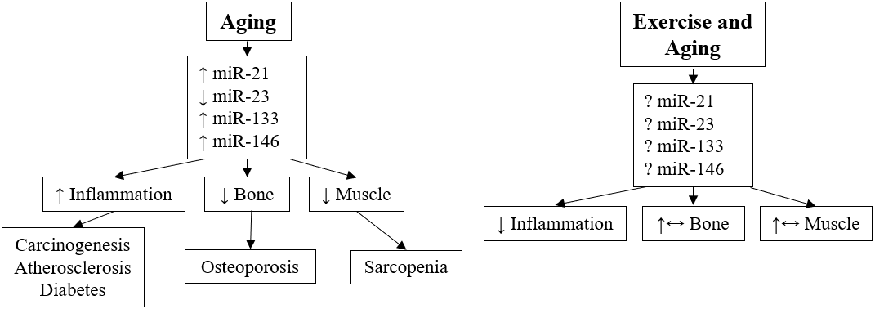
148
148
Figure 1. MicroRNA Expression and System Changes with Aging

Significance
Previous research has examined the effects of exercise on circulating miRNA (c-miRNA) expression. C-miRNAs have been associated with exercise-induced adaptations for skeletal muscle hypertrophy (19, 44, 45) and aerobic capacity (46-48) in humans, and angiogenesis in rats (49). Most studies evaluating miRNA expression post-exercise have utilized either running, cycling, or resistance training, but no studies were found where whole-body vibration was used in humans. Furthermore, evaluation of miRNAs in the context of exercise and aging is also sparse in evidence in human populations, especially postmenopausal women. Evaluating alterations in the expression of c-miRNA may provide deeper insight into the positive effects of exercise in the attenuation of the negative effects of aging.

Purpose
The primary purposes of this study were to: (1) characterize the effects of acute bouts of resistance exercise and whole-body vibration on expression of selected c-miRNAs in postmenopausal women aged 65-85 years (yrs), and (2) determine if there was a correlation between exercise responses of c-miRNA and TRAP5b. The secondary purpose of this study was to determine if correlations exist between baseline c-miRNAs and muscle strength and bone characteristics.

Research Questions
The research questions of this study are as follows:
- Is c-miRNA expression (miR-21-5p, -23a-3p, -133a-3p, -148a-3p) altered in response to single bouts of resistance exercise or whole-body vibration in postmenopausal women?
- Is there a correlation between c-miRNA expression pre- and post-exercise and markers of bone resorption (TRAP5b)?

Hypotheses
- C-miRNA-21, -23, -133, -148 will be downregulated in response to an acute bout of resistance exercise or whole-body vibration IP. miR-21 will upregulate and miR-133, -148 will return to baseline by 60p. miR-23 will downregulate 60p and remain downregulated at 24h and 48h.

TRAP5b absolute changes will be positively correlated with miR-21, -23, -133, -148.

Sub Questions
- Are there any correlations between pre-exercise c-miRNA and muscle strength values and bone mineral density, geometry, or strength?

Sub Hypotheses
- For miR-21, there will be an inverse correlation with bone characteristics and muscle strength. miR-133 will have a positive correlation with muscle strength and a negative correlation with bone characteristics. miR-148 will have an inverse relationship with muscle strength, and bone characteristics. miR-23 will have an inverse relationship with bone characteristics, but a positive association with muscle strength.

Assumptions
- Participants accurately completed their health screening questionnaire and other questionnaires.
- Women accurately knew their menopausal status.
- Participants were fasted for the blood draws.
- Participants were adequately rested for at least 24h prior to blood draws and exercise testing.
- Participants gave a maximal effort when establishing muscle strength by the one repetition maximum protocol.
- MicroRNAs from circulation reflect tissue microRNAs responsible for adaptations.
- RNA spike-in controls accurately reflect qPCR quality.
- Normalization strategies of quantification cycle values accurately reflect expression of c-miRNA

Delimitations
- Findings are only applied to healthy postmenopausal women not taking hormone replacement therapy.
- Participants with cancer, cardiovascular disease, or diabetes were excluded from the study.
- All baseline blood draws occurred between 8:00-9:00 a.m. to avoid the confounding effects of circadian rhythm.

Limitations
- Participants were volunteers and may not represent all postmenopausal women.
- This study did not look at mRNA of target genes to determine cause-effect of miRNA expression changes.
- Participants were not directly monitored outside the study for diet and physical activity 24h before testing.
- Physical activity status was not controlled for.

Operational Definitions
- Areal Bone Mineral Density (aBMD, g/cm²): The amount of bone mineral per unit of two-dimensional projected area (50).
- Bone formation: The building of new bone by osteoblasts (11).
- Bone Mineral Content (BMC, mg): also called bone mass; the amount of mineral mass measured in a bone, bony area, or the body in grams (47).
- Bone-specific alkaline phosphatase (Bone ALP): glycoprotein found on the surface of osteoblasts and reflects their biosynthetic activity (11).
- Bone Strength Index (BSI, mm³): The density weighed polar section modulus of given bone cross-section. Provides a measure of compressive strength at the metaphysis (51).
- Bone turnover: The amount of bone or the fraction of it that is replaced by new bone (3).
- Bone turnover markers (BTMs): Enzymes reflecting bone metabolic activity or bone matrix degradation products released into the circulation during bone resorption (40).
- Bone resorption: The breakdown of bone tissue by osteoclasts (40).
- Bone Strength Index (BSI): BMD(g/cm³) × CSMI(mm⁴), integrates both the material and structural properties of bone. BSI has been shown to be a better predictor than BMD or BMC alone for long bone strength (52).
- Buckling Ratio: an index of susceptibility to local cortical buckling under compressive loads derived from a DXA image (53).
- Carboxyterminal cross-linking telopeptide of bone collagen (CTX): degradation product of type I collagen from resorption (3).
- Cortical Area: Pixelated area of tissue above 710mg/ml that denotes cortical bone (54).
- Cortical bone: bone that is 80-90% calcified and provides mechanical and protective functions for the body (50).
- Cortical Thickness: Cortical distance (mm) between the endosteum and the periosteum.
- C-telopeptide of Type I collagen cross-links (CTX): Bone resorption marker measurable in serum that detects degradation of type I collagen (50).
- Cross-Sectional Moment of Inertia (CSMI): Derived from bone density and geometric models, provides an estimation of the resistance of bone to bending (55).
- Endosteal circumference: Inner membrane that surrounds the medullary cavity, measured by distance (mm) (51).
- Inflammation: Part of the complex biological response of tissues to harmful stimuli. The function is to eliminate the initial cause of cellular injury and initiate tissue repair (56).
- Menopause: Cessation of menstruation, usually occurs at 48-50 yrs of age in healthy women (9).
- MicroRNA (miRNA, miR): Short, non-coding, single-stranded RNA molecules made of 18-25 nucleotides that negatively regulate protein expression (42).
- Muscle cross-sectional area (mCSA, mm²): Area of a muscle that correlates to the muscle’s force production capabilities, measured in situ by pQCT (29).
- One-repetition maximum (1RM): the highest weight for a given lift that can successfully be lifted one time with proper technique (57).
- Osteoblast: Bone cell responsible for bone formation (9).
- Osteoclast: Bone cell responsible for bone resorption (9).
- Osteocyte: A mature bone cell, formed when an osteoblast is embedded in bone matrix; comprises 90-95% of all bone cells (9).
- Osteoporosis: BMD T-score more than 2.5 SD below the young adult reference value. Bone is fragile and fracture risk is increased (50).
- Peripheral Quantitative Computed Tomography (pQCT): A device that measures cortical and trabecular volumetric BMD (vBMD), bone geometry and SSI, which gives a three-dimensional description of bone composition as opposed to the two-dimensional view from DXA (51).
- Periosteal circumference: The measurement around the periosteum, or the outer layer of bone, at a given site and measured by distance (mm). It is an indicator of bone size and related to bone strength (51).
- Polar Moment of Inertia (iPolar): represents the ability of the bone to resist torsion (55).
- Procollagen type I N-terminal propeptide (PINP): A bone formation marker that is derived from the cleavage of type I procollagen molecules (11).
- Reverse Transcription Quantitative Polymerase Chain Reaction (RT-q-PCR): A technique which monitors the amplification of targeted DNA or cDNA molecules during PCR in real-time.
- Sarcopenia: Skeletal muscle mass index more than 2 SD below the reference population (58).
- Skeletal Muscle Mass Index (SMI, kg/m²): appendicular lean muscle mass (kg) divided by height squared (m²).
- Strength Index: Hip-structural analysis variable that is an index of resistance to axial forces (53).
- Section Modulus: Hip-structural analysis variable (cm³) that is an index of strength in bending (53).
- Stress Strain Index (SSI, mm³): A cortical density weighed section modulus of the bone. It gives a measure of bending and torsional strength of diaphyseal sites.
- Tartrate-resistant acid phosphatase 5b (TRAP5b): secreted into the circulation by osteoclasts during bone resorption and reflects osteoclast number (11).
- Trabecular bone: Cancellous, spongy bone that encloses spaces filled with bone marrow, blood vessels, and connective tissue and is only 10-20% calcified. Fulfills metabolic functions for the body (50).
- T-score: Standard deviation units in relation to the average of healthy Caucasian young females (50).
- Transforming growth factor β (TGFβ): regulates immune responses (59).
- Volumetric Bone Mineral Density (vBMD, g/cm³): Bone mineral content per cross-sectional area of a bone (60).
- Z-score: Standard deviation units above or below the average of age, weight, gender, and ethnicity-matched populations.

Chapter 2: Literature Review
The primary purposes of this study were to: (1) characterize the effects of acute bouts of resistance exercise and whole-body vibration on expression of selected c-miRNAs in postmenopausal women aged 65-85 yrs, and (2) determine if there was a correlation between exercise responses of c-miRNA and TRAP5b. The secondary purpose of this study was to determine if correlations exist between baseline c-miRNAs and muscle strength and bone characteristics.

Introduction
Aging is associated with loss of skeletal muscle and bone, and an increase in inflammation. Exercise in postmenopausal women (PMW) attenuates the loss of skeletal muscle and bone and can reduce inflammation. The purpose of this review was to examine the current evidence concerning aging and inflammation, skeletal muscle, and bone, and the current understanding of how resistance exercise (RE), whole-body vibration (WBV), and microRNAs (miRNAs) may affect, or be associated with, these systems in postmenopausal women. The literature is presented in the following sections: 1. MicroRNA Physiology 2. Age-Related Inflammation, 3. Aging and Skeletal Muscle, 4. Aging and Bone 5. Summary.

MicroRNA Physiology
MicroRNAs (miRNA) are short, non-coding segments of RNA 20-24 nucleotides (nt) in length. They are initially transcribed by RNA polymerase II from the introns of messenger RNA (mRNA) in the nucleus to form primary miRNA, which is folded and contains a hairpin structure. The enzyme complex containing Drosha and DiGeorge syndrome critical region 8 (DGCR8) edit the primary miRNA to pre-miRNA. Pre-miRNA is transported to the cytoplasm via Exportin-5. Once in the cytoplasm, the pre-miRNA is bound to an Argonaut protein. The enzyme, Dicer, cleaves the hairpin structure of the pre-miRNA to form a miRNA duplex. One strand of the duplex disassociates and is degraded. The remaining strand, now a mature miRNA, bound to the Argonaut protein forms the RNA-Induced Silencing Complex (RISC). The RISC complex negatively regulates protein translation post-transcription by selectively binding nt 2-9 to the 3`untranslated region of mRNA. Binding to mRNA either interferes with protein translation or leads to the degradation of the mRNA (61). As of this review, there are currently 1917 miRNAs sequenced in humans on miRbase.org. Multiple RNAs are targetable by a single miRNA, and greater than 60% of human genes are affected by them (62). Typically only a few miRNAs are expressed for a given tissue (63) so the presence of c-miRNAs gives a basis for use as biomarkers for various tissue and physiological systems.

Age-related Inflammation
The word ‘inflammation’ is derived from the Latin word ‘inflammare’ (to set fire). It is believed to be the non-specific immune response that occurs in reaction to any type of bodily injury and may lead to increased blood flow and elevated cellular metabolism (56). Acutely, inflammation is beneficial for neutralizing harmful stimuli in young age, however, the effects of chronic inflammation in later years can be detrimental with increased risk of diseases such as cardiovascular disease, some cancers, and neuromuscular disorders (64, 65). Health outcomes are affected by the balance between pro- and anti-inflammation status. As we age, there is an imbalance with a shift towards a pro-inflammatory status as measured by increases in markers like tumor necrosis factor alpha (TNF-α), C-reactive protein (CRP), and many of the inflammatory interleukins (7). Exercise has been shown to have a positive effect on inflammatory status and may help ameliorate the progression of inflammation-related diseases (25, 66).
Resistance Exercise Effects on Inflammation
One of the potential methods to combat the inflammatory effects due to aging in postmenopausal women is using RE for 16 weeks as an intervention. Nunes et al. (2016) sought to determine the effects of high or low volume resistance training in PMW aged 54-68. Thirty-two participants were divided into a low volume (n=10), high volume (n=11), or a control group (n=11). The two exercise groups performed the squat, leg curl and extension, bench press, rows, pull downs, arm extensions and curls at 70% of 1RM for 8-12 repetitions and three sets for the low volume or six sets for high volume. Authors reported both exercise groups improved strength values and percent body fat, but the high volume group was the only one to show a significantly lower waist to hip ratio and a reduction in interleukin (IL)-6 (26).
Other biomarkers for inflammation are the appetite suppressing hormone, leptin, and resistin. Leptin has been linked to inflammation through its downstream activation and synthesis of IL-6, IL-1, IL-12, and TNFα (67). Resistin, which has been linked to insulin resistance and cardiovascular disease, is involved in the synthesis of TNF-α, IL-1α, and IL-1β, among others (68). In postmenopausal women, resistance exercise in 35 (mean 63 yrs) previously sedentary participants improved markers of inflammation. Training consisted of barbell bench press, 45-degree leg press, seated row, knee extension, lateral raise, knee flexion, arm extension, hip adduction and abduction, arm curl, and standing calf raise. Progression for 16 weeks was periodized for strength with beginning weeks having more repetitions with lighter weight and gradual increasing weight while reducing repetitions. Results showed increased muscular strength for 1RM in the bench press (6.5kg), leg press (53kg), and arm curl (2kg). For inflammatory markers, there were decreases in IL-6, leptin, and resistin, but no change in TNFα or IL-15. In this study, resistance exercise showed evidence of benefit for improving muscular strength and reduction of some inflammatory markers (69).
Rodriguez et al. (2014) sought to determine the effects of RE on Toll-like receptor 2 (TLR2) and 4 (TLR4) expression. These receptors are linked to downstream activation of pro-inflammatory responses. Males and females (aged 65-78) participated twice a week in an 8-week resistance training program. Three exercises were used; leg press, biceps curl, and pec deck with the highest intensities for the last two weeks reaching 80% of 1RM for 3 sets of 10 repetitions. Results showed an increase in 1RM strength of all three exercises for the training group, as well as maximal voluntary isometric contractions. There was also a decrease in TLR2,4, IL-6, and CRP, another inflammation marker (70).
Whole-Body Vibration Effects on Inflammation
Rodriguez et al. (2015) also sought to determine the effects of WBV on TLR2 and TLR4 expression in elderly males and females with an average age of 70 yrs. Twenty-eight participants were divided into a control group (n=12) and an exercise group (n=16). The exercise group was involved in an 8-week program twice a week with exercises on the vibration platform that included static or dynamic exercises consisting of a half squat, deep squat, and a wide-stance squat with two sets per exercise progressing from 30 seconds up to 1 min throughout the 8-week period. Interestingly, the WBV group had both higher levels of IL-10, an anti-inflammatory cytokine and decreased expression of TLR2,4. Additionally, CRP levels and TNFα were also decreased. The authors stated that WBV elicited similar benefits for inflammation to RE and aerobic training (31).
Inflammation-Related MicroRNAs
A potential insight into human aging may be through the observance of microRNA expression throughout the lifespan. Hooten et al. (2013) collected peripheral blood mononuclear cells (PBMC) in young (~30 yrs) and old (~64 yrs) white and black American males and females. Expression level differences between age groups were noted and compared to young and old rhesus monkeys. miR-151a-5p, -181a-5p, and -1248 were downregulated in older humans and monkeys. Target analysis predicted mir-151a-5p to be a central mediator for NFκ-B, which is involved in an inflammatory response, among other contributions. miR-181a-5p targets mRNAs that translate several inflammatory cytokines including IL-α, β,6,8,10 TNFα, and TGFβ. In the Hooten study, there was a negative correlation between miR-181a-5p expression and pro-inflammatory IL-6 and TNFα levels and a positive correlation with anti-inflammatory IL-10 and TGFβ. miR-1248 has predicted targets for IL-6 and IL-8 and may be involved in mediating DNA repair pathways (71).
Other research by Olivieri et al. (2012) has sought to utilize miRNAs as biomarkers for inflammation and aging. Eleven participants from a subset of the Italian National Research Center on Aging were sampled for a microarray to determine expression throughout the lifespan. Three groups consisting of four young (20 yrs), four octogenarians, and three centenarians were used for serum analysis. Of the miRs analyzed, miR-21 met the researchers’ criteria for explaining a significant bulk of variance in their three factors. Young individuals possessed the lowest levels, with miR-21 increasing with the octogenarians. Interestingly, the centenarians had lower levels comparable to the young group and significantly lower than octogenarians. Due to low numbers included in analysis, 111 further samples throughout similar age ranges were used to validate evidence and showed no difference between men and women. The offspring of centenarians were also compared to age and sex matched controls and showed lower levels of miR-21. MiR-21 has multiple targets, one being the anti-inflammatory TGFβ. The study suggests that as we age, miR-21 levels rise, as does the level of inflammation. There is however, a genetic component with some expressing lower levels of miR-21, with subsequent less inflammation across their lifespan (8).
A recent commentary reported over MiR-146a studies in relation to inflammation and osteoarthritis. This miRNA affects TRAF6 and IRAK1, both mediators of inflammation through NF-κB. In the cell model, osteoarthritis and normal chondrocyte cells were manipulated for miR-146a expression. It was found that high levels of miR-146 reduced chondrocyte apoptosis, increased proliferation, and reduced NF-κB expression. The authors make a case for the therapeutic potential of miR-146a in the treatment of osteoarthritis (72).

Aging and Skeletal Muscle
Loss of skeletal muscle with aging is the result of several factors. There is a decrease in the total number of muscle fibers, with some fibers associated with chronically denervated motor units, undergoing apoptosis (73). This occurs primarily in type II fibers. Some of the orphaned type II fibers are reinnervated by type I motor units, with a shift in fiber type expression to resemble a type I fiber. This makes the type II fiber more fatigue resistant, but with smaller cross-sectional area and less strength and power capability (74). The composition of aging skeletal muscle also shifts, with increased intramuscular fat deposition (75). Physical activity can attenuate the loss of skeletal muscle with aging and improve body composition and force production (76).
Resistance Exercise Effects on Skeletal Muscle
The body of literature indicates that resistance exercise is beneficial for improving muscle strength and improving physical function, regardless of age or gender (77), and there is a dose-response for amount of volume with higher volumes of prescription improving strength and hypertrophy, even in persons over 50 yrs age (22, 78).
Oliveira et al. (2015) examined the effects of 12 weeks of resistance training in 22 postmenopausal women (mean 65 yrs). Training took place 3 times/week and included chest press, knee extension, hamstrings curl, leg press, hip abduction, seated row, shoulder abduction, and plantar flexion. Their results demonstrated increases in isokinetic strength, improvements in body composition with reduced central adiposity, and reduced LDL cholesterol levels. There were no improvements in resting blood pressure, CRP, or changes in HDL. The authors state that resistance exercise is an important component of physical activity programs for the elderly (79).
Teixeira et al. (2003) assessed the effects of one year of resistance training in postmenopausal women (mean 55 yrs), who were either taking hormone replacement therapy (HRT) or not. HRT users (n=119) and nonusers (n=114) were divided into exercise or non-exercise groups. The exercise group trained three days per week and included resistance exercise (leg press, hack squats or smith squats, lat pulldowns, lateral rows, back extensions, right- and left-arm dumbbell presses, and rotary torso) for 2 sets of 6-8 repetitions at 70-80% of 1RM and moderate impact activities (skipping, stairs/step boxes with weight vest). Body composition, measured by DXA, showed increases in lean mass and decreases in leg fat mass, regardless of HRT status. HRT had no effect in the exercise group, though the HRT non-exercise group avoided loss of lean tissue compared to the non-exercise non-HRT group. Strength was also unaffected by HRT status, with both exercise groups’ improvements being comparable (23).
Whole-body Vibration Effects on Skeletal Muscle
A meta-analysis of the effects of WBV on leg strength and BMD of the hip and lumbar spine was conducted by Lau et al. (2011). Participants from 18 included studies had mean ages ranging from 57-82 yrs with 7 analyzing only PMW. Frequency of WBV ranged from 1-7 days for six weeks to 18 months, utilizing vertical or oscillating vibrations. Vibration signals ranged from 10-54 Hz and amplitudes ranged from 0.05-8 mm. Different exercises were used including static and isometric partial squats and lunges. While the meta-analysis did not provide evidence for increased BMD at the lumbar spine or hips in postmenopausal women specifically, muscle strength improvements were similar between studies. There is benefit for knee extension dynamic strength, leg extension isometric strength, and improved functional capacity with results comparable to resistance training. The analysis was unable to determine which protocol or device most improves leg strength (27).
Bemben at al. (2010) assessed the effects of resistance exercise and resistance exercise in conjunction with WBV in 55 postmenopausal women aged 55-75 yrs over the course of 8 months. Resistance exercise strength testing consisted of supine two leg press, hip flexion, hip extension, hip abduction, hip adduction, seated military press, lat pull down, and seated row. Exercise were performed at 80% of 1RM for three sets of ten repetitions. WBV consisted of high frequency and low amplitude for three conditions associated with corresponding resistance exercises. Generally, 1RM values increased from pre to post exercise for all 1RM tests and for both exercise conditions. It was also reported that WBV in addition to resistance exercise improved upper body strength and hip abduction and adduction variables beyond that of resistance exercise alone. There were no changes reported for bone turnover markers nor was there a change in BMD for the exercise groups (21).
Muscle-Related MiRNAs
Cui et al. (2017) assessed the time-course of c-miRNA expression from three different resistance exercise protocols in 45 young men (15 each). The three protocols consisted of five exercises: bench press, squat, pulldown, overhead press and standing dumbbell curl and were performed at different volumes and intensities. The strength endurance (StE) group performed three sets of 16-20 repetitions at 40% 1RM with one-min rest intervals. The muscular hypertrophy (MH) group performed three sets of 12 repetitions at 70% of 1RM with two-min rest intervals. The maximum strength (MaxS) group performed four sets of six repetitions at 90% of 1RM with three-min rest intervals. Blood sampling occurred pre, IP, 1h, and 24h after exercise. For the StE group, miR-532 increased 1h post exercise and remained elevated 24h later while miR-208b decreased immediately post (IP) and remained depressed. The MH group showed miR-133a decrease IP and return to baseline 1h later. MiR133b was significantly increased 24h post and miR-206 peaked 1h post and return to baseline 24h later. MiR-21 expression was diminished IP, and elevated to peak expression 1h post. For the MaxS group, miR-133a significantly decreased expression IP and returned to baseline 1h post. Mir-133b increased expression from IP to1h post. The authors concluded that miR-133a may be a potential biomarker of physiological muscle strain for RE at very high intensities (90% 1RM). The changes seen in miR-21 may be indicative of an initial pro-inflammatory response, followed by an anti-inflammatory response. Of note, miR-146a did not respond to any RE protocol in young men, unlike acute endurance exercise (80).
MicroRNAs are involved in the regulation of hypertrophy and other muscular adaptations. D’Souza et al. (2017) observed the effects of an acute resistance exercise bout on the expression of microRNAs in muscle tissue and plasma in 9 healthy young males. Subjects performed 6 sets of 8-10 repetitions for leg press and 8 sets of 8-10 repetitions for knee extension. Samples were collected pre, 2hrs, and 4hrs post-exercise. From skeletal muscle biopsy, miR-133a, -206 increased 2h post and miR-146a increased 4h post. MiR-23a decreased 2h post and further decreased 4h post. Of the c-miRNA, only miR-133a and -149 were elevated from baseline, while miR-1, -208a, and -499 were undetected. From both samples, only miR-133a had increased expression and may serve as a marker for muscle damage (81). MiR-146a has shown a decrease after RE, however the reduced expression was only seen after three days (82).
MicroRNA expression changes from exercise may be attenuated due to aging. Margolis et al. (2016) measured the adaptive response to chronic resistance exercise between 9 younger (mean 22 yrs) and 9 older men (mean 74 yrs). Three miRNAs, miR-19b-3p, -206, -486, significantly predicted age. Ten c-miRNA were upregulated after exercise in the younger group and downregulated in the older group. Of those ten, six (miR-19a-3p, -19b-3p, -20a-5p, -26b-5p, -143-3p, -195-5p) were associated with inhibition of the PI3K-Akt pathway which would increase activation of the Akt-mTOR pathway and increase cellular protein synthesis (19).
Uhlemann et al. assessed c-miRNA expression changes of miR-126 and miR-133a as markers for muscle damage in varying modalities of exercise. Participants performed bouts of maximal cycle testing, 4hrs of cycling below the anaerobic threshold, a marathon race, and eccentric resistance exercise consisting of lat pulldown, butterfly and leg press. The endurance tasks increased miR-126 but not resistance exercise. The authors concluded that miR-126 reflected damage to endothelial tissue in response to endurance activities. miR-133 may reflect muscle damage as it only increased expression in response to exercise modalities that contain eccentric components like marathon running and eccentric resistance exercise, but not in either cycling protocol (83).
Sawada et al. assessed miRNA responses in 12 young men (~29 yrs) performing bench press and bilateral leg press. Participants performed five sets of ten repetitions at 70% 1RM and had serum samples taken before, immediately after, 60 min, 1 day, and 3 days after exercise. There was no significant change for miR-133 nor miR-21 post-exercise, only downregulation of miR-146a and miR-221 three days post-exercise and upregulation of miR-149a 24h post-exercise. Mir-21 had a weak positive correlation with the catecholamines, epinephrine and norepinephrine, and testosterone and IGF-1 were weakly positively correlated with miR-222 (82).

Aging and Bone
In women, bone accrual peaks between 20-30 yrs (84). Bone mineral density (BMD), measured by DXA, steadily declines after peak accrual (85), with accelerated loss of trabecular bone after menopause (86). Of interest, loss of BMD occurs in weight-bearing areas of the spine (~42%) and femur (~58%) and may lead to increased fracture risk (87). Bone may also be assessed by computed tomography to give a noninvasive measurement of bone quality. Riggs et al. (2008) assessed bone quality in the lumbar spine, distal radius, and distal tibia in participants aged 20-97. They found decreased trabecular vBMD starting in young adulthood, and the loss was independent of sex steroid levels. Cortical loss did not occur until later in life and was associated with lower levels of free sex steroids. Trabecular bone loss was greatest in the lumbar spine, and women typically lose more bone mass than men, especially during the menopausal transition (88). There are various options to attenuate bone loss in women, including HRT, supplementation with calcium and vitamin D (89, 90), and exercise. HRT is widely accepted as a beneficial preventer of osteoporosis with low absolute risk of cancer attributed to HRT (91).
Resistance Exercise Effects on Bone
A meta-analysis conducted by Zhao, Zhao, and Xu analyzed the body of literature concerning chronic resistance exercise and bone health status in postmenopausal women. The 24 studies included in the analysis were either controlled or randomized controlled trials in healthy, postmenopausal women without pharmacological treatment or a disease history that impacts bone metabolism. The studies included subjects that did not regularly exercise and protocols were compared with non-exercise controls or sham protocols. Study durations ranged from six months to 12 yrs and 14 of the studies were resistance-alone protocols while the other ten were clinical trials. A total of 924 postmenopausal women underwent exercise interventions, compared to 845 controls. The analysis did not find a significant improvement in BMD from resistance training alone, however combination training that included resistance exercise and high-impact or weight bearing exercises did improve BMD in the hip and spine of postmenopausal women (92).
The beneficial effect of resistance exercise on bone in postmenopausal women was evaluated by Kerr at al. (2009) using DXA. 126 women who were more than 5 yrs resistance untrained were divided into a strength, fitness, or control group. The strength group performed exercise three days/week with three sets of eight repetitions and gradual progression of weight throughout the 24 months. The fitness group performed similar exercises, but each exercise was performed with minimal load for 40 seconds with 10 seconds of rest between exercises and little progression of weight throughout the program. The fitness group also performed some moderate-intensity cycling. RE consisted of wrist curl, reverse curl, biceps curl, triceps pushdown, hip flexion, hip extension, latissimus dorsi pull down, and calf raise. The only positive increase in bone variables occurred in the RE group with increased BMD in the intertrochanter (0.7%) and total hip (0.57%) compared to the other two groups. Circuit training performed by the fitness group did not show the same benefit for BMD in the hip (24).
Gombos et al. (2016) assessed acute bone turnover marker changes in osteoporotic or osteopenic females. Three groups of 50 women each (mean 58.5 yrs) were divided into a RE group, a walking group, and a control group. RE consisted of bodyweight exercises with some exercises utilizing intermittent isometric holds (2 seconds). Examples included plank variations, lunges, and use of resistance bands. The walking group performed brisk walking at 100 steps/min for 46 min. Bone turnover markers analyzed were Bone ALP, CTX, and sclerostin. ANOVA results from pre to IP exercise showed no change in Bone ALP for any group. CTX decreased 27pg/ml in the RE group, but did not significantly change for the other two. Sclerostin levels increased in the RE and walking groups by 2.9 and 6.3pmol/L, respectively with the walking group increasing levels above RE significantly. The results show that acute reductions in CTX from RE may help reduce bone resorption in osteopenic/osteoporotic postmenopausal women (93).
Vincent and Braith (2001) assessed bone turnover responses in 62 elderly men and women from both high and low intensity exercise after a six-month training protocol. Exercises consisted of leg press, leg curl, knee extension, chest press, seated row, overhead press, triceps dip, and biceps curl. Participants were not separated by gender for analysis. Both groups increase muscle strength in each exercise compared to control. BMD values remained unchanged, except for an increase in femoral neck BMD for the high intensity group. Osteocalcin and bone-specific alkaline phosphatase significantly increased for the high intensity group, and only osteocalcin increased for the low intensity group (94).
Whole-Body Vibration Effects on Bone
A meta-analysis concerning WBV in postmenopausal women was conducted by Oliviera et al. (2016). In the analysis, 15 studies were included and took into consideration the type of device being used, either synchronous or side-alternating vibration. It also considered positioning of participants, frequency, and magnitude. Side-alternating devices were found to have a significant effect on BMD of the lumbar spine and trochanter, while synchronous vibration did not. It was also determined that semi-flexed knees significantly improved BMD, while extended knees did not. For the manipulation of frequency and magnitude, it appears that low frequency and high magnitude are the most beneficial for improving BMD in the lumbar spine and trochanter (30).
Bone turnover responses from WBV were assessed in postmenopausal women by Turner et al. (2011). Participants (mean 60 yrs) were divided in three groups: control (n=16), one day/week (n=14), 3 days/week (n=16). Vibration consisted of low- frequency (12Hz), low magnitude (0.5mm peak-to-peak) and subjects stood on the plates with knees extended. Results showed no change in the bone formation markers, B-ALP, but significant decreases in the resorption marker, NTx/Cr (95).
In 2015, Kiel et al. published results from a 2-year WBV intervention in 174 elderly men and women (>60 yrs). WBV consisted of low-magnitude mechanical stimulation with participants’ knees straight for one dose of ten min per day every day of the week. No change was seen for BMD nor for P1NP or CTX. Of note, there was no loss of bone (28).
Bone-Related MicroRNAs
Chen et al. assessed circulating miRNAs in 75 postmenopausal women aged 60-85 yrs based on osteoporosis and sarcopenia status. DXA measures were used to classify bone status, while muscle status was quantified with DXA and functional tests of grip strength, gait speed, and jump power. They measured miR-1-3p, -21-5p, -23a-3p, -24-3p, -100-5p, -125b-5p, -133a-3p, -206, miRNAs associated with targets in muscle and bone, and also the bone resorption markers CTX-I and TRAP5b. There were no significant differences in c-miRNA expression between osteoporotic and non-osteoporotic and sarcopenic and non-sarcopenic participants, but there were potentially biologically relevant differences in fold changes of miR-21 and miR-23 between the higher expressed osteoporotic and the non-osteoporotic group. The osteoporotic group also had lower fold changes of miR-125. Also, miR-21 was negatively correlated with trochanter BMC, miR-23 had a low positive correlation with TRAP5b, and miR-125 was positively associated with jump velocity and power (96).
Very recently a study was published on the effects of high-intensity repeated sprints on the expression of fracture-risk associated miRNAs. Eighteen physically active males (mean 24 yrs) underwent 18 repeated sprints at maximum velocity for 15 meters with 17 seconds of active recovery between bouts three days/week for eight weeks. DKK1 levels decreased at the four-week mark, but returned to baseline by eight weeks. Sclerostin significantly decreased in the exercise group at the eight-week mark. The results also showed no changed in miR-21-5p compared to controls, while miR-23a-3p and miR-24-3p decreased after four weeks and remained depressed after eight weeks. The authors concluded that high-intensity sprint training showed decreased expression of miR-23a-3p, -24-3p, -100, all c-miRNA that have been implicated in fractures (97).
As mentioned previously, microRNAs may serve as biomarkers for osteoporosis. Wang et al. (2012) measured miRNAs in circulating monocytes in 20 postmenopausal women. The cohort was dichotomized into high and low BMD groups and compared for expression levels. Of the miRNAs assessed, miR-133a was expressed significantly higher in the low BMD group. The target for miR-133a in bone is RUNX2, and higher levels in tissue would have a negative impact on bone formation (98).
Seeliger et al. (2014) analyzed circulating and bone tissue miRNAs between osteoporotic (n=10) and nonosteoporotic (n=10) patients with hip fractures. Of the two sample types, 5 miRNAs (miR-21, -23a, -24, -100, -125b) were expressed higher in osteoporotic patients. MiR-21 may affect bone through inhibition of PDCD4 which allows for osteoclast survival. MiR-23a, -24 are implicated in inhibition of RUNX2 for osteocyte formation. MiR-100 may negatively affect bone formation by inhibiting bone morphogenic protein receptor type II, thus halting the growth of preosteoblasts into mature osteoblasts. MiR-125b may also affect formation by inhibiting mesenchymal stem cell differentiation towards an osteoblastic lineage (12).
Weilner at al. (2015) also assessed miRNAs in osteoporotic fracture patients (99). Serum samples from 37 postmenopausal women (>65 yrs) were collected, 19 of which had recent fractures due to osteoporosis. Samples were taken within two weeks of surgery. Differentially expressed miRNAs included the upregulated (miR-10a-5p, 10b-5p, -22-3p) and three downregulated (miR-133b -328-3p, let-7g-5p). A validation cohort was also used to validate the differentially expressed miRNAs. It was found that only miR-22-3p, -328-3p and let-7g-5p reached significance. In the case of miR-22-3p, the first study saw significant upregulation while the validation cohort saw significant downregulation. Of note, there were no differences between fracture patients and controls for miR-21 (99).
Panach et al. (2015) also assessed c-miRNA in eight osteoporotic fracture patients (mean 80 yrs) compared to five controls (100). They found that miR-122-5p, -125-5p, -21-5p were significantly upregulated in the fracture patients. Mir-21-5p was also highly correlated with the bone resorption marker, CTX. Other correlations included miR-21, -125b correlated positively with osteocalcin, miR-122-5p was positively associated with total alkaline phosphatase, and miR-210 correlated positively with BAP. Though miR-21 can have an osteoblastic effect, it appears that in fracture patients, miR-21 serves to improve osteoclastic function to a greater degree. It also appears that miR-210 may serve as a marker for osteoblastic function (100).
A recent review article by Bellavia et al. (2019) discusses the impact of deregulated miRNAs on bone health. The article provides rationale that some miRNAs are supported by evidence for use as biomarkers for osteoporosis. Those miRNAs include miR-21, -23, -124, -125, -133, -148. As mentioned in Chapter 1, miR-21 inhibits a protein that inhibits osteoblast differentiation, thus improving bone formation. However, it also inhibits programmed cell death 4 (PDCD4) in osteoclasts, leading to increased bone resorption. MiR-23 has a negative impact on bone by decreasing osteoblast differentiation. MiR-133 promotes bone resorption by inhibiting the inhibitors of osteoclastogenesis. MiR-148 has doubly negative impacts on bone status by increasing resorption through osteoclastogenesis and decreasing formation by inhibiting osteoblasts (20).

Summary
It is important to understand the potential skeletal muscle, bone marker, and inflammatory responses from resistance exercise and whole-body vibration in postmenopausal women. Based on findings from the literature, both RE and WBV may have a positive influence on inflammatory markers. RE and WBV have potential to increase muscle strength, though muscle hypertrophy and the miRNAs associated with it may not change. For WBV, it appears that protocols using lower frequencies and higher magnitudes produce the most favorable response in bone. The inclusion of miRNAs may serve as potential biomarkers for prediction of responses or as predictors of inflammation, muscle strength, and/or bone status.

Chapter 3: Methods
The primary purposes of this study were to: (1) characterize the effects of acute bouts of resistance exercise and whole-body vibration on expression of selected c-miRNAs in postmenopausal women aged 65-85 yrs, and (2) determine if there was a correlation between exercise responses of c-miRNA and TRAP5b. The secondary purpose of this study was to determine if correlations exist between baseline c-miRNAs and muscle strength and bone characteristics.

Participants
A total of 14 participants were enrolled in the study. Four participants were excluded prior to testing due to voluntary termination (n=2), injury outside of the study (n=1), and an inability to give blood draws (n=1). In total, 10 participants, 65-76 yrs of age were used in the final analysis. Participants were not recruited according to ethnicity although the vast majority of participants identified as Caucasian (n=9); the other ethnicity represented was Asian (n=1). The study design was tolerated well, with only one participant complaint about multiple sticks from blood draws. One other participant missed their 24h timepoint draw.
Prior to participating, participants were taken through aspects of study design, signed an informed consent document and a HIPAA form, and obtained medical clearance from their personal physicians. Participant recruitment was from the Norman and Oklahoma City area via mass email, flyer, newspaper advertisement, and by word of mouth. Participants were screened for inclusion and exclusion criteria prior to consent testing. A priori sample size calculation was performed using G*Power 3.1.9.2 (Heinrich Heine University, Düsseldorf, Germany). A study by Daniels et al. (2014) was used for calculation of effect size. Part of the study compared the detectable changes in miRNA expression between two miRNA kits across multiple timepoints in 12 subjects (101). The variances explained by effect reported for miR-16 were 0.237 and 0.346. These values were applied to the G*Power application. Power was set at 0.8, alpha at 0.05, and number of measurements was set at 5 timepoints. The 0.346 variance yielded an effect size of 0.416 and a sample size estimation of 10 while the 0.237 variance elicited an effect size of 0.344 and a sample estimation of 12 participants.

Inclusion Criteria
- Postmenopausal women, aged 65-85 yrs;
- Community-dwelling individuals.
- Greater than 5 yrs postmenopausal

Exclusion Criteria
- Failure to obtain clearance from a licensed medical physician;
- Current smokers;
- Individuals with metabolic disease (e.g., diabetes), cancer, or uncontrolled hypertension;
- Individuals taking medications known to affect bone metabolism, such as hormone replacement therapy, antidepressants, or glucocorticoids;
- Individuals outside of limits of the DXA table (height over 6’4”, weight over 350 lbs);
- Individuals who have suffered a fracture within the previous 12 months;
- Individuals with metal implants or joint replacement at the hip or spine.

Research Design
This within-subjects randomized crossover study design compared the relative expression changes of c-miRNA from an acute bout of resistance exercise and an acute bout of whole-body vibration. Randomization occurred between exercise modalities and there was a minimum of a 10-day washout period between exercise visits. Nine visits were required in this study; consenting, blood pressure, and questionnaires (visit 1, ~1hr), scans for DXA and pQCT, familiarization of resistance equipment and whole body vibration, and functional performance measures of handgrip strength and jump power (visit 2, ~2.5 hrs), 1 repetition maximum (1 RM) testing of leg press, shoulder press, lat pulldown, leg extension, and hip adduction (visit 3, ~1.5 hrs), resistance exercise testing (visit 4, ~2hrs), whole body vibration testing (visit 7, ~1.5hrs). Visits 4 and 7 were randomized and sampling times are illustrated in Figure 2. Visits 5, 6, 8, and 9 (~30 min each) consisted of blood draws at the Goddard Student Health Center that occurred between 8:00-9:00 a.m. 24 and 48h after each exercise visit. Visit 1 was conducted at the Bone Density Laboratory, Visit 2 was held in the Bone Density Laboratory for scans and the Neuromuscular Lab for familiarization of exercises, and Visits 3, 4, and 5 were conducted at the Neuromuscular Lab only. Both labs and the Goddard Student Health Center are at the University of Oklahoma. Medical clearance was obtained before Visit 2.
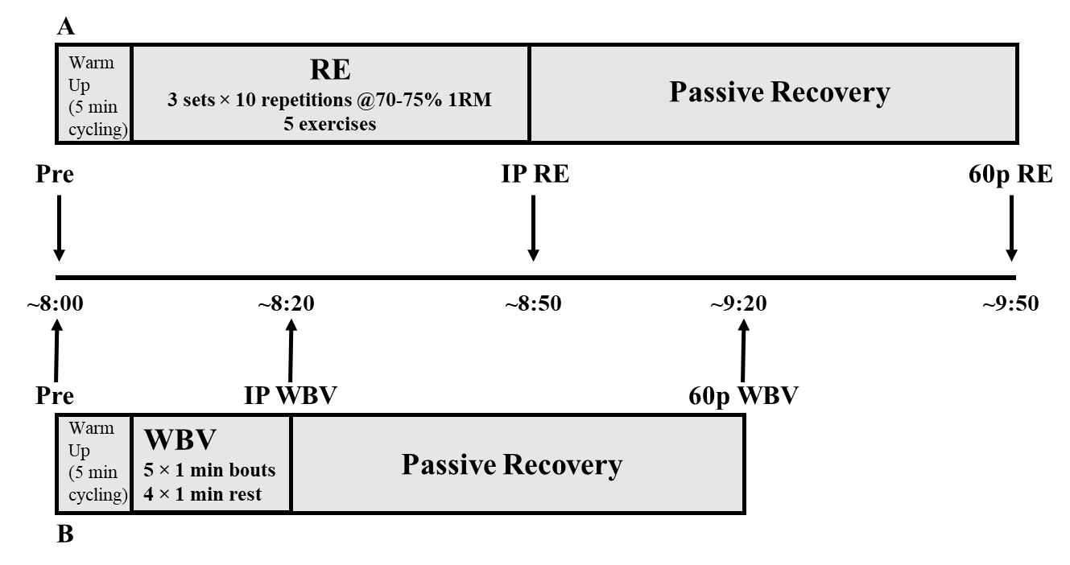
Figure 2. Blood sampling timeline for RE (A) and WBV (B) protocols

The independent variables are exercise modality (RE, WBV) and time points (pre, immediately post, 1h, 24h, and 48h post-exercise). The dependent variables for serum are relative expression levels of c-miRNA (miR-21, -23, -148, -133) and levels of the bone resorption marker, TRAP5b. Dependent strength variables include hand grip, jump power, velocity, height, and 1RM measures. The dependent variables for DXA are areal bone mineral density (aBMD) of the total body, lumbar spine, dual femur, and body composition variables consisting of total body bone-free lean mass and fat mass, and lean mass and fat mass of the arms and legs. Dependent variables for pQCT are volumetric bone mineral density (vBMD), volumetric bone mineral content (vBMC), and total area at the non-dominant tibia 4%, 38%, and 66% sites; trabecular vBMD, vBMC, and area at 4% site; cortical vBMD, vBMC, area, Ipolar, and SSI at 38% and 66% site; muscle cross-sectional area (mCSA) at 66%.

Questionnaires
Questionnaires were filled out by study participants to determine inclusion/exclusion criteria and collect information to reduce the potential confounding influence of physical activity, diet, and menstrual history. The following questionnaires were used.
- Health Status Questionnaire- was used to determine if participants meet study inclusion criteria and if they had any preexisting conditions that warrant exclusion. Also used to record medications taken by the participants.
- Menstrual History Questionnaire- provided information about menstrual history and any hormone replacement therapy.
- International Physical Activity Questionnaire (IPAQ)- designed to designate low (<600 MET min/week), moderate (≥600 to <3,000 MET min/week), or high (≥3,000 MET min/week) physical activity levels per week (102).
- Bone-Specific Physical Activity Questionnaire (BPAQ)- quantified exposure to bone loading physical activity throughout the lifespan (103).
- Calcium Intake Questionnaire- a food frequency questionnaire that estimated daily calcium intake from both diet and supplements (104).

Height and Weight
Height was measured to the nearest 0.5 cm using a wall stadiometer (PAT #290237, Novel Products, Rockton, IL). Weight was measured to the nearest 0.1 kg with a digital electronic scale (BWB-800, Tanita Corporation of America, Inc., Arlington Heights, IL).

Blood Pressure
Participants’ resting blood pressure was measured with an automatic blood pressure monitor (Omron, Japan) on the left arm. Participants lay supine quietly on a bed with their left arm extended and slightly away from the body. Cuff size was determined based on manufacturer recommendations. Cuff positioning was located over the brachial artery and approximately one inch above the antecubital fossa. The “START” button was pressed to begin cuff inflation. Heart rate and systolic and diastolic blood pressure were recorded. A second measurement was performed after one min to determine repeatability. If either blood pressure value was outside of a 5 mm Hg difference, a third measurement was performed. Participant values above 140 mmHg systolic or 90 mmHg diastolic pressure were excluded from further study participation.

Dual Energy X-ray Absorptiometry (DXA)
The Lunar Prodigy DXA (GE Healthcare, Madison, MI) was used to measure areal bone mineral density (aBMD). The four scan sites were the total body, AP lumbar spine (L1-L4), and dual proximal femur (femoral neck, trochanter, and total hip). Total body scans provided body composition of the whole body and appendicular lean mass for potential sarcopenia classification. Scans were analyzed with encore software, v16 (GE Healthcare, Madison, WI). Quality Assurance (QA) tests were performed and documented before each scanning day for calibration of the device. For QA tests, a calibration block was placed on the DXA table as instructed by the device. The software then performed the QA test automatically. Table 1 lists the coefficient of variation percent (CV%) for several previously measured DXA variables in our laboratory.
Prior to arrival, participants were instructed to wear minimal clothing devoid of metal and arrive euhydrated. Hydration status was determined with a urine refractometer (VEE GEE CLX-1, Rose Scientific Ltd., Alberta, Canada). Acceptable hydration for body composition determination is a urine specific gravity between 1.004-1.029 (105). Participants were instructed to remove jewelry, shoes, and lie supine and centered on the scanning table with the top of their head approximately 2-3 cm below the horizontal white line for the total body scan. Hips and shoulders were adjusted, as necessary, to position the participant evenly in the middle of the scanning field. Straps were used below the knee and at the ankles to maintain leg positioning. For the AP scan, the legs were raised and a foam block placed underneath so the knees were bent at a 45-60-degree angle. The scanner arm was placed with the pointer two finger widths below the navel, with the arms crossed and raised to avoid scanning interference. The dual femur scan required the foam block and straps to be removed. A brace was placed between the ankles and strapped in place. The left femur was positioned directly parallel with the table, then the right femur. Regions of interest (ROI) for the total body scan were adjusted as described by Libber et al. (2012). ROI adjustment included cutting the head just below the chin, bisecting the shoulders at the glenohumeral joint, and the hips at the top of the iliac crest (106).
Table 2. Precision for Bone Density and Body Composition Measurements by DXA
Variable | CV%
Total Body aBMD | 1.27%
Lumbar Spine L1-L4 aBMD | 1.80%
Left Femoral Neck aBMD | 1.79%
Right Femoral Neck aBMD | 1.33%
Left Total Hip aBMD | 1.19%
Right Total Hip aBMD | 1.00%
BFLBM | 1.21%
Fat Mass | 1.74%
Body Fat% | 1.56%
Arms BFLBM | 3.97%
Legs BFLBM | 2.29%
ASMM | 2.08%
ASMM- Appendicular Skeletal Muscle Mass; aBMD- Areal Bone Mineral Density; BFLBM- Bone-free Lean Body Mass

Peripheral Quantitative Computed Tomography (pQCT)
pQCT provides additional details concerning the cross-sectional properties of skeletal sites. It measures volumetric values of BMD and can distinguish between cortical and trabecular bone. The device can also assess bone strength (compact and torsional), density, and composition.
Prior to scanning, non-dominant tibia length was assessed using a tape measure. Participants were instructed to sit in a chair and cross their non-dominant leg over their dominant knee. Measurement parameters included the end of the medial malleolus to the endplate of the proximal tibia. Tibia length was recorded in mm.
An XCT-3000 bone scanner (Stratec Medizintechnik GmbH, Pforzheim, Germany) was used for the epiphyseal and diaphyseal bone measurements of the non-dominant tibia at the 4%, 38%, and 66% sites. Integrated software v6.00 (Stratec Medizintechnik GmbH, Pforzheim, Germany) was used for analysis. Scans were obtained with a 0.5 mm voxel size, 2.2 mm slice, and a 20 mm/s scan speed. Analysis required the user to define thresholds and use contmodes and peelmodes for cortical recognition and filtering of partial voxels. Table 3 lists the CV% for previously measured pQCT variables in the non-dominant from our laboratory.
Table 3. Precision for Volumetric Bone Measurements by pQCT
Site | Variable | CV%
4% | Total vBMD (mg/cm³) | 1.12%
 | Total vBMC (mg/mm) | 2.00%
 | Trabecular vBMD (mg/cm³) | 0.68%
 | Trabecular vBMC (mg/mm) | 3.07%
 | Peri_C (mm) | 1.23%
38% | Total vBMD (mg/cm³) | 0.29%
 | Total vBMC (mg/mm) | 0.48%
 | Cortical vBMD (mg/cm³) | 0.29%
 | Cortical vBMC (mg/mm) | 0.61%
 | SSI (mm³) | 1.29%
 | Ipolar (mm⁴) | 0.84%
66% | Total vBMD (mg/cm³) | 1.51%
 | Total vBMC (mg/mm) | 0.92%
 | Cortical vBMD (mg/cm³) | 0.50%
 | Cortical vBMC (mg/mm) | 1.85%
 | Peri_C (mm) | 0.49%
 | Endo_C (mm) | 1.45%
 | SSI (mm³) | 1.49%
 | Ipolar (mm⁴) | 1.08%
 | Muscle CSA (mm²) | 1.73%
Peri_C- Periosteal Circumference; Endo_C- Endosteal Circumference; SSI- Strength Strain Index; Muscle CSA- Muscle Cross-Sectional Area

After entering participant information into the computer, subjects sat in a chair and placed their nondominant foot into a holder. The top of the nondominant tibia was adjusted to be directly parallel to the floor and centered in the middle of the gantry. Straps were used to secure the foot and knee for scanning. A scout view was performed to determine the reference line.

One-Repetition Maximum Testing (1RM)
Leg press, shoulder press, lat pulldown, leg extension, and hip adduction isotonic machines (Cybex, Medway, MA) were used for this study. Trained personnel were present to instruct participants on appropriate lifting technique. Participants warmed up for 5 min at a self-selected comfortable pace and resistance on a stationary bicycle (828E, Monark, Vansbro, Sweden). The 1RM protocol for each piece of equipment was: (1) proper positioning based on manufacturer recommendations; (2) complete a warmup set of 5-10 repetitions at ~50% of estimated maximal strength; (3) after 1 min rest, another set of 3-5 repetitions at ~75% of estimated maximal strength; (4) After 2 min rest, the load was increased for 1 repetition, with this step repeating, until a maximum was achieved. The goal was to achieve a maximum strength value within 5 attempts.

Acute Exercise Protocols
Resistance Exercise
Participants performed resistance exercises in the following order: leg press, shoulder press, lat pulldown, leg extension, and hip adduction. There were three sets of 10 repetitions per exercise at 70-75% of 1RM with 2-3 min of rest between sets and exercises. Each repetition consisted of ~1 second each during the eccentric and concentric phases, with minimal time spent isometrically. One participant failed at 8/10 repetitions on the third set of shoulder press and the weight was reduced by 2.5kg to complete the last two repetitions. All other participants completed every repetition for all sets and exercises.
Whole-Body Vibration
Participants were instructed to remove footwear and socks and stand with knees bent at 30° and their second toe in line with the dot located between positions 1 and 2 on the Vibraflex Vibration Platform (Orthometrix, Inc., Naples, FL). Each of the 5 bouts were performed for one min at a 20 Hz frequency with a 3.38 mm peak-to-peak displacement with a load stimulus of approximately 2.7g and 1 min of rest between bouts.

Muscle Functional Performance Measurements
Handgrip Test
Grip strength was measured with a handgrip dynamometer (Takei Scientific Instruments, Yashiroda, Japan) while in a seated position with the back supported. The elbow was placed on the arm rest at a 90-degree angle with the wrist at the end of the arm rest. The hand was in a neutral position. Starting with the right hand, the participant squeezed the dynamometer as hard as possible for a maximum of 3 seconds. A rest period of 30 seconds was given and then the procedure repeated on the left hand. This occurred for 3 cycles and the best result was recorded to the nearest 0.1kg.
Jump Test
Muscle power (jump height, air time, power, velocity) was assessed by a jump test using a jump mat (Just Jump, Probiotic, AL) and with a Tendo FiTRODYNE (Tendo Sports Machines, Trencin, Slovak Republic). Participants stood in the center of the jump mat with the Tendo strap secured to a belt placed just above the hips. They crouched while swinging their arms down and back and jumped straight up while bring their arms forward and up, landing in the center of the mat. Spotters were in place to ensure participant safety. One min of rest was provided between jumps with a total of 3 successful attempts recorded and averaged.

Blood Sampling
A blood sample of 7.5 ml was collected via venipuncture by a registered phlebotomist. Baseline samples were collected between 8:00 and 9:00 a.m. after an 8h overnight fast to measure c-miRNA and TRAP5b, with further sampling immediately (IP), 1h (60p), 24h, and 48h post-exercise. After each draw, two hematocrit tubes were filled from the serum separator tubes (SST) for measurement of hematocrit (HCT) and plasma volume shifts. Percent change in plasma volume (%ΔPV) was determined with the following equation:
%ΔPV = 100/(100 - Hct Pre) * 100((Hct Pre – Hct Post)/Hct Post) (107) and applied to TRAP5b with the following equation: Corrected Concentration = Uncorrected value * ((100 + %ΔPV)/100).
The same application was performed for plasma volume changes with an alteration to the formula to account for exponential expression changes in quantification cycle (Cq) values with the formula %ΔPV = (log(100)/(log(100) – log(Hct Pre)) * log(100)*((log(Hct Pre) – log(Hct Post))/log(Hct Post)). The correction factor was subtracted from the Cq values for each miRNA from each exercise sample. Blood lactate was analyzed with the Lactate Plus lactate analyzer (Sport Resource Group Inc., Minneapolis, MN) from the SST pre and immediately post-exercise. Samples were allowed to clot for 30 min and then centrifuged at 2,000 g for 15 min. Samples were equally aliquoted into 8 microtubes and frozen at -84 °C until analysis.

TRAP5b Assays
Prior to assays, samples and reagents were thawed at room temperature. MicroVue™ Commercial ELISA kits were used to measure TRAP5b (Quidel, Athens, OH) in duplicate. All assays were performed following step by step instructions included with each kit. Intra-assay CV% ranged from 1.3-7.9% and the inter-assay CV% was 7.2%.

MicroRNA Quantification
RNA Extraction
MicroRNA analyses were performed by TAmiRNA Vienna, Austria. Total RNA was extracted using the miRNeasy Mini Kit (Qiagen, Hilden, Germany) following procedures included in the kit. Serum samples were thawed on ice and centrifuged at 12,000g for 5 min for cellular debris removal. 200µl of serum were used for sample lysis by mixing with 1,000µl QIAzol Lysis Reagent and 1µl of synthetic spike-in, Uni-Spike-In 4 (UniSp4) (Exiqon, Vedbaek, Denmark), to control for variance of cDNA synthesis and qPCR. After incubation at room temperature for 10 min, RNA extraction was performed using 200µl chloroform and phase separation achieved by centrifugation at 12,000g for 15 min at 4°C. 650µl of the upper aqueous phase was transferred to a new collection tube and mixed with 7µl glycogen. Samples were transferred to an miRNeasy mini column, and RNA was precipitated with 750µL of ethanol followed by washing with RPE and RWT buffer. RNA was eluted in 30µL of nuclease-free water and stored at −80°C until further analysis. Detection of hemolysis was performed using the Nanodrop OD414 measurement.
cDNA Synthesis
The extracted RNA was transcribed to cDNA using the Universal cDNA Synthesis Kit II (Exiqon). The protocol was modified in that 2µL of total RNA was used per 10 µL reverse transcription (RT) reaction. To monitor RT efficiency and the presence of impurities with inhibitory activity, a synthetic RNA spike-in (cel-miR-39-3p) was added to the RT reaction. Polymerase chain reaction amplification was performed in a 96-well plate format using custom Pick-&-Mix plates (Exiqon) in a Roche LC480 II instrument (Roche, Mannheim, Germany) and EXiLENT SYBR Green Master Mix (Exiqon) with the following settings: 95°C for 10 min, 45 cycles of 95°C for 10 seconds and 60°C for 60 seconds, followed by melting curve analysis.
Quantification of miRNA Expression
Quantification of expression was determined by assessing the quantification cycle (Cq) of selected c-miRNA utilizing the 2nd derivative method (108). Quality control data for RNA spike-ins are reported in Table 4 and shown in Figure 3. Data was normalized to the RNA spike-in control (UniSP4) that was added in before RNA extraction with the equation Cq = Cq^{(UniSP4)} - Cq^{(miRNA)}. The 2-ΔΔCt was used to calculated fold changes from pre values (109).
Table 4. Quality Control for RNA Spike-ins
Control | MEAN | SD | MIN | MAX | RANGE | %CV
UniSp4 | 26.12 | 0.42 | 25.25 | 27.21 | 1.96 | 1.62
cel-miR-39 | 27.11 | 0.36 | 26.35 | 28.65 | 2.30 | 1.32

Figure 3. Quality Control for cel-miR-39-3p and UniSP4

Data Analyses
Statistical analyses were performed using IBM SPSS Statistics (SPSS Inc., Chicago, IL), version 24. Relative expressions of c-miRNA are reported as mean ± standard error (SE), with other descriptive data reported as mean ± standard deviation (SD). Normality of dependent variables was assessed via Shapiro-Wilk tests. For participant characteristics and imaging variables, normality was only violated for current BPAQ scores, IPAQ, right hip Buckling Ratio, and 66% total volumetric bone mineral density. For miRNAs, all pre-exercise log2-tranformed values were normally distributed. The 24h timepoint on the RE day for miR-21 was non-normally distributed, as well as WBV miR-133 48h and RE miR-133 IP. Separate Kruskal-Wallis tests were run for separate modalities to see differences between timepoints and Mann-Whitney U tests to compare timepoints to pre-exercise expression.
Multiple two-way mixed-model repeated measures ANOVA [modality × time] were used to assess changes across time between the two exercise modalities. ANOVAs included modality × time for all five timepoints (pre, IP, 60p, 24h, 48h), and also separate ANOVAs for the three exercise-day timepoints (pre, IP, 60p) and recovery days (pre, 24h, 48h). For significant modality × time interactions, one-way ANOVAs across time for each modality with Bonferroni corrections and paired t-tests between modalities at each timepoint were used for post-hoc pairwise comparisons. Pre-exercise data was set as control to calculate fold change of c-miRNA expression for subsequent timepoints (IP, 60p, 24h, 48h). Pearson’s correlation coefficient was utilized for normally distributed variables and Spearman’s rank rho for non-normal data to determine associations between microRNAs and muscle strength, bone variables, and TRAP5b. This statistical approach is similar to that used by Margolis et al. (2017) (19). The alpha was set at p≤0.05.

Chapter 4: Results and Discussion
The primary purposes of this study were to: (1) characterize the effects of acute bouts of resistance exercise and whole-body vibration on expression of selected c-miRNAs in postmenopausal women aged 65-85 yrs, and (2) determine if there was a correlation between exercise responses of c-miRNA and TRAP5b. The secondary purpose of this study was to determine if correlations exist between baseline c-miRNAs and muscle strength and bone characteristics.

Participant Characteristics
Participant characteristics are found in Table 5. Calcium intake ranged from 270-1,690 mg/day, with the mean above the recommended 1,000mg/day (110). Additionally, nine of the ten participants were considered highly active according to the IPAQ questionnaire with only one classified as moderately active (102).
Table 5. Participant Characteristics (means ± SD)
 | (n=10)
Age (yrs) | 70.6 | ± | 4.27
Height (cm) | 159.6 | ± | 6.19
Body Mass (kg) | 64.51 | ± | 12.47
Calcium Intake (mg/day) | 1173.8 | ± | 446.0
BPAQ- Past | 58.35 | ± | 28.09
BPAQ- Current | 4.19 | ± | 10.27
BPAQ- Total | 31.27 | ± | 15.07
IPAQ MET/min/week | 6296.25 | ± | 5670.13
BPAQ- Bone Physical Activity Questionnaire; IPAQ- International Physical Activity Questionnaire; MET- Metabolic Equivalent

Physical Performance Measures
Table 6 shows muscular strength and power measures.
Table 6. Muscular Strength and Power Measures (means ± SD)
 | (n=10)
Right Hand Grip (kg) | 22.9 | ± | 5.6
Left Hand Grip (kg) | 23.1 | ± | 4.6
Jump Height (cm) | 18.8 | ± | 4.0
Time in Air (sec) | 0.39 | ± | 0.04
Jump Power (w) | 517.5 | ± | 110.6
Jump Velocity (m/s) | 0.825 | ± | 0.16
Leg Press (kg) | 81.6 | ± | 12.9
Shoulder Press (kg) | 26.6 | ± | 5.1
Lat Pulldown (kg) | 29.4 | ± | 6.3
Leg Extension (kg) | 29.6 | ± | 7.8
Right Hip Adduction (kg) | 33.1 | ± | 3.3
Left Hip Adduction (kg) | 32.5 | ± | 3.7

Dual Energy X-ray Absorptiometry Measures
DXA was used to assess changes in aBMD and body composition for the total body and site-specific areas. Table 7 shows information regarding the three total body scans that were completed. Participants’ total body bone statuses were all considered “normal,” with T-scores ranging from -0.9 to 1.4.
Table 7. Total Body aBMD and Body Composition (means ± SD)
 | (n=10)
Total Body aBMD (g/cm²) | 1.083 | ± | 0.073
Total Body BMC (g) | 2068.0 | ± | 187.1
Total Body T-score | 0.02 | ± | 0.72
Total Body Fat % | 36.93 | ± | 7.44
Total Body Fat Mass (g) | 24485.3 | ± | 8540.1
Total Body BFLBM (g) | 37897.9 | ± | 4753.4
aBMD- Areal Bone Mineral Density; BMC- Bone Mineral Content; BFLBM- Bone Free Lean Body Mass

Regional body composition information is displayed in Table 8. The European Working Group on Sarcopenia in Older People (EWGSOP) 2018 has multiple testing criteria to identify sarcopenia status (111). Based on DXA values, the two current criteria are appendicular skeletal muscle mass (ASMM) < 15kg or ASMM/height² < 5.5kg/m². Based on these cutoffs, two participants were considered sarcopenic for ASMM alone and none had values below 5.5kg/m².
Table 8. Regional Body Composition (means ± SD)
 | (n=10)
Arms BMC (g) | 261.7 | ± | 25.3
Arms Fat % | 37.77 | ± | 5.76
Arms Fat Mass (g) | 2694.5 | ± | 857.3
Arms BFLBM (g) | 4026.6 | ± | 717.3
Leg BMC (g) | 732.6 | ± | 65.3
Legs Fat % | 39.15 | ± | 6.32
Legs Fat Mass (g) | 8687.3 | ± | 2924.3
Legs BFLBM (g) | 12202.1 | ± | 2025.1
ASMM/height²(kg/m²) | 6.33 | ± | 0.69
ASMM (kg) | 16.23 | ± | 2.66
BMC- Bone Mineral Content; BFLBM- Bone Free Lean Body Mass; ASM- Appendicular Skeletal Muscle Mass

Lumbar Spine (L1-L4), dual hip aBMD and BMC, and hip structural analysis (HSA) variables are displayed in Table 9. For the spine, no one was osteoporotic, three were osteopenic and seven were classified as normal (T-scores ranged from -2.1 to 1.3). For the total hips, no one was osteoporotic, five were osteopenic, and five were classified as normal (T-scores ranged from -1.7 to -0.4). For the femoral neck, one participant had an osteoporotic dominant hip, seven were osteopenic, and two were normal (T-scores ranged from -2.6 to 0.0).
Table 9. Lumbar Spine and Dual Hip aBMD, BMC, and HSA (means ± SD)
 | (n=10)
L1-L4 aBMD (g/cm²) | 1.094 | ± | 0.117
L1-L4 BMC (g) | 56.8 | ± | 7.1
L1-L4 T-score | -0.71 | ± | 0.98
Dominant
Femoral Neck aBMD (g/cm²) | 0.826 | ± | 0.097
Femoral Neck BMC (g) | 3.9 | ± | 0.6
Femoral Neck T-score | -1.52 | ± | 0.71
Trochanter aBMD (g/cm²) | 0.707 | ± | 0.060
Trochanter BMC (g) | 8.8 | ± | 1.5
Trochanter T-score | -1.25 | ± | 0.51
Total Hip aBMD (g/cm²) | 0.867 | ± | 0.062
Total Hip BMC (g) | 27.4 | ± | 3.0
Total Hip T-score | -1.1 | ± | 0.47
Strength Index | 1.4 | ± | 0.5
Buckling Ratio | 4.0 | ± | 2.1
Section Modulus (mm³) | 515.7 | ± | 117.3
CSMI (mm⁴) | 8593.1 | ± | 2493.4
Non-Dominant
Femoral Neck aBMD (g/cm²) | 0.837 | ± | 0.096
Femoral Neck BMC (g) | 4.0 | ± | 0.6
Femoral Neck T-score | -1.45 | ± | 0.67
Trochanter aBMD (g/cm²) | 0.715 | ± | 0.080
Trochanter BMC (g) | 8.9 | ± | 1.7
Trochanter T-score | -1.19 | ± | 0.70
Total Hip aBMD (g/cm²) | 0.874 | ± | 0.059
Total Hip BMC (g) | 27.4 | ± | 3.0
Total Hip T-score | -1.05 | ± | 0.45
Strength Index | 1.4 | ± | 0.4
Buckling Ratio | 4.0 | ± | 1.3
Section Modulus (mm³) | 525.0 | ± | 99.5
CSMI (mm⁴) | 8787.9 | ± | 2047.0
aBMD- Areal Bone Mineral Density; BMC- Bone Mineral Content; CSMI- Cross-Section Moment of Inertia

Peripheral Quantitative Computed Tomography Measures
Tables 10-12 depict pQCT variables for the 4%, 38%, and 66% non-dominant tibia sites, respectively.
Table 10. 4% Non-Dominant Tibia pQCT (means ± SD)
 | (n=10)
Total
BMC (mg/mm) | 271.9 | ± | 39.9
vBMD (g/cm³) | 270.6 | ± | 28.7
Area (mm²) | 1006.11 | ± | 117.69
BSI (mg²/mm⁴) | 112.3 | ± | 6.6
Trabecular
BMC (mg/mm) | 197.3 | ± | 36.2
vBMD (g/cm³) | 236.52 | ± | 30.98
Area (mm²) | 833.82 | ± | 103.01
BSI (mg²/mm⁴) | 74.2 | ± | 16.2
Periosteal Circ. (mm) | 47.4 | ± | 13.5
BMC- Bone Mineral Content; vBMD- Volumetric Bone Mineral Density; BSI- Bone Strength Index Circ- Circumference

Table 11. 38% Non-Dominant Tibia pQCT (means ± SD)
 | (n=10)
Total
BMC (mg/mm) | 294.7 | ± | 26.8
vBMD (g/mm³) | 869.83 | ± | 69.53
Area (mm²) | 340.51 | ± | 39.87
Cortical
BMC (mg/mm) | 278.92 | ± | 24.08
vBMD (g/mm³) | 1160.19 | ± | 20.60
Area (mm²) | 240.61 | ± | 22.78
Thickness (mm) | 4.82 | ± | 0.52
Periosteal Circ. (mm) | 65.3 | ± | 3.8
Endosteal Circ. (mm) | 35.0 | ± | 5.5
iPolar (mm⁴) | 18510.2 | ± | 3486.7
SSI (mm³) | 1354.2 | ± | 204.6
BMC- Bone Mineral Content; vBMD- Volumetric Bone Mineral Density; Circ- Circumference; SSI- Strength Strain Index

Table 12. 66% Non-Dominant Tibia pQCT (means ± SD)
 | (n=10)
Total
BMC (mg/mm) | 321.3 | ± | 33.7
vBMD (g/mm³) | 647.79 | ± | 65.41
Area (mm²) | 500.70 | ± | 71.06
Cortical
BMC (mg/mm) | 283.2 | ± | 30.7
vBMD (g/mm³) | 1102.16 | ± | 26.23
Area (mm²) | 256.85 | ± | 26.72
Thickness (mm) | 3.85 | ± | 0.43
Periosteal Circ. (mm) | 79.14 | ± | 5.6
Endosteal Circ. (mm) | 54.9 | ± | 7.1
iPolar (mm⁴) | 33494.0 | ± | 6568.1
SSI (mm³) | 1974.6 | ± | 327.4
IMAT (mm²) | 1554.1 | ± | 359.5
Muscle CSA (mm²) | 6151.3 | ± | 1121.0
Muscle Density (mg/cm³) | 75.8 | ± | 2.5
BMC- Bone Mineral Content; vBMD- Volumetric Bone Mineral Density; Circ- Circumference; SSI- Strength Strain Index; IMAT- Intramuscular Adipose Tissue

Serum Variables
Table 13 displays exercise responses for plasma volume changes and lactate concentrations for the pre, immediate post (IP), and sixty min post-exercise (60p) timepoints. For lactate there was a significant modality × time interaction (p<0.001) and significant main effects for modality (p=0.01) and time (p<0.001). Post hoc comparisons showed an increase in lactate pre to IP for WBV (p=0.027) and RE (p=0.001) but only RE had higher lactate concentrations from IP to 60p (p=0.002). For plasma volume change, there was no significant interaction or modality difference, but there was a significant effect for time with IP decreasing more than 60p (p=0.041).
Table 13. Lactate and Plasma Volume Change (means ± SD)
 | Time | Whole-Body Vibration |  |  | Resistance Exercise
Lactate (mmol/L) §† | Pre | 0.72 | ± | 0.23* | 0.76 | ± | 0.32*
 | IP | 1.11 | ± | 0.47 | 2.73 | ± | 1.47
 | 60p | 0.80 | ± | 0.42 | 0.84 | ± | 0.37*
PVΔ (%) | IP | -3.48 | ± | 4.6 | -8.55 | ± | 3.89
 | 60p | -3.57 | ± | 6.69* | 0.19 | ± | 7.78*
PVΔ- Plasma Volume Change
§ p≤0.001 significant modality × interaction
† p≤0.05 modality difference
*p≤0.05 time difference from IP

Bone Resorption Marker
Table 14 reports the uncorrected and corrected for plasma volume change concentrations of serum tartrate-resistant acid phosphatase (TRAP5b), as well as percent and absolute changes. Two-way repeated measures ANOVA for uncorrected concentrations showed no significant modality × time interaction or main effect for modality, but there was a significant effect for time (p<0.001) (Figure 4). Pairwise analysis with Bonferroni corrections revealed that TRAP5b increased from pre to IP (p=0.048) and decreased pre to 24h post (p=0.007) for both modalities. Also, 24h post was significantly lower than both IP (p=0.001) and 60p (p=0.003). After correction for plasma volume shifts, there was still no significant interaction or main effect for modality (Figure 5). There was still a significant main effect for time (p=0.008) with TRAP5b concentrations decreasing from pre to 24h post (p=0.007).
Table 14. TRAP5b Concentration, Percent Change, and Absolute Change (means ± SD)
 | Time | WBV (n=9) |  |  | RE (n=9)
TRAP5b (µ/L) | Pre | 3.68 | ± | 1.04 | 3.74 | ± | 1.02
 | IP*† | 3.80 | ± | 0.99 | 3.98 | ± | 1.10
 | 60p† | 3.72 | ± | 1.11 | 3.86 | ± | 1.04
 | 24h* | 3.40 | ± | 0.97 | 3.60 | ± | 1.01
Corr TRAP5b (µ/L) | IP | 3.73 | ± | 1.09 | 3.77 | ± | 1.01
 | 60p | 3.69 | ± | 1.16 | 3.56 | ± | 1.77
 | 24h | 3.40 | ± | 0.97 | 3.60 | ± | 1.01
% Change | IP† | 4.00 | ± | 9.92 | 6.70 | ± | 6.85
 | 60p† | 1.30 | ± | 5.81 | 3.56 | ± | 6.50
 | 24h | -7.56 | ± | 5.27 | -3.44 | ± | 4.33
Corr % Change | IP† | 0.89 | ± | 11.22 | -0.67 | ± | 10.19
 | 60p | -1.67 | ± | 9.94 | -6.70 | ± | 33.72
 | 24h | -7.56 | ± | 5.27 | -3.44 | ± | 4.33
Absolute Change | IP† | 0.11 | ± | 0.23 | 0.26 | ± | 0.23
 | 60p† | 0.05 | ± | 0.20 | 0.13 | ± | 0.21
 | 24h | -0.28 | ± | 0.18 | -0.13 | ± | 0.16
Corr Absolute Change | IP | -0.05 | ± | 0.29 | 0.03 | ± | 0.48
 | 60p | 0.01 | ± | 0.30 | -0.18 | ± | 0.67
 | 24h | -0.28 | ± | 0.18 | -0.13 | ± | 0.16
Corr- Corrected for plasma volume change; %- Percent
* p≤0.05 time difference from pre
† p≤0.05 time difference from 24h

*†
†

Figure 4. Serum TRAP5b Uncorrected Concentrations Over Time (means ± SE)
* p≤0.05 time difference from pre
† p≤0.05 time difference from 24h

Figure 5. Serum TRAP5b Corrected Concentrations Over Time (means ± SE)
* p≤0.05 time difference from pre

Two-way repeated measures ANOVA for percent change in TRAP5b showed no significant modality × time interaction or main effect for modality, but there was a significant effect for time (p<0.001). Pairwise analysis with Bonferroni corrections revealed that percent change was lower at 24h compared to IP (p=0.001) and 60p (p=0.001). After correction for plasma volume shifts, there was still no significant interaction or main effect for modality. There was still a significant main effect for time (p=0.013) with TRAP5b percent change being lower at 24h post compared to IP (p=0.035).
Two-way repeated measures ANOVA for absolute change in TRAP5b showed no significant modality × time interaction or main effect for modality, but there was a significant effect for time (p<0.001). Pairwise analysis with Bonferroni corrections revealed that absolute change was lower at 24h compared to IP (p<0.001) and 60p (p=0.002). After correction for plasma volume shifts, there was still no significant interaction or main effect for modality. There was still a significant main effect for time (p=0.013). After pairwise comparisons, there was no significant difference between any of the timepoints (p>0.05)
Table 15 provides the correlations for both the WBV and RE exercise days between pre TRAP5b and measures of bone content, density, and strength. There were multiple significant correlations, however the significant correlations occurred only for TRAP5b on the RE visit.
Table 15. Pearson Correlation Matrix between TRAP5b and DXA/pQCT (means ± SD)
 | WBV (n=10) | RE (n=10)
Right Hip Strength Index | 0.125 | 0.649*
Left Hip Strength Index | 0.174 | 0.690*
38% Total Area | -0.479 | -0.652*
38% Peri Circ | -0.469 | -0.649*
38% Endo Circ | -0.408 | -0.685*
38% SSI | -0.562 | -0.670*
66% Total Area | -0.593 | -0.644*
66% Peri Circ | -0.588 | -0.640*
66% Endo Circ | -0.596 | -0.679*
Peri Circ- Periosteal Circumference; Endo Circ- Endosteal Circumference; SSI- Strength-Strain Index
*p≤0.05

MicroRNA Responses
Tables 16 and 17 show miRNA relative expression changes from WBV and RE exercise with corresponding fold changes. Criteria for differential expression were either p≤0.05 or a fold change ≥2 for upregulation and ≤0.5 for down regulation (112). Figures 6-7 provide a visual of each miRNA with individual responses. In total, 99 samples from the ten participants were analyzed for four miRNAs. MiR-21-5p was expressed in 99/99 samples (mean Cq= 25.0). MiR-23a-3p was expressed in 99/99 samples (mean Cq= 26.28). MiR-133a-3p was expressed in 98/99 samples (mean Cq= 33.77). MiR-148a-3p was expressed in 99/99 samples (mean Cq= 29.18). Paired t-tests were performed between pre-exercise WBV and RE for c-miRNAs. There was no significant difference for miR-21 (p=0.806), mir-23 (p=0.686), miR-133 (p=0.599), or mir-148 (p=0.927).
One-way repeated measures ANOVAs for each modality with Bonferroni corrected pairwise comparisons were performed for normally distributed timepoints associated for each miRNA to determine differences of relative expression from pre to the other timepoints. Two-tailed Mann-Whitney U tests were performed comparing each timepoint to pre for nonparametric data. Fold changes across time for both exercise modalities ranged from 0.69 to 1.65.

Table 16. MicroRNA Relative Expression for WBV (means ± SE)
 | Relative Expression (n=10) |  |  |  |  |  |  |  |  |  | Fold Change
miRNA | Pre |  | IP |  | 60p |  | 24h |  | 48h |  | 1 | 2 | 3 | 4
miR-21-5p | 1.22 | ± 0.22 | 1.22 | ± 0.26 | 1.61 | ± 0.31 | 0.80 | ± 0.16^{₉} | 0.94 | ± 0.19 | 0.94 | 1.31 | 0.75 | 0.82
Adj21 |  |  | 1.04 | ± 0.25 | 1.43 | ± 0.29 |  |  |  |  | 0.89 | 1.16
miR-23a-3p | -0.14 | ± 0.27 | -0.03 | ± 0.28 | 0.26 | ± 0.27 | -0.38 | ± 0.15^{₉} | -0.20 | ± 0.27 | 1.07 | 1.32 | 0.85 | 0.96
Adj23 |  |  | -0.21 | ± 0.28 | 0.08 | ± 0.28 |  |  |  |  | 0.99 | 1.19
miR-133a-3p | -8.03 | ± 0.43 | -7.31 | ± 0.36 | -7.35 | ± 0.33 | -7.61 | ± 0.40^{₉} | -7.70 | ± 0.42⁸ | 1.65 | 1.60 | 1.33 | 1.10
Adj133 |  |  | -7.48 | ± 0.37 | -7.53 | ± 0.98 |  |  |  |  | 1.46 | 1.41
miR-148a-3p | -3.01 | ± 0.24 | -2.91 | ± 0.30 | -2.51 | ± 0.38 | -3.35 | ± 0.24^{₉} | -3.31 | ± 0.43 | 1.08 | 1.42 | 0.79 | 0.81
Adj148 |  |  | -3.08 | ± 0.30 | -2.69 | ± 0.36 |  |  |  |  | 0.95 | 1.25
^{₉}n=9; ⁸n=8; FC- Fold Change; Adj-adjusted for plasma volume shifts; FC 1- comparison of IP to pre; FC 2- comparison of 60p to pre; FC 3- comparison of 24h to pre; FC 5- comparison of 48h to pre.

 | Relative Expression (n=10) |  |  |  |  |  |  |  |  |  | Fold Change
miRNA | Pre |  | IP |  | 60p |  | 24h |  | 48h |  | 1 | 2 | 3 | 4
miR-21-5p | 1.14 | ± 0.24 | 1.17 | ± 0.19 | 1.26 | ± 0.31 | 1.07 | ± 0.26^{₉} | 0.76 | ± 0.22 | 1.03 | 1.04 | 1.04 | 0.70
Adj21 |  |  | 0.71 | ± 0.21 | 1.24 | ± 0.30 |  |  |  |  | 0.75 | 1.04
miR-23a-3p | -0.29 | ± 0.23 | -0.13 | ± 0.18 | -0.08 | ± 0.20 | -0.27 | ± 0.23^{₉} | -0.32 | ± 0.18 | 1.12 | 1.12 | 1.04 | 0.90
Adj23 |  |  | -0.59 | ± 0.20 | -0.09 | ± 0.21 |  |  |  |  | 0.82 | 1.13
miR-133a-3p | -7.75 | ± 0.38 | -7.82 | ± 0.58 | -7.47 | ± 0.32 | -7.59 | ± 0.23^{₉} | -7.90 | ± 0.43 | 0.95 | 1.54 | 1.33 | 0.79
Adj133 |  |  | -8.28 | ± 0.56 | -7.48 | ± 0.39 |  |  |  |  | 0.69 | 1.54
miR-148a-3p | -2.98 | ± 0.27 | -3.05 | ± 0.17 | -2.98 | ± 0.33 | -3.31 | ± 0.31^{₉} | -3.18 | ± 0.26 | 0.95 | 1.00 | 0.93 | 0.87
Adj148 |  |  | -3.50 | ± 0.18 | -2.99 | ± 0.34 |  |  |  |  | 0.69 | 0.98
^{₉}n=9; ⁸n=8; FC- Fold Change; Adj-adjusted for plasma volume shifts; FC 1- comparison of IP to pre; FC 2- comparison of 60p to pre; FC 3- comparison of 24h to pre; FC 5- comparison of 48h to pre.
Table 17. MicroRNA Relative Expression for RE (means ± SE)

Figure 6. miR-21a-5p and miR-23a-3p Individual Relative Expression Changes Over Time for WBV and RE

Figure 7. miR-133a-3p and miR-148a-3p Individual Relative Expression Changes Over Time
Table 18 provides miRNAs and bone variable Pearson correlations. Appendix A provides a full table with every significant correlation. No pre-exercise miRNA correlations existed between WBV and RE for miR-21 (r=0.015, p=0.966), miR-23 (r=-0.082, p=0.822), miR-133 (r=0.190, p=0.60), or miR-148 (r=0.060, p=0.869). There were no significant correlations between miRNAs and muscle mass, strength, or power variables (p>0.05). Correlations were also performed between time points for absolute change in TRAP5b and log2 Cq miRNA values, but there were no significant correlations to report (p>0.05). Of note, there were no variables that correlated with baseline miRNA for both the exercise visits. Figures 8-9 provide a visual example of the inconsistent correlations for each miRNA between exercise modalities explained by the lack of correlation between pre-exercise miRNA expression.
Table 18. Pearson Correlation Matrix Between Pre-Exercise miRNAs and DXA/pQCT/Strength Measures
 | miR-21 (n=10) |  | miR-23 (n=10) |  | miR-133 (n=10) |  | miR-148 (n=10)
 | WBV | RE | WBV | RE | WBV | RE | WBV | RE
BPAQ Current | 0.340 | 0.722* |  |  |  |  | -0.218 | 0.844**
Calcium Intake (mg) |  |  |  |  | 0.713* | 0.490
L Total Hip BMD | -0.783** | 0.159 | -0.886** | 0.097 |  |  | -0.842** | 0.136
R Total Hip BMD | -0.756* | -0.008 | -0.757* | 0.002 |  |  | -0.784** | 0.105
R Total Hip BMC | -0.814* | -0.317 | -0.711* | -0.188 |  |  | -0.782** | -0.289
L CSMI |  |  | -0.760* | -0.494 |  |  | -0.790** | -0.439
4% Total vBMD |  |  |  |  | 0.173 | 0.812**
38% Total BMC | -0.313 | -0.774** | -0.248 | -0.637* |  |  | -0.382 | -0.848**
38% Cort BMC | -0.332 | -0.804** | -0.243 | -0.640* |  |  | -0.286 | -0.862**
38% Cort Area | -0.304 | -0.776** | -0.244 | -0.660* |  |  | -0.309 | -0.856**
66% Total vBMD |  |  |  |  | 0.784** | 0.220
66% Cort BMC | -0.447 | -0.790** |  |  |  |  | -0.241 | -0.663*
66% Endo Circ |  |  |  |  | -0.786** | -0.141
R Adduction | 0.043 | -0.736* | -0.046 | -0.795** |  |  | -0.128 | -0.821**
L Adduction | 0.106 | -0.653* | -0.052 | -0.799** |  |  | -0.074 | -0.740*
BMD- Bone Mineral Density; BMC- Bone Mineral Content; L- Left; R- Right; CSMI- Cross-Sectional Moment of Inertia; vBMD- volumetric Bone Mineral Density; Circ- Circumference; Endo- Endosteal
**p≤0.01
*p≤0.05

r= -0.783**
Figure 8. Correlations between pre-exercise miR-21 and miR-23 and bone variables for WBV and RE days
**p≤0.01

Correlations between pre-exercise miR-133 and miR-148 and bone variables for WBV and RE days
**p≤0.01

Though the Shapiro-Wilk normality tests showed some timepoints were non-normally distributed with occasional outliers, the data for each timepoint followed normal straight-line Q-Q plots. A two-way repeated measures ANOVA for all five timepoints was performed for each miRNA. There was a significant interaction for mir-21 (p=0.019), but no significant main effects. Broken down by modality, a one-way ANOVA with post hoc pairwise comparisons revealed a significant decrease in miR-21 from 60p to 24h (p=0.036) for WBV that did not occur for RE. Paired samples t-tests between modalities at each timepoint did not show any significant differences (p>0.05). Visually, it appears WBV at 60p has a higher mean, but the relationship inverts at 24h with RE having higher expression (Figure 10). Two-way repeated measures ANOVAs were also performed using only the three exercise testing-day time points and another ANOVA with pre, 24h, and 48h. There were no interactions or main effects for any of the miRNAs (p>0.05).
*
Figure 9. miR-21-5p Interaction (means ± SE)
*p≤0.05 significant interaction, WBV higher at 60p compared to 24h

Discussion
The current study characterized the expression of circulating microRNAs (c-miRNA) in response to acute bouts of resistance training (RE) and whole-body vibration (WBV) in postmenopausal women aged 65-85 yrs. As previously mentioned, miRNAs have the potential to serve as biomarkers for age-related diseases such as osteoporosis or sarcopenia (5, 18, 43, 98, 100). A review by Hackl et al. (113) supports the argument for c-miRNAs as biomarkers for osteoporosis and sarcopenia. Sample collection is relatively minimal or non-invasive compared to tissue samples, especially bone, microRNAs are also able to retain stability through multiple freeze-thaw cycles, and measurement with qPCR is a reliable and well-established method for molecular diagnostics (113). Weaknesses of c-miRNAs can be somewhat controlled for, but must be addressed. Environmental factors such as stress, drugs, sleep, alcohol, smoking, and diet can all affect expression (114). C-miRNAs may also serve as biomarkers to track the progression of adaptations from exercise stimuli, though more studies, such as this one, are needed to determine which miRNAs are sensitive enough to express changes and have targets affecting tissues of interest (39, 43).
This study characterized the relative expression exercise responses of miR-21-5p, -23a-3p, -133a-3p, and -148a-3p. The microRNAs chosen have potential implications in the adaptations of muscle and bone to exercise. Mir-21, when overexpressed in denervated muscles, leads to enhanced muscle atrophy through targeting of YY1, eIF4E3, and PDCD10 (115). In bone, high expression of miR-21 is seen in osteoporotic fracture patients (12), but also low expression is seen in other osteoporotic postmenopausal women (116). In mice, miR-23 can attenuate skeletal muscle atrophy through targeting of MAFbx/atrogin-1 (117), but can have negative effects on bone by interfering with osteoblast differentiation by targeting RUNX2 and SATB2 (20). MiR-133 targets SRF in muscle, leading to increased myocyte proliferation (118) and is negative in bone by targeting inhibitors of osteoclastogenesis (20). In muscle and physical inactivity, miR-148 has implications for triggering insulin resistance (38) and is also negative in bone by inhibiting osteoblasts and promoting osteoclasts (20).
To our knowledge, this is the first study to examine any miRNA responses to whole-body vibration in any human population and one of few to study miRNA exercise responses in postmenopausal women, making generalizations to other studies difficult. There were several findings of note, primarily baseline expression levels that correlate with bone status variables for each miRNA studied. This is also the first known exercise study that attempts to correct for c-miRNA expression by incorporating plasma volume shifts.

Circulating microRNA Expression Changes from Exercise
In the current study there were no significant differences or changes in relative expression for miR-21-5p, -23a-3p, -133a-3p, or -148a-3p due to exercise, as illustrated in Figure 11. It must be noted that several participants had appreciable upregulation, while others downregulated for a given miRNA and it is not yet known whether a mediating factor is able to explain the disparate responses. Other studies have shown increases in miR-21 with three different resistance exercise intensities in young men ~20 yrs. Cui et al. (80) divided 45 men into three equal groups that performed either three sets of 16-20 reps at 40% muscular strength endurance, three sets of 12 reps at 70% of 1RM muscular hypertrophy, or four sets of 6 reps at 90% 1RM maximal strength total body resistance exercise. MiR-21 circulating expression significantly downregulated expression IP and then significantly upregulated from IP to 60p in the muscular hypertrophy group. MiR-133a also decreased expression from pre to IP in the muscular hypertrophy and maximal strength groups, but not in the muscular strength endurance group (80).
Uhlemann et al. (83) assessed c-miRNA expression changes of miR-126 and miR-133a before and after bouts of maximal cycle testing, 4h of cycling below the anaerobic threshold, a marathon race, and eccentric resistance exercise with lat pulldown, butterfly and leg press. The endurance tasks increased miR-126 but not resistance exercise. Mir-133 was only affected with increased expression from marathon racing and resistance exercise, both of which have an eccentric component that may reflect muscle damage (83).
D’Souza et al. (119) also assessed c-miRNA and muscle tissue expression changes from resistance exercise. Nine men (18-35 yrs) performed six sets of 8-10 reps at 80% 1RM on a leg press and leg extension machines. MiR-133a was increased by 2h post-exercise in tissue, but serum increases weren’t seen until 4h. MiR-23 only decreased at 2h and 4h post-exercise in muscle tissue, but no significant differences were seen in plasma (119).
Contrasting results were reported by Sawada et al. (82) in 12 young men (~29 yrs) performing bench press and leg press for five sets of ten reps at 70% 1RM. There was no significant change for miR-133 nor miR-21 post-exercise, only downregulation of miR-146a three days post-exercise and upregulation of miR-149a 24h post-exercise (82). It may be possible that 48h was not long enough to capture an expression change in the current study.
MiR-23a and miR-133a have been shown to increase post-exercise in young males consuming protein compared to a placebo, however the miRNAs were taken from muscle tissue, not from the circulation (120). There were not any resistance exercise studies found showing changes in circulating expression of miR-148a, but there has been an increase seen in middle-aged males after running a marathon race (121).
↔
↔
↔
↔
148
148
Figure 10. Postmenopausal miRNA responses to exercise

There are potential reasons why mean relative expression did not change over time for either exercise modality. Margolis et al. has previously shown a disparity between young and old men for adaptations in muscle reflected by c-miRNA expression that only changed in young men (40). Age-associated declines in response to an exercise stimulus may be partially attributed to deregulation of miRNA expression. The activity of participants may have also been a factor. Faraldi et al. has shown that miRNAs are differentially expressed based on physical activity levels, however they did not perform any acute exercise bout to demonstrate if there are differences in response to exercise (122). Based on BPAQ and IPAQ questionnaires, participants in the current study were highly active. Even within the highly active group, MET min/week ranged from 2,100 to over 21,000. Some participants also had higher bone loading activities they took part in like jumping, while others preferred swimming or walking.
There may also be large variability in response to the exercise stimuli. Parr et al. (123) showed a difference in c-miR-140 between “high” and “low” responders to a diet and exercise regimen. By comparing the first and fourth quartiles of ranked weight loss, they were able to show only high responders increased expression that had predicted effects on insulin-responsive tissues, lipid metabolism, and the browning of white adipose tissue (123). The miRNAs in the current study may not be responsive to acute bouts of resistance exercise or whole-body vibration, or not appreciably responsive in the serum of active, healthy postmenopausal women.

Circulating miRNA Associations with Bone Variables
To be useful as biomarkers for osteoporosis detection, c-miRNAs need to correlate with, and accurately predict, bone status. In the present study, baseline miR-21 on the WBV day, but not RE, was negatively correlated with left trochanter BMC. This is similar to a finding from Chen et al. that also saw the same correlation in 62 elderly postmenopausal women, but correlations with right trochanter BMC and 38% cortical vBMD were found that were not seen for either day in the current study (96).Wang et al. (98) conducted one of the first studies that used circulating monocytes to find differences in miRNA expression between high and low aBMD postmenopausal women. Of the 365 miRNAs arrayed, only miR-133a was higher expressed in the low aBMD group, demonstrating the potential of miRNAs from circulation as viable biomarkers (98). Kelch et al. (124) and Seeliger at al. (12) have previously shown that circulating miR-21, -23, and -148 are significantly upregulated in osteoporotic fracture patients compared to non-osteoporotic and are gender-independent. Bone tissue miRNAs were also differentially expressed in their studies and were able to accurately differentiate between osteoporosis and osteopenia. Correlations between c-miRNAs and bone status were not reported (12, 124). Though differences existed, samples were obtained after fracture had already occurred and may not reflect expression pre-fracture. This is evidenced by contrasts from Li et al. who showed that miR-21 was downregulated in osteoporotic and osteopenic, determined by t-scores, Chinese postmenopausal women compared to a normal group (116), and also by Yavropoulou et al. who reported lower expression of both miR-21 and miR-23 in postmenopausal patients with a prior history of osteoporotic vertebral fracture compared to normal, healthy controls (125).
A recent meta-analysis was performed for c-miRNAs and their potential to detect postmenopausal osteoporosis. Studies included compared osteoporotic patients with only healthy controls. Of the 75 miRNAs identified to be differentially expressed from 16 studies, only miR-133a-3p had a significant meta-signature from robust rank aggregation analysis that was associated with osteoporosis (126).
While there were multiple significant pre-exercise c-miRNA correlations with bone variables, they were not consistent across exercise days. This is mostly due to intra-individual variations between exercise days. Poel et al. (127) assessed miRNAs in plasma and serum of healthy subjects and cancer patients on two separate days with an average of eight days between samples. There was low variation in expression between the testing days for the healthy participants (127). In the current study, variation in participants’ pre-exercise miRNA expression between testing days may have been due to environmental factors or the normalization strategy used.
Small ranges of within bone variables could have also contributed to inconsistent correlations. Adami et al. (128) studied effects of wrist strength training on radial bone density in 250 postmenopausal women aged 52-72 yrs. The women in their study had lower lumbar spine, femoral neck, and trochanter densities, and were an average of about five years younger than the present study (128). None of the women in the current study were osteoporotic, with a narrower range in bone values than other studies in postmenopausal women. Regardless of the underlying rationale for variability, having a small sample size and any variability can drastically alter correlations for different testing days.

Circulating miRNA Associations with Muscle Mass, Strength, and Power
Circulating miRNAs, including miR-133, have shown promise as biomarkers for the muscle-related disease, Duchenne Muscular Dystrophy (129), and may have further promise for detecting sarcopenia. In the current study, there were no significant correlations between c-miRNAs and muscle variables. MiR-133, a canonical MyomiR (130) from plasma, was also shown by Zhang et al. (131) to have no correlations with knee extensor strength or changes to knee extensor strength after five months of resistance training in older men and women. Significant changes in expression and correlation with knee extensor strength were only found from muscle miR-133a (131). In contrast, Halper et al. (132) found that miR-21 had a significant, though low, positive correlation with handgrip strength in 90 elderly women 65-92 yrs. The study mainly differed from the current by measuring absolute instead of relative expression and having an older mean population (132). Of note, the Framingham Heart Study evaluated 299 miRNAs and compared their expression to handgrip strength. 93 of the miRNAs had significant false discovery rate q values, but none of the top 15 reported miRNAs were measured in the current study (133).
D’Souza et al. (119) recently assessed the effectiveness of c-miRNA as biomarkers for muscle size and function in middle-aged men (38-57 yrs). They found significant negative relationships between c-miR-451a and total body lean mass and leg lean mass, while c-miR-222 was positively related to 50% femur muscle CSA. Interestingly, none of the c-miRNAs were significantly associated with isometric knee extension. The authors concluded that the c-miRNAs they chose were not adequate biomarkers for either muscle mass or strength (119).

TRAP5b
TRAP5b, a marker of osteoclast cell number and bone resorption (134), significantly increased post-exercise and decreased below pre-levels 24h later, even when corrected for plasma volume shifts. None of the miRNAs measured consistently followed this same pattern. The increase after exercise is similar to Sherk et al. where young women performed combined RE+WBV and RE only on separate days, however they did not test a 24h timepoint (135). Few studies have observed acute changes in TRAP5b from bouts of resistance exercise or whole-body vibration and there is not a definitive mechanism that explains the decrease seen 24h post-exercise. Potentially, calcium (Ca⁺⁺) use within exercising muscle could have induced a lowering of serum Ca⁺⁺. This has been reported before by Ashizawa et al. (136), where urinary calcium was increased in ten men following three sets of 60-80% 1RM resistance exercise. The authors speculated that the excreted calcium was derived from bone (136). Low serum calcium and/or increased acidosis from exercise can trigger an acute increase in parathyroid hormone (PTH), indirectly increasing osteoclast activity (137). PTH binds to receptors on osteoblasts, increasing their expression of RANKL and inhibiting secretion of osteoprotegerin, an inhibitor of RANK. RANKL binding to RANK on osteoclast precursors leads to eventual differentiation into mature osteoclasts, increased osteoclast number and activity, and short-term increased release of calcium from calcium hydroxyapatite (138). The release of calcium during bone resorption can act through negative feedback on osteoclasts to trigger apoptosis. This has been shown in a dose-dependent manner, with higher levels of calcium correlating to inhibited bone resorption in rabbit osteoclasts and significant apoptosis of osteoclasts as early as 8h after culture (139).
Absolute changes in TRAP5b did not have any correlations with c-miRNA expression timepoints compared to pre-exercise. It was hypothesized there would be parallels between TRAP5b and miR-133, -148 due to the positive effects the miRNAs have on osteoclast differentiation (20). The lack of any significance could be due to other unmeasured miRNAs, like miR-26a-5p, -34a-5p, -146a-5p, that have a negative effect on osteoclastogenesis and interfere with the outcome of the relationship (140).

Limitations
There are several limitations to this study. The participants in this study were mostly very active according to their IPAQ scores and may not reflect responses from all elderly postmenopausal women. The cohort was also fairly homogenous in terms of bone and muscle status, with no participants presenting osteoporosis in the total body, spine, or hips, and only two participants being classified as sarcopenic according to EWGSOP guidelines (141). Though some environmental factors like reported tobacco use were controlled for, participants were not monitored outside of the study to control for confounders like exercise, nutrition, sleep, or stress.
Normalization of miRNAs was also limited to a single spike-in RNA control. Though the method is acceptable for MIQE guidelines (142), there are assumptions during RNA isolation and cDNA synthesis that may have been violated (122). Inclusion of a larger number of miRNAs or measurement of endogenous controls would have provided the ability to use global mean normalization or geometric mean (122, 143) and reduce variability in relative expression.

Chapter 5: Conclusions
The primary purposes of this study were to: (1) characterize the effects of acute bouts of resistance exercise and whole-body vibration on expression of selected c-miRNAs in postmenopausal women aged 65-85 yrs, and (2) determine if there was a correlation between exercise responses of c-miRNA and TRAP5b. The secondary purpose of this study was to determine if correlations exist between baseline c-miRNAs and muscle strength and bone characteristics.

Research Questions
- Is c-miRNA expression (miR-21-5p, -23a-3p, -133a-3p, -148a-3p) altered in response to single bouts of resistance exercise or whole-body vibration in postmenopausal women?
The only significant relative expression change for any of the measured circulating microRNAs in response to each exercise modality was for miR-21-5p. There was no significant response when comparing the recovery days (24h, 48h) to pre-exercise expression. The cohort also did not have any fold changes over 2 or under 0.5 for either modality or during recovery. This could be for multiple potential reasons. The relative expression pre exercise was quite variable with up to an 8-fold difference in pre-exercise expression between participants for miR-21 and miR-23, over 16-fold for miR-133, and a 4-fold relative expression for miR-148. It is unknown whether having high or low initial expression is going to affect subsequent responses from exercise. Environmental factors like diet, physical activity outside of the study, and stress (114) were also unable to be controlled for and may have influenced results.
- Is there a correlation between c-miRNA expression changes and changes in markers of bone resorption (TRAP5b) due to resistance exercise or whole-body vibration?
There were no correlations between measured circulating microRNAs and TRAP5b in response to either exercise modality. One reason for the lack of association is due to the nature of c-miRNAs. While TRAP5b concentrations from serum reflect osteoclast number (11), circulating miRNAs can be released from a variety of tissues and may not fully reflect what is occurring in bone tissue. Other miRNAs not measured that oppose osteoclastogenesis, like miR-146a, -503, -125a (144), may have interfered and affected correlations for the miRNAs that were measured.

Sub Questions
- Is there a correlation between pre-exercise c-miRNA and muscle strength values and bone mineral density, geometry, and strength?
There were multiple significant correlations, however none of the correlations were consistent between exercise visits. It has already been previously mentioned that miRNA expression can vary considerably day to day due to various environmental factors. Those environmental factors, primarily diet, stress, and sleep, cannot be fully controlled and may have influenced variation between testing days. Regardless, the lack of a correlation within each pre-exercise miRNA between testing days explains why there were no correlations with muscle and bone status that were the same both days.
Interestingly, the significant correlations that did exist for a given exercise day were in line with expectations. With the exception of miR-21, which can have both positive and negative implications for bone status, the remaining studied miRNAs have an overall negative impact through inhibition of osteoblasts and/or promotion of osteoclastogenesis (20). The significant correlations with bone content, density, or strength all had negative relationships with miR-23, -133, -148 meaning higher c-miRNA expression reflected lower bone status. The one positive relationship between miR-133 on the WBV day and TRAP5b (Appendix A) is also expected as increases in miR-133 should mean more inhibition of proteins that inhibit osteoclastogenesis, thus more osteoclast release of TRAP5b.

Clinical Significance
According to the Biomarkers Definitions Working Group, a biomarker is defined as “a characteristic that is objectively measured and evaluated as an indicator of normal biological processes, pathogenic processes, or pharmacologic responses to a therapeutic intervention.” (145) There should be sufficient evidence that the biomarker(s) can reasonably predict benefit or risk for a given health condition or intervention. In the context of the current study, all four chosen microRNAs were expressed in all participants, with the exception of one timepoint for one participant. There were multiple significant correlations in directions that were expected between mir-21, -23, -133, -148 and bone variables that showed promise as potential predictors for bone status. Controlling for more environmental factors, inclusion of more miRNAs, and having more normalization options to choose from may prove the chosen miRNAs as useful biomarkers to track bone status.
Though this study did not find any significant circulating microRNA responses to exercise, a potential way to correct for relative concentrations due to plasma volume shifts has been put forth.

Suggestions for Future Research
The current study could have been improved with the addition of other components. Recruiting participants with medically diagnosed osteoporosis and/or sarcopenia and comparing them to our healthier cohort could have provided more of a contrast to see differences in resting expression. It would have also given a wider range to plot correlations on, making associations to bone and muscle status more relevant. Running full miRNA panels, while less cost effective, would have provided hundreds of miRNAs that could have generated a profile to predict bone and muscle status more fully. It would have been beneficial to look at other markers of bone turnover such as P1NP, CTX and sclerostin. It would have also been interesting to have a measure of serum calcium, parathyroid hormone, and markers of inflammation like interleukin-6 to provide a more detailed picture of how miRNAs are associated with bone and muscle status and exercise responses. Other studies have had more success associating miRNAs with bone and muscle status by incorporating miRNAs from tissue samples in addition to those found in circulation. While muscle tissue is relatively easy to obtain through biopsy, harvesting bone tissue is generally too invasive unless a patient is already undergoing surgery that removes bone tissue.
While the current study found no significant changes in miRNA expression from acute exercise, chronic adaptations and miRNA expression changes have yet to be studied in this population. Incorporating messenger RNA targets of microRNAs can provide much deeper insights into the interpretation of microRNA expression changes. Also, cheaper technologies are being developed and validated that should make study of a larger number of miRNAs more financially feasible. This will allow for more robust datasets that can provide a better picture for disease detection and also provide reduced variability when normalizing relative expression values. There are still too few exercise studies with miRNA analysis, especially in postmenopausal women. More research is needed for other exercise modalities, including aerobic activities, and at varying intensities.

References
1. Smyth AH. The Writings of Benjamin Franklin. New York: The Macmillan Company; 1907. 63-73 p.
2. Vaupel JW. Biodemography of human ageing. Nature. 2010;464(7288):536-42. Epub 2010/03/26. doi: 10.1038/nature08984. PubMed PMID: 20336136; PMCID: PMC4010874.
3. World Health Organization. Global health and aging (2011).
4. Christensen K, Johnson TE, Vaupel JW. The quest for genetic determinants of human longevity: challenges and insights. Nature Reviews Genetics. 2006;7(6):436-48. Epub 2006/05/19. doi: 10.1038/nrg1871. PubMed PMID: 16708071; PMCID: PMC2726954.
5. Olivieri F, Capri M, Bonafè M, Morsiani C, Jung HJ, Spazzafumo L, Viña J, Suh Y. Circulating miRNAs and miRNA shuttles as biomarkers: Perspective trajectories of healthy and unhealthy aging. Mechanisms of Ageing and Development. 2017;165:162-70. doi: https://doi.org/10.1016/j.mad.2016.12.004.
6. Lee RC, Feinbaum RL, Ambros V. The C. elegans heterochronic gene lin-4 encodes small RNAs with antisense complementarity to lin-14. Cell. 1993;75(5):843-54.
7. Franceschi C, Capri M, Monti D, Giunta S, Olivieri F, Sevini F, Panourgia MP, Invidia L, Celani L, Scurti M, Cevenini E, Castellani GC, Salvioli S. Inflammaging and anti-inflammaging: A systemic perspective on aging and longevity emerged from studies in humans. Mechanisms of Ageing and Development. 2007;128(1):92-105. doi: https://doi.org/10.1016/j.mad.2006.11.016.
8. Olivieri F, Spazzafumo L, Santini G, Lazzarini R, Albertini MC, Rippo MR, Galeazzi R, Abbatecola AM, Marcheselli F, Monti D, Ostan R, Cevenini E, Antonicelli R, Franceschi C, Procopio AD. Age-related differences in the expression of circulating microRNAs: miR-21 as a new circulating marker of inflammaging. Mechanisms of Ageing Development. 2012;133(11-12):675-85. Epub 2012/10/09. doi: 10.1016/j.mad.2012.09.004. PubMed PMID: 23041385.
9. Rosen CJ, Bouillon R, Compston JE, Rosen V. Primer on the Metabolic Bone Diseases and Disorders of Mineral Metabolism (8th Edition). Ames, IA, Wiley-Blackwell; 2013.
10. World Health Organization. Assessment of fracture risk and its application to screening for postmenopausal osteoporosis. Report of a WHO Study Group. World Health Organization Technical Report Series. 1994;843:1-129. Epub 1994/01/01. PubMed PMID: 7941614.
11. Vasikaran S, Eastell R, Bruyere O, Foldes AJ, Garnero P, Griesmacher A, McClung M, Morris HA, Silverman S, Trenti T, Wahl DA, Cooper C, Kanis JA. Markers of bone turnover for the prediction of fracture risk and monitoring of osteoporosis treatment: a need for international reference standards. Osteoporosis International: 2011;22(2):391-420. Epub 2010/12/25. doi: 10.1007/s00198-010-1501-1. PubMed PMID: 21184054.
12. Seeliger C, Karpinski K, Haug AT, Vester H, Schmitt A, Bauer JS, van Griensven M. Five freely circulating miRNAs and bone tissue miRNAs are associated with osteoporotic fractures. Journal of Bone and Mineral Research. 2014;29(8):1718-28. Epub 2014/01/17. doi: 10.1002/jbmr.2175. PubMed PMID: 24431276.
13. Bischoff-Ferrari HA, Orav JE, Kanis JA, Rizzoli R, Schlogl M, Staehelin HB, Willett WC, Dawson-Hughes B. Comparative performance of current definitions of sarcopenia against the prospective incidence of falls among community-dwelling seniors age 65 and older. Osteoporosis International. 2015;26(12):2793-802. Epub 2015/06/13. doi: 10.1007/s00198-015-3194-y. PubMed PMID: 26068298.
14. Fielding RA, Vellas B, Evans WJ, Bhasin S, Morley JE, Newman AB, Abellan van Kan G, Andrieu S, Bauer J, Breuille D, Cederholm T, Chandler J, De Meynard C, Donini L, Harris T, Kannt A, Keime Guibert F, Onder G, Papanicolaou D, Rolland Y, Rooks D, Sieber C, Souhami E, Verlaan S, Zamboni M. Sarcopenia: an undiagnosed condition in older adults. Current consensus definition: prevalence, etiology, and consequences. International working group on sarcopenia. Journal of the American Medical Directors Association. 2011;12(4):249-56. Epub 2011/04/30. doi: 10.1016/j.jamda.2011.01.003. PubMed PMID: 21527165; PMCID: PMC3377163.
15. Cruz-Jentoft AJ, Baeyens JP, Bauer JM, Boirie Y, Cederholm T, Landi F, Martin FC, Michel JP, Rolland Y, Schneider SM, Topinkova E, Vandewoude M, Zamboni M. Sarcopenia: European consensus on definition and diagnosis: Report of the European Working Group on Sarcopenia in Older People. Age and Ageing. 2010;39(4):412-23. Epub 2010/04/16. doi: 10.1093/ageing/afq034. PubMed PMID: 20392703; PMCID: PMC2886201.
16. Morley JE, Abbatecola AM, Argiles JM, Baracos V, Bauer J, Bhasin S, Cederholm T, Coats AJ, Cummings SR, Evans WJ, Fearon K, Ferrucci L, Fielding RA, Guralnik JM, Harris TB, Inui A, Kalantar-Zadeh K, Kirwan BA, Mantovani G, Muscaritoli M, Newman AB, Rossi-Fanelli F, Rosano GM, Roubenoff R, Schambelan M, Sokol GH, Storer TW, Vellas B, von Haehling S, Yeh SS, Anker SD. Sarcopenia with limited mobility: an international consensus. Journal of the American Medical Directors Association. 2011;12(6):403-9. Epub 2011/06/07. doi: 10.1016/j.jamda.2011.04.014. PubMed PMID: 21640657; PMCID: PMC5100674.
17. Muscaritoli M, Anker SD, Argiles J, Aversa Z, Bauer JM, Biolo G, Boirie Y, Bosaeus I, Cederholm T, Costelli P, Fearon KC, Laviano A, Maggio M, Rossi Fanelli F, Schneider SM, Schols A, Sieber CC. Consensus definition of sarcopenia, cachexia and pre-cachexia: joint document elaborated by Special Interest Groups (SIG) "cachexia-anorexia in chronic wasting diseases" and "nutrition in geriatrics". Clinical Nutrition. 2010;29(2):154-9. Epub 2010/01/12. doi: 10.1016/j.clnu.2009.12.004. PubMed PMID: 20060626.
18. Cesari M, Fielding RA, Pahor M, Goodpaster B, Hellerstein M, Van Kan GA, Anker SD, Rutkove S, Vrijbloed JW, Isaac M, Rolland Y, M’Rini C, Aubertin-Leheudre M, Cedarbaum JM, Zamboni M, Sieber CC, Laurent D, Evans WJ, Roubenoff R, Morley JE, Vellas B, for the International Working Group on S. Biomarkers of sarcopenia in clinical trials—recommendations from the International Working Group on Sarcopenia. Journal of Cachexia, Sarcopenia and Muscle. 2012;3(3):181-90. doi: 10.1007/s13539-012-0078-2. PubMed PMID: PMC3424187.
19. Margolis LM, Lessard SJ, Ezzyat Y, Fielding RA, Rivas DA. Circulating MicroRNA Are Predictive of Aging and Acute Adaptive Response to Resistance Exercise in Men. Journals of Gerontology Series A, Biological Sciences and Medical Sciences. 2017;72(10):1319-26. Epub 2016/12/09. doi: 10.1093/gerona/glw243. PubMed PMID: 27927764.
20. Bellavia D, De Luca A, Carina V, Costa V, Raimondi L, Salamanna F, Alessandro R, Fini M, Giavaresi G. Deregulated miRNAs in bone health: Epigenetic roles in osteoporosis. Bone. 2019;122:52-75. Epub 2019/02/18. doi: 10.1016/j.bone.2019.02.013. PubMed PMID: 30772601.
21. Bemben DA, Palmer IJ, Bemben MG, Knehans AW. Effects of combined whole-body vibration and resistance training on muscular strength and bone metabolism in postmenopausal women. Bone. 2010;47(3):650-6. doi: 10.1016/j.bone.2010.06.019.
22. Straight CR, Lindheimer JB, Brady AO, Dishman RK, Evans EM. Effects of Resistance Training on Lower-Extremity Muscle Power in Middle-Aged and Older Adults: A Systematic Review and Meta-Analysis of Randomized Controlled Trials. Sports Medicine. 2016;46(3):353-64. doi: 10.1007/s40279-015-0418-4.
23. Teixeira PJ, Going SB, Houtkooper LB, Metcalfe LL, Blew RM, Flint-Wagner HG, Cussler EC, Sardinha LB, Lohman TG. Resistance training in postmenopausal women with and without hormone therapy. Medicine and Science in Sports and Exercise. 2003;35(4):555-62. Epub 2003/04/04. doi: 10.1249/01.Mss.0000058437.17262.11. PubMed PMID: 12673136.
24. Kerr D, Ackland T, Maslen B, Morton A, Prince R. Resistance training over 2 years increases bone mass in calcium‐replete postmenopausal women. Journal of Bone and Mineral Research. 2009;16(1):175-81. doi: 10.1359/jbmr.2001.16.1.175.
25. McFarlin BK, Flynn MG, Phillips MD, Stewart LK, Timmerman KL. Chronic resistance exercise training improves natural killer cell activity in older women. Journals of Gerontology: Series A. 2005;60(10):1315-8. doi: 10.1093/gerona/60.10.1315.
26. Nunes PRP, Barcelos LC, Oliveira AA, Furlanetto Júnior R, Martins FM, Orsatti CL, Resende EAMR, Orsatti FL. Effect of resistance training on muscular strength and indicators of abdominal adiposity, metabolic risk, and inflammation in postmenopausal women: controlled and randomized clinical trial of efficacy of training volume. AGE. 2016;38(2):40. doi: 10.1007/s11357-016-9901-6.
27. Lau RW, Liao LR, Yu F, Teo T, Chung RC, Pang MY. The effects of whole body vibration therapy on bone mineral density and leg muscle strength in older adults: a systematic review and meta-analysis. Clinical Rehabilitation. 2011;25(11):975-88. Epub 2011/08/19. doi: 10.1177/0269215511405078. PubMed PMID: 21849376.
28. Kiel DP, Hannan MT, Barton BA, Bouxsein ML, Sisson E, Lang T, Allaire B, Dewkett D, Carroll D, Magaziner J, Shane E, Leary ET, Zimmerman S, Rubin CT. Low-magnitude mechanical stimulation to improve bone density in persons of advanced age: a randomized, placebo-controlled trial. Journal of Bone and Mineral Research. 2015;30(7):1319-28. Epub 2015/01/13. doi: 10.1002/jbmr.2448. PubMed PMID: 25581217; PMCID: PMC4834704.
29. Maughan RJ, Watson JS, Weir J. Strength and cross-sectional area of human skeletal muscle. The Journal of Physiology. 1983;338:37-49. PubMed PMID: PMC1197179.
30. Oliveira LC, Oliveira RG, Pires-Oliveira DA. Effects of whole body vibration on bone mineral density in postmenopausal women: a systematic review and meta-analysis. Osteoporosis International. 2016;27(10):2913-33. Epub 2016/05/06. doi: 10.1007/s00198-016-3618-3. PubMed PMID: 27145947.
31. Rodriguez-Miguelez P, Fernandez-Gonzalo R, Collado PS, Almar M, Martinez-Florez S, de Paz JA, González-Gallego J, Cuevas MJ. Whole-body vibration improves the anti-inflammatory status in elderly subjects through toll-like receptor 2 and 4 signaling pathways. Mechanisms of Ageing and Development. 2015;150:12-9. doi: https://doi.org/10.1016/j.mad.2015.08.002.
32. Zhu S, Pan W, Song X, Liu Y, Shao X, Tang Y, Liang D, He D, Wang H, Liu W, Shi Y, Harley JB, Shen N, Qian Y. The microRNA miR-23b suppresses IL-17-associated autoimmune inflammation by targeting TAB2, TAB3 and IKK-α. Nature Medicine. 2012;18:1077. doi: 10.1038/nm.2815
https://www.nature.com/articles/nm.2815#supplementary-information.
33. Chen X, Wang K, Chen J, Guo J, Yin Y, Cai X, Guo X, Wang G, Yang R, Zhu L, Zhang Y, Wang J, Xiang Y, Weng C, Zen K, Zhang J, Zhang CY. In vitro evidence suggests that miR-133a-mediated regulation of uncoupling protein 2 (UCP2) is an indispensable step in myogenic differentiation. Journal of Biological Chemistry. 2009;284(8):5362-9. Epub 2008/12/17. doi: 10.1074/jbc.M807523200. PubMed PMID: 19073597.
34. Liao Y-H, Chang Y-H, Sung L-Y, Li K-C, Yeh C-L, Yen T-C, Hwang S-M, Lin K-J, Hu Y-C. Osteogenic differentiation of adipose-derived stem cells and calvarial defect repair using baculovirus-mediated co-expression of BMP-2 and miR-148b. Biomaterials. 2014;35(18):4901-10. doi: https://doi.org/10.1016/j.biomaterials.2014.02.055.
35. He WA, Calore F, Londhe P, Canella A, Guttridge DC, Croce CM. Microvesicles containing miRNAs promote muscle cell death in cancer cachexia via TLR7. Proceedings of the National Academy of Sciences. 2014;111(12):4525. doi: 10.1073/pnas.1402714111.
36. Wang XH. MicroRNA in myogenesis and muscle atrophy. Current Opinion in Clinical Nutrition & Metabolic Care. 2013;16(3):258-66. doi: 10.1097/MCO.0b013e32835f81b9. PubMed PMID: 23449000.
37. Chen J-F, Mandel EM, Thomson JM, Wu Q, Callis TE, Hammond SM, Conlon FL, Wang D-Z. The role of microRNA-1 and microRNA-133 in skeletal muscle proliferation and differentiation. Nature Genetics. 2006;38(2):228-33. Epub 2005/12/25. doi: 10.1038/ng1725. PubMed PMID: 16380711.
38. Gastebois C, Chanon S, Rome S, Durand C, Pelascini E, Jalabert A, Euthine V, Pialoux V, Blanc S, Simon C, Lefai E. Transition from physical activity to inactivity increases skeletal muscle miR-148b content and triggers insulin resistance. Physiological Reports. 2016;4(17). Epub 2016/09/07. doi: 10.14814/phy2.12902. PubMed PMID: 27597765; PMCID: PMC5027343.
39. Sapp RM, Shill DD, Roth SM, Hagberg JM. Circulating microRNAs in acute and chronic exercise: more than mere biomarkers. Journal of Applied Physiology. 2017;122(3):702-17. doi: 10.1152/japplphysiol.00982.2016.
40. Margolis LM, Rivas DA. Potential role of microrna in the anabolic capacity of skeletal muscle with aging. Exercise and Sport Sciences Reviews. 2018;46(2):86-91. doi: 10.1249/JES.0000000000000147
41. Widmaier E, Strang K. Vander's Human Physiology: 13th Edition: W. Ross MacDonald School Resource Services Library; 2013.
42. Vickers KC, Palmisano BT, Shoucri BM, Shamburek RD, Remaley AT. MicroRNAs are transported in plasma and delivered to recipient cells by high-density lipoproteins. Nature Cell Biology. 2011;13:423. doi: 10.1038/ncb2210

43. Fernandez-Sanjurjo M, de Gonzalo-Calvo D, Fernandez-Garcia B, Diez-Robles S, Martinez-Canal A, Olmedillas H, Davalos A, Iglesias-Gutierrez E. Circulating microRNA as emerging biomarkers of exercise. Exercise and Sport Science Reviews. 2018. Epub 2018/04/17. doi: 10.1249/jes.0000000000000148. PubMed PMID: 29659417.
44. Davidsen PK, Gallagher IJ, Hartman JW, Tarnopolsky MA, Dela F, Helge JW, Timmons JA, Phillips SM. High responders to resistance exercise training demonstrate differential regulation of skeletal muscle microRNA expression. Journal of Applied Physiology. 2010;110(2):309-17. doi: 10.1152/japplphysiol.00901.2010.
45. McCarthy JJ, Esser KA. MicroRNA-1 and microRNA-133a expression are decreased during skeletal muscle hypertrophy. Journal of Applied Physiology (Bethesda, Md : 1985). 2007;102(1):306-13. Epub 2006/09/30. doi: 10.1152/japplphysiol.00932.2006. PubMed PMID: 17008435.
46. Mooren FC, Viereck J, Kruger K, Thum T. Circulating microRNAs as potential biomarkers of aerobic exercise capacity. American Journal of Physiology Heart and Circulatory Physiology. 2014;306(4):H557-63. Epub 2013/12/24. doi: 10.1152/ajpheart.00711.2013. PubMed PMID: 24363306; PMCID: PMC3920240.
47. Bye A, Rosjo H, Aspenes ST, Condorelli G, Omland T, Wisloff U. Circulating microRNAs and aerobic fitness--the HUNT-Study. PLoS One. 2013;8(2):e57496. Epub 2013/03/08. doi: 10.1371/journal.pone.0057496. PubMed PMID: 23469005; PMCID: PMC3585333.
48. Baggish AL, Park J, Min P-K, Isaacs S, Parker BA, Thompson PD, Troyanos C, D'Hemecourt P, Dyer S, Thiel M, Hale A, Chan SY. Rapid upregulation and clearance of distinct circulating microRNAs after prolonged aerobic exercise. Journal of Applied Physiology. 2014;116(5):522-31. doi: 10.1152/japplphysiol.01141.2013.
49. Fernandes T, Magalhães FC, Roque FR, Phillips MI, Oliveira EM. Exercise training prevents the microvascular rarefaction in hypertension balancing angiogenic and apoptotic factors. Hypertension. 2012;59(2):513.
50. Marcus R, Feldman PD, Nelson D, Rosen CJ. Osteoporosis. Fourth Edition. Waltham, MA: Elsevier Science; 2013. 640 p.
51. Sievanen H, Koskue V, Rauhio A, Kannus P, Heinonen A, Vuori I. Peripheral quantitative computed tomography in human long bones: evaluation of in vitro and in vivo precision. Journal of Bone and Mineral Research. 1998;13(5):871-82. Epub 1998/06/04. doi: 10.1359/jbmr.1998.13.5.871. PubMed PMID: 9610752.
52. Siu WS, Qin L, Leung KS. pQCT bone strength index may serve as a better predictor than bone mineral density for long bone breaking strength. Journal of Bone and Mineral Metabolism. 2003;21(5):316-22. doi: 10.1007/s00774-003-0427-5.
53. LaCroix AZ, Beck TJ, Cauley JA, Lewis CE, Bassford T, Jackson R, Wu G, Chen Z. Hip structural geometry and incidence of hip fracture in postmenopausal women: what does it add to conventional bone mineral density? Osteoporosis International. 2010;21(6):919-29. Epub 2009/09/15. doi: 10.1007/s00198-009-1056-1. PubMed PMID: 19756830.
54. Duff WRD, Björkman KM, Kawalilak CE, Kehrig AM, Wiebe S, Kontulainen S. Precision of pQCT-measured total, trabecular and cortical bone area, content, density and estimated bone strength in children. Journal of Musculoskeletal & Neuronal Interactions. 2017;17(2):59-68. PubMed PMID: 28574412.
55. Sheu Y, Zmuda JM, Boudreau RM, Petit MA, Ensrud KE, Bauer DC, Gordon CL, Orwoll ES, Cauley JA, Osteoporotic Fractures in Men Mr OSRG. Bone strength measured by peripheral quantitative computed tomography and the risk of nonvertebral fractures: the osteoporotic fractures in men (MrOS) study. Journal of Bone and Mineral Research. 2011;26(1):63-71. Epub 2010/06/30. doi: 10.1002/jbmr.172. PubMed PMID: 20593412.
56. Ferrero-Miliani L, Nielsen OH, Andersen PS, Girardin SE. Chronic inflammation: importance of NOD2 and NALP3 in interleukin-1β generation. Clinical and Experimental Immunology. 2007;147(2):227-35. doi: 10.1111/j.1365-2249.2006.03261.x. PubMed PMID: PMC1810472.
57. Zatsiorsky VM, Kraemer WJ. Science and Practice of Strength Training: Human Kinetics; 2006.
58. Baumgartner RN, Koehler KM, Gallagher D, Romero L, Heymsfield SB, Ross RR, Garry PJ, Lindeman RD. Epidemiology of sarcopenia among the elderly in New Mexico. American Journal of Epidemiology. 1998;147(8):755-63. Epub 1998/04/29. PubMed PMID: 9554417.
59. Letterio JJ, Roberts AB. Regulation of immune responses by TGF-β. Annual Review of Immunology. 1998;16(1):137-61. doi: 10.1146/annurev.immunol.16.1.137.
60. Rauch F, Schoenau E. Peripheral quantitative computed tomography of the proximal radius in young subjects--new reference data and interpretation of results. Journal of Musculoskeletal & Neuronal Interactions. 2008;8(3):217-26. Epub 2008/09/19. PubMed PMID: 18799854.
61. Cox MM, Doudna J, O'Donnell M. Molecular Biology: Principles and Practice: Macmillan Learning; 2015.
62. Friedman RC, Farh KK, Burge CB, Bartel DP. Most mammalian mRNAs are conserved targets of microRNAs. Genome Research. 2009;19(1):92-105. Epub 2008/10/29. doi: 10.1101/gr.082701.108. PubMed PMID: 18955434; PMCID: PMC2612969.
63. Grosswendt S, Rajewsky N. Essentials of MiRNA-Dependent Control of MRNA Translation and Decay, MiRNA Targeting Principles, and Methods for Target Identification. ScienceDirect: Academic Press; 2017. 19-38 p. www.sciencedirect.com/science/article/pii/B9780128044025000029.
64. Franceschi C, Garagnani P, Vitale G, Capri M, Salvioli S. Inflammaging and ‘Garb-aging’. Trends in Endocrinology & Metabolism. 2017;28(3):199-212. doi: https://doi.org/10.1016/j.tem.2016.09.005.
65. Hunter P. The inflammation theory of disease: The growing realization that chronic inflammation is crucial in many diseases opens new avenues for treatment. European Molecular Biology Organization Reports. 2012;13(11):968-70. doi: 10.1038/embor.2012.142. PubMed PMID: PMC3492709.
66. Smith J, Dykes R, Douglas JE, Krishnaswamy G, Berk S. Long-term exercise and atherogenic activity of blood mononuclear cells in persons at risk of developing ischemic heart disease. Journal of the American Medical Association. 1999;281(18):1722-7. doi: 10.1001/jama.281.18.1722.
67. Iikuni N, Lam QLK, Lu L, Matarese G, La Cava A. Leptin and inflammation. Current Immunology Reviews. 2008;4(2):70-9. doi: 10.2174/157339508784325046. PubMed PMID: PMC2829991.
68. Jamaluddin MS, Weakley SM, Yao Q, Chen C. Resistin: functional roles and therapeutic considerations for cardiovascular disease. British Journal of Pharmacology. 2012;165(3):622-32. doi: 10.1111/j.1476-5381.2011.01369.x. PubMed PMID: PMC3315035.
69. Prestes J, Shiguemoto G, Botero JP, Frollini A, Dias R, Leite R, Pereira G, Magosso R, Baldissera V, Cavaglieri C, Perez S. Effects of resistance training on resistin, leptin, cytokines, and muscle force in elderly post-menopausal women. Journal of Sports Sciences. 2009;27(14):1607-15. Epub 2009/12/08. doi: 10.1080/02640410903352923. PubMed PMID: 19967592.
70. Rodriguez-Miguelez P, Fernandez-Gonzalo R, Almar M, Mejias Y, Rivas A, de Paz JA, Cuevas MJ, Gonzalez-Gallego J. Role of Toll-like receptor 2 and 4 signaling pathways on the inflammatory response to resistance training in elderly subjects. Age. 2014;36(6):9734. Epub 2014/11/28. doi: 10.1007/s11357-014-9734-0. PubMed PMID: 25427999; PMCID: PMC4245402.
71. Hooten NN, Fitzpatrick M, Wood WH, De S, Ejiogu N, Zhang Y, Mattison JA, Becker KG, Zonderman AB, Evans MK. Age-related changes in microRNA levels in serum. Aging (Albany NY). 2013;5(10):725-40. PubMed PMID: PMC3838776.
72. West C, McDermott Michael F. Effects of microRNA-146a on the proliferation and apoptosis of human osteochondrocytes by targeting TRAF6 through the NF- κB signalling pathway. Bioscience Reports. 2017;37(4). doi: 10.1042/bsr20170180.
73. Dirks A, Leeuwenburgh C. Apoptosis in skeletal muscle with aging. American Journal of Physiology Regulatory, Integrative and Comparative Physiology. 2002;282(2):R519-27. Epub 2002/01/17. doi: 10.1152/ajpregu.00458.2001. PubMed PMID: 11792662.
74. Lang T, Streeper T, Cawthon P, Baldwin K, Taaffe DR, Harris TB. Sarcopenia: etiology, clinical consequences, intervention, and assessment. Osteoporosis International. 2010;21(4):543-59. doi: 10.1007/s00198-009-1059-y.
75. Montero-Fernandez N, Serra-Rexach JA. Role of exercise on sarcopenia in the elderly. European Journal of Physical and Rehabilitation Medicine. 2013;49(1):131-43. Epub 2013/04/12. PubMed PMID: 23575207.
76. Raguso CA, Kyle U, Kossovsky MP, Roynette C, Paoloni-Giacobino A, Hans D, Genton L, Pichard C. A 3-year longitudinal study on body composition changes in the elderly: Role of physical exercise. Clinical Nutrition.25(4):573-80. doi: 10.1016/j.clnu.2005.10.013.
77. Liu C-j, Latham NK. Progressive resistance strength training for improving physical function in older adults. The Cochrane Database of Systematic Reviews. 2009(3):CD002759-CD. doi: 10.1002/14651858.CD002759.pub2. PubMed PMID: PMC4324332.
78. Schoenfeld BJ, Ogborn D, Krieger JW. Dose-response relationship between weekly resistance training volume and increases in muscle mass: A systematic review and meta-analysis. Journal of Sports Sciences. 2017;35(11):1073-82. Epub 2016/07/20. doi: 10.1080/02640414.2016.1210197. PubMed PMID: 27433992.
79. Oliveira PFA, Gadelha AB, Gauche R, Paiva FML, Bottaro M, Vianna LC, Lima RM. Resistance training improves isokinetic strength and metabolic syndrome-related phenotypes in postmenopausal women. Clinical Interventions in Aging. 2015;10:1299-304. doi: 10.2147/CIA.S87036. PubMed PMID: PMC4535561.
80. Cui S, Sun B, Yin X, Guo X, Chao D, Zhang C, Zhang C-Y, Chen X, Ma J. Time-course responses of circulating microRNAs to three resistance training protocols in healthy young men. Scientific Reports. 2017;7(1):2203. doi: 10.1038/s41598-017-02294-y.
81. D’Souza RF, Markworth JF, Aasen KMM, Zeng N, Cameron-Smith D, Mitchell CJ. Acute resistance exercise modulates microRNA expression profiles: Combined tissue and circulatory targeted analyses. PLOS ONE. 2017;12(7):e0181594. doi: 10.1371/journal.pone.0181594.
82. Sawada S, Kon M, Wada S, Ushida T, Suzuki K, Akimoto T. Profiling of Circulating MicroRNAs after a Bout of Acute Resistance Exercise in Humans. PLOS ONE. 2013;8(7):e70823. doi: 10.1371/journal.pone.0070823. PubMed PMID: PMC3726615.
83. Uhlemann M, Möbius-Winkler S, Fikenzer S, Adam J, Redlich M, Möhlenkamp S, Hilberg T, Schuler GC, Adams V. Circulating microRNA-126 increases after different forms of endurance exercise in healthy adults. European Journal of Preventive Cardiology. 2012;21(4):484-91. doi: 10.1177/2047487312467902.
84. Teegarden D, Proulx William R, Martin Berdine R, Zhao J, McCabe George P, Lyle Roseann M, Peacock M, Slemenda C, Johnston Conrad C, Weaver Connie M. Peak bone mass in young women. Journal of Bone and Mineral Research. 2009;10(5):711-5. doi: 10.1002/jbmr.5650100507.
85. Riggs BL, Wahner HW, Melton LJ, 3rd, Richelson LS, Judd HL, Offord KP. Rates of bone loss in the appendicular and axial skeletons of women. Evidence of substantial vertebral bone loss before menopause. The Journal of Clinical Investigation. 1986;77(5):1487-91. Epub 1986/05/01. doi: 10.1172/jci112462. PubMed PMID: 3700651; PMCID: PMC424550.
86. Nilas L, Christiansen C. Rates of bone loss in normal women: evidence of accelerated trabecular bone loss after the menopause. European Journal of Clinical Investigation. 1988;18(5):529-34. Epub 1988/10/01. PubMed PMID: 3147906.
87. Khosla S, Atkinson EJ, Melton IIILJ, Riggs BL. Effects of age and estrogen status on serum parathyroid hormone levels and biochemical markers of bone turnover in women: a population-based study. The Journal of Clinical Endocrinology & Metabolism. 1997;82(5):1522-7. doi: 10.1210/jcem.82.5.3946.
88. Riggs BL, Melton LJ, Robb RA, Camp JJ, Atkinson EJ, McDaniel L, Amin S, Rouleau PA, Khosla S. A population-based assessment of rates of bone loss at multiple skeletal sites: evidence for substantial trabecular bone loss in young adult women and men. Journal of Bone and Mineral Research. 2008;23(2):205-14. Epub 2007/10/17. doi: 10.1359/jbmr.071020. PubMed PMID: 17937534; PMCID: PMC2665699.
89. Chapuy MC, Arlot ME, Duboeuf F, Brun J, Crouzet B, Arnaud S, Delmas PD, Meunier PJ. Vitamin D3 and calcium to prevent hip fractures in elderly women. New England Journal of Medicine. 1992;327(23):1637-42. Epub 1992/12/03. doi: 10.1056/nejm199212033272305. PubMed PMID: 1331788.
90. Dawson-Hughes B, Harris SS, Krall EA, Dallal GE. Effect of calcium and vitamin D supplementation on bone density in men and women 65 years of age or older. New England Journal of Medicine. 1997;337(10):670-6. Epub 1997/09/04. doi: 10.1056/nejm199709043371003. PubMed PMID: 9278463.
91. de Villiers TJ, Gass MLS, Haines CJ, Hall JE, Lobo RA, Pierroz DD, Rees M. Global consensus statement on menopausal hormone therapy. Climacteric. 2013;16(2):203-4. doi: 10.3109/13697137.2013.771520.
92. Zhao R, Zhao M, Xu Z. The effects of differing resistance training modes on the preservation of bone mineral density in postmenopausal women: a meta-analysis. Osteoporosis International. 2015;26(5):1605-18. doi: 10.1007/s00198-015-3034-0.
93. Gombos GC, Bajsz V, Pék E, Schmidt B, Sió E, Molics B, Betlehem J. Direct effects of physical training on markers of bone metabolism and serum sclerostin concentrations in older adults with low bone mass. BMC Musculoskeletal Disorders. 2016;17:254. doi: 10.1186/s12891-016-1109-5. PubMed PMID: PMC4899888.
94. Vincent KR, Braith RW. Resistance exercise and bone turnover in elderly men and women. Medicine and Science in Sports and Exercise. 2002;34(1):17-23. Epub 2002/01/10. PubMed PMID: 11782642.
95. Turner S, Torode M, Climstein M, Naughton G, Greene D, Baker MK, Fiatarone Singh MA. A randomized controlled trial of whole body vibration exposure on markers of bone turnover in postmenopausal women. Journal of Osteoporosis. 2011;2011:10. doi: 10.4061/2011/710387.
96. Chen Z, Bemben MG, Bemben DA. Bone and muscle specific circulating microRNAs in postmenopausal women based on osteoporosis and sarcopenia status. Bone. 2019;120:271-8. Epub 2018/11/09. doi: 10.1016/j.bone.2018.11.001. PubMed PMID: 30408612.
97. Sansoni V, Perego S, Vernillo G, Barbuti A, Merati G, La Torre A, Banfi G, Lombardi G. Effects of repeated sprints training on fracture risk-associated miRNA. Oncotarget. 2018; 9:18029-18040. https://doi.org/10.18632/oncotarget.24707
98. Wang Y, Li L, Moore BT, Peng X-H, Fang X, Lappe JM, Recker RR, Xiao P. MiR-133a in human circulating monocytes: a potential biomarker associated with postmenopausal osteoporosis. PLOS ONE. 2012;7(4):e34641. doi: 10.1371/journal.pone.0034641.
99. Weilner S, Skalicky S, Salzer B, Keider V, Wagner M, Hildner F, Gabriel C, Dovjak P, Pietschmann P, Grillari-Voglauer R, Grillari J, Hackl M. Differentially circulating miRNAs after recent osteoporotic fractures can influence osteogenic differentiation. Bone. 2015;79:43-51. Epub 2015/06/01. doi: 10.1016/j.bone.2015.05.027. PubMed PMID: 26026730.
100. Panach L, Mifsut D, Tarín JJ, Cano A, García-Pérez MÁ. Serum circulating micrornas as biomarkers of osteoporotic fracture. Calcified Tissue International. 2015;97(5):495-505. doi: 10.1007/s00223-015-0036-z.
101. Daniels SI, Sillé FCM, Goldbaum A, Yee B, Key E, Zhang L, Smith MT, Thomas R. Improving power to detect changes in blood mirna expression by accounting for sources of variability in experimental designs. Cancer Epidemiology, Biomarkers & Prevention. 2014;23(12):2658-66. doi: 10.1158/1055-9965.EPI-14-0623. PubMed PMID: PMC4256675.
102. Hagstromer M, Oja P, Sjostrom M. The International Physical Activity Questionnaire (IPAQ): a study of concurrent and construct validity. Public Health Nutrition. 2006;9(6):755-62. Epub 2006/08/24. PubMed PMID: 16925881.
103. Weeks BK, Beck BR. The BPAQ: a bone-specific physical activity assessment instrument. Osteoporosis International. 2008;19(11):1567-77. Epub 2008/04/17. doi: 10.1007/s00198-008-0606-2. PubMed PMID: 18414964.
104. Musgrave KO, Giambalvo L, Leclerc HL, Cook RA, Rosen CJ. Validation of a quantitative food frequency questionnaire for rapid assessment of dietary calcium intake. Journal of the American Dietetic Association. 1989;89(10):1484-8. Epub 1989/10/01. PubMed PMID: 2794308.
105. Pietrobelli A, Wang Z, Formica C, Heymsfield SB. Dual-energy X-ray absorptiometry: fat estimation errors due to variation in soft tissue hydration. The American Journal of Physiology. 1998;274(5 Pt 1):E808-16. Epub 1998/06/05. PubMed PMID: 9612238.
106. Libber J, Binkley N, Krueger D. Clinical observations in total body DXA: technical aspects of positioning and analysis. Journal of Clinical Densitometry. 2012;15(3):282-9. Epub 2012/02/11. doi: 10.1016/j.jocd.2011.12.003. PubMed PMID: 22321660.
107. Van Beaumont W. Evaluation of hemoconcentration from hematocrit measurements. Journal of Applied Physiology. 1972;32(5):712-3. Epub 1972/05/01. doi: 10.1152/jappl.1972.32.5.712. PubMed PMID: 5038863.
108. Luu-The V, Paquet N, Calvo E, Cumps J. Improved real-time RT-PCR method for high-throughput measurements using second derivative calculation and double correction. BioTechniques. 2005;38(2):287-93. Epub 2005/02/25. doi: 10.2144/05382rr05. PubMed PMID: 15727135.
109. Livak KJ, Schmittgen TD. Analysis of relative gene expression data using real-time quantitative PCR and the 2(-Delta Delta C(T)) Method. Methods. 2001;25(4):402-8. Epub 2002/02/16. doi: 10.1006/meth.2001.1262. PubMed PMID: 11846609.
110. Quann EE, Fulgoni VL, Auestad N. Consuming the daily recommended amounts of dairy products would reduce the prevalence of inadequate micronutrient intakes in the United States: diet modeling study based on NHANES 2007–2010. Nutrition Journal. 2015;14(1):90.
111. Cruz-Jentoft AJ, Bahat G, Bauer J, Boirie Y, Bruyère O, Cederholm T, Cooper C, Landi F, Rolland Y, Sayer AA, Schneider SM, Sieber CC, Topinkova E, Vandewoude M, Visser M, Zamboni M, Writing Group for the European Working Group on Sarcopenia in Older P, the Extended Group for E. Sarcopenia: revised European consensus on definition and diagnosis. Age and Ageing. 2019;48(1):16-31. doi: 10.1093/ageing/afy169. PubMed PMID: 30312372.
112. Heilmeier U, Hackl M, Skalicky S, Weilner S, Schroeder F, Vierlinger K, Patsch JM, Baum T, Oberbauer E, Lobach I, Burghardt AJ, Schwartz AV, Grillari J, Link TM. Serum miRNA signatures are indicative of skeletal fractures in postmenopausal women with and without type 2 diabetes and influence osteogenic and adipogenic differentiation of adipose tissue–derived mesenchymal stem cells in vitro. Journal of Bone and Mineral Research. 2016;31(12):2173-92. doi: 10.1002/jbmr.2897.
113. Hackl M, Heilmeier U, Weilner S, Grillari J. Circulating microRNAs as novel biomarkers for bone diseases – Complex signatures for multifactorial diseases? Molecular and Cellular Endocrinology. 2016;432:83-95. doi: https://doi.org/10.1016/j.mce.2015.10.015.
114. Wang J, Cui Q. Specific Roles of MicroRNAs in Their Interactions with Environmental Factors. Journal of Nucleic Acids. 2012;2012:978384. Epub 2012/12/05. doi: 10.1155/2012/978384. PubMed PMID: 23209884; PMCID: PMC3502025.
115. Soares RJ, Cagnin S, Chemello F, Silvestrin M, Musaro A, De Pitta C, Lanfranchi G, Sandri M. Involvement of microRNAs in the regulation of muscle wasting during catabolic conditions. The Journal of Biological Chemistry. 2014;289(32):21909-25. Epub 2014/06/02. doi: 10.1074/jbc.M114.561845. PubMed PMID: 24891504.
116. Li H, Wang Z, Fu Q, Zhang J. Plasma miRNA levels correlate with sensitivity to bone mineral density in postmenopausal osteoporosis patients. Biomarkers. 2014;19(7):553-6. doi: 10.3109/1354750X.2014.935957.
117. Wada S, Kato Y, Okutsu M, Miyaki S, Suzuki K, Yan Z, Asahara H, Ushida T, Akimoto T. Stress responsive miR-23a attenuates skeletal muscle atrophy by targeting Mafbx/atrogin-1. Nature Precedings. 2008. https://doi.org/10.1038/npre.2008.2175.1
118. Townley-Tilson WHD, Callis TE, Wang D. MicroRNAs 1, 133, and 206: Critical factors of skeletal and cardiac muscle development, function, and disease. The International Journal of Biochemistry & Cell Biology. 2010;42(8):1252-5. doi: https://doi.org/10.1016/j.biocel.2009.03.002.
119. D’Souza RF, Zeng N, Poppitt SD, Cameron-Smith D, Mitchell CJ. Circulatory microRNAs are not effective biomarkers of muscle size and function in middle-aged men. American Journal of Physiology-Cell Physiology. 2019;316(2):C293-C8. doi: 10.1152/ajpcell.00395.2018.
120. Camera DM, Ong JN, Coffey VG, Hawley JA. Selective modulation of microRNA expression with protein ingestion following concurrent resistance and endurance exercise in human skeletal muscle. Frontiers in Physiology. 2016;7(87). doi: 10.3389/fphys.2016.00087.
121. Gonzalo-Calvo Dd, Dávalos A, Montero A, García-González Á, Tyshkovska I, González-Medina A, Soares SMA, Martínez-Camblor P, Casas-Agustench P, Rabadán M, Díaz-Martínez ÁE, Úbeda N, Iglesias-Gutiérrez E. Circulating inflammatory miRNA signature in response to different doses of aerobic exercise. Journal of Applied Physiology. 2015;119(2):124-34. doi: 10.1152/japplphysiol.00077.2015. PubMed PMID: 25997943.
122. Faraldi M, Gomarasca M, Sansoni V, Perego S, Banfi G, Lombardi G. Normalization strategies differently affect circulating miRNA profile associated with the training status. Scientific Reports. 2019;9(1):1584. doi: 10.1038/s41598-019-38505-x.
123. Parr EB, Camera DM, Burke LM, Phillips SM, Coffey VG, Hawley JA. Circulating microRNA responses between ‘high’ and ‘low’ responders to a 16-wk diet and exercise weight loss intervention. PLOS ONE. 2016;11(4):e0152545. doi: 10.1371/journal.pone.0152545.
124. Kelch S, Balmayor ER, Seeliger C, Vester H, Kirschke JS, van Griensven M. miRNAs in bone tissue correlate to bone mineral density and circulating miRNAs are gender independent in osteoporotic patients. Scientific Reports. 2017;7(1):15861. doi: 10.1038/s41598-017-16113-x.
125. Yavropoulou MP, Anastasilakis AD, Makras P, Tsalikakis DG, Grammatiki M, Yovos JG. Expression of microRNAs that regulate bone turnover in the serum of postmenopausal women with low bone mass and vertebral fractures. European Journal of Endocrinology. 2017;176(2):169-76. Epub 2016/11/12. doi: 10.1530/eje-16-0583. PubMed PMID: 27836951.
126. Pala E, Denkçeken T. Differentially expressed circulating miRNAs in postmenopausal osteoporosis: a meta-analysis. Bioscience Reports. 2019;39(5):BSR20190667. doi: 10.1042/BSR20190667.
127. Poel D, Buffart TE, Oosterling-Jansen J, Verheul HMW, Voortman J. Evaluation of several methodological challenges in circulating miRNA qPCR studies in patients with head and neck cancer. Experimental & Molecular Medicine. 2018;50:e454. doi: 10.1038/emm.2017.288
https://www.nature.com/articles/emm2017288#supplementary-information.
128. Adami S, Gatti D, Braga V, Bianchini D, Rossini M. Site-specific effects of strength training on bone structure and geometry of ultradistal radius in postmenopausal women. Journal of Bone and Mineral Research. 1999;14(1):120-4. doi: 10.1359/jbmr.1999.14.1.120.
129. Li X, Li Y, Zhao L, Zhang D, Yao X, Zhang H, Wang Y-c, Wang X-y, Xia H, Yan J, Ying H. Circulating Muscle-specific miRNAs in Duchenne Muscular Dystrophy Patients. Molecular Therapy - Nucleic Acids. 2014;3:e177. doi: https://doi.org/10.1038/mtna.2014.29.
130. Sempere LF, Freemantle S, Pitha-Rowe I, Moss E, Dmitrovsky E, Ambros V. Expression profiling of mammalian microRNAs uncovers a subset of brain-expressed microRNAs with possible roles in murine and human neuronal differentiation. Genome Biology. 2004;5(3):R13-R. Epub 2004/02/16. doi: 10.1186/gb-2004-5-3-r13. PubMed PMID: 15003116.
131. Zhang T, Birbrair A, Wang Z-M, Messi ML, Marsh AP, Leng I, Nicklas BJ, Delbono O. Improved knee extensor strength with resistance training associates with muscle specific miRNAs in older adults. Experimental Gerontology. 2015;62:7-13. Epub 2015/01/02. doi: 10.1016/j.exger.2014.12.014. PubMed PMID: 25560803.
132. Halper B, Hofmann M, Oesen S, Franzke B, Stuparits P, Vidotto C, Tschan H, Bachl N, Strasser EM, Quittan M, Wagner KH, Wessner B. Influence of age and physical fitness on miRNA-21, TGF-beta and its receptors in leukocytes of healthy women. Exercise Immunology Review. 2015;21:154-63. Epub 2015/04/01. PubMed PMID: 25826292.
133. Murabito JM, Rong J, Lunetta KL, Huan T, Lin H, Zhao Q, Freedman JE, Tanriverdi K, Levy D, Larson MG. Cross-sectional relations of whole-blood miRNA expression levels and hand grip strength in a community sample. Aging Cell. 2017;16(4):888-94. doi: 10.1111/acel.12622.
134. Lv Y, Wang G, Xu W, Tao P, Lv X, Wang Y. Tartrate-resistant acid phosphatase 5b is a marker of osteoclast number and volume in RAW 264.7 cells treated with receptor-activated nuclear κB ligand. Experimental and Therapeutic Medicine. 2015;9(1):143-6. Epub 2014/11/14. doi: 10.3892/etm.2014.2071. PubMed PMID: 25452790.
135. Sherk VD, Chrisman C, Smith J, Young KC, Singh H, Bemben MG, Bemben DA. Acute bone marker responses to whole-body vibration and resistance exercise in young women. Journal of Clinical Densitometry. 2013;16(1):104-9. Epub 2012/08/16. doi: 10.1016/j.jocd.2012.07.009. PubMed PMID: 22902255.
136. Ashizawa N, Fujimura R, Tokuyama K, Suzuki M. A bout of resistance exercise increases urinary calcium independently of osteoclastic activation in men. Journal of Applied Physiology. 1997;83(4):1159-63. doi: 10.1152/jappl.1997.83.4.1159.
137. Bouassida A, Latiri I, Bouassida S, Zalleg D, Zaouali M, Feki Y, Gharbi N, Zbidi A, Tabka Z. Parathyroid hormone and physical exercise: a brief review. Journal of Sports Science and Medicine. 2006;5(3):367-74. PubMed PMID: 24353453.
138. Park JH, Lee NK, Lee SY. Current understanding of RANK signaling in osteoclast differentiation and maturation. Molecules and Cells. 2017;40(10):706-13. Epub 2017/10/17. doi: 10.14348/molcells.2017.0225. PubMed PMID: 29047262.
139. Lorget F, Kamel S, Mentaverri R, Wattel A, Naassila M, Maamer M, Brazier M. High extracellular calcium concentrations directly stimulate osteoclast apoptosis. Biochemical and Biophysical Research Communications. 2000;268(3):899-903. doi: https://doi.org/10.1006/bbrc.2000.2229.
140. Ji X, Chen X, Yu X. MicroRNAs in osteoclastogenesis and function: potential therapeutic targets for osteoporosis. International Journal of Molecular Sciences. 2016;17(3):349-. doi: 10.3390/ijms17030349. PubMed PMID: 27005616.
141. Cruz-Jentoft AJ, Bahat G, Bauer J, Boirie Y, Bruyere O, Cederholm T, Cooper C, Landi F, Rolland Y, Sayer AA, Schneider SM, Sieber CC, Topinkova E, Vandewoude M, Visser M, Zamboni M. Sarcopenia: revised European consensus on definition and diagnosis. Age and Ageing. 2019;48(1):16-31. Epub 2018/10/13. doi: 10.1093/ageing/afy169. PubMed PMID: 30312372; PMCID: PMC6322506.
142. Bustin SA, Benes V, Garson JA, Hellemans J, Huggett J, Kubista M, Mueller R, Nolan T, Pfaffl MW, Shipley GL, Vandesompele J, Wittwer CT. The MIQE guidelines: minimum information for publication of quantitative real-time PCR experiments. Clinical Chemistry. 2009;55(4):611-22. Epub 2009/02/28. doi: 10.1373/clinchem.2008.112797. PubMed PMID: 19246619.
143. Mestdagh P, Van Vlierberghe P, De Weer A, Muth D, Westermann F, Speleman F, Vandesompele J. A novel and universal method for microRNA RT-qPCR data normalization. Genome Biology. 2009;10(6):R64. doi: 10.1186/gb-2009-10-6-r64.
144. Tang P, Xiong Q, Ge W, Zhang L. The role of microRNAs in osteoclasts and osteoporosis. RNA Biology. 2015;11(11):1355-63. doi: 10.1080/15476286.2014.996462. PubMed PMID: 25692234.
145. Biomarkers Definitions Working Group. Biomarkers and surrogate endpoints: Preferred definitions and conceptual framework. Clinical Pharmacology & Therapeutics. 2001;69(3):89-95. doi: 10.1067/mcp.2001.113989.

Appendix A: Full Pearson Correlation Matrix Between Baseline miRNAs and Body Composition/Strength Measures
 | miR-21 (n=10) |  | miR-23 (n=10) |  | miR-133 (n=10) |  | miR-148 (n=10)
 | WBV | RE | WBV | RE | WBV | RE | WBV | RE
Total Body aBMD | -0.649* |  | -0.649*
Total Body BMC |  |  |  |  |  |  | -0.713*
Arms BMC |  |  |  |  |  |  | -0.723*
Leg BMC | -0.687* |  |  |  |  |  | -0.727*
BMC L1-L4 |  |  |  |  |  |  | -0.689*
L Fem Neck BMC |  |  | -0.745* |  |  |  | -0.754*
R Fem Neck BMC | -0.690* |  | -0.684* |  |  |  | -0.658*
L Troch BMD |  |  | -0.689*
R Troch BMD |  |  | -0.686*
R Troch BMC | -0.640*
L Total Hip BMD | -0.783** |  | -0.886** |  |  |  | -0.842**
R Total Hip BMD | -0.756* |  | -0.757* |  |  |  | -0.784**
L Total Hip BMC | -0.731* |  | -0.757* |  |  |  | -0.730*
R Total Hip BMC | -0.814* |  | -0.711* |  |  |  | -0.782**
R Buckling Ration |  |  |  |  | -0.666*
R Section Modulus | -0.658* |  | -0.756* |  |  |  | -0.759*
L Section Modulus |  |  | -0.751* |  |  |  | -0.751*
R CSMI |  |  | -0.677* |  |  |  | -0.702*
L CSMI |  |  | -0.760* |  |  |  | -0.790**
4% Total BMC | -0.678*
4% Total vBMD |  |  |  |  |  | 0.812**
4% Trab BMC | -0.648*
4% Trab vBMD |  |  |  |  |  | 0.736*
4% Total Area |  |  |  |  |  |  |  | -0.652*
4% Trab Area |  | -0.662* |  |  |  |  |  | -0.682*
4% Total BSI |  |  |  |  |  |  |  | -0.647*
4% Trab BSI |  | -0.696* |  |  |  | 0.747*
4% Peri Circ |  | -0.661* |  |  |  | 0.634*
38% Total BMC |  | -0.774** |  | -0.637* |  |  |  | -0.848**
38% Total vBMD |  |  |  |  | 0.682*
38% Cort BMC |  | -0.804** |  | -0.640* |  |  |  | -0.862**
38% Cort Area |  | -0.776** |  | -0.660* |  |  |  | -0.856**
38% Cort Thick |  | -0.656*
38% Endo Circ |  |  |  |  | -0.658*
66% Total BMC |  | -0.666*
66% Total vBMD |  |  |  |  | 0.784**
66% Total Area |  |  |  |  | -0.672*
66% Cort BMC |  | -0.790** |  |  |  |  |  | -0.663*
66% Cort Area |  | -0.716*
66% Cort Thick |  |  |  |  | 0.690*
66% Peri Circ |  |  |  |  | -0.657*
66% Endo Circ |  |  |  |  | -0.786**
66% SSI |  |  |  |  |  |  |  | -0.670*
R Adduction |  | -0.736* |  | -0.795** |  |  |  | -0.821**
L Adduction |  | -0.653* |  | -0.799** |  |  |  | -0.740*
WBV TRAP5b Pre |  |  |  |  | 0.659*
**=p<0.01
aBMD- areal Bone Mineral Density; BMC- Bone Mineral Content; L- Left; R- Right; Fem- Femoral; Troch- Trochanter; CSMI- Cross-Sectional Moment of Inertia; vBMD- volumetric Bone Mineral Density; BSI- Bone Strength Index; Peri- Periosteal; Circ- Circumference; Endo- Endosteal; Thick- Thickness

Appendix B: IRB Approval Letter
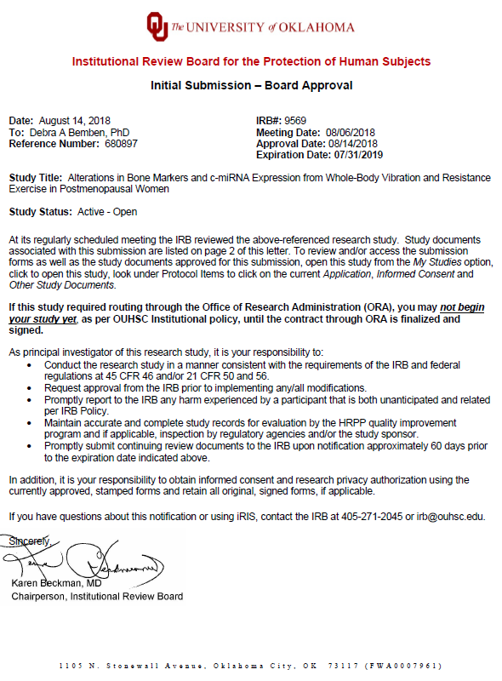

Appendix C: Informed Consent and HIPAA
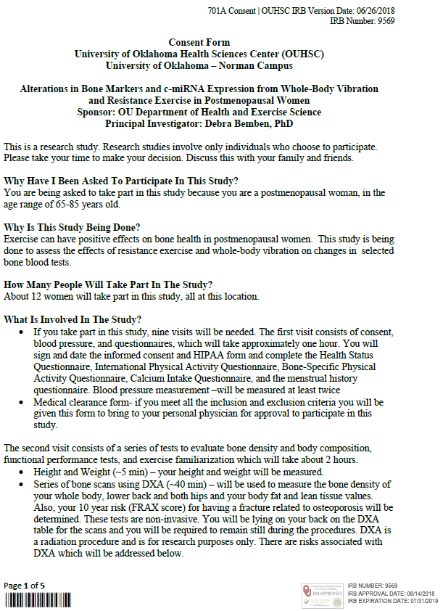
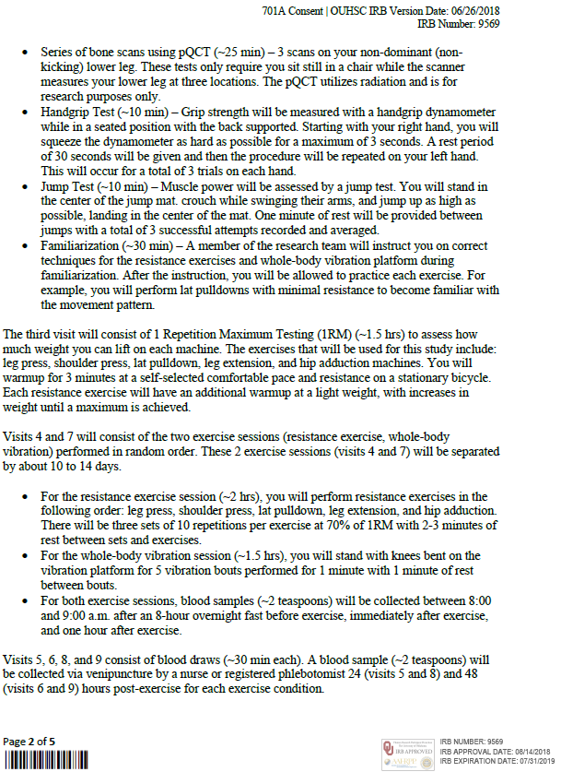
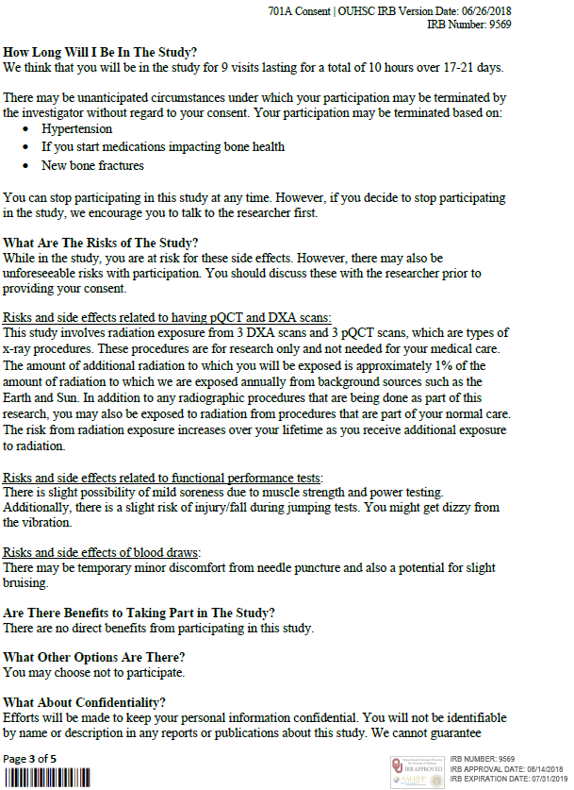

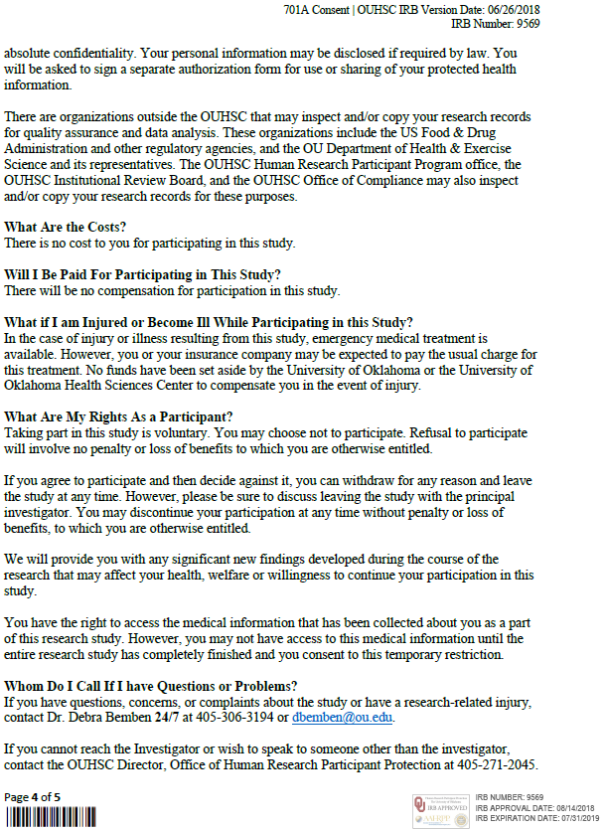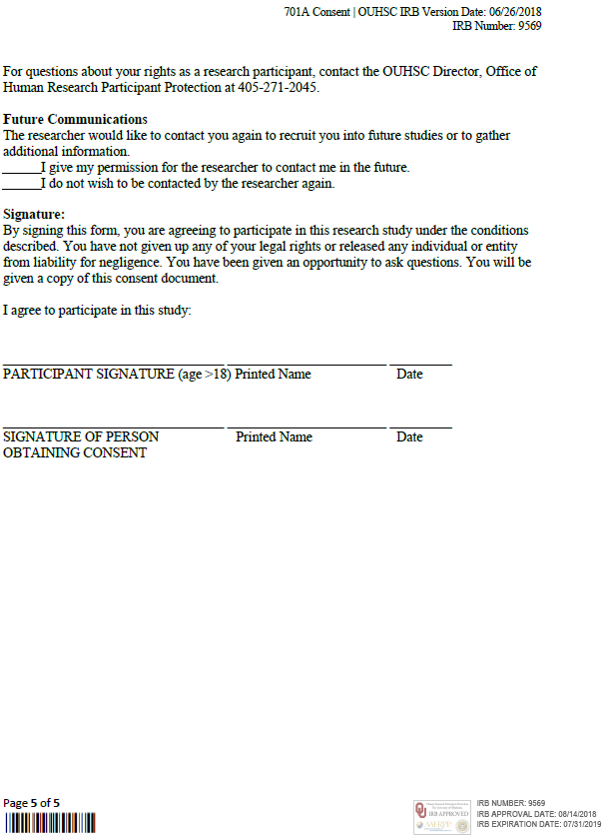

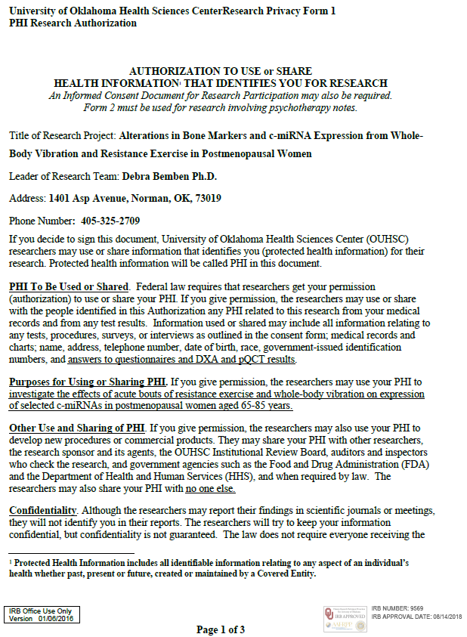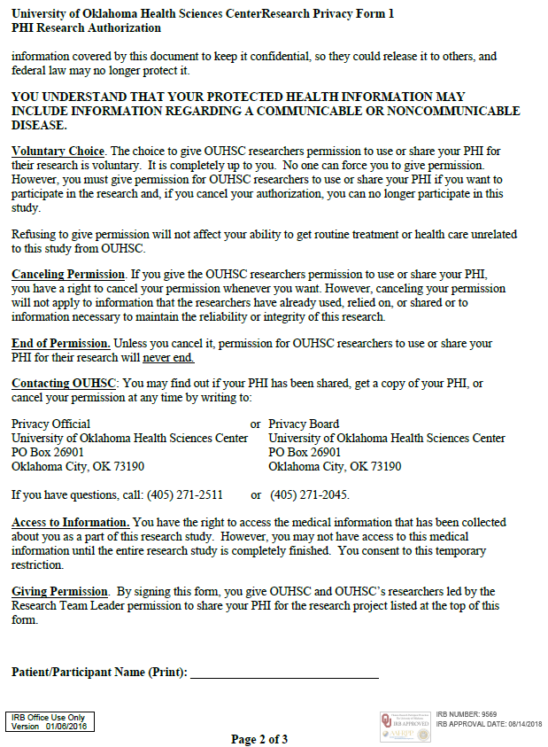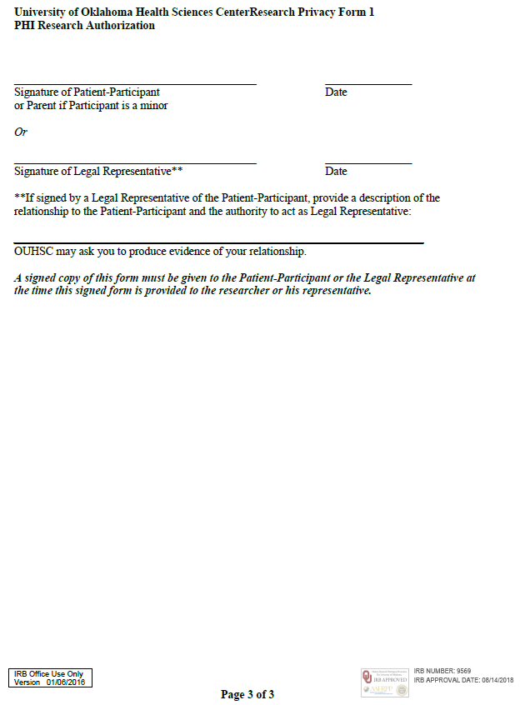

Appendix D: Recruitment Flier


Appendix E: Screening Material and Questionnaires
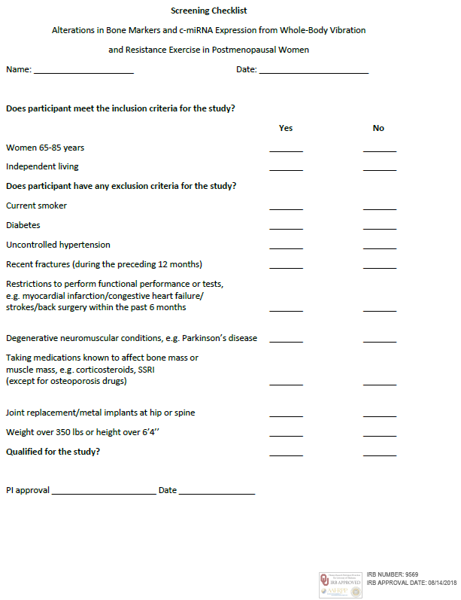

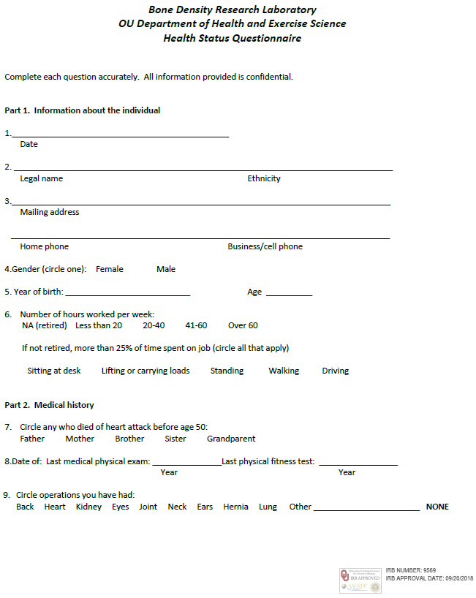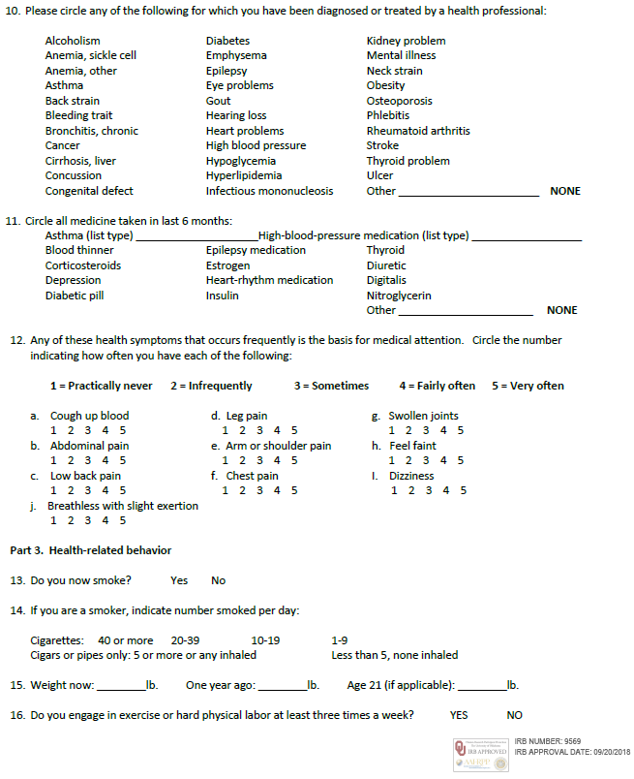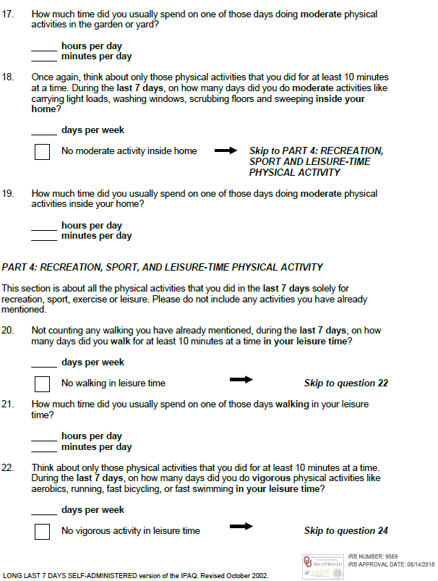
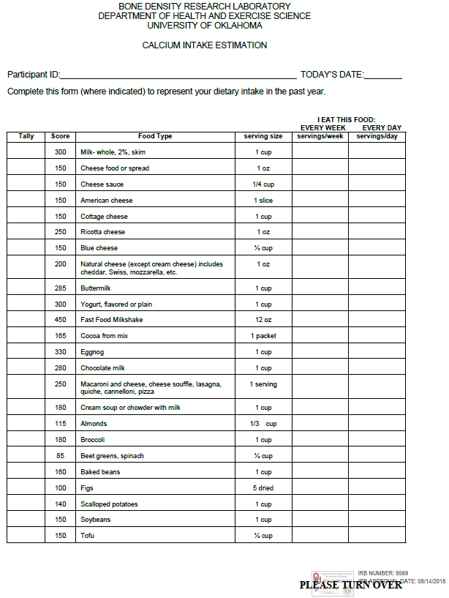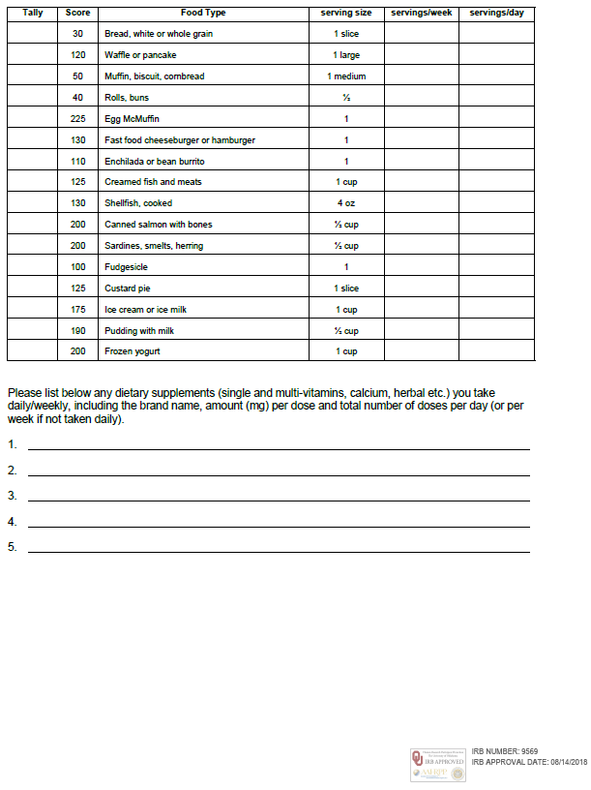

Appendix F: Assay Kit Instructions
