UNIVERSITY OF OKLAHOMA GRADUATE COLLEGE

A COMPUTATIONAL FRAMEWORK TO FOSTER SUSTAINABLE RURAL DEVELOPMENT IN INDIAN OFF-GRID VILLAGES

A THESIS
SUBMITTED TO THE GRADUATE FACULTY
in partial fulfillment of the requirements for the Degree of
MASTER OF SCIENCE

By
VISHNU VARDHAN REDDY KAMALA
Norman, Oklahoma 2020

A COMPUTATIONAL FRAMEWORK TO FOSTER SUSTAINABLE RURAL DEVELOPMENT IN INDIAN OFF-GRID VILLAGES

A THESIS APPROVED FOR THE
SCHOOL OF INDUSTRIAL AND SYSTEMS ENGINEERING

BY THE COMMITTEE CONSISTING OF

Dr. Farrokh Mistree, Chair
Dr. Janet K. Allen
Dr. Edward Sankowski
Dr. Randa L. Shehab

Dr. John Hall

© Copyright by VISHNU VARDHAN REDDY KAMALA
2020
All Rights Reserved.

GururBrahma GururVishnu Gururdevo Maheswarah Guruh Saakshaat ParaBrahma Tasmai Sri Gurve Namah

The Teacher is the Lord Brahma because he/she creates the knowledge inside us. The Teacher is the Lord Vishnu because he/she preserves and operates the knowledge in our mind on to the right path. The Teacher is Lord Shiva because he destroys the wrong thoughts and transforms us with the right kind of knowledge. Thus, the Teacher or the Guru is the live supreme God, and I salute and bow to my teacher.

Acknowledgment
I have worked in the Systems Realization Laboratory at the University of Oklahoma for 2 years. I have invested my effort in realizing a method that deals with some major issues on the planet. This thesis is the outcome of my productive hard work. I express my sincere gratitude to my advisors Dr. Janet K. Allen and Dr. Farrokh Mistree for turning me into a valuable person in society. They always motivate me to be responsible and serve people. They believed me more than I do. They treated me as one of their kids. I appreciate their patience and forgiveness. I am very thankful to the members of the Systems Realization Laboratory (Gehendra Sharma, Lin Guo, Reza Alizadeh, Zhenjun Ming and Shan) for love and support. The insightful comments and encouragement by my committee members, Dr. Edward Sankowski, Dr. Randa L. Shehab, and Dr. John hall have motivated me to broaden my research from various perspectives.
A special thanks to a most important person, who is not an official member of the committee but still made his effort in the successful completion of this project. He is the Founder/CEO of SunMoksha Power Pvt. Ltd, Dr. Ashok Das. This person is a Ph.D. holder from the University of Southern California with more than 15 years of work experience in the field of Mechanical Engineering, went back to India, utilized his knowledge in establishing a social enterprise ‘SunMoksha’ aiming to solve problems in rural India. This is my major motivation to handle the project successfully. I thank Ayushi Sharma, a research engineer in SunMoksha for spending a significant amount of time in providing information about Indian villages required for this thesis. Every two weeks we scheduled to meet online along with my two advisors and one of the members of the thesis committee (Dr. John Hall and his student Hailie Suk) and share the ideas and get feedback. This has helped a lot in completing my thesis.
A former member of Systems Realization Laboratory, Abhishek Yadav, who worked on this project prior to me, has laid the necessary foundation for this thesis. He worked with me voluntarily to bring me on board. I am very thankful for his relentless effort.
Above all, I have to thank my Parents ‘Dr. Krupakar Reddy Kamala’ and ‘Jyothsna Kasiralla’ for their constant love and support. Being a middle-class person, working as a teacher, my father has sacrificed his entire life to see me as a successful person. I always owe my parents for their unconditional love.

GLOSSARY

Sustainable Development

Development that meets the needs of the present without compromising the ability to meet future needs. It satisfies the needs of three spheres of sustainability: social, environmental and economic spheres

(The Brundtland report 1987 by world commission on environment and development (WCED))

Wicked Problem

Problem that is difficult or impossible to solve because of incomplete, contradictory, and changing requirements that are often difficult to recognize

Example: social problems

(Rittel, H.W.J. & Webber, M.M. policy sci (1973) 4: 155. Https://doi.org/10.1007/bf01405730)

Dilemma

A dilemma is a difficult choice from two options, each of which is (or appears) unacceptable or unfavorable. A dilemma represents a zero-one outcome we attempt in engineering is to convert zero-one outcomes into positive sum outcomes.

(Yadav, A and co-authors. (2017). Identifying and managing dilemmas for sustainable development of rural India. V007t06a017. 10.1115/detc2017-67592.)

Social Entrepreneur

A social entrepreneur is a person who establishes an enterprise with the aim of solving social problems or effecting social change. (https://en.wikipedia.org/wiki/social_entrepreneurship)

In this thesis, a collaboration is made with a social entrepreneur “Dr. Ashok Das” CEO of SunMoksha Pvt. Ltd

Value Proposition

A value proposition is a promise or a value to be delivered, communicated, and acknowledged to a customer. In the context of rural development, a value proposition is a promise that is delivered to improve the quality of life of villagers. This can be in the form of an asset, product or a service. (https://en.wikipedia.org/wiki/value_proposition)

Complex Systems

Complex systems embody systemic features (emergent properties) that cannot be predicted or deduced. Hence, you need to learn how to account for emergent properties associated with the realization of complex systems. I suggest that the realization of complex engineered systems necessitates the management of dilemmas in integrating sustainability and social justice with technical efficiency.

A COMPUTATIONAL FRAMEWORK TO FOSTER SUSTAINABLE RURAL DEVELOPMENT IN INDIAN OFF-GRID VILLAGES

ABSTRACT
Social problems are wicked problems. Wicked problems are very complex as there is no definitive solution due to its incompleteness. To achieve sustainable rural development, it is necessary to consider the wicked nature of the problem before developing solutions. There are millions of people in developing, and underdeveloped countries currently lacking access to basic services and are living below the poverty line. One of the main reasons is unavailability or limited basic resource (economic, technology, social) in geographical locations where people live. It is very important to identify the issues involved in a social system and come up with a value proposition to help a social entrepreneur to achieve sustainable rural development. A social entrepreneur establishes an enterprise intending to solve social problems or effect social change. Due to the implementation of the Corporate Social Responsibility (CSR) bill in 2013, the social entrepreneur’s service became easier in India. According to Corporate Social Responsibility (CSR) bill 2013, companies with an average net profit of at least 50 million rupees (approximately $816,000 USD) over a period of three years must spend 2% of their profits for the sustainable rural development in India.
In this thesis, a computational framework is proposed to facilitate social entrepreneurs to achieve sustainable rural development, especially in Indian off-grid villages that are facing extreme poverty. The intention of building this framework is to provide a method for social entrepreneurs, not results. Considering the wicked nature of the problem, in this framework, a decision-support method called ‘Dilemma Triangle’ is introduced to identify the dilemmas present in complex social issues. In villages at the bottom of the pyramid, most of the problems are related to basic needs like Food, Energy, and Water (FEW). In some villages, people cannot make use of available water to grow food as there is no electricity. In some villages, there won’t be a proper availability of water itself even though there is some electricity. This Food, Energy, and Water interdependency are explored in this thesis. Hence, the proposed decision-making method (Dilemma Triangle) which is the first half of the computational framework, is utilized in the FEW nexus to explore the problems related to FEW and find dilemmas that hinder sustainable development and develop the right value proposition. This value proposition is in the form of technology, asset, service-based, or a combination of the three. In the other half of the thesis, a simulation platform is used to evaluate the impact of the developed value propositions. In engineering, the performance of a developed product is tested in a simulation platform to make sure that the product is reliable. This idea is utilized in building the framework to generated scenario-based simulation model that allows any social entrepreneur to evaluate the impact their value proposition. This pre-production impact evaluation guides the social entrepreneur to plan their business operations strategically which allows them to do a proper budget planning and finally attract investors. To evaluate the impact of the value proposition, simulation models are built-in Systems Dynamics. Three scenarios are considered in this model: Worst case (pessimistic), Sufficient case (Realistic), and Best case (Optimistic). In the worst-case scenario, Systems Dynamics is used to show how a village could be without any interventions from social entrepreneurs. In a sufficient case scenario, Systems Dynamics is used to show, how the quality of life of villagers is being improved with a sufficient amount of value proposition is intervened. In the best-case scenario, the best possible help is provided to show the higher end of the development. Receiving maximum funds to implement the best-case scenario is not possible every time. Hence, a social entrepreneur should have a backup plan to initiate the interventions with a sufficient amount of money. This sufficient case is considered as the lower end, and the best-case is considered a higher-end. Since, lower and higher ends are available, by comparing the results of these scenarios, the budget range is decided. This visualization of the impact leads to the strategical planning of the business and raising more funds. This framework needs the right data to get the desired results. In this thesis, a method is proposed with internal consistency which provides desirable results with the right input. The outcome of this framework is intended to connect to a cloud-based crowdfunding platform in the future to display the anticipated results and budget range to attract investors from around the world.

Table of Contents
GLOSSARY vii
A COMPUTATIONAL FRAMEWORK TO FOSTER SUSTAINABLE RURAL DEVELOPMENT IN INDIAN OFF-GRID VILLAGES ix
SOCIAL ENTERPRISES: A WAY TO ACHIEVE SUSTAINABLE DEVELOPMENT IN INDIAN VILLAGES 1
1.1 FRAME OF REFERENCE 1
1.2 SUSTAINABLE RURAL DEVELOPMENT 4
1.2.1 Introduction to Sustainable Development 4
1.2.2. The Need for Sustainable Development in Rural India 8
1.3. ROLE OF A SOCIAL ENTERPRISE IN SUSTAINABLE RURAL DEVELOPMENT 8
1.3.1 Introduction to a Social Enterprise 8
1.3.2. Social Entrepreneur vs Business Entrepreneur 10
1.3.3. Need of a Social Enterprise in Sustainable Rural Development 12
1.3.4. Key Challenges Faced by a Social Enterprise 13
1.4 INDIAN CORPORATE SOCIAL RESPONSIBILITY BILL 2013. 13
1.5 SOCIAL ENTERPRISE: SUNMOKSHA POWER PVT. LTD 15
1.5.1 SunMoksha Addressing Global Sustainable Development Goals (SDGs) 15
1.5.2 The E³ Model: Principles of SunMoksha 17
1.5.3 Sustainable Development through SunMoksha 19
1.5.4 Smart Solutions of SunMoksha to Achieve SDGs 20
1.5.5 Model Village of SunMoksha 21
1.6 QUESTIONS AND OUTCOMES OF THESIS 22
1.6.1. Proposed Framework 27
1.6.2. Outcomes 27
1.7 THESIS LAYOUT 28
1.8. VALIDATION STRATEGY – VALIDATION SQUARE 30
1.9. SYNOPSIS OF CHAPTER 1 33
CRITICAL REVIEW OF LITERATURE TO IDENTIFY GAPS AND RISE OF RESEARCH QUESTIONS 35
2.1. PREVIOUS FRAMEWORK 35
2.1.1. Gap Analysis 37
2.1.2. Reasons for Improvement 42
2.2 LAYOUT OF FURTHER CHAPTERS 45
A COMPUTATIONAL FRAMEWORK TO FOSTER SOCIAL ENTERPRISES TO ACHIEVE SUSTAINABLE RURAL DEVELOPMENT. 47
3.1 NEED OF A COMPUTATIONAL FRAMEWORK 47
3.1.1. Primary Question 48
3.1.2. Recall the Limitations of Previous Frameworks 48
3.2. MODIFIED FRAMEWORK 49
3.2.1. Introduction to Proposed Modified Framework 49
3.2.2. Elements of the Proposed Framework 50
3.3 DILEMMA TRAINGLE METHOD 51
3.3.1 The Dilemma Triangle Method 51
3.3.2. Elements of Dilemma Triangle 54
3.3.3. Role of Dilemma Triangle in Proposed Framework 56
3.3.4. Outcomes of Dilemma Triangle Method 57
3.4. SYSTEMS DYNAMICS TO VISUALIZE THE IMPACT OF VALUE PROPOSITION 58
3.5 SYNOPSIS OF CHAPTER 3 61
IMPLEMENTING THE DILEMMA TRIANGLE METHOD IN FOOD, ENERGY AND WATER (FEW) NEXUS 63
4.1 FOOD, ENERGY AND WATER NEXUS 63
4.1.1 A Recap of Dilemma Triangle Method 63
4.1.2 Introduction to Food, Energy and Water Nexus (FEW) 66
4.1.3 Additional Elements to Justify Secondary Hypothesis 1 68
4.2 ANALYZE THE ISSUES WITH THE HELP OF THE DILEMMA TRIANGLE METHOD IN PERSPECTIVE OF FEW NEXUS 69
4.2.1 Framing the Problem and Categorizing Issues 69
4.2.2. Finding Dilemmas 81
4.2.3 Developing Value Propositions to Clear the Dilemmas 83
4.3 AN AUTOMATED EXCEL DASHBOARD TO PERFORM DILEMMA TRIANGLE METHOD 84
4.3.1 Introduction to the dashboard 84
4.3.2 Manual for the Dashboard 84
4.4 SYNOPSIS OF CHAPTER 4 92
A TOOL TO INVESTIGATE THE IMPACT OF A VALUE PROPOSITION ON A VILLAGE: SYSTEMS DYNAMICS 94
5.1. SYSTEMS DYNAMICS TO EVALUATE THE IMPACT OF VALUE PROPOSITION 96
5.1.1. Introduction to Systems Dynamics 96
5.1.2. Software Information 99
5.1.3 Design of Causal Loop Diagrams (CLDs) 100
5.1.4 Advantages of Building Systems Dynamics Models 107
5.2. STRATEGY TO USE SYSTEMS DYNAMICS FOR SOLVING THE PROBLEM 109
5.2.1. Domain Knowledge 110
5.2.2. Systems Thinking 111
5.3 SCENARIO BASED MODELLING 112
5.4 ASSUMPTIONS AND LIMITATIONS 114
5.5 METHODS FOR COLLECTING DATA 114
5.5.1. Rating Scale 115
5.5.2. Utilizing Historic Data of Other Villages 116
5.5.3. Comparing Nation’s Data 117
5.6 APPLICATION OF SYSTEMS DYNAMICS IN CROWDFUNDING PLATFORMS 118
5.6.1 Python to Connect Systems Dynamics 118
5.6.2 Visualizing Data in Crowdfunding Platforms 119
5.6.3 Process of Crowdfunding 120
5.7 BUILDING PREDICTIVE MODELS USING MACHINE LEARNING 122
5.8 SYNOPSIS 125
APPLICATION OF THE FRAMEWORK ON A VILLAGE 126
6.1 IMPLEMENTATION OF THE FRAMEWORK ON KUDAGOAN VILLAGE 127
6.1.1 Implementing Dilemma Triangle Method in Kudagaon Village Problem 128
6.1.2 Categorizing Issues 142
6.1.3 Identifying Dilemmas 148
6.1.4 Developing Value proposition 151
6.2 BUILDING SYSTEMS DYNAMICS MODELS TO VISULAIZE THE IMPACT OF THE VALUE PROPOSITION 153
6.2.1 Populating the Model with Data 157
6.2.2 Testing the Model in Different Scenarios 159
6.3 CONNECTING SYSTEMS DYNAMICS TO CROWDFUNDING PLATFORMS 163
6.4 CONNECTING THE RESULTS TO E³ MODEL AND SUSTAINABLE DEVELOPMENT GOALS 164
6.5 SYNOPSIS OF CHAPTER 6 168
CLOSURE 169
7.1 SUMMARY OF THE THESIS 169
7.2 CONTRIBUTIONS 173
7.2.1 Critical Review on Answers to Research Questions 174
7.2.2 Limitations of the Framework 176
7.2.3 A Key to Further Research Opportunities 176
7.3 JUSTIFICATION TO THE VALIDATION SQUARE 178
7.4 “I” STATEMENT 180
7.5 FUTURE WORK 182
7.5.1 Cloud based Platform to Perform Crowdfunding 182
7.5.2. Policymaking to Restore Indian Himalayas Region 184
REFERENCES 186
APPENDIX A: Qualitative Data of a Compositive Village (Test Problem) for Chapter 4 191
APPENDIX B: Quantitative Data of Kudagaon Village for Chapter 6 193
APPENDIX C: Qualitative Data of Kudagaon Village for Chapter 6 199

List of Figures

Figure 1. 2 Indian Village Problems 4
Figure 1. 3 Spheres of Sustainable Development 5
Figure 1. 4 Sustainable Development Goals 6
Figure 1. 5 Chottkei, Orissa (Smart Village) 12
Figure 1. 6 Objective of CSR 14
Figure 1. 7 Logo of SunMoksha 15
Figure 1. 8 Strategy of SunMoksha in Achieving SDGs 16
Figure 1. 9 Principles of SunMoksha 18
Figure 1. 10 P³ + E³ Model of SunMoksha to Achieve Sustainable Development 19
Figure 1. 11 A Smart Village Model of SunMoksha 21
Figure 1. 12 Drawbacks in Social Entrepreneur’s work 22
Figure 1. 13 Secondary Hypothesis 1 (Dilemma Triangle) 25
Figure 1. 14 Glimpse of Systems Dynamics 26
Figure 1. 15 Proposed Framework 27
Figure 1. 16 Layout of the Thesis 29
Figure 1. 17 The Validation Square 30
Figure 1. 18 Validation Strategy of this Thesis 32
Figure 1. 19 Questions Addressed in Thesis 33

Figure 2. 2 Framework Overview with method Information Flow Proposed by Abhishek Yadav 36
Figure 2. 3 Interaction among different stages in Abhishek Yadav’s Framework 37
Figure 2. 4 Research Questions 45

Figure 3. 1 Overview of the Proposed Framework 50
Figure 3. 2 The Dilemma Triangle 53
Figure 3. 3 Dilemma Triangle method 55
Figure 3. 4 Issue Matrix 56
Figure 3. 5 Modified Framework (Dilemma Triangle + Systems Dynamics) 59

Figure 4. 1 Workflow of Dilemma Triangle Method (Yadav. A, 2017) 64
Figure 4. 2 Dilemma Triangle Method in FEW Nexus 65
Figure 4. 3 Modified Version of Dilemma Triangle 66
Figure 4. 4 Dilemma Triangle in Perspective of FEW Nexus 67
Figure 4. 5 Dilemma Triangle in Food 70
Figure 4. 6 Dilemma Triangle in Perspective of Energy 71
Figure 4. 7 Dilemma Triangle in Perspective of Water 71
Figure 4. 8 Issue Matrix in Food 72
Figure 4. 9 Issue Matrix in Energy 73
Figure 4. 10 Issue Matrix in Water 73
Figure 4. 11 Issue Matrix in Perspective of Food 75
Figure 4. 12 Issue Matrix in Perspective of Energy 76
Figure 4. 13 Issue Matrix in Perspective of Water 77

Figure 5. 1 Smart NanogridTM arranged by SunMoksha 102
Figure 5. 2 Smart AQUAnetTM 102
Figure 5. 3 Value Propositions available at SunMoskha 103
Figure 5. 4 Intervention part of Systems Dynamics 103
Figure 5. 5 Consumption Part of Systems Dynamics 104
Figure 5. 6 Impact of Value Propositions 105
Figure 5. 7 Impact/Outcome Part of the Systems Dynamics 106
Figure 5. 8 Smart Village (Chottkei) 106
Figure 5. 9 Whole Systems Dynamics Model 107
Figure 5. 10 Scatter Plot between Electrification and Enrollment 120
Figure 5. 11 The Process of Donor Funding Social Enterprises 122
Figure 5. 12 PySD to Build Predictive Models 123
Figure 5. 13 Conversion of a Systems Dynamics Model into a Dataset 124
Figure 5. 14 Multiple Regression Equation 124

Figure 6. 1 The Computational Framework to Foster Sustainable Rural Development 127
Figure 6. 2 Kudagaon Village Map (Source: Google Maps) 128
Figure 6. 3 Ultimate Goal of SunMoksha 129
Figure 6. 4 Dilemma Triangle in FEW Nexus 130
Figure 6. 5 Dilemma Triangle in perspective of FOOD 130
Figure 6. 6 Dilemma Triangle in WATER 133
Figure 6. 7 Dilemma Triangle in ENERGY 135
Figure 6. 8 Dilemma Triangle to Identify Dilemmas in a Problem 138
Figure 6. 9 Intervention variables (Blue colored) 154
Figure 6. 10 Consumption Variables (Green colored) 154
Figure 6. 11 Impact Variables (Red colored) 155
Figure 6. 12 Model Settings of the Systems Dynamics 155
Figure 6. 13 Systems Dynamics Model 156
Figure 6. 14 Visualizing and Analyzing the Impact 161

Figure 7. 1 Three Elements of the Thesis 170
Figure 7. 2 Developing value propositions using Dilemma Triangle method in perspective of FEW Nexus 172
Figure 7. 3 Systems Dynamics to Visualize and Analyze the Impact 173
Figure 7. 4 Collaboration with Other Researchers 177
Figure 7. 5 Justification to Validation Square 179
Figure 7. 6 PDSIDES Framework to Solve Socio-Technical Problems 183
Figure 7.7 Seven Thematic Areas in IHR………………………………………………….185
Figure 7.8 The Dilemma Triangle Method in Seven Thematic Areas……………………..186

List of Tables

Table 1. 1 Poverty in South Asian Countries 2
Table 1. 2 Social Entrepreneur vs Business Entrepreneur 11
Table 1. 3 Relevant Chapters to Evaluate Thesis Questions 28

Table 2. 1 Critical Review of Literature 39

Table 4. 1 Developing Value Propositions 83
Table 4. 2 Value Propositions to Clear Dilemmas 91

Table 6. 1 Issue Matrix In perspective of FOOD 139
Table 6. 2 Issue Matrix in perspective of WATER 140
Table 6. 3 Issue Matrix in ENERGY 141

Table 6.1. 1 Issue Matrix in FOOD with Tensions and Dependents 143

Table 6.2. 1 Issue Matrix in WATER with Tensions and Dependents 144

Table 6.3. 1 Issue Matrix in ENERGY with Tensions and Dependents 146

Table A. 1 The Composite Village Data for the Dilemma Triangle Method in Chapter 4 191

Table B. 1 Kudagaon Village Data for Systems Dynamic Model in Chapter 6 193

Table C. 1 Kudagaon Village Data for the Dilemma Triangle Method in Chapter 6 199

CHAPTER 1

SOCIAL ENTERPRISES: A WAY TO ACHIEVE SUSTAINABLE DEVELOPMENT IN INDIAN VILLAGES

In this chapter, the foundation of the thesis is presented. It begins with the background and motivation of the whole work. The organization of this thesis is also explained in this chapter along with the validation strategy. The main objective is to achieve sustainable development in Indian villages by raising funds. One of the ways to achieve this is by introducing a framework that can be used to analyze the problem, determine the value proposition and also analyze its impact on villagers. In this context, a computational framework is introduced in the form of a flow chart. In this chapter, the need for achieving sustainable development and how to achieve it is also explained. The thesis questions and their outcomes are addressed in this chapter.
Since the goal is to achieve sustainable development through social enterprises, this thesis is anchored to a social entrepreneur called Dr. Ashok Das CEO of “SunMoksha” (Social Enterprise) from India. An introduction is given to “SunMoksha” in Section 1.5. The main reason for the development of social enterprises is the introduction of the Corporate Social Responsibility (CSR) bill in the year 2013. It is presented in Section 1.4.

FRAME OF REFERENCE
Despite achieving rapid development, in many parts of the world especially in parts of Asia, poverty remains widespread (United Nations, 2009). Poverty is the reason for extreme hunger. By estimates of the Food and Agriculture Organization (FAO) in the year 2009, 936 million people are suffering from hunger in the world which results in 25,000 children deaths each day (United Nations, 2009). South Asian countries like India, Pakistan, and Bangladesh are major victims of Poverty. There is a substantial decrement in poverty from the past few years (United Nations, 2009). This decrement is not enough to show the economic development of the country since the number of poor people is still increasing. According to statistics, there is a decrement in poverty from 59 percent in 1981 to 40 percent in 2005 as mentioned in Table 1.1.
Table 1. 1 Poverty in South Asian Countries
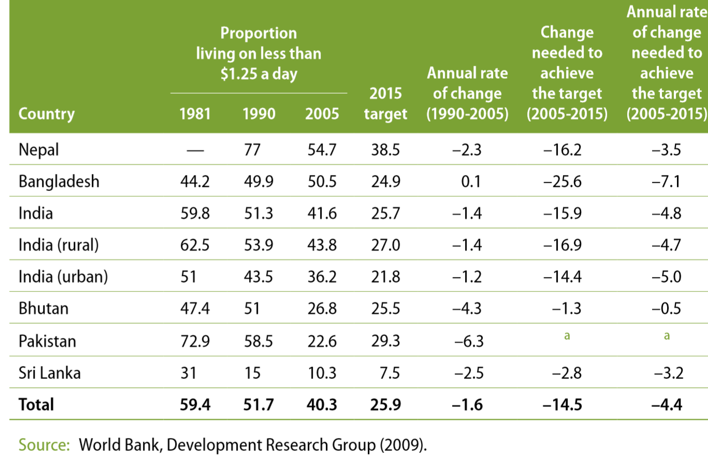
However, there is an increase in the number of poor people from 548.3 million to 595.6 million between 1981 and 2005 (United Nations, 2009). Due to the large population, the Indian poverty percentage is different between urban and rural. In the following table (Table 1.1) the poverty of different south Asian countries where India is represented as India (rural) and India (urban) is presented.
There is a huge difference in poverty between rural and urban India. In 1981, 51 percent of the urban population is living on less than $1.25 (US dollar) a day whereas, in 2005, 53 percent of the rural population is living below the poverty line. There many reasons for increasing poverty in India. However, to achieve socio-economic growth ‘Electricity’ plays a major role. According to the IEA report on World Energy Outlook 2011(https://www.iea.org/topics/world-energy-outlook), one fifth of the world population, which is around 1.4 billion, do not have access to electricity and 80% of them are living in rural areas (Das, A., 2015). India alone has 400 million people without access to electricity. Lack of electricity keep people impoverished (Borgen Magazine, 2005). By 2013, more than 1.5 billion people in the world live on less than $1 a day (WHO, 2013).
In this thesis, a computational framework has been developed for social enterprises to develop value propositions to intervene in Indian villages to achieve 3E’s, that is, Education, Employment and Empowerment through Small-Micro Enterprises (SME). In short, villages are provided with a value proposition where they can make use of it and generate business ideas and achieve socio-economic growth.
In rural areas, electricity is a major problem in India. Despite being the world’s third-largest electricity producer, around 300 million people lack access to electricity in 25,722 un-electrified villages throughout the country (Kathaiyan, 2015). Even though the Indian government has taken measures to overcome this problem, still around 31 million rural households remain in acute darkness. Villagers are facing a lot of problems due to no access to electricity. Some of them are finishing all works before sunset, no lights, no education, child labor, migration, poor cultivation, no health care, no access to potable water, etc. as shown in Figure 1.1 electricity is a major reason for most of the problems. India being the 7th largest country with 1.2 billion of the population it is very difficult for the government to provide their services to every corner of the country.
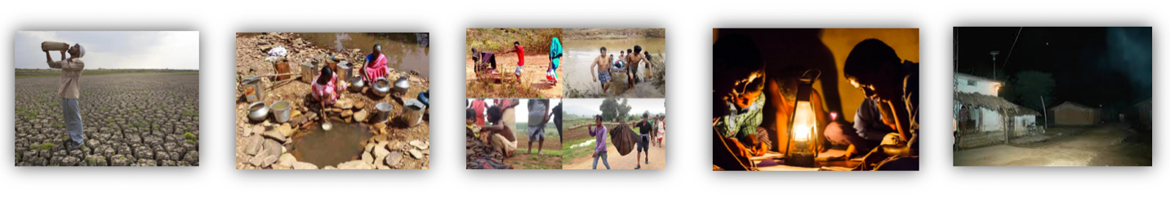
Figure 1. 1 Indian Village Problems
Considering all the reasons of poverty, this thesis is focused on achieving sustainable rural development in Indian villages.

SUSTAINABLE RURAL DEVELOPMENT

1.2.1 Introduction to Sustainable Development
Sustainable development results in the economic growth of a community that is environmentally sound (Colglazier, W., 2015). Sustainable development is different from normal development. The main difference is development aims in raising the quality of life of the present generation, whereas sustainable development means raising the quality of life both present and future generations without threatening natural endowment and environment. From the Brundtland report 1987 by world commission on environment and development (WCED, 1987), the definition of sustainable development is, “To meet the needs of the present without compromising the ability of future generations to meet their needs”. Hence, the focus of in this thesis is to improve the quality of life of humans without affecting social, economic and environmental aspects. Hence, in order to achieve sustainable development, it is important to consider three spheres of sustainability: Social, Environmental and Economical (Hansmann, R. and co-authors, 2012). The concept of sustainability is anchored in an integrated approach that takes into account three drivers, namely, the environment (planet), economics (progress) and society (people). These drivers are interconnected and there is no simple solution for the problems related to it (Flint, R.W., 2013). Value propositions that are developed should be bearable, viable and equitable as shown in Figure 1.3.

Source: http://macaulay.cuny.edu/eportfolios/akurry/files/2011/12/SDspheres.jpg

Figure 1. 2 Spheres of Sustainable Development
The 2030 Agenda for Sustainable Development, adopted by all United Nations Member States in 2015, provides a shared blueprint for peace and prosperity for people and the planet, now and into the future. At its heart are the 17 Sustainable Development Goals (SDGs) (https://sustainabledevelopment.un.org/?menu=1300) as shown in Figure 1.3, that are an urgent call for action by all countries - developed and developing - in a global partnership. Ending poverty and other deprivations must go hand-in-hand with strategies that improve health and education, reduce inequality, and spur economic growth

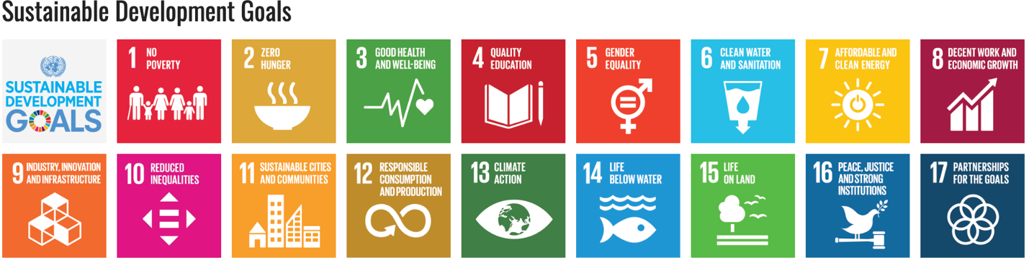
Figure 1. 3 Sustainable Development Goals
(https://sustainabledevelopment.un.org/?menu=1300)

SDG 1 No Poverty: End poverty in all its forms everywhere.
SDG 2 Zero Hanger: End hunger achieve food security and improved nutrition and promote sustainable agriculture.
SDG 3 Good Health and Well-being: Ensure healthy lives and promote well-bring for all at all ages
SDG 4 Quality Education: Ensure inclusive and equitable quality education and promote lifelong learning opportunities for all
SDG 5 Gender Equality: Achieve gender equality and empower all women and girls.
SDG 6 Clean Water and Sanitation: Ensure availability and sustainable management of water and sanitation for all
SDG 7 Affordable and Clean Energy: Ensure access to affordable, reliable, sustainable and modern energy for all
SDG 8 Decent Work and Economic Growth: Promote sustained, inclusive and sustainable economic growth, full and productive employment and decent work for all.
SDG 9 Industry, Innovation and Infrastructure: Build resilient infrastructure, promote inclusive and sustainable industrialization and foster innovation.
SDG 10 Reduced Inequalities: Reduce inequalities within and among counties.
SDG 11 Sustainable Cities and Communities: Make cities and human settlements inclusive, safe, resilient and sustainable.
SDG 12 Responsible Consumption and Production: Ensure sustainable consumption and production patterns
SDG 13 Climate Action: Take urgent actions to combat climate change and its impacts.
SDG 14 Life Below Water: Conserve and sustainably use the oceans, seas and marine resources for sustainable development
SDG 15 Life on Land: Protect restore and promote sustainable use of terrestrial ecosystems, sustainably managed forests, combat desertification, and halt and rivers land degradation and halt biodiversity loss.
SDG 16 Peace, Justice and Strong Institutions: Promote peaceful and inclusive societies for sustainable development, provide access to justice for all and build effective, accountable and inclusive institutions at all levels
SDG 17 Partnerships for the Goals: Strengthen the means of implementation and revitalize the global partnership for sustainable development little

The Need for Sustainable Development in Rural India
For past few years rural activities (like farming) are facing many problems (Singh, Shiv, and Dutta KK, 2012). There is degradation of fertility of soil, reduction in availability of water, increasing population etc. Even though farmers have increased the crop yield, environmental problems are still posing (Mader, Paul and co-authors, 2002). Sustainable agriculture would certainly show less impact on ecological factors. There is a report on sustainability rural development named ‘Sustainability For all’ (www.activesustainability.com) mentions that there are three basic needs in rural development for a sustainable future. They are
- Reducing rural-urban gap
- Protecting and preserving natural resources
- Universal access to food.
To achieve sustainable goals in India, there is a requirement for social enterprises. This thesis is anchored to social entrepreneur’s work. The framework built in this thesis allows social enterprises to achieve sustainable rural development.

1.3. ROLE OF A SOCIAL ENTERPRISE IN SUSTAINABLE RURAL DEVELOPMENT

1.3.1 Introduction to a Social Enterprise
A social enterprise is an approach by star-up companies and entrepreneurs where they develop, fund and intervene value propositions to social, cultural or environmental issues. Social enterprises belong to a normal business discipline but focused on a social mission (Gregory Dess, 1998). Social entrepreneurship is defined as one of the ways to address the social needs by creating solutions that have social value (Dees, J.G, 2017) (Austin, J. and co-authors, 2006). Social entrepreneurs are now required for achieving development. The term ‘social entrepreneurs’ is being used recently but the phenomenon is for many years. There used to be many social entrepreneurs on this planet even though they are not called as social entrepreneurs (Gregory Dees, 1998). For example, many educational institutions, museums, government offices, etc. are built by a person who did not expect any profit. Social entrepreneurs focus on social problems. The value propositions are developed based on available resources. Their mission is to create and sustain social value (Bulsara and co-authors, 2015). India has 300 million people below the poverty line (United Nations, 2009) cannot resolve this issue through government policies. Due to the large population and vast landscape, it is difficult for the Indian government to meet the basic needs of people. This created the need for social entrepreneurs in India. Characteristics of a social entrepreneur are represented below (Hemanthkumar P. Bulsara, Shailesh Gandhi and Jyoti Chandwani, 2015).
Characteristics of a social entrepreneur:
      - Social Entrepreneur acts as a Change Agent
      - Social Entrepreneurs are willing to Share their Credit
      - Social Entrepreneurs are Determined People
      - Social Entrepreneurs Believe in Equality
      - Social Entrepreneurs Work on the Policy of Selflessness
      - Social Entrepreneurs act as Role Model

1.3.2. Social Entrepreneur vs Business Entrepreneur
The most common type of entrepreneur people encounter is a business entrepreneur. Social entrepreneurs are different from them. Even though both establish a business, the end goal defines their difference. The notable differences are,
Investors
A business entrepreneur usually seeks investments from other business entrepreneurs or anyone who wants to invest (For example, Stock Market). Investors seek a return on investment (ROI).
A social entrepreneur seeks investments which are usually called funds from philanthropists or any social organization. Here investors don’t seek a return on interest (ROI).
Profits Used
Business entrepreneurs spend their profits on growing their organization whereas social entrepreneurs spend their profit in doing social activities or donating to charities.
Wealth
Business entrepreneurs define their wealth in the form of money. Everything is done for money. But a social entrepreneur’s wealth is defined in the form of societal change they brought.
In Table 1.2 represented below, developed by Cisco IBGS, 2011 provides more information about the differences between a social and business entrepreneur

Table 1. 2 Social Entrepreneur vs Business Entrepreneur
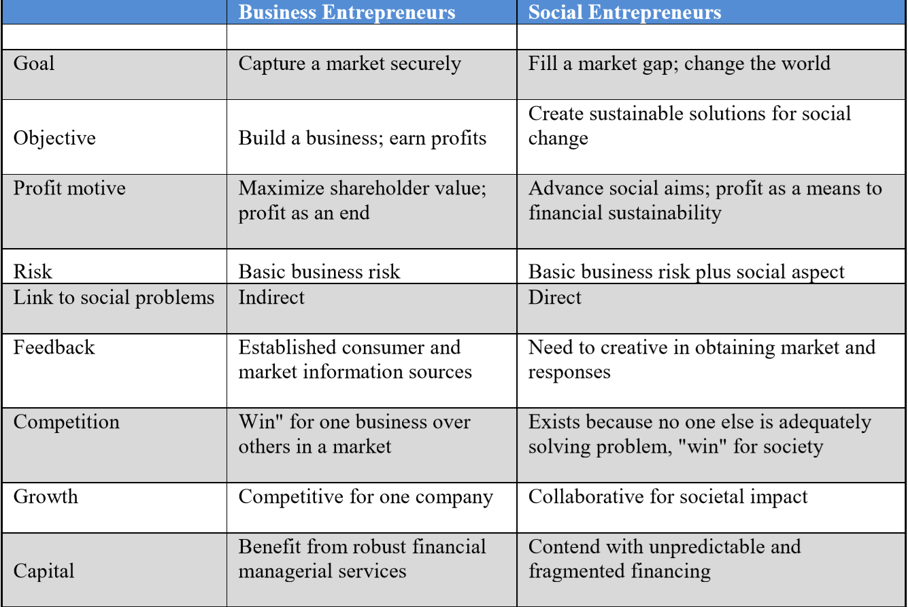

The main idea of a business entrepreneur is to build a business to make profits by capturing a market. Either they make products and sell or provide service. However, these entrepreneurs are responsible for financial growth of a country. They create job opportunities and innovate new things. On the other hand, social entrepreneurs have a similar type of business idea but, they don’t bother about personal profits. They do not pick any market to grow their business. Instead they find a market gap especial between rich and poor. They utilize their skills in developing solutions to fill the gap. This essential reduces income inequalities and bring a social change. They may not create huge job market, but they bring a change in the society such that, people from poor and off-grid communities can live independently by creating their source of income.

1.3.3. Need of a Social Enterprise in Sustainable Rural Development
By summarizing previous section (Section 1.3.2), it is understood that social enterprises play a crucial role in achieving sustainable development in Indian villages. They come up with workable ideas in developing sustainable technologies that could solve many issues in villages. Their service spread to the most untouched areas (off-grid villages). A smart village named “Chottkei” (Figure 1.4) in the state Orissa is developed by a social enterprise called “SunMoksha” (Yadav A, 2018). There is a lot of possibilities in achieving sustainable rural development through social enterprises.
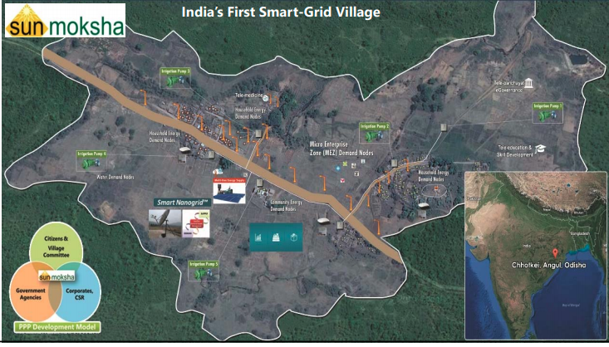
Figure 1. 4 Chottkei, Orissa (Smart Village)
Due to the rise of information and communication technologies, overcoming the social problems has become easier (Shamim, 2016). This has been proved with one of the outcomes of the intervention through a social enterprise as shown in Figure 1.5.

1.3.4. Key Challenges Faced by a Social Enterprise
social enterprises play a very significant role in changing the way people live their lives. Yet they are facing many challenges to scale up. In a report on social enterprises (Rini Dutta, 2019) five main challenges faced by every social enterprise are mentioned. They are,
          - Raising funds
          - Building and following a business plan
          - Investing in right people
          - Process management and planning
          - Balancing the vision with business
In this thesis, first challenge “Raising Funds” and “Building and following a business plan” is considered. Social enterprises can raise funds if they can properly showcase their work and clearly explain donors how they are different from other entrepreneurs and staying focused in a specific area. At the same time, if a social enterprise is able to evaluate the impact of the developed value propositions pre-production, the business operations can be planned strategically. To overcome this issue a framework has been developed which is used by any social enterprise to develop a sustainable value propositions and also evaluate its impact and come up with a business plan and showcase the results to donors.

1.4 INDIAN CORPORATE SOCIAL RESPONSIBILITY BILL 2013.
The lack of social enterprises in developing and underdeveloped countries is seen due to a lack of access to funds and knowledge that is required to develop social enterprises anchored in the socio-economic improvement of the communities.
Due to Corporate Social Responsibility (CSR) bill 2013, any company that is incorporated in India, whether it is domestic or a subsidiary of a foreign company, and which has net worth of Rs. 5 billion or more ($83 million USD) or turnover of INR 10 billion or more ($160 million USD) or net profit of at least 50 million rupees (approximately $816,000 USD) over a period of three years should spend 2% of their profits for the rural development in India (Ghuliani, 2013). The main intention of introducing this bill is to achieve a better tomorrow (Figure 1.5).

Source: http://www.simplydecoded.com/wp-content/uploads/2014/04/csr.jpg
Figure 1. 5 Objective of CSR

The introduction of this bill encouraged many social enterprises to establish their start-ups. However, s social enterprises lack access to knowledge to develop value propositions (Yadav A, 2018). Considering this is the primary gap, a framework based on the knowledge of existing social enterprises is built which can be used by any social enterprise to develop value propositions. For this thesis, collaboration is made with a social entrepreneur “Dr. Ashok Das” who gets funds due to CSR bill and wishes to expand their business through crowdfunding as well.

1.5 SOCIAL ENTERPRISE: SUNMOKSHA POWER PVT. LTD
SunMoksha which is a social enterprise, is an integrator and provider of sustainable solutions for rural development. Dr. Ashok Das is founder/CEO of SunMoksha. SunMoksha has developed Smart Remote Management Solutions to manage energy, water, air, waste, processes, and other resources for villages, cities/townships, industries, institutions, and individuals. Figure 1.6. represents the logo of “SunMoksha”. For more information visit: http://www.sunmoksha.com


Figure 1. 6 Logo of SunMoksha

1.5.1 SunMoksha Addressing Global Sustainable Development Goals (SDGs)
The 2030 agenda of the United Nations adopted by members of the United Nations to achieve sustainable development contains 17 'Sustainable Development Goals (SDGs) as mentioned in Section 1.2.1. SunMoksha has a strategy to achieve most of the SDGs as shown in Figure 1.7
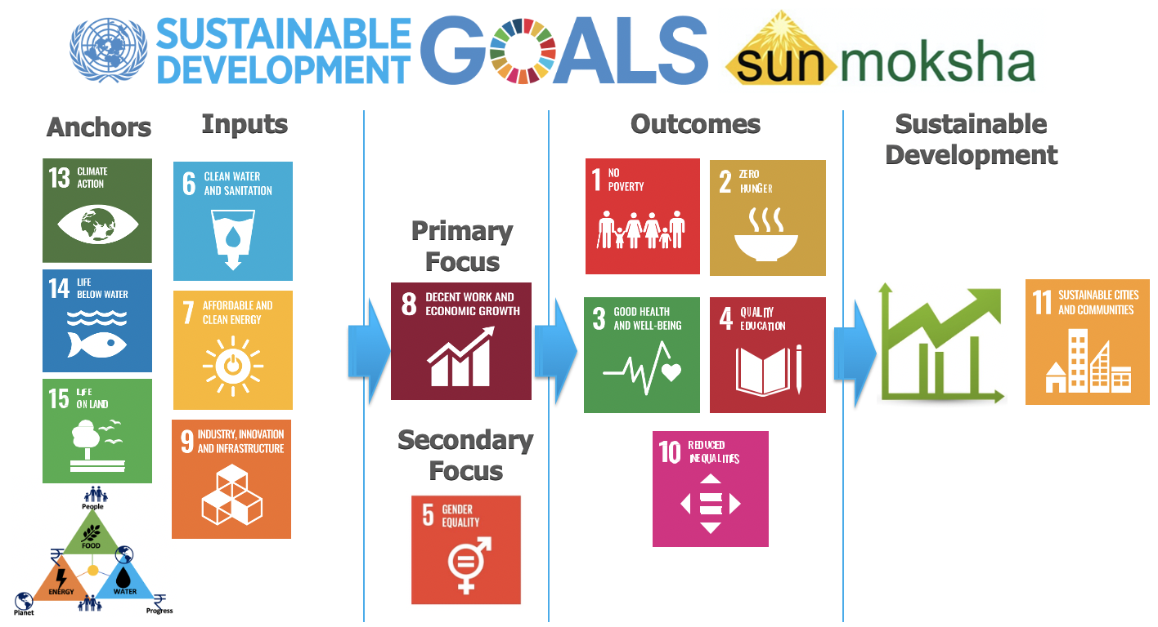
Figure 1. 7 Strategy of SunMoksha in Achieving SDGs

To achieve sustainable development (SDG-11: Sustainable Cities and Communities), SunMoksha primarily focuses on fostering economic growth (SDG-8: Decent Work and Economic Growth) with gender equality (SDG-5 : Gender Equality). Therefore, in a way, value propositions are developed to provide decent work and economic growth within the adopted community. The outcome of SDG-8 directly affects SDG-1: 'No Poverty' and SDG-2:'Zero Hunger’. Since poverty is one of the major aspects that affect poor health and poor education, SDG-3: Good Health and Well Being” and SDG – 4: Quality Education are achieved in succession once people have sufficient economic strength. The SDGs (SDGs: 1, 2, 3, 4) that are dependent on SDG-8 and are simultaneously achieved as presented in Figure 1.17. Also, SunMoksha strives to provide economic power to all so that inequalities can be reduced (SDG-10: Reduced Inequalities).
The value proposition (Inputs) developed by SunMoksha satisfies the needs of Food, Energy and Water by including the principles of sustainability. Hence SunMoksha with their inputs (SDGs: 6,7,8) that is anchored to SDGs: 13,14,15 finally achieves SDG-11 as shown in Figure 1.7.

1.5.2 The E³ Model: Principles of SunMoksha
In this thesis, necessary soft and hard information is gathered from Dr. Ashok Das, CEO of SunMoksha. Based on the experience shared by him, a framework is developed which could improve the business operations of a social enterprise in achieving sustainable rural development in India. Its principles and solutions to achieve sustainable development in rural areas are anchored in socio-economic progress that
empowers the rural community to take care of their needs; with a primary focus on providing opportunities to people at the bottom of the economic pyramid (BOP) (Ansari, S. and co-authors 2012). SunMoksha’s principles work around the nexus of E³ – Education, Entrepreneurship and Empowerment, with value propositions as inputs to achieve socio-economic development. Education is not just school/colleges, it includes all the skills and knowledge necessary to take care of their needs. It is a process of learning skills, values and habits irrespective of age and gender. This is done through schools, awareness campaigns, training sessions etc. Through the Education, villagers are provided with internal and external market and encouraged to come up with business ideas that generates money. Farmers have different strategies available to improve their economic conditions (Van der Ploeg 2000) make us of value propositions to do farming. SunMoksha helps is deciding a best strategy for the villagers to initiate business ideas. Thus, the village starts attaining financial stability. With a sufficient Education and a boost in village economy through Entrepreneurship, villagers are Empowered and motivated to self-educate and come up with new business ideas that in turn empowers the village to grow much stronger. Thus, E³ is repeated at different stages like a spiral as shown in Figure 1.8. To initiate this E³ model, value propositions are introduced at different stages. These value propositions are smart technologies or service-based or both.
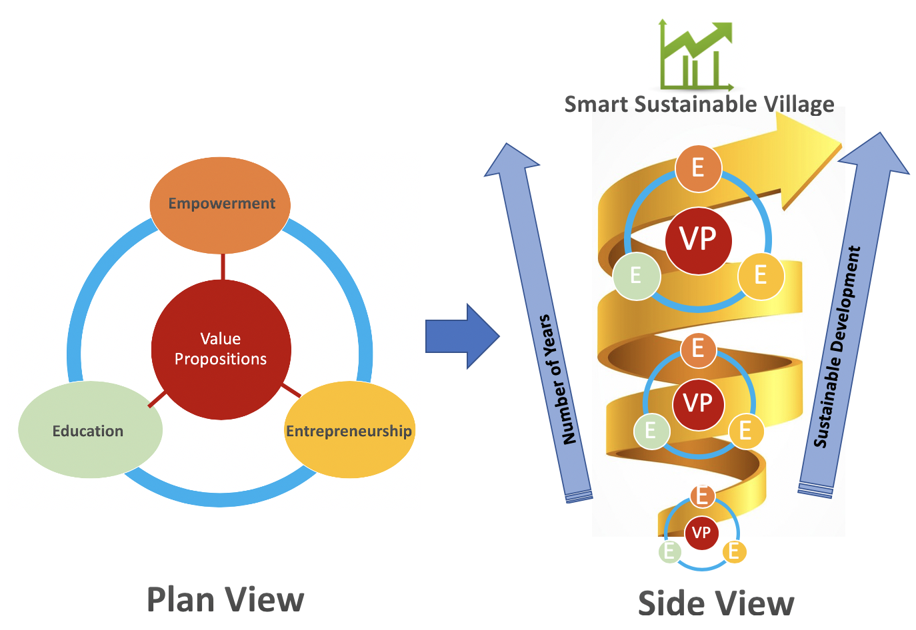
Figure 1. 8 Principles of SunMoksha
E³ circle repeats every time with an upgraded version like a spiral. At the initial stages, the rate of employment and skills they learn is low when compared to higher stages. Different skills are learned and different types of businesses are developed at different stages. For example: At initial stages, learning how to use internet is not a critical skill. But, after many months/years villagers understand the importance of internet and start to learn at some stage. At the final stage after many years, the village is converted into a sustainable community which is the 11th SDG (make cities and human settlements inclusive, safe, resilient and sustainable) declared by the United Nations. Since, social enterprises are aiming at sustainable development, they make sure that developed value propositions are sustainable. One of the outcomes of the thesis is a method that is entailed in concept of sustainability to develop sustainable value proposition. It is explained in next section (Section 1.5.3).

1.5.3 Sustainable Development through SunMoksha
Socio-economic development can be achieved even without consideration of principles of sustainability. Since the ultimate goal of SunMoksha is to achieve socio-economic development anchored with principles of sustainability, its core principles are anchored to social, economic and environmental spheres and also Food-Energy-Water Nexus. Hence, to address SDGs as mentioned in Figure 1, SunMoksha develops value propositions by compromising the needs of 3Ps (P³) – people (social), planet (environmental) and progress (economic) also conserving Food-Energy-Water (Nexus). This combination of SunMoksha’s business model with the principles of sustainability results in upgrading socio-economic development to sustainable development as shown in Figure 1.9.

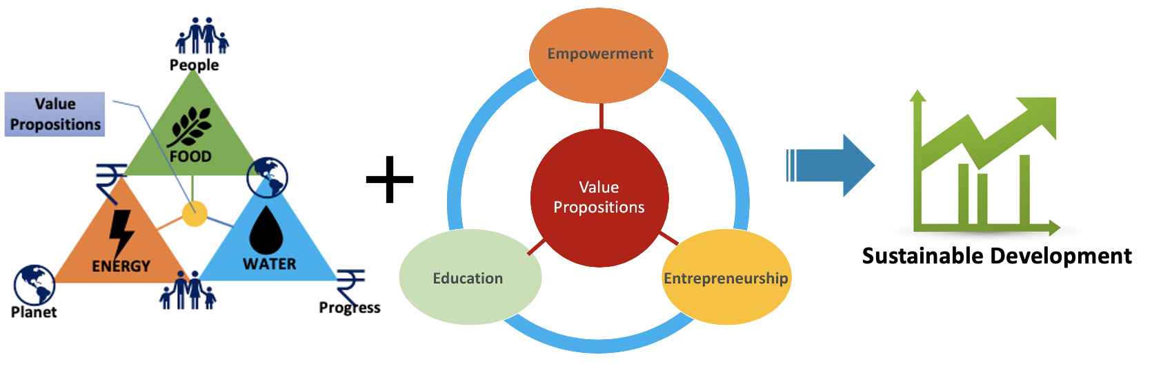
Figure 1. 9 P³ + E³ Model of SunMoksha to Achieve Sustainable Development

1.5.4 Smart Solutions of SunMoksha to Achieve SDGs
Based on its core principle to focus on the Three E’s and SDG-8, SunMoksha has been successfully developed some smart solutions that are anchored in the SDGs proposed by the UN. The smart solutions developed until now are,
      - Smart Micro-Economic Zone (MEZ)
      - Smart AQUAnet™
      - Smart Nanogrid™
SunMoksha’s initiative to develop' Smart Micro-Economic Zone (MEZ)' helps achieve SDG-9: “Industry, Innovation, and Infrastructure” in a community by building the required infrastructure to support sustainable growth and provide opportunities to innovate solutions that work in the real world.
Water is a key resource and a daunting challenge for sustainable development directly connecting “SDG-6: Clean Water and Sanitation” to community development. SunMoksha’s Smart AQUAnet™ interjects an intelligent solution into the community to address clean water utilization and conservation efficiently, especially by improving agricultural irrigation systems.
Energy is a key enabler for all these interventions, and SunMoksha’s Smart Nanogrid™ achieves it through renewable and sustainable energy solutions associating Smart Nanogrid™ with SDG-7: “Affordable and Clean Energy”, as well as, keeping a balance between people, planet and progress (SDG-13: Climate Action, SDG-14: Life Below Water and SDG-15: Life On Land). Smart Nanogrid™ provides electricity for homes and enterprises at Tier 4 & 5 of the energy ladder, as defined by the World Bank² where Tier 5 is equivalent to grid-electricity

1.5.5 Model Village of SunMoksha
SunMoksha’s overarching goal is to develop Smart Villages based on “PURA”, a model proposed by Late Dr. APJ Kalam for provisioning urban amenities for rural areas. A Smart PURA Village moves the villagers up the value chain to improve the socio-economic status of its citizens leading to 'Gram Swaraj' as shown in Figure 1.10.

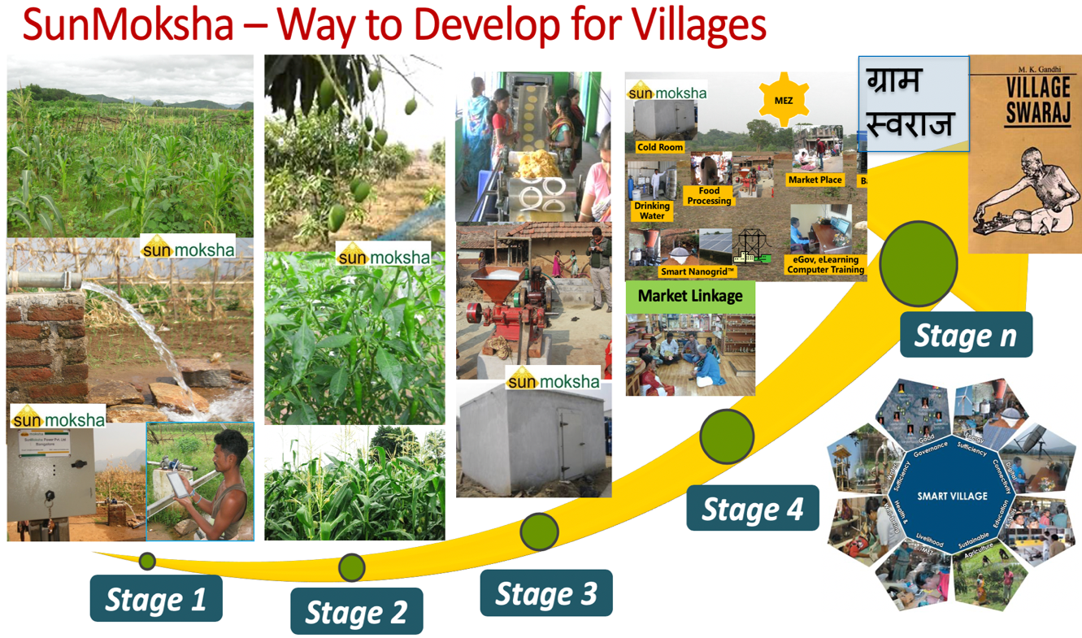
Figure 1. 10 A Smart Village Model of SunMoksha
As 70% of the Indian population is residing in villages, it is more essential to have smart villages than smart cities (V T Ram Pavan Kumar M 2016).

1.6 QUESTIONS AND OUTCOMES OF THESIS
The goal of SunMoksha is to achieve sustainable development in Indian off-grid villages. In detail, the objective of this thesis is to develop a tool that can be used to enhance the work of the social enterprises. In the previous section, the business model of SunMoksha is presented. Hence the steps involved in achieving sustainable development are,
Step 1 - Choose an off-grid village
Step 2 – Problems are explored, and value proposition is developed
Step 3 – Implement the value proposition
These steps seem simple but there are gaps identified especially in step 2 and step 3 as shown in Figure 1.11. These are the main drawbacks that are considered as two questions. Based on these drawbacks hypothesizes are designed.
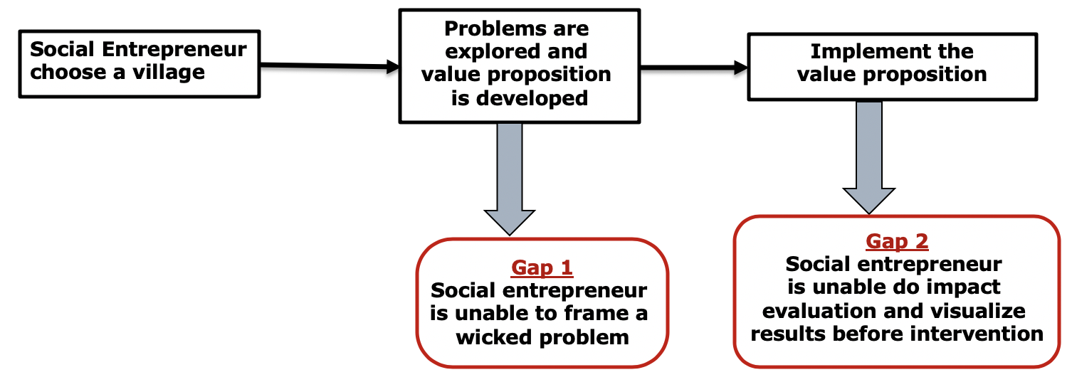
Figure 1. 11 Drawbacks in Social Entrepreneur’s work
Throughout Chapter1, a brief explanation about problems in Indian rural areas, the need for sustainable rural development and the role of a social entrepreneur in achieving it. In Section 1.5 social enterprise named “SunMoksha” is introduced and workflow is described. From the drawbacks represented in Figure 1.11. thesis questions are formulated. In this context, the primary question of this thesis is as follows.

Primary Question (PQ)
Considering the capability of a social entrepreneur and condition of the village, what are the methods required to guide a social entrepreneur to achieve sustainable rural development in off-grid villages facing extreme poverty and also encourage investors to provide necessary funding?
This primary question ties to Section 1.3.4. in which “Raising Funds” and “Business Planning” are considered as key challenges faced by social enterprises. To overcome these issues, hypothesizes are designed and realized at the end.
Primary Hypothesis (PH)
A framework which can be used by any social entrepreneur to develop value propositions and evaluate its impact is needed.
In this context, the primary question results in two secondary questions which consider two drawbacks mentioned in Figure 1.11. where Question 1 deals with deciding value proposition and Question 2 deals with impact assessment. Hence secondary questions are as follows,
Secondary Question 1 (SQ1)
Based on available village data, considering the complexity and wicked nature of the problem, how is it possible to organize and prioritize problems worth investigating and develop a value proposition by a social entrepreneur?
Secondary Question 2 (SQ2)
What tools are required to evaluate the impact of the value proposition before implementing in the village and plan the budget?
In Chapter 2, a critical review of the literature is presented for developing secondary hypothesizes. Briefly, two methods are considered in answering secondary questions. They are
      - Dilemma Triangle Method
      - Systems Dynamics
In upcoming chapters, a clear explanation about the two methods is given. Those two methods serve as building hypotheses for two secondary questions. Each method constitutes a hypothesis. Hence, two secondary hypotheses are as follows.
Secondary Hypothesis 1 (SH 1)
Using a Dilemma Triangle method in Food, Energy and Water (FEW) nexus considering people, planet and progress as drivers, it is possible to analyze most of the problems involved in the village, detect all the problems worthy of investigation and develop a value proposition.
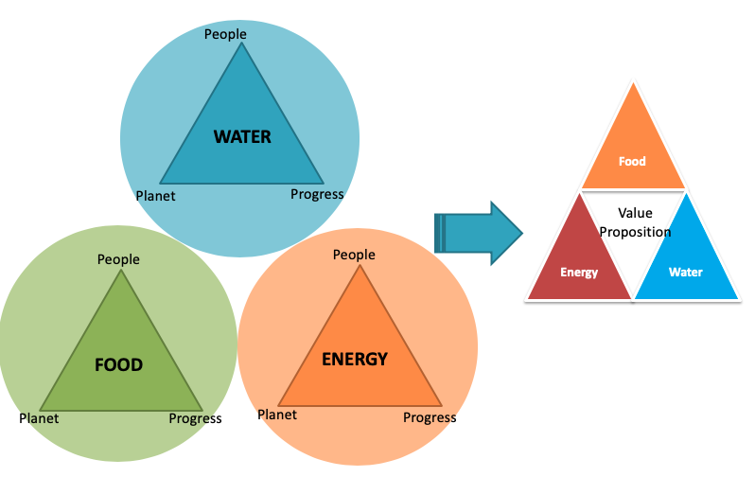
Figure 1. 12 Secondary Hypothesis 1 (Dilemma Triangle)
This method is used to identify dilemmas in a complex problem (Yadav A and co-authors, 2017). As shown in Figure 1.12, a social entrepreneur implements this method in Food, Energy, and Water (FEW) to develop a value proposition that meets FEW requirements and also sustainability requirements (People, Planet and Progress) from spheres of sustainability presented in Section 1.2.1.
- People – Social Sphere
- Planet – Environment Sphere
- Progress – Economic Sphere
Note: A business entrepreneur considers “Profit” as his/her “Economic” sphere but, a social entrepreneur considers “Social Change” as his/her “Economic” sphere. Hence the term “Progress” is used to represent that “Social Change”. Further information about this method and its application is provided in Chapter 3 and Chapter 4.
Secondary Hypothesis 2 (SH 2)
Systems Dynamics can be used to simulate the village dynamics and evaluate the impact of the developed value proposition and decide the budget required for the intervention.
For implementing Systems Dynamics, Vensim software is used. In the following figure (Figure 1.14) the software interface is shown and also variables used for building village dynamics are shown. The diagram inside the Figure 1.13 is called the Causal Loop Diagram (CLD). These CLDs are built with different scenarios to replicate the village dynamics by including value proposition into a village lifestyle to evaluate its impact. More information is provided in Chapter 5.
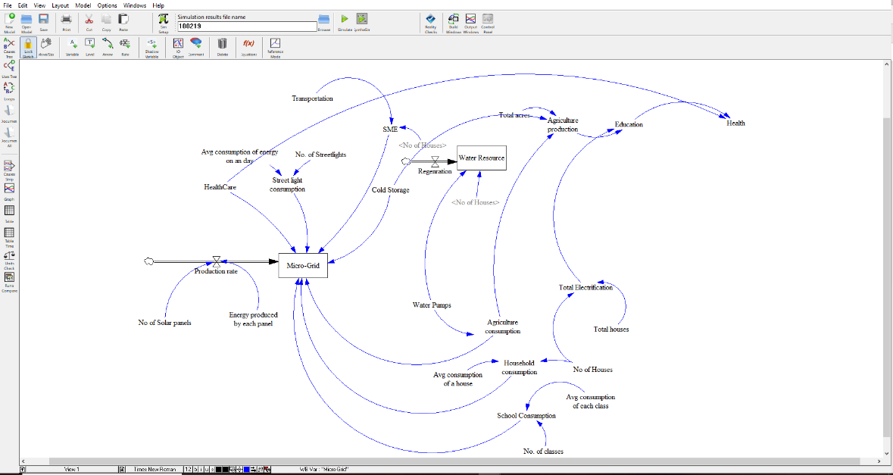
Figure 1. 13 Glimpse of Systems Dynamics
Food, Energy and Water (FEW) Nexus and the Dilemma Triangle Method from Secondary Hypothesis 1; Systems Dynamics from Secondary Hypothesis 2 are major elements of the proposed framework. All together forms a framework which can be used to develop a value proposition and also evaluate its impact. The workflow of this framework is presented in the next section (Section 1.6.1)

1.6.1. Proposed Framework
From the primary and secondary questions, the workflow of proposed framework is shown in Figure 1.14. All chapters are designed based on this workflow.
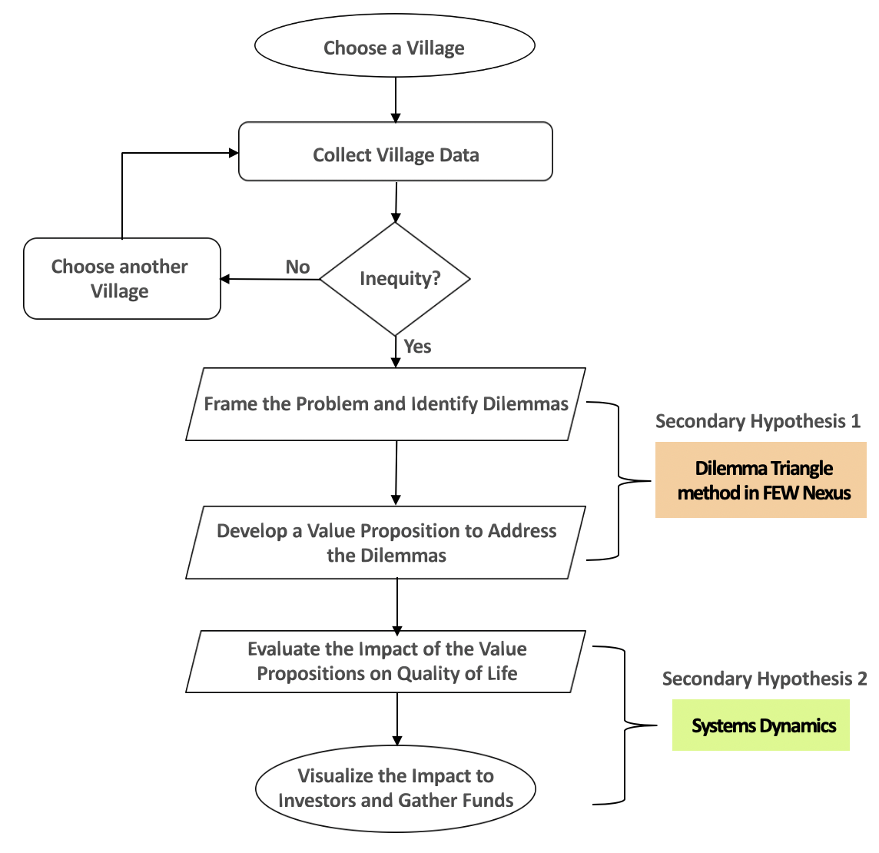
Figure 1. 14 Proposed Framework

1.6.2. Outcomes
By answering two secondary questions, results in realizing primary hypothesis. The outcome of this thesis is a computational framework that is utilized by a social entrepreneur to define the problems, develop a value proposition and evaluate its impact. This helps any social enterprise to easily mount crowd funding for their projects. These outcomes are discussed in further chapters. Relevant chapters discussing each question is given in the following table (Table 1.3)
Table 1. 3 Relevant Chapters to Evaluate Thesis Questions
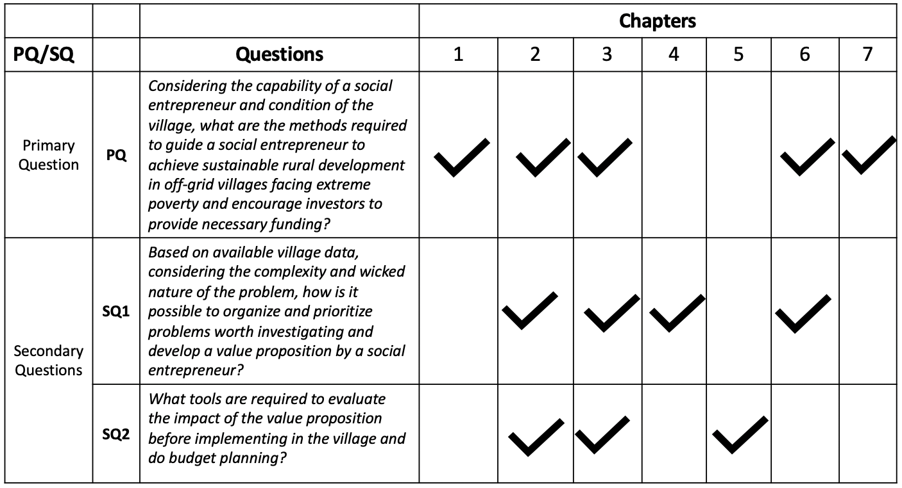

1.7 THESIS LAYOUT
All chapters are designed based on the primary and secondary questions as show in Figure 1.15
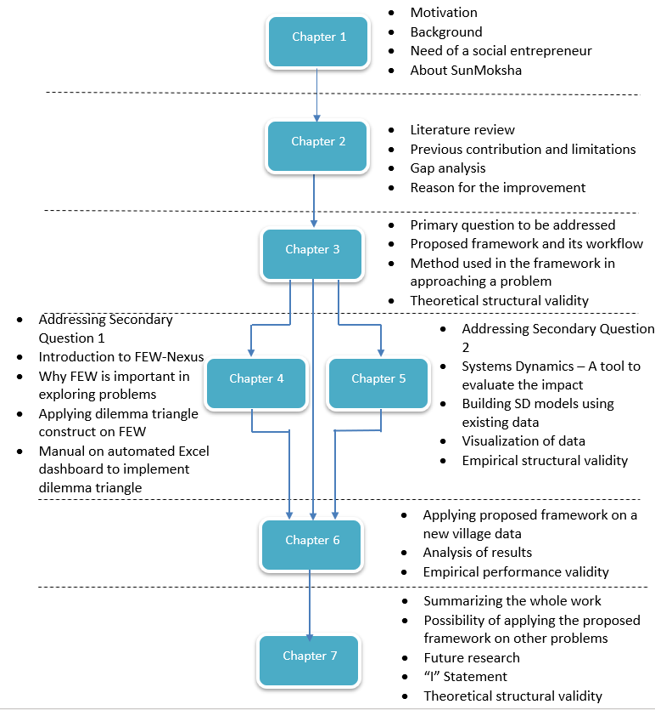
Figure 1. 15 Layout of the Thesis

1.8. VALIDATION STRATEGY – VALIDATION SQUARE
Verification and validation of this thesis follows a strategy called “The validation Square” (Pedersen, Emblemsvag and co-authors, 2000). Validating a design method is a process of demonstrating usefulness with respect to purpose (Pedersen, Emblemsvag and co-authors, 2000). The following figure (Figure 1.16) represents the strategy of the validation square.
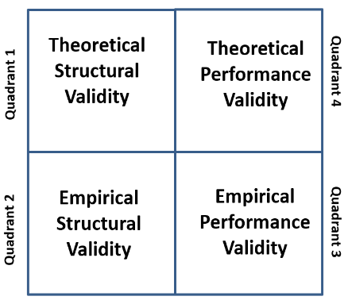
Figure 1. 16 The Validation Square
There are four quadrants in this strategy (Pedersen, Emblemsvag and co-authors, 2000).
Quadrant 1 (Q1)
Theoretical Structural Validity – In this quadrant, structural/logical validity and also overall consistency of the proposed method is discussed. It is a qualitative test, that tests the logical structure with respect to correctness of results. Internal consistency of the design method. i.e., the logical soundness of its construct is verified both individually and integrated.
Verification: Internal consistency
Validation (Utility): Basis for testing Empirical Structural Validity (Q2).
Quadrant 2 (Q2)
Empirical Structural Validity – In this quadrant, an example problem is chosen to test the elements of the method. It is also a qualitative test, to test the logical structure with an appropriate example problem to produce correct results. It is intended to test method for correctness and utility.
Verification: Test the elements of the method to produce correct results.
Validation (Utility): Basis for testing Empirical Performance Validity (Q3).

Quadrant 3
Empirical Performance Validity – Comprehensive problem is chosen to test the performance of the method. It tests the ability of the method to produce useful results. It is quantitative test to test whether the correct results embody utility. This builds more confidence in the applicability of the method.
Verification: Test the entire method to produce correct results for comprehensive problems
Validation (Utility): Basis for testing Theoritical Performance Validity (Q4).

Quadrant 4
Theoretical Performance Validity – By building confidence through Q3, It is determine that the proposed method is useful for other problems which are beyond the comprehensive problem that is chosen for Q3. This required leap of faith which is eased by first three quadrants of the validation square. Hence this quadrant has only validation.
Validation (Utility): The ability to produce useful results beyond the chosen comprehensive problem(s)

For this thesis, all chapters are designed in such a way that it follows the validation strategy as shown in Figure 1.17
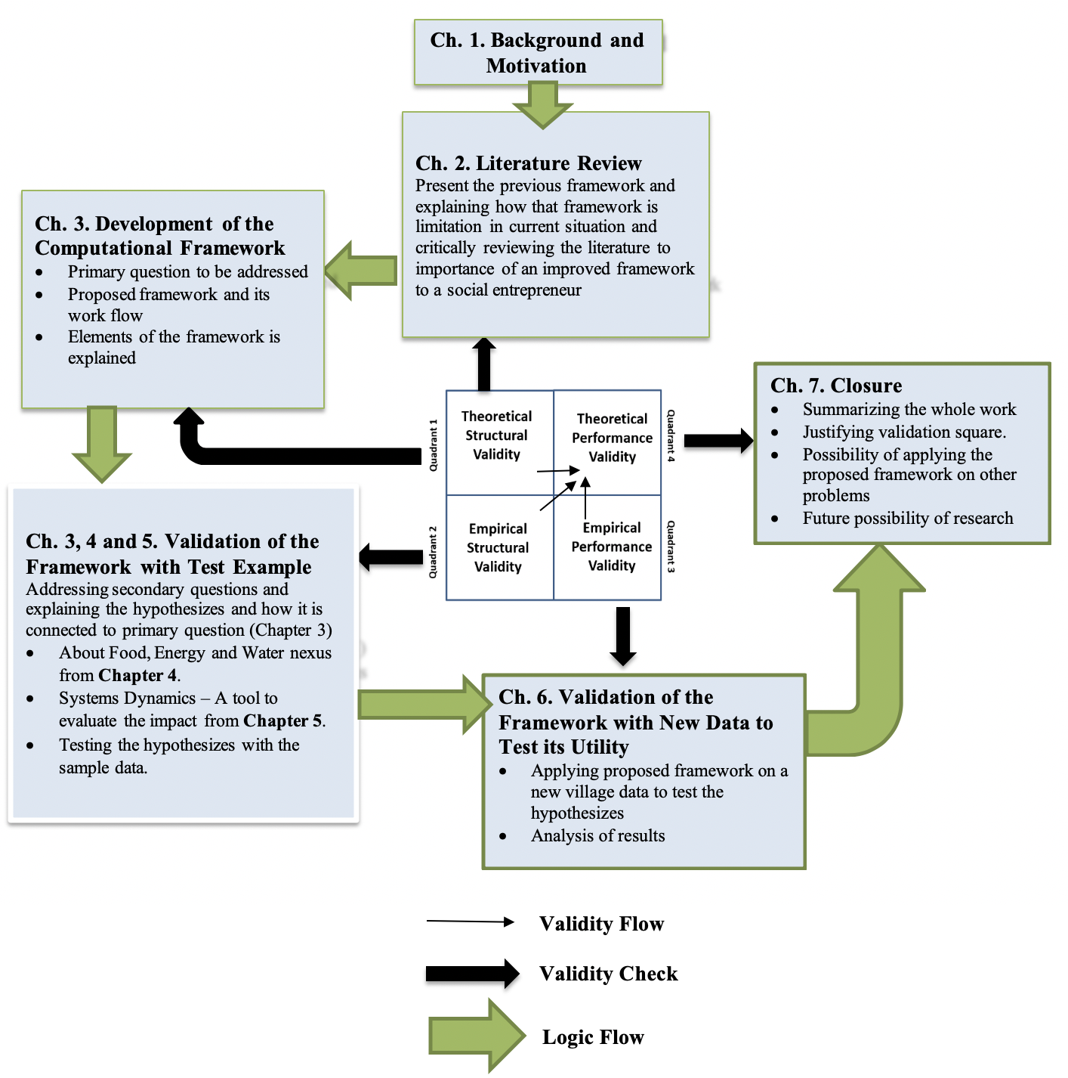
Figure 1. 17 Validation Strategy of this Thesis

1.9. SYNOPSIS OF CHAPTER 1
In this chapter, the role of a social enterprise in achieving sustainable rural development is explained. A brief introduction to CSR bill 2013 is presented and explained how it is encouraging social enterprises in India. Key challenges faced by a social enterprise are presented in which “Raising Funds” is considered as the main issue in this thesis. To attract donors, a social enterprise needs to show the anticipated impact of the value proposition before implementing (Hannah F. and Dirk Shaefer, 2017). However, to evaluate the impact of a value proposition first social entrepreneur needs to develop a value proposition. Hence these gaps led to the primary question whose hypothesis is to develop a framework.
A framework is presented in this chapter. In this framework, two methods have been utilized. The first method is the Dilemma Triangle method which is our Secondary Hypothesis 1 and second method is Systems Dynamics which is our Secondary hypothesis 2 as shown in the following figure (Figure 1.18)
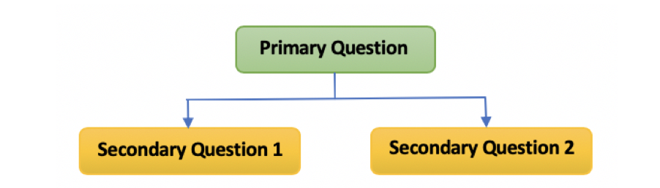
Figure 1. 18 Questions Addressed in Thesis
Research is necessary for finding the problems worthy of investigation and also research is necessary for developing a tool to evaluate the impact of a value proposition. Since social problems are wicked problems (Rittel, H.W.J, and Webber, 1973)
it is important to figure out dilemmas created by the problems; these dilemmas play a crucial role in hindering the intervention of value proposition. To be precise finding worthy problems is considered as finding dilemmas formed due to those problems.
This thesis is divided into two parts depending upon the goals. This first goal is to generate ideas to choose/develop a value proposition that is sustainable by considering dilemmas generated from the problems involved in the village. The second goal is to develop a tool that can be used to evaluate the impact of the value proposition on a villager’s life before implementation. Based on the goals, a research plan has been established and executed which is discussed in Chapter 2.

CHAPTER 2

CRITICAL REVIEW OF LITERATURE TO IDENTIFY GAPS AND RISE OF RESEARCH QUESTIONS

In the process of reviewing the literature regarding sustainable rural development, previous contributions in this field are considered first. A computational framework developed by Abhishek Yadav (Yadav. A, 2018) is taken as main reference for this thesis. The basic layout of this thesis is referred from Abhishek Yadav’s framework. Two methods are utilized from his framework. First, in order to develop a value proposition for a social community, dilemmas are to be cleared first. For this ‘Dilemma Triangle’ method is chosen which is used in his framework (Yadav. A, 2017). Second, to evaluate the impact of the developed value proposition ‘Systems Dynamics’ method is utilized. However existing methods are being used in this thesis, these methods are utilized in a more efficient way than the previous contribution. Based on the gaps found in previous works, new elements are added to existing methods to improvise the efficiency of the framework. A synopsis of the previous existing framework developed by Abhishek Yadav is presented in Section 2.1.

2.1. PREVIOUS FRAMEWORK
The previous framework proposed by Abhishek Yadav (Yadav, A., 2018) is used to achieve sustainable rural development by developing a framework that can be used by any social enterprise, CSR investors and philanthropist to develop and evaluate a value proposition. For developing a value proposition, biggest challenges faced in India are culture, population and unavailability of resources. Each social community has different characteristics which makes this problem more complex. In such complex systems introducing a direct solution for any problem is not a right approach. There is an interdependency among the problems which generates dilemmas while solving a problem. These dilemmas slow down the decision-making process of a social enterprise. This framework acts as a decision-making tool for any social enterprise to enhance their work. In Figure 2.1, framework proposed by Abhishek Yadav is presented

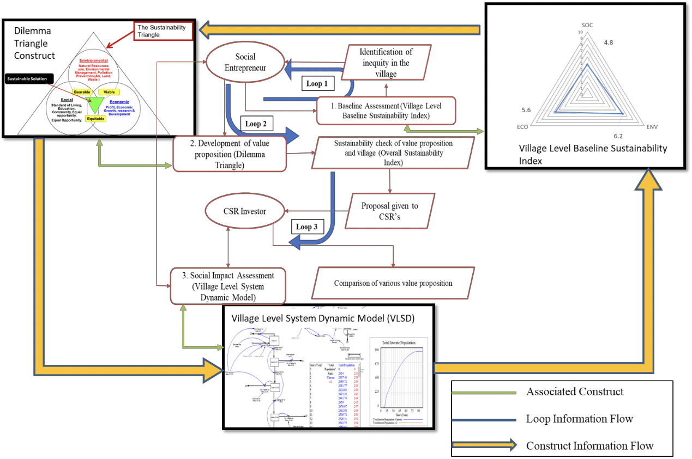
Figure 2. 1 Framework Overview with method Information Flow Proposed by Abhishek Yadav
This framework has three stages which are represented as three loops (Loop 1, Loop2, Loop 3) in Figure 2.1.
In Stage 1 social enterprise uses the concept of ‘Village Level Baseline Sustainability Index’ (VLSBI) to measure the condition of a village in three different perspectives, that is, Social, Economic and Environmental which are spheres of sustainability. VLSBI provides three scores for three perspectives. And then in next stage (Stage 2) ‘Dilemma Triangle’ method is used to identify dilemmas and develop a value proposition. In Stage 3 ‘Systems Dynamics, is used to evaluate the impact of value proposition on villager’s lives. However, the approach of this framework seems promising, there are some drawbacks involved in it. Based on these gaps an improvised version of this framework is developed in this thesis. In Section 2.1.2, gap analysis is presented through which the. Primary and secondary question are developed for this thesis.

2.1.1. Gap Analysis
Based on the limitations of previous contribution, gaps are identified. In the three stages (Loop 1, Loop 2 and Loop 3) presented din Figure 2.2. Stage 1 and Stage 3 has dependency on Stage 2.
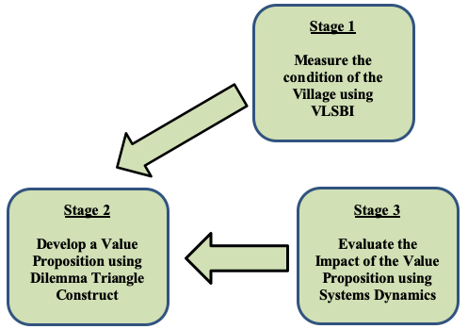
Figure 2. 2 Interaction among different stages in Abhishek Yadav’s Framework
Interaction between Stage 2 and Stage 1
VLSBI is used as measuring tool. It measures the condition of the village before and after the intervention of a value proposition. So, VLSBI does not involve directly in sustainable rural development. Dilemma Triangle method actively involves in developing value proposition.

Interaction between Stage 2 and Stage 3
Systems Dynamics is used to evaluate the impact of value proposition which is developed by using Dilemma Triangle method. Hence, the impact depends upon the value proposition developed by Dilemma Triangle method.
The final verdict of the Abhishek Yadav’s framework is that evaluating the impact and Measuring the condition of a village is not an important task but developing the value proposition is the most important and necessary task. Whatever the value proposition is developed its impact can easily calculated using Systems Dynamics. Poor development of a value position results in poor results in the village. But in his framework, Dilemma Triangle is used without any boundary or perspective. Since there is no boundary, a social entrepreneur can collect any number of issues (it may be less or more) which results in poor identification of dilemmas. Also, the way dilemmas are identified has drawbacks because only one category of issues are considered (Tensions) which is explained in Chapter 3 and Chapter 4. To fill those gaps questions along with hypothesizes are formed. In the following Table 2.1 the most important literature on which this thesis is designed is presented. Each paper is critically evaluated, and gaps are identified. Based on those gaps, research questions are formulated.
Table 2. 1 Critical Review of Literature
 | Paper 1
Title | A Framework for Developing Proposals by Social Entrepreneur for Development of Rural India
Author | Yadav, A.
Summary | This is a thesis dissertation in which a computational framework is proposed which can help a social entrepreneur to develop a value proposition
What’s Missing? | This framework can only be used when a problem is given by a social entrepreneur. But it cannot be used to explore the problems and understand its nature.  If there are many value propositions available, this framework cannot be used to decide which one is most suitable.
 | Paper 2
Title | Identifying and Managing Dilemmas for Sustainable Development of Rural India.
Authors | Yadav, A., Das, A.K., Roy, R.B., Chatterjee, A., Allen, J.K. and Mistree, F.,
Summary | In this paper, a method called dilemma triangle approach is implemented in identifying and managing dilemmas for sustainable development.
What’s Missing? | This method is implemented in general, but author didn’t explain how it works in different perspectives.
 | Paper 3
Title | Principal Sustainability Components: Empirical Analysis of Synergies Between the Three Pillars Of Sustainability.
Authors | Hansmann, R., Mieg, H. A., and Frischknecht, P.
Summary | In this paper, author explained the importance of sustainable development and elaborated the three pillars of sustainability.
What’s Missing? | Author didn’t explain how to make use of the three pillars of sustainability in addressing a social problem.
 | Paper 4
Title | Dilemmas in a General Theory of Planning
Authors | Horst W. J. Rittel, and Melvin M. Webber.
 | This paper helps me in understanding the wicked nature of a problem. He described what things to be considered while planning especially social system.
What’s Missing? | This paper only talks about the wicked nature of a problem but didn’t introduce any approach to deal with it.
 | Paper 5
Title | The Water-Energy-Food Nexus: A new approach in support of food security and sustainable agriculture
Published by | Food and Agriculture Organization of the United Nations
Summary | This article explains how Food, Energy and Water are interdependent, why is it important to secure it.
What’s Missing? | It only concentrates in the field of agriculture but not in others.
 | Paper 6
Title | Guidelines for Successful Crowdfunding
Published by | Hannah Forbes and Dirk Schaefer
Summary | This paper provides some guidelines for successful crowdfunding for any project
Missing | This paper discusses about crowdfunding in general but not in perspective of a social entrepreneur. But still few points are mentioned about social projects helped in building this framework.
Table 2.1. Literature Review

This thesis is an improvement of the previous framework built by Abhishek Yadav. Based on the missing part from Table 2.1 research questions and hypothesizes are developed for further improvement of the framework.
Hence, primary question addressed in this thesis is,
Primary Question (PQ)
Considering the capability of a social entrepreneur and condition of the village, what are the methods required to guide a social entrepreneur to achieve sustainable rural development in off-grid villages facing extreme poverty and also encourage investors to provide necessary funding?
Primary Hypothesis (PH)
A framework which can be used by any social entrepreneur to develop value propositions and evaluate its impact is needed.
In order to build such framework, two concepts from Abhishek Yadav’s thesis are utilized but in a better way. They two concepts are,
- Dilemma Triangle method
- Systems Dynamics

2.1.2. Reasons for Improvement
The drawback in Abhishek’s framework is found in utilizing those two concepts. These drawbacks leaded into two secondary questions.
Draw back 1 – Dilemma Triangle method in used without any perspective and boundary. Hence, it doesn’t have any direction which resulted in poor framing of the problem. Since, this process is an iterative process more time has to dedicated for this process alone.
Draw back 2 – In Systems Dynamics model, only one solution or value proposition is considered but not more than one. Much more complex models are required in order to build the current framework. To understand the interaction among different value propositions. If Systems Dynamics is utilized efficiently, VLSBI is not necessary because both impact evaluation with Systems Dynamics and measuring condition using VLSBI seems to similar.

These two draw backs are considered as my primary gaps which are mentioned in the form two questions. They are Secondary Question 1 and Secondary Question 2.
Secondary Question 1 (SQ 1)
Based on available village data, considering the complexity and wicked nature of the problem, how is it possible to organize and prioritize problems worth investigating and develop a value proposition by a social entrepreneur?
Paper 2 written by Abhishek Yadav and co-authors in Table 2.1 gives describes the concept of ‘Dilemma Triangle method’. More information is provided in Chapter 3. This concept allows a social enterprise to frame the problem and identify dilemmas involved in rural development. In general, there will be always some dilemmas when dealing with social issues (from Paper 4 in Table 2.1). Based on the dilemmas found, an anticipated solution is defined. Using Systems Dynamics, village dynamics are modelled by introducing the anticipated solution into it to calculate the impact of the solution on villager’s life. Solutions developed depends on the way we framed the problem. So, in this thesis, framing the problem should be done in a better way by improvising the concept of ‘Dilemma Triangle method’.

Based on Paper 3 in Table 2.1, the concept of sustainability is still used in framing the problem which circles around the three spheres – Social, Economic and Environmental. This concept is also used in Abhishek Yadav’s framework. In addition to it, Food, Energy and Water (FEW) nexus is considered (Paper 5, Table 2.1) along with sustainability to improve the concept of ‘Dilemma Triangle method’. Considering Food, Energy and Water as three perspectives, Dilemma Triangle is introduced individually for each perspective and connected it at the end to frame the problem in a better way. Since the problem is framed in a better way, more solutions can be developed which embodies both FEW nexus and spheres of sustainability. More information regarding this given in Chapter 4.
Hence, hypothesis for my Secondary Question 1 is as follows,
Secondary Hypothesis 1 (SH 1)
Using a Dilemma Triangle method in Food, Energy and Water (FEW) nexus considering people, planet and progress as drivers, it is possible to analyze most of the problems involved in the village, detect all the problems worthy of investigation and develop a value proposition.
A better way of framing the problem leads to find better solutions. These solutions are to be tested using a tool which is our Secondary Question 2.
Secondary Question 2 (SQ 2)
What tools are required to evaluate the impact of the value proposition before implementing in the village and plan the budget?
In this thesis, in order to answer Secondary Question 2, same tool (Systems Dynamics) is used that has been utilized in previous framework but with more complex relation between variables. This process of realizing these models is clearly explained in Chapter 5. Hence the hypothesis is as follows.
Secondary Hypothesis 2 (SH 2)
Systems Dynamics can be used to simulate the village dynamics and evaluate the impact of the developed value proposition and decide the budget required for the intervention.

Hence our primary is to question is how to build a framework whereas two secondary questions is how it is done. Hence secondary questions are part of primary question as shown in Figure 2.1
Figure 2. 3 Questions Addressed in Thesis

2.2 LAYOUT OF FURTHER CHAPTERS
Based on the research questions, further chapters are planned in such a way that each hypothesis is clearly elaborated. In Chapter 3, primary question and its hypothesis is discussed in detail. Also, a brief introduction about Secondary Hypothesis 1 is given. In Chapter 4, a detailed explanation of Secondary Hypothesis 1 is given along with a manual on ‘Automated Excel Dashboard’ to implement Dilemma Triangle method. In Chapter 5, Secondary Hypothesis 2 which is about Systems Dynamics is explained clearly. An introduction to Systems Dynamics is given and how this Systems Dynamics helps in evaluating a value proposition is explained with some example models. Since Secondary Hypothesis 1 and 2 are parts of primary question, in Chapter 6, both hypothesizes are combined to form a framework and applied on a new village data to validate my entire work. The following figure gives the entire layout of thesis with current chapter (with a green border).

CHAPTER 3

A COMPUTATIONAL FRAMEWORK TO FOSTER SOCIAL ENTERPRISES TO ACHIEVE SUSTAINABLE RURAL DEVELOPMENT.

This chapter is the heart of the whole thesis. It addresses the primary question of the thesis. The main goal of this thesis is to develop a framework for social enterprises to achieve sustainable rural development. Two important tools are necessary to build this framework. One is ‘Dilemma Triangle’ and the other one is ‘Systems Dynamics’. These two tools are combined in such a way that a social entrepreneur is able to find the prominent issues in a village, develop an equitable, viable and bearable solution and analyze the impact of the solution. This impact analysis leads social entrepreneur to develop a plan, decide budget for their work in advance and gather funds.

3.1 NEED OF A COMPUTATIONAL FRAMEWORK
The process of achieving sustainable development in off-grid villages is a tough task. Social entrepreneurs with many years of experience can handle it but new social entrepreneurs find hard to accomplish the tasks. The main goal of any social entrepreneurs is not just to foster sustainable development but also, they need to attract funds by show casing their work to investors. A computational framework fosters the progress of a social enterprise (Yadav. A, 2018). Keeping all these in mind, a computational framework which is an improvised version of previous framework developed by Abhishek Yadav (Yadav. A, 2018) has been developed which can guide a social entrepreneur in achieving sustainable development and also rise necessary funds from either crowd or CSR. (Corporate Social Responsibility) committee.

3.1.1. Primary Question
In literature review from chapter 2, primary question has been addressed by considering the gaps found through previous contributions.
Primary Question (PQ)
Considering the capability of a social entrepreneur and condition of the village, what are the methods required to guide a social entrepreneur to achieve sustainable rural development in off-grid villages facing extreme poverty and also encourage investors to provide necessary funding?
To answer this question, a hypothesis is proposed which represents the primary goal of this thesis.
Primary Hypothesis (PH)
A framework which can be used by social entrepreneur to decide what value proposition is suitable for the village and evaluate the impact of the value proposition in villager’s lives is needed.

3.1.2. Recall the Limitations of Previous Frameworks

The Framework proposed by Abhishek Yadav is used to developed only a given value propositions but cannot be used to decide what value proposition is needed based on the problem. Now, capability of SunMoksha is increasing and many intelligent assets are being introduced by them. So, the utility of this framework is limited.

3.2. MODIFIED FRAMEWORK
With the respect to the primary hypothesis of this thesis and limitations of previous framework, a new computational framework (Figure 1.18) has been developed. This framework is developed by making use of the experience from the social entrepreneur.

3.2.1. Introduction to Proposed Modified Framework
Proposed framework has two stages which is mentioned in chapter 2 as two secondary questions. In stage 1 issues are collected from the village and decide what value proposition is needed. In stage 2 impact of the value proposition on villager’s lifestyle is calculated before the implementation. This gives an idea of the quantity required for that village.
This framework as shown in Figure 3.1, not only help a social entrepreneur evaluate the impact those existing value propositions but also help them decide whether or not to develop a new value proposition. This decision-making process is very crucial in achieving sustainable development. After the decision is made a social entrepreneur should be able to evaluate its pre-impact to check the positive response which shows the confidence to intervene the chosen value proposition in the village
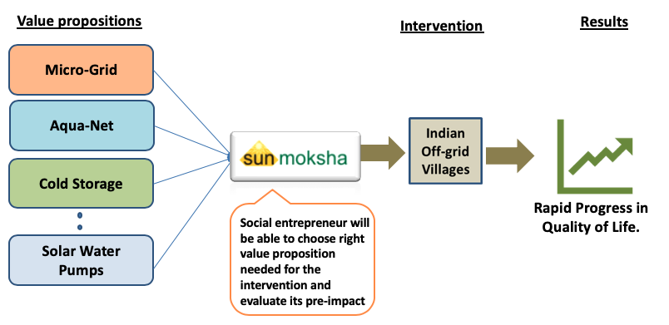
Figure 3. 1 Overview of the Proposed Framework

3.2.2. Elements of the Proposed Framework
Through Secondary Hypothesis 1 and 2, two concepts are utilized in order to realize our framework.
To decide what value proposition is needed, a method called ‘Dilemma Triangle’ method is utilized. This method facilitates a social entrepreneur to make decision from the qualitative information (village problems) they collected from a village. This method is further elaborated in section 3.2.3.
To evaluate the impact of the value proposition, Systems Dynamics is utilized. This Systems Dynamics is used to simulate village dynamics and introduce value proposition into the design and evaluate its impact on the village.
From www.systemsdynamics.org , the definition of systems dynamics goes like this,

Systems Dynamics is a computer-aided approach to policy analysis and design. It applies to dynamic problems arising in complex social, managerial, economic or ecological systems literally any dynamic systems characterized by interdependence, mutual interaction, information feedback, and circular causality.
More explanation about Systems Dynamics is provided in Chapter 5

3.3 DILEMMA TRAINGLE METHOD
A dilemma is a difficult choice from two options, each of which is (or appears) unacceptable or unfavorable (Yadav, A., 2017). A dilemma represents a zero-sum outcome. It can be expressed as a choice among
- Two unfavorable options one of which must be chosen, OR
- Two favorable options, only one of which is possible at this time.
This method is used to make decisions in a complex system. Since, social systems are very complex (Mesjasz, C., 2010), this method plays an effective role.

Note: This method is also been utilized in previous framework which developed by Abhishek Yadav. In this framework a few modifications are made to the method to make better decisions

3.3.1 The Dilemma Triangle Method
Dilemmas in decision making is involved in any wicked problem (Sharma, P and Bhal KT 2004). A village ecosystem is seen as a wicked problem as it does not have a clear solution (DeFries, R. and Nagendra, H., 2017). This Dilemma Triangle method is also used as a tradeoff among multi-stakeholders like social entrepreneurs, people, and investors which results in a variety of dilemma (De Brucker, K. and co-authors, 2013). To achieve sustainable development these dilemmas, play a crucial role. For example: In a village, farmers don’t have access to supply ground water to agriculture. To overcome this problem a social entrepreneur provided water pumps to farmers. Now farmers deplete more ground water which results in over depletion thereby causing water scarcity. Since the water takes time to regenerate meanwhile farmers cannot use it which results in another problem. This is a dilemma for a social entrepreneur whether to provide water pumps by not considering ground water depletion rate or not to provide anything so that groundwater will be safe. To clear this dilemma, he/she has to come up with a sustainable solution which is safe for both people and planet there by creating progress in agriculture. Hence, to develop a sustainable value proposition, it is essential to identify and manage these dilemmas to reduce the complexity of the problem before implementing the solution in social system. Dilemma Triangle method is used to identify dilemmas and come up with a solution to clear those dilemmas. The Dilemma Triangle method is developed to identify a dilemma in a complex system that has three drivers. These drivers represent the spheres of sustainability: social, environmental and economical (Munier, Nolberto 2005). By using the method, a social entrepreneur can identify dilemmas that arise in spheres of sustainability and allows him/her to develop a value proposition which serves as a sustainable solution for the problem. In Figure 3.2, the concept with three drivers is presented and termed as Dilemma Triangle. The three drivers drive the solutions, the focus states the boundary of the problem user is solving, and issues are the challenges that can occur in each driver to reach the desired goal. Previously, the Dilemma Triangle method is used for identifying and managing dilemmas in a dynamically changing workplace environment of the 21st century (Ahmed, Xiao and co-authors, 2012). And then this method is modified to find value proposition (Yadav. A, 2017). In this thesis, the concept is expanded to utilize this method in different perspectives with different goals. This arises many types of issues involved in a village and generates more dilemmas. Three spheres of sustainability are used as three drivers of Dilemma Triangle to develop a sustainable value proposition (Yadav. A, 2018). The dilemmas that arise within these drivers are the gaps that are required to be filled by the social entrepreneurs to sustain their enterprises. (Yadav. A, 2018)
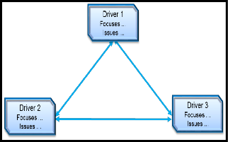
Figure 3. 2 The Dilemma Triangle
This dilemma triangle method (Figure 3.2) with FEW-Nexus is illustrated using data from Kudagaon village (located in Odisha, India) to develop a sustainable value proposition that satisfies multi-stakeholders (social entrepreneurs, villagers, and investors) (Baldassarre, B. and co-authors, 2017).

3.3.2. Elements of Dilemma Triangle
The method of Dilemma Triangle is divided into two parts, the first part is generic and can be used for all the complex systems, the second part of the method is specific to the context of this thesis, wherein the combination of concepts from spheres of sustainability with the method of Dilemma Triangle is presented. For all the complex systems that are anchored in the sustainable development, both the parts of this method can be used. Before this method can be applied, a social entrepreneur must define the problem in the form of a problem statement together with the data that characterizes the village.
Element 1 – Drivers
A driver is nothing but a factor which causes a particular phenomenon to happen. In most of the problems. It is the area where an individual has to focus. Each DRIVER is “defined” in terms of ISSUES. ISSUES are listed as words or verb-noun tuples. For example, mitigate deforestation, provide electricity, etc.
Examples for Drivers
Social Planning – Social, Economic and Environmental
People, Planet and Profit/Progress
Product Development – Good, Fast and Cheap
Software Development – Speed, Quality and Features
Project Management – Time, Cost and Quality
As we know that this thesis is involved in social planning, People, Planet and Progress are considered as drivers.
Element 2 – Focus
It is the aim/goal of an individual which depends upon the problem chosen. The FOCUS is different for each DRIVER. It is in the form of a sentence.
Example
People - To provide reliable and affordable electricity to villagers.
Planet - To produce electricity without affecting the planet.
Profit - To improve socio-economic conditions of villagers with the help of electricity.
Element 3 – Issues
Issues are problems found in a village in perspective of each driver. A social entrepreneur will face these issues while trying to reach the respective goal. Issues will be many in number as shown in Figure 3.3
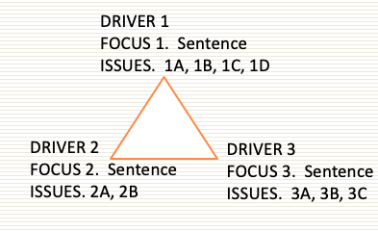
Figure 3. 3 Dilemma Triangle method
Element 4 – Issue Matrix
When a social entrepreneur tries to solve an issue from one driver, there is a high chance that it affects the problem from another driver. Also, there is a high chance that one solution will solve two problems. There might be individual problems which do not affect anything.
This results in categorizing all issues before identifying dilemmas. In order to judge each issue over other issue, an organized layout if issues is built. This layout is called a ‘Issue Matrix’ as shown in figure 3.4
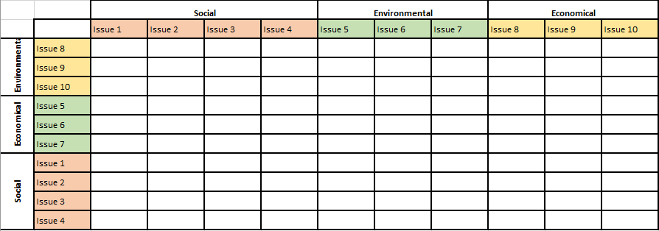
Figure 3. 4 Issue Matrix

Element 5 – Categorizing Issues
Based on type of conflict between two or more issues, category is decided. If solving one issue has a negative impact on another issue, then it is considered as Tension (Yadav. A, 2017). In this thesis more categories are designed to generate more dilemmas there by developing more value propositions. These categories are explained in chapter 4.

3.3.3. Role of Dilemma Triangle in Proposed Framework

This dilemma triangle method has been improved to fit into this new framework. This method is used to do a strategical planning of the business by developing right value proposition. A detailed explanation of this method is presented in Chapter 4.
In the proposed framework, it was mentioned that Secondary Hypothesis 1 is about developing the value propositions. In order to decide what value proposition is needed, first we need to get over all idea of the problem involved in a village. It’s not just the problems, a social entrepreneur should be able to find the inter-relation between those problems (For example: Tensions). If he/she can produce a bird view of all those relations between the issues, it would be very easy for any social entrepreneur to make decisions. Without this method, a social entrepreneur will still be able to come up with a solution, but that solution creates another problem instead of solving the existing problems.
The main role of this method is to guide social entrepreneurs to make wise decisions by considering three spheres of sustainability, that is, People, Planet and Progress.

3.3.4. Outcomes of Dilemma Triangle Method
Social problems are wicked problems. A wicked problem is a problem that is difficult or impossible to solve because of incomplete, contradictory, and changing requirements that are often difficult to recognize. Some of the characteristics of a wicked problem are (Rittel, H.W.J and Webber M.M, 1973):
  - There is no definitive formulation of a wicked problem
  - Every wicked problem is essentially unique.
  - Every wicked problem can be considered to be a symptom of another problem.
  - There is no immediate and no ultimate test of a solution to a wicked problem.
Since there is no definitive formulation of a wicked problem, a method called ‘Dilemma Triangle’ is introduced to frame such wicked problems.
Advantages
- Complexity of a social planning is reduced
- Holistic view of a problem is presented
- Better decisions can be made
- Helps to choose suitable value proposition for solving the problem
- Sustainability is maintained
In Chapter 4, an example problem is chosen to explain the advantages of the dilemma triangle method and also new elements that has been added in this thesis.

3.4. SYSTEMS DYNAMICS TO VISUALIZE THE IMPACT OF VALUE PROPOSITION
Once a social entrepreneur decides what value proposition is needed to identify the dilemmas, next step is to evaluate the impact of the value proposition virtually in a computer platform so that, positive results builds confidence in rising funds and developing the value proposition. To evaluate this impact, Systems Dynamics is used.
Systems Dynamics is an approach to understand non-linear behavior of any complex system. Considering social systems as complex system, Systems Dynamics is used to understand its behavior (Yadav A, 2018). Causal Loop Diagrams (CLDs) (Yadav A, 2018) are built in such a way that village dynamics along with interaction between value proposition and people is presented. This is similar to simulation process. Here village behavior is simulated to understand the impact of the value proposition on their lives. In previous contribution this method is used in evaluating the impact of the developed value position (Yadav. A, 2018). But, due inefficient utilization of Dilemma Triangle method only few value propositions are developed. In this thesis, an improvised version of Dilemma Triangle with new elements is used to develop more value propositions. Due to a greater number of value propositions Systems Dynamics approach results in much more complex models.
This impact evaluation results in displaying the improvement in lifestyle of villagers in the form of graphs. This visualization is used to showcase the effect of a value proposition to donors to rise funds necessary to develop those value proposition. In Chapter 5 information regarding implementation of Systems Dynamics is provided. This process of implementing Dilemma Triangle to develop a value position and the process of implementing Systems Dynamics to evaluate the impact together constitutes whole framework (Figure 3.5).
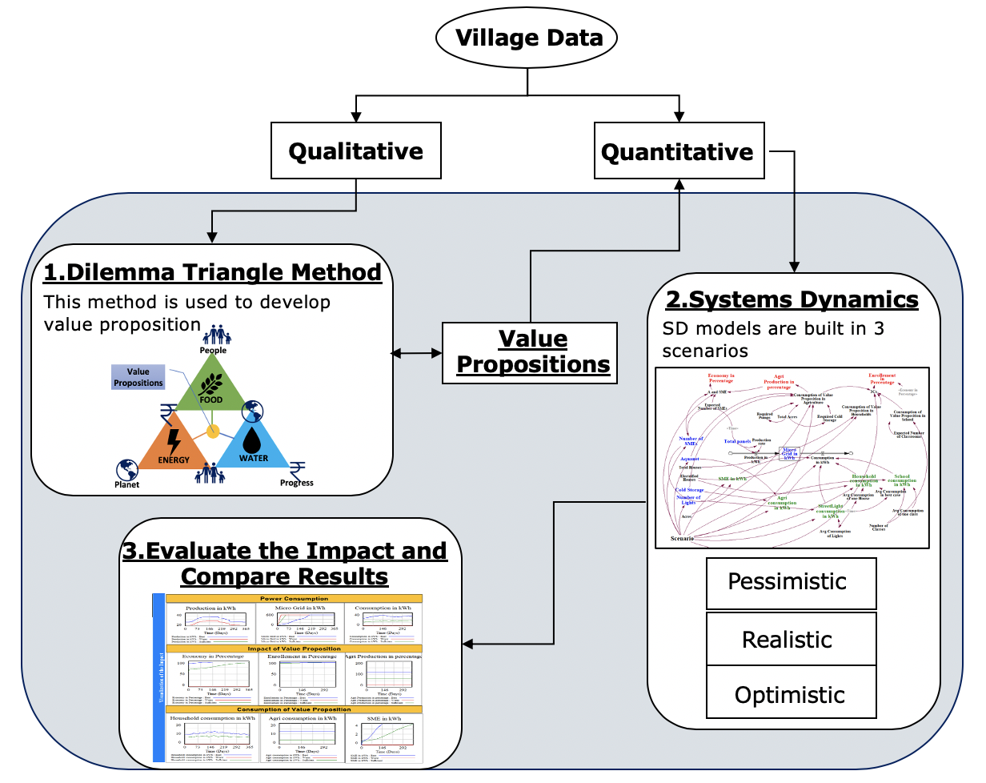
Figure 3. 5 Modified Framework (Dilemma Triangle + Systems Dynamics)
In this framework, both qualitative and quantitative data are utilized. Qualitative data explains the problems involved in a village. For example: Poverty, Severe floods, Poor transportation etc. At the same time, quantitative data like population, number of households, number of acres of farming land, income etc. are utilized in the framework.
From the Figure 3.5, three steps are involved in using this framework,
Step 1: Dilemma Triangle Method
In this step, qualitative information is used in identifying dilemmas involved in the decision making and develop a value proposition. If the value proposition is in the form a smart technology, quantitative information regarding that technology is gathered. For example, if the technology is Microgrid, then quantitative like number of panels, amount of energy produced by each panel, weather patterns etc.
Step 2: Scenario-based Models in Systems Dynamics
In this step, the village is designed and simulated by introducing the value propositions in the model. It is run in three different scenarios, Pessimistic (worst-case scenario), Realistic (sufficient case scenario) and Optimistic (best case scenario). These scenario-based results are visualized in 2D graphs right beside the model in Systems Dynamics itself. In Chapter 5, these scenario-based models are explained and in Chapter 6 these validated with comprehensive problem.
Step 3: Visualizing the Impact
The tool used to perform Systems Dynamics is Vensim. More information regarding Vensim is provided in Chapter 5. In this tool, various variables used in the model can be displayed in 2D graphs. User has an option to pick the desired variable to check the impact. This visualization plays a key factor in elaborating the work of the social entrperneur to investors.

3.5 SYNOPSIS OF CHAPTER 3

In this chapter, the elements of the proposed framework are discussed. Based on the literature review (Chapter 2) research questions and hypothesizes are formulated. The primary question of this thesis is discussed in this chapter. The primary hypothesis is to develop a computational framework which can be used by any social entrepreneur and it is discussed how it is done in this chapter. Two methods are used to build this framework. They are ‘Dilemma Triangle’ method and ‘Systems Dynamics’. Only outcomes of those methods and how they are connected is discussed briefly in this chapter. The workflow of the complete framework is also presented in Figure 3.4 which shows the connection between two methods. Later on, in further chapters these methods are elaborated. In Chapter 4 first method which is developing value propositions using Dilemma Triangle method is explained and in Chapter 5 evaluation of the impact of the developed value proposition using Systems Dynamics is explained.

The following figure represents the layout of further chapters and green border shows the current chapter.

CHAPTER 4

IMPLEMENTING THE DILEMMA TRIANGLE METHOD IN FOOD, ENERGY AND WATER (FEW) NEXUS

In this chapter main essence of the proposed framework is discussed. In proposed framework there are two elements which are considered as two secondary hypothesizes. Among those two elements, first element is implementing dilemma triangle method. In this chapter dilemma triangle method is implemented in perspective FEW nexus (Secondary Hypothesis 1). In this chapter a recap of the dilemma triangle method which is mentioned in Chapter 3 and its capabilities and explains how it can be used in further extend is presented. A new topic called ‘Food, Energy and Water (FEW) Nexus’ is introduced and its importance is presented in this chapter. The combination of ‘Dilemma Triangle’ method and ‘FEW Nexus’ is presented in this chapter. The resultant outcome of this combination helps in realizing the Secondary Hypothesis 2.

4.1 FOOD, ENERGY AND WATER NEXUS

4.1.1 A Recap of Dilemma Triangle Method
Dilemma Triangle method is used to find dilemmas in a complex problem (Yada A., 2017).
Deciding a value proposition without considering all issues will create a new problem due to its wicked nature (Rittel. H.W.J and Webber M.M, 1973). Dilemma Triangle method allows a social entrepreneur to organize all soft information regarding issues in a village and identify dilemmas in it as shown in Figure 4.1.
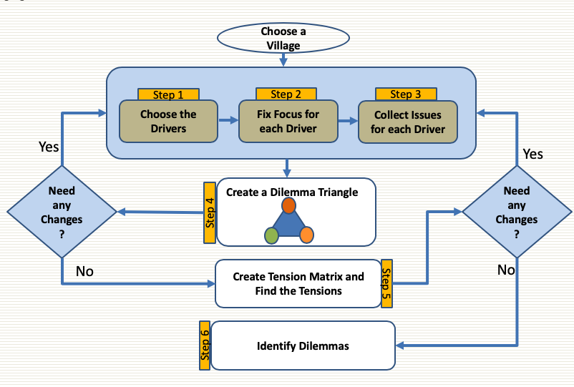
Figure 4. 1 Workflow of Dilemma Triangle Method (Yadav. A, 2017)

In this thesis, the Dilemma Triangle method is utilized in a different way. In the previous contributions (Yadav A., 2018), this method is not used in any perspective. Dilemmas produced very limited. As mentioned in Section 3.3.3 new elements are added to this method to improve its utility. Existing method can be applied only when there are only few problems. If there are lot of problems, framing the problem with existing method is not helpful. In this thesis, in order to get a broader view of the problem, the whole method is applied in three different perspectives as shown in Figure 4.2
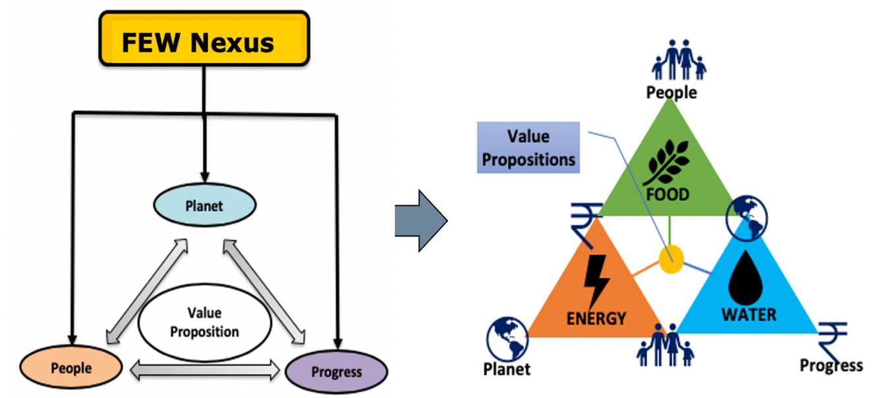
Figure 4. 2 Dilemma Triangle Method in FEW Nexus

So, the question is what are those perspectives?
Going back to the Secondary Hypothesis 1,

Secondary Question 1 (SQ 1)
Based on available village data, considering the complexity and wicked nature of the problem, how is it possible to organize and prioritize problems worth investigating and develop a value proposition by a social entrepreneur?
Secondary Hypothesis 1 (SH 1)
Using a Dilemma Triangle method in Food, Energy and Water (FEW) nexus considering people, planet and progress as drivers, it is possible to analyze most of the problems involved in the village, detect all the problems worthy of investigation and develop a value proposition.

Based on the Secondary Hypothesis 1, existing workflow of dilemma triangle (Yadav. A, 2017) is modified in such a way that it can be used in different perspectives as shown in Figure 4.3. This method also allows a social entrepreneur to categorize issues.
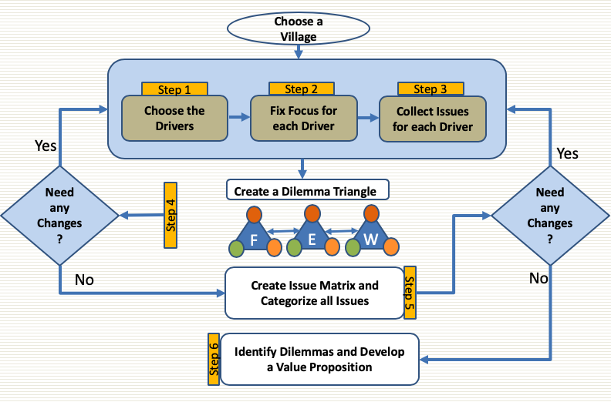
Figure 4. 3 Modified Version of Dilemma Triangle

4.1.2 Introduction to Food, Energy and Water Nexus (FEW)
The FEW-nexus is the intersection of food, energy, and water, three interdependent components that, together, are the lifeblood of the people living in the earth. By 2025, there will be nine billion people on Earth (The University of Arizona). It resulted in the need to manage these three components for better planning (Sukhwani, V. and co-authors, 2019). Unless we are able to thoroughly understand the connection between all three, global efforts to meet the needs of people on Earth will fail. This FEW-Nexus has become one of the most common frameworks in achieving sustainability (Natarajan, M. and co-authors, 2019).
FEW-nexus plays a crucial role in sustainable development. Due to increasing population, demands towards Food, Energy and Water increasing (UN Water). This leads to wicked problems in social systems. A strategy is needed to ensure sustainability in three components, that is, Food, Energy and Water (Godfray, H. and co-authors, 2010). Most of the problems are interlinked with this FEW-nexus. So, exploration of FEW-nexus helps to identify the existing and also upcoming problems of the social system. From Figure 4.3 this dilemma triangle method can be implemented three times. For each perspective issues are collected from three drivers as shown in Figure 4.4

Figure 4. 4 Dilemma Triangle in Perspective of FEW Nexus

4.1.3 Additional Elements to Justify Secondary Hypothesis 1
As mentioned in Figure 4.3, new elements are added into the existing method.
New Element 1 –
New types of Issues (other than Tensions).
Dilemma triangle approach has just found only one category of issues (Tensions). But, through this FEW perspective, five categories of issues are determined along with ‘Tensions’.
They are:
- Tensions
- Dependents
- Inter-perspective Tensions
- Inter-perspective Dependents
- Individual Issues

- Tensions
When two issues conflict in such a way that, if you try to solve one issue, it affects the other issue negatively. These issues are called as ‘Tensions’.

- Dependents
It is similar to Conflict Issues in a reverse way. If you try to solve one problem, it affects the other issue positively. In short, if you a solve one issue, the other issue will be solved automatically due to their dependency. These are represented as ‘Dependents’.

- Inter-perspective Tensions
If an issue from one perspective conflicts with another issue from different perspective, then it is called ‘Inter-perspective Tensions’.

- Inter-perspective Dependents
If an issue from one perspective depends with upon another issue from a different perspective, then it is called ‘Inter-perspective Issues’.
- Individual Issues
These issues do not interfere with any other issues when you try to solve it. These types of issues are called individual issues.
New Element 2 –
Issue Matrices
Since we are considering many types of issues, the tension matrix is no longer called a ‘Tension Matrix’. It is termed as ‘Issue Matrix’. In perspective of FEW, three issue matrices are used to frame the problem. This Issue Matrix is similar to Tension Matrix, but these are built individually for three perspectives.

4.2 ANALYZE THE ISSUES WITH THE HELP OF THE DILEMMA TRIANGLE METHOD IN PERSPECTIVE OF FEW NEXUS

4.2.1 Framing the Problem and Categorizing Issues
In previous method (Yadav. A, 2017), it is able to find dilemmas through ‘Tensions’. Either a single tension produces a dilemma are combination of two or more tensions produce a dilemma. In this case, we have 5 categories of issues so, dilemmas are formed with different combinations of all types. Hence, the biggest advantage of using this method in perspective of FEW is we can find lot more dilemmas which gives a broader view of the problem and help us make better decisions.
To categorize the issues using Dilemma Triangle method a step by step procedure is followed.

Step 1: Construct a Dilemma Triangle with appropriate issues for each driver in each perspective
For this, a typical Indian village is assumed with the help of SunMoksha.
Dilemma Triangle in Perspective of Food
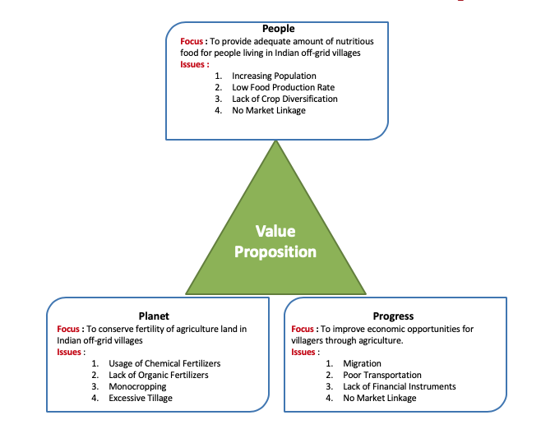
Figure 4. 5 Dilemma Triangle in Food

Dilemma Triangle in Perspective of Energy
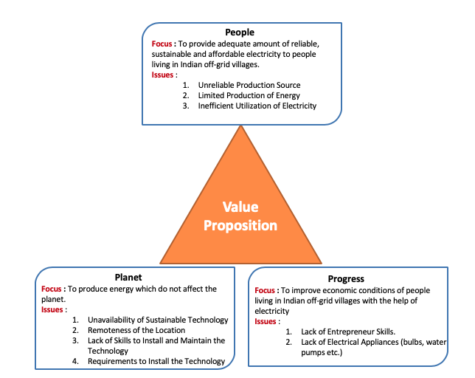
Figure 4. 6 Dilemma Triangle in Perspective of Energy
Dilemma Triangle in Perspective of Water
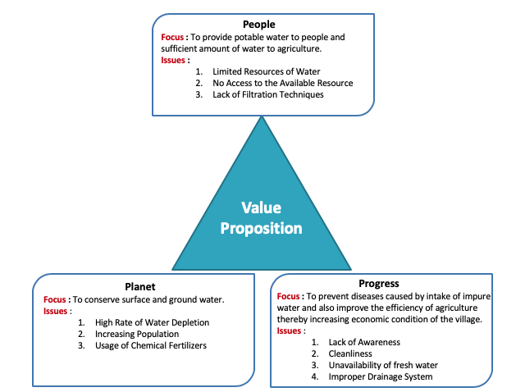
Figure 4. 7 Dilemma Triangle in Perspective of Water

Step 2: Build Issue Matrix for each Dilemma Triangle
These are built manually using Excel. Each matrix contains issues of their respective area, that is, FEW. Issues are represented both horizontally and vertically as shown in Figure 4.6 to 4.8. This arrangement will help a person to compare each issue from one driver with each issue from another driver. This comparison helps to categorize the issues which is our step 3.
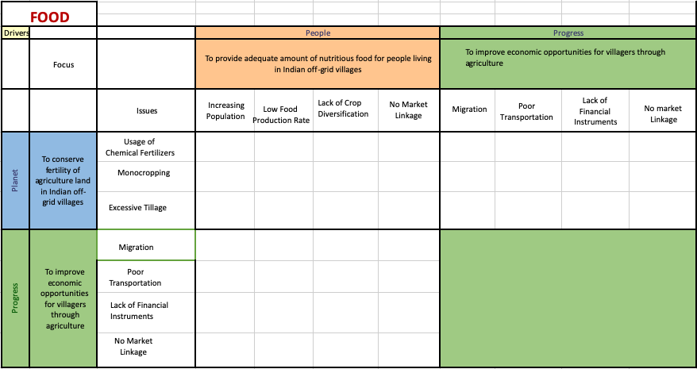
Figure 4. 8 Issue Matrix in Food
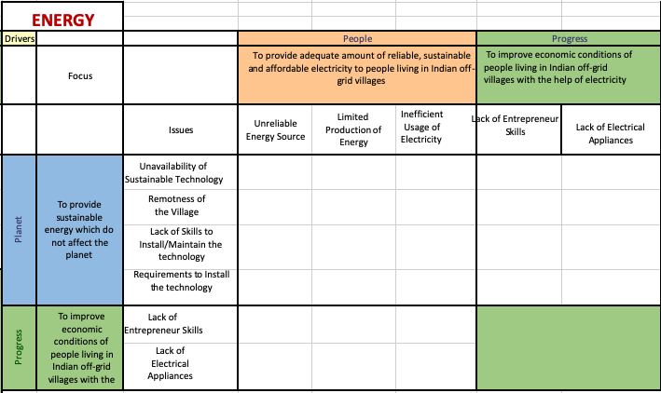
Figure 4. 9 Issue Matrix in Energy
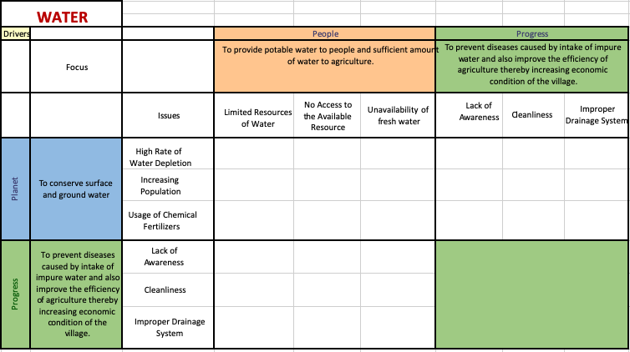
Figure 4. 10 Issue Matrix in Water

Step 3: Compare each issue and mark it as one of the categories mentioned in section 4.1.3.

Tensions are represented with red cell and dependents are represented with green cell. The red dot with a number in it represents ‘Inter-perspective Tensions’. It means that particular issue is forming a tension with another issue from another perspective. In same way green dot represents ‘Inter-perspective dependents’ which means that issue is dependent on another issue from another perspective. If you solve that one dependent issue, automatically the other issue is also solved
Issue Matrices are developed for other perspectives as shown below.

Issue Matrix for Food

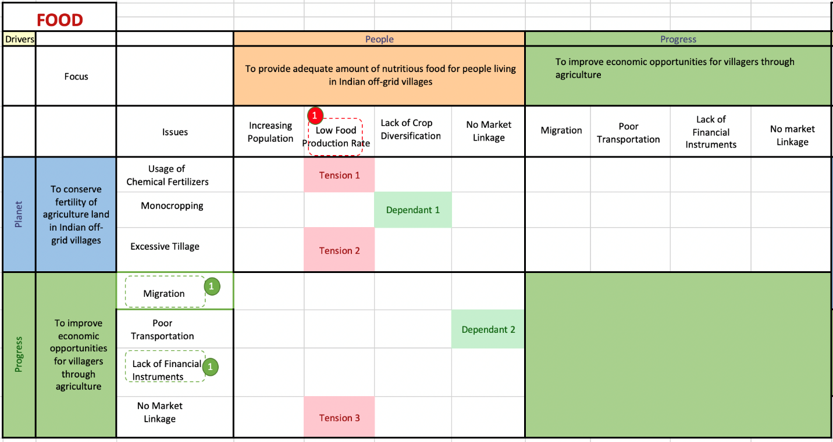
Figure 4. 11 Issue Matrix in Perspective of Food
Issue Matrix for Energy
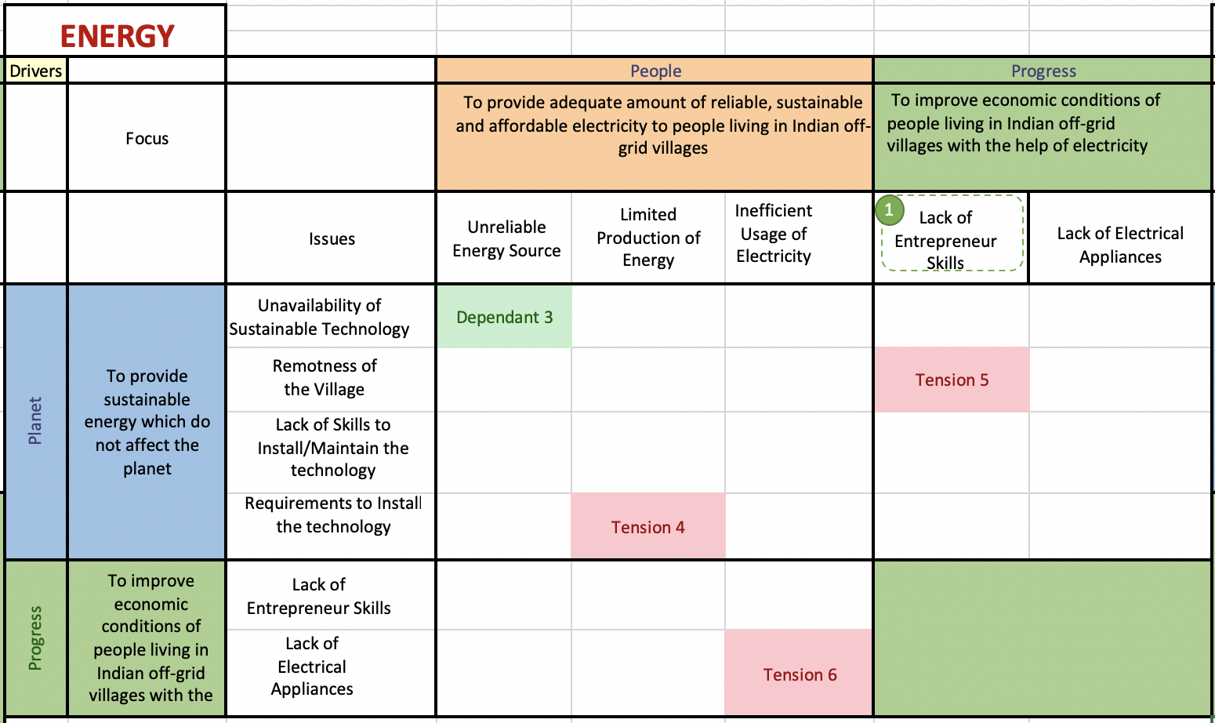
Figure 4. 12 Issue Matrix in Perspective of Energy

Issue Matrix for Water
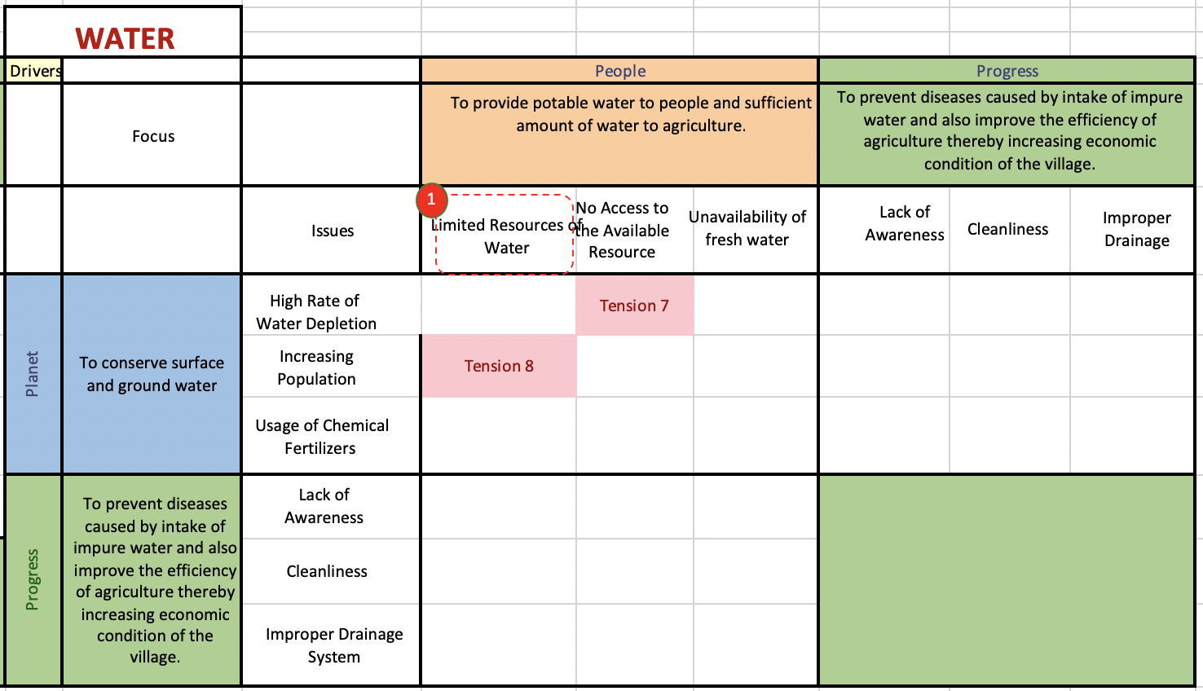
Figure 4. 13 Issue Matrix in Perspective of Water

Food – Tensions
Tension 1
Low Food Production rate vs Usage of Chemical Fertilizers
Every farmer uses chemical fertilizers in the fields for the healthy growth of crop. Due to the interaction of chemicals with soil, it results in killing the soil bacteria. Soil bacteria produces antibiotics to protect the crop from diseases. Hence, the usage of chemical fertilizers should be controlled.
Tension 2
Low Food Production Rate vs Excessive Tillage
Tilling the land will improve the fertility of the soil but, excessive tillage will result in reduction of soil quality. Hence, in long run the land won’t be useful for agriculture.
Tension 3
Low Food Production Rate vs No Market Linkage
Even though the food production rate is increased, villagers cannot make profit if there is no linkage to market.
Energy – Tensions
Tension 4
Limited Production of Energy vs Requirements to Install the Technology
Production of energy depends upon availability of the resource. Basic requirements to install a power source for example, Micro-grid, we need a good amount of land and good sun light almost throughout the year.
Tension 5
Lack of Entrepreneur Skills vs Remoteness of the Village
It might be easy to develop entrepreneur skills among villagers. But there should be a connectivity to nearby towns/cities to do a business. Remoteness of the village will be big problem to promote enterprises.
Tension 6
Inefficient Usage of Electricity vs Lack Electrical Appliances
Electricity is the most important resource which often goes waste due to inefficient use of electrical appliances at home/work. If villagers are provided with electrical appliances like fan, bulb, water pump etc. they will start consuming the electricity which in turn leads to wastage.
Water – Tensions
Tension 7
No Access to the Available Resource vs High rate of Water Depletion
If villagers are provided access to the water resource, they will start consuming water at higher rates than the resource capacity. Since, we cannot stop people from using water, in long run this habit will push the village into droughts.
Tension 8
Limited Resources Water vs Increasing Population
It is very difficult to manage limited resources with increasing population.
Food – Dependents
Dependent 1
Lack of Crop Diversification and Monocropping
Crop Diversification itself solves the issue of Monocropping.
Dependent 2
Poor Transportation and No Market Linkage
If there is any market available away from the village, by providing the transportation can create a linkage to the market.
Energy – Dependents
Dependent 3
Unreliable Energy Source vs Unavailability of Sustainable Technology
If a village has an unreliable energy source by installing a sustainable technology can solve the problem.
Water – Dependents
None were found
Inter-Tensions and Dependents
Inter-Tension 1 (Mentioned with green colored number)
Low Food Production Rate (FOOD) vs Limited Resources of Water (WATER)
Water is essential for food production. If we consider a drought village, availability of water is very limited. So, possibility of increasing food production with limited water resource is very less.

Inter-Dependent Issue 1 (Mentioned with red colored number)
Lack of Entrepreneur Skills (ENERGY) and Migration (FOOD) and Lack of Financial Instruments (FOOD)
The main reason for villagers migrating to cities/towns is due to lack of proper income. So, by providing financial aid and training them how to start an enterprise with available resources would definitely reduce the rate of migration.
Individual Issues
- Unavailability of fresh water
- Cleanliness
- Lake of awareness regarding how diseases caused by drinking unsecure water

Finding Dilemmas
The above-mentioned categories of issues are combined to form dilemmas.
Dilemma 1
From Tension 1, Tension 2 and Inter-Tension 1 we can understand that it is hard to increase food production rate with limited resource of water and using less amount of chemicals. So, the dilemma is how to establish precise cultivation with available technology.
Dilemma 2
From Individual Issues
Unavailability of Fresh Water: If available water in the village is unsafe, what sort of measures are to be taken to overcome this problem?
Dilemma 3
Tension 7, Tension 8
With Increasing Population and limited resource of water, how can you control the extreme usage of water when they are provided access to use water. This is a dilemma where social entrepreneur has to come up with a solution.
Dilemma 4
From Tension 4 we can understand that there are some requirements to install any sustainable energy source. For example, wind for Windmills, land and sunlight for Micro-grid, flowing water for Hydroelectricity. For suppose if we try to increase energy production from a Micro-grid, social entrepreneur needs to install more solar panels which consumes more land. In a village, it is hard to find such land. So, it creates a dilemma how to manage limited production of energy.
Dilemma 5
In Tension 5 we can understand that when villagers are encouraged to start small and micro enterprises, it is not possible to generate profit, if village is very remote. If remoteness is an issue, what type of enterprises should be encouraged.
Dilemma 6
Tension 6: Suppose a village is provided with electrical appliances like bulb, fan etc. initially, gradually number of electrical appliances increases due to gradual development of the village which results in inefficient usage of electricity. It creates a dilemma how to control the usage of electricity without disturbing the lifestyle of villagers.

Dilemma 7
Tension 3: If we increase the food production rate, farmers has to sell the crop immediately in the market to make profit. If markets are close to village, proper transportation is enough to sell their crop. What if the markets are very far? This creates a dilemma how to manage the harvested crop.

Developing Value Propositions to Clear the Dilemmas
For each dilemma we need to either match with the available value proposition or develop a new value proposition by SunMoksha as show in the below Table 4.1.

Table 4. 1 Developing Value Propositions
Dilemma | Solution
Dilemma 1 | AQUA-NET
Dilemma 2 | No value proposition is available. Hence, this dilemma has to be cleared by introducing a solution by SunMoksha.
Dilemma 3 | AQUA-NET
Dilemma 4 | MICRO-GRID with good Scalability is needed
Dilemma 5 | An Enterprise Model which considers the remoteness issue is Needed.
Dilemma 6 | MICRO-GRID with good Scalability is needed
Dilemma 7 | Cold-Storage and also,  A Value Proposition which addresses the transportation issue is needed.

4.3 AN AUTOMATED EXCEL DASHBOARD TO PERFORM DILEMMA TRIANGLE METHOD

4.3.1 Introduction to the dashboard
Th whole process of making dilemma triangles and issue matrices is time consuming task. If social entrepreneur wants to add new issue or change his focus, matrices has to be rebuilt again. In order to overcome this issue, a dashboard is created with VBA in Excel. This allows a social entrepreneur to generate dilemma triangles and tension matrices with just a click. This saves lot of time for any social entrepreneur who wants to use this framework.

4.3.2 Manual for the Dashboard
Step 1
Declare the size of each triangle by inserting number of issues at each driver a shown below.
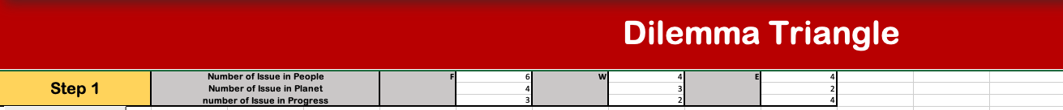
Find the two buttons (for example: Food, Delete_1). Click the Food button to create Food matrix. If you wish to delete it, click Delete_1 button. Similarly, do it for Water and Energy.
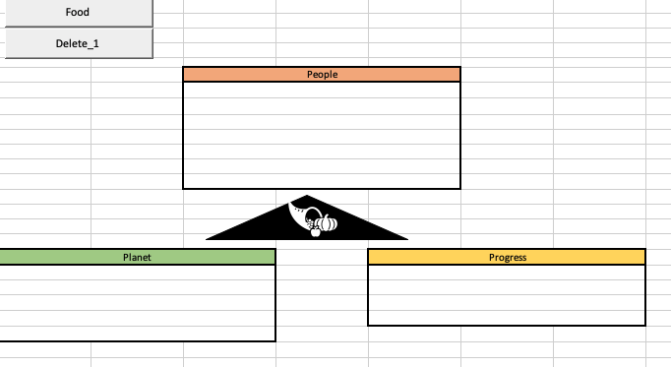
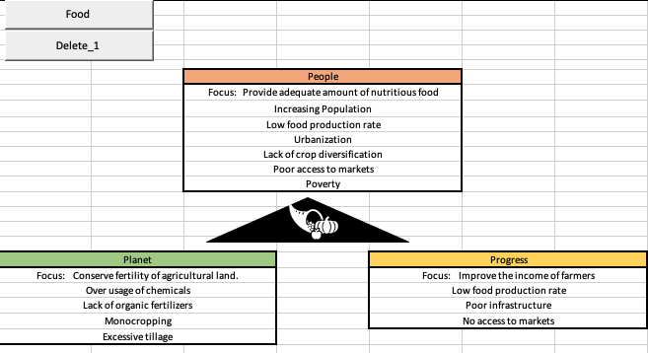

Step 2
In Sheet 1, click Next button at the bottom to move on to Step 2.
In Step 2, for each perspective (Food, Energy and Water) few buttons are provided as shown below.
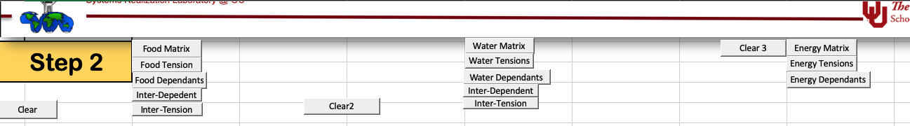
Click Food Matrix, Water Matrix and Energy Matrix to get all the matrices with issues filled in it as shown below.
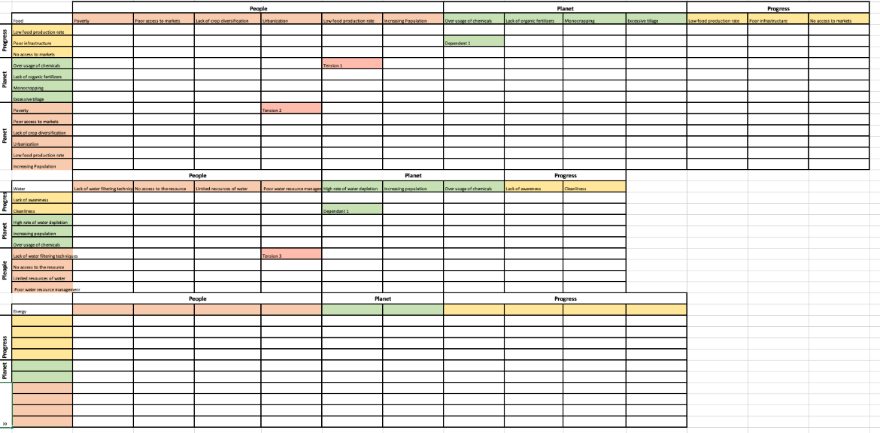
Individual clear buttons are provided to delete the matrices

Step 3
Create Tensions
In each matrix, click a cell where tension is formed and then click the respective Tension (Food, Water or Energy) button as show above
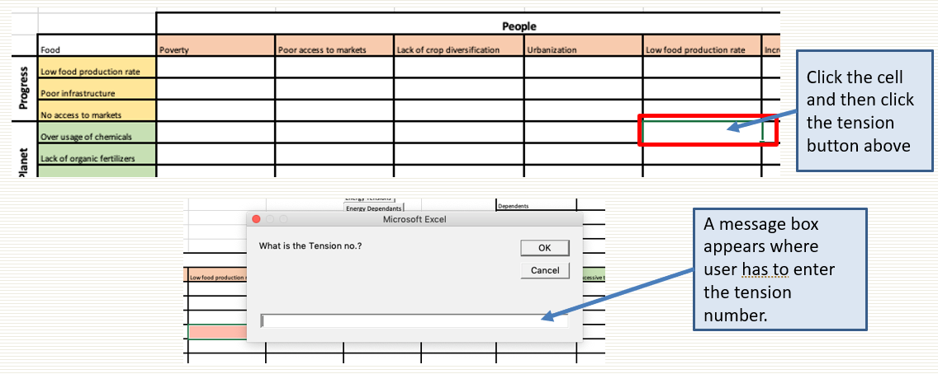
Similarly, find such tensions from all the perspectives (Food, Water and Energy). Finally, user gets total count on tensions (For example, 7 tensions).
Enter the total number of tensions in the table provided in top right corner of the sheet 2 as shown below.
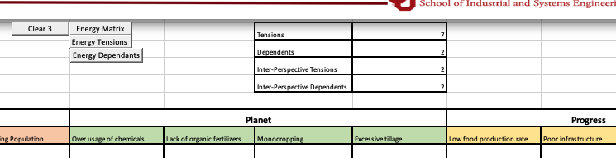
Note: This table should be filled with 2 every time even though you didn’t find any tensions or dependents just to avoid errors in next step

Step 4
Finding Dependents
This is similar to finding Tensions. All we need to do is changing the buttons.

Enter the total number of dependents as we did for tensions
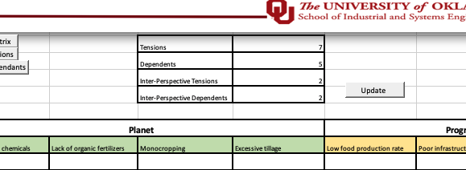

Step 5
Finding Inter-Perspective Tensions and Dependents

Inter-Tensions and Dependents only for Food and Water because,
Inter-Tension between Food and Water -> Click Inter-Tension in Food
2 buttons are enough to find all Inter-Tensions
Inter-Tension between Food and Energy -> Click Inter-Tension in Food
Inter- Tension between Water and Energy -> Click Inter-Tension in Water
Similarly, repeat the same process for Inter-dependents
Enter total number in the table and finally click the ‘update’ button
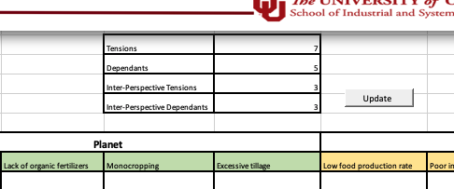
Final table in Sheet 3 looks like this
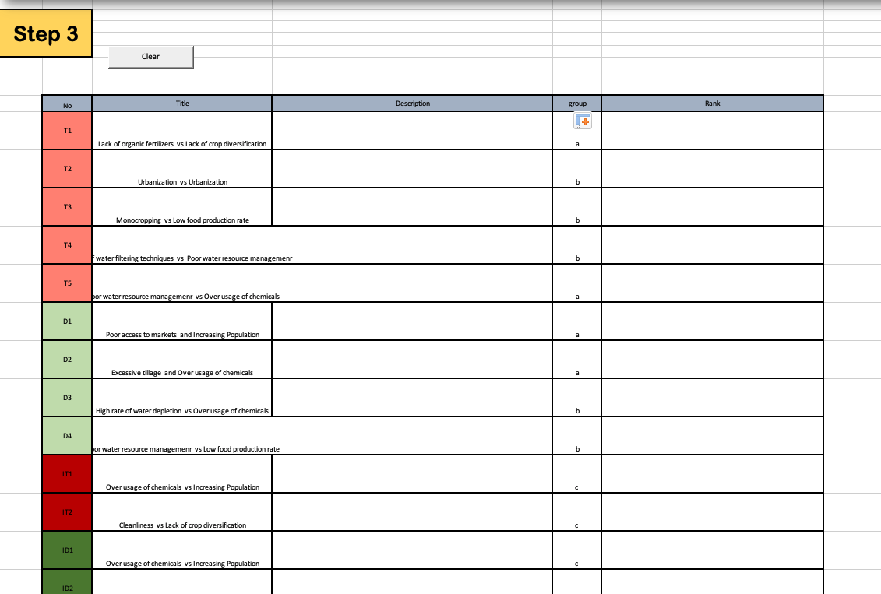
Filled manually
Filled automatically

Note: Soon after all categories of issues are gathered in final table, find which combination of issues is creating dilemmas. If a dilemma is found give a common letter in the group column. This allows a social entrepreneur to sort the issues based on group. Description column is provided to explain the reason for the Tension or Dependent.
Step 6
Finding Dilemmas
As shown in below figure, each group is combination of different categories of issues that are combined to form a dilemma. We can also provide rank for each dilemma to prioritize based on severity of the problem.
Step 7
Clearing the Dilemmas with Solution
This is where we map the dilemmas with available intelligent assets. If there is no asset is available, an anticipated solution is mentioned. The final table looks as presented below (Table 4.2)
All these steps are clearly explained with a tactual village problem in Chapter 6.

Table 4. 2 Value Propositions to Clear Dilemmas
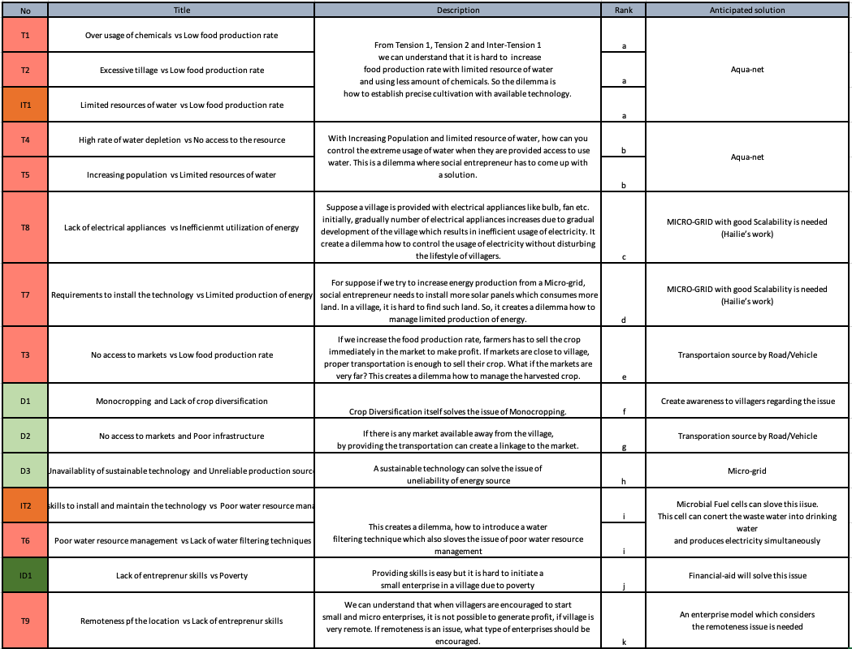

4.4 SYNOPSIS OF CHAPTER 4
In this chapter Dilemma Triangle method is implemented in three interdependent perspectives: Food, Energy and Water (FEW). In section 4.1. introduction to FEW nexus is presented. In next section Dilemma Triangle is implemented in FEW. In this process two new elements are introduced into the existing method to get a broader view of a problem. First element is ‘Categorizing Issues’. In previous work, only one category of issues is used, that is, ‘Tensions’ (Yadav A., 2017). For this thesis, this method is modified in such a way that a person can identify five categories of issues (section 4.2.1). Second element is replacing ‘Tension Matrix’ with ‘Issue matrix’. This Issue Matrix allows a person to find all five categories of issues. These categories generate more dilemmas from which a value proposition is chosen/developed. Since FEW-Nexus is important for achieving sustainable development (UN Water, United nations), this method allows a social entrepreneur to develop a value proposition which follows principles of sustainability. Example for a value proposition is ‘AQUA-NET’. This sustainable technology considers the problems Food, Energy and Water. This technology is used to perform precise cultivation which increases food production and reduces wastage of ground water and electricity. Similarly based on the dilemma produced from the Dilemma Triangle method, social entrepreneur develops value proposition.

This process of implementing dilemma triangle in three perspectives is a time-consuming process and also iterative process. If a person desires to add issues or remove issues he/she has to make changes both in dilemma triangle and issue matrix. To overcome this time-consuming process, an automated dashboard is designed using VBA (section 4.3). Social entrepreneur collects the issues for each driver in each perspective and rest of the process is done by the dashboard. The figure below represents the layout of this thesis and green rectangle border represents the current chapter.

CHAPTER 5

A TOOL TO INVESTIGATE THE IMPACT OF A VALUE PROPOSITION ON A VILLAGE: SYSTEMS DYNAMICS

In this chapter a tool called ‘Systems Dynamics’ which is used to design village dynamics and analyze the data over a period of time is introduced, in order to answer our Secondary Question 2 from Chapter 2. Answer to this question is connected to our Secondary Hypothesis 1 together these answers our primary question. Hypothesis to our primary question is to build a computational framework which can be used to detect problems worthy of investigation and then evaluate the impact. There are two tasks involved in it which has raised tow secondary question. Fist secondary question is answered in Chapter 4. Now, in this chapter second secondary question is going to be answered.
Secondary Question 2 (SQ 2)
What tools are required to evaluate the impact of the value proposition before implementing in the village and plan the budget?

Secondary Hypothesis 2 (SH 2)
Systems Dynamics can be used to simulate the village dynamics and evaluate the impact of the developed value proposition and decide the budget required for the intervention.

Systems Dynamics models are designed in such a way that value propositions are inserted in the village which would be similar to the existing village in real time. The real time village data is collected from social entrepreneur and loaded into the Systems Dynamics models and executed. Analysis of Systems Dynamics data is presented in this chapter. At the end predictive models are shown which can predict with impact of the value proposition for a new village. In Figure 3.5 from Chapter 3 a clear connection between two secondary hypothesizes are presented as shown below.
Overview of the Framework (Figure 3.5, from Chapter 3)
Secondary Hypothesis 1 (SH 1)
Using a Dilemma Triangle method in Food, Energy and Water (FEW) nexus considering people, planet and progress as drivers, it is possible to analyze most of the problems involved in the village, detect all the problems worthy of investigation and develop a value proposition.

Secondary Hypothesis 2 (SH 2)
Systems Dynamics can be used to simulate the village dynamics and evaluate the impact of the developed value proposition and decide the budget required for the intervention.

5.1. SYSTEMS DYNAMICS TO EVALUATE THE IMPACT OF VALUE PROPOSITION
Systems Dynamics is a tool used to design village dynamics to understand the behavior. In this thesis this tool is used to simulate the condition of the village and value proposition is introduced onto village dynamics to see how the quality of life is improving gradually because of the intervention. Designing a well know process like manufacturing is easy because, all variables and interaction between the variables are pre-defined. Designing a social community is not easy as it looks. There are lots of variables and lots of hidden interaction between them is present. Approaching directly without considering all these issues results in poor evaluation of the impact.
A strategy is needed before using this tool. As a part of the strategy, first thinking process is set up before starting to work with Systems Dynamics. This is called ‘Setting a Mental Model’. Once mental model is set up, approach to solve the problem is designed.

5.1.1. Introduction to Systems Dynamics
In order to visualize our systems thinking, Systems Dynamics is used. Systems Dynamics consists of causal loops with stocks and flows.
Causal loop diagrams are developed by system designers to understand the problem conceptually. By creating these loops designers can conceptually answer what-if scenarios of the system and identify how the solution could affect the whole systems and each node of the system.
- Casual loops that are developed for a system feed into Stock and Flow diagrams to design the dynamic model of it.
- Causal loop diagrams (CLDs) are an important tool for representing the feedback structure of systems

Stocks and Flows are two types of variables used in Systems Dynamics,
From Wikipedia, “A stock is measured at one specific time, and represents a quantity existing at that point in time (say, December 31, 2004), which may have accumulated in the past. A flow variable is measured over an interval of time. Therefore, a flow would be measured per unit of time (say a year).”
An article shared by J. Singh in which is given in the following link: http://www.economicsdiscussion.net/difference-between/difference-between-flow-variables-and-stock-variables/555 elaborates the difference between stock and flow variables as given below,

“A flow is a quantity which is measured with reference to a period of time. Thus, flows are defined with reference to a specific period (length of time), e.g., hours, days, weeks, months or years. It has time dimension. National income is a flow. It describes and measures flow of goods and services which become available to a country during a year.
Similarly, all other economic variables which have time dimension, that is, whose magnitude can be measured over a period of time are called flow variables. For instance, income of a person is a flow which is earned during a week or a month or any other period. Likewise, investment (that is, addition to the stock of capital) is a flow as it pertains to a period of time.
Other examples of flows are expenditure, savings, depreciation, interest, exports, imports, change in inventories (not mere inventories), change in money supply, lending, borrowing, rent, profit, etc. because magnitude (size) of all these are measured over a period of time.
A stock is a quantity which is measurable at a particular point of time, e.g., 4 p.m., 1st January, Monday, 2010, etc. Capital is a stock variable. On a particular date (say, 1st April, 2011), a country owns and commands stock of machines, buildings, accessories, raw materials, etc. It is stock of capital. Like a balance-sheet, a stock has a reference to a particular date on which it shows stock position. Clearly, a stock has no time dimension (length of time) as against a flow which has time dimension.
A flow shows change during a period of time whereas a stock indicates the quantity of a variable at a point of time. Thus, wealth is a stock since it can be measured at a point of time, but income is a flow because it can be measured over a period of time. Examples of stocks are wealth, foreign debts, loan, inventories (not change in inventories), opening stock, money supply, population”
From www.systemsdynamics.org , the Systems Dynamics is defined as,
Systems Dynamics is a computer-aided approach to policy analysis and design. It applies to dynamic problems arising in complex social, managerial, economic or ecological systems literally any dynamic systems characterized by interdependence, mutual interaction, information feedback, and circular causality.

Here is further information gathered from Abhishek Yadav’s thesis (Yadav, A., 2018)
“Systems Dynamics (SD) is used to simulate a complex system to understand the behavior of the system over a period. SD modeling is a combination of various stock and flow diagrams having feedback loops, table functions and time delays. For this thesis, System Dynamics is used to evaluate the impact of different value proportions on a community”

5.1.2. Software Information
To design a Systems Dynamic model, the first step is to develop systems thinking and understand how a system works and how each node in that system interacts with other nodes. Next step is to develop causal loop diagram and then stock and flow diagram. There are many tools available in market to perform this Systems Dynamics.
For this framework, Vensim PLE (Personal Learning Edition) is used. Vensim is simulation software which enhances the performance of the complex systems. It provides interface where user can build Systems Dynamics models by choosing appropriate stocks and flows with load data into it. Vensim allows us to run the models with different scenarios and compare the results.
For this framework, Vensim is used to simulate the social systems to understand the impact of a value proposition on society. To do further analysis, a Python library called “PySD” is also introduced to convert Vensim data into a relational data. A relational data is a general form of data which contains rows and columns in Excel, CSV format. This integration with PySD is explained in Section 5.3.

5.1.3 Design of Causal Loop Diagrams (CLDs)
Modeling Systems Dynamics is done in two stages,
Stage 1: Building Causal Loop Diagrams (CLD)
Stage 2: Collecting and Loading of Data
In this section, designing of CLDs (stage 1) is discussed. With the in-built domain knowledge and with the soft information gathered from SunMoksha, dynamics involved in an Indian off-grid village is understood. Systems Thinking plays a very crucial role in understanding these village dynamics and designing it in Systems Dynamics. In modeling CLDs, stocks and flow variables are to be decided. Based on the dilemmas found through Dilemma Triangle method, social entrepreneur chooses the technology required to clear the dilemma. For most of the dilemmas there are solutions available with SunMoksha. But SunMoksha doesn’t implement all the solution at a time. It is villager’s nature to be stubborn and not to accept a change. So, bringing all the value propositions together doesn’t work out. The social entrepreneur (SunMoksha) has a strategy of providing ‘Electricity’ first to create trust among people and then intervene with other value propositions strategically. Moreover, we can understand that Microgrid is the main intervention where other interventions are connected to it as show in Figure 5.2.
Hence stock and flow variables are,
Stock: Microgrid
Flow: Other interventions
Since the main element is ‘Micro-grid’, Systems Dynamics model is built in such a way that all variables like households, school, agriculture, streetlights along with other interventions are connected to Micro-grid.

All these variables are categorized into three types. They are
- Intervention Variables
- Consumption Variables
- Impact/Outcome Variables
Intervention Variables
These are the intelligent assets or value propositions that are being developed by SunMoksha through NIST (National Institute of Science and Technology). Using Sustainable Dilemma Triangle method, SunMoksha decides what intelligent assets are needed for the intervention as explained in Chapter 4. Based on the dilemmas found through sustainable dilemma triangle method, intelligent assets may vary from village to village. These flow variables are connected to the one and only stock variable which is Nanogrid which is shown in Figure 5.1. These variables are directly pointed towards Micro-grid because, all those other value propositions (Figure 5.2 and 5.3) consume electricity. Production of electricity depends upon number of solar panels and capacity of each solar panel.
Here are some pictures from SunMoksha

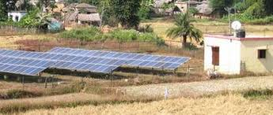

Figure 5. 1 Smart NanogridTM arranged by SunMoksha
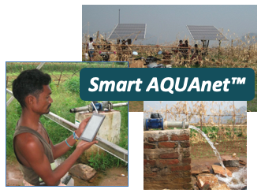
Figure 5. 2 Smart AQUAnetTM
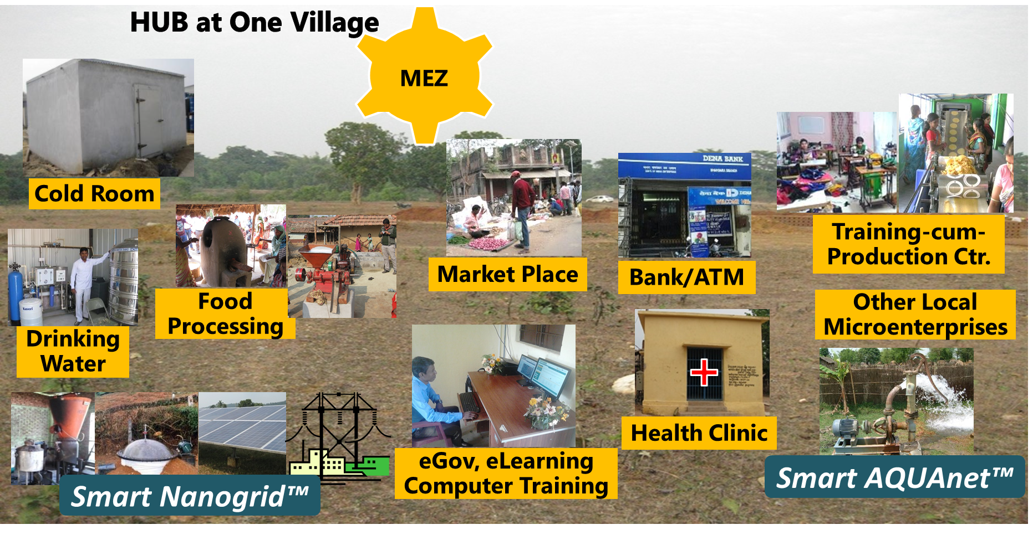
Figure 5. 3 Value Propositions available at SunMoskha

Based on the dilemmas or based on the problems found in a village through Dilemma Triangle, value propositions are decided and connected to Micro-grid as shown in Figure 5.4. A chunk of whole Systems Dynamics model representing intervention variables is shown below.
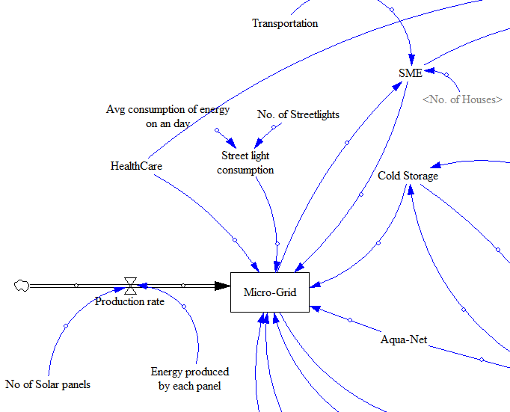
Figure 5. 4 Intervention part of Systems Dynamics
Consumption Variables
These are the elements which consumes or make use of the value proposition (Intervention). For a Micro-grid, consumption is from households, agriculture, school etc. Agriculture consumes electricity and also uses Cold storage and Aquanet. These consumption variables changes based on the village. If there is no school and children go to school in neighboring village then school consumption is not considered. In Figure 5.5. the consumption of value propositions by villagers is presented.

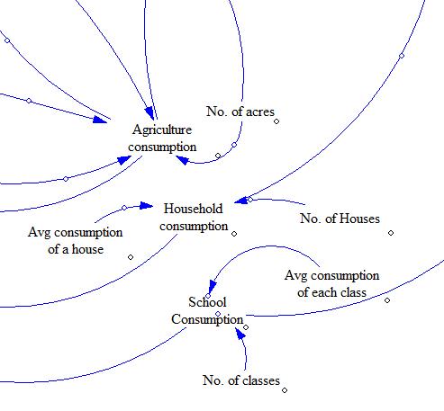
Figure 5. 5 Consumption Part of Systems Dynamics

Impact/Outcome Variables
These variables show the outcome due to consumption of the value proposition. When villages are electrified there will be positive impact on some elements like education, agriculture and health. Moreover, these are the variables shown to CSR or other donors to elaborate the positive impact of the value proposition on villagers. Connecting consumption variables to these variables is the toughest task of this thesis.

In Figure 5.6 the pictures of the village after the intervention is shown.
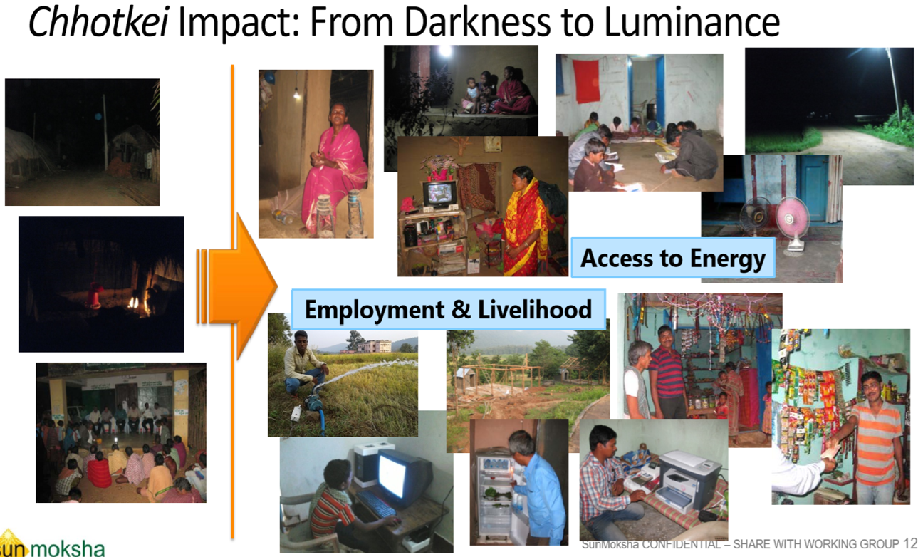
Figure 5. 6 Impact of Value Propositions

This impact should be calculated in terms Education, Health, Agriculture etc. Hemce, there variables are also included into the Systems Dynamics model as shown in Figure 5.7.
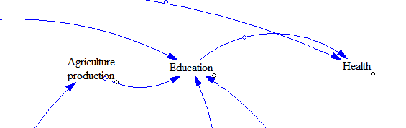
Figure 5. 7 Impact/Outcome Part of the Systems Dynamics

Big Picture
After a successful intervention a village will turn into a ‘Smart Village’ as show in Figure 5.8
Figure 5. 8 Smart Village (Chottkei)
This impact/outcome is to be replicated into a Systems Dynamics model for evaluation. More holistic view of Systems Dynamics model is shown in Figure 5.9. More variables can be added into this model to make it more realistic. Only a limited number of variables are considered for this thesis. Impact can be calculated in many areas but only few are considered based on social entrepreneur’s choice.

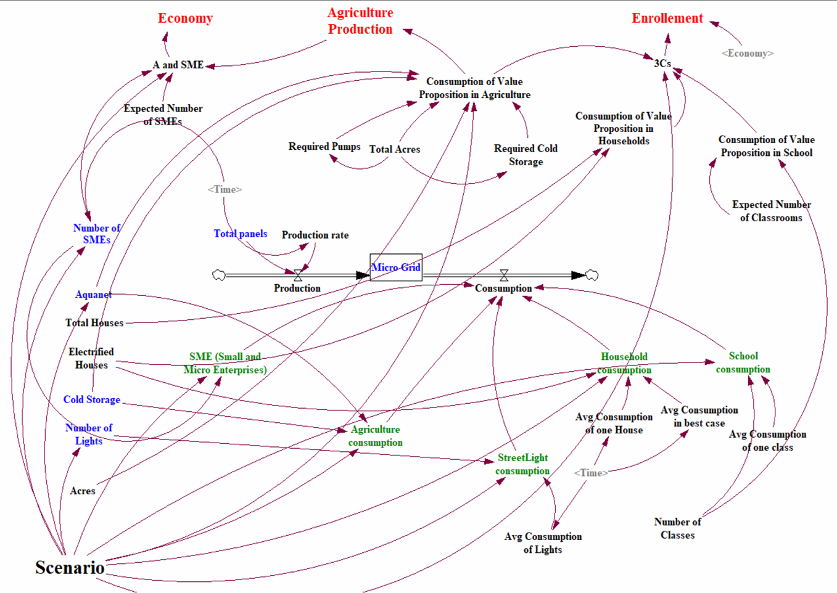
Figure 5. 9 Whole Systems Dynamics Model

5.1.4 Advantages of Building Systems Dynamics Models
There are many advantages of building systems dynamic model of a village. They are,
- Holistic view of the problem is presented
- If data is available in all areas, close to exact simulation of village can be built which is used in predicting future consequences
- A model can be simulated and run for a desired period of time (100 days, 1 year, 10 years etc.)
- Results can be visualized in the form of 2D graph
- Sliders can be arranged to change the data to get desired result
- Many scenarios can be run and saved. Later on, those scenarios can be analyzed to get a better solution
- Systems dynamics is available through VENSIM software which is free to use.
- Most widely used programming language Python can read Systems Dynamics data and converts into a relational data. This helps in building predictive models with the help of machine learning.
- The biggest advantage of building these models is, when SunMoskha chooses a new off-grid village, based on that village characteristics he/she can easily predict or predict the impact of the value proposition on that village.
- It is very easy to do impact analysis before the intervention
- CSRs and other donors can get a visual output of the impact in the form of graphs which prompts them to donate more money.
- If a crowdfunding platform (like a website) is available, we can set user to input their money and check how it is going to affect the village. This allows the user whether or not to increase the fund.
- It is easy to allow any person who donated money to make sure that their money won’t go waste.

5.2. STRATEGY TO USE SYSTEMS DYNAMICS FOR SOLVING THE PROBLEM
Since Systems Dynamics has wide variety of applications, it is important to set our mental model first and then utilize Systems Dynamics in perspective of sustainable rural development.
A mental model is an explanation of someone's thought process about how something works in the real world. It is a representation of the surrounding world, the relationships between its various parts and a person's intuitive perception about his or her own acts and their consequences. (From Wikipedia)
Mental models can help shape behavior and set an approach to solving problems (similar to a personal algorithm) and doing tasks. A mental model is a kind of internal symbol or representation of external reality, hypothesized to play a major role in cognition, reasoning and decision-making.
You can train your brain to think better. For building Systems Dynamics models, an approach has to be setup to solve the current problem. Mental model for this thesis is to use this Systems Dynamics, is to have knowledge in the Indian village dynamics and to have a systems perspective.
In order to develop any Systems Dynamics model, two things should be considered.
They are,
- Domain Knowledge
- Systems Thinking

5.2.1. Domain Knowledge
To build Systems Dynamics models which represents Indian off-grid villages, it is necessary to understand Indian village dynamics. Due to a professional relationship with social entrepreneur Dr. Ashok Das (CEO of SunMoksha) from the beginning of this thesis, gaining knowledge in this specific area become easier.
Basic Characteristics of Indian Off-grid Villages,
- No Electricity
- No access to Water
- No Education
- No connection to the world
- Poverty
Sometimes basic characteristics are also not sufficient to analyze some villages. From the experience of the social entrepreneur (DR. Ashok Das), villagers don’t like to change their lifestyle. In some villages, men don’t allow any aid for women from social entrepreneurs. They faced some strange reactions from some villages where villagers broke solar panels believing that solar panels are insulting their sun god. There are many such behaviors from villagers. Somehow, SunMoksha managed to intervene a village in Orissa called “Chottkei”. Assuming that SunMoksha has created trust in villagers and decided to develop the village, this framework is to execute their plan of action and evaluate the impact and visualize the results to investors.

5.2.2. Systems Thinking
Systems Thinking is a holistic approach of any complex problem. An article written by Margaret Rouse in the year 2005 which is given in the following link: https://searchcio.techtarget.com/definition/systems-thinking has given a very good explanation.
“Systems thinking is a holistic approach to analysis that focuses on the way that a system's constituent parts interrelate and how systems work overtime and within the context of larger systems. The systems thinking approach contrasts with traditional analysis, which studies systems by breaking them down into their separate elements. Systems thinking can be used in any area of research and has been applied to the study of medical, environmental, political, economic, human resources, and educational systems, among many others.
According to systems thinking, system behavior results from the effects of reinforcing and balancing processes. A reinforcing process leads to the increase of some system component. If reinforcement is unchecked by a balancing process, it eventually leads to collapse. A balancing process is one that tends to maintain equilibrium in a particular system.
Attention to feedback is an essential component of system thinking. For example, in project management, prevailing wisdom may prescribe the addition of workers to a project that is lagging. However, in practice, that tactic might have actually slowed development in the past. Attention to that relevant feedback can allow management to look for other solutions rather than wasting resources on an approach that has been demonstrated to be counterproductive.
Systems thinking uses computer simulation and a variety of diagrams and graphs to model, illustrate, and predict system behavior. Among the systems thinking tools are: the behavior over time (BOT) graph, which indicates the actions of one or more variables over a period of time; the causal loop diagram (CLD), which illustrates the relationships between system elements; the management flight simulator, which uses an interactive program to simulate the effects of management decisions; and the simulation model, which simulates the interaction of system elements over time.
Systems thinking originated in 1956, when Professor Jay Forrester founded the Systems Dynamics Group at MIT's Sloan School of Management.”

5.3 SCENARIO BASED MODELLING
In Systems Dynamics, a village is simulated with all the variables mention in Section 5.1.3. Now, a social entrepreneur can run the model and convince donors that the value proposition developed is showing positive impact on villagers. For this, social entrepreneur has to compare the results of before and after the intervention of value proposition. To facilitate this through Systems Dynamics, scenario-based modelling is introduced. In this modelling, three scenarios are considered.

Scenario 1: Worst-case scenario
In this scenario, village is simulated and run in such a way that, no value proposition is intervened. It shows, how poor the impact variables are without value propositions. This makes donor to understand the scenario of the village without any aid.
Scenario 2: Best-case scenario
In this scenario, village is provided with all value propositions with at most quantity. This results in a positive impact on the village. Comparing this result with Scenario 1 results gives the advantages of the value proposition. But, in best-case scenario, intervening with at most quantity of value proposition in practically not possible as it requires huge capital to start. Also, villagers may not adjust to the immediate change. Hence, Scenario 3 is introduced.
Scenario 3: Sufficient-case scenario
This is a practical scenario. Since best-case scenario is not practically possible, social entrepreneur should start introducing value propositions with sufficient quantity. This is easy due to less capital. Then social entrepreneur slowly improves the quantity and reaches best-case.
Hence, the budget is decided with a range between best-case and sufficient case scenarios. For example: If a village needs 60 solar panels at the beginning (due to less consumption) and 90 panels by the end (due to increase in the consumption), then budget is decided in between the cost of 60 panels and cost of 90 panels. Thus, social entrepreneur can elaborate the need of funds to any donor

5.4 ASSUMPTIONS AND LIMITATIONS
Systems Dynamics is a tool which can help us design complex systems. There are many variables involved in a system. Especially in designing social systems there are many variables or factors affecting the system. Hence, it is hard to include all the variables into Systems Dynamics model. To build this framework only few variables are considered, and they are categorized into three types. It is explained in Section 5.2.
Systems Dynamics loops are built in such a way that it takes value proposition as supply variables to village and variables like ‘Education’, ‘Agriculture’, ‘Economy’ is shown as final impact due to intervention.

5.5 METHODS FOR COLLECTING DATA
Collecting and loading data into the whole systems dynamics model is toughest task. SunMoskha has provided quantitative data of both intervention and consumption elements.
Here are the types of information collected regarding the Intervention of value propositions,
- Application
- Size
- Quantity
- Other characteristics
For consumption variables, following data is collected
- Total Population
- Average consumption of each household
- Streetlight consumption
- Population Consuming the Value Proposition
- Current Literacy
- Income Resource
- Other Characteristics
This data is loaded into the Systems Dynamics model to fill consumption and Intervention variables. Once these variables are filled with data, Impact/Outcome variables are to be filled. This is to find out the change occurred in the village lifestyle due to intervention of value proposition. This rate of change is to be calculated, which is a big challenge.
Three- ways to evaluate the Impact,
      - Rating on 0-10 scale with the help of social entrepreneur’s knowledge
      - Utilizing the historic data of other villages
      - Comparing with nation’s data
The idea is not to make an accurate model. In fact, even in an accurate model there will be some deviation with actual result. Hence, instead of trying to make accurate models it is better to make useful models. There is a famous quote said by a British statistician named “George E.P. Box”.
“All models are wrong, but some are useful”

5.5.1. Rating Scale
Rating scale method may not show the exact change because, it comes from social entrepreneur’s opinion. For example, if a social entrepreneur expects that electrification will show 80% effect on enrollment rate, we can take rate of impact as 8 on 0-10 scale. Rating sometimes mislead the information. A social entrepreneur (Dr. Ashok Das) with more than 15+ years of experience can provide a better insight from which it is possible to get solution which is close to actual solution. These ratings are utilized in feeding the data to impact variables in Systems Dynamics.
Advantages
- Trust-worthy if social entrepreneur is well experienced
- No need to rely on actual data which saves lot of time
- Easy to get a solution close to actual one
Disadvantages
- Human’s intuition is not correct every time.
- Others may disagree with output

5.5.2. Utilizing Historic Data of Other Villages
The villages which are already intervened by SunMoskha or any other social entrepreneurs can provide the before and after scenario in the form quantitative data. For example, enrollment before SunMoksha and after SunMoksha, Agriculture production before SunMoksha and after SunMoksha etc. This data is analyzed and correlation between the variables is calculated.
Machine Learning algorithms are utilized in analyzing historic data to predict the future impact of the value proposition in the current village.

Advantages
- Trust-worthy
- No need of social entrepreneur’s experience
Disadvantages
- Need more data (more villages)
- Data collection is difficult
- Even though correlation is found, it might do incorrect prediction

5.5.3. Comparing Nation’s Data
This is similar to previous process, but we collect whole nation rural areas data and find the correlation. For example, rural electrification rate for past 10 years is compared with enrollment rate into schools for past 10 years. There are more chances that this can reflect the individual village style. This type data is usually found in government websites. There are also lot of resources available around the internet.
Advantages
- Data is found easily
- Easy to collect data
Disadvantages
- Since India has very huge population, data may not reflect an individual off-grid village.
- There may be wrong data in websites

5.6 APPLICATION OF SYSTEMS DYNAMICS IN CROWDFUNDING PLATFORMS

5.6.1 Python to Connect Systems Dynamics
A crowdfunding platform is web application. Systems Dynamics cannot be directly shown in a web application. Hence, a third-party tool is used to convert Systems Dynamics data into a format accessible by any web application. There is a library available in Python called PySD (Python Systems Dynamics) which is used to convert Systems Dynamics model into a dataset further which can be used for analyzing and visualizing.
This PySD library is developed by James Houghton who is a doctoral student in Sloan School of Management at in MIT, in Systems Dynamics group. The following link leads to the portfolio of Janes Houghton http://www.jamesphoughton.com/
The documentation of the library (https://pysd.readthedocs.io/en/master/) says following things,
This simple library for running System Dynamics models in python, with the purpose of improving integration of Big Data and Machine Learning into the SD workflow. PySD translates Vensim or XMILE model files into python modules, and provides methods to modify, simulate, and observe those translated models.
Here are the applications of the library,
- Import the Systems Dynamics Model
- Run the model to produce a huge dataset of the model
- Outputting various run information
- Set parameter values
- Set simulation initial conditions
- Query the desired output

Visualizing Data in Crowdfunding Platforms
Since the main objective of this project is to develop a framework which can guide social entrepreneur and also show the impact of the intervention to CSRs and other donors to raise the fund. Especially, to attract crowd funds, people are more interested to look into the impact or outcome of the particular intervention. If a social entrepreneur

According to a paper ‘Guidelines for Successful Crowdfunding, written by Hannah Forbes and Dirk Schaefer it says that,

“People who invest more will worry about the risk of misusing of their money. They always expect a detailed plan of action”

Hence visualizing the data is very essential to show our display the effort of a social entrepreneur. Either it is through an individual presentation or through a crowdfunding website, a donor wants to know how the impact is going to be when they donate some money.

Technically in order to visualize a data, a data set with rows and columns is needed. This data set can be produced with Systems Dynamics Model through PySD library. Once data set is prepared by changing parameters, initial values and various runs many visualizations can be shown. For example, graph between electrification rate and enrollment rate, graph between agriculture production and usage of water-pumps etc. as shown in Figure 5.10.
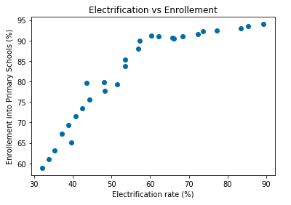
Figure 5. 10 Scatter Plot between Electrification and Enrollment

This type of visualization is used to create an idea about the positive impact of the intervention on villager’s quality of life and allows people to show keen to donate money. These visualizations also guide new social entrepreneurs in deciding what intervention is needed to solve a particular problem.

Process of Crowdfunding
Step 1
Donor is prompted to choose a village (if social entrepreneur is dealing with multiple villages). Donor are be either CSR or a philanthropist or any person. This option for choosing a village can be available in crowdfunding websites (if they exist) or else social entrepreneur has to meet donor directly and give him options.
Step 2
Donor chooses the area he/she wishes to develop (which is an impact variable, that is, Education/ Health/ Agriculture). Showing the previous work of the social entrepreneur to donor will help them decide where he needs to invest.
Step 3
Donor selects the amount he/she wishes to donate. This is based on the quantity of the value proposition. For bigger villages, more solar panels are needed when compared to smaller ones.
Step 4
Based on the donation and the impact area, appropriate equation is run which is derived from Systems model and impact is shown to the donor. This impact is in a graphical representation. For example,
- Graph showing the electrification rate in the village
- Graph showing the improvement in agriculture, education etc.
Step 5
On seeing the positive impact of his donation, he/she might increase or decrease or may not change the amount and finally donates money. Thus, a donor is prompted to provide more funds to social entrepreneurs. This is shown in the Figure 5.11.
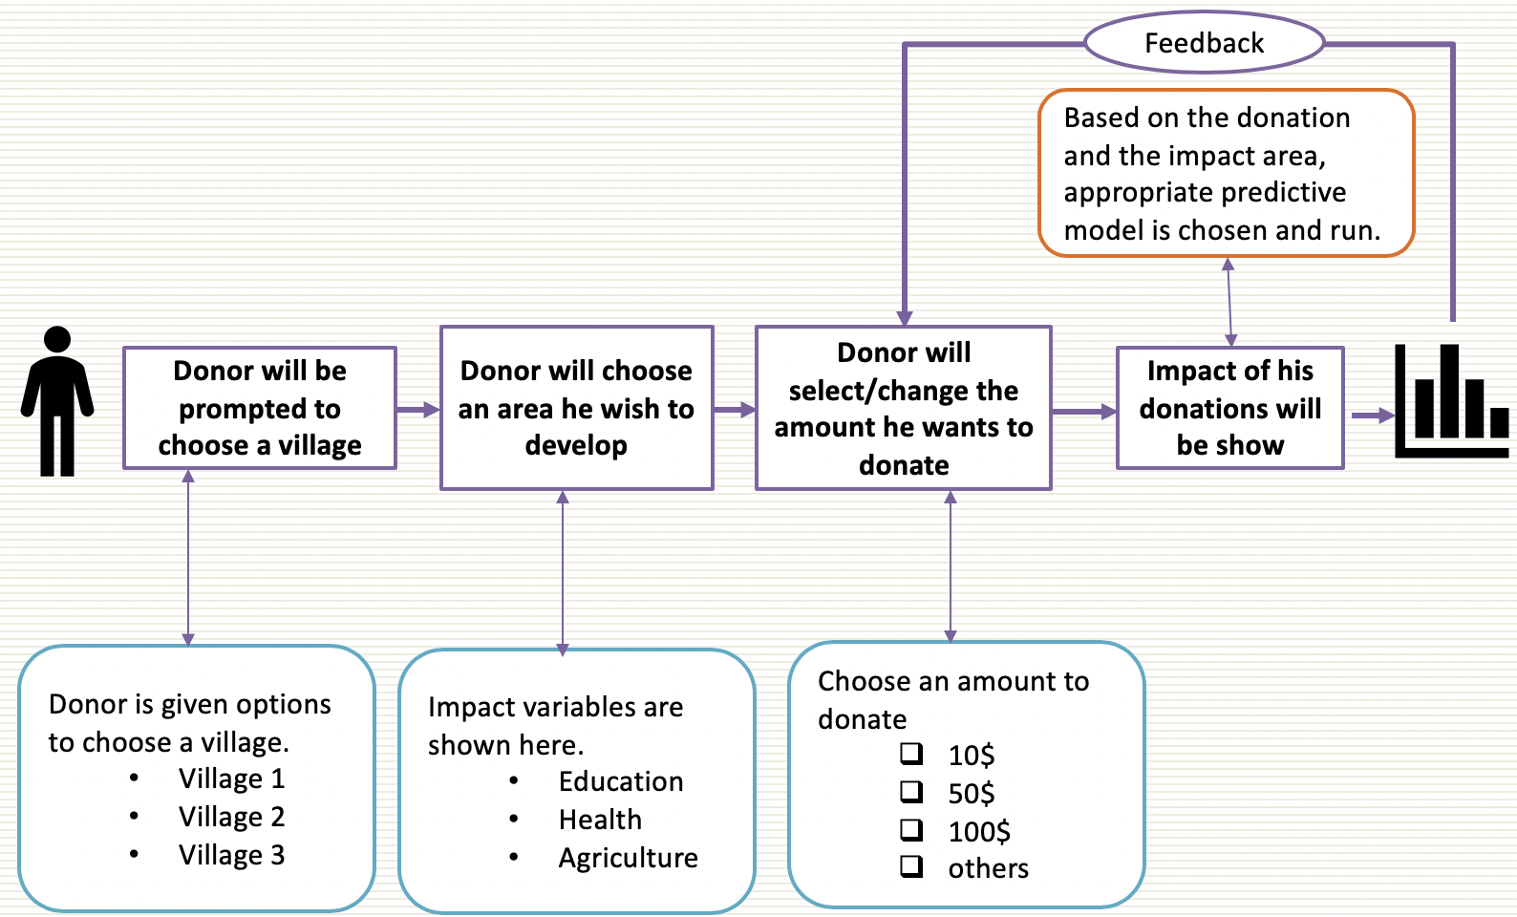
Figure 5. 11 The Process of Donor Funding Social Enterprises

5.7 BUILDING PREDICTIVE MODELS USING MACHINE LEARNING
This is an additional feature that simplifies the process of using Systems Dynamics. In Systems Dynamics, value propositions with some quantity are introduced and simulations are run in three scenarios to visualize the impact. Here, the quantity of value proposition is decided first, and impact is observed. Practically, social entrepreneur decides the impact first and to reach that impact he/she decides the quantity of value proposition. This a two-way process where social entrepreneur decides the value proposition and check the impact or decides what the impact should be and based on that he gives the input as shown in Figure 5.12. This two-way process is not possible in Systems Dynamics alone. Social entrepreneur has to adjust the input until he gets the desired impact. To facilitate this two-way process, PySD library is used. As mentioned in Section 5.6.1, PySD library is used to convert Systems Dynamics model into a relational data with rows and columns. This data format is used in building predictive models using Machine Learning to predict what quantity of value position is needed to get the desired impact.
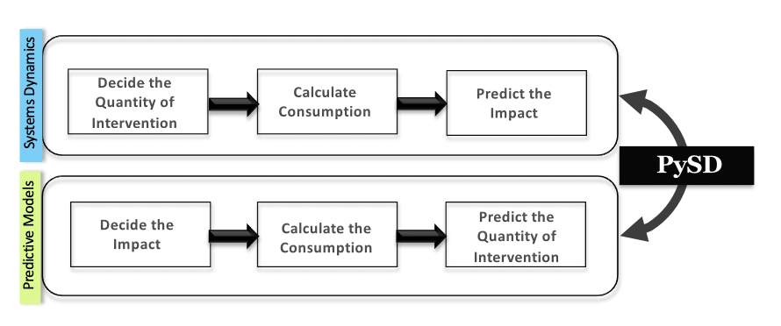
Figure 5. 12 PySD to Build Predictive Models

This two-way process is an additional feature for Systems Dynamics. With these models, a social entrepreneur either checks the impact with different value propositions or decides the value proposition with different ranges of impact.
The Process of Building Predictive Models
PySD library plays very essential role in this process. The Systems Dynamics model is converted into a dataset where every variable act as a column. We can choose only desired columns for building the model. Once dataset is ready as shown in Figure 5.13, we can choose an appropriate algorithm to train the model.
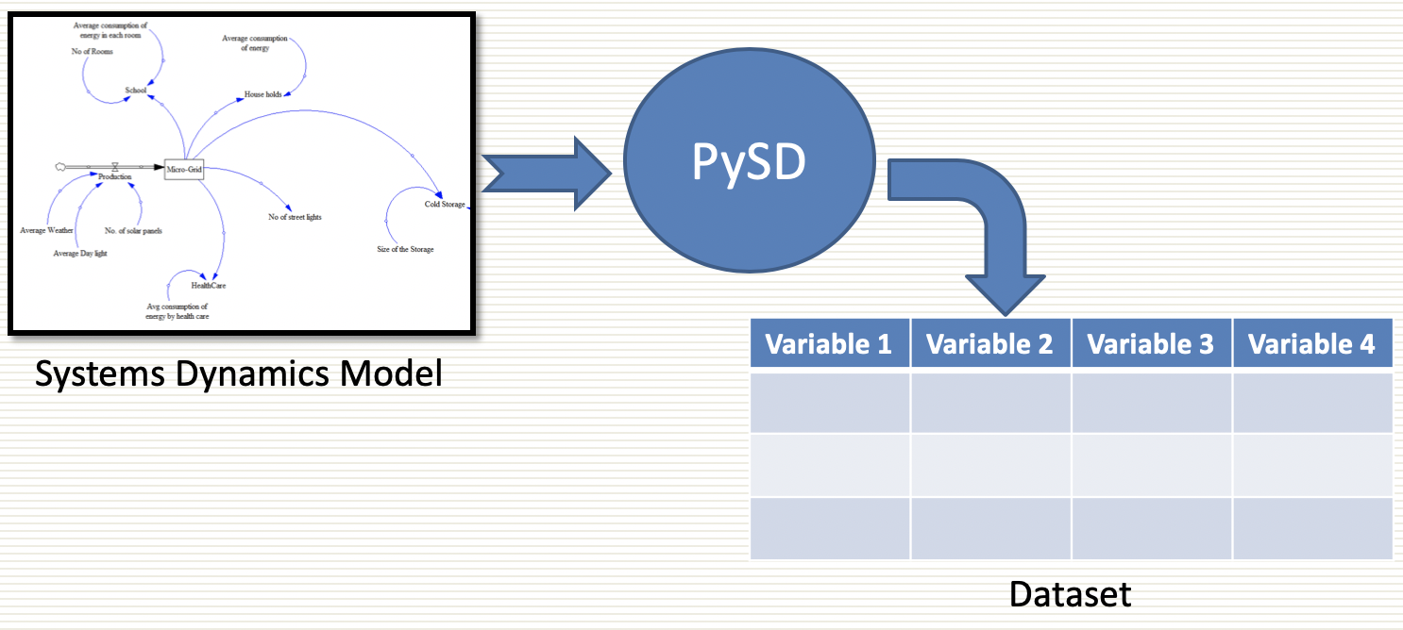
Figure 5. 13 Conversion of a Systems Dynamics Model into a Dataset

The most appropriate machine learning algorithm is regression. Regression allow us to analyze the impact of each variable. The final equation produced by the regression gives the individual effect of each variable on a dependent variable. The dependent variables will be the impact variables from Systems Dynamics. For example, we can predict the education by giving electricity to villagers. We can build many such equations using regression by changing the dependent variables.
Figure 5.14 shows how equations are built using regression.
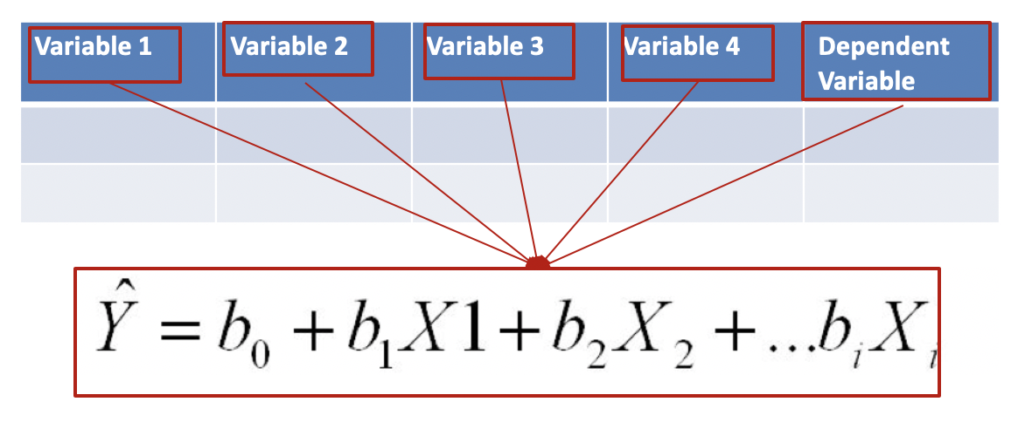
Figure 5. 14 Multiple Regression Equation

5.8 SYNOPSIS
This chapter justifies the Secondary Hypothesis 2. To analyze and visualize the impact of a value proposition, Systems Dynamics is utilized. To connect the Systems Dynamics to crowdfunding platforms and also to build the predictive models, a python library called ‘PySD’ is utilized. In Chapter 4, Secondary Hypothesis 1 is justified and in this chapter, Secondary Hypothesis 2 is justified. This combinedly justified the primary hypothesis.
Primary Hypothesis (PH)
A framework which can be used by any social entrepreneur to develop value propositions and evaluate its impact is needed.

In Chapter 4, Dilemma Triangle method is introduced which helps in deciding what value proposition is needed for the village. In this chapter Systems Dynamics is introduced to evaluate the impact of the decided value proposition. Tools like Vensim (Systems Dynamics) and Python Library (PYSD) is utilized in realizing the framework. The whole process is practically applied on one of the villages of SunMoskha’s portfolio to validate the method. This validation is shown in Chapter 6 where whole framework right from Dilemma Triangle method to Systems Dynamics is applied on the test problem.

CHAPTER 6

APPLICATION OF THE FRAMEWORK ON A VILLAGE

In this chapter, Empirical Performance validity is presented with a test problem. In 2017, SunMoksha achieved sustainable rural development in the village called “Chhotkei” from the state Orissa, India. Now, SunMoksha chose ‘Kudagaon’ village from the same state. This village is considered as the comprehensive problem to validate the framework. Based on the characteristics and information available regarding the village, the proposed computational framework is implemented. Kudagaon is an island village with a poor source of transportation. Due to this, there is no electricity supply from the government.
To introduce sustainable rural development, existing problems should be eradicated. These existing problems can be solved by introducing a value proposition. Since, social problems are wicked problems (Rittel, H.W.J. & Webber, M.M., 1973) introducing a value proposition directly without considering the dilemmas in it creates a new problem. This value proposition is a clean technology developed by SunMoksha which needs huge investment. Instead of solving the existing problem, if the introduced value proposition creates new problem then both time and money will be wasted. Once value proposition is developed, a tool is necessary to evaluate its impact on the village. This demonstration of the impact of the value proposition will bring financial support from investors and co-operation from villagers thus creates a friendly environment for social entrepreneurs inside the village. In this thesis, computational framework is developed which can be used to clear the dilemmas and develop a value proposition and also evaluate its impact.

6.1 IMPLEMENTATION OF THE FRAMEWORK ON KUDAGOAN VILLAGE
In Chapter 3, the complete workflow of the framework is introduced as shown in the figure below (Figure 6.1).
Figure 6. 1 The Computational Framework to Foster Sustainable Rural Development

In order to attract investors through a crowdfunding platform, first the village problem has to be analyzed completely to find the dilemmas. Based on the dilemmas, value propositions are developed. This entire process is done by using Dilemma Triangle method which is the Secondary Hypothesis 1 as mentioned in Chapter 2. Then, developed value proposition is evaluated using Systems Dynamics to show its positive impact on the village to both investors and villagers.

6.1.1 Implementing Dilemma Triangle Method in Kudagaon Village Problem
Kudagoan is a river island surrounded by Mahanadi River water as shown in Figure 6.2.
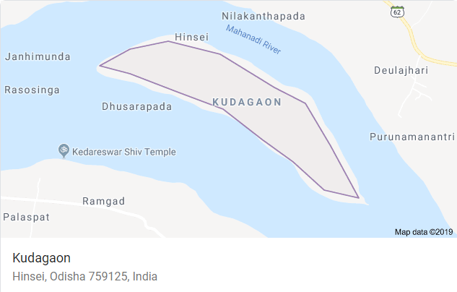
Figure 6. 2 Kudagaon Village Map (Source: Google Maps)
The population of Kudagaon is around 300 people with 85 households. Main occupation is agriculture. Due to poor transportation, villagers don’t have a reliable access to markets. Also, due to absence of electricity agriculture has become weaker. Along with these problems, yearly floods cause severe damage to property which led to increased migration every year. The distance between living area and the river water is very long. This makes villagers to walk to get some drinking water. This distance also creates problem for agriculture. There are no water pumps due to absence of electricity. Kudagoan problem relates Food, Energy and Water (FEW). Hence Dilemma Triangle is introduced by addressing FEW Nexus to empower farmers and villagers.
Goal of SunMoksha
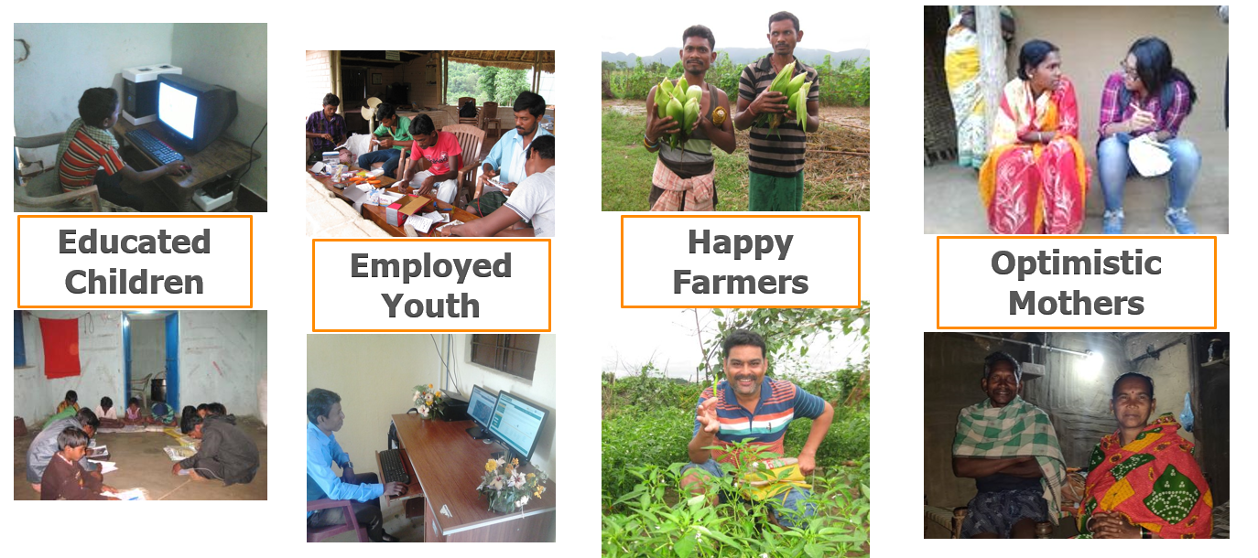
Figure 6. 3 Ultimate Goal of SunMoksha
To achieve this goal, whole problem must be analyzed to identify dilemmas involve in solving the problem using the Dilemma Triangle method.
As discussed in Chapter 4, the Dilemma Triangle is built in three perspectives, that is, Food, Energy and Water by considering three drivers, that is, People, Planet and Progress as shown in Figure 6.4 For each driver in each perspective a focus/goal is set and issues which hinders our goal are collected.
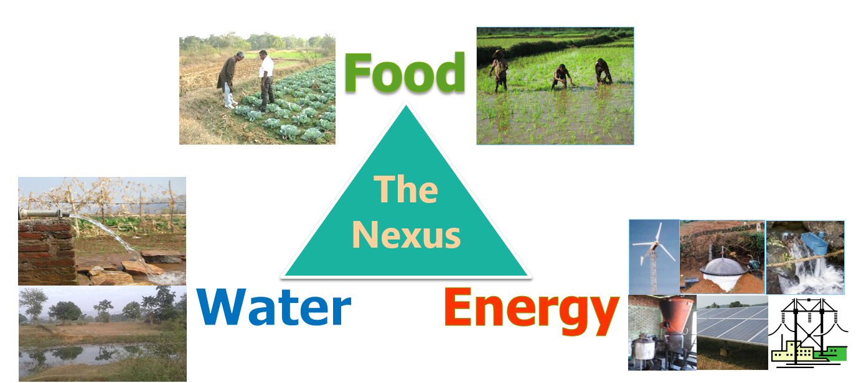
Figure 6. 4 Dilemma Triangle in FEW Nexus

In perspective of FOOD
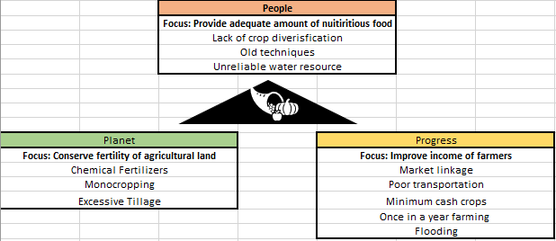
Figure 6. 5 Dilemma Triangle in perspective of FOOD

Driver: People
Focus of a social entrepreneur is to provide adequate amount of nutritious food to everyone in the village.

Issues:
Lack of Crop Diversification
Nutritious food means eating variety of foods that give nutrients to maintain good health. Since there is no crop diversity in the village, people cannot eat nutrient food also can’t buy different foods as there is no access to markets.
Old Agriculture Techniques
Many technologies are introduced into agriculture which can enhance food production. Due to practice of old techniques production will reduce which may not be sufficient for villagers to consume.
Unreliable Water Resource
Water is essential for agriculture. Due to unreliable water resource, it is hard to achieve high food production.

Driver: Planet
Here the focus is to conserver the fertility of the agricultural land for continuous growth of crops.

Issues:
Monocropping
Growing same type of crop every year is called monocropping. Monocropping creates spread of pests and diseases which must be treated with yet more chemicals. Monocropping also reduces the fertility of the soil.
Excessive Tillage
Tilling which is also called ploughing is process of loosening and turning soil before farming to boost the fertility of the soil. Every time when a farmer does the farming, he has to plough the soil. This continuous tilling process will reduce the fertility of the soil in the long run.

Driver: Progress
The goal of social entrepreneur is to achieve progress in farmer’s income. These are some issues which hinders this.

Issues:
No Market Linkage
Being island made Kudagaon people to travel miles to find a nearby market to sell their crop.
Poor Transportation
There is no source of transportation to deliver the entire crop to markets. This makes people not to grow too much crop even though they are capable of.
Minimum cash Crops
There many types of crops but, only few crops can be sold and make profits of it. For example: paddy, corn, Cotton etc. Growing minimum cash crops also effects the income of farmers.
Once in Year Farming
Kudagoan farmers will do farming only once in year. An island surrounded by river water will certainly enough fertility in the soil to grow crops at least twice a year. Due to once a year farming, farmers could.t make much profits out of it.
Flooding
A major issue in Kudagoan which affect the entire economic progress. Floods cause damage to crops, livestock and humans. This sought of danger every year, has a huge impact on farmer’s income.
The above issues in each driver is only in the perspective of food (Figure 6.5). This concludes one third of the whole method. Similarly, this Dilemma triangle is introduced in Water and Energy as well.
In perspective WATER
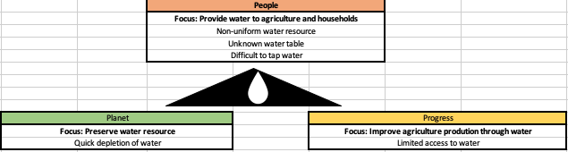
Figure 6. 6 Dilemma Triangle in WATER
Driver: Planet
The main goal of social entrepreneur with respective people is to provide water for both agriculture and households.
Issues:
Non-uniform Water Resource
Even though Kudagaon is an island, availability of water is not uniform. During rainy season river water comes close to the living area but when the dam gate is closed the whole water shrinks and makes villagers difficult to utilize that minimum amount of water.
Unknown Water Table
To access the ground water for household and agriculture purposes, water table of the village should be identified. Since, underground water table is not detected it would be difficult access the water.
Difficult to Tap River Water
Since river water availability is non-uniform a permanent way of tapping river water cannot be introduced in this village.
Driver: Planet
Here the focus is to preserve the available water resources for future use.
Issues
Quick Depletion of Water
This is a common problem in any village. If villagers are provided with a access water (like water pumps) they will deplete the water with no limitation. This is due to flood irrigation. Flood irrigation is a practice in which an entire field is covered with water. Due to excessive use of water especially groundwater, the water cannot regenerate quickly.

Driver Progress
Social entrepreneurs focus is to bring substantial improvement in agricultural production through continuous water supply.

Issues
Limited Access to Water
There should some technology to utilize the available water. This will improve the agriculture production
In perspective of ENERGY
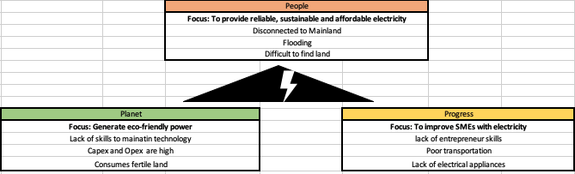
Figure 6. 7 Dilemma Triangle in ENERGY

Driver People
Social entrepreneur’s focus is to provide reliable, sustainable and affordable electricity to Kudagaonf people.
Here are some issues which causes trouble in doing this.

Issues
Disconnected Mainland/Being Island
This is major issue for energy crisis in the village. Usually government of India provides electricity through electric wires. Since, it is hard to pull the wires to an island, Kudagoan is living in the dark.
Flooding
This is an issue which troubles in many aspects. Floods usually creates property damage which includes electric poles and wires. Flooded areas usually loses the access to electricity.
Difficult to Find a Land
To install a reliable and sustainable technology in a village, a good amount of land is needed. Kudagoan is fertile land and to avoid floods power source should be installed in the center of the island. This makes social entrepreneur difficult find land which is not in use.

Driver Planet
Focus is to generate eco-friendly power.
Issues
High Capex and Opex
Eco-friendly technologies like Windmills, Solar-grid, Hydro electricity needs huge capital expenditure (Capex) and high operational expenditure (Opex)
Lack of Skills to Maintain Technology
Since technologies like Solar-grid needs a high maintenance, villagers should develop those skills to maintain it. For example, changing the batteries from solar panels and disposing it safely.
Consuming Fertile Land
Since whole Kudagaon is fertile land, power source will consume good amount of fertile land. Consuming fertile land for other than agriculture may affect the food production.

Driver Progress
The main goal of the social entrepreneur is to improve Small and Micro Enterprises with the help of electricity.
Issues
Lack of Skills
This is probably due to no prior knowledge regarding business. Based on the village resources micro enterprises can be designed but due to lack of entrepreneur skills these SMEs cannot be improved.
Poor Transportation
This is a common issue for many problems. A business needs a goof transportation to export their products to nearby markets.
Lack of Electrical Appliances
Providing electricity doesn’t solve the problem. There should electrical devices available which can utilize the electricity. For example, Farmers need electricity an also they need water pumps to use ground water.

Now Issue are collected from all perspectives with respect to all drivers. These issues are used to form Issue Matrix where it can be categorized. Based on those categories dilemmas re identified. Hence, to reach the dilemmas in a problem first step is to implement dilemma triangle and then method Issue matric for each perspective as shown in Figure 6.8. Based on those dilemmas value proposition is chosen (If available) or developed. The dashboard developed for this particular task is used.
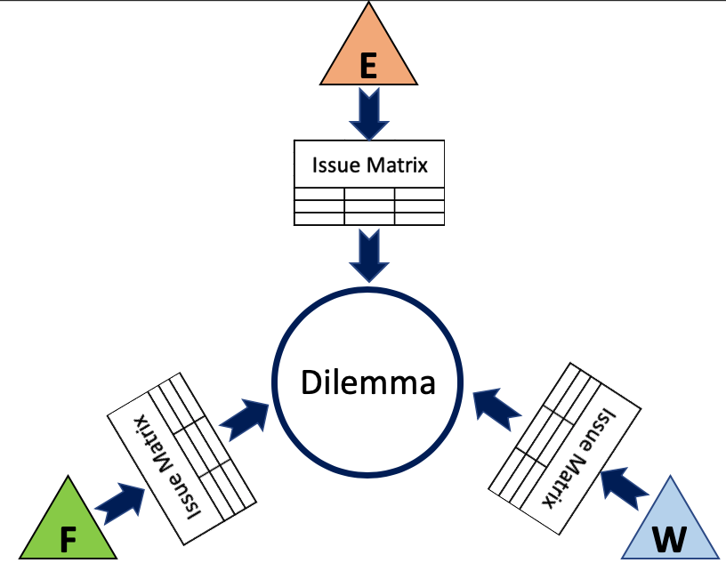
Figure 6. 8 Dilemma Triangle to Identify Dilemmas in a Problem
Issue Matrix in FEW
Three matrices are built for each perspective. Here the matrices represent a tabular form in which issues are placed both vertically and horizontally as shown in Table 6.1 which is the Issue Matrix built in the perspective of FOOD.
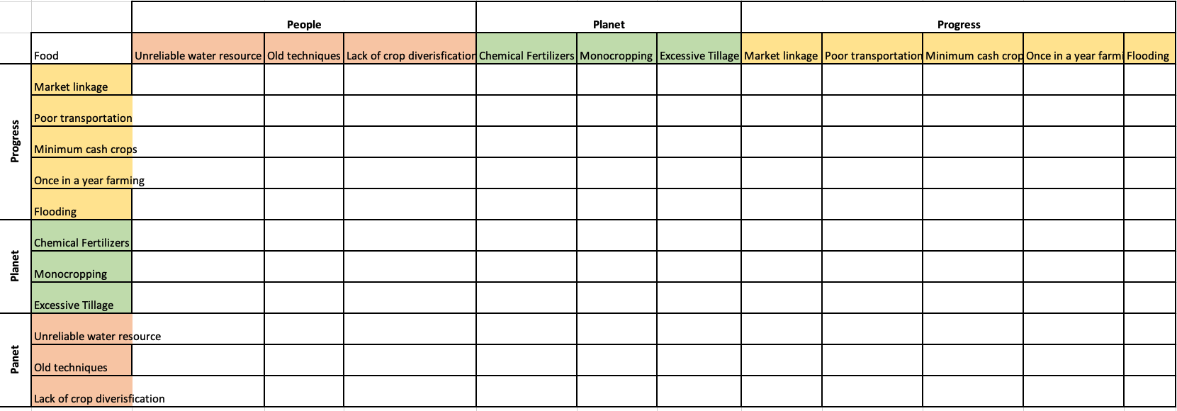
Table 6. 1 Issue Matrix In perspective of FOOD
Similarly, these tables are built for Water and Energy as shown in Table 6.2 and Table 6.3 respectively
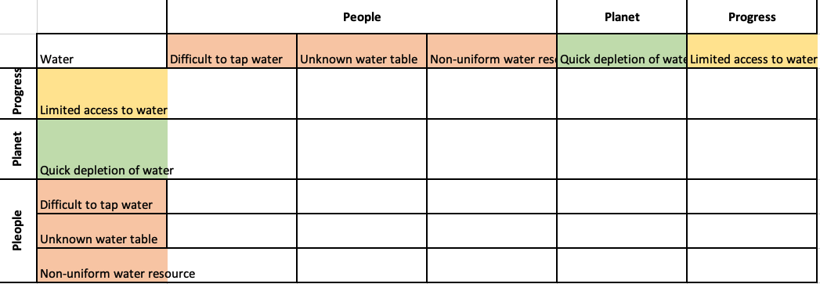
Table 6. 2 Issue Matrix in perspective of WATER
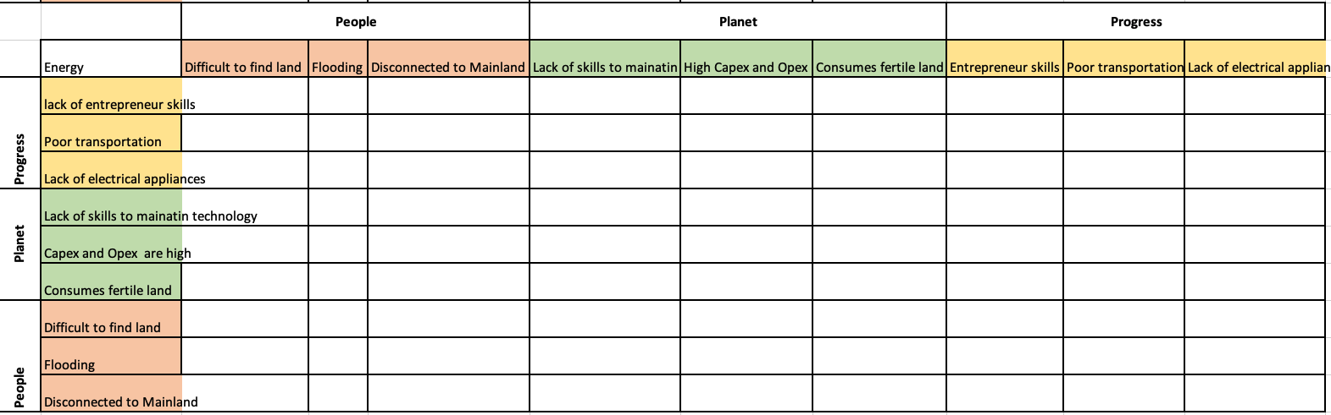
Table 6. 3 Issue Matrix in ENERGY

6.1.2 Categorizing Issues
From Section 4.2.1, it is mentioned that issues can be categorized into five types.
They are,
- Tensions
- Dependents
- Inter-perspective Tensions
- Inter-perspective Dependents
- Individual Issues
Individual Issues has no importance in finding dilemmas because, those issues don’t affect any other issues. Hence other four categories are detected to identify dilemmas at the end. This whole process is by using the dashboard (Section 4.3)
From Table 6.1, Issue Matrix of FOOD, Tensions and Dependents are identified and it its represented in Table 6.1a. The red cell indicates conflict issues (Tensions) and green cell represents Dependents. The numbering represents the serial number of each category of issue.
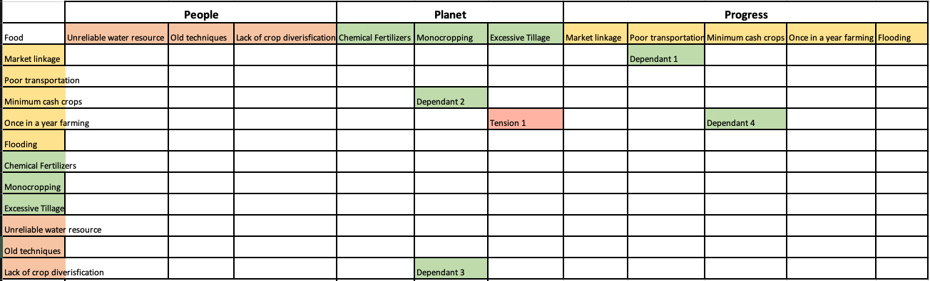
Tension 1
Once in a Year Farming vs Excessive Tillage
Excessive tilling of the farms should be avoided but at the same time goal of the social entrepreneur is to make farmers to do farming more than once in a year which results in excessive tilling of the land. This forms a tension.
Dependent 1
Poor Transportation and Market Linkage
If the transportation issue is solved, then there will be a linkage to markets. This might be a huge problem with respect to SunMoksha’s capability.
Dependent 2 – Monocropping and Minimum Cash Crops
Dependent 3 – Crop Diversification and Monocropping
Dependent 4 – Minimum Cash Crops and Once in a Year Farming
These three dependents (2,3,4) are similar. Monocropping can be avoided by growing different cash crops. Different cash crops can be grown more than twice in a year which solves the ‘once in a year farming’ issue.

Table 6.1. 1 Issue Matrix in FOOD with Tensions and Dependents
Similarly, Tensions and Dependents are identified in WATER
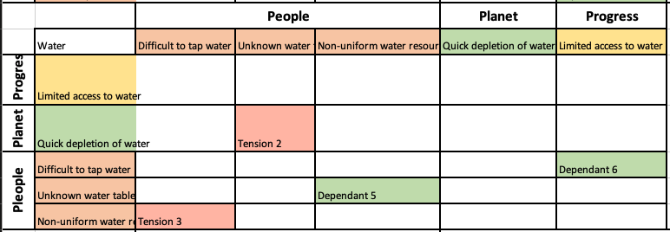
Table 6.2. 1 Issue Matrix in WATER with Tensions and Dependents

Tension 2
Unknown Water Table vs Quick Depletion Water
If water table of ground water resource is known, bore pumps can be installed. But villagers will start consuming water at higher rates which should be avoided. Quick depletion results in unreliable supply of water

Tension 3
Non-uniform Water Resource vs Difficult to Tap River Water
River water level around Kudagaon village is not uniform in all seasons. Hence, tapping river water is not possible in all seasons. But Non-uniformness of water level cannot be solved. Hence, tapping water is permanent tension which should be considered while making decisions.

Dependent 5
Non-uniform Water Resource and Unknown Water Table
Dependent 6
Limited Access to Water and Unknown Water Table
Even though river water level is not uniform, if underground water table is known, it would be easy to plan for providing uniform water supply to villagers. For example: Few seasons river water can be used, if water level is too low ground water source can be used. Hence, there won’t be a limited access to water.

With respect to ENERGY, categorizing of issues is done as show in the Table 6.3.1 in the next page.
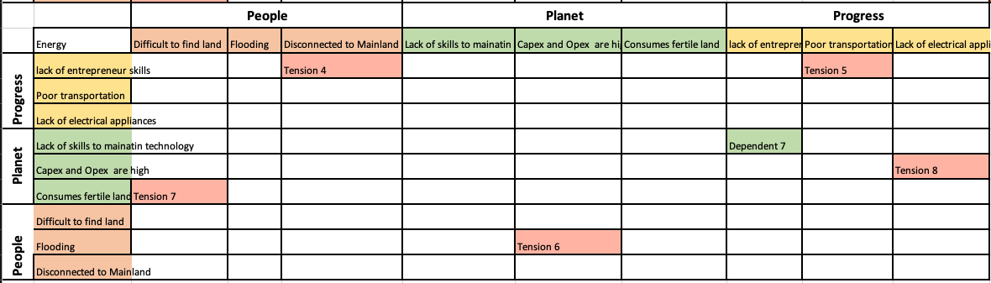
Tension 4 – Disconnected to Island vs Entrepreneur Skills
Tension 5 – Poor Transportation vs Entrepreneur Skills
Not all entrepreneur ideas are successful in village which does not have good transportation and has water around it. These tensions have to be solved to introduce Small and Micro Enterprises in the village.
Tension 6 – High Capex and Opex vs Floods
Tension 8 – High Capex and Opex vs Electrical Appliances
Capital expenditure (Capex) and operational expenditure (Opex) are high for a micro-grid. Floods destroys the property which requires re-installing of micro-grid and at the same time if number electrical appliances increases, more number of solar panels are required which results in high expenditure.
Tension 7
Fertile Land vs Difficulty to Find Land for Installing Power Source
Kudagaon is a fertile land. For installing an eco-friendly power source (Micro-grid), SunMoksha has to find a land which is not in use. Since every piece of land is being consumed in agriculture these two issues form a tension

Table 6.3. 1 Issue Matrix in ENERGY with Tensions and Dependents
Identifying Inter-perspective Tensions and Dependents
Inter-Tensions 1 (Food vs Water)
Non-uniform Water Resource (Water) vs Once in a Year Farming (Food)
In Food perspective, people wish to do farming more than once in a year. But in water perspective, availability of water is not uniform. With irregular water supply, farmers cannot do farming more than once.

Inter-Tension 2 (Food vs Energy)
Consumption of Fertile Land for Micro-grid (Energy) vs Minimum Cash Crops (Food)
Farmers should grow more verities of cash crops with the available fertile land. But Micro-grid requires a good amount of land to install. Due to growing demand of electricity, size of the Micro-grid may increase which consumes more fertile land. Due to this one or more farmer’s land will be consumed. In such cases it is difficult to grow cash crops in it.

Inter-Tension 3 (Food vs Energy)
Flooding (Energy) vs Unreliable Water Resource (Food)
Agriculture needs continuous water supply. If water pump is provided with the help of electricity, during floods the whole setup will be destroyed. Even though there is solution to solve the issue of water, that cannot be directly applied due to flood issue.

Inter-Dependent 1 (Food and Water)
Difficult to Tap River Water (Water) and Minimum Cash Crops (Food)
Inter-Dependent 2 (Food and Water)
Difficult to Tap River Water (Water) and Unreliable Water Resource (Food)
If tapping water from river is easy, then there won’t be unreliability in water supply hence farmers can grow more cash crops

Inter-Dependent 3 (Food and Energy)
Lack of Skills to Maintain Micro-grid (Energy) and Old Agriculture Techniques (Food)
There skills can be taught by SunMoksha at the same time. Farmers can be trained how to maintain micro-grid, how to dispose batteries etc. Teaching advanced techniques in agriculture is also be accomplished with the same training session.

6.1.3 Identifying Dilemmas
Most of the issues are categorized. These categories can group together to form different dilemmas.
Group a – Dilemma 1
Considering the annual floods, how to make use of river water and also groundwater to provide a continuous water supply to agriculture so that farmers grow crops more than once in a year without depleting water too much.

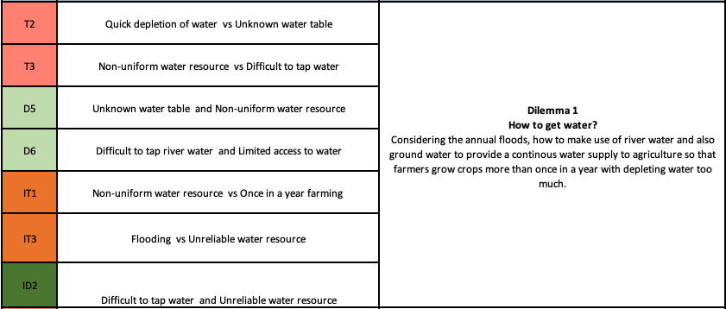

Group b – Dilemma 2
Without performing excessive tillage, how is it possible to increase food production by growing varieties of cash crops with the difficulty to utilize river water?
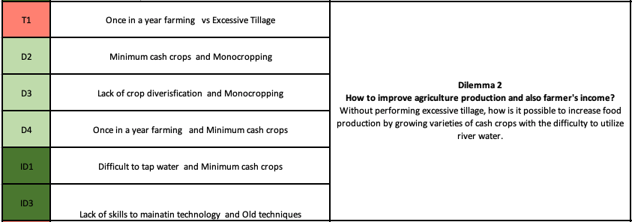

Group c – Dilemma 3
How to install micro-grid concerning growing demand and unavailability of barren land. Also, how to manage micro-grid during severe floods.
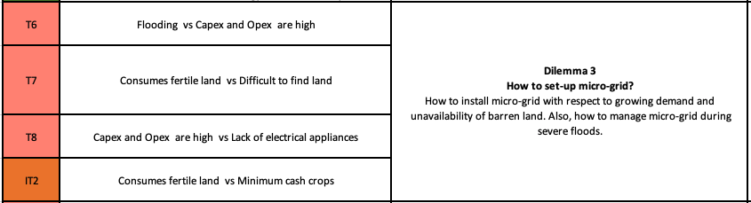
Group d – Dilemma 4
In extremely poor villages, establishing small and micro enterprises (SME) is challenging due to poor transportation and poor market system (Amiri, S. and co-authors, 2019). Hence the issues related to this are grouped
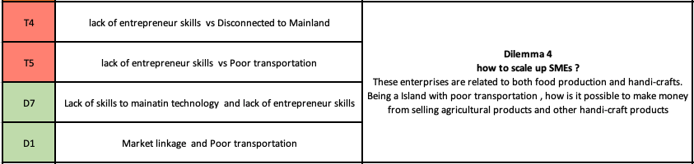
These enterprises are related to both food production and handicrafts. Being an Island with poor transportation, how is it possible to make money from selling agricultural products and other handicraft products.
Since dilemmas are identified, value propositions are developed in such a way that these dilemmas are cleared. These dilemmas serve as a problem statement that provides hints for developing value propositions

6.1.4 Developing Value proposition
Value Proposition 1 (Dilemma 1: How to get water?)
Underground water table of Kudagoan is not identified. Hence two surface pumps are placed at two different spots where the river water level is stable. This provides a continuous water supply to the village

Value Proposition 2 (Dilemma 2: How to improve agriculture production and also farmer's income?)
This should be considered when Dilemma 1 is solved. If there is a plenty of water available, farmers can grow cash crops. To avoid over depletion of water a smart technology called Smart AQUAnet™ is connected to these pumps. This smart technology predicts the exact amount of water needed for farming for that particular day. This results in precise cultivation. Precise cultivation improves agriculture production (Budadev, D. and co-authors, 2018)
Current Crops (Non-cash crops): Sweet Potato, Groundnut, Eggplant, Okras
Expected Cash crops: Tomatoes, Chillies, Onions, Wheat, Paddy

Value Proposition 3 (Dilemma 3: How to set-up an energy source?)
Solar Power Plant
Solar power plant called ‘Smart NanogridTM’ is utilized since Kudagoan has plenty of sunlight available. Since Kudagoan is fertile land it is difficult find a barren land to install the panels. Hence solar panels are installed at a particular height in the fields with short crops.
Problem: Not all crops are short crops. If all villagers grow tall crops it is difficult to find land. For this, anticipated solution would be: Installing panels either in cattle barn or on rooftops of houses.

Value Proposition 4 (Dilemma 4: how to scale up Small and Micro Enterprises?)
Right now, Usha company is providing battery-operated and manual sewing machines. Finished products are collected by Usha itself which solves the market linkage problem.
For agriculture: since market linkage is a huge problem, villagers are provided with cold storage to store their crop until it is sold.
The first stage of the proposed framework is to identify dilemmas and develop a value proposition. Once the value proposition is developed Systems Dynamics is used evaluate the impact of the value proposition. These value propositions are developed with the help of SunMoksha (Dr. Ashok das and Aysuhi Sharma).

Note: Developing a value proposition is not the primary focus. Identifying dilemmas is the most important task. Once a social entrepreneur reaches the dilemma, he/she and his/her team can think and come up with different ways to address those dilemmas. There are many solutions to a problem. When a social entrepreneur identifies a dilemma, there is a high probability of choosing the right solution for a particular problem.

6.2 BUILDING SYSTEMS DYNAMICS MODELS TO VISULAIZE THE IMPACT OF THE VALUE PROPOSITION
The reason for introducing systems dynamics into this framework is to visualize the impact of the value proposition in the village such that, social entrepreneur can make better decisions and also elaborate their work to investors in an efficient way. This visualization of the impact created through introduction of value proposition (which is developed using Dilemma Triangle method) allows a social entrepreneur to talk to investors. These systems dynamics models are built in Vensim software. This software allows user to visualize dynamic results. Social entrepreneur has an option to evaluate the results by changing the data. For example, social entrepreneur can change the average consumption of electricity of one house to check whether Micro-grid production meets the demand or not. If number of households increases in future, social entrepreneur can predict the overall consumption of the village just by changing the values in the systems dynamics model. A generic model is built using Vensim where social entrepreneur can use it for all the villages.
As discussed in Section 5.1, three types of variables are used to build these models.
- Intervention variables
- Consumption variables
- Impact/Outcome variables
For Kudagaon village problem,
Intervention variables – Micro-grid, Aqua-net, Street lights, Cold storage, Small and Micro Enterprise (SME)
Consumption variables – Household consumption, School consumption, Street light consumption, SME consumption, Agriculture consumption
Impact/Outcome variables – Enrollment in schools, Agriculture production, Economy
Each type of variable is given a different color in the model as shown in Figure 6.9, 6.10 and 6.11
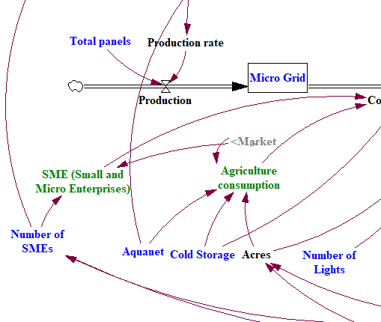
Figure 6. 9 Intervention variables (Blue colored)

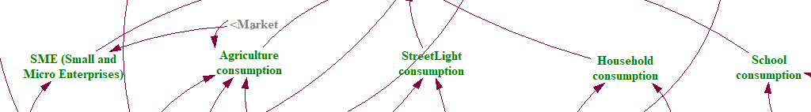
Figure 6. 10 Consumption Variables (Green colored)
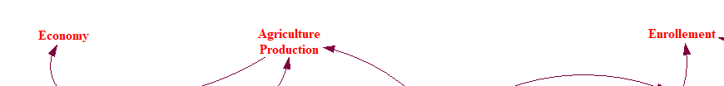
Figure 6. 11 Impact Variables (Red colored)
These variables are designed based on the results obtained from the Dilemma Triangle method. The impact are variables are decided based on social entrepreneur’s (SunMoksha) suggestion. All the variables are connected to each other with the available data. Remaining black colored variables are created for calculation purpose. The whole model is designed for 365 days as shown in Figure 6.12 (This can be modified at any time).
Model Settings
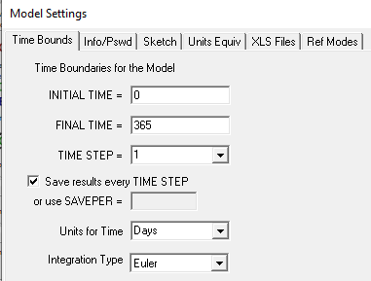
Figure 6. 12 Model Settings of the Systems Dynamics

Systems Dynamics model finally looks as shown in Figure 6.13 with all the variables connected
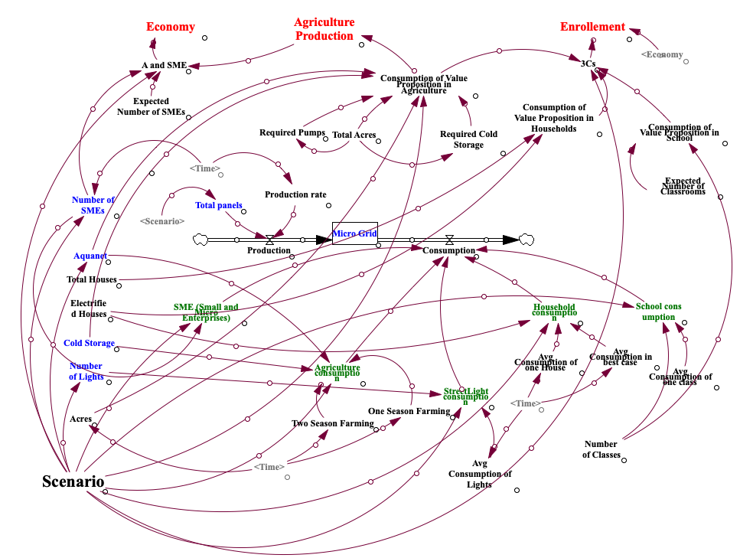
Figure 6. 13 Systems Dynamics Model
Each village has a different characteristic. Some villages have big population with more farmland, and some has small population still with more farmland. For each type of village consumption of electricity is different. Based on the farmland cold storage size varies. For any village, no matter what the size of value proposition is, final impact is believed to be same. For a same village, social entrepreneur can test the model with different scenarios. Scenario based testing helps a social entrepreneur to make better decisions. It also helps them to introduce value proposition and increase its size strategically.

6.2.1 Populating the Model with Data
In Section 5.5, three methods are proposed to get the data needed for systems dynamics. Most easily available data for the Systems Dynamics is quantified data regarding the smart technologies (Intervention variables). This data is provided in Appendix B (Table B.1). The data regarding consumption variables is gathered through the historic data (Section 5.5.2) from the other villages where these value propositions are already being used. Most essential data like average consumption of electricity in agriculture per acre, number of water pumps needed, average consumption of electricity in houses, average consumption of electricity in small enterprises is gathered from this historic data. This data is analyzed, and necessary information is extracted from it. Since, the number of villages in SunMoksha’s portfolio is less, analyzing this data is less reliable. This data eventual improves as the services of the SunMoksha is expanded to more villages. The idea is not to calculate exact results but, to provide an ideal method that could produce useful results when right data is used. To understand the consumption style of the village, data from a village called ‘Chottkei’ (which has been intervened by SunMoksha) is utilized as historic data.
Calculating the impact is the challenging part in Systems Dynamics. Impact variables like growth in agriculture production, growth in enrolment into schools and growth in economy is calculated using two methods i.e., Rating scale (Section 5.5.1) and Comparing with Nation's Data (Section 5.5.3) is used. In Rating scale, social entrepreneur’s experience is utilized and in second method, Indian historic data is analyzed to see if it reflects what social entrepreneur has experienced. A positive relationship is observed between these two variables as shown in the Figure 6.14
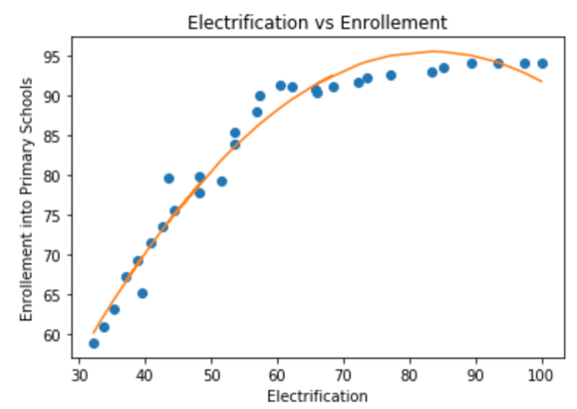 | 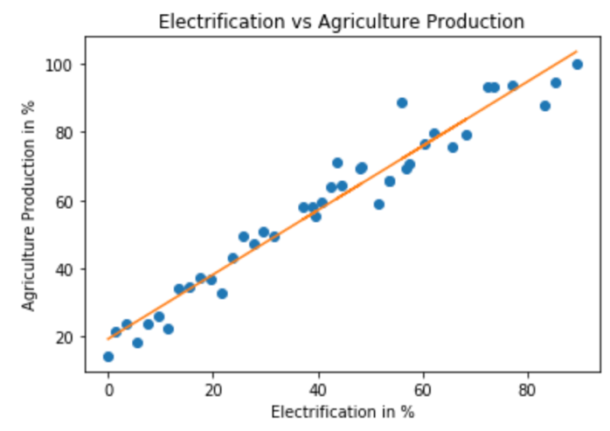
Figure 6. 14 Figure Impact of Value Propositions
For the past 20 – 30 years, rural electrification has improved significantly. Simultaneously, a significant improvement in education and also in agricultural production is observed. The data used for the Figure 6.14 is provided in Appendix B (Table B.2). This positive impact of electrification over agriculture and education is also experienced by the social entrepreneur in the previous village. Hence, this positive relationship is included in Systems Dynamics to connect the Impact variable to other variables. However, these numbers do not replicate exact the scenario of the village. Since, the idea of bringing Systems Dynamics is to connect the variables logically in such a way that, models generate useful results when right data is used. Right now, based on the limited available data, the calculation of impact has become tough. Eventually, the performance of the models improves when more data is available. This scenario-based Systems Dynamics models justifies the word ‘Framework’ as the internal logic is similar for most of the villages, but the results vary based on the input. The results for Kudagaon is shown in Section 6.2.2 may not be correct but they are useful to see the change that resulted due to the interventions.

6.2.2 Testing the Model in Different Scenarios

Scenario 1: Worst-case
As per the current characteristics of Kudagaon village Worst-case scenario is designed as follows
Value propositions - 0
Farming – Once in a year
Farming land – 400 acres
Households – 85
Average household consumption of electricity – 0
Number of SME – 0
School – None
Access to Market – Very poor
Access to electricity – None
Scenario 2: Sufficient case
Value propositions – Micro-grid, Aqua-net, Cold storage
Number of solar panels – 60
No of water pumps in Aqua-net - 2
Farming – twice/thrice in a year
Farming land – 400 acres
Households – 85
Average household consumption of electricity – 0.7 units
Number of SME – 2
School – None
Access to Market – Very poor
Scenario 3: Best-case
Value propositions – Micro-grid, Aqua-net, Cold storage
Number of solar panels – 90
No of water pumps in Aqua-net - 5
Farming – thrice in a year
Farming land – 400 acres
Households – 85
Average household consumption of electricity – 0.9 – 1.0 units
Number of SME – 5
School – None
Access to Market – Very poor
Results
These three scenarios are designed and run in Systems Dynamics. Three types of results are visualized.
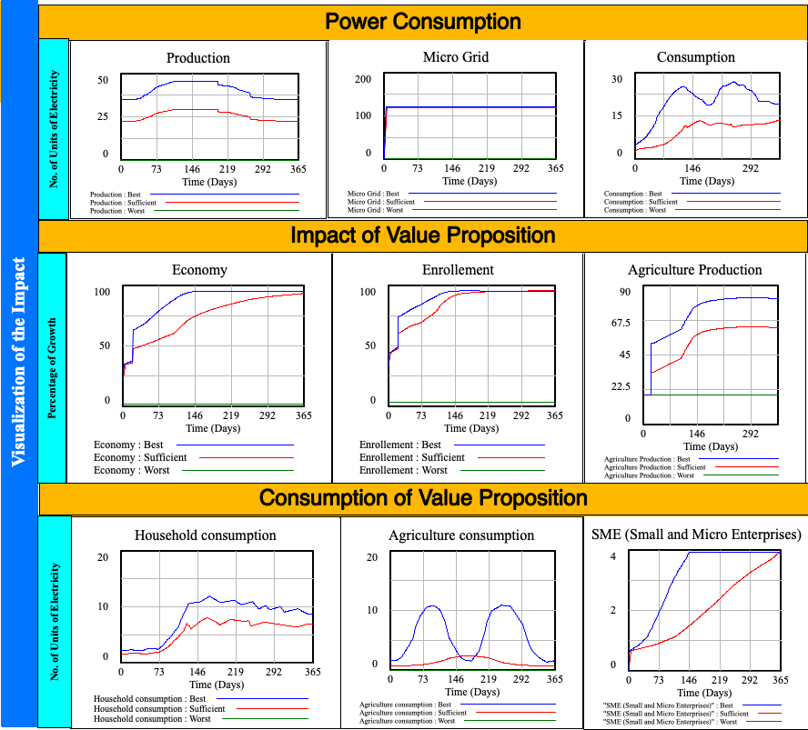
Figure 6. 15 Visualizing and Analyzing the Impact
Power Consumption
The value propositions developed are smart technologies which requires power. Hence, to evaluate the power consumption three graphs are visualized. They are, Production, Consumption and Micro-grid (storage).
In production, three scenarios are visualized with dedicated colors for 365 days. In worst-case (red line), there won’t be any production, storage and consumption. From Figure 6.14, in sufficient case, 60 panels are introduced into the village. Hence there is production throughout the year which varies from 20-30 units every day. In consumption, village consumes around 10 -15 units every day. In micro-grid with a storage of 100 units (varies from village to village), electricity meets the limit of the storage with in 50 days. In best-case, 90 panels are used, and villagers are expected to consume more electricity. Hence, production and consumption are little higher than the sufficient case. Storage limit is met very quickly due to higher production.
Consumption of a Value Proposition
This is mentioned in third row of the Figure 6.15. This represents how well the villagers are utilizing value propositions. Households consumes the Micro-grid and streetlights, agriculture consumes Microgrid, Aqua net and Cold storage and SMEs consumes Micro-grid. These are three main consumptions of the value propositions. In worst-case scenario, there won’t be any consumption. In sufficient case scenario, Households consumes 7-8 units a day, agriculture consumes 4 units a day and SMEs consume 0.4 units in the beginning of the year and reaches 4 units a day by the end of the year due to increase in number of SMEs. In best-case scenario, households will start to use more electrical appliances as production is higher (10-12 units/day). Agriculture consumption also higher due to a greater number of water pumps in Aqua net. Due to higher agriculture production, abundance in power production, SMEs starts to grow faster. Hence, SME consumption is also higher when compared to sufficient case.

Impact of the Value Proposition
By the choice of the donor, different impacts can be shown in Systems Dynamics. For this thesis, three important impacts are visualized. They are, Enrollment into Schools, Agriculture Production and Economy. In worst-case scenario, villagers are not able to send their children to schools due to poor income. In sufficient case scenario, villagers get sufficient amount of value proposition to generate income through agriculture and SMEs. Thus, almost every parent who consumes the value proposition will send their children to schools. Hence there is huge impact on Economy as well. In best-case, this impact will be higher when compared to sufficient case.

These visualizations are dynamic. A user can change the input to see a different impact. Thus, a social entrepreneur can test with different value propositions with different quantity to analyze the impact. The results obtained in sufficient case scenario is considered as lower limit whereas best-case scenario is considered as upper limit. Thus, a social entrepreneur can plan their budget in the form of a range (from sufficient case and best-case). This allows them to convince any investor and raise funds. If maximum fund is available, social entrepreneurs will choose the best-case and start the intervention.

6.3 CONNECTING SYSTEMS DYNAMICS TO CROWDFUNDING PLATFORMS
There are many crowdfunding platforms available online. Most of the platforms doesn’t show the impact created through their funding. Since social entrepreneur has the capability to show their impact on villages through systems dynamics models, they can easily attract more investors. This is done by building some predictive models through the results generated from systems dynamics data. These predictive models are built using machine learning. When an investor/any person interested to fund selects the amount he wants to fund, that amount is converted into number of value propositions that can be introduced into the village. Based on the quantity of value propositions, those predictive models predict the impact that it is going create. This allows the person whether or not to increase the funding amount. This makes the fund collecting process more efficient.

6.4 CONNECTING THE RESULTS TO E³ MODEL AND SUSTAINABLE DEVELOPMENT GOALS
In this thesis three types of audience are involved. They are, Investors, Researchers and the SunMoksha team. Being a researcher, gaps are identified in social entrepreneur’s work and a framework is proposed and utilized in a village called ‘Kudagaon’. A successful intervention of value propositions is made in Kudagoan. These interventions are made different stages as mentioned in Section 1.5.2. Kudagaon is in Stage 3. It has successfully crossed two stages or two rotations of E³. At each stage of intervention, the village starts achieving each goal of SDGs as shown in Figure 6.16.
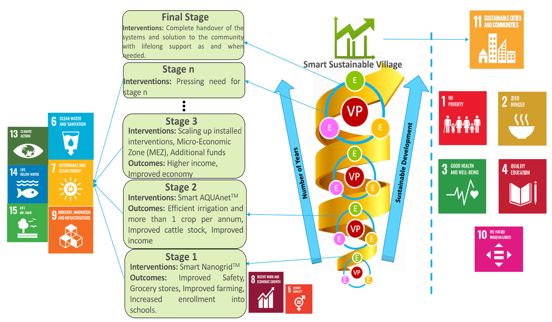
Figure 6. 16 The E³ Model: Stage-wise Interventions in Kudagaon Village

Stage 1: Interventions
As the ultimate goal of the solutions from SunMoksha is focus on SDG 8: Decent Work and Economic Growth in the developing communities, it needs the foundation of energy. The initial solution designed for Kudagaon was Smart Nanogird™ system such that the basic domestic energy requirements such as home lighting, mobile charging, etc. can be addressed. Also, the sizing of the system was to cater to water pump systems for irrigation purposes.
The project has been funded by Good Energies Foundation to cover the capital expenditure. As for the operations, local villagers were given an extensive training during the installation phase of the solution. One of the trainees has now become the Smart Nanogrid™ operator and has access to complete support from SunMoksha team at the command center.
Stage 1: Outcomes
With 20kW solar PV system and 72kWh battery backup, Smart Nanogrid™ (SDG7: Affordable and Clean Energy) is able to provide affordable, reliable and sustainable source of energy for domestic purposes. The comparison between before and after Smart Nanogrid™ installation illustrates that access to electricity from microgrid has influenced the quality of life positively especially for the parameters: education, safety, and social life. It has also proven to have the potential to influence the parameters such as agriculture, entrepreneurship and migration for better. Further development in the latter parameters requires an exposure to the entrepreneurial opportunities both in agriculture and non-agriculture sectors such that electricity becomes the means through which the villagers can socio-economically develop (SDG 8: Decent Work and Economic Growth).
Stage 2: Interventions
While the bore well attempts on the main island have not resulted into promising outcomes, the next option that has been explored and finalized is to pull water from a pond that has continuous water flow from the river even during peak summers, when most of the river dries up. A sump will be constructed on the mainland that will receive water from the pond. The sump will be a common and shared source of water for the nearby farmlands. Smart AQUAnet™ solution will be installed to ensure only the right quantity of water is supplied to the right farmland at the right time and at the right price (SDG 6: Clean Water and Sanitation). Also a few local youths will be trained in the Smart AQUAnet™ system such that they can become operators.
Apart from water solution, as there are two farmers who have shown interest in flour and rice mill, SunMoksha is supporting them with the necessary knowledge on operations (SDG 12: Responsible Consumption and Production), i.e., responsible use of electricity for the mill such that the mill enterprise is energy efficient. As the farmers have invested their personal savings to set up the system, SunMoksha is also helping the entrepreneurs with a business model.
Stage 2: Outcomes
With the steady, affordable and sustainable source of water supply, it is observed that the farmers are able to practice agriculture all year round, which will reduce their migration to nearby towns for daily wages. As farmlands are supplied water through the proposed solution, a significant improvement in their annual income by farming more than once a year is observed. Moreover, through of Smart AQUAnet™, it has become possible to measure the quantity of water required by a crop for a given area of land. This is essential to ensure that only the necessary quantity of water is supplied and there is no water wastage.
In the domain of entrepreneurship, along with improved agriculture practices, villagers have persuaded to venture into post-agriculture enterprises such as rice mill. Besides agriculture, with improved income and available of food and water, villagers started to invest on cattle that further improves their income.
Stage 3: Interventions
Several government (state and central) policies for village level loans or CSR funding or other forms of funding can be tapped into to build the necessary infrastructure for Micro-Economic Zone (MEZ) in the village. NGOs and social enterprises working in rural development area or for-profit agencies can be partnered with to bring in the state-of-the-art technology and concept for the MEZ. The villagers can be trained in the enterprise they chose to work with and gain the necessary skills to become entrepreneurs. Moreover, with a networking system of other agencies, market linkage opportunities will get enabled.
With the MEZ, the demand for electricity will increase. Hence, instead of sourcing the energy from one power plant, another power plant can be introduced with MEZ as its primary load. As both power plants will be IoT/Cloud based, they can be connected with one another forming a fractal grid such that while they address the needs of their respective loads in priority, in case of any technical failure, they can support the primary loads of each other too.
Stage 3: Outcomes
With a successful MEZ SDG 1: No Poverty, SDG 2: No Hunger and SDG 10: Reduced Inequalities can be addressed. Moreover, SDG 9: Industry, Innovation and Infrastructure can be established. Also, as all the technical devices will be smart in nature, i.e., their operations can be monitored and controlled remotely, the necessary data will be captured, analyzed and shared with the entrepreneurs to increase the efficiency and productivity of the enterprises and to help them make better business decisions.

6.5 SYNOPSIS OF CHAPTER 6
In this chapter utility of the framework is discussed. Kudagaon village is chosen as the comprehensive problem. Data is collected from SunMoksha (Dr. Ashok Das and Ayushi Sharma). In Section 6.1 the Dilemma Triangle method is implemented in Food, Energy and Water Nexus to identify the dilemmas. Based on the dilemmas value propositions are chosen. In next stage, in Section 6.2, systems dynamics is used to build causal loop diagrams to visualize analyze the impact of the value proposition. Three types of variables (Intervention, Consumption and Impact variables) are used in the model to get the results. Results are obtained in the form of 2D graphs. These results change dynamically according to the input of the village data. Different scenarios are also designed and tested on Kudagaon village to make a better decision. Later in Section 6.3, the connection between systems dynamics results and crowdfunding platform is explained. Predictive models are built which can be used in the crowdfunding platforms such that any donor can see the impact that is going to create in village through their funds. This prediction of impact motivates donors to donate more money to achieve rapid sustainable development.

CHAPTER 7

CLOSURE

In this chapter whole thesis is summarized. In Section 7.1 summary of the thesis is presented along with capabilities of the framework. In Section 7.2 relevant contributions of the work is discussed along with critical valuation of the proposed research hypothesizes. In Section 7.2.2 limitations of the framework is presented. Later on, scope of the framework and future possibilities of research is also presented. This chapter ends by presenting future possibilities of the research with this thesis.

7.1 SUMMARY OF THE THESIS
To achieve sustainable rural development in developing countries like India, it is very challenging due to increasing population and increasing poverty. It has become a big challenge for government to reach each part of the country. Social enterprises are considered to be one of the ways to achieve sustainable development in rural areas. Due to the introduction of CSR bill, these social enterprises receive funds which can be used for rural development.
In this thesis, a computational framework has been introduced which can be used by any social entrepreneur to develop a value proposition and also visualize and analyze its impact on quality of life of villagers. Apart from CSR, this framework can be still used to attract more investors around the world through a crowdfunding platform that helps a social enterprise to grow
This thesis includes more than a computational framework. Three concepts are discussed which represents the three faces of the thesis. First one is ‘Computational Framework’ which the main face in the thesis, second one is ‘The E³ Model’ which is discussed in Chapter 1 and Chapter 6 and third one is ‘Sustainable Development Goals and Strategy to Achieve it’ which is explained in Chapter 1. This three-faced research work is meant for three different types audience. They are, ‘Social Entrepreneurs’, ‘Investors’ and ‘Researchers’. All audience need to know everything about everything but with levels of importance as shown in Figure 7.1
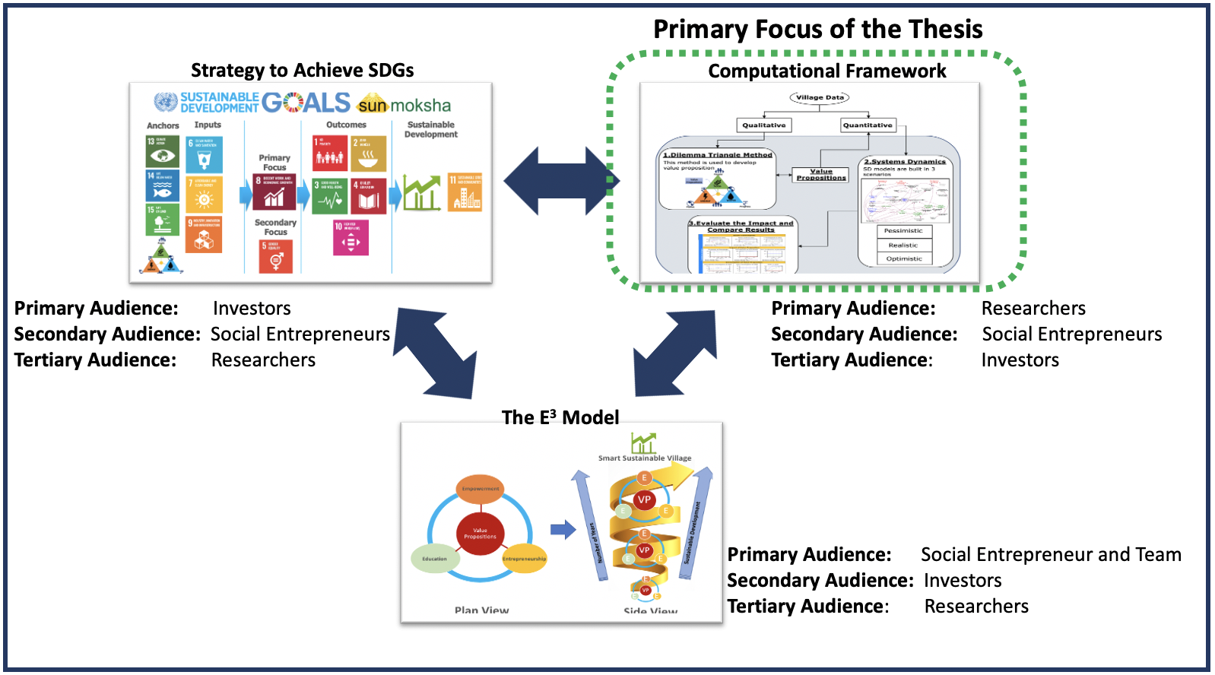

Figure 7. 1 Three Elements of the Thesis
This thesis has an open end and that enables opportunities for upcoming researchers. The ideas introduced in this thesis can be improved further. This serves as reference to many other related projects. Hence, the explanation of the proposed computational framework and methods involved in it is much essential for researchers rather than E³ model and SDGs. Hence, the primary audience of the thesis are researchers. However, the secondary audience are social entrepreneurs as the proposed methods are finally utilized by them. They do not need to know the background and details of each method but still they can utilize it. Investors needs to know what impact their money would create in the village. Instead of elaborating the details of the framework, the final visualization is presented to them. Thus, they became the tertiary audience. Similarly, for the E³ model the primary audience are social entrepreneurs and their team as it represents the principles of a social enterprise that includes their mission and vision. The E³ model serves as shortcut any social entrepreneur who wants to achieve sustainable rural development. While introducing the enterprise to any investor, it is important to mention the principles they follow. It promotes the brand value of the business. Hence, they became secondary audience. Any researcher can introduce any type of method that benefits social entrepreneurs even without knowing their principles. Hence, they became the least important audience. The third face of the thesis is SDGs and strategy to achieve it. In fact, E³ model itself explains the importance of SDGs but, SDGs is a universal concept declared by United Nations that is believed all over the world. Investors are more interested to look at this model rather than their own principles. Hence the primary audience for this concept is ‘Investors’ whereas social entrepreneurs become secondary.
In perspective of the computational framework, two big challenges faced in achieving sustainable development are ‘how to develop a value proposition?’ and ‘’how its impact can be evaluated?’. Hence two hypothesizes are introduced to accomplish these challenges. These two hypothesizes acts as two main elements of the whole framework. First element of the framework is to develop a value proposition using Dilemma Triangle method. This method is already used in previous framework (Yadav. A, 2018) but not in an efficient way. This existing method has been improvised by introducing a new perspective which is Food, Energy and Water (FEW) Nexus.
The FEW nexus is the intersection of food, energy and water three interdependent components that, together are lifeblood of the earth. The FEW nexus plays a crucial role in achieving sustainable development. This nexus should be considered before developing any value proposition. Hence, Dilemma Triangle method is implemented in perspective of Food, Energy and Water individually and dilemma are identified by considering the interdependency among those three components (FEW). In any village, most of the problems are related to FEW. Since Dilemma Triangle method is implemented in the perspective of FEW, dilemmas related to FEW are identified. With the help of dilemmas, value propositions are developed which can solve the problems of FEW (Figure 7.2)
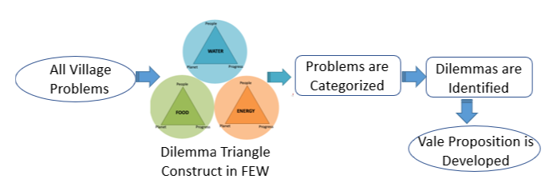
Figure 7. 2 Developing value propositions using Dilemma Triangle method in perspective of FEW Nexus

Once value proposition is decided, systems dynamics is used to visualize and analyze the impact of the value proposition as shown in Figure 7.3
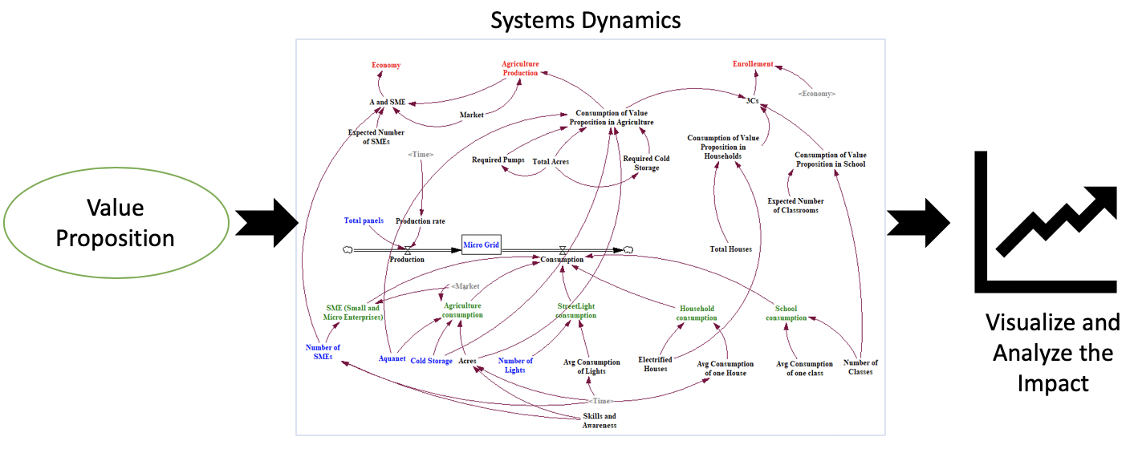
Figure 7. 3 Systems Dynamics to Visualize and Analyze the Impact

7.2 CONTRIBUTIONS
There is lot of literature available in the fields of sustainable rural development. There is an existing framework (Yadav. A, 2018) to achieve this. In order to identify dilemmas, there is no better method available in literature. The combination of Food, Energy and Water nexus with Dilemma Triangle method is novel approach which led to discover many categories of issues which leads to dilemmas. This categorizing and identifying dilemmas in a complex system is biggest contribution in this area.
Systems dynamics is being used at community level for policy making (Currie, Danielle and co-authors, 2018) but, it is not used as a tool to visualize the impact of value proposition. This combination of ‘developing a value proposition’ and ‘visualizing the impact’ is second main contribution in the field of sustainable rural development.
There are many crowdfunding platforms available on internet. However, there are no platforms which can visualize the impact of a value proposition to investors when the donate money. For example, if a person wants to donate 50$ in crowdfunding platform, it shows what impact can be expected in that village with that 50$. This combination of Systems Dynamics with crowdfunding platform is powerful tool to attract investors from all over the world which is the third main contribution of this thesis.

7.2.1 Critical Review on Answers to Research Questions
Primary question of this thesis is,
Primary Question (PQ)
Considering the capability of a social entrepreneur and condition of the village, what are the methods required to guide a social entrepreneur to achieve sustainable rural development in off-grid villages facing extreme poverty and also encourage investors to provide necessary funding?
Primary Hypothesis (PH)
A framework which can be used by any social entrepreneur to develop value propositions and evaluate its impact is needed.
This primary question lead to two secondary questions,
Secondary Question 1 (SQ 1)
Based on available village data, considering the complexity and wicked nature of the problem, how is it possible to organize and prioritize problems worth investigating and develop a value proposition by a social entrepreneur?
Secondary Hypothesis 1 (SH 1)
Using a Dilemma Triangle method in Food, Energy and Water (FEW) nexus considering people, planet and progress as drivers, it is possible to analyze most of the problems involved in the village, detect all the problems worthy of investigation and develop a value proposition.
Secondary Question 2 (SQ 2)
What tools are required to evaluate the impact of the value proposition before implementing in the village and plan the budget?
Secondary Hypothesis 2 (SH 2)
Systems Dynamics can be used to simulate the village dynamics and evaluate the impact of the developed value proposition and decide the budget required for the intervention.
For Secondary Hypothesis 1, FEW-nexus is exploited and utilized the Dilemma Triangle method. Since there are three components, Dilemma Triangle method is implemented in three perspectives. This is presented in Chapter 3 and Chapter 4. Compared to previous framework, this amalgamation of FEW nexus and Dilemma Triangle method resulted in discovering many types of issues which resulted in identifying more dilemmas in a problem. This method of categorizing issues is explained in Chapter 4. A test problem is chosen to implement this method successfully. This testing is done in Chapter 6. Due to the exploration of more dilemmas, a better value proposition is developed than the previous existing method (Yadav. A, 2017). Since this process is a time consuming, an automated excel dashboard is introduced. A manual about this dashboard is presented in Chapter 3.
To answer Secondary Hypothesis 2, systems dynamics is utilized. A brief introduction is given in Chapter 3 and later on in Chapter 5 it is answered clearly how to analyze the impact of the value proposition. Variables used in the systems dynamics model is categorized in to three types and also three methods of collecting data is presented in Chapter 5. In Chapter 6, a comprehensive problem is chosen and verified the validity of the systems dynamics model. These models are tested in different scenarios to get a better result.

7.2.2 Limitations of the Framework
Limitation 1 – This framework is a knowledge-based framework which relies on the knowledge of a social entrepreneur. SunMoksha is only source of information. Other social entrepreneurs may not accept the results of this method.
Limitation 2 – Most of the data necessary for systems dynamics cannot be collected. Hence some data is filled with SunMoksha’s suggestions
Limitation 3 – The data used for most of the variables is collected only from 2 villages. This might vary from village to village.
Limitation 4 – Human behavior is not considered in this framework.

7.2.3 A Key to Further Research Opportunities
As mentioned in previous section, this research is does not have a closed loop. It opens up opportunities for further research. This proposed framework includes different topics like ‘Value propositions’ which are smart sustainable technologies, ‘Impact on quality of life’ which requires with data analysis, ‘Consumption style of village’ that requires knowledge of village dynamics and many more. These areas are key to other researchers to involve. This framework serves as big frame that fits many contributions from other researches as shown in Figure 7.4.
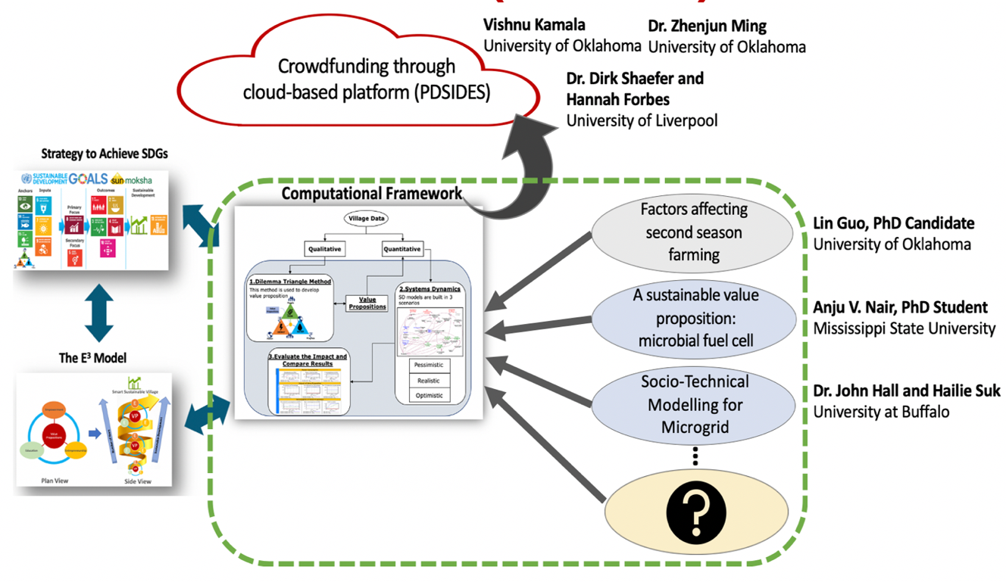
Figure 7. 4 Collaboration with Other Researchers
In scenario-based causal loop diagrams, agriculture serves as one of the consumption variables. This consumption varies based on one season and two season farming. If villagers are motivated to do second season farming the consumption of electricity will increase. This depends upon how well the social entrepreneurs promote it in the village. This opened up an opportunity to do research on factors affecting the acceptance of second season farming in a village. In the framework it is assumed that all villagers are doing two season farming. However, some factors slow down the villagers to convert from one season to two season farming. Lin Guo, a PhD candidate from University of Oklahoma is working in this area. Similarly based on the village characteristics, design of a Microgrid (Solar power source) changes accordingly. Village characteristics are not considered in the framework as it changes from village to village. Hailie Suk, a PhD candidate from University at Buffalo, is doing research to understand the village dynamics and pick the parameters that affects the usage of electricity. This socio-technical modelling results in a better design of the power source. A new technology called ‘Microbial Fuel Cell’ that addresses Water and Energy needs is being developed by Anju V. Nair, a PhD candidate from Mississippi State University. This ‘Microbial Fuel Cells’ does two things at a time. It filters the dirty water and produces electricity through it. This technology as one of the value propositions.
The outcomes of the collaborations fit into the proposed framework which justifies the word ‘Framework’. The end product should be available to any social entrepreneur and any investor from any part of the world. To realize this, a collaboration is made with Dr. Dirk Shaefer and his student Hanna Forbes from University of Liverpool, Dr. Zhenjun Ming from University of Oklahoma to take the proposed framework into a cloud-based platform to mount crowdfunding. More explanation is provided in Section 7.5

7.3 JUSTIFICATION TO THE VALIDATION SQUARE
This validation strategy is explained in Section 1.8. It deals with structural and performance validity of a method. It also checks the internal consistency and utility of the method. It has four quadrants. In these quadrants the proposed framework is verified and validated theoretically and empirically. Each quadrant is clearly answered in various chapters as shown in Figure 7.5
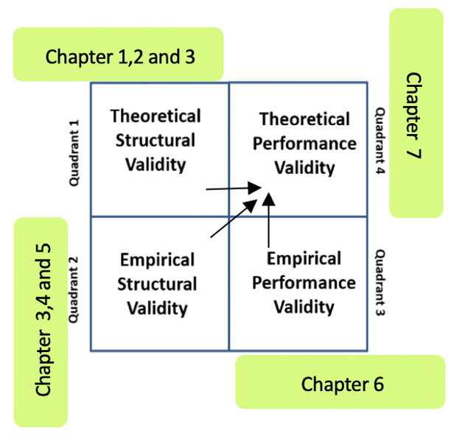
Figure 7. 5 Justification to Validation Square

To justify ‘Theoretical Structural Validity’ (Quadrant 1), background and motivation of the thesis is presented in Chapter 1 and a critical review of literature is done in Chapter 2. The elements of the method are explained in the form of flowchart in Chapter 3. This made the method to qualify to the next quadrant i.e., Empirical Structural Validity. Chapter 3 is connector between Quadrant 1 and 2. To prove the utility of the method a test problem is used in Chapter 4 and Chapter 5. With results obtained in Quadrant 2, the proposed method is qualified to test on comprehensive problem. Kudagaon an Indian village is considered as comprehensive problem to validate the utility of the method. This validation is explained in Chapter 6. By satisfying three quadrants, a leap of faith is created and builds confidence in general purpose of the proposed framework. This requires validation of all three quadrants. Foundation for this Quadrant 4 is provided in last chapter (Chapter 7).

7.4 “I” STATEMENT
Things I Learned
I feel proud to involve in a research work that deals with sustainable development. I have worked with an enterprise that aims for a social change rather than personal profit. This collaboration with a social enterprise changed the way I think. I realized the importance of being responsible as human being. Moreover, the enterprise I worked with, is a start-up. I learned how a business runs from the root level. The idea of a business is not just to have innovative ideas, but it should be able to exhibit their ideas to the world. This also apply to any human being. Being capable is not important, but he/she should be able to showcase their capability to the world.
The computational framework I developed, supports the growth of the enterprise. It sticks to the core structure of any enterprise. Based on the mission and vision of the enterprise, I was able to plan things ahead and brief the team. The core idea of any business operation is to design a solution, evaluate it and raise funds to develop it. Considering this, in my framework, I have developed a decision-making method that can be used by any social entrepreneur to clear the dilemmas and design right solutions. Also, the solution should be evaluated before it is deployed. To facilitate this evaluation process, I utilized ‘Systems Dynamics’ to develop a tool that can be used to evaluate the solution. Any investor wishes to invest in a well-structured organization with innovative ideas. If a social entrepreneur chooses a worthy problem and design a solution with innovative ideas and able to evaluate its impact, any investor can provide funds. However, this has to be done by showcasing the business in the form of a business model. Business model is in the form of vignettes. I, being the part of the social enterprise have developed business models that could depict the mission and vision of the organization.

How it Helps Me
Three main stakeholders are involved in it. They are: Social Entrepreneurs, Researchers and Investors. I as a graduate student served as a researcher to develop tools that is used for business growth. There is a thin line between a solution and a value proposition. A problem has many solutions, the one which can create a value to customers is called value proposition. I listen to some of the experiences shared by the social entrepreneur. Once they installed solar panel in a village with no electricity. Due to lack of awareness, people have destroyed the panels as they believed that solar panels are humiliating the sun. This seems funny but, the mistake is from the side of social entrepreneur as did not consider human behavior before introducing the solution. Thus, the solution has created a problem instead of some value. This may happen to any enterprise. A product developed need not to be successful unless the customer’s thinking is understood. This a very important lesson I learnt. This makes me think how to develop a value proposition instead of a simple solution.
I have a dream of starting my own firm, make money and do philanthropy work. In simple words, I wanted switch from being a researcher to an investor. To help a social entrepreneur, I wanted to be a business entrepreneur. This is possible when I know how to design and start a business. My 2 years of experience with a start-up has taught many valuable things that could help me in starting my own business. The decision-making method I introduced, fits in any type of business. The dilemmas that hinders the growth of the company can be eliminated.

7.5 FUTURE WORK

7.5.1 Cloud based Platform to Perform Crowdfunding
As mentioned in Section 6.3, this framework is connected to a cloud-based crowdfunding platform. ‘PDSIDES’ (Ming, Z and co-authors) is a cloud-based crowdfunding platform. Since the framework constitutes of two methods, it cannot be directly introduced into PDSIDES. The Dilemma Triangle method is decision making method which does not require any mathematical foundation. However, in Systems Dynamics the underlying logic has mathematical formulation. Hence, the outcome of the Secondary Hypothesis 2 is introduced into PDSIDES in the form of a template. This cloud-based platform is easily accessible by any user from any location. User has to set goals like ‘Education’, ‘Production’ etc. (Impact Variables) and algorithm behind runs different simulation with different quantities of value propositions (Intervention Variables) along with the budget and gives the results in the form of a table with right most column as goal and remaining columns as value propositions. Through this visual output, user can pick right combination of the value proposition with minimum budget that gives maximum output as shown in Figure 7.3.
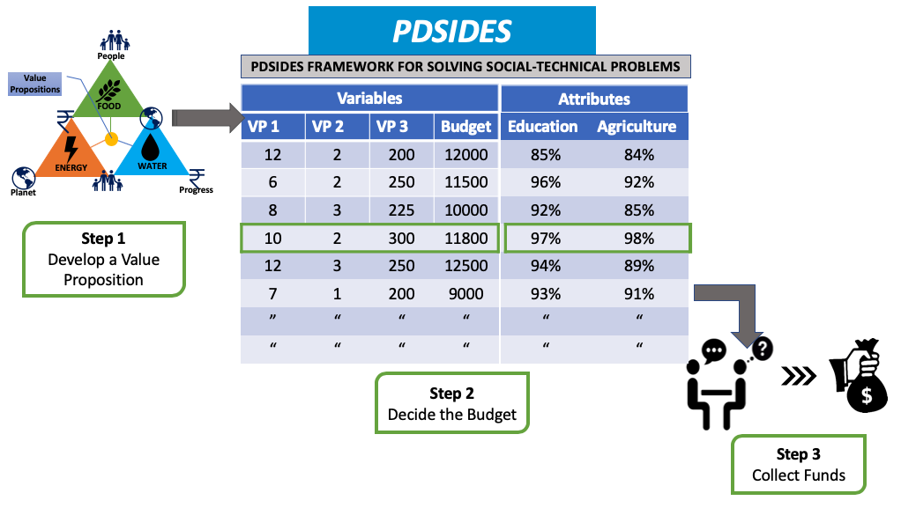
Figure 7. 6 PDSIDES Framework to Solve Socio-Technical Problems

Before utilizing the PDSIDES framework, social entrepreneur has to decide what value propositions are needed for the village. Let’s say, in Step 1 ‘Solar panels, ‘Water-pumps’, ‘Streetlights’ are decided as value propositions for the village. In Step 2, PDSIDES frameworks takes village characteristics such as population, area, number of streets, number of houses etc. as input and runs the algorithm with different quantities of value propositions and gives outcome of the goals such as education, agriculture etc. This helps a social entrepreneur to decide a right budget to raise crowdfunding. In Step 3, these results are shown to public through crowdfunding platform to attract investors. This framework made impact evaluation easier to any social entrepreneur. New social entrepreneurs are encouraged, and more funds can be raised through this idea.

7.5.2. Policymaking to Restore Indian Himalayas Region
International Union of Conservation of Energy (IUCN) took over a project on Indian Himalayas Region (IHR). Due to the extreme human interaction, eco system in Indian Himalayas is disturbed. IUCN need to introduce policies to control this and bring sustainable development in IHR. This problem needs a decision-support method to frame the problem and develop a value proposition (policymaking) and a method analyze the impact of the value proposition. The framework proposed in this thesis is to be modified to fit in this problem. Seven thematic areas have been chosen most critical areas as shown in Figure 7.7
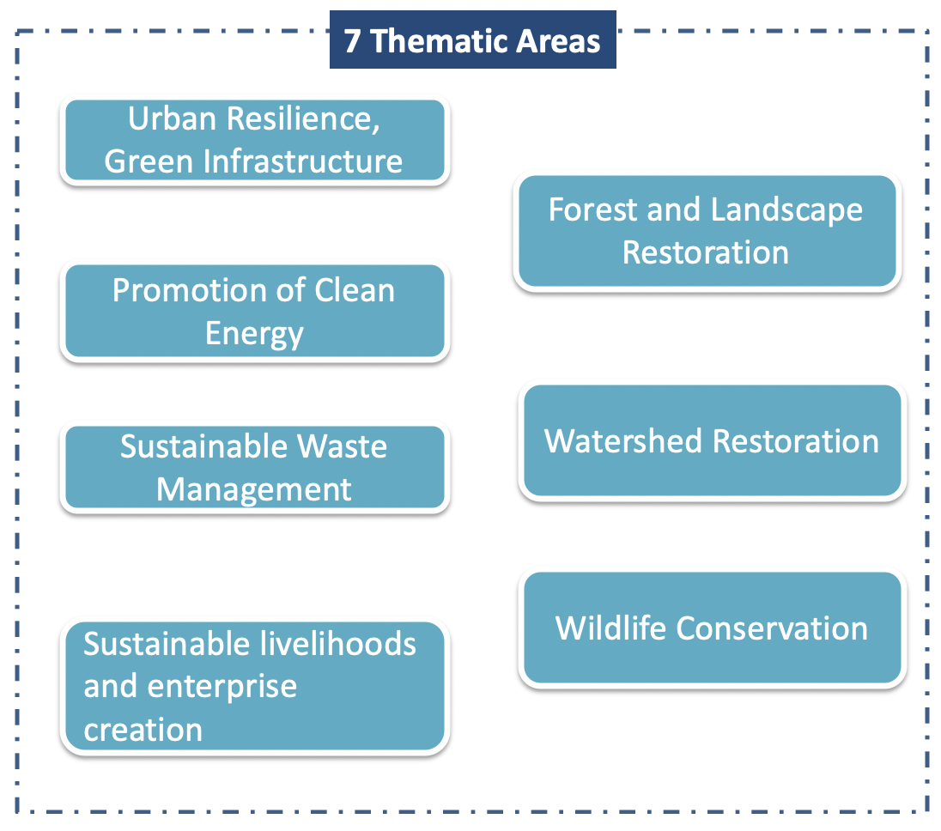
Figure 7.7 Seven Thematic Areas in IHR
The Dilemma Triangle method is implemented in Food, Energy and Water nexus in the context or rural development. However, seven thematic areas are chosen by IUCN, this dilemma triangle is planned to modify and fit in these seven thematic areas as shown in Figure 7.8.
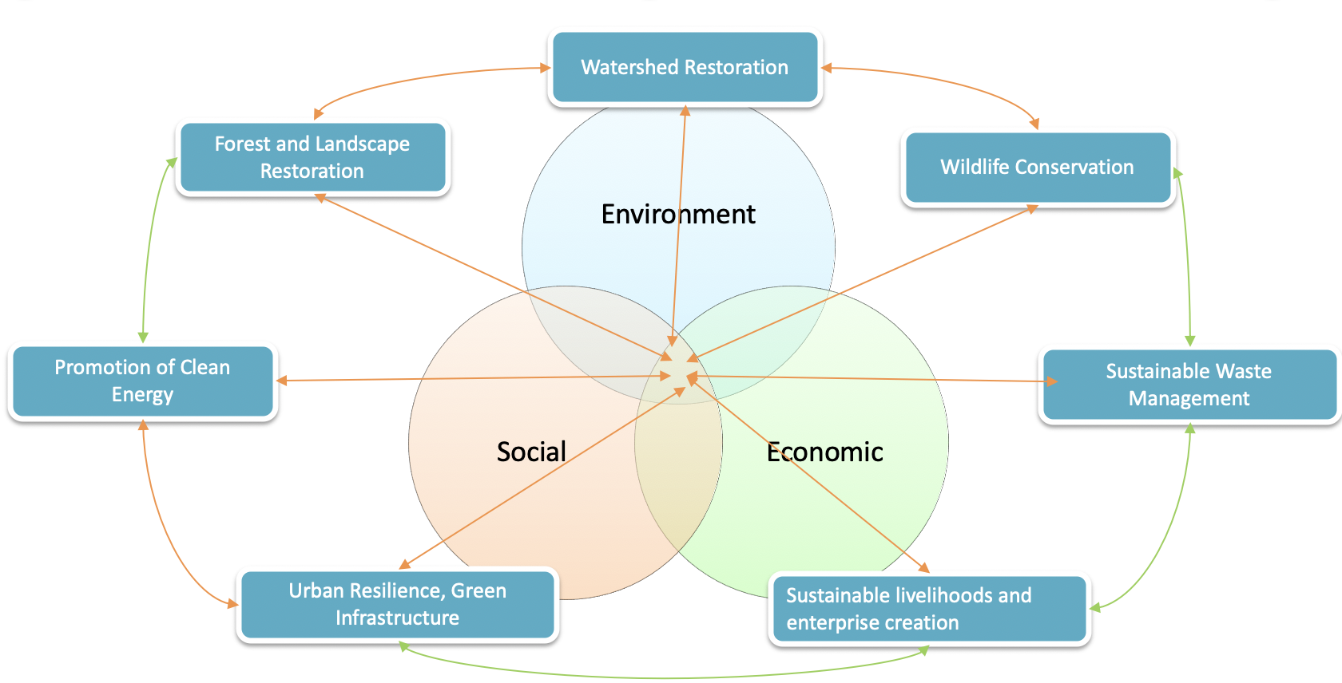
Figure 7.8 The Dilemma Triangle Method in Seven Thematic Areas

In rural development, there is no interaction among the sphere of sustainability (social, economic and environmental) until a value proposition is intervened in the village. Hence, the developed value proposition should not create imbalances between the spheres of sustainability thus become a sustainable value proposition. However, in Indian Himalayas Region (IHR), there is an existing interaction among the spheres of the sustainability. Social and Economic spheres affect the Environment spheres. This has become the major issue in IHR. In order to bring balance, policies are to make to achieve sustainability in IHR. These policies involve technology/service/both. Once the policy is decided, Systems Dynamics is used to simulate the IHR by considering most significant variables to evaluate the impact of the policy.

REFERENCES

Ansari, S., Munir, K. and Gregg, T., (2012). “Impact at the ‘Bottom of the Pyramid’: The Role of
Social Capital in Capability Development and Community Empowerment” Journal of
Management Studies, (49)4 DOI: https://doi.org/10.1111/j.1467-
6486.2012.01042.x

Ahmed, S., Xiao, M., Panchal, J. H., Allen, J. K., and Mistree, F. (2012). "Managing Dilemmas
Embodied in 21st Century Engineering". Paper presented at the ASME 2012 International Design Engineering Technical Conferences and Computers and Information in Engineering Conference, Chicago, IL, Paper Number DETC2012-71168.

Austin, J., Stevenson, H. and Wei‐Skillern, J., (2006). "Social and Commercial Entrepreneurship:
Same, Different, or Both?," Entrepreneurship Theory and Practice, vol. 30, no. 1, pp. 1-
22.

Amiri, S., Naderi, N. and Mohammadi Far, Y. Y (2019). “Conceptualization of the Challenges in
Home-based Businesses in the Villages of Kermanshah Province.” Journal of Rural
Research, 10(2), 172-185

Baldassarre, B., Calabretta, G., Bocken, N. and Jaskiewicz, T. (2017). “Bridging Sustainable
Business Model Innovation and User-Driven Innovation: A process for Sustainable Value
Proposition Design.” Journal of Cleaner Production, 147, 175-186.

Borgen Magazine, Last accessed on January 12, 2020. Available at:
https://www.borgenmagazine.com/power-electricity/

Budaev, D., A. Lada, E. Simonova, P. Skobelev, V. Travin, and G. Voshchuk (2018). "Conceptual
Design of Smart Farming Solution for Precise Agriculture." International Journal of
Design & Nature and Eco dynamics, 13.3: 307-14. Web

Chhavi G., (2013) “India Companies Act 2013: Five Key Points About India’s CSR
Mandate”. Source: https://www.bsr.org/en/our-insights/blog-view/india-companies-act-2013-five-key-points-about-indias-csr-mandate

Currie, D., Carl S., and Paul J. (2018) "The Application of System Dynamics
Modelling to Environmental Health Decision-making and Policy - a Scoping
Review." BMC Public Health 18.1: 402. Web.

Colglazier, W. (2015). SUSTAINABILITY. Sustainable Development Agenda: 2030. Science
(New York, N.Y.), 349(6252), 1048-1050.
http://www.un-documents.net/our-common-future.pdf

Das, Ashok (2015). “Sustainable Energy Access and Security for Rural India”, CPPR – Center
for Strategic Studies, Kochi, http://www.cppr.in/

De Brucker, K., Macharis, C. and Verbeke, A. (2013). “Multi-criteria Analysis and the Resolution
of Sustainable Development Dilemmas: A Stakeholder Management Approach.”
European Journal of Operational Research, 224(1), 122-131.

DeFries, R. and Nagendra, H. (2017). “Ecosystem management as a Wicked Problem.” Science
(New York, N.Y.), 356(6335), 265-270.

Dees, J. G., (2017), "The Meaning of Social Entrepreneurship," Case Studies in Social
Entrepreneurship and Sustainability, Routledge, pp. 34-42.

Emanuel, W., Dickens, C., Hunter, J., and Dawson, M. (2011), “Clarifying Societies Need for
Understanding Sustainable Systems.” Journal of Applied Global Research. 4.

Ellis, F. (2000), “Rural Livelihoods and Diversity in Developing Countries.” Oxford University
Press

Flint R.W. (2013) “Basics of Sustainable Development.” In Practice of Sustainable Community
Development. Springer, New York, NY

Forbes, H., & Schaefer, D. (2017), “Guidelines for successful crowdfunding.” Procedia CIRP, 60,
398-403. https://doi.org/10.1016/j.procir.2017.02.021

Godfray, H., Beddington, J., Crute, I., Haddad, L., Lawrence, D., Muir, J., Toulmin, C. (2010).
“Food Security: The Challenge of Feeding 9 Billion People.” Science (New York, N.Y.),
327(5967), 812-818.

Gregory Dees J, (1998) “The Meaning of ‘Social Entrepreneurship’.” Reformatted and revised,
May 30, 2001.Received on November 13, 2014 / Approved on March 07, 2015
Responsible Editor: Leonel Cezar Rodrigues, Ph.D. Evaluation Process: Double Blind Review E-ISSN: 2318-9975

Hansmann, R., Mieg, H. A., and Frischknecht, P., (2012), "Principal Sustainability Components:
Empirical Analysis of Synergies Between the Three Pillars Of Sustainability."
International Journal of Sustainable Development & World Ecology, vol. 19, no. 5, pp.
451- 459.

Hemantkumar P. B., Shailesh G., and Jyothi C. (2015). “Social Entrepreneurship in India”
International Journal of Innovation, Sao Paulo, v.3, n.1, pp. 07-16 Jan/Jun 2015

IEA World Energy Outlook 2011, Last accessed February 10, 2020
https://www.iea.org/topics/world-energy-outlook

Kathaiyan, D. (2015). "Bringing off-grid electricity to rural villages in India: Opportunities and pitfalls for solar photovoltaics." IEEE 15th International Conference on Environment and Electrical Engineering (EEEIC), Rome, pp. 1795-1799.
doi: 10.1109/EEEIC.2015.7165444
URL: http://ieeexplore.ieee.org/stamp/stamp.jsp?tp=&arnumber=7165444&isnumber=7165173

Rao, K.H., Last accessed February 9, 2020. “Rural Development Statistics 2011-12”, Available:
http://www.indiaenvironmentportal.org.in/files/file/rural%20development%20statistics%202011-2012.pdf.

Mair, J., and Marti, I. (2006). "Social Entrepreneurship Research: A Source of Explanation,
Prediction, and Delight." Journal of World Business, 41(1), 36-44.

Martin, R. L., and Osberg, S. (2007). "Social Entrepreneurship: The Case for Definition."
(Vol. 5): Stanford Social Innovation Review Stanford.

Mesjasz, C., (2010) “Complexity of Social Systems.” Cracow University of Economics,
Rakowicka 27, PL-31-510 Kraków, Poland

Munier, N. (2005). “Introduction to Sustainability: Road to a Better Future.” Springer.
PO Box 17, 3300 AA Dordrecht, The Netherlands. pages 1, 5, 15, 20, 21, 24, 105, 121

Mäder, P., Andreas F., David D., Lucie G., Padruot F., and Urs N. (2002). "Soil Fertility and
Biodiversity in Organic Farming." Science (New York, N.Y.) 296.5573: 1694-697. Web.

Ming, Z., Nellippallil, A. B., Yan, Y., Wang, G., Goh, C. H., Allen, J. K., and Mistree, F. (2018).
"PDSIDES—A Knowledge-Based Platform for Decision Support in the Design of Engineering Systems." ASME. J. Comput. Inf. Sci. Eng. December 2018; 18(4): 041001. https://doi.org/10.1115/1.4040461

Natarajan, M., Chester, Mikhail, Ruddell, Benjamin, Lobo, Jose and Fraser, Andrew, 2019. “Food,
a Global Product: An Enhanced FEW Nexus Approach.” ProQuest Dissertations, and
Theses.

Pedersen, K., Emblemsvag, J., Bailey, R., Allen, J. K., and Mistree, F. (2000). "The ‘Validation
Square’ – Validating Design Methods". Paper presented at the ASME Design Engineering Technical Conferences, New York: ASME, 2000. ASME DETC2000/DTM-14579.

Rini D. Last accessed on December 12, 2020. “Five key challenges faced by social entrepreneurs
in India.” Available at:
https://yourstory.com/socialstory/2019/06/five-challenges-social-entrepreneurs-india

Rittel, H.W.J. & Webber, (1973). M.M. Policy Sci 4: 155. https://doi.org/10.1007/BF01405730

SunMoksha Pvt. Ltd, Bengaluru, India. Last accessed on February 2020. Available at:
https://sunmoksha.com/

Sukhwani, V., Shaw, R., Mitra, B., & Yan, W. (2019). “Optimizing Food-Energy-Water (FEW)
Nexus to Foster Collective Resilience in Urban-Rural Systems.” Progress in Disaster
Science, 1, 100005

Sustainable Development Goals. Last accessed on February 10, 2020. United Nations.
https://sustainabledevelopment.un.org/?menu=1300

Sustainability for all. Last accessed on January 105, 2020. “How to Achieve a Sustainable Rural Development – Land Stewardship.” Available at:
https://www.activesustainability.com/sustainable-development/how-to-achieve-a-sustainable-rural-development-land-stewardship/

Sharma, P., & Bhal, K. T. (2004). “Managerial ethics: Dilemmas and decision making.” SAGE
Publications India.

Singh, S., and K K Datta. (2012)."Food Security in India- Problems and Solution from Farming
Perspectives." Indian Journal of Agricultural Economics 67.3: 525. Web.

Shamim (2016) “Digital India – Scope, Impact and Challenges” International Journal of
Innovative Research in Advanced Engineering (IJIRAE). Vol 3, Issue 12 ISSN: 2349-
2763: https://ijirae.com/volumes/Vol3/iss12/26.DCAESP101.pdf

The University of Arizona https://research.arizona.edu/food-energy-and-water-nexus

UN-Water. Water, Food and Energy. UN Water. Last accessed on December 12, 2019.
Available at: http://www.unwater.org/water-facts/water-food-and-energy/

Van Der L., Jan, D. (2000). "Revitalizing Agriculture: Farming Economically as Starting
Ground for Rural Development." Sociologia Ruralis. 40.4: 497. Web.

V T Ram Pavan Kumar M (2016). “Empiricism of Smart Villages and its Contraption”.
International Journal of Innovative Research in Advanced Engineering (IJIRAE). Vol 3, Issue 12 ISSN: 2349-2763: https://ijirae.com/volumes/Vol3/iss12/25.DCAESP100.pdf

WHO, World Health Statistics (WHO, Geneva), (2013). Last accessed on January 21, 2020.
Available at : https://www.who.int/gho/publications/world_health_statistics/2013/en/

World Commission on Environment and Development (WCED) (1987), “Our Common Future”,
Oxford University Press. ISBN-13: 978-0192820808

Yadav, A., Das, A., Roy, R. B., Chatterjee, A., & Allen, J., and Mistree, F. (2017). “Identifying
and Managing Dilemmas for Sustainable Development of Rural India.” ASME 2017 International Design Engineering Technical Conferences and Computers and Information in Engineering Conference. V007T06A017. 10.1115/DETC2017-67592.

Yadav, A., (2018). “A Framework for Developing Proposals by Social Entrepreneur for
Development of Rural India.” MS Thesis, University of Oklahoma, Norman, Oklahoma

APPENDIX A: Qualitative Data of a Compositive Village (Test Problem) for Chapter 4

To test the elements of the Dilemma Triangle method, a composite village has been designed with the inbuilt knowledge of the Indian villages. This test problem is used to explain the utility of the method to the social entrepreneur (Dr. Ashok Das). In Chapter 4, the Dilemma triangle method is implemented with the information listed in Table A.1 presented below.

Table A. 1 The Composite Village Data for the Dilemma Triangle Method in Chapter 4
Component | Driver | Focus | Issues
Food | People | Provide adequate amount of nutritious food | Lack of crop diversification
Food | People | Provide adequate amount of nutritious food | Low food production rate
Food | People | Provide adequate amount of nutritious food | Increasing population
Food | Planet | Conserve fertility of agriculture land | Usage of chemical fertilizers
Food | Planet | Conserve fertility of agriculture land | Mono cropping
Food | Planet | Conserve fertility of agriculture land | Excessive tillage
Food | Planet | Conserve fertility of agriculture land | Lack of organic fertilizers
Food | Progress | Improve economic opportunities through agriculture | Market linkage
Food | Progress | Improve economic opportunities through agriculture | Poor transportation
Food | Progress | Improve economic opportunities through agriculture | Minimum cash crops
Food | Progress | Improve economic opportunities through agriculture | Migration
Food | Progress | Improve economic opportunities through agriculture | Lack of financial instruments
Water | People | Provide water to agriculture and households | Limited resources of water
Water | People | Provide water to agriculture and households | No access to the available resource
Water | People | Provide water to agriculture and households | Lack of filtration techniques
Water | Planet | Preserve water resource | Quick depletion of water
Water | Planet | Preserve water resource | Increasing population
Water | Planet | Preserve water resource | Usage of chemical fertilizers
Water | Progress | Prevent diseases caused by impure water and improve the agriculture production | Lack of awareness
Water | Progress |  | Cleanliness
Water | Progress |  | Unavailability of freshwater
Water | Progress |  | Improper drainage system
Energy | People | Provide reliable, sustainable and affordable electricity | Unreliable production source
Energy | People | Provide reliable, sustainable and affordable electricity | Limited production of energy
Energy | People | Provide reliable, sustainable and affordable electricity | Inefficient utilization of electricity
Energy | Planet | Generate eco-friendly power | Lack of maintenance skills
Energy | Planet | Generate eco-friendly power | Requirements to install the technology
Energy | Planet | Generate eco-friendly power | Remoteness of the location
Energy | Planet | Generate eco-friendly power | Unavailability of sustainable technology
Energy | Progress | Improve economic condition through electricity | Lack of entrepreneur skills
Energy | Progress | Improve economic condition through electricity | Lack of electrical appliances

APPENDIX B: Quantitative Data of Kudagaon Village for Chapter 6

To run the scenario based causal loop diagrams (Systems Dynamics) in Vensim application, sufficient data regarding Kudagaon village is essential. Ayushi Sharma, Research Engineer from SunMoksha has provided the quantitative data regarding Kudagaon. The below mentioned table (Table B.1) represents the data used in Chapter 6 to run Systems Dynamics

Table B. 1 Kudagaon Village Data for Systems Dynamic Model in Chapter 6
Type | Variables | Value | Comments
Interventions | Smart NanogridTM (Solar Panel) | 60 Panels in Sufficient Case  120 Panels in Best Case | Each Panel costs INR 8100/- and produces 1.5 unit/day
Interventions | Smart AquanetTM (Water Pumps) | 2 Pumps in Sufficient Case  10 Pumps in Best Case | 3hp Submersible DC pump
Interventions | Streetlights | 4 in both cases
Interventions | Small and Medium Enterprises: | 2 in Sufficient Case  At least 4 in Best Case | A villager started cold storage as a business
Consumptions | Population | 300
Consumptions | Number of Households | 85 | Mostly small families
Consumptions | Average consumption of electricity by households | 0.07 – 0.1 units/house/day – Sufficient Case  0.1 – 0.15 units/house/day – Best Case
Consumptions | Number of Acres | 400 | Very fertile lands
Consumptions | Streetlight usage | 0.30-0.45 units/day
Consumptions | Farming style | One season in Sufficient Case  Two Seasons in Best Case
Consumptions | School | 2 Rooms in Sufficient Case  Atleast 4 Rooms in Best Case
Consumptions | Electrical Items in School | Fan and Light | Each room has one fan and a light
Impact | Enrollment | It depends on Agriculture consumption, Household consumption and School consumption | Three consumptions are considered with equal weights (These weights can be changed)
Impact | Economy | It depends upon Small and Medium Enterprises and Farming | Two are considered with equal weights (Weights can be changed)
Impact | Agriculture Production | It depends upon the usage of Aquanet, Nanogrid and cold storage

In Chapter 6, to fill the Impact variables in Systems Dynamics, the following data (Table B.2) is utilized. From the year 1987, the rural electrification started to improve and at the same time the enrollment into primary schools is also improved significantly. The relationship between these two variables is utilized in joining the gap between the impact variable i.e., Enrollment and the intervention variable i.e., Energy in the Systems Dynamic models.
Table B. 2 Impact of Electrification on Education for Chapter 6
Year | Rural electrification in percentage | Enrollment into Primary Schools
1987 | 32.1814306 | 58.9025345
1988 | 33.7601023 | 60.9897308
1989 | 35.338774 | 63.0769272
1990 | 39.5825342 | 65.1641235
1991 | 37.141731 | 67.2513199
1992 | 38.9050407 | 69.3385162
1993 | 40.7393127 | 71.4257126
1994 | 42.5352939 | 73.5129089
1995 | 44.4073227 | 75.6001053
1996 | 48.2629915 | 77.6873016
1997 | 48.105785 | 79.774498
1998 | 43.502878 | 79.6268082
1999 | 51.4674691 | 79.2298279
2000 | 53.5705027 | 83.8012009
2001 | 53.5946543 | 85.2893038
2002 | 56.9791822 | 87.9768587
2003 | 57.3478065 | 89.9897978
2004 | 60.3947354 | 91.2917175
2005 | 62.1273113 | 91.0092697
2006 | 65.6914279 | 90.7546768
2007 | 68.3929975 | 91.0239029
2008 | 66.0959264 | 90.4147568
2009 | 72.3627472 | 91.5685883
2010 | 73.5527883 | 92.258461
2011 | 77.1164075 | 92.5308037
2012 | 83.3665449 | 93.0165543
2013 | 85.2142842 | 93.5023049
2014 | 89.3065549 | 93.9880554
2015 | 93.3988256 | 93.9880554
2016 | 97.4910963 | 94
2017 | 100 | 94
Source 1: https://data.gov.in/
Source 2: https://data.worldbank.org/

There is data available regarding agriculture production for multiple crops. Since, rice and wheat are the most common type of crop in India, production of these two crops is selected for the models to run. In Table B.3 production in provided in the form of tons. These values are normalized by taking the least production as ‘0’ and highest production as ‘100’. The normalized variables are compared to the Electrification rate. It is observed that agriculture production is less and unstable until rural electrification started to improve. There is a linear relationship between these variables which has been captured and utilized in joining the gap between Energy and Agriculture Production in Systems Dynamics as shown in Chapter 6

Table B. 3 Impact of Electrification on Agriculture Production for Chapter 6
Year | Electrification in % | Paddy in tons | Wheat in tons | Wheat normalized | Paddy normalized | Production of Rice and Wheat
1961 | 0 | 53494496 | 10997000 | 0 | 0 | 0
1962 | 0 | 49825552 | 12072000 | 1.228389 | -3.19023 | -0.98092
1963 | 0 | 55497008 | 10776000 | -0.25253 | 1.741231 | 0.744349
1964 | 0 | 58962000 | 9853000 | -1.30723 | 4.754124 | 1.723445
1965 | 0 | 45883504 | 12257000 | 1.439786 | -6.61794 | -2.58908
1966 | 0 | 45657008 | 10394000 | -0.68904 | -6.81488 | -3.75196
1967 | 0 | 56418304 | 11393000 | 0.452504 | 2.54232 | 1.497412
1968 | 0 | 59641808 | 16540100 | 6.33403 | 5.345233 | 5.839632
1969 | 0 | 60644544 | 18651600 | 8.746815 | 6.217135 | 7.481975
1970 | 0 | 63337808 | 20093296 | 10.39422 | 8.558992 | 9.476607
1971 | 0 | 64602000 | 23832496 | 14.66696 | 9.658237 | 12.1626
1972 | 0 | 58867952 | 26409904 | 17.61213 | 4.672347 | 11.14224
1973 | 0 | 66077008 | 24734608 | 15.69779 | 10.94079 | 13.31929
1974 | 0 | 59650000 | 21778000 | 12.31931 | 5.352356 | 8.835834
1975 | 0 | 73352000 | 24104400 | 14.97766 | 17.26657 | 16.12211
1976 | 0 | 63051904 | 28846304 | 20.39617 | 8.310392 | 14.35328
1977 | 1.389815 | 79005600 | 29009904 | 20.58312 | 22.18251 | 21.38281
1978 | 3.41127 | 80608496 | 31749200 | 23.71328 | 23.57626 | 23.64477
1979 | 5.432726 | 63475696 | 35507808 | 28.00819 | 8.678889 | 18.34354
1980 | 7.454181 | 80312000 | 31830000 | 23.80561 | 23.31845 | 23.56203
1981 | 9.475637 | 79883008 | 36312608 | 28.92783 | 22.94543 | 25.93663
1982 | 11.49709 | 70771696 | 37451808 | 30.22958 | 15.02293 | 22.62625
1983 | 13.51855 | 90048000 | 42793904 | 36.33392 | 31.78413 | 34.05903
1984 | 15.54 | 87552800 | 45476000 | 39.39872 | 29.6145 | 34.50661
1985 | 17.56146 | 95817696 | 44068800 | 37.79073 | 36.80102 | 37.29587
1986 | 19.58291 | 90779408 | 47051808 | 41.19937 | 32.42011 | 36.80974
1987 | 21.60437 | 85338704 | 44322896 | 38.08108 | 27.68929 | 32.88519
1988 | 23.62583 | 106368800 | 46169408 | 40.19107 | 45.97546 | 43.08326
1989 | 25.64728 | 110310608 | 54110208 | 49.26492 | 49.40295 | 49.33393
1990 | 27.66874 | 111517408 | 49849504 | 44.39627 | 50.45229 | 47.42428
1991 | 29.69019 | 112042000 | 55134496 | 50.43536 | 50.90844 | 50.6719
1992 | 31.71165 | 109001200 | 55689504 | 51.06956 | 48.26439 | 49.66697
1993 | 39.58253 | 120400000 | 57210100 | 52.80713 | 58.17591 | 55.49152
1994 | 37.14173 | 122640000 | 59840000 | 55.81228 | 60.12365 | 57.96796
1995 | 38.90504 | 115440000 | 65767400 | 62.58544 | 53.86308 | 58.22426
1996 | 40.73931 | 122500000 | 62097400 | 58.39178 | 60.00191 | 59.19685
1997 | 42.53529 | 123700000 | 69350200 | 66.67946 | 61.04534 | 63.8624
1998 | 44.40732 | 129055000 | 66345000 | 63.24546 | 65.70164 | 64.47355
1999 | 48.26299 | 134495904 | 71287504 | 68.8932 | 70.43264 | 69.66292
2000 | 48.10578 | 127464896 | 76368896 | 74.69964 | 64.31901 | 69.50932
2001 | 43.50288 | 139900000 | 69680896 | 67.05735 | 75.13163 | 71.09449
2002 | 51.46747 | 107730304 | 72766304 | 70.583 | 47.15932 | 58.87116
2003 | 53.5705 | 132789000 | 65760800 | 62.5779 | 68.94844 | 65.76317
2004 | 53.59465 | 124697104 | 72156200 | 69.88585 | 61.91235 | 65.8991
2005 | 56.97918 | 137690096 | 68636896 | 65.86438 | 73.21006 | 69.53722
2006 | 57.34781 | 139136992 | 69354496 | 66.68437 | 74.46817 | 70.57627
2007 | 60.39474 | 144570000 | 75806704 | 74.05723 | 79.1923 | 76.62477
2008 | 62.12731 | 148036000 | 78570200 | 77.21504 | 82.20607 | 79.71056
2009 | 65.69143 | 135672992 | 80679400 | 79.6252 | 71.45614 | 75.54067
2010 | 68.393 | 143963008 | 80803600 | 79.76712 | 78.66451 | 79.21581
2011 | 56.09593 | 157900000 | 86874000 | 86.70369 | 90.78305 | 88.74337
2012 | 72.36275 | 157800000 | 94880000 | 95.85204 | 90.6961 | 93.27407
2013 | 73.55279 | 159200000 | 93510000 | 94.28656 | 91.91343 | 93.1
2014 | 77.11641 | 157200000 | 95850000 | 96.96045 | 90.17438 | 93.56742
2015 | 83.36654 | 156540000 | 86530000 | 86.31061 | 89.6005 | 87.95555
2016 | 85.21428 | 163700000 | 92290000 | 92.89248 | 95.82629 | 94.35939
2017 | 89.30655 | 168500000 | 98510000 | 100 | 100 | 100

Source: https://data.gov.in/

APPENDIX C: Qualitative Data of Kudagaon Village for Chapter 6

As mentioned in Appendix A, the Dilemma Triangle method tested in a composite village. This proved the utility of the method and a comprehensive problem is chosen to validate its performance. For this, a village called Kudagaon, located in Orissa state, India is chosen as comprehensive problem in Chapter 6. With the help of the social entrepreneur and his team, information required for running the Dilemma Triangle method is gathered as shown in Table C.1.

Table C. 1 Kudagaon Village Data for the Dilemma Triangle Method in Chapter 6
Component | Driver | Focus | Issues
Food | People | Provide adequate amount of nutritious food | Lack of crop diversification
Food | People | Provide adequate amount of nutritious food | Old Farming Techniques
Food | People | Provide adequate amount of nutritious food | Unreliable water resource
Food | Planet | Conserve fertility of agriculture land | Usage of chemical fertilizers
Food | Planet | Conserve fertility of agriculture land | Mono cropping
Food | Planet | Conserve fertility of agriculture land | Excessive tillage
Food | Progress | Improve income of farmers | Market linkage
Food | Progress | Improve income of farmers | Poor transportation
Food | Progress | Improve income of farmers | Minimum cash crops
Food | Progress | Improve income of farmers | One season farming
Food | Progress | Improve income of farmers | Annual floods
Water | People | Provide water to agriculture and households | Non-uniform water resource
Water | People | Provide water to agriculture and households | Unknown water table
Water | People | Provide water to agriculture and households | Difficult to tap water
Water | Planet | Preserve water resource | Quick depletion of water
Water | Progress | Improve agriculture production | Limited access to water
Energy | People | Provide reliable, sustainable and affordable electricity | Disconnected to mainland (Island)
Energy | People | Provide reliable, sustainable and affordable electricity | Annual floods
Energy | People | Provide reliable, sustainable and affordable electricity | Difficult to find land to install energy source
Energy | Planet | Generate eco-friendly power | Lack of maintenance skills
Energy | Planet | Generate eco-friendly power | High investment
Energy | Planet | Generate eco-friendly power | Consumption of fertile land
Energy | Progress | Improve Small and Medium Enterprises | Lack of entrepreneur skills
Energy | Progress | Improve Small and Medium Enterprises | Poor transportation
Energy | Progress | Improve Small and Medium Enterprises | Lack of electrical appliances

