University of Oklahoma

Graduate College

Dog Parks and their users: a Study of four dog parks in the greater oklahoma city metropolitan area

A Dissertation

submitted to the graduate faculty

in partial fulfillment of the requirements for the

Degree of

Doctor of Philosophy

By

lacy jo burgess-cady
Norman, Oklahoma
2016

Dog parks and their users: a study of four dog parks in the greater Oklahoma City metropolitan area

A Dissertation approved for the
Department of Geography and Environmental Sustainability

By

______________________________
Dr. Fred Shelley, Chair

______________________________
Dr. Scott Greene

______________________________
Dr. Gary Gress

______________________________
Dr. Tom Woodfin

______________________________
Dr. Lori Jervis

______________________________
Dr. Diane Warren

© Copyright by Lacy Jo burgess-cady 2016
All Rights Reserved.

I would like to dedicate this dissertation to my parents, Joanne and Bill Burgess who have seen me all the way through this journey; who loved, supported, and believed in me when even I did not. I would also like to dedicate it to my husband and best friend, Jason Cady

I would like to thank Dr. Todd Fagin who was instrumental in my mapping in this project. I would also like to thank my committee and the support staff who helped me navigate the vast waters that a dissertation represents.

Table of Contents

Acknowledgements iv
List of tables vii
List of Figures ix
Abstract xi
Section 1: Literature Review and Introductions
Introduction 1
Animals in the Social Sciences 4
How to move to a non-human centric viewpoint 6
Human Animal Relationships 10
Domestication 12
Results of domestication 15
Valuation of animals in different cultural and religious traditions 18
Pet keeping: Is it a purely Western Phenomenon? 23
The history of pets in America 26
Modern pet keeping 31
Choice of companion animals 33
Ambivalence towards animals, especially among pet owners 34
Animals in an urban setting 39
Economic impact of pets 43
Dog Parks 46
Conclusions 52
Section 2: Methods and Materials
Introduction 54
Methods 56
Analysis 60
Discussion 61
Section 3: A Typology of Dog Parks
Introduction 63
Type A dog parks 74
Myriad Garden Dog Park, Oklahoma City, OK 74
Downtown Urban Dog Park, Dallas, TX 78
Type B dog parks 81
Oklahoma City PAW Park, Oklahoma City, OK 81
Pets and People Dog Park, Yukon, OK 85
Tails and Trails Dog Park, Arlington, TX 88
Wiggly Fields Dog Park at Ray Trent Park, Del City, OK 90
Edmond Dog Park, Edmond, OK 94
Biscuit Acres Dog Park, Tulsa, OK 98
Joe’s Station, Tulsa, OK 102
Type C dog parks 104
Norman Community Dog Park, Norman, OK 104
Fred Quinn Happy Trails Dog Park at Joe B. Barnes Regional Park, Midwest City, OK 106
Wiggly Field Dog Park, Denton, TX 109
Type D dog parks 113
Mocking Bird Point Dog Park, Dallas, TX 113
Wagging Tails and North Bark Park, Dallas, TX 118
Discussion 122
Section 4: Who are using the dog parks in the Oklahoma City area?
Introduction 127
Groups associated with higher attachment to companion animals 128
Discussion of survey findings 129
Possible motivations for using the park from the survey responses 137
Conclusions and discussion 141
Section 5: How are people using the dog park
Introduction 150
Access to fenced yards 151
Zip Code Analysis 153
Motivations for using the dog park 156
Frequency of dog park visits 163
Length of visit 166
Home dog park 169
What users like about their dog park 170
Park users’ concerns 172
Conclusion and discussion 180
Section 6: How do the dog(s) inform the household’s leisure activity through accessing the dog park?
Introduction 184
The familial role of dogs 187
Importance of the dog park 189
Donation 194
Friendships and other relationships at the dog park 195
Do you recognize other dog park users? 196
Friendships and the dog park 199
Conclusions and discussion 204
Section 7: Discussion and Conclusions
Introduction 207

List of Figures and Images
Figure 3.1 Dog Park typology as devised by Lacy Jo Burgess-Cady 72
Figure 3.2 Stages of dog park development as seen in Gomez (2013) 73
Figure 3.3 Table of parks, date of establishment, type, and stage 126
Figure 4.1 Gender of survey respondents by park 144
Figure 4.2 Relationship status of survey respondents by park 144
Figure 4.3 Status of children in the home of survey respondents by park 145
Figure 4.4 Age groups of respondents by park 145
Figure 4.5 Chi- Square test for children and age groups 146
Figure 4.6 Chi- Square tests ran with P values 146
Figure 4.7 Ethnic Identity 147
Figure 4.8 Housing Type by Park 148
Figure 4.9 Dog breed type for four dog parks in the Oklahoma City Metro 149
Figure 4.10 Presence of Other Pets in Household 149
Figure 5.1 Map of Zip Codes of Respondents 182
Figure 5.2 Table of themes and sub-themes identified from respondents surveys 183
Image 3.1 Google Earth screen capture accessed 4/28/2012 76
Image 3.2 Shot of dog park Oklahoma City, OK 76
Image 3.3 Astroturf use at the Oklahoma City Myriad Garden Dog Park, OK 77
Image 3.4 Jason Cady demonstrating the dog water fountains Oklahoma City, OK 77
Image 3.5 Google Earth screen capture accessed 4/20/2012 79
Image 3.6 Gate detail Dallas, TX 79
Image 3.7 Concrete features Dallas, TX 80
Image 3.8 Google Earth screen capture accessed 4/20/2012 83
Image 3.9 Two way gate entrance Oklahoma City PAW Park, OK 83
Image 3.10 Terracing Oklahoma City PAW Park, OK 84
Image 3.11 Steps Oklahoma City PAW Park, OK 84
Image 3.12 Google Earth screen capture accessed 4/20/2012 87
Image 3.13 Trail Pets and People Yukon, OK 87
Image 3.14 Google Earth screen capture accessed 4/20/2012 89
Image 3.15 Trail at Tails and Trails Park Arlington, TX 89
Image 3.16 Google Earth screen capture accessed 12/23/2014 91
Image 3.17 Agility course Del City, OK 92
Image 3.18 Shade structure Del City, OK 92
Image 3.19 Mister Del City, OK 93
Image 3.20 Google Earth screen capture accessed 11/4/2014 95
Image 3.21 Bridge in entrance Edmond, OK 96
Image 3.22 Pond access Edmond, OK 96
Image 3.23 Walkway entrance Edmond, OK 97
Image 3.24 Dog lock gate entrance Edmond, OK 97
Image 3.25 Google Earth screen capture accessed 11/4/2014 100
Image 3.26 Memory signs Biscuit Acres Tulsa, OK 100
Image 3.27 Shade structures Biscuit Acres Tulsa, OK 101
Image 3.28 Google Earth screen capture accessed 11/4/2014 103
Image 3.29 Entry way Joe’s Station Tulsa, OK 103
Image 3.30 Google Earth screen capture accessed 4/20/2012 105
Image 3.31 Google Earth screen capture accessed 12/22/2014 105
Image 3.32 Google Earth screen capture accessed 1/27/2014 107
Image 3.33 Midwest City, OK 107
Image 3.34 People visiting at dog park Midwest City, OK 108
Image 3.35 The dog park backs up to a housing area Midwest City, OK 108
Image 3.36 Google Earth screen capture accessed 4/20/2012 111
Image 3.37 Gate detail Denton, TX 111
Image 3.38 Dog lock gate system Denton, TX 112
Image 3.39 Google Earth screen capture accessed 1/28/2014 115
Image 3.40 Water access Dallas, TX 116
Image 3.41 Gate to water access Dallas, TX 116
Image 3.42 Standing water Dallas, TX 117
Image 3.43 Google Earth screen capture accessed 4/20/2012 120
Image 3.44Google Earth screen capture accessed 12/23/2014 120
Image 3.45 Fence and seating area North Bark Park Dallas, TX 121
Image 3.46 Fence North Bark Park Dallas, TX 121

Abstract

Humans have had a unique relationship with dogs for thousands of years. In the last three decades, this relationship has shifted and dogs have begun to be more widely recognized as family members by the wider American public. This shift in the relationship has allowed for the creation of a new type of public space: the dog park. These parks are the first time we as a society have dedicated public space for the enjoyment, social, and emotional, well-being of another species. This research explores users of dog park and what types of communities support dog parks. The results show that groups identified by previous research as most likely to form close relationships with their dogs are using the dog park at higher rates than other groups. Respondents cited the ability to exercise their animals, and the freedom and ability to socialize and play with other dogs as the main motivations for using the dog park. Although respondents consistently reported that the dog park was a friendly place, with friendly people and dogs, they failed to report the formation of friendships that continued outside the fence of the dog park.
Section 1: Literature Review and Introductions
Introduction
Companion animals, especially dogs, enjoy a unique place in contemporary American life. They share our homes and lives, and hold sway over our affections; at the same time, their status as animals proves a difficult category to ignore and reconcile with modern life. In urban and suburban settings, dogs and their owners have been catered to in the form of dog parks, public green space reserved for the exclusive use and recreation of dogs and their owner/guardians. The establishment of these parks in the last 30 years has not been extensively examined in a scholarly way. How are these spaces used? How do people who use the park describe the space and their use of the space? Is visiting the park a dog centric activity, a social activity, or a combination of the two? Are their differences between the cities and towns that support dog parks? What, if anything, does the existence of such spaces tell us about the role of companion animals in contemporary American lives? These questions will provide the basis for this research.
Pets, especially dogs, have a long history with humans. Dogs have held many roles, sometimes simultaneously, including hunting partner, herder, beast of burden, and companion. As changes in our society have altered the way the majority of us interact with the environment, dogs and their role in our lives have also undergone changes; emphasizing their value as a companion over their talent to provide labor. Since the majority of the population of the United States now lives in urban or suburban settings, the traditional role of animals, including pets, has changed.
Pets or companion animals (for the purpose of this research these terms are interchangeable) are animals that are bred for pleasure, companionship, or beauty and not for subsistence or utilitarian purposes. They do not play an important economic role in the life of the owner. The increasing number and variety of these animals mirror changes in society from an agrarian, subsistence-oriented way of life to that of increasing urbanity and leisure time.
The special place that dogs hold in our homes and hearts is increasingly reflected in contemporary urban and suburban life. This is most visible through the creation of dog parks, which are fenced areas reserved for off leash play and socialization for dogs and their owner/ guardians. My interest in the subject stems from the establishment of numerous dog parks in Norman, Oklahoma and the surrounding Oklahoma City metropolitan area over the last five to eight years. Although dog parks have existed in large cities on both coast of the United States for decades, the fact that they have been so well received throughout the rest of the country illustrates the magnitude of the acceptance of pets as an important component of contemporary American life. However, the motivation for the creation of these spaces and their use by the public is unclear. Public space is a finite resource in the urban and suburban landscape. Its allocation can be a contentious subject, and has historically been allotted to meet the needs of the community. The fact that this resource is increasingly being dedicated to dogs illustrates a newfound importance for these community members.
The phenomenon is what I find most interesting. Why would we allocate space, often in the form of public space, for the comfort and socialization of these animals? Are these spaces really for the animals, or are they for the socialization and comfort of the owners as much as the animals? Why now? For the majority of human history dogs have not been held in such an elevated position. Pets and pet keeping was actually viewed with suspicion; those who appeared to value animals as much as people were seen as socially backward, if not outright outcasts in western societies (Grier 2006).
This literature review will place the current study in the larger context and history of the study of the human-animal relationship, especially the human-dog relationship. This literature review will inform the scholarly framework from which I will then explore the questions that I hope to address about the role that the dog plays in peoples’ lives and how this role informs their use and understanding of the dog park. I will then explore how people are using the dog parks, how they discuss the role of their dog in their lives, and what changes in contemporary US urban life that has made the large-scale adoption of these parks possible.
The study of human animal interaction is a burgeoning field in which many people from different scholastic fields, including anthropology, sociology, psychology and geography, among others, are tackling aspects of this complex issue. In the dialogue of cultural geography, animals, pets in particular, have held an insignificant place in academic research; a situation that is also true in the other social sciences, including sociology, psychology, and anthropology. However, studies of the relationships between people and animals, especially in the fields of geography and sociology, are becoming increasingly common and have enjoyed a wide acceptance in the larger academic community. This study will expand on and contribute to this growing body of literature concentrating on the forms and uses that dog parks can take and how they are used by people, both physically and socially. Through participant observation, surveys and interviews I will explore these parks through the lens of the geographic concept of sense of place. This will help me to explore the value ascribed, if any, to these parks in both practical and social terms, and by extension the value of the animal and human pet relationship.
Animals in the Social Sciences
Human –animal relationship research is a relatively new interdisciplinary field. Two foci have been identified in this research, animal behavior, where the animal is seen as a subject; and the effects of animals on humans (Kuhl 2011). Animals as subjects have largely been ignored by the social sciences. This can be attributed to several complicating factors, beginning with the historical emphasis on human subjects. Animals represent an intermediate position. This ambiguity has led to contradictory treatment of animals, with some being elevated due to their relationship with humans and others being relegated to obscurity, and even suffering(Serpell 2009). Recently there has been a call to bridge the gap between these two and examine the shared lives that form between humans and their pets (Fox 2006; Nast 2006; Haraway 2003). For this reason, animals, and our relationships toward them, are an interesting subject to study; one which can elucidate much about our relationships with other groups of humans and the environment, as well as our ethics and morality (Serpell 2009).
Anthropology in particular has a long history of only including animals in the context of economic resources, commodities, and modes of production for human use (Noske 2008) . This oversight is the outcome of the legacy of dualistic thinking in which humanness is defined as being in complete opposition of what is understood as animal (Serpell 2009), this is especially true in sociology and psychology as well. The phenomena of pet keeping has largely been ignored (Serpell 1995), partly because pets serve as intermediate beings, not completely animal, but neither completely human. This is a large oversight due to the wide-spread practice of pet keeping, and what such relationships could potentially provide in the way of understanding larger attitudes toward the natural world. Also, since the practice of pet keeping differs from culture to culture, even in the same nation, pet keeping practices might be of use to explore these differences. Noske (2008) suggests that anthropology offers many techniques, especially observation participation, which would be useful methods for investigating the human-animal relationship.
One of the issues encountered with using animals as subjects is anthropomorphism. Several questions surround this issue, among them: How do we portray, represent and even understand the animal other? Can we? And is this issue any larger or more problematic than representing other subjects? This is especially visible in the close relationship fostered by modern American pet keeping. Companion animals, especially dogs are increasingly included in a wider and wider array of everyday activities. Companion animals share our homes; many daily activities are planned around their need for exercise, socialization and companionship. This closeness results in a relationship in which the animal is understood in the context of this shared life experience. The consequence of this is that the owner/guardian can ascribe feeling to the companion animal that cannot be validated.
Donna Haraway (2003) feels that the ascription of childlike qualities to companion animals is a detrimental example of anthropomorphism, since it eliminates the possibility of the exploration of the companion animals as a unique being. By solely understanding companion animals in this context, it removes their essential animalness, resulting in the objectification and the removal of them as a subject
Leslie Irvine (2004) shares similar concerns with Donna Haraway stating that the problem with ‘uncritical sentimental anthropomorphism’ comes when it short circuits efforts to understand animals in animal terms. However, she makes much lighter of the issue of linguistic anthropomorphism exhibited by most informants. Since human communication and understanding are conducted in terms of human language it is almost unavoidable that animals would be understood, discussed and described in the same way (Irvine 2004). She understands the issue to be more of a research problem, and it is in this manner that the issue will be tackled for the current research.
How to move to a non-human centric viewpoint.
The Enlightenment set the precedence of separating the human and animal realm by categorizing what constituted ‘human’ as being in direct opposition of what constituted ‘animal’(Duncan 2006). Descartes denied that animals had the capacity to feel pain, leading to two centuries of atrocities enacted against animals through practices such as vivisection, experimentation, and general abuse and neglect. All of these actions were condoned through this ‘enlightened’ lens. This attitude and tolerance of the designation of ‘other’ has complicated the incorporation of animals into post-human and post-colonial studies because such research can be misconstrued to detract from the serious abuses leveled against non-western cultures, minorities, women and children; however, the non-human actors, the animals and the environment, experienced some of the worst abuses under colonial rule (Spiegel 1996). Human and animal abuses cannot be equated because there is a difference in the valuation of human and animal life, trying to make them equivalent does not advance animals studies, post-colonial studies, or post humanism (Armstrong 2002).
Post-humanism is a reaction against humanism, which puts ‘man’ in the center of the sphere of being, completely distinct from animals, machines and other entities (Badmington 2004). The problem with this type of humanism is that it institutes and supports rigid binary oppositions such as nature/culture, and human/non-human; which no longer adequately explains the relationships between the human and non-human. Post-humanism is not as recent a phenomenon as it initially appears. Badmington (2004) traces its origins to Blavatsky in 1888. Its influence goes beyond geography, and touches almost all of the social sciences and other disciplines including environmental science, philosophy, gender studies and the visual culture and architecture, etc. (Badmington 2004).
The binary between humanism and post-humanism does not have to exist; there are many areas in which they both agree. Some of these areas include the understanding that humans are enmeshed in a complex set of relationships with others and our environment (Murdoch 2004). The three spheres, human, natural and technological, influence and alter the identity of the others. The goal of reconciliation of these two theoretical frameworks should be a “reworked notion of justice, nature, and humanity…” (Murdoch 2004). By examining the human/animal bond through the more familiar and perhaps approachable human/companion animal bond this reworking of the understanding of these relationships can be undertaken more easily with a relationship that has begun to understand and accept the value of both the human and non-human actors.
Post-humanism, perhaps unsurprisingly, is a reasonable starting point in animal-human research. Problematizing of the anthropocentric stance of traditional forms of human geography research can be subsumed under what Sarah Whatmore (2002) termed hybrid geographies. Hybrid geographies especially embrace “in-between spaces, the moments of uncertainty, the complication and crossing” (Badmington 2004). Such in-between spaces and uncertainty are hallmarks of the formations and everyday navigations of the more-than-human-family. Whatmore also gave us the term and concept of more-than-human geography (Whatmore 2004). The recognition of animal agency helps to move the study of animals away from the human centric norm, and attempts to allow animal’s actions and reactions to the environment and other agents to be explored on their own terms. Armstrong (2002) defines agency more broadly then the traditional definition. His definition includes any being that has the capacity to affect the environment and history (Armstrong 2002); which accommodates animals both wild and domestic. He advocates learning to listen to the voices of ‘others’ without assigning value or necessarily trying to translate.
Companion animals especially have helped illustrate the problems with the human-animal and nature-culture divides. Human-companion animal relationships have shown the importance of animals in everyday human lives both through social interactions and the previously static concepts of family and kinship (Fox 2006; Franklin 2006). Attachment, as defined in psychology, is the lasting psychological connectedness between living beings. This can include animal/animal attachments as well as human/animal, or human/human relationships (Woodward 2007).
This connectedness and the recognition of agency by other organisms and systems by such theoretical frameworks such as actor-network theory has led to the development of other theoretical frameworks in geography and other social sciences(Allen 2011). Hybrid geographies, post-humanist and more-than-human geographies try to shift the viewpoint of research from the neo-Cartesian idea of extending personhood to other organisms to one that recognizes the continuity of life forms and assigns intrinsic worth based on the organisms’ autonomy and differences from humans (Fox 2006, Haraway 2003).
More-than-human geographies and hybrid geographies are useful when examining the phenomena and working of dog parks. Dog parks were created to encourage and foster the relationships between humans and their dogs, and to provide space for recreation and exercise for both the dogs and their human guardian/owners in a public space (Steechi 2006). These spaces then embody topics as diverse as cosmopolitanism, sociospatial relations, interdependence, and relationality; all concepts that are hallmarks of both post-humanism and more-than-human geographies. These spaces reflect sociospatial relations in urban and suburban communities and relationality of human-dog relationships in the wider political and cultural context, especially in the context that differences in such relationships reinforce social differences and wider power relations (Panelli 2010). Such dynamic relationships can be discussed in terms of entanglement, because dogs have become so entangled in many people’s everyday lives; and through the creation of dog park, this entanglement has extended into the political, cultural, and social relationships in the wider community. These theoretical frameworks seek to examine social life not simply in terms of relations between people, but to expand them to include relations between people and things, and to recognize that such relationships are coproduced (Bingham 2006; Blouin 2008; Fox 2006; Franklin 2006; Haraway 2003, 2007; Panelli 2010).
Human animal relationships
Humans have shared a long and varied history with the animals that inhabit this planet. Human/ animal interaction is varied and differs across space and time. Different cultures can have vastly different valuation for the same animal (Serpell 1995). For instance, cows are eaten in European countries, while they are sacred beings to the Hindus in India. Animals have been preyed upon, used for food and fiber, used as beasts of burden for the transportation of ourselves and our goods, and they have also served as security, guarding our homes and livestock. Animals help humans who are not mobile, or are missing a sense, especially sight, and more recently they have served as companions and confidants, sharing our homes and lives.
Knight et al, (2009) identified these human-animal interactions as predation, parasitism, and partnership. They also pointed out the positive effect pet partnerships can have for the chronically ill and the elderly. Many types of animals can hold several of these titles at the same time. Horses, for instance are owned, which some people equate with slavery. They may work for their owners at times, and at other times assume the role of friend or partner in daily activities (Norling 2010; Woodward 2007). A dog may also hold several roles at the same time, seeing-eye dogs and other working dogs are valued tools and in a sense a worker, they are usually highly valued confidant and companion, more akin to a friend or child (Esteves 2008).
Animals have been treated as non-sentient objects in western history, this can lead to exploitation (Anderson 1997) as the ultimate other (Wolch 1995; Armstrong 2002). This can be contrasted with some preindustrial societies where animals are understood to have souls. In Western society, animals have generally been viewed as consumer goods (Anderson 1997). This viewpoint can have a very negative effect on the welfare of individual animals. Because they are viewed as property, they can be bought, sold, or abandoned on a whim, with very few consequences to the owner/guardian, either legally or socially. The consequence of this viewpoint can most easily be seen in the thousands of companion animals that are relinquished or turned over to animal shelters (Irvine 2003; Casey 2009). The majority of them will never find a home, and will be euthanized.
As the companion animal and its care becomes integrated into the everyday routine, a very intimate relationship can be formed in which the everyday activities can become organized around the animal as well as around the needs of the human members of the household. Many times, companion animals, and the activities and care surrounding them, act to solidify the family (Fox 2006; Power 2008). The same can be said for other social interactions surrounding companion animals, such as business transactions, visiting with other companion animal guardians, and interactions among companion animal professionals such as groomers, veterinarians, and pet sitters or walkers. In fact, the comparison to children that many people make, such as Fox’s (2008) ‘furbabies,’ is not all that out of line. The amount of time spent with the companion animal, and the subsequent activities that surround it and its wellbeing, can rival that of children. This is precisely the topic that is of most interest to my current research, because the cause of this shift, and the rapid rate at which the larger society has accepted the promotion of these creatures to this prominent role has much bearing on the social activities and economic decisions, and indeed day to day decisions, on the part of the companion animals guardian/owner. However, this historical understanding of animals as an object that is owned and can be treated in any manner that the owner finds appropriate has led to a certain degree of ambivalence, even apathy towards animals and their welfare, which continues to complicate the accepted role of companion animals in our lives (Anderson 2004; Grier 2006).
Domestication
Animals have been treated as the ultimate other in practice and theory for much of Western history. However, human manipulation of nature through domestication has resulted in a complex relationship and mutual dependence between the human /natural spheres. Animal domestication can be defined in many terms, with each definition emphasizing a different aspect of human- animal interactions (Arbuckle 2002).
There are many definitions of domestication. Historically such definitions emphasized the economic aspect of domestication (Franklin 1999; Morey 2010). The definition favored by Arbuckle (2002) emphasizes the anthropogenic environment that the animals reproduce in. He defines domestication as “the process whereby animals reproduce in and adapt to an anthropogenic environment (by genetic change and environmentally induced developmental changes) and are separated by some degree from wild populations for the purposes of human exploitation” (pg. 19). This is a very inclusive definition that builds on a number of other definitions (see (Price 1998). Some emphasize both the biological and cultural process through which the organisms are remade in the image, or imagination of human culture and then incorporated into that culture (Power 2012).
For the companion animal- human relationship I prefer Anderson’s (1997) definition: “By this I take domestication to mean a process of drawing animals into the nexus of human concern where humans and animals become mutually accustomed to conditions and terms laid out by humans” (pg. 464). In the case of companion animals this “drawing into the nexus of human concern” is hard pressed to get more direct since these animals share our homes and our lives. Although this definition allows for more ambiguity, some could argue that pest animals such as mice can be considered to be drawn into the nexus of human concern, especially when they cross the threshold of your home. However, I prefer this definition because I feel that it is more explanatory of the relationship between humans and companion animals, and which emphasizes the intersection of human concern but deemphasizes the exploitation of the animals. Domestication undoubtedly entails exploitations, but I do not feel that this plays as central a role in the discussion of the relationship between companion animals and the wider American public, which is the concentration of this paper.
Domestication has long been an area of concentration among the academic community; however, a critical look at the impacts on the “environmental, commercial, and social systems” (Anderson 1997) has not been undertaken. It is an ongoing experimental process that draws in culture and nature, both human and non-human, and can exceed both human control and human intentionality (Power 2012). The outcome is uncertain. The current research aims to help address this missing aspect. Very few animals meet the criterion of being domesticated. Among these animals are sheep, cows, horses, goats, dogs and cats, and less commonly thought of bees and silkworms.
Dogs have a long history of close relationships with humans with archaeological evidence suggesting that dogs have been domesticated for at least the last 15,000 years. Dogs were the first animals domesticated by humans (Morey 2010). Dogs are unique among domesticated animals in that their appearance precedes the appearance of settled agriculture in the archaeological record. The evidence provided by the remains of the dogs in the archaeological record supports the idea of multiple domestication centers in different geographic regions. In the recent past of the dog humans have selectively bred dogs that exhibit desirable traits and skills that support human needs (Lindblad-Toh 2005). This has resulted in a vast morphological diversity among dogs, one that is much greater than that of the rest of the family Canidae, which is itself quite diverse
Modern dogs have a distinct population structure among mammals. There are hundreds of genetically isolated breeds which makes them excellent candidates for genetic investigation (Lindblad-Toh 2005). A boxer’s genome was compared to wolves, coyote, and other dog breeds. Dogs were found to have less genetic variation then both wolves and coyotes. This is probably attributable to genetic bottlenecks encountered by dogs during the domestication process, and then again within breeds, especially during the world wars (Lindblad-Toh 2005). Genetic evidence supports the understanding of domestication as a process, for instance widely geographically distributed dog breed share mutations for specific phenotypes. One example is Chinese and Mexican breeds of dogs that share the same hairless genes (Larson, 2012). Nineteen breeds share the same mutation for short limbs (Larson, 2012 pg. 8880). This implies a significant degree of gene flow originally between populations and/or breeds, before selective breeding put pressures on modern populations.
An investigation into the genetics of Arctic, North and South American dog breeds using mitochondrial DNA found pre-Columbian origins in such breeds as the Inuit, Eskimo, Chihuahua and Xoloitzcuintili (van Asch 2013). No European influence was found in the Arctic dogs, and the South American dogs had 30% or less genetic influence from European female dogs. The only exception was the Alaskan Malamute, which had ambiguous origins (van Asch 2013). All of the dogs tested have ancient Asian origins, which supports the understanding of human migration into North America.
Results of domestication
Domestication resulted in both physical and psychological changes within dogs that have made them uniquely tuned toward human interaction. The domestication of dogs shortened the timing of sexual maturation; in wolves sexual maturation is reached in 2 years, in dogs this has been shortened to 1 year (Price 1999). The retention of more juvenile features (paedomorphic), such as the shortening of the muzzle, as well as an overall decrease in size was also the result of the domestication process. Domestication also altered brain chemicals that changed the patterns of aggression. These changes allowed dogs to become more integrated into the human dominated environment (Morey, 2010).
Behavior is a complex phenotype that involves interaction with both the physical and social environment (Kukekova 2011). In the latter half of the twentieth century Belyaev and Trut worked to recreate the evolution of canine domestication by dividing foxes (Vulpes vulpes) into two different populations based on degree of tameness or aggression (Trut 2009). Not only were these traits heritable, but phenotypic differences became apparent among both groups, as especially the ears and tails of the tamer individuals changed. Individuals in the tame group began to exhibit floppy ears, a shorter snout, and curly tails, and their vocalizations also changed. All of these traits are shared by domestic dogs (Trut 2009). Genetic testing carried out on backcrossed breeding between tame and aggressive foxes found that the loci for tame versus aggressive behavior was isolated to VUU12. This region has been found to be orthologous to one identified in dogs and wolves as a locus for canine domestication (Kukekova 2011).
Behavioral changes were possibly the most significant result of domestication. Among the most important were changes in aggression between other dogs and humans (Price 1999). Wolves are usually very aggressive toward other wolves that are not part of the pack (Miklósi 2007). The wolf pack is based around a breeding pair and their offspring. Usually wolves stay in the pack for two years and leave upon sexual maturation. Through cooperative work the immature animals help to raise the young and in return they have access to kills and protection offered by the pack (Miklósi, 2007). This model works in a limited sense in human interaction. Dogs had to form an attachment relationship with humans, one that involved communication and cooperation (Miklósi, 2007). This attachment could be modeled on the pack dynamics of wolves with the human assuming the more dominant role and the dog assuming that of the less dominant immature member. Through domestication, dogs evolved to tolerate other members of their species as well as tolerate strangers in the human population, which was manifest in a reduction of the flight response and an increased attention to verbal and non-verbal cues between both groups.
Dogs have become very astute when it comes to reading human cues (Udell 2010; Hare 1998). Dogs routinely outperform wolves on food finding tests in which humans provide non-verbal clues to the presence of food (Udell, 2010, Hare 1998). Dogs look to humans for cues and initiate communicative eye contact at an earlier age then socialized wolves (Miklósi 2003). Communication goes both ways in the human-dog partnership. Humans have learned to interpret both vocal and physical forms of communications. For example, the play bow and wagging tail of a playful dog are rarely misinterpreted. Humans can interpret dog barking, including the emotion represented by the bark, from recordings. Both dog owners and people without dogs performed above the expected chance level (Pongracz 2005). This mutual understanding among the different species can help to explain the cooperative relationship shared among many dog owners and their dog. Working dogs especially demonstrate high levels of cooperative communication.
In modern urban situations dogs have become imbedded in the social fabric of human life. The affiliation of dogs with humans is one of many human universals (Podberscek 2000), and they are present in almost all human societies. Dogs must be able to adapt to a large range of experiences in the modern urban world. The family unit is the most common human social unit in urban settings. However, dogs cannot be overly territorial because the urban setting results in a fluid territory, one that overlaps with various other human-dog units through space and time. This reality is addressed through proper socialization of the animal toward other people and other dogs. The period for this socialization is a very narrow window of time, between the third and ninth month of the puppy’s life, with the fourth through the twelfth week being critical (Miklósi 2003).
This distinction sets up potential conflict, especially with the animals, namely pets, which are accepted members of society. Domestic companion animals represent nature embedded in culture (Philo 1995; Irvine 2004). Those animals that are accepted as part of the human sphere are expected to behave in a certain way, as well as to accept the physical space allotted to them. Philo (1995) discusses the idea of transgression, ‘crossing lines’ both physical and sociological boundaries. When ‘wild’ animals cross into the human dominated sphere, results can include car/animal incidents, nibbled pansies, and other interactions; both positive and negative. When ‘pest’ animals cross our threshold into our homes, these interactions are almost always considered negative. Animals can also transgress through actions, which can include the roles that are expected of them. Philo goes on to suggest that such uneven and varied relationships helps maintain sociospatial separation, almost to the extent of exclusion
Valuation of animals in different cultural and religious traditions
The often contradictory roles of dogs are explained through myth. In these myths dogs are often the scapegoat, which helps reinforce the idea of the dog as being below humans, but allowing them to be placed in a position of higher importance than other animals. This is important because it illustrates some of the dualistic thinking of the differences between humans and animals across cultures, but reflects the unique and often ambiguous role of dogs and the tension that results from this unique relationship.
The Beng of Ivory Coast is one such example. According to their mythology the dog is responsible for bringing death to humankind by becoming side tracked by a bone and allowing the cat to deliver the wrong message to the gods. However, in another creation myth, the dog protected the first man, deceiving the rest of the animal kingdom, saving the human’s life (man)(Gottlieb 1986). In the Beng culture dogs kept as pets are named, although the names used for them are reserved for this purpose only, and often they come from foreign languages, or are proverb names, the last often have negative connotations. The dogs are not fed, but live off scraps. However, dogs are trusted with watching over infants while the women work in the fields. Injured or ill dogs are nursed back to health (Gottlie 1986).
This ambivalent stance, where in some instances the dog is seen as an ally and in other instances viewed with suspicion, can be seen in the Hindu legend of Yudhisthira. In this legend when the Indira, the king of Heaven visits Yudhishthira; who has lost everyone except for his dog on his quest, the hero refuses to abandon his dog for a ride in the chariot of heaven. The difficulty stems from the dogs’ position as an unclean animal in the Hindu tradition, one that is shared by Islam, and the Judeo-Christian tradition, among others. By doing this Yudhishthira passes the final test and is carried to heaven (Serpell 1995). This illustration shows that the social and cultural construct of the dog as unclean can be overcome by the appreciation for the animals’ positive attributes of loyalty and companionship.
In many cultures, among them the Kenyahs of Borneo and the Lisu of Thailand, dogs are tolerated. Not treated like pets, and very rarely fed, excess animals are tolerated, and killing them is often a taboo. This is explained partly because they are understood as being childlike (having no work) in the case of the Lisu, or because they are seen as having the potential to possess intelligence in the case of the Kenyahs (Serpell 1995). These examples demonstrate the complex and contradictory roles that dogs can inhabit in society; they are somehow above other animals, but clearly below humans.
In Buddhist belief, all living things possess innate Buddha-hood and should receive proper posthumous care (Veldkamp 2009). As such dog burial, especially in specialized monasteries, is common in Japan. However, in recent years (since the 1990’s) the attitudes and valuation of pet dogs has altered this tradition. Monuments to other categories of animals, such as laboratory animals and animals kept in schools, have been erected in extant dog and cat cemeteries, some of which date to the early years of the twentieth century (Veldkamp 2009). Traditionally dogs and other companion animals were interred in separate plots or portions of the larger cemetery. Recently however several cemeteries in Tokyo have opened sections that accommodate pets as well as humans. Many of these burials are associated with dogs that were especially loved by older people and were interred before their death but share their space (Veldkamp 2009).
As companion animals gained importance in western societies, the incorporation of these animals into the urban landscape resulted in new challenges that need to be met to the satisfaction of both the owners and the animals. One example is the increased demand for pet cemeteries. These cemeteries are common in many western societies. They had arrived in France in the 1870’s, the oldest one in America dates from 1893 (Howell 2002). Pet cemeteries were necessary because companion animals were not allowed in sacred space, although plenty of clandestine funerals for pets have occurred in human cemeteries. Beyond the sentimental concerns, the disposal of the animal dead was of sanitary concern and in an increasingly urbanizing environment space was at a real premium, resulting in only a few solutions to be offered for the disposal of the beloved animals remains. These choices were either the disposal of the remains in the general trash or interment in any available waste space. With increasing sentimentality associated with Victorian sensibility toward companion animals; these solutions did not satisfy the new understanding of the role of animals, which increasingly resembled that of a family member (Howell 2002). The pet cemetery at Hyde Park in London, England is one such example. The animals that are interred here are mostly dogs and were buried by their mistresses, usually women of privileged classes who erected matching head stones for their animals. The sentiment of the grave stones are markedly sentimental and a reflection of the newly accepted role of companion animal as valued member of the household (Howell 2002). This trend in the desire to inter animal companions and memorialize their life continues with pet cemeteries throughout the US. One example in the Norman area is Pet Memorial Gardens just south of Norman, near Blanchard, Oklahoma.
This contradictory role held by dogs has shown itself in many instances in western civilization. In 18th century England dogs became the object of legislation in an episode that highlighted class conflict. The legislation was an attempt to control what was seen by the upper classes as frivolous spending on pets (Festa 2009). This legislation was before the development of the ASPCA, failure to pay the tax would result in the destruction of the animal. On a larger scale this dog tax defined someone by regulating what they could have; ultimately the tax passed but there were concessions made for the poor, they could have one dog without paying the tax.
Dogs have also been used to illustrate other social conflicts. For instance, the story of the ASPCA in New York City illustrates the uneasy relations between different classes, different cultures, and civil and municipal authority. Nuisance dogs were a problem for the city, and in 1850 the dog bureau was established, mainly to club dogs that were designated a public menace. A bounty was placed on loose dogs which resulted in roving gangs of young men who rounded up dogs of all types. These young men tended to be of a lower social class and there were many reports of stolen pets (Wang 2012). The 1860’s saw the call for the abandonment of the bounty system because it posed a possible detriment to the “morals of children”, representing Victorian ideals. This was followed in 1866 with the establishment of the NYC American Society for the Prevention of Cruelty to Animals (NYC ASPCA) by Henry Bergh, which was the first such society in the US. In 1894 the ASPCA was granted authority over lost and lose animals and had the power to enforce dog laws, and was granted the right to collect the fees for dog licenses to fund their pounds(Wang 2012). Subsequent rabies outbreaks especially the one in 1914, tested this relationship, and the city implemented a muzzle requirement for all dogs, which the ASPCA opposed as unnecessary and cruel. The health department fired back that they valued animals over human life and the status of the organization and its power to enforce laws was threatened but ultimately upheld (Wang 2012). This episode in American history highlights the changing role of dogs, class conflicts, and local government and civic volunteer organizations.
Even in societies where dog meat is consumed, dogs can also be valued as companion animals. Because of these animals’ long association with humans their relationships with humans are often complicated, contested, and at times controversial. These relationships can and have been used to reinforce class distinction, differences among cultures, and discussions about the acceptable treatment of the other, both human and animal.
Pet keeping: is it a purely Western phenomenon?
The concept of a pet, or companion animal, is a pervasive and accepted one in the United States and many other countries. However, as discussed previously, there are many differences among class, gender, and ethnicity when dealing with human animal relationships. Some examples of these issues include: what constitutes an acceptable trans-species relationship? What types of animals are acceptable candidates for the role of companion animal? The definition of a pet animal, however, is not as straight forward. The New Oxford American Dictionary defines a pet as “a domestic or tamed animal or bird kept for companionship or pleasure and treated with care and affection (The New Oxford American Dictionary, Third Edition 2010).” This is explanatory, but not all pets are treated with care and affection. Like Herzog, I prefer Serpell’s definition which is “animals that we live with that have no obvious function” (Serpell 2009). This definition gets at the true, complicated nature of pet keeping. Companion animals are valued in many ways and for many different reasons, none of which involve economic or other tangible reasons. Serpell has argued that pet-keeping is a universal human activity, citing the numerous examples of modern hunters and gatherers that keep animals for companionship, entertainment, and other non-economically motivated reasons (Serpell 1996). Herzog (2010) examined how humans, and only humans, love pets; as he says we are “the only animal that keeps members of other species for extended periods of time purely for enjoyment (pg. 57).” I would argue that pet keeping is not a universal. Animals are kept in many capacities, both for food, fiber and companionship, but pet keeping of animals that do not provide economic input is not a universal trait; especially to the extent that it is taken in North America, where the animals are increasingly integrated into the lives of their owner guardians. These animals usually live in the house, dictating daily activities in the household, constraining the movement and activities of the human voluntarily. So why keep pet animals? Largely because we can, and we derive enjoyment, companionship and some health benefits from animal companionship (Serpell 1995).
Dogs have the longest history of being attached to human civilization. This attachment can come in many different spheres including pest, ally, pet, and worker, among others. Possibly the most notable and widespread role is that of hunting companion. Although these animals are appreciated for their skill, they are not universally lauded. Serpell (1995) gives examples of these extremes. One example is the historical devotion to and fine treatment of dogs by the Australian natives. Another is the mistreatment of dogs by the Bambuti Pygmies of Zaire, even though the dogs were instrumental in this tribe’s success in the hunt. Although these animals played a crucial role in the success of the hunt, they were not understood, nor treated as pets. Some closer attachments to hunting dogs are formed in various cultures, but these animals are often placed in a category of their own. Many are not fed, most are cared for when sick or injured, but not always, and there are often taboos in place against harming excess dogs or ingesting the meat from the animals, except under sacrificial circumstance. However, there is little evidence for these animals inhabiting the role of pet. They are a tool, a highly prized tool, that helps insure the success of their humans (Serpell 1995).
Also, there are no universally recognized ‘pet’ animals. Dogs and cats are by far the most common pet animal, while birds and fish follow closely in popularity (Association 2013). Dogs and cats share the characteristics of being the only domestic animals that do not require fences or other means of containment to maintain their attachment to humans, they seek out and actively maintain their relationship with their humans (Serpell 1995), which helps to explain their popularity as choice of pet. In hunting and gathering societies many animals are used to fulfill the role of pet, including sloths, birds, and baby animals of all shapes and sizes. However, this relationship is not as close as that of pet and owner in the western tradition. Many of these animals have a short life span, are cared for and played with primarily by children, and are not as incorporated into the household (Serpell, 1995). Herzog (2010) has a preference for the term pet, in lieu of companion animal, for as he points out there are many animals kept as pets that do not make good companions. Fish for example provide entertainment and beauty, and are greatly appreciated for their relaxing influence, but not for their companionship. Small caged mammals, such as gerbils, guinea pigs, and hamsters, provide similar pet keeping experiences, but little in the way of companionship. Since the current research is focused on dogs, companion animal is a term that is interchangeable with pet and will be recognized as equivalent.
Dogs are reviled in many Middle Eastern and other Islamic cultures. Early Judeo-Christian traditions, specifically the Bible, both the Hebrew Scriptures as well as the Greek Scriptures, portray dogs negatively, labeling them as unclean animals, and emphasizing the more base behavior. This fact makes the current wide-spread dog loving culture of today’s Europe and North America, both dominated by Christianity, an example of an interesting reversal in attitude, which is being mirrored in many developing countries, especially Asia. In parts of Asia, the Pacific Islands, and Central and South America, however, dogs are still on the menu (Podberscek 2009).
Dogs suffer from a public relations issue. Many of the activities undertaken by feral or unowned animals are in direct opposition with everything that civilization stands for. They then came to represent the baseness that was not tolerated in society, particularly through their unrepressed sexuality, including incest, gluttony, and unhygienic eating habits, which elicited disgust in humans. In countries where these animals are still understood as unclean, this behavior is reinforced as these animals must scavenge to make a living (Serpell 1995).
The history of pets in America
The history of pet keeping in America illustrates the connection between larger questions in society and attitudes toward animals (Grier 2006). During the 19th and early 20th centuries, pet keeping was most often associated with children. Pets were understood to have a humanizing effect on children, reinforcing characteristics and gender roles that were appropriate in society. Practical difficulties in keeping pets, such as pest control and birth control have been resolved in the last century, and with these advances pets moved indoors, assuming a much greater role in the household (Grier 2006 pg. 87). Power (2008) identified two groups of pet owners; those who let their pets in the house and identified them as family members and those who left their pets outside and identify their pets as animals. Power also found that high percentages of people in the United States, Canada, and Australia self- identified their pets as family members. This new more than human family(Power 2008) structure blurs the lines between human and non-human and is a useful example in the continuation of problematizing time honored binaries, in this instance the nature /culture binary. Grier (2008 pg. 7) addresses the discomfort associated with the term pet. This discomfort stems from the fact that pets are “defined as sentient personal property under the law (Grier 2008 pg. 7).” Many people and organizations are uncomfortable with this term, and are actively trying to renegotiate our terminology to deemphasize this history of property.
Attitudes toward pet animals break down along gender, class and ethnic lines. Urban and rural understanding of dogs also varies. The highest rates of pet keeping are found in houses with children (Serpell 1996). A history of pet keeping as a child predicts pet keeping in adulthood (Serpell 1996). Pet keeping has a long history of being associated with children and pets were understood to have a humanizing effect on children, and to be useful in teaching children responsibility and stewardship (Grier 2006). However, pets kept in households that have small children are not viewed in the same way by their owners as pet in households without children. Pets in this context tend to be understood in a more pragmatic way, and are less likely to be described as having a child like role in the family, Blouin found that these owners tended to fall into the dominionist orientation (Blouin 2008).
People without children in the home are more likely to express greater attachment to dogs (Blouin 2008). Young single people, childless couples and retirees have been identified as the groups that have the closest relationships with companion animals and are most likely to invest significant time and money into their pets (Grier 2006). Such relationships also reflect ethnic or racial differences, since some groups are more dominate in certain regions. Kellert (1993) used a similar scale of attitudes as the one that was used by Blouin. In this study he found that people with lower levels of educational attainment tended to hold animals at a greater distance, displaying less concern and affection for animals. Utilitarian attitudes are most prevalent in Southern residents and people of color, and these groups also show less concern and interest in animals. Residents of western states showed greater knowledge about wildlife and animals in general (Kellert 1993). Anderson (1990) found that working class African Americans viewed dogs in a utilitarian manner more often than white citizens. This group tended to understand the appropriate role of the dog as being to provide protection, usually as an outside guard dog (Anderson 1990). Wolch (2000) suggests that the attitude difference between whites and African Americans may be more a result of class differences then racially mediated. This is supported by Kellert’s findings that Southern residents tended to share similar utilitarian views of animals in general. Lassiter (2005) found that cultural attitudes can change after living in the US. This study found that Chicano and Latino women immigrants had changed from a utilitarian understanding of the proper role of animals to more of a humanist view, with some of the women keeping more traditional livestock breeds (chickens and goats) in a pet relationship (Lassiter 2005)
Rural and urban residents also tend to have varying understandings of the role of animals in general. Rural residents tend to have a more dominionist understanding since people have closer relationships with livestock or other working animals. Dogs are very useful in such a setting, protecting crops and other livestock from pests and predators. Dogs also help with moving livestock around on the farm. However, these relationships may not resemble the close friendship found in more urban settings. In urban settings the dog is more likely to be prized for its companionship and unconditional love because it can be separated from the utilitarian role. Companion animals can provide more reliable affection because they are not as prone to negative human characteristics such as envy, jealousy, elitism or materialism (Hirschman, 1994).
Differences within group attitudes can also be seen along lines of age. Hirschman (1994) found that young people talked of their dogs in terms of siblings, while older adults describe the animal in terms of children. Gender differences also exist. Women tend to exhibit a more empathetic or protectionist attitude toward animals (Herzog 2010). Women are more likely to take an activist role in animal issues. Women and men value different things in their relationships with dogs, with men focusing on appearance, and women citing personality as the most important trait (Ramirez 2006). In this same study, how people talk about their relationship was also divided along gender lines, with women describing the relationship between them and the dog in parental terms and men describing the relationship in terms of friendship or partnership (Ramirez 2006).
The type of close relationship, characterized by the term ‘furbaby’ tends to be found in the middle class and upper middle class, largely white communities. Greenebaum (2004) describes a unique niche (both economic and social) that exemplifies a more extreme understanding of the role of their pet dogs. This study is a ethnography of Yappy Hour at Fido’s Barkery, a weekly event held at a dog bakery in Hartford, Connecticut. During her interviews she found that people who attended the weekly social event described dogs in terms of family members, best friends, or furbabies (Greenbaum 2004). These are clearly not representative of your ‘average’ pet owner, or even pet lover. The business caters to owners who indulge and dote on their pet, these owners relish in not being a typical owner. One of the people interviewed in the course of the study sums up the difference between the typical dog owner and an owner that would go to Yappy Hour. She said, “I think people who take time out to have a set routine or something that’s just specifically for their dog are different than people who think, I’m going to take the dog out for a walk and that is their only interaction they’ve had outside” (Greenbaum, 2004: 123). These are the same type of dog owner who are likely to define themselves as a dog guardian, because they perceive the relationship between them and their dog as a friendship or partnership and not one of ownership (Carlisle-Frank, 2006).

Modern pet keeping
In the last four decades in the United States and many locations that share European historical ties this relationship between dogs and humans has become even closer. Dogs have become more ingrained in everyday life. This modern position of the dog can be explained partly by the history of the domestication of the species. Dogs are the oldest domesticated species, and tend to assume a submissive role in the human/animal interactions. Dogs have historically held many valued roles in human society including hunting, guard dogs, and herding. The role of dogs as rescue, interception, and recovery has been expanded in the context of modern policing and armed services.
Today, human motivation for acquiring a companion animal is largely personal and shares a social component, and the resulting bond tends to take on a familial role (Woodward 2007). Woodward et al, (2007) use the circumplex taxonomy to identify and codify eight personality dimensions ranging from dominance to friendliness, and submissive to hostile. These traits make up a gradation. This has not been used to evaluate the human-companion animal bond, but a few early studies support the feasibility of applying this method. This is mainly seen through the owner/guardians need for dominance. Brown (1984) found that owner/guardians that preferred to play a more dominant role in the human/companion animal tended to develop a more punitive relationship, while owner/guardians with less need for dominance developed relationships that valued affection (Brown 1984). Woodward et al, (2007) found that self-proclaimed cat and dog people seek out complementarily in companion animals on the axes of control and affiliation, i.e. the opposite of their personal preference in the relationship. For instance, a person who tends to take on a dominant role in a relationship would seek out a companion animal that is perceived as submissive, usually a dog. However, similar to humans, animals show a range of individualized behaviors and traits, thus making it impossible that the “ideal” pet can be determined using only this method. Most people intuitively recognize what they are looking for in a companion animal, and this method allowed that preference to be quantified (Woodward 2007).
Yi Fu Tuan feels that the relationship between owners and pets is a balancing act between dominance and affection. He feels that this relationship cannot be sustained without both of these elements (Tuan 1984). Although he admits that with pets the element of dominance is often benign, even parental in nature and aim. One instance when this dominance is expressed in a negative, even harmful way is through extreme trait selection, especially when the overall health of the breed is compromised in favor of deleterious, but fashionable, recessive traits. He cites bulldogs and Pekingese as examples (Tuan 1984). I agree with him in concerns of the irresponsible breeding selection among some breeds, but question the role of dominance in these relationships. For instance, Serpell (1995) pointed out that dogs and cats are the only animals that do not require fences to maintain their ‘captivity,’ choosing instead to stay close to their humans, and their habitation voluntarily. Many of the respondents I have interviewed felt that their relationship was more of a partnership, a view point advocated by Haraway (Haraway 2003, 2006, 2007).
Indeed, advances in the science of biotechnology, such as cloning and genetic modification, has resulted in an unprecedented control over plants and animals, and by extension, or control of nature (Anderson 1997). These advances do not come without controversy. Some examples include hotly contested topics such as genetically modified crops, cloned animals, and the capricious breeding of companion animals to meet the fashion and fancy of human aesthetics.
Choice of Companion Animals
The choice of companion animals is a very personal choice. Most companion animal owner/guardians put a great deal of time and effort in researching a perfect fit for their lifestyle and housing situation. Other aspects, such as personal history or simply admiration of a specific animal or its breed, play significant roles in the choice of pet. There are a number of well-documented peaks in breed popularity following a high visibility in the media. Disney movies such as 101 Dalmatians and The Shaggy Dog resulted in spikes among the American Kennel Club registration of the breed that was the star (Herzog 2006). However, these examples seem to be an exception, not the rule. The connection with a specific animal can leave a very profound mark. Anderson (2003) reports that many of her interviewees remarked that their bird “choose” them, not the other way around.
Choices in companion animals are prone to fads and trends, like any other socially mediated activity or choice. Herzog (2006) plotted the boom/bust phases of eight breeds of purebred dogs that have experienced rapid rise in popularity and then an equally rapid decline. He concluded that dog breed popularity has become a form of fashion; he goes so far as to call these choices, and the resulting cycles, a form of social contagion (Herzog 2006). The precise cause of these cycles are not well understood, and indeed are often unrelated to any obvious input from the mass media or other traditional transmission sources. Such fads can have real consequences to individuals of the affected breed, as increased breeding occurs to meet demand, which can cause an increase in deleterious genetic combinations.
Ambivalence towards animals, especially among pet owners
Although companion animals play an important role in the everyday lives of numerous people, there is a real problem with ambivalence towards animals in general. Part of this issue stems from the varying roles animals can represent in a society simultaneously. As omnivores, humans have had to accept that much of our protein comes from animals sources (Franklin 1999; Herzog 2010). In addition to food, animals can provide fiber, transportation, labor and companionship. Their help in scientific lab settings has provided great improvements in human health and well-being, but comes at a great cost (Herzog 2010). Thousands of animals, including companion animals such as cats and dogs, have suffered and died for our sake. This unseen cost in research animals has helped provide safe pharmaceuticals, beauty and health products, as well as vaccines against some of the greatest scourges of human history, including hepatitis and measles; and more recently advances in the treatment of HIV/AIDS, diabetes and cancer, among others.
Humans, especially those removed from the production of food, such as those populations found in urban and suburban centers tend to break animals into three types, ‘food,’ ‘pet,’ and ‘wildlife’(Wolch 2002). Different cultural practices and valuation may make these categories more fluid as they have been in the past. One example is the dog tax in 18th century England. This tax aimed at controlling the number and type of dogs kept illustrated the instability of the classification of the animal, somewhere between an animal and a thing, and it also illustrated that this classification could be fluid between class in the same culture (Festa 2009). Herzog (2010) added the category of pest, which is neither food nor wildlife. Much of the research into human animal interaction has been focused on how this paradox is handled.
In the Judeo-Christian tradition there is an absolute distinction between animals and humans. This line has proved to be more permeable than comfortable for many. People out of place, politically or socially, are often referred to as behaving like animals (Serpell 1995). The opposite can be true for animals that have crossed the barrier by forming strong bonds with a particular human or human group (Serpell 1995). This is where the internal labels of pet, food, wildlife and pest come into play. Pets are not food, by naming an animal and forming a closer bond with it, it has been removed from this possible role. In fact, the consumption of an animal that is understood as a pet is often understood in terms of breaking a taboo, and therefore elicits a sense of disgust at the thought. Dogs especially in the western tradition fall into this group of uneatable beings (Serpell 2009). Horses also share in this category, although possibly because of their traditionally more subservient role in society they can at least be conceived of as a potential source of food, although not an idealized source (Serpell 2009). That is why most farm and lab animals are not named. Herzog (2010) details the sad story of a college student who violated this separation with his lab animals, and the horribly conflicted and depressing outcome of his friend’s research.
The consumption of meat in our society has led to further to separate animals that are viewed as a food source from the urban environment. There has been a long-term effort to control and contain the practices associated with the consumption of animal flesh. Such enterprises have resulted in the butchering of animals being forced to the outskirts of cities and towns (Wolch 2002), maintaining both the emotional and physical distance from this unsavory aspect of our food chain. This is partly due to concerns with hygiene in the cities and towns, especially in terms of smells and pests. This movement to the outskirts also stems from efforts to industrialize our food chain, resulting in ability to distance ourselves from the animals that sustain us.
Ambiguity concerning pets, or companion animals, is codified in modern American understanding through a number of means, including public perception and legal precedence. Legally, companion animals are understood as property, and as such the use, disposal, value of the animal, and codified restrictions are based on property law (Seps 2010; Rock 2013). The legal status of pets as property make municipal ordinances and bylaws in relation to pet animals legally viable (Rock 2013). However, as the role and status of pets has become more and more visible, the inadequacy of the laws has begun to be seen. For instance, custody of a pet after a divorce or separation has become a hot button topic in pet law. Under the current understanding, the pet is property and should be included in the division of the other communal property, but to the people involved the animal is emotionally important. Some judges have used a “best for the pet” guideline that is similar to that used in child custody. Others have ruled allowing for pet visitation (Seps 2010). As Seps (2010) discussed, the law often has to catch up to cultural change; at one time slaves, women, and children, were understood and treated as property by the legal system.
Companion animals are relinquished to shelters by the thousands in the US every year. Attitudes toward animals in general and pets in particular as consumable objects that can be discarded when they become inconvenient exacerbates this problem (Irvine 2003). Another underlying reason for the overpopulation is the ambivalence that is directed at animals in general also extends to birth control, especially among feral or semi-owned animals. Behavioral problems are the most commonly cited reason for relinquishment (Casey 2009). Even our selective breeding based on the dictates of human preference often leads to unhealthy, if not unsustainable, genetic mutations being preferenced without regard to the health of the animals. English bulldogs are one example of this maladaptive selective breeding, resulting in animals that asphyxiate easily, and who can no longer deliver their young without medical intervention (Herzog 2006).
Proximity to animals does play a role in attitudes toward them. This can be seen in cases of semi-owned animals. One of the conundrums associated with the human-companion animal relationship is the issue of unwanted and/or abandoned animals in the urban environment. In the US the ASPCA and municipal authorities run an extensive network of animal shelters that control the density and look after the general welfare of abandoned, lost, and feral domestic animals. These facilities often offer an adoption service for these animals. However, the number of animals surrendered (ownership is passed to the animal welfare authorities) or found wandering the streets greatly outstrips the need for animal adoptions, leading to the euthanasia of thousands of animals yearly in the US.
Those animals that are not taken in by the authorities become part of the urban environment. Most notably, feral domestic cats are present in most urban ecosystems worldwide (Finkler 2011; Toukhsati 2007), The problem is a complex one with many contributing factors including: cat abandonment, the felines adaptability that allows them to survive in urban settings, and little concerted effort to spay/neuter these animals. Their presence is caused by a number of factors including: undisturbed natural reproduction, abandonment by pet owners, and abundant food resources, both provided by humans or the rodents and scraps associated with human urban settlement. Because cats have been domesticated for a shorter time then dogs, and because of the nature of their relationship with humans, namely one of mutual benefits (i.e. humans get rid of pest rodents, cats get food in abundance and a nice warm, dry place to live) cats are more likely to be placed in an ambivalent category, and this attitude allows them to form feral colonies. These animals then incorporate themselves into the urban environment, forming colonies that are supported by feeding from empathetic individuals. These colonies pose a complex social problem, complicated by human attachment with the species. Cats are often perceived as being more independent and thus better able to ‘fend for themselves’ (Levy 2003). In addition, feral cats can better integrate themselves into the urban environment, meaning that fewer feral cats are picked up by animal control.
There is an ongoing debate about the role played by semi-owned feral cats and the larger problem of feral domesticated animals in urban settings. Semi-ownership involves individuals who provide food, shelter, and or medical care, or some combination of this care (Levy 2003; Natoli 1999; Toukhsati 2007).(Levy 2003; Natoli 1999; Toukhsati 2007).
Herzog’s (2010) category of pest is neither food nor wildlife. Animals embedded into the fabric of the urban environment can simultaneously inhabit multiple categories to different people. For instance, many people enjoy bird watching, but those same birds that are lured to backyard birdfeeders to be enjoyed may be seen as a pest species to others. The birdfeeders may take exception to squirrels who raid the feeders for food labeling them as ‘pest,’ but these bushy-tailed raiders are loved by many as an example of urban wildlife.
There are many obstacles to changing the legal status of companion animals. In western tradition, there has always been a clear and firm distinction between people and animals. Extending personhood rights, or indeed rights akin to that of people, would be in direct conflict with historical and philosophical understanding of the order of things. In addition, by opening up the rights extended to animals, the assignment of value of the animal would have to be undertaken. The problem with assigning value to an object that someone has an emotional relationship is problematic, as is codifying such valuation into the legal system. Under the current legal understanding of animals as property, very few cases have ever awarded non-economic damages (i.e., more than the fair market value of the animal). In such cases the damages were awarded for emotional damage or distress caused by the harm/loss of the animal to the human, not actually for the harm inflicted on the animal (Seps 2010).
Animals in an urban setting
Animals in the urban environment present a unique challenge. This challenge has increased as more and different types of animals have been incorporated into the everyday lives of urban and suburban dwellers. Despite all of the possibilities for partnerships, animals are viewed as the ultimate other (Wolch1995). As such, the urban built environment is largely constructed to exclude the animal others. As Wolch et al., (1995) stated “the urban built environment aims at a human distinction from non-human via brick and mortar, concrete and asphalt, zoning and regulation” (pg. 631).
However, this does not represent the lived experience of everyday human interaction with companion animals. In many ways theoretical frameworks of academic scholarship have failed to keep pace with this lived reality. Pets have become intimate members of many American households. Companion animals have become close members of the family, with people ascribing such terms as companionship, friendship, love, and community to these animals and the relationships and roles that these animals have with people (Franklin 2006). Their specific roles can vary depending on the ages of the humans and their interactions with their pets and with one another. Hirschman (1994) for instance found that young single people tended to describe companion animals as siblings, while older adults described them as children. Companion animals often serve their humans’ needs for companionship better than other human friends can, because they are not as prone to negative human characteristics such as envy, jealousy, elitism or materialism (Hirschman 1994).
This has not always been the case. As recently as the 1950’s, dogs lived outside in a kennel or dog house; cats were put outside at night, if they were let in the house in the first place (Franklin 2006). Since the 1970’s this has changed in the US, with more people being comfortable with accepting the enhanced role of pets (Blouin 2008; Carlisle-Frank 2006; Nast 2006; Morrison 2012). Why is this occurring now? Nast (2006) attributes this to globalization and race especially among “whites” in US, Canada, and Europe. Other socioeconomic conditions, such as increased urban density, delayed marriage and delayed or forgone childrearing, has resulted in increased isolation of people and companion animals help to fill the void (see Franklin 2006). The speed with which this shift in public perception has occurred has led to unequal and often times uncomfortable navigation of what it means to be a city dweller and how and when to incorporate other species into the urban fabric. As Morrison (2012) points out it may be the right time for us to be able to envision new forms of citizenship and ascribe value to other organisms and their needs. This is not a given and we as a nation have not been very proficient at navigating these waters among diverse ethnic and socioeconomic lines, much less across species lines, and it is for this reason that the creation of dog parks, public space reserved for the off leash recreation of another species is so interesting to me.
The urban environment has historically been understood as the exclusive domain of humans, with the control and exclusion of animals as one of the main goals of urban planning (Wolch 2002). The lives of companion animals in an urban setting are very restricted, with their mobility, number, and even the breeds allowed codified in municipal statutes and laws. Dogs and cats must be registered with the city or town, and they have to have proof of being current on their rabies shots in almost all US cities and towns. An animal’s mobility is also severely restricted; for instance, dogs must be on a leash when outside of the confines of their home or fenced yard. Free roaming cats are more acceptable, or at least more easily tolerated, although they may be picked up by animal control at any time, and some municipalities are cracking down on owners of highly mobile cats and the semi-feral colonies that often result (Rock 2013; Toukhsati 2007). This has resulted in a highly political situation, with the potential for confrontation among animal owners/lovers and other members of the public who might not share this viewpoint.
High rates of dog ownership reported in the US, Australia, Great Britain and Brazil, often cited as greater than 60% (US Pet Ownership Statistics 2008; Fox 2006; Franklin 1999, 2006; Martins 2013), mean that there are more households with companion animals than with other family types. This change in emphasis on the more traditional family unit of parents and children has reframed many of the conversations that we have about issues facing urban and increasingly suburban areas. For instance, the historical divide between nature and culture has been reframed. Now culture includes tamed nature, in the form of companion animals (Plevin 2014). As a nation we are struggling to adapt and find a balance between the needs of our wild neighbors, both plants and animals; we are also struggling to accommodate the needs (whether perceived or real) of our companion animals. Despite these continued tensions in the negotiation of the urban and suburban landscapes, dog parks have become the fastest growing park type in the US (El Nasser 2011)
Despite these advances in understanding of the accepted role of these animals in the family, and society, which includes the development of a hybrid geography that integrates the human and the non-human, social and legal systems have not yet adapted to this conceptualization. Companion animals are legally understood as property in the US. This is a status that is being questioned. Issues involving companion animals, such as property division after divorce or death, are increasingly becoming more complex as the emotional attachment and the lived value of the animal is not adequately expressed under property laws. Until recently, the only material compensation was for the economic value of the animal and the veterinarian and associated expenses. No pain and suffering awards, for emotional pain and suffering on the part of the owner were given. The validity of this stance is playing out in courtrooms across the country (Seps 2010, Rock 2013).
The shifting understanding, and negotiation of the legal status of companion animals has brought focus onto the role of these animals in society, and the need to consider their rights, and the rights of their owners, in disaster situations. An example of the strides being made in this ongoing dialog is the passing of the PETS legislation in 2006. This legislation, prompted by the difficulties observed in Hurricane Katrina’s aftermath, dictates that FEMA funding is contingent on companion animal evacuation protocol being included in any disaster plan (Hunt 2012). Because people form such strong bonds with their companion animals offering options for the evacuation of companion animals along with human evacuations has become a necessary consideration.
Economic impact of pets
Pets have a unique role in human lives. Often sharing our homes, our beds, and eating specialty diets, akin to and usually the quality of human food, and their comfort often takes precedence to our furniture (Bettany 2008). Some dog owners, especially among the dog fancy set (dog show participants), describe their relationship as being ‘owned’ by the dog not the other way around (Bettany 2008). Due to this relationship, the pet industry represents a huge industry in the US. Pet related consumer spending reached an estimated $52 billion in 2012 (Association 2013). The cost of a pet is estimated to be a cumulative $10,000 per animal over its’ life time (Holbrook 2008). This lucrative business rests on the emotional bond between people and their animals(Holbrook 2008). Three quarters of pet owners interviewed admitted that they would be willing to take on debt to provide for their companion animals (Hill 2008).
One only needs to visit a pet specialty chain store (such as Petco or Petsmart) to see just how many options exist. Two of the most recognizable dog food brands Pedigree and Purina are owned by the parent companies of Mars and Nestle respectively (Bettany, 2008), illustrating the entanglement of the pet products market and human markets. Tesfom et al., (2010) found that dog owners reported less sensitivity to dog food prices then to human food prices. This may stem from the fact dog food represents a relatively minor outlay in relation to the total cost of pet keeping. They also found that as household income increases sensitivity to dog food prices decreases (Tesfom 2010).
Despite the existence of some extremes in feeding regimes most pet owners feed their dogs commercially available dog food (Tesfom 2010). This is the diet that was self-reported most by people participating in Tesfom et al. study. They found that people who reported cooking food for themselves most often were no more likely to cook for their furry family members then other respondents. However, more dog owners reported being more serious about buying healthy pet food then healthy food for themselves. This may stem from the fact that dogs and humans share similar rates of obesity in the US,30-40% of the population (Tesfom 2010).
Beyond the more traditional canned and bagged dog food, there are a number of feeding regimes that are favored by a select group of pet owners. Those seeking a more natural diet can by preservative free frozen or refrigerated meat based food. Rachel Ray recently released (in 2013) her pet food line that is human food grade chief inspired creations, taste tested and approved by her pit bull Isaboo. All profits from the line go to pet charities (Show 1/8/2013). One diet, the biologically acceptable raw food (BARF), utilizes raw meat, usually lamb, chicken, and rabbit, combined with liquefied vegetables, in theory this diet recreates the dogs’ natural diet and satisfies the dogs dietary needs, and its forging nature (Bettany 2008).
Urban and suburban residents in the US are investing a large amount of resources (time, money, etc.) into their pets suggesting that they are gaining something of value from the relationship. Most people would point to the unconditional love provided by these animals as justifying the investments. Companion animals can serve in many roles in people’s lives, often concurrently. Among these potential roles are friends, family members (furbabies, siblings, replacement child), and as an extension of self (Hirshman 1994). The understanding of pets as companions, instead of possessions, goes far in understanding consumer spending on companion animals.
Starting in the 1800’s companion animals have become a symbol of wealth and can act as markers of class (Franklin 1999) and are illustrative of the post - modern consumer culture which has become fragmented into microcultures based on consumption (Arnould 2005). One of the many roles that companion animals can play is that of status symbol. Companion species that are more exotic can be used by their owner/guardians to advertise their chosen lifestyles. Some of these animals may cost significant amount more than traditional companion animals. Also many of these animals, such as birds, reptiles and tropical fish, need very specific environmental and nutritional conditions to thrive (Anderson 2003), resulting in a higher price for long-term care and maintenance. Shelter dogs and cats have become a new trend in the role of status symbol. The adoption of a shelter animal is seen as conveying a sense of social awareness. The value of the animal as a pet can be attested to by any owner/guardian who loves their pound puppy.
Because the attachment to companion animals is so great, and the attachment to dogs has been found to be greater than to other pets (Paul 2000), a recent and relevant direction in the inquiry has been toward the darker side of consumption surrounding pets. Do extremely attached pet owners exhibit similar behaviors in the patterns of buying for their companion animals as they do in other areas of consumption? The answer seems to be yes, with some people excessively buying clothing, toys and other treats for their pets. Luxury companies, such as Chanel, have introduced lines aimed at pets. For example, Martha Stewart has a line of pet accessories found exclusively at PetSmart.
Dog parks
To me one of the most interesting developments in the last 30 years in human/dog relationships is the creation of dog parks in the US. For purposes of this research, a dog park is defined as an area, sometimes fenced, sometimes not, that is designated as a place for off-leash play (dogpark.com, accessed 7/22/2011). The previous discussion on the complicated relationships between humans and animals in general makes the development of this new type of public space that much more interesting in the ongoing navigation of the human animal divide.
The progression from the point where pet centric people were viewed with suspicion (Grier, 2006) to a more accepting and normalizing of such attitudes in the last three decades suggests that the perception of the acceptable role of companion animals has experienced a drastic shift. This shift allowed for the new more acceptable pet centric lifestyle to be accommodated in the urban landscape. The proliferation of dog parks in many urban centers in the United States, and elsewhere in the world, is the physical result of this shift in acceptance of the role of animals, especially dogs. Some of this is the result of changes in general social interactions, changes in economic realities, and normalization of such attitudes through media and marketing campaigns. People from higher economic, educational and class backgrounds have the means and social acceptance to value pets to a greater extent. They understand the animal in different ways. People in these categories often have the resources, both time and money to expend on companion animals. Dog food commercials now routinely reference the familial nature of these relationships in efforts to get consumers to pay for premium dog food.
Urban dogs experience a very controlled existence, with municipal laws and ordinances controlling everything from the number of dogs to the breeds allowed to be kept within city limits, to the physical restraint of dogs by leash laws (Rock 2013; Urbanik 2013). Actor-network theory looks at networks within culture and recognizes that these networks are largely constituted by non-human entities (Rock 2013). Dog parks are an example of this non-human agency. Although cities are designed and used for mainly human needs, in some specific cases such as dog parks, other entities’ needs and desires can be accommodated within the larger urban environment. Such accommodation is a very recent phenomenon. Philo remarked on the marginalized and socially excluded role of animals in the urban environment over two decades ago (Philo 1995). Because dog parks are largely public spaces, other factors such as political, class, and race will come into play. The view that dogs are beings whose social and behavioral needs can and should be met is increasingly gain support, which is illustrated by the spread of dog parks throughout the US and other countries (Rock 2013). Public spaces can become spaces of social control, and as such can reveal relations among gender, race, and class (Urbanik 2013). Dog parks are among the first step toward building cities “as if animals mattered” (Wolch 2002). If and how other species can or will be accommodated remains to be seen.
The majority of dog parks listed on sites such as doggoes.com, dogpark.com and ecoanimal.com/dogfun are facilities that are municipally owned and operated. Sometimes a core of volunteers actually handles the day to day operation. Some facilities charge a nominal fee (usually $25.00 annually or less) to use the facilities. This money goes to the upkeep of the park and helps provide amenities such as waste disposal equipment, running water, play equipment (for agility training) and to maintain the park setting through the planting of shrubs, trees and other landscaping. For purposes of the present research, the definition that will be used is that of a fenced area reserved for off-leash play and socializing of both the dog and the dog owner/guardians. I will not be examining parks that allow dogs on leash or dog beaches, or privately owned dog parks because I am interested in dog parks as public space. Such private parks would not necessarily be used in the same way as those that are public spaces, and their users would not necessarily be similar to public parks. By excluding private parks, I can explore patterns of use of this new type of public space.
There are many social benefits supplied by these parks. For instance, dog parks can encourage people to exercise, foster a sense of community, increase social connectedness among neighborhoods, and promote human behavior towards dogs and other animals (Urbanik 2013). Visiting a dog park represents a situated activity, one in which people who may not know each other in other areas of their lives congregate around a common interest, the dogs (Jackson 2012). These parks offer the animal caretakers the opportunity to define what it means to be a dog in the public realm, instead of the laws and municipal ordinances that define their role(s) in other areas of the urban environment (Jackson 2012). Dog parks can fuel a sense of community investment and ownership of public spaces (Jackson 2012; Tissot 2011; Urbanik 2013; Wolch 1992).
Because dogs are social animals, dog parks provide a place for dogs to interact socially with other members of their species. Some dogs enjoy interacting with others of their kind; however, not all dogs or dog owners will or should utilize dog parks. The American Society for the Prevention of Cruelty to Animals (ASPCA) recommends that only well socialized, healthy and outgoing dogs visit the dog park, emphasizing the need to ensure a good experience for dogs at the park. They also offer tips and explanations of dog behavior and how to interpret body language of the dogs to anticipate any trouble. In observation of taped interactions at the dog park, researchers found that people were more likely to intervene in dog-dog play and that this intervention was not necessary in most instances. In the observations, aggression was very rare, as they reported only one instance of mild aggression (Walsh, 2011). This fits something I have found in the course of my participate observation: that there is very little true aggression among the dogs. If some dog did cross a line its owner usually left the park. Some of intervention was due to dog dominance behavior, such as mounting, which was interpreted as unacceptable by the humans although the behavior is understood by the dogs (Walsh, 2011). This difference in the interpretation can impact socialization among both humans and dogs in the dog parks.
Dog-dog interaction is a learned skill. Social skills in dogs are learned and not innate (Miklósi 2003). If dogs are not raised with interactions with others of their kind they have to learn to read and interpret the communication of their own kind. Fox (1971) demonstrated this with puppies that were isolated from conspecifics and were raised with cats. These animals had to learn how to interpret social signals in the other dogs. This is important in dog interaction where submissiveness is expected between unequal individuals. In context of dog parks this underscores the importance of socialization in that short window of time in a puppies’ life when they can learn the needed social skills to enjoy socializing with other dogs.
Dogs enjoy the company of their owners, preferentially seeking out interaction with their owners. In some cases, humans become a social object (basically a companion) and their presence and attention is the reward (Price, 1999). Intra-species play is appreciated by dogs. However, dogs crave human-dog play and this often outweighs the desire for play with their own kind (Rooney, 1999). In my participant observation, I observed this first hand. During play at the dog park most dogs were soliciting play from their owners and if an owner was playing with their dog other dogs would try and join in. It was a rare dog that only solicited play from other dogs. If a dog could not get their owner to comply with the play request they would play happily with the other dogs. Social interactions among people at the dog parks was often facilitated by the dogs, for instance another dog would approach someone else and solicit attention and this would result in the people chatting about the dog(s).
Because dogs are a gregarious species and help mediate social interactions (Wood 2005), people may feel more comfortable socializing around and through their beloved pets. These unique spaces offer social interaction among people with similar interests. They can also serve as a convenience location. At a minimum, dogs need exercise to maintain both their physical and mental health and the mental and social stimulation provided by the dog park can provide both needs. During the course of my research many of the respondents emphasized the importance of interaction with other dogs for their well-being. Several respondents also reported that the dogs behaved better after a visit to the park.
To explore the proliferation of dog parks in the central portion of the United States, the web databases DogParks.com, Doggoes.com, and other social media such as yahoo and facebook groups will be utilized. These databases list the location of dog parks throughout the country and is a voluntary enterprise to which individuals report their communities’ dog parks. Using these resources as a starting point, I will look for spatial patterns in the location of the dog parks in the Southern Plains states of Texas, Oklahoma, Kansas, Colorado, and New Mexico. Using the dog parks of the Oklahoma City metropolitan area, I expect to confirm the trend of reorganizing already existing park facilities to accommodate the needs of the dogs and their owners. However, it is unclear if other patterns may exist, and the usability of the resource has not been studied. Further, I will examine the wider, national trend of the foundation of dog parks and see if they mirror changes in the expected demographic to make use of these facilities. The demographic that had been identified in earlier literature suggest mainly young single professionals who are highly mobile, especially in regards to job advancement, the childless, and empty nesters are people who share this elevated status of companion animals.
Conclusions
Animals play an important and variable role in human lives. They can be a source of food, fiber, labor, and companionship. However, they can also be viewed ambivalently, due to the subservient and often hidden nature of their relationship to humans. Pet animals inhabit an intermediate position, one of physical and emotional closeness, but also one that places less importance on the animals, making the relationship one that is inherently unequal. Because of the unique relationship that is fostered between human and pet animal, it is surprising that the social sciences have not investigated this subject before now.
Part of the reason for this oversight stems from the dualistic history of western understanding of the difference between humans and animals. This difference is understood to be an absolute, and has left very few options in the pursuit of the topic in any other manner. Recently, the subject has begun to be explored, and the impediments to such investigation have been identified, and discussed. This research into the phenomenon of the creation and proliferation of dog parks in the US is an example of what such research can accomplish. A subset of dog owners are actively changing the urban and suburban landscape to better accommodate and integrate these animals into the fiber of the urban landscape, both physically and socially. By investigating how this space is used and why, a better picture of the role of the animal in this populations’ life can be identified. Such investigation can lead to a better understanding of the role of pet animals in modern life.
This new type of public space, the dog park, also represents a radical shift in the acceptance of the role of pets, especially dogs, in modern US cities and towns. This shift can illuminate changes in society, including the definition of family, the importance and contact with the natural world, and the possibilities of a more-than-human geography. As our culture, cultural values, and understanding shifts, new possibilities of ways to relate, interact, socialize, organize our towns and cities, and prioritize how resources are allocated and what objects or beings are worthy of these resources become areas for scholarly exploration, this dissertation is an attempt to add to this discussion in the realms of human geography, urban and suburban geography, and more-than-human geography.

Section 2: Methods and Materials
Introduction
Who are using the dog parks in four parks in the Oklahoma City Metropolitan area? How are they using the parks? Are the parks serving as an area of convenience, providing space for play and exercise for the dog not provided in other areas of the urban environment? Or are they social areas for the owner/guardians? To address these questions, I conducted both surveys and one-on-one interviews on site at the dog parks in Oklahoma City, Del City, Midwest City, and Norman. All of these parks are free public parks that can be accessed by anyone with no fee for use. There are posted rules that follow city ordinance and require that all dogs be registered with the city and display tags proving that the animal(s) are current on their rabies vaccination, along with general guidelines for safe use of the space. This section will address the methods and materials used in this project.
Prior to starting the survey and interviews I undertook observation at all four of the parks that had been selected for inclusion into the study. During these site visits factors such as perceived safety, ease of access (including parking), and the rate of visitation were observed. Observation was conducted on Saturdays in September 2012. I spent two consecutive hours at each dog park. I repeated this process at all four dog parks, spending a total of 16 hours in the field. I observed how many people were visiting, how many dogs they brought, and how long they stayed. I staggered my visits so that I visited each of the parks in both the morning and afternoon. This was to allow me to gage when peak visiting times were, I found that mid-morning and mid-afternoon were peak visiting times.
During this observation I did not take any pictures, or approach any of the users. I carried a spiral notebook in which I noted the estimated age, ethnic identity, and gender of the people, as well as and the breed of dogs. I tried to seat myself in the park in such a way that I could see the entrance to both the large and small dog sections, as well as the entrance way so that I could note how people accessed the dog park, by driving, walking, or biking. I noted the time spent in the park, along with what activities people engaged in at the park. I found that people stayed for an average of approximately forty-five minutes, and that the most common activities were fetch or other activities playing with the dog that they brought, reading or talking on their cell phones, and talking with other park visitors followed closely behind the other activities. Most people engaged in multiple activities throughout the course of their visit.
After completing the observation phase of the study, I developed a fifteen-question interview that was estimated to take fifteen minutes or less to complete. In it, I asked questions about their park usage such as how they accessed the park (e.g., by walking, driving, etc.), how long they stayed, how often they came. I also asked for their zip code to map the distance they traveled to access the park. This was followed by questions about what they like and disliked about the park, and whether they had access to a fenced yard. Finally, I asked if they used the park to obtain information, such as references for veterinarians or other pet related services. I asked about their familiarity with other dog park users, both human and canine, and whether they had formed any friendships through the park. I concluded with a general wrap-up question, asking if they had anything to add about the park, or if there was anything I had left out.
The results of the first 25 survey respondents allowed me to fine tune my questions for the following round of interviews, as well as to formulate survey questions to address the demographic information that I could not access through interviews. For demographic information I used standard categorical answers for gender, ethnic identity, relationship status, age, type of housing, and presence of children under 18 in the home. For questions about length of visit and frequency of visit I used the first round of interviews to formulate the appropriate categories. I left the rest of the questions open ended, free answer format to encourage more detailed answers that allowed for more detailed ethnographic information. To try and ascertain the role that the dog played in the person’s life, I asked about the inclusion of the animal in holidays and whether the animal was taken during vacations. I also asked about time spent with the dog, and what kind of dog food was fed. I purposefully overlapped interview and survey questions about the satisfaction with the park (what they liked and disliked), whether they recognized other users and/or dogs, and if they had formed friendships through the park. The final surveys consisted of 31 questions and were administered on Saturdays from August 2013-November 2013
Methods
To get a feel for the space and an idea of the best time to visit each park I did preliminary observation at the four parks. I made notes of the type of dogs, number of dogs, and how long each participant stayed at the park. When possible I made notes of how they arrived (if I could see the parking lot for instance). This step proved very valuable. It allowed me to get an idea of peak times as well as the type of dogs who came. One observation that was noted is that at all four of the dog parks visited during this period all visitors arrived by car, even though two of the parks were easily accessible and in close proximity to densely populated areas. This step also helped me formulate both interview and later survey questions. This step also gave me a benchmark to gauge the participant’s estimation of time spent at the dog park. I found all respondents to be surprisingly accurate at their estimation of how long a visit lasted.
I did 25 one–on-one interviews first to gather some ethnographic data on how people use, talk about, and value the dog park. These interviews were very interesting and will be discussed in more detail in a later section of this dissertation. One thing that I found during this period is that I was not getting the demographic information that I needed. However, structuring the fieldwork in this order gave me time to hone my surveys so that I could get the most usable information possible. Other questions were designed to explore the role of the animal in their life, for instance if the animal was included in holiday celebrations, or if they traveled with the dog. Finally some questions explored the possible social aspect of the dog parks, such as if they recognized people or dogs and if they had formed friendships at the park.
In all I administered surveys to 169 people at the four parks, 28 at the Del City, 47 at Midwest City, 43 at Norman, and 51 at Oklahoma City. Initially I had hoped to get at least 50 surveys at each of the parks and approached or exceeded this goal at three of the parks. However, Del City proved to be an extreme challenge. This turn of events is an interesting story in itself. Del City is one of the older dog parks in the metro area. This park is located in a multi-use park complex off of the interstate at a dead -end access road. It was one of the busier dog parks. Then in 2012, Midwest City built their dog park, and the Del City dog park saw a dramatic decrease in usage. It is a nice park but does not have a lot of mature trees and has no water feature. Midwest City’s dog park is in an established city park with large, mature trees, and it incorporates a small wading pond for the dogs in a separate part of the park. Also, this dog park is centrally located in Midwest City, and it represents a closer and more convenient location for residents of the city. Numerous respondents at the Midwest City dog park stated that they used to always go to the Del City dog park before this one opened. I spent twice as much time at the Del City dog park and saw a number of people multiple times (I only allowed them to take the survey once) but struggled to get the 28 respondents that I did.
In general, I only approached people once they were settled into the dog park and otherwise unoccupied. I tried to not approach people that were visiting with other people, reading or on their phones. During my stay at the park I would approach those who were otherwise occupied if they became available. However, I concentrated my efforts on people who came into the park during my visit and in this way I had a better success with making contact with people who were planning to stay at the park for a while, and therefore more likely to be receptive to taking part in either my survey or interviews. This method could introduce bias by missing out on visitors who were already in the park and might have been engaged in other activities. The experience of these other park users might have very different and that might have been interesting to explore. In some cases, I would fill out the survey, always at the request of the respondent. For instance, some people left their reading glasses at home or in their vehicle because they did not expect to do reading at the park, or in a few instances people had young dogs or children and wanted to keep a closer eye on the action. This only took place after I had obtained informed consent. The surveys were not randomly administered. Especially in the case of Del City, I approached everyone with a dog that came through the gate while I was there. In some of the other parks I had the ability to be more selective. Because of this there is the potential for bias to be introduced in the data. I preferentially targeted people of minority ethnicity, as well as people with children, although the numbers for both of these groups was quite low. I do not think that an extreme bias was added and have no way to quantify the bias that would have been added. Otherwise, I tried to approach people when they had been at the park for a while, and as a result I lost some respondents because they were leaving the park.
The surveys consisted of 31 questions and were administered on Saturdays from August 2013, -November 2013. Only surveys were conducted on these days. A total of 55 one-on-one interviews were also conducted from April through July of 2014. I used the same questions as the initial interviews, but began with a general discussion of how they acquired the dog and why they chose that dog. In total, 169 people participated in the surveys. Interviews were recorded when acceptable and then transcribed.
I used this ethnographic data, both the survey and interviews concentrating on the overlapping questions about opinions of the dog park, whether they considered the park at which contact was made as their home dog park, and information on their use and access of the dog park, to conduct the thematic analysis. Because I started developed the survey questions from the initial interviews, I was able to target the survey information to collect both qualitative and descriptive statistics information. The surveys were used to collect the descriptive statistics such as age of the park users and other demographic information and visitation patterns. I was also able to collect qualitative information in the surveys by exploring the users’ satisfaction or dissatisfaction with the parks, as well as their opinions of the importance of the space in their lives, as well as the role of the animal in their family. This qualitative information was bolstered by the interviews, which allowed for richer data set from which to explore peoples’ attitude of the park, how it fit into their social circle (if it did), and how people used and talked about their use of the dog park.
Analysis
Thematic analysis was used to analyze the information provided in the combined free response answers in both the surveys and interviews. The interview and surveys were designed to provide overlap in the questions dealing with relationships and friendships formed at the park, the attitudes and satisfaction with the parks, among other questions. Thematic analysis allows for the exploration of the responses in a systematic way but still provides flexibility, allowing for the discovery and identification of both implicit and explicit ideas in the responses and the themes that emerge from the responses(Guest 2012).
From here, I constructed a list of possible themes and then entered that question’s response into Deedose 6.2.10, a web based social research application that allows researchers to analyze their research (Dedoose 2015). I created a new project for each question and combined all of the responses from both survey and interviews where applicable. Not all respondents provided an answer for each question, so I noted the number of unique responses for each. Some responses included several themes. Deedose allows for analysis of the frequency of responses broken down by park; this was especially useful since much of the rest of my analysis of other aspects of the research was described in this manner.
Using quotes from both the interviews and surveys to illustrate the theme being discussed, I was able to connect broader attitudes towards the dog, the park, and the role of both in the park’s visitors. Because I did not include demographic information in the interviews, I did not disclose the demographic information of my informants because it was impossible to connect this data to all of my respondents. I feel that the information I was trying to explore was about the users’ attitudes toward, and discussion of the dog park, and this research design allowed me to explore these concepts.
Discussion
I am well satisfied with the demographic information that was obtained using the surveys. It validates other research that had identified groups that were most likely form the types of strong bonds with their companion animals. The demographic data also showed that some of my other hypotheses, such as the use of the parks for convenience due to lack of access to a fenced yard, were unfounded. I would have liked to get a better idea of the income levels of people, and if this differed between parks; however, I felt that asking for this information would be off putting and would not add enough to the present study to offset the potential that existed to lose respondents.
Regarding the ethnographic portion of the research, the questions that I asked in both the survey and interviews concerning the respondents’ use of the dog park, their likes and dislike of the design and function of the park, and their socialization around and through the dog park produced interesting and satisfactory responses. Aspects of the design of the park that lead to high rates of user satisfaction were identified. This research design also allowed a better understanding of how people label and understand the dog park’s role in their personal socialization. However, I did not solicit enough responses on motivation for using the dog park to allow for more than a cursory discussion of the possible motivations for accessing the park. For this reason, the topic needs to be addressed more deeply in future research.
I feel that the methods and analysis that were used in this study addressed the research questions well. By using a combination of survey and semi-structured one on one interviews I feel that I produced a richly detailed picture of who are using the parks, how they are using the parks, and to a lesser extent how the parks play into their routine with their dog and their understanding of the space. This research answers some questions, but has suggested several directions in which further research could go. Identified for further research is a more in-depth investigation into the park users understanding of the role that their dog holds in their life and wider familial structure. Another area of possible research is the motivation for accessing the dog park, specifically what benefit the human users derive from accessing the park. I explored this to an extent but I did not get at the deeper reasons for accessing the park, I mostly accessed the practical reasons for accessing the park.

Section 3: A Typology of Dog Parks
Introduction

Because dog parks are such a new phenomenon, with most research agreeing that they have only been in existence for the last 30 years (Gomesz 2013; El Nasser 2011; Urbanik 2013; Wolch 1992), it is not surprising that there is very limited research done on the aspects of the dog park. The literature that does exist is bent toward design, primarily through park and recreation design and management (Hawn 2009; Leschin-Hoar 2005; Steechi 2006); with a few studies focusing on human actors in the dog park (Walsh 2011), the perception and satisfaction with the communities dog parks, or with the risks and liabilities that can be associated with such parks. Most of these studies have been a case study of one community or one dog park, the current research is also a case study, but includes four dog parks in one large metropolitan complex, as well as looking at regional trends in the design and placement of dog parks. The current section will examine the applicability of formulating a typology of dog parks found in the region. I will draw on design advice in the literature as well as Gomez’s (2013) stages of dog park development to explore the types of dog parks found in the region and to analysis their strengths and weaknesses. I will also explore the applicability of using such a descriptive and analytical typology in the exploration of other dog parks, and what can be learned from the usability of the designs in planning dog parks in other communities.
The current research develops a typology of dog parks in Oklahoma and North Texas. The study area was chosen for several reasons including: similarities in population structure, similar economic conditions, variety in dense urban and sprawling suburban housing, as well as ease of access. Dallas/Ft. Worth is the largest metropolis in the study area followed by Oklahoma City and Tulsa. A number of surrounding suburban areas that had dog parks were included. The goal of this typology is to explore the different possible configurations of a dog park in the region, as well as to trace the changes experienced by these parks. This is not meant to be an inclusive list of all dog parks or park types that are found in the region, simply an attempt to classify the types of dog parks that are most common. In this process parks that have a unique approach to a specific space or need become apparent and will hopefully provide a typology scaffolding from which to increase the discussion of dog parks and their designs in a more uniform manner.
Because public space is a finite resource, its allocation is often contentious and has historically been reserved to fulfill the needs of the traditional family unit, parents and children; however, as demographics and family dynamics have changed, dogs, and other companion animals have been elevated to family member status in many families, and this status has been accepted by the larger society. There are many reasons for this, but chief among them is sheer numbers. In 2010 there was an estimated 73-78 million dogs, which means there were as many dogs in the US as children under 17 (Howden 2011; Association n.d.; Gomez 2013). The dog economy alone is a $7.5-billion-dollar industry, which means this group of people have a significant impact on the local economy, possibly going a long way in the explanation of the increased receptiveness of communities to this new amenity. There are many factors, including social, economic, and political, that have gone into the increase of such spaces (Jackson 2012; Lee 2009; Tissot 2011; Urbanik 2013).(Jackson 2012; Lee 2009; Tissot 2011; Urbanik 2013). Likewise, there has been some research into the process of establishing a dog park (Wolch 1992; Steechi 2006),the satisfaction with dog parks (Lee 2009), and a few studies on human-animal interaction inside the park (Tissot 2011; Walsh 2011).This research provides an analysis of the kinds of dog parks found in a specific region. The analysis concentrates on the different forms that a dog park can take; specifically, how the space can be organized and the amenities that can be included. Such analysis has not been undertaken until now.
The wide spread adoption of dog parks across the US can be traced to two developments: increasing urbanization and associated changes in timing and formulation of family life. Another factor is the enactment and enforcement of increasingly restrictive leash laws at the municipal level (Gomez 2013; Urbanik 2013; Holmberg 2013). The increased rates of urbanization and the associated leash laws compound the difficulty of maintaining dogs in this environment. Dogs require exercise, and increasingly owners subscribe to the need for socialization and other interaction with other dogs for their pet’s physical and mental well-being. The increasing awareness of the need to accommodate both the social and behavioral needs of both humans and animals beyond the private space of home has increased the demand for these parks (Urbanik 2013). Dog parks illustrate the normalization among some groups of the more-than- human relationships in which the companion animal hold a place that is more akin to a familial role than anything else, and these spaces can act as a bridge between public and private space of home (Urbanik 2013). This new kind of public space is possible now because parks are, and have been understood historically, as a place to meet the needs of the family, and companion animals are now seen and understood as part of the family by increasing numbers of urban and suburban residents in the US (Urbanik 2013).
There are a number of real benefits that are offered by the availability of dog parks including a sense of community and ownership of public space, a greater sense of security due to the foot traffic generated by theses spaces, and greater sense of community, greater community involvement, and social engagement because people have more social interactions when accompanied by a dog (Urbanik 2013; Gomez 2013; Power 2013; Wood 2007). There are health benefits, both physical and mental, to owning a dog. People spend more time outside when they have a dog, especially among apartment dwellers (Power 2013). This increased time out of doors helps with physical fitness and can help with mental health as well. Companion animals provide social capital; people will stop and talk more often with people that are accompanied by a dog then without one (Wood 2005; Power 2013). Pets act as a facilitator for social contact, resulting in the increased likelihood of people meeting and interacting socially in their community, which can lead to a greater feeling of community and increased perception of safety (Wood 2005: Wood 2007).
The basic design of a dog park are similar across location, but differ in the amenities offered depending on the size of the land available, the amount of funds available, and the demands of the community. The goal of these parks is to maximize the number and range of opportunities for off leash recreation and socialization for the dog and its human(s) (Steechi 2006). Since most of the dog parks in this case study are maintained by municipalities, there are real political and practical components that go into the design of the parks. For instance, the locations of the parks are usually dictated by land that is available, if not already owned by the municipality in question. This fact has in my opinion contributed to the problem of ambiguous audience. The core audience is obviously dog owners, in many instances children younger than 10-12 years of age are prohibited in the dog park due to liability risks, which suggests that the target audience will be people who are relatively dog centric. The exclusion of young children and the fact that many of these parks are located in peripheral areas of the city suggests that these parks serve more than a strictly utilitarian purpose. Because both dogs and humans are gregarious species, the interaction with other dogs and humans are welcome. Young puppies need to be socialized with other dogs and with other humans, so there is a practical aspect of this interaction as well.
This involves a two-part gate entrance system so that the dogs coming to the park can be taken off leash before entering the park, and the dogs in the park cannot get out. This little entrance area allows you to unleash your dog, or leash them when leaving, without dealing with the other dog visiting the park. Most parks utilized 5-6-foot fencing, although some of the parks that were visited had as short as 36-inch fencing. The availability of water was an essential component of these parks due to the hot summers experienced in the region. Many of the parks in Texas had a three tiered water fountain to accommodate humans and dogs, these included handicapped accessible water fountains. Even with this solution, buckets and water bowls were clustered around water spigots that were placed on concrete slabs. Most of the dogs were observed to prefer these to the fountains. However, such communal bowls illustrates the potential hazards associated with the park. Many diseases are passed through communal bowls and shared toys, which is why dogs are required to have their vaccines to enter into the park, but even with vaccines many bacterial and viral infections could be passed through this vector.
In the course of an informal interview with Leong F. Lim (Personal communication), the program manager with the City of Dallas, some general guidelines as far as size and layout were conveyed. He said that a minimum of 1 acre and ideally at least 1.5 acres should be set aside for the large dog section, the smaller dog section needs a minimum of 0.75 acres. This minimum size has also become codified in the literature on dog parks, with a minimum of one acre for the large dog section and a minimum of ½ acre for the small dog section. All parties agree that bigger is better in the case of dog parks, but the reality of urban and suburban development often make large parks impractical (Gomez 2013, Hawn 2009; Steechi 2006; Leschin-Hoar 2005). Also common are separate sections for large and small dogs, which helps to alleviate possible aggression by big dogs against little dogs, although many people choose to ignore this part of the park design and take small dogs into the large dog areas where there are often more dogs (Leschin-Hoar 2005). This oversight and owner naiveté has led to numerous cases of violence against small dogs in the large dog section and has informed dog park design with the small dog section increasingly being designed completely separate from the large dog section. This design can be seen in some of the newer parks in Texas that are discussed later in this section.
The size of the parks should increase as more activities and amenities, such as water features and agility courses, are added. Stecchi suggests 450 ft² for every dog, or one dog park for every 20,000 residents, as a rough estimate for demand (Steechi 2006). This estimate for demand may be correct but it is unlikely that most communities, especially large cities, will be able to allocate, or even find enough space in the extant park system to meet this need. Many of these parks are carved out of land already used as a recreation area. However, this dictates the size of the space, as well as the access to this park. In many cases the dog park becomes a destination. Three of the main dog parks in the Oklahoma City metropolis are such examples; they were carved out of already existing parks and are not necessarily in close proximity to dense urban housing. From this starting point, the amenities offered by the park are dependent on social demand, space, and funds available. Many parks offer water features to allow dogs such as retrievers to play in the water. Many problems can stem from this feature, including the maintenance of water quality, how to clean the animal before taking them home, and also how to control access. One of the newest parks in Dallas includes a dog washing station, so that owners can clean their dogs up before leaving the park. In Oklahoma City a dog wash is located around the corner from the dog park, a number of informants cited this as one of the most appealing aspects that recommended that park as the preferred dog fun destination. Agility courses are also popular amenities, since this type of training requires a lot of space. The inclusion of such equipment allows this activity to be open to a wider audience. Even with these amenities, the most commonly observed activity is still fetch, followed by unstructured play with other dogs.
A universal design for dog parks is something that is unrealistic, as the parks are, and should be, designed with the specific community, and its needs, in mind. As Hawn (2009) points out we have been designing parks since the mid 1800’s and sports complexes since the early 1900’s, but the actual design of dog parks have only really been considered over the last 10-15 years (Hawn 2009; Steechi 2006; Leschin-Hoar 2005). There are some basics components that have been identified and used in almost all dog parks. The standard design utilized by these parks has functionality as the main aim. The primary concern is the safety of the people and animals using the park. Safely maintaining control of the animals using the area for off leash recreation begins and ends with the gate system and fencing. The starting point of the design is the entry gate system, which I call the dog lock system. The first concern when designing a dog park is where is the space going to come from? The acre and a half minimum for a dog size dog park is not an insignificant outlay of park space. However, if the community can see the value in the outlay of this space then there are many options, from modifying already existing park space, to acquiring new park space. This obstacle can be overcome in many ways, such as reassessing the use of already existing park space and carving out underused areas for a dog park. This is the model most often seen in the parks around the Oklahoma City Metro area. Dog parks are also being placed in multi-use park space, often near ball-fields and other multi-use park space; these areas are also usually far away from neighborhoods and help avoid some of the concerns surrounding dog parks. One of the dog parks in Tulsa, Oklahoma is housed in a converted baseball field. The problem is that the use of public space is often contentious and you encounter the politics of place, where several actors are trying to define a certain location and its uses (Holmberg 2013). Dog parks have encountered this kind of contention in several locations because of their unique issues, among them the exclusionary use (e.g., children are often discouraged or outright banned at these parks), the noise, waste, and associated smells which are often off-putting to potential neighbors. Another problem that has been encountered in the creation of dog parks is increased traffic, which can lead to privacy issues among the surrounding neighborhoods. If resources such as access to water, parking, or adequate waste disposal are not addressed, some neighbors have encountered the cooption of their private property, i.e., water spigots or trash cans for use by park goers. This does not make for good neighbors (Roberts 2007). Often a regional approach can help to alleviate some of these design issues. For instance, where amenities, such as a water feature, can be placed in a large size dog park, many surrounding communities will be able to make use of this space for their canine recreation needs and can then make do with smaller parks without such amenities for everyday use (Roberts 2007).
These are some of regional trends that I have observed in the parks that I have visited, and from these observations and the literature on dog parks, I have developed a typology. As previously discussed, there are some components, such as size and necessary requirements for a successful park that have been identified, and to an extent, codified. There has even been a stage of development for dog parks developed by Gomez (2013) which starts to address the issue. Gomez’s stages of development address the activities and amenities offered by dog parks; however, these stages suggest a linear progression with the last stage being the most desirable. This is not how dog parks function. The parks are such local spaces, and their functioning and the amenities that are desired are dictated by the needs of the community in which the park is located. What was missing in this typology was the physical layout and organization of the dog park, which is my contribution to the discussion. This organization allows the community to utilize the space in the way that most fits their needs. For instance, not every community wants a water feature or obstacle course, but most communities appreciate having a dog park that is separated into two or more sections to accommodate different sized dogs effectively. Communities that have access to more space might want to offer more amenities, turning their park into a regional destination. The size and layout of the dog park dictates to a great degree the type and quantity of programing that a park can offer, and therefore dictates the type of visitors to the park.
I do not feel that alone either of the typologies went far enough. By combing, I hope to provide a framework from which to explore what these parks can be and how they can function. I used the Oklahoma City Metropolitan area, the Dallas/Fort Worth metropolis and the Tulsa metropolis areas as my case studies. The following table is a breakdown of my typology and Gomez’s stages of development and this will be followed by a detailed analysis of the parks that were visited in the Oklahoma City, Dallas, and Tulsa Metropolises.
Type A Dog Park | Single park, no separation based on size of the dog, often found in densely populated areas.
Type B Dog Park | Separation of dogs based on size. Often much larger than Type A dog parks
Type C Dog Park | Three or more areas to allow for use rotation to accommodate greater traffic.
Type D Dog Park | Dog parks for the different sized dogs separated physically from each other, usually by sidewalk or parking lot
Figure 3.1 Dog Park Typology as devised by Lacy Jo Burgess, 2014.

Stage 1 | Provides space and basic amenities such as dog bowls, poop bags, water, and seating areas.  Small area, usually ½ acre to 2 acres.
Stage 2 | Park is partitioned into a least two areas. The focus is on visitor use management and resource management, often includes amenities such as a water feature or agility course.
Stage 3 | These parks are destination places for dogs and their owners, often have a number of amenities, can be included in master planning for city’s park planning. Offers social events, such as yappy hour or educational classes, separate parks, usually located far from other park uses, such as children’s play grounds.
Figure 3.2 Stage of dog park development as seen in Gomez (2013)
To develop this typology, I combined my types of dog parks based on the physical layout of the parks with Gomez’s stages of development. This allowed for a more complete understanding of the design and intended use of the space to be shown. By combining the dates of establishment with this typology, the evolution of the use of the space, as well as a better understanding of the needs and desires of the audience of these spaces, can be articulated more clearly. The combination of both sets of criteria allow for the differences in parks, and the strategies of the communities and designers of these parks, to be more effectively explained and the overall trends in the use of such spaces can be explored at a regional scale. The Types of dog parks explain the physical construction of the space, while the stages allow for a discussion of the functioning of the space. This typology was formulated to only examine publicly available dog parks; there are many examples of other forms of dog parks that can be found in this study area.
Type A dog parks
Type A dog parks are sometimes referred to as pocket parks because their small size is often accommodated in pockets of park or green space in urban areas. These areas are the most basic format that a dog park can take, although many of these parks are well designed and offer a number of amenities. These spaces can provide a valuable space in highly urbanized areas, and are especially suited to toy dogs and other small breeds. There are two dog parks that provide examples of what these parks can be and how they can function. The downtown Oklahoma City Dog Park is one of the best designed dog parks in the Oklahoma City area; however, I have never actually seen anyone with a dog in the park and consequently excluded it from the four dog parks that I used to explore the demographics of park users and the ethnographic portion of this study. Its size and the location of the park in the heart of downtown makes accessing the dog park difficult. In addition, because of the size, the usability of the park is lessened, with toy breeds being the best fit. A larger, more active dog would likely leave the dog park unsatisfied. This is one example of how the size and placement of the dog park has real consequences in terms of who will be able to use the space, thus dictating the potential usership.
Myriad Garden Dog Park, Oklahoma City, OK
This park is classified as a Type A Stage 1 park because it offers basic amenities such as water, shade, waste disposal, and seating areas in a single park that does not offer separation by size of dog, but it offers these basic amenities with style. Although small, the park boasts a well thought out design that allows for the enjoyment of both the dog and human visitors. Located in the southeastern corner of the 17- acre grounds of the larger garden (See Image 3.1), the dog park is less than an acre in size and was established in 2011. However, it uses dog friendly decomposed granite substrate; this is the only park among this group to do so (Image 3.2). The existing landscaping was incorporated into the park, and where the trees were left after the grade was taken down Astroturf was used instead of the more difficult grass (Image 3.3). The fountains for the dogs were very interesting solution to the problem of shared water sources since they empty after the water is turned off. Shared water bowls have the potential to spread communicable diseases between park users, and this solution solved that issue by eliminating standing water, while still providing water for the canine guest’s use (Image 3.4).

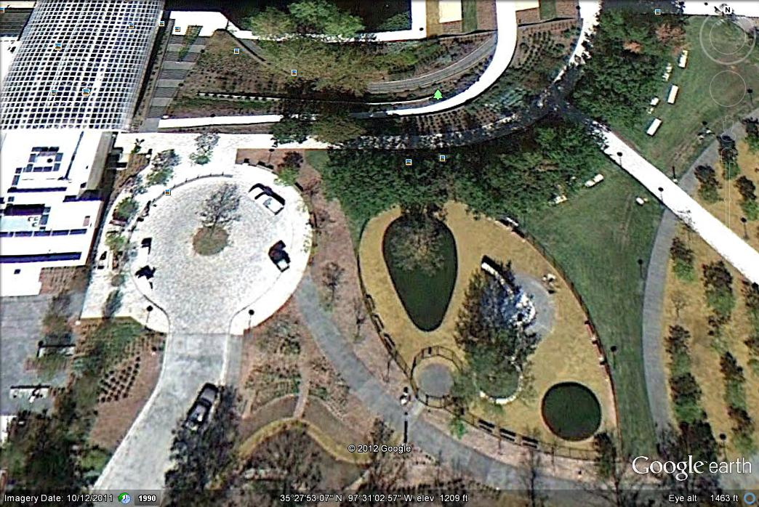
Image 3.1 Google Earth screen capture accessed 4/28/2012
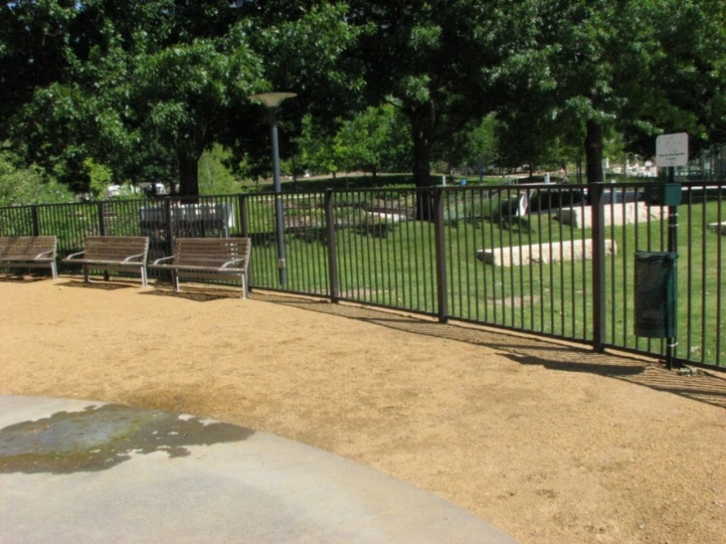
Image 3.2*All pictures by author unless noted
Shot of dog park Oklahoma City, OK

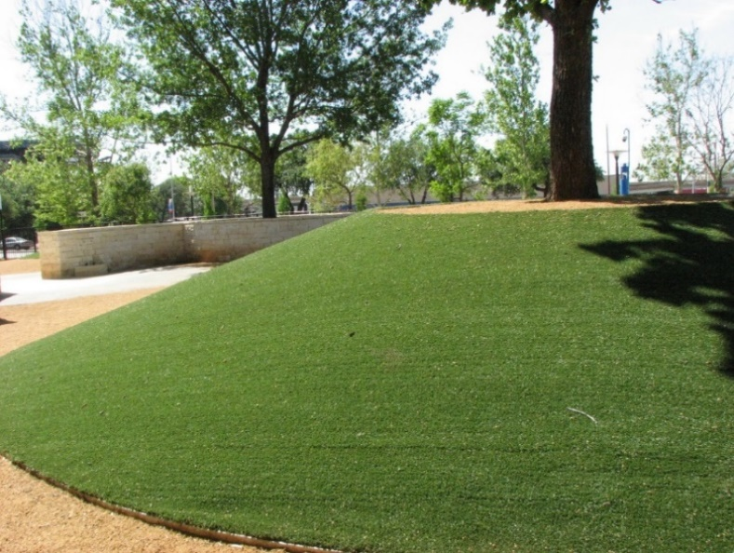
Image 3.3 Astroturf use at the Oklahoma City Myriad Garden Dog Park, OK

Image 3.4 Jason Cady demonstrating the dog water fountains.

Downtown Urban Dog Park, Dallas, TX
This is an example of a Type A Stage 2 because of the introduction of agility equipment into the mix. It is a unique park for many reasons. First is its location on one of the stops of the Deep Ellum light rail system (Image 3.5). It is a very small park, situated on essentially a grassy area that serves as a stop for the light rail, which consists of green space, a small play area for children, and small enclosed off leash park for dogs. It was established in 2009. This park has a 36-inch fence surrounding the park, with a very tight dog lock gate system at either end (Image 3.6). This park is completely paved, and includes poured concrete features that serve as both agility equipment and as sculpture. Shade in the form of pavilions and benches do exist for the human visitors. The concrete has been tinted, possibly in response to the high reflectivity of un-tinted concrete. However, given the location and its proximity to the asphalt paved road and the fact that it is completely paved, it is probably very uncomfortable in the heat of summer. Although the park is situated in an area of high density housing, the size of the fence suggests that the target audience are small dogs; however, this observation is confused by the scale of the included concrete sculptures/agility course, which would be outsized for very small dogs (Image 3.7). Also the gap under the fence although small, about 3-4 inches, would be sufficient for a very small dog to go through. During the visit we observed several mid to large sized dogs being walked in the vicinity, none of these dogs or owners visited the park. An informal conversation with one of the dog owners provided confirmation that this sized animal rarely used the park, preferring to walk on leash in the grassy area. One reason cited was the inability to romp, given the confined space.
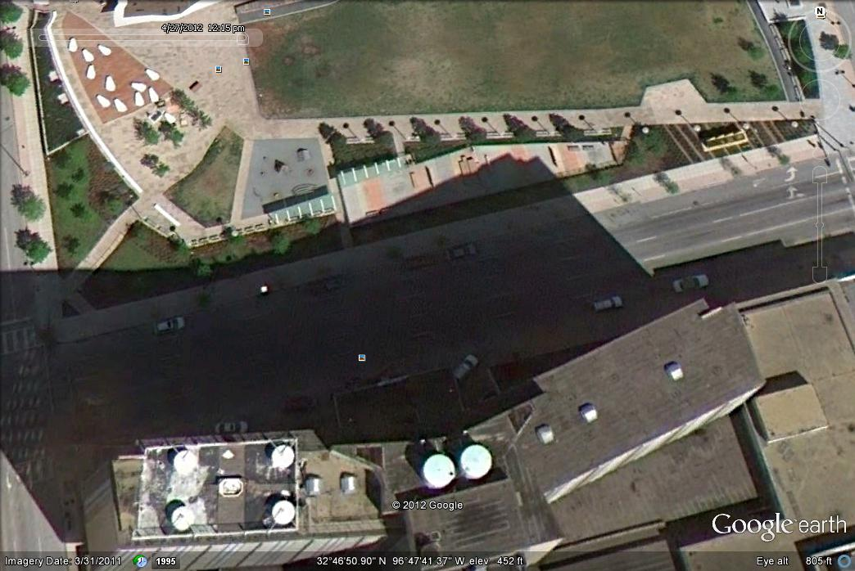
Image 3.5 Google Earth screen capture accessed 4/20/2012
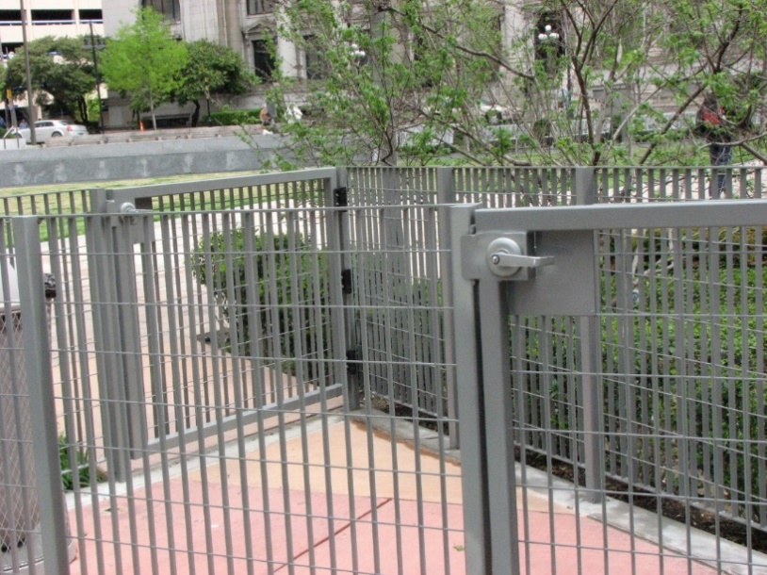
Image 3.6 Gate detail Dallas, TX
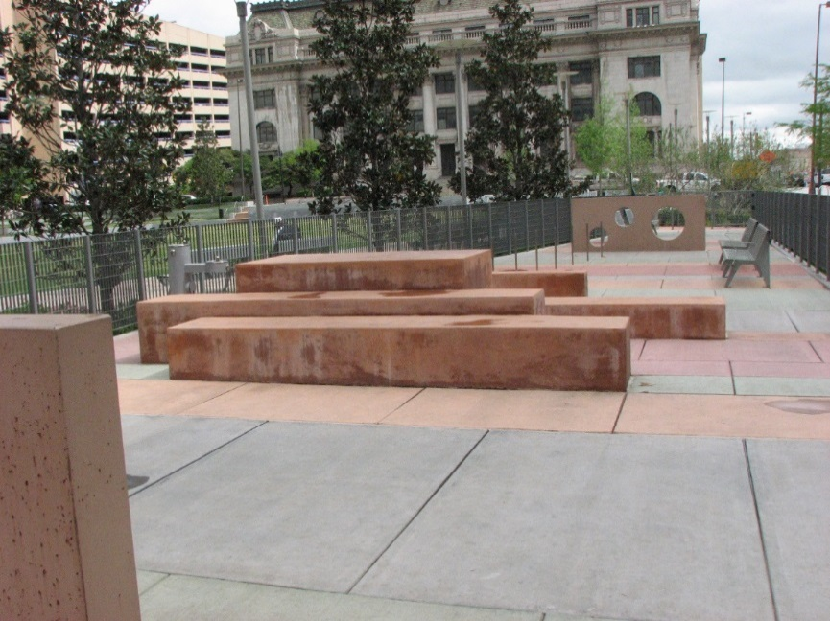
Image 3.7 Concrete features Dallas, TX
Type B Dog Parks
Oklahoma City, PAW Park, OK
This is a Type B Stage 3 dog park because of its large size and the availability of the water feature. This is a large park, approximately three acres in size and was opened in 2003. This park has a small dog and large dog section. The large dog section is significantly larger than the small dog section (See Image 3.8). It also employees the dog lock gate system, although in this case there is a dog lock gate used for an entrance and exit to both of the sections (See Image 3.9) This park contains a large water feature that dominates the north end of the park. There are dogs in the pond feature during warm weather. Erosion of the area around the water feature has been tackled through a terraced design, although some of the construction techniques used are not to code, such as the steps, and the retaining wall is not as effective as could be (See Images 3.10 and 3.11). This park suffers from turf issues, including large areas that have little or no turf left due to the high traffic experienced by this park, and therefore is uncomfortable to visit on dry windy days due to the dust that flies into the air. Some landscaping has been undertaken mainly through tree planting; however, this has not alleviated the need for shade and to address the immediate need nice shade pavilions have been added.
Safety concerns noted with this park include the proximity to the interstate, as the park is adjacent to the interstate. A double layer of 6-foot chain link fencing has addressed this concern. The water feature poses unique difficulties in containment and poses some safety concerns. This has been addressed through fencing of the drainage system that feeds into the pond and through a floating barrel barrier on the far end of the park. However, while on site I overheard one patron describing how her dog had jumped the barrier and that she had had to give chase to bring him back, and during my fieldwork I observed one canine escape artist at work. This type of floating barrier is probably the best solution due to the danger posed by fencing combined with varying water levels, which poses significant risks of drowning or chocking associated with the animal trying to go under fencing. However, it is not resilient to changes in water level and with the prolonged drought that Oklahoma is prone to this has become an increasingly pressing concern.

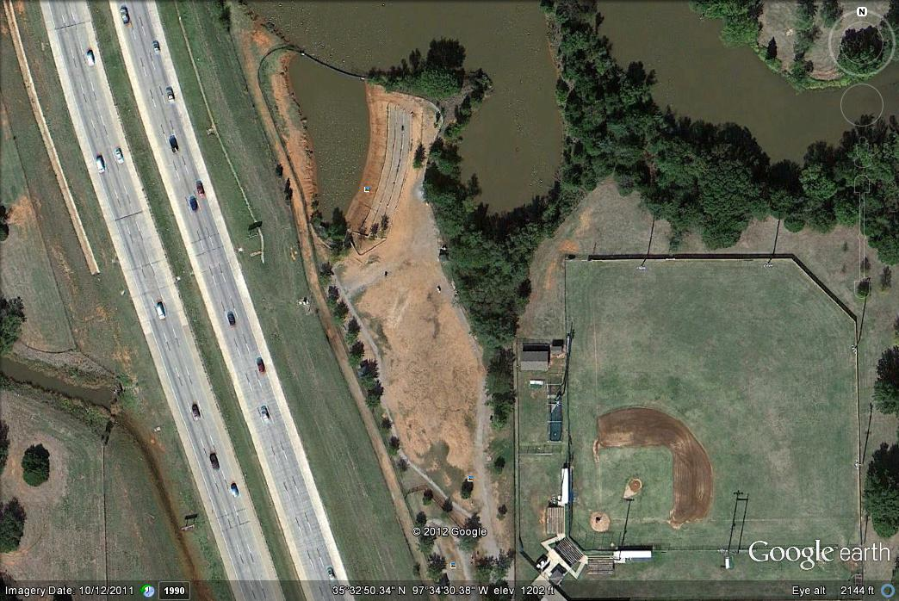
Image 3.8 Google Earth screen capture accessed 4/20/2012
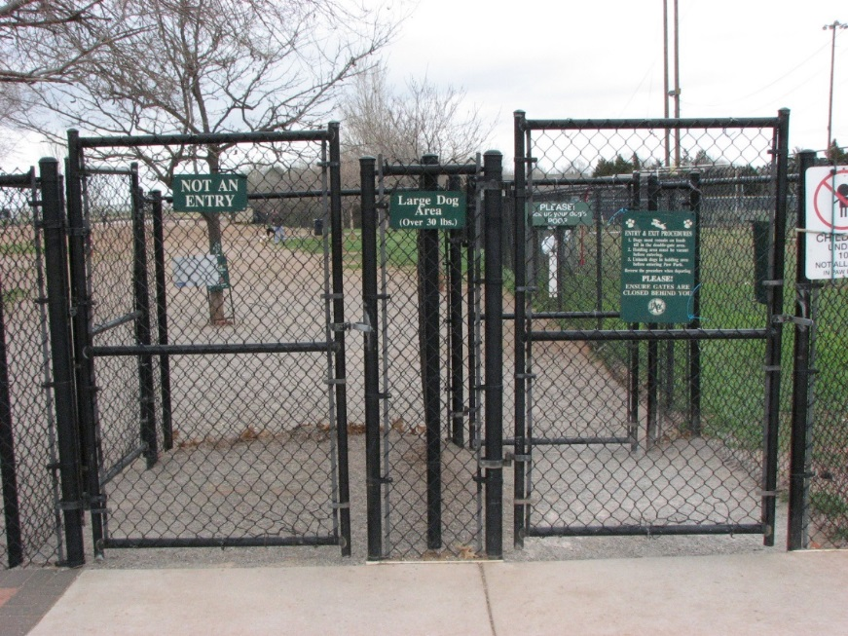
Image 3.9 Two way gate entrance Oklahoma City PAW Park, OK
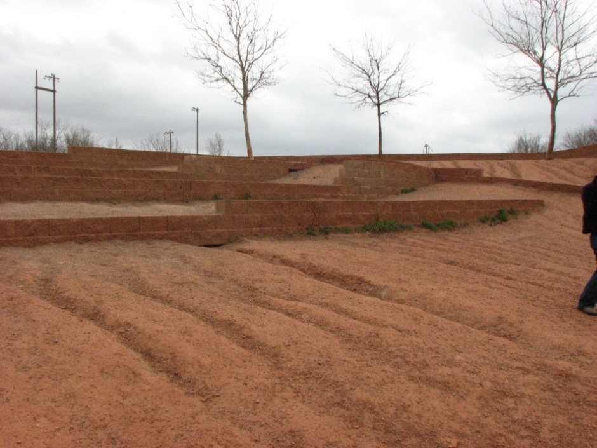
Image 3.10 Terracing Oklahoma City PAW Park, OK
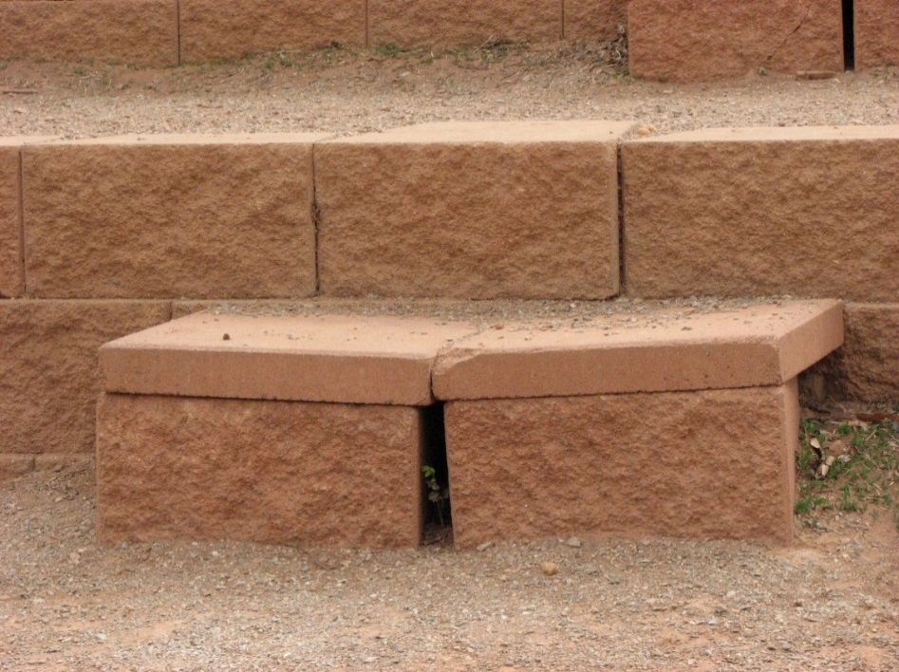
Image 3.11 Steps Oklahoma City PAW Park, OK

Pets and People Dog Park, Yukon, OK
The Pets and People Dog Park in Yukon, OK is one of the oldest dog parks in Oklahoma, established before 2000 (See Image 3.12). Due to the unique multiuse format I struggled with the designation of this park. I decided that Type B Stage 2 was the most appropriate designation because of the emphasis on resource management and maintaining the usability of the park for all parties concerned. It has the familiar two sized dog park layout, only in this case they were labeled as general dog park and agility area. However, the non-profit that runs the dog park uses the agility area as a holding pen for some of the larger dogs. The agility course has since been incorporated into the larger dog park. This park also has a pond with access for the dogs; however, the pond is included entirely into the fenced in area of the park. This park is unique among the parks that were visited in that the park had several functions; the first was a municipal park with access for the public. The posted hours are noon to dusk, and it is requested that visitors register as members, although membership is free. Before noon the non-profit group uses the park for exercising the dogs in their care. Also, prospective adoptees can visit with the dogs that they are interested in in the neutral setting of the dog park, even introducing the potential new addition to existing pets through this venue. The park design is typical of dog parks, although it is in a more rural setting. The fencing is a little low at 48 inches; however, there does not seem to be any concern or issues with the animal’s safety. The agility equipment was in good repair for the most part, and the pond seemed like it was well maintained. Amenities for the human visitors were not abundant, although there were some benches and tables provided, several of which were built as boy scout projects, emphasizing the ability of these parks to become a fixture in the larger community. An informal trail ran around the perimeter of the park, which was useful for human exercise (See Image 3.13). Some landscaping in the form of tree plantings had been undertaken, although there was little usable shade. Unlike many of the other parks, this park seemed big enough that the turf was in good condition.

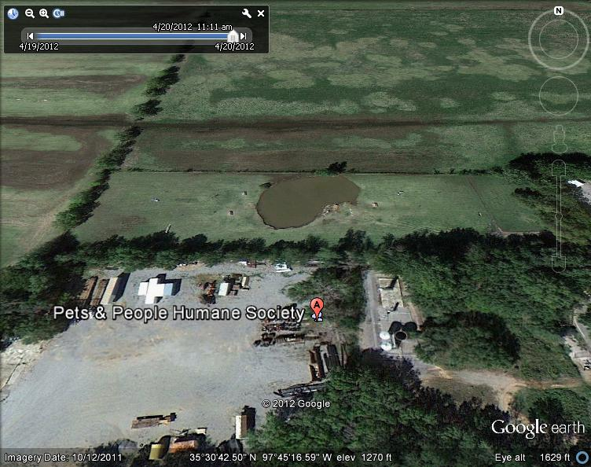
Image 3.12 Google Earth screen capture accessed 4/20/2012
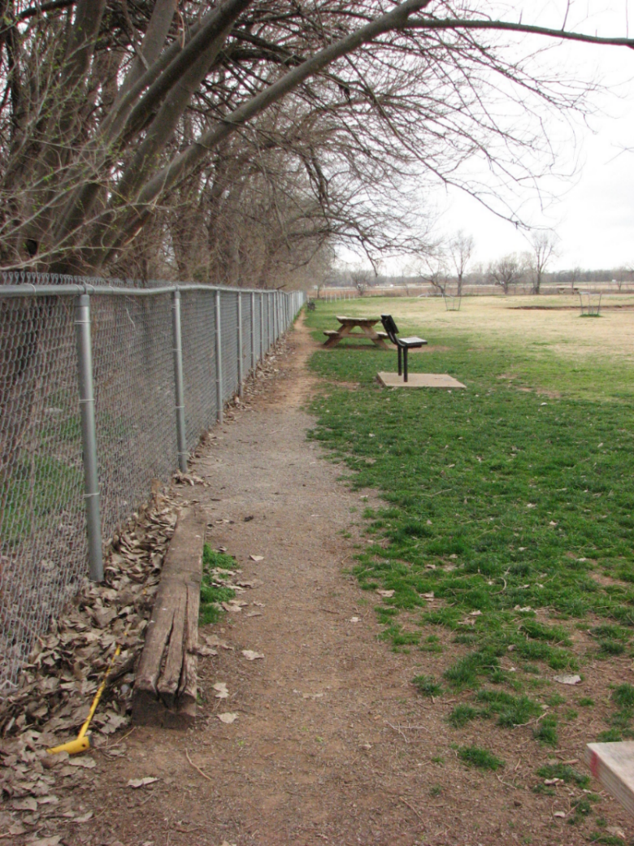
Image 3.13 Trail Pets and People Yukon, OK
Tails and Trails Dog Park, Arlington, TX
Tails and trails in Arlington, Texas is Type B Stage 3 dog park. It is located near other municipal buildings, including the animal welfare and adoption center (See Image 3.14). However, unlike the Yukon dog park, this one is not utilized by the shelter. In fact, the animals in the shelter’s custody are not allowed off the facility’s grounds due to liability issues. This park was established in 2007 and utilizes the small dog and large dog format over a large area, with just under six acres total (5.7 acres). The main amenity of this park is the wooded area that allows the dogs and their owners a trail-like experience (See image 3.15). These wooded areas are in both the small and large dog sections. The tree cover is very nice, as are the trails. Security lighting is provided in the wooded area. Parking was available the day I visited, although I was told by a city employee that that was not always the case. One concern associated with the park was the underbrush in the wooded areas providing a haven for ticks. Visitors to the park said that the underbrush was mowed periodically, although tick control was not practiced chemically due to the lack of an organic option. At the time of the site visit in 2012, the turf in the small dog run was in much better condition than the large dog area. Some dog parks alternate the sides to allow the turf to recover, and this particular park did not do this, although the different sections are similar in size.
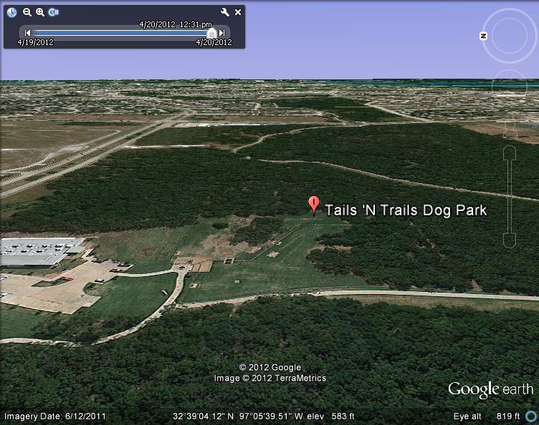
Image 3.14 Google Earth screen capture accessed 4/20/2012
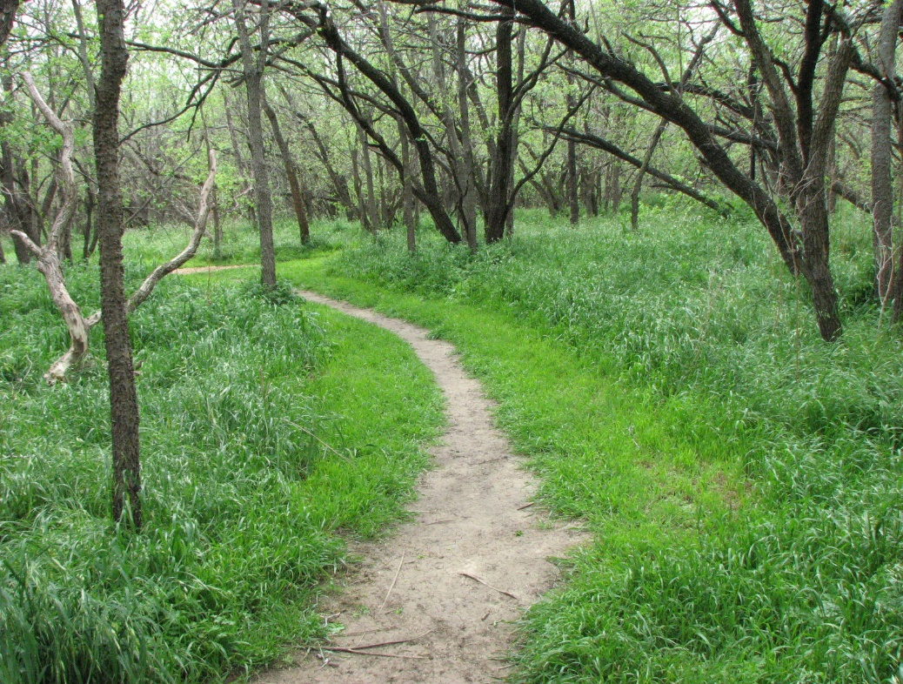
Image 3.15 Trail at Tails and Trails Park Arlington, TX

Wiggly Fields Dog Park at Ray Trent Park, Del City, OK

Wiggly Field is an example of a Type B park at Stage 3. This park is an example of how a community dog park can grow and evolve to meet the needs of the community. This is a mid- sized park at about two acres, with the standard two-section design (See Image 3.16). However, since its creation in 2006, many improvements have been undertaken, including the addition of agility equipment (Image 3.17), shade structures for the humans (Image 3.18), and a misting pad for the dogs (Image 3.19). It is incorporated into an existing park located on the access road off the interstate. Because of this access issue, and the addition of a new dog park in nearby Midwest City that is much more accessible, this park has seen its attendance plummet, despite being one of the larger dog parks available. However, it is well maintained and the turf has improved as attendance has diminished. Many informants who prefer this park have larger, more active dog breeds, such as retrievers or guard dogs, and like the uncrowded nature of this park, although socializing with other dogs is not an attainable goal with spotty attendance. This community has banned pit bulls and the park is marked with signs banning pit bulls, although I observed at least one pit bull playing in the park uncontested.

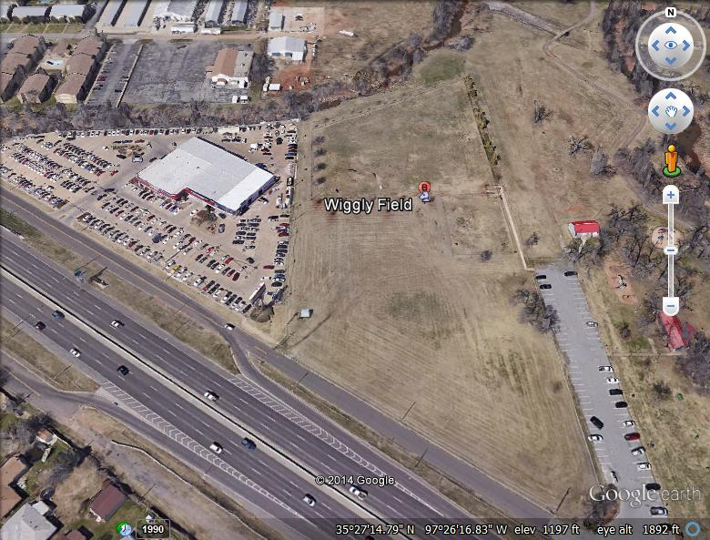
Image 3.16 Google Earth Screen Capture Accessed 12/23/2014
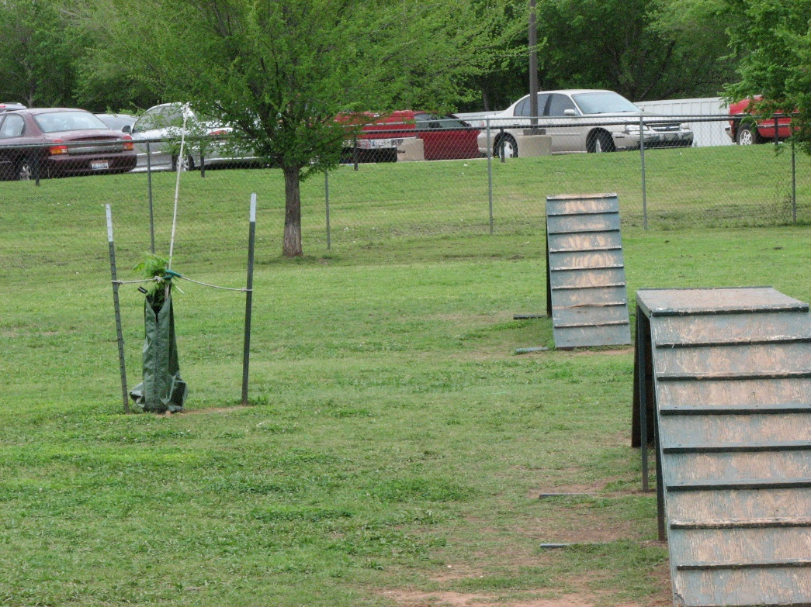
Image 3.17 Agility course Del City, OK
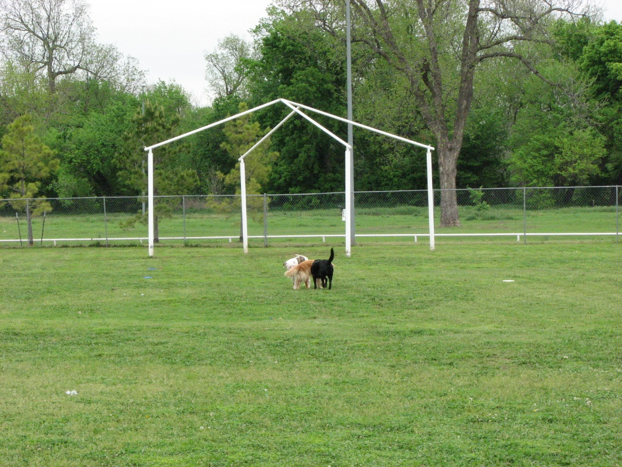
Image 3.18 Shade structure Del City, OK
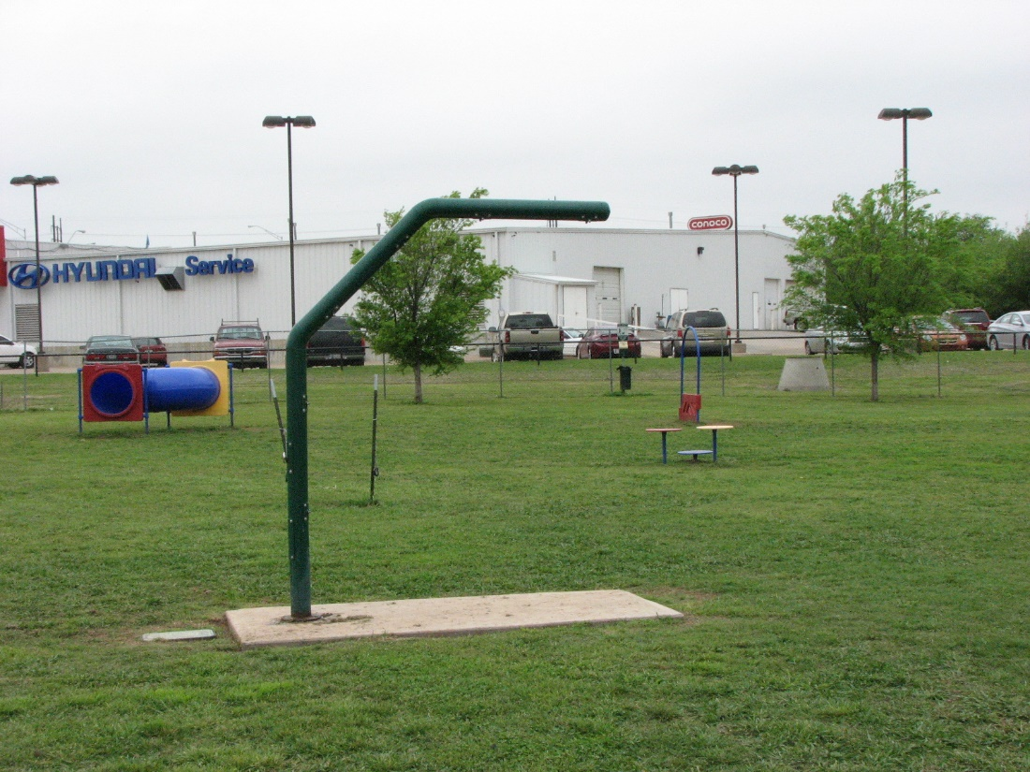
Image 3.19 Mister Del City, OK

Edmond Dog Park, Edmond, OK
I was torn as to what stage to put this Type B dog park because it allows for pond access through the park. However, the pond is not contained within the park so it is a Stage 1 park. This park was established in 2006, and is quite large boasting a total area of four acres (See Image 3.20). The inside of the park is well designed with a sizable small dog area and a very large large-dog area. The park has partnered with a number of local businesses who sponsor benches in the park through advertising on them. Dogs and their humans can access the pond through a gate in the back of the large-dog section (See Image 3.21). A shared parking lot connects to the dog park by a paved sidewalk and bridge (not handicap accessible) across a creek that leads to the dog park (See Images 3.22 and 3.23). The sidewalk is nice and wide but the bridge has no guardrails and the whole creek area has very little visibility and is frankly, creepy. The actual access to the dog park is through a narrow sidewalk that runs parallel to a very busy four lane road and is separated by a short fence (See Image 3.24) and the dog lock gates are as tight as some of the pocket parks that have much smaller actual park areas (See Image 3.24). The associated share parking lot is very spacious, as is the actual park, and the water access is especially nice, although it sets people with small dogs in an awkward position of having to use the large-dog area to access the water feature if they choose. The access and traffic really posed some safety concerns for the animals, although the park is well used and everyone with whom I talked had good things to say about the park.
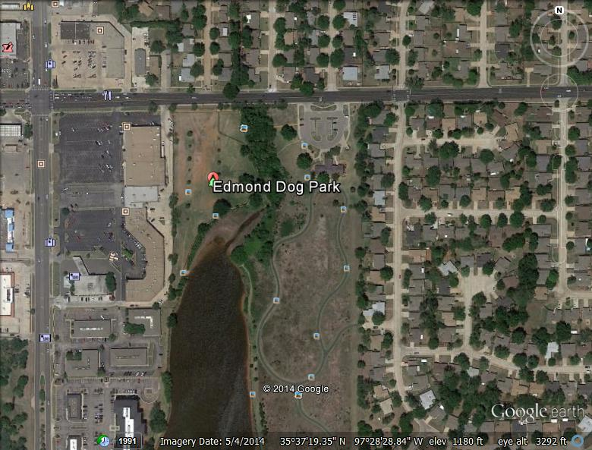
Image 3.20 Google Earth Screen Capture accessed 11/4/2014
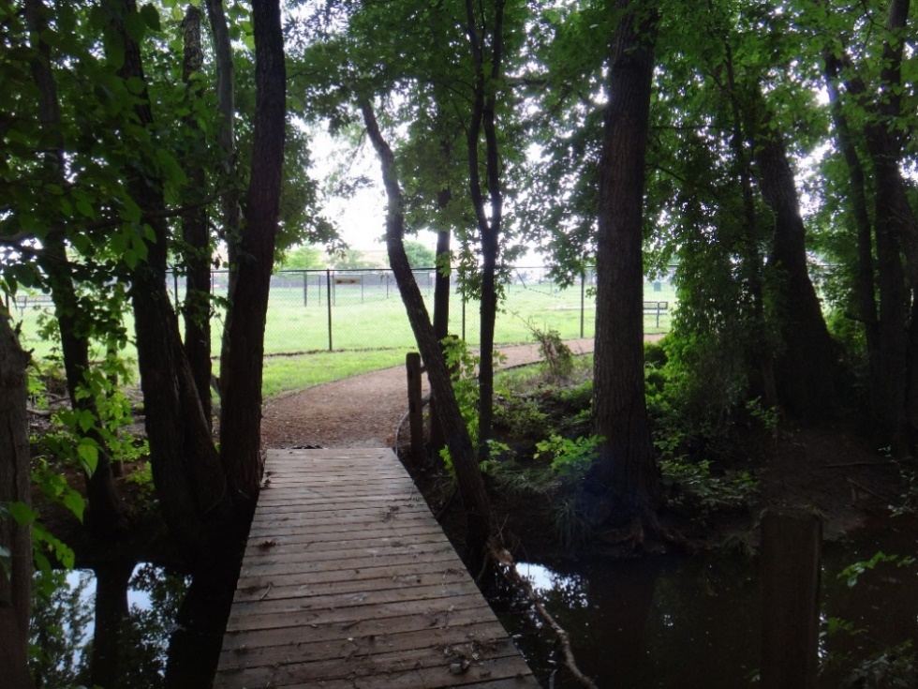
Image 3.21 Bridge in entrance Edmond, OK

Image 3.22 Pond access Edmond, OK
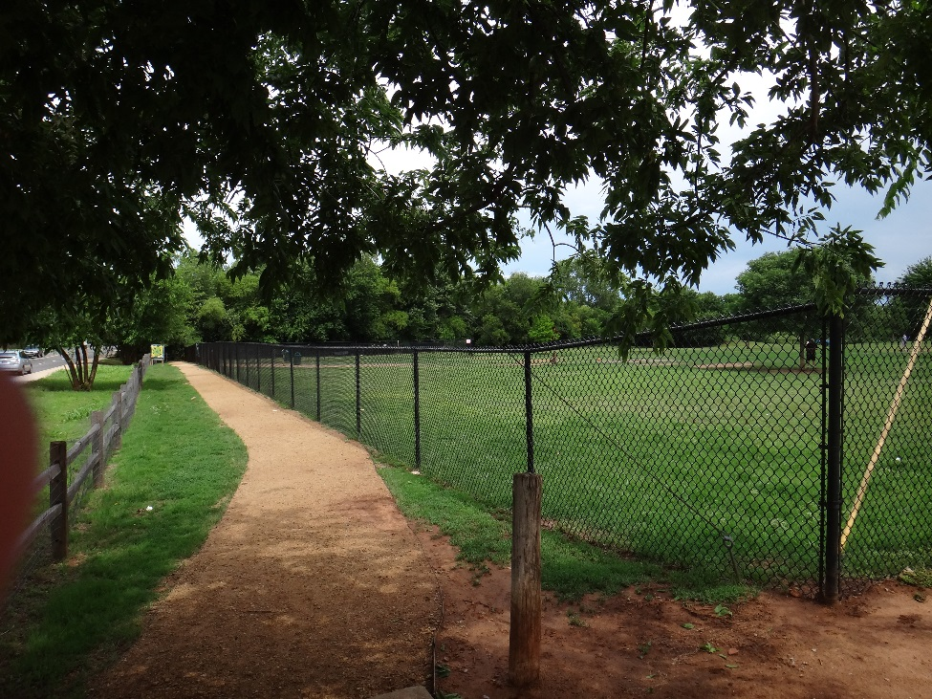
Image 3.23 Walkway entrance Edmond, OK

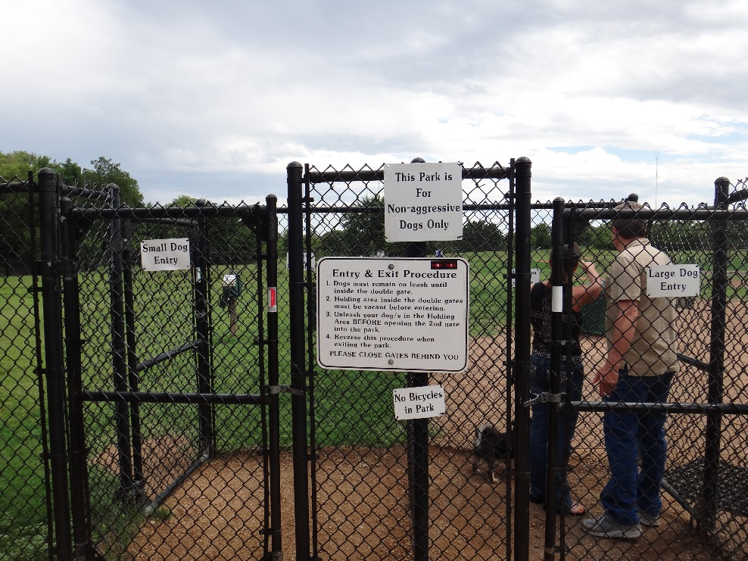
Image 3.24 Dog lock gate entrance Edmond, OK

Biscuit Acres Dog Park, Tulsa, OK
Biscuit Acres opened in 2009, and is located on two and a half acres of land in Hunter Park. The park has enjoyed a large investment of funds and as a result has number of benches and tables for the humans to use, a watering system for the dogs, and has been ranked as one of the top 25 (No. 24 to be exact) dog parks in the United States (Jones 2014). This is an example of a Type B Stage 3 dog park; I feel that even though there is no actual water feature or obstacle course, this dog park is nice enough and offers amenities that draw people in from the surrounding area (See Image 3.25). The park’s theme is “Where dogs bring their people.” This park is really nice in general, but the dog park is located across the road from the paved parking lot and there are embedded trails and a separate children’s play area in the vicinity. This park is marked as not allowing children under 12 in the park. In fact, the web page for the Tulsa Dog Parks makes clear that this requirement is being enforced through ticketing. On my visit there in October 2014, I saw parents at both dog parks that were working together with their spouse/partner inside the dog park, i.e., one took the kids and the other one took the dog. The park has the two-part dog park, with a separate small and large dog section which can be accessed by a fence in between (See Image 3.26). There are a number of established trees and quite a bit of seating (Images 3.27). Both of the Tulsa dog parks have nice grass turf, this is explained by the naturally occurring increase in precipitation in this part of the state, as well as the fact that the dog park is closed for two days a week for maintenance.

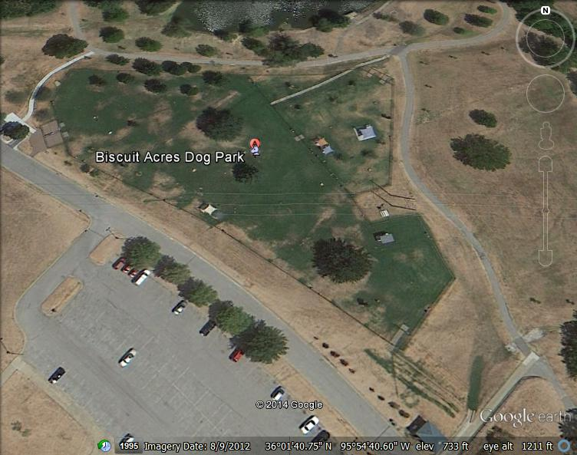
Image 3.25 Google Earth Screen Capture accessed 11/4/2014

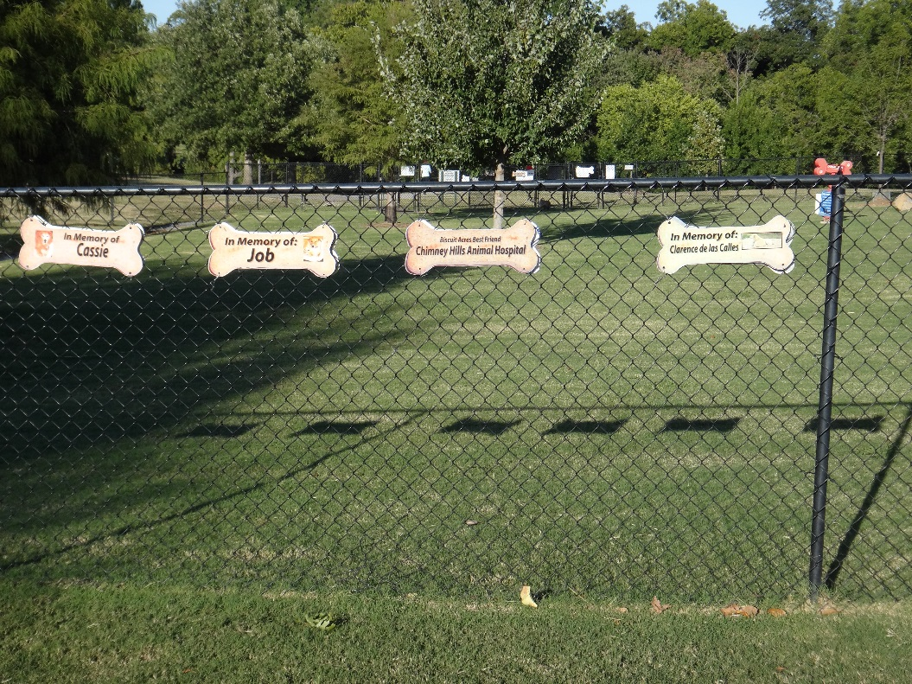
Image 3.26 Memory signs Biscuit Acres Tulsa, OK
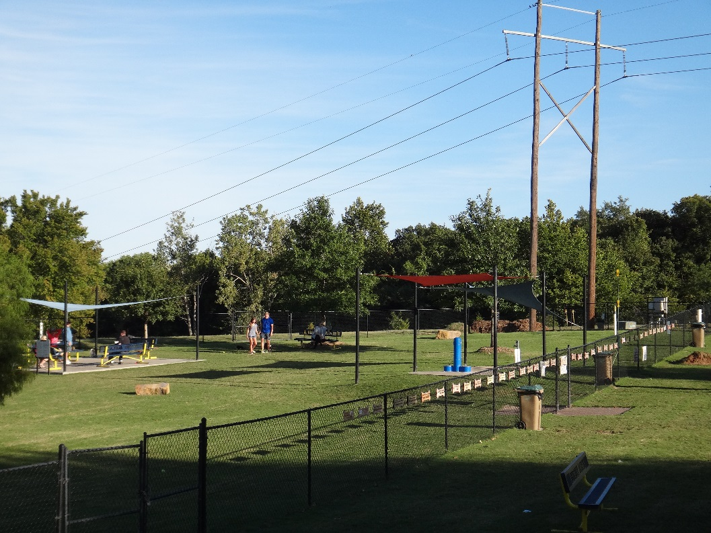
Image 3.27 Shade structures Biscuit Acres Tulsa, OK
Joe’s Station, Tulsa, OK
Joe’s station is a well-designed example of a Type B, Stage 2 dog park. This park, which was established in 2008, was built on the site of an existing baseball diamond, and is therefore an example of the repurposing of public space to meet new needs of the community (See Image 3.28). The dog park was constructed by fencing in the diamond and putting a divider fence down the center of the field, and because of this the two sides are almost identical in space. This stood out to me when I visited since I am used to the small dog section being markedly smaller, compared to the large dog section. The actual entrance has been expanded to include the paved area behind the original home base, and this affords a very comfortable entry into the park (See Image 3.29). The park is well maintained and had an enviable grass cover. Through a conversation I had with one of the visitors, I found that they swap the sides between small and large dogs, which may help with the maintenance of the turf. The park is a very pleasant place, with trees that have been planted to provide shade and picnic tables and benches scattered around. You have room to spread out in this park and although there were a number of visitors at the time of my visit it did not feel as hectic as some of the other parks I have visited, although I do not know if I was there during a peak time for this particular park. Again, I observed the restriction against children under the age of 12, with one couple working to meet this demand on the visit, one taking care of the baby outside of the park and the other going in with their two puppies.
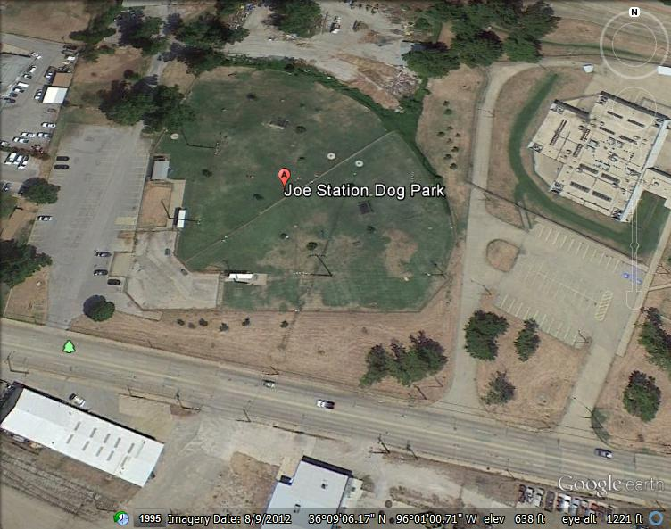
Image 3.28 Google Earth Screen Capture accessed 11/4/2014
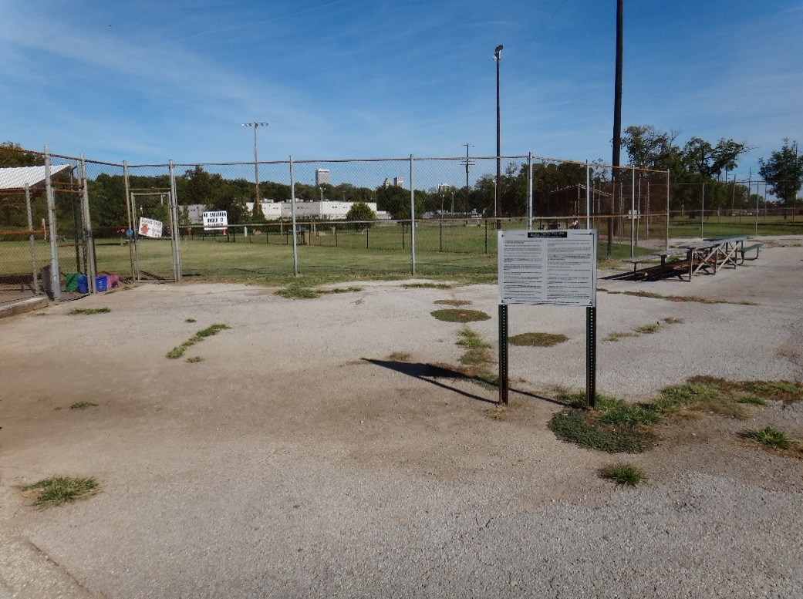
Image 3.29 Entry way Joe’s Station Tulsa, OK

Type C Dog Parks
Norman Community Dog Park, Norman, OK
The Norman Community dog park is an example of an evolving dog park which is responding to demand as funds come available. This dog park started as a basic two-part park with a section for small dogs and a larger section for bigger dogs established in 2005 (See Image 3.30); however, an expansion in 2013 added a third section to the large dog section making this an example of Type C Stage 1 dog park (See Image 3.31). This section has its own dog lock entrance on the perimeter and was furnished with irrigation. It is assumed that the two parts of the large dog section can be shut off to allow for maintenance and rest periods, although I have not seen this done yet. Water is offered in the form of communal bowls on a concrete slab clustered around a spigot. Landscaping is kept to a minimum. There have been small trees planted and these are protected by water tents to minimize the damage that can be done by dogs, either through chewing or digging, or through constant exposure to urine. A number of benches have been donated to the park, and these are concentrated in the shady areas of the park. This pattern often results in a more spread out pattern of use of the park. The turf is rough, with patches of high traffic areas having nothing but bare compacted soil; this is a consistent problem with dog parks. Parking appears to be sufficient; however, there is not enough shade for either the dogs or their owners. Overall this park is a well- used dog park and is a comfortable and friendly place to be.
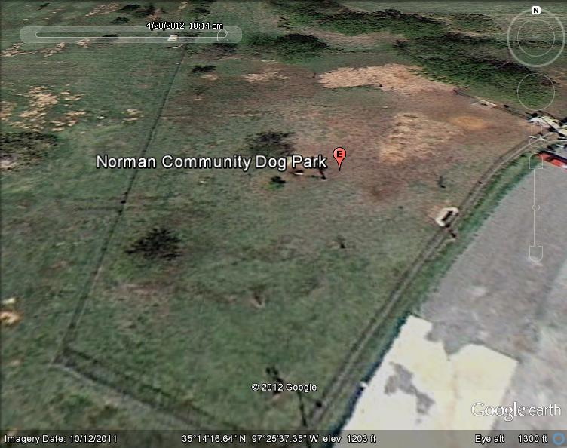
Image 3.30 Google Earth screen capture accessed 4/20/2012
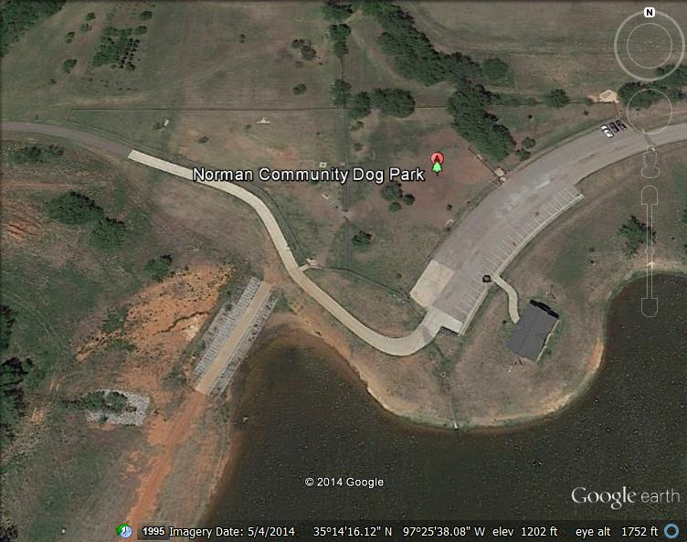
Image 3.31 Google Earth Screen Capture Accessed 12/22/2014
Fred Quinn Happy Trails Dog Park at Joe B. Barnes Regional Park Midwest City, OK
This Type C Stage 2 dog park opened in the summer of 2012. It is a well-designed dog park that is placed in the large, centrally located park in the city. It has three sections, the traditional large and small dog sections, and also a smaller section that offers a wading pool for the dogs that is separated from the large dog section by a gate (See Image 3.32). Because of the established nature of the park that it was placed in this park enjoys established shade trees. The designers have added in elements of landscaping that act as an agility course consisting of wide bridges that offer culverts going under them to allow dogs to get acquainted with going through and over obstacles. The small dog section is markedly smaller but is well designed and offers plenty of seating for guests (See Image 3.33) and the large dog section is very large (See Image 3.34). There is ready access to parking directly outside of the park and the park is well utilized. The only potential problem I can see with this park is the close proximity to a housing development, as the park backs up directly to the back of the neighborhood (See Image 3.35).

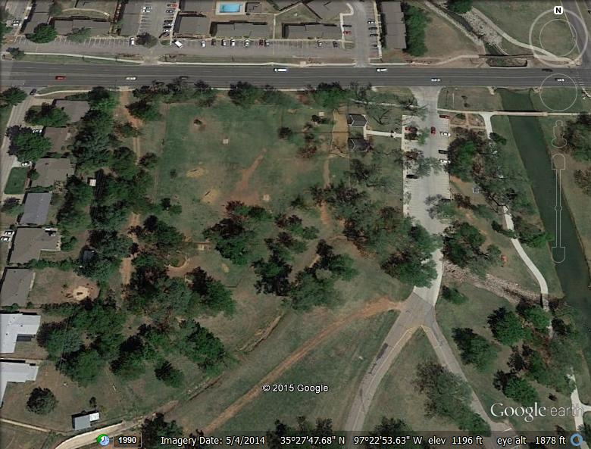
Image 3.32 Google Earth screen capture accessed 1/27/2014
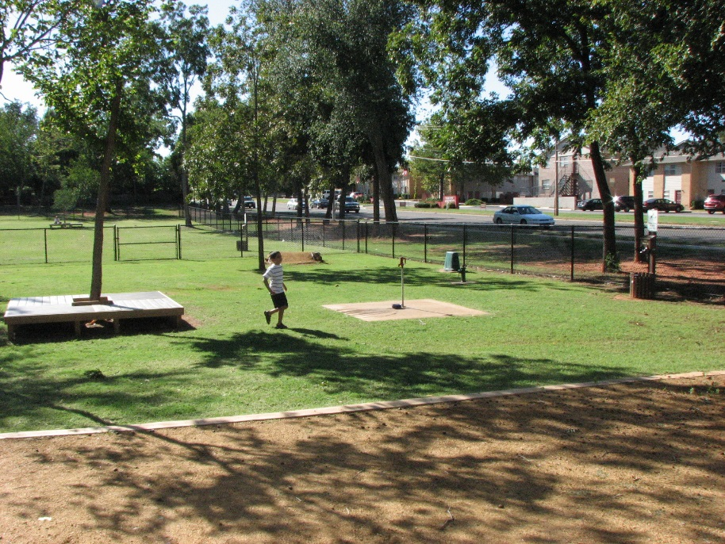
Image 3.33 Midwest City, OK

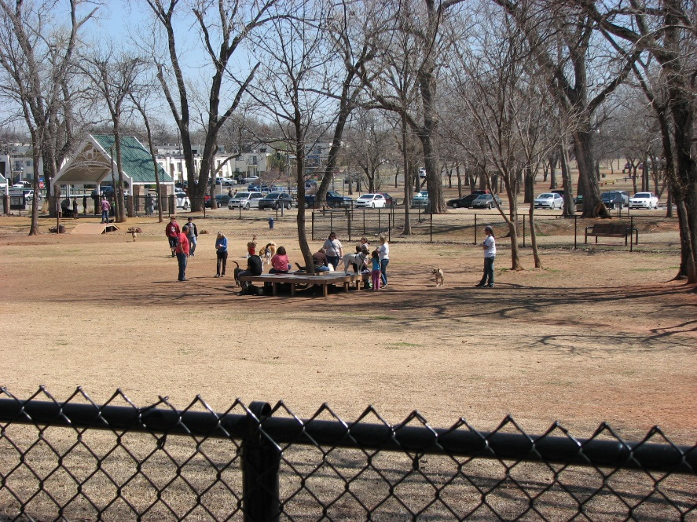
Image 3.34 People visiting at dog park Midwest City, OK
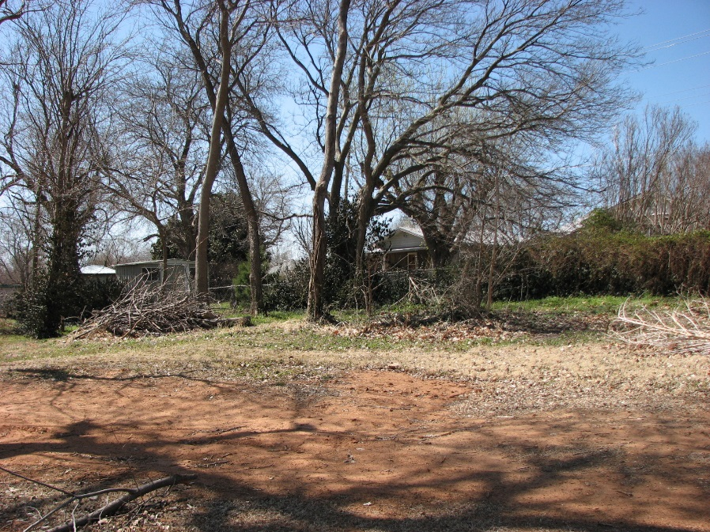
Image 3.35 The dog park backs up to a housing area Midwest City, OK

Wiggly Field Dog Park, Denton, TX
The Denton dog park is significantly lager in size than the Norman dog park; however, it is similar in layout (See Image 3.36). The park opened in 2006 and is another example of a Type C, Stage 1 dog park. The function of the third section was not immediately clear because it was completely separate with its own entrance and no gate leading to the other sections of the park (except for a maintenance gate that was locked). Originally, it was hypothesized that it was used for obedience and socialization training. On asking some of the people visiting the park that day I was informed that it was reserved for puppies that were too young to have received their vaccinations, as well as aggressive, or anti-social animals, that needed time to adjust to the situation. This was a unique feature that was not encountered in any of the other parks that were visited as part of this study. Again, there was the basic layout with separate sections for the different sized dogs and with the dog lock gates. In this case, the gates did not have a latch system in place, and relied on hinges that returned the gate to the closed position (See Images 3.37 and 3.38). One concern was immediately clear, and that was on a windy day, the gates swung open. Some of the visitors were improvising and used their leashes to secure the gates. However, the patrons said that these conditions were rare, and that they actually preferred this gate. It was conveyed that this had helped with handicapped accessibility, as well, and one of the regular patrons was in a wheelchair. Even with this potential problem, the dogs that visit the park are usually eager to gain entrance to the park, and are very reluctant to leave the park under any condition.
Some established trees provided shade, and a few covered seating areas provided some shade. The usual issues with turf quality existed; although due to the larger size of the park overall, it was not as severe as some of the other parks. The three-tiered water fountain was found near the entrance gate in both the large and small dog areas, as well as the slab with the bowls concentrated around the spigot. There was not much in the way of landscaping efforts, and few trees had been added. The parking lot was some distance away from the park, but it was quite large and there seemed to be no difficulties with either parking or access, since a nice wide paved sidewalk lead up to the park entrance.

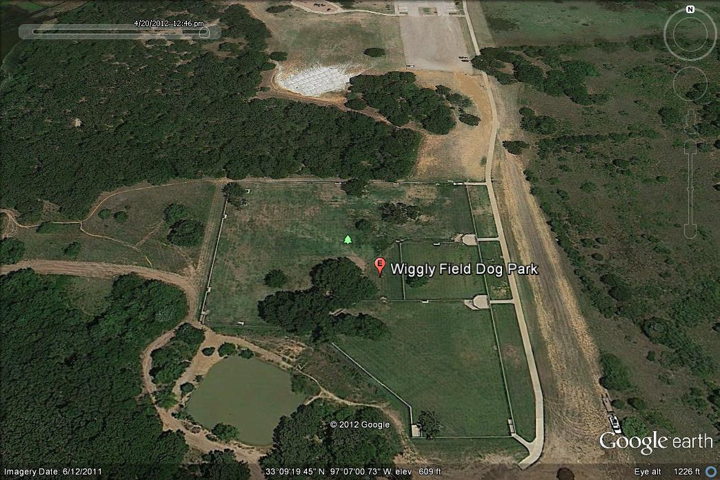
Image 3.36 Google Earth Screen Capture accessed 4/20/2012



Image 3.37 Gate detail Denton, TX
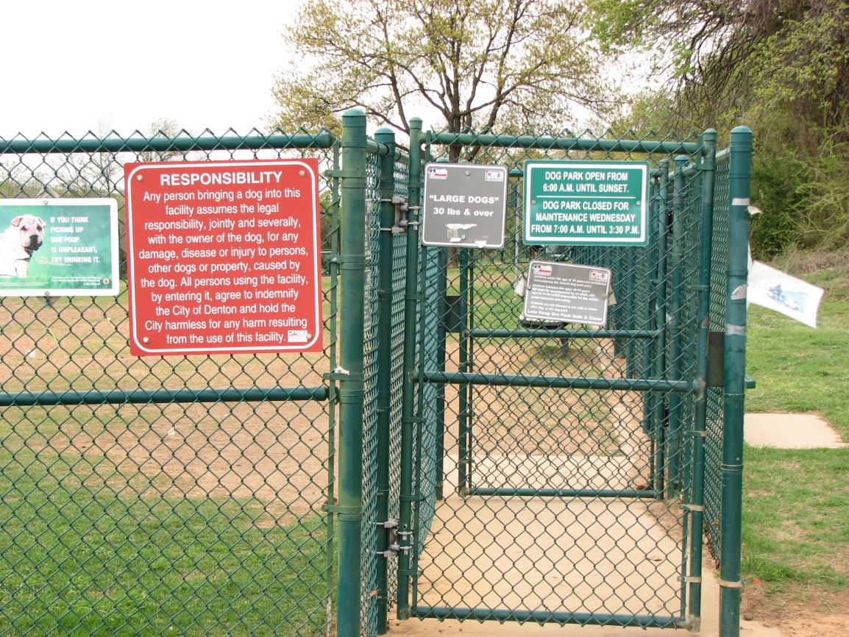
Image 3.38 Dog lock gate system Denton, TX
Type D Dog Parks
Mocking Bird Point, Dallas, TX
Mocking Bird Point dog park is an example of a Type D Stage 1 dog park (See Image 3.39). It is a little smaller in size than the Oklahoma City Paw Park (at 2 acres); however, it has similar access to water, without the barriers (See Image 3.40). This park was opened in 2001. Although this park is an example of an early adoption of the parks in this region, the layout of this park is a design that is favored by the newest dog parks in Dallas. The water access is provided by a separate gateway and sidewalk (See Image 3.41). This design allows the dogs who are exercising in the water to have access only to the water, minimizing the problems with blocking the movement of the other animals. This also helps to lessen the mess with wet dogs rolling in the dirt in the dog park proper. The water access has no barriers to access of the larger body of water, being constructed from a sunken boat ramp. The water access went through an area of trees and underbrush and it was clear even early in the season that mosquitoes would be a large problem. This raises concern for the transmission of heartworms, which are transmitted through mosquito bites. Not to mention that it was unpleasant for the human visitors. Trash accumulation along the waterfront was also an issue. This is one of the older parks in the Dallas metro area, and was not well placed, being placed in a low-lying area of an already existing park. It suffers from poor drainage, and has the usual issues with the turf. It also does not boast many amenities for the human visitors. In fact, there was an assortment of mismatched lawn chairs that people had left because there was a lack of benches (See Image 3.42). However, this park has been identified as one of ten projects for the centennial celebration and is slated to have a complete remodel.

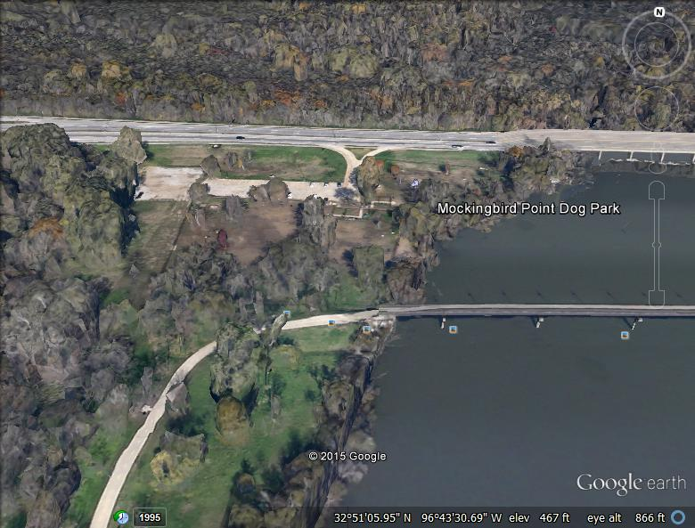
Image 3.39 Google Earth screen capture accessed 1/28/2014
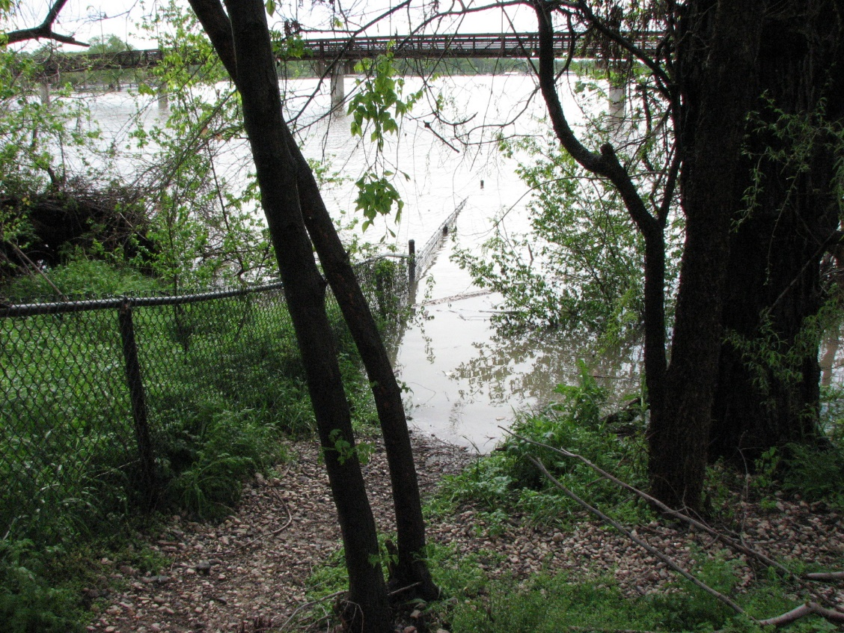
Image 3.40 Water access Dallas, TX
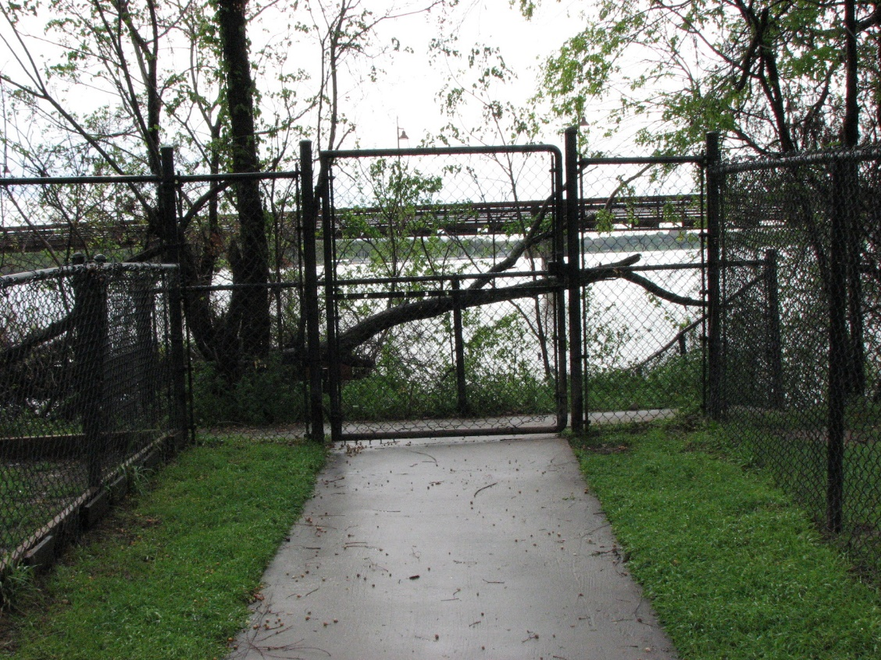
Image 3.41 Gate to water access Dallas, TX
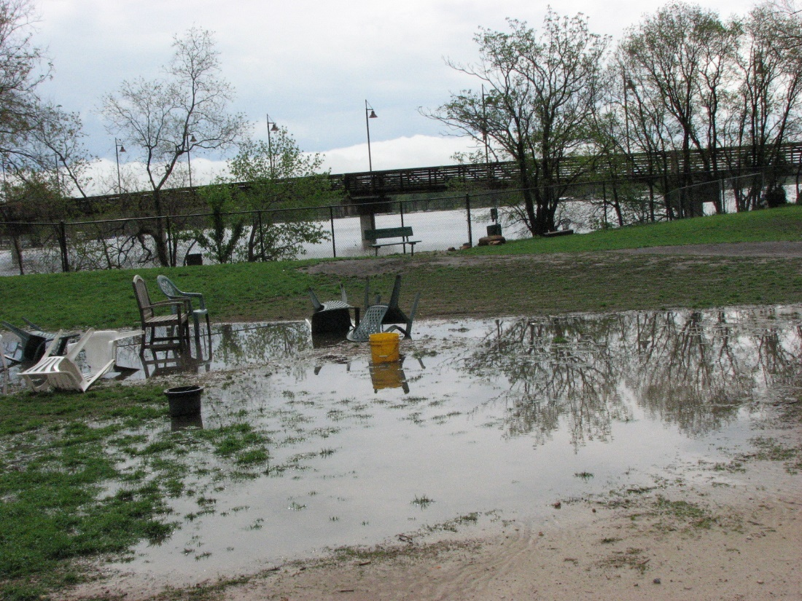
Image 3.42 Standing water Dallas, TX

Wagging Tails and North Bark Park, Dallas, TX
Two of the newest dog parks in the Dallas area, Wagging Tails (established 2010) and North Bark Park (opened May 2012), are very close to each other and were designed from the beginning by the city parks and recreation department; for this reason, I would classify both as Type D Stage 3 dog parks. As such, they avoid many of the problems associated with the other parks that were designed in a more ad hoc manner. In addition, there has been time for lessons learned in other dog parks to be applied from the beginning with these parks. Although Wagging Tails (Image 3.43) had limited space, the layout of both parks is efficient, and some of the problems associated with the Wagging Tails park were addressed in North Bark Park (3.44). For both parks a two park design separated by a sidewalk was utilized. Parking lots separate small and large dog sections. This set up allows for a separation between the varying sizes of dogs, resulting in a less intimidating experience for the smaller dogs. Existing trees were incorporated into the design and raised beds were used to provide both landscaping and seating options (Image 3.45). Wagging Tails has experienced some problems with dogs using the landscaping beads as launch pads to get over the fence; this was addressed in North Bark Park by increasing the distance from the fence for these features. Due to space limitations, Wagging Tails also has issues with parking availability, although this was unavoidable given the site. This was again addressed in North Bark Park where there was more space available. North Bark Park also boasts a dog wash for cleaning your animal off after visiting the water feature in the large dog section. Both parks offer water, and incorporate unique trash collection system that controls smell and compresses into an underground compartment eliminating tipped and spilled trashcans. The North Bark Park is one section of a much larger piece of land that will be developed into a multiuse park, incorporating the illegally constructed dirt bike trails, as well as hiking trails and more formal walking and biking trails. Dogs will be allowed on the walking trails on leash.
Both of these parks are located amongst high-density housing, with much of the North Bark Park being surrounded by condominiums and apartment buildings (Image 3.46). The park is also being used by the complex immediately adjacent for storm water containment, and this added to the budget to accommodate this multiuse component. Since these locations are close to such high-density housing, the audience is a little less ambiguous, and will provide access to the space in a walking setting, clearly adding to the appeal of the location. It is a public park and as such it was designed to attract other members of the community and parking has been provided inside the park, and in the case of the North Bark Park, is available on the street as well.

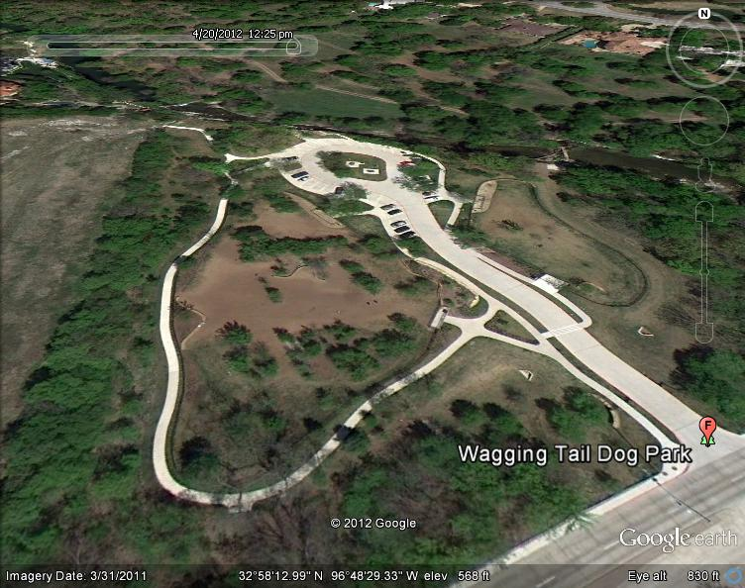
Image 3.43 Google Earth screen capture accessed 4/20/2012
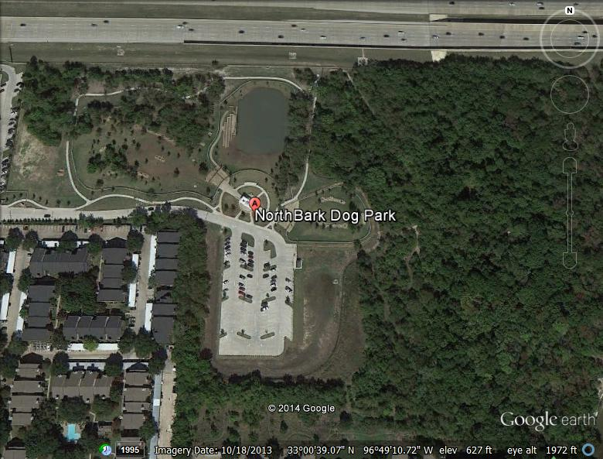
Image 3.44 Google Image screen capture accessed 12/23/2014
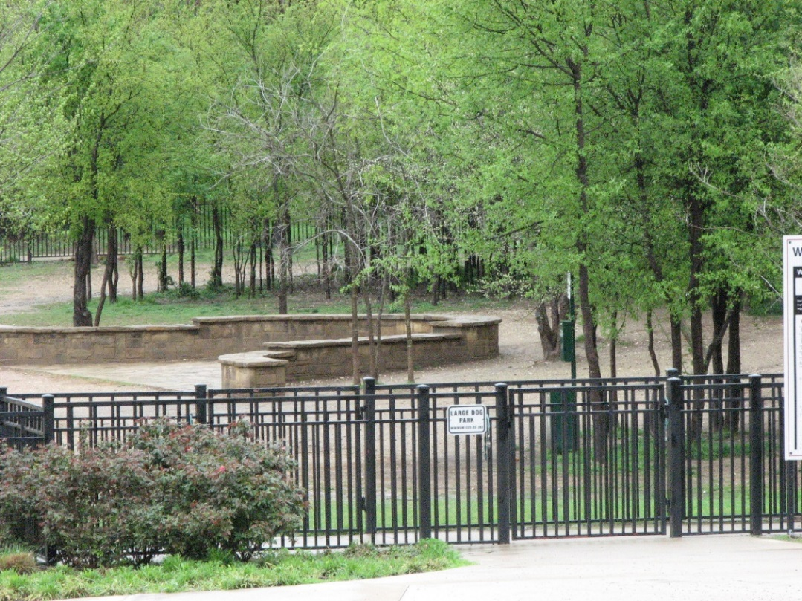
Image 3.45 Fence and seating area North Bark Park Dallas, TX
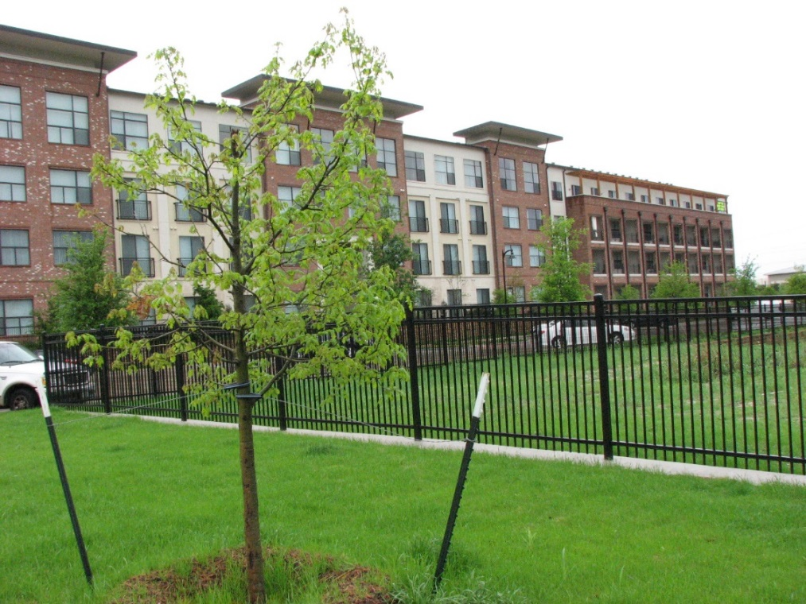
Image 3.46 Fence North Bark Park Dallas, TX

Discussion
This typology was developed to support a more analytical discussion about the forms that dog parks can take and the ways that these parks have developed through time. The different types are not meant to be value laden; the goal of the construction and development of these parks spaces is to meet the needs of that community, and to provide a safe place for both dogs and their humans to recreate. As has been demonstrated, many well designed dog parks, such as the Del City, Oklahoma’s Wiggly Field, dog parks suffer from other factors, in that instance the construction of a new dog park in close proximity that is more convenient for a number of people to visit. While other dog parks, such as the Yukon, Oklahoma example have evolved as the needs and use of the space has changed for the stake holders, in that instance includes the need of the non-profit that maintains and uses the park for the animals under their care.
Dog parks come in all shapes and sizes. Their development in this region started with the Yukon dog park in the late 1990’s, but the adaptation of the model really did not pick up until after 2005, and it continues today with a number of the parks opening after 2010. The vast majority of these dog parks employ the type B model that of two separate dog parks based on the size of the animals connected into one park system (See Image 3.47). This model is the one that is used most often throughout the country. One of the reasons for this is that it works, it significantly cuts down on negative interactions among small dogs and larger dogs, it helps make the space function easily, and the added size requirements are not so large that it negatively affects the ability of a community or municipality to incorporate this type of space into their park system. Significantly, the type D model, that of the parks for the different size animals being separated physically has been most utilized in the Dallas/Ft. Worth area. The newest parks built in this market utilize this model, and these parks have the distinction of being designed by park and city planners from the start, something that is not shared by the rest of the dog parks in this case study.
If the parks and their evolution are examined from a chronological standpoint, then some interesting trends emerge. First, the earliest dog park among those included in this discussion is Yukon’s dog park; it is also one of the most unique, having been designed for use by the non-profit related to the city’s animal welfare facility. This is followed by the establishment of the Mockingbird Point dog park in 2001. This dog park employees the Type D design, which is not seen again until the latest dog parks to be established in the Dallas Texas area. The other dog parks utilize either the two or three- section dog park design, with some parks like the Norman Community Dog Park changing to a three section dog park as space and demand allow. The exceptions are the pocket parks, as both parks discussed in this section are relatively new additions to the urban landscape. These parks are mainly the result of restricted space and the target audience is smaller urban lap dogs. However, these smaller pocket parks are often fantastically designed and maintained, which is probably because of their size, which restricts the use that they receive.
One commonality among these parks is the use and modification of already existing park space to accommodate the addition of this new park type. Sports field complexes are a common area for the establishment of the dog parks, as can be seen in Oklahoma City’s PAW Park and Tulsa’s Joe’s Station, which is actually built on an existing baseball diamond. The most common placement of the parks are in areas of already existing park space. Norman, Midwest City, Del City, and Tulsa’s Biscuit Acres are all examples of how these types of parks can be worked into the fabric of already existing recreation areas. This arrangement works well for maintenance by the city, which is the most common arrangement among these parks in this study region, although other types of public and private dog parks do exist, as discussed in an earlier section of this dissertation. Another factor that favors this arrangement is that accessibility to the dog park is not an issue, and often other amenities, such as water access, restrooms, and security lighting are also in place in these areas.
All of the dog parks in this study seemed to function well. Other than the Del City dog park, which has experienced a large drop off in visitor numbers due to the opening of another dog park in close proximity, all of these parks were heavily utilized and the users were well satisfied. Most of the parks had some challenges or quirks that could be addressed, but very few had real issues that impacted their usability. The parks are separated into size groups for a reason: the larger dogs are often much more rambunctious and with the mix of ages and training, these sections can often be a little chaotic. Another nice addition were multiple access points into a park; this alleviated the pressure on a single entry point during high traffic times.
Dog parks represent unique challenges. The need for land to accommodate the dog park and assure its success often put these amenities in direct conflict with other municipal enterprises. However, there is great demand for these parks, as was conveyed to me by Mr. Lim, who said that dog parks are the most requested, desired, and discussed urban and suburban amenity in the Dallas area. I feel given the challenges and the parameters, including keeping a sufficient distance from neighborhoods to lessen the negative impacts such as smell, loud sounds, and increased traffic, that these parks work well. The reallocation of underused, unused, or undeveloped areas in already existing park space goes a long way into the increased acceptance of the place for and need for these parks.
These spaces are a unique solution to address the needs of a population that cuts across demographic lines. The commonality in this case is the love of their dog. The motivations for using this amenity are many and vary, and this will be explored in the following sections of this research. This is a new type of public space, one which caters to dogs and their owners, but is not suitable for small children. People bring their dogs to the park in order to further socialize the animal; this does not mean that every dog in the park at a given time is a trained, well-behaved canine citizen. This park space belongs to the dogs. It is designed for their safety, enjoyment, and use. The city of Tulsa shares these views and has posted warnings on site. They have also published warnings in the paper that tickets will be handed out to people who have underage children with them inside the park. Children’s parks and playgrounds abound, and people without children are clearly not using these parks, although they are not prohibited from using the space. As our communities continue to evolve and timing of childrearing and marriage continue to change, it makes sense that the needs and desires of a community will change to reflect this new reality. I feel that dog parks and their development and spread are an example of the social changes of modern urban and suburban spaces in the US. The development of this typology and the exploration of the evolution of these spaces in this region was an effort to offer an organized and to an extent codified way of discussing these new park spaces.

Dog Park Name | City and State | Type and Stage | Year Established
Pets and People Dog Park | Yukon, OK | Type B Stage 2 | Before 2000
Mocking Bird Point | Dallas, TX | Type D Stage 1 | 2001
Oklahoma City Paw Park | Oklahoma City, OK | Type B, Stage 3 | 2003
Norman Community Dog Park | Norman, OK | Type C, Stage 1 | 2005
Edmond Dog Park | Edmond, OK | Type B, Stage 1 | 2006
Wiggly Field Dog Park | Denton, TX | Type C, Stage 1 | 2006
Wiggly Fields Dog Park at Ray Trent Park | Del City, OK | Type B, Stage 3 | 2006
Tails and Trails Dog Park | Arlington, TX | Type B, Stage 3 | 2007
Joe’s Station Dog Park | Tulsa, OK | Type B, Stage 3 | 2009
Biscuit Acres Dog Park | Tulsa, OK | Type B, Stage 3 | 2009
Downtown Urban Dog Park | Dallas, TX | Type A, Stage 2 | 2009
Wagging Tails | Dallas, TX | Type D, Stage 3 | 2010
Myriad Garden Dog Park | Oklahoma City, OK | Type A, Stage 1 | 2011
North Bark Park | Dallas, TX | Type D, Stage 3 | 2012
Fred Quinn Happy Trails Dog Park at Joe B. Barnes Regional Park | Midwest City, OK | Type C, Stage 2 | 2012
Figure 3.3 Table of Parks, Date of Establishment, and Type and Stage

Section 4: Who is using the dog parks in the Oklahoma City Area?
Introduction

In the literature three distinct groups were identified as most likely to share a dog centric viewpoint and lifestyle; these groups are: young, single people, young professional couples without children, and retired or empty nesters. As previously discussed, dogs can function much in the same manner as another family member, and when the physical and social needs of the other members of the household are met some people enjoy activities that they can share with their pets. Visiting a dog park is one such option. To explore this topic, I employed a number of methods, including participant observation, one-on-one interviews on the site of the four dog parks that were chosen, and finally during the fall of 2013 I conducted surveys at the four parks on Saturdays during the late summer and fall. The results of these surveys have provided a snapshot of the types of people who use these parks on Saturdays, as well as giving some insight into their likes, dislikes, and motivations for using this resource.
As companion animals, especially dogs, have become more integrated into everyday routines, a new and more intimate relationship can be formed. This is clearly demonstrated in the urban and suburban landscape in the advent and widely adopted phenomena of dog parks in the US. Pet keeping has a spatial dimension; people who have dogs especially have to use the urban and suburban landscape extensively to exercise the animal. Dog keeping has become more numerous but also the social and economic role of the dogs has become more prominent (Tissot 2011). Although these relationships can and do vary widely across gender, ethnic, and even regional lines. Dogs are understood as working animals in more rural settings, and as working animals in the urban and suburban. What has not been explored is the types of individuals who utilize these resources and how they use the space. This is what the primary goal of this
Groups associated with higher attachment to companion animals
A search of the literature identified some groups that were more likely to share a more dog-centric attitude, and therefore might be more likely to make use of a resource like a dog park. People without children in the home are more likely to express greater attachment to dogs (Blouin 2008). Young single people, childless couples and retirees have been identified as the groups that have the closest relationships with companion animals and are most likely to invest significant time and money into their pets (Grier 2006). So, one would hypothesis that these groups would make up a significant portion of respondents, although to my knowledge this has not been tested until now.
Relationships between people and their companion animals can become quite intimate, with some everyday activities becoming organized around the animal. In fact, to many people who have close relationships to their companion animals words and concepts such as companionship, friendship, love and community have been used to describe the relationships with these animals (Franklin 2006). Other social interactions surrounding companion animals, especially business interactions among companion animal professionals such as groomers, veterinarians, and pet sitters or walkers, would not be possible without the presence of the animal. More money is spent on companion animals than children’s toys (Association 2013). In fact, the comparison to children that many people make, such as Fox’s (2008) ‘furbabies,’ is not out of line. The amount of time spent with the companion animal, and the subsequent activities that surround it and its wellbeing, can rival that of children. This situation is exactly the one that I am most interested in because this change in attitudes and amount of time expended on and with companion animals explains the appearance of dog parks.
Because of the relative newness of these spaces in the urban and suburban landscape, the use of and value of these parks is not well understood. Dog parks are the fastest growing sector of parks in the US (El Nasser 2011), and are very much in demand. However, due to the exclusionary nature of the parks, the value to the wider public is not immediately seen. For instance, many parks, including the OKC PAW park, prohibit young children from being in the dog park; in my opinion this is understandable and wise, but this limits the potential pool of visitors. Only people with dogs who like other dogs, and who have time and resources to spend exclusively on their animals are likely to use the parks. The use of the parks represents a real outlay of time and energy. In the Oklahoma City Metropolitan area where I have concentrated, the vast majority of people surveyed and interviewed drove to access the park. For these reasons and others, dog parks are seen as playing a role in the process of inclusion and exclusion, especially in gentrifying neighborhoods (Tissot 2011). Although in this regional study, the reassignment of underused public space, such as unused areas surrounding ball complexes, is more the norm then the creation of an all new space.
Discussion of survey findings.
The surveys consisted of 31 questions and were administered on Saturdays from August 2013-November 2013. Only surveys were conducted on these days. A total of 169 people participated in the surveys. Because I did not stick to any randomizing protocol for the collection of survey recipients, I was curious to see if there were any markedly obvious bias in my data. The first parameter that I examined was the gender ratio (See Figure 4.1). Out of the 169 respondents 106 were female and 63 were male. This resulted in a skewed male to female ratio for the overall set, with nearly 2/3 respondents (62.7%) respondents being female, and only a little over a third (37.2%) of respondents being male. This ratio varied greatly across sites. For instance, Oklahoma City and Del City are close to the 50/50 split with 45% male and 54.9% female at Oklahoma City and 42.8% male and 57.1% female at Del City. The park with the biggest difference was Midwest City, which had only 27.6% male respondents and 72.3% female respondents. Norman was almost exactly 1/3 to 2/3 ratio between male and females with 34.8% male and 65% female. These numbers may reflect real difference in the ratio of males and females that use the park, but I suspect that some of the discrepancy is the reflection of couples that were approached and agreed to participate in which the female partner filled out the actual survey. In addition, some may be due to bias on my part; I may have unconsciously approached more females in the course of my research. However, these results are similar to other studies of dog park users in studies done in the US, so this is probably a reflection of the real trends in users of this resource. For instance in Gomez’s study in Norfolk, Virginia he found a 62.9% female, 37.1% male break down among his respondents (Gomez 2013). Matisoff found that out of 298 respondents in his Atlanta, Georgia study his respondents were nearly split evenly between the genders (Matisoff 2012), and Lee et al, found that there was a 32.1% male to 67.9% female ratio in their survey covering four parks in Texas and Florida (Lee 2009).
My hypothesis is that families without children, either young couples, empty nesters, and young singles, are using the dog parks at a higher rate than any other group(s). To examine this hypothesis, questions about relationship status, age group, and the presence of children in the household made up the first part of my survey (See appendices 1-3). As mentioned previously, these are characteristics that have been identified in the literature that are more likely to indicate someone who is likely to form close relationships with their companion animals.
Relationship status posed a challenge when constructing the survey due to the number of unique possibilities represented by lifestyle decisions, economics, and family structure. I chose to allow people a few choices and not dictate the numerous possibilities. There were four categories, married, single, domestic partnership, and other (See Figure 4.2). It was interesting to see the differences between the parks, for instance Norman had an almost 50/50 (44% married (19 count), 46% (20 count) single, 9.3% (4 count)) domestic partnership or other split between married and single respondents. Oklahoma City had twice the number of single respondents compared with those who identified themselves as married (29.4% (15 count) married, 56.8% (29 count) single, and 13.7% (7 count) domestic partnership or other). Overall between the four dog parks in this sample 44.3% of respondents were married and 45.5% of respondents were single.
These results were similar to other studies of dog park users in the US that asked about marriage status. Gomez (2012) and Tissot (2011) did not inquire about marriage status. Tissot found that there was a higher than expected instance of gay couples among her respondents. Matisoff (2012) found the respondents in his study to be evenly split between married and single. Meanwhile Lee et al, (2009) found that only 20.5% of respondents were single while 71.1% were married.
The overwhelming number of respondents reported no children in the house (See Figure 4.3). Out of 167 total respondents, 134 or 80.2% reported no children in the household, with only 33 or 19.7% reporting children. Considering that the population of Oklahoma under the age of 18 in the 2010 census was 24.8% of the total population this seems low. One unanticipated problem with this questions was a small number of respondents, either grandparents, or other family members, who reported children in the home, but who were not responsible for them. A few respondents asked me specifically about this question, and I directed them to go ahead and report the presence of children, regardless of their relationship to those children. Because there were so few respondents with children, this did not skew the data significantly, but it could have been an interesting aspect to explore.
Lee et al, (2009), Tissot (2011) and Gomez (2013) did not explore the number of users who had children in the home. Only Mtisoff (2012) asked about the presence of children in contemporary dog parks; she/he found that 15% of respondents reported having children in the home (Matisoff 2012). As a result, this makes my results hard to connect to any possible trend in developing an idea of a ‘typical’ dog park user.
When looking at the responses of the participants in regard to age, the majority of those surveyed were 35 years of age or younger (See Figure 4.4). The age groups were: 18-25, 26-35, 36-45, 46-55, 56-65, and over 65. These categories were chosen to follow similar age groups used most often in consumer marketing research. Because age 18 is generally considered the age of adulthood in the US this was my starting point. For all four of my parks, the highest percentage of respondents reported either 18-25 (28.9%), or 26-35 (28.4%). So over 50% (57.3%) identified with the 35 and under categories. There is a secondary, but much smaller spike in the age groups over 45; with the 46-55 groups representing 13.6% and the 56-65 group representing 14.7%. The smallest group was the over 65 with only 4.7%, followed by the 36-45 group with 13.6%.
To try and identify any relationship between age group and the presence of children in the household I performed a chi-square analysis. The chi-squared analysis was significant at the 95% with a p value of .006. One thing that stands out in the initial examination of age groups is the few people in all four parks who assigned themselves to the 36-45 age group, with only 13.6% of respondents identifying with this age group. Less than 20% of all groups reported children being in the household. No household in the over 65 age group reported children. However, in the Chi-square analysis over half of the 36-45 age group reported children in the household (See Figure 4.5). This information, taken with the fact that the 36-45 age group is the second lowest age group within my study results, suggests that this age group may have higher rates of children in the home and therefore would be expected to access the dog park less, supporting my hypothesis that households without children are more likely to utilize the dog park than those with children.
I also conducted Chi-square analysis on a number of other factors, including relationship status and age group, city and children under 18, relationship status and city, and children under 18 and relationship (See Figure 4.6). Only one pair of variables, children under 18 and relationship had a statistical significance at the 95% level with a p value of .004 (See Figure 4.6). A total of 167 respondents answered both of these questions and were included in the analysis. As has been stated before there were only a small number of respondents who stated that there were children in the home. Of the 33 who indicated the presence of children, 23 were married. Only six single respondents indicated that children were present, and only two respondents in both domestic partnerships and other categories reported the presence of children. This suggests that in households where children are present the majority of these households subscribe to the traditional family structure.
This, combined with the overwhelming number of households without children among the respondents, supports the view that the people who are more likely to share a dog or pet centric viewpoint, mainly young single adults, childless couples and empty nesters, are indeed the primary users of these four parks, as indicated by this group of survey respondents. These findings had been suggested throughout the literature, but until now there was no way of exploring this connection. The limitation of the current study is my ability to connect this to the motivation for these groups to use this particular resource. I have attempted to ascertain if the space is used in a utilitarian manner through questions about housing and access to a fenced yard at home, as well as exploring the socialization that potentially takes place in the park, but I did not go into depth on motivation for accessing the parks. As discussed later in the thematic analysis of both the survey and interviews, people talk extensively about the fact that the visits to the dog park were primarily motivated by the enjoyment of the dog.
The final point of interest from a demographic point of view was the ethnic make-up of the park users. Again, I tried to let the respondents have as much flexibility in self-assessing ethnic identity. I chose to focus on ethnic identity and avoid the term race. For the categories themselves I used White or Euro-American, African-American, American Indian, Hispanic or Latino, Asian American, and Other. I tried to emphasize ethnic identity but still follow categories used in the 2010 census; that is why I included Euro-American or white. I also left out Native Hawaiian or other Pacific Islander because that choice was selected by less than one percent of the population in all four of my test cities for the 2010 census.
At all four cities in the study survey respondents identified as predominantly Euro American or white populations. Oklahoma City reported approximately 56% Euro American, Midwest City reported 65%, Del City reporting 67%, and Norman reported approximately 79% Euro American population. Oklahoma City reflects the most ethnically diversity with approximately 15% Hispanic or Latino residents, 13% African American, and 8% identifying with other ethnicities. Del City’s second highest ethnic identity in the 2010 census was African American with 13%; however, its Hispanic or Latino population was less than 1%. Midwest City’s survey respondents’ second highest ethnic identity was Hispanic or Latino with 5.6%, followed by American Indian at 3.7%. Norman’s survey respondents’ second highest ethnic identity was also Hispanic or Latino with 6.32%, followed by American Indian at 4.69% (Please see figure 4.7)
Visiting a dog park has been identified as a largely Euro American, upper middle class activity (Gomez 2013; Jackson 2012; Lee 2009; Matisoff 2012; Tissot 2011). This research has shown that to be the case in this instance as well; however, what has not been examined is the fact that the communities that are being studied are already predominantly Euro American in their make-up, as is the case in the current study. The question then becomes whether the ethnic make-up of the park users is reflective of the community in which they are found. To examine this, I compared the demographic distribution of my dog park survey respondents to the greater communities’ make up. The results cannot be taken as an apple to apples comparison because my data sets are so small compared to the greater populations of the communities in which the parks are situated. Also, there may other factors playing into the differences, for instance the neighborhood nearest the dog park may reflect a different ethnic make-up from the greater city and thus skew the data. However, for discussion purposes the comparison may suggest whether this is possibly a real phenomenon and deserves a closer look, or if there is little or no difference between the surrounding city and the people who use the dog park.
All four of the study parks had higher rates of Euro American respondents than the census data would suggest; however, the differences ranged from a 1% increase in Norman to a high of 16% greater rate in the Oklahoma City dog park. Oklahoma City had the greatest difference in the make-up of the survey respondents and the expected ratios based on 2010 census data. Oklahoma City was the city that had the most diverse ethnic make-up of all my study cities; however, 90% of survey respondents identified as Euro-American. There were significantly fewer Hispanic or Latino, and African American respondents; there were also no respondents that identified as Asian American or Other. Del City had a similarly unexpectedly high rate of Euro American respondents (82% respondents vs. 66.62% of the census). This was coupled with much lower than expected African American respondents (3.5% of respondents vs. 17.75% of the census data). Interestingly, a higher than expected number of Hispanic or Latino self-identified respondents were in the sample at Del City (10.7% of respondents vs. less than 1% of the census population). Norman had the most closely aligned pool of respondents with 80% of respondents identifying as Euro American and 78.9% of the census data. The Hispanic or Latino respondents were 6.66% versus 6.32% of the census data.
The demographic information is very interesting, but it does not help explain the motivation for use and the importance of the space in the respondent’s lives. To address these questions, I employed another series of questions in the surveys to see if I could tease out information on these questions.
Possible Motivations for Using the Dog Park from the Survey Responses
There are any number of possible motivations for people to use the dog park. Some possible examples include convenience when exercising their dog, access to a bigger space than is provided by the back yard, socialization of the animal and social interaction with other people. In the course of both the surveys and interviews, I found that most people had to drive to access the dog park, so this suggests that people and their animals are getting something out of the experience that makes the time commitment of driving to the park worthwhile. I did not ask directly why people came to the dog park, but I did try to address some possible reasons. For instance, I asked if people had access to a fenced yard for their animal. My reasoning for this is that if they did not have access to a fenced yard they would have to rely on walking the dog to obtain exercise for their animal. Even if they have a fenced yard the dog park is most often much bigger than the yard, and the dog park allows for interaction and play with other dogs. Because of the social nature of dogs, this can be a big draw and resource for the animal’s socialization and mental health.
In the interviews, I asked if respondents had access to a fenced yard. To explore this issue further, I asked about the housing situation in the surveys. I chose the categories house, apartment, mobile home, duplex, townhouse, and other (See Figure 4.8). The overwhelming majority of respondents stated they lived in a house (121 out of 169 or 71%), 26 people reported living in an apartment (15%), 3 in a mobile home (1.7%), 12 in a duplex (7%), 5 in a townhouse (2.9%), and 3 chose other (1.7%). Interestingly all of the respondents who chose “other” were from Midwest City, which has a large air force base, and this may represent people living in base housing. These results were very interesting to me; they reflect that most of the respondents should have access to adequate yard space, since they live in a house, and most houses in this region have a decent size backyard associated with them. I thought that if people were using these parks for convenience that more people would live in housing that did not necessarily have a backyard associated with it, such as apartments or townhouses. This is clearly not the case. Instead, a number of respondents emphasized that they had a big backyard but that the dog enjoyed coming to the dog park. Another interesting trend that I encountered was people traveling further to go to a dog park that they or their dog likes better. This was especially common with the Oklahoma City PAW park because of the water feature. People said that they came to the park “for a treat” so that their dog could play in the water.
Another possible factor playing into motivation for dog park use is the type of dog. I asked about type of dog (either pure breed or mixed breed) and method of acquiring the animal (bought, gift, or rescue) in both my interviews and surveys. I thought that the method of attainment might predict use of the dog park, for instance people who had mixed breed rescue dogs might use the dog park more because these animals were pets and not being used as potential breeders. Some interesting things that I found was the prevalence of Craig’s list as a method of finding and adopting/buying dogs. Another thing is the number of big breeds versus smaller breeds, with larger breeds far outnumbered the smaller breeds. This makes sense to me because bigger dog breeds appreciate the bigger spaces offered by the dog parks.
I found no statistically significant relationship between whether a dog was a pure breed or mixed breed and the park that they visited, having conducted a Chi-square with a P value of .599. By using both interview and survey data I could get a better idea of the population of the dogs that are using the resource. In total, my dog population was 343 dogs. I found that most of the dog parks had evenly distributed numbers of pure breed and mixed breed dogs. For example, Del City had an even 50/50 split between mixed and pure breed dogs, while the other three parks had more pure breed dogs. Norman had the greatest disparity between mixed and pure breed dogs with 59.4% pure bred. Oklahoma City followed closely behind with 57.8% being pure bred. Finally, Midwest City had 51.9% pure breed (See figure 4.9). These numbers do not support my hypothesis that people with mixed breed dogs would be more likely to use the dog park. From spending time at the different parks, some interesting factors that may play a part in these numbers have become visible. For instance, Oklahoma City’s dog park has a large water feature, and this feature draws in large numbers of water loving breeds, and this alone could explain the differences between the expected ratio and actual ratio of pure bred vs. mixed bred dogs. In Norman, there is a group of Huskies which meet up in the Husky huddle, many in this group utilize the dog park on a daily basis, and therefore were probably sampled at a higher rate than other users. In addition, Del City prohibits Pit Bull dogs and as a result several Pit Bull owners interviewed stated that that was the main deciding factor in their utilizing Norman’s dog park.
Because there were more pure breed dogs than anticipated, I examined the relationship between the breed of dog and how the animal was obtained. I used four categories for obtainment: bought, rescue, gift and other. The other category was primarily utilized by people who had obtained their animal on Craig’s list (both free and bought), stray animals, and also getting the animal through friends or family. Rescue was the most often method of obtainment as a whole, with 187 out of 343 animals being obtained this way. However, the majority of pure breed dogs were bought, 91 of 190 pure breed dogs. The Chi-square test was significant with a p value .0005 showing that there was a relationship between method of obtainment and the breed type of the dog.
To explore if the dog park users are in fact a dog centric population, in the surveys I asked about the presence of other pets. Overall, only 59 out of 169 respondents (34.9%) that answered that question reported having another pet in the household. However, interestingly this represented a greater number than reported children in the household (19.7%). The results varied widely among the parks. For instance, Midwest City had almost a 50/50 split among households with other pets and without (48.9% with, 51% without), while Norman had only 18.6% with other pets and 81.3% without other pets. This supports the hypothesis that the group that uses this public amenity are indeed dog centric in lifestyle (See Figure 4.10).
Conclusions and discussion
In this section, I have explored who is using the dog parks, as well as some of the motivations for using this type of public space. I found that the largest group of users were concentrated in the below 35 age groups, and that more females than males completed the surveys. I only collected demographic information (i.e. age, gender, ethnic identity, type of house, etc.) in my surveys. I asked about access to a fence and type, number, and method of attainment in the interview sections. Because of this, I have a better idea of the type of dogs, number of dogs and method of attainment of the dogs at my four dog parks.
In many places in the literature search people had identified three groups as more likely to have close relationships with their dogs and share a more dog centric viewpoint and lifestyle. These three groups were young singles, childless couples, and older couples who are empty nesters (Grier 2006, Blouin 2008, Tissot, 2011). I found that these groups made up the majority of my survey respondents. Most of my respondents fit in the under 35 age groups, and less than 20% of my respondents reported the presence of children under the age of 18 in their home. However, more than 34% of survey respondents reported the presence of other pets in the household. There were more female respondents than males (roughly 2/3 of respondents). This was similar to other studies of dog park users (see Lee 2009, Tissot 2011, Gomez 2012, Matisoff 2012); these results suggest that there is credence to this hypothesis, at least in the four dog parks in this study.
Other studies have suggested that there is an ethnic bias among dog park users, mainly that there are higher rates of Euro American users. This is indeed the case in my study of parks. There were high rates of Euro American users; however, this is complicated by the fact that all of the communities that included my test parks are dominantly Euro American in population according to the 2010 census data. For the most part, the rates of Euro American users mirrored the expected ratio in my parks, except for one significant exception, Oklahoma City. Oklahoma City is the most ethnically diverse of my test parks. However, it had a much higher than expected percentage of respondents who were Euro American. This suggests that other factors, such as differences in the ethnic make-up of the surrounding zip code, may differ from the wider community. This was not explored in this research. To say anything meaningful about differences in ethnic use of the dog parks, a study would have to identify, concentrate, and sample dog parks found in areas that are more ethnically diverse than this sample was. Until this is done, the results are inconclusive at best.
By utilizing both interview and survey data I was able to get a more detailed profile of the types of dogs that are using this amenity. The total dog population for all for parks was 343 individuals. More than expected pure bred dogs were found to be using the dog parks. This trend may be explained by the types of pure breed dogs that were encountered. Although I did not gather specific details as to what breeds of dogs were encountered, I did note that the parks were utilized by people with large breeds, especially Oklahoma City PAW Park, which offers water access and is especially a draw for larger sporting breeds such as Golden Retrievers and Labradors. Also larger breeds would possibly benefit most from the increased space offered by the dog parks.
Motivation for using the dog parks was also explored. Because of the space limitations, most community parks dog parks tend to be placed in other park type and multi-use areas. This results in the amenity being a destination instead of a convenience location. Despite this, I thought that the motivation for the utilization of this amenity might reflect some degree of convenience; for instance, if a large percentage of the population did not have access to a fenced yard at home, the dog park might become a designation of necessity to exercise the animal. This was not the case. Seventy-one percent of respondents reported living in a house, and therefore should have access to a fenced yard. Many respondents reported having enough space in the back yard to accommodate the needs of the animal but stated that the dog park offered more room, and access to other dogs with which to socialize.

Figure 4.1: Gender of Survey Respondents by park.

Figure 4.2: Relationship Status of Survey Respondents by park.

Figure 4.3: Status of Children in the Home of Survey Respondents by park.

Figure 4.4: Age groups of respondents by park

Children Under 18 and Age Group from Survey Results for all Four Parks | 18-25 | 26-35 | 36-45 | 46-55 | 56-65 | Over 65 | Total
Yes | 4 | 15 | 6 | 6 | 2 | 0 | 33
Expected | 9.3 | 12.3 | 2.2 | 4.2 | 3.4 | 1.6 | 33
% of Total | 2.4 | 9.0 | 3.6 | 3.6 | 1.2 | 0 | 19.9
No | 43 | 47 | 5 | 15 | 15 | 8 | 133
Expected | 37.7 | 49.7 | 8.8 | 16.8 | 13.6 | 6.4 | 133
% of Total | 25.9 | 28.3 | 3.0 | 9.0 | 9.0 | 4.8 | 80.1
Figure 4.5 Chi-square test done for Children and Age Group of Respondents of
the Survey.
Variables | P value
Relationship Status and Age Group | .134
City and Children under 18 | .330
Relationship Status and City | .085
Relationship and Children under 18 | .004
Figure 4.6 Chi-square tests ran with P values

Self-Identified Ethnic Identity by Park Compared to 2010 Census Results for Each City* | Euro American or White | African American | American Indian | Hispanic or Latino |  | Asian American | Other**
Del City 2010 Census | 66.7 (14156)*** | 17.7  (3773) | 4.2  (909) | 7.2  (1544) |  | 1.5  (339) | 2.2  (483)
Del City Survey Results |  |  | 82  (23) | 3.5  (1) | 0 | 10.7  (3) | 3.5  (1) | 0
Midwest City 2010 Census |  |  | 65.2  (35113) | 22  (11888) | 3.7  (2029) | 5.6  (3019) | 1.6  (913) | 1.6  (875)
Midwest City Survey Results |  |  | 75.5  (37) | 12.2  (6) | 8.1  (4) | 0 | 4  (2) | 0
Norman 2010 Census |  |  | 80  (88382) | 4.3  (4794) | 4.7  (5260) | 6.4  (7082) | 3.8  (4245) | 4.8  (5350)
Norman 2010 Survey Results |  |  | 80  (36) | 2.2  (1) | 2.2  (1) | 6.6  (3) | 4.4  (2) | 4.4  (2)
Oklahoma City 2010 Census |  |  | 55.9  (363646) | 13.4  (87354) | 3.1  (20533) | 15.3  (100038) | 3.5  (23310) | 8.4  (55179)
Oklahoma City Survey Results |  |  | 90.3  (47) | 3.8  (2) | 1.9  (1) | 3.8  (2) | 0 | 0
*Percent to one decimal, not rounded
**Census Data included Native Hawaiian or Other Pacific Islander, this category was added to Other for Census
Data to maintain comparison.
*** () Count
Figure 4.7 Ethnic Identity of Respondents compared to Census Data

Figure 4.8: Housing type by park

City | Pure Breed | Mixed Breed | Total Number
Del City | 23 | 23 | 46
Midwest City | 50 | 54 | 104
Norman | 32 | 47 | 79
Oklahoma City | 48 | 66 | 114
Figure 4.9 Number of Pure vs. Mixed Breed Dogs By Dog Park

Figure 4.10: Other Pets in the Household by Park

Section 5: How are people using the dog park?
Introduction

As dogs have continued to grow in their importance in their owner’s lives, many taking on the role of family member and even organizing the activities of the household around their needs; dog parks have become a high demand urban and suburban amenity. Part of this demand comes from the difficulties in keeping companion animals, especially dogs, in the built up environment of the urban and suburban landscape. Legislation for the control of the dog’s movements and activities is done on the local scale and as such, there is very little comprehensive literature on the formalized control mechanisms in place for dogs in such settings. All four of my dog parks are in communities that have leash laws which state that dogs are to be on leash at all times when they are outside of their fenced yard, or inside the dog park. Del City also has legislation on breed specific controls, no pit bulls, or pit bull type breeds are allowed inside city limits, and this is also posted on the park’s entrance as well.
The dog park offers a place to socialize and exercise dogs in a controlled environment. Beyond this, the motivations for using the dog park are not well understood. Because visits to the dog park represent an investment in time and energy on the owner’s part, it is assumed that the owner derives benefits and enjoyment from the dog park, but the extent to which the owner vocalizes this has not been well studied. In this section, my hope is to explore how people are using dog parks. This will be explored practically from the viewpoint of how often they visit. The study also explores users’ views on what works and does not work at the parks.
As discussed previously, there are large differences among the parks in the breeds of dogs (pure bred or mixed breed) that use the park. Although I did not collect data on specific breeds that visit the park, I observed at all of the parks that larger breeds, both pure and mixed, were more commonly using the dog park. This was especially noticeable at the Oklahoma PAW Park where many sporting breeds, especially retrievers and shepherds, were using the park in high numbers because of access to the water feature. Small dog breeds, were found in much smaller numbers than was expected, especially at the Del City Dog Park. This can be explained by the nature of these dogs, many of these toy breeds were developed to serve as lap dogs, and as such, they prefer to stay close to their owners and often do not enjoy a dog park setting. This small dog section of the dog park is used largely by owners with young dogs to help socialize and exercise the dog.
I also observed a number of small breed dogs who utilized the big dog section. When I followed up with questions about why they let the small dog in with the big dogs, which is something that is not encouraged or advised, the most common reason given was that the small dog was raised and housed with large dogs and was used to being around large dogs. They also remarked that they could not be in both sections at a time and so chose to keep a closer eye on the bigger dogs. Respondents also stated that their small dog wanted to socialize and play with other dogs and that was not available in the small dog section.
Access to Fenced Yards
To understand some of the potential motivations for using the dog park I tried to direct my surveys and interviews in directions that might help answer some of these questions. For instance, I hypothesized that people might use the dog park in a utilitarian sense if they did not have access to a fenced yard at their home. I only specifically asked about access to a fenced yard in the interview sections, because I did not ask about housing situations like I did in the survey. However, by using the housing responses from the survey as a proxy, I feel that the question can be adequately addressed; the choices were house, apartment, mobile home, duplex, town house, and other. In this region if someone lives in a house or duplex, they should have access to a fenced yard at their home. Housing patterns in this region generally consists of individual lots with single family homes surrounded by yard, including a fenced yard at least in the backyard. Duplexes would share a yard that would be fenced between the units. Most apartments, town houses, and some mobile homes would not have access to individual yards. This hypothesis about utilitarian use due to lack of access to a fenced yard was not supported by the data. The majority of survey respondents stated that they lived in a house or duplex (78% combined total). In the interviews, 77.3% of respondents from all four of the parks reported having access to a fenced yard. The fact that the responses are so close in percentage of respondents suggest that my use of housing type as a proxy is supported. Also, it suggests that this is not the main driving factor in people using this space. A Chi square analysis was done of the access to a fenced yard from the interviews that were conducted in which was the only format in which this question was asked. The results were statistically significant at the 95% level with a p value of <0.005. This suggests that the results were not the result of random forces, and that people who access the dog parks also have a high rate of access to a fenced yard. Park users are not using the park as a replacement for a fenced yard, but instead, are using the park for other reasons. This suggests that people are not using the availability of a fenced yard as the sole, or even primary, factor when deciding to access the dog park.
A number of respondents had emphasized that they had big backyards, but that they accessed the dog park because their dog(s) enjoyed the interaction it/they got at the dog park. A number of dog owners stated that they took the different amenities offered by the parks into consideration when accessing a dog park. This was especially true with the water feature in the Oklahoma City PAW park with a number of the respondents stating that they traveled to access the water feature especially. The enjoyment of the animal was the driving force when choosing to access the dog park.
Zip Code Analysis
There were a number of factors that I could explore among both my survey and interviews. One of these was the zip code of the respondents. By asking this I could explore the distance that the visitors were traveling, as well as the pattern of usage among park visitors. In all, I got 230 responses from all four of my parks through both interviews and surveys.
One of the aspects of interest in this study was how people are using the dog park. This aspect is complicated by the size requirements of the parks, a recommended 1½ acres for a standard small and large dog park (Stecchi 2005). Because of this size requirement, locating these parks into the fabric of existing park resources is challenging. As explored earlier in this paper this has resulted in the reassignment of underutilized park space such as converted sports fields, areas surrounding sports fields, and the peripheral areas of mixed use park space regionally. All four of the dog parks in this study were built using this strategy.
I collected zip codes of respondent’s homes for both interviews and survey. In total, there were 230 zip codes that I used in this analysis from the four dog parks. Oklahoma City had the largest number of respondents with 75, and Del City the least with 45. By organizing the visitors by zip code, it was hoped that a better understanding of the functioning of the dog parks could be obtained. For example, because the dog parks tend to be located in regional parks instead of neighborhood parks, the targeted audience is unclear. Also, because respondents had stated that they were willing to travel with their dog to access amenities not offered by their local dog park, it was a question as to what amenities were sufficient to result in such travel. Upon close examination, the four parks exhibited very different patterns of use.
Norman had the fewest unique zip codes with only eight. This was followed closely by Del City with nine unique zip codes. Midwest City had 19 unique zip codes, and Oklahoma City reported the most unique zip codes with 29. Three out of state zip codes were excluded from this analysis because they represented visitors, not residents, and would unnecessarily skew the results of average distance traveled to the dog park. Another factor is the visibility of two of the parks from the interstate system. One visitor stated that they used doggoes.com to plot stops along their route to allow their dog, a sporting breed, and opportunities to exercise and run off leash as they traveled cross-country in their RV.
All four of the parks had reported visitors from the same zip code as the dog park; therefore, all four parks’ ranges begin with 0 miles traveled. Del City and Norman shared their most reported zip code with the home zip code of their park. While, interestingly the most common zip code reported in the Midwest City dog park was 73110, which is the home zip code of Del City’s dog park. Oklahoma City’s most reported zip code was 73071, which is the home zip code of Norman’s dog park. This illustrates the willingness of people to travel, sometimes long distances, to access a dog park that has a desirable amenity, or is somehow perceived to be ‘nicer’ or more convenient than the park that is the closest in proximity to a person’s home.
When calculating the average distance traveled for the dog parks’ respondents, I took a number of things into consideration. For instance, I looked at the frequency of the occurrence of each zip code. All of the parks had a large percentage of zip codes that had only one instance in the course of both the survey and interview stages of the research project. For example, Del City had only nine unique zip codes reported, but of those 4, or 44%, had only one respondent. The top two zip codes were 73110 (with 19 respondents citing this zip code), the home zip code of the park, and 73072 (with 12 respondents citing this zip code), which is a Norman zip code. With 45 people taking part in the study from Del City, these two zip codes account for 31 people or 68.8% of the respondents. The range of distance traveled by respondents from Del City was 0 miles to 238.25 miles, with an average of 33.34 miles. However, the maximum distance traveled (238.5 miles) represents only one respondent, and if this is excluded the average distance traveled becomes 7.73 miles.
For these reasons, the median distance traveled was calculated for all of the dog parks. The median distance for Del City was 5.91 miles, for Midwest City it was 7.02 miles, for Norman it was 7.76 miles, and for Oklahoma City it was 9.28 miles. Midwest City had the least distance traveled, followed closely by Norman. Oklahoma City had the greatest median distance traveled (see Image 5.1). This is to be expected, especially since Oklahoma City, a Class B Stage 3 dog park, attracts regional visitors due to its water feature. Midwest City is located in an established, centrally located park, and as such attracts visitors from surrounding communities, such as Del City. Del City’s park is also located in a park, but one that is difficult to reach, and has many fewer visitors compared to the other parks. Although some respondents reported walking to the park, those who drove had to drive further to reach the park.
Motivations for using the dog park
There are any number of motivations for people to utilize this park space. The most common ones that came up during the course of my interviews and surveys were to socialize the dog, let the dog have a sense of freedom, and to burn off some energy. Another theme was that of a sense of community and a benefit for the people who socialized around their pet. As discussed previously, most people who were interviewed or took the survey reported having access to a fenced yard; however, many people stated that they enjoyed having extra space where their dog could run freely.
Socialization of the dog became a big theme in the course of discussion of motivations for using the dog park. As this new park space has become available, people are increasingly understanding the need for their dog to be sociable and friendly with other dogs. In addition, if the dog will socialize with other dogs and people, the park becomes a relaxing place for the people who bring their dogs to visit, because they do not have to keep such a tight control or eye on their pet. Fifty-seven users stated explicitly that the thing they liked best about the dog park was the fact that their dog could socialize with other dogs. To gage this, I looked for key phrases that included socialize, other dogs, interact with other dogs, and play with other dogs. This represents a full 25% of the sample of 225 people who responded to this question in either the survey or interview at any of the four dog parks in the study. One respondent sums up the value of socialization by sharing the differences in temperament between her two dogs and the fact that they still both get something out of a visit to the dog park. She stated: “Well their yard gets boring to them and I keep them inside a lot because one of them, the pit bull boxer, loves to jump the fence. So I either have to put her on a tie in the yard or keep them in the house, and they sleep all day, and the husky lab loves playing fetch. That is all she lives for, and so, she will do it until she falls over, so it is just nice to come where it’s a bigger space and they can run around. I mean, she is a little skittish around other dogs, and Lalia can run her heart out. So it’s good for both of them.”
Within this theme, sub themes became apparent. These included use of the dog park in training and socialization of the dog. For instance, one person talked about bringing young animals, “(I find the park to be) friendly, my dogs can come and socialize. I use it to train dogs (when pups) bring them early when they are two months old, it takes that for pets.” Another example; “Place to socialize your animals, it teaches them to get along with other animals. You meet neat people, and every dog is handled different so it teaches you new ways to handle your dog,” suggesting that people can learn from other users how to handle or train their own dogs.
Another sub theme was people expressing hope that their dog would open up or become more socialized and less shy by visiting the dog park. Because so many people had stated that they adopted or rescued their dogs, it comes as no surprise that people have shy dogs and are trying to encourage them to become friendlier and to enjoy the company of other animals. As one respondent stated when asked what aspect they appreciated the most: “Probably that she gets socialization. Because she is an animal shelter dog I don’t know what she has been through, so having her with other people and other dogs is really good for her. Also for her to be able to run and play because she is a big dog and needs the exercise. She is much happier. We have only come 4 or 5 times and all I have to say is ‘Do you want to go to the park?’ and she is at the door. So she likes it here.” The park becomes a treat, somewhere that the animal can bond and play with other animals, but also somewhere that the owner and dog can form greater bonds through shared enjoyment of the space. However, some dogs just do not enjoy the dog park; for example, one respondent stated that she made her dog stay at the dog park stating: “I made him stay an hour. I was hoping he would start having fun. We will just keep coming back. I want him to be socialized to other dogs. He’s already good with people…other than the jumping.” In this example, the respondent was using a form of tough love to encourage the dog to become more comfortable around other dogs, not unlike playdates that parents arrange with their children to encourage a child to become more comfortable around a wider variety of other people. Another sub theme was the value of socialization for dogs that lived in single dog homes: “I think anyone that has a dog needs to bring them to a dog park every once in a while to socialize, especially if they only have one. I have three. I have a privacy fenced back yard with a doggie door so they can come and go. I only have to grab a leash and they come to the front door. They know where they are going. They get so excited it’s like ‘Dog park, we are going to the dog park.’ Even if they just sit around, they like coming to the dog park. They get petted by people and uhm and most of the people here will pet anyone else’s dog. I mean, I guess you have noticed that we know most of the dogs by name. Most of the dogs will come up and expect to be petted. It’s just like a fun family, more or less.” This family-like environment is unique to these spaces, because everyone that goes to a dog park shares a common interest, their dog.
The next theme, that of freedom and the ability of the dog to exercise or play unrestricted by leash laws, is often found together or in conjunction with the theme of socialization. Thirty percent, or 67 respondents out of the 225 sampled, responded that this was one of their favorite things about the dog park. I used the key words of freedom, unrestricted play, and big to identify respondents whose comments suggested that they shared this attitude toward the dog park. This is best summed up by this quote from one of the respondents: “I like it, that it is for dogs just a place for dogs to socialize and get out. You have to have them on leashes at all of these other places.” Dogs and other companion animals are heavily restricted in the urban and suburban space, with ordinances in place that require dogs to be on a leash or in a fenced yard at all time. The dog park allows some freedom of movement, while also providing the opportunity for the dog to play with other dogs and other people in a safe environment.
The ability for dogs to “burn energy” was very important for a number of respondents. Thirty respondents out of 225 shared this attitude. I used the key words and terms of energy burned off, run around, interact with other dogs, and play. By exercising with other dogs, the animal is perceived to be a better behaved pet. For example, one respondent explained: “Um just the fact that he gets to run around and socialize, and it just tires him out so he is full of energy. So I can come home and he is all tired out. He is more likely to chill than jump up every five minutes until we are ready to go to bed.” Another respondent stated: “He has a lot of energy. If someone else is playing fetch he knows he has nothing to do with it, but he will go and run with the dog. Basically it is so he can get all the energy out. We do play fetch at home a lot, but this is a bigger space. When he gets home he is dead!”
Also, breed specific or the space needed for bigger dogs to exercise were brought up in the course of both the surveys and the interviews. As one respondent with a retriever stated: “It’s a good way to exercise certain dogs. If you have retrievers, it’s really hard to exercise your dog. She runs him with her bike. But I mean for mental and physical stimulation here is very good, you know what I am saying.” Other amenities such as the water feature at the Oklahoma City PAW Park was mentioned as a specific draw, an amenity that filled a need for a specific dog that greatly increased their enjoyment of the space. One of the users stated: “We had a couple of people recommend it to us just because it had the water and all of the running space. We have been to a few others, but they are not as big and don’t have the running space. At home our dog will go up to her water and try and splash herself because she wants to get in the water. It is closest to us, but mostly we like it because she has the space, water area, the steps, and the water. She has some variety not just grass.” Amenities, such as agility courses, are appreciated by owners who do not have the space, or resources. Such amenities can be used to train and bond with their animal. Del City was the only park in this data set that offers an agility course, and as was stated previously, was the most underutilized park in this data set; however, I observed someone using the agility course at almost all of my site visits to this park. One respondent stated: “I preferred when all of these ramps were in close quarters where I could bring him and run in circles and train him. These were gone for a short period of time, and I was a little disappointed. Now that they are back, I went ahead and ran them to make sure he still knew how to. I like to train him on the agility. “
The last two themes were of a sense of community and also the ability of the human visitors to the park to visit and socialize with other dog owners. People stated that the dog park was friendly or that they preferred one dog park to another because people were perceived to be friendlier. Thirty-nine visitors used words or phrases such as safe, sense of community, friendly people, or visit with people, and were included in this theme. While at a dog park people tend to gather around benches or other seating areas and chat with other dog owners, although I have also witnessed many people doing solo activities, such as reading or talking on their cell phones while at the dog park. Some examples of statements made by respondents include the more generic benefit of chatting with other dog owners. “That the dogs get to play with others and visiting with other owners.” Others cited the more specific appreciation of feeling safe and accepted: “The dog park is a wonderful place for people, they get together and socialize, me I have social anxiety, I have uh panic/anxiety attacks, when I am out here I don’t have them as much like when I am doing normal everyday things like shopping or that, I get to be myself out here and am surrounded by unconditional love of all different kinds of and breeds of dogs.”
The sense of community manifested itself in gratitude toward the larger community. For instance, one respondent stated that: “I think it’s really cool that people put time and effort into this place, because I am like most people don’t have, even though they had dogs that did not have a spacious back yard or anything. So I think it is really cool that they would do this.” This quote recognizes the uniqueness of the space, and also expresses gratitude to a wider community that would provide the space to people who do not have access to spacious back yards but are pet owners. This person recognizes the value to themselves, but also the amount of effort and work that goes into the organization and upkeep of such an amenity. Another respondent expressed her enjoyment in watching the interactions among the dogs in the dog park but placed the value on the greater community and city stating: “I will say that it is kind of funny. It is like children quarreling they will get into a fight or something. It is kind of funny to watch. I think it’s a great thing for the city and the public. I enjoy it, so I think it is a good thing.” Still another respondent compared dog parks to children’s playgrounds: “Kids have playgrounds to get burned out and then you can relax the same way,” equating the exercise that kids get with the exercise the dog gets at the park. This is another comparison of dog parks to other social amenities offered to other society members. The thing that has changed and made dog parks a viable option is our attitude towards, and wider acceptance of companion animals, especially dogs, as valid family members, and as such deserving of accommodations in the urban and suburban environment.
These findings support some of the findings in other studies of dog parks from the US. Matisoff (2012) found that the top reasons for visiting the dog park are to exercise the dog, socialize their dog and to meet other people and socialize with family. Tissot (2011) found that people liked spending time at the dog park for the sense of community that it fostered; with people sharing common interest. Lee et al. (2009) found that people stated that the dog park was beneficial to the dog’s health, and that it provided a place for socialization of both the dog and the owners, as well as providing a sense of community.
Frequency of dog park visits
Having explored some of the motivations for visiting the dog park, my interest now turns to how people use the dog park in their everyday lives. To examine this aspect in more detail, I asked specifics in both the interviews and surveys as to how often people visit the dog park and how long they stay. In the survey I used the following categories: daily, weekly, monthly, occasionally, and rarely to accommodate the categorical framework of my surveys, these categories were derived from the initial interviews that I did at the parks. Because these categories were identified by the initial interviews, I was able to provide continuity in my data and translated the answers from my interviews into these categories. For instance, if someone stated that they visited the dog park 2 or 3 times a month I noted that as a monthly visitation pattern. By far the most common visitation pattern is weekly, with 58% of the 213 people that answered this question in either a survey or interview. This was followed by daily users which accounted for 15% of the respondents. Occasional users (people that use the park on a less than monthly basis) represented 12% and monthly users represented 10%. The least common response was rarely, with only about 3% of the total respondents. Patterns of use were similar across the parks, except for the number of daily users; Norman and Midwest City had the highest number of respondents who used the park daily, and Oklahoma City, which had the most respondents of any of the parks, had half the number of daily users. Part of this can be explained by the setting of the dog park. Both Midwest City and Norman’s dog parks are located in already existing city parks and are nearer to areas of higher density residential neighborhoods.
There are many factors that go into use patterns of the dog part. There were a number of themes that I identified in the narrative that respondent’s provided. The schedule of the person is very important. As one respondent put it: “Depends on my schedule. If I had my way I would come probably 3 times a week.” Many respondents made similar statements that if their work or school schedule had allowed it, they would come more often. Weekend trips to the dog park were very common. This may be a reflection of the fact that I did my fieldwork during the weekend, but according to my informants these were traditionally the heaviest traffic days at the park. “Normally I come like; I try to come with the dog on the weekend. When I go out of town, I take her with me. I bring her to the park so she can be around other dogs.” This quote shows that the weekend is the best time for the visitor, but that she also feels that being around other dogs is important for her dog.
People expressed the role that weather conditions, and the comfort of themselves and their pets in their narrative. One quote stated: “I come as often as I can, but my dogs come every day if it’s nice. My husband will bring them if I don’t.” Another stated that they time the visit to the dog park with the dog’s bath, stating: “Usually about once a week, maybe every couple of weeks. We basically come when she needs a bath…If the weather is nice we don’t leave.” The dog park can be muddy or dusty depending on the weather. If you go to the Oklahoma City PAW Park there is the presence of water that can make for a muddy wet dog in the car. By waiting until she needed a bath the couple allowed their dog to have a good time and still give her the bath.
Because of the public nature of the dog parks, there are some unique activities that are forming around the space; specifically, dog parks are becoming destinations. One respondent mentioned that they bring the dog when they are making a shopping trip, and that one person stayed at the park with the dog while the other went shopping. Another respondent used the park as a refuge to remove themselves and the dog from their home stating: “There was actually, my fiancé was having a party thing at my parent’s house. One of those I will show you a presentation and you buy stuff deals. So he and I wanted to get out of the house.” I also interviewed a couple that brought their dogs to the park while their house was being shown. This space now offers a real alternative to boarding the animal in situations where the house needs to be vacated for a short time period.
The last theme that was apparent was the theme of the attitude and preference of the dog: some dogs just do not like the dog parks, and others have issues with specific dogs. Even with these difficulties, the allure of the dog park, with its wide open spaces and amenities, often lead people to keep trying to access the dog park. One way of trying to mitigate the problem with the dog is to change dog parks. Several people that I interviewed had changed to the Del City dog park because it was less crowded. One respondent stated: “I used to go every day but then my male started being aggressive, so I stopped going. Then I brought them here recently, so I started taking them maybe twice a week now.” Another respondent, also at Del City, was surprised that there was another dog and was pleased with the outcome stating: “Actually today is the first day in a very long time because sometimes he doesn’t do well with other dogs. So I was lucky that he did well with the other dog. I came here so I could let him run around and drain his energy.” Other respondents have stated that they know the dogs well enough that if a dog or group of dogs are in the park that their animal does not enjoy, they will simply not go to the park at that time. Other dog guardians saw the value in the socialization opportunities and kept going back to the park in hopes that the dog would begin to like going to the park.

Length of Visit
As has been shown from the analysis of the median distance traveled to access the park there can be a significant amount of time and effort put into accessing the dog park. As has also been shown, the majority of respondents’ state that they access the dog park on a weekly basis. The next factor of interest in this study was the amount of time that people stayed at the dog park and the factors that influenced their decision. This decision was also based on the outside factors including weather, the enjoyment of the dog, and a person’s schedule. The most commonly reported length of visit was one hour. A total of 218 respondents, from both surveys and interviews answered this question and 107 or 49% reported staying for one hour when they visited. This was followed closely by 30 minutes with 23.8% of responses and one and a half hours with 22.9% of responses. The category other was chosen very infrequently, representing only 4% of the total responses.
The number one factor in deciding the length of the visit to the dog park was the enjoyment of the dog. For example, some of the responses in interviews and surveys indicating this included the following statements:
“Thirty minutes. Honestly it depends on the other dogs. If they get picked on we will leave early. Sometimes she will lay down.”
“Oh about an hour, maybe 2 if they are having a good time.”
“Weekend sometimes stay up to 3 hours if buddies are here”

If the animal was enjoying itself, the owner/respondents would stay longer, especially if there were other dogs at the park that their animals enjoyed. Another factor affecting this decision was the presence of dogs that their dogs did not enjoy. A secondary theme was that people would leave the park if their dog was being picked on. Some people blamed the aggressive dog or their owners, suggesting that they should remove the animal from the park. Others took the view that their dog needed to learn to stand up for themselves, become better socialized, or make friends with other dogs, completely removing the blame from the other dog owners. Some respondents singled out some of the groups visiting the park and making the park an unwelcoming space. This was true, for example, with the Husky Huddle in Norman’s dog park. Some visitors said they would not visit if a huddle was in the park because the Huskies were too rambunctious and their dog did not enjoy the roughhousing.
The weather was a constant theme running through this narrative. Some visitors reported making arrangements and going to extra trouble to visit the park when the temperatures and weather were more conducive to a long visit. For example, one respondent in her mid-30s stated: “We will stay anywhere from 1 to 3 hours, depending on how the dogs are doing. If they get snippy we will take them home. During the summer, we will come about 7 o’clock when it is starting to get shade and we will close the park down. I have lights that go on their collars and lighted leashes.” She outfitted her dogs with special lighted collars to allow for them to enjoy the park when conditions were more optimal for their enjoyment. With this extra effort they were able to use the park for a significant amount of time, perhaps offsetting the effort and time that went into planning. The age of the animal and the animal’s tolerance to heat were also included in this theme. One respondent explained how she made these decisions: “it depends on how hot it is outside. He does not do well in the heat. But we try and say at least an hour, and sometimes in the fall when it is cooler we will do like hour and half, depending on what kind of dogs are here.” This quote shows the overlap of the themes; taking into consideration the kinds of dogs that were present and factoring that into the enjoyment of the park by their dog. The age of the dog is also a factor in how well they handle the weather conditions. For example, one visitor said: “Oh, now that he has gotten older, we do not stay that long. However, we used to stay; like I got him in 2003, so when I first got him we started going to the doggie park at Lake Heffner, and uhm, we stayed over there for an hour or two hours.”
Home Dog Park
My interest in whether or not someone considered the dog park at which they were interviewed as their home dog park stemmed from my interest in how people are using the dog park. If they were visiting one dog park, but did not consider it their home dog park, what was the reason? Were there amenities that were offered by one dog park that another did not? Is one park more convenient to their home or work? Do they like the dogs at one park better than another?
I only asked this question on the survey section. If they answered no, I followed by asking which park they considered their home dog park. I found that the vast majority of people considered the park at which they were interviewed as their home dog park. The one exception was Del City, which had about one third of the respondents identify another park as their preferred park, usually Midwest City. Although they did not give specific reasons for using another dog park, this survey question shows that convenience in location is one driving factor determining which dog park is accessed and how often the park is utilized.
Norman had the highest rate of loyalty with 97.7% (43 count) of the respondents identifying Norman as their home dog park. This was followed by Midwest City with 86.9% and Oklahoma City with 86% of users identifying the park at which they were administered the survey being their home park. Oklahoma City had two dog parks that most commonly came up as the alternative dog park: Norman, which makes sense since the most commonly cited zip code was a Norman zip code, and Edmond, which was in relatively close proximity to this park. Del City was the outlier with a 60%/40% split of respondents identifying the park as their home park. Midwest City was the most commonly identified home dog park of the Del City users.
What users like about their dog park

Using the free responses that I received from both surveys and interviews, I examined the themes that developed from people’s responses. I found several themes having to do with the park space itself, as well as its upkeep. I also found a theme dealing with safety, mainly for the dog through the direct mentioning of the fence, many people emphasizing the height and the safety of the fence compared to the one that was available at the dog’s home. Another theme I found was the attitude that the park was friendly, either through the use of the term friendly being applied to the owners, or the dogs, or both. Three themes concerned the use of the dog park: 1) location and convenience, 2) exercise, 3) socialization. Some mentioned the location of the dog park and how convenient the location was from their home. The next use aspect was the exercising of the dog. The final aspect was the ability for the dog to get socialization with the other dogs and people. The final themes had to do with fun, either for the dog, or the person, or both; and that the trip to the park was motivated by the enjoyment of the dog.
The single aspect that was common among all of the responses that they liked the big, open space of the park. “Very big,” as one user explained. Another stated: “(I) like the fact that’s it’s as big as it is. Some parks are much smaller.” The size is important; many users reported liking that the park was big, much bigger than their backyards, and this allowed the dog more freedom and room to play. One user explained that she liked that the park offered a place where her dog could “run freely, run without being restricted.” The ability to play and run freely was very important, especially when combined with the fact that the animal could interact with other dogs. Some owners especially appreciated this aspect due to specific needs of their dog. One respondent explained it this way: “I like how much open space there is for them to run around. Because with, where, an Australian Cattle dog is bred to be a herding dog, being in the apartment alone all day while I am at work she is not able to burn off energy and stuff, so I like her being able to get out and just run and stuff. It’s good for her to burn off energy and stuff, like for her not to feel too cramped in the apartment and stuff.”
The upkeep of the park was important and the satisfaction with the parks upkeep varied greatly between parks. For instance, 31% of Midwest City and Del City dog park users mentioned the upkeep of the park as something they liked. This was only mentioned in 13% of Oklahoma City’s dog park users’ responses. Midwest City is one of the newest dog parks, and Del City has the least amount of traffic, so it makes sense that their upkeep would be more prominently mentioned in the responses. One of the words used over and over for this theme was clean. One respondent from Midwest City stated: “It just seems well maintained, it looks like a zoo exhibit, not just ‘hey let’s take your dog run around in the field.’ It looks like someone had put some thought into it. I pulled in and I did not realize it was the dog park until I saw the thing that says dog park. So it is not really an eye sore to anyone as well. I think they did a good job of it. It looks good. Hopefully they can maintain it.”
The location of the dog park was cited as something that they liked by 20-27% of all respondents across all four parks. The reason for this was twofold: some people liked the convenience of the location. One respondent stated that the park was located half way between home and work, and therefore was very convenient to access. A few users stated that they used the dog park as a destination, one stating: “Yeah, we do this one. We have heard the one up in Heffner is nice, and the one in Norman, but we do this one because it is so convenient. Even when we were in Moore we would come here because it was killing two birds with one stone since the base is here. He would do grocery shopping, and I would do the dog park. So yeah, it’s we have met people, a lot of people from the base come here, so we will either get together with the friends from there, or we’ve met people here.”
The atmosphere and sense of community also showed up as a theme in both the interviews and surveys. Friendliness was applied to both the people and to the dogs. Many people mentioned the fact that visitors are friendly, specifically. The fact that people shared a common interest with the dog facilitated casual interactions and resulted in the place being identified as friendly, safe, or welcoming.
Park users’ concerns
The thematic analysis of what people disliked or other concerns about the dog park was a little more challenging than what they liked about the dog park. Between 20% and 31% of respondents at the four dog parks disliked nothing about the dog park. Norman had the greatest rate of overall satisfaction with the dog park at 31.3%, followed by Oklahoma City with 24.7% of respondents. Del City had 23.5% of respondents who liked everything about the dog park, and Midwest City had 20.5% of respondents who shared that opinion. There were a total of 135 responses for this category from both surveys and interviews.
The widespread satisfaction with the dog parks shows the appreciation that dog park users have for the parks. One respondent summed up the feelings shared by people who found nothing lacking with the parks saying: “Really there is nothing I really don’t like about the park. It is pretty open and it has lots of people and to me I like it, so far there is nothing bad about it.” When there were things that people did find wrong with the dog park, they would share the things that they did not like, but would couch it in terms of ‘there is nothing the city/park/officials can do’ or would recognize that there were challenges that were specific to this type of park that were very hard to overcome.
Beyond the high rates of overall satisfaction with the dog park, there were a number of themes that were identified. Landscaping was the most commonly cited element that people were dissatisfied with, and a subtheme within this was general upkeep. There was also user dissatisfaction with the location of some of the dog parks, as well as needed or desired amenities at the parks. Some themes represented some more serious concerns such as safety concerns, the presence of children at the dog parks, and problems with other dogs at the park. Other dog park users were the last theme that was identified in the discussion of things people did not like. Safety concerns generally represented concerns for the well-being of the dog, and not necessarily for safety of the human, although there were a few concerns expressed about people. These were included in the analysis of this theme. Respondents’ attitudes about the acceptable role of children in the dog park was varied and ranged from children under the age of ten being banned at the Oklahoma City PAW Park, to no posted regulations against the presence of children at Del City or Norman.
I identified a theme of landscaping and a sub theme of general upkeep of the dog park. I made this distinction because I felt that landscaping concerns, such as muddy conditions, spotty turf, or lack of trees was significantly different from general upkeep, although there was some overlap with terms used such as “dusty” or “dirty” that I categorized under general upkeep. Landscaping issues were identified by respondents as a source of dissatisfaction with the dog park. This was highest at Midwest City with 31% of responses, followed by 29.9% at Oklahoma City, 28.4% at Norman, and only 10.7% at Del City. Midwest City is the newest dog park in my data set, and as such had some growing pains with landscaping. There was a low area in the park that collected rainwater and became a large mud hole that the dogs gravitated to. Oklahoma City, on the other hand, is the oldest dog park in the study set, and has high rates of use. In fact, during the summer of 2015 the park closed down to undergo extensive renovations to address many of the issues that come with such high traffic. Del City had the lowest response of users unhappy with landscaping, and this is largely due to the low traffic experienced by this park. Because there is much lower usage of the park, the turf is in terrific shape, and many people stated that they come to this park to avoid the mud issue at Midwest City, which is the next closest dog park. Responses in this theme often acknowledged the difficulties which this park type presents, especially in the challenging climatic conditions presented by Oklahoma. For example, one respondent said: “No, its just things I don’t like about Oklahoma. It’s windy and no grass, but those are not things you can fix in a dog park.” Another stated: “Mud, it’s not my favorite, but other than that it is an inevitable part of it, so it’s fine.” Both of these examples illustrate that park users, while annoyed by the conditions, recognize that the combination of climatic conditions and use by dogs’ result in the conditions, and that there is realistically a limited amount of recourse for the mitigation of these issues.
The sub theme of general upkeep included things like complaints about the general tidiness of the park, and concerns about the upkeep of the fence or other equipment. These concerns also often overlapped with safety concerns, which were mostly focused on the safety of the dog. One example is the following statement: “I don't think they keep up the fence. There is a spot that they can get under and city has not done anything to fix it.” Another visitor observed: “Make sure they had water, not enough shade, space under fence needs to be fixed.” Del City had the highest rate of respondents who stated they had concerns about the general upkeep of the park with 37.3%, followed by Midwest City with 27.1%. Norman and Oklahoma City both had less than 20% of respondents who stated concerns with general upkeep. This is an interesting reversal of the landscaping theme. Del City ranked the lowest in concerns with landscaping, but ranked highest with general upkeep. This park has a number of places in the fence that are clearly a concern for dog owners, especially in the small dog side of the park. Safety concerns varied greatly across the parks, with the highest being Oklahoma City with 53.7%. This reflects the concerns with the water barrier, which floats on the surface of the swimming pond. During the drought this became inadequate, and I personally witnessed a dog escape from the park this way. Norman had 25.5% responses coded with this theme, and Midwest City had 20.9%, while Del City reported no examples of this code. This was unexpected because of the presence of spaces and gaps under the fence at Dell City.
General upkeep also overlapped in many instances with the theme of concerns with other users. For example, one visitor mentioned “that people can smoke and leave their cig butts everywhere.” With time and increased use and familiarity with the dog park, respondents expressed more concerns with general upkeep and what is perceived by other users as increasing rates of carelessness by others. For example, “You know when it first started it seemed like everyone picked up the poo, but now it seems like there is poo everywhere. And they are not picking it up any longer.”
The size of the dog park, the location of the dog park, and desired amenities were all themes that emerged with the analysis of what people disliked about the park. The size of the dog park was sited often at two of the dog parks; Oklahoma City had 49.1% of respondents comment about wishing the size was bigger, and Midwest City had 50.9%. The other two parks had no reports of this complaint. Most of these complaints related to the size of the small dog park. One response that is typical for this complaint is: “Maybe its size. I wish it was bigger. I mean, it’s adequate. I don’t come here as often because it is smaller, a little crowded. Like on Saturday afternoon this place is packed. It could definitely stand to be a little bigger. I guess that is its biggest downside: its small size compared to the northwest side of town, but it’s not bad. It’s no big deal. The benefits definitely outweigh the fact that it is not as big as the northwest side’s dog park.” The benefits that the respondent is discussing is the nearness to their home. Norman had just added a significant addition to the large dog park section, and Del City is quite large and very rarely crowded, so these circumstances are reflected in the lack of this complaint at these locations.
The location of the dog park in relation to a person’s home was another common theme in things people disliked about the dog parks. Oklahoma City had the highest rate of this complaint with 46.5% of respondents making some comment that supported this theme. Norman was next with 29.4%, while Midwest City and Del City had no instances of this complaint. This may be explained by the fact that Oklahoma City’s dog park attracts attendants from surrounding communities due to the water feature, while Norman’s park is on the far northeast side of the city and is not convenient to access for much of the town. Although people overwhelmingly drive to access the parks, there is still a recognition of the time investment by users, and dealing with traffic to access the dog park is factored into some respondent’s decision to visit a dog park. For example, one respondent complained: “Just the distance from my house (is inconvenient).”
Another uneven complaint among dog parks analyzed in this research is the desire for amenities. These amenities can include things for dogs, such as water features or agility equipment, or amenities for human comfort, such as more benches, lighting, or easier access to restroom facilities. Some examples of such responses included: “I guess access to facilities like running water. It would be nice if they had human facilities closer by, you have to go down to find a restroom. We come here for her exercise. She has to do something every afternoon, or she is a little anxious in the evening times if she doesn’t get some exercise.” Because the parks are in relatively close proximity and many people have visited multiple parks, the users have the reference to what amenities are available elsewhere, and this can be reflected in the desire of such additions to the park they frequent most often. For example, one respondent stated: “(I) wish they had some dog agility items like tubes, walls, and ramps.” This statement suggests that they have had some experience with such equipment. Del City has an agility course and no respondents stated a desire for more amenities. Norman has added on to its park, and although there is no agility equipment, there is a pond outside of the dog park that people do use for their dogs and as such there was no complaint about the amenities offered there. Midwest City had a rate of 50.9% respondents mentioning desired amenities.
Other park users, other dogs, and the presence of children were some of the other things that people reported disliking about the parks. Problems with other dogs was highest at Del City with 49.4% of respondents citing this as a concern. The other dog parks all had the same concerns, but at much lower rates, with all of them reporting less than 20% of this concern. Aggressive or untrained dogs were the most common cause of concern. Some examples of responses dealing with this concern includes:
“Some of the dogs aren’t always as friendly as they should be. That is going to be my nice answer. They have different backgrounds.”
“The worst thing some stray dogs without shots or tags.”
Some of the respondents linked the aggressive or misbehaving dogs with concerns about other dog park users, namely people who did not adequately supervise their dog, or brought in an aggressive or untrained dog to the park. Many respondents connected bad behavior of the dog with faults of the training of animal, and by extension with poor pet keeping on the owner’s part. Again, the highest rate of concerns was raised by respondents from Del City, while the other dog parks reported rates under 25%. Some examples of the complaints associated with this theme are included below.
“That just about anybody can come in here with their dog. There have been several bad fights and we’ve had to, you know one or two fights that’s to be expected, uhm but we had one person, it was a Great Dane, and it kept starting fights with dogs and it finally hurt one dog pretty bad, and it just kept trying to start fights so we had to tell the lady that she needed to leave the park, and she told us to…that she wasn’t leaving.”

“When owners have over aggressive dogs that pin your dog down and they are like oh they are just being dogs. Most owners are good about it here but I have heard that you leave if you see certain dogs. There are a couple who are bigger that are aggressive players. Just leave. That is probably the only thing. I would like it if there were more grass.”
The final sub theme identified in this analysis was safety concerns associated with the presence of children at the dog park. The presence of children was also viewed quite differently by park. For instance, it did not come up in any of the Oklahoma City parks, mainly because the presence of children under 10 is prohibited in this park. It was highest in Del City with 59.6% of respondents making some reference to the issue; this is probably related to the proximity of a children’s park to the dog park and many families use both with the children coming into the park. Norman was next highest with 31.8%, and is the park where I have witnessed some children-dog interactions make me very uncomfortable. Midwest City only had 8.7% of respondents who discussed the subject. The following quote shows some of the concerns associated with children’s presence in the parks: “Uh its nothing that the city can actually do, but a lot of people bring their smaller children here and the children don’t really know the proper etiquette around strange dogs. Uh, earlier today, for example, this little girl was just running full speed through the dog park, and she got every dog riled up, even her own, and she just started crying and she wanted to blame the dogs for scaring her. Well it’s not the dog’s fault. Don’t run through the dog park. It’s just etiquette, the dogs are going to chase it. The city can’t do anything. Its kids being kids.” The combination of dogs and children can be a volatile situation, especially when they are small children. People feel that the space is for dogs, and as such, children should not be included. People come to the dog park to give their dog some freedom and resent being faced with having to contend with the extra supervision that becomes necessary with the presence of children.
Conclusion and Discussion
The results of the research indicate that people access dog parks to provide socialization and exercise for their animals. The median distance traveled by the users of my four study parks is less than 10 miles. Most users access the dog park on a weekly basis, usually around their work schedules and on the weekends. The weather, other dogs, and enjoyment of their pets are factors that determine when they visit as well as how long they stay. The location of the park, its proximity to the user’s home, and what amenities are provided all help decide which park is going to be accessed and at one times.
Matisoff (2012) found similar motivations for using the dog park: exercise for the dog, socialization for their animal, and meeting other people and socializing with their friends and family. Lee et al. (2009) found that people thought that dog parks were beneficial for the dog’s health, the community, and provided socialization for the dog and human alike. Tissot (2011) and Matisoff (2012) found that there was a sense of community among park users. Respondents in this study also reported that they liked that the park was a safe place that was filled with people with similar interests.
The sense of freedom offered by the dog park was a big draw for users. The opportunity for their animals to run off leash and play with other dogs was a unique offering of the dog park. In urban and suburban areas, the movements of dogs are highly controlled, and dogs have to be contained in fenced yards or on leashes if outside of their yards. Also, dog parks are usually much larger than suburban backyards and they provide space for the animals to exercise and enjoy the outdoors. People viewed the parks as friendly places, with generally friendly dogs and owners. The safety of the parks was also appreciated, as was the general maintenance and upkeep of the park.
Despite these favorable attributes, respondents identified some concerns. The landscaping challenge presented by high use by dogs was the most common complaint, followed by general upkeep of the park. Actions of fellow users and aggressive or ill-trained dogs were also common complaints, as were safety concerns presented by the presence of children in the parks.
Some of the motivations for using the dog park were found to be consistent with the findings of other studies. However, my findings suggest that the dog park is much less of a social space for the dogs’ owners than was suggested in the literature. People stated that they appreciate the space for the services that it offers to the dogs, namely allowing them to romp and run with their own kind in a space that is completely their own. Also, people liked that the space allowed people to congregate that shared common interest in dogs without necessarily expecting more than friendly companionship from other users. The respondents were most likely to dislike the park structure and behavior of people that interfered with the park’s function as a dog space.
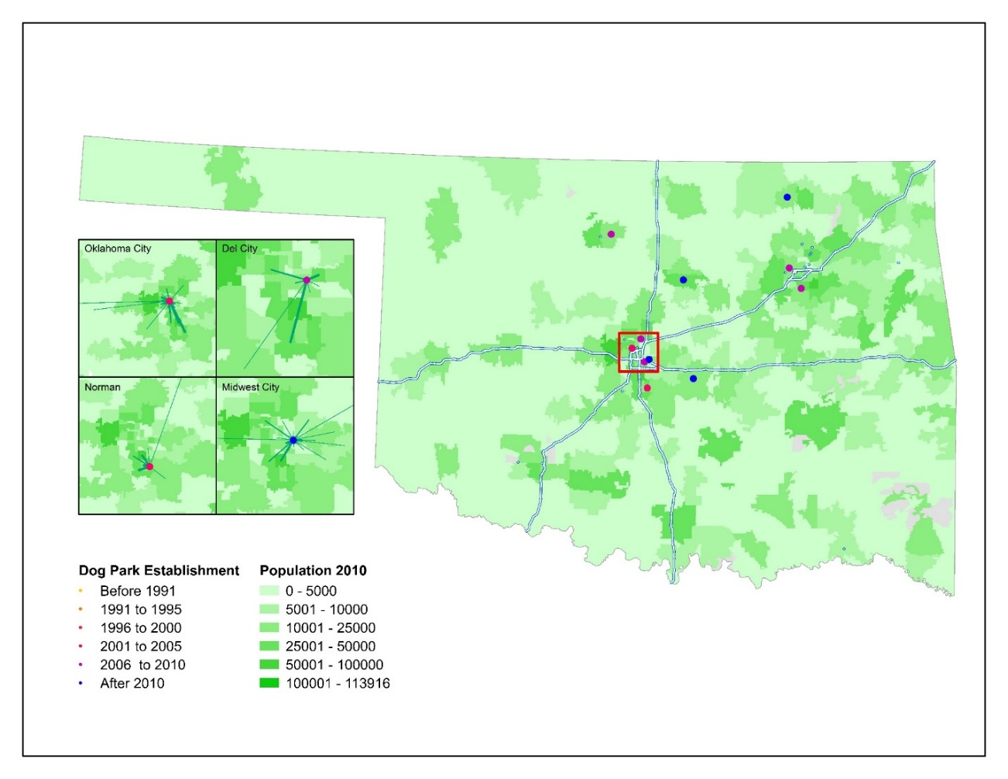
Figure 5.1 Map of zip codes of users for the four dog parks in the Oklahoma City Metro Area.

Identified themes and sub of survey respondent about aspects of the park that they like
Themes | Subthemes
The park space itself | Big, open space  Supplied space for the dog to play  Provided freedom for the dog (run freely)  Upkeep of the Park
Safety | Mainly for the dog through the fence
Friendly space | Applied to both users and dogs
Use of the space | Location and Convenience  Exercise (for the dog)  Socialization (for the dog)
Fun | Fun for the dog  Fun for the person  Fun for both
Identified themes and sub of survey respondent about aspects of the park that are concerns
Landscaping | General park upkeep  Condition of turf
Location of park
Desired amenities | Restroom availability  More space in the park
Safety concerns | Mainly in relation to the dog’s safety  Upkeep of the fence  Presence of children in the park
Other users | Not picking up after animal  Smoking
Figure 5.2 Table of themes and sub-themes identified from respondents surveys

Section 6: How do the dog(s) inform the household’s leisure activity through accessing the dog park?
Introduction
In the previous chapters, I have explored how people are using dog parks, what they like about dog parks, and what types of communities are supporting dog parks. In this final section, I explore the role of the animals in people’s lives and the importance of the parks in their lives, and the lives of their dogs. I am interested in the social role of the park in the humans’ lives, and whether that translates to relationships that extend outside of the dog park. Friendship is a complex concept that is self-defined and understood. The park is a unique space that provides for the possibility of friendship formation between both people and dogs. As dogs, and other companion animals, have gained status, and in many cases being elevated to familial status, such a space offers a unique solution to navigating this new order. The navigation of this new reality and the resulting relationships is the subject of this chapter.
Dogs are increasingly treated as family members, and this change in the role of companion animals has been accepted by the wider US public (Fox 2006, Power 2009). As such, they can constitute a significant factor in the organization and use of the leisure time held by the household. Power (2012) explored how owners navigate this new reality temporally through their homes. She found that relationships with dogs were affecting significant amounts of time, and that the household’s routine began to include the animal’s routines. How does accessing the dog park play into this? Is this seen as a leisure activity, similar to other activities that other family members are active in, such as extracurricular activities of children? What are the possible motivations for accessing such a resource? How are people who participated in my survey and interviews discussing the role of the animal in their familial structure and how this role informs their use of the dog park?
As dogs become more visible in urban and suburban landscapes, the demand for dog parks that offer dog-centered spaces, is increasing throughout the US. The increase mirrors the changes in the last thirty years in how dogs are treated in the public sphere. Laws and municipal ordinances concerning dogs have become more restrictive, with increasing restrictions and enforcement of municipal leash laws. Breed-specific municipal ordinances have resulted in some residents feeling persecuted by their towns, often having to find new homes for their beloved dogs.
To understand how people at the four dog parks in my study regarded the roles of their dogs in their lives, I included some questions in the surveys to better elicit their understanding of the role of the dog in the family unit. I asked questions about issues that are generally indicative of a familial role such as inclusion in holiday celebrations and travel arrangements. Although not direct, these questions help gauge the role of the animal in the decision making for the household, especially in leisure situations in which the best interest for the animal has to be balanced by the reality of travel and incorporation of the animal with the wider family.
I then asked each person about the importance of the park. This question was intended to support questions about the likes and dislikes about the park, but it was intended to go further, probing the persons’ feelings about the role of the space in their lives, and that of their dogs. Because dog parks tend to have large grassroots efforts behind their creations, I also asked my survey participants if they had ever donated time, money, or materials to the park.
As dogs have become more embedded in the family structure and the fabric of the urban and suburban landscape, their role has been compared to that of children. I believe that the role of the dog does not mirror the role of children, but instead is understood as fulfilling a familial role, which can be flexible and can be understood differently by the dogs’ owner(s) at different times. Dogs are influencing an increasing amount of their owner/guardians time. The embedded nature of this relationship may reflect similar motivations for accessing the dog parks as parents encourage and support children’s enrollment in extracurricular activities.
Another area of interest was possible motivations for people to use the dog park. Although I did not specifically ask about the reasons people used the dog park, I did get responses that give some idea as to motivations. Park users reported using the dog park to socialize their animals with other dogs and people, provide exercise for the animal(s), and because they perceived that the dog(s) derived great enjoyment from the park. These are similar to motivations that parents cited for encouraging and supporting their children’s participation in extracurricular activities according to the literature on children’s extracurricular activities (Kremer-Sadlik 2010). Some park users described the park as being a place of great importance to their dogs, and therefore it became a special place for them as well, some place that provided the ability to bond with the animals.
My final interest was the role the park had in peoples’ social lives. I was interested if it was a social space, and if so what role it played. For instance, was it a place where friendships were made? Or was that the acquaintances made at the park were just acquaintances with no real lasting bonds being made?
The familial role of dogs
The role that is ascribed to companion animals, especially dogs, is often described in terms of the role of the animal in the family. This role is described in terms of children, with people often describing their pet as a furbaby, or one of the kids. Although I did not specifically ask about the familial role of the dog I did ask questions that were intended to illicit information about the position and the role of the animals in their households. The only place in my research that people specified that the animal shared a familial, and more specifically a childlike role, was in questions about the inclusion of the animal(s) in holiday celebrations. Among these questions was one about the inclusion of their dog(s) in holiday celebrations. If the answer was affirmative they were asked to elaborate. I found that there were high rates of inclusion of the animal in holiday celebrations. Some included them by providing them with presents or their own stockings with treats. Some included the animal in holiday pictures.
Some respondents reported that extended family members viewed the dog as part of the family, and included them in holiday celebrations. For example, there were reports of the animals traveling with them when they visited their parents for the holidays. Another respondent stated: “I do. She gets treats and such. She normally wears a themed bandana. My family sees her as my child.” Another said “Yes, they get something; my mom sends gifts.” In these two examples the parents of the dog’s owners recognized the dog as serving a childlike role for their child, however, it does not necessarily suggest that that is the role that the owner ascribes to the animal. Hirscham (1994) found that young people often described the role of their dog as being most similar to a sibling, providing companionship and comradery, while older people tended to describe the role of the dog in terms of children. This may explain the pattern here, with the parents understanding and describing the role of their children’s dogs in terms of children.
The role of the companion animal in the family structure has clearly been expanded from simply that of pet, and this expansion has been accepted by the larger American population. However, this role is more complex than simply describing the role of the dog to that of childlike family member or furbaby. The animal’s role in the family is a dynamic position that can change with changes in the dynamics of the family By naming the animal and incorporating the animal into the wider household, both physically within the home and also practically through the inclusion of the animal into the family through incorporation into the routine of the household, the animal is ascribed personhood (Charles 2014). Shir-Vertesh (2012) applied the concept of “flexible personhood” to dogs and other companion animals. She found that the role of companion animals can be situated on a continuum based on the stage of the nuclear family development of young families in Israel (Shir-Vertesh 2012). In her study, she found that the animal was understood and treated as a child until there were actual children in the family. At this point the animals were understood to be very different than the child and were often downgraded, for instance, being restricted in their movements in the home, and in a few cases the animal was rehomed (Shir-Vertesh 2012).
In conjunction with the stage of development of the family animals are understood differently by people at different ages. The majority of pet owners who responded to a recent Harris poll in the USA stated that they felt that their pets were members of the family (Charles 2014). Although the relationship between the companion animals and people are understood in familial terms, they may be experienced differently from those relationships between human kin, people choose who to relate to and who counts as kin (Charles 2014). Many people explain their relationship to companion animals in terms of friendship or siblings, while older adults tended to describe and emphasis the childlike qualities of the animal. Children placed more importance on the pet. However, adults stated that individual animals created a sense of connectedness. Sometimes, these adults reported that pets were better at “being family” than human family members because the pets could provide uncomplicated affection which is often compared to the love and affection offered by very young children (Charles 2014). Possibly most importantly, Charles (2014) found that the relationships formed with animals is not replacing other types of relationships or kin, and instead are in addition to these other social ties.
Importance of the dog park
I asked an open-ended question on the surveys to try to get at the importance of the parks in peoples’ lives, simply providing space for their response. Some people used Likert scale in their explanations, for instance assigning a value from one to ten; but many people simply stated ‘very important.’ Ninety percent of the 163 people who responded stated that the park was moderately important to very important. The two most commonly reported reasons for the dog park being important was for exercising the animal and socializing the animal.
Several people identified the dog park as being a unique place. One respondent stated “It is probably my dog’s favorite place in the world, which makes it very important to me.” Because the respondents felt that their dogs had such good times, the place took on special meaning, and value to the owners because it offered something that is not otherwise available. Because their dogs enjoy the place it becomes significant to the owners because it represents a space where the owner and dog enjoy each other, the space, and the time spent together. One respondent was even willing to place some monetary value of the place stating: “I’d definitely miss it if it wasn’t here, and I’d even pay [a] higher sales tax to make it better.”
The value of the park went beyond just a place of convenience and a place where dogs could socialize and exercise to being a special place because of the shared experiences between guardian and pet. One respondent said that the dog park is, “Very important. It is great for my dog’s happiness and growth,” denoting the importance of the physical and emotional health of the animal. People who had adequate space at home for their animal to play still recognized the value and uniqueness of the space. One example is this quote from a respondent, “We have a big back yard but they still feel like this is their time. Both of them recognize and start whining when they turn the corner; they know where they are going.” The park represents both a special place, but also a special time that is focused on the animal’s enjoyment.
Respondents’ reason for accessing the dog park mirror some of the reasons cited in research exploring the motivations for parents to encourage and support their children’s involvement in extracurricular activities. Play for children, especially play that is unstructured and takes place in natural settings is regarded as imperative for cognitive and social health of children (Herrington 2015). Kids identified fun, pleasure, personal choice and freedom as being the most important aspects of playing (Herrington 2015). Similar elements were identified by dog park users as elements that they liked, such as the opportunity for the dog to run free and play and socialize with other dogs, the fact that the space offered a place that was specifically for dogs, and the freedom that the space offered the animal. The dog park provides a place where dogs can run free and play and socialize with other dogs. As one respondent stated “A tired dog is a good dog.” Many people stated that the dog park is a good place for both themselves and their dogs. Some examples are: “The dog park is very important to me. It’s a place we can come and get fresh air while the dogs socialize. My dog is a very high energy dog and the dog park really helps keep her worn out.”
Based on the literature, I had expected that people who accessed the dog park would claim to derive benefit from visiting the dog park either through the exchange of information, increased socialization, or the formation of relationships through the park. I thought that accessing the dog park would resemble some of the reasoning for parents to join playgroups or parents’ groups. People joined parent’s groups to forge friendships and reduce isolation (Strange 2014; Sandstrom 2014). Such playdates and groups, both physical and those relationships made on line, served to benefit the parents, more than the small children whose interactions were planned.
My expectation that people would view social activity at dog parks in similar ways was not supported in my study. Instead of the desire for companionship, the exchange of information, or coping mechanism, the motivation for accessing the dog park was primarily because the human guardians believed the activity of visiting the dog park to be pleasurable for the dogs. Mutual enjoyment of the park is the driving factor for regularly accessing the park. Many park goers said that the dogs knew when they were going to the park and exhibited what the owners interpreted as excitement. Park users also stated that they would stay as long as the animal was having a good time during periods of nice weather. As reported earlier, one respondent said that the park was the dog’s favorite place, and because of this the park took on added significance for the owner as well.
The majority of people who accessed the park did so because they perceived that their animal enjoyed the space and the activity and it allowed them to do something for and with their companion. This social interaction amongst the people is facilitated by their common interests in their animals. Meeting and playing with other dogs is a draw of the facility for some, as one respondent stated: “Very. It gives me a chance to let Kona socialize and get energy out and it gives me an opportunity to meet people and play with puppies.”
However, according to respondents, not every dog immediately loved the dog park. Some park users remarked that they were accessing the dog park in hopes of increasing their dog’s socialization. Some even stated that they believed that their dogs hated going to the parks, but they were staying or returning to try and address the animal’s perceived anti-social behavior. It is recognized in the literature that parents who encourage their children to participate in extracurricular activities understand the importance of such activity in similar ways. Parents see these activities as helping to develop traits that will help ensure children’s well-being and future educational and personal success, even if the children dislike such activities (Kremer-Sadlik 2010). By continuing with an activity that the child did not like originally, parents ascribed increases in confidence; the attitude has shifted from parents protecting their children from unpleasant, or difficult things, to preparing the child for their futures, because there is a perception that excellence in extracurricular activities help the child to accumulate future social and cultural capital (Kremer-Sadlik 2010). This understanding helps to explain, and the parents to justify, the outlay of time and money that goes into supporting their children’s activities. Although people who are accessing the dog parks are not spending as much time or money as parents who have children enrolled in extracurricular activities, the outlay of time and effort for what is most commonly identified as a bonding activity is not insignificant. The dog owners believe that by being well socialized and learning to interact with a wide variety of dogs and humans, the animal is placed in a better situation than one that is not as well socialized. By interacting in a positive way with a wide variety of other animals and people, their guardians believe that their dogs have proven that they are adaptable and trustworthy. This would then open up more possible interactions and situations in which the dog could be included, for example allowing the dog to travel with its owner or to be included in social situations that are not dog-centric. Also, the owner is making contact with a wider variety of people than they would ordinarily encounter in their everyday interactions, so they could be accumulating social capital.
Donation
Because dog parks have historically been established through the grass-roots efforts of interested community members, I wanted to explore the rates of donation at the parks to try and better understand the value park users put on the space. I asked survey participants if they donated money, time, or other goods such as toys, water bowls, or other supplies to the parks. The rate of self-reported donation varied with each park. Oklahoma City had the highest rate with 35.2% of respondents reporting that they donated in some way. Del City was the next highest with 28.5% of respondents reporting some form of donation; and Norman and Midwest City were very similar with 20.9% for Norman and 21.2% for Midwest City. That Oklahoma City had the highest donation rate could be explained in part by the fact that Oklahoma City’s dog park has well marked donation boxes and has a very active volunteer corp. Del City has a donation box but it had been pried open.
The most common report of donation was time and money. As one respondent stated: “Money and time through poop duty.” Time volunteered to help clean up the park was often cited as donation, and visitors reported doing this the most often. Other donated materials, such as balls for communal use. People can donate trees or park benches more formally through donations to the city for these uses. In Midwest City specifically, a number of people stated that they would like to donate but did not know how. One respondent said “I wish I knew how-they should put up a sign.” The majority of people did not donate, instead viewing the space as part of public park space and therefore not expecting to give. One respondent stated that he “paid taxes” and that was his donation to the park. The space is indeed publicly held and available space so there is not requirement for donation.
Friendships and other relationships at the dog park
To try to illuminate the complexity of concepts of friendship and other relationships, I designed my surveys and interviews to have a two-pronged approach to this question. I first asked people if they recognized either other dog park users or other dogs and asked them to elaborate. I then asked people if they had formed friendships or other relationships with other dog park users. I found that people generally find the park and its users, both canine and human, to be generally friendly. However, few people extended their friendships beyond the fences of the dog parks.
People started to become familiar with the dogs first, recognizing particular dogs with which their dogs tended to socialize. People stated that they began talking with the owners of the dogs with which their own dogs played most often, in time learning the dog owners’ names. Most people agree that a dog park is a pleasant and friendly place; however, it is possible to avoid human interactions by avoiding other dog park users, carrying a book, or talking on a cell phone. From my participant observation, the dogs who used the dog park most frequently solicited attention and play with their owners, suggesting that the park visit is a human-dog activity, and is understood as such by both sides. This aspect of the human-dog interaction made avoiding other human interactions easier if the participant wanted to avoid such interactions.
People reported liking that the dog park was a dog-specific space. As such, a number of respondent reported that they had no expectations of making friendships at the park, instead stating that it was a friendly place with friendly people and that they enjoyed chatting about their animals with other people, but that that was as far as they wanted or expected those relationships to go. However, the fact that most users reported accessing the dog park on a weekly basis suggests that the park has become part of the wider household’s routine, even if this household only consists of the owner/guardian and the dogs. This is further supported by the number of people that reported a sense of familiarity with other users. Even though there was not an expectation of forming deep friendships through the park the importance of the dog park as a community building source of acquaintances may provide social and health benefits to its users.
Do you recognize other dog park users?
I asked whether people recognized other users or dogs in order to gauge how people talk about the space, and what if any relationships or friendships are formed around the animals and the dog parks. I had expected that there would be some form of human socialization that people gathered from the space to continue to utilize the space, especially given that people are traveling an average of five to eight miles, and spending a minimum of thirty minutes at the park. I found that people are utilizing the parks to exercise and socialize their dogs, and appreciate the space. However, people largely do not consider the dog parks as places of socialization for themselves, although 59.5% of the respondents reported recognizing either other dogs or owners.
I found a theme of the park as being a friendly place, filled with nice people and nice dogs. A friendly and inviting space filled with people that share common interests will be an area that will appeal to a wider audience and should be considered when designing such spaces. Some respondents reported the value of meeting people. One person stated; “The dog park is extremely important to me because my dog can play, wrestle, and socialize with other dogs. Plus, since I’m retired, going to the dog park gets me out of the house. Here at the dog park the dog owners have many interesting backgrounds, careers, and personalities.” However, for most respondents the social aspect of the park was not one of the top reasons people gave for visiting the park; they stated that they visited to socialize and exercise their dogs, and the enjoyment of the dog was the single most important factor cited for choosing to access the dog park. While conducting the thematic analysis of the ethnographic portion of the respondents’ responses, I found that people who reported not recognizing anyone the reason most often cited was because they had not been visiting that particular dog park for long enough to recognize anyone. Only at Del City did people report that there were not enough visitors for people to become familiar.
Just because people do not specifically identify the dog park as a social place, that does not mean that they do not derive social, mental, and other health benefits from visiting the dog park. Dogs have a positive impact on their owner’s activity, which positively impacts the individual’s overall health. By including social interactions, the social and mental well-being of the park visitors can be positively affected. Weak ties, or relationships involving less frequent contact, low emotional intensity and limited intimacy, has been demonstrated to offer positive social benefits and increase feelings of well-being and sense of belonging (Sandstrom 2014).
Weak ties were originally applied to social networks, specifically the spread of information, especially information about job opportunities (Granovetter 1973). Granovetter (1973) found that weak ties were very important for an individual’s integration into the wider community; while strong ties resulted in fragmentation, not cohesion, in the wider community. Weak ties actually allow for information to be transmitted from distant parts of a social system, because strong ties share more in common and thus are more likely to share the same information (Granovetter 1983). Networks lacking in weak ties will be fragmented and new ideas and information will spread more slowly (Granovetter 1983). The original research has been expanded to examine how weak ties now play into peoples’ satisfaction with their general connection with their community, and it is from this perspective that I explored the concept and use of weak ties.
The results of my study are consistent with this concept of weak ties. Discussing a shared interest, in this case the dogs, helped provide an overall impression of the dog park being a friendly place. Another user reported “I haven’t made friends with anybody. We’ve talked about our dogs.” Others were surprised by the fact that they did not recognize people, finding a different mix of people and dogs every time. One respondent stated: “No I haven’t, I see people all the time, I expect to see the same people but it is different every time, different dogs.”
Park users reported knowing the dogs first and then becoming familiar or friendly with the other park users. One respondent stated: “(You) learn the dogs' name first, then the dog’s 'mommy' name.” One interesting thing that came from this analysis was that people made a distinction between knowing the dogs and recognizing the owners. For example, “I recognize people and I know dogs, I don’t remember names. I remember the dog’s name better than the humans’ names.” This supports the research that shows that dogs act as social facilitators, they can bridge a situation in which humans may experience unease and provide a reason to interact (Esteves 2008, Grier 2006). Some respondents knew specific dogs with which their dogs enjoyed playing, helping to foster a sense of community or belonging. This sense of belonging can increase the social involvement and community ownership of an area, which can help increase the safety and satisfaction with the wider neighborhood or community (Jackson 2012; Tissot 2011; Urbanik 2013; Wolch 1992). These interactions often lead to increased friendliness and social interactions among the owners; one respondent explaining “We know dogs first, then owners. We have to have someone to talk to while our pups play! Everyone is very friendly usually.”
This is summed up by this quote, “I have met some lovely people and dogs here at the park.” And, under specific circumstances some people classify their relationships as friendships, one visitor stated; “Yeah, we’ve become friends and everything.”
Friendships and the Dog Park
Friendship is an individually constructed concept. How people define and understand friendship is as unique as each person. Therefore, when I wanted to explore the role of the dog park to people’s understanding of friendship, I wanted to leave the question open ended and follow what people were telling me through the resulting narrative. I asked a two-part question in both the survey and interviews, first I asked if they had formed friendships at the park. I then asked them to elaborate.
The results varied by park, as was expected with Del City and Oklahoma City reporting the fewest instances of friendships, and Midwest City and Norman the highest. These results reflect the type of dog park, as well as its physical location in the wider community. For example, Midwest City’s dog park is located in a large, long-established city park that is located in the center of Midwest City. It has adequate parking and is easily accessible by car or by foot; therefore, it has a feel of a community park and provides more of a built-in community of users. The dog parks in Oklahoma City and Del City, on the other hand, are both located near busy interstate highways. In Oklahoma City there is a ball field, but no other park amenities nearby. Del City also has the lowest use rate of the parks, so it would make sense that fewer people would have formed friendships, because the pool of users is lower.
As discussed previously, people generally view the dog park as a friendly place, but in the case of friendships people did not extend the in-park comradery beyond the fence of the dog park. Some examples of some responses of my participants that illustrates this includes:
“Very friendly here but does not go beyond the dog park.”
“Small talk, you know…because the dogs are a commonality, an icebreaker-because everyone has a dog that wants to be petted-or they start fighting and you’re like “Hey! Get down” usually some interaction, but not friends.”
“I wouldn’t necessarily say friendships. I would say friendly acquaintances, I mean we talk and enjoy when they come over, talk about the week . . . but we don’t know each other’s cell phone numbers, we don’t hang out, when we meet up its just coincidental and it’s not planned.”
“No I don't come here too often. I got a flat here once and a fellow dog owner tried to help me fix it. It meant a lot for a stranger helping.”

A few people stated that they did not expect to make friends at the dog park, and some preferred to keep to themselves at the park, or to use the time to read or do other work on their own. One person suggested that the location of the park had a lot to do with how people interacted saying: “Depends on the day. I like to read. People stay to themselves. I think it’s the area. Put this near 23rd. Everyone would talk.” This is in reference to 23rd Street in Oklahoma City, which is a popular destination with numerous eating places and other businesses.
People who did report making friends at the park often attributed the friendships with the fact that there were with a group of people that shared a common interest. One respondent said that they did make friendships stating: “Yes, because it’s easy to find common ground-whether they're students, athletes, or just dog lovers.” Another described how they socialized specifically around their dogs’ breeds, “I run a Facebook group for monthly meetups of Northern breeds.” A number of people reported specifically socializing or forming friendships with other people and their dogs if the dogs played well together. One example, “Yeah, we have made some friends, like when we see them we socialize with them and let our dogs roam around. There is a couple here that has a shepherd collie mix that looks like Zulu and they have another long-haired shepherd mix. Those two are Earl and Aspen and they like each other.”
Some of these friendships are quite close and the park can even act as a memorial to the person or dog when they have passed away. For instance, one respondent said, “Yes I have. When we used to go to the Lake Hefner doggie park . . . we made lots of friends. The doggie friends we made were Molly and Joey; [my dog] was in love with Molly. She was a lab, a brown lab, and they played all the time. Then Molly’s owner passed away, and that was hard on us. There is a bench over there for him. We were regulars, we used to be regulars. Yeah, so you do meet people.” This example shows the evolution from the dogs making friends to that extending to the humans.
The people that did report making friendships through the park stated that they ranged from close friends to people that helped out with concerns surrounding the dog. One respondent reported on finding her best friend at the dog park, stating: “Lots of them, my best friend is one from the dog park when my dog was just a puppy, about four years ago.” This social support around a common interest, coupled by taking place in the setting of a leisure activity, helps mediate the awkwardness that surrounds adult friendship making. The social nature of leisure venues provide a social infrastructure and can facilitate social attachments; and shared leisure interests have been found to be necessary to form deep friendships (Parry 2013).
Some romantic attachments have occurred, at least one respondent reported finding a girlfriend at the park, and another had said that he requested a girl’s number, but that she did not call him back. However, another reported enjoying the dogs more than the human companions: “Yeah her! That’s about it, usually I am more friends with the doggies than I am with the people. Kind of like the dogs more I guess. It’s easier to get along with doggies then with people you don’t know.” Helping each other was another common them, as the example previously where someone from the park helped with a flat tire. Another respondent reported: “Yes we help each other out and share phone numbers and Facebook.” Another noted that they had been helped out with recommendations, stating: “the people are usually very friendly and some of the people we see offer to help with vet visits and finding clinics.” Others came to the park with friends or met up with other friends at the park.
Even though there are vast differences among the parks and among park users about the role of the park in their social life, the park can provide an important source of general social connectedness through the formation of weak ties. The importance of weak ties has become of interest to social science because of increasing perception of the isolation experienced due to urbanization. Sandstrom (2014) cited dog park acquaintances as examples of weak ties. Research suggest that such weak ties are important in general well-being, increasing the perception of a person’s happiness. The results of my study were consistent with Sandstrom’s conceptualization of weak ties.
Clearly, the respondents to both the surveys and interviews derived enjoyment from visiting the park. They enjoyed visiting a place where there was a concentration of people with a shared interest, the dogs. They enjoyed watching the dogs interact and by extension they interacted with other dog owners. Even if these acquaintances did not extend past the fence of the dog park, people benefited socially from being able to access a resource in which their interactions were mediated by a shared love for their animals. Visiting the dog park was primarily understood as a bonding experience between them and their animal, but it also provided a broader attachment to their community, and built a sense of belonging that often resulted in personal investment in the space.
Many analysts have found that parks in general can support socially healthier urban communities (Gomez 2015). A sense of belonging has been proven to increase the satisfaction with one’s community and contributes to an overall sense of well-being (Sandstrom 2014). Just the presence of parks and other green spaces contribute to community quality of life, regardless of actual use (Gomez 2015). Dog parks offer a unique form of green space that caters to dogs and their owners. These parks have the potential to further increase the perception of general well-being by providing a space that offers built in shared interest, and therefore the potential to form relationships and benefit from increased social capital. This kind of specialized social, leisure focused, space should be explored further to ascertain the potentially positive effect this type of space could provide users as a focus for either the building of social capital, a sense of place, or interpersonal relationships. This research is beyond the scope of the current research, but is an area that I hope to explore in future research through more in-depth interviews that is focused solely on the social role of the park in the user’s lives.
Conclusion and Discussion
As human-companion animal relationships have continued to evolve, these changing roles are fostering new types of social interactions, and challenging previously static concepts of family and kinship (Fox 2006; Franklin 2006). The animals’ role in the family is a dynamic position that can change with changes in the family. Changes in the valuation and accepted role of companion animals have allowed dog parks to operate within the US suburban and urban landscape. These spaces reflect sociospatial relations in urban and suburban communities and relationality of human-dog relationships in the wider political and cultural context, especially in the context that differences in such relationships reinforce wider power relations (Panelli 2010). My research sample suggests that the majority of users visiting the dog park view it as a dog centric activity that is undertaken for the perceived enjoyment of the animal(s).
Based on the results of my research, I feel that the role is much more complicated and that the metaphoric child role is a convenient and descriptive category. I think that it is applied because it is a known role that is more easily relatable for people, and does not reflect the complex and changeable role. The concept of flexible personhood is a more descriptive option, but the current research did not go into enough depth about people’s understandings of the animal and its role in the household (Shir-Vertesh 2012).
The majority of people using the dog parks in my study do so for the dog’s well-being and perceived enjoyment. The main appeal and use for the dog park is socialization of the dog with other dogs, and other people. Exercising the animal was the most cited use and perceived benefit of the dog park in previous studies of dog parks (Lee 2009, Matisoff, 2012); however, the other studies did not explore the role of the dog park in the person’s social life. This research project was conceptualized as a where, who, and how project to explore where these dog parks were being placed in the urban and suburban environment, who were using them, and how the users were using the park. As such, there are many questions that are pertinent and interesting, even important, that I simply cannot address in this research.
Among these are questions of the role that the dog plays in users’ lives and how people articulate and understand this role. I can make some inferences as to the importance of the animal in my respondents’ lives through some of their answers, however, I did not focus on this line of questioning in my current research. Also, the motivation for using the dog park is another area that I cannot adequately address with the current data set. Again, I can derive some insight into motivation through some of the answers provide by my respondents. However, I did not concentrate on why they were using the dog park, so my ability to fully address these motivations do not go into sufficient depth as to provide more than general insight into the reasons for using the dag park that are superficial at most. Another limitation of this project is that I did not formulate my survey or interviews to address the sense of community or the sense of place that might form around such a space. To adequately address such issues one would need to do an ethnographic study that focuses solely on these issues.

Chapter 7: Discussion and Conclusion
Introduction

Dog parks are new additions to public space. They are the physical representations of the shifting valuation of companion animals and their role(s) in the family structure of modern life in the United States. The purpose of this research was to investigate how these spaces are used. How do people who use the parks describe the space, and their use of the space? Is visiting the park a dog-centric activity, a social activity, or a combination of the two?
My research’s main contribution to the literature is the finding that people are using the dog park(s) primarily because of the perceived enjoyment of the parks by their dogs, and to add to the socialization and exercise of the animal in an environment that allows them to interact and play with other dogs. I initially expected that respondents would report a social benefit to people who used the space. However, although many weak ties were formed among dog park users, the perceived enjoyment by their dog is the driving factor in accessing the dog park.
The accepted role of companion animals in the wider US public’s understanding has changed from animal other to full-fledged family member. The shift in understanding has been swift and widespread. People with pet centric viewpoints were regarded with suspicion by the wider society in the past (Grier, 2006), but a more accepting and normalizing of such attitudes has occurred in the last three decades. Pets share our homes, and increasingly influence our movements and activities. Companion animals, and the activities and care surrounding them, act to solidify the family (Fox 2006; Power 2008).The importance of animals in everyday human lives is demonstrated through their ability to mediate and facilitate social interactions of their owner/guardian. Companion animals have impacted and challenged the previously static concepts of family and kinship, resulting in the comparison to children that many people make, a concept demonstrated by Fox’s (2008) ‘furbabies,’. Such changes are demonstrated through new avenues of social interactions provided to accommodate the inclusion of dogs. The previously static concepts of family and kinship (Fox 2006; Franklin 2006) have also changed in the last few decades to encompass our companion animals. The amount of time spent with the companion animal, and the subsequent activities that surround it and its wellbeing, can rival that of children. However, I feel that the actual role that dogs hold is much more nuanced and dynamic than can be explained simply by comparing them to children. It is a dynamic flexible role, one that can and often does change with shifts in the family dynamics, and most closely resembles Shir-Vertes (2015) ‘flexible personhood”. The dynamic relationship between people and their companion animals can be described in terms of entanglement. Dogs have become entangled in many people’s everyday lives, influencing the routine of the household, with their physical and social needs being recognized and efforts made to accommodate them within the household and its leisure activities. Through the creation of dog parks, this entanglement has extended from the private sphere of the home to political, cultural, and social relationships in the wider community. These spaces reflect sociospatial relations in urban and suburban communities, and relationality of human-dog relationships in the political and cultural context (Panelli 2010). I found that the motivation for encouraging socialization of their animals was a similar as parent’s encouragement of their children’s participation in extracurricular activities. In both instances, people must expend their time and effort, and the benefit that they derive is the perceived enjoyment and benefit that their dependents receive from the socialization provided by the activity.
Urban dogs and their owners experience a very controlled existence. Municipal laws and ordinances control everything from the number of dogs, to the breeds allowed to be kept within city limits. Dogs and their owners even have their physical movement restrained by leash laws (Rock 2013; Urbanik 2013). As the rate of both pet keeping and urbanization has risen there has become a demand for spaces where dogs and their owners could enjoy leisure activities without these restrictions. Philo (1995) discusses the idea of transgression, ‘crossing lines’ both physical and sociological boundaries. Dog parks are examples of such transgressions. The view that dogs are beings whose social and behavioral needs can and should be met is increasingly gaining support. Support for this view is expressed in the creation of dog centric spaces such as dog parks in the United States and other countries (Rock 2013).
The type of close relationship characterized by the term ‘furbaby’ tends to be associated with middle class and upper middle class, largely white communities (Greenebaum 2004). I hypothesized that these groups would make up the core of the users of the four dog parks in my study set. This hypothesis proved correct for this set of parks. Three groups that have been identified in previous research as more likely to share this view were young singles, childless couples, and older couples who are empty-nesters (Grier 2006, Blouin 2008, Tissot, 2011). The largest group of users in my data set was similar to other studies of dog park users (see Lee 2009, Tissot 2011, Gomez 2012, Matisoff 2012.
The shift towards more acceptance of a pet centric lifestyle allowed dogs to be accommodated in the urban landscape. The proliferation of dog parks in many urban centers in the United States and elsewhere in the world is the physical manifestation on the landscape of this shift in acceptance of the role of animals. Some of this is the result of changes in general social interactions, changes in economic realities, and normalization of such attitudes through media and marketing campaigns. Companion animals provide many social benefits. Visiting a dog park is a situated activity where these social benefits can be magnified. Among these benefits are increased rates of exercise, fostering a sense of community, increase social connectedness among neighborhoods, and the promotion of humane behavior towards dogs and other animals (Urbanik 2013).
The location of the park in the wider city setting determined the rates of reported friendship formation. For instance, Midwest City and Norman’s dog parks are located in a more centralized park setting, and as such, people are more likely to use the park like a neighborhood park. This resulted in more familiarity, and reports of more friendships. Oklahoma City, on the other hand, serves as more of a destination dog park and reported many fewer friendships.
This research adds to the ongoing discussion and exploration of human-animal relationships, specifically in the context of the urban and suburban US city. My study sample validated that the types of people who were identified in the literature as more likely to form strong bonds with their companion animals, namely young single people, childless couples, and empty nesters are indeed using the dog parks at higher rates. I found that the primary use of the dog park was to exercise and socialize the dog, and that the people who used the dog park do so because they perceive that their dogs enjoy the park, often discussing the visits to the dog park as being a treat for the animal. An interesting theme in all users’ interviews and survey answers was the recognition of the importance of socialization for the dog. This was not common before the emergence of dog parks, and it seems that the availability for this type of interaction made the need for the dog park have more value to the users because of the socialization that it offered for the dogs.
This study also increased the understanding of the role of the companion animal in the person’s life. The respondents who used the park talked about the dog in familial terms and visited the dog park as a bonding experience between themselves and the dog. People who used the park most often did so because of the dog’s perceived enjoyment of the space.
The primary deciding force for accessing the dog park was the perceived enjoyment of the dog. People also cited positive outcomes in the health, happiness, and socialization of their dog(s). Their personal socialization was not a factor in deciding to access the park. I thought that people who are outlaying that much time and effort to visit the park would be deriving some social benefit from using the resource, and literature exploring weak ties suggest that people are indeed benefiting from using the resource, it is just not a conscious factor in their decision making. In this instance the visit was motivated purely by the animal’s perceived pleasure derived from a park visit. Also, the park becomes a leisure destination, a shared pleasurable experience between the animal and its guardian. Accessing this new leisure space reinforces and illustrates the validity of the wider understanding of the familial role now held by companion animals. People are choosing to spend leisure time with their dog(s) instead of other family members or friends in a space that is specifically set aside for dogs in the urban and suburban landscape. These findings suggest that the animal is influencing more of the household activities than initially anticipated.
In order to extend the findings of this study, future research could be devoted to considering deeper motivations for accessing dog parks. In this study, I concentrated on who were using dog parks, and how these people were using them. However, I did not focus in depth on the meaning of this space. What are the cultural and practical meanings of dog parks to their users, and to the general community? One way to approach these questions would be to do a series of interviews that deal specifically with the role of the park, the parks as a source of information, and to the role that dogs play in the lives of their owners.
Parks in the urban environment can provide space in which people interact in many ways. They can provide a sense of community, a place for recreation, and as a space for families to gather. Does the dog park serve in such a manner? Most research into parks is focused on equitable access of the parks and the health benefits afforded by such spaces. Dogs have been found to have a positive effect on urban dwellers through the added activity provided through the care of the animal. It would be valuable to determine the extent to which this added activity affects the physical and emotional health of both the people and the dogs. Do people who take their dogs to dog parks feel stronger emotional connections to their pets? It would also be useful to see if dog park users who also walked their dogs in their neighborhoods found that they derived greater benefits, both physical and social, from one activity over the other.
The social role of the dog park is another area that cannot be adequately explored with the current data set. I briefly explored the social role of the park in the users’ lives, but I did not explore it in any deeper sense. Are the dog parks even seen as a social space? I found it surprising that people were not using the dog park as a source of social interaction. The results suggested that many people did not view the dog part as a social space for themselves. Why not? To what extent does enhancing bonds between dog owners and their dogs take precedence over relationships among dog owners themselves? I would like to explore the extent to which people viewed the dog park as a social space for themselves. Were they expecting to make friendships through the park? In a few instances in the course of the current research I got responses that suggested that some did not view the park as a source of potential relationships. I had hypothesized that the dog park would serve as a social space for the owner/guardians. This initial hypothesis was based on previous research that found that dogs offered a starting point for social interaction. Especially in the case of physical limitations, dogs can offer social capital that can bridge social difficulties. However, many of the respondents did not see the dog park as a social space for humans, contrary to expectations based on the literature.
The dog park is an informal social space, one in which people can decide how they want to interact with their dogs, or other people and dogs. I expected to find that it could serve a similar role in their social lives to relationships formed around other informal spaces, such as children’s playgrounds. Instead, I found that people did not necessarily form deep connections in these spaces. Instead, I found that connections among dog owners were more likely to be made in more structured activities such as the Husky Huddle. The Husky Huddle is organized through a Facebook group that organizes meetups at the park for Huskies and other northern breeds and their owners. Huskies are very high energy dogs that benefit from such interaction. Through these meetups people meet other Husky enthusiasts and on days that the huddle is not in session these owners /guardians are more likely to be visiting with each other. I found this to be more similar to relationships formed between parents of children who share the same extracurricular activities. The contrast between these semi-structured activities and the latent use of the dog park may be highly significant. The motivations between using the dog park in the informal setting and the motivation associated with participating in Husky Huddle or similar events needs to be explored. This could be done through an exploration of programming at a dog park. Do people enjoy and participate in said programming? Is informal programming, such as the Husky Huddle more effective? Does such programming result in more meaningful interaction in the dog park? Does programming result in higher satisfaction with the park experience? Or is the more passive use of the space still the one that people prefer the most?
My respondents reported that the dog park was a friendly space and that they enjoyed visiting with other dog park users. However, because I had not anticipated that my findings would demonstrate that the perceived enjoyment of the animal was the driving force behind the visitation, and not any social interaction on the behalf of the owner/guardians, my study did not provide the opportunity to explore these findings in detail. For instance, were people satisfied with their social interactions at the park? Was social interaction, which was generally a secondary reason to use the parks, even desired by their users? I think this line of investigation is very important to gain a better understanding of the role of the dog park, especially of what role it represents in the wider community. Is the role of this park similar to other parks and public spaces? I think ethnographic exploration is the best method to use in this line of inquiry. One-on-one interviews that could follow up on the role that the park plays in their social interactions in the space could elucidate the social role, if any, that is occupied by the dog park.
The respondents stated that there was a sense of community surrounding the dog parks. However, the current research did not allow for in-depth exploration of a sense of place surrounding the space. Because the park has the ability to foster a sense of community, examining the park through the lens of sense of place could potentially lead to a better understanding of the parks, and their role in the wider community. Using this lens, an exploration of the role and place of the dog parks in the social lives of their users could possibly be ascertained.
The perceived role that companion animals occupy in families, friendships, and other interactions among people has changed over the last three decades. However, the role is not static and can change with changes in the family unit, especially the addition of human children. As well, family dynamics can change when a family with young children obtains a dog, especially given that many people view dogs as valuable to their children’s maturation and socialization as the children grow up. Although the animals occupy a significant position in the family, this position is flexible. The concept of flexible personhood needs to be explored in more detail with respect to companion animals. Exploring this concept in detail will help researchers to elaborate upon the deeper meanings and roles that the companion animal is understood to hold in the family unit, if indeed they are understood to hold such a role. By exploring the history of a person’s pet-keeping through in-depth interviews, one could explore how the role of the companion animals, and the person’s understanding of that role has changed over their lifetime. Animals have allowed people to assign kinship roles, if a better understanding of these assignments can be reached, a better understanding of contemporary family and kinship could be elucidated. Is the animal an addition to the family, a substitution for other relationships, or some form of extension to the known kinship framework? Is it all of the above? Or none of the above?
Another area of interest is the desire for, and understanding of the need for socialization of dog(s). The recognition and desire for the need for socialization of their dog was an unexpected finding of this study. Dogs are social animals, but to what extent do people view socializing their dogs with other dogs as valuable to the dogs as well as to the relationships between dogs and their owners? It is unclear if the socialization of the animal became desirable because of the availability of dog parks, or if somehow the understanding of the benefits of socialization facilitated the spread and adoption of dog parks.
From a broader standpoint, I would like to explore the valuation of other animals and other shared resources, such as the environment, by people who share companion animal-centric lifestyles. Is the value that they place on their companion animals extended to other animals, both domestic and wild, or if it is solely related to the specific companion animal only? Finally, I would like to explore how the legislation that came out of Hurricane Katrina involving the need to include companion animals in emergency planning will be implemented. Because of the changes in the valuation of companion animals, and the increased acceptance of their familial role; I feel that we can no longer expect people to leave their animals behind in a crisis. How they are accommodated, and how this will be put into action will be very interesting to watch. I would like to follow how the plan is written and how it actually translates into practice in a crisis.

Works Cited

Allen, C. 2011. On actor-network theory and landscape. Area 43 (3):274-280.
Anderson, D. C. 2004. The human-companion animal bond. The reference librarian
41 (86):7-23.
Anderson, E. 1990. Streetwise: Race, class and change in an urban community. Chicagol, Illinois USA: The University of Chicago Press.
Anderson, K. 1997. A Walk on the WIld SIde: A Critical Geography of Domestication. Progress in Human Geography 21 (4):463-485.
Arbuckle, B. 2002. Experimental animal domestication and its application to the study of animal exploitation in prehistory. In 9th ICAZ Conference, ed. J. D. Vigne, J. Peters, and D. Helmer, 18-33. Durham.
Armstrong, P. 2002. The postcolonial animal. Society and Animals 10 (4):413-419.
Arnould, E. a. C. T. 2005. Consumer culture theory: twenty years of research. Journal of Consumer Research 31 (4):868-893.
Association, A. P. P. M. 2013. Industry statistics and trends.
Association, A. V. M. n.d. Industry Statistics and Trends. http://www.americanpetproducts.org/press_industrytrends.asp.
Badmington, N. 2004. Mapping Posthumanism. Environment and Planning A 36:1352-1355.
Bettany, S., and R. Daly. 2008. Figuring companion-species consuption: A multi-site ethnography of the post-canine Afghan hound. Journal of Business Research 61:408-418.
Bingham, N. 2006. Bees, butterflies, and bacteria: biotechnology and the politics of non-human friendship. Environment and Planning A 38:483-498.
Blouin, D. 2008. All in the family? Understanding the meanings of dogs and cats in the lives of American pet owners. Bloomington Indiana University.
Brown, D. 1984. Personality and gender differences on human relationships with horses and dogs. In The pet connection: Its influence on our health and quality of life, ed. B. L. H. R.K. Anderson, and L.A. Hart, 216-233. Minneapolis: University of Minnesota Press.
Carlisle-Frank, P., J. Frank. 2006. Owners, guardians, and owner-guardians: Differing relationships with pets. Anthrozoos 19 (3):225-242.
Casey, R., S. Vandenbussche, J.Bradshaw, M. Roberts. 2009. Reasons for relinquishment and return of domestic cats (Felis Silvestris Catus) to rescue shelters in the UK. Anthrozoos 22 (4):347-358.
Charles, N. 2014. 'Animals just love you as you are': Experiencing kinship across the species barrier. Sociology 48 (4):715-730.
Dedoose 6.2.10. SocioCultural Research Consultants, LLC.
Duncan, I. 2006. The changing concept of animal sentience. Applied Animal Behaviour Science 100:11-9.
El Nasser, H. 2011. Fastest-growing urban parks are for the dogs. In USA Today.
Esteves, S., T. Stokes. 2008. Social effects of a dog's presence on children with disabilities. Anthrozoos 21 (1):5-15.
Festa, L. 2009. Person, Animal, Thing: The 1796 Dog Tax and the Right to Superfluous Things. Eighteenth-Century Life 33 (2):1-44.
Finkler, H., J. Terkel. 2011. Dichotomy in the Emotional approaches of caretakers of free-roaming cats in urban feeding groups: Findings from in-depth interviews. Anthrozoos 24 (2):201-218.
Fox, R. 2006. Animal Behaviors, Post-Human Lives: Everyday Negotiations of the Animal-Human Divide in Pet-Keeping. social and cultural geography 7 (4):525-553.
Franklin, A. 1999. Animals and Modern Culture. London, UK: Sage Publications.
———. 2006. "Be[a]ware of the dog": A post-humaninst approach to housing. Housing, Theory and Society 23 (3):137-156.
Gomesz, E. 2013. Dog Parks: Benefits, conflicts and suggestions. Journal of Park and Recreation Administration 31 (4):79-91.
Gomez, E. 2013. Dog Parks: Benefits, Conflicts, and Suggestions. Journal of Park and Recreation Administration 31 (4):79-91.
Gomez, E., J. Baur, E. Hill, and S. Georgiev. 2015. Urban parks and psychological sense of community. Journal of Leisure Research 47 (3):388-398.
Gottlieb, A. 1986. Dog: ally or traitor? Mythology, cosmology and society among the Beng of Ivory Coast. American Ethnologist 6 (2):3-11.
Granovetter, M. 1973. The strength of weak ties. American Journal of Sociology 78 (6):1360-1380.
———. 1983. The Strength of weak ties: A network theory revisited. In Sociological Theory 201-233.
Greenbaum, J. 2004. It's a dog's life: elevating status from pet to 'fur baby' at yappy hour. Society and Animals 12 (2).
Grier, C. 2006. Pets in America, A History. Chapel Hill, North Carolina: University of North Carolina.
Guest, G., K. MacQueen, and E. Namey. 2012. Applied thematic analysis. Lost Angeles, California, USA: Sage Publication.
Haraway, D. 2003. The companion species manifesto: dogs, people and significant otherness: Prickly Paradigm Press.
———. 2006. Encounters with Companion Species: Entangling Dogs, Baboons, Philosophers,and Biologiest. Configurations 14 (1-2):97-114.
———. 2007. When species meet (Posthumanities): University of Minnesota Press.
Hare, B., J. Call, and M. Tomasello. 1998. Communication of food location between human and dog (Canis familiaris). Evolution of Communication 2 (1):137-159.
Hawn, R. 2009. Canine Design: Dog Parks with more bite. Parks and Recreation 44 (1):34-38.
Herrington, S. 2015. Beyond physical activity: The importance of play and nature-based play spaces for children's health and development. Current obesity reports 4 (4):477-483.
Herzog, H. 2006. Forty-two thousan and one dalmatians: fads, social contagion and dog breed popularity. Society and Animals 14 (4):382-398.
———. 2010. Some we love, some we hate, some we eat: why it's so hard to think straight about animals. New York, NY: Harper Collins Publishers.
Hill, R., J. Gaines, and R. Wilson. 2008. Consumer behavior, extended-self, and sacred consumption: An alternative perspective from our companion animals. Journal of Business Research 61 (5):553-562.
Hirshman, E. 1994. Consumers and their animal companions. Journal of Consumer Research 20 (3):616-632.
Holbrook, M., and A. Woodside. 2008. Animal companions, consumption experiences, and the marketing of pets: Transcending boundaries in the animal-human distinction. Journal of Business Research 61:377-381.
Holmberg, T. 2013. Trans-Species urban politics: Stories from a beach. Space and Culture 16 (1):28-42.
Howden, L., and J. Meyers. 2011. Age and Sex Composition:2010. In 2010 Census Briefs. http://www.census.gov/prod/cen2010/briefs/c2010br-03.pdf: U.S. Census Bureau: U.S. Department of Commerce.
Howell, P. 2002. A place for the animal dead: pet cemeteries and animal ethics in late Victorian Britain. Ethics, Policy and Environment 5 (1):5-22.
Hunt, M., K. Bogue, and N. Rohrbaugh 2012. Pet Ownership and Evacuation Prior to Hurricane Irene. Animals 2:529-539.
Irvine, L. 2003. The problem of unwated pets: A case study in how institutions think about clients' needs. Social Problems 50:550-566.
———. 2004. If you tame me: Understanding our connection with Animals. Philadelphia, PA: Temple University Press.
Jackson, P. 2012. Situated Activites in a dog park: Identity and Conflict in Human-Animal Space. Society and Animals 20:254-272.
Jones, C. 2014. Biscuit Acres dog park in south Tulsa to mark five years. Tulsa World, June 5, 2014.
Kellert, S. 1993. Attitudes, knowledge, and behavior toward wildlife among the industrial superpowers- United States, Japan, and Germany. Journal of Soical Issues 49 (1):53-69.
Kremer-Sadlik, T., C. Izquierdo, and M. Fatigante. 2010. Making meaning of everyday practives: Parents' attitudes toward children's extracurricular activities in the United States and in Italy. Anthropology and Education Quarterly 41 (1):35-54.
Kuhl, G. 2011. Human-Sled dog relations: What can we learn from the stories and experiences of mushers? Society and Animals 19 (1):22-37.
Kukekova, A., L. Trut, K.Chase, A. Kharlamova, J. Johnson, S. Temnykh, I. Oskina, R. Gulevich, A. Vladimirova, S. Klebanov, D. Shepeleva, S. Skikhevich, G. Acland, and K. Lark. 2011. Mapping the loci for fox domestication: Deconstruction/reconstruction of a behaviroal phenotype. Behavioral Genetics 41:593-606.
Lassiter, U. a. J. W. ed. 2005. Changing attitudes towards animals among Chicanas and Latinas in Los Angeles. Pittsburgh, Pennsylvania, USA: University of Pittsburgh Press.
Lee, H., M. Shepley, and C. Huang. 2009. Evaluation of off-leash dog parks in Texas and Florida: A study of use patterns, user satisfaction and perception. Landscape and Urban Planning 92:314-324.
Leschin-Hoar, C. 2005. Danger in the dogpark. Parks and Recreation 40 (7):57-59.
Levy, J., D. Gale, and L. Gale. 2003. Evaluation of the effect of a long-term trap-neuter-return and adoption program on a free-roaming cat population. J Am Vet Med Assoc 222 (1):42-6.
Lindblad-Toh, K., C.M. Wade, T.S. Mikkelsen, E.K. Karlsson, D.B. Jaffe, M. Kamal, M. Clamp, J. L. Chang, E.J. Kulbokas III, M.C. Zody, E. Mauceli, X. Xie, M. Breen, R.K. Wayne, E. A> Ostrander, C. P. Ponting, F. Galibert, D. R. Smith, P.J. deJong, E. Kirkness, P. Alvares, T. Biagi, W. Brockman, J. Butler, C.W Chin, A. Cook, J. Cuff, M. J. Daly, D. DeCaprio, S. Gnerre, M. Grabherr, M. Kellis, M. Kleber, C. Bardeleben, L. Goodstadt, A. Heger, C. Hitte, L. Kim, K.P. Koepfil, H. G. Parker, J. P. Pollinger, S.M.J. Searle, N.B. Sutter, R. Thomas, C. Webber, Broad Institute Genome Sequencing Platform and E.S. Lander. 2005. Genome sequence, comparative analysis and haplotype structure of the domestic dog. Nature 438:803-819.
Martins, C., A. Mohamed, A. Sa Guimares, C. da Conceica O de Barros, R. dos Santos Pampuch, W. Suoboda, R. dC. M. Garcia, F. Ferreira, and A. Biondo. 2013. Impact of demograpic characteristics in pet ownership: Modeling animal count according to owners income and age. Preventative Veterinary Medicine 109:213-218.
Matisoff, D. a. D. N. 2012. Managing contested greenspace: neighborhood commons and the rise of dog parks. International Journal of the Commons 6 (1):28-51.
Miklósi, Á. 2007. Dog behavior, evolution, and cognition. Oxford, England, UK: Oxford University Press.
Miklósi, Á., J. Topál, and V. Csányi. 2003. A simple reason for a big difference: wolves do not look back at humans but dogs do. Curent Biology 1:763-766.
Morey, D. F. 2010. Dogs: Domestication and the development of a social bond. New York, New York USA: Cambridge University Press.
Morrison, C., L. Johnston, and R. Longhurst. 2012. Criticle geographies nof love as spatial, relational, and plitical. Progress in Human Geography 37 (4):505-521.
Murdoch, J. 2004. Humanising posthumanism. Environment and Planning A 36:1356-1359.
Nast, H. 2006. Critical Pet Studies? Antipode 38:894-906.
Natoli, E., M. Ferrari, E. Bolletti, and D. Pontier, . 1999. Relationship between cat lovers and feral cats in Rome. Anthrozoos 12 (1):16-23.
The New Oxford American Dictionary, Third Edition. 2010. ed. A. a. C. A. L. Stevenson. Oxford, UK: Oxford University Press.
Norling, A., and L. Keeling. 2010. Owning a dog and working: A telephone survey of dog owners and employers in Sweden. Anthrozoos 23 (2):157-171.
Noske, B. 2008. The animal question in anthropology. In Social Creatures, A human and animal studies reader, ed. C. P. Flynn, 22-28. Brookly, NY: Lantern books.
Panelli, R. 2010. More-than-human social geographies: posthuman and other possibilities. Progress in Human Geography 34 (1):79-87.
Parry, D., T.Glover, C. Mulcahy. 2013. From "stroller-stalker" to "Momancer": Courting friends through a social networking site for mothers. Journal of Leisure Research 45 (1):23-46.
Paul, E. ed. 2000. Love of pets and love of people. New York, NY: Cambridge University Press.
Philo, C. 1995. Animals, geography, and the city: notes on inclusions and exclusions. Environment and Planning D: Society and Space 13:655-681.
Plevin, A. 2014. How wild do we want it? "Wiley" coyote versus fluffy. Society and Animals 22:80-101.
Podberscek, A. 2009. Good to pet and eat: The keeping and consuming of dogs and cats in South Korea. Journal of Social Issues 65 (3):615-632.
Podberscek, A., E. Paul, and J. Serpel ed. 2000. Companion ANimals and Us. Cambridge, UK: Cambridge University Press.
Pongracz, P., C. Molnar, A. Miklósi and V. Csanyi. 2005. Human listeners are able to classify dog (Canis familiaris) barks recorded in different situations. Journal of Comparative Psychology 119 (2):136-144.
Power, E. 2008. Furry Families: Making a Human-Dog Family Through Home. social and cultural geography 9 (5):535-555.
———. 2012. Domestication and the dog: embodying home. Area 44 (3):371-378.
Power, E. 2013. Dogs and Practices of Community and Neighboring. Anthrozoos 26 (4):579-591.
Price, E. 1998. Behavioral genetics and the process of animal domestication. In Genetics and the behavior of domestic animals, ed. T. Gradin, 31-65. Boston: Academic Press.
———. 1999. Behavioral development in animals undergoing domestication. Applied Animal Behaviour Science 65:245-271.
Ramirez. 2006. My dogs just like me: Dog ownership as a gender display. Symbolic interaction 29 (3):373-391.
Roberts, R. 2007. A Walk in the Park. Parks and Recreation 42.
Rock, M. 2013. Pet bylaws and post humanist health promotion: a case study of urban policy. Critical Public Health 23 (2):201-212.
Sandstrom, G. a. E. D. 2014. Social Interactions and well-being: The suprising power of weak ties. Personality and Soical Psychology Bulletin 40 (7):910-922.
Seps, C. 2010. Animal Law Evolution: Treating pets as persons in tort and custody disputes. In University of Illinois Law Review: University of Illinois
Serpell, J. 1995. From paragon to pariah: some reflections on human attitudes to dogs. In The domestic dog: its evolution, behaviour and interactions with people, ed. J. Serpell. Cambridge, UK: Cambridge University Press.
———. 1996. In the company of animals: A study of human-animal relationships. Cambridge, UK: Cambridge University Press.
———. 2009. Having our dogs and eating them too: Why animals are a social problem. Journal of Soical Issues 65 (3):633-644.
Shir-Vertesh, D. 2012. Flexible personhood: Loving animals as family members in Israel. American Anthropologist 114 (3):420-432.
Spiegel, M. 1996. The dreaded comparison: Human and animal slavery. New York: Mirror Books.
Steechi, S. 2006. So you want to build a dog park? 8 ed: Dog Parks USA.
Strange, C., C. Fisher, P. Howat and L. Wood. 2014. Fostering supportive community connnections through mothers' groups and playgroups. . Journal of Advanced Nursing 70 (12):2835-2846.
Tesfom, G. a. N. B. 2010. Do they buy for their dogs the way they buy for themselves? Psychology and Marketing 27 (9):898-912.
Tissot, S. 2011. Of dogs and men: The making of spatial boundaries in a gentrifying neightborhood. City and Community 10 (3):265-284.
Toukhsati, S., P. Bennett, and G. Coleman. 2007. Behaviors and Attitudes towards Semi-Owned Cats. Anthrozoos 20 (2):131-142.
Trut, L., I. Oskina, and A. Kharlamova. 2009. Animal evolution during domestication: the domesticated fox as a model. BioEssays 31:349-360.
Tuan, Y. 1984. Dominance and Affection: The Making of Pets. New Haven: Yale University Press.
Udell, M., N. Dorey, and C. Wynne. 2010. What did domestication do to dogs? A new account of dogs' sensitivity to human action. Biological Review 85:327-345.
Urbanik, J., and M. Morgan. 2013. A tale of tails: The place of dog parks in the urban imaginary. Geoforum 44:292-302.
US Pet Ownership Statistics. The Humane Society of the United States, 03/17/2008 2008 [cited 10/17/2008. Available from http://www,hsus.org/pets/issues_affecting_our_pets/pet_overpopulation.
van Asch, B., A. Zhang, M. Oskarsson, C. Klutsch, A. Amorim, and P. Savolainen. 2013. Pre-Columbian origins of Native American dog breeds, with only limited replacement by European dogs, confirmed by mtDNA analysis. Proceedings of the Royal Society 280 (20131142).
Veldkamp, E. 2009. The emergence of "pets as family" and the socio-historical develpoment of pet funerals in Japan. Anthrozoos 22 (4):333-346.
Walsh, C., M. Howse, C. Green, L. Butler, and R. Anderson. 2011. "Stop that!" Interrupting dog behaviors in a dog park setting. Journal of Veterinary Behavior 6 (1):77.
Wang, J. 2012. Dogs and the making of the American state: Voluntary association, state power, and the politics of animal control in New York City, 1850-1920. . The Journal of American History 98 (4):998-1024.
Whatmore, S. 2004. Humanism's excess: Some thoughts on the 'post-human/ist agenda. Environment and Planning A 36:1360-1363.
Wolch, J. 2002. Anima urbis. Progress in Human Geography 26 (6):721-743.
Wolch, J., K. West, and T. Gaines. 1995. Transpecies Urban Theory. Environment and Planning D: Society and Space 13:735-760.
Wolch, J. a. S. R. 1992. Companions in the park: Laurel Canyon dog park. Landscape 31 (3):16-23.
Wood, L., B. Giles-Corti, and M. Bulsara. 2005. The pet connection: Pets as a conduit for social capital. Social Science and Medicine 61:1159-1173.
Wood, L., B. Giles-Corti, M. Bulgara, and D. Bosch. 2007. More than a furry companion: The ripple effect of companion animals on neighborhood interactions and sense of community. Society and Animals 15:43-56.
Woodward, L., and A. Bauer. 2007. People and thier pets: A relational perspective on interpersonal complementarity and attachments in compnaion animal owners. Society and Animals 15:169-189.

Appendices 1-3 Study Consent Form, Interview Questions, and Survey

University of Oklahoma
Institutional Review Board
Informed Consent to Participate in a Research Study

Project Title: | Dog parks and their users
Principal Investigator: | Lacy Jo Burgess
Department: | Geography

You are being asked to volunteer for this research study. This study is being conducted at Paw Park Oklahoma City, Del City Dog Park, Norman Dog Park, and Midwest City Dog Park. You were selected as a possible participant because you have visited this dog park today.
Please read this form and ask any questions that you may have before agreeing to take part in this study.

Purpose of the Research Study
The purpose of this study is to explore the usage patterns of the dog park, and to discuss the role that the dog park plays in your everyday life (i.e. recreational space, social space, or convenience)

Number of Participants
About 520 people will take part in this study. Some (120) will be asked to participate in an interview, others (400) will be asked to take part in a survey

Procedures
If you agree to be in this study, you will be asked to participate in a short interview
Length of Participation
A 10-15 minute interview.

Risks of being in the study are

There are no anticipated risks and no direct benefits from being in this study.

Confidentiality
In published reports, there will be no information included that will make it possible to identify you without your permission. Research records will be stored securely and only approved researchers will have access to the records.
There are organizations that may inspect and/or copy your research records for quality assurance and data analysis. These organizations include the OU Institutional Review Board.

Voluntary Nature of the Study
Participation in this study is voluntary. If you withdraw or decline participation, you will not be penalized or lose benefits or services unrelated to the study. If you decide to participate, you may decline to answer any question and may choose to withdraw at any time.
Compensation
There is no compensation for agreeing to participate in the study.

Waivers of Elements of Confidentiality
Your name will not be retained or linked with your responses unless you specifically agree to be identified. The data you provide will be retained in anonymous form unless you specifically agree for data retention or retention of contact information beyond the end of the study. Please check all of the options that you agree to:
I consent to being quoted directly. ___ Yes ___ No
I consent to having my name reported with quoted material. ___Yes ___ No
I consent to having the information I provided retained for potential use in future studies by this researcher. ___Yes ___ No
I consent to having my contact information retained after the study so that I can be contacted to participate in future studies. ___ Yes ___ No

Audio Recording of Study Activities
To assist with accurate recording of your responses, interviews may be recorded on an audio recording device. You have the right to refuse to allow such recording without penalty. Please select one of the following options:
I consent to audio recording. ___ Yes ___ No

Photographing of Study Participants/Activities
In order to preserve an image related to the research, photographs may be taken of participants. You have the right to refuse to allow photographs to be taken without penalty. Please select one of the following options:
I consent to photographs. ___ Yes ___ No

Future Communications
The researcher would like to contact you again to recruit you into this study or to gather additional information.
_____ I give my permission for the researcher to contact me in the future.
_____ I do not wish to be contacted by the researcher again.

Contacts and Questions
If you have concerns or complaints about the research, the researcher(s) conducting this study can be contacted at lacyjo@ou.edu or 405-826-2155 or fshelley@ou.edu.
Contact the researcher(s) if you have questions, or if you have experienced a research-related injury.
If you have any questions about your rights as a research participant, concerns, or complaints about the research and wish to talk to someone other than individuals on the research team or if you cannot reach the research team, you may contact the University of Oklahoma – Norman Campus Institutional Review Board (OU-NC IRB) at 405-325-8110 or irb@ou.edu.
You will be given a copy of this information to keep for your records. If you are not given a copy of this consent form, please request one.

Statement of Consent
I have read the above information. I have asked questions and have received satisfactory answers. I consent to participate in the study.

Participant Signature Print Name | Date
Signature of Person Obtaining Consent Date
Print Name of Person Obtaining Consent

Signature of Witness (if applicable) | Date
Print Name of Witness | Date

The goal of the study is to explore the usage and users of the Oklahoma City Metropolitan dog parks. In conjunction with participant observation I propose to add onsite interviews with between 25-40 informants. These interviews will last between 10 and 15 minutes and will be based around the following questions.

1. Is your dog an inside dog?
2. What type of dog food do you feed your dog? (national brand, store brand, specialty, homecooked, etc.?)
3. Do you have access to a fenced yard for your dog?
4. How often do you visit the dog park?
5. How long do your visits last?
6. What is your zip code? (for mapping purposes)
7. How do you access the dog park? (walk, ride bike, drive?)
8. Do you know any of the other dogs name?
9. Do you know any of the other dog’s owners?
10. Have you formed any friendships/relationships among other dog owners?
11. Do you socialize with any of the other dog owners outside of the park?
12. Have you asked for any references concerning your dog from any of the other dog owners? (i.e. for a vet, groomer, etc.)
13. Why did you choose this dog park?
14. What do you like and dislike most about the park?
15. Anything you would like to add about the park?

IRB NUMBER: 1163 IRB APPROVAL DATE: 06/24/2014

This survey seeks to elicit your views about this dog park. You have been identified as someone with an active interest in the dog park. I am interested in your opinions and use of the dog park. The survey is fairly brief and should not take more than 7 minutes to complete. Completing the survey is completely voluntary and your identity and responses will remain anonymous. You may choose to not complete the survey at any time. There is no compensation for participation in this study. Thank you!

First are some questions to explore the demographic make up of the users of the park. Please choose only one from each group of answers.

1. Gender
----Male
----Female

2. Are You?
---Married
---Single
---In a domestic partnership
---Roomates
----Other

3. Age Group
----18-25
----26-35
----36-45
----41-55
----51-65
---- Over 65

4. Ethnic Identity
----White or Euro-American
----African-American
----American Indian
----Hispanic or Latino
----Asian American
----Other

5. What type of home do you consider your primary residence?
---House
---Apartment
---Mobile Home
---Duplex
---Townhouse
----Other

6. Are there children under the age of 18 living in your home
---Yes
---No

7. If yes, how many?

8. What is your home zip code?

These questions are dealing with your pets. Please choose only one answer unless instructed otherwise.

9. How many dogs do you have?

10. What breed is your dog(s)?

11. How old are your dog(s)?

12. How did you acquire your dog(s)? (Check all that apply to your current dog(s))
----Bought the dog
---- Rescue/ Adopted
Describe:

13. Do you have other pets at home?
----Yes
----No

14. If yes, what kind of other pets do you have?
----Cat
----Bird
----Fish
----Reptile
----Amphibian
----Other
Describe:

15. What type of diet do you feed your dogs? (Check all that apply)
----National brand dry dog food
----National brand moist dog food
----Specialty diet
----Prescription diet
----Homemade food
----Refrigerated food
----Other
Describe:

16. How much (on average) do you spend on your dog(s) per month? Be sure to include vet costs.

17. How much time do you spend with your dog(s) (One on one dog-centric interaction such as walking the dog) on an average weekly basis?

The following questions will address your dog park visits.

18. How often do you visit a dog park?
---- Daily
----Weekly
----Monthly
----Occasionally
----Rarely

19. On average how long do you stay at the dog park?
----1/2 hour
----1 hour
----More than 1 hour
----Other
20. Do you consider this dog park your regular park?
----Yes
----No

21. If no, which park do you consider your regular park?

22. Have you ever donated (either time or money) to the dog park?
----Yes
----No

The following questions are open ended. Please provide as much detail as you can.

23. Do you carry a picture of your dog(s) with you (either in your wallet or on your phone)?

24. Do you include your dog(s) in holiday celebrations? Describe:

25. Do you travel with your dog(s)?

26. Do you have pet insurance for your dog(s)?

27. What do you like about this dog park?

28. What do you not like about this dog park?

29. Do you recognize other dogs/owners? Describe.

30. Have you formed friendships with other people at this dog park? Describe.

31. How important is the dog park to you?

IRB NUMBER: 1163 IRB APPROVAL DATE: 07/10/2013

See Appendix 1 and 2 for Sample Survey and Information/Consent form
Myriad Garden Dog Park, Oklahoma City, Oklahoma. Site Visit April 24, 2012. http://www.myriadgardens.org/index.php?myriad-botanical-gardens
Downtown Dog Park, Dallas, Texas. Site visit March 20, 2012 with Michelle Simmons.
Oklahoma City Paw Park, Oklahoma City, Oklahoma. Site visit March 7, 2012 with Michelle Simmons. http://www.okc.gov/parks/PawPark.html
Pets and People Dog Park, Yukon, Oklahoma. Site Visit March 7, 2012 with Michelle Simmons. http://www.petsandpeople.com/index.html
Tails and Trails, Arlington, Texas. Site visit March 20, 2012 with Michelle Simmons.
Wiggly Fields Dog Park at Ray Trent Park, Del City, Oklahoma. Site visit November 9, 2013.
Edmond dog park, Edmond, Oklahoma. Site visit June 7, 2014.
Biscuit Acres, Tulsa. Oklahoma. Site visit October 4, 2014. http://biscuitacres.com/about
Joe’s Station, Tulsa, Oklahoma. Site visit October 4, 2014.
Norman Community Dog Park, Norman, Oklahoma. Site visit September 29, 2013.
Fred Quinn Happy Tails Dog Park, Midwest City, Oklahoma. Site visit September 14, 2013.
Wiggly Field Dog Park, Denton, Texas. Site visit March 20, 2012 with Michelle Simmons.
Mockingbird Point Dog Park, Dallas, Texas. Site visit March 20, 2012 with Michelle Simmons.
Wagging Tails and North Bark Park, Dallas, Texas. Site visit March 20, 2012 with Michelle Simmons.
All population statistics were found using censusviewer.com free version accessed 12/22/2014

