UNIVERSITY OF OKLAHOMA
GRADUATE COLLEGE

SEVERAL ISSUES CONCERNING THE USE OF BIFACTOR MODEL IN UNDERSTANDING DIMENSIONALITY

A DISSERTATION
SUBMITTED TO THE GRADUATE FACULTY
in partial fulfillment of the requirements for the
Degree of
DOCTOR OF PHILOSOPHY

By
XIAOLAN LIAO
Norman, Oklahoma
2018
SEVERAL ISSUES CONCERNING THE USE OF BIFACTOR MODEL IN UNDERSTANDING DIMENSIONALITY

A DISSERTATION APPROVED FOR
DEPARTMENT OF PSYCHOLOGY

BY

Dr. Hairong Song, Chair
Dr. Michael Bemben
Dr. Robert Terry
Dr. Lara Mayeux
Dr. Lori Snyder

Copyright by XIAOLAN LIAO 2018
All Rights Reserved.

Table of Contents
ACKNOWLEDGEMENTS………….…………………………...……………………….…. XI
ABSTRACT……………………………...…….……………………………………………...XIII
CHAPTER 1 INTRODUCTION………………………………………………………….…….1
1.1 Research Questions to be Addressed………………………………………………….….12
1.2 Scope and Significance of the Study………………………………………………….….13
CHAPTER 2 LITERATURE REVIEW…………………………………………………….…15
2.1. A Brief Review of Development of Factor Models…….…………………………….…15
2.1.1. Spearman’s Two-Factor Model, 1904………………………………………...15
2.1.2. Multiple Factor Model, 1931………………………………………….….…...15
2.1.3. Bifactor Model, 1937……………………………………………….…….…...16
2.1.4. Second-order Factor Model, 1944……………………………………….……17
2.2. A Review of Exploratory Bifactor Analysis……………………………………….…….18
2.2.1. Schmid-Leiman Transformation (Schmid & Leiman, 1957) …………………18
2.2.2. Target Rotation (Reise, et al., 2010) ……………………………………….….19
2.2.3. Jennrich-Bentler Method (Jennrich & Bentler, 2011 & 2012) …………….….20
2.3. A Review of Two Influential Papers……………………………………………….….…21
2.3.1. Chen and Colleagues’ Paper (2006) …………………….…….……….…. ….21
2.3.2. Reise and Colleagues’ Paper (2007) ………...……….…………...…….…….24
2.4. A Review of Literatures on Model Fit Favoring Bifactor Bias…………………….……28
2.5. A Review of Bifactor Model-Based Indices……………………………………….…….30
CHAPTER 3 METHODOLOGY …………………………………………………………...…32
3.1. Confirmatory Bifactor Analysis…………………………………………………………32
3.2. Exploratory Factor Analysis……………………………………………….….………....35
3.2.1. Principle Component Analysis……………………………………………….35
3.2.2. Maximum Likelihood Method…………………………………………...…...38
3.2.3. Rotate to Meaningful Factors………………….……………………………...41
3.3. Exploratory Bifactor Analysis………………………………………………………...…44
3.3.1. S-L Transformation…………………………………………………………...44
3.3.2. J-B Method……………………………………...………….…………………46
3.3.3. Target Rotation…………………………………………………….….…...….47
3.4. Bifactor Model-based Indices……………………………………………………………47
3.5. Model Fit Indices……………………………………………………………………..….52
CHAPTER 4 STUDY 1: PHYSICAL SELF-PERFECPTION ..................................……….56
4.1. Purpose of the Study…………...…………………………………………………….….56
4.2. Background of Theory……….…………………………………………………….……56
4.3. Method…………………………………………...……………………………………...57
4.4. Analysis…………………………………………….……………………………………58
4.4.1. Exploratory Factor Analysis…………………………………….…….…...….58
4.4.2. Exploratory Bifactor Analysis………………………………….…….…...….59
4.4.3. Confirmatory Factor Analysis…………………………………….….……….60
4.5. Results…………………………………………………………………………………...61
4.5.1. Descriptive Information……………………………………………………….61
4.5.2. Exploratory Factor Analysis……………………………………….….….……61
4.5.3. Exploratory Bifactor Analysis……………………………………….…. ….…62
4.5.4. Exploratory Bifactor Model-based Indices…………………………….………65
4.5.5. Confirmatory Factor Analysis……………………….……………….…….….66
4.5.6. Confirmatory Bifactor Model-based Indices………………………….…….…69
4.6. Summary………………………………………………………………………………...70
CHAPTER 5 STUDY 2: IMPLIED MATH AND SCIENCE ABILITY…………………....74
5.1. Purpose of the Study…………….……………….…………………………….….…….74
5.2. Background of Theory………….……………………………………………….………74
5.3. Method………………………………………………………………………………......76
5.4. Analysis………………………………………………………………………....….…....77
5.4.1. Exploratory Factor Analysis………………………………………….……….77
5.4.2. Exploratory Bifactor Analysis……………………………………….……….77
5.4.2. Confirmatory Factor Analyses……………………………………….……….78
5.4. Results…………………………………………………………………………….….….79
5.5.1. Descriptive Information……………………………………………………....79
5.5.2. Exploratory Factor Analysis…………………………………………….…….80
5.5.3. Exploratory Bifactor Analysis………………………………………….….….82
5.5.4. Confirmatory Factor Analysis………………………………………….….….86
5.6. Summary……………………………………………………………………………...…96
CHAPTER 6 STUDY 3: DISASTER PREPAREDNESS…………………………….….….100
6.1. Purpose of the Study…………………………….……………………….……….…….100
6.2. Background of Theory………………………………………………………………….101
6.3. Method………………………………………………………………………...……….101
6.4. Analysis.……………………………………………….…………………….…………102
6.4.1. Exploratory Factor Analysis…………………………………………………102
6.4.2. Exploratory Bifactor Analysis………………………………………………102

6.4.3. Confirmatory Factor Analyses………………………………………………103
6.5. Results……………………………………………………………………………….….104
6.5.1. Descriptive Information…………………………………………….….…....104
6.5.2. Exploratory Factor Analysis…………………………………………………104
6.5.3. Exploratory Bifactor Analysis…………………………………………...…..106
6.5.4. Exploratory Bifactor Model-based Indices………………………………….107
6.5.5. Confirmatory Factor Analysis……………………………………………….108
6.5.6. Confirmatory Bifactor Model-based Indices………………………………...109
6.6. Summary………………………………………………………………….……………109
CHAPTER 7 DISCUSSIONS AND CONCLUSIONS…………………….……….…….….112
7.1. General Discussions……………………………………………………………………112
7.2. Conclusions…………………………………………………………………………….125
TABLES and FIGURES ……………………………………………………………….….….128
REFERENCES…………………………………………………………………………...……173
APPENDIX A………………………………………………………………………….…....…181

List of Tables
Table 1. An example: Hierarchical solution transformed to S-L bifactor solution.…...………...46
Table 2. Computation: The computation of S-L bifactor solution from hierarchical solution.….46
Table 1.1. Correlations, means and SDs of PSPP Data (EFA sample: n = 250; CFA sample: n = 150) …………………………………………………………………………………………….128
Table 1.2. Item cluster analysis of PSPP data (n = 250) …………………………………….…129
Table 1.3. Eigenvalues and variance explained of PSPP data (n = 250) ………………….....…130
Table 1.4. EFA: correlated multiple factor model, second-order model, and bifactor model through S-L method (n = 250) …………………….………………………………………………….....131
Table 1.5. EBFA: target rotation(orthogonal), target rotation(Oblique), J_B method(orthogonal), and J_B method(Oblique) (n = 250) …………………………………...………………….........132
Table 1.6. Model fit of EFA and EBFA models of PSPP data (n = 250) ………………………133
Table 1.7. Model fit of CFA and CBFA models of PSPP data (n = 150) …………………..…...134
Table 1.8. Bifactor model-based indices based on EBFA and CBFA of PSPP data (n = 150) …………………………………………………………………………………………….135
Table 2.1. Correlations, means and SDs of ITMSA Data (EFA sample: n = 467; CFA sample: n = 632) …………………………………………………………………………………………….144
Table 2.2. Item cluster analysis for science and math items (n = 467) ……………….……..….145
Table 2.3. Eigenvalues and variance explained (n = 467) …………………………….…...…...146
Table 2.4. Model fit of EFA models (n = 467) and CFA models of ITMSA data (n = 632) ….....147
Table 2.5. Exploratory factor and bifactor analysis for entire sample (n = 467) …….……..…..148
Table 2.6. Exploratory factor and bifactor analysis for science (n = 467) ………………...….…149
Table 2.7. Exploratory factor and bifactor analysis for math (n = 467).……………………........150
Table 2.8. Confirmatory factor and bifactor models for entire sample (n = 632) .......................151
Table 2.9. Confirmatory factor and bifactor models for science (n = 632) ……………………...152
Table 2.10. Confirmatory factor and bifactor models for math (n = 632) ….………………….153
Table 2.11. Bifactor model-based indices of EBFA and CBFA models of ITMSA data (n = 632) …………………………………………………………………………………………….154
Table 3.1. Correlation, means and SDs of DP Data (EFA sample: n = 1115; CFA sample: n = 256) ...………………………………………………….………………………………….........163
Table 3.2. Eigenvalues and variance explained of DP Data (n = 1115) ………………….…….164
Table 3.3. Model fit of EFA & EBFA (n = 1115) and CFA & CBFA models (n = 256) of DP Data…………………………………………………………………………………………......165
Table 3.4. Item cluster analysis and exploratory factor analysis of DP Data (n = 1115) ………...166
Table 3.5. Exploratory bifactor analysis of DP Data (n = 1115) …………………………...……167
Table 3.6. Bifactor model-based indices based on EBFA and CBFA models of DP Data (n = 256) ………………………………………………………………………………………….…168

List of Figures
Figure 1. Full second-order model of QOL (page 8, Chen et al. 2006) ………………...…………23
Figure 2. Bifactor model of QOL (page 3, Chen et al. 2006) ………………………….…………23
Figure 3. A diagram of bifactor model……………………………………………………………35
Figure 1.1. Scree plot of PSPP data……………………………………………………...………136
Figure 1.2. 2nd-order factor model with standardized loadings of PSPP data ………………….137
Figure 1.3. Orthogonal bifactor model with standardized loadings of PSPP data ……….…….138
Figure 1.4. Oblique bifactor model with standardized loadings of PSPP data …………….……139
Figure 1.5. 2nd-order factor model with GPSW as an external variable of PSPP data ………….140
Figure 1.6. Bifactor model with GPSW as an external variable of PSPP data ………………......141
Figure 1.7. 2nd-order factor model with gender as a covariate of PSPP data ……………………142
Figure 1.8. Bifactor model with gender as a covariate of PSPP data ……………………………143
Figure 2.1. Scree plot of the ITMSA (Entire sample) …………………………………………...155
Figure 2.2. Scree plot of the ITMSA (Science items) ……………………… ……………….….155
Figure 2.3. Scree plot of the ITMSA (Math items) ……………………………………………...156
Figure 2.4. Correlated 2-factor model of the ITMSA (Entire sample) ………………………......157
Figure 2.5. Modified correlated bifactor model of the ITMSA (Entire sample) ………………...158
Figure 2.6. Oblique bifactor model of the ITMSA (Science items) ………………………...…...159
Figure 2.7. Orthogonal bifactor model of the ITMSA (Science items) …………………………160
Figure 2.8. Oblique bifactor model of the ITMSA (Math items) ……………………………......161
Figure 2.9. Orthogonal bifactor model of the ITMSA (Math items) ………………………. ….162
Figure 3.1. Scree plot of DP data………………………………………………………….…….169
Figure 3.2. Correlated two-factor model of DP data ……………………………………………170
Figure 3.3. Bifactor model with one group factor of DP data …………………………………...171
Figure 3.4. Bifactor model with one group factor with corr. Items of DP data ………………….172

ACKNOWLEDGEMENTS
I would like to express the deepest appreciation and gratitude to my advisor and committee chair, Professor Hairong Song, for her patient academic guidance, encouragement and constant support throughout the years. It would never have been possible for me to take this work to completion without her incredible support and encouragement. Hairong has supported me not only academically but also emotionally through the rough road to finish the dissertation. I am fortunate to have her as my advisor.
I also must thank rest of my committee members Professor Robert Terry, Professor Michael Bemben, Professor Lara Mayeux, and Professor Lori Snyder. I am thankful to Robert for advice and support, insightful discussions and suggestions many times during my graduate school years. I also show gratitude to Lara, an excellent teacher and expert in developmental psychology area, and an inspiration in many ways. I am quite appreciative of Michael and Lori for agreeing to serve on my dissertation committee on very short notice.
I would like to thank my lab mates for their support. I am thankful to Dexin Shi and Melanie Lewis for their collaboration and contribution in various projects related to this dissertation. I am also grateful for the fun and great company.
I am also truly thankful to Dr. Ryan Chung, Professor Lori Snyder, and my best friend and college roommate Professor Yibing Tan for letting me use their data for my dissertation projects. I am thankful for the experiences of working as a statistician on their research teams from which the research ideas originated, and the dissertation becomes possible.
A special thanks to my family. Words cannot express how grateful I am to my mother-in-law and father-in-law for all the sacrifices that you’ve made on my behalf. I would also like to thank my beloved husband, Yong Zhou. Thank you for always being there and supporting me for everything. To my beloved sons Jeremy Zhou and Maxwell Zhou, I would like to express my thanks for them being such good boys always cheering me up.

ABSTRACT OF THE DISSERTATION
Several Issues Concerning the Use of Bifactor Models in Understanding Dimensionality

By

Xiaolan Liao
Doctor of Philosophy in Quantitative Psychology
University of Oklahoma, Norman, 2018
Professor Hairong Song

The goals of the study are to investigate the use of bifactor models in understanding dimensionality and to demonstrate several issues that arise from its applications. The bifactor analysis is available for about 80 years, and it is lately argued that the bifactor model is superior to its competitors in many aspects of studying dimensionality. The bifactor model is currently widely applied to examine both old and new concepts against second-order factor model/multiple factor models in many fields. Despite its widespread use and many advantages, the bifactor analysis is not well understood, and the latest techniques developed for it are not endorsed by applied researchers. The misunderstandings had led to both methodological challenges and practical erroneousness which resulted in fallacious conclusions. The present study attempts to demonstrate several critical issues concerning bifactor favoring model fit bias, three exploratory bifactor analytics (S-L transformation, J-B analytics, and target rotation), and oblique versus orthogonal bifactor representations by using three real data. Substantively, the present study will potentially advance the understandings of the three constructs under review as well as their relations to external variables. Methodologically, the present research broadens the literature in clarifying the current issues regarding bifactor analysis, and hopefully, this study will enlighten the applied researchers on the latest techniques.
Results from the current study showed that the confirmatory bifactor model has a better fit than its nested second-order factor model or multiple factor models across the three studies which conform with previous findings. Whether a bifactor model will always fit better is still under investigation. Several researchers have dedicated their work to identify the source of the bias, and a consolidated explanation is yet to find. However, it is warned that researchers shall not rely on model fit as the sole criterion in determining the champion between the two. Results from the first study also showed that the three exploratory bifactor analytics do not agree in the presence of cross-loadings. Specifically, unexpected patterns are observed with the orthogonal J-B solution and the oblique target rotation solution. The former has produced a distorted group factor with which three out of 6 of its loadings are smaller than .30, and two negative loadings cross-loaded. The latter has generated a weak and partially defined general factor with which seven out of 24 of its loadings are smaller than .40 and three of them lower than .30. The results might indicate that orthogonal J-B analytic and oblique target rotation methods are inadequate at recovering complexities (e.g., the presence of cross-loaded items). With the second study, a surprising factor pattern is observed, in which a second general factor runs through all the items but with half negative loadings. This unexpected pattern might represent a special case of the “group factor collapsing onto general factor” problem that is specific to the J-B analytic.
The current findings also suggest that oblique solution tends to introduce a higher level general factor to account for the group factor intercorrelations which complicates the model and results in difficulties in interpretation. The bifactor model is found especially useful with two-dimensional data where a second-order model is not identifiable. The model-based indices such as omega hierarchical, ECV, FD, and H are helpful in assessing the strength of the general factor, and it is recommended to report them in applied researches. Worth mentioning is that they might be subject to model misspecifications. Besides, item cluster analysis seems to be useful in discovering departure from the perfect independent structure of multidimensional data. It is recommended to perform exploratory factor analysis as a preliminary exploration before conducting the exploratory bifactor analysis. Recommendations and insights for future studies follow discussions on the issues.
Keywords: Bifactor model, model fit bias, exploratory bifactor analysis, model-based indices, general factor

CHAPTER 1
INTRODUCTION
Not until recently the bifactor model has gained popularity. Bifactor analysis is a technique developed by Holzinger and Swineford (1937) as an extension of Spearman’s two-factor theory (1904) which is the origin of factor analysis. Though invented over 100 years ago, the progress in factor analysis is relatively slow compared to other techniques. It was believed that the slow pace in factor analysis is due to the lack of a clear understanding of the importance of Spearman’s two-factor theory (Bartholomew, 1995). I now briefly review the history of factor analysis which might help understand what has been hampering the development of factor analysis, as well as the acceptance of the bifactor model.
Factor analysis is a dimension reduction analytic technique developed right after the innovation of its base bivariate correlation technique (Bartholomew, 1995; Pearson, 1895; Spearman, 1904). Spearman’s two-factor theory (i.e., g factor and s factor,1904) was initially developed to study human abilities in which Spearman assumes there is one general intelligence factor that exerts influences on the entire set of measurements and n specific factors that each has an impact on only one test. In addressing the limitations of Spearman’s two-factor model, the multiple factor model was later developed by Thurstone as an extension of Spearman’s two-factor model to include group factors (Thurstone, 1931), in which he assumes there are several group factors each influencing a proportion of the tests and one specific factor affecting each test. At about the same time, the bifactor model was developed by Holzinger & Swineford as another extension to include group factors (Holzinger & Swineford, 1937), in which there is one general factor that running through all the tests, several group factors that each running through a portion of the tests, and one specific factor affecting each test.
Though developed at about the same time and both were extensions of the Spearman’s two-factor theory, “bifactor analysis has spent the last 50 years overshadowed by the numerous applications of Thurstone’s correlated-factors model,” (p. 668) (Reise, 2012) despite that Holzinger and Swineford had been arguing that the bifactor solution is simpler to compute and easier to interpret as compared to the alternative models. In contrary to the immediate popularity the multiple factor model had gained right after its invention, bifactor model has only recently been recognized for its importance in understanding dimensionalities (F. F. Chen, West, & Sousa, 2006; Reise, Morizot, & Hays, 2007). There are two major reasons for the longtime overlook of the bifactor model. On the one hand, many authors at the time had denied the existence of the general factor (Spearman, 1939). On the other hand, Thurstone’s multiple factor model imposes a simple structure which “gives the appearance of easy psychological interpretation.”(p. 249) (Schmid Jr, 1957)
Thurstone (1931) initially developed the multiple factor model as a supplemental model to Spearman’s two-factor theory to include group factors. He claimed that one of the factors in his multiple factor model might be a general factor if it is defined by all the tests and have psychological significance, but he did not want to distinguish the two and referred to both as group factors. Later he had denied the existence of a general factor and claimed that he did not find such a general factor in his study (Thurstone, 1938). Spearman (1939) published a paper titled “Thurstone’s work re-worked” to criticize Thurstone’s multiple-factor method for not explaining the disappearance of the “general factor” (Spearman, 1939). He argued that “Indeed, as we shall see, at one stage of the operations in his present work itself, Thurstone arrives at a general factor in its extreme form; but later, it suddenly vanishes (by means of rotation which is a method Thurstone developed to obtain simple structure and meaningful interpretation of the factors).” (Spearman, 1939, p. 2)
Thurstone Later argued that, in Spearman’s study, the general factor was obtained by “taking the average of a battery of tests” and such a factor “can be easily found with any set of correlated tests.” (p. 208) Also, such a general factor does not have “any psychological significance beyond the arbitrary collection of tests for which such a factor is just an ordinary average,” (p. 208) and that “as psychologists, we cannot be interested in a general factor which is only the average of any random collection of tests.” (p. 208) He also warned that “we must guard against the simple, but common, error of merely taking a first centroid factor, a first principle component, or other mean factor, in a test battery and then calling it a general factor.” (p. 208) (Thurstone, 1940) Nevertheless, a few years later, Thurstone developed the second-order factor model in which a higher-order general factor is included to account for the intercorrelations among correlated primary factors (Thurstone, 1944).
Thomson (1916, 1920, 1934) is another one among opponents who had been strongly objecting the existence of a general factor (Thomson, 1916). Thomson argued that Spearman’s theory - “if a hierarchy can be formed the existence of a General Factor is said to be proved” (p. 272) is problematic. Thomson showed that using a dice throwing experiment, “an excellent hierarchy can be made with Specific and Group Factors only, without a General Factor.” (p. 272) However, in a later paper published by Thomson in 1920 (Thomson, 1920), he admitted that “the existence of general ability is still possible” (p. 173) and insisted that “hierarchical order, unless perhaps when it is absolutely perfect, is no proof of the existence of a general factor.”(p. 180) In another later published paper (Thomson, 1934), Thomson implicitly admitted that such a general factor as claimed by Spearman does exist. In this paper, Thomson applied Hotelling's process to a hierarchy data, in which “the first component has the largest contribution to the total variance of the test-scores,” (p. 366) (Hotelling, 1933) and showed that “taking out the largest principal component from a perfect hierarchy will take out Spearman’s g.” (p. 366) (Thomson, 1934)
Burt (1949,1950) has also been actively denying the existence of a general factor for many years (Burt, 1949, 1950). However, his group factor model has in fact yielded a hierarchical model which includes a general factor (Burt, 1950; Schmid & Leiman, 1957). There are other researchers have been denying the existence of the general factor. In Spearman’s defense (Spearman, 1939), Kelley (1927) who have been opposing the general factor but actually found one (Kelley, 1927), Guilford (1934) who have denied the general factor but actually found one (Guilford & Guilford, 1934), and in Thurstone’s model – the author did not find the general factor only because it is masked by the ‘oblique reference axes’ - this explains why he developed the second-order factor model later on to include the “general factor” (Spearman, 1939).
On the other hand, a few researchers have been advocating the existence of a general factor. Schmid and colleagues (1957) are among those have been defending the presence of general factor and developed the Schmid-Leiman method (S-L method) to obtain a bifactor solution from a second-order factor model. The S-L method later is adopted by applied researchers to conduct an exploratory bifactor analysis. Details on the S-L method will be discussed in the methodology chapter. Despite that Spearman and Holzinger have been defending the bifactor model be a superior model to the multiple factor model, the multiple factor model has been widely used and bifactor model has been overlooked for a long time, and this continues after the development of second-order factor model. With a few advocators endorsing bifactors as a superior model to the second-order model or higher-order model for that “higher-order factors are mysterious and incomprehensible,”(Gignac, 2008, p. 22) bifactor model stays in the shadow of multiple factor model and second-order factor model for another several decades until Reise and colleagues’ (2007) and Chen and colleagues’ (2006) influential papers published (F. F. Chen et al., 2006; Gignac, 2008; Humphreys, 1962; Reise et al., 2007).
Reise and colleagues (2007) and Chen and colleagues (2006) are the pioneers who re-evaluated the value of bifactor model in factor analysis (F. F. Chen, Hayes, Carver, Laurenceau, & Zhang, 2012; F. F. Chen et al., 2006; Reise, 2012; Reise et al., 2007). According to google scholars as of July 2018, the paper “The role of the bifactor model in resolving dimensionality issues in health outcomes measures” published by Reise and colleagues (2007) and the paper “A comparison of bifactor and second-order models of quality of life” published by Chen and colleagues (2006) have been cited 536 times and 613 times, respectively. These two papers have marked the beginning of a new era of bifactor analysis. In the following years, Reise and colleagues devoted to study bifactor analysis and have published dozens of papers on bifactor modeling (Bonifay, Lane, & Reise, 2017; Bonifay, Reise, Scheines, & Meijer, 2015; Ebesutani et al., 2012; Embretson & Reise, 2013; Mansolf & Reise, 2016, 2017; Olatunji, Ebesutani, & Reise, 2015; Reise, 2012; Reise, Kim, Mansolf, & Widaman, 2016; Reise, Moore, & Haviland, 2010; Reise, Scheines, Widaman, & Haviland, 2013; Reise, Ventura, et al., 2011; Rodriguez, Reise, & Haviland, 2016a, 2016b). They discussed and studied bifactor analysis from both confirmatory and exploratory perspective (Mansolf & Reise, 2016; Reise, 2012; Reise et al., 2010), and from both structure equation modeling and item response theory perspective (Reise, 2012; Reise, Ventura, et al., 2011). Thereafter, bifactor model soon rapidly gains popularity and has received broad use primarily in the field of psychology, psychopathology, and education (Chung, Liao, Song, & Lee, 2016; Deng, Guyer, & Ware, 2015; Hindman, Pendergast, & Gooze, 2016; Lac & Donaldson, 2017; McKay, Boduszek, & Harvey, 2014; Aja Louise Murray, McKenzie, Kuenssberg, & Booth, 2017; Norr, Allan, Boffa, Raines, & Schmidt, 2015; Primi, Da Silva, Rodrigues, Muniz, & Almeida, 2013; Revelle & Wilt, 2013; Rowe, Roman, McKenna, Barker, & Poulter, 2015; Smith et al., 2018; Tóth-Király, Morin, Bőthe, Orosz, & Rigó, 2018).
Bifactor model has been primarily used in studying intelligence (Acton & Schroeder, 2001; Gault, 1954; Gignac & Watkins, 2013; Golay, 2011; Hammer, 1950; Jensen & Weng, 1994; Watkins, 2010; Watkins & Beaujean, 2014) and personality (Armon & Shirom, 2011; Cattell, 1945; Martel, Roberts, Gremillion, Von Eye, & Nigg, 2011; McAbee, Oswald, & Connelly, 2014; Revelle & Wilt, 2013; Rushton & Irwing, 2009). Recently bifactor models are also being applied to study constructs in many other fields, such as ADHD (Arias, Ponce, & Núñez, 2016; Gomez, 2014; Gomez, Vance, & Gomez, 2013; Lee, Burns, Beauchaine, & Becker, 2015; Leonard Burns, Moura, Beauchaine, & McBurnett, 2014; Martel et al., 2011), depression and anxiety (de Miranda Azevedo et al., 2016; Ebesutani et al., 2012; Gomez & McLaren, 2015; Iani, Lauriola, & Costantini, 2014; L. J. Simms, Grös, Watson, & O'Hara, 2008; Vanheule, Desmet, Groenvynck, Rosseel, & Fontaine, 2008; Xie et al., 2012), mental health (De Bruin & Du Plessis, 2015; Jovanović, 2015; Mu, Luo, Nickel, & Roberts, 2016), self-esteem (Hyland, Boduszek, Dhingra, Shevlin, & Egan, 2014; McCain, Jonason, Foster, & Campbell, 2015; McKay et al., 2014; Reise et al., 2016), autism (Aja Louise Murray et al., 2017; Posserud, Breivik, Gillberg, & Lundervold, 2013), health outcomes (Reise et al., 2007), quality of life (F. F. Chen et al., 2006), PANAS (F. F. Chen et al., 2006; Leue & Beauducel, 2011; Martel et al., 2011; Reise et al., 2007; L. J. Simms et al., 2008; Xie et al., 2012), academic achievement (Dombrowski, 2014b), mental disorders (Kim & Eaton, 2015), leadership (Furtner, Rauthmann, & Sachse, 2013; Levin, 1973), Cognition (Dombrowski, 2014b; Gavett, Crane, & Dams-O'Connor, 2013; Gurnani, John, & Gavett, 2015), and Religions (Stauner et al., 2016).
In recognizing the importance of bifactor model in understanding dimensionalities, many researchers started to re-examine the dimensionality of ‘old’ constructs such as personality (Revelle & Wilt, 2013), self-esteem (McKay et al., 2014), physical self-perception (Chung et al., 2016), ADHD (Leonard Burns et al., 2014), anxiety and depression (Iani et al., 2014), and intelligence (Watkins & Beaujean, 2014) by applying the bifactor analysis against second-order factor model. Many have found that bifactor model is superior to second-order factor model and multiple-factor model, while some stay being skeptical about the usefulness of the bifactor model in helping understanding concepts and dimensionality (Revelle & Wilt, 2013).
Several problems arise from the widespread applications of bifactor models. First of all, the model comparisons have been relying on only the model fit as the sole criteria to select the better model between the second-order model and bifactor model (Gignac, 2008). Which is now found problematic as both empirical studies and simulation studies have suggested that model fit indices have an inherent bias favoring the bifactor model (Morgan, Hodge, Wells, & Watkins, 2015; Aja L Murray & Johnson, 2013). It is showed that second-order factor model and bifactor model are nested model with the former nested within the later, and the less restricted model (bifactor model) will tend always to fit better than the parsimony one (second-order model) unless the gain in model fit does not justify the loss in degrees of freedom. Morgan and colleagues (2015) reported that the bifactor model is more likely to be identified as the best model when the data is generated with a second-order factor model as the true model.
Researchers have attempted to identify the source of the bias. Reise and colleagues (2016) suggested that the bifactor model fits better than the second-order factor model because the bifactor model is better at modeling “implausible patterns” (Reise et al., 2016). Gignac (2016) suggested that the reason for the bias toward bifactor models is due to that the second-order factor model imposes a “proportionality constraint” while the bifactor model does not (Gignac, 2016). However, this argument is found both confusing and misleading (Mansolf & Reise, 2017). Mansolf and Reise (2017) in the latest paper suggested that “proportional condition” should be a better wording than “proportion constraints” in Gignac’s interpretation, and the cause of bias favoring bifactor model lies in data per se but not in the model. They demonstrated that when data meet a certain “tetrad” conditions, the bifactor model and second-order model will be equivalent. The two models are “distinguishable to the degree that these unique tetrad constraints are violated.” (p. 120) However, it is not clear yet why the bias occurs and whether it always stays true especially when data are of complexity (i.e., the presence of cross-loadings or correlated residuals).
Furthermore, the model comparison needs to be understood from the exploratory and confirmatory analysis, respectively. In the framework of exploratory analysis, the bifactor model obtained through S-L transformation and the second-order model are not nested models, because the second-order factor model and bifactor model are transformations of each other and will have the same model fit. In this case, the “proportion constraint” is not affecting the model fit which remains unchanged in both models. In the framework of confirmatory factor analysis, it is showed that for every bifactor model, there is an equivalent full second-order model. In their study, the confirmatory bifactor model was built based on the S-L solution which is based on the second-order factor model. The two models are nested because bifactor model can be obtained by adding direct effects of the general factor to every observed variable, over and above the second-order impact on the lower order factors (F. F. Chen et al., 2006). Note that the “proportional constraints” is irrelevant to the confirmatory model and does not have an impact on the model fit.
A second issue concerns the understanding of the three exploratory bifactor analytics – the S-L transformation method, the target rotation method, and the J-B analytics (Mansolf & Reise, 2016; Reise et al., 2010). The J- B analytics and the target rotation methods are relatively new methods and developed mathematically, and their strengths and limitations in modeling real data are not fully understood. Mansolf and Reise (2016) pointed out that the J- B analytics may subject to “perfect independent cluster structure,” “local minima,” and “Group factors collapsing to general factor” problems. Please refer to (Mansolf & Reise, 2016) for a review of the S-L method and J-B analytics.
The S-L transformation method is known to have two limitations - “perfect independent cluster structure” and “proportional constraint.” The former refers to the natural characteristic of a data structure where each of the observed measures belongs to one and only one group. The latter refers to the occurrence of a constant ratio of general to group factor loadings for the items within a group which is a constraint imposed on the S-L bifactor solution. Some misunderstood the concept and claimed that “EBFA (i.e., the J-B method) more readily produces independent cluster structure and overcomes the proportionality constraint experienced by the S-L method” (Dombrowski, 2014b), in which “independent cluster structure” was thought something produced by a method rather than the nature characteristic carried by the data per se (Dombrowski, 2014a, 2014b; Gignac, 2008, 2016). Likewise, Gignac (2016) made a similar erroneous statement about “proportional constraints” in his paper (Gignac, 2016), in which the “proportional constraints” was thought a constraint imposed on the second-order model rather than on the S-L bifactor solution. Mansolf and Reise (2016) suggested that when the data possess a “perfect independent cluster structure” and the structure ensures “proportional constraint” condition, then a direct bifactor solution (i.e., the solution obtained by using Holzinger’s bifactor analysis) would be identical to S-L bifactor solution (Mansolf & Reise, 2016).
Third concerning the controversial debates on the existence and strength of the general factor. The discussions on the existence and importance of the general factor are dated back to the origin of factor analysis and continue today (Bonifay et al., 2017; Revelle & Zinbarg, 2009; Rodriguez et al., 2016a; Thomson, 1920; Zinbarg, Revelle, Yovel, & Li, 2005). Revelle and Wilt (2013) argued that the general factor of personality found by many researchers is questionable that many of the studies failed to define the general factor (Revelle & Wilt, 2013). The authors believe that the inconsistent findings are due to the lack of clarity on the conceptual and statistical definition of the general factor. He criticized that the five popular methods that were used for evaluating the strength of the general factor are not all good indicators of general factor saturation. He suggested that the first factor from a bifactor rotation or the general factor from the confirmatory bifactor model might not be a real general factor. The authors showed that a general factor is suggested by some of the methods even when there is no general factor in the generated data structure. Also, they suggest that sometimes this occurred was because the calculation identifies one or another group factor as a general factor. The author recommended using omega hierarchical as a general factor saturation estimation (Davies, Connelly, Ones, & Birkland, 2015). However, the authors have also suggested that “when g has a high saturation on each test, it is clearly useful to think in terms of g, but when the saturation is low, when there is good biological evidence for separate, although correlated systems associated with the lower order constructs.” (p. 502) Several model-based indices are developed to assess the strength of the general factor, and to be reviewed in a later chapter.
Fourth, should factors be orthogonal in the bifactor model? This question has received renewed attention since the innovation of J-B method for oblique cases (Jennrich & Bentler, 2011, 2012). The typical bifactor model in Holzinger and Swine’s original work is specified to be orthogonal for simplicity and ease of interpretation. Opponents have been objecting the bifactor model for its rigid constraint of orthogonality of latent factors in the model (Reise et al., 2007). Reise and colleagues (2007, 2012) have suggested that “at the least, group and general factors must be orthogonal” (p. 691) otherwise group factor cannot be interpreted as accounting for residual variances resulting from the general factor (Reise, 2012; Reise et al., 2007). Jennrich and Bentler (2011, 2012) extended their J-B rotation analytics for oblique cases, in which the intercorrelations among group factors are allowed. However, Reise (2012) warned that group factor intercorrelations imply “the presence of additional and unmodeled general factors, Thus, any gains in the fit by allowing group factors to correlate ultimately may be offset by losses in model interpretability and applicability.” (p. 691)
Lastly, the inconsistency in terminology for the hierarchical model and the higher-order factor model. Reise refers to the second-order model as hierarchical model and refers the bifactor model as a non-hierarchical model (Mansolf & Reise, 2017), whereas some researchers refer to the Holzinger’s bifactor model as the direct hierarchical model, the bifactor model obtained through S-L transformation as the indirect hierarchical model, and the second-order model as the higher-order model (Gignac, 2008). Some other researchers refer both the bifactor model and second-order factor model as hierarchical models (Mészáros, Ádám, Szabó, Szigeti, & Urbán, 2014; Reise et al., 2007). Some refer to the bifactor model as a nested model (F. F. Chen et al., 2006). A consistent terminology for the two models will help the communications and understandings of the two models.
  - Research Questions to Be Addressed
The methodological goals of the study are to investigate the use of the bifactor model in understanding dimensionality and demonstrate several issues associated with its use. The substantive goals are to study the dimensionality of the three constructs under study and their relationship with some external variables. Both exploratory bifactor analysis and confirmatory bifactor analysis will be conducted. The performance of the three exploratory bifactor analytics (S-L method, J-B analytics, and target rotation) will be compared. The bifactor model and second-order factor model/multiple factor model will also be compared in the framework of confirmatory factor analysis. The model fit indices will be computed for each model, and factor structures and factor patterns will be examined and compared. Bifactor model-based indices will be computed from both the exploratory and confirmatory bifactor model to assess the strength of the general factor and group factors. Most of the previous studies are assuming orthogonality in the bifactor model, in this study, I conducted both oblique bifactor analysis as well as orthogonal bifactor analysis.
Some substantive questions will be discussed concerning the application of the bifactor model to study each of the constructs, for example, are
- What’s the dimensionality of the construct under study?
- Does a bifactor model have better model fit than a second-order factor model in the given data?
- Is the bifactor model a better model than the second-order factor model? Does the bifactor model provide a more natural and clear interpretation?
- How should the general factor be interpreted? How should the group factors be interpreted?
- Should a uni-dimensional model be used instead of a bifactor model?
Methodological questions to be asked:
- Do the exploratory bifactor model and exploratory factor analysis agree on the dimensionality? How many factors should be extracted?
- Do the indirect solution through S-L transformation, the solution from the J-B method, and the solution from the target rotation model agree? Which one is better?
- Orthogonal and oblique bifactor method, which one to use?
- Are the bifactor model and second-order factor model distinguishable regarding model fit?
- Are model-based indices useful in helping to determine the dimensionality?
- Is item cluster analysis useful as preliminary exploration for exploratory bifactor analysis?
- Does the model address the research question?
  - Scope and Significance of the Study
Bifactor model has lately been widely and increasingly applied in the study of the dimensionality of old and new concepts in many fields. As more researchers choose to use the bifactor model as an alternative method to study dimensionality, it becomes more important to get a good understanding of the bifactor model theory and its techniques. It is evident that many issues have arisen with the widespread use of bifactor models. Due to misunderstandings of the analytics, many researchers have been erroneously using the bifactor model. For instance, treating second-order factor model and the bifactor solution through S-L transformation as nested models, relying on only model fit to pick a champion model between a bifactor model and a second-order factor model, and conducting confirmatory bifactor analysis without first doing exploratory bifactor analyses, and so forth. Those erroneous practices were not only confusing by itself but also leading to further confusions.
By applying the bifactor model to study three representative real datasets, this study attempts for a solid understanding of the issues with the current use of bifactor analysis. This study will provide applied researchers with valuable information concerning the use of the bifactor model in studying dimensionality. This study will also provide insight to applied researchers of the latest bifactor modeling techniques and their strengths and limitations. This study also enlightens future researcher with suggestions and directions for future studies.

CHAPTER 2
LITERATURE REVIEW

2.1. A Brief Review of Development of Factor Models

2.1.1. Spearman’s Two-Factor Model, 1904
Spearman is recognized as the one who invented factor analysis (Bartholomew, 1995). The paper “ ‘General Intelligence,’ objectively determined and measured” which published by Spearman in 1904, is recognized as the first work on Factor analysis (Spearman, 1904). In 1895, the bivariate correlation was developed by Pearson to measure associations between two variables (Pearson, 1895). Taking immediate advantage of the advance in statistics, Spearman developed the two-factor theory to study the inter-correlations observed among a set of correlated measures. In this paper, Spearman measured a variety of human abilities among high school students and discovered that they are positively correlated. He believed that a common influence, which he referred to as the general factor or common factor or “g,” is accountable for the positive associations among the measures. Any influence that is specific to each measure he referred to it as specific factor. Spearman then developed a two-factor model to study the relationship between the general factor and the set of measures. In Spearman’s two-factor model, a general factor is assumed to run through all the measures, and the specific factors are assumed all uncorrelated. In this pioneer work, he demonstrated that, on page 276, the influence of the common factor on the observed measures is computed by taking square of their observed correlations, r, and the influence of the specific factor on the observed measures is obtained by taking out the influence of common factor from the whole (i.e., 1- r^2). Note that the two-factor model that Spearmen invented is what we called today, common one-factor model.

2.1.2. Multiple Factor Model, 1931
Thurstone pointed out that the two-factor model that Spearman invented is limited in real-world applications (Thurstone, 1931). In Spearman’s two-factor model, a general factor is assumed to have influence on all observed variables, and specific factors are assumed to have influence on individual variable only. But there exists a third type of factors that have influence on some but not all the observed variables, named by Thurstone as group factor, is not considered in Spearman's two-factor model. Thurstone invented multiple factor model as “supplementary to the Spearman's two-factor method” (p. 406) and “do not have any restrictions as to the number of general factors or the number of group factors.” (p. 406) In Thurstone’s model, both the general factor and group factors are termed as general factor. The goal of the multiple-factor model is to identify a set of uncorrelated general factors to account for the inter-correlations for the set of observed variables. The object of the model is to find solutions of the necessary number of factors and the factor loadings of factors to the observed variables. Thurstone’s multiple-factors model then was applied to study a battery of 56 tests measuring primary abilities. By using of factoring method and proper rotation, 12 orthogonal primary factors are obtained to represent the 56 tests. As reported, clear psychological meaning can be made for seven of the 12 factors (Thurstone, 1936). And soon was applied by other researchers to study human abilities (Thomson, 1939) and primary mental abilities (Eysenck, 1939).

2.1.3. Bifactor Model, 1937
Bifactor was later developed as another extension of Spearman’s two-factor model by Holzinger and Swineford (Holzinger & Swineford, 1937). “The simplest form of the Bifactor Method of factor analysis is merely an extension of Spearman’s Two-factor pattern to the case of group factors” (p. 41) (Holzinger & Swineford, 1937). In the bifactor model, the general factor as defined by Spearman remains to be an import factor. In the bifactor model, a general factor is assumed to have influence on all the variables, several group factors are assumed to have influence on some but not all variables, specific factors only have influence on individual variables. In a typical bifactor model, there will be one general factor, q group factors, and n specific factors where n is the number of measured variables and q is usually a much smaller number than n. In their model, all the factors are assumed to be uncorrelated for simplicity. Holzinger and Swineford illustrated the Bifactor method using a set of 14 tests. In their paper, they demonstrated that the Bifactor analysis “is not only very simple” but the computation of factor loadings “is relatively easy as compared with other methods.” (p. 54) See (Holzinger & Swineford, 1937) details for the original method of computing factor loadings used by the authors).

2.1.4. Second-order Factor Model, 1944
Although had been denying the existence of general factor Thurstone later published a paper to address the phenomena that factors are indeed psychologically correlated and a general factor is attributable to the correlations of the group factors (Thurstone, 1944). In this paper, Thurstone developed second-order factor models as an extension to the multiple factor model to include a general factor to account the correlations among the group (first-order) factors. In the second-order factor model, factors that are obtained from the correlation of variables are called first-order factors, factors that are obtained from the correlations of the first-order factors are called second-order factors. In this paper, using a set of eight tests Thurstone described four types of second-order type. The second type of model is a typical second-order factor model, in which the correlations of the eight tests are accounted for by five primary factors and the correlations between the five primary factors are accounted for by a single general second-order general factor. The first type of model is in fact a variation of a typical bifactor model, in which five factors accounted for the correlations of the eight tests, with the fifth factor runs through all the eight tests, and the other four factors influence only some of the tests. All the five factors are uncorrelated. The fifth factor is referred to as general factor in Holzinger’s bifactor model. In this paper, the author asserted that this ‘general factor’ might be just a method factor (i.e., the same way the test being administered), and suggested that “in order to determine the nature of the factor E (i.e., the fifth factor) it would be necessary to study it in different test batteries so that one could predict with certainty when the factor would be present and when it would be absent from a test.” (p. 77) The author concluded that in this type of model, there is no need to include a second-order factor since that the primary factors are all uncorrelated. Apparently, the author did not treat the factor that runs through all the tests as a general factor the same way as Holzinger did in his bifactor model. Additional two types of model are described. Please refer to (Thurstone, 1944) for details.

2.2. A Review of Exploratory Bifactor Analysis

2.2.1. Schmid-Leiman Transformation (Schmid & Leiman, 1957)
Since the innovation of bifactor model by Holzinger and Swineford in 1937, Schmid- Leiman made the biggest breakthrough with the method after 20 years of its invention (Schmid & Leiman, 1957; Schmid Jr, 1957). In their paper, the authors developed a method which is now called “Schmid-Leiman” (S-L) transformation to obtain a bifactor solution from an exploratory higher-order factor model. The S-L transformation then become the dominant method for conducting exploratory factor analysis for bifactor model until the J-B method (2011) and target rotation method (2010) become available.
In their study, they used a correlated matrix which ensures a simple structure factor structure for demonstration the S-L method. First, they developed an oblique solution by using the multiple-group method invented by Thurstone. Next, a second-order factor model is obtained by including a second-order level factor(s) to explain the intercorrelations of the first order factors. Then a bifactor solution is obtained through then newly developed S-L transformation, in which the loadings of the bifactor model are computed by multiplying the factor loadings of first-order factors to the corresponding factor loadings of the second-order factor from the second-order model. The detailed computation steps will be reviewed in the Methodology chapter. In the obtained S-L solution, all the factors are uncorrelated. This procedure can be extended to third level or higher-level factors if multiple correlated factors were observed. The S-L was later discovered to have two main constraints which limited its use in practice, namely, “perfect independent cluster structure” and “proportionality constraints.” To be discussed in Methodology chapter.

2.2.2. Target Rotation (Reise, et al., 2010)
In recognizing the limitations of the S-L transformation method, Reise and colleagues (2011) proposed the target rotation method to avoid the proportional constraints of the S-L method (Reise, Moore, & Maydeu-Olivares, 2011). They used free CEFA program which allows the users to specify a target rotation. A target matrix is a pattern matrix where each element is either specified (0) or unspecified (?). The specified is fixed values and the unspecified are values to be estimated. To specify a target matrix, A priori is required. The priori might be obtained from previous theory and empirical preliminary analyses. They used the indirect bifactor solution from S-L transformation as a priori. The results suggested that “target rotations can be used productively to establish a plausible comparison model” depends on the degree of “independent cluster structure” met by the data. If a priori cannot be obtained or the a priori is not correct, then the target rotation either is not applicable or will be biased.

2.2.3. Jennrich-Bentler Method (Jennrich & Bentler, 2011 & 2012)
This target rotation requires a priori which is not often available. The J-B method does not require such a priori. Their approach is to use regular exploratory factor analysis but with a special rotation criterion (a new bi-quartimin criterion). The authors initially developed an orthogonal rotation criterion which only produces bifactor models in which all the factors are uncorrelated (Jennrich & Bentler, 2011, 2012). One of the objections from bifactor analysis opponents is the restriction of orthogonality of all the factors. Reise and colleagues (2012) claimed that at least, the general factor should be uncorrelated with all the group factors, otherwise, “group factors would no longer be interpretable as residualzed factors” (Reise, 2012). Later, Jennirch and Bentler (2012) developed an oblique rotation criterion considering the group factors are correlated in the bifactor model which they think is more of the common case in the applied research. However, the correlation of group factor which suggests the presence of additional and unmodeled general factors will result in a loss in interpretability and applicability, as concerned by Reise and Bentler (Reise, 2012).
A review of limitations of the S-L method and J-B analytics is conducted by Mansolf and Reise (2016). The authors demonstrated that both the S-L method and J-B analytics are subject to “perfect intendent cluster structure” problem. The parameter estimates from both methods are bias when there are items cross loaded on two group factors. In addition, The S-L method is subject to “proportional constraints” problem. The J-B rotation methods are also subject to the “local minima” problem and the “group factors collapse to general factor” problem. Jennrich and Bentler emphasized that the general factor is also rotated with their method although the rotation criterion is not dependent on the general factor. However, as pointed out, in the J-B rotation, “the general factor is only rotated during the projection step, not the gradient descent step” (p. 13) (Mansolf & Reise, 2016). They demonstrated that at the gradient descent step the general loading is unchanged and “the gradient descent is not a proper solution.” (p. 13) The authors recommend conducting item cluster analysis as preliminary exploration before conducting exploratory bifactor analysis. In this study, I conducted item cluster analysis for each of the three studies using the ICLUST (hierarchical clustering technique) in the psych package in R 3.5.

2.3. Two Influential Papers on Bifactor Model

2.3.1. Chen and Colleague’s Paper (2006)
Chen and colleagues used Bifactor models in studying the dimensionality of quality of life data set consists of 403 participants. The quality of life data was previously reported as to have four subdomains, however, the results from the bifactor model suggest there is only three domain specific factors in addition to a general factor. Their study involves only confirmatory bifactor analysis. They first fit a “exploratory” four-factor model to the sample data, then assess the model based on model fit indices RMSEA (cut-off point .05~.08), CFI (cur-off point .95) and SRMR (cut-off point .08). This “exploratory” four-factor model was rejected based on the model fit. Next, they fit a bifactor model to the data. The bifactor model including one general factor that running through all the 17 items and four domain specific factors based on the “exploratory” four-factor model, and the five latent factors are specified to be orthogonal, that is the general factor and group factors are all uncorrelated. For model identification, one of the factor loadings of the general factor was set to 1, and one of the loadings of each domain factors was also set to 1. The variances of the factors were estimated. The results suggest that one of the domain factors – mental health factor having negative variance with non-significant factor loadings indicating that the model was mis-specified. Next, they fit an incomplete bifactor model which removing the mental health factor from the model, and the model fit suggests adequate fit.
To compare the model fit between the bifactor model to a second-order factor model, they next built a second-order model based on the bifactor model (Figure 2) which is believed to be “equivalent” to the bifactor model. This second-order model differs from a regular second-order model by adding a direct effect from the second-order factor to each item. This model is referred to as full second-order model (Figure 1). This model was fit to the data and were found having exact the same fit statistics as the original bifactor model which does not provide acceptable fit to the data. Then they fit a standard second-order factor model to the data in which each item is specified to load on the corresponding domain specific factor, and all domain specific factors load on the general factor. The model fit suggest that model has acceptable model fit. This regular second-order model is a reduced form of the full second-order model which is believed equivalent to the original bifactor model, thus the regular second-order model is believed to be nested with the original bifactor model. In the same way, the incomplete second-order factor model is believed nested with the incomplete bifactor model. The incomplete second-order factor model was obtained by removing the mental health first-order factor from the full second-order model. Their results suggest that the incomplete bifactor model has better fit than the incomplete second-order factor model. It was later reported that the bifactor model will always fit better than its nested second-order factor model (Gignac, 2016; Mansolf & Reise, 2017; Aja L Murray & Johnson, 2013; Reise et al., 2016).

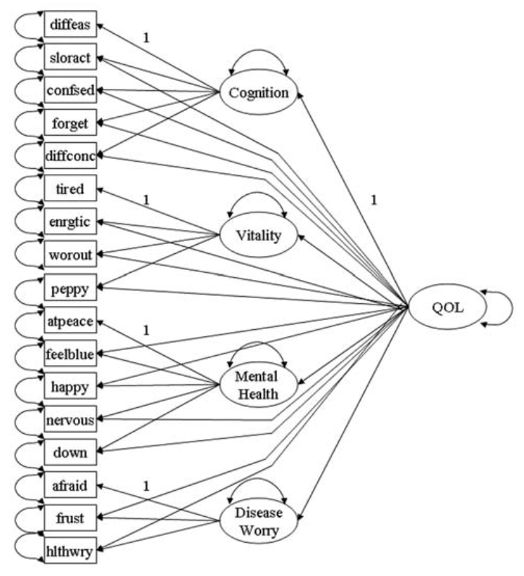
Figure 1. Full second-order model of QOL (page 8, Chen et al. 2006)
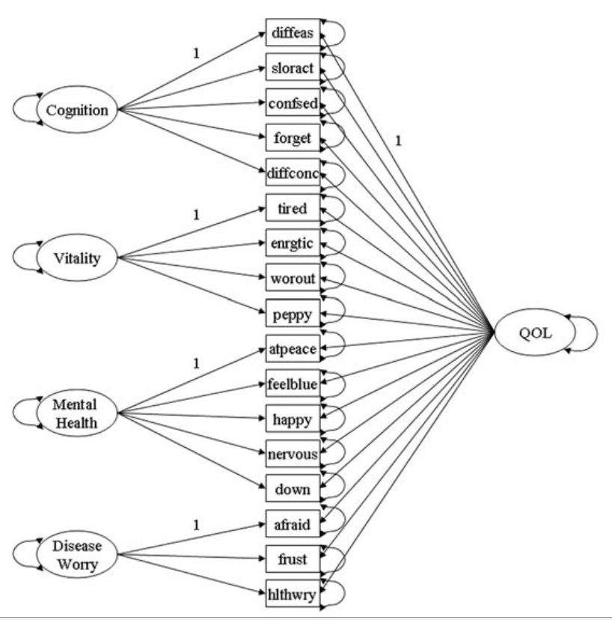
Figure 2. Bifactor model of QOL (page 3, Chen et al. 2006)
A few advantages of bifactor model over its competitors have been endorsed for its abilities in a) separating domain specific factors from the general factor, b) studying the relation between items and the general factors, and between items and domain specific factors, c) identifying whether a domain specific factor still exists after partialling out the general factor, d) testing whether a subset of the domain specific factors predict external variables, over and above the general factor, e) Testing mean difference on both the general and specific factor levels, and f) testing measurement invariance at both the general and specific factor levels (F. F. Chen et al., 2012; F. F. Chen et al., 2006; Reise, 2012; Reise et al., 2010).

2.3.2. Reise and Colleagues’ Paper (2007)
Reise and colleagues (2007) in their paper applied the bifactor model to study the dimension of an item response matrix of 16 items from the Consumer Assessment of Health care providers and Systems survey consist of 100 participants (Reise et al., 2007). They used both exploratory and confirmatory factor analytics in studying the dimensionality. Review of Item Reponses Theory is beyond the scope of the current study. It is important to note that IRT model assumes the item response matrix is unidimensional that there exist only one single latent variable explains the item responses. In other words, after partialling out the influence of a single latent variable, the item responses become independent. Thus, in the field of IRT, “acknowledging this fact, researchers have focused on methods of exploring whether data are ‘unidimensional enough’ for IRT application.” (p. 21) Common methods that have been used for estimating the dimensionality of item response matrix include “inspection of the ratio of the first to second eigenvalues, inspection of the distribution of residuals after extracting one factor, inspection of scree plots, …, confirmatory factor analysis.” (p. 21)
They fit four models to the sample data. The first one is a standard unidimensional model where one factor is specified to explain the covariance among the item responses. The second model is an uncorrelated multidimensional model where two factors are specified to explain the covariance among the item responses and the two factors are uncorrelated. The third model is a correlated multiple factor model where two factors are specified to explain the covariance among the item responses and two factors are correlated. The fourth model is a bifactor model where there is a general factor is specified to explain the covariance of all the item responses and two group factors are specified to explain only the variances among the items define the group factor after partialling out the influence of the general factor. Their key research question was “How much of the item variance is due to the general construct researcher is hoping to measure versus how much is due to secondary dimensions?” (p. 22- 23)
They first did exploratory factor analysis using principal axis factoring method. They argued there was a “strong” general factor based on the following criteria: “all items load reasonably well (i.e., > .40) on the first factor”, “the ratio of the first to second eigenvalues is 4.9 (the first five eigenvalues are 6.8, 1.4, .9, .8, and , .7)”, “GFI (.982)”, “mean residual (.001), and total variance (43%).”(p. 23) They kept a five-factor model as the priori domains while the two-factor solution as a plausible alternative, and both the two-factor solution and five-factor solution are substantively interpretable. Although it has been warned by previous researchers, the ratio of the first to second eigenvalues should not be used as an indicator of the strength of a general factor, the nature of factor analysis is to extract a first factor that explains as much as the variance possible.
They then did an exploratory bifactor analysis by performing S-L orthogonalization for both the two-factor model and five factor models. They then compared the factor loading from the S-L solution to the loadings from a unidimensional model, by observation of the derivations of the loadings between the two models, they suggest that “when unidimensional models fit to multidimensional data, the latent factor may not be an accurate representation of the general construct underling all the items.” (p. 25) In the paper, they also proposed to measure reliability to indicate “the degree to which individuals could be precisely assessed on the group factors” (p. 26 – p. 27) to answer the question “after controlling for the general factor, is there still enough reliable variance left to also scale individuals on the group factors (i.e., the subscale scores).” (p. 26)
Reise (2012) later published a more influential paper titled “The rediscovery of bifactor measurement models” (Reise, 2012). The author compared the relation between correlated-factors, second-order, and S-L method using a tetrachoric correlation matrix for Revised Child Anxiety and Depression Scale (RCADS-15). They used Schmid function in the psych library to obtain the S-L solution. They first obtained a five correlated-factors model, in which most items loaded strongly on only one of the five indicators and near zero elsewhere indicating “a fairly good independent cluster structure,” (p. 671) and the five factors are moderately correlated (from .21 to .59). They then obtained second-order model and obtained a S-L solution from the second-order model through S-L transformation. They discussed the two main limitations of the S-L transformation - “perfect Independent cluster structure” (e.g., items cross loaded on two group factors) and “proportional constraints” which are to discuss later in the study.
Given these two limitations of the S-L transformation, the authors suggested two alternatives. One is target bifactor rotations method developed by Reise (Reise, Moore, et al., 2011). The key point of the target rotation method is to first specify a priori (i.e., target pattern). The priori is a factor pattern with 0s and ?s or +s, where 0 indicates that the element is fixed at 0, ? indicates an element to be estimated, and + indicates the estimated element need to be positive. Then they conducted a regular factor extraction on the data, then rotate the factor pattern matrix to minimize its difference from the priori. It was suggested this priori can be obtained from preliminary data analyses or theory. It was suggested “by Cai (2010) that the mean root square standard deviation computed on the difference between the estimated pattern and the target pattern can be used to judge the adequacy of the resulting solution.” (p.675) The other alternative method is exploratory approach developed by Jennrich and Bentler (Jennrich & Bentler, 2011). More on this method will be discussed later in methodology chapter. They compared the solutions from the S-L method, the target rotation method, and the J-B method, and their results suggest that the target bifactor rotation appears similar to the S-L solution, and the J-B method yields highly similar results to the S-L and target models with one exception.
They then did confirmatory factor analysis and compared the three models (i.e., correlated factor model, second-order factor model, and unidimensional model) to the bifactor model in the framework of confirmatory analysis. By comparing bifactor model to the three models, they discussed the concept of “item parameter invariance.” In the framework of bifactor model, if the item parameter estimate invariance holds, then the same general and group factor loadings would be obtained if only a subset of the items were estimated.
At the end of their paper, they suggested that there are four important psychometric properties of bifactor model that can benefit the applied researchers. They are as follows: 1) the bifactor model allows to partition the reliable item response variance into two parts - one part is attributable to the general factor and the other part is attributable to the group factor; 2) the bifactor model allows a computation of reliability indices (e.g., ECV, PUC) to indicate the degree of uni-dimensionality; 3) the bifactor model allows estimation of proportion of item variance is explained by the general factor (e.g., Omega hierarchical); and 4) the bifactor model allows estimation of proportion of item variance explained by the group factors after partitioning out the influence of the general factor(e.g., Omega hierarchical for subscales).

2.4. A Review of Literatures on Model Fit Favoring Bifactor Model
Murray and Johnson (2013) demonstrated suggested that the bifactor model tends to always fit better than its nested second-order factor model. In their study, the generated a simulated data based on second-order factor model with added complexities (e.g., cross loadings), and then fit pure second-order factor model and pure bifactor model in which no cross loadings are added to the simulated data (Aja L Murray & Johnson, 2013). The results suggest that the fit indices AIC, BIC, CFI, TLI, RMSEA, and SRMR, and the chi-square tests are all biased toward the bifactor model. Reise and colleagues (2016) argued that why a bifactor model fit better than a nested second-order factor model is because that the bifactor is better at modeling “implausible patterns.” In their study, they applied iteratively reweighted least squares (IRLS, Yuan & Bentler, 2000) to study Rosenberg Self-Esteem Scale (RSES, Rosenberg, 1965). From response patterns perspective, they aimed to address the research question about what proportion of the individuals can be modeled by a bifactor model, by a unidimensional model, and cannot be modeled with any reasonable model respectively. They used two types of distance measure - ds (implausibility, reflects the discrepancy between an individual’s item response pattern and an estimated mean and covariance matrix) and dr (unmeltability, reflects the magnitude of an individuals’ residual given a fitted model) along with the IRLS method. The results suggest that 86% of the cases can be modeled by unidimensional model with adequate model fit, and only 3% require a bifactor model (significant residuals observed if fitted to a unidimensional model), and 11% of cases were unmodeled due to “their significant residuals in all models considered.” The results also suggest that part of the reason why a bifactor model fits better than the alternative is because the bifactor model is better at “accommodate implausible and possible invalid response patterns (e.g., 44444 11111)” (Reise et al., 2016). Gignac (2016) argued that the reason for this bias is that the second-order factor model imposed a “proportional constraint” whereas bifactor model does not have this constraint. In their study, they generated data based on a bifactor model but the proportional constraints of the general factor loadings to group factor loadings varied to different levels. Then they fit a second-order factor and a bifactor model to the simulated data. The results suggest that the fit difference between a bifactor model and a second-order factor model is positively associated with the degree of violation to the proportion constraints in the data. Gignac’s (2016) argument is later pointed out to be confusing by Mansolf and Reise (2017) (Gignac, 2016; Mansolf & Reise, 2016). They argued that the term “proportional constraint” is not an appropriate term to be used here. First, “proportional constraint” is a constraint imposed on the bifactor model solution obtained through S-L transformation not a constraint imposed on second-order model. Second, in their argument, “proportional constraint” should be better termed as “proportional constraint” which ensures proportional constraint to be met by the data.
Built on Gignac (2016)’s work, Mansolf and Reise (2016) used both Mathematical proofs and simulation study and demonstrated that a second-order model implies a unique set of tetrad constraints whereas the bifactor model does not. The fit difference between the two models is associated with the degree that these unique tetrad constraints are violated. Tetrads are “functions of the elements in the correlation matrix.” They reminded that “Spearman originally developed two-factor theory using tetrad constraints to establish whether a set of indicators was unidimensional” (p. 122). A tetrad is noted as “$Τ_{a.b.c.d}=r_{a.b}r_{cd}- r_{a.c}r_{b.d}=0$” where $r_{a.b}$is the correlation between variables a and b and $Τ_{a.b.c.d}$ is called a tetrad (Bollen and Ting, 1993). According to the authors, “All measurement models impose tetrad, sextad, and octad constraints on R.” (p. 122) They demonstrated mathematically the number of tetrads (as well as Sextads and Octads) imposed on R by each of the four models given the number of factors and number of items per factor in the model. For instance, for a 4-factor model with 4 items defining each factor, the number of Tetrads imposed on the R by a second-order model is 2724, and by a bifactor models is 2136, which implies that there are extra 588 tetrads imposed by second-order model but not bifactor model. Further they identified an independent set of 12 n-tad constraints that the 588 tetrads dependent on. They claimed that “to the degree that these 12 constraints are violated the second-order model will display a decrement in fit relative to the bifactor model.”(p. 123) and implied that if data is generated from a pure 4 factor of 4 items second-order factor model, these 12 constraints will be 0, and both the bifactor model and second-order factor model fit equally well. They then simulated data based on second-order factor with added complexities (cross-loadings, correlated residuals) and then fit both second-order factor model and bifactor model to the data. the results suggested that, “as the magnitude of the cross-loading increases, the magnitude of the tetrad violation increases, and in turn, the chi-square test becomes more favor-able toward the bifactor model.” (p. 123) They then simulated data based on bifactor with loadings that are disproportional and then fit both second-order factor model and bifactor model to the data. The results suggest that “as the degree of tetrad constraint violation increases, the chi-square values for the second-order model get worse, relative to the bifactor.” (p. 125) However, what the model fit will be for when the cross-loadings are modeled is not addressed in their study which needs further investigations.

2.5. A Review of Bifactor Model-based Indices
Rodriguez and colleagues (2016) have done a thorough review of the bifactor-model-based indices, including omega reliability coefficients ($ω$,$ω_{s}$, , $ω_{h}$,$ω_{hs}$, ${ω_{h}}/ω$, ${ω_{hs}}/{ω_{s}}$,), factor determinacy (FD), construct reliability (H), explained common variance (ECV), and percentage of uncontaminated correlations (PUC), and Average Relative Parameter Bias (ARPB) (Reise et al., 2013; Rodriguez et al., 2016a, 2016b). Details on the computation of each indices are reviewed in the methodology chapter. Omega ($ω$) estimates the proportion of variance in the observed total score that is attributable to all factors. The omega origins from Jorekog (1971), and advanced by McDonald (1999), modified later to estimate the strength of the general factor in a bifactor model (Reise, 2012; Zinbarg, Barlow, & Brown, 1997; Zinbarg et al., 2005; Zinbarg, Yovel, Revelle, & McDonald, 2006). Omega ($ω$) is computed by taking the ratio of variance explained by all factors and dividing it by the observed total variance. Omega hierarchical ${(ω}_{h})$, is computed by taking the ratio of variance explained by the general factor and dividing it by the observed total variance. The relative omega is computed by dividing Omega hierarchical by Omega, representing the proportion of reliable variance that is attributable to the general factor. Explained Common Variance (ECV) indexes estimate the proportion of reliable variances that is attributable to a specific factor. For the general factor, ECV is computed by taking the ratio of variance explained by the general factor and dividing it by the variance explained by the general and group factors where factors are assumed to be uncorrelated. Detailed information on the computation of the indices are reviewed in the methodology chapter. Although those model-based indices have been available for quite a while, they are not commonly reported in applied researches. One reason might be that many researchers do not believe bifactor model is appropriate for describing the structure of psychological traits (Rodriguez et al., 2016a, 2016b).

CHAPTER 3
METHODOLOGY
  - Confirmatory Bifactor Analysis
Bifactor model was first introduced by Holzinger and Swineford (1937). The original theory assumes one general factor runs through all the test items, and g group factors runs through some of the test items, and n unique factors specific to each of the n test items. All the latent factors are assumed to be orthogonal. Let assume a test consisting of six items y1 ~ y6, is administered to n subjects, and there is one general factor is attributable to all the six items and two group factors that are attributable to three items each. The test scores Y on the six items can be expressed mathematically as in the following:
$Y= Λ_{y}η+ ε$, [1]
where
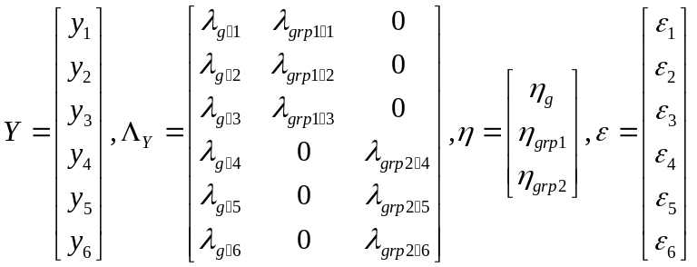
Y is a scalar of observed test scores on the six items, $Λ_{y}$ is a matrix of factor loadings on the test scores on the general factor and two group factors, $η$ is a scalar of latent factors consisting of a general factor and 2 group factors, $ε$ is a scalar of unique factors, or errors, or residuals of the test scores. Equation [1] can be interpreted in this way: the test score observed on item 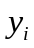 is a combination of contributions from the latent general factor, latent group factors, and random errors. We can also understand the relationships of test scores, latent factors, and unique factors from the variance-covariance structure and mean structure. Follow the same example, the variance of test scores can be written as a function of latent factors with their associated factor loadings, and unique factors.
, [2]
Where 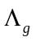 is a scalar of factor loadings on the general factor is, 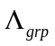is a matrix of factor loadings on the group factors, 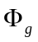is the variance of the general factor, 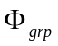is a matrix of variance-covariance of the group factors, 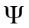is a diagonal matrix of variance-variance of the unique factors (i.e., the off diagonal elements are all zero because the factors are orthogonal)
or equivalently
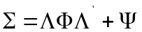, [3]
where 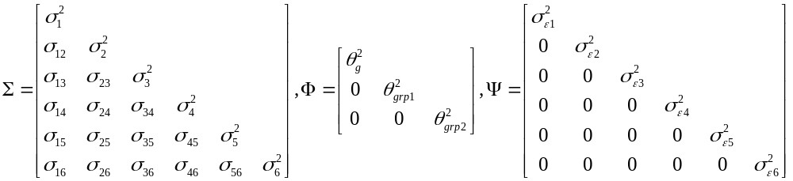
is a model-implied variance-covariance matrix, is a diagonal matrix of inter-correlation of the general factor and two group factors (i.e., the off-diagonal elements are all zero because the factors are orthogonal), is a diagonal matrix of variance-variance of the unique factors. So the variance-covariance equation can be rewritten as
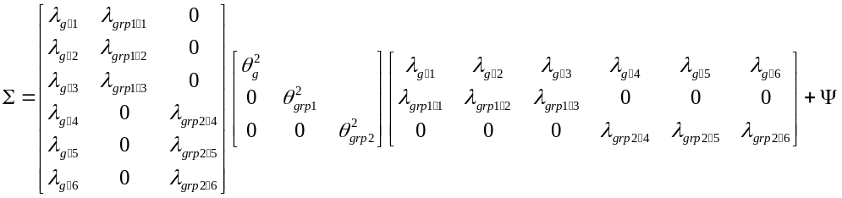 [4]
The mean of the test scores can be written as a function of intercepts and latent factor means
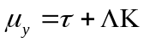, [5]
Where

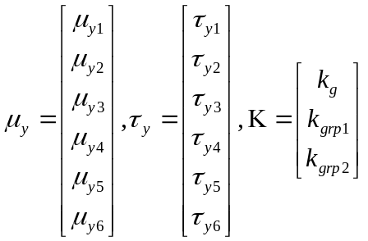

$μ_{y}$ represents a scalar of the observed item means, $τ_{y}$ represents a scalar of item intercepts, and K represents a scalar of latent general factor mean and group factor means. The mean equation can be rewritten as
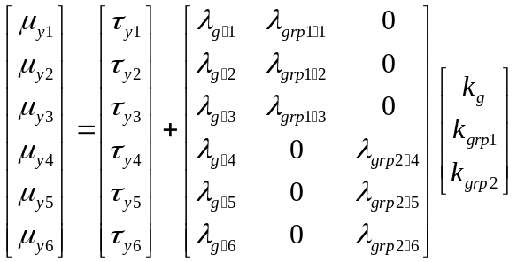
The relationship between observed item scores and latent factors can also be represented visually. Follow the same example, a diagram of bifactor model is presented in Figure 3.
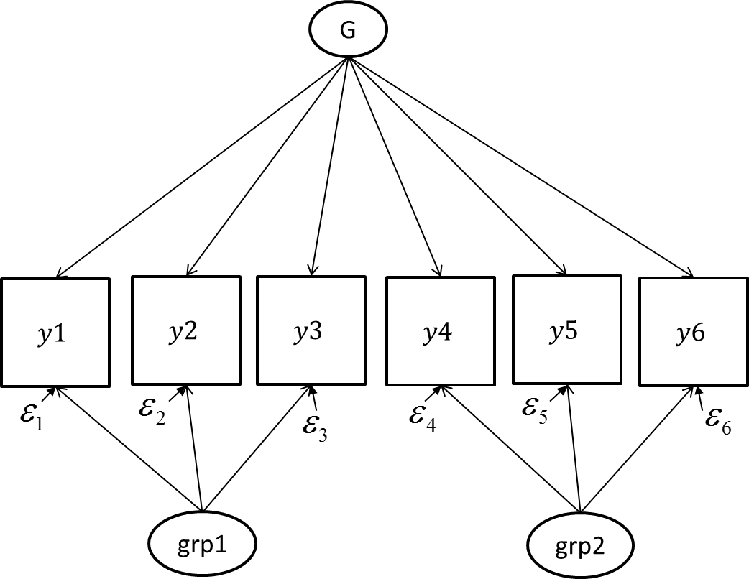
Figure 3. A diagram of bifactor model
  - Exploratory Factor Analysis
I’ll briefly review exploratory factor analysis before I begin on exploratory bifactor analysis. Factor analysis is a dimension reduction technique to simplify observed data by combining a large set of measured variables into a small set of latent factors. Exploratory factor analysis is an analytic technique to identify this set of latent factors and their relations with the observed variables.

3.2.1. Principle Component Analysis
Principle component analysis is one of the most widely used dimension reduction approaches. It’s also one of the oldest techniques formalized by Hotelling (1933) (Abdi & Williams, 2010; Hotelling, 1933). There are many other dimension reduction methods available, such as maximum likelihood, principal axis, multiple group-method, alpha factor analysis, image factor analysis. This article will focus on only reviewing principle component analysis (PCA) method and maximum likelihood method which are the most commonly used methods in factor analysis. Interested researchers on the rest methods please refer to Harman (1976) (Harman, 1976).
The goal of PCA approach is to find a smaller set of orthogonal components that can represent the larger set of observed variables. Each of the components can be expressed as a linear combination of all the measured variables. These components are called principle components. Mathematically, “PCA depends on the eigen-decomposition of positive semi-definite matrices and upon the singular value decomposition (SVD) of rectangular matrices” (p. 1) (Abdi & Williams, 2010). In principle components method, the component $z_{r}$ can be expressed as
$z_{r}=\sum_{i=1}{w_{ir}x_{i} (i,r=1,2,…, n)}$ [6]
Where $z_{r}$ stands for the $r^{th}$ component and $w_{ir}$ is the weight of the $r^{th}$ component associated with the $i^{th}$variable.
Let X be a $n×m$ matrix, where $n$ is number of observations and 𝑚 is number of variables. The element $x_{ij}$ in X is an observed value of $i^{th}$ subject on $j^{th}$ variable, where i=1, …, n; j =1, …, m. The matrix X has rank r where $r ≤min⁡[m,n]$. Let columns of X be centered so that the mean of each column is equal to 0, and let C be a $m×m$ variance-covariance matrix of X, then C can be computed as
$C= X^{T}X/n$ [7]
Notice that by singular value decomposition, (any) matrix X can be expressed as a product of three matrix, P, Q and $∆$ :
$X= P∆Q^{T}$ [8]
where P is a $n×r$ matrix of left singular vectors, Q is a $m×r$ matrix of right singular vectors, and $∆$ is the a$r×r$ diagonal matrix of singular values. P and Q are both orthogonal matrix such that $P_{.i}∙P_{.j}=0 for i≠j, P_{.i}∙P_{.j}=1 for i=j, P∙P^{T}=I$ and $Q_{.i}∙Q_{.j}=0 for i≠j, Q_{.i}∙Q_{.j}=1 for i=j, Q∙Q^{T}=I.$
The Variance-covariance matrix can be rewritten as
$C=\frac{X^{T}X}{n} =\frac{{(P∆Q^{T})}^{T}P∆Q^{T}}{n}=\frac{Q∆^{T}P^{T}P∆Q^{T}}{n}=\frac{Q{(∆}^{T}∆)Q^{T}}{n}$
$=\frac{Q∆^{2}Q^{T}}{n} (let Σ=∆^{2} )$
$=\frac{QΣQ^{T}}{n}$ [9]
Notice that $Σ$ is a diagonal matrix with ordered eigen values from largest to smallest listed on the diagonal. The columns of matrix $Q$ includes the orthogonal eigenvectors associated with each eigen value in $Σ$. Each column in $Q$ is called principal component, and its associated eigen value can be interpreted as the amount of variance in X explained by the principle component. Eigenvalue and eigen vectors can be solved mathematically from the above equation. $∆$ can be computed by taking square root of $Σ$, and P can be obtained by solving the SVD equation given $∆$ and Q. Let F be a $n×r$ factor score matrix, F can be represented as
${F=XQ}^{ }$ [10]
and matrix X can be expressed as
$X=FQ^{T}$ [11]
The matrix Q is called a loading matrix, the matrix X is interpreted as the product of the factor score matrix by the loading matrix, with that
$F^{T}F=Σ, and$ $Q^{T}Q=I.$ [12]
The matrix Q can also be viewed as a transformation matrix that transforms the original data matrix X into factor scores. Notice that $Σ$ is a variance-covariance matrix of the factor scores. From the above it is known that $Σ$ is a diagonal matrix with ordered eigen values from largest to smallest listed on the diagonal and that eigenvalues can be interpreted as the variance in the observed variables explained by the factor. Also note that all the factors are uncorrelated since that the off-diagonal elements of matrix F are all 0. Let Z be a column-centralized (i.e., the mean of each column of z is equal to 0) and column-standardized (i.e., dividing each variable by the square root of the sum of all the squared elements of the variable) form of $X/\sqrt{n}$, then the correlation matrix R of X can be computed as
$R= Z^{T}Z$ [13]
let F be a $n×r$ factor score coefficient matrix, A be a $m×r$ factor loading matrix, where $r$ is the number of factors extracted
$Z=FA^{T}$ [14]
Let $Φ$ be a$r×r$factor correlation matrix,
$Φ= F^{T}F$ [15]
Then R can be rewritten as
R = $Z^{T}Z={\left({FA}^{T} \right)}^{T}{FA}^{T} =AF^{T}FA=A ΦA^{T}$ [16]
It can be easily seen that A is a standardized loading matrix. Most statistical packages use correlation matrix as the input by default. In the same sense, Z can be written as of singular value decomposition
R = $Z^{T}Z=$(${PΔQ^{T})}^{T} PΔQ^{T}=QΔ^{T}P^{T}PΔQ^{T}=QΔ^{2}Q^{T}$ [17]
Let $Φ=Δ^{2}$, then Q is a solution of A. Note that $Φ$ is a diagonal matrix and Q is orthogonal, and that Factors are uncorrelated. Note that principal component is one of many methods used to obtain the initial matrix F, other methods such as centroid method, the multiple-group method (Carroll, 1953). Also note that Q is not a unique solution to A. Q is just one of many initial orthogonal matrices that satisfying the above equation.

3.2.2. Maximum Likelihood Method
Maximum likelihood method in factor analysis was originally proposed by Lawley (1940). In contrast to principle component method, in maximum likelihood method the observed $x_{i}$ can be expressed as
$x_{i}=\sum_{r=1}^{k}{λ_{ir}f_{r}}+e_{i} (i=1,2,…,n)$ [18]
where $f_{r}$ is the r-th common factor, $λ_{ir}$ is the factor loading associating the factor and its targeted item, and $e_{i}$ is a residual representing sources of variation affecting only the variable $x_{i}$. Let $σ_{ii}^{2}$ be the variance of $x_{i}$ and $σ_{ij}$ be the covariance of $x_{i}$ and $x_{j}$, then $σ_{ii}^{2}$ and $σ_{ij}$ can be expressed in terms of factor loadings and residual variances
$σ_{ii}^{2} =\sum_{r=1}^{k}{λ_{ir}^{2}+u_{i} ,}$ [19]
$σ_{ij}=\sum_{r=1}^{k}{λ_{ir}λ_{jr}(i≠j),}$ [20]
Let $Σ$ be the variance-covariance matrix with elements $σ_{ii}^{2}$on the diagonal and $σ_{ij}$ off diagonal , let A be the $n×k$ matrix of loadings with elements$λ_{ir}$ , let $U$ be the diagonal matrix with elements $u_{i}^{2}$, then the equations can be rewritten in terms of matrix algebra as
$Σ=AA^{'}+U$ [21]
Let S be the observed sample variance-covariance matrix with elements $s_{ii}^{2}$ on the diagonal and $s_{ij}$ off diagonal, the likelihood function of L of the observed sample given the parameter estimates $\hat{A}$and $\hat{U}$ is obtained as
L = $K{\left|Σ\right|}^{-\frac{1}{2}(N-1)}{\left|S\right|}^{\frac{1}{2}(N-n-2)}\exp^{-\frac{N-1}{2}}\sum_{j,k=1}^{n}{σ^{jk}s_{jk}}\prod_{j<k=1}^{n}{ds_{jk}}$ [22]
where K is a constant involving only N and n. This function is first derived by Wishart (1928). The maximum likelihood method is to find the estimates $\hat{A}$and $\hat{U}$ that maximizing the likelihood L. For ease of computation, the nature logarithm of the likelihood function is obtained,
$\log{L}=-\frac{N-1}{2}\left(log\left|Σ\right|+\sum_{j,k=1}^{n}{σ^{jk}s_{jk}}\right)+function independent of Σ$ [23]
minimizing the following expression
$-\frac{2}{N-1}\log{L}=\left(log\left|Σ\right|+\sum_{j,k=1}^{n}{σ^{jk}s_{jk}}\right)+function independent of Σ$ [24]
will obtain the maximum of the likelihood function L. Due to the complexity in the computations, Joreskog and Lawley (1967) developed new methods for maximum likelihood estimation in 1967. The likelihood function L is redefined as
$L=-\frac{1}{2}N\left\{log\left|Σ\right|+tr(SΣ^{-1})\right\}$, [25]
where
$Σ=ΛΦΛ^{'}+Ψ$ [26]
where $Λ$ is a $p×k$ matrix of factor loadings, $Φ$ is a $k×k$ factor correlation matrix, and $Ψ$ is a diagonal matrix with residuals terms on the diagonal. Mathematically it is more convenient to minimize the function,
$F(Λ,Φ,Ψ)=log\left|Σ\right|+tr\left(SΣ^{-1}\right)-log\left|S\right|-p$ [27]
Or equivalently
$F_{ML}(θ)=tr\left(Σ^{-1}S\right)-log\left|Σ^{-1}S\right|-p$ [28]
and minimizing F is the same as maximizing L. To obtain the estimates A and $ψ$ that maximize the L function is to solve the following two partial derivative equations:
$\frac{∂l}{∂A}=-\frac{n}{2}\left[Σ^{-1}A-Σ^{-1}SΣ^{-1}A\right]=0$ [29]
$\frac{∂l}{∂Ψ}=-\frac{n}{2}diag\left[Σ^{-1}-Σ^{-1}SΣ^{-1}\right]=0$ [30]
Or equivalently:
$A=SΣ^{-1}A$ [31]
$Ψ=diag\{S-AA'\}$ [32]
Since it’s not possible to solve the equations explicitly, iterative procedures are used to maximize the likelihood function L. Many algorithms have been proposed to improve the speed of the iteration processes, including the quasi Newton-Raphson algorithm (Joreskog, 1967), Newton-Raphson algorithm (Jennrich and Bobinson,1969), the expectation-maximization (EM), algorithm (Dempster,1977), ECME (Liu, 1994), full information estimation (developed particularly for dealing with missing data) (Arbuckle, 1996) (Arbuckle, 1996), conditional maximization (CM) algorithm (Zhao, Philip, & Jiang, 2008). The maximum likelihood method in Mplus use “one or a combination of the following: Quasi-Newton, Fisher scoring, Newton-Raphson, and the Expectation Maximization (EM) algorithm.” (Mplus user guide 8.0, p .9) The details on the algorithms are beyond the scope of the current paper. The likelihood ratio test is based on the likelihood function and defined as
$LRT = -2 log\{max[L(θ_{i})/$max[L($θ_{j}$)]}, [33]
where $L(θ_{i})$ is the likelihood for model i with parameters $θ_{i}$, and $L(θ_{j})$ is the likelihood for model j with parameters $θ_{j}$. The two models are nested models with model j nested with model i.

3.2.3. Rotate to Meaningful Factors
Due to this “inherited indeterminacy” and the difficulties in interpreting the initial loading matrix, meaningful solutions are obtained by rotating the initial loading matrix under the constraints of “simple structure.” This “simple structure” of a factor matrix of m columns is defined by Thurstone (1947):
- Each row should contain at least one zero.
- Each column should contain at least m zeros.
- Every pair of columns should have several rows with a zero in one column but not the other.
- If m>=4, every pair of columns should have several rows with zeros in both columns.
- Every pair of columns of ^ should have few rows with nonzero loadings in both columns.

A perfect simple structure factor matrix looks like this:
$Λ=\left[\begin{aligned}\begin{aligned}\begin{aligned}\begin{matrix}X & 0 & 0 \\ X & 0 & 0\end{matrix} \\ \begin{matrix}X & 0 & 0 \\ 0 & X & 0\end{matrix} \\ \begin{matrix}0 & X & 0 \\ 0 & X & 0\end{matrix}\end{aligned} \\ \begin{matrix}0 & 0 & X \\ 0 & 0 & X\end{matrix} \\ \begin{matrix}0 & 0 & X\end{matrix}\end{aligned} \\ \begin{matrix}0 & 0 & X\end{matrix}\end{aligned}\right]$ [34]
where X refers to a nonzero quantity. The matrix A contains factors with nonzero loadings on single variable. The variable has only one non-zero loading is called “perfect indicator.” This factor matrix is said to have a “perfect cluster configuration” as all the indicators are perfect indicators. The goal of rotation thus becomes to obtain a simple structure from the initial factor score matrix. Many scholars have developed different mathematical formula to quantify Thurstone’s concept of “simple structure.” The most widely used orthogonal rotation method is the quartimax method developed by Carroll (Carroll, 1953; Neuhaus & Wrigley, 1954) and two varimax methods (Crawford & Ferguson, 1970; Kaiser, 1958). The raw varimax method is developed by Kaiser (1958) which is referred to as varimax rotation criteria and the one developed by Crawford and Ferguson (1970) is referred to as CF-varimax. These two rotation criteria are equivalent in orthogonal rotation.
Let $Λ$ * be an initial $m×r$ (i = 1, …, m; j = 1, …, r) factor loading matrix, where
$Λ$ * = $\left[\begin{aligned}\begin{aligned}\begin{aligned}\begin{matrix}X & X & X \\ X & X & X\end{matrix} \\ \begin{matrix}X & X & X \\ X & X & X\end{matrix} \\ \begin{matrix}X & X & X \\ X & X & X\end{matrix}\end{aligned} \\ \begin{matrix}X & X & X \\ X & X & X\end{matrix} \\ \begin{matrix}X & X & X\end{matrix}\end{aligned} \\ \begin{matrix}X & X & X\end{matrix}\end{aligned}\right]$ [35]
The variance of the squared elements of optimal $Λ$ is
$σ^{2}=\frac{\sum_{i}{\sum_{j}{λ_{ij}^{4}-\frac{{\left[\sum_{i}{(\sum_{j}{λ_{ij}^{2}})}\right]}^{2}}{mr}}}}{mr}=\frac{1}{mr}\sum_{i}{\sum_{j}{λ_{ij}^{4}}}-\frac{1}{m^{2}r^{2}}{\left[\sum_{i}{\sum_{j}{λ_{ij}^{2}}}\right]}^{2}$ [36]
The quartimax method is to find the $Λ$ which the sum of fourth powers of the elements is largest.
Kaiser (1958) suggested that “from any arbitrary factor matrix ...rotating under the criterion that each factor successively accounts for the maximum variance” (p. 187) and to obtain “psychologically meaningful factors (i.e., columns).” The Kaiser varimax criteria is modified from quartimax criterion and is:
$v(Λ)=\sum_{j}{\left\{\left[m\sum_{i}{{(λ_{ij}^{2})}^{2}}-{(\sum_{i}{λ_{ij}^{2}})}^{2}\right]/m^{2}\right\}}$ [37]
The maximum simplicity of a factor matrix is obtained as the maximization of the variance of squared loadings by columns of $v\left(Λ\right)$ is achieved. Crawford and Ferguson (1970) suggested a family of complexity functions based on variable complexity in a factor loading matrix. “The complexity of a variable in a factor pattern refers to the number of nonzero elements in the corresponding row of the factor loading matrix.” (Browne, 2001, p. 115) “All rotation criterion is expressed as complexity functions to be minimized to yield a simple pattern of loadings.” (Browne, 2001, p. 117) This family is indexed by a single parameter, $κ(0≤κ ≤1)$, and its members are of the form:
$$f\left(L\right)=\left(1-κ\right)\sum_{i=1}^{m}{c\left(s_{i.}\right) + κ\sum_{i=1}^{r}{c\left(s_{.j}\right) }}$$
$$=\left(1-κ\right)\sum_{i=1}^{m}{\sum_{j=1}^{r}{\sum_{l≠j}^{r}{λ_{ij}^{2}λ_{il}^{2}} + κ}}\sum_{j=1}^{r}{\sum_{i=1}^{m}{\begin{aligned}\sum_{k≠i}^{m}{λ_{ij}^{2}λ_{kj}^{2}} \\ \end{aligned}}}$$
Row(variable)complexity Column(factor)complexity [38]

Thus the Crawford-Ferguson criterion is a weighted sum of a measure of complexity of the p rows of $Λ$ and a measure of complexity of the m columns. The Quartimin criterion is defined at $κ=0$. The Crawford-Ferguson criterion is the base of the rotation method used by Jennrich and Bentler in developing the J-B analytic.
Transformation matrix
Let $Λ$ be the rotated matrix of $Λ$*. let T be a $2×2$ orthogonal matrix which transform $Λ$* to $Λ$:
$T=\left[\begin{matrix}cosθ & -sinθ \\ sinθ & cosθ\end{matrix}\right]$ [39]
The rotated factor loadings can be written as:
$$λ_{ij}=λ_{ij}^{*}cosθ+λ_{ij^{'}}^{*}sinθ$$
$λ_{ij^{'}}={-λ}_{ij}^{*}cosθ+f_{ij^{'}}^{*}sinθ$ [40]
A transformation will be proceeded if there is a desired level of increase or decrease in the maximizer or minimizer of the rotation criterion; iterations stop otherwise.

3.3. Exploratory Bifactor Analysis

3.3.1. Schmid, J. and J. M. Leiman Transformation (1957)
Schmid and Leiman developed the method to obtain a bifactor solution from a second-order factor model. How the bifactor solution was obtained from the S-L transformation can be showed by an example as presented in Table 1. At the left side of the table is the solution from second-order factor model, and at the right side is the bifactor solution obtained from the S-L transformation. Table 2 shows how the bifactor solution is computed from the hierarchical solution. It can be easily noticed that there is linear dependency between the general factor loading and group factor loading for the items loaded on the same group factors. For example, for item1, the general loading is calculated as .66* .85 + .83*0 +.60*0 =.56, and group factor loading is calculated as 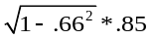 = .64, it’s easy to see that the ratio of the general factor loading to the group factor loading is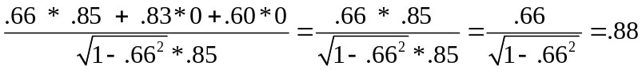. It’s easy to show that for item2 and item3, thus the ratio of the variance explained by the general factor to the variance explained by the group factor is also 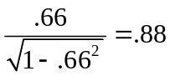, for item 4-6, the ratio is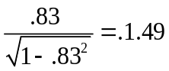, and for item 7-9, the ratio is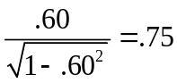. This proportional relationship between the general factor and group factors is referred to as “proportional constraints.” Notice that in the second-order solution, item 1-3 only loaded on F1 and has exact 0 on F2 and F3, item 4-6 only loaded on F2 and has exact 0 on F1 and F3, and item 7-9 only loaded on F3 and has exact 0 on F1 and F2. This structure is referred to as “perfect independent cluster structure” which no cross loadings are present. When the data does not support “perfect independent cluster structure”, it is not possible to recover the bifactor pattern through S-L transformation. When both “proportional constraint” and “perfect independent cluster structure” were true in the true population model, then the bifactor solution obtained through S-L transformation will be identical to the second-order solution.

Table 1. An example: Hierarchical solution transformed to S-L bifactor solution
Item | SL hierarchical solution |  |  |  |  | Item | SL bifactor solution
Item | F1 | F2 | F3 | G |  | Item | G | Grp1 | Grp2 | Grp3 | Ratio
Item1 | .85 | 0 | 0 |  |  | Item1 | .56 | .64 |  |  | 0.88
Item2 | .80 | 0 | 0 |  |  | Item2 | .53 | .60 |  |  | 0.88
Item3 | .75 | 0 | 0 |  |  | Item3 | .50 | .56 |  |  | 0.88
Item4 | 0 | .75 | 0 |  |  | Item4 | .62 |  | .42 |  | 1.49
Item5 | 0 | .70 | 0 |  |  | Item5 | .58 |  | .39 |  | 1.49
Item6 | 0 | .65 | 0 |  |  | Item6 | .54 |  | .36 |  | 1.49
Item7 | 0 | 0 | .65 |  |  | Item7 | .39 |  |  | .52 | 0.75
Item8 | 0 | 0 | .60 |  |  | Item8 | .36 |  |  | .48 | 0.75
Item9 | 0 | 0 | .55 |  |  | Item9 | .33 |  |  | .44 | 0.75
F1 | 1 |  |  | .66
F2 | .55 | 1 |  | .83
F3 | .40 | .50 |  | .60

Table 2. Computation: The computation of S-L bifactor solution from hierarchical solution
Item | G | Grp1 | Grp2 | Grp3
Item1 | .66* .85 + .83*0 +.60*0 =.56 | =.64 | 0 | 0
Item2 | .66* .80 + .83*0 +.60*0 =.53 | 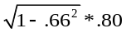=.45 | 0 | 0
Item3 | .66* .75 + .83*0 +.60*0 =.50 | 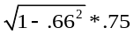=.60 | 0 | 0
Item4 | .66* 0 + .83*.75 +.60*0 =.62 | 0 | 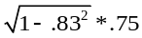=.42 | 0
Item5 | .66* 0 + .83*.70 +.60*0 =.58 | 0 | 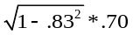=.39 | 0
Item6 | .66* 0 + .83*.65 +.60*0 =.54 | 0 | 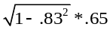=.36 | 0
Item7 | .66* 0 + .83*0 +.60*.65 =.39 | 0 | 0 | 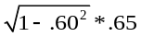=.52
Item8 | .66* 0 + .83*0 +.60*.60 =.36 | 0 | 0 | 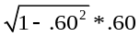=.48
Item9 | .66* 0 + .83*0 +.60*.55 =.33 | 0 | 0 | 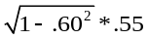=.44

3.3.2. Jennrich-Bentler Analytic Bifactor Rotations (2011, 2012)
Exploratory bifactor analysis is simply exploratory factor analysis using a bifactor rotation criterion. Jennrich and Bentler first developed the bi-quartmin rotation criterion for orthogonal and later developed the bi-geomin rotation criterion for oblique case. The criterion is designed to produce “perfect cluster structure” in the last K-1 columns of a rotated loading matrix. Let $Λ$ be an arbitrary $P×K$ loading matrix, and $Λ_{2}$ be a loading matrix consists of the last K-1 columns of matrix $Λ$, the bi-quartmin rotation criterion is defined as
$B_{q}\left(Λ\right)=Qquartimin\left(Λ_{2}\right)=\sum_{i=1}^{p}{\sum_{r=1}^{k-1}{\sum_{s=r+1}^{k-1}{λ_{ir}^{2}λ_{is}^{2}}}}$ [41]
It is easy to see that to obtain a “perfect cluster structure”, all the terms $λ_{ir}^{2}λ_{is}^{2}$ need to be zero and $Qquartimin\left(Λ_{2}\right)=0$. Let A be an initial loading matrix obtained from exploratory factor analysis. Let $\hat{A}$ be the loading matrix that minimize a bifactor rotation criterion $B_{q}\left(A\right)$ over all rotations of A. This $\hat{A}$ is called a bifactor rotation of A corresponding to $B_{q}\left(A\right)$. The authors pointed out that all the columns are rotated although the rotation criterion does not depend on the first column. The bi-geomin rotation criterion is defined as
$B_{q}\left(Λ\right)=Qgeomin\left(Λ_{2}\right)=\sum_{i=1}^{p}{({\prod_{r}{(λ_{ir}^{2}+ε)})}^{1/(k-1)}}$ [42]
where $ε$ is a small positive value.

3.3.3. Target Rotation Method (2010)
A target matrix is a pattern matrix where each element is either specified (0) or unspecified (?). The specified is fixed values and the unspecified are values to be estimated. To specify a target matrix, A priori is required. In specifying a target pattern for bifactor model, the target pattern matrix will consist of unspecified elements (?) in the first column and each item will have zero or one or more unspecified elements on the group factor (Browne, 2001; Reise, Moore, et al., 2011; Reise et al., 2010). The factor extraction is conducted as usual to obtain an initial factor loading matrix $Λ$*. Then the $Λ$* is rotated to minimize the difference between the final matrix and the target matrix.
  - Bifactor Model-based Indices

3.4.1. McDonald’s Coefficient Omega
Coefficient Omega is originally developed as a model-based reliability coefficient from Common factor theory perspective by McDonald to examine the reliability of a set of homogenous tests (i.e., uni-dimensional). In a homogenous test, “the items measure the same things… If a test has substantial internal consistency, it is psychologically interpretable” (p. 320) (Cronbach, 1951). A single-factor model can be applied to represent the homogenous tests, then the test scores can be expressed as
$x=Λf+Λ_{u}s+e$ [43]
The variance in $x$ consists of three parts: the part explained by the single factor which is referred to as common variance, the part cannot be explained by the common factor which is referred to as unique variance, and random errors.
Var(x) = $σ_{x}^{2}= σ_{c}^{2}+σ_{u}^{2}+σ_{e}^{2}$ [44]
McDonald (1999) stated that “the unique part is the error of measurement” and then the variance in x can either be rewritten as
$σ_{x}^{2}= σ_{c}^{2}+σ_{u}^{2}$ or $σ_{x}^{2}= σ_{c}^{2}+σ_{e}^{2}$ [45]
by the algebra of expectations (McDonald, 1999) (Equation 6.18a)
$σ_{x}^{2}={(\sum{λ_{i})}}^{2}+\sum{Ψ_{i}^{2}}$ [46]
The coefficient Omega is defined as (Equation 6.20a, 6.20b)
$ω=σ_{c}^{2}/σ_{x}^{2}$ or $ω={(\sum{λ_{i})}}^{2}/{[(\sum{λ_{i})}}^{2}+\sum{Ψ_{i}^{2}]}$ [47]
The total variance in the above equation can either be computed from the model-based estimates by summing up common variance and unique variance, or be computed from observed scores by taking sum of all the elements in the variance-covariance matrix of X. The former computation is more often applied. It is shown that coefficient omega ($ω$) is a ratio of the common factor variance to the total variance of X. Coefficient omega ($ω$) is interpreted as a reliability coefficient.

3.4.2. Coefficient Omega Hierarchical ($ω_{H}$)
In the framework of bifactor model, variance in composite score can be partitioned into four parts: a general factor, r group factors, m specific factors, and random errors (Zinbarg et al., 2005). Of them the first three are reliable sources of variance that are systematic and repeatable. Let $x$be a $m×1$vector of observed scores on $m$ items, then $x$ can be expressed as
$x=Λ_{gen}g+Λ_{grp}f+Λ_{u}s+e$ [48]
where g is a general factor, $Λ_{gen}$ is a $m×1$ vector of unstandardized factor loadings of the general factor on the $m$ observed items, f is a $r×1$ vector of group factors, $Λ_{grp}$ is a $m×r$ matrix of unstandardized group factor loadings, s is a $m×1$ vector of unique factors that are specific to each observed item, $Λ_{u}$ is a $m×m$ matrix of unstandardized specific factors loadings, e is a $m×1$ vector of random error scores. Assuming that in the simplest bifactor model, all the factors are uncorrelated, then both $Λ_{grp}$ and $Λ_{u}$ will be diagonal matrix that the off-diagonal elements are all 0. The variance in X can be decomposed into four parts:
Var(x) = $σ_{x}^{2}= σ_{gen}^{2}+σ_{grp}^{2}+σ_{u}^{2}+σ_{e}^{2}$ [49]
In reality, $σ_{u}^{2}$ and $σ_{e}^{2}$ cannot be separated from each other, thus they will be combined into one term,
Var(x) = $σ_{x}^{2}= σ_{gen}^{2}+σ_{grp}^{2}+σ_{ε}^{2}$ [50]
Or by the algebra of expectations
Var(x) = $σ_{x}^{2}={(\sum{λ_{gen∙i})}}^{2}+{(\sum{λ_{grp∙i})}}^{2}+\sum{Ψ_{i}^{2}}$ [51]
Omega can be computed as
$ω=\frac{{(\sum_{i=1}^{m}{λ_{gen}})}^{2}+{(\sum{λ_{grp∙i})}}^{2}}{Var(X)}$ [52]
Omega Hierarchical can be computed as
$ω_{H}=\frac{{(\sum_{i=1}^{m}{λ_{gen}})}^{2}}{Var(X)}$ [53]
where $Var(X)$ is the total variance in the observed scores, or be computed from model-based estimates (Rodriguez et al., 2016a)
$Var\left(X\right)= {(\sum_{i=1}^{m}{λ_{gen∙i}})}^{2}+{(\sum_{j=1}^{r}{\sum_{i=1}^{m}{λ_{grpj∙i}}})}^{2} +\sum{(1-h^{2})}$ [54]
Omega can be computed as
$ω=\frac{{(\sum_{i=1}^{m}{λ_{gen}})}^{2}+{(\sum{λ_{grp∙i})}}^{2}}{{(\sum_{i=1}^{m}{λ_{gen∙i}})}^{2}+{(\sum_{j=1}^{r}{\sum_{i=1}^{m}{λ_{grpj∙i}}})}^{2} +\sum{(1-h^{2})}}$ [55]
Omega Hierarchical can be computed as
$ω_{H}=\frac{{(\sum_{i=1}^{m}{λ_{gen}})}^{2}}{{(\sum_{i=1}^{m}{λ_{gen∙i}})}^{2}+{(\sum_{j=1}^{r}{\sum_{i=1}^{m}{λ_{grpj∙i}}})}^{2} +\sum{(1-h^{2})}}$ [56]
Omega Hierarchical "reflects the percentage of systematic variance in unit-weighted (Crawford & Ferguson) total scores that can be attributed to the individual differences on the general factor” and “when omega Hierarchical is high (> .80), total scores can be considered essentially unidimensional” (p. 224).

3.4.3. Omega Hierarchical Subscale, $ω_{HS}$
OmegaHS,$ω_{HS}$ , is an index indicating the proportion of reliable systematic variance of a group factor beyond and above the general factor
$ω_{HS}=\frac{{(\sum{λ_{grpj}})}^{2}}{{{(\sum{λ_{gen}})}^{2}+(\sum{λ_{grpj}})}^{2}+\sum{(1-h^{2})}}$ [57]

3.4.4. Omega Subscale, $ω_{s}$
The omega subscale, $ω_{s}$, is “an index reflecting the proportion of reliable systematic variance of a subscale score.” (Rodriguez et al., 2016a, p. 225) Subscale Omega Hierarchical can be computed in the same way for the subscale as for the scale but with only the items in the subscale
$ω_{S}=\frac{{{(\sum{λ_{gen}})}^{2}+(\sum{λ_{grpj}})}^{2}}{{{(\sum{λ_{gen}})}^{2}+(\sum{λ_{grpj}})}^{2}+\sum{(1-h^{2})}}$ [58]

3.4.5. Relative Omega
Relative Omega is obtained by dividing Omega H by Omega. For the general factor, this represents the percent of reliable variance in the multidimensional composite due to the general factor. For specific factors, relative omega represents the proportion of reliable variance in the subscale composite that is due to the specific factor.

3.4.6. ECV and PUC
Explained common variance (ECV) to a general factor is obtained by “taking the ratio of variance explained by a general factor and dividing it by the variance explained by a general and group factors where all factors are assumed to be uncorrelated” (Rodriguez et al., 2016a, P. 231) (Reise, 2012; Reise et al., 2013; Rodriguez et al., 2016a). ECV is computed as:
$ECV=\frac{{(\sum{λ_{gen}})}^{2}}{{(\sum{λ_{gen}})}^{2}+ {(\sum_{j=1}^{r}{\sum_{i=1}^{m}{λ_{grpj∙i}}})}^{2}}$ [59]
It is suggested higher ECV values indicate a strong general factor. When ECV is greater than .70 ~ .80, a single-factor model will represent the data well.
The Percent of Uncontaminated Correlations (PUC) is defined as
$PUC=1-\frac{\begin{aligned}Number of correlaions among items \\ within group factors\end{aligned}}{Total number of correlations}$ [60]
Or
$PUC=\frac{\begin{aligned}Number of correlaions between items \\ from different group factors\end{aligned}}{Total number of correlations}$ [61]
From the above equation it is easy to see that when there are many group factors (the number of items per group factor then become small) the PUC value will be large. Rodriguez and colleagues (2016) demonstrated that when ECV > .70 and PUC >.70, there is slight difference in the loadings of the general factor between a unidimensional model and a bifactor model that fit to the same data.

3.4.7. Factor Determinacy
Factor Determinacy indicates the correlation between factor scores and the factors. It is computed as
$FD={diag(ΦΛ^{T}Σ^{-1}ΛΦ)}^{1/2}$ [62]
where $Φ$ is a $r × r$ matrix of factor intercorrelations and $r$ is the number of factors, the $Λ$ is a $m × r$ matrix of standardized factor loadings where $m$ is the number of items, $Σ$ is a $m × m$ model-based correlation matrix ($Σ= ΛΦΛ^{'}+ψ$). FD ranges from 0 to 1, with values closer to 1 indicating better determinacy. It is recommended that factor score estimates should be considered only when determinacy values exceed .90 (Gorsuch, 1983, p. 260).

3.4.8. Construct Replicability, H
Index H is a measure of construct replicability conceptualized by Hancock and Mueller (2001). It is an index to evaluate how well a set of items represents a latent variable, it is computed as
$H=\frac{1}{1+\frac{1}{\sum_{i=1}^{r}{\frac{λ_{i}^{2}}{1-λ_{i}^{2}}}} }$ [63]
which “represent[s] the correlation between a factor and an optimally-weighted item composite… high H values (> .80) suggest a well-defined latent variable which is likely stable across studies.” (Rodriguez, 2016, P.230)
  - Model Fit Indices
Goodness of a model can be evaluated in many ways (Hu & Bentler, 1999). To select an ultimate model is to balance the conflict closeness of fit and parsimony. Model fit indices are developed taking consideration both closeness of fit and parsimony, if the increase in fit can offset the loss of parsimony (interpretability), then additional parameters are justified to be included to the model. The closeness of fit is measured by discrepancies between observed variance-covariance and estimated variance-covariance. The parsimony is measured by degrees of freedom.
A well-known discrepancy function is the normal theory maximum likelihood discrepancy function which assess the discrepancy between observed sample variance-covariance ($S$) and model implied variance-covariance ($Σ$). The discrepancy function F is defined as,
$F_{ML}\left(S,Σ\right)=ln\left|Σ\right|-ln\left|S\right|+tr\left(SΣ^{-1}\right)-p$, [64]
where $p$ is the number of observed items. F will decrease when parameters are added to the model.
The chi-square goodness-of-fit assesses the magnitude of discrepancy between the sample and fitted covariance matrices, and it is the product of the sample size minus one and the minimum fitting function $(χ^{2}=(N-1)F_{min}$). The chi-squared test is known to have several limitations. Chi-Square test is sensitive to sample size. a trivial level of mis-specification model tends to be rejected when sample is large, and an inappropriate model might be accepted when sample is small. The chi-square tests assume multivariate normal distribution of the data, any deviations from normal distribution will lead to inaccurate estimate (Browne & Cudeck, 1992; Hooper, Coughlan, & Mullen, 2008). The Satorra-Bentler robust $χ^{2}(SB)$ was proposed by Satorra and Bentler(1988) for when data fail to meet multivariate normal distribution (Satorra & Bentler, 1988).
Root Mean Square Error of Approximation(RMSEA) is developed (Steiger and Lind,1980; Steiger,1990) as a measure of the discrepancy per degree of freedom to take parsimony into consideration,
$RMSEA=\sqrt{\frac{{\hat{F}}_{0}}{{df}_{0}}}$, where ${\hat{F}}_{0}=max⁡[{\left({χ^{2}}_{H_{0}}-{df}_{H_{0}}\right)}/{\left(N-1\right)},0]$ [65]
, where ${df}_{0}$ is the degree of freedom of the hypothesized model. RMSEA “will decrease if the inclusion of additional parameters substantially reduces $F$, but can increase if the inclusion of additional parameters reduces $F$ slightly.” (Browne & Cudeck, 1992, P. 239) A RMSEA value of smaller than .08 indicates a reasonable error of approximation and value smaller than .05 indicates a close fit of model.
The Standardized Root Mean Square Residual(SRMR) is the standardized square root of the difference between the residuals of the sample covariance matrix and hypothesized covariance model. A SRMR value of smaller than .08 indicates an acceptable model fit and value smaller than .05 indicates a close fit of model. SRMR is defined as,
$SRMR=\sqrt{\left\{2\sum_{i=1}^{p}{\sum_{j=1}^{i}{{\left[{\left(s_{ij}-{\hat{σ}}_{ij}\right)}/{s_{ii}s_{jj}}\right]}^{2}}}\right\}/p(p+1)}$ [66]
The RMSEA and SRMR are called absolute fit indices which evaluate how well a priori model reproduces sample data. In contrast, incremental model fit indices evaluate a proportionate improvement in fit by comparing a target model with a null model. The null model(H₀) assumes all the measured are uncorrelated, whereas the target model is the hypothesized model from which the model-based $Σ=S$. TLI and CFI are two of the commonly used incremental model fit indices.
The TLI is defined as,
$TLI=\frac{{χ_{B}^{2}}/{{df}_{B}}-{χ_{H_{0}}^{2}}/{{df}_{H_{0}}}}{\left({χ_{B}^{2}}/{{df}_{B}}\right)-1}$, [67]
where ${df}_{b}$ and ${df}_{H_{0}}$ are the degrees of freedom for the baseline and the hypothesized model, respectively. A TLI value of larger than .95 indicates a close fit of model (Hu & Bentler, 1999).
The Comparative Fit Index (CFI, Bentler, 1990) is defined as,
$CFI=1-max⁡[\left({χ^{2}}_{H_{0}}-{df}_{H_{0}}\right),0]/max⁡[\left({χ^{2}}_{H_{0}}-{df}_{H_{0}}\right),\left({χ^{2}}_{B}-{df}_{B}\right),0$ [68]
A CFI value of larger than .95 indicates a close fit of model (Hu & Bentler, 1999). All the reviewed model fit indices are reported in the SEM in Mplus. For a detailed review of model fit and cut off values please refer to Hooper et al., 2008 (Browne & Cudeck, 1992; Hooper et al., 2008; Hu & Bentler, 1999; Yu, 2002) .

CHAPTER 4
STUDY I: PHYSICAL SELF-PERCEPTION

4.1. Purpose of the Study
The substantive goal of this study is to apply the bifactor model to re-evaluate the construct General Physical Self-Perception. The methodological goal is to compare the use of the second-order factor model and bifactor model in studying multidimensional concepts. The Physical Self-Perception Profile (PSPP) is developed by Fox and Corbin in 1989 to measure Physical Self-Perception (Fox & Corbin, 1989). The construct was derived theoretically from the concept of self-perception and describes an individual’s sense of competence in the physical domain. The PSPP scale contains 24 items to measure the General Physical Self-Perception with six items measuring one subdomain concept respectively, and an additional six items measure a general self-perception construct.

4.2. Background of Theory
Physical self-perception is a sense of competence in physical appearance and physical body movement (Fox & Corbin, 1989; Harter, 1999). Fox and Corbin (1989) developed the Physical Self-Perception Profile (PSPP) to assess physical self-perception and its four specific domains including sports competence, physical strength, physical condition, and body attractiveness. The PSPP is now a well-known tool to examine physical self-perception and is widely used in the fields of physical education, sports psychology, and social psychology research. PSPP has been translated into several different languages and applied in different nations (Chung et al., 2016; Hagger, Asçi, & Lindwall, 2004).
The PSPP was developed based off a theoretical hierarchical model in which a general physical Self-Perception construct is specified at the domain level and four domain-specific constructs at subdomain levels. In the hypothesized three-tier hierarchical model, the global self-esteem is specified as the apex level. For each of the subdomain construct, a six-item subscale was constructed to tap its general evaluative perceptions. An additional six-item was constructed to assess physical self-worth at the domain level.
Initially, in Fox and Corbin’s work, the PSPP is analyzed using a correlated four-factor model to handle the multidimensionality of the PSPP. In a correlated four-factor model, each of the four sub-domain factors is specified to be loaded on the intended items, and the four factors are allowed to be correlated (Fox & Corbin, 1989). The four factors were found to be moderately correlated with each other, and each was strongly correlated with the general Physical self-worth factor. However, the correlated four-factor model was not able to represent the hierarchical structure of the theoretical model (Fox & Corbin, 1989; Harter, 1985).
With the advancement in statistical modeling, second-order factor model was after that adopted to handle the hierarchical nature of the PSPP instrument (Hagger et al., 2004; Hagger, Biddle, Chow, Stambulova, & Kavussanu, 2003). The second-order factor model extended the correlated-factor model by introducing a general factor at its top level. The second-order factor was representing the general Physical Self-Perception in the three-tier hierarchical model (Hagger et al., 2004; Hagger et al., 2003). In this model, the general factor is specified as a domain level factor (i.e., second-order factor) to explain the covariance among the subdomain level factors (i.e., first-order factors). In the current study, the goal is to apply a bifactor model to study the general Physical Self-Perception construct and the four subdomain factors and their relationship to external factors, by comparing it to a second-order factor model.

4.3. Method
Physical Self-Perception Profile (PSPP) (Fox and Corbin, 1989). The original PSPP is a 30-item self-report inventory. Twenty four of the items were to measure the four specific domains of Physical Self-Perception: (1) Sports Competence (e.g., “Given the chance, I am always among the first to join in sports activities”), (2) Physical Condition (e.g., “I am very confident about my ability to exercise regularly and maintain my physical condition”), (3) Body Attractiveness (“I am extremely confident about my body’s appearance”), and (4) Physical Strength (“When a situation requires strength, I am among the first to step forward”). Each subscale consists of six items with two contrasting descriptions that participants are required to indicate with which they most identify on a 4-point Likert scale, with 1 indicating very untrue and 4 indicating very true. Each subscale score can range from 6 to 24. The rest six items were initially included in the scale to measure a general overall physical self-worth construct (e.g., “I feel extremely satisfied with the kind of person I am physically”).
Data. The participants were 400 full-time male (n = 200) and female (n = 200) undergraduate students, who were at least 18 years old and enrolled in three medium-sized colleges and universities in the northeastern United States. In the data selection process, the researcher checked each questionnaire after every classroom visit. A total of 400 students were selected. Only questionnaires answered completely were included. All participants were asked to sign an Informed Consent form before participation. A first sample (n = 250) is randomly selected from the data and will be used for exploratory factor analysis. The remaining data consists of a second sample (n = 150) and will be used for confirmatory factor analysis.

4.4. Analyses

4.4.1. Exploratory Factor Analyses
I first conduct exploratory factor analyses with the EFA sample (n = 250). A typical EFA is first conducted by specifying the ANALYSIS as in the following: Estimator = MLR, EFA = 1-6, Rotation = Geomin. An oblique multiple factor model is estimated. The primary factor pattern and an intercorrelation among the primary factors are obtained. Then an exploratory factor analysis is conducted using the intercorrelation matrix as input to obtain the higher order factor pattern. A second-order model is then obtained by combining the two levels of factor patterns.

4.4.2. Exploratory Bifactor Analyses
The second-order factor model is then used as the base model to compute the indirect bifactor solution through S-L transformation (Schmid & Leiman, 1957). Next, I conduct a direct bifactor exploratory factor analysis by using the target rotation method. The bifactor solution obtained through the S-L method is used as a priori (Reise et al., 2010). An orthogonal target rotation is conducted by specifying the ANALYSIS as in the following: Estimator = MLR, ROTATION = TARGET (ORTHOGONAL); An oblique target rotation is conducted by specifying the ANALYSIS as in the following: Estimator = MLR, ROTATION = TARGET (Example on p. 681, Mplus 8.0).
Last, I conduct another direct bifactor exploratory factor analysis using the J-B method (Example 4.7 in Mplus 8.0). An orthogonal EBFA is conducted by specifying the ANALYSIS as in the following: Estimator = MLR, EFA= 2 - 6, Rotation = BI-Geomin (ORTHOGONAL) for obtaining an orthogonal solution in which all the factors are uncorrelated. An oblique EBFA is conducted by specifying the ANALYSIS as in the following: Estimator = MLR, EFA= 2 - 6, Rotation = BI-GEOMIN for obtaining an oblique solution in which the group factors are allowed to be correlated with each other but uncorrelated with the general factor.
The following criteria are used to assist in deciding the optimum number of factors to retain: Kaiser’s criteria (eigenvalue > 1 rule), the scree test, the cumulative percent of variance extraction, factor patterns, and model fit. All analyses are conducted in Mplus7.0. Besides, item cluster analysis is conducted as a preliminary analysis to discover the cluster structure of the data. The item cluster analysis is conducted in R with the ICLUST technique in psych package in R3.5.

4.4.3. Confirmatory Factor Analyses
Seven models were fitted to the data: 1) a base 2nd-order factor model which built from the exploratory factor analysis; 2) a base orthogonal bifactor model and an oblique bifactor model from the exploratory bifactor analysis; 3) a second-order model with GPSW as an external variable; 4) a bifactor model with GPSW as an external variable; 5) a second-order model with gender as a covariate; and 6) a bifactor model with gender as a covariate. The three base models are compared concerning model fit and ease of interpretation. The two models with external variable and the two covariate models are compared regarding its usefulness in studying the relationships of the PSPP construct with external concepts and ease of in interpretation of the results.
Model evaluations are based on chi-square test statistics and practical fit indices such as the comparative fit index (CFI; Bentler, 1990), the Tucker-Lewis index (TLI; Tucker & Lewis, 1973), the root mean square error of approximation (RMSEA; Steiger, 1990) with its confidence interval, and the standardized root mean square residual (SRMR; Hu and Bentler, 1999). I followed a set of cutoff criteria researchers have recommended: values smaller than .08 /.06 for RMSEA indicates acceptable/good model fit, values greater than .90 /.95 for CFI and TLI indicates acceptable/good model fit (Mulaik et al., 1989; Sharma, Mukherjee, Kumar, & Dillon, 2005), and values smaller than .10 /.05 for SRMR indicates acceptable/good model fit (Schermelleh-Engel, Moosbrugger, & Müller, 2003). I also considered information criterion indices such as the Akaike Information Criteria (AIC; Akaike, 1987), the Bayesian Information Criteria (BIC; Schwartz, 1978). Generally, the model with the lowest values for AIC and BIC is selected among several competing models.

4.5. Results

4.5.1. Descriptive Information
Presented in Table 1.1 are the means, SDs, and correlations of the 24 items for the EFA sample and CFA sample, respectively. The lower triangle contains the sample statistics for the EFA sample, and the upper triangle contains the statistics for CFA sample. Of the EFA sample, the correlations range from .02 to .73, with a majority greater than 0.3 indicating that the data is suitable for factor analysis. The mean ranges from 2.51 to 3.16 and SD ranges from .76 to 1.01. Similar results are observed from the CFA sample. Of the CFA sample, the correlations range from .13 to .75, with a majority greater than 0.3. The means range from 2.53 to 3.40 and SD ranges from 0.80 to 1.07.

4.5.2. Exploratory Factor Analysis
As presented in Table 1.2, results from the item cluster analysis suggest that the 24 items can be clustered into four groups with six items each. The four clusters are moderately correlated (the correlations range from .37 to .61). There are two items cross-loaded items (i.e., Q6R and Q29). Specifically, Q6R have large loadings on both SC factor (i.e.,.75) and PS factor (i.e., .63) and item Q29 have large loadings on SC (i.e., .62) and PS factor (i.e., .71). As presented in Table 1.3, the results suggest that a cumulative percentage of variance of 67.63% and a total of 4 components (factors) having an eigenvalue > 1. The Kaiser’s criterion suggests that 4 factors should be retained. Examination of the scree plot also indicates that there is a break between the 4th and 5th factor and that 4 factors should be retained.
As presented in Table 1.4, examination of the factor pattern from the correlated four-factor model suggests that all the items are loaded on one of the four factors with one exception. The item Q29 cross-loaded on both SC factor (i.e., .38) and PS factor (i.e., .43). The loadings of the SC factor range from .38 to .87, of the PC factor ranges from .37 to .90, of the BA factor ranges from .70 to .85, and of the PS factor ranges from .43 to .89. The correlation between the four factors ranges from .36 to .56 indicating a moderate level of association between the four factors. The residuals range from .26 to .56. As presented in Table 1.6, the model fit for the correlated four-factor model are as follows: $χ^{2}=336.60, df=186, RMSEA=0.057, 90\%CI=\left[.047-.067\right], CFI = .951, TLI =.927, SRMR = .028, AIC =11655, BIC = 12141$. The model fit suggests that the two-factor model have an acceptable model fit.
The second-order model consists of the measurement model which indicates the relationship between the observed variables and the structure model which indicates the relationship between the first-order factor and second-order factor. As presented in Table 1.4, the measurement model is the same as the correlated four-factor model; the structure models contain the factor loadings of the general factor GPSP on the four first-order factors: .60, .82, .65, and .65 respectively. Since the Mplus does not compute exploratory second-order factor model, its model fit cannot be obtained.

4.5.3. Exploratory Bifactor Analysis

4.5.3.1. S-L Transformation
The bifactor solution computed through S-L transformation from the second-order factor model are presented in Table 1.4. The general factor runs through all the 24 items with loadings range from .28 to .74, the loadings on the SC factor range from .22 to .76, on the PC factor range from .14 to .81, on the BA factor range from .49 to .72, and on the PS factor range from .25 to .80. Note that the item Q29 cross-loaded on two factors - SC (i.e., .22) and PS (i.e., .25), and that there is one general loading (.28 of Q29 on GPSP) and four group factor loadings (i.e., .24 of Q6R on SC, .22 of Q29 on SC, .14 of Q17 on PC, and .25 of Q29 on PS) smaller than .3. In this model, it is unknown whether the group factors are correlated or not. Its model fit should be identical to that of the second-order factor model because the two are transformations of each other.

4.5.3.2. Target Rotation

4.5.3.2.1. Orthogonal
The orthogonal bifactor solution computed through target rotation are presented in Table 1.5. The general factor runs through all the 24 items with loadings ranging from .39 to .68, the loadings on the SC factor range from .46 to .57, on the PC factor range from .12 to .61, on the BA range from .47 to .76, and on the PS range from .27 to .70. Note that there is one group factor loading (i.e.,.12 of Q17 on PC) smaller than .30. In this model, all the factors are uncorrelated. As presented in Table 1.6, the model fit for the correlated four-factor model are as follows: $χ^{2}=279.78, df=166, RMSEA=0.052, 90\%CI=\left[.042-.063\right],CFI = .963, TLI =.938, SRMR = .022, AIC = 11595, BIC = 12152$. The model fit suggests that the orthogonal bifactor model from target rotation have an acceptable model fit.

4.5.3.2.2. Oblique
The oblique bifactor solution computed through target rotation are presented in Table 1.5. The general factor runs through all the 24 items with loadings ranging from .15 to .64 with seven loadings smaller than .40 and three of them smaller than .30 (.39 of Q1, .27 of Q7R, .34 of Q3R, .33 of Q18R, .15 of Q4R, .24 of Q9R, and .35 of Q14R). The loadings on the SC factor range from .51 to .65, on the PC factor range from .28 to .74, on the BA range from .46 to .80, and on the PS range from .46 to .84. Note that there are four general factor loadings smaller than .40 and three of them smaller than .30 (i.e., .27 of Q7R, and .15 of Q4R, and .24 OF Q9R). In this model, the group factors can be correlated. The correlations range from .03 to .46 indicating small to moderate associations among the group factors. The group factors are not allowed to be correlated with the general factor. As presented in Table 1.6, the model fit for the correlated four-factor model are as follows: $χ^{2}=279.78, df=166, RMSEA=0.052, 90\%CI=\left[.042-.063\right],CFI = .963, TLI =.938, SRMR = .022, AIC =11595, BIC = 12152$. The model fit suggests that the oblique bifactor model from target rotation have an acceptable model fit.

4.5.3.3. J-B Analytics

4.5.3.3.1. Orthogonal
The orthogonal bifactor solution computed through J_B method are presented in Table 1.5. The general factor runs through all the 24 items with loadings ranging from .40 to .75, the loadings on the SC factor range from .42 to .54, on the PC factor range from .13 to .60, on the BA factor range from .47 to .76, and on the PS factor range from .10 to .59. Note that there are four group factor loadings (i.e.,.13 of Q17 on PC, and .21 of Q19, .29 of Q24R, and .10 of Q29 on PS) smaller than .30, and two items crossed loaded on two factors with negative loadings on the PS factor (i.e., -.35 of Q8 and -.28 of Q13 on PS). In this model, all the factors are uncorrelated. As presented in Table 1.6, the model fit for the correlated four-factor model are as follows: $χ^{2}=279.78, df=166, RMSEA=0.052, 90\%CI=\left[.042-.063\right], CFI = .963, TLI =.938, SRMR = .022, AIC =11595, BIC = 12152$. The model fit suggests that the orthogonal bifactor model from J-B analytic have acceptable model fit.

4.5.3.2.2. Oblique
The oblique bifactor solution computed through J_B method are presented in Table 1.5. The general factor runs through all the 24 items with loadings ranging from .42 to .69, the loadings on the SC factor range from .46 to .55, on the PC factor range from .19 to .68, on the BA range from .34 to .72, and on the PS range from .33 to .74. Note that there is one group factor loading (i.e.,.19 of Q17 on PC) smaller than .30. In this model, the group factors can be correlated. The correlations range from -.22 to .26 indicating small associations among the group factors. The group factors are not allowed to be correlated with the general factor. As presented in Table 1.6, the model fit for the correlated four-factor model are as follows: $χ^{2}=279.78, df=166, RMSEA=0.052, 90\%CI=\left[.042-.063\right], CFI = .963, TLI =.938, SRMR = .022, AIC =11595, BIC = 12152$. The model fit suggests that the oblique bifactor model from J-B analytic have acceptable model fit.

4.5.4. Exploratory Bifactor Model-based Indices.
The bifactor model-based indices are computed for the five exploratory bifactor models. As presented in Table 1.8, the J_B method (orthogonal) yields a strong general factor ($ω_{H}$ = .837) but one weak group factor ($ω_{HS}= .060$), the target rotation (oblique) method yield a weak general factor ($ω_{H }= .660$) but strong group factors ($ω_{HS}= .538, .526, .554, and .670$ respectively). The target rotation (orthogonal) method and J_B method (oblique) yield similar strength general factor ($ω_{H}$ = .803 and$ω_{H}$ = .804 respectively). The general factor from S-L are all well-defined (H = .895). The general factor from the target rotation (orthogonal) (H = .929), J_B method (orthogonal) (H = .937) and J_B method (oblique) (H = .929) are well-defined. The factor scores of the general factor from all the five models (FD = .895, .929, .884, .937, and .929 respectively) can be used for further analysis.

4.5.5. Confirmatory Factor analysis

4.5.5.1. Second-Factor Model
A second-order factor model is built from the exploratory factor analysis and fit to the CFA sample. As presented in Figure1.2, four first-order factors are indicated by the target indicators, one general factor is present to account the intercorrelations among the first-order factors. The loadings of SC range from .62 to .79, of PC range from .68 to .78, of BA range from .69 to .81, of PS range from .67 to .86. The loadings of GPSP factor range from .76 to .84. Two correlations (i.e., .34 of Q13 and Q28R, and -.33 of Q8 and Q14R) are included to improve model fit based on the modification indices output from MPlus. The cross-loadings of Q29 on SC was first included in the model but later removed due to its nonsignificant value (i.e., .12). As presented in Table 1.7, the model fit for the second-order factor model are as follows: $χ^{2}=379, df=246, RMSEA=0.060, 90\%CI=\left[.048-.072\right],CFI = .924, TLI =.915, SRMR = .065, AIC =7515, BIC = 7550$. The model fit suggests that the second-order factor model have acceptable model fit.

4.5.5.2. Orthogonal Bifactor Model
An orthogonal bifactor model is built from the exploratory bifactor analysis and fit to the CFA sample. As presented in Figure1.3, one general factor runs through all the 24 items, and four group factors are indicated by the target indicators. The loading of general factor GPSP range from .38 to .75, the loadings of SC range from .36 to .55, of PC range from .28 to .57, of BA range from .34 to .58, of PS range from .28 to .79. Two correlations (i.e., .38 of Q13 and Q28R, and -.36 of Q8 and Q14R) are included to improve model fit based on the modification indices output from MPlus. As presented in Table 1.7, the model fit for the orthogonal bifactor model are as follows: $χ^{2}=296.10, df=227, RMSEA=0.045, 90\%CI=\left[.029-.059\right], CFI = .961, TLI =.952, SRMR = .051, AIC =7460, BIC = 7752$. The model fit suggests that the orthogonal bifactor model have good model fit.

4.5.5.3. Oblique Bifactor Model
An oblique bifactor model is built from the exploratory bifactor analysis and fit to the CFA sample. As presented in Figure1.4, one general factor runs through all the 24 items and four group factors are indicated by the target indicators. The loading of the general factor GPSP range from .25 to .78, the loadings of SC range from .41 to .65, of PC range from .36 to .67, of BA range from .32 to .65, of PS range from .41 to .86. Two correlations (i.e., .40 of Q13 and Q28R, and -.35 of Q8 and Q14R) are included to improve model fit based on the modification indices output from MPlus. The group factors are allowed to be correlated. Moderate correlations are observed between PS and the other three group factors (i.e., .49 with SC, .40 with PC, and .32 with BA). As presented in Table 1.7, the model fit for the oblique bifactor model are as follows: $χ^{2}=284.38, df=221, RMSEA=0.044, 90\%CI=\left[.027-.058\right], CFI = .964, TLI =.955, SRMR = .048, AIC =7450, BIC = 7761$. The model fit suggests that the Oblique Bifactor model have good model fit.

4.5.5.4. 2nd-order Factor Model with GPSW as An External Variable
An external variable indicated by an additional set of six items were added to the base 2nd-order factor model. As presented in Figure 1.5, the correlation between the GPSP general factor and the external variable GPSW is .96. In this model, the correlation between GPSW and the four first-order factors cannot be studied. As presented in Table 1.7, the model fit for the second-order factor model are as follows: $χ^{2}=629.95, df=398, RMSEA=0.062, 90\%CI=\left[.053-.071\right], CFI = .905, TLI =.896, SRMR = .074, AIC =9251, BIC = 9236$. The model fit suggests that the second-order factor model with GPSW have acceptable model fit.

4.5.5.5. Bifactor Model with GPSW as An External Variable
An external variable indicated by an additional set of six items were added to the base bifactor model. As presented in Figure 1.6, the correlation between the GPSP general factor and the external variable GPSW is .79. The correlation between the GPSW and the four group factors are .07 with SC, .08 with PC, .47 with BA, and .07 with PS respectively. As presented in Table 1.7, the model fit for Bifactor model with GPSW are as follows: $χ^{2}=523.23, df=375, RMSEA=0.051, 90\%CI=\left[.040-.061\right], CFI = .939, TLI =.930, SRMR = .053, AIC = 9175, BIC = 9537$. The model fit suggests that the Bifactor model with GPSW have acceptable model fit.

4.5.5.6. 2nd-order Factor Model with Gender as Covariate
Gender was added to the base 2nd-order factor model as a covariate. As presented in Figure 1.7, gender has a coefficient of $-.27$ (p < .05) on GPSP indicating that, on average, male students have a higher score on the GPSP factor than female students. In this model, the effect of gender on the four first-order factors cannot be studied. As presented in Table 1.7, the model fit for the second-order factor model with gender are as follows: $χ^{2}=426.21, df=269, RMSEA=.062, 90\%CI=\left[.051-.073\right], CFI = .913, TLI =.903, SRMR = .069, AIC = 7508, BIC = 7746$. The model fit suggests that the second-order factor model with gender have an acceptable model fit.

4.5.5.7. Bifactor Model with Gender as Covariate
Gender was added to the base bifactor model as a covariate. As presented in Figure 1.8., gender has a coefficient of ‒.28 (p < .05) on GPSP indicating that, on average, male students have a higher score on the GPSP factor than female students. Gender has a coefficient of ‒.31(p < .05) on SC, .18 (p > .05) on PC, .10 (p > .05) on BA, and .15 (p > .05) on PS, indicating that, on average, male students have higher score on the SC factor than female. No significant gender difference was observed on the other three group factors. As presented in Table 1.7, the model fit for the second-order factor model with gender are as follows: $χ^{2}=326.44, df=246, RMSEA=.047, 90\%CI=\left[.032-.060\right],CFI = .955, TLI =.946, SRMR = .051, AIC = 7443, BIC = 7750$. The model fit suggests that the bifactor model with gender have an acceptable model fit.

4.5.6. Confirmatory Bifactor Model-based Indices
The bifactor model-based indices are computed based on the orthogonal bifactor model. As presented in Table 1.8, the omega values for the entire scale and the four subscales are as follows: .959, .866, .903, .891, and .907, respectively, suggesting the internal reliability for the entire scale is .959, for the SC subscale is .866, for the PC subscale is .903, and for the BA subscale if .891, and for the PS subscale is .907. The omega hierarchical values for the general factor and the four group factors are as follows: .837, .354, .277, .321, and .421, respectively, suggesting that 83.7% of the total variance is attributable to the general factor, 35.4% of the SC subscale variance is attributable to the SC factor after partialling out variability attributed to the general factor, 27.7% of the PC subscale variance is attributable to the PC factor after partialling out variability attributed to the general factor, 32.1% of the BA subscale variance is attributable to the BA factor after partialling out variability attributed to the general factor, and 42.1 % of the PS subscale variance is attributable to the PS factor after partialling out variability attributed to the general factor. The relative Omega values for the general factor and the four group factors are as follows: .837, .354, .277, .321, and .421, respectively, indicating that 83.7% of the reliable variance in the composite is attributable to the general factor, 35.4% of the reliable variance is SC subscale is attributable to the SC factor, 27.7 % of the reliable variance is PC subscale is attributable to the PC factor, 32.1% of the reliable variance is SC subscale is attributable to the BA factor, 42.1% of the reliable variance is SC subscale is attributable to the PS factor. The Explained Common Variance (ECV) values for the general factor and the four group factors are as follows: .613, .412, .319, .365 and .482, respectively, indicating that 61.3% of the common variance is explained by the general factor, 41.2% of the common variance in the SC subscale is explained by the SC factor, 31.9 % of the common variance in the PC subscale is explained by the PC factor, 36.5 % of the common variance in the BA subscale is explained by the BA factor, 48.2% of the common variance in the PS subscale is explained by the PS factor. The Construct replicability (H) values for the general factor and the four group factors are as follows: .936, .628, .587, .631, and .787, respectively. Indicating that only the general factor is well defined. The Factor Determinacy (FD) values for the general factor and the four group factors are as follows: .936, .803, .821, .822, and .953, respectively. Indicating that only factor scores of the general factor and the PS factor should be used for analysis. The PUC value is .801 and APRB = 0.092. It was suggested that when PUC > .7 and ECV > .7, relative bias will be slight and can be regarded as essentially unidimensional. It was suggested that average relative bias less than 10-15% is acceptable and poses no serious concern (Rodriguez, Reise, and Haviland, 2016b).

4.6. Summary
I first did exploratory factor analysis. The eigenvalues and scree plot suggest that four factors should be retained, and the factor pattern also shows there is a cross-loaded item. I also conducted item cluster analysis, and the results suggest that the 24 items are clustered into four groups with two cross-loaded items.
I then conducted exploratory bifactor analyses using S-L transformation, target rotation, and J-B analytics. I compared the model fit and the factor patterns from the three methods. The model fit of all the four models from the target rotation and J-B analytics are the same. The bifactor model obtained through S-L transformation should have the same model fit with the second-order model. However, Mplus does not compute exploratory second-order model and its model fit cannot be obtained. By investigation of the model fit and the factor patterns across the five exploratory bifactor models, it is difficult to determine which model is the “true” model or close to the “true” model as the population is unknown. With overall similar patterns observed across the five models, there are a few differences worth mentioning.
The S-L solution suggests there is a cross-loaded item (i.e., Q29) but all are lower than .30 (i.e., .28 on GPSP, .22 ON SC, and .25 on PS respectively). The orthogonal target rotation solution, however, suggests the Q29 does not cross-load and has a relatively large loading on the general factor (i.e., .68) and relatively small loading on the PS (i.e., .27). The oblique target rotation method produced a weak and partially defined general factor. Seven out of the 24 loadings are smaller than .40 and three of them smaller than .30 (.39 of Q1, .27 of Q7R, .34 of Q3R, .33 of Q18R, .15 of Q4R, .24 of Q4R, and .35 of Q14R). The moderate correlations (from .21 to .46, and one .03) among the group factors suggest that a second-order general factor is needed to explain the intercorrelations. The orthogonal J-B solution produced a distorted group factor. Specifically, the PS factor has three loadings larger than .30 (i.e., .59 of Q4R, .53 of Q9R, and .30 of Q14R), three loading lower than .30 (i.e., .21 of Q19, .29 of Q24R, and .10 of Q29), and two negative loadings that are cross-loaded (i.e., ‒.35 of Q8 and ‒.28 of Q13). Overall, this model does not provide a simple and easy to interpret factor pattern. The oblique bifactor model obtained through J-B method yield similar results to the Orthogonal bifactor model obtained through target rotation, but with correlations among the group factors.
Note that across all the four bifactor models from target rotation and J-B analytics, the residual items remain the same indicating that no matter what the factor patterns are the explained variances of the observed variables remain the same. This explains why the model fit remains the same across models (the chi-square test and all the model fit indices are a function of the discrepancy function which computes the difference between the observed variances and model-based variances which is the residual variances).
A confirmatory second-order factor model, an orthogonal bifactor model, and an oblique bifactor model are then fit to the CFA model to cross-validate the models. The second-order factor model and both the bifactor models fit the model better with the oblique bifactor model fits the data slightly better than the orthogonal bifactor model, and both bifactor models fit better than the second-order factor model. As the correlations of the PS factor with the other three group factors are of no research interests, and then the simpler bifactor model was chosen as a base model for further analyses. Discussions on whether to choose the orthogonal model or the oblique model are presented in the general discussion chapter.
The second-order model and the orthogonal bifactor model are used as the base model to study the relationships of the external variable GPSW and the general factor and group factors. The set of six items which measures GPSW factor are added to the base models. The bifactor model allows examining the relationship of GPSW with both general factor and group factors whereas the second-order factor model only allows studying the relationship of GPSW with the general factor. This is a definite advantage of the bifactor model over second-order factor model endorsed by many researchers. Likewise, the gender is added to both base models as a covariate. The bifactor model allows examining the effect of gender on both general factor and group factors whereas the second-order factor model only allows studying the effect of gender on the general factor.
Results from the confirmatory bifactor model-based indices suggest that the general factor GPSP is well defined (H =.936) and general latent factor can be used for further analysis (FD = .932), whereas the group factors are not well defined, and their latent scores should not be used for analyses. The general factor is strong enough ($ω_{H }= .837$, and relative Omega = .872; PUC =.801, and ECV =.613) so that the scale can be regarded as uni-dimensional, and the results will not be severely biased (APRB = .092). This also suggests that, in studying the relationship of the external variables and the general factor and group factors, the results regarding the group factors may not be trustworthy because the group factors are not well defined. The same applies to the covariate model.

CHAPTER 5
STUDY II: IMPLICIT SCIENCE AND MATH ABILITY

5.1. Purpose of the Study
The substantive goal of the study is to study the dimension of the concept of implied theories. The methodologist goal is to use and compare bifactor analysis and alternative models in studying the concept. The implied math and science ability scale is used to assess the constructs in the study. Eight of the items are developed by Shively and Ryan (2013) to measure students’ implicit theories in the domain of math ability (Shively & Ryan, 2013). The measure was adapted from Dweck (1999)’s measure to assess endorsement and entity theories concerning overall intelligence, in which all negatively worded items measure entity theory and positively worded items measure incremental theory (Dweck, 1996; Hong, Chiu, Dweck, Lin, & Wan, 1999). The second set of eight items were added to the measure to assess the implicit theories in science by Snyder and colleagues (2015).

5.2. Background of Theory
According to intelligence theories, the belief that intelligence is malleable or not held by a person can predict a person’s achievement behavior. When individuals hold an incremental theory of their intelligence, they believe that the intelligence ability is malleable and can be changed. They are more likely to view the effort as the more important cause of their performance outcome and tend to focus more on effort and work toward to increase their ability. In contrast, when individuals hold an entity theory, they believe that the intelligence ability is fixed and cannot be changed, they are more likely to view innate ability as the more important cause and tend to orient more toward performance goals and attribute failure to lack of ability rather than effort (J. A. Chen, 2012; Hong et al., 1999; Wang & Ng, 2012).
Are these two implicit theories two distinct theories or but just two ends on a continua concept? There seems to be inconsistency in the understanding in the applied research. In testing the implicit theories in the domain of world and self, Yang and Hong (2010) treated the two implicit theories as unidimensional and used computed total scores for the implicit theories of the world (self) measures for analyses. They reverse-coded the four items that are measuring incremental theory “so that all items reflected entity theory of the word\self” (p. 7) and so that the total score can be interpreted as the higher score indicates higher agreement with the items that measuring entity theories (Y.-J. Yang & Hong, 2010). Wang and Ng (2012) also treated the implicit theories as unidimensional in the testing theory of intelligence and theory of school performance. The measure of theory of intelligence consists of three items: “a student’s smartness is not something that s/he can change very much”, “a student is a certain amount smart, and s/he really can’t do much to change it.” Also, “a student can learn new things, but s/he can’t really do much to change it.” They did factor analyses and the results suggest that the three items loaded on the same latent factor. Mean scores were computed for the measure with “higher numbers representing a stronger belief that intelligence cannot be changed” (p. 931) (Wang & Ng, 2012).
In testing students’ implicit theories in general intelligence and the specific domain of math, Shively and Ryan (2013) suggest that “these two types of implicit theories may be thought of as separate ends of a continuum” (p. 242). They used negatively worded items to measure entity theory (e.g., You have a certain amount of intelligence, and you really can’t do much to change it), and positively worded items to measure incremental theory (e.g., You can always substantially change how intelligent you are). Also, they asked students to evaluate what the percentage they attribute to effort and ability respectively so that the total would be 100%, with that “Higher percentages for effort reflect a stronger incremental theory, whereas higher percentages for ability reflect a stronger entity theory.” (p. 247) Mean scores were computed for the measure with “higher values indicate a stronger incremental than entity implicit theory.” (P. 247) (Shively & Ryan, 2013)
Some researches treated the entity theory and incremental theory as two distinct theories. Chen and colleagues (2012) in testing the implicit theories in the domain of science, they classified students into four profile groups based on theirs scores on the items measuring entity theory and their scores on the items measuring incremental theory respectively along with other measures (e.g., Epistemic beliefs about the nature of science, science grated self-efficacy, and science achievement goal orientations). For example, the thriving profile consists students that endorse very low agreement with a fixed theory and very high agreement with an incremental theory, and the Growth/Passive profiles consist of students who showed a moderate agreement with the incremental theory of ability and somewhat disagree with the fixed theory of ability. If the two theories are just two ends of a continuum, then treat the concept as two distinct concepts may lead to biased results (J. A. Chen, 2012).

5.3. Method
Implicit Theories of Math and Science Ability Measure. The measure includes 16 items with 8 items measuring implied math ability and the other 8 items measuring implied science ability. Half items are positive worded (i.e., can) and the other half are passively worded (i.e., cannot). Sample items include “You have a certain amount of science ability, and you can’t really do much to change it” , “You have a certain amount of math ability, and you can’t really do much to change it” , “No matter who you are, you can significantly change your science ability level”, “No matter who you are, you can significantly change your science ability level.” The participants were asked to rate on a 6-point Likert scale to indicate the extent to which they agree or disagree with each of the statements, with 1 indicating “strongly disagree” and 6 indicating “strongly agree.” A high score indicates more agreement with the specific item.
Data collection. The data were collected from undergraduate students from a large south-central research university. Students’ email addresses were obtained from the university’s admissions office and participants were invited to an online survey. Participants were compensated with a gift card for the completion of the survey. The sample used for exploratory factor analysis was collected during the Spring 2014 semester and the sample used for confirmatory factor analysis was collected during the Fall 2014 semester. The EFA sample consisted of 467 undergraduate students (male = 194, female = 273) and the CFA sample consisted of 635 undergraduate students (male = 243, female = 389).

5.4. Analysis

5.4.1. Exploratory Factor Analysis
All the negatively worded items are reverse-coded for both EFA sample and CFA sample so that a positive definite correlation matrix is obtained. Exploratory factor analysis is conducted for the entire total 16 items, for the eight items measuring science, and for the eight items measuring math respectively.
I first conduct exploratory factor analyses with the EFA sample (n = 467). A typical EFA is conducted by specifying the ANALYSIS as in the following: Estimator = MLR, EFA= 1- 4, Rotation = Geomin. An oblique multiple factor model is estimated. Note, the analysis yields a correlated two-factor model.

5.4.2. Exploratory Bifactor Analysis

A second-order model cannot be identified with only two first-order factors. The indirect S-L method cannot be applied in this case. I conduct a direct bifactor exploratory factor analysis using the J-B method (Example 4.7 in Mplus 8.0). An orthogonal EBFA is conducted by specifying the ANALYSIS as in the following: Estimator = MLR, EFA = 2 - 4, Rotation = BI-Geomin (ORTHOGONAL) for obtaining an orthogonal solution in which all the factors are uncorrelated. An oblique BI-EFA is conducted by specifying the ANALYSIS as in the following: Estimator = MLR, EFA = 2 - 4, Rotation = BI-Geomin for obtaining an oblique solution in which the group factors are allowed to be correlated with each other but uncorrelated with the general factor.
Last, I conduct another direct bifactor exploratory factor analysis by using the target rotation method using the bifactor model obtained earlier from the J-B method as a priori. An orthogonal target rotation is conducted by specifying the ANALYSIS as in the following: Estimator = MLR, ROTATION = TARGET (ORTHOGONAL). An oblique target rotation is conducted by specifying the ANALYSIS as in the following: Estimator = MLR, ROTATION = TARGET (Example on p. 681, Mplus 8.0).
The following criteria are used to assist in deciding the optimum number of factors to retain: Kaiser’s criteria (eigenvalue > 1 rule), the scree test, the cumulative percent of variance extraction, factor patterns and model fit. All analyses are conducted in Mplus7.0. Besides, item cluster analysis is conducted on the EFA sample as a preliminary analysis to discover the cluster structure of the data. The item cluster analysis is conducted in R with the ICLUST technique in psych package in R3.5.

5.4.3. Confirmatory Factor Analyses
Confirmatory factor analysis is conducted for the entire total 16 items, for the eight items measuring science, and for eight items measuring math respectively. Three models were fitted to the CFA sample for science and math respectively (n = 635): 1) a correlated two-factor model which built from the exploratory factor analysis; 2) an orthogonal bifactor model; 3) an oblique bifactor model from the exploratory bifactor analysis. The three base models are compared regarding model fit and ease of interpretation.
Model evaluations were based on chi-square test statistics and practical fit indices such as the comparative fit index (CFI; Bentler, 1990), the Tucker-Lewis index (TLI; Tucker & Lewis, 1973), the root mean square error of approximation (RMSEA; Steiger, 1990) with its confidence interval, and the standardized root mean square residual (SRMR; Hu and Bentler, 1999). I followed a set of cutoff criteria researchers have recommended: values smaller than .08 /.06 for RMSEA indicates acceptable/good model fit, values greater than .90 /.95 for CFI and TLI indicates acceptable/good model fit (Mulaik et al., 1989; Sharma et al., 2005), and values smaller than .10 /.05 for SRMR indicates acceptable/good model fit (Schermelleh-Engel et al., 2003). I also considered information criterion indices such as the Akaike Information Criteria (AIC; Akaike, 1987) and the Bayesian Information Criteria (BIC; Schwartz, 1978). Generally, the model with the lowest values for AIC and BIC is selected among several competing models. The results of our findings were cross-validated in the cross-validation sample.

5.5. Results

5.5.1. Descriptive Information
The correlation coefficients computed from the two samples are presented in Table 2.1, along with the means and standardized deviations. At the lower triangle, the correlation coefficients from the EFA sample (n = 467) range from .29 - .90, indicating that this data is suitable for factor analysis. At the upper triangle, the correlation coefficients from the CFA sample (n = 632) range from .32 - .91 with most of them higher than .40. The means and standard deviations from the two samples look close in values.

5.5.2. Exploratory Factor Analysis

5.5.2.1. The Entire Scale
As presented in Table 2.2, the item cluster analysis suggests that for the entire scale, the items are clustered into two groups, with all the positively items go to the first group and all negatively items go to the second group. The two clusters are moderately correlated (i.e., .53). For the science items and math items respectively, there is only one cluster. As presented in Table 2.3, for the entire 16 items, the results suggest that a cumulative percentage of variance of 75.74% and a total of 3 components (factors) having an eigenvalue > 1. The Kaiser’s criterion suggests that three factors should be retained. Examination of the scree plot also indicates that there is a break between the 3nd and 4th factor and that three factors should be retained. In Mplus, I requested models with 1-4 factors; however, the models with more than three factors do not converge within 1000 iterations. Only results for models with one factor and two factors are produced by Mplus.
As presented in Table 2.5, examination of the factor pattern from the 2-factor model suggests that all the negatively worded items loaded on the first factor and all the positively worded items loaded on the second factor. The factor loadings range from .59 to .89. The correlation between the first factor and the second factor is 0.52 indicating a moderate level of association between the two factors. As presented in Table 2.4, the model fit from the two-factor model are as follows: $χ^{2}=1262.95, df=89, RMSEA=0.168, 90\%CI=\left[.160-.176\right], CFI = .629, TLI = .500, SRMR = .071$. The model fit suggests that the two-factor model does not have an acceptable model fit.

5.5.2.2. The Science Items
As presented in Table 2.2, the item cluster analysis suggests that for the science items, there is only one cluster. As presented in Table 2.3, for the eight items that measuring science, the results suggest that a cumulative percentage of variance of 72.59% and a total of 2 components (factors) having an eigenvalue > 1. In Mplus, I requested models with 1-3 factors; however, the models with three factors do not converge within 1000 iterations. Only results for models with one factor and two factors are produced by Mplus.
As presented in Table 2.6, examination of the factor pattern from the 2-factor model suggests that all the negatively worded items loaded on the first factor and all the positively worded items loaded on the second factor. The factor loadings range from .48 to .90. The correlation between the first factor and the second factor is 0.48 indicating a moderate level of association between the two factors. As presented in Table 2.4, the model fit from the two-factor model are as follows: $χ^{2}=57.086, df=13, RMSEA=0.085, 90\%CI=\left[.063-.108\right], CFI = .951, TLI = .895, SRMR = .031$. The model fit suggests the model have an acceptable model fit.

5.5.2.3. The Math Items
As presented in Table 2.2, the item cluster analysis suggests that for the math items, there is only one cluster. As presented in Table 2.3, for the eight items that measuring math, the results suggest that a cumulative percentage of variance of 73.36% and a total of 2 components (factors) having an eigenvalue > 1. In Mplus, I requested models with 1-3 factors; however, the models with three factors do not converge within 1000 iterations. Only results for models with one factor and two factors are produced by Mplus.
As presented in Table 2.7, examination of the factor pattern from the 2-factor model suggests that all the negatively worded items loaded on the first factor and all the positively worded items loaded on the second factor. The factor loadings range from .54 to .92. The correlation between the first factor and the second factor is 0.59 indicating a moderate level of association between the two factors. As presented in Table 2.4, the model fit from the two-factor model are as follows: $χ^{2}=68.152, df=13, RMSEA=0.095, 90\%CI=\left[.074-.1108\right], CFI = .945, TLI = .880, SRMR = .032$. The model fit suggests the model have acceptable model fit. This two-factor model has better model fit than the one factor model ( $χ^{2}=503.65, df=20, RMSEA=0.228, 90\%CI=\left[.211-.245\right], CFI = .513, TLI = .319, SRMR = .099$).

5.5.3. Exploratory Bifactor Analysis

5.5.3.1. The Entire Scale

5.5.3.1.1. J-B method
In Mplus, I requested models with 2-4 factors, however, for both the orthogonal and oblique method, the models with more than three factors do not converge within 1000 iterations. Only results for models with two factors are produced by Mplus. As presented in Table 2.5, examination of the factor pattern from the J_B method (orthogonal) model suggests that all the items loaded on the general factor with positive loadings range from .64 to .76. All the items loaded on the specific factor with all the negatively worded items having positive loadings range from .24 to .47, and all the positively worded items loaded having negative loadings range from ‒.29 to ‒.44. As presented in Table 2.3, the model fit for the J_B method (orthogonal) model are as follows: $χ^{2}=1262.95, df=89, RMSEA=0.168, 90\%CI=\left[.160-.176\right], CFI = .629, TLI = .500, SRMR = .071$. The model fit suggests that the J_B method (orthogonal) model does not have acceptable model fit. The J_B method (Oblique) yielded the same results as from the J_B method (orthogonal) model. The correlation between the two factors are allowed to be freely estimated and the estimate is 0. The model fit of the J_B method (Oblique) yielded is the same as the J_B method (orthogonal) model.

5.5.3.1.2. Target rotation method
The orthogonal bifactor solution computed through target rotation are presented in Table 2.5. The general factor runs through all the 16 items with loadings ranging from .35 to .89, and all the positively-worded items loaded on the specific factor with positive loadings range from .63 to .78. Problems occurred in exploratory factor analysis with two factors for the target rotation. Model fit could not be computed for the model. Target rotation (Oblique) yielded the same results as from the Target rotation (orthogonal) model. The correlation between the two factors can be freely estimated and the estimate is 0. Problems occurred in exploratory factor analysis with two factors for the target rotation.

5.5.3.2. The Science items

5.5.3.2.1. J-B method
In Mplus, I requested models with 2-3 factors, however, for both the orthogonal and oblique method, the models with three factors do not converge within 1000 iterations. Only results for models with two factors are produced by Mplus. As presented in Table 2.6, examination of the factor pattern from the J_B method (orthogonal) model suggests that all the items loaded on the general factor with positive loadings range from .64 to .76. All the items loaded on the specific factor with all the negatively worded items having positive loadings range from .21 to .50, and all the positively worded items loaded having negative loadings range from ‒.30 to ‒.41. As presented in Table 2.4, the model fit for the J_B method (orthogonal) and J_B method (Oblique) model are as follows: $χ^{2}=57.09, df=13, RMSEA=.085, 90\%CI=\left[.063-.108\right], CFI = .951, TLI = .895, SRMR = .031$. CFI and SRMR suggest that the models have a good fit whereas RMSEA and TLI suggest the models do not acceptable fit. The correlation between the two factors are allowed to be freely estimated and the estimate is 0.

5.5.3.2.2. Target rotation method
The orthogonal bifactor solution computed through target rotation are presented in Table 2.5. The general factor runs through all the eight items with loadings ranging from .38 to .86, and all the positively-worded items loaded on the specific factor with positive loadings range from .63 to .77. Problems occurred in exploratory factor analysis with two factors for the target rotation. Model fit could not be computed for the model. Target rotation (oblique) yielded the same results as from the Target rotation (orthogonal) model. The correlation between the two factors are allowed to be freely estimated and the estimate is 0. Problems occurred in exploratory factor analysis with two factors for the target rotation.

5.5.3.2.3. Exploratory bifactor model-based indices
The model derived indices are computed for both target rotation models. As presented in Table 2.11, the values are the same for both models. The general factor ($ω_{H}= .668$) and group factor ($ω_{H}= .671$) are of moderate strength. The general factor is well-defined (H = .904), and the factor scores of both the general factor (FD = .918) and the group factor (FD = .949) can be used for further analysis.

5.5.3.3. The Math items

5.5.3.3.1. J-B method
In Mplus, I requested models with 2-3 factors, however, for both the orthogonal and oblique method, the models with three factors do not converge within 1000 iterations. Only results for models with two factors are produced by Mplus. As presented in Table 2.7, examination of the factor pattern from the J_B method (orthogonal) model suggests that all the items loaded on the general factor with positive loadings range from .63 to .79. All the items loaded on the specific factor with all the negatively worded items having positive loadings range from .27 to .39, and all the positively worded items loaded having negative loadings range from $-.19$ to $-.46$. As presented in Table 2.4, the model fit for the J_B method (orthogonal) model are as follows: $χ^{2}=68.15, df=13, RMSEA=.095, 90\%CI=\left[.74-.118\right], CFI = .945, TLI = .880, SRMR = .032$. CFI and SRMR suggest that the models have a good fit whereas RMSEA and TLI suggest the models do not acceptable fit. The correlation between the two factors are allowed to be freely estimated and the estimate is 0.

5.5.3.3.2. Target rotation method
The orthogonal bifactor solution computed through target rotation are presented in Table 2.7. The general factor runs through all the eight items with loadings range from .44 to .91, and all the positively-worded items loaded on the specific factor with positive loadings ranging from .57 to .70. Problems occurred in exploratory factor analysis with two factors for the target rotation. Model fit could not be computed for the model. Target rotation (oblique) yielded the same results as from the Target rotation (orthogonal) model. The correlation between the two factors are allowed to be freely estimated and the estimate is 0. Problems occurred in exploratory factor analysis with two factors for the target rotation.

5.5.3.3.3. Exploratory Bifactor Model-based Indices
The model derived indices are computed for both target rotation models (the indices cannot be computed for J-B models because of the unusual factor pattern). As presented in Table 2.11, the values are the same for both models. The general factor ($ω_{H}= .722$) and group factor ($ω_{H}= .587$) are of moderate strength. The general factor is well-defined (H = .923), and the factor scores of both the general factor (FD = .958) and the group factor (FD = .900) can be used for further analysis.

5.5.4. Confirmatory Factor Analysis

5.5.4.1. The Entire Scale
A second-order factor model with only two first-order factors cannot be identified. I fit a correlated factor model to the CFA sample. As presented in Table 2.8, all the negatively worded items loaded on the first factor with loadings ranging from .76 to .86, and all the positively worded items loaded on the second factor with loadings ranging from .75 to .90. The two factors are moderately correlated (r = .73, p < .05). As presented in the Table 2.3, the model fit for the correlated two-factor model ($χ^{2}=1926.798, df=103, RMSEA=0.167, 90\%CI=\left[.161-.174\right], CFI = .624, TLI = .562, SRMR = .074$) suggest this model is an unacceptable solution.
I fit two bifactor models based on the two-factor model from the exploratory bifactor analysis to the CFA sample. From the J-B exploratory bifactor analysis, it is shown that two factors are retained for the final model- one general factor and one group factor. However, this group factor is a very special case which has all the items loaded on it and half of the loadings having positive loadings and the other having negative loadings. In specifying the confirmatory factor models, two group factors are needed to represent the one group factor from the exploratory bifactor analysis - one factor has all the items that with negative loadings and the other factor has all the items with positive loadings. I fit an oblique bifactor model which allows the two group factors to be correlated and an orthogonal bifactor model which specifies the two-group factor model to be uncorrelated.
As presented in Table 2.8, the results from the oblique bifactor model suggest that all the items loaded on the general factor and the loadings range from .30 to .92, all the negatively worded items loaded on the first group factor GRP1 and the loadings range from .39 to .88. All the negatively worded items load on the second group factor GRP2 and the loadings range from .69 to .79. The residual variance ranges from .01 to .38. The two group factors are moderately correlated with r = .65. Results from the orthogonal bifactor model suggest that all the items loaded on the general factor and the loadings range from .37 to .80, only six of the eight negatively worded items that loaded on the first group factor with loadings larger than .30 and the loadings range from .52 to ,80, and all the negatively worded items load on the second group factor GRP2 and the loadings range from .65 to .72. Then I fit a modified orthogonal model to the sample with the two items on the first group items whose loadings smaller than 0.3 being removed from the model. As presented in Table 2.7, this modified orthogonal bifactor model has all the items loaded on the general factor with loadings ranging from .41 to .96, six items loaded on the first group factor GRP1 and the loadings range from .44 to .75, and all the positively worded items load on the second group factor GRP2 and the loadings range from .64 to .70. The residual variance ranges from .07 to .39.
The model fit for the three models are as presented in Table 2.8. The model fit for the oblique bifactor model are as follows: $χ^{2}=1704.706, df=90, RMSEA=.168, 90\%CI=\left[.162-.176\right], CFI = .667, TLI = .556, SRMR = .173$. The model fit for the orthogonal bifactor model are as follows: $χ^{2}=1712.92, df=91, RMSEA=.168, 90\%CI=\left[.161-.175\right], CFI = .665, TLI = .551, SRMR = .210$. The model fit for the modified oblique bifactor model are as follows: $χ^{2}=1690.52, df=93, RMSEA=.165, 90\%CI=\left[.158-.172\right], CFI = .670, TLI = .575, SRMR = .185$. The results suggest that all the three models do not have acceptable model fit. The modification indexes from all the three models suggested that eight pairs of correlations (M1 and M2, M3 and M4, M5 and M6, M7 and M8, M9 and M10, M11 and M12, M13 and M14, M15 and M16) need to be included in the models to improve model fit.

5.5.4.2. Science Items
As a second-order factor model with two first-order factors cannot be identified. I fit a correlated factor model to the CFA sample for the eight items measuring science. As presented in Table 2.8, all the negatively worded items loaded on the first factor with loadings ranging from .72 to .89, and all the positively worded items loaded on the second factor with loadings ranging from .73 to .90. The two factors are moderately correlated (r = .72, p < .05). As presented in the Table 2.3, the model fit for the correlated two-factor model ($χ^{2}=211.20, df=19, RMSEA=0.127, 90\%CI=\left[.111-.142\right], CFI = .897, TLI = .849, SRMR = .058$) suggest this model is an unacceptable solution.
I fit two bifactor models based on the two-factor model from the exploratory bifactor analysis to the CFA sample. From the exploratory bifactor analysis, it is shown that two factors are retained for the final model- one general factor and one group factor. However, this group factor is a very special case which has all the items loaded on it and half of the loadings having positive loadings and the other having negative loadings. In specifying the confirmatory factor models, two group factors are needed to represent the one group factor from the exploratory bifactor analysis - one factor has all the items that with negative loadings and the other factor has all the items with positive loadings. I fit an oblique bifactor model which allows the two group factors to be correlated and an orthogonal bifactor model which specifies the two-group factor model to be uncorrelated.
As presented in Table 2.9, the results from the oblique bifactor model suggest that all the items loaded on the general factor and the loadings range from .40 to .79. All the negatively worded items loaded on the first group factor GRP1 and the loadings range from .35 to .81, and all the negatively worded items load on the second group factor GRP2 and the loadings range from .55 to .71. The residual variance ranges from .13 to .39. The two group factors are moderately correlated with r = .47. Results from the orthogonal bifactor model suggest that all the items loaded on the general factor and the loadings range from .45 to .84, only two of the eight negatively worded items that loaded on the first group factor with loadings larger than .30 and the loadings are .56 and .81. All the positively worded items load on the second group factor GRP2 and the loadings range from .51 to .69. Then I fit a modified orthogonal model to the sample with the two items on the first group items whose loadings smaller than 0.3 being removed from the model. As presented in the Table 2.7, this modified orthogonal bifactor model has all the items loaded on the general factor with loadings ranging from .44 to .87, and all the positively worded items load on the second group factor GRP2 and the loadings range from .57 to .69. The two items rM1 and rM3 are specified to be correlated and the correlation between the two items is .65. The residual variance ranges from .07 to .39.
The model fit for the three models are as presented in Table 2.3. The model fit for the oblique bifactor model are as follows: $χ^{2}=60.857, df=14, RMSEA=.073, 90\%CI=\left[.055-.092\right], CFI = .975, TLI = .950, SRMR = .056$. The model fit for the orthogonal bifactor model are as follows: $χ^{2}=66.748, df=15, RMSEA=.074, 90\%CI=\left[.056-.092\right], CFI = .972, TLI = .948, SRMR = .073$. The model fit for the modified oblique bifactor model are as follows: $χ^{2}=71.56, df=17, RMSEA=.071, 90\%CI=\left[.055-.089\right], CFI = .971, TLI = .952, SRMR = .086$. Modification indices from the oblique models suggest that correlations between M5, M9, M13, M15 should be included to improve the model fit; modification indices from the orthogonal model suggest that correlations between rM1, rM3, rM7, rM11 should be included to improve the model fit.

5.5.4.3. Math Items
As a second-order factor model with two first-order factors cannot be identified. I fit a correlated factor model to the CFA sample for math items. As presented in Table 2.10, all the negatively worded items loaded on the first factor with loadings ranging from .77 to .82, and all the positively worded items loaded on the second factor with loadings ranging from .75 to .91. The two factors are moderately correlated (r = .77, p < .05). As presented in the Table 2.3, the model fit for the correlated two-factor model ($χ^{2}=203.02, df=19, RMSEA=0.124, 90\%CI=\left[.109-.139\right], CFI = .897, TLI = .845, SRMR = .048$) suggest this model is an unacceptable solution.
I fit two bifactor models based on the two-factor model from the exploratory bifactor analysis to the CFA sample. From the exploratory bifactor analysis, it is shown that two factors are retained for the final model- one general factor and one group factor. However, this group factor is an extraordinary case which has all the items loaded on it and half of the loadings having positive loadings and the other having negative loadings. In specifying the confirmatory factor models, two group factors are needed to represent the one group factor from the exploratory bifactor analysis - one factor has all the items that with negative loadings and the other factor has all the items with positive loadings. I fit an oblique bifactor model which allows the two group factors to be correlated and an orthogonal bifactor model which specifies the two-group factor model to be uncorrelated.
As presented in Table 2.10, the results from the oblique bifactor model suggest that all the items loaded on the general factor and the loadings range from .28 to .79. All the negatively worded items loaded on the first group factor GRP1 and the loadings range from .42 to .89, and all the positively worded items load on the second group factor GRP2 and the loadings range from .55 to .69. The residual variance ranges from .13 to .36. The two group factors are moderately correlated with r = .58. Results from the orthogonal bifactor model suggest that all the items loaded on the general factor and the loadings range from .48 to .78, only two of the four negatively worded items that loaded on the first group factor with loadings larger than .30 and the loadings are .56 and .75, and all the positively worded items load on the second group factor GRP2 and the loadings range from .50 to .68. Then I fit a modified orthogonal model to the sample with the two items on the first group items whose loadings smaller than 0.3 being removed from the model. As presented in the Table 2.10, this modified orthogonal bifactor model has all the items loaded on the general factor with loadings ranging from .47 to .86, and all the positively worded items load on the second group factor GRP2 and the loadings range from .54 to .67. The two items rM2 and rM4 are specified to be correlated and the correlation between the two items is .63. The residual variance ranges from .20 to .55.
The model fit for the three models are as presented in Table 2.4. The model fit for the oblique bifactor model are as follows: $χ^{2}=34.45, df=14, RMSEA=.043, 90\%CI=\left[.028-.069\right], CFI = .988, TLI = .977, SRMR = .047$. The model fit for the orthogonal bifactor model are as follows: $χ^{2}=72.08, df=15, RMSEA=.078, 90\%CI=\left[.060-.096\right], CFI = .967, TLI = .939, SRMR = .070$. The model fit for the modified oblique bifactor model are as follows: $χ^{2}=77.87, df=17, RMSEA=.075, 90\%CI=\left[.059-.093\right], CFI = .965, TLI = .943, SRMR = .099$.
Based on modification indices, the final models I built are one oblique bifactor model for the entire scale, and one orthogonal and orthogonal model for science items and math items separately, and all the five models are modified models based on the modification indices as presented in Figure 2.5 -2.9. I tried to fit an orthogonal bifactor model for the entire scale, but the modification indices suggest that a correlation between two group factors should be added to improve the model fit which results in the same oblique factor model.
As presented in Figure 2.5, it is the oblique bifactor solution for the entire sample. As suggested, the general factor runs through all the items with moderate level of loadings (i.e., from .44 to .74). One of the two group factors run through all the negatively worded items with moderate loadings (i.e., from .55 to .82), and the other group factor run through all the positively worded items with moderate loadings (i.e., from .51 to .80), and the two group factors are moderately correlated (i.e., r = .73). All the corresponding items between science and math are moderate to highly correlated (i.e., from .52 to .92). As presented in Table 2.4, the model fit for the modified oblique bifactor model are as follows: $χ^{2}=347.83, df=82, RMSEA=.129, 90\%CI=[.064-.079,CFI = .945, TLI = .920, SRMR = .129]$.
As presented in Figure 2.6, it is the oblique bifactor solution for the science sample. As suggested, the general factor runs through all the items with a moderate level of loadings (i.e., from .44 to .81). One of the two group factors run through all the negatively worded items with moderate loadings (i.e., from .47 to .72), and the other group factor run through all the positively worded items with moderate loadings (i.e., from .30 to .80), and the two group factors are slightly correlated (i.e., r = .37). The orthogonal solution as presented in Figure 2.7, there is one general factor and one group factor, with the general factor running through all the items with moderate level of loadings (i.e., from .45 to .87), and the group factor running through only the positively worded items with moderate level of loadings (i.e., from .50 to .79). The model fit for the oblique model are as follows: $χ^{2}=31.332, df=13, RMSEA=.047, 90\%CI=\left[.026-.069\right],CFI = .990, TLI = .979, SRMR = .034$, and the model fit for the orthogonal model are as follows: $χ^{2}=52.371, df=16, RMSEA=.060, 90\%CI=\left[.042-.069\right], CFI = .981, TLI = .966, SRMR = .078$. The model suggests that the oblique model has a better fit than the orthogonal model. However, we should be very cautious in relying on only the model fit as the sole criteria in selecting a champion model.
Similar results were observed for the math items. As presented in Figure 2.8, it is the oblique bifactor solution for the math sample. As suggested, the general factor runs through all the items with a moderate level of loadings (i.e., from .41 to .79). One of the two group factors run through all the negatively worded items with moderate to large loadings (i.e., from .42 to .89), and the other group factor run through all the positively worded items with moderate loadings (i.e., from .55 to .69), and the two group factors are moderately correlated (i.e., r = .57). The orthogonal solution as presented in Figure 2.9, there is one general factor and one group factor, with the general factor running through all the items (i.e., from .47 to .86) and the group factor running through only the positively worded items (i.e., from .54 to .67). The model fit for the oblique model are as follows: $χ^{2}=34.448, df=14, RMSEA=.048, 90\%CI=[.028-.069],CFI = .988, TLI = .977, SRMR = .047$, and the model fit for the orthogonal model are as follows: $χ^{2}=63.909, df=16, RMSEA=.069, 90\%CI=\left[.052-.087\right], CFI = .973, TLI = .952, SRMR = .096$. The model suggests that the oblique model has a better fit than the orthogonal model. However, again we should be very cautious in relying on only the model fit as the sole criteria in selecting a champion model.

5.5.4.1. Confirmatory Bifactor Model-based Indices
Next, omega coefficients, ECV, PUC, F, HD, are computed based on both the orthogonal model and oblique model for science items and math items separately. As presented in Table 2.11, for the science items as suggested by the correlated bifactor model, the omega hierarchical for the general factor suggest a moderate general factor (i.e., $ω_{H}=.683$ ) and two moderate group factors (i.e., $ω_{HS}= .397 for GRP1, and ω_{HS}= .396 for GRP2$ ). According to Reise, Bonifay & Haviland (2013), when Omega hierarchical is greater than .8, then the total scores can be considered essentially unidimensional. About 72% of reliable variance is attributable to the general factor ( $\frac{{ω }_{H}}{ω}$ = .723), about 43% is attributable to the first group factor ( $\frac{ω_{HS}}{ω_{S}}$= .432), and about 44% is attributable to the second group factor ($\frac{ω_{HS}}{ω_{S}}$= .435). The general factor explained about 55% (ECV = .553) of the common variances and the first group factor explained about 24% (ECV = .235) and the second group factor explained about 21% (ECV = .212) of them. The percent of uncontaminated correlation is .571; it is suggested that the relative bias of the uni-dimensional solution will be small only if ECV > .7 and PUC > .7. The general factor is well defined and factor score can be used for further analyses (FD = .901 and H = .869). However, the computation of factor determinacy assumes all factor are orthogonal. The factor determinacy computed for correlated models may not be trustworthy.
The orthogonal bifactor model suggests that the omega hierarchical for the general factor suggest a moderate general factor (i.e., $ω_{H}=.787$) and one moderate group factor (i.e., $ω_{HS}= .430 for GRP1$). About 85% of reliable variance is attributable to the general factor ( $\frac{{ω }_{H}}{ω}$ = .850), about 48% is attributable to the first group factor ( $\frac{ω_{HS}}{ω_{S}}$= .475). The general factor explained about 74% (ECV = .740) of the common variances and the first group factor explained about 26% (ECV = .260) of them. The percent of uncontaminated correlation is .786. The general factor is well defined and factor score can be used for further analyses (FD = .942 and H = .902). The ARPB from both models suggests that the estimates will be seriously biased if a unidimensional model were fit to the data (APRB = .256 (Oblique) and APRB = .205 (Orthogonal)).
Similar values were computed for the math items. As presented in Table 2.11. For the math items as suggested by the correlated bifactor model, the omega hierarchical for the general factor suggest a moderate general factor (i.e., $ω_{H}=.573$ ) and two moderate group factors (i.e., $ω_{HS}= .558 for GRP1, and ω_{HS}= .498 for GRP2$ ). About 60% of reliable variance is attributable to the general factor ( $\frac{{ω }_{H}}{ω}$ = .603), about 60 % is attributable to the first group factor ( $\frac{ω_{HS}}{ω_{S}}$= .595), and about 54% is attributable to the second group factor ($\frac{ω_{HS}}{ω_{S}}$= .541). The general factor explained about 44% (ECV = .440) of the common variances and the first group factor explained about 30% (ECV = .302) and the second group factor explained about 26% (ECV = .258) of them. The percent of uncontaminated correlation is .571. The general factor is well defined and factor score can be used for further analyses (FD = .919 and H = .836). However, the computation of factor determinacy assumes all factor are orthogonal. The factor determinacy computed for correlated models may not be trustworthy.
The orthogonal bifactor model suggests that the omega hierarchical for the general factor suggest a moderate general factor (i.e., $ω_{H}=.781$) and one moderate group factor (i.e., $ω_{HS}= .457 for GRP1$). About 84% of reliable variance is attributable to the general factor ( $\frac{{ω }_{H}}{ω}$ = .839), about 50% is attributable to the first group factor ( $\frac{ω_{HS}}{ω_{S}}$= .498). The general factor explained about 73% (ECV = .727) of the common variances and the first group factor explained about 27% (ECV = .273) of them. The percent of uncontaminated correlation is .786. The general factor is well defined and factor score can be used for further analyses (FD = .941 and H = .902). The ARPB from both models suggests that the estimates will be seriously biased if a unidimensional model were fit to the data (APRB = .496 (Oblique) and APRB = .205 (Orthogonal)).

5.5. Summary
I started with reverse-coding the negatively worded items for both EFA and CFA sample data so that positive definite correlation matrices are obtained. It is common practice to recode negatively worded items so that a higher score will have the same meaning for each item and a total score can be computed and is meaningful. When the negatively worded items are reversely coded, it implicitly assumes that the items can be asked in a positive statement and there is no meaningful difference in the statements other than the way it is presented. However, in this case, special attention should be paid to the reverse-coding. The items with the word can’t are designed to form a “fixed” concept and items with the word with can are designed to form a “malleable” concept. In this case, the method factor is perfectly confounded with the substantive factors. We should be very cautious in interpreting the results.
I first did item cluster analysis for the entire scale, for science items, and math items respectively. The results suggest that the 16 items clustered into two groups, with positive items belong to one group and negative items belong to the other group. This seems to imply that there is a method factor. For the science items and math items, respectively, the results suggest that the science items clustered into a single group, and math items clustered into a single group. This seems to imply that the measured implied science/math ability is unidimensional.
I then conducted exploratory factor analysis and exploratory bifactor analysis. Similar patterns were observed for the three sets of analyses. One exception worth noting is that Kaiser’s eigenvalue rule and the scree plot criteria, for the entire sample, suggest that three factors should be retained. However, the three-factor model does not converge within 1000 iterations. In the produced correlated two-factor model, all the negative items loaded on one factor and all the positive items loaded on the other factor, and the two factors are moderately correlated (i.e., r = .52). In the bifactor model, one general factor and one group factor retained. The general factor loaded all the items and the loadings are all positive numbers. The group factor is like a second general factor running through all the items but with half of the loadings are negative. This is a rare pattern that is not often seen, and it is not plausible to interpret the meaning of the two factors at this point. Also, results from the model fit suggest that neither of the two models has an acceptable model fit.
To untangle the complexity, I analyzed the science and math items separately. Similar patterns were observed for the two. For the science items, in the correlated two-factor model, one factor is defined by all positive items and the other by negative items, and the two factors are moderately correlated (i.e., r = .48). In the bifactor model, there is one general factor and one group factor. The general factor loaded on all the items with all positive loadings. The group factor is like a second general factor running through all items but with half are negative loadings. The same was observed for the math items. This unexpected pattern might represent the “group factor collapsing onto general factor” problem, “decreased, or even negative, group factor loadings for items that load on the collapsed group factor” (p. 15), that of J-B analytic as pointed out by Mansolf and Reise (2016). Moreover, the model fit suggests that neither of the two models has an acceptable model fit.
The confirmatory factor analyses are performed with the CFA sample to cross-validate the results. For the entire sample, I built a correlated two-factor model based on exploratory factor analysis; this model does not have an acceptable model fit. I modified the model based on modification indices, eight pairs of correlations were added to the model. The model fit was significantly increased, but a clear interpretation cannot be made from the factor structure.
I did the same analyses for the science and math items separately. Similar results were observed. For the science items, a correlated two-factor, an oblique and an orthogonal bifactor model with one general factor and two group factors were fit to the data. The model fit from both the orthogonal and oblique models suggest that both models have an acceptable model fit with that the oblique model has a better fit to the data than the orthogonal model. The modification indices from the oblique model suggest that correlations between M5, M9, M13, M15 should be included to improve the model fit; The modification indices from the orthogonal model suggest that correlations between rM1, rM3, rM7, rM11 should be included to improve the model fit. Bear in mind that model fit cannot and should not be used as a sole criterion to pick the champion model. At this point, I still cannot decide which model (the orthogonal or the oblique) should be selected as the final model, so I decided to keep both for further analyses and see how the results would turn out to be. Results for the math items look very similar to that of science items with a few exceptions.
Finally, I fit one orthogonal and one oblique model to the science items and math items respectively based on the model modification indices. Both the orthogonal model and oblique model have an acceptable fit with the oblique model fits better for both science items and math items. Model-based indices are computed based on the final models. Results from both models suggest that a moderate general factor is indicated and fitting a uni-dimensional model to the data will result in severe bias for both science and math items.
The goal of the research is to examine the dimensionality of the implied math\science ability. Some argue that the concept is two dimensional with one represents “fixed” ability and the other represents “malleable” ability. Others argue that the concept is one continua concept with “fixed” ability on one end and “malleable” ability on the other end. However, the bifactor analyses do not provide a unique answer. Both the orthogonal model and oblique model suggest there is a moderate general factor that is influencing all the items. In the orthogonal bifactor model, it might be argued that the general factor is the implied science/math ability, and the group factor is a method factor. However, in the oblique bifactor model, the group factors can either be interpreted as “malleability” factor and “fixed” factor or “positive method” factor and “negative method” factor. The item cluster analysis suggests the concept is unidimensional.
One thing worth mentioning is about the marker item selection. As observed with the science items, when item rM1 is selected as the marker item for the general factor and the marker item for one of the group factor, the group factor yields 2 negative loadings (i.e., ‒.37 and ‒.026), the residual variance of rM1 is negative (i.e., ‒.167), and the correlation of the two group factors are ‒.128, as presented in table 2.9. Then I selected a different marker item for the general factor, and the results look normal as presented in table 2.9.

CHAPTER 6
STUDY III: DISASTER PREPAREDNESS

6.1. Purpose of the Study
The methodological goal of this study is to study the dimensionality of the demand for disaster preparedness questionnaire using bifactor analysis. The questionnaire was developed by Tan and colleagues (2016) with the intent to use it as an assessment to investigate what constitutes appropriate disaster preparedness competencies for undergraduate students from different majors. The questionnaire includes items from three different areas: general principles of disaster management, on-site rescue skills, and post-disaster coping knowledge. The content validity of the questionnaire was reviewed and evaluated by experts from universities and hospitals in the field of disaster and disaster education.

6.2. Background of Theory
Disaster preparedness is defined as “the action taken by individuals or community to cope with disasters and effectively reduce the negative impacts of disasters” (Tkachuck et al., 2018, p. 269). Nature or man-made disasters are doing tremendous damages to our society, resulting in numerous deaths and post-disaster costs. There have been growing attention in the effectiveness of disaster preparedness at universities (Tkachuck, Schulenberg, & Lair, 2018). At the institutional level, students consist of a large part of a university’s population, and as such, their disaster preparedness is core to the university’s disaster response plan. While today’s students are tomorrow’s citizens, with proper training, students will be able to make positive impacts on the society regarding disaster preparedness and response. As a group of people who have received higher educations, students are believed capable to not only protect themselves during the disasters but also be able to help and educate others with their knowledge and skills in disaster response (Tan et al., 2017).
It is reported that disaster preparedness education is most needed in China. Have been experiencing several catastrophe nature disasters in recent years, scholars in public health area realize the insufficiency of effective preparedness and response strategies. The State Council of China published the national comprehensive disaster prevention and reduction plan (2011 -2015) calling for comprehensive national disaster preparedness plans. Research has suggested that university students are more vulnerable to disasters and are overlooked in preparedness efforts. It is reported that most university students failed the disaster coping knowledge and skills tests (53% to 91%), and most students had no disaster rescue skills learning experiences (65% to 88%) (Tan et al., 2017).
This lack of effective college-level educational disaster preparedness programs is not a problem confined to China. In a study conducted in US surveying college students’ perceived disaster preparedness and confidence in the University’s preparedness in the event of a nature disaster, students reported that they lack basic knowledge about disasters, disaster risks, and not having adequate emergencies supplies (Tanner & Doberstein, 2015) and not being well prepared (Tkachuck et al., 2018). In a study conducted in University of South Florida in Tampa, most students reported not having an evacuation plan (71%) and few students reported taking action to prepare for a disaster (30%) (J. L. Simms, Kusenbach, & Tobin, 2013).

6.3. Method
Demand for Disaster Preparedness scale. The scale includes 16 items. Sample items include “The characteristics of disasters”, “The characteristics of disaster resuscitation”, “The domestic home and oversees abroad models of disaster self-help rescue skills”, and “fraction fixation” The participants were asked to rate on a 5-point Likert scale to indicate their need for a specific knowledge or skill, with 1 indicating “strongly not needed” and 5 indicating “strongly needed.” A high score indicates a higher demand for the specific item.
Data collection. The data on the 16 items were collected along with participants’ demographic information from college students from the Guangzhou Higher Education Mega center in South China. For the current study, only data on the 16 items and gender are used. The sample includes 1765 participants. The final dataset for analysis includes the 1371 participants who are with complete data on the 16 items and gender. A first sample with n = 256 (Male = 134, Female =122) is randomly selected from the final dataset which accounts for 20% of the total sample. This sample will be used as a cross-validate sample for confirmatory factor analysis. The rest of the cases consist the second sample with n =1115 (Male = 545, Female = 570) and is used for exploratory data analysis.

6.4. Analysis

6.4.1. Exploratory Factor Analysis
I first conduct exploratory factor analyses with the EFA sample (n = 1115). A typical EFA is conducted by specifying the ANALYSIS as in the following: Estimator = MLR, EFA = 1- 4, Rotation = Geomin. An oblique multiple factor model is estimated. Note, the analysis yields a correlated two-factor model.

6.4.2. Exploratory Bifactor Analysis
An exploratory second-order model cannot be identified with only two first-order factors. The indirect S-L method cannot be applied in this case. I conduct a direct bifactor exploratory factor analysis using the J-B method (Example 4.7 in Mplus 8.0). An orthogonal EBFA is conducted by specifying the ANALYSIS as in the following: Estimator = MLR, EFA = 2 - 4, Rotation = BI-Geomin (ORTHOGONAL) for obtaining an orthogonal solution in which all the factors are uncorrelated. An oblique EBFA is conducted by specifying the ANALYSIS as in the following: Estimator = MLR, EFA = 2 - 4, Rotation = BI-Geomin for obtaining an oblique solution in which the group factors are allowed to be correlated with each other but uncorrelated with the general factor.
Last, I conduct another direct bifactor exploratory factor analysis by using the target rotation method using the bifactor model obtained earlier as a priori. An orthogonal target rotation is conducted by specifying the ANALYSIS as in the following: Estimator = MLR, ROTATION = TARGET (ORTHOGONAL); An oblique target rotation is conducted by specifying the ANALYSIS as in the following: Estimator = MLR, ROTATION = TARGET (Example on p. 681, Mplus 8.0).
The following criteria are used to assist in deciding the optimum number of factors to retain: Kaiser’s criteria (eigenvalue > 1 rule), the scree test, the cumulative percent of variance extraction, interpretation of factor patterns and model fit. All analyses are conducted in Mplus 7.0. Also, item cluster analysis is conducted on the EFA sample as a preliminary analysis to discover the cluster structure of the data. The item cluster analysis is conducted in R with the ICLUST technique in psych package in R3.5.

6.4.3. Confirmatory Factor Analyses
Confirmatory factor analysis is performed for the entire total of 16 items. Four models were fit to the CFA sample (n = 256): 1) a correlated two-factor model which built from the exploratory factor analysis; 2) a bifactor model with one general factor and one group factor; 3) an orthogonal bifactor model with one general factor and two uncorrelated group factors, and 4) an oblique bifactor model with one general factor and two correlated group factor. The three base bifactor models are compared regarding model fit and ease of interpretation. In total five models were fit to the CFA sample.
Model evaluations were based on chi-square test statistics and practical fit indices such as the comparative fit index (CFI; Bentler, 1990), the Tucker-Lewis index (TLI; Tucker & Lewis, 1973), the root mean square error of approximation (RMSEA; Steiger, 1990) with its confidence interval, and the standardized root mean square residual (SRMR; Hu and Bentler, 1999). I followed a set of cutoff criteria researchers have recommended: values smaller than .08 /.06 for RMSEA indicates acceptable/good model fit, values higher than .90 /.95 for CFI and TLI indicates acceptable/good model fit (Mulaik et al., 1989; Sharma et al., 2005), and values smaller than .10 /.05 for SRMR indicates acceptable/good model fit (Schermelleh-Engel et al., 2003). I also considered information criterion indices such as the Akaike Information Criteria (AIC; Akaike, 1987) and the Bayesian Information Criteria (BIC; Schwartz, 1978). Generally, the model with the lowest values for AIC and BIC is selected among several competing models. The results of our findings were cross-validated in the cross-validation sample.

6.5. Results

6.5.1. Descriptive Information
The correlation matrix computed from the second sample is presented in Table 3.1 along with mean and standardized deviations. At the lower triangle, the correlation coefficients from the EFA sample (n = 1115) range from .38 - .88, indicating that this data is suitable for factor analysis. At the upper triangle, the correlation coefficients from the CFA sample (n = 256) range from .27 - .88 with most of them higher than .40.

6.5.2. Exploratory Factor Analysis
As presented in Table 3.4, the item cluster analysis suggests that all the 16 items clustered into one group. As presented in Table 3.2, the results suggest that a cumulative percentage of variance of 73.37% and a total of two components (factors) having an eigenvalue > 1. The Kaiser’s criterion suggests that two factors should be retained. Examination of the scree plot also indicates that there is a break between the 2nd and 3rd factor and that two factors should be retained. Examination of the factor patterns suggests that item6 - item16 loaded on the second factor only, and item1, item3, and item5 loaded on the first factor only, whereas item2 and item4 cross-loaded on both factors with item2 has relatively larger loading on 1st factor (.54 vs .35) and item2 has relatively larger value on 2nd factor (.30 vs .59) from the two-factor model. The correlation between the first factor and the second factor is 0.66 indicating a moderate to high level of association between the two factors. Examination of the three-factor model suggests that three items having loadings greater than 1 (i.e., i1 of 1.08 on 1st factor, i11 of 1.01 on 2nd factor, and i11 of 1.01 on 2nd factor), item1 has a negative loading on 2nd factor (i.e., $-.42$) while having a larger than 1 loading on 1st factor, and for the 3rd factor there are only two items loaded on it. These all indicate that too many factors are being extracted (over-factoring). The examination of factor patterns suggests two factors should be retained. As presented in Table 3.3, the model fit for the two-factor model are as follows: $χ^{2}=605.11, df=89, RMSEA=0.072, 90\%CI=\left[.067-.078\right],CFI = .948, TLI = .929, SRMR = .026, AIC = 34908, and BIC = 35224$. The model fit indices suggest that the model has an acceptable fit. The model fit for the one-factor model are as follows: $χ^{2}=957.31, df=104, RMSEA=0.086, 90\%CI=\left[.081-.091\right],CFI = .913, TLI =.900, SRMR = .049, AIC = 35605, and BIC = 35846$. The model fit indices suggest that the model has a reasonable fit. The model fit for the three-factor model are as follows: $χ^{2}=361.51, df=75, RMSEA=0.059, 90\%CI=\left[.053-.065\right],CFI = .971, TLI = .954, SRMR = .018, AIC = 24489, and BIC = 34875$. The model fit indices suggest that the model has an acceptable fit.

6.5.3. Exploratory Bifactor Analysis

6.5.3.1. J-B method.
In both Orthogonal and oblique exploratory analysis, I request Mplus to extract 2- 3 factors. As presented in Table 3.3, the two-factor model suggests that all the items loaded on the general factor with positive loadings ranging from .56 to .91, and four items loaded on the group factor with loadings range from .29 to .47. The orthogonal three-factor model suggests that all the 16 items loaded on the general factor with loadings ranging from .51 to .91, and four items on the first group factor with loadings ranging from .30 to .57, and two items loaded on the second factor with loadings .29 and .33, respectively. The oblique three-factor model suggests that all the 16 items loaded on the general factor with loadings ranging from .50 to .93, and four items on the first group factor with loadings ranging from .29 to .58, and two items loaded on the second factor with loadings .30 and .35, respectively, and the two group factors are not significantly correlated (r = .157, p > .05). As presented in Table 3.2, the model fit for the two-factor model are as follows: $χ^{2}=605.11, df=89, RMSEA=0.072, 90\%CI=\left[.067-.078\right], CFI = .948, TLI = .929, SRMR = .026, AIC = 34908, and BIC = 35224$. The model fit indices suggest that the model has an acceptable fit. The model fit for both the orthogonal and oblique three-factor model are as follows: $χ^{2}=361.51, df=75, RMSEA=0.059, 90\%CI=\left[.053-.065\right], CFI = .971, TLI =.954, SRMR = .018, AIC = 24489, and BIC = 34875$. The model fit indices suggest that the model has an acceptable fit.

6.5.3.2. Target Rotation Method.
The target rotation exploratory bifactor analyses are conducted using the models obtained from the J-B method as a priori. As presented in Table 3.3, the two-factor model suggests that all the items loaded on the general factor with positive loadings ranging from .50 to .91, and four items loaded on the group factor with loadings range from .37 to .53. The orthogonal three-factor model suggests that all the 16 items loaded on the general factor with loadings ranging from .49 to .94, and four items on the first group factor with loadings range from .34 to .58, two items loaded on the second factor with loadings .32 and .36, respectively. The oblique three-factor model suggests that all the 16 items loaded on the general factor with loadings ranging from .49 to .94, and four items on the first group factor with loadings range from .32 to .59, two items loaded on the second factor with loadings .32 and .36, respectively, and the two group factors are not significantly correlated (r = .126, p > .05). As presented in Table 3.2, the model fit for the two-factor model are as follows: $χ^{2}=605.11, df=89, RMSEA=0.072, 90\%CI=\left[.067-.078\right], CFI = .948, TLI = .929, SRMR = .026, AIC = 34908, and BIC = 35224$. The model fit indices suggest that the model has an acceptable fit. The model fit for both the orthogonal and oblique three-factor model are as follows: $χ^{2}=361.51, df=75, RMSEA=0.059, 90\%CI=\left[.053-.065\right], CFI = .971, TLI = .954, SRMR = .018, AIC = 24489, and BIC = 34875$. The model fit indices suggest that the model has an acceptable fit.

6.5.4. Exploratory Bifactor Model-based Indices
Since the second group factor is indicated by only two items from both J-B methods and target rotation method, the model with one group factor is retained as the final model. Model-derived indices are computed for both the J-B model and Target rotation model. As presented in Table 2.11, the general factor from both models are very strong ($ω_{H}= .958, and ω_{H}= .954 respectively$), both are well-defined (H = .973 and H = .976 respectively), and latent scores can be used for further analysis (FD = .986 and FD = .987 respectively).

6.5.5. Confirmatory Factor Analysis
I fit a correlated two-factor model based off the two-factor model built from the exploratory factor analysis to the CFA sample. As presented in Figure 3.2, the four items loaded on the first primary factor with loadings range from .51 to .82, and the other 12 items loaded on the second primary factor with loadings range from .67 to .90. The two primary factors are moderately correlated (r = .69, p < .05) As presented in Table 3.2, the model fit for the correlated two-factor model are as follows: $χ^{2}=240.71, df=103, RMSEA=0.072, 90\%CI=\left[.060-.084\right], CFI = .940, TLI = .930, SRMR = .062, AIC = 7919, and BIC = 8096$. This model has acceptable model fit.
I then fit a bifactor model with one general factor and one group factor and a bifactor model with one general factor and one group factors and with correlated items to the data built from both the J-B method and target rotation method. As presented in Figure 3.3, for the model with one general factor and one group factor, all the 16 items loaded on the general factor with loadings from .38 to .90, and four items loaded on the group factor with loadings from .20 to .62. As presented in Table 3.3, the model fit for the model are as follows: $χ^{2}=224.66, df=100, RMSEA=.072, 90\%CI=\left[.060-.084\right], CFI = .945, TLI = .934, SRMR = .047, AIC = 7899, BIC = 8083$. The model has an acceptable model fit. For the model with one general factor and one group factor and with correlated items, as presented in Figure 3.4, all the 16 items loaded on the general factor with loadings from .37 to .93, and four items loaded on the group factor with loadings from .21 to .62, and with a correlation of .34 between i15 and i16. As presented in Table 3.3, the model fit for the model are as follows: $χ^{2}=207.30, df=99, RMSEA=.065, 90\%CI=\left[.053-.078\right], CFI = .953, TLI = .942, SRMR = .046, AIC = 7870, BIC = 8058$. The model has an acceptable model fit.

6.5.6. Confirmatory Bifactor Model-based Indices
Next, model-based indexes are computed for the bifactor model with one general factor and one group factor. As presented in Table 3.6, $ω=.957$ and $ω_{S}=.793$, suggesting the internal reliability for the entire set of items is .957 and the internal reliability for the items in the group (I1-I3 and I5) is .793. The $ω_{H}=.936$ and $ω_{HS}=.477$, suggesting that the general accounts for 93.6% of the variance in the raw total scores, and the subscale omega hierarchical ($ω_{HS}$) indicates that specific factor accounts for 47.7% of the variance in the scores of the items that in the specific group after partitioning out variability attributed to the general factor. About 97.8% of reliable variance is attributable to the general factor ( $\frac{{ω }_{H}}{ω}$ = .978), about 60 % is attributable to the group factor ( $\frac{ω_{HS}}{ω_{S}}$= .602). The general factor explained about 90% (ECV = .898) of the common variances and the group factor explained about 59% (ECV = .594). The percent of uncontaminated correlation is .975. The general factor is well defined and factor score can be used for further analyses (FD =.985 and H = .971). The group factor is not well defined and factor score cannot be used for further analyses (FD =.971 and H = .604). A single factor model is fit to the sample data. The average of the absolute relative parameter biases (ARPB = .016) is the difference between an item’s loading in the unidimensional solution and its general factor loading in the bifactor (i.e., the truer model) divided by the general factor loading in the bifactor, according to Muthen, Kaplan, and Hollis (1987), average parameter bias less than 10 -15% is acceptable and poses no serious concern.

6.5. Summary
Item cluster analysis is conducted, and the results suggest that the 16 items belong to one group. Both exploratory factor analysis and exploratory bifactor analysis are performed with the first sample data. The analyses were conducted using Mplus 7.0 with Robust maximum likelihood as the estimator. The following set of criteria are used to decide the number of factors to retain for the final model: Kaiser’s criteria (eigenvalue > 1 rule), the scree test, the cumulative percent of variance extraction, interpretation of factor patterns and model fit. Results from exploratory factor analysis suggest that two factors should be retained, and a correlated two-factor model should be selected as the final model. Results from exploratory bifactor analysis suggest that two factors should be retained and a bifactor model with one general factor and one specific factor should be selected as the final model.
Confirmatory factor analysis is then performed with the second sample as a cross-validate sample. The exploratory factor analysis indicates that the two factors are moderately correlated, so I fit the correlated two-factor model to the sample. I then fit a bifactor model with one general factor and one group factor based on the exploratory bifactor analysis to the cross-validate sample data. The results suggest that the bifactor model have an acceptable model fit. Based on the modification indexes from the Mplus output and information from the exploratory bifactor analysis, two correlation terms were added to the bifactor model which increased the model fit.
Based on the model-based indices from the confirmatory model, it is presumed a unidimensional might represent the data as well and with minimal bias in the estimates. I fit a single factor model to the data with one general factor running through all the 16 items. The average absolute relative parameter bias between the uni-dimensional solution and the bifactor solution is then computed. The ARPB is .016. It is recommended that average parameter bias less than 10% -15% is acceptable and will not cause any serious concern.
To summarize, results from the exploratory factor analysis and exploratory bifactor analysis, confirmatory factor analysis, and the model-based indexes suggest that a bifactor model with one general factor and one group factor will represent the sample data very well. Besides, a unidimensional model with only one general factor running through all the items will represent the sample data well enough as well with the negligible level of bias in parameter estimates. Either the bifactor model with one general factor or the single factor model can be used as the final base model for further analysis. Depends on the purpose of a study, researchers may select any of the two as their base model. Also, the researchers may use latent scores of general factors or total raw scores for further analysis. Substantively interested research may want to check whether the same models hold across students from different majors.

CHPATER 7
DISCUSSIONS AND CONCLUSIONS

7.1. General Discussions
The bifactor model was developed about 80 years ago but spent decades overshadowed by Thurstone’s multiple factor model (1931) and second-order factor model (1944). Recently, the bifactor model has been revisited and is recognized for its importance in understanding dimensionality. On the one hand, from Structural Equation Modeling (SEM) perspective, Chen and colleagues (2006) reported that the bifactor model is superior to second-order factor model in understanding multidimensional concepts and their relationship to external variables (F. F. Chen, Bai, Lee, & Jing, 2016; F. F. Chen et al., 2006). On the other hand, from Item Response Theory perspective (R. Yang, Spirtes, Scheines, Reise, & Mansoff), Reise and colleagues (2007) found that Bifactor model is very instrumental in understanding dimensionalities. They suggested the bifactor model derived indices can be computed from the bifactor model to evaluate the strength of general factor, which in turn can assist in determining the dimensionality of the measure (Reise et al., 2007).
Ever since the publications of the above mentioned two influential papers, the bifactor model has received incremental popularity, especially in the fields of Personality, Intelligence, and Psychopathology. However, with the widespread use of the bifactor analysis, several issues have drawn attention. On the one hand, the bifactor analysis is not well understood by many applied researchers and misunderstandings had led to erroneous conducts. On the other hand, new techniques that are later developed in the field have not yet received board attention, and their strengths and limitations have not been thoroughly tested with real data. The current study concerning several issues with the use of the bifactor models and is aimed at inspiring researchers on the latest techniques that are recently developed. The study used three representative empirical datasets to demonstrate the issues. The two new exploratory bifactor analytics - J-B analytic and target rotation method - are applied and compared to the existing indirect exploratory bifactor technique - the S-L transformation.
The current study agrees with previous findings on that the bifactor model tends always to fit better than a nested second-order factor model (Morgan et al., 2015). One major concern observed with the use of bifactor analysis is that many studies relied on only the model fit to pick the better model between a bifactor model and a second-order factor model. However, why the bifactor model fits better than its nested second-order factor model is yet not clear. It was suggested by Mansolf and Reise (2017) that a bifactor model has this “inherited bias” and tends always to fit better than a second-order factor model. Gignac (2016) argued that this bias is caused by “proportional constraint” which is imposed on the bifactor model (Gignac, 2016). In his paper, he suggested that the bifactor model has a better model fit than the second-order factor model because “in the second-order (higher-order) model, the first-order loadings are not estimated freely. Instead, a ‘hidden’ constraint (i.e., proportional constraint) is imposed by the higher-order model” (p. 59). This argument is problematic simply because in fitting a confirmatory second-order model to data, no such “proportionality constraint” is being imposed. As reviewed before, the “proportional constraint” is introduced during the S-L transformation to obtain the bifactor solution from the second-order factor model (Mansolf & Reise, 2017).
Reise and colleagues (2016) and Mansof and Reise (2017) also suggested that the reason for the model fit difference is that the bifactor model is better at modeling “implausible responses” and the degrees of difference is also dependent on the data structure per se (Mansolf & Reise, 2017; Reise et al., 2016). In their study, Reise and colleagues (2016) observed that 86% of the cases could be adequately modeled by a single factor model, and only 3% of the cases require a bifactor model. Their analyses suggested that the “superior fit of the bifactor model” is due to that the bifactor is better at accommodating implausible patterns (e.g., 1111 4444 responses). According to Mansolf and Reise (2017), whether the bifactor model will fit better than the second-order factor model might depend on the number of “tetrad” present in the data correlation structure. Their findings suggest that for a second-order model to truly represent a data, the data need to have at least m “tetrad”; for a bifactor model to truly represent a data, the data need to have at least n “tetrad”, where $n <m$. When data have more than m “tetrad”, then the bifactor model and second-order factor model fit equally well, and the second-order model might be selected for parsimony. When data have less than m but more than n “tetrad”, the bifactor model will fit better than the second-order model. When there are less than n “tetrad” hold by the data, supposedly both model will not represent the data well with second-order model fit worse. Further studies are needed to test this theory, especially when cross-loadings or correlated residuals are present.
Results from this study suggest that, across the three empirical samples, the three exploratory bifactor analytics do not agree with each other and the performance of the three methods is not unified. In the first sample, the eigenvalues and scree plot suggest that four factors should be retained, and the factor pattern from the correlated multiple factor model indicate that there is one item (i.e., Q29) cross-loaded on two factors. The item cluster analysis suggests four cluster and two items are cross-loaded (i.e., Q29 and Q6). It was noted that when the data do not have “perfect independent cluster structure” (i.e., cross-loadings in the model) both the S-L method and the J-B method will yield biased estimates (Mansolf & Reise, 2016). In the presence of cross-loaded items, all the five solutions are different from each other in a certain way, and it cannot be determined which model is a better model.
Specifically, the S-L solution suggests that the Q29 cross-loaded on two group factors but loadings all lower than .30 (i.e., .28 on GPSP, .22 on SC, and .25 on PS respectively). The orthogonal target rotation solution suggests that the item does not cross-load and with a substantive loading on the GPSP (i.e., .68) and a relatively small loading on SC (i.e., .28). The oblique target rotation solution suggests but the item does not cross-load but with a relatively smaller GPSP loading (i.e., .56) and larger SC loading (.46), and the GPSP is partially defined and relatively weak (with 7 out of 24 loadings smaller than .4 and three of them <.3). The orthogonal J-B model suggests the item does not cross-load and with a relatively large loading on the GPSP (i.e., .72) and a small loading on the SC factor (i.e., 10). Besides, the SC factor from the orthogonal J_B method solution has three loadings smaller than .3 (i.e., .21, .29, .10) and two negative loadings (i.e., ‒.35, ‒.28). The oblique J_B method suggests the item Q29 does not cross-load and with a large loading on the GPSP factor (i.e., .66) and a moderate loading on the SC factor (i.e., 33). It is difficult to decide which model should be selected as the final model to be validated against the confirmatory sample based on model fit since four of the five models have the same model fit. However, the results may indicate that the orthogonal J-B method and oblique target rotation method are not good at modeling complexity (e.g., items cross-loaded on two factors).
In the second sample, the J-B analytics do not agree with the target rotation method. Though the orthogonal and oblique J_B method yield the same results, and the orthogonal and oblique rotation method yield the same results. This is because there is only one group factor produced in the models. The J_B methods generated a very intriguing and unexpected factor pattern – the group factor loaded on all items but with half of them are negative loadings. This factor may be viewed as a second “general” factor given that it runs through all the measures. The target rotation method used the J_B method solution as a priori, and the results suggest that one group factor only with four indicators and all with positive loadings. Note that when the data has only two dimensions, an exploratory second-order factor model cannot be estimated. Thus, an S-L bifactor solution cannot be obtained in this case.
In the third sample, the target rotation solutions and J-B methods agree with each other. With the EFA sample, I requested for two and three factors to be extracted, respectively. For the bifactor model with one group factor, the J-B method and target rotation method yield similar factor pattern and factor loadings. For the bifactor model with two group factors, the oblique J-B method and orthogonal J-B method yield similar factor pattern and factor loadings as the correlation between the two group factors from the oblique solution are quite small (i.e., .16). The oblique target rotation and orthogonal target rotation yield similar factor pattern and factor loadings as the correlation between the two group factors from the oblique solution quite small (i.e., .13). The target rotation method yields similar results to those from the J-B method in both orthogonal and oblique cases. Note the S-L solution cannot be obtained due to that an exploratory second-order factor model cannot be computed with only two first-order factors.
It seems hard to choose between an orthogonal solution and an oblique solution (from both the target rotation and J-B method). Across the first two studies, in the framework of exploratory bifactor analysis, these four models fit equally well, and the best model cannot be picked. In the first study, the orthogonal J-B method and oblique target rotation solution seem to produce models that do not have more natural interpretations, and they might not be good candidates though. In the framework of confirmatory bifactor analysis, both orthogonal and an oblique model fits the data well with the oblique model fit the data slightly better than an orthogonal model. However, should a better model be selected based on just the model fit? Given that it is reported that the bifactor model seems to be good at modeling “implausible patterns,” (Reise et al., 2016) and that the performance of the model fit indices in assessing bifactor model misspecification is unknown (Mansolf & Reise, 2017), and that correlated group factors will introduce additional higher-order factor to account for the group factor intercorrelations which will complicate the model and offset the gain in model fit (Reise, 2012), and that it is difficult to interpret a high-order factor in existence of a first-order general factor, further investigations are needed on determining the most appropriate model from exploratory analyses.
Furthermore, in the second study, the oblique and orthogonal model tend to give different interpretations of the data. The orthogonal bifactor model with one group factor suggests that the implied science/math ability is one dimensional with “malleability” at one end and “fixed” ability at the other end, and there is a method factor. The oblique model with two correlated group factors, however, could be interpreted in two ways. The science/math ability could be two dimensional with positively worded items indicating “malleability” and negatively worded items indicating “fixed” ability, or science/math ability is one dimensional with positively worded items indicating “positive” method effect and negatively worded items indicating “negative” method effect. With the first interpretation, the general factor may be interpreted as a general ability factor, whereas with the second interpretation the general factor may be interpreted as implied science/math ability. The bifactor model-based indices suggest that the general factor is of moderate strength and severe bias will occur if a uni-dimensional model was fit to the data. The research question might not be statistically addressable due to the perfect confounding between a potential method factor and substantive concepts.
Due to the indeterminacy of the most appropriate model, a related question arises in picking the final exploratory factor model to be validated against the confirmatory sample. One workaround solution is to fit all the exploratory bifactor models to the validate sample and select the one that has the best model fit. Another related problem is then should the best confirmatory model based be chosen as the most appropriate model to represent the population? Moreover, yet another related question is then - should the post-modeling modification indices be used to adjust the model? Keep in mind that the model fit can always be increased by freeing parameter estimates which will result in the loss of degrees of freedom. Usually, the exploratory factor model is obtained from a larger sample, and the confirmatory factor model is then fit to a smaller sample to verify the model. That being said, the model derived from exploratory factor analysis should be more genuinely representing the population than the adjusted confirmatory factor model.
As mentioned earlier, an exceptional factor pattern was observed in the second study. From both the orthogonal and oblique J-B analytics, a bifactor model with two general factors was obtained. The first general factor looks like a normal general factor which runs through all the measures and with all positive loadings. The second general factor runs through all the measures with half negative loadings which is a very odd pattern seldom observed in previous studies. In a similar study conducted by Tomas and Oliver (1999) to analyze self-esteem, they did not find such a factor pattern could be because they only did confirmatory factor analysis and did not do exploratory bifactor analysis (Tomas & Oliver, 1999). In the framework of confirmatory factor analysis, such a model is not identifiable. It is noted that one major limitation of J-B analytics is its tendency of “group factors collapsing to general factor” (Mansolf & Reise, 2016), this might be what’s being observed with the sample.
With the second study, neither the second-order factor model or the bifactor model was able to address the research question. Specifically, the research question of the second study is whether the implied science/math ability is one dimensional with “malleable” at one end and “fixed” at the other end, or two dimensional with “malleable” as one dimension and “fixed” as a second dimension. In previous studies, the concept has been treated in both ways with some researchers use the total scale score (with items reverse coded first) for further analysis, and other researchers use separate subscale scores to categorize participants. For instance, if participants scored high on “malleable” and low on “fixed” measures, then they belong to “thriving profile” group (J. A. Chen, 2012). However, in the current study, the bifactor model was not able to address the research question. It is likely that the question is not addressable because the measures are being constructed in such a special way that the positive method is perfected confounded with “malleable” ability and the negative method is perfectly confounded with “fixed” ability.
A similar question was asked about the dimensionality of self-esteem. The self-esteem was measured by ten items with half of which are positively worded and half negatively worded. Studies have been treating self-esteem either as one-dimensional or two-dimensional (Tomas & Oliver, 1999). Attempted to address the inconsistency in the understanding of self-esteem, Tomas and Oliver (1999) had used the bifactor analysis to study the concept. They compared nine models including four unidimensional models, two correlated factor models, and three bifactor models, and claimed that the self-esteem is unidimensional and method effect is present as well based on the model fit. However, I remain skeptical about to solely rely on the model fit to pick the better model (Tomas & Oliver, 1999). According to Reise and colleagues (2016), there are a few potential reasons why the bifactor model fits better than the unidimensional model in Tomas and Oliver’s (1999) study. First, they observed that the INDCHI (Individual contribution chi-square) values (Reise & Widaman, 1999) for individuals who responded all 1 s or all 4 s were large and positive which disproportionally contributing to the chi-square test being significant. Second, the item presenting patterns (half positive worded and half negatively worded) was “ ‘wildly inconsistent’ with a uni-dimensional model, but better accommodated by a bifactor model specifying two ‘direction of wording’ factors” (Mansolf & Reise, 2017, p.127). Also, it is possible that “participants just completed the measure without paying attention to the direction of wording or were confused by the item phrasings” (Mansolf & Reise, 2017, p.127 ) (Mansolf & Reise, 2017; Reise et al., 2016).
Does there exist a general factor? This question is still debatable with the use of the bifactor model. This is the question have been interesting scholars ever since the invention of Spearman’s two-factor model (Davies et al., 2015; Revelle & Wilt, 2013; Spearman, 1939; Thomson, 1916, 1934; Thurstone, 1940). The answer to this question affects how we understand the original theory of factor analysis. Thomson (1916,1920,1934) has been strongly objecting the existence of such a general factor, but later he admitted that such a general factor could exist (Thomson, 1916, 1920, 1934). Thurstone (1938,1940,1944) had argued that such a general factor is just an average of all measured items and is of no research interest but later developed the second-order factor model to include a general factor to account for the intercorrelations among the primary factors (Thurstone, 1938, 1940; Thurstone, 1944). However, whether the general factor defined in the bifactor model have psychological meaning is still debatable, as it was argued that the “the average of a set of items” should not be taken as a naturally meaningful general factor (Revelle & Wilt, 2013; Thurstone, 1947).
On the other hand, in the Item Response Theory framework, the research interest lies in whether a one-dimensional model can be used to represent the data and how much the bias would there be if a unidimensional model is fit to a multidimensional data. Several model-based indices are developed to evaluate the strength of the general factor. In the current study, the omega hierarchical ($ω_{h}$), factor determinacy (FD), and construct replicability (H) are found useful to evaluate the strength of a general factor. ARPB is used to assess the bias between a uni-dimensional model estimate from a bifactor estimate. The indices used to measure the strength of a general factor can also be applied to group factors to evaluate their strengths and determinacy (Rodriguez et al., 2016a, 2016b). One critical problem of those model indices is that the estimate may be biased if the bifactor model is misspecified. Future studies are in need to evaluate the robust of the index to model misspecification.
Accurate bifactor model estimates may be obtained when data have a perfect independent cluster structure (Jennrich & Bentler, 2011; Mansolf & Reise, 2016; Schmid & Leiman, 1957). In the real world, perfect independent cluster structured data is hardly obtainable. In other words, all bifactor models are not correctly specified. Currently, the most commonly used model fit indices including AIC, BIC, chi-square test, RMSEA, SRMR, TLI, and CFI used to evaluate the degree to which the model is representing the data. However, it is yet not clear about the performance of each of the model fit indices in evaluating the misspecification of a bifactor model. Further studies are needed to investigate the performance and sensitiveness of those model fit indices to the bifactor model misspecification (Morgan et al., 2015; Aja L Murray & Johnson, 2013).
Item cluster analysis seems to be only useful when the data are of more than two dimensions, and it does not agree with exploratory factor analysis for data of lower dimensions. For the first study, item cluster analysis indicated that there are two cross-loaded items (i.e., Q6R and Q29), whereas the exploratory factor analysis only indicates only one cross-loaded item (i.e., Q29) cross loaded. For the second study, the item cluster analysis suggests that the eight items (science/math) clustered into one group, whereas eigenvalues and factor pattern suggest two factors should be retained. The bifactor model-based indices suggest that the general factor is of moderate strength and severe bias will occur if a uni-dimensional model was fit to the data. For the third study, item cluster analysis suggested that the 16 items are clustered into one group, whereas the eigenvalues and factor patterns from the exploratory factor analysis suggest two factors should remain. However, the bifactor model-based indices indicate that the general factor is strong enough then a uni-dimensional model can be applied to the data with minimal bias. The item cluster analysis seems to be valuable in discovering cross-loadings with multidimensional data. However, it does not provide much information compared to exploratory factor analysis with data of fewer dimensions. It is recommended to conduct exploratory factor analysis before performing exploratory the bifactor analysis.
Measurement invariance is an essential requirement for cross-group comparisons which assumes that the same factors are defined in the same way in different settings. If this requirement is not met, it is likely an apple is being compared to a pear which will lead to meaningless results (Ainsworth, 2007; Meredith, 1993; Shi, Song, & Lewis, 2017; Shi, Song, Liao, Terry, & Snyder, 2017; Vandenberg, 2002; Vandenberg & Lance, 2000). Measurement invariance is defined at several levels. For example, configural invariance assumes that the same constructs are defined by the same set of measures for both groups; metric variance assumes that the relationships between each measure and its underlying construct (loadings) are the same for both groups. Please refer to (Vandenberg & Lance, 2000) for a valuable review on measurement invariance. No empirical study has been conducted about measurement invariance of the bifactor model so far. One study has used the bifactor model for doing longitudinal factor analysis. However, the measurement invariance across time is not evaluated in the study (Koch, Holtmann, Bohn, & Eid, 2017). One simulation study has evaluated the sensitivities of model fit indices in testing measurement invariance in the bifactor model, and please refer to (Khojasteh & Lo, 2015) for details. Factor invariance (whether the same factor is defined with a subset of items) may worth special mentioning in cases where an incomplete bifactor model is observed (F. F. Chen et al., 2006).
Another observation from the current study worth mentioning is that the change of marker items may result in different factor loadings, and the model-based indices computed from the model may yield different results. For example, with one marker item, the omega hierarchical may be a large number that greater than .9 and indicates a strong general factor, consequently a uni-dimensional model will be considered as a model that will fit the data with minor bias; with a different marker item being used, the omega hierarchical might be a relatively small number that smaller than .9 and indicates a weak general factor. Further studies are needed to evaluate the selection of marker item in affecting the model solutions. Notably, such questions as “if an item is selected as a marker item for the general factor, should it or should it not be selected as a marker item for the group factors?” and “should the same marker item be used for cross-group comparisons” should be investigated.
Results from the current study suggest that the bifactor model becomes particularly useful in studying constructs with only two dimensions where a second-order factor model cannot be applied. In our second and third sample, the concepts are of two dimensions (or less depends on the method being used). A typical second-order factor model cannot be used to study a measure with only two dimensions because a second-order general factor cannot be defined by only two primary factors. An exploratory second-order model in the two studies cannot be obtained, and thus an S-L transformation for the studies cannot be computed. This should be a clear advantage of the bifactor model over second-order factor model in addition to the advantages observed by previous researchers.

7.2. Conclusions
To summarize, this study investigated the use of bifactor analysis in studying three empirical datasets. The study compared the three exploratory bifactor methods (S-L method, target rotation, and J-B analytics) and discussed the performance of each. The study demonstrated the difficulties confronting the researcher in selecting the “best” exploratory model caused by that the three methods did not always agree with each other. The findings suggest that the orthogonal J-B analytics and oblique target rotation method seem to perform poorly in the presence of cross-loaded items. Specifically, the former yields a distorted group factor and the latter yields a weak and partially defined general factor in comparing to other methods. A special form of “Group factors collapsing” is observed with both the oblique and orthogonal J-B analytics. Further studies are needed to evaluate the performance of the three methods under various conditions especially when perfect independent cluster structure is not met (i.e., the presence of cross-loadings and/or correlated residuals). Worth noting is that the study used the maximum likelihood method to obtain parameter estimates, future studies may also want to evaluate other estimation methods such as the least square method. It is recommended to start with exploratory factor analysis before performing the exploratory bifactor analysis. Besides, item cluster analysis seems useful in assessing the cluster structure of data of higher dimensionality.
In comparing the confirmatory bifactor model and its nested second-order factor model, it is not recommended to compare the two models based on the currently most commonly used model fit indices. It was reported by previous researchers and supported by the current study that the bifactor tends always to fit better than its nested second-order factor model. Either the researchers must accept that the bifactor model does always fit better than its nested second-order factor model, or model fit indices that are sensitive to misspecifications of the two models are in the call to distinguish the two models. Attempts have been made but no consolidated answer yet to why the “bias” occurs. Mansholf and Reise’s (2017) latest paper suggested that the degree of differences in model fit between the two models is associated with the number of “tetrad” possessed by the data (Mansolf & Reise, 2017). Test of this theory is beyond the scope of the current study and which is worth further investigations.
Should the general factor from the bifactor model be always accepted as a general factor of psychological significance? This question is still debatable. On the one hand, given that the model-based coefficients such as omega hierarchical, factor determinacy, and construct replicability are developed to evaluate the general factor, examination of these coefficients may be providing an idea of how strong the general factor is. However, the robustness of those coefficients to model misspecifications is still in question. On the other hand, if a set of measures were randomly collected and a general factor is extracted from the analysis, is such a general factor of significant psychological meaning? Nevertheless, this case should never happen in real life. No serious researchers should try to interpret a general factor defined by a set of measures that look irrelevant to each other.
Between an orthogonal bifactor model and an oblique bifactor model, how should we pick the better model between the two? Should the model selection base on just the model fit? Also, if an oblique bifactor model is picked, then it requires an additional higher-order factor to account for the intercorrelations among group factors which will complicate the model. Also, the interpretation of the first order general factor and the second-order general factor might be difficult.
I second the suggestions proposed by previous researchers that “the choice of method should be dependent on the researchers’ goals” (p. 879) as “there is no one system that should be used for all research purposes,” (p. 879) (Terry & Coie, 1991) and that “decisions as to which model to adopt either as a substantive description of … or as a measurement model in empirical analyses should not rely (only) on which is better fitting” (p.407) (Aja L Murray & Johnson, 2013) but “must also be judged on substantive and conceptual grounds.” (p. 19) (Morgan et al., 2015)
Last, I have no problem with using the names of “hierarchical model” and “higher-order model” to refer to either the bifactor model or second-order model, but consistent terminology should be sought so to reduce the misunderstandings and confusions among researchers. However, both the names “hierarchical model” and “higher-order model” seem describing the “second-order factor model” better since the model does involve higher order factors and its structure resembles a hierarchy where the bifactor model does not. Probably the bifactor model should only be referred to as “bifactor model” whereas the second-order (or higher-order) model can be referred to as both “hierarchical model” and “higher-order model.”

Table 1.1. Correlations, means and SDs of PSPP Data (EFA sample: n = 250; CFA sample: n = 150).
 | Q1 | Q2 | Q3 | Q4 | Q6 | Q7 | Q8 | Q9 | Q11 | Q12 | Q13 | Q14 | Q16 | Q17 | Q18 | Q19 | Q21 | Q22 | Q23 | Q24 | Q26 | Q27 | Q28 | Q29 | Mean | SD
Q1 |  | .48 | .25 | .18 | .54 | .26 | .27 | .29 | .48 | .36 | .26 | .25 | .46 | .32 | .21 | .41 | .48 | .26 | .34 | .34 | .45 | .40 | .32 | .30 | 2.69 | .87
Q2 | .41 |  | .45 | .24 | .34 | .47 | .58 | .28 | .40 | .51 | .47 | .35 | .32 | .53 | .40 | .52 | .35 | .51 | .53 | .43 | .38 | .56 | .49 | .46 | 2.62 | .98
Q3 | .18 | .36 |  | .31 | .40 | .33 | .55 | .23 | .24 | .34 | .49 | .27 | .32 | .28 | .58 | .47 | .24 | .38 | .61 | .39 | .32 | .46 | .63 | .29 | 2.70 | .88
Q4 | .28 | .39 | .21 |  | .47 | .30 | .19 | .75 | .22 | .21 | .17 | .61 | .33 | .24 | .30 | .58 | .20 | .22 | .21 | .65 | .24 | .36 | .29 | .42 | 2.77 | .83
Q6 | .52 | .45 | .32 | .47 |  | .44 | .27 | .46 | .52 | .49 | .31 | .55 | .61 | .38 | .26 | .44 | .43 | .36 | .32 | .56 | .53 | .55 | .42 | .42 | 2.73 | .86
Q7 | .24 | .51 | .22 | .34 | .39 |  | .29 | .36 | .32 | .55 | .30 | .41 | .34 | .63 | .29 | .36 | .21 | .68 | .33 | .50 | .39 | .65 | .37 | .36 | 3.40 | .89
Q8 | .10 | .35 | .58 | .02 | .23 | .12 |  | .18 | .36 | .45 | .53 | .13 | .33 | .41 | .44 | .43 | .27 | .38 | .60 | .37 | .30 | .36 | .58 | .38 | 2.53 | .88
Q9 | .28 | .38 | .20 | .73 | .46 | .34 | .13 |  | .29 | .23 | .24 | .55 | .39 | .30 | .21 | .58 | .18 | .29 | .31 | .69 | .27 | .38 | .29 | .48 | 2.61 | .91
Q11 | .61 | .37 | .22 | .29 | .56 | .21 | .23 | .26 |  | .43 | .42 | .37 | .62 | .38 | .24 | .45 | .50 | .25 | .39 | .41 | .61 | .41 | .39 | .40 | 3.14 | .93
Q12 | .28 | .56 | .24 | .24 | .43 | .51 | .39 | .24 | .39 |  | .38 | .38 | .44 | .60 | .31 | .43 | .33 | .59 | .49 | .48 | .44 | .62 | .35 | .41 | 2.93 | .94
Q13 | .18 | .44 | .58 | .18 | .31 | .25 | .61 | .22 | .33 | .40 |  | .29 | .37 | .44 | .43 | .42 | .21 | .36 | .59 | .33 | .25 | .38 | .69 | .33 | 2.78 | 1.07
Q14 | .35 | .32 | .19 | .54 | .43 | .23 | .11 | .55 | .36 | .25 | .23 |  | .44 | .38 | .28 | .59 | .28 | .32 | .30 | .61 | .36 | .43 | .37 | .52 | 2.69 | .80
Q16 | .54 | .42 | .24 | .42 | .71 | .26 | .22 | .44 | .66 | .38 | .31 | .44 |  | .33 | .27 | .50 | .47 | .30 | .38 | .52 | .61 | .43 | .46 | .34 | 2.87 | .85
Q17 | .28 | .51 | .32 | .32 | .40 | .44 | .34 | .37 | .38 | .47 | .49 | .34 | .44 |  | .33 | .49 | .31 | .62 | .43 | .48 | .42 | .63 | .34 | .46 | 3.10 | .85
Q18 | .15 | .39 | .72 | .28 | .36 | .30 | .54 | .31 | .20 | .34 | .54 | .21 | .28 | .33 |  | .40 | .18 | .40 | .60 | .36 | .21 | .38 | .52 | .26 | 2.53 | .88
Q19 | .38 | .42 | .26 | .53 | .50 | .30 | .26 | .60 | .43 | .40 | .35 | .54 | .45 | .43 | .36 |  | .36 | .41 | .48 | .68 | .42 | .50 | .47 | .56 | 2.67 | .84
Q21 | .52 | .36 | .17 | .26 | .54 | .27 | .16 | .24 | .62 | .38 | .22 | .27 | .63 | .37 | .19 | .39 |  | .24 | .21 | .39 | .47 | .33 | .29 | .32 | 3.11 | .85
Q22 | .28 | .58 | .36 | .35 | .46 | .67 | .33 | .38 | .29 | .57 | .47 | .21 | .38 | .55 | .45 | .35 | .22 |  | .47 | .47 | .36 | .69 | .35 | .36 | 3.12 | .86
Q23 | .20 | .45 | .62 | .15 | .39 | .31 | .64 | .25 | .31 | .43 | .61 | .19 | .32 | .41 | .64 | .32 | .22 | .46 |  | .46 | .35 | .48 | .58 | .42 | 2.58 | .90
Q24 | .38 | .49 | .31 | .59 | .54 | .39 | .27 | .66 | .37 | .37 | .34 | .49 | .49 | .45 | .38 | .69 | .41 | .42 | .40 |  | .37 | .57 | .40 | .57 | 2.66 | .80
Q26 | .55 | .35 | .19 | .32 | .53 | .26 | .26 | .31 | .71 | .40 | .28 | .37 | .68 | .43 | .19 | .42 | .59 | .33 | .24 | .40 |  | .48 | .33 | .37 | 3.05 | .97
Q27 | .40 | .65 | .42 | .46 | .55 | .62 | .36 | .43 | .43 | .64 | .44 | .31 | .48 | .47 | .48 | .49 | .34 | .69 | .43 | .52 | .46 |  | .43 | .35 | 2.91 | .93
Q28 | .22 | .41 | .70 | .16 | .35 | .22 | .59 | .26 | .35 | .31 | .69 | .25 | .35 | .42 | .68 | .40 | .25 | .42 | .60 | .44 | .27 | .45 |  | .30 | 2.55 | .96
Q29 | .43 | .42 | .23 | .52 | .48 | .31 | .22 | .51 | .53 | .42 | .34 | .56 | .50 | .47 | .23 | .57 | .47 | .33 | .32 | .54 | .46 | .42 | .30 |  | 2.67 | .83
Mean | 2.72 | 2.84 | 2.63 | 2.73 | 2.73 | 3.26 | 2.54 | 2.66 | 3.08 | 3.01 | 2.67 | 2.68 | 2.80 | 3.10 | 2.51 | 2.73 | 3.06 | 3.16 | 2.52 | 2.70 | 3.07 | 2.97 | 2.52 | 2.75
SD | .85 | .94 | .81 | .81 | .82 | .86 | .89 | .84 | .93 | .83 | 1.01 | .84 | .87 | .76 | .81 | .81 | .84 | .82 | .88 | .81 | .91 | .87 | .91 | .77
Note: At the lower triangle are the correlation coefficients from the EFA sample (n = 250) at the bottom are its variable means and standard derivations; At the upper triangle are the correlation coefficients from the CFA sample (n = 150) at the right are its variable means and standard derivations.

Table 1.2. Item cluster analysis of PSPP data (n = 250).
 | Item Cluster Analysis
Items | SC | PC | BA | PS
Q1 | .69 | .42 | .22 | .46
Q6R | .75 | .59 | .41 | .63
Q11 | .82 | .46 | .35 | .49
Q16R | .84 | .52 | .36 | .60
Q21 | .75 | .43 | .25 | .45
Q26R | .79 | .49 | .30 | .50
Q2 | .51 | .74 | .50 | .53
Q7R | .35 | .73 | .30 | .42
Q12 | .48 | .74 | .45 | .42
Q17 | .49 | .65 | .49 | .52
Q22R | .42 | .82 | .52 | .45
Q27R | .57 | .84 | .54 | .57
Q3R | .29 | .42 | .81 | .31
Q8 | .26 | .42 | .75 | .22
Q13 | .35 | .55 | .77 | .36
Q18R | .29 | .50 | .80 | .39
Q23 | .36 | .55 | .79 | .36
Q28R | .39 | .50 | .84 | .40
Q4R | .44 | .46 | .21 | .78
Q9R | .43 | .47 | .29 | .81
Q14R | .48 | .37 | .25 | .69
Q19 | .55 | .53 | .41 | .77
Q24R | .56 | .58 | .45 | .79
Q29 | .62 | .53 | .35 | .71
SC | 1
PC | .56 | 1
BA | .37 | .56 | 1
PS | .61 | .58 | .39 | 1

Table 1.3. Eigenvalues and variance explained of PSPP data (n = 250).
Component | Initial Eigenvalues | Variance explained% | Cumulative variance explained%
1 | 10.067 | 41.95 | 41.95
2 | 2.884 | 12.02 | 53.96
3 | 1.754 | 7.31 | 61.27
4 | 1.527 | 6.36 | 67.63
5 | 0.852 | 3.55 | 71.18
6 | 0.63 | 2.63 | 73.81
7 | 0.601 | 2.50 | 76.31
8 | 0.56 | 2.33 | 78.65
9 | 0.523 | 2.18 | 80.83
10 | 0.489 | 2.04 | 82.86
11 | 0.458 | 1.91 | 84.77
12 | 0.433 | 1.80 | 86.58
13 | 0.407 | 1.70 | 88.27
14 | 0.359 | 1.50 | 89.77
15 | 0.33 | 1.38 | 91.14
16 | 0.312 | 1.30 | 92.44
17 | 0.29 | 1.21 | 93.65
18 | 0.27 | 1.13 | 94.78
19 | 0.25 | 1.04 | 95.82
20 | 0.23 | 0.96 | 96.78
21 | 0.219 | 0.91 | 97.69
22 | 0.207 | 0.86 | 98.55
23 | 0.186 | 0.78 | 99.33
24 | 0.161 | 0.67 | 100.00

Table 1.4. EFA: correlated multiple factor model, second-order model, and bifactor model through S-L method (n = 250).
 | Correlated multiple factor model |  |  |  |  |  | 2nd-order model |  |  |  |  |  |  |  | Bifactor solution through S-L method
items | SC | PC | BA | PS | σ_{ε}² |  | items | SC | PC | BA | PS | σ_{ε}² |  | items | GPSP | SC | PC | BA | PS | σ_{ε}²
Q1 | .67 |  |  |  | .52 |  | Q1 | .67 |  |  |  | .52 |  | Q1 | .40 | .44 |  |  |  | .52
Q6R | .49 |  |  |  | .41 |  | Q6R | .49 |  |  |  | .41 |  | Q6R | .30 | .24 |  |  |  | .41
Q11 | .87 |  |  |  | .27 |  | Q11 | .87 |  |  |  | .27 |  | Q11 | .52 | .76 |  |  |  | .27
Q16R | .71 |  |  |  | .32 |  | Q16R | .71 |  |  |  | .32 |  | Q16R | .42 | .50 |  |  |  | .32
Q21 | .76 |  |  |  | .44 |  | Q21 | .76 |  |  |  | .44 |  | Q21 | .45 | .57 |  |  |  | .44
Q26R | .79 |  |  |  | .35 |  | Q26R | .79 |  |  |  | .35 |  | Q26R | .48 | .63 |  |  |  | .35
Q2 |  | .55 |  |  | .46 |  | Q2 |  | .55 |  |  | .46 |  | Q2 | .45 |  | .30 |  |  | .46
Q7R |  | .90 |  |  | .37 |  | Q7R |  | .90 |  |  | .37 |  | Q7R | .74 |  | .81 |  |  | .37
Q12 |  | .67 |  |  | .46 |  | Q12 |  | .67 |  |  | .46 |  | Q12 | .55 |  | .44 |  |  | .46
Q17 |  | .37 |  |  | .56 |  | Q17 |  | .37 |  |  | .56 |  | Q17 | .30 |  | .14 |  |  | .56
Q22R |  | .85 |  |  | .28 |  | Q22R |  | .85 |  |  | .28 |  | Q22R | .70 |  | .73 |  |  | .28
Q27R |  | .69 |  |  | .28 |  | Q27R |  | .69 |  |  | .28 |  | Q27R | .57 |  | .48 |  |  | .28
Q3R |  |  | .85 |  | .34 |  | Q3R |  |  | .85 |  | .34 |  | Q3R | .55 |  |  | .72 |  | .34
Q8 |  |  | .78 |  | .43 |  | Q8 |  |  | .78 |  | .43 |  | Q8 | .50 |  |  | .60 |  | .43
Q13 |  |  | .70 |  | .40 |  | Q13 |  |  | .70 |  | .40 |  | Q13 | .46 |  |  | .50 |  | .40
Q18R |  |  | .75 |  | .34 |  | Q18R |  |  | .75 |  | .34 |  | Q18R | .49 |  |  | .57 |  | .34
Q23 |  |  | .70 |  | .39 |  | Q23 |  |  | .70 |  | .39 |  | Q23 | .45 |  |  | .49 |  | .39
Q28R |  |  | .85 |  | .27 |  | Q28R |  |  | .85 |  | .27 |  | Q28R | .55 |  |  | .72 |  | .27
Q4R |  |  |  | .84 | .31 |  | Q4R |  |  |  | .84 | .31 |  | Q4R | .54 |  |  |  | .70 | .31
Q9R |  |  |  | .89 | .26 |  | Q9R |  |  |  | .89 | .26 |  | Q9R | .58 |  |  |  | .80 | .26
Q14R |  |  |  | .64 | .52 |  | Q14R |  |  |  | .64 | .52 |  | Q14R | .41 |  |  |  | .41 | .52
Q19 |  |  |  | .59 | .43 |  | Q19 |  |  |  | .59 | .43 |  | Q19 | .38 |  |  |  | .35 | .43
Q24R |  |  |  | .63 | .36 |  | Q24R |  |  |  | .63 | .36 |  | Q24R | .41 |  |  |  | .40 | .36
Q29 | .38 |  |  | .43 | .48 |  | Q29 | .38 |  |  | .43 | .48 |  | Q29 | .28 | .22 |  |  | .25 | .48
SC | 1 |  |  |  |  |  | GPSP BY
PC | .45 | 1 |  |  |  |  |  | .60 | .82 | .65 | .65
BA | .38 | .56 | 1
PS | .47 | .53 | .36 | 1
Note: Loadings with absolute values smaller than .3 are removed from all the models but with a few exceptions for bifactor model. For example, the three loadings on Q29 (i.e., .28,.22, .25), the loading of SC on Q6R (i.e., .24), and the loading of PC on Q17(.14) are kept for comparison and illustration purpose.

Table 1.5. EBFA: target rotation(orthogonal), target rotation(Oblique), J_B method(orthogonal), and J_B method(Oblique) (n = 250).
 | Target rotation(orthogonal) |  |  |  |  |  |  | Target rotation(Oblique) |  |  |  |  |  |  |  | J_B method(orthogonal) |  |  |  |  |  |  |  | J_B method(Oblique)
Items | GPSP | SC | PC | BA | PS | σ_{ε}² |  | Items | GPSP | SC | PC | BA | PS | σ_{ε}² |  | Items | GPSP | SC | PC | BA | PS | σ_{ε}² |  | Items | GPSP | SC | PC | BA | PS | σ_{ε}²
Q1 | .47 | .51 |  |  |  | .51 |  | Q1 | .39 | .57 |  |  |  | .51 |  | Q1 | .48 | .50 |  |  |  | .51 |  | Q1 | .48 | .49 |  |  |  | .51
Q6R | .58 | .46 |  |  |  | .36 |  | Q6R | .40 | .51 |  |  |  | .36 |  | Q6R | .63 | .42 |  |  |  | .36 |  | Q6R | .58 | .46 |  |  |  | .36
Q11 | .61 | .57 |  |  |  | .28 |  | Q11 | .59 | .65 |  |  |  | .28 |  | Q11 | .59 | .59 |  |  |  | .28 |  | Q11 | .65 | .54 |  |  |  | .28
Q16R | .60 | .57 |  |  |  | .29 |  | Q16R | .48 | .63 |  |  |  | .29 |  | Q16R | .63 | .54 |  |  |  | .29 |  | Q16R | .62 | .55 |  |  |  | .29
Q21 | .52 | .53 |  |  |  | .44 |  | Q21 | .48 | .60 |  |  |  | .44 |  | Q21 | .52 | .54 |  |  |  | .44 |  | Q21 | .55 | .50 |  |  |  | .44
Q26R | .60 | .53 |  |  |  | .35 |  | Q26R | .55 | .59 |  |  |  | .35 |  | Q26R | .59 | .53 |  |  |  | .35 |  | Q26R | .62 | .50 |  |  |  | .35
Q2 | .67 |  | .31 |  |  | .45 |  | Q2 | .51 |  | .46 |  |  | .45 |  | Q2 | .67 |  | .31 |  |  | .45 |  | Q2 | .64 |  | .37 |  |  | .45
Q7R | .50 |  | .61 |  |  | .37 |  | Q7R | .27 |  | .79 |  |  | .37 |  | Q7R | .52 |  | .60 |  |  | .37 |  | Q7R | .42 |  | .68 |  |  | .37
Q12 | .69 |  | .31 |  |  | .40 |  | Q12 | .60 |  | .56 |  |  | .40 |  | Q12 | .64 |  | .34 |  |  | .40 |  | Q12 | .66 |  | .42 |  |  | .40
Q17 | .69 |  | .12 |  |  | .51 |  | Q17 | .59 |  | .28 |  |  | .51 |  | Q17 | .67 |  | .13 |  |  | .51 |  | Q17 | .67 |  | .19 |  |  | .51
Q22R | .62 |  | .56 |  |  | .28 |  | Q22R | .42 |  | .74 |  |  | .28 |  | Q22R | .62 |  | .56 |  |  | .28 |  | Q22R | .57 |  | .62 |  |  | .28
Q27R | .68 |  | .48 |  |  | .27 |  | Q27R | .47 |  | .60 |  |  | .27 |  | Q27R | .70 |  | .46 |  |  | .27 |  | Q27R | .65 |  | .51 |  |  | .27
Q3R | .39 |  |  | .76 |  | .27 |  | Q3R | .34 |  |  | .80 |  | .27 |  | Q3R | .40 |  |  | .76 |  | .27 |  | Q3R | .48 |  |  | .72 |  | .27
Q8 | .52 |  |  | .52 |  | .38 |  | Q8 | .59 |  |  | .52 |  | .38 |  | Q8 | .45 |  |  | .53 | -.35 | .38 |  | Q8 | .60 |  |  | .40 |  | .38
Q13 | .63 |  |  | .47 |  | .36 |  | Q13 | .64 |  |  | .46 |  | .36 |  | Q13 | .58 |  |  | .47 | -.28 | .36 |  | Q13 | .69 |  |  | .34 |  | .36
Q18R | .43 |  |  | .70 |  | .28 |  | Q18R | .33 |  |  | .73 |  | .28 |  | Q18R | .46 |  |  | .70 |  | .28 |  | Q18R | .49 |  |  | .67 |  | .28
Q23 | .57 |  |  | .53 |  | .39 |  | Q23 | .55 |  |  | .53 |  | .39 |  | Q23 | .54 |  |  | .53 |  | .39 |  | Q23 | .63 |  |  | .43 |  | .39
Q28R | .56 |  |  | .63 |  | .28 |  | Q28R | .55 |  |  | .66 |  | .28 |  | Q28R | .54 |  |  | .64 |  | .28 |  | Q28R | .64 |  |  | .56 |  | .28
Q4R | .44 |  |  |  | .70 | .29 |  | Q4R | .15 |  |  |  | .77 | .29 |  | Q4R | .60 |  |  |  | .59 | .29 |  | Q4R | .37 |  |  |  | .72 | .29
Q9R | .51 |  |  |  | .68 | .27 |  | Q9R | .24 |  |  |  | .84 | .27 |  | Q9R | .66 |  |  |  | .53 | .27 |  | Q9R | .45 |  |  |  | .74 | .27
Q14R | .51 |  |  |  | .46 | .51 |  | Q14R | .35 |  |  |  | .63 | .51 |  | Q14R | .60 |  |  |  | .30 | .51 |  | Q14R | .47 |  |  |  | .52 | .51
Q19 | .67 |  |  |  | .39 | .39 |  | Q19 | .51 |  |  |  | .60 | .39 |  | Q19 | .74 |  |  |  | .21 | .39 |  | Q19 | .64 |  |  |  | .47 | .39
Q24R | .66 |  |  |  | .46 | .35 |  | Q24R | .46 |  |  |  | .61 | .35 |  | Q24R | .75 |  |  |  | .29 | .35 |  | Q24R | .62 |  |  |  | .51 | .35
Q29 | .68 |  |  |  | .27 | .42 |  | Q29 | .56 |  |  |  | .46 | .42 |  | Q29 | .72 |  |  |  | .10 | .42 |  | Q29 | .66 |  |  |  | .33 | .42
GPSP |  |  |  |  |  |  |  | GPSP | 1 |  |  |  |  |  |  |  |  |  |  |  |  |  |  | GPSP | 1
SC |  |  |  |  |  |  |  | SC | 0 | 1 |  |  |  |  |  |  |  |  |  |  |  |  |  | SC | 0 | 1
PC |  |  |  |  |  |  |  | PC | 0 | .31* | 1 |  |  |  |  |  |  |  |  |  |  |  |  | PC | 0 | .03 | 1
BA |  |  |  |  |  |  |  | BA | 0 | .03 | .36* | 1 |  |  |  |  |  |  |  |  |  |  |  | BA | 0 | -.22* | .16* | 1
PS |  |  |  |  |  |  |  | PS | 0 | .46* | .46* | .21* | 1 |  |  |  |  |  |  |  |  |  |  | PS | 0 | .26* | .26* | -.03 | 1
Note: Loadings with absolute values smaller than .3 are removed from the bifactor model with a few exceptions. For example, the loading of PC on Q17(i.e., .12), and the loading of PS on Q29 (i.e., .27) from the Target rotation(orthogonal) model, and loadings of GPSP on Q7R, Q4R, Q9R (i.e.,.27, .15, .24) from the Target rotation(Oblique) model, the loading of PC on Q17(i.e., .13), and the loading of PS on Q8,Q13,Q19,Q24R,Q29 (i.e., -.35,-.28,.21,.29, and .10) from the J_B method(orthogonal) model, and loadings of PC on Q17R(i.e.,.19) from the J_B method(Oblique) model are kept for comparison and illustration purpose.

Table 1.6. Model fit of EFA and EBFA models of PSPP data (n = 250).
Models | $$x^{2}$$ | $$df$$ | SCF | CFI | TLI | RMSEA | RMSEA 90% CI | SRMR | AIC | BIC
EFA
Correlated multiple factor | 336.60 | 186 | 1.1835 | .951 | .927 | .057 | .047 - .067 | .028 | 11655 | 12141
2nd order factor | -
EBFA
S-L method | -
Target rotation(orthogonal) | 279.78 | 166 | 1.0656 | .963 | .938 | .052 | .042-.063 | .022 | 11595 | 12152
Target rotation(oblique) | 279.78 | 166 | 1.0656 | .963 | .938 | .052 | .042-.063 | .022 | 11595 | 12152
J_B method(orthogonal) | 279.78 | 166 | 1.0656 | .963 | .938 | .052 | .042-.063 | .022 | 11595 | 12152
J_B method(oblique) | 279.78 | 166 | 1.0656 | .963 | .938 | .052 | .042-.063 | .022 | 11595 | 12152
Note: 1) SCF = Scaling Correction Factor for MLR.
2) Mplus does not estimate a second-order EFA. The 2nd order factor model was obtained by fitting a structure model to the first-order factors intercorrelations in which a general factor accounts for the covariance among the primary factors. No model fit estimates can be computed for the model.
3) The Bifactor model obtained through S-L method is transformed from the 2nd order factor and should have the same model fit as the 2nd-order factor model.

Table 1.7. Model fit of CFA and CBFA models of PSPP data (n = 150).
Models | $$x^{2}$$ | $$df$$ | SCF* | CFI | TLI | RMSEA | RMSEA 90% CI | SRMR | AIC | BIC
2nd order factor | 379.00 | 246 | 1.1336 | .924 | .915 | .060 | .048 - .072 | .065 | 7515 | 7750
Bifactor(Orthogonal) | 296.10 | 227 | 1.1358 | .961 | .952 | .045 | .029 - .059 | .051 | 7460 | 7752
Bifactor(Oblique) | 284.38 | 221 | 1.1083 | .964 | .955 | .044 | .027 - .058 | .048 | 7450 | 7761
2nd order factor w/GPSW | 629.95 | 398 | 1.1316 | .905 | .896 | .062 | .053 - .071 | .074 | 9251 | 9236
Bifactor w/GPSW | 523.23 | 375 | 1.1294 | .939 | .930 | .051 | .040 - .061 | .053 | 9175 | 9537
2nd order factor w/Gender | 426.21 | 269 | 1.1245 | .913 | .903 | .062 | .051 - .073 | .069 | 7508 | 7746
Bifactor w/Gender | 326.44 | 246 | 1.1284 | .955 | .946 | .047 | .032 - .060 | .051 | 7443 | 7750
Note: 1) SCF = Scaling Correction Factor for MLR.
2) 2nd order factor is a base model built from exploratory factor analysis, Bifactor(Orthogonal) model is a base model built from exploratory bifactor analysis where all the factors are specified to be uncorrelated; Bifactor(Oblique) is a base model built from exploratory bifactor analysis where the group factors are allowed to be correlated;2nd order factor w/GPSW is a model with GPSW as an external variable added to the base 2nd order factor model; Bifactor w/GPSW is a model with GPSW as an external variable added to the base bifactor model; 2nd order factor w/Gender is a model with Gender as a covariate added to the base 2nd-order factor model; Bifactor w/Gender is a model with Gender as a covariate added to the base bifactor model.

Table 1.8. Bifactor model-based indices based on EBFA and CBFA models of PSPP data (n = 250).
Indices | Formula |  | Exploratory bifactor model |  |  |  |  | Confirmatory bifactor model
Indices | Formula |  | S-L | Target rotation  (orthogonal) | Target rotation  (oblique) | J_B method (orthogonal) | J_B method (Oblique) | Confirmatory bifactor model
$$ω$$ | $$\frac{{(\sum{λ_{gen})}}^{2}+ {(\sum{{λ_{ij}}^{*})}}^{2}}{VAR\left(X\right)}$$ | GPSP | .941 | .961 | .949 | .962 | .962 | .959
$$ω_{S}$$ | $$\frac{{{(\sum{λ_{gen}})}^{2}+(\sum{λ_{grpj}})}^{2}}{{{(\sum{λ_{gen}})}^{2}+(\sum{λ_{grpj}})}^{2}+\sum{(1-h^{2})}}$$ | SC  PC  BA  PS | .834  .893  .906  .830 | .900  .896  .914  .899 | .895  .892  .917  .896 | .901  .893  .916  .903 | .900  .899  .912  .902 | .866  .903  .891  .907
$$ω_{H}$$ | $$\frac{{(\sum_{i=1}^{m}{λ_{gen}})}^{2}}{{(\sum_{i=1}^{m}{λ_{gen∙i}})}^{2}+{(\sum_{j=1}^{r}{\sum_{i=1}^{m}{λ_{grpj∙i}}})}^{2} +\sum{(1-h^{2})}}$$ | GPSP | .717 | .803 | .660 | .837 | .804 | .837
$$ω_{HS}$$ | $$\frac{{(\sum{λ_{grpj}})}^{2}}{{{(\sum{λ_{gen}})}^{2}+(\sum{λ_{grpj}})}^{2}+\sum{(1-h^{2})}}$$ | SC  PC  BA  PS | .483  .388  .535  .460 | .421  .249  .526  .379 | .538  .526  .554  .670 | .407  .253  .539  .060 | .387  .336  .400  .462 | .354  .277  .321  .421
Relative  Omega | $\frac{{ω }_{H}}{ω}$ or $\frac{ω_{HS}}{ω_{S}}$ | GPSP  SC  PC  BA  PS | .762  .580  .434  .590  .554 | .835  .468  .278  .576  .421 | .695  .601  .590  .603  .748 | .870  .451  .283  .588  .067 | .836  .430  .374  .439  .512 | .872  .409  .307  .360  .464
$$ECV$$ | $$\frac{{(\sum{λ_{gen}})}^{2}}{{(\sum{λ_{gen}})}^{2}+ {(\sum_{j=1}^{r}{\sum_{i=1}^{m}{λ_{grpj∙i}}})}^{2}}$$ | GPSP  SC  PC  BA  PS | .438  .140  .130  .167  .124 | .550  .114  .076  .151  .108 | .370  .144  .145  .161  .180 | .590  .111  .075  .153  .072 | .551  .104  .098  .117  .130 | .613  .412  .319  .365  .482
$$PUC$$ | $$\frac{\begin{aligned}NO. of corr. between items \\ from different group factors\end{aligned}}{Total number of correlations}$$ |  | .761 | .783 | .783 | .736 | .783 | .801
$$FD$$ | $${diag(ΦΛ^{T}Σ^{-1}ΛΦ)}^{1/2}$$ | GPSP  SC  PC  BA  PS | 1.000  .930  1.000  .945  .984 | .928  .843  .794  .899  .859 | .892  .866  .893  .897  .921 | .946  .855  .812  .903  .824 | .927  .826  .839  .870  .885 | .932  .803  .821  .822  .953
$$H$$ | $$\frac{1}{1+\frac{1}{\sum_{i=1}^{r}{\frac{λ_{i}^{2}}{1-λ_{i}^{2}}}} }$$ | GPSP  SC  PC  BA  PS | .895  .761  .788  .794  .769 | .929  .703  .612  .801  .723 | .884  .768  .809  .825  .856 | .937  .697  .607  .803  .583 | .929  .677  .692  .743  .773 | .936  .628  .587  .631  .787
ARPB | Absolute difference between the general loadings |  |  |  |  |  |  | .092

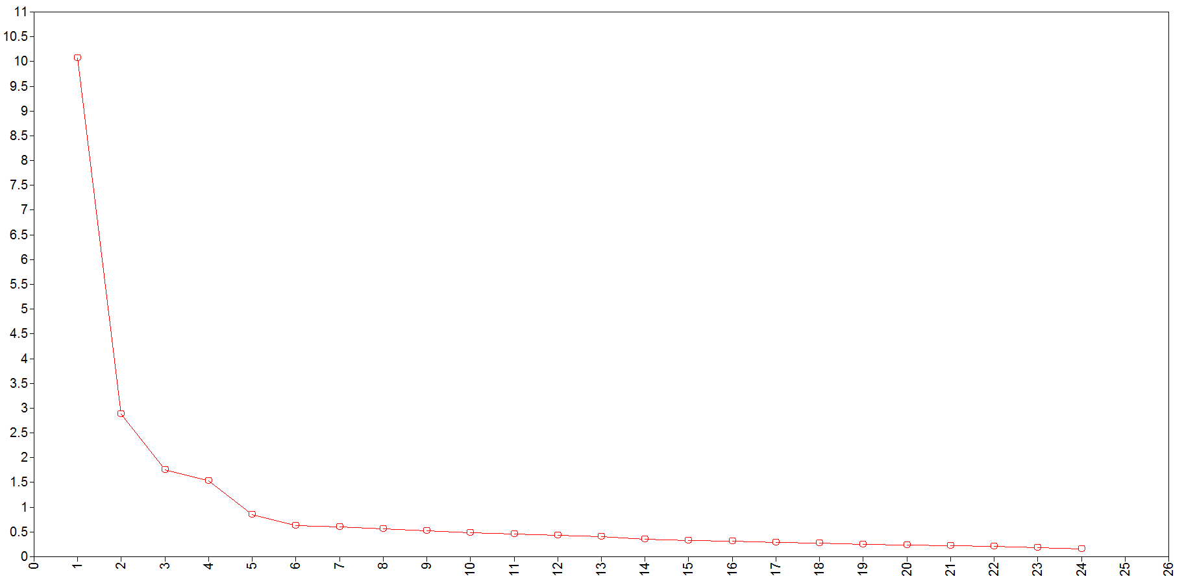

Figure 1.1. Scree plot of PSPP data

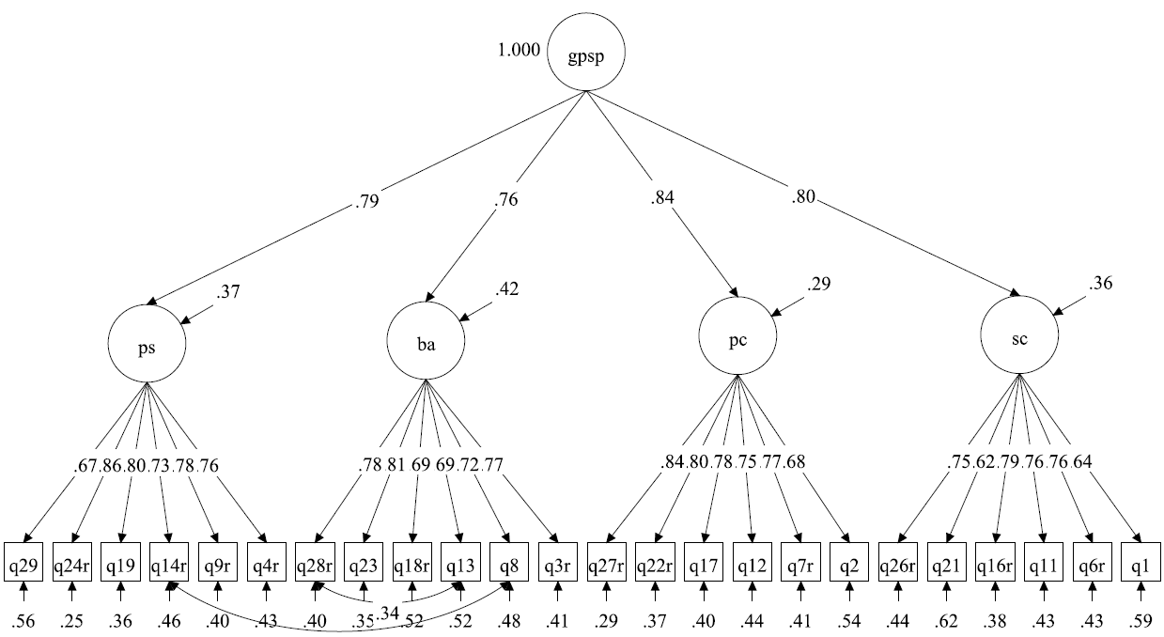

Figure 1.2. 2nd-order factor model with standardized loadings of PSPP data

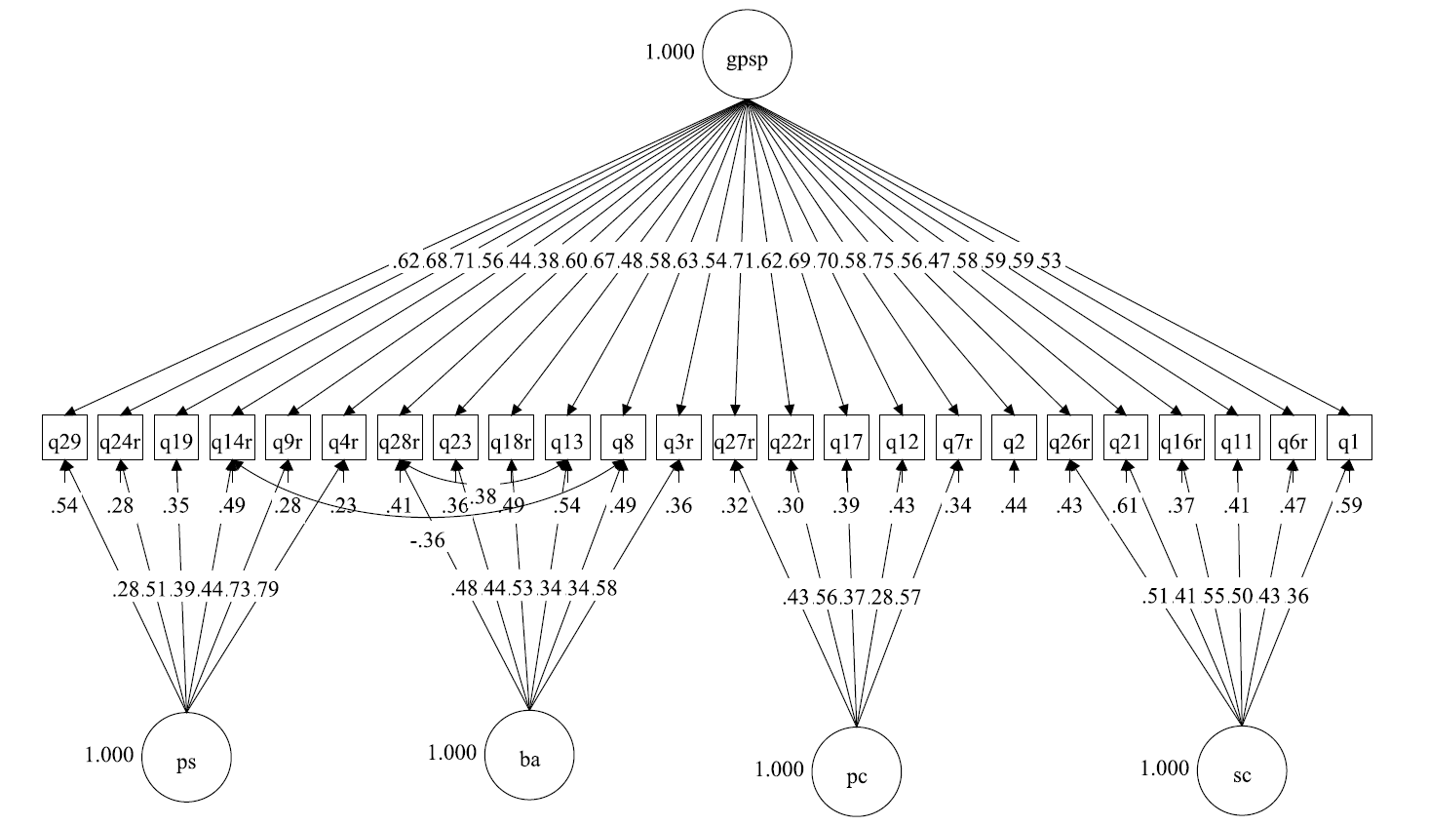

Figure 1.3. Orthogonal bifactor model with standardized loadings of PSPP data
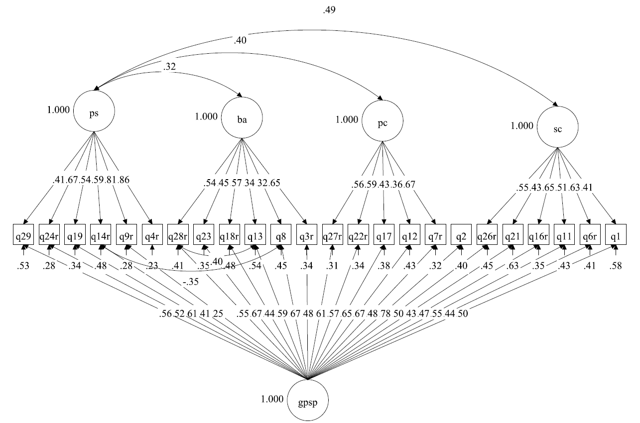

Figure 1.4. Oblique bifactor model with standardized loadings of PSPP data

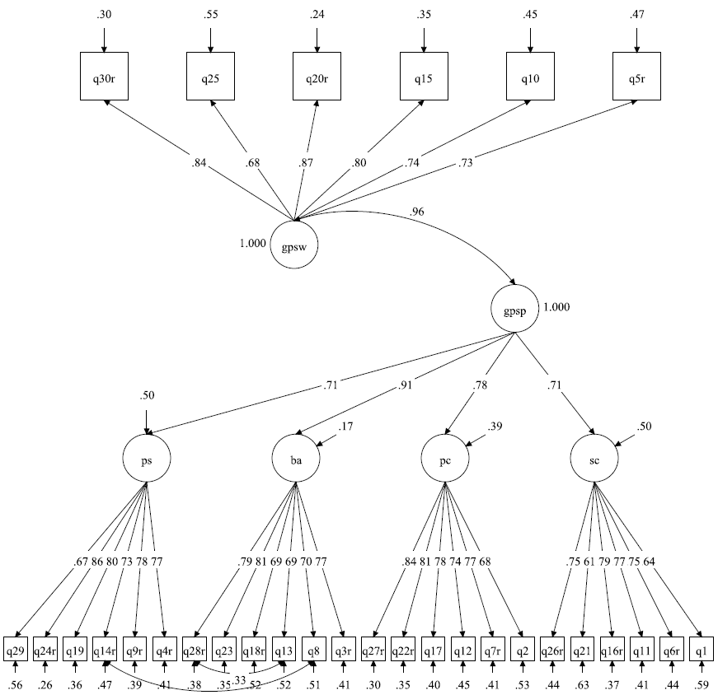

Figure 1.5. 2nd-order factor model with GPSW as an external variable of PSPP data
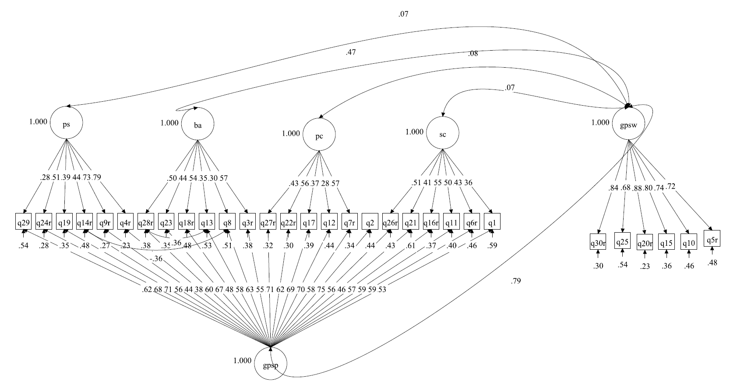

Figure 1.6. Bifactor model with GPSW as an external variable of PSPP data

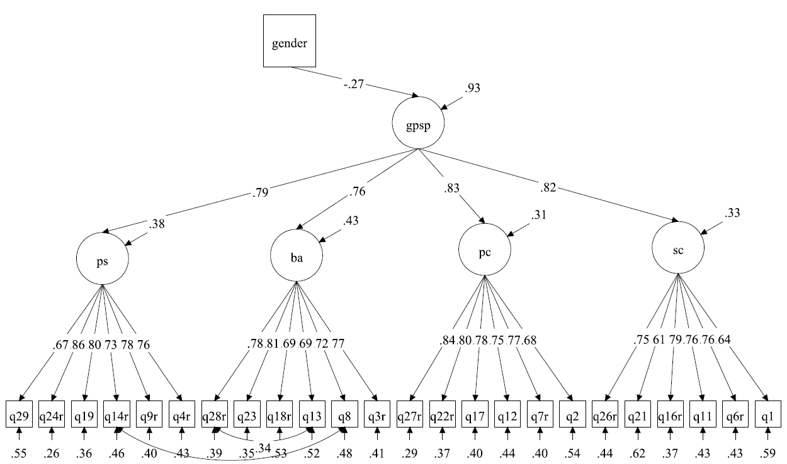

Figure 1.7. 2nd-order factor model with gender as a covariate of PSPP data

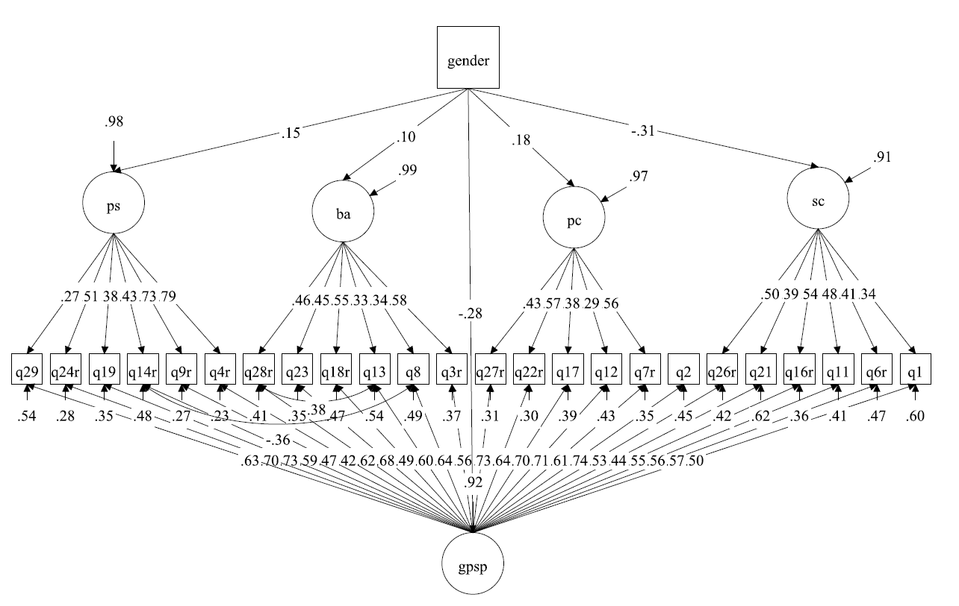

Figure 1.8. Bifactor model with gender as a covariate of PSPP data

Table 2.1. Correlations, means and SDs of ITMSA Data (EFA sample: n = 467; CFA sample: n = 632).
 | M1 | M2 | M3 | M4 | M5 | M6 | M7 | M8 | M9 | M10 | M11 | M12 | M13 | M14 | M15 | M16 | Mean | SD
M1 |  | .79 | .83 | .71 | .39 | .37 | .63 | .56 | .38 | .35 | .56 | .49 | .48 | .44 | .47 | .44 | 4.23 | 1.25
M2 | .81 |  | .73 | .82 | .36 | .43 | .57 | .63 | .33 | .41 | .52 | .57 | .43 | .51 | .43 | .49 | 4.39 | 1.36
M3 | .79 | .73 |  | .84 | .43 | .42 | .68 | .62 | .45 | .44 | .60 | .55 | .55 | .52 | .52 | .49 | 4.33 | 1.26
M4 | .69 | .83 | .84 |  | .44 | .51 | .62 | .69 | .43 | .50 | .57 | .62 | .51 | .59 | .49 | .55 | 4.24 | 1.33
M5 | .33 | .31 | .37 | .34 |  | .89 | .49 | .48 | .66 | .63 | .40 | .39 | .64 | .62 | .64 | .62 | 4.17 | 1.30
M6 | .31 | .41 | .36 | .42 | .88 |  | .46 | .52 | .59 | .67 | .39 | .44 | .61 | .68 | .60 | .65 | 4.23 | 1.36
M7 | .56 | .57 | .62 | .56 | .33 | .32 |  | .91 | .61 | .58 | .69 | .65 | .63 | .59 | .65 | .61 | 4.39 | 1.23
M8 | .53 | .63 | .59 | .64 | .29 | .35 | .90 |  | .57 | .66 | .64 | .72 | .57 | .65 | .60 | .66 | 4.33 | 1.27
M9 | .37 | .34 | .40 | .34 | .61 | .55 | .44 | .41 |  | .89 | .51 | .48 | .73 | .69 | .72 | .69 | 4.24 | 1.22
M10 | .32 | .43 | .38 | .44 | .56 | .64 | .41 | .48 | .87 |  | .48 | .55 | .69 | .76 | .67 | .74 | 4.17 | 1.27
M11 | .52 | .53 | .56 | .50 | .37 | .34 | .65 | .61 | .38 | .34 |  | .90 | .57 | .54 | .57 | .53 | 4.07 | 1.29
M12 | .48 | .57 | .52 | .55 | .32 | .35 | .59 | .66 | .31 | .36 | .90 |  | .53 | .60 | .53 | .59 | 4.03 | 1.31
M13 | .33 | .33 | .38 | .36 | .64 | .59 | .35 | .32 | .65 | .63 | .38 | .33 |  | .90 | .81 | .74 | 4.25 | 1.17
M14 | .31 | .44 | .37 | .45 | .58 | .61 | .34 | .43 | .58 | .66 | .37 | .43 | .85 |  | .74 | .80 | 4.18 | 1.19
M15 | .33 | .32 | .36 | .33 | .59 | .56 | .38 | .34 | .67 | .62 | .40 | .34 | .74 | .66 |  | .91 | 4.30 | 1.19
M16 | .29 | .40 | .32 | .40 | .52 | .55 | .32 | .40 | .60 | .67 | .36 | .41 | .65 | .72 | .86 |  | 4.26 | 1.20
Mean | 4.17 | 4.10 | 4.30 | 4.20 | 4.36 | 4.27 | 4.46 | 4.41 | 4.20 | 4.13 | 4.18 | 4.14 | 4.22 | 4.14 | 4.37 | 4.31
SD | 1.23 | 1.30 | 1.20 | 1.29 | 1.22 | 1.26 | 1.18 | 1.21 | 1.20 | 1.24 | 1.25 | 1.27 | 1.15 | 1.19 | 1.17 | 1.22
Note: The lower triangle contains the correlations, means, and SDs from the EFA sample (n = 467); the upper triangle contains the correlations, means, and SDs from the CFA sample (n = 632).

Table 2.2. Item cluster analysis for science and math items (n = 467).
 | Entire |  |  | Science |  | Math
Items | F1 | F2 |  | Items | G | Items | G
rM1 | .39 | .79 |  | rM1 | .69 | rM2 | .77
rM2 | .45 | .85 |  | rM3 | .74 | rM4 | .77
rM3 | .45 | .84 |  | M5 | .67 | M6 | .66
rM4 | .47 | .84 |  | rM7 | .69 | rM8 | .72
M5 | .79 | .41 |  | M9 | .72 | M10 | .74
M6 | .80 | .44 |  | rM11 | .67 | rM12 | .66
rM7 | .44 | .82 |  | M13 | .73 | M14 | .75
rM8 | .46 | .84 |  | M15 | .73 | M16 | .71
M9 | .82 | .46
M10 | .84 | .48
rM11 | .44 | .79
rM12 | .43 | .79
M13 | .85 | .43
M14 | .83 | .48
M15 | .84 | .43
M16 | .82 | .44
F1 | 1
F2 | .53 | 1

Table 2.3. Eigenvalues and variance explained (n = 467).
 | Science &Math combined |  |  |  | Science |  |  |  | Math
Component | Initial Eigen-values | Variance explained% | Cumulative variance explained  % |  | Initial Eigen-values | Variance explained % | Cumulative variance explained % |  | Initial Eigen-values | Variance explained % | Cumulative variance explained %
1 | 8.443 | 52.77 | 52.77 |  | 4.373 | 54.66 | 54.66 |  | 4.588 | 57.35 | 57.35
2 | 2.632 | 16.45 | 69.22 |  | 1.434 | 17.93 | 72.59 |  | 1.281 | 16.01 | 73.36
3 | 1.044 | 6.53 | 75.74 |  | 0.596 | 7.45 | 80.04 |  | 0.58 | 7.25 | 80.61
4 | 0.803 | 5.02 | 80.76 |  | 0.432 | 5.40 | 85.44 |  | 0.448 | 5.6 | 86.21
5 | 0.746 | 4.66 | 85.43 |  | 0.4 | 5.00 | 90.44 |  | 0.407 | 5.09 | 91.3
6 | 0.54 | 3.38 | 88.80 |  | 0.306 | 3.83 | 94.26 |  | 0.28 | 3.5 | 94.8
7 | 0.491 | 3.07 | 91.87 |  | 0.255 | 3.19 | 97.45 |  | 0.248 | 3.1 | 97.9
8 | 0.457 | 2.86 | 94.73 |  | 0.203 | 2.54 | 100.00 |  | 0.168 | 2.1 | 100.00
9 | 0.297 | 1.86 | 96.58
10 | 0.139 | 0.87 | 97.45
11 | 0.102 | 0.64 | 98.09
12 | 0.087 | 0.54 | 98.63
13 | 0.069 | 0.43 | 99.06
14 | 0.059 | 0.37 | 99.43
15 | 0.049 | 0.31 | 99.74
16 | 0.044 | 0.28 | 100.00

Table 2.4. Model fit of EFA models (n = 467) and CFA models of ITMSA data (n = 632).
Models | $$x^{2}$$ | $$df$$ | SCF | CFI | TLI | RMSEA | RMSEA 90% CI | SRMR | AIC | BIC
EFA & EBFA
Entire sample
Correlated multiple factor | 1262.9 | 89 | 2.6827 | .629 | .500 | .168 | .160-.176 | .071 | 18822 | 19083
J_B method(orthogonal) | 1262.9 | 89 | 2.6827 | .629 | .500 | .168 | .160-.176 | .071 | 18822 | 19083
J_B method(oblique) | 1262.9 | 89 | 2.6827 | .629 | .500 | .168 | .160-.176 | .071 | 18822 | 19083
Science
Correlated multiple factor | 57.09 | 13 | 1.6047 | .951 | .895 | .085 | .063-.108 | .031 | 9985 | 10113
J_B method(orthogonal) | 57.09 | 13 | 1.6047 | .951 | .895 | .085 | .063-.108 | .031 | 9985 | 10113
J_B method(oblique) | 57.09 | 13 | 1.6047 | .951 | .895 | .085 | .063-.108 | .031 | 9985 | 10113
Math
Correlated multiple factor | 68.15 | 13 | 1.6697 | .945 | .880 | .095 | .074-.118 | .032 | 10114 | 10243
J_B method(orthogonal) | 68.15 | 13 | 1.6697 | .945 | .880 | .095 | .074-.118 | .032 | 10114 | 10243
J_B method(oblique) | 68.15 | 13 | 1.6697 | .945 | .880 | .095 | .074-.118 | .032 | 10114 | 10243
CFA & CBFA
Entire sample
Correlated 2 factor | 1926.79 | 103 | 2.7396 | .624 | .562 | .167 | .161 - .174 | .074 | 24713 | 24931
Oblique bifactor | 1704.71 | 90 | 2.5967 | .667 | .556 | .168 | .162 -.176 | .173 | 23886 | 24162
Orthogonal bifactor | 1712.92 | 91 | 2.7172 | .665 | .550 | .168 | .161 -.175 | .210 | 24112 | 24384
Modified orthogonal | 1690.52 | 93 | 2.7691 | .670 | .575 | .165 | .158 -.172 | .185 | 24135 | 24398
Final Oblique bifactor | 347.83 | 82 | 1.9834 | .945 | .920 | .072 | .064 - .079 | .129 | 20166 | 20477
Science
Correlated 2 factor | 211.20 | 19 | 1.3964 | .897 | .849 | .127 | .111- .142 | .058 | 13128 | 13239
Oblique bifactor | 60.86 | 14 | .9837 | .975 | .950 | .073 | .055 -.092 | .056 | 12902 | 13036
Orthogonal bifactor | 66.75 | 15 | 1.3117 | .972 | .948 | .074 | .056 - .092 | .073 | 12928 | 13057
Modified orthogonal | 71.56 | 17 | 1.4071 | .971 | .952 | .071 | .055- .089 | .086 | 12937 | 13057
Final Oblique bifactor | 31.33 | 13 | 1.2638 | .990 | .979 | .047 | .026 - .069 | .034 | 12884 | 13022
Final Orthogonal bifactor | 52.37 | 16 | 1.3929 | .981 | .966 | .060 | .042 - .078 | .078 | 12912 | 13036
Math
Correlated 2 factor | 203.02 | 19 | 1.4470 | .895 | .845 | .124 | .109 - .139 | .048 | 13289 | 13400
Oblique bifactor | 34.45 | 14 | 1.4189 | .988 | .977 | .048 | .028 - .069 | .047 | 13054 | 13188
Orthogonal bifactor | 72.08 | 15 | 1.4709 | .967 | .939 | .078 | .060 - .096 | .090 | 13109 | 13238
Modified orthogonal | 77.87 | 17 | 1.4724 | .965 | .943 | .075 | .059 - .093 | .099 | 13114 | 13234
Final Oblique bifactor | 34.45 | 14 | 1.4189 | .988 | .977 | .048 | .028 - .069 | .047 | 13054 | 13188
Final Orthogonal bifactor | 63.91 | 16 | 1.4606 | .973 | .952 | .069 | .052 - .087 | .096 | 13095 | 13219
Note: 1) SCF = Scaling Correction Factor for MLR.
2) Problems occurred in exploratory factor analysis with 2 factors for the target rotation. Model fit could not be computed for the models.

Table 2.5. Exploratory factor and bifactor analysis for entire sample (n = 467).
Items | Two-factor |  |  | J_B method (orthogonal) |  |  | J_B method  (Oblique) |  |  | Target rotation  (orthogonal) |  |  | Target rotation  (Oblique)
 | F1 | F2 |  | G | F1 |  | G | F1 |  | G | F1 |  | G | F1
rM1: You have a certain amount of science ability, and you can’t really do much to change it. | .86 |  |  | .68 | .47 |  | .68 | .47 |  | .83 |  |  | .83
rM2: You have a certain amount of math ability, and you can’t really do much to change it. | .89 |  |  | .75 | .47 |  | .75 | .47 |  | .89 |  |  | .89
rM3: Your science ability is something about you that you can’t change very much. | .88 |  |  | .74 | .46 |  | .74 | .46 |  | .87 |  |  | .87
rM4: Your math ability is something about you that you can’t change very much. | .88 |  |  | .76 | .46 |  | .76 | .46 |  | .88 |  |  | .88
M5: No matter who you are, you can significantly change your science ability level. |  | .74 |  | .66 | -.33 |  | .66 | -.33 |  | .36 | .65 |  | .36 | .65
M6: No matter who you are, you can significantly change your math ability level. |  | .71 |  | .69 | -.29 |  | .69 | -.29 |  | .40 | .63 |  | .40 | .63
rM7: To be honest, you can’t really change how intelligent you are at science. | .67 |  |  | .67 | .30 |  | .67 | .30 |  | .72 |  |  | .72
rM8: To be honest, you can’t really change how intelligent you are at math. | .70 |  |  | .70 | .31 |  | .70 | .31 |  | .75 |  |  | .75
M9: You can always substantially change how intelligent you are at science. |  | .79 |  | .72 | -.35 |  | .72 | -.35 |  | .39 | .69 |  | .39 | .69
M10: You can always substantially change how intelligent you are at math. |  | .78 |  | .75 | -.32 |  | .75 | -.32 |  | .43 | .69 |  | .43 | .69
rM11: You can learn new things, but you can’t really change your basic science ability. | .59 |  |  | .64 | .24 |  | .64 | .24 |  | .66 |  |  | .66
rM12: You can learn new things, but you can’t really change your basic math ability. | .61 |  |  | .64 | .26 |  | .64 | .26 |  | .67 |  |  | .67
M13: No matter how much science ability you have, you can always change it quite a bit. |  | .88 |  | .74 | -.43 |  | .74 | -.43 |  | .36 | .77 |  | .36 | .77
M14: No matter how much math ability you have, you can always change it quite a bit. |  | .82 |  | .76 | -.36 |  | .76 | -.36 |  | .42 | .73 |  | .42 | .73
M15: You can change even your basic science ability level considerably. |  | .89 |  | .73 | -.44 |  | .73 | -.44 |  | .35 | .78 |  | .35 | .78
M16: You can change even your basic math ability level considerably. |  | .84 |  | .73 | -.39 |  | .73 | -.39 |  | .38 | .74 |  | .38 | .74
F1 | 1 |  |  |  |  |  | 1 |  |  |  |  |  | 1
F2 | .52 | 1 |  |  |  |  | 0 | 1 |  |  |  |  | 0 | 1
Note: Problems occurred in exploratory factor analysis with 2 factors for the target rotation. Model fit could not be computed for the models.

Table 2.6. Exploratory factor and bifactor analysis for science (n = 467).
Items | Two-factor |  |  | J_B method (orthogonal) |  |  | J_B method  (Oblique) |  |  | Target rotation  (orthogonal) |  |  | Target rotation  (Oblique)
 | F1 | F2 |  | G | F1 |  | G | F1 |  | G | F1 |  | G | F1
rM1: You have a certain amount of science ability, and you can’t really do much to change it. | .87 |  |  | .70 | .49 |  | .70 | .49 |  | .86 |  |  | .86
rM3: Your science ability is something about you that you can’t change very much. | .90 |  |  | .76 | .50 |  | .76 | .50 |  | .90 |  |  | .90
M5: No matter who you are, you can significantly change your science ability level. |  | .70 |  | .68 | -.30 |  | .68 | -.30 |  | .39 | .63 |  | .39 | .63
rM7: To be honest, you can’t really change how intelligent you are at science. | .62 |  |  | .66 | .27 |  | .66 | .27 |  | .69 |  |  | .69
M9: You can always substantially change how intelligent you are at science. |  | .74 |  | .73 | -.30 |  | .73 | -.30 |  | .43 | .66 |  | .43 | .66
rM11: You can learn new things, but you can’t really change your basic science ability. | .55 |  |  | .64 | .21 |  | .64 | .21 |  | .64 |  |  | .64
M13: No matter how much science ability you have, you can always change it quite a bit. |  | .86 |  | .75 | -.41 |  | .75 | -.41 |  | .39 | .77 |  | .39 | .77
M15: You can change even your basic science ability level considerably. |  | .85 |  | .75 | -.40 |  | .75 | -.40 |  | .38 | .76 |  | .38 | .76
F1 | 1 |  |  |  |  |  | 1 |  |  |  |  |  | 1
F2 | .48 | 1 |  |  |  |  | 0 | 1 |  |  |  |  | 0 | 1
Note: Problems occurred in exploratory factor analysis with 2 factors for the target rotation. Model fit could not be computed for the models.

Table 2.7. Exploratory factor and bifactor analysis for math (n = 467).
Items | Two-factor |  |  | J_B method (orthogonal) |  |  | J_B method  (Oblique) |  |  | Target rotation  (orthogonal) |  |  | Target rotation  (Oblique)
 | F1 | F2 |  | G | F1 |  | G | F1 |  | G | F1 |  | G | F1
rM2: You have a certain amount of math ability, and you can’t really do much to change it. | .92 |  |  | .79 | -.46 |  | .79 | -.46 |  | .91 |  |  | .91
rM4: Your math ability is something about you that you can’t change very much. | .90 |  |  | .79 | -.44 |  | .79 | -.44 |  | .90 |  |  | .90
M6: No matter who you are, you can significantly change your math ability level. |  | .69 |  | .67 | .27 |  | .67 | .27 |  | .45 | .57 |  | .45 | .57
rM8: To be honest, you can’t really change how intelligent you are at math. | .62 |  |  | .70 | -.23 |  | .70 | -.23 |  | .72 |  |  | .72
M10: You can always substantially change how intelligent you are at math. |  | .80 |  | .74 | .33 |  | .74 | .33 |  | .48 | .66 |  | .48 | .66
rM12: You can learn new things, but you can’t really change your basic math ability. | .54 |  |  | .63 | -.19 |  | .63 | -.19 |  | .64 |  |  | .64
M14: No matter how much math ability you have, you can always change it quite a bit. |  | .85 |  | .77 | .36 |  | .77 | .36 |  | .48 | .69 |  | .48 | .69
M16: You can change even your basic math ability level considerably. |  | .86 |  | .73 | .39 |  | .73 | .39 |  | .44 | .70 |  | .44 | .70
G
F1 | 1 |  |  |  |  |  | 1 |  |  |  |  |  | 1
F2 | .59 | 1 |  |  |  |  | 0 | 1 |  |  |  |  | 0 | 1
Note: Problems occurred in exploratory factor analysis with 2 factors for the target rotation. Model fit could not be computed for the models.

Table 2.8. Confirmatory factor and bifactor models for entire sample (n = 632).
Items | Correlated 2 factor |  |  |  | Bifactor-oblique |  |  |  |  | Bifactor-orthogonal |  |  |  |  | Modified Bifactor-orthogonal
Items | GRP 1 | GRP 2 | $$σ_{e}^{2}$$ |  | G | GRP1 | GRP2 | $$σ_{e}^{2}$$ |  | G | GRP1 | GRP2 | $$σ_{e}^{2}$$ |  | G | GRP1 | GRP2 | $$σ_{e}^{2}$$
rM1# | .80 |  | .36 |  | .30 | .85 |  | .18 |  | .44 | .80 |  | .16 |  | .51 | .75 |  | .18
rM2 | .81 |  | .34 |  | .39 | .79 |  | .22 |  | .50 | .75 |  | .19 |  | .55 | .72 |  | .19
rM3 | .86 |  | .27 |  | .35 | .88 |  | .11 |  | .49 | .80 |  | .11 |  | .56 | .75 |  | .12
rM4 | .86 |  | .26 |  | .44 | .80 |  | .16 |  | .55 | .74 |  | .14 |  | .60 | .71 |  | .14
M5 |  | .75 | .44 |  | .33 |  | .72 | .38 |  | .37 |  | .71 | .36 |  | .41 |  | .70 | .35
M6# |  | .75 | .44 |  | .38 |  | .69 | .38 |  | .43 |  | .65 | .40 |  | .46 |  | .64 | .39
rM7 | .84 |  | .30 |  | .53 | .66 |  | .29 |  | .68 | .52 |  | .26 |  | .72 | .44 |  | .29
rM8* | .84 |  | .29 |  | .62 | .62 |  | .22 |  | .63 | .61 |  | .23 |  | .63 | .61 |  | .24
M9 |  | .83 | .32 |  | .44 |  | .73 | .27 |  | .50 |  | .68 | .28 |  | .53 |  | .66 | .28
M10 |  | .84 | .29 |  | .51 |  | .70 | .25 |  | .55 |  | .66 | .27 |  | .57 |  | .67 | .26
rM11 | .76 |  | .42 |  | .82 | .44 |  | .14 |  | .91 | .22 |  | .13 |  | .94 |  |  | .13
rM12 | .77 |  | .41 |  | .92 | .39 |  | .01 |  | .96 | .16 |  | .05 |  | .96 |  |  | .07
M13 |  | .89 | .21 |  | .45 |  | .79 | .18 |  | .54 |  | .72 | .20 |  | .59 |  | .67 | .20
M14 |  | .90 | .19 |  | .52 |  | .75 | .16 |  | .59 |  | .69 | .18 |  | .62 |  | .66 | .18
M15 |  | .88 | .22 |  | .47 |  | .77 | .19 |  | .55 |  | .70 | .21 |  | .60 |  | .66 | .21
M16 |  | .89 | .21 |  | .52 |  | .75 | .17 |  | .59 |  | .68 | .19 |  | .61 |  | .65 | .20
G |  |  |  |  | 1
GRP 1 | 1 |  |  |  | 0 | 1
GRP 2 | .73 | 1 |  |  | 0 | .65 | 1
Note: the modification indexes from all the three models indicates that correlations between M1 and M2, M3 and M4, M5 and M6, between M7 and M8, between M9 and M10, between M11 and M12, between M13 and M14, between M15 and M16 should be added to the models to improve the model fit.

Table 2.9. Confirmatory factor and bifactor models for science (n = 632).
Items | Correlated 2-factor |  |  |  | Bifactor-oblique |  |  |  |  | Bifactor-orthogonal |  |  |  |  | Modified Bifactor-orthogonal |  |  |  |  |  | Bifactor-oblique
 | GRP1 | GRP2 | $$σ_{e}^{2}$$ |  | G | GRP1 | GRP2 | $$σ_{e}^{2}$$ |  | G | GRP1 | GRP2 | $$σ_{e}^{2}$$ |  | G | GRP1 | GRP2 | $$σ_{e}^{2}$$ |  | Items | G | GRP1 | GRP2 | $$σ_{e}^{2}$$
rM1# | .85 |  | .28 |  | .40 | .80 |  | .21 |  | .56 | .81 |  | .04 |  | .68 |  |  | .54 |  | rM1#* | .76 | .76 |  | -.17
rM3 | .89 |  | .21 |  | .46 | .81 |  | .13 |  | .67 | .56 |  | .24 |  | .74 |  |  | .45 |  | rM3 | .80 | .31 |  | .27
M5# |  | .73 | .46 |  | .40 |  | .71 | .34 |  | .45 |  | .69 | .32 |  | .44 |  | .69 | .34 |  | M5# | .47 | -.04 |  | .33
rM7* | .81 |  | .35 |  | .79 | .40 |  | .34 |  | .84 | .18 |  | .26 |  | .87 |  |  | .25 |  | rM7 | .90 | -.03 |  | .19
M9 |  | .82 | .32 |  | .63 |  | .55 | .30 |  | .65 |  | .54 | .30 |  | .60 |  | .58 | .30 |  | M9 | .63 |  | .67 | .28
rM11 | .72 |  | .48 |  | .70 | .35 |  | .39 |  | .76 | .14 |  | .40 |  | .77 |  |  | .41 |  | rM11 | .79 |  | .58 | .19
M13 |  | .90 | .20 |  | .66 |  | .61 | .20 |  | .72 |  | .52 | .22 |  | .67 |  | .57 | .22 |  | M13 | .70 |  | .56 | .20
M15 |  | .89 | .21 |  | .68 |  | .58 | .20 |  | .72 |  | .51 | .22 |  | .68 |  | .57 | .22 |  | M15 | .70 |  | .56 | .20
rM1 with rM3 |  |  |  |  |  |  |  |  |  |  |  |  |  |  | .65
G |  |  |  |  | 1 |  |  |  |  |  |  |  |  |  |  |  |  |  |  |  | 1
GRP1 | 1 |  |  |  | 0 | 1 |  |  |  |  |  |  |  |  |  |  |  |  |  |  | 0 | 1
GRP2 | .72 | 1 |  |  | 0 | .47 | 1 |  |  |  |  |  |  |  |  |  |  |  |  |  | 0 | -.13 | 1
Note: *the marker item of the general factor; #the marker item of group factors.
Note: Modification indices from the oblique models suggest that correlations between M5, M9, M13, M15 should be included to improve the model fit; modification indices from the orthogonal model suggest that correlations between rM1, rM3, rM7, rM11 should be included to improve the model fit.

Table 2.10. Confirmatory factor and bifactor models for math (n = 632).
Items | Correlated 2 factor |  |  |  | Bifactor-oblique |  |  |  |  | Bifactor-orthogonal |  |  |  |  | Modified Bifactor-orthogonal
 | GRP1 | GRP2 | $$σ_{e}^{2}$$ |  | G | GRP1 | GRP2 | $$σ_{e}^{2}$$ |  | G | GRP1 | GRP2 | $$σ_{e}^{2}$$ |  | G | GRP1 | GRP2 | $$σ_{e}^{2}$$
rM2 | .82 |  | .33 |  | .28 | .89 |  | .13 |  | .58 | .75 |  | .10 |  | .67 |  |  | .55
rM4# | .87 |  | .24 |  | .44 | .77 |  | .21 |  | .68 | .56 |  | .23 |  | .74 |  |  | .45
M6# |  | .75 | .43 |  | .42 |  | .69 | .35 |  | .48 |  | .68 | .32 |  | .47 |  | .67 | .33
rM8* | .84 |  | .30 |  | .79 | .46 |  | .18 |  | .85 | .15 |  | .26 |  | .86 |  |  | .25
M10 |  | .85 | .29 |  | .66 |  | .55 | .26 |  | .68 |  | .52 | .28 |  | .64 |  | .56 | .28
rM12 | .77 |  | .41 |  | .68 | .42 |  | .36 |  | .78 | .11 |  | .37 |  | .79 |  |  | .37
M14 |  | .91 | .18 |  | .61 |  | .67 | .18 |  | .71 |  | .55 | .20 |  | .68 |  | .58 | .20
M16 |  | .88 | .23 |  | .64 |  | .61 | .23 |  | .71 |  | .50 | .24 |  | .68 |  | .54 | .25
rM2 with rM4 |  |  |  |  |  |  |  |  |  |  |  |  |  |  | .63
G |  |  |  |  | 1
GRP1 | 1 |  |  |  | 0 | 1
GRP2 | .77 | 1 |  |  | 0 | .58 | 1

Note: *the marker item of the general factor; #the marker item of group factors.
Note: No modification indices above the minimum value for the oblique model; Modification indices form the orthogonal model suggest that a correlation between M10 and Rm8 can be included in the model to improve the model fit.

Table 2.11. Bifactor model-based indices based on EBFA and CBFA models of ITMSA data (n = 632).
Indices | Formula |  | Science |  |  |  |  | Math
Indices | Formula |  | BEFA |  | BCFA |  |  | BEFA |  | BCFA
Indices | Formula |  | Target rotation  (orthogonal) | Target rotation  (Oblique) | Oblique | Ortho-gonal |  | Target rotation  (orthogonal) | Target rotation  (Oblique) | Oblique | Ortho-gonal
$$ω$$ | $$\frac{{(\sum{λ_{gen})}}^{2}+ {(\sum{{λ_{ij}}^{*})}}^{2}}{VAR\left(X\right)}$$ | G | .911 | .911 | .944 | .926 |  | .918 | .918 | .949 | .931
$$ω_{S}$$ | $$\frac{{{(\sum{λ_{gen}})}^{2}+(\sum{λ_{grpj}})}^{2}}{{{(\sum{λ_{gen}})}^{2}+(\sum{λ_{grpj}})}^{2}+\sum{(1-h^{2})}}$$ | GRP1  GRP2 | .885 | .885 | .920  .911 | .906 |  | .879 | .879 | .938  .920 | .918
$$ω_{H}$$ | $$\frac{{(\sum_{i=1}^{m}{λ_{gen}})}^{2}}{{(\sum_{i=1}^{m}{λ_{gen∙i}})}^{2}+{(\sum_{j=1}^{r}{\sum_{i=1}^{m}{λ_{grpj∙i}}})}^{2} +\sum{(1-h^{2})}}$$ | G | .668 | .668 | .683 | .787 |  | .722 | .722 | .573 | .781
$$ω_{HS}$$ | $$\frac{{(\sum{λ_{grpj}})}^{2}}{{{(\sum{λ_{gen}})}^{2}+(\sum{λ_{grpj}})}^{2}+\sum{(1-h^{2})}}$$ | GRP1  GRP2 | .671 | .671 | .397  .396 | .430 |  | .587 | .587 | .558  .498 | .457
Relative Omega | $\frac{{ω }_{H}}{ω}$ or $\frac{ω_{HS}}{ω_{S}}$ | G  GRP1  GRP2 | .734  .759 | .734  .759 | .723  .432  .435 | .850  .475 |  | .786  .667 | .786  .667 | .603  .595  .541 | .839  .498
$$ECV$$ | $$\frac{{(\sum{λ_{gen}})}^{2}}{{(\sum{λ_{gen}})}^{2}+ {(\sum_{j=1}^{r}{\sum_{i=1}^{m}{λ_{grpj∙i}}})}^{2}}$$ | G  GRP1  GRP2 | .605  .395 | .605  .395 | .553  .235  .212 | .740  .260 |  | .665  .335 | .665  .335 | .440  .302  .258 | .727  .273
$$PUC$$ | $$\frac{\begin{aligned}NO. of corr. between items \\ from different group factors\end{aligned}}{Total number of correlations}$$ |  | .786 | .786 | .571 | .786 |  | .786 | .786 | .571 | .786
$$FD$$ | $${diag(ΦΛ^{T}Σ^{-1}ΛΦ)}^{1/2}$$ | G  GRP1  GRP2 | .949  .918 | .949  .918 | .901  .891  .819 | .942  .862 |  | .958  .900 | .958  .900 | .919  .922  .876 | .941  .874
$$H$$ | $$\frac{1}{1+\frac{1}{\sum_{i=1}^{r}{\frac{λ_{i}^{2}}{1-λ_{i}^{2}}}} }$$ | G  GRP1  GRP2 | .904  .810 | .904  .810 | .869  .763  .674 | .902  .685 |  | .923  .757 | .923  .757 | .836  .856  .733 | .902  .702
ARPB |  |  |  |  | .256 | .205 |  |  |  | .496 | .205

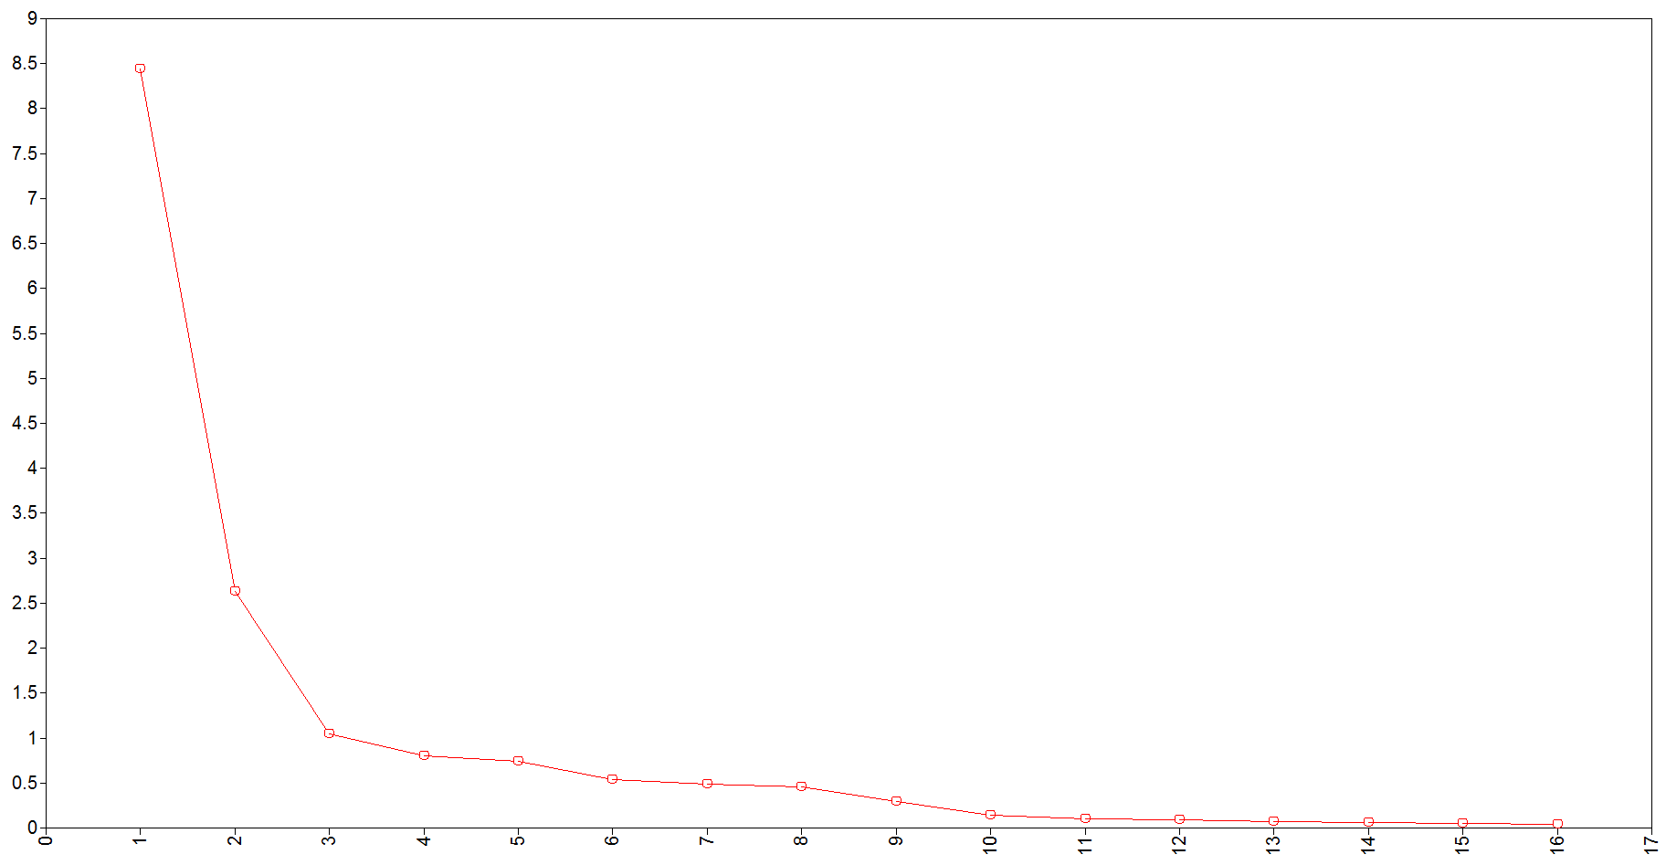

Figure 2.1. Scree plot of the ITMSA (Entire sample)

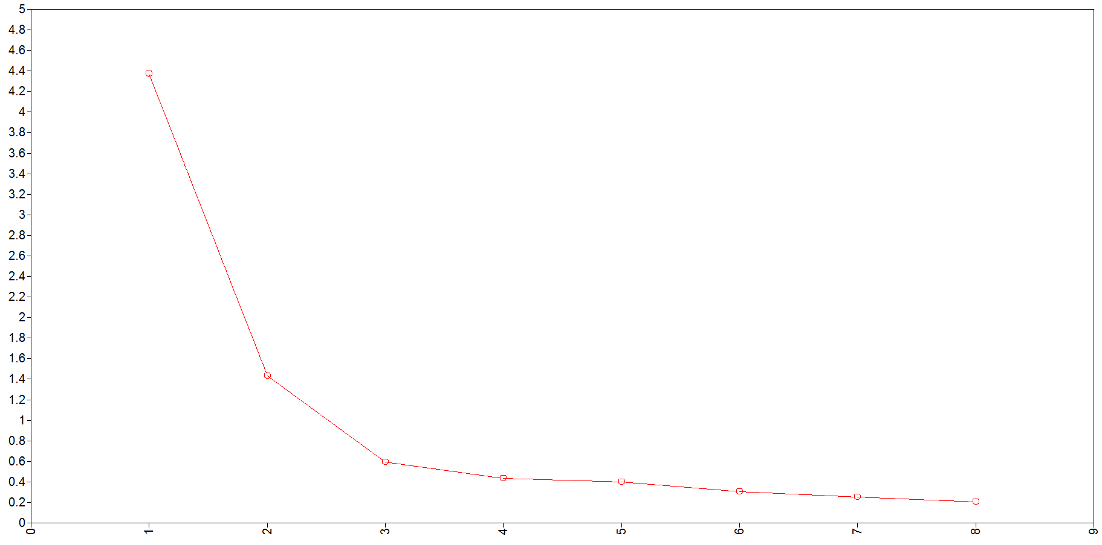

Figure 2.2. Scree plot of the ITMSA (Science items)
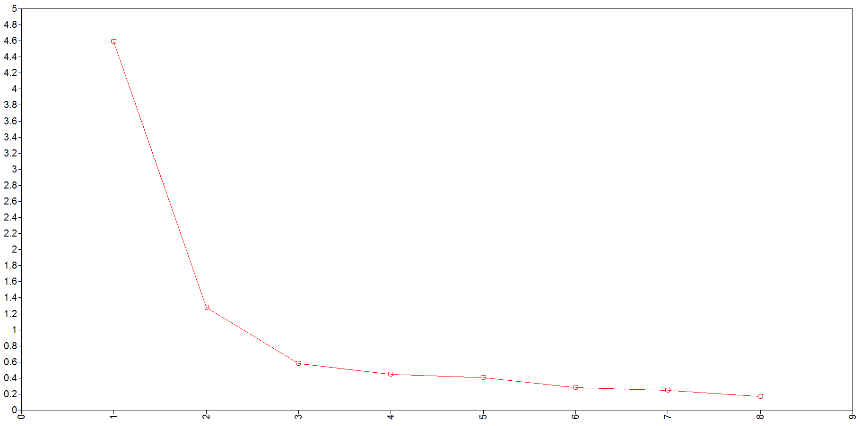

Figure 2.3. Scree plot of the ITMSA (Math items)

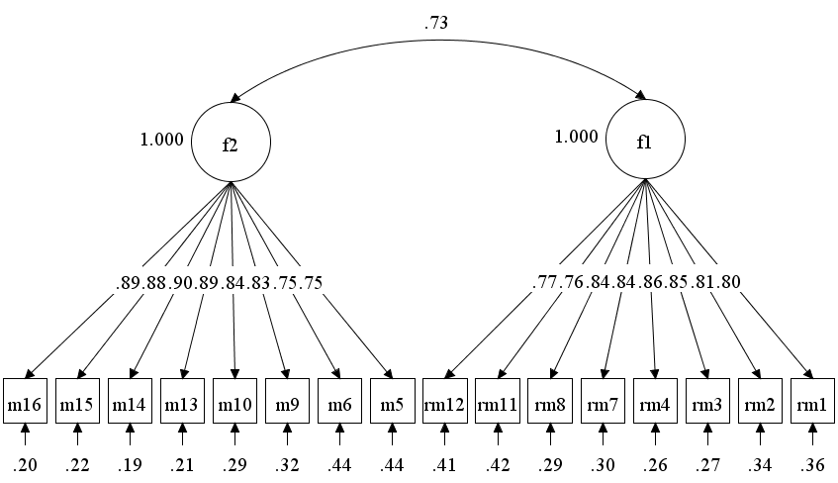

Figure 2.4. Correlated 2-factor model of the ITMSA (Entire sample)

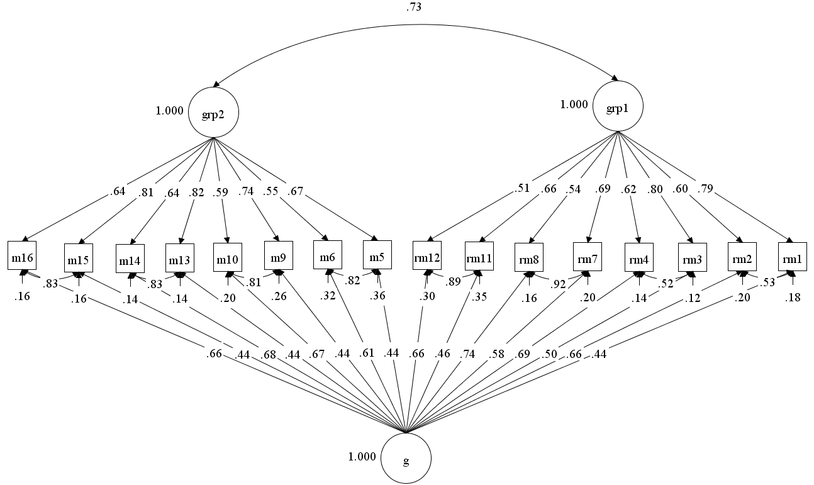

Figure 2.5. Modified correlated bifactor model of the ITMSA (Entire sample)

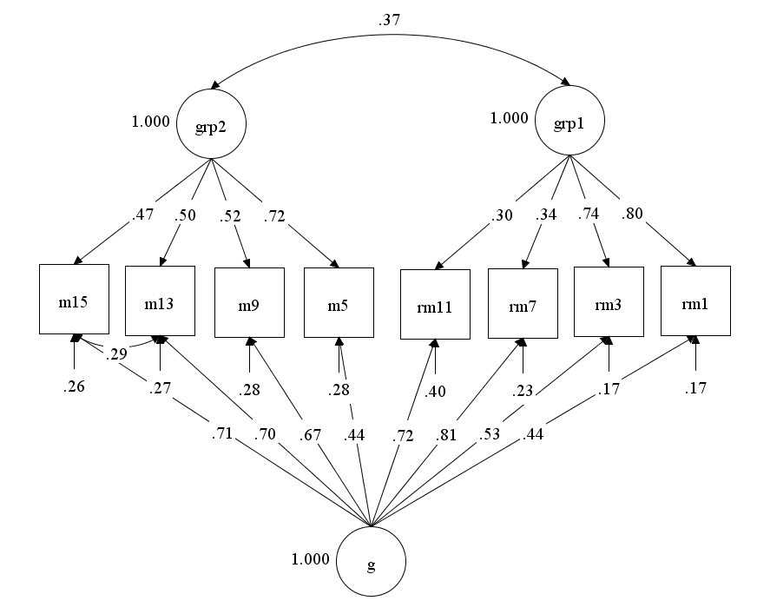

Figure 2.6. Oblique bifactor model of the ITMSA (Science items)

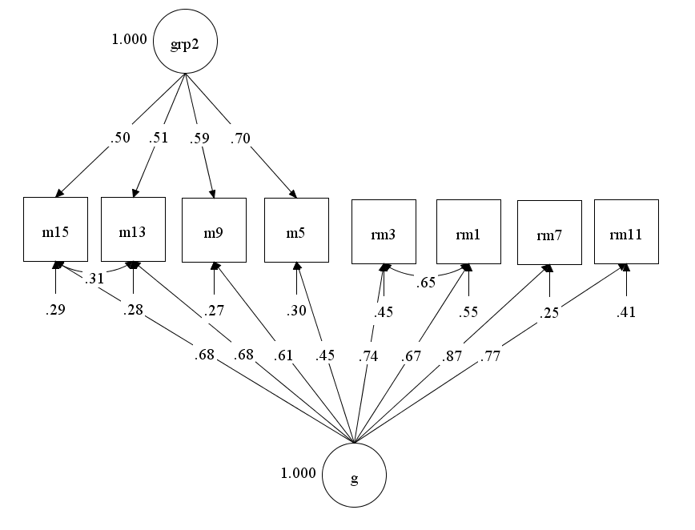

Figure 2.7. Orthogonal bifactor model of the ITMSA (Science items)

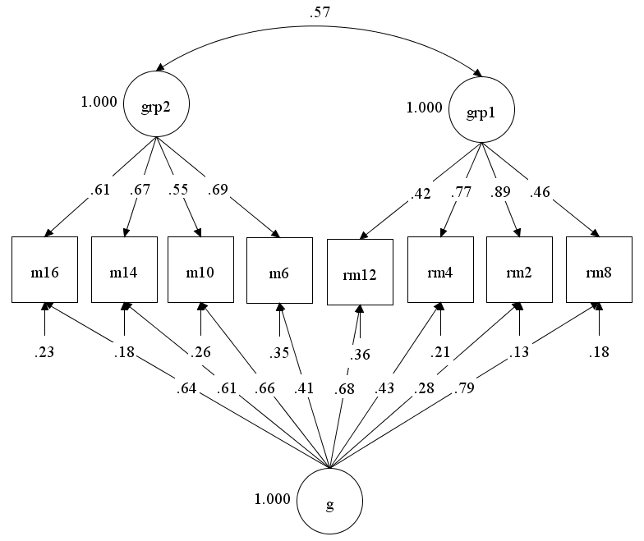

Figure 2.8. Oblique bifactor model of the ITMSA (Math items)

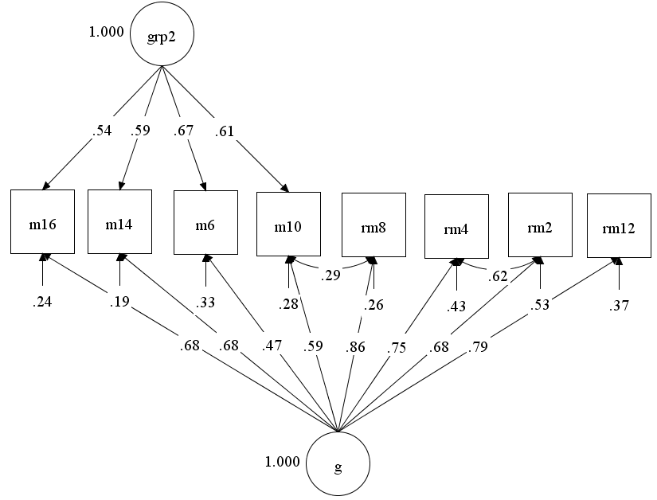

Figure 2.9. Orthogonal bifactor model of the ITMSA (Math items)

Table 3.1. Correlation, means and SDs of DP Data (EFA sample: n = 1115; CFA sample: n = 256).
 | I1 | I2 | I3 | I4 | I5 | I6 | I7 | I8 | I9 | I10 | I11 | I12 | I13 | I14 | I15 | I16 | Mean | SD
I1 |  | .57 | .51 | .43 | .31 | .26 | .30 | .27 | .29 | .35 | .30 | .32 | .33 | .30 | .36 | .42 | 4.07 | 1.00
I2 | .66 |  | .58 | .54 | .34 | .46 | .55 | .46 | .45 | .53 | .56 | .52 | .48 | .47 | .44 | .41 | 4.41 | .93
I3 | .51 | .60 |  | .55 | .39 | .37 | .42 | .31 | .37 | .40 | .40 | .34 | .35 | .35 | .33 | .39 | 4.13 | .98
I4 | .46 | .62 | .66 |  | .42 | .53 | .66 | .55 | .61 | .65 | .64 | .62 | .58 | .60 | .64 | .50 | 4.42 | .94
I5 | .47 | .52 | .54 | .58 |  | .44 | .38 | .39 | .44 | .40 | .39 | .42 | .43 | .43 | .46 | .46 | 3.98 | 1.00
I6 | .41 | .58 | .53 | .68 | .50 |  | .63 | .56 | .57 | .61 | .63 | .62 | .59 | .66 | .52 | .48 | 4.46 | .93
I7 | .45 | .68 | .59 | .74 | .50 | .76 |  | .70 | .65 | .88 | .82 | .81 | .69 | .79 | .66 | .56 | 4.73 | .85
I8 | .41 | .60 | .53 | .68 | .52 | .70 | .77 |  | .76 | .73 | .67 | .69 | .71 | .69 | .61 | .52 | 4.40 | .91
I9 | .39 | .58 | .53 | .63 | .53 | .67 | .70 | .79 |  | .69 | .69 | .67 | .70 | .61 | .66 | .59 | 4.23 | .95
I10 | .43 | .65 | .57 | .72 | .48 | .74 | .88 | .77 | .73 |  | .84 | .86 | .74 | .83 | .68 | .60 | 4.68 | .85
I11 | .38 | .61 | .53 | .68 | .49 | .73 | .79 | .73 | .74 | .84 |  | .81 | .71 | .78 | .68 | .57 | 4.55 | .91
I12 | .42 | .62 | .55 | .71 | .50 | .72 | .84 | .73 | .71 | .86 | .83 |  | .72 | .84 | .66 | .58 | 4.66 | .85
I13 | .39 | .57 | .51 | .65 | .49 | .70 | .74 | .72 | .72 | .78 | .80 | .79 |  | .73 | .64 | .62 | 4.43 | .91
I14 | .45 | .64 | .55 | .69 | .51 | .69 | .83 | .72 | .70 | .84 | .79 | .81 | .77 |  | .68 | .59 | 4.61 | .88
I15 | .42 | .56 | .55 | .64 | .53 | .63 | .70 | .65 | .68 | .69 | .70 | .71 | .71 | .74 |  | .67 | 4.42 | .90
I16 | .43 | .55 | .52 | .59 | .55 | .63 | .65 | .63 | .65 | .65 | .66 | .66 | .67 | .67 | .76 |  | 4.35 | 1.02
Mean | 4.04 | 4.34 | 4.18 | 4.41 | 3.94 | 4.43 | 4.64 | 4.34 | 4.30 | 4.59 | 4.48 | 4.54 | 4.40 | 4.54 | 4.30 | 4.27
SD | 1.06 | 1.06 | 1.04 | 1.02 | 1.06 | 1.00 | 0.99 | 1.01 | 1.00 | 1.00 | 1.01 | 1.01 | 1.00 | 1.03 | 1.07 | 1.09
Note: At the lower triangle are the correlation coefficients from the EFA sample (n = 1115) at the bottom are its variable means and standard derivations; At the upper triangle are the correlation coefficients from the CFA sample (n = 256) at the right are its variable means and standard derivations.

Table 3.2. Eigenvalues and variance explained of DP Data (n = 1115).
Component | Initial Eigenvalues | Variance explained% | Cumulative variance explained%
1 | 10.625 | 66.41 | 66.41
2 | 1.113 | 6.96 | 73.37
3 | 0.647 | 4.04 | 77.51
4 | 0.547 | 3.40 | 80.91
5 | 0.461 | 2.88 | 83.79
6 | 0.397 | 2.48 | 86.27
7 | 0.349 | 2.18 | 88.45
8 | 0.298 | 1.86 | 90.31
9 | 0.286 | 1.79 | 92.10
10 | 0.254 | 1.59 | 93.69
11 | 0.228 | 1.43 | 95.12
12 | 0.214 | 1.34 | 96.46
13 | 0.181 | 1.13 | 97.59
14 | 0.166 | 1.03 | 98.63
15 | 0.132 | 0.8 | 99.42
16 | 0.101 | 0.63 | 100

Table 3.3. Model fit of EFA& EBFA (n = 1115) and CFA&CBFA models (n = 256) of DP Data.
Models | $$x^{2}$$ | $$df$$ | SCF | CFI | TLI | RMSEA | RMSEA 90% CI | SRMR | AIC | BIC
EFA
One-factor model | 957.31 | 104 | 1.8551 | .913 | .900 | .086 | .081 - .091 | .049 | 35605 | 35846
Two-factor model | 605.11 | 89 | 1.7327 | .948 | .929 | .072 | .067 - .078 | .026 | 34908 | 35224
Three-factor model | 361.51 | 75 | 1.6646 | .971 | .954 | .059 | .053 - .065 | .018 | 34489 | 34875
EBFA
2 factors
J_B method(orthogonal) | 605.11 | 89 | 1.7327 | .948 | .929 | .072 | .067 - .078 | .026 | 34908 | 35224
Target rotation(orthogonal) | 605.11 | 89 | 1.7327 | .948 | .929 | .072 | .067 - .078 | .026 | 34908 | 35224
3 factors
J_B method(orthogonal) | 361.51 | 75 | 1.6646 | .971 | .954 | .059 | .053 - .065 | .018 | 34489 | 34875
J_B method(oblique) | 361.51 | 75 | 1.6646 | .971 | .954 | .059 | .053 - .065 | .018 | 34489 | 34875
Target rotation(orthogonal)) | 361.51 | 75 | 1.6646 | .971 | .954 | .059 | .053 - .065 | .018 | 34489 | 34875
Target rotation(oblique) | 361.51 | 75 | 1.6646 | .971 | .954 | .059 | .053 - .065 | .018 | 34489 | 34875
CFA
Correlated 2-factor model | 240.71 | 103 | 1.5762 | .940 | .930 | .072 | .060 - .084 | .062 | 7917 | 8091
CBFA
1grp factor | 224.66 | 100 | 1.5808 | .945 | .934 | .070 | .058 - .082 | .047 | 7899 | 8083
1 grp factor w/corr. items | 207.30 | 99 | 1.5658 | .953 | .942 | .065 | .053 - .078 | .046 | 7870 | 8058
Note: 1) SCF = Scaling Correction Factor for MLR.

Table 3.4. Item cluster analysis and exploratory factor analysis of DP Data (n = 1115).
 | Item cluster analysis |  | One-factor |  | Two-factor |  |  | Three-factor
Items | G |  | F1 |  | F1 | F2 |  | F1 | F2 | F3
I1 | .56 |  | .50 |  | .73 |  |  | 1.08 | -.42
I2 | .76 |  | .72 |  | .54 | .35 |  | .88
I3 | .69 |  | .65 |  | .55 |  |  | .68
I4 | .81 |  | .80 |  | .30 | .59 |  | .39 | .46
I5 | .64 |  | .59 |  | .55 |  |  | .54
I6 | .81 |  | .81 |  |  | .75 |  |  | .71
I7 | .89 |  | .91 |  |  | .90 |  |  | .85
I8 | .84 |  | .84 |  |  | .78 |  |  | .76
I9 | .82 |  | .81 |  |  | .75 |  |  | .75
I10 | .90 |  | .93 |  |  | .99 |  |  | 1.01
I11 | .87 |  | .89 |  |  | .96 |  |  | 1.01
I12 | .88 |  | .91 |  |  | .96 |  |  | .98
I13 | .84 |  | .85 |  |  | .89 |  |  | .93
I14 | .88 |  | .89 |  |  | .88 |  |  | .86
I15 | .81 |  | .80 |  |  | .67 |  |  | .66 | .36
I16 | .78 |  | .75 |  |  | .59 |  |  | .55 | .40
F1 |  |  |  |  | 1 |  |  | 1
F2 |  |  |  |  | .66 | 1 |  | .83 | 1
F3 |  |  |  |  |  |  |  | .44 | .41 | 1
Note: absolute value of loadings < 0.3 were omitted from the table.

Table 3.5. Exploratory bifactor analysis of DP Data (n = 1115).
 | J_B method |  |  |  |  |  |  |  |  |  |  | Target rotation
 | Two-factor  (Orthogonal) |  |  | Three-factor  (Orthogonal) |  |  |  | Three-factor  (Oblique) |  |  |  | Two-factor  (Orthogonal) |  |  | Three-factor  (Orthogonal) |  |  |  | Three-factor  (Oblique)
 | G | F1 |  | G | F1 | F2 |  | G | F1 | F2 |  | G | F1 |  | G | F1 | F2 |  | G | F1 | F2
I1 | .56 | .47 |  | .51 | .57 |  |  | .50 | .58 |  |  | .50 | .53 |  | .49 | .58 |  |  | .49 | .59
I2 | .76 | .29 |  | .72 | .43 |  |  | .71 | .46 |  |  | .72 | .37 |  | .71 | .45 |  |  | .71 | .46
I3 | .68 | .31 |  | .65 | .35 |  |  | .64 | .36 |  |  | .65 | .38 |  | .64 | .37 |  |  | .64 | .37
I4 | .81 |  |  | .80 |  |  |  | .79 |  |  |  | .80 |  |  | .79 |  |  |  | .79
I5 | .63 | .32 |  | .60 | .30 |  |  | .59 | .29 |  |  | .59 | .38 |  | .59 | .34 |  |  | .58 | .32
I6 | .81 |  |  | .81 |  |  |  | .81 |  |  |  | .81 |  |  | .81 |  |  |  | .81
I7 | .90 |  |  | .91 |  |  |  | .91 |  |  |  | .91 |  |  | .91 |  |  |  | .91
I8 | .83 |  |  | .84 |  |  |  | .84 |  |  |  | .84 |  |  | .83 |  |  |  | .83
I9 | .81 |  |  | .82 |  |  |  | .82 |  |  |  | .81 |  |  | .81 |  |  |  | .81
I10 | .91 |  |  | .93 |  |  |  | .93 |  |  |  | .93 |  |  | .94 |  |  |  | .94
I11 | .88 |  |  | .89 |  |  |  | .89 |  |  |  | .89 |  |  | .89 |  |  |  | .89
I12 | .89 |  |  | .90 |  |  |  | .91 |  |  |  | .91 |  |  | .91 |  |  |  | .91
I13 | .84 |  |  | .86 |  |  |  | .86 |  |  |  | .86 |  |  | .86 |  |  |  | .86
I14 | .88 |  |  | .89 |  |  |  | .89 |  |  |  | .89 |  |  | .89 |  |  |  | .89
I15 | .80 |  |  | .82 |  | .29 |  | .81 |  | .30 |  | .80 |  |  | .80 |  | .32 |  | .80 |  | .32
I16 | .76 |  |  | .77 |  | .33 |  | .77 |  | .35 |  | .75 |  |  | .76 |  | .36 |  | .76 |  | .36
G |  |  |  |  |  |  |  | 1 |  |  |  |  |  |  |  |  |  |  | 1
F1 |  |  |  |  |  |  |  | 0 | 1 |  |  |  |  |  |  |  |  |  | 0 | 1
F2 |  |  |  |  |  |  |  | 0 | .157 | 1 |  |  |  |  |  |  |  |  | 0 | .126 | 1

Table 3.6. Bifactor model-based indices based on EBFA and CBFA models of DP Data (n = 256).
Indices | Formula |  | EBFA |  | CBFA
Indices | Formula |  | J-B method | Target rotation | CBFA
$$ω$$ | $$\frac{{(\sum{λ_{gen})}}^{2}+ {(\sum{{λ_{ij}}^{*})}}^{2}}{VAR\left(X\right)}$$ | G | .969 | .970 | .957
$$ω_{S}$$ | $$\frac{{{(\sum{λ_{gen}})}^{2}+(\sum{λ_{grpj}})}^{2}}{{{(\sum{λ_{gen}})}^{2}+(\sum{λ_{grpj}})}^{2}+\sum{(1-h^{2})}}$$ | GRP1 | .835 | .834 | .793
$$ω_{H}$$ | $$\frac{{(\sum_{i=1}^{m}{λ_{gen}})}^{2}}{{(\sum_{i=1}^{m}{λ_{gen∙i}})}^{2}+{(\sum_{j=1}^{r}{\sum_{i=1}^{m}{λ_{grpj∙i}}})}^{2} +\sum{(1-h^{2})}}$$ | G | .958 | .954 | .936
$$ω_{HS}$$ | $$\frac{{(\sum{λ_{grpj}})}^{2}}{{{(\sum{λ_{gen}})}^{2}+(\sum{λ_{grpj}})}^{2}+\sum{(1-h^{2})}}$$ | GRP1 | .182 | .261 | .477
Relative Omega | $\frac{{ω }_{H}}{ω}$ or $\frac{ω_{HS}}{ω_{S}}$ | G  GRP1 | .988  .218 | .983  .313 | .978  .602
$$ECV$$ | $$\frac{{(\sum{λ_{gen}})}^{2}}{{(\sum{λ_{gen}})}^{2}+ {(\sum_{j=1}^{r}{\sum_{i=1}^{m}{λ_{grpj∙i}}})}^{2}}$$ | G  GRP1 | .953  .047 | .935  .065 | .898  .594
$$PUC$$ | $$\frac{\begin{aligned}NO. of corr. between items \\ from different group factors\end{aligned}}{Total number of correlations}$$ |  | .950 | .950 | .975
$$FD$$ | $${diag(ΦΛ^{T}Σ^{-1}ΛΦ)}^{1/2}$$ | G  GRP1 | .986  .712 | .987  .773 | .985  .832
$$H$$ | $$\frac{1}{1+\frac{1}{\sum_{i=1}^{r}{\frac{λ_{i}^{2}}{1-λ_{i}^{2}}}} }$$ | G  GRP1 | .973  .373 | .976  .470 | .971  .604
ARPB |  |  |  |  | .016

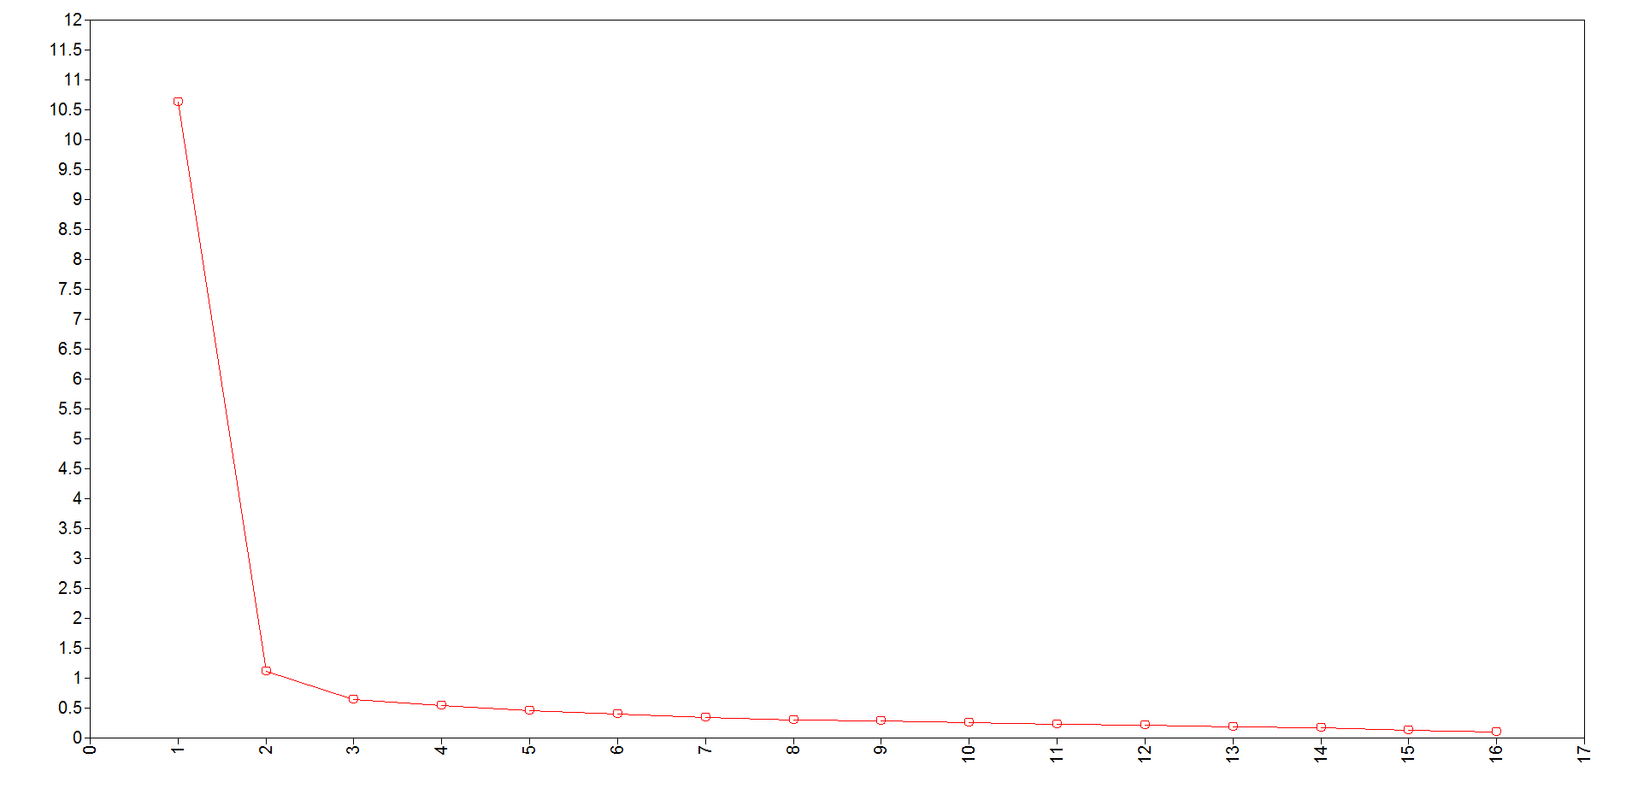

Figure 3.1. Scree plot of DP data

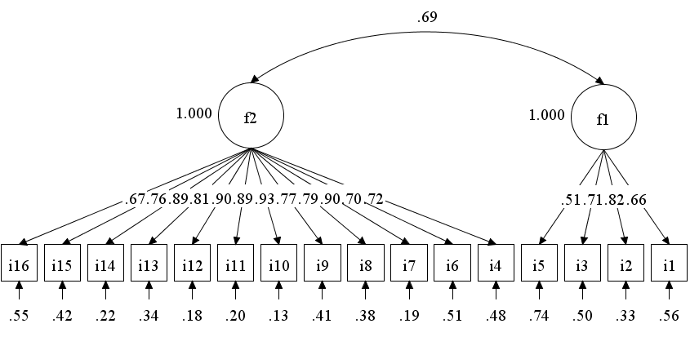

Figure 3.2. Correlated two-factor model of DP data

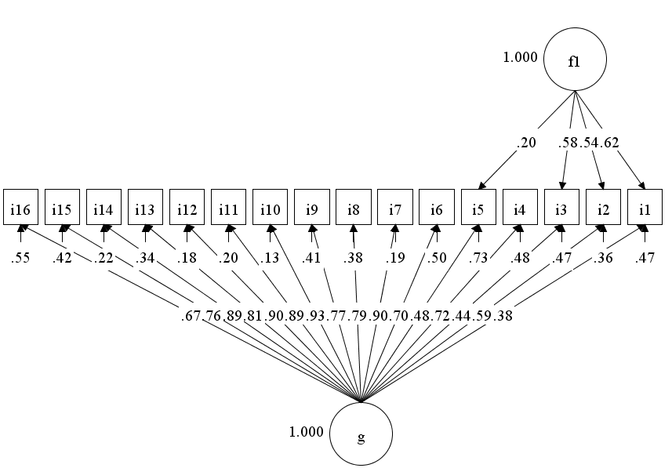

Figure 3.3. Bifactor model with one group factor of DP data

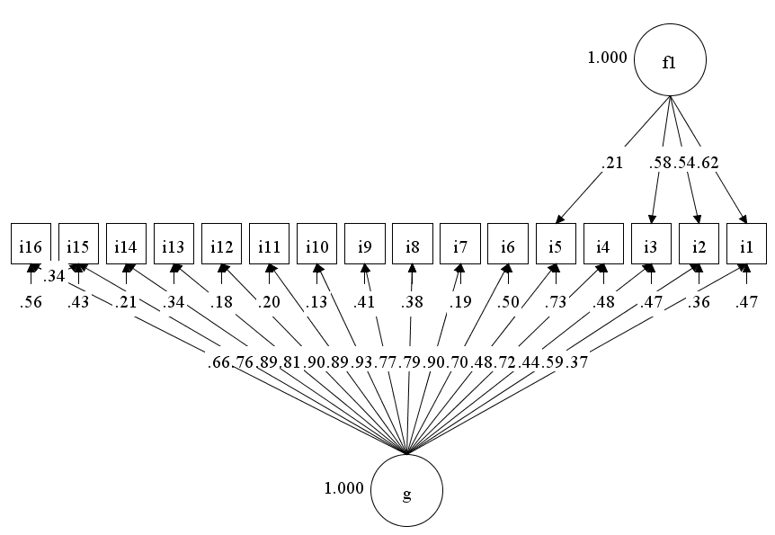

Figure 3.4. Bifactor model with one group factor with corr. Items of DP data

References

Abdi, H., & Williams, L. J. (2010). Principal component analysis. Wiley interdisciplinary reviews: computational statistics, 2(4), 433-459.
Acton, G. S., & Schroeder, D. H. (2001). Sensory discrimination as related to general intelligence. Intelligence, 29(3), 263-271.
Ainsworth, A. T. (2007). Dimensionality and invariance: Assessing differential item functioning using bifactor multiple indicator multiple cause models: ProQuest.
Arbuckle, J. L. (1996). Full information estimation in the presence of incomplete data. Advanced structural equation modeling: Issues and techniques, 243, 277.
Arias, V. B., Ponce, F. P., & Núñez, D. E. (2016). Bifactor models of attention-deficit/hyperactivity disorder (ADHD) an evaluation of three necessary but underused psychometric indexes. Assessment, 1073191116679260.
Armon, G., & Shirom, A. (2011). The across-time associations of the Five-Factor Model of Personality with vigor and its facets using the bifactor model. Journal of personality assessment, 93(6), 618-627.
Bartholomew, D. J. (1995). Spearman and the origin and development of factor analysis. British Journal of mathematical and statistical Psychology, 48(2), 211-220.
Bonifay, W. E., Lane, S. P., & Reise, S. P. (2017). Three concerns with applying a bifactor model as a structure of psychopathology. Clinical Psychological Science, 5(1), 184-186.
Bonifay, W. E., Reise, S. P., Scheines, R., & Meijer, R. R. (2015). When are multidimensional data unidimensional enough for structural equation modeling? An evaluation of the DETECT multidimensionality index. Structural Equation Modeling: A Multidisciplinary Journal, 22(4), 504-516.
Browne, M. W. (2001). An overview of analytic rotation in exploratory factor analysis. Multivariate Behavioral Research, 36(1), 111-150.
Browne, M. W., & Cudeck, R. (1992). Alternative ways of assessing model fit. Sociological Methods & Research, 21(2), 230-258.
Burt, C. (1949). Alternative methods of factor analysis. British Journal of Statistical Psychology, 2(2), 98-121.
Burt, C. (1950). Group factor analysis. British Journal of mathematical and statistical Psychology, 3(1), 40-75.
Carroll, J. B. (1953). An analytical solution for approximating simple structure in factor analysis. Psychometrika, 18(1), 23-38.
Cattell, R. B. (1945). The description of personality: Principles and findings in a factor analysis. The American Journal of Psychology, 58(1), 69-90.
Chen, F. F., Bai, L., Lee, J. M., & Jing, Y. (2016). Culture and the structure of affect: A bifactor modeling approach. Journal of Happiness Studies, 17(5), 1801-1824.
Chen, F. F., Hayes, A., Carver, C. S., Laurenceau, J. P., & Zhang, Z. (2012). Modeling general and specific variance in multifaceted constructs: A comparison of the bifactor model to other approaches. Journal of personality, 80(1), 219-251.
Chen, F. F., West, S. G., & Sousa, K. H. (2006). A comparison of bifactor and second-order models of quality of life. Multivariate Behavioral Research, 41(2), 189-225.
Chen, J. A. (2012). Implicit theories, epistemic beliefs, and science motivation: A person-centered approach. Learning and Individual Differences, 22(6), 724-735.
Chung, C., Liao, X., Song, H., & Lee, T. (2016). Bifactor approach to modeling multidimensionality of physical self-perception profile. Measurement in Physical Education and Exercise Science, 20(1), 1-15.
Crawford, C. B., & Ferguson, G. A. (1970). A general rotation criterion and its use in orthogonal rotation. Psychometrika, 35(3), 321-332.
Cronbach, L. J. (1951). Coefficient alpha and the internal structure of tests. Psychometrika, 16(3), 297-334.
Davies, S. E., Connelly, B. S., Ones, D. S., & Birkland, A. S. (2015). The General Factor of Personality: The “Big One,” a self-evaluative trait, or a methodological gnat that won’t go away? Personality and Individual Differences, 81, 13-22.
De Bruin, G. P., & Du Plessis, G. A. (2015). Bifactor Analysis of the Mental Health Continuum—Short Form (MHC—SF). Psychological reports, 116(2), 438-446.
de Miranda Azevedo, R., Roest, A. M., Carney, R. M., Denollet, J., Freedland, K. E., Grace, S. L., . . . Pilote, L. (2016). A bifactor model of the Beck Depression Inventory and its association with medical prognosis after myocardial infarction. Health Psychology, 35(6), 614.
Deng, N., Guyer, R., & Ware, J. E. (2015). Energy, fatigue, or both? A bifactor modeling approach to the conceptualization and measurement of vitality. Quality of Life Research, 24(1), 81-93.
Dombrowski, S. C. (2014a). Exploratory bifactor analysis of the WJ-III cognitive in adulthood via the Schmid–Leiman procedure. Journal of Psychoeducational Assessment, 32(4), 330-341.
Dombrowski, S. C. (2014b). Investigating the structure of the WJ-III Cognitive in early school age through two exploratory bifactor analysis procedures. Journal of Psychoeducational Assessment, 32(6), 483-494.
Dweck, C. S. (1996). Implicit theories as organizers of goals and behavior.
Ebesutani, C., Reise, S. P., Chorpita, B. F., Ale, C., Regan, J., Young, J., . . . Weisz, J. R. (2012). The Revised Child Anxiety and Depression Scale-Short Version: Scale reduction via exploratory bifactor modeling of the broad anxiety factor. Psychological assessment, 24(4), 833.
Embretson, S. E., & Reise, S. P. (2013). Item response theory: Psychology Press.
Eysenck, H. (1939). Primary mental abilities. British Journal of Educational Psychology, 9(3), 270-275.
Fox, K. R., & Corbin, C. B. (1989). The physical self-perception profile: Development and preliminary validation. Journal of Sport & Exercise Psychology.
Furtner, M. R., Rauthmann, J. F., & Sachse, P. (2013). Unique self-leadership: A bifactor model approach. Leadership, 1742715013511484.
Gault, U. (1954). Factorial patterns of the Wechsler intelligence scales. Australian Journal of Psychology, 6(1), 85-89.
Gavett, B. E., Crane, P. K., & Dams-O'Connor, K. (2013). Bi-factor analyses of the Brief Test of Adult Cognition by Telephone. NeuroRehabilitation, 32(2), 253-265.
Gignac, G. E. (2008). Higher-order models versus direct hierarchical models: g as superordinate or breadth factor? Psychology Science, 50(1), 21.
Gignac, G. E. (2016). The higher-order model imposes a proportionality constraint: That is why the bifactor model tends to fit better. Intelligence, 55, 57-68.
Gignac, G. E., & Watkins, M. W. (2013). Bifactor modeling and the estimation of model-based reliability in the WAIS-IV. Multivariate Behavioral Research, 48(5), 639-662.
Golay, P. (2011). Orthogonal higher order structure and confirmatory factor analysis of the French Wechsler Intelligence Scales. Paper presented at the 12th Congress of the Swiss Psychological Society.
Gomez, R. (2014). ADHD bifactor model based on parent and teacher ratings of Malaysian children. Asian journal of psychiatry, 8, 47-51.
Gomez, R., & McLaren, S. (2015). The center for epidemiologic studies depression scale: support for a bifactor model with a dominant general factor and a specific factor for positive affect. Assessment, 22(3), 351-360.
Gomez, R., Vance, A., & Gomez, R. M. (2013). Validity of the ADHD bifactor model in general community samples of adolescents and adults, and a clinic-referred sample of children and adolescents. Journal of attention disorders, 1087054713480034.
Guilford, J. P., & Guilford, R. B. (1934). An analysis of the factors in a typical test of introversion-extroversion. The Journal of Abnormal and Social Psychology, 28(4), 377.
Gurnani, A. S., John, S. E., & Gavett, B. E. (2015). Regression-based norms for a bi-factor model for scoring the Brief Test of Adult Cognition by Telephone (BTACT). Archives of Clinical Neuropsychology, 30(3), 280-291.
Hagger, M. S., Asçi, F. H., & Lindwall, M. (2004). A Cross‐Cultural Evaluation of a Multidimensional and Hierarchical Model of Physical Self‐Perceptions in Three National Samples1. Journal of Applied Social Psychology, 34(5), 1075-1107.
Hagger, M. S., Biddle, S. J., Chow, E. W., Stambulova, N., & Kavussanu, M. (2003). Physical Self-Perceptions in Adolescence Generalizability of a Hierarchical Multidimensional Model Across Three Cultures. Journal of Cross-Cultural Psychology, 34(6), 611-628.
Hammer, A. (1950). A factorial analysis of the bellevue intelligence tests. Australian Journal of Psychology, 1(2), 108-114.
Harman, H. H. (1976). Modern factor analysis: University of Chicago press.
Harter, S. (1985). Manual for the self-perception profile for children: University of Denver.
Harter, S. (1999). The construction of the self: A developmental perspective: Guilford Press.
Hindman, A. H., Pendergast, L. L., & Gooze, R. A. (2016). Using bifactor models to measure teacher–child interaction quality in early childhood: Evidence from the Caregiver Interaction Scale. Early Childhood Research Quarterly, 36, 366-378.
Holzinger, K. J., & Swineford, F. (1937). The bi-factor method. Psychometrika, 2(1), 41-54.
Hong, Y.-y., Chiu, C.-y., Dweck, C. S., Lin, D. M.-S., & Wan, W. (1999). Implicit theories, attributions, and coping: A meaning system approach. Journal of personality and social psychology, 77(3), 588.
Hooper, D., Coughlan, J., & Mullen, M. (2008). Structural equation modelling: Guidelines for determining model fit. Articles, 2.
Hotelling, H. (1933). Analysis of a complex of statistical variables into principal components. Journal of Educational Psychology, 24(6), 417.
Hu, L. t., & Bentler, P. M. (1999). Cutoff criteria for fit indexes in covariance structure analysis: Conventional criteria versus new alternatives. Structural Equation Modeling: A Multidisciplinary Journal, 6(1), 1-55.
Humphreys, L. G. (1962). The organization of human abilities. American Psychologist, 17(7), 475.
Hyland, P., Boduszek, D., Dhingra, K., Shevlin, M., & Egan, A. (2014). A bifactor approach to modelling the Rosenberg Self Esteem Scale. Personality and Individual Differences, 66, 188-192.
Iani, L., Lauriola, M., & Costantini, M. (2014). A confirmatory bifactor analysis of the hospital anxiety and depression scale in an Italian community sample. Health and quality of life outcomes, 12(1), 1.
Jennrich, R. I., & Bentler, P. M. (2011). Exploratory bi-factor analysis. Psychometrika, 76(4), 537-549.
Jennrich, R. I., & Bentler, P. M. (2012). Exploratory bi-factor analysis: The oblique case. Psychometrika, 77(3), 442-454.
Jensen, A. R., & Weng, L.-J. (1994). What is a good g? Intelligence, 18(3), 231-258.
Jovanović, V. (2015). Structural validity of the Mental Health Continuum-Short Form: The bifactor model of emotional, social and psychological well-being. Personality and Individual Differences, 75, 154-159.
Kaiser, H. F. (1958). The varimax criterion for analytic rotation in factor analysis. Psychometrika, 23(3), 187-200.
Kelley, T. L. (1927). Interpretation of educational measurements.
Khojasteh, J., & Lo, W.-J. (2015). Investigating the sensitivity of goodness-of-fit indices to detect measurement invariance in a bifactor model. Structural Equation Modeling: A Multidisciplinary Journal, 22(4), 531-541.
Kim, H., & Eaton, N. R. (2015). The hierarchical structure of common mental disorders: Connecting multiple levels of comorbidity, bifactor models, and predictive validity. Journal of abnormal psychology, 124(4), 1064.
Koch, T., Holtmann, J., Bohn, J., & Eid, M. (2017). Explaining General and Specific Factors in Longitudinal, Multimethod, and Bifactor Models: Some Caveats and Recommendations.
Lac, A., & Donaldson, C. D. (2017). Higher-order and bifactor models of the drinking motives questionnaire: examining competing structures using confirmatory factor analysis. Assessment, 24(2), 222-231.
Lee, S., Burns, G. L., Beauchaine, T. P., & Becker, S. P. (2015). Bifactor Latent Structure of Attention-Deficit/Hyperactivity Disorder (ADHD)/Oppositional Defiant Disorder (ODD) Symptoms and First-Order Latent Structure of Sluggish Cognitive Tempo Symptoms.
Leonard Burns, G., Moura, M. A., Beauchaine, T. P., & McBurnett, K. (2014). Bifactor latent structure of ADHD/ODD symptoms: predictions of dual‐pathway/trait‐impulsivity etiological models of ADHD. Journal of Child Psychology and Psychiatry, 55(4), 393-401.
Leue, A., & Beauducel, A. (2011). The PANAS structure revisited: on the validity of a bifactor model in community and forensic samples. Psychological assessment, 23(1), 215.
Levin, J. (1973). Bifactor analysis of a multitrait-multimethod matrix of leadership criteria in small groups. The Journal of social psychology, 89(2), 295-299.
Mansolf, M., & Reise, S. P. (2016). Exploratory bifactor analysis: The Schmid-Leiman orthogonalization and Jennrich-Bentler analytic rotations. Multivariate Behavioral Research, 51(5), 698-717.
Mansolf, M., & Reise, S. P. (2017). When and why the second-order and bifactor models are distinguishable. Intelligence, 61, 120-129.
Martel, M. M., Roberts, B., Gremillion, M., Von Eye, A., & Nigg, J. T. (2011). External validation of bifactor model of ADHD: Explaining heterogeneity in psychiatric comorbidity, cognitive control, and personality trait profiles within DSM-IV ADHD. Journal of abnormal child psychology, 39(8), 1111-1123.
McAbee, S. T., Oswald, F. L., & Connelly, B. S. (2014). Bifactor Models of Personality and College Student Performance: A Broad Versus Narrow View. European Journal of Personality.
McCain, J. L., Jonason, P. K., Foster, J. D., & Campbell, W. K. (2015). The bifactor structure and the “dark nomological network” of the State Self-Esteem Scale. Personality and Individual Differences, 72, 1-6.
McDonald, R. P. (1999). Test theory: A unified approach.
McKay, M. T., Boduszek, D., & Harvey, S. A. (2014). The Rosenberg self-esteem scale: a bifactor answer to a two-factor question? Journal of personality assessment, 96(6), 654-660.
Meredith, W. (1993). Measurement invariance, factor analysis and factorial invariance. Psychometrika, 58(4), 525-543.
Mészáros, V., Ádám, S., Szabó, M., Szigeti, R., & Urbán, R. (2014). The Bifactor Model of the Maslach Burnout Inventory–Human Services Survey (MBI‐HSS)—An Alternative Measurement Model of Burnout. Stress and Health, 30(1), 82-88.
Morgan, G. B., Hodge, K. J., Wells, K. E., & Watkins, M. W. (2015). Are fit indices biased in favor of bi-factor models in cognitive ability research?: A comparison of fit in correlated factors, higher-order, and bi-factor models via Monte Carlo simulations. Journal of Intelligence, 3(1), 2-20.
Mu, W., Luo, J., Nickel, L., & Roberts, B. W. (2016). Generality or specificity? Examining the relation between personality traits and mental health outcomes using a bivariate bi‐factor latent change model. European Journal of Personality, 30(5), 467-483.
Mulaik, S. A., James, L. R., Van Alstine, J., Bennett, N., Lind, S., & Stilwell, C. D. (1989). Evaluation of goodness-of-fit indices for structural equation models. Psychological Bulletin, 105(3), 430.
Murray, A. L., & Johnson, W. (2013). The limitations of model fit in comparing the bi-factor versus higher-order models of human cognitive ability structure. Intelligence, 41(5), 407-422.
Murray, A. L., McKenzie, K., Kuenssberg, R., & Booth, T. (2017). Do the Autism Spectrum Quotient (AQ) and Autism Spectrum Quotient Short Form (AQ-S) primarily reflect general ASD traits or specific ASD traits? A bi-factor analysis. Assessment, 24(4), 444-457.
Neuhaus, J. O., & Wrigley, C. (1954). The quartimax method. British Journal of Statistical Psychology, 7(2), 81-91.
Norr, A. M., Allan, N. P., Boffa, J. W., Raines, A. M., & Schmidt, N. B. (2015). Validation of the Cyberchondria Severity Scale (CSS): replication and extension with bifactor modeling. Journal of anxiety disorders, 31, 58-64.
Olatunji, B. O., Ebesutani, C., & Reise, S. P. (2015). A bifactor model of disgust proneness: Examination of the Disgust Emotion Scale. Assessment, 22(2), 248-262.
Pearson, K. (1895). Note on regression and inheritance in the case of two parents. Proceedings of the Royal Society of London, 58, 240-242.
Posserud, M.-B., Breivik, K., Gillberg, C., & Lundervold, A. J. (2013). ASSERT–The Autism Symptom SElf-ReporT for adolescents and adults: Bifactor analysis and validation in a large adolescent population. Research in developmental disabilities, 34(12), 4495-4503.
Primi, R., Da Silva, M. C. R., Rodrigues, P., Muniz, M., & Almeida, L. S. (2013). The use of the bi-factor model to test the uni-dimensionality of a battery of reasoning tests. Psicothema, 25(1), 115-122.
Reise, S. P. (2012). The rediscovery of bifactor measurement models. Multivariate Behavioral Research, 47(5), 667-696.
Reise, S. P., Kim, D. S., Mansolf, M., & Widaman, K. F. (2016). Is the bifactor model a better model or is it just better at modeling implausible responses? Application of iteratively reweighted least squares to the Rosenberg Self-Esteem Scale. Multivariate Behavioral Research, 51(6), 818-838.
Reise, S. P., Moore, T., & Maydeu-Olivares, A. (2011). Target rotations and assessing the impact of model violations on the parameters of unidimensional item response theory models. Educational and Psychological Measurement, 71(4), 684-711.
Reise, S. P., Moore, T. M., & Haviland, M. G. (2010). Bifactor models and rotations: Exploring the extent to which multidimensional data yield univocal scale scores. Journal of personality assessment, 92(6), 544-559.
Reise, S. P., Morizot, J., & Hays, R. D. (2007). The role of the bifactor model in resolving dimensionality issues in health outcomes measures. Quality of Life Research, 16(1), 19-31.
Reise, S. P., Scheines, R., Widaman, K. F., & Haviland, M. G. (2013). Multidimensionality and structural coefficient bias in structural equation modeling a bifactor perspective. Educational and Psychological Measurement, 73(1), 5-26.
Reise, S. P., Ventura, J., Keefe, R. S., Baade, L. E., Gold, J. M., Green, M. F., . . . Seidman, L. J. (2011). Bifactor and item response theory analyses of interviewer report scales of cognitive impairment in schizophrenia. Psychological assessment, 23(1), 245.
Reise, S. P., & Widaman, K. F. (1999). Assessing the fit of measurement models at the individual level: A comparison of item response theory and covariance structure approaches. Psychological methods, 4(1), 3.
Revelle, W., & Wilt, J. (2013). The general factor of personality: A general critique. Journal of research in personality, 47(5), 493-504.
Revelle, W., & Zinbarg, R. E. (2009). Coefficients alpha, beta, omega, and the glb: Comments on Sijtsma. Psychometrika, 74(1), 145-154.
Rodriguez, A., Reise, S. P., & Haviland, M. G. (2016a). Applying bifactor statistical indices in the evaluation of psychological measures. Journal of personality assessment, 98(3), 223-237.
Rodriguez, A., Reise, S. P., & Haviland, M. G. (2016b). Evaluating bifactor models: Calculating and interpreting statistical indices. Psychological methods, 21(2), 137.
Rowe, R., Roman, G. D., McKenna, F. P., Barker, E., & Poulter, D. (2015). Measuring errors and violations on the road: A bifactor modeling approach to the Driver Behavior Questionnaire. Accident Analysis & Prevention, 74, 118-125.
Rushton, J. P., & Irwing, P. (2009). A general factor of personality in the Comrey personality scales, the Minnesota multiphasic personality inventory-2, and the multicultural personality questionnaire. Personality and Individual Differences, 46(4), 437-442.
Satorra, A., & Bentler, P. (1988). Scaling corrections for statistics in covariance structure analysis.
Schermelleh-Engel, K., Moosbrugger, H., & Müller, H. (2003). Evaluating the fit of structural equation models: Tests of significance and descriptive goodness-of-fit measures. Methods of psychological research online, 8(2), 23-74.
Schmid, J., & Leiman, J. M. (1957). The development of hierarchical factor solutions. Psychometrika, 22(1), 53-61.
Schmid Jr, J. (1957). The comparability of the bi-factor and second-order factor patterns. The Journal of Experimental Education, 25(3), 249-253.
Sharma, S., Mukherjee, S., Kumar, A., & Dillon, W. R. (2005). A simulation study to investigate the use of cutoff values for assessing model fit in covariance structure models. Journal of business research, 58(7), 935-943.
Shi, D., Song, H., & Lewis, M. D. (2017). The impact of partial factorial invariance on cross-group comparisons. Assessment, 1073191117711020.
Shi, D., Song, H., Liao, X., Terry, R., & Snyder, L. A. (2017). Bayesian SEM for specification search problems in testing factorial invariance. Multivariate Behavioral Research, 52(4), 430-444.
Shively, R. L., & Ryan, C. S. (2013). Longitudinal changes in college math students’ implicit theories of intelligence. Social Psychology of Education, 16(2), 241-256.
Simms, J. L., Kusenbach, M., & Tobin, G. A. (2013). Equally unprepared: Assessing the hurricane vulnerability of undergraduate students. Weather, Climate, and Society, 5(3), 233-243.
Simms, L. J., Grös, D. F., Watson, D., & O'Hara, M. W. (2008). Parsing the general and specific components of depression and anxiety with bifactor modeling. Depression and anxiety, 25(7), E34-E46.
Smith, Z. R., Becker, S. P., Garner, A. A., Rudolph, C. W., Molitor, S. J., Oddo, L. E., & Langberg, J. M. (2018). Evaluating the structure of sluggish cognitive tempo using confirmatory factor analytic and bifactor modeling with parent and youth ratings. Assessment, 25(1), 99-111.
Spearman, C. (1904). " General Intelligence," objectively determined and measured. The American Journal of Psychology, 15(2), 201-292.
Spearman, C. (1939). Thurstone's work re-worked. Journal of Educational Psychology, 30(1), 1.
Stauner, N., Exline, J. J., Grubbs, J. B., Pargament, K. I., Bradley, D. F., & Uzdavines, A. (2016). Bifactor models of religious and spiritual struggles: Distinct from religiousness and distress. Religions, 7(6), 68.
Tan, Y., Liao, X., Su, H., Li, C., Xiang, J., & Dong, Z. (2017). Disaster preparedness among university students in Guangzhou, China: assessment of status and demand for disaster education. Disaster medicine and public health preparedness, 11(3), 310-317.
Tanner, A., & Doberstein, B. (2015). Emergency preparedness amongst university students. International journal of disaster risk reduction, 13, 409-413.
Terry, R., & Coie, J. D. (1991). A comparison of methods for defining sociometric status among children. Developmental Psychology, 27(5), 867.
Thomson, G. H. (1916). A hierarchy without a general factor. British Journal of Psychology, 8(3), 271-281.
Thomson, G. H. (1920). General versus group factors in mental activities. Psychological Review, 27(3), 173.
Thomson, G. H. (1934). Hotelling's method modified to give Spearman's g. Journal of Educational Psychology, 25(5), 366.
Thomson, G. H. (1939). The factorial analysis of human ability. British Journal of Educational Psychology, 9(2), 188-195.
Thurstone, L. L. (1931). Multiple factor analysis. Psychological Review, 38(5), 406.
Thurstone, L. L. (1936). The factorial isolation of primary abilities. Psychometrika, 1(3), 175-182.
Thurstone, L. L. (1938). A new rotational method in factor analysis. Psychometrika, 3(4), 199-218.
Thurstone, L. L. (1940). Current issues in factor analysis. Psychological Bulletin, 37(4), 189.
Thurstone, L. L. (1944). Second-order factors. Psychometrika, 9(2), 71-100.
Thurstone, L. L. (1947). Multiple factor analysis.
Tkachuck, M. A., Schulenberg, S. E., & Lair, E. C. (2018). Natural disaster preparedness in college students: implications for institutions of higher learning. Journal of American college health, 66(4), 269-279.
Tomas, J. M., & Oliver, A. (1999). Rosenberg's self‐esteem scale: Two factors or method effects. Structural Equation Modeling: A Multidisciplinary Journal, 6(1), 84-98.
Tóth-Király, I., Morin, A. J., Bőthe, B., Orosz, G., & Rigó, A. (2018). Investigating the multidimensionality of need fulfillment: A bifactor exploratory structural equation modeling representation. Structural Equation Modeling: A Multidisciplinary Journal, 25(2), 267-286.
Vandenberg, R. J. (2002). Toward a further understanding of and improvement in measurement invariance methods and procedures. Organizational research methods, 5(2), 139-158.
Vandenberg, R. J., & Lance, C. E. (2000). A review and synthesis of the measurement invariance literature: Suggestions, practices, and recommendations for organizational research. Organizational research methods, 3(1), 4-70.
Vanheule, S., Desmet, M., Groenvynck, H., Rosseel, Y., & Fontaine, J. (2008). The factor structure of the Beck Depression Inventory–II: An evaluation. Assessment.
Wang, Q., & Ng, F. F.-Y. (2012). Chinese students’ implicit theories of intelligence and school performance: Implications for their approach to schoolwork. Personality and Individual Differences, 52(8), 930-935.
Watkins, M. W. (2010). Structure of the Wechsler Intelligence Scale for Children—Fourth Edition among a national sample of referred students. Psychological assessment, 22(4), 782.
Watkins, M. W., & Beaujean, A. A. (2014). Bifactor structure of the Wechsler Preschool and Primary Scale of Intelligence—Fourth Edition. School Psychology Quarterly, 29(1), 52.
Xie, J., Bi, Q., Shang, W., Yan, M., Yang, Y., Miao, D., & Zhang, H. (2012). Positive and negative relationship between anxiety and depression of patients in pain: a bifactor model analysis. PloS one, 7(10), e47577.
Yang, R., Spirtes, P., Scheines, R., Reise, S. P., & Mansoff, M. (2017). Finding Pure Submodels for Improved Differentiation of Bifactor and Second-Order Models. Structural Equation Modeling: A Multidisciplinary Journal, 24(3), 402-413.
Yang, Y.-J., & Hong, Y.-y. (2010). Implicit theories of the world and implicit theories of the self as moderators of self-stereotyping. Social Cognition, 28(2), 251-261.
Yu, C.-Y. (2002). Evaluating cutoff criteria of model fit indices for latent variable models with binary and continuous outcomes (Vol. 30): University of California, Los Angeles Los Angeles.
Zhao, J.-H., Philip, L., & Jiang, Q. (2008). ML estimation for factor analysis: EM or non-EM? Statistics and computing, 18(2), 109-123.
Zinbarg, R. E., Barlow, D. H., & Brown, T. A. (1997). Hierarchical structure and general factor saturation of the Anxiety Sensitivity Index: Evidence and implications. Psychological assessment, 9(3), 277.
Zinbarg, R. E., Revelle, W., Yovel, I., & Li, W. (2005). Cronbach’s α, Revelle’s β, and McDonald’s ω H: Their relations with each other and two alternative conceptualizations of reliability. Psychometrika, 70(1), 123-133.
Zinbarg, R. E., Yovel, I., Revelle, W., & McDonald, R. P. (2006). Estimating generalizability to a latent variable common to all of a scale's indicators: A comparison of estimators for ωh. Applied Psychological Measurement, 30(2), 121-144.

APPENDIX A
Physical Self-Perception Profile
1. I am not so confident when I take part in sports activities
2. I tend to feel a little uneasy in fitness and exercise settings
3. I am extremely confident about my body’s appearance
4. When a situation requires strength, I am among the first to step forward
5. I feel extremely satisfied with the kind of person I am Physically
6. Given the chance, I am always among the first to join in sports activities
7. I am very confident about my ability to exercise regularly and maintain my physical condition
8. I do not feel that my body looks like it’s in good physical shape, compared to most people’s
9. I feel that I am physically stronger than most people of my sex
10. When it comes to the physical side of myself, I do not feel very confident
11. I am sometimes slower than most when I learn a new sports-related skill
12. I do not feel confident about my level of physical conditioning and fitness
13. I feel that I have difficulty maintaining an attractive body
14. I feel that I am very strong and have well-developed muscles compared to most people
15. I wish that I could have more respect for my physical self
16. I feel that I am among the best when it comes to athletic ability
17. I do not usually have a high level of stamina and fitness
18. I feel that I have an attractive body, compared to most people’s
19. I feel that most people are better than me when dealing with situations requiring strength
20. I almost always feel very proud of who I am and what I can do physically
21. I do not feel I am very good at playing sports
22. I feel that I always maintain a high level of physical conditioning, compared to most people
23. I feel embarrassed by my body when I wear few clothes
24. I feel that my muscles are much stronger than most others’ of my sex
25. I am sometimes unhappy with the way I am or what I can do physically
26. I feel that I am always among the best when it comes to joining in sports activities
27. I make certain I take part in some form of regular, vigorous physical exercise
28. I feel that I am often admired because my body is considered attractive
29. I tend to lack confidence when it comes to my physical strength
30. I always have a very positive feeling about the physical side of myself

Implicit Theories of Math and Science Ability Measure
1. You have a certain amount of science ability, and you can’t really do much to change it.
2. You have a certain amount of math ability, and you can’t really do much to change it.
3. Your science ability is something about you that you can’t change very much.
4. Your math ability is something about you that you can’t change very much.
5. No matter who you are, you can significantly change your science ability level.
6. No matter who you are, you can significantly change your math ability level.
7. To be honest, you can’t really change how intelligent you are at science.
8. To be honest, you can’t really change how intelligent you are at math.
9. You can always substantially change how intelligent you are at science.
10. You can always substantially change how intelligent you are at math.
11. You can learn new things, but you can’t really change your basic science ability.
12. You can learn new things, but you can’t really change your basic math ability.
13. No matter how much science ability you have, you can always change it quite a bit.
14. No matter how much math ability you have, you can always change it quite a bit.
15. You can change even your basic science ability level considerably
16. You can change even your basic math ability level considerably

Students’ Demand for Disaster Course Content
1. The characteristics of disasters
2. The characteristics of disaster resuscitation
3. The management of disaster resuscitation
4. Disaster emergency communication equipment
5. The domestic home and overseas abroad models of disaster resuscitation
6. Disaster self-help rescue skills
7. Wounded triage
8. Wounded shunt
9. Hemostatic techniques
10. Fracture fixation
11. Airway opening
12. Wounded handling
13. Cardiopulmonary resuscitation
14. Prevention and management of post-disaster infectious disease
15. Post-disaster psychological crisis intervention
16. Disaster resuscitation scenario demonstration simulation

