UNIVERSITY OF OKLAHOMA
GRADUATE COLLEGE

CLOUDY WITH A CHANCE OF CONSERVATION: HOW PERCEPTION SHAPES CONSERVATION BEHAVIOR

A THESIS SUBMITTED TO THE GRADUATE FACULTY
in partial fulfillment of the requirements
for the Degree of
MASTER OF ARTS

By
TAYLOR J. GAMBLE
Norman, Oklahoma
2024

CLOUDY WITH A CHANCE OF CONSERVATION: HOW PERCEPTION SHAPES CONSERVATION BEHAVIOR

A THESIS APPROVED FOR
THE DEPARTMENT OF SOCIOLOGY

BY THE COMMITTEE CONSISTING OF

Dr. Julie Gerlinger, Chair
Dr. Chris Garneau
Dr. Tom Burns

© Copyright by TAYLOR GAMBLE 2024
All Rights Reserved.

Acknowledgments
I would like to extend my sincere appreciation to my committee Dr. Chris Garneau, Dr. Julie Gerlinger, and Dr. Tom Burns. Their expertise, guidance, teachings, and support were essential to this work and in greater context my graduate education up to this point. I cannot thank them enough for the belief they put in me and the work they have done to help me succeed in this endeavor.
I would also like to thank Dr. Martin Piotrowski, Dr. Ian Carrillo, Dr. Cyrus Schleifer, Dr. Erin Maher, and Dr. Mitch Peck for their invaluable contributions to my education which profoundly affected me and greatly contributed this research project. I am also grateful to my fellow graduate students for their assistance and encouragement throughout this endeavor. I am profoundly grateful for the insightful feedback and discussions provided by all my colleagues. Their perspectives greatly enriched the quality of this research.
Finally, I would like to express my gratitude to my friends, family, teachers, and to many others whom this would not be possible without their unwavering encouragement, understanding, and support throughout my life and through this academic pursuit. Thank you to you all, I am grateful beyond words.
- Taylor Gamble

Table of Contents:
Introduction …............................................................................................................................ 1 Growing Environmental Issues ................................................................................................. 1
How Communities Experience Environment ……….….......................................................... 2
Constructing Environmental Places as Social Spaces …......................................................... 5
Construal-Level Theory …......................................................................................................... 7
Hypotheses 1 …............................................................................................................................ 9 Community Conservation and Social Capital .......................................................................... 9 Hypotheses 2 .............................................................................................................................. 11
Hypothesis 3 …........................................................................................................................... 13 Data and Methods .…................................................................................................................ 13 Data …........................................................................................................................................ 13
Variables ..….............................................................................................................................. 14
Analysis and Results….............................................................................................................. 19
Results for Water Conservation…........................................................................................... 20
Results for Energy Conservation ............................................................................................ 24
Comparative Analysis and Notable Observations…............................................................. 27
Discussion................................................................................................................................... 29
Limitations and Conclusion ..................................................................................................... 33 References ….............................................................................................................................. 37
Tables and Figures ………………………………………………………………………...…. 46
Appendix …………………………………………...…………………………………………. 53
Abstract

With disruptive natural events such as hurricanes, flooding, and drought-based wildfires affecting ecosystems and human communities more frequently than ever, environmental conservation is a critical issue now and going forward. In this study, I assert that individual perceptions of natural events, weather, and local climate are linked to differing attitudes and behavior related to conservation. Using the complementing interdisciplinary theories of social construction of space, construal-level theory, and social capital theory, I investigate the relationship between individual weather perception and environmental conservation behavior independent of common social, political, and ideological variables. Results from poisson regression models using data from the Oklahoma Center for Risk and Crisis Management’s 2018 national survey “Weather Society and Government” demonstrate a clear positive relationship between the perception of disruptive natural events and conservation actions. Furthermore, results show that social capital is an important moderator in this relationship. Specifically, the relationship between weather perception and conservation behavior is more pronounced for those with higher reported social capital. This study underscores the importance of environmental perceptions and social connections in predicting individual conservation behaviors.

Introduction and Background

Globally, conservation scientists place pollution, the over-exploitation of natural resources, and water scarcity near the top of environmental issues that humans are facing now and into the future (Bilgen & Sarıkaya 2018; Corson & Campbell 2023). Additionally, various forms of energy production and consumption infamously contribute to environmental issues such as global climate change, ocean acidification, and air and water pollution (Hill 2020). However, according to a recent Pew Research Center study, only 50 percent of Americans find conserving energy to be very important (Alper 2022). As an important aspect of sustainable resource management, the demand for water and energy conservation solutions is a longstanding and continuing need - and is expected to be a growing issue going forward (Danielopol, 2003; Shahangian et al. 2022).
Communities around the world are increasingly dealing with effects of extreme weather, and more frequent and destructive natural events. Many densely populated areas are located on floodplains, others are centered in dry areas prone to the effects of drought, and still others are on coasts which experience the effects of hurricanes and rising sea levels (Bai et al. 2018). Driven by global climate change, multiple severe environmental events, including floods in Southeast Asia, drought in Cape Town, and various challenges in California and Rio de Janeiro, have caused significant human displacement and represent large health and financial risks. By 2030, disruptive natural or environmental events are anticipated to threaten millions of lives and cause damage to assets worth trillions of USD (Mathew 2022). Global warming poses a myriad of threats including rising sea levels, intensified extreme weather events, fragmentation of ice sheets, ongoing Antarctic ice loss, and destabilization of ocean currents. The environmental and anthropogenic consequences of global climate change have pushed many, such as scientific experts and policy-makers, to prioritize immediate action to address environmental challenges at all institutional levels (Mathew 2022). Some communities, however, are slow to adopt scientific findings and are not as acutely aware of challenges these issues will bring going into the future (Salim et al. 2023). This awareness (or lack thereof) could impact individual behavior related to environmental conservation (Hoffmann, et al. 2022).
How communities understand, experience, and address environmental challenges related to climate change now and into the future is of empirical interest (Brügger et al. 2015). From small rural towns to bustling urban centers, communities grapple with issues like pollution, climate change, and resource depletion. These challenges impact people's lives in profound ways. Coastal areas are dealing with ever more severe storms due to climate change which erode shorelines and cause damage to city infrastructures (Emanuel 2011). However, communities act and adapt to these challenges. This collective action demonstrates the intersection of communal values, and individual behavior (Kraushar & Rosenberg 2015). Moreover, the study of how communities understand, experience, and address environmental change is a pressing societal need. Gaining a deeper understanding of how communities, economy, and environment relate is imperative to a more sustainable future (Cobb Jr. 1991).
Addressing climate change is one of the most crucial needs towards the goal of environmental sustainability, and many prerequisites are needed to achieve the sustainable development of growing communities. Understanding the intricate relationship between individuals’ perceptions of the closeness or remoteness of disruptive natural events, their attitudes toward environmental issues, as well as their conservation behaviors can provide valuable insights into how people respond and react to environmental challenges (Brügger, Morton, & Dessai 2016). This work can be instrumental in guiding the development of more effective communication strategies to encourage pro-environmental actions (Rode et al. 2021; Sacchi, Riva, & Aceto 2016). The work of understanding the aspects of social influence on an individual’s conservation behaviors (a complex task) remains relatively understudied (Zucchinelli et al. 2021, Bennet 2016).
A good deal of scholarship finds that beliefs and worldviews influence conservation attitudes, however, research focuses differ among academic disciplines. (Skibins & Powell 2013, Leiserowitz 2005, MacDonald et al. 2015, Salim et al. 2023). In psychological research on environmental conservation, researchers focus on how individuals interpret environmental events and the importance of or pressing need for environmental conservation (Feidler et al. 2012). For instance, Levin et al. (2021) show that individuals are motivated to justify their interpretation of the environment by filtering ecological realities through their cultural, political, and psychological perspectives. The resulting various interpretations are even found when said individuals are all subject to the same environmental event. Other studies related to market research focus on explanatory socio-economic factors, attitudes, and common social characteristics to explain variation in behavioral change (White, MacDonnell, & Dahl 2011). Accordingly, current empirical knowledge of non-demographic factors leading to changes in conservation behavior is poorly understood and is an ongoing research need to further address explanatory factors external to individual demographics (Freymeyer & Johnson 2010; Koop, Van Dorssen & Brouwer 2019).
While focusing on the efforts of individuals to bolster water conservation solutions has been commonplace in the psychological literature on conservation, policy and management work surrounding community conservation behavior has been pushed to the periphery of the academic discourse. Most scholarship connecting environmental perceptions directly to conservation behaviors is based on case studies and few studies utilize survey data (Bennett, & Dearden 2014; Cauberghe et al. 2021; Fan, et al. 2014). There is a need for additional study into how an individual’s physical and social environment affects conservation behavior. Furthermore, social scientists have called for more theory-driven studies which measure actual behavior (Steg & Vlek 2009). Cumulatively, the consensus among experts in various fields is a need for empirical studies which adequately address conservation behaviors rather than simply assessing attitudes. Additionally, the there is a need to understand these behaviors beyond the scope of socio-economic explanations and researchers have identified the exploration and adoption of conservation behaviors as an ongoing research need. (Hurlimann, Dolnicar, & Meyer 2009).
Nationally representative survey-based research would provide robustness to previous findings on behavioral ties to perceptions. Thus, using nationally representative survey data which captures reported conservation behaviors, I address the question: does an individual’s perception of disruptive events affect their water and energy conservation behaviors? I do so by adding to the literature in two ways. First, I establish that individuals’ perceptions of natural geological and weather-related events serve as an experience which helps make abstract concepts (such as water scarcity, energy use, and climate change) more concrete, thus prompting conservation action. The reasoning follows that as an individual becomes more connected to their physical environment, noticing environmental change leads to a higher awareness of the need to conserve. Environmental sociology asserts that people’s communities are holistic, and their social connections are intertwined with their physical environments (Burns & Caniglia 2017). Therefore, I also investigate the role of social capital as a moderating factor between weather perceptions and conservation behavior.
Conservation scientists prioritize water and energy conservation as ongoing environmental concerns globally, emphasizing the need for sustained efforts. In this paper, I work to further expand the discourse and understanding of how an individual’s perception of their community and environment plays a role in their conservation behaviors at home. I do so by utilizing theoretical work including construal-level theory, the social construction of space, and social capital to develop my hypotheses. I subsequently analyze data from the Oklahoma Center for Risk and Crisis Management’s 2018 national data set “Weather, Society and Government” to conduct a series of poisson regressions. I then interpret the results to understand the predicative factors relating to the number of conservation behaviors undertaken in a household. I conclude with a discussion about the crucial implications of my findings as they relate to future research, science communication, and community conservation efforts.

Constructing Environmental Places as Social Spaces:
Theoretical work in social psychology offers insights into how environmental perception impacts conservation behavior. The social construction of space (theory) and construal-level theory both endeavor to explain how individual interpretations of space can create different social contexts – which can, in turn, affect conservation behaviors. Scientifically, many environmental spaces have historically been studied by intentionally excluding human influence and presence (Bulanti et al. 2022; Tolman 2018). However, the humanization of natural environments has resulted in new interpretations of environmental spaces as socially constructed space by providing social context to the space humans occupy and observe (Bulanti et al. 2022; Gómez & Köpsel 2022). For instance, people make sense of their environmental spaces when they draw on prior memories of weather to understand current weather events or draw on cultural meanings of climate to make sense of changing seasons (Berland 1994). Providing social meaning to natural events helps researchers understand how communities perceive, adapt, and prepare for different aspects of their environment, such as the variations in political and social responses toward climate change and pollution (Grünhagen et al. 2023; Nixon 2011).
Understanding how individuals experience their environment and define the events that occur around them is key to accurately defining their construction of space. Developed by Henri Lefebvre, the social construction of space follows three interrelated aspects of existence within a space: the physical space, the conceived space, and the lived space (Collins 2022). While the physical space humans occupy (e.g. neighborhoods and localized communities) is often the primary way they interpret “space,” conceived space is considered the dominant space within the social construction of space theory, as socially constructed spaces are primarily ideological rather than physical (Merrifield 2013). Taken together, physical space (what is out there), lived space (what is experienced), and conceived space (what is interpreted) combine to produce the socially constructed meaning of space (Chen et al. 2023; Collins 2022).
The social construction of space prioritizes individual experiences - which can predict variation in conservation behavior related to a single natural event (Buchan 2022, Collins 2022, Thompson & Barton 1994). Some recent literature on the effects of weather have employed the use of objective environmental measures, such as high or low temperatures and rainfall as predictors of conservation behavior (Groppo & Kraehnert 2017; Wang et al. 2022). While ‘normal science’ relies on positivist definitions to define aspects of environment (Kuhn 1997), the use of objective events as a predictor of human behavior is problematic. Human idiosyncrasies in perceived space means that individual subjective interpretations of events may be a better predictor than actual objective events as lay perceptions do not always align with scientific understanding (Chowdhury & Haque 2011). To better understand how natural events influence behavior, it is crucial to consider the importance of subjective individual perceptions rather than solely focusing on the objectively measured environmental events themselves (Fiedler et al. 2012; Kim & Ahn 2019; Levin et al. 2021; Merrifield 2013).
The social process of the perceptions of natural events prompting individual conservation behaviors can also be understood through construal-level theory. Construal-level theory (CLT) is a social psychological theory that attempts to define individuals’ relationships to a concept in the context of that concept being either psychologically near or distant. Proposed by Trope and Liberman (2010) as a description of psychological distance theory (Liberman & Trope 2008), CLT examines how psychological distance influences the abstractness or concreteness of mental representations (Rabinovich et al. 2009). It suggests that distant events or concepts are construed more abstractly, while closer ones are construed more concretely, depending on temporal, spatial, social, or hypothetical factors (Maiella et al. 2020). Near thinking (or concrete construal) consists of immediate and concrete details and consequences for individuals and societies. For instance, with individuals in Southern California, earthquakes are commonplace, while in Florida, hurricanes are more immediate and weather issues such as rising seas are rather removed from individuals living inland. The ecological distance from these events creates a corresponding psychological distance (Feidler et al. 2012). Conversely, the immediacy of these ecological events (physically or culturally) makes concrete construal more likely (Gifford et al. 2009; Griffioen, Handgraaf, & Antonides 2019; Haden et al. 2012). Distant thinking or abstract construal, conversely, is an abstract perspective which requires greater effort to understand details and consequences. Abstract construal can lead to subjective reasoning which complicates some traditional objective scientific measures of weather as true predictors of conservation behavior (Davidson & Kecinski 2022; Jones, Hine, & Marks 2017).
As perceptions of disruptive natural events increase (regardless of whether they do increase), individuals may become more willing to engage in conservation actions. The difference between reality and perception is documented in weather and conservation related research (McDonald et al. 2015; Shao 2016). Results from a localized study comparing Texas residents’ water use perceptions to public water use records shows that individual usage perceptions often do not align with actual usage (Araya et al. 2020). Variations in individual weather perceptions are motivating factors that move ideas from the abstract to the concrete (Kyselá, Tvinnereim, & Ivarsflaten 2019). For example, perceptions of increased heat-levels can motivate individuals to be more health-conscious (Semenza et al. 2008b). Similarly, psychological distance strongly affects the perceived severity of various environmental threats and influences an individual’s willingness to perform conservation behaviors (Carmi & Kimhi 2015; Garcia-Cuerva et al. 2016).
By relying on construal as a means of understanding the social construction of space, I propose a theoretical process by which ecological events are given various meanings and contexts which potentially lead to behavioral differences. Therefore, it is plausible that differing construal in an individual’s perceptions of natural events can meaningfully determine variation of conservation actions. Or to put plainly, individuals who encounter and interpret disruptive natural events more acutely than their otherwise similar counterparts are more likely to transition their understanding of local environments from abstract concepts to more concrete concepts. This lessening of the psychological distance of environment could then potentially reify the need for water and energy conservation measures within those individuals’ communities. I therefore hypothesize the following:
H1: As the number of disruptive natural events an individual perceives increases as well as when an individual perceives changes in temperature, there is an associated increase in the number of conservation behaviors an individual undertakes.

Community Conservation and Social Capital:
Social capital theory contributes to the construction of social spaces (i.e. observable natural environment) by explaining how individuals work collectively to create community-based, socially constructed realities (Putnam 1993). Social capital theory can be simply described as the axis of collective social networks, their value to individuals, and the level of closeness experienced in a community (Putnam 2000). Within social capital theory, the closeness of a community contributes to the well-being of individuals, communities, and society (Helliwell 2006; Putnam 2000). Putnam asserts that social capital has significant implications for the basic functioning of social institutions. In Bowling Alone (2000), he argues that a strong foundation of social capital is essential for effective institutional operation and change. He establishes that trust and cooperation are key characteristics of social capital measurable in survey data (Putnam, 2000). Many social institutions contribute to conservations efforts such as government agencies, however local grassroot community efforts are often difficult to define and quantify. social capital is therefore an important concept to help understand motivations for community conservation behaviors. Prior research has established that social and community norms and values contribute to energy conservation behaviors (Dwyer et al. 2015; Sütterlin et al. 2013; Xu et al. 2024). For example, Allcott (2011) finds that a third-party institution simply sending “Home Energy Report” letters to residents can promote household energy conservation. Another recent study, based on a survey of residents in Austin, Texas, similarly finds social trust to be a strong predictor of environmentally responsible behavior (Atshan et al. 2020).
While the theory of social capital encompasses a wide array of social experiences and is sometimes criticized for being used piecemeal or too contextually (Bhandari & Yasunobu 2009), longstanding research has established that aspects of social capital can aid in achieving conservation goals (Pretty & Ward 2001). For instance, Pretty & Smith (2004) find that types of voluntary participation related to social capital are key in promoting positive biodiversity outcomes. Additionally, multiple researchers provide evidence that social capital has a significant positive relationship to conservation attitudes (El Zahed & Habib 2020; Jones et al. 2011; Lui et al. 2014; Thuy et al. 2011). Furthermore, Jones et al (2011) finds that multiple connections of social capital, in the form of social trust, institutional trust, and social norms, contribute positively to citizens’ attitudes toward water conservation policies.
Not all forms of social capital, however, lead to an increase in positive conservation outcomes. Some aspects of the literature suggest a “dark side” of social capital (Villalonga-Olives & Kawachi 2017). While social capital generally provides an explanatory framework for bridging the gap between community social norms related to conservation and individual social perceptions, comparative analysis in communication research has shown that social capital can affect conservation behaviors differently for different social groups. Specifically, Rai et al. (2006) find that social capital can aid in a community groups’ influence, but existing political structures can counteract gains in social capital. When confronted with vague or uncomfortable environmental messages, some individuals become avoidant, reliant on established institutions, or willfully ignorant of environmental issues (Shepherd, & Kay 2012). Through five studies, Shepherd, & Kay (2012) find that those who know little about issues which feel uncomfortable to them, such as “looming oil shortages,” demonstrate greater trust in government, and avoid learning opportunities - instead taking an “ignorance is bliss” approach to the issues. In this way, social capital can act as a filter of scrutiny which promotes selective knowledge sharing and piecemeal adoption of information (Shepherd, & Kay 2012; Willem & Scarbrough 2006; Semenza et al. 2008a).
Despite a smaller amount of research showing that social capital can, in certain contexts, present barriers to conservation, the bulk of literature offers theoretical support that local communities with higher social capital exhibit higher levels of conservation behaviors. Given the bulk of literature suggesting a positive effect of social capital on conservation behaviors, I theorize the following:
H2: As social capital levels increase, there is an associated increase in the number of conservation behaviors an individual undertakes.
Furthermore, recent discussion around social capital suggests the use of models which holistically encompass the various social capitals of a community. Specifically, Halstead et al. (2022) propose that social capital should be treated in an ecological manner, in which growth is holistically interconnected to all social resources. To understand the interconnected aspects of social capital, some scholarship has moved to define social capital along three different but connected fronts: linking, bonding, and bridging (Aldrich & Meyer 2015; Kawachi et al. 2004). Social linking is connecting people with varying degrees of social power, such as city councils working with citizens to employ new water or energy conservation initiatives. Social bonding describes social capital between those of similar characteristics. For instance, family members, close friends, or members of the same social group coming to social consensus about environmental norms within shared spaces. Social bridging happens among those with loosely connected but similar social groups, such as neighbors who connect with each other at local events, or in shared public spaces, like parks (Aldrich & Meyer 2015). Bonding and bridging social capital can be seen in localized communities among friends and neighbors. The resulting capital strengthens moral convictions and sense of community which can translate into ideological and behavioral conformity (Miller et al. 2006). Neighbors talking about the weather is a tired trope of social interaction. This rote cliché demonstrates the concept of social connections reifying individuals’ beliefs and perceptions. Likeminded individuals coming together and sharing their opinions and behaviors, can create and typify the “normative” state of the environment within a community (Miller et al. 2012).
Manifested through participation in local groups, bonding and bridging within social capital play a vital role in solving environmental problems leading to positive conservation outcomes when combined with appropriate external support (Liu et al. 2014; Pretty & Ward 2001). One social experiment, conducted by researchers at a Canadian university, found that students who indicted higher environmental concern were more likely to engage in pro-environmental behaviors when they were subjected to pro-environmental social norms (Soliman et al. 2018). Additionally, when individuals construe environmental benefits where they believe it also strengthens social connections, it can lead to increased conservation efforts among those who value both personal and community welfare (Gerolemou et al. 2022). Social capital can lead to increased social solidarity, manifested in the enforcement and reinforcement of ideologies, related to conservation behaviors (Berger 2023). In other words, an area where individuals regularly come together and share common experiences can strengthen their personal sense of social connection and mutual support. As a result, these residents (compared to more socially isolated residents) become more inclined to enforce and commit to conservation behaviors (such as water saving initiatives and reducing energy consumption) as they collectively prioritize the well-being of both their community and the local environment. Given previous work connecting social capital to both conservation behaviors and an increase in community-based construal of environmental events, I theorize the following:
H3: Social capital moderates the effect of weather and natural event perceptions on conservation behaviors. The effect of weather and natural event perception on conservation behaviors is greater for those with more reported social capital compared to otherwise similar individuals with less social capital.

Data and Methods
This study uses data from the “Weather, Society, and Government” (WSG) 2018 national survey. Conducted by the Oklahoma Center for Risk and Crisis Management (CRCM), WSG is a representative survey of U.S. households (N=1800). The survey is conducted to measure the way household members perceive and respond to weather and climate. CRCM randomly selected respondents from separate pools based on a geolocation. The pools were provided by Qualtrics, which uses sampling from opt-in panels based on demographic characteristics with quotas to achieve demographic representation of US Census estimates (Jenkins-Smith et al. 2017). The CRCM recruited for the survey by phone and mail with a reported response rate of 20 percent –37 percent depending on the state. Respondents, however, were asked to opt into a web based 30-minute survey four times each year for four to five years which could explain the lower response rate (Jenkins-Smith et al. 2017). To supplement income data, I include a living wage variable matched to each respondents’ state of residence living wage from World Population Review (WPR n.d.).

Dependent Variables:
The WSG asks respondents about both water conservation and energy conservation. For assessment of water conservation, the WSG asks respondents, “Were any of the following steps taken to decrease the amount of water used at your residence this summer? Please indicate all that apply: installed a low-volume or low-flush toilet, installed a low-volume or low-flow showerhead, took shorter or less frequent baths or showers, watered lawn or garden less frequently, washed car less frequently, repaired leaks, did laundry less frequently, and other (please specify).” Each step is binary coded. I then sum the water steps into a count variable. A single outlying instance of eight steps taken is combined with the seven-step category. The resulting variable ranges from zero steps taken to seven or more steps. Similarly, for energy conservation steps, the WSG asks respondents, “Were any of the following steps taken to decrease the amount of energy used at your residence this summer? Please indicate all that apply: turned lights off, turned air conditioning down/off, installed energy saving appliances, unplugged appliances, added insulation, installed energy saving doors/windows, installed energy saving light bulbs, and other (please specify).” The energy conservation steps are coded into binary variables and then summed into a count variable. The distribution for both conservation variables follow a poisson distribution.

Main Effects:
To understand the effect of disruptive natural events perception on conservation behaviors, I sum nine indicator variables from the following survey items into a scale, “Have you experienced any of the following kinds of events in the area around where you live? Please indicate all that apply: extreme high winds, drought, extreme rainstorms, floods, tornadoes, wildfires, earthquakes, extreme hot temperatures, hailstorms”. Each of these responses is dummy coded into separate variables and summed. Due to small cell size, I collapse counts six through nine into a single cell for six or more events. Lastly, to understand respondents’ local temperature perceptions, I employ the survey question, “In the area around where you live, would you say that this summer has been cooler (0), about the same (1), or warmer (2), than previous summers?” which is used as a categorical variable with cooler as the reference category.
To quantify respondents’ perceived level of social capital, I combine four Likert scale questions measured from (1) strongly disagree to (7) strongly agree that capture the respondents’ level of positive neighborhood social capital. The combined scale termed “social capital” is treated as a continuous measure within the model. Respondents indicated the extent they agreed with the following statements: “This is a close-knit neighborhood / area,” “If there is a problem around here, the neighbors get together to deal with it,” “When I am away from home, I know that my neighbors will keep their eyes open for possible trouble at my place,” and “If I needed emergency repairs at my residence, I could count on my neighbors to pitch in and help.” I combine these items in to a “neighborhood social capital” scale that I treat as a continuous measure within regression models. Respondent values rage from zero to a high of 24 with a minimum of zero and a possible maximum of 28. Figure 1.0 below shows the distribution of perceived temperature change across the social capital scale. Of note is the average perception of nearly two and a half degrees warmer this summer compared to previous summers, which falls far above global trends in climate warming year after year.
Controlled Exogenous Effects:
To isolate the effects of natural event perception and social capital, I control for several possible exogenous effects. To account for worldview that could influence conservation reasoning, I include four variables that assess (on a scale from zero to ten) individual scores for scales of hierarchy, egalitarianism, individualism, and fatalism (Xue et al. 2014). I assess the impact of governmental water conservation mandates with a dichotomous measure from a question on the WSG survey that asks respondents, “Over the past few months (June, July and August 2018), did you experience any water shortages or water use restrictions for your residence?” Responses of ‘yes’ are coded as (1).
Because regionality often informs experiences with natural events, I create a region variable to account for possible regional biases. Using each respondent’s state of residence, I create dummy variables for region of residence based on shared climate and ecological experiences. The five regions are: Coastal South, Northeast, Pacific Coast, Mountain West, and Midwest/Bible Belt. The dichotomy of economic versus environmental values relate to how individuals view their existence as either connected or separate from the larger world (Cobb Jr. 1991). The New Ecological Paradigm (NEP) is a common survey instrument used to understand how an individual constructs the relationship between anthropogenic and natural environments (Dunlap 2008a). The WSG asks respondents seven questions relating to the NEP. A higher value on the NEP scale indicates that a respondent is more aligned with a pro-ecological worldview. I combine these seven variables to create a scale where zero indicates strong anti-NEP views and 28 indicates entirely pro-NEP views. Responses on the NEP scale range from four to 26 with an average score falling between 16 and 17. Climate issues often fall along political party lines often independent of ideology (Dunlap 2008b). To account for these possibilities, I use dummy variables for political party with Democrat as the reference category for independent and Republican. I use certainty of global warming as a key control variable to further isolate the effects of political party. Based on responses to belief in anthropogenic climate change (yes, no), the WSG captures the respondents’ level of belief or disbelief by asking them “On a scale from zero to ten, where zero means not at all certain and ten means completely certain, how certain are you that greenhouse gases [are/are not] causing average global temperatures to rise?” To capture the complete range of attitudes in one variable, I combine these responses into a 20-point scale (completely not certain = 0 to completely certain = 20).
[INSERT TABLE 1.0]
For basic demographic controls, I include variables that account for a respondent’s education, race, sex, age, economic opportunity, and two religion variables. Sex in the WSG is binary with female (0) and male (1) as the possible responses. For age, respondents were asked to list their age in years. For education, the WSG asks “What is the highest level of education you have COMPLETED?” with eight possible responses ranging from “less than high school” to “PhD / JD (Law) / MD.” To adjust for small cell sizes, I collapse the variable into four categories creating dummy’s for, less than college, some college, undergraduate degree, and graduate degree with less than college as the reference category. For similar reasons, I collapse the race measure by creating dummies for African American and Asian along with an “other race” variable that combines American Indian or Alaska Native, Native Hawaiian or Pacific Islander, and “two or more races.” In regression models, the category for white Americans is the reference. I divide respondents’ individual income by the WPR individual state-based living wage to create an income ratio to measure economic opportunity. To account for the respondent’s type of community, I include dummy indicators derived from a WSG question for property type which asks, “Which of the following best describes your property? Urban lot in a densely populated area (1), suburban lot in a neighborhood that is near a densely populated area (2) or, rural lot in a sparsely populated area (3)” using rural as the reference category. Lastly, I use two religion variables: religious attendance and religious importance to capture the effect or religiosity among respondents. Respondents were able answer the question: “apart from occasional weddings, baptisms, or funerals, how frequently do you attend religious services?” Responses ranged from never (0) to more than once a week (6). Similarly, WSG asked, “Using a scale from zero to ten, where zero means not at all important and ten means extremely important, how important do you consider religion to be in your life?”

Analysis and Results
I assess the effects of disruptive natural event perceptions and social capital on conservation behavior with six separate models. The distribution of the energy and water conservation variables skew lower with larger counts of 0 and 1 present in the data (consistent with typical poisson distributions). For both the energy conservation and water conservation models, I test for over-dispersion in the data by conducting a Pearson’s chi-squared likelihood ratio test to test for the need to use negative binomial models over poisson (Long & Freese 2006). In comparing the fit of the poisson models to the negative binomial models, I surprisingly find no statistically significant difference in fit to the data (p = .50 for the water models and p > .99 for the energy models). I determine the poisson regression model most appropriate to calculate the predicted probability of disruptive natural event perceptions increasing or decreasing an individual’s number of conservation steps taken. Therefore, to test my hypotheses, I conduct three poisson regressions using water conservation steps as the dependent variable and three poisson regressions using energy conservation steps as the dependent variable. The relationship between the expected count of water or energy conservation steps taken and the probability of observing a given count given the dependent variable of interest is specified in the poisson distribution as:
$$\operatorname{Pr}\left(y | μ\right)=\frac{e^{-μ}μ^{y}}{y!}$$
In the sections that follow, I discuss the results from each model. I first interpret the predicted effects of the coefficients and results of the water-based models in Table 2.0 to understand the effects of disruptive natural events, temperature perceptions, and social capital on the expected count of water conservation steps given the inclusion of the controlled factors. Similarly, I interpret the same predicted effects of the three energy-based models listed in Table 2.1. Lastly, I conclude my results by elaborating on a series of postestimation tests (not shown) to quantitatively compare the findings of interest from the water models to those in the energy models and discuss some additional notable observations from the models.

Results for Water Conservation
As Seen in Table 2.0 below, analyses on water conservation include a baseline model and two subsequent interaction models. Water Model 1 does not specify any interactions. In Water Model 2, I interact continuous variables for natural event experience and social capital. In Water Model 3, I interact average temperature perceptions with social capital.
[INSERT TABLE 2.0]
In Water Model 1, I find evidence that perceptions of disruptive natural events lead to a significant increase in expected count for an individual’s number of water conservation steps (supporting Hypothesis 1). There is a significant positive association between disruptive natural events and the number of expected conservation behaviors (μ = .112). More intuitively phrased, for each additional reported disruptive natural event, a respondent is expected to engage in 11.8 percent more water conservation behaviors (p = <.001). Additionally, in opposition of H1, the model results suggest there is no significant effect of temperature perception on expected water conservation actions. Lastly, I find an increase in social capital is significantly associated with a corresponding increase in the respondent’s expected number of water conservation behaviors (μ = .010 p = .001). Specifically, a standard deviation increase in social capital within respondents is associated with a 7.1 percent increase in the expected count of water conservation behaviors. Considering this outcome, I find statistical support for Hypothesis 2, in which increased social capital is positively associated with the expected number of conservation behaviors. These results suggest that there is a meaningful reinforcing effect for individuals that are a part of communities with higher trust and cohesion. Additionally, baseline results for control variables demonstrate that water restrictions, religious attendance, egalitarianism, and living in a suburban neighborhood increase the expected number of water conservation steps while identifying as republican (compared to democrat), and living in the Northeast, Midwest, or Bible Belt (compared to the Coastal South) reduces the expected number of water conservation actions.
Turning to Water Models 2 and 3 of Table 2.0, I investigate the potential moderating effect that social capital may have on the effect of disruptive natural experiences and temperature perception on the expected count of water conservation behaviors. Interaction effects can be difficult to interpret solely from coefficient tables. Recently, experts in statistical analysis have cautioned against trusting traditional significance testing for interactions in categorical regression models. Instead, a proposed alternative is the use of linear combinations to test the significance of linear differences in post estimation (Long & Mustillo 2021). Linear combinations calculate specific point estimates, and p-values between coefficients from the model estimations as a means of determining magnitude, direction, and significance of differences in these coefficients (Hosmer, Lemeshow, & Sturdivant 2013). To assist in the interpretation of the linear combination tests of the interaction effects for the following models, I create four graphs (shown below) that display the moderating effect of social capital on the different independent variables of interest.
Water Model 2 of Table 2.0 shows the moderating effect of social capital on perceptions of disruptive natural events for the expected count of water conservation behaviors. This effect is displayed graphically in Figure 1.0. To understand the difference in the expected count for the interaction effect of perceiving disruptive natural events by social capital, I compare the difference in expected counts of water conservation behaviors from lowest social capital values to those at the highest values. Using linear combinations, I take the difference for those who reported experiencing one (1) disruptive natural event with no social capital (0) compared to the those who, similarly, responded to have experienced one disruptive natural event and high social capital (24 on the social capital scale). I follow the same procedure for the those on highest value the reported of the disruptive natural event scale (6). In doing so, I obtain the effect of the increase of social capital for both the low end of the natural event scale as well as the high end of the scale. I then compare the social capital effect values for one (1) disruptive event to those of six or more (6) to test the difference of effect between the two groups. By cumulatively comparing the difference within (effect of social capital) to difference between (effect of perception of disruptive natural events), I find the difference in predicted water conservation actors across the effect of gained social capital between those at low end of disruptive natural events and the high end of the scale. In support of Hypothesis 3, The results show that the effect of gains in social capital was greater for individuals who had perceived a larger number of disruptive natural events. The difference in social capital gains for the expected number of water conservation behaviors at opposite ends of the event scale is 2.83 conservation behaviors, a significant difference in gains (p = .006). To visually grasp the interaction effects of the following models, I create four graphs (two for the water models and two for the energy models) that display the moderating effect of social capital along the different interactions.
[INSERT FIGURE 1.0]
Results for the interaction effects of social capital and the event scale on water conservation steps are shown in Water Model 3. Following the same procedure explained in the analysis of Water Model 2, I use linear combinations to determine the moderating effect of social capital within the different temperature perceptions measured with three categories: colder (0) about the same (1) and warmer (2). Graphically depicted in Figure 1.1 below is the moderating effect of social capital on temperature perception’s effect on expected number of water conservation behaviors. To investigate the difference in effects for Water Model 3, I run three separate comparisons: warmer compared to about the same, about the same compared to colder, and warmer compared to colder. Notably, for those that perceived the temperature as colder, the effect of gains in social capital is negative compared to the effects for “warmer” and “about the same,” in which the effects of social capital are positive.
[INSERT FIGURE 1.1]
Using linear combinations to compare the effects of social capital gains for warmer perception compared to those who indicate the temperatures to be about the same, I find a nonsignificant difference (an expected difference of .41, p = .350). Compared to those who indicate cooler temperatures, however, those who indicate the temperature was about the same have a significantly greater expected gain in the count of water conservation behaviors along social capital (a value of 2.23, p = .019). Lastly, for those who indicated experiencing warmer temperatures, I find that the expected gain in count of water conservation behaviors along social capital is 2.88 greater compared those that who indicated cooler temperatures (p = .004). These results are partially supportive of Hypothesis 3, perceptions of temperature stability or cooling may have an inverse or reduced effect among respondents. Overall, the three models provide a glimpse into how individuals' perceptions of disruptive natural events influence their water conservation behaviors. The findings across models support Hypothesis 1 and 2, holding other effects constant, experiencing disruptive natural events and greater social capital corresponds with individuals’ participation in a greater number of water conservation actions, while

Results for Energy Conservation
To better understand the robustness of findings for water conservation, I again employ poisson regression models with predicted energy conservation steps used as a dependent variable shown in Table 2.1. Energy Model 1 is used as a baseline model. In Energy Models 2 and 3, I run the same interactions between perception of disruptive natural events and social capital that were used to predict water conservation behaviors. Results in Table 2.1 provide a breakdown of how respondents' perceptions of natural events affect energy conservation behaviors. Similar to results on water conservation, baseline results in Energy Model 1 demonstrate, in support of my first hypothesis, that an increase in perceived disruptive natural events is positively associated with a higher number of energy conservation measures. The perception of disruptive natural events is positively significant in predicting the expected number of energy conservation behaviors (μ = .097). In terms of a percent change, I find that individuals are expected to participate in 10.8 percent more energy conservation behaviors for each disruptive natural event they experience (p = <.001). Results displayed in Energy Model 1 also show that perceived changes in temperature leads to more energy conservation steps. Specifically, compared to the reference category of perceiving colder temperatures, those who perceive no change in temperature are expected to participate in 16.8 percent fewer energy conservation steps (p = .011). Similar to Water Model 1, Energy Model 1 strongly supports Hypothesis 2, social capital is significant in promoting energy conservation behaviors (p = .002). For each standard deviation increase in social capital, a respondent is expected to have a 5.6 percent increase in the expected count of energy conservation behaviors. In line with results for water conservation steps, these findings demonstrate that social capital has a meaningful influence on expected conservation behavior which holds true for energy conservation. Of note, baseline results for control variables demonstrate that the new ecological paradigm, religious attendance, and egalitarianism increase the expected number of energy conservation steps while fatalism reduces the expected number.
[INSERT TABLE 2.1]
To explore the moderating effect of social capital on disruptive natural experiences in relation to the expected count of energy conservation behaviors, I run two different interaction models (shown in Energy Models 2 and 3 of Table 2.1) which follow the structure of those previously discussed with water conservation.
Energy Model 2 displays interaction results for perception of disruptive natural events and social capital on counts of energy conservation behaviors. Following the linear combinations procedure previously detailed (Water Model 2), I compare the difference in expected counts of energy conservation behaviors from each end of the social capital scale to understand the interaction effect of experiencing disruptive natural events with social capital (depicted in Figure 1.2 below). I find, in support of hypothesis 3, the difference in effects for the low end of social capital compared the high end is greater for individuals who had perceived a larger number of disruptive natural events. I find a significant difference in social capital gains for the expected number of conservation behaviors at opposite ends of the event scale of 2.85 conservation behaviors (p = .027).
[INSERT FIGURE 1.2]
Results for the moderating effect of social capital on perceptions of temperature change for predicting energy conservation behaviors are displayed in Energy Model 3. Following the same procedure explained in the analysis of Water Model 3, I investigate the difference of the moderating effect of social capital within the three different temperature perception categories. To understand the difference in effects for Energy Model 3, I use three separate linear combination comparisons: warmer compared to about the same, about the same compared to colder, and warmer compared to colder. Notably, another unexpected finding that further complicates Hypothesis 3, for those that perceived the temperature as colder, there is almost no effect along social capital. Figure 1.3 illustrates the effect of social capital as a moderating factor of temperature perceptions effect on the number of expected energy conservation behaviors.
[INSERT FIGURE 1.3]
Using linear combinations, I analyze the comparative effects of social capital gains for those that indicated a perception of warmer temperatures compared to those who indicated temperatures to be about the same, I find that the difference in the effect is insignificant (p = .153). My comparison of those who indicated cooler temperatures to those who indicated the temperature was about the same is also insignificant in determining an observable difference in the expected gain in the count of energy conservation behaviors along social capital (p = .722). Lastly, those who indicated the warmer temperatures also had a surprisingly insignificant expected gain in count of energy conservation behaviors along social capital compared to those that who indicated cooler temperatures (p = .240).

Comparative Analysis and Notable Observations
Using Stata’s postestimation commands for analysis of seemingly unrelated regressions, I expand upon my findings by exploring the idiosyncrasies between models. To accomplish this, I systematically conduct a series of postestimation tests. I start by combining the estimation results from each water conservation model to the matching energy model (e.g. Water Model 1 with Energy Model 1 and so on). This places parameter estimates and associated covariance and variance matrices into one parameter vector. This new matrix is then used in the testing to obtain the difference in effect compared to the expected value (chi-square) across models (Clogg, Petkova, & Haritou 1995).
In comparing Models 1 for both energy and water conservation, I find differences in effect for water regulations between the two models. Unsurprisingly, I did find that the greater effect of water regulations in the water conservation model was significantly different (Prob > chi² = .006) than in the energy conservation model. These findings suggest that the water regulations have a unique effect on water conservation action rather than conservation actions in general. The final noteworthy effect between both baseline models was the effect of suburban property compared to urban residence. The baseline models suggest a difference in effect using the same methodology, I find that in fact, there is a significant difference between the way that property type predicts different types of conservation actions (Prob > chi² = .006). I theorize that the difference in effect in this case may be a result of the level of visibility of water conservation in suburban spaces, however, further research is needed to better understand the nuances of how spaces interact with conservation actions.
The unexpected effects of temperature when interacted with social capital proved to be one of the main findings of interest. I previously reported finding that while these differences of effect are significant for water conservation, the same does not hold true for energy conservation. To better understand the differences across the different types of conservation, I compare the holistic effect of this interaction in water conservation to the same in energy conservation. To do so, I use the seemingly unrelated regression test motioned above to combine the estimation results. I then conduct a series of accumulated postestimation tests. Each individual test compares one coefficient to the corresponding coefficient in the other model. I then accumulate each test to determine a joint significance for the assumption of a difference of these effects between models. Interestingly, even though I do not find significance in the energy conservation interaction effect, I find that the effect of temperature along social capital is not significantly different across models (Prob > chi² = .5481). In other words, the effects of temperature moderated by social capital may be an observable phenomenon across different types of conservation. The implications of the comparisons are further discussed in detail in my discussion below.

Discussion
Environmental conservation is a critical global issue, with disruptive natural events such as droughts, hurricanes, and flooding affecting ecosystems and human communities. This study demonstrates that differences in individual perceptions of natural events are linked to differing attitudes and behavior related to conservation. Drawing from interdisciplinary work on the social construction of space and construal-level theory, I investigate the relationship between an individual’s perception of the levels of disruptive natural events and their environmental conservation behavior. Additionally, I use social capital theory to show how an individual’s perceived connection with their local community affects their experiences of natural events and in turn, shapes their environmental conservation behavior. Results of this study demonstrate that there is a clear positive relationship between perception of natural events and conservation actions. Furthermore, I find that social capital within a community, is an important moderator of this relationship. This study underscores the importance of perceptions and social capital (independent of common social, political, behavioral, and ideological factors) in predicting individual conservation behaviors.
In this study, I hypothesize that perceived temperature change increases conservation behavior. While the effects of temperature perception are significantly associated with energy conservation, these effects are less clear for water conservation. Temperature in dry areas may be associated with drought which could be masking the effects of temperature perceptions in the water model. Concretely, when ideologically assigning the cause of water shortages, drought and warm temperatures could become entangled and drought could be the more salient perceived factor. In supplemental testing, I find drought perceptions to be significantly predictive of water conservation - suggesting that dryness may be more relevant than temperature when related to water conservation, whereas with energy conservation, change in temperature is possibly related to more concrete consequences like higher electricity bills. Some newer literature supports this idea, finding that water use is less affected by social influence compared to electricity (Kažukauskas, Broberg, & Jaraitė 2021) and thrift motivated energy conservation is tied to social pressures more than other motives (Sütterlin, Brunner, & Siegrist 2011).
Also, in support of my initial hypothesis, I find evidence that an increased perception of disruptive natural events is associated with an increase in both water and energy conservation. These findings are in line with similar studies that examine the relationship between psychological distance and conservation behaviors (e.g. Carmi & Kimhi 2015; Garcia-Cuerva et al. 2016). The results of the current study, however, fall in stark contrast to the findings of Wang et al. (2022) who find that objective measures of actual extreme weather and other natural events predict an inhibiting effect towards pro-environmental behaviors. I contend that the use of perceptions compared to objective measures of events may be the key confounding factor. My findings suggest that perceptions of disruptive natural events predict water and energy conservation efforts in a manner that supports current social constructionist thought. The insight into how different individuals code and respond to similar natural events invites a deeper examination of social-psychological mechanisms through which perceptions influence behavior. Factors such as the framing of events, individual cognitive processes, and socio-cultural contexts could all contribute to varying responses - which is grounds for researchers to examine in future studies. By acknowledging the pivotal role of perceptions as a confounding factor, future efforts in conservation and conservation research can account for the complex interactions between subjective interpretations of environmental phenomena and behavioral outcomes. Future studies should include environmental measures that compare individual perceptions (such perceived temperature change) to real atmospheric phenomena (such as actual temperature change) to further understand the effect of social construction in conservation behavior.
I also find support for my second hypothesis - that social capital is a key predictor of conservation behavior. My results support the theory that individuals with a greater sense of community participate in more conservation behaviors. These findings bolster an already robust amount of literature showing that conservation behaviors are strongly tied to aspects of social capital (Dwyer et al. 2015; Sütterlin et al. 2013; Xu et al. 2024; Allcott 2011). Social capital generally contributes value to individuals in the form of social networks, perceived self-worth in a social context, and the level of closeness experienced in a community (Putnam 2000). Many barriers to conservation behavior such as lack of effective communication, poor public engagement, and socio-economic barriers (Oluwadipe et al. 2022) are theoretically addressed by individuals gains in social capital (Putnam 2000). Much of the current study supports this theoretical connection in which perceived social capital is positively associated with conservation behavior.
When exploring the mediating effects of social capital with environmental perceptions, I find partial support for my third hypothesis. In most cases, the effect of temperature change and natural event perception on conservation behaviors is greater for those who report greater social capital compared to otherwise similar individuals with less social capital. For analyses including both water and energy conservation, the positive association between perceived disruptive natural events and conservation behaviors is greater for those reporting higher levels of social capital compared those with lower social capital. However, social capital does not moderate these effects to the same magnitude across water and energy conservation. This suggests some level of idiosyncrasy in how individual experience of different events contributes to behavior. Some literature suggests that other social structures like political structures could be disruptive to the expected gains of social capital (Shepherd & Kay 2012), while others suggest stronger effects for specific communities (Gerolemou et al. 2022). My results showing that those who perceive cooler temperatures participate in fewer conservation behaviors as their perceived social capital increases may be an example of the “dark side” of social capital (Villalonga-Olives & Kawachi 2017). Perhaps certain groups of individuals who resist the idea of warming temperatures willfully construct a narrative in which the average temperature is cooler (Shepherd & Kay 2012). This construction of climate may push them to be resistant and skeptical to conservation messaging which they see as related to messaging of a warming climate.
This study offers valuable insights into the interplay of the environmental social construction of space and environmental conservation. Generally, there is a need for more pragmatic research in social sciences aimed at finding solutions rather than just knowledge (Zyphur & Pierides 2017). This research provides insight for pragmatic policy solutions by elucidating how perceptions, independent of demographics and beliefs, contribute to conservation behavior. This research paves the way in science communication for targeted interventions aimed at promoting environmentally sustainable practices in diverse socio-environmental contexts. For instance, awareness campaigns can be used to bring local environmental issues (such as more frequent neighborhood flooding) which are part of large-scale issues (such as global warming or rising sea levels) to individuals who were otherwise unaware. Such efforts may prompt behavioral shifts in favor of conservation independent of the individual’s disposition towards larger context (such as promoting water conservation due to a local drought in the area, even if the individual is political opposed to climate change narratives). To truly advance conservation efforts, researchers, government agencies, and environmental social activist communities must further work to identify important social and ideological communities. Furthermore, they should develop greater understanding of members of varying communities engage with conservation behaviors. This involves identifying specific elements of social environments that influence conservation actions.

Limitations and Conclusion
In considering the findings of this study, it is imperative to recognize and address several inherent limitations that may impact the interpretation and generalizability of the results such as the challenges associated with operationalizing complex variables and several sources of potential biases. Respondents’ self-reported responses can introduce issues such as social desirability bias and issues surrounding retrospective memory. Such was the case with residents overestimating their water conservation efforts (Araya et al. 2020) and as demonstrated earlier with the inaccuracies in perception of average temperature change among WSG respondents. It is possible that individuals reporting just one conservation behavior may be a case of wishing to not appear entirely indifferent to conservation of resources. However, the accuracy of self-reported behaviors and attitudes is difficult to validate. I therefore use counts of conservation behaviors as an objective measure in the analysis. Another limiting factor is that as a cross-sectional survey, the WSG captures attitudes and behaviors at one point in time, therefore I cannot establish causality or temporal ordering of the relationships discussed in this analysis.
The lack of clear operationalization for key concepts in this study (and within the WSG dataset) poses a challenge for interpreting and validating measurements. The operationalization and measurement of key variables like “perceptions of disruptive natural events" and "social capital" are not fully captured in the survey data; therefore, the nuances of these complex constructs are not fully represented. For instance, the presence of 84 individuals on the social scale who scored zero (0) does not align with social capital theoretically. These limitations in the current survey design highlight that future data collection should aim to further explore concepts of behavior, especially related to severity of disruptive natural events. Additionally, there is an opportunity to combine survey data measuring perceptions to physical data of actual events to capture the “perception gap” of individuals’ experiences.
Brügger (2020), argues that there are limitations to construal-level theory (CLT) as a single theoretical framework for understanding the psychological distance when he states, “using CLT seems not appropriate when a direct effect of distance on personal relevance is postulated, or when perceived distance is conceptualized as a relatively stable individual belief” (pg. 5). The motivated reasoning involved in the reporting of weather perceptions could be incorrect when understood through construal level theory. For example, if personal relevance of weather is key to an individual’s life (such as a lifeguard who cannot work during bad weather because of beach closures) then construal-level theory may be inappropriate. To this end, I incorporate social capital and social construction of space to capture the aspects of motivated reasoning more holistically within the framework of the research question.
Selection bias in WSG survey sampling and recruitment methods could affect the representativeness of the results. The 20 to 37 percent response rate introduces potential response bias. For this research project, I conduct a secondary analysis of the survey data, so the questions and measurements used in this analysis are somewhat limited by the survey designer’s original purpose of the survey. This leads to factors being omitted from the survey which could benefit this study, such as a series of questions to evaluate the social desirability bias of a respondent. Additionally, the generalizability of this study may be limited, as findings based on US household respondents may not apply equally across other geographic, socio-economic, and cultural contexts. To this end, a Pew Research Study found probability-based panels tend to have about 50 percent lower error rates compared to opt-in panels, which could have implications for the reliability of the WSG survey results and the validity of conclusions drawn from them (Mercer & Lau 2023).
In an effort to facilitate conversations that lead toward pragmatic solutions to environmental issues, this study offers insights as to how differences in conservation behavior exist independent of common socio-economic and demographic factors normally used to explain such variations such as race, class, gender and income. In its totality, this study underscores the real and important social process where an individual’s subjective perception of their real-world environment forms a crucial axis which, in part, determines their environmental conservation behaviors. By drawing from aspects of environmental sociology and psychology, this study contributes to the greater transdisciplinary effort to evaluate how lived and perceived experiences can be understood as factors contributing to behavioral differences and can be applied in a pragmatic way towards finding solutions to complex social problems.

References:

Aldrich, D. P., & Meyer, M. A. (2015). Social capital and community resilience. American behavioral scientist, 59(2), 254-269.

Allcott, H. (2011). Social norms and energy conservation. Journal of public Economics, 95(9-10), 1082-1095.

Alper, B. A. (2022). How Religion Intersects with Americans’ Views on the Environment. Pew Research Center.

Araya, F., Osman, K., & Faust, K. M. (2020). Perceptions versus reality: Assessing residential water conservation efforts in the household. Resources, Conservation and Recycling, 162, 105020.

Atshan, S., Bixler, R. P., Rai, V., & Springer, D. W. (2020). Pathways to urban sustainability through individual behaviors: The role of social capital. Environmental Science & Policy, 112, 330-339.

Bai, X., Dawson, R. J., Ürge-Vorsatz, D., Delgado, G. C., Salisu Barau, A., Dhakal, S., ... & Schultz, S. (2018). Six research priorities for cities and climate change. Nature, 555(7694), 23-25.

Bennett, N. J., & Dearden, P. (2014). Why local people do not support conservation: Community perceptions of marine protected area livelihood impacts, governance and management in Thailand. Marine policy, 44, 107-116

Berger, J. (2023). Social capital is associated with cooperation and indirect norm enforcement in the field: behavioural evidence from Switzerland. European Sociological Review, jcad039.

Berland, J. (1994). On reading ‘the weather’. Cultural Studies, 8(1), 99-114.

Bhandari, H., & Yasunobu, K. (2009). What is social capital? A comprehensive review of the concept. Asian Journal of Social Science, 37(3), 480-510.

Bilgen, S., & Sarıkaya, İ. (2018). Energy conservation policy and environment for a clean and sustainable energy future. Energy Sources, Part B: Economics, Planning, and Policy, 13(3), 183-189.

Brügger, A. (2020). Understanding the psychological distance of climate change: The limitations of construal level theory and suggestions for alternative theoretical perspectives. Global Environmental Change, 60, 102023.

Brügger, A., Morton, T. A., & Dessai, S. (2016). “Proximising” climate change reconsidered: A construal level theory perspective. Journal of Environmental Psychology, 46, 125-142.

Brügger, A., Dessai, S., Devine-Wright, P., Morton, T. A., & Pidgeon, N. F. (2015). Psychological responses to the proximity of climate change. Nature Climate Change, 5(12), 1031-1037.

Buchan, P. M. (2022). Transformation through participation: Democratising the human-ocean relationship. in Transdisciplinary Marine Research: Bridging Science and Society (pp. 63-81). Routledge

Bulanti, L. B., Lagos, X., & Beramendi, L. M. (2022). Empty oceans–humanizing ocean and seascapes for building transdisciplinary knowledge and practice. In Transdisciplinary Marine Research: Bridging Science and Society (pp. 27-45). Routledge.

Burns, T. J., & Caniglia, B. S. (2017). Environmental sociology: The ecology of late modernity (2nd ed.). Norman, OK: Mercury Academic.

Carmi, N., & Kimhi, S. (2015). Further than the eye can see: Psychological distance and perception of environmental threats. Human and Ecological Risk Assessment: An International Journal, 21(8), 2239-2257.

Cauberghe, V., Vazquez-Casaubon, E., & Van de Sompel, D. (2021). Perceptions of water as commodity or uniqueness? The role of water value, scarcity concern and moral obligation on conservation behavior. Journal of Environmental Management, 292, 112677.

Chen, J., Hassan, T., & Zhao, D. (2023). Does awareness of environmental pollution increase electricity consumption? A view from household survey of China. Environmental Science and Pollution Research, 30(5), 13532-13550.

Chowdhury, P. D., & Haque, C. E. (2011). Risk perception and knowledge gap between experts and the public: issues of flood hazards management in Canada. Journal of Environmental Research and Development, 5(4), 1017-1022

Clogg, C. C., E. Petkova, and A. Haritou. 1995. Statistical methods for comparing regression coefficients between models. American Journal of Sociology 100: 1261–1312. (With comments by P. D. Allison and a reply by C. C. Clogg, E. Petkova, and T. Cheng).

Cobb Jr, J. B. (1991). Economism or Planetism: the coming choice. Earth Ethics, 3(1), 1-3.

Collins, K. (2022). Co-Production of Knowledge as Production of Space. In Transdisciplinary Marine Research: Bridging Science and Society. (pp. 46-62) Routledge.

Corson, C., & Campbell, L. M. (2023). Conservation at a crossroads: Governing by global targets, innovative financing, and techno-optimism or radical reform? Ecology and Society, 28(2). https://doi.org/10.5751/ES-13795-280203

Danielopol, D. L., Griebler, C., Gunatilaka, A., & Notenboom, J. (2003). Present state and future prospects for groundwater ecosystems. Environmental conservation, 30(2), 104-130.

Davidson, D. J., & Kecinski, M. (2022). Emotional pathways to climate change responses. Wiley Interdisciplinary Reviews: Climate Change, 13(2), e751.

Dunlap, R. E. (2008). The new environmental paradigm scale: From marginality to worldwide use. The Journal of Environmental Education, 40(1), 3-18.

Dunlap, R. E., & McCright, A. M. (2008). A widening gap: Republican and Democratic views on climate change. Environment: Science and Policy for Sustainable Development, 50(5), 26-35.

Dwyer, P. C., Maki, A., & Rothman, A. J. (2015). Promoting energy conservation behavior in public settings: The influence of social norms and personal responsibility. Journal of Environmental Psychology, 41, 30-34.

El Zahed, H., & Habib, M. (2020). Social Capital & Water Conservation Behavior among University Students in Egypt. المجلة العربية لبحوث الاعلام والاتصال, 2020(31), 152-170.‎

Emanuel, K. (2011). Global warming effects on US hurricane damage. Weather, Climate, and Society, 3(4), 261-268.

Fan, L., Wang, F., Liu, G., Yang, X., & Qin, W. (2014). Public perception of water consumption and its effects on water conservation behavior. Water, 6(6), 1771-1784.

Fiedler, K., Jung, J., Wänke, M., & Alexopoulos, T. (2012). On the relations between distinct aspects of psychological distance: An ecological basis of construal-level theory. Journal of Experimental Social Psychology, 48(5), 1014-1021.

Freymeyer, R. H., & Johnson, B. E. (2010). A cross-cultural investigation of factors influencing environmental actions. Sociological Spectrum, 30(2), 184-195.

Garcia-Cuerva, L., Berglund, E. Z., & Binder, A. R. (2016). Public perceptions of water shortages, conservation behaviors, and support for water reuse in the US. Resources, Conservation and Recycling, 113, 106-115.

Gerolemou, R. V., Russell, J. C., & Stanley, M. C. (2022). Social capital in the context of volunteer conservation initiatives. Conservation Science and Practice, 4(9), e12765.

Gifford, R., Scannell, L., Kormos, C., Smolova, L., Biel, A., Boncu, S., ... & Uzzell, D. (2009). Temporal pessimism and spatial optimism in environmental assessments: An 18-nation study. Journal of Environmental Psychology, 29(1), 1-12.

Gómez, S., & Köpsel, V. (Eds.). (2022). Transdisciplinary marine research: bridging science and society. Taylor & Francis.

Griffioen, A. M., Handgraaf, M. J., & Antonides, G. (2019). Which construal level combinations generate the most effective interventions? A field experiment on energy conservation. PloS One, 14(1), e0209469.

Groppo, V., & Kraehnert, K. (2017). The impact of extreme weather events on education. Journal of Population Economics, 30(2), 433-472.

Grünhagen, C., Schwermer, H., Wagner-Ahlfs, C., Voss, R., Gross, F., & Riekhof, M. C. (2023). The Multifaceted Picture of Transdisciplinarity in Marine Research. In Transdisciplinary marine research: Bridging Science and Society. (pp. 3-26) Taylor & Francis.

Haden, V. R., Niles, M. T., Lubell, M., Perlman, J., & Jackson, L. E. (2012). Global and local concerns: what attitudes and beliefs motivate farmers to mitigate and adapt to climate change?. PloS One, 7(12), e52882.

Halstead, J. M., Deller, S. C., & Leyden, K. M. (2022). Social capital and community development: Where do we go from here?. Community Development, 53(1), 92-108.

Helliwell, J. F. (2006). Well‐being, social capital and public policy: what's new?. The Economic Journal, 116(510), C34-C45.

Henri, L., & Donald, N. S. (1991). The Production of Space. Massachusetts: Blackwell.

Hill, M. K. (2020). Understanding Environmental Pollution. Cambridge University Press.

Hoffmann, R., Muttarak, R., Peisker, J., & Stanig, P. (2022). Climate change experiences raise environmental concerns and promote Green voting. Nature Climate Change, 12(2), 148-155.

Hosmer Jr, D. W., Lemeshow, S., & Sturdivant, R. X. (2013). Applied Logistic Regression (Vol. 398). John Wiley & Sons.

Hurlimann, A., Dolnicar, S., & Meyer, P. (2009). Understanding behaviour to inform water supply management in developed nations–a review of literature, conceptual model and research agenda. Journal of Environmental Management, 91(1), 47-56.

Jenkins-Smith, H., Ripberger, J., Silva, C., Carlson, N., Gupta, K., & Henderson, M. (2017, September 29). The Oklahoma Meso-Scale Integrated Socio-Geographic Network: A Technical Overview. OU CRCM. Retrieved September 9, 2023, from http://crcm.ou.edu/epscor/codebooks/MSISNet-TechnicalOverview.pdf

Jones, C., Hine, D. W., & Marks, A. D. (2017). The future is now: Reducing psychological distance to increase public engagement with climate change. Risk Analysis, 37(2), 331-341.

Jones, N., Evangelinos, K., Gaganis, P., & Polyzou, E. (2011). Citizens’ perceptions on water conservation policies and the role of social capital. Water Resources Management, 25, 509-522.

Kawachi, I., Kim, D., Coutts, A., & Subramanian, S. V. (2004). Commentary: Reconciling the three accounts of social capital. International Journal of Epidemiology, 33(4), 682-690.

Kažukauskas, A., Broberg, T., & Jaraitė, J. (2021). Social comparisons in real time: A field experiment of residential electricity and water use. The Scandinavian Journal of Economics, 123(2), 558-592.

Kim, K., & Ahn, S. J. (2019). The moderating role of cultural background in temporal framing: focusing on climate change awareness advertising. Asian Journal of Communication, 29(4), 363-385.

Koop, S. H., Van Dorssen, A. J., & Brouwer, S. (2019). Enhancing domestic water conservation behaviour: A review of empirical studies on influencing tactics. Journal of Environmental Management, 247, 867-876.

Kuhn, T. S. (1997). The Structure of Scientific Revolutions (Vol. 962). Chicago: University of Chicago press.

Kraushar, M. L., & Rosenberg, R. E. (2015). A community-led medical response effort in the wake of Hurricane Sandy. Disaster Medicine and Public Health Preparedness, 9(4), 354-358.

Kyselá, E., Tvinnereim, E., & Ivarsflaten, E. (2019). Attitudes to public spending on environmental risk reduction: The role of temporal and spatial distance. Environmental Sociology, 5(4), 362-373.

Leiserowitz, A. A. (2005). American risk perceptions: Is climate change dangerous?. Risk Analysis: An International Journal, 25(6), 1433-1442.

Levin, P. S., Gray, S. A., Möllmann, C., & Stier, A. C. (2021). Perception and conflict in conservation: The Rashomon effect. BioScience, 71(1), 64-72.

Liberman, N., & Trope, Y. (2008). The psychology of transcending the here and now. Science, 322(5905), 1201-1205.

Liu, J., Qu, H., Huang, D., Chen, G., Yue, X., Zhao, X., & Liang, Z. (2014). The role of social capital in encouraging residents' pro-environmental behaviors in community-based ecotourism. Tourism Management, 41, 190-201.

Long, J. S., & Freese, J. (2006). Regression models for categorical dependent variables using Stata (Vol. 7). Stata Press.

Long, J. S., & Mustillo, S. A. (2021). Using predictions and marginal effects to compare groups in regression models for binary outcomes. Sociological Methods & Research, 50(3), 1284-1320.

Maiella, R., La Malva, P., Marchetti, D., Pomarico, E., Di Crosta, A., Palumbo, R., ... & Verrocchio, M. C. (2020). The psychological distance and climate change: A systematic review on the mitigation and adaptation behaviors. Frontiers in Psychology, 11, 568899.

Mathew, M. D. (2022). Nuclear energy: A pathway towards mitigation of global warming. Progress in Nuclear Energy, 143, 104080.

McDonald, R. I., Chai, H. Y., & Newell, B. R. (2015). Personal experience and the ‘psychological distance’ of climate change: An integrative review. Journal of Environmental Psychology, 44, 109-118.

Mercer, A. & Lau, A. (2023). Comparing Two Types of Online Survey Samples. Pew Research Center. United States of America. Retrieved from https://policycommons.net/artifacts/4817397/comparing-two-types-of-online-survey-samples/5654040/ on 26 Mar 2024. CID: 20.500.12592/hw6qzn.

Merrifield, A. (2013). Henri Lefebvre: A Critical Introduction. Routledge.

Miller, B. W., Caplow, S. C., & Leslie, P. W. (2012). Feedbacks between conservation and social‐ecological systems. Conservation Biology, 26(2), 218-227.

Miller, E., Buys, L., Barnett, K., & David, L. (2006). Social Capital, Environment and Water Sustainability: Essential Ingredients Prompting Community Action on Conservation Challenges?. International Journal of Environmental, Cultural, Economic and Social Sustainability, 2(2), 95-101.

Mohan, G., & Mohan, J. (2002). Placing Social Capital. Progress in Human Geography, 26(2), 191-210.

Nixon, R. (2011). Slow Violence and the Environmentalism of the Poor. Harvard University Press.

Oluwadipe, S., Garelick, H., McCarthy, S., & Purchase, D. (2022). A critical review of household recycling barriers in the United Kingdom. Waste Management & Research, 40(7), 905-918.

Pretty, J., & Smith, D. (2004). Social capital in biodiversity conservation and management. Conservation Biology, 18(3), 631-638.

Pretty, J., & Ward, H. (2001). Social capital and the environment. World Development, 29(2), 209-227.

Putnam, R. (1993). The prosperous community: Social capital and public life. The American Prospect, 4(13), 35–42.

Putnam, R. D. (2000). Bowling Alone: The collapse and revival of American community. Simon and Schuster.

Rabinovich, A., Morton, T. A., Postmes, T., & Verplanken, B. (2009). Think global, act local: The effect of goal and mindset specificity on willingness to donate to an environmental organization. Journal of Environmental Psychology, 29(4), 391-399.

Rai Peterson, T., Nils Peterson, M., Peterson, M. J., Allison, S. A., & Gore, D. (2006). To play the fool: Can environmental conservation and democracy survive social capital?. Communication and Critical/Cultural Studies, 3(02), 116-140.

Rode, J. B., Dent, A. L., Benedict, C. N., Brosnahan, D. B., Martinez, R. L., & Ditto, P. H. (2021). Influencing climate change attitudes in the United States: A systematic review and meta-analysis. Journal of Environmental Psychology, 76, 101623.

Sacchi, S., Riva, P., & Aceto, A. (2016). Myopic about climate change: Cognitive style, psychological distance, and environmentalism. Journal of Experimental Social Psychology, 65, 68-73.

Salim, E., Ravanel, L., & Deline, P. (2023). Does witnessing the effects of climate change on glacial landscapes increase pro-environmental behaviour intentions? An empirical study of a last-chance destination. Current Issues in Tourism, 26(6), 922-940.

Semenza, J. C., Hall, D. E., Wilson, D. J., Bontempo, B. D., Sailor, D. J., & George, L. A. (2008)a. Public perception of climate change: voluntary mitigation and barriers to behavior change. American Journal of Preventive Medicine, 35(5), 479-487.

Semenza, J. C., Wilson, D. J., Parra, J., Bontempo, B. D., Hart, M., Sailor, D. J., & George, L. A. (2008)b. Public perception and behavior change in relationship to hot weather and air pollution. Environmental Research, 107(3), 401-411.

Schuldt, J. P., Rickard, L. N., & Yang, Z. J. (2018). Does reduced psychological distance increase climate engagement? On the limits of localizing climate change. Journal of Environmental Psychology, 55, 147-153.

Shao, W. (2016). Are actual weather and perceived weather the same? Understanding perceptions of local weather and their effects on risk perceptions of global warming. Journal of Risk Research, 19(6), 722-742.

Shepherd, S., & Kay, A. C. (2012). On the perpetuation of ignorance: System dependence, system justification, and the motivated avoidance of sociopolitical information. Journal of Personality and Social Psychology, 102(2), 264.

Skibins, J. C., & Powell, R. B. (2013). Conservation caring: Measuring the influence of zoo visitors' connection to wildlife on pro‐conservation behaviors. Zoo Biology, 32(5), 528-540.

Soliman, M., Alisat, S., Bashir, N. Y., & Wilson, A. E. (2018). Wrinkles in time and drops in the bucket: Circumventing temporal and social barriers to pro-environmental behavior. Sage Open, 8(2), 2158244018774826.

Sütterlin, B., Brunner, T. A., & Siegrist, M. (2011). Who puts the most energy into energy conservation? A segmentation of energy consumers based on energy-related behavioral characteristics. Energy Policy, 39(12), 8137-8152.

Sütterlin, B., Brunner, T. A., & Siegrist, M. (2013). Impact of social value orientation on energy conservation in different behavioral domains. Journal of Applied Social Psychology, 43(8), 1725-1735.

Tolman, A. (2018). Seismology in India: Colonial Geologists and the Raj, 1880-1910.

Thompson, S. C. G., & Barton, M. A. (1994). Ecocentric and anthropocentric attitudes toward the environment. Journal of Environmental Psychology, 14(2), 149-157.

Thuy, N. N., Dwivedi, P., Rossi, F., Alavalapati, J. R., & Thapa, B. (2011). Role of social capital in determining conservation attitude: a case study from Cat Tien National Park, Vietnam. International Journal of Sustainable Development & World Ecology, 18(2), 143-153.

Trope, Y., & Liberman, N. (2010). Construal-level theory of psychological distance. Psychological Review, 117(2), 440.

Venta, A., Bailey, C. A., Walker, J., Mercado, A., Colunga-Rodriguez, C., Ángel-González, M., & Dávalos-Picazo, G. (2022). Reverse-Coded Items Do Not Work in Spanish: Data From Four Samples Using Established Measures. Frontiers in Psychology, 13, 828037.

Villalonga-Olives, E., & Kawachi, I. (2017). The dark side of social capital: A systematic review of the negative health effects of social capital. Social Science & Medicine, 194, 105-127.

Wang, Y., Wu, Y., & Han, Z. (2022). Extreme weather and residents’ pro-environmental behaviors. Frontiers in Environmental Science, 10, 1030010.

White, K., MacDonnell, R., & Dahl, D. W. (2011). It's the mind-set that matters: The role of construal level and message framing in influencing consumer efficacy and conservation behaviors. Journal of Marketing Research, 48(3), 472-485.

Willem, A., & Scarbrough, H. (2006). Social capital and political bias in knowledge sharing: An exploratory study. Human Relations, 59(10), 1343-1370.

WPR (n.d.). About World Population Review. World Population Review. Retrieved September 9, 2023, from https://worldpopulationreview.com/about

Xu, Z., Li, Y., Wang, C., & Shan, J. (2024). Social capital and environmentally friendly behaviors. Environmental Science & Policy, 151, 103612.

Xue, W., Hine, D. W., Loi, N. M., Thorsteinsson, E. B., & Phillips, W. J. (2014). Cultural worldviews and environmental risk perceptions: A meta-analysis. Journal of Environmental Psychology, 40, 249-258.

Zyphur, M. J., & Pierides, D. C. (2017). Is quantitative research ethical? Tools for ethically practicing, evaluating, and using quantitative research. Journal of Business Ethics, 143, 1-16.

Table 1.0 Descriptive Statistics
 | Min | Max | Mean | SD
 |  |  | (Proportion)
Water Conservation Behaviors | 0 | 7 | 1.83 | 1.33
Energy Conservation Behaviors | 0 | 8 | 2.51 | 1.44
Event Experience | 1 | 6 | 2.30 | 1.33
Colder | 0 | 1 | (.06) | --
About the Same | 0 | 1 | (.36) | --
Warmer | 0 | 1 | (.58) | --
Social Capital | 0 | 24 | 12.92 | 6.73
New Ecological Paradigm (NEP) | 4 | 26 | 16.32 | 3.16
Water Regulations | 0 | 1 | (.15) | --
Coastal South | 0 | 1 | (.31) | --
Northeast | 0 | 1 | (.21) | --
Pacific Coast | 0 | 1 | (.16) | --
Mountain West | 0 | 1 | (.08) | --
Midwest/Bible Belt | 0 | 1 | (.24) | --
Democrat | 0 | 1 | (.44) | --
Independent | 0 | 1 | (.31) | --
Republican | 0 | 1 | (.25) | --
Religious Importance | 0 | 10 | 4.60 | 3.44
Religious Attendance | 0 | 6 | 2.23 | 2.07
Certainty of Global Warming | 0 | 20 | 12.75 | 6.05
Fatalism | 0 | 10 | 4.77 | 3.09
Egalitarianism | 0 | 10 | 5.43 | 2.95
Individualism | 0 | 10 | 6.10 | 2.94
Hierarchy | 0 | 10 | 5.53 | 2.87
High School or Less | 0 | 1 | (.22) | --
Some Post High School | 0 | 1 | (.24) | --
Undergraduate Degree | 0 | 1 | (.38) | --
Graduate Degree | 0 | 1 | (.16) | --
White | 0 | 1 | (.76) | --
Black | 0 | 1 | (.12) | --
Asian | 0 | 1 | (.06) | --
Other Race | 0 | 1 | (.06) | --
Age | 18 | 99 | 46.80 | 16.41
Male | 0 | 1 | (.49) | --
Income / Living Wage Ratio | 0 | 14.42 | 1.58 | 1.54
Rural | 0 | 1 | (.20) | --
Suburban | 0 | 1 | (.48) | --
Urban | 0 | 1 | (.32) | --
Source: Weather, Society and Government 2018 National Survey (N = 1,564)

Table 2.0 The Perception of Meteorological and Geological Events as a Predictor for Water Conservation Behaviors
Poisson Regression | Water |  | Water |  | Water
 | Model 1 |  | Model 2 |  | Model 3
 | μ | SE | μ | SE | μ | SE
Key Independent Effects
Event Scale | 0.112*** | (.014) | 0.070* | (.030) | 0.111*** | (.014)
Average Temperature
About the Same | -0.169 | (.088) | -0.173* | (.088) | -0.449* | (.174)
Warmer | -0.028 | (.085) | -0.033 | (.085) | -0.300 | (.163)
Social Capital | 0.010** | (.003) | 0.002 | (.006) | -0.009 | (.010)
Interactions
Event X Social Capital | -- | -- | 0.003 | (.002) | -- | --
Social Cap X Same | -- | -- | -- | -- | 0.021 | (.012)
Social Cap X Warmer | -- | -- | -- | -- | 0.021 | (.011)
Controlled Effects
New Ecological Paradigm | 0.011 | (.007) | 0.012 | (.007) | 0.011 | (.007)
Water Restrictions | 0.143** | (.054) | 0.138* | (.054) | 0.141** | (.054)
Region of Residence
Northeast | -0.157** | (.057) | -0.161** | (.057) | -0.158** | (.057)
Pacific Coast | 0.068 | (.058) | 0.070 | (.058) | 0.070 | (.058)
Mountain West | -0.079 | (.077) | -0.085 | (.077) | -0.067 | (.077)
Midwest/Bible Belt | -0.184*** | (.055) | -0.186*** | (.055) | -0.183*** | (.055)
Political Party
Independent | -0.043 | (.048) | -0.042 | (.048) | -0.044 | (.048)
Republican | -0.112* | (.054) | -0.111* | (.054) | -0.116* | (.054)
Religious Importance | 0.005 | (.006) | 0.006 | (.006) | 0.005 | (.006)
Religious Attendance | 0.033** | (.010) | 0.033** | (.010) | 0.033** | (.010)
Cert. of Global Warming | -0.002 | (.004) | -0.002 | (.004) | -0.002 | .004)
Fatalism | -0.009 | (.007) | -0.008 | (.007) | -0.008 | (.007)
Egalitarianism | 0.024** | (.008) | 0.024** | (.008) | 0.024** | (.008)
Individualism | 0.008 | (.007) | 0.008 | (.007) | 0.008 | (.007)
Hierarchy | -0.013 | (.008) | -0.014 | (.008) | -0.013 | (.008)
Education
Post Highschool | 0.178** | (.060) | 0.176** | (.060) | 0.181** | (.060)
Undergraduate | 0.091 | (.056) | 0.087 | (.057) | 0.088 | (.056)
Graduate Degree | 0.016 | (.072) | 0.013 | (.072) | 0.012 | (.072)
Race
Black | -0.145* | (.068) | -0.148* | (.068) | -0.153* | (.068)
Asian | -0.057 | (.091) | -0.061 | (.092) | -0.051 | (.092)
Other Race | 0.050 | (.078) | 0.051 | (.078) | 0.055 | (.078)
Age | 0.002 | (.001) | 0.002 | (.001) | 0.002 | (.001)
Male | 0.064 | (.042) | 0.062 | (.042) | 0.063 | (.042)
Economic Opportunity | -0.015 | (.014) | -0.015 | (.014) | -0.014 | (.014)
Neighborhood Type
Suburban | 0.139* | (.055) | 0.141* | (.055) | 0.133* | (.055)
Urban | 0.080 | (.061) | 0.078 | (.061) | 0.076 | (.061)
Intercept | -0.227 | (.172) | -0.128 | (.183) | 0.031 | (.214)
N | 1454 |  | 1454 |  | 1454
AIC | 4535.88 |  | 4535.40 |  | 4536.17
BIC | 4699.62 |  | 4704.42 |  | 4710.48
Standard errors in parentheses
* p < 0.05, ** p < 0.01, *** p < 0.001
Table 2.1 The Perception of Meteorological and Geological Events as a Predictor for Energy Conservation Behaviors
Poisson Regression | Energy |  |  | Energy |  | Energy
 | Model 1 |  |  | Model 2 |  | Model 3
 | μ |  | SE | μ | SE | μ |  | SE
Key Independent Effects
Event Scale | 0.097*** |  | (.012) | 0.052* | (.026) | 0.097*** |  | (.012)
Average Temperature
About the Same | -0.184* |  | (.072) | -0.186** | (.072) | -0.260 |  | (.146)
Warmer | -0.087 |  | (.070) | -0.091 | (.070) | -0.198 |  | (.138)
Social Capital | 0.008** |  | (.003) | -0.001 | (.005) | 0.001 |  | (.009)
Interactions
Event X Social Capital | -- | -- |  | 0.003* | (.002) | -- | --
Social Cap X Same | -- |  | -- | -- | -- | 0.006 |  | (.010)
Social Cap X Warmer | -- |  | -- | -- | -- | 0.008 |  | (.009)
Controlled Effects
New Ecological Paradigm | 0.020*** |  | (.006) | 0.021*** | (.006) | 0.020*** |  | (.006)
Water Restrictions | 0.019 |  | (.048) | 0.013 | (.048) | 0.018 |  | (.048)
Region of Residence
Northeast | 0.012 |  | (.048) | 0.009 | (.048) | 0.012 |  | (.048)
Pacific Coast | -0.002 |  | (.052) | 0.000 | (.052) | -0.001 |  | (.052)
Mountain West | -0.057 |  | (.067) | -0.064 | (.067) | -0.053 |  | (.067)
Midwest/Bible Belt | -0.048 |  | (.046) | -0.049 | (.046) | -0.046 |  | (.046)
Political Party
Independent | 0.057 |  | (.040) | 0.058 | (.040) | 0.056 |  | (.040)
Republican | -0.037 |  | (.046) | -0.036 | (.046) | -0.039 |  | (.046)
Religious Importance | 0.003 |  | (.005) | 0.003 | (.005) | 0.003 |  | (.005)
Religious Attendance | 0.018* |  | (.009) | 0.018* | (.009) | 0.018* |  | (.009)
Cert. of Global Warming | 0.001 |  | (.003) | 0.001 | (.003) | 0.001 |  | (.003)
Fatalism | -0.015* |  | (.006) | -0.014* | (.006) | -0.015* |  | (.006)
Egalitarianism | 0.017** |  | (.006) | 0.018** | (.006) | 0.017** |  | (.006)
Individualism | 0.010 |  | (.006) | 0.010 | (.006) | 0.010 |  | (.006)
Hierarchy | -0.002 |  | (.007) | -0.003 | (.007) | -0.002 |  | (.007)
Education
Post Highschool | 0.021 |  | (.051) | 0.019 | (.051) | 0.024 |  | (.051)
Undergraduate | 0.036 |  | (.047) | 0.033 | (.047) | 0.036 |  | (.047)
Graduate Degree | -0.025 |  | (.060) | -0.028 | (.060) | -0.027 |  | (.060)
Race
Black | -0.027 |  | (.057) | -0.030 | (.057) | -0.030 |  | (.057)
Asian | 0.011 |  | (.076) | 0.006 | (.076) | 0.013 |  | (.076)
Other Race | 0.077 |  | (.067) | 0.077 | (.067) | 0.080 |  | (.067)
Age | 0.001 |  | (.001) | 0.002 | (.001) | 0.001 |  | (.001)
Male | -0.050 |  | (.036) | -0.053 | (.036) | -0.050 |  | (.036)
Economic Opportunity | 0.017 |  | (.011) | 0.017 | (.011) | 0.017 |  | (.011)
Neighborhood Type
Suburban | 0.002 |  | (.045) | 0.004 | (.045) | 0.001 |  | (.045)
Urban | -0.015 |  | (.051) | -0.017 | (.051) | -0.017 |  | (.051)
Intercept | 0.134 |  | (.146) | 0.240 | (.155) | 0.227 |  | (.182)
N | 1454 |  |  | 1454 |  | 1454
AIC | 4996.77 |  |  | 4994.73 |  | 4999.83
BIC | 5160.51 |  |  | 5163.76 |  | 5174.14
Standard errors in parentheses
* p < 0.05, ** p < 0.01, *** p < 0.001

Figure 1.0 The Interaction Effect of Social Capital at Events Experienced on Expected Number of Water Conservation Behaviors
Source: Weather, Society and Government 2018 National Survey (N = 1,564)
Figure 1.1 The Expected Number of Water Conservation Behaviors Among Different Temperature Perceptions by Social Capital (Quartile Averages)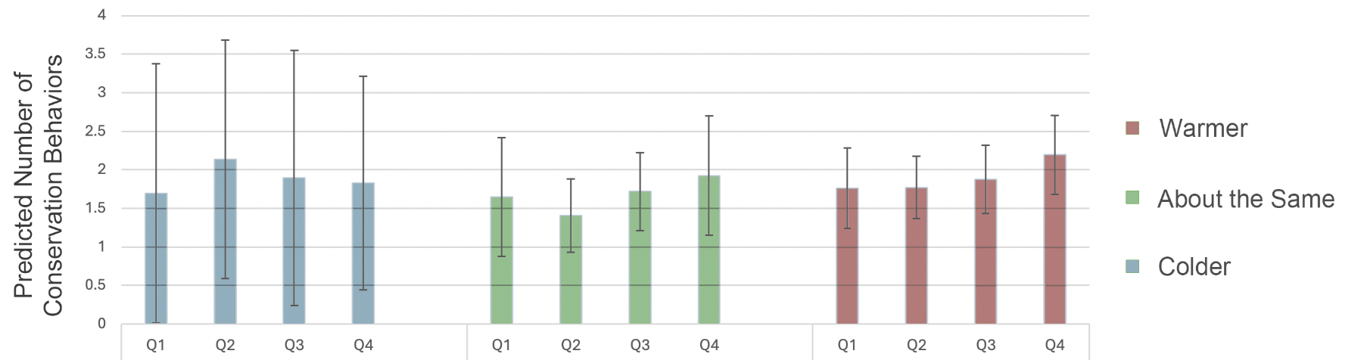
Source: Weather, Society and Government 2018 National Survey (N = 1,564)

Figure 1.2 The Interaction Effect of Social Capital at Events Experienced on Expected Number of Energy Conservation Behaviors
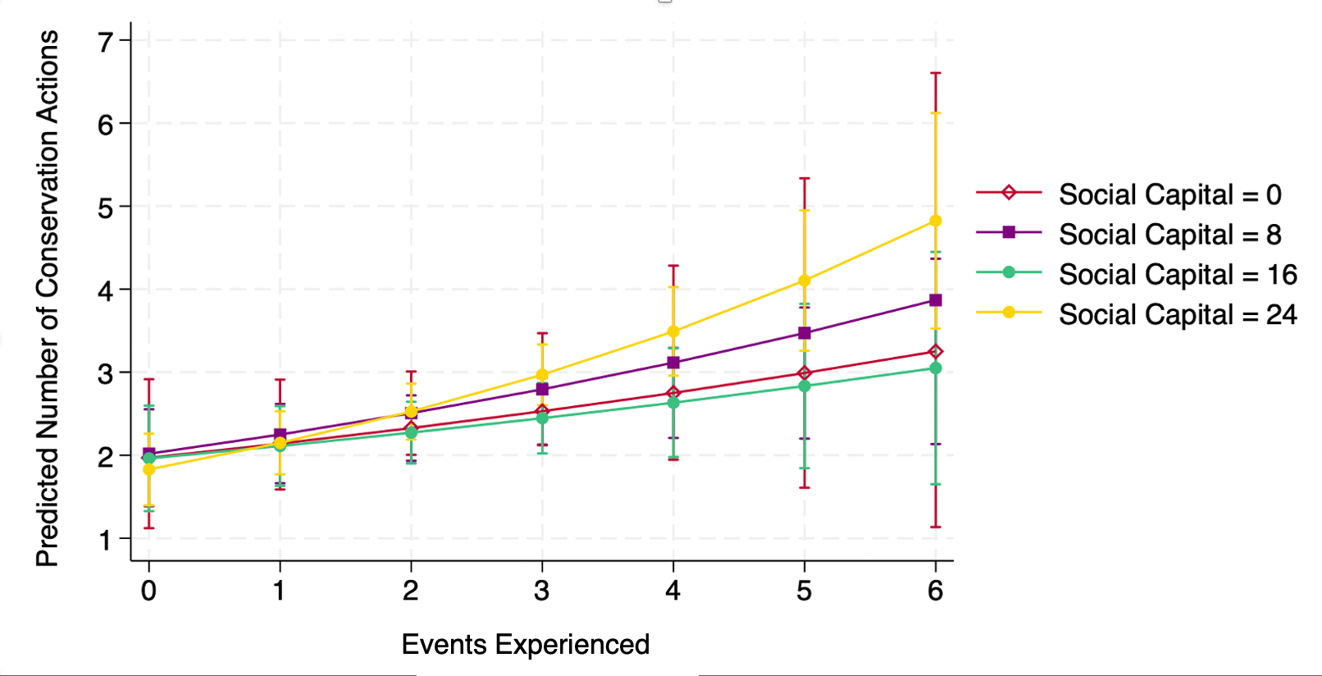
Source: Weather, Society and Government 2018 National Survey (N = 1,564)

Figure 1.3 The Expected Number of Energy Conservation Behaviors Among Different Temperature Perceptions by Social Capital (Quartile Averages) 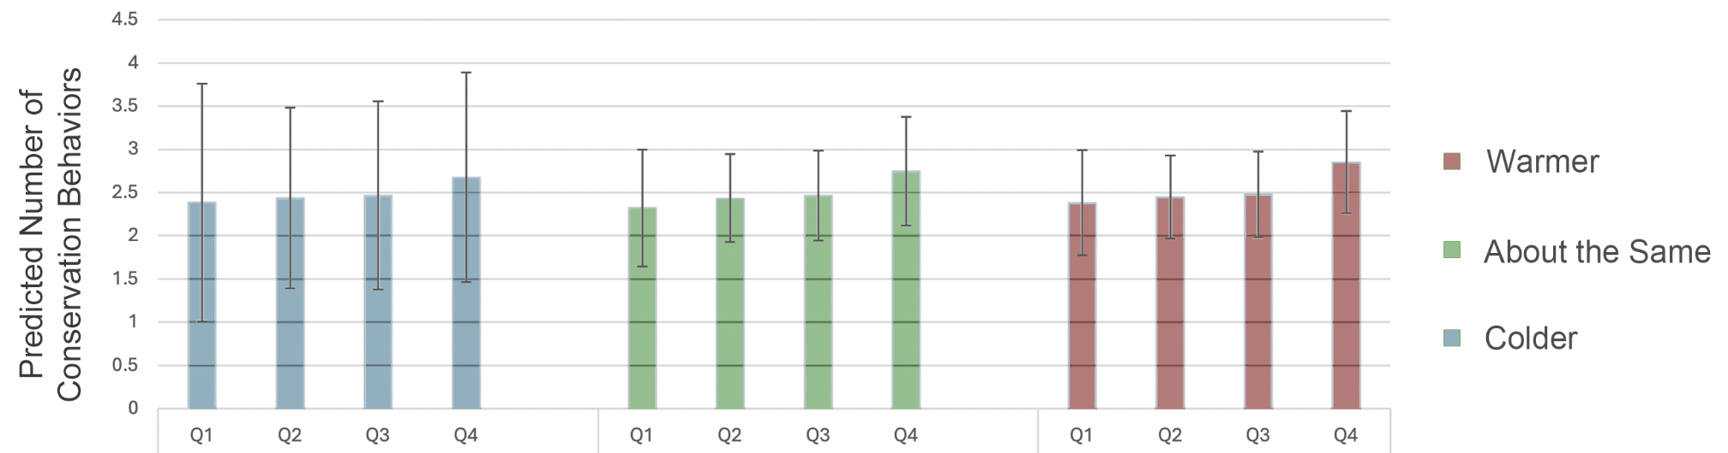
Source: Weather, Society and Government 2018 National Survey (N = 1,564)

Appendix A

Figure 0.0 Correlation Matrix
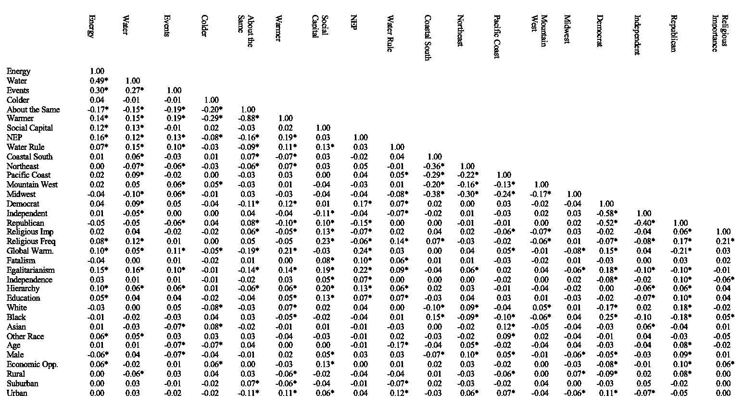
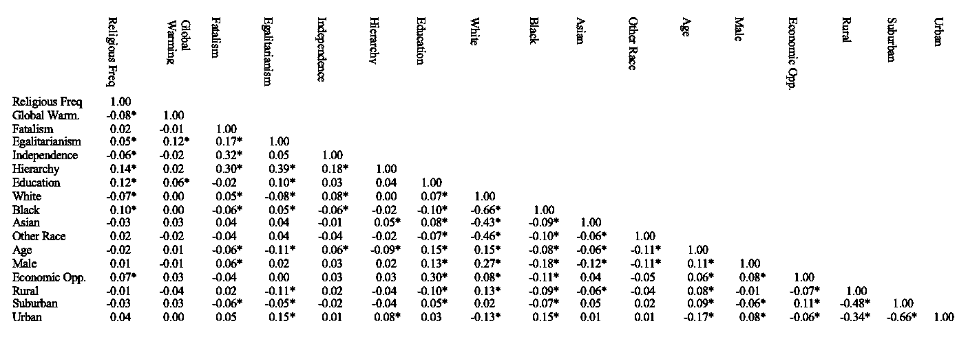

Appendix Figure 1.0 Regions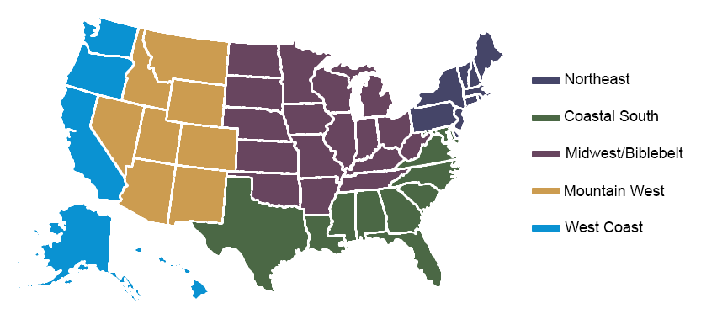

Appendix Figure 2.0 The Expected Change in the Number of Water Conservation Behaviors When Moving from Low to High Social Capital by Temperature Perception 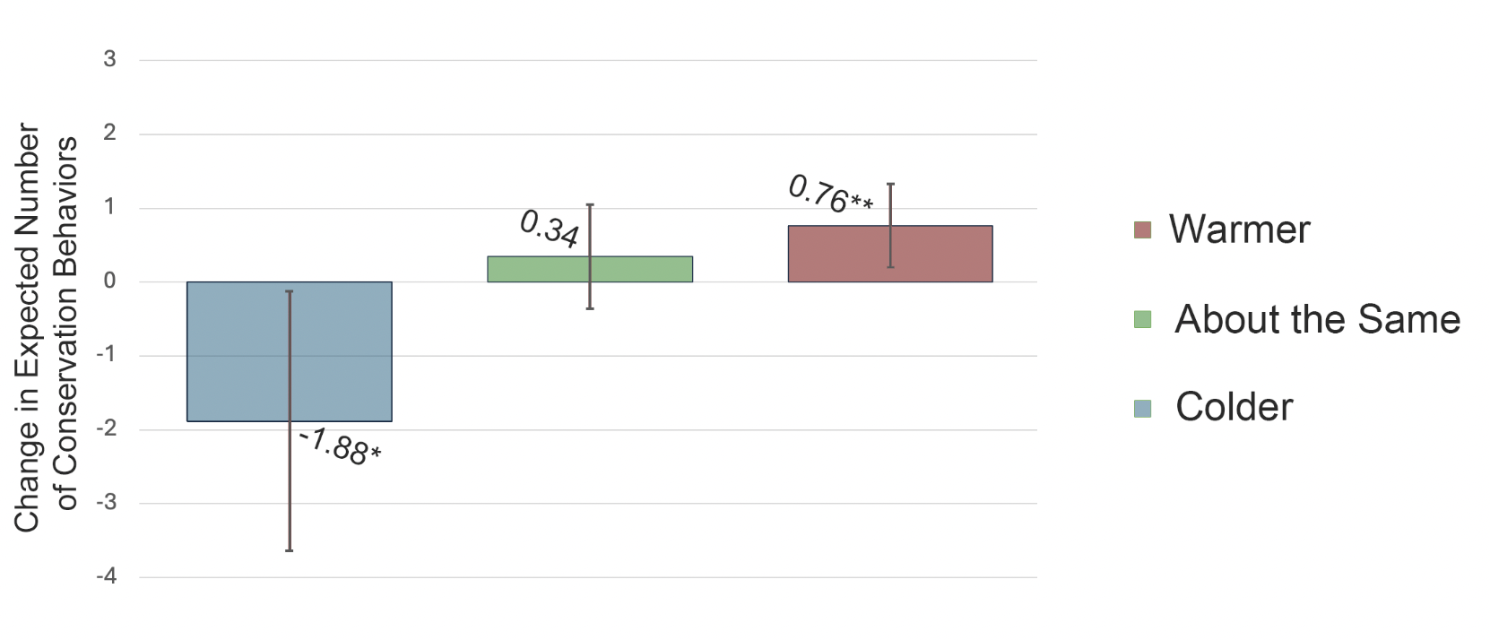
Source: Weather, Society and Government 2018 National Survey (N = 1,564)

Appendix Figure 2.1 The Expected Change in the Number of Energy Conservation Behaviors When Moving from Low to High Social Capital by Temperature Perception 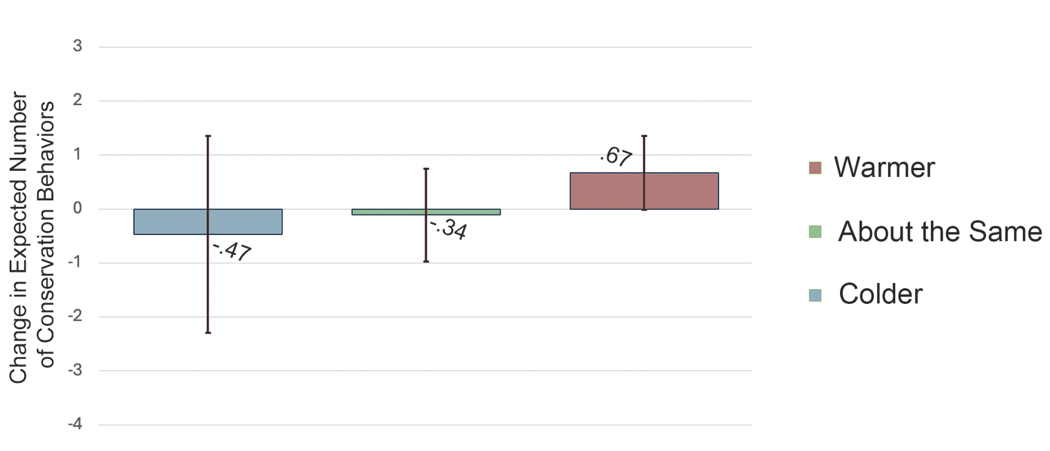
Source: Weather, Society and Government 2018 National Survey (N = 1,564)

While using a different sampling methodology, distribution of common demographics in WSG are comparable to GSS distributions.
Some findings show that certain methods of reducing psychological distance have limited returns in localizing the effects of climate change. (Schuldt, Rickard, & Yang, 2018)
Home Energy Report letters compare a household's energy use to usage rates of neighbors with similar situations.
Social capital may be intertwined with socioeconomic disparities. There are concerns about operationalizing the concept of social capital and whether it can be separated from these concepts (Mohan & Mohan 2002).
CRCM originally began collecting data on this dataset strictly within the state of Oklahoma in 2014. A technical overview of the methods was published in 2017. The 2018 dataset uses the same methodology but on a national scale.
Visit http://crcm.ou.edu/epscordata/ for details.
After listwise deletion for missing data and removal of observations with outlying wages, 1,564 individuals are included in the analysis.
Alpha test to determine scale reliability of the coefficient: .89.
The four reverse coded question were not included for two reasons. First, the inclusion of these questions lowers the reliability below acceptable levels. Second, recent research suggests that cultural and language difference can disrupt the validity of reverse coded responses (Venta 2022).
These totals were collapsed into groups of three for a total of eight categories (for larger cell sizes) to achieve convergence in testing for overdispersion. After finding no overdispersion, I returned to the original scale to capture greater detail in the data.
An example of one of these questions is: “Please rate the degree to which the [following statement] describes your outlook on life, using a scale from zero to ten, where zero means not at all and ten means completely: Life is unpredictable, and I have very little control. I tend not to join groups, and I try not to get involved because I can't make much difference anyway. Most of the time other people determine my options in life. Getting along is largely a matter of doing the best I can with what comes my way, so I just try to take care of myself and the people closest to me. It's best to just go with the flow because whatever will be will be.”
The nine category groups were used in supplemental testing and did not significantly alter results.
See Appendix A for region map.
In supplemental testing, the inclusion of a Hispanic ethnicity variable was included but no significant effect was found. For simplicity purposes it was not included in the final model.
To account for influential outliers identified in supplemental testing, I exclude observations which exceed 15 on the economic opportunity scale.
Correlation matrix for all the variables included in the model can be found in Appendix A.
All interactions are preformed using STATA’s interaction interface.
Tables are in expected counts. The percent change interpretations are included for clarity but are not shown in tables.
Mathematically this test is expressed as testing that (Disruptive Event [1] x Social Capital [0] - Disruptive Event [1] x Social Capital [24]) - (Disruptive Event [6] x Social Capital [0] - Disruptive Event [6] x Social Capital [24]) is significantly different from zero. See appendix figures 2.0 and 2.1 for visual representation of change in expected count along the ends of social capital.
This can also be expressed as: there is an expected .008 more conservation behaviors per one unit increase in social capital.
Visual representation can be found in Appendix figure 2.1
For results on energy conservation, the NEP measure was determined a significant predictor which I did not find in the water conservation model. When compared to each other, however, I find that compared to the predictive power of water conservation, the effect of NEP on Energy conservation is not significantly different, suggesting that the differences between the two may be related to sampling error (Prob > chi2 = .154). Some other effects of note: In Water Model 1 using accumulated hypothesis testing I found that a respondent’s region of residence (p < .000) was significant as well as their level of education (p = .012). However, these effects were not found to be significant in the energy conservation model. These findings further suggest that there are idiosyncratic effects for behaviors related to the different types of conservation.

