UNIVERSITY OF OKLAHOMA
GRADUATE COLLEGE

AN EXPLORATORY ANALYSIS OF WELL ABANDONMENT DECISION

A THESIS
SUBMITTED TO THE GRADUATE FACULTY
in partial fulfillment of the requirements for the
Degree of
MASTER OF SCIENCE IN MANAGEMENT
OF INFORMATION TECHNOLOGY

By
SNIGDHA ALATHUR
Norman, Oklahoma
2016

AN EXPLORATORY ANALYSIS OF WELL ABANDONMENT DECISION

A THESIS APPROVED FOR THE
MICHAEL F. PRICE COLLEGE OF BUSINESS

BY

Dr. Radhika Santhanam, Chair

Dr. Scott C. Linn

Dr. Shaila Miranda

© Copyright by SNIGDHA ALATHUR 2016
All Rights Reserved.

Acknowledgements

The master's thesis was developed at the Micheal F. Price College of Business, University of Oklahoma, together with my supervisor Prof. Dr. Radhika Santhanam and Prof Dr. Scott C. Linn. The data for this thesis was provided by DrillingInfo, IHS Inc. and Oklahoma Oil and Gas Commission.
Foremost, I would like to express my sincere gratitude to my supervisor, Prof. Dr. Radhika Santhanam, for her continuous support, motivation, and immense knowledge. Her guidance helped me throughout the development of this thesis, be it during data gathering or analysis. Her quick, invaluable feedbacks helped me reorient myself when I felt that I had hit a dead end.
I would like to express my gratitude to Prof. Dr. Scott C. Linn, for his valuable insights into the Finance aspect of oil and gas industry and for his continuous support and guidance during the course of this project.
I would like to thank all the professors at the Price College for their help in introducing me to many new concepts, and tools and technology which helped me in the course of this thesis.

Snigdha Alathur Norman, OK May 5, 2016

Table of Contents
Acknowledgements iv
List of Tables vii
List of Figures viii
Abstract ix
1. Introduction – Oil and Gas industry 1
1.1. Challenges and Potential – Oil and Gas industry 1
1.2. Big data Analytics – Oil and Gas 3
1.3. Well Abandonment 6
1.4. Objective 11
2. Literature Review 12
2.1. Review of paper - Influence of Oil and gas Regulation on Well Abandonment (Prescott, 2013) 13
2.2. Review of paper - Cost of Well Decommissioning (Andrew Bressler, 2015) 17
2.3. Summary 21
3. Methodology 22
3.1. Data Collection and Data cleaning 23
3.2. Data Analysis 24
3.3. Predictive Model 28
3.4. Analysis of Basin 30
3.5. Summary 39
4. Factors Influencing Well Abandonment 40
4.1. Company type 40
4.2. Regulatory Changes 41
4.3. Primary Product 43
4.4. Predictive Modeling 44
4.4.1. Number of wells abandoned – Linear regression 44
4.4.2. Well status - Logistic Regression 45
4.4.3. Number of wells abandoned vs Spot price – Linear Regression 46
4.5. Summary 47
5. Discussion and Further Research 48
5.1. Further Research 50
6. References and Bibliography 52
7. Appendices 54
Appendix A: Keywords 54

List of Tables
Table 1 Results - Regression model for number of wells abandoned 15
Table 2 Results – Regression model for time taken to abandon wells 16
Table 3 Oil well Decommission process description 18
Table 4 Correlation between well attributes 30
Table 5 Cluster analysis – K-means clustering 31
Table 6 Dummy variables for basin 31
Table 7 Dummy variable for well operators 40

List of Figures
Figure 1 Description of upstream, midstream and downstream 5
Figure 2 Offshore decommissioning model 20
Figure 3 Annual oil and gas production from Entity 135010010471 25
Figure 4 Annual oil and gas production from Entity 135010060932 26
Figure 5 Annual Production for wells with primary product oil 27
Figure 6 Annual Production for wells with primary product gas 27
Figure 7 Cumulative oil production – Cluster 1 32
Figure 8 Cumulative oil production for cluster 2 33
Figure 9 Cumulative oil production for cluster 3 34
Figure 10 Cumulative oil production for cluster 4 34
Figure 11 Cumulative wells in each basin 35
Figure 12 Arkoma basin – Cumulative wells in each county 36
Figure 13 Cumulative wells based on well type 37
Figure 14 Cumulative wells based on well status 37
Figure 15 Cumulative oil and gas production year-wise 38
Figure 16 Total wells plugged and abandoned each year 41
Figure 17 Number of wells plugged and abandoned based on primary product 44
Figure 18 Predicted vs actual values of number of wells abandoned 45
Figure 19 Analysis of maximum likelihood estimates 46
Figure 20 odds ratio estimates 46

Abstract

The Oklahoma Corporation Commission Oil and Gas conservation division reports that as of 2012, there have been roughly 500,000 wells drilled in Oklahoma since 1978. 350,000 of those have been plugged and abandoned. The decision to abandon a well mainly depends on its economic viability. Most efficient production rate is one of the critical drivers in the decision to abandon wells. There are however other potentially important factors that can influence the decision such as government regulation, physical properties of the oil field, and most importantly, expected volatility of oil or natural gas prices as well as the trajectory and uncertainly associated with the operating cost as technology changes. Using application of data analytics tools and techniques, we examine the choices made by oil producers in Oklahoma regarding drilling and abandonment and present a study of the interactions and interrelations between a number of well related factors and prices which can potentially influence the well abandonment choice.
Well production and well attributes were collected for all wells with completion dates between January 1975 and January 2015. Arkoma basin, with a history of 14,000 wells was chosen for the initial analysis.
From our study, we understand that government regulations, well operator, complexity of decommissioning process are some of the factors along with the oil and gas price that influence well abandonment decisions.

Introduction – Oil and Gas industry

Oil and gas industry has always been one of the important revenue generators around the world. In the USA, the total revenue of oil and gas industry was around 146 billion U.S. dollars in 2010 and by 2014, the revenue increased up to 220 billion U.S. dollars (Statista, 2016). This is a very dynamic industry as there are constant changes with respect to technology and methodologies.
Since 1950, over 2.5 Million oil and gas wells have been drilled in the U.S and tens of thousands of wells are drilled every year. Oil and gas industry has always dealt with great amounts of data; also with constant updates in the technology, the amount of data generated is ever increasing. USA today ranked 10 states in the United States that accounted for majority of oil and natural reserved in the USA (USA today, 2013). Texas was ranked number 1 with 7014 million barrels of reserve oil and Oklahoma was ranked 5 with around 879 million barrels of reserve oil.

Challenges and Potential – Oil and Gas industry

Oil industry deals with data from different sources such as sensors, and machine-to-machine data. One of the major issues faced by the oil companies is to handle this data and derive useful values. However, a high percentage of this data is of poor quality and needs to be integrated. There are also cases where different parts of data are owned by different people, thereby increasing the complexity even more.
Some of the primary challenges faced by the petroleum industry are – fluctuating price, changing government regulations, complex process handled by different set of people and inefficient exploration and production. Oil and gas companies can mitigate many of these challenges utilizing the vast amount of data it generates every day.
Although there is a huge amount of data and potential to gain value, petroleum industries are not able to extract full value from the data. Gathering data is one of the most tedious and challenging tasks in this industry, especially in upstream sector. A lot of information which could be useful are in PDF and image formats. Also some of the information is manually entered, and could be erroneous. Technical staff and line of business leaders are often asked to make quick and informed decisions.
If IT systems are implemented in these companies, value from data can be extracted to improve their processes. For instance, if the company implements a data warehousing system, data across different teams can be maintained by individual owners and can be accessed by all stake holders to make informed decisions.
Many companies such as Shell are implementing new technology to improve data collection and analysis. Royal Dutch Shell has been developing a concept called ‘Data Driven Oil Field’ to bring down drilling costs, which is one of the major expenses. Shell uses fibre optic cables, created in partnership with Hewlett Packard, to survey potential oil exploration sites and transfers the data to its private servers, which are maintained by Amazon web services. Analysis of this data gives detailed insights of the chosen oil exploration site and has helped The Royal Dutch Shell optimize the production operations by minimizing the cost.
Deloitte Consulting LLP implemented visual analytics tools to help improve performance and lower operating costs of oil wells for an independent oil and gas company. This company wanted to get a detailed view of their well development and operation cost as they pressurized by low natural gas prices. Deloitte developed a visual analytics tool called DCAT – Drilling and completion analytics toolset to help decision makers create opportunity to manipulate and explore the data in different ways to arrive at an optimal solution.
Value proposition of oil and gas industry is to reduce cost and risk, and increase revenue (Brown, 2011). Enabling Oil and gas industry with IT and analytics will help companies achieve this value proposition. With more data of different types being accumulated each day in every sector, businesses - big and small alike – are beginning to understand the importance of Data and the value that could be derived from this data. Companies are investing in technology to capture, integrate, analyze and derive value from Data. As defined by SAS, Big data is a relative term that describes a situation where a company has to deal with a larger and more complex data than they can actually handle with their current infrastructure.

Big data Analytics – Oil and Gas

Big Data analytics is a science of examining data, understanding it and drawing conclusions from the data to make improved business decisions. This is a concept that can be applied to any industry. Although some industries are adapting the “data-driven” business model now, oil and gas industry has always dealt with large amount of data and has used this data to make business decisions. Large amount of data is being gathered from various sources - geological, production, technology, equipment and engineering etc. This data has enabled oil and gas industry in many ways.
Business Intelligence and Data mining techniques are applied to large data sets to get deeper understanding of the data. These techniques help understand the company process more clearly and also help identify pain areas of a particular process.
Decision models and Predictive analytics techniques are used to build optimized production methods.
In a survey conducted by Accenture and Microsoft, around 80-90% of oil companies said that increasing their analytical and internet capabilities would increase the value of their business.
Oil and Gas industry is growing in a fast pace, and generates huge amount of data. The data gathered comes from different sources and is highly complex. Hence, data gathered in this sector, covers all the four Vs of analytics -
- Volume: The data generated by this industry is in Petabytes and Terabytes
- Variety: Field data and geological data. There are some of the many sources from which data is gathered. Most of this data is complex, and although the data is both structured and unstructured, a large percentage of about 80% of this data is unstructured. A large amount of data is in the form of picture or pdf documents which needs to be extracted
- Velocity: Usage of many modern techniques in upstream, mid-stream and downstream sectors, generates large amount of data in very short intervals
- Value: Data gathered can be used to derive value for the business. It helps come up with useful models to optimize production and drilling processes, production forecasting, and asset management.
There are three sectors of oil and gas industry – Upstream, downstream and midstream. Figure 1 gives a brief understanding of these sectors.
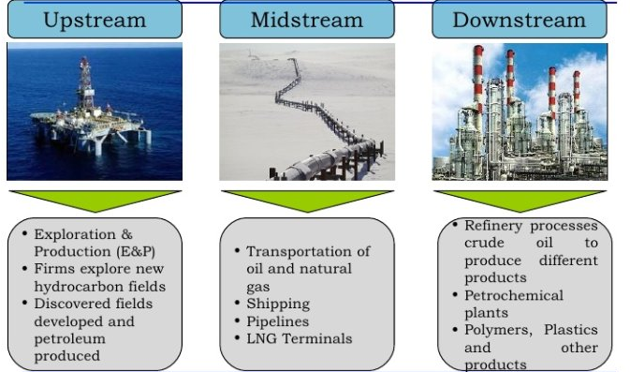
Figure 1 Description of upstream, midstream and downstream
Applications of big data and analytics is enormous in all three sectors of Oil and Gas industry. Precision, safety and environmental aspects are some of the factors in this industry that make appropriate decision making models a critical requirement.
Many oil and gas industries currently use data analytics in their operations. Some of the applications are -
- Upstream: Optimization in exploring, Risk Assessment, Optimization in Drilling, Production optimization etc.
- Midstream: Storage optimization, Pipeline risk assessment, transportation optimization etc.
- Downstream: Market analysis, demand & price optimization etc.

Well Abandonment

Oil well Abandonment is one of the very crucial activities that has to be performed by oil well operators. It could take two days to many days to complete this process depending on the number of plugs that has to be set in the oil well. This process requires cement pumped into the wellbore to ensure appropriate plugging. Incorrect plugging and abandonment can cause major environmental threats. The fluids injected to the wellbore during the extraction process could seep into ground water, or natural gas could moves up to the surface, these could be dangerous as the injected fluids and natural gas is toxic in nature. The government has strict regulations on plugging and abandonment of a well. If the wells to be abandoned are located in a zone which is prone to harsh weather conditions, e.g. storms, tornadoes or extreme temperatures, measures should be taken to ensure that the plugging is sturdy enough to handle corrosion or any damage caused by the local weather conditions. Well depth and pressure are two important factors to be considered before choosing a plugging and abandoning method as improper plugging can pose threat to coastline, shipping and fishing activities if they are located in such areas. All these complexities make it expensive for a company to plug and abandon a well. While the plugging and abandonment costs are very low for onshore oil wells, the costs may range from a few hundred thousand dollars to millions of dollars for offshore wells (George E King, 2009).
As P & A involves high-costs and complex processes, the decision to Plug and Abandon a well can be complex. Many operators can choose to temporarily abandon the well, some of the scenarios where an oil and gas well is temporarily abandoned are -
- A well is deemed uneconomical
- The company wishes to wait for new technology to be developed
- The company wants to suspend the well operations temporarily for any other operational reason
If a well is temporarily abandoned, then appropriate plugs have to be inserted to completely isolate the well. If the well has to be permanently abandoned, then it is not advisable to opt for Temporary abandonment as delaying the permanent abandonment could eventually increase P & A cost considerably (George E King, 2009)
Well abandonment represents an opportunity cost for oil companies as applying new production techniques in abandoned wells is more expensive compared to applying them in operational wells. The primary factor motivating the eventual abandonment is the lack of production from that well. If oil or gas prices are low, a well may be temporarily abandoned until production from that well becomes economic. Even though price of oil and gas is not a direct determining factor for well abandonment, it could be a factor that determines how many wells are abandoned in a year, i.e., if prices are high, then the companies may concentrate on drilling more wells rather than spending on abandonments or vice versa.
Number of wells drilled per year represents the financial health and anticipated production prospects of the company. Number of wells drilled can have a positive correlation with number of wells abandoned, this is mainly because not all completed wells are profitable.
It is a known fact that an oil well is abandoned when its most efficient production rate does not cover the operating costs. The formula to calculate a well’s economic limit is given by –
$$EL_{oil}=\frac{WI*LOE}{NRI}\left[P_{0}+\frac{P_{g}*GOR}{1000}\right]*(1-T)$$
$$EL_{gas}=\frac{WI*LOE}{NRI}\left[\left(P_{0}*Y\right)+P_{g}\right]*(1-T)$$

Where,
EL_{oil} = oil well’s economic limit in oil barrels per month
EL_{gas} = Gas wells economic limit in thousand standard cubic feet per month
P_{o} and P_{g} = Current prices of oil and gas in dollars per barrels and dollars per MSCF respectively
LOE = least operating expenses in dollars per well per month
WI = working interest (A percentage of ownership in an oil and gas lease granting its owner the right to explore, drill and produce oil and gas from a tract of property. Working interest owners are obligated to pay a corresponding percentage of the cost of leasing, drilling, producing and operating a well or unit)
NRI = net revenue interest
GOR = gas/oil ratio as SCF/bbl
Y = condensate yield as barrel/million standard cubic feet
T = Production and severance taxes
The above model gives the economic limit of a well. Although economic limit is one of the primary factors that contribute to well abandonment decision, it is not the only factor. There are, many other factors that can contribute to the abandonment of a well such as oil and gas price, government regulations and geographical locations. Some of these factors are discussed in the next chapters.
Oil and gas industry has been divided into three main sectors – Upstream, midstream and downstream, these three sectors are briefly explained in figure 1 in the previous section. Upstream sector mainly deals with exploration and production. Oil and gas industries invest in different technologies such as optic fibre cable to make their exploration process more efficient. Upstream sector involves many complex operational and decision making process. The cost involved in exploration and production (E & P) is very high and they also have strict regulations imposed by the government. These factors add to the complexity of this sector and makes it interesting to study.
As discussed in the beginning to section 1.2, well abandonment is an extremely complex process. Although economic limit of the well is the primary factor that determines the well abandonment decisions, there are many other factors that can either directly or indirectly influence the well abandonment decision. For instance, we can study if there is a relationship between oil and natural gas price in a particular year and the number of wells abandoned in that year. Type of company, government regulations are some of the many subtle factors that can be considered before abandoning a well. Physical properties of rocks like porosity or permeability also can help determine the possibility of recovery of more oil and gas even after a certain limit is reached. All these factors about upstream sector and well abandonment gives enormous scope to study and propose new ideas to enhance the efficiency in exploration and production of oil and gas.
Oil and gas sector has enormous amount of data, upstream sector involves lot of decision making processes. In many of the research papers that I reviewed, there was considerably less information about the reasons behind plugging and abandoning a well. This was the motivation to study more about the abandonment process and understand different factors that lead to well abandonment.

Objective

The main objective is to study and understand the various attributes that contribute to plugging and abandonment of an oil well.
In this thesis, the focus is on the upstream sector of oil and gas industry in Oklahoma. Various attributes of oil and gas wells, are studied to analyze if there are any relationships between these variables, and if there are any patterns that could give us insights into the data. Production data gathered from drilling Info is analyzed to get an understanding of the attributes that impact well abandonment.

Literature Review

Two papers were reviewed to get an understanding of - factors influencing well abandonment decisions and complexity involved in well abandonment.
First one was a paper from SS-AAEA Journal of agricultural economics (Prescott, 2013) - the Influence of oil and gas regulation on well abandonment. This is a paper written by Sarah Prescott, the author has studied the effects of oil and gas regulation on well abandonment. In this analysis, the author has considered the data from Alberta, Canada. This predictive models discussed in this paper explains the relationship between number of wells abandoned (in a particular year) and other variables like oil and gas price, number of wells drilled and oil and gas regulations. This paper helped me understand about the influence of regulations on well abandonment. With this paper as background information, I plotted a graph of the number of wells abandoned each year in Oklahoma. For the years with higher and lower number of abandoned wells, I commented on the regulatory changes that occurred in the same period.
The second paper is – A cost model for offshore decommission in California, by Andrew Bressler and Brock B Bernstein (Andrew Bressler, 2015). Complete decommission of oil well involves many steps. Also there are many elements that has to be decommissioned. The authors in this model have proposed a model which would optimize the cost of complete decommission of oil wells. This helped me get an understanding of the decommissioning process and the complexities involved in the decommission process.

Review of paper - Influence of Oil and gas Regulation on Well Abandonment (Prescott, 2013)

When a company decides to abandon a well, it is essential that they take the required measures to ensure that it has been plugged correctly. In Pennsylvania, over 200,000 wells have been completed since the late 1800s, many of these wells are now inactive and the location of these wells are unknown. These wells were completed in the early years of oil and gas exploration (late 1800s) and hence did not have strict regulations on decommissioning a well. In 2010, two houses in Pennsylvania exploded as stray gas from a poorly plugged well escaped. Incorrect plugging of an abandoned well can cause such accidents and can also contaminate the soil and surrounding water bodies, thereby raising various environmental concerns. Abandonment of wells is an expensive process and according to Oklahoma Oil and gas Commission, it is a process and not a project. Due to this, most operators prefer to temporarily plug a non-operational well. The operators temporarily suspend operations at a well and wait for the technology to develop so that more oil and gas could be recovered from the well. Also, as many of the leases are privately owned, the annual rents were lower and the overall maintenance cost would be far lesser when compared to plugging and abandonment cost. The problem with this approach by the operators is that poorly and temporarily plugged wells posed considerable environmental threats.
To address this issue, many state governments imposed strict regulations on oil and gas operations. In this paper on the influence of oil and gas regulation on well abandonment, written by Sarah Prescott, the relationship between government regulations and abandoned wells in Alberta, Canada is studied. Production potential of well, price of oil and gas, number of wells drilled per year are few other factors considered to understand the behavior of well abandonment.
In this paper by Sarah Prescott, a regression model was built to explain the relationship between number of wells abandoned and other variables mentioned above.
Regression Model for number of wells abandoned -
$$NoAbd= β1+ β2*price+ β3*WellsDrilled+ β4*AbdFundDummy+ β5*LTIWPDummy+ β6*LLRPDummy+e$$
Description of variables –
NoAbd: Number of abandoned well per year
Price: price of oil or gas
WellsDrilled: Number of oil or gas wells drilled that year
Next three variables are dummy variables created to represent three main regulations imposed by Alberta Government - Abandonment Fund: 1986-2001, Long Term Inactive Well Program: 1997-2001, Licensee Liability Rating Program/ Transition to Orphan Well Association – 2001 - 2013
AbdFundDummy: It is the length of time the Abandonment Fund was in place (1986-2001)
LTIWPDummy: It is a variable for the length of time the Long Term Inactive Well Program operated (1997-2001)
LLRPDummy: It is the variable for the length of time that program operated (2002-2011)
Table 1 Results - Regression model for number of wells abandoned
Regression  Parameter | Anticipated Sign | Anticipated Relative Magnitude | Oil Wells | Gas Wells
R-square value |  |  | 0.85 | 0.87
Intercept | + | Low | 74.69 | 27.43
Price | - | Low | -5.43 | 5.42
WellsDrilled | + | Low-Medium | 0.09 | -0.05
AbdFundDummy | + | Medium | 357.83 | 391.46
LTIWPDummy | + | Low-Medium | 107.09 | 381.34
LLRP Dummy | + | High | 378.75 | 930.76

The regression model for the number of wells abandoned, gave an R-Squared value of 0.85 (oil) and 0.87 (gas). From the above table, we can interpret that all three regulations cause a change in the number of wells abandoned in a year, especially the LLRP regulation, which has a high impact on the dependent variable.
Another regression model was built, using same predictors as chosen in the aforementioned model, to understand the behavior of time difference between a well’s last production and year of abandonment. The model is formulated as follows.
Regression Model for time taken to abandoned wells -
$$TimeToAbd= β1+ β2*price+ β3*WellsDrilled+ β4*AbdFundDummy+ β5*LTIWPDummy+ β6*LLRPDummy+e$$
Table 2 Results – Regression model for time taken to abandon wells
Regression  Parameter | Anticipated Sign | Anticipated Relative Magnitude | Oil Wells | Gas Wells
R-square value |  |  | 0.08 | 0.25
Intercept | + | Low | 0.55 | 12.68
Price | - | Low | 0.10 | -0.01
Wells Drilled | - | Low-Medium | -0.00004 | 0.0004
AbdFundDummy | + | Medium | 3.33 | -7.16
LTIWP Dummy | + | High | 2.05 | -0.57
LLRP Dummy | - | Medium | 4.38 | -10.01)
R-Squared value of this model is quite low, but the author has made following comments on the results – “The value of the intercept is statistically significant. At 0.55, it indicates that, in general, only oil wells that have been in production for less than a year are abandoned. The oil price is significant and small in magnitude, but is positive instead of negative. The number of oil wells drilled was not significant. All of the policy parameters were significant. However, against expectations, the magnitude of the LTIWP parameter was less than the Abandonment Fund parameter. As well, the LLRP parameter was expected to be negative, but was positive and greater in value than both the Abandonment Fund and LTIWP parameters.”
From this analysis, it is evident that the government regulations play an important role in permanent abandonment of oil wells. Further observations are made in this paper, e.g. more gas wells are abandoned than oil wells, which could be due to opportunity cost difference between the two products; the number of oil and gas wells drilled per year is double the number of abandoned wells.

Review of paper - Cost of Well Decommissioning (Andrew Bressler, 2015)

A very important factor that has to be considered before abandonment of well is decommission and P & A cost. As mentioned earlier, due to the complexities involved in the process, the total cost of plugging and abandoning a well is very high for an offshore well. Andrew Bressler and Brock B Bernstein, in their paper A costing model for offshore decommissioning in California, described various activities that should be performed to completely decommission a well. The activities are tabulated as below.
Table 3 Oil well Decommission process description
Decommissioning element | Description
Well Abandonment | - Remove down-hole equipment  - Plug well  - All effort occurs below ocean floor surface
Platform Preparation | - Inspect structural condition  - Flush/clean all process piping and equipment  - Detach all deck modules and equipment in preparation for removal  - Remove marine growth to approximately 100 feet below water line
Conductor Removal | - Sever conductors below the ocean floor  - Lift and cut or unscrew conductors into 40-foot lengths  Barge Conductors to shore
Pipeline and power cable disposition | - Disconnect pipeline and power cables from platform  - Flush pipeline and fill with seawater  - Cut both pipeline and power cable at seafloor  - Cap pipeline and bury ends  - Bury power cable ends  - Both likely to be abandoned in place to minimize bottom disturbance
Heavy lift vessel (HLV) mobilization and Demobilization | - Group platforms to enable HLV mobilization and demobilization costs to be shared  - Select HLV based on single heaviest lift envisioned  - HLV transit to and from southern California from Gulf of Mexico, Asia, or North Sea  - Widened Panama Canal may shorten transit times and costs  - for some HLVs
Platform and Deck removal | - Decks and topsides of small platforms may be removed in a single lift  - Decks and topsides of larger platforms may require multiple lifts  - All decks and topsides transported to shore for processing
Platform Jacket Removal | - Sever piles that fix platform to ocean floor  - Piles cut below the ocean floor  - Lift jacket, either whole or in pieces, using HLV  - Transport piles and jacket to shore for processing
Platform structure transportation and disposal | - Large mass of steel will result from complete removal  - Platform structure will be processed at Port of Los Angeles or Port of Long Beach  - Process includes disassembly, recycling, disposal
Site Clearance | - Pre- and post-decommissioning site surveys  - Regulations and leases require that all debris and other impediments be removed  - Site clearance confirmed with test trawling  - Disposition of shell mounds is contentious  - Shell mounds may be left in place based on negotiation with BSEE or SLC

Some of the elements in the oil wells (that are mentioned in the above table) have the option to be partially decommissioned.
They also created a cost model which takes into account all costs involved in complete decommissioning of a well. The overall conceptual structure of decommissioning costing analysis is shown in Figure 1.
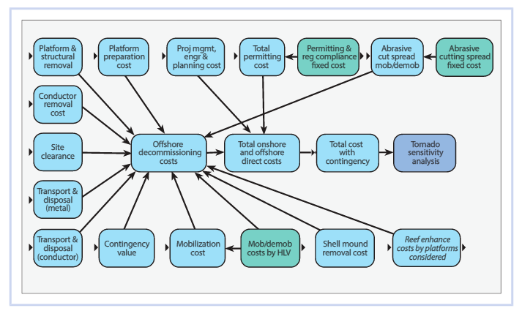
Figure 2 Offshore decommissioning model
A mathematical decision model, known as ‘Platform’, is used to allocate fixed cost to each element in the model. Complete decommissioning of a well can be accomplished in more than one phase. As mentioned earlier, elements of the well can be decommissioned partially. This model helps the decision makers create an optimal plan to decommission different platforms in different phases.
In the above model, the author has not considered the plugging and abandonment costs, this is because, plugging and abandonment is an element which is required to be decommissioned by government regulation regardless of decommissioning plan.

Summary

From both the papers reviewed in this chapter, it is evident that the process of Plugging & Abandonment of a well is extremely complex and expensive. If a well has been inactive for a long time, different companies could take different approaches to deal with it. While big companies and companies with defined processes could opt for decommissioning of the well, smaller companies and private operators could choose the option of either temporarily abandoning the well or suspending it as the cost of well maintenance is far lower than the cost involved in P & A.
To ensure compliance, regulations imposed by the government ensures that irrespective of type of owner, a well is plugged and abandoned if it has been inactive for a long time. It should also be noted that government regulation is one of the factors that determines the number of wells abandoned in a particular year.
This review helped me understand the complexity involved in complete decommissioning process of a well, and importance of the role of regulations in oil well operations. It was clear that well abandonment decision is not very straight forward, a lot of factors will be considered to finally arrive a decision to abandon a well. This led me to study if factors such as price, company and well type influence the plugging and abandonment decisions.

Methodology

Data used for the analysis was initially obtained from IHS Inc. database. IHS Inc., headquartered in Colorado, United States, provides information and analysis on various sectors such as aerospace, finance chemical, oil and gas, etc. Data from around 4,000 oil well leases in the state of Oklahoma was gathered and a basic analysis was performed by me to understand the relationship between various attributes such as lease status, production start year, production end year, cumulative production and other relevant attributes. IHS database provided the data on lease level which was used for an initial analysis.
For further analysis, oil well production data was collected from DrillingInfo. DrillingInfo, a company based out of Austin, Texas, collects and provides data and business intelligence solutions that can be used by upstream Exploration and Production (E and P) customers to be more efficient and competitive. For gathering and extraction of data, two of Drillinginfo’s tools – DI Classic and DI desktop – were used.
DI Classic – Data on production, completions, leases, plugging and well logs were obtained from DI Classic. Various conditions can be set using any of the following attributes to generate a dataset - well type, production dates, operators, APIs, field, reservoirs, cumulative production, daily production, well depth, well direction type etc. Well data generated from DI Classic consists of 85 attributes, some of which are mentioned below. We, however, select only relevant attributes that will help in our analysis.
DI Desktop – DI Desktop, like DI Classic, provides well attributes and production data. This tool, however, is more powerful than DI Classic as it helps us write more specific queries to generate required report or dataset. This tool was used to extract basin-wise oil well production data the state of Oklahoma.

Data Collection and Data cleaning

County-wise production data was gathered for the wells that started oil and gas production between Jan 1, 1975 - Jan 1, 2015. 81 columns with different attributes were collected for each well. Some of the well attributes were – API number, Operator name, Basin Name, Production start and end dates, Production volumes, type of drilling, reservoirs, well Status etc.
To download the required data, a query had to be run in DI classic by giving condition variables - county name and Production start and end date. Once the query was run, if number of data points was more than 5,000, the tool automatically truncated the extra data and retained only 5,000 data points. To avoid this, after running the query, the tool had to be checked for any truncated rows. If there were any rows that were removed by the tool, the query had to be changed to reduce the total number of data points to be less than 5,000. This was done by considering different time periods between production start data and end date. Due to this, multiple excel sheets had to be downloaded and merged later.
Once the data was gathered from Drilling Info, data cleaning was performed. Missing data was one of main concerns with the dataset. Attributes such as Total well depth, Elevation, cumulative production was missing for some data points. Huge numbers of missing values were found in many of the attributes and no apparent pattern was observed in the missing data. Hence, an assumption was made that the values were missing completely at random. Also, as any variable with more than 40% of missing data does not help in the analysis, rows with missing values were deleted. A dataset was created which consisted of around 12 Well attributes that included basin name, first month liquid, temperature gradient, Cumulative production, production start and end year etc.
Another challenge faced was to match data set from different sources. Most of the data was taken from drillingInfo, but some information about number of abandoned wells was taken from Oklahoma oil and gas commission website. The number of abandoned wells from both the sources did not match each other.

Data Analysis

Basic analysis was performed on the gathered data to get an understanding of the data set. Few wells were randomly chosen from different counties to look at the production pattern. It was observed that, the production of primary product of a well reached the maximum level during the first five years of production, after which there is a drop. Volume recovered, however, increases slightly before the final production.
Figure 2 below shows oil and gas well lease - 135010010471, which produced oil as a primary product and gas as the by-product.
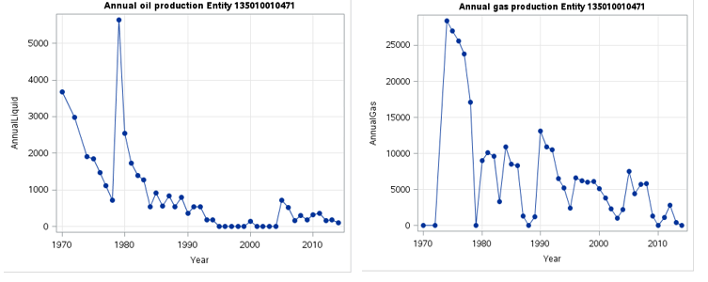
Figure 3 Annual oil and gas production from Entity 135010010471
As mentioned earlier, oil recovery reaches its peak during the first five years of well operations, after which there is a drop in production volume. After this point, oil production is almost constant with less variation.
Even though Entity 135010010471 is currently marked as active and hence the recovery is still in progress, the data set has production details of this entity only until 2014.
In the entity 135010010471, it can be observed that gas production is zero for the first few years. This could be related to production process and recovery of the primary product. As the primary product of these wells is oil, there could be a possibility where the initial crude oil extracted contains negligible gas (byproduct) which is not economical to be recovered in the early stages.
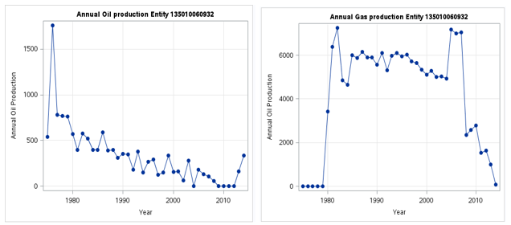
Figure 4 Annual oil and gas production from Entity 135010060932
In entity 135010060932, gas production increases to very high values in the year 2005-2007 and in this period, the oil recovery is observed to be very low. This could again depend on the physical properties of the well and recovery process. On the other hand, this pattern was not observed in entity 135010010471. This could be because the entity is currently active or the physical property of the well and recovery methods are different.
The same analysis was performed on the data collected from DrillingInfo. Eight different wells were selected randomly from Arkoma basin, where four wells had oil as their primary product and the remaining had gas as their primary product. Figure 5 shows the amount of primary product that particular well generated every year since it first began producing. In the wells that produce oil primarily, we observe that while oil production is high in the first 5 years, it decreases gradually over time.
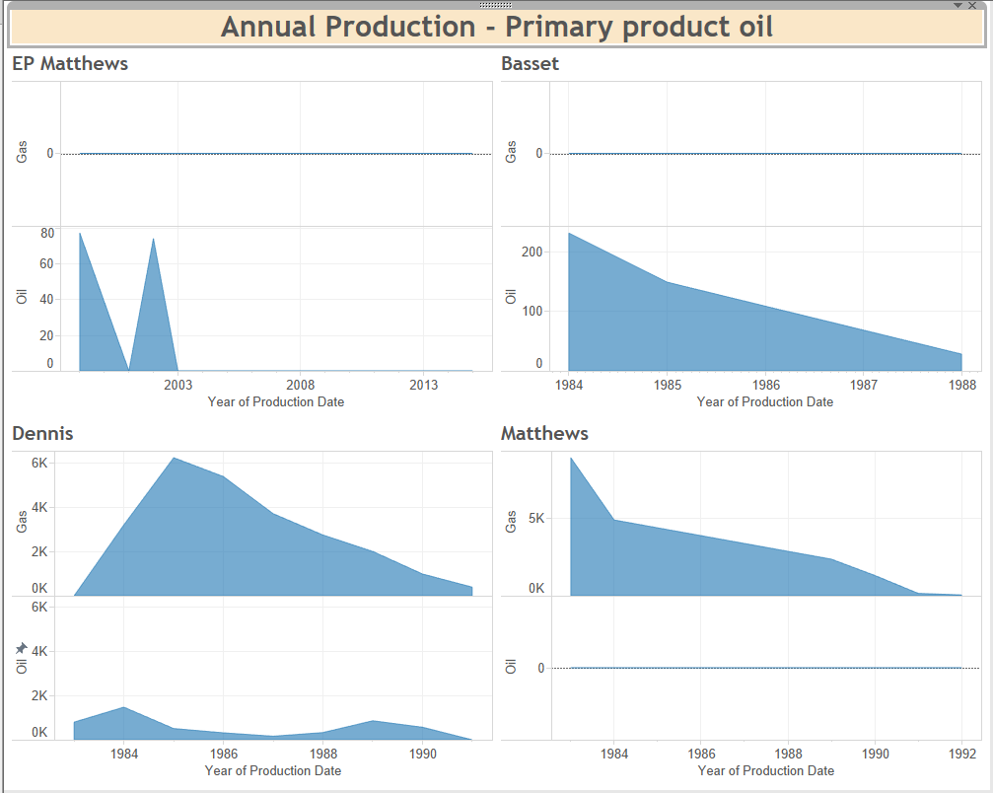
Figure 5 Annual Production for wells with primary product oil
Figure 6 shows the cumulative production for wells with primary product as gas. Here we see that there is no oil production in these wells. Also, while gas production is high in the initial years in the first two wells, it gradually decreases in the following years. In some wells, it is observed that the operators extract the maximum product close to production end dates.
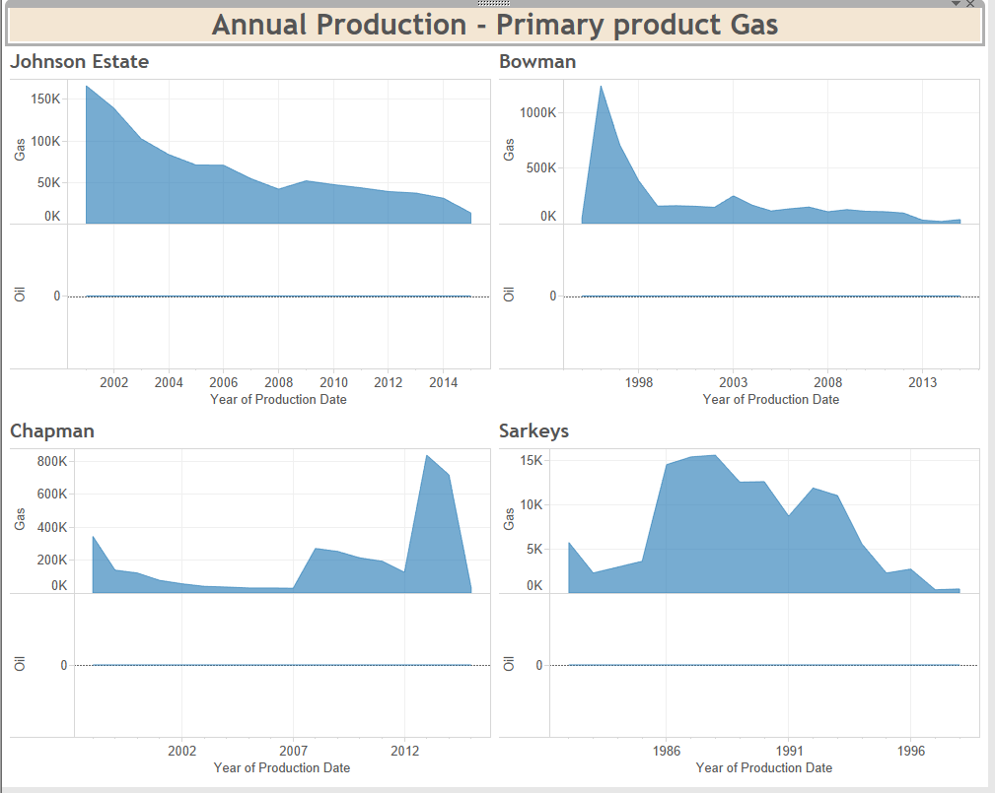
Figure 6 Annual Production for wells with primary product gas

Predictive Model

If a well is inactive or decommissioned, the cumulative production is the total production of oil or gas by the well in its lifetime. On the other hand, if the well is still active, cumulative production is the total production of the well until the most recent production. When a regression analysis was run to understand the behavior of cumulative oil production, initially, the independent variables considered were – number of years produced, which is the difference between production end and production start date; oil production of first 60 months; peak oil production and type of well (oil or gas). The following model was obtained from regression analysis: –
$$CumulativeOilProdcution= -5189.63+37.83*PeakLiquid+32.82*MonthsProduced+1.29*oilProducedin60months$$
Peak liquid production of a well, total months a particular well produced and the oil produced in the first 60 months of its life are the predictors that help explain changes in cumulative oil production.
Type of well (oil well/ gas well) did not seem to have a significant impact on cumulative oil production. This means that good amount of oil was extracted from both oil wells and gas wells.
When the regression analysis was performed again on cumulative gas production, the following model was obtained:
$$CumulativeGasProduction= -354087+2539.46* MonthsProduced+1.9*peakGas+1.27*Gasproducedin60months+productType2*251827$$
Predictors used in regression model of cumulative gas production are almost same as the predictors used in the cumulative oil model with an additional variable – product type two. Product type is marked 2 if the primary product of a particular well is gas. This implies that unlike oil production, majority of gas recovery is done from the wells with primary product gas.
For both the models – cumulative gas production and cumulative oil production, the R-squared value of the model was 0.75 and 0.78 respectively. This means about 75% of changes in the dependent variable is explained by the model.
Relationship between oil and gas production data and price data was studied to analyze if any of the variables are correlated. A new dataset that included the following attributes was created to study the relationship between oil price data and well attributes - Year of production, annual oil/gas production, prior oil/gas cumulative production, Oklahoma crude oil first purchase price (dollars per barrels), GDP of oil and gas extraction (millions of current dollars), US field production of crude oil (thousand barrels), number of wells abandoned, number of wells drilled, Gas oil ratio, active wells, Oklahoma crude oil proved reserves (Million Barrels), Oklahoma production of crude oil (thousand barrels). Some of the correlations that were observed are –
Table 4 Correlation between well attributes
Variable 1 | Variable 2 | Correlation Coefficient
Hole Direction | Well Depth | 0.78
Well completion year | Production start year | 0.9
Number of wells Abandoned | Oil price in Oklahoma | 0.9
Number of wells drilled | Number of active wells | -0.95

Analysis of Basin

As a high volume of data was available, it was important to stratify the data. Production data set was created basin-wise and each basin was studied in detail. There are six basins in the state of Oklahoma - Anadarko Basin, Chautauqua Basin, Arkoma Basin, Ouchita Folded Belt, Palo Duro Basin, South Oklahoma Folded belt.
Variables such as temperature gradient, Basin Name, Status Current Name, Prod Start Year, Prod Stop Year, Cumulative oil, Cumulative gas, First Month Liquid, Last Month Liquid, First 12 Month Liquid Last 12 Month Liquid, 2nd year oil were analyzed to see if there were any patterns. Cluster analysis was perfumed on these variables –
Initially, 4 clusters were selected to analyze the given dataset and snapshot below shows the cluster center and distance between clusters. Distance between the clusters is pretty high, which means the clusters are well defined and hence these cluster analysis output can be considered for our study.
Table 5 Cluster analysis – K-means clustering
 | Cluster 1 | Cluster 2 | Cluster 3 | Cluster 4
Temperature Gradient | 0.265 | 1.248 | 1.251 | 0.952
Basin | 2.044 | 1.463 | 1.761 | 4.222
Well status | 0.613 | 0.997 | 0.230 | 0.504
Product start year | 1974.99 | 2004.445 | 1975.203 | 1976.709
Production stop year | 2004.478 | 2014.399 | 2010.574 | 2010.044
Cumulative oil | 134120.871 | 60751.100 | 86697.841 | 771182.499
Cumulative gas | 76251.622 | 167427.38 | 139605.338 | 724964.054

Cluster 1 had the values where the mean production start year is around 1974 and stop year is around 2004. Well status contains two values – Active (1) and Inactive (0). As the mean value of well status is close to 0.5, we can say that this cluster has an equal ratio of Active and Inactive Entities.
Table 6 Dummy variables for basin
Basin | Dummy Variable
Anadarko Basin | 1
Chautauqua Platform | 2
Palo Duro Basin | 3
South Oklahoma Folded Belt | 4
Ouachita Folded Belt | 5
Arkoma Basin | 6

The above table shows the coding for different basins. In cluster 1, mean value of basin close to 2 (2.0440) and hence we can say that most of the basins in this cluster is - Chautauqua Platform. Wells in this cluster have a higher average cumulative oil and low average cumulative gas. Wells under this cluster were found to be in counties that have a lower temperature gradient.
Anadarko basin is spread over a larger area and has many oil and gas wells. Clusters 2 and 3 seem to have many Anadarko basins. This basins have higher average cumulative gas production.

Figure 7 Cumulative oil production – Cluster 1
Most of the entities in cluster2 are Active as the cluster mean value is very close to 1. Also the average start and end year of production in this cluster is between 2004 and 2013 and from this we can say that these entities contain relatively newer wells. It has relatively lower value of cumulative liquid and higher amount of cumulative gas. Also all the active entities in the given data set have a production end date in 2014. We can assume that wells in these entities are still active and may be in recompletion phase* or the production may be temporarily stopped.

Figure 8 Cumulative oil production for cluster 2
Cluster 3 has mean value for status current name very close to 0, and from this we can say that majority of wells in the entities under this cluster are Inactive. The average production start year and end year in this cluster is between 1975 and 2010. Wells in these entities have lower cumulative oil production and relatively higher cumulative gas production. Mean value for basin is 1.73 and it has three types of basins - Anadarko Basin, Chautauqua Platform and Palo Duro Basin.

Figure 9 Cumulative oil production for cluster 3
Even though Cluster 4 contains all wells in all six basins, the majority of wells are in SO OKLA FOLDED BELT basin. This cluster has wells that have high overall production rates of both oil and gas. Average production start year and end year in this cluster is between 1976 and 2010 and this cluster has an equal distribution of Active and Inactive wells.

Figure 10 Cumulative oil production for cluster 4
Figure 11 shows the cumulative wells in each of the six basins.
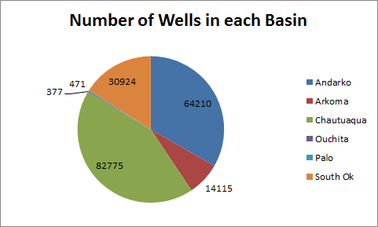
Figure 11 Cumulative wells in each basin
Each of the six basins were analyzed to understand –
- In what counties are they distributed in
- What is the cumulative production of oil and gas wells
- How many active and inactive wells are present in each basin
- What is the primary product in each of these basins

Characteristics of Arkoma basin has been discussed below.
Figure 12 Arkoma basin – Cumulative wells in each county
Figure 12 shows counties in which Arkoma basin is distributed and number of wells in each of these counties.
Figure 13 Cumulative wells based on well type
Figure 14 Cumulative wells based on well status
Gas is the primary product in majority of wells in this basin and most of the wells are active.
In the below figure, x-axis is the year in which the production began for a particular well and y-axis shows the cumulative oil and gas production.
Figure 15 Cumulative oil and gas production year-wise
There are around 60 counties and six basins in the state of Oklahoma; this analysis helps us choose basins/counties which could be more useful for our analysis. Anadarko and Chautauqua are major basins in the state of Oklahoma with over 50,000 wells in each of these basins. Although these are all major basins, Arkoma basin seems to be more suitable to begin our analysis. This is because there are around 14,000 wells to study, which is a good sample size. Also we have a good distribution of Active, plugged and abandoned and temporarily abandoned wells which would be very useful for our analysis. There are a good number of oil wells and gas wells, this lets us study if the type of well (oil or gas) influences well abandonment decisions.

Summary

Production data required for the analysis was gathered from drillingInfo website. This data was first gathered county-wise. Multiple datasets had to be downloaded as the application truncates the data set if the number of rows returned is more than 5000. Once all datasets were collected, they were merged and cleaned.
Analysis was performed to get a basic understanding of this dataset. It was observed that, in an oil well, maximum production was within the first 5 years of the well’s life. A predictive model was built to understand the factors influencing cumulative oil production in a well. It was observed that, in an oil well, peak oil production of that well, number of months of production in that well and total production in first 60 months influenced the cumulative production of that well. For cumulative production of gas well, the predictors are same as that in cumulative production of oil with an additional predictor of product type. This means that, oil recovery happens in both oil and gas wells but majority of natural gas recovery happens from natural gas wells.
In analysis of basin, visual analytics tool Tableau was used to analyze the basic properties of each of six basins. Arkoma basin was selected to perform further analysis as more diversity with respect to production attributes was observed in this basin.

Factors Influencing Well Abandonment

Based on the initial analysis of the data and from the information obtained from the papers mentioned in the literature section, some of the factors influencing decommission of wells are discussed in this chapter.

Company type

There are many operators within the state of Oklahoma running the oil and gas business, many of which are privately owned. However, a good number of leases are owned by bigger companies like Devon, Exxon etc. In Arkoma Basin, operators were divided into class 0 and class 1. All the private and relatively smaller companies were classified as 0 and bigger companies (higher revenue and higher production) were classified as 1. Companies classified as 1 are listed in the below table.
Table 7 Dummy variable for well operators
Operator | Classification
BP America Production Company | 1
Chesapeake Operating LLC | 1
Chevron USA INC | 1
ConocoPhilips Company | 1
Devon Energy Corporation | 1
Exxon Mobil Corporation | 1
Marathon Oil Company | 1
XTO Energy INC (Subsidiary of Exxon Mobil) | 1
In Arkoma basin, 84% of the operators were small and privately-owned wells and the remaining wells were operated by bigger companies.
When cluster analysis was performed, it was observed that a good number of active wells are owned by larger companies and a good number of the inactive wells are owned by the smaller companies. Also the number of months produced and average product recovery is relatively lower for the smaller companies than the bigger ones. Investments made by the companies on latest technology to recover the products, process-oriented approach and higher efficiency could be the reason for this pattern. This pattern is more apparent for the wells that started producing between 1975 and 1990.

Regulatory Changes

As mentioned in the literature review section, oil and gas regulations is an important factor that impacts number of wells closed.

Figure 16 Total wells plugged and abandoned each year
Data for the above graph is taken from 2006 Annual report of Oklahoma oil and gas commission. When this graph was compared with the various regulatory changes, few observations were made which could be used to explain the reason behind higher and lower points in the above chart.
The year 1971 witnessed a large number of P & A of wells. From 1950 onwards, the US government started imposing strict regulations on plugging and abandonment of wells. As a result, from mid 1960s to early 1970s, a large number of wells that were either inactive or suspended were plugged and appropriately abandoned.
Another spike was observed between 1981 and 1984 as this was the period of oil boom with crude oil price at $37.6 per barrel (inflation-adjusted). It is interesting to see an increased P & A activity during this oil boom. , On the other hand, we observe low P & A activity between the years 1998-2004 when the oil and gas price drops to one of the lowest points in 25 years.
We notice that during the oil boom, many wells were plugged and abandoned, this seems a little unexpected as we expect less abandonments during oil boom. The number of abandoned wells dropped after 1984 for a few years and there was a slight increase in abandonments in 2005. We observe that the operators wait for some time before arriving at the decision of abandonment based on current economic conditions.

Primary Product

In the annual report published by Oklahoma oil and gas commission in 2006, the total number of wells plugged and abandoned was listed for each year between 1970 and 2006. From the data collected by the Oklahoma corporation commission (OCCEWeb) website, it looked like more oil wells were abandoned compared to gas wells each year. When the total number of Plugged and abandoned wells were looked at in four different counties – Alfalfa, Atoka, Beaver and Cleveland – Atoka and Beaver had more Gas wells plugged compared to oil wells. In Alfalfa County, except for the time between 1985 and 1990, the number of oil and gas wells plugged is close to each other. The number of oil or gas wells abandoned depends on the total number of wells initially present – in Atoka and Beaver County, majority of wells are gas wells, whereas in Cleveland County, only 25% of the wells are gas wells. Even when we look at the total completions per year or the total recovery per year, we see that number of wells with oil as primary product is higher than the number of wells with gas as primary product. Hence at this point we cannot say if the product of well influences the number of wells abandoned.

Figure 17 Number of wells plugged and abandoned based on primary product

Predictive Modeling

Predictive modeling was done to determine the effects of different production and economic attributes on the number of wells abandoned.

Number of wells abandoned – Linear regression

Regression was performed to study the relationship between number of wells that are plugged and abandoned and the other economic and derived variables which are considered in the production dataset. A correaltion of 0.7 was observed between number of wells abondoned and number of active wells.
Linear regression model with an R-squared value of 0.58 was obtained and variables that influence number of abandoned wells are GDP (Oil and gas Extraction) for the state of Oklahoma, number of wells drilled, and crude oil reserves of the state of Oklahoma.
$$NumberofwellsAbandoned=25.75-OK GDP*0.000667+NumOfWellsDrilled*0.071-OKCrudeReserves*0.024$$
Figure 18 shows the Actual vs predicted values of number of wells abandoned.
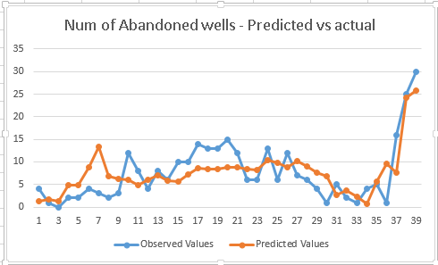
Figure 18 Predicted vs actual values of number of wells abandoned

Well status - Logistic Regression

Logistic regression was done to understand the influence of different variables on entity status (inactive - 0, active - 1). Cumulative production, production dates, economic data (data as of production stop year), etc. was considered for the analysis. A random sample dataset was created to perform the analysis.
Figure 19 gives the results of the logistic regression and the variables considered. Production start year, well depth, cumulative gas and hole direction had higher Wald chi-squared value and p-value lower than 0.05 which made them significant predictors for entity status.
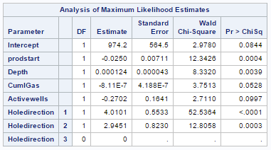
Figure 19 Analysis of maximum likelihood estimates
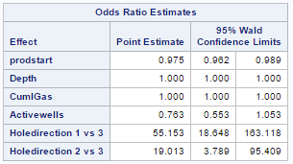
Figure 20 odds ratio estimates
When logistic regression was done for the first time, it appeared that crude oil price was a predictor. The data was further cleaned and a random sample was generated using SAS on which logistic regression was applied. Results of logistic regression is displayed in figure 19 and 20.

Number of wells abandoned vs Spot price – Linear Regression

Predictive model was built to understand the relationship between spot price and number of wells abandoned. The Spot price data was collected from Energy information administration (EIA) website. Natural gas future contract prices were independent variables and number of wells abandoned is the dependent variable. A regression model with R-squared value of 0.0388 was obtained.
$$Number of wells abandoned=2999.89-78.87*Spot price$$
The model obtained is not significant as the R squared value is too low. However, this analysis could be performed by considering monthly spot price data for each year as an independent variable and number of wells abandoned in each county in a year as independent variable to see if the model has improved.

Summary

In any well, maximum product recovery happens during the first sixty months of that well, this can be observed in oil production. However, for gas, we see two high points in the production, one during the initial years and one during the final years. This could be the pattern as gas is secondary product.
High correlation between cumulative production and production of initial years shows that the maximum productivity of a well is in its initial years.
From the predictive analysis performed in this section, we can say that regulatory changes and company time influences the number of wells abandoned. Crude reserves, number of wells completed etc. are some of the production attributes that influence the number of wells abandoned. Regression model obtained using spot price was not very significant, however if the analysis is performed by considering monthly data, for each county, R squared value could improve.

Discussion and Further Research

Oil and gas industry has vast amount of data. Obtaining the right data and cleaning the data to use it for data analysis is very crucial. For this thesis, data was obtained from different sources. Initial analysis was performed on the data collected from IHS Inc. Majority of the data obtained is from DrillingInfo. Some of the data has also been obtained from eia.gov and Oklahoma Oil and Gas Commission website. Different insights were obtained from each of these data sets.
As mentioned in the beginning, the economic model that decides decommission of a well is given by –
$$EL_{oil}=\frac{WI*LOE}{NRI}\left[P_{0}+\frac{P_{g}*GOR}{1000}\right]*(1-T)$$
$$EL_{gas}=\frac{WI*LOE}{NRI}\left[\left(P_{0}*Y\right)+P_{g}\right]*(1-T)$$
However, it is not always this straightforward. In many cases, companies may just suspend the well or keep it active by recovering a minimum amount of oil or gas. This could be done due to many reasons - the company could be waiting for new technologies which would help them extract more oil, the company may not have the right processes or the budget to implement the processes to decommission a well. This happens especially with smaller companies. There are, however, programs initiated by the government to aid these private owners to ensure appropriate P & A when the well has been inactive over a long period of time.
It is also noticed that, vicinity of near-by wells influences P & A decision of a company. If there are many wells located in close proximity or in the same lease that are inactive and no longer economical to extract, it is observed that they are more likely to be abandoned. This could be mainly due to the cost involved. Overall cost to plug and abandon a well reduces when more wells are abandoned together.
Government regulations play a very important role in permanent closure of wells. If appropriate measures are not taken to plug a well, it can pose serious threat to the environment. Injection fluid, water, brine and any other products used in extraction can contaminate underground water and other natural water bodies in vicinity. If the gas or oil diffuses to the upper layers, it would be dangerous as they are highly combustible products. To tackle these issues, the government has imposed different regulations over the year. In this study, it is observed that number of abandoned wells is more in the year where a major regulatory change has been made. For instance, in early 1970s, many wells were plugged and abandoned and this is because the government stipulated companies to plug all inactive and suspended wells.
Oil and gas price plays an important role in permanent decommission of oil wells. It is observed that there is a slight increase in the number of wells plugged following a period of low oil prices. Number of active wells also influences the number of wells abandoned.
Due to the complexity involved in complete decommission of a well, many companies may choose to do it in stages or may postpone the decommissioning. This is especially true in case of offshore wells, where the process is complex and expensive. So the company’s policy and processes play a huge role in Plugging and Abandonment of wells.

Further Research

Each of the basins can be studied in detail to analyze their behavior. Various patterns can be studied to understand more about the factors leading to well abandonment.
Some of the factors that help us understand the reasons for well abandonment are physical properties - permeability and porosity. These can be considered in further studies. Porosity of a rock is the measure of its ability to hold fluid. Porosity is normally expressed as a percentage of the total rock which is taken up by pore space. The permeability of a rock is a measure of the resistance to the flow of a fluid through a rock. If it takes a lot of pressure to squeeze fluid through a rock, that rock has low permeability or low perm. If fluid passes through the rock easily, it has high permeability, or high perm.
High porosity and high permeability are desired characteristics to have a high productive well. Hence, study of these two properties will help us understand more about well abandonment. There are different formations observed in the state of Oklahoma, also each basin has many different kinds of formations, and the mean porosity and permeability of the rocks in these formations are different. Analysis could be performed to understand if they influence abandonment.
Some of the other factors which may impact well abandonment are – commodity prices, company culture, water data, depth, hole-direction etc.
Supply chain, import and export of products could also be analyzed to understand their relationship with plugging and abandonment of well.
Least Operating Expense (LOE) is another major factor that impacts well abandonment. LOE is the cost of maintaining and operating property and equipment on a producing oil and gas lease.
As LOE of any company is its proprietary data, it is difficult to obtain. However, a mathematical model to calculate LOE can be built by taking following variables as predictors – size of operator, proximity to pipeline, connectivity to network, proximity to other wells and water production.

References and Bibliography

Administration, U. E. (2016). Data sets - Oil and Gas Spot Prices. Retrieved from http://www.eia.gov/: http://www.eia.gov/petroleum/data.cfm
Andrew Bressler, B. B. (2015). A Costing Model for Offshore Decommissioning in California. Integrated Environmental Assessment and Management, 554–563.
Brown, S. Y. (2011). Managing High-Cost Projects. Retrieved from http://www.ogfj.com/: http://www.ogfj.com/articles/print/volume-8/issue-6/features/managing-high-cost-projects.html
Geomore.com. (2016). Porosity and Permeability. Retrieved from http://www.geomore.com/: http://www.geomore.com/porosity-and-permeability-2/
Imanuel. (2016). Predictive analytics in oil and gas. Retrieved from http://www.predictiveanalyticstoday.com/: http://www.predictiveanalyticstoday.com/predictive-analytics-oil-gas/
J. Daniel Arthur, H. W. (2011). PLUGGING AND ABANDONMENT OF OIL AND GAS WELLS . NPC North American Resource Development Study .
King, G. E. (2009). Plug and Abandonment – Producing Well. Retrieved from http://gekengineering.com/: http://gekengineering.com/Downloads/Free_Downloads/Plug-and_Abandonment_Basics.pdf
Magna Energy Services. (2015). Oil Well Abandonment. Retrieved from http://magnaes.com/: http://magnaes.com/plug-and-abandonment/oil-well-abandonment/
Marr, B. (2015, May 26). Big Data In Big Oil: How Shell Uses Analytics To Drive Business Success. Retrieved from www.forbes.com: http://www.forbes.com/sites/bernardmarr/2015/05/26/big-data-in-big-oil-how-shell-uses-analytics-to-drive-business-success/#2d1b040974b9
Marr, B. (2015, May 26). Big Data In Big Oil: How Shell Uses Analytics To Drive Business Success. Retrieved from http://royaldutchshellplc.com/: http://royaldutchshellplc.com/2015/05/26/big-data-in-big-oil-how-shell-uses-analytics-to-drive-business-success/
Milne, I. (2015). Downstream, Mid-stream and Upstream - understand these supply chains! Retrieved from www.linkedin.com: https://www.linkedin.com/pulse/downstream-mid-stream-upstream-drowning-terminology-ian-milne
MPG Petroleum Inc. (2003). Oil, Gas and Petroleum Prospecting Term Glossary. Retrieved from http://www.mpgpetroleum.com/: http://www.mpgpetroleum.com/glossary.html
OCCEWeb. (2016). Oklahoma Oil and Gas Commission. Retrieved from http://www.occeweb.com/.
Offshore Energy Today. (2014). Will falling oil prices boost plug & abandonment ops? Retrieved from http://www.offshoreenergytoday.com/: http://www.offshoreenergytoday.com/will-falling-oil-prices-boost-plug-abandonment-ops/
Padmanabhan, R. B. (2014). Big Data analytics in oil and gas. Retrieved from http://www.bain.com/: http://www.bain.com/Images/BAIN_BRIEF_Big_Data_analytics_in_oil_and_gas.pdf
Prescott, S. (2013). Influence of Regulation on Oil and Gas Well Abandonment Rates in Alberta, Canada. SS-AAEA Journal of Agricultural Economics, 1-15.
Schlumberger. (2016). Oilfield glossary. Retrieved from http://www.glossary.oilfield.slb.com/: http://www.glossary.oilfield.slb.com/
Statista. (2016). Oil and gas industry revenue in the U.S. from 2010 to 2014. Retrieved from http://www.statista.com/: http://www.statista.com/statistics/294614/revenue-of-the-gas-and-oil-industry-in-the-us/
Troester, M. (2011). Big Data Meets Big Data Analytics. Retrieved from www.SAS.com: http://www.sas.com/content/dam/SAS/en_us/doc/whitepaper1/big-data-meets-big-data-analytics-105777.pdf
USA today. (2013). The 10 most oil-rich states. Retrieved from http://www.usatoday.com/: http://www.usatoday.com/story/money/business/2013/08/03/the-most-oil-rich-states/2613497/

Appendices

Appendix A: Keywords
Oil and Gas
Well Abandonment
Production attributes
Well abandonment Decisions

