UNIVERSITY OF OKLAHOMA
GRADUATE COLLEGE

Development of Envelope Evaluation Benchmarks Using EnergyPlus and Data-Driven Thermal Model

A THESIS
SUBMITTED TO THE GRADUATE FACULTY
In partial fulfillment of the requirement for the
Degree of
MASTER OF SCIENCE

By
Luyao Xie
Norman, Oklahoma
2022

Development of Envelope Evaluation Benchmarks Using Energyplus and Data-Driven Thermal Model

A THESIS APPROVED FOR THE
SCHOOL OF AEROSPACE AND MECHANICAL ENGINEERING

BY THE COMMITTEE CONSISTING OF

Dr. Li Song, Chair
Dr. Jie Cai
Dr. Dong Zhang

© Copyright by Luyao Xie 2022
All Rights Reserved.

Acknowledgment
When I am writing this acknowledgement, a lot of scenarios come to my mind. It seems like yesterday was my first day at OU. The campus where I always get lost when I first came, the classroom where I spent my first class, the midnight’s light in the Kraettli apartment for homework, the library's chic study desks and the software which always failed to get the desired results, all of these have witnessed my growth here. OU may be just a stop on my life journey, but every day I am here is very happy and fulfilling and has left a very deep memory. I want to acknowledge many people who helped me throughout my master’s journey.
Firstly, I would like to thank my advisor Dr. Li Song. During my master's study, she gives me meticulous care in both my life and study. I am very thankful for her guidance and inculcation for my study. She never gave up and guided me to complete the master project and this thesis. I am also very thankful for her taking great care of my life. I wouldn't be here without Dr. Song's help. Great thanks to her for providing me the opportunity to study for my master when the international policy was tense during the epidemic and that I could come to OU and meet a better version of myself. My advisor's influence on me is so great that I can't express it in words. Both academically and personally are the objects I have been studying. It is my honor to be her student.
I would like to thank my family. I am grateful to my parents Xie, Xiujun and Zhou, Songnan, for their openness, unconditional dedication, and support to me. I know that they miss me who has traveled across the Pacific Ocean every day. No matter where I am, parental affection is the backing that I am proud of. Maybe I haven't become an "other's family’s child" that my parents can be proud of, but I always know that my parents have always been "other's family’s parents" that my peers envy. I am also grateful to my husband, Wang, Junke. We got our marriage license this year. Thank to him for giving me a family and taking care of me. When I was busy with my studies, he not only acted as my personal driver, chef, cleaner, and delivery man, but also acted as my tutor to answer questions, soothe my emotions, and relieve my worries when I was in a bad mood. I sincerely thank him for his efforts and spiritual help. When we quarrel in the future, I will try to think about his merits as much as possible and try to communicate in a calm way. In addition, I also promise here that I will actively do housework and undertake a psychological consultant’ work when he is busy with study and work.
Last but not least, I would like to thank my committee members Drs. Jie Cai and Dong Zhang, who put efforts on my thesis and defense, as well as the faculties, staff, and classmates I met here for their help. I am very happy to be a student at OU. Having them by my side in my life has enriched my student life. Their positive and optimistic attitude towards life, humble personality and helpful qualities are all imprinted in my mind. Thanks for meeting them here.
I dedicate this thesis to all of you.

Table of Contents
Acknowledgment iv
List of Figures ix
List of Tables xi
Abstract xii
Chapter 1 : Introduction 1
1.1 Motivation 1
1.2 State of the art 5
1.3 Research Objectives 9
1.4 Thesis Breakdown 10
Chapter 2 : Literature Review 12
2.1 Building Energy Model Calibration 13
2.2 RC Models 16
2.3 Model-based Envelope Performance Evaluation Methods 20
2.4 Research Questions and Limitations 22
Chapter 3 : Methodology 24
3.1 Introduction of EnergyPlus and Thermal Network Models 24
3.1.1 EnergyPlus Model 25
3.1.2 Simplified 2R2C Model 28
3.2 Model Calibration Method 29
3.3 Envelope Performance Benchmark 30
3.3.1 Tau Value Calculated from Dashboard 30
3.3.2 Tau Value Identified from Simplified 2R2C Model 33
3.3.3 Benchmark Method 35
Chapter 4 : Three-Dimensional EnergyPlus Model Construction 37
4.1 Three-Dimensional House Model Setup 37
4.1.1 Modeling and Simulation Software 37
4.1.2 Test House Modeling 38
4.1.3 Weather Data 40
4.2 Analysis of House Thermal Property 41
4.2.1 Uncalibrated Envelop Materials 41
4.2.2 Comparison of Tau values 44
4.2.3 Sensitivity Analysis 45
4.3 Calibration 47
4.3.1 Uncalibrated EnergyPlus models 48
4.3.2 Calibrated EnergyPlus models 49
4.4 Summary 52
Chapter 5 : Envelope Performance Evaluation Benchmark 54
5.1 Calibrated EnergyPlus model based on ASHRAE standard 90-75 54
5.2 Calibrated EnergyPlus model based on ASHRAE standard 90.2-2007 57
5.3 Calibrated EnergyPlus model based on ASHRAE standard 90.2-2018 59
5.4 Summary 61
Chapter 6 Conclusion and Future Work 63
References 65

List of Figures
Figure 1-1 Shares of total U.S. energy consumption by end-use sectors, 2017 [2]. 2
Figure 1-2 U.S. Electricity retail sales to major end-use sectors and electricity direct use by all sectors [7]. 3
Figure 1-3 End-use consumption shares by types of U.S. homes, 2015 [9]. 4
Figure 1-4 Distribution of Tau (i.e., $τ$) values for different home ages [10, 13]. 6
Figure 2-1 Schematic of the 3R2C plus 2R2C model [31]. 17
Figure 2-2 Schematic of the 2R2C Model [30]. 19
Figure 3-1 Flow chart of methodology used in this study. 24
Figure 3-2 Overall EnergyPlus Structure [37]. 25
Figure 3-3 Tools and services supported by EnergyPlus [38]. 26
Figure 3-4 Definition of data represented in a DEF file. 28
Figure 4-1 Floor plan of the 3-D house model divided by three thermal zones. 39
Figure 4-2 Side view of test house and its 3-D model. 40
Figure 4-3 EPW data displayed in an Elements interface. 41
Figure 4-4 Comparison of simulated temperatures using 14-day measured data. 45
Figure 4-5 Comparison of simulated temperatures based on uncalibrated EnergyPlus model. 49
Figure 4-6 Calibrated 3-D model without ceiling. 50
Figure 4-7 Comparison of simulated temperatures using 14-day simulated data from EnergyPlus. 51
Figure 4-8 Calibrated 3-D model with ceiling only. 51
Figure 4-9 Comparison of simulated temperatures using 14-day simulated data from EnergyPlus. 52
Figure 5-1 Requirements of wall U values given by ASHRAE 90-75 [49]. 55
Figure 5-2 Annual heating degree days by census division [50]. 56
Figure 5-3 Simulation results of simplified 2R2C model based on calibrated EnergyPlus model and ASHRAE standard 90-75. 57
Figure 5-4 Simulation results of simplified 2R2C model based on calibrated EnergyPlus model and ASHRAE standard 90.2-2007. 59
Figure 5-5 Simulation results of 2R2C model based on calibrated EnergyPlus model and ASHRAE standard 90.2-2018. 60
Figure 5-6 Distribution of the relevant Tau values in this study 62

List of Tables
Table 2-1 Summary of relevant calibration approaches and their key characteristics. 15
Table 4-1 House thermal zones represented by different colors. 39
Table 4-2 Properties of Surface Construction Materials. 42
Table 4-3 Properties of Windows and Doors. 42
Table 4-4 Values of component areas of test house. 43
Table 4-5 Calculated thermal resistances of components of test house. 43
Table 4-6 Calculated thermal capacitance of components of test house. 43
Table 4-7 Sensitivity Analysis of Different Envelope Materials. 46
Table 4-8 Comparison of the mean and maximum errors from different EnergyPlus models. 53
Table 5-1 Prescriptive envelope criteria given by ASHRAE 90.2-2007 [51]. 57
Table 5-2 Envelope Component Maximum SHGC and U-factors (SI) by ASHRAE 90.2-2018. 59
Table 5-3 Adopted thermal properties from different years of ASHRAE standards. 61
Table 5-4 Comparison of the learned Tau1 values and model accuracies. 61

Abstract
Residential buildings account for a large portion of the consumption of the global energy and total energy by end use. To mitigate the rising trend of energy consumption, residential buildings show a huge potential by improving their energy efficiencies, thus achieving energy saving. Moreover, the envelopes of the residential building, as one of key factors in the energy consumption of a building, are closely related to building energy saving, as it closely determines how much heat is transferred between indoor space of the building and its outdoor environment. Even though the challenges in how to judge the performance of the residential envelopes, especially evaluation of the overall building envelope via model-based data-driven and measurement-based methods, have been addressed by current studies and still have their limitations in comparison with ground truth, a method to benchmark the envelope performance evaluation is still lacking and urgently needed. Therefore, a benchmarking method using both building energy and thermal network models is proposed in this study.
Specifically, this study first proposes a calibration method that utilizes both EnergyPlus and simplified 2R2C models. The EnergyPlus models are used to generate simulated data that are utilized in the simplified 2R2C model training. Moreover, this study also creates an excel dashboard, along with the the EnergyPlus and simplified 2R2C models, for the calibration process. Then three representative years of American Society of Heating, Refrigerating and Air-Conditioning Engineers (ASHRAE) standards are selected to the minimum thermal property requirement of residential building envelope and utilized in the calibrated EnergyPlus models. In the next step, a benchmarking method is proposed to determine the minimum required Tau value (time constant of building envelope) for a specific year of a residential building envelope. That is, different years of houses need to meet the minimum thermal property requirement of residential building envelope defined by ASHRAE standards. Lastly, the performance evaluation benchmarking process can be done with the determination of thermal properties identified by the simplified 2R2C model trained using simulated data from the calibrated EnergyPlus model.
Overall, this research successfully proposes an efficient calibration method to calibrate EnergyPlus modes used for residential buildings, introduces quantitative study and performance analysis of a calibration method that utilizes building thermal network models, and develops a benchmark method and shows investigation and analysis for building envelope performance evaluation. Therefore, this research contributes the knowledge of benchmarking the envelope performance evaluation using both EnergyPlus and data-driven thermal model for residential buildings.

: Introduction
This chapter will first introduce the motivation of this study, and then discuss the state of the art and current challenges in building models used to achieve benchmarks of building envelope performance evaluation. Finally, the detailed information of research objectives and thesis outline will be concluded.

1.1 Motivation
Worldwide energy use is rising steadily over the past few decades. In the United States, Department of Energy (DOE) indicates that there are four broad energy use sectors: industrial, transportation, residential, and commercial [1]. Detailed share of each sector for the energy consumption can be found in Figure 1-1. Among these four sectors, residential and commercial buildings play an important role which consumed a large portion of global energy use and 38% of total energy consumption by end use [2], and meanwhile account for 32% of global final energy use [3]. To mitigate the rising trend of energy consumption, residential and commercial buildings show a huge potential by improving their energy efficiencies, thus achieving energy saving. As mentioned in [4], building envelopes are one of key factors in the energy consumption of a building, which are closely related to building energy saving. Therefore, the building envelope performance and its evaluation are studied in this study.
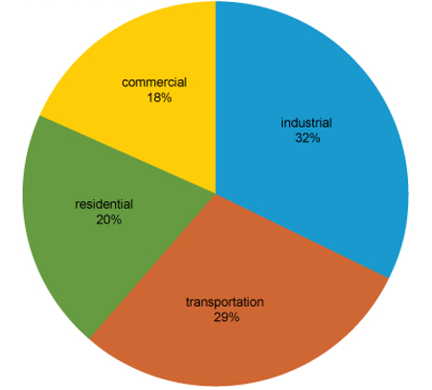
Figure 1-1 Shares of total U.S. energy consumption by end-use sectors, 2017 [2].
There is no denying that buildings, as an indispensable place for human’s daily life and production take up a large amount of energy use. In 2021, energy consumption of buildings was about 21 quadrillion Btu, almost 39% of total U.S. final energy consumption [5]. The energy consumed by buildings has different types of composition, including natural gas, renewable energy, nuclear, coal, petroleum. Figure 1-2 shows the U.S. Electricity retail sales to major end-use sectors and electricity direct use by all sectors. It is clearly that the total electricity consumption increases every year, rising from 0.3 trillion kWh in 1950 to 3.93 trillion kWh in 2021 [6]. It is also easy to find that residential building sector had the fastest growth rate, which covers 39% of the electricity [6].
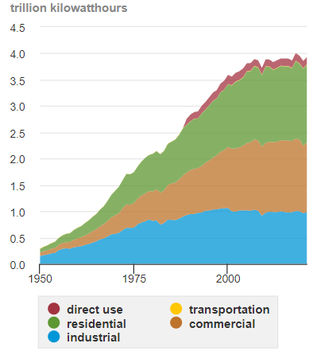
Figure 1-2 U.S. Electricity retail sales to major end-use sectors and electricity direct use by all sectors [7].
In the residential building section, energy is used for space heating, air conditioning (AC), refrigeration, water heating, cooking, lighting and running a variety of other appliances in the living areas of private homes [8]. Figure 1-3 reveals that home space heating and air conditioning made up more than 50% of a household’s annual energy consumption accounting for the largest portion of residential energy use.
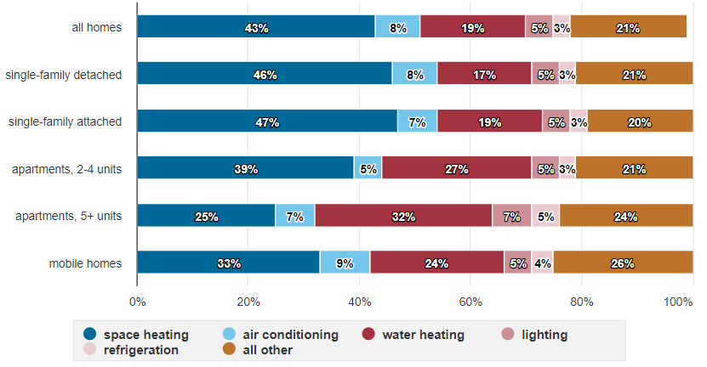
Figure 1-3 End-use consumption shares by types of U.S. homes, 2015 [9].
There are many factors that may affect the amount of energy of household uses, such as type of house, house geographic location and climate and its physical characteristics, and so on. Among these factors, given regulation of space air thermal comfort that takes up the most energy use for residential buildings, buildings’ envelope is very important for energy saving because it may determine how much heat is transferred from room space to outdoor (or from outdoor to room space). Residential buildings’ envelope makes a decisive role in whether heating a room in winter or using AC for cooling in summer.
For the requirements of residential building envelopes, American Society of Heating, Refrigerating and Air-Conditioning Engineers (ASHRAE) published standards from1975 to 2018. However, in the ASHRAE standards, they only provide criteria of the sole thermal resistance (R) value or thermal transmittance (U) value of building specific materials. Since the direct U value measurements are not practical for the evaluation of existing building envelope energy performance. This brings challenges in how to classify the performance of the residential envelopes according to the standards, which will be investigated in this study.

1.2 State of the art
Since the overall performance evaluation of the residential building envelope is becoming more and more crucial, there are two methods, namely model-based or measurement-based, that have been intensively investigated in this field. Both methods need to compare with their reference points for performance evaluation. While measurement-based methods can directly compare with U values given in the ASHRAE standards, they are either destructive for building envelopes or inconvenient for operators. Therefore, model-based methods are getting more and more popular. However, these methods also need to have reference points for comparison, which lacks investigations due to their complexity and impossibility from existing buildings. This study will focus on providing these methods to generate the reference points and thus benchmarking performance evaluation of the residential building envelopes. This section will first give a brief introduction of these methods from previous studies, then identify the research gaps, and finally state a method proposed in this study to fill out the identified gaps.
In the past decades, there are several studies about measurement-based and model-based method. In [10], it introduced two types of measurement-based methods for envelope performance evaluation: destructive and non-destructive. In the destructive measurement methods, a hollow drill is used for obtaining the thickness and conductivity of selected sample. Then R and U values can be calculated based on ISO 2017 [11]. In the non-destructive method, [12] indicates that heat flow meters (HFMs) and infrared (IR)/thermographic cameras are widely used for measurement envelope performance. Instead of measurement-based methods, model-based methods, especially RC model-based methods, that utilized measured data from available sensors, provide alternative ways to evaluate the overall envelope performance without the need of physical building materials, as introduced in [13]. Due to lack of the reference for comparison, the authors in [13] presented the distribution of the Tau values based on home ages as shown in Figure 1-4. Although there is no ground truth for comparison, these methods still provide possibilities for benchmarking the performance evaluation of the residential envelopes as investigated in this study.
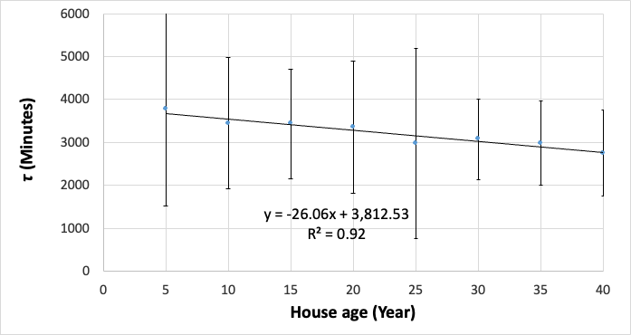
Figure 1-4 Distribution of Tau (i.e., $τ$) values for different home ages [10, 13].
Even if there is a lack of studies about benchmarking the performance of the residential envelopes in literatures, there are still several studies that have investigated benchmarking energy performance of building envelopes by researchers. For example, in [14], a new benchmarking method that utilized Principal Component Regression was proposed to benchmark energy performance of existing residential buildings’ envelopes, compared with high dimensional dataset as references. This method was compared with a traditional statistical rating method that uses average energy consumption of buildings and both methods were applied to datasets of a real project. Through validations, the authors conclude that the proposed benchmarking method outperforms the traditional statistical rating method.
In [15], a Latin hypercube sampling method was applied by authors to create various building envelope samples for building energy simulation and build evaluation equations. Compared each sample’s annual sensible cooling energy with its own baseline case, a new building envelope energy performance index was proposed based on the dry-bulb temperature and the operative temperature control. The performance index can be used to simultaneously analyze the influence of thermal comfort and energy consumption instead of the building envelope thermal performance evaluation method that considers energy consumption only. The authors found that when using the operative temperature instead of dry bulb temperature, the coefficient that represents the glazing's thermal insulation property rises twice. This finding indicated that the requirements of thermal performance for building envelope openings are more important for the proposed performance index.
In [16], the authors proposed a benchmarking method to determine how well a building is performing, based on the estimation of a statistical model for energy use of samples of buildings and identification of a reference value for each group/class of buildings, and to quantify the potential reduction of energy use for large building stocks. The method utilized the estimation of a statistical model for energy consumption and was tested using Healthcare Centers in Northern Italy. Through analysis and comparison with a common deterministic or one-dimensional benchmarking approach that utilizes a statistical basis, the authors found that the proposed method can overcome the limitations of the common approaches.
In [17], the authors compared three schemes’ performance criteria and credit scales, i.e., Building Research Establishment Environmental Assessment Method (BREEAM), the Hong Kong Building Environmental Assessment Method (HK-BEAM) and LEED, by statistical analysis of the energy assessment results obtained from 60 certified buildings. Moreover, the authors also established a systematic approach to benchmark the energy evaluation across schemes, which provided a good reference for future benchmarking of energy evaluation schemes. Similar studies can also be found in [18–20], where the common goal is to develop an approach to benchmark building energy performance.
In [21], a residential building envelope performance benchmarking model was proposed to achieve improved life cycle operation energy consumption prediction. The benchmarking model was constructed using stochastic and data mining methods and validated by comparison with infrared thermal inspections. The model was applied to houses in a community and generated simulated data, compared with real energy consumption data. The results indicated that the benchmarking model can generate comparable results compared to infrared thermal inspections. Although there are some limitations of the proposed benchmarking model on the variation of the residential energy performance, this study was applied to real residential buildings and compared with on-site measurements.
Although the aforementioned approaches achieve their purposes for benchmarking building energy performance, most of them do not focuse on the benchmarking purposes of the residential building envelope performance. Moreover, there were limited study that investigated the building envelope performance benchmarking by utilizing stochastic and data mining methods, which may be too complicate and not very useful in large building stocks.
In this study, a benchmarking method for residential building envelope performance evaluation, by using one parameter to represent overall residential building envelope performance, is proposed that utilizes both EnergyPlus and a simplified RC model [10]. First, operational data of a home with different envelope designs based on different ASHRAE standards are produced using EnergyPlus, a widely used software for building energy simulation. Then, the parameters of the simplified RC model are trained using the simulated data that are produced using different ASHRAE standards. Since the RC model represent physical laws of heat transfer, the key parameters in the trained RC model express the envelope thermal condition and therefore are used as a benchmark index. Hence, this study will adopt EnergyPlus to generate simulated data instead of operation data that will be utilized in RC models for the overall performance evaluation of the residential building envelope.

1.3 Research Objectives
The objective of this research focuses on developing the benchmark method for envelope performance evolution discussed in Section 1.2. The EnergyPlus model will facilitate the generation of simulated data instead of operational data collected from sensors. Moreover, the RC models will be trained by the simulated data to generate the learned key parameter value for the overall envelope performance evolution. Furthermore, different parameter values, generated from the RC models that are trained using different simulated data from EnergyPlus and representative ASHRAE standards, will be used for benchmark of building envelope performance.
The study will be carried out in the following steps:
- Collect relevant information for modeling a residential building in EnergyPlus.
The first step is to prepare relevant information for building a 3-D house model. The relevant information includes processing local weather data to meet the requirements of EnergyPlus’s data formats, measuring dimensions for different kinds of envelopes such as pitched roof angle, windows, etc.
- Create a 3-D model based on a residential building by EnergyPlus and execute simulation.
A house 3-D model is built by Openstudio and simulation result is obtained at the same time.
- Create a dashboard to calculate the Tau value from the physical residential building.
According to the materials’ thermal properties and parameters provided by EnergyPlus, the physical R and C value is calculated through the equations (details shown in the chapter 3) based on the physical residential building.
- Calibrate the 3D model based on the dashboard.
RC model is trained by the measured data and get the Tau value firstly. Compare the Tau value obtained from RC model (trained by measured data) and Tau calculated by dashboard, regulate 3-D model to close the difference between two Tau values.
- Select representative years of ASHRAE standards to identify different requirements of thermal properties of building envelope materials and modify thermal performance of 3D models to generate simulated data for the training of RC models.
- Compare the results of Tau value based on different years of ASHRAE standards and generate envelope evaluation benchmarks.

1.4 Thesis Breakdown
This research aims to create a EnergyPlus 3-D model, calibrate the 3-D model, simulate data for RC model training, obtain Tau value from RC model parameter identification, and build a benchmark for representative building ages. The breakdown of this thesis will be as follows:
Chapter 1: This chapter gives an introduction of the study. It first explains the motivation, identifies the research gaps, and then draw the objectives of the study. It also demonstrates the basic information of study process.
Chapter 2: This chapter reviews the literature from three fields: building energy model calibrations, RC models, building envelope performance evaluation methods, and benchmarking methods for building energy models. At the end of this chapter, current research limitations and proposed research methods are stated for this study.
Chapter 3: This chapter proposed research methods. It introduces information about how to combine EnergyPlus model with thermal network models for calibration and the way of how to determine envelope performance benchmark.
Chapter 4: This chapter gives detailed information of the construction of 3-D EnergyPlus models for carrying out envelope performance evaluation benchmark that includes four steps: building and setting 3-D model in EnergyPlus, discussing thermal properties for 3-D model’s envelope materials, using simplified 2R2C model for simulation and calibration of the 3-D model, and comparison of the simulation results.
Chapter 5: This chapter discusses how to use calibrated 3-D model to get Tau value and determine the benchmarks for different envelope performance evaluation. Three different years of ASHRAE standards in 1975, 2007, and 2018 are given and used, along with the calibrated EnergyPlus and simplified RC model, for benchmarking the envelope performance evaluation
Chapter 6: This chapter includes the thesis summary and presents the concluded results and suggestions. It also discusses work limitations and future work needed.

: Literature Review
The proposed benchmark method requires using calibrated EnergyPlus model to generate operational data based on different ASHRAE standards. The calibration of building energy models (e.g., the EnergyPlus models) is complicated and sophisticated, involving extensive expert experience and time-consuming labor. To facilitate a quick and accurate calibration process, this study proposes to take advantage of building thermal network models, which utilize a data-driven method and attract a lot of attention in recent decades due to easy use with reasonable accuracy, as a reference in the calibration. With the calibrated EnergyPlus model, building envelope performance can be evaluated and compared with the one assessed from thermal network models.
Moreover, the operational data from buildings will be used as references for comparison with the simulated data from EnergyPlus models, which will guarantee the models’ accuracies and facilitate the calibration process. In addition, ASHRAE standards can be adopted to provide the minimum requirements for thermal properties of different years of buildings and utilized by EnergyPlus and building thermal network models for the benchmarking purpose.
In this study, a comprehensive literature review is conducted to address the existing challenges and identify research questions. Specifically, Section 2.1 reviews the methods and tools used for building energy model calibration, Section 2.2 introduces the building thermal network models used for facilitating the calibration process, Section 2.3 states the building envelope performance evaluation based on the calibrated EnergyPlus models, and Section 2.4 identifies the research questions and limitations.

2.1 Building Energy Model Calibration
EnergyPlus models, as one of the most popular building energy models, have attracted researchers, architects, and engineers to use for modeling both energy consumption—for heating, cooling, ventilation, lighting and plug and process loads—and water use in buildings. To ensure the accuracy of the EnergyPlus models, calibrations are necessary and crucial due to their widespread use. Different methods or tools that facilitate the calibration have been heavily investigated by researchers since the widespread use of EnergyPlus.
In [22], the authors used optimization tools for building energy model calibration. An EnergyPlus model was created based on a large educational building which is located in the province of Treviso, north of Italy for calibration. The design contains 72,000 EnergyPlus building models. The first step of calibration in this study was sensitivity analysis. The authors conducted sensitivity analysis by jEPlus+EA and jEPlus that are genetic algorithm-based optimization tools used on a local computer and a cloud server. In the second step, genetic algorithm was adopted for calibration. This study certainly pushed the development of the tools component of building energy model calibration methods.
In [23], two sensors and a weather station provided measured data of an office building to verify the accuracy of EnergyPlus simulated results for calibration. The authors used Mean Bias Error (MBE) values within ±5% and Cumulative Variation of Root Mean Square Error (CV(RMSE)) values below 10% as indices. The EnergyPlus model after calibration can be used for prediction hourly air temperature with an accuracy of ±1.5 °C for 99.5% and an accuracy of ±1 °C for 93.2% in the studied period.
In [24], an optimization-based method is adopted for calibration building energy models utilizing monitored data in this study. In the calibration process, the authors combined EnergyPlus energy simulation tool with the GenOpt optimization tool. The objective function was used for minimizing the difference between the simulated energy data and monitored energy data. Evaluation index of this study also applied MBE and Cv (RMSE) (mentioned above) to evaluate accuracy.
In [25], the authors proposed a Gaussian process-based Bayesian method to calibrate the building energy models. The method can account for different uncertainties. In addition, in this study, they also proposed a posterior approximation method to evaluate the posterior distribution in the Bayesian approach for further improving the computational efficiency. The authors set lower bound and upper bound in process of calibration parameters. The results of this study showed that the proposed method may offer an accurate calibrated result which is better than MCMC (Markov chain Monte Carlo) method.
In [26], the authors applied autotune approach in two case studies. This approach is focus on using measured data to produce calibrated building energy models automatically. In the first case, faults were injected into more than 60 parameters of a building model to let the model de-tuned. Then, the model was calibrated by using autotune approach. The accuracy with respect to the original model was evaluated in terms of MBE and CVRMSE. In the second case, the authors used autotune calibration to compare an experts’ manual calibration of a full-size residential building. The results showed that the calibration time of autotune is shorter. This study concluded with a discussion of the key strengths and weaknesses of auto-calibration approaches.
In [27], the authors listed six stages for their studied model calibrations, including 1) Calibration of power and schedules of constant loads; 2) Simulation of design days for thermal loads analysis; 3) Sensitivity analysis for parameters related to significant heat gains/loss; 4) Adjustment input values with uncertainty and high influence; 5) Whole year simulation for comparison with measured data; and 6) Final adjustments. The study concluded the effective of the 6-stage process for model calibration. Table 2-1 summaries the references mentioned above accompanied by crucial characteristics of the relevant calibration approaches proposed therein.
Table 2-1 Summary of relevant calibration approaches and their key characteristics.
Ref. | Method | Calibrated Parameter | Calibrated Objective | Evaluation Index | Building Sector | Advantages | Disadvantages
[22] | Genetic algorithm | Ventilation Air Flow, | Energy use | MBE & CV(RMSE) | Commercial | Automated calibration | Need to know detailed EnergyPlus parameters
[23] | Two-stage screening approach | Envelop, HVAC & Occupancy | Electricity and Gas consumption for stage 1; Temperature for stage 2 | MBE & CV(RMSE) | Commercial | Good accuracy | Manual process and time consuming
[24] | Optimization-based | Building Envelope, Ventilation and internal gains | Heating energy consumption | MBE & CV(RMSE) | Commercial | Setting lower and upper bounds for calibrated parameters; identifying the most important parameters during screening | Need another software to assist process; didn’t explain how to identify the most important parameters
[25] | Gaussian process-based Bayesian and posterior approximation | Envelope and internal loads | electricity consumption | CVRMSE | Commercial | Setting lower and upper bounds for calibrated parameters; comparison of two methods | Complicate in practice
[26] | Auto-calibration | Envelope, electric equipment, fan, pump, and so on | Electric energy use; zone temperatures | NMBE & CVRMSE | Commercial and residential buildings | Require less computing  power, time, and human intervention | Injecting faults into parameters and doing calibration
[27] | 6-stages calibration | Envelope, electric equipment | electricity consumption |  | Commercial | Sensitivity analysis (use IC to calculate the important factors),having calculation process | base case characteristics are not adequate.
The aforementioned studies investigated different methods and/or tools used for building energy model calibrations. Overall, either expert knowledge is needed for calibration or automated calibration methods require large computational capacity. In addition, even though some of the studies are effective to capture energy use and/or electricity consumption in terms of the model accuracies, such as MBE and CVRMSE, they may not be accurate to be implemented for indoor air temperature prediction and building envelope evaluation. Moreover, most studies have focused on commercial buildings, which differ from residential buildings that will be investigated in this study due to their unique characteristics. Due to the accuracy of building thermal network models in indoor air temperature prediction and building envelope evaluation (as introduced in the next section), this study will resort to thermal network models for references in the calibration of building EnergyPlus models.

2.2 RC Models
To facilitate the quick calibration process, this study proposes to take advantage of building thermal network models as a reference in the calibration. The thermal network models, derived from the standard (Resistance-Capacitance) RC approach, utilize data-driven method to capture building thermal properties without the need of physical building information. The thermal network approach has been modified and applied in different forms, e.g., 1R1C [28] and 2R2C [29, 30], 3R2C plus 2R2C [31] models and their further applications for optimal precooling studies [32, 33] and envelope performance evaluation [10, 13]. The general applicability of the thermal network approach has been limited by the identified issues, such as convergence and stability issues and unavailable or unreliable measurements. Most importantly, with increasing building complexity, the thermal network model becomes increasing difficult to develop and optimize.
The 3R2C plus 2R2C model [31] is one of the popular building thermal network models that attract attentions, based on thermodynamic laws and physical heat transfer. However, this model was simplified by integrating variables and parameters, which are either very expensive or hard to obtain, as shown in Figure 2-1. The three thermal resistors and two capacitors (i.e., 3R2C or R_{e1}, R_{e2}, R_{e3}, and two C_{w}) were used to represent the physical layers of building envelope (i.e., consolidating the layers with similar thermal properties and representing in a simplified form).
Moreover, the 2R2C (R_{int1}, R_{int2}, and two C_{int}) circuit were used to represent the total heat capacity of interior components. In addition, T_{in1}, T_{in2}, Q_{r1}, and Q_{conv} were used to represent two indoor air temperature nodes, half of the radiative heat gains from occupants, appliances or/and lighting, and convective heat gains that directly become the load and have no thermal delays. T_{in}, representing indoor air temperature, assumed as one uniform air in a thermal zone, which was associated its thermal capacity C_{in}.
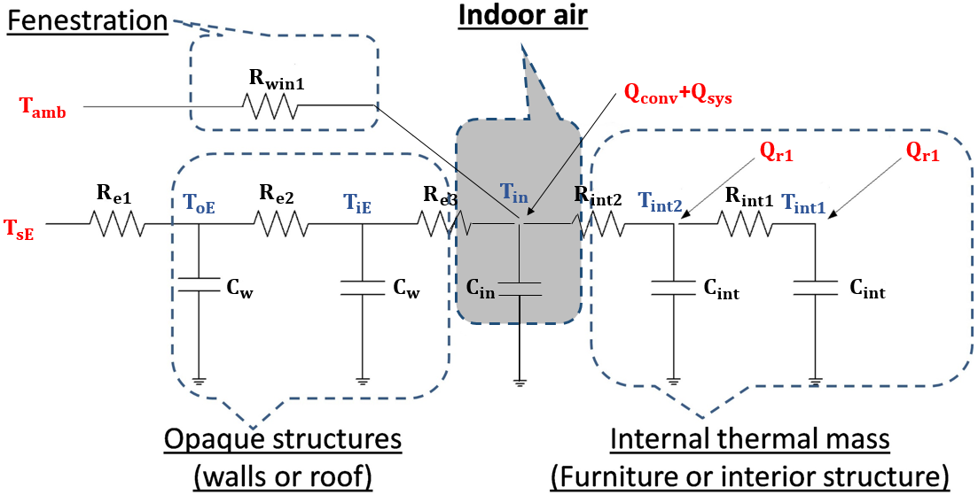
Figure 2-1 Schematic of the 3R2C plus 2R2C model [31].
According to the diagram of the 3R2C plus 2R2C model in Figure 2-1, a heat balance at each node generates:
$C_{w}\frac{dT_{oE}}{dt}=\frac{T_{sE}-T_{oE}}{R_{e1}}+\frac{T_{iE}-T_{oE}}{R_{e2}}$ (2-1)
$C_{w}\frac{dT_{iE}}{dt}=\frac{T_{oE}-T_{iE}}{R_{e2}}+\frac{T_{in}-T_{iE}}{R_{e3}}$ (2-2)
$C_{in}\frac{dT_{in}}{dt}=\frac{T_{iE}-T_{in}}{R_{e3}}+\frac{T_{int2}-T_{in}}{R_{int2}}+\frac{T_{amb}-T_{in}}{R_{win1}}+Q_{conv}+Q_{sys}$ (2-3)
$C_{int}\frac{dT_{int2}}{dt}=\frac{T_{in}-T_{int2}}{R_{int2}}+\frac{T_{int1}-T_{int2}}{R_{int1}}+Q_{r1}$ (2-4)
$C_{int}\frac{dT_{int1}}{dt}=\frac{T_{int2}-T_{int1}}{R_{int1}}+Q_{r1}$ (2-5)
As observed, the above equations include coefficients that are very complex and make the identification of the parameters extremely difficult, using the known inputs and output [28, 30]. However, the parameter identification process is particularly important for this study due to no need for user inputs. Moreover, for residential buildings, they have much smaller size, i.e., only one or two thermal zones, which give a chance to make simplifications of the 3R2C plus 2R2C model in order to achieve its parameter identification process. Furthermore, these residential buildings do not have building pressurization control in common and thus have a large chance to experience infiltration from outdoor air [28]. Hence, a thermal network model which is applicable for the use of residential buildings is necessary in this study.
The thermal model in this study adopted 2R2C (2-Resister-2-Capacitor) modeling technique to represent the thermal zone plus the envelope, due to its sufficient accuracy and simplification applicable for residential buildings [29, 30]. This method relies on the heat transfer concept of the thermal circuit, as represented in Figure 2-2. The left part shows the virtual envelope, and the right part shows the indoorl space.
In the figure, $R_{ve}$ and $C_{ve,in}$ represent the thermal resistance and capacity of the lumped, virtual envelope components; $R_{air}$ and $C_{air}$ are the air thermal resistance and capacity; $T_{o}$, $T_{ie}$, and $T_{in}$ are the outdoor air, interior wall surface, and space air temperatures, respectively; $R_{vw}$ represents a variable resistance which relys on the wind speed and the airtightness of a home; and $Q_{solar}$, $Q_{int}$, and $Q_{sys}$ represent the rates of heat transfer introduced by solar radiation, internal occupancy, and the HVAC system, respectively.
Figure 2-2 Schematic of the 2R2C Model [30].
Using heat balance to each node in Figure 2-1 gives [29, 30]
$\frac{dT_{ie}\left(t\right)}{dt}=\frac{1}{τ_{1}}\left[T_{o}\left(t\right)-T_{ie}\left(t\right)\right]+\frac{1}{τ_{2}}\left[T_{in}\left(t\right)-T_{ie}\left(t\right)\right]$ | (2-6)
$\frac{dT_{in}\left(t\right)}{dt}=-\frac{1}{τ_{3}}T_{in}\left(t\right)+\frac{1}{τ_{3}}\left[T_{ie}\left(t\right)+\left(T_{o}\left(t\right)-T_{in}\left(t\right)\right)\left(b_{1}W\left(t\right)+b_{2}W^{2}\left(t\right)\right)+\left(a_{1}G\left(t\right)+a_{2}G^{2}\left(t\right)+a_{3}G^{3}\left(t\right)\right)+Q_{i}u_{i}\left(t\right)+Q_{s}u_{s}\left(t\right)\right]$ | (2-7)
where $W$ represents the wind speed; $G$ represents the global horizontal solar irradiation; $u_{i}$ is the occupancy (i.e., $u_{i}=1$ if occupied and $u_{i}=0$ otherwise); $u_{s}$ is the HVAC control signal (i.e., $u_{s}=1$ if AC on and $u_{s}=0$ if AC off);$Q_{i}$ and $Q_{s}$ are constant gains with the latter representing the HVAC system cooling capacity; $τ_{1}=C_{ve,in}R_{ve}$ and $τ_{3}=C_{air}R_{air}$ are the time constants of the virtual envelope and space air, respectively; $τ_{2}$,$b_{1}$, $b_{2}$, $a_{1}$, $a_{2}$, $a_{3}$, $Q_{i}$, and $Q_{s}$ represent parameters scaled by $R_{air}$. All the unknown parameters in the home thermal model described by Eqs. (1) and (2) can be identified using a parameter identification scheme [29, 30]. Since the value of Tau (i.e., $τ_{1}$) represents the physical thermal properties of all the components of a residential building, it can be used for envelope performance evaluation.

2.3 Model-based Envelope Performance Evaluation Methods
Since this study proposed to use the calibrated EnergyPlus model for building envelope performance evaluation, it is necessary to introduce the concept of performance assessment and review the state-of-art methods investigated in literature. Moreover, advantages and disadvantages for different evaluation methods are also stated in this section by comparisons.
In [34], the authors developed a model-based method to evaluate the thermal properties for a residential building. A coarse grade thermal response model was developed and used nighttime data to correlate the interval indoor temperature changes over a heater’s runtime. The authors assumed that the indoor temperature increased linearly with a constant outdoor temperature in each runtime, in addition to ignoring wind and internal heat gains. The authors also assumed that the “typical” grade of the home insulations is a ground truth, i.e., with the recommended R-value for walls in US climate zone 5 is 13 ft²·°F·h /Btu (or U=0.08 Btu/ft²·°F·h). However, the estimated U-values range from ~50% to ~ 200% of this “typical” value and the authors believed these values were still within the “typical” category. Moreover, in [28, 33], the authors proved that it was not appropriate to ignore the wind impacts and suggested that the amount of heat gains or losses could be related to wind speeds. Unavoidably, the model will cause large errors in the real practice of envelope performance evaluation.
Similar work was done by [35], in which a simple linear equation was used as a model-based approach to estimate the integrated overall heat transfer coefficient. The authors assumed the indoor air temperature reduced linearly with the temperature difference between the average indoor air and outdoor air within the setback period. Therefore, these models are only applicable for nighttime heating or nighttime indoor temperature floating period (i.e., temperature setback period in this case).
In [36], the author applied the RC model and physics-based solar and infiltration method to capture the thermal dynamics in residential buildings. There are a total of 12 parameters to be estimated by applying the data, such as the indoor and outdoor temperature, wind speed, solar irradiation, and HVAC signal. A genetic Algorithm (GA) method was used to train the model. Even though the model is complicated and difficult to be applied and the data of wind and solar usually are unavailable for residential buildings, thermal properties identified by the model can be used to evaluate the performance of the envelopes.
In [10, 13], simplified model-based methods were proposed to evaluate the envelope thermal performance of a residential building. The simplicity of the method allows the model parameters to be automatically identified using a short period of measurable data through data screening without the need for the physical information of residential buildings. Moreover, the method can also evaluate the heat transfer and the integrated heat transfer rate of an envelope through the heat transfer rate through heat transmission only and both heat transmission and infiltration together, respectively, depending on the availability of the wind or not. Unlike the traditional methods by eliminating physical heat flow or construction material property measurements, the simplified model-based envelope performance evaluation method can be an efficient, practical, and effective alternative, as shown and concluded in serval experiment results.
As a conclusion, the model-based envelope evaluation models provide a way to obtain the overall thermal property of building envelops, i.e., the values of Tau from the RC models [e.g., 10, 13]. These studied provided good references for obtaining the Tau values for different years of house. However, the values of Tau were obtained purely based on the RC model-based data-driven method, which cannot be evaluated without a reference for comparison and thus cannot be decided whether the envelope performance is good or bad. Therefore, for benchmarking purpose in this study, the combination of the calibrated EnergyPlus and 2R2C models are adopted and used for benchmarking the residential building envelope performance evaluation.

2.4 Research Questions and Limitations
As illustrated previously, the calibration of the EnergyPlus models is complicated and sophisticated, involving either extensive expert experience and time-consuming labor or large computational capacity. The calibration is still experiencing challenges for both researchers and users. To facilitate a quick and accurate calibration process, this study proposes to take advantage of building thermal network models and their simulated results as references in the calibration processes. Moreover, this study proposes to use the calibrated EnergyPlus model for building envelope performance evaluation. Therefore, two research questions are raised here and need to be answered in this study:
- How to quickly facilitate the calibration of EnergyPlus models of residential buildings based on the use of building thermal network models?
- How different years of buildings envelope performance, that will be evaluated based on the calibrated EnergyPuls models, vary for benchmark use?
The above research questions will be investigated through simulations. The outcome of this research will fill the following knowledge gaps:
- Lack of an efficient calibration process of EnergyPlus models used for residential buildings.
- No quantitative study and performance analysis of a calibration method that utilizes building thermal network models.
- No investigation and analysis of effective building envelope performance benchmark method for model-based envelope evaluation methods.

: Methodology
In this chapter, both EnergyPlus and thermal network models are introduced first. Based on the network modeling approaches introduced in Chapter 2, the 2R2C model is simplified based on the available data used in this study. EnergyPlus, as one of the popular building energy modeling tools, is also adopted for generating simulated data. Then a calibration method is proposed to calibrate constructed EnergyPlus models based on a test house. Finally, the determination of the overall envelope thermal performance (i.e., represented by the value of Tau) is stated and utilized to benchmark the residential building envelope performance evaluation. A summary of the methodologies used in this study is illustrated in Figure 3-1.

Figure 3-1 Flow chart of methodology used in this study.

3.1 Introduction of EnergyPlus and Thermal Network Models
This study adopts both EnergyPlus and thermal network models for benchmarking building envelope performance evaluation. This section will first introduce the EneryPlus model and then state the simplifications of a thermal network model.

3.1.1 EnergyPlus Model
EnergyPlus is an energy modeling and simulation program, sponsored by US department of Energy, which can be used for both residential and commercial buildings. The overall Energyplus structure can be found in Figure 3-2, in which it requires the input data and generates output data from simulation. Moreover, in the past ten years, there are a lot of public and private-sector tools (such as SketchUp, OpenStudio, and Python) and services that have been supported by EnergyPlus, as shown in Figure 3-3, which become more functional and useful for researchers.
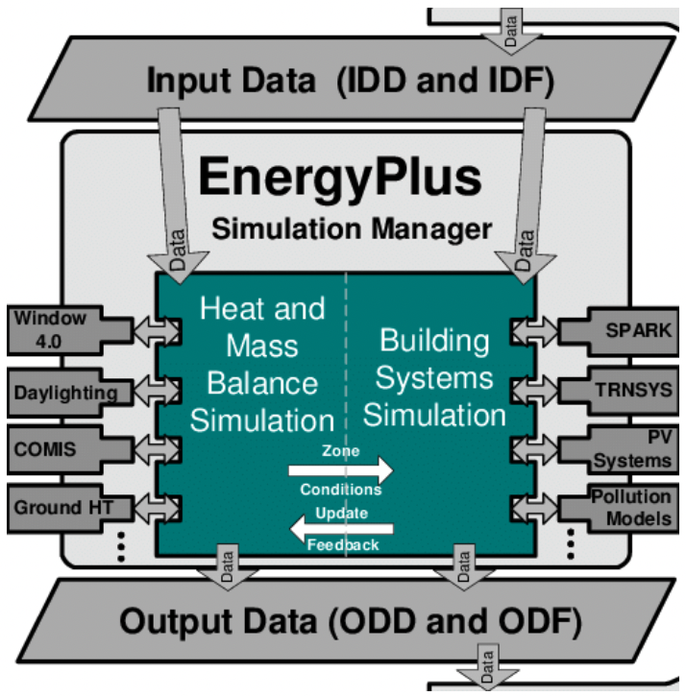
Figure 3-2 Overall EnergyPlus Structure [37].
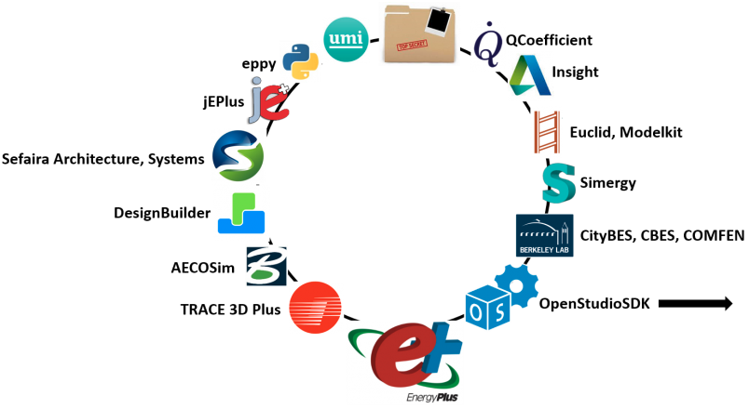
Figure 3-3 Tools and services supported by EnergyPlus [38].
In this study, three kinds of software, i.e., EnergyPlus 9.5.0 [39], OpenStudio 1.2.1 [40], and SketchUp Pro 2021 [41], respectively, as detailed in Section 4.1.1, were used in development and simulation of three-dimensional (3-D) house models. The 3-D model was firstly created in Openstudio, then modified in SketchUp, and finally calibrated by EnergyPlus, in which the detailed process will be introduced in Chapter 4.
Since the 3-D model requires to be calibrated using the measured data from the test house, the measured weather data are required as well. While the historical weather data were not available for the location of the test house, a weather data processing method that utilizes the measured data from the test house and local weather station is also introduced in this study. To adopt the measured weather data as the weather data file of EnergyPlus (or OpenStudio), several steps are required.
Firstly, the measured data need to be processed and converted, following the requirements of EnergyPlus, e.g., its data formats, categories, and units. In terms of data categories, it includes the date, time, temperature, relative humidity, atmospheric pressure, global horizontal radiation, normal direct radiation, and diffuse horizontal radiation. In this study, the measured weather data includes wind speed, global horizontal solar irradiation, outdoor air temperature, and relative humidity and considers constant atmospheric pressure. Then normal direct radiation and diffuse horizontal radiation need to be calculated, based on the measured global horizontal solar radiation data and ASHRAE Clear Sky model [42], where the normal direct irradiation (G_{ND}) is firstly calculated and the normal direct irradiation (G_{DH}) and diffuse irradiation (G_{dH}) on the horizontal surface are obtained, as expressed by
 | G_{ND} = $\frac{A}{exp⁡(B/sinβ)}$ C_{N} | (3-1)
 | G_{DH} = G_{ND} sin$β$ | (3-2)
 | G_{dH} =C (G_{ND}) | (3-3)
where
A=apparent solar irradiation at air mass equal to zero
B=atmosphere extinction coefficient
$C$= ratio of diffuse irradiation on horizontal surface to direct normal irradiation
β = solar altitude
C_{N} = clearness number
All the parameter values of Equations (4-1)-(4-3) can be obtained from ASHRAE handbook fundamental [43]. For global horizontal solar irradiance G, it can be calculated by
 | $$G=G_{DH}+G_{dH}$$ | (3-4)
Lastly, it needs to rewrite the definition of these data for the parameters in the DEF file, as shown in Figure 3-4. This process is to check the units of these data as same as the ones in EnergyPlus and set up simulation parameters, such as timestep and location of test house. After obtaining all the necessary parameters, a tool, i.e., weather utilities from EnergyPlus, was used for format conversion.
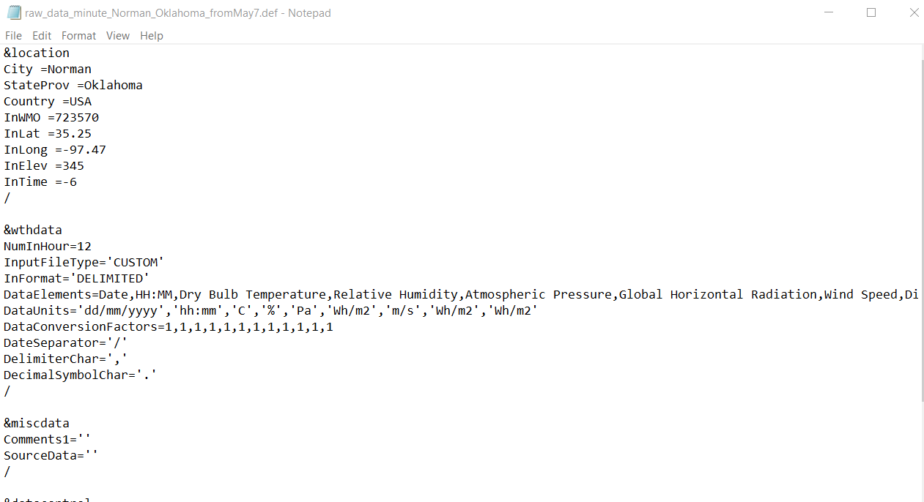
Figure 3-4 Definition of data represented in a DEF file.

3.1.2 Simplified 2R2C Model
Thermal network models have been very effective and accurate in building energy modeling. As for residential use, a 2R2C model has been validated by [29, 30] for its accuracy and will be sufficient and adopted in this study due to the merits mentioned in Chapter 2, and be simplified for accommodating the available data. Specifically, this study uses only intermittent data when the HVAC system is off and there is no occupancy, and the 2R2C model mentioned in Chapter 2 can be simplified into
$\frac{dT_{ie}\left(t\right)}{dt}=\frac{1}{τ_{1}}\left[T_{o}\left(t\right)-T_{ie}\left(t\right)\right]+\frac{1}{τ_{2}}\left[T_{in}\left(t\right)-T_{ie}\left(t\right)\right]$ (3-5)
$\frac{dT_{in}\left(t\right)}{dt}=-\frac{1}{τ_{3}}T_{in}\left(t\right)+\frac{1}{τ_{3}}\left[T_{ie}\left(t\right)+\left(T_{o}\left(t\right)-T_{in}\left(t\right)\right)\left(b_{1}W\left(t\right)+b_{2}W^{2}\left(t\right)\right)+\left(a_{1}G\left(t\right)+a_{2}G^{2}\left(t\right)+a_{3}G^{3}\left(t\right)\right)\right]$ (3-6)
The simplified models represented in Equations (3-1) and (3-2) are time-continues model. To use the measured data for parameter identification, discretization of the models is necessary. Therefore, the simplified models are converted, using Euler’s Forward Method, expressed by
$T_{ie}\left[k+1\right]=T_{ie}\left[k\right]+\frac{∆t}{τ_{1}}\left[T_{o}\left[k\right]-T_{ie}\left[k\right]\right]+\frac{∆t}{τ_{2}}\left[T_{in}\left[k\right]-T_{ie}\left[k\right]\right]$ (3-7)
$T_{in}\left[k+1\right]=T_{in}\left[k\right]+(1-\frac{∆t}{τ_{3}})T_{in}\left[k\right]+\frac{∆t}{τ_{3}}\left[T_{ie}\left[k\right]+\left(T_{o}\left[k\right]-T_{in}\left[k\right]\right)\left(b_{1}W\left[k\right]+b_{2}W^{2}\left[k\right]\right)+\left(a_{1}G\left[k\right]+a_{2}G^{2}\left[k\right]+a_{3}G^{3}\left[k\right]\right)\right]$ (3-8)
where $∆t$ is the sampling interval and $k$ denotes discrete time.
With a least-square method [29, 30], the parameters in Equations (3-3) and (3-4) can be identified and used for benchmarking envelope performance evaluation purpose, as carried out in Section 3.3.2. As discussed in Section 2.3, Tau 1 is used to evaluate the envelope energy performance.

3.2 Model Calibration Method
The calibration method of the EnergyPlus models constructed in this study is divided into 5 steps:
(1) Real measured weather data collected from the test house and local weather station are processed for creating the EPW weather file, required by input data of EnergyPlus;
(2) Sensitivity analysis over input parameters related to significant changes of the Tau values is conducted;
(3) Adjustment of the Tau values. As either the roof or ceiling can cause larger difference of the Tau values, the combination of the roof and ceiling is considered in this study;
(4) Comparison. Indoor air temperature and the learned Tau values from the RC models are used for the calibrated objectives; and
(5) Simulation. A total of 14 days of data when the HVAC system is off (i.e., during the transition season) and there is no occupancy are used for simulations. The errors between the measured and simulated air temperatures are used to evaluate the accuracy of the calibrations.

3.3 Envelope Performance Benchmark

3.3.1 Tau Value Calculated from Dashboard
An excel dashboard is created to facilitate the calculation of the physical Tau value, which is the product of the total thermal resistance and capacity of the entire building envelope. To calculate the values of the total resistance and capacitance of the whole envelope, each component of the house, such as the roof, walls, ceiling, windows, and doors, needs to be considered. In the total resistance calculation process, the unit resistance $R^{'}$ of each component of the envelope should be ensured firstly and can be calculated using the thickness and conductivity of the component. The properties of the components can be obtained from the EnergyPlus library. Hence, the unit resistance $R^{'}$ of each component can be calculated by
 | $$R^{'}=\frac{∆x}{k}$$ | (3-9)
where
$R^{'}$ = Unit resistance of the component (m²-k/w)
$∆x$ = Thickness of the component (m)
k = Conductivity of the component (w/m-K)
The resistance of each component can be calculated by
 | $$R=\frac{R^{'}}{A}$$ | (3-10)
where
R = Resistance of the component (K/W)
A = Total surface area of the component (m²)
To calculate the total resistance of the whole envelope, the resistances of walls, doors, windows, and combination of ceiling and roof (because of the existing of the attic) can be regarded as parallel connections, in which the combination of ceiling and roof is connected in series. The total resistance $R_{tot}$ of the whole envelope can be expressed as
 | $$R_{tot}=\frac{1}{\frac{1}{R_{t,w}}+\frac{1}{R_{d}}+\frac{1}{R_{win}}+\frac{1}{R_{com}}}$$ | (3-11)
where
$R_{t,w}$= overall resistance of walls (K/W)
$R_{d}$= resistance of doors (K/W)
$R_{win}$= resistance of windows (K/W)
$R_{com}$= resistance of the combination of roof and ceiling (K/W)
For the overall resistance of walls, the convective heat transfer coefficients from both interior and exterior wall surfaces are also considered, based on their constant values of 8.29 W/(m²·K) and 22.7 W/(m²·K), respectively, in this study. Therefore, the overall resistance of walls can be calculated by
$R_{t,w}=\frac{1}{h_{i}A_{i}}+R_{w}+\frac{1}{h_{o}A_{o}}$ (3-12)
where
$R_{w}$= resistance of walls (K/W)
$h_{i}$= convective heat transfer coefficient from interior wall surface (W/(m²·K))
$h_{o}$= convective heat transfer coefficient from exterior wall surface (W/(m2·K))
$A_{i}$= surface area of interior walls (m²)
$A_{o}$= surface area of exterior walls (m²).
Moreover, the value of $R_{com}$ for the combination of the roof and ceiling adopted the similar calculation. The only difference is that they can be regarded as series connection, as calculated by
$$R_{com}=R_{roof}+R_{ceiling}$$ | (3-13)
where
$R_{roof}$ = roof resistance (K/W), which considers half volume of the air between the roof and ceiling (i.e., attic air)
$R_{ceiling}$= ceiling resistance (K/W), which considers another half volume of the air between the roof and ceiling
Similarly, based on the specific heat and density of each component and the corresponding volume, the total capacitance of the whole envelope can be calculated by.
$C_{tot}=C_{w}+C_{d}+C_{r}+C_{win}+C_{c}$ | (3-14)
where
$C_{tot}$ = total capacitance of the whole envelope (J/K)
$C_{w}$ = total capacitance of wall (J/K)
$C_{d}$ = total capacitance of door (J/K)
$C_{r}$ = total capacitance of roof (J/K)
$C_{win}$ = total capacitance of window (J/K)
$C_{c}$ = total capacitance of ceiling (J/K)
As introduced in Section 2.2, the value of Tau represents the physical thermal properties of all the components of a test house. To compare and differentiate the Tau values identified from RC models (referred to as the learned Tau values), the Tau value calculated based on physical envelop materials is referred to as the physical Tau value. Specifically, based on the total values of $R_{tot}$ and $C_{tot}$, the physical Tau value can be calculated by
$Tau=R_{tot}*C_{tot}$ | (3-15)

3.3.2 Tau Value Identified from Simplified 2R2C Model
To identify the values of the simplified 2R2C model parameters $τ_{1}$ and $τ_{2}$ in Equation (3-7), a two-step least-squared method [29, 30] is adopted. Equation (3-7) can be rewritten as
$X_{1}β_{1}=Y_{1}$ (3-16)
The least squares solution to Equation (3-16) is
${\hat{β}}_{1}=\left(\begin{matrix}{\hat{β}}_{1}(1) \\ {\hat{β}}_{1}(2)\end{matrix}\right)={\left(X_{1}^{T}X_{1}\right)}^{-1}X_{1}^{T}Y_{1}$ (3-17)
Thus,
$τ_{1}=∆t/{\hat{β}}_{1}(1)$ and $τ_{2}=∆t/{\hat{β}}_{1}(2)$. (3-18)
where $X_{1}$ and $Y_{1}$ are known matrices; $β_{1}$ is the matrix to be identified; and ${\hat{β}}_{1}$ is the least squares solution matrix.
$X_{1}=\left[\begin{matrix}T_{o}\left(2\right)-T_{ie}(2) & T_{in}\left(2\right)-T_{ie}(2) \\ T_{o}\left(3\right)-T_{ie}\left(3\right) & T_{in}\left(3\right)-T_{ie}\left(3\right) \\ ⋮ & ⋮ \\ T_{o}\left(k-1\right)-T_{ie}\left(k-1\right) & T_{in}\left(k-1\right)-T_{ie}\left(k-1\right) \\ T_{o}\left(k\right)-T_{ie}\left(k\right) & T_{in}\left(k\right)-T_{ie}\left(k\right)\end{matrix}\right]$, $β_{1}=\left[\begin{matrix}τ_{1} \\ τ_{2}\end{matrix}\right]$,
$Y_{1}=\left[\begin{matrix}T_{ie}\left(2\right)-T_{ie}\left(1\right) \\ T_{ie}\left(3\right)-T_{ie}\left(2\right) \\ ⋮ \\ T_{ie}\left(k-1\right)-T_{ie}\left(k-2\right) \\ T_{ie}\left(k\right)-T_{ie}\left(k-1\right)\end{matrix}\right]$. (3-19)
Similar, to identify the values of the simplified 2R2C model parameters $τ_{3}$, $b_{1}$, $b_{2}$, $a_{1}$, $a_{2}$, and $a_{3}$ in Equation (3-8), the equation can be rewritten as
$X_{2}β_{2}=Y_{2}$ (3-20)
The least squares solution to Equation (3-20) is:
${\hat{β}}_{2}=\left(\begin{matrix}{\hat{β}}_{2}(1) \\ {\hat{β}}_{2}(2) \\ {\hat{β}}_{2}(3) \\ {\hat{β}}_{2}(4) \\ {\hat{β}}_{2}(5) \\ {\hat{β}}_{2}(6)\end{matrix}\right)={\left(X_{2}^{T}X_{2}\right)}^{-1}X_{2}^{T}Y_{2}$ (3-21)
Thus,
$τ_{3}=∆t/{\hat{β}}_{2}(1)$, $b_{1}={\hat{β}}_{2}(2)/{\hat{β}}_{2}(1)$, $b_{2}={\hat{β}}_{2}(3)/{\hat{β}}_{2}(1)$, $a_{1}={\hat{β}}_{2}(4)/{\hat{β}}_{2}(1)$, $a_{2}={\hat{β}}_{2}(5)/{\hat{β}}_{2}(1)$, and $a_{3}={\hat{β}}_{2}(6)/{\hat{β}}_{2}(1)$. (3-22)
where $X_{2}$ and $Y_{2}$ are known matrices; $β_{2}$ is the matrix needed to identify; and ${\hat{β}}_{2}$ is the least squares solution matrix.
$X_{2}=\left[\begin{matrix}T_{ie}\left(2\right)-T_{in}\left(2\right) & \left(T_{o}\left(2\right)-T_{in}(2)\right)W\left(2\right) & \left(T_{o}\left(2\right)-T_{in}\left(2\right)\right)W^{2}(2) & G(2) & G^{2}(2) & G^{3}(2) \\ T_{ie}\left(3\right)-T_{in}\left(3\right) & \left(T_{o}\left(3\right)-T_{in}\left(3\right)\right)W(3) & \left(T_{o}\left(3\right)-T_{in}\left(3\right)\right)W^{2}(3) & G(3) & G^{2}(3) & G^{3}(3) \\ ⋮ & ⋮ & ⋮ & ⋮ & ⋮ & ⋮ \\ T_{ie}\left(k-1\right)-T_{in}\left(k-1\right) & \left(T_{o}\left(k-1\right)-T_{in}\left(k-1\right)\right)W(k-1) & \left(T_{o}\left(k-1\right)-T_{in}\left(k-1\right)\right)W^{2}(k-1) & G(k-1) & G^{2}(k-1) & G^{3}(k-1) \\ T_{ie}\left(k\right)-T_{in}\left(k\right) & \left(T_{o}\left(k\right)-T_{in}\left(k\right)\right)W(k) & \left(T_{o}\left(k\right)-T_{in}\left(k\right)\right)W^{2}(k) & G(k) & G^{2}(k) & G^{3}(k)\end{matrix}\right]$,
$β_{2}=\left[\begin{matrix}\begin{matrix}τ_{3} \\ b_{1}\end{matrix} \\ b_{2} \\ a_{1} \\ a_{2} \\ a_{3} \\ Q_{i} \\ Q_{s}\end{matrix}\right]$, and $Y_{2}=\left[\begin{matrix}T_{in}\left(2\right)-T_{in}\left(1\right) \\ T_{in}\left(3\right)-T_{in}\left(2\right) \\ ⋮ \\ T_{in}\left(k-1\right)-T_{in}\left(k-2\right) \\ T_{in}\left(k\right)-T_{in}\left(k-1\right)\end{matrix}\right]$. (3-23)

3.3.3 Benchmark Method
As discussed in Section 2.3, the model-based envelope evaluation method provides a way to obtain the overall thermal property of building envelops, i.e., the values of Tau from the RC models. Moreover, in [10, 13], the authors found that there is a correlation between the value of Tau and house age. That is, the older homes with older technologies result in poorer thermal performance of the envelopes in design and construction phase as well as the thermal performance of home envelopes deteriorate as the age increases. This study provided a good reference for the Tau values for different years of house. However, the values of Tau were obtained purely based on the RC model-based data-driven method, which may not be very accurate and convincible in comparison with a ground truth, e.g., the physical Tau values obtained from physical building information.
Therefore, for benchmarking purpose in this study, the combination of the calibrated EnergyPlus and 2R2C models are adopted, of which the calibrated EnergyPlus models are used to generate simulated data that are utilized in the simplified 2R2C model training. Moreover, three ASHARE standards in 1975, 2007, and 2018 are selected for the determination of the minimum requirements of thermal properties of residential building envelopes, of which the standard in 1975 is the first available standard from ASHRAE, the standard of 2018 is the latest one, and the standard in 2007 is between these two. Based on the method to determine the Tau values as descried in Section 3.3.1, different years of houses that meet the minimum thermal property requirement of residential building envelope defined by ASHRAE standards, the performance evaluation benchmarking process can be done with different values of Tau, i.e., representing the minimum required Tau value for a specific year of a residential building envelope.

: Three-Dimensional EnergyPlus Model Construction
To carry out the simulation in Chapter 5, a three-dimensional (3-D) model is constructed. Specifically, Section 4.1 introduces the 3-D house model using simulation softwares (i.e., EnergyPlus, SketchUp, and OpenStudio). Section 4.2 discusses the thermal properties of the envelope materials used in the 3-D model construction. Section 4.3 utilizes the simplified 2R2C model in Chapter 3 for simulation and comparison with the 3-D model. Finally, Section 4.4 introduces the 3-D model calibration based on the procedures described in Chapter 3 and presents a comparison of the simulation results from both the 3-D model and the simplified 2R2C model.

4.1 Three-Dimensional House Model Setup
To create a 3-D house model, a software designed for modeling and simulation is firstly introduced in Section 4.4.1 and then the 3-D house model is created using the software introduced in Section 4.1.2.

4.1.1 Modeling and Simulation Software
Three kinds of software were used in the development and simulation of the 3-D house model. They are EnergyPlus 9.5.0 [43], OpenStudio 1.2.1 [44], and SketchUp Pro 2021 [45], respectively. EnergyPlus is an energy modeling and simulation program, sponsored by US department of Energy, which models both energy consumption—for HVAC, lighting, and plug and process loads—and water use in buildings, as detailed in Section 3.1.1. OpenStudio is a collection of software tools that support whole building energy modeling using EnergyPlus and other analysis, which can be regarded as a graphical user interface for EnergyPlus. ShetchUp is a 3D professional design software, it may be used together with OpenStudio to facilitate a quick design of a 3-D model. By using OpenStudio ShetchUp Plugin, we can modify 3-D models created by OpenStudio directly. As a main goal of OpenStudio is used for energy simulation (due to its limited function in constructing complicate models), SketchUp was used for further improving the models’ accuracy in simulations. In this study, a 3-D model was firstly created in OpenStudio, then modified in SketchUp, and finally calibrated by EnergyPlus.

4.1.2 Test House Modeling
A residential test house, whose latitude is 35.2226° N and longitude is 97.4395° W and located in Norman, State of Oklahoma, US, is used in this study. The test house is a single-family, one-story home with a floor area of 154 m², and was built in 1940. The test house consists of three bedrooms, a kitchen room, a dining room, a living room, and 2 bathrooms. Moreover, this residential house has one attic with a 39° pitched roof. The test house is equipped with a 3.5-ton heat pump system for space heating and cooling. The house is also equipped with a data acquisition system that has capacity of measuring temperatures of different thermal zones and interior wall surfaces and outdoor air. In this study, the indoor air temperature of the thermal zone 2 (as shown in figure 4-1) and its surrounding interior wall surface temperatures are adopted due to their representatives of actual location of the thermostat where the indoor air temperature is measured and the reasonable model accuracy in calibration results as introduced in Section 4.3.
As temperatures of the external walls facing various orientations can be affected by solar radiation, winds speed, and outdoor temperature, they will consequently impact the indoor air temperatures. Hence, in this study the lab house was divided into three thermal zones based on the orientations and physical layout. The floor plan of the 3-D house model with three thermal zones is shown in Figure 4-1, in which the light blue area represents the Thermal Zone 1 facing north, the green area represents the Thermal Zone 2 located in the middle, and the purple area represents the Thermal Zone 3 facing south, as summarized and listed in Table 4.1. It is to be noted that this study ignored the ground heat transfer because the real house floor was exposed to an insulated air and had no direct contact with the ground.
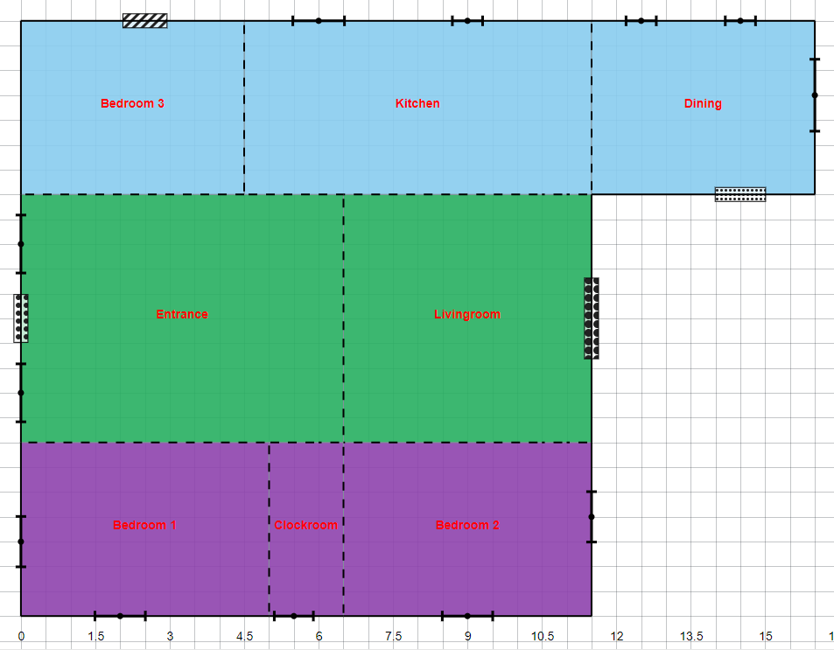
Figure 4-1 Floor plan of the 3-D house model divided by three thermal zones.
Table 4-1 House thermal zones represented by different colors.

There are three main steps for setting up the 3-D house model. The first step is to obtain the actual house dimensions where the geometry is from the actual measurements of the house elements, such as walls, windows, and doors. The material of these elements is introduced in Section 4.2. The second step is to use these elements as inputs to build a 3-D model (without roof) in OpenStudio. The last step is to complete the 3-D house model by adding the specific pitched roof. The side view the test house and its corresponding 3-D model constructed are shown in Figure 4-2.
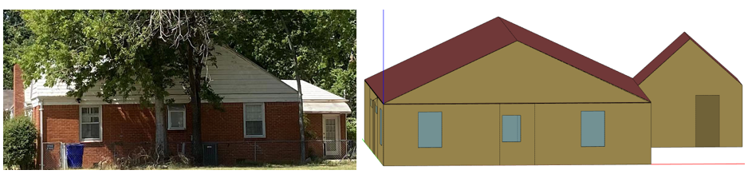
(a) Side view of test house (b) 3-D house model
Figure 4-2 Side view of test house and its 3-D model.

4.1.3 Weather Data
Both EnergyPlus and OpenStudio provide a global historical weather library, e.g., represented by the third typical meteorological year collection (TMY3), on their websites, which can be downloaded and implemented in the developed 3-D house model. To access the local weather data for this study, there are two problems existed. First, there is no weather data that are available for the test house at Norman, Oklahoma provided by the website. The nearest area which can be downloaded is from Oklahoma City-Tinker AFB (Location #: 723540). Another problem is the timestep of the historical weather data, i.e., only 60-minute interval is available. However, this study needs use the measured data to calibrate the 3-D model and thus is necessary to use the measured weather data as well. Moreover, the timestep of 10 minutes is also required. Therefore, the weather data used for the 3-D model was measured and collected from the lab house and compared with data downloaded from Mesonet [48]. As Mesonet provides more stable results, it will be used for the weather data sources. The data covers a long period from April 1 to June 30 in 2020.
Based on the weather data processing method described in Section 3.1.1, the measured weather data can be converted and used as an input data file for EnergyPlus. Moreover, Elements (i.e., a tool that can read files in an EPW format) can be used for checking the converted content, as shown in Figure 4-3.
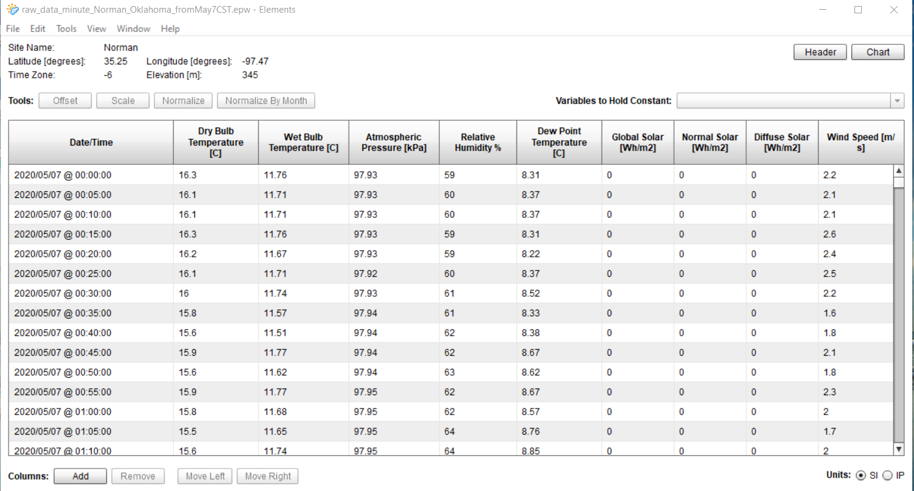
Figure 4-3 EPW data displayed in an Elements interface.

4.2 Analysis of House Thermal Property
This subsection first introduces the normal values of the thermal properties of the house envelope materials for residential use. Then the total thermal resistance and capacitance and the time constant of the test house is calculated based on these values of the thermal properties. Finally, sensitivity analysis is conducted to determine the most crucial thermal properties that impact the model performance for calibration process as introduced in the subsequent subsection.

4.2.1 Uncalibrated Envelop Materials
As the test house was built in 1940, the actual thermal properties of the construction materials are not available. To construct the EnergyPlus model without calibration, the default values of these thermal properties were adopted based on the available ‘typical’ values in the built year of 1940 and default values in the EnergyPlus library. Note that there are a total of 14 different types of surface construction materials in the EnergyPlus model. The detailed properties of these construction materials are listed in Table 4-2. Moreover, for the door and window, the detailed information provided by EnergyPlus are listed in Table 4-3. Based on these values of the thermal properties, the total resistance and capacitance and the time constant of the test house can be calculated, as shown in Section 4.2.2.
Table 4-2 Properties of Surface Construction Materials.
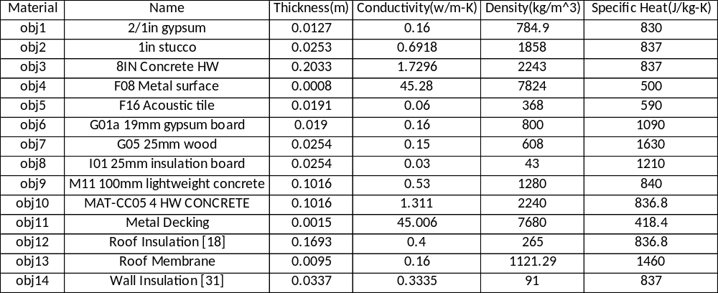
Table 4-3 Properties of Windows and Doors.
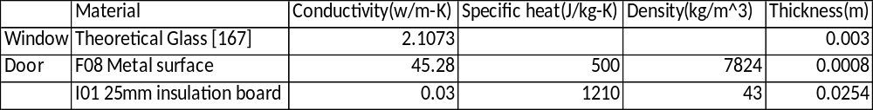
In this study, the total area of walls, windows, doors, and the combination of the ceiling and roof from the test house are calculated based on the real measured dimensions and are listed in Table 4-4. Based on these values and the calculation method introduced in Section 3.3.1, we can calculate the values of the resistance of each component and the total resistance and capacitance, as shown in Tables 4-5 and 4-6, respectively. Moreover, based on the obtained values of the total resistance and capacitance listed in Tables 4-5 and 4-6, the physical Tau value can be further calculated and equals to 3161 (note that the combination of roof and ceiling is considered in the EnergyPlus model configuration).
Table 4-4 Values of component areas of test house.
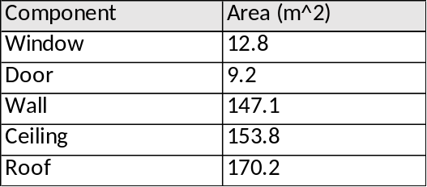
Table 4-5 Calculated thermal resistances of components of test house.
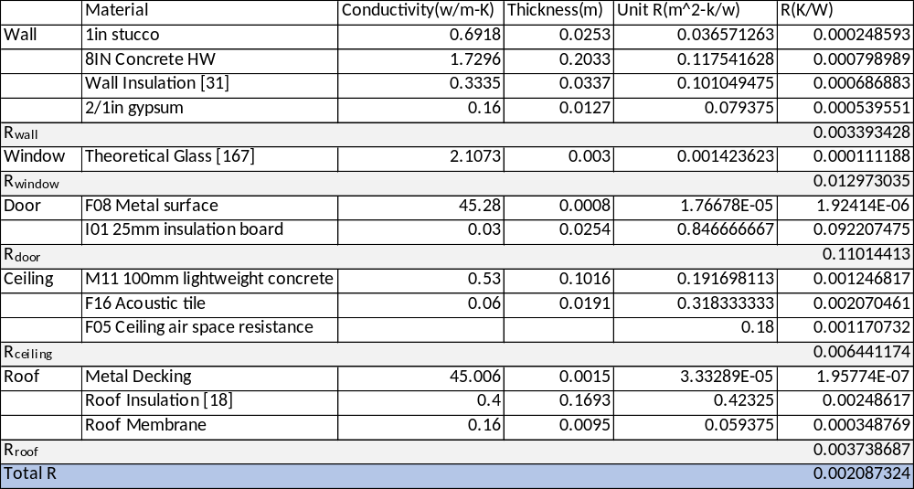
Table 4-6 Calculated thermal capacitance of components of test house.
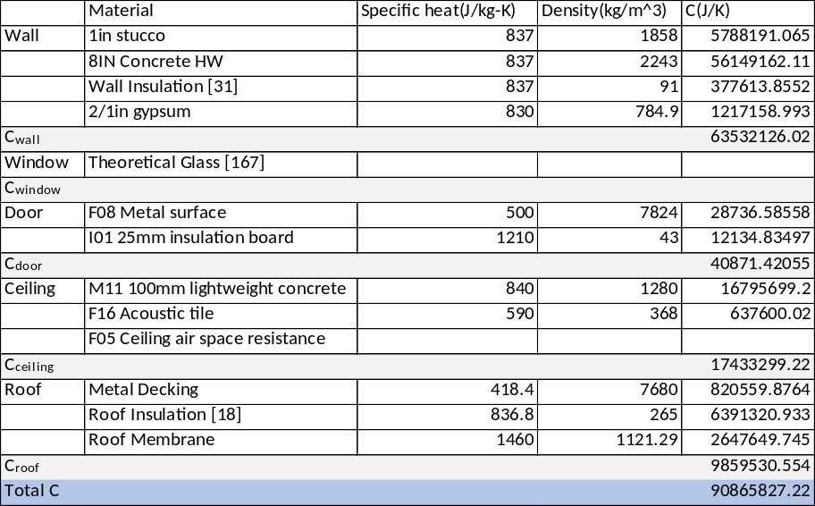

4.2.2 Comparison of Tau values
Simulated data can be generated from the EnergyPlus model that can be constructed utilizing the uncalibrated envelope materials as listed in Tables 4-2 and 4-3. The simulated data was then used to train the simplified 2R2C model and the learned Tau value is 608. Moreover, based on the simplified 2R2C model introduced in Section 3.1.2, the model identification procedures introduced in Section 3.3.2, and the weather data introduced in Section 4.1.3, the Tau value can also be learned using measured data, including the wind speed, horizontal solar irradiation, outdoor air temperature, and indoor air temperature of the thermal zone 2 and its area-weighted interior wall surface temperature.
Figure 4-4 shows the simulation results from the simplified 2R2C model using 14-day measured data. As can be seen from the figure, for both wall surface and indoor air temperatures, the simulated data from the 2R2C model match well with the measured data, while a relatively small deviation (e.g., the maximum absolute error of 1.64 °C) shows up between the measured data and the simulated data from the simplified model. The results validate the accuracy of the simplified 2R2C model using 14-day measured data. To show an obvious sense about the accuracy, the mean and maximum absolute errors of the simulated indoor air temperature from the 2R2C model and measured ones are generated, which are 0.32 °C and 1.64 °C, respectively. In addition, the Tau (i.e., $τ_{1}$) value equals to 2906 (referred to as the learned Tau value hereafter), which is far from the learned Tau value of 608 trained by utilizing the simulated data from the EnergyPlus model and uncalibrated envelope materials. Therefore, calibration of the EnergyPlus model is needed in this study before carrying out the envelope performance evaluation benchmarks.
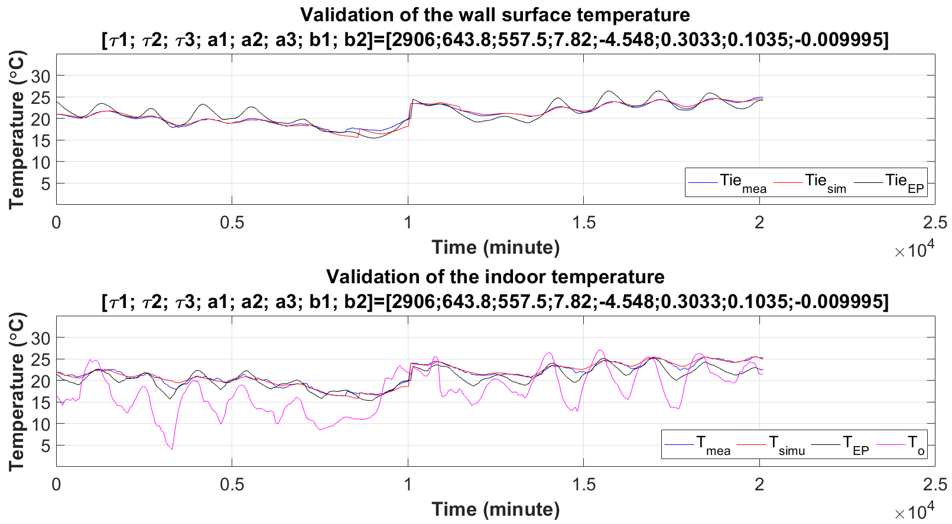
Figure 4-4 Comparison of simulated temperatures using 14-day measured data.

4.2.3 Sensitivity Analysis
As there are a variety of construction materials for the residential building envelope, it is important to determine which kind of materials is most likely to affect the total R and C values, thus impacting the physical Tau value. Therefore, a sensitivity analysis is necessary and conducted in this study. Because specific heat and conductivity are the two basic properties of building materials, in the calibration process only these two properties are adjusted for each material, as listed in the 3rd and 4th columns of Table 4-7.
To match with the learned Tau value of 2906 obtained in Section 4.2.1, we can either decrease the value of R or C from the uncalibrated envelope materials. In this study, conductivity was doubled by its initial value for only one material each time to calculate the corresponding physical Tau value, which is conductivity-related and listed in the 5th column of Table 4-7. Similarly, specific heat was decreased to half of its initial value for only one material each time to calculate the corresponding physical Tau value, which is specific heat-related and listed in the 6th column of Table 4-7. Observed from the table, the concrete and insulation materials have the crucial impact, as marked in red, on the calculated Tau values, which deviate from the initial Tau value of 3161. In this way, we are able to identify the most influential materials, whose specific heat and conductivity are adjusted only for calibration process as introduced in the subsequent section.
Table 4-7 Sensitivity Analysis of Different Envelope Materials.
Envelop | Material | Initial Conductivity  (W/m-K) | Initial Specific Heat  (J/kg-K) | Tau Value  (Conductivity-related) | Tau Value  (Specific heat-related)
Wall | 1in stucco | 0.6918 | 837 | 3089 | 3060
Wall | 8IN Concrete HW | 1.7296 | 837 | 2921 | 2184
Wall | Wall Insulation | 0.3335 | 837 | 2956 | 3155
Wall | 2/1in gypsum | 0.16 | 830 | 3002 | 3140
Door | F08 Metal surface | 45.28 | 500 | 3161 | 3161
Door | I01 25mm insulation board | 0.03 | 1210 | 3119 | 3161
Ceiling | M11 100mm lightweight concrete | 0.53 | 840 | 3119 | 2869
Ceiling | F16 Acoustic tile | 0.06 | 590 | 3089 | 3150
Roof | Metal Decking | 45.006 | 418.4 | 3161 | 3147
Roof | Roof Insulation | 0.4 | 836.8 | 3073 | 3050
Roof | Roof Membrane | 0.16 | 1460 | 3150 | 3115

4.3 Calibration
Following the calibration method introduced in Section 3.2, this study will conduct the calibration based on the following steps: 1) Based on section 4.1.3, real measured weather data from the test house are processed for creating the EPW weather file; 2) Sensitivity analysis over input parameters related to significant changes of the Tau values is conducted, following by Section 4.2.3; 3) As considering either the roof or ceiling in the constructed 3-D house model can cause larger difference of the Tau values, the combination of the roof and ceiling is considered in this study; 4) Indoor air temperature of the thermal zone 2 and the learned Tau values from the simplified RC models are used for the calibrated objectives; and 5) Simulation and generated data for the use of the simplified 2R2C model. A total of 14 days of data when the HVAC system is off (i.e., during the transition season) and there is not occupied are used for simulations. The mean and maximum absolute errors between the measured and simulated air temperatures are used to evaluate the accuracy of the calibration results. The results of the following subsections are generated based on these steps above.
This section analyzes via simulation the comparisons of the results from uncalibrated and calibrated EnergyPlus models with the measured data in various scenarios. Moreover, the results from the simplified 2R2C models are also used for comparisons. Specifically, Section 4.3.1 presents the simulated results from the uncalibrated EnergyPlus models. Section 4.3.2 investigates the calibrated EnergyPlus models, in which two scenarios are considered for the calibrated model without and with ceilings in the EnergyPlus model configuration.

4.3.1 Uncalibrated EnergyPlus models
Although the following figures look at different aspects of the comparison of the EnergyPlus models, all the simulation results therein are generated in the same way as follows: The top plots represent the comparison of interior wall surface temperatures, and the bottom plots represent the comparison of indoor air temperatures. Moreover, the blue curves represent the measured data from the house, the red curves represent the simulated results from the 2R2C models, and the black curves represent the simulated results from EnergyPlus models.
Through the calculations using the created dashboard as introduced in Section 4.2.1, the initial physical Tau value equals to 3161. The simulated indoor air and interior wall surface temperatures from the uncalibrated EnergyPlus model (where the combination of roof and ceiling is considered in the EnergyPlus model configuration) are used for the training of the simplified 2R2C model. Figure 4-5 shows the simulation results from the trained 2R2C model and its validation, compared with the measured indoor air and interior wall surface temperatures. As can be seen from the figure, for both wall surface and indoor air temperatures, the simulated data from the simplified 2R2C model were far from with the simulated data from the uncalibrated EnergyPlus model (e.g., with the mean and maximum absolute errors of 1.46 °C and 6.48 °C, respectively) and meanwhile do not match with the measured data. Moreover, it should be noted that the value of Tau (i.e., Tau1) is 608.9, which much smaller than the learned Tau value of 2906 identified from the simplified 2R2C model that utilized simulated data from the uncalibrated EnergPlus model, thus indicating the inaccuracy of the uncalibrated EnergyPlus model.
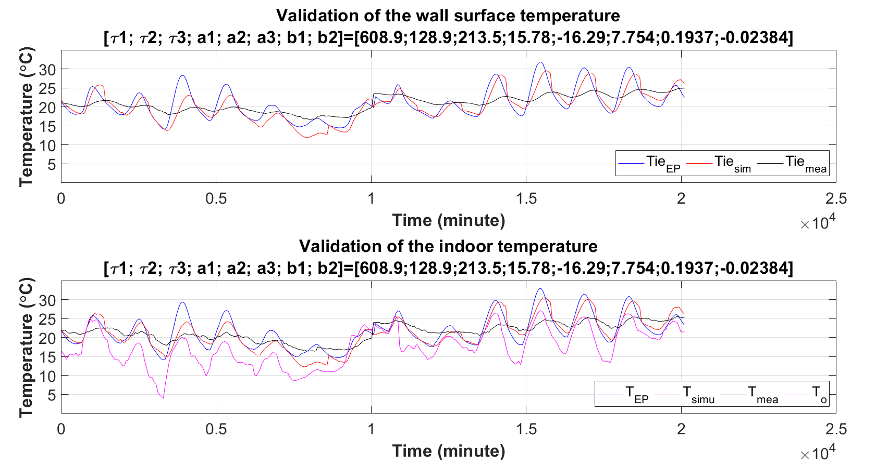
Figure 4-5 Comparison of simulated temperatures based on uncalibrated EnergyPlus model.

4.3.2 Calibrated EnergyPlus models
(1) Model without Ceiling
The calibrated 3-D model without ceiling is shown in Figure 4-6. Compared with the value of 608 obtained from the uncalibrated EnergyPlus model, this learned Tau value of 2225 is relatively close to the learned Tau value of 2906 trained by measured data, but still has a big difference. For comparisons, both measured data and simulation results generated, using the calibrated EnergyPlus model when not considering ceiling, are used for the simplified 2R2C model training. Then the trained 2R2C models are used for simulations.
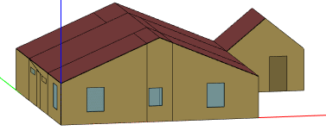
Figure 4-6 Calibrated 3-D model without ceiling.
Figure 4-7 shows the simulation results from the simplified 2R2C model. As can be seen from the figure, for both wall surface and indoor air temperatures, the simulated data from the simplified 2R2C model did not match well with both the simulated data from the calibrated EnergyPlus model and the measure ones, with the mean and maximum absolute errors of 0.90 °C and 3.30 °C, respectively. The results indicate that 1) when the phsical Tau value obtained from the calibrated EnergyPlus model is not very close to the learned Tau value, this calibrated EnergyPlus model may not be suitable for real implementations due to its incorrect trained model parameters; and 2) compared with the uncalibrated EnergyPlus model that considers the combination of roof and ceiling, the calibration of EnergyPlus models may need to consider the ceiling for a residnetial house with an attic.
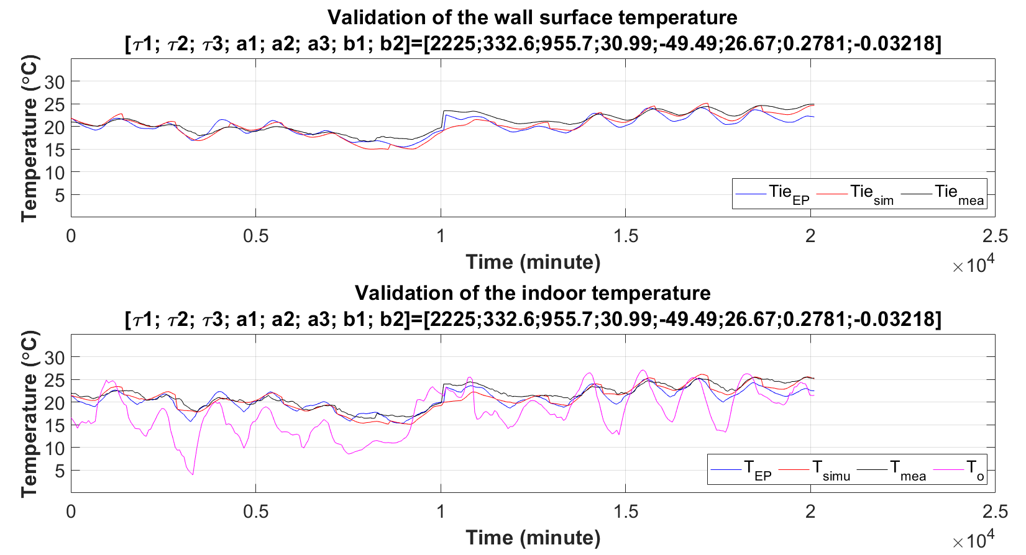
Figure 4-7 Comparison of simulated temperatures using 14-day simulated data from EnergyPlus.
(2) Model with Ceiling
Unlike the results from the EnrgyPlus models that do not consider ceiling, the new calibrated EnrgyPlus model herein only considers ceiling in the EnergyPlus model configuration as shown in Figure 4-8. Following the same procedure, both measured data and simulation results generated, using the new calibrated EnergyPlus model when only considering ceiling, are used for the simplified 2R2C model training. Then the trained 2R2C models are used for simulations.
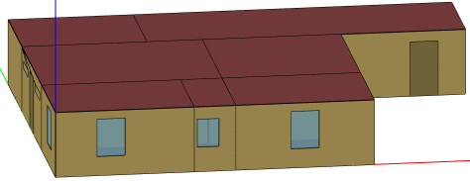
Figure 4-8 Calibrated 3-D model with ceiling only.
Figure 4-9 shows the simulation results using the new calibrated EnergyPlus model when considering ceiling only. As observed from the figure, for both wall surface and indoor air temperatures, the simulated data from the simplified 2R2C model match with both the measured data and the simulated data from the new calibrated EnergyPlus model. The mean and maximum absolute errors of the simulated indoor air temperature from the simplified 2R2C model and simulated data from the the new calibrated EnergyPlus model are generated, which are 0.86 °C and 2.7 °C, respectively. The model accuracy indeed gets improved compared with the ones obtained from the calibrated EnergyPlus model without ceiling.
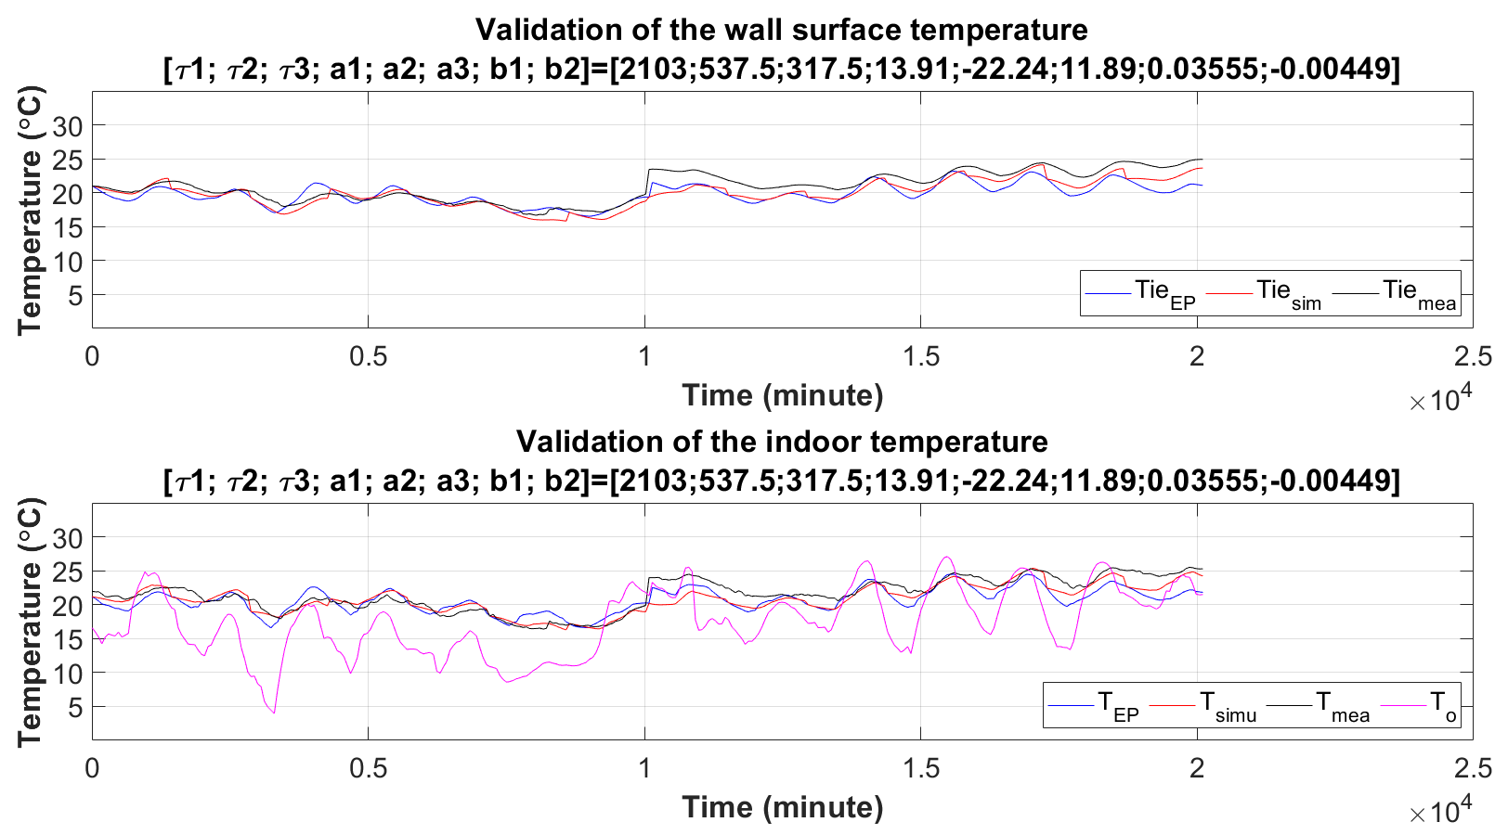
Figure 4-9 Comparison of simulated temperatures using 14-day simulated data from EnergyPlus.

4.4 Summary
Based on the aforementioned simulation results, Table 4-8 lists the comparison of the statistic index, i.e., the mean and maximum absolute errors, for each simulation. As observed, the calibrated EnergyPlus models have a better actuary than the uncalibrated ones. Moreover, the calibrated EnergyPlus model when considering ceiling only is better than the one when not considering ceiling in terms of the mean and maximum absolute errors. All the observations are in line with the conclusions made in the above subsections.
Table 4-8 Comparison of the mean and maximum errors from different EnergyPlus models.
EnergyPlus model | Model configuration | Mean absolute error, °C | Maximum absolute error, °C
Uncalibrated | Combination of ceiling and roof | 1.46 | 6.48
Calibrated | Not considering ceiling | 0.90 | 3.30
Calibrated | Considering ceiling only | 0.86 | 2.7

In summary, compared with the uncalibrated EnergyPlus model, the new calibrated EnergyPlus model based on the learned Tau value from the simplified 2R2C model has much improvement on the accuracy of the model parameters and simulation results. Moreover, even if the accuracy of the model considering ceiling did not get much improved compared with the ones obtained from the calibrated EnergyPlus model without considering ceiling, the learned Tau value makes sense because it is much close to the physical Tau value calculated from the created dashboard. Overall, the calibrated EnergyPlus model when considering ceiling only can be used for building envelope performance evaluation conducted in the next chapter.

: Envelope Performance Evaluation Benchmark
As described in Chapter 3, the value of Tau represents the physical thermal properties of all envelope elements for a residential building. The value can be obtained based on the simplified 2R2C and calibrated EnergyPlus model as introduced in Chapter 4. Since this value will vary for buildings with materials constructed in different years, it can be used to evaluate envelope performance and used for benchmark purpose, based on the calibrated EnergyPlus models that utilize the physical thermal properties from the requirements of ASHRAE standards in different years. Therefore, this chapter will recalibrate the calibrated EnergyPlus models (i.e., modify the configuration of the calibrated EnergyPlus model with considering ceiling only due to its accuracy) from Chapter 4 to match with the thermal properties required by ASHRAE standards published in different years.
To differentiate the thermal properties, this study adopts the ASHRAE standards applicable for residential use and published in the year of 1975, 2007, and 2018. According to these ASHRAE standards, we can find that as the building age gets younger, the thermal property requirements become stricter, i.e., a better insulation requirement. Hence, the value of Tau should become larger as the building age gets younger in theory and may be used as the requirement of the minimum value for the benchmark purpose.

5.1 Calibrated EnergyPlus model based on ASHRAE standard 90-75
ASHRAE standard 90-75 [49] is the first ASHRAE standard that stipulates the details of exterior envelopes, HVAC systems, and other relevant housing systems, thus is adopted as the first scenario in this study. According to this standard, it is obvious to obtain the maximum overall heat transfer coefficient (i.e., U value or minimum R_{tot} value reversely) of wall for family dwellings based on different annual heating degree days, as shown in Figure 5-1. While the heating degree days in 1975 can be obtained based on the physical location of the building, as shown in Figure 5-2. Since this study is conducted at Norman, the state of Oklahoma, located in the category of West South Central, we can determine the maximum value of U-factors for walls which is approximately close to 1.4 W/(m²·k).
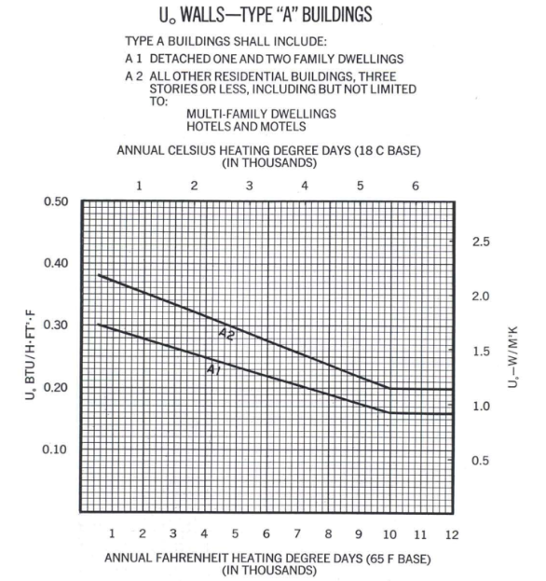
Figure 5-1 Requirements of wall U values given by ASHRAE 90-75 [49].
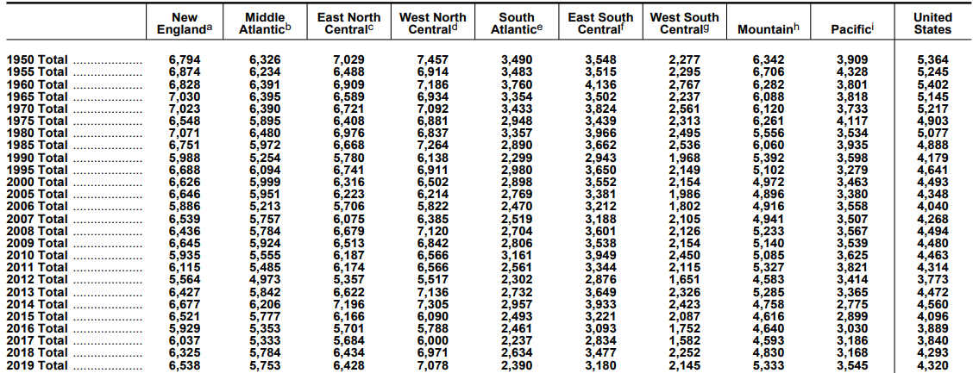
Figure 5-2 Annual heating degree days by census division [50].
Since ASHRAE standard 90-75 did not provide the thermal property requirements for other envelope elements except for walls, U value of ceiling, adopted in the configuration of the EnergyPlus model in 1975, is determined by the same ratio of walls between ASHRAE standard 1975 and ASHRAE standard 2018. Moreover, fenestration is supposed to be single window, and its U value is 5 W/(m²·k). Additionally, solar heat gain coefficient (SHGC) is also one of important factors which may influence windows’ heat transfer. Compared with the SHGC values of 0.41 and 0.3 for Standard 2007 and Standard 2018, respectively, the value of SHGC for this model adopts 0.5.
After changing the envelope thermal properties to match Standard 90-75, the calibrated EnergyPlus model can be recalibrated and the simulated data can be used to train the parameters of the simplified 2R2C model, as carried out in Chapter 4. Then the simplified 2R2C model is validated using the same set of training data, compared with measured ones, as shown in Figure 5-3. As overserved, the learned Tau (i.e., Tau1) value is 1788 which is the smallest one compared with the values obtained based on the ASHRAE standard 90-75. Moreover, the mean and maximum absolute errors of the simulated indoor air temperature and measured ones are 0.92 °C and 3.09 °C, respectively. It demonstrates the accuracy of the calibrated EnergyPlus model and indicates the minimum required Tau1 value for buildings constructed by the requirements of ASHRAE standard 90-75.
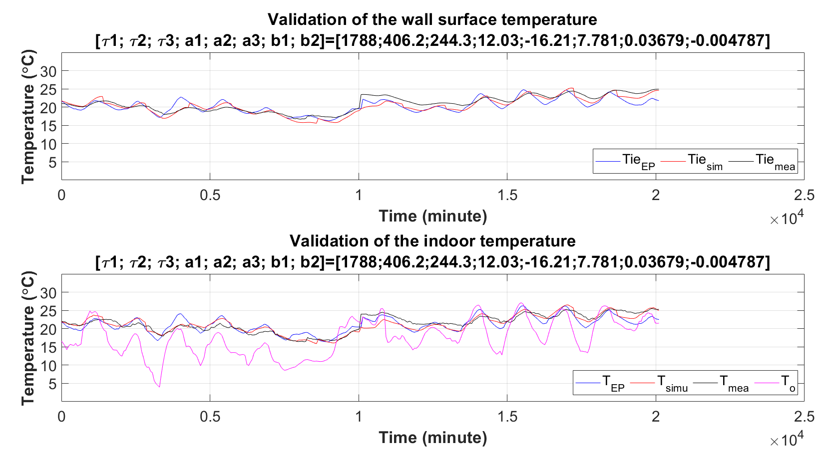
Figure 5-3 Simulation results of simplified 2R2C model based on calibrated EnergyPlus model and ASHRAE standard 90-75.

5.2 Calibrated EnergyPlus model based on ASHRAE standard 90.2-2007
Unlike ASHRAE standard 90-75, the ASHRAE standard 90.2-2007 [51] defines the required R/U values of building envelope elements, which include ceilings, walls, floors, doors, and fenestration. The detailed information can be seen in Table 5-1.
Table 5-1 Prescriptive envelope criteria given by ASHRAE 90.2-2007 [51].
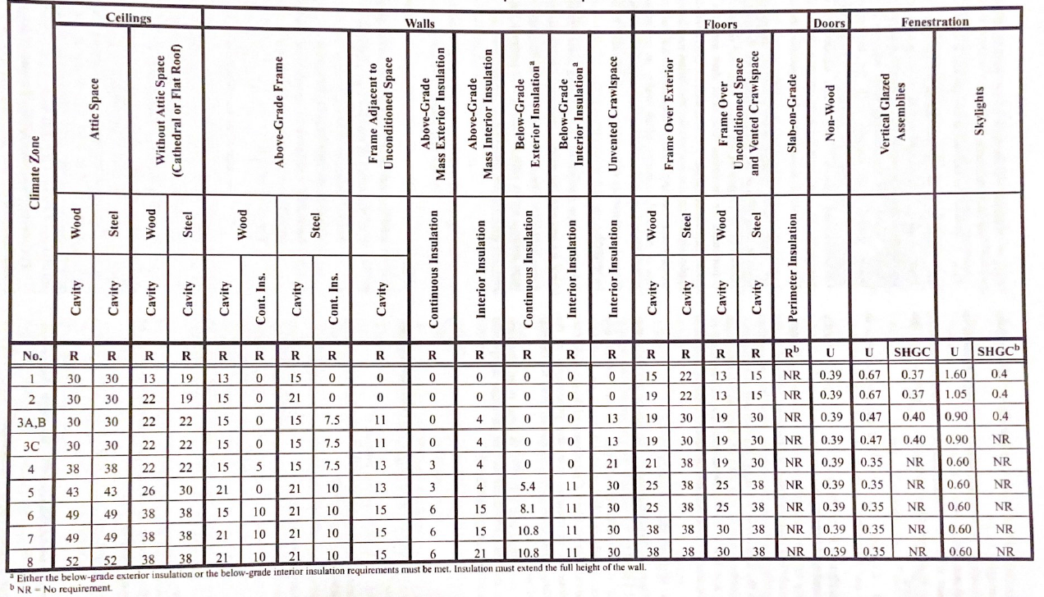
According to the values provided by the standard, we can recalibrate the calibrated EnergyPlus model and generate the simulation results, as shown in Figure 5-4. The learned Tau1 value from the 2R2C model is 2838, which is higher than the value based on the ASHRAE standard 90-75 and less than the value obtained based on the ASHRAE standard 90-2018. It indicates that the Tau1 will become larger as the house age becomes younger, which is in line with our expectations. Moreover, the mean and maximum absolute errors of the simulated indoor air temperature and measured ones are 0.82 °C and 2.69 °C, respectively. This also demonstrates the accuracy of the calibrated EnergyPlus model and shows the minimum required Tau1 value for buildings constructed by the requirements of ASHRAE standard 90.2-2007.
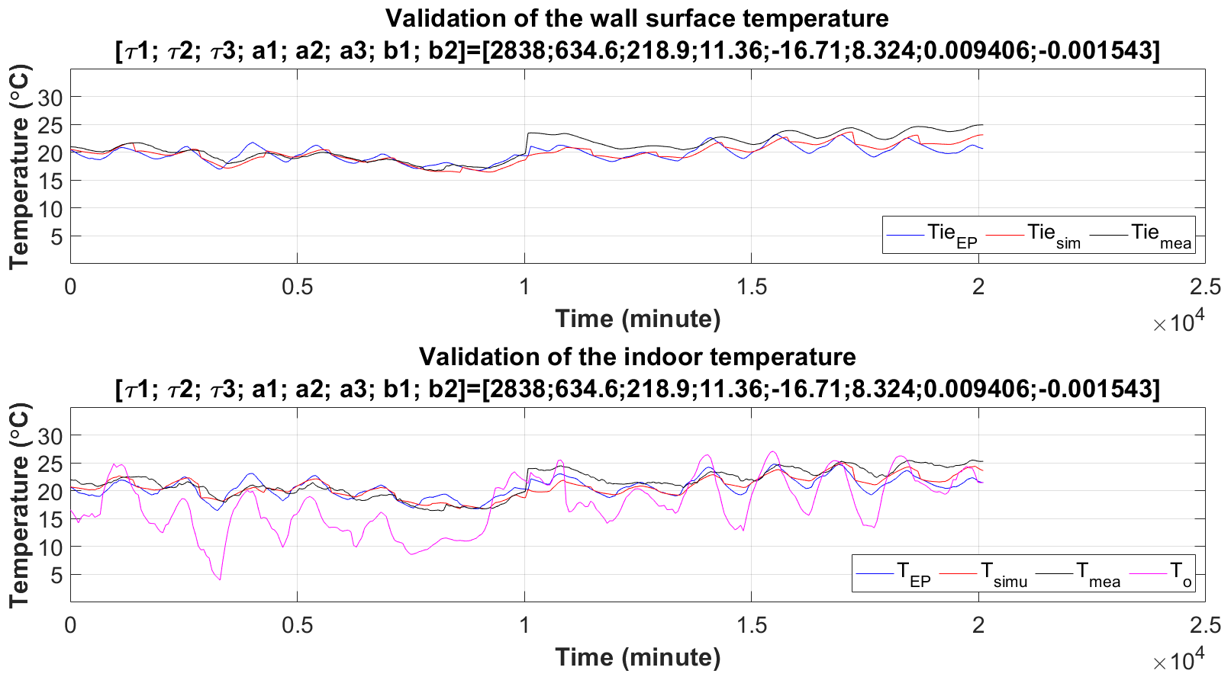
Figure 5-4 Simulation results of simplified 2R2C model based on calibrated EnergyPlus model and ASHRAE standard 90.2-2007.

5.3 Calibrated EnergyPlus model based on ASHRAE standard 90.2-2018
Similar procedures will be done in this section. According to ASHRAE standard 90.2-2018 [52], it gives the maximum values of the SHGC and U-factors as shown in Table 5-2. Based on the information listed in the table, a 2R2C model was generated and simulated. The simulation results are shown in Figure 5-5, in which the learned Tau1 value is 3575, which is higher than the two values obtained based on the ASHRAE standard 90-75 and ASHRAE standard 90-2018, respectively. Moreover, the mean and maximum absolute errors of the simulated indoor air temperature and measured ones are 0.77 °C and 2.39 °C, respectively. These results further demonstrate the accuracy of the calibrated EnergyPlus model and obtains the minimum required Tau1 value for buildings constructed by the requirements of ASHRAE standard 90.2-2018.
Table 5-2 Envelope Component Maximum SHGC and U-factors (SI) by ASHRAE 90.2-2018.
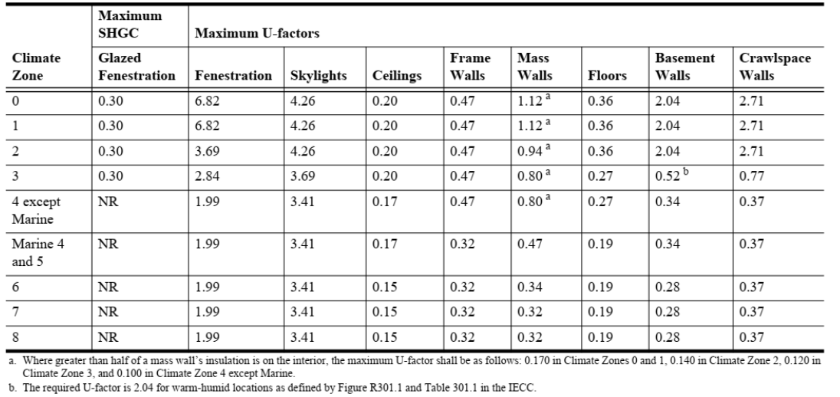
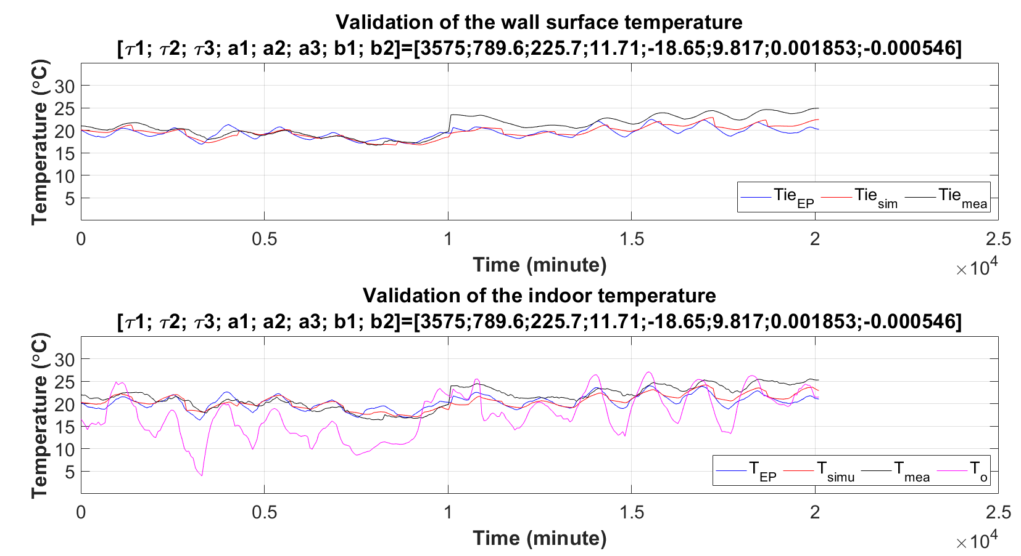
Figure 5-5 Simulation results of 2R2C model based on calibrated EnergyPlus model and ASHRAE standard 90.2-2018.

5.4 Summary
For essay observation, Table 5-3 lists the comparison of the adopted thermal properties from different years of ASHRAE standards. Obviously, as standards update, their thermal properties get improved. Moreover, Table 5-4 lists the learned Tau1 value obtained from the simplified 2R2C models that utilize the simulated data from the recalibrated EnergyPlus models and also list the comparisons of the accuracies. As observed, when the standards update, the values of Tau1 become larger. This trend is in line with expectations and makes sense in practice, which may be use for benchmark purpose. In addition, these values of Tau1 also agree with the one identified by the study using pure data-driven method [37, 38]. In summary, this chapter demonstrates the potentials of the calibrated EnergyPlus model to use for benchmarking building envelope performance evaluation for different years of buildings with the minimum thermal property requirements from ASHRAE standards.
Table 5-3 Adopted thermal properties from different years of ASHRAE standards.
Standard | ASHRAE 90-75 | ASHRAE 90.2-2007 | ASHRAE 90.2-2018
Fenestration (minR), m2-k/w | 0.20 | 0.37 | 0.35
Ceiling (minR), m2-k/w | 2.86 | 5.29 | 5.00
Mass Walls (minR), m2-k/w | 0.71 | 2.64 | 8.33
Doors (minR), m2-k/w | 2.21 | 2.21 | 2.21
SHGC (max) | 0.50 | 0.41 | 0.30

Table 5-4 Comparison of the learned Tau1 values and model accuracies.
Standard | ASHRAE 90-75 | ASHRAE 90.2-2007 | ASHRAE 90.2-2018
Learned Tau1, min | 1788 | 2838 | 3575
Mean absolute error, °C | 0.92 | 0.82 | 0.77
Maximum absolute error, °C | 3.09 | 2.69 | 2.39

Based on the Tau value obtained in this study and different years, a diagram of distribution of the relevant Tau values was create and shown in the figure 5-6. We can find that the calibrated model’s tau value (2103) should be built in 1980’s. But actually, the house is built in 1940s. Maybe the house might have some renovations. So, in the previous study, only based on age estimate is not accurate.
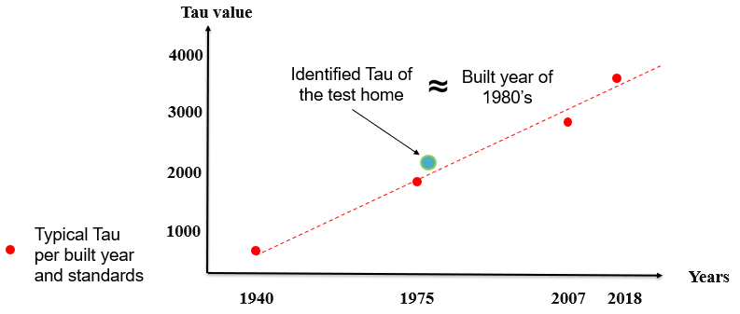
Figure 5-6 Distribution of the relevant Tau values in this study

Conclusion and Future Work
As the calibration of building energy models is complicated and sophisticated, involving extensive expert experience and time-consuming labor, this study proposes to take advantage of building thermal network models, that utilize a data-driven method as a reference in the calibration, to facilitate a quick and accurate calibration process. Specifically, this study proposes a calibration method that utilizes both EnergyPlus and simplified 2R2C models, of which the EnergyPlus models are used to generate simulated data that are utilized in the simplified 2R2C model training. Moreover, this study creates an excel dashboard, along with the the EnergyPlus and simplified 2R2C models, for the calibration process.
Compared with the uncalibrated EnergyPlus model, the new calibrated EnergyPlus model based on the learned Tau value from the simplified 2R2C model has much improvement on the accuracy of the model parameters and simulation results. Moreover, even if the accuracy of the model considering ceiling did not get much improved compared with the ones obtained from the calibrated EnergyPlus model without considering ceiling, the learned Tau value makes sense because it is much close to the physical Tau value calculated from the created dashboard. Overall, the calibrated EnergyPlus model when considering ceiling only can be used for building envelope performance evaluation.
Lastly, a benchmarking method is proposed to determine the minimum required Tau value for a specific year of a residential building envelope. That is, different years of houses need to meet the minimum thermal property requirement of residential building envelope defined by ASHRAE standards and the performance evaluation benchmarking process can be done with different values of Tau.
The outcome of this research generates the following knowledge: (1) proposing an efficient calibration method to calibrate EnergyPlus modes used for residential buildings; (2) introducing quantitative study and performance analysis of a calibration method that utilizes building thermal network models; and (3) developing benchmark method and showing investigation and analysis for building envelope performance evaluation.
There are still limitations for conducting the research questions in this study. For example, this study assumes that the EnergyPlus models are treated as calibrated when their physical model parameters are close to the parameters identified from the thermal network model trained by measured data. In addition, the temperature prediction accuracy is in an acceptable range. Thirdly, the study only considers the thermal properties of building envelope from three different years’ standards as references and does not cover the detailed and complicate scenarios when considering all residential building types. Even with the above assumptions and limitations, this study still provides an important reference and knowledge for researchers and users in the use of EnergyPlus.

References
- DOE U. S. Department of Energy, Washington DC, 2017. Available online: http://www.energy.gov.
- U.S. Energy Information Administration, Monthly Energy Review, Table 2.1, Apr 2018, preliminary data.
- Devernois, Nils. Promoting energy efficiency investments: Case studies in the residential sector. Organization for Economic, 2008.
- Sadineni, Suresh B., Srikanth Madala, and Robert F. Boehm. "Passive building energy savings: A review of building envelope components." Renewable and sustainable energy reviews 15, no. 8 (2011): 3617-3631.
- U.S. Energy Information Administration, May 12, 2022, Available online: https://www.eia.gov/tools/faqs/faq.php?id=86&t=1.
- U.S Energy Information Administration, Monthy Energy Review, March 2021. [Online]. Available: https://www.eia.gov/energyexplained/electricity/use-of-electricity.php#:~:text=Electricity%20is%20an%20essential%20part,machinery%2C%20and%20public%20transportation%20systems.
- U.S Energy Information Administration, Monthy Energy Review, Table 7.6, March 2022. preliminary data for 2021.
- U.S. Energy Information Administration, Monthly Energy Review, April 2022, Tables 1.3 and 2.1-2.6.
- U.S Energy Information Administration, Monthy Energy Review, March 2021. [Online]. Available: https://www.eia.gov/energyexplained/use-of-energy/homes.php.
- Wang, Junke, Choon Yik Tang, and Li Song. "Model-Based Home Envelope Performance Evaluation: A Use Case of Data from Connected Thermostats." ASHRAE Transactions 125, no. 2 (2019).
- ISO. 2017. Building Components and Building Elements, Thermal Resistance and Thermal Transmittance, Calculation Methods. ISO Standard 6946, International Organization for Standardization, Geneva, Switzerland.
- Nardi, I., Paoletti, D., Ambrosini, D., Rubeis, T.D. and Sfarra, S. 2016. U-Value Assessment by Infrared Thermography: A Comparison of Different Calculation.
- Wang, Junke, and P. E. Li Song PhD. "Home Envelope Performance Evaluation Using a Data Driven Method." ASHRAE Transactions 126 (2020): 713-724.
- Wang, Endong, Zhigang Shen, and Kevin Grosskopf. "Benchmarking energy performance of building envelopes through a selective residual-clustering approach using high dimensional dataset." Energy and Buildings 75 (2014): 10-22.
- Hwang, Ruey-Lung, Wen-Mei Shih, and Kuo-Tsang Huang. "Performance-rating-based approach to formulate a new envelope index for commercial buildings in perspective of energy efficiency and thermal comfort." Applied Energy 264 (2020): 114725.
- Capozzoli, Alfonso, Marco Savino Piscitelli, Francesco Neri, Daniele Grassi, and Gianluca Serale. "A novel methodology for energy performance benchmarking of buildings by means of Linear Mixed Effect Model: The case of space and DHW heating of out-patient Healthcare Centres." Applied energy 171 (2016): 592-607.
- Lee, Wai Ling, and J. Burnett. "Benchmarking energy use assessment of HK-BEAM, BREEAM and LEED." Building and environment 43, no. 11 (2008): 1882-1891.
- Marrone, Paola, Paola Gori, Francesco Asdrubali, Luca Evangelisti, Laura Calcagnini, and Gianluca Grazieschi. "Energy benchmarking in educational buildings through cluster analysis of energy retrofitting." Energies 11, no. 3 (2018): 649.
- Shabunko, V., C. M. Lim, S. Brahim, and S. Mathew. "Developing building benchmarking for Brunei Darussalam." Energy and Buildings 85 (2014): 79-85.
- Yoon, Seong-Hwan, and Cheol-Soo Park. "Objective building energy performance benchmarking using data envelopment analysis and Monte Carlo sampling." Sustainability 9, no. 5 (2017): 780.
- Wang, Endong. Addressing uncertainties in residential energy performance benchmarking and projecting through data mining approach. The University of Nebraska-Lincoln, 2013.
- Lara, Rigoberto Arambula, Emanuele Naboni, Giovanni Pernigotto, Francesca Cappelletti, Yi Zhang, Furio Barzon, Andrea Gasparella, and Piercarlo Romagnoni. "Optimization tools for building energy model calibration." Energy Procedia 111 (2017): 1060-1069.
- Royapoor, Mohammad, and Tony Roskilly. "Building model calibration using energy and environmental data." Energy and buildings 94 (2015): 109-120.
- Monetti, Valentina, Elisabeth Davin, Enrico Fabrizio, Philippe André, and Marco Filippi. "Calibration of building energy simulation models based on optimization: a case study." Energy Procedia 78 (2015): 2971-2976.
- Yuan, Jun, Victor Nian, and Bin Su. "A meta model based Bayesian approach for building energy models calibration." Energy Procedia 143 (2017): 161-166.
- Chaudhary, Gaurav, Joshua New, Jibonananda Sanyal, Piljae Im, Zheng O’Neill, and Vishal Garg. "Evaluation of “Autotune” calibration against manual calibration of building energy models." Applied energy 182 (2016): 115-134.
- Westphal, Fernando Simon, and Roberto Lamberts. "Building simulation calibration using sensitivity analysis." In Ninth International IBPSA Conference, pp. 1331-1338. 2005.
- Wang, Junke, Choon Yik Tang, Michael R. Brambley, and Li Song. "Predicting home thermal dynamics using a reduced-order model and automated real-time parameter estimation." Energy and Buildings 198 (2019): 305-317.
- Wang, Junke, Yilin Jiang, Choon Yik Tang, and Li Song. "Development and validation of a second-order thermal network model for residential buildings." Applied Energy 306 (2022): 118124.
- Wang, Junke. "Design and analysis of building thermal model for grid-interactive efficient operations." Dissertation (2020).
- O. T. Ogunsola and L. Song. Application of a Simplified Thermal Network Model for Real-Time Thermal Load Estimation. Energy and Buildings 96 (2015): 309–318.
- Wang, Junke, Choon Yik Tang, and Li Song. "Design and analysis of optimal pre-cooling in residential buildings." Energy and Buildings 216 (2020): 109951.
- Wang, Junke, Choon Yik Tang, and Li Song. "Analysis of precooling optimization for residential buildings." Applied Energy 323 (2022): 119574.
- Zeifman, Michael, and K. Roth. "Residential remote energy performance assessment: estimation of building thermal parameters using interval energy consumption data." In ACEEE Summer Study on Energy Efficiency in Buildings, pp. 1-12. 2016.
- Newsham, G. R., Y. Grinberg, A. Pardasani, and K. Bar. "Remote energy auditing: Energy efficiency through smart thermostat data and control." ECEEE Proceedings (2017).
- Siemann, Michael. Performance and applications of residential building energy grey-box models. University of Maryland, College Park, 2013.
- Crawley, Drury B., Linda K. Lawrie, Frederick C. Winkelmann, Walter F. Buhl, Y. Joe Huang, Curtis O. Pedersen, Richard K. Strand et al. "EnergyPlus: creating a new-generation building energy simulation program." Energy and buildings 33, no. 4 (2001): 319-331.
- NREL National Renewable Energy Laboratory. EnergyPlus - building energy simulation program n.d. https://energyplus.net/.
- NREL National Renewable Energy Laboratory. OpenStudio n.d. https://www.openstudio.net/.
- Trimble. SketchUp 3D modelling software n.d. http://www.sketchup.com/.
- McQuiston, Parker, and Spitler. "Heating, ventilation, and air conditioning analysis and design." Sixth edition.
- ASHRAE. 2021 ASHRAE HANDBOOK—FUNDAMENTALS.
- Oklahoma Mesonet. Mesonet Data Files. 2016. http://www.mesonet.org/index.php/weather/mesonet_data_files.
- ASHRAE Standard, Energy Conservation in New Building Design, standard 90-75, 1975.
- U. S. Energy Information Administration, Table 1.9 Heating Degree Days by Census Division, Sep. 2022.
- ASHRAE Standard, Energy-Efficient Design of Low-Rise Residential Buildings, standard 90.2, 2007.
- ASHRAE Standard, Energy-Efficient Design of Low-Rise Residential Buildings, standard 90.2, 2018.

