University of Oklahoma

Graduate College

AMERICAN INDIAN ACCESS TO HEALTH CARE SERVICES IN OKLAHOMA POST AFFORDABLE CARE ACT

A thesis

submitted to the Graduate Faculty

in partial fulfillment of the requirements for the

Degree of

Master of Arts

By

Kathalene Carden
Norman, Oklahoma
2016

AMERICAN INDIAN ACCESS TO HEALTH CARE SERVICES IN OKLAHOMA POST AFFORDABLE CARE ACT

A thesis approved for the
Department of native american studies

By

______________________________
Dr. Christopher Basaldu, Chair

______________________________
Dr. Jerry Bread

______________________________
Dr. Amanda Cobb-Greetham

© Copyright by kathalene Carden 2016
All Rights Reserved.

Table of Contents
List of Tables vii
Abstract viii
Chapter 1: Introduction 1
Purpose 3
Policy…………………………………………………………………………….4
Tribal Consultation 5
Chapter 2: History of Indian Health 7
Snyder Act of 1921 8
Indian Reorganization Act of 1934 9
Transfer Act of 1954 10
Indian Self Determination and Education Assistance Act of 1975 11
Indian Health Care Improvement Act of 1976 14
2010 Patient Protection and Affordable Care Act 15
Chapter 3: Access to Care 16
American Indian Access to Care in Oklahoma 18
Indian Health Service 20
Urban Facilities 22
Tribal Health Facilities 24
Free Clinics and Federally Qualified Health Centers 24
Direct Care and Contract Health Services 26
Chapter 4: Health Insurance 29
Health Insurance Definitions 30
Federal Health Insurance Marketplace 33
Medicaid/SoonerCare 36
Insure Oklahoma 37
Medicare 38
Shared Responsibility Payment 40
Chapter 5: Identity 43
Lineal Descent and Blood Quantum 44
Blood Quantum Issues 47
Tribal Examples 48
Muscogee (Creek) Nation 48
Chickasaw Nation 50
Cherokee Nation 50
Kickapoo Tribe of Oklahoma and Kiowa Indian Tribe 51
Facility Definitions 52
Indian Health Service 53
Other Definitions 54
The Affordable Care Act 54
The United States Census 55
Chapter 6: Oklahoma’s Future 59
Oklahoma Health Improvement Plan 59
Tribally Sponsored Insurance Premium Coverage 60
Expanding or Rebalancing Medicaid 62
Conclusion 64
References 67
Appendices 75
Appendix A: Federally Qualified Health Centers 75
Appendix B: Free and Charitable Clinics in Oklahoma 77
Appendix C: Insure Oklahoma Employee Sponsored Insurance 79
Appendix D: Insure Oklahoma Individual Plan 81
Appendix E: Preventive Services Covered Under the Affordable Care Act 83

List of Tables
Table 1. Marketplace Metal Categories 320

Abstract
The American Indian health system is difficult to navigate. American Indians have historically had a high rate of being in poverty, being uninsured, and poor access to care. Oklahomans overall also have a high uninsured rate and poor access to care. This thesis is descriptive study using literature regarding the American Indian health care system in Oklahoma post the Affordable Care Act (ACA). This thesis reviews the ACA and examines the unique American Indians aspects of the act. The ACA has had many positive impacts on American Indian insurance enrollment as well as access to care but there is much more work that needs to be done in Oklahoma in order to diminish American Indian health disparities.

Chapter 1: Introduction
Health care is something that everyone will need at some point in their life. Unfortunately, the health care system is tedious and takes a high level of knowledge and skill to navigate. Individuals are expected to be able to pay for health care as well as health insurance. In 2015, Oklahoma had an overall poverty rate of 16.1% with this number being 23.1% for American Indians. Being in poverty can significantly affect an individual’s ability to purchase health insurance. Having health insurance is a significant predictor in overall health. According to Kaiser Family Foundation,
Health insurance makes a difference in whether and when people get necessary medical care, where they get their care, and ultimately, how healthy people are. Uninsured adults are far more likely than those with insurance to postpone or forgo health care altogether. The consequences can be severe, particularly when preventable conditions go undetected.

Indian Health Service (IHS) states that American Indians “have long experienced lower health status when compared with other Americans.” Possible reasons for the existence of these health disparities include “inadequate education, disproportionate poverty, discrimination in the delivery of health services, and cultural differences.” American Indians are dying before non-Indian counterparts with 4.4 less years of life. Oklahoma has an extensive network of agencies and providers striving to eliminate the health disparities in the American Indian population but the gap still exists. Disparities among the American Indian population include “chronic liver disease and cirrhosis, diabetes mellitus, unintentional injuries, assault/homicide, intentional self-harm/suicide, and chronic lower respiratory diseases.” Indian health facilities in Oklahoma are capable of seeing American Indian people at any income level, with or without insurance. In 2011, 17% of Oklahomans were uninsured (578,336). As of 2011, 36 percent of American Indians in Oklahoma or were uninsured, compared with the national rate of 30 percent. Oklahoma has consistently stayed at the lower end on national health rankings, in 2014 ranking 49th in overall health. With the current budget of the state looking bleak Oklahoma is currently looking for innovative ways to improve the state’s health. Oklahoma’s population is significantly rural with approximately 33% of the state living outside of the urban cities. Oklahoma has a large American Indian population with 9.1 percent of Oklahomans self-identifying as American Indian. The ACA was enacted in 2010 and since then there have been major strides in both American Indian health care as well as an increase in the American Indian insured rate.

Purpose
This thesis will examine the unique health care system in Oklahoma for American Indians, options for accessing care, and explore how identity impacts access to services. This thesis explores the hypothesis that the Patient Protection and Affordable Care Act (ACA) has improved access to care for American Indians in Oklahoma but more work is needed to eliminate health disparities and create adequate access to care. This thesis is a descriptive study using literature relevant to health care of American Indians and access to care in Oklahoma. Due to the complexity of the American Indian health care system in Oklahoma, many individuals have difficulty navigating and accessing care. In order to understand the complex nature of American Indian health this thesis will give a brief review of the history of the American Indian health system to establish background. This thesis will also discuss the differences in accessing care for both the insured versus the uninsured American Indian population in Oklahoma. After establishing background all resources are post ACA. This thesis will discuss basics of insurance coverage options in Oklahoma for American Indians. There will be an exploration of the concept of American Indian identity and how identity affects access to health programs and services. For this thesis I use the term American Indian when referring to any citizen of any federally recognized tribe or Alaskan Native. Some direct quotes will use AI/AN when referring to the same group. This thesis will provide the basics of accessing care in Oklahoma which can be built upon to create an easy resource to help American Indians navigate the Oklahoma health care system in order to address disparities in health care and high uninsured rates.

Policy
In order for Oklahoman’s to have better access to health care Oklahoma needs to adopt health laws and policies that will benefit everyone in the state. It is important to consider the implication’s to health care when creating or changing all policies, laws, regulations, procedures, and voluntary practices and this is something that tribal consultation is ensuring. Policy is behind every major shift in health care whether it is the creation of IHS, enactment of the ACA, to tobacco control policies. Health policy can vary from national to state level and also from state to state. Health policy can have many different faces and could often time be disguised behind seemingly unrelated policies. The health care system in the United States is a result of numerous policies, laws, and treaties that have been ongoing since settler contact with tribes. American Indians need to have their voices heard rather than having non-Indians make decisions without tribal input. The next section will discuss how tribes in Oklahoma participate in consultation to ensure both their voice and their tribal citizens best interest are heard when creating policy.

Tribal Consultation
Tribal consultation occurs at both the state and national level. “Tribal consultation is an enhanced form of communication that emphasizes trust, respect, and shared responsibility. It is an open and free exchange of information and opinion among parties, which leads to mutual understanding and comprehension.” President Obama issued a Presidential Memorandum on November 9, 2009 which required agencies to engage in tribal consultation and collaboration with tribal officials. Tribal consultation should be ongoing in order “to establish and maintain a positive government-to-government relationship.” Consultation gives tribes the “opportunity to provide meaningful and timely input on issues that may have a substantial direct effect on them.” State agencies including Oklahoma Health Care Authority, Oklahoma State Department of Health, Oklahoma Department of Mental Health and Substance Abuse Services are some of the agencies that rely on tribes and tribal organizations for feedback on how rules and policies could impact American Indians across the state. Tribal consultation policies allow input to be received before implementing new rules that will potentially affect tribes or tribal citizens. Tribal citizens in Oklahoma need to urge their tribal representatives to attend these consultations and make sure their voices are heard. Some agencies have open tribal consultations and anyone is welcome to come and provide input. Although some meetings are open to the public, it is important that valid individuals are speaking on behalf of tribes and tribal citizens. Tribal consultation has been created and enforced due to policies instituted by numerous agencies. The history of American Indian health care can be traced back to the numerous treaties with tribes after European contact. The next chapter will look deeper into the history of American Indian health care.

Chapter 2: History of Indian Health
Numerous treaties and executive orders between American Indian tribes and the Unites States government guarantee health care for American Indians. These treaties were confirmed in the Constitution of the United States under the Supremacy Clause and reinforced in court cases such as Cherokee Nation v Georgia. ”The federal government has a trust responsibility to provide health care for American Indians and Alaska Natives, based on multiple treaties, court decisions, and legislative acts.” “The federal Indian trust responsibility is a legal obligation under which the government “has charged itself with moral obligations of the highest responsibility and trust” toward Indian tribes.” According to Moss, the “last treaty between the United States and Indians was signed on March 3, 1871.” U.S. Code, Title 25 § 71 states:
No Indian nation or tribe within the territory of the United States shall be acknowledged or recognized as an independent nation, tribe, or power with whom the United States may contract by treaty; but no obligation of any treaty lawfully made and ratified with any such Indian nation or tribe prior to March 3, 1871, shall be hereby invalidated or impaired.
This means there will be no more treaties made with Indian tribes. According to Moss, tribes are no longer viewed as sovereign nations but more of partial or quasi-sovereign nations. Even with this quasi-sovereign status the Federal government still must honor its trust responsibility and provide health care for American Indians. Some acts that had a significant impact on American Indian health include the Snyder Act, Transfer Act, Indian Self Determination and Education Assistance Act, and the Indian Health Care Improvement Act. Through all of these acts, we can perceive the evolution of American Indian health care. The American Indian health care system has come a long ways but has become very complex. The next sections will go through these individual acts and show how tribes have used policy to take charge of the health of their citizens.

Snyder Act of 1921
The Snyder Act of 1921 was crucial to the development of the American Indian health system as we know it. According to Warne and Frizzell, the Snyder Act of 1921 (Public Law 67-85) “was the ﬁrst law that allowed Congress to appropriate funds to address AI/AN health on a recurring basis.” The Snyder Act states
The Bureau of Indian Affairs, under the supervision of the Secretary of the Interior, shall direct, supervise, and expend such moneys as Congress may from time to time appropriate, for the benefit, care, and assistance of the Indians throughout the United States for the following purposes: General support and civilization, including education. For relief of distress and conservation of health.
The Snyder Act established a reference for who is to be considered an Indian and considered eligible to receive services, stating “Indians throughout the United States.” This act was later used as basis in the court case Morton v. Ruiz, which “determined that reasonable classification and eligibility requirements could be created in order to allocate limited funds.” This is important because the court recognized the problem with the limited funding to Indian health facilities and created a ruling that would allow for allocating of those funds with the creation or eligibility requirements. According to IHS the Snyder Act “was never superseded, authority only transferred and expanded.”

Indian Reorganization Act of 1934
The Indian Reorganization Act of 1934 also known as the Wheeler-Howard Act “authorizes tribes to form constitutional governments and create business entities, and authorizes the Bureau of Indian Affairs to provide loans and other benefits for individuals defined as “Indian.”” The act “aimed at decreasing federal control of American Indian affairs and increasing Indian self-government and responsibility.” The Indian Reorganization Act required tribes move away from traditional forms of “tribal organization (systems of kinship, clan, and community) and traditional consensus-based approaches to decision making” and move toward U.S.-style governance, Another issue which arose out of the enactment of the Indian Reorganization Act was that many of the constitutions adopted consisted of blood quantum requirements for tribal membership. Tribal constitutions were required to be approved by both “tribal membership and the secretary of the interior.” As we will discuss later, requiring blood quantum is a way to diminish the number of tribal citizens and ultimately eliminate tribes. Limiting citizenship results in a reduced number of individuals eligible to receive services such as health care. This act “remains the basis of federal legislation concerning Indian Affairs.”

Transfer Act of 1954
The Transfer Act of 1954 “transferred responsibility for Indian health care from the Bureau of Indian Affairs in the U.S. Department of the Interior to the Public Health Service in what is now the U.S. Department of Health and Human Services, creating IHS in 1955.” The Transfer Act also included permissions that “with the consent of the Indian people served, to contract with private or other non-Federal health agencies or organizations for the provision of health services to such people on a fee-for-service-basis or on a prepayment or other similar basis.” According to IHS the Transfer Act “was the beginning of specific directives on how such health care services were to be provided. i.e., through the construction of facilities.” This Transfer Act made way for the Indian Self-Determination and Education Assistance Act of 1975 which according to Warne and Frizzell is “the most significant law affecting how health services are provided to AI/AN tribes.”

Indian Self Determination and Education Assistance Act of 1975
The Indian Self Determination and Education Assistance Act of 1975 (Public Law 93-638) was “designed to expedite transfer of the administration of federal programs that benefit Indian people to Indian tribal governments.” This act along with the programs attached to it are often referred to as “638” because it is Public Law 93-638. This act
gives tribes the right to assume the responsibility, and associated funding, to carry out programs, functions, services and activities (PFSAs) that the United States government would otherwise be obliged to provide to Indians and Alaska Natives. Examples of such services include healthcare, education, road construction, and social services.
The Indian Self Determination and Education Assistance Act allowed tribes to take over the “control of programming with federal monies that would have gone to IHS provided care.”
According to IHS the Indian Self Determination and Education Assistance Act gave tribes two options. Tribes could choose to administer and operate their own PSFA’s or continue to have health services provided by “IHS-administered, direct-care health system.” There have been numerous revisions since the act was originally passed in 1975. The 1988 Amendments included the removal of many “administrative and practical barriers” as well as authorizing “the initial Self-Governance Demonstration Project” for the Department of the Interior. This demonstration project was a success and in a 1992 amendments it was extended to Indian Health Service. “In 1994 the IHS Tribal Self-Governance Demonstration Project was extended to 18 years, with authority to add 30 tribes per fiscal year (Pub. L. No. 103-435). In 1996, the Tribal Self-Governance Advisory Committee (TSGAC) was created to provide advice to the Director of IHS” as well as to assist “on issues and concerns pertaining to Tribal Self-Governance and the implementation of the self-governance authority within the IHS.” “In 2000, Congress passed the Tribal Self-Governance Amendments (Public Law 106-260) to create Title V of the ISDEAA and authorize the IHS Tribal Self-Governance Program (TSGP) (25 U.S.C. § 458aaa et seq.; 42 C.F.R. Part 137).” Through the TSGP, Tribes have the option to assume IHS program funds and manage them to best fit the needs of their Tribal communities. Tribes participating in the TSGP have the ability to choose which portions of TSGP they would like to control.
The ISDEAA which lead to the authorization of TSGP is the mechanisms through which tribes can take control of their own health care if they desire. According to IHS as of December 2011 there were “337 Tribes are participating in the TSGP” which is approximately 60% of tribes in the United States. Tribes can go through one of three options or even a hybrid of the options when participating in TSGP; they are as follows:
1. Continue to receive health care services offered by the IHS to American Indians and Alaska Natives. 2. Use the authority of the Indian Self-Determination and Education Assistance Act (ISDEAA), Titles I and V, to assume responsibility for health care formerly offered by the federal government. Tribes may contract with the IHS through self-determination contracts and annual funding agreements under Title I or self-governance compacts and funding agreements under Title V. 3. Fund the establishment of their own programs or supplementation of ISDEAA programs.
There are positives and negatives to each of these acts. Some tribes did not choose to take over their health programs. One concern is that if all tribes took self-determination then the federal responsibility to provide health care could end. As you can see many tribes have chosen to take charge of their health care by utilizing the Indian Self-Determination and Education Assistance Act.

Indian Health Care Improvement Act of 1976
The Indian Health Care Improvement Act allowed Indian Health Service to supplement funding by billing both Medicare and Medicaid for services provided their beneficiaries., In 1988 amendments were added so IHS could also receive reimbursement from private insurance companies. This act was crucial because it allowed IHS to seek additional revenue sources to fill their budget gap. The act also recognized “the relationship between the federal government and the American Indian people, and the need to eradicate the severe health inequalities experienced by AI/ANs.” This act also authorized funding for urban Indian health programs and allowed urban programs to contract with IHS.

2010 Patient Protection and Affordable Care Act
One of the most important acts in regard to the current state of health care is the 2010 Patient Protection and Affordable Care Act (ACA). One of the largest impacts on American Indian health of the ACA was the permanent reauthorization of the Indian Health Care Improvement Act of 1976. The ACA added new “Indian-specific provisions and reforms” with positive outcomes for American Indian people. The ACA created protections for American Indians such as being able to enroll on the newly created Marketplace any time of the year, as well as cost sharing exemptions, and access to tax credits for enhanced affordability. This thesis will focus on the ACA and its impact on American Indians in Oklahoma when seeking care and services. Overall the ACA is creating opportunities for coverage that did not exist prior to the ACA but there is still room for improvement.

Chapter 3: Access to Care
As the previous chapter discussed, United States policy has created a unique structure for American Indian health care. This structure is actually the “complex merging of federal, state, and tribal laws and programs.” Moss states “Navigating the health care system for anyone in the United States can be daunting, but even more so for its indigenous population.” Access to care is a problem that exists all over the world. “Access to affordable, quality health care is important to physical, social, and mental health.” “Access to comprehensive, quality health care services is important for the achievement of health equity and for increasing the quality of a healthy life for everyone.” Four basic components that impact access to care include coverage, services, timeliness, and workforce. These four components are also a large barrier when accessing the health care system. Individuals without health insurance are “less likely to receive medical care, more likely to die early, and more likely to have poor health status.” As we discussed early American Indians in Oklahoma have a 36% rate of being uninsured. Access to services such as primary care is another barrier. Receiving primary care and having a primary care provider (PCP) are important aspects in improving health services. Primary care providers are able to gain valuable rapport with patients and “diagnose and treat common illnesses and spot minor health problems before they become serious.” It is important for individuals to have a PCPs and receive regular health care. Timeliness includes “time spent waiting in doctors' offices and emergency departments (EDs)” as well as “time between identifying a need for specific tests and treatments and actually receiving those services.” It is no secret that wait times at any doctor’s office can be almost unbearable but when seeking care at an Indian Health facility, wait times can be exasperated by understaffing. Lastly, workforce plays a significant role especially in rural Oklahoma. Having enough PCP’s to serve the population plays into all points of access to care. Without enough PCP’s access to care can easily become a crisis. Oklahoma is currently 48th in the nation for our number of primary care physicians.” In Oklahoma we have 85.2 primary care physicians per 100,000 population. The national average is 127.2 primary care physicians per 100,000 population. JeVonna Caine of the Oklahoma Policy Institute stated, that rising insurance enrollment due to the ACA is causing the uninsured rate to decrease which means there is an “impending increase in the demand for primary care services.” American Indians are enrolling in the Marketplace and the revenue is coming back into tribal facilities. In 2014 alone, IHS was able to gain an additional 49 million dollars in revenue by providing care to patients who enrolled through the ACA.

American Indian Access to Care in Oklahoma
In Oklahoma, American Indians have numerous options when seeking health care. Oklahoma has three different kinds of Indian Health facilities available to American Indians. American Indians have access to Indian Health Service (IHS) facilities, tribal facilities, and urban facilities. Together IHS facilities, tribal facilities, and urban facilities are often referred to as I/T/Us. These facilities are similar in the fact that they see American Indian individuals, although they might have different eligibility requirements in order to receive services. Certificate Degree of Indian Blood (CDIB) cards are important for individuals to provide I/T/Us when seeking care. “Most Indian health facilities will require each person to provide a CDIB card, and some tribal facilities may require only a tribal enrollment card or proof of eligibility for a CDIB card.” There are many individuals who have American Indian ancestry but lack membership in any tribe and are unable to qualify for either enrollment in a tribe or a CDIB. Individuals fall into an identity gap where they may self-identify as American Indian but cannot prove ancestry. This is a direct result of United States policy which made tribes create membership qualifications. According to Moss these individuals “have much of the same genetics, and biological tendencies” as enrolled American Indians. They are susceptible to the same health disparities but could have a larger gap in access to care because in many cases they are unable to access I/T/Us. Moss states that “being American Indian in the United States is primarily a political designation over racial and ethnic identifications.” This political designation is what creates access to I/T/Us without it these individuals fall into the non-Indian uninsured gap.
One of the easiest ways to find an I/T/U in Oklahoma is to go to https://www.ihs.gov/findhealthcare/ at this website an individual can enter their address and state whether or not they are looking for a hospital, health center, dental clinic, or behavioral health facility. Individuals can also say if they would like tribal and urban health facilities included in their search. Then click “view table of the search results for a comprehensive list of local facilities. This list includes the facility name, available services, address, and phone number of the facilities as well as links to their individual website if available.
American Indians are not limited to receiving care at I/T/Us. American Indians can also receive care at any facility who either takes their insurance or that the individual can negotiate payment with. In the event of an emergency they may also seek care at an emergency department. The Emergency Medical Treatment and Labor Act of 1986 protects individuals and ensures “public access to emergency services regardless of ability to pay.” Many Indian health hospitals also operate their own emergency department. Even though American Indians have access to facilities outside of I/T/Us some may prefer to receive care from an I/T/U because of their cultural sensitivity. Moss states “American Indians do not all look a certain way, and cannot always be identified through appearance.” When receiving care at an I/T/U the care provided is usually more culturally sensitive, with providers having more knowledge about American Indian culture.

Indian Health Service
As discussed previously the Indian Health Service has gone through many changes since its inception. IHS currently falls under the Department of Health and Human Services (HHS) and “is responsible for providing federal health services to American Indians and Alaskan Natives” IHS does this by providing a comprehensive health delivery system. IHS states they are the “principal federal health care provider and health advocate for Indian people.” Their goals align with the Indian Health Care Improvement Act and are to raise the health of American Indians to the highest possible level.
According to IHS they serve 2.2 million American Indians, have 12 area offices, and serve 567 federally recognized tribes. Oklahoma IHS facilities fall under the service of the Oklahoma City Area Office of Indian Health Service and fall into one of 8 Service Units. There are ten IHS facilities in Oklahoma. Facilities administrated by the IHS in Oklahoma include the following: Anadarko Indian Health Center, Carnegie Indian Health Center, Claremore Indian Hospital, Clinton Indian Health Center, El Reno Indian Health Center, Lawton Indian Hospital, Oklahoma City Area Office (Telemedicine Site), Pawnee Indian Health Center, Watonga Indian Health Center, and Wewoka Indian Health Center.

Urban Facilities
Individuals can also seek care from urban Indian health centers (urban). There are two urban clinics in Oklahoma, one in Oklahoma City and one in Tulsa. Urban facilities are outpatient facilities and are “owned or leased by Urban Indian organizations”. The two urban facilities are Oklahoma City Indian Clinic (OKCIC), and the Indian Health Care Resource Center of Tulsa (IHCRC).
OKCIC is located in Oklahoma City, their mission is “providing excellent health care to American Indians” and vision statement “to be the national model for American Indian health care.” In 2015 the OKCIC served patients from 191 different tribes. The majority of patients served are uninsured (52%) and 20% have Medicaid.
OKCIC is a contractor of the Indian Health Service to provide culturally sensitive health and wellness services from talented and devoted providers. From pediatric and prenatal care to family medicine, OKCIC services not only included basic medical care, but also dental, optometry, behavioral health services, fitness, nutrition and other family programs.
Indian Heath Care Resource Center of Tulsa opened in 1976. IHCRC will see “any person with a certificate of degree of Indian blood (CDIB) card.” “Their mission is to provide quality, comprehensive health care to Tulsa-area Indian people in a culturally sensitive manner that promotes good health, well being and harmony.” Their vision “is to eliminate health disparities, expand innovative family-focused practices and promote an embracing approach to care that strengthens physical, mental, emotional and spiritual wellness within the Indian community.” In 2015, IHCRC served more than 10,500 individuals that represented 142 federally recognized tribes. Of those individuals 72 percent were uninsured and 37 percent had Medicare or Medicaid. The IHCRC
Offers a full range of health and wellness services tailored to the Indian community. Services include: Medical, Optometry, Dental, Pharmacy, Transportation, Behavioral Health, Health Education and Wellness, Substance Abuse Treatment and Prevention, and Youth Programs focused on traditions, health, and leadership skills.

Tribal Health Facilities
Another option is to seek care from tribal health facilities. There are 38 tribal health facilities in Oklahoma run by various tribes. Many tribes will see members of any tribe at their facility but some tribes may only provide services to their members. Therefore, it is important to check individual facility requirements. Tribal facilities range from “large scale hospitals to the smaller preventive care programs and behavior health programs.”

Free Clinics and Federally Qualified Health Centers
Some American Indians lack proof of American Indian status, they are unable to qualify for a CDIB or attain tribal enrollment. There are options for health care for these individuals without health insurance. They can seek care from free clinics and federally qualified health centers (FQHCs). Oklahoma has a total of 84 free clinics, this number includes “primary, mental, pharmacy, or dental health clinics that serve patients at no-cost.” The full list of free and charitable clinics can be found in appendix A. The uninsured with no access to I/T/Us may also go to an FQHC. “FQHCs must serve an underserved area or population, offer a sliding fee scale, provide comprehensive services, have an ongoing quality assurance program, and have a governing board of directors.” “FQHCS are non-profit organizations or public entities that receive grants under Section 330 of the Public Health Service Act. They are a critical safety net for Oklahoma's uninsured population, as they provide comprehensive primary care regardless of a patient's ability to pay.” Facilities that qualify as FQHCs receive “enhanced reimbursement from Medicare and Medicaid, as well as other benefits.” Oklahoma has a total of 20 primary FQHCs with 88 delivery sites. Services available vary from facility to facility, in addition to medical services some additional services might include “oral health, behavioral health, substance abuse services, and non-clinical enabling services.” A comprehensive list of FQHCs in Oklahoma can be found in appendix B.

Direct Care and Contract Health Services
When seeking care at an IHS facilities is important to know the difference between direct services and contract health services also known as Purchased/Referred Care provided by facilities. According to IHS “direct health care services are services provided at an IHS facility. Contract Health Services (CHS) are services that the IHS is unable to provide in its own facilities. CHS are provided by non-IHS health care providers and facilities.” IHS funding is far from complete (at an estimated 60% of health care need) and therefore CHS are not guaranteed. To be eligible for CHS an individual must meet the following criteria:
1. Be eligible for direct care as defined in 42 CFR §136.12;
2. Reside within the U.S. on a Federally-Recognized Indian reservation; or
3. Reside within a CHSDA and;
4. Be a member of the Tribe or Tribes located on that reservation; or
5. Maintain close economic and social ties with that Tribe or Tribes.
IHS allocates a capped amount of funding to tribes and when all of the funding is allocated they cannot receive additional funding. “CHS payments are authorized based on clearly defined guidelines and are subject to availability of funds.” Individuals given a referral for CHS could be denied because of lack of funding and or not meeting the guidelines. For example the Kickapoo Tribe of Oklahoma states that “Request for CHS are reviewed weekly and ranked according to relative medical priority. Requests are approved for CHS payment to the extent of available resources for the review period.” If any individual has insurance that can help them get necessary services when referred out of the Indian health care system. Many tribes require individuals seeking care to exhaust all alternate resources before CHS funds will be used. Examples of alternate resources include Medicaid, Medicare, Worker’s Compensations, Auto Insurance, etc. In 2014 I/T/Us in Oklahoma had more than “56,000 unmet Purchased and Referred Care claims that accounted for tens of millions of dollars necessary-but not provided-specialty care.” When discussing CHS in many other states an individual must reside in a Contract Health Service Delivery Area (CHSDA) in order to be eligible for CHS. It is important to note that Oklahoma is unique because the entire state is considered a CHSDA.
As discussed, being referred out for services can be difficult with the limited budget most Indian health facilities are allotted. Having insurance is a way to ensure access to services outside of Indian health. When obtaining health insurance it can be hard to know where to start. The next chapter will discuss different options for obtaining health insurance in Oklahoma as well as the shared responsibility payment for those individuals who do not have health insurance.

Chapter 4: Health Insurance
Even though American Indians have access to I/T/Us it is still important for them to consider having insurance. Insurance will allow individuals to see more providers and have greater access to care. If individuals have insurance, the facility can save their funds if the patient is referred out for services. This will free up contract health funds for individuals who do not have health insurance to the receive care. This is a way for the I/T/U to care for more individuals. Insurance reimbursement is very important considering I/T/U funding is based on a limited budget.
Individuals can acquire insurance in multiple ways. Some options to get health insurance in Oklahoma are through employers, on the Federal Health Insurance Marketplace, Medicaid, Medicare, Insure Oklahoma, through insurance companies, online health insurance sellers, or through an insurance agent or broker. When deciding on different insurance plans it is important to consider a number of factors. Some factors to consider include the following: What is the deductible? What is the maximum out of pocket? How often does the individuals go to the doctor? Does the plan meet minimum essential coverage? Insurance can help by limiting medical costs and paying for services. Insurance provides protection from having to pay for medical care out of pocket (once deductible is met). Unpaid medical bills can go to collection if unpaid and negatively impact credit scores. With insurance individuals pay a monthly premium, depending on the plan the copay and deductible will vary. Insurance can help pay for normal doctors’ visits, preventive care, surgery or hospitalization.
Having insurance can also help pay for prescription drugs. To find out what drugs are covered under an insurance plan the individual should visit the insurer’s website, refer to their summary of benefits and coverage, call their insurer, or review any materials that might have been mailed to them. Individuals with private insurance coverage or Medicare or Medicaid can still visit the website or call directly to find out which medications are covered.

Health Insurance Definitions
Health insurance can be very confusing even for individuals who have had health insurance for many years. Health insurance companies use many terms individuals may not be familiar with. In this section I will define some of the common terms used throughout this thesis, and terms that are common when acquiring health insurance.
A premium is the cost of the plan usually paid monthly. Cost sharing is defined as "the share of costs covered by your insurance company that you pay out of your own pocket.” Cost sharing generally includes deductibles, coinsurance, and copayments, or similar charges, but it doesn't include premiums, balance billing amounts for non-network providers, or the cost of non-covered services." “Health savings accounts (HSAs) are like personal savings accounts, but the money in them is used to pay for health care expenses. You not your employer or insurance company own and control the money in your HSA.” HSAs are only allowed with a high-deductible insurance plan. High-deductible insurance plans usually also have a combined annual deductible for both health care and prescription drugs. Therefore, insurance will not kick in to help pay until the deductible is met.
Two main types of insurance plans are Fee-for-Service (FFS) plans or Managed Care plans. In FFS plans providers are paid “a fee for each service (office visits, test, procedure, or other health care service; the amount the plan pays is dependent upon established fee schedule.” Managed Care plans “generally provide comprehensive health services to their members and offer financial incentives for patients to use the providers who belong to the plan.” Two popular managed care plans are Preferred provider organization (PPO) plans and Health Maintenance Organization (HMO) plans. They are both defined below:
PPO: A network of selected health care providers (such as hospitals and physicians) working for specific health insurance company. The enrollees may go outside the network but would incur larger costs in the form of higher deductibles, higher coinsurance rates, or non-discounted charges from the providers.

HMO: A health care system that assumes both the financial risks associated with providing comprehensive medical services (insurance and service risk) and the responsibility for health care delivery in a particular geographic area to HMO members, usually in return for a fixed, prepaid fee. Financial risk may be shared with the providers participating in the HMO. Restrictions on physician, hospital, and ancillary services. A primary care physician must provide referrals for specialty care. Preapprovals are necessary for procedures and tests in order to be covered by HMO.

It is important to know the difference in health insurance plans because each insurance plan can vary by what providers the members can utilize as well as what portion of the services insurance will cover.
The Marketplace has various types of insurance plans. The Marketplace separates its plans into four separate categories. The table below describes the difference in plan categories comparing monthly premiums, costs member pays and cost the plan pays. It is important to consider all of these factors when choosing a plan on the Marketplace.

Table 1. Marketplace Metal Categories
Approximate Costs | Bronze Plan | Silver Plan | Gold Plan | Platinum Plan
Monthly Premium | $ | $$ | $$$ | $$$$
Cost You Pay | $$$$ | $$$ | $$ | $
Cost Plan Pays | 60% | 70% | 80% | 90%
Source: “Metal Categories,” MNSure, accessed November 28, 2016, https://www.mnsure.org/shop-compare/about-plans/plan-types-costs/metals.jsp.

Two more definitions that are important when learning about health insurance is the term minimum essential coverage which is referring to health insurance plans that meet the ACA requirements for minimal essential coverage, if the plan does not meet the requirements individuals will receive a penalty. The final term is premium tax credit. A premium tax credit is a tax credit which can be used for individuals to lower their monthly premium. The amount is based on both income and household information.

Federal Health Insurance Marketplace
The Federal Health Insurance Marketplace (Marketplace) is a place where individuals can easily enroll in a private health insurance plan. The application on the Marketplace will also check eligibility for Medicaid and the Children's Health Insurance Program. When purchasing health insurance on the Marketplace American Indians have certain provisions which were included in the ACA. The American Indian specific provisions address "inequities and increases access to quality, affordable health coverage, invests in prevention and wellness, and gives American Indian and Alaskan Native individuals and families more control over their care." The enactment of the ACA created the Marketplace. Some states elected to make their own marketplace but Oklahoma did not. The federal marketplace can be found at HealthCare.gov. This is where individuals in Oklahoma can go and "compare health insurance options" "based on price, benefits, quality, and other factors with a clear picture of premiums and cost-sharing amounts to help them choose the insurance that best fits their needs." “All American Indian plans on the Marketplace have either zero or limited cost-sharing for plans at any level.” Special protections for American Indians who are members of federally recognized tribes include the following:
While you are not exempt from paying monthly premiums, you may be able to get lower premium costs based on your income. Eligibility for lower costs depends on your income, family size, and whether you have access to other health coverage.
Members of federally recognized tribes or Alaska Native Claims Settlement Act (ANCSA) corporation shareholders with a household income between 100% and 300% of the federal poverty level (between $24,250 and $72,750 for a family of 4 in 2015, or between $30,320 and $90,960 for the same family in Alaska) won’t have any out-of-pocket costs like copayments, coinsurance, or deductibles for services covered by their Marketplace health plan.
If you’re a member of a federally recognized tribe or an ANCSA shareholder, you’re eligible for monthly special enrollment periods. If it’s outside the open enrollment period, you can still enroll in (or change) a health plan once per month in order to find a health plan that meets your needs.
Regardless of income, tribal members or ANCSA shareholders who enroll in a Marketplace health plan won’t have any out-of-pocket costs such as copayments, coinsurance, or deductibles for items or services provided by an Indian Health Care Provider or through Purchased and Referred Care.
This means individuals with an income below 300% of the federal poverty level do not have to “pay for care from either and Indian health care provider or a non-Indian health care provider” when in network. They will also not “need a referral from and Indian health care provider to get zero cost-sharing from a non-Indian health care provider or to fill a prescription at and outside pharmacy.” If an individual does not qualify for zero cost-sharing, limited cost-sharing plans are available. Limited cost-sharing means individuals will not “pay for care from an Indian health care provider or with a referral from and Indian health care provider”. They will also not pay “for prescriptions at an Indian health care provider or with a referral from an Indian health care provider.” The main difference is individuals will need a referral when seeking care or prescriptions outside of an Indian health care provider in order to not have to pay. With both zero cost-sharing and limited cost-sharing plans individuals must stay within your insurance plan’s network and you must apply through the marketplace. American Indians can also enroll anytime not just within the enrollment period.

Medicaid/SoonerCare
When applying on the marketplace you may be told you qualify for Medicaid. “Medicaid is a joint federal and state program that helps with medical costs for some people with limited income and resources.” In Oklahoma the Medicaid program is run by the Oklahoma Health Care Authority and is referred to as SoonerCare. SoonerCare determines eligibility based on Modified Adjusted Gross Income (MAGI). There is no premium for individuals who qualify for SoonerCare. The majority of individuals who are covered by SoonerCare are pregnant women and children. SoonerCare also covers the aged, blind, and disabled population. Aged, blind, and disabled individuals must apply for benefits through the Oklahoma Department of Human Services (DHS). “The Children's Health Insurance Program (CHIP) serves uninsured children up to age 19 in families with incomes too high to qualify them for Medicaid.” The CHIP program in Oklahoma is also run by the Oklahoma Health Care Authority. Individuals who qualify for SoonerCare are immediately eligible for SoonerCare services. American Indian SoonerCare members may see one of the 48,224 SoonerCare providers throughout the state or receive care from any I/T/U that is contracted with SoonerCare. To find the most current list you can go to okhca.org/tribalrelations.

Insure Oklahoma
Insure Oklahoma is another option for health coverage for those in Oklahoma. “Insure Oklahoma is designed and intended to assist in the purchase of health coverage.” Insure Oklahoma is “state-sponsored health insurance coverage for low to middle-income working adults.” The program is comprised of an employer sponsored plan (ESI) and an individual plan (IP). Insure Oklahoma is also ran by the Oklahoma Health Care Authority, individuals can apply online through the same site for SoonerCare enrollment which is mysoonercare.org. The qualifications for both of these programs vary and can be viewed in appendix C and appendix D. ESI is for businesses in Oklahoma with less than 250 employees and for the employee to qualify they must be able to pay up to 15% of the premium. The IP program has various qualifying groups and in order to qualify you must fall into one of the four categories listed below
Group one- Working adults who do not qualify for an Insure Oklahoma employer-sponsored Qualified Health Plan, and work for an Oklahoma business with 250 or fewer employees (or self-employed)
Group two- Temporarily unemployed adults who qualify to receive unemployment benefits through the Oklahoma Employment Security Commission (OESC)
Group three- Working adults with disability who work for any size employer and have a Ticket-to-Work
Group four- College students ages 19-22.
For both plans you must be an Oklahoma resident, be between the ages of 19 and 64, and meet the plans income requirements., For IP you also must not be enrolled in Medicare or SoonerCare (Medicaid) or any other commercial health plan. Both ESI and IP are unique plans because the person covered does not have to pay the full amount of the premium because the state will cover a portion. With both plans the individual will have a monthly premium, on IP it will not exceed 4% of their monthly gross household income and with ESI it will not exceed 3% of their annual household income.,

Medicare
Medicare is also an option for coverage. “Medicare is the federal health insurance program for people who are 65 or older, certain younger people with disabilities, and people with End-Stage Renal Disease (permanent kidney failure requiring dialysis or a transplant, sometimes called ESRD).” There are four parts of Medicare coverage outlined below.
Medicare Part A (Hospital Insurance): Part A covers inpatient hospital stays, care in a skilled nursing facility, hospice care, and some home health care.
Medicare Part B (Medical Insurance): Part B covers certain doctors' services, outpatient care, medical supplies, and preventive services.
Medicare Part C (Medicare Advantage Plans): A type of Medicare health plan offered by a private company that contracts with Medicare to provide you with all your Part A and Part B benefits. Medicare Advantage Plans include Health Maintenance Organizations, Preferred Provider Organizations, Private Fee-for-Service Plans, Special Needs Plans, and Medicare Medical Savings Account Plans. If you’re enrolled in a Medicare Advantage Plan, most Medicare services are covered through the plan and aren’t paid for under Original Medicare. Most Medicare Advantage Plans offer prescription drug coverage.
Medicare Part D (prescription drug coverage): Part D adds prescription drug coverage to Original Medicare, some Medicare Cost Plans, some Medicare Private-Fee-for-Service Plans, and Medicare Medical Savings Account Plans. These plans are offered by insurance companies and other private companies approved by Medicare. Medicare Advantage Plans may also offer prescription drug coverage that follows the same rules as Medicare Prescription Drug Plans.
The following Medicare parts qualify as minimum essential coverage: Part A and Part B together, Part A alone, or Medicare Advantage. The premiums, copays, and coinsurance will vary depending on which part of Medicare the individual enrolls in. With the implementation of the ACA, Medicare now covers certain preventive services under Part B which include mammograms and colonoscopies. Individuals can also get a free yearly wellness visit. The ACA also protected Medicare by extending funding until at least 2029.

Shared Responsibility Payment
With the ACA also came the individual shared responsibility payment. This is a fee an individual must pay if they, their spouse, or their dependents were without minimum essential coverage. This fee will be applied to your federal tax return for the year. The amount of the fee varied and for 2016 and 2017 the fee for not having minimum essential coverage is the higher of either:
Percentage of income: 2.5% of household income; Maximum: Total yearly premium for the national average price of a Bronze plan sold through the Marketplace

Per person: $695 per adult; $347.50 per child under 18; Maximum: $2,085

American Indians who do not have minimum essential coverage throughout the year may apply for an exemption to avoid the shared responsibility payment. You can apply for the Indian health coverage exemption in one of two ways. 1) "By filling out an exemption application and mailing it into the Marketplace" or 2) "By claiming it when filling a federal income tax return." It is important to know that having access to an I/T/U is not considered minimum essential coverage. American Indians still have access to health coverage from the marketplace even though they are eligible for the American Indian exemption.
The ACA did great things for all people who have insurance by making preventive care covered as well as changing the law so individuals with preexisting conditions could get health coverage. Certain “preventive services must be covered without your having to pay a copayment or co-insurance or meet your deductible. This applies only when these services are delivered by a network provider.” See appendix E for a comprehensive list. The ACA requires everyone to have minimum essential coverage. This is a good because it also requires all health insurance plans offered on the Marketplace meet the requirement of minimal essential coverage. The shared responsibility payment could also be viewed as a negative aspect of the ACA because individuals are fined and may be unable to pay the fee. The ACA protects individuals with insurance by providing “established limits on cost-sharing (like deductibles, copayments, and out-of-pocket maximum amounts)” as well as providing minimal essential coverage.

Chapter 5: Identity
Since the enactment of the ACA numerous changes have affected the health care delivery system to American Indians. One thing that has not changed is the constant confusion over the definition of who is and who is not considered American Indian. The 2010 United States census found that 5.2 million people in the United States identify as American Indian. This number includes those individuals who self-identify as American Indian, as well as those who identify as American Indian plus other races. This number has continued to grow since the 2000 census. Census data on race is important for legislative and program requirements, including policy decisions. The Bureau of Indian Affairs issues a Certificate Degree of Indian Blood (CDIB) to individuals who can trace their ancestry to a family member (by blood) listed on historical rolls of tribal record. Individuals can also apply for enrollment in a specific tribe or nation. Eligibility for membership and holding a CDIB determines what services American Indian’s can receive. There are numerous services offered by state and federal entities that have specific rules in place for American Indians. In order to receive American Indian specific services and or benefits, individuals must prove they are American Indian. The same goes for tribal entities; tribes currently offer numerous services and new services are continually being added, but in order to be eligible for tribal services you must be a member of the tribe, eligible for membership, and/or be American Indian and reside in their tribal jurisdiction. This chapter will look deeper into the rules agencies use in determining eligibility for services, as well as what tribes use for their determination. Entities included in my research include several tribes, Centers for Medicare and Medicaid Services, and Indian Health Service.
There is a large misconception that being American Indian entitles individuals to a vast number of services, of these some of the most common stereotypes include paying no taxes, free college, free housing, and receiving a lump sum of money every month. Although the benefits of being American Indian may not be as monetary as some believe, for those who are citizens of tribal nations and hold a certificate degree of Indian blood they are entitled to certain exemptions and services if they meet the qualifications. These programs are a direct result of treaties between the United States and American Indian nations. Tribes have strict rules in their constitutions protecting and stipulating membership criteria for their tribes. According to Santa Clara Puebla v. Martinez (1978) all tribes have the right to determine their own membership criteria.

Lineal Descent and Blood Quantum
There are two common requirements tribes use for membership determinations, lineal descent and blood quantum. Ancestry by lineal descent requires that individuals who wish to be a citizen trace their ancestry back to someone who is an enrolled member or is listed on a tribal roll, in Oklahoma this is typically the Dawes Roll. Ancestry by blood quantum requires a minimum blood quantum in order to be eligible for citizenship in the tribe. Federally recognized tribes must establish membership criteria within their constitution which in turn must be approved by the Bureau of Indian Affairs. After a tribe determines if an individual meets their citizenship requirements they are issued a tribal membership or tribal enrollment card which identifies their status as a citizen of that particular tribe. There is also the issuance of a CDIB that comes with proving blood line/ancestry. With ancestry by blood quantum the emergence of numerous issues has occurred which will be further discussed later. A blood quantum requirement is set by the tribe in their constitution and is the minimum blood quantum an individual must meet in order to be eligible for citizenship. In tribes of Oklahoma with a minimum blood quantum, one-fourth is very common. A one-fourth blood quantum means the individual must be able to track their ancestry to enrolled members and trace their blood quantum at a level at, or greater than one-fourth of their total blood/ancestry. An issue raised with these requirements is that someone could be very active in their tribal community but have a low blood quantum and therefore not be eligible for enrollment. “Some tribes adopt permutations of the blood quantum rule in that their qualifying blood quantum can come from any number of tribal groups.” It is very common today for individuals to have inaccurate blood quantum on both their CDIB or tribal enrollment card. According to Sturm these inaccuracies are related to a method of tracing lineage which is “rather haphazard paper trails leading to racially quantified ancestors.” Ramirez discusses other reasons for inaccurate blood quantum’s such as the person taking the census may have based the assignment of blood quantum degrees “on physical and behavior characteristics” such as the ability to speak English. Ramirez also states that “there were Native Americans who did not want to identify to the enumerator as full- blood, since this label carried with it a powerful stigma.” On the other hand a person could have lived a life separate from their tribal community and traditional culture yet able to document their ancestry and have full citizenship in their tribe. Ramirez discusses the emergence of blood quantum and states:
Since 1887, and the General Allotment Act, blood quantum has been used to determine rights to Indian land and tribal membership. The purpose of this legislation was to “civilize” Native people by dissolving them as collective entities and forcing Indians to live on individual allotments of land. Indians of varying degrees of blood quantum were given parcels of land; some, however, did not receive parcels and were disenfranchised altogether. This policy limited the number of people eligible for Indian Status and the rights that go along with it.
Traditional methods for determining tribal membership are very different than membership criteria today. Traditional forms of tribal membership were more flexible and accepting when compared to methods today. Traditionally in order to be incorporated into a tribe as a member the individual must contribute to society. Clans could be inherited through either the mother or father’s clan depending on if the tribe was matrilineal or patrilineal. Ancestry was determined in a similar manner. If the tribe was patrilineal then the child would be considered a member of the father’s tribe. If the tribe was matrilineal then the child would be a member of the mother’s tribe. There was no need to prove blood quantum. Adoptions were common and outsiders were often accepted into tribes as equals.

Blood Quantum Issues
Next, I would like to discuss the idea of tribes getting away from blood quantum. Blood quantum requirements have consistently been debated among American Indian people. The blood quantum requirement has both positive and negative impacts on tribal members and tribal sovereignty. Bizzaro cites Nelson Limerick’s discussion on the government’s intention with the institution of blood quantum by stating “Set the blood quantum at one-quarter, hold to it as rigid standard definition of Indians, let intermarriage proceed as it had for centuries, and eventually Indians will be defined out of existence. When that happens the federal government will be freed of its persistent Indian problem." This quote is significant because it states the impact of blood quantum and how restrictive definitions can actually lead to the disappearance of American Indians all together. Ronald Hall discusses the blood quantum use by tribes as a way of protecting themselves from outsiders but also results in the continuation of genocide. These are both topics tribes need to consider when deciding if they should stick with blood quantum for determination of membership. This approach could ultimately lead to the disappearance of tribal status and tribes all together. On the other hand the impact of not being able to trace quantum and ancestry could have detrimental effects on tribal sovereignty and also negatively affect tribal members.

Tribal Examples
I will start with an analysis of a few tribes in Oklahoma, whom have varying criteria for tribal membership. Services available by these tribes also varies as do their requirements. Some services are only available for individuals who are enrolled members of the tribe and/or eligible for enrollment in the tribe. The right to determine citizenship is the sole right of the tribe which is why it can vary significantly across the state. It is essential for tribal sovereignty that tribes maintain the right to determine their own citizenship requirements. Most tribes in Oklahoma follow either lineal descendency or blood quantum requirements for citizenship.

Muscogee (Creek) Nation
The Muscogee (Creek) Nation is one of the Five Civilized Tribes located in Oklahoma. The Muscogee (Creek) Nation whom as of November 21, 2016 had 81,370 enrolled members. The Muscogee (Creek) Nation has numerous services and programs. The eligibility for these programs and services varies and each have their own requirements. Some services only require citizenship in the Muscogee (Creek) Nation, others have additional requirement of living within the jurisdiction of the tribe, which extends through eleven counties. The Muscogee (Creek) Nation also offers services to American Indian, non-citizens who live within their jurisdictional boundaries, an example of these services include child support enforcement. According to the Muscogee (Creek) Nation’s their “criteria for citizenship is that you must be Creek by blood and trace back to a direct ancestor listed on the 1906 Dawes Roll by issuance of birth and/or death certificates.” Therefore, the Muscogee (Creek) Nation traces ancestry by lineage and individuals must have blood ancestry to be a member but there is no minimum blood quantum for enrollment. The tribe does not allow individuals without blood lineage to be enrolled such as adoptees. The Muscogee (Creek) Nation also does not allow duel enrollment, therefore individuals must sign an oath upon application for citizenship stating they are not enrolled with another tribe. The Muscogee (Creek) Nation has an excellent department of health which is continuously growing and offering new services. They currently offer “six health centers, an express care clinic, a hospital, and nine comprehensive community health programs” The Muscogee (Creek) Nation Department of Health states they serve over 288 federally recognized tribes.

Chickasaw Nation
Next, I will look at the Chickasaw Nation which is also located in Oklahoma, one of the Five Civilized Tribes, and also follows lineal descendency for enrollment with no minimum blood quantum. The Chickasaw Nation splits their eligibility for services into three categories: 1) Chickasaw Nation Residents: Services are only available to citizens who reside in one of the thirteen counties of the Chickasaw Nation 2) Chickasaw at Large: services are only to Chickasaw Nation citizens outside of the Chickasaw Nation boundaries 3) Both: these services are available to both those who live within and outside of the Chickasaw Nation boundaries. The Chickasaw Nation has six health facilities inclusive of one hospital located in Ada, and five clinics spread among their jurisdictional boundaries.

Cherokee Nation
The Cherokee Nation has similar requirements for membership as the tribes Muscogee (Creek) Nation and Chickasaw Nation. The Cherokee Nation requires that applicants have “at least one direct Cherokee ancestor listed on the Dawes Final Roll” They also have no minimum blood quantum and do not allow duel enrollment. Similar to other tribes that follow lineage requirements the Cherokee Nation requires adoptees lineage to go through the biological parents. Sturm states that Cherokee Nation citizen’s blood quantum vary from “full blood” all the way to one two thousand and forty-eighth (1/2048). According to the Cherokee Nation
There are no specific benefits guaranteed to you as a Cherokee Nation citizen. However, you may be eligible for some tribal, Bureau of Indian Affairs or Indian Health Service benefits, depending on your specific situation and the service's eligibility requirements (such as income, age, disability or residence).”

Kickapoo Tribe of Oklahoma and Kiowa Indian Tribe
In Oklahoma there are also tribes which follow the blood quantum requirement for citizenship, tribes with such rules include the Kickapoo Tribe of Oklahoma and the Kiowa Indian Tribe. The Kickapoo Tribe of Oklahoma considers all individuals who were original allottees after the General Allotment Act “Full Blood.” Tribal applicants after that must be able to prove a minimum of one-fourth degree of “Kickapoo Tribe of Oklahoma Indian Blood.” The Kiowa Indian Tribe considers “all original Kiowa allottees of Kiowa Indian blood and/or Kiowa Captive blood," “full blood” members of the tribe. Descendants must apply for enrollment and also meet the one-fourth minimum blood quantum standard. In both these tribes individuals are not eligible for membership if they have received “land or money by virtue of being enrolled as members of another tribe” These tribes both have programs and services with individual requirements.

Facility Definitions
Tribal facilities provide health care to eligible individuals per their own requirements whereas Indian Health Service facilities use a separate definition for eligibility. This allows for some facilities to accept a broader range of patients and potentially have the ability to attain reimbursement. In order for the government to deal with tribal nations as sovereigns rather than a specific race tribes they are seen "not as a discrete racial group, but rather, as members of quasi-sovereign tribal entities." Some sources of funding for Indian health programs include tribal revenue, federal funding which is inclusive of billing both Medicare and Medicaid as well as funding received from Indian Health Service, the Bureau of Indian Affairs and some may take private insurance. From here I will discuss a few definitions of American Indian and how the definitions affect access to care.

Indian Health Service
The Indian Health Service has their own specific “policies, standards, and procedures that determine” who can receive care at an Indian Health facility, I am going to focus on their definition of Indian which is as follows:
Individuals of Indian descent belonging to the Indian community served by the local facilities and program of the Indian Health Service are eligible for services. An individual may be regarded as within the scope of the Indian Health Service program if he or she is regarded as an Indian by the community in which he or she lives as seen by such factors as tribal membership, enrollment, residence on tax-exempt land, ownership of restricted property, active participation in tribal affairs, or other relevant factors in keeping with general Bureau of Indian Affairs practices in the jurisdiction. Eligibility based on one’s status as a California Indian, Eskimo, Aleut, or other Alaska Native is included within this framework.
Non-Indians are also defined and noted to be eligible for services if they are “A child under the age of 19 who is the natural child, adopted child, stepchild, foster child, legal ward, or orphan of an eligible Indian.” Two other eligibility categories exist for non-Indians, “Spouses of an eligible Indian, if the tribe passed a tribal resolution that makes spouses eligible to receive services from the Indian Health Service” and “Non-Indian women who are pregnant with the child of an eligible Indian.” This definition is broad and inclusive which ensures services will be provided to various individuals to fulfill the federal trust responsibility.

Other Definitions

The Affordable Care Act
The federal governments has another definition for who is considered American Indian set forth by the Affordable Care Act. The Affordable Care Act states individuals without health insurance will be required to pay a fee on their taxes. This fee is waived for those who are American Indian because they have access to Indian health facilities such as IHS, tribal hospitals and clinics, as well as urban facilities. Although, American Indians have access to health care at these facilities that does not necessarily mean they will get the health care that they need at those facilities. As stated, Indian clinics run on a federal budget and therefore if there is not adequate funding available not all patients will receive the necessary services. This has caused many tribal facilities to encourage their patients to apply for insurance through the health insurance marketplace as well as apply for Medicaid and Medicare coverage. There are rules for who can be served and ultimately who facilities can receive reimbursement for serving under these programs. Therefore, rules for membership and who these programs define as being American Indian have a significant impact on both tribal facilities and tribal citizens. In regards to the Affordable Care Act, American Indians have special provisions which allow for American Indians to enroll any time of the year and cost sharing reductions. This allows flexibility and affordability for some American Indian members and also allows tribal citizens the opportunity to enroll any time of the year. Access to the Federal exchange along with federal and state programs allows for American Indians to have increased access to care as well as increased access to services. The Affordable Care Act uses the definition of American Indian as “A member of a federally recognized tribe, or Alaska Native tribe, band, nation, Pueblo, village, or community that the Department of the Interior (DOI) acknowledges as an Indian tribe, including ANCSA regional and village corporations.” The definition for Medicaid and the Children’s Health Insurance program is “An American Indian or Alaska Native or other individual who is eligible for health services through the Indian Health Service, tribes and tribal organizations, or urban Indian organizations (I/T/U).” This definition is great because it allows the facilities to define their population and therefore both the clinics and patients have more flexibility in their services and health care. The benefit for American Indians on Oklahoma Medicaid is availability of transportation to and from appointments although this benefit is not tribal specific it is a significant problem in Indian country.

The United States Census
Coming back to the topic of the United States census, let us discuss the current growing number of American Indians identified on the 2010 United States Census. The definition used in the 2010 census was as follows
American Indian or Alaska Native” refers to a person having origins in any of the original peoples of North and South America (including Central America) and who maintains tribal affiliation or community attachment. The American Indian and Alaska Native population includes people who marked the “American Indian or Alaska Native” checkbox or reported entries such as Navajo, Blackfeet, Inupiat, Yup’ik, or Central American Indian groups or South American Indian groups.
This definition has a large effect on the numbers reported because this means all of the individuals listed on the census are self-reported and therefore do not have to prove their ancestry or membership. This example of self-reporting shows why census numbers are increasing while enrollment numbers in tribes with blood quantum requirements are dropping. Sturm believes the drop in enrollment numbers is related to racial blending between Native Americans and non-Indians and states
How much racial blending can occur before Native Americans cease to be identified as a distinct people, and what danger is posed to Native-American sovereignty and even continuity if the federal government continues to identify Native Americans on a racial instead of cultural or more explicitly political basis.

According to Hall “The rise is census numbers is not necessarily a bad thing. It shows people feel less stigmatized and more politically powerful.” Why would individuals who are not eligible for citizenship or citizens of a tribe self-identify as American Indian? Ramirez states
Full membership not only includes legal entitlements, but also incorporates the right to be treated with dignity and respect in all contexts along the lines of race, class, gender, sexuality, and age, as well as other differences. Thus, citizenship for Native Americans can mean legal entitlements, but is not reducible to those privileges; it incorporates Indians’ multi- sited and multi- layered struggles to belong.
Perhaps self-identifying gives these individuals a sense of identity and belonging. We can be hopeful that individuals who do this are in fact of Indian ancestry, are active in their culture, are respectful of their culture, and are being honest although there is no way to know the truth. The rights that come with being American Indian are significant but the responsibilities are just as significant. Restrictions on tribal enrollment are something tribes cannot get away from. It is important to set limits and hold boundaries in order to protect the sovereignty of the tribe. Being able to determine their own membership criteria is a great power of tribes and with it allows them to evolve and become more restrictive or more accepting on their own terms and as to what the tribe determines best. According to Lambert the citizenship requirement contributed to sovereignty and helped the Choctaw Nation become more bureaucratic. Lambert stated
Hardening the boundaries around the tribal citizenry- boundaries that had been made permeable by events of the twentieth century- reinforced Choctaw distinctiveness and reinstated the tribe as a citizenship-conferring nation. The strengthening of ties among Choctaws and the reestablishment of formal ties linking each citizen to the tribal government were assertions of sovereignty that both helped constitute and promote Choctaw corporateness.
Unfortunately, there is nothing we can do about federal definitions except speak at tribal consultations and encourage tribal leadership to do the same. These definitions and eligibility requirements limit services to many individuals who are not eligible for enrollment but may be considered and American Indian by every other social aspect. Unfortunately, there are many ways to look at the blood quantum and definition of Indian. In all circumstances tribal sovereignty must be protected first and foremost. Membership classification and definitions of who is American Indian in order to receive specific services is necessary in order for tribes to protect their sovereignty and ensure services are available for future generations.

Chapter 6: Oklahoma’s Future

Oklahoma Health Improvement Plan
The United States health system is extremely complicated. Attempting to receive care, pay for services, navigate insurance enrollment and benefits is extremely complicated. In 2014 the total uninsured rate for Oklahoma was 15%, down from 17% in 2013., Of the 3,749,043 Oklahomans in 2014, 578,336 are uninsured. In 2014 Oklahoma ranked 49th out of 50 states plus Washington D.C. in state health performance The Oklahoma Health Improvement plan (OHIP) addresses many issues Oklahomans face regarding health and gives a plan on how Oklahoma will address these issues. Within OHIP Secretary of Health and Human Services, Terry Cline stated “Some Oklahomans don’t have the same access to quality health services as others.” In the 2015 OHIP one of the goals is to “Decrease the percentage of uninsured individuals from 17% in 2013 to 9.5% by 2020.” One strategy listed in order to achieve this goal is the following:
Strategy 1: Pursue the use of premium assistance programs, such as Insure Oklahoma or tribal sponsored premium coverage programs, with an emphasis on increasing the uptake of minimal essential insurance coverage.
This means that by 2020 Oklahomans can expect to see changes in the current health care delivery system within Oklahoma as it relates to state health insurance programs. These changes which could include expanding existing premium assistance programs or modifying existing waivers.

Tribally Sponsored Insurance Premium Coverage
Strategy 1 discusses the Insure Oklahoma program as well as Tribal Sponsored Insurance Premium Coverage. Tribally sponsored insurance coverage is new since the ACA. The ACA created a mechanism for tribes to purchase health insurance for tribal citizens on the Marketplace. Because tribal health facilities run on a budget from the federal government they are constantly searching for different mechanisms to bring money into the tribal health system. Tribal sponsored health insurance is the “Enrollment of Tribal members and their dependents in health insurance coverage through a Marketplace” where the premium is sponsored or payed for by the tribe. It is beneficial to tribes because it “offers significant opportunities to increase access to care for enrollees and improve the finances of tribal health organizations. These results are made possible due to two sets of resources available only through the Marketplace. Premium tax credits for Marketplace coverage; and comprehensive cost-sharing protections for American Indians and Alaska Natives.” Tribal sponsored health insurance allows for an increase in resources available to tribal citizens when receiving care. The goal for tribes when agreeing to pay the premium is “to leverage the financial assistance made available by the Federal government in order to fully finance health care services to sponsored individuals.” “The goal is to achieve a net increase in resources as the amounts paid for the plan premiums are more than offset by increased revenues and/or reduced contract health service expenditures.” In other words, the tribes are already spending money on these individuals to receive care therefore they might choose to sponsor private insurance for the individual and then when they receive care at the tribal facility that care will be reimbursed by the insurance company. Tribes have the opportunity to choose to pay the premiums for individuals without health insurance and bring revenue back to the tribe.
As discussed, tribes may require individuals to enroll in Medicaid or Medicare if eligible to bring revenue into the facilities. Medicaid and Medicare along with the CHIP program are all considered entitlement funding as of right now this funding is uncapped and individuals with these forms of insurance are able to get all of the care and services they require. Individuals who are uninsured and utilizing I/T/Us are using capped money and might not receive all the care they need. If tribes in Oklahoma continue to move forward with tribal sponsorship of insurance they will be allowed to make their own rules and qualifications for whomever they chose to purchase insurance, and the programs may look different from tribe to tribe.
Oklahoma is on the forefront as far as state government working with tribes. A option that Oklahomans might see in the future is a tribal sponsorship option for Insure Oklahoma. A general overview of the program is as follows
The Oklahoma Health Care Authority (OHCA) submitted an 1115 waiver amendment to CMS requesting approval to establish the "Insure Oklahoma Sponsor's Choice Option," which would permit uninsured American Indians/Alaskan Natives up to 200% of the FPL to enroll in coverage sponsored by Indian Health Service Facilities, Tribal or Urban Indian Organizations (I/T/U). Medicaid would reimburse for the individuals' premium costs. OHCA estimates that more than a quarter of the State's uninsured are American Indians (80,000 individuals), and that the amendment would allow for 50,000 "potentially eligible" uninsured American Indians to gain coverage. The amendment, if approved, would be implemented January 1, 2017.
The Centers for Medicare and Medicaid Services (CMS) manages Medicaid, CHIP, Medicare, and the health insurance marketplace programs. CMS provides oversight as well as fosters innovation and collaboration for the programs. These are the reasons why the approval must be granted by CMS.

Expanding or Rebalancing Medicaid
The ACA gave states the option to expand Medicaid, which would provide coverage to more individuals in poverty. Expansion was originally supposed to be implemented nationally until the Supreme Court ruled in 2012 that it was optional, currently only 19 states have not expanded Medicaid, Oklahoma is one of them. As we discussed before Medicaid in Oklahoma primarily covers children and pregnant women, but if Oklahoma was to accept Medicaid expansion more low income adults would be able to acquire coverage. According to Garfield and Damico, since the ACA was originally meant for all individuals below poverty to qualify for Medicaid, the Marketplace has a “coverage gap” where individuals make too much to qualify for Medicaid but not enough to qualify for tax credits. Expanding Medicaid in Oklahoma will provide needed health insurance to approximately 140,000 individuals.
The health system in Oklahoma could be considered very fragile, with reimbursement being the key for both doctors and facilities to provide care. Without insurance many of these facilities do not receive reimbursement and are providing uncompensated care. This is causing many facilities in Oklahoma to struggle. Rural hospitals are closing, Oklahomans cannot afford health insurance and the state is facing detrimental budget cuts. In the 2016 legislative session the Oklahoma Health Care Authority supported the Medicaid Rebalancing Act of 2020 as a mechanism for maintaining reimbursement for providers as well as increasing coverage for Oklahomans. The plan was not approved this year but something similar may be seen in Oklahoma’s future. The plan would reduce Oklahoma’s uninsured rate by 30% and also increase the state’s tobacco sales tax by an additional $1.50 per pack. This plan is building on Insure Oklahoma and would create jobs, keep doctors in Oklahoma, help small businesses, keep rural hospitals open, and “improve the health of working Oklahomans.”,

Conclusion
In conclusion, the ACA has reduced multiple barriers for American Indians to gain insurance coverage and access to care. The creation of the Marketplace, as well as tax credits have not only made insurance acquisition more affordable but also easily accessible. The American Indian exemption enacted by the ACA, does not penalize American Indians for not having health insurance. Due to the high poverty rates the exemption is potentially helping American Indians who might otherwise be unable to afford the fee for lacking coverage. American Indians are allowed to enroll in the Marketplace throughout the year and are not limited to open enrollment, this helps American Indians have more flexibility and opportunity to apply for insurance. Allowing tribal premium sponsorship is a game changer for the Indian health world and in the future I predict this will be much more widely used as a way to not only bring revenue back to the health system but also a mechanism to ensure needed health services are received. Many American Indians have preexisting conditions such as diabetes that prior to the ACA would have allowed insurance companies to deny them coverage. Thanks to the ACA these individuals can now obtain insurance without worrying about being denied due to these conditions. The ACA also requires that plans include coverage for preventive health which is important in order to catch problems early before they get out of control. The ACA protected numerous American Indians on Medicare and individuals who will soon be eligible for Medicare by ensuring funding until 2029. All of these benefits of the ACA directly lead to increased access to care for American Indians as well as increased access to health insurance coverage. There is still room for improvement. The biggest thing Oklahoma could do to improve insurance coverage as well as access to care would be expanding Medicaid. This is crucial in closing the gap between those who qualify for Medicaid and those who can receive premium tax credits on the Marketplace. Expanding Medicaid will also give the Medicaid network the sustainability it needs to retain and recruit enough providers to sustain the program as well as keep reimbursement up to protect rural health services. Oklahoma also needs tribal leaders to help change the definition of American Indian in the ACA so the definition will align with other definitions. Changing the definition will allow more American Indian individuals to qualify for the American Indian protections offered on the Marketplace.
American Indian health care has come a long way in a relatively short period of time. American Indian health care will have to continue to change in the upcoming years in order to see the best health outcomes. There is always a chance that the ACA could be repealed or modified. Regardless, innovative thinking within Oklahoma will be what drives up the health status of American Indians. I/T/Us will need to continue to keep their population’s health as their main goal. Oklahoma will need to seek out National best practices to find what is working and how we can most effectively reduce health disparities in the American Indian population. Oklahoma will not and should not settle with being 49th in the nation. Oklahoma is lucky to have so many different organizations fighting to eliminate disparities, with strong collaboration Oklahoma will lead the charge toward better health outcomes for American Indians. As we can see American Indians are working against numerous barriers but they also have proven resiliency to overcome and thrive in Oklahoma.

References
“About.” Indian Health Care Resource Center of Tulsa. Accessed November 11, 2016. http://www.ihcrc.org/about/.
“About.” Oklahoma City Indian Clinic. Accessed November 11, 2016. http://www.okcic.com/about/.
“About Us.” Indian Health Service. Accessed November 11, 2016. http://www.ihs.gov/selfgovernance/aboutus/.
“About Us.” Muscogee (Creek) Nation Geospatial Department. Last modified 2010. http://mcngis.com/index.php/about-us.
“Access to Care.” County Health Ranking and Roadmaps. Accessed November 12, 2016. http://www.countyhealthrankings.org/our-approach/health-factors/access-care.
“Access to Health Services.” Healthy People 2020. Accessed November 12, 2016. https://www.healthypeople.gov/2020/topics-objectives/topic/Access-to-Health-Services.
An Act to the Maintenance and Operation of Hospital and Health and Health Facilities for Indians to the Public Health Service, and for Other Purposes, Public Law 83-568, U.S. Statutes at Large 68 (1954): 674-675.
“Annual Deductible Combined.” HealthCare.gov. Accessed November 12, 2016. https://www.healthcare.gov/glossary/annual-deductible-combined/.
Bergman, Abraham, David Grossman, Angela Erdrich, John Todd, and Ralph Forquera. “A Political History of the Indian Health Service,” Milbank Quarterly 77, no.4 (1999): 571-604.
“Bureau of Indian Affairs Certificate Degree of Indian or Alaska Native Blood Instructions.” U.S. Department of the Interior. Last modified July 31, 2011. http://www.bia.gov/cs/groups/public/documents/text/idc-001805.pdf.
Caine, JeVonna. “Oklahoma needs more primary care physicians, but we’re still putting up barriers.” Oklahoma Policy Institute. June 4, 2014. http://okpolicy.org/oklahoma-needs-primary-care-physicians-still-putting-barriers-guest-post-jevonna-caine/.
“Citizenship.” Cherokee Nation. Last modified 2015.
http://www.cherokee.org/Services/TribalCitizenship/Citizenship.aspx.
“Citizenship.” Muscogee (Creek) Nation. Last modified 2016. http://www.muscogeenation-nsn.gov/Pages/Citizenship/citcriteria.html.
“Contract Health Services Program.” The Kickapoo Eagle, Spring 2011, http://www.kickapootribeofoklahoma.com/files/ktoeagle/v1n1-042611/Kickapoo%20Eagle%20-%20Spring%202011%20WEB%202.pdf.
Cosgrove, Jaclyn. “At a glance: Understanding Medicaid.” The Oklahoman (Oklahoma City, OK), May 3, 2016.
“Cost Sharing.” HealthCare.gov. Accessed November 13, 2016. https://www.healthcare.gov/glossary/cost-sharing/.
“Coverage exemptions for American Indians, & Alaska Natives, and others eligible for services from Indian health programs.” HealthCare.gov. Accessed November 13, 2016. https://www.healthcare.gov/american-indians-alaska-natives/exemptions/
“Coverage for American Indians.” BlueCross BlueShield of Oklahoma. Accessed November 7, 2016. https://connect.bcbsok.com/making-it-work/b/weblog/archive/2016/09/13/coverage-for-american-indians.
Cunningham, P.J. "Access to Care in the Indian Health Service," Health Affairs (Project Hope) 12, no. 3 (1993): 224-233.
Curry, Lucy A. "A Closer Look at Santa Clara Pueblo v. Martinez: Membership by Sex, by Race, and by Tribal Tradition." Wisconsin Women's Law Journal 16, no. 2 (2001): 161-214.
“Disparities.” Indian Health Service. March 2016. https://www.ihs.gov/newsroom/factsheets/disparities/.
“Eligibility.” Child Support Muscogee (Creek) Nation. Accessed November 21, 2016. http://www.mcnchildsupport.com/index.php/eligibility.
“Enrollment.” Kiowa Tribe. Accessed April 28, 2015. https://www.kiowatribe.org/enrollment.html.
“Federally Qualified Health Centers (FQHCs).” Oklahoma State Department of Health. Accessed November 11, 2016. https://www.ok.gov/health/Organization/Center_for_Health_Innovation_and_Effectiveness/Office_of_Primary_Care_and_Rural_Health_Development/Federally_Qualified_Health_Centers/index.html.
“Frequently Asked Questions.” Cherokee Nation. Last modified 2015. http://www.cherokee.org/Services/TribalCitizenship/FrequentlyAskedQuestions.aspx.
“Frequently Asked Questions.” Indian Health Services. Accessed November 14, 2016. https://www.ihs.gov/forpatients/faq/.
Future Treaties with Indian Tribe, Public Law 100-647, U.S. Statutes as Large 102 (1988): 17.
Garfield, Rachel and Anthony Damico. “The Coverage Gap: Uninsured Poor Adults in States that Do Not Expand Medicaid.” Kaiser Family Foundation. October 19, 2016. http://kff.org/uninsured/issue-brief/the-coverage-gap-uninsured-poor-adults-in-states-that-do-not-expand-medicaid/.
“Getting Prescription Medications.” HealthCare.gov. Accessed November 12, 2016. https://www.healthcare.gov/using-marketplace-coverage/prescription-medications/. “Health Insurance Choices for American Indians.” BlueCross BlueShield of Oklahoma. Accessed November 12, 2016. http://www.bcbsok.com/static/ok/pdf/health-insurance-for-american-indians-ok.pdf.
Gorman, Anna. “Spreading The Word: Obamacare is for Native Americans, too.” NPR. September 2, 2015. http://www.npr.org/sections/health-shots/2015/09/02/435581014/spreading-the-word-obamacare-is-for-native-americans-too.
Hall, Ronald E. The Melanin Millennium Skin Color as 21st Century International Discourse. Dordrecht ; New York: Springer, 2013.
“Health Insurance Choices for American Indians.” BlueCross BlueShield of Oklahoma. Accessed November 12, 2016. http://www.bcbsok.com/static/ok/pdf/health-insurance-for-american-indians-ok.pdf.
“Health savings accounts: Is an HSA right for you?.” Mayo Clinic Staff. Accessed November 12, 2016. http://www.mayoclinic.org/healthy-lifestyle/consumer-health/in-depth/health-savings-accounts/art-20044058.
“Helping Oklahoma Businesses Stay Strong.” Insure Oklahoma. March 2016. http://www.okhca.org/publications/pdflib/New%20IO_Emplyer-Spnsr%20Ins_final.pdf.
“How Does the Affordable Care Act Impact American Indians and Alaska Natives?.” HHS.gov. November 6, 2015. http://www.hhs.gov/healthcare/facts-and-features/fact-sheets/aca-and-american-indian-and-alaska-native-people/index.html.
“If you don’t have health insurance: How much you’ll pay.” HealthCare.gov. Accessed November 13, 2016. https://www.healthcare.gov/fees/fee-for-not-being-covered/.
“IHS 2016 Profile.” Indian Health Service. Accessed November 14, 2016. https://www.ihs.gov/newsroom/factsheets/ihsprofile/.
“Indian Health.” Oklahoma Health Care Authority. Accessed November 11, 2016. http://www.okhca.org/individuals.aspx?id=3267&terms=cdib.
“Indian Reorganization Act: United States (1934).” Encyclopedia Britannica. Accessed November 11, 2016. https://www.britannica.com/topic/Indian-Reorganization-Act.
“Individual Plan.” Insure Oklahoma. April, 2016. http://www.okhca.org/publications/pdflib/Insure%20Oklahoma%20Individual%20Plan%20Brochure%204-16.pdf.
“Insure Oklahoma History.” Insure Oklahoma. Accessed November 13, 2016. http://www.insureoklahoma.org/IOaboutus.aspx?id=4052.
Lambert, Valerie. Choctaw Nation : A Story of American Indian Resurgence. Lincoln: University of Nebraska Press, 2007.
“Legislation.” Indian Health Service. Accessed November 11, 2016. https://www.ihs.gov/aboutihs/index.cfm/legislation/.
“Make ok better.” The Oklahoma Hospital Association. Accessed November 28, 2016. http://www.makeokbetter.org/.
Malerba, Marilynn. Email to Sylvia Mathews Burwell and Andy Slavitt. April, 5, 2016. http://www.tribalselfgov.org/wp-content/uploads/2016/06/2016-04-05-TSGAC-Letter-of-Support-for-OK-1115-Waiver-Request-.pdf.
Margaret P. Moss. American Indian Health and Nursing. New York: Springer Publishing Company, 2016.
“MCN Department of Health Centers.” Muscogee (Creek) Nation Department of Health. Last modified 2012. http://www.creekhealth.org/index.php/facilities/health-centers.
McDonough, Doneg. “Tribal Sponsorship of Beneficiaries for Health Insurance Coverage through a Marketplace.” Presentation, Health Care Reform in Indian Country, March 18, 2015. http://www.tribalselfgov.org/health-reform/webinars/sponsorship-options/.
“Measure: Primary Care Physicians, Oklahoma.” America’s Health Rankings. Last modified 2016. http://www.americashealthrankings.org/explore/2015-annual-report/measure/PCP/state/OK.
“Medicaid.” Medicare.gov. Accessed November 13, 2016. https://www.medicare.gov/your-medicare-costs/help-paying-costs/medicaid/medicaid.html.
“Medicare and the Affordable Care Act.” Medicare.com. Last updated February 23, 2016. https://medicare.com/about-medicare/medicare-open-enrollment-and-you/.
“Medicare Premiums and Deductibles for 2016.” Medicare.com. Last updated July 25, 2016. https://medicare.com/about-medicare/medicare-premiums-deductibles-2016/.
“Medicaid Rebalancing Act of 2020.” Oklahoma Health Care Authority. Accessed November 28, 2016. https://www.okhca.org/WorkArea/linkit.aspx?LinkIdentifier=id&ItemID=18952&libID=17934.
“Minimum Essential Coverage (MEC).” Healthcare.gov. Accessed November 28, 2016. https://www.healthcare.gov/glossary/minimum-essential-coverage/.
Norris, Tina, Paula Vines, and Elizabeth Hoeffel. “The American Indian and Alaska Native Population: 2010. 2010 Census Briefs, (January 2010): 1-21.
“Oklahoma City Area.” Indian Health Service. Accessed November 27, 2016. https://www.ihs.gov/oklahomacity/.
“Oklahoma Federally Qualified Health Centers.” Office of Primary Care and Rural Health Development. July, 2016. https://www.ok.gov/health2/documents/Oklahoma%20FQHCs%20July%202016.pdf.
“Oklahoma Health Improvement Plan.” Oklahoma State Department of Health. February 2015: 41. http://ohip2020.com/wp-content/uploads/2015/04/17395OSDH-OHIP-2020-Report-LR-F.pdf.
“Oklahoma Uninsured Fast Facts.” Oklahoma Health Care Authority. October 2016. http://www.okhca.org/WorkArea/linkit.aspx?LinkIdentifier=id&ItemID=18048&libID=17030.
“Oklahoma 2016.” Talk Poverty. Accessed November 7, 2016. https://talkpoverty.org/state-year-report/oklahoma-2016-report/.
Organizational Overview.” Indian Health Care Resource Center of Tulsa. Accessed November 11, 2016. http://www.ihcrc.org/about/organizational-overview/.
“Premium Tax Credit.” Healthcare.gov. Accessed November 28, 2016. https://www.healthcare.gov/glossary/premium-tax-credit/.
“Preventive Services Covered Under the Affordable Care Act.” HHS.gov. Accessed November 13, 2016. http://www.hhs.gov/healthcare/facts-and-features/fact-sheets/preventive-services-covered-under-aca/#.
“Primary Care: Our First Line of Defense.” The Commonwealth Fund. Accessed November 12, 2016. http://www.commonwealthfund.org/publications/health-reform-and-you/primary-care-our-first-line-of-defense.
“Private plans outside the Marketplace outside Open Enrollment.” HeathCare.gov. April 8, 2016. https://www.healthcare.gov/private-plan-exceptions-outside-open-enrollment/.
“Provider Fast Facts.” Oklahoma Health Care Authority. September 2016, http://www.okhca.org/WorkArea/linkit.aspx?LinkIdentifier=id&ItemID=19715&libID=18698.
“Purchased/Referred Care (PRC).” Indian Health Service. Accessed November 12, 2016. https://www.ihs.gov/prc/index.cfm?module=chs_requirements_chsda.
“Qualified Health Plan.” HealthCare.gov. Accessed November 13, 2016. https://www.healthcare.gov/glossary/qualified-health-plan/.
“QuickFacts Oklahoma.” United States Census Bureau. Accessed November 7, 2016. http://www.census.gov/quickfacts/table/PST045215/40.
Roubideaux, Yvette. "Perspectives on American Indian Health." American Journal of Public Health 92, no. 9: (2002): 1401-1406.
Schaefer, Richard T. Encyclopedia of Race, Ethnicity, and Society. Los Angeles: SAGE Publications, 2008.
“Services.” The Chickasaw Nation. Last modified February 19, 2015. https://www.chickasaw.net/Services.aspx
Sethi, Manish and William Frist. An Introduction to Health Policy: A Primer for Physicians and Medical Students, New York: Springer, 2013.
Spruhan, Paul. "Indian as Race/Indian as Political Status: Implementation of the Half-blood Requirement under the Indian Reorganization Act.” Rutgers Race and the Law Review 8, no. 1 (2006): 27-349.
Strommer, Geoffrey and Osbnorne, Stephen. “History, Status, and Future of Tribal Self-Governance Under the Indian Self-Determination and Education Assistance Act.” American Indian Law Review 39, no. 1 (2014): 1-75.
Sturm, Circe. Blood Politics : Race, Culture, and Identity in the Cherokee Nation of Oklahoma. Berkeley, Calif.: University of California Press, 2002.
“The Affordable Care Act & Medicare.” Medicare.gov. Accessed November 21, 2016. https://www.medicare.gov/about-us/affordable-care-act/affordable-care-act.html.
“The Muscogee Creek Nation.” The Muscogee (Creek) Nation. Accessed November 21, 2016. http://www.mcn-nsn.gov/.
“The Uninsured a Primer 2013- 4: How does lack of insurance affect access to health care?.” Kaiser Family Foundation. November 14, 2013. http://kff.org/report-section/the-uninsured-a-primer-2013-4-how-does-lack-of-insurance-affect-access-to-health-care/.
Thornton, Russell. "Tribal Membership Requirements and the Demography of ‘old’ and ‘new’ Native Americans." Population Research and Policy Review 16, no. 1 (1997): 33-42.
“Tribal & Urban Indian Health Centers.” Health Resources and Services Administration. Accessed November 14, 2016. http://www.hrsa.gov/opa/eligibilityandregistration/healthcenters/tribalurbanindian/index.html.
“Tribal Consultation.” CMS.gov. Accessed November 14, 2016. https://www.cms.gov/Outreach-and-Education/American-Indian-Alaska-Native/AIAN/Consultation.html.
“Tribal Glossary.” CMS Tribal Affairs. Accessed April 27, 2015. http://www.cms.gov/Outreach-and-Education/American-Indian-Alaska-Native/AIAN/Downloads/Tribal-Glossary-Brochure.pdf.
“Tribal Relations Health Facility List.” Oklahoma Health Care Authority. Accessed November 14, 2016. http://www.okhca.org/WorkArea/linkit.aspx?LinkIdentifier=id&ItemID=10143.
“Tribal Self-Governance.” Indian Health Service. Accessed November 11, 2016. https://www.ihs.gov/newsroom/index.cfm/factsheets/tribalselfgovernance/.
“Types of health insurance that count as coverage.” HealthCare.gov. Accessed November 13, 2016. https://www.healthcare.gov/fees/plans-that-count-as-coverage/.
United States. Congress. Office of Technology Assessment. Indian Health Care. Washington, D.C.: U.S. Government Printing Office. Congress of the U.S., Office of Technology Assessment, 1986.
Warne, Donald and Frizzell, Linda. “American Indian Health Policy: Historical Trends and Contemporary Issues.” American Journal of Public Health 104, no. S3 (2014) : 263-267. Accessed November 11, 2016. http://www.nec.navajo-nsn.gov/Portals/0/NN%20Research/AJPH/PastPresentFutureThreatsToAIANHealth.pdf.
“What are Federally qualified health centers (FQHCs)?” Health Resources and Services Administration. Accessed November 11, 2016. http://www.hrsa.gov/healthit/toolbox/RuralHealthITtoolbox/Introduction/qualified.html.
“What’s Medicare?” Medicare.gov. Accessed November 21, 2016. https://www.medicare.gov/sign-up-change-plans/decide-how-to-get-medicare/whats-medicare/what-is-medicare.html.
“What is the difference between in-network and out-of-network benefits?.” Blue Cross Blue Shield Blue Care Network of Michigan. Accessed November 13, 2016. http://www.bcbsm.com/index/health-insurance-help/faqs/topics/how-health-insurance-works/difference-between-in-network-out-of-network-benefits.html.
Wilkins, David E. The Navajo Political Experience. Rev. ed. The Spectrum Series, Race and Ethnicity in National and Global Politics. Lanham, Md.: Rowman & Littefield, 2003.
Williams, Robin. “Oklahoma City Area Federal/Tribal/Urban Indian Health System 2013 Directory.” February 2013. https://www.ihs.gov/oklahomacity/includes/themes/newihstheme/display_objects/documents/2013OCAFederal_Tribal_UrbanFacilitiesDirectory.pdf.
“1934: President Franklin Roosevelt signs the Indian Reorganization Act.” Native Voices. Accessed November 11, 2016. https://www.nlm.nih.gov/nativevoices/timeline/452.html
“1976: President Ford signs Indian Health Care Improvement Act.” Native Voices. Accessed November 14, 2016. https://www.nlm.nih.gov/nativevoices/timeline/542.html.
“2010 Population- Urban and Rural.” United Way OKC. Accessed November 7, 2016. http://www.unitedwayokc.org/research/data-center/demographics/population/2010-population-urban-and-rural.
“2015 Annual Report.” Oklahoma City Indian Clinic. Accessed November 11, 2016. http://www.okcic.com/okcic-2015-annual-report/.
“2015 Indian Health Care Resource Center of Tulsa Annual Report.” Indian Health Care Resource Center of Tulsa. Accessed November 11, 2016, 1-28. https://issuu.com/ihcrc/docs/annual_report_2015_digital.

Appendices

Appendix A: Federally Qualified Health Centers
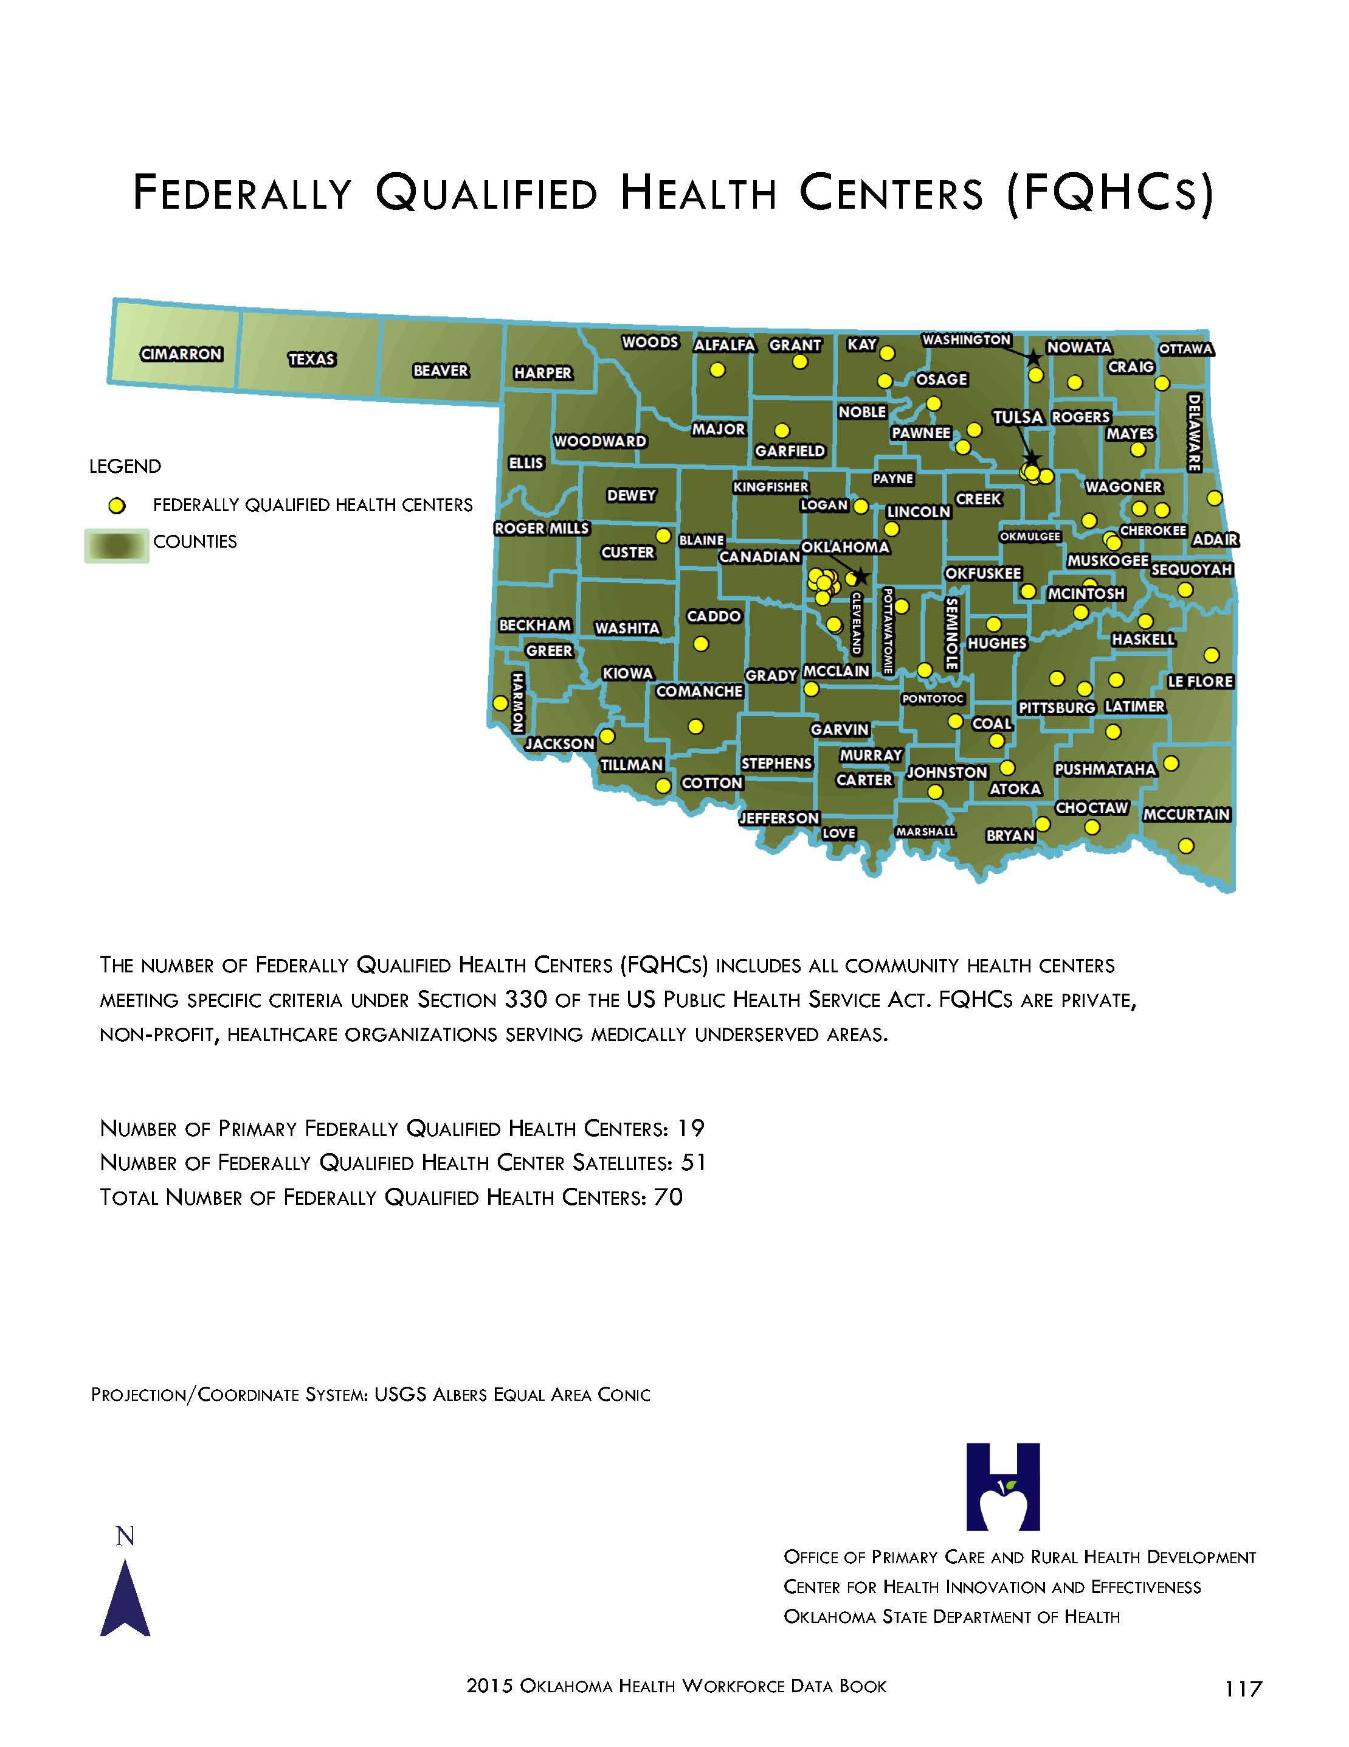

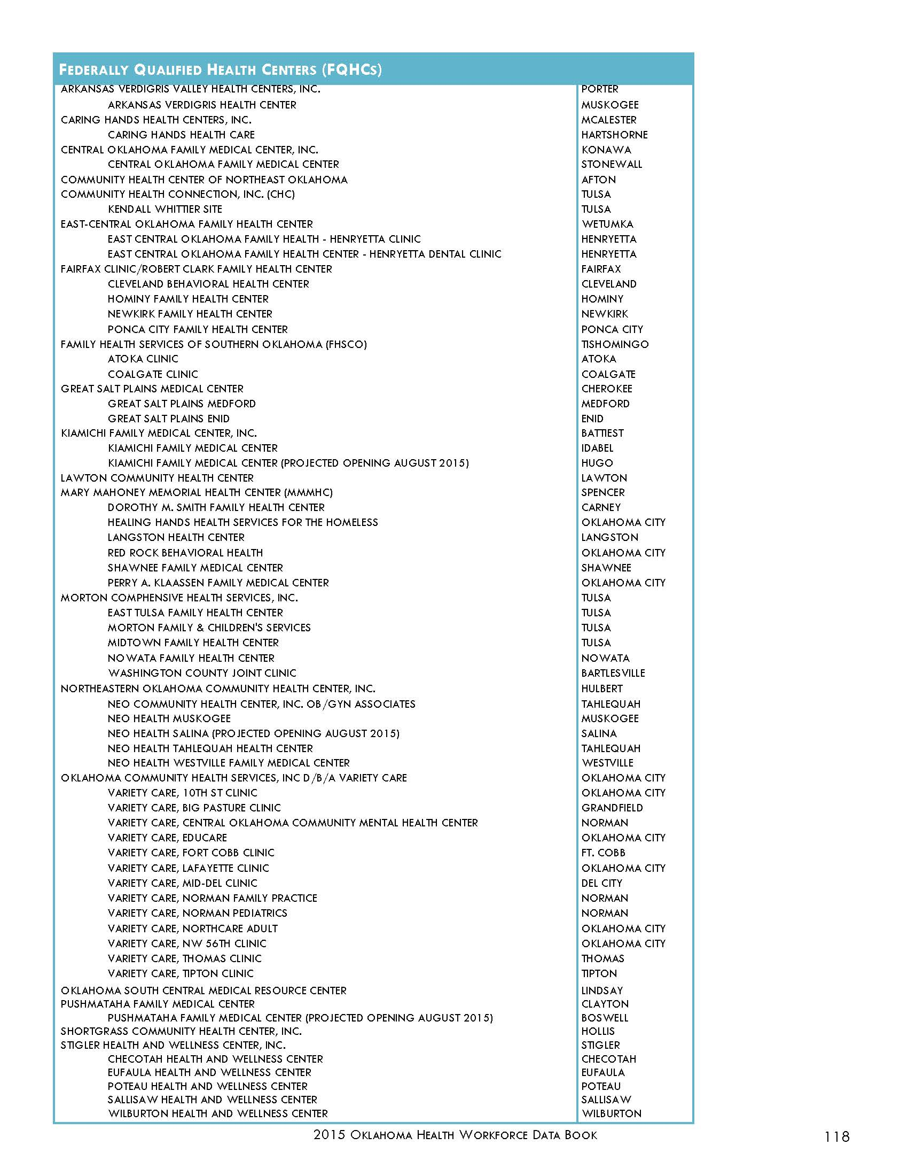

Appendix B: Free and Charitable Clinics in Oklahoma

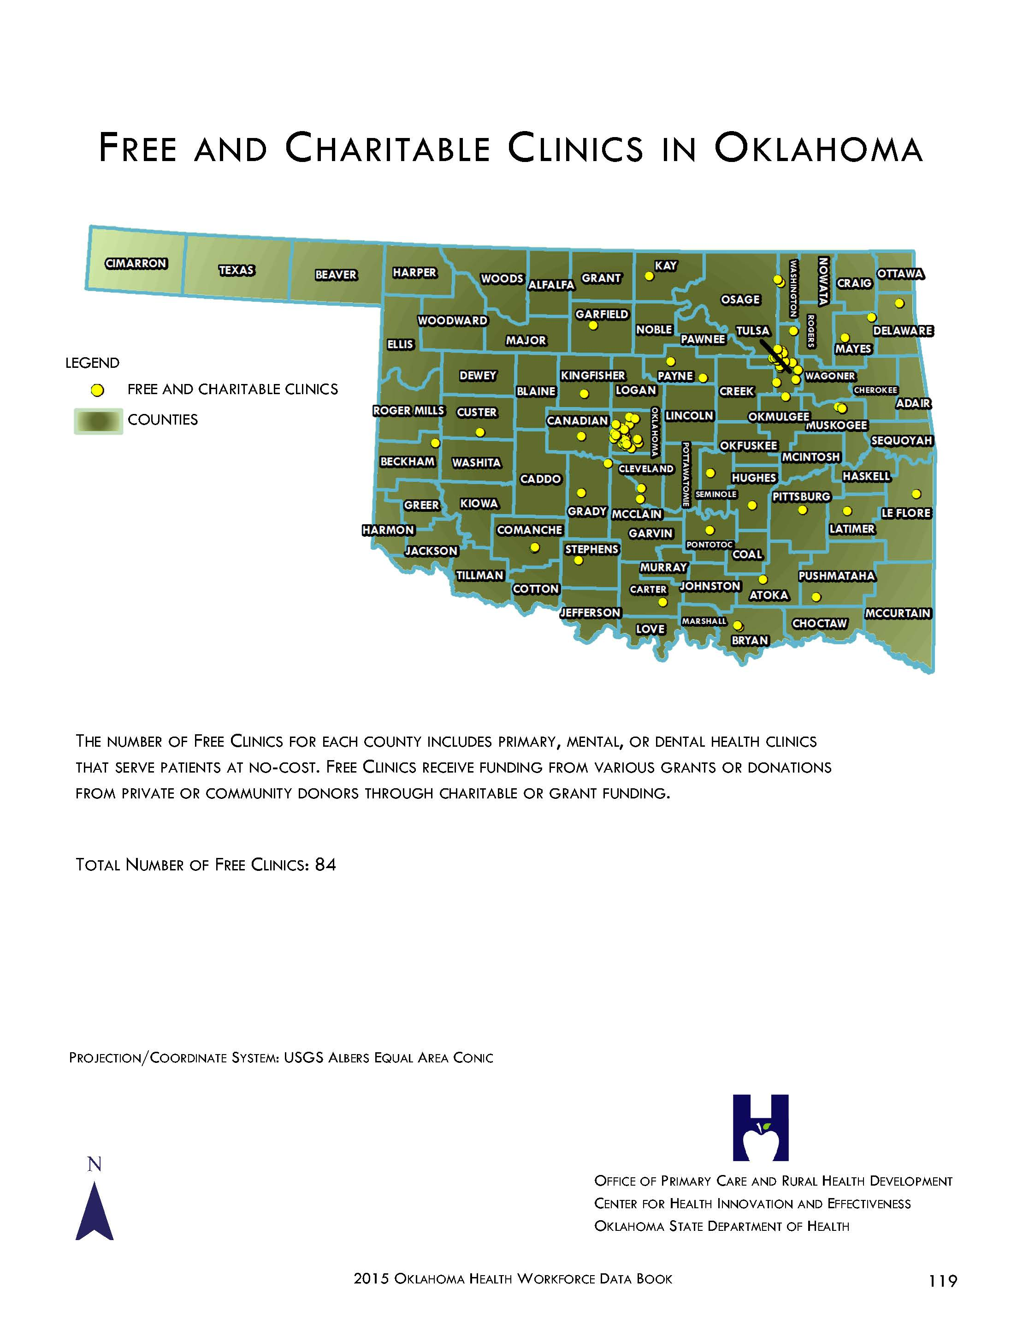

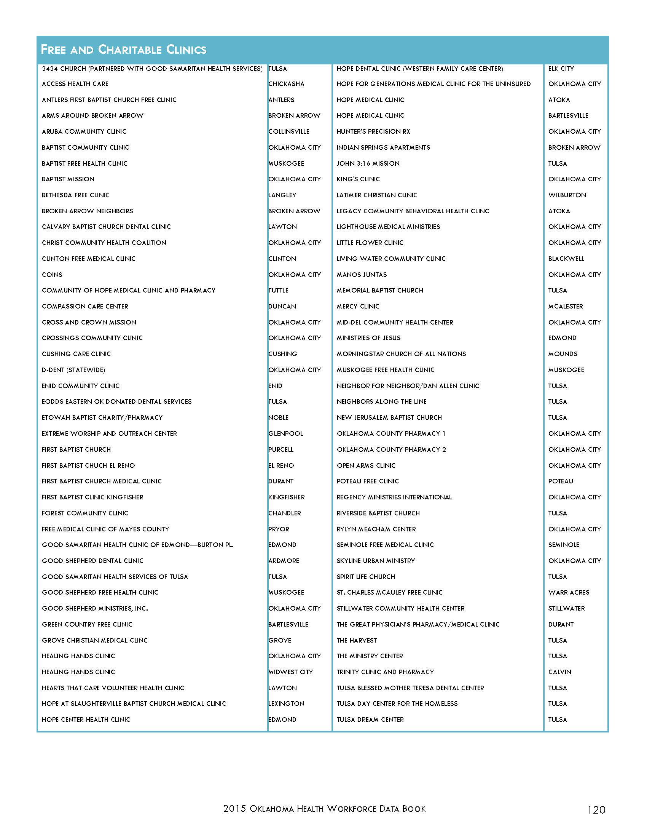

Appendix C: Insure Oklahoma Employee Sponsored Insurance

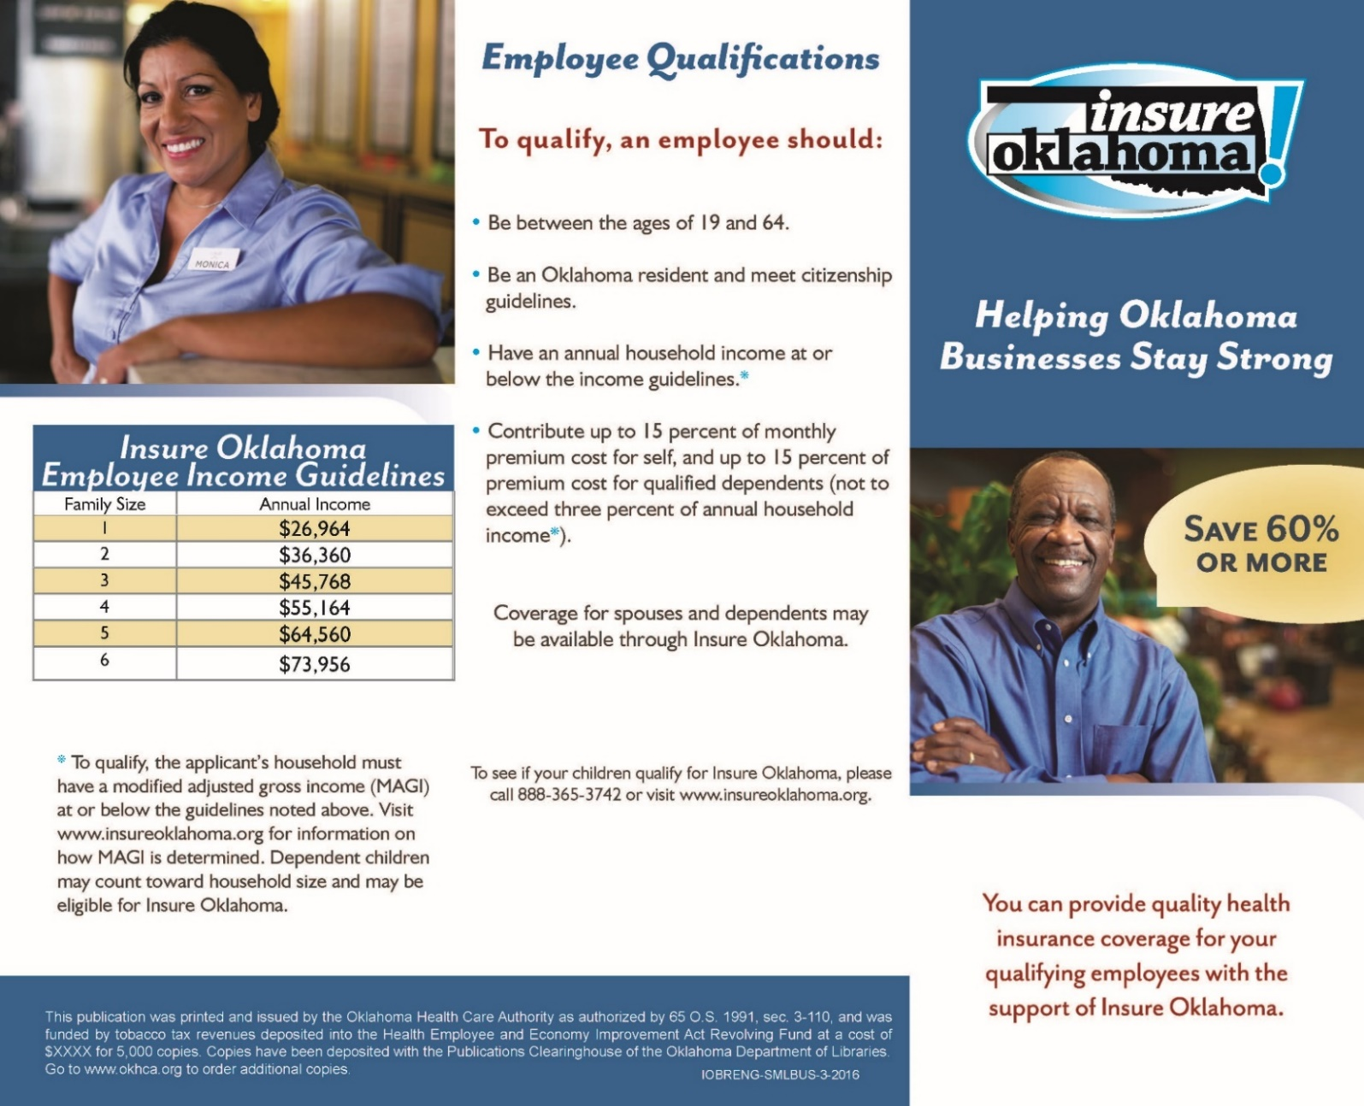

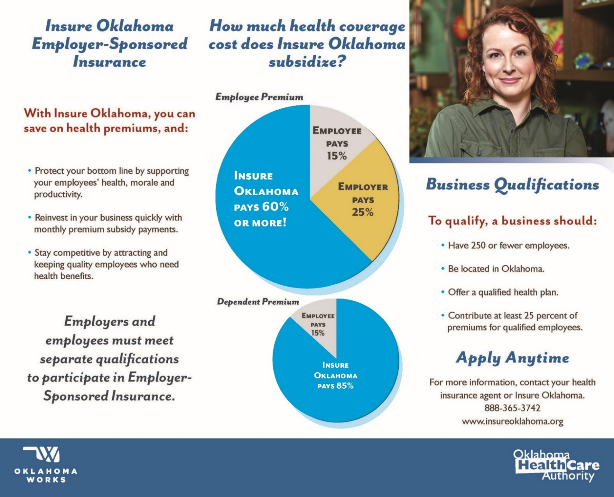

Appendix D: Insure Oklahoma Individual Plan
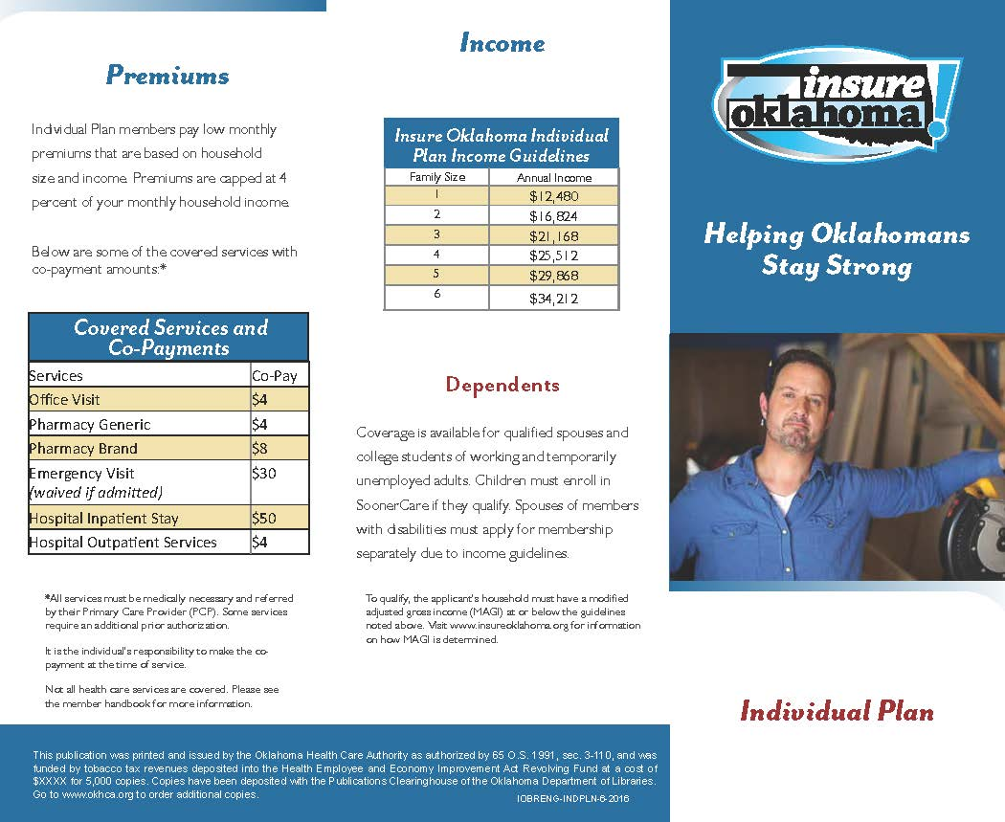

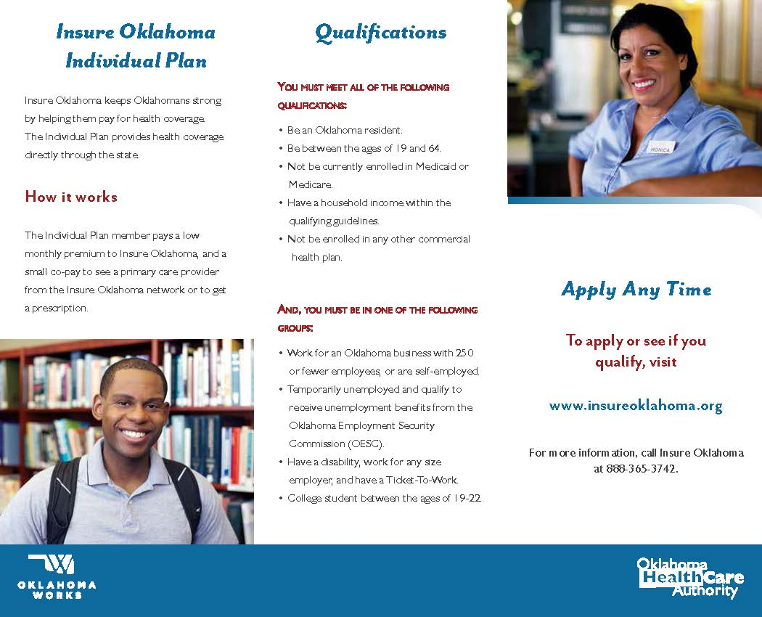

Appendix E: Preventive Services Covered Under the Affordable Care Act
Preventive Services Covered Under the Affordable Care Act
If you have a new health insurance plan or insurance policy beginning on or after September 23, 2010, the following preventive services must be covered without your having to pay a copayment or co-insurance or meet your deductible. This applies only when these services are delivered by a network provider.

- Covered Preventive Services for Adults
- Covered Preventive Services for Women, Including Pregnant Women
- Covered Preventive Services for Children

15 Covered Preventive Services for Adults
- Abdominal Aortic Aneurysm one-time screening for men of specified ages who have ever smoked
- Alcohol Misuse screening and counseling
- Aspirin use for men and women of certain ages
- Blood Pressure screening for all adults
- Cholesterol screening for adults of certain ages or at higher risk
- Colorectal Cancer screening for adults over 50
- Depression screening for adults
- Type 2 Diabetes screening for adults with high blood pressure
- Diet counseling for adults at higher risk for chronic disease
- HIV screening for all adults at higher risk
- Immunization vaccines for adults--doses, recommended ages, and recommended populations vary:
  - Hepatitis A
  - Hepatitis B
  - Herpes Zoster
  - Human Papillomavirus
  - Influenza (Flu Shot)
  - Measles, Mumps, Rubella
  - Meningococcal
  - Pneumococcal
  - Tetanus, Diphtheria, Pertussis
  - Varicella
Learn more about immunizations and see the latest vaccine schedules.
- Obesity screening and counseling for all adults
- Sexually Transmitted Infection (STI) prevention counseling for adults at higher risk
- Tobacco Use screening for all adults and cessation interventions for tobacco users
- Syphilis screening for all adults at higher risk

22 Covered Preventive Services for Women, Including Pregnant Women
The eight new prevention-related health services marked with an asterisk ( * ) must be covered with no cost-sharing in plan years starting on or after August 1, 2012.
- Anemia screening on a routine basis for pregnant women
- Bacteriuria urinary tract or other infection screening for pregnant women
- BRCA counseling about genetic testing for women at higher risk
- Breast Cancer Mammography screenings every 1 to 2 years for women over 40
- Breast Cancer Chemoprevention counseling for women at higher risk
- Breastfeeding comprehensive support and counseling from trained providers, as well as access to breastfeeding supplies, for pregnant and nursing women*
- Cervical Cancer screening for sexually active women
- Chlamydia Infection screening for younger women and other women at higher risk
- Contraception: Food and Drug Administration-approved contraceptive methods, sterilization procedures, and patient education and counseling, not including abortifacient drugs*
- Domestic and interpersonal violence screening and counseling for all women*
- Folic Acid supplements for women who may become pregnant
- Gestational diabetes screening for women 24 to 28 weeks pregnant and those at high risk of developing gestational diabetes*
- Gonorrhea screening for all women at higher risk
- Hepatitis B screening for pregnant women at their first prenatal visit
- Human Immunodeficiency Virus (HIV) screening and counseling for sexually active women*
- Human Papillomavirus (HPV) DNA Test: high risk HPV DNA testing every three years for women with normal cytology results who are 30 or older*
- Osteoporosis screening for women over age 60 depending on risk factors
- Rh Incompatibility screening for all pregnant women and follow-up testing for women at higher risk
- Tobacco Use screening and interventions for all women, and expanded counseling for pregnant tobacco users
- Sexually Transmitted Infections (STI) counseling for sexually active women*
- Syphilis screening for all pregnant women or other women at increased risk
- Well-woman visits to obtain recommended preventive services*

Learn more about Affordable Care Act Rules on Expanding Access to Preventive Services for Women.
(Effective August 1, 2012)

26 Covered Preventive Services for Children
- Alcohol and Drug Use assessments for adolescents
- Autism screening for children at 18 and 24 months
- Behavioral assessments for children of all ages
Ages: 0 to 11 months, 1 to 4 years, 5 to 10 years, 11 to 14 years, 15 to 17 years.
- Blood Pressure screening for children
Ages: 0 to 11 months, 1 to 4 years, 5 to 10 years, 11 to 14 years, 15 to 17 years.
- Cervical Dysplasia screening for sexually active females
- Congenital Hypothyroidism screening for newborns
- Depression screening for adolescents
- Developmental screening for children under age 3, and surveillance throughout childhood
- Dyslipidemia screening for children at higher risk of lipid disorders
Ages: 1 to 4 years, 5 to 10 years, 11 to 14 years, 15 to 17 years.
- Fluoride Chemoprevention supplements for children without fluoride in their water source
- Gonorrhea preventive medication for the eyes of all newborns
- Hearing screening for all newborns
- Height, Weight and Body Mass Index measurements for children
Ages: 0 to 11 months, 1 to 4 years, 5 to 10 years, 11 to 14 years, 15 to 17 years.
- Hematocrit or Hemoglobin screening for children
- Hemoglobinopathies or sickle cell screening for newborns
- HIV screening for adolescents at higher risk
- Immunization vaccines for children from birth to age 18 —doses, recommended ages, and recommended populations vary:
  - Diphtheria, Tetanus, Pertussis
  - Haemophilus influenzae type b
  - Hepatitis A
  - Hepatitis B
  - Human Papillomavirus
  - Inactivated Poliovirus
  - Influenza (Flu Shot)
  - Measles, Mumps, Rubella
  - Meningococcal
  - Pneumococcal
  - Rotavirus
  - Varicella
Learn more about immunizations and see the latest vaccine schedules.
- Iron supplements for children ages 6 to 12 months at risk for anemia
- Lead screening for children at risk of exposure
- Medical History for all children throughout development
Ages: 0 to 11 months, 1 to 4 years, 5 to 10 years, 11 to 14 years, 15 to 17 years.
- Obesity screening and counseling
- Oral Health risk assessment for young children
Ages: 0 to 11 months, 1 to 4 years, 5 to 10 years.
- Phenylketonuria (PKU) screening for this genetic disorder in newborns
- Sexually Transmitted Infection (STI) prevention counseling and screening for adolescents at higher risk
- Tuberculin testing for children at higher risk of tuberculosis
Ages: 0 to 11 months, 1 to 4 years, 5 to 10 years, 11 to 14 years, 15 to 17 years.
- Vision screening for all children

. “Oklahoma 2016,” Talk Poverty, accessed November 7, 2016, https://talkpoverty.org/state-year-report/oklahoma-2016-report/.
. “The Uninsured a Primer 2013- 4: How does lack of insurance affect access to health care?” Kaiser Family Foundation, November 14, 2013, http://kff.org/report-section/the-uninsured-a-primer-2013-4-how-does-lack-of-insurance-affect-access-to-health-care/.
. “Disparities,” Indian Health Service, March 2016, https://www.ihs.gov/newsroom/factsheets/disparities/.
. Ibid.
. Ibid.
. Ibid.
. “Oklahoma Health Care Authority Here When it Counts Annual Report 2012,” Oklahoma Health Care Authority, 2012: 33 http://www.okhca.org/publications/pdflib/AR2012.pdf.
. “Coverage for American Indians,” BlueCross BlueShield of Oklahoma, accessed November 7, 2016, https://connect.bcbsok.com/making-it-work/b/weblog/archive/2016/09/13/coverage-for-american-indians.
. “Oklahoma Health Improvement Plan,” Oklahoma State Department of Health, February 2015: 38, http://ohip2020.com/wp-content/uploads/2015/04/17395OSDH-OHIP-2020-Report-LR-F.pdf.
. “2010 Population- Urban and Rural,” United Way OKC, accessed November 7, 2016, http://www.unitedwayokc.org/research/data-center/demographics/population/2010-population-urban-and-rural.
. “QuickFacts Oklahoma,” United States Census Bureau, accessed November 7, 2016, http://www.census.gov/quickfacts/table/PST045215/40.
. “Tribal Consultation,” CMS.gov¸ accessed November 14, 2016, https://www.cms.gov/Outreach-and-Education/American-Indian-Alaska-Native/AIAN/Consultation.html.
. Ibid.
. Ibid.
. Ibid.
. Donald Warne and Linda Frizzell, “American Indian Health Policy: Historical Trends and Contemporary Issues,” American Journal of Public Health 104, no. S3 (2014): 264, accessed November 11, 2016, http://www.nec.navajo-nsn.gov/Portals/0/NN%20Research/AJPH/PastPresentFutureThreatsToAIANHealth.pdf
. Ibid.
. Yvette Roubideaux, "Perspectives on American Indian Health," American Journal of Public Health 92, no. 9 (2002): 1401-1406.
. Warne and Frizzell, “American Indian Health Policy”, 264.
. Margaret Moss. American Indian Health and Nursing (New York: Springer Publishing Company, 2016), 20.
. Future Treaties with Indian Tribe, Public Law 100-647, U.S. Statutes as Large 102 (1988): 17.
. Moss. American Indian Health and Nursing, 20.
. Warne and Frizzell, “American Indian Health Policy”, 23.
. Ibid., 264.
. Snyder Act, 25 U.S.C. § 13 (1921).
. United States Congress Office of Technology Assessment, Indian Health Care, (Washington, D.C.: U.S. Government Printing Office, 1986), 49.
. Ibid., 9
. “Legislation,” Indian Health Service, accessed November 11, 2016, https://www.ihs.gov/aboutihs/index.cfm/legislation/.
. Paul Spruhanl, "Indian as Race/Indian as Political Status: Implementation of the Half-blood Requirement under the Indian Reorganization Act,” Rutgers Race and the Law Review 8, no. 1 (2006): 29.
. “Indian Reorganization Act: United States (1934),” Encyclopedia Britannica, accessed November 11, 2016, https://www.britannica.com/topic/Indian-Reorganization-Act.
. “1934: President Franklin Roosevelt signs the Indian Reorganization Act,” Native Voices, accessed November 11, 2016, https://www.nlm.nih.gov/nativevoices/timeline/452.html.
. Richard Schaefer, Encyclopedia of Race, Ethnicity, and Society, (Los Angeles: SAGE Publications, 2008), 218.
. Ibid., 182.
. Ibid., 217.
. “Indian Reorganization Act,” Encyclopedia Britannica.
. United States Congress, Indian Health Care¸ 363.
. An Act to the Maintenance and Operation of Hospital and Health and Health Facilities for Indians to the Public Health Service, and for Other Purposes, Public Law 83-568, U.S. Statutes at Large 68 (1954): 674-675.
. “Legislation,” Indian Health Service.
. Warne and Frizzell, “American Indian Health Policy”, 264.
. Geoffrey Strommer and Stephen Osbnorne, “History, Status, and Future of Tribal Self-Governance Under the Indian Self-Determination and Education Assistance Act,” American Indian Law Review 39, no. 1 (2014): 18.
. Indian Self Determination and Education Assistance, Public Law 93-638, U.S. Statutes at Large 88 (1975): 2203-2217.
. Moss. American Indian Health and Nursing, 48.
. “About Us,” Indian Health Service, accessed November 11, 2016, http://www.ihs.gov/selfgovernance/aboutus/.
. Ibid.
. Ibid.
. “Tribal Self-Governance,” Indian Health Service, accessed November 11, 2016, https://www.ihs.gov/newsroom/index.cfm/factsheets/tribalselfgovernance/.
. Ibid.
. Ibid.
. “Tribal Self-Governance,” Indian Health Service.
. United States Congress, Indian Health Care¸ 215.
. “1976: President Ford signs Indian Health Care Improvement Act,” Native Voices, accessed November 14, 2016, https://www.nlm.nih.gov/nativevoices/timeline/542.html.
. Moss. American Indian Health and Nursing, 327.
. P.J. Cunningham, "Access to Care in the Indian Health Service," Health Affairs (Project Hope) 12, no. 3 (1993): 224.
. Moss. American Indian Health and Nursing, 325.
. United States Congress, Indian Health Care¸ 48, 36.
. “About Us,” Indian Health Service.
. Moss. American Indian Health and Nursing, 22.
. Ibid.
. “Access to Care,” County Health Ranking and Roadmaps, accessed November 12, 2016, http://www.countyhealthrankings.org/our-approach/health-factors/access-care.
. “Access to Health Services,” Healthy People 2020, accessed November 12, 2016, https://www.healthypeople.gov/2020/topics-objectives/topic/Access-to-Health-Services.
. Ibid.
. Ibid.
. Ibid.
. “Primary Care: Our First Line of Defense,” The Commonwealth Fund, accessed November 12, 2016, http://www.commonwealthfund.org/publications/health-reform-and-you/primary-care-our-first-line-of-defense.
. “Access to Health Services,” Healthy People 2020.
. Moss. American Indian Health and Nursing, 72.
. “Measure: Primary Care Physicians, Oklahoma,” America’s Health Rankings, last modified 2016, http://www.americashealthrankings.org/explore/2015-annual-report/measure/PCP/state/OK.
. Ibid.
. Ibid.
. JeVonna Caine, “Oklahoma needs more primary care physicians, but we’re still putting up barriers,” Oklahoma Policy Institute, June 4, 2014, http://okpolicy.org/oklahoma-needs-primary-care-physicians-still-putting-barriers-guest-post-jevonna-caine/.
. Anna Gorman, “Spreading The Word: Obamacare is for Native Americans, too,” NPR, September 2, 2015, http://www.npr.org/sections/health-shots/2015/09/02/435581014/spreading-the-word-obamacare-is-for-native-americans-too.
. “Indian Health,” Oklahoma Health Care Authority, accessed November 11, 2016, http://www.okhca.org/individuals.aspx?id=3267&terms=cdib.
. Moss. American Indian Health and Nursing, 6.
. Ibid., 9.
. “Emergency Medical Treatment and Labor Act (EMTALA),” CMS.gov, last modified March, 26, 2012, https://www.cms.gov/Regulations-and-Guidance/Legislation/EMTALA/.
. “Indian Health,” Oklahoma Health Care Authority.
. Moss. American Indian Health and Nursing, 9.
. “About Us,” Indian Health Service.
. Ibid.
. Ibid.
. Ibid.
. “IHS 2016 Profile,” Indian Health Service, accessed November 14, 2016, https://www.ihs.gov/newsroom/factsheets/ihsprofile/.
. “Robin Williams, “Oklahoma City Area Federal/Tribal/Urban Indian Health System 2013 Directory,” February 2013, https://www.ihs.gov/oklahomacity/includes/themes/newihstheme/display_objects/documents/2013OCAFederal_Tribal_UrbanFacilitiesDirectory.pdf
. “Tribal Relations Health Facility List,” Oklahoma Health Care Authority, accessed November 14, 2016, http://www.okhca.org/WorkArea/linkit.aspx?LinkIdentifier=id&ItemID=10143.
. “Tribal & Urban Indian Health Centers,” Health Resources and Services Administration. accessed November 14, 2016, http://www.hrsa.gov/opa/eligibilityandregistration/healthcenters/tribalurbanindian/index.html.
. “About,” Oklahoma City Indian Clinic, accessed November 11, 2016, http://www.okcic.com/about/.
. “2015 Annual Report,” Oklahoma City Indian Clinic, accessed November 11, 2016: 4, http://www.okcic.com/okcic-2015-annual-report/.
. Ibid, 5.
. “About,” Oklahoma City Indian Clinic.
. “About,” Indian Health Care Resource Center of Tulsa, accessed November 11, 2016, http://www.ihcrc.org/about/.
. Ibid.
. “Organizational Overview,” Indian Health Care Resource Center of Tulsa, accessed November 11, 2016, http://www.ihcrc.org/about/organizational-overview/.
. Ibid.
. “2015 Indian Health Care Resource Center of Tulsa Annual Report,” Indian Health Care Resource Center of Tulsa, accessed November 11, 2016: 5, https://issuu.com/ihcrc/docs/annual_report_2015_digital.
. Ibid.
. “Organizational Overview,” Indian Health Care Resource Center of Tulsa.
. Robin Williams, “Oklahoma City Area Directory.”
. “Oklahoma City Area,” Indian Health Service¸ accessed November 27, 2016, https://www.ihs.gov/oklahomacity/.
. “Oklahoma Health Workforce Data Book,” Oklahoma State Department of Health Center for Health Innovation and Effectiveness, Office of Primary Care and Rural Health Development, 2014-2015: 138, https://www.ok.gov/health2/documents/Oklahoma%20Health%20Workforce%20Databook%20V2.pdf.
. “What are federally qualified health centers (FQHCs)?” Health Resources and Services Administration, accessed November 11, 2016, http://www.hrsa.gov/healthit/toolbox/RuralHealthITtoolbox/Introduction/qualified.html.
. “Federally Qualified Health Centers (FQHCs),” Oklahoma State Department of Health, accessed November 11, 2016, https://www.ok.gov/health/Organization/Center_for_Health_Innovation_and_Effectiveness/Office_of_Primary_Care_and_Rural_Health_Development/Federally_Qualified_Health_Centers/index.html. . “Frequently Asked Questions,” Indian Health Services, accessed November 14, 2016, https://www.ihs.gov/forpatients/faq/.
. “What are FQHCs?” Health Resources and Services Administration.
. “Oklahoma Federally Qualified Health Centers,” Office of Primary Care and Rural Health Development, July, 2016, https://www.ok.gov/health2/documents/Oklahoma%20FQHCs%20July%202016.pdf.
. “Federally Qualified Health Centers,” Oklahoma State Department of Health.
. “Frequently Asked Questions,” Indian Health Service.
. Ibid.
. “Indian Health Manual,” Indian Health Service, accessed November 22, 2016: 2-3.6, https://www.ihs.gov/ihm/index.cfm?module=dsp_ihm_pc_p2c3.
. “Frequently Asked Questions,” Indian Health Service.
. “Contract Health Services Program,” The Kickapoo Eagle, Spring 2011, http://www.kickapootribeofoklahoma.com/files/ktoeagle/v1n1-042611/Kickapoo%20Eagle%20-%20Spring%202011%20WEB%202.pdf.
. Ibid.
. Marilynn Malerba, email to Sylvia Mathews Burwell and Andy Slavitt, April, 5, 2016, http://www.tribalselfgov.org/wp-content/uploads/2016/06/2016-04-05-TSGAC-Letter-of-Support-for-OK-1115-Waiver-Request-.pdf.
. “Purchased/Referred Care (PRC),” Indian Health Service, accessed November 12, 2016, https://www.ihs.gov/prc/index.cfm?module=chs_requirements_chsda.
. “Private plans outside the Marketplace outside Open Enrollment,” HeathCare.gov, April 8, 2016, https://www.healthcare.gov/private-plan-exceptions-outside-open-enrollment/.
. “Health Insurance Choices for American Indians,” BlueCross BlueShield of Oklahoma, accessed November 12, 2016, http://www.bcbsok.com/static/ok/pdf/health-insurance-for-american-indians-ok.pdf.
. “Getting Prescription Medications,” HealthCare.gov, accessed November 12, 2016, https://www.healthcare.gov/using-marketplace-coverage/prescription-medications/.
. “Cost Sharing,” HealthCare.gov, accessed November 13, 2016, https://www.healthcare.gov/glossary/cost-sharing/.
. Ibid.
. “Health savings accounts: Is an HSA right for you?,” Mayo Clinic Staff, accessed November 12, 2016, http://www.mayoclinic.org/healthy-lifestyle/consumer-health/in-depth/health-savings-accounts/art-20044058.
. “Annual Deductible Combined,” HealthCare.gov, accessed November 12, 2016, https://www.healthcare.gov/glossary/annual-deductible-combined/.
. Manish Sethi and William Frist, An Introduction to Health Policy: A Primer for Physicians and Medical Students (New York: Springer , 2013), 39.
. Ibid., 40.
. Ibid., 41.
. Ibid., 39.
. “Minimum Essential Coverage (MEC),” Healthcare.gov, accessed November 28, 2016, https://www.healthcare.gov/glossary/minimum-essential-coverage/.
. “Premium Tax Credit,” Healthcare.gov, accessed November 28, 2016, https://www.healthcare.gov/glossary/premium-tax-credit/.
. Ibid.
. “How Does the Affordable Care Act Impact American Indians and Alaska Natives?” HHS.gov, November 6, 2015, http://www.hhs.gov/healthcare/facts-and-features/fact-sheets/aca-and-american-indian-and-alaska-native-people/index.html.
. “How Does the Affordable Care Act Impact American Indians, HHS.gov.
. “Health Insurance Choices,” BlueCross BlueShield of Oklahoma, 4.
. Ibid., 2.
. Ibid.
. Ibid.
. Ibid.
. Ibid.
. Ibid.
. “Medicaid,” Medicare.gov, accessed November 13, 2016, https://www.medicare.gov/your-medicare-costs/help-paying-costs/medicaid/medicaid.html.
. “What is SoonerCare?” Oklahoma Health Care Authority, accessed November 21, 2016, http://www.okhca.org/individuals.aspx?id=52&menu=40&parts=11601_7453.
. “Eligibility,” Medicaid.gov, accessed November 21, 2016, https://www.medicaid.gov/chip/eligibility-standards/chip-eligibility-standards.html.
. “Provider Fast Facts,” Oklahoma Health Care Authority, September 2016, http://www.okhca.org/WorkArea/linkit.aspx?LinkIdentifier=id&ItemID=19715&libID=18698.
. “Insure Oklahoma History,” Insure Oklahoma, accessed November 13, 2016, http://www.insureoklahoma.org/IOaboutus.aspx?id=4052.
. Jaclyn Cosgrove, “At a glance: Understanding Medicaid,” The Oklahoman (Oklahoma City, OK), May 3, 2016.
. “Helping Oklahoma Businesses Stay Strong,” Insure Oklahoma, March 2016, http://www.okhca.org/publications/pdflib/New%20IO_Emplyer-Spnsr%20Ins_final.pdf.
. “Individual Plan,” Insure Oklahoma, April, 2016, http://www.okhca.org/publications/pdflib/Insure%20Oklahoma%20Individual%20Plan%20Brochure%204-16.pdf.
. “Helping Oklahoma Businesses Stay Strong,” Insure Oklahoma.
. “Individual Plan,” Insure Oklahoma.
. “Helping Oklahoma Businesses Stay Strong,” Insure Oklahoma.
. “Individual Plan,” Insure Oklahoma.
. “What’s Medicare?” Medicare.gov, accessed November 21, 2016, https://www.medicare.gov/sign-up-change-plans/decide-how-to-get-medicare/whats-medicare/what-is-medicare.html.
. Ibid.
. “Medicare and the Affordable Care Act,” Medicare.com, last updated February 23, 2016, https://medicare.com/about-medicare/medicare-open-enrollment-and-you/.
. Ibid.
. Ibid.
. Ibid.
. Ibid.
. “If you don’t have health insurance: How much you’ll pay,” HealthCare.gov, accessed November 13, 2016, https://www.healthcare.gov/fees/fee-for-not-being-covered/.
. Ibid.
. Ibid.
. “Coverage exemptions for American Indians, & Alaska Natives, and others eligible for services from Indian health programs,” HealthCare.gov, accessed November 13, 2016, https://www.healthcare.gov/american-indians-alaska-natives/exemptions/.
. Ibid.
. “Preventive Services Covered Under the Affordable Care Act,” HHS.gov, accessed November 13, 2016, http://www.hhs.gov/healthcare/facts-and-features/fact-sheets/preventive-services-covered-under-aca/#.
. “Types of health insurance that count as coverage,” HealthCare.gov, accessed November 13, 2016, https://www.healthcare.gov/fees/plans-that-count-as-coverage/.
. “Qualified Health Plan,” HealthCare.gov, accessed November 13, 2016, https://www.healthcare.gov/glossary/qualified-health-plan/.
. Tina Norris, Paula Vines, and Elizabeth Hoeffel, “The American Indian and Alaska Native Population: 2010, 2010 Census Briefs, (January 2010): 1.
. Ibid.
. Ibid., 20.
. “Bureau of Indian Affairs Certificate Degree of Indian or Alaska Native Blood Instructions,” U.S. Department of the Interior, last modified July 31, 2011, http://www.bia.gov/cs/groups/public/documents/text/idc-001805.pdf.
. Lucy Curry, "A Closer Look at Santa Clara Pueblo v. Martinez: Membership by Sex, by Race, and by Tribal Tradition (Case Note)," Wisconsin Women's Law Journal 16, no. 2 (2001): 204.
. Matthew Fletcher, "Tribal Membership and Indian Nationhood,” American Indian Law Review 37, no. 1 (2012): 4.
. Russell Thorton, "Tribal Membership Requirements and the Demography of ‘old’ and ‘new’ Native Americans," Population Research and Policy Review 16, no. 1 (1997): 35.
. Matthew Fletcher, "Tribal Membership,” 4.
. Circe Sturm, "Blood Politics, Racial Classification, and Cherokee National Identity: The Trials and Tribulations of the Cherokee Freedmen," (Berkeley, CA: University of California Press, 2002), 6.
. Renya Ramirez, Native Hubs: Culture, Community, and Belonging in Silicon Valley and Beyond. (North Carolina: Duke University Press, 2007), 240.
. Ibid., 2843.
. Ibid., 5725.
. Matthew Fletcher, "Tribal Membership,” 12.
. Ronald Hall, “The Melanin Millennium,” 211.
. “The Muscogee Creek Nation,” The Muscogee (Creek) Nation, accessed November 21, 2016, http://www.mcn-nsn.gov/.
. “About Us,” Muscogee (Creek) Nation Geospatial Department, last modified 2010, http://mcngis.com/index.php/about-us.
. “Eligibility,” Child Support Muscogee (Creek) Nation, accessed November 21, 2016, http://www.mcnchildsupport.com/index.php/eligibility.
. “Citizenship,” Muscogee (Creek) Nation, last modified 2016, http://www.muscogeenation-nsn.gov/Pages/Citizenship/citcriteria.html.
. “MCN Department of Health Centers,” Muscogee (Creek) Nation Department of Health, last modified 2012, http://www.creekhealth.org/index.php/facilities/health-centers.
. Ibid.
. “Services,” The Chickasaw Nation, last modified February 19, 2015, https://www.chickasaw.net/Services.aspx.
. “Tribal Relations Health Facility List,” Oklahoma Health Care Authority.
. “Citizenship,” Cherokee Nation, last modified 2015, http://www.cherokee.org/Services/TribalCitizenship/Citizenship.aspx.
. Circe Sturm, "Blood Politics,” 3.
. “Frequently Asked Questions,” Cherokee Nation, last modified 2015, http://www.cherokee.org/Services/TribalCitizenship/FrequentlyAskedQuestions.aspx.
. “Enrollment Application,” Kickapoo Tribe of Oklahoma, last modified November 23, 2010, http://kickapootribeofoklahoma.com/forms/Enrollment%20Application.pdf.
. Ibid.
. “Enrollment,” Kiowa Tribe, accessed April 28, 2015, https://www.kiowatribe.org/enrollment.html.
. “Enrollment Application,” Kickapoo Tribe of Oklahoma.
. David Wilkins, The Navajo Political Experience, Rev. ed, The Spectrum Series, Race and Ethnicity in National and Global Politics (Lanham, Md.: Rowman & Littefield, 2003): 11.
. “Tribal Glossary,” CMS Tribal Affairs, accessed April 27, 2015: 2, http://www.cms.gov/Outreach-and-Education/American-Indian-Alaska-Native/AIAN/Downloads/Tribal-Glossary-Brochure.pdf.
. Ibid., 2-3.
. Ibid., 5.
. Ibid., 2.
. Ibid.
. Tina Norris, Paula Vines, and Elizabeth Hoeffel, “The American Indian Population,” 2.
. Circe Sturm, "Blood Politics,” 3.
. Ronald Hall, “The Melanin Millennium Skin Color as 21st Century International Discourse,” (Dordrecht, New York: Springer, 2013), 212.
. Renya Ramirez, Native Hubs, 5725.
. Valerie Lambert, Choctaw Nation: A Story of American Indian Resurgence (Lincoln: University of Nebraska Press, 2007), 98.
. Ibid.
. “Oklahoma Uninsured Fast Facts,” Oklahoma Health Care Authority.
. “Oklahoma Health Improvement Plan,” Oklahoma State Department of Health, 41.
. “Oklahoma Uninsured Fast Facts,” Oklahoma Health Care Authority.
. “Oklahoma Health Improvement Plan,” Oklahoma State Department of Health, 38.
. Ibid., 4.
. Ibid., 41.
. Doneg McDonough, “Tribal Sponsorship of Beneficiaries for Health Insurance Coverage through a Marketplace” (presentation, Health Care Reform in Indian Country, March 18, 2015): 5, http://www.tribalselfgov.org/health-reform/webinars/sponsorship-options/.
. Ibid.
. Ibid.
. Ibid., 6.
. Ibid.
. Doneg McDonough, “Tribal Sponsorship.”
. “Manatt on Health Reform: Weekly Highlights,” Manatt, March 22, 2016, https://www.manatt.com/Documents/Newsletters/2016-23.
. Rachel Garfield and Anthony Damico, “The Coverage Gap: Uninsured Poor Adults in States that Do Not Expand Medicaid,” Kaiser Family Foundation, October 19, 2016, http://kff.org/uninsured/issue-brief/the-coverage-gap-uninsured-poor-adults-in-states-that-do-not-expand-medicaid/.
. Ibid.
. Ibid.
. Ibid.
. Ibid.
. Ibid.
. “Make ok better,” The Oklahoma Hospital Association, accessed November 28, 2016, http://www.makeokbetter.org/.
. Ibid.
. “Medicaid Rebalancing Act of 2020,” Oklahoma Health Care Authority, accessed November 28, 2016, https://www.okhca.org/WorkArea/linkit.aspx?LinkIdentifier=id&ItemID=18952&libID=17934.

