University of Oklahoma

Graduate College

Symphony No. 2, Op. 24, by Robert F. Kurka (1921-1957):
a Band Transcription

A document submitted to the graduate faculty

in partial fulfillment of the requirements for the

degree of

Doctor of Musical Arts

By

George e. Schrader Jr.
Norman, Oklahoma
2019

Symphony No. 2, OP. 24, by Robert F. Kurka (1921-1957):
a band transcription

A Document approved for the
school of music

By

Dr. William Wakefield, Chair

Dr. Michael Hancock

Dr. Marvin Lamb

Dr. Eugene Enrico

Dr. Alison Palmer

© Copyright by George E. Schrader Jr., 2019
All Rights Reserved

Acknowledgements
First and foremost, thank you God for guiding my every step and comforting me in my times of struggle. When I am weak, you are strong. Without you, Lord, I am nothing. Thank you for giving me this wonderful gift of music and providing me the opportunity and ability to share this gift with the world.
My most sincere gratitude to my doctoral committee for their continual guidance and support: William Wakefield, Michael Hancock, Marvin Lamb, Eugene Enrico, and Alison Palmer. A special thank you to the Spring 2019 University of Oklahoma Wind Symphony, under the direction of Shanti Simon, for being willing to read my transcription of Kurka’s Symphony and assist in producing a final product worthy of performance. I have been fortunate to work with the brightest minds in music in my music education, and they all continue to impact me as a person and musician: Charles Livesay, Bruce Brown, Robert Belser, Anne Guzzo, Nicole Lamartine, William Wakefield, Shanti Simon, Michael Hancock, Brian Britt, and Brian Wolfe. Two individuals helped me to find my passion for music at an early age: Sheryl Kaptur and Rick Catherman. I would not have become a musician without the two of you. Thank you!
To my Mom, Dad, Doug, and Stephanie: On August 4, 2007, I ventured to New Mexico to begin my teaching career. You never hesitated to support me as I began my new life out west. I am forever grateful for all the wisdom and support you have given me through the years. I love you all. Finally, to my wife, Whitney, and daughter, Norah: The sacrifices you have made to support me in this final degree were numerous and unfair. Yet, your love and support never faltered. For everything you have given me, I can only say this: I love you. With all of my heart, I love you.

Table of Contents
Acknowledgements iv
Abstract vi
List of Figures vii
Chapter 1 - Biography of Robert Kurka 1
Chapter 2 - Symphony No. 2, Op. 24 4
Historical Context 4
Structural Analysis 6
Movement I – “Allegro molto” 6
Movement II – “Andante espressivo” 10
Movement III – “Presto gioioso” 14
Chapter 3 - Strategies for Transcription and Retention of Composer’s Voice 18
Instrumentation 18
Retention and Doubling of the Contrabass 20
Versatility of the Euphonium 21
Added Mallet Percussion 22
Chapter 4 - Transcription Process 24
Selection of Repertoire 24
Initial Scoring – Advantage of Current Technology 25
Horn Considerations and Adjustments 27
Trumpet Considerations and Adjustments 31
Addition of 3rd Clarinet in B-flat 35
Technical passages in Woodwinds and Strings 36
Enharmonic Spellings 42
Chapter 5 –Summary, Conclusions and Recommendations for Further Study 46
Summary and Conclusions 46
Recommendations for Further Study 46
Appendix A – Symphony No. 2 Op. 24 Transcription – Full Score 48
Appendix B – Symphony No. 2 Op. 24 – Structural Analysis 129
Appendix C – List of Works by Robert Kurka 132
Appendix D – Copyright Permission 134
Appendix E – Correspondence with San Diego Symphony 135
Bibliography 136

Abstract
The need for this project stems from the lack of published compositions and biographical material on Robert Kurka. Given his short life it is no surprise that a lack of information exists; however, based on numerous awards and grants received in his final years his music deserves more recognition and intensive study. Adding a unique work to the band repertoire further broadens awareness for another compositional voice from the 1950s. A band transcription of Kurka’s Symphony No. 2 addresses this need by providing a work to explore his compositional language in a large wind band setting.
Symphony No. 2 is a well-crafted work written at the peak of Kurka’s compositional maturity. It lends itself well for a band transcription because of its prominent wind writing. Presently, wind ensembles are limited to programming The Good Soldier Schweik Suite for chamber wind ensemble, and the band transcription of his Concerto for Marimba and Orchestra by Thomas Wubbenhorst. The transcription of Symphony No. 2 will be the first piece by Robert Kurka for a large wind ensemble. The stylistic differences from his other works will reintroduce Kurka’s music with new sounds for the band genre.
.

List of Figures
Figure 2.1. Movement I, m. 1-7 - Theme 1 7
Figure 2.2. Movement I, m. 7-8 - Accompaniment Figure 1 7
Figure 2.3. Movement I, m. 21-24 – Accompaniment Figure 2 8
Figure 2.4. Movement I, m. 34-39 – Theme 2 8
Figure 2.5. Movement I, m. 58-61 – Theme 3 9
Figure 2.6. Movement I, m. 108-112 – Theme 4 9
Figure 2.7. Movement II, m. 3-14 – Main theme 11
Figure 2.8. Movement II, m. 20-31 – Variation I 11
Figure 2.9. Movement II, m. 33-44 – Variation II 12
Figure 2.10. Movement II, m. 46-50 – Variation III 13
Figure 2.11. Movement II, m. 59-66 – Variation IV 13
Figure 2.12. Movement III, Section A Melody 15
Figure 2.13. Movement III, Section B Melody 15
Figure 2.14. Movement III, Section C Melody 16
Figure 2.15. Movement III, Section D Melody 17
Figure 2.16. Movement III, Section E Melody 17
Figure 4.1. Movement I, m. 7-10 – Original Score - Extreme horn register. 27
Figure 4.2. Movement I, m. 7-10 – Transcription - Adjusted voicing for horns using saxophones. 28
Figure 4.3. Movement I, m. 26-32 – Original Score – Extreme horn register. 28
Figure 4.4. Movement I, m. 26-32 – Transcription– Adjusted voicing for horns using trumpet. 29
Figure 4.5. Movement I, m. 236-239 – Original Score – Large horn leaps. 29
Figure 4.6. Movement I, m. 236-239 – Transcription – Large horn leaps rescored with saxophones. 30
Figure 4.7. Movement III, m. 133-136 – Original Score – Horn range at piano dynamic. 31
Figure 4.8. Movement III, m. 133-136 – Transcription – Saxophones substitute for horns. 31
Figure 4.9. Movement I, m. 194-207 – Original Score – Muted trumpet solo with oboe accompaniment. 32
Figure 4.10. Movement I, m. 194-207 – Transcription – Oboe solo with muted trumpet accompaniment. 33
Figure 4.11. Movement II, m. 46-52 – Original Score – Trumpet scoring with high range. 33
Figure 4.12. Movement II, m. 46-52 – Transcription – Adjusted trumpet scoring for range. 34
Figure 4.13. Movement I, m. 191-194 – Original Score – Cello in high range. 36
Figure 4.14. Movement I, m. 191-194 – Transcription – Bass clarinet and 3rd clarinet for cello. 36
Figure 4.15. Movement I, m. 104-109 – Transcription – Clarinet multiple performer instructions. 37
Figure 4.16. Movement III, m. 17-20 – Original Score – Flute and piccolo sixteenth-note passage. 38
Figure 4.17. Movement III, m. 24-30 – Transcription – Alternating entrances of piccolo and flute. 40
Figure 4.18. Movement III, m. 5-7 – Original Score – Large leaps in violin and viola. 41
Figure 4.19. Movement III, m. 5-7 – Transcription – Large leaps limited to one octave in winds. 42
Figure 4.20. Movement III, m. 5-6 – Transcription – Use of double-sharp. 43
Figure 4.21. Movement III, m. 98-99 – Original Score – Trumpet part before enharmonic spelling. 44
Figure 4.22. Movement III, m. 98-99 – Transcription – Trumpet part enharmonically spelled. 44
Figure 4.23. Movement III, m. 108 – Enharmonic example. 45

- Biography of Robert Kurka
“Why did Robert Kurka’s Symphony have to wait until last night for its first performance by the Boston Symphony Orchestra under Robert Shaw? As an American conductor, he had the grace to bring us an attractive and worthwhile American Symphony.” – Howard Taubman, New York Times music critic, January 15th, 1959.

In the last year of his short life, American composer Robert F. Kurka (1921-1957) received a citation as a “composer on the threshold of real distinction” from composer Gunther Schuller of Brandeis University. Kurka was the recipient of two Guggenheim Fellowship Awards and an award from the National Institute of Arts and Letters, before leukemia took his life on December 12, 1957, just ten days before his 36th birthday. He was born in Cicero, Illinois to Anton Joseph Kurka and Rose B. Kurka on December 22, 1921. His father was a Czech immigrant, who arrived in the United States on January 14, 1908. In my research, I discovered he served in the United States Army Reserves, enlisting on July 31, 1942 in New York. Specific details about his service are unknown with the exception that he may have traveled to Tokyo shortly after Japan’s surrender at the end of World War II in 1945. A newspaper announcement from the Reno Evening Gazette on February 25, 1946 states that on the following Wednesday, “Lieutenant Robert F. Kurka of Ruby, New York” would have a performance of one of his string quartets broadcast for the first time on Tokyo’s radio station JOAK. The title of the article reads, “Soldier Plays Concert Piece,” providing the possibility of a live performance in Tokyo.
Little is known about Robert Kurka’s formal training as a young musician, but he eventually earned bachelor and master degrees from Columbia University, completing the latter in 1948. He was a violinist, studying with Canadian violinist Kathleen Parlow, and Alsatian violinist Hans Letz. Kurka’s work in composition began around 1946, with the completion of his Chamber Symphony Op. 3, which was not premiered until March 7, 1948 in New York. He studied briefly with composers Otto Luening and Darius Milhaud but is labeled a “self-taught” composer in the Grove Dictionary of Music and Musicians. After completing his degrees, Kurka worked as a professor of composition at the City College of New York and Queens College from 1948 to 1951. He also served as a composer-in-residence at Dartmouth College during that time.
In spite of his short life, Kurka created a substantial catalogue of compositions, including solo and chamber works for strings, two chamber works for winds, two choral works, full orchestral works including two symphonies, and one opera. His opera, The Good Soldier Schweik, has been performed in the United States and Europe. The opera received its world premiere performance posthumously in New York on April 23, 1958, but did not receive a premiere recording for 43 years, when in 2001 it was finally recorded by the Chicago Opera Theater. Kurka’s most recognized chamber wind piece, The Good Soldier Schweik Suite for fourteen winds and two percussion, was written two years prior to the completion of the opera and remains a highly regarded work in the wind band catalogue. His second chamber work for winds, entitled Seven Moravian Folk Songs for flute, oboe, clarinet, and bassoon is available through TrevCo-Varner Music Publishing, based in Lake Worth, Florida. See Appendix C for a complete list of Kurka’s known works.

- Symphony No. 2, Op. 24
“The Symphony begins with a muscular theme announced by trombones, bassoons, and low strings; a broad, lyrical melody initiated by the violas and cellos provides the formal second theme. These two subjects are brought into contention as the sonata-form movement unfolds, with the dynamic first theme dominating. The outer sections of the Andante are based on a long, gentle strain of melancholy character, while the center of the movement’s arch form is more animated and expressively intense. The finale is vigorous and optimistic; its driving main theme provides the engine for a fine display of orchestral brilliance.” – Carlos Kalmar, Conductor, Grant Park Orchestra.

Historical Context
Symphony No. 2, one of Kurka’s last two large-scale works, was premiered posthumously on July 8, 1958 by the San Diego Symphony Orchestra conducted by John Burnett. It went on to receive performances and recordings by some of America’s most influential orchestral ensembles, including the Boston Symphony Orchestra, conducted by Robert Shaw, and the Louisville Orchestra, conducted by Robert Whitney. Kurka received the commission for Symphony No. 2 in 1952 from the Ignacy Jan Paderewski fund and completed the work in 1953. The premiere recording was completed by the Louisville Orchestra in 1959, and was part of the orchestra’s project to make premiere recordings of new compositions by American composers under their own record label, First Edition Records.
Kurka’s Symphony No. 2 reflects Soviet Russia symphony models of the late 1940s and early 1950s, specifically those of Sergei Prokofiev. Similarities are found in the selection of instrumentation, formal structure of movements, motor rhythmic elements, motivic development, and harmonic language and progression. Preston Stedman, in his book The Symphony, notes that Prokofiev attributed his own composition style to four main factors:
- A classical influence, traced back to listening to his mother play Beethoven piano sonatas in his childhood.
- The neoclassical trend of instrumental works of the time.
- The modernization of his harmonic language by his teacher Taneyev.
- The motor or toccata element, inspired by Schumann’s Toccata.
Kurka demonstrates these same characteristics in Symphony No. 2 with the use of short motivic elements, traditional forms such as sonata form (movement I), theme-and-variation (movement II), and sonata-rondo form (movement III), unprepared dissonances, unusual harmonic shifts, and the persistent use of motor rhythms. The Symphony also includes the bass clarinet and contrabassoon for bass-line scoring, similar to Prokofiev, adding a distinctive color to the bass voices.
Symphony No. 2 is a well-crafted work written at the peak of Kurka’s compositional maturity. It lends itself well for a band transcription because of its prominent wind writing. Presently, wind ensembles are limited to programming The Good Soldier Schweik Suite for chamber winds, and a transcribed version of his Concerto for Marimba and Orchestra by Thomas Wubbenhorst. The transcription of Symphony No. 2 will be the first piece by Robert Kurka for a large wind ensemble. The stylistic differences from his other works will reintroduce Kurka’s music with new sounds for the band genre.

Structural Analysis
A structural analysis of Kurka’s Symphony No. 2 is useful in further understanding his compositional language and its impact on the band transcription. This analysis will not include an exhaustive theoretical analysis but will focus on an overall phrase structure for each movement. In addition to the prose version in the following sections, a table representation of the analysis is included in Appendix B.

Movement I – “Allegro molto”
The first movement is in sonata form, and can be outlined as follows:
- Exposition – m. 1-103
  - Theme 1 – m. 1-20 – D minor
    - Transition – Rehearsal 2, m. 21-31
  - Theme 2 – Rehearsal 3, m. 32-44 – G minor
    - Transition – Rehearsal 4, m. 45-57
  - Theme 3 – Rehearsal 5, m. 58-73 – G minor
    - Transition to Theme 1’ – Rehearsal 6, m. 74-87
  - Theme 1’ – Rehearsal 7, m. 88-101 – A minor
    - Transition to the development – m. 102-103
- Development – Rehearsal 8, m. 104-257
  - Theme 4 – m. 108-151
  - Theme 2’ (diminution) – Rehearsal 9, m. 112-151
    - Transition to Theme 1 material – m. 152-156
  - Focus on Theme 1 material – Rehearsal 12, m. 157-257
- Recapitulation – Rehearsal 20, m. 258-311
  - Theme 1’’ – m. 258-269 – D minor
    - Transition – Rehearsal 21, m. 270-271
  - Theme 2’’ – m. 272-295 – D minor
  - Theme 3’ – Rehearsal 23, m. 296-297 – D minor
    - Transition – m. 298-311
- Coda – Rehearsal 24, m. 312-347
The Symphony begins immediately with Theme 1 projected in unison octaves by the low voices of the orchestra. Kurka often fragments and develops the first two measures of this melody throughout the movement.
Figure 2.1. Movement I, m. 1-7 - Theme 1
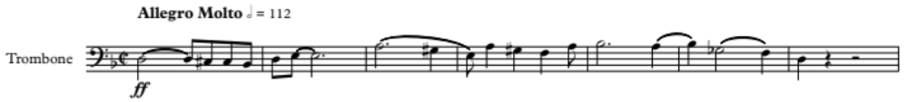
This primary theme begins and ends on D, strongly asserting a D minor tonal center. Kurka uses the first two measures of Theme 1 throughout the movement.
In the exposition, two accompaniment figures are presented that are developed later in the movement. The first of these accompaniment figures is a rising eighth-note passage that is presented by the horns in measure 7.
Figure 2.2. Movement I, m. 7-8 - Accompaniment Figure 1
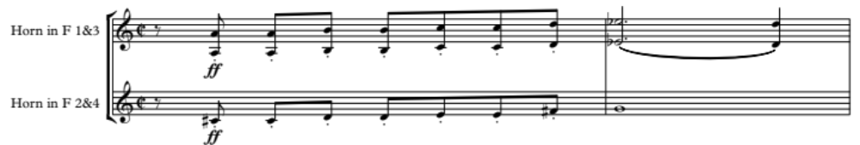 This figure is in contrary motion to the descending eighth-notes at the beginning of Theme 1. The second accompaniment figure is a punctuated three-note statement introduced at rehearsal 2.

Figure 2.3. Movement I, m. 21-24 – Accompaniment Figure 2
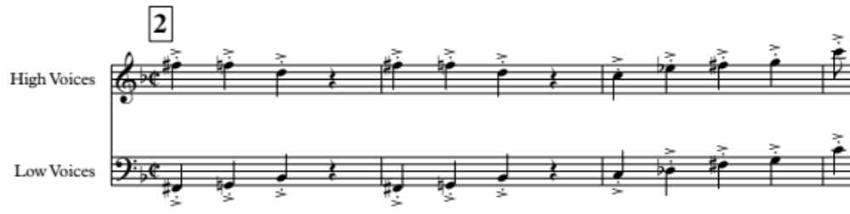
The high and low voices move in contrary motion, with the higher voices descending on pitches F-sharp, F-natural, and D, and the low voices ascending on F-sharp, G-natural, and B-flat. This figure is taken from the syncopated notes in the fourth measure of Theme 1. These two figures, extracted from the main theme, provide developmental and structural unity to the movement.
Transitional material begins at measure 21, shifting the harmony to a plagal tonal relationship of G minor, and arriving at the introduction of Theme 2 at measure 32.
Figure 2.4. Movement I, m. 34-39 – Theme 2
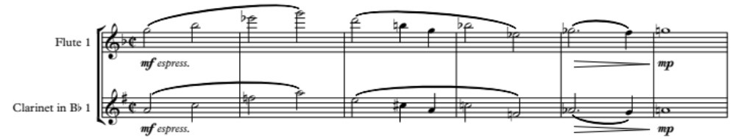
Theme 2 is a foreboding but lyrical theme that contrasts with the rhythmic and angular Theme 1 and is first stated by solo flute and clarinet in octaves. This theme is immediately echoed by middle and low strings, but shifts the tonal center momentarily to B-flat. Imitative statements by 1st horn, 1st oboe, and strings begin a transition to a third theme in the exposition.
Theme 3 is the first theme of the Second Symphony that demonstrates the influence of jazz in Kurka’s music, with a syncopated rhythm that is representative of Ragtime.
Figure 2.5. Movement I, m. 58-61 – Theme 3
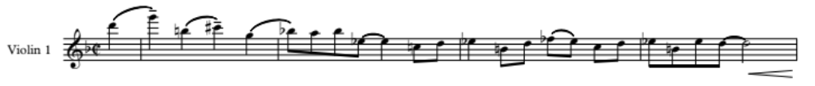
The dark nature of the movement is sustained with the persistence of a G minor tonality within this theme. The last two measures of Theme 3 are used as transitional material at rehearsal 6 to return to Theme 1.
The brass powerfully restate Theme 1 at rehearsal 7, but the theme is abbreviated by six bars. The restatement of this theme provides convincing formal clarity to the conclusion of the exposition. A short two-measure transition occurs in measures 102 and 103, with the clarinets establishing a new tonal center in the dominant key of A to begin the development.
Kurka introduces a new theme at the start of the development, identified here as Theme 4.
Figure 2.6. Movement I, m. 108-112 – Theme 4
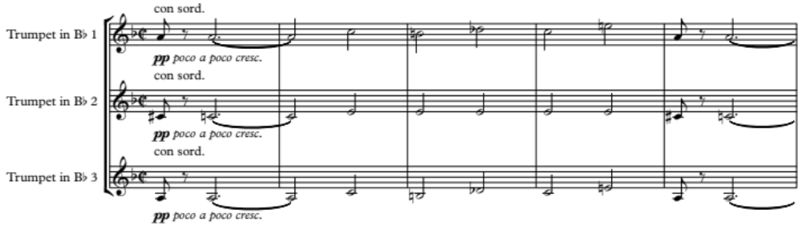
Throughout the first half of the development Theme 4 is placed in the trumpets and upper woodwinds, and is accompanied with Theme 2 in rhythmic diminution by lower voices. As the development progresses, new tonal centers are explored for short periods of time (see appendix B), including F-sharp, E-flat, and C.
Kurka focuses on Theme 1 material for the remainder of the development beginning at measure 152. Fragments of motives pass around the ensemble as the individual voices contend to be the dominant voice. In a sudden change at rehearsal 15, the musical landscape evaporates to an isolated muted trumpet solo, stating Theme 1 with light upper woodwind accompaniment. A dialogue between the trumpet and a solo piccolo is accompanied by delicate staccato quarter-note patterns in the double-reeds and snare drum. The end of each phrase in this portion of the development consists of a subito forte punctuation in syncopated strings. With each statement of Theme 1, more voices are added, building to the recapitulation at rehearsal 20.
At the onset of the recapitulation, Theme 1 is stated in the dominant key; however, the accompaniment initially emphasizes the original tonic key of D minor. Conforming to neo-classical ideals, Kurka restates his second and third themes in the tonic at measures 272 and rehearsal 23, respectively. After a transition in measures 298 through 311 using Theme 3 material, the coda begins at rehearsal 24, concluding the movement in the original key.

Movement II – “Andante espressivo”
Kurka constructs the second movement of the Symphony in a theme-and-variations form, in keeping with the neo-classical nature of the work. The use of 6/8 meter and staccato bass accompaniment closely resembles the second movement, “Lament,” of Kurka’s The Good Soldier Schweik Suite. He organizes the second movement of the Symphony as follows:
- Theme – m. 1-15 – B-flat major/minor
  - Transition – m. 16-19
- Variation I – Melodic Variation – Rehearsal 2, m. 20-30 – G major/minor
  - Transition – m. 31-32
- Variation II – Figure Variation – Rehearsal 3, m. 33-43 – E major/minor
  - Transition – m. 44-45
- Variation III – Character Variation – Rehearsal 4, m. 46-57 – E-flat and F
- Variation IV – Character Variation – Rehearsal 5, m. 58-71 – D major
  - Transition – m. 72-73
- Theme (abbreviated) – Rehearsal 7, m. 74-77 – B-flat major/minor
- Coda – m. 78-84
The Theme is introduced by the 1st violin and 1st flute:
Figure 2.7. Movement II, m. 3-14 – Main theme
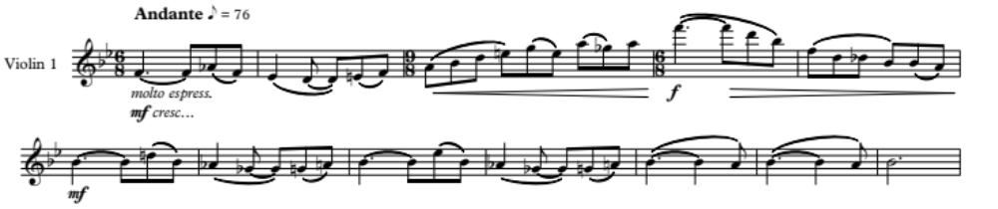
The Theme centers around a B-flat major/minor tonality, and is accompanied by delicate pizzicato strings, staccato low woodwinds, and march-like timpani and bass drum. Horns enter in measure 3 and provide a harmonized legato line in two-voice texture supporting the Theme.
Variation I begins in measure 20 stated by the flutes and clarinets, shifting the timbral color from the violins to woodwinds.
Figure 2.8. Movement II, m. 20-31 – Variation I
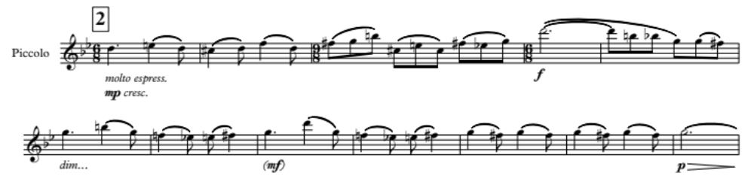
Kurka centers this variation on the submediant G and condenses the intervallic range of the Theme from two octaves to one, resulting in a more chromatic melody. He harmonizes the melody using parallel thirds in flute and clarinet, and gradually expands the parallel motion to sixths by the end of the phrase.
Both the Theme and Variation I begin on the dominant and end on the tonic of their respective tonal areas. The melodic rhythm and contour of the musical line also share similarities. Kurka uses the same meter structure, utilizing two measures of 6/8, one measure of 9/8, followed by nine measures of 6/8 to end the variation.
Variation II presents a dramatic change, and features a lively, Chopin-like ornamented melody in the violins, taking on a brighter tonality.
Figure 2.9. Movement II, m. 33-44 – Variation II
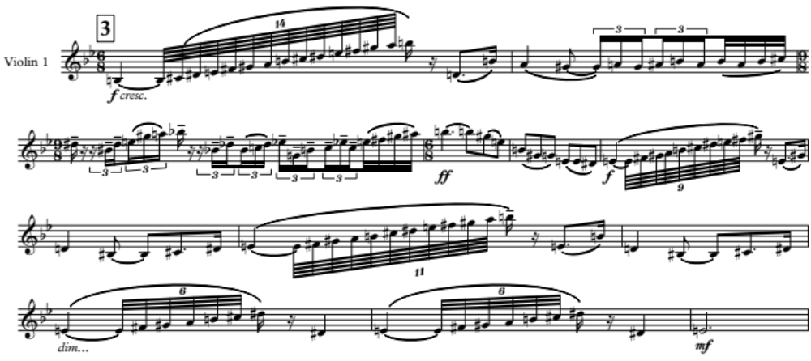
This variation continues the descending submediant trend, using E major/minor as its new pitch center. Kurka retains the Theme meter structure of 6/8, 9/8, and 6/8. Again, he begins the variation on the dominant of the new center and ends on the tonic, using a similar melodic contour.
Variation III is the most dramatic alteration of the Theme. The first two variations each moved a minor third down from the previous tonal center; B-flat (Theme), to G (Variation I), then to E (Variation II). Kurka alters this pattern in Variation III by moving down a minor second to the sub-dominant E-flat of the original B-flat tonal center. Instead of using the entire original Theme, he develops only the first two measures. He also shifts the orchestration color by featuring a powerful, fortissimo brass section. This is the first and only time the brass are featured in this movement. Kurka saved the brass for the most unusual variation of the set, from the standpoint of phrase structure, melodic contour, and articulation style. The uniqueness of the variation is further enhanced through displacement of the melody by a single eighth-note between the trumpets and trombones.
Figure 2.10. Movement II, m. 46-50 – Variation III
Variation III is echoed by the upper woodwinds in a new key center of F, the dominant of the original key (B-flat). At the completion of the variation, Kurka unexpectedly moves the F to F-sharp, establishing the third of the chord for the new D major tonality in the next variation.
Variation IV features Kurka’s most sensitive and expressive writing of the entire Symphony. Shifting the pitch center down a minor third to D major, he establishes the most stable tonality of the movement by limiting dissonant harmonies.
Figure 2.11. Movement II, m. 59-66 – Variation IV
In character with the original theme, he begins the melody on the dominant (A), imitates the original phrase structure, and uses the same melodic contour. However, he does not end this variation on the newly established tonic. Instead, a short two-measure modulation in bars 72 and 73 craftily evades expectations by moving the tonic back to B-flat, where Kurka ends the movement stating the Theme one final time, reflectively fading away before the final B-flat major chord.
Variation IV and the restatement of the Theme in the second movement marks a turning point in the mood and style of the Symphony. Aggressive declarations dominated the first movement, followed by a somber and lamenting mood in the second. Suddenly, the final variation melody in the second movement is presented in D major and brings optimism to the composition.

Movement III – “Presto gioioso”
Movement III builds on the optimism established in movement II with energetic statements of joyous enthusiasm. The finale is in sonata-rondo form and features exuberant musical statements that bring light to what thus far has been a dark and lamenting symphony. The outline is as follows:
- Exposition – m. 1-60
  - A: m. 1-12 – D major to A major
    - Transition: m. 13-16 – D major
  - B: Rehearsal 2, m. 17-30 – D major
    - First statement – m. 17-23 – D major
    - Repeat – Rehearsal 3, m. 24-30 – A major
  - A: Rehearsal 4, m. 31-42 – D major to A major
    - Transition: m. 43-46 – remains in A major
  - C: Rehearsal 6, m. 47-60
    - First statement – m. 47-52 – A major
    - Repeat – Rehearsal 7, m. 53-58 – A major
      - Transition – m. 59-60 – D major
- Development – Rehearsal 8, m. 61-142
  - A’: Rehearsal 8 – m. 68 – D major to E-flat
    - Transition: Rehearsal 9, m. 69-84 – E-flat to F
  - D: Rehearsal 10, m. 85-110
    - First statement – m. 85-95 – F major
      - Transition: m. 96-97
    - Second statement – Rehearsal 11, m. 98-108 – E major
      - Transition: m. 109-110 – A major/minor
  - E: Rehearsal 12, m. 111-142
    - First statement – m. 111-119 – A major/minor
    - Second statement – Rehearsal 13, m. 120-126 – A major/minor
    - Third statement – Rehearsal 14, m. 127-132 – G major/minor
      - Transition: m. 133-142 – G major/minor
- Delayed Recapitulation – Rehearsal 16, m. 143-165
  - B’: Rehearsal 16 – m. 165
    - First statement – Rehearsal 16 – m. 158 – G major/minor
    - Second statement – Rehearsal 17, m. 159-165 – D major
- Recapitulation – Rehearsal 18, m. 166-223
  - A: Rehearsal 18, m. 166-177 – D major to A major
    - Transition: m. 178-181
  - C: Rehearsal 20, m. 182-195
    - First statement – m. 182-187 – A major
    - Second statement – Rehearsal 21, m. 188-193 – A major
      - Transition – m. 194-195
  - B”: Rehearsal 22, m. 196-223
    - First statement – m. 196-209 – D major
    - Second statement – Rehearsal 23, m. 210-223 – D major
- Coda: Rehearsal 24, m. 224-234 – D major/minor
Section A is in D major, the parallel major key of the first movement. The driving and syncopated sixteenth-note rhythms give this section an almost Gershwin-like feel.
Figure 2.12. Movement III, Section A Melody
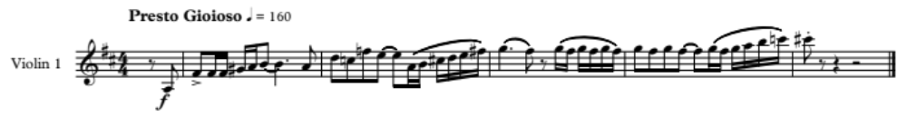
The addition of a staccato bass-line resembling a walking-bass gives this movement a jazz-inspired essence.
Section B, also set in D major, contains a soaring, lyrical melody, contrasting with the more rhythmic A melody. The Section B melody has an important use later in the movement, when Kurka uses it to craft a convincing finale. Horns first play the melody at measure 17, doubling in octaves.
Figure 2.13. Movement III, Section B Melody
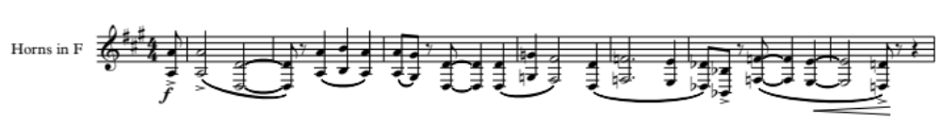
Rhythmic intensity though this section is sustained by the continuous sixteenth-note scalar figures in the flute and piccolo.
Kurka uses a lighter rhythmic gesture for the theme in Section C, along with a brief meter shift, alternating between 6/4 and 4/4. Middle strings comprise the first statement, while the upper strings restate the melody in the second phrase.
Figure 2.14. Movement III, Section C Melody
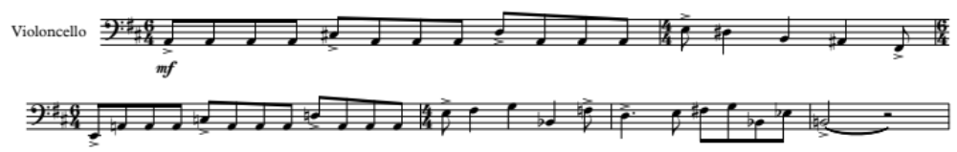
The mechanical nature of this section strays from the Gershwin-like essence, and perhaps is more inspired by compositions in the style of Sergei Prokofiev.
The development begins at rehearsal 8. The A melody is stated in detached fragments that are passed around the ensemble, yet remain in D major. As the fragments begin to dissipate, Kurka composes a transition using descending quarter-notes beginning at measure 77. The music crescendos with thicker texture and cascading voices, anticipating a significant musical arrival.
Section D, a new thematic idea in the movement, is first introduced within the development at rehearsal 10. New themes being presented in the development of a sonata-rondo form movement is not an uncommon practice, and dates back to the early classical symphonies of Sammartini and Brioschi. An example given by Bathia Churgin, in her article Beethoven and the New Development-Theme in Sonata-Form Movements, notes that Sammartini’s Symphonies J-C 7 and 65 include distinctive development themes and were written in the mid-18th century. Kurka uses this same compositional idea in sections D and E of his Second Symphony. These melodies only occur in the development, and do not return later in the composition.
Figure 2.15. Movement III, Section D Melody
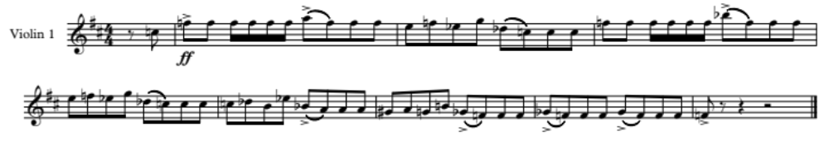
Figure 2.16. Movement III, Section E Melody
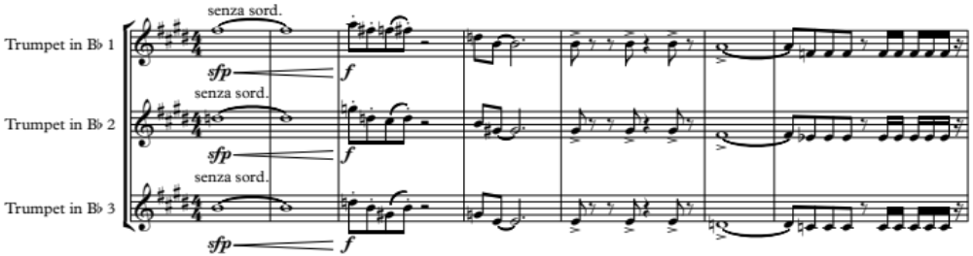
The Section B melody returns in rhythmic diminution at rehearsal 16 and is set in the dominant key of A major. The significance of this arrival is two-fold:
- It is the first of the three exposition melodies (A, B, and C) to return after the development in its entirety.
- Using the B melody after the development results in a delayed recapitulation, with the return of the original A melody not occurring until rehearsal 18.
The Section B melody is immediately restated at rehearsal 17 in its original key of D major, presenting the tonic key before the return of Section A.
Finally, Section A returns at rehearsal 18, announcing the arrival of the true recapitulation in the tonic key of D major. After a brief return of Section C at rehearsal 20, the B melody is used as the primary material in which Kurka constructs a powerful finale.

- Strategies for Transcription and Retention of Composer’s Voice
“Orchestration deals with the emotional and aesthetic possibilities of instruments in their tone color and shading, mixtures and blending characteristics, dynamic values in relation one to the other, their use to enhance nuance, rhythm, distinctive passages, or entire melodies.” - Arthur A. Clappé

Instrumentation
Clappé’s statement suggests that the emotional output of a work depends on the clarity of the music, considering all of the characteristics listed. This served as a guiding principle throughout the transcription process. John Cacavas cautions transcribers to “...be as true to the original sounds as possible...” Erik Leidzén suggests the transcriber consider what the composer would have done had he or she written the original work for band. In this transcription, the orchestrator has made every attempt to achieve musical clarity while adhering as close as possible to the original voice of the composer.
Kurka’s Symphony No. 2 utilizes a common wind instrumentation seen in the middle to late Romantic orchestra. He often favors the wind voices in the Symphony, using them for thematic, harmonic, and textural development. The wind instrumentation is the following:

Piccolo
2 Flutes
2 Oboes
English Horn
2 Clarinets in B-flat
Bass Clarinet
2 Bassoons
Contrabassoon
4 Horns in F
3 Trumpets in B-flat
3 Trombones
Tuba

The first step towards achieving musical clarity within the transcription is the careful selection of instrumentation. Timothy Shade, in his doctoral essay regarding the process of transcribing orchestral works for wind band, states that instrumental range is one of his first considerations in rescoring string voices. Middle to low strings present less of a concern than the higher violin register, which requires more careful consideration. The violin’s highest note in this work is an E7, occurring at measure 155 in the first movement. The piccolo is the only wind instrument able to attain this pitch in a comfortable manner. Kurka’s compositional style consists of numerous doublings at the octave, lending itself to having fewer instruments perform in extreme registers. This provides ease of tuning and balance, difficulties that might otherwise be present. With this possibility, the piccolo can be supported by other instruments including flutes, E-flat clarinet, B-flat clarinet, soprano saxophone, and mallet percussion at the lower octave, and still generate a similar orchestrational goal.
The middle to low string parts can be managed by the saxophone family of instruments down to C2, the lowest sounding pitch for the baritone saxophone. Bass saxophone is not utilized in this transcription, since the instrument is not commonly accessible. Kurka included five string parts in the original manuscript, so it is fitting to have the saxophone ensemble reflect this instrumentation. Therefore, the saxophone voices used in the transcription are soprano, two altos, tenor, and baritone. To achieve the desired orchestration for band, the addition of E-flat clarinet, a 3rd B-flat clarinet, saxophones, and euphonium, along with standard doubling of personnel on certain parts expands the instrumentation to the following:

Piccolo
2 – 1st Flute
2 – 2nd Flute
1st Oboe
2nd Oboe
English Horn
1st Bassoon
2nd Bassoon
Contrabassoon
E-flat Clarinet
3 – 1st B-flat Clarinet
3 – 2nd B-flat Clarinet
3 – 3rd B-flat Clarinet
B-flat Bass Clarinet
Soprano Saxophone
1st Alto Saxophone
2nd Alto Saxophone
Tenor Saxophone
Baritone Saxophone
2 – 1st B-flat Trumpet
2 – 2nd B-flat Trumpet
2 – 3rd B-flat Trumpet
4 – F Horn
1st Trombone
2nd Trombone
Bass Trombone
2 – Euphonium
2 – Tuba
String Bass (with extension)
Timpani
Snare Drum
Triangle
Bass Drum
Cymbals (Sus. and Crash)
1st Xylophone
2nd Xylophone
Glockenspiel

Retention and Doubling of the Contrabass
The contrabass part is retained in the transcription; however, with only a solo player being requested it becomes necessary periodically to double the part using other wind instruments. Doubling the contrabass voice utilizing baritone saxophone presents an issue, as the latter cannot reach the lower register of the bass. Fortunately, Kurka includes wind instruments in the original instrumentation capable of doubling the contrabass when they are musically available, including the contrabassoon, bass clarinet, and tuba. The latter is most often available for this purpose.
When the contrabass performs independently from the wind voices in the original score, balance issues must be taken into account in the transcription. An example of this is measure 136 in the first movement. Kurka utilizes all low winds separately from the contrabass. If the baritone saxophone is the only instrument that doubles the solo contrabass in the transcription, these two instruments will be over-powered by the remainder of the winds. A solution to this dilemma is adding a second tuba. The menacing nature of the strings from measures 112 to 157 is now retained because of the added depth provided by the second tuba voice. Additionally, using two independent tubas benefits the entire transcription by providing another bass voice while simulating a larger contrabass section comparable to the original composition.

Versatility of the Euphonium
The euphonium offers transcribers many benefits in a transcription. The lower range of the instrument, with its conical bell and warmth of tone, provides added depth of sound and can support both low brass and low reed voices. In its middle and upper registers, it can provide a satisfactory substitute or supporting voice for many instruments. These capabilities in the euphonium provide the transcriber a flexible option for setting music from an orchestral score.
The euphonium found its greatest use in this transcription as a substitute for higher tuba passages. This allowed the transcribed tuba to support the original contrabass voice. An example is found in movement I, measures 18 through 20. In the original score, Kurka has the tuba performing the punctuated brass motive; however, the strings rearticulate the original thematic material, and take prominence over the other voices. It is important for the string material to be realized in the transcription. This necessitates the tuba to double the contrabass part to further enhance the melodic motif. The euphonium is utilized to perform the original material written for the tuba.
An example of the euphonium’s virtuosic versatility occurs in movement III at measure 95. A sixteenth-note passage descends through the strings at a fortissimo dynamic. Using only saxophones to handle this passage provides a difficult challenge for balance. The euphonium deftly supports the end of the passage by assisting the baritone saxophone during the final two beats.

Added Mallet Percussion
“Contemporary wind bands are typically around 50 players and include extensive percussion sections. These percussion sections contain instruments capable of assisting with rescoring some of the more diverse string passages. The use of percussion has assisted with the inherent balance issues in transcribing from orchestra to the wind band.” – Timothy Shade

A lack of wind instrument substitutes for the violin in its higher tessitura presents many issues to the transcriber. The piccolo is the most direct instrument for this purpose regarding pitch, but it is not common practice to have multiple piccolo players within a wind ensemble. Doubling music written above C7 at the octave below helps the presence of the highest voice, but the added brilliance of the highest register is easily lost using this method alone. Mallet percussion instruments can be of great value by supplying the brighter timbre associated with the original register.
Rehearsal 22 of Movement III is one example of the challenge of transcribing high string parts. Kurka composed this particular passage by using rhythmic diminution of the B melody from this movement. The musical phrase contains whole notes and half notes, and is set in a higher register, reaching B6 in the 1st violin. This presents a passage that is physically problematic for winds to reproduce. In addition, the piccolo and flute voices are composed with their own musical material, leaving only the oboe, clarinet, and soprano saxophone available to substitute for violin. In this transcription, the glockenspiel proved useful by maintaining the register of the violin passage while the soprano saxophone and clarinets double the part an octave below. Although the number of voices in the highest register is minimized to only the glockenspiel, this solution avoids the predictable issues of tuning and balance from having numerous wind voices performing in this extremely high register. Further, the longer ring of the glockenspiel is more advantageous in supporting the longer tones of the melody than the xylophone.
A second instance where mallet percussion proved beneficial was during rapid technical passages. In movement III, rehearsal 2, the piccolo and flute perform a continuous scalar sixteenth-note passage for fourteen measures, all tongued at 152 bpm. With such a fast tempo, and high demand for articulation and finger coordination, this transcription includes slurs for this passage, with the xylophones doubling. This provides an articulation for each note, and satisfies the original intent.

- Transcription Process
“The adaptation of a composer’s work to another medium demands a carefully designed process to ensure that the end result is comparable to the original. This process is a combination of a preliminary investigative procedure and the actual transcription of the work. The preliminary process will ensure the transcriber has obtained all necessary information regarding the piece and composer before beginning the transcription, allowing for decisions more aligned with the style of the composer.”

Selection of Repertoire
In October of 2017, my D.M.A. chamber recital featured Robert Kurka’s The Good Soldier Schweik Suite for 16 winds and percussion. Intense study of this suite led to a curiosity of both the life and works of the composer. Surprisingly, I discovered that only the final nine years of Kurka’s life are well-documented. Everything before then largely remains a mystery to published historical research. Furthermore, his unique compositional voice is rarely explored by all ensembles due to his limited catalogue. Providing the band genre with an opportunity to perform Kurka’s music became a primary goal, and the exploration of his catalogue was essential to determine the work best suited to a larger band ensemble.
Kurka’s orchestral compositions served as the primary source of potential works for a band transcription. He wrote exclusively for orchestra; the exception being The Good Soldier Schweik opera which was written for chamber winds. His catalogue includes two symphonies; however, a published score or recording of Symphony No. 1, Op. 17 could not be located. Recordings of his orchestral compositions aided in the selection process. Of particular interests were the following: Music for Orchestra Op. 11, Serenade for Small Orchestra (after Walt Whitman) Op. 25, Julius Caesar Symphonic Epilogue (after William Shakespeare) Op. 28, and Symphony No. 2, Op. 24 (1953/1958). From this group, Symphony No. 2, Op. 24, was selected for transcription based on the following criteria:
- Appeal to the transcriber based on recordings.
- The prominence of the wind writing within the original work, regarding motivic and harmonic development.
- The potential for movements of the Symphony to be performed individually.

Initial Scoring – Advantage of Current Technology
Erik Leidzén outlines a four-step transcription plan in the book An Invitation to Band Arranging:
- Score all solid tutti passages first.
- After all tutti passages have been transcribed, turn to the places where the full scoring appears but combined with some characteristic voice-leading.
- ...treat all places that are scored a bit lighter.
- ...scan each part to ascertain if there are enough breathing places. This is especially important if the wind part has been transcribed from a string part.

Timothy Shade encourages this plan in his document, noting that the process would “...preserve authenticity and fidelity.” Fidelity must be a primary objective for transcribers; however, the process that allows the transcriber to complete the project, while achieving the goal of authenticity, should be informed by the original composition with the transcriber’s own discretion. Furthermore, Leidzén’s plan was written in the first half of the 20th century, before the availability of a computer and music notation software. Current technological advantages allow for a slightly altered process.
The process for transcribing Symphony No. 2 included the following steps:
- Notation of all music, including all text, dynamics, and tempo markings using the desired instrumentation of the band:
  - Keep all music in the same voice as notated in the original, regardless if it will remain in that voice or not.
  - Notate string parts in added instrument parts, such as saxophones and euphoniums, or other available voices.
- Rescore as necessary:
  - Re-voice sections to better fit the idiomatic capabilities of the instruments, with specific attention to string parts.
  - Re-voice sections where extreme range issues occur.
  - Re-voice where balance issues become present.
  - Assign solos to either the same or similar instruments, depending on balance challenges in the band.
  - Add or subtract instruments that may or may not be needed in favor of clarity and finalize instrumentation.
- Study each part to ensure that music written is within the capabilities of the instruments.

The initial step of scoring all notes, texts, and dynamics in a literal fashion from beginning to end allowed for the music to be set in the most authentic form possible, though perhaps not the best form for the band medium. With the assistance of current music notation software, rescoring portions of the music consumed less time than it would have for Erik Leidzén in the early 20th century. Though the process developed by Leidzén is in no way obsolete, this project utilized the efficiency and editing benefits of technology to craft the final product once the literal setting of the music had been completed.
The transcription of Symphony No. 2 presented unique problems from what might be considered normal. Kurka’s Symphony possesses youthful vitality, congruent with a 32-year-old “self-taught” composer. Ranges of trumpets and horns exceed comfortable limits for some performers. Fast, articulated passages in the third movement for the piccolo and flute require double-tonguing for an extended period of time. These issues raise concerns of repeated performances. Adjustments made to ameliorate the identified challenges are discussed in the following sections of this chapter.

Horn Considerations and Adjustments
Horn register issues are common in Symphony No. 2. Kurka consistently doubled pairs of horns in octaves. Occasionally, these octaves exceed the comfortable range of the horn. With the addition of saxophones, forcing the horns to play at such extreme registers can be avoided.
The first instance of this occurs in measures 7-10 of movement I. The 1st horn ascends to a written B5, or sounding E5.
Figure 4.1. Movement I, m. 7-10 – Original Score - Extreme horn register.
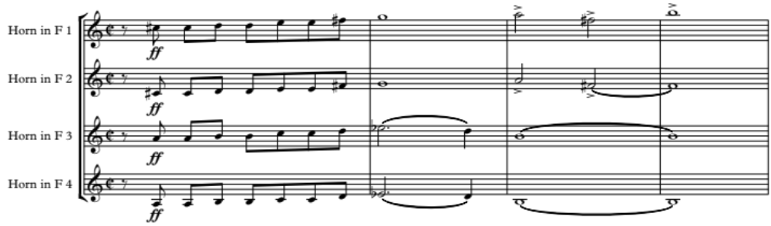
In figure 4.2., the original 1st horn part has been placed in the 1st alto saxophone line, an instrument capable of handling the extreme register with greater ease. Measures 9 and 10 are doubled by the soprano saxophone to assist with balance, allowing the higher octave to be present within the ensemble. The 2nd and 4th horns double the 1st and 2nd alto saxophones, while 1st and 3rd horns double the tenor saxophone.
Figure 4.2. Movement I, m. 7-10 – Transcription - Adjusted voicing for horns using saxophones.
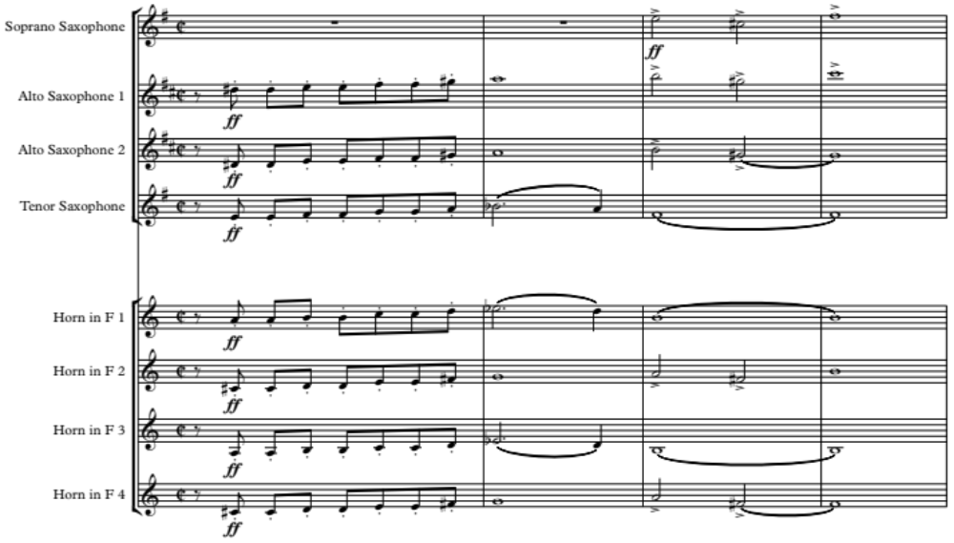
Trumpets are also useful in rescoring horn sections. The example below occurs in measures 26 through 32 of movement I. Due to the increasing dynamic of the music, the trumpet, rather than the saxophone, provides improved balance of voices in the ensemble.
Figure 4.3. Movement I, m. 26-32 – Original Score – Extreme horn register.
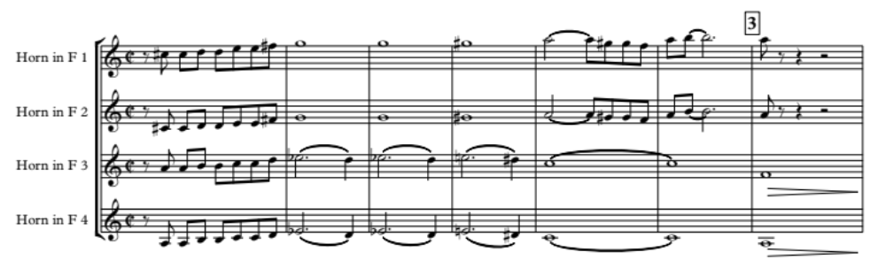

Figure 4.4. Movement I, m. 26-32 – Transcription– Adjusted voicing for horns using trumpet.
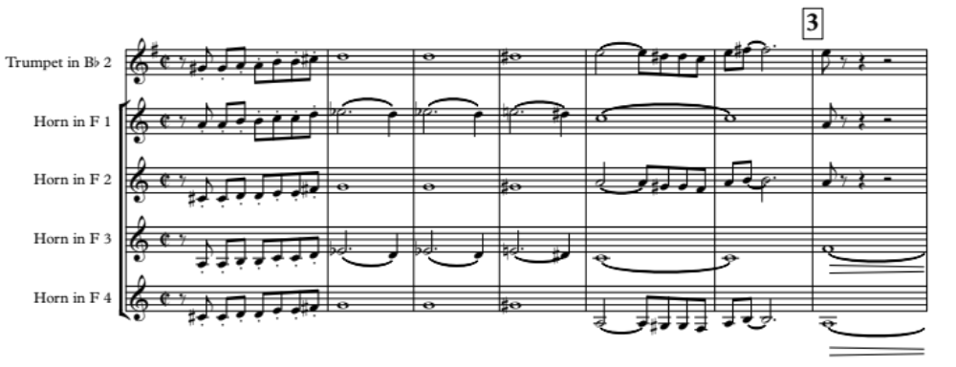
The rescoring in the above example presents appropriate voicing for the instruments involved. Reassigning the original 1st horn line to the 2nd trumpet leaves the most difficult passage in the 3rd horn. Re-voicing this section becomes necessary to ensure the principal player is tasked with the performance of the most challenging line of music. In Figure 4.4., the 1st and 3rd horns double the musical line in octaves, with the 1st part performing the higher octave. The 2nd and 4th horns double the original 1st horn part, now reassigned to 2nd trumpet.
Kurka, on rare occasions, composed a line of music that is uncharacteristic or extremely difficult for a particular instrument. Examples occur at measures 224 and 236 of movement I.
Figure 4.5. Movement I, m. 236-239 – Original Score – Large horn leaps.
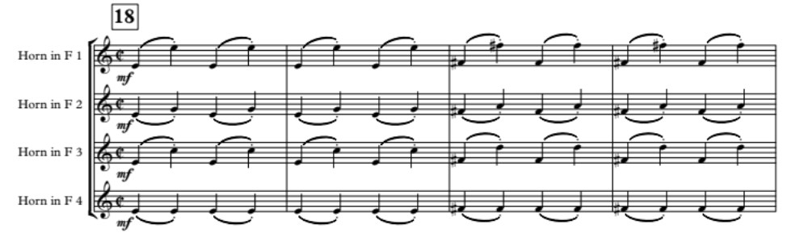
The 1st horn voice is tasked with performing quarter-note leaps in octaves for eleven continuous measures. A second passage at measure 236, with similar material placed in a higher tessitura, makes the passage even less idiomatic. The leaps in the 2nd, 3rd, and 4th horn parts are more manageable, and can remain as written. The saxophones are available at this point in the music, and can be used to re-voice these passages for ease of performance in the horns.
Figure 4.6. Movement I, m. 236-239 – Transcription – Large horn leaps rescored with saxophones.
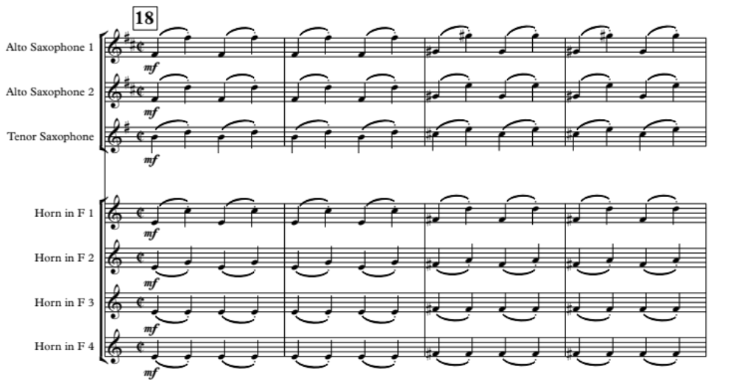
The 1st alto saxophone is scored to manage the most difficult line of this section. The remaining lines are doubled with the following couplings; 2nd alto saxophone/1st horn, tenor saxophone/2nd horn, and 3rd horn/4th horn. The voicings continue into rehearsal 19.
At rehearsal 15 of movement III, Kurka orchestrates the horn voices in an extremely high register at a piano dynamic marking.
Figure 4.7. Movement III, m. 133-136 – Original Score – Horn range at piano dynamic.
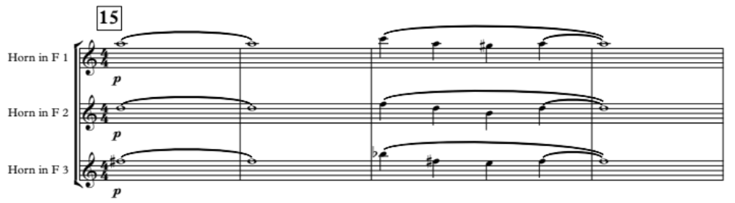
This presents an obvious problem for repeat performances. In the transcription, saxophones substitute for the horns to provide a similar timbre and a more idiomatic setting for the music.
Figure 4.8. Movement III, m. 133-136 – Transcription – Saxophones substitute for horns.
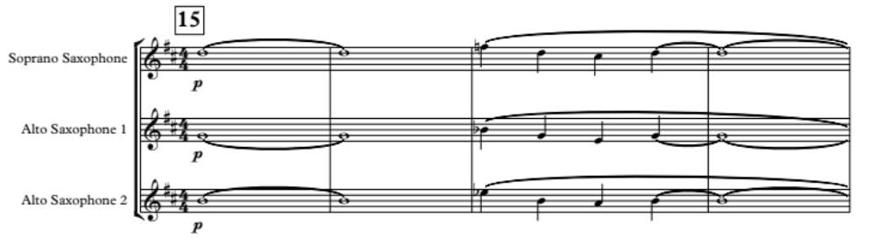
Other rescoring passages of note for the horns occur in the following locations, utilizing similar voicings as previously mentioned:
- Movement I – Rehearsal number 24, measures 312-327
- Movement III – Rehearsal number 7, measures 53-61
- Movement III – Rehearsal number 21, measures 188-195

Trumpet Considerations and Adjustments
Register issues occur in the trumpets similar to horns. While one could argue that the original trumpet parts are playable, they would limit repeat performances of the transcription. To allow greater access, many of the moments in question have been adjusted while some remained unedited to retain musical intent. The Symphony’s 1st trumpet range extends to a written D6, or sounding C6.
The first rescoring for trumpet occurs in movement I at rehearsal 15, where a muted trumpet is featured as a solo voice. The passage reaches a written D6 while demanding a mezzo-piano dynamic, increasing the difficulty of performance.
Figure 4.9. Movement I, m. 194-207 – Original Score – Muted trumpet solo with oboe accompaniment.
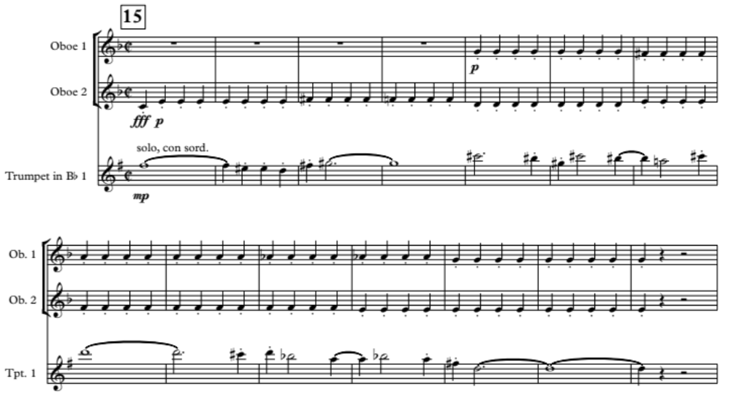
Due to similar timbres, substituting oboe for muted trumpet is an option. In the original Symphony, Kurka sets the oboe voices in an accompaniment role, playing repeated staccato quarter-notes. Reversing the roles by placing the solo part in 1st oboe and moving the staccato quarter-notes into muted trumpet lines solves this range issue.
Figure 4.10. Movement I, m. 194-207 – Transcription – Oboe solo with muted trumpet accompaniment.
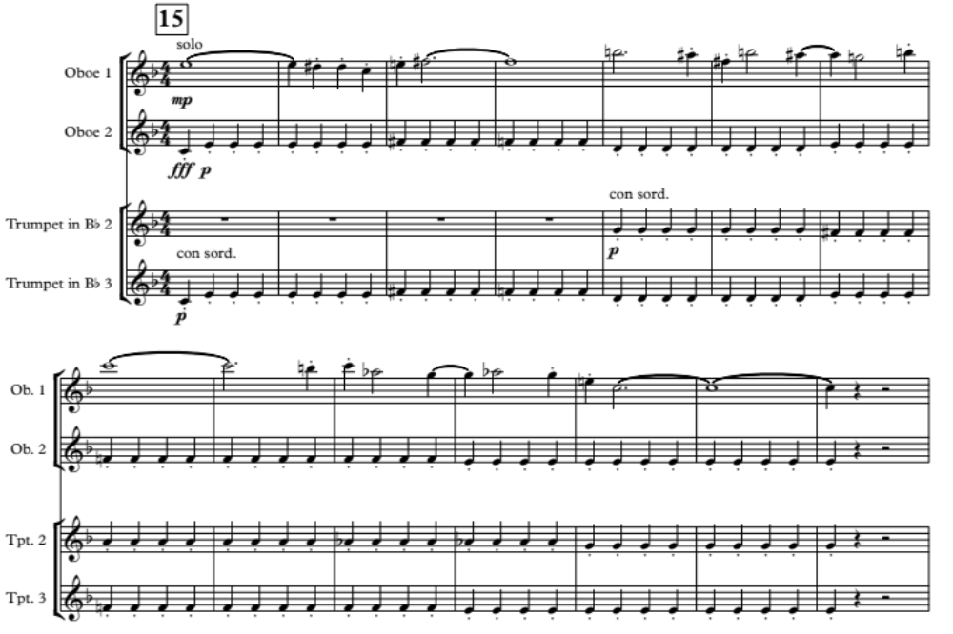
At measure 46 of movement II, a stately moment occurs in the trumpet and trombone voices. All three trumpet voices have range demands in this passage, with the 1st trumpet reaching a D6, 2nd trumpet reaching an A5, and 3rd trumpet reaching an A-flat5.
Figure 4.11. Movement II, m. 46-52 – Original Score – Trumpet scoring with high range.
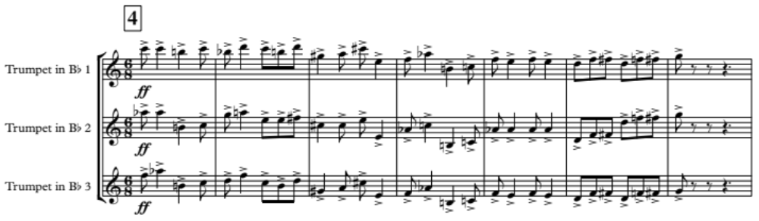
The 3rd trumpet is tasked with the melody along with the 1st oboe. The original 1st trumpet part can be lowered one octave and placed in the 3rd part for greater ease of performance. Consequently, the 2nd trumpet plays the 3rd part (the melody), and the 1st trumpet covers the 2nd part. The rescoring of these voices occurs only for the first three bars of the statement, at which point the voices return to their original and more playable parts.
Figure 4.12. Movement II, m. 46-52 – Transcription – Adjusted trumpet scoring for range.
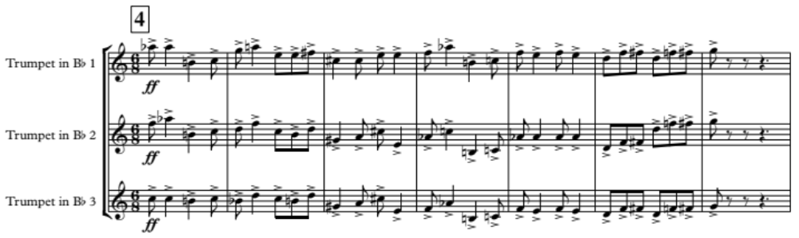
Measure 24 of movement III presents another register problem. All three trumpets play a sustained, harmonized musical line scored in the higher tessitura of the instrument. The B-flat clarinets are available to suitably perform the music with greater ease. The change has two added benefits:
- It allows the trumpet performers to rest for a longer period of time, improving endurance for the entirety of the work.
- The restatement of the theme by the trumpets in measure 159, as opposed to the clarinets, provides a timbral and dynamic change that supports the approaching climatic ending.

In the finale at measure 210, the trumpets are tasked with a long musical phrase that states the second theme of movement III. In this case, the registers were not altered for the trumpets to allow for a more powerful climatic sound. Consequently, in some instances, assistance in carrying the melodic content would be useful. The E-flat clarinet, 3rd clarinet, and soprano saxophone, available at this point in the transcription, can double the trumpet lines. The pairings are as follows:
- Trumpet 1 with E-flat clarinet
- Trumpet 2 with soprano saxophone
- Trumpet 3 with 3rd B-flat clarinet

Regardless of the range adjustments that have been made, the 1st trumpet for the transcription still requires an advanced performer. Passages that were considered for adjustment, but ultimately were not altered for the purpose of musical intent, include the following:
- Movement I, m. 124-133
- Movement I, m. 187-190
- Movement I, m. 268-230
- Movement III, m. 159-166

Addition of 3rd Clarinet in B-flat
The addition of 3rd clarinet in B-flat provides an option for doubling higher brass lines, substituting or doubling string parts, substituting for a high-register bass clarinet, or for supporting the other soprano clarinet voices. A more practical reason to add this voice is to conform to a current band instrumentation, which generally utilizes three clarinet parts.
The 3rd clarinet can double at the octave, providing a greater depth of sound within the clarinet section. This occurs immediately in the first entrance of the clarinets in movement I at measure 9. In the first three notes, the clarinet voices cover three octaves. As the music continues, the 3rd part doubles the 1st at the octave.
The 3rd clarinet may also serve as a continuation instrument, using a point of stretto, if the part of the bass clarinet exceeds a comfortable high range. An example occurs in movement I at measure 193. In the transcription, the bass clarinet is substituting for the original cello part, which ascends to an E5. In figures 4.13. and 4.14., a solution is presented to remedy the bass clarinet range issue. Using a point of stretto in the last beat of measure 192 allows the 3rd clarinet to complete the passage.
Figure 4.13. Movement I, m. 191-194 – Original Score – Cello in high range.
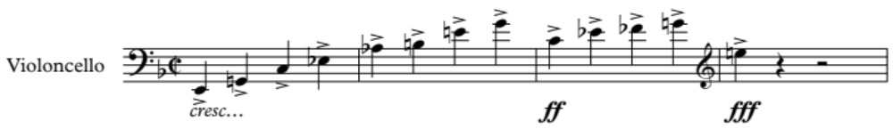
Figure 4.14. Movement I, m. 191-194 – Transcription – Bass clarinet and 3rd clarinet for cello.
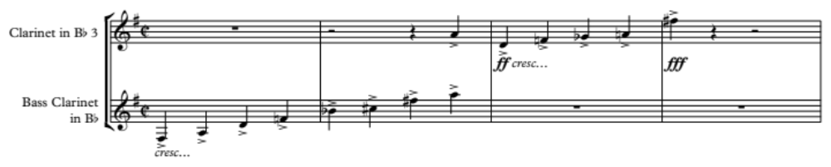

Technical passages in Woodwinds and Strings
In Philip Lang’s book, Scoring for Band, he outlines five characteristics of an original score that should deter someone from transcribing an orchestral work for band:
- Independent activity of woodwinds and strings in the upper register.
- Intricate and delicate passages for violas, cellos, and basses.
- Passages for strings of a “violinistic” character with rapid skips, changes of register, double stops, spiccato bowing, etc.
- String phrases of unusually long duration and sustained intensity.
- Passages for harp and piano.
He continues, stating, “If an orchestral score contains all or many of these characteristics it is not a good subject for band transcription.” Though it is advantageous to be aware of these challenges, with the advancement of technology and the design of current musical instruments, lines of music that may have proven difficult in the early or middle 20th century may, in some cases, be more easily achieved in the present day. Interestingly, many of the challenging passages that Kurka writes in his Symphony involve wind instruments more often than strings.
The clarinets are faced with a daunting task at measure 102 in movement I. Kurka composed a continuous rhythmic accompaniment lasting for 50 measures. Past performers of this work would have undoubtingly omitted notes at certain points to breathe and continue performing. The advantage in the transcription is the benefit of multiple individuals on each clarinet part. The original music may be retained, while instructing the performers to alternate entrances by noting “player 1a” or “player 1b.” The following is an example:
Figure 4.15. Movement I, m. 104-109 – Transcription – Clarinet multiple performer instructions.
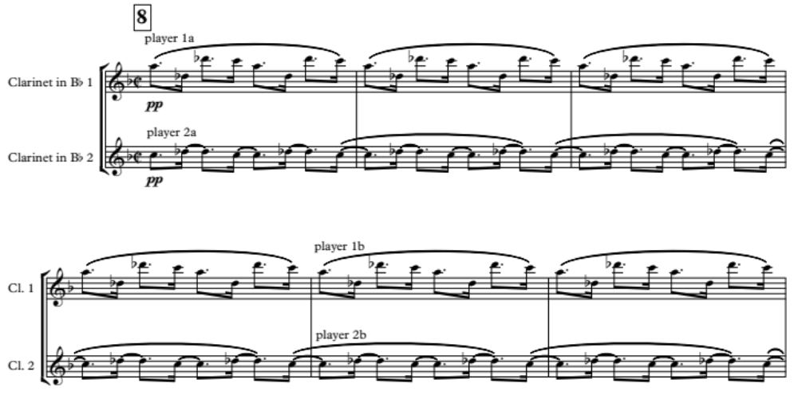
Kurka orchestrates another difficult passage in movement III, measure 17, setting a lengthy sixteenth-note passage in the piccolo and flute voices that accompanies the main melody. The passage is 14 measures, with a note in the original published score that states, “In the parts, the flutes and piccolo alternate, as indicated, to facilitate the performance of this and similar passages later on.” In the case of this transcription, the parts were unavailable, and the notes in the score that attempt to indicate the instructions for each player are not clear.
The entire passage of sixteenth-notes is on the piccolo staff. An attempt is made to notate where the piccolo, 1st flute, or 2nd flute voices are to enter to play the written music. Upon initial study of the score, it appears the 2nd flute voice begins the sixteenth-note passage, with tacet written above the piccolo staff and a note of “I. tacet” written above the flute staff, signifying that the 1st flute voice should rest. To designate when either the 1st flute or 2nd flute part should be playing, a simile mark is included in the flute staff, similar to figure 4.16. When that simile mark is absent, it appears the piccolo then takes over the line as written. At best, this method of notation is unclear to the conductor.
Figure 4.16. Movement III, m. 17-20 – Original Score – Flute and piccolo sixteenth-note passage.
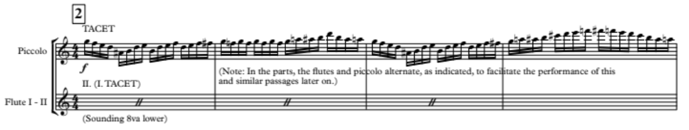
The most puzzling moment is encountered when the word “play” is written over the piccolo line at measure 24, yet “I. (II. Tacet)” is also written over the flute staff, signifying that the 1st flute voice should play and the 2nd flute voice should rest; however, the simile mark remains in every staff from this point up until the end of the line at measure 31. It can be assumed that Kurka did not intend to have both the piccolo and flute voice playing at the same time, but rather that they alternate as previously noted.
With the notes by the composer or publisher in the score causing confusion, reexamining and altering the piccolo and flute entrances is acceptable. Slurs were also added to aid in ease of performance. The 1st and 2nd xylophone parts double the piccolo and flute line, adding an articulated sound to the music which is desired by the original composer (See Figure 4.17.). Similar passages occur at measures 17, 159 and 196, all in movement III.
Figure 4.17. Movement III, m. 24-30 – Transcription – Alternating entrances of piccolo and flute.
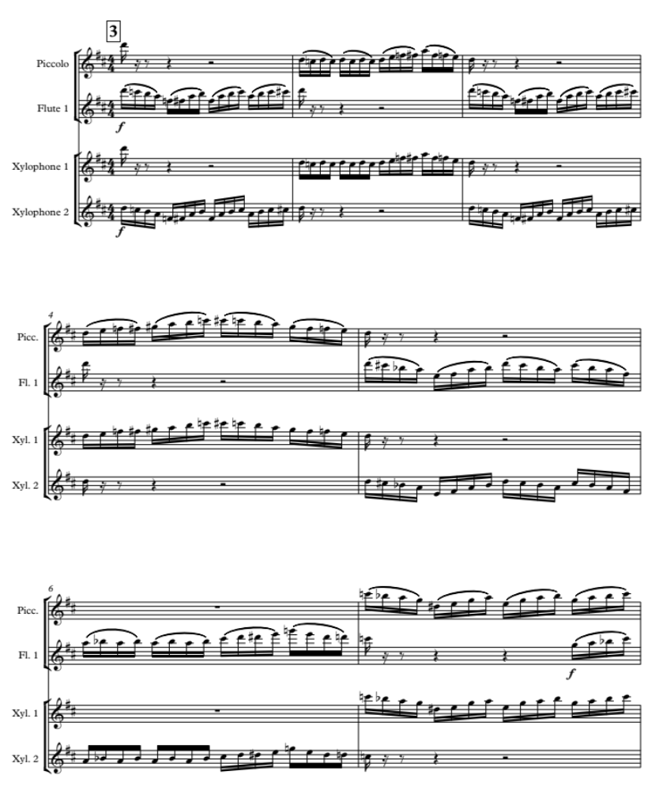
The string parts in the original composition presented few issues regarding musical gestures. To facilitate ease of performance, slurs were added in the transcribed wind parts for sixteenth-note passages in faster tempi. Staccato articulations were also added to simulate pizzicato technique.
One problematic musical line occurs in movement III, measures 5 through 7. The 1st violin and viola parts contain fast passages with leaps that exceed two octaves.
Figure 4.18. Movement III, m. 5-7 – Original Score – Large leaps in violin and viola.
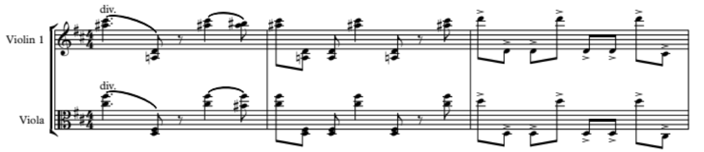
Clarinets and saxophones are able to manage such a line; however, one could argue whether the two-octave leaps are necessary for retaining fidelity, or if leaping just a single octave is a possibility. The latter option allows for the composition to be more accessible while remaining true to the composer’s musical intent. Additionally, mallet percussion can assist with the prominence of the line, to ensure proper balance within the ensemble.
Figure 4.19. Movement III, m. 5-7 – Transcription – Large leaps limited to one octave in winds.
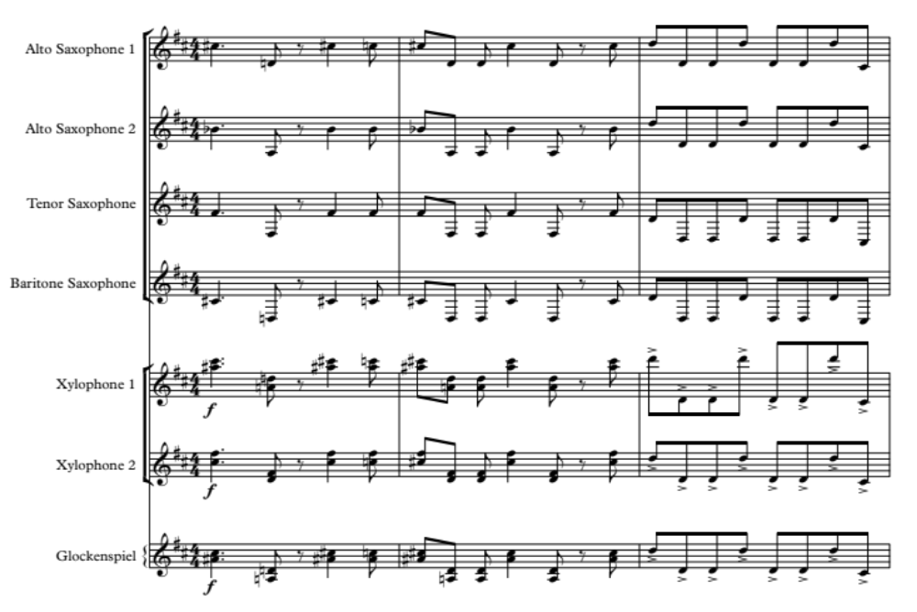
Three other instances of the same or similar gestures occur within the movement:
- Measures 35-37
- Measures 170-172
- Measures 224-227
In all cases, similar voicings were used.

Enharmonic Spellings
Enharmonic spellings are used to assist wind players in performance. Some changes involve short lines of music, while the majority of changes are the result of double-sharps or double-flats occurring after the score is transposed in the Sibelius music notation software. The natural enharmonic equivalents of E-sharp, F-flat, B-sharp and C-flat were generally used with few exceptions. These spelling changes do pose difficulties in the analysis of the score by the conductor, however it results in less confusion for the performers.
There are some exceptions to the use of double-accidentals that should be noted. When the use of a double-accidental results in less accidentals being written in close proximity, it is preferable. A primary example occurs in the 3rd clarinet voice in movement III, measure 5 where the clarinet is playing a sixteenth-note figure between a written D-sharp and C-double-sharp. The use of the double-sharp makes the music clearer than if the transcriber were to use a D-natural in its place. Figure 4.20. provides the comparison.
Figure 4.20. Movement III, m. 5-6 – Transcription – Use of double-sharp.
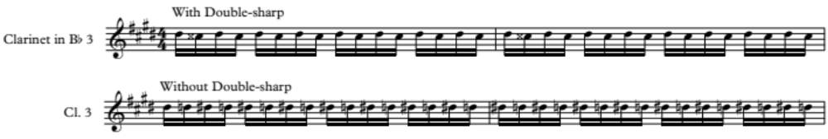

When a portion of the music requires numerous enharmonic re-spellings, it is often preferable to re-notate the entire section with enharmonic equivalents. An example occurs at rehearsal 11 of movement III for the trumpet voices, and later at measure 102 for the horns. The music includes a written B-sharp and F-double-sharp for the trumpets, and written B-sharp and E-sharp for the horns in the original score. The passage also contains many sharp accidentals in general, which is not preferable for wind performers. Reading an enharmonic equivalent of the passage allows the performers to read the music with greater ease, thus improving performance. The following is an example from the trumpet voice:
Figure 4.21. Movement III, m. 98-99 – Original Score – Trumpet part before enharmonic spelling.
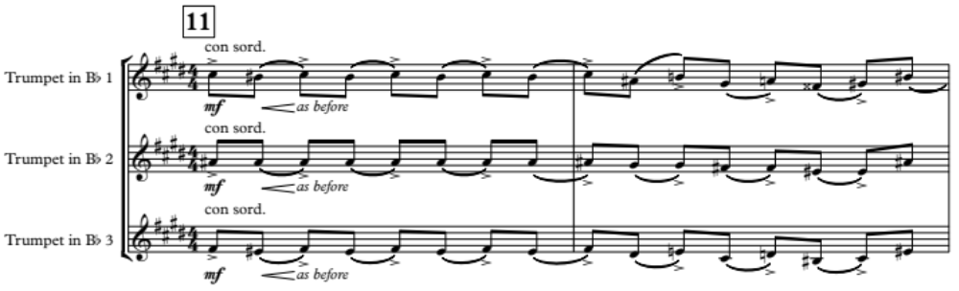
Figure 4.22. Movement III, m. 98-99 – Transcription – Trumpet part enharmonically spelled.
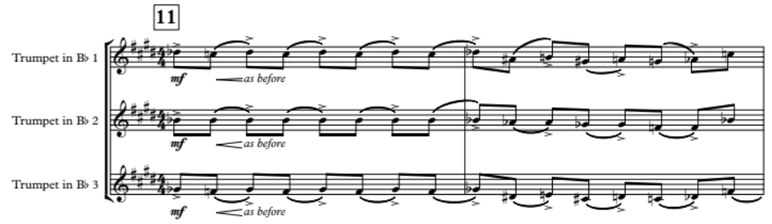
Fragments of melodies are also respelled as necessary. One example is the melodic fragment found in the violins in movement III, measure 108. This fragment is stated often, and by multiple voices. Though the sharp and double-sharp accidentals fit the key center of E in this section, the respelling of the fragment allows for ease of reading.
Figure 4.23. Movement III, m. 108 – Enharmonic example.
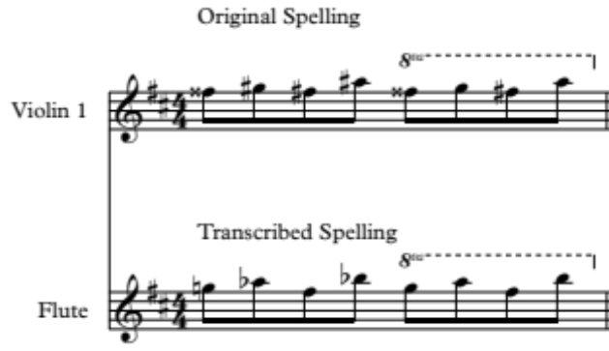
With the majority of enharmonic issues occurring in movement III, one could argue that the entire key of the movement could be changed. Collette Rockley states in her document that, “Awkward fingering combinations are usually the result of poor key selection by the composer or the transcriber...The farther away from the central pitch of an instrument a particular note is, the more the instrument has to be manipulated through the opening and closing of certain holes to attain that pitch.” This statement is true from the point of view of a performer or conductor. However, a composer often takes a different approach to the decision of a key to use within a work. Respected music editor and conductor Mark Rodgers notes that Percy Grainger would often try a piece of music in many key signatures to decide which sounded the best before publishing the composition. Based on Mark Rodgers’ observation, changing the key of any portion of Symphony No. 2 would not ensure fidelity, as it was Kurka’s decision to set the music in the given key.

–Summary, Conclusions and Recommendations for Further Study

Summary and Conclusions
The transcription of Symphony No. 2 provides current band ensembles with another voice from the 1950s, a decade that witnessed a surge of new works for band by American composers. Darius Milhaud, Vincent Persichetti, Paul Hindemith, Percy Grainger, Igor Stravinsky and Morton Gould all composed significant wind band works within the lifetime of Kurka. The trends in Kurka’s writing signify a desire to write for winds, considering his Moravian Folk Songs for chamber winds, The Good Soldier Schweik Suite, and the prominent use of winds in his Symphony No. 2 and other large orchestral compositions. With prominent composers writing for wind ensembles in the 1950s, perhaps, given a longer life, Kurka would have done the same.
With the transcription of Kurka’s Symphony No. 2 for full band, the possibility of Kurka’s compositional voice in a large wind setting is realized. As a result, the composer’s creative melodic development, free use of dissonance in a tonal setting, and features of neo-classical music may be experienced by more wind musicians, providing further insight into American compositions of the 1950s. Even though the Symphony contains substantial technical challenges and a youthful vitality in the original orchestration of the composer, the work lies within the grasp of most upper-collegiate ensembles. Smaller university, college, or high school band programs may also find the work playable.

Recommendations for Further Study
The transcription of Symphony No. 2 assumes an important role in renewing interest in Robert Kurka’s legacy. Transcriptions do not hold the same importance as they once did in the early 20th century, when they were the primary source of repertoire for wind bands. Since the second-half of the 20th century, the creation of original music for wind band has been, and remains the expectation. Regardless, adapting music for other genres remains an important endeavor for enriching performers’ and listeners’ experiences.
Additional study is recommended of Robert Kurka’s solo and chamber works, which constitute the largest portion of the composer’s output. In addition, performing and recording these works would assist in introducing Kurka’s music to a new generation of musicians and further understanding his compositional language. Finally, additional transcriptions of his large ensemble works would continue to offer more opportunities to explore his music.
Due to the limited publication of biographical information on Robert Kurka from 1921 through 1948, research is needed to focus on his early childhood. Research through correspondence or interviews with living relatives and perhaps the uncovering of new documentation, may provide insight into his life including early musical training and general education.
Mark Rodgers notes that a transcription or arrangement being recognized as an important addition to the band repertoire is preferred, but that “such a goal...may be unattainable for any setting of a composition which has the misfortune to be an arrangement and is therefore less than totally authentic.” Though performance of this adaptation of Kurka’s Symphony is desired, the transcription primarily serves as a starting point to rediscover the history of the composer. The next step is the continuation of research and the performance of Kurka’s works, and to learn more about a gifted American composer who has evaded intensive study for over 60 years.

Appendix A – Symphony No. 2 Op. 24 Transcription – Full Score

Robert F. Kurka

Symphony No. 2
Op. 24 (1953)

Transcribed for Band by
George Schrader Jr.

Instrumentation

Piccolo
2 – 1st Flutes
2 – 2nd Flutes
1st Oboe
2nd Oboe
English Horn
1st Bassoon
2nd Bassoon
Contrabassoon
Clarinet in E-flat
3 – 1st Clarinet in B-flat
3 – 2nd Clarinet in B-flat
3 – 3rd Clarinet in B-flat
Bass Clarinet in B-flat
Soprano Saxophone
1st Alto Saxophone
2nd Alto Saxophone
Tenor Saxophone
Baritone Saxophone

2 – 1st Trumpet in B-flat
2 – 2nd Trumpet in B-flat
2 – 3rd Trumpet in B-flat
1st Horn in F
2nd Horn in F
3rd Horn in F
4th Horn in F
1st Trombone
2nd Trombone
Bass Trombone
Euphonium
2 – Tuba
Double Bass
Timpani
Snare Drum
Triangle
Bass Drum
Cymbals (Sus. and Crash)
1st Xylophone
2nd Xylophone
Glockenspiel

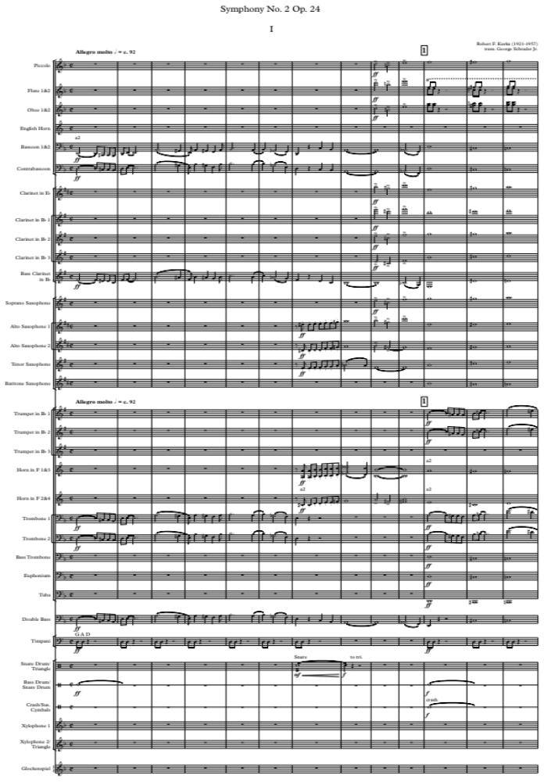
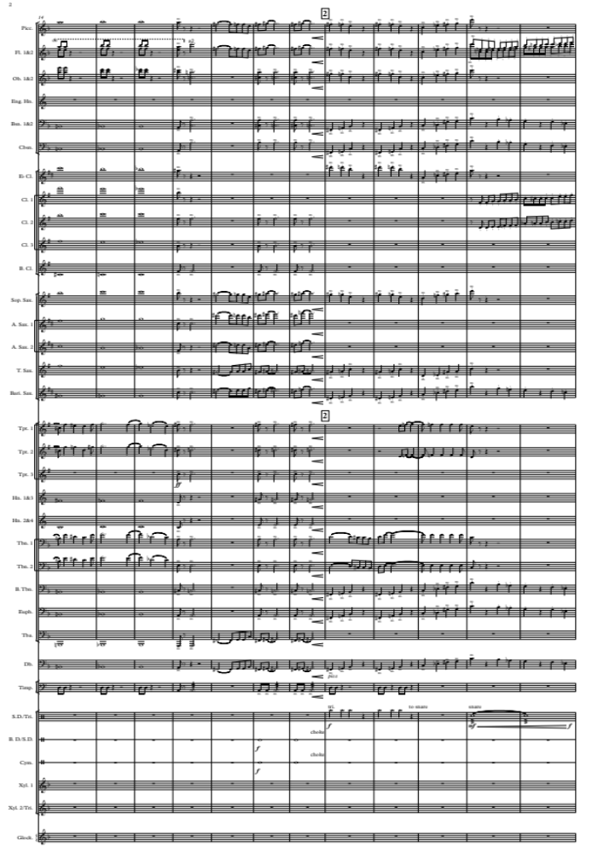
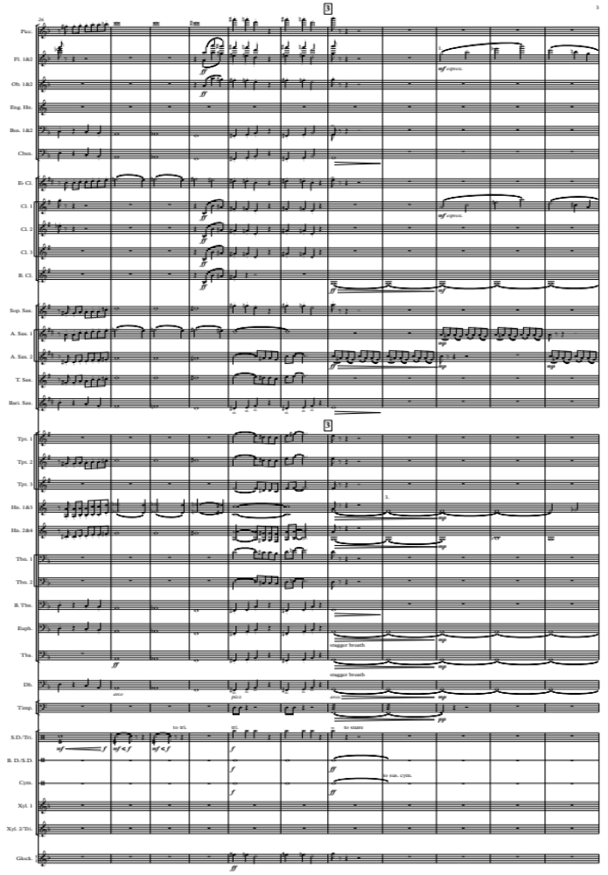
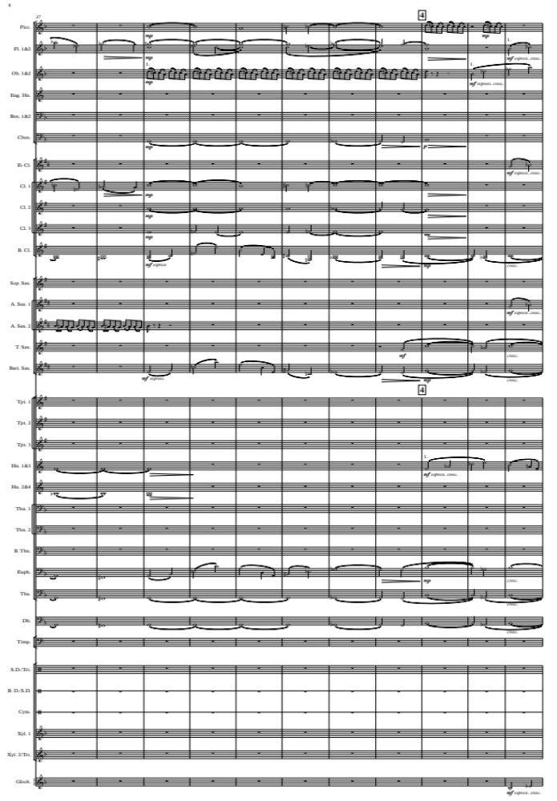
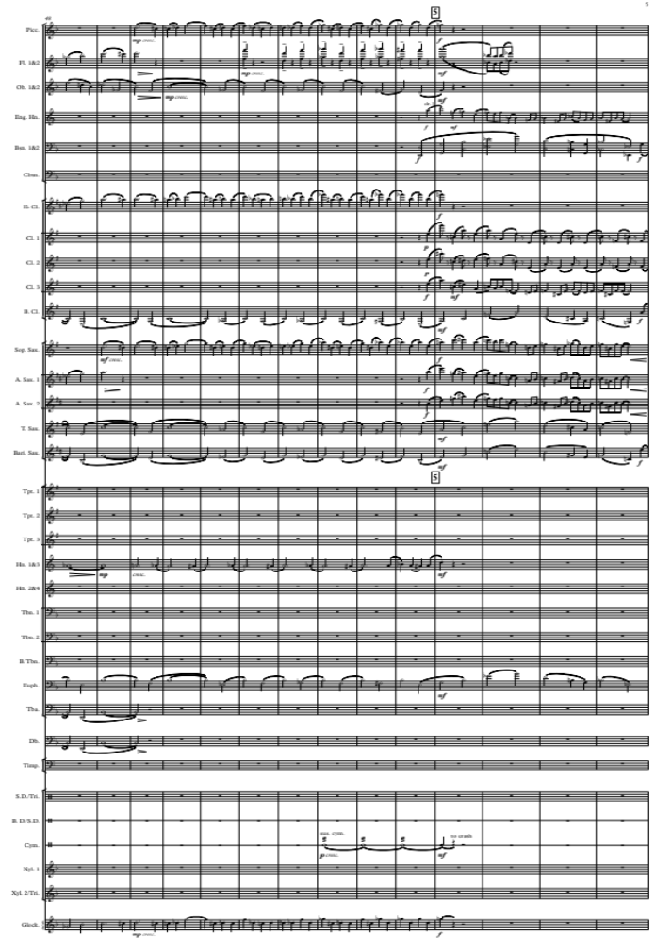
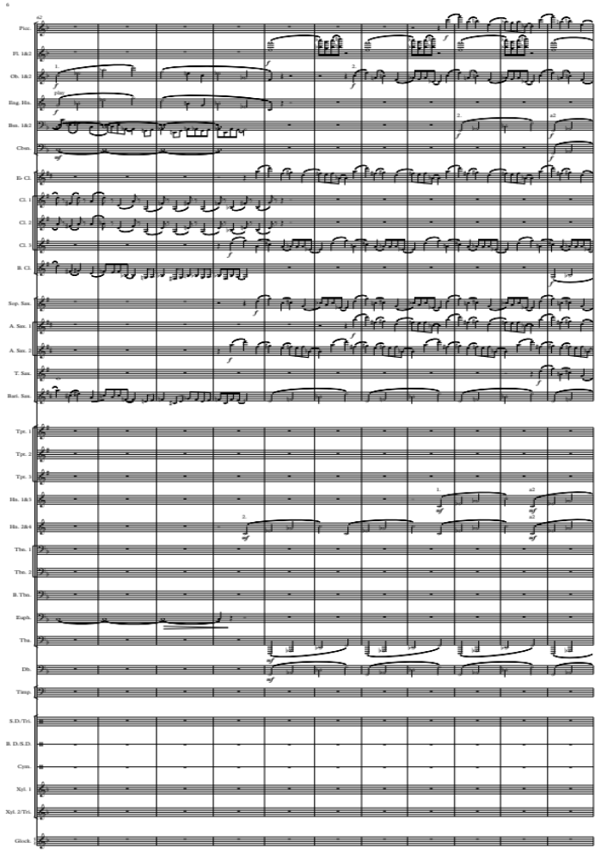
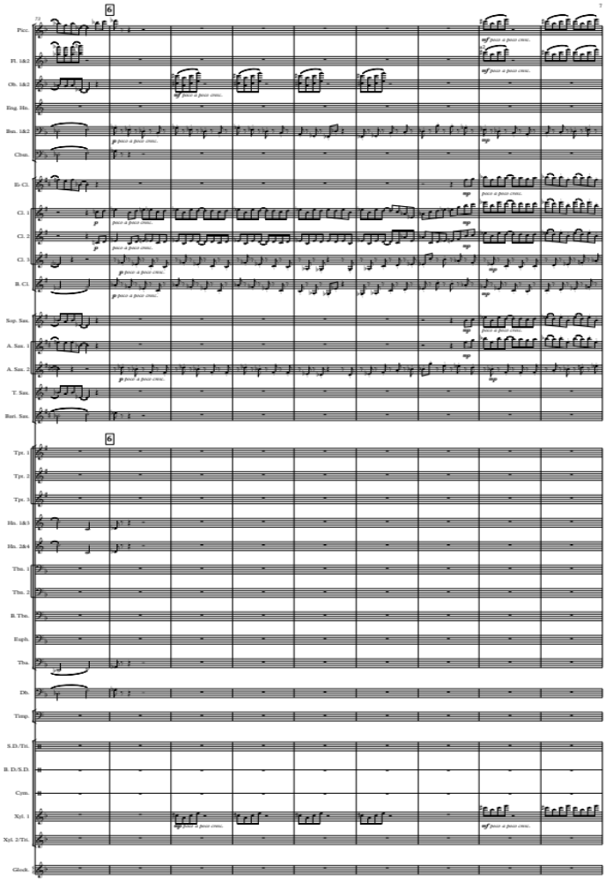
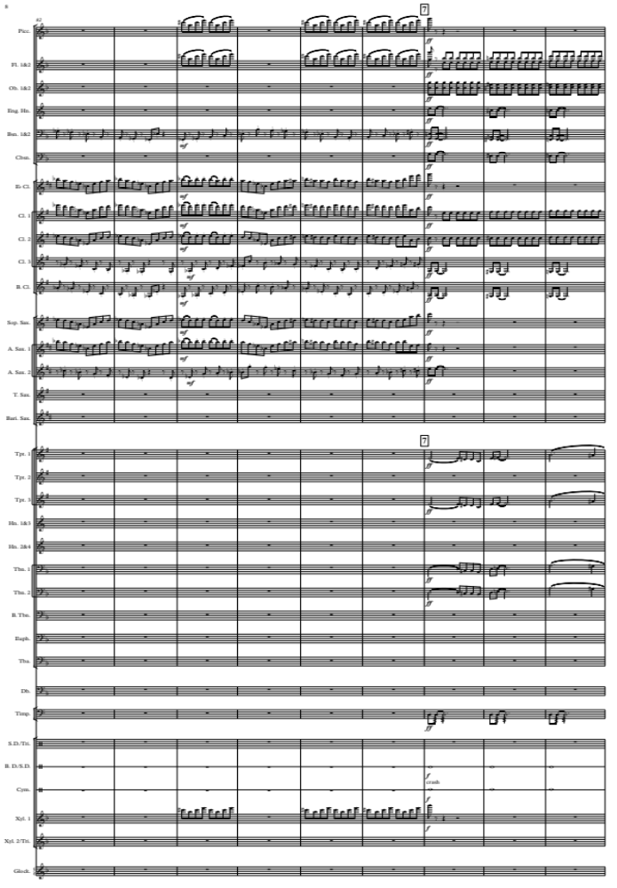
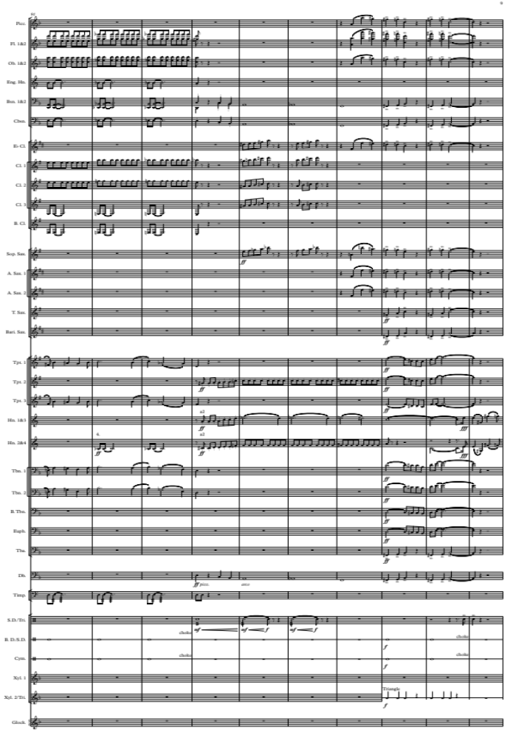
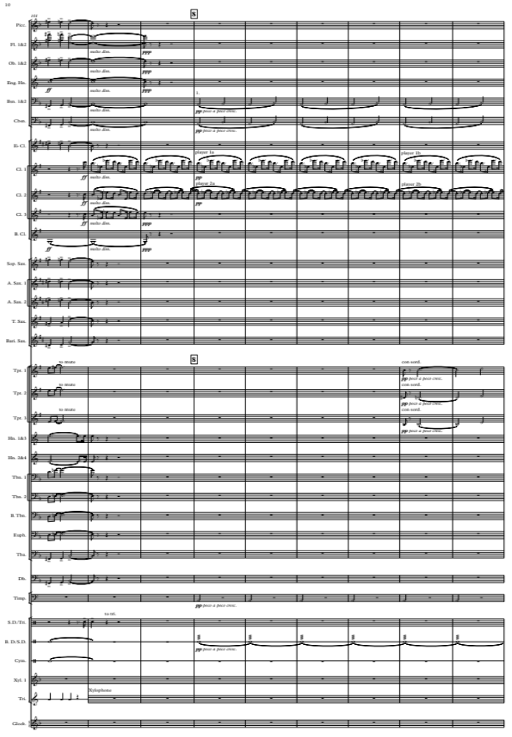
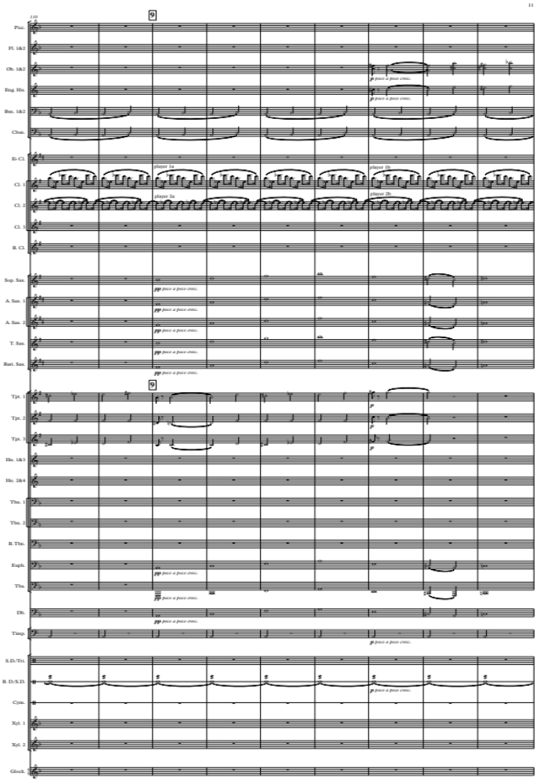
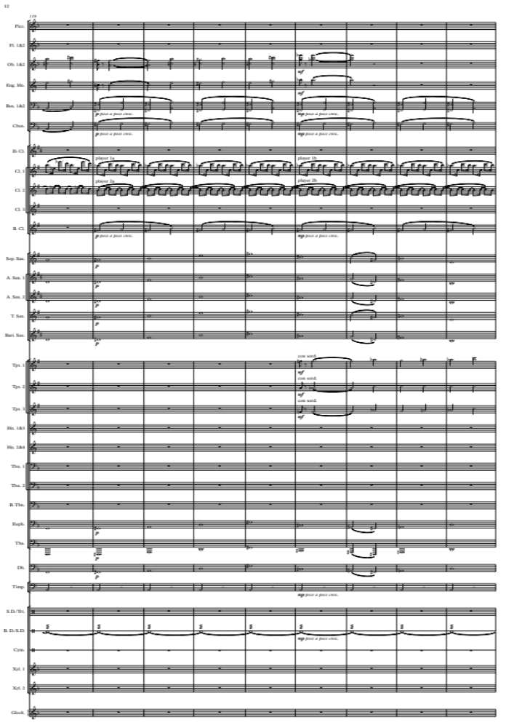
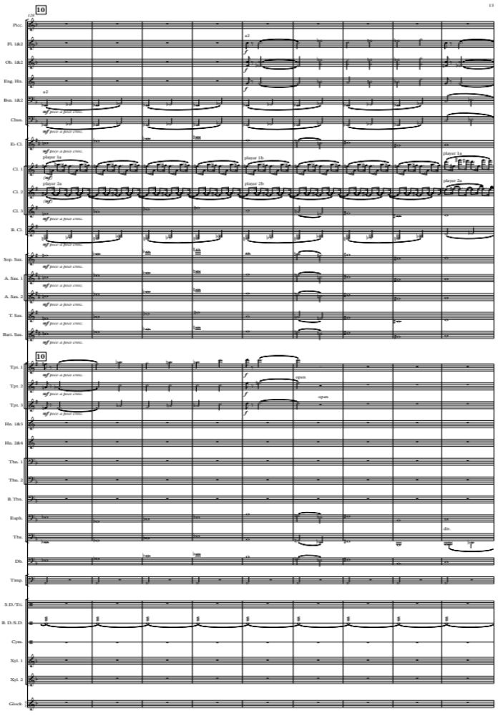
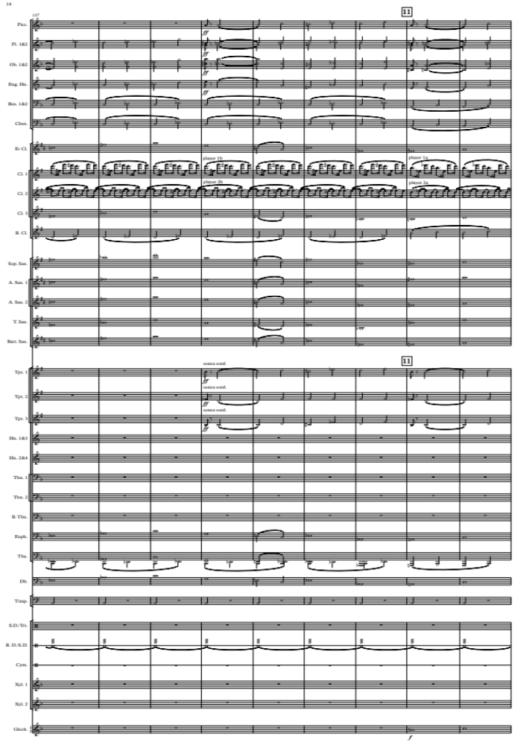
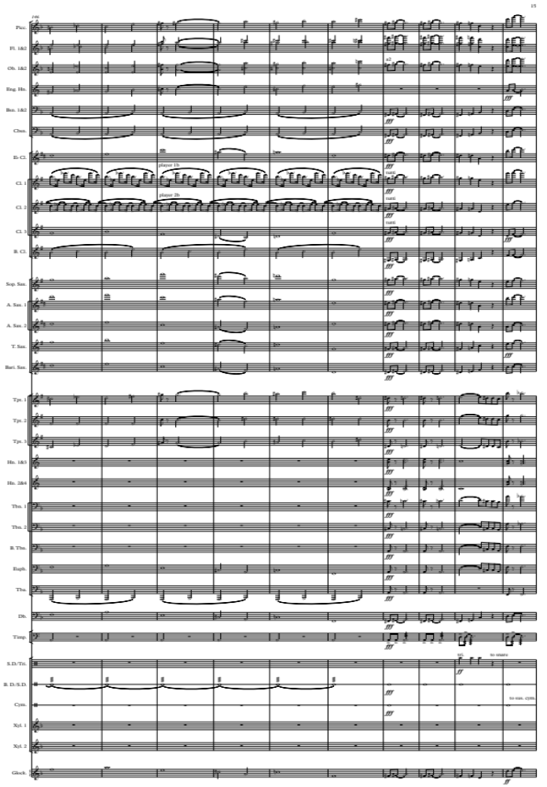
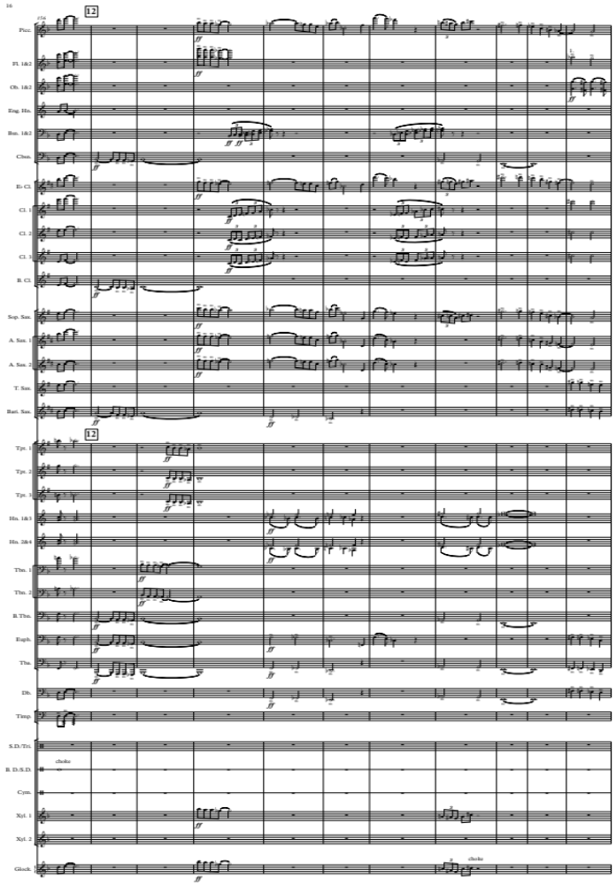
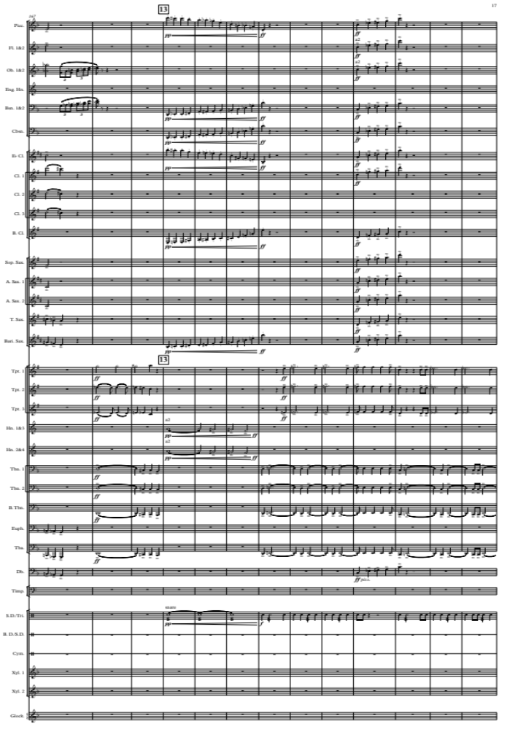
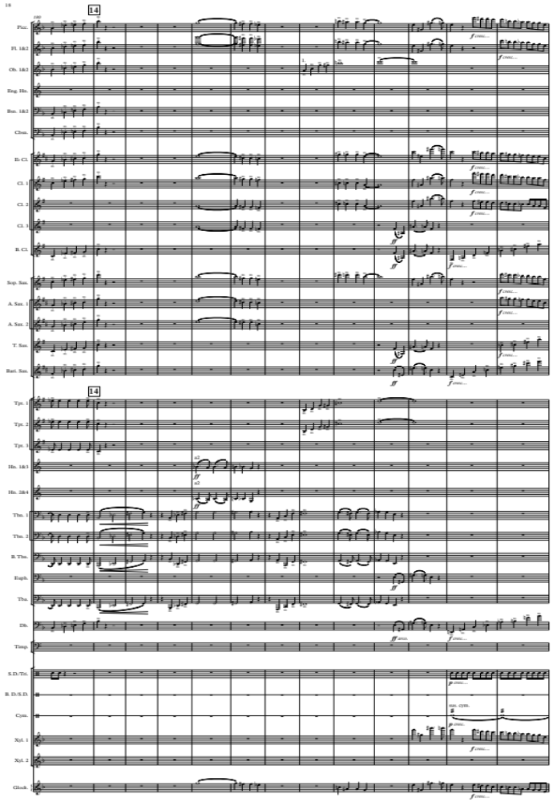
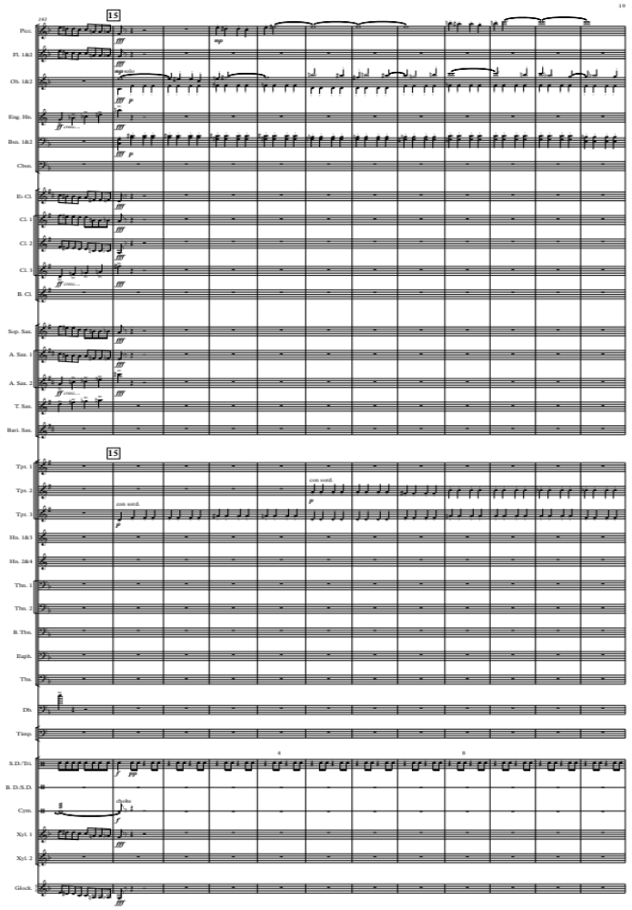
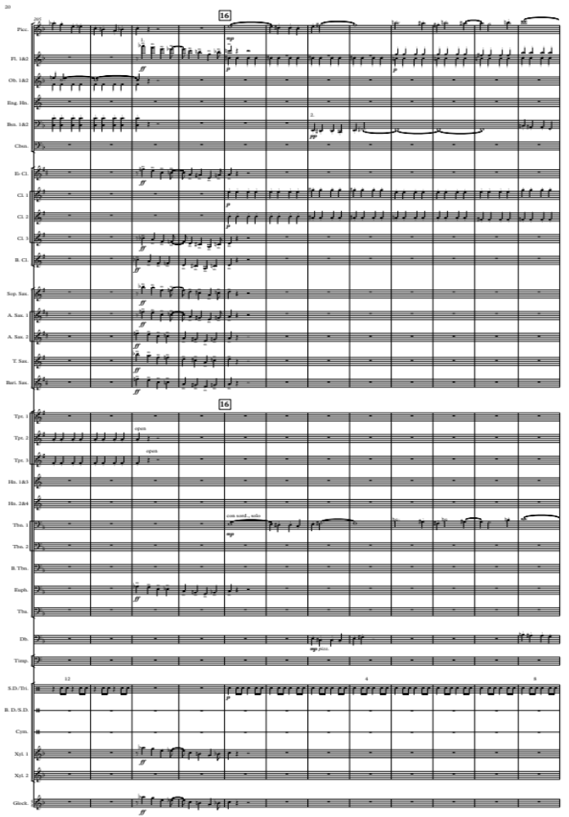
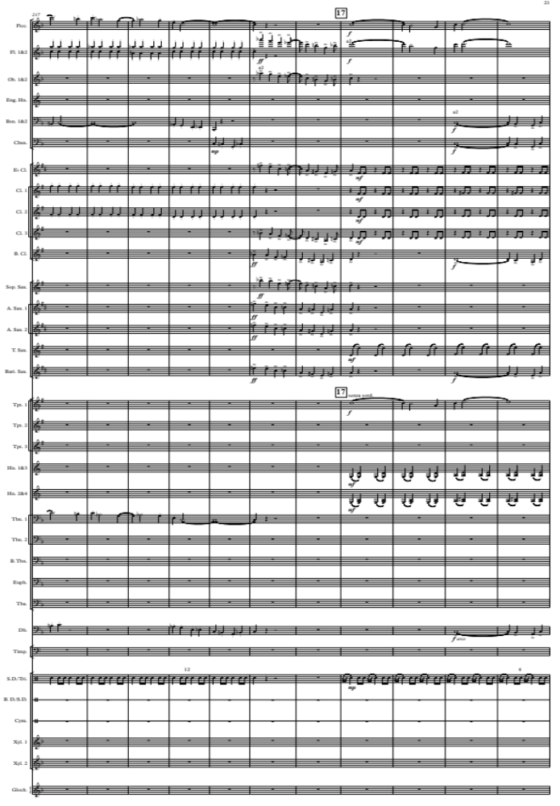
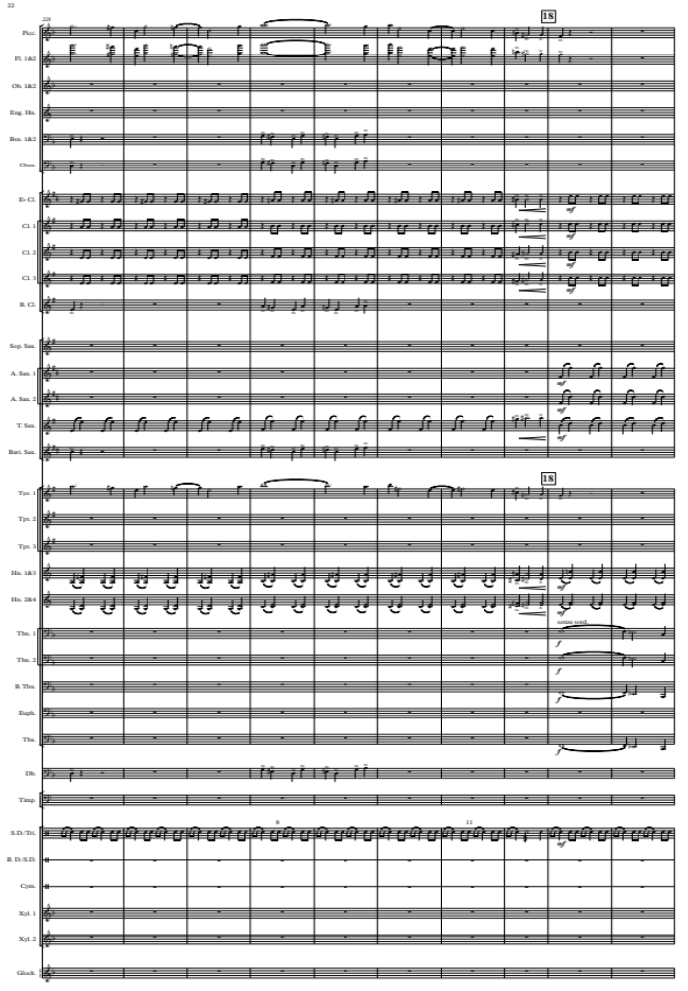
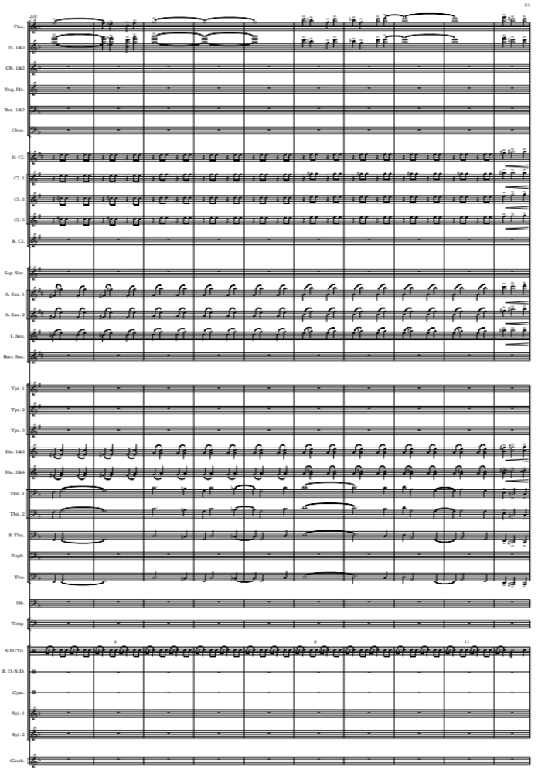
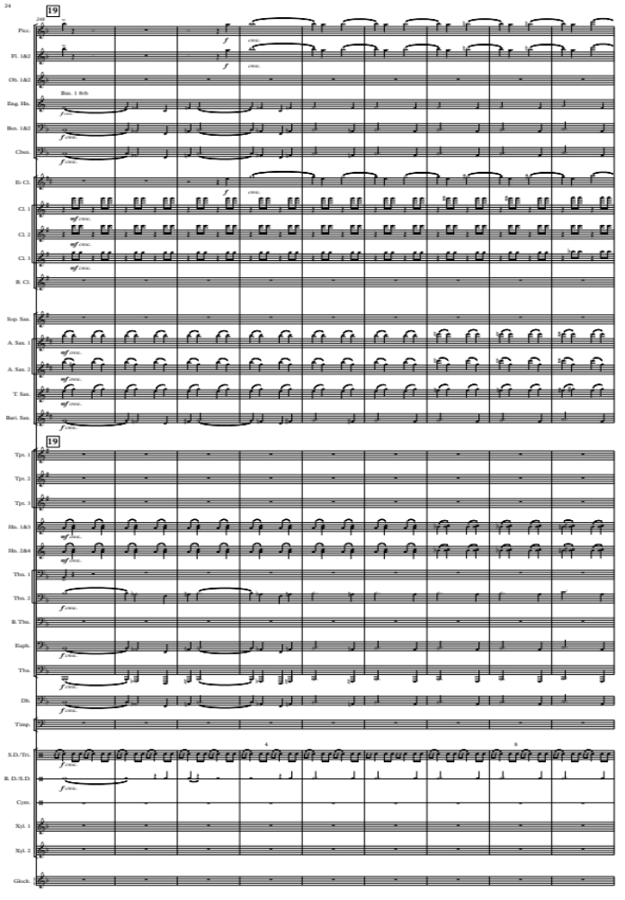
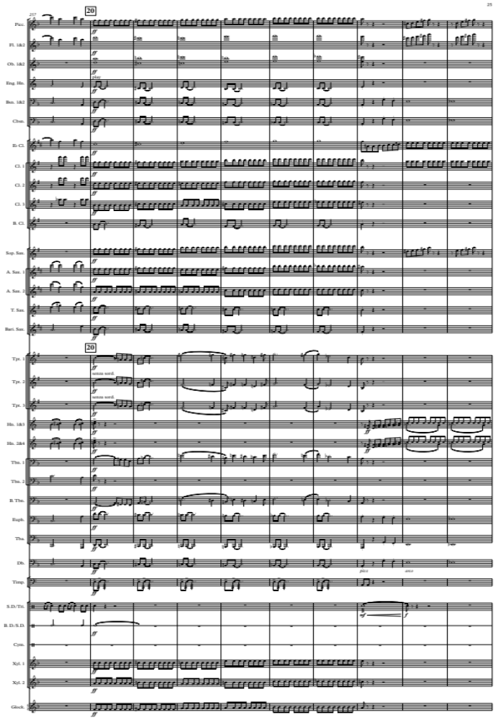
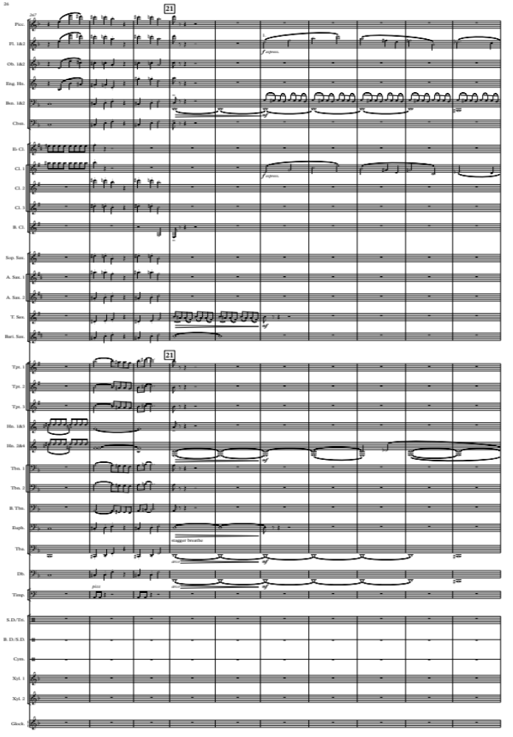
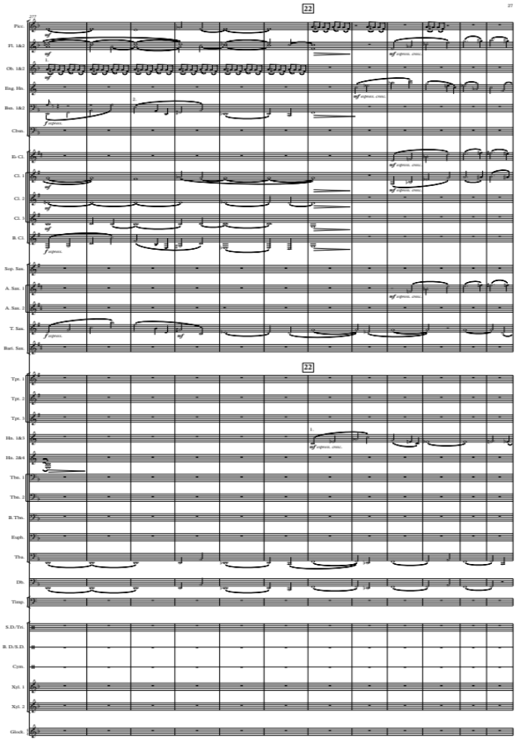
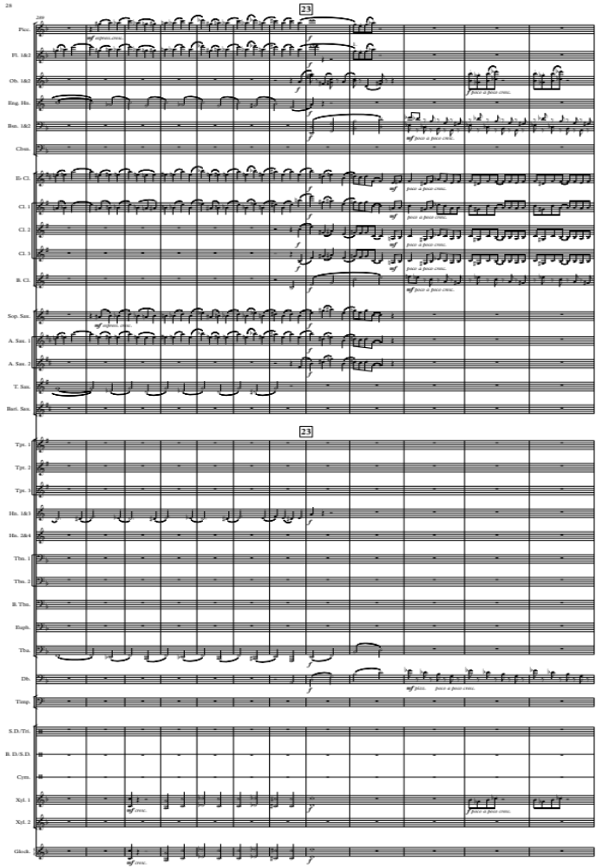
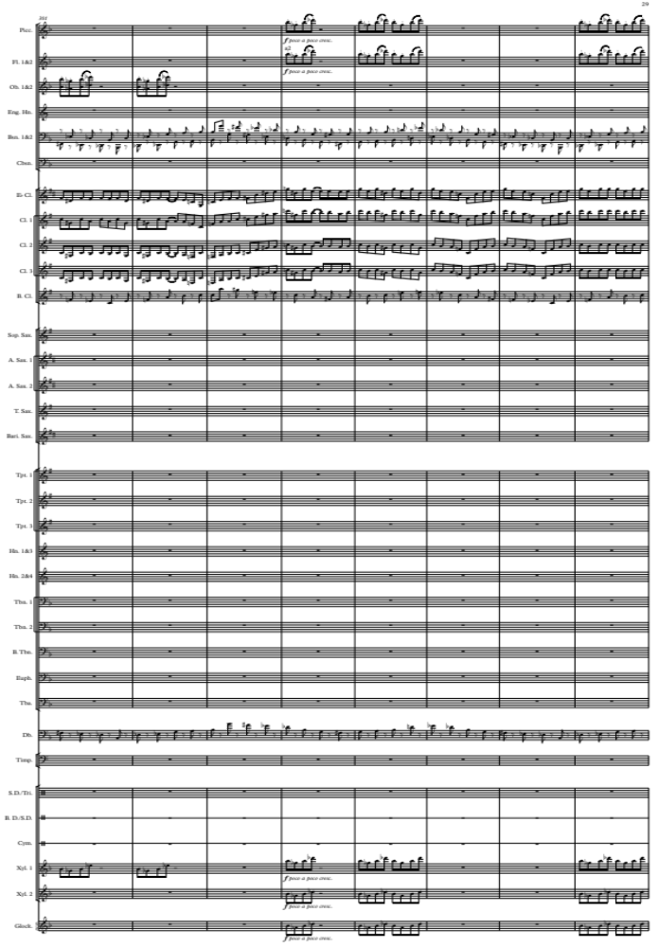
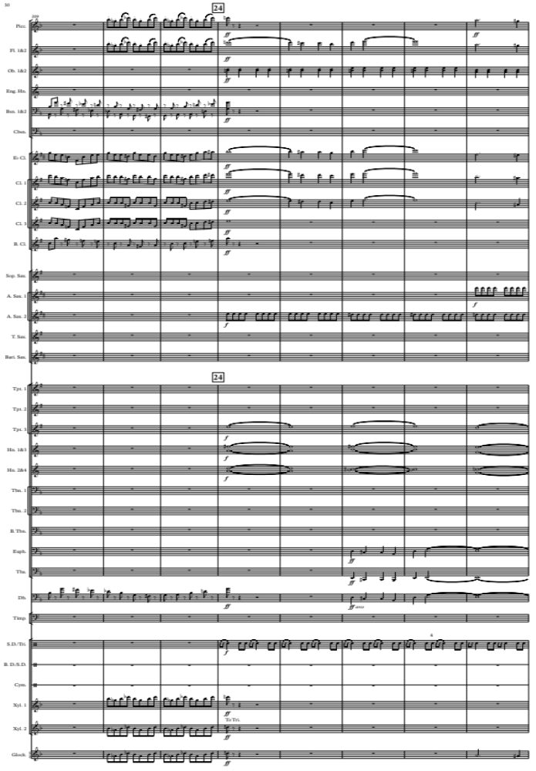
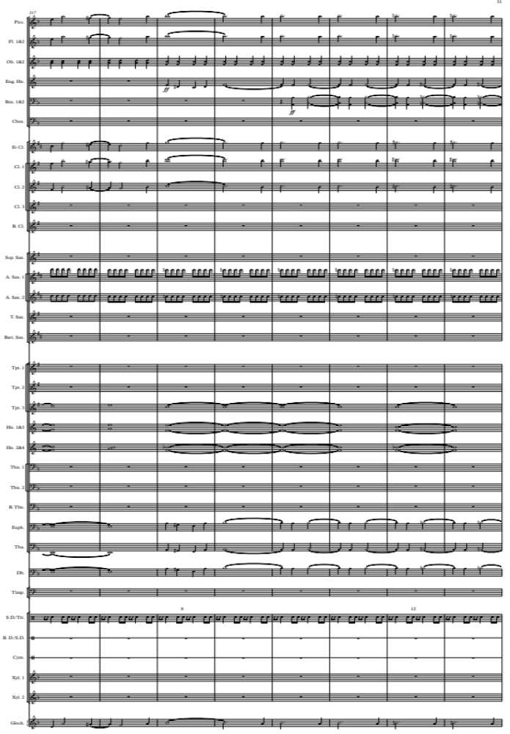
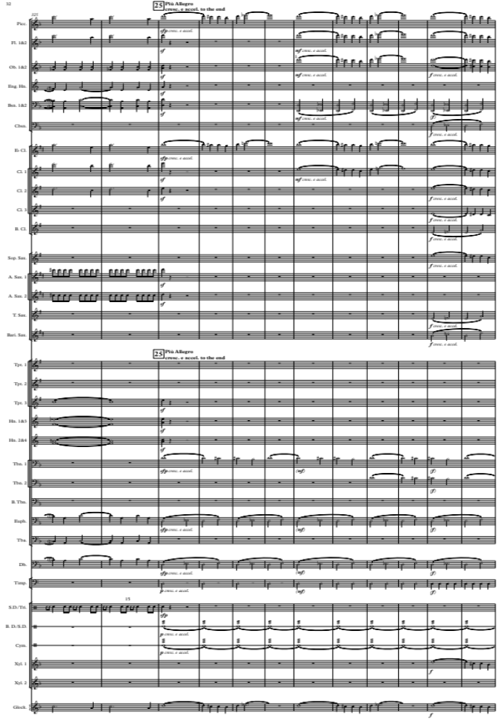
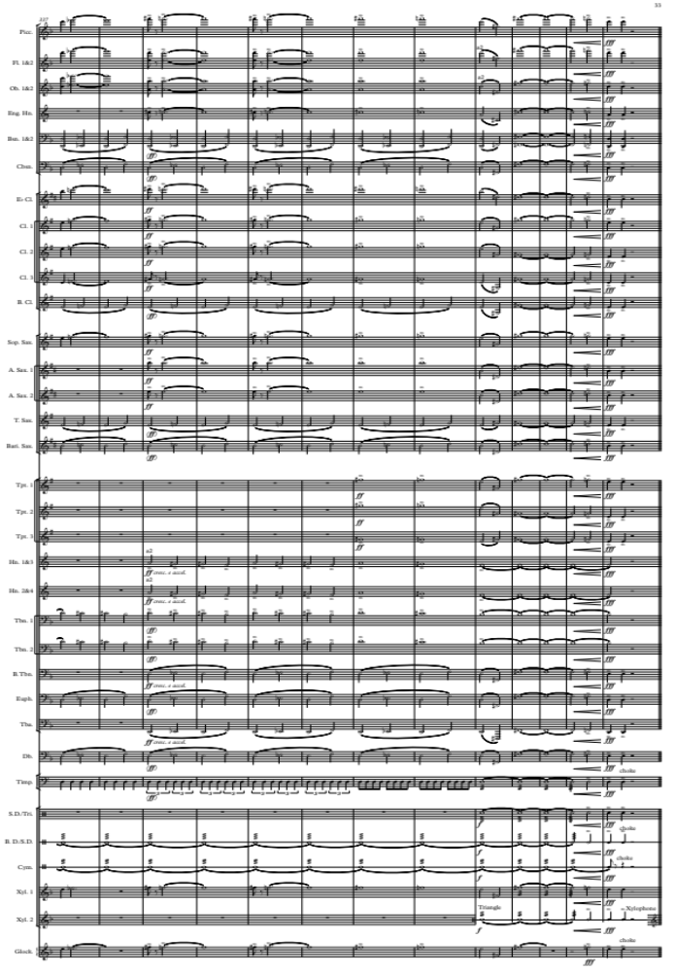
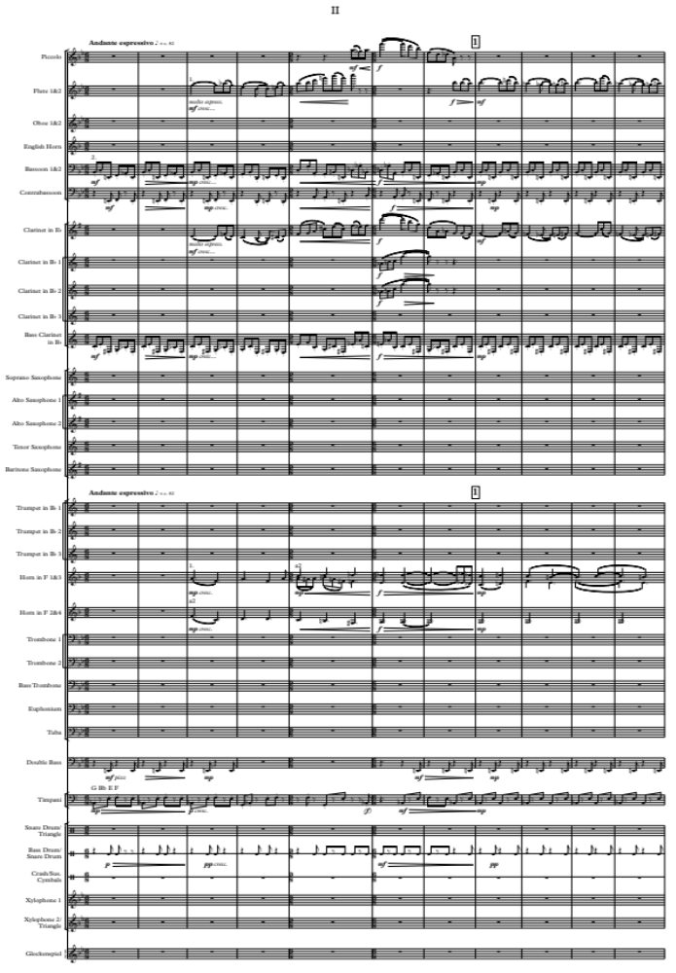
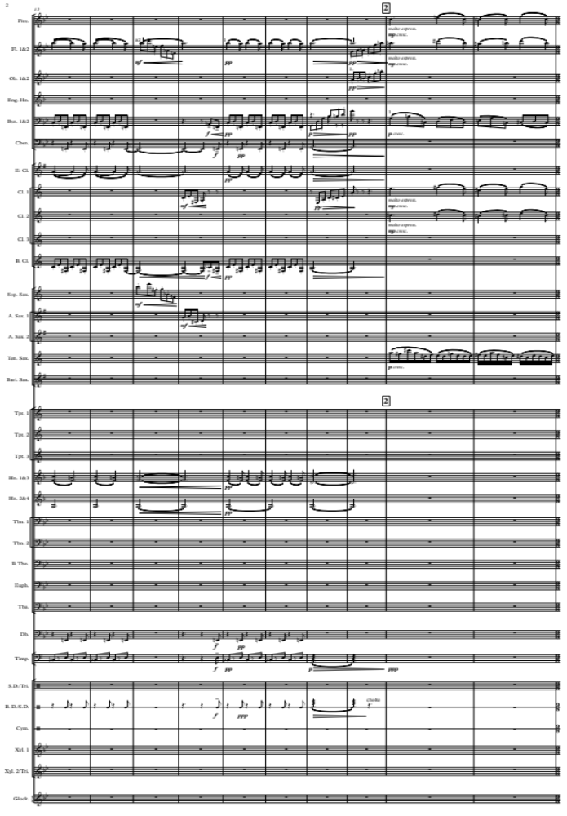
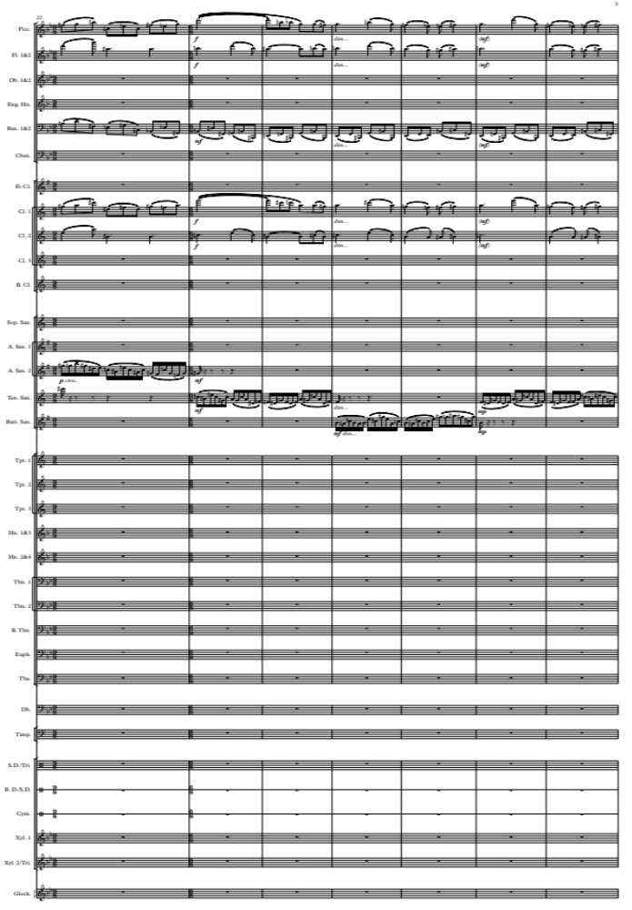
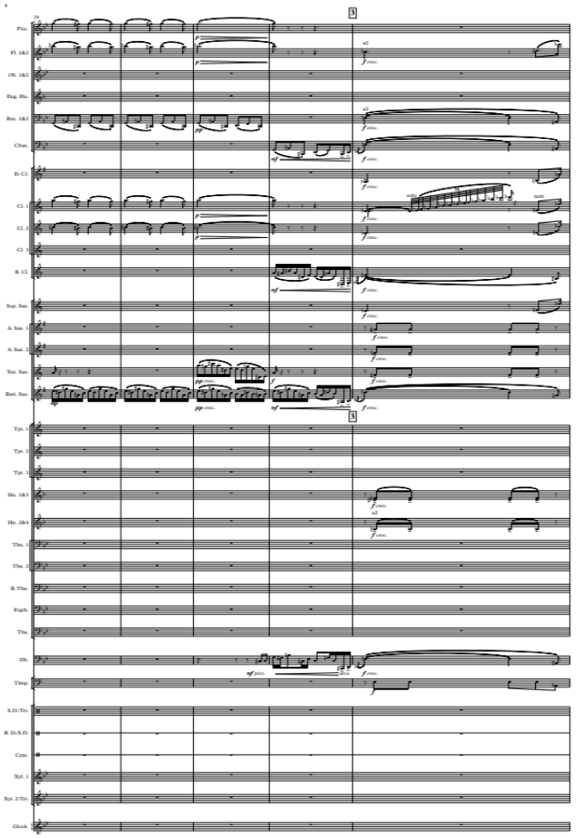
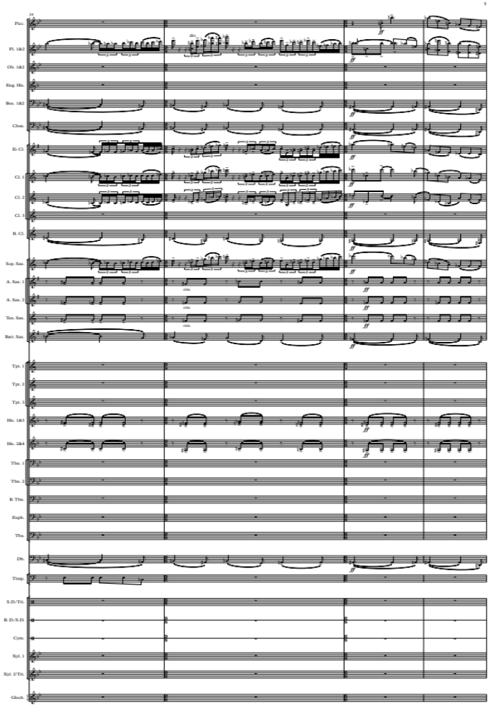
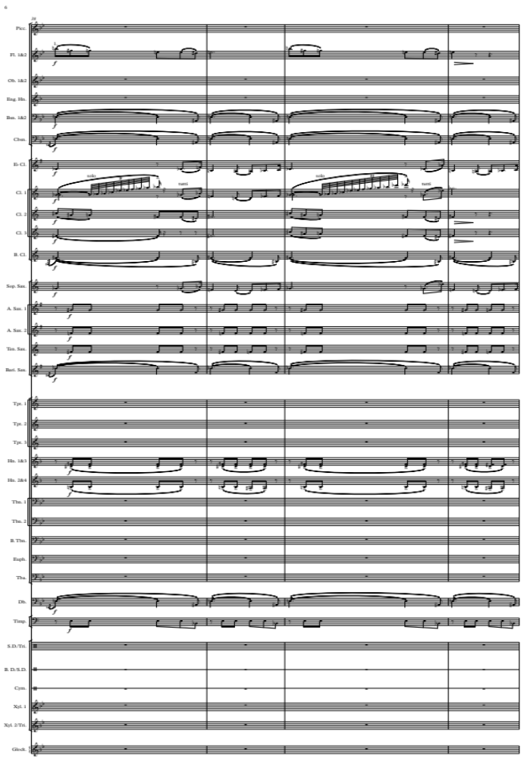
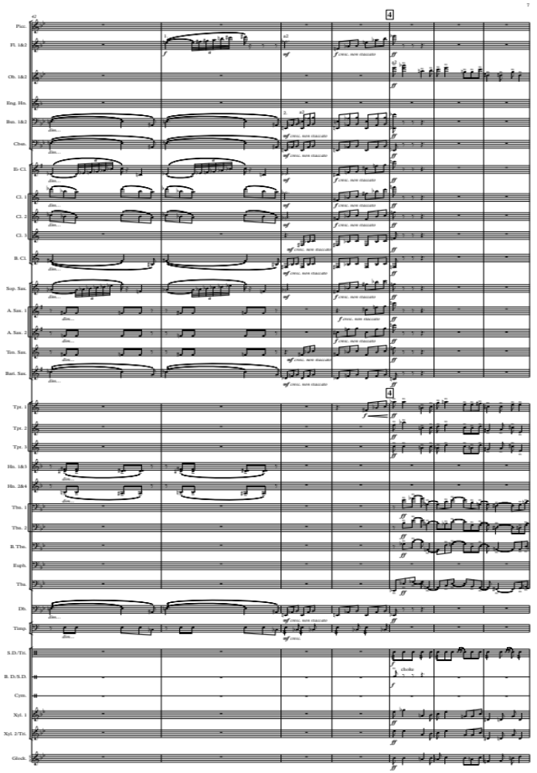
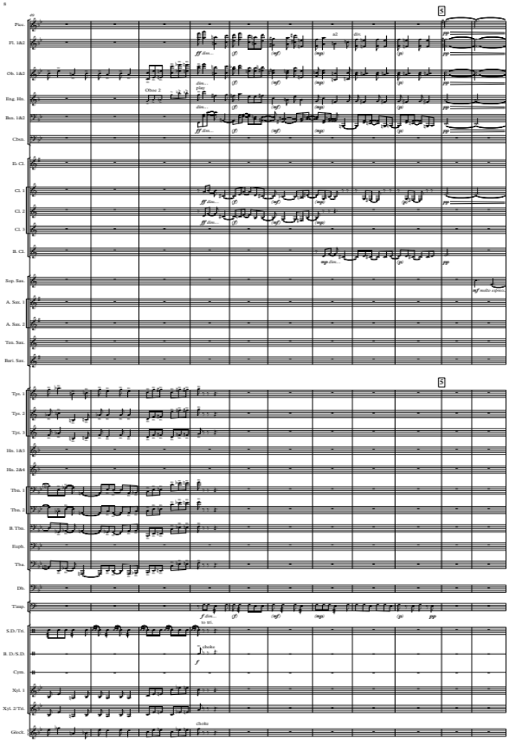
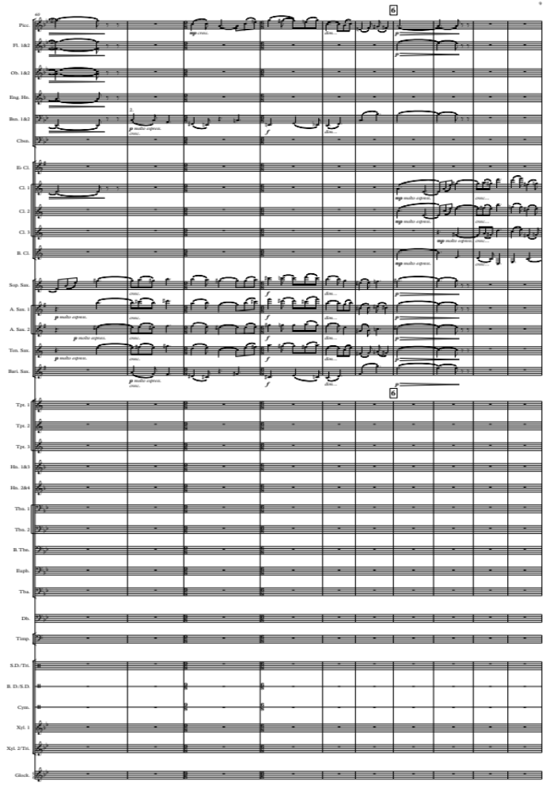
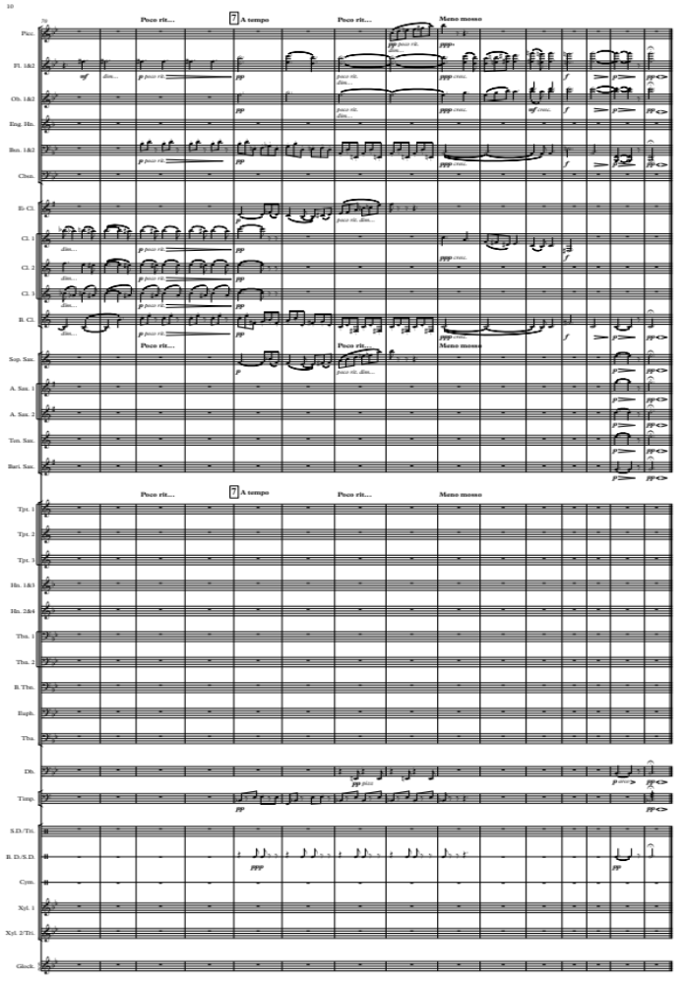
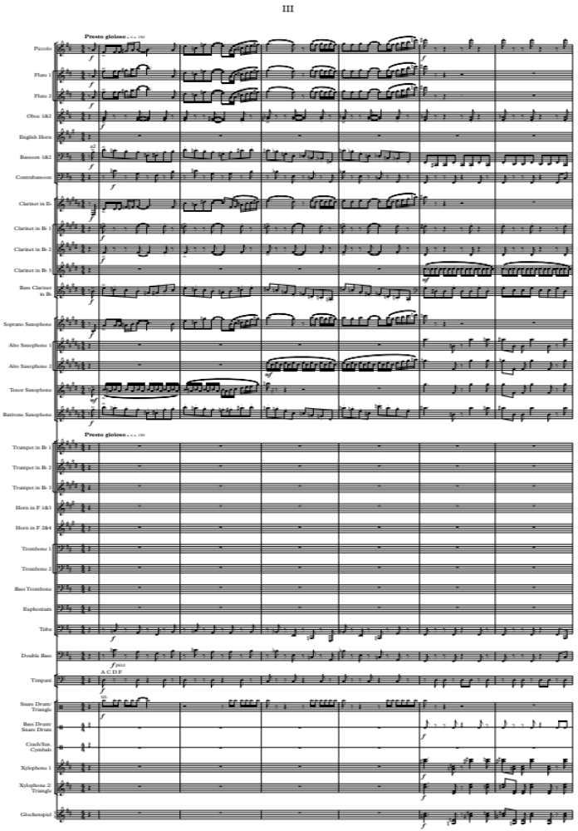
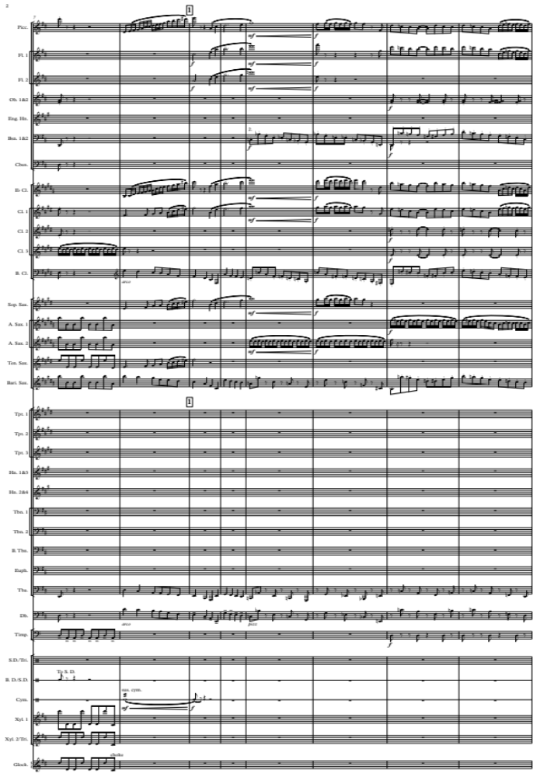
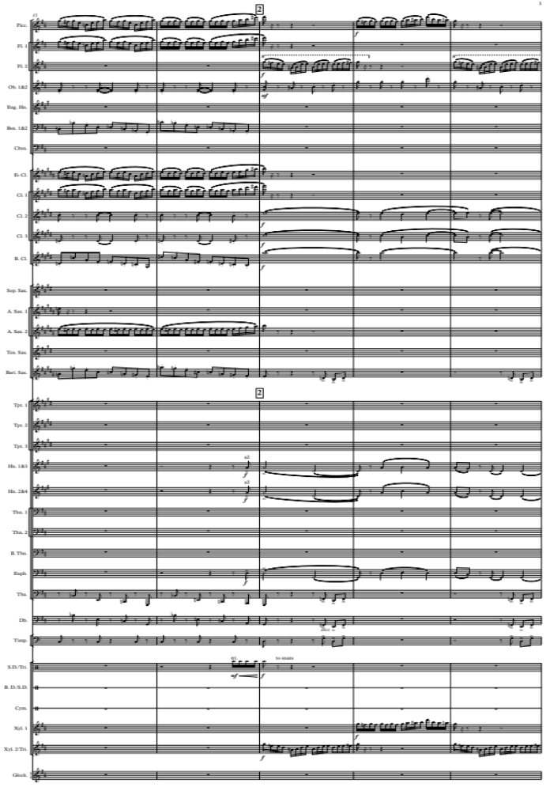
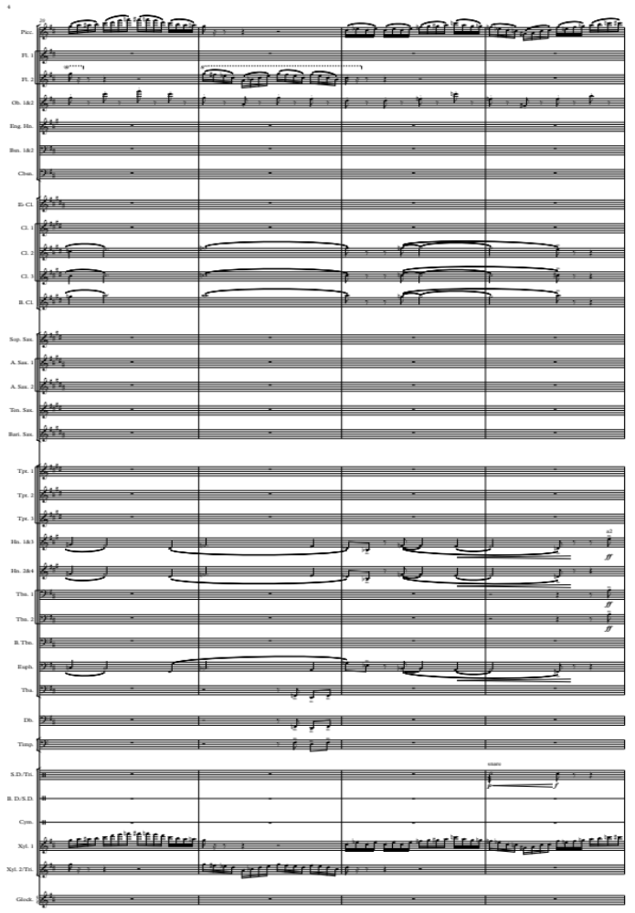
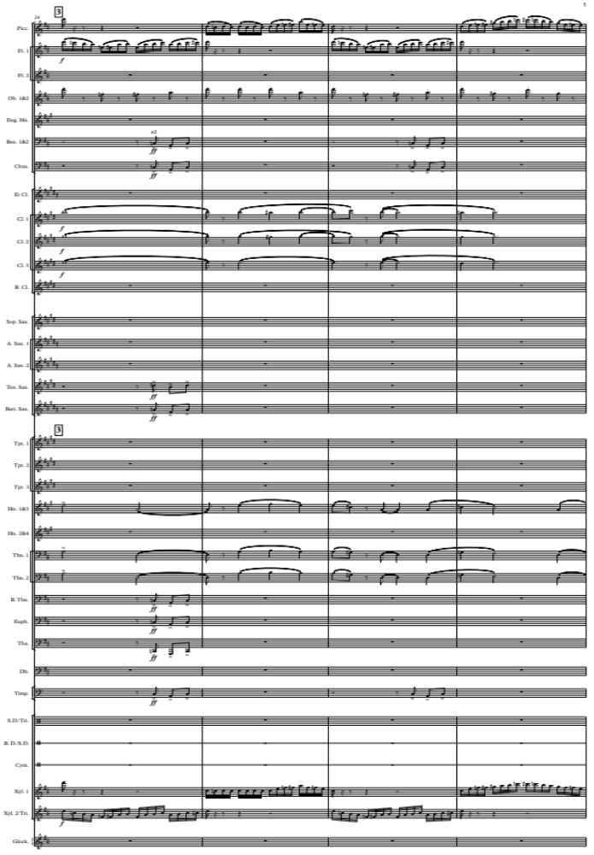
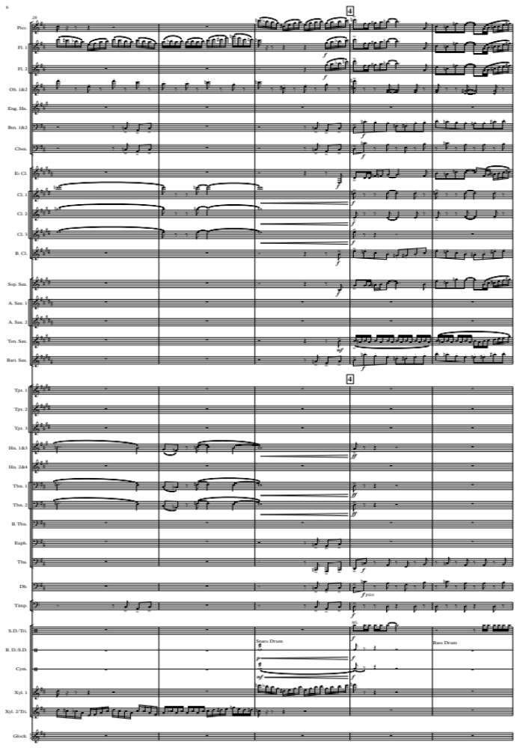
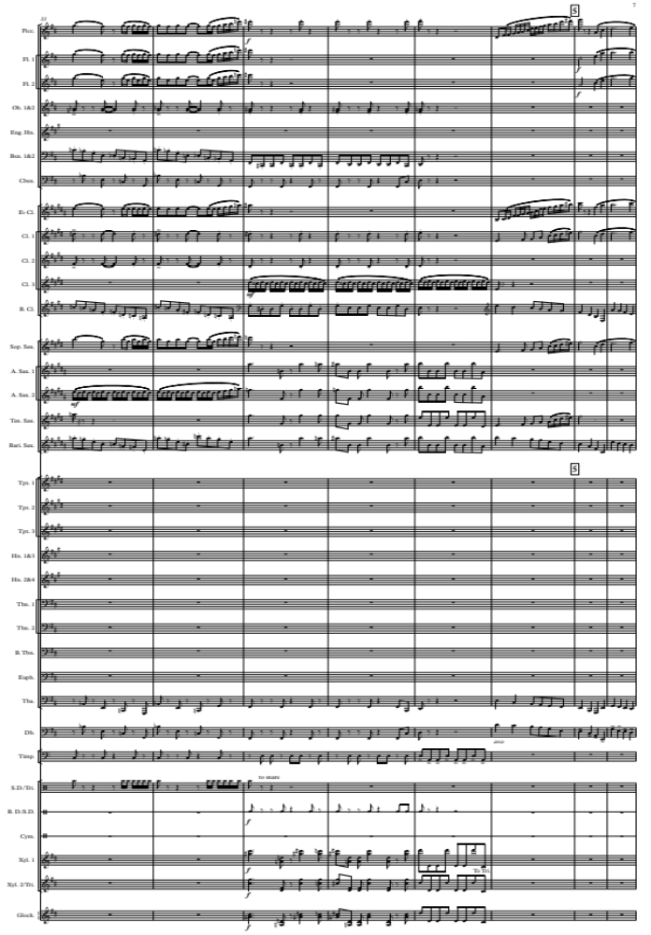
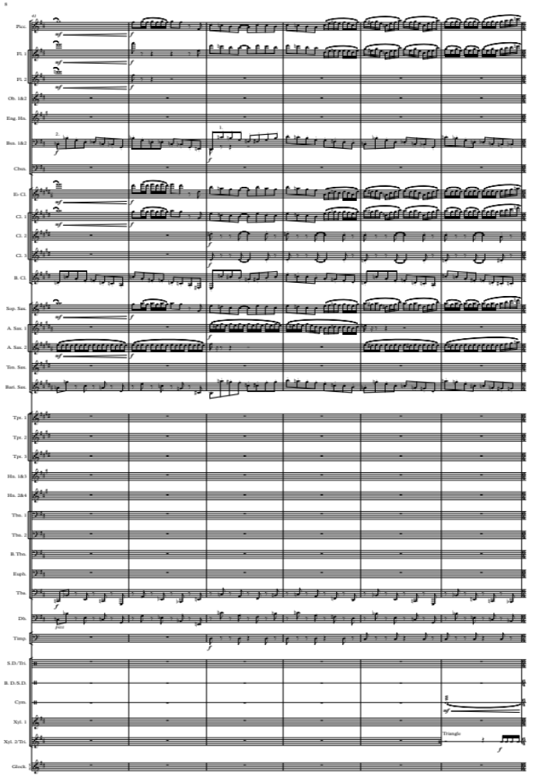
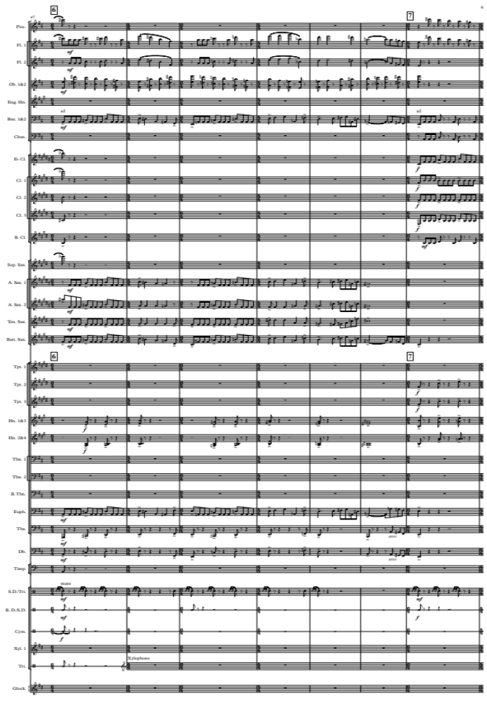
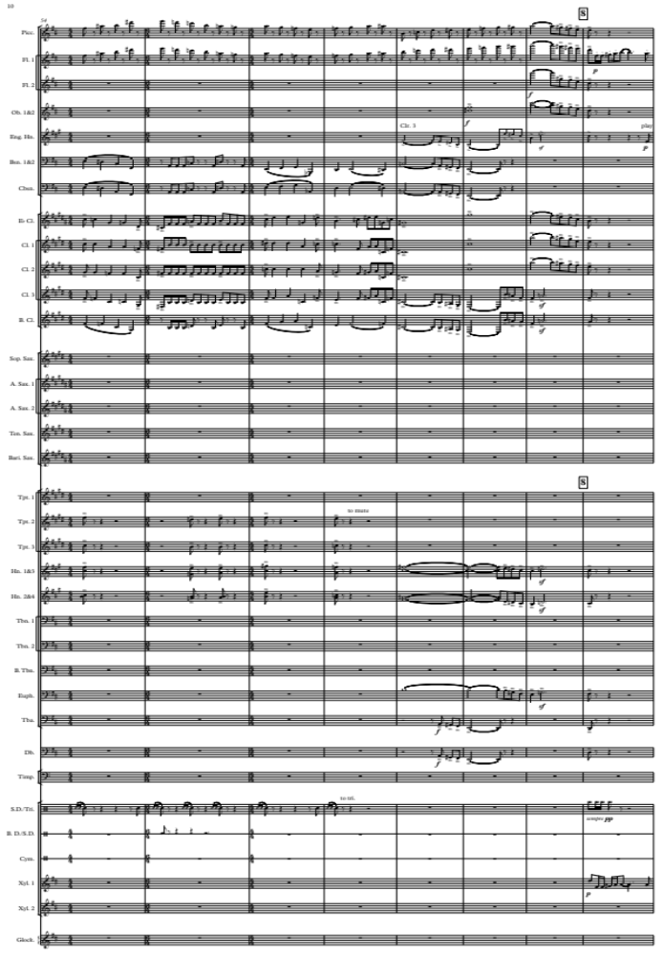
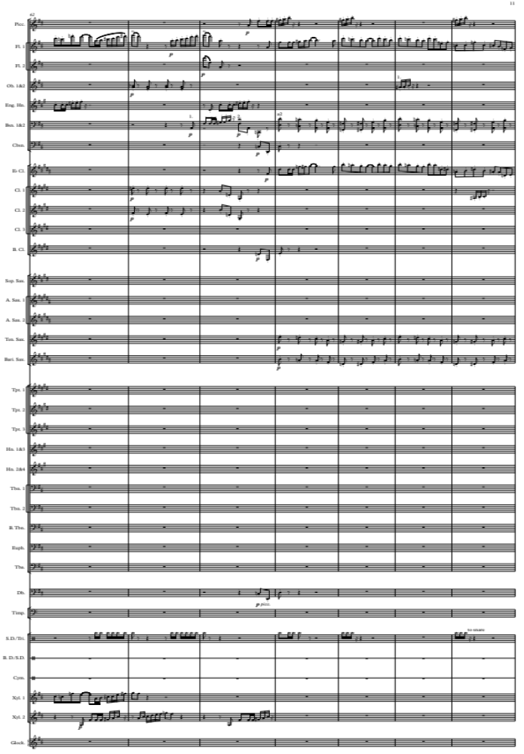
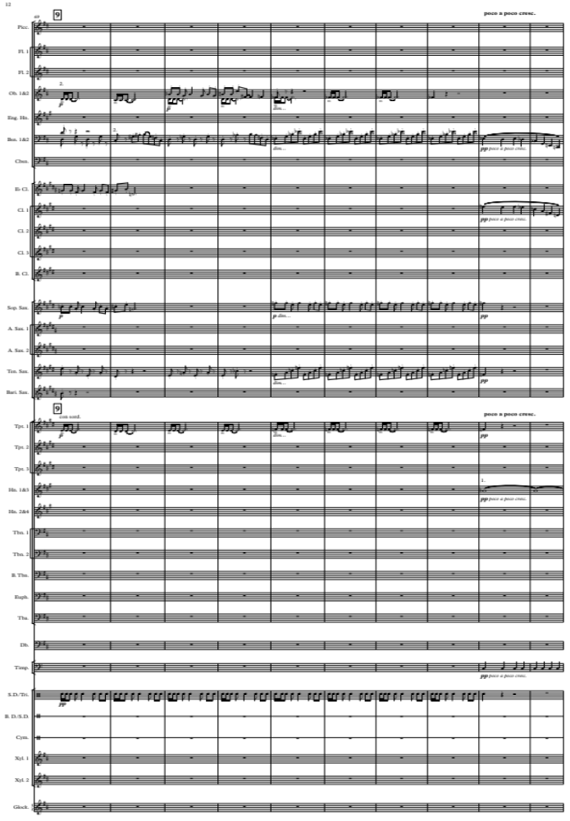
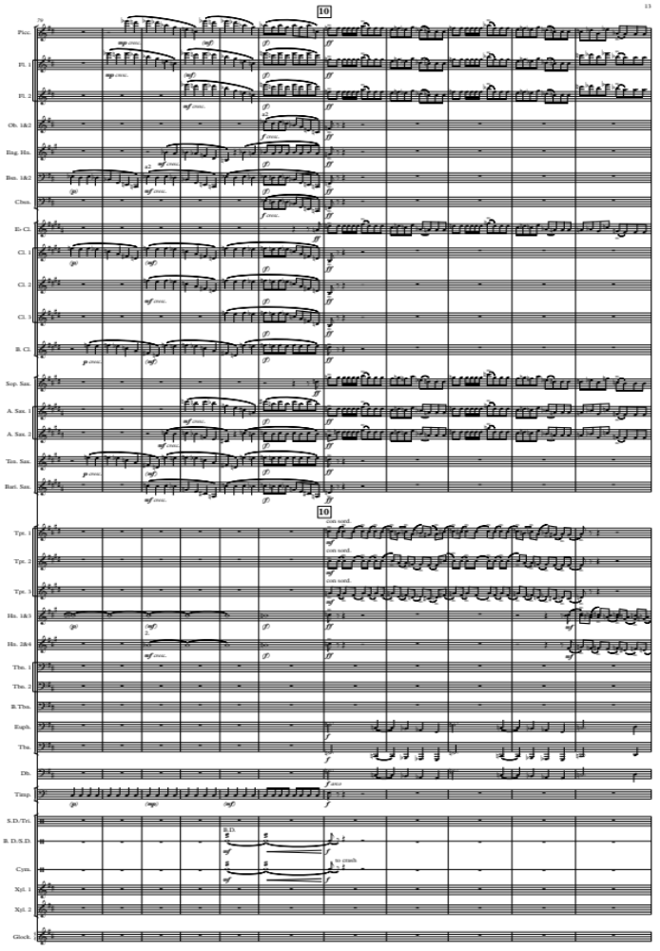
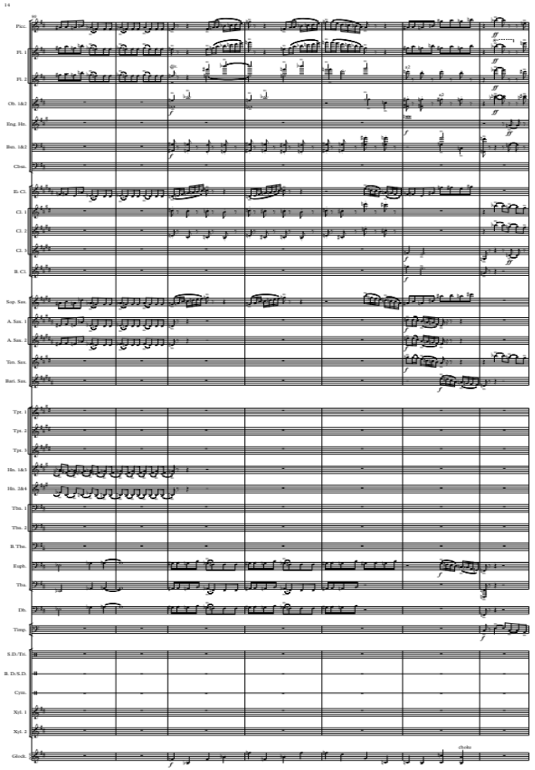
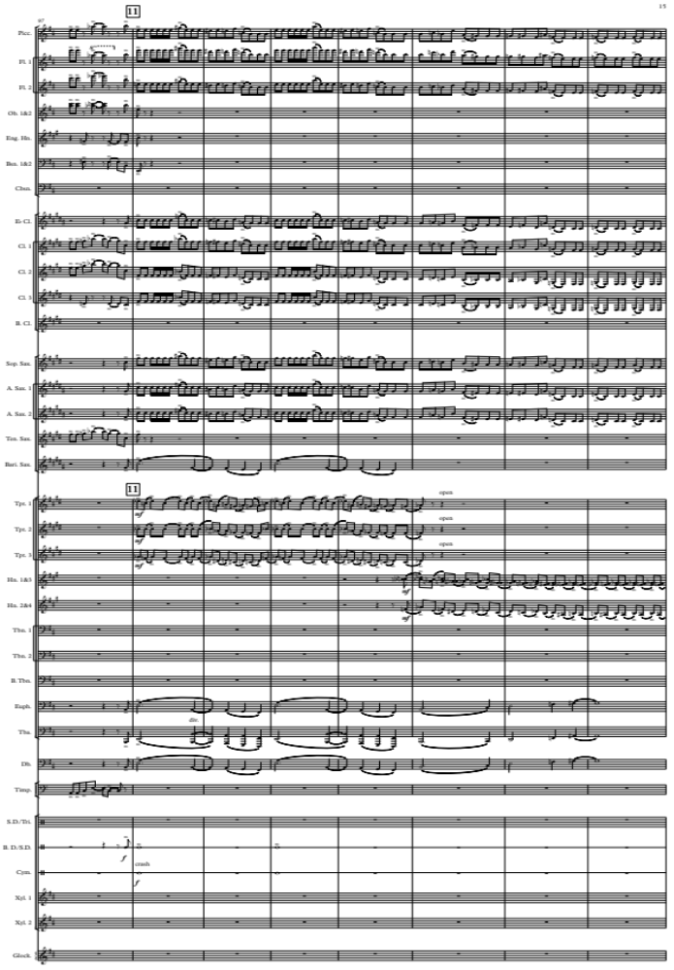
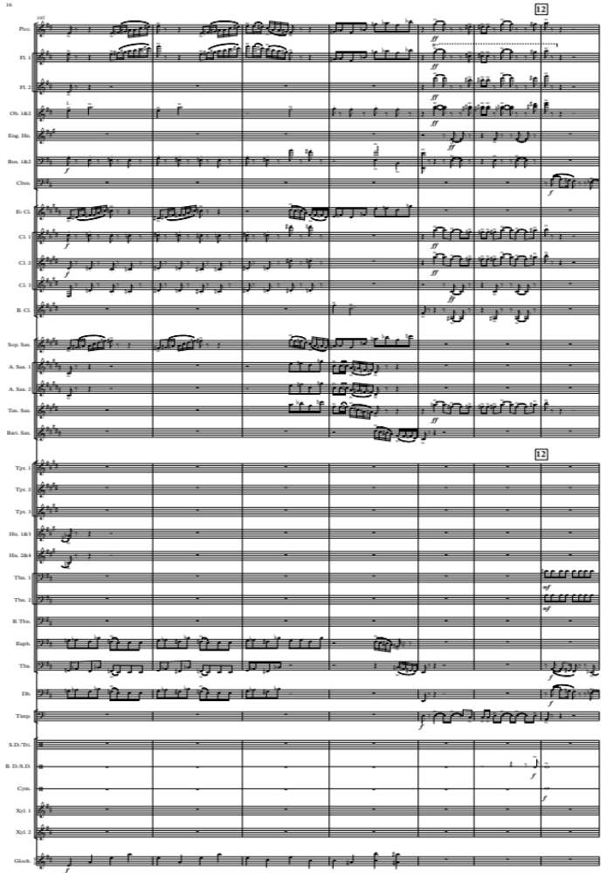
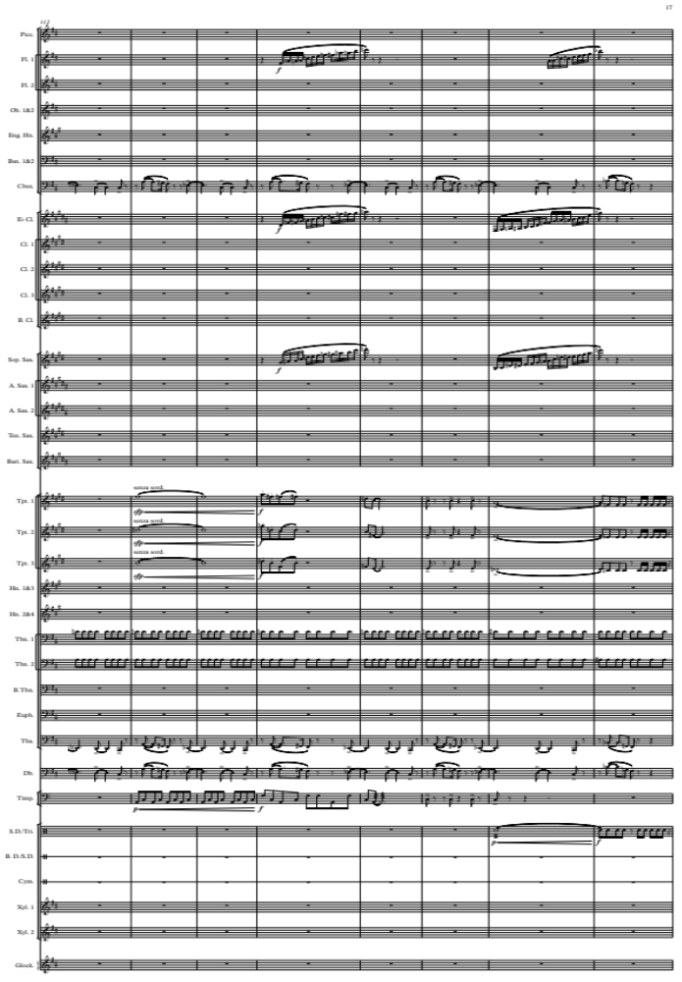
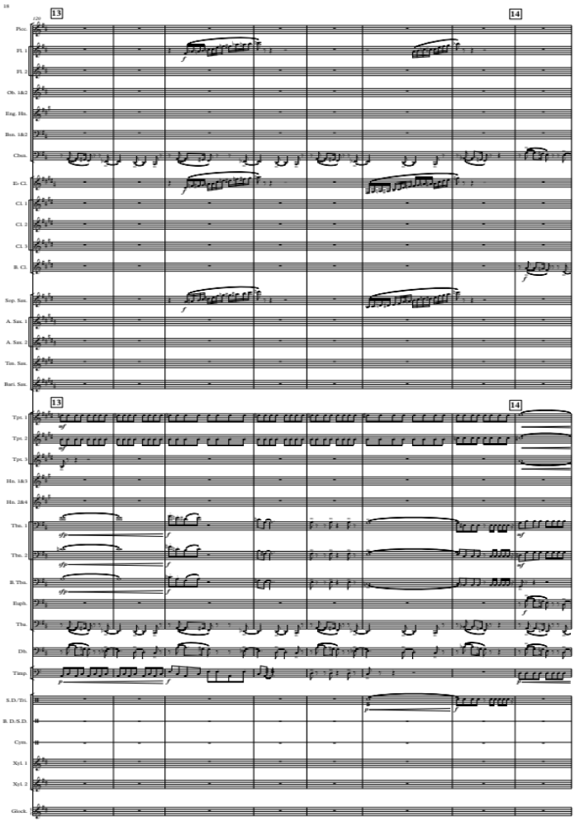
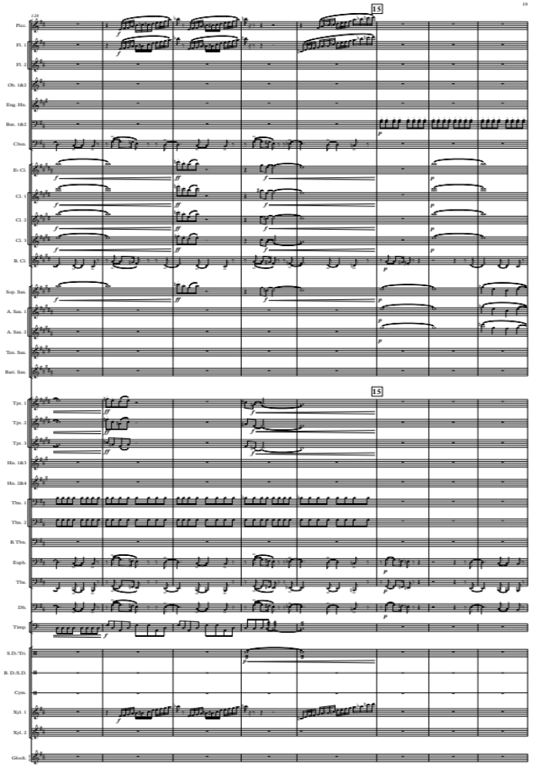
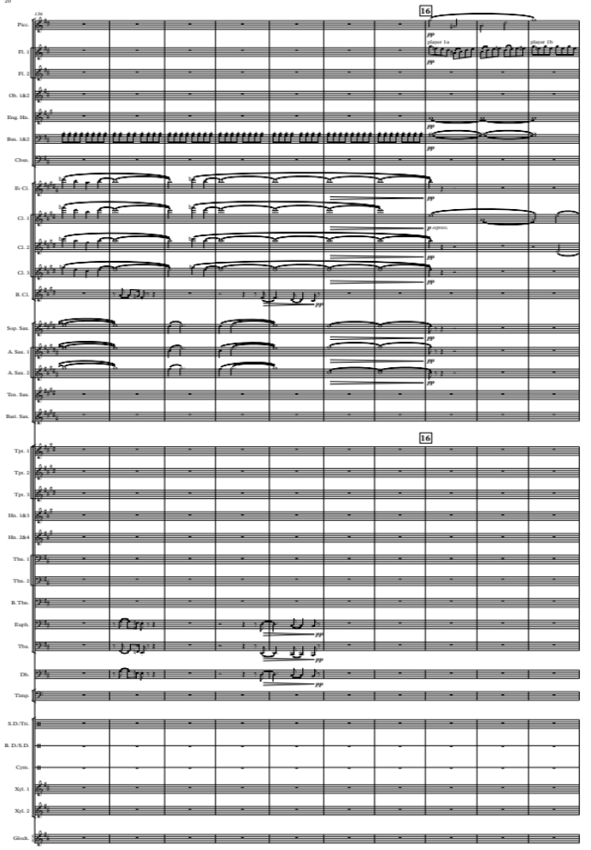
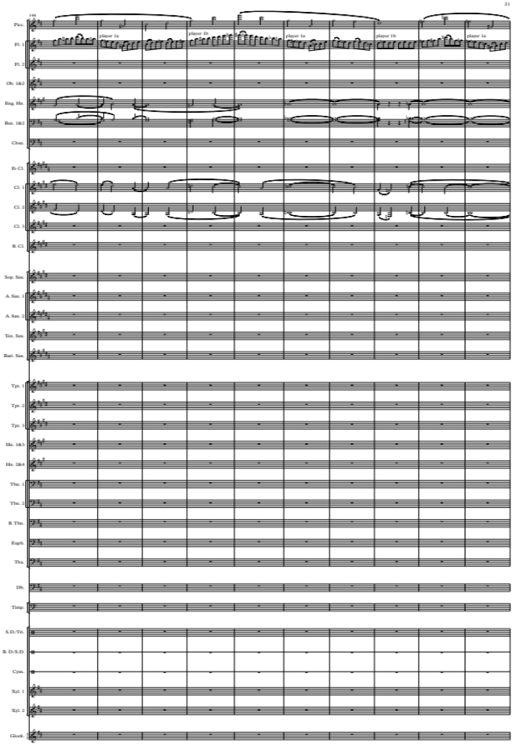
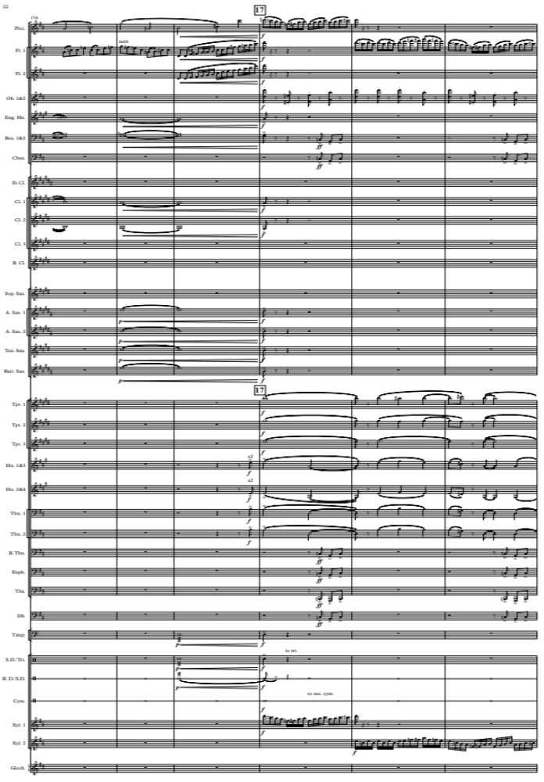
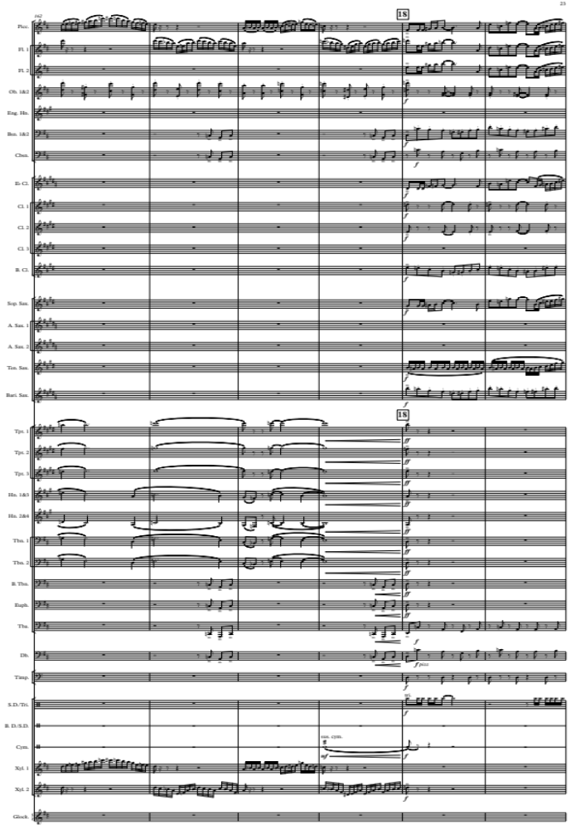
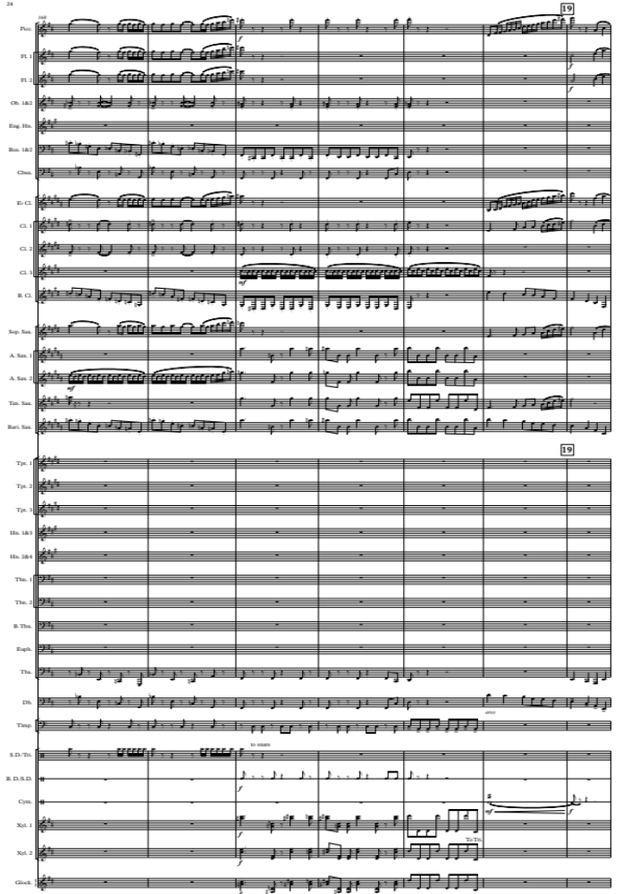
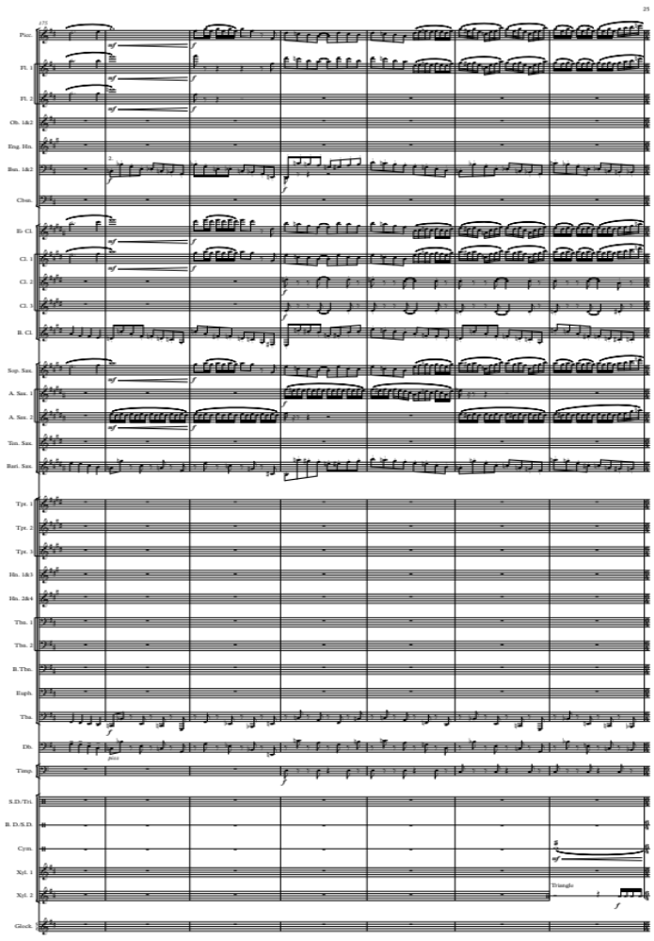
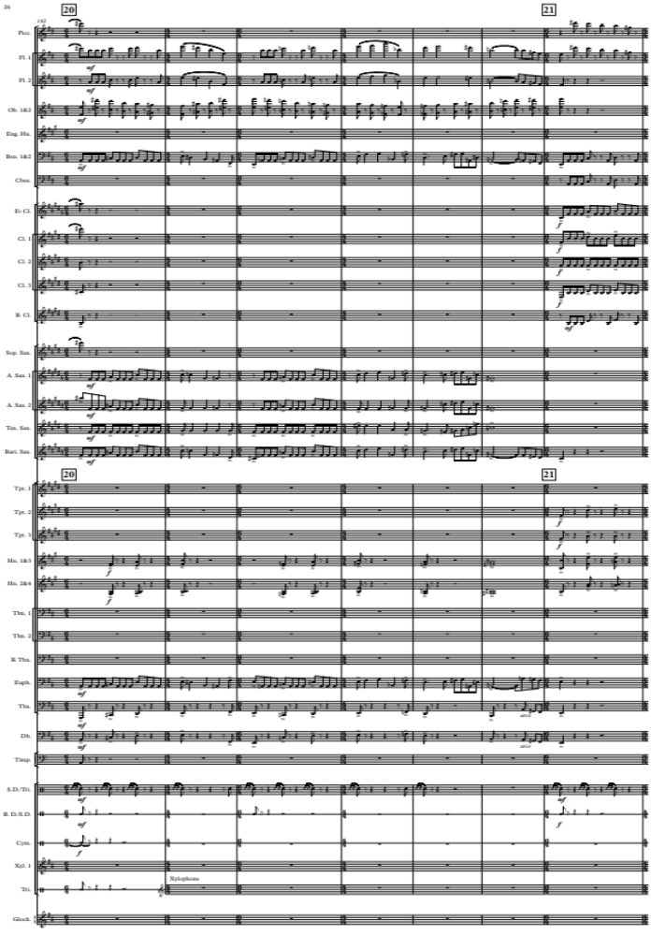
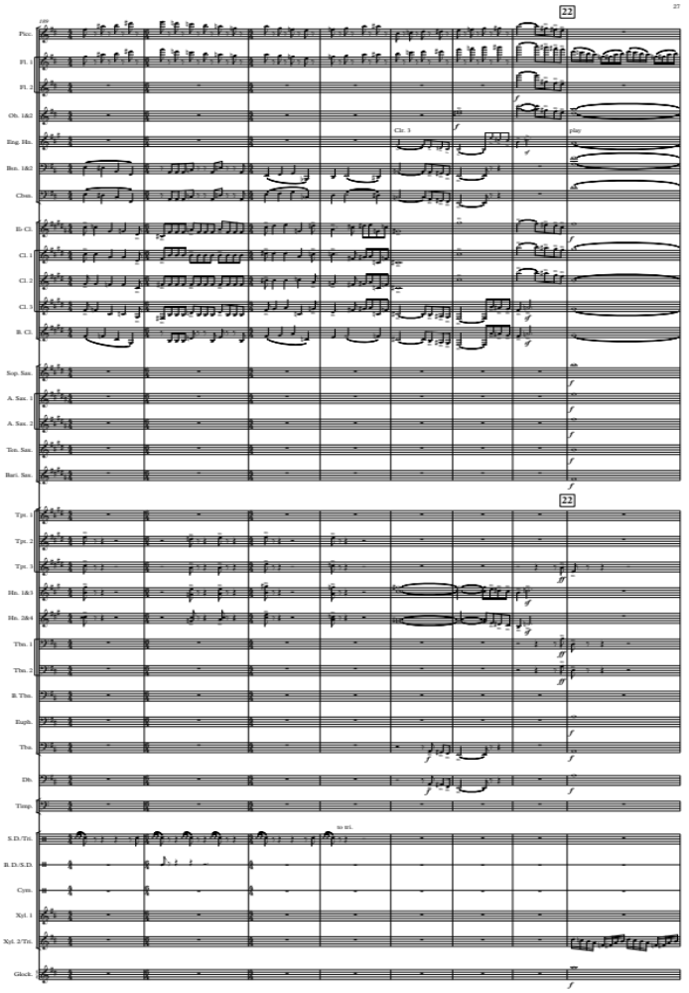
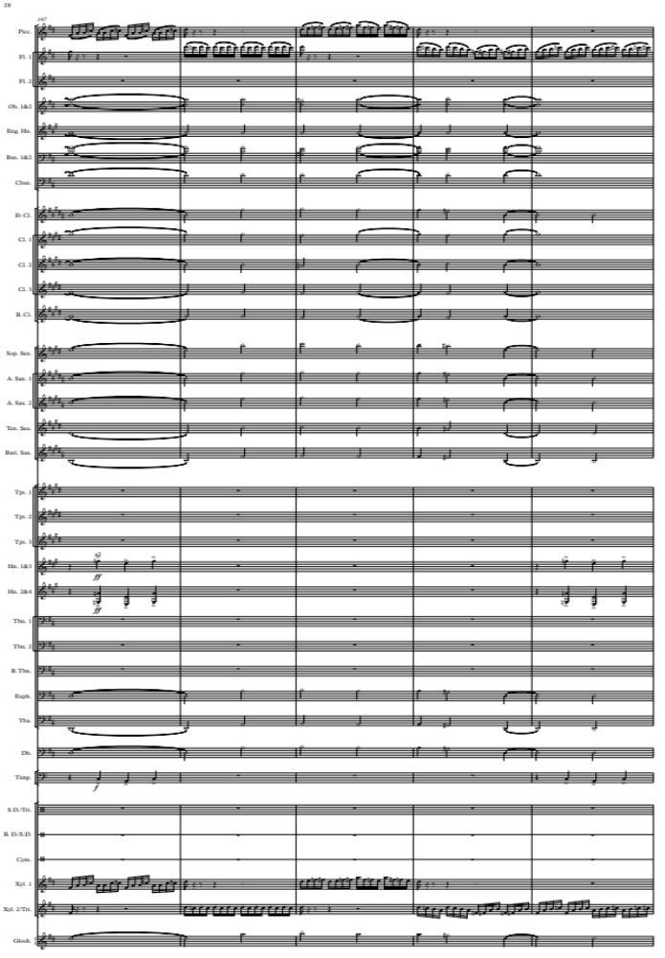
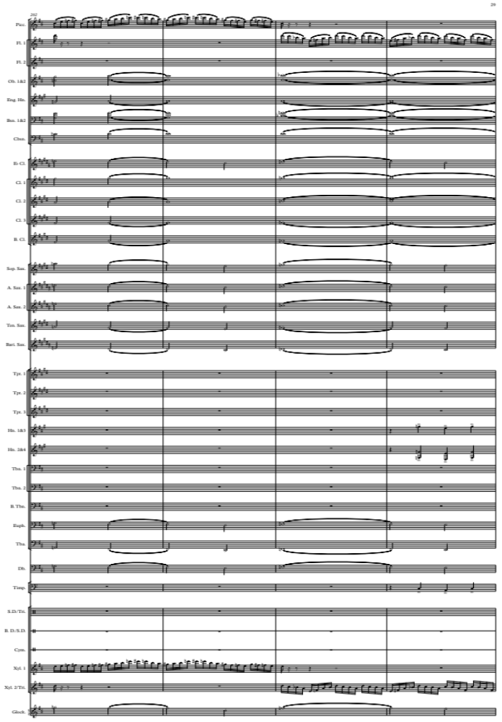
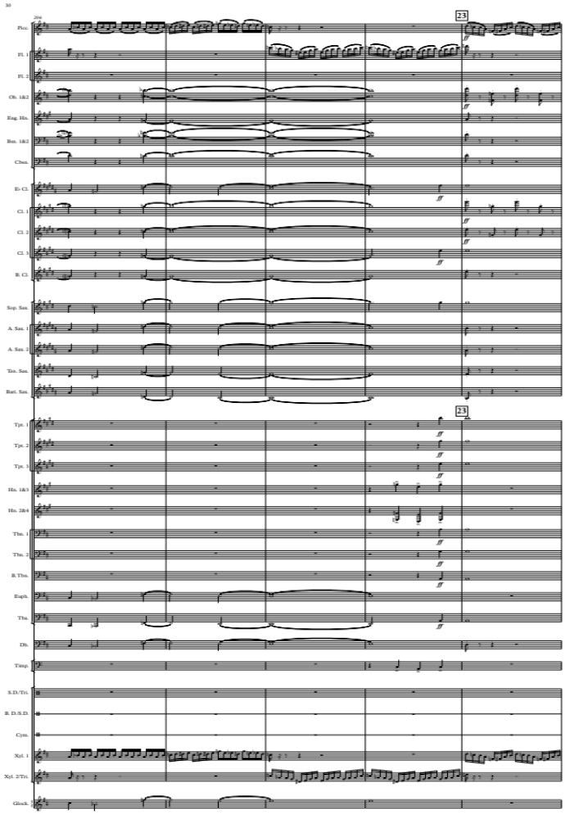
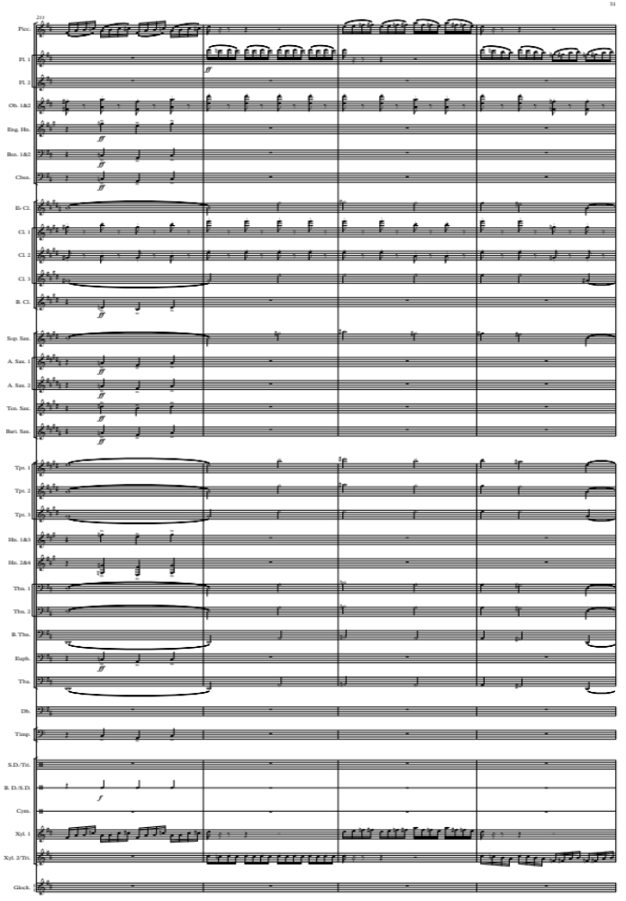
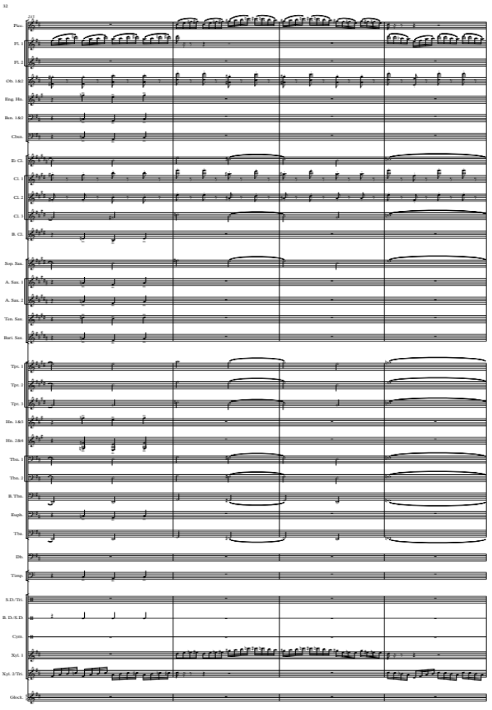
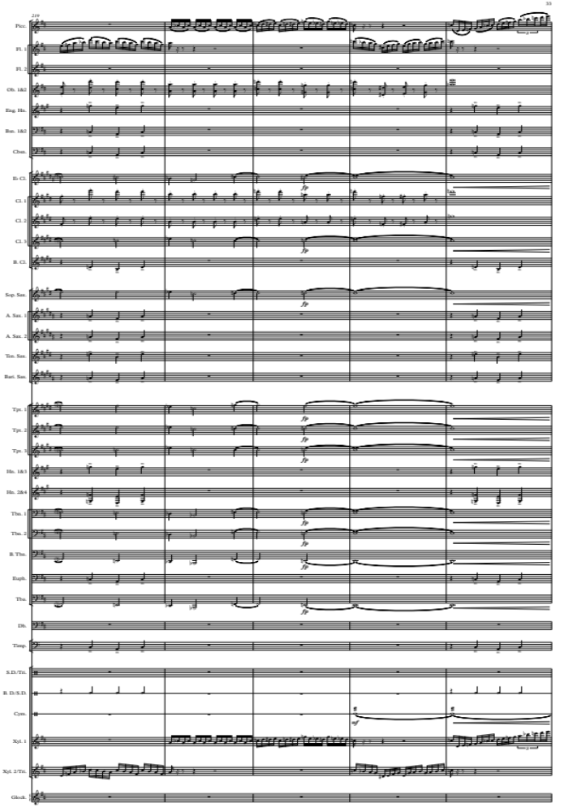
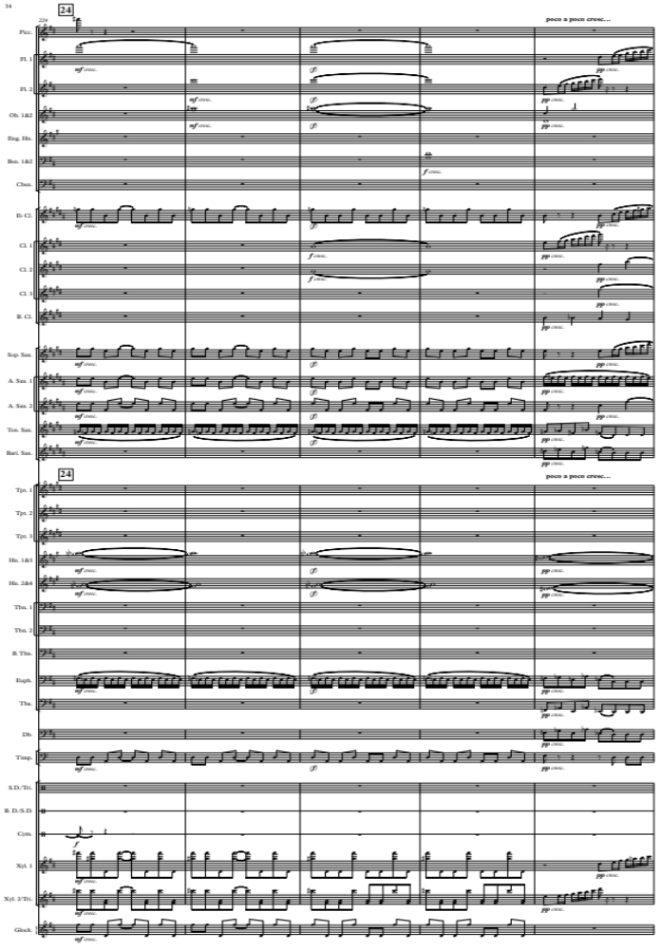
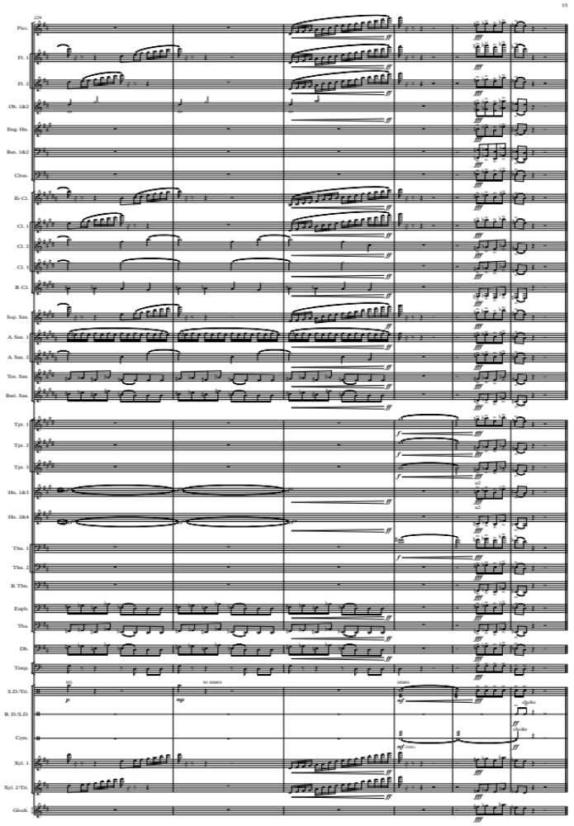

Appendix B – Symphony No. 2 Op. 24 – Structural Analysis
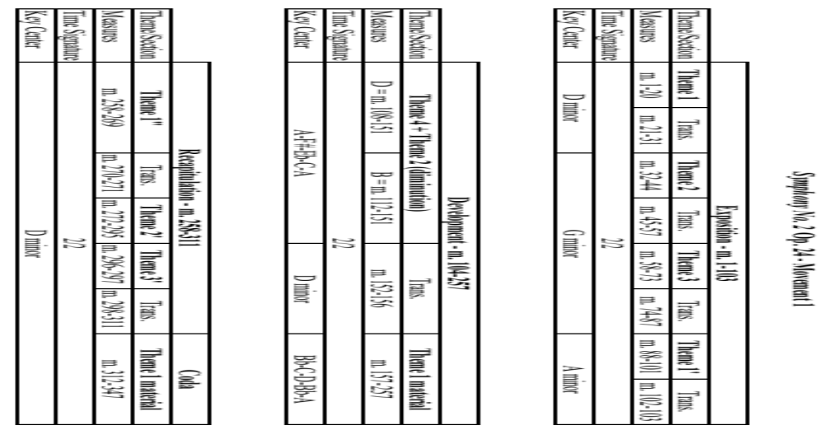
Appendix B - Continued
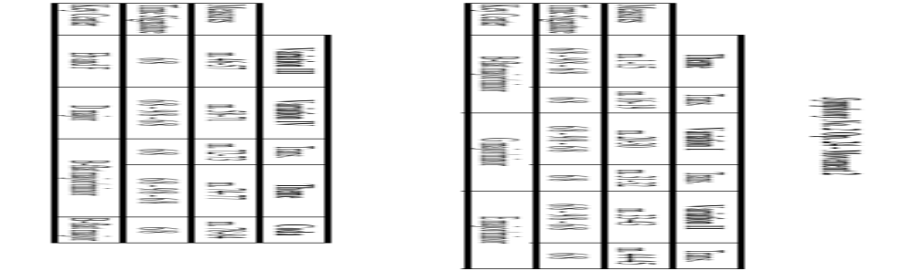
Appendix B – Continued
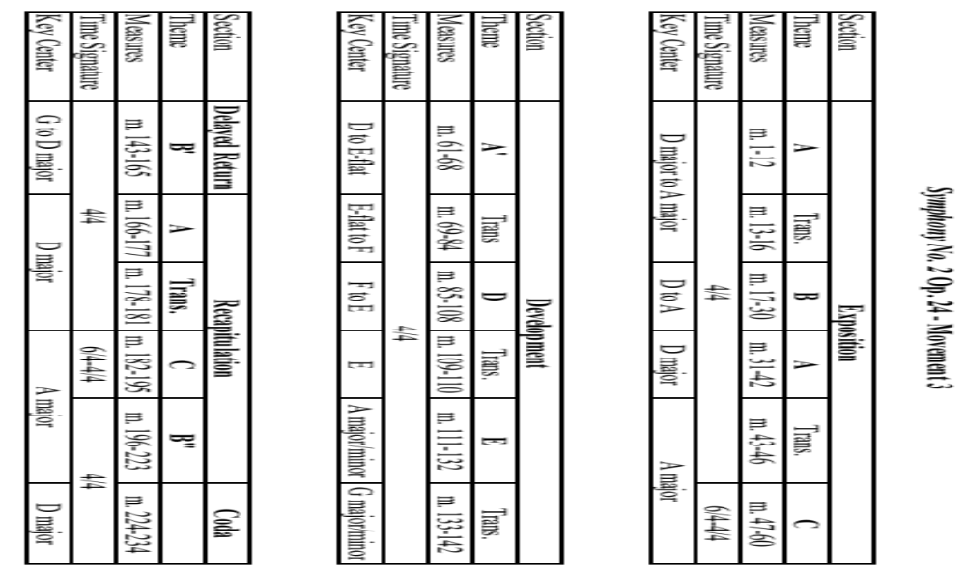

Appendix C – List of Works by Robert Kurka
The following is a full list of Kurka’s known works, according to the Grove Online Dictionary of Music and Musicians:
- Opera:
  - The Good Soldier Schweik (1957)

- Orchestral:
  - Chamber Symphony, Op. 3 (1946/1948)
  - Symphony for brass and strings, Op. 7
  - Concerto for violin and chamber orchestra, Op. 8
  - Music for Orchestra, Op. 11
  - Three Pieces, Op. 15
  - Symphony No. 1, Op. 17
  - The Good Soldier Schweik Suite (for 16 winds and percussion), Op. 22 (1956)
  - Symphony No. 2, Op. 24 (1953/1958)
  - Serenade for Small Orchestra (after Walt Whitman), Op. 25
  - John Henry, Op. 27 (for orchestra)
  - Julius Caesar Symphonic Epilogue (after William Shakespeare), Op. 28
  - Concerto, Op. 31 (for piano, strings, and trumpet)
  - Concerto for Marimba and Orchestra, Op. 34 (1958)
  - Chamber Sinfonietta, Op. 39

- Vocal:
  - Who Shall Speak for the People (C. Sandburg), TTBB
  - Song of the Broadaxe, TTBB

- Chamber and Solo Instrumental:
  - Sonata, Op. 5 (for violin)
  - Piano Sonatina, Op. 6
  - String Quartet No. 4, Op. 12 (1950)
  - For the Piano, Op. 13
  - Music for Clarinet, Horn, Trumpet, Violin, and Double-Bass, Op. 14
  - Piano Trio, Op. 16
  - Piano Sonata, Op. 20
  - Sonatina (for Cello), Op. 21
  - Sonata No. 3 (for violin and piano), Op. 23 (1953)
  - Dance Suite (for piano and four hands), Op. 29
  - Sonatina for Young Persons (for piano), Op. 40
  - Seven Moravian Folksongs (for flute, oboe, clarinet and bassoon)
  - Notes from Nature (for piano)
  - Ballad for Horn and Strings Op, 36
  - Four other string quartets
  - Three other violin sonatas
  - Other piano works

Appendix D – Copyright Permission
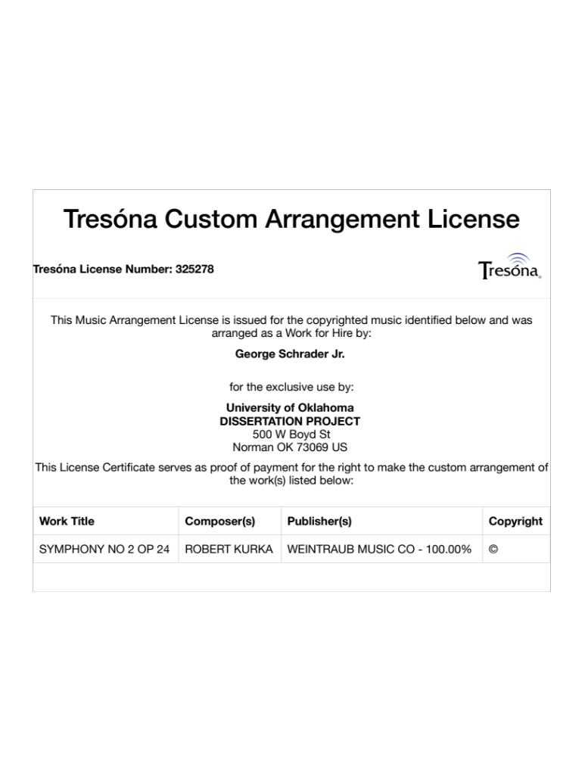

Appendix E – Correspondence with San Diego Symphony
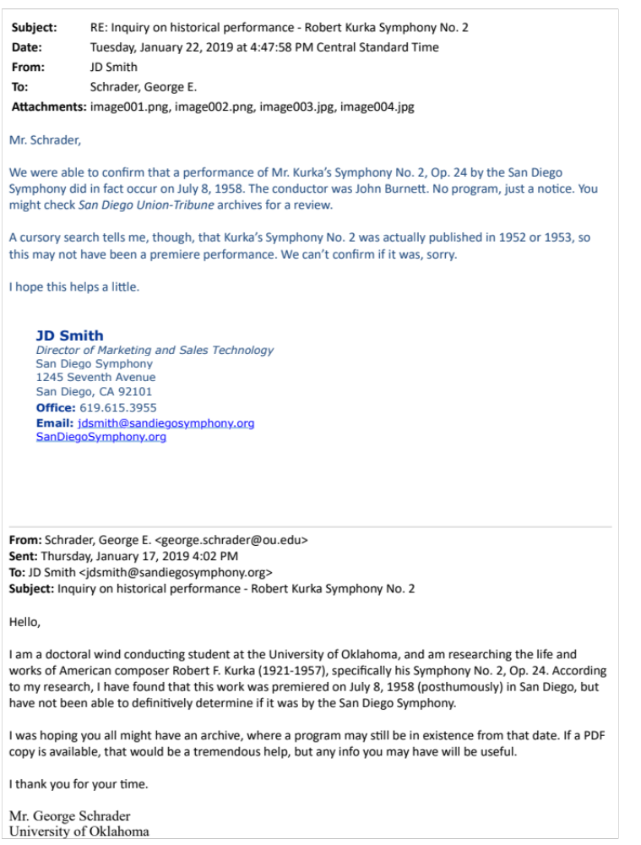

Bibliography

Ancestry.com. “Anton Kurka in the New York, Passenger and Crew Lists (including Castle Garden and Ellis Island, 1820-1957.” Provo, UT, USA: Ancestry.com Operations, Inc. Accessed January 20, 2019. https://search.ancestry.com
Bassett, Leslie. Notes Second Series 14, no. 4 (September 1957): 616. Accessed September 27, 2017. http://www.jstor.org/stable/893734
Battisti, Frank L. The Winds of Change: The Evolution of the Contemporary American Wind Band/Ensemble and its Conductor. Gainsville, MD: Meredith Music Publications, 2002.
Churgin, Bathia. “Beethoven and the New Development-Theme in Sonata-Form Movements.” The Journal of Musicology 16, no. 3 (Summer 1998): 323-325. Accessed April 10, 2019. https://www.jstor.org/stable/763994
Clappé, Arthur A. The Principles of Wind-Band Transcription. New York: Carl Fischer, 1921.
Friedheim, Philip. Notes Second Series 22, no. 1 (Autumn 1965): 814–815. Accessed September 27, 2017. http://www.jstor.org/stable/894447
Jellinek, George. "The Good Soldier Schweik (review)." The Opera Quarterly 19, no. 1 (2003): 157-158. Accessed January 14, 2019. https://muse.jhu.edu.
Kurka, Robert F. Dance Suite: 1 Piano-4 Hands, Op. 29. New York City. Weintraub Music Company, 1965.
Kurka, Robert F. Sonata No. 3 for Violin and Piano, Op. 23. New York City. Weintraub Music Company, 1964.
Kurka, Robert F. Sonatina for Cello and Piano, Op. 21. New York City. Weintraub Music Company, 1964.
Kurka, Robert F. Sonatina for Young Persons, Op. 40. New York City. Weintraub Music Company, 1960.
Kurka, Robert F. Symphony No. 2, Op. 24. New York City. Weintraub Music Company, 1970.
Kurka, Robert F. The Good Soldier Schweik Suite for 16 players, Op. 22. New York City. Weintraub Music Company, 1956.
Land. "Opera Review: Good Soldier Schweik." Variety (Archive: 1905-2000) (April 1958): 86. Accessed on September 26, 2017. https://search.proquest.com/docview/964054196?accountid=12964.
Lang, Philip J. Scoring for Band. New York: Mills Music, Inc., 1950.
Leidzén, Erik. An Invitation to Band Arranging. Bryn Mowr, Pennsylvania: Theodore Presser Co., 1950.
Lindsay, Tedrin Blair. “The Coming of Age of American Opera: New York City Opera and The Ford Foundation, 1958-1960.” Ph.D. diss., University of Kentucky, 2009. Accessed September 27, 2017. https://search.proquest.com/docview/885866495/
Mangan, Timothy. Opera News. “Long Beach, Ca.” 74 (10): 56-57. Accessed January 14, 2019. http://libraries.ou.edu/access.aspx?url=http://search.ebscohost.com/login.aspx?direct=true&db=aph&AN=48914515&site=ehost-live.
Mell, Albert. Notes Second Series 22, no. 3 (March 1966): 1111. Accessed September 27, 2017. http://www.jstor.org/stable/895521
Moyer, Dennis. “Robert Kurka: The Good Soldier Schweik.” Cedille Records. 2002. Accessed February 23, 2019. http://www.cedillerecords.org/albums/robert-kurka-the-good-soldier-schweik
Ratner, Carl Joseph. “Chicago Opera Theater: Standard Bearer for American Opera, 1976-2001.” Doctor of Music diss., Northwestern University, 2005. Accessed September 27, 2017. https://search.proquest.com/docview/305401922/
"Robert F. Kurka, Composer, Dies at 35; Wrote Opera, Chamber and Other Music." New York Times (1923-Current File). (December 13, 1957): 27. Accessed September 27, 2017. https://search.proquest.com/docview/114270520?accountid=12964.
Rockley, Collette Jeanine. “Guidelines for Effective Transcription for Wind Band: An Analysis of the Orchestration Techniques Used in Keith Wilson’s Transcriptions of Hindemith’s Symphonic Metamorphosis.” D.M.A. document, The University of Arizona, 1997. Accessed February 28, 2019. UMI Company.
Rodda, Richard E. “Robert Kurka Symphony No. 2, Julius Caesar, Music for Orchestra, Serenade for Small Orchestra.” Grant Park Orchestra. Carlos Kalmar, conductor. Cedille Records. CD Booklet. 2002. Pg. 5. Accessed February 7, 2019. http://www.cedillerecords.org/album-artwork/077-robert-kurka-symphonic-works-booklet.pdf
Rogers, Robert Mark. “The Hill-Songs of Percy Aldridge Grainger: An Historical and Analytic Study with a New Performance Edition.” D.M.A. document, The University of Texas at Austin, 1987. Accessed February 28, 2019. UMI Company
Shade, Timothy M. “A Process for Transcribing Orchestral Works for Wind Band: Andre Previn’s Sallie Chisum remembers Billy the Kid.” Doctoral essay, University of Miami, 2016. Accessed February 28, 2019. ProQuest LLC.
Sinclair, Charles. "Reviews: Happy Debut for Yardbird Schweik at City Center." The Billboard (Archive: 1894-1960) 70, no. 17 (April 1958): 7. Entertainment Industry Magazine Archive. Accessed September 26, 2017. https://search.proquest.com/docview/1040537139?accountid=12964.
“Soldier Plays Concert Piece.” Reno Evening Gazette. February 25, 1946. Accessed January 20, 2018. http://search.ancestry.com.
Stedman, Preston. The Symphony. Englewood Cliffs, NJ: Prentice-Hall, Inc., 1979
The National Archives. “Access to Archival Databases (AAD), Display Full Records.” Created June 1, 2002 – September 30, 2002. Accessed January 20, 2019. https://aad.archives.gov/aad/record-detail.jsp?dt=929&mtch=1&cat=all&tf=F&q=Kurka%2C+Robert+F&bc=&rpp=10&pg=1&rid=37934
“The National Opera Center America.” North American Works Directory. 2017. Accessed January 17, 2019. https://www.operaamerica.org/applications/NAWD/newworks/details.aspx?id=545#schedule
Towner, Clifford. “An Evaluation of Compositions for Wind Band According to Specific Criteria of Serious Artistic Merit: A Second Update.” DMA diss., University of Nebraska, 2011.
TrevCo-Varner Music. 2019. Accessed April 3, 2019. https://www.trevcomusic.com
Von Rhein, John. “Kurka’s ‘The Good Soldier Schweik’ in no danger of fading away.” Chicago Tribune. March 23, 2001. Accessed January 17, 2019. https://www.chicagotribune.com/news/ct-xpm-2001-03-23-0103220389-story.html
Weir, Martin Paul. "The Role of Vida Chenoweth in Mid-Twentieth-Century Concert Marimba Performance and Literature: A Professional and Personal Perspective." DMA diss., University of Kentucky, 2005. Accessed September 25, 2018. https://search.proquest.com/docview/304992277?accountid=12964.
The Wind Repertory Project. “Suite Française (Milhaud).” Accessed April 7, 2019. https://www.windrep.org/Suite_Française_(Milhaud)

Robert F. Kurka, Symphony No. 2, Op. 24, (New York City, Weintraub Music Company, 1970).
Michael Burch-Pesses, The Wind Band and Its Repertoire: Two Decades of Research as Published in the CBDNA Journal, “A Composer at the Threshold of a Career of Real Distinction: Robert Kurka, and The Good Soldier Schweik, ed. Michael Votta, Jr. (CBDNA, Warner Bros. Publications, 2003), 152-4
James Wierzbicki, “Kurka, Robert,” Grove Music Online, 2001, accessed September 4, 2018, http://www.oxfordmusiconline.com/grovemusic/view/10.1093/gmo/9781561592630.001.0001/omo-9781561592630-e-0000015691.
Ancestry.com, “Anton Kurka in the New York, Passenger and Crew Lists (including Castle Garden and Ellis Island), 1820-1957,” Provo, UT, USA: Ancestry.com Operations, Inc., accessed January 20, 2019, https://search.ancestry.com.
The National Archives, “Access to Archival Databases (AAD), Display Full Records,” created June 1, 2002 – September 30, 2002, accessed January 20, 2019, https://aad.archives.gov
“Soldier Plays Concert Piece,” Reno Evening Gazette, February 25, 1946, accessed January 20, 2018, http://search.ancestry.com.
Baker’s Biographical Dictionary of Music and Musicians, ed. Nicolas Slonimsky and Laura Kuhn, vol. 3 (New York, NY, Schirmer, 2001), p. 1991, accessed February 23, 2019, http://go.galegroup.com.
James Wierzbicki, 2001 "Kurka, Robert," Grove Music Online, accessed February 23, 2019, http://www.oxfordmusiconline.com/grovemusic/view/10.1093/gmo/9781561592630.001.0001/omo-9781561592630-e-0000015691.
Robert F. Kurka, Symphony No. 2, Op. 24, (New York City, Weintraub Music Company, 1970).
John von Rhein, “Kurka’s ‘The Good Soldier Schweik’ in no danger of fading away,” Chicago Tribune, accessed January 17, 2019, https://www.chicagotribune.com/news/ct-xpm-2001-03-23-0103220389-story.html
Dennis Moyer, “Robert Kurka: The Good Soldier Schweik,” Cedille Records, 2002, accessed February 23, 2019, http://www.cedillerecords.org/albums/robert-kurka-the-good-soldier-schweik
Clifford Towner, “An Evaluation of Compositions for Wind Band According to Specific Criteria of Serious Artistic Merit: A Second Update” (DMA diss., University of Nebraska, 2011), 149.
TrevCo-Varner Music, 2009, accessed April 3, 2019, https://www.trevcomusic.com.
Robert Kurka, Symphony No. 2, Julius Caesar, Music for Orchestra, Serenade for Small Orchestra, with the Grant Park Orchestra, conducted by Carlos Kalmar, recorded June 29-30, 2002, and June 27-28, 2003, Orchestra Hall, Chicago, Cedille Records, CD, accessed January 19, 2019, http://www.cedillerecords.org/album-artwork/077-robert-kurka-symphonic-works-booklet.pdf
JD Smith, Director of Marketing Sales and Technology, San Diego Symphony, email message to author, January 22, 2019.
Robert Kurka, Symphony No. 2, Julius Caesar, Music for Orchestra, Serenade for Small Orchestra, with the Grant Park Orchestra, conducted by Carlos Kalmer, Cedille Records, CD booklet
Robert F. Kurka, Symphony No. 2, Op. 24, (New York City, Weintraub Music Company, 1970).
“History,” Louisville Orchestra, 2019, accessed April 1, 2019, https://louisvilleorchestra.org/about/history
Preston Stedman, The Symphony (Englewood Cliffs, NJ: Prentice-Hall, Inc., 1979), 284
Preston Stedman, 286-287
Bathia Churgin, “Beethoven and the New Development-Theme in Sonata-Form Movements,” The Journal of Musicology 16, no. 3 (Summer 1998): 323-325, accessed April 10, 2019, https://www.jstor.org/stable/763994
Arthur A. Clappé, The Principles of Wind-Band Transcription (New York: Carl Fischer, 1921), p. 2.
John Cacavas, Music, Arranging, and Orchestration (Melville, NY: Belwin-Mills Publishing Corporation, 1975), 96.
Erik Leidzén, An Invitation to Band Arranging (Bryn Mawr, Pennsylvania: Theodore Presser Co., 1950), 174.
Arthur A. Clappé, p. 122
Timothy Shade, “A Process for Transcribing Orchestral Works for Wind Band: Andre Previn’s Sallie Chisum Remembers Billy the Kid” (doctoral essay, University of Miami, 2016), 53
Timothy Shade, 19.
Timothy Shade, 38
Robert Kurka, Robert Kurka: Symphonic Works, Carlos Kalmer, recorded with the Grant Park Orchestra in June 2002 and June 2003, Cedille Records, CDR 90000 077, 2004.
Lopatnikoff, Helps, Thomson & Kurka, David Alan Miller, recorded with the Albany Symphony Orchestra, Albany Records, 2003.
Erik Leidzén, An Invitation to Band Arranging (Bryn Mawr, Pennsylvania: Theodore Presser Co., 1950), 181.
Timothy Shade, 35.
James Wierzbicki, 2001 "Kurka, Robert," Grove Music Online.
Philip J. Lang, Scoring for Band (New York: Mills Music, Inc., 1950), 134.
Collette Jeanine Rockley, “Guidelines for Effective Transcription for Wind Band: An Analysis of the Orchestration Techniques Used in Keith Wilson’s Transcriptions of Hindemith’s Symphonic Metamorphosis” (D.M.A. document, The University of Arizona, 1997), 89-90.
Robert Mark Rodgers, “The Hill-Songs of Percy Aldridge Grainger: An historical and analytic study with a new performance edition” (D.M.A. document, The University of Texas at Austin, 1987), 81.
Robert Mark Rodgers, p. 184
Grove Music Online, s.v. “Kurka, Robert,” accessed January 10, 2018, http://www.oxfordmusiconline.com/grovemusic/view/10.1093/gmo/9781561592630.001.0001/omo-9781561592630-e-0000015691.

