UNIVERSITY OF OKLAHOMA
GRADUATE COLLEGE

UNDERSTANDING THE BIOLOGY OF THE WICHITA MOUNTAINS PILLSNAIL, EUCHEMOTREMA WICHITORUM, AND RELATED SPECIES IN WESTERN OKLAHOMA

A THESIS
SUBMITTED TO THE GRADUATE FACULTY
In partial fulfillment of the requirement for the
Degree of
MASTER OF SCIENCE

By
ALEXANDER C COOPER
Norman, Oklahoma
2020

UNDERSTANDING THE BIOLOGY OF THE WICHITA MOUNTAINS PILLSNAIL, EUCHEMOTREMA WICHITORUM, AND RELATED SPECIES IN WESTERN OKLAHOMA

A THESIS APPROVED FOR THE
DEPARTMENT OF BIOLOGY

BY THE COMMITTEE CONSISTING OF

Dr. Elizabeth Bergey, Chair
Dr. Michael Patten
Dr. Cameron Siler

© Copyright by ALEXANDER C COOPER 2020
All Rights Reserved.

Acknowledgments
I would like to thank my advisor, Liz Bergey for her support, patience, and guidance throughout my time in at the University of Oklahoma. I would like to thank my partner Kelsey Spitz for letting me drag her down to Oklahoma and for being a real adult while I gallivanted off to collect snails. I would like to thank my dogs Wally, Rex, and Clover for being great companions and bringing a lot of joy into my life. I thank Mike Mather for his guidance, hospitality, field assistance, and for assembling the best collection of land snails in Oklahoma. I would like to thank my committee members Cam Siler and Michael Patten for their assistance with this research and manuscript. I would like to separately thank Michael Patten for his instrumental role in the analyses presented in this thesis. I would like to thank Steve Bittner and Todd Fagin for their excellent mapmaking. I would like to thank various people who have provided field assistance for this research, chiefly Finley Carmen, but also Ben Whipkey, Jonathan Lopez, and several members of US Fish and Wildlife staff from the Wichita Mountains Wildlife Refuge. I would like to thank the Oklahoma Department of Wildlife Conservation for funding for this research. I would like to thank the staff at various state and local agencies for assistance with obtaining all the permits and permissions needed to collect snails all over the state. Lastly, I would like to thank the various landowners who were gracious enough to let me trek through their land and flip their logs.

TABLE OF CONTENTS
ACKNOWLEDGMENTS………………………………………………………………………..iv
TABLE OF CONTENTS…………………………………………………………………………v
ABSTRACT……………………………………………………………………………………...vi
CHAPTER
- A semi-arid land snail may benefit from fire; an investigation into the range, ecology, and conservation needs of the Wichita Mountains pillsnail, Euchemotrema wichitorum…………………………………………………………………………….1
- Morphometric analysis of Euchemotrema wichitorum, Euchemotrema leai, and undetermined Euchemotrema populations in western Oklahoma…………………...73

Abstract
The Wichita Mountains pillsnail, Euchemotrema wichitorum, was originally described in 1972 from surveys in two counties in southwest Oklahoma. Virtually all that was known about this species was in this one pubication. The goal of my research was to investigate this snail’s distributional range, habitat use, aspects of its natural history, and its relationship to other Euchemotrema in Oklahoma. I surveyed 106 sites across 15 counties in western Oklahoma searching for E. wichitorum to establish the species’ range and to delimit the range boundary between E. wichitorum and the widespread E. leai aliciae, whose range occurs throughout much of eastern and central Oklahoma. I expanded the species’ known range to from two to seven counties in southwest Oklahoma and analyzed measured habitat characteristics at survey sites in to determine which environmental characters were associated with live abundance of E. wichitorum, finding the species is positively associated with the number or logs in an area and negatively associated with the number of boulders. This, along with other environmental data, suggests the E. wichitorum favors increasingly dense woodlands over the more open, boulder-dominated habitats found within much of its range. I also found that E. wichitorum abundance is positively associated with fire; sites with evidence of relatively recent fire had more live snails and charred logs sheltered more live snails than their unburned counterparts. However, snail mortality is high when fires are severe because shelter habitats are more likely to be burned than during low-severity fires, which leave many unburned patches and often only char the surface of logs rather than the soil-log interface where snails occur. Increased abundance may occur after low-severity fires due to an influx of bioavailable calcium as calcium oxalalate in the leaves and bark of the dominant tree species, Post Oak (Quercus stellata), is converted into soluble calcium ions and calcium carbonate. After locating several populations of Euchemotrema outside the known ranges of E. wichitorum and E. leai that contained individuals of intermediate morphology between the two species, I compared these three groups of snails, along with two other Euchemotrema groups, using a Discriminant Function Analysis in an attempt to classify the intermediate western Oklahoma (“E. westOK”) populations to establish the range boundary between E. wichitorum and E. leai. The DFA using all five Euchemotrema groups did not strongly separate the three focal groups. While a DFA comparing just E. wichitorum and E. leai suggested that E. wichitorum, which had a classification rate of 92%, is morphologically distinct from E. leai, the “E. westOK” populations proved to be morphologically intermediate between the two group and undercuts this initial finding of distinctness. While E. wichitorum appears to have an overall positive conservation outlook, more research is needed understand the evolutionary relationship between this species, E. leai aliciae, and the isolated populations scattered between the ranges of the two species and elsewhere in western Oklahoma.

Chapter 1: A semi-arid land snail may benefit from fire; an investigation into the range, ecology, and conservation needs of the Wichita Mountains pillsnail, Euchemotrema wichitorum
Alexander C Cooper
Oklahoma Biological Survey and Department of Biology, University of Oklahoma, Norman OK, 73019, USA
Correspondence: AC Cooper; email: alexander.cooper@ou.edu

Abstract
The Wichita Mountains pillsnail, Euchemotrema wichitorum, was originally described in 1972 from surveys in two counties in southwest Oklahoma. Virtually all that was known about this species was in this one publication. The goal of this study was to investigate this snail’s distributional range, habitat use, and aspects of its natural history so that we may better understand and conserve this restricted endemic species. I located Euchemotrema in 70 of 106 sites across nine of the 15 counties surveyed. 65 of those 70 sites were assigned to E. wichitorum. I estimated the species’ range to be approximately 4700 km², which is significantly larger than the earlier two-county range. A General Additive Model of multiple microhabitat conditions explained 57.5% of the variation in live snail abundance and indicated that this species is strongly associated with factors correlated to increased forest density, particularly the availability of logs large enough to use as shelter sites. Interestingly, E. wichitorum’s abundance had multiple positive associations with fire; survey sites with fire evidence had significantly more snails and charred logs harbored significantly more snails than unburned logs. Analysis of soil pH from 34 survey sites showed that fire increased soil pH, which is typically associated with increased snail abundance. Increased abundance may occur after low-severity fires due to an influx of bioavailable calcium as calcium oxalalate in the leaves and bark of the dominant tree species, Post Oak (Quercus stellata), is converted into soluble calcium ions and calcium carbonate. However, surveying recently burned sites also showed that fire causes mass mortality in local snail populations, especially when fire severity was high. Overall, E. wichitorum’s long-term conservation prospects are likely strong when considering that the species’ range is much larger than originally described, there is evidence of populations persisting through major wildfires, and based on over a dozen successful lab colonies, a captive breeding program would be both cheap and efficient if the species becomes imperiled.

Introduction
While scientists the world over describe tens of thousands of new species each year (Mora et al. 2011), many of these species receive little attention after their initial description (Zedan 2004). Species throughout the biosphere are under threat from the ever-increasing impacts global climate change (Baur and Baur 1993), habitat degradation (Schilthuizen et al. 2005; Douglas et al. 2013; Hodges and McKinney 2018), and invasive species (Curry and Yeung 2013), and many understudied species may face extinction without the possibility of attempting conservation measures (Richling and Bouchet 2013).
Land snails are a group with many understudied species, with only 102 of approximately 1,975 extant land snail species in North America having sufficient data to be assigned formal IUCN conservation status, despite projections that 54% of North American land snail species are threatened (Zedan 2004). Conservation of these oft-ignored animals is important because land snails perform many ecosystem services: they contribute significantly to nutrient cycling and promote soil formation through their detritivorous diet (Jennings and Barkham 1979) and by promoting the spread of fungi (Burke 1999), they serve as food and important calcium sources for many animals (Martin 2000), and reduction in snail abundance has been associated with lower songbird egg quality (Bańbura et al. 2010), songbird population declines (Graveland 1994) and changes in floral community structure (Peters 2007).
Land snails have limited dispersal abilities (Baur and Baur 1986) and are particularly sensitive to desiccation (Solem 1984, Asami 1993), often restricting movement away from sheltered microsites until environmental conditions are relatively cool and moist, especially after rain (Iglesias et al. 1996). Their sensitivity to desiccation means that land snail abundance is often driven by environmental factors that reduce the risk of drying; such as the availability of shelter sites in the form of coarse woody debris (Kappes et al. 2006), thick leaf litter (Brand et al. 2020), or rocks (Goodward et al. 2017); increased canopy cover (McDade 2002; Hylander et al. 2004); and increased humidity (Sulikowska-Dozd 2005; Čejka et al. 2008). Snails low vagility means they are often unable to escape disturbances that make environmental conditions unsuitable (Denny 1980). Fire, through its reduction of logs, leaf and grass litter, opening of canopy, and simplification of plant and fungi communities (Ray and Bergey 2015; Kiss and Magnin 2006) promotes xeric conditions and has been shown to negatively impact land snail diversity and abundance (Nekola 2002; Burke 1999). Understanding environmental factors that are associated with snail abundance and how common management practices, like controlled burning, affect populations is key information when assessing the conservation needs of target snail species (Spellberg 1994).
I sought to examine the ecology, distribution and conservation needs of one such understudied land snail species, Euchemotrema wichitorum, the Wichita Mountains pillsnail. A land snail in the family Polygyridae, E. wichitorum is, appropriately, known only from the Wichita Mountains region of southwest Oklahoma (USA), specifically Comanche and Caddo counties (Branson 1972; Hubricht 1985; Fig. 3). Euchemotrema wichitorum is believed to be most closely related to the widespread forest-inhabiting species E. leai, which occurs throughout much of the central and eastern US and extends westward into central Oklahoma (Fig.3). The two species were distinguished primarily on the basis E. wichitorum’s relatively shorter shell height (Branson 1972). Both E. wichitorum and Oklahoma populations of E. leai average approximately 8mm in shell width (Cooper Thesis Chapter 2). Euchemotrema wichitorum is one of the few species of native macrosnails (snails >5mm) known from the Wichita Mountains region of southwest Oklahoma (Branson 1972). No research has been done on this species since its description and little is known about the species other than its basic conchology (Branson 1972). The only available information on the species since its description consisting documentation of continued presence in the Wichita Mountains Wildlife Refuge (WMWR) by the occasional visiting biologist (Mather, Bergey, Nekola pers. Comm.). We lacked basic information on what habitat the species prefers, how widespread it is, if fire (which is a common management tool in the WMWR) impacts populations, and, ultimately, if the species is of conservation concern. To fill these gaps in our knowledge, I conducted extensive field surveys in a range of habitat types in the WMWR and surrounding areas in western Oklahoma. To establish microhabitat location and the possible effects of fire, I recorded counts of snails and measurements of several biotic and abiotic habitat features, including evidence of fire, at each survey location. Fire effects were also examined by assessing snail mortality in several areas shortly after controlled burns, comparing soil pH of burned and unburned survey sites, and comparing snail abundances both at sites with and without evidence of relatively recent fire and under charred versus unburned shelter logs.
Methods
Study Site
The Wichita Mountains are a primarily granitic formation in southwest Oklahoma, encompassing an area about 100 kilometers long and 40 kilometers wide, running from the town of Granite, OK in the northwest to Ft. Sill in the southeast (Buck 1964). The formation has hills and mountains that generally range from 150 to 400 meters in height. The mountains in this formation are characterized by granite boulders and generally have small, oak-dominated woodlands towards their base (Buck 1964). The surrounding land is flat to gently rolling and is primarily prairie (Woods et al. 2005). Land use is primarily grazing, with some wheat fields (Woods et al. 2005). The formation hosts the western extent of the Cross Timbers, a mosaic habitat of grasses, oak savannas and forest that extends from central Texas through southeastern Kansas (Hoagland et al. 1999).
The Wichita Mountains Wildlife Refuge (WMWR) is a protected area of approximately 60,000 acres in the southeastern section of the Wichita Mountain formation and is managed by the US Fish and Wildlife Service. The WMWR is predominantly mixed grass prairie with stands of trees dominated by Post Oak (Quercus stellata) and, to a lesser extent, Blackjack Oak (Quercus marilandica) (Buck 1964). Post Oak dominates most tree stands but sheltered or otherwise mesic habitats such as northern slopes, canyons, and riparian corridors host a variety of eastern deciduous species, notably Sugar Maple (Acer saccharum) (Buck 1964). The woodlands of the WMWR tend to have low tree density and richness compared to eastern deciduous forests (Dooley and Collins 1984). The soils are largely derived from granite and gabbro bedrock and tend to be acidic and have high drainage (Crockett 1964; Buck 1964). Based on fire-scar tree ring analysis, the average amount of time between fires for individual tree stands before European settlement was 4.4 years. However, time between fires varies greatly for individual tree stands due to both variability in landscape characteristics that influence fire (i.e. slope, aspect, proximity to natural fire breaks like boulder fields and streams) and stochasticity (Stambaugh et al. 2009). Typical pre-European fires in the WMWR and across much of the Cross Timbers were low-severity surface burns during the dormant season that likely left mosaics of burned and unburned areas (Stambaugh et al. 2009; DeSantis et al. 2011). Controlled burning has been used as a management tool in the WMWR since at least 1978, with a focus on increasing prairie floral diversity, improving grazing conditions for ungulates, and reducing juniper encroachment (Collins and Uno 1983). This region of Oklahoma is also subject to wildfires, which can be often be intense; the 2011 Ferguson Fire burned approximately 30,000 acres of refuge land and was severe enough to cause significant tree mortality throughout many portions of the refuge (US Fish and Wildlife 2011).

Surveys and Data Collection
Field surveys: I surveyed 106 sites across western Oklahoma searching for populations of E. wichitorum (Fig. 4, Table 1). Surveys occurred throughout the year from 07/05/2017 to 03/08/2020 (Table 1). I conducted 30-minute visual search surveys for standardized collection of snail abundance data, which is the recommended approach for surveying for large snail species across multiple heterogeneous habitats (Cameron and Pokrysko 2005). Initial exploratory surveys found no E. wichitorum in open grassland, but instead in areas where boulders, cliffs, and logs could serve as shelter locations (Bergey pers comm). Target areas were identified by searching for potential habitats, such as tree stands or boulder fields, in Google Earth, hiking to the general location, and surveying after finding an area with sufficient woodfall and/or boulders to serve as shelter sites for snails.
While surveying, if snails were found within 10 minutes of search time, the survey continued for 30 minutes of total search time. Within the WMWR a site would be abandoned if no shells were located after 10 minutes and researchers would move to a new area after taking environmental measurements. Surveys conducted outside of the WMWR had the additional goal of establishing E. wichitorum presence in locations outside the previously known range of the species, so searching at these sites continued beyond an initial unsuccessful 10 minutes and the area would be searched until either all potential shelters in an area were examined or approximately 60 minutes of search time produced no shells or live Euchemotrema snails. All sites outside of the WMWR where Euchemotrema were found had snails discovered within the initial 10-minute timeframe. I collected all structurally sound shells found at survey sites as vouchers. Some of these vouchered specimens are available at the Field Museum of Natural History and the University of Florida Museum of Natural History.

Range Estimation: I conducted field surveys at 49 sites beyond the previously described range of the species (the WMWR and a single locality <14km N of the refuge border at Meers Rd) to help determine the range extent of E. wichitorum. I surveyed locations across 15 counties throughout western Oklahoma, from sites within 7 km of the Texas border to sites >195 km northwest of the WMWR (Fig. 4). Our surveys included most of the Wichita Mountains range, but also extended to forested areas throughout southwestern Oklahoma, including riparian forests along major streams that drain the Wichita Mountains and the forests surrounding most large reservoirs in the region (Figs. 4 & 5). Permission was not granted to survey Ft. Sill (military post), which abuts the south border of the Refuge, or some privately held mountains, so the full extent of the Wichita Mountains formation was not sampled.
I estimated the range of E. wichitorum in ArcGIS through construction of a minimum convex polygon (Hayne 1949) that encompassed all survey points containing Euchemotrema populations that could be confidently assigned to E. wichitorum based either on shell morphology closely matching the species description and individuals from the WMWR, additional morphometric analysis (Cooper Thesis Chapter 2), or genetic screening (Cooper unpublished). Five Euchemotrema populations in western Oklahoma could not be confidently assigned to E. wichitorum and were excluded from the range estimate (Fig. 4). A 3 km buffer was used around each boundary-defining site. An area of largely unsuitable habitat (flat agricultural land and a developed portion of the city of Lawton, OK, lacking any large tree stands) was excised from the southern portion of the range polygon to produce a more conservative and accurate estimate of range area (Greuter et al. 2008).

Environmental Data Collection: A variety of microhabitat variables were measured at field survey sites to determine environmental factors associated with snail abundance. These data were recorded at all survey sites within the WMWR and all range-expansion survey sites where Euchemotrema were located. Sites outside the known range that did not contain Euchemotrema were not measured because the lack of snails does not indicate a site represents unsuitable habitat; snails are poor dispersers and typically require continuous habitat for dispersal (Baur and Baur 1990) meaning isolated patches of suitable habitat can lack populations due to historic lack of connectivity (Dépraz et al. 2008).
At each site I recorded following data: GPS coordinates, fire evidence, general dominant vegetation (tree species, grass, forbes), general habitat type in relation to tree and boulder density, and took a photograph. Fire evidence at survey sites was recorded only as presence/absence because I could not determine timing of the most recent fire or estimate its severity because site-specific fire history was typically unknown and successional recovery varied across habitat types (i.e., forest logs may remain charred for several years while an annual grass prairie may have no obvious signs of fire after several months of growth).
Starting with field surveys in 2018, I further described the area around the shelter of highest snail abundance within the site by making it the center of a 12 m x 12 m plot where I recorded data that I believed would be associated with snail abundance. I counted the number of shelter logs (defined as any log with diameter >5cm with at least 15cm of flush soil contact), boulders, and estimated litter coverage because these features provide sheltered habitat for snails during hot, dry conditions and have been positively linked to abundance for snail species across various environments (Kappes 2005; Moreno-Rueda 2007; Woodward et al. 2015). Logs and leaf litter also provide most of the senescing plant matter available as food for snails in this environment (Buck 1964). Some snail species are also positively associated with increased forest density (Douglas et al. 2013) and increased relative humidity (Čejka et al. 2008) and I attempted to capture these data by counting the number of trees taller than 2 meters and estimating canopy cover across our plot, respectively. Canopy cover was measured with a spherical crown densiometer (Forestry Suppliers) as an average of five points taken throughout the plot (Fig. 1). For surveys within the WMWR with no live snails, a random (potential) shelter site was chosen as the center of the 12 m x 12 m plot. All but two of the 48 WMWR field survey sites from 2017 were revisited between 04/08/2018 and 07/09/2018 for 12 m x 12 m plot measurement, with one site being revisited in 01/31/2019. A portion of sites were affected by an April 9, 2018 controlled burn. The fire severity was not high enough at any sites to combust logs or down standing trees but did affect the litter layer of several sites. In those cases, I used site photographs taken during the initial survey as a reference to help estimate litter coverage at time of initial survey.
For all new field surveys conducted in 2018 and 2019 (Fig. 7, Table 1), I recorded additional data for each shelter where I located snails to see if what differences in shelter habitat conditions were associated with differences in abundance (Fig. 2). I recorded the snail species, number of live individuals, and number of shells for each shelter. I recorded the adjacent litter type (grass/leaves/cedar needles/mixed), the shelter type (log/boulder). I measure the shelter size (length, circumference, and relative size) to see if larger shelters, which should theoretically provide larger and more thermally insulated habitats, had more snails. I also measured shelter-adjacent litter depth as an average of three points (either end and the approximate center) to see if a thicker litter layer, which provides more thermal insulation and potential food, had more snails. I also directly tested the relative thermal insulation of shelters by measuring the difference in temperature between soil directly underneath a shelter and the adjacent exposed surface litter temperature to see if shelters providing greater thermal protection had more snails. I measured temperatures with a Fluke 62 Max+ Infrared Thermometer. Soil surface temperature was taken by scanning the length of the sheltered soil (either directly under for logs or under overhangs or underneath litter buildup around boulders) four times with the thermometer and using the thermometer’s average temperature function. Adjacent ground temperature was taken with four, one meter passes along open ground or litter within one meter of the shelter. relative soil moisture (dry to the touch, some moisture, or soil saturated) was measured to see whether moist shelters, which should lessen desiccation stress, had more snails than drier shelters. Lastly, I recorded burn evidence (charring of shelter or adjacent litter) at each shelter largely because the first shelter with multiple live snails was recorded in December 2017 under a heavily charred log and this finding was impactful enough to merit recording of burn evidence for all measured logs.
I collected soil samples for pH measurement from 33 of the 2017 field survey sites while they were being revisited during 2018. I also collected soil from one 2018 survey site. I took soil samples from beneath shelter sites (logs and boulders) and one meter away (Fig. 2) to test if shelter site pH differed from local soil pH (Müller 2005). Soil was collected and stored under standard refrigeration until measured (all samples measured within a month of collection). Soil pH was measured following protocols of Robertson et al. (1999) using a Hanna HI98128 pHep 5 pH meter. In short, two replicates of 15 g of soil were stirred into 100 ml of distilled water and allowed to equilibrate for 30 minutes before measurement. I did not sample several sites due to missing supplies during revisit and not all collected samples were measured because equipment failure prior to measuring all samples.

Fire Impact: I took several approaches to assess the impact of fire on snail populations. I recorded burn evidence at all survey sites based on presence of obvious burn patches, ash around logs and boulders, charred logs and trees. One site was labeled as having burn evidence despite no charring or ash due the presence of many dead standing trees and documentation provided by USFW staff showing the site burned in 2015. I compared the abundance of snails under shelters with and without burn evidence. I also measured soil pH from sites with and without burn evidence. Several of the revisited sites had burned since the initial visit and, consequently, burn evidence for soil pH data was based on site conditions at the time of soil sampling rather than on the conditions during the original visit. Lastly, I surveyed several areas (2018-1, 2019-14, several 2017 sites remeasured in 2018; Table 1) burned recently enough that the site was still covered in ash and the primary successional vegetation had not yet established and observed whether there were signs of mass mortality (bleached shells in ash outlines of logs, in ash piles surrounding boulders, or scattered haphazardly in the open). Most burned sites appeared to be subject to low-severity fires, but several appeared to experience high-severity burns and one site (2019-14, Table 1) was surveyed three days after high-severity fire that burned all ground cover, completely combusted most logs, and downed many live trees, with some still smoldering at the time of survey.

Data Analysis
Microhabitat Analysis: I used two separate General Additive Models (GAM) (Hastie and Tibshirani 1987), to model the live abundance of E. wichitorum in relation to the measured habitat characteristics. The first GAM compared the live abundance of E. wichitorum at 60 survey sites (Fig. 7) in relation to the site microhabitat characteristics measured in the 12 m x 12 m plots (Fig. 1, Supplemental Table 1). The second GAM compared live snail abundance to the measured characteristics of each shelter habitat containing snails, which were measured for 55 shelters from 14 sites surveyed in 2018 and 2019 (Fig. 7, Supplemental Table 2). I chose to model abundance with count of live snails in favor of a combination of live snails and shells because incorporating shells can distort abundance data when comparing habitats with different soil chemistry (Cernohorsky et al. 2010). Empty shells are difficult to interpret; they can persist in the environment for many years and their rate of decomposition varies due to both environmental effects and differences in consumption of empty shells by snails, songbirds, and other animals (Pearce 2008; Cadée 1999; Graveland 1994).
The relationship between live snail abundance and the measured habitat characteristics in each 12 m x 12 m plot was compared with a General Additive Model (Hastie and Tibshirani 1987). GAMs are a semi-parametric extension of generalized linear models (GLM) that are ideal for handling data that is non-linear, non-monotonic, and highly collinear, as is often the case with ecological data (Wood 2017). GAMs have been used to model relationships between species abundance and environmental characteristics across a diversity of taxa (Becker et al. 2019; Drexler and Ainsworth 2013; Chen et al. 2012). GAM analysis and visualization was conducted R version 4.0.3 (R Core Team 2020) using the package ‘mgcv’ (Wood & Wood 2020). The “standard” thin-plate spline was selected as the smoothing parameter for my data, as responses were generally monotonic and met none of the criteria that would warrant a different smoother (Wood 2003). The underlying distributional assumption for this analysis was the negative binomial, which is a better fit for biological count datasets with low values than the Poisson distribution (Bliss and Fisher 1953). Fire was modeled as a fixed effect because fire evidence at survey sites was recorded as a binary presence/absence, which prevented fire from being modeled as a smooth function. The GAM was checked for problematic variables using the MGCV function gam.check. This GAM included data from 60 field survey sites (Table 1). Sites where only shells were found acted as zero-value sites for the model (live snails=0, Supplemental Table 1). Sites within the WMWR without E. wichitorum snails or shells were not included because I believed they did not provide any additional information beyond only-shell sites as to what environmental factors influenced live snail abundance. For survey sites outside the WMWR, I included those with snails that I could assign confidently to E. wichitorum or populations who had at least one sampled individual sort with the main clade E. wichitorum individuals during preliminary genetic screening (Fig. 4, Cooper unpublished, Table 1). A few sites (2019-4, 2019-6, 2019-8, and 2019-13; Table 1) were riparian forests with large quantities of driftwood logs, often in large piles (Supplemental Photo 3). Two of these sites, 2019-6 and 2019-8, had large driftwood piles in the 12 m x 12 m plot. For these sites I arbitrarily assigned them log values of 100 (an underestimate) to keep these unique E. wichitorum habitats in the model while mitigating their negative impact as outliers.
To further investigate the significant effect of fire indicated by the microhabitat GAM, I compared the number of live snails found at burned and unburned sites using a Bayesian analog of the t-test. I constructed a Bayesian model using the R packages ‘rjags’ (Plummer 2019) and ‘HDInterval’ (Meredith & Kruschke 2020) to test for a true difference, D, between the average number of live snails found at sites with and without burn evidence. The model differs from a t-test in having a negative binomial rather than a normal distribution assumption, which is better for count data (Bliss and Fisher 1953). The Bayesian model created a 95% credible interval of the average number of snails found at burned and unburned sites and estimated the true difference, D, between those averages. The model then used posterior estimates to construct a 95% credible interval of the value of D and reported the proportion of estimates greater than zero. If the credible intervals of the estimated parameters do not overlap or if 95% of posterior estimates of D are greater than zero, the groups are considered significantly different. I graphed the outputs using R package ‘bayesplot’ (Gabry & Mahr 2020).

Shelter Analysis: I used the same analytical approach for analyzing the live snail abundance in relation to measured shelter log characteristics as I did between live snails and 12 m x 12 m survey site characteristics: I constructed a GAM of measured characteristics and, upon seeing fire (charring) had a significant effect, constructed a Bayesian analog of a t-test comparing the abundance of live snails associated with burned and unburned logs. The GAM and the Bayesian models for the shelter sites had the same underlying parameters (smoothing terms, distributional assumptions) as the survey site analyses described in the previous section and the outputs of the two Bayesian models are presented together for ease of comparison.
I analyzed 52 logs that harbored snails or shells from 14 field survey sites surveyed 2018 and 2019 (Table 1, Supplemental Table 2). I used the same site selection parameters as for this GAM as for the microhabitat GAM (see microhabitat analysis section of methods, Fig. 4) and also excluded boulders from the dataset as there were only three boulders that had shells (none with live snails) and because fire evidence is more difficult to assess for boulders since granite does not char. For the GAM, the two categorical measurements, soil moisture and degree of shelter, had almost no variation (there were only three categorical levels for each and almost all live snails found in well-sheltered logs with moist soil) and thus could not be modeled as smooth functions and were excluded from the GAM. The difference between soil and litter surface temperatures was also excluded because this measure correlated strongly with ambient air temperature (hot, sunny days had a greater thermal difference between shelter soil and open ground) and thus indicated the weather conditions during the survey rather than the degree of thermal shelter provided by a particular log. Of the measured log characteristics, I was only able to model adjacent litter depth, log size characteristics (length, circumference, and volume), and fire evidence (Supplemental Table 2).

Soil Analysis: I measured the soil pH from 34 survey sites in the WMWR (Table 1, Fig. 7). I examined soil pH values for normality with a Shapiro-Wilks test using the shapiro.test function in the R version 4.0.3 (R Core Team 2020). The data failed to meet the assumption of normality. The non-normal dataset was then analyzed using R package ‘R2jags’ (Su & Yajima 2020) to construct a Bayesian analog of a two-way ANOVA with shelter soil vs. open soil (taken 1 meter away from the shelter), site burn evidence, and their interaction as the three factor levels. R package ‘coda’ (Plummer et al. 2020) was used to design a custom function that provides a Bayesian approximation of the P-value. The model estimates a 95% credible interval of the difference in soil pH between each factor and provides the Bayesian approximation of P-value to determine whether the estimated difference is significant.
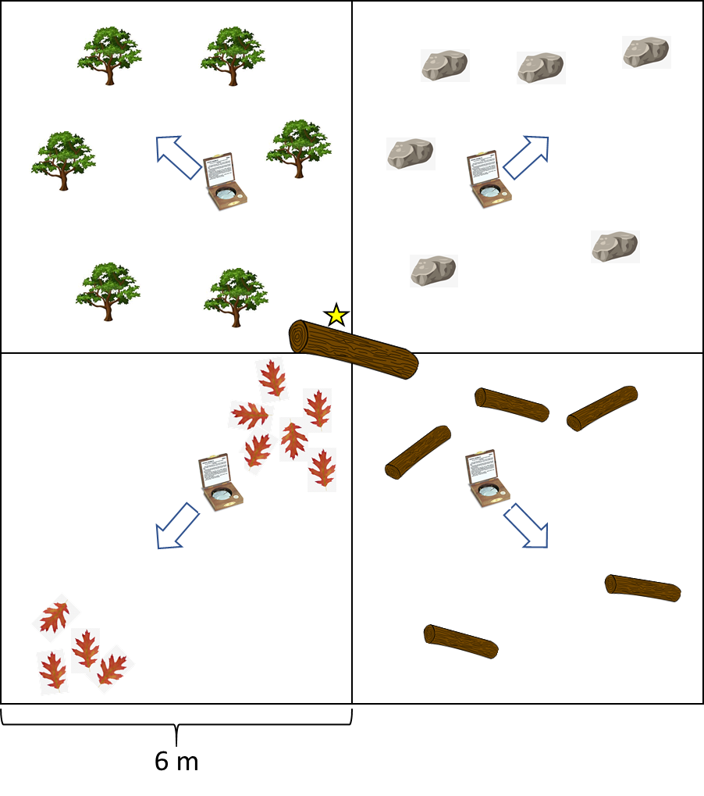
Figure 1. Simplified 12 m x 12 m plot design used for collecting microhabitat data at survey sites. Plots were centered on the shelter of highest abundance (brown log with star). Within each quadrant we recorded count of trees taller than 2 m, count of logs with diameter > 5 cm with enough ground contact (> 15 cm) to serve as a shelter site, and count of boulders that could serve as shelter sites. We visually estimated litter coverage (%) in each quadrant and averaged the result. We averaged the measured canopy cover values taken with a spherical densiometer at the approximate center of each quadrant facing toward the adjacent corner (arrows) and at the plot center facing a random direction.

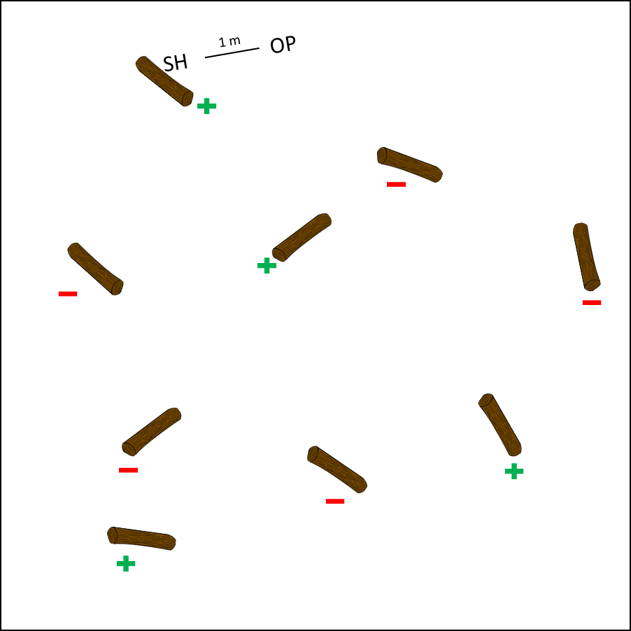
Figure 2. Diagram of a theoretical 30-minute survey site where shelter characteristics were documented. Shelters (brown) where snails were found (green plus) or were absent (red minus). All shelters with snails had the following characteristics documented: number and species of live snails and shells, length (m), circumference (m), adjacent litter depth (cm), adjacent litter type (leaves or grass), soil temperature underneath shelter ($℃)$,temperature of the surface of adjacent litter ($℃)$, relative soil moisture (dry/medium/moist), burn evidence (yes/no). For some sites, soil samples were taken underneath a shelter (SH) and 1 m away from soil open to the environment (OP) to examine if shelters affect microsite soil conditions.
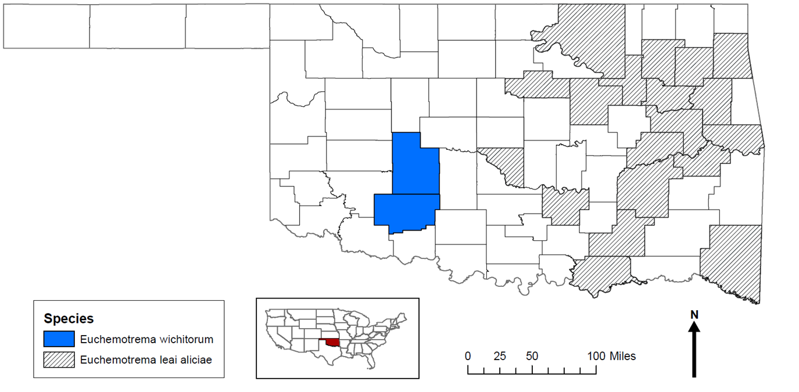
Figure 3. A map of the historic distribution of E. wichitorum and E. leai based on the museum collection records of the Field Museum of Natural History, the Carnegie Museum of Natural History, and the University of Florida Museum of Natural History. Species distributions generally match those presented by Hubricht (1985).
Results
Range
Euchemotrema were found at 70 of the 106 survey sites and in nine of the 15 surveyed counties (Fig. 4). Some populations outside the WMWR were of intermediate shell morphology between E. wichitorum and E. leai and could not be confidently assigned to E. wichitorum and thus were excluded from the estimation of range (Fig. 4, 2019-2, 2019-3, 2019-8, 2019-12, 2020-3, Table 1). The estimated range of E. wichitorum covers an area of 4722 km² and extends beyond the WMWR into Caddo, Comanche, Cotton, Jackson, Kiowa, Stephens, and Tillman Counties (Fig. 6). Euchemotrema wichitorum was not found in the western, isolated portion of the Wichita Mountains around the southern portion of Lake Altus (mostly within Quartz Mountain State Park) and around the town of Granite, OK. However, E. wichitorum was found throughout the extent of the core portion of the Wichita Mountains, Mt. Scott in the eastern portion of the WMWR to the western extent of the main formation which runs northeast to southwest starting at the Blue Mountains northwest of Cooperton, through the Glen Mountains north of Tom Steed reservoir, and ending at the Navajo Mountains east of Friendship. The population found in the Navajo Mountains now represents the known western extent of the species. Populations were found south of the Wichita Mountains along both Cache Creeks, which drain most of the Wichita Mountains formation. Interestingly, a population of snails was also found just north of Waurika Lake on a floodplain of Beaver Creek that does not drain the Wichita Mountains, but instead an area east of the Wichita Mountains that is predominantly flat agricultural land. These three floodplain populations were found in streamside forests that receive deposits of driftwood during flooding events and now represent the known southern extent of the species. Populations of E. wichitorum were also found along forested ridges southwest of Anadarko, and in a drainage southwest of Carnegie, which now respectively represent the known eastern and northern extent of populations.

Microhabitat and Fire
The general additive model (GAM) of the microhabitat conditions measured in the 12 m x 12 m plots explained 57.50% of the variance of live snail abundance at the field survey sites (Table 2). Of the five modeled variables (canopy cover, litter cover, count of trees taller than 2m, count of boulders, and count of shelter logs), only the count of shelter logs and the count of boulders were statistically significant (Table 2). The number of logs had a positive relationship with snail abundance (Fig. 8). The downward projection in the model at the higher log values represents a trend towards a lesser increase in snail abundance at very high levels of logs and is represented by two riparian driftwood sites which represent an outlier habitat type with respect to the amount of available shelter logs (see Microhabitat Analysis subsection of methods, Supplemental photo 3). The number of boulders at the field survey sites had a negative relationship with snail abundance (Fig. 8). Although not statistically significant, the number of trees and percent of leaf litter cover were positively associated with increasing snail abundance (Fig. 8). Canopy cover was not associated with live snail abundance. Fire evidence was present at 13 of the 60 sites and had a significant, positive effect on live snail abundance when modeled as a fixed effect. No variables were identified as problematic from the gam.check function.
The GAM for shelter log characteristics and live snail abundance did not have any significant variables, with only log length (p = 0.078) showing a near-significant trend. As a fixed effect, fire had a significant positive effect (p = 0.002) on live snail abundance. Overall, variance capture of the model was 24.8% (Supplemental Table 2).
The Bayesian models examining the effect of fire on live snail abundance showed that burned survey sites and charred logs both had significantly more snails than their unburned counterparts (Fig. 9). Soil from burned sites had significantly higher pH than soil from unburnt sites (p = 0.02, Table 3). The pH of soil under logs and one m away were not significantly different (p = 0.24).
Several sites in the WMWR were surveyed close enough to burn date that ash still covered portions of the sites and vegetation had yet to recover. No surviving snails were found from burns that removed all vegetation from an area. Shells of E. wichitorum persist through even severe fire, as evidenced by shells documented in the white ash piles of completely burned shelter logs (Supplemental Photo 6). This indicates that burned areas lacking shells likely lacked snails before the fire.
Survey site 2018-1 (Table 1), which had been previously surveyed and contained known locations of logs harboring snails, was revisited after a low-severity controlled burn to determine the fate of snails. Although many snails survived, even where large portions of their shelter log burned (Supplemental Photo 4), others likely died because the adjacent leaf litter caught fire and burned the area at the soil-log interface while leaving the rest of the log intact (Supplemental Photo 5).
Snail shells that last through fires are highly visible on the ground after burns as burned shells are white on a background of black and grey ash. After fire, shells were observed in the ash piles of completely burned logs as well as the burned areas adjacent to intact logs and boulders (Supplemental Photo 6). E. wichitorum shells were not observed in open prairie habitat, even when adjacent areas with shelters had over one hundred exposed shells. Slopes with forbes, but lacking other shelters sometimes had E. wichitorum shells and often these sites also contained shells of a second large snail, Bulimulus dealbatus.
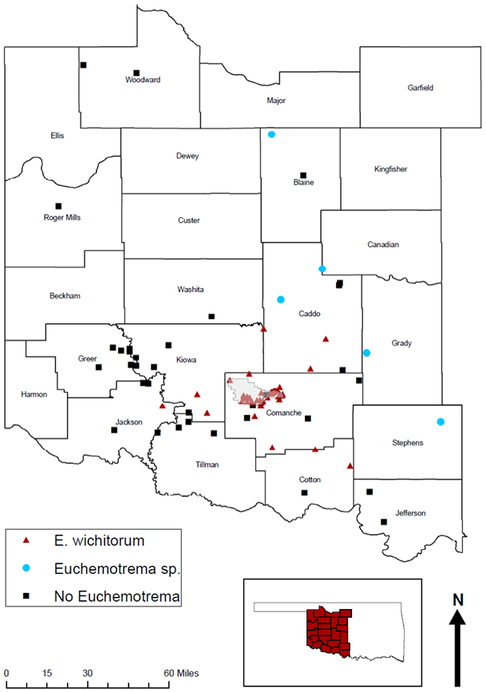
Figure 4. A map of the 106 western Oklahoma survey sites. Red triangles are populations that could confidently be assigned to Euchemotrema wichitorum (n = 65). Five populations of Euchemotrema could not be assigned to E. wichitorum (blue circles). Sites where no Euchemotrema were located are represented by black squares (n = 36).

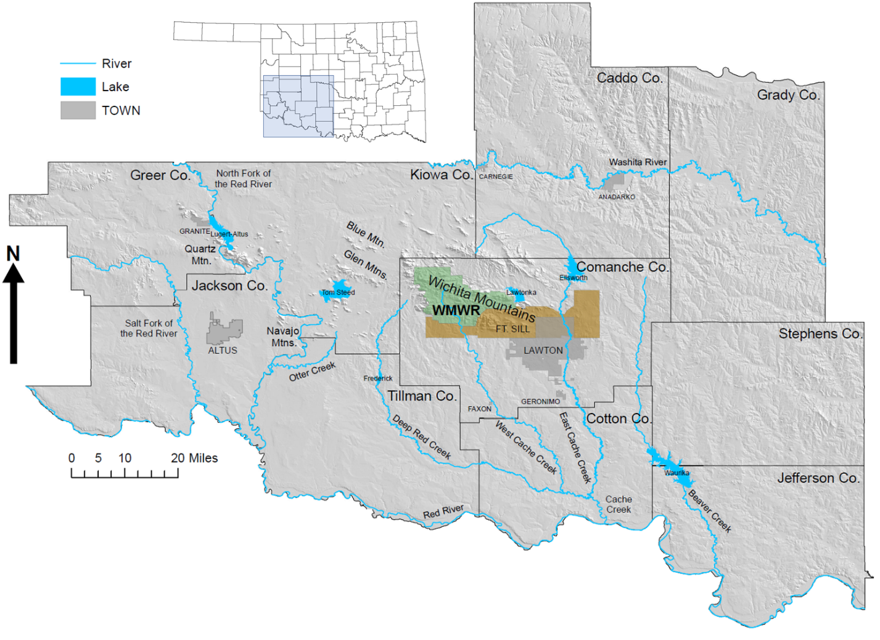
Figure 5. A regional map of southwest Oklahoma, where this study took place. All major sub-formations of the Wichita Mountains are labeled, as are the streams that drain the region and their associated reservoirs. The Wichita Mountains Wildlife Refuge (WMWR, green) is the core of the described habitat of E. wichitorum.

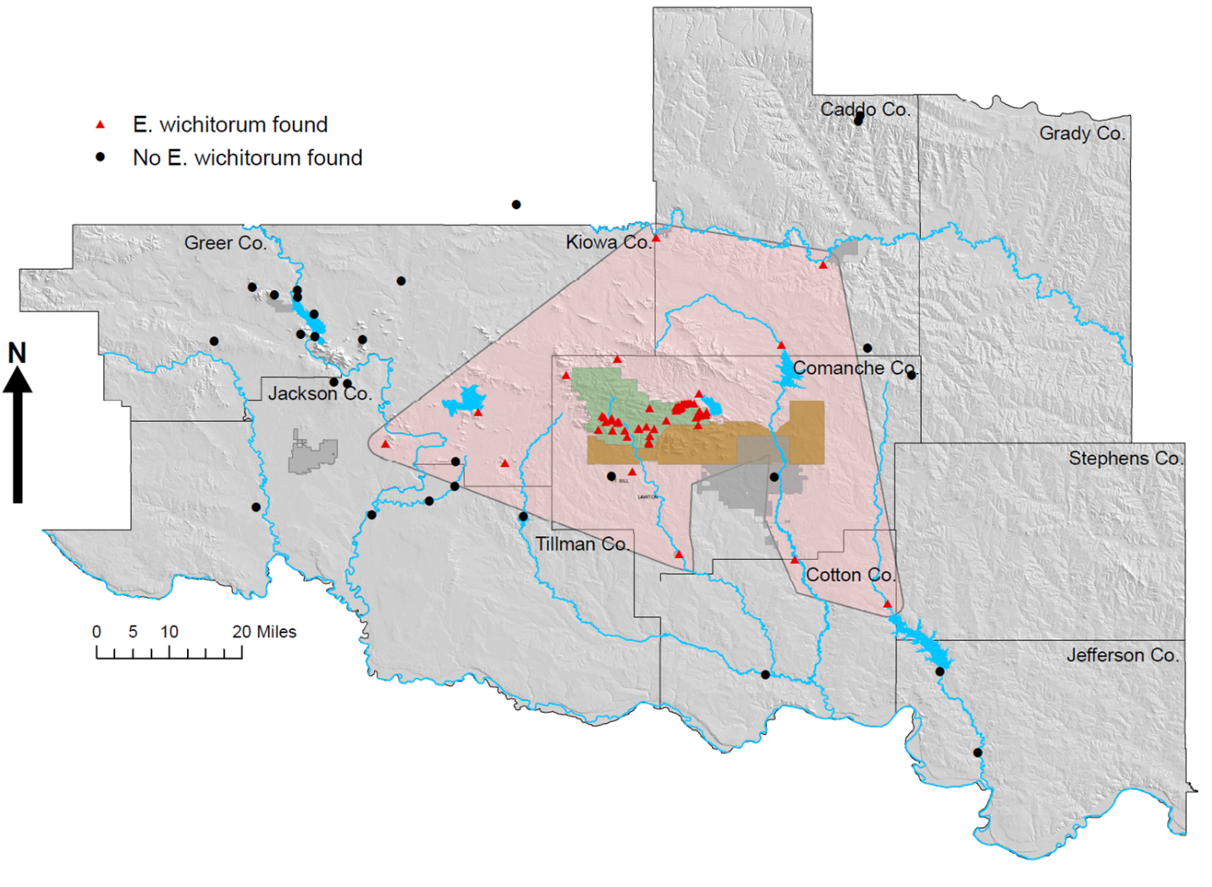
Figure 6. Map showing the estimated range of E. wichitorum based on our surveys. Red triangles indicate areas where E. wichitorum was found, while black circles indicate surveys that did not locate and Euchemotrema shells. The range covers an estimated 4,722 km² across seven counties and is significantly larger than the original description to northern Comanche and southern Caddo Counties. Additional sites were surveyed outside of the pictured area, but definitive E. wichitorum were not located.
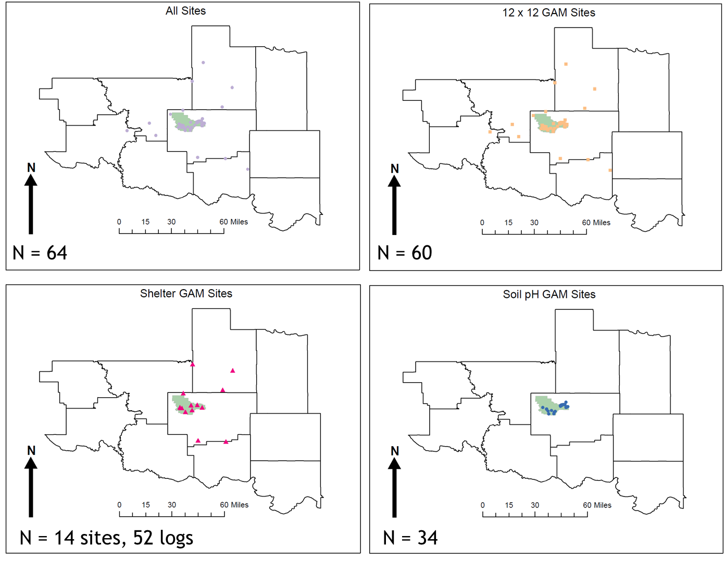
Figure 7. A map of the survey sites used for the different analyses. There were 64 E. wichitorum sites in the pictured area (top left), with 60 of those sites being used for the microhabitat survey site GAM analysis (top right). 52 logs from 14 sites surveyed in 2018 and 2019 were used for the shelter GAM analysis (bottom left), and 34 sites composed primarily of 2017 survey sites from within the WMWR were used for the soil pH analysis (bottom right).
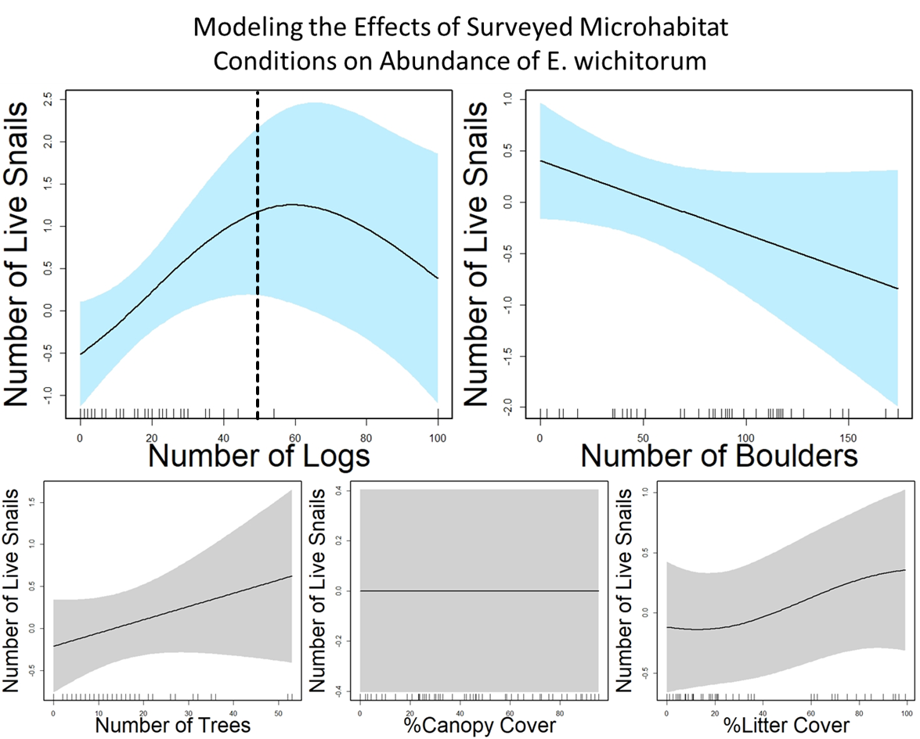

Figure 8. The response of live snail abundance to microhabitat conditions recorded in the 12 m x 12 m plot surveys as analyzed via our General Additive Model (GAM). Only the counts of shelter logs (p=0.011) and boulders (p=0.044) were statistically significant in the model. Shaded areas represent ±1 standard error around parameter estimate, with additional uncertainty in the confidence intervals around mean values depicted using seWithMean=TRUE (Mara and Wood 2012). The dashed line in Number of Logs plot represents a break between riparian driftwood sites, which were the only sites with above 50 logs in a survey plot, and the rest of our survey sites, which were mostly Post Oak habitats that typically have fewer than 30 logs.

Table 1. All survey sites from this study. “Species ID” notes populations classification and was used for range-estimation purposes, which incorporated morphometric (Cooper Thesis Chapter 2) and genetic (Cooper unpublished) data; N/A = no Euchemotrema spp. found. “12 x 12: Yes” and “Log: Yes” note sites used in the microhabitat and shelter GAMs, respectively. “pH: Yes" notes sites that had soil pH measurements. “DFA: Yes” notes populations included in a Discriminant Function Analysis (Cooper Thesis Chapter 2). “DNA: Yes” notes populations with individuals that have CO1 sequence data (Cooper unpublished).

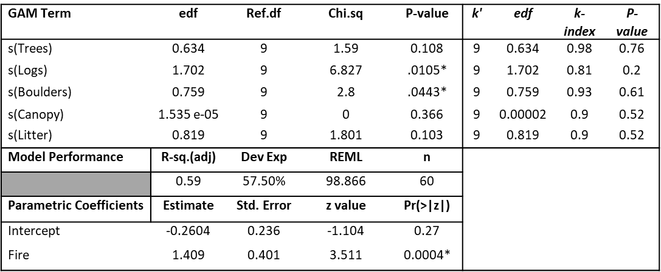
Table 2. Quantitative output of survey site General Additive Model using package ‘mgcv’ in R (left). Potential problematic variable evaluated with function gam.check (right; problematic variables would have p < 0.05).
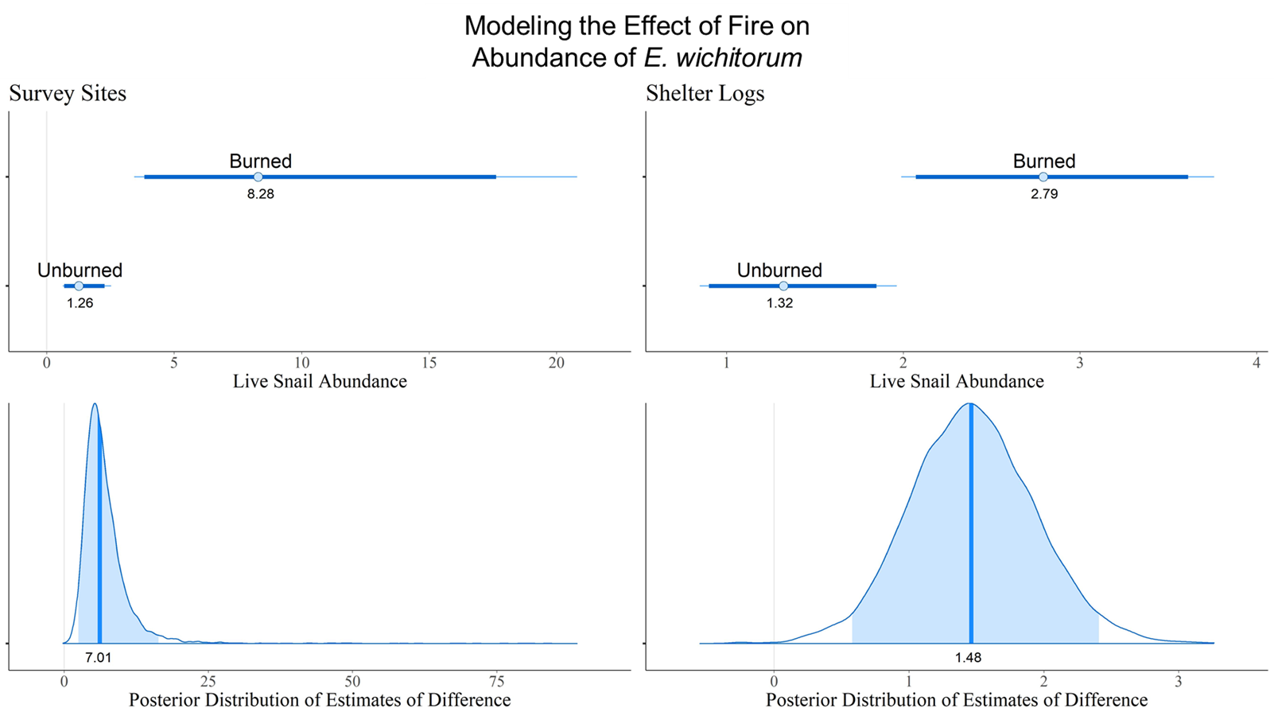

Figure 9. Bayesian modeling of the difference in number of live snails observed at survey sites with and without burn evidence (left) and under burned (charred) vs unburned logs (right). Numbers represent mean estimates. 95% credible interval estimates are represented by the dark bars in the upper graphs and by the shading in the lower graphs.

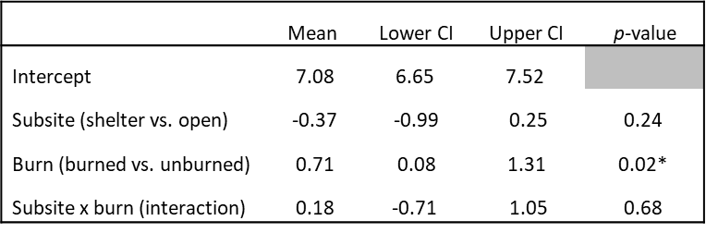

Table 3. Difference in open versus shelter soil pH for 34 survey sites. Sites were further divided into burned and unburned sites and compared using a Bayesian analog of a two-way ANOVA. Mean for comparisons represents the difference between the mean values of the first and second factor (i.e. mean Burn value is: mean soil pH burned sites minus mean soil pH unburned sites).

Discussion
Range
Spanning approximately 4700 km² in seven counties, the range of E. wichitorum is much larger than initially expected based on its original description of two counties (Branson 1972; Hubricht 1985; Fig. 3). Euchemotrema wichitorum’s range includes several woodland areas well outside the Wichita Mountains formation, suggesting that its ties to the Wichita Mountains stems from this area providing large islands of woodland habitat in a sea of mixed-grass prairie and agricultural land rather than an association with the unique granitic geology typical of the region. The association with wooded areas is consistent with its close relation to the forest-dwelling E. leai, rather than an association with unique rocky habitats exhibited by two other related species, E. hubrichti and Stenotrema pilsbryi, whose endemism to regions of unique geology are because of a close habitat association with said geology (Anderson and Smith 2005; Mather 1998).
The presence of populations in drift deposition areas of riparian forests along streams that drain the Wichita Mountains indicates that E. wichitorum may be passively dispersed along waterways, as has been a suggested dispersal mechanism for other land snail species, based on population genetics data (Sinclair-Winters 2014; Liang et al. 2019). Riparian forests can support high abundances of land snails because the microclimate of these forests may be more mesic than other local habitats and these woodlands have an increased number of woody debris deposited by floods (Kappes et al. 2014).
Outside of the drift deposit forests, which support large numbers of several commonly introduced species, E. wichitorum is the dominant macrosnail species in its habitat. Euchemotrema wichitorum was the only species observed at 46 of the 65 survey sites where it was located. Bulimulus dealbatus was the only other macrosnail with large populations found in non-riparian habitats, and occurred at 13 sites, which tended to be relatively open, rocky habitats.
Several populations of snails north of the range of E. wichitorum did not fully match the species description, with a mix of characters between E. wichitorum and E. leai (Fig. 4). These populations were not included in our range estimation or data analyses, but they warrant further study and will likely require both morphometric and genetic analysis to taxonomically delineate.

Microhabitat
Live snail abundance was significantly associated with increasing numbers of logs and decreasing numbers of boulders. These two variables roughly define the gradient of habitat types in the Wichita Mountains that harbor E. wichitorum; with high numbers of boulders being characteristic of more open habitat that tends to be dominated by grasses and higher number of logs being characteristic of increasingly dense woodlands. More open habitat is generally characterized by few live snails, but many shells, while forest habitats generally had far more live snails than shells. This trend is likely because of low numbers of hard-to-detect snails living in open habitats, where shells may degrade more slowly, compared to denser populations of snails in forests, where shell breakdown is likely more rapid because of both increased moisture and increased consumption by living snails and other animals (Pearce 2008; Cadée 1999). Theoretically, E. wichitorum could be burrowing and living under large boulders, but the soil of open habitats is generally thin and coarse, and no shells or snails were found under the few boulders small enough to easily turn over. Additionally, little evidence of burrowing into soil has been observed in forested habitats or laboratory colonies (Pers. Obs.).
In general, logs serve as key habitat for many snail species by providing moist, cool sites that shelter snails during harsh conditions and provide an incubation habitat for their eggs (Kappes 2005). Increased number of logs and other woody debris that can be used as shelter has been associated with increased snail abundance for various gastropod species in numerous habitat types (Caldwell 1996; Kappes 2005; Kappes et al. 2006; Kappes et al. 2009; Kappes et al. 2014). Although not statistically significant in this somewhat limited analysis of the subject, soil conditions under logs may be favorable to snails beyond moisture retention; with soil under and around logs having higher pH and higher amounts of nutritive minerals such as calcium, magnesium, and potassium (Müller et al. 2005). Decaying wood is eaten by snails and fosters various types of fungi (Norden et al. 2005) and lichens (Radu 2006) that snails may consume (Dourson 2008).
The positive, but non-significant trends in the association between the number of trees and litter cover are also consistent with higher numbers of snails in forested areas. E. wichitorum’s association with forested habitat is not a surprise: forested areas have lower light conditions, cooler soil surface temperatures, higher relative humidity, and much more decaying organic matter than neighboring prairie (Karlin 1961). These microhabitat conditions are associated with increased food and reduced desiccation risk for snails, which can be drivers of land snail presence and abundance (Albuquerque et al. 2008; Čejka et al. 2008).
Several of the measured microhabitat variables may have had non-significant associations because of sampling methodology. Areas with high numbers of logs tend to represent clearings within woodlands that have relatively lower tree density. Within the relatively small 12 m x 12 m survey plots, tree density and consequently canopy cover was often noticeably lower than the general surrounding habitat. In more open habitats, shells tend to be concentrated in areas where scattered trees provide some shade. Even a single tree in an otherwise open landscape can provide high canopy cover readings for portions of a plot. Additionally, there was no differentiation between grass litter and tree leaf litter in our surveys and so high litter values were assigned to a variety of habitats. While many land snail species live in tree leaf litter and E. leai abundance has been associated with increasing litter depth (Brand et al. 2020), much of the litter in our survey was provided by grasses, which is likely of lesser importance to E. wichitorum.
Although snail shells were often found next to boulders, live snails were rare in boulder-dominated habitats. This distribution indicates that these boulder habitats act as sinks (Pulliam 1988). Boulders may serve as temporary shelters for dispersing snails, which are most likely to be active on nights during or immediately after rain (Iglesias et al. 1996; Dahriel et al. 2014). Snails wandering into prairie habitats during such times must seek shelter during the day, and if moisture does not return, they may become stranded and vulnerable to desiccation. Using boulders as temporary shelters during favorable conditions may enable individuals to travel between patches of suitable habitat as they disperse among habitats or seek mates, but it evidently has a high risk of mortality.

Fire
The increased number of snails in sites with burn evidence and under charred logs was an unexpected finding of this study. Fire has typically been shown to have a negative (Nekola 2002; Ross et al. 2019; Nioclai et al. 2020) or, at best, neutral (Kiss and Magnin 2004; Gaines et al. 2011) effect on snail community diversity and richness. Certain fire-adapted species may have positive associations with fire insofar as it maintains a more open woodland habitat where they are competitive (Santos et al. 2012), but to my knowledge only Severns (2005) documented increased abundance of certain land snail species compared to controls after fire, with abundance in Oregon wetland prairie burned patches showing increased abundance in years three and four post-fire.
The negative effects of fire, beyond direct mortality, are explained by environmental alterations that increase desiccation risk: fire reduces litter and coarse woody debris, opens canopy, and makes the microclimate more xeric (Kiss and Magnin 2004). However, fire can also change the environment in ways that benefit certain snail species. Severns (2005) postulated that because fire both increases soil ammonium and removes aboveground vegetation, post-fire vegetation may be both younger and more palatable and have increased nutrient quality. Fire is also generally associated with a temporary increase in soil pH and extractable calcium (Certini 2005) and the soil pH data from sites in the WMWR showed burn sites had higher pH. In the WMWR the increased pH is likely to be partially to the result of high level of calcium carbonate in oak ash (Misra et al. 1993). Indeed, ash from post oak collected from the WMWR that was experimentally burned at approximately 500 – 550°C had a pH of 10.5 (Cooper unpublished).
Many snail species have increased abundance in higher pH conditions (Götmark et al. 2008) and soil pH is often highly correlated to calcium availability (Martin and Sommer 2004). Patterns observed in snail abundance related to pH may be better explained by calcium content in some cases (Hylander 2011). In several studies, calcium was the stronger predictor of snail abundance than pH when both were modeled together (Graveland and van der Wal 1996; Horsak and Hajek 2003). Snails from environments with non-calcareous soil are dependent on vegetation for the calcium needed to produce their shells and make their eggs (Sulikowska-Drozd and Horsak 2007). Considering the non-calcareous granite and gabbro bedrock, a major source of calcium for snails in the woodlands of the WMWR is the leaf litter and decaying wood of the dominant tree, Post Oak (Quercus stellata).
Oaks sequester calcium in their leaves, bark, and wood as calcium oxalate (Trockenbrodt 1994), which is a largely insoluble calcium salt that does not significantly increase soil pH in oak woodlands (Wäreborn 1969). Post oaks store a significant amount of calcium in their bark, in concentrations up to six times that of the average deciduous tree (Johnson and Risser 1974). Calcium oxalate can be difficult for animals to absorb (Weaver et al. 1987; Harbers et al. 1980) and is less favorable to snail growth and reproductive success than more soluble forms like calcium citrate (Wäreborn 1979). Fire converts the calcium oxalate in oak and other wood into soluble calcium ions and then into calcium carbonate (Pereira et al. 2012), meaning that charred logs and leaf litter would be a better calcium source than their unburned equivalents. Other nutritive elements (K, Na, Mg, Si, S) are also converted to more soluble and mineralized forms by fire, which makes them more extractable from charred wood than from unburned wood (Ubeda et al. 2009; Pereira et al. 2011). Indeed, burned logs are associated with higher rates of snail growth and higher soil pH (Ray and Bergey 2015). The increased concentration of bioavailable calcium, other minerals, and higher pH caused by charring of logs and litter by low-severity fires may be the reason burned survey sites and charred logs harbored more snails than their unburned counterparts, although it is possible some unconsidered factor drives these associations.
Surveying areas after fires showed that snails persist as long as the immediate portion of shelter log they are under does not burn (Supplemental Photo 2). Additionally, the presence of numerous exposed shells in recently burned areas suggests that snails sheltering in litter, or whose shelters burn do not survive. Low-severity burns left mosaics that had no observed mortality of snails in unburned patches, while mortality in burned patches was largely dependent on shelter log combustion. High-severity fire that completely burned all woodfall and left little litter did not have any apparent live snails, instead, whitened shells were often visible within the ash outlines of logs. If snails are found in these areas within the next several years, it may indicate that some E. wichitorum survive high-severity fires through sheltering in cryptic refuges, as has been proposed for several species native to fire-prone areas (Kiss and Magnin 2006; Santos et al. 2009).
Even though some individuals persist through wildfire and our data suggests fire can be associated with increased abundance, I did not experimentally examine mortality and population recovery rates after burning. Observational evidence suggests favoring low-severity mosaic burns, which leave many snails alive in comparison to high-severity burns, where I found no live snails. However, without experimental data, I default to the fact that fire has historically been a part of this landscape and the observed widespread distribution of live snails throughout the WMWR as evidence that current fire management practices are unlikely to be severely threatening E. wichitorum. In fact, canopy density throughout the Cross Timbers is estimated to be 71% higher than before European settlement (DeSantis et al. 2011) so it may be arguable that current conditions are more favorable for populations E. wichitorum.

Conservation
The contradictory consequences of fire—reducing snail abundance during severe fires yet also providing post-fire conditions that may be conducive to snails—suggests the need for a nuanced approach to fire as management tool. Fire increases oak recruitment and reduces fire-sensitive competing species in the Cross Timbers forests of Oklahoma (Clark et al. 2007) and thus fire helps maintain the primary habitat of E. wichitorum. Studies that suggest an optimal fire return intervals for gastropod management have come to varying conclusions. Gaines et al. (2011) suggested emulating the study region’s natural fire return interval (~10 years) based on no observed negative effects of fire in their burn treatment plots, while Kiss and Magnin (2006) saw an interval of 4–5 years as sufficient for community recovery in a fire-prone region of southern France. Others have suggested that significantly longer intervals (15+ years) may be needed to maintain gastropod abundance and diversity (Nekola 2002, Burke 1999 Brand et al. 2020). Without experimental or more rigorous data focused on the impact of fire on E. wichitorum, I will not make recommendations on fire intervals here. However, I will use my observational data as well as background research on snail ecology to give some suggestions of times to avoid burning.
The observed egg-laying peak of E. wichitorum in the wild and in laboratory colonies started in mid-March and continued early-May. Eggs and young are highly sensitive to heat and disturbance (Baur and Baur 1993; Asami 1993) and thus burning between mid-March and July may have a negative impact on snail recruitment. Mid-March until through June is also the period of highest rainfall in the region and thus is also the likely peak of snail activity. Historically, about 90% of burns in the WMWR were in the oak dormant season (generally late October to early-March) and snails are likely to be inactive during dry periods throughout this time. Controlled burns should be avoided for several days after rain events even outside of the growing season because rain stimulates snail activity (Iglesias et al. 1996) and winters are mild enough in the region that snails may be active for short periods after rainfall even in the coldest months.
There are several simple conservation measures besides burning practices that have the potential to ameliorate some impacts of fire or logging on land snail populations if needed. Leaving logging slash significantly increased the coarse wood debris habitat used by land snails (Abele 2010) and this increase in shelter habitat has been attributed to increased snail abundance in some logging areas 5 – 10 years post-treatment (Kralka 1986). Where fire preceded logging, recovery was faster in sites where slash was left (Bros et al. 2011). Logging may be a potential management tool to reduce tree density in Cross Timbers forests and transition woodlands back into savannas (De Santis et al. 2011); leaving some slash or downed tree as habitat may help offset disturbance mortality in local E. wichitorum populations if retained wood is not dense enough to increase the risk of high-severity fire.
Several studies have found that adding calcium to sites resulted in increased snail diversity and substantially increased abundance (abundance range 1.73x to 40x increase) (Skeldon et al. 2007; Pabian et al. 2007; Gardenfors 1992; McCay et al. 2013). Oak ash can be over 40% calcium by weight (Misra et al. 1993) and additions of wood ash has been shown to promote herbaceous plant growth and be of little environmental risk if added in reasonable quantities (Demeyer et al. 2001). If conservation intervention for E. wichitorum is deemed necessary in the future, redistributing or adding additional wood ash to affected woodlands after controlled burns may be another method to promote both land snail and understory vegetation recovery, but should be tested experimentally before implementation.
E. wichitorum readily reproduces in large numbers under laboratory conditions on a diet of primarily leaf litter and romaine lettuce, with occasional supplementation of calcium carbonate powder, sweet potato, carrot, and cucumber (Pers. Obs.). While not advisable unless the species becomes threatened, a captive breeding program could easily produce hundreds to thousands of individuals for attempted reintroductions at modest effort and expense. Snail reintroduction efforts have historically been of mixed success (Gilbertson et al. 2019; James et al. 2012; Pearce-Kelly et al. 1995), but these efforts tend to focus on species with very specialized habitat (Gilbertson et al. 2019) or those facing active predation threats (Coote et al. 2004) that require more intensive management to ensure reintroduction success.
The long-term prospects of E. wichitorum are likely positive when considering its larger-than-expected range and its ability to endure fire and thrive in burned habitats. This species has enough isolated populations under different ownership and land management regimes (federal, tribal, recreational, residential, and agricultural) that the species is unlikely to be severely affected by any single major natural (massive wildfire, prolonged drought, 100-year flood) or manmade (controlled burns and many wildfires, pesticide use, logging, problematic invasive species introduction) disturbance. Wildlife managers and private landowners can be given a relatively simple set of guidelines related to burning and logging practices that can help conserve this species on their land. Euchemotrema wichitorum may have been ignored since its description almost fifty years ago, but at least this lack of attention was not neglect for a species in need of conservation intervention. The Wichita Mountains pillsnail may not be the star attraction of its oft-visited home range, but it should continue to thrive in obscurity.
References
Abele, S.E. (2010). Gastropod diversity in the boreal mixedwood forest of northern Alberta – variation among forest types and response to partial harvesting. M.S. Thesis. Edmonton, Alberta: University of Alberta. 107 pp.
Albuquerque, F. S. D., Peso-Aguiar, M. C., & Assunção-Albuquerque, M. J. T. (2008). Distribution, feeding behavior and control strategies of the exotic land snail Achatina fulica (Gastropoda: Pulmonata) in the northeast of Brazil. Brazilian Journal of Biology, 68(4), 837-842.
Anderson, F. E., & Smith, D. A. (2005). A redescription of the carinate pillsnail, Euchemotrema hubrichti (Pilsbry, 1940) (Pulmonata: Polygyridae), with notes on habitat and genetics. Zootaxa, 807(1), 1-11.
Asami, T. (1993). Interspecific differences in desiccation tolerance of juvenile land snails. Functional Ecology 7: 571-577.
Bańbura, M., Sulikowska-Drozd, A., Kaliński, A., Skwarska, J., Wawrzyniak, J., Kruk, A., ... & Bańbura, J. (2010). Egg size variation in Blue Tits Cyanistes caeruleus and Great Tits Parus major in relation to habitat differences in snail abundance. Acta Ornithologica, 45(2), 121-129.
Baur, B. (1986). Patterns of dispersion, density and dispersal in alpine populations of the land snail Arianta arbustorum (L.)(Helicidae). Ecography, 9(2), 117-125.
Baur, A., & Baur, B. (1990). Are roads barriers to dispersal in the land snail Arianta arbustorum? Canadian Journal of Zoology, 68(3), 613-617.
Baur, B., & Baur, A. (1993). Climatic warming due to thermal radiation from an urban area as possible cause for the local extinction of a land snail. Journal of Applied Ecology, 333-340.
Baur, B. (1994). Parental care in terrestrial gastropods. Experientia, 50(1), 5-14.
Becker, E. A., Forney, K. A., Redfern, J. V., Barlow, J., Jacox, M. G., Roberts, J. J., & Palacios, D. M. (2019). Predicting cetacean abundance and distribution in a changing climate. Diversity and Distributions, 25(4), 626-643.
Bliss, C. I., & Fisher, R. A. (1953). Fitting the negative binomial distribution to biological data. Biometrics, 9(2), 176-200.
Brand, M. E., Rechkemmer, W. T., Clark, S. A., McCravy, K. W., Lydeard, C., Meiers, S. T., & Jenkins, S. E. (2020). The influence of fire and other environmental factors on terrestrial gastropod species composition in an oak-hickory woodland of west-central Illinois. American Malacological Bulletin, 38(1), 39-49.
Branson, B. A. (1972). "Mollusca of the Wichita, Arbuckle, and Black Mesa uplifts of Oklahoma and description of Stenotrema wichitorum, new species." Southwestern Naturalist 16(3-4): 307-320.
Bros, V., Moreno-Rueda, G., and X. Santos. (2011). Does postfire management affect the recovery of Mediterranean communities? The case study of terrestrial gastropods. Forest Ecology and Management 261(3): 611-619.
Buck, P. (1964). Relationships of the woody vegetation of the Wichita Mountains Wildlife Refuge to geological formations and soil types. Ecology, 45(2), 336-344.
Burke, T.E. (1999). Management recommendations for terrestrial mollusk species Cryptomastix devia, the Puget Oregonian Snail. V. 2.0. Prepared for the Oregon Bureau of Land Management. 33 pp
Cadée, G. C. (1999). Shell damage and shell repair in the Antarctic limpet Nacella concinna from King George Island. Journal of Sea Research, 41(1-2), 149-161.
Caldwell, R. S. (1996, March). Macroinvertebrates and their relationship to coarse woody debris: with special reference to land snails. In Biodiversity and coarse woody debris in southern forests, proceedings of the workshop on coarse woody debris in southern forests: effects on biodiversity (JW McMinn and DA Crossley, Jr., eds.). United States Department of Agriculture, Forest Service, General Technical Report, SE-94 (Vol. 1, No. 146, pp. 49-54).
Cameron, R. A. D., & Pokryszko, B. M. (2005). Estimating the species richness and composition of land mollusc communities: Problems, consequences and practical advice. Journal of Conchology, 38(5), 529-548.
Čejka, T., Horsák, M., & Némethová, D. (2008). The composition and richness of Danubian floodplain forest land snail faunas in relation to forest type and flood frequency. Journal of Molluscan Studies, 74(1), 37-45.
Cernohorsky, N. H., Horsák, M., & Cameron, R. A. (2010). Land snail species richness and abundance at small scales: the effects of distinguishing between live individuals and empty shells. Journal of Conchology, 40(2), 233.
Certini, G. (2005). Effects of fire on properties of forest soils: a review. Oecologia, 143(1), 1-10.
Chen, B., Liu, H., & Huang, B. (2012). Environmental controlling mechanisms on bacterial abundance in the South China Sea inferred from generalized additive models (GAMs). Journal of Sea Research, 72, 69-76.
Clark, S. L., Hallgren, S. W., Engle, D. M., & Stahle, D. W. (2007). The historic fire regime on the edge of the prairie: a case study from the Cross Timbers of Oklahoma. In: Proceedings of the Tall Timbers Fire Ecology Conference (Vol. 23, pp. 40-49).
Collins, S. L., & Uno, G. E. (1983). The effect of early spring burning on vegetation in buffalo wallows. Bulletin of the Torrey Botanical Club, 474-481.
Coote, T., Clarke, D., Hickman, C. J. S., Murray, J., & Pearce-Kelly, P. (2004). Experimental release of endemic Partula species, extinct in the wild, into a protected area of natural habitat on Moorea. Pacific Science, 58(3), 429-434.
Crockett, J. J. (1964). Influence of soils and parent materials on grasslands of the Wichita Mountains Wildlife Refuge, Oklahoma. Ecology, 45(2), 326-335.
Curry, P. A., & Yeung, N. W. (2013). Predation on endemic Hawaiian land snails by the invasive snail Oxychilus alliarius. Biodiversity and Conservation, 22(13-14), 3165-3169.
Dahirel, M., Ansart, A., & Madec, L. (2014). Stage-and weather-dependent dispersal in the brown garden snail Cornu aspersum. Population Ecology, 56(1), 227-237.
Demeyer, A., Nkana, J. V., & Verloo, M. G. (2001). Characteristics of wood ash and influence on soil properties and nutrient uptake: an overview. Bioresource Technology, 77(3), 287-295.
Denny, M. (1980). Locomotion: the cost of gastropod crawling. Science, 208(4449), 1288-1290.
Dépraz, A., Cordellier, M., Hausser, J., & Pfenninger, M. (2008). Postglacial recolonization at a snail's pace (Trochulus villosus): confronting competing refugia hypotheses using model selection. Molecular Ecology, 17(10), 2449-2462.
DeSantis, R. D., Hallgren, S. W., & Stahle, D. W. (2011). Drought and fire suppression lead to rapid forest composition change in a forest-prairie ecotone. Forest Ecology and Management, 261(11), 1833-1840.
Douglas, D. D., Brown, D. R., & Pederson, N. (2013). Land snail diversity can reflect degrees of anthropogenic disturbance. Ecosphere, 4(2), 1-14.
Dourson, D. C. (2008). The feeding behavior and diet of an endemic West Virginia land snail, Triodopsis platysayoides. American Malacological Bulletin, 26(1/2), 153-159.
Emberton, K. C. (1994). Polygyrid land snail phylogeny: external sperm exchange, early North American biogeography, iterative shell evolution. Biological Journal of the Linnean Society, 52(3), 241-271.
Drexler, M., & Ainsworth, C. H. (2013). Generalized additive models used to predict species abundance in the Gulf of Mexico: an ecosystem modeling tool. PloS one, 8(5), e64458.
Gabry J., Mahr. T (2020). bayesplot: Plotting for Bayesian Models. R package version 1.7.2. https://mc-stan.org/bayesplot
Gaines, W. L., Lyons, A. L., Weaver, K., & Sprague, A. (2011). Monitoring the short-term effects of prescribed fire on an endemic mollusk in the dry forests of the eastern Cascades, Washington, USA. Forest Ecology and Management, 261(8), 1460-1465.
Gardenfors, U. (1992). Effects of artificial liming on land snail populations. Journal of Applied Ecology, 29(1), 50-54.
Gärdenfors, U., Waldén, H. W., & Wäreborn, I. (1995). Effects of soil acidification on forest land snails. Ecological Bulletins, 259-270.
Gilbertson, C. R., Rundell, R. J., & Niver, R. (2019). Determining diet and establishing a captive population of a rare endemic detritivore, the endangered Novisuccinea chittenangoensis (Pilsbry, 1908)(Pulmonata: Succineidae). Journal of Molluscan Studies, 85(1), 41-47.
Goodward, D. M., Gilbertson, L. H., Rugman-Jones, P. F., & Riggs, M. L. (2017). A contribution to the phylogeography and anatomy of Helminthoglyptid land snails (Pulmonata: Helminthoglyptidae) from the deserts of southern California. Bulletin, Southern California Academy of Sciences, 116(2), 110-136.
Götmark, F., von Proschwitz, T., & Franc, N. (2008). Are small sedentary species affected by habitat fragmentation? Local vs. landscape factors predicting species richness and composition of land mollusks in Swedish conservation forests. Journal of Biogeography 35(6), 1062-1076.
Graveland, J., van der Wal, R., van Balen, J.H., & van Noordwijk, A. J. (1994). Poor reproduction in forest passerines from decline of snail abundance on acidified soils. Nature 368, 446–448.
Graveland, J., & van der Wal, R. (1996). Decline in snail abundance due to soil acidification causes eggshell defects in forest passerines. Oecologia, 105(3), 351-360.
Grueter, C. C., Li, D., Ren, B., & Wei, F. (2009). Choice of analytical method can have dramatic effects on primate home range estimates. Primates, 50(1), 81-84.
Harbers, L. H., Callahan, S. L., & Ward, G. M. (1980). Release of calcium oxalate crystals from alfalfa in the digestive tracts of domestic and zoo animals. The Journal of Zoo Animal Medicine, 11(2), 52-56.
Hastie, T., & Tibshirani, R. (1987). Generalized additive models: some applications. Journal of the American Statistical Association, 82(398), 371-386.
Hayne, D. (1949). Calculation of size of home range. Journal of Mammalogy 30, 1–18
Hoagland, B. W., Butler, I. H., Johnson, F. L., & and Glenn, S. (1999). The Cross Timbers [Chapter 14], In: R. C., Fralish, J. S., & Baskin, J. M. eds., Savannas, barrens, and rock outcrop plant communities of North America. New York, Cambridge University Press, pp. 231-245.
Hoagland, B. W., Messick, J., Rahman, M., & Fagin, T. (2017). Vegetation patterns in Wichita Mountains National Wildlife Refuge, Oklahoma; an analysis of General Land Office Survey records from 1874 and 1905. Publications of the Oklahoma Biological Survey, 12, 1 -14.
Hodges, M. N., & McKinney, M. L. (2018). Urbanization impacts on land snail community composition. Urban Ecosystems, 21(4), 721-735.
Hotopp, K. P. (2002). Land snails and soil calcium in central Appalachian Mountain forest. Southeastern Naturalist, 1(1), 27-44.
Hubricht, L. (1985). The distributions of the native land mollusks of the eastern United States (p. 191). Chicago: Field Museum of Natural History.
Hylander K., Nilsson, C., & T. Göthner, T. (2004). Effects of buffer-strip retention and clearcutting on land snails in boreal riparian forests. Conservation Biology 18(4), 1052-1062.
Hylander, K. (2011). The response of land snail assemblages below aspens to forest fire and clear-cutting in Fennoscandian boreal forests. Forest Ecology and Management 261(11), 1811-1819.
Iglesias, J., Santos, M., & Castillejo, J. (1996). Annual activity cycles of the land snail Helix aspersa Müller in natural populations in north-western Spain. Journal of Molluscan Studies, 62(4), 495-505.
Johnson, F. L., & Risser, P. G. (1974). Biomass, annual net primary production, and dynamics of six mineral elements in a post oak‐blackjack oak forest. Ecology, 55(6), 1246-1258.
Jordan, S. F., & Black, S. H. (2012). Effects of forest land management on terrestrial mollusks: a literature review. The Xerces Society for Invertebrate Conservation, Portland, Oreg.
Juřičková, L., Horsák, M., Cameron, R., Hylander, K., Míkovcová, A., Hlaváč, J. Č., & Rohovec, J. (2008). Land snail distribution patterns within a site: the role of different calcium sources. European Journal of Soil Biology, 44(2), 172-179.
Kappes, H. (2005). Influence of coarse woody debris on the gastropod community of a managed calcareous beech forest in western Europe. Journal of Molluscan Studies, 71(2), 85-91.
Kappes, H., Topp, W., Zach, P., & Kulfan, J. (2006). Coarse woody debris, soil properties and snails (Mollusca: Gastropoda) in European primeval forests of different environmental conditions. European Journal of Soil Biology, 42(3), 139-146.
Kappes, H., Catalano, C., & Topp, W. (2007). Coarse woody debris ameliorates chemical and biotic soil parameters of acidified broad-leaved forests. Applied Soil Ecology, 36(2-3), 190-198.
Kappes, H., Jabin, M., Kulfan, J., Zach, P., & Topp, W. (2009). Spatial patterns of litter-dwelling taxa in relation to the amounts of coarse woody debris in European temperate deciduous forests. Forest Ecology and Management, 257(4), 1255-1260.
Kappes, H., Kopeć, D., & Sulikowska-Drozd, A. (2014). Influence of habitat structure and conditions in floodplain forests on mollusc assemblages. Polish Journal of Ecology, 62(4), 739-750.
Kiss, L., Magnin, F., & Torre, F. (2004). The role of landscape history and persistent biogeographical patterns in shaping the responses of Mediterranean land snail communities to recent fire disturbances. Journal of Biogeography 31(1), 145-157.
Kiss, L., & Magnin, F. (2006). High resilience of Mediterranean land snail communities to wildﬁres. Biodiversity and Conservation 15: 2925–2944.
Kleewein, D. (1999). Population size, density, spatial distribution and dispersal in an Austrian population of the land snail Arianta arbustorum styriaca (Gastropoda: Helicidae). Journal of Molluscan Studies, 65(3), 303-315.
Kralka, R. A. (1986). Population characteristics of terrestrial gastropods in boreal forest habitats. American Midland Naturalist, 115(1), 156-164.
James, A. F., Brown, R., Weston, K. A., & Walker, K. (2013). Modelling the growth and population dynamics of the exiled Stockton coal plateau landsnail, Powelliphanta augusta. New Zealand Journal of Zoology, 40(3), 175-185.
Jennings, T.J. & J.P. Barkham. (1979). Litter decomposition by slugs in mixed deciduous woodland. Holarctic Ecology 2(1), 21-29.
Liang, H., Liu, C., Li, Y., Wang, Y., Kong, Y., Quan, J., & Yang, X. (2019). Low population genetic differentiation in two Tamarix species (Tamarix austromongolica and Tamarix chinensis) along the Yellow River. Genetica, 147(1), 13-22.
Marra, G., & Wood, S. N. (2012). Coverage properties of confidence intervals for generalized additive model components. Scandinavian Journal of Statistics, 39(1), 53-74.
Martin, S.M. (2000). Terrestrial snails and slugs (Mollusca: Gastropoda) of Maine. Northeastern Naturalist 7(1), 33–88.
Martin, K., & Sommer, M. (2004). Relationships between land snail assemblage patterns and soil properties in temperate‐humid forest ecosystems. Journal of Biogeography, 31(4), 531-545.
Mather, C. M. (1998). Monitoring populations of the Rich Mountain Slitmouth (Stenotrema pilsbryi) in Oklahoma. Oklahoma Department of Wildlife Conservation Endangered Species Act Final Report.
Meredith, M., & Kruschke, J. (2020). HDInterval: Highest (Posterior) Density Intervals. R package version 0.2.2. https://CRAN.R-project.org/package=HDInterval
McDade, K. (2002). Habitat relationships of small terrestrial vertebrates and invertebrates in managed forests in the southern Oregon Cascades. M.S. Thesis. Corvallis, OR: Oregon State University. 212 pp.
McCay, T. S., Cardelús, C. L., & Neatrour, M. A. (2013). Rate of litter decay and litter macroinvertebrates in limed and unlimed forests of the Adirondack Mountains, USA. Forest Ecology and Management, 304, 254-260.
Misra, M. K., Ragland, K. W., & Baker, A. J. (1993). Wood ash composition as a function of furnace temperature. Biomass and Bioenergy, 4(2), 103-116.
Mora, C., Tittensor, D. P., Adl, S., Simpson, A. G., & Worm, B. (2011). How many species are there on Earth and in the ocean?. PLoS Biology, 9(8), e1001127.
Moreno-Rueda, G. (2007). Refuge selection by two sympatric species of arid-dwelling land snails: Different adaptive strategies to achieve the same objective. Journal of Arid Environments, 68(4), 588-598.
Müller, J., Strätz, C., &T. Hothorn. (2005). Habitat factors for land snails in European beech forests with a special focus on coarse woody debris. European Journal of Forest Research 124, 233-242.
Nekola, J.C. (2002). Effects of fire management on the richness and abundance of central North American grassland land snail faunas. Animal Biodiversity and Conservation 25, 53-66.
Nicolai, A., Forsyth, R. G., Grantham, M., & Hamel, C. D. (2020). Tall grass prairie ecosystem management—a gastropod perspective. The Canadian Field-Naturalist, 133(4), 313-324.
Nordén, B., Ryberg, M., Götmark, F., & Olausson, B. (2004). Relative importance of coarse and fine woody debris for the diversity of wood-inhabiting fungi in temperate broadleaf forests. Biological Conservation, 117(1), 1-10.
Pabian, S. E., Rummel, S. M., Sharpe, W. E., & Brittingham, M. C. (2012). Terrestrial liming as a restoration technique for acidified forest ecosystems. International Journal of Forestry Research, 2012.
Pearce, T. A. (2008). When a snail dies in the forest, how long will the shell persist? Effect of dissolution and micro-bioerosion. American Malacological Bulletin, 26(1/2), 111-117.
Pearce-Kelly, P., Mace, G. M., & Clarke, D. (1995). The release of captive bred snails (Partula taeniata) into a semi-natural environment. Biodiversity & Conservation, 4(6), 645-663.
Pereira, P., Úbeda, X., Martin, D., Mataix-Solera, J., & Guerrero, C. (2011). Effects of a low severity prescribed fire on water-soluble elements in ash from a cork oak (Quercus suber) forest located in the northeast of the Iberian Peninsula. Environmental Research, 111(2), 237-247.
Pereira, P., Úbeda, X., & Martin, D. A. (2012). Fire severity effects on ash chemical composition and water-extractable elements. Geoderma, 191, 105-114.
Peters, H. A. (2007). The significance of small herbivores in structuring annual grassland. Journal of Vegetation Science, 18(2), 175-182.
Pfenninger, M., & Magnin, F. (2001). Phenotypic evolution and hidden speciation in Candidula unifasciata ssp. (Helicellinae, Gastropoda) inferred by 16S variation and quantitative shell traits. Molecular Ecology, 10(10), 2541-2554.
Pilsbry, H. A. (1939). Land mollusca of North America:(north of Mexico). Academy of Natural Sciences.
Plummer, M. (2020). rjags: Bayesian Graphical Models using MCMC. R package version 4-10. https://CRAN.R-project.org/package=rjags
Plummer, M., Best, N., Cowles, K., & Vines, K. (2020). coda: Convergence Diagnosis and Output Analysis for MCMC. R package version 0.19.4. https://cran.r-project.org/package=coda
Pulliam, H. R. (1988). Sources, sinks, and population regulation. The American Naturalist, 132(5), 652-661.
R Core Team (2020). R: A language and environment for statistical computing. R Foundation for Statistical Computing, Vienna, Austria. URL https://www.R-project.org/.
Radu, S. (2007). The ecological role of deadwood in natural forests. In: Gafta D & Akeroyd J (eds) Nature Conservation. Concepts and Practice. Springer, Heidelberg, pp 137–141.
Ray, E. J., & Bergey, E. A. (2015). After the burn: factors affecting land snail survival in post-prescribed-burn woodlands. Journal of Molluscan Studies, 81(1), 44-50.
Rice, E. L. (1960). The Microclimate of Relict Stand of Sugar Maple in Devils Canyon in Canadian County, Oklahoma. Ecology, 41(3), 445-453.
Richling, I., & Bouchet, P. (2013). Extinct even before scientific recognition: a remarkable radiation of helicinid snails (Helicinidae) on the Gambier Islands, French Polynesia. Biodiversity and Conservation, 22(11), 2433-2468.
Ross, P. M., Harvey, K., Vecchio, E. M., & Beckers, D. (2019). Impact of fire and the recovery of molluscs in south‐east Australian salt marsh. Ecological Management & Restoration, 20(2), 126-135.
Santos, X., Bros, V., & Miño, À. (2009). Recolonization of a burned Mediterranean area by terrestrial gastropods. Biodiversity and Conservation, 18(12), 3153-3165.
Santos, X., Bros, V., & Ros, E. (2012). Contrasting responses of two xerophilous land snails to fire and natural reforestation. Contributions to Zoology, 81(3), 167-S1.
Severns, P. M. (2005). Response of a terrestrial mollusc community to an autumn prescribed burn in a rare wetland prairie of western Oregon, USA. Journal of Molluscan Studies, 71(2), 181-187.
Sinclair-Winters, C. M. (2014). Upstream or downstream? Population structure of the land snail Ventridens ligera (Say, 1821) in the Potomac River drainage basin. Journal of Molluscan Studies, 80(3), 280-285.
Skeldon, M. A., Vadeboncoeur, M. A., Hamburg, S. P., & Blum, J. D. (2007). Terrestrial gastropod responses to an ecosystem-level calcium manipulation in a northern hardwood forest. Canadian Journal of Zoology, 85(9), 994-1007.
Solem, A. (1984). A world model of land snail diversity and abundance. In: A. Solem, A.C.V. Bruggen (Eds.), World-wide Snails. Biogeographical Studies on Non-marine Mollusca, Backhuys Publisher, Leiden (1984), pp. 6-22.
Spellberg, I. F. (1994). Evaluation and assessment for conservation: ecological guidelines for determining priorities for nature conservation (Vol. 4). Springer Science & Business Media.
Stambaugh, M. C., Guyette, R. P., Godfrey, R., McMurry, E. R., & Marschall, J. M. (2009). Fire, drought, and human history near the western terminus of the Cross Timbers, Wichita Mountains, Oklahoma, USA. Fire Ecology, 5(2), 51-65.
Su, Y. & Yajima, M. (2020). R2jags: Using R to Run 'JAGS'. R package version 0.6-1. https://CRAN.R-project.org/package=R2jags
Sulikowska-Drozd, A. (2005). Habitat choice in the Carpathian land snails Macrogastra tumida (Rossmässler, 1836) and Vestia turgida (Rossmässler, 1836) (Gastropoda: Clausiliidae). Journal of Molluscan Studies, 71(2), 105-112.
Sulikowska-Drozd, A., & Horsák, M. (2007). Woodland mollusc communities along environmental gradients in the East Carpathians. Biologia, 62(2), 201-209.
Trockenbrodt, M. (1994). Quantitative changes of some anatomical characters during bark development in Quercus robur, Ulmus glabra, Populus tremula and Betula pendula. Iawa Journal, 15(4), 387-398.
Úbeda, X., Pereira, P., Outeiro, L., & Martin, D. A. (2009). Effects of fire temperature on the physical and chemical characteristics of the ash from two plots of cork oak (Quercus suber). Land Degradation & Development, 20(6), 589-608.
Wäreborn, I. (1969). Land molluscs and their environments in an oligotrophic area in southern Sweden. Oikos, 461-479.
Wäreborn, I. (1979). Reproductive success of two species of land snails in relation to calcium salts in forest litter. Malacologia 18, 177–180.
Weaver, C. M., Martin, B. R., Ebner, J. S., & Krueger, C. A. (1987). Oxalic acid decreases calcium absorption in rats. The Journal of Nutrition, 117(11), 1903-1906.
Wood, S. N. (2003). Thin plate regression splines. Journal of the Royal Statistical Society: Series B (Statistical Methodology), 65(1), 95-114.
Wood, S., & Wood, M. S. (2020). mgcv: Mixed GAM Computation Vehicle with Automatic Smoothness Estimation. R package version 1.8.33. https://cran.r-project.org/package=mgcv
Wood, S. N. (2017). Generalized additive models: an introduction with R. CRC press.
Woods, A.J., Omernik, J.M., Butler, D.R., Ford, J.G., Henley, J.E., Hoagland, B.W., Arndt, D.S., & Moran, B.C., (2005). Ecoregions of Oklahoma (color poster with map, descriptive text, summary tables, and photographs): Reston, Virginia, U.S. Geological Survey (map scale 1:1,250,000).
Zedan, H. (2004). 2004 IUCN red list of threatened species: a global species assessment. Iucn.

Supplementary
Supplemental Table 1. The survey site measurement data used to construct the microhabitat General Additive Model. “Site” codes correspond to sites localities listed in Table 1. “Date” notes the date when 12 x 12 plot data was collected. “Live” and “Shells” correspond to the number of live snails and shells found during the 30-minute visual survey. “Trees”, “Logs”, “Boulders”, “Canopy”, and “Litter” note the measurement values of these characters within the 12 m x 12 m microhabitat plot at each site. For “Fire”, values of 1 indicate fire evidence was noted at the site. Totals represent number of sites, not cumulative sums.

Supplemental Table 2. The shelter log data used for the microsite General Additive Model. Only logs with snails located underneath them were measured and this was done over the whole survey site (no relation to the 12 m x 12 m plots for microhabitat measurements). “Alive” and “Shells” correspond to the number of live snails and shells found underneath the log. “Burn” values of 1 indicate the log was charred. “Length” is log length in meters. “Circum” is log circumference (in meters) measured at the center of the log. “Volume” is calculated as the volume of a cylinder with the given “Length” and “Cirum” values. “Depth” is the litter depth in cm, measured at three points along the logs. “Litter_ID” identifies the type of litter surround the log. “Total” column is the number or logs at each site. Bottom row summarizes number or sites, number or charred logs, and cumulative total of logs measured.

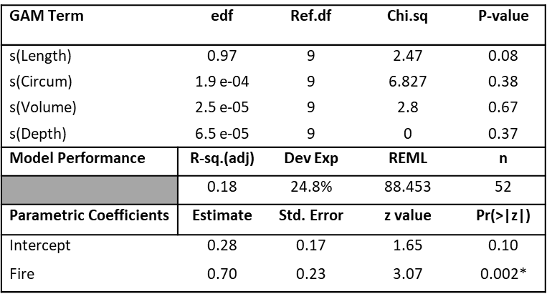

Supplemental Table 3. Output of the shelter log GAM. Only fire as a fixed effect had a significant effect on snail abundance.

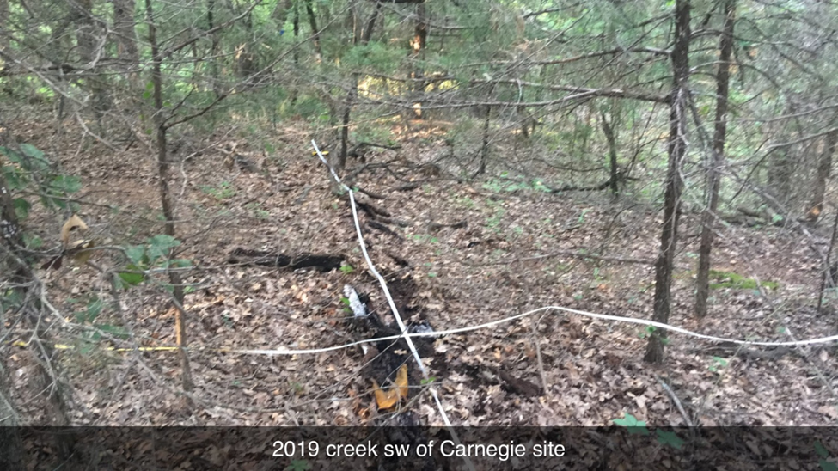
Supplemental Photo 1. An example of the 12 m x 12 m survey plots used for microhabitat measurements at survey sites.
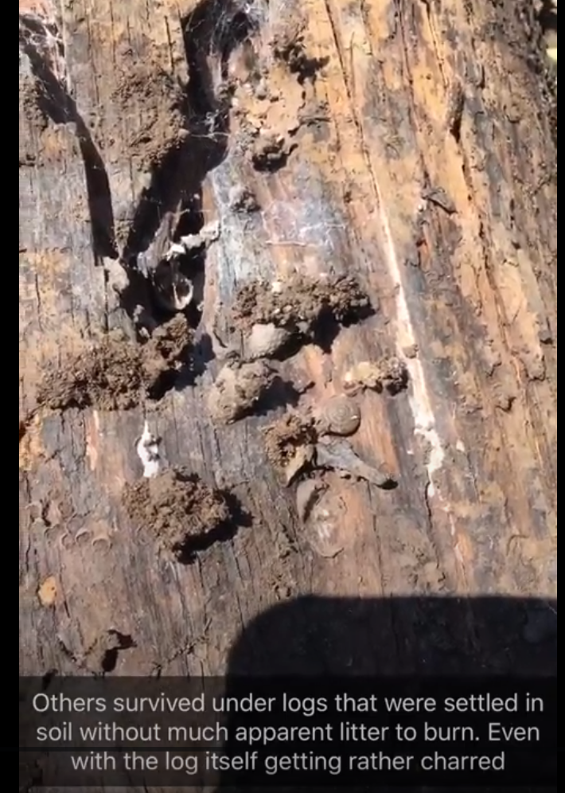

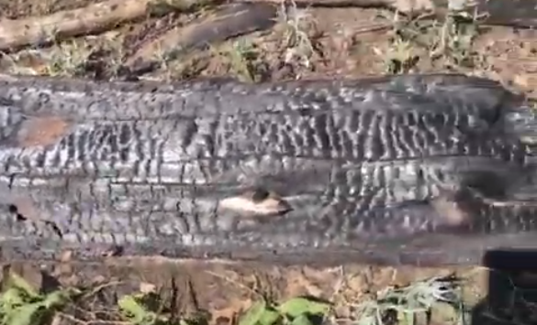
Supplemental Photo 2. (top) Snail that survived under log that experienced significant surface charring (bottom) because soil-log interface was undisturbed.
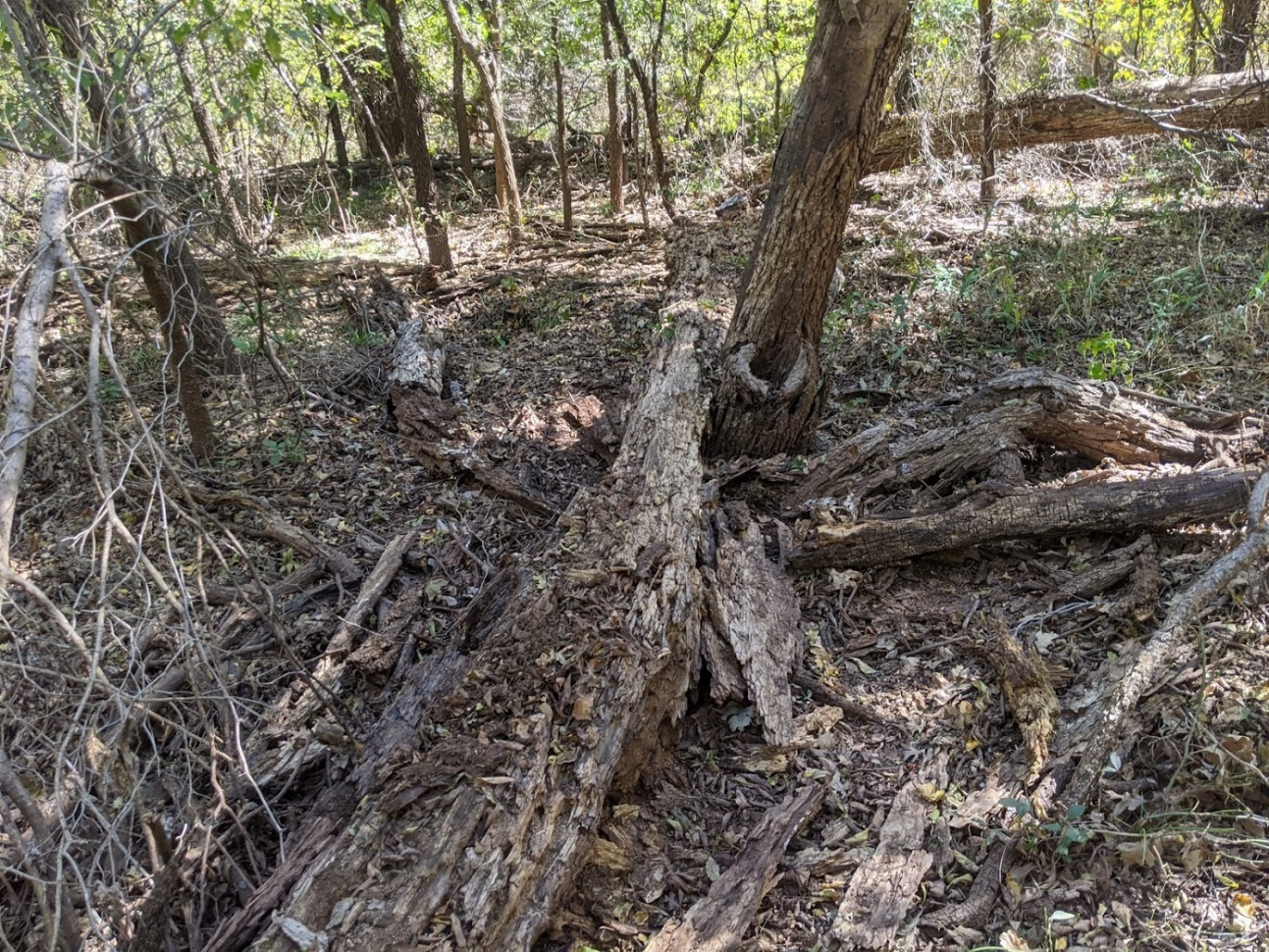
Supplemental Photo 3. An example of a driftwood forest site. These sites have significantly more coarse woody debris and have many more snails (most are not E. wichiotorum) than other surveyed environments in western Oklahoma.
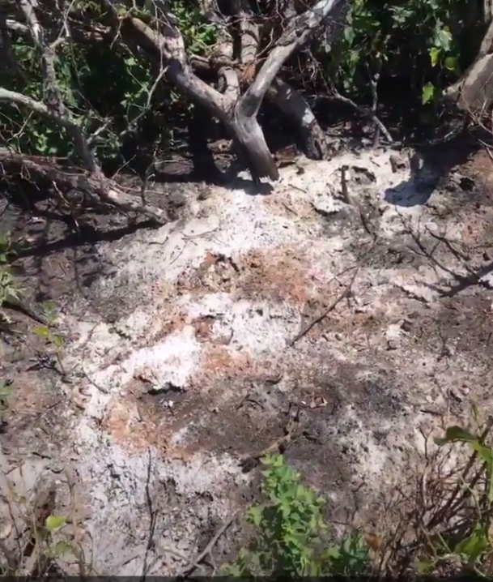
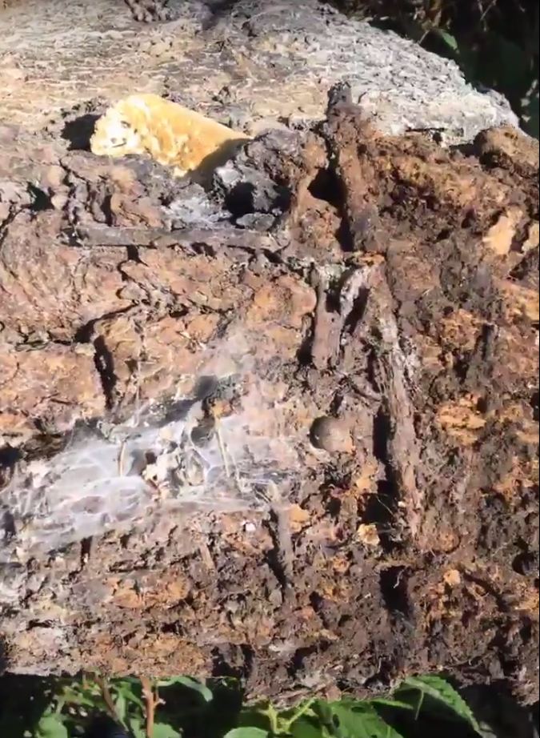

Supplemental Photo 4. One example where a snail survived under a small intact section of a downed tree (left) that was otherwise reduced to a pile of ash (right)
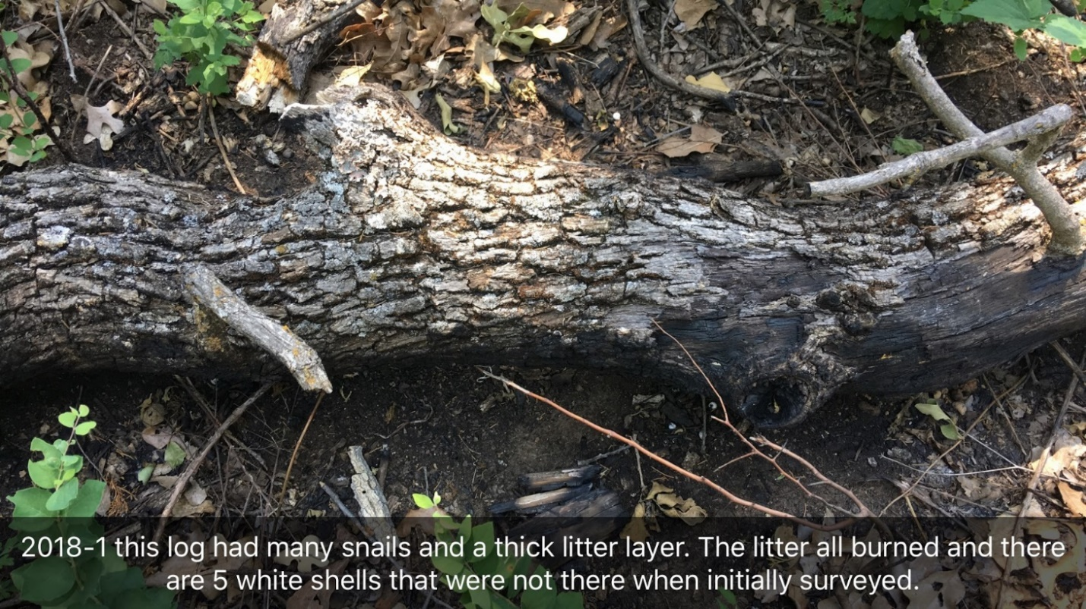
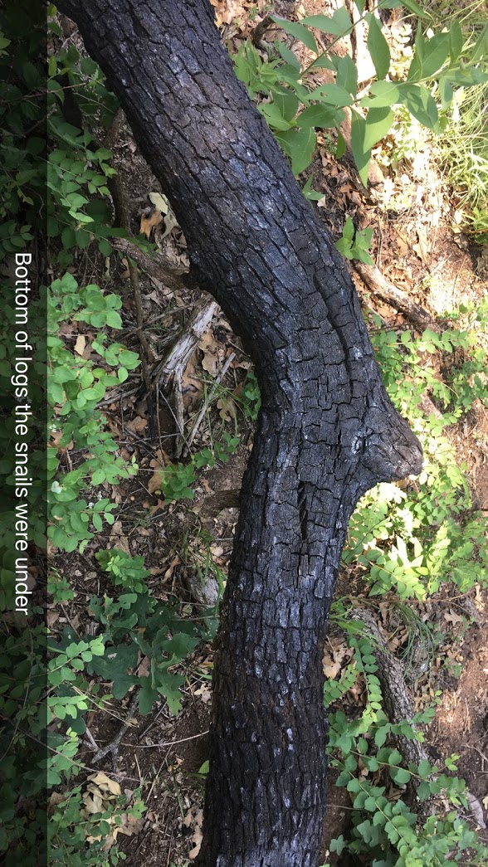
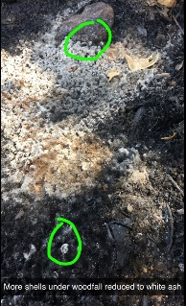
Supplemental Photo 5. This log had been part of previous survey and known locations of logs with snails were revisited 42 days after a burn and the fates of their snails was documented. Several logs showed a similar burning pattern where the adjacent litter burned, but only a small portion of the log at the soil-log interface burned. This pattern likely caused the death of sheltering snails.
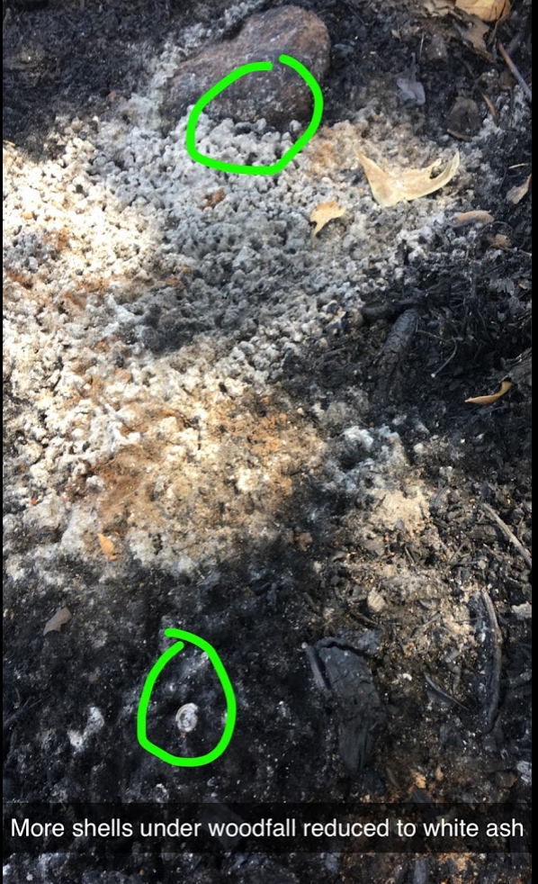
Supplemental Photo 6. High-intensity fires that completely combust shelter logs can have shells found in the ash afterward, indicating shells last through intense heat. They are much more brittle afterwards.

Chapter 2: Morphometric analysis of Euchemotrema wichitorum, Euchemotrema leai, and undetermined Euchemotrema populations in western Oklahoma
Alex Cooper
Abstract
Euchemotrema wichitorum was described in 1972 by Branson, largely on the basis the shorter, flatter shell shape relative to the similar, widely distributed Euchemotrema leai. I analyzed shells from multiple Euchemotrema populations from Oklahoma, Arkansas, and Texas using Discriminant Function Analysis in an attempt to classify populations from western Oklahoma (“E. westOK”), which appear to be of intermediate morphology between Euchemotrema wichitorum from the Wichita Mountains region of southwest Oklahoma and E. leai aliciae which occurs throughout much of the central and eastern portion of the state. Euchemotrema populations from Texas, which generally matched the description of a regional variant E. leai friersoni, were also included (as “E. texas”), as these populations are tentatively described as E. leai aliciae but appear significantly larger than E. leai populations from Oklahoma and elsewhere. E. fraternum imperforatum, an endemic species of the Ouachita Mountains (OK-AR) was also included. Our DFA of all five groups accurately classified the visually distinct E. fraternum imperforatum at a rate of 93%. While our DFA generally separated E. fraternum imperforatum and “E. texas” individuals from the Oklahoma complex, no group was wholly distinct. A reduced DFA comparing E. wichitorum and E. leai using shell width, height, and relative height (height/width) was able to properly classify individuals from these groups at rates of 92.0% and 79.2%, respectively, largely based on relative height. “E. westOK” individuals showed a morphological distribution that falls between the two species and most populations were not confidently assigned to one group or another, and only two of 12 populations with multiple individuals had an average classification rate for either E. wichitorum or E. leai above 75%. There was no pattern between distance from the documented range of E. wichitorum and population classification scores for “E. westOK”. These analyses suggest an integrative approach with more extensive morphometric characters and molecular data may be needed to understand the evolutionary relationship between the isolated Euchemotrema populations from western Oklahoma, E. wichitorum and E. leai aliciae.

Introduction
Despite natural phenotypic and genetic variation among populations being the basis for divergence, species descriptions of land snails have historically focused heavily on comparing mean morphological trait values to as the basis for species designation (Pilsbry 1939; Branson 1972, Solem 1981). Although this may be a useful approach when populations are sampled from across their range, unsampled populations with intermediate morphological characters can make previously clear trait differences less useful as a diagnostic tool (Dorazio and Royal 2005).
Historically, land snail systematics was based on the morphology of the shell and secondarily on reproductive system anatomy. Species descriptions in Pilsbry’s (1939) seminal work on land snails of Eastern North America includes many examples of species distinguished by small differences in a single shell character and other species with multiple regional subspecies that differ in several shell characters. However, many cases of high variability in shell shape within populations and successful interbreeding between populations with distinct genital anatomies have been reported (Köhler and Johnson 2012). Most modern approaches incorporate a combination genetic analysis and morphometrics using either a traditional approach, based on various measurements of different shell components (Fiorentino et al. 2008), or a geometric approach, based comparing differences in shell form through comparison of homologous landmarks (Bookstein 1991). Any systematic study should include sampling over the species range to capture the natural variation among populations (Cardini et al. 2015).
Land snails, by nature of their biology, are an inherently difficult taxonomic group to sample and can require intensive collection effort (Cameron and Pokrysko 2005; Mather 1998). Land snails are relatively small, colored to match their environment, and spend almost all their time hidden in sheltered habitats, which can be difficult to access (Mather 1998; Dourson 2008, Anderson and Smith 2005). Land snails are also primarily nocturnal, make no noise to broadcast presence in an area, and move too slowly to be noticed (Barker 2001). Land snail occurrence within a habitat is often patchy because of small-scale environmental differences in topography, aspect, humidity, and edaphic characteristics (Sulikowska-Dozd 2005; Čejka et al. 2008; Nunes and Santos 2012). Furthermore, many land snails tend to aggregate in clumps that are not associated with perceivable environmental variation, making detection even more difficult (Goodhart 1962).
Euchemotrema wichitorum, the Wichita Mountains pillsnail, was described by Branson (1972) as Stenotrema wichitorum based on approximately 50 shells collected from two localities, one locality in the Wichita Mountains Wildlife Refuge (WMWR) in Comanche County, Oklahoma and one locality >14 km north of the WMWR in Caddo County, Oklahoma. Branson distinguished S. wichitorum from the widespread S. leai by its relatively shorter shell height, presenting data of ratio of height to width for 20 populations of Stenotrema (two S. wichitorum, two S. leai friersoni, 11 S. leai, one S. hubrichti, and four S. fraternum) to demonstrate that S. wichitorum was relatively shorter than all groups except S. hubrichti. All species used for comparison were moved to genus Euchemotrema (Archer 1939) when that subgenus was elevated following genitalia differences noted between this group and the rest of Stenotrema (Emberton 1994). The genus Euchemotrema has five recognized species: E. hubrichti, E. wichitorum, E. fasciatum, E. leai, and E. fraternum. The first three species are regional endemics (Hubricht 1985), but the E. leai and E. fraternum are widespread throughout the eastern US and have multiple described subspecies and unrecognized regional forms (Pilsbry 1939, Hubricht 1985). Within Oklahoma, the E. leai subspecies is E. leai aliciae and the E. fraternum subspecies is E. fraternum imperforatum. Texas has three described E. leai variants: E. leai aliciae, E. leai cheatumi (known only from the area around Palmetto State Park in Gonzales County), and E. leai friersoni, which is an unrecognized regional variant from Texas and Louisiana distinguished from E. leai aliciae by a larger shell width and a relatively shorter shell (Pilsbry 1939).
The data provided by Branson (1972) in his species description is incomplete with respect to comparisons with similar species. He presented data on relative shell height for multiple species of Euchemotrema but did not run statistical analyses and only two of the 18 non-wichitorum populations had a sample size greater than five, with six of the 11 E. leai populations presented having ranges of relative shell height that overlapped E. wichitorum. Shell color is only vaguely described as varying from light tan to dark brown, when E. wichitorum typically has a noticeably lighter coloration than E. leai individuals from Oklahoma. often with a distinct red tinge that leads to a coloration closer to cinnamon brown than the walnut brown of Oklahoma E. leai (Pers. Obs.).
Given the incomplete data presented in the description of E. wichitorum I sought to more rigorously analyze the morphology of the species in relation to E. leai as part of efforts to assess the E. wichitorum’s taxonomic validity, determine its range, and to potentially delimit populations is western Oklahoma that are outside of the described range of both species (Hubricht 1985). While surveying western Oklahoma for potential E. wichitorum populations (Cooper Thesis Chapter 1) several Euchemotrema populations collected outside the Wichita Mountains and its drainages did not closely match the description of either E. wichitorum or E. leai, with many individuals being of intermediate height and coloration when observed in the hand (Supplemental Photo 1). I wished to see whether these populations, collectively deemed “E. westOK” for this study, could be confidently assigned to either species, or if they might represent a regional variant separate from E. wichitorum that is also adapted to the relatively warmer and drier conditions of western Oklahoma. I compared shells I collected of these three groups from across Oklahoma using a Discriminant Function Analysis, with additional shells provided by the Mather Zoological Collection at the University of Science and Arts of Oklahoma to increase the geographic coverage of the groups, particularly E. leai. The Mather Zoological collection also had shells of two other groups used by Branson (1972) in his comparison: E. leai friersoni and E. fraternum imperforatum.
E. leai friersoni is a currently unrecognized regional variant distinct from Oklahoma E. leai by its larger size and relatively shorter height (Pilsbry 1939). Access to shells that match this variant’s description presented an opportunity to note if this regional variant may warrant further study and official description. Furthermore, this provided a chance to analyze the diagnosability of a size difference that is immediately obvious in the hand to a collector experienced with the group.
Euchemotrema fraternum imperforatum is a subspecies endemic to the Ouachita Mountains of Oklahoma and Arkansas and is distinguished from other Oklahoma Euchemotrema by its larger width and especially by its elevated shell form, presenting as a tall conical shape. This species is the most morphologically distinct Euchemotrema species that occurs in Oklahoma and was added to serve as a comparator that should have high self-assignment in our Discriminant Function Analysis if our measured characters have good discriminatory power.

Methods
Specimen Collection
I collected Euchemotrema in western Oklahoma to delimit the range of Euchemotrema wichitorum (Cooper Thesis Chapter 1). A total of 28 Euchemotrema populations collected as part of surveys in western Oklahoma were used for this study; 21 populations totaling 175 individuals were assigned to E. wichitorum and seven populations totaling 45 individuals were assigned to “E. westOK” (Table 1). I have deposited samples of E. wichitorum shells at both the Field Museum of Natural History and the University of Florida Museum of Natural History, but shells used for this analysis are still in my possession.
I also surveyed for E. leai and E. fraternum imperforatum in central and eastern Oklahoma, but site selection for these species was based on museum records of the Mather Zoological Collection at the University of Science and Arts of Oklahoma or personal communication with its namesake, CM Mather. The surveys for these species employed the same visual search methods as for Euchemotrema in western Oklahoma (Cooper Thesis Chapter 1), but no regard was given to search time. Collections from these surveys added at total of 16 shells from four populations of E. leai and one shell of E. fraternum imperforatum from one population (Table 1).
I sourced the additional shells from the Mather Zoological Collection at the University of Science and Arts of Oklahoma. Shells from this collection contributed 180 of the 412 shells used in this study and included the 50 Euchemotrema shells from eight sites in Texas (tentatively believed to match the description of E. leai friersoni). The collection contributed 30 of the 31 of the E. fraternum imperforatum shells and added eight additional sites, for a total nine sites for this group. The collection also contributed 61 of the 77 E. leai shells from 14 additional sites, for a total of 18 sites for this group. The collection contributed 24 of 69 “E. westOK” shells from eight additional sites, for a total of 15 sites for this group. Lastly, the collection contributed 12 of the 187 E. wichitorum shells from two additional sites, for a total of 23 sites for this group (Table 1).

Shell Measurement
I photographed shells with a Spot Idea microscope camera under x60 magnification in a frontal orientation (full side profile with aperture facing the camera) (Fig. 1). Because shells are three dimensional, I used a 1 cm scale set at the approximate height of the shell aperture (the widest point of the shell in this position) to calibrate the digital measurements. I placed shells on pieces of black molding clay affixed to a black metal plate to secure shells and provide a contrasting background. I used SPOT BasicTM version 5.6 (Diagnostic Instruments, Inc., Sterling Heights, MI) to measure shell width, shell height, apertural height (vertical distance from the junction of the aperture and body whorl to the shell apex), and spire height (vertical distance from the body whorl shell suture to the shell apex) to the nearest 0.01 mm (Fig. 1). I then calculated the shell relative height by dividing the shell height by the shell width. These characters are frequently used in gastropod species description and morphometric analyses (Chiba 2005, Goodward et al. 2017, Fiorentino et al. 2008). Generally, shells with a lower relative height appear flatter and may have a sharper periphery angle, while shells with a higher relative height appear more conical and generally have a rounder periphery. I chose digital measurement over calipers to have digital records for all shells and because the magnification allowed more consistent orientation of shells because characters like spire height and apertural height vary with shell orientation.
I generally photographed all shells from a site if it had six or fewer intact shells. For sites with more than six shells, six to nine shells would typically be selected at random for measurement. Some populations had additional shells measured, but no population had more than 14 measured shells. Live snails were photographed for some populations, and these photographs were taken with the snail body retracted into the shell, so that no shell characteristics were obscured.

Data Analysis
Measurement Error: Measurement error for all shell characters was assessed for both the variation due to non-uniform positioning of shells for photography and for user error in software measurement. Measurement error (%ME) was calculated for each shell character individually using the formula of Bailey and Byrnes (1990). I partitioned the variation among individuals (s²_{among}) and between replicates (s²_{within}) using R version 4.0.3 (R Core Team 2020) using the ICCest command from R package ‘ICC’ (Wolak 2015) and the THD method (Searle 1971). Bailey and Byrnes (1990) recommend a sample size sufficient to give 50 degrees of freedom when calculating within-individual variation, which for two replicate measures would require a minimum of 50 individuals (df=n(# replications-1)).
Positioning error is caused by variation in positioning of a shell during photography that are within the user tolerance of meeting the “standard” positioning. This variation was accessed by taking a photograph of a shell and then moving it to a different piece of molding clay on our 3 x 3 photography plate at random and taking a new photo. I photographed the 57 individuals used for this analysis in batches of 4-9 individuals and no individual and its replicate were photographed consecutively. Initial photos were not visible while positioning replicates and measurements were taken after an entire batch of individuals were photographed twice. I measured photographs in the order they were taken.
User software measurement error was accessed by remeasurement of previously morphometric photographs. Measurements are saved as a layer on top of the photograph. Deleting this layer and remeasuring individual photos may introduce bias through user memory of measurement values. To reduce this potential source of bias, photographs were measured in six groups of 12 individuals with all measurements deleted prior to remeasurement. I recorded remeasurements values in a separate file until all individuals had been remeasured.
Measurement error above 10% is considered moderate; values of 35% considered to be very high (Yezerinac et al. 1992). Variables with moderate levels of measurement error may be removed, but character importance should be considered when making this decision (Yezerinac et al. 1992). Positioning error of spire height (29.4%) was almost triple the positioning error of the next closest character, indicating that slight changes in shell position affected this measure to such a degree that it should be excluded from the model (Table 2). Removal of this character had little effect on performance of the DFA. Positioning error of apertural height (10.21%) was considered for removal, but its inclusion improved the classification scores for all groups in the analysis and eliminated horseshoeing seen in the plot of discriminant axis scores when only width, height, and ratio were used and so it was retained (Supplemental Figure 1).
There was no significant error for any shell measurements resulting from using the Spot BasicTM software, with no %ME values exceeding 1%. This means all shell photos should have consistent measurement if reevaluated in the future if the scale is set to the same value.

Discriminant Function Analysis: I used a Discriminant Function Analysis (DFA) to analyze the morphological distinctness of the five groups of Euchemotrema based on the shell characteristics width, height, relative height (the ratio of height to width), and apertural height. I conducted the Discriminant Function Analysis in R version 4.0.3 (R Core Team 2020) using R package ‘MASS’ (Ripley et al. 2020). Discriminant Function Analysis can be conceptualized as a MANOVA in reverse: multivariate data are the independent variables and the a priori groups are the dependent variables, where synthetic discriminant variables (loadings) are generated that maximally distinguish groups (Paulsen and French 2008). Individuals are assigned classification probabilities to each of the groups based on their individual loading scores and the “correct” assignment rate (proportion of individuals whose highest probability is their user-defined group) approximates how distinct each group is in reference to the provided measures (Paulsen and French 2008). While there is not a consensus on the level of discriminatory power needed for species recognition, Patten and Unitt (2002) advocate for 95% separation for subspecies rather than a more liberal convention of 75% separation. These benchmarks may need to be relaxed for terrestrial gastropods, whose shells are less morphologically complex than structures of many other terrestrial taxa (Schopf et al. 1975). I classified Euchemotrema populations in this study based on shells matching morphological species descriptions and by population locality in reference to described species ranges and museum collection records (Hubricht 1985, Fig. 4). Euchemotrema from the WMWR and its southern drainages all closely resembled each other in terms of relative shell height and coloration and were classified as E. wichitorum. Shells collected north and east of the WMWR but west of the previously described range of E. leai (Figs. 3 &4) were generally of intermediate relative height and color between E. wichitorum and E. leai aliciae from central and eastern OK and were labeled as “E. westOK”. Euchemotrema from central and eastern Oklahoma and Arkansas that matched the description of E. leai aliciae were labeled E. leai. Euchemotrema from Texas were believed to match the description of E. leai friersoni, but a full morphological description of this regional variant with accompanying range data are absent. Without this data, I opted to classify these shell populations, primarily collected from southeastern Texas (Fig. 3), simply as “E. texas”. Euchemotrema fraternum imperforatum, a snail endemic to the Ouachita Mountains of Oklahoma and Arkansas, was labeled E. fraternum (Fig. 3).
In addition to comparing these five groups, I separately compared the E. wichitorum, “E. westOK”, and E. leai groups using a reduced dataset that excluded apertural height to test the discriminatory power of the measurements that can easily be measured by calipers (i.e., shell height and width) so that future material may be assessed solely based on caliper measurements. A discriminant function analysis was run using only the E. wichitorum and E. leai groups to define the discriminant function. This direct comparison of the two species allowed me to assess the diagnosability of the differences between these two groups, which is a superior comparison that simply comparing mean trait values (Patten and Unitt 2002). Additionally, individuals from the “E. westOK” populations could be assessed with the discriminant function a posteriori to produce classification scores for both of the two groups to which they may belong, E. wichitorum or E. leai. If classification scores were strongly in favor of one species, the “E. westOK” population could be assigned to that group.

“E. westOK” Classification by Distance: I compared average classification scores for “E. westOK” populations to their straight-line distance from the nearest boundary of the WMWR, which approximates the previously known range of E. wichitorum (Branson 1972), using a linear regression model. This analysis examined if the morphometric data had any signal of isolation by distance, which is often seen in genetic data of comparing land snail populations across their range (Pfenninger et al. 1996). While landscape-based geographic distance is a superior method to straight-line distance (Arnaud 2003), habitat fragmentation outside of the WMWR is such that no modern dispersal corridors currently exist. Distance was measured as the straight-line distance from the population to the nearest boundary of the WMWR using the Google Maps measurement function. I constructed the linear regression models with R version 4.0.3 (R Core Team 2020) with the lm function.

Shell Relative Height Frequentist Comparisons: I analyzed the shell relative height ratios for differences between our groups in R version 4.0.3 (R Core Team 2020) using a Kruskal-Wallis Test with post-hoc analysis between all group pairings done using pairwise Wilcoxon tests with a Bonferroni correction for multiple comparisons. Branson (1972) presented ranges for shell relative height ratios of various groups of Euchemotrema but did not test whether the ratios, which overlapped between several populations of E. wichitorum and E. leai, were significantly different among these groups. I was especially interested in testing whether E. wichitorum’s relative shell height was significantly shorter than that of other groups (except E. hubrichti). Output boxplots provide an easily interpretable visualization of the distribution of the measured characteristics of Oklahoma and Texas Euchemotrema groups for rough taxonomic assignment of future populations based solely on caliper-measured characters.

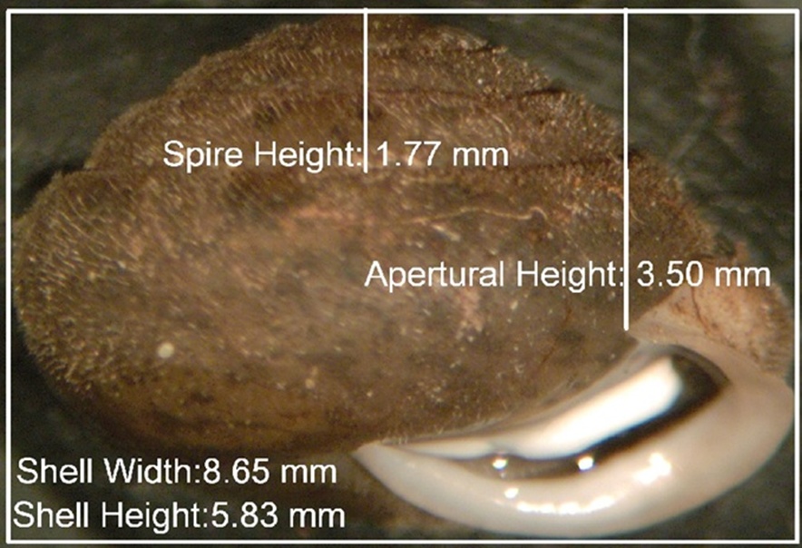

Figure 1. An example shell photograph measured using the SPOT software. A rectangle encompassing the height and width of the shell was used for these to measurement. Spire height and apertural height were measured as straight vertical lines from the midpoint of the shell at the lowest whorl suture and the junction of the aperture with the body whorl, respectively.

Results
General Shell Character Distribution and Comparison
Snails assigned to the three focal groups, E. wichitorum, E. leai, and “E. westOK”, had similar shell widths, with mean and median values for all three groups being between 8.06 – 8.32 mm (Fig. 5). The three groups differed in shell height and thus shell relative height ratio (Table 2), with the order of relative height from shortest to tallest being E. wichitorum, E. “westOK”, and E. leai. The Kruskal-Wallis test comparing the relative heights of the five taxonomic groups was significant (P < 0.001) as were the Wilcoxon-pairwise tests between all group combination except “E. westOK” vs. “E. texas”, meaning there was no difference observed in the relative shell height between these two groups (Table 2).
Shells of E. fraternum and “E. texas” were both generally wider and taller than the other three Euchemotrema groups (Figs. 2 & 5). Euchemotrema fraternum’s high relative height presents as a somewhat conical form, while the intermediate relative height of “E. texas” shells presents as somewhat appressed, larger version of typical E. leai from central and eastern Oklahoma.
Discriminant Function Analysis of E. wichitorum versus E. leai aliciae
Diagnosability of E. wichitorum: When comparing populations of confident assignment to E. wichitorum and E. leai aliciae using shell height, width, and relative height, the two groups were fairly distinguishable, with a correct classification rate of 92.0% and 79.2%, respectively (Table 4). This discriminatory power of the model was driven almost entirely on relative shell height, which had a correlation of -0.982 to the discriminatory axis (Table 4). The distributions of these two groups along the discriminant axis have relatively little overlap (Fig. 6a).

Classification of “E. westOK” populations: Only 41 of 69 (59.4%) of “E. westOK” shells had a classification score above 75%, for either E. wichitorum or E. leai. Most populations had individuals that scored highly for both species and only two of 12 populations with multiple individuals had an aggregate score of 75% in favor of one species (Supplemental Table 1). The linear regression found no relationship between distance from the WMWR and average population classification score for E. wichitorum (p = 0.943, R² = 0; Fig. 7). When loading scores for the “E. westOK” group were plotted on the linear discriminant axis of E. wichitorum vs. E. leai, the distribution sits almost exactly between the two (Fig. 6b).

Discriminant Function Analysis of All Euchemotrema Groups
The DFA of all five groups did not have strong discriminatory power for the groups except for E. fraternum imperforatum, which had over 90% of individuals correctly classified. The second control group, “E. texas” was largely distinguished by its larger shell width, resulting in many of the larger E. wichitorum, E leai, and “E. westOK” individuals being misclassified as “E. texas” and many of the smaller “E. texas” shells being misclassified as one of the three aforementioned groups. The “E. texas” group was largely separated from other groups along the second discriminant axis, which was driven by shell width, but the group was not completely distinct from non-fraternum groups (Fig. 8). This visual separation in our DFA plot did not translate into strong classification performance (with only 68% of individual correctly assigned to “E. texas”) (Table 5). E. wichitorum and E. leai had classification rates of 74.3% and 57.1%, respectively (Table 5) and were most distinguishable from each other along the third discriminant axis, which was primarily driven by the shell relative height ratio (Fig. 8b). “E. westOK” was the worst performing group at a classification rate of 36.4% (Table 5), which is consistent with the group’s relative shell height being between two E. wichitorum and E. leai.

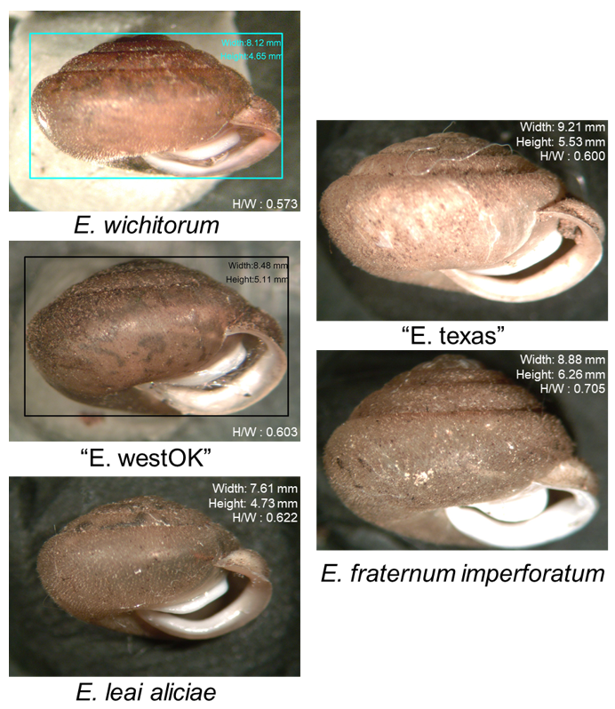
Figure 2. Representative from each of the groups used in our Discriminant Function Analysis. Photos reflect relative size of shells.
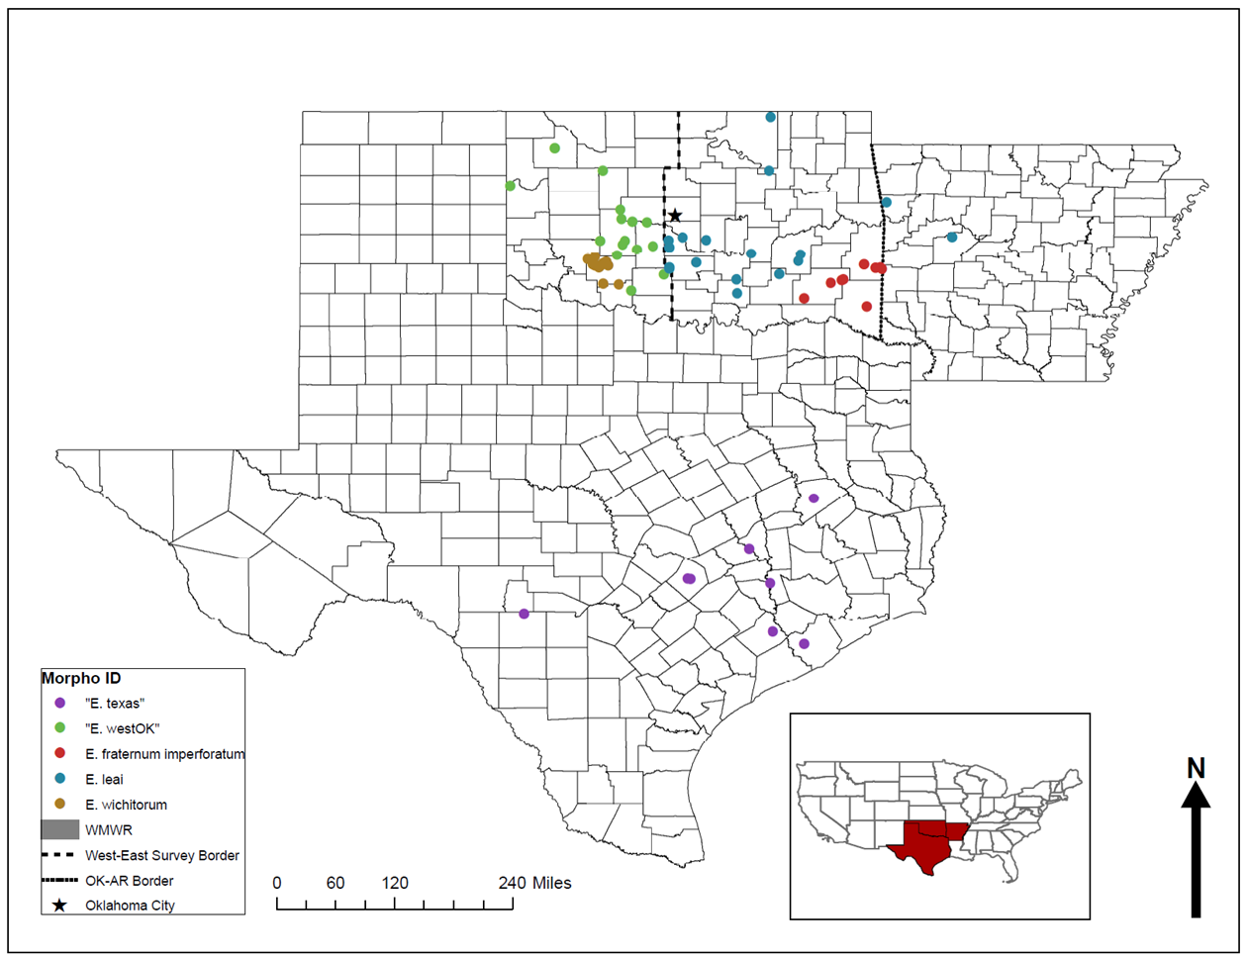

Figure 3. Map of sampled Euchemotrema populations. The dotted line down central Oklahoma represent the line of demarcation between populations assigned to E. leai (East) and “E. westOK” (West).

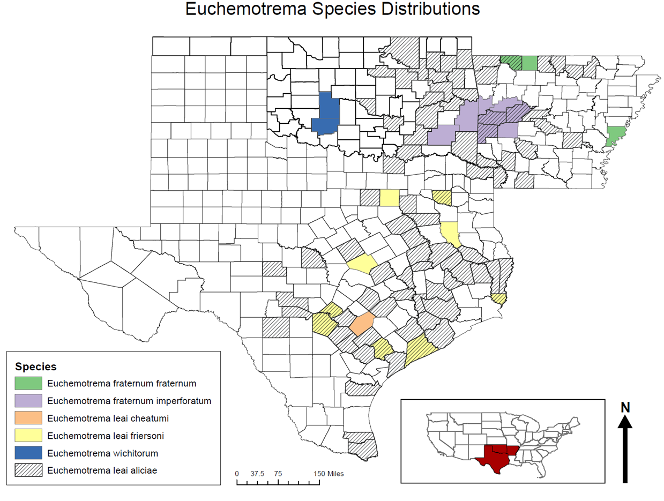
Figure 4. Map of the known ranges of Euchemotema in Oklahoma, Texas, and Arkansas based on the museum collection records of the Field Museum of Natural History, the Carnegie Museum of Natural History, and the University of Florida Museum of Natural History. Species distributions generally match those presented by Hubricht (1985).
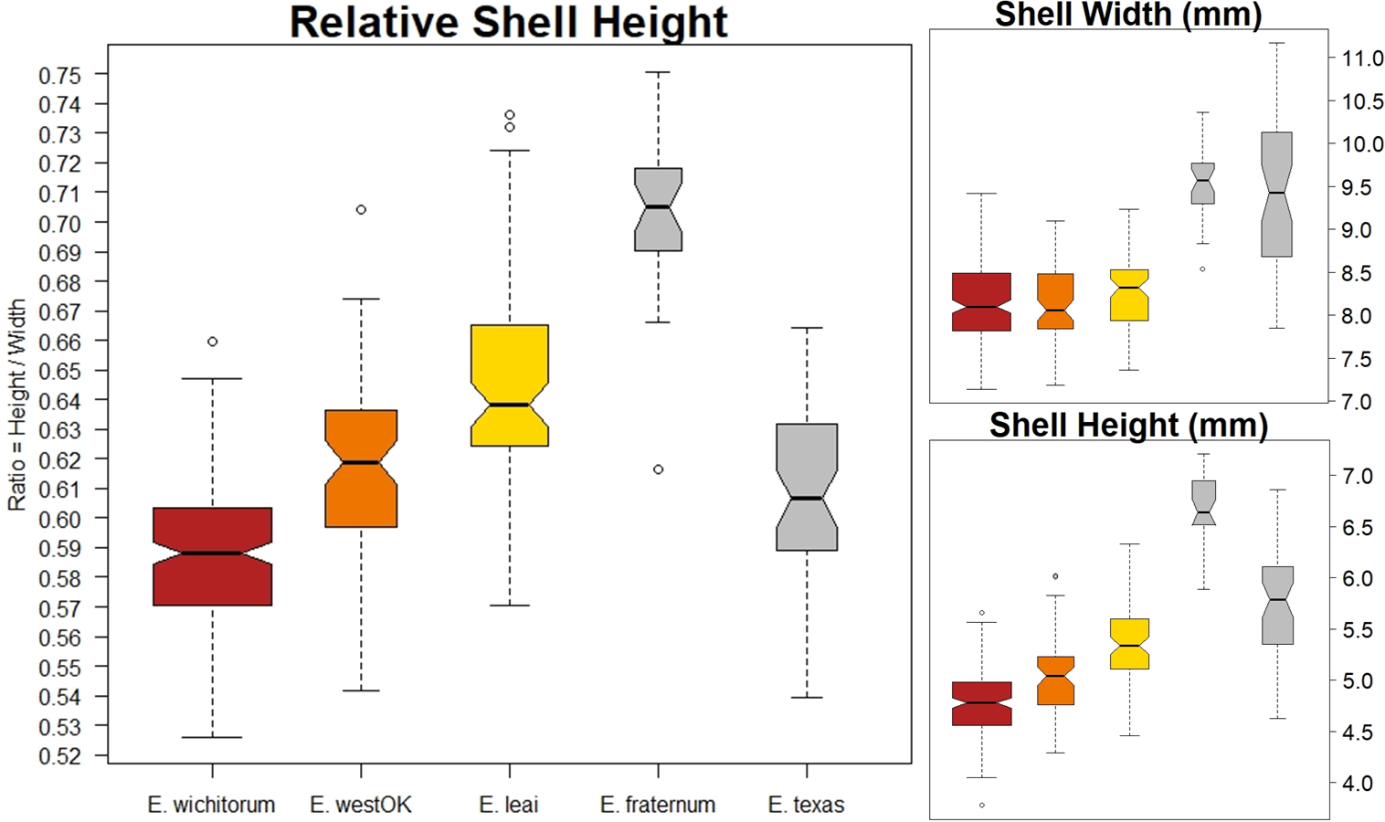

Figure 5. Distribution of measured trait values of Euchemotrema measured for our analysis. Black lines represent median values, with box width representing the relative sample size of each group and the notch representing the 95% confidence interval about the median. Non-overlap between notches is considered strong evidence of a significant difference in median values (Chambers 2018).

Table 1. All populations sampled for this study. “DFA code” distinguishes the different sites sampled for each group. “# Shells” notes the number of shells for each site. “DFA Group” notes the user-assigned group for each site used in the DFA. “Total” notes the number of shells for each group.

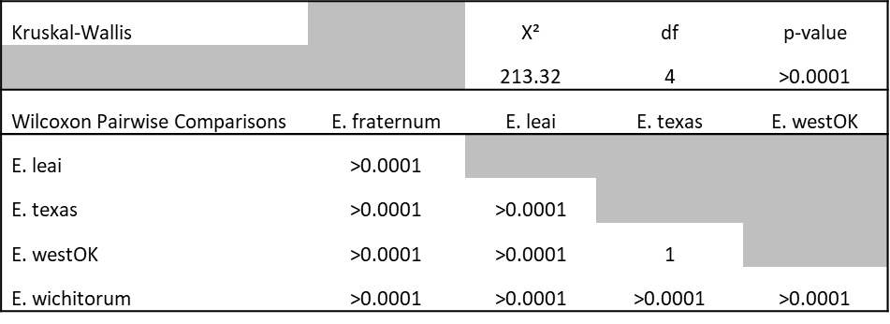
Table 2. Summary of analysis of shell relative heights between our different Euchemotrema groups using a Kruskal-Wallis test, with post-hoc analysis using Wilcoxon-pairwise comparison with a Bonferroni correction for multiple testing (p-value threshold = 0.0056).

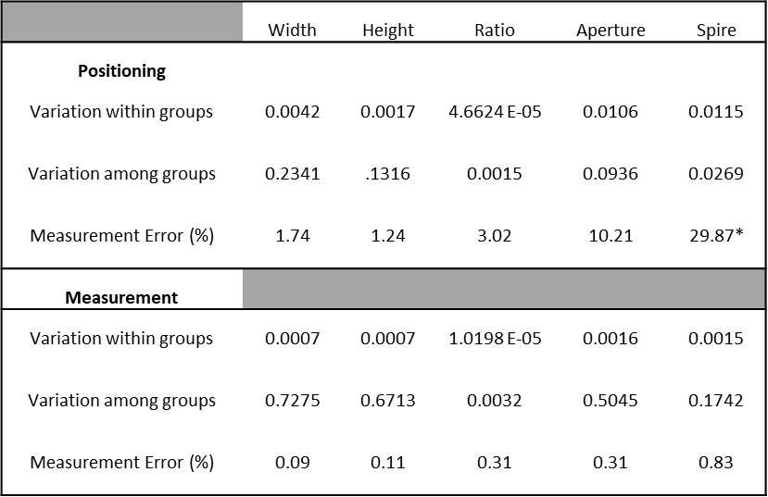
Table 3. Measurement error values calculated for variation in mensural characters due to inconsistencies in shell positioning and software measurement of shells.
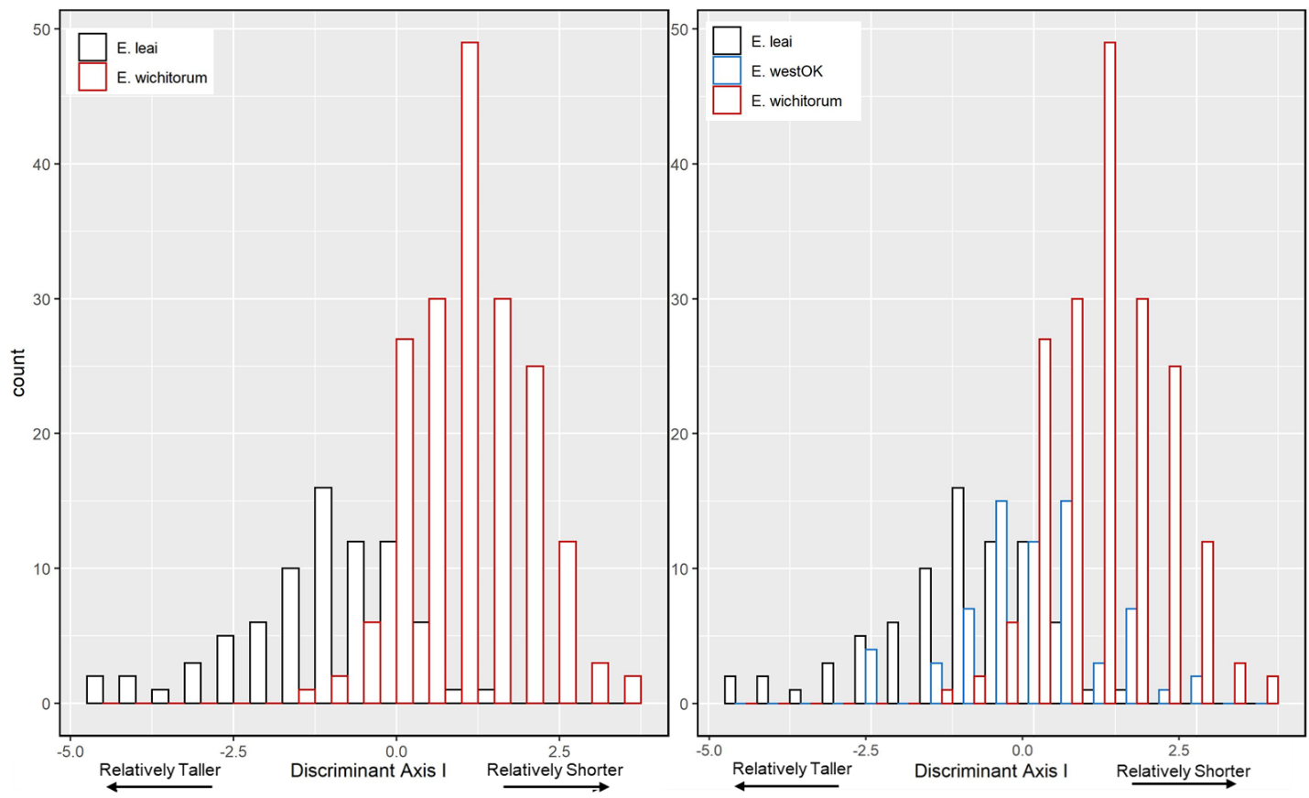

Figure 6. 6a (left) Distribution of loadings from DFA of E. leai (black) vs. E. wichitorum (red). 6b (right) “E. westOK” (blue) loadings distribution when ran this DFA.
Table 4. Classification rates for E. wichitorum and E. leai groups in our 3-character DFA. The Discriminant Axis is primarily explained by relative shell height.
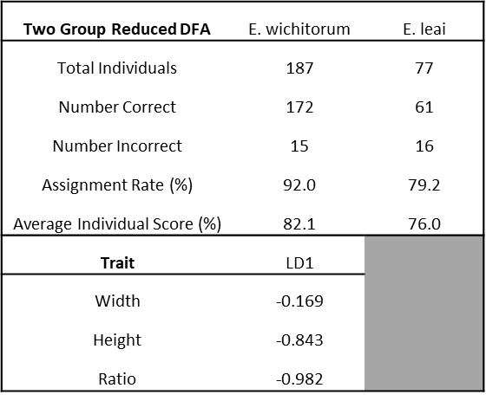

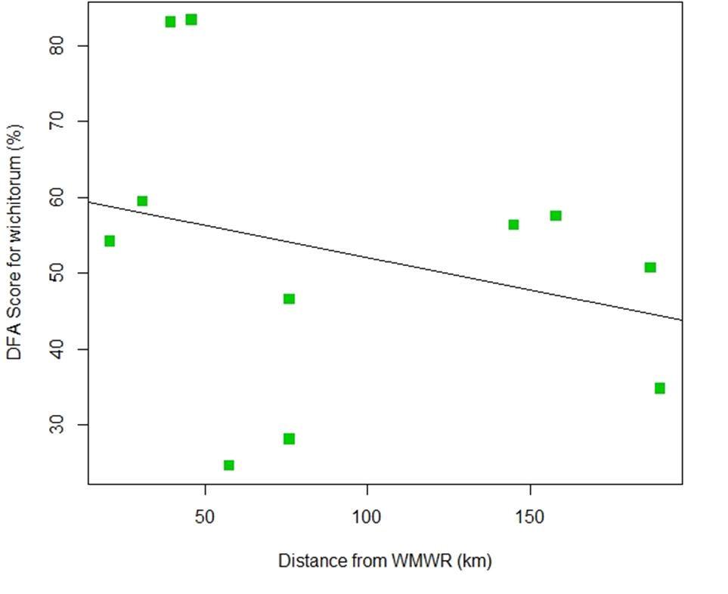

Figure 7. Linear Regression Model of the E. wichitorum classification score for the different “E. westOK” populations in relation to their distance from the WMWR showed morphology of “E. westOK” populations had no relation to proximity to core of described habitat of E. wichitorum (p value = 0.947, R² = 0).

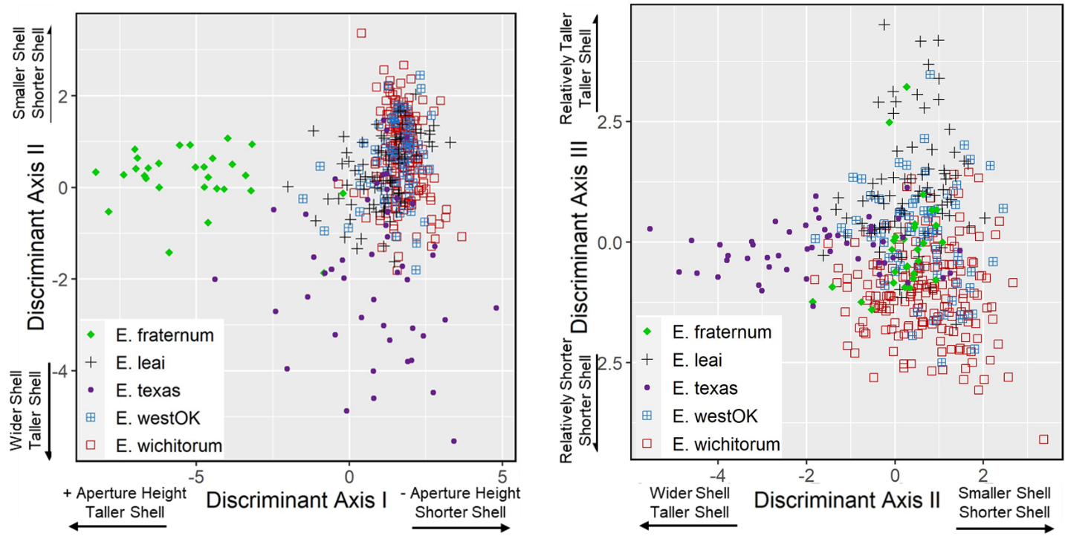

Figure 8. Distribution of Linear Discriminant Loading Scores for our five Euchemotrema groups. 8a (left)The first two axes primarily distinguish the “E. texas” and E. fraternum groups from the Oklahoma complex, which are in turn better distinguished along axis III (8b, right).

Table 5. Classification rates for the different groups from our DFA and the corresponding loading axis correlations.

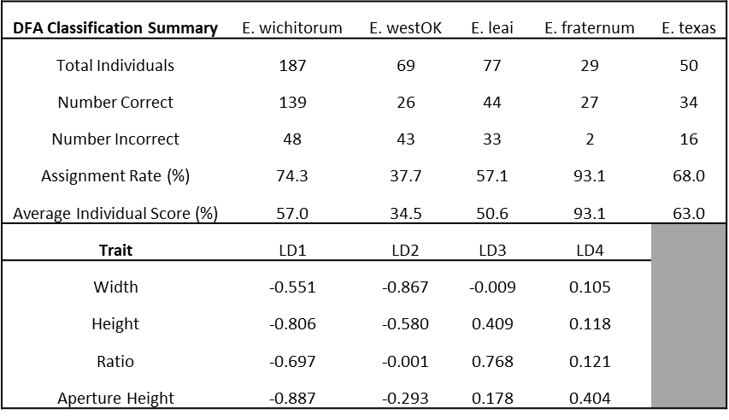

Discussion
The Discriminant Analyses of these five groups of Euchemotrema from Oklahoma and Texas showed noticeable morphological differences between some pairs of groups, but ultimately points to the need for additional measures for stronger discriminatory power among others. The “E. texas” group had larger overall shells widths, but there is enough overlap in size range between this group and the central and western Oklahoma groups that misclassification was common. The geographic range of the Texas samples was much larger than the other groups, so there is a possibility of multiple diverging lineages present in that state, as seems to be the case in Oklahoma. The inclusion of “E. texas” highlight the complexity within E. leai near the western extent of its range (Fig. 4; Hubricht 1985). There may be more need of revision beyond the currently accepted two subspecies (E. leai aliciae, used in this study, and E. leai leai). Morphologically complex land snails have been shown to have significantly more subspecies assignments (Pall-Gergely et al. 2018) and Euchemotrema, with their relatively simple apertural morphology, may have additional unrecognized taxonomic groups among the widespread E. leai. E. fraternum (sensu lato) also has a wide geographic range and greater scrutiny of variation over its range may be warranted.
This study highlights the need for caution when using central tendencies of a few traits to describe a new taxonomic group. A significant difference in relative height ratios between all groups except “E. westOK” and “E. texas” did not translate into strong ability to discriminate groups using that measure. Comparing E. wichitorum to E. leai from Oklahoma theoretically supports E. wichitorum as a valid species distinct from E. leai. The classification score for E. wichitorum was over 90% in the DFA comparing just the two species and this was driven almost entirely by relative height. However, when considering that “E. westOK” populations have intermediate morphology and fill in what previously seemed like a clear range boundary (Figs. 3 & 4) it becomes unclear if E. wichitorum is truly morphologically distinct based on our measured characters. E. wichitorum may also differ from E. leai from Oklahoma in apex morphology (although the difference is categorical and thus cannot be directly included in DFA) and in shell color (Pers. Obs.), which is not a trait that varies greatly within members of family Polygyridae (Pilsbry 1939). Considering additional morphological character may help discriminate between these groups but will require more intensive effort. Additional analysis will require measurement of additional characters that are not susceptible to measurement error and color in particular has the drawback requiring live snails because the periostracum degrades post-mortem (leaving only underlying white calcium carbonate shell). Color is also affected by the presence of the snail body because shells are not completely opaque.
Additional measures are often included in morphometric analyses of land snails (Kameda et al. 2007; Giokas et al. 2014; Fiorentino et al. 2008), but many shell characters are autocorrelated due to allometry (i.e., “E. texas” basal tooth length is likely greater than E. wichitorum because overall width is greater) and may not increase discriminatory power of a given DFA. Additional measures may also decrease model validity through introduction of measurement error due to positioning, as spire height would have if included in our analyses. Positioning can be difficult to repeat precisely for globular shells with individual variation in apertural formation (compared to more elongated or discoid shells, which can more easily placed in a level position). No reports of measurement error were noted in any other land snail studies utilizing DFA.
Including additional difficult-to-measure characters or using more intensive techniques, such as landmark geometric analyses, can be useful in systematic studies, but also greatly increases the difficulty of categorizing unsampled populations and generally limits the application to those without access to precision photographic setups and analysis software (Van Bocxlaer and Schultheiß 2010). Our initial approach focused on delimiting the “E. westOK” populations using the most basic shell characters to see if ‘unknown’ populations could be accurately classified using a set of calipers. This would have allowed the potential for novice collectors or land managers to provide sufficient data to diagnose populations. Citizen science is an increasingly valuable resource and participation is higher when required technical expertise is lower (Rotman et al. 2012).
When considering the “E. westOK” group, the inclusion of additional shell characters is likely warranted to assess whether other characters show an intermediate phenotype like relative height, which fell between that of E. wichitorum and E. leai. If these populations show other intermediate characters, they may represent an intermediate form that connects E. leai and E. wichitorum as a single lineage. If “E. westOK” do not differ in other characters from E. leai then these populations may represent E. leai populations with a shell shape converging with that of E. wichitorum. The reduced relative shell height in E. wichitorum and “E. westOK” compared to widespread E. leai may be an adaptation to their relatively warmer and drier environment (versus most of the range of E. leai), an adaptation that has been observed in other snail species (Pfenniger and Magnin 2001). Land snail morphology has shown variable responses to aridity (Giokas et al. 2014) and there is much speculation as to the adaptive advantage of a flattened shell shape in different types of environment (reviewed in Fiorentino et al. 2008). Another adaptive path linked to increasing aridity and temperature is increasing overall size, which may explain the morphology of the “E. texas” group, which are from a warmer climate than the Oklahoma populations and have a similar relative shell height to “E. westOK” populations while being significantly larger.
The Oak Ridge population of “E. westOK” snails (Table 1) had seven of nine individuals classified as E. wichitorum in the five-group DFA and should be tentatively assigned E. wichitorum. This population had six of nine individuals in the E. wichitorum vs. E. leai DFA with E. wichitorum classification score above 93%. Most individuals also had the distinctive red tinge that appears to be characteristic of E. wichitorum (Pers. Obs.).
Consideration of both the current and past environment are important when considering the isolated populations of Euchemotrema in western Oklahoma. Land snails in the family Polygyridae are generally associated with hardwood forests (Karlin 1961; Kralka 1986), and this is the observed trend for Euchemotrema in western Oklahoma (Chapter 1). Hardwoods spread into the southern plains between 12,000 and 10,000 ypb (Delcourt 1981) after the end of the last glacial maximum. It is likely snails followed the spread of these forests. Populations of Euchemotrema are known from the Texas panhandle, which is believed to be the maximal historical extent of the Cross Timbers (Delcourt 1981). At least two prolonged dry periods that impacted ancient land snail communities occurred during the Holocene: one in the middle Holocene between 4500 – 3500 ypb (Holliday 1989), and one in the late Holocene around 1000 ybp (Hall 1982). Hall (1982) points to droughts occurring in the 11th, 12th, and 14th centuries that were more severe than any recently recorded droughts. These long-ago droughts likely killed many trees in the Cross Timbers. It would follow that during one or both dry periods the Cross Timbers retreated eastward, leaving only the remaining isolated stand of Cross Timbers in the Wichita Mountains and a few scattered refugia environments elsewhere as the only remaining sites with suitable Euchemotrema habitat in western Oklahoma. While other dispersal mechanisms may explain Euchemotrema distribution, two commonly believed mechanisms of land snail long-distance dispersal, carried on leaves by wind and dispersed downriver by drifting, are unlikely because most storm systems move west to east and this is also the general direction of all of the major rivers in the region. Anthropogenic dispersal is also common in land snails (Bergey et al. 2014; Cowie and Robinson 2003) and many of the sheltered localities that provide potential habitat for snails in western Oklahoma (springs, canyons, riparian forests) would also have made suitable shelter areas for indigenous peoples and European settlers. Many of these habitats now have recreational development and several have non-native species that were likely introduced via firewood or construction materials (Cowie and Robinson 2003).
The proposed hypotheses of relict populations and possible human-associated introductions in explaining the distribution of Euchemotrema in western Oklahoma could be investigated, in part, using molecular techniques. In addition, the application of more rigorous morphometric analysis has the potential to clarify patterns of morphological divergence in these groups that may lead to updated evaluation of taxonomic status and provide evidence of historical dispersal. Discordance between shell morphology and molecular data is not uncommon for land snails (Alonso et al. 2006; Elejalde et al. 2008; Emberton 1995) and incorporating both approaches is often required to delimit cryptic species groups (Razkin et al. 2017), which will likely be the case for the edge-of-range Euchemotrema populations in Oklahoma and Texas.

References
Alonso, M. R., Goodacre, S. L., Emerson, B. C., Ibanez, M., Hutterer, R., & Groh, K. (2006). Canarian land snail diversity: conflict between anatomical and molecular data on the phylogenetic placement of five new species of Napaeus (Gastropoda, Pulmonata, Enidae). Biological Journal of the Linnean society, 89(1), 169-187.
Arnaud, Jean-François. (2003). Metapopulation genetic structure and migration pathways in the land snail Helix aspersa: influence of landscape heterogeneity. Landscape Ecology 18(3), 333-346.
Barker, G. M. (Ed.). (2001). The biology of terrestrial molluscs. CABI.
Bergey, E. A., Figueroa, L. L., Mather, C. M., Martin, R. J., Ray, E. J., Kurien, J. T., ... & Suriyawong, P. (2014). Trading in snails: plant nurseries as transport hubs for non-native species. Biological Invasions, 16(7), 1441-1451.
Cameron, R. A. D., & Pokryszko, B. M. (2005). Estimating the species richness and composition of land mollusc communities: Problems, consequences and practical advice. Journal of Conchology, 38(5), 529-548.
Cardini, A., Seetah, K., & Barker, G. (2015). How many specimens do I need? Sampling error in geometric morphometrics: testing the sensitivity of means and variances in simple randomized selection experiments. Zoomorphology, 134(2), 149-163.
Čejka, T., Horsák, M., & Némethová, D. (2008). The composition and richness of Danubian floodplain forest land snail faunas in relation to forest type and flood frequency. Journal of Molluscan Studies, 74(1), 37-45
Chambers, J. M. (2018). Graphical methods for data analysis. CRC Press.
Chiba, S. (2005). Appearance of morphological novelty in a hybrid zone between two species of land snail. Evolution, 59(8), 1712-1720.
Cowie, R. H., & Robinson, D. G. (2003). Pathways of introduction of nonindigenous land and freshwater snails and slugs. Invasive species: vectors and management strategies. Island Press, Washington, DC, 93-122.
Delcourt, P. A. (1981). Vegetation maps for eastern North America: 40,000 yr BP to the present. Geobotany II.
Dorazio, R. M., & Royle, J. A. (2005). Estimating size and composition of biological communities by modeling the occurrence of species. Journal of the American Statistical Association, 100(470), 389-398.
Elejalde, M.A., Muñoz, B., Arrébola, J.R., Gómez-Moliner, B.J. (2005). Phylogenetic relationships of Iberus gualtierianus and I. alonensis (Gastropoda: Helicidae) based on partial mitochondrial 16s rRNA and COI gene sequences. Journal of Molluscan Studies 71: 349–355.
Emberton, K. C. (1995). When shells do not tell-145-million years of evolution in North-America Polygyrid land snails, with a revision and conservation priorities. Malacologia, 37(1), 69-109.
Emberton, K. C., Pearce, T. A., Kasigwa, P. F., Tattersfield, P., & Habibu, Z. (1997). High diversity and regional endemism in land snails of eastern Tanzania. Biodiversity & Conservation, 6(8), 1123-1136.
Fiorentino, V., Salomone, N., Manganelli, G., & Giusti, F. (2008). Phylogeography and morphological variability in land snails: the Sicilian Marmorana (Pulmonata, Helicidae). Biological Journal of the Linnean Society, 94(4), 809-823.
Goodhart, C. B. (1962). Variation in a colony of the snail Cepaea nemoralis (L.). The Journal of Animal Ecology, 207-237.
Goodward, D. M., Gilbertson, L. H., Rugman-Jones, P. F., & Riggs, M. L. (2017). A contribution to the phylogeography and anatomy of Helminthoglyptid land snails (Pulmonata: Helminthoglyptidae) from the deserts of southern California. Bulletin, Southern California Academy of Sciences, 116(2), 110-136.
Giokas, S., Páll-Gergely, B., & Mettouris, O. (2014). Nonrandom variation of morphological traits across environmental gradients in a land snail. Evolutionary Ecology, 28(2), 323-340.
Hubricht, L. (1985). The distributions of the native land mollusks of the eastern United States (p. 191). Chicago: Field Museum of Natural History.
Karlin, E. J. (1961). Ecological relationships between vegetation and the distribution of land snails in Montana, Colorado and New Mexico. American Midland Naturalist, 60-66.
Koehler, F., & Johnson, M. S. (2012). Species limits in molecular phylogenies: a cautionary tale from Australian land snails (Camaenidae: Amplirhagada Iredale, 1933). Zoological Journal of the Linnean Society, 165(2), 337-362.
Kralka, R. A. (1986). Population characteristics of terrestrial gastropods in boreal forest habitats. American Midland Naturalist, 156-164
Ng, T. P., Saltin, S. H., Davies, M. S., Johannesson, K., Stafford, R., & Williams, G. A. (2013). Snails and their trails: the multiple functions of trail‐following in gastropods. Biological Reviews, 88(3), 683-700.
Nunes, G. K. M., & Santos, S. D. (2012). Environmental factors affecting the distribution of land snails in the Atlantic Rain Forest of Ilha Grande, Angra dos Reis, RJ, Brazil. Brazilian Journal of Biology, 72(1), 79-86.
Páll‐Gergely, B., Asami, T., & Sólymos, P. (2019). Subspecies description rates are higher in morphologically complex land snails. Zoologica Scripta, 48(2), 185-193.
Patten, M. A., & Unitt, P. (2002). Diagnosability versus mean differences of Sage Sparrow subspecies. The Auk, 119(1), 26-35.
Pfenninger, M., Bahl, A., & Streit, B. (1996). Isolation by distance in a population of a small land snail Trochoidea geyeri: evidence from direct and indirect methods. Proceedings of the Royal Society of London. Series B: Biological Sciences, 263(1374), 1211-1217.
Pfenninger, M., & Magnin, F. (2001). Phenotypic evolution and hidden speciation in Candidula unifasciata ssp.(Helicellinae, Gastropoda) inferred by 16S variation and quantitative shell traits. Molecular Ecology, 10(10), 2541-2554.
Poulsen, J., & French, A. (2008). Discriminant function analysis. San Francisco State University: San Francisco, CA.
Pilsbry, H. A. (1939). Land mollusca of North America:(north of Mexico). Academy of Natural Sciences.
Ripley, B., Venables, B., Bates, D. M., Hornik, K., Gebhardt, A., Firth, D., & Ripley, M. B. (2020). MASS: Support Functions and Datasets for Venables and Ripley's MASS. R package version 7.3.53. https://cran.r-project.org/package=MASS
Rotman, D., Preece, J., Hammock, J., Procita, K., Hansen, D., Parr, C., ... & Jacobs, D. (2012, February). Dynamic changes in motivation in collaborative citizen-science projects. In Proceedings of the ACM 2012 conference on computer supported cooperative work (pp. 217-226).
Schopf, T.J.M., Raup, D.M., Gould, S.J., & Simberloff, D.S. (1975). Genomic versus morphologic rates of evolution: influence of morphologic complexity: Paleobiology, 1. 63–70.
Searle, S. R., & Gruber, M. H. (1971). Linear models (Vol. 10). New York: Wiley.
Solem, A. (1981). Camaenid land snails from western and central Australia (Mollusca: Pulmonata: Camaenidae). II. Taxa from the Kimberley, Amplirhagada Iredale, 1933. Records of the Western Australian Museum 11, 147–320.
Sulikowska-Drozd, A. (2005). Habitat choice in the Carpathian land snails Macrogastra tumida (Rossmässler, 1836) and Vestia turgida (Rossmässler, 1836) (Gastropoda: Clausiliidae). Journal of Molluscan Studies, 71(2), 105-112.
Van Bocxlaer, B., & Schultheiß, R. (2010). Comparison of morphometric techniques for shapes with few homologous landmarks based on machine-learning approaches to biological discrimination. Paleobiology, 36(3), 497-515.
Wolak, M. (2015). ICC: Facilitating Estimation of the Intraclass Correlation Coefficient. Package version 2.3.0. https://cran.r-project.org/package=ICC
Yezerinac, S. M., Lougheed, S. C., & Handford, P. (1992). Measurement error and morphometric studies: statistical power and observer experience. Systematic Biology, 41(4), 471-482.

Supplementary

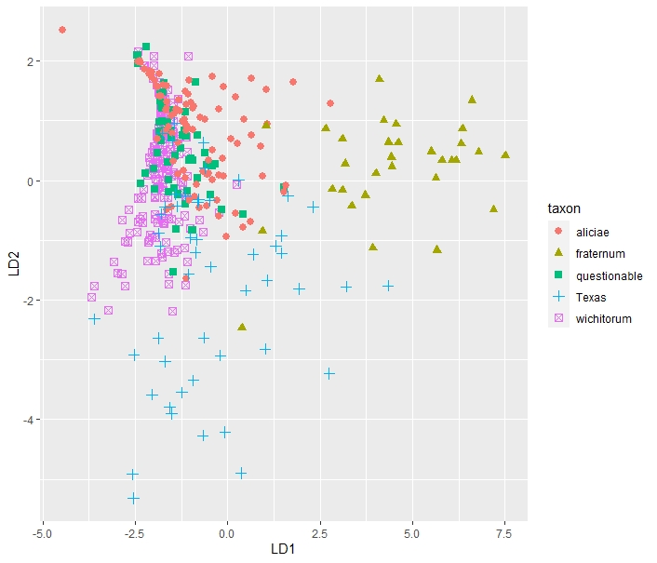

Supplemental Figure 1. Five group DFA plots without apertural height included had “horseshoeing”, indicating that the morphology using these characters could not properly fill the multivariate space made by the discriminant axes. Adding apertural height fixed this problem, which is why it was included despite a marginally concerning %ME score of 10.21%.

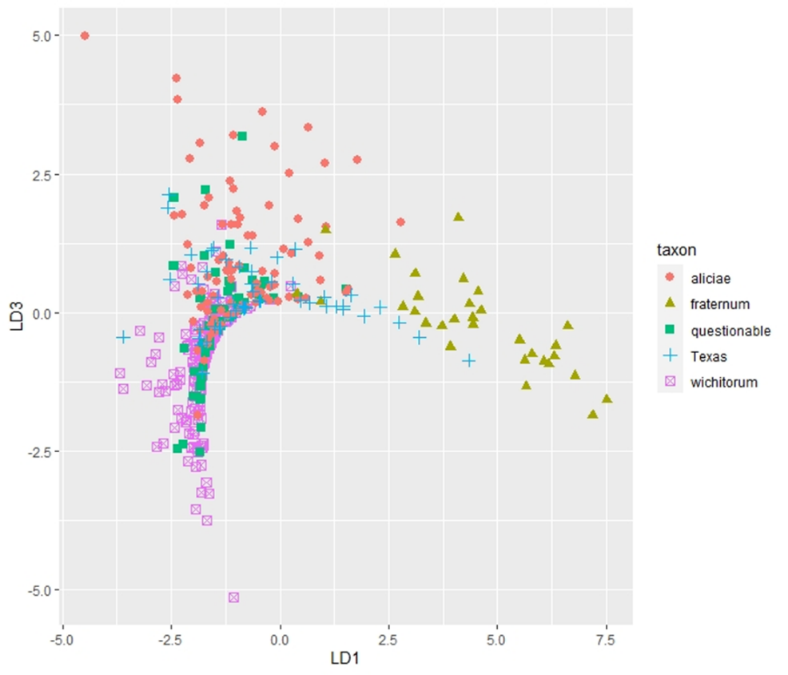

Supplemental Table 1. The E. wichitorum classification scores (EWC100) of different “E. westOK” populations and their distance from the WMWR (km). The results of the linear model between classification score and distance are presented in the bottom rows.
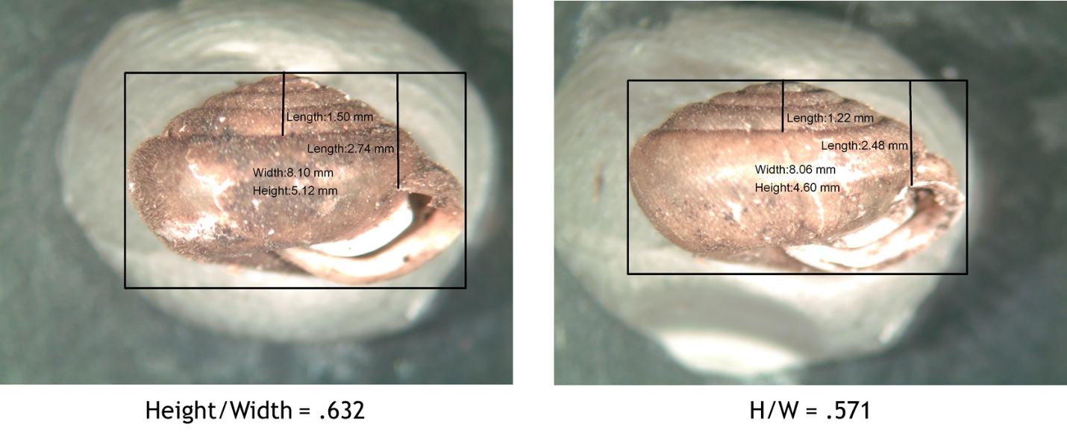
Supplemental Photo 1. Many “E. westOK” would have a mix of individuals that looked like the taller, darker E. leai (left), the shorter, lighter E. wichitorum (right), or somewhere in between the two species. Snails with very different morphologies were sometimes collected from the same shelter log.

