UNIVERSITY OF OKLAHOMA
GRADUATE COLLEGE

Free College for Whom? How Policy Design and Public Management Shape Program Access and Success

A DISSERTATION
SUBMITTED TO THE GRADUATE FACULTY
in partial fulfillment of the requirement for the
Degree of
DOCTOR OF PHILOSOPHY

By
Elizabeth Bell
Norman, Oklahoma
2019

Free College for Whom? How Politics, Policy Design, and Public Management Shapes Program Access and Success

A DISSERTATION APPROVED FOR THE DEPARTMENT OF POLITICAL SCIENCE

BY

Dr. Alisa Hicklin-Fryar

Dr. Deven Carlson

Dr. Samuel Workman

Dr. Abhisekh Ghosh Moulick

Dr. Gregg Garn

© Copyright by Elizabeth Bell 2019
All Rights Reserved

Acknowledgements
This project would not have been possible without all of the support and encouragement from so many people. Without my advisers, Deven Carlson and Alisa Fryar, I would have not even gone to graduate school and certainly wouldn’t have been able to produce this dissertation project. Deven demonstrated what it means to do rigorous research that has a real impact on policy and dedicated countless hours to patiently and expertly guiding me as I struggled with concepts, methods, and mastering the art of writing well. When others looked down on my work for being too “applied”, Deven encouraged me to use my passion and skill to strike the balance between theoretical rigor with policy relevance—something that shines through in this dissertation project. If I can become a scholar akin to him, it would be one of my greatest accomplishments. More than anything, though, I will never forget the lessons about the delicate balance between the love of family and hard work. Deven’s family will always be very special to me—I will never forget all of the fun Lila, Natalie and I had at the Center and I will never forget the kindness and generosity of Nina. Much of the same goes for Alisa, who has been my own personal mascot and cheerleader throughout graduate school. Alisa constantly reminded me that I am not an imposter in this profession and that what I have to say matters. I am so thankful that I met Alisa serendipitously in D.C. and got the opportunity to work with her. I can never thank Alisa and Deven enough for generously opening their doors for me anytime I needed it.
I will also never forget what gave me the passion to write this dissertation in the first place. As a child I witnessed the transformative power of higher education in my family and I also saw so many families that were unable to access college, not because of a lack of ability or desire but because it was simply too expensive. I was only able to attend college thanks to the many sacrifices of my parents, Mary and Jeffery Bell, who took on debt for me without a second glance and have empowered me in everything I do. Every day I carry their unconditional love and support with me as I fight for a world in which every child, no matter their socioeconomic status or racial/ethnic identity can access quality educational opportunities.
I also am grateful to my partner, Matthew Jacobson, who probably deserves an honorary degree in political science for how many times he has intently listened to my preliminary ideas, edited my works in progress, and listened to my final presentations. Thanks also goes to Breena Robinson, my soul sister, best friend, and partner in crime. Thank you for reminding me to keep my head up and balance self-care with the pursuit of my dreams. I also want to thank my loving family, including my brothers James and Charles, and my many aunts, uncles and cousins who have always been my biggest fans and supporters! Thanks also to my grad school comrades Tracey Bark, Wesley Wehde, Lauren Reinke, Gloria Noble, Ani Ter-Mkrtchyan, Tyler and Krystal Camarrilo, and Jungwha Choi, who have been constant companions throughout my time at OU. Writing a dissertation was much sweeter thanks to all of your love and support.
Finally, this project also wouldn’t have been possible without the hard work and dedication of my research partner and friend Kylie Smith. Kylie is a coauthor on Chapter 4 in which she conducted the qualitative analysis and weaved the narratives of high school counselors into the paper. She also facilitated access to the data, with the help of Bryce and his Oklahoma’s Promise team at OSRHE and Gayle in the data division at OSRHE. I am so grateful to have worked with passionate practitioners who work every day to make college more affordable and accessible to the students in Oklahoma.

Table of Contents

List of Figures vii

List of Tables ix

Abstract 1
Chapter 1: A Holistic Policy Design Framework 2

Chapter 2: Applying the Holistic Policy Design Framework to the Study of College Affordability and College Promise Policies 34

Chapter 3: The Politics of Designing Tuition-Free College: How Socially Constructed Target Populations Impact Policy Support 54

Chapter 4: Perspectives from the Front-line: Street-Level Bureaucrats, Administrative Burden, and Access to Oklahoma’s Promise 90
Chapter 5: How Policy Design Shapes Beneficiary Populations and Student Outcomes: An Examination of Tuition-free College Programs in Oklahoma 135

Chapter 6: Conclusion 195

References 199

List of Figures
Figure 1-1. Policy Design Framework 4
Figure 1-2. Policy Design in Policy Evaluation Studies 9
Figure 1-3. Policy Design in Policy Process Scholarship 17
Figure 1-4. Policy Design in Public Administration 25
Figure 2-1. Policy Design Framework Applied to College Promise Policies 51
Figure 3-1. The Political Pathway: How Politics Shapes Statutory Designs 54
Figure 3-2. Multiple Streams Model of Merit-Based Scholarship Criteria Determination 61
Figure 3-3. Tuition-free Community College Policy Support Distributions, by Randomly Assigned Target Population 75
Figure 4-1. The Administrative Pathway: How Statutory Designs are Translated in the Implementation Process to Impact Outcomes 90
Figure 4-2. Variation Across High Schools in the Proportion of Students Receiving the Oklahoma’s Promise Scholarship 106
Figure 5-1. The Instrumental Pathway: How Statutory Designs Impact Outcomes 134
Figure 5-2. Change in Enrollment Before and After Implementation of Tuition-free College 140
Figure 5-3. Changes in Student Population at Tulsa Community College 142
Figure 5-4. Changes in Student Population at Oklahoma City Community College 144
Figure 5-5. Changes in Student Population at Rose State College 145
Figure 5-6. Theoretical Model of Mechanisms by which Promise Programs impact K-12 and Postsecondary Outcomes 160
Figure 5-7. Major Demographic Changes, by Cohort 164
Figure 5-8. Proportion of Students Receiving Tulsa Achieves, by Distance from High School GPA Threshold 168
Figure 5-9. Distribution of Students by Distance from High School GPA Eligibility Threshold 169
Figure 5-10. Mean of Significant Outcomes of Interest, by Distance from Threshold 177
Figure 5-11. Event-Study Figures for the Effect of Tulsa Achieves Eligibility on Student Outcomes (ITT) 183-184
Figure 5-A1. Observable Characteristics near the Threshold 190
Figure 6-1. Policy Design Framework Applied to College Promise Policies 195

List of Tables
Table 3-1. Typology of Target Populations 63
Table 3-2. Randomly Assigned Policy Design Treatments 70
Table 3-3. Measurement and Wording of Non-Binary Measures 72
Table 3-4. Descriptive Statistics with Post-stratification Weights 73
Table 3-5. Sample Means, by Randomly Assigned Target Group 74
Table 3-6. Regression Results 77
Table 3-7. Regression Results: Ideological Subgroup Analysis 80
Table 3-A1. Demographic Attributes of Survey Respondents Compared to 2016 US Census Estimation 86
Table 3-B1. Ordinal Logistic Regression Results 87
Table 3-B2. Ordinal Logistic Regression Results: Restricted Sample with Comprehension 88
Table 3-B3. Ordinal Logistic Regression Results: Ideological Subgroup Analysis 89
Table 4-1. Descriptive Statistics 110
Table 4-2. Measurement and Operationalization of Role Perception Variables 111
Table 4-3. Regression Results 114
Table 4-4. Regression Results with Role Perception Interaction 116
Table 4-A1. Changes to Eligibility Requirements for Oklahoma’s Promise Over Time 130
Table 4-B1. Comparison of Sample of High School with Population Across State 131
Table 4-C1. Comparison of Results with Alternative Measurement 132
Table 4-D1. N for Each Combination of Roles 133
Table 4-E1. Measurement of Control Variables 134
Table 5-1. Comparison of Policy Design in Oklahoma Tuition-free College Policies 137
Table 5-2. Comparing the School Districts Impacted by Tuition-free College Policy 138
Table 5-3. Comparing Who Benefits from Oklahoma Tuition-free College Programs 139
Table 5-4. Policy Designs and Findings from Promise Research on Postsecondary Outcomes 154
Table 5-5. Descriptive Statistics 162
Table 5-6. Coefficients and Standard Errors on Scoring Above GPA Threshold from Reduced-Form Model Predicting Student Observable Characteristics 171
Table 5-7. RD Estimates of the Effect of Tulsa Achieves with Eligibility as Instrument for Receipt 174-175
Table 5-8. Difference-in-Difference Results for the Effect of Tulsa Achieves Eligibility on Student Outcomes (ITT) 181
Table 5-9. Event-Study Results for the Effect of Tulsa Achieves Eligibility on Student Outcomes (ITT) 182
Table 5-10. Two-Stage Least Squares Regression Results for the Effect of Tulsa Achieves Receipt on Student Outcomes (2005-2012) 186
Table 5-B1. Robustness Check with Out-of-State Students as Comparison Group: Difference-in-Difference Results for the Effect of Tulsa Achieves Eligibility on Student Outcomes (ITT) 191
Table 5-B2. Robustness Check with Out-of-State Students as Comparison Group: The Effect of Tulsa Achieves Eligibility on Student Outcomes (ITT) 192
Table 5-B3. Robustness Check with High School Fixed Effects: Difference-in-Difference Results for the Effect of Tulsa Achieves Eligibility on Student Outcomes (ITT) 193
Table 5-B4. Robustness Check with High School Fixed Effects: Event-Study Results for the Effect of Tulsa Achieves Eligibility on Student Outcomes (ITT) 194

I. Abstract
Drawing on theory from political science, policy process, and policy analysis/evaluation, this project investigates the different streams by which policy design influences the effectiveness of tuition-free college initiatives. My dissertation takes a different approach than previous literature by drawing connections across literature in policy process theory and public administration—including the social construction of target populations, administrative burden, and street-level bureaucracy—to formulate a holistic policy design framework. The central contention of my dissertation is that there are three main pathways through which policy design influences the success or failure of policy: political, administrative, and operational.
First, I argue that there is a fundamental tension between the most politically advantageous and the most effective policy design, with risk averse policymakers often choosing the former to remain in line with perceptions of fairness among the public. Second, I find that politically motivated policy designs are translated through administrative agencies by bureaucrats that exercise uneven uses of discretionary power, which translates to inequities in access to free college programs. Third, I find that the alignment of policy tools and eligibility requirements with client needs structure who benefits and who loses, which meaningfully impacts whether policy outcomes are aligned with policy goals. Together, this project leverages public policy and public administration theories on the social construction of target populations, administrative burden and street-level bureaucracy to better understand the conditions under which politically shaped governmental policies aimed at extending the ladder of opportunity will meaningfully reduce inequality in college access and success.

Chapter 1: A Holistic Policy Design Framework
In theory, the foundation of a healthy democracy is built through the adoption and maintenance of public policies that solve the problems faced by citizens. In this way, democratic governments serve as the embodiment of the public, echoing and responding to the voices and needs of its constituency. Public policy, as the foundation of the democratic way of life, holds the potential to fulfill its duty and carry out the will of the people, effectively addressing the concerns of constituents and working for the betterment of society. However, in many cases, policy reforms in and of themselves may not accomplish intended policy goals and may, in fact, exacerbate inequality and contribute to degenerative politics that degrades the healthy functioning of democratic government.
A key factor determining whether policy reforms alleviate or exacerbate societal problems, I argue, is policy design—and not policy design in the narrow sense that it is normally considered by siloed academic literatures within political science, but policy design as it is defined in the holistic framework developed by this dissertation. Current conceptualizations of policy design within the subfields of policy evaluation, policy process and public administration studies, put forth incomplete explanations of how policy design translates into an effective or ineffective policy reform. For instance, as a result of the a-theoretical, econometric approach, policy evaluation scholars would argue that ineffective policy tools or flawed eligibility criteria are to blame for the failure of a policy reform. On the other hand, policy process scholars often argue that politically charged bureaucratic implementation processes are to blame for ineffective policy reform. In contrast, public administration scholars would argue that bureaucrats are constrained by politically charged policy designs enacted by politicians interested in re-election and not necessarily the effectiveness of a program. In reality, none of these explanations fully capture all of the moving parts of policy design—it could be any of these explanations, or all of them, that explain the relationship between design and outcomes, depending on the context of the policy reform.
In an effort to bridge the gap between academic literatures in public policy and public administration on the role of policy design in shaping outcomes, this dissertation takes a different approach to the study of policy design—one in which the insights of each academic literature mentioned above are incorporated into the holistic conceptualization of policy design. As such, this dissertation considers policy design as being composed of multiple interconnected components that work together to determine the effectiveness of policy reform. Policy design, as it is defined in this dissertation, is composed of political, symbolic and operational components including the choice of socially constructed target population, causal stories, rationales, policy tools, eligibility criteria, funding structures, implementation structures and allocations of policy benefits and burdens. Together, these components of policy design work to either undermine or facilitate the effectiveness of public policies in translating public problems into policy solutions. The process by which policy designs are developed and translate into outcomes is described in the holistic framework developed by this dissertation in Figure 1-1.
As shown in Figure 1-1, policy design processes begin with political officials wielding policy design as a political tool, in which the flexibility in the choice of policy tool is exploited to maximize political gain for the coalition in power. Part of this process is the gauging of likely public support for a policy reform, in which political officials select the framing, target population, causal story and rationale that will be most likely to draw support from a broad base of their constituencies (Stone 2001).
Figure 1-1. Policy Design Framework

As a function of this process, statutory design incorporates bargaining and coalition building and the strategic choices of eligibility requirements and policy tools that ensure that target populations with positive social constructions are allocated benefits and those with negative social constructions are allocated burdens in order to align with citizen perceptions of fairness (Boushey, 2016; Schneider & Ingram, 2012). In this way, policy designs are politically constrained by the strategic actions of officials concerned with the political feasibility of policy reforms and the consequences of policy reforms for their re-election. Thus, policy design in the politics phase involves the consideration of social constructions of target populations, rationales, assumptions, causal theories and deliberation regarding the various designs, tools and implementation structures that will be most likely to achieve political goals. In this way, the political component of policy design is made up of policymakers who are able to exploit the range of possible policy designs to maximize re-election chances and cultivate positive perceptions of the policy among the public.
Next, the decisions made at the politically determined statutory design phase impacts the translation of policy designs into outcomes through the political process of implementation. Often, in this phase bureaucrats wield substantial discretionary authority due to the ambiguity in the statutory design passed by strategic public officials looking to avoid controversial, high-profile decisions regarding the distribution of resources. In fact, many public administration scholars posit that discretion is not only sometimes baked into policy designs, but is inevitable in almost every public program (Tummers & Bekkers, 2014). This leaves the decisions on how to allocate limited resources in the hands of unelected bureaucrats, who are charged with interpreting policy designs implemented by politicians amidst the constraints of the statutory boundaries in their strategic use of discretion. For instance, the statutory design decisions made by political officials, in some cases, impose red tape on application or administrative processes of public agencies in an effort to restrict program access. This can be politically advantageous for officials looking to restrict citizen access to programs that do not align with their ideology or for officials looking to redirect limited public resources away from programs without having to make high-profile and controversial decisions in which the programs are eliminated, or funding is cut. In these cases, bureaucrats charged with implementing the policy changes can utilize discretion in ways that align or do not align with the priorities of political officials. This means that while some bureaucrats might utilize discretion in ways that empower clientele to overcome red tape, others may make matters worse for clientele, serving as a source of bureaucratic disentitlement. The strategic use of bureaucratic discretion, then, is another key element of policy design and the translation of policy designs into policy outcomes.
Together, these policy design mechanisms—politically constrained statutory design and political implementation processes—determine whether policy reforms will solve or exacerbate societal problems in a democratic system of government. As a result of the system of majority rule, politicians are incentivized to appeal to broad bases on the constituency that are politically active, which can create a system in which policy reforms aimed at reducing inequality and uplifting the poor may be designed in ways that are politically feasible instead of in line with the needs of citizens. Moreover, policy designs that put the success or failure of a policy reform in the hands of constrained bureaucrats, who have the discretionary power and the limitations of public resource constraints, lead to systematic variation in the effectiveness of local agencies’ provision of public services in ways that can further contribute to systemic inequality. Therefore, the interaction of these policy design mechanisms can contribute to degenerative politics and leave societal problems unsolved and the will of citizens unheard.
In this dissertation, this holistic conceptualization of policy design is applied to my examination of college promise policies in order to more effectively portray the entire process of policy design, from the political bargaining stage all the way to the realization of policy outcomes. In this way, this dissertation leverages the insights of public administration and public policy theories to provide an empirically and theoretically rigorous investigation into the role of policy design in translating policy goals into policy outcomes in the context of college promise policies. In doing so, this project combines the methodological strengths of substantive policy evaluation with the theoretical rigor of public administration and public policy process studies to provide the first step toward the development and application of a holistic policy design framework.
In my analysis of college promise policies, policy design is center stage as the determinant predicting whether college promise policies will accomplish policy goals of increasing access and success in college. Specifically, this dissertation leverages public policy and public administration theories on the social construction of target populations, administrative burden and street-level bureaucracy to better understand the conditions under which politically shaped governmental policies aimed at extending the ladder of opportunity will meaningfully reduce inequality in college access and success.
The following sections review the related literatures in public policy, substantive policy evaluation and public administration that investigate the implications of policy design for political, social, economic and educational outcomes. Then, the chapter concludes with a preview of the dissertation.
1.1 Bringing the Strands Together: How do the Subfields Conceptualize Policy Design?
The subfields within political science have previously dealt with policy design in a piecemeal fashion, which has led to a fragmented literature that rarely crosses subfield boundaries. Indeed, while subfields such as policy process theory, policy evaluation and public administration have separately attempted to understand the influence of policy design on democratic outcomes, the fragmentary approach with which these investigations have been conducted leaves blind spots that are problematic for a holistic understanding of policy design. Before demonstrating the insights to be gained from a holistic understanding of policy design, the next sections review the treatment of policy design in each of the subfields in this study—substantive policy evaluation, policy process theory, and public administration. Then, I establish the drawbacks of such a fragmented approach and highlight the insights that can be gained through an integrated policy design framework.
1.1.1 Policy Design in Policy Evaluation
In the policy evaluation literature, scholars with expertise in a substantive policy area such as education or health care policy are interested in how public policy designs (the independent variable of interest) impact societal outcomes such as educational attainment, political engagement or economic prosperity. In this way, the conceptualization of public policy in this literature speaks directly to questions of importance for policy effectiveness and observed citizen outcomes. This approach to studying policy design has multiple benefits including practical relevance to policy debates, advanced methodological tools for causal inference, and a degree of localized contextual knowledge that leads to rich descriptions and elevated levels of internal validity. Each of these strengths is a product of the unique epistemology of policy evaluation studies, which emphasizes the ability to identify causal effects more than the development of grand theories that apply across policy domains.
As shown in Figure 1-2, due to the epistemology of policy evaluation work, policy design is conceptualized narrowly in economic terms as being composed of eligibility criteria and practical policy tools that influence a public policies’ ability to solve the problems of market failure and affect citizen outcomes (Weimer & Vining, 2017). For instance, policy evaluation scholars are keen to highlight the impacts of differences in structure between supply side versus demand side subsidies and taxes. In this repertoire, scholars categorize the ways in which government can create rules (price regulation, quantity regulation) and the role of policy in freeing, facilitating and simulating markets (Wiemer and Vining 2017). These scholars, often publishing in substantive policy field journals such as Education Evaluation and Policy Analysis (EEPA) or the Journal of Policy Analysis and Management (JPAM), play an integral role in improving public and scholarly knowledge of the effectiveness of policies. Insights from JPAM range in policy issue areas, including anything from education and welfare to labor and workforce development, all focusing on the impacts of policies, once enacted, on societal outcomes of interest. This perspective of policy design from an economic perspective lends itself well to the utilization of advanced econometric estimation techniques that uncover the causal effects of specific policies on societal outcomes of interest in substantive areas such as health care, education, tax policy etc.

Figure 1-2. Policy Design in Policy Evaluation Studies

In fact, perhaps one of the most important strengths of the policy evaluation literature is the advanced econometric and experimental methodological techniques utilized to isolate the causal impact of public policy tools on citizen outcomes. Indeed, the singular focus on the impact of policies on societal outcomes makes policy evaluation scholars particularly effective at utilizing rigorous econometrics to measure causal effects, efficiency trade-offs and implications of particular tools for distributional outcomes and policy effectiveness.
1.1.2 Policy Design in Policy Process Studies
In direct contrast to the policy evaluation literature, throughout much of the development of public policy process literature, the majority of scholars have conceptualized policy design as the outcome to be explained by a whole host of political phenomena. The policy process literature on policy design is substantial and illuminating for better understanding the politics of policy design choices by legislatures and the consequences of those design choices for political outcomes such as civic engagement and trust in government.
In particular, scholars have made theoretical developments in two main bodies of literature that enable a better understanding of policy design and democratic outcomes. First, scholars have developed the social construction of target populations framework, which explains why policies are designed in ways that contribute to inequality and degenerative politics through developing theory around the impact of socially constructed target populations within policy designs. Second, scholars in political science have developed a better understanding of the processes of policy feedback, which details the influence of policy design on future policies and citizen outcomes such as civic engagement, trust in government and political efficacy. Combined with the insights from policy evaluation and public administration, the insights from these two literatures help establish a more holistic understanding of the implications of policy design.
Policy Design in the Social Construction of Target Populations Framework
Drawing from the social construction of target populations, or more recently termed policy design theory, policy design is conceptualized as a politically relevant factor composed of goals/problems, rules, rationales, assumptions, target populations, social constructions, benefits, burdens, tools, and implementation structures (Schneider & Sidney, 2009). In opposition to the policy evaluation literature, which considers eligibility criteria and the economic classification of public policy to be the central aspect of policy tools and designs, the social construction of target populations framework highlights the importance of "the cultural characterization or popular images of the persons or groups whose behavior and well-being are affected by public policy" (Schneider & Ingram, 1993, 334). In addition, this literature recognizes that discussions of policy tools cannot just be considered in classic economic theory terms but must also incorporate investigations into how the uses of authority, coercion, or stigma shape the experience of policy for different target populations. Moreover, in opposition to the relatively simplistic treatment of policy design in policy evaluation, social construction theorists also take seriously the role of socially constructed realities, rationales/causal logics and underlying assumptions about the capacity of people and organizations that are embedded in policy designs. As such, the treatment of policy design in this literature moves beyond the rational and instrumental treatment of policy design in public policy evaluation and analysis to more effectively characterize the value-laden and socially constructed political phenomena that shape the politics of policy design.
The foundation of this literature relies upon three major assumptions: first, that elites and the public rely upon mental heuristics that lead to confirmation bias and use of stereotypes when making policy decisions about target groups (Jones, 1994; Munro et al., 2002; Simon, 1985), second, that power is unequally distributed in political environments (Bachrach & Baratz, 1962) and third, that policies create politics (Lowi, 1964; Schattschneider, 1960). Based on these assumptions, this framework explains the allocation of benefits and burdens as a function of the target populations’ perceived level of political power and deservingness by political elites and the public. In other words, policy designs are primarily explained by variation in the social construction of target populations. These social constructions, or powerful images and stereotypes conveying deservingness and political power of certain groups, serve as the underlying mechanism that predicts whether a policy will allocate benefits and burdens. More specifically, because elected officials focus on re-election (Arnold, 1990), they incorporate social constructions in re-election calculus by anticipating the reaction of certain designs by both target groups and the broader public regarding whether the allocation of benefits and burdens is going to a group that deserves benefits or burdens. Therefore, when policymakers are designing policies, they will exploit the range of possible policy designs for achieving goals to select those most likely to be viewed by the public as fair, which ultimately exacerbates existing structural inequality for minority groups that have less voting block power.
For instance, policymakers faced with the college affordability crisis could implement a financial aid policy that provides support for students with the most financial need (need-based financial aid) or leave the policy open to all students in the state that meet certain academic merit standards (merit-based aid). In designing the policy as only benefitting the poor, the policymaker could face opposition by many in the middle class who also want financial support. On the other hand, by designing the policy universally and only allowing students deemed as “college-ready” or “worthy” of the financial aid, policymakers can more easily justify spending tax payer money on this policy to the public. While this may seem like a hypothetical situation, higher education scholars have observed a massive and spreading shift in state financial aid policy from need-based designs to merit-based designs (Toutkoushian & Shafiq, 2010), despite the consensus among scholars that merit-based aid serves to reinforce existing educational inequalities (Dynarski, 2000). This current movement in higher education policy exemplifies the potential for policy design to have serious consequences for a democratic system, often contributing to structural inequality and degenerative politics.
Moving beyond just higher education policy, this framework has significant support at the elite level across a variety of policy areas. In fact, scholars have found that political elites make decisions regarding the allocation of benefits and burdens according to perceived deservingness and political power of target groups in the context of health care, k-12 education, welfare, and criminal justice (Boushey 2016; Chanley 2005; Donovan 1993; Hogan 1997; Reich and Barth 2010; Schneider and Ingram 1993; Schneider and Ingram 2012; Schneider 2006; Schroedel and Jordan 1998; Stein 2001). In particular, studies have found that political elites design policies so that they allocate benefits to advantaged populations with higher levels of power and perceived deservingness (Schneider and Ingram 1993). On the other hand, political elites allocate burdens to deviant populations that suffer from low levels of political power and perceived deservingness (Boushey 2016; Schneider and Ingram 1993). Moreover, political elites are more likely to design policies that provide hidden benefits, such as submerged tax breaks that are less salient to the public, to populations that have high levels of power but low levels of deservingness. Finally, this body of literature has revealed that political elites will design policies in ways that stigmatize populations that have low levels of power but positive social constructions (Schneider and Ingram 2012).
Policy Design in the Policy Feedback Literature
The implications of policy design are also explored in the investigations of policy feedback. This literature focuses on highlighting the impact of policies, through the design structures, on subsequent policymaking processes (Pierson, 1993; Skocpol, 1992). Specifically, public policies shape democratic outcomes through bestowing resources, imposing rules and conveying norms and messages. The streams of literature within the policy feedback body of work investigate the influences of public policies on: 1) the capacity and learning of public officials, 2) the emergence and influence of interest groups and 3) the meaning of citizenship and political behavior among the public.
To the first point, policy feedback literature has established the related, although distinct role of policy designs in shaping governance through the capacity and learning of public officials. Specifically, policies can create positive feedback, in which positively constructed policy designs can influence future policymaking decisions, or negative feedback, in which policy designs become negatively constructed, preventing reforms and the expansion of the expansion of benefits in future policymaking (Skocpol 1992). Take, for instance, the positive construction of the social security administration (SSA) among the public, which led to positive feedback, where the implementation of Medicare was delegated to SSA (Derthick, 1979). On the other hand, consider the impact of the skepticism and negative constructions of corruption that became associated with the patronage system in civil war pensions. This negative association made it less likely for the government to administer benefits in this structure in the future (Skocpol 1992).
Second, policy feedback literature has highlighted the role of policy designs in shaping the mobilization of mass publics through two main mechanisms: interpretive and resource effects (Pierson, 1993). The first mechanism, interpretive effects, describes the provision of information and meaning which affects citizen attitudes. The second mechanism, resource effects, describes the process by which the expansion of benefits through public policy impacts the ability and incentives for political activity among the populace. For instance, social security is designed as a universal benefit for all citizens and structured in a way that conveys the subliminal message and assumption that citizen recipients are capable of effectively managing their subsidy without the intervention of bureaucrats. As a result, the interpretive effects are positive with no stigma associated with the acquisition of these benefits and the resource effects enable significant improvements in the income level and political participation of the elderly (Campbell, 2003), particularly among lower-income elderly populations (Campbell, 2002).
More generally, through these two mechanisms, policy designs impact political participation and the meaning of citizenship through establishing rules that influence the membership, citizen status, and identity of the public. First, public policy designs shape membership in the political community. Take, for instance, immigration policy. The requirements and level of integration and support for immigrant communities shapes the likelihood of civic participation (Bloemraad, 2006; Zolberg, 2008). In addition, public policy designs shape citizenship status. Policies determine whether citizens are considered legal members of society (Shklar, 1998) and whether they enjoy the right to vote (Keyssar, 2009; Uggen & Manza, 2002). Moreover, policies can guarantee social rights and labor laws that directly affect the development of interest groups and voting participation (Dahl, 2003; Fox, 2012; Mettler, 1998; Orloff, 1993; Skocpol, 1992). Furthermore, public policies directly influence the level of civic participation and engagement with government through the establishment of policies that citizens are willing to invest time and effort into protecting. For example, the establishment of social security, Medicare and the GI Bill gave citizens more resources, which made citizens more engaged and involved in civic activities (Campbell, 2003; Mettler, 2007). Additionally, the provision of education policies build up civic capacities through the establishment of skills, resources and social networks that facilitate participation in government (Verba, Schlozman, & Brady, 1995). Taken together, the literature supports the notion that public policy designs that allocate resources to mass publics shape levels of participation and the emergence of interest groups committed to retaining the status quo.
On the other hand, public policies, depending on the policy design, can also have negative impacts on the engagement of citizens through interpretive mechanisms that stigmatize particular populations. Public policies can, for example, convey messages that legitimize or delegitimize your way of life and communicate how the state sees you through the establishment or withholding of citizenship (Engel, 2014). For example, the establishment of policies such as welfare and incarceration make civic participation decline among disadvantaged populations (Soss, 1999; Weaver & Lerman, 2010). In addition, the state can regulate personal lives through the legal recognition and persecution of homosexuality (Canaday, 2011). In this way, policies deeply affect the way citizens see themselves. Policies can stigmatize those that are not seen as deserving of help or they can empower citizens through programs such as Head Start, which engaged parents in political life depending on how the policy is designed (Soss, 1999). Consider the differences in political feasibility and stigmatization involved in social security policies and welfare policies. The universal design of social security democratizes citizenship and encourages mass support and engagement while means-tested policies may lead to stigmatization and disagreements over the appropriate and deserving targets of redistribution (Jordan, 2013; Korpi & Palme, 1998; Rothstein, 2001; Skocpol, 1992; W. J. Wilson, 2012). Social security benefits, based on the design, are viewed as earned while welfare programs such as TANF are perceived as a handout that can be abused because of the structure (Williamson, Skocpol, & Coggin, 2011).
Together, these literatures on the role of policy design in policy processes built a better understanding of the processes by which policy designs are formulated and changed by government institutions as well as the political consequences of policy designs for a subset of democratic outcomes (Arnold, 1990; Baumgartner & Jones, 2010; Ingram & Schneider, 1991; Kingdon, 1984; Sabatier & Weible, 2014; Sabatier & Mazmanian, 1980; Weible, Sabatier, & McQueen, 2009). In particular, policy process scholars have highlighted the role of policy design as a political tool that impacts policy effectiveness, political participation, policy drift, political efficacy and trust in government (McCann 2016; Schneider and Ingram 1993; Soss and Mettler 2004; Mettler 2011; Soss 2002; Ingram and Schneider 1992; Linder and Peters 1985; Ostrom 1990; Schneider and Ingram 1990a, 1990b; Stone 1988).
Both the policy process literature and the policy evaluation literature provide insight into some aspects of policy design, providing a partial and incomplete picture of the importance and relationship of policy design and outcomes, as shown in Figure 1-3. In particular, the policy process literature provides insight on the political processes that shape the choice of policy design while the policy evaluation literature provides the tools needed to effectively characterize the impact of policies on societal outcomes. However, there is still a missing element in the model. The final literature adds the final component to this model—the politics of implementation.

Figure 1-3. Policy Design in Policy Process Scholarship

1.1.3 Policy Design in Public Administration

In public administration literature policy design is conceptualized as the product of political coalitions that express the will of the public in legislation that expands or constrains the authority of executive agencies. More specifically, policy design is treated as a product of our representative democratic system of government in which the interests of winning political coalitions translates into "constitutionally sanctioned public choice" that determines the types of policies and programs the executive branch is charged with implementing as well as the levels of rep tape and administrative burdens that citizens must face in order to gain access to programs (Lynn et al., 2001, 33). Therefore, public policy design is treated as an important element of the context in which implementation takes place; public policy designs establish the directives and goals that provide the context for bureaucratic behaviors and management strategies as well as the structure and functioning of public organizations charged with execution of policies and programs. As the context in which implementation takes place, policy design is a component but is not the centerpiece of theoretical investigations into the functioning of executive agencies. Instead, public administration research sheds lights on the ways in which policy design affects the managerial and street-level bureaucrats that are charged with implementing public programs and services.
This conceptualization, unlike policy evaluation and policy process studies, takes on the challenge of opening up the black box of implementation and thus contributes substantial theoretical insight into the impacts policy design has on the bureaucrats working in the managerial and street-level implementation process. In doing so, this literature provides insight into the impact of politics and policy design as it moves through the bureaucratic implementation process to impact citizens. In doing so, this literature provides the theoretical foundation necessary for understanding the underlying causal mechanisms for the occasional disjuncture found in policy evaluation studies between policy goals and policy outcomes. Additionally, the public administration perspective extends policy process insights by extending the focus from the politics of policy design formation to the impacts of political policy designs for the implementation of public programs. As such, public administration literature effectively builds on the policy evaluation and public policy processes literature by providing substantial explanatory power in the theoretical exploration of policy designs, political implementation processes and policy outcomes.
The first major insight of public administration literature is the conceptualization of implementation processes as the product of political coalition and, as such, inherently political (Moe, 1989). However, scholars of traditional public administration argued that ideally, in our system of shared constitutional power, bureaucrats would be neutral agents of the state, removed from politics, and would carry out orders exactly as they are directed by elected officials (Goodnow, 1900; Wilson, 1887). In this way, we could avoid the threat of powerful unelected bureaucrats in a representative democracy, effectively separating politics from administration. Therefore, in classic public administration perspectives, problems in the delivery of services to clients, or in the management processes of public agencies is the result of poorly designed laws that failed to effectively control bureaucrats (Finer, 1941; Howlett & Lejano, 2013). This argument, however, relies upon the normative assumption that "in democratic self-government, elected officials, including legislators and executives (presidents, governors, mayors), should control the decisions and actions of appointed (usually civil service officials)" (Frederickson, Smith, Larimer, & Licari, 2015, 16). There are two problems with this assumption: first, orders are politically crafted out of compromise and are thus often not clear in the first place, providing for substantial decision-making authority among bureaucrats; second, bureaucrats are human beings with values, biases and political views embedded in complex, hierarchical organizations and networks that vary widely in terms of structure and management. Both of these theoretical insights highlight the political nature of implementation as a system in which unelected bureaucrats have substantial power over the translation of policy goals into policy outcomes.
To the first point, as a reflection of institutional choices based in compromise and coalition building by policymakers interested in re-election, policy design is wielded as a tool that is sometimes embedded with ambiguity and contradictions as to how implementation is to take place. Essentially, electoral institutions sometimes have failed to adequately resolve issues in a reasoned manner with clear objectives and instead often pass laws with conflicting goals and leave it to bureaucracy to sort out (ex: Social welfare policy, affirmative action and agriculture policy) (Meier, 1997). In this way, politicians can avoid making controversial and salient decisions regarding the distribution of resources, leaving the bureaucrats with substantial discretion and power in shaping the success of policies and programs. Moreover, politicians can enact policy designs that sabotage the effective implementation of public policies by purposefully introducing inefficiency and administrative burden (McCann, 2016; Moe, 1989). For example, the seminal policy implementation piece by Pressman & Wildavsky (1973) illustrates how the complexity of policy design in economic development initiatives designed to address poverty led to implementation problems that led to a failed program in which the policy goals were not in line with the policy outcomes.
Moreover, politicians can purposefully induce inefficiency in the bureaucratic process and implement programs with administrative burdens or red tape that prevent citizens from accessing public programs (Moynihan & Herd, 2010; Moynihan, Herd, & Harvey, 2015). In the emerging body of literature on the impact of policy designs with embedded administrative burdens, public administration scholars have taken the most promising step toward appreciating the role of design on this element of the policy process and shedding light of a policy design mechanism that works through the implementation process to undermine the alignment of policy goals and outcomes. Public administration scholars have conceptualized administrative burden as:
“learning costs, or the investment it takes to find out about a program and its relevance to an individual; compliance costs, or the rules and requirements for accessing the benefits or services; and psychological costs associated with the intrusiveness of the application process or rejection or stigma that might be experienced in the process” (Heinrich 2016, 405).
This element of policy design is often manipulated by public officials as a strategic tool for engaging in hidden politics in which the normal democratic processes of political debate and consideration are circumvented (Moynihan, Herd, & Ribgy, 2016; Nisar, 2018). In enacting administrative burdens, elected officials can restrict access to programs they do not agree with and push controversial decisions on resource distribution down onto bureaucrats to avoid negative re-election consequences (Lipsky, 2010a). And based on the research, these efforts to restrict access to programs through enacting administrative burdens are often successful. Recent studies have revealed that the level of administrative burden meaningfully impacts access to public programs and the ways in which citizens relate to government (Burden, Canon, Mayer, & Moynihan, 2012; Heinrich, 2016; Heinrich & Brill, 2015; Moynihan, Herd, & Harvey, 2015). In addition, emerging studies have highlighted the negative impact of administrative burden on disadvantaged groups in particular (Nisar, 2017). Many of the scholars involved in the development of the literature revealing the political nature of implementation employ a top-down perspective, and thus argue that meaningful reforms should come in the form of changes in policy design by legislative officials in either the revocation of administrative burdens or the enactment of clearly delineated policies with efficient organizational mechanisms for carrying out the law (Pressman & Wildavsky, 1973). However, this top-down perspective overlooks a key element of the implementation process that bottom-up perspectives highlight as another potential lever for improving the responsiveness and performance of government institutions—the use of discretion by street-level bureaucrats.
The second major insight of public administration literature for the study of policy design concerns the significant power and discretion placed in the hands of street-level bureaucrats, which are key players in translating policy goals into policy outcomes (Keiser, 1999; Kelly, 1994; Lipsky, 2010a; Maynard-Moody & Musheno, 2000; Maynard-Moody & Musheno, 2003; Meyers, Glaser, & Donald, 1988; Scott, 1997; Weissert, 1994). Indeed, the consensus in the literature is that due to the often politically ambiguous nature of laws, this transfers the power of decisions regarding the distribution of resources into the hands of unelected bureaucrats which has been shown to impact policy outcomes through the strategic use of discretion. How the use of discretion impacts the responsiveness and performance of government institutions, however, has been a matter of substantial theoretical and normative debates.
Some scholars have argued that the use of discretion by street-level bureaucrats is problematic for responsive government institutions due to the potential for street-level bureaucrats to serve as a force of disentitlement and bias. This body of literature focuses on the ways in which street-level bureaucrats are or are not compliant or aligned with the goals of administrators and politicians. In fact, a substantial literature on street-level bureaucracy has uncovered the important role that discretion at the front-lines of government policies play in policy outcomes despite the signals by administrators and politicians (Keiser, 1999; Kelly, 1994). These studies have revealed that there are four main influential factors in the alignment of policy goals and street-level bureaucrat goals: communication by political or administrative superiors on context/importance of policy goals, organizational implementation factors, knowledge/attitudes of street-level bureaucrats about tasks, work and clients, and finally the contextual factors such as street-level bureaucrats workloads, client mix and external pressure from political and social environments. These studies have found that managerial influences such as training, performance monitoring and leadership as well as contextual and organizational factors can have some impact on the alignment of policy goals and street-level bureaucrats’ priorities (May & Winter, 2009; Riccucci, Meyers, Lurie, & Han, 2004). However, the influence of individual values, knowledge and beliefs about policy, clients and the work environment have been highlighted as the dominant factor affecting the use of street-level discretion (Lipsky, 2010b; Maynard-Moody & Musheno, 2003; Sandfort, 2000). In fact, even if high level policy changes attempt to change the priorities of street-level operations, street-level bureaucrats may be resistant to these changes and therefore may not change front-line operations (Brehm & Gates, 1997; Riccucci, 2005; Riccucci et al., 2004; Sandfort, 2000). For instance, in the context of welfare reform, Riccucci et al (2004) finds that despite the welfare reform policy changes, front-line employees did not shift away from emphasizing eligibility determination to prioritizing employment/deterrence away from staying on welfare rolls. This infusion of individual values and judgement, to this group of scholars is perceived as a threat due to the potential for bias and disentitlement. However, the use of individual judgement and lack of alignment between some policy priorities and front-line employees could also be viewed as a way to improve the responsiveness and performance of public institutions when the political will of the people does not align with the needs of the clientele of public programs. For example:
"for many of the frontline workers we observed, the mismatch between rules and problems encourages the street-level worker to improvise and innovate or, in the words of one social worker, to “be creative.” Rather than engaging in discretionary decision making, they practice pragmatic improvisation." (S19)
Indeed, the bottom-up perspective in street-level bureaucracy literature reveals that policy designs that are overly paternalistic and do not allow for local discretion in meeting the individual needs of clients and citizens may also undermine the effectiveness of public policies (Bertelli & Lynn, 2003; Brodkin, 2011; Lindhorst & Padgett, 2005; Maynard-Moody & Musheno, 2003). Indeed, literature on performance measurement reveals that the more street-level bureaucrats are pressured to meet performance metrics, the less discretion they have to use in remaining responsive to individual client needs (Soss, Fording, & Schram, 2011). In this view, the use of discretion is a force of individualized justice, in which the street-level bureaucrats are given the necessary flexibility to respond to nonroutine cases and individual client needs (Bertelli & Lynn, 2003; Friedrich, 1940). Moreover, the use of discretion may be seen as a way of alleviating inequality and helping the disadvantaged, with street-level bureaucrats making moral judgements in the use of discretion that aligns outcomes with “their visions of justice” (Kelly 1994, 119). Indeed, the “New Public Administration” movement called for bureaucrats to be advocates that defend social equity through the use of administrative discretion to benefit historically marginalized groups (Frederickson, 2010). Moreover, the use of discretion as a force for social equity, however, does not necessitate ignoring the priorities of public officials and may reflect an effective balance of power between legislative and executive branches of government (Keiser, 1999). In this way, the executive can more effectively respond to the individual needs of clientele without having to act within the constraints of electoral motivations, which may encourage burdensome implementation processes for programs that benefit disadvantaged groups (Ingram & Schneider, 1991). Despite these different perspectives on the perils or praise of the use of discretion in public administration literature, all would agree that street-level bureaucrats are an essential element of understanding the relationship between policy goals and policy outcomes.
Together, these two insights on the politics of implementation and the role of bureaucratic discretion make it clear that as a result of our representative democratic system of government, public governance is "constitutionally sanctioned public choice" in which politics manifests itself in both the choice of policy design, according to the interests of winning coalitions and as a result, permeates the political management strategies and implementation structures in the execution of policies (Lynn et al., 2001, 33; Keiser 1999; Moynihan and Herd 2010). Indeed, public administration scholars have been keen to highlight policy design along with the influence of street-level bureaucrats’ use of discretion as a major reason for the occasional misalignment of policy goals and outcomes. Public administration scholarship, as opposed to the few public policy scholars that have attempted to open up the black box of implementation, realize that in order to improve policy designs, we must understand the management of public organizations and the street-level bureaucrats that themselves carry out the law (Pressman & Wildavsky, 1973). This perspective highlights the role of street-level bureaucrats not just as agents of the state but as policymakers themselves, that have the power to shape the experience of policies and programs directly in their relationship and interactions with citizens (Lipsky, 2010b).
In sum, the insights of public administration literature on policy designs have provided valuable theoretical development on the reasons for the disjuncture between policy goals and outcomes, effectively building on the policy evaluation and public policy processes literature by opening up the black box of implementation to investigate the implications of policy design for the politics of bureaucratic implementation. In doing so, public administration literature has shed light on the ways in which policy design is wielded as a tool with which to manipulate democratic outcomes through bureaucratic agencies.

Figure 1-4. Policy Design in Public Administration

1.2 Limitations of Fragmented Approach to Policy Design & Benefits of Holistic Conceptualization of Policy Design
Taken together, while public administration and public policy literatures all separately deal with some components of policy design, the siloed nature of these discussions leaves each subfield with blind spots that are problematic for holistic theoretical development. In fact, as a result of the lack of cohesion, some scholars in policy design studies have called for a holistic approach in which scholars treat “policy design as causal factors that, if changed, could enable public policy to become a more democratic tool” (Schneider & Sidney, 2009, 116). This approach requires an integration of insights from policy processes, public administration and policy evaluation studies. In this way, future research can address “how processes shape designs and how designs affect justice, problem solving, citizenship, and subsequent democratic institutions” as well as “who political change serves” and “how negative and divisive social constructions of social groups, of types of knowledge, and of events are used to manipulate opinion” (Schneider & Sidney 2009, 116).
This dissertation takes the first step in establishing a holistic investigation into the theoretical and practical implications of policy design through applying theoretical and empirical tools from three subfields within political science. By combining these three conceptualizations of policy design, we can gain insight into the ways that policy designs function as political tools in formulation and the ways in which statutory design influences implementation and citizen outcomes. In this section, I demonstrate the limitations of a fragmentary approach in each of the subfields and the insights to be gained from a holistic approach to the study of policy design.
Policy Evaluation
Despite the methodological strengths, insightful contextual knowledge and practical relevance of policy evaluation literature, this literature often neglects to develop generalizable theoretical contributions. This is despite the fact that many times policy evaluations will find that in some cases the policies work to improve outcomes and in other cases they do not, providing the kind of variation one would need to link systematic elements of policy design to policy outcomes. However, policy evaluation scholars often do not take the crucial step to understand why a policy with the same design in one state did not work in another state, or why a policy might not have worked at all across sites. Integrating the study of politics and implementation can help integrate theoretical explanations for the disjuncture between policy goals and outcomes in multiple ways.
First, integrating the role of politics can help explain the disjuncture between policy goals and observed policy outcomes by explaining the role of political feasibility and symbolic political choices in the process of policy design. In this way, policy evaluation would greatly benefit from appreciating the role political feasibility considerations as well as the political manipulation of policy design highlighted by policy process scholars in shaping outcomes (McCann, 2016; Mettler, 2011; Schneider & Ingram, 1993). In fact, integrating this insight could reveal the underlying reason why policymakers sometimes choose the more inefficient policy tool for political reasons such as re-election calculus and social constructions of target populations.
Second, integrating literature on the politics of policy design and implementation would greatly benefit our understanding of the relationship between public policy and citizen outcomes by moving beyond rational choice assumptions to nuanced discussions of design as a venue of political decision making. The current economic perspective that dominates the policy evaluation literature overlooks the symbolic, rhetorical, and political dynamics that structure policy design choices and implementation. Integrating insights from political science and public policy process literature on policy design as a political tool and venue of politics would be beneficial for scholars interested in the role of policy design and structure on citizen outcomes. More specifically, this integration would benefit the ability of policy evaluation scholars to move beyond efficiency assessments and assumptions regarding rational policymaking processes to better characterize the highly subjective, symbolic, and value laden process of political decision making (Schneider & Sidney, 2009; Stone, 2001). As the originators of policy design theory argue, “policy establishes the programs and processes that become the focus of evaluation research, thereby reminding the evaluator to pay attention to the contingencies and politics of the creation of the policy itself rather than at least temporarily assuming, while conducting an evaluation, that policymaking is a technical/rational exercise. Thus, outcomes can be understood or linked back to original policymaking processes in which compromises, rhetoric, etc., imposed certain qualities on the design in the first place” (Schneider & Sidney, 2009, 114-115).
Third, integrating insights on the politics of implementation provides another key element in understanding the occasional disjuncture between policy goals and observed outcomes. While policy evaluation scholars often utilize a rational choice model to explain human behavior, implementation scholars realize that policy designs are wielded as a political tool and venue of politics with which officials can manipulate implementation processes and, in turn, citizen outcomes. In fact, studies on the politics of policy design and implementation have shown that some policies are hardwired for failure for political purposes through inducing inefficiency in the implementation process (McCann, 2016). As scholars of governance put it, "Even rational actors in legislatures cannot be expected to create rational organizations to execute their mandates; indeed, they may act to preclude effective administration of a controversial program rather than eliminate it outright" (Lynn, Heinrich, & Hill, 2001, 10; Moe, 1989). In this way, public officials can blame bureaucrats for the failure of policy while all the while the politicians can ensure the failure or success of policies according to their ideological preferences and reap the benefits in their re-election campaigns.
Together, this section reveals that policy evaluation fails to account for the role of politics, non-rational actors, and implementation processes in the relationship between public policy designs and outcomes. To overcome this oversight, this dissertation integrates the study of politics and implementation into the investigation into policy design so that scholars can better understand both the causal effects of policies while also taking into account the political and implementation processes that shape the relationship between design and outcomes.
Policy Process Literature
In contrast to the a-theoretical, practical approach of policy evaluation studies, policy process theory literature focusses almost entirely on relationships of theoretical interest. As a result, this literature often examines the processes by which policies are designed in ways that produce degenerative politics instead of extending the discussion to include the implications for societal outcomes. Moreover, the emphases on processes instead of outcomes and the singular focus on political outcomes such as civic engagement and political efficacy neglect the fact that the vast majority of the policies in question are put in place with the explicit intention of improving heath, educational, economic or social outcomes. Therefore, while this literature provides insight on the political ramifications of policy designs, it often overlooks the impact of design on the realization of policy goals in the form of improved health, educational, social or economic conditions—the problems that motivated the enactment of policy reform in the first place. In this way, the policy process approach to design would be complemented by the policy relevant discussions in the policy evaluation literature, so that both the political process and the implications of politically constrained designs for societal outcomes can be better understood.
Perhaps most problematic, however, is the treatment of implementation. In fact, many policy process studies neglect bureaucratic implementation processes entirely, casting it as a black box or ignoring its influence entirely. This is where the conceptualization of policy design by public administration scholars is poised to add relevance and rigor to the conversation. Public administration literature realizes that the execution of policy reforms does not stop at the passage of legislation; policy designs directly influence governance which, in turn, translates into the effectiveness or ineffectiveness of policy reforms. Through opening up the black box of implementation, public administration scholarship has provided significant insight on the ways in which street-level bureaucrats and public managers navigate the translation of policy designs into policy outcomes.
Therefore, while policy process literature on policy design provides the theoretical foundation for a holistic policy design framework, it could be complemented by the policy relevance of policy evaluation studies and the insights on the politics of implementation from public administration. Together, with the insights of policy evaluation and public administration, policy process conceptualizations of policy design can serve as the basis for better understanding the relationship between policy design and outcomes.
Public Administration
Finally, despite providing valuable insight into the black box of implementation, public administration studies often suffer from endogeneity, which can prevent clear causal interpretation of the results. Thus, despite the theoretical gains from public administration scholars highlighting the role of policy designs with administrative burden and the use of discretion in explaining the disjuncture between stated policy goals and outcomes, this literature would benefit from the insights from policy evaluation in the sophistication with which policy evaluation studies isolate exogenous variation to reveal causal estimates. Indeed, policy evaluation studies, despite studying complex networks of organizations that influence outcomes, have developed advanced econometric tools and measurement of outcomes that would aid public administration literature in better addressing the issues of endogeneity.
Additionally, public administration literature has focused on the role of policy design in areas such as welfare policy extensively but have not extended the theories of administrative burden to other policy areas. This is problematic because unlike welfare policy, other policy areas such as college affordability are not under the significant political constraints of partisan polarization. Therefore, the application of public administration frameworks in the context of multiple policy areas such as health care, K-12 and higher education could provide insight into potential deviations in policy areas that are less controversial than welfare policy (Keiser, 1999).
Moreover, public administration literature has often focused on the management practices of bureaucrats and how the management of organizations affects performance as measured by some output such as citizens accessing public programs. Therefore, in these investigations, performance is often measured as the number of people served rather than the effectiveness of programs for transforming citizen outcomes the way they were intended to. Again, the policy evaluation literature’s attention to policy outcomes as expressed through wage gains, educational attainment, or improved health outcomes would provide an innovative measurement of the performance of government agencies.
Summary
In this chapter, I argue that the current fragmented approach to the study of policy design in political science is counterproductive for a holistic understanding of the implications of policy design for the alignment of policy goals and outcomes. Specifically, this chapter demonstrates the strengths and weaknesses of each approach to the study of policy design in the three fragmented literatures—public policy evaluation, public policy process, and public administration. In doing so, this chapter demonstrates the benefits of pursuing an integrated approach in which the politics of policy design formation as well as the implications of political designs are explored for both bureaucratic implementation and policy outcomes. Thus, this chapter illustrates the theoretical benefits of an integrated approach in which scholars interested in policy design can appreciate the role of politically shaped policy designs in determining the alignment, or lack thereof between policy goals and policy outcomes.
I argue that the a-theoretical policy evaluation investigations would benefit from better understanding the politics of policy design choices by electoral institutions as well as the strategic use of discretion by bureaucrats in the implementation process. Next, I argue that policy process theories could benefit from a focus on the impact of political charged policy designs on policy outcomes instead of only choosing to focus on political outcomes. Moreover, I argue that policy process theories would greatly benefit from better understanding of how political choices affect implementation processes. Finally, I illustrate the ways in which public administration literature could benefit from the methodological tools in policy evaluation and the insights of policy process scholars on the underlying reasons for policies being designed in ways that exacerbate inequality.
In the following chapter, I demonstrate the utility of incorporating the study of politics, public administration and policy evaluation into the substantive policy area of higher education policy—specifically college promise policy. Together these chapters highlight the utility of an integrated approach to the study of policy design and demonstrate what an integrated investigation might look like in the context of a salient policy area.

Chapter 2. Applying the Holistic Policy Design Framework to the Study of College Affordability and College Promise Policies
In the last chapter, I demonstrated the importance of combining substantive policy evaluation tools with the theoretical insights of policy process and public management theories in the study of policy design. In this chapter, I reveal how this combined approach can be applied to a substantive policy area—in this case, college affordability and the college promise movement.
In this chapter, I review the state of the literature on college promise policies and demonstrate the utility of leveraging political science and public management frameworks in the study of policy design and inequality in college access and success. Thus, I first set the stage by introducing the public problem that college promise policies are attempting to address—inequality in college access and success. Then, I review the current literature on college promise policies and highlight the flaws in the current approach. After establishing the drawbacks of the current approaches to studying policy design and college promise, I draw on public policy literature on the politics of policy design to provide theoretical grounding for the investigation into the ways in which politics constrains policy design choices in the enactment of college promise policies. Next, I leverage the literature from public administration on the role of administrative burden and street-level bureaucrats to explore the potential ways in which high school counselors could moderate the effect of promise policy design on student outcomes. This lays the foundation for a more comprehensive assessment of the role of policy design in shaping inequality in the context of college promise policies and sets the stage for future theoretical development at the intersections of higher education policy, public management and public policy theory.
The rest of this chapter delineates the connections between college affordability, inequality, the college promise movement and policy design. In the next section I provide an overview of the formidable college affordability crisis and provide an in-depth description of the college promise policy reforms, including the variation in policy design. Next, I review the current literature on policy design and the college promise movement, highlighting the limitations of current narrow conceptualizations of policy design. Finally, I integrate the insights from social construction of target populations and administrative burden frameworks to demonstrate the benefits of the integrated approach to the study of policy design in the college promise movement.
1.2 Inequality in College Opportunity and the College Affordability Crisis
The systemic inequality that pervades the contemporary higher education system is not composed of a single stagnant component but rather has come to fruition thanks to a combination of equally troublesome dynamics that, when combined, present a formidable public problem many pundits have called the college affordability crisis. In this section, I lay out the contributing factors that have exacerbated the college affordability crisis and the consequences of this crisis for inequality and social mobility.
Inequality and College Affordability
While the cost of college has skyrocketed, wages for middle and working-class families have remained stagnant, leaving a growing gap between what colleges charge and what families can pay. First, income inequality is on the rise with middle and working-class families facing stagnant wages while upper-class families have continued to thrive. These dynamics are reflected in the growth in the Gini coefficient from 0.48 in 1979 to 0.60 in 2013, indicating a steady growth in the disparity between the rich and poor in the U.S. (Congressional Budget Office 2016). Second, the cost of college has skyrocketed; the average net price of college for a student in the lowest quartile of the income distribution was 84 percent in 2012 compared to only 45 percent in 1990 (Callahan et al. 2018; Mortenson 2014). With a more than 40 increase in the percentage of yearly income that a college education would require in only the span of 22 years, Americans in the lowest quartile of the income distribution face increasing barriers to accessing a college education.
To make matters worse, while the cost of college has been rising and income inequality is on the rise, state and local public funds have not kept up, shifting more burden onto students and families in paying for college. Indeed, the percentage of college costs paid by students and families, as opposed to state, federal and local expenditures has increased from 33 percent in the late 1970s to 51 percent in 2015 (Bureau of Economic Analysis 2016). Thus, an increasing proportion of college costs are no longer supported by government revenues, at a time when students from families in the bottom quartile of the income distribution need help the most. These dynamics have contributed to a system in which the average unmet need of students in the lowest family income quartile has more than doubled from 1990 to 2012 (Callahan et al. 2018).
Consequently, many families sending their children to college have been forced to take out federal loans or resort to other, more risky forms of financial aid to assist in obtaining a college credential. With the hope that a college degree will be a golden ticket to a higher paying job than their parents, many students borrow more than they can pay back and end up defaulting on their student loans. In fact, currently 38 percent of undergraduates took out student loans in 2015-16 and by 2023 the cumulative student default rate is projected to be nearly 40 percent, meaning that almost half of the students that take out loans are not able to pay them back (Radwin, 2018). And unfortunately, despite the growing industry demand for a highly educated workforce, "sixty percent of Americans aged twenty-five to sixty-four do not hold a college credential. But 22 percent of them—32.6 million Americans—have tried to get one. They left college frustrated, often saying it had something to do with money" (Goldrick-Rab 2016, 259). These experiences have manifested in a growing public concern about college affordability; in fact, 77% of adults expressed extreme concern when asked about how they would finance their child’s college education (Public Agenda, 2011).
In the midst of this crisis, financial aid programs have emerged as a beacon of hope for students in their pursuit of a financially prudent higher education. However, many of the programs targeting low-income students have declined in purchasing power, are underfunded, or are being removed entirely. Most troubling is the declining purchasing power of the Pell Grant, which was put in place by policymakers who wanted every American to be able to pursue a higher education, no matter their family background. While the maximum Pell Grant used to cover 68 percent of average college costs in 1980, it only covers 25 percent of average college costs in 2016-17, leaving those struggling families in the bottom quartile of the income distribution with a substantial financial barrier standing in the way of postsecondary opportunity (Callahan et al. 2018). For a long time, this is where the financial aid programs at the state level would come in and make up the difference for low-income student struggling to pay for college. However, many states financial aid programs have shifted the policy design to be merit-based instead of need-based aid (Toutkoushian & Shafiq, 2010). In designing the financial aid programs this way, policymakers exacerbate instead of alleviating the inequality in college access and success; merit-based financial aid is often awarded to students who could otherwise afford college while need-based aid is awarded to students who need help the most (Heller & Marin, 2002). In fact, almost thirty percent of spending on merit-based aid is awarded to families from the top quartile of the income distribution (Goldrick-Rab 2016, 252). Put plainly, "when children from families with resources get these scholarships, parents buy them cars. But when children of poor families get financial aid, they eat" (Goldrick-Rab 2016, 252). So, at a time when poor kids need help the most due to the declining purchasing power of the Pell grant, state policy shifts have undermined many students’ ability to access state financial aid. Additionally, even in the states with need-based financial aid programs, the programs are often underfunded leaving eligible students with nothing. Just last year, nearly a million low-income students who were eligible for the need-based aid programs were left empty handed because student demand outweighed states’ supply of general fund money (Kolodner, 2018).
As a result of the dire circumstances that have collided to create the college affordability crisis, inequality in college access and attainment has increased drastically, effectively cutting off middle and working-class families from access to the opportunities required for upward mobility. Gains in achievement on test scores and courses in high school have been concentrated among wealthier students which solidifies the stratification of high and low-income students in competitive advantage in the market of college admissions (Bastedo & Jaquette, 2011). This manifests as major barriers in enrolling in college for, low-income students whether that be due to structural disadvantage, manifesting in a lack of competitive advantage or the inability to afford the massive price tags that is inextricably linked to a modern college education.
These dynamics are also evident in college persistence and attainment, with high-income families being significantly more likely to attend college in the first place and persist year to year (Alon, 2009; Bowen et al., 2006; Libassi, 2018). In fact, economists estimate that college attainment has increased by only four percent for low-income families since the 1960s while high-income families have seen an increase of 18 percent (Bailey & Dynarski, 2011). Further evidence suggests that in 1970 there was about a 30 percent gap in college attainment between the top quartile and the bottom quartile of the income distribution; by 2018, that gap has risen to about 47 percent (Calahan et al. 2018). Moreover, the hardship induced by the college affordability crisis and the resulting gap in college persistence and attainment is particularly evident for racial and ethnic minorities. There continue to be stark disparities by race in educational opportunities with white students much more likely to attend and persist in college compared to Latino and Black students (Libassi 2018). Moreover, this translates to lower rates of upward mobility for black children and higher rates of downward mobility when compared to white children (Chetty et al. 2017). Together, the evidence clearly demonstrates that the college affordability crisis is a formidable public problem that stands in the way of meaningful upward mobility and disproportionately impacts the disadvantaged. It is clear that while “education was the springboard to upward mobility” for many generations of Americans, by 2007 “the fruits of economic growth were confined to a smaller portion of the population (Duncan & Murnane, 2011 p. 3-4)
Public policy has the task of taking on one of the most important barriers to social mobility of our time—unequal access to higher education opportunities. Together, with skyrocketing college costs and an increase in demand for an educated workforce, policymakers face a landscape in which inequality in college access and completion has dire consequences not only for the livelihood of citizens and the integrity of the American Dream, but also for the economy as a whole. Policymakers and administrators face a dismal financial landscape in higher education; with college affordability being threatened and economic inequality on the rise, the risk of inaction is simply too high. The question is not whether policymakers will enact policies to address the college affordability crisis, but whether the types of policy reforms enacted will work to meaningfully reduce the inequality in college access and success.
1.3 College Promise Policies: How Will Policy Design and Public Management Impact the Ability to Reduce Inequality?
Faced with the daunting college affordability crisis and the resulting disparities in college access and success, policymakers and citizens have increased support for policies aimed at providing affordable higher education opportunities for students of all socio-economic backgrounds. One of the most prevalent of these policies are college promise policies. Some states and localities have enacted innovative college promise programs, or place-based scholarship programs that resemble the Kalamazoo Promise and state-wide free college initiatives in order to increase access to affordable higher education opportunities (Perna & Leigh, 2017). Many state and local policymakers have pursued college promise policies sometimes referred to as tuition-free college, in which place-based scholarships are awarded to all students in a geographic area that cover some chunk of college costs in an attempt to solve the college affordability crisis and even the playing field between the rich and poor in college access and success.
While these policies are put in place with the uniform intention of increasing college attainment especially among traditionally disadvantaged groups, the policy designs utilized to accomplish these policy goals varies substantially across different programs. Ultimately, scholars have argued that this variation in policy design will determine whether college promise policies are able to meaningfully reduce inequality in college access and success, yet empirical work has yet to assess whether this will indeed be the case. This dissertation takes the first step in doing so. In this section, I describe the variation in the design of college promise policies and link this variation in the impact that the policies will likely have on student outcomes and inequality.
Policy Design Variation
With over 289 programs either proposed or enacted at the state and local level, scholars have begun to characterize the variation in the design of these policies and have identified multiple different dimensions (Perna & Leigh, 2017). First, the policies utilize different implementation structures, with some requiring merit or need-based requirements while others have universal eligibility. For example, some programs make students with family incomes over a certain limit such as $50,000 or $100,000 ineligible while other programs require students to make a certain GPA in high school and college as well as a minimum standardized test score. Additionally, while some programs only cover tuition and fees, others cover the full cost of attendance and some policies only allow promise recipients residing in certain geographic areas such as cities, counties, or states to attend certain college, such as community colleges only.
Second, the policies have different financial award structures, with some more generous programs adopting a first-dollar approach in which the aid is awarded on top of other grants and scholarships and others adopting a last-dollar approach in which the award covers the gap between the grants and scholarships and any leftover costs. This element of policy design variation is particularly important given the distributional implications. If students receive the Pell grant, and the program only covers tuition and fees, this could mean that in a last-dollar program these students would receive no aid while a student with a higher family income would receive more of the financial aid dollars.
Finally, some programs require students to engage in community service and academic mentoring programs as well as providing student support programs while in college. Other programs require students to be full-time students and make satisfactory academic progress to encourage students to perform well in college while receiving the scholarship. Some programs also require extensive documentation such as income verification forms and academic transcripts as well as disciplinary records, while others only require students to fill out the FAFSA. Given that these policies are so recent, it is essential that scholars begin to evaluate the implications of variation in design for the ability of these policies to reduce the disparity in college access and success between the rich and poor.
2.2 Promise Policy Design and Student Outcomes
Current research on college promise programs focuses on estimating the impacts of single programs on K-12 enrollment, academic achievement, and graduation in addition to the impacts on community development and post-secondary enrollment, college choice and persistence. As such, this literature investigates the impact of promise programs on college access and success from a policy evaluation epistemology. Inherent in this approach is the narrow treatment of variation in policy design as the independent variable composed of eligibility criteria, which structures who benefits, and the practical policy tools that impact the social or economic outcome variables of interest (Weimer & Vining, 2017). This lens offers both strengths and weaknesses that will be explored in this section. However, first, I provide a summary of the current body of evidence on college promise policies, policy design and student outcomes.
2.2.1 The Impact of College Promise on Community Development
Many of the studies on the impact of Promise programs, or place-based scholarships, focus on the impact on K-12 enrollment and other elements of community development. In fact, part of the rationale for these programs is the contribution these financial aid incentives will provide for increasing populations, job growth, property values, and consumer spending (Bartik, Eberts, & Huang, 2010; LeGower & Walsh, 2017). The studies investigating whether this rationale is reflected in reality have found that the implementation of Promise programs substantially increases the K-12 academic outcomes in the local areas as well as the vitality of the local community. For instance, in the Kalamazoo Promise, the most well-researched program, enrollment in Kalamazoo public schools increased by 12 percent after the introduction of the promise program (Miron & Cullen 2008). Other estimates suggest that K-12 enrollment in Kalamazoo in 2009 was 25 percent higher than what would be expected in the absence of the program (Bartik et al., 2010). This increase in K-12 enrollment in Kalamazoo is attributed to the influx of students from one adjacent high-poverty suburban school district (Hershbein 2013). Moreover, this study found the program stabilized racial and ethnic diversity by reducing the likelihood of white flight (Bartik et al., 2010). Not only did enrollment increase, but academic performance also increased; the implementation of the program led to increased academic effort in high schools and decreased dropout rates for minority populations (Bartik et al., 2010).
In addition, the evidence suggests that teacher expectations and attitudes changed in ways that have the potential to contribute to better outcomes in the K-12 sector as well as serving as a catalyst for change in the school district (Jones, Miron, & Kelaher-Young, 2012). Similar increases in academic performance were observed in evaluations of the El Dorado Promise in Arkansas. The El Dorado Promise in Arkansas is estimated to have increased student achievement, especially for low-income and high-achieving minority students (Ash & Ritter 2014). In the context of the Say Yes to Education programs in Syracuse and Buffalo, scholars have found that K-12 enrollment surges in both places after the implementation of the promise programs (Sohn, Rubenstein, Murchie, & Bifulco, 2017). Finally, in both El Dorado and in Pittsburgh, the implementation of promise programs stabilized K-12 enrollment in the previously shrinking school districts impacted by the promise (Ash & Ritter, 2014; Gonzalez, Bozick, Tharp-Taylor, & Phillips, 2011; Iriti, Bickel, & Kaufman, 2012)
On the other hand, unlike the predominantly positive impacts of promise programs on K-12 enrollment and academic achievement, the evidence on the impact of promise on local economies remains mixed. In the Say Yes to Education program, home prices increased in Syracuse, but prices did not significantly change in Buffalo (Sohn et al. 2017). Moreover, in Kalamazoo, estimates suggest that home sales were not significantly impacted by the implementation of the promise program (Miller 2011). In an unpublished manuscript, scholars estimate the impact of a whole host of place-based scholarships and find that public school enrollment and housing prices increased (LeGower and Walsh 2014). Taken together, it is clear from current policy evaluation research that college promise policies have a positive impact on K-12 student outcomes and local economic development, but that these effects may be heterogeneous based on the local context and policy design.
2.2.2 The Impact of College Promise on Post-secondary Outcomes
Evaluations have also begun investigating whether Promise programs end up increasing the probability of enrolling, persisting and completing college (Andrews, DesJardins, & Ranchhod, 2010; Bartik, Hershbein, & Lachowska, 2015; Carruthers & Fox, 2016; Daugherty & Gonzalez, 2016; Gurantz, 2018; Swanson and Ritter 2018). The main take-away from these evaluations is that no program leads to exactly the same outcomes, with policy design and local context as the main moderating factor in the relationship between promise and student postsecondary outcomes.
For instance, the generous first-dollar Kalamazoo promise program led to large and significant impacts on college enrollment, credit hours earned, and the probability of obtaining a bachelor’s degree (Bartik, Hershbein, & Lachowska, 2015). Additionally, unlike some other programs like Knox Achieves which only help fund students’ tuition and fees at community colleges, the Kalamazoo promise actually increased the likelihood of enrolling in a 4-year college (Bartik, Hershbein & Lachowska 2015). When scholars utilize the dissemination of ACT test score results as a proxy for college choice, they find that students are not only more likely to enroll in 4-year colleges but are also more likely to consider public colleges in Michigan, with the results especially pronounced for student from families making less than $50,000 in annual income (Andrews et al., 2010; Miller-Adams and Temmeney 2013). Together, the evidence on the Kalamazoo promise is definitely positive for a range of postsecondary outcomes including college choice, enrollment, persistence, and degree completion.
Other programs reveal similar, although heterogeneous results. For example, in the El Dorado Promise, which is first-dollar and covers up to the total cost of attendance, preliminary analyses suggest that the promise led to an 11.4 percent increase in college enrollment and a 10.7 percent increase in bachelor’s degree completion (Swanson and Ritter 2018). Additionally, this analysis reveals that the results were heterogenous across different types of students. Students of color and students with below-average GPAs experienced the largest gains in college enrollment while students of color with above-average GPAs experienced the biggest gains in bachelor’s degree completion (Swanson and Ritter 2018). In this context, the results suggest that generous promise programs in rural areas will likely have a positive impact on postsecondary outcomes.
Moreover, preliminary results for the New Haven promise suggest that there is a positive impact on public college enrollment (Daugherty & Gonzalez, 2016). Additionally, the New Haven promise is associated with increasing college going culture and community cohesion (Gonzalez et al. 2014). Next, evaluations of the Pittsburgh Promise reveal that students were more likely to attend four-year colleges and go to college in-state and were more likely to persist through the first two years of college and were less likely to undermatch (Bozick, Gonzalez, & Engberg, 2015; Page and Iriti 2016). In addition, a recent evaluation of the Pittsburgh Promise reveals that graduates of Pittsburgh Public Schools are more likely to enroll in college (5 percent), more likely to select a Pennsylvania institution (10 percent), more likely to enroll and persist (4-7 percent) (Page, Iriti, Lowry, & Anthony, 2018). Finally, in an anonymous program in which a low-income inner city school offered a universal scholarship for the local community college, researchers observed a massive increase in college going behavior and an approximately 20 percent increase in the number of students matriculating to community college (Pluhta & Penny, 2013). Moreover, promise scholarships for community colleges are mainly utilized by students of color and students who were considered academically disadvantaged (Pluhta 2015). However, this evidence also revealed that many of these disadvantaged students had trouble making substantial progress toward a degree, which the author primarily attributes to the lack of support services for students in the program (Pluhta 2015).
In the case of Knox Achieves, the regional version of the Tennessee Promise, the program led to increased enrollment among low-income students in particular (Carruthers & Fox, 2016). Moreover, Knox Achieves scholars were significantly more likely to persist for the first two years and earned more credit hours than comparable non-recipients. However, as a function of the limited institutional eligibility in the policy design, the Knox Achieves program was also associated with a 6% reduction in the probability of enrolling at a 4-year college (Carruthers & Fox 2016). Therefore, while the program encouraged more low-income students to attend and persist through two years of college, the impact of bachelor’s degree completion is unknown and may be negatively impacted if more students are choosing to not transfer to four-year colleges and may be associated with an increasing rate of undermatch.
2.2.3 The Strengths and Weaknesses of Current College Promise Literature
First, policy evaluation and education policy scholars do an excellent job providing causal identification, which leads to the isolation of treatment effects that help us to understand whether a single program, like the Kalamazoo Promise, is helping, hurting or having no effect on students or local communities. This literature utilizes advanced econometric analyses such as regression discontinuity, difference-in-difference analysis and cost-benefit analysis to not only better understand the precise impacts of policies like college promise on outcomes like college enrollment but also to measure the return on investment through cost benefit analyses. This singular focus on the impact of policies on societal outcomes makes policy analysis/evaluation scholars particularly effective at measuring efficiency trade-offs and implications of particular tools for student outcomes and policy effectiveness. Indeed, the main strength of this approach are the practically relevant insights on the most efficient and effective policy option for maximizing measurable societal outcomes.
However, the evaluation literature also suffers from weaknesses that limit the utility of these studies for theoretical development. For instance, the current college promise literature only addresses the relationship between statutory design and outcomes, ignoring the political and implementation processes that are concurrently working to influence outcomes. Nowhere in the college promise literature do researchers investigate the political dynamics that shape statutory design. This limits scholarly understanding of the political constraints on college promise statutory designs, leading to a simplified understanding of policy design as simply the eligibility requirements, tools etc. when policy design is also functioning as a political tool for policymakers. Likewise, college promise literature has completely ignored the importance of bureaucratic discretion and implementation of programs in shaping outcomes. Better understanding the ways in which implementation shapes outcomes is essential for building a comprehensive understanding of the ways in which policy design shapes outcomes.
This dissertation builds on the policy evaluation literature by exploring the previously overlooked dynamics between politics, policy design and implementation. By bringing the study of politics and public management into the literature on college promise policies, this dissertation advances the study of promise policies from both a theoretical and a practical perspective.
Integrating Politics
One of the major weaknesses of the policy evaluation approach to understanding policy design and college promise policies is the exclusion of political analysis. This major omission has led to an oversimplified understanding of the relationship between policy designs in the college promise movement and student outcomes. For example, policy evaluation scholars have neglected political feasibility considerations as well as the political manipulation of policy design highlighted by policy process and political science scholars (McCann, 2016; Mettler, 2011; Schneider & Ingram, 1993). In this way, this literature overlooks the underlying reason why policymakers sometimes choose the more inefficient policy tool for political reasons such as re-election calculus and social constructions of target populations.
To illustrate this oversight, consider the debate among policy analysis/evaluation scholars and political scientists regarding the optimal policy design for people in poverty. On one hand, when determining the optimal design of many social welfare policies, policy analysts/evaluators often advocate for policies that are targeted and incorporate tools that benefit the neediest populations because they consider them to be most efficient at accomplishing intended goals for disadvantaged groups (Finkelstein & Notowidigdo, 2018; Greenberg, 2018; Hanushek, Leung, & Yilmaz, 2014; Heller & Marin, 2002). In the context of education, Hanushek, Yilmaz and Leung (2004) argue that “in a world with budget constraints, the overall efficiency of the economy can clearly be helped by finding mechanisms that allow high ability but poor children to attend school. In most respects, this is easiest and most efficiently done with need-based policies” (31). Similar arguments have been made with college promise policies, with prominent scholars arguing that merit-requirements may undermine the ability of these policies to expand college access and success (Harris et al. 2018).
However, scholars trained in political science and policy process theory have insightfully argued that targeted policies with tools and implementation structures that benefit only the working class will not help disadvantaged populations due to their lack of political feasibility and susceptibility to policy drift (Hacker, 2004). In fact, a significant amount of research shows that the design of welfare policies impacts political attitudes and support for programs; when welfare policies are designed as inclusive and universal they build larger constituencies and shift the focus from redistribution to common market insecurities that affect both the working and middle class (Edlund 1999; Jakobsen 2011; Larsen 2008; May 1991). In effect, researchers claim that “universal eligibility criteria may help incorporate beneficiaries as full members of society, bestowing dignity and respect on them. Conversely, means-tested programs may convey stigma and thus reinforce or expand beneficiaries’ isolation” (Mettler & Stonecash, 2008, 275). Therefore, understanding the political dynamics of college promise policies in addition to the statutory design and outcomes can aid in research aiming to uncover the most politically feasible and effective policy design.
In chapter 3, this dissertation incorporates an entire chapter on the role of politics in constraining the design of college promise policies. In effect, I expand the conceptualization of the relationship between public policy and citizen outcomes by moving beyond rational choice assumptions to nuanced discussions of design as a venue of political decision making. This integration benefits the ability of policy analysis/evaluation scholars to move beyond efficiency assessments and assumptions regarding rational policymaking processes to better characterize the highly subjective, symbolic, and value laden process of political decision making (Schneider & Sidney, 2009; Stone, 2001). In particular, I leverage literature on the social construction of target populations to explain the underlying reasons for variation in public support for college promise policies.
Integrating Implementation
Often, scholars in higher education policy remind us the importance of people like high school counselors in shaping student experiences and take up of financial aid programs (see Harris et al. 2018). However, these scholars are not trained to study implementation processes and public management and thus omit this element of the process from the analysis. Scholars in college promise literature so far have made the argument that counselors matter, but this dissertation takes this a step further.
In my integration of administrative burden and public management literature into the study of college promise in Chapter 4, I establish how counselors matter for student access to promise programs in the context of the Oklahoma Promise policy. In this way, this dissertation extends the college promise literature by investigating how the use of discretion by street-level bureaucrats in a program with complex eligibility requirements, or administrative burden, impacts the level of program access in local high schools. In many promise programs and financial aid programs there are rules and requirements that might be conceptualized as administrative burden. In these programs, I investigate the role of high school counselors in shaping the experience of burdens.
Applying Holistic Policy Design Framework to College Promise
In the Figure below, I present my integration of politics and public management into understanding the process of designing and implementing college promise policies. In this framework, I include all of the statutory designs that have been the focus of the current literature investigating college promise. However, I also include essential insights on the role of politics in shaping these statutory designs and implementation in translating design into outcomes.

Figure 2-1. Policy Design Framework Applied to College Promise Policies

First, I integrate the use of statutory design in political deliberations as a strategic tool for striking a balance between political feasibility and efficiency. Specifically, policymakers, whether consciously or unconsciously, are determining who will be the socially constructed target population through making decision like the inclusion of merit requirements and the decision to target benefits for low-income students or keep it universally accessible for all residents. These decisions, as I demonstrate in Chapter 3, are consequential for the ability of tuition-free college policies to create sustainable constituencies and are, in turn, important in shaping political feasibility.
Next, I include what have already been identified in the college promise literature as some of the most important elements of statutory design variation. These statutory designs are considered the direct result of political deliberations regarding what will bode well for elected leaders’ re-election chances. Then, once politics has shaped statutory design, it is now public managers’ turn to interpret and administer the policy. In this process, both public managers and street-level bureaucrats strategically utilize discretion in ways that either align or do not align with elected leaders. These processes, in the context of tuition-free college, range from advertising the program to students to helping students understand and complete the requirements for enrolling in the program. The way in which bureaucrats perceive policy design and go about these duties affects students’ ability to overcome barriers and enroll in tuition-free college programs and in college. Together, this framework predicts that even if we get the politics right, the statutory design could fail, and even if public managers are doing their best, the politics may have dictated an ineffective policy design. Therefore, all three components—politics, statutory design, and public management—are essential in crafting effective tuition-free college policies.
1.1 Summary of Chapter
Access to quality higher education opportunities is a contemporary cornerstone of American society, serving as the ladder that families can climb in order to achieve meaningful social mobility and accomplish the American Dream. However, in its current form, our system of higher education is vastly unequal, making that ladder out of reach for many hard-working Americans. This dissertation leverages public policy and public administration theories to better understand the conditions under which politically shaped governmental policies aimed at extending the ladder of opportunity will meaningfully reduce inequality in college access and success. This exploration reveals that in order to extend opportunity to those who can no longer afford higher education, policies must be designed in ways that alleviate inequality and break down the barriers that hold back so many from accessing higher education. However, political forces that shape policy design constrain the range of feasible public policies, which can function to exacerbate instead of alleviating the inequality in college access and success.
In this dissertation I evaluate the extent to which college promise policies will work to alleviate inequality. My central contention is that while college promise policies have the potential to improve college affordability for disadvantaged students and families, policy design and public management will be the main determining factor predicting whether inequality is alleviated or exacerbated by these programs. In this investigation, I leverage my expertise in public policy and public management to identify the ways in which public administration, public policy and politics can combine to create policy designs that align student supports to student needs and meaningfully close the gap in educational attainment between the rich and poor, effectively increasing access to social mobility and, in turn, the American Dream.

Chapter 3: The Politics of Designing Tuition-Free College: How Socially Constructed Target Populations Influence Policy Support
In this chapter, I investigate the political dynamics of designing tuition-free college. Connecting back to the theoretical framework, this means that this empirical chapter explores the first element of the theoretical framework below—the political dynamics that shape the statutory design of promise policies. This chapter draws on political science and public policy theories to explain the systematic variation in statutory designs of college promise policies as a function of the political dynamics of socially constructed target groups.
Figure 3-1. The Political Pathway: How Politics Shapes Statutory Designs

Abstract
As tuition-free college policies spread across the states, an increasingly important policy debate has emerged regarding the optimal policy design of tuition-free college. Utilizing a nationally representative survey experiment and a novel theoretical framework, this chapter provides evidence on how variation in policy design impacts support for tuition-free college. By integrating the social construction of target populations theory—an underutilized theoretical framework in the study of higher education policymaking—this analysis provides increased explanatory power on the role of policy design in shaping a cornerstone of politically feasible tuition-free college—public opinion. In line with theoretical expectations, the analysis reveals that universal, merit-based tuition-free college is the most supported by the public, and that the salient target population was especially important in predicting policy support for conservatives. These findings demonstrate the importance of social construction of target populations theory for the study of higher education policy processes and shed light on the political dynamics of designing tuition-free college.

College affordability concerns dominate discussions of higher education policy, with over 70 percent of parents expressing concern about how to finance their child’s college education (Callahan, Perna, Yamashita, Wright, & Santillan, 2018; Jones, 2015). In response to this growing concern, the tuition-free college—or college promise—movement, has gained traction in recent years with 16 states implementing some form of tuition-free college policy (Perna & Leigh, 2017). While each of these policies have the shared goal of expanding college access and affordability, they employ substantially different approaches to policy design, with some states—such as Oregon—facing considerable difficulty in establishing political feasibility and sustainability (Lobosco, 2017; Perna & Leigh, 2017). Despite the importance of politics in shaping the design, adoption, and sustainability of tuition-free college, studies investigating promise programs have focused almost entirely on student outcomes (Andrews, DesJardins, & Ranchhod, 2010; Bartik et al., 2015; Bozick, Gonzalez, & Engberg, 2015; Carruthers & Fox, 2016; Gonzalez et al., 2014; Page, Iriti, Lowry, & Anthony, 2018), which is an essential area of study, but leaves the political dynamics of promise policy adoption and design understudied.
This article diverges from previous literature by putting politics in the spotlight, leveraging a novel theoretical framework from public policy literature and a nationally representative survey experiment of 2,850 respondents to uncover the causal impact of variation in policy design on public support for tuition-free college. In doing so, this article answers a salient question on the mind of many policymakers around the nation: How do we craft politically feasible tuition-free college? As such, this paper answers the call to address questions that are both practically important for policymakers and theoretically important for scholars in higher education policy (Hillman, Tandberg, & Sponsler, 2015; McLendon, 2003). To retain the practical importance while also contributing to theoretical development, I leverage the social construction of target populations theory—an underutilized theoretical framework in the study of higher education policymaking—and strategically chose the most salient policy design debates among policymakers and pundits. In turn, the key research questions in this study include:
1) How does targeting tuition-free college benefits for low-income families shape public perceptions of tuition-free college?
2) How does the inclusion of academic merit requirements shape public perceptions of tuition-free college?
To answer these questions, I conduct a survey experiment in which each respondent was randomly assigned to one of four potential tuition-free college policy prompts. These treatments vary along two dimensions: whether the policy includes a family income cap and a minimum GPA requirement. After being exposed to the treatments, respondents were asked to answer follow-up questions regarding their preferences and beliefs about the tuition-free college policy.
The analysis reveals strong support for the key theoretical hypotheses— support for tuition-free college is significantly impacted by variation in policy design and the salient target population. First, respondents were more willing to support tuition-free college policies when the policy incorporated a minimum high school GPA requirement. This finding aligns with the theoretical framework, suggesting that the public is more supportive of tuition-free college when the target population is perceived as more deserving or “college ready”. Next, the findings reveal that the public is more likely to view tuition-free college policies as fair when they are accessible to all families regardless of income rather than means-tested. In the context of social construction of target populations theory, this finding suggests that the public is less supportive of tuition-free college when the target population is restricted to low-income families with less political power.
Finally, the analysis reveals that the effect of policy design on public opinion is heterogeneous based on the respondents’ ideological identification. Specifically, while conservatives are more likely to view universal tuition-free college as fair and more likely to support tuition-free college that includes merit requirements, these effects are not present for non-conservatives. This is in line with the theoretical hypotheses and previous evidence suggesting that conservatives are more likely to distinguish between target populations on the basis of perceived deservingness (Lawrence, Stoker, & Wolman, 2013). Together, these findings shed light on the current discussion regarding the most effective, feasible and sustainable tuition-free college policy design (Garcia, 2018; Millett, 2017; Tisch, 2018). Specifically, this finding suggest that the political feasibility of tuition-free college initiatives will depend on the ideological makeup of the constituency, with policy design playing a key role in shaping the base of support among conservatives. Together, these findings support the key hypotheses regarding the role of social constructions in shaping public opinions of tuition-free college and provide theoretical insight for future discussions into the politics of designing tuition-free college.
The following sections begin with a description of the tuition-free college movement including a discussion of the variation in policy design and scholarly research to date. Then, I leverage the insights from social construction of target populations theory to formulate a set of hypotheses to test in the analysis. Following this discussion is the description of the survey experiment, data, analytical approach, and results. Finally, in light of the call to engage in more policy-relevant research that can be of use to policymakers (Hillman et al. 2015), I conclude by discussing the policy implications of the findings.
Background on College Promise/Tuition-Free College Movement
In 2015, the Obama Administration proposed the America’s College Promise program through a $60 million-dollar matching grant program aimed at eliminating tuition and fee expenses for students in the first two years of community college (Executive Office of the President 2015). This program was modeled after the Tennessee Promise program, implemented by Republican Governor Bill Haslam in 2014 for all students in the state. Ever since the implementation of the Tennessee Promise, the policies have been spreading like wildfire across states. As of 2018, 16 states have enacted and funded tuition-free college/college promise programs with over 289 estimated policies total across states, regions, and localities (Mishory, 2018a; Perna & Leigh, 2017).
For state and local officials, these policies address multiple interconnected public issues (Swanson, Watson, Ritter, & Nichols, 2017). First, tuition-free college policies are seen as a way to address the rising cost of college and the increasing proportion of the population that face crippling student loan debt. Second, these policies are also seen as an economic development initiative that will keep students in local or state geographic areas and will contribute the health and growth of industry (Miller-Adams, 2015). Finally, many tuition-free college policies, as opposed to previous forms of financial aid, are easily understood with a clear affordability message which may encourage more students to consider going to college and increase educational attainment in the community. So far, the evidence shows that some tuition-free college policies are successful in accomplishing these goals, with scholars findings increasing housing prices and population in local areas affected (Bartik, Eberts, & Huang, 2010; Bartik, Hershbein, & Lachowska, 2015; LeGower & Walsh, 2017; Sohn, Rubenstein, Murchie, & Bifulco, 2017), increasing student performance and likelihood of graduating from high school (Carruthers & Fox, 2016; Gonzalez et al., 2014; Lachowska & Bartik, 2013), and increasing levels of college enrollment, persistence, and graduation for recipients of tuition-free college scholarships (Andrews, DesJardins, & Ranchhod, 2010; Bartik et al., 2015; Bozick, Gonzalez, & Engberg, 2015; Carruthers & Fox, 2016; Gonzalez et al., 2014; Page et al. , 2018). However, this is not to say that these goals will be achieved in every tuition-free college program—these studies investigate different types of tuition-free college policies, with each policy containing unique variation in the design that are likely key determinants of effectiveness.
For instance, most tuition-free college programs have some merit or need component in the eligibility requirements. These requirements most often come in the form of an income limit, like in the New-York Excelsior Scholarship, where families making over $125,000 are not eligible for the scholarship. Merit requirements are often in the form of minimum high school GPA or a minimum ACT/SAT. In fact, 8 of the 16 state tuition-free college programs have a merit requirement in the eligibility (Mishory, 2018b). By limiting eligibility for the programs through these two mechanisms, state officials can keep the cost of the program down and ensure that the financial aid is going to students that either come from middle or working-class families or have demonstrated a degree of college readiness.
In addition to eligibility requirements, tuition-free college programs vary in terms of whether they are publicly or privately funded, whether they are last-dollar or first-dollar, whether they apply only to two-year colleges instead of all in-state colleges, whether they include student supports, post-graduation residency requirements, and whether they cover just tuition and fees or the full cost of attending college. Each of these design components—and especially the eligibility requirements—represents a strategic political choice by policymakers on who will get what, when, and how.
Theoretical Framework
Higher education scholars have previously investigated the policy processes that produce financial aid policy (Ness 2010; Ness 2008; Doyle 2012), demonstrating the explanatory power of theories such as the advocacy coalition framework, punctuated equilibrium, multiple streams, and policy diffusion for explaining policy change in higher education (McClendon, Cohen-Vogel, & Wachen, 2003; E. C. Ness & Gándara, 2014). For instance, Ness (2008, 2010) leverages these policy theories to construct a framework for determining the eligibility criteria, or policy design, of merit-based financial aid.
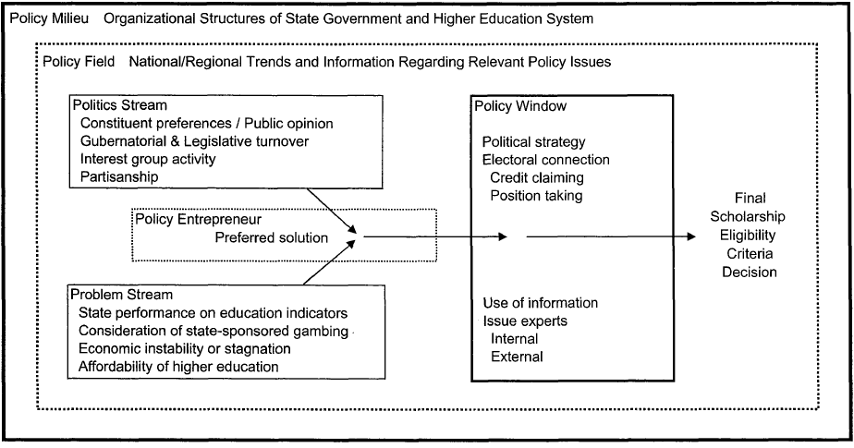
Figure 3-2. Multiple Streams Model of Merit-Based Scholarship Criteria Determination—source: Ness (2010)
This framework, displayed in Figure 3-2, is an important development in the understanding of higher education policy processes, but misses an essential mechanism that shapes both the politics stream and the political strategy used by policy entrepreneurs and policymakers: policy design and the social construction of target populations. This framework, described in detail below, provides substantially more explanatory power for the determination of who gets what, when, and how in financial aid policy.
The Politics of Socially Constructed Target Populations
Variation in the design of tuition-free college eligibility establishes the most important element of political decision making by providing the guidelines for who gets what, when and how (Lasswell, 1971)—effectively, by structuring the allocation of tuition-free college policy benefits to target groups, the variation in design creates the winners and the losers of tuition-free college. For instance, a tuition-free college policy such as the Oklahoma Promise that includes a $50,000 family income cap creates a substantial benefit for low-income students but excludes many middle-class families that may also be struggling to pay for college. This target group is very different from the beneficiary of a program in which eligibility is open to all in-state students who demonstrated academic merit. In opposition to the first means-tested policy design, the latter program expands the beneficiary population to a broader subset of students that have demonstrated some degree of college readiness. As a result of the various beneficiary groups in these different forms of tuition-free college policies, the level of public support also likely varies. In fact, in other policy areas, the relationship between target populations and policy support has been explained in detail by policy scholars interested in the role of power and social constructions in shaping public and elite decision making.
Policy design scholars argue that social constructions, or powerful rhetorical images and stereotypes that are associated with groups of people, will substantially impact public preferences for policies across issue domains (Lawrence, Stoker, & Wolman, 2013; Schneider & Ingram, 1993). These social constructions of target populations convey meaning to the public and to political officials that send signals of deservingness and political power which substantially influence the types of policies that these groups are subject to (Schneider & Ingram, 2012). Social constructions are normative and evaluative, portraying groups as positive or negative with symbolic language that labels groups as deserving or undeserving (Edelman, 1988; Schneider & Ingram, 1993). The typology for socially constructed target groups can be simplified into four main categories summarized in Table 3-1 based on their level of deservingness and political power: advantaged, contenders, dependents or deviants.
Table 3-1. Typology of Target Populations—Source: Schneider and Ingram (1993)
 |  | Social Construction/Deservingness
 |  | Positive | Negative
Political Power | High | Advantaged  Powerful, positively constructed  Ex: elderly, business interests  Benefits: salient, abundant | Contenders  Powerful, negatively constructed  Ex: very wealthy, big unions  Benefits: hidden, submerged
Political Power | Low | Dependents  Politically weak, positively constructed  Ex: children, mothers  Benefits: demeaning, means-tested, stigmatizing | Deviants  Politically weak, negatively constructed  Ex: criminals  Benefits: none, instead burdens

The substantial body of literature on the social construction of target populations has provided empirical and theoretical insight into this phenomenon, providing evidence that the allocation of policy benefits and burdens is systematically related to the target populations’ perceived level of political power and deservingness by political elites and the public (Boushey 2016; Chanley 2005; Donovan 1993; Lawrence, Stoker, and Wolman 2013; Reich and Barth 2010; Schneider and Ingram 1993; Schneider and Ingram 2012). These studies reveal that in order to maximize the probability of re-election, elected officials strategically design policies that benefit positively constructed constituents and burden negatively constructed target populations; this ensures that a broad swath of the public will support the policy and become a mobilized constituency. As a result, policymakers are more likely to allocate benefits to advantaged groups (Ex: business interests) and implement hidden or submerged benefits for contenders (Ex: unions). Dependents (Ex: children, mothers) are likely to also be allocated benefits, but the benefits are often inadequate and demeaning due to the stringent eligibility requirements that convey stigma to target populations (Schneider & Ingram, 2012). Finally, deviants (Ex: criminals, illegal immigrants) are most likely to be allocated burdens and are much less likely to receive a policy benefit like a tuition-free college scholarship.
In the context of tuition-free college policies, this framework would predict that public support for tuition-free college would substantially shift as a result of eligibility requirements such as the family income cap or a minimum academic merit requirement due to the salient socially constructed target population of interest—the key causal mechanism. For instance, limiting eligibility to students that meet merit requirements creates a positively constructed, meritorious or “college-ready” target population that may be more likely to be perceived as deserving of the tuition-free college policy benefit. In fact, recent surveys indicate that one of the main reasons that respondents have supported tuition-free college was a desire for qualified students to go to college regardless of family income (Gerchick, 2018). This suggests that students meeting academic merit standards are positively constructed as deserving and therefore, policies that target students that are required to meet academic merit standards are likely to elicit higher levels of public support.
Hypothesis 1: Tuition-free college policies that require students to meet merit requirements will elicit higher levels of public support.
Additionally, limiting eligibility to students that meet a $50,000 family income cap likely also significantly shifts public perceptions of tuition-free college policies. This is due to the negative stigma of means-tested policies relative to programs with universally designed eligibility. In the context of welfare policies, previous research reveals that universally designed programs, as opposed to targeted means-tested programs shift the focus away from the controversial redistribution and instead invoke a uniting purpose that appeals to the market insecurities in both working and middle class families (Jakobsen, 2011; May, 1991). In this way, universal designs “help incorporate beneficiaries as full members of society, bestowing dignity and respect on them. Conversely, means-tested programs may convey stigma and thus reinforce or expand beneficiaries’ isolation” (Mettler & Stonecash, 2008). In the context of tuition-free college, universally designed tuition-free college policies, unlike those that are only available for families making less than $50,000 such as the Oklahoma’s Promise, may elicit higher levels of public support. Universal policy designs, therefore, may expand the constituency of the program and may convey less stigma and isolation, instead knitting the fabric of communities together. In fact, this proposition was put forth by recent analysis at the Century Foundation, in which the author argues that if more people benefit from the tuition-free college program, the broad swath of beneficiaries will sustain public support for the program over time (Mishory, 2018b). This paper provides the first empirical assessment of this proposition, predicting higher levels of support for universally targeted tuition-free college.
Hypothesis 2: Universally targeted tuition-free college policies, relative to means-tested programs, will receive higher levels of public support.
Finally, it is likely that factors such as political ideology shape how policy design impacts perceptions of tuition-free college policies. In fact, previous research has found that the public relies on credible information from party elites when formulating decisions about policies, which means that the messaging by political elites on policies significantly shapes the formulation of policy beliefs among the public (Druckman, 2001; Feldman & Zaller, 1992). In addition, previous studies have found that these dynamics are not the same across liberals and conservatives—conservative republicans have been found to distinguish between target populations on the basis of perceived deservingness in their designing of and marking of public policies much more than liberal democrats (Bell, Forthcoming; Lawrence et al., 2013). Therefore, conservative respondents may be more likely to be impacted by variation in the socially constructed target populations of tuition-free college policies across the design treatments.
Hypothesis 3: Conservatives will be more likely to be significantly impacted by variation in socially constructed target populations.
A Window into Political Feasibility: Existing Evidence on Support for Tuition-Free College
Public opinion polls on support for tuition-free college policies have been increasingly common in the news media as an increasing number of states, local governments, non-profit organizations and institutions of higher education implement tuition-free college place-based scholarship programs. Existing evidence from public opinion polling data focuses on the demographic and political factors that are associated with support for tuition-free college, which provides insight into the characteristics associated with the propensity to support tuition-free college policies in the U.S.
First, the demographics strongly associated with support for tuition-free college are race, income, and age. In a variety of public opinion polls, non-white respondents are more likely to support tuition-free college policies (Moore, 2015). Moreover, middle and working-class families are much more likely to support tuition-free college. In fact, the biggest determinant of public support for debt-free higher education initiatives was whether a respondent was in the working or middle-class, not whether they were a Republican or Democrat (Demos, 2016). Finally, and unsurprisingly, younger people and millennials, in particular, are more likely to support tuition-free college (Pounds, 2016).
Political affiliation is also a significant determinant of support for tuition-free college, which is not surprising given the previous research demonstrating the importance of ideology and partisanship in predicting preferences for higher education policies (Dar, 2012; Doyle, 2007, 2010). For instance, in 2015, YouGov polls revealed that 90% of Democrats supported President Obama’s plan to offer two years of community college free for students who maintain a C+ average and make progress toward a degree while only 42% of Republicans supported this policy (Moore, 2015). However, in more recent years support for tuition-free college policies has become less polarized by partisanship. A poll by Politico in 2017 found that a plurality (47%) of Republicans agreed with a proposal to make four-year public colleges tuition-free (Jilani, 2017), and the Campaign for Free College polls in 2018 suggest that 67% of conservatives now support state-funded free-tuition (Gerchick, 2018). This poll also revealed that the main reason the majority of respondents supported making public colleges tuition-free was a desire for qualified students to go to college regardless of lacking financial resources and for young people to avoid facing substantial student debt when they finish school (Gerchick, 2018).
While these polling results provide insight into the potential factors that are descriptively related to support for the idea of tuition-free college, they overlook the variation in policy design across states and localities. Given that tuition-free college policies come in so many forms, the heterogeneity in program design likely influences public perceptions of tuition-free college as much, if not more, than the set of demographic and political factors identified in previous studies. Therefore, this study advances this line of inquiry by investigating how variation in policy design of tuition-free college policies impacts the propensity to support these policies. Moreover, this study diverges from previous public opinion polls by utilizing a survey experiment technique in which random assignment avoids the problems of selection bias and facilitates causal identification instead of descriptive correlations.
Research Design
The experimental survey data utilized in this analysis was collected in November 2017. The nationally representative survey sample was recruited by Qualtrics via internet-based pools, with 2,850 respondents over the age of 18 and over 50% of respondents representing families with children aged 5-25. This quota ensured that at least half of the respondents had recent experience with education issues and had some stake in college access and affordability. Appendix Table 1 shows that the sample is representative of the demographic proportions in the national population according to data from the U.S. Census, with the exception of gender and age. To improve the generalizability of results, standard post-stratification weights are applied to the data, as described in detail in the Appendix.
The survey experiment began with a general question where they ranked support for tuition-free college policies, more generally, before they were presented with the treatment prompts. This pre-test measure helps to isolate the causal impact of policy design variation on public support ratings by controlling for the level of baseline support for tuition-free college before respondents are exposed to the variation in program design. After completing the pre-test, respondents were randomly assigned to receive one of the four treatment groups summarized in Table 3-2 and were asked to rank levels of support or opposition to the state-wide tuition-free college policy. The experiment was set up so that the treatments groups varied along two dimensions: the inclusion or exclusion of a family income cap and the inclusion or exclusion of a high school GPA requirement. This means that two groups of respondents were presented with a tuition-free college policy in which all in-state students regardless of family income are eligible. One of these two treatment groups incorporated a 2.0 minimum high school GPA requirement while the other treatment group explicitly excludes academic merit requirements. The next two groups of respondents received a treatment prompt describing a tuition-free college policy in which eligibility is restricted to students with family incomes less than $50,000. Again, one of the treatments includes a 2.0 high school GPA requirement while the second specifies that the policy does not have a GPA requirement. In this way, these four treatment groups capture experimental variation on the impact of including merit-requirements and family income requirements on public perceptions of tuition-free college.
Furthermore, in order to overcome a lack of public awareness on the tuition-free college policy issue, the second section of each treatment prompt presents fictitious quotes from state officials expressing concerns and trade-offs of the policy design. This is an important element of the design as it approximates what the public might be exposed to in the public discourse on tuition-free college and provides credible information from stakeholders on both sides of the debate.

Table 3-2. Randomly Assigned Policy Design Treatments
 |  | High School GPA Requirement
 |  | Yes | No
Family Income Cap | Yes | Target Population: Students with family incomes of $50,000 or less; maintaining a 2.0 GPA  Prompt: Imagine the following situation: Your state has implemented a new policy that fully covers tuition and fees at any college in the state for resident students with family incomes less than $50,000. Students receiving this aid must maintain a 2.0 grade point average (GPA) (C average) or higher. Officials in your state are divided on the best design of the policy. On one hand, Rebecca Wilson, President of the flagship university argues that while she appreciates expanded state support for low-income students with high GPAs, she also believes that the current policy should be expanded to include middle-class families struggling to pay for college and low-income students below the current GPA threshold. On the other hand, State Department of Education Secretary, Emma McDaniel argues that the current policy targets those who need help the most and would not be financially sustainable if all students were eligible. | Target Population: Students with family incomes of $50,000 or less  Prompt: Imagine the following situation: Your state has implemented a new policy that fully covers tuition and fees at any college in the state for resident students with family incomes less than $50,000. There is no grade point average (GPA) requirement for students receiving financial aid through this program. Officials in your state are divided on the best design of the policy. On one hand, Rebecca Wilson, President of the flagship university argues that while she appreciates expanded state support for low-income students, she believes that the current policy should be expanded to include middle-class families also struggling to pay for college. On the other hand, State Department of Education Secretary, Emma McDaniel argues that the current policy targets those who need help the most and would not be financially sustainable if all students were eligible.
Family Income Cap | No | Target Population: All in-state students maintaining a 2.0 GPA  Prompt: Imagine the following situation: Your state has implemented a new policy that fully covers tuition and fees at any college in the state for resident students, regardless of family income. Students receiving this aid must maintain a 2.0 grade point average (GPA) (C average) or higher.  Officials in your state are divided on the best design of the policy. On one hand, Rebecca Wilson, President of the flagship university argues that while she appreciates expanded state support for students with high GPAs, she also believes that the current policy should be expanded to include students below the current GPA threshold. On the other hand, State Department of Education Secretary, Emma McDaniel argues that the current policy targets those who need help the most and would not be financially sustainable if all students were eligible. | Target Population: All in-state students  Prompt: Imagine the following situation: Your state has implemented a new policy that fully covers tuition and fees at any college in the state for resident students, regardless of family income. There is no grade point average (GPA) requirement for students receiving financial aid through this program. Officials in your state are divided on the best design of the policy. On one hand, Emma McDaniel, State Department of Education Secretary, argues the policy is not financially sustainable and should be targeted at the students who need help the most. On the other hand, President of the flagship university, Rebecca Wilson, argues that she appreciates expanded state support for both middle-class and low-income students, as well as those students whose GPAs prevent them from receiving other forms of financial aid.

In each of the treatment groups the University President of the state flagship university, Rebecca Wilson, advocates for expanding access to benefits, while the State Department of Education official, Emma McDaniel, worries about the financial sustainability of the policy. The framing in each of the treatment prompts increases the credible information available to respondents, allowing them to carefully consider the trade-offs of each policy design. After the respondents read the treatment prompt describing the policy targeting in question, they were presented with a series of questions regarding their opinions on the policy. These outcome variables and other non-dichotomous measures are described in detail in Table 3-3.

Table 3-3. Measurement and Wording of Non-Binary Measures
Outcome Measure | Question Wording | Measurement
Support for Tuition-Free College Policy | Do you support or oppose the financial aid policy described above? | 5 – Strongly Support  4 – Somewhat Support  3 – Neither Support nor Oppose  2 – Somewhat Oppose  1 – Strongly Oppose
Perceptions of Fairness | Please rate the degree to which you agree or disagree with the following statement. The policy described above is fair. | 5 – Strongly Agree  4 – Somewhat Agree  3 – Neither Agree nor Disagree  2 – Somewhat Disagree  1 – Strongly Disagree
Income | Was the estimated annual income for your household in 2016 | 1 - Less than $10,000  2 - $10,000 to less than $20,000  3 - $20,000 to less than $30,000  4 - $30,000 to less than $40,000  5 - $40,000 to less than $50,000  6 - $50,000 to less than $60,000  7 - $60,000 to less than $70,000  8 - $70,000 to less than $80,000  9 - $80,000 to less than $90,000  10 - $90,000 to less than $100,000  11 - $100,000 to less than $110,000  12 - $110,000 to less than $120,000  13 - $120,000 to less than $130,000  14 - $130,000 to less than $140,000  15 - $140,000 to less than $150,000  16 - $150,000 to less than $160,000  17 - $160,000 to less than $170,000  18 - $170,000 to less than $180,000  19 - $180,000 to less than $190,000  20 - $190,000 to less than $200,000  21 - $200,000 or more
Region | Created based on the following question: What state or district do you live in? | 1 – Northeast  2 – Midwest  3 – South  4 – West
Education | What is the highest level of education you have COMPLETED? | 1 - Less than High School  2 - High School / GED  3 - Vocational or Technical Training  4 - Some College — NO degree  5 - 2-year College / Associate’s Degree  6 - Bachelor’s Degree  7 - Master’s degree  8 – Doctorate/PhD/ JD(Law)/MD
Ideology | On a scale of political ideology, individuals can be arranged from strongly liberal to strongly conservative. Which of the following categories best describes your views? | 1 - Strongly liberal  2 - Liberal  3 - Slightly liberal  4 - Middle of the road  5 - Slightly conservative  6 - Conservative  7 - Strongly conservative
Data Description
The descriptive statistics for the full weighted dataset are summarized in Table 3-4. This table reveals that, on average, respondents somewhat support tuition-free college before receiving a treatment prompt. With a mean value of 4.04 on a scale of 1 to 5, this means that the average respondent is somewhat in support of tuition-free college policies. In terms of demographics, the sample is 81 percent white and 49 percent male. There is a lot of variation in both income and age across respondents with the average age around 46 years of age. The average ideology is middle of the road, with 44 percent of the sample identifying as Republican.

Table 3-4. Descriptive Statistics with Post-stratification Weights
Variable | N | Mean | SD | Min | Max
Support for Tuition-Free College
Pre-test Support | 2823 | 4.04 | 1.06 | 1 | 5
Post-test Support | 2832 | 3.72 | 1.05 | 1 | 5
Treatment Variables
Family Income Cap | 2850 | 0.49 | 0.50 | 0 | 1
Academic Merit Requirement | 2850 | 0.53 | 0.50 | 0 | 1
Control Variables
White | 2850 | 0.81 | 0.39 | 0 | 1
Male | 2850 | 0.49 | 0.50 | 0 | 1
Income | 2796 | 6.70 | 4.70 | 1 | 21
Age | 2839 | 46.52 | 17.42 | 18 | 91
Region | 2850 | 2.63 | 1.02 | 1 | 4
Education | 2841 | 4.52 | 1.79 | 1 | 8
Ideology | 2836 | 4.04 | 1.68 | 1 | 7
Party ID- Republican | 2731 | 0.44 | 0.50 | 0 | 1

Table 3-5 provides evidence of balance across the treatment groups by displaying the mean demographic characteristics for the full sample compared to respondents in each treatment group. While the demographics across the randomly assigned target population groups appear to be balanced, I provide further evidence of balance by performing a series of logistic regressions utilizing each treatment group as the outcome and the covariates as the explanatory variables. In each of these models, the F-statistic is insignificant, suggesting that the balance assumption is not violated.

Table 3-5. Sample means, by randomly assigned treatment group
Characteristic | All observations | Treatment Group #1 | Treatment Group #2 | Treatment Group #3 | Treatment Group #4
White | 0.79 | 0.78 | 0.79 | 0.79 | 0.79
Black | 0.11 | 0.11 | 0.11 | 0.12 | 0.10
Hispanic | 0.12 | 0.12 | 0.12 | 0.13 | 0.13
Asian | 0.06 | 0.07 | 0.06 | 0.06 | 0.08
Male | 0.39 | 0.36 | 0.41 | 0.37 | 0.41
Income | 6.74 | 6.71 | 6.92 | 6.69 | 6.65
Age | 44.60 | 44.03 | 44.80 | 44.84 | 44.86
Region | 2.62 | 2.58 | 2.67 | 2.62 | 2.62
Education | 4.54 | 4.55 | 4.48 | 4.49 | 4.65
Ideology | 3.97 | 3.88 | 4.07 | 4.00 | 3.92
Republican | 0.53 | 0.51 | 0.57 | 0.52 | 0.51
N | 2,850 | 690 | 726 | 686 | 748
Support for Tuition-free College | 3.69 | 3.65 | 3.71 | 3.66 | 3.74

I present a summary of the variation in support for tuition-free college after receiving the treatment prompts in Table 3-5 and in Figure 3-3. Table 3-5 reveals that treatment group 4, in which the tuition-free college policy was open to all in-state students but required students to meet the minimum 2.0 GPA requirement has the highest average support rating. On the other hand, the tuition-free college policy that limited eligibility to students that are under the $50,000 income cap and did not include a GPA requirement had the lowest average support rating. Additionally, Figure 3-3 makes it clear that the majority of respondents somewhat support, strongly support, or neither support nor oppose tuition-free college.
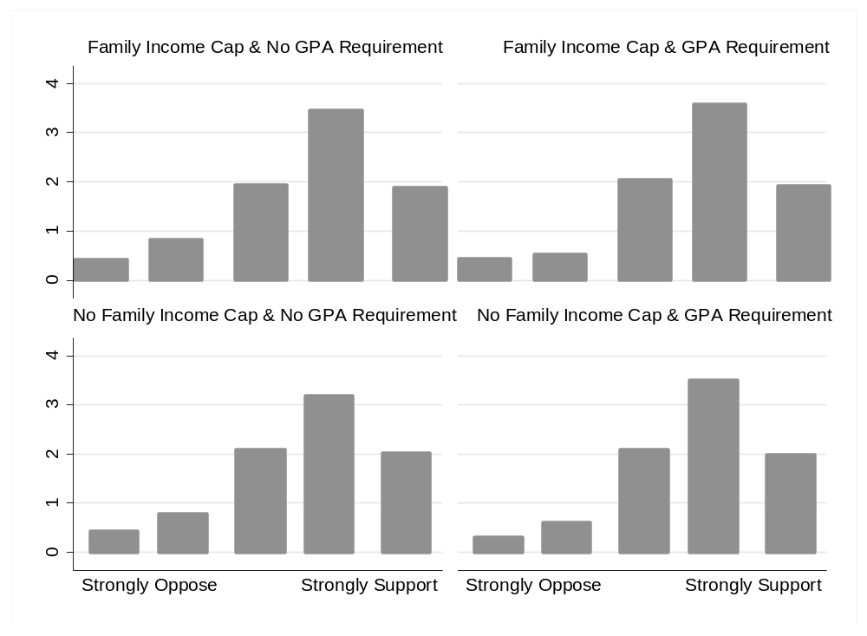
Figure 3-3. Tuition-Free Community College Policy Support Distributions, by Randomly Assigned Target Population. This figure provides a visual depiction of the density of policy support, by randomly assigned target population.

Analytical Approach
To estimate the impact of the policy design treatments on public support and perceptions of fairness, I implement an OLS approach with robust standard errors and post-stratification weights. I also perform the analysis without the post-stratification weights and find that the results are consistent across specifications. The model is summarized in Equation 1, in which support for tuition-free college (1 reflecting strongly oppose and 5 reflecting strongly support) is modeled as a function of the randomly assigned treatments ($T_{i}$) and the control variables $\left(X_{i}\right)$. The randomly assigned treatment groups are combined into two main variables of interest for ease of interpretation. The first treatment variable captures whether the tuition-free college policy included a family income cap or whether it was open to all in-state students. The second treatment variable indicates whether the tuition-free college policy required students to meet a minimum 2.0 GPA requirement or whether the policy was open to students below the GPA requirement. This approach is preferable to conducting the analysis separately for each treatment for two main reasons: first, it maximizes statistical power and second, it avoids the problem of choosing one of the treatment groups to serve as the baseline.
$Y_{i}=a_{i}+∅_{i}T_{i}+β_{i}X_{i}+ε_{i}$ (1)
This equation estimates the impact of the treatments ($T_{i})$and covariates ($X_{i}$) on the level of support or opposition for tuition-free college ($Y_{i}$). In this equation, $a_{i}$ is the intercept, and $∅_{i}$ is the parameter of interest indicating the change in the dependent variable as a result of being assigned to a treatment group when all other variables are held constant. Given that the treatment variables of interest were randomly assigned and passed the balance test, the results should be interpreted as causal effects.
Results
The results of the analysis are presented in Table 3-6. Model 1 reveals that the family income cap treatment did not significantly impact the level of support for tuition-free college. However, the inclusion of an academic merit requirement significantly increased the level of support for tuition-free college by approximately a tenth of a standard deviation.
Table 3-6. Regression Results
Explanatory Variables | Model 1: Support | Model 2: Fairness
Treatment 1: Family Income Cap | -0.001 | -0.115**
 | (0.043) | (0.045)
Treatment 2: Academic Merit Requirement | 0.109** | 0.195***
 | (0.044) | (0.046)
Controls
White | -0.138*** | 0.005
 | (0.052) | (0.055)
Male | 0.029 | 0.066
 | (0.044) | (0.046)
Income | -0.0224*** | -0.0154***
 | (0.005) | (0.006)
Age | 0.000 | -0.002
 | (0.001) | (0.002)
Region | -0.027 | -0.016
 | (0.020) | (0.022)
Education | 0.004 | -0.003
 | (0.014) | (0.015)
Ideology | -0.0431*** | 0.000
 | (0.016) | (0.019)
Party ID-Republican | -0.008 | -0.123**
 | (0.055) | (0.061)
Voted in Last Election | 0.080 | 0.049
 | (0.054) | (0.057)
Baseline Support | -0.475*** | -0.356***
 | (0.025) | (0.025)
Constant | 4.994*** | 4.380***
 | (0.129) | (0.150)
N | 2,624 | 2,614
R² | 0.279 | 0.176
Note: Each model includes post-stratification weights and controls for the pre-test measure of support for tuition-free community college policies (Baseline Support). Robust Standard Errors in parentheses. *p<0.10 **p<0.05 ***p<0.01

This provides support for hypothesis 1, suggesting that positive messages of deservingness/college readiness increase the likelihood of policy support among the public. The control variables in Model 1 and 2 are all in expected directions based on previous polling data—non-white, lower-income, and liberal respondents were more likely to support tuition-free college. Together, this model reveals that tuition-free college policies with merit requirements draw higher levels of public support but that respondents are no less likely to support tuition-free college policies with family income cap provisions.
In Model 2, the results provide evidence on the causal impact of variation in policy design on the likelihood that respondents viewed the policy as fair. This model reveals an interesting inconsistency between the impact of tuition-free college policy design on policy support and perceptions of fairness. Indeed, while respondents are not less likely to support tuition-free college policies with a family income cap, they are significantly less likely to view these policies as fair. This finding aligns with hypothesis 2, suggesting that respondents are more likely to view universally designed policies as fair compared to policies that only target low-income families.
Moreover, Model 2 also reveals that the inclusion of academic merit requirements also significantly influenced public perceptions of fairness. Table 6 shows that respondents were significantly more likely to view tuition-free college policies with academic merit standards as fair. In terms of magnitude, perceptions shifted by almost two tenths of a standard deviation due to the merit requirement treatment and one tenth of a standard deviation due to the family income cap treatment. Taken together, these results support hypothesis 1 and 2, suggesting that the inclusion of merit requirements increases the level of support for tuition-free college while the family income cap decreases perceptions of fairness.
Subgroup Analysis
So far, the analysis has focused on aggregated results, which may neglect underlying heterogeneity in the impact of tuition-free college policy design on public opinion. Therefore, in this section the analysis reveals the moderating impacts of ideology in determining public perceptions of tuition-free college policies.
Table 3-7 presents a comparison of the regression estimates for conservatives and compared to all other respondents. First, Models 1 and 3 provide evidence that conservatives are more likely to support tuition-free college policies when eligibility is limited to students meeting minimum academic requirements while other respondents are not significantly more likely to support merit-based tuition-free college policies. For a conservative respondent, receiving the merit-requirement treatment increased the level of policy support by two tenths of a standard deviation. This provides support for hypothesis 3, suggesting that conservatives are more prone to make decisions based on the perceived deservingness/college readiness of target groups. Interestingly, however, ideology does not reveal significant heterogeneity for the family income cap treatment—conservatives and non-conservatives are both unaffected in their level of support for tuition-free college by the inclusion of a family income cap.
Next, Models 2 and 4 further support hypothesis 3. While conservatives are significantly less likely to think tuition-free college with family income caps are fair, this is not the case for non-conservatives. On the other hand, both conservatives and non-conservative respondents are more likely to view tuition-free college policies as fair when they include minimum GPA requirements. Together, these results reveal that the impact of social constructions of target populations on public perceptions of tuition-free college is moderated by ideology.

Table 3-7. Regression results- Ideological Subgroup Analysis
 | Conservative |  | Non-Conservatives
Explanatory Variables | Model 1: Support | Model 2: Fairness | Model 1: Support | Model 2: Fairness
Treatment 1: Family Income Cap | -0.067 | -0.199** | 0.039 | -0.064
 | (0.080) | (0.082) | (0.050) | (0.053)
Treatment 2: Academic Merit Requirement | 0.229*** | 0.240*** | 0.060 | 0.186***
 | (0.079) | (0.084) | (0.051) | (0.054)
Controls
White | -0.232** | 0.084 | -0.105* | 0.000
 | (0.116) | (0.105) | (0.057) | (0.064)
Male | -0.024 | 0.050 | 0.056 | 0.059
 | (0.081) | (0.083) | (0.052) | (0.053)
Income | -0.035*** | -0.016 | -0.0145** | -0.0144**
 | (0.009) | (0.011) | (0.006) | (0.006)
Age | 0.001 | -0.001 | 0.000 | -0.003
 | (0.003) | (0.003) | (0.002) | (0.002)
Region | -0.081** | -0.027 | -0.002 | -0.009
 | (0.039) | (0.040) | (0.024) | (0.026)
Education | 0.007 | 0.005 | 0.008 | 0.000
 | (0.025) | (0.027) | (0.016) | (0.017)
Ideology | 0.023 | 0.086 | -0.072*** | -0.069***
 | (0.051) | (0.059) | (0.025) | (0.026)
Party ID-Republican | -0.071 | -0.382*** | 0.038 | -0.016
 | (0.104) | (0.117) | (0.065) | (0.065)
Baseline Support | 0.172 | 0.098 | 0.041 | 0.021
 | (0.115) | (0.106) | (0.063) | (0.069)
Constant | -0.517*** | -0.370*** | -0.425*** | -0.337***
 | (0.039) | (0.040) | (0.032) | (0.029)
N | 870 | 869 | 1754 | 1745
R² | 0.362 | 0.236 | 0.197 | 0.140
Note: Each model includes post-stratification weights and controls for the pre-test measure of support for tuition-free community college policies (Baseline Support). Robust Standard Errors in parentheses. *p<0.10 **p<0.05 ***p<0.01

Conclusion
Tuition-free college policies have been rapidly spreading across states and cities, outpacing the accumulation of scholarly literature on the topic. So far, scholars studying tuition-free college have focused almost entirely on student outcomes, leaving the political dynamics of tuition-free college policies understudied. In light of the recent calls for theoretically rigorous and policy relevant research on higher education policy (Hillman et al. 2015), this study integrates a prominent theory in public policy literature into the context of tuition-free college and provides insight into the most politically feasible policy design in the eyes of the public.
Utilizing a nationally representative survey experiment, I highlight how socially constructed target groups invoked in policy designs impact public support for tuition-free college. The results of the survey experiment suggest that when tuition-free college policies are designed universally, so that all students in the residential area are eligible, rather than limiting eligibility to families making less than $50,000, respondents were more likely to view the policy as fair. Additionally, when tuition-free college policies incorporate academic merit requirements, the public is more likely to support the policy and more likely to view the policy as fair. However, these results are not entirely consistent across subgroups—unlike other respondents, conservative respondents are significantly more supportive of tuition-free college when it includes a minimum GPA requirement and were significantly more likely to consider universal tuition-free college as fair. This is consistent with the theoretical expectations and suggests that conservatives are more likely to differentiate between target populations on the basis of deservingness (Lawrence et al., 2013). In practice, this means that state or local leaders looking to implement a tuition-free college policy in a majority conservative area will find more support when the policy is universal and merit-based. Theoretically, this suggests that the social construction of target populations theory provides significant insight the politics of designing tuition-free college and should be integrated into future research on higher education policymaking.
These findings also have a number of practical and normative implications for current discussions on the optimal policy design for sustainable, effective, and politically feasible tuition-free college (Garcia, 2018; Millett, 2017; Tisch, 2018). By shedding light on the political dynamics of public opinion on tuition-free college, this study advances current discussions on political feasibility, which have almost solely focused on the funding streams and neglected the influences of political constituencies (Garcia, 2018; Millett, 2017; Tisch, 2018). Given the challenges many tuition-free college policies have already had maintaining sustainability in funding and political support (Oregon, for instance), it is imperative to better understand which programs are likely to mobilize an active constituency committed to its longevity. In a representative democratic system in which political elites must justify policies to the public in order to get re-elected, scholars interested in policy design and tuition-free college must recognize that “there is social value in making policies correspond to common perceptions of fairness” (Weimer & Vining, 2017, 141). When policies are perceived as legitimate and enjoy support from political elites and the public, they gain constituencies committed to retaining the status quo, which make it harder to abolish or disinvest in programs (Campbell, 2002; Hacker, 2004; May, 1991). Scholars and pundits speculating about the optimal policy design of tuition-free college, therefore, must recognize the importance of public sentiment in driving the strategic choice of policy design by policymakers looking to solidify favorable and sustainable constituencies (Campbell, 2002; Doyle, 2007; May, 1991; Mettler, 2007).
Next, the normative policy implications of these findings are especially important to reflect on. There is a substantial body of evidence suggesting that merit-based financial aid widens the gap between rich and poor in college access and success (Dynarski, 2000, 2002; Dynarski & Scott-Clayton, 2013; Heller & Marin, 2002). In fact, recent experimental evidence suggests that the inclusion of merit requirements may undermine ability of tuition-free college policies to expand college access and affordability and reinforce existing inequality (Harris et al., 2018). Therefore, if tuition-free college policies become the next form of merit-based aid, they may fail to accomplish the goals of expanding college access and success. This means that the most politically feasible policy design—especially in jurisdictions with conservative majorities—may not necessarily be the most effective for expanding college access and success.
This paper represents the first step toward nuanced understanding of tuition-free college policy design and public opinions. That said, there is much more work to do in better understanding the relationship between tuition-free college policy designs and sustainability. Future research should address the impacts of other elements of design on the feasibility and sustainability of tuition-free college and investigate the politics involved in the design and adoption of promise policies. The most effective, feasible, and sustainable tuition-free college policy is still up for debate. Higher education policy scholars should be weighing into this debate and contribute to evidence to the conversations surrounding the delicate balancing act between politics, economics, and effectiveness of tuition-free college policies.

Appendix A: Survey Experiment Methodology, Representativeness & Instrument

Methodology
The survey respondents were recruited by Qualtrics, the leading survey administration company. The participants are recruited through partnerships with 20 online panel maintenance firms that provide a set of diverse respondents across the country. To recruit respondents, Qualtrics reaches out via email communication, and advertisements on social media and phone applications.
Qualtrics acts as a panel aggregator in which market research panels are leveraged to provide a sample that meets the quotas and demographic proportions needed for a nationally representative sample. The quotas set in this survey required every respondent to be age 18+ and 50% of respondents to have children anywhere between 5 years to 25 years of age. The panel base is randomized to avoid any source bias and proportioned to the demographic proportions in the U.S. census to ensure the sample is reflective of the national population.
Data Weighting
To increase the representativeness of the sample and generalizability of results, I apply post-stratification weights to the survey data. To do so, I first calculate the proportion of the U.S. population that shares the demographic characteristics of each respondent according to Census data. Then, I calculate the proportion of the sample that shares the demographic characteristics of each respondent and divide the population proportion from the Census by the sample proportion to provide a weight for each respondent. In effect, this standard post-stratification weighting process determines whether a respondent with a given set of demographic attributes is underrepresented or overrepresented in the survey sample (relative to the national population). Then, in order to account for the under or overrepresentation of certain demographic populations, the weight either increases the statistical emphasis or decreases the statistical emphasis of each respondent. These weights are calculated within Census regions to enable generalization within and comparison across the regions.

Table 3-A1. Demographic Attributes of Survey Respondents Compared to 2016 US Census Estimation
Demographic | % US Population  18 Yrs. of Age and Above* | % Survey  Respondents
Gender
Female | 51.3 | 61.2
Male | 48.7 | 38.8
Age
18-29 | 21.5 | 18.8
30-49 | 33.3 | 43.2
50+ | 45.1 | 38.0
Education
High School Graduate or higher | 87.4 | 98.1
Bachelor’s Degree or higher | 31.2 | 26.2
Ethnicity
Hispanic | 15.8 | 12.5
Non-Hispanic | 84.2 | 87.5
Race
White | 78.5 | 78.9
Black or African American | 12.8 | 11.2
American Indian or Alaska Native | 1.1 | 0.8
Asian | 5.6 | 6.6
Native Hawaiian or Pacific Islander | 0.2 | 0.04
Two or more races | 1.8 | 1.5
Household Income
$0–49,999 | 46.7 | 46.6
$50–99,999 | 29.8 | 36.2
$100–149,999 | 13.0 | 11.5
$150–or more | 10.4 | 5.7
Census Region
Northeast | 18.0 | 18.9
Midwest | 21.2 | 22.5
South | 37.8 | 36.1
West | 23.1 | 22.5
*Note: U.S. Population estimates exclude AK, HI, and the District of Columbia. Population estimates were obtained from the U.S. Census Annual Estimates of the Resident Population by Sex, Age, Race, and Hispanic Origin for the United States and States: April 1, 2010 to July 1, 2016 (PEPASR6H).

Appendix B: Ordinal Logistic Regression Results
Table 3-B1. Ordinal Logistic Regression results
Explanatory Variables | Model 1: Support | Model 2: Fairness
Family Income Cap | 0.00162 | -0.209**
 | (0.0901) | (0.0948)
Academic Merit Requirement | 0.191** | 0.356***
 | (0.0906) | (0.0948)
White | -0.290** | 0.0285
 | (0.117) | (0.112)
Male | 0.118 | 0.153
 | (0.0917) | (0.0951)
Income | -0.0437*** | -0.0268**
 | (0.0101) | (0.0120)
Age | -0.00159 | -0.00544
 | (0.00300) | (0.00364)
Region | -0.0601 | -0.0419
 | (0.0420) | (0.0437)
Education | 0.0150 | 0.00347
 | (0.0279) | (0.0312)
Ideology | -0.0710** | 0.00768
 | (0.0351) | (0.0416)
Party ID-Republican | 0.00457 | -0.222*
 | (0.115) | (0.130)
Voted in Last Election | 0.228** | 0.117
 | (0.116) | (0.119)
Baseline Support | 1.071*** | 0.776***
 | (0.0629) | (0.0589)
N | 2,624 | 2,614
Log Likelihood | -2975.15 | -3135.62
R² | 0.12 | 0.07
Note: Each model includes post-stratification weights and controls for the pre-test measure of support for tuition-free community college policies (Baseline Support). Robust Standard Errors in parentheses. *p<0.10 **p<0.05 ***p<0.01

Table 3-B2. Ordinal Logistic Regression Results-Restricted Sample with Comprehension
Explanatory Variables | Model 1: Support | Model 2: Fairness
Targeted at Low-Income Students | 0.0483 | -0.206
 | (0.136) | (0.143)
Includes Academic Merit Requirement | 0.550*** | 0.421***
 | (0.138) | (0.139)
White | -0.225 | -0.107
 | (0.166) | (0.172)
Male | -0.188 | 0.0820
 | (0.139) | (0.142)
Income | -0.0359** | -0.0222
 | (0.0152) | (0.0175)
Age | 0.00180 | -0.000654
 | (0.00483) | (0.00475)
Region | -0.0970 | -0.0468
 | (0.0648) | (0.0687)
Education | -0.0418 | 0.0260
 | (0.0422) | (0.0427)
Ideology | -0.105* | -0.0849
 | (0.0588) | (0.0590)
Party ID-Republican | -0.00447 | -0.00139
 | (0.180) | (0.182)
Voted in Last Election | 0.366** | 0.0603
 | (0.182) | (0.176)
Baseline Support | 1.060*** | 0.790***
 | (0.0926) | (0.0951)
N | 1,142 | 1,141
Log Likelihood | -1290.71 | -1338.62
R² | 0.14 | 0.08
Note: Each model includes post-stratification weights and controls for the pre-test measure of support for tuition-free community college policies (Baseline Support). Robust Standard Errors in parentheses. *p<0.10 **p<0.05 ***p<0.01

Table 3-B3. Ordinal Logistic Regression results- Ideological Subgroup Analysis
 | Conservative |  | Non-Conservatives
Explanatory Variables | Model 1: Support | Model 2: Fairness | Model 1: Support | Model 2: Fairness
Targeted | -0.0737 | -0.298* | 0.0594 | -0.131
 | (0.163) | (0.172) | (0.108) | (0.111)
Merit Requirement | 0.392** | 0.396** | 0.102 | 0.370***
 | (0.163) | (0.173) | (0.109) | (0.112)
White | -0.408 | 0.330 | -0.242* | -0.0159
 | (0.269) | (0.231) | (0.130) | (0.132)
Male | 0.0251 | 0.130 | 0.170 | 0.124
 | (0.166) | (0.171) | (0.112) | (0.112)
Income | -0.0645*** | -0.0257 | -0.0292** | -0.0260*
 | (0.0176) | (0.0217) | (0.0128) | (0.0137)
Age | 0.000256 | -0.00267 | -0.000873 | -0.00605
 | (0.00605) | (0.00681) | (0.00331) | (0.00395)
Region | -0.153* | -0.0549 | -0.0246 | -0.0334
 | (0.0788) | (0.0819) | (0.0501) | (0.0519)
Education | 0.0387 | 0.0426 | 0.0253 | 0.00396
 | (0.0486) | (0.0576) | (0.0335) | (0.0360)
Ideology | 0.0671 | 0.215* | -0.136** | -0.153***
 | (0.105) | (0.128) | (0.0550) | (0.0547)
Party ID-Republican | -0.0912 | -0.769*** | 0.0771 | -0.0349
 | (0.222) | (0.272) | (0.139) | (0.138)
Baseline Support | 1.122*** | 0.780*** | 1.006*** | 0.767***
 | (0.101) | (0.0971) | (0.0795) | (0.0669)
N | 870 | 869 | 1754 | 1745
Log Likelihood | -1083.25 | -1126.83 | -1882.59 | -1986.63
R² | 0.15 | 0.09 | 0.09 | 0.06
Note: Each model includes post-stratification weights and controls for the pre-test measure of support for tuition-free community college policies (Baseline Support). Robust Standard Errors in parentheses. *p<0.10 **p<0.05 ***p<0.01

Chapter 4: Perspectives from the Front-line: Street-level Bureaucrats, Administrative Burden and Access to Oklahoma’s Promise

Elizabeth Bell, Corresponding Author
and
Kylie Smith

In this chapter, I investigate the role of strategic uses of discretion by street-level bureaucrats in translating statutory designs into outcomes. Therefore, this chapter provides insight into the linkages between politically shaped statutory designs, implementation and program access as shown in Figure 4-1.

Figure 4-1. The Administrative Pathway: How Statutory Designs are Translated in the Implementation Process to Impact Outcomes

Abstract
Emerging public administration scholarship has revealed the negative impact of administrative burden on access to public programs. However, this literature has yet to thoroughly explore forces that mitigate or exacerbate administrative burden for clients seeking access to programs at the local level. In this article, we utilize a mixed methods design to explore the role of street-level bureaucrats in facilitating, or impeding, clients’ ability to overcome administrative burden and gain access to the Oklahoma’s Promise program—a means-tested college scholarship program. We find that street-level bureaucrats have varying role perceptions in the administration of burdens, and that these role perceptions shape whether discretion is used as a force for client resilience to administrative burden or as a force that exacerbates existing barriers to program access. These findings also highlight the implications of uneven street-level conditions and provide rich avenues for future research on administrative burden.

Emerging public administration scholarship has revealed the detrimental impact of administrative burden, or policies contributing to onerous experiences of government, on access to public programs (Heinrich, 2016; Herd, DeLeire, Harvey, & Moynihan, 2013; Moynihan, Herd, & Harvey, 2015). In particular, previous studies reveal how policies contributing to administrative burden may seem neutral in theory but perpetuate inequality by disproportionately reducing access to services for marginalized groups (Nisar, 2017). However, this body of literature has yet to thoroughly explore potential mechanisms by which administrative burden impacts program access at the local level—such as the unique and varying interactions between clients and street-level bureaucrats (SLBs).
This article contributes to existing administrative burden literature by exploring how street-level bureaucrats can exacerbate or alleviate the impacts of administrative burden on program access. We explore these dynamics in the context of Oklahoma’s Promise—a state means-tested financial aid program that requires students to overcome significant compliance, psychological, and learning costs in the application process. Specifically, we hypothesize that the role perceptions and uneven uses of discretion by SLBs will significantly impact the experience of administrative burden for clients and, in turn, predict access to the Oklahoma’s Promise program. To test these hypotheses, we utilize a sequential explanatory mixed methods case study design (Honig 2018), in which we analyze statewide survey data of SLBs charged with implementing the promise program and supplement this analysis with in-depth qualitative follow-up interviews of SLBs utilizing grounded theory methods.
Our analysis reveals that SLBs have varying perceptions of their role in implementation, which translates to uneven uses of discretion that moderate the impact of administrative burden on client access across local agencies. Unlike support officials, who are primarily concerned with using discretion to go above and beyond to help clients navigate complicated systems of administrative burden, compliance officers are primarily concerned with making sure clients meet the set of stringent eligibility requirements before gaining access. These differences in role perception meaningfully impact uses of discretion as well as whether clients are able to overcome administrative burden and gain access to programs—specifically, when SLBs consider their role in implementation to be a compliance officer, rather than a student support official, significantly less students overcome administrative burden and gain access to the program. Moreover, the findings also reveal that SLBs find themselves in local organizations with vastly unequal capacity to support clients in the struggle to overcome administrative burdens. Together, these findings take a step toward better understanding how SLBs moderate the impact of administrative burden on local levels of program access.
This study builds on existing administrative burden literature by making two main contributions. First, it leverages variation at the local level in client access to programs instead of being limited to aggregate measures of client take-up. As a function of this approach, this study extends the study of administrative burden by incorporating the role of street-level bureaucrats and local institutional context. Accordingly, this investigation takes a step toward answering the call of previous administrative burden research to highlight the relationship between front-line administrators and burdens (Moynihan et al., 2015). Moreover, our approach diverges from previous literature that explores changes in laws governing programs by exploring how even in the absence of reform, the same application process will be interpreted in vastly different ways by street-level bureaucrats who wield the power to shape program access. Second, this approach takes on the challenge that Moynihan et al. (2015) set forth to address potential avenues for reducing the impact of administrative burdens. By studying the ways in which the strategic use of discretion by SLBs can moderate the impact of burdens on clientele, this study provides evidence on whether the use of discretion in street-level interactions could be an avenue through which the impact of administrative burdens can be reduced in some local agencies and potentially exacerbated in others. Therefore, this study examines how bureaucratic discretion, when wielded by SLBs in charge of facilitating access to public programs, can be an empowering or disempowering force for clients in the struggle to overcome administrative burden. Moreover, we also explore the extent to which SLBs are constrained by local agency capacity in their efforts to facilitate client access programs impacted by administrative burden.
In the following section, we leverage the existing literature on both administrative burden and street-level bureaucracy to provide theoretical grounding for the set of hypotheses to be tested. Next, we provide a detailed description of the system of administrative burden in the Oklahoma’s Promise scholarship program. Then, we present our research design, data, and analytical approach. Finally, we conclude with a discussion of the implications of our findings for future research.
Previous Literature
We leverage two literatures in public administration—administrative burden and street-level bureaucracy—to provide the theoretical grounding for our investigation. It is our contention that a deeper understanding of the ways in which administrative burden impacts democratic outcomes at the front-lines of government requires acknowledging the influence of SLBs and the context of the local agencies. Combining the insights of these literatures, this study is poised to contribute to theoretical advancement within the study of administrative burden that is grounded in the foundational work on street-level bureaucracy.
Administrative Burden
Fundamental to the study of public administration are the complex interactions between clients and bureaucrats. These interactions are shaped in large part by the rules and constraints placed on bureaucrats by elected officials, which may serve to undermine organizational effectiveness and limit access to programs that clients desire from government. These interactions are the subject of the emerging literature on administrative burden, also known as bureaucratic disentitlement, which describes the experience of client-state interactions as onerous (Brodkin & Majmundar, 2010; Moynihan et al., 2015). In this way, the literature delves into a different transactional category than the traditional red tape literature (Kahn, Katz, and Gutek 1976), which highlights the role of burdens in the form of rules, constraints, and impediments to the internal functioning of organizational activities (Bozeman, Scott, and Reed 1992; Feeney and Rainey 2010). In opposition to the red tape literature, administrative burden literature focuses on the impact of burdens on the extra-organizational interactions between bureaucrats and clients seeking access to public services.
Administrative burden literature has highlighted the use of burden as a political tool with which policymakers and service providers can manipulate the compliance, psychological, and learning barriers that impede client access to public programs. To ration limited resources and exert social control, officials embed programs with barriers or administrative burdens that function to restrict client access to program benefits (Brodkin, 1997; Heinrich, 2016; Lipsky, 1984; Soss, Fording, & Schram, 2011). First, officials can exacerbate learning costs, or the challenges clients face in their efforts to learn about and understand fluctuating eligibility requirements that determine whether they will gain access to the program. Next, officials can manipulate the level of compliance costs, which refer to the documentation demands in the applications required to access public programs. Finally, officials utilize administrative burden to induce psychological costs, including stigma, stress, and a loss of agency for clients attempting to access public programs. Together, these three components of administrative burden are wielded as strategic policy tools by public officials engaging in hidden politics to enact significant policy changes to programs without participation in the traditional democratic processes of political consideration, debate, and public transparency (Moynihan, Herd, & Ribgy, 2016). This is a particularly effective political tool because elected officials can avoid making high-profile, controversial decisions that may threaten their chances of re-election, such as funding cuts or program elimination, and instead utilize administrative burden to restrict access to programs not aligned with their political priorities (Lipsky 1984; Moynihan et al. 2015). Therefore, administrative burden is a powerful policy tool with which officials can manipulate democratic outcomes through the enactment of policy changes that induce learning, compliance, and psychological costs in client-state interactions.
The enactment and implementation of administrative burden has consequences for a variety of democratic outcomes, including: 1) civic engagement and efficacy (Bruch, Ferree, and Soss 2010; Soss 1999), 2) access to public programs and policy effectiveness (Heinrich & Brill, 2015; Herd et al., 2013), and 3) social equity (Jilke, van Dooren, and Rys 2018; Nisar 2017). First, administrative burdens can influence whether clients view government as a source of empowerment or disempowerment. In turn, administrative burdens shape perceived political efficacy (Soss 1999), as well as the likelihood that clients will take the essential step in any healthy democracy to engage in political and civic actions (Bruch, Ferree, and Soss 2010). In fact, administrative burden may shape not only the perceived efficacy of political action but also the perceived fairness and effectiveness of government as a whole (Heinrich, 2018).
In addition, administrative burden literature has also documented the detrimental impacts of administrative burden on access to public programs and the effectiveness of policies aimed at alleviating suffering and improving client well-being (Cherlin, Bogen, Quane, & Burton, 2002; Heinrich, 2018; Heinrich, 2016; Herd et al., 2013; Shore-Sheppard, 2008; Wallace, 2002). For instance, enhanced levels of administrative burden have been linked to limited participation in social programs such as workforce training, Medicaid, and Temporary Assistance for Needy Families (TANF) (Cherlin et al. 2002; Shore-Sheppard 2008; Wallace 2002). Increased administrative burden and restricted access to public programs has serious consequences for those that rely on public assistance programs for their livelihood. For example, in the context of the South African cash transfer program, the loss of benefits due to additional programmatic burdens resulted in children engaging in higher levels of risky behavior and experiencing lower levels of educational attainment (Heinrich, 2016). On the other hand, in the context of Medicaid, scholars have revealed that when burdens are reduced, program enrollment increases (Herd et al. 2013). Together, these studies suggest that increased administrative burdens negatively impact access to essential social programs for clients, call attention to the potential for administrative burden to degrade program impacts for clients, and argue for improved program access and client outcomes through reductions in burdens.
Finally, administrative burden exacerbates inequality by disproportionately impacting the most disadvantaged populations, who have fewer financial, social, and cultural resources with which to navigate and overcome administrative burdens (Cherlin et al., 2002; Nisar, 2017; Nisar, 2018). Recent evidence suggests that private elderly care service providers discriminate against minority applicants by withholding information on the application process, which induces uneven learning costs across clients (Jilke, van Dooren, and Rys 2018). Moreover, research has revealed that higher levels of administrative burden in the eligibility requirements and enrollment process of the TANF program were associated with particularly pronounced declines in participation among the most disadvantaged populations (Brodkin and Majmundar 2010). Given such findings, administrative burden may counteract the democratizing and equalizing force of public assistance programs, and instead perpetuate the system of inequality that these programs intend to alleviate. However, at the same time, there are entities, such as nonprofit organizations, that can reduce the administrative burden placed on marginalized groups by providing a source of additional client-state interactions in which the cognitive, temporal and economic costs of accessing government programs can be significantly reduced (Nisar, 2018). In particular, some nonprofits have "made it their business to ameliorate the administrative burden on the victim by slicing through the red tape" as a way to fulfill their organizational mission (Wiley and Berry 2018). This study takes a different approach, investigating whether such counteracting sources of assistance can also come from an insufficiently explored, yet essential actor in the program implementation process—the street-level bureaucrat (SLB).
While administrative burden studies have substantially advanced scholarly understanding of the impact of burdens on a whole host of democratic outcomes, the variation across local agencies in the implementation of burdens has been understudied. With the notable exception of Heinrich (2018), who highlights the variation in the implementation of immigration policy across local registrar offices in Texas, the role of local agencies and uneven uses of street-level discretion is omitted from the analysis of administrative burden and program access. This is especially surprising considering that the manipulation of administrative burdens was perhaps first captured by Lipsky's (1984) seminal examination of street-level bureaucracy. In this work, Lipsky (1984) revealed that instead of making high-profile controversial decisions to cut programs that may impact the likelihood of re-election, policymakers often push decisions regarding resource distribution down onto front-line bureaucrats who interact daily with clients. This devolution of authority to the front-line creates the potential for administrative practices to vary geographically, which introduces the possibility for bureaucratic discretion to serve as a force for disentitlement and rationed access to limited resources for public programs (Brodkin 2008; Lipsky 2010; Scott 1997; Soss, Fording, and Schram 2011). Therefore, in the study of administrative burden, it is an essential next step to investigate the ways in which the strategic use of discretion by SLBs at the front-line of government moderates the impact of burdens on access to programs. Indeed, it is our contention that in a program impacted by administrative burden, the use of discretionary authority by SLBs plays a key role in the resilience of clientele in overcoming barriers to access.
Street-level Bureaucrats and the Strategic Use of Discretion
As the front-line of government, SLBs wield the discretionary authority to shape whether clients gain access to programs and whether policy goals are translated into policy outcomes (Keiser, 1999; Kelly, 1994; Lipsky, 2010; Scott, 1997; Weissert, 1994). Accordingly, SLBs serve as “empowered citizen agents, who in their decisions to ration resources, provide access to programs, and sanction individuals” and in doing so “both communicate and convey social status”(Maynard-Moody & Musheno, 2000, p. 355). This use of discretion is essential due to the variability of individual client cases, which may be in conflict with or overlooked by the system of often-ambiguous laws. In these cases, SLBs make discretionary decisions based on value judgments for individual clients in navigating the inevitable tension between the demands of policy and the unique needs of individuals in nonroutine cases (Maynard-Moody & Musheno, 2003). In this way, street-level agents can be thought of as informal policymakers whose normative choices regarding “which rules, procedures, and policies are acted on; who gets what services and who is hassled or arrested” substantially impact the experiences of government programs (Maynard-Moody & Musheno, 2003, p. 155). In other words, in both formal and informal roles, SLBs utilize discretion in ways that shape the ability of clients to access public programs and, in doing so, are a key player in the translation of policy objectives into policy outcomes.
In the exercise of discretionary authority, SLBs are significantly influenced by four main factors identified in previous literature: 1) communication by political or administrative superiors on the prioritization of policy goals, 2) organizational implementation factors, 3) knowledge and attitudes of SLBs about tasks, work and clients, and 4) contextual factors such as workload, clientele and external pressure from political and social environments (May and Winter 2009). First and foremost, previous literature has revealed that the most influential factor is the individual values, knowledge, and beliefs of SLBs about policy, clients and the work environment (Lipsky, 2010; Maynard-Moody & Musheno, 2003; Sandfort, 2000). Previous studies have found that even if policymakers and high level administrators attempt to change the priorities of street-level operations, SLBs are often still motivated primarily by their individual values and beliefs in the use of discretion (Brehm and Gates 1997; Riccucci 2005; Sandfort 2000). For instance, in the context of welfare reform, Riccucci et al. (2004) find that despite welfare reform policy changes aimed at reducing access to welfare, front-line employees did not deter clients from staying on welfare rolls. In this case, SLBs were unwilling to implement the policy change and utilized discretion as a force of resistance. Although the literature has documented the role of individual values and beliefs as a dominating force in exercising discretion, other factors are not totally irrelevant in discretionary decisions. In fact, managerial influences such as training, performance monitoring, and leadership, as well as contextual factors, such as workload and political environments, can impact the alignment of policy goals and SLBs’ priorities (May and Winter 2009; Riccucci et al. 2004). However, the main element shaping the use of discretion by SLBs are individual values and beliefs, which introduces the potential for individual SLBs to mitigate or exacerbate the sting of administrative burden.
Indeed, in the context of administrative burden, there is either the potential for SLBs to 1) comply with rules and policy directions perceived as justified, which may limit access to public programs, or 2) leverage discretion to counteract the forces of administrative burdens on clients that they perceive as deserving of assistance. As manifestations of individual values and beliefs of SLBs, we predict that a key factor in this process will be role perceptions, which influence the use of discretion and likely impact program access under a system of administrative burden (Maynard-Moody & Musheno 2000; Riccucci, 2005; Sandfort, 2000). This expectation is grounded in previous literature that finds varying meanings of success and role perceptions, with some SLBs going out of their way to help those who need it no matter the consequences and others acting within the strict set of rules and boundaries to act in compliance with the law and higher level administrators (Maynard-Moody and Musheno 2000). This divergence in the use of discretion is inextricably linked to the ways in which SLBs perceive their role in the implementation of a program. For instance, if SLBs see themselves as agents of the state who are responsible for protecting a valuable, tax-payer funded program from those who would cheat the system, the use of discretion might be first and foremost about gatekeeping. To these SLBs, administrative burden in the application process may be necessary to balance the budget and ensure that tax payer dollars are not wasted on undeserving clientele. In these cases, we predict that SLBs taking on a compliance role, in which the SLB is mainly concerned with making sure applicants are meeting program requirements, will be negatively associated with program access.
H1: In a program affected by administrative burden, SLBs’ that take on a compliance role will be negatively associated with program access.
On the other hand, another SLB might take on the responsibility for fulfilling the program goals of expanding access to opportunity and may use discretion to increase resilience to the administrative burdens. Learning costs, along with psychological and compliance costs, may be formidable only in situations where SLBs do not take on the responsibility for reducing these costs. If part of the perceived role in implementation involves making sure students do not feel the stigma, information asymmetry, and compliance burdens in the application process, clients may be able to overcome administrative burdens and gain access to the program. These SLBs, because they believe their role to be a client advocate or support official, may even bend the rules on behalf of an applicant they consider deserving of program access. Therefore, we predict that SLBs taking on a support role will likely use discretion in ways that reduce learning, compliance and psychological costs for applicants and facilitate a higher level of program access.
H2: In a program affected by administrative burden, SLBs’ that take on a support role will be positively associated with program access.
The Oklahoma’s Promise Program
We strategically select Oklahoma’s Promise Program as the test case for these hypotheses because the program requires students to meet a stringent set of requirements, similar to the programs in administrative burden literature, but reflect a new and unique policy area. The Oklahoma Promise’s program is a means-tested financial aid policy designed to increase college access by covering the full cost of tuition for low-income students attending Oklahoma colleges (Oklahoma State Regents for Higher Education 2017). As an early commitment financial aid program, Oklahoma’s Promise seeks to not only provide financial support to low-income, first-generation students but also to reduce the information asymmetry between these students and their higher-income peers. In this way, the Oklahoma’s Promise program was created with the explicit intention of shifting the burden away from families in the college preparation and financial aid process to reduce inequalities in college access and affordability. However, the administrative burdens placed on families during the application process, coupled with decentralized implementation processes, may undermine the ability of low-income students to access the scholarship program.
The Oklahoma’s Promise program was created by the Oklahoma Legislature in 1992 and has been amended significantly over time. Since its enactment, lawmakers have increased the eligibility requirements for the program, effectively expanding the burdens on prospective promise students over time. As part of the original program design, students were required to meet income thresholds, take a core high school curriculum, maintain a 2.5 high school grade point average (GPA), attend school regularly, and refrain from criminal activity and substance abuse. These already stringent eligibility requirements have increased over time. Lawmakers have expanded the core curriculum, required evidence of citizenship, enforced additional income verification requirements once a student enters college, required students to meet satisfactory academic progress and avoid any disciplinary incidents, eliminated support for remedial courses, and capped the total number of credit hours that the program will cover for students. These requirements affect the ability of students to 1) understand the program eligibility requirements, 2) comply with the requirements, and 3) develop the psychological strength to overcome the social stigmas associated with the recurring means-tests along the way.
Moreover, these programmatic changes are implemented through both the Oklahoma State Regents for Higher Education (OSRHE), which is the centralized state agency responsible for administration of the scholarship program, and through a decentralized system of SLBs. Indeed, while Oklahoma’s Promise is stringent and prescriptive regarding its eligibility requirements, substantial discretion is delegated to the decentralized K-12 school system in compliance certification and program advertisement. Given the existence of local variation in resources and community values within this decentralized system, front-level employees maintain high levels of discretion in how they conceive of and carry out their duties as implementation officials in the Oklahoma’s Promise program. Therefore, the Oklahoma’s Promise scholarship program, as opposed to a financial aid program that is automatically awarded to students based on income, like the federal Pell Grant, requires the interaction of SLBs charged with implementing the program and students in the application process.
As a result, differential use of discretionary authority in program administration likely impact the experiences of clientele and factor into the variation in program access across high schools shown in Figure 4-2. Figure 4-2 shows that there is substantial variation in the distribution of program access—measured as the proportion of students gaining access to the Promise in each high school—and that the survey sample approximates the state-wide population. The determinants of this variation in the ability of students to access the Oklahoma’s Promise program will be explored in detail in the forthcoming analysis.
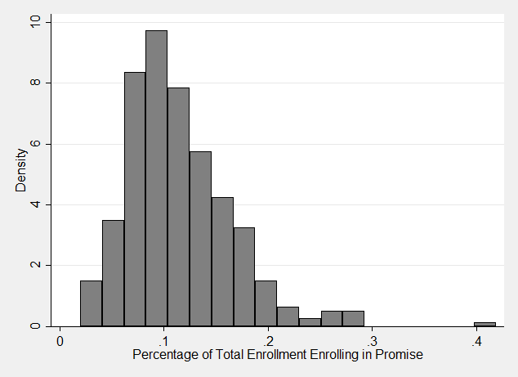
High Schools in Oklahoma

N=382 Mean=0.114

High Schools Represented in Survey
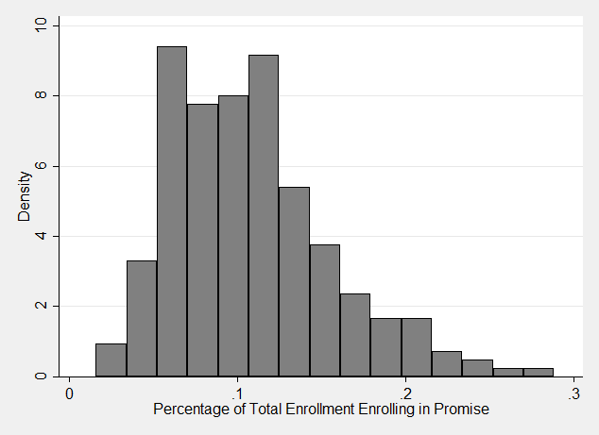

N=134 Mean=0.113

Figure 4-2. Variation Across High Schools in the Proportion of Students Receiving the Oklahoma’s Promise Scholarship (2015)
Research Design
To investigate how SLBs moderate the impact of administrative burden on access to the Oklahoma’s Promise program, we implement a sequential explanatory mixed methods design that leverages data from four main sources: first, we leverage a statewide survey of SLBs in charge of implementing the Oklahoma’s Promise program; second, we supplement the survey data with in-depth interviews; third, we leverage data available through the National Center for Education Statistics (NCES) Common Core Dataset (CCD) on high school characteristics; and fourth, we gather data from OSRHE on the number of students in each high school enrolling in the promise program in the most recent year available (2015-16) (Creswell 2009). The combination of both quantitative and qualitative data allows for a mutually supportive mixed methods case study design, which has been recently lauded as a particularly effective approach to the study of public agencies (Honig 2018; Hendren, Luo, and Pandey 2018). This approach allows for triangulation of findings, effectively increasing the validity of the findings and reducing bias (Burch and Heinrich 2016). The use of qualitative interviews enables us to not only substantiate quantitative findings from survey results but also to explore explanatory factors in SLB behavior that may be omitted from the survey questions. On the other hand, the survey analysis ensures that findings from the qualitative interviews are indicative of systematic, generalizable phenomena that are not dependent on a single agencies’ context. The survey and interview protocol were deliberately created as complementary sources of data that work to account for the weaknesses of each strategy when used in isolation. In our sequential explanatory research design, we first conducted the statewide survey which then informed our development of the interview plan and facilitated the integration and triangulation of the results.
The statewide survey data was completed by 167 high school personnel involved in administering the Oklahoma’s Promise program in May 2018. This sample reflects the observations for which we were able to match the survey data with the high school level data and the observations for which we know the respondent was working at the same high school back in 2015—the year in which we observe student access. These respondents represent 134 unique high schools across the state, which allows us to observe the patterns across a large set of schools that contain rich variation in urbanicity, administrative support, and access to resources. We incorporate a series of survey questions that control for other factors that impact the strategic use of discretion outside of the main role perception measures (May and Winter 2009). The measurement and operationalization of these controls is described in the Appendix.
Next, we gathered data from the NCES on the number of students eligible for free or reduced-price lunches as well as the total enrollment and other descriptive characteristics of each high school in the 2015-16 school year. This data helps us to account for the total client population and the proportion of students that are likely eligible for the Oklahoma’s Promise scholarship program at each high school. We then matched the survey data and the NCES data to the data on the number of Oklahoma’s Promise recipients by high school in the 2015-16 school year provided by OSRHE. Based on this data, we construct our dependent variable—the proportion of students enrolling in the Oklahoma’s Promise in each high school out of the total enrollment.
We triangulate the findings of the quantitative survey data with evidence from in-depth semi-structured interviews using grounded theory methodology, which provides a systematic approach to qualitative data analysis (Corbin and Strauss 2007; Strauss and Corbin 1998). Grounded theory is an appropriate methodology for this study because it enables the study of phenomena – the differential impact of SLBs on access to Oklahoma’s Promise program – on which few empirical studies have been conducted to date. In grounded theory methodology, theory is developed through the iterative process of creating and refining “abstract conceptualizations of particular phenomenon” (Jones, Arminio & Torres, 2014, p. 77). Using Strauss & Corbin’s (1998) guidelines for grounded theory methods, we employed several tools of analysis to explore the data that emerged from the interviews, including open and axial coding and constant comparative analysis. Open coding and axial coding occurred simultaneously, in which we broke data apart to identify concepts through open coding and then reassembled the data through axial coding to relate the concepts identified. In addition to coding, we utilize the constant comparison technique to compare incident with incident in the data and identify similarities and differences within the data (Corbin and Strauss, 2008).
Moreover, Jones, Torres and Arminio (2014) assert that sampling in qualitative research is generally purposeful in nature, meaning that researchers seek out information-rich cases that hold the potential to provide insight about the topic of interest. In accordance with purposeful sampling, we initially reached out to counselors from 5 high-performing and 5 low-performing schools recommended by OSRHE Oklahoma’s Promise staff, as measured by the percentage of students enrolling in Oklahoma’s Promise. Finding no willing participants, we subsequently reached out to 38 survey respondents who indicated in their survey that they might have interest in participating in a follow-up interview. A total of six interviews were conducted, with interview participants representing urban, suburban, and rural school sites. Interviews were conducted via phone, audio-recorded, and lasted approximately 30 to 45 minutes in length. An interview protocol was utilized to guide the interview, but we also asked probing questions to elicit rich discussion on certain topics of interest that emerged. From the interviews, 103 pages of transcripts were produced. The triangulation of the survey data with this interview data facilitates a deeper understanding of the on-the-ground realities and constraints of the SLBs’ task environments as well as the influence of their personal values and belief systems, working to increase the validity of our findings.
Quantitative Data Description
Table 4-1 shows that most respondents were serving as counselors, but that 11 percent of respondents are serving in more than one position. In the inadequately funded system of K-12 education in Oklahoma, it is not altogether surprising that some administrators are also expected to serve as counselors and cover other staffing shortages (Education Week 2018). In terms of demographics, the survey sample is overwhelmingly female with high levels of education and the modal annual income between $50,000 and $100,000. The sample is also mostly white (82 percent), with 56 percent of the sample identifying as somewhat or strongly conservative and 54 percent identifying with the Republican party.
Table 4-1. Descriptive Statistics  Variables | Source | N | Mean | SD | Min | Max
Position
Counselor | Survey | 167 | 0.886 | 0.318 | 0 | 1
Other/More Than One Position | Survey | 167 | 0.114 | 0.319 | 0 | 1
Demographics
Male | Survey | 167 | 0.048 | 0.214 | 0 | 1
Income | Survey | 167 | 2.222 | 0.802 | 1 | 4
Education | Survey | 167 | 6.994 | 0.257 | 6 | 8
Race & Ethnic Identity
White | Survey | 167 | 0.820 | 0.385 | 0 | 1
Black or African American | Survey | 167 | 0.018 | 0.133 | 0 | 1
Native American | Survey | 167 | 0.078 | 0.269 | 0 | 1
Hispanic | Survey | 167 | 0.072 | 0.259 | 0 | 1
Political Affiliation
Ideology-Conservative | Survey | 167 | 0.557 | 0.498 | 0 | 1
Party ID-Republican | Survey | 167 | 0.545 | 0.499 | 0 | 1
Perceived Role
Compliance Officer | Survey | 167 | 0.423 | 0.495 | 0 | 1
Student Support | Survey | 167 | 0.591 | 0.492 | 0 | 1
Information Disseminator | Survey | 167 | 0.471 | 0.500 | 0 | 1
Task Environment
High Discretion | Survey | 167 | 0.521 | 0.201 | 0 | 1
% of Time Spent on College Preparation | Survey | 167 | 44.575 | 21.868 | 5 | 95
% of Students Able to meet One-on-One | Survey | 167 | 79.682 | 29.574 | 0 | 100
School Family Income Comparison | Survey | 167 | 3.611 | 0.863 | 2 | 5
Partner with Nonprofits | Survey | 167 | 0.132 | 0.339 | 0 | 1
Administrative Support | Survey | 167 | 1.054 | 0.275 | 1 | 3
High School Characteristics
Total Enrollment | NCES | 167 | 572.34 | 657.7 | 24 | 3489
Percent FRL | NCES | 167 | 0.553 | 0.175 | 0.071 | 0.985
Percent OK Promise Recipients | OSRHE | 167 | 0.113 | 0.048 | 0.038 | 0.288

Next, the survey data reveal substantial variation in the self-identified role of the respondents as well as their access to resources and time spent on college preparation. Table 1 shows that approximately 50 percent of the respondents identified with the compliance officer and information disseminator roles. Moreover, 62 percent of respondents identified as a student support official. It is important to note that this question allowed respondents to be able to identify with more than one role, if desired. The measurement and operationalization of these key variables is described in Table 4-2 below. The information dissemination is treated as the neutral category, with support and compliance roles being the variables of interest based on the theoretical hypotheses.
Table 4-2. Measurement and Operationalization of Role Perception Variables
Concept | Question Wording | Measurement
Role Perception | Which of the following best describes the role you identify with when dealing with students applying for the Oklahoma’s Promise scholarship program? Please select all that apply.  - Compliance Officer: I am primarily concerned with making sure students meet program requirements and have the right documentation  - Student Support Official: I am primarily concerned with helping all potentially eligible students navigate the process and ensure that as many eligible students as possible receive the Oklahoma Promise Scholarship  - Information Liaison: I am primarily concerned with disseminating information about the scholarship requirements | 1—Identifies with the role  0—Does not identify with the role
Note: Respondents could choose more than one role. Each role is coded as a separate dichotomous variable.

The descriptive statistics also demonstrate that, on average, less than half of the respondents’ time is spent on college preparation (44 percent) but that the average SLB meets with almost 80 percent of students one-on-one. Additionally, 13 percent of survey respondents indicated that they partnered with a community organization in the implementation of the Promise program. The average respondent indicated the perceived family incomes of their school population was about the same (3) or slightly lower (4) than the surrounding area and the perceived administrative support of efforts on behalf of students applying for the Promise program was generally low.
Finally, the data from CCD help provide a picture of the school level characteristics. This data reveals that the average high school in the sample had 574 students enrolled and 55 percent of students eligible for free and reduced-price lunches. Lastly, as we would expect, the proportion of students eligible for free and reduced-price lunch at each school is substantially larger than the proportion of students that actually end up receiving the Promise scholarship. This data suggests that there is substantial variation across high schools in the proportion of students accessing the Promise program, providing the ideal context to explore the mechanisms by which administrative burden translates to restricted program access at the local level.
Quantitative Analytical Approach
We model the variation in the proportion of students gaining access to the Oklahoma’s Promise program at each high school as a function of the role perception in addition to a set of control variables capturing organizational as well as individual factors that have been identified as important in previous studies on street-level bureaucracy. At the individual level, these factors include education, race, gender, ideology, perceived support from administration, the number of years they have been working in the position, and the task environment ($X_{i}$). At the organizational level, we include the proportion of students in the FRL program and the perceived average family income of the school ($X_{s}$). Access to Oklahoma’s Promise program is modeled as a function of these sets of variables in the following equation:
$Y_{s}=α+R_{i}δ+X_{is}β+ε_{i}$ (1)
where $Y_{s}$ is the proportion of school enrollment that gains access to the Oklahoma’s Promise scholarship, $α$ is the constant, $ε_{i}$ is the error term, $X_{is}$ are the independent variables at the individual ($i$) and school level ($s$) and $R_{i}$ are the dichotomous role perception variables.
Quantitative Findings
The analysis predicting the proportion of students accessing the Oklahoma’s Promise scholarship is presented in Table 4-3. These results reveal that the self-identified role is significantly related to program access, providing support for both key theoretical hypotheses. In high schools where personnel indicated that they perceive their role as a compliance officer, a smaller proportion of students enroll in the promise program (p<0.01). On the other hand, high schools that employ SLBs identifying as student support officials were significantly positively related to the proportion of students enrolling in the promise program (p<0.05). In terms of magnitude, these role perceptions translate to approximately 2.3 percent more students gaining access in the case of support officials and 1.8 percent less students gaining access in the case of compliance officers. These findings reveal that the role identification of SLBs is significantly related to the ability of students to overcome the barriers of administrative burden and gain access to the promise program, which is also corroborated with the qualitative evidence presented in the next section.
Moreover, the results in Table 4-3 also reveal interesting relationships between the control variables and the level of program access. For instance, respondents who identified with the Republican party were significantly negatively related to the proportion of students that overcome administrative burden and access the Promise program.
Table 4-3. Regression Results
 | Percent of Total Enrollment Accessing Oklahoma's Promise
Role Perception
Support Role | 0.023**
 | (0.007)
Compliance Role | -0.018*
 | (0.007)
Information Dissemination Role | 0.000
 | (0.006)
Individual Controls
White | -0.003
 | (0.009)
Education | -0.010
 | (0.014)
Conservative | 0.010
 | (0.007)
Republican | -0.021*
 | (0.008)
Promise Knowledge | -0.007
 | (0.004)
Years in Position | 0.003
 | (0.004)
Perceived Support from Administration | 0.009
 | (0.006)
High Discretion | 0.002
 | (0.007)
% of Students Able to Meet With | 0.001**
 | (0.0001)
% of Time Spent on College Preparation | 0.000
 | (0.0002)
School Level Controls
School Family Income Comparison | -0.009
 | (0.004)
Partner with Nonprofits | -0.018
 | (0.009)
Percent FRL Students | 0.040
 | (0.0258)
Constant | 0.174
 | (0.0891)
Observations | 167
R-squared | 0.247
Robust standard errors in parentheses clustered at the school level; ** p<0.01, * p<0.05

In terms of magnitude, this model suggests identifying with the Republican party was associated with a 2 percent reduction in the proportion of students gaining program access. This finding likely reflects the role of political beliefs in shaping interpretations of burden and the formulation of role perception, further indicating the importance of values and beliefs of SLBs (Lavertu et al. 2013). Finally, the findings highlight the importance of task environments in predicting access to the promise program. For instance, the more students the SLB meets with one-on-one, the more likely the school is to have a higher proportion of students able to overcome barriers and gain access to the program. This reveals that SLBs find themselves in schools with unequal capacity to increase student resilience to administrative burden, which is also corroborated in the qualitative analysis in the next section.
Given the potential for SLBs to take on multiple roles, we also perform the same model presented in Table 4-3 with an interaction between the support and compliance role and present the results in Table 4-4. These results add significantly more nuance to the relationships uncovered previously. First, those counselors that take on only a support role are insignificantly related to program access. On the other hand, counselors that take on only a compliance role are significantly negatively associated with program access at an even higher substantive magnitude than the previous results. Lastly, when counselors are taking on both a support and compliance role, this is insignificantly related to program access. These findings suggest that taking on the support role, in addition to the compliance role, counteracts the negative association we find with those counselors who are only identifying as compliance officers. Moreover, these findings suggest that it is likely easier to prevent access than promote access.

Table 4-4. Regression Results with Role Perception Interaction
 | Percent of Total Enrollment Accessing Oklahoma's Promise
Role Perception
Support Role | 0.008
 | (0.011)
Compliance Role | -0.034**
 | (0.011)
Support Role*Compliance Role | 0.035
 | (0.017)
Information Dissemination Role | -0.009
 | (0.008)
Individual Controls
White | -0.003
 | (0.009)
Education | -0.012
 | (0.014)
Conservative | 0.010
 | (0.007)
Republican | -0.021*
 | (0.008)
Promise Knowledge | -0.008
 | (0.005)
Years in Position | 0.003
 | (0.004)
Perceived Support from Administration | 0.009
 | (0.005)
High Discretion | 0.001
 | (0.007)
% of Students Able to Meet With | 0.001**
 | (0.0001)
% of Time Spent on College Preparation | 0.000
 | (0.0002)
School Level Controls
School Family Income Comparison | -0.009
 | (0.004)
Partner with Nonprofits | -0.016
 | (0.009)
Percent FRL Students | 0.042
 | (0.025)
Constant | 0.201*
 | (0.0879)
Observations | 167
R-squared | 0.261
Robust standard errors in parentheses clustered at the school level; ** p<0.01, * p<0.05

For instance, if a counselor has gone above and beyond to support students by certifying compliance with all of the academic and conduct requirements, parents still may fail to send in the required income or citizenship documentation. Therefore, while student support officials may do everything in their power to promote access, they still may face challenges in facilitating student access. On the other hand, all it takes to prevent access is refusing to certify compliance on any of the long list of requirements, which makes restricting access much simpler than going above and beyond to increase student resilience to administrative burdens.
Qualitative Findings
Our grounded theory analysis reveals three main findings: 1) high school counselors’ role perceptions influence the use of discretion, 2) the self-identified role is largely a product of beliefs about responsibility, and 3) administrative support and institutional capacity constrain SLBs’ ability to facilitate program access.
Role Perception and Discretion: Routine Activities vs. Going the Extra Mile
In the context of Oklahoma’s Promise, administrative burden is not self-implementing—it functions through a system of decentralized authority, in which local agencies delegate discretion to the front-lines of government, where the individual values, expertise, and moral judgments of SLBs come into play. Accordingly, high school counselors serve a key role in advertising the Oklahoma’s Promise scholarship and assisting students enroll in and complete program requirements. Our survey asked respondents to indicate whether they see themselves as performing compliance officer, information dissemination, or student support roles with regard to implementation of the Oklahoma’s Promise program. Qualitative data from follow-up interviews with survey respondents confirm these types of roles among counselors and administrators involved in the implementation of the program. Furthermore, the interviews reveal that these roles translate to different uses of discretion, and specifically in decisions to engage in routine activities or to “go the extra mile.”
In taking on a compliance role, counselors review lists of students with incomplete applications, conduct regular credit checks to ensure students are on track to complete curricular requirements, and verify completion of course requirements and grade point averages after graduation. Counselors also function as disseminators of information about the Oklahoma’s Promise program. In this capacity, counselors and other front-line personnel communicate information about Oklahoma’s Promise to students and their families as well as correct misinformation about the program. Interestingly, the support role manifests as the way in which counselors choose to engage in the compliance and information activities. Counselors can choose to take on passive roles and engage in routine activities or they can take on a student support role, which manifests as going the extra mile in their efforts to facilitate compliance and disseminate information.
The passive role, in which counselors engage in routine information dissemination and compliance activities, consists of outreach strategies such as group presentations, distribution of flyers, mass communication through text messages or e-mails, etc. As an example, in describing her responsibilities for college preparation and financial aid awareness activities, one counselor (Participant 3) noted:
In general, mostly it’s the seniors I work with on college and scholarships. Don’t really have a lot of time with the younger ones. And so, I ended up spending most of my time with the older ones…I go into the classroom with juniors and seniors and talk about college scholarships. I attempt to maintain a scholarship page, but I get behind on it honestly. But a lot of the students come to me when they need something as opposed to me doing as much going out to them. They come to me as they need it.
With regard to Oklahoma’s Promise advertisement in particular, Participant 3 cites distributing “flyers that Oklahoma’s Promise gives us at any event that we have” and utilizing “our all call system” to notify families of the upcoming application deadline. Participant 3’s statements reveals a passive approach to outreach activities, relying on students to take initiative and ownership for their interactions with the counselor by going to her when needed rather than actively reaching out to students. Additionally, in “triaging” her workload by focusing her time primarily on seniors, the counselor is no longer able to help low-income ninth and tenth grade students in the critical period where students must enroll in the Oklahoma’s Promise program to gain access.
While all interviewees viewed themselves as performing compliance and information dissemination functions to some extent, two interviewees strongly identified with the student support role, seeing themselves as college advocates for students. These interviewees went above and beyond, engaging in high-touch strategies that were more time consuming and involved one-on-one communication with students and/or parents. For example, Participant 5 described his efforts to assist a student obtain income documentation. While the student was a U.S. citizen, his father was an undocumented immigrant who refused to provide income documentation due to fear of deportation. Ultimately, Participant 5 assisted the student’s mother in drafting a letter attesting that the father lives in Mexico but sends money to the family. In reflecting on the situation, Participant 5 noted “that was a little bit of a hurdle, but it wasn’t that bad. We got it fixed and…it’s not a complaint, it’s just… it was just a situation where it wasn’t as clear cut and there was no quick solution, it required more work.”
In another example, Participant 1 recalled a situation in which she “had a little girl, her mom, she struggled with drugs really bad, she did have like the W2s, so I even helped her mom get on Turbo Tax and file her taxes so that she would complete that so that she could have the documentation to complete her application for Oklahoma’s Promise.” Participant 1 also noted that she took it upon herself to communicate directly with OSRHE staff when the daughter of a personal friend was told by her school counselor that she was short one history credit and would not receive the Oklahoma’s Promise scholarship. In communicating with the OSRHE, Participant 1 was able to clarify that the military studies course taken by the student did indeed count towards the history credit requirement and that the student had met the curricular requirements to receive the scholarship. These instances of going above and beyond in a support role reflect the power of SLBs’ uses of discretion in meaningfully reducing the onerous experiences of policy in systems of administrative burden.
Decisions to engage in routine activities or to make every effort possible to assist students access the Oklahoma’s Promise scholarship highlight the potential of SLBs to serve as both policymakers and gatekeepers. In helping the student and his family provide an acceptable source of income verification while at the same time protecting the father’s undocumented status, Participant 5 worked to craft a solution to a vague policy. Additionally, Participant 1’s intervention to clarify the completion of course credit and help a parent fill out tax forms demonstrates the potential for the student support role perception to translate to uses of discretion that serve as a source of client empowerment.
Responsibility for Administrative Burden: Individual Responsibility vs. Alleviating Systematic Barriers
Follow-up interviews with survey respondents indicated varying beliefs about the extent to which school personnel are responsible for facilitating student access to Oklahoma’s Promise. While some SLBs view themselves as having primary responsibility, others externalize responsibility for administrative burdens related to Oklahoma’s Promise to students and parents. For example, one counselor (Participant 3) suggested that many students simply do not view college in their future. While this counselor assigns primary responsibility to students for decisions to prepare or not prepare for college, she also peripherally acknowledges the immaturity of adolescents, noting the tendency for these students to “change their mind” about college attendance as high graduation approaches. Additionally, even in instances when potentially eligible students wish to enroll in Oklahoma’s Promise, many survey respondents and interview participants maintained that enrolling children in Oklahoma’s Promise, submitting documentation, and ensuring that curriculum requirements are met is just not a “priority” for some parents. To illustrate, one counselor (Participant 4) observed, “Yeah, I mean there’s been some where parents just are not quite with it enough to get stuff together. Yeah. And they just don’t – the parents don’t make it a priority.” Another interviewee (Participant 6) lamented that “we can’t get parents to follow through on their end” and described not taking advantage of Oklahoma’s Promise as “crazy.” Participant 3 blamed an underlying attitude among parents that the student is just not college material—“I think sometimes they [parents] think their kid’s not going to go to college. They’re just going to go to work, and so they’re not thinking that’s really in the child’s plan.”
Perceptions regarding student and parent priorities as well as student status as college-bound, in turn, influence the degree to which counselors internalize their level of responsibility for helping students overcome administrative burdens and judge their own performance. For example, with regard to their role in information dissemination, two counselors (Participant 2 and Participant 3) maintained that information about Oklahoma’s Promise is frequently distributed to students, but students often to do not relay this information to parents. As Participant 3 noted, one major barrier to access is “probably just the information actually getting to their parents. We get it to the kids pretty frequently, but then the kids don’t get it to their parents.” In passing responsibility to students for communicating information about Oklahoma’s Promise to their parents, SLBs generally demonstrate a passive, perfunctory role in the implementation of the program.
In contrast to beliefs about student and parental responsibility held by front-line staff focused on compliance and information roles, interviewees exhibiting a support role were more likely to recognize the role systematic barriers play in preventing access to the Oklahoma’s Promise scholarship. For example, in describing the need for more centralized and dedicated staff to assist students enroll in Oklahoma’s Promise, Participant 1 acknowledged poverty and low parental educational attainment as significant college access barriers for students.
Because especially, like Oklahoma, our poverty rate is so high, but then we also have a high area of like rural areas where, you know, those, those families in the rural areas are less likely to have any kind of post-high school education. So they just don’t know. They’re just uninformed.
In addition to poverty and a lack of college-going culture, many students also face psychological barriers to college access. One interviewee (Participant 5) maintained that low self-esteem prevented some students from enrolling in the program and preparing academically for college. He commented that students sometimes think, “I don’t think I can do it. I really would like to go to OU, but I’m probably not going to get in.”
In recognizing systematic barriers to college access, it’s important to note that student advocates also seem to assume more personal responsibility for the role they play in helping students overcome these obstacles. To illustrate, in addressing the problem of parent-child communication, Participant 5 described taking a more proactive and assertive role in assisting students overcome administrative burdens:
Another problem that I’ve picked up on is the parent-offspring communication or lack thereof. In other words, didn’t you do it? No, I thought you did it. No, I thought you did it, no I thought you did it. Well somebody’s got to do it, let’s get it done right now. Let’s not let another day go by, there’s the computer, you and your mom go sit over there and do it.
This section reveals that, depending on personal values and ideology, SLBs may think that the parents or students bear primary responsibility for access, or they may blame an inherently inequitable system and exert additional effort to assist students in need of help. These beliefs about responsibility are ultimately shaping how SLBs take on different roles and use discretion which has serious consequences for program access, as shown in the quantitative analysis.
Administrative Support and Capacity
An additional element that emerged from the qualitative evidence and was marginally significant in the quantitative models was support from administration and task environment or capacity. First, respondents with higher levels of perceived support from administration were associated with higher levels of program access (p<0.10). This relationship was echoed in the qualitative evidence. For example, one counselor noted that her school administrators are generally supportive of Oklahoma’s Promise, but “they’re not a school that says we need to get as many signed up as we can.” When administrators do not explicitly make Oklahoma’s Promise enrollment a top priority, advertising the program and working closely with students to ensure access can take a backseat to other duties, such as testing, course scheduling, and crisis intervention. As another interviewee put it, “because counselors have so many other duties, it’s not that this isn't a priority but when administrators don't put this on your list of things to do, you kind of have to stick to your list. It does take going above and beyond and using your own time and not all counselors are going to do that.” Therefore, when street-level personnel perceive higher levels of support from administration, they are more likely to help students overcome burdens and gain access.
Moreover, the qualitative evidence corroborates our quantitative findings that indicate unequal organizational capacity plays a role in constraining SLBs’ ability to facilitate high levels of program access. In the quantitative analysis, high schools where SLBs meet one-on-one with a larger proportion of students (p<0.01) were associated with a higher proportion of students overcoming administrative burden and gaining access to the program. This indicates that counselors vary in their capacity to provide a large proportion of students with personalized support. The problem of resources and capacity also surfaced in our interviews, where front-line personnel described the struggle to balance their many job responsibilities with providing one-on-one support to students during the Oklahoma’s Promise application process. For example, in describing her responsibilities at a rural school serving approximately 800 Pre-K-12 students, one interviewee asserted that she did “anything and everything under the sun” including curriculum development, supervising alternative education students on a daily basis, substituting in the classroom for absent teachers, and serving as the school’s primary counselor for high school students. As Participant 1 observed, her fellow counselors are “just spread so thin, that they don’t have the time that it takes to dedicate to something like Oklahoma’s Promise to make sure that every student eligible applies, every student eligible, you know, has their parent send in their…information.”
Furthermore, the schools with the highest proportions of potentially eligible students may have the least capacity to meet student needs. The quantitative findings show that schools with lower family incomes than surrounding schools were negatively associated with program access (p<0.10). This is echoed in the interviews in which one counselor noted that:
Since many of our students will be first generation college students and 70% of our school receives free/reduced lunch our students need more support. Unfortunately much of time is spent testing during peak seasons, we cannot possibly help all of our kids in a timely manner.
Previous research further supports these comments, with Perna and Thomas (2009) finding that counselors in lower-resourced schools devote a disproportionate amount of time on standardized testing and improving exam pass rates, “thereby reducing the ability of counseling services that are more directly related to college going” (475). Therefore, institutional environments matter—SLBS in schools with less supportive administration and high concentrations of disadvantaged students face capacity constraints that restrict the ability to go above and beyond for clientele.
Conclusion
Previous research has highlighted the negative impacts of administrative burden on access to public programs—however, many of these studies have not explored the role of SLBs in shaping variation in program access at the local level. This study provides evidence on the role of SLBs in shaping access to the Oklahoma’s Promise scholarship program—a state means-tested financial aid program that requires low-income families to overcome significant administrative burden.
First, the findings indicate that SLBs play an important role in moderating the impact of administrative burden on access to public programs—specifically, we find that the role perceptions and party identification of SLBs influence the proportion of clientele that overcome administrative burdens and gain access to the program. The qualitative findings reveal that the role that SLBs take on is mainly a function of values and beliefs, such as whether they believe the client is facing systemic barriers or is personally responsible for their inability to submit documentation. Moreover, the role that SLBs take on is translated to uneven uses of discretion, which function to either exacerbate or alleviate the administrative burdens students face in pursuit of the Promise program. Taken together, the quantitative and qualitative analyses suggest that in a system of administrative burden, SLBs play an important role in facilitating clients’ resilience to barriers to program access.
Second, we find that capacity and perceived support from administration are significant predictors of program access. This means that a program aimed at reducing systemic inequality for low-income populations is being implemented in ways that could potentially reinforce existing inequality through a system of K-12 schools that are unequal in their capacity to help students overcome administrative burden. In this way, the results suggest that the politics of administrative burden penetrates the street-level through hard-wiring policy with stringent eligibility requirements and delegating the implementation of burden to vastly unequal local agencies.
While the delegation of responsibility by state agencies down to the street-level in these programs may actually be a vehicle for perpetuating inequality, it also provides insight into efforts that could reduce the detrimental impacts of administrative burden. For instance, in the interviews, 5 out of the 6 interviewees said the program could be improved by more direct communication from the OSRHE with students and parents so that the concern about resources, workload, and the difficulty counselors face in providing customized assistance to students would not serve as a barrier to access. In this way, state level responsibility for the primary promotion of Oklahoma’s Promise would mitigate some of the existing inequities in program access. Further research should investigate whether programs with administrative burden, when implemented in a centralized, rather than a decentralized implementation system, function to alleviate some of the negative impacts on administrative burden.
This study has multiple limitations. First, the sample of participants who agreed to participate in follow-up interviews is relatively small. However, we believe that the interviews provide convincing support for our survey findings and reach the level of theoretical saturation. Second, Oklahoma’s economic, political, and policy context is an essential element of the story, which makes the rich description and case study approach appropriate, but also may limit the generalizability of the findings. For instance, the findings may translate well to other states that have low levels of per pupil education funding and high levels of inequality and poverty but may not reflect states in which these conditions diverge. However, it is interesting to note that despite applying the theoretical framework of administrative burden into the previously unexplored area of higher education policy, many of the findings of previous research are consistent. This suggests that administrative burden frameworks may be broadly applicable across policy areas, which is another area that should be tested in the future. Finally, moving forward, scholars should also develop a framework for better understanding the mechanisms underlying the impact of administrative burden on access to programs in a causal framework and explore other potential mechanisms that explain variation in program access at the local level under a system of administrative burden.

Appendix Table 4-A1. Changes to Eligibility Requirements for Oklahoma’s Promise Over Time

Year | Eligibility Requirements
1992 (Original Legislation) | - $25,000 family income limit at time of application; income defined as total “taxable and nontaxable” income.  - 15-unit core curriculum; 2.5 overall GPA; 2.5 GPA in the core curriculum  - Must attend school regularly and do homework regularly; refrain from substance abuse; refrain from criminal or delinquent acts.  - Must start college within 3 years of high school graduation; May not receive the award for more than five years (consecutive) or the completion of a baccalaureate degree; Must maintain standard academic eligibility in college.
1994 | - Increased the 15-unit core curriculum to 17 units for students in the 9th grade
1996 | - Required students to provide their SSN or local school ID number
1999 | - Increased the family income limit at the time of application from $25,000 to $32,000
2000 | - The income limit at the time of application was increased from $32,000 to $50,000.  - Specified content of the core curriculum
2007 | - Created a second income check at $100,000 at the time the student begins college  - Created a statutory college GPA requirement requiring a 2.0 for courses taken during the sophomore year and a 2.5 for courses thereafter  - Required scholarship recipients to provide documentation proving that they are a U.S. citizen or lawfully present in the U.S.  - Created a college conduct requirement
2011 | - Added requirement that students meet satisfactory academic progress standards
2017 | - The family income limit at the time of application in the 8th-10th grade is increased to $55,000 AGI in 2017-18 and later to $60,000 beginning in 2021-22.  - Added yearly income checks in college to make sure family doesn’t make more than $100,000.  - Elimination of payment for noncredit remedial courses in college beginning in 2018-19.  - Cap on the number of credit hours paid in college  - The specific statutory college GPA requirements are repealed; the scholarship retention/GPA requirements are now aligned with college academic retention and degree-completion standards.

Appendix B: Representativeness of the Sample
To provide evidence on the representativeness of the high schools included in the sample of respondents, we present Table B1, which compares the descriptive characteristics of all schools in Oklahoma with those in the survey sample. First, the survey sample captures 134 unique high schools out of 382 total high schools in the state.
Table 4-B1. Comparison of Sample of High Schools with Population Across State
Variables | N Schools | Mean | SD | Min | Max
 | Statewide Population of High Schools
Total Enrollment | 466 | 388.96 | 552.89 | 21 | 3778
Percent Minority | 466 | 0.44 | 0.186 | 0.048 | 0.996
Urban | 466 | 0.14 | 0.342 | 0 | 1
FTE Teachers | 460 | 24.09 | 28.59 | 0.59 | 194.5
Charter | 466 | 0.03 | 0.165 | 0 | 1
Percent FRL | 459 | 0.595 | 0.184 | 0.03 | 1
 | Survey Sample High Schools
Total Enrollment | 134 | 574.16 | 659.25 | 24 | 3489
Percent Minority | 134 | 0.45 | 0.173 | 0.056 | 0.916
Urban | 134 | 0.18 | 0.381 | 0 | 1
FTE Teachers | 134 | 33.97 | 33.776 | 0 | 1
Charters | 134 | 0.01 | 0.109 | 0 | 1
Percent FRL | 134 | 0.553 | 0.175 | 0.071 | 0.985

The average high school in the state enrolled almost 400 students while the average high school in the survey sample enrolled over 550 students. Additionally, the average number of FTE teachers across the state is 24 whole in the sample the average is 34. These variables suggest that the sample slightly overrepresents larger schools. On the other characteristics, however, the survey sample matches the statewide population of high schools. For example, the average high school in Oklahoma enrolled 44 percent non-white and 59 percent FRL students and the sample of high schools enrolled 45 percent non-white and 55 percent FRL students.

Appendix Table 4-C1: Comparison of Results with Alternative Measurement
 | Model 1: % of Total Enrollment Accessing Oklahoma's Promise | Model 2: % of FRL Enrollment Accessing Oklahoma’s Promise
Role Perception
Support Role | 0.023*** | 0.022
 | (0.007) | (0.021)
Compliance Role | -0.018** | -0.034*
 | (0.007) | (0.019)
Information Dissemination Role | 0.000 | -0.017
 | (0.006) | (0.018)
Individual Controls
White | -0.003 | -0.005
 | (0.009) | (0.024)
Education | -0.010 | -0.027
 | (0.014) | (0.028)
Conservative | 0.010 | 0.049
 | (0.007) | (0.026)
Republican | -0.021** | -0.060*
 | (0.008) | (0.034)
Promise Knowledge | -0.007* | -0.010
 | (0.004) | (0.008)
Years in Position | 0.003 | 0.006
 | (0.004) | (0.009)
Perceived Support from Administration | 0.009 | 0.029**
 | (0.006) | (0.014)
High Discretion | 0.002 | 0.015
 | (0.007) | (0.019)
% of Students Able to Meet With | 0.001*** | 0.001***
 | (0.0001) | (0.0003)
% of Time Spent on College Preparation | 0.000 | 0.001
 | (0.0002) | (0.0004)
School Level Controls
School Family Income Comparison | -0.009* | -0.0289**
 | (0.004) | (0.0125)
Partner with Nonprofits | -0.018* | -0.0404*
 | (0.009) | (0.0227)
Percent FRL Enrollment | 0.040 | -0.414***
 | (0.0258) | (0.0568)
Constant | 0.174* | 0.600***
 | (0.0891) | (0.185)
Observations | 167 | 167
R-squared | 0.247 | 0.432
Robust standard errors in parentheses clustered at the school level; *** p<0.01, ** p<0.05, * p<0.1

Appendix D: Breakdown of Role Perception Variables

Table 4-D1. N for Each Combination of Roles
All Roles | 47
Support Only | 43
Compliance Only | 23
Information Only | 23
Support & Compliance | 8
Support & Information | 6
Compliance & Information | 6
None | 11

Appendix E. Measurement of Control Variables
The perceived support from school administration for the efforts by the SLB on behalf of students applying for the Promise program captures the first key determinant of street-level action—communication by administration. Next, we account for organizational implementation factors by including measures of the perceived level of discretion as well as whether the school has any partnerships with community organizations. These variables capture the variation in the delegation of discretion to the front-line as well as the variation across schools in the use of collaboration to increase capacity (Lynn, Heinrich, and Hill 2001). To account for the third element—values, knowledge, and attitudes of the SLB—we incorporate a measure of the SLB’s familiarity with the eligibility requirements in the promise program, how long the SLB has been working at the school, political ideology and political party identification. Finally, we incorporate contextual factors by including measures of the perceived average family income at the school, the percentage of students that the SLB is able to meet with one-on-one, and the percentage of their time spent on student college preparation activities as a representation of workload.
Table 4-E1. Measurement of Control Variables
Concept | Variable | Question Wording | Measurement
Communication by administration on prioritization | Support from Administration | Is your school administration supportive of your efforts on behalf of students applying for the Oklahoma's Promise program? | 4 – Very much so  3 – Somewhat  2 – Not really  1 – Not at all
Organizational Implementation Factors | High Discretion | To what extent do you feel you have the authority and flexibility to strategize and make decisions in each of your roles?  - High discretion: I make almost all decisions with regard to how I perform my role  - Some discretion: I work in partnership with upper administration to determine how to best perform my role  - No discretion: I perform my role based solely on instructions received from upper administration | 1 – High discretion  0 – Some discretion; No discretion
Organizational Implementation Factors | Partner with Nonprofits | Does your school partner with any community organizations (such as churches or local non-profits) to help with college preparation? | 1 – Yes  0 – No
Knowledge & Attitudes about Tasks | Promise Knowledge | On a scale from 0 to 10, where 0 means not at all confident and 10 means very confident, how confident are you in your knowledge of the eligibility requirements for the Oklahoma's Promise scholarship program? | 10 – Very Confident  0 – Not at all Confident
Contextual Factors | School Family Income Comparison | When compared to other schools in your community, do you think the average income of families at your school is lower, higher, or about the same? | 1 – Much higher  2 – Somewhat higher  3 – About the same  4 – Somewhat lower  5 – Much lower

Chapter 5: How Policy Design Shapes Beneficiary Populations and Student Outcomes: An Examination of Tuition-free College Programs in Oklahoma
So far, Chapter 3 and 4 have explored the first two linkages in Figure 5-1, demonstrating the importance of politics and administration in college promise policy. Chapter 3 called attention to the connection between politics in shaping politically feasible statutory designs and Chapter 4 highlighted the importance of street-level bureaucrats in translating politically constrained designs into program access. However, the question still remains as to how variation in statutory design shapes outcomes. Afterall, even if the policy is politically feasible and bureaucrats use discretion in ways that facilitate program access, a program can still fail to accomplish its goals.
Figure 5-1. The Instrumental Pathway: How Statutory Designs Impact Outcomes

In this chapter, I leverage two unique datasets to explore three different local tuition-free college initiatives in Oklahoma—Tulsa Achieves, Ticket to Rose, and OKCGo. First, I demonstrate how statutory designs have shaped the beneficiary populations in these programs, along with an analysis of changes in student populations at the colleges affected over time. Second, I explore the impacts that one of the policies—Tulsa Achieves—has on student retention, GPA, and graduation rates.
How does Policy Design affect Beneficiaries?
Before presenting the evidence on the beneficiary populations of each tuition-free college program in Oklahoma, it is necessary to understand the statutory design of each policy included in this chapter. Table 5-1 below summarizes the main policy design details in each policy. First, is the Tulsa Achieves program, which is a place-based tuition-free community college program established in 2007. All students graduating from a high school in Tulsa County receive last-dollar aid covering the cost of tuition and fees at Tulsa Community College (TCC) if they meet the eligibility requirements. The last-dollar structure means that students must use all other grants and scholarships before the Tulsa Achieves program kicks in to cover any expenses left in tuition and fees. In terms of initial eligibility requirements, Tulsa Achieves requires a minimum high school GPA of 2.0 and requires that students complete the FAFSA. The next program, OKCGo, is a last-dollar tuition-free community college policy for students attending high schools in the Oklahoma City Metropolitan Area first established in 1999. All students graduating from the set of high schools eligible for the program can receive last-dollar aid to attend Oklahoma City Community College (OCCC). Unlike the Tulsa Achieves program, OKCGo does not require students to graduate with a minimum high school GPA.

Table 5-1. Comparison of Policy Design in Oklahoma Tuition-free College Policies
Policy | Eligible Colleges | Year Implemented | Financial Aid Structure | Expenses Covered | Geography | Eligibility Requirements | Requirements for Maintaining Eligibility
Tulsa Achieves | Tulsa Community College | 2007 | Last-Dollar | Tuition and Fees | Students in Tulsa County. For students who don't maintain full residency, Tulsa Achieves covers a percentage of the remaining balance. | 1) legal citizen  2) At least 2.0 high school GPA  3) Submit FAFSA | 1) Maintain good academic standing  2) Complete at least three credit hours with a passing grade each fall and spring semester 3) Complete the First Year Experience Seminar 4) Complete 40 hours of volunteer service each year
OKCGo | Oklahoma City Community College | 1999, expanded in 2008 to Western Heights Schools | Last-Dollar | Tuition and Fees | Students in any Oklahoma City Public Schools | 1) legal citizen  2) Submit FAFSA | 1) Enroll in a minimum of nine credit hours by the Fall semester immediately following high school graduation  2) Maintain a cumulative retention 2.0 GPA 2) Maintain continuous enrollment of at least nine credit hours per semester
Ticket to Rose | Rose State College | 2008, expanded to Choctaw High School in 2010, and Star Spencer in 2013. | Last-Dollar | Tuition and Fees | Students in the Carl Albert, Choctaw, Del City, Midwest City, and Star Spencer school districts | 1) legal citizen  2) At least 2.5 high school GPA  3) Submit FAFSA | 1) Students must participate in community service programs

Finally, the Ticket to Rose program, first implemented in 2008, provides last-dollar scholarships for students attending four high schools near Oklahoma City to attend Rose State College. While the scholarship opened in 2008 for Carl Albert, Del City and Midwest City High School students, it later expanded to Choctaw High School students in 2010, and then Star Spencer in 2013. In order to participate in the program, students must have over a 2.5 GPA in high school and must complete the FAFSA and the application form for Ticket to Rose. While all of the programs share the last-dollar structure, the beneficiary populations are likely to differ based on the local demographics of the school districts eligible for the aid as well as the inclusion or exclusion of merit requirements. To provide a brief description of the school districts impacted by the tuition-free college policies I summarize the racial/ethnic characteristics and free and reduced lunch enrollment in Table 5-2 below.
Table 5-2. Comparing the School Districts Impacted by Tuition-Free College Policy (1998-2015)
 | Tulsa Achieves | OKCGo | Ticket to Rose: Choctaw | Ticket to Rose: Midwest City
Percent FRL | 0.759 | 0.826 | 0.309 | 0.559
Percent White | 0.356 | 0.238 | 0.756 | 0.523
Percent Black | 0.327 | 0.314 | 0.044 | 0.288
Percent Hispanic | 0.191 | 0.365 | 0.041 | 0.06
Percent Native | 0.084 | 0.049 | 0.121 | 0.085
Note: Data from National Center for Education Statistics Common Core Dataset

This table demonstrates that the school districts vary significantly in the racial/ethnic makeup and the free and reduced lunch enrollment. For instance, while the school districts served by Tulsa Achieves and OKCGo are majority minority, the school districts in the Ticket to Rose program are predominantly white. Moreover, the Tulsa Achieves and OKCGo school districts are made up of 3 in 4 students who are considered low-income enough to qualify for free or reduced priced lunches while the school districts affected by Ticket to Rose are much more affluent. The school district populations provide a proxy for potentially eligible populations but do not capture the students that end up enrolling in and benefitting from the programs, which is described in the next section.
Who Benefits from These Programs?
In Table 5-3 below, I compare the descriptive characteristics of students benefitting from the tuition-free college programs in Oklahoma over the years 2012-2015.
Table 5-3. Comparing Who Benefits from Oklahoma Tuition-free College Programs (2012-15)
 | All Students | Students at Two-Year Colleges | Tulsa Achieves Recipients | OKCGo Recipients | Ticket to Rose Recipients | Oklahoma’s Promise Recipients
Demographics
Male | 0.43 | 0.41 | 0.45 | 0.40 | 0.37 | 0.38
Age | 25.4 | 25.8 | 19.2 | 19.3 | 19.1 | 20.28
Race & Ethnicity
White | 0.59 | 0.58 | 0.62 | 0.25 | 0.60 | 0.54
Black | 0.08 | 0.09 | 0.04 | 0.13 | 0.08 | 0.09
Native American | 0.08 | 0.09 | 0.05 | 0.05 | 0.04 | 0.10
Hispanic | 0.06 | 0.07 | 0.08 | 0.29 | 0.07 | 0.10
Two Races/Other | 0.19 | 0.18 | 0.15 | 0.13 | 0.16 | 0.20
FAFSA Information
Estimated Family Contribution | $2,903.58 | $1,865.17 | $10,586.30 | $2,075.25 | $10,466.62 | $1651.85
High School Characteristics
GPA | 3.25 | 2.79 | 3.14 | 2.85 | 3.48 | 3.41
Composite ACT score | 22.16 | 20.31 | 20.98 | 18.83 | 20.77 | 21.63
Financial Aid
Pell recipients | 0.42 | 0.57 | 0.08 | 0.52 | 0.09 | 0.63
OK Promise recipients | 0.13 | 0.12 | 0.06 | 0.29 | 0.03 | -
OTAG recipients | 0.12 | 0.14 | 0.004 | 0.18 | 0.001 | 0.27
N | 1,717,531 | 675,413 | 14,305 | 2,894 | 2,895 | 144,485
Table 5-3 shows that while OKCGo recipients are more likely to be students of color and lower income (have lower estimated family contributions and more likely to be Pell grant recipients), Tulsa Achieves and Ticket to Rose recipients are on average predominantly white and relatively affluent compared to the average two-year college student across the state. This is despite Tulsa Achieves and OKCGo serving similar school districts in term of the racial/ethnic makeup and share of free and reduced-price lunch students. The main difference in the design of these policies is clearly the inclusion of a merit-requirement in the Tulsa Achieves program, which stipulates that students must graduate with a 2.0 high school GPA in order to be eligible to receive the financial aid. Therefore, it is possible that the inclusion of merit-requirements in the form of minimum high school GPAs creates a beneficiary population that is higher income and less likely to be from racial/ethnic minorities. Moreover, it is worth noting that the beneficiary populations in the OKCGo program and the Ticket to Rose program are substantially smaller. This section makes it clear that the beneficiary populations of tuition-free college policies in Oklahoma are significantly different, partially likely due to policy design differences. The next section explores how the tuition-free college policies shape the student populations attending each college affected.
How does Tuition-free College Affect Access? What are the Changes in Student Populations Over Time?
One of the main goals of tuition-free college policies are to expand access to college and increase the number of residents with college degrees. In order to descriptively explore the changes in student populations attending TCC, OCCC and Rose State, I present a series of graphs comparing the student populations before and after the implementation of tuition-free college in both all other two-year colleges in the state and in the college affected by the policy.
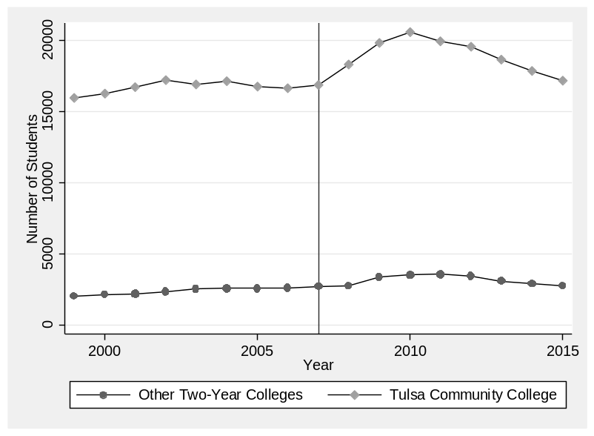
Figure 5-2. Change in Enrollment Before and After Implementation of Tuition-free College

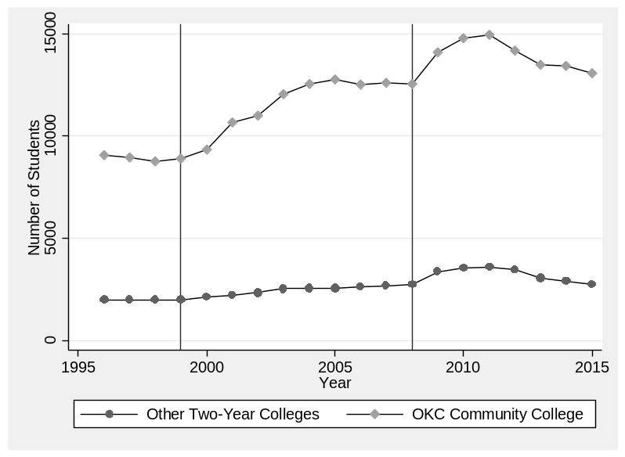

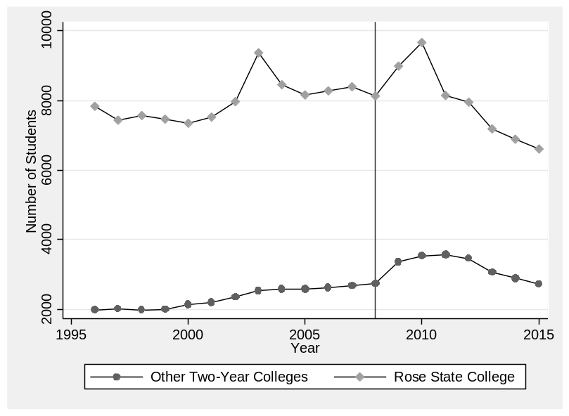

As Figure 5-2 demonstrates, there are significant increases in the total student population at TCC, OCCC, and Rose State College immediately after the implementation of tuition-free college. However, in the case of Rose State College, this enrollment boost drops off three years after implementation. This is likely due to the competition that Rose State faces with OCCC and many other colleges such as the University of Oklahoma due to the close proximity to other options. Moreover, because the beneficiaries of Ticket to Rose and the population attending K-12 schools in the local school districts are much more affluent, it is likely that many students choose to not take up the program. These students are likely able to attend research universities like the University of Oklahoma and Oklahoma State University more easily than their counterparts in the Tulsa and Oklahoma City school districts.
However, it should also be noted that TCC and OCCC experience declines from their initial gains in enrollment after the implementation of the tuition-free college program, which might that students are choosing to attend the community college for one or two years and then transfer to other colleges in the state. This would be a pragmatic option for many students looking to get general education requirements out of the way and then transfer to a four-year college where they can transfer the credits and obtain a bachelor’s degree.
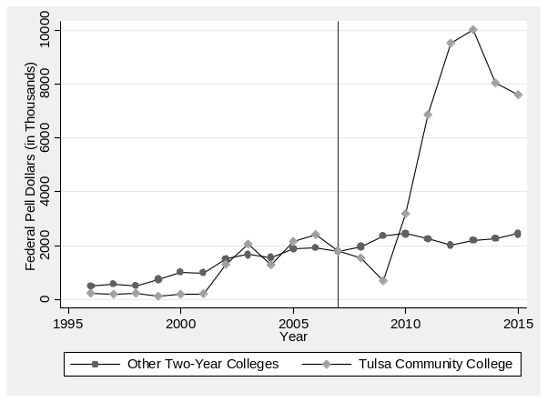
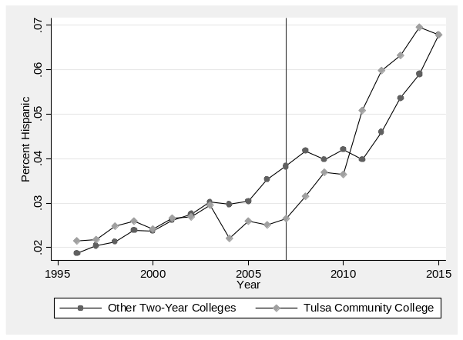
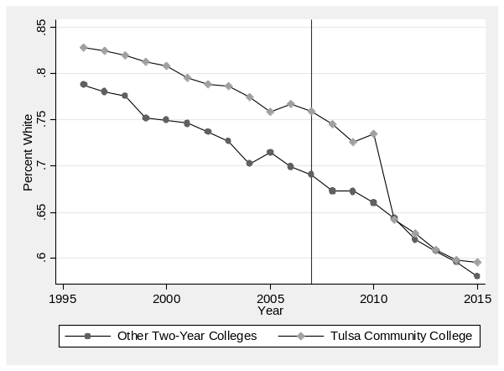
Another possibility is that TCC, OCCC, and Rose State experience these initial increases in enrollment and then drop off because students begin to realize that what is marketed as “free college” is not actually free. While receiving coverage of the tuition and fees expenses may be helpful for students who are ineligible for the Federal Pell grant, students receiving the full Pell grant are not receiving any additional aid from these programs and thus have little incentive to take up the program and attend TCC, OCCC, or Rose State. Moreover, students in the school districts may have watched their friends and family go through the program and realize the importance of living expenses and opportunity cost of attending classes instead of working on their ability to truly afford college.
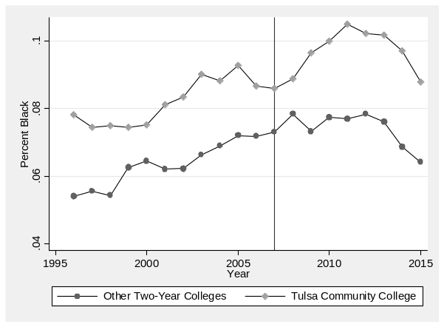
Figure 5-3. Changes in Student Population at Tulsa Community College. This figure displays the changes in student populations in other two-year colleges in the state of Oklahoma and in Tulsa Community College before and after the implementation of Tulsa Achieves. The data for these figures comes from the Delta Cost Dataset. The Pell grant data is in 2007 dollars.
While looking at the changes in overall enrollment is important, it is also essential to examine what types of student populations are changing over time at each of the colleges affected. In Figure 5-3 above, I examine the changes in racial/ethnic and Pell enrollment at TCC over time. This figure demonstrates that the Tulsa Achieves program is associated with a significant increase in the percentage of students identifying as Black or Hispanic and an increase in the enrollment of student receiving the Federal Pell grant. In terms of magnitude, there was around a two percent increase in the percentage of Black students by 2013, which declined to a zero percent increase by 2015. For Hispanic students, the share of enrollment grew by approximately four percent by 2015 and there was a corresponding decline in the share of white students of around 15 percent over the post implementation time period. This suggests that the Tulsa Achieves program, regardless of whether the students take up the Tulsa Achieves policy, is associated to increases in access for Hispanic students. In fact, only 15 percent of Hispanic students attending TCC are recipients of Tulsa Achieves, but many may have been impacted by the free college message and found out that they qualify for the Federal Pell grant (which covers the full cost of tuition and fees at TCC)—67 percent of Hispanic students attending TCC during this time period receive the Federal Pell grant. Finally, the increase in the amount of Pell grant money flowing to TCC grew exponentially in the post implementation time period. Going from less than 2 million in Pell grant aid in 2009 to 10 million in 2013, and around 8 million in 2014 and 2015, it is clear that Tulsa Achieves is associated with many more students attending TCC with Pell support. This indicates that in addition to producing an initial increase in Black enrollment and a steadily increase in Hispanic enrollment, the Tulsa Achieves program is also associated with a greater share of students from low income families attending TCC.
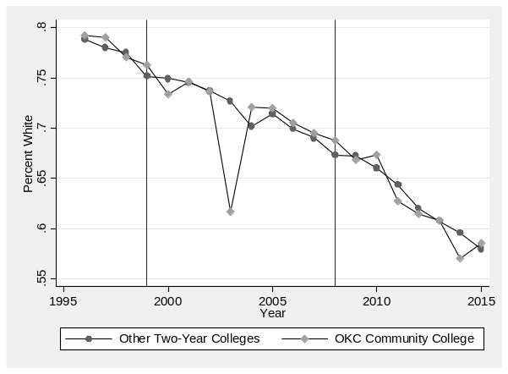
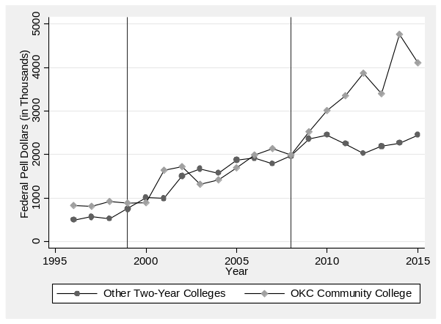
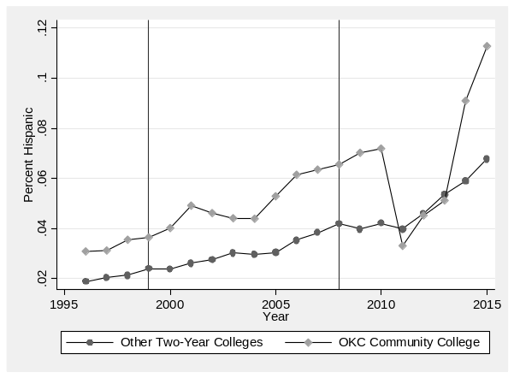
Next, I explore whether the OKCGo program produced similar impacts on racial/ethnic and low-income enrollment based on Figure 5-4 below. This figure demonstrates that the percentage of Black students increased along with the share of Hispanic students and Pell grant recipients over the post implementation time period. Black student enrollment increased in the first phase of OKCGo from 6 percent to over 8 percent. Then, Black student enrollment increased to over 10 percent but then stabilized back to 8/9 percent by 2015. Hispanic enrollment similarly grew 2 percent from 1999 to 2008 and then experienced a sharp decline in 2011-2013 only to increase yet again in 2014 and 2015 to over 10 percent. White enrollment, on the other hand, steadily decreased, mirroring the changes in the other two-year colleges around the state during this time period. The Pell enrollment, while steadily increasing along with other two-year colleges over 1999-2008, increased rapidly from 2 million up to over 4 million in 2015.
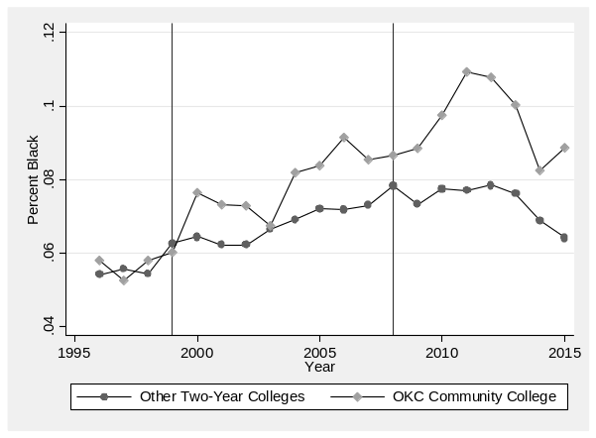
Figure 5-4. Changes in Student Population at Oklahoma City Community College. This figure displays the changes in student populations in other two-year colleges in the state of Oklahoma and in Oklahoma City Community College before and after the implementation of OKCGo. There are two years of implementation because the program was expanded in 2008. The data for these figures comes from the Delta Cost Dataset. The Pell grant data is in 2007 dollars.
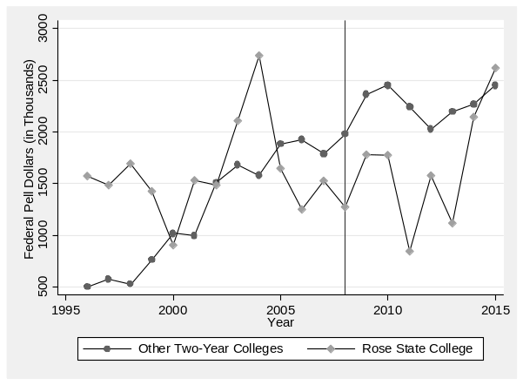
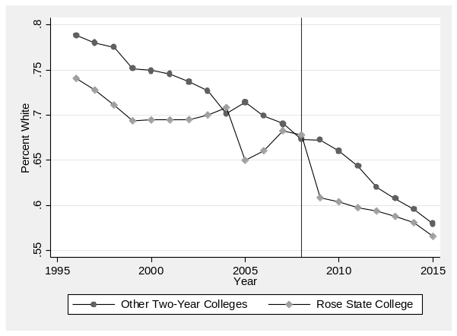
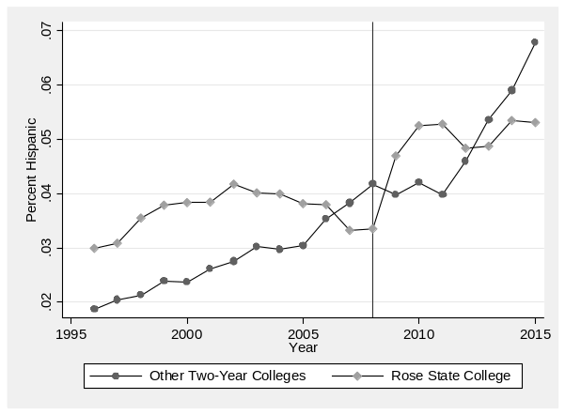
Finally, Figure 5-5 below displays the changes in the student population attending Rose State College before and after the implementation of the Ticket to Rose program.
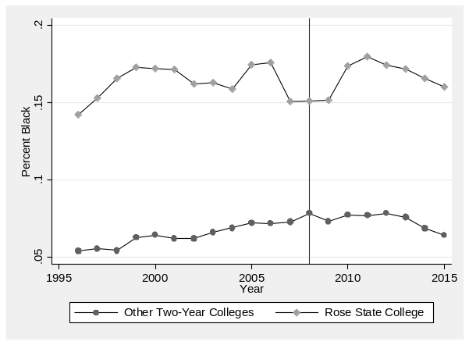
Figure 5-5. Changes in Student Population at Rose State College. This figure displays the changes in student populations in other two-year colleges in the state of Oklahoma and in Rose State College before and after the implementation of Ticket to Rose. The data for these figures comes from the Delta Cost Dataset. The Pell grant data is in 2007 dollars.
Figure 5-5 above reveals that the Black enrollment increased by around 2-3 percent in the first three years post implementation but then dropped back to around 16 percent, only 1 percent higher than the share of Black enrollment at the start of the program. On the other hand, there was a sharp decline in the percentage of white students immediately after the implementation of Ticket to Rose and an overall 20 percent decrease in the share of white students, although similar declines were occurring at other universities across the state during this time period as well. The share of Hispanic students attending Rose State increased by about 2 percent during post implementation years, despite some fluctuation. Finally, Rose State College started off well below the average Pell dollars in 2008 but ended up above the average two-year college in Oklahoma by 2015. In terms of magnitude, Rose State was bringing in 1.3 million in Pell grant aid in 2008 and by 2015 they were seeing 2.5 million in Pell dollars.
Summary of the Section
In sum, this section reveals that the beneficiaries are significantly different across the tuition-free college policies in Oklahoma. However, the changes produced in the proportion of students of color and Pell recipients appears to increase in all three colleges post implementation. Therefore, the effect of tuition-free college may be more than just on those receiving the last-dollar aid but also on the students that were induced to attend these colleges thanks to the simple college affordability message sent by the programs. While these descriptive changes over time are an essential element of better understanding how policy design shapes student outcomes, it is also necessary to take the next step and conduct analysis aimed at revealing the causal impact of tuition-free college policies. In order to conduct this analysis, I requested and obtained institutional data from Tulsa Community College that allows me to implement two quasi-experimental strategies—difference-in-differences and regression discontinuity—that together work to reveal both the local average treatment effect and the average treatment effect of Tulsa Achieves on student outcomes. This analysis, as well as the discussion of policy design and outcomes in other tuition-free college programs, is detailed in the section below.

Section 2: Crossing the Finish Line: The Effects of Tulsa Achieves on Student Persistence and Degree Completion
Abstract: A growing body of work aims to estimate the impact of promise programs, with varying policy designs, on student outcomes (Carruthers and Fox 2016; Andrews, DesJardins, and Ranchhod 2010; Bartik, Hershbein, and Lachowska 2015; Daugherty and Gonzalez 2016). However, these studies have yet to investigate how a common type of local promise program—a last-dollar, merit-based, and narrow program—will shape student outcomes. In this study, I estimate the effects of Tulsa Achieves, a narrow, merit-based, last-dollar program, on credit accumulation, GPA, and degree attainment. Utilizing a regression discontinuity and difference-in-differences approach, I estimate the local average treatment effect of Tulsa Achieves for students along the high school GPA threshold as well as the average treatment effect based on administrative data from Tulsa Community College (TCC) for 2005-2015 cohorts. The analysis reveals mixed findings, with positive and significant effects on GPA and transfer to four-year colleges in the regression discontinuity analysis and null effects on persistence and completion. On the other hand, the difference-in-differences estimates indicate that Tulsa Achieves eligibility increases credit accumulation, persistence, and the likelihood of graduating with a bachelor’s degree within five years but reduces the likelihood of transferring to a four-year college. The implications of these findings are discussed in light of the growing interest among state and local officials in implementing promise programs, and the emerging discussion on the importance of policy design in shaping outcomes.

Introduction
As college costs have skyrocketed and the demand for college degrees steadily increased, state and local leaders have begun implementing a series of promise policies, also known as tuition-free college, aimed at increasing college access and affordability. While the expansion of these programs has been swift, the accumulation of scholarly evidence on the effects of these programs has lagged behind, leaving policymakers with little evidence to draw upon in the crucial decisions regarding the optimal design and delivery of these programs. The evidence to date has focused on programs—such as the Kalamazoo promise, Pittsburgh promise, New Haven promise, Knox Achieves, and the El Dorado scholarship—and found positive impacts on K-12 educational outcomes and college enrollment, persistence and degree completion (T. J. Bartik, Hershbein, & Lachowska, 2015; Carruthers & Fox, 2016; Daugherty & Gonzalez, 2016; Page, Iriti, Lowry, & Anthony, 2018; Swanson & Ritter, 2018). However, as the systematic review of the literature by (Swanson, Watson, Ritter, & Nichols, 2017) highlight, there has been a lack of studies investigating outcomes associated with narrow, last-dollar, merit-based programs on post-secondary outcomes.
In this article, I explore how Tulsa Achieves—a merit-based, narrow, last-dollar program covering tuition and fee expenses for students who graduate from a Tulsa County high school—impacts postsecondary. Specifically, I leverage a unique administrative dataset on students attending Tulsa Community College (TCC) from 2005-2015 along with a difference-in-differences and regression discontinuity design to estimate the effect of Tulsa Achieves on student GPA, credits earned, retention, transfer to four-year colleges, and degree completion. The findings reveal that the local average treatment effect for students along the high school GPA threshold is mainly null, with the exception of the positive effects on GPA in the first and third year and transfer to four-year colleges. The difference-in-differences results, on the other hand, reveal mixed results—the analysis reveals that Tulsa Achieves eligibility has a positive effect on credit accumulation, retention, and the probability of obtaining a bachelor’s degree within five years and a negative effect on the likelihood of transferring to a four-year college and graduating from TCC in later cohorts. Taken together, these findings suggest that while students along the eligibility threshold are more likely to earn higher GPAs in college and transfer to four-year colleges as a result of receiving Tulsa Achieves, the average treatment effect for all students eligible for the program is mixed, revealing some positive effects on bachelor’s degree completion, retention and credit accumulation and negative effects on likelihood of transferring to a four-year college and making it to graduation at TCC.
The following sections of the paper begin by discussing how promise programs impact student outcomes. The next sections provide an in-depth description of the Tulsa Achieves policy, the administrative data, and the measurement of key outcomes. Then, I present the regression discontinuity and difference-in-differences analyses and detail the analytical models. Finally, I lay out the findings of the study and discuss the implications for future research and policy.
The Impact of Promise Programs on College Access and Affordability
In the wake of rising college costs, sticker prices, and net price, obtaining a college degree has become increasingly out of reach for many students and families (Bailey & Dynarski, 2011). With the average unmet need of students in the lowest quartiles of the income distribution more than doubling from 1990 to 2012, many families have been forced to take out federal or more risky loans to assist in obtaining a college credential, many of which they may not be able to pay back (Callahan, Perna, Yamashita, Wright, & Santillan, 2018; Radwin, 2018). Therefore, it comes as no surprise that 77% of adults express extreme concern about how they would finance their child’s college education (Public Agenda, 2011). These troubling dynamics have been accompanied by an increasing gap in college attendance, persistence, and graduation by family income—economists estimate that college attainment has increased by only four percent for low-income families since the 1960s while high-income families have seen an increase of 18 percent (Alon, 2009; Bailey & Dynarski, 2011; Bowen et al., 2006; Libassi, 2018). At a time when market demand for college degrees are at an all time high, it is clear that policymakers have work to do in the pursuit of a more accessible and affordable system of higher education (Perna, Finney, & Callan, 2014).
In the search for a solution to the growing cost of higher education, multiple forms of financial aid have emerged, with initiatives aimed at providing tuition-free or “free college” through place-based promise scholarships dominating recent reform efforts (Miller-Adams, 2015; Perna & Leigh, 2017). In fact, as of 2018, sixteen states have now initiated a promise, or place-based scholarship program, with over 280 programs total at the local, regional, and state level (Mishory, 2018a; Perna & Leigh, 2017). Unlike other financial aid programs, place-based promise programs offer not only the promise of reducing college costs, but also the potential for community renewal. Indeed, studies have shown that some promise programs such as the Kalamazoo Promise, Pittsburgh Promise, and New Haven Promise catalyze changes in K-12 schools that manifest in increases in college going culture and improved student achievement while in high school (Bartik, Eberts, & Huang, 2010; Jones, Miron, & Kelaher-Young, 2012). Moreover, scholars have uncovered increases in enrollment in affected school districts and increases in local property values, suggesting that some promise programs may produce improvements in community economic development (Gonzalez et al., 2014; Iriti, Page, & Bickel, 2018; LeGower & Walsh, 2017; Miller-Adams, 2015; Sohn, Rubenstein, Murchie, & Bifulco, 2017). However, whether promise programs are able to uplift students and communities may depend on the design of the program.
While each promise program is united in the goal to expand access to postsecondary education, build a college going culture through early commitment aid, and foster community vitality and renewal (Miller-Adams, 2015), they are distinct in design and implementation, providing rich avenues for researchers. The variation in program design centers on three main features: 1) wide or narrow institutional eligibility, 2) first-dollar or last-dollar structures, and 3) universal, merit-based, or needs-based student eligibility. First, while wide programs offer scholarships for a wide variety of colleges such as all two-year or four-year colleges in the state, narrow programs offer the scholarship for a single or a couple of colleges (LeGower & Walsh, 2017). Perna & Leigh (2017) estimate that 35 percent of promise programs restricted the institution students could attend, with the rest of programs opting for wide institutional eligibility. Second, promise programs structure the financial aid in either a first-dollar or last-dollar design—first-dollar programs, like the Kalamazoo Promise, offer the scholarship funds in addition to other state and federal aid obtained after filling out the Free Application for Student Aid (FAFSA) while last-dollar programs, like Tulsa Achieves, covers any gap in costs after accounting for other Federal or state financial aid. Finally, the eligibility requirements for accessing the aid vary—promise programs often include a minimum GPA requirement or a need-based element such as a family income cap like the state programs in New York and Oregon (Mishory, 2018b). Some programs also include community service requirements, a first-year seminar while in college, and provide student support services.
Each of these design characteristics likely play a key role in the effectiveness of the programs in the pursuit of expanded college access and affordability. Indeed, existing studies investigating promise programs and postsecondary outcomes reveal some variation in the magnitude and significance of the effects across programs with varying designs. These studies, reviewed in detail in the next section, provide insight into how Tulsa Achieves might affect student outcomes.
The Impact of Promise Programs on Post-secondary Outcomes
The question of whether promise programs end up increasing the probability of enrolling, persisting and completing college has been the subject of increasing attention in higher education policy (Andrews, DesJardins, & Ranchhod, 2010; Bartik, Hershbein, & Lachowska, 2015; Carruthers & Fox, 2016; Daugherty & Gonzalez, 2016; Gurantz, 2018; Swanson and Ritter 2018). The main take-away from these evaluations is that no program leads to the same outcomes, with policy design likely serving a key role in how promise programs impact student postsecondary outcomes. Given the importance of program design, I present a detailed summary of the program including the eligibility requirements and structure as well as the estimated impacts on postsecondary outcomes in Table 5-4.
The wide, first-dollar programs in Table 5-4—including the Kalamazoo Promise, the El Dorado Scholarship, and the New Haven Promise—are a more generous form of aid that provides the scholarship before other state and federal aid are applied to the financial aid package at a variety of colleges, effectively allowing students to use any additional aid for room and board, books, and living expenses.
Table 5-4. Policy Designs and Findings from Promise Research on Postsecondary Outcomes
Program | Structure | Eligibility Requirements | Findings
Kalamazoo Promise | First-dollar aid covers tuition & fees at any public institution in Michigan | Attend Kalamazoo Public School; 2.0 GPA and 12 credits per semester in college | Increase in college application, enrollment, credits attempted, persistence and attainment (Bartik et al. 2015; Andrews et al. 2010)
El Dorado Scholarship | First-dollar scholarship covers tuition at any college in the country (capped at the highest tuition and fees at an Arkansas public university) | Attend high school in El Dorado School District from kindergarten-12th for 100% or 9th-12th for 60% of scholarship | Increase in college enrollment and bachelor’s degree completion. Null impact on associate’s degree completion (Swanson & Ritter 2018)
New Haven Promise | First-dollar aid up to $10,000 per year covers tuition at all public college in Connecticut. Includes student support system. | 40 hours community service in high school, 3.0 GPA or higher in high school, 90% attendance rate in high school, Attend school and reside in New Haven, no expulsions in high school. In college, student must maintain a 2.0 GPA in first year and 2.5 GPA afterwards. | Unclear impacts on college enrollment and persistence (Daugherty & Gonzalez, 2016). None consistently statistically significant and positive.
Pittsburgh Promise | Last-dollar aid covers cost of attendance up to $5,000/$10,000 max award per year to attend any institution in Pennsylvania | Attend Pittsburgh Public Schools, 90% attendance rate and high school GPA requirement (varies over time) | Increase in college enrollment & persistence (Page et al. 2018)
Knox Achieves | Last-dollar aid covers tuition and fees in any Tennessee community college | Attend Knox County high school | Increase in two-year college enrollment and credit accumulation. Reduction in four-year enrollment (Carruthers & Fox 2016)
Oregon Promise | Last-dollar aid covers tuition at any Oregon community college | Recently implemented family income cap | Increased likelihood student enroll in two year instead of four year universities (Gurantz 2018)
The Degree Project | Last dollar aid providing up to cost of attendance or $12,000 per year to one cohort of students to attend any two or four-year public college in Wisconsin. | Attend and graduate from eligible high school in Milwaukee Public Schools, make 2.5 high school GPA, attend class 90% of the time & FAFSA, need at least $1 of unmet need & enroll within four years of high school | Increase in two-year college enrollment and attainment (Harris et al. 2018)
Tulsa Achieves | Last-dollar aid covers tuition at Tulsa Community College | Attend Tulsa County high school, 40 hours of community service, 2.0 high school GPA, maintain good academic standing

The most well researched program is the Kalamazoo promise program, which has led to large and significant impacts on college enrollment, credit hours earned, and the probability of obtaining a bachelor’s degree (Bartik, Hershbein, & Lachowska, 2015). Additionally, the Kalamazoo promise significantly shaped college choice and increased the likelihood of enrolling in a four-year college, which is likely a result of the scholarship’s wide instead of narrow design (Andrews et al., 2010; Bartik et al., 2015; Miller-Adams & Timmeney, 2013). Other wide first-dollar programs such as the El Dorado scholarship program, which covers up to the total cost of attendance at any college in the country, reveals similar results—the El Dorado scholarship is associated with an 11.4 percent increase in college enrollment and a 10.7 percent increase in the probability of completing a bachelor’s degree, with students of color earning above-average GPAs experiencing the biggest gains in bachelor’s degree completion (Swanson and Ritter 2018).
Another wide first-dollar program, the New Haven Promise, has produced more mixed results. The New Haven Promise is distinct from the El Dorado scholarship in that it requires students to meet a more stringent set of eligibility requirements including 40 hours of community service in high school, a cumulative 3.0 GPA in high school, a 90 percent attendance rate, and a clean disciplinary record. In college, students must maintain a 2.0 GPA in the first year and a 2.5 GPA afterwards. Preliminary results for the New Haven promise are null for persistence and mixed in terms of the impact on college enrollment with the difference-in-difference estimates reflecting null findings and the regression discontinuity estimates sensitive to specification (Daugherty & Gonzalez, 2016). Therefore, while the El Dorado and Kalamazoo programs produced consistently positive outcomes for enrollment, persistence, and completion, it remains unclear whether the New Haven Promise produced similar impacts.
The evidence on wide, last-dollar promise programs has been consistently positive for postsecondary outcomes such as college enrollment, persistence and completion. The Pittsburgh Promise reflects a wide, merit-based program similar in structure to the New Haven promise with fewer eligibility requirements. In line with the findings for Kalamazoo and El Dorado, the regression discontinuity and difference-in-differences estimates from the Pittsburgh Promise also indicate that students experienced an increase in college attendance and persistence—graduates of Pittsburgh Public Schools were more likely to enroll in college (5 percentage points), more likely to select a Pennsylvania institution (10 percentage points), and more likely to persist (4-7 percentage points) (Page et al., 2018). In one of the phases, Pittsburgh Promise students were less likely to undermatch by two percentage points and more likely to attend four-year colleges (Bozick, Gonzalez, & Engberg, 2015; Page and Iriti 2016). Similarly, in the case of Knox Achieves—a wide, last-dollar program that does not include merit requirements–scholars have uncovered a 3-4 percentage point increase in college enrollment, particularly among low-income students (Carruthers & Fox, 2016). Moreover, Knox Achieves scholars were significantly more likely to persist for the first two years and earned more credit hours than comparable non-recipients. Similar, although substantively smaller results are found in the evaluation of The Degree Project—a wide, merit-based, last-dollar program modeled after the Pittsburgh Promise. In this randomized control trial, scholars have revealed that The Degree Project leads to increased student motivation and college expectations as well as college preparatory behavior like engaging in college access programs and filling out the FAFSA (Harris et al., 2018). On the other hand, the study uncovers null effects on graduation from high school, initial college entry, and possibly a shift to two-year colleges. However, in line with the evidence from Pittsburgh Promise and Knox Achieves, The Degree Project does produce a 1 percentage point increase in two-year college enrollment and graduation from two-year colleges. Therefore, based on the existing evidence wide, last-dollar programs appear to produce positive impacts on college enrollment, persistence and completion.
Taken together, Table 5-4 makes it clear that the current state of knowledge on promise programs is dominated by wide programs (Swanson et al., 2017). This is problematic given the variation in the design and structure of promise programs around the country, which makes the findings of these studies applicable to only a subset of promise programs. In fact, there is only one unpublished study so far that includes narrow promise programs and it only includes an analysis of enrollment, not of persistence and completion. This study estimates a 9-22 percent increase in enrollment across the 32 narrow promise programs, with policy design serving as a key moderating factor (Gandara & Li, 2018). However, an examination of how narrow programs affect student persistence and completion is notably absent from current analyses. In this study, I advance the state of knowledge on promise programs by estimating the effects of an understudied type of promise program—a pioneering local, narrow, last-dollar program—on student GPA, credit accumulation and degree attainment.
A recent dissertation develops a benefits index that helps contextualize the likely outcomes of a program like Tulsa Achieves in comparison to other promise programs (Billings, 2018). This framework establishes the index based on 1) whether the program is targeted or universal and 2) whether the benefits are comprehensive or limited. In this index, Tulsa Achieves receives a -1 score on the eligibility dimension and a negative 3 on the benefits dimension, indicating that it is targeted and limited because of the high school GPA requirement, last-dollar structure, coverage of only tuition and fees instead of the total cost of attendance, and the lack of student supports such as mentoring. As a result, this framework would predict null results for the program on postsecondary outcomes in line with the New Haven Promise program.
Furthermore, Billings (2018) finds further support for the predictions of this framework in her comparison of the results from the two evaluations conducted: one on the generous Kalamazoo Promise and the other only Promise zones. While she finds large statistically significant positive impacts of Kalamazoo Promise on college enrollment and degree completion, she finds that Promise zones have a much smaller impact on college attendance, persistence and degree completion.
Policy Background
With the goal of increasing the number of college educated Tulsa County residents, local business and government leaders came together to create Tulsa Achieves—a pioneering place-based tuition-free community college program for students in Tulsa County funded by property owners through ad valorem taxes. Starting with the graduating class of 2007, Tulsa County students graduating from high school with at least a 2.0 high school GPA were eligible to receive the last-dollar Tulsa Achieves scholarship program and attend TCC. The last dollar aid covers any remaining tuition and fees expenses after students collect other state or federal aid for up to three years or for 63 credits, whichever comes first. The amount of aid also scales based on how many years the student resided in Tulsa County during high school: for students who were Tulsa County residents for one year, two years, or three years while in high school the scholarship pays up to 25, 50, or 75 percent of tuition and fees expenses, respectively.
To be deemed eligible for Tulsa Achieves, students must have at least a 2.0 high school GPA, reside in Tulsa County at the time of high school graduation, graduate from any public or private high school in Tulsa County, and commit to attend TCC the Fall after they graduate from high school. To retain the scholarship, students must maintain Tulsa County residency, complete at least three credit hours a semester, complete the FAFSA, complete at least 67 percent of attempted coursework, and maintain a 1.7 GPA if they take 30 or more credits and a 2.0 GPA if they take less than 30 credits in the year. In addition, students must take a required student success course and complete 40 hours of community service each year in order to remain eligible for the Tulsa Achieves scholarship.
Theoretical Framework
For eligible Tulsa County students, the Tulsa Achieves program likely functions through multiple mechanisms to influence postsecondary outcomes. For instance, Tulsa Achieves could be working to improve college affordability through reducing the costs paid by students for tuition and fees—at least for the students whose Pell grant or state aid did not already cover tuition and fees expenses. For these students, the financial support for tuition and fee expenses may enable them to take out less in student loans or work less hours outside of school. It is also possible that Tulsa Achieves functions to change perceptions of college affordability in ways that help students realize they are eligible for federal and state financial aid programs that they previously did not know were available. Finally, Tulsa Achieves could also be increasing college readiness and college going culture in K-12 schools in Tulsa County (Page et al., 2018). While it is impossible to observe these mechanisms at play based on the data in this study, previous studies have laid out comprehensive frameworks, like the one in Figure 5-6 below, in which these possibilities are explored.
According to this framework, changes in college readiness, college going culture, and perceived or actual college affordability, likely also affects student enrollment decisions and postsecondary outcomes such as persistence and degree completion.
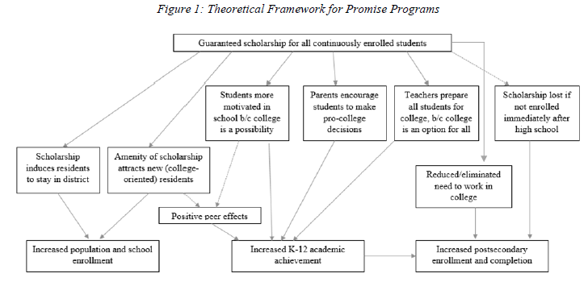
Figure 5-6. Theoretical Model of Mechanisms by which Promise Programs impact K-12 and Postsecondary Outcomes (Source: Swanson et al 2017)
In the context of Tulsa Achieves, the enrollment changes could manifest as a higher probability of some students attending TCC to earn a credential before entering the workforce as opposed to entering the workforce right after high school. At the same time, students that were planning to attend a four-year college could be induced to enroll at TCC instead of starting at the four-year school. These potential changes likely result in two new student populations enrolling at TCC as a result of the Tulsa Achieves program—students who would not have attended college otherwise, and students who would have attended a four-year college instead of TCC in the absence of the program. These potential shifts in enrollment are explored descriptively in the next section, which introduces the unique administrative data in this study.
Data and Measures
The student-level administrative data in this analysis captures all students attending TCC from 2005-2015. That data were extracted from TCC and matched to National Student Clearinghouse records for students that transferred to four-year colleges. The student-level records extracted contain information on student demographics, high school GPA, county residency at the time of high school graduation, and a variety of outcome measures such as credit accumulation, college GPA, transfer to four-year colleges, and completion. With respect to the financial aid packages, the data include dichotomous indicators for whether a student received the Federal Pell grant, Tulsa Achieves, and any other form of financial aid or scholarship.
Based on this data, I calculate a series of outcome variables including:
- credits earned and GPA at the end of year one and year three,
- number of semesters enrolled over three years,
- whether the student earned 63 credits in three years,
- whether the student graduated from TCC or from a four-year college with a credential,
- whether the student graduated from TCC,
- transferred to a four-year college, and
- graduated with a bachelor’s degree.
- To capture time-to-degree I also calculate whether the student obtained a bachelor’s degree within five years.

Table 5-5. Descriptive Statistics
 | Analytic Sample for DD Analysis (2005-2015) |  |  |  |  | Analytic Sample for RD Analysis (2007-2015)
Variable | All Cohorts | Pre-Tulsa Achieves: 2005-2006 Cohorts |  | Post-Tulsa Achieves: 2007-2015 Cohorts |  | Tulsa Residents with 1.5-2.75 GPA | Tulsa Residents with 1.5-1.9 GPA | Tulsa Residents with 2.0-2.75 GPA
 |  | Eligible | Ineligible | Eligible | Ineligible
Controls
White | 0.57 | 0.65 | 0.70 | 0.53 | 0.58 | 0.46 | 0.35 | 0.47
Black | 0.11 | 0.11 | 0.09 | 0.13 | 0.11 | 0.19 | 0.25 | 0.18
Hispanic | 0.07 | 0.05 | 0.04 | 0.09 | 0.06 | 0.11 | 0.12 | 0.11
Native American | 0.08 | 0.08 | 0.08 | 0.07 | 0.10 | 0.07 | 0.08 | 0.06
Other Race | 0.07 | 0.08 | 0.02 | 0.08 | 0.06 | 0.09 | 0.09 | 0.06
Male | 0.43 | 0.36 | 0.44 | 0.42 | 0.44 | 0.52 | 0.60 | 0.51
Age | 26.49 | 30.21 | 31.52 | 24.64 | 27.25 | 22.02 | 22.54 | 21.97
High School GPA | 2.26 | 2.09 | 2.03 | 2.38 | 2.18
Pell Grant | 0.22 | 0.32 | 0.29 | 0.22 | 0.18 | 0.25 | 0.29 | 0.24
Other Scholarships | 0.04 | 0.06 | 0.04 | 0.04 | 0.04 | 0.09 | 0.01 | 0.02
Treatment Variable
Tulsa Achieves | 0.37 | 0.00 | 0.00 | 0.52 | 0.21 | 0.60 | 0.02 | 0.66
Postsecondary Outcomes
GPA End of Year 1 | 1.95 | 1.88 | 1.94 | 2.00 | 1.90 | 1.32 | 1.00 | 1.36
Credits Earned End of Year 1 | 9.81 | 10.55 | 11.07 | 9.78 | 9.37 | 6.41 | 4.57 | 6.62
GPA End of Year 3 | 1.91 | 1.85 | 1.92 | 1.95 | 1.86 | 1.29 | 0.96 | 1.33
Credits Earned Year 3 | 19.95 | 22.93 | 23.13 | 19.92 | 18.69 | 11.88 | 8.19 | 12.30
Semesters Enrolled in 3 Years | 4.38 | 5.12 | 5.10 | 4.29 | 4.23 | 3.37 | 2.92 | 3.42
Graduate with Credential | 0.17 | 0.06 | 0.08 | 0.05 | 0.05 | 0.06 | 0.03 | 0.06
Earn 63 Credits in 3 Years | 0.06 | 0.23 | 0.19 | 0.10 | 0.11 | 0.01 | 0.01 | 0.01
Transfer to Four-Year College | 0.36 | 0.49 | 0.44 | 0.34 | 0.36 | 0.22 | 0.16 | 0.22
Bachelor’s Degree | 0.12 | 0.21 | 0.22 | 0.10 | 0.12 | 0.03 | 0.01 | 0.04
Bachelor’s Degree in 5 Years | 0.07 | 0.06 | 0.09 | 0.06 | 0.07 | 0.02 | 0.01 | 0.02
N | 35,458 | 3,968 | 1,113 | 18,087 | 12,284 | 5,214 | 533 | 4,681
Note: The N size is based on the unique number of students attending TCC. For students who drop out, cumulative GPA and credits earned are imputed as the cumulative GPA or credits earned when last enrolled.

The dataset is summarized in Table 5-5 for all cohorts in the data in Column 1, for the pre and post cohorts in Columns 2-5 and for the analytic sample for the RD analysis in Columns 6-9. Columns 2 and 4 present the descriptive statistics for students who were Tulsa County residents upon high school graduation and earned a high school GPA greater than or equal to the 2.0 threshold in the pre and post time periods. Columns 3 and 5 reflect the comparison group of students who were ineligible for Tulsa Achieves as a result of either not being a Tulsa County resident or earning below a 2.0 high school GPA. Together, these columns demonstrate that TCC experiences significant demographic change after the implementation of Tulsa Achieves. First, there are significantly higher proportions of students of color attending TCC in the post-implementation years. Second, the high school GPA of students attending TCC is higher in post-implementation years and the proportion of students receiving the Pell grant declines. This suggests that some higher achieving students are deciding to attend TCC and also that students from families with higher family incomes are choosing to attend TCC in the post-implementation years. I provide a visual depiction of these changes over time in Figure 5-7, which make it clear that the TCC student body was more racially diverse, younger and more affluent in the post Tulsa Achieves time period compared to the two cohorts before Tulsa Achieves was implemented.

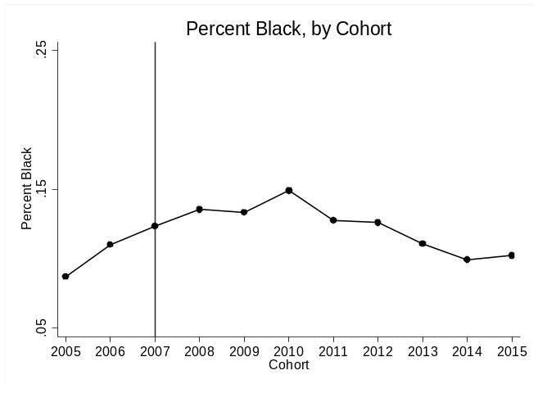
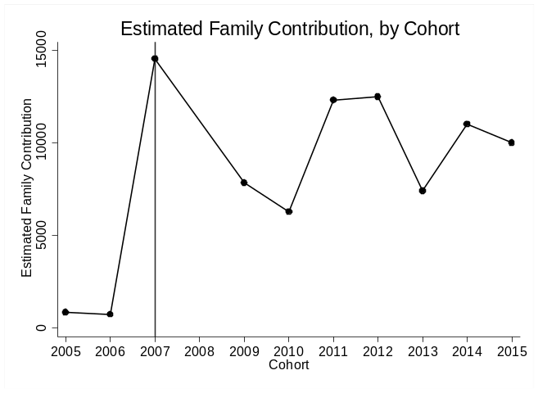
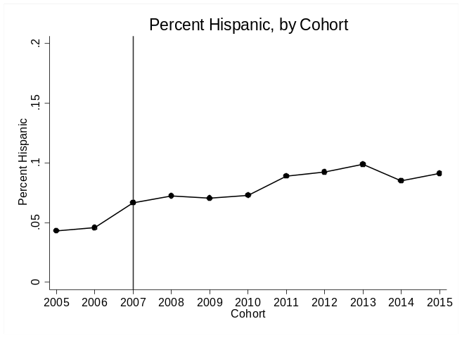
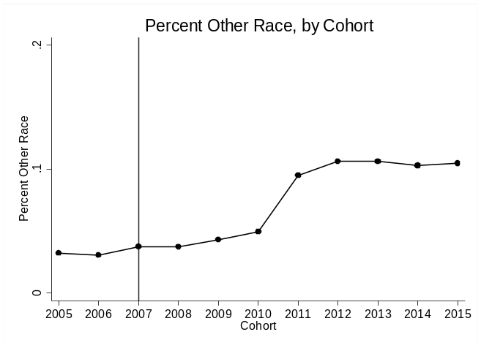
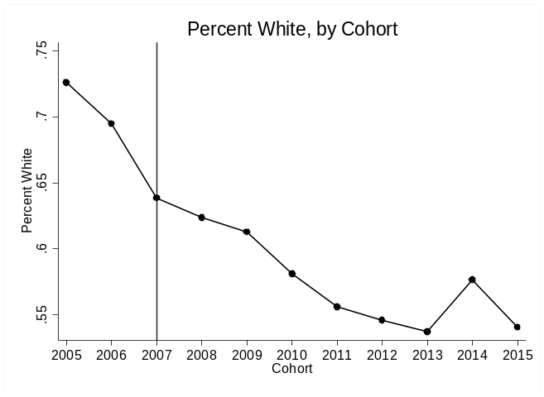
Figure 5-7. Major Demographic Changes, by Cohort
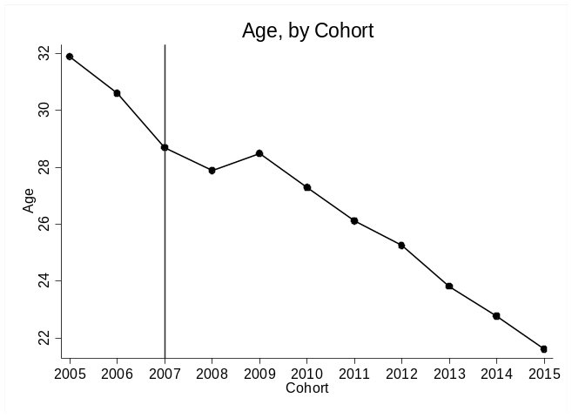

Moreover, Columns 6-9 in Table 5-5 present the descriptive statistics for the sample included in the regression discontinuity analysis, which is composed of students along the high school GPA threshold in the 2007-2015 cohorts that are residents of Tulsa County and were born on or after 1988. When compared to Column 1, the set of students reflected in Columns 6-9 are more racially diverse and have lower proportions of students making key achievement thresholds such as graduating from TCC, earning 63 credits in three years, transferring to four-year colleges, and obtaining a bachelor’s degree. These descriptive differences reveal that the analytical sample for students along the GPA threshold is substantially different from the overall sample, which is important to note before interpreting the findings from the analysis. In the section below, I present my analytical approach along with a series of robustness checks that verify the validity of the research design.
Estimating the Effects of Tulsa Achieves
To estimate the effect of receiving Tulsa Achieves on credit accumulation, retention, and graduation, I implement both a difference-in-difference and regression discontinuity approach. This paired analytical approach proves the most beneficial for identifying the local average treatment effect and also being able to test whether the local average treatment effect reflects the overall treatment effect (Page et al., 2018; Scott-Clayton, 2011). While each individual approach has weaknesses, together they present complementary evidence that works to strengthen the analysis. For instance, the difference-in-differences strategy is beneficial in that it leverages discontinuous timing of program implementation to provide an estimate of the average treatment effect across all recipients. However, the credibility of this approach relies on the differences being attributable to the program instead of pre-existing trends or simultaneously occurring institutional policies or socioeconomic conditions. The regression discontinuity approach complements the DD strategy in that it links the observed impacts to an arbitrary program rule, effectively ruling out other explanations for findings. In the regression discontinuity analysis, I leverage the design of the eligibility requirements—particularly the high school GPA threshold—to exploit plausibly exogenous variation near the eligibility threshold in a regression discontinuity approach. As specified above, in order to be eligible to receive Tulsa Achieves students must have at least a 2.0 high school GPA or face disqualification from the scholarship program. This policy rule allows for the estimation of causal effects in a regression discontinuity analysis, in which I identify the effect of being just above rather than just below the high school GPA threshold for Tulsa Achieves eligibility. However, the RD approach only estimates the effect of the program for students near the eligibility threshold, which is only approximately 14.7 percent of students, and students near the threshold may exhibit substantially different responses to the program than other students.
The major threat to validity in both approaches is the potential for selection bias. This bias could come from multiple potential sources: first, students who would not have attended college may have been induced to do so because of the Tulsa Achieves program (likely negatively biasing the analyses), second, students who would have chosen to attend a college other than TCC could have chosen to enroll in TCC instead due to the financial stability (potentially inducing an upward bias), third, students who would have failed to meet the eligibility requirements could have worked harder to do so (likely negatively biasing the DD analysis).
In the regression discontinuity approach, this would be in the form of differential selection around the cutoff, especially given that students know about the GPA threshold. In order to be valid, the regression discontinuity approach assumes that students just above the threshold are a suitable comparison group in terms of both observable and unobservable characteristics to the students just below the GPA threshold. On the other hand, the difference-in-differences analysis requires evidence of parallel trends in the treatment and control groups in pre-treatment time periods to ensure differences are attributable to the implementation of the program and not from pre-existing trends in the outcomes of interest. Below I present evidence in support of the internal validity of the regression discontinuity approach and the difference-in-differences analysis, which together provide causal estimates of the local and average treatment effect of Tulsa Achieves on student outcomes.
Identification Assumptions for Regression Discontinuity Analysis
First, for the regression discontinuity design to reveal causal estimates, the assignment rule determining eligibility at the threshold must be followed with a high degree of fidelity. Below, I present the plot establishing the difference in the proportion of students receiving Tulsa Achieves for students scoring above and below the high school GPA threshold for the analytic sample of Tulsa County residents born on after 1988 in the 2007-2015 cohorts. Figure 3 presents the mean proportion of students receiving Tulsa Achieves across the distribution of the centered high school GPA running variable. This figure reveals a significant jump in the proportion of students receiving Tulsa Achieves at the threshold—while around 75 percent of students above the high school GPA threshold received Tulsa Achieves, only an average of 1.6 percent of students below the threshold received the scholarship. This jump, once subject to formal statistical testing, reflects a large and significant discontinuity at the threshold. However, Figure 5-8 reveals that the discontinuity at the threshold is probabilistic instead of deterministic—that is, there is imperfect compliance with the high school GPA rule. As a result, I utilize a fuzzy regression discontinuity approach instead of a sharp regression discontinuity design.
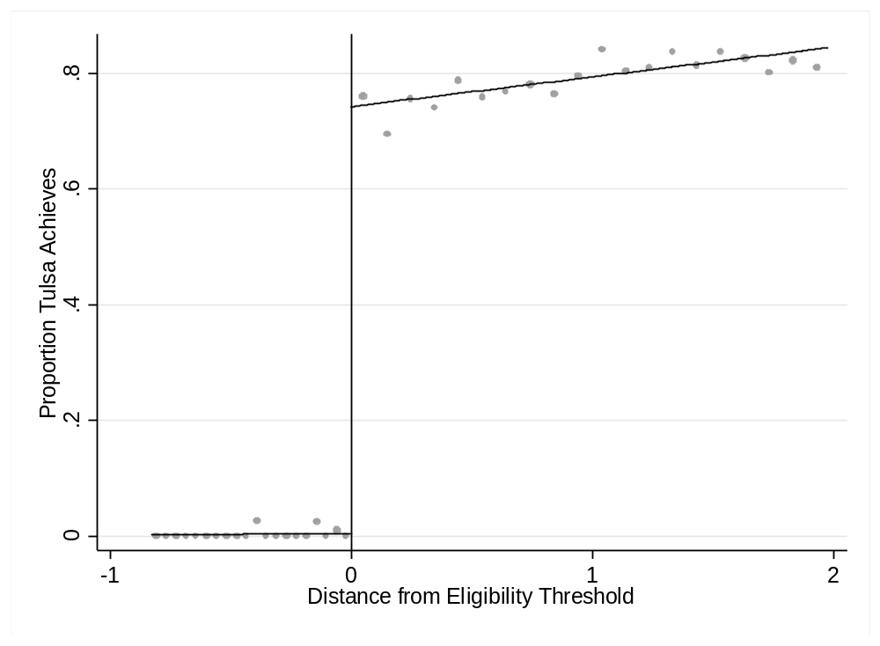
Figure 5-8. Proportion of Students Receiving Tulsa Achieves, by Distance from high school GPA threshold
The large discontinuity at the threshold, while necessary for a regression discontinuity design, presents a potential threat to validity if students can systematically manipulate their high school GPAs and, as a result, whether they scored above or below the threshold for Tulsa Achieves eligibility. To examine this possibility visually, I present Figure 5-9, in which I plot the density of students around the high school GPA threshold to assess whether there is a disproportionate number of cases stacked on either side of the threshold, which would indicate potential manipulation. Figure 5-9 shows no indication of such disproportionate stacking, providing preliminary evidence against the probability of manipulation at the threshold. Moreover, Figure 5-9 demonstrates that there is sufficient density around the cutoff for estimation of treatment effects.
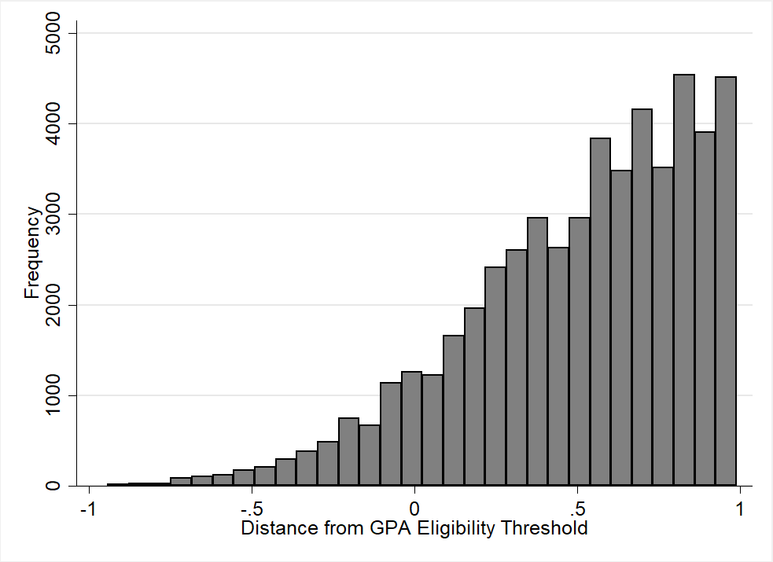
Figure 5-9. Distribution of Students by Distance from high school GPA eligibility threshold
To further test for this potential manipulation at the threshold, I utilize the nonparametric local-polynomial density estimator approach developed by Cattaneo & Escanciano, (2017); Cattaneo, Titiunik, & Vazquez-Bare, (2017) which has been shown to increase the size and power of the manipulation tests. Moreover, this calculation approach, described in detail in (Cattaneo, Jansson, & Ma, 2018), is preferable to the McCrary (2008) test in that it does not require the pre-binning of data. The results of this analysis reveal a consistent failure to reject the null hypothesis of no change in the density of students at the threshold. Therefore, I conclude that there is no evidence of manipulation at the GPA threshold providing additional evidence in support of the validity of the design.
Despite the strong evidence against the potential for manipulation at the threshold, the validity of the regression discontinuity design also requires demonstrating that the characteristics of students just above the cutoff are not systematically different from students just below the threshold. I investigate the potential for differential student composition in observable student characteristics at the GPA threshold by estimating:
$O_{i}=f\left({GPAdist}_{i}\right)+βG_{iAbove}+C_{i}∂+ε_{i}$ (1)
where O reflects the observable characteristics of student i, $f\left({GPAdist}_{i}\right)$ represents the running variable or the flexible function of the distance from the GPA threshold, $G$ indicates whether a student is above or below the threshold, and $C$ is the vector of cohort fixed effects. The results of this analysis are presented in Table 5-6 below, which reveal all null results. This suggests that the observable characteristics for students just above the GPA threshold are not significantly different from the characteristics of students just below the threshold, providing further support for the validity of the regression discontinuity design. For further evidence on differential student composition at the threshold, I also present figures in Appendix A.

Table 5-6. Coefficients and Standard Errors on Scoring Above GPA Threshold from Reduced-Form Model Predicting Student Observable Characteristics

Outcome | N | Model 1 | N | Model 2
Male | 3,175 | 0.016 | 13,594 | 0.011
 |  | (0.087) |  | (0.023)
Black | 4,869 | 0.123 | 13,594 | -0.015
 |  | (0.078) |  | (0.020)
White | 4,283 | 0.068 | 13,594 | 0.033
 |  | (0.148) |  | (0.023)
Hispanic | 4,963 | -0.133 | 13,594 | 0.006
 |  | (0.100) |  | (0.015)
Other Race | 6,135 | -0.004 | 13,594 | 0.005
 |  | (0.043) |  | (0.013)
Pell | 4,077 | -0.153 | 13,594 | -0.023
 |  | (0.096) |  | (0.018)
Age | 6,041 | -0.289 | 13,594 | -0.038
 |  | (0.899) |  | (0.067)
Note: In Model 1, the data driven bandwidths were calculated using the msetwo function with triangular kernels to maintain consistency with the main RD analysis. In Model 2, the bandwidth is 1 on either side of the cutoff. Both models include cohort fixed effects. Robust standard errors in parentheses *p < 0.10; **p < 0.05; ***p < 0.01.

The final threat to validity that must be investigated is the potential for the high school GPA threshold to reflect more treatments and opportunities than just Tulsa Achieves, which could be the potential mechanism for the effects revealed in the analysis. However, this is unlikely to be an issue because there were no simultaneously occurring reforms at Tulsa Community College during the years 2005-2015 that would meaningfully affect the analysis, according to conversations with programs coordinators at the college. Moreover, the high school GPA eligibility threshold for the major statewide financial aid programs is either not applicable (for the Oklahoma Tuition Aid Grant program) or much higher than a 2.0 (for the Oklahoma’s Promise program).
The evidence of the strong discontinuity in the proportion of students receiving Tulsa Achieves above and below the threshold, along with the validity checks support the internal validity of the regression discontinuity design and the causal nature of the estimates. To obtain estimates capturing the effect of Tulsa Achieves on the outcome variables, I employ an instrumental variables (IV) approach in which I utilize scoring above the GPA threshold as the instrument for receiving Tulsa Achieves, in line with (Imbens & Lemieux, 2007). For this instrument to be valid, scoring above the GPA threshold must predict treatment assignment and it must be uncorrelated with the outcomes other than through its effect on Tulsa Achieves receipt. Based on the evidence in Figure 5-8, the first condition is met—obtaining a high school GPA above the eligibility threshold is highly correlated to whether a student receives Tulsa Achieves. The second condition, which is not directly testable, should be met as long as the flexible functional form is correctly specified and there is no evidence of manipulation. Given that the validity checks showed no evidence of manipulation, I implement the instrumental variables approach in a two-stage least squares model (2SLS) where Tulsa Achieves recipient ($T_{i})$ is predicted in the following model:
$T_{i}=f\left({GPADist}_{i}\right)+θG_{iAbove}+X_{i}π+{\text{λ}}_{\text{t}}+ω_{i}$ (2)
as a function of $f\left({GPADist}_{i}\right)$, the flexible function of the distance from the GPA threshold, $G_{iAbove}$ is an indicator of scoring above the threshold, $X_{i}$ is a vector of student characteristics, ${\text{λ}}_{\text{t}}$ are the cohort fixed effects, and $ω_{i}$ is the idiosyncratic error term. The predictions for T in the equation 2 are denoted as $\hat{T}$ in the second stage equation presented below. The second stage model is presented in equation 3:
$Y_{i}=f\left(D_{i}\right)+φ\hat{T_{i}}+X_{i}β+ε_{i}$ (3)
In this model, $φ$ represents the local average treatment effect (LATE) of Tulsa Achieves on student retention, credit accumulation, transfer, and graduation. As a result of the instrumental variables approach, $\hat{T}$ reflects only the variation in treatment assignment that is attributable to obtaining a high school GPA above the threshold and is thus uncorrelated with $ε$. This LATE represents the causal impact of Tulsa Achieves on student outcomes for those students near the high school GPA threshold for whom scoring above the threshold would have resulted in receiving Tulsa Achieves. In accordance with best practices suggested by (Lee & Card, 2008), the errors are clustered by the forcing variable—high school GPA. Additionally, I utilize mse-two bandwidth selection in the baseline results to allow for the data-driven bandwidths to be calculated separately above and below the threshold and present the results with multiple different bandwidths to test whether the results are sensitive to specification (Imbens & Kalyanaraman, 2012). In the section below, the I present the estimates for the local average treatment effect, before pairing this analysis with a difference-in-differences approach.
Regression-Discontinuity Results
The main results from the regression discontinuity analysis are presented in Table 5-7, in which the baseline results are presented in Column 1. For many of the outcome measures, it appears that Tulsa Achieves receipt has no significant impact. However, Tulsa Achieves receipt does significantly positively affect college GPA both in year one and in year three. These effects are meaningful in magnitude, reflecting more than a half point increase in the college GPA of students just above compared to the students just below the threshold.
The baseline results also reveal the positive effect of Tulsa Achieves on the likelihood of transferring to a four-year college—Tulsa Achieves recipients were 16 percentage points more likely to transfer to a four-year college in the baseline specification (p<0.10). The figure below displays the mean of the outcome measure along the GPA threshold for the significant relationships in Table 5-7.
Table 5-7. RD Estimates of the Effect of Tulsa Achieves with Eligibility as Instrument for Receipt
 |  | Robustness Checks
Outcome | (1) MSE Two Bandwidth | (2) MSE Two + HS FE | (3) CER Two Bandwidth | (4) Quadratic MSE Two Bandwidth
GPA End of Year 1 | 0.669** | 0.674*** | 0.674** | 0.889***
 | (0.263) | (0.260) | (0.284) | (0.341)
Observations | 4,462 | 4,530 | 2,765 | 6,204
Bandwidth Below | 0.151 | 0.153 | 0.108 | 0.244
Bandwidth Above | 0.698 | 0.700 | 0.498 | 0.894
Credits Earned End of Year 1 | 1.495 | 1.562 | 1.953 | 2.997*
 | (1.210) | (1.204) | (1.214) | (1.531)
Observations | 4,134 | 4,618 | 2,886 | 7,747
Bandwidth Below | 0.159 | 0.158 | 0.114 | 0.169
Bandwidth Above | 0.714 | 0.712 | 0.509 | 1.076
GPA End of Year 3 | 0.629** | 0.630** | 0.581** | 0.820**
 | (0.269) | (0.268) | (0.279) | (0.338)
Observations | 4,026 | 4,026 | 2,603 | 7,082
Bandwidth Below | 0.151 | 0.151 | 0.108 | 0.249
Bandwidth Above | 0.648 | 0.649 | 0.463 | 0.981
Credits Earned End of Year 3 | 3.062 | 3.032 | 3.536 | 3.944
 | (3.410) | (3.414) | (3.751) | (4.062)
Observations | 4,012 | 5,013 | 3,173 | 7,470
Bandwidth Below | 0.168 | 0.169 | 0.12 | 0.274
Bandwidth Above | 0.763 | 0.764 | 0.544 | 1.03
Semesters Enrolled in 3 Years | 0.091 | 0.130 | 0.136 | 0.226
 | (0.903) | (0.591) | (0.606) | (0.714)
Observations | 4,041 | 3,782 | 2,609 | 5,821
Bandwidth Below | 0.162 | 0.163 | 0.116 | 0.264
Bandwidth Above | 0.648 | 0.618 | 0.463 | 0.846
Had 63 Credits by Year 3 | -0.036 | -0.037 | -0.0485 | -0.054
 | (0.027) | (0.026) | (0.034) | (0.035)
Observations | 2,564 | 2,554 | 1,681 | 5,031
Bandwidth Below | 0.14 | 0.137 | 0.100 | 0.176
Bandwidth Above | 0.454 | 0.455 | 0.324 | 0.760
Graduate with Credential | -0.015 | -0.016 | -0.0313 | -0.062
 | (0.040) | (0.040) | (0.041) | (0.069)
Observations | 4,935 | 4,937 | 3,156 | 5,296
Bandwidth Below | 0.292 | 0.296 | 0.208 | 0.260
Bandwidth Above | 0.739 | 0.736 | 0.527 | 0.786
Table 5-7 Continued. RD Estimates of the Effect of Tulsa Achieves with Eligibility as Instrument for Receipt
 |  | Robustness Checks
Outcome | (1) MSE Two Bandwidth | (2) MSE Two + HS FE | (3) CER Two Bandwidth | (4) Quadratic MSE Two Bandwidth
Transfer to Four-Year College | 0.161* | 0.159* | 0.244*** | 0.205*
 | (0.087) | (0.087) | (0.0810) | (0.110)
Observations | 6,091 | 6,192 | 3,969 | 6,784
Bandwidth Below | 0.151 | 0.153 | 0.108 | 0.263
Bandwidth Above | 0.899 | 0.905 | 0.641 | 0.957
Bachelor's Degree | 0.022 | 0.023 | 0.0381** | 0.012
 | (0.015) | (0.014) | (0.016) | (0.024)
Observations | 5,031 | 5,033 | 3,188 | 6,116
Bandwidth Below | 0.172 | 0.173 | 0.122 | 0.247
Bandwidth Above | 0.763 | 0.767 | 0.545 | 0.885
Bachelor's Degree in 5 Years | -0.014 | -0.014 | -0.012 | -0.006
 | (0.022) | (0.022) | (0.024) | (0.025)
Observations | 4,591 | 4,578 | 2,908 | 5,317
Bandwidth Below | 0.235 | 0.228 | 0.168 | 0.437
Bandwidth Above | 0.677 | 0.677 | 0.483 | 0.749

Note: Results based on data-driven bandwidth selectors calculated using local polynomial density estimation and triangular kernels. All regressions include controls for gender, race/ethnicity, age, and Pell receipt as well as cohort fixed effects. The varying N size is due to the exclusion of cohorts for which the outcome does not apply. For instance, cohorts beginning college in 2013-2015 are excluded from the three-year GPA, credits, and completion measures because the students have not been enrolled for three years. Robust bias-corrected standard errors clustered by high school GPA in parentheses *p<0.10 **p<0.05 ***p<0.01

Table 5-7 also suggests that the results are robust to alternative specifications, including different bandwidth calculations and functional forms. In Column 2, I test whether the estimates are robust to the inclusion of high school fixed effects, along with an indicator of whether the high school was unknown. Column 2 reveals almost identical results, suggesting that the inclusion of high school fixed effects has virtually no effect on the estimates. Second, I test whether the estimates are robust to a different bandwidth calculation in Columns 3. Interestingly, while the results from Column 3 are all substantively in line with the baseline results, the restricted bandwidth calculations do increase the statistical significance of some relationships. For example, while the effect of Tulsa Achieves on transferring to a four-year college remains substantively meaningful in all specifications, the coefficient is largest and highly statistically significant in Column 3 (p<0.01). Moreover, while the estimates Columns 1-2 reveal a positive and statistically insignificant effect on the likelihood of ever earning a bachelor’s degree, the alternative bandwidth specification in Column 3 reveals that Tulsa Achieves recipients are 3.8 percentage points more likely to obtain a bachelor’s degree (p<0.05). Finally, in Column 4, I estimate an identical two-stage model, except for the addition of quadratic terms for ${GPADist}_{i}$ on each side of the threshold. The only notable differences in Column 4 are the substantially increased standard errors and the movement from statistically insignificant to marginally significant effect of Tulsa Achieves on credits earned in year one—while credits earned in year 1 was positive and insignificant in the main specifications, this relationship becomes positive and marginally significant in the quadratic specification in Column 4. Taken together, the regression discontinuity analysis reveals a consistently positive effect of Tulsa Achieves receipt on college GPA and transfer to four-year colleges.

Figure 5-10. Mean of Significant Outcomes of Interest, by Distance from Threshold
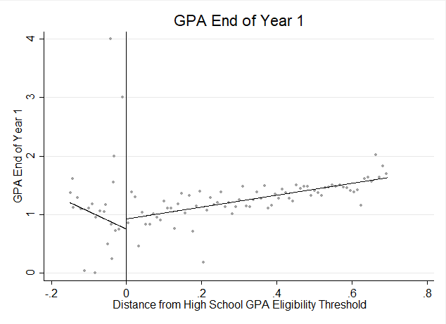

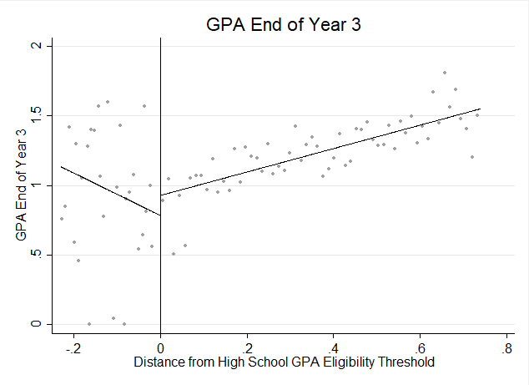

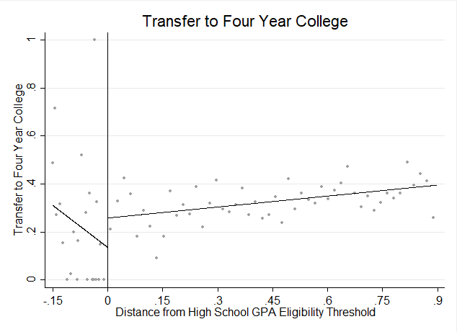

Difference-in-Differences Approach
To estimate the average treatment effect for students not included in RD analyses, I also implement a difference-in-differences approach. The difference-in-differences design is implemented in a regression framework that is presented in the equation below.
${\text{Y}}_{\text{it}}\text{= }\text{∝}\text{ +} {Post}_{t}\text{+}{\text{TA}}_{\text{i}}\text{ + }\text{β}{\text{(}\text{TA}}_{\text{i}}\text{*}{Post}_{t}\text{)}+{\text{X}}_{\text{i}\text{t}}\text{+} {\text{λ}}_{\text{t}}+{\text{ϵ}}_{\text{it}}$ (4)
In this model, the outcome variables $\text{(}{\text{Y}}_{\text{it}}\text{) }$are a function of a constant ($α$), a cohort fixed effect (${\text{λ}}_{\text{t}})$, a set of covariates including race, age, gender, and Pell status (X_{it}), an error term (${\text{ϵ}}_{\text{it}})$, and an interaction between a dichotomous indicator for eligibility (${\text{TA}}_{\text{i}})$ and a dichotomous indicator coded as zero in 2005-2006 cohorts and one for post Tulsa Achieves implementation (2007-2015) cohorts (${Post}_{t})$. The parameter of interest ($\text{β}$) reveals the effect of Tulsa Achieves eligibility and the outcomes of interest. This allows for a comparison of the average effect of Tulsa Achieves eligibility, essentially the ITT estimate, but does not allow for estimation of the treatment on the treated (TOT) estimate.
To estimate the TOT, I implement an instrumental variables (IV) approach in which I leverage the timing of program implementation to reveal the effect of Tulsa Achieves receipt on student outcomes. This technique has been utilized in previous studies on the West Virginia PROMISE as an approximation of the treatment on the treated parameter (Scott-Clayton, 2011). For this analysis, I limit the sample to the 9,605 students that meet the high school GPA and Tulsa residency requirements in the two cohorts before Tulsa Achieves (2005-06 and 2006-07) and six cohorts after the program was implemented (2007-2012).
In the equation below, I utilize an IV specification which estimates the causal effects of Tulsa Achieves receipt by using ${Post}_{t}$ as the plausibly exogenous instrument. These equations reflect a two-stage model:
${\text{TA}}_{\text{it}}\text{= }\text{∝}\text{ + β}{(Post}_{t}\text{)}+∅{\text{X}}_{\text{it}}\text{+} {\text{λ}}_{\text{t}}+{\text{ϵ}}_{\text{it}}$ (5)
${\text{Y}}_{\text{it}}\text{= }\text{∝}\text{ + β}{(\hat{TA}}_{it}\text{)}+∅{\text{X}}_{\text{it}}\text{+} {\text{λ}}_{\text{t}}+{\text{ϵ}}_{\text{it}}$ (6)
where ${\text{TA}}_{\text{it}}$ is receipt of Tulsa Achieves, ${\hat{TA}}_{it}$ is the predicted Tulsa Achieves receipt based on Equation 2 and all other variables consistent with previous definitions.
Identification Assumptions
The primary identification assumption of the difference-in-differences research design is that there are parallel pre-treatment trends in the treatment and comparison groups. To formally test this assumption, I also include an event-study model, where I interact each cohort with the indicator for Tulsa Achieves eligibility. This approach is identical to equation 4 with the exception that ${\text{(}\text{TA}}_{\text{i}}\text{*}{Post}_{t}$) in equation 4 is instead ${\text{(}\text{TA}}_{\text{i}}\text{*}{Cohort}_{t})$, where ${Cohort}_{t}$ is an indicator for each cohort from 2005-2015 with the 2006 cohort as the reference category. This estimation technique provides multiple analytical benefits: first, it provides insight into whether there are any significant differences in the outcome measures between the treatment and control group in pre-treatment years, and second, it provides insight into whether the treatment effect varies over the post-implementation time period. As I present in the next section, this analysis further supports the notion that any changes in the outcomes are not a result of differential preexisting trends across treatment and control groups.
Another important identification assumption of this design is that any relative shift in the outcomes are attributable to shifts in response to the implementation of the Tulsa Achieves program and not another policy that was implemented simultaneously. According to my discussions with the program administrators at TCC, there were no other major programs implemented in the same year, providing support for the simultaneity assumption.
Difference-in-Differences Results
The results for the difference-in-differences analysis for the effect of Tulsa Achieves eligibility on student outcomes are presented in Table 5-8. First, this table reveals that the average treatment effect of Tulsa Achieves eligibility is significantly impacting multiple outcomes of interest. First, the estimates reveal a positive impact of Tulsa Achieves eligibility on credits earned in year one and on the number of semesters students enrolled over three years. On the other hand, the estimates also reveal a negative effect of Tulsa Achieves eligibility on the likelihood of graduating from TCC and a negative effect on the likelihood of transferring to a four-year college. In terms of magnitude, these estimates suggest that Tulsa Achieves eligibility is associated with a 3.8 percentage point decrease in the likelihood of graduating from TCC and a 6.6 percentage point decrease in the likelihood of transferring to a four-year college. However, the estimates also demonstrate a positive effect of Tulsa Achieves eligibility on the likelihood of graduating with a bachelor’s degree within five years.
Finally, the consistently insignificant coefficients for the interaction between the 2005 cohort and Tulsa Achieves eligibility show that the treatment and control groups were not significantly different in pre-treatment years. While it would be ideal to have more pre-treatment cohorts, this evidence does support the parallel trends assumption, providing further evidence for the validity of the research design.
Table 5-8. Difference-in-Difference Results for the Effect of Tulsa Achieves Eligibility on Student Outcomes (ITT)
 | GPA End of Year 1 | Credits End of Year 1 | GPA End of Year 3 | Credits End of Year 3 | Semesters Enrolled in 3 Years | Had 63 Credits by Year 3 | Graduate with Credential | Transfer to Four Year College | Bachelors Degree | Bachelors Degree in 5 Years
2005 Cohort*Tulsa Achieves Eligibility | 0.039 | -0.150 | 0.023 | -1.271 | 0.052 | -0.014 | -0.011 | 0.024 | -0.005 | 0.014
 | (0.085) | (0.581) | (0.079) | (1.412) | (0.249) | (0.016) | (0.030) | (0.034) | (0.027) | (0.017)
2006 Cohort*Tulsa Achieves Eligibility | OMIT | OMIT | OMIT | OMIT | OMIT | OMIT | OMIT | OMIT | OMIT | OMIT
Post Cohort*Tulsa Achieves Eligibility | 0.048 | 0.706* | 0.043 | 1.190 | 0.285* | 0.012 | 0.004 | -0.066*** | 0.010 | 0.028**
 | (0.060) | (0.412) | (0.055) | (0.987) | (0.171) | (0.012) | (0.020) | (0.023) | (0.019) | (0.011)
Observations | 35,452 | 35,458 | 35,455 | 35,458 | 35,458 | 35,458 | 35,458 | 35,458 | 35,458 | 35,458
R-squared | 0.168 | 0.196 | 0.180 | 0.228 | 0.220 | 0.062 | 0.132 | 0.081 | 0.111 | 0.064
The reference year utilized in each model is the year before Tulsa Achieves implementation, which is the 2006 cohort. The 2005 cohort coefficient provides an estimate of whether the eligible and ineligible groups were significantly difference in pre-treatment years. Each model includes controls for race/ethnicity, gender, age, pell, and an indicator of receipt of another scholarship. Robust standard errors in parentheses *** p<0.01, ** p<0.05, * p<0.1

The estimates presented in Table 5-8, although insightful, mask heterogeneity in the treatment effect over the post treatment time period. To provide insight into the dynamic effects of Tulsa Achieves eligibility over time, I present the event-study analysis in Table 5-9 and Figure 5-11. When the average treatment effect estimates are allowed to vary based on the treatment cohort, as shown in Table 5-9, significant heterogeneity emerges in the average treatment effect across cohorts.

Table 5-9. Event-Study Results for the Effect of Tulsa Achieves Eligibility on Student Outcomes (ITT)
 | GPA End of Year 1 | Credits Year 1 | GPA End of Year 3 | Credits Year 3 | Semesters Enrolled in 3 Years | Had 63 Credits by Year 3 | Graduate with Credential | Transfer to Four Year | Bachelors Degree | Bachelors Degree in 5 Years
2005 Cohort*TA Eligibility | 0.039 | 0.026 | 0.021 | -0.993 | 0.085 | -0.013 | -0.008 | 0.024 | 0.000 | 0.017
 | (0.085) | (0.566) | (0.079) | (1.594) | (0.250) | (0.020) | (0.030) | (0.034) | (0.027) | (0.017)
2006 Cohort*TA Eligibility | OMIT | OMIT | OMIT | OMIT | OMIT | OMIT | OMIT | OMIT | OMIT | OMIT
2007 Cohort*TA Eligibility | 0.173** | 1.448** | 0.181** | 2.868** | 0.363 | 0.012 | 0.021 | 0.008 | 0.012 | 0.11
 | (0.082) | (0.583) | (0.076) | (1.430) | (0.241) | (0.018) | (0.029) | (0.032) | (0.026) | (0.017)
2008 Cohort*TA Eligibility | 0.128 | 0.564 | 0.142* | 1.982 | 0.316 | 0.018 | 0.013 | -0.016 | 0.004 | 0.018
 | (0.080) | (0.569) | (0.073) | (1.386) | (0.234) | (0.017) | (0.028) | (0.031) | (0.025) | (0.017)
2009 Cohort*TA Eligibility | 0.023 | 1.078** | 0.001 | 1.329 | 0.245 | 0.025* | 0.017 | -0.073*** | 0.021 | 0.025*
 | (0.071) | (0.484) | (0.066) | (1.159) | (0.201) | (0.014) | (0.024) | (0.027) | (0.021) | (0.014)
2010 Cohort*TA Eligibility | 0.151** | 0.952* | 0.128* | 3.087*** | 0.711*** | 0.030** | 0.039* | -0.033 | 0.036* | 0.035**
 | (0.073) | (0.488) | (0.067) | (1.168) | (0.201) | (0.014) | (0.024) | (0.028) | (0.021) | (0.014)
2011 Cohort*TA Eligibility | 0.087 | 0.786 | 0.070 | 1.738 | 0.502** | 0.002 | 0.010 | -0.077*** | 0.017 | 0.041***
 | (0.073) | (0.493) | (0.068) | (1.192) | (0.205) | (0.014) | (0.024) | (0.028) | (0.021) | (0.014)
2012 Cohort*TA Eligibility | 0.027 | 0.633 | 0.022 | 1.470 | 0.400* | 0.014 | -0.008 | -0.096*** | 0.003 | 0.033**
 | (0.075) | (0.500) | (0.069) | (1.189) | (0.207) | (0.014) | (0.023) | (0.028) | (0.020) | (0.014)
2013 Cohort*TA Eligibility | -0.032 | 0.371 | -0.021 | 0.966 | 0.210 | 0.006 | -0.020 | -0.069** | -0.001 | 0.028**
 | (0.074) | (0.498) | (0.068) | (1.158) | (0.198) | (0.013) | (0.022) | (0.028) | (0.019) | (0.013)
2014 Cohort*TA Eligibility | -0.009 | 0.636 | -0.001 | -0.428 | -0.013 | 0.000 | -0.022 | -0.082*** | -0.009 | 0.026**
 | (0.074) | (0.501) | (0.069) | (1.056) | (0.182) | (0.012) | (0.021) | (0.028) | (0.019) | (0.011)
2015 Cohort*TA Eligibility | -0.067 | -0.147 | -0.068 | -2.305** | -0.298* | -0.005 | -0.021 | -0.113*** | -0.009 | 0.021*
 | (0.080) | (0.440) | (0.077) | (1.017) | (0.173) | (0.012) | (0.021) | (0.028) | (0.019) | (0.011)
Observations | 35,452 | 35,458 | 35,455 | 35,458 | 35,458 | 35,458 | 35,458 | 35,458 | 35,458 | 35,458
R-squared | 0.169 | 0.196 | 0.180 | 0.229 | 0.221 | 0.063 | 0.133 | 0.082 | 0.111 | 0.064
Each model includes controls for race/ethnicity, gender, age, pell, and an indicator of whether they received another scholarship. Robust standard errors in parentheses *** p<0.01, ** p<0.05, * p<0.1

For instance, Table 5-9 shows that in the 2007 and 2010 cohorts Tulsa Achieves eligibility has a statistically significant positive effect on GPA and credit accumulation, while later cohorts experience insignificant gains in GPA and credit accumulation. For retention, measured as the number of semesters students were enrolled over the first three years, it appears that while most of the coefficients are substantively positive, the 2010-2012 cohorts were statistically significantly positive.
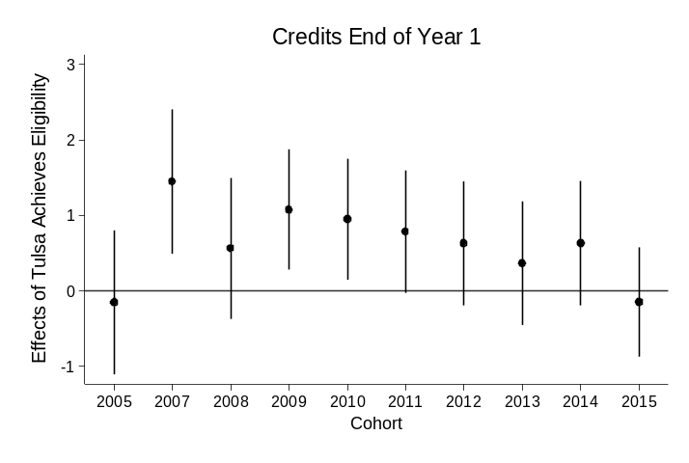
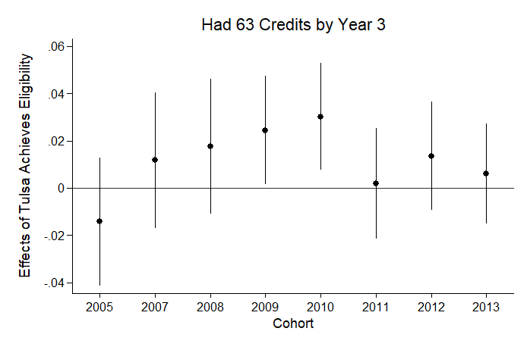
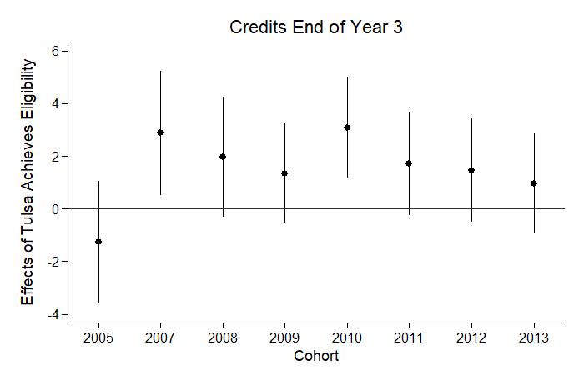
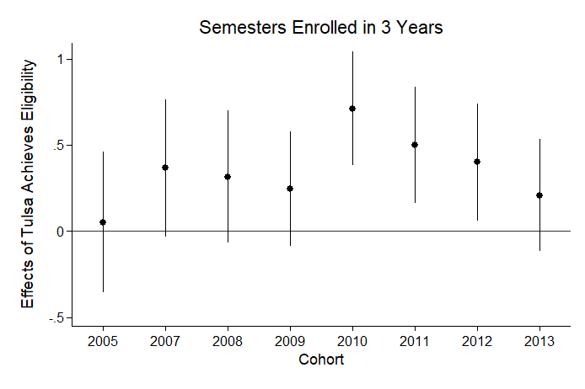
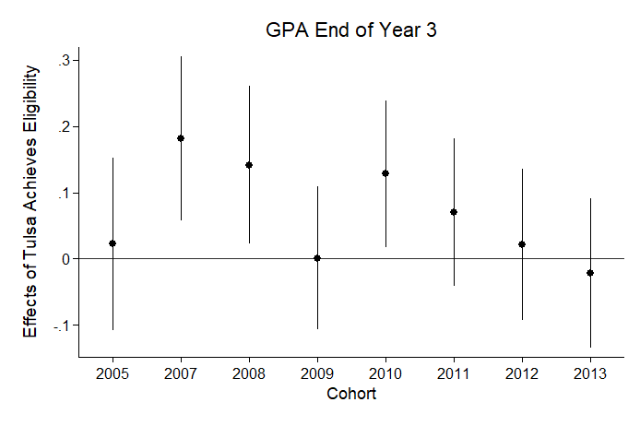
Figure 5-11. Event-Study Figures for the Effect of Tulsa Achieves Eligibility on Student Outcomes (ITT)
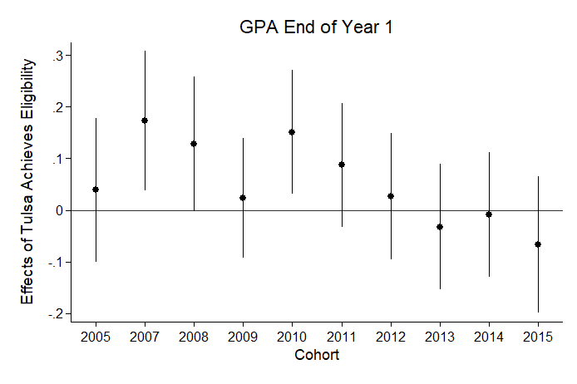
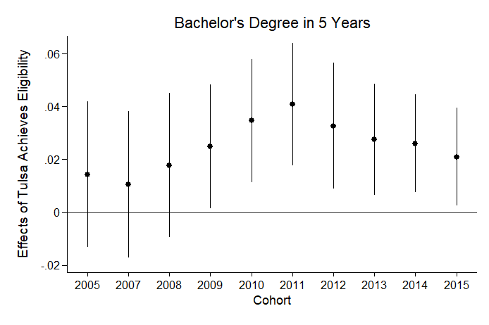
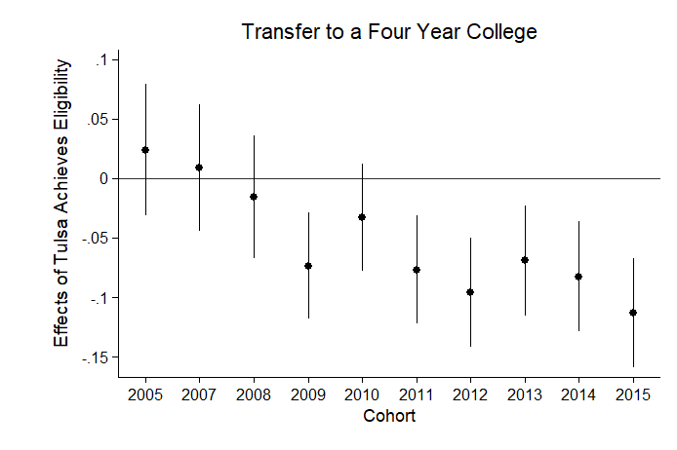
Figure 5-11 Continued. Event-Study Model Figures for the Effect of Tulsa Achieves Eligibility on Student Outcomes (ITT)
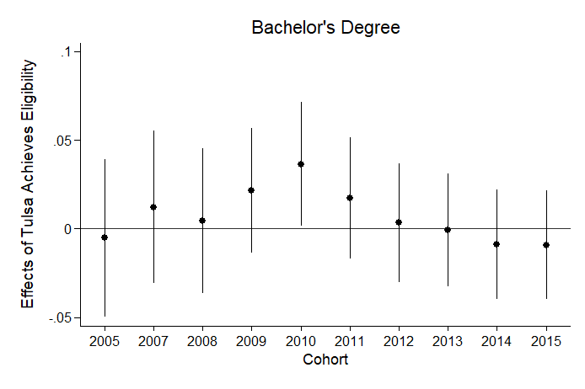
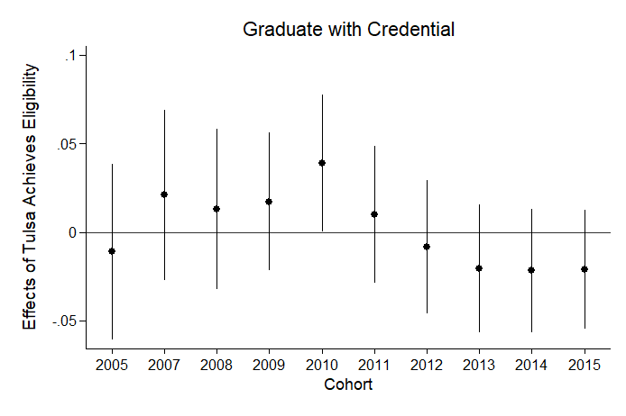
Students eligible for Tulsa Achieves in the 2009 and 2010 cohort were also more 2-3 percentage points more likely to meet key achievement thresholds such as obtaining 63 credits by year three. However, students eligible for Tulsa Achieves were also significantly less likely to graduate from TCC and transfer to four-year colleges, especially in later cohorts. This may seem counter to the findings that Tulsa Achieves eligibility positively affects the likelihood of obtaining a bachelor’s degree within five years, since students must transfer to a four-year college in order to earn a bachelor’s degree. However, this pair of findings likely suggests that the students who do end up transferring to four-year colleges are a different set of students than those who stay at TCC. Those students who do end up transferring have significantly higher GPAs and higher credit accumulation in both the treatment and control groups, suggesting that this set of students are higher achieving. For the students that are induced to attend college instead of entering the workforce, as opposed to the students that choose to attend TCC instead of starting college at a four-year institution, the effects of the program are likely very different.
Robustness Analysis
To test whether the difference-in-differences results are robust to multiple comparison groups, I present the analysis utilizing the approximately 8,000 out-of-state students as the comparison group, who would have been ineligible regardless of high school GPA because of their residency. As Tables 5-B1-B2 demonstrate, the results are remarkably similar to the main analysis, suggesting that the models are robust to multiple comparison groups. Second, I test whether the results are robust to the inclusion of high school fixed effects in Tables 5-B3-B4. These results are in line with the main analysis, suggesting that the results are robust to multiple specifications.
IV Analysis Results
Table 5-10 presents the results from the IV approach described in equations 5 and 6, where the sample is limited to eligible students in the 2005-2012 cohorts and the indicator for post Tulsa Achieves cohorts is utilized as an instrument for receipt of Tulsa Achieves. Therefore, these results reflect an approximation of the average treatment effect on the treated Tulsa Achieves students, which is a substantially different estimate from the analysis above comparing eligible to ineligible students in the analysis above.
Table 5-10. Two-Stage Least Squares Regression Results for the Effect of Tulsa Achieves Receipt on Student Outcomes (2005-2012)-First Stage=0.45
Outcome | Reduced Form | IV
GPA End of Year 1 | 0.207*** | 0.267
 | (0.0476) | (0.196)
Credits Year 1 | 0.647* | 4.376***
 | (0.336) | (1.340)
GPA End of Year 3 | 0.167*** | 0.245
 | (0.0438) | (0.181)
Credits Year 3 | 2.158*** | 10.65***
 | (0.832) | (3.454)
Semesters Enrolled in 3 Years | 0.0870 | 1.815***
 | (0.131) | (0.513)
Had 63 Credits by Year 3 | 0.023** | 0.118***
 | (0.0103) | (0.0440)
Graduate with Credential | -0.0305* | -0.0211
 | (0.0162) | (0.0709)
Transfer to Four Year College | -0.112*** | -0.185**
 | (0.0197) | (0.0839)
Bachelor's Degree | -0.060*** | -0.0354
 | (0.0157) | (0.0612)
Bachelor's Degree in 5 Years | 0.0222** | 0.0741*
 | (0.00982) | (0.0381)
N | 9,605 | 9,605
Note: All models include high school fixed effects and controls
for race/ethnicity, age, gender and pell. Robust standard errors
in parentheses *** p<0.01, ** p<0.05, * p<0.1
Table 5-10 presents both the reduced form estimates and the 2SLS results in which post is utilized as an instrument for Tulsa Achieves receipt. These results reveal that Tulsa Achieves recipients earned 4.4 additional credits in the first year enrolled and 10.6 additional credits by the third year of enrollment. Tulsa Achieves recipients also had significantly higher retention rates, enrolling in almost two more semesters than their peers. Moreover, Tulsa Achieves recipients were significantly more likely to reach key achievement thresholds—they were 11.8 percentage points more likely to earn 63 credits by year three, and 7.4 percentage points more likely to obtain a bachelor’s degree within five years. On the other hand, Tulsa Achieves recipients were also 18.5 percentage points less likely to transfer to a four-year college. These results mirror the findings in the main difference-in-differences analysis and also suggest that the set of eligible students is likely systematically different from the students that end up being Tulsa Achieves recipients. Empirically, these differences between the 9,303 recipients and the 6,105 eligible non-recipients are easily evident in the estimated family contribution (EFC). Students who are recipients of Tulsa Achieves in this sample have an average EFC of $14,222 while the non-recipients have an average EFC of $4,423. Therefore, this comparison may be revealing differences not in the effects of the Tulsa Achieves program and instead the gap in student success among low-income and higher-income students. This analysis, as a result, shows that Tulsa Achieves recipients are higher performing than their eligible non-recipient peers. However, this should not be extrapolated as the causal effect of the program due to the systematic differences in the treated and control groups.
Discussion and Conclusion
Scholarly literature on college promise programs faces a formidable challenge in accumulating evidence on programs that are diverse as they are numerous. So far, the literature has revealed the impacts of a variety of programs—such as the Kalamazoo Promise, the Pittsburgh Promise, the El Dorado Scholarship, and Knox Achieves. These evaluations, for the most part, reveal consistently positive impacts on postsecondary outcomes such as enrollment, persistence, and completion. However, the literature has yet to investigate a common and understudied version of college promise—local, merit-based, narrow programs like Tulsa Achieves.
In this article I leverage a difference-in-differences and regression discontinuity design to reveal the effects of Tulsa Achieves on postsecondary outcomes, based on an administrative dataset of students attending TCC from 2005-2015. While the results of the regression discontinuity analysis reveal predominantly null findings, with the exception of GPA and transfer to four-year colleges, the difference-in-differences results reveal a number of positive effects along with some negative effects. When I compare students who are eligible for Tulsa Achieves to students that are ineligible because of their high school GPA or county residency, the results reveal a positive impact of Tulsa Achieves on credit accumulation and the probability of earning a bachelor’s degree within five years. However, this analysis also reveals that in later cohorts students eligible for Tulsa Achieves are less likely to transfer to four-year colleges and graduate from TCC. Therefore, on average, students are less likely to make it to a four-year college, but the students that do transfer are more likely to be successful at obtaining a bachelor’s degree within five years of initial enrollment. Together, these results suggest that students along the eligibility threshold are impacted differently than the wider set of students impacted by the program.
Future research should investigate whether tuition-free college reduces or widens gaps in educational attainment between the rich and poor and between white students and students of color. The data in this study are subject to multiple limitations that should be built upon in future research. First, the data only include students who attend Tulsa Community College, instead of the entire population of potentially eligible students from Tulsa County high schools. Therefore, students who do not attend college at all, or students who choose to attend a university other than TCC are not included in the dataset. However, the inability to capture students who did not attend college or attended another college is less problematic given that the outcomes of interest are GPA, credit accumulation, retention, and degree completion. Second, the data acquired from the National Student Clearinghouse captures students transferring to four-year colleges, not other two-year or technical colleges. This means that students may be continuing on and transferring to other two-year colleges and obtaining their associate’s degree at those institutions, but I cannot observe these students’ graduation based on the data provided. Future research would do well to consider not only transfer to four-year universities but also transfer to other community colleges.

Appendix A
Figure 5-A1. Observable Characteristics near the Threshold
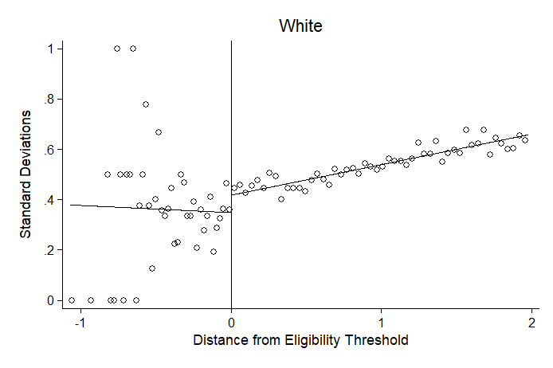
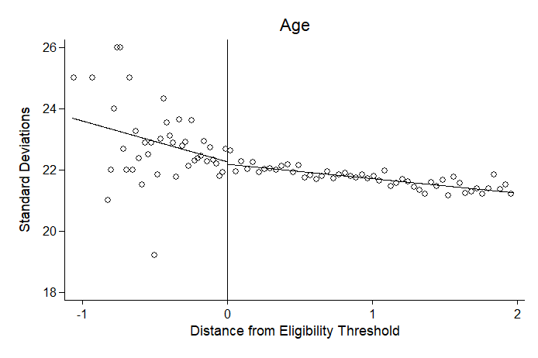

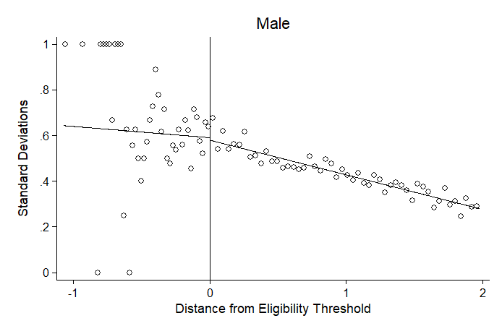
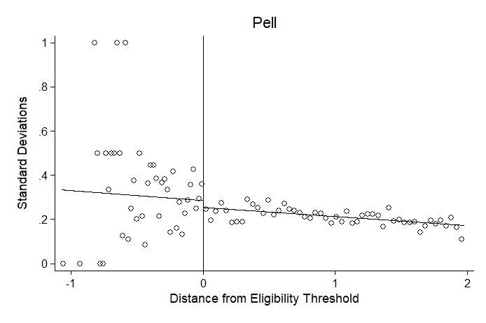

Appendix B: Robustness Analysis for Difference-in-Differences Models
Table 5-B1. Robustness Check with Out-of-State Students as Comparison Group: Difference-in-Difference Results for the Effect of Tulsa Achieves Eligibility on Student Outcomes (ITT)
 | GPA End of Year 1 | Credits Earned End of Year 1 | GPA End of Year 3 | Credits Earned End of Year 3 | Semesters Enrolled in 3 Years | Had 63 Credits by Year 3 | Graduate with Credential | Transfer to Four Year College | Bachelor's Degree | Bachelor's Degree in 5 Years
2005 Cohort*Tulsa Achieves Eligibility | 0.0910 | -0.492 | 0.0353 | -2.691 | -0.0788 | -0.0325 | -0.00660 | 0.0136 | 0.0123 | 0.0160
 | (0.103) | (0.723) | (0.0958) | (1.789) | (0.313) | (0.0218) | (0.0389) | (0.0430) | (0.0354) | (0.0216)
2006 Cohort*Tulsa Achieves Eligibility | OMIT | OMIT | OMIT | OMIT | OMIT | OMIT | OMIT | OMIT | OMIT | OMIT
Post Cohort*Tulsa Achieves Eligibility | 0.145* | 0.735 | 0.130* | 1.472 | 0.512** | -0.00299 | -0.00899 | -0.074** | 0.00206 | 0.0295**
 | (0.0743) | (0.542) | (0.0682) | (1.296) | (0.218) | (0.0162) | (0.0266) | (0.0302) | (0.0241) | (0.0148)
Observations | 22,166 | 22,172 | 22,169 | 22,172 | 22,172 | 22,172 | 22,172 | 22,172 | 22,172 | 22,172
R-squared | 0.202 | 0.197 | 0.216 | 0.239 | 0.223 | 0.071 | 0.150 | 0.090 | 0.122 | 0.074
The reference year utilized in each model is the year before Tulsa Achieves implementation, which is the 2006 cohort. Each model includes controls for race/ethnicity, gender, age, pell, and an indicator of receipt of another scholarship. Robust standard errors in parentheses *** p<0.01, ** p<0.05, * p<0.1

Table 5-B2. Robustness Check with Out-of-State Students as Comparison Group: The Effect of Tulsa Achieves Eligibility on Student Outcomes (ITT)
 | GPA End of Year 1 | Credits Year 1 | GPA End of Year 3 | Credits Year 3 | Semesters Enrolled in 3 Years | Had 63 Credits by Year 3 | Graduate with Credential | Transfer to Four Year | Bachelors Degree | Bachelors Degree in 5 Years
2005 Cohort*TA Eligibility | 0.0909 | -0.493 | 0.0353 | -2.691 | -0.0789 | -0.0325 | -0.00662 | 0.0122 | 0.0160 | 0.0135
 | (0.103) | (0.723) | (0.096) | (1.789) | (0.313) | (0.0218) | (0.0389) | (0.0354) | (0.0216) | (0.0430)
2006 Cohort*TA Eligibility | OMIT | OMIT | OMIT | OMIT | OMIT | OMIT | OMIT | OMIT | OMIT | OMIT
2007 Cohort*TA Eligibility | 0.152 | 1.48** | 0.166* | 2.757 | 0.454 | -0.0105 | 0.0223 | 0.00638 | 0.0267 | 0.0250
 | (0.0957) | (0.710) | (0.088) | (1.728) | (0.286) | (0.0217) | (0.0356) | (0.0319) | (0.0208) | (0.0395)
2008 Cohort*TA Eligibility | 0.0516 | 0.0024 | 0.0732 | 0.308 | 0.371 | -0.0214 | -0.00931 | 0.00255 | 0.0233 | -0.00242
 | (0.0931) | (0.692) | (0.085) | (1.665) | (0.282) | (0.0209) | (0.0336) | (0.0306) | (0.0200) | (0.0382)
2009 Cohort*TA Eligibility | 0.161* | 1.44** | 0.122 | 1.237 | 0.416 | 0.00270 | 0.00881 | 0.0245 | 0.0317* | -0.101***
 | (0.0902) | (0.650) | (0.084) | (1.539) | (0.261) | (0.0195) | (0.0312) | (0.0282) | (0.0190) | (0.0357)
2010 Cohort*TA Eligibility | 0.350*** | 1.196* | 0.35*** | 4.602*** | 1.183*** | 0.0254 | 0.0323 | 0.0292 | 0.0355* | -0.0630
 | (0.101) | (0.689) | (0.093) | (1.635) | (0.274) | (0.0197) | (0.0325) | (0.0294) | (0.0204) | (0.0383)
2011 Cohort*TA Eligibility | 0.217** | 0.929 | 0.157 | 2.259 | 0.762** | -0.00634 | -0.00307 | 0.00528 | 0.0439** | -0.110***
 | (0.106) | (0.725) | (0.0996) | (1.767) | (0.296) | (0.0217) | (0.0338) | (0.0300) | (0.0215) | (0.0402)
2012 Cohort*TA Eligibility | 0.0769 | -0.466 | 0.0778 | 0.957 | 0.414 | 0.0188 | -0.0505 | -0.0289 | 0.0221 | -0.187***
 | (0.117) | (0.808) | (0.109) | (1.802) | (0.316) | (0.0207) | (0.0349) | (0.0311) | (0.0247) | (0.0432)
2013 Cohort*TA Eligibility | -0.0199 | 0.409 | -0.116 | 1.103 | 0.752*** | -0.0196 | -0.089*** | -0.0399 | 0.0113 | -0.0709
 | (0.123) | (0.819) | (0.115) | (1.863) | (0.292) | (0.0209) | (0.0348) | (0.0293) | (0.0221) | (0.0451)
2014 Cohort*TA Eligibility | -0.0003 | 0.162 | 0.0190 | -1.060 | -0.0708 | -0.0190 | -0.0566* | -0.0383 | 0.0332** | -0.124***
 | (0.121) | (0.873) | (0.115) | (1.626) | (0.274) | (0.0162) | (0.0308) | (0.0275) | (0.0147) | (0.0460)
2015 Cohort*TA Eligibility | 0.161 | -0.256 | 0.151 | -3.290** | -0.375 | -0.0178 | -0.0412 | -0.0192 | 0.0310** | -0.130***
 | (0.157) | (0.682) | (0.155) | (1.468) | (0.235) | (0.0162) | (0.0285) | (0.0245) | (0.0147) | (0.0489)
Observations | 22,166 | 22,172 | 22,169 | 22,172 | 22,172 | 22,172 | 22,172 | 22,172 | 22,172 | 22,172
R-squared | 0.202 | 0.197 | 0.217 | 0.240 | 0.224 | 0.071 | 0.151 | 0.122 | 0.074 | 0.091
Each model includes cohort and high school fixed effects and controls for race/ethnicity, gender, age, pell, and an indicator of whether they received another scholarship. Robust standard errors in parentheses *** p<0.01, ** p<0.05, * p<0.1

Table 5-B3. Robustness Check with High School Fixed Effects: Difference-in-Difference Results for the Effect of Tulsa Achieves Eligibility on Student Outcomes (ITT)
 | GPA End of Year 1 | Credits End of Year 1 | GPA End of Year 3 | Credits End of Year 3 | Semesters Enrolled in 3 Years | Had 63 Credits by Year 3 | Graduate with Credential | Transfer to Four Year College | Bachelors Degree | Bachelors Degree in 5 Years
2005 Cohort*Tulsa Achieves Eligibility | 0.0958 | 0.0329 | 0.0720 | -0.995 | 0.0699 | -0.0137 | -0.0131 | 0.0239 | -0.00798 | 0.0162
 | (0.085) | (0.583) | (0.08) | (1.426) | (0.251) | (0.0168) | (0.030) | (0.0336) | (0.0274) | (0.0170)
2006 Cohort*Tulsa Achieves Eligibility | OMIT | OMIT | OMIT | OMIT | OMIT | OMIT | OMIT | OMIT | OMIT | OMIT
Post Cohort*Tulsa Achieves Eligibility | 0.0432 | 0.471 | 0.0324 | 0.461 | 0.189 | 0.00784 | -0.0052 | -0.065*** | 0.000 | 0.0252**
 | (0.060) | (0.411) | (0.05) | (0.996) | (0.173) | (0.0119) | (0.021) | (0.0234) | (0.0188) | (0.0115)
Observations | 35,452 | 35,458 | 35,455 | 35,458 | 35,458 | 35,458 | 35,458 | 35,458 | 35,458 | 35,458
R-squared | 0.168 | 0.196 | 0.180 | 0.228 | 0.220 | 0.062 | 0.132 | 0.081 | 0.111 | 0.064
The reference year utilized in each model is the year before Tulsa Achieves implementation, which is the 2006 cohort. The 2005 cohort coefficient provides an estimate of whether the eligible and ineligible groups were significantly difference in pre-treatment years. Each model includes cohort and high school fixed effects and controls for race/ethnicity, gender, age, pell, and an indicator of receipt of another scholarship. Robust standard errors in parentheses *** p<0.01, ** p<0.05, * p<0.1

Table 5-B4. Robustness Check with High School Fixed Effects: Event-Study Results for the Effect of Tulsa Achieves Eligibility on Student Outcomes (ITT)
 | GPA End of Year 1 | Credits Year 1 | GPA End of Year 3 | Credits Year 3 | Semesters Enrolled in 3 Years | Had 63 Credits by Year 3 | Graduate with Credential | Transfer to Four Year | Bachelors Degree | Bachelors Degree in 5 Years
2005 Cohort*TA Eligibility | 0.0959 | 0.0354 | 0.0721 | -0.986 | 0.0711 | -0.0137 | -0.0130 | 0.0112 | -0.00791 | 0.0162
 | (0.0857) | (0.583) | (0.0798) | (1.426) | (0.251) | (0.0168) | (0.0305) | (0.0341) | (0.0274) | (0.0171)
2006 Cohort*TA Eligibility | OMIT | OMIT | OMIT | OMIT | OMIT | OMIT | OMIT | OMIT | OMIT | OMIT
2007 Cohort*TA Eligibility | 0.204** | 1.422** | 0.20*** | 2.728* | 0.370 | 0.0103 | 0.0227 | 0.00303 | 0.0124 | 0.0167
 | (0.0822) | (0.576) | (0.0754) | (1.426) | (0.241) | (0.0177) | (0.0293) | (0.0326) | (0.0265) | (0.0170)
2008 Cohort*TA Eligibility | 0.144* | 0.519 | 0.158** | 1.539 | 0.318 | 0.0112 | 0.00868 | -0.0136 | 0.00399 | 0.0205
 | (0.0796) | (0.566) | (0.0728) | (1.386) | (0.236) | (0.0174) | (0.0277) | (0.0318) | (0.0252) | (0.0167)
2009 Cohort*TA Eligibility | 0.0273 | 0.838* | -0.002 | 0.826 | 0.147 | 0.0202 | 0.00752 | -0.079*** | 0.0115 | 0.0217
 | (0.0713) | (0.484) | (0.0661) | (1.165) | (0.203) | (0.0141) | (0.0239) | (0.0274) | (0.0217) | (0.0145)
2010 Cohort*TA Eligibility | 0.151** | 0.911* | 0.128* | 2.693** | 0.676*** | 0.0286** | 0.0340 | -0.0410 | 0.0299 | 0.0315**
 | (0.0734) | (0.488) | (0.0678) | (1.179) | (0.204) | (0.0140) | (0.0239) | (0.0279) | (0.0215) | (0.0144)
2011 Cohort*TA Eligibility | 0.0671 | 0.452 | 0.0462 | 0.826 | 0.393* | -0.00275 | -0.00337 | -0.082*** | 0.00520 | 0.0381***
 | (0.0737) | (0.493) | (0.0683) | (1.201) | (0.207) | (0.0146) | (0.0239) | (0.0281) | (0.0212) | (0.0143)
2012 Cohort*TA Eligibility | 0.00684 | 0.338 | -0.00322 | 0.521 | 0.214 | 0.00782 | -0.0230 | -0.115*** | -0.0118 | 0.0268*
 | (0.0754) | (0.500) | (0.0697) | (1.202) | (0.210) | (0.0143) | (0.0234) | (0.0284) | (0.0208) | (0.0147)
2013 Cohort*TA Eligibility | -0.0504 | 0.0304 | -0.0494 | -0.221 | 0.0573 | 0.00107 | -0.0294 | -0.074*** | -0.0142 | 0.0245*
 | (0.0747) | (0.499) | (0.0691) | (1.170) | (0.200) | (0.0132) | (0.0223) | (0.0284) | (0.0198) | (0.0130)
2014 Cohort*TA Eligibility | -0.0215 | 0.309 | -0.0208 | -1.417 | -0.126 | -0.00490 | -0.0333 | -0.089*** | -0.0219 | 0.0234**
 | (0.0746) | (0.501) | (0.0702) | (1.069) | (0.185) | (0.0119) | (0.0216) | (0.0282) | (0.0191) | (0.0114)
2015 Cohort*TA Eligibility | -0.0961 | -0.624 | -0.102 | -3.512*** | -0.464*** | -0.0102 | -0.0349* | -0.120*** | -0.0254 | 0.0162
 | (0.0809) | (0.443) | (0.0774) | (1.038) | (0.177) | (0.0119) | (0.0209) | (0.0281) | (0.0189) | (0.0114)
Observations | 34,489 | 34,495 | 34,492 | 34,495 | 34,495 | 34,495 | 34,495 | 34,495 | 34,495 | 34,495
R-squared | 0.205 | 0.244 | 0.217 | 0.267 | 0.252 | 0.080 | 0.155 | 0.112 | 0.136 | 0.084
Each model includes cohort and high school fixed effects and controls for race/ethnicity, gender, age, pell, and an indicator of whether they received another scholarship. Robust standard errors in parentheses *** p<0.01, ** p<0.05, * p<0.1

Chapter 6: Conclusion
In Chapter 1, I draw on literature from public management and public policy to introduce a comprehensive framework for assessing the impact of policy design on outcomes which I apply to college promise policies in Chapter 2. This framework, described in detail in Figure 6-1, reaches across the boundaries of public policy and public administration to construct the following logic model for the three pathways by which I argue policy design affects outcomes.

Figure 6-1. Policy Design Framework Applied to College Promise Policies

First, there is the politics pathway, in which political feasibility may come into conflict with efficiency and effectiveness, ultimately shaping who gets what when and how in college promise policies. In Chapter 3, I demonstrate how the social construction of target population shapes public support for college promise policies and introduces potential tensions between political feasibility and effectiveness. In particular, while the public is more likely to support college promise policies that are structured as universal, merit-based benefits, these policies are likely to be the least efficient and also potentially the least effective at accomplishing the goals of expanding college access and affordability. From a political standpoint, policymakers looking to gain support from broad constituencies would gain political points (a broader political constituency) for allowing all in-state families to benefit from college promise and ensuring that tax payer money is only allocated to those students that demonstrate some degree of “college readiness”. However, this politically optimal structure also would shut out students that likely face the most challenges in accessing and affording college and provide benefits to students who would have attended college with or without the presence of a college promise program. Therefore, this chapter demonstrates the importance of politics and social constructions of target populations in shaping the relationship between policy design and outcomes. However, there are also instances where despite the potential political costs, policymakers may enact policies that target benefits to students who need help the most. In this case, the first pathway between policy design and outcomes would be clear of barriers, but there are still two other pathways by which policy design can form barriers to achieving the policy goals.
Second, I discuss the statutory design pathway in Chapter 5, which describes the implications of aid structures, eligibility requirements, requirements for students receiving aid and the provision or lack thereof of student supports like mentoring and childcare. Even if the policy is structured so that those who need help the most are eligible for the aid, the statutory design must demonstrate an alignment with client needs and integrate the policy tools that meaningfully meet those needs. For instance, in the narrow, last-dollar Tulsa Achieves program, low-income students are eligible for the aid as long as they have a 2.0 high school GPA, but many of these students do not receive any financial support due to the last-dollar structure and the lack of support for living expenses such as rent, transportation and books. Therefore, the students who benefit the most from this policy are those that are not eligible for the federal Pell grant, which excludes the students in the lowest income quartile from receiving any benefit from the program—the students who are also least likely to earn a degree and afford college. However, financial aid may be one of many ways in which Tulsa Achieves impacted college access and success for students. Indeed, according to the analysis, the program did induce some positive changes in GPA and bachelor’s degree completion. It also appears that as a result of the narrow structure, in which students can only attend TCC if they are receiving aid from the program, students who may have otherwise started at a four-year college in the absence of the policy chose to attend TCC instead and while some made it to the four-year college many others did not. But, those that did make it to a four-year college were more likely to graduate with a bachelor’s degree. As this chapter demonstrates, the statutory design is important in predicting whether college promise expands college access and affordability and for whom this expansion occurs.
Finally, Chapter 4 reveals that even if the politics and statutory design are set up for success, the implementation pathway can still pose barriers to accomplishing the goals of college promise programs. In this chapter I leverage the growing literature on administrative burden—the political tool by which policymakers induce additional costs on clients seeking access to programs in the bureaucratic application processes—to explore the ways by which individual bureaucrats can alleviate or exacerbate the learning, psychological, and compliance costs of applying for Oklahoma’s Promise program. This chapter reveals that the role perception and uses of discretion among street-level bureaucrats—in this case, high school counselors—affects the ability of low-income students to gain access to college promise aid. In particular, some counselors went above and beyond to support students through the burdensome bureaucratic application process of Oklahoma’s Promise program while others exacerbated the costs of applying for the program, considering it their job to serve as gatekeepers to a valuable tax payer benefit. Finally, this chapter reveals that agency resources and capacity were another important element predicting the proportion of students that were able to overcome the costs of applying for the program and gain access to Oklahoma’s Promise. In fact, the analysis reveals that the schools with the highest proportions of eligible low-income students were also the schools that were less likely to have the resources to aid students in overcoming the costs of applying for the program. This solidifies previous notions that administrative burdens are not only consequential, but also distributive (Herd and Moynihan 2018). In sum, this chapter reveals that bureaucrats play an essential role in translating statutory design into program access and outcomes, serving to either exacerbate or alleviate the learning, compliance and psychological costs of means-tested programs.
Together this dissertation puts forth a framework for assessing the holistic impact of policy design on outcomes in the context of college promise policies. I argue that policy design works through the three pathways—political, statutory, and administrative—to determine whether public policies will fulfill their goals and improve the lives of citizens or exacerbate inequality and forge a system of degenerative politics. For all those concerned with the effective design and delivery of public programs and the efficacy of democratic governance, this framework takes the first step in determining the critical junctures that can either facilitate or impede the effectiveness of public policies.

References

Alon, S. (2009). The Evolution of Class Inequality in Higher Education: Competition, Exclusion, and Adaptation. American Sociological Review, 74(5), 731–755. https://doi.org/10.1177/000312240907400503
Andrews, R. J., DesJardins, S., & Ranchhod, V. (2010). The effects of the Kalamazoo Promise on college choice. Economics of Education Review, 29(5), 722–737. https://doi.org/10.1016/j.econedurev.2010.05.004
Arnold, R. D. (1990). The Logic of Congressional Action (Reprint edition). Yale University Press.
Bachrach, P., & Baratz, M. S. (1962). Two Faces of Power. American Political Science Review, 56(04), 947–952. https://doi.org/10.2307/1952796
Bailey, M. J., & Dynarski, S. M. (2011). Gains and Gaps: Changing Inequality in U.S. College Entry and Completion (Working Paper No. 17633). National Bureau of Economic Research. https://doi.org/10.3386/w17633
Bartik, T. J., Hershbein, B. J., & Lachowska, M. (2015). The Effects of the Kalamazoo Promise Scholarship on College Enrollment, Persistence, and Completion (SSRN Scholarly Paper No. ID 2624727). Rochester, NY: Social Science Research Network. Retrieved from https://papers.ssrn.com/abstract=2624727
Bartik, T., Eberts, R., & Huang, W.-J. (2010). The Kalamazoo Promise, and Enrollment and Achievement Trends in Kalamazoo Public Schools. Upjohn Institute. Retrieved from http://research.upjohn.org/confpapers/15
Baumgartner, F. R., & Jones, B. D. (2010). Agendas and Instability in American Politics, Second Edition. University of Chicago Press.
Bell, E. (Forthcoming). Deserving to Whom? The Heterogeneous Effects of Social Constructions on Mass Opinion. Policy Studies Journal.
Bertelli, A. M., & Lynn, L. E. (2003). Managerial Responsibility. Public Administration Review, 63(3), 259–268.
Bloemraad, I. (2006). Becoming a Citizen: Incorporating Immigrants and Refugees in the United States and Canada (1 edition). Berkeley: University of California Press.
Boushey, G. (2016). Targeted for Diffusion? How the Use and Acceptance of Stereotypes Shape the Diffusion of Criminal Justice Policy Innovations in the American States. American Political Science Review, 110(1), 198–214. https://doi.org/10.1017/S0003055415000532
Boushey, G. (2016). Targeted for Diffusion? How the Use and Acceptance of Stereotypes Shape the Diffusion of Criminal Justice Policy Innovations in the American States. American Political Science Review, 110(1), 198–214. https://doi.org/10.1017/S0003055415000532
Bowen, W. G., Kurzweil, M. A., Tobin, E. M., Pichler, S. C., Hall, M., & Ryan, A. (2006). Equity and Excellence in American Higher Education (1st Pbk. Ed edition). Charlottesville: University of Virginia Press.
Bozeman, Barry, Patrick Scott, and Pamela Reed. 1992. “Red Tape and Task Delays in Public and Private Organizations.” Administration and Society 24 (3): 290–322.
Bozick, R., Gonzalez, G., & Engberg, J. (2015). Using a Merit-Based Scholarship Program to Increase Rates of College Enrollment in an Urban School District: The Case of the Pittsburgh Promise. Journal of Student Financial Aid, 45(2). Retrieved from https://publications.nasfaa.org/jsfa/vol45/iss2/2
Brehm, J., & Gates, S. (1997). Working, Shirking, and Sabotage: Bureaucratic Response to a Democratic Public. Ann Arbor, MI: University of Michigan Press.
Brehm, John, and Scott Gates. 1997. Working, Shirking, and Sabotage: Bureaucratic Response to a Democratic Public. Ann Arbor, MI: University of Michigan Press.
Brodkin, E. Z. (2011). Policy Work: Street-Level Organizations Under New Managerialism. Journal of Public Administration Research and Theory, 21(suppl_2), i253–i277. https://doi.org/10.1093/jopart/muq093
Brodkin, Evelyn, and Malay Majmundar. 2010. “Administrative Exclusion: Organizations and the Hidden Costs of Welfare Claiming.” Journal of Public Administration Research and Theory 20 (4): 827–48.
Brodkin, Evelyn. 1997. “Inside the Welfare Contract: Discretion and Accountability in State Welfare Administration.” Social Service Review 71 (1): 1–33.
Brodkin, Evelyn. 2008. “Accountability in Street-Level Organizations.” International Journal of Public Administration 31 (3): 317–36.
Bruch, Sarah, Myra Marx Ferree, and Joe Soss. 2010. “From Policy to Polity: Democracy, Paternalism, and the Incorporation of Disadvantaged Citizens.” American Sociological Review 75 (2): 205–26.
Burch, Patricia, and Carolyn J. Heinrich. 2016. Mixed Methods for Policy Research and Program Evaluation. Thousand Oaks California: SAGE Publications, Inc.
Burden, B. C., Canon, D. T., Mayer, K. R., & Moynihan, D. P. (2012). The Effect of Administrative Burden on Bureaucratic Perception of Policies: Evidence from Election Administration. Public Administration Review, 72(5), 741–751. https://doi.org/10.1111/j.1540-6210.2012.02600.x
Callahan, M., Perna, L. W., Yamashita, M., Wright, J., & Santillan, S. (2018). 2018 Indicators of Higher Education Equity in the United States: Historical Trend Report. Washington, DC: The Pell Institute for the Study of Opportunity in Higher Education, Council for Opportunity in Education and Alliance for Higher Education and Democracy of the University of Pennsylvania. Retrieved from http://pellinstitute.org/downloads/publications-Indicators_of_Higher_Education_Equity_in_the_US_2018_Historical_Trend_Report.pdf
Campbell, A. L. (2002, September). Self-Interest, Social Security, and the Distinctive Participation Patterns of Senior Citizens. https://doi.org/10.1017/S0003055402000333
Campbell, A. L. (2002, September). Self-Interest, Social Security, and the Distinctive Participation Patterns of Senior Citizens. https://doi.org/10.1017/S0003055402000333
Campbell, A. L. (2003). Self-Interest, Social Security, and the Distinctive Participation Patterns of Senior Citizens. American Political Science Review, 96(3).
Canaday, M. (2011). The Straight State: Sexuality and Citizenship in Twentieth-Century America (unknown edition). Princeton, NJ: Princeton University Press.
Carruthers, C. K., & Fox, W. F. (2016). Aid for all: College coaching, financial aid, and post-secondary persistence in Tennessee. Economics of Education Review, 51, 97–112. https://doi.org/10.1016/j.econedurev.2015.06.001
Cattaneo, M. D., & Escanciano, J. C. (Eds.). (2017). Regression Discontinuity Designs: Theory and Applications. United Kingdom ; North America: Emerald Publishing Limited.
Cattaneo, M. D., Jansson, M., & Ma, X. (2018). Manipulation testing based on density discontinuity. Stata Journal, 18(1), 234–261.
Cattaneo, M. D., Titiunik, R., & Vazquez-Bare, G. (2017). Comparing Inference Approaches for RD Designs: A Reexamination of the Effect of Head Start on Child Mortality. Journal of Policy Analysis and Management, 36(3), 643–681. https://doi.org/10.1002/pam.21985
Chanley, J. J. J. (2005). An analysis of civic education policy-making in Arizona using the advocacy coalition framework and policy design theory.
Cherlin, Andrew, Karen Bogen, James Quane, and Linda Burton. 2002. “Operating within the Rules: Welfare Recipients’ Experiences with Sanctions and Case Closings.” Social Service Review 76 (3): 387–405.
Corbin, Juliet, and Anselm Strauss. 2007. Basics of Qualitative Research: Techniques and Procedures for Developing Grounded Theory. 3rd edition. Los Angeles, Calif: SAGE Publications, Inc.
Creswell, John. 2009. Research Design: Qualitative, Quantitative, and Mixed Methods Approaches. SAGE Publications.
Dahl, R. A. (2003). How Democratic is the American Constitution? Second Edition (2nd ed. edition). New Haven, Conn.: Yale University Press.
Dar, L. (2012). The Political Dynamics of Higher Education Policy. The Journal of Higher Education, 83(6), 769–794. https://doi.org/10.1080/00221546.2012.11777269
Daugherty, L., & Gonzalez, G. C. (2016). The Impact of the New Haven Promise Program on College Enrollment, Choice, and Persistence. RAND Corporation. Retrieved from https://www.rand.org/pubs/working_papers/WR1147.html
Demos. (2016). New National Poll Shows 80% of Americans Support Addressing College Affordability Crisis. Demos. Retrieved from http://www.demos.org/press-release/new-national-poll-shows-80-americans-support-addressing-college-affordability-crisis
Derthick, M. (1979). Policymaking for Social Security. Washington: Brookings Institution Press.
Donovan, M. C. (1993). Social Constructions of People with AIDS: Target Populations and United States Policy, 1981–1990. Review of Policy Research, 12(3–4), 3–29. https://doi.org/10.1111/j.1541-1338.1993.tb00548.x
Donovan, M. C. (1993). Social Constructions of People with AIDS: Target Populations and United States Policy, 1981–1990. Review of Policy Research, 12(3–4), 3–29. https://doi.org/10.1111/j.1541-1338.1993.tb00548.x
Doyle, W. R. (2007). Public Opinion, Partisan Identification, and Higher Education Policy. The Journal of Higher Education, 78(4), 369–401. https://doi.org/10.1080/00221546.2007.11772321
Doyle, W. R. (2010). U.S. Senator’s Ideal Points for Higher Education: Documenting Partisanship, 1965–2004. The Journal of Higher Education, 81(5), 619–644. https://doi.org/10.1353/jhe.2010.0006
Doyle, W. R. (2012). The Politics of Public College Tuition and State Financial Aid. The Journal of Higher Education, 83(5), 617–647. https://doi.org/10.1353/jhe.2012.0033
Druckman, J. N. (2001). On the Limits of Framing Effects: Who Can Frame? Journal of Politics, 63(4), 1041–1066. https://doi.org/10.1111/0022-3816.00100
Dynarski, S. (2000). Hope for Whom? Financial Aid for the Middle Class and Its Impact on College Attendance (Working Paper No. 7756). National Bureau of Economic Research. https://doi.org/10.3386/w7756
Dynarski, S. (2000). Hope for Whom? Financial Aid for the Middle Class and Its Impact on College Attendance (Working Paper No. 7756). National Bureau of Economic Research. https://doi.org/10.3386/w7756
Dynarski, S. (2002). The Behavioral and Distributional Implications of Aid for College. American Economic Review, 92(2), 279–285. https://doi.org/10.1257/000282802320189401
Dynarski, S., & Scott-Clayton, J. (2013). Financial aid policy: lessons from research. The Future of Children, 23(1), 67–91.
Edelman, M. (1988). Constructing the Political Spectacle. University of Chicago Press.
Education Week. 2018. “Map: Per-Pupil Spending, State-by-State - Education Week.” Education Week, June 6, 2018. https://www.edweek.org/ew/collections/quality-counts-2018-state-finance/map-per-pupil-spending-state-by-state.html.
Engel, L. C. (2014). Global citizenship and national (re)formations: Analysis of citizenship education reform in Spain. Education, Citizenship and Social Justice, 9(3), 239–254. https://doi.org/10.1177/1746197914545927
Federal Register. 2015. “Child Nutrition Programs-Income Eligibility Guidelines.” Food and Nutrition Service. https://www.federalregister.gov/documents/2015/03/31/2015-07358/child-nutrition-programs-income-eligibility-guidelines.
Feeney, Mary, and Hal Rainey. 2010. “Personnel Flexibility and Red Tape in Public and Nonprofit Organizations: Distinctions Due to Institutional and Political Accountability.” Journal of Public Administration Research and Theory 20 (4): 801–26.
Felder, Ben. 2017. “Student Denied Oklahoma’s Promise Has Rejection Overturned.” NewsOK. https://newsok.com/article/5569688/student-denied-oklahomas-promise-has-rejection-overturned.
Feldman, S., & Zaller, J. (1992). The Political Culture of Ambivalence: Ideological Responses to the Welfare State. American Journal of Political Science, 36(1), 268–307. https://doi.org/10.2307/2111433
Finer, H. (1941). Administrative Responsibility in Democratic Government. Public Administration Review, 1(4), 335–350. https://doi.org/10.2307/972907
Fox, C. (2012). Three Worlds of Relief: Race, Immigration, and the American Welfare State from the Progressive Era to the New Deal. Princeton N.J.: Princeton University Press.
Frederickson, H. G. (2010). Social Equity and Public Administration: Origins, Developments, and Applications. Armonk, N.Y.: M.E. Sharpe, Inc.
Frederickson, H. G., Smith, K. B., Larimer, C. W., & Licari, M. J. (2015). The Public Administration Theory Primer (3 edition). Boulder, CO: Westview Press.
Friedrich, C. (1940). Public Policy and the Nature of Administrative Responsibility. In Public Policy. Cambidge: Harvard University Press.
Gandara, D., & Li, A. (2018). How Promise programs for two-year colleges affect different student subgroups. Presented at the American Educational Research Association, New York City, NY.
Garcia, S. (2018). 4 Principles for a Free Community College Program That Works for All. Retrieved from https://www.americanprogress.org/issues/education-postsecondary/news/2018/05/24/451337/4-principles-free-community-college-program-works/
Gerchick, A. (2018). Americans Overwhelmingly Embrace Free College Tuition’s Promise of Economic Opportunity. Retrieved May 29, 2018, from https://www.freecollegenow.org/poll_econopp_feb
Gonzalez, G. C., Bozick, R., Daugherty, L., Scherer, E., Singh, R., Suárez, M. J., & Ryan, S. (2014). Transforming an Urban School System - Progress of New Haven School Change and New Haven Promise Education Reforms (2010–2013). RAND Corporation.
Goodnow, F. J. (1900). Politics and administration; a study in government. New York ; London: Macmillan. Retrieved from http://archive.org/details/politicsadminis00good
Gurantz, O. (2018). The Oregon Promise and college attendance. College Board.
Hacker, J. S. (2004). Privatizing risk without privatizing the welfare state: The hidden politics of social policy retrenchment in the United States. The American Political Science Review., 98(02), 243. https://doi.org/10.1017/S0003055404001121
Harris, D. N., Farmer-Hinton, R., Kim, D., Diamond, J., Reavis, B., Rifelj, K. K., … Carl, B. (2018). The promise of free college (and its potential pitfalls). Brown Center for Education Policy, The Brookings Institution, 38.
Heinrich, C. J. (2016). The Bite of Administrative Burden: A Theoretical and Empirical Investigation. Journal of Public Administration Research and Theory, 26(3), 403–420. https://doi.org/10.1093/jopart/muv034
Heinrich, C. J., & Brill, R. (2015). Stopped in the Name of the Law: Administrative Burden and its Implications for Cash Transfer Program Effectiveness. World Development, 72(Supplement C), 277–295. https://doi.org/10.1016/j.worlddev.2015.03.015
Heinrich, Carolyn, and Robert Brill. 2015. “Stopped in the Name of the Law: Administrative Burden and Its Implications for Cash Transfer Program Effectiveness.” World Development 72: 277–95.
Heinrich, Carolyn. 2016. “The Bite of Administrative Burden: A Theoretical and Empirical Investigation.” Journal of Public Administration Research and Theory 26 (3): 403–20.
Heinrich, Carolyn. 2018. “"A Thousand Petty Fortresses”: Administrative Burden in U.S. Immigration Policies and Its Consequences.” Journal of Policy Analysis and Management.
Heller, D. E., & Marin, P. (2002). Who Should We Help? The Negative Social Consequences of Merit Scholarships. Civil Rights Project, Harvard University, 124 Mt. Retrieved from https://eric.ed.gov/?id=ED468845
Hendren, Kathryn, Qian Eric Luo, and Sanjay Pandey. 2018. “The State of Mixed Methods Research in Public Administration and Public Policy.” Public Administration Review 78 (6): 904–16.
Herd, Pamela, Thomas DeLeire, Hope Harvey, and Donald Moynihan. 2013. “Shifting Administrative Burden to the State: The Case of Medicaid Take-Up.” Public Administration Review 73 (s1): S69–81.
Herd, P., & Moynihan, D. P. (2018). Administrative Burden: Policymaking by Other Means. New York: Russell Sage Foundation.
Hillman, N. W., Tandberg, D. A., & Sponsler, B. A. (2015). Public Policy and Higher Education: Strategies for Framing a Research Agenda. ASHE Higher Education Report, 41(2), 1–98. https://doi.org/10.1002/aehe.20020
Hogan, N. (1997). The Social Construction of Target Populations and the Transformation of Prison-Based AIDS Policy. Journal of Homosexuality, 32(3–4), 77–114. https://doi.org/10.1300/J082v32n03_04
Honig, Dan. 2018. “Case Study Design and Analysis as a Complementary Empirical Strategy to Econometric Analysis in the Study of Public Agencies: Deploying Mutually Supportive Mixed Methods.” Journal of Public Administration Research and Theory.
Howlett, M., & Lejano, R. P. (2013). Tales From the Crypt: The Rise and Fall (and Rebirth?) of Policy Design. Administration & Society, 45(3), 357–381. https://doi.org/10.1177/0095399712459725
Imbens, G., & Lemieux, T. (2007). Regression Discontinuity Designs: A Guide to Practice (Working Paper No. 13039). National Bureau of Economic Research. https://doi.org/10.3386/w13039
Ingram, H., & Schneider, A. (1991). The Choice of Target Populations. Administration & Society, 23(3), 333–356. https://doi.org/10.1177/009539979102300304
Jakobsen, T. G. (2011). Welfare Attitudes and Social Expenditure: Do Regimes Shape Public Opinion? Social Indicators Research, 101(3), 323–340. https://doi.org/10.1007/s11205-010-9666-8
Jilani, Z. (2017, September 21). More Republicans Now Support Free College Than Oppose It, Poll Finds. Retrieved May 29, 2018, from https://theintercept.com/2017/09/21/free-college-tuition-republicans-bernie-sanders/
Jilke, Sebastian, Wouter van Dooren, and Sabine Rys. 2018. “Discrimination and Administrative Burden in Public Service Markets: Does a Public-Private Difference Exist?” Journal of Public Administration Research and Theory.
Jones, B. D. (1994). Reconceiving Decision-Making in Democratic Politics. Retrieved from https://books.google.com/books/about/Reconceiving_Decision_Making_in_Democrat.html?id=PuLskkB8MScC
Jones, J. (2015). U.S. Parents’ College Funding Worries Are Top Money Concern. Gallup. Retrieved from https://news.gallup.com/poll/182537/parents-college-funding-worries-top-money-concern.aspx
Jordan, J. (2013). Policy feedback and support for the welfare state. Journal of European Social Policy, 23(2), 134–148. https://doi.org/10.1177/0958928712471224
Kahn, Robert, Daniel Katz, and Barbara Gutek. 1976. “Bureaucratic Encounters— An Evaluation of Government Services.” The Journal of Applied Behavioral Science 12 (2): 178–98.
Keiser, L. R. (1999). State Bureaucratic Discretion and the Administration of Social Welfare Programs: The Case of Social Security Disability. Journal of Public Administration Research and Theory, 9(1), 87–106. https://doi.org/10.1093/oxfordjournals.jpart.a024407
Keiser, Lael. 1999. “State Bureaucratic Discretion and the Administration of Social Welfare Programs: The Case of Social Security Disability.” Journal of Public Administration Research and Theory 9 (1): 87–106.
Kelly, M. (1994). Theories of Justice and Street-Level Discretion. Journal of Public Administration Research and Theory: J-PART, 4(2), 119–140.
Kelly, Marisa. 1994. “Theories of Justice and Street-Level Discretion.” Journal of Public Administration Research and Theory: 4 (2): 119–40.
Keyssar, A. (2009). The Right to Vote: The Contested History of Democracy in the United States (Revised ed. edition). New York: Basic Books.
Kingdon, J. W. (1984). Agendas, alternatives, and public policies. Little, Brown.
Korpi, W., & Palme, J. (1998). The Paradox of Redistribution and Strategies of Equality: Welfare State Institutions, Inequality, and Poverty in the Western Countries. American Sociological Review, 63(5), 661–687. https://doi.org/10.2307/2657333
Lachowska, M., & Bartik, T. J. (2013). The Short-Term Effects of the Kalamazoo Promise Scholarship on Student Outcomes. In New Analyses of Worker Well-Being (Vol. 38, pp. 37–76). Emerald Group Publishing Limited. https://doi.org/10.1108/S0147-9121(2013)0000038002
Lasswell, H. D. (1971). A pre-view of policy sciences. American Elsevier Pub. Co.
Lavertu, Stéphane, David Lewis, and Donald Moynihan. 2013. “Government Reform, Political Ideology, and Administrative Burden: The Case of Performance Management in the Bush Administration.” Public Administration Review 73 (6): 845–57.
Lawrence, E., Stoker, R., & Wolman, H. (2013). The Effects of Beneficiary Targeting on Public Support for Social Policies. Policy Studies Journal, 41(2), 199–216. https://doi.org/10.1111/psj.12014
Lee, D. S., & Card, D. (2008). Regression discontinuity inference with specification error. Journal of Econometrics, 142(2), 655–674. https://doi.org/10.1016/j.jeconom.2007.05.003
LeGower, M., & Walsh, R. (2017). Promise scholarship programs as place-making policy: Evidence from school enrollment and housing prices. Journal of Urban Economics, 101(Supplement C), 74–89. https://doi.org/10.1016/j.jue.2017.06.001
Libassi, C. J. (2018). The Neglected College Race Gap: Racial Disparities Among College Completers. Retrieved May 25, 2018, from https://www.americanprogress.org/issues/education-postsecondary/reports/2018/05/23/451186/neglected-college-race-gap-racial-disparities-among-college-completers/
Lindhorst, T., & Padgett, J. D. (2005). Disjunctures for Women and Frontline Workers: Implementation of the Family Violence Option. The Social Service Review, 79(3), 405–429. https://doi.org/10.1086/430891
Lipsky, M. (2010a). Street-Level Bureaucracy: Dilemmas of the Individual in Public Service, 30th Anniversary Expanded Edition (Anniversary, Expanded, Updated edition). New York: Russell Sage Foundation.
Lipsky, M. (2010b). Street-Level Bureaucracy: Dilemmas of the Individual in Public Service, 30th Anniversary Expanded Edition (30 Anv Exp edition). New York: Russell Sage Foundation.
Lipsky, Michael. 1984. “Bureaucratic Disentitlement in Social Welfare Programs.” Social Service Review 58 (1): 3–27.
Lipsky, Michael. 2010. Street-Level Bureaucracy: Dilemmas of the Individual in Public Service, 30th Anniversary Expanded Edition. New York: Russell Sage Foundation.
Lobosco, K. (2017, August 22). Oregon promised free tuition. Now it’s cutting back. CNNMoney. Retrieved from https://money.cnn.com/2017/08/22/pf/college/oregon-free-tuition-promise-scholarship/index.html
Lowi, T. J. (1964). Review: American Business, Public Policy, Case-Studies, and Political Theory. World Politics, 16(4), 677–715. https://doi.org/10.2307/2009452
Lynn, L. E., Heinrich, C. J., & Hill, C. J. (2001). Improving Governance: A New Logic for Empirical Research. Washington, DC: Georgetown University Press.
Lynn, Laurence, Carolyn Heinrich, and Carolyn Hill. 2001. Improving Governance: A New Logic for Empirical Research. Washington, DC: Georgetown University Press.
May, P. J. (1991). Reconsidering Policy Design: Policies and Publics. Journal of Public Policy, 11(2), 187–206.
May, P. J., & Winter, S. C. (2009). Politicians, Managers, and Street-Level Bureaucrats: Influences on Policy Implementation. Journal of Public Administration Research and Theory, 19(3), 453–476. https://doi.org/10.1093/jopart/mum030
May, Peter, and Søren Winter. 2009. “Politicians, Managers, and Street-Level Bureaucrats: Influences on Policy Implementation.” Journal of Public Administration Research and Theory 19 (3): 453–76.
Maynard-Moody, S. W., & Musheno, M. C. (2003). Cops, Teachers, Counselors: Stories from the Front Lines of Public Service (58807th edition). Ann Arbor: University of Michigan Press.
Maynard-Moody, S., & Musheno, M. (2000). State Agent or Citizen Agent: Two Narratives of Discretion. Journal of Public Administration Research and Theory, 10(2), 329–358. https://doi.org/10.1093/oxfordjournals.jpart.a024272
Maynard-Moody, Steven Williams, and Michael Musheno. 2003. Cops, Teachers, Counselors: Stories from the Front Lines of Public Service. Ann Arbor: University of Michigan Press.
Maynard-Moody, Steven, and Michael Musheno. 2000. “State Agent or Citizen Agent: Two Narratives of Discretion.” Journal of Public Administration Research and Theory 10 (2): 329–58.
McCann, P. J. C. (2016). The Federal Design Dilemma: Congress and Intergovernmental Delegation. New York, NY: Cambridge University Press.
McClendon, M., Cohen-Vogel, L., & Wachen, J. (2003). Understanding education policymaking and policy change in the American states: Learning from contemporary policy theory. In Handbook of Education Politics and Policy (2nd ed., pp. 86–117).
McLendon, M. K. (2003). The Politics of Higher Education: Toward an Expanded Research Agenda. Educational Policy, 17(1), 165–191. https://doi.org/10.1177/0895904802239291
Meier, K. J. (1997). Bureaucracy and Democracy: The Case for More Bureaucracy and Less Democracy. Public Administration Review, 57(3), 193–199.
Mettler, S. (1998). Dividing Citizens: Gender and Federalism in New Deal Public Policy. Cornell University Press.
Mettler, S. (2007). Soldiers to Citizens: The G.I. Bill and the Making of the Greatest Generation (1 edition). Oxford ; New York: Oxford University Press.
Mettler, S. (2007). Soldiers to Citizens: The G.I. Bill and the Making of the Greatest Generation (1 edition). Oxford ; New York: Oxford University Press.
Mettler, S. (2011). The Submerged State: How Invisible Government Policies Undermine American Democracy. University of Chicago Press.
Mettler, S., & Stonecash, J. M. (2008). Government Program Usage and Political Voice*. Social Science Quarterly, 89(2), 273–293. https://doi.org/10.1111/j.1540-6237.2008.00532.x
Meyers, M. K., Glaser, B., & Donald, K. M. (1988). On the front lines of welfare delivery: Are workers implementing policy reforms? Journal of Policy Analysis and Management, 17(1), 1–22. https://doi.org/10.1002/(SICI)1520-6688(199824)17:1<1::AID-PAM1>3.0.CO;2-I
Miller-Adams, M. (2015). Promise Nation: Transforming Communities through Place-Based Scholarships. Upjohn Press. https://doi.org/10.17848/9780880995061
Millett, C. (2017). Designing Sustainable Funding for College Promise Initiatives. ETS Research Report Series, 2017(1), 1–55. https://doi.org/10.1002/ets2.12161
Mishory, J. (2018a). The Future of Statewide College Promise Programs. The Century Foundation. Retrieved from https://tcf.org/content/report/future-statewide-college-promise-programs/
Mishory, J. (2018b, July 12). “Free College:” Here to Stay? Retrieved July 12, 2018, from https://tcf.org/content/report/free-college-stay/
Moe, T. M. (1989). The Politics of Bureaucratic Structure. In J. E. Chubb & P. E. Peterson (Eds.), Can the Government Govern? (pp. 267–329). Washington, DC: The Brookings Institution.
Moore, P. (2015, January 13). Americans back free community college plan. Retrieved May 29, 2018, from https://today.yougov.com/topics/politics/articles-reports/2015/01/13/free-community-college
Moynihan, D. P., Herd, P., & Ribgy, E. (2016). Policymaking by Other Means: Do States Use Administrative Barriers to Limit Access to Medicaid? Administration & Society, 48(4), 497–524. https://doi.org/10.1177/0095399713503540
Moynihan, D., & Herd, P. (2010). Red Tape and Democracy: How Rules Affect Citizenship Rights. The American Review of Public Administration, 40(6), 654–670. https://doi.org/10.1177/0275074010366732
Moynihan, D., Herd, P., & Harvey, H. (2015). Administrative Burden: Learning, Psychological, and Compliance Costs in Citizen-State Interactions. Journal of Public Administration Research and Theory, 25(1), 43–69. https://doi.org/10.1093/jopart/muu009
Moynihan, Donald, and Pamela Herd. 2010. “Red Tape and Democracy: How Rules Affect Citizenship Rights.” The American Review of Public Administration 40 (6): 654–70.
Moynihan, Donald, Pamela Herd, and Elizabeth Ribgy. 2016. “Policymaking by Other Means: Do States Use Administrative Barriers to Limit Access to Medicaid?” Administration & Society 48 (4): 497–524.
Moynihan, Donald, Pamela Herd, and Hope Harvey. 2015. “Administrative Burden: Learning, Psychological, and Compliance Costs in Citizen-State Interactions.” Journal of Public Administration Research and Theory 25 (1): 43–69.
Munro, G. D., Ditto, P. H., Lockhart, L. K., Fagerlin, A., Gready, M., & Peterson, E. (2002). Biased Assimilation of Sociopolitical Arguments: Evaluating the 1996 U.S. Presidential Debate. Basic and Applied Social Psychology, 24(1), 15–26. https://doi.org/10.1207/S15324834BASP2401_2
Ness, E. (2008). Merit aid and the politics of education. New York: Routledge.
Ness, E. C. (2010). The Politics of Determining Merit Aid Eligibility Criteria: An Analysis of the Policy Process. The Journal of Higher Education, 81(1), 33–60. https://doi.org/10.1080/00221546.2010.11778969
Ness, E. C., & Gándara, D. (2014). Ideological Think Tanks in the States: An Inventory of Their Prevalence, Networks, and Higher Education Policy Activity. Educational Policy, 28(2), 258–280. https://doi.org/10.1177/0895904813515328
Nisar, M. (2017). Children of a Lesser God: Administrative Burden and Social Equity in Citizen–State Interactions. Journal of Public Administration Research and Theory, 28(1), 104–119. https://doi.org/10.1093/jopart/mux025
Nisar, M. A. (2018). Overcoming resistance to resistance in public administration: Resistance strategies of marginalized publics in citizen-state interactions. Public Administration and Development, 38(1), 15–25. https://doi.org/10.1002/pad.1817
Nisar, Muhammad. 2017. “Children of a Lesser God: Administrative Burden and Social Equity in Citizen–State Interactions.” Journal of Public Administration Research and Theory 28 (1): 104–19.
Nisar, Muhammad. 2018. “Overcoming Resistance to Resistance in Public Administration: Resistance Strategies of Marginalized Publics in Citizen-State Interactions.” Public Administration and Development 38 (1): 15–25.
Oklahoma State Regents for Higher Education. 2017. “Oklahoma’s Promise 2016-17 Year End Report.”
Orloff, A. S. (1993). Gender and the Social Rights of Citizenship: The Comparative Analysis of Gender Relations and Welfare States. American Sociological Review, 58(3), 303–328. https://doi.org/10.2307/2095903
Page, L. C., Iriti, J. E., Lowry, D. J., & Anthony, A. M. (2018). The Promise of Place-Based Investment in Postsecondary Access and Success: Investigating the Impact of the Pittsburgh Promise. Education Finance and Policy, 1–60. https://doi.org/10.1162/edfp_a_00257
Perna, L. W., & Leigh, E. W. (2017). Understanding the Promise: A Typology of State and Local College Promise Programs. Educational Researcher, 0013189X17742653. https://doi.org/10.3102/0013189X17742653
Perna, L. W., Finney, J. E., & Callan, P. M. (2014). The Attainment Agenda: State Policy Leadership in Higher Education. Baltimore, Md: Johns Hopkins University Press.
Pierson, P. (1993, July). When Effect Becomes Cause: Policy Feedback and Political Change. https://doi.org/10.2307/2950710
Pluhta, E. A., & Penny, G. R. (2013). The Effect of a Community College Promise Scholarship on Access and Success. Community College Journal of Research and Practice, 37(10), 723–734. https://doi.org/10.1080/10668926.2011.592412
Pounds, S. (2016). Is College Worth It? 89% Believe College Is a Good Investment. Retrieved May 29, 2018, from https://www.bankrate.com/finance/consumer-index/money-pulse-0816.aspx
Pressman, J. L., & Wildavsky, A. B. (1973). Implementation: how great expectations in Washington are dashed in Oakland : or, Why it’s amazing that Federal programs work at all, this being a saga of the Economic Development Administration as told by two sympathetic observers who seek to build morals on a foundation of ruined hopes. University of California Press.
Public Agenda. (2011). Slip-Sliding Away. Retrieved February 25, 2018, from https://www.publicagenda.org/pages/slipsliding-away
Radwin, D. (2018). 2015–16 National Postsecondary Student Aid Study (NPSAS:16) Student Financial Aid Estimates for 2015–16: First Look. National Center for Education Statistics, 81.
Reich, G., & Barth, J. (2010). Educating Citizens or Defying Federal Authority? A Comparative Study of In-State Tuition for Undocumented Students. Policy Studies Journal, 38(3), 419–445. https://doi.org/10.1111/j.1541-0072.2010.00368.x
Reich, G., & Barth, J. (2010). Educating Citizens or Defying Federal Authority? A Comparative Study of In-State Tuition for Undocumented Students. Policy Studies Journal, 38(3), 419–445. https://doi.org/10.1111/j.1541-0072.2010.00368.x
Riccucci, N. M. (2005). Street-Level Bureaucrats and Intrastate Variation in the Implementation of Temporary Assistance for Needy Families Policies. Journal of Public Administration Research and Theory: J-PART, 15(1), 89–111.
Riccucci, N. M., Meyers, M. K., Lurie, I., & Han, J. S. (2004). The Implementation of Welfare Reform Policy: The Role of Public Managers in Front-Line Practices. Public Administration Review, 64(4), 438–448. https://doi.org/10.1111/j.1540-6210.2004.00390.x
Riccucci, Norma 2005. “Street-Level Bureaucrats and Intrastate Variation in the Implementation of Temporary Assistance for Needy Families Policies.” Journal of Public Administration Research and Theory 15 (1): 89–111.
Riccucci, Norma, Marcia Meyers, Irene Lurie, and Jun Seop Han. 2004. “The Implementation of Welfare Reform Policy: The Role of Public Managers in Front-Line Practices.” Public Administration Review 64 (4): 438–48.
Rothstein, B. (2001). THE UNIVERSAL WELFARE STATE AS A SOCIAL DILEMMA. Rationality and Society, 13(2), 213–233. https://doi.org/10.1177/104346301013002004
Sabatier, P. A., & Weible, C. M. (2014). Theories of the Policy Process. Avalon Publishing.
Sabatier, P., & Mazmanian, D. (1980). The Implementation of Public Policy: A Framework of Analysis*. Policy Studies Journal, 8(4), 538–560. https://doi.org/10.1111/j.1541-0072.1980.tb01266.x
Sandfort, J. R. (2000). Moving Beyond Discretion and Outcomes: Examining Public Management from the Front Lines of the Welfare System. Journal of Public Administration Research and Theory, 10(4), 729–756. https://doi.org/10.1093/oxfordjournals.jpart.a024289
Sandfort, Jodi. 2000. “Moving Beyond Discretion and Outcomes: Examining Public Management from the Front Lines of the Welfare System.” Journal of Public Administration Research and Theory 10 (4): 729–56.
Schattschneider, E. E. (1960). The Semisovereign People. Holt, Rinehart and Winston.
Schneider, A. L., & Ingram, H. M. (2012). Deserving and Entitled: Social Constructions and Public Policy. SUNY Press.
Schneider, A., & Ingram, H. (1993). Social Construction of Target Populations: Implications for Politics and Policy. American Political Science Review, 87(2), 334–347. https://doi.org/10.2307/2939044
Schneider, A., & Ingram, H. (1993). Social Construction of Target Populations: Implications for Politics and Policy. American Political Science Review, 87(2), 334–347. https://doi.org/10.2307/2939044
Schneider, A., & Sidney, M. (2009). What Is Next for Policy Design and Social Construction Theory?1. Policy Studies Journal, 37(1), 103–119. https://doi.org/10.1111/j.1541-0072.2008.00298.x
Schneider, Anne L., & Ingram, H. M. (2012). Deserving and Entitled: Social Constructions and Public Policy. SUNY Press.
Schneider, Anne Larason. (2006). Patterns of Change in the Use of Imprisonment in the American States: An Integration of Path Dependence, Punctuated Equilibrium and Policy Design Approaches. Political Research Quarterly, 59(3), 457–470. https://doi.org/10.1177/106591290605900313
Schroedel, J. R., & Jordan, D. R. (1998). Senate Voting and Social Construction of Target Populations: A Study of AIDS Policy Making, 1987–1992. Journal of Health Politics, Policy and Law, 23(1), 107–132. https://doi.org/10.1215/03616878-23-1-107
Scott, P. G. (1997). Assessing Determinants of Bureaucratic Discretion: An Experiment in Street-Level Decision Making. Journal of Public Administration Research and Theory, 7(1), 35–58. https://doi.org/10.1093/oxfordjournals.jpart.a024341
Scott, Patrick. 1997. “Assessing Determinants of Bureaucratic Discretion: An Experiment in Street-Level Decision Making.” Journal of Public Administration Research and Theory 7 (1): 35–58.
Scott-Clayton, J. (2011). On Money and Motivation A Quasi-Experimental Analysis of Financial Incentives for College Achievement. Journal of Human Resources, 46(3), 614–646. https://doi.org/10.3368/jhr.46.3.614
Shklar, J. N. (1998). American Citizenship: The Quest for Inclusion (Fourth Printing edition). Cambridge, Mass.: Harvard University Press.
Shore-Sheppard, Lara. 2008. “Stemming the Tide? The Effect of Expanding Medicaid Eligibility On Health Insurance Coverage.” The B.E. Journal of Economic Analysis & Policy 8 (2).
Simon, H. A. (1985). Human Nature in Politics: The Dialogue of Psychology with Political Science. The American Political Science Review, 79(2), 293–304. https://doi.org/10.2307/1956650
Skocpol, T. (1992). Protecting Soldiers and Mothers. Retrieved from https://books.google.com/books/about/Protecting_Soldiers_and_Mothers.html?id=BWZ0g8A7NBwC
Sohn, H., Rubenstein, R., Murchie, J., & Bifulco, R. (2017). Assessing the Effects of Place-Based Scholarships on Urban Revitalization: The Case of Say Yes to Education. Educational Evaluation and Policy Analysis, 39(2), 198–222. https://doi.org/10.3102/0162373716675727
Soss, J. (1999, June). Lessons of Welfare: Policy Design, Political Learning, and Political Action. https://doi.org/10.2307/2585401
Soss, J., Fording, R. C., & Schram, S. F. (2011). Disciplining the Poor: Neoliberal Paternalism and the Persistent Power of Race (Chicago Studies in American Politics edition). Chicago ; London: University Of Chicago Press.
Soss, Joe, Richard Fording, and Sanford Schram. 2011. Disciplining the Poor: Neoliberal Paternalism and the Persistent Power of Race. London: University Of Chicago Press.
Soss, Joe. 1999. “Lessons of Welfare: Policy Design, Political Learning, and Political Action.” American Political Science Review.
Stein, S. J. (2001). ‘These are your Title I students’: Policy language in educational practice. Policy Sciences, 34(2), 135–156. https://doi.org/10.1023/A:1010323227348
Stone, D. (2001). Policy Paradox: The Art of Political Decision Making (Revised edition). New York: W. W. Norton & Company.
Strauss, Anselm, and Juliet Corbin. 1998. Basics of Qualitative Research: Techniques and Procedures for Developing Grounded Theory. SAGE Publications.
Swanson, E., & Ritter, G. (2018). Start to Finish: Examining the Impact of the El Dorado Promise on Postsecondary Outcomes (SSRN Scholarly Paper No. ID 3153153). Rochester, NY: Social Science Research Network. Retrieved from https://papers.ssrn.com/abstract=3153153
Swanson, E., Watson, A., Ritter, G., & Nichols, M. (2017). Promises Fulfilled? A Systematic Review of the Impacts of Promise Programs (SSRN Scholarly Paper No. ID 2849194). Rochester, NY: Social Science Research Network. Retrieved from https://papers.ssrn.com/abstract=2849194
Tisch, M. (2018, May 29). Free-college programs are valuable, but must be done right [Text]. Retrieved July 26, 2018, from http://thehill.com/opinion/education/389399-free-college-programs-are-valuable-but-must-be-done-right
Toutkoushian, R. K., & Shafiq, M. N. (2010). A Conceptual Analysis of State Support for Higher Education: Appropriations versus Need-Based Financial Aid. Research in Higher Education, 51(1), 40–64.
Tummers, L., & Bekkers, V. (2014). Policy Implementation, Street-level Bureaucracy, and the Importance of Discretion. Public Management Review, 16(4), 527–547. https://doi.org/10.1080/14719037.2013.841978
Uggen, C., & Manza, J. (2002). Democratic Contraction? Political Consequences of Felon Disenfranchisement in the United States. American Sociological Review, 67(6), 777–803. https://doi.org/10.2307/3088970
Verba, S., Schlozman, K. L., & Brady, H. E. (1995). Voice and Equality: Civic Voluntarism in American Politics. Harvard University Press.
Wallace, John. 2002. “Work Support Centers: A Framework.” Text. MDRC. https://www.mdrc.org/publication/work-support-centers-framework.
Weaver, V. M., & Lerman, A. E. (2010, November). Political Consequences of the Carceral State. Retrieved September 10, 2017, from /core/journals/american-political-science-review/article/political-consequences-of-the-carceral-state/4E39A3AFDAB682A1D4DE53C57E38C019
Weible, C. M., Sabatier, P. A., & McQueen, K. (2009). Themes and Variations: Taking Stock of the Advocacy Coalition Framework. Policy Studies Journal, 37(1), 121–140. https://doi.org/10.1111/j.1541-0072.2008.00299.x
Weimer, D. L., & Vining, A. R. (2017). Policy Analysis: Concepts and Practice. Taylor & Francis.
Weimer, D. L., & Vining, A. R. (2017). Policy Analysis: Concepts and Practice. Taylor & Francis.
Weissert, C. S. (1994). Beyond the Organization: The Influence of Community and Personal Values on Street-Level Bureaucrats’ Responsiveness. Journal of Public Administration Research and Theory, 4(2), 225–254. https://doi.org/10.1093/oxfordjournals.jpart.a037205
Weissert, Carol. 1994. “Beyond the Organization: The Influence of Community and Personal Values on Street-Level Bureaucrats’ Responsiveness.” Journal of Public Administration Research and Theory 4 (2): 225–54.
Wiley, Kimberly, and Frances Berry. 2018. “Compassionate Bureaucracy: Assuming the Administrative Burden of Policy Implementation.” Nonprofit and Voluntary Sector Quarterly 47 (4): 55S-75S.
Williamson, V., Skocpol, T., & Coggin, J. (2011, March). The Tea Party and the Remaking of Republican Conservatism. Retrieved September 11, 2017, from /core/journals/perspectives-on-politics/article/tea-party-and-the-remaking-of-republican-conservatism/BDF68005B52758A48F7EC07086C3788C
Wilson, W. (1887). The Study of Administration. Political Science Quarterly, 2(2), 197–222.
Wilson, W. J. (2012). The Truly Disadvantaged: The Inner City, the Underclass, and Public Policy, Second Edition. University of Chicago Press.
Zolberg, A. R. (2008). A Nation by Design: Immigration Policy in the Fashioning of America. New York, NY: Harvard University Press.

It should be noted that contextual factors such as economic, social, political, and cultural context are undoubtedly influential in many of the processes of translating politics into statutory design and design into implementation and implementation into outcomes. This logic model is displaying the influence of policy design on outcomes when those contextual factors are held constant.
For a comprehensive list of the variation in policy design see Perna and Leigh (2017).
I also conducted these models as ordinal logistic regressions and the results are consistent, although less easily interpretable.
I have also conducted the analysis separately for each treatment combination and find, again, the findings are consistent across specifications, but this approach has much less statistical power. These results are available upon request.
It should be noted, however, that in this study the minimum high school GPA requirement is substantially lower than merit-based aid programs like the Georgia HOPE, which require a 3.0 GPA.
As Moynihan et al. (2015) note, “high-achieving low-income students face learning costs that their better-advised high-income peers do not” (45).
These changes are summarized in detail in the Appendix.
These SLBs include a variety of actors, including counselors, teachers, school administrators, and grant-funded staff for federal programs such as TRIO, Upward Bound and GEAR UP in high schools, higher education institutions, nonprofit organizations, tribal organizations, and career technology schools (CareerTechs)
Moreover, it should be noted that the use of discretionary authority in program implementation has the potential to result in erroneous decisions that deny program access. For example, in a high profile 2017 case, Bailey White, valedictorian for Pond Creek-Hunter High School, sued the school district for certifying her as a juvenile delinquent, which resulted in denial of the Oklahoma’s Promise scholarship (Felder, 2017). Although the student had been involved in a non-adjudicated shoplifting incident three years prior to high school graduation, she had never been disciplined by the school and was even allowed to continue playing sports for the school. The OSRHE, based on advice from the Oklahoma Attorney General, reversed the decision to deny the scholarship for Ms. White (Felder, 2017). Subsequently, to limit the likelihood of discretion resulting in erroneous eligibility decisions in the future, the OSRHE posted proposed permanent administrative rule revisions at their September 2018 meeting to provide clear definitions of student conduct requirements as related to attendance, substance abuse, and criminal/delinquent activity. This exemplifies how delegation to local agencies in the implementation of programs with administrative burden can result in bureaucratic disentitlement.
For an extended exploration of the representativeness of the sample see the Appendix.
Thanks to our partnership with the Oklahoma State Regents for Higher Education, and their shared interest in this study, we worked closely with them to obtain the list serves of high school counselors to survey and interview. These results will be shared with them to facilitate potential policy changes that could increase access for eligible students across Oklahoma.
Specifically, we partnered with staff at the Oklahoma State Regents for Higher Education (OSRHE), who sent out the recruitment email to the listserv of counselors and administrators at schools across the state to implement Oklahoma’s Promise program.
We account for the instances in which we have multiple respondents from the same school in the analytical approach section in the clustering of the standard errors. Moreover, we also run the analysis on the sample that does not include multiple respondents from the same school and find the results are remarkably similar. These results are available upon request.
Utilizing the free and reduced-price lunch enrollment as a proxy for the potentially eligible population for the Oklahoma Promise is an ideal approach given that in the 2015-16, families with 5 or less family members had to make less than $55,000 in order to receive free or reduced-price lunches (Federal Register 2015). Therefore, this group of kids would meet the income eligibility requirement, which serves as one of the main mechanisms for determining eligibility for the Oklahoma Promise Scholarship.
The schools represented by interviewees varied in size and program access. See the Appendix. Four interviewees were high school counselors, one served as the assistant director of an Upward Bound program, and one served as an assistant superintendent in addition to being the counselor for the school.
In addition to follow-up interviews, we also engaged in multiple informal conversations with OSRHE staff that informed our understanding regarding how authority and tasks are delegated to local K-12 schools in the implementation of the program.
In fact, this was a theme that emerged from the interviews. Interviews revealed that counselors themselves maintain responsibility for multiple functions, which often vary by school. These duties include but are not limited to course scheduling, credit checks, IEP and 504 plans, responding to parent and student questions, addressing teacher concerns, administering standardized tests such as the ACT and Pre-ACT, attendance checks, providing letters of recommendation, disseminating college preparation and financial information, crisis intervention, and lunch duty.
See the appendix for a breakdown of how many SLBs were in each combination of categories.
We cluster standard errors at the school level to account for the instances in which there are multiple respondents from the same school. The within-school variation captured by the survey is not rich enough to run a hierarchical linear model.
This is in line with previous research finding that while most students utilize counselors and other school staff as sources of college information, “in most schools, these encounters are haphazard and due to individual rather than systematic efforts by students, teachers or counselors” (Bell, Rowan-Kenyon & Perna, 2009, p. 268).
Students who spent Sophomore, junior & senior years as a Tulsa County resident receive 75% of balance; Students who spent Junior & senior years as a Tulsa County resident receive 50% of balance; Students who spent only Senior year as a Tulsa County resident receive 25% of balance
Earn a 1.7 GPA with 30 attempted credit hours or less OR Earn a 2.0 GPA with 31 attempted credit hours or more
For some promise programs the first-dollar or last-dollar aid only covers tuition and fees, while other programs allow the funds to be used for the full cost of attendance—including expenses such as room and board, books, and transportation.
Students dual enrolled in high school and in Tulsa Community College—which reflect only one percent of the sample—are dropped from the dataset.
Unfortunately, I was not able to get an indicator of whether the student completed the FAFSA.
For the cases in which the student drops out, I impute the outcome measure based on the credits or GPA when they last enrolled.
The average time to graduation at two-year colleges is 3.3 years and 5.1 years for a bachelor’s degree (Shapiro, Wakhungu, Yuan, Nathan, & Hwang, 2016).
The set of students that receive Tulsa Achieves but are deemed ineligible in Column 5 are likely the students that resided in Tulsa County for at least one year of high school but did not reside in Tulsa County upon high school graduation. Despite current enforcement of the eligibility rule that students must be Tulsa County residents upon high school graduation, it appears this rule was not strictly enforced for the first two cohorts.
This age restriction greatly increases the first-stage by dropping adult students from the sample who would not be eligible for Tulsa Achieves.
The graph was created based on uniform kernel-weighted mean calculations and rule of thumb bandwidth.
The coefficient estimate from this test is -0.115 with a standard error of 0.908. Results based on data-driven bandwidth selectors calculated using local polynomial density estimation. The bandwidth method was comb with triangular kernels and jackknife standard errors. I also have run the McCrary test which returns similar null results.
The baseline specification does not include the high school fixed effects for multiple reasons: 1) high school is missing from 8.7 percent of the sample and 2) controlling for high school may also control for some of the effects of the program if students move into eligible high schools prior to entering college.
I also add high school fixed effects to equation 4 in the analysis below as a robustness check and present the results in the appendix.
I exclude cohorts 2013-2015 because I do not include cohort fixed effects in the IV models do not observe the full 5-year enrollment time period for these three cohorts.
The 2006 cohort is utilized as the reference category because it represents the first year prior to implementation.
I have also run the same specification omitting the 2005 cohort instead of the 2006 cohort and the results are consistently insignificant in the pre-treatment years.
The models are also robust to the inclusion of high school fixed effects and linear time trends. These results are available upon request and are only excluded due to the length of the manuscript.
This variable is missing for one third of the non-recipients and 20 percent of the recipients, which is why it is not included in the main analysis.

