
GeoHealth
Supporting Information for
Human Mobility to Parks under the COVID-19 Pandemic and Wildfire Seasons in the Western and Central United States
Anni Yang¹, Jue Yang², Di Yang³, Rongting Xu^{4,5}, Yaqian He⁶, Amanda Aragon², Han Qiu⁷
¹ Department of Geography and Environmental Sustainability, University of Oklahoma, Norman, OK, USA.
² Department of Geography, University of Georgia, Athens, GA, USA.
³ Wyoming Geographic Information Center, University of Wyoming, Laramie, WY USA.
⁴ Forest Ecosystems and Society, Oregon State University, Corvallis, OR, USA
⁵ Climate and Ecosystem Sciences Division, Lawrence Berkeley National Laboratory, Berkeley, CA, USA
⁶ Department of Geography, University of Central Arkansas, Conway, AR, USA
⁷ Department of Forest and Wildlife Ecology, University of Wisconsin-Madison, Madison, WI, USA.

Contents of this file

Figures S1 to S4

Introduction
The supporting information material includes four figures. Figure S1 is the Pearson’s correlations matrix of the 23 covariates considered in this study, which is calculated and produced in R v4.0.3. Figures S2-4 are the maps of the additional coefficients from the top-selected GTWR models, which we used to describe the spatiotemporal patterns of the number of visitors, median of minimum dwell time, and travel distance from home, respectively. Please see more details about the GTWR models and model selections in the main text.

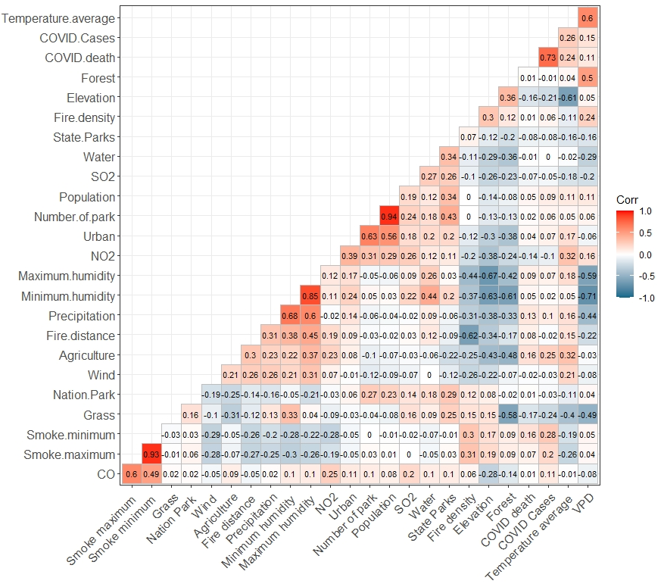Figure S1. Correlations among the 25 potential covariates
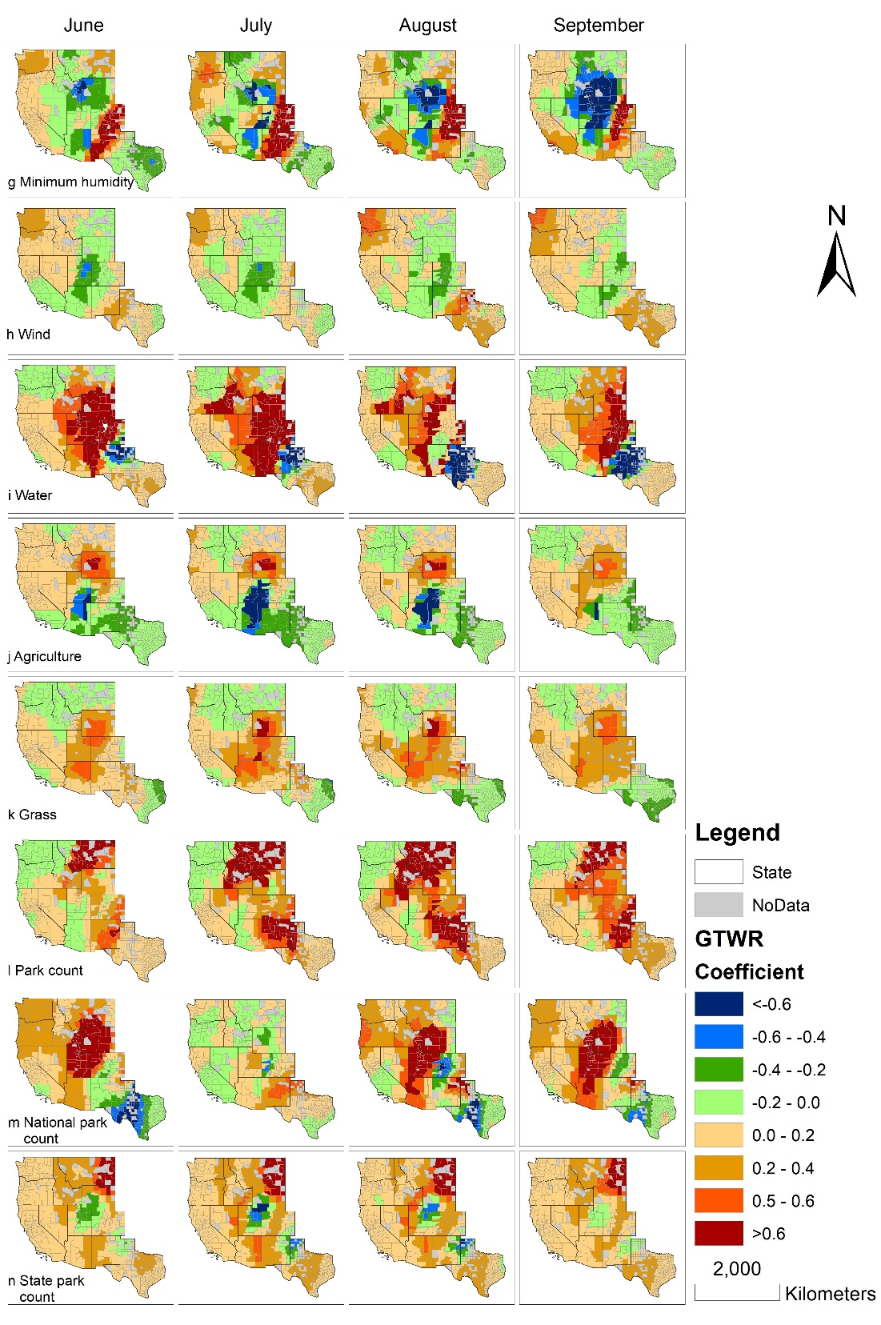

Figure S2. Spatiotemporal impacts of g) Minimum humidity, h) Wind, i) Water, j) Agriculture, k) Grass, and l) Park count (Number of park), m) Nation Park, and n) State parks derived from the top-selected GTWR model on the pattern of the number of visitors in each county of the western and central US during June – September 2020.

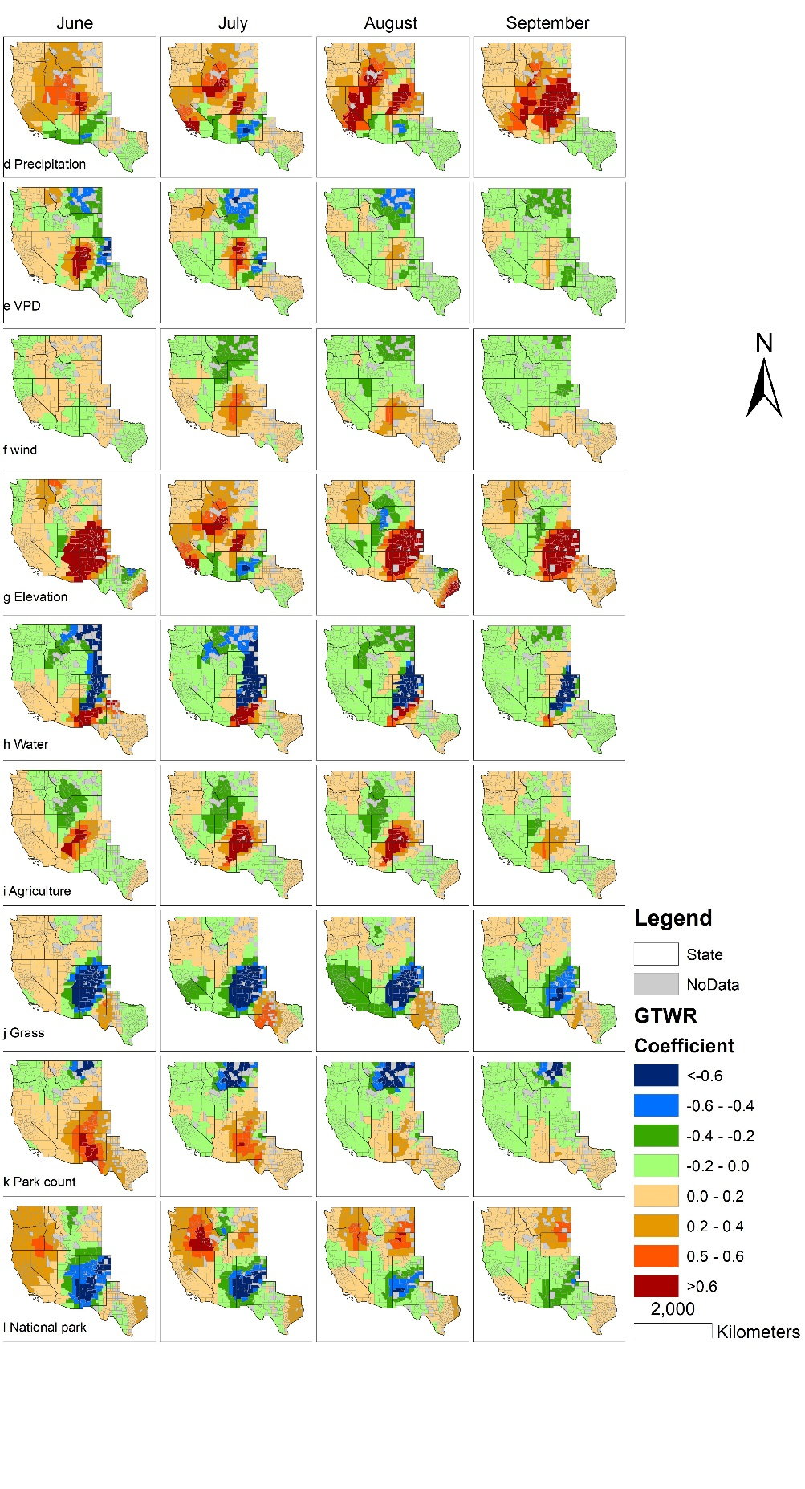

Figure S3. Spatiotemporal impacts of d) Precipitation, e) VPD, f) Wind, g) Elevation h) Water, i) Agriculture, j) Grass, k) Park count (Number of park), and l)National park derived from the top-selected GTWR model on the pattern of the median minimum dwell time at parks in each county of the western and central US during June – September 2020.

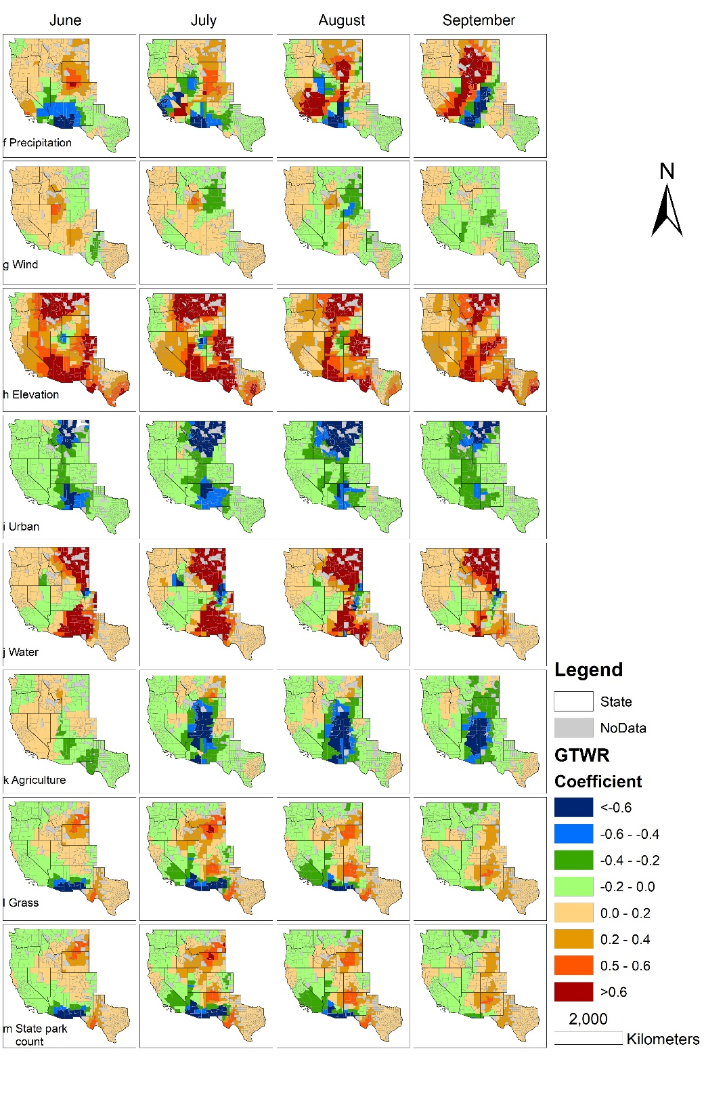

Figure S4. Spatiotemporal impacts of f) Precipitation, g) Wind, h) Elevation , i) Urban, j) Water, k) Agriculture, l) Grass, and m) State Parks derived from the top-selected GTWR model on the pattern of the travel distance from home in each county of the western and central US during June – September 2020.

