UNIVERSITY OF OKLAHOMA
GRADUATE COLLEGE

THE DESIGN OF AN EXPERIMENTAL SETUP TO CHARACTERIZE METAL STEM SEALS

A THESIS
SUBMITTED TO THE GRADUATE FACULTY
in partial fulfillment of the requirements for the
Degree of
MASTER OF SCIENCE

By
OLGA UMANSKAYA
Norman, Oklahoma
2020
THE DESIGN OF AN EXPERIMENTAL SETUP TO CHARACTERIZE METAL STEM SEALS

A THESIS APPROVED FOR THE
SCHOOL OF AEROSPACE AND MECHANICAL ENGINEERING

BY THE COMMITTEE CONSISTING OF

Dr. Zahed Siddique, Chair

Dr. Yingtao Liu

Dr. Jivtesh Garg

Dr. Raghu Madhavan

© Copyright by OLGA UMANSKAYA 2020
All Rights Reserved.

ACKNOWLEDGMENTS
I would like to thank Dr. Zahed Siddique for mentoring me through my college career, allowing me to do research with him, and helping me to achieve my educational heights. His kindness, patience, and encouragement brightened up my academic path. I also would like to thank Dr. Raghu Madhavan for supporting my research and providing his technical expertise that fulfilled my knowledge. Thank you to Dr. Yingtao Liu and Dr. Jivtesh Garg for contributing their time and serving on my thesis committee.
I would like to thank Adam Flenniken for being a great research partner. His bright mind and cheerful spirit made the research experience enjoyable. His creative thoughts and outstanding work ethics brought many unique solutions for the research. It was a pleasure to do research with Adam Flenniken. I would like to thank Richard Perry and Brandon Mansur for assisting me in my research studies and for being good friends with whom I share many great memories about my academic life. I would like to thank Greg Williams and Billy Mays, who introduced me to the graduate research opportunities, and for all support, they provided to me during my research. I would like to thank AME office personal including Bethany Burklund and Melissa Foster for their dedication to the students.
I want to especially thank Jon Keegan. He supported me through all the stages of my academic research. His experience and patience helped my research studies to prosper. He dedicated long hours working with me to ensure the success of my research. His friendship is extremely valuable to me. I will always be grateful for his support that he provided me throughout my graduate college years.
I also would like to say thank you to my amazing mother, my sister, my family, and my friends, who supported me during my graduate school.
Table of Contents
ACKNOWLEDGMENTS iv
LIST OF TABLES ix
LIST OF FIGURES x
ABSTRACT xiii
CHAPTER 1: Introduction 1
1.1 Lesson from History 1
1.2 Problem Statement 1
1.3 Research Objectives 3
1.4 Overview of Approach 4
1.5 Outline of Thesis 6
CHAPTER 2: Literature Review 9
2.1 Introduction 9
2.2 Overview of Seals 9
2.2.1 Seal Classification 10
2.2.2 Seal Materials 12
2.2.2.1 Elastomer Seals 12
2.2.2.2 Plastic Seals 13
2.2.2.3 Metal Seals 14
2.2.3 Seal Coating 15
2.2 Seal Application in the Oil and Gas Industry 17
2.2.1 Blowout Preventer (BOP) 17
2.2.2 Wellhead 19
2.2.3 Christmas Tree 19
2.2.4 Valves 20
2.3 API Specifications 6A and 17D 25
2.4 Chapter Summary 27
CHAPTER 3: Design Process 28
3.1 Introduction 28
3.2 Phase Zero: Project Initiation 30
3.3 Phase 1: Conceptual 30
3.4 Phase 2: Definition 33
3.5 Phase 3: Detailed Design 35
3.6 Phase 4: Commissioning of system 41
3.7 Chapter Summary 42
CHAPTER 4: Design and Fabrication Process 43
4.1 Introduction 43
4.2 Rotating Subassembly 44
4.2.1 Servomotor, Servo Drive, and Gearbox 44
4.2.2 Housing Cell 47
4.2.3 Coupling Drive Shaft Design 50
4.2.3.1 Bolt Joints 51
4.2.3.2 Finite Element Analysis of Drive Shaft 54
4.3 Frame 59
4.4 Mounting Torque Meter and Housing Cell Adapter Plates 63
4.4.1 Adapter Plate between Torque Meter and Gearbox 63
4.4.2 Housing Cell Adapter Plate 65
4.5 Piping System 69
4.5.1 Piping and Instrumentation Diagram (P&ID) 69
4.5.2 Valves, Tubing, and Fittings 72
4.5.3 High Pressure Gas Booster 73
4.6 Instrumentation and Control 74
4.6.1 Torque Meter 74
4.6.2 High and Low Pressure Transducers 75
4.6.3 Thermocouples, Band Heater, and PID Controller 76
4.6.4 NI cDAQ Chassis, NI C Series I/O Modules, and LabVIEW 77
4.7 Electrical System 78
4.8 Assembly Processes 81
4.8.1 Assembly 81
4.8.2 Seal Installation and Removal Processes 81
4.8.3 Alignment Process 83
4.9 Chapter Summary 85
CHAPTER 5: Testing DesiGN and Performance OF the Testing Setup 88
5.1 Introduction 88
5.2 Testing Procedure 88
5.3 Step 1: High Pressure vs. Low Pressure 91
5.4 Step 2: Testing Setup PerformanCe with Pressure and Torque Application at Room Temperature 92
5.4.1 Seal Holding the Pressure for the Test at Room Temperature 92
5.4.2 Leak Developing During the Test at Room Temperature 94
5.5 Step 3: Testing Setup PerformanCe with Pressure and Torque Application at 400°F 96
5.5.1 Seal Holding the Pressure for the Test at 400° F 96
5.5.2 Leak Developing During the Test at 400°F 98
5.6 Chapter Summary 99
CHAPTER 6: Concluding Remarks 101
6.1 Summary of Thesis 101
6.2 Addressing Research Questions 102
6.3 Research Limitations and Challenges 106
6.4 Future Recommendations 107
REFERENCES 110

LIST OF TABLES
Table 1: Characteristics of common coatings for metal seals. Data from [15, 24, 59] 16
Table 2: Description of linear motion valves and their operating principles [5] 23
Table 3: Components of the different types of drive combination 36
Table 4: Specification comparison of two types of motor 36
Table 5: Torque output at a different voltage value 46
Table 6: Specifications for zinc –aluminum coated, 3/8” -16 thread size, grade 8, 1-1/2” long fastener. Data source [14, 18, 27, 32, 35, 52] 52
Table 7: Calculated values of 3/8’’-16 bolts properties, preload, and their tightening torque 53
Table 8: Values of stresses and permissible torque that can be applied on all four 3/8”- 16 fasteners of the coupling. 53
Table 9: Mechanical properties of ASTM A36 steel. Data obtained from [7] 60
Table 10: Mechanical properties of 5/8”-18 bolts and calculated values to determine maximum torque applied. Data were obtained from [14, 27, 32, 37, 52] 65
Table 11: Mechanical properties of 5/8”-18 bolts and calculated values to determine maximum torque applied. Data were obtained from [14, 27, 32, 36, 52] 67
Table 12: Specification for bottom adapter dowel pins Data were obtained from [27, 34] 68
Table 13: Testing procedure steps for testing setup commissioning process 89

LIST OF FIGURES
Figure 1: Overview of the research approach new figure 5
Figure 2: Surface BOP stack API RP53 [54] 18
Figure 3: Christmas tree and wellhead assembly for onshore well [11] 20
Figure 4: Valve type classification by motion principle [5, 61] 21
Figure 5: CC30 choke valve assembly illustrating stem seal location [57] 25
Figure 6: Structure of the design process divided into phases. Data from [4, 19] 29
Figure 7: Project key requirements 31
Figure 8: Main components of the testing setup 32
Figure 9: Motor specifications outlines 33
Figure 10: Wide flange beam frame design vs. triangular shape frame design (CAD models and created by Adam Flenniken) 38
Figure 11: Testing equipment setup 43
Figure 12: Servo motor, gearbox and servo drive combination 45
Figure 13: Fully assembled housing cell on the left and without a cap on the right 48
Figure 14: Stem and housing cell after galling 49
Figure 15: Coupling CAD model (CAD models and idea created by Adam Flenniken) 51
Figure 16: Isometric view of coupling assembly total deformation under 60,000 lbf-in torque applied (ANSYS simulation was performed in a collaboration with Jon Keegan) 55
Figure 17: Shear stress of coupling drive shaft with the torque load under 60,000 lbf-in (ANSYS simulation was performed in a collaboration with Jon Keegan) 56
Figure 18: Von Mises stress in the outer wall of the coupling cylinder when 60,000 lbf-in of torque id applied (ANSYS simulation was performed in a collaboration with Jon Keegan) 57
Figure 19: Von Mises stress in the drive shaft coupling (ANSYS simulation was performed in a collaboration with Jon Keegan) 58
Figure 20: Steel frame of the testing setup 59
Figure 21: CAD model of I-beam structured frame (CAD models created by Adam Flenniken) 60
Figure 22: Front and rare views of frame total deflection with 60,000 lbf-in torque application (ANSYS simulation was performed in a collaboration with Jon Keegan) 61
Figure 23: Front and rare views of Von Mises stress concentration with 60,000 lbf-in torque application (ANSYS simulation was performed in a collaboration with Jon Keegan) 61
Figure 24: Front and rare views of shear stress concentration with 60,000 lbf-in torque application (ANSYS simulation was performed in a collaboration with Jon Keegan) 62
Figure 25: Torque meter adapter plate (CAD models created by Adam Flenniken) 64
Figure 26: Housing cell adapter plate (CAD models created by Adam Flenniken) 66
Figure 27: P&ID of the system 70
Figure 28: Port interfaces of DLE30-75-2 model gas booster. Data were obtained from [33] 73
Figure 29: Torque meter and its position in the setup (CAD models created by Adam Flenniken) 75
Figure 30: Arrangement inside an electrical enclosure 79
Figure 31: Power distribution diagram in the testing set electrical system 80
Figure 32: Metal seal installation and removal processes 82
Figure 33: Pressure needed to remove a metal stem seal from the housing cell 83
Figure 34: Housing cell alignment process 84
Figure 35: Check for leaks at a low-pressure side by applying 25 psi to a low-pressure region. 90
Figure 36: 500 psi and 15,000 psi pressure applied during the first step of the testing procedure to ensure pressure hold at the low-pressure side 91
Figure 37: Step 2 phase A of the testing procedure where high pressure at 15,000 psi and low-pressure side is stable. 93
Figure 38: Collected data at the second step of the testing procedure during phases B, C, and D 93
Figure 39: Pressure leak into low-pressure region during the second step of the testing procedure 95
Figure 40: Applied torque during the second step of the testing procedure when the leak to the low-pressure side occurred 95
Figure 41: Part A of step three of the testing procedure 97
Figure 42: Collected data at the third step of the testing procedure during phases B, C, and D at 400° F 97
Figure 43: Pressure leak into a low-pressure region during phase A of the third step in the testing procedure where the temperature is 400° F 98
Figure 44: Torque applied when a leak developed at a low-pressure region during step 3 of the testing procedure, at 400° F 99

ABSTRACT
Modernization has brought use of machinery in most industrial sectors to home use. Equipment used in the food industry, medical industry, construction, defense, aircraft, automotive, and energy industries utilizes the principle of the separation process of one media from another during rotation. Equipment used in the oil and gas industry sector uses machinery that requires sealing solutions for a safe and reliable process of handling hydrocarbons. The industry utilizes a variety of equipment where sealing mechanisms are employed, such as pumps, valves, manifolds, drilling, processing, and refining equipment. The equipment must securely separate the flow within and from the ambient environment. Lessons from the past have shown that the lack of attention to a sealing solution can lead to tragic outcomes.
To reduce these catastrophic failures and bring the application of oil and gas equipment into standardization, the industry developed standards with the help of the American Petroleum Institute (API). Any piece of equipment that falls under API standards must adhere to their specific requirements. This research was done with an overview of API 6A and API 17D standards, which cover the utilization and commissioning of Christmas trees and wellheads, where the latter can be a part of a blowout preventer assembly. Choke valves are the part of the equipment that falls under API 6A and API 17D standards. Depending on the manufacturer, some choke valves have a metal seal installed to control the leak of the contained fluid to the environment. The area of interest of this research was to design and build the testing equipment that can simulate real-life operating conditions of a choke valve to test the performance of the metal seal.
Seals are classified based on their static or dynamic applications. Seals can be designed and manufactured from a combination of materials depending on the application, environmental conditions, temperature, and pressure. To cater to different operating conditions, metal seals have different geometries that vary in complexity. Metal seals provide a wide array of sealing characteristics based upon these different geometries, materials, and coatings.
To properly test the performance of a metal seal, it needs to be exposed to the conditions that closely simulate the environment and operating conditions at which this seal will be utilized. The seal needs to be subjected to a cyclic application in a controlled laboratory environment and proves that it is reliable and safe for the application in the field. The unique testing setup should be designed and manufactured to imitate the custom environmental conditions. Since the testing setup equipment is a custom-made item, it must incorporate available components and specially manufactured components into one system.
This Thesis is focused on the following research questions:
1. How to organize the design and fabrication process of the metal stem seal testing equipment?
2. How to design and manufacture a unique testing setup to test metal seals?
The setup was developed to facilitate the design and manufacturing process. This thesis is organized to present several phases and details of the important steps of each phase. The phases included the process of gathering the ideas of the testing design, finalizing the concept, phase of development and execution of the design process, and validating the setup through testing and experimentation. The design portion of this research included a detailed analysis of the equipment and systems that were created to serve the goals of this research.
Testing of the metal seal performance under various pressure conditions, temperature, and different torque application showed the limitations and recommendations for future research.

CHAPTER 1: Introduction

1.1 Lesson from History
January 28, 1986, was a special day for the United States and captured the attention of millions of people around the world. The Space Shuttle Challenger launched from NASA's Kennedy Space Center in Florida on that date. The 10th mission of the Challenger would never be accomplished; 73 seconds after liftoff, The Space Shuttle Challenger exploded killing the crew of seven members and shaking the nation and space science of the world [22, 23]. The morning temperature of January 28, 1986, was unusually cooler in Cape Canaveral; the ambient air temperature fell to freezing 31 degrees Fahrenheit [22]. The engineers at Cape Canaveral underestimated the chances of a catastrophic outcome. The reason for the explosion was later determined to be a failed sealing O-ring in the solid rocket booster [13]. After analysis of the catastrophe, it was found that cold weather was determined to be a contributing factor [13]. Seals are often one of the smallest elements of the mechanism but sometimes they can play a critical role in equipment performance. The right selection of the sealing solution can extend the life expectancy of the mechanism, reduce the contamination of the environment, and limit the exposure of the workers to the hazardous chemicals.

1.2 Problem Statement
Before commissioning the sealing product, it has to undergo a series of tests and prove its reliability and safe application. To do so, the testing equipment or testing setup needs to be manufactured in the way that it is capable to replicate the environmental conditions that the seal product will experience during the field application. The research goal is to create the testing setup that accommodates the process of characterizing metal seals through a series of tests, which later helps with commissioning the metal seals to the market. Since the testing setup was tailored to test the specific performance of the metal stem seal, the components that make up the testing setup were selected accordingly to create the specific testing environment. Most of the components of the testing setup are available from the manufacturer shelf and some need to be custom made. The challenge was to bring all the components into one system that would satisfy the research goal. The research goal was to build a piece of testing equipment that is capable to exert the specific forces to a metal stem seal, control equipment and instrumentation of the testing system, and process and collect the resulted data about the metal seal performance.
To accomplish this research, the project management concept of the manufacturing industry was brought to facilitate the research project. The distinctive future of this research was to bring the industrial approach to academic research. The testing equipment is not a readily available piece of equipment and had to build from scratch. To accomplish these research objectives, the project was divided into several phases that are discussed in Chapter 3.
The research had two main parts: 1) the project organization part; 2) the detailed design of the testing equipment. These two parts are internally connected. The project organization part was a planning process of the project that is specific to this research, whereas the design and fabrication part was about the execution of this plan. Some of the parts of the research involved sequential application and some could be done concurrently. All the steps that were taken to plan the project of this research were aimed to facilitate with testing equipment design and fabrication part, which will be used to investigate the performance of the metal stem seal afterward. The questions that were considered in this thesis are the following:
1. How to organize the design and fabrication process of the metal stem seal testing equipment?
2. How to design and manufacture a unique testing setup to test metal seals?

1.3 Research Objectives
A metal stem seal, which is a part of the valve assembly, has to undergo certain performance testing procedure to be considered for a field application. To evaluate the testing performance of the metal stem seal, a testing equipment setup has to be designed and built. Therefore, the research objectives are the following:
- Design and build the testing setup in accordance with the testing parameters and requirements, which are discussed later. (R1, R2)
- Subject the metal stem seal to an array of controlled operating conditions and collect the resulted data. (R2)
The testing setup design has to follow explicit testing parameter requirements:
- Pressure applied 15,000 psi of gas flow media;
- Temperature range from 0° F to 400° F;
- Stem rotation from 0° to 90° minimum;
- Torque capacity 60,000 lbf-in (5,000 lbf-ft ) maximum;
- Leak monitoring from high to low-pressure region;
- Absence of side loads on the stem;
This research project was initiated to assist the research with the design and build process of the testing setup that can perform experimental testing procedures according to the listed requirements. Therefore, the main variables, which have to be created and applied cyclically, measured, and recorded are the following:
- Torque load, lbf-in (lbf-ft);
- Temperature, F°;
- Pressure, psi;
The stem has to be rotated to simulate the rotational movement in field application. The performance of the testing setup is during the tests is observed to analyze the behavior and performance of the testing setup to improve its design.
As a result, the fixture has to accommodate a housing body with an installed stem seal. It has to be able to rotate the stem in both clockwise and counterclockwise directions while recording the applied torque. The applied and leaked pressure needs to be recorded under certain temperate. The fixture has to ensure a safe and reliable application while measuring and recording all necessary data.

1.4 Overview of Approach
Figure 1 outlines the overview of the approach that was applied to answer the thesis research questions raised in Section 1.2. The flow chart is divided into two parts: the design process and manufacturing and assembly.
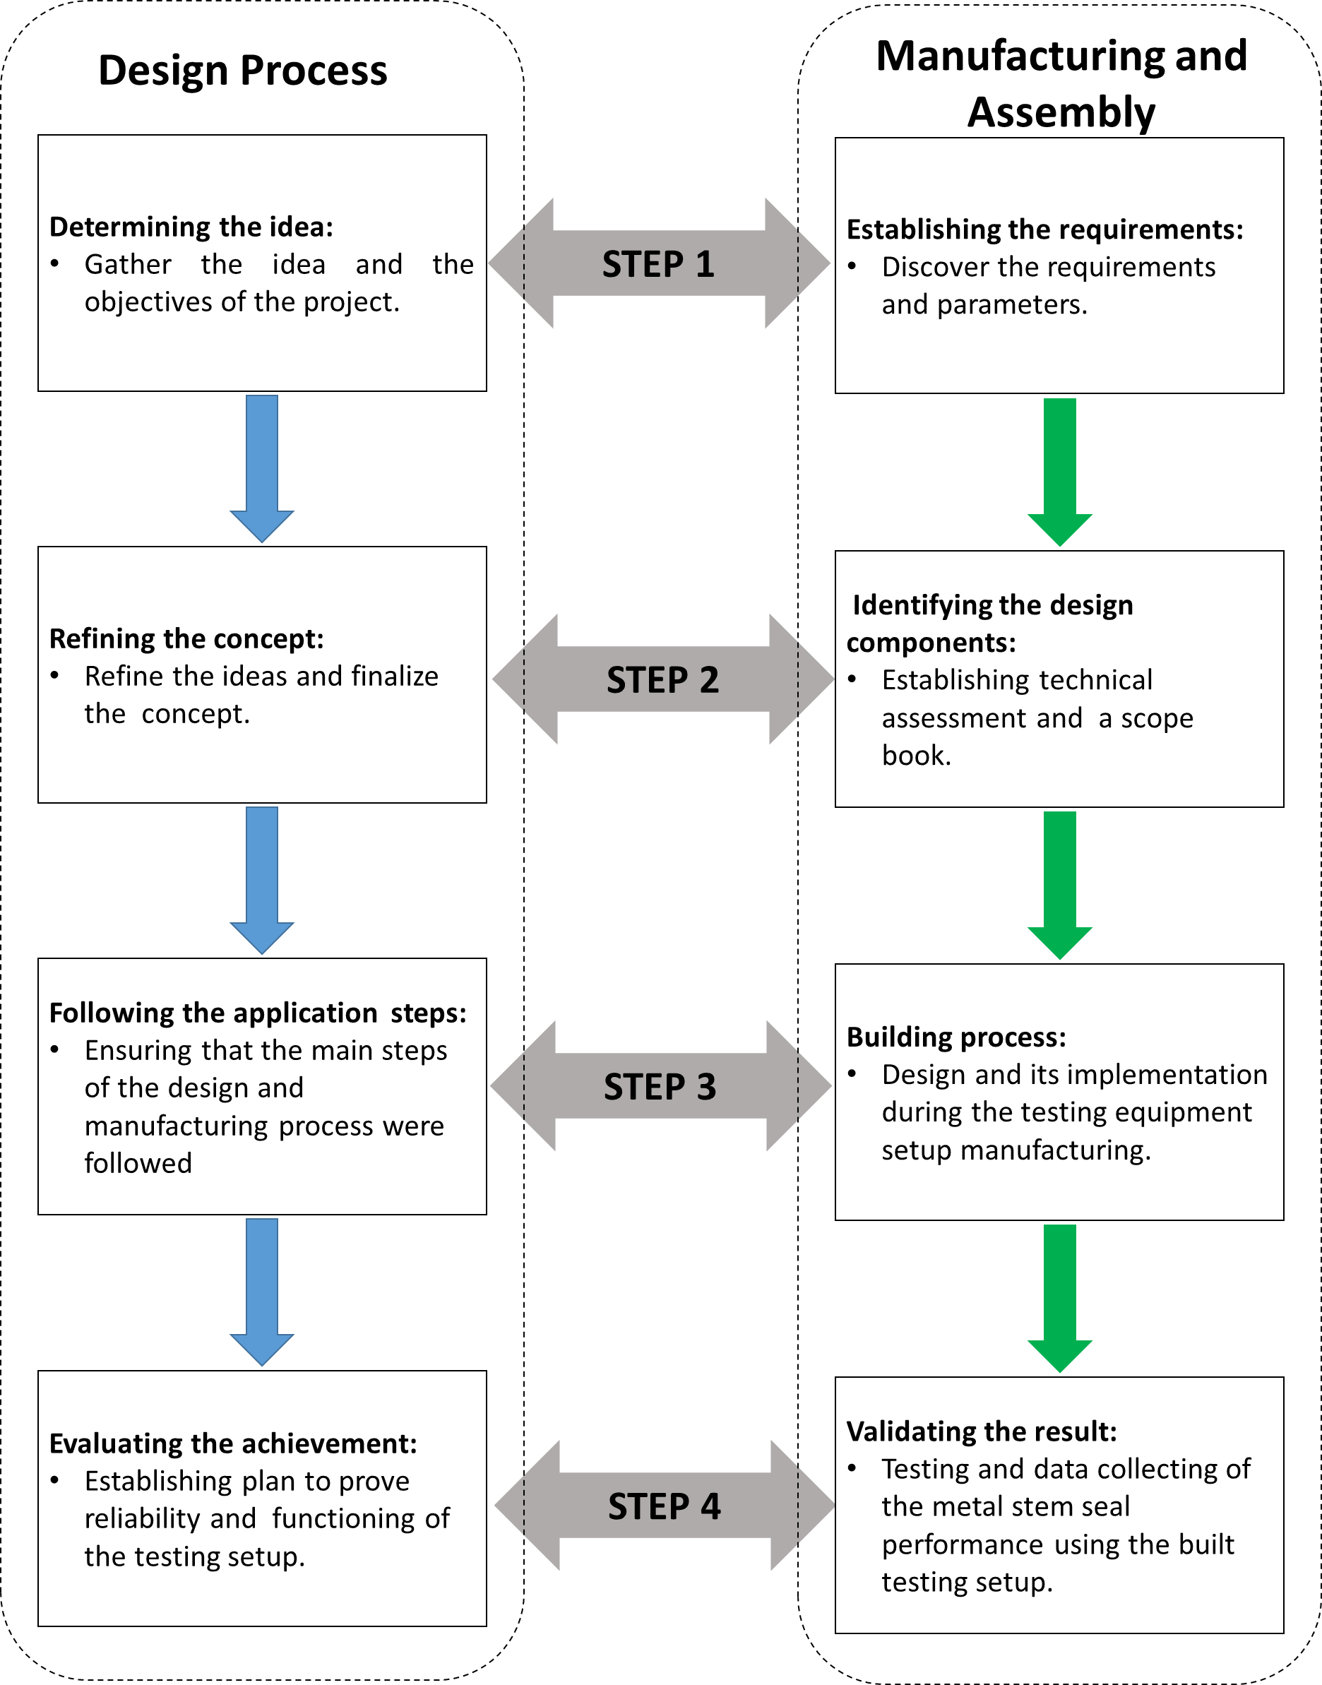
Figure 1: Overview of the research approach new figure
The overview (Figure 1) introduces the approach that was taken to achieve the research objectives and answer the thesis questions. These two parts of the approach are codependent. The proposed approach was accomplished by applying planning and executing both parts simultaneously. They were intended to work in a synchronized manner, facilitating each other during the research. The research was done in the step order.
- Step 1: Gather the ideas according to requirements. The first step focused on the research ideas and objectives from the planning perspective. When the task was defined, the technical requirements and parameters of the design were identified. During this step, the critical requirements were established to achieve the research goal.
- Step 2: Define the concept and the main components of the design. During the second step, the planning part of the research was focused on defining the concept of the research and completing the plan of action. The main components were identified and approved for being the building blocks of the testing setup design.
- Step 3: Execute the actual design and manufacturing steps. This step was dedicated to the actual design, manufacturing, and system assembling. The planning portion of this step involved organizing the sequential and concurrent steps of the design and manufacturing process.
- Step 4: Summarize the achievement and validating the result. During this step the testing equipment setup was tested for the performance, to satisfy the requirements. Alterations were made to tune the system performance. During this step, the safety and reliability of the setup were verified to satisfy the goal of the research.
A more detailed analysis of the design planning and analysis parts can be found in Chapter 3 and Chapter 4 respectively.

1.5 Outline of Thesis
Chapter 1 is the introduction and reveals the importance of the research. It provides context and appeals to the reader why the subject of this research is valuable. This Chapter specifies the research questions and objectives. It also provides an overview of the approach.
Chapter 2 consists of a literature review of the material that is helpful for this research. It includes an overview of seals, a classification based on their application principles, and manufacturing materials of the seals. This Chapter describes a seal application in the equipment employed in the oil and gas industry. Chapter 2 reviews the oil and gas industry standards that the seal industry adheres to during the seal manufacturing process.
Chapter 3 describes the design process. It consists of five phases: project initiation, conceptualization, definition, detailed design, and closeout phase. Each phase is described in a stepped manner. The project initiation section of the Chapter describes the process of gathering information and ideas. Conceptual and definition phases illustrate the refining process of the approaches and conclude the main course of the research. The detailed design phase describes the development and the approach taken towards the design and manufacturing process of this research. The closeout phase or the final phase describes the last stage of the project taken to ensure the successful completion of the project research.
Chapter 4 describes the design process of the testing. Chapter 4 is an essential chapter of the thesis. The majority of the detailed design part of the research is described in this chapter. It details each major component of the assembly and the system of the setup. The assembling processes of the testing equipment are also presented in Chapter 4.
Chapter 5 focuses on the testing and testing procedure approach. This chapter proves that the testing setup is reliable and satisfies the requirements proposed for the research. The chapter covers the testing in static and dynamic applications. Sections of this chapter describe the testing procedure and the data obtained after testing to verify the design of the testing setup for metal stem seal performance.
Chapter 6 concludes the research effort, where the research objectives and questions are once more discussed and answered. This chapter contains an overview of limitations and challenges, which were discovered over the course of the research. In Chapter 6, future recommendations are given that are beneficial for both immediate and long-term studies.

CHAPTER 2: Literature Review

2.1 Introduction
It is important to understand the nature of the seals, their field application, equipment structure where metal seals are used, and the standards that regulate their implementation are necessary background knowledge to create the best-suited design for the setup to test metal seals. Therefore, this chapter presents review of types of seals and their material, seal application in the oil and gas industry, and standards that the industry follows during the manufacturing process and implementation.

2.2 Overview of Seals
A seal is a device that facilitates in leakage prevention of gas or liquid, by creating a barrier in open passages between the parts within the mechanism [15]. The industry has access to a variety of sealing devices and sealing solutions, for instance, packing, gaskets, O-rings, mechanical seals, stem seals. The main considerable problem is to prevent leakage around the rotating shaft that connects with the enclosure [26]. Seal technologies aid in emission control, safety, and reliability of the operating machinery.
To choose the proper sealing solution, the required information about the purpose and the environment of the application has to be known. The right decision depends on the movement of the mechanism and the conditions of the seal application. The variables such as pressure, temperature, flow media, environment, the integrity of sealing required, the material of counterfaces, operating cycles requirements, maintenance requirements, and assembly methods, all these listed variables can influence the decision when choosing a proper sealing solution [15]. It is necessary to notice that the seals are categorized based on the movement of the seal and the shaft movement in the relationship to the seal. There are three most common categories of the seals, which are static seals, rotary, and reciprocating seals.

2.2.1 Seal Classification
Static seals are divided into two major categories, O-rings and gaskets. Static seals are designed in such a way that they need to be self-energized within itself, whereas the gasket is needed to be fastened with enough force, which is greater than the potential energy of the gasket [15]. These types of sealing solution are better implemented when there is no or limited rotational movement is involved.
Since most of the mechanisms imply numerous moving parts that have to be sealed, rotary seals are the most common to be utilized for purposes of sealing rotating mechanisms. The most inexpensive seal from the static seal category is manufactured out of packing material that has the purpose of a pressure breakdown device [4]. The packing sealing solution has its pros and cons. For instance, as an advantage of using packing due to its non-complicated installation procedure and low cost can be an advantage in sealing solution when it suitable for the process [4]. Disadvantages that one has to consider when choosing a packing method are constant adjustment due to its wear and allowance of some leakage for cooling and lubrication purposes [26]. Therefore, the packing method as a sealing solution cannot be suitable when the environment is hazardous or aggressive. Since leaking is required for cooling purposes, packing serves as a controlling mechanism rather than a complete isolating solution. Packing has some sufficient disadvantages such as grooving and wearing of the shafts and increased maintenance time for packing gland adjustment [26]. These drawbacks forced many industries to search for a better sealing solution.
The solution was found with the invention of a mechanical seal. Mechanical seal is a mechanism that has two flat surfaces mounted on the shaft in a perpendicular position to the shaft and provide constant contact between each other [4]. Unlike packing, the implementation of the mechanical seals in the process requires more complex installation process and higher initial investment [26]. Despite the high initial cost, under normal condition mechanical seals are better suited to eliminate the leakage rate and require less frequent adjustment and maintenance, which prevents loss of product and energy [4]. Mechanical seals were happened to be one of the complex structures in the seal family.
When the shaft rotates, there will always be some shaft movement during the operation of the equipment [26]. Therefore, a practical method to address the issue of shaft movement is to mount one of the seal faces flexibly in axial direction [26]. The mechanical seal consists of two faces, a stationary face, and a rotating face. In between those faces, a lubricating film prevents the seal faces of the undesirable wear. Generated heat by the seal faces and the seal assembly can be a cause of premature failure of the seal. To avoid premature damage, a circulation system also known as a piping plan is installed in a loop with a mechanical seal. Piping plans are designed to remove heat, decrease fluid temperature, adjust the internal seal chamber pressure, and manages the seal side which facing atmosphere [16]. Installing a piping plan into the system creates a more appropriate environment to extend the seal operational life-cycle and helps to control seal leakage [16]. It is critical to install the seal flush arrangement correctly for a proper seal operation. The piping plan selection depends on the structure of the seal assembly. There are several types of seal assemble including single seals, dual seals, quench seals, secondary containment seals, and dual gas seals [25]. All of these designs facilitate proper equipment operations and leak preventions to the ambient.

Seal Materials
One of the critical characteristics of the seal design and operation is material selection. Depending on the operational environment and sealing substance, appropriate materials have to be chosen when designing a sealing system. Properly selected materials for a seal allow the operator to extend the life cycle of the equipment and help to avoid expensive fines that are imposed due to the leakage of the sealing media. Selection of the primary materials for the seal manufacturing process depends on the operating conditions.

Elastomer Seals
Among the most popular materials are elastomers, plastics, carbon, silicon carbide, tungsten carbide, silicon nitride, alumina ceramics, diamond coated faces, and metals [15]. One of the most broadly used materials in the seal manufacturing is a synthetic elastomer. According to the Seals and Sealing Handbook written by Robert Flitney, the first synthetic elastomers were created in the 1930s [15]. Since that time, elastomers became widely used and their applications includes the full range of static and dynamic seals [15]. Elastomers became very popular due to their properties, manufacturing processes, and chemical composition, which can be customized depending on the implementation of the seal. Elastomers own such popularity in the industry to their properties. Elastomers have a low modulus of elasticity of typically 5-20 MPa and a high Poisson’s ratio, which is close to 0.5 [15]. The high Poisson’s ratio combined with the very low Young’s modulus makes a material, which is both easily deformed and incompressible [15]. While elastomers are widely used and found in many static and mechanical seals, depending on their operational condition, elastomer material has some critical limitations, which are fluid resistance and temperature range [15]. The material of the future seal has to be chosen on its ability to withstand the reaction with the sealing media or fluid and it has to be fluid resistant to surrounding fluid in the sealed environment. When elastomers cannot be used due to their limitations, plastics are available as a seal manufacturing material.

2.2.2.2 Plastic Seals
Names such as Vespel® Polyimide, Teflon®, Delrin®, and many other popular names, are often used in the seal manufacturing industry. They are all meaning one thing, plastics. Plastics with the different formulation of the ingredients and the material properties are designed to accommodate the industry with a safe and reliable sealing solution. Different manufacturers create their products and tailor them for different industries. Due to the mechanical properties, plastics can take a large segment of the sealing market [15]. Plastics have several advantages when it comes to the decision about which material to use in certain applications. The actual properties of the selected plastic material dependent on the base polymer, fillers and method of processing, which can affect both mechanical and thermal properties essentially [15]. Depending on the supplier, the properties of the individual plastic material can fluctuate extensively within any one group depending on the material, manufacturing processes, and type of the filler used for the manufacturing of the seal [15]. Available plastics on the market that can be used at both higher and lower temperatures than elastomers which makes them popular in the industry [15]. Another feature that makes plastics more suitable for the aggressive environment than elastomers is their resistance to chemicals. Polytetrafluoroethylene (PTFE) also known as Teflon has a very wide chemical resistance [15]. In practice, it is common to use lubrication for reliable performance of the seal but sometimes the conditions do not allow the presence of the lubricant in the process. This is another benefit of using plastics because many plastics will permit dry running, which is an advantage when the process does not allow the presence of the lubricant [15]. The other benefits of using plastics are good wear resistance, good extrusion resistance, and high strength. However, the benefits listed above are only available from a limited number of plastic types [15]. Depending on the sealing needs and the environment, plastics lose some points to elastomers. Low limit of elasticity, low inherent energization, and creep are the limitations that have to be considered in the manufacturing process [15]. When elastomers and plastics cannot be chosen as a seal material, the seal manufacturing industry has several other options. Carbon, silicon carbide, tungsten carbide, silicon nitride, alumina ceramics, diamond coated faces, and metals are available to provide reliable sealing performance.

2.2.2.3 Metal Seals
Metal seals are often used in the oil and gas industry where pressure and temperature can reach critical numbers. As elastomers, metal material also consists of a variety of components. A mix of the metals forms an alloy, which has its properties depending on the ingredients. The manufacturing seal industry uses a wide range of metals [15]. When it comes to identifying the metal and its composition, The American Iron and Steel Institute (AISI) and the Unified Numbering System for Metals and Alloys (UNS) uses a system of a letter and numbers [15]. Most popular materials are stainless steel and nickel allows. Stainless steels are used for a wide range of sealing products [15]. The following will describe the most popular stainless steel alloys that are used in the seal manufacturing process. S30400 (AISI 304) is a high-chrome alloy, which has good corrosion resistance quality. It is used for manufacturing gaskets and energizing springs of static seal [15]. Mechanical seal are often manufactured from S31600 (AISI 316) material [15]. Another very common material stock for the seal manufacturing processes is nickel allows. Nickel found its recognition for high corrosion and temperature capacity. The consumer is more familiar with the nickel allows trade names such as Hastelloy and Inconel [15]. Hastelloy or N10276 (Alloy 276) is one of the most widely used nickel alloys in the oil and gas industry because of its corrosion resistance to seawater, brine and the array of acids [15]. It is well suitable for metal parts when the environment is corrosive and requires high-temperature applications [15]. Another highly rated material is Inconel, which is a nickel-chromium alloy. Inconel is widely used in the refining industry because it is resistant to caustic corrosion. For this purposes O-rings are often manufactured using Inconel 600 [15]. Inconel alloy 718 is related to the topic of this research. This alloy contains high concentration of nickel and chromium and has high corrosion-resistant and strength capabilities. Inconel alloys are preferred for metal seals with complex geometry [58].

2.2.3 Seal Coating
In some instances, using a bare metal seal does not provide sustainable and reliable sealing. To improve the metal seal performance, the seal manufacturers in conjunction with the metallurgic industry employed the process of plating or coating metal seals with the soft metal overlay. The most commonly used metals are gold, silver, indium, lead, aluminum, soft nickel [15]. To prevent leakage through the seal, the metallic coating is applied to the contact surfaces of metal seals, which is rubbed into the imperfections of the surfaces between the metal seal and contact surface [24]. Electrodeposited overlay of silver, gold, soft nickel or lead is bonded to selected alloy. The thickness of coating applied to the seal surface is proportional to the surface roughness of the contact surface which seal is acting against [24]. Each coating metal has its advantages and limitations. They are used depending on the necessity and the sealing environmental conditions such as temperature and pressure range and the degree of corrosiveness. Table 1 describes the most commonly used soft metal overlays and their characteristics to ensure seal integrity.
Table 1: Characteristics of common coatings for metal seals. Data from [15, 24, 59]
Coating | Applications and characteristics | Load Limit | Temperature Limit
Gold | Expensive soft coating with good corrosion resistance and temperature range. Selected for wide corrosive environment. | Usually unlimited | 1500 °F (815 °C)
Silver | Widely used coating in the seal industry, has The most common metal coating. Has good corrosion resistance and temperature qualities | Usually unlimited | 800 °F (425 °C)
Soft nickel | Best for high temperature applications with combination of corrosive environment. | Usually unlimited | 1500 °F (815 °C)
Indium | Softer than gold coating and only used in low temperature environment. | 285 lbf/in | 105 °F (40 °C)
Aluminum | Inexpensive coating used only for sealing non-corrosive gases. | 800 lbf/in | 390 °F (200 °C)
The most popular coating in manufacturing seal industry are made from aluminum and silver [15]. The key determining factors for correctly selected metallic material for the coating are fluid resistance, application temperature range, and the price target. Mostly metallic coating and plating are used on metal O-rings and C-rings and metal seals with comparable configurations [15]. Selection of type, configuration, material, and coating of the sealing solution depends on the sealing environment and application. All the segments of the oil and gas industry use different types of sealing solutions. Mainly it depends on the equipment and the sealing flow media.

2.2 Seal Application in the Oil and Gas Industry
In the oil and gas industry, processes involved in moving, separating, storing liquids and gases are the parts of each sector of the petroleum industry. When it comes to separating one media from another or the ambient environment, every equipment has a sealing device installed. Some sealing solutions have a less complicated structure than others do. Some sealing solutions are so complex, like a mechanical seal that requires its separate flushing system for sustainable performance. In the upstream section or often referred to as E&P, exploration and production, equipment involved in production and drilling operations moves thousands of barrels of hydrocarbons. An oilrig, whether it is located onshore or offshore, has thousands of the equipment units that have some sort of the sealing mechanisms. This part of the chapter focuses on the equipment that is related to this research. Since the research is dedicated to the equipment of the petroleum industry, it is natural to start with the drilling stage equipment where the metal stem seals are implemented.

2.2.1 Blowout Preventer (BOP)
During the drilling procedure, the well control system is vital to successful and safe drilling practices. The well control system is a first system that prevents the uncontrolled flow of the hydrocarbon fluid from the wellbore [10]. When the drilling bit penetrates the formation, the drilling fluid excerpts the pressure on the formation fluid. When the hydrostatic pressure of the drilling mud is less than the pressure of the formation fluid, the formation fluid makes its way into the drilling mud and creates a kick. Blowout preventer (BOP) is one of the main components of the well control system that protects work area from the kick. The main purpose of BOP is to stop fluid coming from the well in unsafe drilling conditions [10]. The BOP is a high-pressure safety valve that is installed at the wellhead during the drilling operation. Its main purpose to prevent the uncontrolled flow of liquids and gases escape from the annular space and the drill pipe during well drilling operations [45, 54]. Depending on the location of the rig, onshore or offshore, BOP’s stack is located beneath the rig floor for the on-land rig and offshore BOP is installed on the seafloor. Industry distinguishes two types of blowout preventers, inside of the BOP, annular blowout preventer, and the ram blowout preventer, which seals the pressure in a hole with or without pipe [54]. Figure 2 is an example of the surface blowout preventer API RP53.
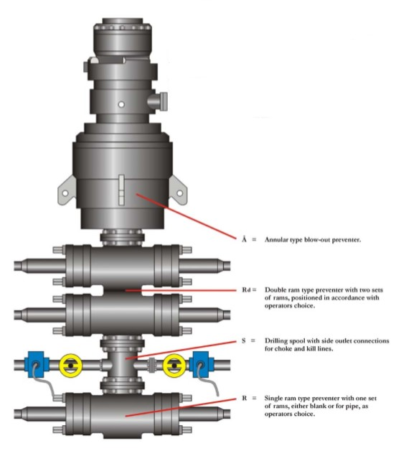
Figure 2: Surface BOP stack API RP53 [54]
Since pressure control is critical during the drilling operation, blowout preventer is essential safety equipment in well drilling completion. It operates on the fail-safe bases [45]. Therefore, the blowout preventer is subjected to extremely high pressure. Some of the subsea BOP’s are rated to withstand 20,000 psi [46]. Consequently, the sealing material and technology used in these units have to withstand similar pressure, temperature, and extreme environment.
One of the design requirements, for the setup presented in this thesis, is testing the metal seal with the pressure application up to 15,000 psi. It is beneficial for research and design to know the structure of BOP and its working principle since BOP “sees” similar pressure rating in the oil field.

Wellhead
Another piece of equipment, which is part of the drilling and production phases, is a wellhead. The wellhead has a multistage installation procedure. A wellhead is a piece of the oilfield equipment that is utilized in the drilling operation, well completion phases, and production. The wellhead is a system of valves, adapters, and spools, that provide pressure control for a production well [56]. Wellhead assembly consists of several main pieces, which are casing head, casing spool, and tubing spool. Wellhead provides structural support and pressure control at the surface of the oil and gas well. This piece of equipment has multiple valves that are controlled by stem movement within the valve. Since a wellhead is a part of pressure control equipment, the components of the wellhead have to withstand the different range of pressure. Similar to a BOP, the wellhead experiences a high-pressure action.

Christmas Tree
When the well completion stage is over, a unit of E&P equipment, which calls a Christmas tree, is installed on top of the wellhead. As an example, Figure 3 illustrates the assembly of a Christmas tree and a wellhead above the production well.

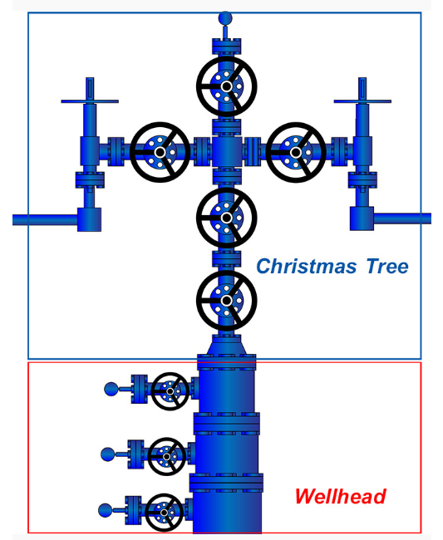
Figure 3: Christmas tree and wellhead assembly for onshore well [11]
A Christmas tree represents the assembly of the adapters and series of valves that controls the flow from the well. Christmas tree is a part of the production equipment consist of “a seal flange which is often called the tubing head adapter, a series of gate valves, a T or cross, rig valves or side valves, and a choke” [12]. High-pressure Christmas trees designed to handle 20,000 psi pressure from the flow. Therefore, the valves and their components have to endure the same pressure requirements [9].

Valves
Many equipment units of E&P consist of the different types of valves or the series of valves. A valve is a piece of the equipment that regulates the flow of the flowing media through the system. Valves can be divided by the motion principle [5]. Figure 4 shows a flow chart of the valve types that are relative to this research.
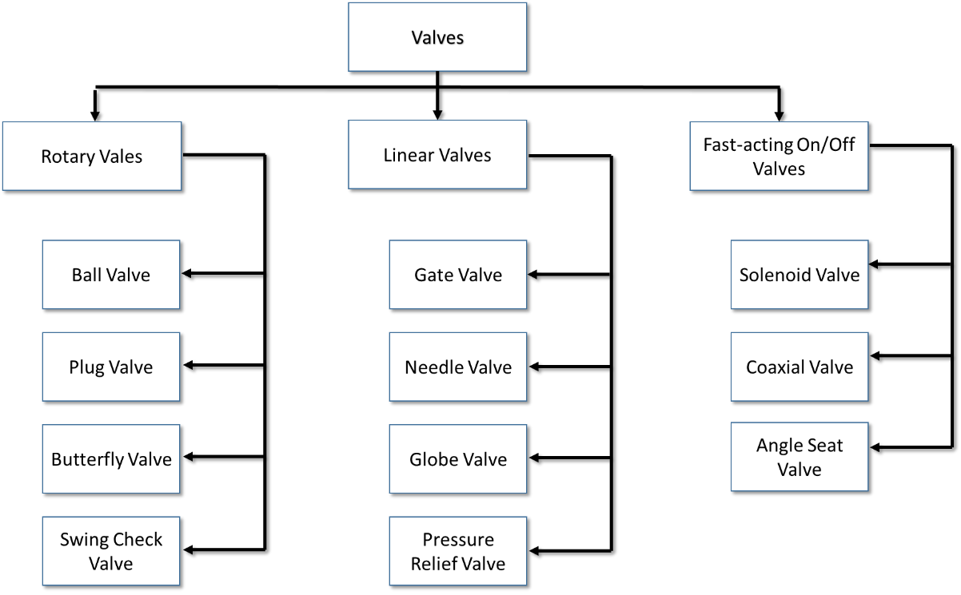
Figure 4: Valve type classification by motion principle [5, 61]
The above classification was created based on the motion principle. By any means, Figure 4 does not represent the entire variety of the existing valves but provides examples of the most commonly used in the industry. The valves were divided into three groups, rotary, linear, and fast-acting, based on the motion of the flow preventing mechanism. Rotary valves also known as quarter-turn valves. Rotation of the valve is limited to 90° turn, a full quarter turn. It is completely open at 90° and fully shut at 0° [5].
Most utilized rotary valves are ball valves, plug valves, and butterfly valves. The ball valve is a two-way quarter-turn valve that has two positions, open and closed. Ball valves are commonly used as a shut-off valve to isolate a system or its components. The flow obstructer is a ball with a bore straight through its body. The ball seats in a housing of the valve and attached to the stem. When the ball turned 90° the flow media “sees” the solid side of the ball, but when the ball is turned 0°, the flowing current goes straight through the bore in the ball. The ball valve is most appropriate for the on/off applications [5].
Similar to a ball valve, a plug valve also operates on 90 degrees on/off principle. Constriction of the plug valve is the same as a ball valve with a difference in the obstructer shape. The obstructer is a cylinder, which reminds a plug. The plug has an oval-shaped with a through-hole in it. There are a few advantages that the plug valve has over the ball valve. The plug valve does not have any cavities or voids where flow media can be trapped, and unlike a ball valve, the plug valve can be adjusted for developed leaks. These characteristics make them preferred valves for extreme service applications in every sector of the oil and gas industry [5].
A butterfly valve is a different type of valves from the rotary valve family. The obstructer is a disc that is seated concentrically in the seal of the valve body [5, 47]. When the disc is rotated 90°, the disc is turned parallel to the flow and the current goes through. When the disc at 0°, the disc is in a perpendicular position to the flow and presses against the seal [5]. Butterfly valve operates as a control valve or on/off valves. Often in flow control application, the stem that regulates the disc is locked to avoid the rotation of the disc by the fluid. They are more common on the larger diameter pipes because of its weight and cost [5].
Unlike rotary valves that regulate flow based on rotational movement of the obstructer, linear movement valves control the flow by rising or lowering the obstructer. In Table 2 the operating principles of these valves can be observed.

Table 2: Description of linear motion valves and their operating principles [5]
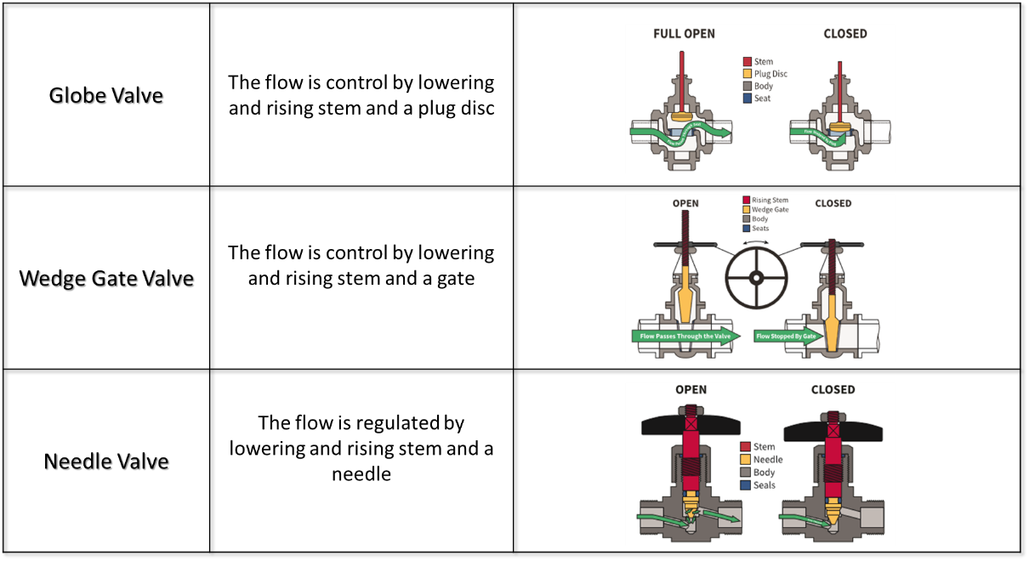
Another term to describe the linear motion valves is multi-turn valves. To open or close the valve stem has to be turned multiple times. The linear motion valve family has the longest list of valve types. Most known of them are gate valves, globe valves, and needle valves. Globe valves’ obstructer is a complex disc-shaped plug, that is seals against the globe-shaped body [5]. When the plug rises, the flow is entering the lower compartment of the valve body and then travels up to the upper part through the seat where the flow leaves through the outlet on the opposite side of the upper part of the valve. Globe valves mostly used for isolating or throttling applications. Three-way valves are suitable for mixing applications, where the components enter through two inlet ports and a mixture leaves the outlet [5].
When it comes to isolating the flow, the wedge gate valve can provide sustainable performance due to its low friction losses and reliable sealing effectiveness [47]. It operates by lowering and rising the treaded stem, therefore, to go up and down the treaded stem needs to be turned multiple revolutions. This type of valve is not suitable for throttling applications [5].
Similar to a globe valve a gate valve was found to be a needle valve. The obstructer is tapered down conical shape “needle” seats in the tapered seat. The needle valves are used for smaller lines; they provide finer control of the flow. They are used for throttling control flow [5]. They often subject to erosion due to cavitation [61].
Another group of valves that are used to automate the process of isolating or controlling the flow is fast acting on/off valves with built-in actuators. This chapter will discuss several of them, solenoid valves and coaxial valves, and angle seat valves. The solenoid valve consists of a body and a coil. The valve regulates the flow by the obstructer that is moved linearly by an energized electromagnetic coil. Solenoid valves are come in usually small size because they are limited by the strength of the coil [5]. Solenoid valves are used for smaller lines, in the industry, they usually paired with pneumatic actuators to deliver air to activate the last ones [5]. Solenoid valves are exactly the types of valves that are used in the piping system of the testing setup.
Coaxial valves are the group of the fast-acting valves, which are controlled pneumatically or electrically. Their work principle is similar to a solenoid valve and controlled by an electromagnetic coil. There are two versions of the pneumatic coaxial valves, powered by compressed air and spring or by solely by the air supply also called double-acting [5, 47]. Compare to the solenoid valves, coaxial valves have a larger flow path but regardless they have a limit on the flow [5].
Choke valve or also referred to as choke is the type of valve that has the stem seals in its assembly. It is a manual or automatic valve for continuous throttling operation in hydrocarbon production [47]. There are several categories of the choke valves depending on the application, which includes drilling and production [48]. Its main purpose is to control the pressure between the well and production line at the surface [51]. Besides cavitation, a choke valve design has to consider sand erosion, hydrogen sulfide, and carbon dioxide gases due to their detrimental effects on a valve and its components [47]. Since chokes designed to operate with the great pressure differential and sometimes in critical conditions, manufacturers have to focus on the components of the valve that seals the high-pressure flow from the ambient. Figure 5 represents the common CC 30 for surface oilfield applications.
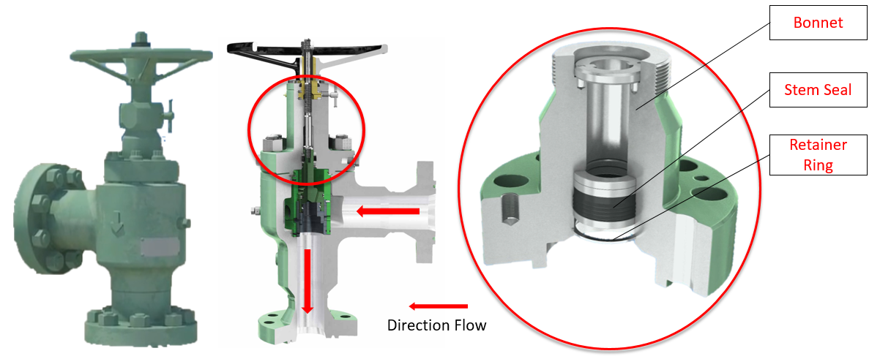
Figure 5: CC30 choke valve assembly illustrating stem seal location [57]
Most of the researches about choke valves are concentrated around the area where the contact between the parts of the valve and flow media occurs and less focused on the sealing integrity of the valve. Therefore, it is advisable for manufacturers, besides concentrating their efforts on efficiency and performance of the obstructer and valve geometry, to invest in sealing performance of the valve because the valve has to meet fugitive emission standards.

2.3 API Specifications 6A and 17D
When it comes to evaluation of the quality performance and standards in the oil and natural gas industry, the American Petroleum Institute (API) standardization system sets the benchmark and distributes consensus standards for the equipment operation, procedures, and environmental management and protection during all stages of oil and gas business handling. More than 700 standards developed by API were adopted globally [3]. The main purpose of API standards is to ensure safety during industry operations, sustainability and environmental protection, assure quality, reduce cost, and keep confusion within the industry at a minimum level [3]. This research was guided by two API standards, API specification 6A and API specification 17D. Therefore, it is necessary to keep in mind, that even though the research project was performed to aim to reach the standards, the goal is not to satisfy the standard requirement but to design the system that helps to observe the performance of the stem seal. Standards, in this case, are given as a benchmark to what the client is looking to achieve in the future for their equipment. Valve assembly and its place in the oil and gas equipment influence the design of the testing setup.
API specification 6A, 20th edition, is a guarding specification for wellheads and Christmas tree equipment. It is equivalent to ISO10423:2009 (modified) standard, where ISO stands for International Organization for Standardization. The standard requires the components that are containing the pressure to undergo a proof test. Before commissioning any unit of the upstream equipment, in this case within API 6A, it has to be qualified under this particular standard, in the context of this research, Annex F, Design validation procedure of API 6A [2]. Annex F contains the testing requirements including chokes with stem seal. Validating design testing has to go through sequences of dynamic load – measuring cycles, as well as temperature and pressure cycles performed over a specific amount of time. The more detailed explanation of the testing procedure of this research could be found in Chapter 5.
Since the exploration and production can be carried onshore and in the subsea environment, API 6A has to be adapted for subsea qualifying standards. API 17D is a specification for the design and operation of subsea production systems: subsea wellhead and tree equipment, and its equivalent in ISO system is ISO 13628-4 (identical), design and operation of subsea production systems, part 4: subsea wellhead and tree equipment [1]. API 17 covers many subsea types of equipment, but API 17D is solely related to wellheads and Christmas tree systems. As API 6A, API 17D follows qualification test protocol, which described in Annex F. Annex F involves pressure and temperature cycling [17]. This research was conducted with close observation of API standards but not as an API qualification test. Therefore, the testing procedure may differ from API specifications. These standards were given as a general overview. Any piece of equipment involved in either surface or subsea operation has to comply with safety regulations and industry-specific standards.

2.4 Chapter Summary
Since the research objectives are design and manufacturing a testing setup to evaluate the seal performance, it is important to understand the nature of the seals and their application in the field. Knowing the equipment that is used in the field and its standards facilitate testing setup design and manufacturing. This literature overview assists the design and manufacturing process with recreating the field environment and operating applications in laboratory settings. Chapter 2 starts with an overview of the mechanical and static seals classification and their manufacturing materials, which can play a role in seals performance. It proceeds with the oil field equipment, where the metal seals are employed. This part allows a better understanding of the field environment and operating applications. Subsection 2.2.4 gives the overview of the valve and focuses on choke valves that are the components of the earlier discussed oil field equipment. The metal seal is one of the key components of the choke valve, understanding the structure of the valve helps with the design portion of the testing setup. Section 2.3 provides an overview of the API 6A and 17D standards that facilitate the testing system setup of this research.

CHAPTER 3: Design Process

3.1 Introduction
In the oil and gas industry, the majority of the projects are expensive and complex. In the manufacturing business that supports the oil and gas industry, a single project can be a part of a bigger one. Despite the differences in the projects, each project can be structured into the phases. Figure 6 illustrates the waterfall project approach, when each phase begins after completion of the previous one [62]. This research is not a continuation of the previously existed project or extension of another research. This research involves creating a new testing setup that is able to accommodate stated requirements. Therefore, the design process started from phase zero and finished by commissioning as a product, it is rightful to say that it underwent through all the phases stated in Figure 6. This chapter includes an overview description of each phase of this research with specifics to the metal stem seal testing setup design and manufacturing.

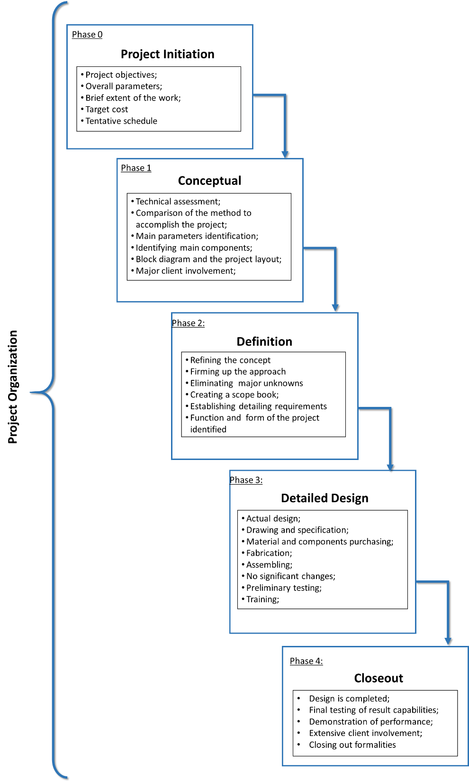
Figure 6: Structure of the design process divided into phases. Data from [4, 19]

3.2 Phase Zero: Project Initiation
Before the beginning of any project, there should be a reason why this project is initiated. Project initiation comes in life when the project objective and the goals are established [4]. This stage differs from the conceptual stage because it only overviews the nature of the project, gives a brief estimate of the schedule and target cost [4].
Concerning this particular research project, the initiation part started when the goal was established. The goal of this research was to design and build the testing setup that allows accommodating the certain size housing with the upright stem. The stem sits in the housing with the metal stem seal installed. The housing has to be pressurized and the stem needs to be rotated. The data of torque, time, pressure, and temperature needs to be collected and recorded. At this stage, the project was given a rough time frame as well as a cost.
This would be enough information to conclude the project initiation phase. This phase answers the following questions: 1) what needs to be done; 2) when it needs to be done; 3) what is the target budget for the project? This phase rarely contains any exact numbers and mostly belongs to the initiator of the project rather than the executor of the project. Often the conceptual phase, which is going to be discussed next, is the phase where the project begins to develop.

3.3 Phase 1: Conceptual
The conceptual phase requires much more specifics compare to the project initiation phase. During the conceptual phase, the development of the project was established, and concept selection performed to navigate the project through the next phases. Basic decisions were made regarding the future of the project and its form [19]. The conceptual phase of this research began from identifying the key data that needs to be collected, which in the future helps to navigate through the main equipment components necessary to create this data. This phase would be the best to be described through steps.
Conceptual Step 1: Identifying the main requirements
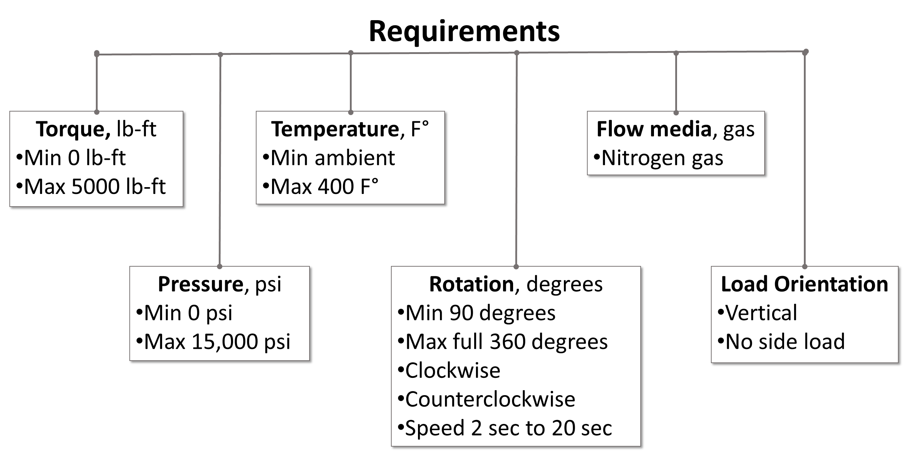
Figure 7: Project key requirements
Figure 7 describes the main established requirements that further will determine the design and the main components of the testing equipment unit. Determining the requirements facilitate tin establishing project's negotiable and nonnegotiable parts. The tolerances and nuances will come later in the definition phase. At this point, the requirements and their critical parameters were discussed, which leads to the second step.
Conceptual Step 2: Project layout (block diagram)
Completing the second step of the conceptual phase of the project helps to overview the layout of the project and connects the main parts of it. It helps to see the misses of the approach and the possible alternatives. Figure 8 illustrates the general layout of the research project to satisfy the main requirements.
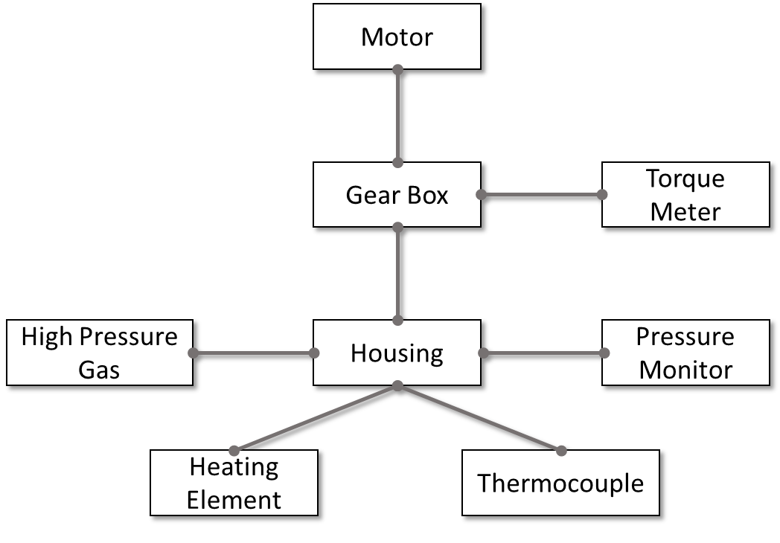
Figure 8: Main components of the testing setup
The block diagram identifies the key components that functioning as a foundation structure for other components. During the conceptual phase, the involvement of the project initiator is highly desirable to discuss and make corrections to the established plan. The developed block diagram helps to identify functional and performance requirements that are easier to classify using a block diagram [19].
Conceptual Step 3: Identifying the main components
Identifying the main components helps to seek the best-fitted alternatives for the sub-systems and later on integration. The evaluation process of the alternatives allows the project to have the appropriate and competitively priced components in the case of this research project. It is beneficial to identify critical requirements for the main components. As an example, identifying the motor’s key specifications gives a better understanding on what kind of motor would be the best option for this particular application.
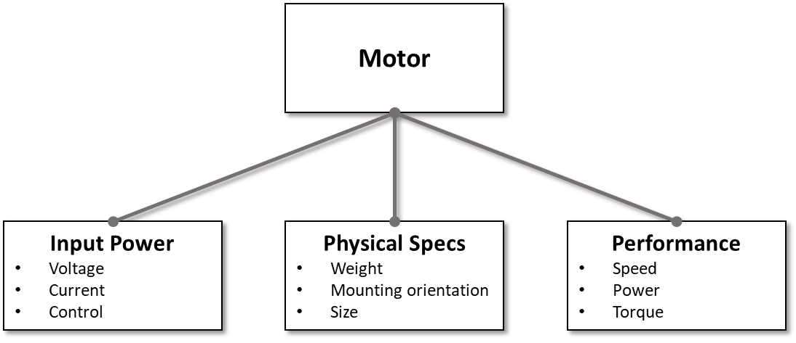
Figure 9: Motor specifications outlines
A detailed analysis of the components will be discussed later in this thesis. The effort to link the industrial approach to project organization and the master thesis research was done to illustrate that the research is connected to the real world engineering application. Project management from the manufacturing world can be successfully adopted in academic settings.

3.4 Phase 2: Definition
The project definition phase occasionally is mixed with the conceptual phase. There are no distinctive borders that would separate these two phases [19]. Therefore, the definition phase is the last part before the project gets into the detailed design phase. It is the phase where all the details of the projects are written. This phase can be separated into several steps to make the process flow smoothly and in a reasonable way.
Definition Step 1: A scope book
A scope book allows organizing the conditions of the projects such as design parameters, flow sheets, logic, and block diagrams, all necessary components to keep the bookkeeping of the requirements and progress of the design portion of the project. A scope book keeps the information about the technical application and approach of the project [19].
Definition Step 2: Identifying milestones
Identifying milestones helps the project to stay within the project timeframe and recognize any significant parts that need to be completed. For this research, it is important to identify the main parts of the project and sequence of their completion. Identifying the main segments of the projects that have to be completed in concurrent or sequential order. The main milestones of this research are listed below:
- Mechanical components (motor, gearbox, pressure booster, etc.);
- Instrumentation (pressure transducers, torque meter, thermocouples, etc.);
- Automation and coding (software, hardware, programming, etc.);
- Fabricated and machined components (support frame, connectors, adapters, etc.);
- Piping system (valves, pining, etc.);
- Electrical system (electrical connection, wiring);
- Assembling process
Identifying the main segments and milestones allows to keep control of the process and to minimize the risk of missing an important step or a component of the project.
Definition Step 3: Finalize the form and the function of the project
After finishing the definition phase, there should not be any or much less unknowns or uncertainty about the form and the function. After completion of the project definition stage, the scope book was established and the main milestones were identified. The research project's main components were listed and prioritized based on their preliminary lead time [19]. When the consensus was reached between the project initiator and project executor, the project can move on to the next phase of its development, which is a detailed design phase.

3.5 Phase 3: Detailed Design
The detailed design phase of the project is one of the longest phases. The active phase of the design and its analysis begins during phase four. All identified segments discussed in the definition phase were carried forward each with detailed design and analyses. Since the nature of the research was the commissioning of a non-standard testing setup, the availability of the readily available components on the market was limited. With this in consideration, the execution phase had several important steps that are discussed below in general matter. The detailed analysis of the design portion was discussed in Chapter 4.
Detailed Design Step 1: Selection of the main mechanical components and instrumentation
The first step of tackling the project’s execution face is to select the main mechanical components of the setup. Based on the requirements that were indicated in the conceptual phase and specifications form the definition phase, the proper mechanical component can be selected. This phase would be a perfect example, why project initiator involvement is very critical in previous phases. Clearly identifying the critical requirements and limitations of the technical capacity of mechanical components allowed to make the best-fitted choice.
Table 3: Components of the different types of drive combination
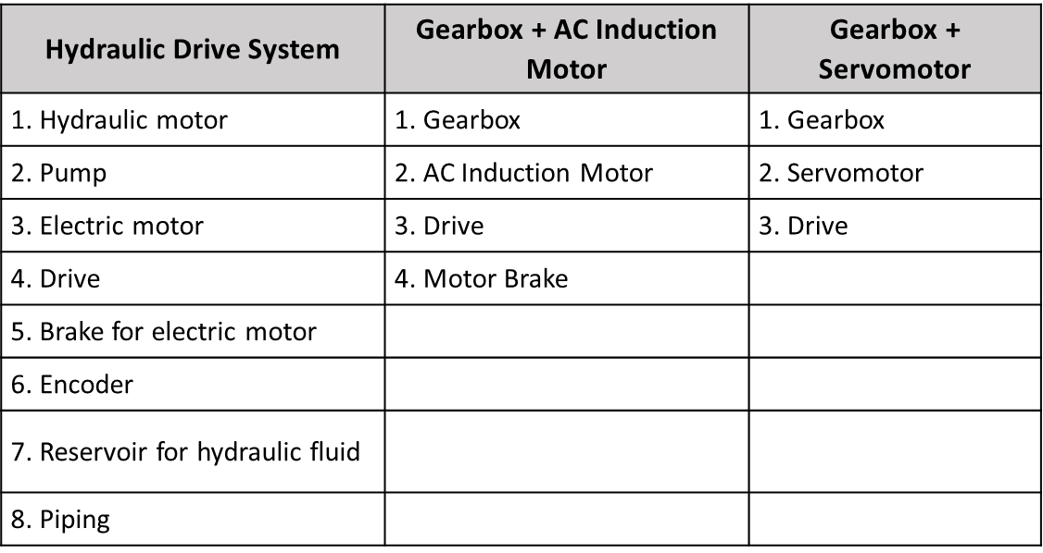
An example of choosing a proper motor and gearbox is described next. First, different types of possible drive combinations are identified, which were illustrated in Table 3. Second, critical requirements are known, which is the controlled motor. Using the elimination tactics, the least favorable system was eliminated from the option list, in this case, it is a hydraulic drive system, and then compared the two choices that left. Table 4 shows the comparison between a servo-controlled motor and an AC induction motor.
Table 4: Specification comparison of two types of motor
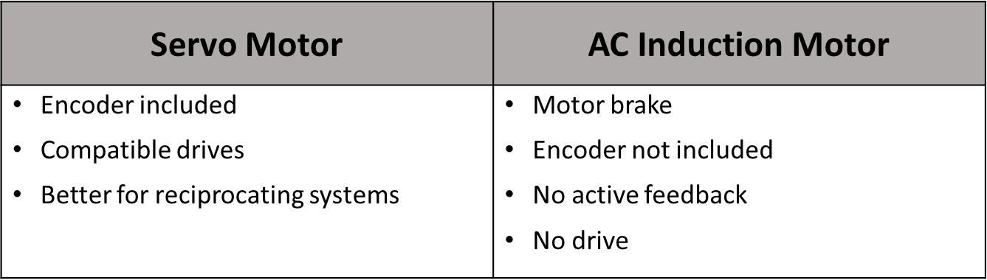
Based on the requirements that the motor needs to be controlled and be able to provide active feedback, a servomotor would be the best fit for the research project. The choice between the best option starts from looking at what market can offer and narrowing the choice to the best-fitted option. After the decision is made the different options of servomotors and gearboxes are examined, the most appropriate combination of the servomotor and gearbox is selected. The decision-making driver is the satisfaction of the research requirements, comparability of the components, cost, and the leading time. This technique is applied to most of the main mechanical components selection process. This selection process is very close to what implements in the industry but due to research academic nature, it differed from the industrial by omitting the bidding part of the acquisition process. The next step of the detailed design phase was to design and fabricate the structure that would serve as a bone structure that organized and supported the equipment.
Detailed Design Step 2: Design and fabrication of the structure support
The goal is to come up with a solution that would allow not only arrange and secure the main components but could be easily fabricated, reliable, provide easy access to the components for repair and operation purposes, and has a small footprint. The main requirements for this design were considered, such as the absence of any side load and the vertical orientation of the housing stem. Several considered designs of the frame are illustrated in Figure 10.
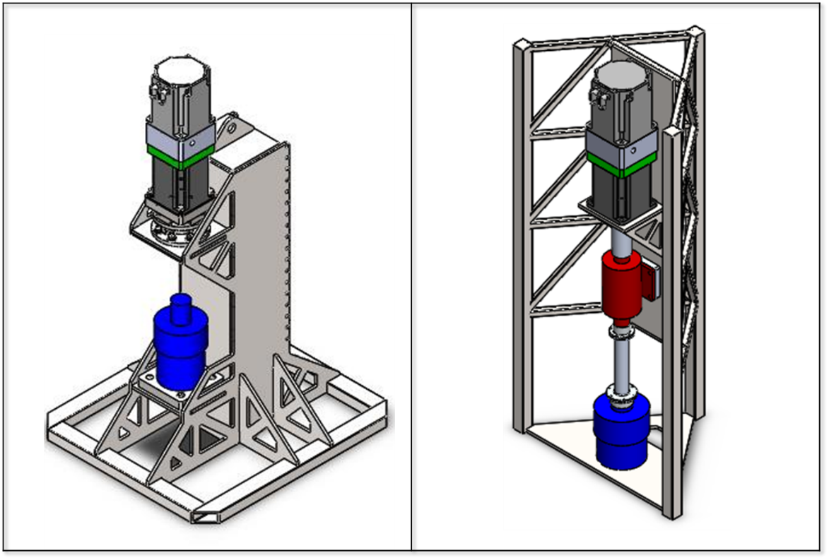
Figure 10: Wide flange beam frame design vs. triangular shape frame design (CAD models and created by Adam Flenniken)
The design involving a wide flange beam was chosen among the others, due to its durability and performance calculation predictability. When the design was confirmed, the fabrication stage began, involving plasma cutting technology and welding.
Detailed Design Step 3: Design and fabrication of the adapters and connectors
When the general design of the setup was known, adapters and connectors were designed and fabricated during this step. This type of testing equipment is not usual and unique and needs to be adapted to be mounted together. To connect the parts, several adapters and the coupling were designed and fabricated. The technic for fabrication was chosen to be a 4-axis CNC machining because it allows to obtain precise production while maintaining tight tolerances. Unlike the following steps, step 3 is sequential and was not seemed to be feasible for concurrent design with the earlier steps.
Detailed Design Step 4: Electrical system installation
Step 4 involved electrical system analysis and installation. At this point, it is important to note that step 4 could be processed simultaneously with step 2. During this step, it was important to identify the main components of the electrical system of the testing setup, make the diagram, order the components of the system, and the installation tools according to their lead time. Most of the components that made up the electrical system of the project could be found below:
- Electrical enclosure;
- Fuses (30 Amp and 15 Amp);
- Wires;
- Relays;
- Electrical terminal block
- Quick disconnect box (240 V and 120 V);
- Arranging material for the electrical enclosure interior;
- Wall outlets and plugins (240 V and 120 V);
- DC power supplies;
- Terminal blocks;
It is significant to mention that the electrical system was designed for 480 V electricity supply to minimize future redesigning changes, and only indicated items for voltage of 240 V will be changed for the future performance, which is discussed in Section 4.7.
Detailed Design Step 5: Design and installation of the piping components
The piping system of the testing setup manages the flow of the testing media. Piping and instrumentation diagram (P&ID) is discussed in detail in Chapter 4. At this step, it is important to mention that since the volume of the flow media was small tubing was used to construct the piping system. There is a different rating of tubing, valves, and fitting that are used in the piping system. Safety consideration is a driving force when it came to selecting the components of the high-pressure line. Since these components were obtained from the supplier, most suitable components were rated for safe operation up to 30,000 psi. Identifying the main components allowed to design the most suitable version piping diagram for this project.
Detailed Design Step 6: Instrumentation and automation installation
Instrumentation and automation installation is one of the steps that can be started at the early stage of the project. Since the input and output signal are known, instrumentation equipment and its quantity can be evaluated and procured. For this research project main instrumentation components of the testing setup were:
- Torque meter;
- High-pressure transducers;
- Low-pressure transducers;
- Thermocouples;
Another part of this step is automation. Besides the software, the hardware needed to be acquired promptly, since this part of the automation equipment takes a long lead time. The main hardware components of the automation system were listed below:
- National Instruments cDAQ chassis;
- National Instruments C Series modules;
- Programmable servo drive;
- Proportional–integral–derivative controller (PID controller);
To automate the process, LabVIEW software was utilized to collect, process, analyze data, and control instruments and equipment [31].
Detailed Design Step 7: Assembly and preliminary testing
The last step of the detailed design phase was finishing assembly. At step 7 the project was at the final stage of the testing setup assembly, the goal was to finish the testing setup assembly, check the readiness of the setup systems, electrical, piping, automation, housing alignment, and verify that the equipment is ready to perform preliminary testing. This step concludes the detailed design phase of the project. The execution phase can be effectively achieved if the conceptual and definition phases were performed correctly.

3.6 Phase 4: Commissioning of system
The final phase of the project is a closeout phase. During this phase of the project the product is prepared to be commissioned. All outstanding inquiries got resolved at this stage of the project [19]. Several steps of the final phase were essential for this research. Establishing a testing procedure and final testing of the setup equipment and the system was most significant in the closeout phase.
Commissioning Step 1: Establishing a testing procedure and instructions
Creating a testing procedure to prepare the setup for being ready to perform and test the metal stem seals are the main activities during this phase. The testing procedure underwent several revisions to make the instructions flow sequentially in a consistent way. The testing procedure was written in a way to keep a connection with the testing procedure required by API 6A and 17D. However, the first version of the testing procedure was created to test the system's ability to perform specific tasks, and its accuracy.

Commissioning Step 2: Testing
Step 2 of the closeout phase was an actual execution of the testing procedure. When the system was all set, the following testing procedure could be followed to collect and process the received data. The testing procedure was established and later iterated to adjust to the requirements of the test. The closeout phase includes some other steps that were necessary to make the commissioning of the testing setup successfully. A more detailed overview of the testing part and the procedure was described in Chapter 5.

3.7 Chapter Summary
Project organization differs from case to case, depending on the nature and the complexity of the task. This research project consists of five phases, which flow in sequential order. Each phase included the steps that were specific to the particular phase. Each step described the activity that was performed to progress towards successful project completion. The chapter overviews the plan of the design and fabrication process of the metal stem seal testing equipment, from the idea of the project to its final commissioning phase.

CHAPTER 4: Design and Fabrication Process

4.1 Introduction
Detailed analysis of the design and fabrication process is presented in this chapter. Sub-system and components of the testing setup is described from the technical characteristics and application standpoint. The physical setup is shown in Figure 11.
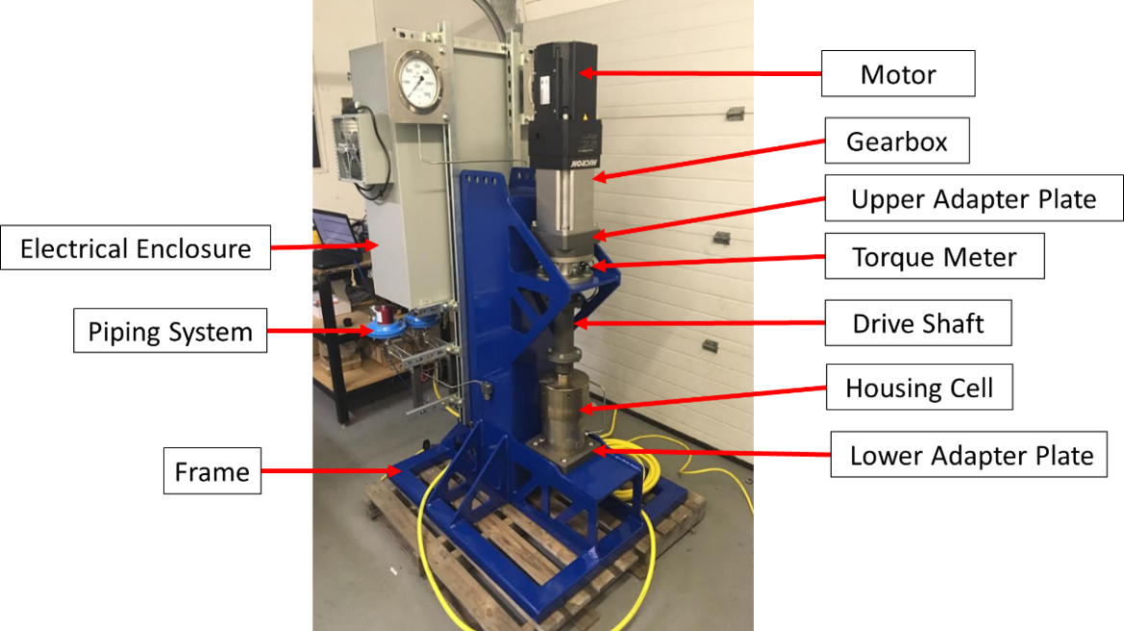
Figure 11: Testing equipment setup
The full assembly consists of several different systems and subassemblies. Rotating subassembly, frame, mounting adapters, instrumentation, piping, and electrical systems are presented in this Chapter. Hence, the Chapter covers principal parts of testing setup assembly and the procedure of assembling, seal installation and removal, and alignment for concentricity of the rotating mechanism.

4.2 Rotating Subassembly
A motor, gearbox, housing cell, and connecting them coupling shaft are the main components of the rotating subassembly. Each component is selected based on the requirement (see Section 3.3) and the component mechanical capabilities that it contributes to the testing setup.

4.2.1 Servomotor, Servo Drive, and Gearbox
One of the main research requirements is to apply and control torque to the stem of the housing cell. For this purpose AKM73P-ACCNC servomotor was selected. It belongs to AKM7 series of electro-mechanical, three-phase, direct current servomotors family manufactured by Kollmorgen with a closed keyway, international standard mount, and a smart feedback device (SFD) installed. SFD uses a position sensor resolver and digitally communicate information back to the drive [28]. The selected servomotor is a programmable servomotor with an installed resolver that precisely controls speed, location, and motion in clockwise and counterclockwise directions. A servomotor is a critical design component. The selected servomotor is 9 Hp, 640 Vdc, with an output of 344 lbf-in (29 lbf-ft) of continuous torque and peak torque of 985 lbf-in (82 lbf-ft), and maximum mechanical speed of 6000 rpm when operating on the power supply of 480 Vac [30]. When evaluating options for servomotor, one of the limiting conditions that were accounted for was supply power by the facility. The facility where the testing setup assembly is stationed can provide three-phase electrical power and 240 Vac voltage. The servomotor was selected with the possibility to be operated on a 480 Vac power supply in the future. Since the input voltage is 240 Vac, which is correlated to 320 Vdc, the rated torque that the servomotor can output is 307 lbf-in (26 lbf-ft) at a rated speed of 1300 rpm, and power of 6.33 Hp [30]. For this research, speed was a secondary priority during a servomotor specification process. The revolutions per minute do not play a critical role in this application since rpm is kept very low. The research requires rotating a stem from 0 to 90 degrees within the time interval between 2 and 20 seconds, which sets the revolutions per minute to be between 15 rpm and 1.5 rpm. The important feature of the servomotor is that the torque, velocity, and position are controlled during the application.
Servomotor drive belongs to the dynamic motion application servomotors. The compatible drive was acquired from Kollmorgen with the manufacturer number of AKD-T04807-ICAN. This drive operates on 240/400/480 Vac input voltage. It uses a rectifier that converts input AC voltage to DC output voltage to power the servomotor. The power supply to the servomotor goes through the AKD drive, which can be observed in the electrical flow chart in Section 4.7. The AKD servo drive is controlled through digital inputs sent by Kollmorgen WorkBench on the remote computer. The WorkBench allows programming the drive to the desired parameters according to the installed servomotor and gearbox [29]. Figure 12 represents a physical copy of the servomotor, drive, and the gearbox that were selected for the testing setup assembly.
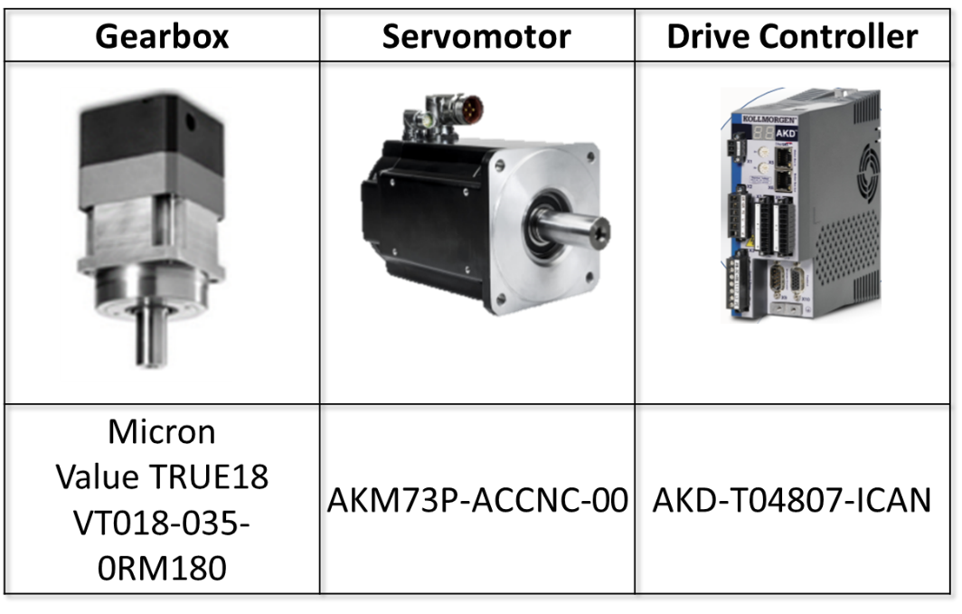
Figure 12: Servo motor, gearbox and servo drive combination
The gearbox of the rotating subassembly belongs to the Micron ValueTRUE 18 series gearboxes manufactured by Thompson. This gearbox is a planetary gearhead that permits the drive assembly installation in a vertical position to avoid any side load to the testing cell stem. The ratio of the gearbox is 35:1 [39]. Therefore, when the servomotor operates on 340 Vdc voltage the torque output produced by drive head is 10,745 lbf-in (875 lbf-in). The servomotor and the gearbox are major objects of research expenditure. The cost of a gearbox significantly increases with a higher ratio. Since the metal stem seal was not subjected to the torque application previously, the decision was made to gradually increase the torque application. Therefore, there is no need to apply 5,000 lb-ft of torque at the testing setup commissioning stage. The decision was made to supply the assembly with lower-rated torque output that helped to handle the budget rationally. Table 5 provides a summary outlook on what the motor and gearbox output undercurrent and maximum conditions.
Table 5: Torque output at a different voltage value
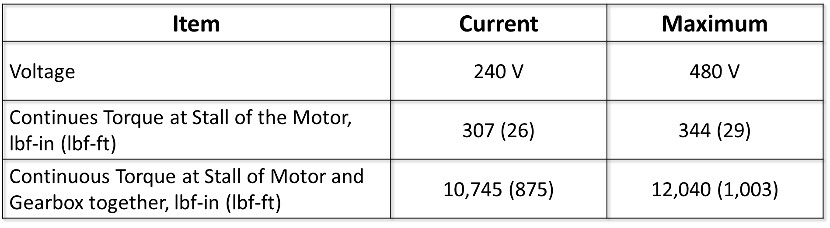
Therefore, current servomotor and gearbox output together 12,040 lbf –in (1003 lbf-ft) of torque when operated on 480 Vac voltage input. It is important to remember that the gearbox is rated for 24,870 lbf-in (2072 lbf-ft) maximum output torque, but the ultimate torque required for this research is 60,000 lbf-in (5,000 lbf-ft) [38]. When the research gets to the point where the application of 60,000 lbf-in torque is necessary, the gearbox will need to be changed ultimately. Micron ValueTRUE gearboxes are only available of the shelf for the maximum torque of 26,287 lbf-in (2,191 lbf-ft). To get 60,000 lbf-in (5,000 lbf-ft) of torque with the current motor, the gear ratio of the gearbox has to be equal to 174:1 or more and have a maximum torque capacity of 60,000 lbf-ft (5,000lbf-ft) or more. High ratio gearboxes often sell as custom-made items, which increases their price and lead-time. The other item that might need to be change is the servomotor. Kollmorgen has a motor that can output 1,590 lbf-in (133 lbf-ft) of continuous stall torque when operated with 400Vac voltage supply. The ratio of a servo gearbox in this case needs to be 40:1.

4.2.2 Housing Cell
A housing cell is a vessel that encloses the metal stem seal and serves as a pressure container that subjected to different testing conditions. The housing assembly consists of a housing chamber, cap, stem, metal stem seal, and axillary components to support the internal structure. The housing cell is divided into two pressure parts, low and high pressure. Low and high-pressure regions are isolated by the metal stem seal that sits on the stem. The stem is situated in the middle of the housing chamber. The axillary components support the metal stem steal and facilitate the seal removal process. When all internal components are installed in place, a thrust bearing is placed around the stem to support the movement of the stem and keep it in place when the assembly is pressurized.
The high-pressure media enters the housing cell through the high-pressure supply port. The high-pressure common port serves to control high pressure containing area. It verifies that the high-pressure media enters the high-pressure area inside the housing cell freely. The common port confirms the proper process of pressurizing application. The V-shaped stem seal is located above the high-pressure ports. When the high pressure applied, the “lips” of the seal are pushed against the surface of the housing chamber and the stem activating the sealing mechanism. Above the seal, two low-pressure ports are located. They serve as a contained area where testing media should leak if the seal would fail. Above the low-pressure ports, the O-ring is installed to insulate the low-pressure region. One of the ports has a low-pressure transducer that senses the pressure in a low-pressure region, which is discussed in Section 4.6.1, and a solenoid-operated valve that allows to relieve the pressure from the low-pressure region. The second low-pressure port provides safety to the low-pressure transducer and piping associated with its connection. In case of rapid leak of the media to the low-pressure region, safety rupture disc rated to a maximum pressure of 100 psi is installed on the other low-pressure port. The detailed schematic can be observed on the piping and instrumentation diagram in Section 4.5. Figure 13 illustrates a picture of a fully assembled housing cell and the housing cell without a cap.
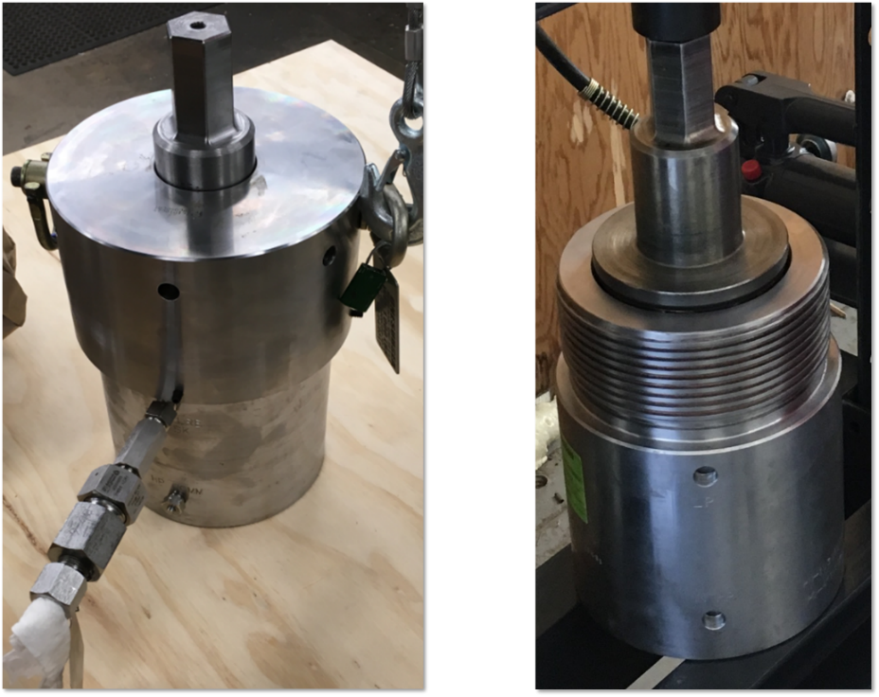
Figure 13: Fully assembled housing cell on the left and without a cap on the right
Housing cell assembly was not designed at OU because of the proprietary nature of the seals. Due to the nature of this research, the exact dimensions and tolerances of the housing cell assembly cannot be provided but they play a significant role in the testing setup performance. Even though, the housing cell design was not under the control of the research, the validity of the housing cell design was learned throughout the research. The housing cell was designed to handle high pressure during static application and rotational movement operation. The stem is the only rotating component of the housing assembly. The observation of the movement of the stem inside the housing provides the research with critical knowledge. Learned knowledge regarding the housing cell design includes the hardness of the metal on contact surfaces, tightness of the tolerances, geometry of the components, applied loads, and operating temperature. Unbalanced constituents listed above can lead to galling wear of the components. When the housing cell was assembled and the stem was connected to the gearbox by the coupling, the coupling weight applied axial load to the housing cell, creating undesired compression between the surfaces of a housing chamber and a stem. Compression, the equal hardness of the metal components, and applied torque (the rotational movement) created the condition that damaged the housing chamber and the stem by galling wear. Figure 15 represents the galled members of the housing cell assembly. After damage, both the housing chamber and stem were reworked. On the right side of Figure 14, the pictures represent the repaired housing cell and the stem.
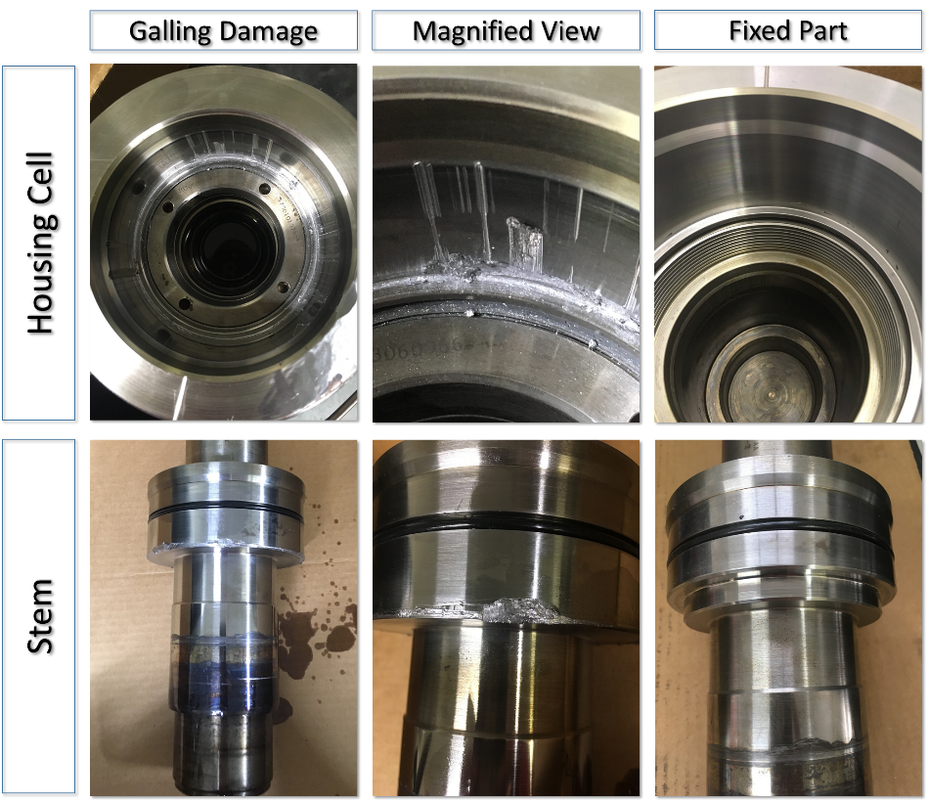
Figure 14: Stem and housing cell after galling
The housing cell’s top internal section was machined to remove scratches and burrs. By turning the upper inside diameter of the housing cell and taking material off, the tolerances were decreased between the stem and housing cell easing the compression but still allowing the sealing O-ring to be engaged. The stem was reworked by taking out the edge that sits in the corner of the housing cell. By machining a groove, it allows to insert a ring made of impregnated brass. The brass ring is made of a softer metal that serves an intermediate between two steel surfaces. The damage that was done to the stem around the seal was polished. Since the testing setup design is custom made, some adjustments were made to the housing cell components in response to unexpected outcomes.

Coupling Drive Shaft Design
The coupling was designed to connect the gearbox shaft and the stem of the housing cell assembly. The linkage between the shaft and the stem has to be made of several pieces because of 15.5-inch distance between them. Therefore, the distance between the stem and the shaft opens the possibility for radial and axial misalignments. Since one of the design requirements is the absence of the side load to the stem and having minimal vibration and shock exposure, the drive linkage was made of coaxial, rigid, flange connected couplings. Figure 15 represents the CAD model of the designed couplings.
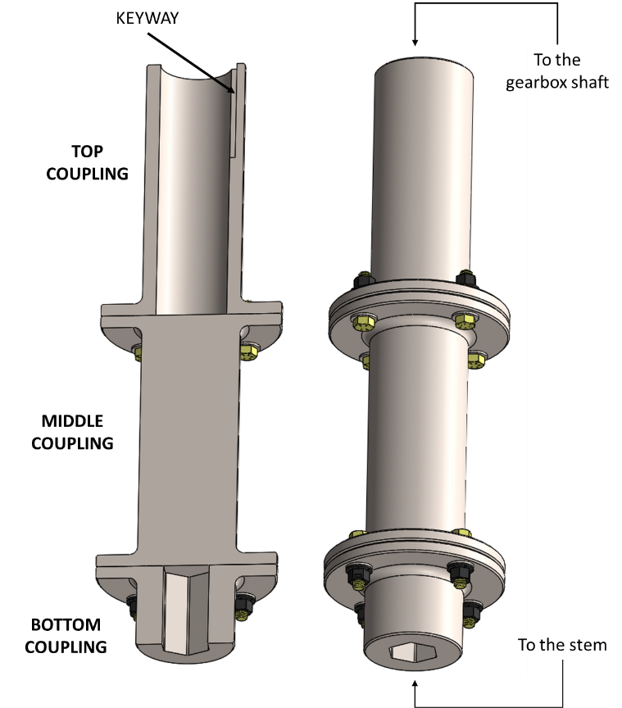
Figure 15: Coupling CAD model (CAD models and idea created by Adam Flenniken)
The space between the stem and the gearbox shaft is limited, which can make assembling and disassembling the coupling linkage difficult. Space constraint drove the decision to make a three-piece shaft coupled with each other by flanges and holding them bolts. The coupling consists of three parts. The top part has a broached keyway to fit with the keyed gearbox shaft. The middle part is a solid piece that is removable and allows to disassemble the stack of the coupling. The bottom coupling has a hex shape hollow that fits over the stem.
Flanged coupling serves as a reliable solution for this purpose. Flange coupling type provides high torque transporting capacity, has an easy installation process, and low manufacturing cost [40].

Bolt Joints
When torque is applied, the part of power transmission from the gearbox to the stem takes place through the bolts. Each pair of couplings is connected by joints made of four bolts that situated in an equally spaced circular pattern on the flange, 90 degrees between each bolt. All coupling flanges have the same dimensions of the outside diameter. The bolt circle for all flanges has a 4.375-inch diameter; all flanges of the couplings have the same circular pattern diameter. The bolts are eight grade 3/8”-16 thread size bolts with a tensile strength of 150,000 psi and 130,000 psi of yield strength [35, 52]. Table 6 illustrates specifications of the 3/8”-16 bolts that were used to connect flanges of drive shaft couplings.
Table 6: Specifications for zinc –aluminum coated, 3/8” -16 thread size, grade 8, 1-1/2” long fastener. Data source [14, 18, 27, 32, 35, 52]
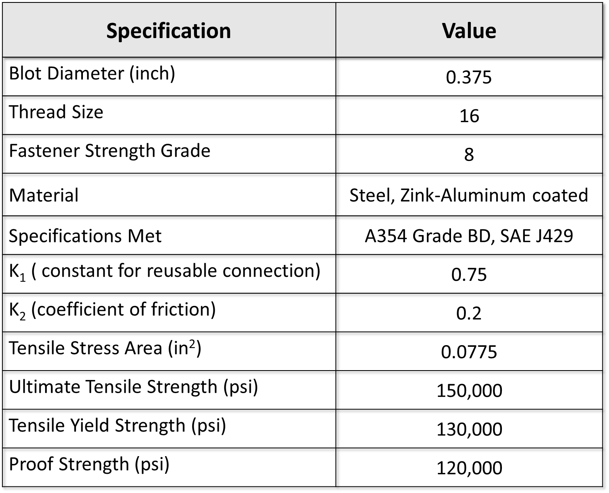
3/8”- 16 fasteners that are used for coupling connection have 0.375-inch nominal diameter in decimal equivalent, 16 thread size, 8 grade strength, and made of coated zinc-aluminum steel [35]. Since the drive shaft is assembled and disassembled when the seal needs to be changed, K₁ constant is equal to 0.75, which is suitable for reusable connection. The coefficient of friction for zinc-aluminum plated steel is equal to 0.2. Bolts with diameter 0.375 and 16 thread size have tensile stress area that is equal to 0.0775 square inches [32]. Specifications from Table 6 provide the necessary information to calculate the values in Table7.
Table 7: Calculated values of 3/8’’-16 bolts properties, preload, and their tightening torque
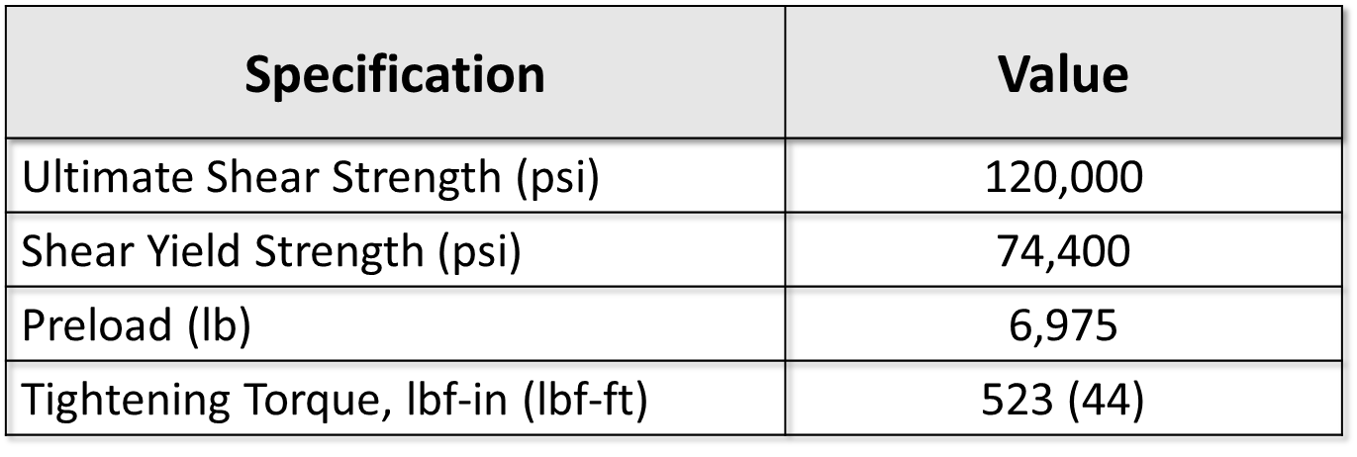
The following equations were used to calculate the values provided in Table 7 [27]:
$Ultimate Shear Strength=0.8×Ultimate Tensile Strength$ Eq. 1
$Shear Yield Strength=0.58×Tesile Yield Strength$ Eq. 2
$Preload=K_{1}×Tensile Stress Area×Proof Strength$ Eq. 3
$Tightening Torque=K_{2}×Preload×Bolt Diameter$ Eq. 4
According to the calculated value represented in Table 7, the recommended tightening torque is 44 lbf-ft. The maximum load in single shear that each bolt can support before failure is 120’000 psi. After knowing the values from Table 7, the maximum permissible torque with the safety factor of 2 can be calculated. The values are disclosed in Table 8.
Table 8: Values of stresses and permissible torque that can be applied on all four 3/8”- 16 fasteners of the coupling.
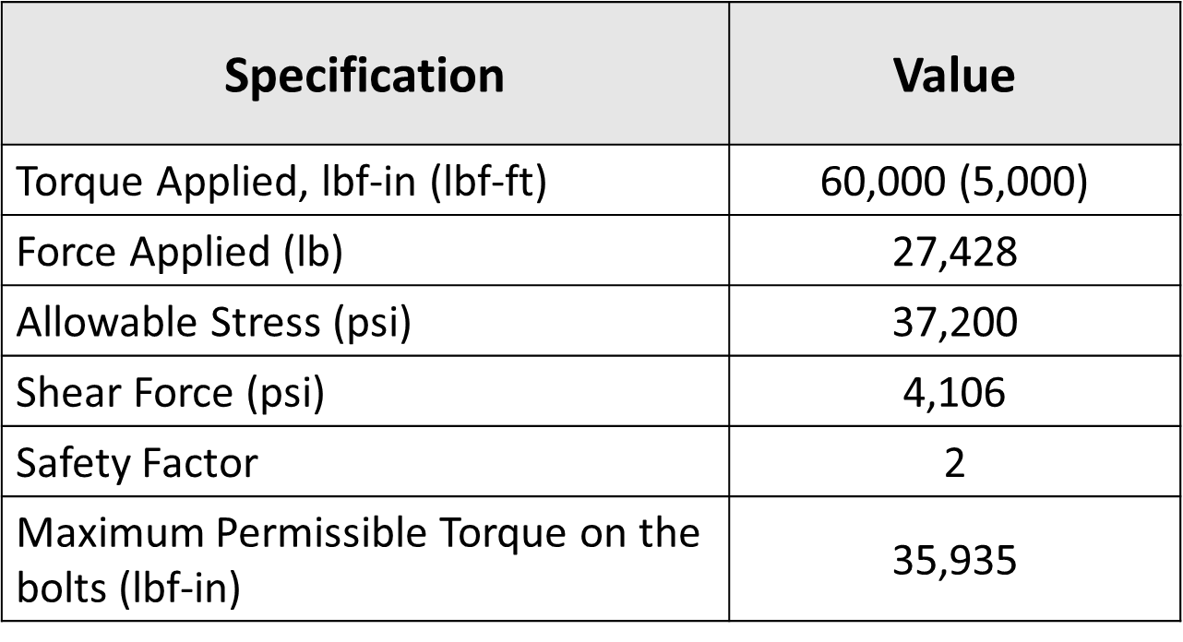
The ultimate torque that the research is aiming for is 60,000 lbf-in; therefore, the calculations were performed for 60,000 lbf-in possible torque application. With the safety factor of two and shear yield strength of 74,400 psi, the allowable stress is calculated to be 37,200 psi. The shear force for each bolt is 4,106 psi. Hence, the total torque that can be applied to four bolts in the coupling is only 35,935 lbf-in. Therefore, if torque will increase over 35,935 lbf-in, the bolt joints need to be changed to keep the safety factor of two.
Equations below were used to calculate the values represented in Table 8 [27].
$Allowable Shear Stress=\frac{Shear Yield Strength}{Safety Factor}$ Eq. 5
$Shear Force=Allowable Shear Stress×Bolt Shear Area$ Eq. 6
$Torque=Number of Bolts×Shear Force ×Radius of Bolt Circle$ Eq. 7

Finite Element Analysis of Drive Shaft
The drive shaft was designed to transmit torque from gearbox shaft to the stem of the housing cell assembly. All three couplings of the drive shaft are made of AISI 4140 steel coated with zinc phosphate. The ANSYS simulation and analysis was performed on a drive assembly. Computing FEA for drive shaft assembly allows to ensure that design was done properly and able to guaranty reliable application in the process. The simulation was performed for a drive coupling assembly including top, middle, and bottom coupling. The mesh of a drive shaft model has a tetrahedral structure and consists of 1,363,111 nodes and 935,062 elements. Contact regions between the couplings were defined as bonded for computational aid since the bolts calculation was performed earlier. Fix support was applied to the hex part of the bottom coupling that sits on the stem of the housing assembly.
The rotational movement in the stem occurs when the force is perpendicularly applied to one of the keyway walls in the top coupling. The inner radius of the top coupling is equal to 1.083 inches. The torque that is used in the simulation is equal to 60,000 lbf-in. Even though the drive assembly has to be changed when the gearbox will be changed to accommodate higher torque, the ANSYS simulation was performed with 60,000 lbf-in torque applied to accommodate future couplings design. Figure 16 illustrates the isometric view of the drive shaft assembly that is subjected to 55,402 lbf of force that is applied to the perpendicular wall of the keyway. As it was expected, the keyway region of the top coupling experiences the highest degree of deformation compared to other components, which is equal to 0.0761 of an inch. It is permissible deformation knowing that the torque will never reach 60,000 lbf –in since the maximum rated torque of the current gearbox is 24,870 lbf-in.
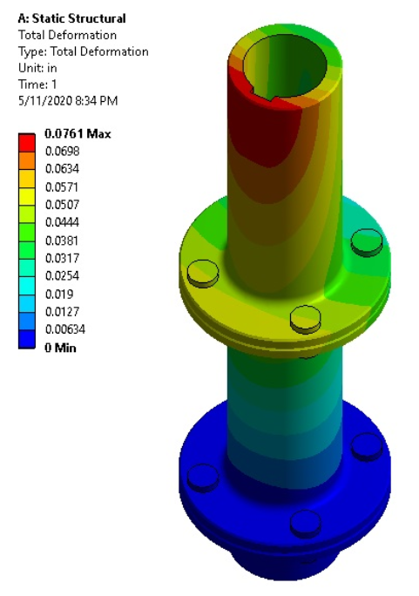
Figure 16: Isometric view of coupling assembly total deformation under 60,000 lbf-in torque applied (ANSYS simulation was performed in a collaboration with Jon Keegan)
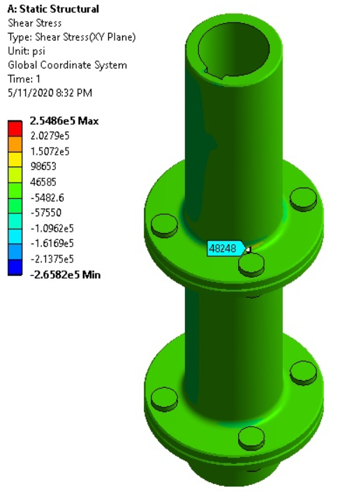
Figure 17: Shear stress of coupling drive shaft with the torque load under 60,000 lbf-in (ANSYS simulation was performed in a collaboration with Jon Keegan)

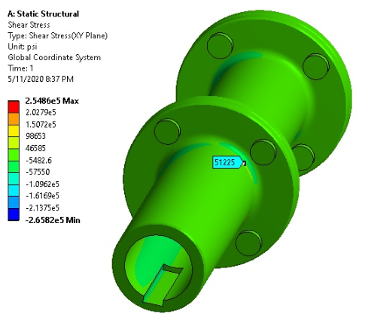
Figure 18: Keyway view of the top couplings under the shear stress (ANSYS simulation was performed in a collaboration with Jon Keegan)
Figures 17 and 18 illustrate the coupling shear stress distribution in drive shaft assembly caused by 55,402 lbf of shear force applied by the gearbox keyed shaft to the wall of the top coupling keyway. The largest shear stress concentration occurs in a quarter-inch fillet between cylinder and flange of the top coupling. According to ANSYS simulation, the maximum shear stress is equal to 254,860 psi. It occurs in high-stress concentration areas inside the hex adapter, which is expected. The shear stress in the fillet and near keyway is equal to 51,225 psi, which is greater than the shear yield strength of the material. The tensile yield strength of AISI 4140 is 60,200 psi [8]. By applying Eq.2 from Section 4.2.3.1, shear yield strength comes out to be equal to 34,916 psi, which indicates that the design of the coupling needs to be revised when the torque gets to 60,000 lbf-in.

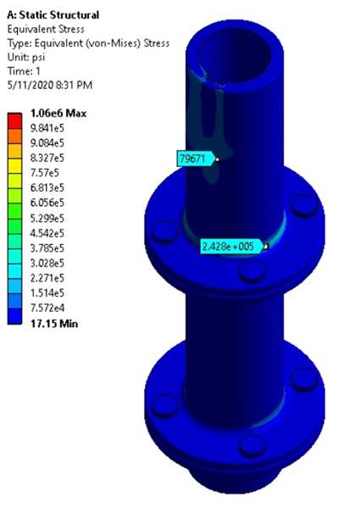
Figure 18: Von Mises stress in the outer wall of the coupling cylinder when 60,000 lbf-in of torque id applied (ANSYS simulation was performed in a collaboration with Jon Keegan)

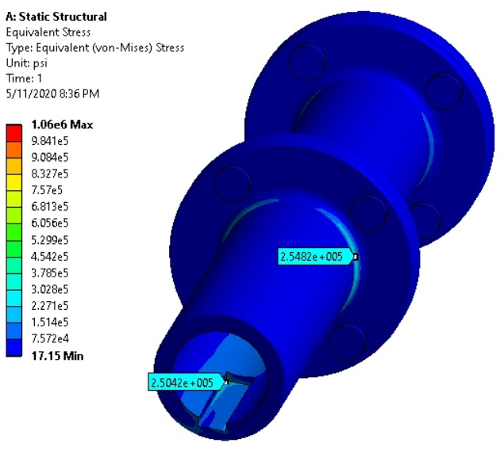
Figure 19: Von Mises stress in the drive shaft coupling (ANSYS simulation was performed in a collaboration with Jon Keegan)
Figure 19 and Figure 20 represent the distribution of the von-Mises stress in the drive shaft assembly. According to the ANSYS simulation, the maximum stresses are allocated near the keyway and on the fillets of the couplings. Maximum von-Mises stress is equal to 1,060 ksi, which is located around high-stress concentration points on the hex on the bottom couplings. The stress on the fillet is equal to 242 ksi, which is four times greater than the yield strength of AISI 4140 steel.
Therefore, when the actual output of torque needs to be equal or greater than 60,000 lbf-in, the drive shaft assembly needs to be redesigned and remanufactured to safely accommodate new gearbox and increased torque application

4.3 Frame
The frame is a structural element of the testing set up that holds all the setup components together. The frame is one of the most important components of the research. The frame design objectives include creating a compact and reliable structure that allows easy installation and removal process of a housing cell that weighs over 100 lbs.
Figure 20 shows the picture of an actual frame that was designed and manufactured for this research. The backbone structure of the frame is a structural steel wide flange beam W10 × 68. The carcass of the frame parts is made of low carbon A36 half-inch steel. Plasma cutter and MIG welding technology were employed to manufacture the frame. Each component of the frame underwent FEA for load stresses.
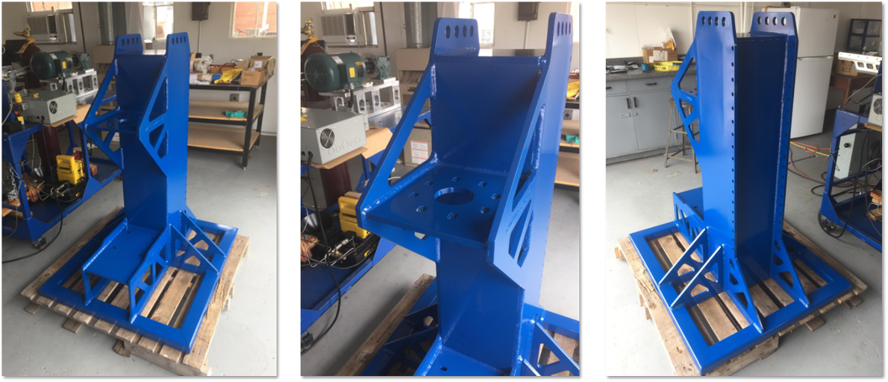
Figure 20: Steel frame of the testing setup
Figure 21 represents the sectional view of the frame. The wide flange serves as a supporting structure of the frame where the rest of the components are welded. The frame has two horizontal panels, the top and bottom. The top panel serves as a supporting panel for a torque meter, gearbox, and a servo motor assembly. The bottom panel is where the housing cell is mounted. The distance of 26.6 inches between the housing mounting plate and the top plate allows free access to the housing cell for assembling and disassembling purposes.
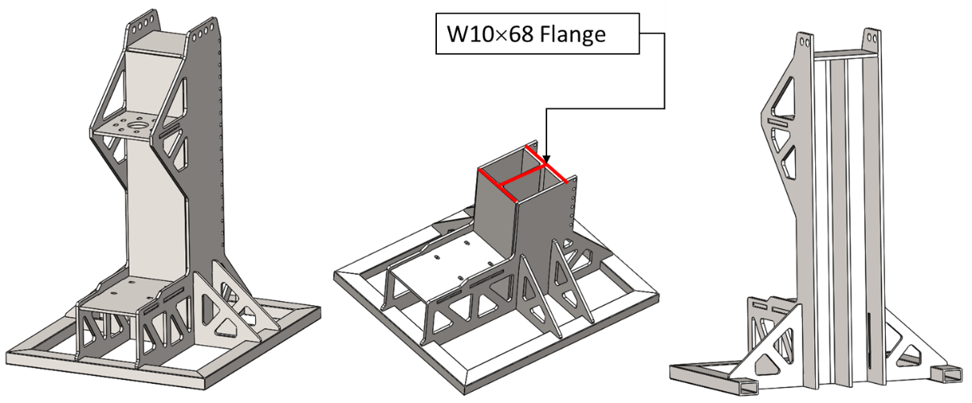
Figure 21: CAD model of I-beam structured frame (CAD models created by Adam Flenniken)
To verify the design reliability finite element analysis was performed using ANSYS. The mechanical properties of low carbon steel that were used in a frame design are presented in Table 9.
Table 9: Mechanical properties of ASTM A36 steel. Data obtained from [7]
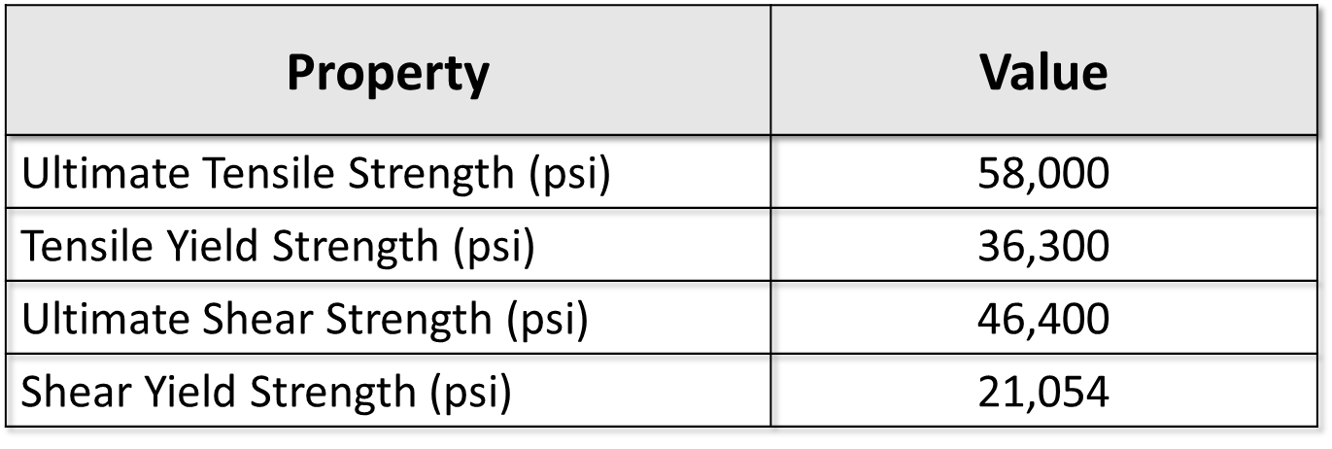
ANSYS simulation model mesh consists of 1,750,149 nodes and 821,300 elements. The contact regions of the parts are denoted as bonded. The moment that is equal to 60,000 lbf-in is applied to the top panel where the torque meter reacts against the frame when torque is applied. The fixed support is a bottom housing mounting plate. Figure 22 illustrates the total deformation of the frame when 60,000 lbf-in torque is applied. Maximum deformation of the frame equal to 0.015 of an inch, which is located at the bottom support of the frame.
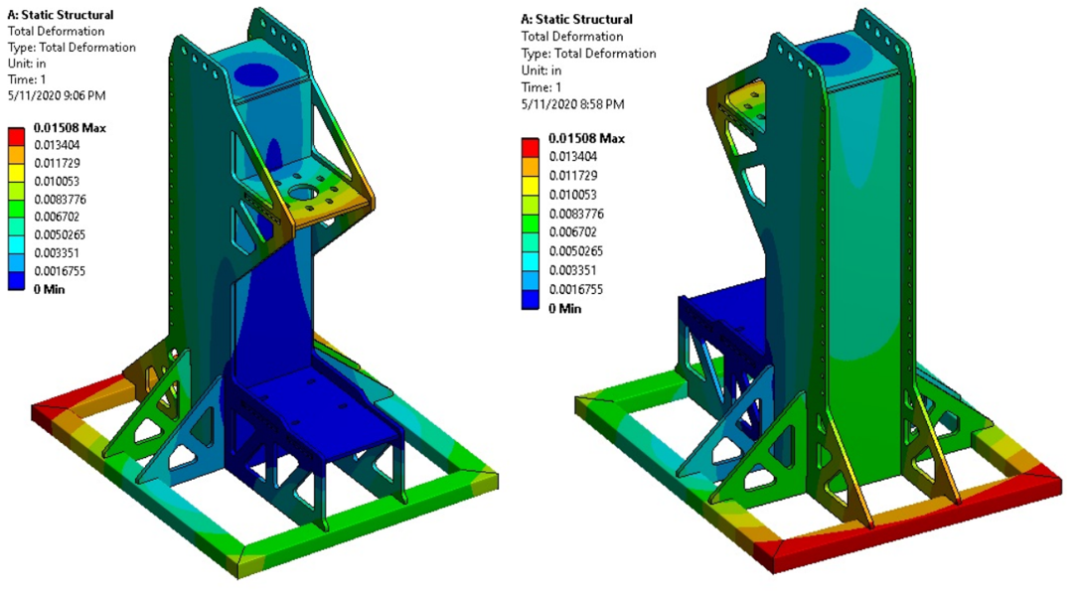
Figure 22: Front and rare views of frame total deflection with 60,000 lbf-in torque application (ANSYS simulation was performed in a collaboration with Jon Keegan)
Figure 23 represents von-Mises stress in the frame when 60,000 lbf-in is applied. The maximum von- Mises stress is equal to 18,130 psi, which is twice less than the yield strength of the material. The maximum stress concentration occurs around the top and bottom panels.
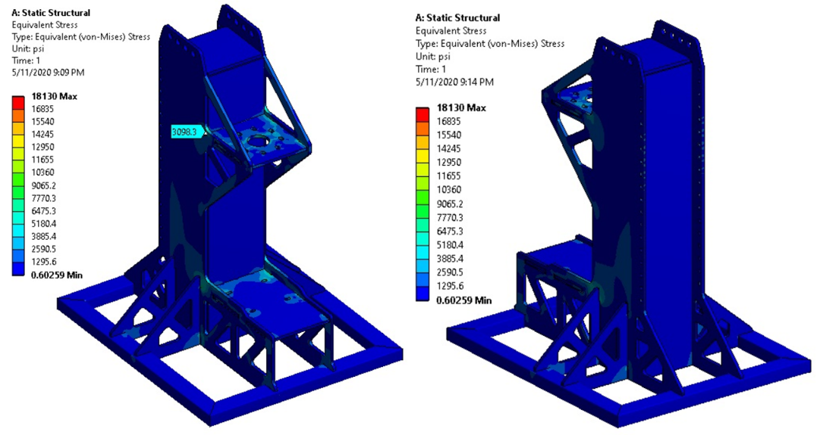
Figure 23: Front and rare views of Von Mises stress concentration with 60,000 lbf-in torque application (ANSYS simulation was performed in a collaboration with Jon Keegan)

Figure 23 represents von-Mises stress in the frame when 60,000 lbf-in is applied. The maximum von- Mises stress is equal to 18,130 psi, which makes the factor of safety equal two when torque of 60,000 lbf-in is applied. The maximum stress concentration occurs around the top and bottom panels.

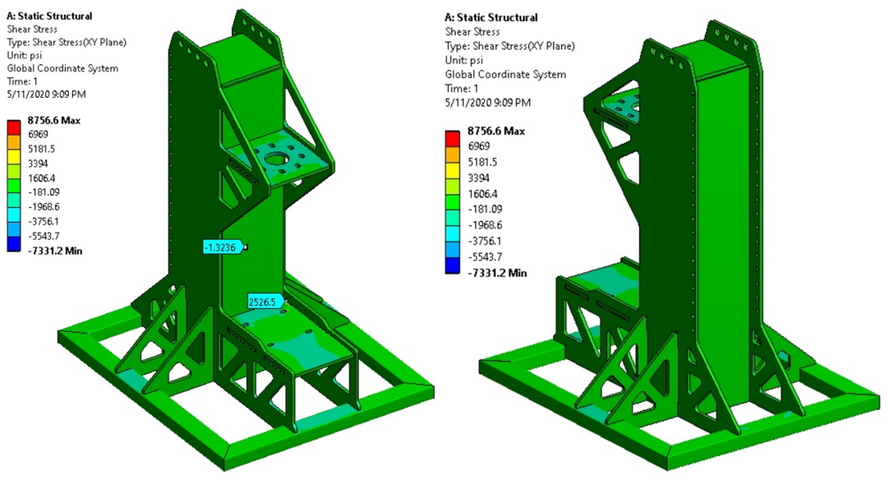
Figure 24: Front and rare views of shear stress concentration with 60,000 lbf-in torque application (ANSYS simulation was performed in a collaboration with Jon Keegan)
Figure 24 illustrates shear stress concentration in the frame structure. The maximum shear stress is 8,757 psi, which is almost two and a half times smaller than the material’s shear yield strength indicated in Table 9. Figure 24 legend shows that minimum shear is equal negative 7,331 psi, which happens due to the direction of the moment.
After conducting FEA, it is determined that the stresses acting in the frame do not exceed the strength of manufacturing material. Hence, it is safe to conclude that the designed and manufactured frame will remain intact under 60,000 lbf-in torque application.

Mounting Torque Meter and Housing Cell Adapter Plates
There are two adapter plates in the testing setup assembly; both of them serve as a bonding mechanism between the testing setup components. The top adapter plate serves to connect the toque meter and the gearbox. The bottom adapter plate is needed to mount the housing cell to the frame. Both adapters were designed and manufactured using ASTM A829-4140 alloy steel which, tensile strength is 95,000 psi and yield strength is 60,200 psi [6].

4.4.1 Adapter Plate between Torque Meter and Gearbox
The torque meter is mounted to the top plate of the frame. The next component that needs to be mounted on top of the torque meter is a motor-gear-head. All three components, a motor, gearbox, and a torque meter are mounted to each other in the tandem way. The motor and the gearbox have RediMountTM, a matching type connection between their flanges from the manufacture. The same is not true for the gearbox and the torque meter. These two components need to have a custom-made adapter to bond them together. Figure 25 represents a CAD model of the adapter that was used to connect the gearbox and the torque meter in the testing setup assembly.
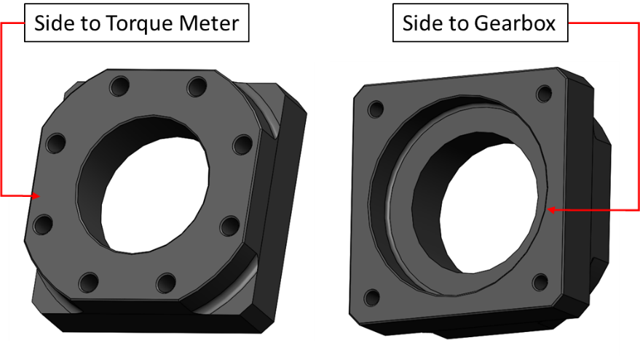
Figure 25: Torque meter adapter plate (CAD models created by Adam Flenniken)
The side that goes to the gearbox adapts its single piece output shaft with straddle mount bearing and secures it with four 5/8”-18 grade 8 fasteners[60]. The side that goes to the torque meter has an eight-bolt circular pattern with a bolt circle diameter of 7 inches that fastens to the torque meter flange by 5/8”-18 bolts. Table 10 represents the mechanical properties of SAE J429 bolts and calculated values of the maximum permissible torque on the bolts between the adapter plate and the torque meter and between the torque meter and the frame top plate.
Table 10: Mechanical properties of 5/8”-18 bolts and calculated values to determine maximum torque applied. Data were obtained from [14, 27, 32, 37, 52]
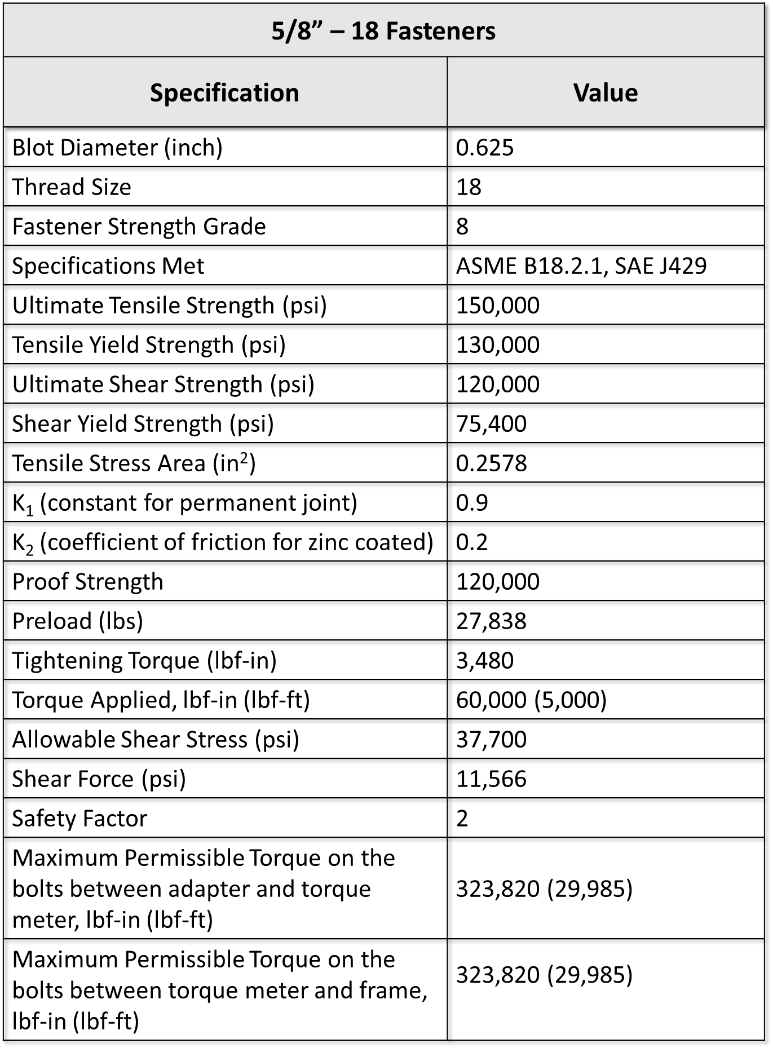
Therefore, with a factor of safety equal to two the maximum permissible torque on the bolts equal to 32,636 lbf-ft. The mounting fasteners for the torque meter can stay the same even when the requirement for torque will increase to 5,000 lbf-in.

Housing Cell Adapter Plate
The second adapter plate in the testing setup assembly is mounted to the bottom plate of the frame. Its purpose to secure the housing cell on the frame and serves as an axillary component during the housing cell alignment. The adapter plate has four oval counterbore slot that allows lateral movement of the adaptor plate. Figure 26 illustrates the CAD model of the bottom housing cell adapter plate.
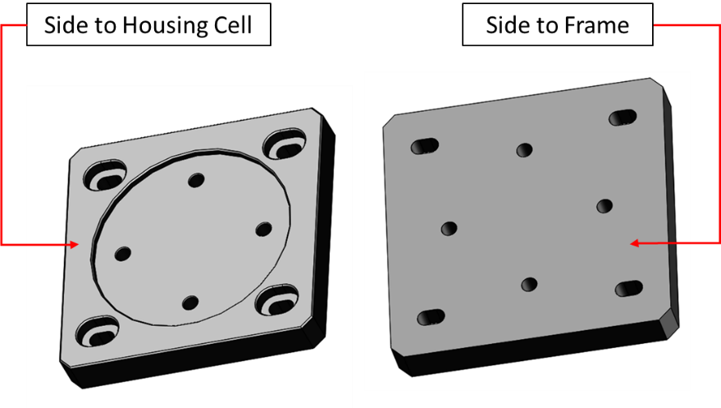
Figure 26: Housing cell adapter plate (CAD models created by Adam Flenniken)
The adapter plate mounts to the frame by four 1/2”- 20 fasteners arranged in 9 inch bolt circle. Table 11 contains mechanical properties and calculated values including the maximum allowable torque on the bolts of the adapter plate.
Table 11: Mechanical properties of 5/8”-18 bolts and calculated values to determine maximum torque applied. Data were obtained from [14, 27, 32, 36, 52]
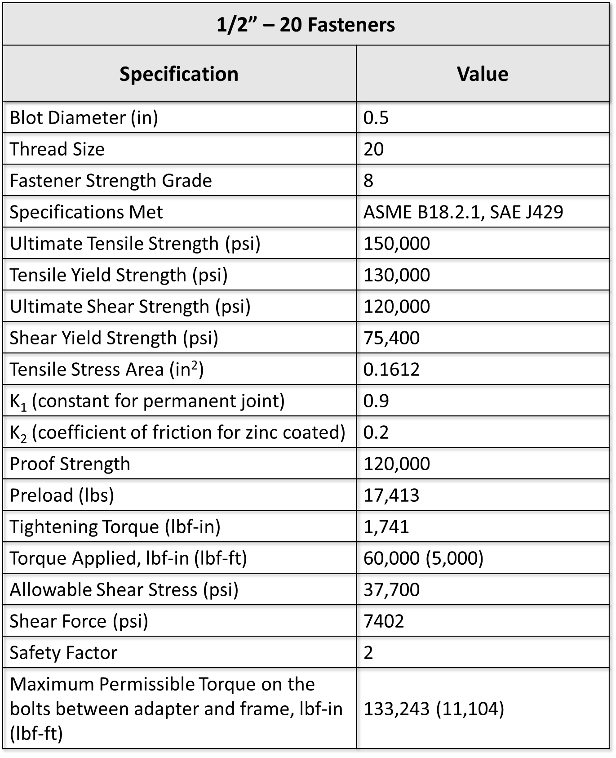
Therefore, the calculated maximum torque on the bolts of the bottom adapter permits their application in the assembly when torque needs to be equal to 5,000 lbf-in.
The housing cell is fixed on the bottom adapter plate by installed dowel pins. The housing cell reacts against dowel pins when the torque applied. Therefore, they are critical components when the system is in rotational motion. A half-inch diameter dowel pins are arranged in a circular pattern of 5-inch diameter. Table 12 lists the value for the dowel pins that are installed between the bottom adapter plate and the housing chamber.
Table 12: Specification for bottom adapter dowel pins Data were obtained from [27, 34]
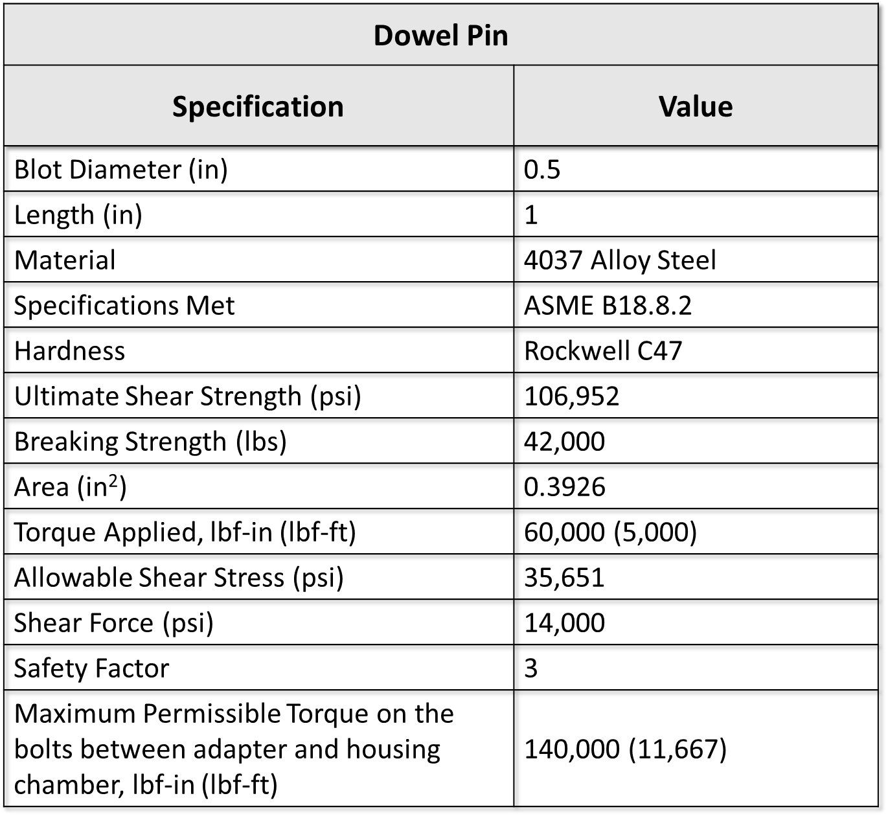
According to Table 12, the dowel pins that connect a housing chamber and the adapter plate can withstand 11,667 lbf-ft of torque with the safety factor of three. Therefore, when the needs of the research will require the torque to be set at 5,000 lbf, it is safe to leave the same dowel pins for the bottom adapter plate.

Piping System
The major requirements of the setup are application, measurement, and recording of pressure differential of the nitrogen gas inside the housing cell. This part of the design process is dedicated to the process of pressure regulation and application. The measurement and recoding process of the pressure application is discussed in Section 4.6, which is dedicated to a detailed analysis of instrumentation. The piping system of the testing setup consists of different types of valves, fittings, and tubing of different pressure ratings.

Piping and Instrumentation Diagram (P&ID)
The system is divided into two pressure regions of high and low pressure. The piping and instrumentation diagram represented by Figure 27, allows to trace the flow of the nitrogen gas through numerous valves and the location of the installed instrumentation. The black line on P&ID represents a bottle pressure of the nitrogen gas supplied to the gas booster. The nitrogen gas under 500 psi is fed to pressure gas booster where it is boosted to 15,000 psi. The instrument air supply is connected to the gas booster to drive its boosting mechanism. The supply of the bottle-pressure gas to the booster is regulated by a solenoid valve. High-pressure nitrogen gas leaves the gas booster and enters two legs of the tubing that are made of high-pressure rating tubing and fittings and indicated on P&ID as a red line.

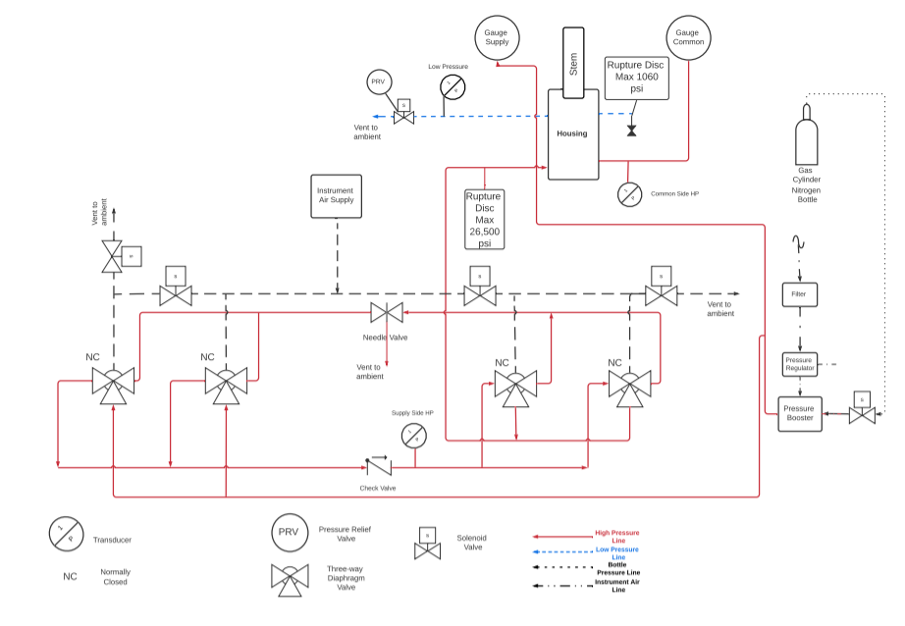
Figure 27: P&ID of the system

Each leg of high-pressure tubing enters a pair of three-way diaphragm valves. Electric solenoid valves supply instrumentation air application to each three-way diaphragm valve to activate them. The valves are normally closed diverting valves. When they are in a normally closed position, the pressurized nitrogen flows to the first pair of three-way valves located on the left side of the P&ID and then nitrogen enters the second pair of three-way valves where then it is diverted to the high-pressure supply port of the housing cell. Safety is a reason for duplicating a set of three-way diaphragm valves to ensure a remote control of the pressurized system in case of losing control of any diaphragm valve. Each diaphragm valve can vent nitrogen to the ambient by remotely operating through the solenoid valve, The solenoid valve applies the instrument air to the diaphragm and opens a passage in a three-way valve to the ambient environment.
The housing cell has a second high-pressure port, which is called a common port. The purpose of the common pressure is monitoring the distribution of high-pressurized nitrogen inside the high-pressure side of the housing cell and ensuring there is no blockage on the way of the high-pressure nitrogen. Both high-pressure ports are monitored by pressure gauges and transducers. The high-pressure side has a rupture disc that is installed at the entrance of the housing chamber high-pressure supply port. In case of uncontrolled pressure increase, the disc will rupture at 26,500 psi and release nitrogen gas to the ambient air.
If the seal inside the housing cell fails to hold high pressure of nitrogen than nitrogen leaks into the low-pressure side of the housing chamber where it accumulates. The low-pressure side of the housing chamber has two ports. One port of the low-pressure side is connected to a rupture disc housing. The disc will rupture in the event of rapid seal failure when the pressure in the low-pressure side reaches 1060 psi. The other low-pressure port is connected to the low-pressure transducer and an electric solenoid valve that can relieve the low-pressure side when it is needed or when the pressure reaches 30 psi to prevent transducer damage.
The piping and instrumentation diagram serves as a visual schematic representation of the required piping system for operating the pressure of the testing setup system.

4.5.2 Valves, Tubing, and Fittings
Two major types of valves are used in the system, three-way diaphragm valve and solenoid valve. Three-way diaphragm valves are installed on the high-pressure side of the system, whereas electrical solenoid valves are used on the low-pressure side, bottle pressure regulation, and on axillary valves for three-way valves operation.
A three-way diaphragm valve is a diverting type of valve that serves in a piping system to regulate a high-pressure nitrogen gas supply to the housing chamber. Three-way diaphragm valves are manufactured by the High Pressure Equipment Company. The valve series is 30-13HF4-NC and it is rated to a maximum pressure of 30,000 psi. Installed valves are normally closed service valves that are air to open and spring to close [20]. Supply air is controlled by electric solenoid valves.
There are six identical solenoid valves installed throughout the piping system. All solenoid valves of the system were purchased from McMaster-Carr. They operate on the electric actuation principle and connected by hardwire and have a maximum rating of 3,000 psi at 150° F. Solenoid valves are normally closed and have a voltage of 24 V DC [35].
There are two types of pressure operation in the system, high and low. High-pressure loop goes from a gas booster to the high-pressure ports of the housing. The equipment that is used for the high-pressure loop is rated to safely handle up to 30,000 psi pressure. High-pressure tubing and fittings are required for this application. The tubing for a piping system is a quarter-inch size stainless steel tubing with the corresponding fitting [21].
The low-pressure region of the piping system is the area where the pressure does not reach 3,000 psi. This includes the low-pressure side of the housing chamber, nitrogen tank pressure, and all the parts of the system that handles the instrument air. The tubing that is used on the low-pressure side is a quarter stainless steel tubing and corresponding size NPT fitting.

4.5.3 High Pressure Gas Booster
The maximum pressure requirement for the research is 15,000 psi. For the purposes to reach 15,000 psi in a short time, an air-driven pressure booster was installed in the piping system. Figure 28 represents the picture of the installed gas booster with annotated ports.
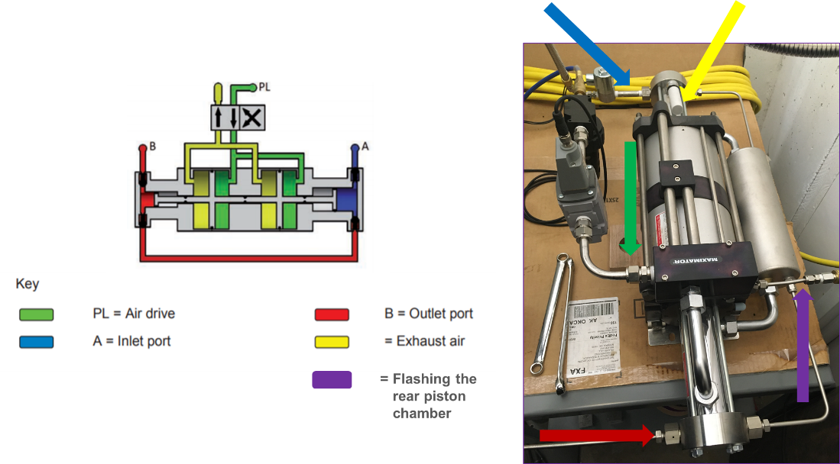
Figure 28: Port interfaces of DLE30-75-2 model gas booster. Data were obtained from [33]
DLE30-75-2 model is a double stage gas booster that is driven by compressed air supplied at 100 psi. It has a pressure ratio of 1:150 and a compression ratio of 1:50. It takes less than a minute to reach the required 15,000 psi. The maximum outlet rated pressure of the gas booster is 21,750 psi. Minimum supply nitrogen pressure to the inlet port needs to be no less than 218 psi; therefore, in application supply nitrogen gas is set to 500 psi.
Gas booster, valves, tubing, and fittings form a piping system of the pressure setup that is sufficient to operate safely and reliably under different pressure ratings, which satisfy the research pressure requirements.

Instrumentation and Control
One of the main requirements of the research is to measure and record pressure temperature, and torque. Pressure transducers, torque meter, thermocouples are the sensors that are used in the system to measure pressure, temperature, and toque. They transmit the information through the National Instrument cDAQ chassis and multiple C Series modules. The system is controlled by the LabVIEW software installed on the remote computer. The data collection process is automated and testing setup equipment is remotely controlled.

Torque Meter
The ability to measure applied torque to rotate the stem of the housing cell is one of the major requirements of the testing setup design. To fulfill this requirement, a torque meter was mounted into the assembly. The torque meter is a reaction type torque meter with the hollow shaft is positioned in between the frame and the top adaptor plate that connects to a motor-gear-head. Figure 29 shows a CAD model of a torque meter and its place in the assembly. The torque meter model number is RTM2070 (5-4). It is manufactured by S. Himmelstein and rated to 50,000 lbf –in of maximum torque. The reaction torque transducer has ± 0.1% or ±50 lbf-in of accuracy. The manufacturer recommends performing an annual calibration service for this torque meter [55].
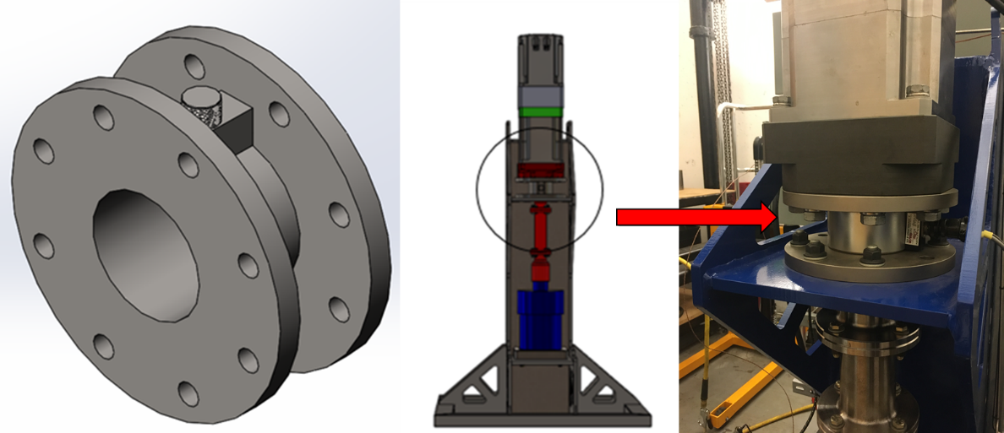
Figure 29: Torque meter and its position in the setup (CAD models created by Adam Flenniken)
When the torque requirement needs to be at 60,000 lbf-in, the torque meter will be changed. The next higher range torque meter available from S.Himmelstein in this class is RTM 2070 (1-5) model, which is rated to 100,000 lbf-in with the same accuracy as a current torque meter, which makes it equal to ±100 lbf-in.

High and Low Pressure Transducers
Each pressure side has the transducer to measure the pressure and transmit it to the system. Depending on the pressure and accuracy required each pressure region has an appropriate transducer.
Two high accuracy amplified voltage output pressure transducers are installed on each side of the high-pressure housing port entrance. Both high-pressure transducers are manufactured by Omega Engineering and have the range from 0 to 30,000 psig with and accuracy of ±0.19% or ±57 psig [49]. This is not a significant gap in data because the smallest pressure applied to the high-pressure side is equal to 500 psi. Both transducers send 4-20 mA current output signal, which allows them to be low electrical noise transmitters.
The low-pressure transducer is located at the entrance of the low-pressure port of the housing chamber. It is a high precision performance transducer manufactured by Omega Engineering. The low-pressure transducer has a range from 0 psi to 100 psi, the accuracy of ±0.08% or ±0.08 psi, and high response time [50]. This type of transducers ideally serves the purpose of collecting and transmitting data about pressure change in the low-pressure region of the housing chamber. The transducer sends the current output signal between 4 mA and 20 mA, which makes it electric noise resistant. All transducers installed in the testing setup assembly have a twist-lock connector, which eases the installation process.

Thermocouples, Band Heater, and PID Controller
Seal performance is affected by temperature. The testing is taking place at room temperature and elevated temperature of 400° F. To heat the metal seal inside the housing cell, the band heater is wrapped around the housing chamber. The temperature is controlled by a PID controller and measured by installed the thermocouple.
A standard K-type thermocouple is used to gauge the temperature inside the housing cell. The temperature range of K-type thermocouple is between 32° F and 527° F with the accuracy of ±3.96° F.
To bring the temperature of the housing cell up, the band heater is placed around the middle of the housing chamber. The ceramic band heater is made by Tempco Company and it requires 240V of the voltage supply.
The temperature around the housing cell is regulated by the installed PID controller. According to provided feedback from the thermocouple, the PID controller automatically regulates the work of the band heater when the temperature drops inside the housing cell.

4.6.4 NI cDAQ Chassis, NI C Series I/O Modules, and LabVIEW
The remote communication with the testing setup system occurs through the implementation of National Instruments hardware and integrated LabVIEW software.
CompactDAQ chassis from National Instruments is used to control the data transfer between National Instrument C Series modules and an external computer. The cDAQ-9189 chassis are used in combination with C Series I/O modules for analog or digital inputs and outputs, and counter or timer measurements. The chassis allow simultaneously running multiple hardware-timed applications independently [41]. CompactDAQ-9189 chassis have eight slots for NI C Series I/O modules. The connection with the remote host occurs through the Ethernet cable.
The system employs seven I/O modules of C Series from National Instruments. Their location is shown in Figure 33 in Section 4.7. There are three NI-9474 C Series modules installed in the cDAQ chassis. Each NI-9474 module has eight digital output channels. They send an output signal to the AKD servo drive, solenoid valves, and the fan in an electrical enclosure. NI-9263 is an analog output module with an analog voltage range between -10V to 10V [42]. It sends the signal to the gas booster electronic proportional regulator to control nitrogen flow pressure that enters a high pressure loop. NI-9273 is a C Series analog input module that provides the power and measures the load on the torque meter. NI-9203 is an analog input module that receives signals from all pressure transducers installed in the system. It has eight programmable channels, each channel input ranges of ±20 mA or 0 mA to 20 mA [43]. NI-9212 is a C Series temperature input module that receives the analog signal from the testing setup installed thermocouples. Its maximum sampling rate is 95 samples per second per channel with an accuracy of 1.278° F [44].
Data operation from NI modules is implemented through LabVIEW software. It allows the user to acquire, process, and analyze data. It also remotely controls the instruments and equipment of the testing setup [31]. All the valves in the piping system, AKD servomotor, gas booster, and the electrical enclose fan are controlled through the LabVIEW program. It collects 20 samples per second of high and low pressure, temperature, and applied torque. The sample collection per second can be adjusted up to the maximum sampling capabilities of each C Series module.

Electrical System
The electrical system of the testing setup powers all the components of the system. The voltage that is supplied to the system is 120 V and 240 V. The electrical system is located in the electrical enclosure, which is mounted to the back of the frame. Electrical power is distributed through two quick-disconnect switches mounted on the side of the electrical enclosure. Quick disconnect switches provide safe electric power usage with installed 30 Amp and 15 Amp fuses, for three-phase 240V and 120V voltage respectively.
Three-phase 240V power is supplied to the AKD servo drive that powers the servomotor. The band heater also requires 240 V to operate. Power supplied to the band heater is delivered through the switch box with 30 Amp fuses. The rest of the electrical components receives the power through 120 V AC quick disconnect.
The temperature inside of the electrical enclosure is controlled by the thermocouple and if the temperature rises over 80° F, the electrical enclosure fan turns on automatically.
Figure 30 represents the electrical components and data acquisition hardware of the testing setup and their layout inside of the electrical enclosure.
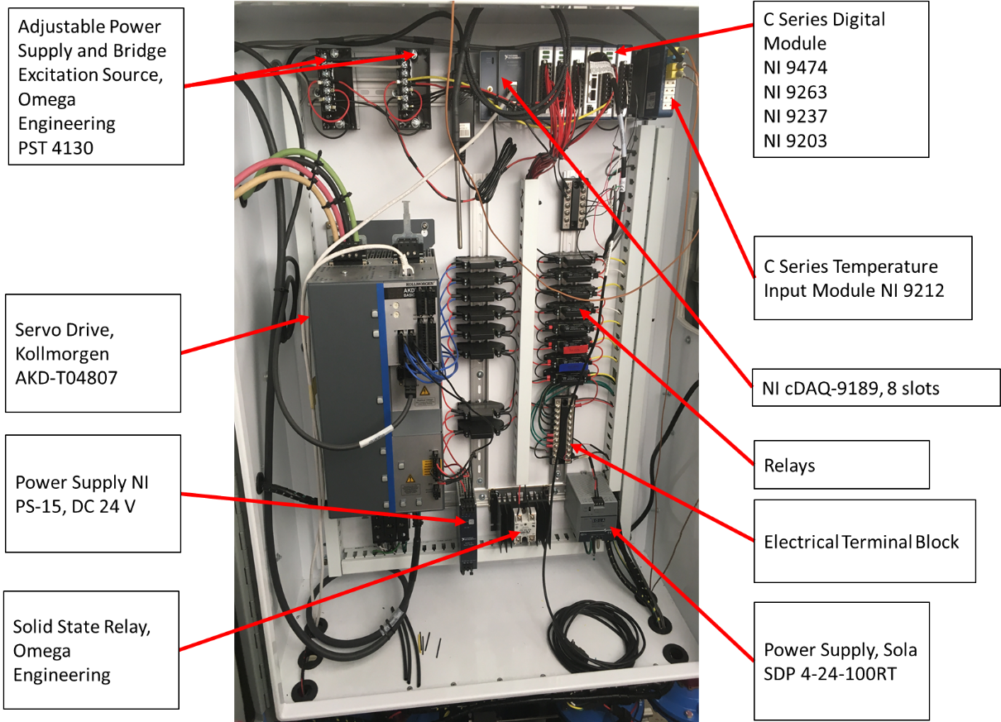
Figure 30: Arrangement inside an electrical enclosure
The AKD servo drive is located in the lower-left corner. Three-phase 240V power comes from the side of the electrical enclosure and connects to the top connector of the AKD drive. The next component is a power supply NI PS-15 located next to the AKD drive in the electrical enclosure. It is powered by 120VAC power and supplies 24 V of DC power to the axillary power connector for AKD logic. National Instruments data acquisition hardware is located in the upper right corner of the electrical enclosure. The cDAQ chassis powered by 120VAC. The other components of the electrical system powered by a 24 V DC power supply. Figure 31 represents a diagram of electrical power distribution in the testing setup components.

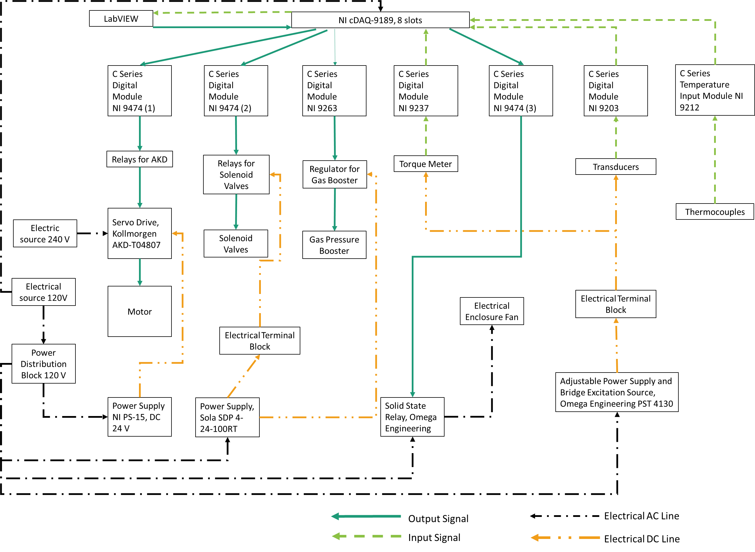
Figure 31: Power distribution diagram in the testing set electrical system
The black dashed line represents the 120V AC line that powers all DC power supplies, cDAQ chassis, and electrical enclosure fan. The green dashed line stands for an electrical DC power line. AKD servo drive logic, gas booster regulator, pressure transducers, solenoid valves, and torque meter are power by 24V DC power. Red and blue lines represent input and output signals that send the signal to and from the sensors.
In the future, if the higher power will be required, there will be no need to change anything in the electrical system except a 240 V quick disconnect switch on the side of the electrical enclose.

Assembly Processes

Assembly
Every subassembly was put together in a step order depending on their completion. The first step was mounting the torque meter to the frame. After that, both adapter plates were installed in place. When the adapter plates were secured, the servo motor-gear-head was fastened to assembly. The next step was the installation of the electric power system and data acquisition hardware. At the same time, the work was done on the piping system. Wiring electrical components and installing a piping system were significant time-consuming processes. When the testing setup was assembled, the process of writing a LabVIEW program began. It took several iterations to finalize the testing setup LabVIEW program that meets the requirements of the research.

Seal Installation and Removal Processes
The topic of installation and removal processes can be considered as a part of the assembly process. The seal installation and removal processes are the part of housing cell assembly preparation for the testing. If the seal installed improperly, it will affect its sealing properties, create undesirable friction and load to the inside service of the housing chamber, and can compromise the performance of the entire testing assembly. Figure 32 illustrates both, installation of the seal on the right picture and the removal of the seal on the left.
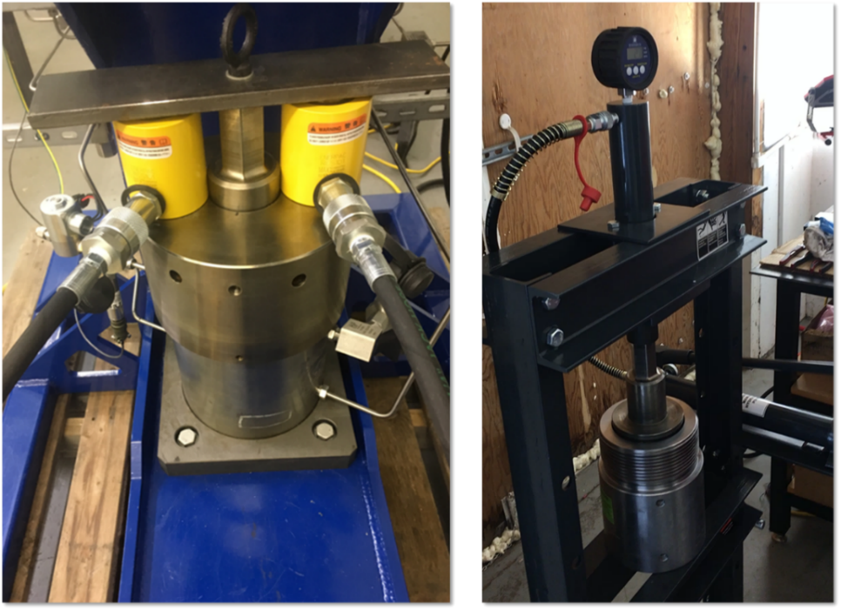
Figure 32: Metal seal installation and removal processes
An upright hydraulic press is used to install the metal stem seal. When all internal components inside the housing chamber including aligned stem seal and the stem except the cap are assembled, the housing cell is placed on the press table under the ram. The press applies the force to the stem making the stem to plunge into the housing chamber and by that pressing metal stem seal into place. It takes 520 lbf of force or 400 psi of pressure to install the metal stem seal in place.
The opposite process of seal installation is a seal removal. Two hydraulic cylinder presses are placed on both sides of the stem between a steel plate, which is mounted at the top of the stem, and the housing steel cap. The hydraulic presses are manually operated and have a transducer installed to record the applied pressure. When the pressure applied the cylinder presses reacts against the cap and pressing into the temporarily mounted steel plate. The plot in Figure 33 represents the pressure needed to remove the stem.

Figure 33: Pressure needed to remove a metal stem seal from the housing cell
It takes around 450 psi or 2025 lbf of force to remove the stem from the housing. When the stem is removed, a specially designed for this purpose hydraulic cylinder screwed into the bottom of the housing chamber. When the pressure applied to the hydraulic cylinder, the piston rod inside the cylinder extends and reacts against the bottom of the chamber. This movement pushes the metal seal towards the opening of the housing chamber, which completes the removal seal process.

Alignment Process
One of the requirements of the research and rigid couplings used in assembly is the absence of any side load. Whenever the housing cell is installed into the testing setup assembly, the housing cell has to be concentrically aligned with the gearbox shaft. The housing cell is also checked for alignment in the horizontal plane to avoid any intolerable inclines of the housing cell. The dial indicator is used to perform the alignment.
When the housing cell is installed into the assembly and is ready to be aligned, the dial indicator attaches to the bottom coupling and the tip of the dial indicator touching the surface of the housing cap and makes a complete circle around it. The concentric alignment process is illustrated in Figure 34. If the eccentricity is greater than permissible 0.005 of an inch, which means the housing cell is off-centered and the stem needs to be aligned with the gearbox shaft.
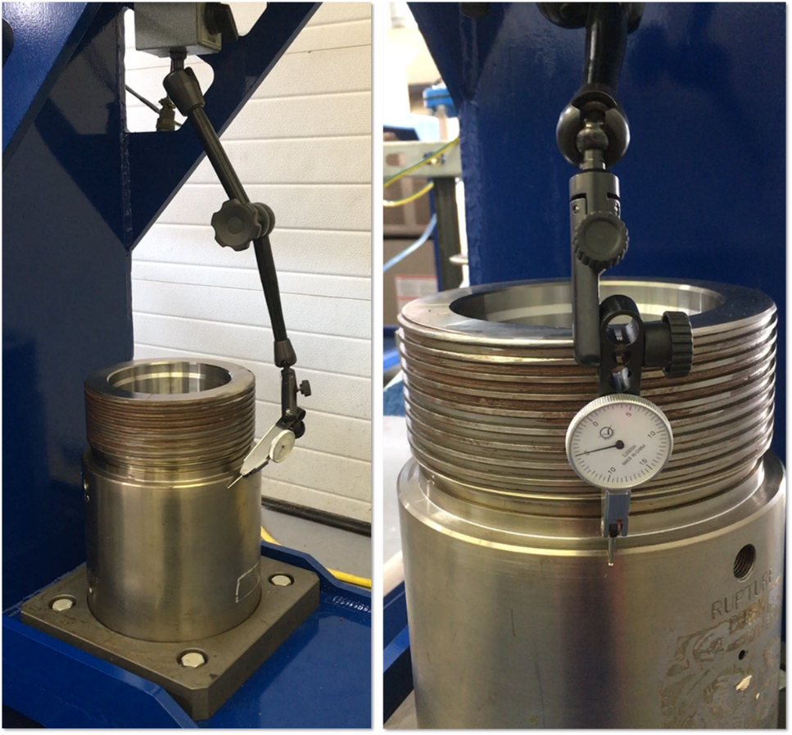
Figure 34: Housing cell alignment process
To align the housing cell and drive shaft, the housing cell is adjusted by moving from side to side until the desired concentricity is reached. On average, the alignment process takes about three to four hours.

Chapter Summary
This chapter includes the design, manufacturing, and assembling processes of the testing setup. There are seven major parts of the design, which includes rotating subassembly, design and manufacturing of the frame, adapter plates, piping system, instrumentation, electrical system, and assembling process.
Rotating subassembly includes the servomotor, servo drive, gearbox, coupling assembly, and the housing cell. When the motor and gearbox are supplied with a 240 V electrical power, their combination is designed to apply a maximum of 2,072 lbf-ft. When the research will require updating the torque to 5,000 lbf-ft the gearbox has to be changed. The motor may stay the same depending on the model and gear ratio of the updated gearbox. When the power is updated to 480V, the servomotor and the servo drive will stay unchanged. The drive shaft that couples the housing stem and the gearbox shaft also needs to be redesigned to safely provide the service. The housing cell consisting of the housing chamber, stem, and the internal component including the metal seal are described in this section.
The next section is dedicated to the design process of the frame. The frame base is a wide flange beam that serves as a column to which the rest of the frame parts are welded. The section gives the finite element analysis to the frame structure. If in the future, the torque needs to be increased to 5,000 lbf-ft, the frame can stay unchanged. According to FEA, its performance is safe and reliable even when torque is 5,000 lbf-ft.
Section 4.2 is describing the design process of the adapter plates used in the assembly. The top adapter plate helps to mount the gearbox to the torque meter. The bottom adapter plate fastens to the frame and secures the housing cell in place. When torque is applied, the housing chamber reacts against the dowel pins that hold the housing chamber on the adapter plate. Dowel pins with a safety factor of three are capable to safely withstand a torque greater than 5,000 lbf-ft.
The next two sections describe the piping and instrumentation system. On the provided piping and instrumentation diagram, it is schematically indicated the location of the valves, transmitters, and the flow direction of the nitrogen gas. There are two types of pressure in the system, high and low. High is rated to 30,000 psi and low pressure is below 3,000 psi. The data measurement of torque load, pressure, and temperature are done by sensors, such as torque meter, pressure transducers, and thermocouples. The data acquisition and equipment control are implemented through National Instruments C Series modules and the LabVIEW program specially written for these purposes.
Section 4.7 presents the electrical system of the testing setup. The system uses two voltages to power the system. 240 V power supplies the AKD drive to power the servomotor and 120V power supply is used to power the rest of the system electrical components. The power distributed to the system through two quick disconnect switches. When the power needs to be updated to a higher voltage, the 240V quick disconnect switch is the only component of the testing setup electric system that needs to be updated to accommodate the greater electrical power input, whereas the rest of the components should stay unchanged.
The last part of the design chapter covers the assembly process, installation and removal of the metal stem seal, and the aligning process. The assembly had a step order completion based on the lead-time of the components and readiness of the manufactured parts. Before starting any test of the tryout of the setup, the seal needs to be installed into the housing chamber cavity by pressing the stem into the housing chamber with the fully assembled internal components using the hydraulic press. The removal of the housing stem and the metal seal also involves the use of hydraulic power. Before every test, the housing cell needs to be aligned concentrically with the gearbox shaft and be checked for any inclinations in the horizontal plane.

CHAPTER 5: Testing DesiGN and Performance OF the Testing Setup

5.1 Introduction
The final phase of the research project is commissioning the testing setup system. The testing of the system allows to identify the benefits and the flaws of the current design and helps to adjust the setup accordingly. The testing procedures have to follow the instructions, established for the metal stem seal testing. Following the instruction of the seal, testing allows to observe and learn the performance of the testing setup. The designed testing setup replicates the real-life application conditions that affect the metal stem seals during the service in a field environment.
The testing procedure includes the steps during which the field-like conditions alternate to exert pressure, torque load, and temperature on the seal. The testing procedures and performance response to some degree are similar to API standards. The setup goes through different applications where the pressure, temperature, and torque applied in various combinations. The application data is collected and recorded per count or time unit. The testing setup system is tested on its design integrity and quality of the targeted performance.

5.2 Testing Procedure
The testing procedure is a list of steps, which describe various temperature, pressure, and torque application to the housing cell. Table 13 provides an example of the steps that are taken to commission the testing setup system and test the performance of its component.
Table 13: Testing procedure steps for testing setup commissioning process
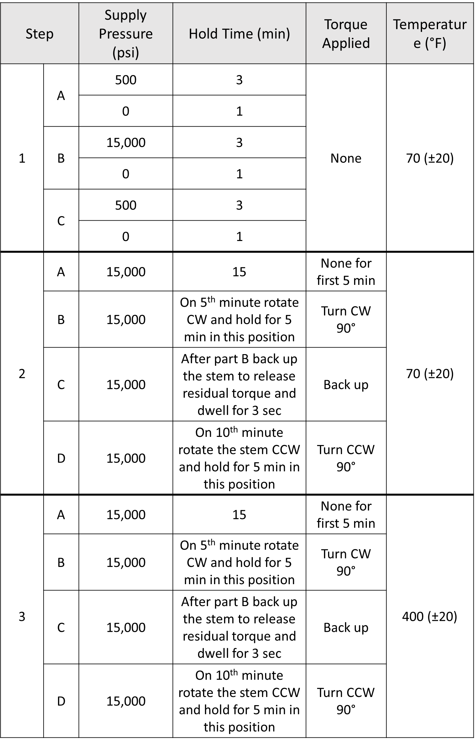
Three steps in Table 13 are examples of the testing procedure. The testing procedure includes several steps to check the testing setup performance for future seal testing. The steps are divided into several parts. The steps are explained and illustrated in the graphs throughout this chapter. The requirements of the design include the ably of the system apply the pressure to the housing cell and then while holding a pressure turn the stem of the housing cell in counter and counterclockwise directions. The temperature is also a variable of the testing procedure.
Besides the main steps of the procedure where the conditions are applied to the housing cell, the preparation step for the test needs to be done beforehand. The air pressure of 25 psi is applied to the low-pressure side and held for at least 3 minutes to check for any leaks, which may occur at the piping links that connected to the low-pressure ports on both sides of the housing chamber. It is important to perform backpressure tests for the low-pressure side because during the actual testing the low-pressure transducer data will not be compromised by the leak that occurs not through the metal seal. Figure 35 represents the graph of the data collected from the backpressure test for the low-pressure side. It shows that the low-pressure side is pressurized to 28 psi. Since the low-pressure transducer has very high accuracy and very sensitive to any changes in the pressure, it is difficult to apply exact 25 psi of pressure. It needs to be close to 25 psi but no more than 30 psi because at 30 psi the automatic valve would activate and exhaust the trapped air.
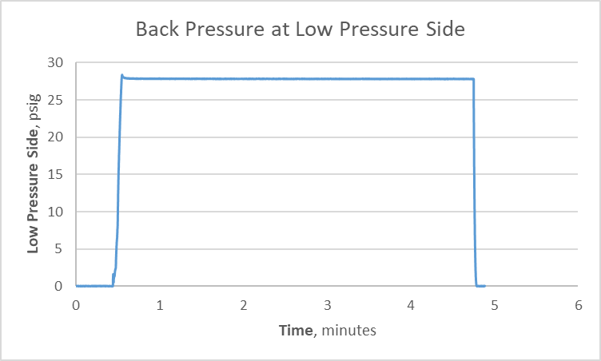
Figure 35: Check for leaks at a low-pressure side by applying 25 psi to a low-pressure region.
When the housing cell is assembled, installed, and aligned with the drive shaft couplings, the backpressure testing proceeds. After the completion of the preliminary preparation, the testing premises are vacated and further control and communication with the testing setup occur remotely to comply with safety procedures.

5.3 Step 1: High Pressure vs. Low Pressure
The first step of the testing procedure is completed during a static application. Figure 36 represents the graph which is created during step one. Step one takes place at room temperature around 75° F. The nitrogen gas filled the high-pressure side of the housing at the pressure of 500 psi.
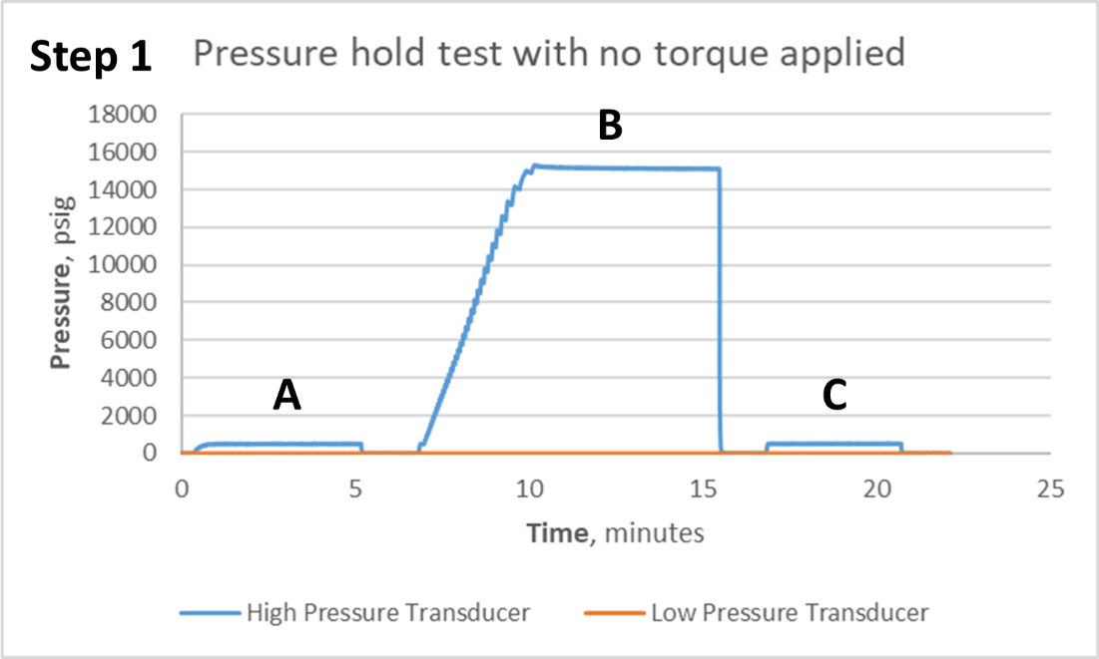
Figure 36: 500 psi and 15,000 psi pressure applied during the first step of the testing procedure to ensure pressure hold at the low-pressure side
For phase A, the bottle pressure is used to achieve 500 psi. When the pressure reaches 500 psi and stabilizes, it dwells for 3 minutes and then released to 0 psi. After 1 minute being at 0 psi, phase B of step 1 begins. During phase B, the pressure is boosted to 15,000 psi. The pressurized nitrogen gas reaches 15,000 psi at a high-pressure side of the housing cell and stabilizes; it dwells for about 3 minutes. After 3 minutes of dwelling, the pressure is realized and held at 0 psi for 1 minute. Phase C is a repeat of Phase B, where the pressure held at 500 psi for 3 minutes and is released to 0 psi and held for 1 minute. Any pressure regulation such as boosting of the pressure and pressure cutoffs are done manually through the LabVIEW program, due to the safety procedure. The purpose of this step is to verify the integrity of the piping system, data acquisition, high and low pressure transducers, and check for any leaks in the system. There are no leaks on the low-pressure side, which is indicated by the orange line on the graph. It is observed from the graph that the testing setup accurately performs testing where the pressure is involved.

5.4 Step 2: Testing Setup PerformanCe with Pressure and Torque Application at Room Temperature
This section illustrates step two of the testing procedure. There are two tests represented for step two. The first test illustrates that the seal holds the pressure when the torque is applied and another where the leak occurs while applying the torque. Both tests indicate that the testing setup works properly. It can measure and record the data when any changes occur. Step two of the testing procedure is a dynamic test that is taken at a temperature of 70° F.

Seal Holding the Pressure for the Test at Room Temperature
Figure 37 and 38 represent the completion of step two during which the torque and pressure were applied to the housing cell. This test indicates that no leak occurred through the seal while the pressure was held and torque was applied. During phase A, the nitrogen gas was boosted to 15,000 psi into the high-pressure side of the housing cell. When the pressure stabilized at 15,000 psi, time is started to record. The high pressure does not change throughout the entire step two, as indicated in the graph of Figure 37.
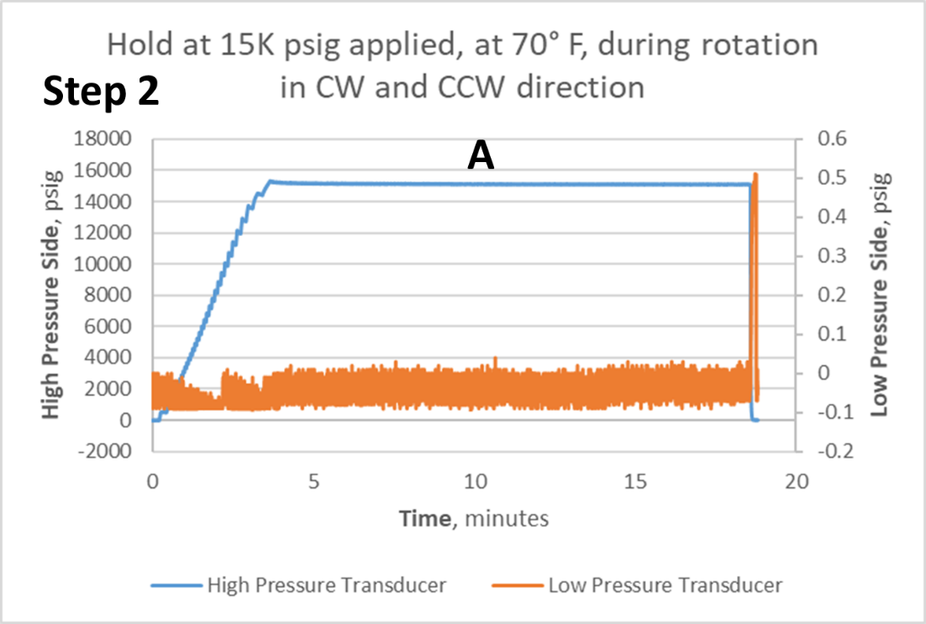
Figure 37: Step 2 phase A of the testing procedure where high pressure at 15,000 psi and low-pressure side is stable.
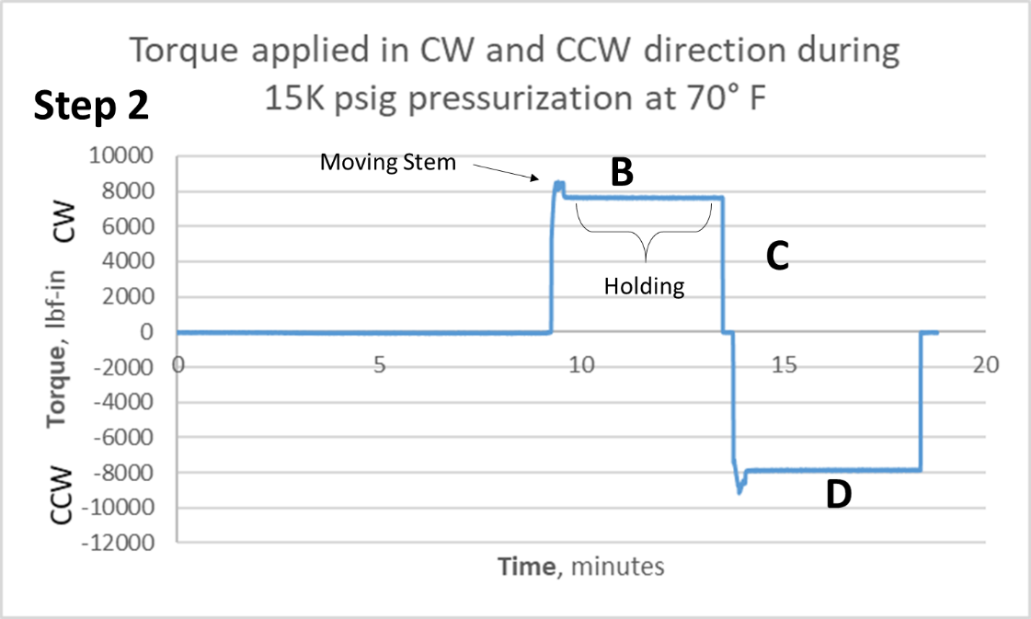
Figure 38: Collected data at the second step of the testing procedure during phases B, C, and D
After 5 minutes into the test, the stem of the housing was rotated to the clockwise direction. When the stem made 90° turn into the clockwise direction, it was stopped. After 5 minutes, the stem is backed up slightly just enough to relieve a residual torque between the stem and the drive shaft. When the torque meter reads zero, after a few seconds of dwelling the stem is rotated back to zero degrees in the counterclockwise direction.
The data collected during the second step of the testing procedure indicates that communication with the torque equipment is uninterrupted through the established system, and the torque meter transmits the signal from the testing setup. It shows that there is no leak occurred through the seal form high to low regions inside the housing cell. The spike of 0.5 psi indicated by the orange line on the graph of Figure 37 at the end of the testing is not considered a leak. Any gain, which is greater than 1 psi on the low-pressure size, is considered as a leak.

Leak Developing During the Test at Room Temperature
Figure 39 and 40 represent the graphs of the data that was collected during the second step of the testing procedure. Figure 39 graph represents phase A, of the test, whereas Figure 40 represents the torque application on the housing cell. Just as the test described in Section 5.4.1, Phases B, C, and D are happening during the phase A. The testing procedure of this test is identical to the test described in Section 5.4.1.

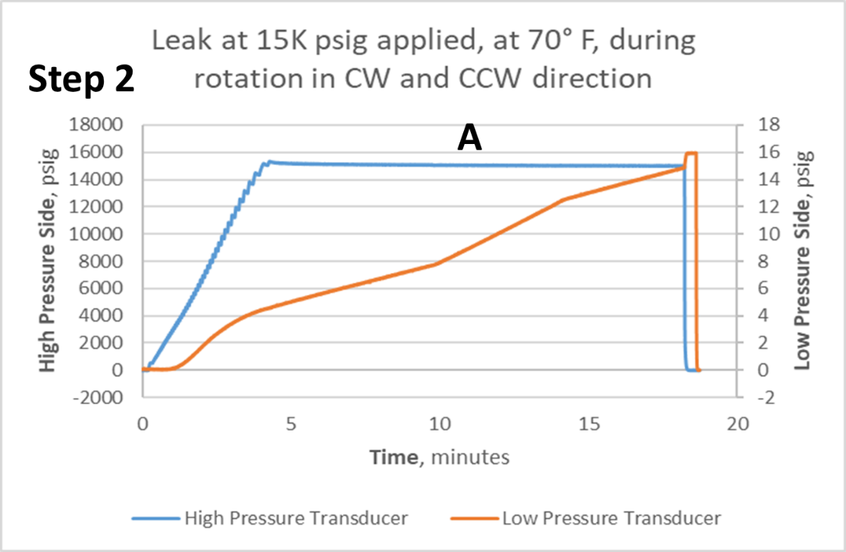
Figure 39: Pressure leak into low-pressure region during the second step of the testing procedure
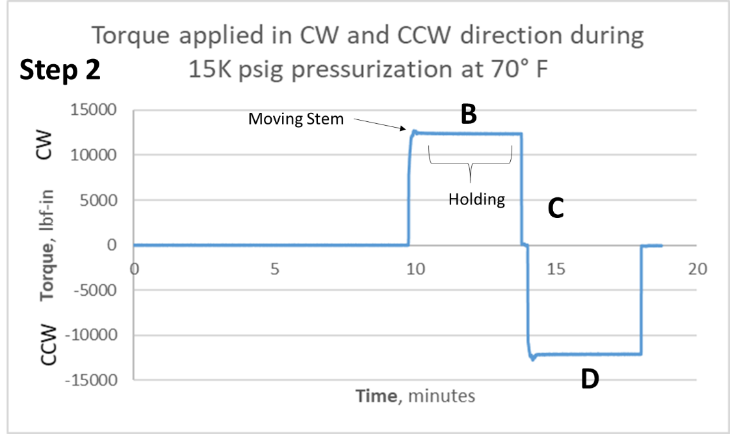
Figure 40: Applied torque during the second step of the testing procedure when the leak to the low-pressure side occurred
As observed, there are differences between the two tests in the collected data. During this test, the compressed nitrogen gas leaked through the seal into the low-pressure side of the housing cell as illustrated in Figure 39. This example proves that the equipment, instrumentation, and the data acquisition system work properly and able to detect the leak through the seal. Compare to the previous test, this test was performed for a different metal seal.

Step 3: Testing Setup PerformanCe with Pressure and Torque Application at 400°F
This is the third step of the described testing procedure. It has four Phases, A, B, C, and D. Phases B, C, and D take place during phase A. This test is similar to the one that is described in Section 5.4. It is similar to step two, except the testing takes place at elevated temperatures. The band heater was placed around the housing cell and turned on in advance to allow the temperature inside the housing reach 400° F. When the temperature gets to desired 400° F, the test begins. Before turning the gas booster, the solenoid valve gets open and closed to allow the pressure inside the low-pressure side to calibrate to zero.

5.5.1 Seal Holding the Pressure for the Test at 400° F
Figure 41 and 42 illustrates the graph of the collected data during the test. The pressure was boosted to 15,000 psi and left at 15,000 psi through the duration of the test. Phase A on the graph from Figure 41 shows that high pressure stabilized on the second minute after the beginning of the test. The graph from Figure 41 indicates that there is no significant leak was developed throughout the test. During Phase A, the stem of the housing is rotated in clockwise and counterclockwise directions.
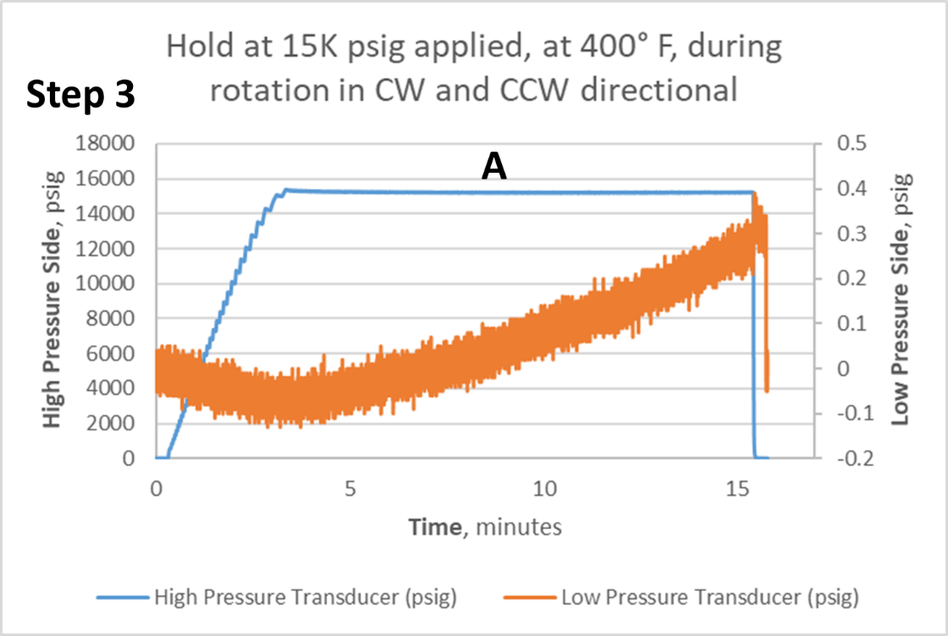
Figure 41: Part A of step three of the testing procedure
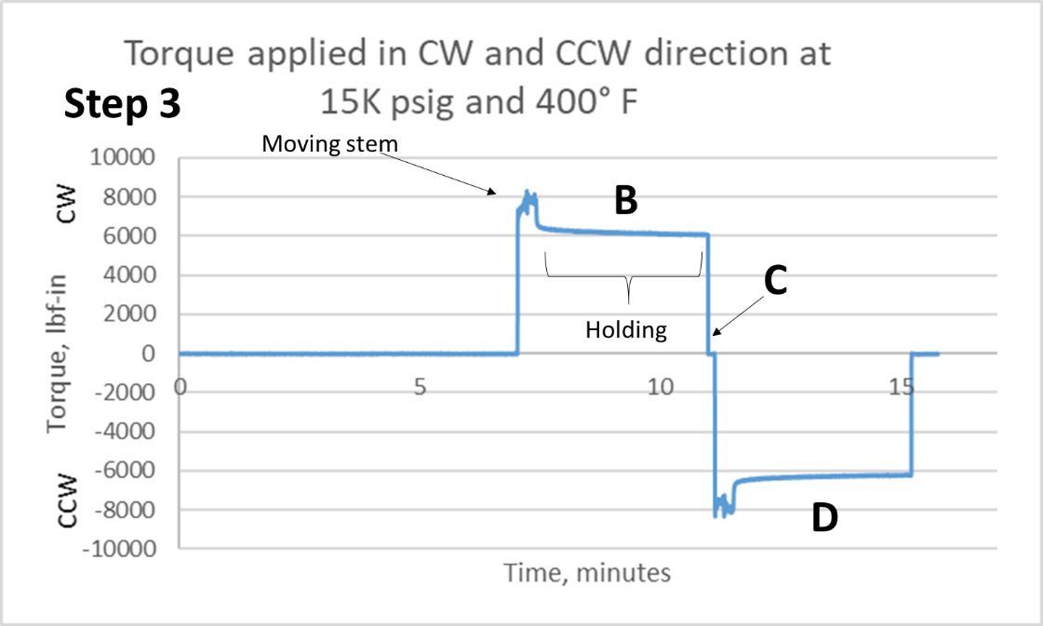
Figure 42: Collected data at the third step of the testing procedure during phases B, C, and D at 400° F
After about 5 minutes when the pressure stabilized, the stem of the housing cell was rotated 90° in a clockwise direction. It was held there for another 5 minutes and then the stem was backed up to release the residual torque. The stem dwells for a few seconds, indicated by letter C in the graph of Figure 42. At phase D, the stem rotates back to zero degree position making a counterclockwise turn. Figure 41 illustrated that even after rotation of the stem, the metal seal holds its integrity.

5.5.2 Leak Developing During the Test at 400°F
Section 5.5.2 describes step number three of the testing procedure described in Table 13. This test was performed in the same as the test described in Section 5.5.1. The internal temperature of the housing cell was 400° F at the start of the test. Figure 43 illustrates that as soon as the pressure starts increasing on the high-pressure side, the low-pressure transducer reads the pressure build-up in the low-pressure side of the housing cell.
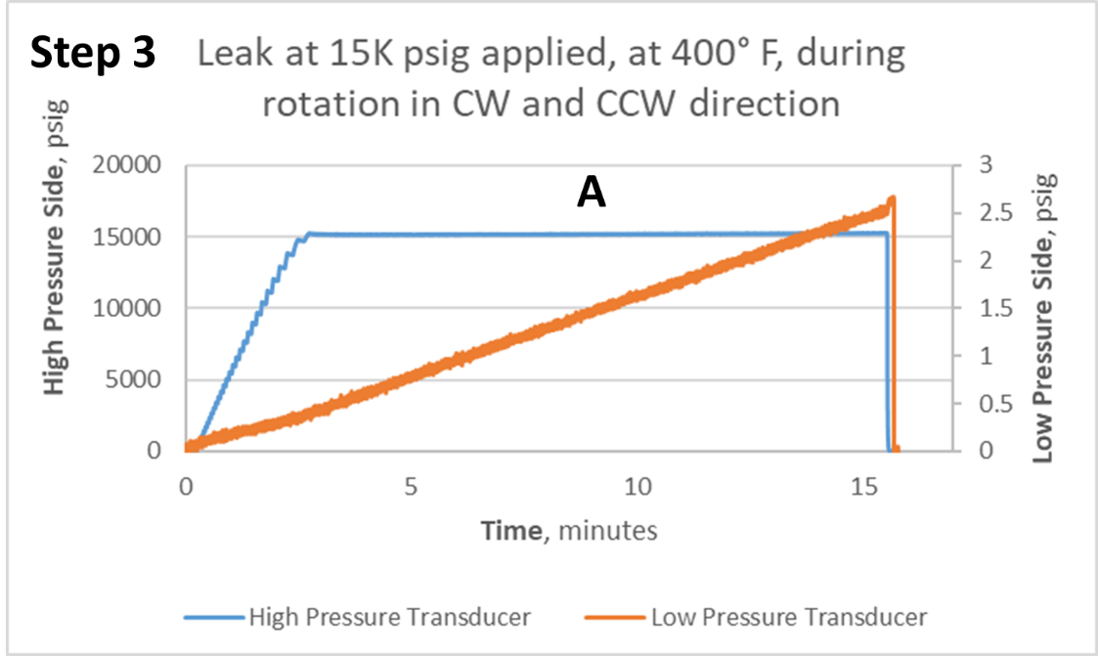
Figure 43: Pressure leak into a low-pressure region during phase A of the third step in the testing procedure where the temperature is 400° F
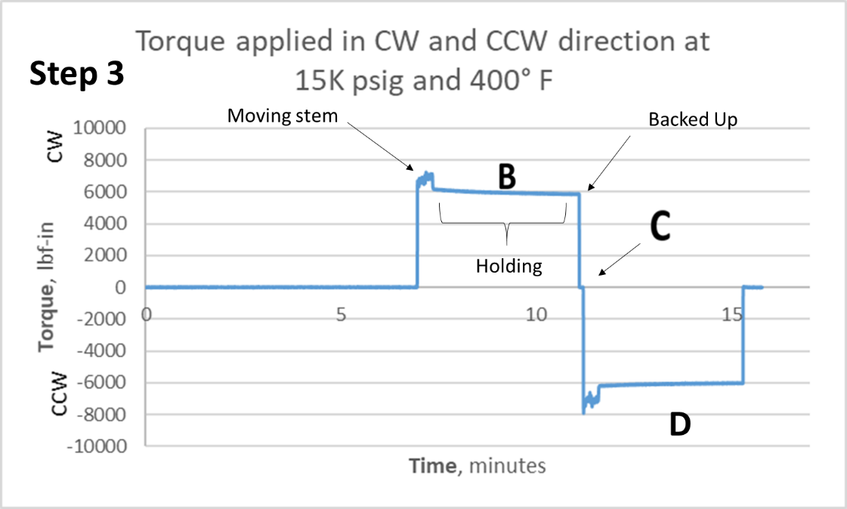
Figure 44: Torque applied when a leak developed at a low-pressure region during step 3 of the testing procedure, at 400° F
This test occurred at an elevated temperature that can greatly affect the results of the test. Temperature plays a significant role in the housing cell components' performance. Metal components behave differently at the elevated temperatures. This test illustrates that the thermocouples and temperature-related data acquisition system perform as expected. Step 3 shows that testing setup performance meets the requirements raised at the beginning of the research.

5.6 Chapter Summary
This chapter illustrates the final phase of this project. During the commissioning phase, the testing setup performs a series of tests from the proposed testing procedure. During the testing the design integrity and performance are proved to be valid.
The testing procedure is formulated based on the requirements that need to be addressed to demonstrate the metal stem seal efficiency. The backpressure test of the low-pressure side needs to be done before the beginning of any test. The valve on the low-pressure side needs to be open and closed to calibrate the pressures to zero. A part of the testing procedure is demonstrated in this chapter. The procedure has three steps and each step consists of several phases during which the change in data is monitored and recorded.
The chapter provides the data for several tests during which the testing setup equipment performance and data acquisition system are tested. The first step is a static test where the pressure applied to the high-pressure side of the housing cell at room temperature. This test is dedicated to checking the work of the gas booster, piping system, pressure transducers, electrical system, and the data acquisition system of the testing setup.
The second step of the testing procedure takes place at room temperature. It requires boosting the pressure to 15,000 psi and whiling holding the pressure at 15,000 psi rotate the stem of the housing cell to CW and CCW directions. Two tests of step 2 are described in this chapter, one where the seal holds the pressure and one where the seal developed a leak. Both tests are aimed to inspect the testing setup performance especially the rotating subassembly described in the design chapter.
The third test of the commissioning phase described in this chapter occurred during step 3 of the testing procedure. This test is similar to that described in step 2 except the test was performed at an elevated temperature of 400° F. The test was repeated twice. As a result, the first test of step 3 did not leak the nitrogen into the low-pressure side, and during the second iteration of this test, pressure nitrogen gas leaked into the low-pressure side of the housing cell. Performing step 3 of the testing procedure helps to check the testing setup equipment related to the temperature application and once again proves the integrity of the testing setup design.

CHAPTER 6: Concluding Remarks

6.1 Summary of Thesis
This thesis is dedicated to the design project for an experimental testing setup to characterize the metal stem seal. It was an effort of the entire team to accomplish the research successfully. The research project, actual design, and product testing were completed throughout the duration of this research as a teamwork.
Before commissioning the metal stem seal to the market of the oil and gas equipment, it needs to be tested accordingly with the oil and gas industry standards. To do so, the testing equipment or setup needs to be designed and manufactured. The testing setup has to exert the same operating conditions on the metal seals as they experience during the field service.
The main requirements for the testing setup include pressure, temperature, and torque applications to the housing cell, which contains the metal stem seal. To understand the metal stem seal environment and to have a better idea of the design plan for the testing setup, the literature review of the oil and gas equipment, industry standards, and sealing mechanisms were review in this thesis.
Before starting the actual design and manufacturing part, the design project phases were established. The project approach has a waterfall methodology, which contains five parts or phases of the research project, which includes project initiation, conceptual phase, definition, the detailed or actual design, and manufacturing phase, and the fifth phase is a closeout phase or also called a final phase of the project. Each phase is dedicated to specific activities. During each phase, the special activities are completed moving towards the commissioning of the testing setup.
The detailed design part of the thesis is divided into seven main groups. Each group contains a detailed explanation of the design and characteristics of each component in the group that ultimately becomes part of the final testing setup assembly. The first group of the design chapter is rotating subassembly that includes a servo motor, servo drive, gearbox, housing cell, and a drive shaft that couples the gearbox shaft with the stem of the housing cell. The second part covers the design of the frame. The structure that holds and organize together all the components of the testing setup. The next part describes the design of the adapter plates that help to mount the testing setup equipment to the frame. The piping system is another group in the design chapter that includes gas booster, valves, and supply and handling of testing media. The next two groups cover the design and distribution of system instrumentation, data acquisition, and the electrical system of the testing setup. The detailed design part is concluded with the assembly process of the testing procedure and important steps such as alignment of the housing cell in the testing setup and process of seal installation and removal.
The final stage of the research is the commissioning testing setup. During this stage, the testing procedure is established and several tests at room and elevated temperatures are performed. The tests indicate the validity of the design and performance of the final product.
This research is unique because the result of this research is a testing setup to test the metal stem seal type that was not tested before.

Addressing Research Questions
The objective of the research was to design and build the testing setup to characterize the metal stem seals and which satisfies the requirements in Chapter 1 of this Thesis. The design phase does not start immediately; the process of the design has to be developed. The developing and organizing the design processes established the following research question, which was raised in Chapter 1:
RQ 1: How to organize the design and fabrication process of the metal stem seal testing equipment?
The main objective of the research was to design and build the testing setup, which was approached with the help of project management waterfall methodology, where completion of each phase leads to the completion of the project.
The first step is to learn about the equipment and the environment where the metal stem seals are utilized. After that, the ideas of the design were gathered to provide the options for further development. The ideas were conceptualized and defined according to the learned information and major requirement of the project. After all unknowns were eliminated and the design concept was established, the research moved into actual detail design and manufacturing part. When the testing setup was built through a series of tests, the testing setup unit was commissioned. The academic research project was approached with the implementation of the industrial project management concept.
When the project was established, the main part of it was the detailed design and manufacturing process of the testing setup to test and characterize the metal stem seal types that were not tested previously. This raised the second research question, which is the following:
RQ 2: How to design and manufacture a unique testing setup to test metal seals?
The design of the testing setup was approached by dividing it into several parts, such as designing the rotating subassembly, frame design, mounting adaptor plates, piping and instrumentation systems, design electrical system, and assembling all the completed parts into final assembly. The design of some parts had a concurrent character, whereas others were completed in sequential order.
Design of the rotating subassembly included technical assessment of servomotor including servo drive and gearbox, which meets the requirements of the research goal. Provided housing cell assembly containing a metal seal has to be coupled with the gearbox shaft. The drive shaft that couples the gearbox shaft and the housing stem complies with the torque load needed to rotate the stem.
One of the main components of the design is the frame. The frame structure holds the testing setup parts together. It is compact, easy to transport, and has a small footprint. The frame had several iterations of the design until the most suitable was found. The frame has a wide flange beam as a core component of its structure, which provides reliable, safe, and compact results. Flange design allows easy access to the housing for assembling and disassembling purposes.
Some parts of the testing setup assembly, such as a gearbox or a housing cell, need to have adjusted mounting surfaces for proper security to the frame. Since gearbox and torque meter have to be fastened together, to fulfill this requirement the adapter plate between them was designed. It provides secure fastening between the gearbox and torque meter surfaces. To fix the housing cell on the frame, the bottom adapter plate was designed. It mounts to the frame and the housing cell is placed on top of it. Dowel pins were selected to fix the housing cell on the adapter plate since a tensile load is not excreted on the housing cell during the testing procedure.
The testing setup design has to include the piping system to supply and manage the flow of the nitrogen gas. The system handles two types of pressure ratings, low and high pressure. The piping system includes three-way diverting valves that manage supply and exhaust of the high pressure. The gas booster compresses the bottle-supplied nitrogen up to 15,000 psi and delivers it to the high-pressure loop of the piping system. A low-pressure side and three-way valves are controlled by electronic solenoid valves.
Control and communication with the testing setup occur remotely to maintain the safety precaution, which is one of the requirements of the design. Instrumentation that collects the measurements includes pressure transducers, thermocouples, and torque meter, transmit the signal via the National Instruments (NI) data acquisition system. The communication and control of the testing setup equipment are implemented trough output NI C Series modules and AKD drive, which controls the servomotor. The control hardware receives the commands through a LabVIEW program.
The electrical power supplied from the facility to the testing setup has a voltage of 240 V. To operate, the testing setup equipment receives electrical power between 120 V and 240 V voltage. The voltage of 240 V and the current of 30 Amp are supplied to servo drive to power the servomotor, whereas the rest of the system needs 120 V. Majority of the equipment is powered by 24 V DC power, which is rectified from AC by power supplies installed in the system. The electric system has numerous relays that help to operate the equipment.
Throughout the design process, depending on the completion and availability of the parts, the testing setup components were assembled together. Some assembling processes were co-dependent on the completion of other subassemblies. The assembly process includes the alignment process of the housing stem to the gearbox shaft and a metal seal installation and removal processes.
Validation of the testing setup design integrity is obtained through multiple tests performed when the testing setup was set to operate.

Research Limitations and Challenges
The research has its limitations and challenges that it faced throughout the course of the research project. There are several design limitations that the current testing setup version has. There two major limitations, which are important for the current testing setup design, referrer to torque limitation and the limitation caused by the electrical power supplied.
- Since the metal seal has not been tested prior, the ultimate torque of 60,000 lbf-in (5,000 lbf-ft) mentioned in the requirement was not pursued for the rotating subassembly at this point of time. The combination of the servomotor and the gearbox can output a maximum of 24,870 lbf-in (2,072 lbf-ft) because of the maximum rated torque of the gearbox. The coupling drive shaft including the fasteners in its assembly needs to be redesigned to accommodate a greater torque load.
- The facility supplying electrical power to the testing setup has a maximum voltage of 240V. The servomotor and servo drive installed in the assembly are rated to operate at 480 V. The lower voltage limits the servomotor ability to provide the full power to the gearbox, which results in lower torque load.
When the testing setup was fully assembled and underwent through preliminary testing, the challenges emerged. The main challenges were faced during the housing cell alignment and the galling occurrence inside the housing cell.
- The aligning process helps to avoid unnecessary side load on the couplings and the internal components of the housing cell. The housing stem aligns concentrically with the gearbox shaft and the couplings using a dial indicator. The acceptable concentricity of off-center distance is 0.005 inches. The challenge immerges when the housing needs to be moved around to be concentric with the driving shaft. The housing cell needs to be moved a fraction of an inch, and the absence of an aligning mechanism installed in the frame makes the aligning process extremely lengthy.
- Another challenge immerged during the preliminary testing of the setup, the inside surfaces of the housing cell began to gall when torque was applied. Tight tolerances between the housing chamber and the stem, same metal hardness, and 20 lbs of drive shaft weight acting on the stem of the housing cell cause severe damage to the inside surfaces of the housing chamber and the stem.

Future Recommendations
The testing setup will be used in metal stem seal characterization and it will continue to improve. The future recommendations for this research include a redesign of driving head subassembly and torque meter, frame redesign, housing cell internal design revision, and exploring the design for the possibility to test in freezing temperatures.
- The drive subassembly includes servomotor, gearbox, and the coupling drive shaft. When the research reaches the point where the torque load has to be greater than the current gearbox with a maximum capacity of 24,870 lbf-in (2,072 lbf-ft) needs to be changed. Depending on the gearbox, the servomotor may stay the same. If the servomotor left the same, to get to desired 60,000 lbf –in of torque load, the gearbox ratio has to be equal to 174:1.
- If the gearbox with a high ratio is not feasible to install than the compromise can be done with the change of the servomotor. The servomotor supplier has a servomotor, which motor continuous stall output torque is 1,590 lbf-in (133 lbf-ft) when operated with 400 Vac voltage supply. The ratio of a servo gearbox, in this case, needs to be 40:1 to get the desired 5,000 lbf-ft of torque. Therefore, the facility electrical power supply needs to be increased.
- Despite the changes in the gearbox, if it stays the same or being changed, the redesign of the coupling drive shaft is recommended. The weight of the coupling should be considered. The new design has to remove any weight load from the stem seal to help with galling wear.
- Addressing the design of the housing cell internal structure can help with the metal galling occurring between the surfaces of the housing components. Incorporating bearing that accommodates with axial load, using different types of metal or coating can help to reduce the risk of galling.
- The reaction torque meter can read up to 50,000 lbf-in of torque load. If the torque application increases above 50,000 lbf-in (4,167 lbf-ft), the torque meter needs to be changed. The next available torque meter of the same type and from the same manufacturer is rated to 100,000 lbf-in.
- Redesign of the frame is recommended since it will help to accommodate larger housing cells. If the footprint of the frame is negotiable, it is recommended to make it large. If the height between the top and the bottom plates and the flat surface of the bottom plate of the frame can be increased, the taller housing cell of different configurations can be fitted. Having a frame design that can fit a variety of housing cell sizes will increase testing setup versatility. Making a bottom adapter plate, which fits the housing cell, adjustable, and installing jacking bolts to it will help with the fine housing cell alignment process [53].
- Testing seals in subzero temperatures is a future part of the research. Redesigning frame structure process has to be done the way that it can accommodate an enclosed insulated sealed container where the housing cell can be submerged into liquid nitrogen. Being able to acquire the data of seal performance at lower temperatures will expand the future study of the research.

REFERENCES
1. American Petroleum Institute. API specification 17D: specification for design and operation of subsea production systems—subsea wellhead and tree equipment. 2011 [cited 2020 February 24]; Available from: https://www.api.org/~/media/files/certification/monogram-apiqr/program-updates/17d-2nd-edition-purch-guidelines-r1-20120429.p.
2. American Petroleum Institute, Specification for wellheads and Christmas tree equipment, in API 6A. 2010, API Publishing Services: Washington D.C.
3. American Petroleum Institute. Standards. 2020 [cited 2020 February 14]; Available from: https://www.api.org/Standards/.
4. Arnold K. and Stewart M., Surface Production Operations. 1989, Houston: Gulf Publishing Company. 369-371.
5. Assured Automation. Types of valves. 2020 [cited 2020 January 29].
6. AZO Material. AISI 4140 Alloy Steel (UNS G41400). 2012 [cited 2020 April 15]; Available from: https://www.azom.com/article.aspx?ArticleID=6769.
7. AZO Material. ASTM A36 Mild/Low Carbon Steel. 2012 [cited 2020 April 15]; Available from: https://www.azom.com/article.aspx?ArticleID=6117.
8. AZO Materials. AISI 4140 Alloy Steel (UNS G41400). 2012 [cited 2020 April 20]; Available from: https://www.azom.com/article.aspx?ArticleID=6769.
9. Bellarby, J., Well completion design. 1st ed. Developments in petroleum science,. 2009, Amsterdam, Netherlands ; Boston, Mass.: Elsevier. xiii, 711 p.
10. Bourgoyne A.T., Millinheim K. K., and Chenevert M. E., Applied drilling engineering, ed. S.t. series. 1986, Richardson, TX: Society of Petroleum Engineers,. 502 p.
11. DrillingFormulas.Com. Surface Christmas Tree (Dry Tree) Basic Knowledge. 2016 [cited 2020, January 29]; Available from: http://www.drillingformulas.com/surface-christmas-tree-dry-tree-basic-knowlege/.
12. DrillingFormulas.Com. Well Head Installation Video. 2015 [cited 2020, January 29]; Available from: http://www.drillingformulas.com/well-head-installation-vdo/.
13. Dunbar, B. NASA - STS-51L Mission Profile. 2005 August 7, 2017 [cited 2019 November 11]; Available from: https://www.nasa.gov/mission_pages/shuttle/shuttlemissions/archives/sts-51L.html.
14. Engineers Edge. Strength Properties Specifications for Steel Bolts. 2020 [cited 2020 May 1]; Available from: https://www.engineersedge.com/strength_specifications_steel_bo.htm.
15. Flitney, R., Seals and sealing handbook. Sixth edition. ed. iChemE. 2014, Amsterdam: Butterworth-Heinemann, an imprint of Elsevier. xiii, 633 pages.
16. Flowserve, Mechanical Seal Fundamentals. 2019, Flowserve.
17. FMC Technologies, New Items for ISO 13628-4 – API 17D and how it works with ISO 10423 - API 6A.
18. Greenslade, J. What is the Proper Torque to Use on a Given Bolt. 2020 [cited 2020 February 1]; Available from: http://www.zerofast.com/proper-bolt-torque.
19. Heisler, S.I., The Wiley project engineer's desk reference : project engineering, operations, and management. 1994, New York: Wiley. xv, 504 p.
20. High Pressure Equipment Company, Air Operated Valves. 2020, High Pressure Equipment Company,.
21. High Pressure Equipment Company, High Pressure Valves, Fittings and Tubing. 2020, High Pressure Equipment Company.
22. History.com. Challenger Explosion. February 15, 2010 January 24, 1920 [cited 2020 January 12, 2020]; Available from: https://www.history.com/topics/1980s/challenger-disaster.
23. Howell, E. Challenger: The Shuttle Disaster That Changed NASA. 2019 [cited 2019 November 1]; Available from: https://www.space.com/18084-space-shuttle-challenger.html.
24. Jetseal, High Performance metal sealing technology, in Jetseal. 2020. p. 11.
25. John Crane, Mechanical Seal Piping Plans. 2016, John Crane.
26. John Crane, Seal Basics. 2001: Morton Grove, Illinois.
27. Juvinall, R.C. and K.M. Marshek, Fundamentals of machine component design. 5th ed. 2012, Hoboken, NJ: John Wiley & Sons. xix, 899 p.
28. Kollmorgen. SFD Feedback. 2020 [cited 2020 April 22]; Available from: https://www.kollmorgen.com/en-us/developer-network/sfd-feedback/.
29. Kollmorgen Corporation, AKD User Guide. Kollmorgen Corporation.
30. Kollmorgen Corporation, AKM Servo Motor. 2017, Kollmorgen Corporation.
31. Larsen, R.W., LabVIEW for engineers. 2011, Upper Saddle River, N.J.: Prentice Hall/Pearson. xi, 391 p.
32. Life Time Reliability. Bolt Tensioning. 2020; Available from: http://www.lifetime-reliability.com/free-articles/precision-maintenance/Summary_of_Bolt_Tensioning.pdf.
33. Maximator, Air-Driven Gas Booster. 2016, MAXIMATOR GmbH.
34. McMaster-Carr. Dowel Pin. 2020 [cited 2020 April 15]; Available from: https://www.mcmaster.com/98381A712-98381A712.
35. McMaster-Carr. High-Strength Grade 8 Steel Hex Head Screw; Zinc-Aluminum Coated, 3/8"-16 Thread Size, 1-1/2" Long. 2020 [cited 2020 February 1]; Available from: https://www.mcmaster.com/91286a204.
36. McMaster-Carr, Zinc Yellow-Chromate Plated Hex Head Screw Grade 8 Steel, 1/2"-20 Thread, 2-1/2" Long, Partially Threaded. 2020.
37. McMaster-Carr, Zinc Yellow-Chromate Plated Hex Head Screw Grade 8 Steel, 5/8"-18 Thread, 2-1/2" Long, Partially Threaded. 2020.
38. Micron, TRUE™ Planetary Gearheads, I. Thomson Industries, Editor. 2017.
39. Micron by Boston Gear. MicronMOTIONEERING: True Planetary Gearheads. 2020 [cited 2020 April 25]; Available from: https://www.micronmotioneering.com/GearheadSelection/SelectGearhead?gearHeadModelId=VT&isExpress=false.
40. Mobile Tutor. Coupling [Year-1]. 2017 [cited 2020 May 5]; Available from: https://www.youtube.com/watch?v=CwiaS075YzQ.
41. National Instruments. CompactDAQ Chassis. 2020 [cited 2020 April 1]; Available from: https://www.ni.com/en-us/shop/select/compactdaq-chassis?modelId=155404.
42. National Instruments. Model: NI-9263. 2020 [cited 2020 April 1]; Available from: https://www.ni.com/en-us/shop/select/c-series-voltage-output-module?modelId=122200.
43. National Instruments, NI 9203 Datasheet. 2014, National Instruments.
44. National Instruments, NI 9212 and TB-9212. 2019, National Instruments.
45. National Oilwell Varco. Pressure control systems. 2020 [cited 2020, January 25]; Available from: https://www.nov.com/products/pressure-control-systems.
46. National Oilwell Varco Rig Technology, Next Generation 20,000 psi subsea system. 2018.
47. Nesbitt, B., Valves manual international: handbook of valves and actuators. 1st ed. 2007, Oxford; Burlington, MA: Butterworth-Heinemann. xxiv, 546 p.
48. OKGlobal and Master Flo, Choke Valves 101: Flow Control Issues. 2018. p. https://www.youtube.com/watch?v=kK5HEMgOLLw&t=198s.
49. OMEGA Engineering. High Accuracy Amplified Voltage Output Pressure Transducer. 2020 [cited 2020 May 1]; Available from: https://www.omega.com/en-us/sensors-and-sensing-equipment/pressure-and-strain/pressure-transducers/px02/p/PX02S1-30KGI.
50. Omega Engineering. High Accuracy Oil Filled Pressure Transducers/Transmitters for General industrial applications. 2020 [cited 2020 February 2]; Available from: https://www.omega.com/en-us/sensors-and-sensing-equipment/pressure-and-strain/pressure-transducers/px409-series/p/PX429-100GI.
51. PetroWiki. Flow through chokes. 2017 [cited 2020 February 8]; Available from: https://petrowiki.org/Flow_through_chokes.
52. Portland Bolt and Manufacturing Company. J429 Mechanical Properties 2020 [cited 2020 February 1]; Available from: https://www.portlandbolt.com/technical/specifications/sae-j429/.
53. Riddle, S. Shaft alignment. 2011 [cited 2020 May 1]; Available from: https://vibralign.com/shaft-alignment/jacking-bolts/.
54. RIGTRAIN, Drilling and well service training. 2001: Downhole Technology Limited.
55. S.Himmelstein and Company. Hollow flange reaction torque transducer. 2020 [cited 2020 April 1]; Available from: https://www.himmelstein.com/torque-transducers/reaction-torque-transducers/hollow-flanged/rtm-2000.
56. Schlumberger Limited. Oilfield Glossary. 2020 [cited 2020, January 29]; Available from: https://www.glossary.oilfield.slb.com/Terms/w/wellhead.aspx.
57. Schlumberger Limited. Plug and Cage: Control choke. 2020 [cited 2020 February 14]; Available from: https://www.products.slb.com/valves/choke-valves/plug-and-cage-choke-valve.
58. Special Metals Corporation, INCONEL alloy 718. 2007. p. 28.
59. Technetics group, Metal seals technical catalog. 2020. p. 20.
60. Thompson Liner Motion, TRUE Planetary™ Gearheads. 2010, Thompson Industries, Inc.
61. Valve manufacturing association of America. Common valve type. 2018 [cited 2020, January 31 ]; Available from: https://www.vma.org/page/CommonValveTypes.
62. Van Casteren, W., The Waterfall Model and the Agile Methodologies : A comparison by project characteristics. 2017.
Lolow o

