University of Oklahoma

Graduate College

ENHANCING ALCOHOL PRODUCTION IN CLOSTRIDIUM CARBOXIDIVORANS STRAIN P7^{T} AND THE ROLE OF TANDEM ADH GENES

A Dissertation

submitted to the Graduate Faculty

in partial fulfillment of the requirements for the

Degree of

DOCTOR OF PHILOSOPHY

By

michael Ukpong
Norman, Oklahoma
2014

Enhancing ALCOHOL PRODUCTION IN CLOSTRIDIUM CARBOXIDIVORANS STRAIN P7^{T} AND THE ROLE OF TANDEM ADH GENES

A Dissertation approved of for the
Department of Microbiology and plant biology

By

______________________________
Dr. Bradley Stevenson, Chair

______________________________
Dr. Ralph Tanner

______________________________
Dr. Paul Lawson

______________________________
Dr. Michael McInerney

______________________________
Dr. Mark Nanny

© Copyright by Michael ukpong 2014
All Rights Reserved.

Acknowledgements
Every worthwhile endeavor of human beings is the result of collaborative effort on many people’s part. This modest work is no exception. It is with deep personal gratitude and delightful outward pleasure that I write this thanks to those who have helped me get to where I am now. I firstly want to thank my Lord and God, he has given me strength and wisdom in pursuing this dissertation. I pray the work is pleasing to him. I wish to thank my mentor, supervisor and friend Dr. Bradley Stevenson. He brought me into his lab and gave me a home where I could grow as a scientist. Under his tutelage I have grown from graduate student padawan to scientific Jedi.
I would like to thank my parents Ambassador Basil Ukpong and Mrs. Lucy Ukpong. They planted the seeds of my love for science by building a chemistry lab in our attic at home. Their love and support has sustained me through this journey. Thankfully, along with my dear siblings Tony, Joseph and Mary, they are here to see the end with me. I am blessed to have the support of my fiancée Monique. She has been my muse on this journey, inspiring me to great science with her song.
Numerous contributions to this work have been performed by the members of the Stevenson lab past and present. Specifically: Black stamps, Heather Nunn, Brain Bill, Lauren Cameron, Micaela Langevin, Jenny Cosby, Ben Rossavik, John Erne, and Munim Deen. I will like to thank them for their help in performing experiments, their time in critiquing my work, and their invaluable companionship. I would especially like to mention Blake Stamps who many years ago while working under me as an undergraduate made a key observation about Clostridium carboxidivorans strains P7. That observation fuelled a lot of this work.
Last but not least I wish to thank profusely the members of my committee for graciously giving me their time and overseeing me throughout this process. I thank Dr. Tanner for spearheading the larger biofuel project and sharing helpful research experience. I thank Dr. Lawson for his kind words, open doors and advice. I thank both Dr. McInerney and Dr. Nanny for their scientific input and critiquing of my work. I also want to mention that I had the pleasure of taking both their classes, that experience shaped my philosophy as a teacher as I try to emulate their teaching style.
To all graduate students coming after me I share these words “A luta continua victoria et certa” (continue to struggle victory is certain).

Table of Contents

Acknowledgements iv
List of Tables xi
List of Figures xii
Abstract xiv
Chapter 1: A Review of Syngas Fermentation Enzymology and Molecular Biology 1
Background 2
Product Formation and Enzymology of Pathway 8
Genomic Analysis 10
Clostridial Genetic Systems 14
Preamble: 15
References 18
Chapter 2: Physiological Response of Clostridium carboxidivorans during Conversion of Synthesis Gas to Solvents in a Gas-fed Bioreactor 24
Abstract 25
Introduction 27
Materials and Methods 31
Bioreactor Conditions and Sampling 31
Enzyme Activity 33
Gene Expression 34
Results ……………………………………………………………………………...36
Growth and Fermentation Product Formation 36
Key Enzymatic Activity 39
Gene Expression for Key Enzymes 39
Discussion 43
Cell Growth and Product Formation 43
Enzyme Activity 44
Ethanol and Butanol Production 45
Conclusions 48
References 50
Chapter 3: Development of a Cloning and Expression Vector in the Syngas-Fermenting and Alcohol-Producing Clostridium carboxidivorans strain P7 56
Abstract 57
Introduction 58
Materials and Methods 60
Bacterial strains, plasmids and growth media used 60
Minimum inhibitory concentration 64
Plasmid maintenance and extraction 64
Construction of the clostridial shuttle vector 65
Genetic system development 66
Results….. 69
Development of genetic system for strains P11 and P7 69
Plasmid modification 74
Optimization of strain P7 transformation using plasmid pMM2 74
Discussion 78
Genetic system approach 78
Creation of pMM family of plasmids 79
Acknowledgements 80
References 81
Chapter 4: Tandem, homologous alcohol dehydrogenase genes in Clostridium carboxidivorans strain P7 possess different activities 85
Abstract 86
Introduction 88
Materials and Methods 92
Bacterial strains, plasmids and growth media used 92
Plasmid construction 93
Gene expression plasmid construction 93
ADH expression in E. coli 96
Alcohol dehydrogenase activity 97
Product formation experiment 98
Analytical methods 98
Results ……………………………………………………………………………..99
Expression of adhE1 and adhE2 in E. coli 99
Gene duplication experiment 103
Discussion 110
In vitro properties of adhE genes 110
Expression in E. coli 111
In vivo properties of adhE1 and adhE2: the effect of gene duplication 112
Implications and applications of different ADH 113
Acknowledgements 113
References 114
Summary and Future Directions: What next? 118
Summary of work and key implications 119
Future directions 120
Medium and Strain optimization 120
Acids to alcohols 121
Genetic system and metabolic engineering 122
References 123
Appendix A: A Novel Pseudomonas putida Strain Demonstrates High Levels of Ciprofloxacin Tolerance Due to Multiple Resistance Mechanisms 126
Abstract 127
Introduction 128
Methods and Materials 130
Bacterial Strains and Culture Conditions 130
Drug Resistance Studies 130
Single Carbon Source 131
Transposon mutation 132
Fatty Acid content determination 134
Salt Tolerance assay 134
Results: 135
Description of strain ML 135
Antibiotic Resistance 135
Single carbon source growth 136
Mutants 137
Genome analysis 137
Membrane permeability 138
Discussion: 139
Metabolic costs of ciprofloxacin resistance 139
Role of Mutated Genes 140
Native plasmid 146
Conclusion 146
Acknowledgements 147
References: 148

List of Tables

Table 1.1: syngas fermenters with sequenced genomes…………………………………7
Table 1.2: Plasmids used in attempted transformation of strain P11 or/and strain P7…16

Table 2.1: Targeted genes and primers used in this study……………………………...55
Table 3.1: Plasmids used in this study. ………………………………………………..62
Table 3.2: MIC of antibiotics for strain P11 and P7 …………………………………..72
Table 3.3: Summary of variations in electroporation conditions attempted…………...73
Table 4.1: Bacterial strains and plasmids………………………………………………95
Table 4.2: Product formation and growth of E. coli clones with adhE genes……...…108
Table 4.3: strain P7 and transformants product formation……………………………109
Table S1. Antibiotics used in Kirby-Bauer tests…………………………...………....160
Table S2: Substitutions in QRDRs of P. putida strain ML Compared to KT2440 and F1……………………………………………………………………………………..162
Table S3: Antibiotic Concentration at which MIC was reached (µg/ml)…………….164
Table S4: percent bacterial fatty acid comparison……………………………………165

List of Figures

Figure. 1.1. Conversion of CO and CO₂ to ethanol and butanol via the Wood-Ljungdahl pathway………………………………………………………………………………….6
Figure. 1.2. The location and organization of adhE genes on the genomes C. carboxidivorans strain P7 and strain P20 are compared with the genomes of other clostridia……………………………………………………………………………..…13
Figure. 2.1. Conversion of CO and CO₂ to ethanol and butanol via the Wood-Ljungdahl pathway……………………………………………………………………………..…..30
Figure. 2.2. Mean values for A) measured growth and B) product formation…………37
Figure. 2.3. A) Measured growth and pH B) product formation over time (h) for the third bioreactor run……………………………………………………………………..38
Figure. 2.4. Measured activities of A) hydrogenase and carbon monoxide dehydrogenase; B) butanol dehydrogenase…………………………………………….41
Figure. 2.5. Gene expression of A) adh1 and adh2 and B) codh and two Fe-only dehydrogenases…………………………………………………………………………42
Figure. 3.1. Flow chart of electrotransformation process………………………………68
Figure. 3.2. Gel image confirming retransformation of E .coli………………………...71
Figure. 3.3: Map of plasmid pMM2 showing location of key features………………...76
Figure. 3.4. Gel image confirming transformation of C. carboxidivorans……………..77
Figure. 4.1. Whole cell alcohol dehydrogenase activity of E. coli ^{pQEADH1} and E. coli ^{pQEADH2} ………………………………………………………………………………..101
Figure.4.2. Map of plasmid pMM2 showing location of key features………………..102
Figure. 4.3. Mean values for growth of strain P7, strain P7^{pMM3} and strain P7^{pMM5} overtime…………………………………………………………………………….…105
Figure. 4.4. Growth and product formation profiles of A) strain P7, B) strain P7^{pMM2}, C) strain P7^{pMM3}, D) strain P7^{pMM5}……………………………………………………….106
Figure S1: Neighbor-joining tree based on 16S rRNA gene sequences depicting the phylogeny between Pseudomonas putida strain ML and its close relatives …………153
Figure S2: A model of the different mechanisms of resistance to ciprofloxacin present in or absent from strain ML…………………………………………………………...154
Figure S3: A) CFUs of strain ML in the absence and presence of ciprofloxacin. B) Effect of ciprofloxacin on consistency of cultures of strain ML C) Gel electrophoresis image confirming insert of transposon genome of 20G2……………………………..155
Figure S4: Neighbor-joining tree based of rare lipoprotein b amino acid sequences..156
Figure S5: A) Growth profile of strain ML, Type strain, E .coli, P. aeruginosa under ciprofloxacin pressure in liquid medium. B) Growth profile of strain ML in liquid medium compared to the mutants 20G2, 19B1, and 15E8…………………………....157
Figure S6: Kirby-Bauer results showing the antibiotic susceptibility pattern for strain ML 19B1, 15E8, and 20G2…………………………………………………………...158

Abstract
Petroleum use constitutes over 90% of national liquid transportation fuel consumption. As population growth continues and transportation needs increase with it, demand for fuel will also increase. The use of fossil fuels like petroleum has negative environmental effects and economic implications. To combat this problem the scientific community has intensified research in the development of renewable biological fuels (biofuels). Indirect fermentation is an immerging technology which is attractive as a means of producing biofuels. Feedstocks as diverse as switchgrass, woodchips or dried sewage can be combusted incompletely to produce synthesis gas (syngas, CO, CO₂ and H₂). Syngas is then fed to microbial catalysts which ferment it into liquid transportation fuels. The key to this process is the development of suitable microbial catalysts. The novel bacterium Clostridium carboxidivorans strain P7 is an organism capable of fermenting syngas and producing ethanol, butanol, and hexanol as its end products.
Examination of the genome revealed the presence of two tandem alcohol dehydrogenase genes (adhE1 and adhE2). Gene expression studies reveal increased expression of adhE1 and adhE2 during strain P7’s ethanol and butanol formation. In order to perform metabolic engineering a genetic system was developed for strain P7. As part of this system, adhE1 and adhE2 containing expression vectors were constructed and used to transform strain P7. The increased copy numbers of each adhE gene in transformants led to increased ethanol production (adhE1) (40%) and butanol production (adhE2)(20%).

Chapter 1: A Review of Syngas Fermentation Enzymology and Molecular Biology

Background
Over the past two decades, political and commercial interest in renewable energy sources has increased. Limited global reserves of crude oil coupled with an increase in the demand for energy in developing countries are among many factors straining existing energy resources. In response, the scientific community has intensified research in renewable energy (Thomas, 2000; Verbruggen et al., 2010). The need for alternative sources of transportation fuels is especially acute (90% of transportation fuel comes from petroleum) and several types of technologies are in development to meet this need (Daniell et al., 2012). New technologies use biomass from food crops, (de Vries et al., 2010), non-food crops (Liew et al., 2013), and industrial and municipal waste (Liew et al., 2013) as feed stocks for the production of biofuels, such as ethanol, butanol, and hexanol. Major technologies for conversion of biomass to transportation fuels include: physical processes (pyrolysis), chemical processes (enzymatic digestion), and biological processes (fermentation).
The biofuel conversion process of pyrolysis (Fisher-Tropsch process) consists of the thermal decomposition of biomass in the absence of oxygen. Thermal energy is used to convert a wide variety of biomass into end-products (Babu, 2008; Daniell et al., 2012). The major advantage of this process is that it is flexible with potential sources of biomass; however, pyrolysis often has a high energy input requirement and produces a wide range of end-products (Babu, 2008; Cunliffe & Williams, 1998; Goyal et al., 2008). End-products vary in range and composition, and depending on the conditions can include compounds as diverse as poly aromatic hydrocarbons, benzene, toluene, styrene, methylfluorenes, and chrysene (Cunliffe & Williams, 1998). This is a severe disadvantage in the production of liquid fuels, if fuels such as propanol and butanol are the desired these side products limit over all yield. The low yield and presence of undesirable side-products in pyrolysis reactions must be compensated with post-pyrolysis purification steps which add another layer of expense to the process.
Direct fermentation of biomass into transportation fuels is a well researched and established process. Acetone, butanol, and ethanol (ABE) fermentation is one of the oldest means of producing butanol and ethanol on a large scale for industrial purposes, and has been in use since 1916 (Jones & Woods, 1986). Sugar-rich feedstock such as sugar cane, sweet beets, and corn syrup are fed directly to microorganisms to produce ethanol and butanol. Common organisms used in direct fermentation include the yeast strains: Saccharomyces cerevisiae and Dekkera bruxellensis (Blomqvist et al., 2011), and the anaerobic bacteria: Clostridium acetobutylicum, Clostridium beijerinckii, Clostridium saccharobutylicum, and Clostridium saccharoperbutylacetonicum (Dürre, 1998; Durre, 2005). Unlike pyrolysis, direct fermentation is limited by the need to use sugar-rich substrates in order to gain economically viable yields.
One approach to widening the range of feedstock used in direct fermentation is by using cellulolytic bacteria such as Clostridium cellulolyticum (Calusinska et al., 2010; Cui et al., 2012), Clostridium thermocellum (Calusinska et al., 2010; Tyurin et al., 2004), and Clostridium phytofermentans (Calusinska et al., 2010). These microbes are capable of directly fermenting cellulose-rich substrates into ethanol by hydrolyzing lignocelluoses and fermenting the resultant sugars. Another approach being researched is two-step direct fermentation. Starch or cellulose-rich feedstocks are broken down by amylases, cellulases, and hemicellulases to produce easily fermentable sugars (Blomqvist et al., 2011; Olsson & HahnHagerdal, 1996). These sugars are then fed to microorganisms to produce ethanol and butanol. Direct fermentation is a more established approach to producing biofuels, but has many limitations: the use of food crops as substrates for fuel has a negative competing effect with food consumption, enzymes used for pretreatment are expensive to manufacture and do no break down all the target material, and critically, the microbes used in the fermentation process have a limited range of substrates necessitating different microbes to be customized for different substrates.
Indirect fermentation of biomass into transportation fuels is a relatively newer process. The first step consists of the gasification of carbon-rich substrates by incomplete combustion to produce synthesis gas (syngas), a mixture of CO, CO₂, and H₂. The syngas is then fed to a microbial catalyst that ferments syngas into the transportation fuels ethanol, butanol, and hexanol (Kopke et al., 2011a; Tanner, 2008). The range of cellulosic feedstocks that can be used for this process is very broad and includes non-food crops such as switchgrass and agricultural residues (Kumar et al., 2009; Liew et al., 2013). Additionally, exhausts from coal power plants and other industries that contain high concentrations of CO can be used directly by the bacteria. Gasification technology is well developed and significant advancements have been made in the direction of purifying products post-production (Daniell et al., 2012; Liew et al., 2013). The critical breakthrough needed in order to make this approach commercially viable is the development of microbial catalysts to optimize the conversion of syngas into liquid fuels. A limited number of organisms capable of fermenting syngas are known that produce ethanol and/or butanol: Clostridium ljungdahlii (Kopke et al., 2010; Tanner et al., 1993), Clostridium autoethanogenum (Munasinghe & Khanal, 2010), “Clostridium ragsdalei strain P11”(Saxena et al., 2007),“Moorella sp.” (Sakai et al., 2004), Alkalibaculum bacchii (Allen et al., 2010), Clostridium carboxidivorans strain P7 (Liou et al., 2005) and Butyribacterium methylotrophicum (Grethlein et al., 1991). The goals for research on microbial syngas fermentation include: increasing product yields (chapter 3)(Kundiyana et al., 2010), refining nutrient requirements (Saxena et al., 2007), increasing tolerance to toxic syngas by-products (Ahmed et al., 2006; Ahmed & Lewis, 2007), increasing tolerance towards the accumulation of end products (Torres & Tanner, 2012), monitoring the effect of scale-up on product formation (chapter 2)(Kundiyana et al., 2010), and directing the flow of carbon towards one product or another (chapter 3) (Kopke et al., 2010; Leang et al., 2013; Saxena & Tanner, 2008).
While the indirect fermentation approach may not replace the use of fossil fuels entirely it presents a viable option for increasing biofuel production. It adds diversity to transportation fuel production options that are carbon-neutral, using materials that would otherwise be considered waste (old papers, woodchips, tires). An added benefit of indirect fermentation is that it avoids placing pressure on existing food supplies. This dissertation focuses on C. carboxidivorans strain P7 as a microbial catalyst for indirect fermentation and explores prior knowledge about strain P7’s product formation, enzymatic pathway, genome, and existing genetic systems.

Figure. 1.1. Conversion of CO and CO₂ to ethanol and butanol via the Wood-Ljungdahl pathway. Hypothetical acid to alcohol pathways indicated with red star. The locations of key enzymes are shown: aldehyde alcohol dehydrogenase (ADH), formate dehydrogenase (FDH), carbon monoxide dehydrogenase/acetyl-CoA synthetase (CODH/ACS), hydrogenase (H₂ase), acetate kinase (AK), butyryl kinase (BK), and Aldehyde ferredoxin oxidoreductase (AOR).

Table 1.1: syngas fermenters with sequenced genomes
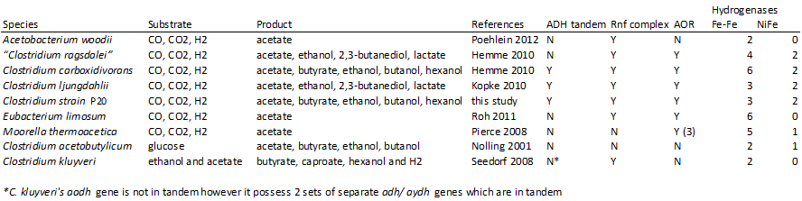

Product Formation and Enzymology of Pathway
Many microorganisms are able to ferment syngas as a sole energy and carbon source (Oelgeschlager & Rother, 2008) but few microorganisms are known that can use syngas to produce biofuels. Clostridium carboxidivorans strain P7 is one of only ten bacteria described in the literature to produce solvents from syngas, and is one of only three naturally capable of producing butanol (Berzin et al., 2012; Köpke et al., 2011; Liu et al., 2012; Maddipati et al., 2011). Butyribacterium methylotrophicum was reported to produce 19 mM butanol from pure CO (Worden et al., 1991), “Clostridium ragsdalei” strain P11 produced 8 mM butanol from a simulated syngas mixture and C. carboxidivorans strain P7 produced 18 mM butanol from syngas derived from cellulosic feedstock (Datar et al., 2004; Liou et al., 2005; Rajagopalan et al., 2002). Strain P7 has also been shown to produce hexanol (Saxena & Tanner, 2008). Because of its versatility and product range, this dissertation explores the use of strain P7 as a biological catalyst for the production of transportation fuels, specifically ethanol, butanol and hexanol.
Strain P7 shows product formation patterns typical of acetogenic clostridia (chapter 2). During exponential growth phase and when pH is high, acids are the dominant product. Upon reaching stationary phase and low pH, alcohols become the dominant end-product of metabolism (chapters 2 and 3)(Drake et al., 2008; Durre, 2005). Acetogens, such as strain P7, use the Wood-Ljungdahl pathway to convert syngas de novo into organic acids and alcohols (Fig. 1.1)(Drake et al., 2008). Carbon enters the pathway through the actions of the enzymes formate dehydrogenase (FDH) and carbon monoxide dehydrogenase/acetyl CoA synthase (CODH/ACS)(Fig. 1.1). The enzyme FDH reduces CO₂ to formate (consuming an ATP in the process); while CODH/ACS combines a methyl group bound to a corrinoid-FeS protein and a CO molecule to form acetyl-CoA (Drake et al., 2008; Ljungdahl, 1986). CODH is also involved in the biological water-gas shift reaction by catalyzing the oxidation of CO into CO₂ using H₂O as a co-substrate. This reaction generates energy by the reduction of ferredoxin (Ragsdale, 2004). Hydrogenases (H₂ases) catalyze the reversible conversion of H₂ to H⁺, a reaction often associated with the energy deriving oxidation of ferredoxin (Calusinska et al., 2010; Gheshlaghi et al., 2009). Two of the three classes of hydrogenases are found in clostridia: FeFe and NiFe types (Calusinska et al., 2010; Gheshlaghi et al., 2009). Interestingly, FeFe hydrogenases are considered sensitive to CO; the presence of CO in C. acetobutylicum culture headspace has been shown reduce hydrogen production (and hydrogenase activity) and concurrently increase solvent formation (Kim et al., 1984).
In solvent producing clostridia, acetaldehyde dehydrogenases (AYDH) catalyze the first reaction towards ethanol or butanol production (Fig. 1.1) and are CoA and NAD(P) dependent (Gheshlaghi et al., 2009). The terminal reaction in the Wood-Ljungdahl pathway for production of alcohol is catalyzed by an NAD(P) dependent alcohol dehydrogenases (ADH). This enzyme is often found in the same transcription product as an aldehyde dehydrogenase domain, and annotated as aldehyde/alcohol dehydrogenase (AADH). The specificity of ADH or AADH enzymes varies widely, and can be ethanol only, butanol only, or both (Elleuche & Antranikian, 2013; Gheshlaghi et al., 2009). ADH is considered the rate-limiting step in solvent formation (Saxena & Tanner, 2011), and thus investigating the enzyme’s activities may be a key to increasing solvent production. The role of the enzyme ADH in strain P7 and its specificity are explored in-depth in chapter 3.
Along with the de novo production of alcohols described above, strain P7 produces alcoholic solvents by re-assimilation of acids and converting them into their corresponding alcohols (Isom et al., 2011; Perez et al., 2013). The enzyme ADH catalyzes the last step of this process (Fig. 1.1). The physiological capacity of converting acetate and butyrate into ethanol and butanol has been documented in Clostridium acetobutylicum (Durre, 2005; Fraisse & Simon, 1988; Hartmanis et al., 1984), Clostridium strain P11 (Isom et al., 2011) and in strain P7 (Datar et al., 2004). However, the ability to convert acids to alcohols is not limited to re-assimilation of the substrates acetate and butyrate; direct acids to alcohol conversion by strain P7 has also been observed using other acids, such as propionate and valerate (Isom et al., 2011; Perez et al., 2013).
Chapter 2 explores the how the activities of the key enzymes CODH, FDH, H₂ases, and ADH, change relative to one another and during growth phases of a strain P7 bioreactor culture.

Genomic Analysis
The availability of sequenced genomes presents a veritable gold mine of opportunities for molecular microbiology. The genomes of several syngas fermenting organisms are available, including strain P7, and are compared to C. acetobutylicum and C. kluyveri (non-syngas users)(Table 1.1)(Hemme et al., 2010; Kopke et al., 2010; Nolling et al., 2001; Pierce et al., 2008; Poehlein et al., 2012; Roh et al., 2011; Seedorf et al., 2008). All the genes involved in the Wood-Ljungdahl pathway’s acid production are present on all the genomes, as are most of those involved in alcohol production (Table 1.1); however, some key differences can be observed. When compared with other clostridia, strain P7 has a higher than average number of genes annotated as hydrogenases (Table 1.1)(Calusinska et al., 2010). Furthermore, two of its hydrogenases are NiFe, a feature uncommon among clostridia but present in all the alcohol producing syngas fermenters (Table 1.1). The presence of aldehyde ferredoxin oxidoreductase (AOR) presents a possible pathway for strain P7’s acids to alcohol direct conversion. Of greatest interest is the observation that strain P7, strain P20, and C. ljungdahlii possess duplicate tandem copies of the adh gene, the terminal gene in alcohol formation (Fig. 1.2). This was hypothesized to be a positive factor in the range of solvents produced by these organisms. The two tandem copies of the adh genes differ in amino acid sequence; as such, it can be hypothesized that each gene has a different function and acts upon different alcohols.
Mining the genome for information raised several questions: at what growth phase are genes of interest like codh, adh and hydrogenases expressed? Are the regulation and expression of the tandem genes adh1 and adh2 identical in strain P7? Which of the many hydrogenase genes are involved in syngas fermentation? Only a few studies have presented work on gene expression in syngas fermenters (Kopke et al., 2011b; Liu et al., 2013; Tan et al., 2013). In chapter 2 of this dissertation the expression of hydrogenases, codh, adh, and fdh genes are all investigated. Strain P7’s genomic information enabled the identification of targets for genetic manipulation and modifications. Successful modification requires a genetic system to deliver desired genes into cells, and prior to this work strain P7 had no such system. Chapter 3 describes efforts made in developing a genetic system for strain P7, other anaerobic acetogenic clostridia and potentially a very broad range of Gram positive microorganisms.

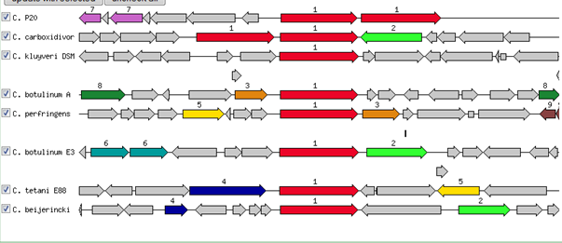

Figure. 1.2: The location and organization of adhE genes on the genomes C. carboxidivorans strain P7 and strain P20 are compared with the genomes of other clostridia.

Clostridial Genetic Systems
There are no reports of natural competence in clostridia and members of the genus are notoriously difficult to transform artificially (Davis et al., 2005). This is partially attributed to clostridia’s thick Gram-positive cell walls and to the prevalence of numerous restriction endonucleases in their cells (Mermelstein et al., 1992). Several factors influence successful transformation: choice of plasmid, cell preparation, method of transformation, and selection conditions for transformants. As there is no universal formula for success, the right conditions for any bacterial strain have to be determined empirically.
Plasmids are still not completely understood, despite their discovery and extensive use since the early 1960s (Phillips & Funnell, 2004). Several factors affect plasmid efficiency as a genetic system vector: origin of replication, size, antibiotic resistance, host methylation, and sequence (targets for restriction digestion). These factors have to be empirically tested. In supporting research for this dissertation, the strategy used for screening plasmid vectors initially focused on plasmids developed for closely related clostridial species (e.g. C. acetobutylicum, and C. cellulolyticum). Additional plasmids were chosen that had different origins of replication compatible with clostridia or other Gram positive microorganisms and conferred different antibiotic resistances (Table 1. 2). Methylation was also used to protect plasmids prior to transformation attempts (Mermelstein & Papoutsakis, 1993).
When developing a genetic system careful attention must be paid to cell preparation and transformant selection; transformation efficiency and overall success can depend on subtle details in this process. The addition of chemicals such as isoniacin and glycine (Tyurin et al., 2004) during cell preparation are thought to weaken cell walls and ease the entrance of plasmid DNA into cells. Protoplast formation (Davis et al., 2005) or sonication of cells prior to transformation also increase chances of success. Some studies report manipulation of cell culture harvesting time and temperature as well as variations in electroporation voltages to be the key to their genetic systems (Dower et al., 1992; Trevors et al., 1992).
Changes in cell harvesting and electroporation conditions were systematically tested and success in transforming strain P7 and strain P11 was achieved using square pulse electrotransformation (Lee et al., 1992; Tyurin et al., 2004) (chapter 3). This genetic system was then used to introduce extra copies of adh into strain P7 and measure subsequent effects (chapter 4).

Preamble:
Chapter 2: A bioreactor study of strain P7. This chapter investigates the enzymatic activity and gene expression of key syngas fermentation enzymes: FDH, CODH, H₂ases, and ADH. It correlates this data with different growth stages and solvent formation.
Chapter 3: Development of a genetic system for strain P11 and strain P7
Chapter 4: Strain P7’s adh1 and adh2 genes are studied in vivo and in vitro. Increased copies of genes increase alcohol production in strain P7 cells.
Appendix: Development and use of a genetic system to study Pseudomonas putida strain ML

Table 1.2: Plasmids used in attempted transformation of strain P11 or/and strain P7
Strain or plasmid | Relevant characteristics | source or reference
C. carboxidivorans | syngas fermenting strain | ATCC PTA-7827
C. ragsdalei P11 | syngas fermenting strain | ATCC PTA-7826
C. acetobutylicum | reference strain | ATCC 824
E. coli DH5-α | Strain for plasmid maintenance | Invitrogen
E. coli top10 | Strain for plasmid maintenance | Invitrogen
E. coli ER2275 | Strain contains pAN1 plasmid | Mermelstein 1993
E. coli R2702 | Strain contains Tn1545 | Jennert 2000
pIKM1 | Plasmid: E. coli and Gram positive shuttle vector | Tyurin 2004
pUC19 | Plasmid: contains multiple cloning site | Invitrogen
pMM | Plasmid: pIKM1 derivative, Km^{r} | This study
pMM2 | pMM plus pUC19 multiple cloning site | This study
pMM3 | pMM2 with strain P7 adh2 insert | This study
pMM4 | pMM2 with C. acetobutylicum adhE insert | This study
pMM5 | pMM2 with strain P7 adh1 insert | This study
pAN1 | encodes bacillus phage methyl transferase | Mermelstein 1993
pBS42 | Plasmid: E. coli host, Cm^{r} | Whitehead 1992
p121BS | Plasmid: E. coli host Er^{r} | Whitehead 2001
Tn1545 | conjugative plasmid | Jennert 2000
pUB110 | Plasmid: B. subtilis host Km^{r} | Gryczan 1978
pBD10 | Plasmid: B. subtilis host Cm^{r} | Gryczan 1978
pBC16 | Plasmid: B. subtilis host Tet^{r} | Koehler 1987
pEU327 | Plasmid: E. coli host spec^{r} | Eichenbaum 1998
pAT28 | Plasmid: E. coli host spec^{r} | Trieucuot 1985
pIMPTH | Plasmid: E. coli/Clostridium shuttle vector | Sullivan 2008
pMK3 | Plasmid: B. subtilis host Km^{r} | O’Sullivan 1984

Km: kanamycin, Spec: spectinomycin, Cm: chloramphenicol, Er: erythromycin, Tet: tetracylcine

References
Ahmed, A., Cateni, B. G., Huhnke, R. L. & Lewis, R. S. (2006). Effects of biomass-generated producer gas constituents on cell growth, product distribution and hydrogenase activity of Clostridium carboxidivorans P7T. Biomass and Bioenergy 30, 665-672.

Ahmed, A. & Lewis, R. S. (2007). Fermentation of biomass-generated synthesis gas: effects of nitric oxide. Biotechnol Bioeng 97, 1080-1086.

Allen, T. D., Caldwell, M. E., Lawson, P. A., Huhnke, R. L. & Tanner, R. S. (2010). Alkalibaculum bacchi gen. nov., sp. nov., a CO-oxidizing, ethanol-producing acetogen isolated from livestock-impacted soil. International journal of systematic and evolutionary microbiology 60, 2483-2489.

Babu, B. V. (2008). Biomass pyrolysis: a state-of-the-art review. Biofuels Bioproducts & Biorefining-Biofpr 2, 393-414.

Berzin, V., Kiriukhin, M. & Tyurin, M. (2012). Elimination of Acetate Production to Improve Ethanol Yield During Continuous Synthesis Gas Fermentation by Engineered Biocatalyst Clostridium sp MTEtOH550. Applied Biochemistry and Biotechnology 167, 338-347.

Blomqvist, J., South, E., Tiukova, L., Momeni, M. H., Hansson, H., Stahlberg, J., Horn, S. J., Schnurer, J. & Passoth, V. (2011). Fermentation of lignocellulosic hydrolysate by the alternative industrial ethanol yeast Dekkera bruxellensis. Letters in Applied Microbiology 53, 73-78.

Calusinska, M., Happe, T., Joris, B. & Wilmotte, A. (2010). The surprising diversity of clostridial hydrogenases: a comparative genomic perspective. Microbiology-Sgm 156, 1575-1588.

Cui, G. Z., Hong, W., Zhang, J., Li, W. L., Feng, Y., Liu, Y. J. & Cui, Q. (2012). Targeted gene engineering in Clostridium cellulolyticum H10 without methylation. J Microbiol Methods 89, 201-208.

Cunliffe, A. M. & Williams, P. T. (1998). Composition of oils derived from the batch pyrolysis of tyres. Journal of Analytical and Applied Pyrolysis 44, 131-152.

Daniell, J., Kopke, M. & Simpson, S. D. (2012). Commercial Biomass Syngas Fermentation. Energies 5, 5372-5417.

Datar, R. P., Shenkman, R. M., Cateni, B. G., Huhnke, R. L. & Lewis, R. S. (2004). Fermentation of biomass-generated producer gas to ethanol. Biotechnol Bioeng 86, 587-594.

Davis, I. J., Carter, G., Young, M. & Minton, N. P. (2005). Gene cloning in clostridia. In Handbook on Clostridia, pp. 37-52. Edited by P. Durre: Crc Press-Taylor & Francis Group, 6000 Broken Sound Parkway Nw, Ste 300, Boca Raton, Fl 33487-2742 USA.

de Vries, S. C., van de Ven, G. W. J., van Ittersum, M. K. & Giller, K. E. (2010). Resource use efficiency and environmental performance of nine major biofuel crops, processed by first-generation conversion techniques. Biomass & Bioenergy 34, 588-601.

Dower, W. J., Chassy, B. M., Trevors, J. T. & Blaschek, H. P. (1992). Protocols For The Transformation Of Bacteria By Electroporation. Chang, D C, Et Al (Ed) Guide to Electroporation and Electrofusion X+581p Academic Press, Inc: San Diego, California, USA; London, England, Uk Illus, 485-499.

Drake, H. L., Gossner, A. S. & Daniel, S. L. (2008). Old acetogens, new light. In Incredible Anaerobes: from Physiology to Genomics to Fuels, pp. 100-128. Edited by J. Wiegel, R. J. Maier & M. W. W. Adams: Annals of the New York Academy of Sciences.

Dürre, P. (1998). New insights and novel developments in clostridial acetone/butanol/isopropanol fermentation. Appl Microbiol Biotechnol 49, 639-648.

Durre, P. (2005). Handbook on clostridia. Boca Raton, Fla.: Taylor & Francis.

Eichenbaum, Z., Federle, M. J., Marra, D., De Vos, W. M., Kuipers, O. P., Kleerebezem, M. & Scott, J. R. (1998). Use of the lactococcal nisA promoter to regulate gene expression in gram-positive bacteria: Comparison of induction level and promoter strength. Applied and Environmental Microbiology 64, 2763-2769.

Elleuche, S. & Antranikian, G. (2013).Bacterial group III alcohol dehydrogenases–function, evolution and biotechnological applications. In OA alcohol: OA Publishing London.

Fraisse, L. & Simon, H. (1988). Observations on the reduction of non-activated carboxylates by Clostridium formicoaceticum with carbon monoxide or formate and the influence of various viologens. Archives of Microbiology 150, 381-386.

Gheshlaghi, R., Scharer, J. M., Moo-Young, M. & Chou, C. P. (2009). Metabolic pathways of clostridia for producing butanol. Biotechnology advances 27, 764-781.

Goyal, H. B., Seal, D. & Saxena, R. C. (2008). Bio-fuels from thermochemical conversion of renewable resources: A review. Renewable & Sustainable Energy Reviews 12, 504-517.

Grethlein, A. J., Worden, R. M., Jain, M. K. & Datta, R. (1991). Evidence for production of n-butanol from carbon monoxide by Butyribacterium methylotrophicum. Journal of Fermentation and Bioengineering 72, 58-60.

Gryczan, T. J., Contente, S. & Dubnau, D. (1978). Characterization of Staphylococcus aureus plasmids introduced by transformation into Bacillus subtilis. Journal of Bacteriology 134, 318-329.

Gryczan, T. J. & Dubnau, D. (1978). Construction and properties of chimeric plasmids in Bacillus subtilis. Proc Natl Acad Sci U S A 75, 1428-1432.

Hartmanis, M. G. N., Klason, T. & Gatenbeck, S. (1984). Uptake and activation of acetate and butyrate in Clostridium acetobutylicum. Applied Microbiology and Biotechnology 20, 66-71.

Hemme, C. L., Mouttaki, H., Lee, Y. J. & other authors (2010). Sequencing of multiple clostridial genomes related to biomass conversion and biofuel production. Journal of Bacteriology 192, 6494-6496.

Isom, C. E., Nanny, M. A. & Tanner, R. S. (2011).Reduction of acids to alcohols by novel solventogenic acetogens. In Abst Ann Meet Am Soc Microbiol, Q-1358.

Jones, D. T. & Woods, D. R. (1986). Acetone-butanol fermentation revisited. Microbiol Rev 50, 484-524.

Kim, B. H., Bellows, P., Datta, R. & Zeikus, J. G. (1984). Control of Carbon and Electron Flow in Clostridium acetobutylicum Fermentations: Utilization of Carbon Monoxide to Inhibit Hydrogen Production and to Enhance Butanol Yields. Appl Environ Microbiol 48, 764-770.

Koehler, T. M. & Thorne, C. B. (1987). Bacillus subtilis (natto) plasmid pLS20 mediates interspecies plasmid transfer. J Bacteriol 169, 5271-5278.

Kopke, M., Held, C., Hujer, S. & other authors (2010). Clostridium ljungdahlii represents a microbial production platform based on syngas. Proc Natl Acad Sci U S A 107, 13087-13092.

Kopke, M., Mihalcea, C., Bromley, J. C. & Simpson, S. D. (2011a). Fermentative production of ethanol from carbon monoxide. Curr Opin Biotechnol 22, 320-325.

Kopke, M., Mihalcea, C., Liew, F., Tizard, J. H., Ali, M. S., Conolly, J. J., Al-Sinawi, B. & Simpson, S. D. (2011b). 2,3-butanediol production by acetogenic bacteria, an alternative route to chemical synthesis, using industrial waste gas. Appl Environ Microbiol 77, 5467-5475.

Köpke, M., Mihalcea, C., Bromley, J. C. & Simpson, S. D. (2011). Fermentative production of ethanol from carbon monoxide. Current Opinion in Biotechnology 22, 320-325.

Kumar, A., Jones, D. D. & Hanna, M. A. (2009). Thermochemical Biomass Gasification: A Review of the Current Status of the Technology. Energies 2, 556-581.

Kundiyana, D. K., Huhnke, R. L. & Wilkins, M. R. (2010). Syngas fermentation in a 100-L pilot scale fermentor: Design and process considerations. Journal of Bioscience and Bioengineering 109, 492-498.

Leang, C., Ueki, T., Nevin, K. P. & Lovley, D. R. (2013). A genetic system for Clostridium ljungdahlii: a chassis for autotrophic production of biocommodities and a model homoacetogen. Appl Environ Microbiol 79, 1102-1109.

Lee, S. Y., Mermelstein, L. D., Bennett, G. N. & Papoutsakis, E. T. (1992). Vector construction, transformation, and gene amplification in Clostridium acetobutylicum ATCC-824. Annals of the New York Academy of Sciences 665, 39-51.

Liew, F. M., Köpke, M. & Simpson, S. a. D. (2013).Gas Fermentation for Commercial Biofuels Production. In Gas Fermentation for Commercial Biofuels Production, Liquid, Gaseous and Solid Biofuels - Conversion Techniques. Edited by Z. Fang.

Liou, J. S., Balkwill, D. L., Drake, G. R. & Tanner, R. S. (2005). Clostridium carboxidivorans sp. nov., a solvent-producing clostridium isolated from an agricultural settling lagoon, and reclassification of the acetogen Clostridium scatologenes strain SL1 as Clostridium drakei sp. nov. International journal of systematic and evolutionary microbiology 55, 2085-2091.

Liu, J. J., Tan, Y., Yang, X. H., Chen, X. H. & Li, F. L. (2013). Evaluation of Clostridium ljungdahlii DSM 13528 reference genes in gene expression studies by qRT-PCR. Journal of Bioscience and Bioengineering 116, 460-464.

Liu, K., Atiyeh, H. K., Tanner, R. S., Wilkins, M. R. & Huhnke, R. L. (2012). Fermentative production of ethanol from syngas using novel moderately alkaliphilic strains of Alkalibaculum bacchi. Bioresource Technology 104, 336-341.

Ljungdahl, L. G. (1986). The autotrophic pathway of acetate synthesis in acetogenic bacteria. Annual Review of Microbiology 40, 415-450.

Maddipati, P., Atiyeh, H. K., Bellmer, D. D. & Huhnke, R. L. (2011). Ethanol production from syngas by Clostridium strain P11 using corn steep liquor as a nutrient replacement to yeast extract. Bioresource Technology 102, 6494-6501.

Mermelstein, L. D., Welker, N. E., Bennett, G. N. & Papoutsakis, E. T. (1992). Expression of cloned homologous fermentative genes in Clostridium acetobutylicum ATCC 824. Bio/technology 10, 190-195.

Mermelstein, L. D. & Papoutsakis, E. T. (1993). Invivo Methylation in Escherichia coli by the Bacillus subtilis Phage-Phi-3t-I Methyltransferase to Protect Plasmids from Restriction Upon Transformation of Clostridium acetobutylicum Atcc-824. Applied and Environmental Microbiology 59, 1077-1081.

Munasinghe, P. C. & Khanal, S. K. (2010). Biomass-derived syngas fermentation into biofuels: Opportunities and challenges. Bioresource Technology 101, 5013-5022.

Nolling, J., Breton, G., Omelchenko, M. V. & other authors (2001). Genome sequence and comparative analysis of the solvent-producing bacterium Clostridium acetobutylicum. Journal of Bacteriology 183, 4823-4838.

O'Sullivan D, J. & Klaenhammer, T. R. (1993). Rapid Mini-Prep Isolation of High-Quality Plasmid DNA from Lactococcus and Lactobacillus spp. Appl Environ Microbiol 59, 2730-2733.

Oelgeschlager, E. & Rother, M. (2008). Carbon monoxide-dependent energy metabolism in anaerobic bacteria and archaea. Archives of Microbiology 190, 257-269.

Olsson, L. & HahnHagerdal, B. (1996). Fermentation of lignocellulosic hydrolysates for ethanol production. Enzyme and Microbial Technology 18, 312-331.

Perez, J. M., Richter, H., Loftus, S. E. & Angenent, L. T. (2013). Biocatalytic reduction of short-chain carboxylic acids into their corresponding alcohols with syngas fermentation. Biotechnol Bioeng 110, 1066-1077.

Phillips, G. & Funnell, B. E. (2004). Plasmid biology. Washington, DC: ASM Press.

Pierce, E., Xie, G., Barabote, R. D. & other authors (2008). The complete genome sequence of Moorella thermoacetica (f. Clostridium thermoaceticum). Environmental Microbiology 10, 2550-2573.

Poehlein, A., Schmidt, S., Kaster, A. K. & other authors (2012). An Ancient Pathway Combining Carbon Dioxide Fixation with the Generation and Utilization of a Sodium Ion Gradient for ATP Synthesis. Plos One 7, 8.

Ragsdale, S. W. (2004). Life with carbon monoxide. Critical Reviews in Biochemistry and Molecular Biology 39, 165-195.

Rajagopalan, S., Datar, R. P. & Lewis, R. S. (2002). Formation of ethanol from carbon monoxide via a new microbial catalyst. Biomass & Bioenergy 23, 487-493.

Roh, H., Ko, H. J., Kim, D., Choi, D. G., Park, S., Kim, S., Chang, I. S. & Choi, I. G. (2011). Complete Genome Sequence of a Carbon Monoxide-Utilizing Acetogen, Eubacterium limosum KIST612. Journal of Bacteriology 193, 307-308.

Sakai, S., Nakashimada, Y., Yoshimoto, H., Watanabe, S., Okada, H. & Nishio, N. (2004). Ethanol production from H-2 and CO2 by a newly isolated thermophilic bacterium, Moorella sp HUC22-1. Biotechnology Letters 26, 1607-1612.

Saxena, J., Maune, M. W. & Tanner, R. S. (2007).Effect of optimizing a trace metals solution on growth and ethanol production by Clostridium strain p11. In Abstracts of the General Meeting of the American Society for Microbiology, pp. 493.

Saxena, J. & Tanner, R. S. (2008). Production of Hexanol and Hexanoic Acid by the Acetogen Clostridium carboxidivorans Strain P7(T). Abstracts of the General Meeting of the American Society for Microbiology 108, 320-320.

Saxena, J. & Tanner, R. S. (2011). Effect of trace metals on ethanol production from synthesis gas by the ethanologenic acetogen, Clostridium ragsdalei. Journal of Industrial Microbial Biotechnology 38, 513-521.

Seedorf, H., Fricke, W. F., Veith, B. & other authors (2008). The genome of Clostridium kluyveri, a strict anaerobe with unique metabolic features. Proceedings of the National Academy of Sciences of the United States of America 105, 2128-2133.

Sullivan, L., Scotcher, M. C. & Bennett, G. N. (2008). Increased Biofuel Production by Metabolic Engineering of Clostridium acetobutylicum. In Bioenergy, pp. 361-376. Edited by J. D. Wall, C. S. Harwood & A. Demain: Amer Soc Microbiology, 1752 N Street Nw, Washington, Dc 20036-2904 USA.

Tan, Y., Liu, J. J., Chen, X. H., Zheng, H. J. & Li, F. L. (2013). RNA-seq-based comparative transcriptome analysis of the syngas-utilizing bacterium Clostridium ljungdahlii DSM 13528 grown autotrophically and heterotrophically. Molecular Biosystems 9, 2775-2784.

Tanner, R. S., Miller, L. M. & Yang, D. (1993). Clostridium ljungdahlii Sp-Nov, An Acetogenic Species In Clostridial Ribosomal-Rna Homology Group-I. International Journal of Systematic Bacteriology 43, 232-236.

Tanner, R. S. (2008). Production of Ethanol from Synthesis Gas.

Thomas, G. (2000).Overview of Storage Development DOE Hydrogen Program. Edited by S. N. Laboratories. San Ramon, California.

Torres, J. T. & Tanner, R. S. (2012).Syngas to butanol. In Abst Ann Meet Am Soc Microbiol, Q984.

Trevors, J. T., Chassy, B. M., Dower, W. J. & Blaschek, H. P. (1992). Electrotransformation Of Bacteria By Plasmid DNA. Chang, D C, Et Al (Ed) Guide to Electroporation and Electrofusion X+581p Academic Press, Inc: San Diego, California, USA; London, England, Uk Illus, 265-290.

Trieucuot, P. & Courvalin, P. (1983). Nucleotide-Sequence Of The Streptococcus faecalis Plasmid Gene Encoding The 3'5''-Aminoglycoside Phosphotransferase TYPE-III. Gene 23, 331-341.

Tyurin, M. V., Desai, S. G. & Lynd, L. R. (2004). Electrotransformation of Clostridium thermocellum. Applied and Environmental Microbiology 70, 883-890.

Verbruggen, A., Fischedick, M., Moomaw, W., Weir, T., Nadai, A., Nilsson, L. J., Nyboer, J. & Sathaye, J. (2010). Renewable energy costs, potentials, barriers: Conceptual issues. Energy Policy 38, 850-861.

Whitehead, T. R. (1992). Genetic transformation of the ruminal bacteria Butyrivibrio fibrisolvens and Streptococcus bovis by electroporation. Letters in Applied Microbiology 15, 186-189.

Whitehead, T. R. & Cotta, M. A. (2001). Sequence analyses of a broad host-range plasmid containing ermT from a tylosin-resistant Lactobacillus sp. Isolated from swine feces. Curr Microbiol 43, 17-20.

Worden, R. M., Grethlein, A. J., Jain, M. K. & Datta, R. (1991). Production of Butanol and Ethanol from Synthesis Gas Via Fermentation. Fuel 70, 615-619.

Chapter 2: Physiological Response of Clostridium carboxidivorans during Conversion of Synthesis Gas to Solvents in a Gas-fed Bioreactor

Abstract
Clostridium carboxidivorans P7 is one of three microbial catalysts capable of fermenting synthesis gas (mainly CO, CO₂ and H₂) to produce the liquid biofuels ethanol and butanol. Gasification of feedstocks to produce synthesis gas (syngas), followed by microbial conversion to solvents, greatly expands the diversity of suitable feedstocks that can be used for biofuel production beyond commonly used food and energy crops to include agricultural, industrial and municipal waste streams. C. carboxidivorans P7 uses a variation of the classic Wood-Ljungdahl pathway, identified through genome sequence-enabled approaches but only limited direct metabolic analyses. As a result, little is known about gene expression and enzyme activities during solvent production. In this study, we measured cell growth, gene expression, enzyme activity and product formation in autotrophic batch cultures continuously fed a synthetic syngas mixture. These cultures exhibited an initial phase of growth, followed by acidogenesis that resulted in a reduction in pH. After cessation of growth, solventogenesis occurred, pH increased and maximum concentrations of acetate (41 mM), butyrate (1.4 mM), ethanol (61 mM) and butanol (7.1 mM) were achieved. Enzyme activities were highest during the growth phase, but expression of carbon monoxide dehydrogenase, Fe-only hydrogenases and two tandem bi-functional acetaldehyde/alcohol dehydrogenases were highest during specific stages of solventogenesis. Several amino acid substitutions between the tandem acetaldehyde/alcohol dehydrogenases and the differential expression of their genes suggest that they may have different roles during solvent formation. The data presented here provides a link between the expression of key enzymes, their measured activities and solvent production by C. carboxidivorans P7. This research also identifies potential targets for metabolic engineering efforts designed to produce higher amounts of ethanol or butanol from syngas.

Introduction
Humankind began to exploit microbial fermentation to produce ethanol before 10,000 B.C. (Patrick, 1952) and the commercial production of butanol over one hundred years ago (Dürre, 1998). The increasing demand for renewable, carbon-neutral liquid transportation fuels has intensified the study of their production through microbial fermentation of cellulosic feedstocks. Initially, the focus was solely on ethanol, which can either be a stand-alone fuel or act as a substitute for the gasoline supplement MTBE to reduce CO and NO_{x} emissions (reviewed in Ahmed and Lewis, 2007; Henstra et al., 2007; Shaw et al., 2008). The hygroscopic nature and low caloric content of ethanol limits its use with current infrastructure. Butanol as a biofuel has the benefits of being less hygroscopic and possessing a higher caloric content than ethanol (Wallner et al., 2009). The fermentation of cellulosic feedstocks by acetogenic clostridia has been developed to produce both ethanol and butanol as commercially viable end products and has been studied extensively (Carroll and Somerville, 2009; Dürre, 2005; Grethlein et al., 1991; Weizmann and Rosenfeld, 1937).
The most studied approach for the production of renewable liquid biofuels is by direct fermentation of sugars extracted from food or energy crops. Direct fermentation requires pretreatment of feedstocks to convert carbohydrate polymers to sugars, followed by fermentation to desired end products. In contrast, indirect fermentation consists of the nearly complete and indiscriminant conversion of a wide variety of carbonaceous compounds to synthesis gas (syngas; largely CO, CO₂ and H₂) through gasification, followed by fermentation of this syngas to valuable end products (Datar et al., 2004; Henstra et al., 2007; Lewis et al., 2008; Tanner, 2008). An advantage of indirect fermentation is that syngas, and therefore end products like ethanol and butanol, can be produced from a wide variety of sources such as natural gas, coal, oil, biomass, municipal waste and potentially even from the solar conversion of CO₂

(Fernandez et al., 2008; Pena et al., 1996; Service, 2009).
Syngas-fermenting microbial catalysts are a unique and critically important component of indirect fermentation. Many microorganisms are able to ferment syngas as a sole energy and carbon source (Oelgeschlager and Rother, 2008), but few microorganisms are known that can use syngas to produce biofuels. Clostridium carboxidivorans P7 (ATCC PTA-7827) is one of only nine bacteria known to produce solvents from syngas (reviewed in Köpke et al., 2011) and, along with “Butyribacterium methylotrophicum” (Lynd et al., 1982) and “Clostridium ragsdalei” (Maddipati et al., 2011), is also capable of producing butanol. Metabolic and genomic analyses indicate that C. carboxidivorans uses a variation of the Wood-Ljundahl (acetyl-CoA) pathway to utilize syngas as the sole carbon and energy source to produce ethanol, butanol, acetate and butyric acid as end products (Fig. 2.1) (Bruant et al., 2010; Hemme et al., 2010; Liou et al., 2005). The overall reactions for ethanol and acetic acid production from H₂ and CO are (Vega et al., 1989) and the change in Gibbs free energy at 298 °K and 100 kPa are displayed below:
6 CO + 3 H₂O → C₂H₅OH + 4 CO₂ ΔGº = -217.4 kJ (1)
6 H₂ + 2 CO₂ → C₂H₅OH + 3 H₂O ΔGº = -97.0 kJ (2)
4 CO + 2 H₂O → CH₃COOH + 2 CO₂ ΔGº = -154.6 kJ (3)
4 H₂ + 2 CO₂ → CH₃COOH + 2 H₂O ΔGº = -74.3 kJ (4)
The overall reactions for butanol and butyric acid production from H₂ and CO are:
12 CO + 5 H₂O → C₄H₉OH + 8 CO₂ ΔGº = -486.4 kJ/mol (5)
12 H₂ + 4 CO₂ → C₄H₉OH + 7 H₂O ΔGº = -245.6 kJ/mol (6)
10 CO + 4 H₂O → CH₃(CH₂)₂COOH + 6 CO₂ ΔGº = -420.8 kJ/mol (7)
10 H₂ + 4 CO₂ → CH₃(CH₂)₂COOH + 6 H₂O ΔGº = -220.2 kJ/mol (8)
The purpose of this study was to provide a comprehensive physiological characterization of C. carboxidivorans growing under conditions analogous to those that would be used for industrial production of biofuels through indirect fermentation of cellulosic feedstocks. C. carboxidivorans was grown in a batch reactor that was continuously fed a synthetic syngas mixture. Product formation, the expression of genes for key metabolic enzymes and their enzymatic activities were monitored at various time points. Of particular interest was the expression of two acetaldehyde/alcohol dehydrogenases that are found in tandem on the genome (Bruant et al., 2010; Hemme et al., 2010). Genome analyses have only found this arrangement in one other syngas utilizing, solvent-producing acetogen, Clostridium ljungdahlii (Köpke et al., 2010). Our results show a difference in expression levels of these two genes by C. carboxidivorans.

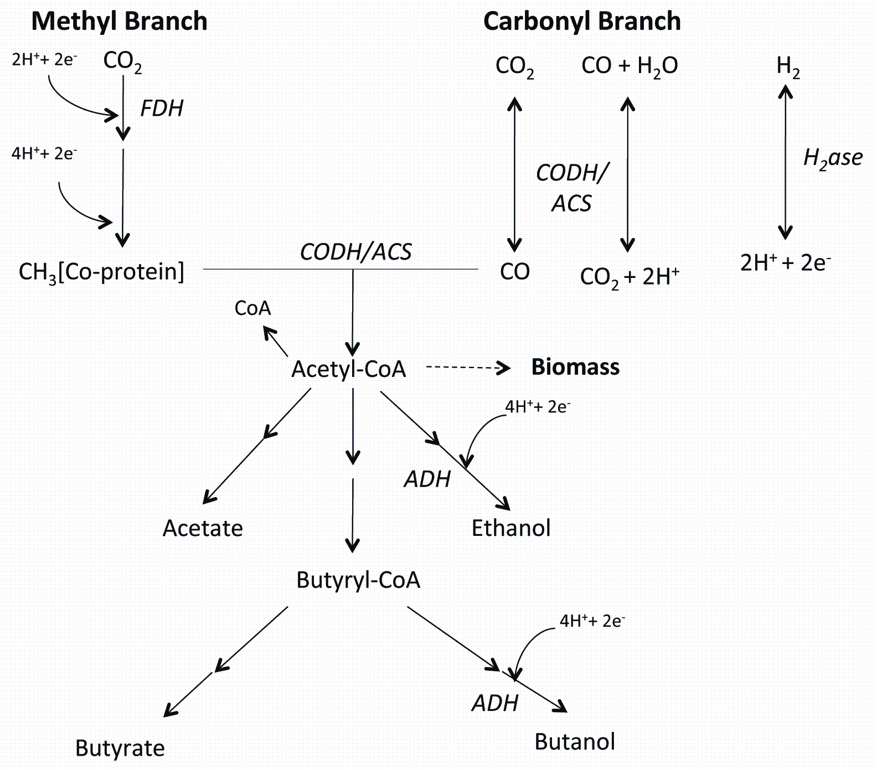

Figure 2.1. Conversion of CO and CO₂ to ethanol and butanol via the Wood-Ljungdahl pathway. Key metabolic products and flow of protons have been emphasized. The locations of key enzymes are shown: alcohol dehydrogenase (ADH), formate dehydrogenase (FDH), carbon monoxide dehydrogenase/acetyl-CoA synthetase (CODH/ACS) and hydrogenase (H₂ase).

Materials and Methods

Bioreactor Conditions and Sampling
Starter cultures of C. carboxidivorans P7 (ATCC PTA-7827) (Liou et al., 2005) were grown and maintained anaerobically in 250 mL serum seal bottles containing 100 mL of a modified basal medium (Liou et al., 2005; Tanner, 2007), with a syngas atmosphere (N₂:CO:CO₂:H₂ [60:20:15:5]) at 210 kPa, 37ºC and pH 5.7. This medium was composed of (L⁻¹): yeast extract, 1.0 g; mineral solution, 25 mL; trace metal solution, 10 mL; vitamin solution, 10 mL; MES, 10 g; resazurin, 1 mL; cysteine sulfide, 5 mL (Tanner, 2007). Under strict anaerobic conditions, aliquots (60 mL) from each starter culture were pooled (300 mL total, 10% v/v inoculum) and used to inoculate an unpressurized anoxic bioreactor (BioFlo 110, New Brunswick Scientific, Edison, NJ,) (7.5 L total volume) containing 3.0 L of basal medium. Agitation was provided by three six-blade Rushton turbine impellers, with an agitation speed set at 150 rpm. The temperature in the fermentor was maintained at 37°C. Four baffles were symmetrically arranged to avoid vortex formation of liquid media and improve mixing. A microsparger (New Brunswick Scientific) with a pore size of 10-15 μm was used for sparging a syngas mix (N₂:CO:CO₂:H₂ [60:20:15:5]; Stillwater Steel and Supply Co., Stillwater, OK) at a rate of 0.10 SLM (standard liter min⁻¹). The syngas mix flowing out of the bioreactor passed through a condenser cooled at 5°C using a refrigerated circulator (1156 D, VWR International, West Chester, PA). Condensed vapor was returned to the fermentor to minimize losses of alcohols by evaporation and gas stripping. BioCommand software was used for data acquisition, monitoring and controlling the fermentor. The initial pH of the medium was adjusted to 5.7 using 5N NaOH. The pH of the bioreactor culture was monitored using an integrated probe. Each of three sequential bioreactor runs was maintained until no increase in solvent production was observed. Every 24 h, a 40 mL liquid sample was taken to monitor pH, growth and physiological parameters. Culture growth was measured from a 1 mL subsample as optical density (OD) at 660 nm wavelength with a 1 cm light path using a UV-vis spectrophotometer (Cary 50Bio, Agilent Technologies, Wilmington, DE). Fermentation products, enzyme activity and gene expression were measured as described below.
Fermentation Products
Fermentation products were analyzed for each of three bioreactor replicates from liquid subsamples (1 mL) every 24 h using methods described previously (Ramachandriya et al., 2010). Briefly, the samples were centrifuged at 10,000 x g for 10 min at room temperature and the supernatant was filtered with a 0.45 µm nylon membrane syringe filter (VWR International). Filtrates were analyzed for ethanol, acetic acid, butanol and butyric acid with a gas chromatograph (GC) (6890 N, Agilent Technologies) fitted with a flame ionization detector (FID) and a J&W DB-FFAP chromatography column (Agilent Technologies). Hydrogen was the carrier gas at initial flow rate 1.9 mL min⁻¹ for 3.0 min and then the flow was increased to 4 mL min⁻¹ at a ramping rate of 0.5 mL min⁻². The inlet temperature was 200°C with a split ratio of 50:1. The oven temperature was held at 40°C for 1.5 min and then increased at a ramping rate of 40°C min⁻¹ to 235°C. The FID temperature was 250°C with H₂ (40 mL min⁻¹) and air (450 mL min ⁻¹). The data were analyzed using CHEMSTATION® software (Agilent Technologies).
Enzyme Activity
Enzyme assays were conducted for the third bioreactor run with whole cells collected from 20 mL subsamples (2,200 x g, 10 min, 4°C) and resuspended in 5 mL TAPS buffer (5.0 mM N-tris(hydroxymethyl)methyl-3-aminopropanesulfonic acid, 2 mM MgCl₂.6H₂O and 2 mM 2-mercaptoethanol; pH 8.5 with KOH) under strict anoxic conditions. Enzyme activities were measured using the substrate-dependent reduction of methyl viologen (MV) in stoppered, crimped anaerobic tubes (Bellco Glass, Vineland, NJ) at 40ºC with a headspace of 100% N₂ (Balch and Wolfe, 1976; Saxena and Tanner, 2011). Resuspended cells (200 μL) were added to an anaerobic tube containing TAPS buffer with 4 mM MV to initiate each assay. Assays for ethanol dehydrogenase (EDH) and butanol dehydrogenase (BDH) activities contained 300 mM ethanol or 192 mM butanol, respectively. Assays for carbon monoxide dehydrogenase (CODH) or hydrogenase (H₂ase) activity contained TAPS buffer with 4 mM MV, but the nitrogen headspace was replaced with the substrate gases CO or H₂ at 160 kPa, respectively. The reduction of MV was monitored over time as absorbance at 578 nm (extinction coefficient for MV ε₅₇₈ = 9.78 cm⁻¹ mM⁻¹) (Champine and Goodwin, 1991) at 40ºC using a Spectronic® 20D+ (Thermo Scientific, Waltham, MA). One unit was defined as the quantity of enzyme that catalyzed the reduction of 2 µmol MV min⁻¹ (2 e⁻ reduction) mg⁻¹ of protein (Saxena and Tanner, 2011). Protein content was measured using the bichinchoninic acid method (Smith et al., 1985) and bovine serum albumin was used as the standard. Cell mass concentrations were calculated from OD using the equation cell mass concentration at t_{n}= 0.34•OD_{tn} (Maddipati et al., 2011). Statistical significance was determined for comparisions at different time points using 2-tailed, unpaired student T-tests, with Walsh correction as needed (GraphPad InStat, Graph Pad Software, San Diego, CA).

Gene Expression
For the third bioreactor run (Fig. 2.3), gene expression was monitored over time using reverse transcriptase quantitative PCR (RT-qPCR) with primers specific for the catalytic subunit of carbon monoxide dehydrogenase (codh, EC:1.2.99.2, Ccarb_0164), two tandem acetaldehyde /alcohol dehydrogenases (adhE1and adhE2; Ccarb_4321 and 4322) and two Fe-only hydrogenases (large subunit domain, Ccarb_2646, and 4385). Each primer pair (Table 2.1) was developed manually from the C. carboxidivorans P7 draft genome sequence (JGI-PGF Project ID: 33115) (Hemme et al., 2010) and checked for T_{m}, hairpins, self-dimerization and hetero-dimerization using the Oligo Analyzer software provided on the Integrated DNA Technologies website (Integrated DNA Technologies, Coralville, IA; http://www.idtdna.com/analyzer/Applications/OligoAnalyzer/). Optimal conditions (primer concentrations and annealing temperatures) for each primer pair were identified as those producing the largest amount of product with no non-specific bands or primer-dimer, based on visualization on agarose gels.
At each time point, a 5 mL subsample was treated with 2.5 mL of RNA Protect® (Qiagen, Valencia, CA) and stored at -80°C until assayed. RNA was extracted from the frozen subsamples using the RNeasy mini kit (Qiagen) according to the manufacturer’s protocol with modifications. Cells were treated with lysozyme for 30 min at 25ºC prior to mechanical lysis conducted with 0.1 mm glass beads (RPI Research, Mount Prospect, IL) shaking in a Mini-Beadbeater-8® (BioSpec Products, Inc., Bartlesville, OK) at maximum speed (2,800 oscillations min⁻¹, with a displacement of 3.18 cm) for 2 min at room temperature. DNA in each sample was digested using RNase-free DNase (Qiagen) while nucleic acids were still bound to the chromatography column, and again after elution using RQ1® RNase–free DNase (Promega, Madison, WI) according to manufacturer’s protocols. Quantity and purity of nucleic acids was determined by absorbance spectra between 200-300 nm on a NanoPhotometer (Implen GmbH, Munich, Germany). Samples were deemed “DNA-free” if PCR with 16S rDNA primers gave no visible amplified product on an agarose gel.
Gene expression was measured using a two-step qRT-PCR. Following denaturation at 92ºC, complementary DNA (cDNA) copies of mRNA for each gene were produced from 5 μL of RNA extract with m-MLV reverse transcriptase (Fisher Scientific, Pittsburg, PA) and gene-specific primers (0.2 nM) in a total reaction volume of 25 μL at 37ºC for 72 min following manufacturer’s protocols. Quantitative PCR was performed on triplicate 5 μL samples of the RT reaction product to determine the mean number of cDNA copies in each sample • ng⁻¹ of DNA using gene-specific primers and Power SYBR® Green PCR Master Mix (Applied Biosystems, Carlsbad, CA) in a total reaction volume of 30 μL. Thermal cycling and real time product detection was conducted in a 7300 Real-Time PCR system (Applied Biosystems) with the following conditions: 95ºC for 10 min; 40 cycles (95ºC for 45 s, 55ºC for 45 s, and 72ºC for 1 min). Ten-fold serial dilutions of C. carboxidivorans genomic DNA (2.3 to 2.3 x 10⁴ copies) were used as the standard for qPCR of adh1, adh2 and codh gene expression. For the Fe-only hydrogenase genes, PCR-amplified products cloned into Escherichia coli using the TOPA-TA cloning system for sequencing (Invitrogen, Carlsbad, CA) were used as standards. Each RT-qPCR experiment was visualized on an agarose gel to confirm the absence of non-specific products including primer-dimers. Statistical significance was determined for comparisons of gene expression at different time points and between different genes using 2-tailed, unpaired student T-tests with Welsh correction as needed (GraphPad InStat, GraphPad Software).

Results

Growth and Fermentation Product Formation
The growth of C. carboxidivorans and the formation of fermentation products from three bioreactor replicates followed a pattern common for acetogenic clostridia (Fig. 2.2A). Acetate accumulation (up to 31 mM) coincided with a decrease in pH and growth rate during the first 72 h. Initiation of solvent formation after 50 h coincided with a decrease in acetate and increase in pH. Among the bioreactor replicates, solvent production ranged from 32.1-61.2 mM ethanol and 4.4-7.1 mM butanol (Fig. 2.2B). Ethanol production appeared to increase at the expense of acetic acid, with no substantial increase in solvent production observed after 192 h. The rate of ethanol production peaked at 35 to 65 mM g⁻¹ of cells day⁻¹ between 72 and 96 h, and then dropped to less than 20 mM g⁻¹ of cells day⁻¹ for the rest of the experiment (data not shown). In contrast, butanol production was first detected after 96 h. As shown in Fig. 2.3, each individual replicate began with a period of growth (10.2 h mean generation time) that began less than 24 h after inoculation.

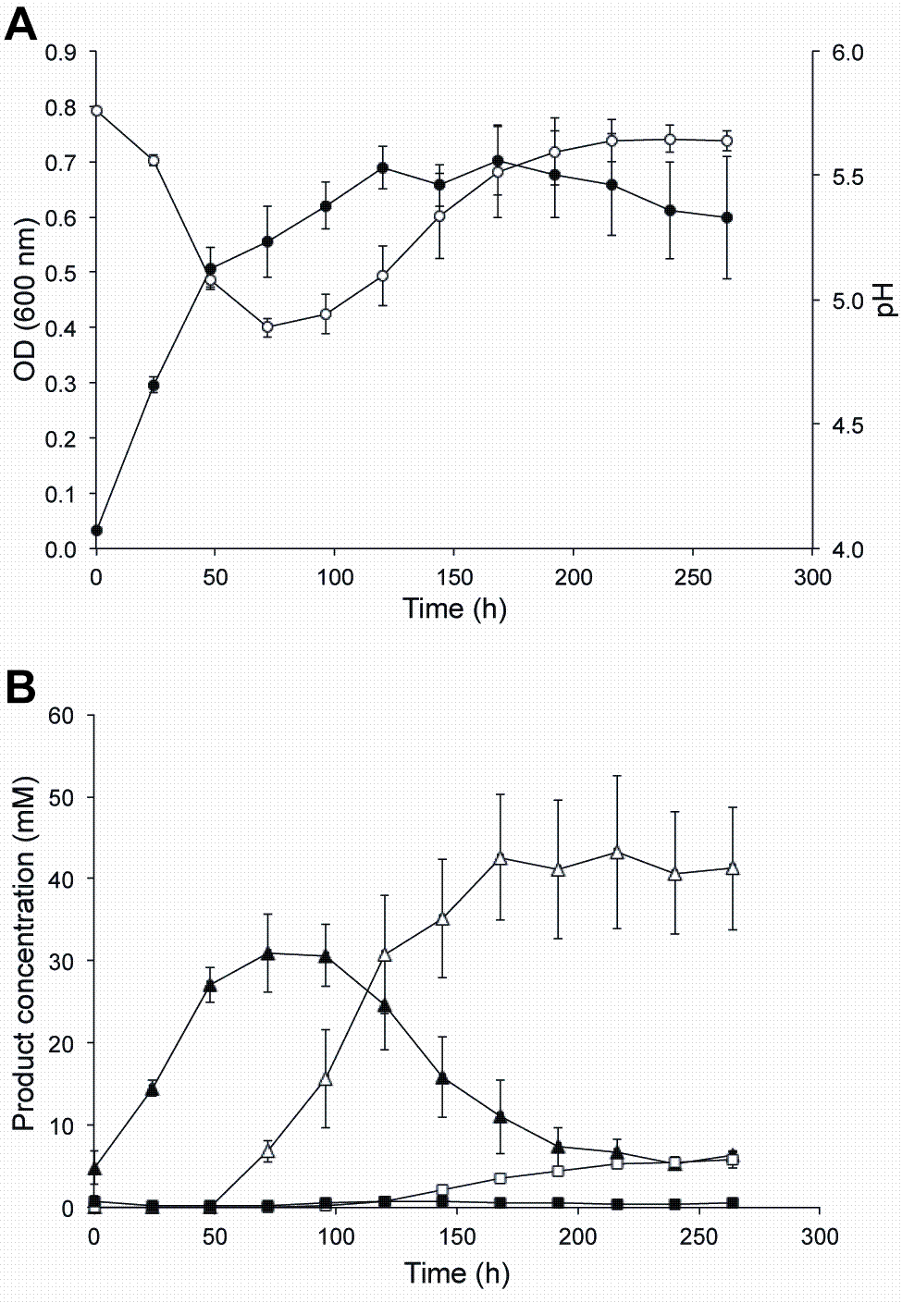

Figure 2.2. Mean values for A) measured growth (OD₆₆₀, solid circles) and pH (open circles) and B) product formation (acetate, solid triangles; butyrate, solid squares; ethanol, open triangles; and butanol, open squares) over time (h) from three syngas-fed bioreactor runs. Error bars represent standard error (n = 3).

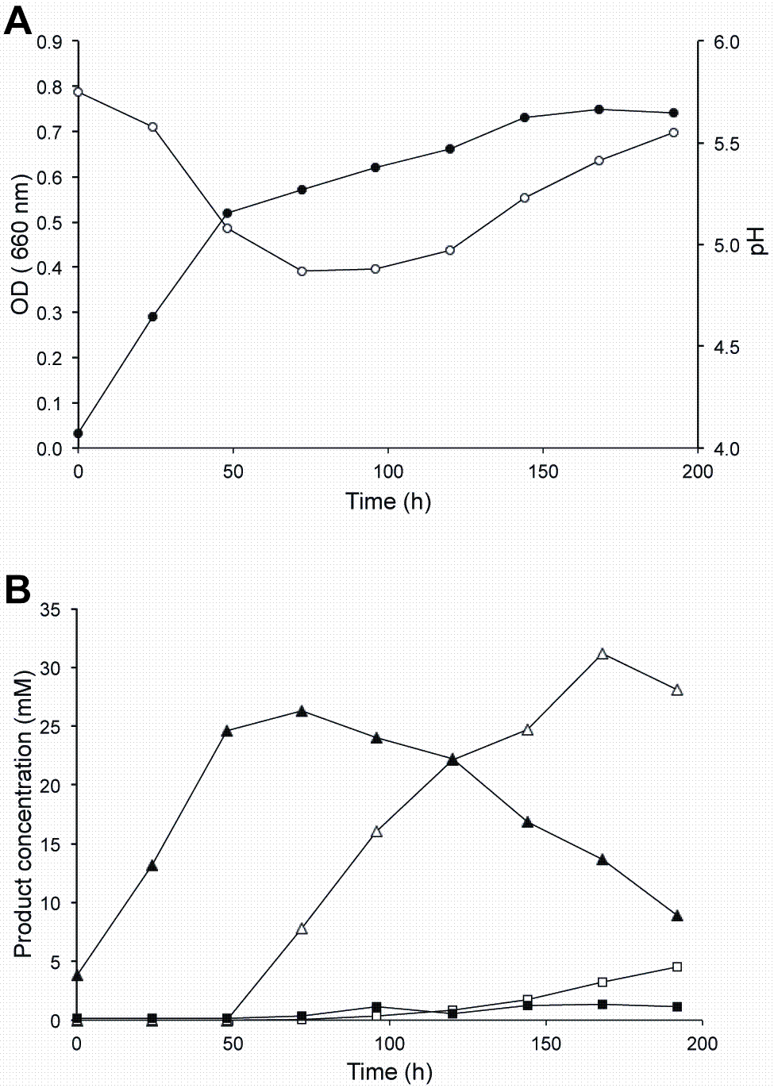
Figure 2.3. A) Measured growth (OD₆₆₀, solid circles) and pH (open circles) and B) product formation (acetate, solid triangles; butyrate, solid squares; ethanol, open triangles; and butanol, open squares) over time (h) for the third bioreactor run.

Key Enzymatic Activity
Whole cell enzyme assays were used to monitor enzyme activity over time within the third bioreactor replicate. H₂ase activity was highest during the first 50 h, followed by a sharp decline at 72 h and then a gradual increase throughout the remainder of the experiment (Fig. 2.4A). CODH showed much less activity than H₂ase, but followed a similar trend that reached a minimum at 96 h. Butanol and ethanol dehydrogenase activity was also greatest during cell growth, reaching a minimum at 96 h (Fig. 2.4B). Butanol dehydrogenase activity, however, was greater than ethanol dehydrogenase at all time points (p < 0.05) except during the transition to solventogenesis between 72 and 96 h, and during late stationary phase at 192 h.

Gene Expression for Key Enzymes
To enable direct comparison with enzyme activity measurements, the third bioreactor run was the source of all gene expression data. Both tandem acetaldehyde/alcohol dehydrogenase genes (adh1 and adh2) were expressed during all stages of the bioreactor run, showing a large increase during solventogenesis (Fig. 2.5A). Expression of the adh genes was differential, with greater expression of adh2 than adh1. Differential expression was nominal during the production of primarily ethanol (5.4 and 6.8-fold at 48 and 96 h), but increased significantly during butanol production (184.7-fold at 192 h) (p < 0.01). Expression of the catalytic subunit of carbon monoxide dehydrogenase (codh) increased over 6000 fold from 48 to 192 h (Fig. 2.5B). Both Fe-only hydrogenase genes, Ccarb_2646 and Ccarb_4385, showed expression responses to changing culture conditions, increasing prior to 48 h and coinciding with the initiation of ethanol formation (Fig. 2.5B).

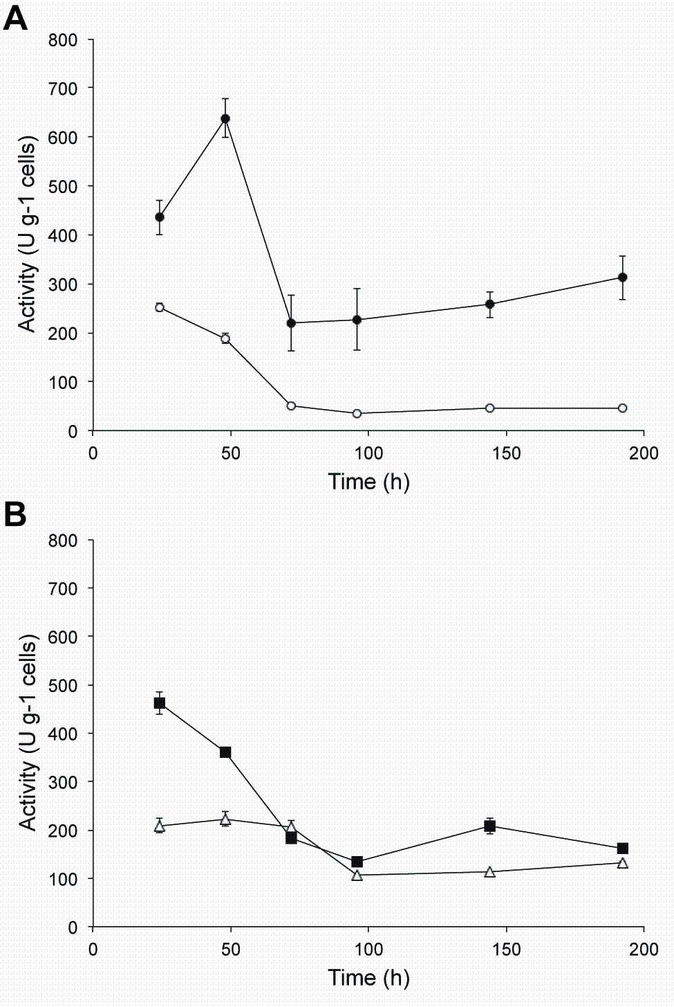
Figure 2.4. Measured activities of A) hydrogenase (solid circles) and carbon monoxide dehydrogenase (open circles); B) butanol dehydrogenase (closed squares) and ethanol dehydrogenase (open triangles) in units (U) per gram cells over time. Error bars represent standard deviation of mean values (n = 3).

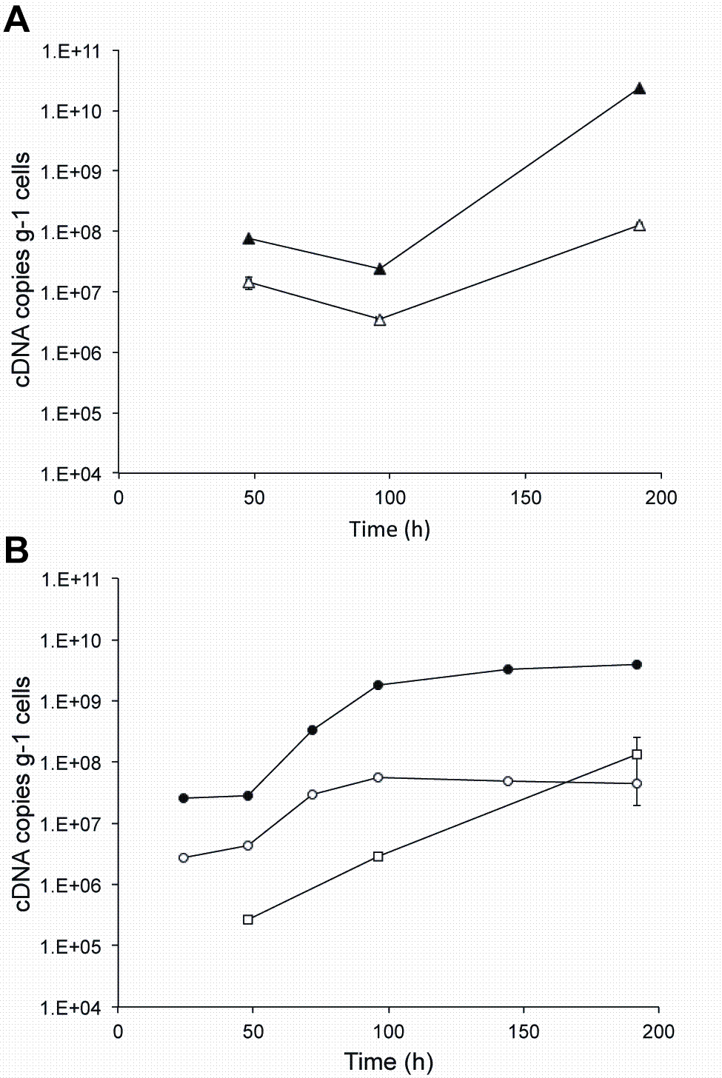
Figure 2.5. Gene expression of A) adh1 (open triangles) and adh2 (closed triangles) and B) codh (open squares), two Fe-only dehydrogenases (Ccarb_2646, closed circles; Ccarb_4385, open circles) measured as the number of cDNA copies per gram of cells over time (h). Error bars represent standard error of mean measurements (n = 3).

Discussion
There are as few as nine acetogenic bacteria capable of autotrophic growth on CO, producing acetate and other products (Köpke et al., 2011). These microorganisms use CO, CO₂ and H₂ via the Wood-Ljungdahl (acetyl-CoA) pathway to produce acetyl-CoA, a precursor of cell biomass, acetate, ethanol, butyrate, butanol and potentially many other products

(Drake et al., 2008; Gössner et al., 2008). Only three of these acetogens, Clostridium carboxidivorans (Liou et al., 2005), “Clostridium ragsdalei” (Maddipati et al., 2011) and “Butyribacterium methylotrophicum” (Lynd et al., 1982) are known to be intrinsically capable of producing butanol.
In the work described here, growth, product formation, enzyme activity and gene expression were monitored for the CO-fermenting acetogen C. carboxidivorans growing in a bioreactor continuously fed syngas as the sole source of carbon and energy. This research was carried out under growth conditions likely to be used in the industrial production of ethanol and butanol. A goal of this work was to link transcriptional control of key metabolic genes with their measured activities and product formation in a bioreactor.

Cell Growth and Product Formation
Medium pH is believed to serve as a trigger causing acetogens to shift from the production of acids to their respective solvents (Dürre, 2005). The pH of the bioreactor was not controlled after the initial pH (5.7) adjustment of the medium. As expected, all bioreactor replicates demonstrated a decrease in pH as acids were formed, followed by an increase in pH that coincided with the conversion of acids to alcohols (Fig. 2.2).
The highest measured growth rates during the initial stages of the bioreactor indicated generation times of 10.2 h, slower than the maximal doubling time of 4.3 h recorded for bottle cultures that were run with a different gas composition and at higher pressures (Liou et al., 2005). The gas compositions used in this study (N₂:CO:CO₂:H₂ [60:20:15:5]) was chosen to model syngas produced during gasification of switchgrass, which contains three times less CO than the gas used by Liou et al. (2005). Measured growth in the bioreactor was linear, never exponential, which was interpreted as an indication of substrate limitation due to mass transfer of the gaseous substrate to the aqueous phase. We are currently studying improved reactor designs to reduce mass transfer limitations. For example, using hollow fiber membranes as diffusers has recently been reported to improve the mass transfer of CO in water (Lee et al., 2012; Munasignhe and Khanal, 2012).
Two distinct rates of growth were observed in the bioreactor. The first, faster growth rate occurred during the first 48 h. The production of organic acids in the Wood-Ljungdhal pathway yields more ATP than when alcohols are produced (White, 2007). Along with a minimum pH (4.8-5.0) and a maximum acetate concentration (23-34 mM) for the three bioreactor runs, transition to a second, slower growth rate coincided with the production of the solvents ethanol and butanol.

Enzyme Activity
The activity of several important enzymatic reactions was monitored throughout the third bioreactor run, which included the growth phase (first 48 h) and the stationary phase of the bioreactor. Activity for all measured enzymatic reactions peaked during the first 48 h, followed by significantly less activity (Figs. 2.4A and 2.4B). Despite the lower levels of ethanol dehydrogenase and butanol dehydrogenase activity measured during solventogenesis, these levels were still well above those needed to produce the alcohols accumulated in the bioreactor. The difference between measured activity and actual rate of production suggests that product formation is limited by something other than the amount of active enzyme present in the cell. For example, the predicted rate of ethanol and butanol production based on activity measurements was higher than the actual rate of formation per day (data not shown). It is even more interesting that the rate of butanol formation over time was different from that of ethanol (p < 0.05). The rate of ethanol formation peaked by 120 h, whereas butanol formation gradually increased throughout the stationary phase and increase in pH, peaking only after 192 h. This was interpreted as a preference of C. carboxidivorans for ethanol formation compared to butanol formation.
A potential limitation of the enzyme activity measurements was that only the reverse enzyme reactions were measured. These measured activities may not be directly interpretable if the kinetics of these reactions were not equal in each direction (Gheshlaghi et al., 2009). Additionally, the enzyme assays were conducted with a saturating amount of substrate, which is likely to be higher than intracellular concentrations during growth in the bioreactor.

Ethanol and Butanol Production
The onset of ethanol production around 48 h did not coincide with an appreciable increase in EDH enzyme activity. Instead, this activity was at its peak at around 48 h, but decreased by 50% between 72 and 96 h (Fig. 2.4B). Expression of the two tandem, bi-functional acetaldehyde/alcohol dehydrogenase genes (adh1 and adh2) also decreases by about the same amount between 48 and 96 h (Fig. 2.5A). Between 96 and 192 h, expression of both adh genes increased significantly (p < 0.01). Neither the EDH activity nor the rate of production of ethanol seemed to reflect the dynamics of gene expression measured for either gene. One possible interpretation for the large increase in expression is an attempt by the cell to compensate for a drop in efficiency of ethanol production. This and alternative explanations, however, remain untested.
The presence of two tandem, homologous adh genes has only been observed on the genomes of C. carboxidivorans P7 and C. ljungdahlii. Although both genes are annotated as acetaldehyde dehydrogenase (EC 1.2.1.10) / alcohol dehydrogenase adhE (EC 1.1.1.1), they are not identical. They differ in length by 15 bases (5 amino acids) and share only 82% identity (695/847), or 91% allowing for conservative substitutions (775/847) at the amino acid level (Altschul et al., 1997). The 200 bp long region between these genes contains a putative terminator for adh1 followed by a promoter region for adh2. The genetic structure and genomic context of these two genes support the potential for differential expression, which was readily observed by RT-qPCR (Fig. 2.5A).
The adh2 gene, second in the tandem arrangement on the genome, was always expressed at a higher level than adh1 (Fig. 2.5A). More importantly, at some point after 96 h both genes are up-regulated but to very different degrees. The expression of adh1 increased 36-fold between 96 and 192 h, whereas, adh2 expression increased over 1,000-fold over the same time span. The period of greatest differential expression corresponded to the greatest rate of butanol production, raising questions as to the potential differential roles between these two enzymes.
Energy Conservation
C. carboxidivorans was in a stationary phase of growth following the decrease in pH and production of solvents (Figs. 2.2 and 2.3). The oxidation of CO to CO₂, carried out by CODH, generates energy captured by the reduction of ferredoxin (Ragsdale, 2004). The levels of CODH activity were greatest during the first 72 h of the bioreactor replicate (Fig. 2.4A), but the expression of codh increased over 500-fold from 48 to 192 h (Fig. 2.5B). This discrepancy again points to a potential for decreased efficiency of the enzyme. Additionally, the culture was still consuming CO but at a decreased rate compared to the first 72 h (data not shown).
H₂ase activity was greatest during the first 48 h, dropping 3-fold at 72 h, followed by a modest increase in measured activity until 192 h. Expression of the two Fe-only H₂ases monitored suggests that they were not responsible for the initial high amounts of activity but become more important after 48 h with increases in expression of 100-fold (Ccarb_2646) and 10-fold (Ccarb_4385) (Fig. 2.5B). If the CODH is not participating in the oxidation of CO to CO₂ via the biological water-gas shift reaction, the Fe-only hydrogenases may be required to compensate for the deficit in reducing equivalents (Ragsdale, 2004). Additionally, these H₂ases could be involved in generating a membrane gradient for the generation of ATP (Biegel and Müller, 2010; Köpke et al., 2010; Müller et al., 2008) via the Rnf complex found on its genome (Bruant et al., 2010; Hemme et al., 2010).
A strain of C. ljungdahlii transformed with the necessary genes was also capable of producing trace amounts of butanol from CO (Köpke et al., 2010). These microorganisms can act as microbial catalysts for the conversion of CO-containing gases into valuable fuels and chemicals. Industrial waste gases, and gasification of coal, biomass and municipal solid waste can all serve as sources of CO. The gasification of non-food lignocellulosic feedstocks (e.g. switchgrass, forestry waste) offers a promising approach to producing fuels and chemicals that are renewable and carbon-neutral.
The development of strategies to use gas fermentation for the commercial production of fuels and chemicals is on the rise, but not fully mature (Köpke et al., 2011). Significant developments have come from the optimization of nutrient concentrations and pH, which influence cellular growth, substrate efficiency and the ratio of acids versus alcohols produced (Saxena and Tanner, 2011). Much is known about the enzymes, pathways and energetics of autotrophic, gas-fermenting acetogens
(Gheshlaghi et al., 2009; Ljungdahl, 1986) but our understanding of the molecular processes underlying this biochemistry is limited. This study measured the expression of tandem adh genes during solvent formation, which suggests they may have different roles. Isolation and characterization of these adh genes may provide insight into the physiological regulation of syngas solventogenesis. The genetic information needed to identify the molecular underpinnings of this useful biochemistry has only recently become available with the release of genome sequences for C. ljungdahlii and C. carboxidivorans (Bruant et al., 2010; Hemme et al., 2010; Köpke et al., 2010) and is a prelude to exciting new research.

Conclusions
Linking the production of syngas from various waste streams or renewable, non-food lignocellulosic feedstocks with subsequent fermentation to solvents and other useful products is a promising and maturing industrial process. At the heart of this process are the novel microbial catalysts that are capable of CO fermentation and product formation. Optimized media conditions and reactor designs have addressed some of the limitations, but further study of the metabolic pathways and their molecular underpinnings is paramount.
Several important observations are presented here that were made by simultaneously monitoring growth, product formation and gene expression of C. carboxidivorans in a syngas-fed bioreactor. The increased expression of CODH and Fe-only H₂ases during later stages of the bioreactor fermentation implies their importance during solventogenesis and suggests a need for reducing equivalents. Additionally, the differential expression of two tandem adh genes suggests a differential role for each during solvent production. Genetic manipulation of these processes in C. carboxidivorans or through their transformation into other suitable microorganisms is likely to provide further optimization that will directly benefit our understanding of this useful biochemistry and its commercialization.
Acknowledgements:
Support for this research was provided by the Oklahoma Bioenergy Center, Oklahoma Agricultural Experiment Station, The South Central Sun Grant Initiative and Oklahoma NSF EPSCoR Grant No EPS-0814361.

References
Ahmed A, Lewis RS. 2007. Fermentation of biomass-generated synthesis gas: Effects of nitric oxide. Biotechnol Bioeng 97:1080–1086.
Altschul SF, Madden TL, Schäffer AA, Zhang J, Zhang Z, Miller W, Lipman DJ. 1997. Gapped BLAST and PSI-BLAST: a new generation of protein database search programs. Nucleic Acids Res 25:3389–3402.
Balch WE, Wolfe RS. 1976. New approach to cultivation of methanogenic bacteria: 2-mercaptoethanesulfonic acid (HS-CoM)-dependent growth of Methanobacterium ruminatium in a pressurized atmosphere. Appl Environ Microbiol 32:781–791.
Biegel E, Müller V. 2010. Bacterial Na+-translocating ferredoxin: NAD+ oxidoreductase. Proc Natl Acad Sci USA 107:18138–18142.
Bruant G, Levesque MJ, Peter C, Guiot SR, Masson L. 2010. Genomic analysis of carbon monoxide utilization and butanol production by Clostridium carboxidivorans strain P7. PLoS One 5:e13033.
Carroll A, Somerville C. 2009. Cellulosic biofuels. Annu Rev Plant Biol 60:165–182.
Champine JE, Goodwin S. 1991. Acetate catabolism in the dissimilatory iron-reducing isolate GS-15. J Bacteriol 173:2704–2706.
Datar, RP, Shenkman, RM, Cateni, BG, Huhnke, RL, Lewis RS. 2004. Fementation of biomass-generated producer gas to ethanol. Biotechnol Bioeng 86:587-594.
Drake HL, Gössner AS, Daniel SL. 2008. Old acetogens, new light. Ann NY Acad Sci 1125:100–128.
Dürre P. 1998. New insights and novel developments in clostridial acetone/butanol/isopropanol fermentation. Appl Microbiol Biotechnol 49:639–648.
Dürre P. 2005. Handbook on Clostridia. Boca Raton: CRC Press. 903 p.
Fernandez Y, Fidalgo B, Dominguez A, Pis JJ, Menendez JA. 2008. Obtaining synthesis gas by heat treatment in microwave biomass and biogas. Afinidad 65:103–109.
Gheshlaghi R, Scharer JM, Moo-Young M, Chou CP. 2009. Metabolic pathways of clostridia for producing butanol. Biotechnol Adv 27:764–781.
Gössner AS, Picardal F, Tanner RS, Drake HL. 2008. Carbon metabolism of the moderately acid-tolerant acetogen Clostridium drakei isolated from peat. FEMS Microbiol Lett 287:236–242.
Grethlein AJ, Worden RM, Jain MK, Datta R. 1991. Evidence for production of n-butanol from carbon monoxide by Butyribacterium methylotrophicum. J Ferment Bioeng 72:58–60.
Hemme CL, Mouttaki H, Lee Y-J, Zhang G, Goodwin L, Lucas S, Copeland A, Lapidus A, Glavina del Rio T, Tice H and others. 2010. Sequencing of multiple clostridial genomes related to biomass conversion and biofuel production. J Bacteriol 192:6494–6496.
Henstra AM, Sipma J, Rinzema A, Stams AJM. 2007. Microbiology of synthesis gas fermentation for biofuel production. Curr Opin Biotechnol 18:200–206.
Köpke M, Mihalcea C, Bromley JC, Simpson SD. 2011. Fermentative production of ethanol from carbon monoxide. Curr Opin Biotechnol 22:320–325.
Köpke M, Held C, Hujer S, Liesegang H, Wiezer A, Wollherr A, Ehrenreich A, Liebl W, Gottschalk G, Dürre P. 2010. Clostridium ljungdahlii represents a microbial production platform based on syngas. Proc Natl Acad Sci USA 107:13087–13092.
Lee P-H, Ni S-Q, Chang S-Y, Sung S, Kim S-H. 2012. Enhancement of carbon monoxide mass transfer using an innovative external hollow fiber membrane (HFM) diffuser for syngas fermentation: Experimental studies and model development. Chem Eng J 184:268-277.
Lewis RS, Frankman A, Tanner RS, Ahmed A, Huhnke RL. 2008. Ethanol via biomass-generated syngas. Int Sugar J 110:150–155.
Liou JSC, Balkwill DL, Drake GR, Tanner RS. 2005. Clostridium carboxidivorans sp. nov., a solvent-producing clostridium isolated from an agricultural settling lagoon, and reclassification of the acetogen Clostridium scatologenes strain SL1 as Clostridium drakei sp. nov. Int J Syst Evol Microbiol. 55:2085–2091.
Ljungdahl LG. 1986. The autotrophic pathway of acetate synthesis in acetogenic bacteria. Annu Rev Microbiol 40:415–450.
Lynd L, Kerby R, Zeikus JG. 1982. Carbon monoxide metabolism of the methylotrophic acidogen Butyribacterium methylotrophicum. J Bacteriol 149:255–263.
Maddipati P, Atiyeh HK, Bellmer DD, Huhnke RL. 2011. Ethanol production from syngas by Clostridium strain P11 using corn steep liquor as a nutrient replacement to yeast extract. Bioresour Technol 102:6494–6501.
Müller V, Imkamp F, Biegel E, Schmidt S, Dilling S. 2008. Discovery of a ferredoxin:NAD+-oxidoreductase (Rnf) in Acetobacterium woodii: a novel potential coupling site in acetogens. Ann N Y Acad Sci 1125:137–146.
Munasinghe PC, Khanal SK. 2012. Syngas fermentation to biofuel: Evaluation of carbon monoxide mass transfer and analytical modeling using a composite hollow fiber (CHF) membrane bioreactor. Bioresour Technol http://dx.doi.org/10.1016/j.biortech.2012.03.053.
Oelgeschlager E, Rother M. 2008. Carbon monoxide-dependent energy metabolism in anaerobic bacteria and archaea. Arch Microbiol 190:257–269.
Patrick CH. 1952. Alcohol, Culture, and Society. Durham, North Carolina: Duke University Press. 176 p.
Pena M, Gomez J, Fierro J. 1996. New catalytic routes for syngas and hydrogen production. Appl Catal, A 144:7–57.
Ragsdale SW. 2004. Life with carbon monoxide. Crit Rev Biochem Mol Biol 39:165–195.
Ramachandriya KD, DeLorme MJ, Wilkins MR. 2010. Heat shocking of Clostridium strain P11 to promote sporulation and ethanol production. Biol Eng 2:115–131.
Saxena J, Tanner RS. 2011. Effect of trace metals on ethanol production from synthesis gas by the ethanologenic acetogen, Clostridium ragsdalei. J Ind Microbiol Biotechnol 38:513–521.
Service RF. 2009. Sunlight in your tank. Science 326:1472–1475.
Shaw AJ, Podkaminer KK, Desai SG, Bardsley JS, Rogers SR, Thorne PG, Hogsett DA, Lynd LR. 2008. Metabolic engineering of a thermophilic bacterium to produce ethanol at high yield. Proc Natl Acad Sci USA 105:13769–13774.
Smith PK, Krohn RI, Hermanson GT, Mallia AK, Gartner FH, Provenzano MD, Fujimoto EK, Goeke NM, Olson BJ, Klenk DC. 1985. Measurement of protein using bicinchoninic acid. Anal Biochem 150:76–85.
Tanner RS. 2007. Cultivation of bacteria and fungi. In: Hurst, CJ, Crawford, RL, Mills, AL, Garland, JL, Stetzenbach, LD, Lipson, DA, editors. Manual of Environmental Microbiology. Washington, D.C.: ASM Press, p. 69–78.
Tanner, RS. 2008. Production of ethanol from synthesis gas. In: Wall, JD, Harwood, CS, Demain, A, editors. Bioenergy. Washington, D.C.: ASM Press, p. 147-151.
Vega J, Prieto S, Elmore B, Clausen E, Gaddy J. 1989. The biological production of ethanol from synthesis gas. Appl Biochem Biotech 20-1:781–797.
Wallner T, Miers SA, McConnell S. 2009. A comparison of ethanol and butanol as oxygenates using a direct-injection, spark-ignition engine. J Eng Gas Turbines Power, 131:032802.
Weizmann C, Rosenfeld B. 1937. The activation of the butanol-acetone fermentation of carbohydrates by Clostridium acetobutylicum (Weizmann). Biochem J 31:619–639.
White D. 2007. The physiology and biochemistry of prokaryotes. New York: Oxford University Press. 628 p.

Table 2. 1. Targeted genes and primers used in this study.

Targeted geneª | Primer name | Sequence (5’-3’) | Amplicon size (bp)
Acetaldehyde/alcohol dehydrogenase 1, adhE1 (Ccarb_4321) | adh1F | GAGAACCAACAGTTGAGTTATCTGGAA | 380
Acetaldehyde/alcohol dehydrogenase 1, adhE1 (Ccarb_4321) | adh1R | TATAAGCAGGTTGTCCAACGA | 380
Acetaldehyde/alcohol dehydrogenase 2, adhE2 (Ccarb_4322) | adh2F | TGTGCTTCAGAGCAGTCGGT | 482
Acetaldehyde/alcohol dehydrogenase 2, adhE2 (Ccarb_4322) | adh2R | AATGTTCTACCAGTCTTCATAGTTTCTCTA | 482
Carbon monoxide dehydrogenase, codh (Ccarb_0164) | codhF | TGGTTGGATTTAGTACAGAGGCT | 285
Carbon monoxide dehydrogenase, codh (Ccarb_0164) | codhR | GTCTTAAGTCCAGGACCAGCGAGT | 285
Fe-only hydrogenase, large subunit (Ccarb_2646) | hyd1F | GAGTATGCCCTACAGGTGCATTGG | 236
Fe-only hydrogenase, large subunit (Ccarb_2646) | hyd1R | GATCTGTCCCACTGTTACTTTTGGTCC | 236
Fe-only hydrogenase, large subunit (Ccarb_4385) | hyd2F | TGGTGCTACAGGAGGAGTTATGGAAGC | 283
Fe-only hydrogenase, large subunit (Ccarb_4385) | hyd2R | TTTTGGTTGACCGCCGCCAC | 283
ª Locus tags from C. carboxidivorans P7 draft genome (JGI-PGF Project ID: 33115) are given in parentheses

Chapter 3: Development of a Cloning and Expression Vector in the Syngas-Fermenting and Alcohol-Producing Clostridium carboxidivorans strain P7

Abstract
Great advancements in modern molecular biology have been achieved since the discovery of plasmids in the 1960s. A key aspect of these advancements has been the ability to use genetic systems to modify organisms using plasmids as vectors. Clostridium carboxidivorans strain P7 is a Clostridium capable of fermenting synthesis gas (CO, CO₂ and H₂) to produce the alcoholic transportation fuels ethanol and butanol. Hypothetically, strain P7’s ability to produce alcohols can be improved by increasing the copy number of solvent production genes (such as alcohol dehydrogenase (adh)) in cells. However, members of the genus Clostridium are recalcitrant organisms and known for their resistant to genetic manipulation. A genetic system has been developed for strain P7, this was done using plasmid pIKM1, square pulsed electroporation, and liquid selection medium. The plasmid pIKM1 was subsequently modified by sub-cloning separate adh genes into it to produce the plasmids pMM3, and pMM5.These cloning and expression vectors have been used successfully to transform strain P7.

Introduction

A key tool that has revolutionized modern molecular microbiology has been the use of genetic systems to introduce desirable traits into bacteria. Traits as diverse as the ability to produce insulin (Ullrich et al., 1977), increasing bioremediation capacity (Arora (Arora et al., 2014) or the introduction of fluorescent pigments (Malone et al., 2009) have been introduced successfully to diverse bacterial species using genetic systems. An essential feature of every genetic system is a choice of vectors, plasmids, viruses, transposomes and cosmids are all vectors used in molecular biology (Sambrook & Russell, 2001). Plasmids are by far the most commonly used vectors in the transformation of bacteria (Phillips & Funnell, 2004). Despite their discovery and extensive use since the early 1960s, plasmids are still not completely understood, the mechanisms governing the regulation of plasmid copy number and replication have only been partially described (Phillips & Funnell, 2004). This lack of knowledge often hampers the development of genetic system for novel organisms.
Molecular biology benefits from knowledge of organisms and the availability of their genomes in databases (Markowitz et al., 2010). The availability of fully sequenced bacterial genomes increases the potential of genetic systems, allowing specific genes to be targeted for deletion or/and duplication. Clostridium ragsdalei strain P11 and Clostridium carboxidivorans strain P7 are syngas-fermenting organisms with tremendous industrial potential, as they produce the valuable end products acetate, ethanol, butyrate and butanol (Liou et al., 2005). The sequencing of their genomes (Bruant et al., 2010; Hemme et al., 2010) provides an avenue for improving their industrial capacity through genetic modification but a genetic system was necessary. Unfortunately, clostridia are notoriously difficult to transform (Davis et al., 2005), which is attributed to their thick cell walls and the prevalence of nucleases in their cells (Mermelstein et al., 1992a; Pyne et al., 2013). Methylation has been used to protect plasmid DNA from nuclease activity (Mermelstein & Papoutsakis, 1993a; Pyne et al., 2013) but this has also been reported to have a negative effect on transformation with some species of Clostridium (Guss et al., 2012). Methylation has not always been necessary for successful transformation (Dong et al., 2010).
The two most common methods of delivering plasmids into clostridia cells are electroporation and conjugation. Electroporation is the most common method of delivering plasmids into clostridia and has been used successfully in C. acetobutylicum (Nair & Papoutsakis, 1994) , C. ljungdahlii (Leang et al., 2013) and, C. perfringens (Allen & Blaschek, 1988). Conjugation, as an alternative, has been successful in other clostridia such as C. cellulolyticum (Jennert et al., 2000). For both methods, empirical testing is needed to determine the ideal cell harvest times and conditions, transformation environment and recovery and selection methods (Dower et al., 1992).
The objective of this study was to identify a suitable plasmid for strains P11 and strain P7, while at the same time determine the optimal conditions for transformation. The genetic system was optimized to ensure consistent delivery and detection of the plasmid. A suitable plasmid pIKM1 (Tyurin et al., 2004) was then modified to produce a vector suitable for the cloning and expression of different alcohol dehydrogenase genes (adh) involved in ethanol and butanol production in strains P11 and P7. Plasmids containing adh genes were used to create new strains of C. carboxidivorans strain P7.

Materials and Methods

Bacterial strains, plasmids and growth media used
The bacterial strains and plasmids used in this study are listed in (Table 3.1). All cultures were incubated at 37°C. All anaerobic media were prepared using strict anoxic technique (Balch & Wolfe, 1976). “Clostridium ragsdalei” strain P11 and Clostridium carboxidivorans strain P7 were grown and maintained in basal medium (Liou et al., 2005). This medium was composed of (per liter): yeast extract, 1.0 g; mineral solution, 25 ml; trace metal solution, 10 ml; vitamin solution, 10 ml; MES, 10 g; resazurin, 1 ml. The pH of the medium was adjusted to 6.1 using KOH, supplemented with 3 ml cysteine sulfide as a reducing agent (Tanner, 2007) and prepared with an initial headspace of H₂:CO₂ (80:20 @10 psi). In order to quickly generate robust biomass, strain P11 and strain P7 were grown heterotrophically in basal medium supplemented with 0.05 ml 30% w/v xylose and 0.05 ml of 30% w/v fructose per ml of medium (respectively). Basal medium was amended by pressurizing the headspaces with CO to 30 psi when strain P7 or strain P11 were grown with syngas as the only source of carbon and energy.
Clostridium acetobutylicum was grown anaerobically on 2YTG medium (Fontaine et al., 2002) supplemented with 3 ml cysteine sulfide as a reducing agent and 0.05 ml of 30% w/v glucose per ml of medium.
All Escherichia coli strains (Table 3.1) were grown and maintained aerobically on liquid or solid Luria Betrani medium (LB). Media were supplemented with the appropriate antibiotics kanamycin (Km) 50 µg/ml, ampicillin (Amp) 100 µg/ml and chloramphenicol (Cm) 34 µg/ml) as needed for plasmid maintenance, (Table 3.1).

Table 3.1: Plasmids used in this study.
Strain or plasmid | Relevant characteristics | Source
C. carboxidivorans | syn gas fermenter | ATCC PTA-7827
C. ragsdalei P11 | syn gas fermenter | ATCC PTA-7826
C. acetobutylicum | reference strain | ATCC 824
E. coli DH5-α | for plasmid maintainance | Invitrogen
E. coli top10 | for plasmid maintainance | Invitrogen
E. coli ER2275 | contains pAN1 plasmid | Mermelstein 1993
E. coli R2702 | contains Tn1545 | Jennert 2000
Plasmids
pIKM1 | E. coli and Gram positive shuttle vector | Tyurin 2004
pUC19 | contains multiple cloning site | Invitrogen
pMM | pIKM1 derivative, Km^{r} | This study
pMM2 | pMM plus pUC19 multiple cloning site | This study
pMM3 | pMM2 with strain P7 adh2 insert | This study
pMM4 | pMM2 with C. acetobutylicum adhE insert | This study
pMM5 | pMM2 with strain P7 adh1 insert | This study
pAN1 | encodes bacillus phage methyl transferase | Mermelstein 1993
pBS42 | E. coli host, Cm^{r} | Whitehead 1992
p121BS | E. coli host Er^{r} | Whitehead 2001
pUB110 | B. subtilis host Km^{r} | Gryczan 1978
pBD10 | B. subtilis host Cm^{r} | Gryczan 1978
pBC16 | B. subtilis host Tet^{r} | Koehler 1987
pEU327 | E. coli host spec^{r} | Eichenbaum 1998
pAT28 | E. coli host spec^{r} | Trieucuot 1985
pIMPTH | E. coli/Clostridium shuttle vector | Bennett 2008
pMK3 | B. subtilis host Km^{r} | Sullivan 1984

Km: kanamycin, Spec: spectinomycin, Cm: chloramphenicol, Er: erythromycin, Tet: tetracylcine

Minimum inhibitory concentration
The minimum inhibitory concentrations (MIC) for strain P11 and strain P7 were determined by exposure of cell cultures to antibiotics in liquid broth. The antibiotics ampicillin, spectinomycin , erythromycin, thiamphenicol and kanamycin were tested on strain P11 and the antibiotics kanamycin and erythromycin were tested on strain P7. Concentrations of 0, 1.0, 5.0,25, 50 and 100 µg/ml were used in 5 ml culture volume quadruplicate replicate. All cultures were incubated at 37ºC for 4 days and final growth was observed at OD_{600nm}. Inhibition was defined as no increase in optical density of cultures.

Plasmid maintenance and extraction
All genomic DNA was extracted and purified using a phenol chloroform extraction protocol (Lawson et al., 1989). Extractions of plasmid DNA from E. coli were performed using the Plasmid Midi Kit, part no 12143 (Qiagen, Valencia, Ca). Plasmids were maintained in E. coli DH5 alpha unless otherwise stated. Plasmids were introduced into E. coli cells using Gene Pulser Xcell electroporating system (Bio-Rad laboratories, Hercules CA), according to the manufacturer’s protocol. Restriction enzymes were purchased from NEB biolabs (Ipswich, Ma). DNA from strains of clostridia suspected of harboring plasmids was extracted using one or more of the following methods: Plasmid Midi Kit (Qiagen, Valencia, Ca), alkaline lysis protocol (Sambrook & Russell, 2001), QuickExtract DNA extraction solution (Epicentre, Madison, WI) or ethidium bromide extraction (O'Sullivan D & Klaenhammer, 1993).

Construction of the clostridial shuttle vector
High fidelity PCR was performed using AccuPrime pfx DNA polymerase (Invitrogen, Carlsbad, Ca) to amplify strain P7 adhE1 and adhE2 genes. The primers used were designed to amplify the entire gene as well as the complete intergenic upstream and downstream sequences to ensure any native promoter and terminator would be included in the final amplicon. The resulting amplicons, adhE1 (3735 bp) and adhE2 (2980 bp), were cloned into the pCR-Xl-TOPO vector (invitrogen, Carlsbad, Ca) following manufacturer’s protocol and maintained in E. coli TOP10 (invitrogen, Carlsbad, Ca).
An E. coli-Clostridium shuttle vector, pIKM1(Tyurin et al., 2004), was used as a plasmid backbone. The restriction enzymes ScaI and PciI were used to remove a 1390 bp fragment from plasmid pIKM1 to create plasmid pMM: the 1390 bp fragment was discarded and the remaining fragment was blunted using NEB blunting kit (NEB biolabs, Ipswich, Ma) and self-ligated using T4 DNA ligase (Promega, Madison, Wi) to create plasmid pMM.
Plasmid pMM was digested using Eco53KI to produce a 48 bp fragment and a 4562 bp fragment. The linear 4562 bp fragment was blunted using the NEB blunting kit. Bstu1 was used to cut a 545bp fragment from plasmid pUC19 containing its’ multiple cloning site (MCS), the MCS fragment was blunted. Plasmid pMM2 was created using T4 DNA ligase to combine the 545bp pUC19 fragment with the blunted 4562 bp pMM fragment. SacI was used to linearize plasmid pMM2. SacI and EcoRV were used to remove the adhE1 and adhE2 gene fragments from pCR-XL-topo plasmid. The adhE1 and adhE2 gene fragments were ligated into pMM2 to produce plasmids pMM5 and pMM3, respectively. Presence of MCS insert in pMM2 and adh inserts in pMM3 and pMM5 was confirmed using sanger sequencing. A map of each plasmid was created using the web tool plasmapper (Dong et al., 2004).

Genetic system development
All plasmid DNA was methylated prior to transforming clostridia by transforming E .coli ER2272 ^{pAN1}cells (Mermelstein & Papoutsakis, 1993b) with each plasmid of interest and harvesting total plasmid DNA from these transformants. Unless otherwise stated, all plasmid and genomic DNA was harvested as described in the plasmid maintenance section.
Cultures of strain P7, strain P11 and C. acetobutylicum were grown at 37ºC, as described above, until mid-exponential phase (OD_{600nm} 0.4-0.8) and harvested (2,500 or 5,000 Xg, 10 min, 4 ºC) under anoxic conditions. Cells were maintained at 4 ºC prior to electroporation. Pellets were washed 1, 2 or 3 times (2,500-5,000 g, 10 min, 4 ºC) with 5 ml electroporation buffer (Oultram et al., 1988) then resuspended in 1or 2ml of buffer. Aliquots (400 μL) of cell suspensions were incubated on ice with 40-800 ng of methylated or unmethylated plasmid DNA for 10-15 min. Control samples contained no plasmid.
Plasmids were introduced into clostridia using the Gene Pulser Xcell electroporation system (Bio-Rad laboratories, Hercules CA) to deliver electrical pulses. The following settings were used: 2 mm cuvettes, 1 or 2 square wave pulse(s) at 1000v for 0.5 ms duration with 5 s intervals. Cell recovery was performed immediately after electroporation by the addition of 2 ml basal medium with or without 10% glycerol and pressurized with CO to 30 PSI (for strain P7 and strain P11) or 2YTG (for C. acetobutylicum); recovered cells were incubated at 37ºC for 6-48 h.
Transformed cells were selected by transferring the entire recovery culture to 25 or 50 ml of medium with antibiotic pressure and incubated at 37ºC until growth was observed. For samples transformed with plasmid pMM2, kanamycin at concentrations 1.0, 5.0, 25 and 50 µg/ml was used for selection. Initial confirmation of the presence of the plasmid was performed on samples showing metabolic activity using PCR with primers specific for the kanamycin resistance gene. Metabolic activity during selection was defined as a doubling in OD600_{nm} values. Plasmids were subsequently extracted as described above. Whole genomic DNA extracts of strain P11^{pIKM1} were used to electrotransform E. coli DH5 alpha cells.
Strain P7 cells were transformed with plasmid pMM2, as described above. After a 12 h recovery period and a 7-fold serial dilution, in quintuplet, the Most Probable Number (MPN) technique was performed in 5 ml basal medium tubes with 25 μg/ml kanamycin to calculate transformation efficiency. Cultures were pressurized to 30 psi with CO and incubated at 37ºC for 36 hours. PCR was used to confirm that positive MPN tubes contained plasmid.

Figure. 3.1. Flow chart of electrotransformation process

Results

Development of genetic system for strains P11 and P7
The minimum inhibitory concentration (MIC) of antibiotics for strain P11 was determined prior to any attempts at transformation (Table 3.2). The MIC of kanamycin for strain P11 was less than 10 µg/ml. The MIC of erythromycin and kanamycin for strain P7 was less than 5 µg/ml. Like many Gram-positive organisms, strain P11 displayed tolerance for spectinomycin with an MIC of greater than 100 µg/ml (Durre, 2005). As such, plasmids encoding ampicillin, erythromycin, thiamphenicol and kanamycin resistances were given priority in this study.
Transformation attempts on strain P11 were made using a wide range of plasmids (Table 3.1) and using different electroporation conditions as described in the methods (Table 3.3). Successful transformation of the control C. acetobutylicum, strain P11 and strain P7 was only achieved using plasmid pIKM1 under the following conditions: cultures harvested during exponential phase (OD_{600nm} 0.3-0.7), cells chilled at 4ºC, prewashed with cold buffer (Oultram et al., 1988) and electroporated with a square pulse electrical shock of 1kv/mm. Methylation of plasmid DNA prior to transformation attempts was necessary: no transformations were detected without prior DNA methylation. Transformations under these conditions were only observed with recovery times of 2 days or longer. The use of liquid medium for selection was the key to detecting transformants: by transferring recovered post-electroporated cells into liquid broth with kanamycin, transformants of strain P11 and P7 were detected.
Initial transformation was confirmed through the observation of kanamycin resistance in cell cultures. Further confirmation was achieved through PCR amplification using plasmid specific primers for the kanamycin resistance gene (Fig. 3.4); a 620 bp fragment was the end product. Plasmids could not be extracted using commercial extraction kits or conventional alkaline lysis (Sambrook & Russell, 2001). Instead, pIKM1 was extracted using an extraction process which involves binding DNA with ethidium bromide (O'Sullivan D & Klaenhammer, 1993). Whole genomic DNA extracts from strain P11^{pIKM1} samples were used to transform competent E. coli cells and thus fully confirm the presence of the parent pIKM1 plasmid in clostridia (Fig. 3.2a).
It is important to note that the control C. acetobutylicum was only transformed by plasmid pIKM1 under these conditions. Other plasmids have been used successfully in transforming C. acetobutylicum but did not work under these conditions (Sullivan et al., 2008).

A
B

Figure. 3.2a. Gel image confirming retransformation of E .coli. 1 Kb DNA marker (M), control plasmid pIKM1 (lane 1), plasmid extracts of E. coli retransformed with pIKM1 from strain P11 (lanes 2 and 3). Figure 3.2b: Gel image confirming presence of pIKM1 in strain P7. DNA marker (M), control plasmid pIKM1 (lane 1) and strain P7 plasmid extract (lane 2) are shown.

Table 3.2: MIC of antibiotics for strain P11 and P7
Strain | Antibiotic | MIC (µg/ml )
P11 | kanamycin | <10
P11 | erythromycin | <25
P11 | ampicillin | <50
P11 | spectinomycin | >100
P11 | thiamphenicol | <1
P7 | kanamycin | <10
P7 | erythromycin | <25

Table 3.3: Summary of variations in electroporation conditions attempted.
 |  | Electroporation variables
Plasmid | Species | Growth | Incubation (mins) | Pulse type | Recovery (h)
pIKM1 | CA P11 P7 | exp, st | 5, 10 , 15 | Sq, Ed | 6,12,24
pMM2 | P7 | exp | 10, 15 | Sq | 24
pMM3 | P7 | exp | 10, 15 | Sq | 24
pMM4 | P7 | exp | 10, 15 | Sq | 24
pMM5 | P7 | exp | 10, 15 | Sq | 24
pIMPTH | CA P11 | exp, st | 1, 5, 10 | Sq, Ed | 1, 3
pBS42 | CA P11 | exp | 1 | Sq | 1, 3
p121BS | CA P11 | exp | 1, 5 | Sq | 1, 3
pAT28 | CA P11 | exp | 1 | Sq | 3, 20
pEU327 | CA P11 | exp | 1, 5 | Sq | 3, 20
pBD10 | P11 | exp | 1 | Sq | 3, 20
pBC16 | P11 | exp | 1 | Sq | 3, 20
pMK3 | P11 | exp | 1 | Sq | 3, 20
pUB110 | P11 | exp | 1 | Sq | 3, 20

exp: exponential growth phase; st: stationary growth phase; CA: Clostridium acetobutylicum; Sq: Square pulse; Ed: Exponential decay pulse. Successful transformation conditions in bold

Plasmid modification
Transformation efficiency tends to be negatively correlated with plasmid size (Dower et al., 1992; Trevors et al., 1992). The size of the E. coli to Clostridium shuttle vector pIKM1(Tyurin et al., 2004) was reduced to create the plasmid pMM. The flexibility of this vector was increased by the insertion of a multiple cloning site (MCS) from pUC19 to create plasmid pMM2. The alcohol dehydrogenase genes of strain P7, adhE1 and adhE2 and C. acetobutylicum adhE were added to the MCS site of the recombinant plasmid pMM2 to produce plasmids pMM3, pMM5 and pMM4, respectively (Fig. 3.3)(Table 3.1). Care was taken to include the entire native gene regulatory mechanisms: the promoter, the open reading frame and the terminator regions, by cloning the entire intergenic regions upstream and downstream of the genes into the parent plasmid pMM2. The result is a family of vectors that contain 3 different adh genes and native Clostridium promoters.

Optimization of strain P7 transformation using plasmid pMM2
Clostridium carboxidivorans strain P7 is able to produce ethanol, butanol and hexanol. As alcohol production was the focus of genetic manipulation studies, emphasis was placed on optimizing the transformation conditions for this organism in order to ensure consistent transformation and shorten post electroporation recovery times. Transformed cells were produced whether strain P7 cells were grown on fructose or on syngas, as long as a minimum cell density (OD₆₀₀ of 0.2 or greater in 25ml culture volume) was reached. The presence or absence of glycerol did not have an impact on successful transformation. The optimal recovery time post electroporation was 12-24 h; shorter recovery times resulted either in no transformations or long selection times ( ≥ 5 d) required before growth was observed. The optimal antibiotic concentration for selection was determined to be 5 µg/ml. Higher concentrations of antibiotics increased selection time and lowered growth rate, lower concentrations of antibiotics sometimes led to false positives. The transformation efficiency was determined using MPN counts and calculated to be 250 CFU/µg of DNA. Strain P7 was successfully transformed with plasmids pMM2, pMM3, pMM4 and pMM5 (Fig. 3.2b).
In this study C. carboxidivorans strain P7,”C. ragsdalei strain P11” and C. acetobutylicum and have been transformed successfully with plasmid pIKM1.

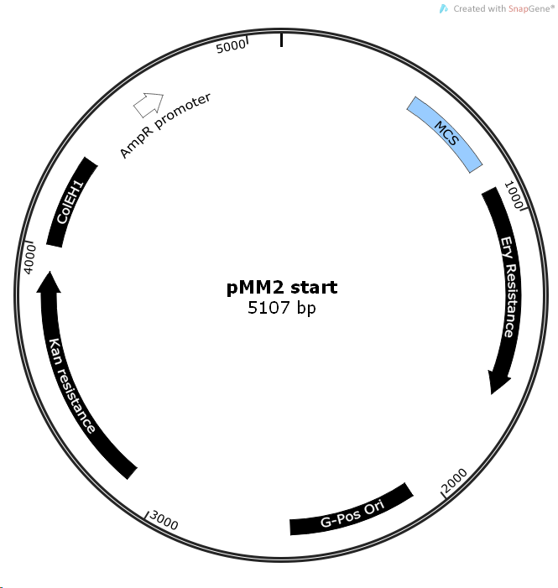

Figure. 3.3: Map of plasmid pMM2 showing location of key features

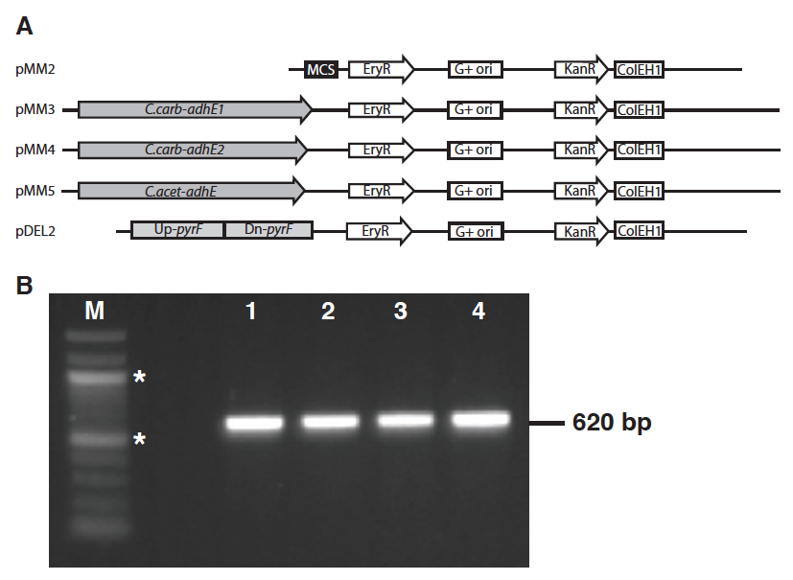

Figure. 3.4. Gel image confirming transformation of C. carboxidivorans with pMM2, pMM3, pMM4 and pMM5 (lanes 1-4, respectively) via amplification of a fragment of the Kan^{R} gene.

Discussion

Genetic system approach
Members of the class Clostridia are notoriously difficult to transform (Davis et al., 2005; Dower et al., 1992; Trevors et al., 1992). This is due in part to formidable obstacles to transformation that include strictly anaerobic growth requirements, thick Gram-positive cell walls and extensive restriction endonuclease systems (Aune & Aachmann, 2010; Pyne et al., 2013; Tyurin et al., 2004). Harsh conditions such as high voltages, heat or cold shock and/or membrane weakening are needed to overcome these limitations. These treatments often lead to cell death and consequently low transformation efficiencies, such as those observed in this study.
Proper methylation is often the key to successful transformation with DNA between different bacteria. Mermelstein et al. showed that the Bacillus subtillus Φ3T I methyltransferase was capable of protecting foreign DNA from attack by the restriction enzyme Cac824I (5’-GCNGC-3’) in C. acetobutylicum (Mermelstein et al., 1992b; Mermelstein & Papoutsakis, 1993b). Given the phylogenetic relationship between C. acetobutylicum and strain P7, this methylation was included as a variation in transformation attempts. No transformants were observed when non-methylated DNA was used, leading to the conclusion that strain P7, like other clostridia, possess restriction endonucleases that limit transformation efficiency (Cui et al., 2012; Dong et al., 2010; Klapatch et al., 1996). Furthermore, unlike DCM methylation in C. thermocellum (Guss et al., 2012), Φ3T I methylation is not detrimental to transformation in strain P7.
A key component to the transformation success in this study was the use of liquid medium during cell recovery instead of growth on solid medium (Fig. 3.1). Liquid broth may represent a more suitable growth environment for transformants. Given the very low transformation efficiencies, it is also possible that out growth from all transformed cells insures recovery. This modification can be applied to transforming other hitherto recalcitrant clostridia.
Confirmation of transformants is commonly performed using plasmid extractions followed by visualization using gel electrophoresis (Sambrook & Russell, 2001). In this study, transformation was verified by recovery of total DNA from presumptive transformants of strain P11 or P7, followed by subsequent PCR specific to the kanamycin resistance gene on the plasmid. Retransformation of E. coli with DNA extracts increased confidence in this approach. PCR amplification was the primary means of confirmation because pIKM1 has been shown to be difficult to extract using conventional means (Tyurin et al., 2004). Tyurin et al proposed that this difficulty was due to unusual protein plasmid complexes. Subsequently a complex plasmid extraction protocol (O'Sullivan D & Klaenhammer, 1993) did enable visualization (Fig. 3.2b).

Creation of pMM family of plasmids
The plasmid pIKM1 has no readily available multiple cloning site. Modifying the plasmid to include the MCS from pUC19 increased the flexibility of the resulting vector (pMM2) by enabling the use of a wide range of restriction enzymes on the plasmid without disrupting essential features and providing blue/white selection (Yanischperron et al., 1985) when grown in E.coli.
Optimization of the transformation of strain P7 performed with pMM2 resulted in identification of 12-24 h recovery times and 5 µg/ml kanamycin selective pressure as key conditions. Despite the optimization of transformation, efficiencies were still low (2.5 *10² CFU/µg of DNA), compared to the parent plasmid pIKM1 (2.2*10⁵ CFU/µg of DNA) in other organisms (Tyurin et al., 2004). Clearly, plenty of room for improvement remains.
With the genetic system developed in this study in hand and the family of plasmids pMM (Table 3.1) now available, metabolic engineering can now be performed on strain P7 and strain P11. Increasing alcohol dehydrogenase copies in strain P7 and strain P11 and creating robust solvent producing strains can now be done.This study presents a viable method for transforming C. carboxidivorans strain P7,”C. ragsdalei strain P11” and C. acetobutylicum and can be applied to other hitherto recalcitrant clostridia.

Acknowledgements
This work was partially funded by Oklahoma NSF EPSCoR Grant No EPS-0814361.

References

Allen, S. P. & Blaschek, H. P. (1988). Electroporation-induced transformation of intact cells of Clostridium perfringens. Appl Environ Microbiol 54, 2322-2324.

Arora, P. K., Srivastava, A. & Singh, V. P. (2014). Bacterial degradation of nitrophenols and their derivatives. Journal of Hazardous Materials 266, 42-59.

Aune, T. E. & Aachmann, F. L. (2010). Methodologies to increase the transformation efficiencies and the range of bacteria that can be transformed. Appl Microbiol Biotechnol 85, 1301-1313.

Balch, W. E. & Wolfe, R. S. (1976). New approach to cultivation of methanogenic bacteria - 2-mercaptoethanesulfonic acid (hs-com)-dependent growth of Methanobacterium ruminantium in a pressurized atmosphere. Applied and Environmental Microbiology 32, 781-791.

Bruant, G., Levesque, M. J., Peter, C., Guiot, S. R. & Masson, L. (2010). Genomic analysis of carbon monoxide utilization and butanol production by Clostridium carboxidivorans strain P7. Plos One 5, e13033.

Cui, G. Z., Hong, W., Zhang, J., Li, W. L., Feng, Y., Liu, Y. J. & Cui, Q. (2012). Targeted gene engineering in Clostridium cellulolyticum H10 without methylation. J Microbiol Methods 89, 201-208.

Davis, I. J., Carter, G., Young, M. & Minton, N. P. (2005). Gene cloning in clostridia. In Handbook on Clostridia, pp. 37-52. Edited by P. Durre: Crc Press-Taylor & Francis Group, 6000 Broken Sound Parkway Nw, Ste 300, Boca Raton, Fl 33487-2742 USA.

Dong, H., Zhang, Y., Dai, Z. & Li, Y. (2010). Engineering clostridium strain to accept unmethylated DNA. Plos One 5, e9038.

Dong, X. L., Stothard, P., Forsythe, I. J. & Wishart, D. S. (2004). PlasMapper: a web server for drawing and auto-annotating plasmid maps. Nucleic Acids Research 32, W660-W664.

Dower, W. J., Chassy, B. M., Trevors, J. T. & Blaschek, H. P. (1992). Protocols For The Transformation Of Bacteria By Electroporation. Chang, D C, Et Al (Ed) Guide to Electroporation and Electrofusion X+581p Academic Press, Inc: San Diego, California, USA; London, England, Uk Illus, 485-499.

Durre, P. (2005). Handbook on clostridia. Boca Raton, Fla.: Taylor & Francis.

Fontaine, L., Meynial-Salles, I., Girbal, L., Yang, X., Croux, C. & Soucaille, P. (2002). Molecular characterization and transcriptional analysis of adhE2, the gene encoding the NADH-dependent aldehyde/alcohol dehydrogenase responsible for butanol production in alcohologenic cultures of Clostridium acetobutylicum ATCC 824. J Bacteriol 184, 821-830.

Guss, A. M., Olson, D. G., Caiazza, N. C. & Lynd, L. R. (2012). Dcm methylation is detrimental to plasmid transformation in Clostridium thermocellum. Biotechnology for Biofuels 5, 6.

Hemme, C. L., Mouttaki, H., Lee, Y. J. & other authors (2010). Sequencing of multiple clostridial genomes related to biomass conversion and biofuel production. Journal of Bacteriology 192, 6494-6496.

Jennert, K. C., Tardif, C., Young, D. I. & Young, M. (2000). Gene transfer to Clostridium cellulolyticum ATCC 35319. Microbiology 146 Pt 12, 3071-3080.

Klapatch, T. R., Demain, A. L. & Lynd, L. R. (1996). Restriction endonuclease activity in Clostridium thermocellum and Clostridium thermosaccharolyticum. Appl Microbiol Biotechnol 45, 127-131.

Lawson, P. A., Gharbia, S. E., Shah, H. N. & Clark, D. R. (1989). Recognition of Fusobacterium nucleatum subgroups Fn-1, Fn-2 and Fn-3 by ribosomal RNA gene restriction patterns. FEMS Microbiol Lett 53, 41-45.

Leang, C., Ueki, T., Nevin, K. P. & Lovley, D. R. (2013). A genetic system for Clostridium ljungdahlii: a chassis for autotrophic production of biocommodities and a model homoacetogen. Appl Environ Microbiol 79, 1102-1109.

Liou, J. S., Balkwill, D. L., Drake, G. R. & Tanner, R. S. (2005). Clostridium carboxidivorans sp. nov., a solvent-producing clostridium isolated from an agricultural settling lagoon, and reclassification of the acetogen Clostridium scatologenes strain SL1 as Clostridium drakei sp. nov. International journal of systematic and evolutionary microbiology 55, 2085-2091.

Malone, C. L., Boles, B. R., Lauderdale, K. J., Thoendel, M., Kavanaugh, J. S. & Horswill, A. R. (2009). Fluorescent reporters for Staphylococcus aureus. Journal of Microbiological Methods 77, 251-260.

Markowitz, V. M., Chen, I. M. A., Palaniappan, K. & other authors (2010). The integrated microbial genomes system: an expanding comparative analysis resource. Nucleic Acids Research 38, D382-D390.

Mermelstein, L. D., Welker, N. E., Bennett, G. N. & Papoutsakis, E. T. (1992a). Expression of cloned homologous fermentative genes in Clostridium acetobutylicum ATCC 824. Bio/technology 10, 190-195.

Mermelstein, L. D., Welker, N. E., Bennett, G. N. & Papoutsakis, E. T. (1992b). Expression Of Cloned Homologous Fermentative Genes In Clostridium acetobutylicum ATCC 824. Bio-Technology 10, 190-195.

Mermelstein, L. D. & Papoutsakis, E. T. (1993a). Invivo Methylation In Escherichia coli By The Bacillus subtilis Phage-Phi-3t-I Methyltransferase To Protect Plasmids From Restriction Upon Transformation Of Clostridium acetobutylicum Atcc-824. Applied and Environmental Microbiology 59, 1077-1081.

Mermelstein, L. D. & Papoutsakis, E. T. (1993b). In vivo methylation in Escherichia coli by the Bacillus subtilis phage Φ3T I methyltransferase to protect plasmids from restriction upon transformation of Clostridium acetobutylicum ATCC-824. Applied and Environmental Microbiology 59, 1077-1081.

Nair, R. V. & Papoutsakis, E. T. (1994). Expression Of Plasmid-Encoded aad In Clostridium acetobutylicum M5 Restores Vigorous Butanol Production. Journal of Bacteriology 176, 5843-5846.

O'Sullivan D, J. & Klaenhammer, T. R. (1993). Rapid Mini-Prep Isolation of High-Quality Plasmid DNA from Lactococcus and Lactobacillus spp. Appl Environ Microbiol 59, 2730-2733.

Oultram, J. D., Loughlin, M., Swinfield, T. J., Brehm, J. K., Thompson, D. E. & Minton, N. P. (1988). Introduction Of Plasmids Into Whole Cells Of Clostridium acetobutylicum By Electroporation. Fems Microbiology Letters 56, 83-88.

Phillips, G. & Funnell, B. E. (2004). Plasmid biology. Washington, DC: ASM Press.

Pyne, M. E., Moo-Young, M., Chung, D. A. & Chou, C. P. (2013). Development of an electrotransformation protocol for genetic manipulation of Clostridium pasteurianum. Biotechnol Biofuels 6, 50.

Sambrook, J. & Russell, D. W. (2001). Molecular cloning : a laboratory manual, 3rd edn. Cold Spring Harbor, N.Y.: Cold Spring Harbor Laboratory Press.

Sullivan, L., Scotcher, M. C. & Bennett, G. N. (2008). Increased Biofuel Production by Metabolic Engineering of Clostridium acetobutylicum. In Bioenergy, pp. 361-376. Edited by J. D. Wall, C. S. Harwood & A. Demain: Amer Soc Microbiology, 1752 N Street Nw, Washington, Dc 20036-2904 USA.

Tanner, R. S. (2007). Cultivation of bacteria and fungi. In Manual of Environmental Microbiology, pp. 69-78. Edited by R. L. C. C. J. Hurst, A. L. Mills, J. L. Garland, L. D. Stetzenbach, and D. A. Lipson. Washington DC. Washington DC: American Society for Microbiology.

Trevors, J. T., Chassy, B. M., Dower, W. J. & Blaschek, H. P. (1992). Electrotransformation Of Bacteria By Plasmid DNA. Chang, D C, Et Al (Ed) Guide to Electroporation and Electrofusion X+581p Academic Press, Inc: San Diego, California, USA; London, England, Uk Illus, 265-290.

Tyurin, M. V., Desai, S. G. & Lynd, L. R. (2004). Electrotransformation of Clostridium thermocellum. Appl Environ Microbiol 70, 883-890.

Ullrich, A., Shine, J., Chirgwin, J., Pictet, R., Tischer, E., Rutter, W. J. & Goodman, H. M. (1977). Rat Insulin Genes - Construction Of Plasmids Containing Coding Sequences. Science 196, 1313-1319.

Yanischperron, C., Vieira, J. & Messing, J. (1985). Improved M13 Phage Cloning Vectors And Host Strains - Nucleotide-Sequences Of The M13MP18 and PUC19 Vectors. Gene 33, 103-119.

Chapter 4: Tandem, homologous alcohol dehydrogenase genes in Clostridium carboxidivorans strain P7 possess different activities

Abstract
Economic growth and globalization has lead to an increased demand for transportation, which accounted for 61.5% of global energy in 2010. The energy for transportation is derived almost entirely from liquid fuels, derived from fossil fuel sources, which is largely (84%) used for road transportation. The growing demand for transportation fuels and the environmental consequences of burning fossil fuels is driving the need for economical approaches to producing renewable (i.e. carbon neutral) liquid transportation fuels (biofuels).
Indirect fermentation of synthesis gas (syngas; largely CO, CO₂ and H₂) is an attractive approach to biofuel production because it circumvents the limitations of direct fermentation by using a wide range of feedstocks. However, success of this technology does depend on development of suitable microbial catalysts. Clostridium carboxidivorans strain P7 is capable of fermenting syngas and producing ethanol, acetate, butyrate, butanol and hexanol, all industrially valuable compounds. No other syngas fermenter has been shown to be this diverse in their metabolic end-products. Strain P7 ferments syngas using the Wood-Ljungdahl pathway; alcohol dehydrogensase (adhE) is the terminal step in this pathway. Previous studies show an increase in expression of two tandem adhE genes (adhE1 and adhE2) during solvent production. It was hypothesized that an increase in copies of these adhE genes would lead to an increase alcohol production.
In this study both adhE genes were cloned and expressed in E. coli. The in vitro activities of both adhE genes were examined and both gene products were shown to demonstrate a wide range of adhE activity: they catalyzed methanol, ethanol, propanol, butanol, and hexanol. The gene product of adhE2 was seen to have a greater butanol dehydrogenase activity. A genetic system developed for strain P7 was used to transform P7 with adhE1 and adhE2 cloned into the plasmids pMM5 and pMM2 respectively. The increased copy numbers of each adhE gene in transformants led to increased ethanol production (pMM5) (40%) and butanol production (pMM3)(20%).

Introduction
Economic growth and globalization has lead to an increased demand for transportation, which accounted for 61.5% of global energy in 2010. The energy for transportation comes almost solely liquid, derived from fossil fuels and is largely (84%) used for road transportation (Rodrigue et al., 2013). The enormous, growing demand for transportation fuels and the environmental consequences of burning fossil fuels is driving the need for economical means of producing renewable (i.e. carbon neutral) liquid transportation fuels. Renewable liquid transportation fuels that can be distributed and used with existing infrastructure with minimal adjustment costs are the most desireable. Direct fermentation is the more established method for producing renewable transportation fuels. Acetone, butanol and ethanol fermentation (ABE) has been performed on a large scale industrially since 1916 (Jones & Woods, 1986).
The direct fermentation process uses sugar-rich feed stock such as sugar cane, soy beans and corn to feed microorganisms which in turn ferment them to produce fuels (Jones & Woods, 1986). Limitations of this process include limited arable land for cultivation of feed stock as well as the direct economic competition between using crops for food versus biofuel production. An alternative approach to producing renewable fuels is through indirect fermentation, which is the production of transportation fuels such as ethanol and butanol from the flexible raw material synthesis gas (syngas: CO, CO₂ and H₂) (Kopke et al., 2011a; Liew et al., 2013). Syngas can be generated from renewable sources as well as waste materials and has additional advantages, which include, but are not limited to, reducing greenhouse gas production, energy independence, and economic diversification. Synthesis gas is an attractive feedstock for transportation fuel because it can be generated from waste products of industrial processes or incomplete combustion of materials such as woodchips, waste paper, or cultivated switchgrass. The key to this technology is the development of suitable microbial catalysts (Liew et al., 2013). Clostridium carboxidivorans strain P7 is one of a few organisms capable of syngas fermentation (Kopke et al., 2011b).
Strain P7 has been shown to produce diverse metabolic end products, such as acetate, butyrate, ethanol, butanol, and hexanol (Ahmed & Lewis, 2007; Liou et al., 2005; Saxena & Tanner, 2008), all of which are all industrially important compounds that can be used as fuels or as precursors in the synthesis of other chemicals. Ongoing research focuses on increasing the production of one or more of these end products and overall strain improvement with the goal of industrialization (Ahmed et al., 2006; Ahmed & Lewis, 2007; Bengelsdorf et al., 2013; Ukpong et al., 2012). Two general directions of research aimed at increasing solvent productivity are via strain optimization and genetic manipulation. A body of work has been done on the former but genetic manipulation of clostridia still presents difficulties (Cui et al., 2012; Leang et al., 2013; Pyne et al., 2013). As such, few syngas fermenters have genetic systems (Chapter 3) (Kopke et al., 2010; Leang et al., 2013).
Like other syngas fermenters, Clostridium carboxidivorans strain P7 uses the Wood-Ljungdahl pathway to ferment syngas (Bruant et al., 2010; Ukpong et al., 2012). The enzyme alcohol dehydrogenase (ADH) catalyzes the conversion of aldehydes to their corresponding alcohols. It is also often found in complex with the enzyme aldehyde dehydrogenase, which catalyzes the conversion of acetyl-CoA into aldehydes. ADH is the terminal enzyme in any alcohol production via proposed pathways (Fig. 1.1): De novo alcohol production from acetyl-CoA catalyzed by acetaldehyde dehydrogenase (ALDH) and then alcohol dehydrogenase (ADH) (1) (Jones & Woods, 1986; Kopke et al., 2011b), direct acids to alcohols conversion via the action of aldehyde oxidoreductase (AOR)(2) (Kopke et al., 2011b), re-assimulation of acids via formation of Acetyl-CoA (3)(Jones & Woods, 1986), and acids to alcohols action of an alcohol dehydrogenase directly.

- $Acetyl-CoA\underset{→}{ALDH} Aldehyde\underset{→}{ADH} Ethanol$
- $Acetate\underset{→}{AOR} Aldehyde\underset{→}{ADH} Ethanol$
- $Acetate\underset{→}{AK} Acetate-P\underset{→}{AOR} Acetyl CoA\underset{→}{ALDH}Aldehyde\underset{→}{ADH} Ethanol$
- $Acetate\underset{→}{ALDH} Aldehyde\underset{→}{ADH} Ethanol$

Thus it was hypothesized that increasing the copy number of the adhE gene will lead to an increase in quantity of enzyme and the amount of alcohol produced by strain P7. The genome of strain P7 contains tandem adhE genes (adhE1 and adhE2) that share 91% amino acid similarity (Bruant et al., 2010; Ukpong et al., 2012). Among the clostridia whose genomes have been sequenced, this gene duplication feature has only been reported in Clostridium ljungdahlii (Kopke et al., 2010). The expression of these tandem genes in P7 is not uniform during growth on syngas and alcohol production (Chapter 2)(Ukpong et al., 2012). Expression of the adhE1 gene corresponds to ethanol production, where adhE2 expression increases during butanol formation, suggesting differential roles in ethanol versus butanol production (Ukpong et al., 2012). Based on differences between the protein sequences and their expression, it is hypothesized that the enzymes encoded by adhE1 and adhE2 have different enzyme activities and therefore roles in the production of alcohol. Here, it can be predicted that adhE2 would have a greater butanol dehydrogenase activity and increasing copy numbers of this gene in strain P7 cells will result in increased butanol production. The purpose of this study was to demonstrate that increasing the number of adhE1 or adhE2 gene copies will influence the direction of end product formation and increase alcohol end product yield.

Materials and Methods

Bacterial strains, plasmids and growth media used
The bacterial strains and plasmids used in this study are listed in (Table 4.1). All anaerobic media was prepared using strict anoxic technique (Balch & Wolfe, 1976). Clostridium carboxidivorans strain P7 was grown and maintained in basal medium (Liou et al., 2005). This medium was composed of (per liter): yeast extract, 1.0 g; mineral solution, 25 ml; trace metal solution, 10 ml; vitamin solution, 10 ml; MES, 10 g; resazurin, 1 ml. The pH of the medium was adjusted to 6.1 using KOH, supplemented with 3 ml cysteine sulfide as a reducing agent (Tanner, 2007) and prepared with an initial headspace of H₂:CO₂ (80:20 @10 psi). In order to quickly generate robust biomass, strain P7 was grown heterotrophically in basal medium supplemented with 0.05 ml of 30% w/v fructose. Basal medium was amended by pressurizing the headspace with CO to 30 psi when strain P7 was grown with syngas as the only source of carbon and energy. All cultures were incubated at 37°C. Media were amended with kanamycin 25 µg/ml to maintain plasmids unless otherwise stated.
All Escherichia coli strains (Table 4.1) were grown and maintained aerobically on liquid or solid Luria Betrani medium (LB). Cultures for the ADH assay were grown anaerobically on 2YTG medium (Fontaine et al., 2002) supplemented with 60 mg/l FeCl₂ with a N₂ headspace @10 psi. Cultures for the study of adhE genes in E. coli were grown anaerobically with in Davis minimal medium with a headspace of N₂ @ 10 psi (Carlton & Brown, 1981) modified with (per liter), 5 mL vitamin solution, 5 mL trace metal solution, 1 mL resazurin, and 3 ml cysteine sulfide as a reducing agent (Tanner, 2007). All media were prepared using strict anoxic conditions as described above, and cultures were incubated at 37°C, unless otherwise stated. Media were supplemented with the appropriate antibiotics (kanamycin (Km) 50 µg/ml, ampicillin (Amp) 100 µg/ml and chloramphenicol (Cm) 34 µg/ml) as needed for plasmid maintenance, (Table 4.1).

Plasmid construction
All genomic DNA was extracted and purified using phenol chloroform extraction (Lawson et al., 1989). Plasmid extractions were performed using Plasmid Midi Kit, part no 12143 (Qiagen, Valencia, Ca). Plasmids were maintained in E. coli DH5 alpha unless otherwise stated. Plasmids were introduced into E. coli cells using Gene Pulser Xcell electroporating system (Bio-Rad laboratories, Hercules CA) and following the manufacturer’s protocol. Restriction enzymes were purchased from NEB biolabs (Ipswich, Ma).

Gene expression plasmid construction
Gene specific primers developed from the sequenced genome were used to amplify the genes adhE1 and adhE2 using strain P7 genomic DNA template. Plasmid specific primers were used to amplify plasmid pQE80LCS to create a linear fragment. All primers contained 20-30 bp 5’ extensions matching the inserts or plasmid sequences as required by the Gibson assembly system. High fidelity PCR was performed using AccuPrime pfx DNA polymerase part no 12344-024 (Invitrogen, Carlsbad, Ca) to create all amplicons. Gibson assembly master mix, part no E2611 (NEB biolabs, Ipswich, Ma) and manufacturers recommended protocol (Gibson et al., 2009) was used to assemble plasmids pQEADH1 and pQEADH2 using plasmid pQE80LCS as the backbone and adhE1 and adhE2 as inserts. Plasmids were maintained in E .coli DH5 alpha.

Table 4.1: Bacterial strains and plasmids
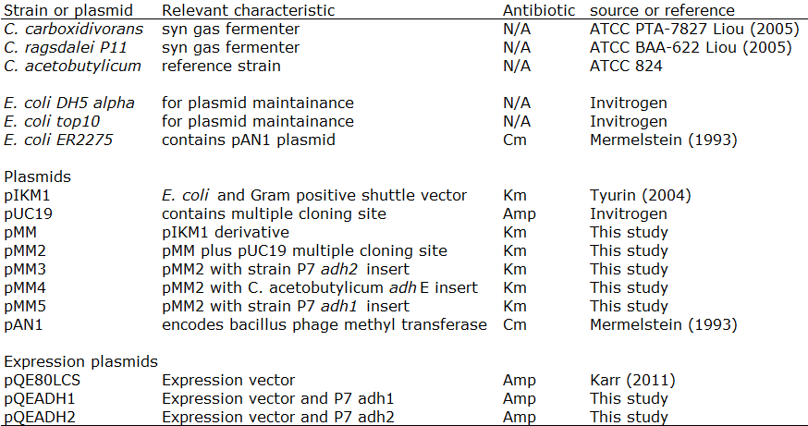
Km: kanamycin, Spec: spectinomycin, Cm: chloramphenicol, Amp: ampicillin

ADH expression in E. coli
Cell lines used for ADH expression assay were E. coli ^{pQEADH1} and E. coli ^{pQEADH2}. E. coli ^{pQE80LCS} was used as a non-insert plasmid control. The organisms were grown in separate 125 ml serum bottles containing anaerobic 2YTG medium with a headspace of N₂ @ 10 psi and incubated at 37 ºC until OD_{600nm} 0.4-0.6 was reached. Expression was induced by adding 0.25-0.5 mM of IPTG. Cultures were allowed to incubate at room temperature for 3-4 hours. Cells were pelleted (5 000 g, 10 min, 4 ºC) and resuspended in 5 mL TAPS buffer (5.0 mM N-tris(hydroxymethyl)methyl-3-aminopropanesulfonic acid, 10 mM MgCl₂•6H₂O and 2mM 2-mercaptoethanol; pH 8.5 with KOH) under strict anoxic conditions. Sub samples were taken for protein content (see below). Mechanical lysis was conducted with 0.1mm glass beads (RPI Research, Mount Prospect, IL) shaking in a Mini-Beadbeater-8 (BioSpec Products, Inc., Bartlesville, OK) at maximum speed (2,800 oscillations min⁻¹, with a displacement of 3.18 cm) for 30 s at room temperature. Enzymatic lysis was performed by treating cells with lysozyme for 1 h at 37 ºC. In order to reduce the effect of proteases on adh enzymes a complete set of samples were treated by adding 250 μl/pellet of protease inhibitor cocktail, part no P8465 (Sigma-Aldrich, St Louis, Mo) prior to cell samples lysis. To separate cellular debris from supernatant samples were pelleted at 10 000 g for 10 min, 4 ºC. Samples were used in assays as described below.
To measure the effect of strain P7’s adhE on anaerobic product formation in E. coli, triplicate Balch tubes containing 5 ml of anaerobic Davis minimal medium were inoculated with E. coli ^{pQEADH1}, E. coli ^{pQEADH2} and E. coli ^{pQE80LCS} and incubated at 37ºC for 24 hours. Every 30-40 minutes OD_{600nm} readings were taken using a Spectronic 20D (Thermo Scientific, Waltham, MA) and end-point samples were taken from stationary phase cultures for product formation analysis.

Alcohol dehydrogenase activity
Alcohol dehydrogenase assays on E. coli cells were conducted with whole cells, lysed cells or the supernatant portion of lysed cells. Enzyme activities were measured using the substrate-dependent reduction of methyl viologen (MV) in stoppered, sealed anaerobic tubes at 40 ºC with a headspace of 100% N₂ (Saxena & Tanner, 2011). Resuspended cells (300 μL) were added to an anaerobic tube containing TAPS buffer with 4mM MV and an alcohol (400 μL) to initiate each assay. Alcohols used were: methanol, ethanol, propanol, butanol and hexanol.
The reduction of MV was monitored over time as absorbance at 578 nm (extinction coefficient for MV e578. 9.78 cm⁻¹ mM⁻¹) (Champine & Goodwin, 1991) at 40 ºC using a Spectronic 20D (Thermo Scientific, Waltham, MA). One unit was defined as the quantity of enzyme that catalyzed the reduction of 2 mmol MV min-¹ (2 e- reduction) mg⁻¹ of protein. Protein content was measured using the bichinchoninic acid method (Smith et al., 1985) and a standard curve was generated using bovine serum albumin (NEB biolabs, Ipswich, Ma). Activities were normalized to protein content and noise was removed by subtracting the ADH activity observed in plasmid only no insert controls.

Product formation experiment
This experiment was conducted to measure the effect of plasmid containing adhE genes on strain P7. Strains used were strain P7 ^{pMM5} and strain P7 ^{pMM3} containing adhE1 and adhE2 respectively; strain P7 as a no-plasmid control and strain P7 ^{pMM2} as a plasmid no insert control.
Triplicate cultures of strain P7 ^{pMM5} and strain P7 ^{pMM3} were grown at 37ºC in 125 ml serum bottles with 25ml basal medium, background gas 10 psi CO₂: H₂ (80/20 mix), and fed CO at 30 psi. Cultures were supplemented with Km 5 µg/ml, where applicable, vented and sampled periodically (2-3 days) for OD and product formation analysis by removing 1 ml volumes. After sampling, the cultures were then re-pressurized to 30 psi using CO and maintained for 20 days, or until cell death was observed. Triplicate cultures of strains P7 and P7 ^{pMM2} were included and treated identically to experimental groups as no-plasmid and plasmid no insert controls, respectfully.

Analytical methods
Acid and alcohol concentrations were quantified by gas chromatography (GC) using the Shimadzu GC-8A (Shimadzu Scientific Instruments, Columbia, MD) equipped with a flame ionization detector (FID). Samples were injected into a glass column (2 m x 5 mm x 2.6 mm) packed with 4 percent Carbowax 20M TPA on Carbopack B 80/120 mesh (Supelco Analytical, Bellefonte, PA). The inlet and detector were both set at 200°C. Column temperature was held at 155°C for alcohols containing < 5 carbons and acids < 3 carbons in length. Column temperature was held at 185°C for >5 carbon alcohols and >3 carbon acids. Data was analyzed using a C-R8A Chromatopac Integrator (Shimadzu Scientific Instruments, Columbia, MD). Statistical analysis was performed using 2-tailed, unpaired student’s t -tests with Welsh correction as needed (GraphPad InStat, GraphPad Software).

Results

Expression of adhE1 and adhE2 in E. coli
An increase in adh activity was observed in E. coli cultures with cloned strain P7’s adhE1 and adhE2 genes. This implied that E. coli ^{pQEADH1} and E. coli ^{pQEADH2} were capable of assembling functional proteins. Furthermore, the expression of either protein had a positive effect on the growth of E. coli cultures when compared to controls containing only the plasmid (Table 4.2). The presence of either adhE1 or adhE2 genes enabled E. coli cells to grow significantly faster (doubling 0.496 and 0.397 h⁻¹, respectively) than cells containing the plasmid only (0.115 h⁻¹)(p < 0.05). Both adhE1 and adhE2 containing cells also attained a higher final cell mass (p < 0.05) than control cells (Table 4.2), but the differences in final OD between cell lines with adhE1 and adhE2 were not significant. When grown anaerobically, all E. coli strains produced acetate and ethanol after 24 hours of growth (Table 4.2). Strains containing cloned adhE1 and adhE2 (E. coli^{pQEADH1} and E. coli^{pQEADH2}) produced significantly higher (p <0.05) concentrations of acetate and ethanol than plasmid only controls: E. coli^{pQEADH1} produced 115% more ethanol and 54% more acetate, E. coli^{pQEADH2} produced 69% more ethanol and 33% more acetate.
In order to compare the enzymatic activity of adhE1 and adhE2, an alcohol dehydrogenase assay was performed on E. coli^{pQEADH1} and E. coli^{pQEADH2}. The greatest alcohol dehydrogenase activities were observed when whole cells were used in the assay. Mechanically or enzymatically lysed cells lost all measurable alcohol dehydrogenase activity with 30 minutes of lysis. Treatment of cell samples with protease inhibitor cocktail prior to lysing them resulted in no observed adh activity. Both ADH enzymes showed extreme sensitivity to oxygen, activity was drastically reduced in the presence of trace amounts of oxygen. Both products of the genes adhE1 and adhE2 displayed the expected alcohol dehydrogenase catalysis of ethanol and butanol. Both enzymes also demonstrated a wide range of substrate promiscuity by acting on methanol, propanol and hexanol (Fig. 4. 1). Although there were no significant quantitative differences in ethanol, propanol and hexanol dehydrogenase activity between both enzymes (p > 0.05), there were significant differences in their methanol and butanol dehydrogenase activities (p < 0.05).

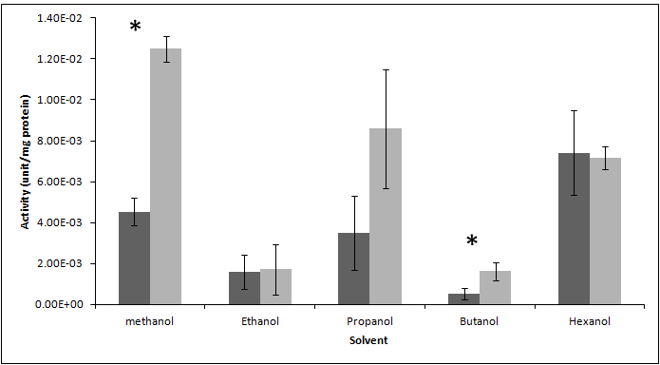
Figure. 4.1. Whole cell alcohol dehydrogenase activity of E. coli ^{pQEADH1} (dark) and E. coli ^{pQEADH2} (light). Error bars represent standard deviation (n = 3). Significantly different E. coli ^{pQEADH1} versus E. coli ^{pQEADH2} values noted by * (p<0.05).

Figure.4.2. Map of plasmid pMM2 showing location of key features. pUC19 Multiple cloning site 485 to 808; Ery: erythromycin resistance, 899 to 1633; Gram positive origin of replication, 2081 to 2521; Kan: kanamycin resistance, 3121 to 3914; Gram negative origin of replication ColEH1, 4006 to 4321; Amp: ampicillin resistance partial fragment , 4675 to 5091.

Gene duplication experiment
The strain P7 without a plasmid reached stationary phase within 48 hours and grew to a higher OD_{600nm} 1.98 than any of the plasmid-containing strains (Table 4.3 and Fig. 4.3). All the other strains took over 100 hours to reach stationary phase and reached OD_{600nm} of 1.3, 1.5, and 1.2, for plasmids pMM2, pMM3, and pMM5, respectively.
All clostridia strains showed the same product formation dynamics in that ethanol, acetate, and butanol were all detected as end products (Fig. 4.4). As is typical, acetate was the dominant product during exponential growth phase (Durre, 2005). Ethanol production started during exponential growth and persisted throughout stationary growth phase. The presence of butanol was only detected after cells had reached late exponential (OD_{600nm} of 1.0) or stationary phase.
As predicted, the addition of aldehyde alcohol dehydrogenases via plasmid-borne copies caused an increase in alcohol production in strain P7. The plasmid control strain (plasmid but no additional adhE) produced 21% more ethanol than strain P7 without a plasmid (no plasmid control). This, however, was not significantly different from strain P7^{pMM3}, which produced 10% more ethanol than the no plasmid control (p < 0.05). Strain P7^{pMM5} (containing additional adhE1) produced the most ethanol of all the strains and showed a 44% increase when compared to the no plasmid control (Table 4.3)(p < 0.01). Strain P7^{pMM3} (containing additional adhE2) produced the most butanol, 9.8 mM, a 20% increase in butanol production when compared to the no plasmid control (p < 0.05). Interestingly, strain P7^{pMM5} and the controls all produced the same amount of acetate while strain P7^{pMM3} had 28% less acetate. Increasing the amount of antibiotic selective pressure had no effect on the production of alcohols or growth. The greatest alcohol production was observed in recently transformed cell lines.

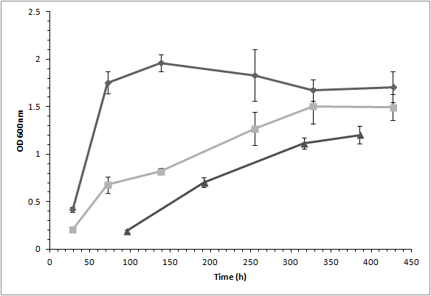

Figure. 4.3. Mean values for growth of strain P7 (diamond), strain P7^{pMM3}(squares) and strain P7^{pMM5} (triangles) overtime. Error bars represent standard deviation (n = 3).

A
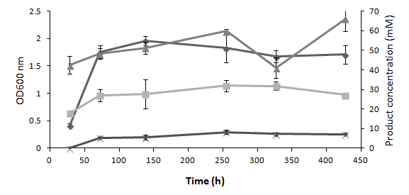
B
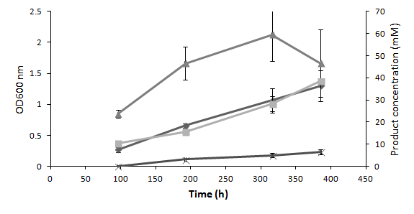

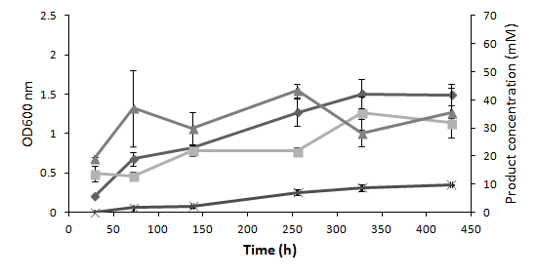
C
D
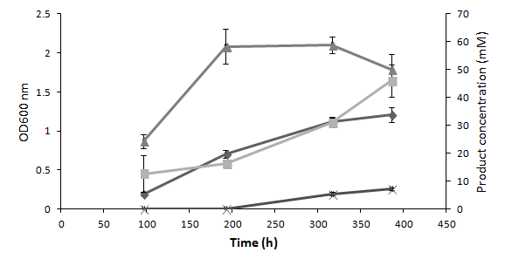

Figure. 4.4. Growth and product formation profiles of A) strain P7, B) strain P7^{pMM2}, C) strain P7^{pMM3}, D) strain P7^{pMM5}. OD600nm (diamond), ethanol (square), acetate (triangle) and butanol (x). Error bars represent standard deviation (n = 3).

Table 4.2: Product formation and growth of E. coli clones with adhE genes
 | Growth rate | OD600nm | Ethanol | Acetate
Plasmid | K (h-1) | 24 (h) | mM | mM
pQE80LCS | 0.115(0.02) | 0.45 (0.02) | 5.1(0.2) | 11.7 (0.03)
pQEADH1 | 0.496(0.01) | 0.63 (0.01) | 11.0 (2.9) | 18.0 (2.0)
pQEADH2 | 0.397(0.06) | 0.57 (0.1) | 8.6 (084) | 15.6(3.4)

Mean values shown (n=3), Standard deviation in parenthesis

Table 4.3: strain P7 and transformants product formation
Strain | Properties | max OD | Acetate | Ethanol | Butanol
P7 | wild type | 1.96 | 59.9(0.9) | 31.9 (2.9) | 8.2(1)
pMM2 | only plasmid | 1.3 | 59.4(11) | 38.5(1.16) | 6.48(1.0)
pMM3 | adh2 | 1.5 | 43.4(2.5) | 35.4 (5.8) | 9.8 (0.2)
pMM5 | adh1 | 1.2 | 58.9(3.1) | 46.0(5.8) | 7.29(0.48)

Maximum product observed (mM) Mean values shown (n=3) Standard deviation in parenthesis

Discussion
The Wood-Ljungdahl pathway is the primary solvent forming pathway in Clostridium carboxidivorans strain P7, and the rate limiting step of alcohol production is the terminal enzyme ADH (Saxena & Tanner, 2010). Increasing the copy number of this gene in C. acetobutylicum led to an increase in alcohol production (Green & Bennett, 1998). This study examined the effect of increasing adhE genes on alcohol production in C. carboxidivorans strain P7. Additionally, the hypothesis that the enzymes encoded by the two, tandem adhE genes (adhE1 and adhE2) found on the genome have different enzyme activities and therefore roles in the production of alcohol was tested.

In vitro properties of adhE genes
One aim of this study was to confirm the annotation of adhE1 and adhE2 and subsequently deduce their roles in strain P7 metabolism. Sequence identity reveals that both genes are members of group III bacterial alcohol dehydrogenases, a group of alcohol dehydrogenases which can be involved in a variety of pathways or be highly specific for one catabolic end product (Elleuche S & Antranikian G, 2013). Both ADHE1 and ADHE2 enzymes showed ethanol and butanol dehydrogenase activity (Fig. 4.1), catalytic steps in the Wood-Ljungdahl pathway and as such are expected reactions. However, ADHE1 and ADHE2 were also able to catalyze the substrates methanol, propanol and hexanol, substrates not found in Wood-Ljungdahl pathway. This broad promiscuity in activity seen with non-native substrates indicates these enzymes may participate in direct conversion of acids to alcohols (Isom, 2011; Perez et al., 2013), and indeed may participate in part or all of the end- product alcohol production by this organism (introduction pathways reactions 1 to 4)(Fig. 1.1). Despite sharing activity for the substrates tested, the differences in the rate of enzymatic reactions (Fig. 4.1) coupled with differences in expression (Ukpong et al., 2012) suggest specialization of the ADH enzymes and perhaps their functional divergence. The enzyme ADHE2 showed almost twice the butanol dehydrogenase activity of ADHE1 thus enabling a prediction that increasing the copies of the adhE2 gene is key to increasing strain P7 butanol production. This prediction was confirmed by the gene duplication experiments.

Expression in E. coli
Expression of adhE1 and adhE2 anaerobically in E. coli aided in closer examination of these enzymes outside their native organism. These genes cloned on the same expression vector system, with identical promoters, enabled the comparison of the enzyme properties independent of any expression regulatory mechanisms. Cloning foreign adhE genes into E. coli has been previously shown to increase ethanol production (Ingram et al., 1987), and are consistent with the results shown in this study (Table 4.2). Both adhE genes granted E. coli cells a clear physiological advantage compared to the plasmid only controls. An explanation of this observation is that the extra ADH enzymes increased the production of ethanol and recycling of the cofactor NAD+, allowing for the production of more acetate and ATP via substrate level phosphorylation. This would explain the increases in observed cell mass, growth rate and product formation (Table 4.2). Interestingly, a clear difference was observed between the effects of adhE1 and adhE2 in E .coli; E. coli ^{pQEADH1} cells grew significantly faster than those containing pQEADH2. This supports previous data (Ukpong et al., 2012) indicating that the two genes different in sequence and expression, and brings up the questions of ADH1 being a more efficient ethanol producer.

In vivo properties of adhE1 and adhE2: the effect of gene duplication
The Wood-Ljungdahl pathway used by strain P7 and other clostridia to produce alcohols is limited by the activity of the enzyme ADH (Saxena & Tanner, 2010). The expression of adhE2 increases over 100-fold during butanol production (Ukpong et al., 2012). By increasing the copy number of adhE genes within strain P7, both ethanol (adhE1) and butanol (adhE2) production increased by 44% and 20%, respectively. In vitro experiments demonstrated that adhE2 has a greater butanol dehydrogenase activity than adhE1 (Fig. 4.1). It is therefore likely that gene duplication of adhE2 could be used to direct the carbon flow towards the production of the more desirable biofuel butanol.
Transformed cells grew to a lower final density than no-plasmid controls (Table 4.3), indicating a physiological burden for carrying the plasmid. Despite the reduction in cell mass, all strains containing plasmid-borne ADH genes had higher ethanol yields than the no-plasmid controls (Table 4.3) in both ethanol per gram of cell or total ethanol produced per liter. Achieving higher cell mass in strain P7^{pMM3} and strain P7^{pMM5} may result in even higher yields. Future experiments on C. carboxidivorans strain P7^{pMM3} and strain P7^{pMM5} can focus on growth medium optimization to increase cell mass or/and the increase in the metal supplements zinc and iron which act as co factors for ADH enzymes.

Implications and applications of different ADH
Several studies have explored the effect of gene deletion on solvent production in clostridia (Leang et al., 2013; Shaw et al., 2008; Tripathi et al., 2010). An increased amount of solvent production was achieved by deleting genes encoding for competing pathways. The data in this study demonstrates that increased solvent production can also be achieved through the duplication of the adhE genes, this agrees with the results of other work (Kopke et al., 2010; Mermelstein et al., 1992; Sullivan et al., 2008). This data also demonstrates the choice of duplication of adhE1 or adhE2 impacts end product formation, i.e. ethanol or butanol. To the best of the authors’ knowledge this observation has not been made elsewhere.
Based on the data from this paper and the strains produced herein, further studies can be done. The adh gene is involved in direct acids to alcohol conversion (Fig. 1.1), it would be interesting to observe how effectively clostridia strain P7^{pMM3} and strain P7^{pMM5} perform direct acids to alcohol conversion and compared those results to the wild type (Isom, 2011; Perez et al., 2013). Other research is being done on the cloning of solvent forming genes from difficult to handle organisms such as clostridia into more malleable bacteria such as E. coli (Mattam & Yazdani, 2013; Tashiro et al., 2013). The results of this study show that such work can be improved by the careful selection of which adh is cloning.

Acknowledgements
This work was partially funded by Oklahoma NSF EPSCoR Grant No EPS-0814361.
Special thanks to Dr. Elizabeth Karr (Karr, 2011) for material support and advice.

References
Ahmed, A., Cateni, B. G., Huhnke, R. L. & Lewis, R. S. (2006). Effects of biomass-generated producer gas constituents on cell growth, product distribution and hydrogenase activity of Clostridium carboxidivorans P7T. Biomass and Bioenergy 30, 665-672.

Ahmed, A. & Lewis, R. S. (2007). Fermentation of biomass-generated synthesis gas: effects of nitric oxide. Biotechnol Bioeng 97, 1080-1086.

Balch, W. E. & Wolfe, R. S. (1976). New approach to cultivation of methanogenic bacteria - 2-mercaptoethanesulfonic acid (hs-com)-dependent growth of Methanobacterium ruminantium in a pressurized atmosphere. Applied and Environmental Microbiology 32, 781-791.

Bengelsdorf, F. R., Straub, M. & Durre, P. (2013). Bacterial synthesis gas (syngas) fermentation. Environ Technol 34, 1639-1651.

Bruant, G., Levesque, M. J., Peter, C., Guiot, S. R. & Masson, L. (2010). Genomic analysis of carbon monoxide utilization and butanol production by Clostridium carboxidivorans strain P7. Plos One 5, e13033.

Carlton, B. C. & Brown, B. J. (1981). Gene mutation. In Manual of methods for general bacteriology, pp. 222-242. Edited by G. P. Washington, D.C.: American Society for Microbiology.

Champine, J. E. & Goodwin, S. (1991). Acetate catabolism in the dissimilatory iron-reducing isolate GS-15. J Bacteriol 173, 2704-2706.

Cui, G. Z., Hong, W., Zhang, J., Li, W. L., Feng, Y., Liu, Y. J. & Cui, Q. (2012). Targeted gene engineering in Clostridium cellulolyticum H10 without methylation. J Microbiol Methods 89, 201-208.

Durre, P. (2005). Handbook on clostridia. Boca Raton, Fla.: Taylor & Francis.

Elleuche S & Antranikian G (2013).Bacterial group III alcohol dehydrogenases–function, evolution and biotechnological applications. In OA alcohol: OA Publishing London.

Fontaine, L., Meynial-Salles, I., Girbal, L., Yang, X., Croux, C. & Soucaille, P. (2002). Molecular characterization and transcriptional analysis of adhE2, the gene encoding the NADH-dependent aldehyde/alcohol dehydrogenase responsible for butanol production in alcohologenic cultures of Clostridium acetobutylicum ATCC 824. J Bacteriol 184, 821-830.

Gibson, D. G., Young, L., Chuang, R. Y., Venter, J. C., Hutchison, C. A., 3rd & Smith, H. O. (2009). Enzymatic assembly of DNA molecules up to several hundred kilobases. Nat Methods 6, 343-345.

Green, E. M. & Bennett, G. N. (1998). Genetic manipulation of acid and solvent formation in clostridium acetobutylicum ATCC 824. Biotechnol Bioeng 58, 215-221.

Ingram, L. O., Conway, T., Clark, D. P., Sewell, G. W. & Preston, J. F. (1987). Genetic engineering of ethanol production in Escherichia coli. Appl Environ Microbiol 53, 2420-2425.

Isom, C. E. N., Mark A. Tanner, Ralph S. (2011).Reduction of acids to alcohols by novel solventogenic acetogens. In 111th General Meeting of the American Society for Microbiology. New Orleans, La, U.S.A.

Jones, D. T. & Woods, D. R. (1986). Acetone-butanol fermentation revisited. Microbiol Rev 50, 484-524.

Karr, E. A. (2011).

Kopke, M., Held, C., Hujer, S. & other authors (2010). Clostridium ljungdahlii represents a microbial production platform based on syngas. Proc Natl Acad Sci U S A 107, 13087-13092.

Kopke, M., Mihalcea, C., Bromley, J. C. & Simpson, S. D. (2011a). Fermentative production of ethanol from carbon monoxide. Curr Opin Biotechnol 22, 320-325.

Kopke, M., Mihalcea, C., Bromley, J. C. & Simpson, S. D. (2011b). Fermentative production of ethanol from carbon monoxide. Curr Opin Biotechnol 22, 320-325.

Lawson, P. A., Gharbia, S. E., Shah, H. N. & Clark, D. R. (1989). Recognition of Fusobacterium nucleatum subgroups Fn-1, Fn-2 and Fn-3 by ribosomal RNA gene restriction patterns. FEMS Microbiol Lett 53, 41-45.

Leang, C., Ueki, T., Nevin, K. P. & Lovley, D. R. (2013). A genetic system for Clostridium ljungdahlii: a chassis for autotrophic production of biocommodities and a model homoacetogen. Appl Environ Microbiol 79, 1102-1109.

Liew, F. M., Köpke, M. & Simpson, S. D. (2013).Gas Fermentation for Commercial Biofuels Production. In Liquid, Gaseous and Solid Biofuels - Conversion Techniques. Edited by F. Zhen: InTech.

Liou, J. S., Balkwill, D. L., Drake, G. R. & Tanner, R. S. (2005). Clostridium carboxidivorans sp. nov., a solvent-producing clostridium isolated from an agricultural settling lagoon, and reclassification of the acetogen Clostridium scatologenes strain SL1 as Clostridium drakei sp. nov. International journal of systematic and evolutionary microbiology 55, 2085-2091.

Mattam, A. J. & Yazdani, S. S. (2013). Engineering E. coli strain for conversion of short chain fatty acids to bioalcohols. Biotechnol Biofuels 6, 128.

Mermelstein, L. D., Welker, N. E., Bennett, G. N. & Papoutsakis, E. T. (1992). Expression of cloned homologous fermentative genes in Clostridium acetobutylicum ATCC 824. Bio/technology 10, 190-195.

Perez, J. M., Richter, H., Loftus, S. E. & Angenent, L. T. (2013). Biocatalytic reduction of short-chain carboxylic acids into their corresponding alcohols with syngas fermentation. Biotechnol Bioeng 110, 1066-1077.

Pyne, M. E., Moo-Young, M., Chung, D. A. & Chou, C. P. (2013). Development of an electrotransformation protocol for genetic manipulation of Clostridium pasteurianum. Biotechnol Biofuels 6, 50.

Rodrigue, J. P., Comtois, C. & Slack, B. (2013). The Geography of Transport Systems. Routledge.

Saxena, J. & Tanner, R. S. (2008). Production of Hexanol and Hexanoic Acid by the Acetogen Clostridium carboxidivorans Strain P7(T). Abstracts of the General Meeting of the American Society for Microbiology 108, 320-320.

Saxena, J. & Tanner, R. S. (2010). Effect of trace metals on ethanol production from synthesis gas by the ethanologenic acetogen, Clostridium ragsdalei. Journal of Industrial Microbial Biotechnology.

Saxena, J. & Tanner, R. S. (2011). Effect of trace metals on ethanol production from synthesis gas by the ethanologenic acetogen, Clostridium ragsdalei. Journal of Industrial Microbiology & Biotechnology 38, 513-521.

Shaw, A. J., Podkaminer, K. K., Desai, S. G., Bardsley, J. S., Rogers, S. R., Thorne, P. G., Hogsett, D. A. & Lynd, L. R. (2008). Metabolic engineering of a thermophilic bacterium to produce ethanol at high yield. Proc Natl Acad Sci U S A 105, 13769-13774.

Smith, P. K., Krohn, R. I., Hermanson, G. T. & other authors (1985). Measurement of protein using bicinchoninic acid. Analytical Biochemistry 150, 76-85.

Sullivan, L., Scotcher, M. C. & Bennett, G. N. (2008). Increased Biofuel Production by Metabolic Engineering of Clostridium acetobutylicum. In Bioenergy, pp. 361-376. Edited by J. D. Wall, C. S. Harwood & A. Demain: Amer Soc Microbiology, 1752 N Street Nw, Washington, Dc 20036-2904 USA.

Tanner, R. S. (2007). Cultivation of bacteria and fungi. In Manual of Environmental Microbiology, pp. 69-78. Edited by R. L. C. C. J. Hurst, A. L. Mills, J. L. Garland, L. D. Stetzenbach, and D. A. Lipson. Washington DC. Washington DC: American Society for Microbiology.

Tashiro, Y., Yoshida, T., Noguchi, T. & Sonomoto, K. (2013). Recent advances and future prospects for increased butanol production by acetone-butanol-ethanol fermentation. Engineering in Life Sciences 13, 432-445.

Tripathi, S. A., Olson, D. G., Argyros, D. A. & other authors (2010). Development of pyrF-Based Genetic System for Targeted Gene Deletion in Clostridium thermocellum and Creation of a pta Mutant. Applied and Environmental Microbiology 76, 6591-6599.

Ukpong, M. N., Atiyeh, H. K., De Lorme, M. J., Liu, K., Zhu, X., Tanner, R. S., Wilkins, M. R. & Stevenson, B. S. (2012). Physiological response of Clostridium carboxidivorans during conversion of synthesis gas to solvents in a gas-fed bioreactor. Biotechnol Bioeng 109, 2720-2728.

Summary and Future Directions: What next?

Summary of work and key implications
The work presented in Chapter 2 presents a blueprint for behavior of Clostridium carboxidivorans strain P7 in a bioreactor setting under syngas fermentation and alcohol producing conditions and has aided in the shaping of other studies (Liu et al., 2014a; Liu et al., 2014b; Ramachandriya et al., 2013). It is one of few studies that have investigated RNA expression in syngas fermenting bacteria (Kopke et al., 2011; Tan et al., 2013). More gene expression surveys, especially those using technologies like RNAseq (Tan et al., 2013; Wang et al., 2009) should lead to the identification of other key enzymes for biofuel production like the tandem adh genes discussed here.
The genetic system developed in Chapter 3 for manipulation of strain P7 and P11 genomes was essential for the genetic engineering of these organisms. The basic task of developing a genetic system was time consuming and challenging (Dower et al., 1992) because the interactions between an organism and foreign DNA cannot be easily predicted. In Escherichia coli, the most studied bacterium, up to 30% of its genome has unknown functions (Markowitz et al., 2010). Predicting interactions with foreign DNA is even more difficult with relatively much more novel species such as strain P7 whose genome has only recently been published (Hemme et al., 2010). Prior to this work the genome of strain P7 had not been manipulated for the increasing of alcohol production. The liquid recovery approach used in Chapter 3 may be the key to manipulating other recalcitrant bacteria.
Gene duplication studies discussed in Chapter 4 were an application of the genetic system developed for strain P7 and other organisms. Addition of adh genes showed a direct way to enhance solvent production of strain P7 and present a way of controlling carbon flow. Prior to this work, no other study has investigated the characteristics of tandem adh genes.

Future directions

Medium and Strain optimization
Manipulation of medium components is a common way to optimize solvent production. Limitation of nutrients such as sulfate and phosphate for C. acetobutylicum, can enhance solvent production (Jones & Woods, 1986). Ethanol production by Acetobacterium woodii was stimulated by phosphate limitation (Buschhorn et al., 1989). The optimization of trace metals in medium used by strain P11 has increased its’ ethanol production (Saxena & Tanner, 2011). Manipulation of medium components and adaptation through sub cultivation has increased strain P7 alcohol production (Torres & Tanner, 2012). Similar experiments with manipulation of medium and growth conditions can be performed on plasmid modified strain P7 cells; optimization could result in a significant increase in solvent production.
Currently, the plasmid containing strains of C. carboxidivorans strain P7 require selective pressure (the drug kanamycin) to prevent loss of plasmid. The use of antibiotics in growth media is expensive and impractical on a large scale, furthermore, even resistant strains can exhibit suboptimal growth in the presence of antibiotics (as seen in Chapter 4). A natural progression of this work would be to make the gene duplication permanent and thus remove the need for antibiotic pressure. To do so homologous recombination can be used to move genes encoded on a plasmid to locations on its chromosome (Vos & Didelot, 2009) making the gene duplication effect permanent.

Acids to alcohols
Industrial and sewage waste streams often contain volatile fatty acids such as butyric acid, propionic acid and hexanoic acid as their end products (Parawira et al., 2004). The corresponding alcohols of these compounds (butanol, propanol and hexanol) are of great industrial value. Acetogens and other bacteria are garnering interest because of their ability to directly convert acids into alcohols. This capability has been studied in E. coli (Mattam & Yazdani, 2013) and in syngas fermenting organisms including strain P7 (Isom et al., 2011; Liu et al., 2014b; Perez et al., 2013). Strain P7 with plasmids containing adh can be screened for their ability to convert acids to alcohols. Based on the increased alcohol production seen in the plasmid containing P7 strains, and the role of adh in the acids to alcohols pathway (Fig 1.1), it can be hypothesized that strains with more copies of adh will be more efficient at acid to alcohol conversion. Furthermore, the ADHE1 and ADHE2 of strain P7 demonstrate different activities for a wide range of alcoholic substrates (Chapter 4). Therefore, it can be expected that the impact of gene duplication on direct conversion would change based on choice of adh duplicated.

Genetic system and metabolic engineering
Despite optimizing the genetic system of strain P7’s (Chapter 3) a low transformation efficiency of 2.5 *10² CFU/µg of DNA was achieved. This is 3 orders of magnitude less than the maximum observed with the parent plasmid pIKM1 in Clostridium thermocellum (2.2*10⁵ CFU/µg of DNA)(Tyurin et al., 2004). Needless to say, there is plenty of room for improvement with regard to transformation efficiency. Methods to improve transformation efficiency such as weakening cell walls with isonaicin, glycine or threonine have not been fully explored (Dower et al., 1992; Tyurin et al., 2004). A bolder approach would be to use our current genetic system (Chapter 3) in the creation of a strain P7 that contains a pyrF deletion mutation. Mutant strains with delected pyrF gnees are uracil auxotrophs and do not require antibiotics for selection (Yamagishi et al., 1996). Therefore, PyrF mutants can be more suitable for metabolic engineering (Sato et al., 2005; Schneider et al., 2005; Tripathi et al., 2010).
There are tremendous advantages to continuing the metabolic engineering of strain P7. Chapter 4 shows how metabolic engineering can increase ethanol and butanol production. With six possible end products from syngas fermentation (acetate, ethanol, butyrate, butanol, hexanoate and hexanol) derived from different branches of the Wood-Ljungdahl pathway (Fig 1.1) there may be significant intracellular competition for carbon flow. Eliminating competing pathways using the genetic system of strain P7 (Chapter 3) could produce strains specialized in the production of a narrower range of products. An increase in acid production was achieved by deleting the adh genes in Clostridium ljungdahlii (Leang et al., 2013). Alcohol production was increased in this strain by deleting acetate kinase and competing genes that regulate the production of acids (Jang et al., 2012). Scale up studies of Clostridium mutants show an increase in alcohol production (Berzin et al., 2012; Berzin et al., 2013).
Whether such improvements are made via gene duplication or gene deletion, metabolic engineering of the versatile organism Clostridium carboxidivorans strain P7 presents fascinating avenues for future research.

References
Berzin, V., Kiriukhin, M. & Tyurin, M. (2012). Elimination of Acetate Production to Improve Ethanol Yield During Continuous Synthesis Gas Fermentation by Engineered Biocatalyst Clostridium sp MTEtOH550. Applied Biochemistry and Biotechnology 167, 338-347.

Berzin, V., Tyurin, M. & Kiriukhin, M. (2013). Selective n-Butanol Production by Clostridium sp MTButOH1365 During Continuous Synthesis Gas Fermentation Due to Expression of Synthetic Thiolase, 3-Hydroxy Butyryl-CoA Dehydrogenase, Crotonase, Butyryl-CoA Dehydrogenase, Butyraldehyde Dehydrogenase, and NAD-Dependent Butanol Dehydrogenase. Applied Biochemistry and Biotechnology 169, 950-959.

Buschhorn, H., Durre, P. & Gottschalk, G. (1989). PRODUCTION AND UTILIZATION OF ETHANOL BY THE HOMOACETOGEN ACETOBACTERIUM-WOODII. Applied and Environmental Microbiology 55, 1835-1840.

Dower, W. J., Chassy, B. M., Trevors, J. T. & Blaschek, H. P. (1992). PROTOCOLS FOR THE TRANSFORMATION OF BACTERIA BY ELECTROPORATION. Chang, D C, Et Al (Ed) Guide to Electroporation and Electrofusion X+581p Academic Press, Inc: San Diego, California, USA; London, England, Uk Illus, 485-499.

Hemme, C. L., Mouttaki, H., Lee, Y. J. & other authors (2010). Sequencing of multiple clostridial genomes related to biomass conversion and biofuel production. Journal of Bacteriology 192, 6494-6496.

Isom, C. E., Nanny, M. A. & Tanner, R. S. (2011).Reduction of acids to alcohols by novel solventogenic acetogens. In Abst Ann Meet Am Soc Microbiol, Q-1358.

Jang, Y. S., Lee, J. Y., Lee, J. & other authors (2012). Enhanced Butanol Production Obtained by Reinforcing the Direct Butanol-Forming Route in Clostridium acetobutylicum. Mbio 3, 9.

Jones, D. T. & Woods, D. R. (1986). Acetone-butanol fermentation revisited. Microbiol Rev 50, 484-524.

Kopke, M., Mihalcea, C., Liew, F., Tizard, J. H., Ali, M. S., Conolly, J. J., Al-Sinawi, B. & Simpson, S. D. (2011). 2,3-butanediol production by acetogenic bacteria, an alternative route to chemical synthesis, using industrial waste gas. Appl Environ Microbiol 77, 5467-5475.

Leang, C., Ueki, T., Nevin, K. P. & Lovley, D. R. (2013). A genetic system for Clostridium ljungdahlii: a chassis for autotrophic production of biocommodities and a model homoacetogen. Appl Environ Microbiol 79, 1102-1109.

Liu, K., Atiyeh, H. K., Stevenson, B. S., Tanner, R. S., Wilkins, M. R. & Huhnke, R. L. (2014a). Continuous syngas fermentation for the production of ethanol, n-propanol and n-butanol. Bioresource Technology 151, 69-77.

Liu, K., Atiyeh, H. K., Stevenson, B. S., Tanner, R. S., Wilkins, M. R. & Huhnke, R. L. (2014b). Mixed culture syngas fermentation and conversion of carboxylic acids into alcohols. Bioresource Technology 152, 337-346.

Markowitz, V. M., Chen, I. M. A., Palaniappan, K. & other authors (2010). The integrated microbial genomes system: an expanding comparative analysis resource. Nucleic Acids Research 38, D382-D390.

Mattam, A. J. & Yazdani, S. S. (2013). Engineering E. coli strain for conversion of short chain fatty acids to bioalcohols. Biotechnol Biofuels 6, 128.

Parawira, W., Murto, M., Read, J. S. & Mattiasson, B. (2004). Volatile fatty acid production during anaerobic mesophilic digestion of solid potato waste. Journal of Chemical Technology and Biotechnology 79, 673-677.

Perez, J. M., Richter, H., Loftus, S. E. & Angenent, L. T. (2013). Biocatalytic reduction of short-chain carboxylic acids into their corresponding alcohols with syngas fermentation. Biotechnol Bioeng 110, 1066-1077.

Ramachandriya, K. D., Kundiyana, D. K., Wilkins, M. R., Terrill, J. B., Atiyeh, H. K. & Huhnke, R. L. (2013). Carbon dioxide conversion to fuels and chemicals using a hybrid green process. Applied Energy 112, 289-299.

Sato, T., Fukui, T., Atomi, H. & Imanaka, T. (2005). Improved and versatile transformation system allowing multiple genetic manipulations of the hyperthermophilic archaeon Thermococcus kodakaraensis. Applied and Environmental Microbiology 71, 3889-3899.

Saxena, J. & Tanner, R. S. (2011). Effect of trace metals on ethanol production from synthesis gas by the ethanologenic acetogen, Clostridium ragsdalei. Journal of Industrial Microbial Biotechnology 38, 513-521.

Schneider, J. C., Jenings, A. F., Mun, D. M., McGovern, P. M. & Chew, L. C. (2005). Auxotrophic markers pyrF and proC can replace antibiotic markers on protein production plasmids in high-cell-density Pseudomonas fluorescens fermentation. Biotechnology Progress 21, 343-348.

Tan, Y., Liu, J. J., Chen, X. H., Zheng, H. J. & Li, F. L. (2013). RNA-seq-based comparative transcriptome analysis of the syngas-utilizing bacterium Clostridium ljungdahlii DSM 13528 grown autotrophically and heterotrophically. Molecular Biosystems 9, 2775-2784.

Torres, J. T. & Tanner, R. S. (2012).Syngas to butanol. In Abst Ann Meet Am Soc Microbiol, Q984.

Tripathi, S. A., Olson, D. G., Argyros, D. A. & other authors (2010). Development of pyrF-based genetic system for targeted gene deletion in Clostridium thermocellum and creation of a pta mutant. Appl Environ Microbiol 76, 6591-6599.

Tyurin, M. V., Desai, S. G. & Lynd, L. R. (2004). Electrotransformation of Clostridium thermocellum. Applied and Environmental Microbiology 70, 883-890.

Vos, M. & Didelot, X. (2009). A comparison of homologous recombination rates in bacteria and archaea. Isme Journal 3, 199-208.

Wang, Z., Gerstein, M. & Snyder, M. (2009). RNA-Seq: a revolutionary tool for transcriptomics. Nature Reviews Genetics 10, 57-63.

Yamagishi, A., Tanimoto, T., Suzuki, T. & Oshima, T. (1996). Pyrimidine biosynthesis genes (pyrE and pyrF) of an extreme thermophile, Thermus thermophilus. Applied and Environmental Microbiology 62, 2191-2194.

Appendix A: A Novel Pseudomonas putida Strain Demonstrates High Levels of Ciprofloxacin Tolerance Due to Multiple Resistance Mechanisms

Abstract
The prevalence of antibiotic resistance amongst clinical bacterial populations is of great concern because of the corresponding lose of drug effectiveness being observed. This problem is growing as bacteria exchange their resistances amongst themselves.
One approach to counteracting increased drug resistance is to identify potential mechanisms of resistance in genetic reservoirs prior to their transfer to pathogens.
As part of a wider screen for ciprofloxacin resistant organisms, a novel bacterium Pseudomonas putida strain ML was isolated from a sewage treatment plant. Strain ML demonstrated a higher resistance to ciprofloxacin than any reported so far in the literature (>4000 µg/ml). Further characterization of strain ML showed that it was resistant to a wide range of drugs belonging to different antibiotic classes and targeting a range of cellular processes.
It was hypothesized the high resistances observed in strain ML were due to the presence of multiple mechanisms of resistance and/or a completely novel mechanism.
Genomic analysis shows the genes for several multidrug resistant transport proteins (efflux pumps). A random transposon mutation screen was performed and produced several ciprofloxacin susceptible mutants. Two mutants were deficient in separate efflux pump systems and one mutant was identified as having a deleted rare lipoprotein B (rplB) gene. The gene product of rplB has never before been associated with ciprofloxacin (or any other quinolone) resistance and thus presents a possible target for future drug development.

Introduction
Antibiotics have been a crucial component of modern medical science since the 1940s. Soon after the advent of antibiotics, resistance to such drugs began to be observed in bacterial populations. This is an ongoing and growing problem in clinical settings with various drugs becoming less effective overtime (Hernández et al., 2011). Most original antibiotics were natural compounds and often natural immunities were transferred from environmental populations to pathogens via horizontal gene transfer (HGT)(Cetinkaya et al., 2000). Artificial antibiotics such as the fluoroquinolones had the advantage of not having natural analogs and thus resistances to them were not expected to be developed via HGT. However, resistances to fluoroquinolones and other classes of drugs resulting from gene transfer have been seen amongst pathogens (Hata et al., 2005; Horodniceanu et al., 1979; Jacoby et al., 2006; Svara & Rankin, 2011). Resistances are often transferred from “genetic reservoirs” natural or clinical settings to pathogens. Screening such sources for existing resistances enable us to anticipate future adaptations in pathogenic bacteria populations and may discover modifications of known or novel mechanisms of resistance. As part of a wider screen for ciprofloxacin resistant microorganisms, a novel isolate Pseudomonas putida strain ML (Fig. S1) was isolated from an anaerobic sludge digestor in Norman Oklahoma.
Members of the genus Pseudomonas are particularly diverse in their physiological traits and demonstrate a resilience to numerous toxic compounds (Canovas et al., 2003) and stressors including antibiotics (Kumita et al., 2009a; Tomas et al., 2010). What is surprising is the extraordinarily high levels of resistance to ciprofloxacin that is observed in strain ML (>4000 µg/ml) when compared to other bacteria (Alonso & Martinez, 2001; Kumita et al., 2009a; Wang & Schaffner, 2011).
The literature contains several well described mechanisms of resistance to antibiotics (Hernández et al., 2011). The possession and expression of efflux pumps by bacteria is a common mechanism of resistance to all classes of antibiotics (Chang et al., 2003; Francesco et al., 2011; Li & Nikaido, 2009; Magnet et al., 2001; Ribera et al., 2002). These membrane transport pumps increase bacterial tolerance for antibiotics by exporting them from the cell, thereby reducing internal concentrations to sub-toxic levels. Some bacteria use changes in their membrane permeability to limit the ability of antibiotics to enter their cells (Krivets et al., 1987). Finally, pentapeptide repeat proteins (PRPs) have been shown to bind to DNA gyrase and thus protect them from the actions of quinolones (Hernández et al., 2011).
Several mechanisms for resistance to the fluoroquinolones like ciprofloxacin are well known. The target of this class of antibiotics is DNA gyrase (gryA and gryB) and topoisomerase IV (parC and parE), two major enzymes involved in DNA replication (Wolfson & Hooper, 1985). DNA gyrase and topoisomerase IV create double stranded breaks in DNA structure for the DNA helix to pass through thereby relieving stress during DNA replication (Froelich-Ammon & Osheroff, 1995). Inhibition of these enzymes kills bacterial cells by preventing genome replication. Mutations in a certain region of the target enzymes has been found to confer quinolone resistance and is referred to as the quinolone resistance determining regions (QRDR)(Hernández et al., 2011; Kumita et al., 2009a). Lastly, low levels of resistance to antibiotics have been attributed to bacterial ability to use antibiotics as a carbon and energy source (Dantas et al., 2008). However, this could be a survival mechanism in the absence of other carbon substrates as opposed to a continuously active mechanism of resistance.
There is also the possibility that novel mechanisms to counteract ciprofloxacin toxicity to bacteria remain undiscovered. The high resistance of strain ML to Ciprofloxacin in particular and the widespread antibiotic resistances of strain ML, lend themselves to the hypothesis that several mechanisms cooperate within this one organism. This study investigated this hypothesis and constructs a model of this organism’s resistance abilities (FigS2).

Methods and Materials

Bacterial Strains and Culture Conditions
E. coli (DSMZ 1103), Pseudomonas aeruginosa (DSMZ 1117), Pseudomonas putida type strain (DSMZ 291) and Pseudomonas putida F1 (DSMZ 6899) cultures were maintained in Luria-Bertani (LB) liquid and solid media. P. putida strain ML cultures were grown in LB liquid and on solid media with 50 μg/mL ciprofloxacin (cip), unless stated otherwise. P. putida strain ML transposon mutant cultures were grown in LB liquid and on solid media with 50 μg/mL kanamycin.

Drug Resistance Studies
The initial range of strain ML resistance was determined by growth in triplicate LB broth cultures (5 ml) supplemented with 0, 5, 50, 100, 400, 1000, 2000 and 4000 μg/mL ciprofloxacin. Cultures were grown at 30°C and 37°C , shaking at 250 rpm and were checked for growth using a Spectrophotometer 20D+ (Thermo Scientific, Waltham, Ma) after 24 and 48 hours. A more in depth screen on liquid medium was performed on the following bacterial strains, P. putida type strain, strain ML, E. coli, P. aeruginosa, 20G2, 19B1 and 15E8. Six replicate cultures were grown in 200 μl LB broth supplemented with 0, 25, 50, 100, 500 or 1000 μg/mL ciprofloxacin, erythromycin, ampicillin, thiamphenicol, kanamycin, spectinomycin gentamycin, and chloramphenicol. These cultures were incubated at 30 °C shaking at 250 rpm for 24 hours. Final OD_{600nm} was measured using a 96 well plate reader.
The antibiotic resistance of strains ML, 20G2, 19B1 and 15e8 on solid medium was determined using triplicate Kirby-Bauer assays under standard conditions according to the Clinical Laboratory Standards Institute protocol (Institute, 2009) with the antibiotics listed in table S1. E. coli, P. putida type strain, and P. aeruginosa were used as controls.

Single Carbon Source
Strain ML was grown on single carbon source broth (SCS, per liter: 5 g ammonium sulfate, 3 g potassium phosphate, monobasic, 0.5 g hydrated magnesium sulfate, 15 mg EDTA (tetrasodium), 4.5 mg hydrated zinc sulfate, 4.5 mg calcium chloride, 3 mg hydrated iron(II) sulfate, 1 mg hydrated manganese (II) chloride, 1 mg boric acid, 0.4 mg hydrated sodium molybdate, 0.4 mg hydrated copper (II) sulfate, 0.4 mg hydrated cobalt (II) chloride, and 0.1 mg potassium iodide (Dantas et al., 2008) supplemented as follows: no carbon source, 40 mM glucose, 400 μg/ml cip 1000 μg/ml cip, and 40mM glucose + 400 μg/ml cip. Cultures were incubated at 30 ºC for 21 days and shaken at 225 rpm with growth measured at OD_{600nm}. Six replicates of 5ml SCS medium with 40 mM glucose were inoculated with an overnight culture of P. putida strain ML (1:100) with and without ciprofloxacin. Growth was monitored by optical density with a Spectrophotometer 20D+ (Thermo Scientific, Waltham, Ma), at a wavelength of 600 nm. Growth rates for all six replicates were determined and averaged. Separate strain ML cultures were grown 24h in LB broth with and without 400 μg/ml cip in triplicate. After 24h of growth, 1ml volume samples were taken, washed in 1ml of phosphate buffered saline (5 000 g, 10 min, 25 ºC), serial ten-fold diluted and spread on LB plates to determine CFU/ml. Whenever applicable two-tailed T-tests with equal variance assumed were performed.

Transposon mutation
Random mutations of strain ML were generated using the EZ-TN5 transposome insertion kit in order to identify genes essential for ciprofloxacin resistance. To do this cells were prepared and treated as described in manufacturers protocol for Pseudomonas aeroginosa (Dennis & Sokol, 1995). Prior to delivery of electrical pulse 10 μg of type one restriction inhibitor (TY0261H) (Epicentre, Madison Wi) and 1μl volume of EZ-TN5 transposome mix (TSM08KR) (Epicentre, Madison Wi) was added to electrocompetent cells. Electrotransformation was performed using a Biorad gene Pulser Xcell electroporation system to deliver an exponential decay pulse of 2.5 kV to a 2 mm cuvette. Transformants were selected on LB ^{kan 50 μg/ml} plates. Colonies were counter selected for inability to grow on LB ^{cip400 μg/ml} medium. Susceptibility in mutants was defined as the lack of formation of colonies 48 h after transfer onto LB agar medium with cip 400 μg/ml.
Transposon mutations in strains 20G2, 19B1, and 15E8 were identified using inverted PCR of circular ligated fragments. Whole genomic DNA was extracted using phenol chloroform extraction (Lawson et al., 1989). Restriction digestion was performed on DNA using PstI and BamHI (NEB biolabs, Ipswich, Ma) followed by self-ligation using T4 DNA ligase (Promega, Madison, Wi). Ligated DNA was amplified using PCR and EZ-TN5 kit primers then Sanger sequenced to identify deleted genes. PCR using inward facing primers was used to confirm insertion of transposons in mutant genomes.
Genomic Analysis
P. putida strain ML cultures were grown overnight to stationary phase and DNA was extracted using MO BIO PowerBiofilm DNA Isolation Kit following manufacturer’s instructions (Carlsbad, CA). The purity of gDNA was confirmed using a NanoPhotometer (Implen, West Lake Village, CA) and submitted to the Oklahoma Medical Research Foundation (OMRF) to be sequenced on an Illumina MiSeq using TruSeq LT 2 x 250 bp chemistry (Illumina, San Diego, CA). Reads were assembled using the CLC Genomics Workbench suite de novo assembly algorithm (CLC Bio, Cambridge, MA). Contigs smaller than 800 bp were discarded. After assembly, scaffolded contigs were initially submitted to the RAST server for total-genome annotation (Aziz et al., 2008). Post-annotation, pan-genomic comparisons were carried out using PanSeq (Laing et al., 2010) to identify novel regions within strain ML with P. putida strains F1, GB-1, KT2440, and W619 serving as a reference. Novel regions greater than 500 bp were reported. Sequences returned from PanSeq as novel were re-annotated using RAST. Key characteristics within the genome relating to antibiotic resistance were noted. MEGA 5.1 was used to generate maximum-likelihood phylogenetic trees of 16S rRNA sequences and rare lipoprotein amino acid sequences with bootstrapping values displayed (1000 permutations) (Tamura et al., 2011). Sanger sequencing was used to confirm the sequences of the following; rare lipoprotein B (rlpB), and the QRDR of gyrA, gyrB, parC and parE. The rare lipoprotein B sequence was analyzed using the Dolop database (Babu & Sankaran, 2002) to confirm structure and function.

Fatty Acid content determination
P. putida strain ML was grown on LB agar (n = 3) in the absence and presence of 500 μg/mL of ciprofloxacin and the transposon mutant 20G2 was grown on LB agar (n = 3) containing 50 μg/mL kanamycin. Fatty acid content was determined for each replicate using a Sherlock Microbial Identification System version 6.1 (MIDI, Newark DE) and following the Q-FAME Rapid Microbial ID Method (Miller, 1982; Sasser, 1990). Triplicate measurements were averaged and standard deviations were included.

Salt Tolerance assay
LB broth with NaCl concentrations from 1 to 5 g/l was inoculated with P. putida strain ML and mutant strains 20G2, 19B1 and 15E8 (n = 4). Cultures were grown at 30°C, shaking at 250 rpm and were checked for growth over a 12 h period by measuring OD_{600nm} with a Spectrophotometer 20D+ (Thermo Scientific, Waltham, Ma) to determine doubling time. Single carbon source medium (Dantas et al., 2008), 40 mM glucose, with sodium chloride concentrations of 0, 0.5, and 5 g/L was inoculated with P. putida strain ML, and 20G2 (n = 3) and incubated overnight at 30°C shaking at 250 rpm. Cultures were checked for growth at 24 h period by measuring OD_{600nm} with a Spectrophotometer 20D+ (Thermo Scientific, Waltham, Ma).

Results:

Description of strain ML
The isolate described in this study was identified as a strain of Pseudomonas putida with less than one percent difference in 16S rRNA sequence when compared to other strains of Pseudomonas putida (Fig. S1).

Antibiotic Resistance
When grown in LB broth, strain ML showed high resistance to ciprofloxacin up to 4000 μg/ml. After 24 hours of growth, the final OD_{600nm} in LB with 1,000 mg/ml was comparable (< 20% lower density) to cultures in LB with no drug pressure (Fig. S5 A). In LB with concentrations of Cipro greater than 1000 μg/ml, an accumulation of extracellular material was observed (Fig. S3 B), making monitoring of growth through OD_{600nm} unfeasible. Control strains of P. putida type strain, P. putida F1, P. aeruginosa and E. coli were unable to grow under the same conditions. Cipro sensitive transposon mutants displayed varying tolerances to cirofloxacin. The rare lipoprotein mutant 20G2 showed the greatest susceptibility of less than 100 µg/ml, 19B1 was susceptible to 1,000 µg/ml and 15E8 showed no change in growth at ciprofloxacin concentrations of 1,000 µg/ml (Fig. S5 B) but did show susceptibility on solid medium (Fig. S6 B).
Strain ML was screened in liquid broth to ascertain resistance to other antibiotics (Table S3). Strain ML was susceptible to gentamycin and kanamycin at concentrations of 25 µg/ml. Strain ML was more resistant to erythromycin, ampicillin and chloramphenicol, than the control strains of P. putida type strain, P. putida F1, P. aeruginosa under the same conditions. The mutant strains all demonstrated lower tolerances to erythromycin, ampicillin, thiamphenicol, kanamycin, spectinomycin, gentamycin and chloramphenicol than the wild type (Table S3). Overall 20G2 showed the lowest tolerances, 19B1 was highly susceptible to chloramphenicol (<25 µg/ml).
The antibiotic tolerance profile of strain ML on solid medium was the same as that on liquid broth (Fig. S6 A) but the profile of the mutants on solid medium (Fig. S6 B) showed some differences from the liquid assay. All the mutants showed greater susceptibility to carbenillin, gentamicin, and ceftriaxone than the wild type. The mutants were also more sensitive to erythromycin. Similar to the liquid profile 20G2 showed sensitivity to ampicillin but otherwise had the most resistance to the other antibiotics tested. The mutants 19B1 and 15E8 were susceptible to the three fluoroquinolones ofloxacin, levofloxacin, and gatifloxacin. Unlike the profile on liquid medium (Table S3) 15E8 was susceptible to the widest range of antibiotics (Fig. S6 b).
The mean CFU of strain ML grown in LB without ciprofloxacin was over ten times greater than those grown in LB with ciprofloxacin (Fig. S3 A).

Single carbon source growth
Strain ML was able to grow on SCS supplemented with glucose and grew to similar maximum ODs in the presence of both glucose and ciprofloxacin. Growth rates for strain ML on SCS with glucose, with and without ciprofloxacin were 1.191$±$0.132 generations/hour and 1.681$±$0.245 generations/hour, respectively. A Student’s T-test based on measured growth rates showed that they were significantly different (p ≤ 0.05). No growth was observed in cultures grown in SCS broth with ciprofloxacin as the only carbon source.

Mutants
Over 4,000 mutants generated through random transposon mutagenesis were screened. A total of three mutants demonstrated increased susceptibility to 400 µg/ml ciprofloxacin. Mutant 20G2 had a deletion in a gene annotated as encoding a rare lipoprotein B (rlpB). PCR amplification of 20G2 using rare lipoprotein specific primers produced a 2,651 bp fragment confirming the location of the transposon insertion (Fig. S3 C). Analysis using DOLOP (Babu & Sankaran, 2002; Babu et al., 2006) confirmed that this sequence follows the motif of lipoproteins. Comparison of strain ML’s rare lipoprotein B with that of other P. putida shows high conservation in the gene (Fig. S4). Mutant 19B1 had a deletion in gene arcB encoding for a subunit of a resistance nodulation division family (RND) efflux pump. Mutant 15E8 had a deletion in a ccmF cytochrome c type gene encoding for a subunit of a bacterial ATP-Binding Cassette Systems (ABC) (Davidson et al., 2008).

Genome analysis
The full gene sequences for gyrA, gyrB, parC, and parE in strain ML were highly similar to those of P. putida F1 and P. putida KT2440 (Table S2). Amino acid substitutions were found within the QRDRs, Thr83Ile and Asp87Asn in gyrA, Ser87Trp in parC, and Thr516Ala in parE. These are at the same locations as substitutions found in clinical isolates of KT2440 resistant to ciprofloxacin (Kumita et al., 2009a). A search for genes known to confer resistance to ciprofloxacin revealed that strain ML did not posses any genes for pentapeptide repeat proteins or aminoglycoside acetyltransferase (Hernández et al., 2011; Jacoby et al., 2006).
Further examination of the genome revealed interesting features associated with antibiotic resistance. Strain ML had several efflux pumps and membrane transport systems that were absent from the genomes of other P. putida strains. Compared to all P. putida organisms in the RAST database (strains F1, KT2440, GB-1 and W619) (Aziz et al., 2008), P. putida strain ML was the only strain that had a type I fimbriae anchoring protein (FimD). Reference strains P. putida KT2440 (Nelson et al., 2002) and P. putida F1 lack some genes for the full operon of an ABC transporter for oligopeptides, and Ton and Tol (multidrug) transport systems that are fully present in P. putida strain ML. Unlike P. putida F1, strain ML has the complete operons for multidrug efflux pumps, an ABC transporter for alkylphosphonates, an ABC transporter for branched-chain amino acid, and an ABC transporter for dipeptides.

Membrane permeability
Table S4 shows the analyses of fatty acid content. Similar percent compositions of cell membrane components were observed for major peaks (≥10% composition) (Kampfer & Kroppenstedt, 1996), suggesting that the major fatty acid components of strain ML are unchanged in the presence of ciprofloxacin and were unaffected by the mutation in rare lipoprotein B (20G2). However, strain ML showed no 17:0 cyclo peak when grown without ciprofloxacin pressure and 20G2 showed significantly less lauric acid (12:0).
The growth rate of strain ML, 19B1 and 15E8 were unaffected by increasing salt concentration, while 20G2 grew more slowly, with doubling times of 2.02 to 3.37 per hour (p-value <0.05) when the NaCl concentration increased from 1 g/l to 2 g/l (data not shown). Strain ML and 20G2 grew in minimal medium at all salt concentrations (0, 0.5, and 5 g/L) showing that while the reduction of salt slows the 20G2’s growth the absence of NaCl does not stop growth.

Discussion:
Pseudomonas as a genus is well known for diverse metabolic capabilities and tolerances to different stresses (Spiers et al., 2000). However, this study reports unprecedented high resistance of a strain of P. putida to the drug ciprofloxacin. This organism, P. putida strain ML, was able to grow in concentrations of ciprofloxacin up to 4000 µg/ml. The focus of this study was to investigate the physiological and genetic factors contributing to this high ciprofloxacin resistance, systematically exploring which mechanisms of resistance were present or absent and how wide a role they played (Fig. S2).

Metabolic costs of ciprofloxacin resistance
Several microorganisms, including some pseudomonads, have been reported to have the ability to use ciprofloxacin (at small concentrations) as a sole carbon source (Dantas et al., 2008). It was hypothesized that the high resistance to ciprofloxacin of strain ML could be due to the ability to catabolize the drug. Results from the growth experiments with ciprofloxacin as the sole carbon source indicated that strain ML was unable to use the drug as a source of energy and carbon. Furthermore, the growth rate and viability (CFU/ml) in the presence of ciprofloxacin was less than in glucose only cultures indicating that, despite strain ML being highly resistant to ciprofloxacin, expressing this resistance has a negative effect on the growth (Fig. S3 a). Rather than being able to use ciprofloxacin as a carbon source there is a metabolic cost for growing in the presence of the drug. Ciprofloxacin resistance has a metabolic price probably due to energy needed to export the drug from the cell cytoplasm (see mutant section below).

Role of Mutated Genes
The transposon mutation in 20G2 was identified as a mutation in the rare lipoprotein B gene (rlpB). Bacterial lipoproteins have many functions attributed to them that inlcude cell structural and cell wall components, toxins, antigens, adhesive roles, binding proteins and transporters (Babu & Sankaran, 2002; White et al., 2012) . Few studies have delved into the function of rare lipoprotein B in bacteria and none have proposed any function for them in pseudomonads. In E. coli, rare lipoprotein B has been reported to play a role in lipopolysaccharide (LPS) localization to the outer leaflet of the outer membrane (Freinkman et al., 2011; Grabowicz et al., 2013; Takase et al., 1987). Mutations in the E. coli rare lipoprotein B gene produced abnormalities of the membrane, with LPS building up inside the cell (Wu et al., 2006). A link between mutation in rare lipoprotein B and loss of erythromycin resistance in E .coli has been reported (Grabowicz et al., 2013). Within Strain ML this lipoprotein may perform a similar function.
Rare lipoprotein B gene synteny among P. putida strains does not give an indication of function and the amino acid sequences are highly conserved (Fig. S4). It, therefore, may not be directly responsible for the high resistance in strain ML but contributes to overall cell wall stability. Rare lipoprotein B may anchor part of the cell wall peptidoglycan layer to the membrane as is seen in E. coli (Wu et al., 2006), perhaps as a component interacting with one or more of strain ML’s multi drug resistance (MDR) pumps. In this study a clear link between the loss of rare lipoprotein and increased susceptibility to several antibiotics was established (Fig. S6 b, Table S3). This link suggests that the gene product plays a similar or even wider role in Pseudomonas putida strain ML than in E. coli.
The mutation identified in strain 19B1 was identified as being in the arcB gene, a subunit of an efflux pump belonging to the HAE family and the resistance-nodulation division (RND) superfamily. These are a multiple drug resistant (MDR) class of efflux pumps (Coyne et al., 2011) which are secondary transporter, non-ATP users. Quinolones are a common substrate for these pumps (Hernández et al., 2011; Hooper, 1999) and expression of these MDR pumps has been shown to contribute to quinolone resistance (Hernández et al., 2011). In Strenotrophomonas maltophila resistance towards fluoroquinolones was found to be not related to mutations in DNA gyrase and topoisomerase IV but involved fluoroquinoline efflux pump systems (Alonso & Martinez, 2001; Ribera et al., 2002). The resistance profile of 19B1 would suggest that the RND efflux pump system in strain ML is involved in aminoglycoside, macrolide, fluoroquinolone and tetracycline resistance (Fig. S6 b, Table S3). These properties have also been characterized for the same class of pumps in Acinetobacter baumannii (Magnet et al., 2001).
The third characterized ciprofloxacin susceptible mutant 15E8 was discovered to possess a deletion in the ccmF gene, which is a cytochrome c type gene encoding for a subunit of a class three bacterial ATP-Binding Cassette (ABC) System (Davidson et al., 2008). ABC transporters are ubiquitous amongst bacteria and often function in detoxification and antibiotic resistance roles (Li & Nikaido, 2009; Lubelski et al., 2007). It was not unexpected that strain ML would posses this class of proteins. In E. coli an ABC type system conferred some macrolide resistance (Li & Nikaido, 2009; Lubelski et al., 2007). However, within strain ML the antibiotic resistance profile (Fig. S6 a) suggests that the ABC system is also involved in sulfonamide and tetracycline resistances.
The ABC and RND MDR systems are not passive and are either direct ATP users or require an ionic gradient to operate. As such, their contribution to ciprofloxacin resistance could explain the measured metabolic cost discussed above.The presence of at least two mutants deficient in two different MDR systems and showing ciprofloxacin susceptibility supports the hypothesis that the high ciprofloxacin resistance expressed by strain ML is due to multiple, complimentary systems.

Antibiotic Resistance
Strain ML was resistant to high levels of ciprofloxacin but as discussed earlier, this resistance came at a cost in viable cells as well as the production extracellular material (Fig. S3 B) a common bacterial stress response. Other than the fluoroquinolone ciprofloxacin, strain ML was resistant to classes of antibiotics as diverse as beta-lactams, chloramphenicol, fluoroquinolones, tetracycline and macrolides (Fig. S6 A). These classes of antibiotics target different cellular systems such as DNA replication, cell wall synthesis and protein synthesis (Table S1)(Dantas et al., 2008) suggesting that the resistances are more general in nature. The ability of the cell to rid itself of toxic substances may be more important than the accumulation of mutations in systems targeted by the antibiotics. Such widespread, diverse and high resistance to antibiotic compounds in a non-clinical isolate is uncommon. Interestingly, strain ML showed susceptibility to the aminoglycosides kanamycin and gentamycin but not to streptomycin.
Examination of the antibiotic resistance patterns (Fig. S6 b and table S3) of the transposon mutants produced an intriguing observation. In liquid broth, the rare lipoprotein B mutant (20G2) was susceptible to most antibiotics, whereas the ABC transporter mutant 15E8 had the fewest. However, on solid medium the reverse was true. Antibiotics in liquid medium present cultures with a constant concentration due to mixing action. Two possible hypotheses explaining this observation are: adhesion to surfaces triggers the expression of some efflux pumps and not others and/or some of the efflux pumps are better able to cope with the consistent antibiotic pressure strain ML was exposed to in liquid medium.
Genome Analysis
This study presents a newly sequenced genome of a strain of P. putida. The availability of several other P. putida genomes in the IMG.JGI database (Markowitz et al., 2012; Nelson et al., 2002) enabled thorough comparisons to be made with the aim of finding unique properties that could contribute to the antibiotic resistance of strain ML. Mutations in the genes for the quinolone targets DNA gyrase (gyrA and gyrB,) and topoisomerase (parC, and parE) have been shown to confer quinolone resistance (Dessus-Babus et al., 1998; Giraud et al., 2000; Kumita et al., 2009a; Taylor & Chau, 1997). Clinical isolates of P. putida KT2440 possessing specific amino acid mutations in their QRDRs that have been shown contribute to fluoroquinolone resistance (Kumita et al., 2009b). A similar substitution was seen in P. putida strain ML (Table S2). Strain ML, however, also has another substitution at position 87 in the gyrA QRDR region not observed by Kumita et al. There is also a difference in the parC mutation at position 87. The mutation described in strain KT2440 was Ser87Leu, but strain ML has a tryptophan at that position. Both amino acids are non-polar but tryptophan has a bulkier side chain that may alter folding of the topoisomerase IV subunit A enzyme, making the target less available to fluoroquinolones. Strain ML has an accumulation of mutations in the genes targeted by fluoroquinolones, this confirms the hypothesis that the target for the drug was altered hence limiting fluoroquinolones detrimental effects.
Two efflux pump systems involved in the antibiotic resistance strain ML were identified by transposon mutagenesis, prompting the question of whether stain ML had other efflux systems and how those compared with other P. putida strains. A comparative examination of the genomes of strain F1 and strain KT2440 revealed that strain ML potentially has more complete transport mechanisms that are known to be involved in antibiotic resistance. Also Strain ML was unique in possessing a type I fimbriae anchoring protein (FimD). The fimbriae anchoring protein (FimD) has been shown to play a role in antibiotic resistance in E. coli (Xu et al., 2006) by interacting with its porins and may perform the same role in strain ML.
Membrane Permeability
Changes in the fatty acid composition of bacterial cell membrane have been associated with antibiotic resistance and tolerance to toxic compounds (Krivets et al., 1987). In some Gram negative organisms, there is a higher concentration of unsaturated fatty acids and a lower concentration of cyclopropane fatty acids when cultures were grown in the presence of antibiotics (Dunnick & O'Leary, 1970). Initially, the fatty acid assay was performed to elucidate the effect that loss of rare lipoprotein B (20G2) had on the fatty acid composition of the cell and subsequently the cell membrane. The only observed difference in fatty acid content between the mutant 20G2 and strain ML was a reduction in lauric acid (12:0)(Table S4). This acid is not directly attributed to any membrane function or structure.
As expected, P. putida strain ML grown in the presence of ciprofloxacin had a lower composition of 17:0 cyclo (none detected) when compared to P. putida strain ML grown without ciprofloxacin (0.9 %)(Table S4). However, the percent composition of 17:0 cyclo in strain ML was far less than that observed in E. coli drug sensitive or resistant strains (9-10%)(Dunnick & O'Leary, 1970) and changes in quantity of 17:0 cyclo is in response to growth conditions (antibiotic pressure). It is possible to surmise that although membrane fatty acid composition may play a role in this organisms ciprofloxacin resistance such a role is small due to only minor changes in fatty acid content observed.
Abnormalities in the growth of strain ML mutants were observed in low salt concentrations. This prompted a study of the cell membrane when subjected to osmotic stress. At an NaCl concentration of < 2g/l the rare lipoprotein B mutant 20G2 had a significant reduction of growth rate. This indicates that deletion of rare lipoprotein B has a wider physiological impact than antibiotic resistance and suggests a role in membrane permeability.

Native plasmid
Plasmid mediated quinolone resistance (qnr) has been documented in the literature (Hernández et al., 2011) with at least five plasmid borne quinolone resistant families amongst bacterial pathogens (Hata et al., 2005; Jacoby et al., 2006). The qnr gene encodes for a pentapeptide repeat protein that protects DNA gyrase from the action of quinolones. Genomic sequence and plasmid DNA extraction methods show that neither pentapeptide sequences nor any plasmids DNA are present in strain ML. However, a more rigorous search involving techniques such as pulse field gel electrophoresis is need to completely rule out the presence of plasmids.

Conclusion
To the best of our knowledge this study presents the highest recorded resistance to the flouroquinolone ciprofloxacin by a bacterial isolate (>4000 µg/ml). Even more interestingly P. putida strain ML has resistance to a wide range of other antibiotics of different classes. Since fluoroquinolones are synthetic drugs, mechanisms that contribute to the heightened resistance of P. putida strain ML to fluoroquinolones, particularly ciprofloxacin, are of interest.
Genomic analysis and scrutiny of strain ML mutant physiology implicate several mechanisms responsible for the resistance present in this one organism. Three export systems were identified, along with modified genes for target enzymes. This work presents an overall picture of P. putida strain ML’s resistance mechanisms to ciprofloxacin (Fig. S2). The more that is discovered about natural reservoirs of resistance like this one, the better the ability to devize strategies to counteract future transfer of such resistances to pathogens. Additionally, identifying cellular components like rare lipoprotein B that confer innate resistance present potential targets for counteracting drug resistant microbes. This study presents the first time rare lipoprotein B has been associated with quinolone resistance.

Acknowledgements
The authors would like to thank the following individuals for their help in the production of this work: David Schwebs, Patricia Lezu, E. Benjamin Rossavik, and Blake Stamps. We wish to thank the capstone in microbiology class for initial isolation of this strain.

References:

Alonso, A. & Martinez, J. L. (2001). Expression of multidrug efflux pump SmeDEF by clinical isolates of Stenotrophomonas maltophilia. Antimicrobial Agents and Chemotherapy 45, 1879-1881.

Aziz, R. K., Bartels, D., Best, A. A. & other authors (2008). The RAST server: Rapid annotations using subsystems technology. Bmc Genomics 9.

Babu, M. M. & Sankaran, K. (2002). DOLOP-database of bacterial lipoproteins. Bioinformatics 18, 641-643.

Babu, M. M., Priya, M. L., Selvan, A. T., Madera, M., Gough, J., Aravind, L. & Sankaran, K. (2006). A database of bacterial lipoproteins (DOLOP) with functional assignments to predicted lipoproteins. Journal of Bacteriology 188, 2761-2773.

Canovas, D., Cases, I. & de Lorenzo, V. (2003). Heavy metal tolerance and metal homeostasis in Pseudomonas putida as revealed by complete genome analysis. Environmental Microbiology 5, 1242-1256.

Cetinkaya, Y., Falk, P. & Mayhall, C. G. (2000). Vancomycin-resistant enterococci. Clinical microbiology reviews 13, 686-707.

Chang, L., Chen, H., Chang, T. & Chang, C. (2003). SmeDEF efflux pump contributes to fluoroquinolone resistance in clinical isolates of Stenotrophomonas maltophilia. Abstracts of the General Meeting of the American Society for Microbiology 103, A-158.

Coyne, S., Courvalin, P. & Perichon, B. (2011). Efflux-Mediated Antibiotic Resistance in Acinetobacter spp. Antimicrobial Agents and Chemotherapy 55, 947-953.

Dantas, G., Sommer, M. O., Oluwasegun, R. D. & Church, G. M. (2008). Bacteria subsisting on antibiotics. Science 320, 100-103.

Davidson, A. L., Dassa, E., Orelle, C. & Chen, J. (2008). Structure, function, and evolution of bacterial ATP-binding cassette systems. Microbiol Mol Biol Rev 72, 317-364.

Dennis, J. J. & Sokol, P. A. (1995). Electrotransformation of Pseudomonas. Methods in Molecular Biology; Electroporation protocols for microorganisms 47, 125-133.

Dessus-Babus, S., Bebear, C. M., Charron, A., Bebear, C. & de Barbeyrac, B. (1998). Sequencing of gyrase and topoisomerase IV quinolone-resistance-determining regions of Chlamydia trachomatis and characterization of quinolone-resistant mutants obtained in vitro. Antimicrobial Agents and Chemotherapy 42, 2474-2481.

Dunnick, J. K. & O'Leary, W. M. (1970). Correlation of bacterial lipid composition with antibiotic resistance. Journal of Bacteriology 101, 892-900.

Francesco, V. D., Zullo, A., Hassan, C., Giorgio, F., Rosania, R. & Ierardi, E. (2011). Mechanisms of Helicobacter pylori antibiotic resistance: An updated appraisal. World J Gastrointest Pathophysiol 2, 35-41.

Freinkman, E., Chng, S.-S. & Kahne, D. (2011). The complex that inserts lipopolysaccharide into the bacterial outer membrane forms a two-protein plug-and-barrel. Proceedings of the National Academy of Sciences of the United States of America 108, 2486-2491.

Froelich-Ammon, S. J. & Osheroff, N. (1995). Topoisomerase poisons: harnessing the dark side of enzyme mechanism. J Biol Chem 270, 21429-21432.

Giraud, E., Cloeckaert, A., Kerboeuf, D. & Chaslus-Dancla, E. (2000). Evidence for active efflux as the primary mechanism of resistance to ciprofloxacin in Salmonella enterica serovar typhimurium. Antimicrobial Agents and Chemotherapy 44, 1223-1228.

Grabowicz, M., Yeh, J. & Silhavy, T. J. (2013). Dominant Negative lptE Mutation That Supports a Role for LptE as a Plug in the LptD Barrel. Journal of Bacteriology 195, 1327-1334.

Hata, M., Suzuki, M., Matsumoto, M., Takahashi, M., Sato, K., Ibe, S. & Sakae, K. (2005). Cloning of a novel gene for quinolone resistance from a transferable plasmid in Shigella flexneti 2b. Antimicrobial Agents and Chemotherapy 49, 801-803.

Hernández, A., Sánchez, M. B. & Martínez, J. L. (2011). Quinolone resistance: much more than predicted. Frontiers in Microbiology 2.

Hooper, D. C. (1999). Mechanisms of fluoroquinolone resistance. Drug Resistance Updates 2, 38-55.

Horodniceanu, T., Bougueleret, L., Elsolh, N., Bieth, G. & Delbos, F. (1979). High-Level, Plasmid-Borne Resistance To Gentamicin In Streptococcus faecalis Subsp Zymogenes. Antimicrobial Agents and Chemotherapy 16, 686-689.

Institute, C. L. S. (2009). Performance Standards for Antimicrobial Disk Susceptibility Tests, Tenth Edition. 29.

Jacoby, G. A., Walsh, K. E., Mills, D. M., Walker, V. J., Oh, H., Robicsek, A. & Hooper, D. C. (2006). qnrB, another plasmid-mediated gene for quinolone resistance. Antimicrobial Agents and Chemotherapy 50, 1178-1182.

Kampfer, P. & Kroppenstedt, R. M. (1996). Numerical analysis of fatty acid patterns of coryneform bacteria and related taxa. Canadian Journal of Microbiology 42, 989-1005.

Krivets, I. A., Vasyurenko, Z. P., Nastoyashchaya, N. I., Ostrovskaya, Z. N. & Stavskaya, S. S. (1987). Fatty-Acid Composition Of Pseudomonas aeruginosa Cells Differing In Their Resistance To Dodecyl-Sulfate. Microbiology 56, 32-35.

Kumita, W., Saito, R., Sato, K., Ode, T., Moriya, K., Koike, K., Chida, T. & Okamura, N. (2009a). Molecular characterizations of carbapenem and ciprofloxacin resistance in clinical isolates of Pseudomonas putida. J Infect Chemother 15, 6-12.

Kumita, W., Saito, R., Sato, K., Ode, T., Moriya, K., Koike, K., Chida, T. & Okamura, N. (2009b). Molecular characterizations of carbapenem and ciprofloxacin resistance in clinical isolates of Pseudomonas putida. J Infect Chemother 15, 6-12.

Laing, C., Buchanan, C., Taboada, E. N., Zhang, Y., Kropinski, A., Villegas, A., Thomas, J. E. & Gannon, V. P. J. (2010). Pan-genome sequence analysis using Panseq: an online tool for the rapid analysis of core and accessory genomic regions. Bmc Bioinformatics 11.

Lawson, P. A., Gharbia, S. E., Shah, H. N. & Clark, D. R. (1989). Recognition of Fusobacterium nucleatum subgroups Fn-1, Fn-2 and Fn-3 by ribosomal RNA gene restriction patterns. FEMS Microbiol Lett 53, 41-45.

Li, X.-Z. & Nikaido, H. (2009). Efflux-Mediated Drug Resistance in Bacteria An Update. Drugs 69, 1555-1623.

Lubelski, J., Konings, W. N. & Driessen, A. J. M. (2007). Distribution and physiology of ABC-Type transporters contributing to multidrug resistance in bacteria. Microbiol Mol Biol Rev 71, 463-+.

Magnet, S., Courvalin, P. & Lambert, T. (2001). Resistance-nodulation-cell division-type efflux pump involved in aminoglycoside resistance in Acinetobacter baumannii strain BM4454. Antimicrobial Agents and Chemotherapy 45, 3375-3380.

Markowitz, V. M., Chen, I. M. A., Palaniappan, K. & other authors (2012). IMG: the integrated microbial genomes database and comparative analysis system. Nucleic Acids Research 40, D115-D122.

Miller, L. T. (1982). Single Derivatization Method for Routine Analysis of Bacterial Whole-Cell Fatty-Acid Methyl-Esters, Including Hydroxy-Acids. J Clin Microbiol 16, 584-586.

Nelson, K. E., Weinel, C., Paulsen, I. T. & other authors (2002). Complete genome sequence and comparative analysis of the metabolically versatile Pseudomonas putida KT2440. Environmental Microbiology 4, 799-808.

Ribera, A., Domenech-Sanchez, A., Ruiz, J., Benedi, V. J., De Anta, M. T. J. & Vila, J. (2002). Mutations in gyrA and parC QRDRs are not relevant for quinolone resistance in epidemiological unrelated Stenotrophomonas maltophilia clinical isolates. Microbial Drug Resistance 8, 245-251.

Sasser, M. (1990). Identification of bacteria by gas chromatography of cellular fatty acids. MIDI Technical Note #101.

Spiers, A. J., Buckling, A. & Rainey, P. B. (2000). The causes of Pseudomonas diversity. Microbiology-Uk 146, 2345-2350.

Svara, F. & Rankin, D. J. (2011). The evolution of plasmid-carried antibiotic resistance. Bmc Evolutionary Biology 11.

Takase, I., Ishino, F., Wachi, M., Kamata, H., Doi, M., Asoh, S., Matsuzawa, H., Ohta, T. & Matsuhashi, M. (1987). Genes encoding 2 lipoproteins in the leus-daca-region of the Escherichia coli chromosome. Journal of Bacteriology 169, 5692-5699.

Tamura, K., Peterson, D., Peterson, N., Stecher, G., Nei, M. & Kumar, S. (2011). MEGA5: Molecular Evolutionary Genetics Analysis Using Maximum Likelihood, Evolutionary Distance, and Maximum Parsimony Methods. Mol Biol Evol 28, 2731-2739.

Taylor, D. E. & Chau, A. S. S. (1997). Cloning and nucleotide sequence of the gyrA gene from Campylobacter fetus subsp fetus ATCC 27374 and characterization of ciprofloxacin-resistant laboratory and clinical isolates. Antimicrobial Agents and Chemotherapy 41, 665-671.

Tomas, M., Doumith, M., Warner, M., Turton, J. F., Beceiro, A., Bou, G., Livermore, D. M. & Woodford, N. (2010). Efflux Pumps, OprD Porin, AmpC beta-Lactamase, and Multiresistance in Pseudomonas aeruginosa Isolates from Cystic Fibrosis Patients. Antimicrobial Agents and Chemotherapy 54, 2219-2224.

Wang, H. H. & Schaffner, D. W. (2011). Antibiotic Resistance: How Much Do We Know and Where Do We Go from Here? Applied and Environmental Microbiology 77, 7093-7095.

White, D., Drummond, J. T. & Fuqua, C. (2012). The physiology and biochemistry of prokaryotes, 4th edn. New York: Oxford University Press.

Wolfson, J. S. & Hooper, D. C. (1985). The fluoroquinolones: structures, mechanisms of action and resistance, and spectra of activity in vitro. Antimicrob Agents Chemother 28, 581-586.

Wu, T., McCandlish, A. C., Gronenberg, L. S., Chng, S. S., Silhavy, T. J. & Kahne, D. (2006). Identification of a protein complex that assembles lipopolysaccharide in the outer membrane of Escherichia coli. Proceedings of the National Academy of Sciences of the United States of America 103, 11754-11759.

Xu, C. X., Lin, X. M., Ren, H. X., Zhang, Y. L., Wang, S. Y. & Peng, X. X. (2006). Analysis of outer membrane proteome of Escherichia coli related to resistance to ampicillin and tetracycline. Proteomics 6, 462-473.

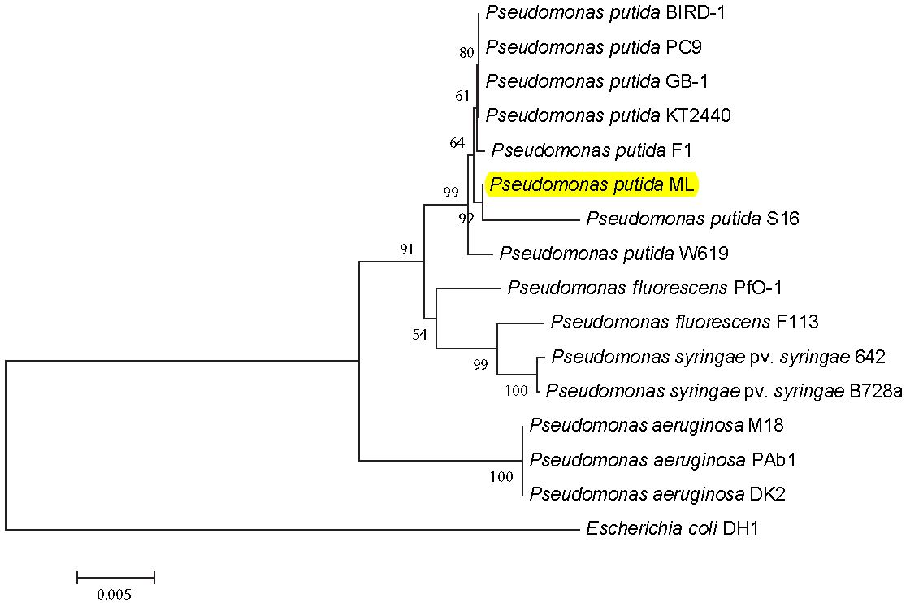

Figure S1: Neighbor-joining tree based on 16S rRNA gene sequences depicting the phylogeny between Pseudomonas putida strain ML and its close relatives. Bootstrap values (n=1,000) are shown at nodes. Scale bar represents 5 differences per 1000 nucleotides.

Figure S2: A model of the different mechanisms of resistance to ciprofloxacin present in or absent from strain ML. Red cross show deleted systems.

A

C
B
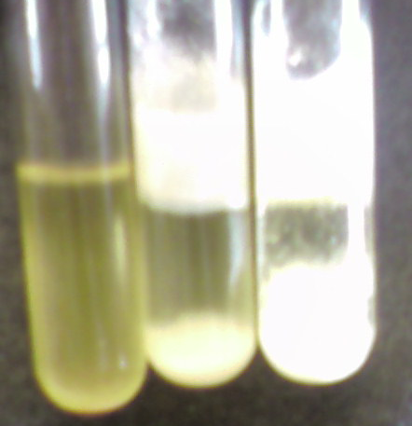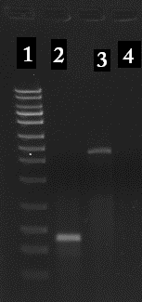
Figure S3: A) CFUs of strain ML in the absence and presence of ciprofloxacin. B) Effect of ciprofloxacin on consistency of cultures of strain ML, from left to right 50, 2000, and 4000 µg/ml ciprofloxacin. C) Gel electrophoresis image confirming insert of transposon genome of 20G2: lane 1 1kb ladder, lane 2 rplB gene 650 bp, lane 3 transposon inserted in rplB 2651 bp, lane 4 negative control.

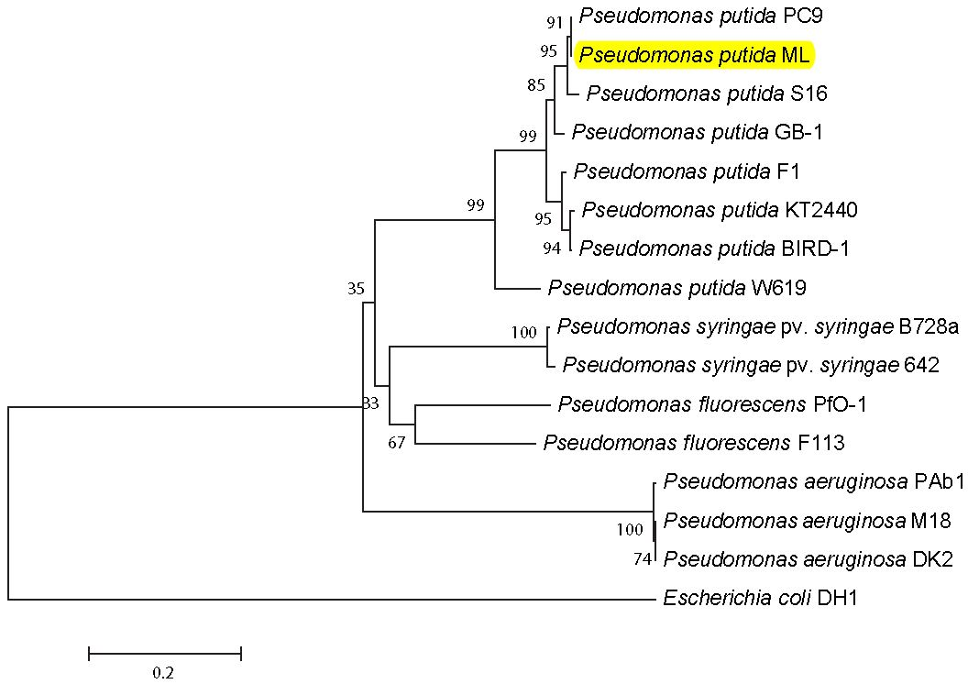

Figure S4: Neighbor-joining tree based of rare lipoprotein b amino acid sequences depicting the phylogeny between Pseudomonas putida strain ML and its close relatives. Bootstrap values (n=1,000) are shown at nodes. Scale bar represents 20 amino acid substitutions per 100 sites.

A

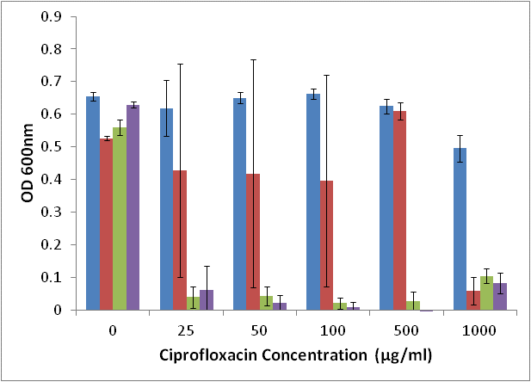
B
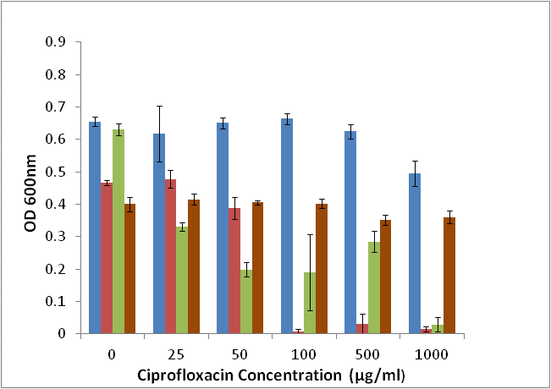
Figure S5: A) Growth profile of strain ML (blue), Type strain (red), E .coli (green), P. aeruginosa (purple) under ciprofloxacin pressure in liquid medium. B) Growth profile of strain ML (blue) in liquid medium compared to the mutants 20G2 (red), 19B1 (green), 15E8 (brown).

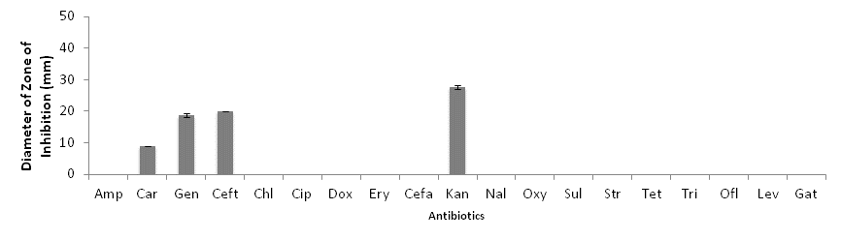
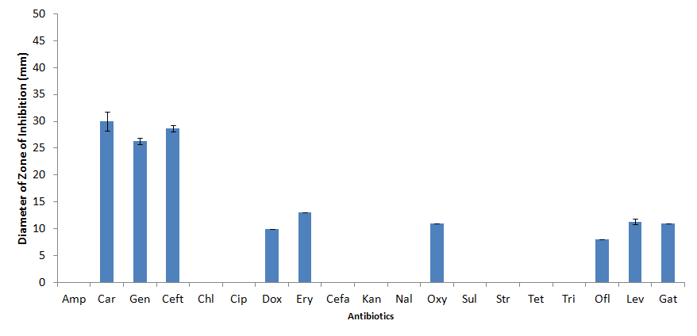
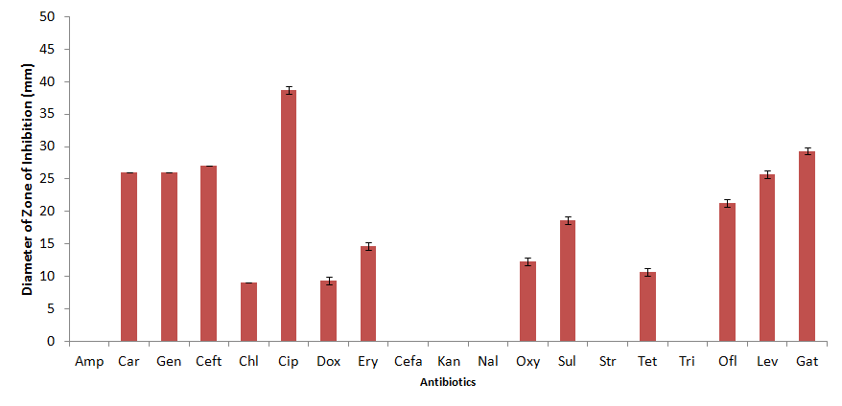
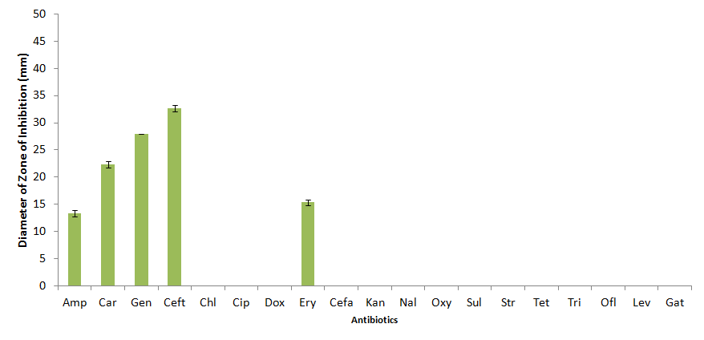
Figure S6: Kirby-Bauer results showing the antibiotic susceptibility pattern for strain ML (grey), 19B1 (blue), 15E8 (red), and 20G2 (green).

Table S1. Antibiotics used in Kirby-Bauer tests.
Antibiotic | Class | Target | Amount on Disks (μg)
Ampicillin (Amp) | β-lactam | Transpeptidase | 10
Carbenicillin (Car) | β-lactam | Cell wall synthesis | 100
Gentamicin (Gen) | Aminoglycoside | 30S ribosomal subunit | 10
Ceftriaxone (Ceft) | Cephalosporin | Peptidoglycan synthesis | 30
Chloramphenicol (Chl) | Bacteriostatic antimicrobial | 50S ribosomal subunit | 30
Ciprofloxacin (Cip) | Fluoroquinolone | DNA gyrase and topoisomerase | 5
Doxycycline (Dox) | Tetracycline | 30S ribosomal subunit | 30
Erythromycin (Ery) | Macrolide | 50S ribosomal subunit | 15
Cefaclor (Cefa) | Cephalosporin | Peptidoglycan synthesis | 30
Kanamycin (Kan) | Aminoglycoside | 30S ribosomal subunit | 30
Nalidixic Acid (Nal) | Quinolone | DNA gyrase and topoisomerase | 30
Oxytetracycline (Oxy) | Tetracycline | 30S ribosomal subunit | 30
Sulfathiazole (Sul) | Sulfonamide | Folate synthesis | 250
Streptomycin (Str) | Aminoglycoside | 30S ribosomal subunit | 10
Tetracycline (Tet) | Tetracycline | 30S ribosomal subunit | 30
Trimethoprim (Tri) | Sulfonamide | Folate synthesis | 5
Ofloxacin (Ofl) | Fluoroquinolone | DNA gyrase and topoisomerase | 5
Levofloxacin (Lev) | Fluoroquinolone | DNA gyrase and topoisomerase | 5
Gatifloxacin (Gat) | Fluoroquinolone | DNA gyrase and topoisomerase | 5

Table S2A: Substitutions in QRDRs of P. putida strain ML Compared to KT2440 and F1
 | gyrA | gyrB | parC | parE
KT2440 | Thr83Ile  Asp87Asn | NA | Ser87Trp | Thr516Ala
F1 | Thr83Ile  Asp87Asn | NA | Ser87Trp | NA

Table S2B: Comparison (% nucleotide similarity) of gene sequences from P. putida strain ML to Close Relatives.
 | Gyrase A | Gyrase B | Topisomerase IV, A subunit | Topoisomerase IV, B subunit
KT2440 | 97 | 99 | 98 | 99
F1 | 97 | 99 | 97 | 99

Table S3: Antibiotic Concentration at which MIC was reached (µg/ml)

 | Erythromycin |  | Ampicillin |  | Thiamphenicol |  | Kanamycin
Strain | RG | NG | RG | NG | RG | NG | RG | NG
Pseudomonas Aerugenosa | 50 | 500 | 100 | 500 | 100 | 500 | NA | 500
Pseudomonas putida Type strain | 50 | 500 | 100 | 500 | 500 | 1000 | NA | <25
Pseudomonas putida F1 | 100 | 500 | NA | 1000 | NA | 500 | NA | <25
Pseudomonas putida ML | 500 | 1000 | 500 | 1000 | 500 | 1000 | NA | <25
20G2 (rlpB) | NA | 100 | NA | 100 | 500 | 500 |  | 1000
19B1 (efflux) | 100 | 500 | 100 | 500 | 500 | 500 |  | 1000
20B10 | 100 | 500 | 100 | 500 | 500 | 500 |  | 1000
15 E8 (ABC family) | 100 | 500 | 100 | 500 | 500 | 500 |  | 1000

 | Spectinomycin |  | Gentamycin |  | Chloramphenicol
Strain | RG | NG | RG | NG | RG | NG
Pseudomonas Aerugenosa |  | 500 | NA | <25 |  | 500
Pseudomonas putida Type strain | 500 | 1000 | NA | <25 | 100 | 500
Pseudomonas putida F1 | 100 | >1000 | NA | <25 | NA | 500
Pseudomonas putida ML |  | >1000 | NA | <25 | 500 | >1000
20G2 (rlpB) | 500 | >1000 | NA | <25 | 1000
19B1 (efflux) | 500 | >1000 | NA | <25 | 25 | 1000
20B10 | 500 | >1000 | NA | <25 | 25 | 1000
15 E8 (ABC family) | >1000 | >1000 | NA | <25 | 1000

RG: Reduced growth, less than half the OD_{600nm} of no antibiotic controls
NG: No growth.
Brown highlights: acquired resistance from transposon

Table S.4: percent bacterial fatty acid comparison

Fatty Acid Type | P. putida strain ML (grown with ciprofloxacin) | P. putida strain ML (grown without ciprofloxacin) | Mutant strain 20g2
10:0 3 OH | 10.89$±$4.11 | 9.80$±$1.29 | 10.22$±$3.80
12:0 | 1.38$±$0.15 | 1.57$±$0.23 | 0.79$±$0.05
12:0 2 OH | 17.33$±$3.57 | 19.21$±$4.09 | 18.77$±$1.55
12:0 3 OH | 1.40$±$0.41 | 1.79$±$0.39 | 1.57$±$0.52
16:1 w7c, 16:1 w6c | 25.71$±$3.34 | 22.73$±$3.37 | 24.29$±$1.11
16:0 | 27.42$±$3.43 | 24.62$±$3.31 | 25.10$±$0.15
Unk16.197/15:0 iso 3 OH | 0.44$±$0.77 | 1.52$±$0.66 | 1.47$±$1.37
Unknown 16.315 | 0.55$±$0.95 | 2.02$±$0.68 | 2.00$±$1.75
17:0 cyclo | 0.05$±$0.08 | 0.87$±$0.30 | 0.82$±$0.26
18:1 w7c | 10.29$±$1.08 | 11.07$±$0.38 | 9.23$±$0.17
Unknown 17.975/18:0 | 2.88$±$0.53 | 2.18$±$0.44 | 1.75$±$0.47

