––
UNIVERSITY OF OKLAHOMA

GRADUATE COLLEGE

A PEDAGOGICAL APPROACH TO GEORGE ANTHEIL’S LA FEMME 100 TÊTES FOR SOLO PIANO

A DOCUMENT

SUBMITTED TO THE GRADUATE FACULTY

in partial fulfillment of the requirements for the

Degree of

DOCTOR OF MUSICAL ARTS

By

DAVID MACH
Norman, Oklahoma
2024

A PEDAGOGICAL APPROACH TO GEORGE ANTHEIL’S LA FEMME 100 TÊTES FOR SOLO PIANO

A DOCUMENT APPROVED FOR THE
SCHOOL OF MUSIC

BY THE COMMITTEE CONSISTING OF

Dr. Sara Ernst, Chair

Dr. Barbara Fast, Co-Chair

Dr. Jeongwon Ham

Dr. Vivian Luong

Dr. Robert Bailey

© Copyright by DAVID MACH 2024
All Rights Reserved.

Acknowledgements
Placeholder.

Table of Contents
Acknowledgements 4
List of Tables 8
List of Figures 10
ABSTRACT 20
Chapter 1: Introduction 2
Overview 2
Purpose of Study 7
Need for the Study 8
Justification for the Study 9
Limitations of Study 9
Organization of the Study 11
Review of Related Literature 12
Historical Context 13
Antheil’s Life and Career 15
Antheil’s Artistic Collaboration 20
Antheil’s Musical Aesthetics Over Time 23
Max Ernst’s La Femme 27
Antheil’s La Femme 28
Ballet Mécanique 30
Piano Pedagogical Methodology 32
Recordings 34
Summary 36
Chapter 2: The Life and Aesthetics of George Antheil 37
Antheil’s Berlin Works and “The Dream” 38
Stravinsky and Antheil 42
Antheil and the Machine Aesthetic 44
Ballet Mécanique 46
Antheil as Futurist 49
Antheil, Max Ernst, and Surrealism 52
Antheil as Film Composer 54
Chapter 3: Overview of La Femme 100 Têtes 57
History of Publication 60
Compositional Style of La Femme 100 Têtes 62
Score Legibility as Barrier to Access 67
The Missing Holograph 68
Misleading Complexity 69
Organization of Pedagogical Analysis 70
Chapter 4: Pedagogical Analysis of La Femme 100 Têtes Part 1 72
Prelude No. 9: “Sad” 72
Prelude No. 7: “Sad” 78
Prelude No. 32: “Sad” 88
Prelude No. 3: “Faintly Energetic” 96
Prelude No. 6: “Floating” 103
Prelude No. 8: “Electrical, Spiccato” 114
Prelude No. 16: “Lights Flashing” 122
Prelude No. 13: “Nostalgic, Twisted, Slowly” 130
Prelude No. 23: “Well Articulated” 138
Chapter 5: Pedagogical Analysis of La Femme 100 Têtes Part 2 146
Prelude No. 2: “Thoughtfully, Not Too Slow” 146
Prelude No. 35: “Furioso” 156
Prelude No. 5: “Furioso” 164
Prelude No. 34: “Brilliant” 170
Prelude No. 33: “Mystic Tempo” 177
Prelude No. 21: “Slower” 188
Prelude No. 15: “Slowly” 198
Prelude No. 4: “Floating” 205
Prelude No. 20: “Faster” 212
Prelude No. 24: “Slowly” 217
Prelude No. 25: “Minuet?” 228
Prelude No. 19: “Fast, An Even Piano Throughout” 235
Prelude No. 14: “Brilliant, Fast, Tricky” 243
Prelude No. 38: “Broad” 252
Prelude No. 1: “Thoughtfully, Not Too Slow” 264
Chapter 6: Conclusion 275
Recommendations for Further Study 277
References 278
Books 278
Dissertations and Monographs 279
Journals Articles and Periodicals 280
Scores 282
Reviews 283
Radio Interviews 283
Historical Newspapers 283
Websites 284
Archives 284
Liner Notes 284
Miscellaneous 285
Recordings 285
Appendix A 287
Progressive Guide to La Femme 100 Têtes by Level (Progressive within Level) 287
Appendix B 289
Suggested Groupings of Preludes for Teaching 289

List of Tables

Table 1: Formal “Time-Canvas” Analysis of Prelude No. 35 (Right Hand) 44
Table 2: Formal “Time-Canvas” Analysis of Prelude No. 35 (Left Hand) 44
Table 3: Prelude No. 9 Formal Analysis 70
Table 4: Prelude No. 7 Formal Analysis 76
Table 5: Prelude No. 32 Formal Analysis 87
Table 6: Prelude No. 3 Formal Analysis 94
Table 7: Prelude No. 3 “Faintly Energetic,” B section, Analysis of Time-Canvas Technique 97
Table 8: Prelude No. 6 Formal Analysis 101
Table 9: Prelude No. 8 Formal Analysis 112
Table 10: Prelude No. 16 Formal Analysis 120
Table 11: Prelude No. 13 Formal Analysis 128
Table 12: Prelude No. 23 Formal Analysis 136
Table 13: Prelude No. 2 Formal Analysis 144
Table 14: Prelude No. 35 Formal Analysis 154
Table 15: Prelude No. 5 Formal Analysis 162
Table 16: Prelude No. 34 Formal Analysis 168
Table 17: Prelude No. 33 Formal Analysis 174
Table 18: Prelude No. 21 Formal Analysis 186
Table 19: Prelude No. 15 Formal Analysis 196
Table 20: Prelude No. 4 Formal Analysis 203
Table 21: Prelude No. 20 Formal Analysis 210
Table 22: Prelude No. 24 Formal Analysis 215
Table 23: Prelude No. 25 Formal Analysis 226
Table 24: Prelude No. 19 Formal Analysis 233
Table 25: Prelude No. 14 Formal Analysis 241
Table 26: Prelude No. 38 Formal Analysis 250
Table 27: Prelude No. 1 Formal Analysis 262

List of Figures

Figure 1: Motif used in Death of Machines (1922) and Ballet Mécanique 38
Figure 2: “Death of Machines” (1922), mvt. 4, mm. 1-3 39
Figure 3: Ballet Mecanique (1924), mm. 1-6. 40
Figure 4: Prelude No. 3 “Faintly Energetic,” A section, mm. 1-2 61
Figure 5: Prelude No. 19 “Fast, An Even Piano Throughout,” mm. 1-3 62
Figure 6: Prelude No. 1 “Thoughtfully, Not Too Slow,” mm. 1-2 63
Figure 7: Prelude No. 1 “Thoughtfully, Not Too Slow,” mm. 7-8 64
Figure 8: Prelude No. 9 “Sad,” A section, mm. 1-5 70
Figure 9: Prelude No. 9, A section, mm. 6-9 71
Figure 10: Prelude No. 9, B section, mm. 10-13 71
Figure 11: Prelude No. 9, A’ section, mm. 14-17 72
Figure 12: Prelude No. 9, A’ section, mm. 17-20 72
Figure 13: Preparation exercise for La Femme 100 Têtes, Prelude No. 9 73
Figure 14: Prelude No. 9, A section, mm. 6-8 73
Figure 15: Prelude No. 9, A section, mm. 1-3 74
Figure 16: Prelude No. 7, A section, mm. 1-3 76
Figure 17: Prelude No. 6, mm. 10-11, Prelude No. 7 mm. 1-2 77
Figure 18: Prelude No. 7 “Sad,” A section, mm. 3-6 77
Figure 19: Prelude No. 32 “Sad,” mm. 1-4 78
Figure 20: Prelude No. 7 “Sad,” mm. 5-8 78
Figure 21: Prelude No. 7 “Sad,” B section, mm. 8-10 79
Figure 22: Prelude No. 34 “Brilliant” mm. 1-3 80
Figure 23: Prelude No. 7 “Sad,” A section, mm. 4-6 81
Figure 24: Preparation exercise for La Femme 100 Têtes, Prelude No. 7 81
Figure 25: Prelude No. 29 “Nostalgic, Slowly,” A section, mm. 1-4 82
Figure 26: Prelude No. 7 “Sad,” mm. 5-8 82
Figure 27: Prelude No. 7 “Sad,” mm. 5-8 83
Figure 28: Prelude No. 7 “Sad,” B section, mm. 8-10 84
Figure 29: Prelude No. 32 “Sad,” A section, mm. 1-4 86
Figure 30: Prelude No. 7 “Sad,” A section, mm. 3-6 86
Figure 31: Prelude No. 32 “Sad,” B section, mm. 6-9 87
Figure 32: Prelude No. 8 “Electrical, Spiccato,” A section, mm. 1-3 88
Figure 33: Prelude No. 8 “Electrical, Spiccato,” B section, mm. 6-8 88
Figure 34: Prelude No. 32 “Sad,” A’ section, mm. 18-21 89
Figure 35: Prelude No. 15 “Nostalgic, Twisted, Slowly,” A section, mm. 1-4 90
Figure 36: Preparation exercise for La Femme 100 Têtes, Prelude No. 32 “Sad” 91
Figure 37: Prelude No. 32 “Sad,” mm. 4-7 92
Figure 38: Prelude No. 3 “Faintly Energetic,” A section, mm. 1-11 94
Figure 39: Prelude No. 3 “Faintly Energetic,” A section, mm. 1-2 95
Figure 40: Prelude No. 3 “Faintly Energetic,” B section, mm. 12-13 96
Figure 41: Prelude No. 3 “Faintly Energetic,” B section, mm. 14-16 96
Figure 42: Preparation exercise for La Femme 100 Têtes, Prelude No. 3 “Faintly Energetic,” A section 98
Figure 43: Preparation exercise for La Femme 100 Têtes, Prelude No. 3 “Faintly Energetic,” B section 98
Figure 44: Prelude No. 3 “Faintly Energetic,” A section, mm. 5-8 99
Figure 45: Prelude No. 6 “Floating,” A section, mm. 1-2 101
Figure 46: Prelude No. 6 “Floating,” A section, mm. 1-2 102
Figure 47: Prelude No. 6 “Floating,” mm. 2-3 102
Figure 48: Prelude No. 5 “Furioso,” mm. 1-2 103
Figure 49: Prelude No. 6 “Floating,” A section, mm. 1-2 103
Figure 50: Prelude No. 6 “Floating,” B section, mm. 4-6 104
Figure 51: Prelude No. 6 “Floating,” B section 6-8 105
Figure 52: Prelude No. 6 “Floating,” mm. 2-3 106
Figure 53: Prelude No. 6 “Floating,” mm. 4-5 107
Figure 54: Preparation exercise for La Femme 100 Têtes, Prelude No. 6 “Floating” 108
Figure 55: Prelude No. 6 “Floating,” A section, mm. 1-3 109
Figure 56: Prelude No. 8 “Electrical, Spiccato,” A section, mm. 1-3 112
Figure 57: Prelude No. 8 “Electrical, Spiccato,” A section, mm. 4-6 113
Figure 58: Prelude No. 8 “Electrical, Spiccato,” A section, mm. 7-9 113
Figure 59: Prelude No. 3 “Faintly Energetic,” mm. 5-8 114
Figure 60: Prelude No. 1 “Thoughtfully, Not Too Slow,” mm. 1-2 114
Figure 61: Prelude No. 8 “Electrical, Spiccato,” B section, mm. 10-11 115
Figure 62: Prelude No. 4 “Floating” m. 1 115
Figure 63: Prelude No. 8 “Electrical, Spiccato,” end of B section, mm. 14-17 116
Figure 64: Prelude No. 8 “Electrical Spiccato,” mm. 1-2 117
Figure 65: Prelude No. 8 “Electrical, Spiccato,” mm. 10-11 118
Figure 66: Prelude No. 16 “Lights Flashing,” mm. 1-2 121
Figure 67: Prelude No. 16 “Lights Flashing,” mm. 3-5 122
Figure 68: Prelude No. 16 “Lights Flashing,” mm. 5-8 123
Figure 69: Prelude No. 16 “Lights Flashing,” mm. 1-2 124
Figure 70: Prelude No. 16 “Lights Flashing,” mm. 3-4 125
Figure 71: Prelude No. 16 “Lights Flashing,” mm. 5-8 125
Figure 72: Prelude No. 13 “Nostalgic, Twisted, Slowly,” mm. 1-3 128
Figure 73: Prelude No. 13 “Nostalgic, Twisted, Slowly,” mm. 3-6 129
Figure 74: Prelude No. 1 “Thoughtfully, Not Too Slow,” m. 1-2 130
Figure 75: Prelude No. 7 “Sad,” m. 3 130
Figure 76: Prelude No. 13 “Nostalgic, Twisted, Slowly,” mm. 10-13 131
Figure 77: Prelude No. 13 “Nostalgic, Twisted, Slowly,” mm. 3-6 132
Figure 78: Prelude No. 13 “Nostalgic, Twisted, Slowly,” mm. 7-8 133
Figure 79: Prelude No. 23 “Well Articulated,” mm. 1-2 136
Figure 80: Prelude No. 23 “Well Articulated,” mm. 3-4 137
Figure 81: Copyist manuscript for Prelude No. 23 “Well Articulated,” mm. 4-6 138
Figure 82: Prelude No. 23 “Well Articulated,” mm. 5-6 138
Figure 83: Prelude No. 23 “Well Articulated,” mm. 7-8 139
Figure 84: Prelude No. 23 “Well Articulated,” mm. 9-11 139
Figure 85: Preparation exercise for La Femme 100 Têtes, Prelude No. 23 “Well Articulated” 140
Figure 86: Prelude No. 23 “Well Articulated,” mm. 9-10 141
Figure 87: Prelude No. 2 “Thoughtfully, Not Too Slow,” mm. 1-4 144
Figure 88: Prelude No. 2 “Thoughtfully, Not Too Slow,” mm. 4-6 145
Figure 89: Prelude No. 2 “Thoughtfully, Not Too Slow,” mm. 9 146
Figure 90: Prelude No. 15 “Slowly,” mm. 15-17 146
Figure 91: Prelude No. 2 “Thoughtfully, Not Too Slow,” mm. 15-16 147
Figure 92: Fable No. 3 from Fables, op. 21 by Robert Muczynski 148
Figure 93: Prelude No. 2 “Thoughtfully, Not Too Slow,” mm. 4-6 149
Figure 94: Prelude No. 2 “Thoughtfully, Not Too Slow,” mm. 15-16 149
Figure 95: Prelude No. 2 “Thoughtfully, Not Too Slow,” mm. 1-3 150
Figure 96: Prelude No. 2 “Thoughtfully, Not Too Slow,” mm. 1-4 151
Figure 97: Prelude No. 5 “Furioso,” m. 1 154
Figure 98: Prelude No. 5 “Furioso,” m. 1 155
Figure 99: Prelude No. 5 “Furioso,” mm. 1-2 156
Figure 100: Prelude No. 5 “Furioso,” m. 1 158
Figure 101: Preparation exercise for La Femme 100 Têtes, Prelude No. 5 “Furioso” 158
Figure 102: Prelude No. 5 “Furioso,” m. 2 159
Figure 103: Étude 1: Désordre from Études pour piano, premier livre, mm. 5-9 162
Figure 104: Prelude No. 5 “Furioso,” mm. 1-4 163
Figure 105: Prelude No. 5 “Furioso,” m. 1-2 164
Figure 106: Prelude No. 35 “Furioso,” m. 2 165
Figure 107: Prelude No. 5 “Furioso,” m. 7 165
Figure 108: Exercise No. 5 from School of Velocity, op. 299 by Carl Czerny, mm. 48-52 168
Figure 109: Prelude No. 34 “Brilliant,” mm. 1-3 169
Figure 110: Prelude No. 34 “Brilliant,” mm. 6-8 170
Figure 111: Prelude No. 34 “Brilliant,” mm. 6-8 172
Figure 112: Prelude No. 34 “Brilliant,” mm. 8-11 172
Figure 113: Prelude No. 33 “Mystic Tempo,” mm. 1-3 175
Figure 114: Example of tresillo rhythm 175
Figure 115: Prelude No. 33 “Mystic Tempo,” mm. 16-19 177
Figure 116: Prelude No. 33 “Mystic Tempo,” mm. 26-29 178
Figure 117: Prelude No. 33 “Mystic Tempo,” mm. 32-34 179
Figure 118: Prelude No. 33 “Mystic Tempo,” mm. 1-2 180
Figure 119: Prelude No. 33 “Mystic Tempo,” mm. 3-6 181
Figure 120: Prelude No. 33 “Mystic Tempo,” mm. 11-12 182
Figure 121: RH chord reduction from Prelude No. 33 “Mystic Tempo,” mm. 26-34 183
Figure 122: Prelude No. 33 “Mystic Tempo,” mm. 1-2 183
Figure 123: Prelude No. 21 “Slower,” m. 1 187
Figure 124: Prelude No. 5 “Furioso,” m. 1 187
Figure 125: Prelude No. 35 “Furioso,” m. 1 187
Figure 126: Prelude No. 6 “Floating,” mm. 2-3 188
Figure 127: Prelude No. 21 “Slower,” m. 1 188
Figure 128: Prelude No. 1 “Thoughtfully, Not Too Slow,” mm. 1-2 189
Figure 129: Prelude No. 9 “Sad,” mm. 1-4 189
Figure 130: Prelude No. 8 “Electrical, Spiccato,” mm. 1-2 190
Figure 131: Prelude No. 23 “Well Articulated,” mm. 1-2 190
Figure 132: Prelude No. 21 “Slower,” mm. 3-5 191
Figure 133: Scotch snap rhythm 192
Figure 134: Prelude No. 21 “Slower,” m. 6 193
Figure 135: Preparation exercise for La Femme 100 Têtes, Prelude No. 21 “Slower,” m. 6 193
Figure 136 Prelude No. 21 “Slower,” mm. 3-5 194
Figure 137: Prelude No. 15 “Slowly,” mm. 6-8 197
Figure 138: Prelude No. 15 “Slowly,” mm. 9-11 198
Figure 139: Prelude No. 15 “Slowly,” mm. 16-17 199
Figure 140: Prelude No. 15 “Slowly,” mm. 3-5 200
Figure 141: Prelude No. 15 “Slowly,” mm. 16-17 201
Figure 142: Prelude No. 4 “Floating,” mm. 1 203
Figure 143: Prelude No. 4 “Floating,” mm. 8-9 205
Figure 144: Prelude No. 4 “Floating,” m. 1 206
Figure 145: Prelude No. 4 “Floating,” mm 4-5 206
Figure 146: Prelude No. 4 “Floating,” mm 7-9 207
Figure 147: Prelude No. 20 “Faster,” mm. 1-3 211
Figure 148: Prelude No. 20 “Faster,” m. 6 211
Figure 149: Prelude No. 20 “Faster,” mm. 2-4 212
Figure 150: Prelude No. 20 “Faster,” mm. 4-6 213
Figure 151: Prelude No. 24 “Slowly,” mm. 1-3 216
Figure 152: Prelude No. 24 “Slowly,” mm. 1-3 216
Figure 153: Prelude No. 24 “Slowly,” mm. 4-5 217
Figure 154: Prelude No. 24 “Slowly,” mm. 4-5 218
Figure 155: Prelude No. 24 “Slowly,” m. 11 219
Figure 156: Prelude No. 24 “Slowly,” mm. 13-14 219
Figure 157: Prelude No. 24 “Slowly,” m. 1 220
Figure 158: Right hand of Prelude No. 24 “Slowly,” mm. 1, in retrograde 220
Figure 159: Preparation exercise for La Femme 100 Têtes, Prelude No. 24 “Slowly,” mm. 11 222
Figure 160: Prelude No. 24 “Slowly,” mm. 13-14 223
Figure 161: Prelude No. 24 “Slowly,” mm. 6-8 224
Figure 162: Common minuet rhythm 226
Figure 163: Prelude No. 25 “Minuet,” mm. 5-7 226
Figure 164: Prelude No. 25 “Minuet,” mm. 3-4 227
Figure 165: Prelude No. 25 “Minuet,” mm. 9-11 228
Figure 166: Prelude No. 25 “Minuet,” m. 9 230
Figure 167: Prelude No. 25 “Minuet,” m. 15 230
Figure 168: Prelude No. 19 “Fast, An Even Piano Throughout,” mm. 1-3 233
Figure 169: Prelude No. 19 “Fast, An Even Piano Throughout,” mm. 4-6 234
Figure 170: Prelude No. 19 “Fast, An Even Piano Throughout,” mm. 16-18 235
Figure 171: Prelude No. 19 “Fast, An Even Piano Throughout,” mm. 20-21 236
Figure 172: Prelude No. 19 “Fast, An Even Piano Throughout,” mm. 17-18 237
Figure 173: Prelude No. 19 “Fast, An Even Piano Throughout,” mm. 3-5 237
Figure 174: Prelude No. 19 “Fast, An Even Piano Throughout,” mm. 19-21 239
Figure 175: Prelude No. 14 “Brilliant, Fast, Tricky,” mm. 3-4 242
Figure 176: Prelude No. 14 “Brilliant, Fast, Tricky,” mm. 3-4 243
Figure 177: Prelude No. 14 “Brilliant, Fast, Tricky,” mm. 10-11 243
Figure 178: Prelude No. 14 “Brilliant, Fast, Tricky,” m. 4 244
Figure 179: Prelude No. 14 “Brilliant, Fast, Tricky,” mm. 12-13 244
Figure 180: Prelude No. 14 “Brilliant, Fast, Tricky,” mm. 1-2 246
Figure 181: Prelude No. 14 “Brilliant, Fast, Tricky,” m. 3 247
Figure 182: “La cathédrale engloutie” by Claude Debussy, mm. 1-3 251
Figure 183: Prelude No. 38 “Broad,” mm. 1-6 251
Figure 184: Prelude No. 38 “Broad,” mm. 7-8 252
Figure 185: Prelude No. 19 “Fast, An Even Piano Throughout,” mm. 1-3 253
Figure 186: Prelude No. 38 “Broad,” mm. 10-13 254
Figure 187: Prelude No. 38 “Broad,” mm. 14-16 254
Figure 188: Prelude No. 38 “Broad,” mm. 17-18 255
Figure 189: Copyist manuscript of Prelude No. 38 “Broad,” mm. 10-13 257
Figure 190: Prelude No. 38 “Broad,” mm. 10-13 257
Figure 191: Prelude No. 38 “Broad,” mm. 7-8 258
Figure 192: Example 111 and 113 from The Pianist’s Guide to Pedaling by Joseph Banowetz 259
Figure 193: Prelude No. 38 “Broad,” mm. 1-6 259
Figure 194: Prelude No. 1 “Thoughtfully, Not Too Slow,” mm. 1-2 262
Figure 195: Prelude No. 1 “Thoughtfully, Not Too Slow,” mm. 4-5 264
Figure 196: Prelude No. 1 “Thoughtfully, Not Too Slow,” mm. 7-8 265
Figure 197: Prelude No. 1 “Thoughtfully, Not Too Slow,” mm. 13-15 266
Figure 198: Prelude No. 1 “Thoughtfully, Not Too Slow,” mm. 18-21 267
Figure 199: Prelude No. 1 “Thoughtfully, Not Too Slow,” mm. 4-5 269
Figure 200: Prelude No. 1 “Thoughtfully, Not Too Slow,” mm. 19-21 271

ABSTRACT

David A. Mach, DMA
The University of Oklahoma, 2024
Chair: Dr. Sara Ernst
Co-Chair: Dr. Barbara Fast

This document provides a pedagogical analysis of 24 late-intermediate to early-advanced preludes from La Femme 100 Têtes, a work for solo piano by George Antheil, emphasizing the brevity and usefulness of these preludes in the private piano studio. This analysis provides a historical overview, in addition to a compositional and pedagogical analysis of 24 of the 45 preludes from La Femme. A biography of George Antheil, a guided progressive leveling, and suggested groupings for the preludes are also included.
Chapter One defines the purpose, need, limitations, organization of the study, and provides a summary of literature related to George Antheil’s La Femme 100 Têtes. Chapter Two provides a biographical sketch of George Antheil, detailing his musical aesthetics. Chapter Three provides historical context related to La Femme. Chapters Four and Five contain an analysis of each of the 9 late-intermediate and the 15 early-advanced preludes from La Femme, respectively, including compositional and pedagogical analysis. Chapter Six serves as a conclusion to this study. This study offers pianists and teachers a practical guide for teaching La Femme 100 Têtes, highlighting George Antheil’s contributions to the piano’s pedagogical literature.

Chapter 1: Introduction

Overview
George Antheil (1900-1959), an early 20th century American composer, pianist, and author, created a wealth of solo piano works suitable for the developing pianist, several of which remain absent from the standard piano teaching literature despite Antheil’s innovations as a composer. Notably, Antheil advanced the role of machines and percussion in music, exemplified by his most famous work, Ballet Mécanique (1924), one of the first works for percussion ensemble. Ballet Mécanique has been both the center of discussion regarding Antheil’s music and his most often performed work, resulting in a lack of scholarship focused on his works suitable for the developing pianist.
This document seeks to contribute to Antheil scholarship by presenting a pedagogical analysis of the 24 intermediate to early advanced preludes from Antheil’s collection of 45 preludes for solo piano entitled La Femme 100 Têtes (1933), which translates to “The Hundred Headless Woman,” a work distinct for its use of Antheil’s innovative compositional techniques, multitude of stylistic influences and interdisciplinary connections (see Chapter 3 for a discussion of the title of this work.) These preludes, characterized by their bursts of brief musical episodes containing both rhythmic vitality and humor, incorporate and expand upon the compositional ideas of Debussy, Stravinsky, Schoenberg, and Antheil’s own Ballet Mécanique (1924), written nearly a decade prior. They function well in the piano studio due to their expressive variety, particularly for adolescent students seeking a self definition. Antheil also drew interdisciplinary inspiration for this collection from artwork by the Surrealist painter Max Ernst (1891-1976). Specifically, Antheil named his collection of 45 preludes La Femme 100 Têtes (1933) after Max Ernst’s own seminal work entitled La Femme 100 Têtes (1929), which founded the collage novel as a genre. Collage novels combine visual and literary art using found illustrations from Victorian newspapers and other documents to form a narrative, a technique which Antheil sought to translate to the musical composition of La Femme 100 Têtes (1933). Antheil premiered 40 of the 45 preludes in La Femme 100 Têtes at the second Yaddo Festival in 1933, held in Saratoga Springs, New York. In 1934, Martha Graham, a crucial figure in the development of modern dance, choreographed 25 preludes from La Femme 100 Têtes as a solo ballet entitled Dance in Four Parts, connecting La Femme to dance, in addition to visual art and literature.
The current author, analyzing the work in its entirety, categorized 24 of the 45 preludes from La Femme 100 Têtes (1933) as intermediate to early advanced, according to Jane Magrath’s leveling system, while categorizing the remaining 21 preludes as artist-level works. A pedagogical analysis of the 24 intermediate to early advanced preludes from La Femme constitutes the majority of this document. These preludes feature compositional and technical elements found in the music of Debussy, Stravinsky, and Schoenberg, among others, effectively preparing students for advanced 20th century repertoire. In addition to their value as preparations for more advanced literature, the intermediate to early advanced preludes from La Femme 100 Têtes would be excellent additions to the piano’s pedagogical repertoire due to their interdisciplinary connections to literature, visual art, and dance.
While the preludes were partially premiered by Antheil in 1933, La Femme 100 Têtes remained unpublished during Antheil’s lifetime. Only recently made available in 2017, G. Schirmer published the complete manuscript of La Femme 100 Têtes, a document in the handwriting of Antheil’s copyist Henry Brant, although no typeset edition of the score exists commercially at the time of writing this document. Copies of the handwritten version of the score, which contain all 45 preludes, are available for teachers to purchase at Classicalondemand.com. Rarely performed and absent from pedagogical keyboard literature, La Femme 100 Têtes requires attention for its potential value to teachers, in addition to its position as both Antheil’s largest solo piano work and his only large Surrealist work.
Outside of his Ballet Mécanique (1924), Antheil’s music rarely appears in concert halls of the 21st century, but, at multiple points in the 20th century, his music experienced surges of popularity. The peak of Antheil’s critical acclaim in France occurred in 1924, coinciding with the Parisian premiere of Ballet Mécanique (1924), while Antheil’s critical acclaim in the United States did not reach its pinnacle until his later career in the middle of the 20th century. According to a survey conducted in 1947, his music was performed as much as his contemporaries Samuel Barber (1910-1981), Aaron Copland (1900-1990), and George Gershwin (1898-1937).
In his active years, from 1919 to 1949, Antheil’s music received praise and criticism during and after his life, often from the same individuals. In Paris, where he lived intermittently from 1923-1931, the artistic elite held him in high regard. Copland himself, in 1926 stated his jealousy of Antheil’s “brilliant” pianism, and that he “possesses the greatest gift of any young American now writing.” Virgil Thomson, a close friend and collaborator of Antheil stated that he “envied” Antheil’s freedom from movements within purely academic music, as well as the “bravado” and “brutal charm” of his music. Antheil also befriended his compositional idol, Igor Stravinsky, who spoke highly of Antheil’s interpretation as a pianist. Nonetheless, these same composers later criticized Antheil’s musical contributions. For example, in 1936 Copland revised his earlier statement when he suggested that various factors kept Antheil from attaining “full fruition.” Copland implied that Antheil’s “lack of artistic integrity…susceptibility to influences, or a lack of any conscious direction” were the primary factors of Copland’s disappointment in Antheil. Stravinsky also eventually distanced himself from Antheil. These critiques affected public perception of his music over time, which contributed to his music’s absence from the piano’s pedagogical literature.
When Antheil first moved to Paris in 1923, he lived in the center of the Parisian artistic elite. He and his wife Böski Antheil resided in an apartment above Sylvia Beach’s bookstore, Shakespeare & Company, whose remarkable publication history included books by James Joyce (1882-1941), Ernest Hemingway (1899-1961), and held ties with Max Ernst (1891-1976), all of whom befriended Antheil. His collaborations with these artists and others form a basis for understanding the composer’s aesthetics and many of his compositions, including La Femme 100 Têtes (1933). Chapter Three provides additional details on his relationship with Max Ernst, who created La Femme 100 Têtes (1929), the collage novel which inspired Antheil’s own work of the same title from 1933.
24 of the 45 preludes within La Femme 100 Têtes can serve as outstanding introductions to early 20th century compositional techniques for intermediate to early advanced students, inspiring interdisciplinary performances with visual art and dance. Preludes within La Femme can be performed individually or in sets for competitions or recitals. The brevity, humor, rhythmic energy, and multitude of vibrant textures and characters within these preludes can invigorate students, effectively preparing them for more complex works from the 20th and 21st century by Copland, Stravinsky, Bartok, Schoenberg, and Carl Vine, among others. Several of the preludes work together as sets, offering significant flexibility for their inclusion in recital programs (see Appendix B for suggested groupings of the preludes for performance and teaching). For interdisciplinary projects, advanced piano students can present sets of preludes, or the entire work, alongside multimedia displays of panels from Max Ernst’s collage novel. Among other possibilities, performers can also display visuals connecting the work to the 1967 film based on Ernst’s collage novel, directed by Eric Duvivier.
Antheil’s La Femme 100 Têtes also contains interdisciplinary connections to dance. In 1934, Martha Graham, the groundbreaking modernist dancer, and Antheil created a solo ballet version of 25 of the 45 preludes in La Femme 100 Têtes, the score of which remains undiscovered. This ballet, featuring Graham as soloist, premiered in November 1934 at the Guild Theatre in New York City.
The pedagogical overview of each prelude in Chapters Four and Five will include suggestions for introducing individual preludes from La Femme. This approach is designed to engage students with the technical challenges required of each prelude, with occasional emphasis on the intersection of music, literature, visual art, and dance, demonstrating the intriguing interdisciplinary aspects of La Femme.
This study aims to give a detailed analysis of the 9 intermediate/late intermediate and 15 early advanced preludes within La Femme 100 Têtes to rectify the lack of pedagogical attention received by these preludes. Hopefully, a practical guide for students and teachers on La Femme will heighten interest in George Antheil’s contributions to the pedagogical literature of the piano, solidify his music’s valuable position in the piano repertoire, and enrich the musical literature performed by students and professional pianists.

Purpose of Study
The purpose of this study is to provide a detailed analysis of the 9 intermediate/late intermediate and 15 early advanced preludes within La Femme 100 Têtes, which total 24 of the 45 preludes. Currently, there is no pedagogical analysis of La Femme 100 Têtes. This study will analyze the musical material, interpretive and technical challenges, and provide pedagogical suggestions for each of the 24 selected preludes. The goal of this study is to offer pianists and teachers a practical guide for teaching La Femme 100 Têtes in the pre-collegiate piano studio, highlighting George Antheil’s contributions to the piano’s pedagogical literature. Thus, the preludes remaining 21 artist-level preludes are not included. In addition, the current author digitally engraved examples from the selected preludes using Finale. These digitally engraved short excerpts from the copyist manuscript, annotated with compositional analysis and pedagogical suggestions by the current author, provide a more legible resource for students and teachers to select which preludes to explore from La Femme 100 Têtes.

Need for the Study
While numerous publications document Antheil’s biography and compositional output, limited research has been conducted on George Antheil’s piano works suitable for the advancing pianist. In particular, no pedagogical study has been dedicated to George Antheil’s work La Femme 100 Têtes. To promote greater pedagogical focus on La Femme 100 Têtes, there is need for an in-depth pedagogical analysis of the work, providing progressive and leveled annotations for the intermediate/late intermediate and early advanced preludes within the set. Furthermore, the current author is aware of no digitally engraved version of the 24 intermediate/late intermediate and early advanced preludes from La Femme 100 Têtes exist prior to writing of this document. This document will furnish a framework to aid students and teachers in learning or teaching this work, providing clear guidance on its musical and technical requirements, using the leveling system presented by Jane Magrath’s Piano Literature for Teaching and Performance: A Graded Guide and Annotated Bibliography. This resource includes her system of assessing the difficulty of works for solo piano on a scale from 1 (corresponding to late elementary) to 10 (corresponding to early advanced.) This document primarily adopts an analytical approach with the goal of creating an accessible guide to La Femme 100 Têtes (1933) for teachers and students.

Justification for the Study
La Femme 100 Têtes should be afforded a position in the pedagogical repertoire due to their variety of style, rhythmic vibrance, exceptionally brief length, and rapid presentation of ideas. These qualities allow students to explore dissonance, rhythmic asymmetry, and virtuosic technique without needing the mental and physical endurance required by 20th century works of greater length and difficulty. In addition, the preludes from La Femme provide an accessible gateway for teachers to introduce 20th century compositions into the piano lesson using interdisciplinary connections between music, visual art, literature, and dance. La Femme’s connections to the other fine arts relate to students of diverse ages, skill levels, and interests. These qualities justify La Femme as an excellent addition to intermediate to early advanced pedagogical collections from the early 20th century pedagogical canon.

Limitations of Study
This study is limited to the 24 preludes of La Femme 100 Têtes suitable for intermediate/late intermediate and early advanced pianists. The research of this study is currently limited by the scarcity of primary documentation on La Femme 100 Têtes, particularly the disappearance of Antheil’s original handwritten score (holograph) of La Femme 100 Têtes at some point between 1933 and 1975. The only manuscript from around the time of composition is a manuscript in the handwriting of Henry Brant, Antheil’s copyist while composing La Femme in the winter of 1932-1933. This manuscript will be referred to as the copyist manuscript.
While multiple versions of Antheil’s La Femme 100 Têtes could have existed in the past, no intervening versions of the work have been found. One example of a missing manuscript, thought to be lost since 1934, is the holograph for Martha Graham and Antheil’s Dance in Four Parts, an arrangement of La Femme 100 Têtes, as yet undiscovered by scholars. The extant copyist manuscript remains the only complete version of La Femme 100 Têtes (1933). This copyist manuscript contains several markings in the hand of the composer. Beyond this score scholars have discovered no relevant letters providing additional information on the evolution of La Femme from the initial 40 preludes premiered by Antheil in 1933, Dance in Four Parts from 1934, and the extant copyist manuscript.
The study is also limited by the current state of the extant copyist manuscript, which possesses limited legibility. Specifically, the following issues arose when studying the copyist manuscript: legibility in Prelude No. 14; ambiguity of shorthand in Prelude No. 21; copying errors in Prelude No. 26; and inconsistencies in notation of accidentals in Preludes Nos. 30 and 37. The current author’s annotated digital engraving of the copyist manuscript will provide strategies to solve these issues in the pedagogical overview section of each prelude’s analysis in Chapters Four and Five. In addition, while Charles Amirkhanian, former executor of the Antheil Estate, found that Antheil owned a first edition of Max Ernst’s collage novel La Femme 100 Têtes (1929), the present author was not able to receive any further information on Antheil’s copy of that book, including whether it contained notes or annotations by Antheil. A future discovery of Antheil’s copy of Ernst’s book could provide insight into connecting the panels of Max Ernst’s collage novel to individual preludes within Antheil’s La Femme 100 Têtes, thus clarifying the composer’s intentional extramusical connections between Antheil’s La Femme (1933) and Ernst’s La Femme (1929), or lack thereof.

Organization of the Study
This document is organized into six chapters followed by a bibliography and two appendices. After an overview of the document, Chapter One defines the purpose, need, limitations and organization of the study, and offers a review of the literature related to George Antheil’s La Femme 100 Têtes. Chapter Two provides a biographical overview of George Antheil and his musical aesthetics. Chapter Three introduces La Femme 100 Têtes, providing historical context for the work’s absence from the piano’s pedagogical literature by use of primary sources.
Chapters Four and Five provide a pedagogical analysis of 24 of the 45 preludes from La Femme, which the author categorized as late intermediate or early advanced. Chapter Four includes pedagogical analysis of the 9 late intermediate preludes, and Chapter Five includes pedagogical analysis of the 15 early advanced preludes, and Chapter Six acts as the conclusion to this research. In this document, the analyses of individual preludes are arranged in order of ascending difficulty. Each analysis includes a compositional overview, outlining the compositional techniques used in each prelude. Each analysis also includes a pedagogical overview, which provides technical analysis and teaching considerations, to aid teachers developing introductions to these preludes, identifying potential challenges in the piano studio.
With permission from the Antheil Estate, the author digitally engraved 24 of the 45 preludes from La Femme 100 Têtes using Finale, analyzing each prelude using Jane Magrath’s leveling system. The author also studied the work in preparation for performance and teaching, and analyzed the difficulty of each movement for technical and musical complexity using several parameters including: tempi; density of musical ideas; rhythmic, harmonic and melodic complexity; pedaling; and length. In addition, the present author compiled the connections between individual preludes and other pieces of art or music to facilitate the introduction of these preludes in the piano studio.
The author consulted all relevant and accessible primary sources available at the major archives containing Antheil’s work, including the George and Böske Antheil papers, circa 1875-1984 at the Library of Congress, as well as George Antheil papers 1912-1959 and The Yaddo Records, both held by the New York Public Library. These archives provided access to Antheil’s scores, programs, letters, and writings. Beyond archival research, the author consulted relevant scores, books, periodicals, monographs, dissertations, theses, news articles, and audio recordings for additional historical context.

Review of Related Literature
Current literature focused on George Antheil consists of archives, scores, books, dissertations, journal articles, newspaper articles, websites, film, and recordings. The author selected the following categories to organize the discussion of sources related to La Femme: historical context, Antheil’s life and career, Antheil’s artistic collaborations, Antheil’s musical aesthetic over time, Antheil’s La Femme 100 Têtes (1933), Max Ernst’s La Femme 100 Têtes (1929), Ballet Mécanique (1924), piano pedagogical methodology, and recordings.

Historical Context
In contextualizing Antheil’s music historically, the author examined a range of texts that offer diverse perspectives on music in the early 20th century. Richard Taruskin’s critique in The Oxford History of Western Music challenges the linear narrative that dominated musicology in the early 20th century, and is pivotal in understanding the varied assessments of Antheil’s place in music history. In contrast, Burkholder and Grout’s A History of Western Music underscores the continuity with past traditions in 20th-century music, which offer a different viewpoint from Taruskin. These texts by Taruskin, Burkholder and Grout deepened the current study on La Femme 100 Têtes by providing perspectives on works contemporaneous to Antheil’s 45 preludes.
Virgil Thomson, who befriended Antheil in Paris, provides a critical perspective on Antheil's role in modern music in his books, Virgil Thomson and Music in the Early Twentieth Century, which contain critiques of Antheil's contributions significantly influencing Antheil's historiography. Additionally, the author consulted William T. Austin's Music in the Twentieth Century from 1966 for its portrayal of the linear approach to music history, a concept which was later criticized by Taruskin. These sources by Austin, Thomson, and Taruskin were crucial in forming the basis of the historiographical framework in this study of La Femme.
Christine Fena’s 2011 dissertation, “Composing the ‘Land of Sewing Machines and Typewriters’: American Modernist Music and the Piano in the Machine Age 1918-1933,” offers an extensive historical background on the concept of 'mechanical' music. It examines the rise of the player piano and sets the stage for a thorough discussion of Antheil's legacy as a composer. This work is particularly significant in understanding the interplay between technological advancements and musical innovation during this era.
For overviews of individual topics related to music history, several books, dissertations, and journal articles provide detailed insights into the aesthetic and musical innovations that surrounded Antheil’s career in Europe from 1922 to 1932. For background on the Futurism movement, Giovanni Lista’s Futurism translated by Susan Wise provides additional information on the experiments with mechanical ballets by the Italians, which assisted in placing Antheil’s Ballet Mécanique (1924) historically. Additionally, Grove Music Online provides further depth and perspective to the study with articles on “Futurism” and “Percussion Music”.
Two books, by Adam Gopnik and Ernest Earnest, provide additional perspective into the artistic milieu of expatriates Americans in Paris, like Antheil, during the 1920s. Adam Gopnik’s Americans in Paris: A Literary Anthology offers numerous vivid primary accounts, contemporaneous with Antheil, of American life in Paris. Ernest Earnest’s Expatriates and Patriots: American Artists, Scholars, and Writers in Europe suggests that Americans in Paris in the 1920s exaggerated the degree to which the United States exhibited inhospitality to artistic innovation. This perspective forms an intriguing backdrop to Antheil's career, especially considering Christine Fena's argument that Antheil effectively exaggerated his American identity for success in Paris.
An Introduction to Music and Art in the Western World by Milo Wold et al., though not discussing Antheil directly, offers a comprehensive history of the convergence between visual art and music in Western music history until the first half of the 20th century. This broad historical context is invaluable for situating Antheil’s La Femme 100 Têtes at the intersection of visual art and music history. The text provides a foundational understanding of the cultural and artistic movements that influenced and paralleled Antheil’s work.

Antheil’s Life and Career
Undoubtably, Antheil’s autobiography Bad Boy of Music stands as one of the most colorful firsthand accounts of any composer’s life. The work encapsulates his early years in Trenton, New Jersey, as well as his experiences as a piano and composition student. His autobiography also provides a thorough, albeit occasionally exaggerated, account of his life in Europe, and chronicles his return to America. While the book offers unique insights, the accuracy of some details has been questioned or contradicted by other sources, highlighting the necessity for additional firsthand accounts to provide a more complete picture of Antheil's life and work.
Primary source material gained from several prominent figures in the artistic circles of Paris and America enriches the understanding of George Antheil's life through their writings. These primary sources are invaluable in expanding an understanding of the composer’s charismatic personality, bohemian lifestyle, and distinctive approaches to pianism and composition. Notably, Margaret Anderson's autobiography sheds light on Antheil's brief stay at her home in 1921, offering insights into the influences that would shape his compositions and pianistic style during his European tour as pianist-composer in 1922 and 1923. Her account particularly focuses on his unconventional piano practice methods. Similarly, American author Bravig Imbs provides an intimate glimpse into Antheil’s personality in the 1920s and provides a firsthand account of the premiere of Ballet Mécanique (1924), capturing its tumultuous reception in Paris.
Sylvia Beach, the proprietor of the renowned “Shakespeare & Company” bookstore, housed Antheil and his wife Böski above her store in the 1920s. Her autobiography offers a detailed account of her interactions with the Antheil family and provides insight into Antheil's connections with other artists, notably Ezra Pound.
Pound, deeply influenced by Antheil's machine aesthetic, authored Antheil: With a Treatise on Harmony in 1927, a book which delves into this concept. However, Antheil later distanced himself from this work, denying significant collaboration in its creation and criticizing Pound's book in his own autobiography for its sensationalism, which he deemed damaging.
While no work has analyzed the individual preludes from La Femme 100 Têtes as teaching pieces in the piano studio, David Lyman Albee's 1977 dissertation, “George Antheil's La Femme 100 Têtes: A Study of the Piano Preludes (Volume I and II),” stands out for its biographical synthesis of primary sources related to Antheil’s life, laying the foundation for future research on his life and work. Albee's treatise delves into Antheil's life story, traces the development of his compositional style, and conducts a musical and stylistic analysis of La Femme 100 Têtes, treating the piece as a whole, instead of discussing individual preludes. Notably, Albee's work presents the overarching artistic and stylistic elements of La Femme, in lieu of discussing technical challenges in individual preludes, thus creating a need for a pedagogical analysis of La Femme to aid piano teachers seeking to explore the work in their studio. In contrast with prior Antheil scholarship on La Femme 100 Têtes, the current study emphasizes both La Femme’s absence from the pedagogical literature, and addresses teaching solutions, with the goal of creating a guide for educators. In Chapter Four of Albee’s dissertation, “Critical Discussion of the Preludes,” Albee adopts a categorical approach to analyze the preludes, focusing on their formal features rather than examining each individually. The current study undertakes an individual approach for the late intermediate to early advanced preludes, adding to the previous scholarship on La Femme 100 Têtes by providing a guided resource for piano teachers seeking to introduce the work to their students.
Linda Whitesitt's dissertation on George Antheil significantly contributes to the understanding of the composer's life and music. Her 1981 dissertation, “The Life and Music of George Antheil (Volumes I and II),” would be revised and expanded in her more comprehensive 1983 book, The Life and Music of George Antheil 1900-1959. This book, the most extensive biography on Antheil to date, references Albee’s dissertation when discussing La Femme 100 Têtes. Nonetheless, the preludes remain undiscussed individually in the available literature. Thus, the current study includes an individual approach to the late intermediate and early advanced preludes from La Femme 100 Têtes, seeking to rectify the absence of La Femme from the current teaching literature for the piano.
Whitesitt's book meticulously compiles a wide range of sources related to Antheil, utilizing: his autobiography; published works on diverse topics ranging from endocrino-criminology to philosophical and aesthetic treatises; and his correspondences with his patron, Mary Louise Curtis Bok, which are housed in the Music Division of the Library of Congress. These letters, consulted by the present author as well, span from 1921 to 1940 and provide a unique window into Antheil's financial struggles, his creative process, and the details of his compositions and performances.
Whitesitt’s 1983 book is structured into three distinct sections. Part I, “Antheil’s Career,” chronicles his travels across Europe and America, mapping the trajectory of his career. Part II, “Antheil’s Writings about Music,” collates his musical writings, his autobiography, and his ventures into various non-musical fields. Part III, “Antheil’s Music,” offers a thorough analysis of the evolution of Antheil's musical style throughout his career. Whitesitt would later co-author the “Antheil, George” entry in the New Grove Dictionary of Music and Musicians 2nd edition (2001), with Charles Amirkhanian and Susan C. Cook, a brief but valuable update to Whitesitt’s book.
One of the most notable sources of Antheil scholarship in the 21st century has been Paul Lehreman’s Bad Boy Made Good, a documentary on Antheil. This film not only disseminates biographical details from Antheil's autobiography but also builds upon the research of Whitesitt and Albee, reaching a broader audience. Most notably, the film shows the process of creating a performance of the original version of Ballet Mécanique (1924) for the first time in the late 1990’s, with the help of midi technology.
Lehreman's engagement with Antheil's legacy extends to the website Antheil.org, which he manages. This platform offers additional insights into the history of the publication of Antheil’s scores, particularly through Schirmer, and touches upon earlier efforts by the short-lived Antheil Press. This includes the 1985 publication of the copyist manuscript of La Femme 100 Têtes.
Adding to the growing body of work on Antheil, Mauro Piccinini is currently writing a biography. His website is a source of some of the latest research in Antheil studies, with a special emphasis on Antheil's time in Berlin in 1922. Additionally, the website features anecdotes from Antheil's son, Peter, offering a more personal perspective on the composer's life and work. Despite this, his current work does not focus on La Femme 100 Têtes, as his published material focuses on the early part of Antheil’s career. It neither emphasizes La Femme nor demonstrates how his piano music can be taught in the piano studio. This is a topic addressed in Chapters Three, Four and Five of the current study.

Antheil’s Artistic Collaboration
Scholarly intrigue surrounding Antheil’s numerous artistic collaborations throughout his career produced several documents focusing on his interactions with the cultural elite of Paris. Special attention was given to Antheil’s friend Ezra Pound, whose actions significantly contributed to Antheil’s notoriety leading to the Parisian premiere of Ballet Mécanique (1924). Max Ernst’s book also directly inspired Antheil’s La Femme 100 Têtes of 1933. As a result, sources related to their interactions are crucial to the current study. Additionally, three books discussed below concern Martha Graham, the pioneering dancer, and her collaboration with Antheil which led to a solo ballet adaptation of La Femme 100 Têtes in 1934 titled Dance in Four Parts.
Several documents aid in understanding Ezra Pound’s and Antheil’s iconoclastic roles in the artistic world of Paris, and their collaborative efforts to define Antheil’s “machine aesthetic.” Antheil's autobiography sheds light on the artistic communities that influenced his compositions, emphasizing his relationship with Pound. Ezra Pound’s book on Antheil, Antheil: With a Treatise on Harmony, while not particularly helpful for its intended purpose to analyze Antheil’s musical language, reveals the contemporary opinions of Antheil from his social circle. Ann Saddlemeyer's article, “William Butler Yeats, George Antheil, Ezra Pound: Friends and Music” in A Journal of Irish Studies, provides a glimpse into the details of the collaborative efforts of Yeats, Pound, and Antheil, including the editing work by Yeats and Pound on Antheil’s only authored mystery novel, Death in the Dark (1930), published under Antheil’s pseudonym, Stacey Bishop. The study shares information on his interactions with artists leading up to the creation of La Femme 100 Têtes. Additionally, Hannah Leland’s dissertation examines Antheil’s violin sonatas, with a focus on his collaborations with Ezra Pound and James Joyce between 1923 and 1924, when these sonatas were composed. It explores the musical contexts of these works and how Antheil's personal relationships influenced their creation.
Antheil’s relationship with Max Ernst, although crucial to this document, remains poorly documented. Antheil’s autobiography mentions that Max Ernst’s book La Femme 100 Têtes from 1929 was often by his bedside during the brief time that Antheil lived in the French village of Cagnes-sur-mer in the Winter of 1932-1933 (when Antheil wrote La Femme 100 Têtes). Charles Amirkhanian’s liner notes from David Albee’s 1984 recording of La Femme 100 Têtes reveals that Antheil owned copy number 657 of the first 1000 printed copies of Ernst’s novel. Amirkhanian also notes that Ernst knew George Antheil and his wife Böski in Paris, though he does not cite the source of this information in the liner notes. Furthermore, Buja Maureen’s 2022 article on Max Ernst and Antheil in Interlude magazine, while not providing new insights into their relationship, has helped to bring La Femme 100 Têtes to a broader audience.
Lynn Garafola’s paper, “George Antheil and the Dance,” gives an impressive overview of Antheil’s musical contributions to ballet, a field that consistently interested Antheil and sparked numerous interdisciplinary collaborations. Contextually, Garafola traces the history of Antheil’s work with the ballet beginning with Ballet Mécanique (1924), and including his later collaborations with Martha Graham and finally George Balanchine. Notably, Garafola states it is not known which 24 preludes were used by Antheil and Martha Graham.
To discuss Martha Graham’s interactions with Antheil in the 1930s, it was necessary to consult biographies of Martha Graham, as Graham herself rarely discussed the topic. The document’s research primarily draws upon two Martha Graham biographies, one by Merle Armitage and another by Agnes De Mille. De Mille’s biography, notably lacking direct commentary on the collaboration, includes an extensive list of Martha Graham’s performances. This list includes Dance in Four Parts, the ballet which incorporated 25 preludes from La Femme 100 Têtes. Intriguingly, Martha Graham’s autobiography, Blood Memory, makes no mention of Antheil. Further biographical details can be found on the John Simon Guggenheim Memorial Foundation’s website. The biographies hosted there reveal that both Antheil and Graham were Guggenheim fellows during the same season, providing another layer of context to their professional relationship.

Antheil’s Musical Aesthetics Over Time
Several documents trace how the perception of Antheil’s musical aesthetics transformed over his career. These documents highlight the factors contributing to the absence of Antheil’s music, especially La Femme 100 Têtes, from the pedagogical repertoire of the piano.
George Antheil's initial European tour in 1922, followed by his collaborations with the Parisian artistic community, led to the creation of Ballet Mécanique (1924). During this period, authors who covered Antheil's work often sensationalized his performances and compositions. Ezra Pound’s book Antheil and the Treatise on Harmony, for example, exaggerates details of Antheil’s musical contributions, stating that “[Ballet Mécanique] is definitely a new musical act; a new grip on life by the art, a new period, a bigger break with the habits of acceptance than any made by Bach or by Beethoven, an age coming into its own, an art coming into its own…” In his autobiography Bad Boy of Music, Antheil was critical of this sensationalism.
Newspaper coverage in the 1920s from New York and Paris significantly influenced public perception of Antheil’s music, especially Antheil’s infamous American debut of Ballet Mécanique at Carnegie Hall in 1927. This is crystallized in the New York Times article from April 10, 1927, which sensationally suggested that Antheil's Ballet Mécanique had incited riots at its Parisian debut in 1926, and that the same would happen in the states. This article, published before Antheil's infamous Carnegie Hall debut of the piece, played a key role in shaping public expectations. The debut's subsequent failure was widely covered in the press, including a notable negative cartoon depiction. The negative press had a devastating impact on Antheil's reputation as a serious classical composer in America, leading to the withdrawal of support from fellow composers like Virgil Thomson and Aaron Copland.
Virgil Thomson’s critique of Antheil affected the public’s perception of him in the 20th century. Thomson’s Twentieth-Century Composer: American Music Since 1910, as well as his autobiography, examine his complex relationship with Antheil. Thomson praises Antheil’s music for its “delicious moments” but later criticizes it for seeming pompous or childish. Thomson acknowledged that his writings, especially a printing in Modern Music, substantially affected public perception of Antheil’s music when he stated that “[Antheil’s] career is more interesting than the music.” Thomson also asserted that Antheil’s compositional output has the tendency to undergo revivals by musicians and scholars at different times, a claim accurate both during Antheil’s lifetime and up until the time of writing this document. The frequency of recordings, addressed later in this literature review, shows these revivals.
Several reviews of recordings of Antheil’s music demonstrate the multiple revivals of Antheil’s music since his death, revivals which reveal the trajectory of the widely varying critical reception of his compositional legacy. For instance, Ian Lace, in his review of Frank Dupree and the Deutsche Staatsphilharmonie Rheinland-Pfalz’s recording, which includes Antheil's Jazz Symphony and other works, points out several misconceptions which plagued earlier writers on Antheil’s music. As an example, Lace claims that Antheil's Jazz Symphony was influenced by Gershwin's Rhapsody in Blue, despite Antheil's piece being composed earlier. In contrast, David “Uncle” Lewis’s review of Guy Livingston’s George Antheil: The Lost Sonatas, from 2003, notes Antheil’s significance as an innovator and expresses hope that Livingston’s recording will dispel notions of Antheil's stylistic inconsistency. Similarly, Guy Rickards, reviewing “Antheil Ballet: Dreams; Piano Concerto No. 2,” a recording featuring Guy Livingston on piano, acknowledges his surprise at discovering the rich romanticism present alongside his signature harmonic edge in Antheil’s later music, confirming David Lewis’s claim that Antheil was stylistically consistent. These reviews help to explain Antheil’s constantly fluctuating place in the musical canon, pedagogical and otherwise.
Linda Whitesitt's biography offers a comprehensive summary of how George Antheil perceived his own aesthetic evolution over time. The book gives particular attention to the influence of Luigi Russolo's The Art of Noises, a work Antheil characteristically both praised and criticized at different points in his career. Additionally, Antheil's own document, “Manifesto of the Musico-Mechanics,” serves as a primary source, shedding light on his perspective regarding his own contributions to musical aesthetics.
Since jazz rhythms can be found occasionally in Antheil’s European output between 1922 and 1932, including in La Femme 100 Têtes, reactions to Antheil’s explorations into jazz, as well as his contradictory remarks on jazz, aid in the understanding of Antheil’s perceived musical aesthetic. Antheil’s article, “Jazz is Music,” in Forum (July 1928) is the clearest source of Antheil’s positive views on the future of jazz. Francis Perkins's 1925 article “Jazz Breaks Into Society” from The Independent, and Sigmund's response to Antheil’s views in the August 1928 Forum article, “Jazz is not music: A Reply to George Antheil in the July Forum,” are particularly significant in understanding the reception and impact of jazz elements in Antheil's music.
Regardless of the public perception of Antheil’s music over time, Antheil’s own decision to move back to the United States in 1933 and change his pursuit from concert music to film music solidified his place in history in the eyes of his critics. In the years prior to Antheil’s composition of La Femme 100 Têtes (1933), he was navigating between the exploration of his theory of time-space in musical composition and pursuing the world of commercial German Opera. After the successful German premiere of Antheil’s opera Transatlantic (1930), Antheil’s foray into German Opera quickly ended with the rise of Hitler, consequently leading him to pursue commercial film music in America. The fact that La Femme remained in an unpublished state after Antheil’s 1933 premiere of the work signifies the piece as a turning point in his career, representing his last compositional explorations into his theory of time-space. Instead of furthering this exploration, the brief commercial success of his opera Transatlantic (1930) steered him towards his subsequent commercial endeavors in America. This would be a source of criticism from classically trained musicians up until the present day, critique which further catalyzed his music’s absence from the pedagogical literature during the past century.

Max Ernst’s La Femme
Max Ernst’s collage novel, La Femme 100 Têtes (1929) inspired Antheil’s La Femme 100 Têtes (1933) for solo piano, and basic knowledge about Ernst’s work can inform teachers introducing Antheil’s piece to piano students. The rich creativity demonstrated in Antheil and Max Ernst’s respective La Femme 100 Têtes offer a wealth of potential for teachers to create captivating introductions for individual preludes from the set. It is helpful to comprehend the circumstances that influenced the creation of both Ernst's and Antheil's La Femme, to effectively facilitate the teaching of this work.
The visual art community has produced insightful psychoanalytical interpretations of Ernst's collage novels, which are instrumental in exploring the parallels between the creation of Ernst's La Femme and the composition of Antheil's La Femme. Dorothea Tanning, a renowned surrealist painter and sculptor herself, as well as Max Ernst's wife, translated from French to English both La Femme 100 Têtes and the foreword by André Breton, the de-facto leader of the Surrealist movement. Breton’s forward gives a glimpse of how Ernst’s La Femme was perceived at the time of its creation, depicting it as a bewildering collection of images related only by their dreamlike qualities.
Lucy Lippard’s article in Art Journal from 1973 discusses the importance of Ernst’s work especially from 1920 to 1930, when he created his first collage-novel La Femme 100 Têtes (1929). Lippard draws parallels between Ernst’s dense conceptual style and that of James Joyce, an author with notable links to Antheil. She further underscores the symbiotic relationship between the text and imagery in La Femme, arguing that this mix of media culminates in a unique form of literary art, where each element is indispensable to the other. Interpretations of Ernst’s work can illuminate the more enigmatic aspects of Antheil’s composition due to the intrinsic link between Antheil’s and Ernst’s La Femme. While Antheil’s La Femme has been subject to technical analysis, it has rarely been explored through a psychoanalytical lens, providing room for further scholarship.
Subsequent studies on Ernst’s work embraced both technical and psychoanalytical approaches to his collage novels, contrasting with the initial reactions of the Surrealist community to these works. Notably, Charlotte Stokes’ “Surrealist Persona: Max Ernst’s Loplop, Superior of Birds” closely analyzes the surrealist elements of La Femme 100 Têtes (1929), including symbolism from Ernst’s childhood. Yet, recent scholarship including Liat Kosovich’s 2017 dissertation “Max Ernst’s Collage-Novels” attempts to dismiss the idea that Ernst’s La Femme is autobiographical. The present author will apply these contrasting perspectives to Antheil’s composition in the pedagogical analysis of La Femme 100 Têtes in Chapters 3, 4, and 5.

Antheil’s La Femme
Several documents on Antheil’s La Femme 100 Têtes, are notable for their contribution to the current study. As stated earlier, David Albee’s dissertation laid the foundation for biographical and musical analysis of Antheil’s music and provides a seminal study on La Femme 100 Têtes, a piece Albee has performed on several occasions since 1977. His 1983 recording, released in 1984, featuring liner notes by Amirkhanian, gives an update for the state of research on the work in 1984. Antheil’s autobiography Bad Boy of Music from 1945, cited by Amirkhanian, includes small fragments of information on the piece, providing insight into Antheil’s own compositional inspiration for the work. Marthanne Verbit’s edition of George Antheil: The Piano Album, published by Schirmer, has an excellent forward describing the pieces present in the collection including the aforementioned 8 movements from La Femme 100 Têtes. Kathryn Fouse’s dissertation entitled “Surrealism in the Piano Music of Representative Twentieth-Century American Composers: with Three Recitals of Selected Works of Ives, Cowell, Crumb, Cage, Antheil, and Others” explores the connections of the work to Max Ernst’s collage novel in more depth, highlighting its interdisciplinary significance.
La Femme 100 Têtes was premiered at the 2nd Yaddo Festival in 1933, thus archives related to the Yaddo festival offer insights into understanding the publication history of La Femme 100 Têtes. Notably, Ben Alexander's article, “The Yaddo Records,” delves into the history and impact of the Yaddo Music Festival, and its support of new compositions, dating back to its inception in 1932. He emphasizes the role of Yaddo in nurturing artistic creativity and fostering significant works. Alexander also discusses the unique archival structure of Yaddo Records, noting its inclusion of family, institutional, and administrative papers, while excluding manuscripts and typescripts of works composed at or for Yaddo. This detail further explains why La Femme 100 Têtes was nearly unknown for decades after its premiere at Yaddo.

Ballet Mécanique
The author consulted documents including historical and musical analyses of Ballet Mécanique (1924), since Preludes Nos. 1, 2, 3, 4, and 6 from La Femme 100 Têtes are direct transcriptions of the work. Also, motifs from these preludes are quoted throughout the entire work, a feature which creates consistency in the work and facilitates the learning and teaching of these preludes. The research included Angharad Davis’s 2018 article on Ballet Mécanique entitled “Objects May Be Less Thrilling Than They Appear: Spectacle Sensation and the Failure of Ballet Mécanique,” which examines the American debut of George Antheil's Ballet Mécanique in 1927. Davis argues that despite the hype and sensationalism surrounding the event, it was underwhelming due to technical mishaps surrounding the advertising and performance of the concert. The author discusses the role of media sensationalism and public spectacle in the early 20th century, highlighting Antheil's use of these elements as a career strategy. The article, while not mentioning La Femme, demonstrates how Antheil’s early approach to self-promotion contrasts with his less public approach to La Femme in the 1930’s, a piece which he performed only once in his lifetime.
Paul Lehreman’s dissertation, “The History and Technology of Ballet Mécanique,” investigates the intricate attempts to synchronize Antheil’s composition with Fernand Léger’s film from 1923 to 1925. It details the technological challenges and Lehreman’s modern efforts to merge the music and film, including a robotic ensemble. He analyzes the musical and cinematic precursors to Antheil’s work, the technological capabilities of the era, and the efforts over decades to combine and synchronize the music and film using modern digital technology. The dissertation elucidates the complexities encountered during the creation of Ballet Mécanique, and its surrealistic inclusion in La Femme 100 Têtes.
Paul Jackson’s article “‘...Out of and for machines...’: time-space and time-form
in George Antheil’s Ballet Mécanique” highlights Antheil’s unique approach to time and form in Ballet Mécanique. Jackson posits Ballet Mécanique as a precursor to modern computer-sequenced electronic music, illustrating a shift in compositional practices and the conception of music in time. Antheil's experiment with Ballet Mécanique serves as a seminal example of integrating human and machine elements in music composition, reflecting a significant moment in the modernist exploration of time and music. La Femme 100 Têtes contains many of these same techniques, not only in the introductory preludes that quote Ballet Mécanique, but also in the treatment of thematic material. The musical irregularity and asymmetry that results from these compositional techniques serves as a central musical challenge in both the teaching and performing of this work, a topic which will be addressed in the pedagogical analysis of this document.
Liner notes for recordings of La Femme 100 Têtes and other Antheil works offer limited new insights into La Femme; however, Other Minds Records’ release entitled Antheil plays Antheil, contains previously unreleased recordings of Antheil playing his own music, in addition to the only extant radio interview of Antheil. The radio interview took place in 1958 for KPPC FM Radio in Pasadena California. The included liner notes provide details surrounding the composition and recording history of the included performances and the radio interview. The information illuminates the difficulties Antheil faced in promoting his music, acquiring recording deals, and selling scores. All of this further contextualizes the absence of La Femme 100 Têtes from the pedagogical repertoire. Unfortunately, Antheil plays Antheil does not include a recording of Antheil performing La Femme 100 Têtes.

Piano Pedagogical Methodology
To develop a systematic approach to introducing individual preludes from La Femme 100 Têtes to students, this author considered various pedagogical approaches. This investigation into numerous pedagogical texts highlighted the need for a distinct strategy to integrate non-standard repertoire such as La Femme 100 Têtes into the piano studio, intending to provide interesting, concise, clear, and intelligible introductions for the intermediate to early-advanced student. Therefore, the author will prioritize pedagogical methodologies emphasizing the importance of well-structured introductions to repertoire throughout Chapters 4 and 5 of this document. This involves applying Jane Magrath’s repertoire leveling system and the philosophical approach of Richard Chronister to the analysis of La Femme 100 Têtes.
Jane Magrath’s The Pianist’s Guide to Standard Teaching and Performance Literature from 1995, as well as her recent publication Piano Literature for Teaching and Performance: A Graded Guide and Annotated Bibliography were consulted to aid in the assessment of difficulty in each prelude from La Femme 100 Têtes. The Frances Clark Center for Keyboard Pedagogy’s publication entitled A Piano Teacher’s Legacy: Selected Writings by Richard Chronister contains Richard Chronister’s system for developing introductions to new piano pieces in the lesson. His approach emphasizes a holistic and progressive approach to repertoire introduction, prioritizing student motivation. This method is crucial in introducing non-traditional repertoire in the piano lesson and provides an excellent strategy for introducing individual preludes from La Femme 100 Têtes. This approach, focusing on progressive repertoire balancing and student motivation, is the primary strategy for the pedagogical analysis in Chapters Four and Five.
Due to the wide variety of technical challenges associated with teaching La Femme 100 Têtes, the technical portion of the pedagogical overview incorporates Otto Ortmann’s methodology, combining an understanding of the physiology and the psychology of technique. Ortmann’s The Physiological Mechanics of Piano Technique (1929) provides a basis for extracting the simplest choreography required for each prelude. Complementing this, William S. Newman’s The Pianist’s Problems, grounded in Ortmann’s scientific principles, presents a more accessible approach for piano students and teachers, and informs the technical approach of this study, offering practical insights.
In developing the pedagogical analysis for Chapters Four and Five, The Pianist’s Guide to Pedaling by Joseph Banowetz was a key resource. Published in 1985, Banowetz’s book is a critical reference for stylistically appropriate pedaling, a significant aspect of this analysis due to Antheil’s use of technical features that demand unique pedaling solutions.
The author also referenced Jeanine Jacobson’s book Professional Piano Teaching: A Comprehensive Piano Pedagogy Textbook, both volumes 1 (elementary) and 2 (intermediate to advanced piano teaching). Jacobson presents valuable insights into repertoire introduction, student learning strategies, and the pedagogy of musical expression and interpretation at different stages of keyboard instruction.

Recordings
Throughout the past century, recordings of La Femme 100 Têtes have varied in frequency, revealing shifts in interest in Antheil’s composition. Their timeline of creation, alongside the frequency of articles clustered in certain time frames reveals the fluctuation of interest in Antheil’s composition over time. The author found a total of three complete recordings of La Femme 100 Têtes, three partial recordings, one recording of an individual movement, and one arrangement of a single prelude from La Femme. David Albee recorded the first complete version of the work on vinyl record in 1983 accompanied by Charles Amirkhanian’s invaluable liner notes, as a follow-up to his 1977 dissertation. This was later released on compact disc in 2010.
Recordings of the work surged in the 1990s. Benedict Koehlen’s 1991 recording of the work stands out for its virtuosic tempi, clarity of touch, and rhythmic structure. Prior to editing her 1997 compilation of several works by Antheil in George Antheil: A Piano Album, Marthanne Verbit recorded 20 movements from La Femme 100 Têtes in 1994. This includes the first 14 movements and 6 scattered preludes ending with Prelude No. 45. Daniele Lombardi’s recording from 1995 presents an interpretation entirely different from those of previous pianists, choosing slower tempi and utilizing a broader dynamic range. Lombardi performs the first 10 preludes, skipping Prelude No. 4. Afterwards, Lombardi plays scattered preludes, ending with the penultimate prelude. Hideki Nagano completed the third full recording of the preludes in 1999.
Recordings became scarce in the 2000s, the work having gone out of print in 1992. Herbert Henc recorded Prelude No. 44 in 2001, and Italian pianist Andrea Rebaudengo recorded 14 preludes in 2022. Rebaudengo’s clean, and sensitive recordings focus more on the latter half of the work than earlier recordings. For example, the selection deviates from previous recordings which focus on the first 8 preludes, instead including Preludes Nos. 1, 9, and 12.
In a unique adaptation, Trevor Helminski orchestrated Prelude No. 3 for the Nintendo Entertainment System’s sound chip in 2019. An Elementary English teacher and pianist, Helminski utilized Famitracker and Audacity for this arrangement.

Summary
While numerous publications document Antheil’s biography and compositional output, limited research has been conducted on George Antheil’s piano works suitable for the advancing pianist, especially La Femme 100 Têtes. The current study seeks to amend this gap by providing an in-depth pedagogical analysis of the work, with progressive and leveled annotations for the late intermediate and early advanced preludes within the set, focusing on levels 6 through 10.

Chapter 2: The Life and Aesthetics of George Antheil
George Antheil was born in Trenton, New Jersey to a German-American family that owned a small shoe business near an active factory. Antheil’s musical studies began with piano lessons at the age of 6. He received lessons in composition beginning at age 16 with Constantin von Sternberg, a student of Franz Liszt, whom he studied with at the Sternberg School of Music in Philadelphia.
Soon after beginning to study with Sternberg, Antheil’s personal compositional style, as well as the seeds of his “machine aesthetic,” began taking form. Even in this early stage, his compositions were inspired by both Stravinsky’s block form, in which sections are organized using consecutive blocks of time rather than traditional forms such as sonata, minuet-trio, or variation form. Antheil’s early sketches also regularly employed additive rhythms, another prominent feature in Stravinsky’s early ballets. In 1920, Antheil began studying composition with Ernest Bloch in New York, where he likely studied the compositions of Schoenberg in addition to Stravinsky and Debussy, composers who prominently influenced Antheil’s music including La Femme 100 Têtes. These lessons ended in 1921 when his family could not afford his further study.
In November 1921, his former teacher Constantin von Sternberg introduced Antheil to Mary Louise Curtis Bok, a wealthy patron of the arts who later founded the Curtis Institute of Music in 1924. She would become his patron in support of his career in composition at the age of 21. Although she often disapproved of Antheil’s financial decisions, Bok gave him recurrent payments for the next two decades from 1921 until 1940.

Antheil’s Berlin Works and “The Dream”
During Antheil’s initial European tour as a concert pianist in 1922, his experimental piano works such as the Airplane Sonata and Mechanisms as well as his percussive style of playing the piano at his solo concerts brought him early success in London, Leipzig, Dresden, Berlin, Paris, and several smaller cities in Germany. His first European concerts were held in London and began with works by Chopin, then modernists such as Stravinsky or Debussy. During these early years, his solo concerts would conclude with his most recently composed avant-garde piano compositions, which were constantly renamed and revised at each new concert.
Airplane Sonata for solo piano, one of the first works featured in his European concerts, was written shortly before Antheil left for Europe. In Antheil’s autobiography, Bad Boy of Music, he described three strange dreams in 1921, one of which inspired Airplane Sonata:
The scene had the atmosphere of Chirico…everything was strangely quiet…I found myself walking along a pathway of small residential buildings. Out of each of them, as I passed it, came the music of a symphony orchestra playing– my music!
Antheil immediately transcribed the rhythmic, melodic, orchestral, and chordal ideas that he could remember. He wrote down Airplane Sonata from his improvisations on these sketches “as if by automatic writing.” According to Antheil, expanding upon the ideas in his dream formed the genesis for many of his most performed works for piano, including Airplane Sonata, Sonata Sauvage, Death of the Machines, and Mechanisms, all of which were composed around the same time as his concerts in Berlin, from 1922 to 1923. Later in his autobiography, Antheil states that Ballet Mécanique (1924) derived from these same four piano pieces. La Femme 100 Têtes (1933), which heavily quotes Ballet Mécanique (1924), therefore belongs to this same family of pieces that can be traced back to Antheil’s dreams, which occurred prior to leaving America in 1921.
Antheil’s early works from his Berlin concerts in 1922 and 1923, including Airplane Sonata, Sonata Sauvage, Death of Machines, and Mechanisms, contain compositional ideas used later by Antheil in Ballet Mécanique (1924). The relation between Death of Machines (1922) and Ballet Mécanique (1924) provides one of the clearest examples of Antheil’s ability to repurpose and transform musical ideas from previous compositions. For example, the opening motive of Ballet Mécanique (1924) uses the opening motive from the fourth movement of Death of Machines (1922) (see Figure 1). Figures 2 and 3 demonstrate this relationship by highlighting the motive from the fourth movement of Death of Machines, present in the middle voice of the right hand (see Figure 2), which recurs in both the glockenspiel and the first piano part of the opening of Ballet Mécanique (1924) (see Figure 3). The following sequence of pitches occur in both excerpts: B-D-C#-B-C#-A-B (see Figure 1).
Figure 1: Motif used in Death of Machines (1922) and Ballet Mécanique
Figure 2: “Death of Machines” (1922), mvt. 4, mm. 1-3

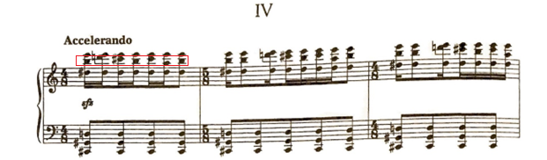

Figure 3: Ballet Mecanique (1924), mm. 1-6.

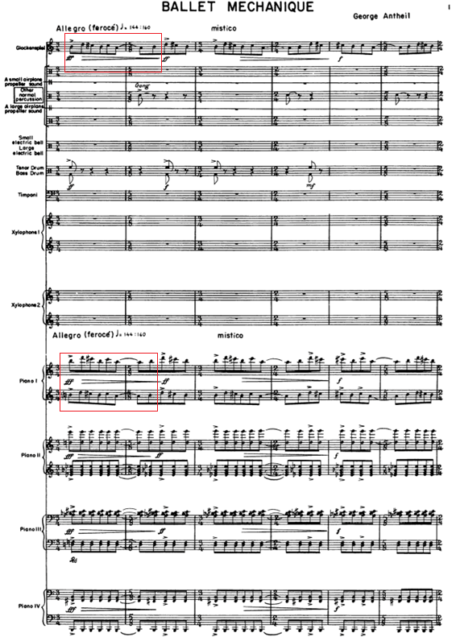
Antheil’s endeavor to actualize the music from his dream would inspire a large portion of his music from 1922 to 1931, concluding with La Femme 100 Têtes. Antheil’s solo piano compositions Airplane Sonata, Sonata Sauvage, Death of Machines, and Mechanisms from 1922 and 1923 form the youthful beginning to this search, Ballet Mécanique forms the bombastic pinnacle in the mid 1920s, and La Femme 100 Têtes serves as its final actualization in his solo piano music, thus ending his European venture in 1932. According to his autobiography, Antheil perceived the realization of “The Dream” to occur with the last act of his opera Transatlantic (1928), as well as his 4th Symphony (1942), both of which required the resources of the full orchestra. Nonetheless, La Femme 100 Têtes contains both Antheil’s most ambitious attempt to utilize his dream sketches for the solo piano, and his most intimate exploration of these dreams, an aspect which will become apparent in Chapter 3: Overview of La Femme 100 Têtes.

Stravinsky and Antheil
In 1922, Antheil met Igor Stravinsky in Paris. Stravinsky had the most influence on Antheil throughout the 1920s, culminating in Antheil’s composition of La Femme 100 Têtes, which contains several elements inspired by Stravinsky’s compositions. In Bad Boy of Music, Antheil said in 1922 that he “worshipped the brain that had conceived the colossal, world-shaking Sacre du Printemps, the fingers that had actually written Histoire du Soldat, Renard, Petrouchka, Oiseau [sic] de Feu.”
Upon Stravinsky’s arrival in Berlin in 1922, Antheil was able to find Stravinsky’s location from Caesar Searchinger, his Berlin host. Antheil arrived at Stravinsky’s home soon afterwards, bringing a score of Antheil’s Symphony for 5 Instruments, a piece written in 1922. Antheil admits that he took inspiration from Stravinsky’s Symphony for Wind Instruments (1920). Stravinsky, intrigued by Antheil's compositions, maintained regular discussions with him. Anticipating a future tour in America, Stravinsky frequently conversed with Antheil to learn more about the musical culture and various facets of life in Antheil's home country, the United States. According to Antheil, the two went on daily walks discussing American culture and composition throughout Stravinsky’s two-month stay in Paris.
Stravinsky’s account of their friendship differed from Antheil’s, claiming that Antheil was a nuisance. Nonetheless, Stravinsky spoke highly of Antheil as a musician when he said, “You play my music exactly as I wish it to be played.” Beyond that, Stravinsky’s offer to pay for Antheil’s Parisian debut as a pianist in 1922 is a testament to the mutual respect shared between the two composers.
Antheil employed three compositional techniques popularized by Stravinsky throughout his compositional output, including La Femme 100 Têtes: the additive rhythms from Stravinsky’s early ballets; the neo-classicism of Stravinsky’s interwar music, especially Les Noces; and block form, which Stravinsky used throughout his career. These influences will be apparent from the analysis of La Femme 100 Têtes, in Chapters 4 and 5 of this document.

Antheil and the Machine Aesthetic
The evolution of Antheil’s “machine aesthetic,” while often discussed in Antheil scholarship, must be introduced to contextualize La Femme 100 Têtes within Antheil’s career. The years from 1922 to 1927 would take Antheil across Europe from London to Paris to Berlin. According to a letter from Antheil to his patron, Mary Louise Curtis Bok on May 12, 1922, Antheil had several dreams which reshaped his compositional goals shortly before he left for Europe. He said that in these dreams he “caught the true significance and atmosphere of these giant engines and things that move about us.” Thus, Antheil’s implementation of these concepts into his music acted as the beginning of his famous “machine aesthetic.” This style was defined by H.H. Stuckenschmidt in 1923, by its “polyrhythmic homophony. He sets amorphous, motionlessly rhythmical blocks against one another and welds the totality into a wonderfully clear, crystalline form.” Antheil’s style was strictly anti-expressive, cold, and mechanical. His “machine aesthetic” defined most of his compositional output from 1922 to 1925.
In the Winter of 1932 to 1933, Antheil returned to his “machine aesthetic” for the final time with the composition of La Femme 100 Têtes, which features many of the compositional traits of that style, and quotes Ballet Mécanique. However, in contrast with his earlier works using the “machine aesthetic” from 1922 to 1925, Antheil included several more compositional styles in La Femme 100 Têtes, particularly neo-romanticism and neo-classicism.
One of the primary qualities of the “machine aesthetic” that feature prominently in La Femme is Antheil’s concept of “time-canvas.” This compositional technique is like Stravinsky’s block form, in that it contains consecutive sections that are unrelated thematically and texturally, mostly avoiding traditional structures such as rounded binary, sonata form, etc. Antheil’s “time-canvas” technique differs from Stravinsky’s block form in that separate musical blocks can occur simultaneously and change at different times. Linda Whitesitt describes this technique in The Life and Music of George Antheil, 1900-1959 stating “The fabric is constructed of layers of noncoordinating ostinato patterns in a hierarchy where one layer, usually the top, functions, because of its less rigid character, as a synthetic melody.”
Understanding the basics of Antheil’s “time-canvas” technique aids in the performance and teaching of La Femme, as several examples of the technique occur in the work. The simplest illustration of this concept occurs in Prelude No. 35 “Furioso,” which only lasts 8 measures. Both hands change patterns at separate times, causing two distinct forms to occur simultaneously, one in the right hand and one in the left hand. The form of the right hand contains three sections, A, B, and C (see Table 1). In contrast, the left-hand blocks divide the prelude differently than the right hand (see Table 2). This adds interest to the prelude, while increasing the challenge of learning and memorizing the work. See Chapter 5 for the score and teaching strategies to overcome these challenges.
Table 1: Formal “Time-Canvas” Analysis of Prelude No. 35 (Right Hand)
A | B | C
m. 1 | mm. 2-4 | 5-8

Table 2: Formal “Time-Canvas” Analysis of Prelude No. 35 (Left Hand)
A | B | C
mm. 1-3 | mm. 4-5 | 6-8

Antheil wrote several piano works of note during this mechanistic period, including his Airplane Sonata (1921), Sonata Sauvage (1923), Death of Machines, (1923), and Mechanisms (1923). Antheil’s performances of these works brought him early fame in Paris for their harsh dissonances, combined with Antheil’s virtuosity. Gradually, his compositional output in the 1920s would include pieces in more varied styles, but Antheil returned to the machine aesthetic for the last time in the Winter of 1932 and 1933 when he composed La Femme 100 Têtes, a piece which incorporates many of the traits of his machine aesthetic.

Ballet Mécanique
Before the composition of La Femme, Antheil’s machine aesthetic reached its peak with Ballet Mécanique (1924), a piece which was conceived to accompany a film by Fernand Léger. Léger was inspired to create the film by the machine-like qualities in George Antheil's early piano work, “Mechanisms” (1923). Due to disagreements between Antheil and Léger, the film Ballet Mécanique and Antheil’s composition of the same name were released separately. Antheil’s Ballet Mécanique was premiered in Paris in 1924, and later in the United States, in 1927. Nonetheless, Ballet Mécanique stands as the most notable example of the “machine aesthetic” in this era. While Antheil’s experimental piano works and percussive piano concerts brought him early success in Europe in the early 1920s, it was his avant-garde futurist film score Ballet Mécanique and its surrounding controversies that made Antheil famous in Paris and infamous in the United States.
Antheil composed the film score for Léger’s Ballet Mécanique, which had no accompanying dancers or choreography, for an unconventional percussion ensemble, including 16 player pianos. Originally, Antheil intended the piece to accompany a Dadaist film by the French artist Fernand Léger. The film would not be released with Antheil’s score during Antheil’s lifetime. Léger and Antheil disagreed over the length of the film and were not able to reconcile. As a result, the film was released without sound, separate from Antheil’s score.
Antheil scored the initial sketches of his 1924 version for 16 player pianos and lasted nearly half an hour, whereas Leger’s film totaled just under twelve minutes. Additionally, Antheil’s ambitious project to align 16 player pianos proved impossible given Léger’s time-frame.
Numerous efforts have been made by Antheil scholars to hypothesize the original planned synchronization of Antheil’s score to the film. Notably, Paul Lehrman led the mixing and editing of the 1924 version of Ballet Mécanique, aligning it with Legér’s film, a project which premiered at Brandeis University in 2001 during their Boston Cyberarts Festival. Ortiz Morales created a separate version in his 2008 dissertation based on his own theory of synchronization for the film and audio.
In its original orchestration, Antheil scored the piece for 15 player pianos synchronized with xylophones, wood, steel airplane, and other futuristic percussion instruments, an insurmountable technological feat at the time. Bravig Imbs, an American novelist from the same Parisian circle, described Ballet Mécanique’s tumultuous Parisian premiere as “sheer bedlam.” Nonetheless, it became lauded by the 1924 Parisian artistic elite including Eric Satie, Virgil Thompson, and James Joyce.
La Femme 100 Têtes, from the Winter of 1932 to 1933, exemplifies an amalgamation of Antheil’s “machine aesthetic” with his later neo-classical and neo-romantic interests. His “machine aesthetic” is represented most clearly in Preludes Nos. 1, 2, 3, 4, and 6, which are nearly direct transcriptions of mm. 240 to 281 of Ballet Mécanique. Many of the following preludes reference motivic material from the opening preludes that transcribe Ballet Mécanique. Other preludes contain elements more aligned to Antheil’s growing interest in neoclassicism and neo-romanticism.
Unfortunately, the American premiere of Ballet Mécanique on April 10, 1927 proved disastrous enough to shatter Antheil’s early reputation as a composer in the United States. Antheil later described his feelings on the piece in Bad Boy of Music when he said: “Therefore this Ballet Mécanique has become to me what the ‘C Sharp Minor Prelude’ must have become to Rachmaninoff: it is frankly my nightmare.” Antheil believed that it functioned to represent his entire career, regardless of his stylistic development before and after. Nonetheless, Preludes Nos. 1, 2, 3, 4, and 6 from La Femme 100 Têtes (1933) contain a transcription of the middle section of Ballet Mécanique starting from mm. 240 to 281 in the orchestral score.
The French Premiere and the American premiere of Ballet Mécanique, along with Antheil’s colorful life among the Parisian artistic elite, have dominated discussions of Antheil, in lieu of substantial analysis of his individual compositions. While Antheil’s music has been represented in performance through Ballet Mécanique, a piece that has received several performances and re-orchestrations since its 1924 premiere in Paris, Antheil’s notable contributions to solo piano literature have rarely entered the standard repertoire. While a few of his early iconoclastic Berlin piano solos have received attention in the sphere of performance, especially “Airplane Sonata”, many of his solo works remain underrepresented amongst classical pianists. Particularly, La Femme 100 Têtes, a collection of 45 miniatures whose thematic genesis lies in Ballet Mécanique, is rarely performed and is largely absent from the pedagogical keyboard literature, despite its usefulness as an introduction to the avant-garde.

Antheil as Futurist
George Antheil’s “machine aesthetic” period from 1922-1925, which also includes a few works composed outside of this range, resembles an aesthetic movement that had gained traction within the interwar years: futurism. The Italian futurism movement initiated, or at least codified, by Filippo Tommaso Marinetti in his 1909 work entitled The Manifest of Futurism, propagated the importance of industry, aggression, war, and the rejection of the immediate past. Luigi Russolo took Marinetti’s philosophy and applied it to music in his 1913 manifesto entitled Art of Noises, which detailed how the tenants of futurism could be applied to the creation of music.
Antheil was clearly influenced by Russolo’s 1913 manifesto, which emphasized creating pitch out of Russolo’s invented musical machines called “intonarumori,” unconventional noise instruments with descriptive names such as cracklers, buzzers and bursters. Like Russolo, Antheil used unconventional percussion instruments such as propellers and sirens to create timbres which can be heard to represent industry and mechanism in Ballet Mécanique (1924).
But, beyond the use of unconventional percussion instruments, Ballet Mécanique (1924) had few similarities with the tenants of Russolo’s manifesto. Antheil gradually shifted away from the philosophy presented by the Futurists. Antheil wrote a three-page neo-futurist “Manifesto of the Musico-Mechanics.” In the document, he criticizes the futurists for their lack of compositional structure, and, while Antheil’s manifesto agrees with Russolo’s notion that the music of the future will use countless new timbres to offset the standard orchestral instruments, Antheil goes further by stating that musicians will use machines to manipulate rhythm itself,, not just timbre. For musicians opposed to the notion of mechanical rhythm, Antheil predicted that a time will come where subtleties of a performance can be recorded upon a paper piano player roll, and that those subtleties can be further modified to more accurately reflect the musician’s intention. The accuracy of both of these predictions can be seen in the workflows of leading producers of popular music, all of whom use digital audio workstations such as Ableton or Logic to digitally record and manipulate subtleties of a performance. Beyond the performance itself, these programs, along with virtual instruments which interface with the digital audio workstations, can synthesize a practically infinite range of timbres through frequency modulation, additive synthesis, and sampling. And, as Antheil predicted, the mechanistic evenness of a rhythm created in a digital audio workstation can be given subtleties of rhythm which resemble human performance. Similarly, the rhythmic subtleties from a human performance can be removed to create a mechanistic evenness, a process called quantization.
In contrast with his critiques of Futurism in “Manifesto of the Musico-Mechanic,” Antheil admitted that he had used the term “futurist” to describe himself often during his time in Paris in the 1920s. He used the label as a simple way to emphasize his interest in the concept of the mechanism as applied to music, according to a typescript from 1923 entitled “Musical Neofism 1923.” Nonetheless, categorizing Antheil as a futurist is misleading. Since its inception by Marinetti, the Italian Futurist movement has had connections to Italian nationalist groups, connections which eventually led to the rise of fascism in the country. The nationalist and political implications of the Italian futurism movement had little to do with Antheil’s brand of Futurism. By the time of Antheil’s rejection of Futurism, Americans had little appetite for war after World War I, which contrasted with the Italian futurists. Antheil, like his compatriots, did not share the Italian futurist’s lust for war, and therefore distanced himself from the movement. Instead, Antheil indicated on multiple occasions that he composed Ballet Mécanique not as a Futurist statement, but as a warning of “the simultaneous beauty and danger of its mechanistic philosophy.” The current author proposes that Antheil’s mechanical period represents the essentially American reimagining of Futurism, a movement which would transform in the following years through the music of Edgar Varèse and the composers of musique concrète.

Antheil, Max Ernst, and Surrealism
While Ballet Mécanique defines the most orchestrally expansive culmination of his machine aesthetic, before Antheil permanently left Europe for America in 1933, he began composing a collection of 45 piano preludes entitled La Femme 100 Têtes, in 1932. This work represents the maturation of his mechanistic style. It functions as the final large expression of the machine aesthetic in his compositional output, crystallized into a surrealist work for solo piano. It combines aspects of Futurism, neoclassicism, and the newest movement amongst the Parisian artistic elite, Surrealism. Surrealism evolved out of Dadaism, a movement which emphasized the bizarre and nonsensical aspects of art. Surrealism differed from dadaism by emphasizing the importance of the subconscious mind, dreams, and psychoanalysis. Antheil’s La Femme 100 Têtes (1933) draws inspiration from Max Ernst’s surrealist collage novel of the same name from 1929, which took engravings from Victorian magazines and books, and connected a series of 100 collages made from these items into a nightmarish story.
In 1929, during the height of the Surrealist movement, Max Ernst, who, according to Charles Amirkhanian, knew Böski and George Antheil, combined images from old newspapers to create a series of collages depicting the interactions of two characters, Loplop-Bird Superior, and the book’s heroine, La Femme 100 Têtes. Antheil owned a first edition of the book, which he kept by his bed during his time in the French coastal village of Cagnes-sur-mer, where he composed his 45 piano preludes after Max Ernst’s collage novel, a piece which Antheil gave the same name: La Femme 100 Têtes.
Max Ernst’s original title, La Femme 100 Têtes, is in fact a triple-entendre. When read in French, it can be interpreted as “la femme cent têtes,” meaning the hundred-headed woman. In the novel, this refers to the heroine who is often given the name “Perturbation, my sister,” and takes several forms throughout the book, hence the hundred heads.
The title can also be heard as “la femme sans tête”, meaning the woman without a head. This translation reveals the inherent morbidity of the work, with figures of death often lurking in the background of the engravings. Max Ernst endured the death of his sister Maria at the age of six, an experience mirrored in Antheil’s own life by the death of his own sister Ruth, at age 12. Max Ernst’s life contained further tragedy later when, at the age of 14, Max’s beloved pet bird died on the same day that his youngest sister, Loni, was born. According to Ernst, this created “a dangerous confusion between birds and humans…” which defined a significant portion of his artistic output throughout his career, including La Femme 100 Têtes (1929.)
The third homophone for the title is “la femme s’entête”, which means the persistent woman. In the novel, the heroine seems to endure insurmountable obstacles throughout the nine chapters including ocean waves, storms, cages, and titans. Nonetheless, she is described as “stronger than volcanoes, airy and isolated…”
During the years prior to Antheil’s composition of 45 preludes inspired by Max Ernst’s La Femme 100 Têtes (1929), he moved several times between Europe and America. In 1928, he moved from Paris to Vienna. And, after several visits to America between 1929 and 1933, Antheil returned to America in 1933 for the rest of his career (the exception being a short time spent in Spain later in life). There he would abstain from the more avant-garde stylings that defined his early Parisian career, and his Surrealist experimentations in the early 1930s. Instead, he preferred a neo-romantic style suitable for his film scoring career, an endeavor which he continued for the rest of his life.

Antheil as Film Composer
In August 1933, prior to completing La Femme 100 Têtes, Antheil and his wife Böski moved from Cagnes-sur-mer, the coastal French town where they had lived sporadically since 1931, to New York City. In 1934, two American filmmakers, Ben Hecht and Charles MacArthur, invited Antheil to compose movie scores for their upcoming productions. This began Antheil’s venture into film scoring, which lasted until his death in 1959.
To facilitate this career choice, Antheil moved to Hollywood in May 1936, where he would remain for the rest of his life. In a letter to his patron Mary Louise Curtis Bok, Antheil himself stated that his primary goal in moving to Hollywood “was first and last to earn money.”
After composing numerous film scores in the 1930s and 40s, Antheil regained interest in the more serious side of composition, all the while continuing his movie score composition. This led to his music gaining popularity and critical acclaim, especially his Fourth Symphony which Leopold Stokowski premiered in 1944. In his last years, Antheil continued to compose movie scores, but also wrote concert works including his Fifth Symphony, composed 1947-1948, and his Sonata No. 4 for piano, composed in 1948. In 1947, Antheil became one of the most performed American composers according to a survey from that year. This commercial success lasted through the rest of Antheil’s life. On February 12, 1959, Antheil died of a heart attack. His wife Böski Antheil passed in 1978, and their son Peter lived until 2010. Antheil’s nephew, Arthur McTighe is the current executor of Antheil’s estate.
Antheil’s musical legacy is remembered through projects organized by his family as well as the scholars and performers who study his music. In 2000, many Antheil scholars and performers, including Linda Whitesitt, Charles Amirkhanian, David Albee, Paul Lehrman, and other authors and performers referenced in this document, assembled a recording project for Antheil’s centennial. The CD included never-released recordings of Antheil at the piano, including songs he wrote at the piano to sing for his son Peter.
In the 21st century, Antheil’s music has been the subject of a few small but notable music events. In 2003, the first and only George Antheil Conference was held in Trenton, NJ. The event held the initial screening of Paul Lehrman’s documentary on Antheil entitled Bad Boy Made Good (2003). Tufts University presented a two-day festival in Medford, MA dedicated to the film music of Antheil, which included presentations and performances of Antheil’s music.
Virgil Thomson, Antheil’s friend and contemporary, said in 1971, “his music, though not strongly current in repertory, does not die. Pieces of it are constantly being revived.” Thomson’s statement remains true even now. Antheil’s innovations as a composer shaped the trajectory of music and technology, and his visionary works deserve attention from musicians, scholars, and teachers. This study intends to highlight Antheil’s accomplishments as a composer and solidify his position in the pedagogical repertoire of the piano.

Chapter 3: Overview of La Femme 100 Têtes
George Antheil’s La Femme 100 Têtes is a collection of 45 preludes written for solo piano in the winter between 1932 and 1933, currently absent from the piano’s pedagogical literature. The work was inspired by Max Ernst’s surrealist collage-novel of the same name, La Femme 100 Têtes (1929). Antheil evokes the bizarre imagery and the disjunct narrative of Ernst’s work through dissonant and often humorous harmonic language. Structurally, Antheil mimics Max Ernst by quoting his own Ballet Mécanique within the piece, creating a musical analogue to the collage techniques Ernst used in the creation of his La Femme 100 Têtes (1929).
Later, in 1934, Antheil arranged 25 of the preludes for small chamber ensemble to be choreographed by Martha Graham as Dance in Four Parts. While no versions of the score for Dance in Four Parts are known to exist, this collaboration provides further insight into the value Antheil placed on the interdisciplinary connections possible with La Femme 100 Têtes.
Beyond the compositional homages to Ernst’s collage novel, Antheil described the work’s meaning in several contradictory ways in different primary sources. The preludes were at one point described by Antheil to represent “the subconscious and strange feelings of my childhood in Trenton.” In letters contemporary with La Femme 100 Têtes, Antheil says that seeing stars through a telescope piqued his compositional imagination while writing the work. In 1933, he described the magnitude of this inspiration: “These strange mathematics of infinity always inspire me with music the day after.” He continues describing the process of composing La Femme 100 Têtes: “I am putting this strange feeling of space and time into a series of 100 piano preludes I am finishing.” While he mentioned a total of 100 piano preludes, Antheil’s wife stated that this was incorrect and that the extant 45-movement work is the complete version of La Femme 100 Têtes. Nonetheless, it is known now that several versions of the piece were created. Charles Amirkhanian states that the preludes were partially premiered in 1933 by Antheil at the Second Yaddo Festival of Contemporary Music in Saratoga Springs, New York. At that time, the work only included 40 preludes although it is unknown which 5 were added later. One can speculate that Antheil might have planned to compose 100 preludes, but then either found the 45 movements to be self-contained, or eventually relinquished the idea of finishing the project.
Clearly, the meaning of the work for Antheil was mercurial. Other analysis of Surrealist art can help elucidate methods for deciphering its meaning. For example, Charlotte Stokes’ analysis of Max Ernst’s collage novels entitled “Surrealist Persona: Max Ernst’s Loplop, Superior of Birds” provides such a method. In this article, Stokes claims that “all surrealist art is to some degree autobiographical.” Likewise, Antheil’s La Femme 100 Têtes can be analyzed autobiographically. In the same way that Ernst reflects on the tragedies he has experienced in life, Antheil reflects his “nightmare” by opening the work with a direct transcription of the middle section of Ballet Mécanique, the piece that gave Antheil his greatest success, and his greatest failure. Preludes Nos. 1, 2, 3, 4, and 6 are all transcriptions of mm. 240-281 of Ballet Mécanique. Motifs from Preludes Nos. 1, 2, 3, 4, and 6, and consequently, from Ballet Mécanique, occur throughout the 45 preludes of La Femme. Thus, Stoke’s concept of the autobiographical nature of all surrealist art can be applied to Antheil’s La Femme 100 Têtes (1933) as well as Max Ernst’s La Femme 100 Têtes (1929). The analyses present in Chapters Four and Five will occasionally draw upon autobiographical references in La Femme 100 Têtes to aid in introducing these preludes to the piano studio.
Aesthetically, La Femme 100 Têtes uses techniques developed during Antheil’s machine aesthetic period, including the use of percussive rhythmic ostinati and textures that can be heard to mimic the sounds of machines. In the collection, Antheil takes advantage of the entire range of the keyboard.
The preludes vary radically in difficulty. When taking Dr. Jane Magrath’s leveling system into account, 24 of the 45 movements have been considered by the author to fall into the category of late intermediate to early advanced (Magrath Levels 6 to 10). This provides a wealth of avant-garde miniatures for the aspiring high school student. See Appendix A for a reference chart of the preludes leveled by difficulty.
Antheil’s work remained unpublished until 1985 when 8 of the preludes were published by G. Schirmer in George Antheil: The Piano Album, edited by Marthanne Verbit, and photocopies of the complete copyist manuscript were sold by request through Charles Amirkhanian via Antheil Press from 1985 until 1992. The complete score fell out of print until the complete version, still sold as manuscript photocopies, was published in 2017. Like Charles Amirkhanian, G. Schirmer published photocopies of only the extant version of the work, a copyist’s score, as the holograph seems to be lost. This version of the score is available for print on demand at classicalondemand.com.
La Femme 100 Têtes has a history of choreography. In 1934, just one year after Antheil premiered 40 of the 45 preludes, Martha Graham, one of the most influential dancers of the 20th century, choreographed 25 of the preludes in a ballet entitled Dance in Four Parts. The four movements were eventually titled “Quest,” “Derision,” “Dream,” and “Sportive Tragedy.”
La Femme has influenced a range of artistic projects beyond Graham's ballet. In 1976, composer-pianist Robert de Leeuw and Argentinian pianist Jorge Zulueta, a founder of the theater and music company called Grupo Acción Instrumental, created a version of La Femme 100 Têtes featuring the preludes as well as other piano pieces from Antheil’s “machine aesthetic” period composed from 1922 to 1925. This work, entitled Arposophie: Opera-Collage, dramatized the interactions among Max Ernst, Antheil and his wife Böski Antheil over projections of Ernst’s collages. The current author found only an advertisement for this work, as the score seems to be lost.

History of Publication
The absence of La Femme 100 Têtes from the standard teaching literature can be explained through its fragmented history of publication, the disappearance of the holograph, and ambiguities in the extant copyist manuscript. Although La Femme 100 Têtes was composed in the winter of 1932-1933 and partially premiered at the Second Yaddo Festival in 1933, Antheil never published the work during his lifetime, and no extant handwritten scores by the composer (holographs) of the work have been found. The copyist manuscript, in the handwriting of Henry Brant, remained unpublished for over 50 years and in the possession of Mrs. Böski Antheil, thus eliminating the possibility of the work’s establishment in the pedagogical canon in the decades following its composition due to the lack of a clearly engraved edition of the work and despite its important position in the composer’s output.
Access to the score of La Femme 100 Têtes increased marginally during the second half of the twentieth century. In 1977, David Albee acquired a reproduction of the copyist manuscript from Mrs. Böski Antheil for his dissertation entitled “George Antheil’s La Femme 100 Têtes: A Study of the Piano Preludes. (Volumes I and II).” Volume II of Albee’s dissertation included Albee’s edited manuscript of La Femme 100 Têtes, which has since been removed at the request of Albee. Albee never released this manuscript edition commercially. Upon Mrs. Boski Antheil’s death in 1978, Charles Amirkhanian, San Francisco composer, received the rights to Antheil’s unpublished scores and manuscripts, which included the copyist manuscript of La Femme 100 Têtes. Amirkhanian distributed copies of manuscripts from the Antheil estate collection by creating the short-lived publication business called Antheil Press. In 1985, Amirkhanian published the unedited copyist manuscript of La Femme 100 Têtes, coinciding with the first commercial recording of the work by David Albee in 1984. Amirkhanian did not publish Albee’s manuscript edition of La Femme 100 Têtes, but instead published photocopies of the copyist manuscript from 1934 which Albee had used as a source for his edition.
The current author accessed a copy of the Antheil Press’s 1985 publication of the score through the library at the University of Ottawa, one of only two copies in circulation in libraries internationally. When Amirkhanian sold the rights to Schirmer in 1992, La Femme 100 Têtes was among the collection. Thus, La Femme 100 Têtes fell out of print until 8 of the 45 preludes were printed in Schirmer’s George Antheil: A Piano Album, edited by Marthanne Verbit in 1997. Currently, the 8 preludes edited by Verbit remain the only preludes from La Femme 100 Têtes engraved digitally.
The availability of La Femme 100 Têtes increased substantially in the 21st century. In 2006, Amirkhanian donated a photocopy of the copyist manuscript of La Femme 100 Têtes to the Music division of the Library of Congress, allowing scholars to freely view the entire work. Most importantly, in 2016, Schirmer initiated classicalondemand.com which functioned as an online storefront for scores copyrighted by Schirmer that remained unpublished. This included the copyist manuscript of all 45 preludes from La Femme 100 Têtes, which became commercially available in its entirety for the first time in 2017.

Compositional Style of La Femme 100 Têtes
La Femme 100 Têtes marks a crucial turning point in George Antheil’s compositional career. Written primarily at Cagnes-sur-mer, the last place in Europe Antheil would live prior to moving back to the United States for the remainder of his career, the preludes from La Femme transmit a multitude of aesthetics which Antheil had either previously explored during his time in Europe, or would explore in the years following his move to New York City in May of 1933.
Because Antheil composed Preludes Nos. 1, 2, 3, 4, and 6 as transcriptions of passages from Ballet Mécanique (1924), and most of the remaining preludes feature motivic material from these initial preludes, several preludes from La Femme 100 Têtes include numerous characteristics from Antheil’s “machine aesthetic.” Antheil’s “machine aesthetic” was defined by repetitive eighth note ostinatos, harsh dissonances, and mimicry of the player piano and other percussion instruments. The mechanical ostinato and biting minor ninth leaps of Prelude No. 3 “Faintly Energetic” reflect these qualities (see Figure 4).

Figure 4: Prelude No. 3 “Faintly Energetic,” A section, mm. 1-2

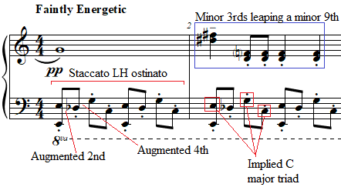

Beginning with his Piano Concerto from 1926 and appearing in several preludes from La Femme 100 Têtes, Antheil employed an economy of means influenced by the neoclassical works of Igor Stravinsky, for example, Stravinsky’s ballet Pulcinella (1920). This style featured elements of tonal music: triads, contrapuntal passages, a prevalence of perfect intervals, and baroque dance influences. Antheil and Stravinsky used these features, borrowed from the music of the Baroque and Classical eras, to create unexpected harmonic progressions and additive rhythms. For example, Prelude No. 19 “Fast, An Even Piano Throughout” features two ideas, one stepwise motif in sixteenth notes, and another motif consisting largely of skips in eighth notes. The left and right hands trade these motifs in a manner resembling the subject and countersubject of a Bach invention (see Figure 5).
Figure 5: Prelude No. 19 “Fast, An Even Piano Throughout,” mm. 1-3
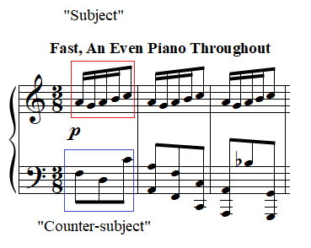
The primary difference is that while Bach develops motivic material in the inventions primarily through modulation, inversion, augmentation, and diminution, Antheil develops his subjects through the atomization of the subjects into their smallest composite parts, interval and rhythm (see Chapter Five: Prelude No. 19: “Fast, An Even Piano Throughout”). This concept features heavily in the writings of Arnold Schoenberg, another one of Antheil’s compositional influences, who defined musical ideas as a relationship between tones.
Antheil, who was likely introduced to the music of Arnold Schoenberg through his studies with Ernest Bloch, sporadically employed the compositional techniques of the Second Viennese School in La Femme 100 Têtes. Prelude No. 13 “Nostalgic, Twisted, Slowly,” for example, features the (012) trichord, manipulated through transposition and inversion (see Chapter 4: Prelude No. 13 “Nostalgic, Twisted, Slowly”).
In contrast with the music of the Second Viennese School, the most prevalent compositional technique for motivic manipulation used in La Femme 100 Têtes involves the irregular transposition or inversion of pitch content, a process which Joseph N. Strauss defines as quasi-transposition/inversion or fuzzy transposition/inversion. This technique constitutes the primary means of motivic manipulation throughout La Femme 100 Têtes. This can be demonstrated by comparing two instances of the opening motif of La Femme 100 Têtes in Prelude No. 1 “Thoughtfully, Not Too Slow” (see Figure 6 and Figure 7). Aurally, the contour of both passages suggests a transpositional relationship. Yet, the pitch content of both passages is not related by a single interval, but by a general melodic contour. Even the rhythm of the first beat of the motif is transformed from four sixteenth notes, to three triplet eighth notes. One can speculate that this technique functions as a musical representation of distorted dreams and memories, a ubiquitous concept in Surrealism.

Figure 6: Prelude No. 1 “Thoughtfully, Not Too Slow,” mm. 1-2
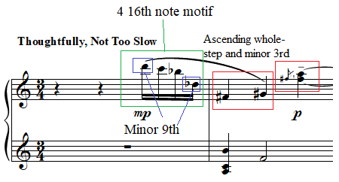
Figure 7: Prelude No. 1 “Thoughtfully, Not Too Slow,” mm. 7-8
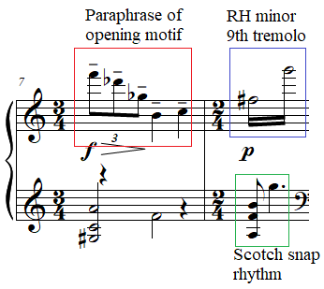
To reflect a dreamlike state in La Femme 100 Têtes, Antheil also utilized compositional techniques popularized by Debussy, a composer whose piano music Antheil had performed on his European debut piano recital in 1922 at Wigmore Hall in London. Prelude No. 38 “Broad” features stacked quintal harmony with inner voice movement that requires delicate use of the pedal, features present in Debussy’s tenth prelude “La cathédrale engloutie” from his first book of preludes (see Chapter 5: Prelude No. 38 “Broad” for further discussion). Other preludes such as Prelude No. 24 “Slowly” feature arpeggiated flourishes similar to the fourth prelude from Debussy’s second book of preludes, “Les fées sont d’exquises danseuses.”
La Femme 100 Têtes forms a unique compendium of Antheil’s aesthetic experimentation, both reflecting the styles he explored in Europe and the styles which he would explore later in the United States. The free use of compositional techniques from Stravinsky, Schoenberg, Debussy, and Antheil’s own experimentation generates a style unique during this transitional time in his career. These features render La Femme 100 Têtes compelling for study by pianists, students and teachers.

Score Legibility as Barrier to Access
Even if teachers are aware of classicalondemand.com, a service rarely advertised by Schirmer, the legibility of the manuscript score is still a barrier to access for students and teachers. Schirmer’s complete score which is available for print on demand at the time of this document’s writing is an unedited duplication of the original copyist manuscript, which contains additional markings by the composer. Unfortunately, both the copyist’s efforts and Antheil’s markings do little to clarify the more confusing aspects of the work. Several preludes contain illegible or ambiguous notes, contradictory pagination, and performance notes that are seemingly impossible to execute. For example, Prelude No. 7 ends with the rehearsal text “go back to XXVII, page 25,” when Prelude No. 27 is on page 33.
Beyond the legibility of the manuscript, the numbering of preludes in the copyist manuscript contains errors. Scholars have yet to find Prelude No. 42. If it ever did exist, it was never included in the final work, as Prelude No. 41 is followed by Prelude No. 43 in the copyist manuscript. The photocopy of the copyist manuscript from classicalondemand.com is the only commercially available score of the complete work.

The Missing Holograph
The history of the original score for La Femme 100 Têtes has always been poorly documented. The location of Antheil’s holograph remains unknown, and no recording of Antheil’s 1933 premiere has been discovered. The Collection of Yaddo Festival Sound Recordings does not have recordings prior to 1937. Attempts by the author to locate a possible recording in the Yaddo Records and the Collection of Yaddo Festival Sound Recordings, both held by the New York Public Library, proved unsuccessful. Beyond this, while the Yaddo festival required a manuscript sent for evaluation to be accepted for performance, a requirement which could have created a spare copy of the Antheil’s holograph of La Femme 100 Têtes, attempts to locate the manuscript within the Yaddo archives, which opened in 2003, have not yielded any results.
Obviously, the lack of documentation on La Femme in its early stages of composition has stunted critical studies of the work, inhibiting the creation of a critical edition. But neither has a scholarly or performance edition of La Femme been published, nor any edition which would make the easier preludes within the collection available to more teachers, performers, and students. At the current time of research, teachers can order a photocopy of the unedited copyist manuscript to be printed, including all 45 preludes, from classicalondemand, although it is difficult to discern which preludes are appropriate for the piano studio, and several are challenging to read.
Currently, no resource exists for teachers to ascertain the appropriate level to introduce each prelude, as no progressive analysis of the 45 preludes in La Femme has been written. In the leading reference texts of piano pedagogy including Jane Magrath’s The Pianist’s Guide to Standard Teaching and Performance Literature, and her more recent Piano Literature for Teaching and Performance: A Graded Guide and Annotated Bibliography, La Femme is notably absent, although Maurice Hinson’s Guide to the Pianist’s Repertoire from 2000 includes a brief entry which asks the reader to reference David Albee’s dissertation for more information. This entry contains neither a leveling of difficulty nor any information about the preludes individually.
Schirmer’s publication George Antheil: A Piano Album includes 8 preludes from La Femme. Two are late intermediate to early advanced and the other 6 feature a much higher difficulty. This publication omits 22 of the 24 intermediate to early advanced preludes available within the entire collection of 45 preludes from La Femme.
Consequently, the majority of the easiest preludes from La Femme have never been digitally engraved. This lack of accessibility renders La Femme, a significant American piano work, largely unavailable to a wide range of students and teachers, simply due to a lack of knowledge about the score’s availability.

Misleading Complexity
The 45 preludes within La Femme 100 Têtes are inherently accessible due to their rhythmic vitality and clever humor, provided teachers are aware of them and can easily access the scores. However, the previously mentioned features of the copyist manuscript can prove daunting to teachers and students, and the complexity surrounding the composition has the potential to overshadow its inherent appeal and inventiveness. This could deter teachers, performers, and students who might feel they lack the necessary knowledge to fully grasp the piece. However, with carefully planned introductions, teachers will find that the preludes are valuable for their technical and musical qualities, with little historical context necessary to understand each. Teachers can provide additional information about the preludes to students based on individual student interests and needs. Thus, the 45 preludes are worth exploring for their value as teaching pieces in the piano studio.
Furthermore, La Femme’s position as a large surrealist work for the piano gives it a unique position in keyboard literature. The standard pedagogical literature of the piano rarely relates the eccentricities of the unconscious mind in the manner accomplished by Antheil in La Femme. La Femme's relevance to pianists makes it an ideal choice for music teachers in their studios, especially when engaging with adolescents and teenagers, as standard pedagogical literature does not always resonate with teenagers. In this context, the preludes from La Femme stand out for their ability to captivate students, offering both artistic merit and a unique learning experience.

Organization of Pedagogical Analysis
The following two chapters will contain a pedagogical analysis of the late intermediate and early advanced preludes from La Femme 100 Têtes using excerpts from the piece input into Finale by the current author. Chapter Four will present a pedagogical and performance analysis of the 9 late intermediate preludes from La Femme 100 Têtes, treated individually, arranged in order of ascending difficulty. Similarly, Chapter Five will analyze the 15 early advanced preludes from La Femme, ordered individually by increasing difficulty. In both Chapters Four and Five, each prelude’s analysis will include compositional and pedagogical overviews.

Chapter 4: Pedagogical Analysis of La Femme 100 Têtes Part 1

Prelude No. 9: “Sad”
Overview
Suggested Tempo: Quarter note = 45-58
Key: D Dorian mode
Time Signature: 3/4
Measures: 20
Pages: 1
Level: 6
Length: 1:30 – 1:45
Publication: G. Schirmer, The Antheil Album
Prelude No. 9 “Sad” is the easiest of all the preludes in La Femme 100 Têtes, at a level 6. As in all the preludes in La Femme, Antheil provided only an expressive title, “Sad,” and no metronome marking. The piece exhibits Antheil at his most lyrical and harmonically stable. At only 20 measures long, this piece serves as an excellent introduction to the romantic side of Antheil’s compositional style.

Compositional Overview:
Prelude No. 9 loosely follows rounded binary form (see Table 3). The opening A section features a one-measure introduction, and the final A section ends with a one-measure codetta. Both A sections feature six-measure phrases which can each be divided into four measures plus two measures. The piece is characterized by the prominent use of thirds, sixths, and quiet dynamics.

Table 3: Prelude No. 9 Formal Analysis
Introduction | A | B | A’ | Codetta
m. 1 | mm. 2-7 | mm. 8-13 | mm. 14-19 | m. 20

Prelude No. 9 begins in m. 1 with an introduction lasting one measure (see Figure 8). This introduces an ostinato in the left hand, which consists of thirds with a steady eighth note rhythm. This ostinato rhythm from m. 1 is featured throughout the piece in the left hand.

Figure 8: Prelude No. 9 “Sad,” A section, mm. 1-5
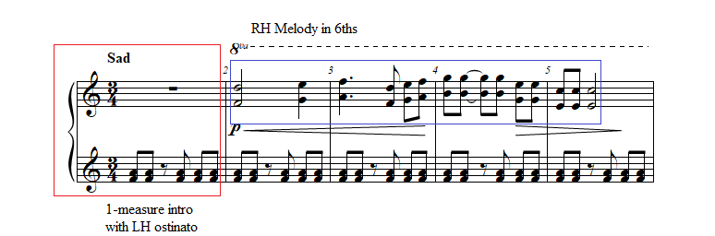

The A section, which begins at m. 2, presents the melody in sixths in the right hand (see Figure 8). The 2nd subphrase, lasting two measures from mm. 6-8, introduces descending chromatic sixths (see Figure 9).

Figure 9: Prelude No. 9, A section, mm. 6-9
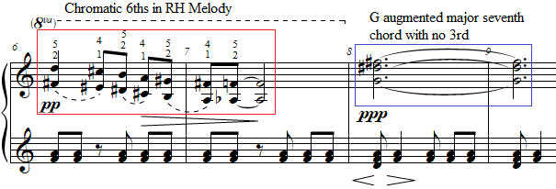
The B section starts at m. 8 and lasts until m. 13. It introduces a d-minor chord in the left hand with a more sustained ostinato and features a pianississimo dynamic (see Figure 9). After the initial chord in the right hand which features a G augmented major seventh chord with no third (G-D#-F#), the right hand, mm. 10-12 consists of a disjunct single-note melody with a range of nearly three octaves (see Figure 9). This melody increases in chromaticism until its resolution on a D minor chord in m. 13 (see Figure 10).

Figure 10: Prelude No. 9, B section, mm. 10-13
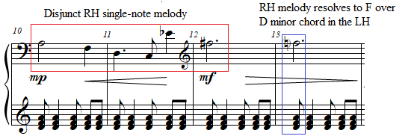

The return of the A section is identical to the opening A section, except it features the more sustained left-hand ostinato from the B section (see Figure 11). The piece concludes with a single dotted half-note chord in the left hand which implies an incomplete and unresolved G dominant seventh chord (see Figure 12). This same chord quality concludes Preludes Nos. 10 and 29.
Figure 11: Prelude No. 9, A’ section, mm. 14-17
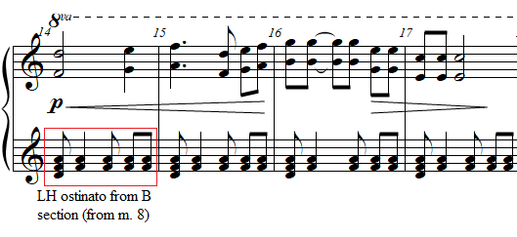

Figure 12: Prelude No. 9, A’ section, mm. 17-20
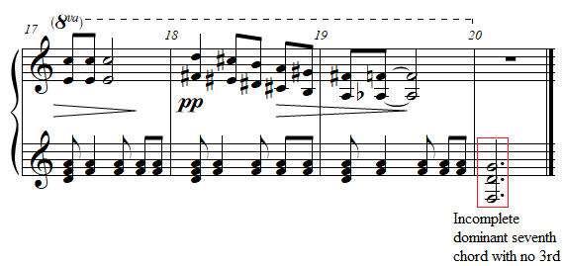

Pedagogical Overview:
Prelude No. 9, evaluated at level 6, is the most accessible prelude within La Femme. The rounded binary form and the ostinato in the left hand make this piece easy to learn for late intermediate students. Rhythmically, Prelude No. 9 features a 3/4 time signature, with note values consisting of quarter notes and eighth notes.
In teaching the A section of Prelude No. 9, the following short exercise could be established to aid students in moving 6ths around the keyboard (see Figure 13).
Figure 13: Preparation exercise for La Femme 100 Têtes, Prelude No. 9
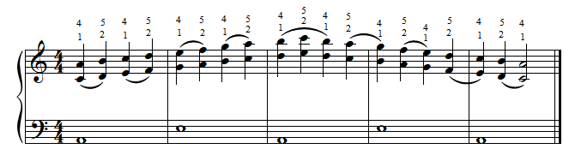

The most difficult passage is the chromatic sixths in the right hand in mm. 6-7 and mm. 18-19. This passage can be made easier by grouping each pair of sixths, to create separate hand positions (see Figure 14 for the current author’s suggested fingerings).

Figure 14: Prelude No. 9, A section, mm. 6-8
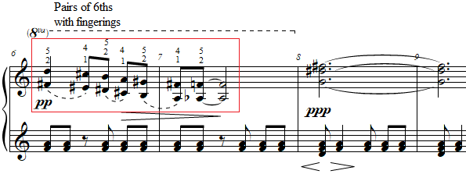

Dynamics and pedaling within Prelude No. 9 are crucial to gain a somber and “Sad” atmosphere. Dynamics in this prelude range from mezzo forte to pianississimo. A non-percussive touch from the key is necessary to successfully achieve this dynamic range. The scalar sixths must be played in succession with a relaxed hand. The current author suggests that the ostinato in the left hand be played without the left hand fully lifting from the keys, to insure proper balance and a quiet dynamic. Pianists should carefully release the pedal during eighth rests in the left hand. A suggested pedaling is shown in Figure 15.

Figure 15: Prelude No. 9, A section, mm. 1-3
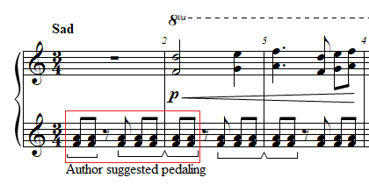
An effective performance of Prelude No. 9 emphasizes the contrast of phrasing and touch between the two hands. Students can bring out the stepwise contour of the right-hand melody in the A sections against the contrastingly static left-hand ostinato by exaggerating the right hand’s phrasing up and down the keyboard. This contrast can be furthered when the right hand plays the disjunct melody during the B section from mm. 8-13 by using agogic accents during large leaps in the right hand. Prelude No. 9 is an excellent choice for a student interested in a modern variation of romantic music.

Prelude No. 7: “Sad”
Overview
Suggested Tempo: Quarter note = 45-58
Key: D Dorian mode, G Mixolydian
Time Signature: 3/4
Measures: 12
Pages: 1
Length: 0:45 – 1:00
Level: 6-7
Publication: G. Schirmer (classicalondemand.com), La Femme 100 Têtes
Prelude No. 7 “Sad” is another prelude accessible to the intermediate student, with difficulty ranging from levels 6 to 7. Antheil’s expressive marking, “Sad,” anticipates Prelude No. 9, which shares the same expressive marking. However, instead of harmonic and lyrical stability, the melodic material within Prelude No. 7 is constantly interrupted, leading to a much larger number of musical ideas. At only 12 measures long, the current author suggests that this prelude should be grouped in performance with at least one other prelude, a topic discussed further below.

Compositional Overview:
Prelude No. 7 is through-composed, consisting of an A section followed by a transition into a coda (see Table 4). Of the preludes selected for analysis in this document, Prelude No. 7 is the least suited to be performed individually. After the introduction, Antheil introduces a four-measure phrase followed by a one measure transition in m. 7 that connects the A section to the coda. The piece is characterized by chords spanning a ninth, as well as its density of musical ideas, despite its brief length.

Table 4: Prelude No. 7 Formal Analysis
A | Transition | Coda
mm. 1-6 | m. 7 | mm. 8-12

Prelude No. 7 begins with a two-measure introduction, featuring a left-hand ostinato in thirds which foreshadows Prelude No. 9 (see Figure 16).

Figure 16: Prelude No. 7, A section, mm. 1-3
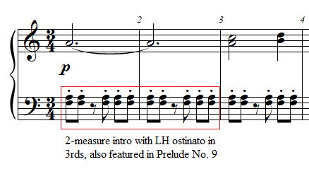

The opening A section features a two-measure introduction, which connects the previous prelude, Prelude No. 6 “Floating,” to Prelude No. 7 “Sad” via a tied note (see Figure 17). This provides the option for Preludes Nos. 6-7 to be connected in performance. This ostinato lasts from mm. 1-6.
Figure 17: Prelude No. 6, mm. 10-11, Prelude No. 7 mm. 1-2
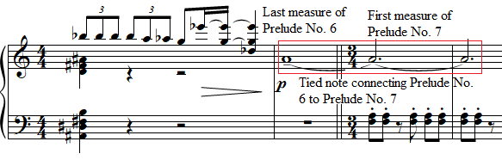

The right hand plays a pair of ascending thirds in m. 2, a motif rhythmically and texturally transformed in several other preludes including Prelude No. 32 “Sad,” another prelude analyzed in this chapter (see Figure 18 and Figure 19). Mm. 3-6 feature the two-note motif alternately played in thirds or ornamented with chords spanning an octave (see Figure 18.)

Figure 18: Prelude No. 7 “Sad,” A section, mm. 3-6
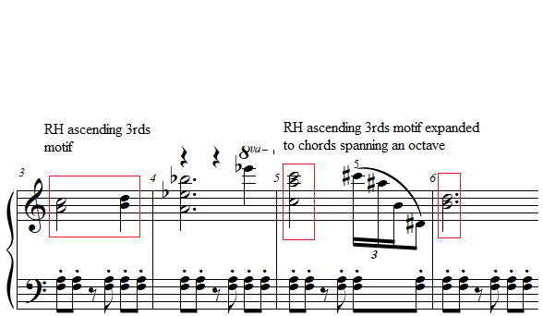
Figure 19: Prelude No. 32 “Sad,” mm. 1-4
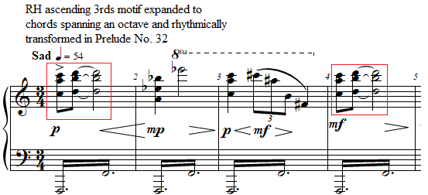

M. 7 features a transition, including a disrupting chord in the right and left hands (see Figure 20). This is followed by an increase in dynamic to a forte with an accented augmented second which leads the right hand into the high G that begins the coda (see Figure 20).

Figure 20: Prelude No. 7 “Sad,” mm. 5-8
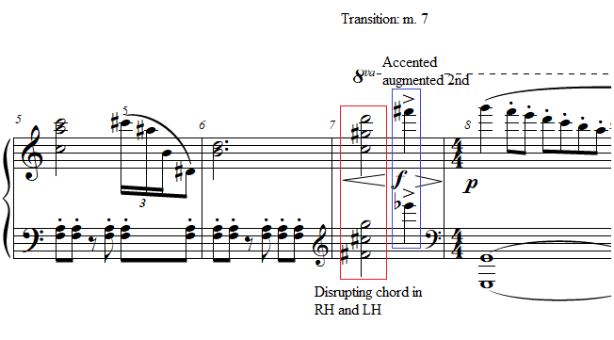
In the coda, the left hand drops to a low G octave creating a jarring expansion of register with the lowest note in the left hand and highest note in the right hand spanning six octaves (see Figure 21). The right hand performs a simplistic descending G Mixolydian scale, finally meeting on the G an octave above the left hand’s pedal octave. The current author asserts that these white-key scales acts as a parody of Czerny. This Neoclassical element returns in other preludes as well, notably in the contrary C major scales in the opening of Prelude No. 34 (see Figure 22). Prelude No. 7 ends on three G’s in separate octaves resting on a whole note.

Figure 21: Prelude No. 7 “Sad,” B section, mm. 8-10
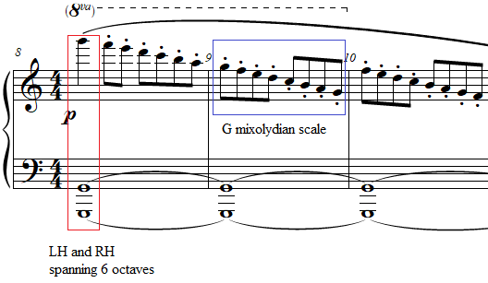:

Figure 22: Prelude No. 34 “Brilliant” mm. 1-3
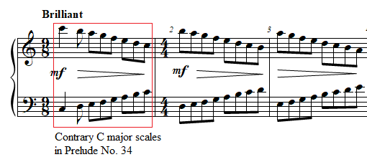

Pedagogical Overview:
Prelude No. 7, evaluated at level 6-7, is the second easiest prelude within La Femme due to its brevity, and slow tempo. Nonetheless, Prelude No. 7 is less suitable to be performed individually than Prelude No. 9. Instead, Prelude No. 7 can be performed as a pair following Prelude No. 6 “Floating,” acting as a conclusion to this prelude. The ostinato in the left hand makes this piece easy to learn for late intermediate students.
Rhythmically, Prelude No. 7 features a 3/4 time signature until the 4/4 coda, featuring the same rhythm from the left-hand ostinato in Prelude No. 9, with note values primarily consisting of whole notes, half notes, quarter notes and eighth notes. The exception is the group of triplet sixteenth notes in m. 5 (see Figure 23). This challenging rhythm is combined with a difficult set of leaps (for a suggested fingering for this passage see Figure 23).
Figure 23: Prelude No. 7 “Sad,” A section, mm. 4-6
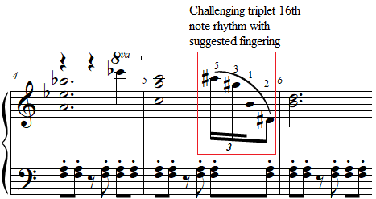

The current author created the following preparation exercise to be used to prepare students for the crossover of the right hand in Prelude No. 7 (see Figure 24).

Figure 24: Preparation exercise for La Femme 100 Têtes, Prelude No. 7
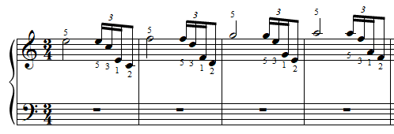

In teaching the A section of Prelude No. 7, the chords such as beat one of m. 4, spanning a ninth or more can be easily arpeggiated for students with smaller hands. In fact, arpeggiation becomes a motivic feature throughout La Femme, justifying its use throughout the piece in chords spanning over an octave. Several preludes, such as Prelude No. 29 (see Figure 25), feature the arpeggiation of large chords, and the manuscript often contains chords that span an 11th without any arpeggiation symbol, clearly giving pianists the liberty to arpeggiate as needed.

The chords in both hands of m. 7, both of which span a ninth, can likewise be arpeggiated (see Figure 26).

Figure 25: Prelude No. 29 “Nostalgic, Slowly,” A section, mm. 1-4
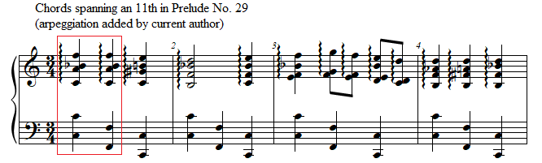

Figure 26: Prelude No. 7 “Sad,” mm. 5-8
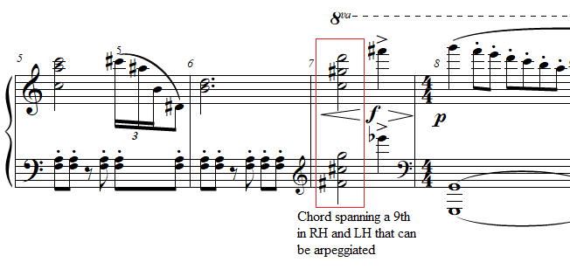

Antheil emphasizes specific dynamics and articulation to create a somber soundscape in Prelude No. 7. A piano dynamic is maintained throughout this prelude, with the exception of the transition in m. 7, which features a crescendo to forte on beat three. Teachers can help students internalize this crescendo, occurring on a half note, by asking them to sing along with the top of the right hand, which from mm. 7-8 forms the melody D-F#-G (see Figure 27).

Figure 27: Prelude No. 7 “Sad,” mm. 5-8
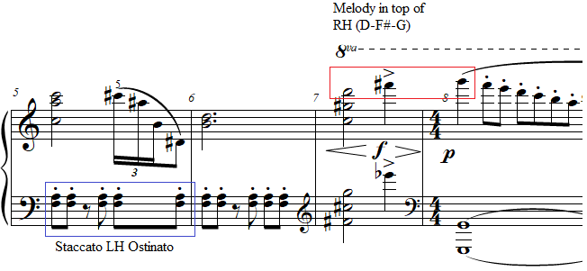

In contrast with Prelude No. 9, the ostinato of the left hand is marked staccato (see Figure 27). This creates an even more extreme contrast between the sustained right-hand notes and the left-hand ostinato. To maintain this articulation, pedaling must be used only to connect the right hand chords, giving the illusion of legato. In m. 8, the descending G Mixolydian scale in the right hand is to be played portato, suggesting an articulation in between legato and staccato. To help students achieve this portato effect, students can play the descending scale with the third finger alone, having the arm articulate notes from the elbow (see Figure 28). This has the additional benefit of ensuring the evenness of tone. This resulting sound, combined with a quarter pedal, creates a slight decay on each note, simulating portato.

Figure 28: Prelude No. 7 “Sad,” B section, mm. 8-10
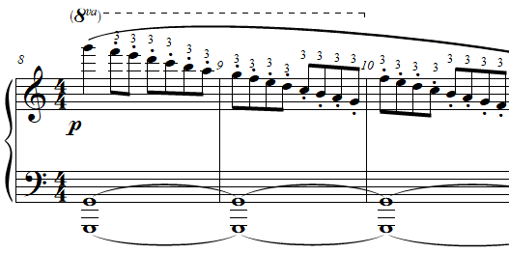

An effective performance of Prelude No. 7 emphasizes the contrast of articulation between the two hands and accomplishes the pedaling necessary to maintain this contrast while depicting a “Sad” atmosphere. Prelude No. 7 “Sad” is most effective when played in a pair with Prelude No. 6 “Floating,” although several other groupings are possible (see Appendix B). The prelude can help students learn how to connect extremely different musical ideas in a brief span of time. Prelude No. 7 is an excellent choice for a student who has already enjoyed working on another prelude from La Femme, especially Prelude No. 6.

Prelude No. 32: “Sad”
Overview
Suggested Tempo: Quarter note = 44-58
Key: F Lydian
Time Signature: 3/4
Measures: 21
Pages: 1
Length: 2:15 – 2:30
Level: 7
Publication: G. Schirmer (classicalondemand.com), La Femme 100 Têtes
The dramatic character of Prelude No. 32 “Sad,” at level 7, evokes an ominous character. The defining feature of this prelude is its constant drone in the left hand on an F octave, generating a rippling, murky quality. The Lydian mode created from this drone anticipates Antheil’s later career as a film score composer, and this film score quality allows this prelude to stand by itself, though only 21 measures.

Compositional Overview:
Prelude No. 32 is in rounded binary form (see Table 5). In the manner of Max Ernst’s collage novel, which features recurring characters and motifs, Antheil’s Prelude No. 32 takes motivic ideas from four other preludes from La Femme that are analyzed in this document, Preludes Nos. 7, 8, 15, and 1. The opening A section begins with the two-note ascending slur motif from Prelude No. 7 “Sad,” expanded to a chord spanning an octave (see Figure 29).
Figure 29: Prelude No. 32 “Sad,” A section, mm. 1-4
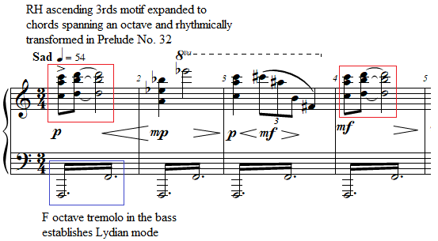

This is followed by a reprisal of the right-hand motif from mm. 4-5 of Prelude No. 7 (see Figure 30). The B section consists of thematic material from Prelude No. 8 “Electrical, Spiccato.” The return of A references Preludes Nos. 15 and 1, finally ending by returning to the opening motif of Prelude No. 32. The piece is characterized by the tremolo bass, which stays on an octave F, creating a cinematic Lydian flavor.

Figure 30: Prelude No. 7 “Sad,” A section, mm. 3-6
Table 5: Prelude No. 32 Formal Analysis
A | B | A’
mm. 1-5 | mm. 6-17 | mm. 18-21

The A section opens with the same two-note motif from Prelude No. 7, expanded to two chords spanning an octave over a tremolo in the left hand (see Figure 29). The F octave in the bass which is sustained throughout this prelude establishes the Lydian mode. Mm. 2-5 are variations from the right hand of Prelude No. 7, mm. 3-7 (see Figure 30).
The B section, from mm. 6-17, quotes Prelude No. 8 “Electrical, Spiccato” (see Figures 31 and 32). Variations on the opening motif of Prelude No. 8 form the entire B section of Prelude No. 32 “Sad.” The motif is started on increasingly high pitches, with the intervallic content changing in each transposition. By m. 12, the intervallic content consists primarily of ascending tritones.

Figure 31: Prelude No. 32 “Sad,” B section, mm. 6-9
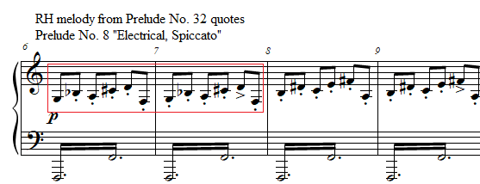
Figure 32: Prelude No. 8 “Electrical, Spiccato,” A section, mm. 1-3
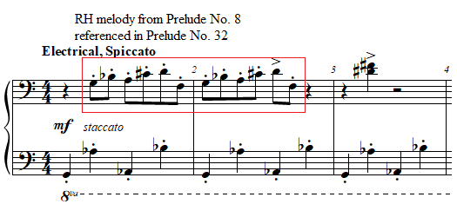

The return of A in m. 18 begins with a two-measure phrase which quotes mm. 6-7 of Prelude No. 8 (see Figure 33 and Figure 34).

Figure 33: Prelude No. 8 “Electrical, Spiccato,” B section, mm. 6-8
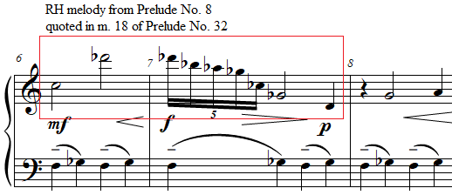

Figure 34: Prelude No. 32 “Sad,” A’ section, mm. 18-21
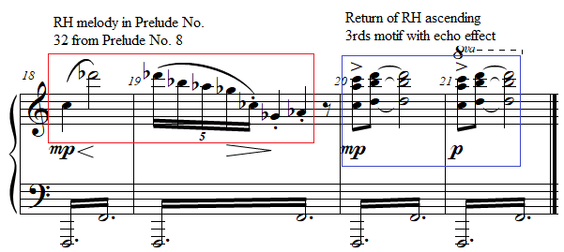

In a similar manner to Max Ernst’s process of creating a collage, these two measures also quote m. 18 of Prelude No. 15 (see Figure 35). Prelude No. 15 opens with an ascending minor ninth, an important and structural interval throughout La Femme 100 Têtes (see Figure 35). Afterwards, the opening two-note motif from Prelude No. 7 is repeated twice, with the second time creating an echo effect, contrasting the mezzo-piano dynamic of m. 20 with the piano dynamic of m. 21 (see Figure 34).

Figure 35: Prelude No. 15 “Nostalgic, Twisted, Slowly,” A section, mm. 1-4
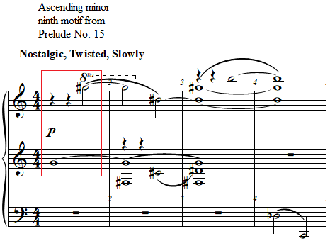

Pedagogical Overview:
Prelude No. 32, evaluated at level 7, is a wonderful introduction to La Femme for the intermediate student, due to its exciting Lydian mode, which can remind students of a soundtrack to a movie. Containing several helpful patterns, the ternary form and tonality of this prelude can be beneficial to students in the process of memorization. Rhythmically, Prelude No. 32 contains challenging rhythms in the right hand including a triplet and a group of sixteenth-note quintuplets, both which can be isolated in lessons due to the simplicity of the left hand. Thankfully, since the rhythms are at a slow tempo, the following preparation exercise can help students learn this rhythm (see Figure 36).
Figure 36: Preparation exercise for La Femme 100 Têtes, Prelude No. 32 “Sad”
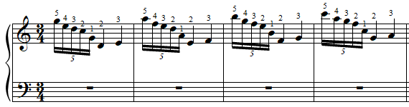
Dynamics and pedaling within Prelude No. 32 help build anticipation throughout. Dynamics in this prelude range from piano to mezzo forte. In Prelude No. 32, many right-hand leaps are emphasized by a crescendo, for example m. 5 (see Figure 37). Teachers can use this to their advantage when teaching the dynamics of this prelude, by showing that the leaps can be achieved by creating an upwards curved motion across the keyboard. This will create a natural crescendo without a sudden dynamic change. To aid in this effect, special attention should be given throughout to the left hand, which consists of a tremolo on an F octave. Teachers can ask students to play only the left hand, creating all dynamic shades with only the weight given to the hand. For smaller dynamics, the student can play using only the tips of the fingers, while the louder dynamics can be created by allowing a larger surface area of the fingers to be in contact with the keys (see Figure 37). Constant pedaling in this piece is required, although for added coloristic effect, pedal can be modified throughout alongside the dynamics. Passages with a piano dynamic can be played with quarter pedal, and mezzo forte passages can be played with full pedal. This technique has the added benefit of allowing Antheil’s staccato dynamics, which, in this prelude, only occur in passages with a piano dynamic, to be given a separate and distinct color from the mezzo forte passages, which require a richer sonority.
Figure 37: Prelude No. 32 “Sad,” mm. 4-7
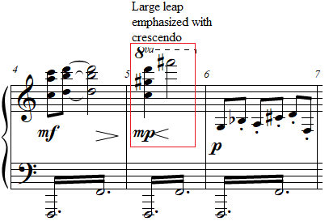

An effective performance of Prelude No. 32 finely executes the crescendi and decrescendi by combining changes of choreography in the right hand, speed and articulation in the left hand, and pedaling. Students who achieve this will hear numerous tone colors throughout the piece, despite the static nature of the left hand. This will create a dramatic prelude that can stand on its own or precede a larger piece in a recital. Prelude No. 32, with its cinematic effects, is an ideal introduction to Antheil’s style, and an excellent choice for students interested in learning about the stylistic compositional features present in film music.

Prelude No. 3: “Faintly Energetic”
Overview
Suggested Tempo: Quarter note = 45-58
Key: E
Time Signature: 4/4
Measures: 19
Pages: 1
Length: 0:45 – 1:00
Level: 7-8
Publication: G. Schirmer, The Antheil Album
At a level 7-8, Prelude No. 3, “Faintly Energetic,” is the easiest of the five preludes within La Femme 100 Têtes that directly transcribe Ballet Mécanique. The expressive marking “Faintly energetic” is evoked dynamically through the pianissimo left-hand ostinato, which was performed by pitched drums in Ballet Mécanique. This prelude is a quintessential representation of Antheil’s “machine aesthetic,” and the easiest prelude demonstrating it. At 19 measures, this prelude introduces Antheil’s musical style as it was known to Paris in the 1920s when he wrote Ballet Mécanique.

Compositional Overview:
Prelude No. 3 also follows rounded binary form (see Table 6). The opening A section features a one-measure introduction with an optional tied note from Prelude No. 2. Despite this transitional material, Prelude No. 3 stands well on its own in performance. After the one-measure introduction, the A section consists of a 10-measure phrase which is disjunct both in articulation and range, creating a playful, mechanical effect with three distinct sub-phrases (see Figure 38).
Figure 38: Prelude No. 3 “Faintly Energetic,” A section, mm. 1-11
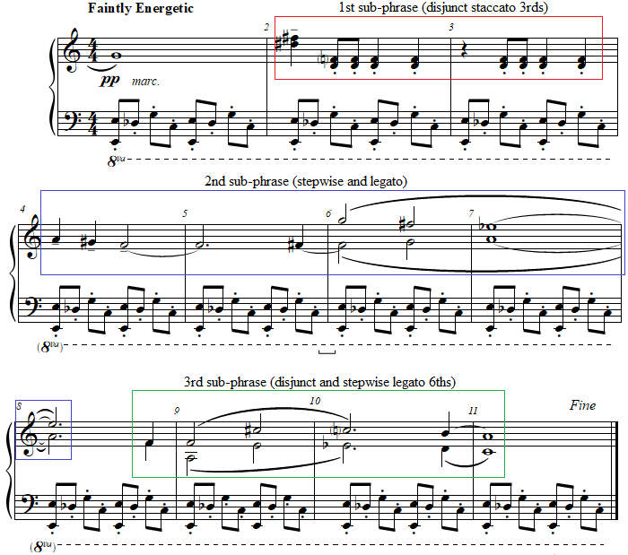

The B section lasts 8 measures and features Antheil’s time-canvas technique, explained below. The A section is then repeated via an unwritten D.C. al fine. The piece is characterized by the driving staccato bass ostinato in the left hand.

Table 6: Prelude No. 3 Formal Analysis
A | B | A
mm. 1-11 | mm. 12-19 | mm. 1-11

M. 1 of Prelude No. 3 begins by introducing the staccato left-hand ostinato pattern which continues moto perpetuo throughout the prelude (see Figure 39). At the beginning, this ostinato consists of an octave on strong beats, followed by two dissonant leaps of an augmented second and an augmented fourth (see Figure 39). Since this is followed by a C, an implied C major triad with an added Db can be heard by the listener, hinting at tertian harmony. This ostinato rhythm from m. 1 is featured throughout the piece in the left hand.

Figure 39: Prelude No. 3 “Faintly Energetic,” A section, mm. 1-2

The right hand does nothing to further any establishment of tonality, as it features two minor thirds leaping by a minor ninth (see Figure 39). Thus, E, by nature of its proximity to the pitches in the right hand and its repetition in octaves in the left hand, is established as a pitch center. Interestingly, the right hand does not play E in the entire A section, however, listeners will hear E through its emphasis in the left hand.
The B section, featuring one of the only complete sections in the copyist manuscript in the handwriting of George Antheil himself, features aspects of Antheil’s time-canvas technique, since the right and left hands have different forms. The B section in the right hand can be divided into two distinct sections. From mm. 12-13, the right hand plays thirds that leap a tenth, forming a B minor triad in m. 12 and a Eb augmented triad in m. 13 (see Figure 40).

Figure 40: Prelude No. 3 “Faintly Energetic,” B section, mm. 12-13
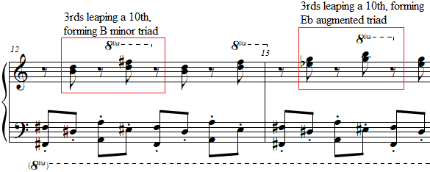
From mm. 14-19, the right hand plays a sequence of chromatically descending major thirds (see Figure 41). The left-hand ostinato on the other hand, consists of octaves on every beat from mm. 12-15. This left-hand pattern changes in m. 16, with a B octave on beats one and three, and a minor ninth on beats two and four. This difference between the phrase lengths in the right hand and left hand is an example of Antheil’s time-canvas technique (see Table 7). The return to the A section, with the original ostinato emphasizing E, further establishes E as a pitch center.

Figure 41: Prelude No. 3 “Faintly Energetic,” B section, mm. 14-16
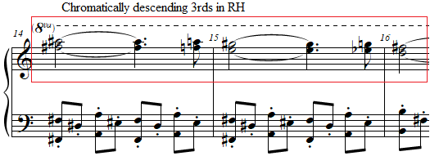
Table 7: Prelude No. 3 “Faintly Energetic,” B section, Analysis of Time-Canvas Technique
 | M. 12 | M. 13 | M. 14 | M. 15 | M. 16 | M. 17 | M. 18 | M. 19
RH Patterns | RH Pattern 1  Mm. 12-13 |  | RH Pattern 2  Mm. 14-19
LH Patterns | LH Pattern 1  Mm. 12-15 |  |  |  | LH Pattern 2  Mm. 16-19

Pedagogical Overview:
Prelude No. 3, evaluated at level 7-8, represent the clearest introduction to the musical style of La Femme. The driving left hand ostinato in eighth notes combined with the disjunct right-hand melody makes this piece exciting to hear and fun to play for late intermediate students. Rhythmically, Prelude No. 3 is one of the simplest preludes, with an unchanging pulse of eighth notes.
Throughout Prelude No. 3, the most common figure in the right hand is a pair of thirds separated by a leap of a minor ninth. In teaching the A section of Prelude No. 3, a preparation exercise to acquaint students with the circular motion necessary to practice these leaps can be used as an aid in this process (see Figure 42). With this exercise, it is important in the first and third measure to play beat one with a downwards motion of the wrist, and beats two, three, and four with an upwards motion of the wrist.

Figure 42: Preparation exercise for La Femme 100 Têtes, Prelude No. 3 “Faintly Energetic,” A section
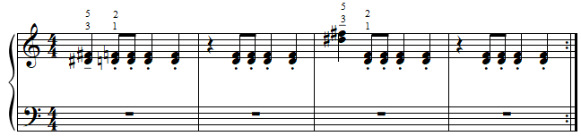

The challenges in the B section are similar to the A section. Mm. 12-13 contain leaps of thirds that form a B minor triad in m. 12 and an Eb augmented triad in m. 13. An exercise involving leaping thirds to complete triads can aid in preparing for this piece (see Figure 43). The right hand in mm. 14-19 consists of major thirds descending chromatically (see Figure 41). Alternating between fingers 2-4 and fingers 1-3 tends to make this section comfortable for students.

Figure 43: Preparation exercise for La Femme 100 Têtes, Prelude No. 3 “Faintly Energetic,” B section

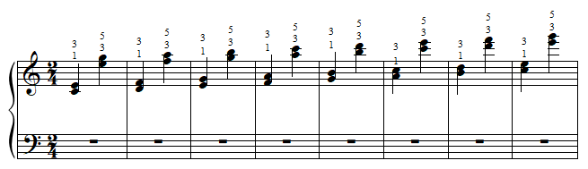

The expressive marking for the prelude combined with the pianissimo dynamic and marcato articulation gives a clear outline of the character of the piece. To achieve the correct articulation and dynamics in the left-hand ostinato, the fingers should pluck the keys to create the shortest note length possible while keeping the fingers on the keys. The darker tone color created by this technique will give the prelude the “faintly energetic” effect required. Pedaling can be used exclusively to help connect certain melodic leaps in the right hand, for example mm. 5-6 (see Figure 44).

Figure 44: Prelude No. 3 “Faintly Energetic,” A section, mm. 5-8
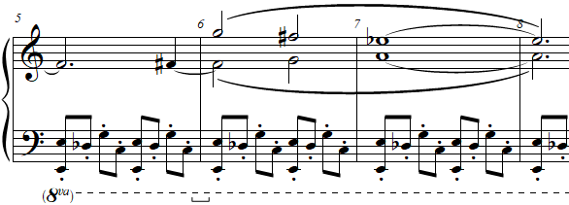

An effective performance of Prelude No. 3 emphasizes its articulation and dynamics to create the feeling of a “faintly energetic” machine in the distance. Teachers can show students the percussion ensemble version of this prelude present in Ballet Mécanique (1924) to add extra interest and ideas for tone color and expression. Prelude No. 3 would be an excellent choice for a student who enjoys the intermediate works of Vladimir Rebikov or is curious about the music of Igor Stravinsky, due to its emphasis on dissonance and ostinato.

Prelude No. 6: “Floating”
Overview
Suggested Tempo: Quarter note = 45-58
Key: Atonal
Time Signature: 4/4, 3/4, 2/4
Measures: 11
Pages: 1
Length: 0:45 – 1:00
Level: 8
Publication: G. Schirmer (Classicalondemand.com), La Femme 100 Têtes
At a level 8, Prelude No. 6, “Floating,” is the second easiest of the preludes which transcribe Ballet Mécanique, suitable for the late intermediate pianist. The expressive marking “Floating” implies a slow tempo with a melody in the upper treble clef suspended above rolled chords. Although the prelude is atonal (discussed under ‘Compositional Overview’), the stepwise chromatic motion of the melody produces a lyrical and dreamy effect. At 11 measures, this piece contains a parody of a tone row, that is nonetheless useful for teaching the concept to curious students.

Compositional Overview:
Prelude No. 6 is in ternary form (see Table 8). The opening A section features a two-measure theme, repeated as the final A section (see Figure 45). The B section consists of two blocks which end on a quartal chord reminiscent of the opening two-measure theme from the A-section. The piece is characterized by its surreal atmosphere and its approachable use of atonality.

Table 8: Prelude No. 6 Formal Analysis
A | B | A
mm. 1-2 | mm. 3-9 | mm. 10-11

The A section, which is only 2 measures, establishes a dreamy texture through an arpeggiated eight-note chord that requires a hand crossover (see Figure 45). The pitches of this chord form a third inversion B major seventh chord with an added minor third (see Figure 45).

Figure 45: Prelude No. 6 “Floating,” A section, mm. 1-2
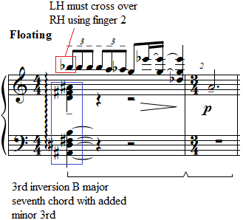

The top of the chord forms the opening motif, which, after four repeated Bb’s descends to G and then leaps quietly down to A with each note increasing in length, creating a floating effect (see Figure 46).
Figure 46: Prelude No. 6 “Floating,” A section, mm. 1-2
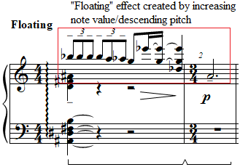

The B section consists of 2 blocks, one from mm. 3-7 and the other from mm. 8-10. The first block opens in m. 3 with a brief measure reference to Prelude No. 5 “Furioso,” inverting the contour of the right hand’s sextuplet motif from that prelude (see Figure 47 and Figure 48).

Figure 47: Prelude No. 6 “Floating,” mm. 2-3
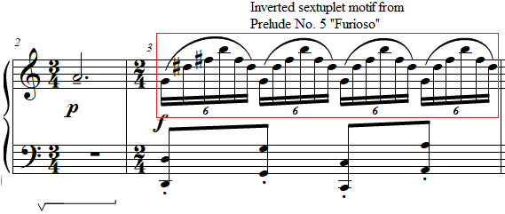
Figure 48: Prelude No. 5 “Furioso,” mm. 1-2
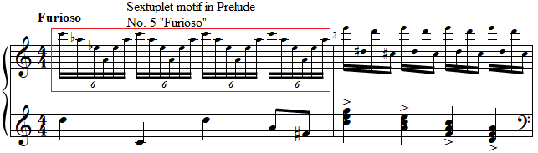

Mm. 4-5 feature an approximate inversion of the opening chord, arpeggiated down instead of up, and repeating the lowest note in the chord four times rather than the highest note four times (see Figure 49 and Figure 50). After a brief interruption of minor 2nds, the right hand plays a G major seventh chord with a sharp five, and the left hand plays a chord consisting of ascending fourths starting on Ab (see Figure 50). The right hand arpeggiates down and the left hand arpeggiates up.

Figure 49: Prelude No. 6 “Floating,” A section, mm. 1-2
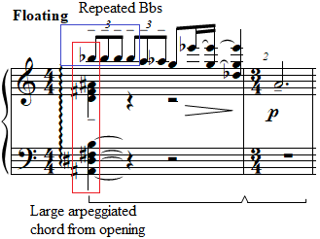

Figure 50: Prelude No. 6 “Floating,” B section, mm. 4-6
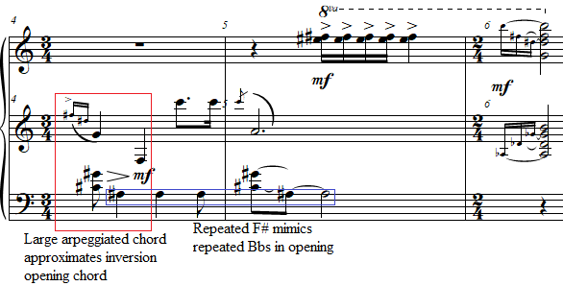

The next block begins with the pickup eighth note to m. 7. This D# begins a tone row, written monophonically, that includes all pitches except for F# (see Figure 51). Antheil, who regularly performed Schoenberg during his tour of Europe as a concert pianist, could have viewed the simplicity and incompleteness of this tone row as a musical joke. This block ends in m. 9 with the same chord that ended the first block of the B section in m. 6. The return of the A section is completely unaltered from the opening A section.
Figure 51: Prelude No. 6 “Floating,” B section 6-8
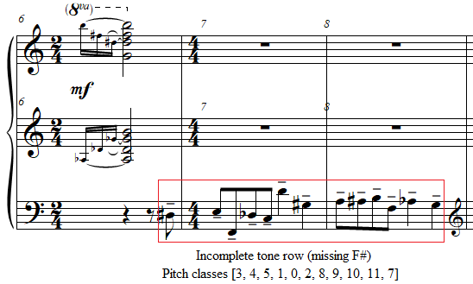

Pedagogical Overview:
Prelude No. 6, notable for its density of characters and moods, presents several characteristics of Antheil’s music at only a level 8. The ternary form combined with its contrasting musical blocks can be highly motivational for students due to its peculiar and stimulating musical organization. Rhythmically, Prelude No. 6 features a mix of 4/4, 3/4, and 2/4 time signatures. The triplets leading into an eighth followed by two sixteenth notes could prove challenging at first. Fortunately, the “Floating” tempo marking lends itself to a certain amount of freedom in the opening. Importantly, students must ensure that counting to the eighth note occurs in m. 2, in preparation for the sextuplet 32nd notes in m. 3 (see Figure 52).
Figure 52: Prelude No. 6 “Floating,” mm. 2-3
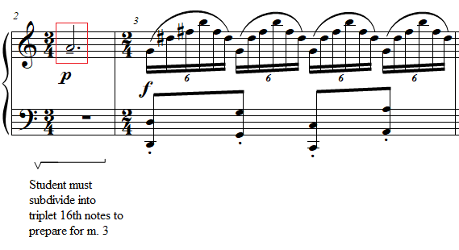
Several passages from La Femme present unique keyboard patterns and figurations, requiring special pedagogical attention. For example, m. 4 from Prelude No. 6 features two grace notes which arpeggiate the right-hand chord, an incomplete augmented triad with a major seventh (see Figure 53). Immediately after these grace notes, the right hand must cross over to the F natural on beat two, only to move laterally a twelfth immediately afterwards. As with the other disjunct melodies in La Femme, the teacher must prepare this choreography. An exercise to aid students in gaining efficiency in crossovers and lateral motion will be helpful (see Figure 54).

Figure 53: Prelude No. 6 “Floating,” mm. 4-5
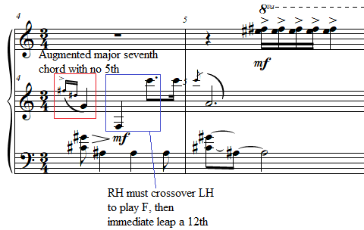
Figure 54: Preparation exercise for La Femme 100 Têtes, Prelude No. 6 “Floating”

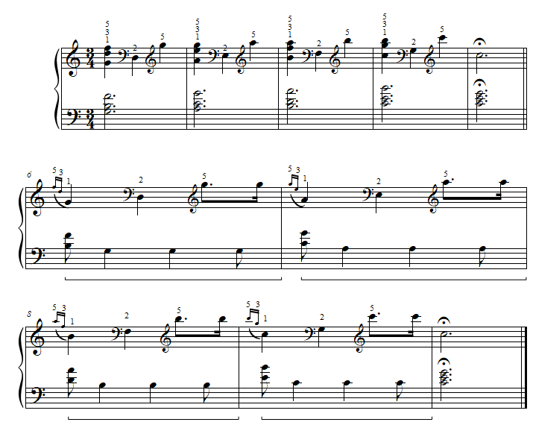

In mm. 6 and 9, the chord that is arpeggiated inwardly in both hands requires rotation of the forearm to gain a richness in tone. The Ab in the left hand, as well as the B in the right hand, can be played with the wrist at just over a 45-degree angle. As the student arpeggiates the chord, both students’ hands should rotate to parallel.
Prelude No. 6 is defined by sudden character shifts which occur in nearly every measure. Careful planning of articulation, dynamics, and pedaling can ensure the radical changes of color necessary to present an effective performance of this piece (see Figure 55). Strangely, in mm. 4, 5, and 6, Antheil marks the dynamic mezzo forte once in each measure. Teachers can invite students to find gradients of this dynamic to create additional character. For example, the single-note melody in the left hand in mm. 7-8 can have a darker, more distant character, while the chord in m. 9 can regain brightness with a percussive first note at the beginning of the inward arpeggio. Pedal should be used generously throughout the prelude. There are two notable exceptions: avoiding pedal in m. 3 ensures the production of a sudden harsh tone color, emphasizing its reference to Prelude No. 5 “Furioso.” Furthermore, minimal pedal in mm. 7-8 enhances the solitary declamation of the left-hand melody.

Figure 55: Prelude No. 6 “Floating,” A section, mm. 1-3
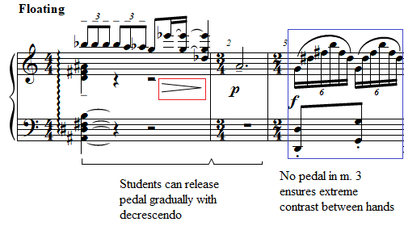

An effective performance of Prelude No. 6 “Floating” creates a surrealistic musical collage by contrasting the dreamlike episodes with the harsher episodic blocks within the prelude. The prelude can work beautifully on its own and contains enough variety to be an excellent teaching piece. Students can pair this prelude with Prelude No. 7 “Sad” which can act as a conclusion to Prelude No. 6. This prelude is an excellent choice for a student looking for a piece that can evoke dreams and spark the imagination.

Prelude No. 8: “Electrical, Spiccato”
Overview
Suggested Tempo: Quarter note = 45 – 58
Key: G Harmonic Minor
Time Signature: 4/4, 6/4, 3/4
Measures: 22
Pages: 2
Length: 0:45 – 1:00
Level: 8
Publication: G. Schirmer (classicalondemand.com), La Femme 100 Têtes
Due to its tuneful melodies and pianism, Prelude No. 8 “Electrical, Spiccato”, at level 8, is one of the most idiomatic and attractive preludes from La Femme 100 Têtes. The word ‘electrical’ reflects the “machine aesthetic” revealed in this prelude through its inclusion of left-hand ostinati, emphasis on repeated musical cells, and chromaticism. This prelude can be performed alone or in a group. Its incessant repetition of motivic material eases the difficulty of the prelude. The piece contains 22 measures, with exciting mechanical imagery throughout.

Compositional Overview:
Prelude No. 8 is in rounded binary form (see Table 9). The opening A section is reprised in abbreviated form in the A’ section. The first A section features a motoric three-measure phrase over a staccato quarter note ostinato in the left hand, followed by a six-measure phrase in which a different ostinato, characterized by two-note slurs, accompanies a disjunct melody. The B section contains a single extended phrase which Antheil unifies through constant two-note slurs in both hands. The B section can be divided into two sub-phrases as the first two measures feature unified articulation markings, and the next four measures contain different time signatures, articulation and dynamics. The piece is characterized by its perpetual mechanical quarter notes which occur in nearly every measure of the left hand.
Table 9: Prelude No. 8 Formal Analysis
A | B | A’
mm. 1 - 9 | mm. 10 - 15 | mm. 16 - 22

Prelude No. 8 begins with a two-voice texture. The left hand consists of staccato quarter notes with leaps of a ninth, outlining pitches of G Phrygian (see Figure 56). The right hand begins on beat two and consists of two pairs of eighth notes in ascending thirds followed by a descending sixth. This three-beat motif is immediately repeated, thus creating a polyrhythmic effect (see Figure 56). The subphrase concludes with an offbeat accented harmonic minor third in m. 3 (see Figure 56).

Figure 56: Prelude No. 8 “Electrical, Spiccato,” A section, mm. 1-3

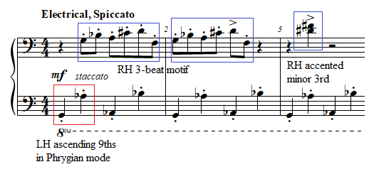
The second subphrase, mm. 4-9, introduces a new two-note ostinato, higher than the opening four-note ostinato, composed of two-note slurs between F and Gb (see Figure 57). The right hand subsequently enters with a motif found throughout the work, an ascending minor ninth, followed by four sixteenth notes descending in close and then distant intervals. The ascending minor ninth comes from Prelude No. 3 “Faintly Energetic,” which prominently uses this interval (see Figure 57 and Figure 59). The four sixteenth notes descending in increasingly large intervals has its source in the opening of Prelude No. 1 “Thoughtfully, Not Too Slow” (see Figure 58 and Figure 60).

Figure 57: Prelude No. 8 “Electrical, Spiccato,” A section, mm. 4-6
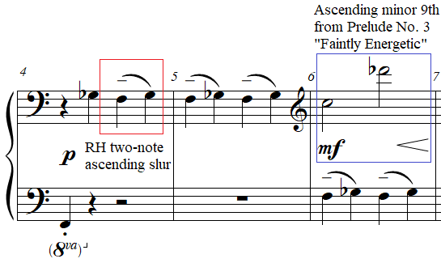

Figure 58: Prelude No. 8 “Electrical, Spiccato,” A section, mm. 7-9
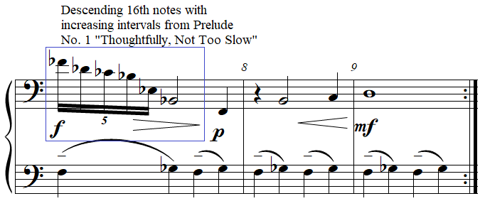

Figure 59: Prelude No. 3 “Faintly Energetic,” mm. 5-8
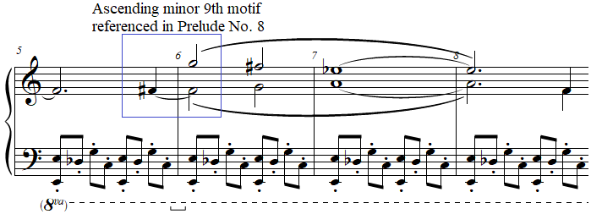

Figure 60: Prelude No. 1 “Thoughtfully, Not Too Slow,” mm. 1-2
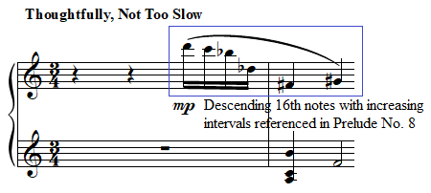
The B section starts in m. 10 and lasts until m. 15. The B section expands upon the ascending two-note slur motif from the second subphrase, this time featuring a 6/4 time signature to account for the three two-note slurs in mm. 10 and 11. The two-note slurs are arranged in a pattern reminiscent of Prelude No. 4 “Floating” which featured a motif consisting of three chords of which the outer chords are the same, and the middle is higher (see Figure 61 and Figure 62). The pairs of two-note slurs reflect this same arrangement (see Figure 61).
Figure 61: Prelude No. 8 “Electrical, Spiccato,” B section, mm. 10-11
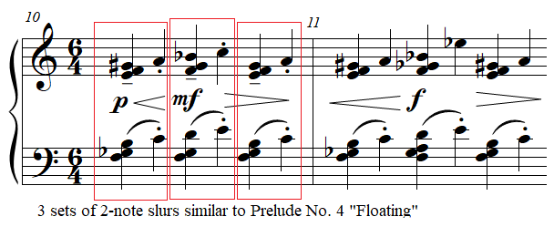

Figure 62: Prelude No. 4 “Floating” m. 1
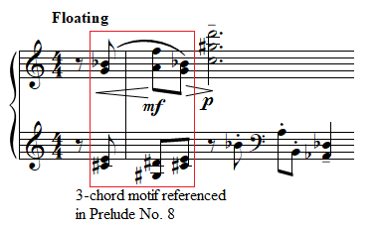

The two-note slur pattern is broken in mm. 12 and 13, where beat two is repeated three times in both measures, creating an incessant drive additionally accentuated with a crescendo. The rhythm then returns to quarter notes in m. 14, featuring a (0236) tetrachord in the right hand over a G-flat major chord (see Figure 63). For both mm. 14 and 15, all voices remain static in pitch except for the top of the G-flat major chord in the left hand, which descends twice in a chromatic melody from Gb to Eb (see Figure 63). The second descent leads directly into the sforzando D octave in m. 16, which is followed by two quarter rests, creating the only silence in the piece (see Figure 63). This silence is followed by the abbreviated return of A in m. 17. This octave D is notable for occurring in a structurally climactic moment in the piece, followed by a return to the A, in which the first pitch of both hands is a G. This, therefore, reinforces G as the pitch center, creating a quasi-tonal cadence.

Figure 63: Prelude No. 8 “Electrical, Spiccato,” end of B section, mm. 14-17
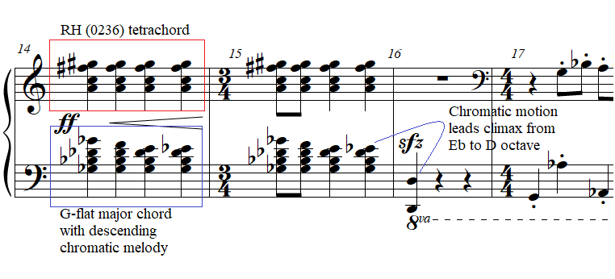
The return of A, instead of bringing any resolution to the prelude, is a direct copy of the opening, except when the ascending chromatic two-note slur ostinato is reintroduced in m. 20, the ostinato is repeated with decreasing dynamics, featuring a pianississimo dynamic, which then has a decrescendo. This creates a niente effect, in which the prelude fades to nothing.

Pedagogical Overview:
Prelude No. 8, evaluated at a level 8, is one of the most ear-catching preludes within La Femme. Its rounded binary form, with a repeated A section, and a middle section lasting only seven measures, combined with its motoric rhythm makes the piece motivating for late intermediate students. Rhythmically, the outer sections of Prelude No. 8 use exclusively a 4/4 time signature, while the middle section uses primarily a 6/4 time signature, divided into two-beat groups, with measures gradually shortening to 4/4 in m. 12 and 3/4 in m. 16.
Prelude No. 8 “Electrical, Spiccato” is particularly ergonomic for pianists, compared to the other selections from this document. The opening bassline should be isolated by the teacher and student to ensure proper use of curved arm motion, (see a suggested choreography for the opening bassline in Figure 64). To ensure fluidity of the opening right hand motif, see the current author’s suggested fingering in Figure 64.

Figure 64: Prelude No. 8 “Electrical Spiccato,” mm. 1-2
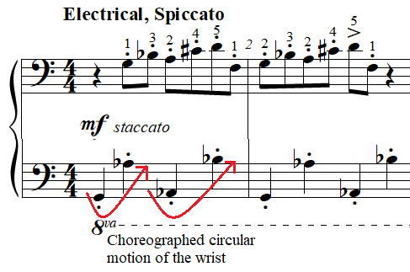

Dynamics seem to come less frequently than in several other preludes, typically at the beginnings of new phrases, subphrases, and sections. Mm. 1 - 30, constituting the majority of the prelude, feature dynamics ranging from piano to mezzo forte, with dynamic peaks to forte in mm. 7, 11, and fortissimo in m. 14. Antheil approaches these chords pianistically with crescendi. The fortissimo chords which follow in mm. 14 - 15 should be played with a sharp activation of the wrist joint, immediately releasing after the attack of each chord.
Prelude No. 8 requires minimal pedal compared to other preludes in La Femme. The first notes of two-note slurs, and accents should be accentuated with touches of pedal. In m. 10, the bar in 6/4, the two-note slurs marked piano can receive half-pedal, while the mezzo forte two-note slur can receive a fuller pedal, adding to the dynamic palette of the prelude (see Figure 65).

Figure 65: Prelude No. 8 “Electrical, Spiccato,” mm. 10-11
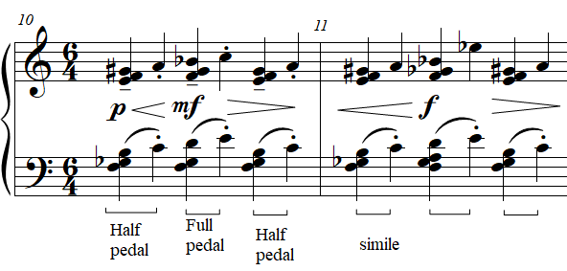

An effective performance of Prelude No. 8 “Electrical Spiccato” is energetic in its staccato articulation, with minimal rubato to mimic a machine. Dynamics should be refined by examining the prelude as a whole to delineate the dramatic peak of the prelude in m. 15. This prelude contains the variety and specificity of articulation present in many sonatinas, allowing the prelude to serve as an excellent study in articulation varieties including staccato, two-note slurs, accents, sforzandi, and effective management of dramatic crescendo and decrescendo. Prelude No. 8 is a wonderful choice for students interested in electronic musical styles, looking for an energetic recital piece, or a student needing to refine their variety of articulation who does not connect easily with classical sonatinas which address similar issues.

Prelude No. 16: “Lights Flashing”
Overview
Suggested Tempo: Quarter note = 45 – 100
Key: F# Major/C Major
Time Signature: 4/4
Measures: 10
Pages: 1
Length: 0:30 – 0:45
Level: 8
Publication: G. Schirmer (classicalondemand.com), La Femme 100 Têtes
At only two and a half lines long in the copyist manuscript, Prelude No. 16 “Lights Flashing” presents a surreal and poetic soundscape in only 10 measures, at level 8. The bizarre expressive marking can be interpreted in numerous ways, and one can find recordings of this movement played as slow as quarter note = 75 to around 150. The current author interprets the phrase “Lights Flashing” as referring to the grace notes found in the A sections. This aphoristic prelude contains brief musical ideas with no development, with the entire prelude only lasting 10 measures. Stylistically, the bitonality of the work yields a surreal atmosphere throughout.

Compositional Overview:
Prelude No. 16 is in ternary form (see Table 10). The opening A section, only two-measures long, distinguished by quarter notes in the treble clef decorated by leaping grace notes. The B section is introduced with a transition in mm. 3 - 4 which gradually expands the limited register from the opening texture featuring two-note slurs and chords spanning a ninth in the right hand. The B section begins with a large register spanning four octaves between the hands. The left hand then provides an ostinato on a major third while the right hand plays a melody with a rapidly changing number of voices, ending with an F# major chord over a C major chord, the so-called Petrouchka chord. The A section then returns with a mezzo-forte dynamic.
Table 10: Prelude No. 16 Formal Analysis
A | Transition | B | A’
mm. 1 - 2 | mm. 3 - 4 | mm. 5 - 8 | mm. 9 - 10

The two-measure A section of Prelude No. 16 is built from two primary features: a minor ninth and the whole-tone collection. The prelude begins with a pickup beat with a grace note descending a minor ninth (one of the most important intervals with La Femme), leading to a chord featuring three notes from a whole tone collection (C#, B, and D#). The downbeat of m. 1 includes two other pitches from the whole tone collection (D# and G) (see Figure 66). In beat four, two more grace notes on two pitches from the opening chord (D# and C#) are followed by a descent of a major sixth. These grace notes land on a minor ninth with the same pitches as the pickup beat of the entire prelude, but transposed down an octave (D# and E).
Figure 66: Prelude No. 16 “Lights Flashing,” mm. 1-2
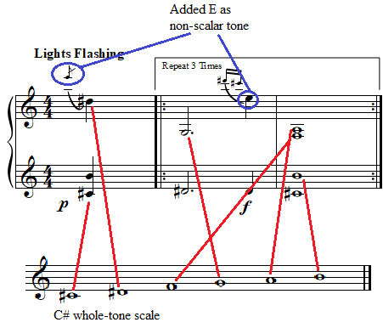
Notably, mm. 1 - 2 are marked to be repeated three times, an uncommon marking. The current author considers this to be an allusion to panels 5 - 7 of Max Ernst’s collage novel La Femme 100 Têtes (1929), all three of which bear the text “Le paysage change trois fois,” which translates to “The landscape changes 3 times.”
The transition in mm. 3 - 4 is unified compositionally by pairs of descending fourths in the lower voice of the left hand, grouped in two-note slurs. This sequence is broken in beat three of measure four when the lowest note of the left hand descends on a major third instead, forming an arpeggiated major chord (see Figure 67). The right hand in mm. 4 - 5 consists of dissonant trichords spanning a ninth, with the first two being quasi-transpositions of one another. Each voice of these three right hand chords forms a typical diatonic melodic fragment, but together they resolve to a dissonant (016) trichord on beat 1 of m. 4, a chord which includes both a minor ninth and a tritone (see Figure 67).

Figure 67: Prelude No. 16 “Lights Flashing,” mm. 3-5
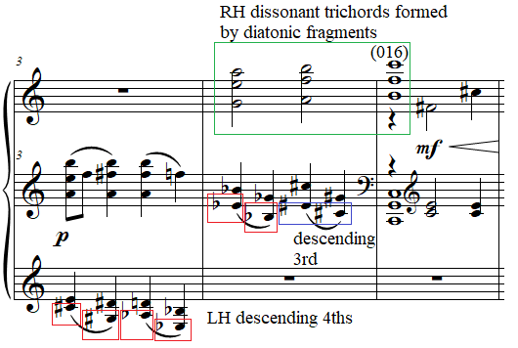

The B section, beginning at m. 5, expands the register of the prelude with the left hand playing a C chord and the right hand playing diatonically stacked fifths starting on B, creating dissonances of both a tritone and a minor ninth. Antheil’s notation requires that the sostenuto pedal should sustain these two chords from mm. 5 - 8. The left and right hands fill the middle register during this passage. The right hand plays a melody consisting of pairs of pitch sets, which freely changes from one, two, or three voices. When paired by voice, the second of each pair is a transposition of the first of that pair, with the exception of the first two chord of m. 6, which feature another quasi-transposition (see Figure 68). This connects the B section compositionally to the transition, which features a similar chromatically altered transposition in m. 4. Notably, the pitch content of the right hand seems to emphasize F# in numerous passages, denoting F# as the right hand’s pitch center.

Figure 68: Prelude No. 16 “Lights Flashing,” mm. 5-8
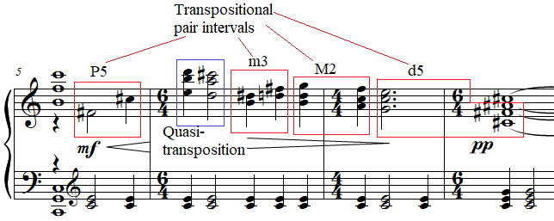

Meanwhile, the left hand, beginning in m. 5 on the open C chord, emphasizes pitches of the C major triad, with mm. 5 - 8 in the left hand containing exclusively repeated major thirds on C and E. Despite the prelude’s lack of tonal progression, the opposing pitch centers of F# in the right hand and C in the left hand hint at bitonality, if not dual-pitch centricity. The right hand does eventually play an inverted C major triad in beat two of m. 7, but this is immediately followed by an F-sharp major chord in the right hand over a C major triad in the left hand.
The A section returns on beat three of m. 8, identical to the opening, except without repeats, and with less contrasting dynamics.

Pedagogical Overview:
Prelude No. 16, evaluated at level 8, is an excellent addition to the pedagogical repertoire, especially for adult learners, due to its brevity, unique pianistic texture, and emotional complexity, while remaining an upper intermediate piece. Its ternary structure allows the prelude to sound complete, despite its exceptionally short length and unstable final harmony. Prelude No. 16 is rhythmically simple, with two eighth notes being its fastest note value. Its time signature also remains a stable 4/4 throughout.
In teaching the opening of Prelude No. 16 “Lights Flashing,” teachers should allow students to take note of the moments when the right hand crosses over the left. This passage should not be redistributed, as Antheil’s written distribution naturally elucidates interval voicing which could be lost in a redistribution (see Figure 69). For example, the whole note in m. 2 could be redistributed as an F augmented chord in the left hand and a B in the right hand. However, this would obscure the connection between the minor seventh (C#, B) in this passage from the pickup note to m. 1.

Figure 69: Prelude No. 16 “Lights Flashing,” mm. 1-2
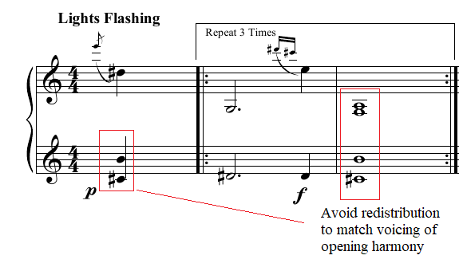
The transition in from mm. 3 - 4 will present the greatest challenge of this piece. The numerous chords spanning a ninth will often necessitate arpeggiation, as in other parts of La Femme. This passage should be learned hands separately. Thankfully, the left hand’s content fits well in the hand (see the current author’s suggested fingerings in Figure 70).

Figure 70: Prelude No. 16 “Lights Flashing,” mm. 3-4
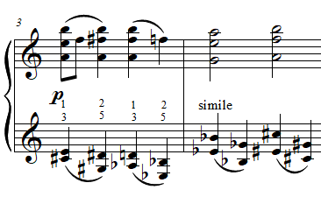
For the B section, choreography is important to produce the proper round sound on the downbeat of m. 5 without falsely accenting beat two. The notes and chords of the right hand in this passage can be grouped in pairs for ease of performance (see Figure 71 for these groupings and the current author’s suggested fingerings).

Figure 71: Prelude No. 16 “Lights Flashing,” mm. 5-8
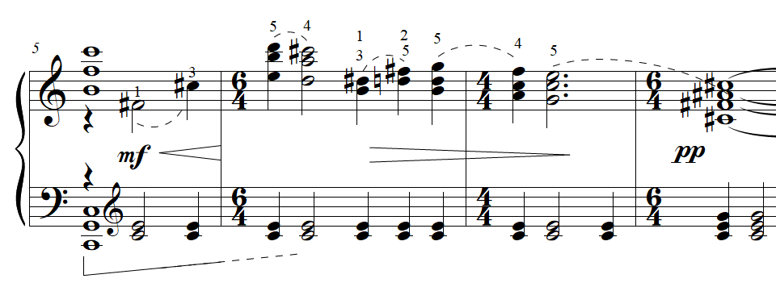
The current author suggests that teachers reinforce dynamics and articulation by referring to the unique expressive marking “Lights Flashing.” For example, the grace notes in the A section in mm. 1 - 2, can be given a brilliant sparkle with a percussive attack on the first pitch, which can be achieved by preparing the fifth finger before beginning the prelude, and an upwards motion on the chord following the grace note. The dynamics also reflect the expressive marking, with the alternation between piano and forte denoting the switching of a light.
The author suggests legato pedaling throughout to emphasize the impressionistic texture which pervades the prelude. The notation of m. 5 implies an extended pedal to catch the voices from the middle register that enter on beat two (see Figure 71). The current author agrees with David Albee’s assessment in his unofficial handwritten edition of La Femme 100 Têtes that the pedaling should fade soon after the beginning of m. 6.
An effective performance of Prelude No. 16 “Lights Flashing” evokes the imagery of the expressive text through careful planning of articulation and pedaling. Lightness and or roundness of touch should be preferred in this prelude to the stark weightiness required of several other preludes from La Femme. A range of tempos can be effective for this prelude; students should use this prelude as a creative drawing board for interpretive decisions. It can be a piece where depth of character and maturity of sound can be explored in a brief, but self-contained prelude.

Prelude No. 13: “Nostalgic, Twisted, Slowly”
Overview
Suggested Tempo: Quarter note = 45 – 58
Key: Atonal
Time Signature: 4/4
Measures: 19
Pages: 1
Length: 1:30 – 2:00
Level: 8
Publication: G. Schirmer (classicalondemand.com), La Femme 100 Têtes
Prelude No. 13 “Nostalgic, Twisted, Slowly”, alongside Prelude No. 15, with its pointillistic, sustained tones, clearly represent the stars which, according to Antheil, inspired him to contemplate the “strange mathematics of infinity”. This is evident in the expressive marking, as well as the sparse but sustained texture, spread over three staves. This piece showcases Antheil’s skill in logically organizing a highly dissonant harmonic landscape. In 19 measures, this prelude, with its sustained tones, can stand alone as a study in touch and pedaling.

Compositional Overview:
Prelude No. 13 is in ternary form (see Table 11). The dissonance of the opening A section, which consists entirely of whole notes and half notes, entirely avoids a pitch center, contributing to a sense of weightlessness. The first phrase, mm. 1-4, spans over four octaves, while the second phrase, mm. 5-6, spans only a diminished eleventh. The B section in m. 7 begins with a disjunct but melodic figure in the right hand which references Prelude No. 3 “Faintly Energetic.” The left hand plays a series of trichords until the beginning of the second phrase. The second phrase briefly roots A as the pitch center, hinting at A Locrian, and finishes with a C major seventh chord with a sharp nine. The return of the A section is identical to the opening, with the exception of dynamics, which have a much wider range than the opening. The piece is characterized by the striking beauty of its intervallic content, and its ethereal character.

Table 11: Prelude No. 13 Formal Analysis
A | B | A
mm. 1 - 6 | mm. 7 - 13 | mm. 14 - 19

In the opening of Prelude No. 13, G4 briefly acts as the inversional axis, being followed by an ascending minor ninth on G# and a descending minor ninth on F# forming an (012) trichord. The next two pitches immediately break the pattern, but remain near inversions around the pitch G4, forming a major seventh (see Figure 72). M. 3 introduces a second major seventh pitch interval between D# and D natural. Combined, this pair of major seventh pitch intervals form (0123), a tetrachord formed by combination of two (012) trichords.

Figure 72: Prelude No. 13 “Nostalgic, Twisted, Slowly,” mm. 1-3
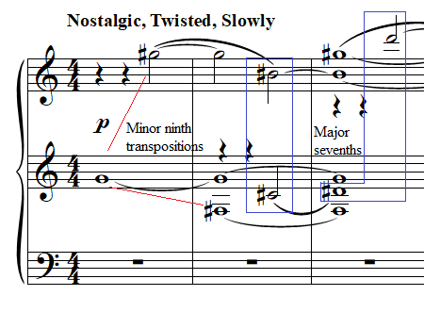
Three other moments of inversion occur within the opening six measures. On beat three of m. 3 through m. 4, D, Db, and C are played in succession in separate octaves, forming another (012) and showing Db as the inversional axis (see Figure 73). The other moment of inversional symmetry occurs in mm. 5 - 6, in which three minor thirds are played in succession, with the pitch class sets of the first minor two thirds being chromatically adjacent to the third, causing the inversional axis to center on G and Bb in those two measures (see Figure 73). The first two of these minor thirds, which ascend by whole step, form another instance of the ascending minor third motif which appears in several other preludes, notably Prelude Nos. 9, 7, 32, all of which are derived from the opening of Prelude No. 1, which opens with an ascending whole step (see Figure 74 and Figure 75).

Figure 73: Prelude No. 13 “Nostalgic, Twisted, Slowly,” mm. 3-6
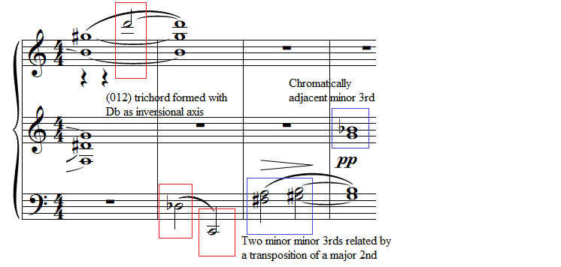
Figure 74: Prelude No. 1 “Thoughtfully, Not Too Slow,” m. 1-2
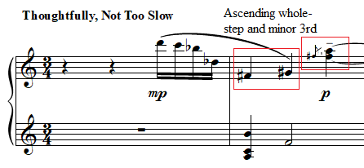

Figure 75: Prelude No. 7 “Sad,” m. 3
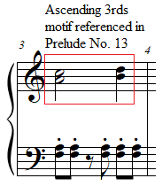

The B section, beginning in m. 7 introduces a melody-accompaniment texture. From mm. 7 - 9, the left hand plays a single extended (016) trichord from mm. 7 - 8, followed by an enharmonic C# dominant seventh chord (026) and a C major triad. The right hand elevates rapidly as it ascends to from G4 to A6, then steps down, reaching a minor third (D# F#). This minor third is then repeated three times down an octave in a manner reminiscent of Prelude No. 3 “Faintly Energetic,” before ending on an enharmonic A-flat minor chord over the left hand’s C major chord on beat three of m. 9.
Mm. 10 - 12 begin with A and D, which act as the inversional axis for those measures. The D in the right hand ascends a minor ninth, referencing the opening. However, from here the middle voices oscillate between Bb and Ab in the right hand and Eb and Db in the left hand. Both pairs of pairs of pitches invert around A and D respectively (see Figure 76). The B section concludes with two Bs and an Eb in the right hand over a C major chord, forming a split third triad with a major seventh.

Figure 76: Prelude No. 13 “Nostalgic, Twisted, Slowly,” mm. 10-13
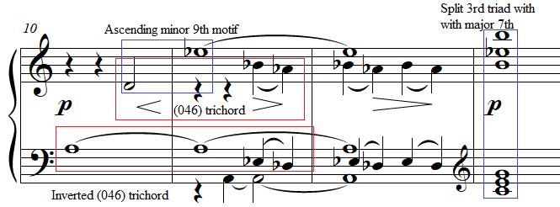

As in several other preludes from La Femme, the return of A is identical with the exception of dynamics. Prelude No. 13 “Nostalgic, Twisted, Slowly” follows this convention. The dynamics of A’ begin with a declamatory mezzo forte, in contrast to the opening piano, and the prelude ends with a pianississimo dynamic, in contrast with the pianissimo of the opening.

Pedagogical Overview:
While Prelude No. 13 “Nostalgic, Twisted, Slowly,” evaluated at level 8, contains several complicated pitch relations, it remains pianistic, and can provide an excellent exploration in beauty of tone color and phrasing to depict the starry skies referenced by Antheil. Rhythmically, Prelude No. 13 features a 4/4 time signature, with note values consisting of only whole, half, and quarter notes, adding to its expansive quality.
In teaching the A section of Prelude No. 13, Antheil’s use of three staves could be the most challenging aspect of this prelude. Thankfully, no measure exists which utilizes all three clefs simultaneously. Teachers can point out this aspect, noting that the use of three clefs which allow Antheil to delineate changing voice, as in mm. 4 or 6 (see Figure 77). The middle section, beginning in m. 7, uses only two clefs, which reflects the texture changing from a sparse polyphonic texture to melody and accompaniment. Students should reflect this change of texture by voicing the right-hand melody in m. 7 beginning with an arc-shaped down motion onto the G with the thumb, an arc motion through the Eb on beat two, and a drop of the wrist on A with the pinky (see Figure 78).

Figure 77: Prelude No. 13 “Nostalgic, Twisted, Slowly,” mm. 3-6
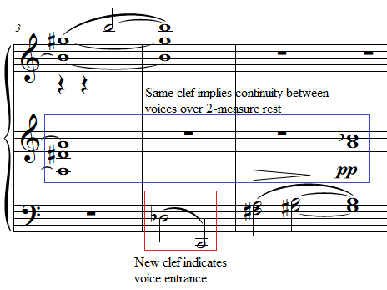
Figure 78: Prelude No. 13 “Nostalgic, Twisted, Slowly,” mm. 7-8
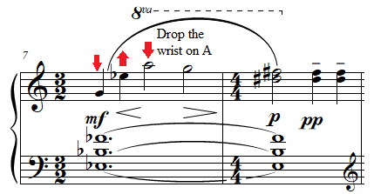

Prelude No. 13 “Nostalgic, Twisted, Slowly” requires students and teachers to take note of the interaction between dynamics, pedaling, and articulation in order to produce a range of tone colors. To depict the stars within this prelude, teachers can explore a range of tone colors with their students for notes in different registers, while adhering to Antheil’s dynamics which range from pianississimo only to mezzo forte. The current author suggests that for notes below middle C, it is helpful for teachers to emphasize the use of a curved arm motion into the keys, to minimize percussiveness, and, when used in combination with legato pedaling, produce a velvety tone color. As notes ascend in range, particularly the G#6 in m. 1 and the A in m. 7, students can experiment with a bell-like tone. Otto Ortmann describes bell-like tone in Physiological Mechanics as containing a percussive beginning, and a quick release, imitating the clapper of a bell. With pedal added, the release of the finger is only heard in the thud of the returning action, and heard in the imagination through the pianist’s visible release of the key.
An effective performance of Prelude No. 13 “Nostalgic, Twisted, Slowly” takes advantage of the slow tempo to explore a gradient of tone colors ranging from velvety to bell-like, using legato pedaling and focusing on the softer end of the dynamic range. Contrast can be created in the B section through a well-voiced melody. Rubato should be used minimally, but the phrases should be given time to breathe, in addition to larger leaps (for example in m.7). Prelude No. 13 is an excellent choice for a student who had previously enjoyed dissonant music with an aggressive edge and has not had the opportunity to explore gradients of tone color. This prelude allows students to play a lyrical piece which still has biting dissonances.

Prelude No. 23: “Well Articulated”
Overview
Suggested Tempo: Quarter note = 45 – 58
Key: F# Major/D Dorian mode
Time Signature: 4/4 (10/8)
Measures: 16
Pages: 1
Length: 1:00 – 1:15
Level: 8
Publication: G. Schirmer (classicalondemand.com), La Femme 100 Têtes
Prelude No. 23 “Well Articulated,” at level 8, provides a wonderful introduction to bitonality through a pattern-based composition. The expressive marking “Well Articulated” refers to the percussive tone quality needed in this prelude, despite the ubiquitous presence of slurs. The piece, while containing several repeating motivic ideas, is largely pattern based, which eases its difficulty to a degree. While it is nominally 16 measures, the repeated sections in this movement allow the prelude to be performed on its own. This prelude contains elements of both Antheil’s “machine aesthetic” as well as his exploration into surrealism.

Compositional Overview:
Prelude No. 23 loosely follows rounded binary form (see Table 12), although its form is obscured using Antheil’s “time-canvas” technique. The time signature in the copyist manuscript is 4/4 (10/8), emphasizing the groupings of 5 eighth notes occurring simultaneously as quarter notes throughout the prelude. The time signature can be conceived primarily in 10/8, although Antheil’s marking of 10/8 in parentheses rather than 4/4, implies that special care should be taken to avoid 3 + 2 groupings in the performance of this prelude. The opening A section features an eighth note quintuplet ostinato in both hands, with the right hand in F# major and the left hand in D Dorian. The B section consists of three consecutive ideas in the right hand over the left-hand ostinato. In the first idea, from mm. 5 - 7, the right hand plays octaves outlining a melody which recalls Prelude No. 13 “Nostalgic, Twisted, Poetry.” The second idea, from mm. 8 - 12, consists of grouped sixteenth note patterns in groups of five, then seven, which consequently form polyrhythms over the left hand. In the third idea, the hands play the same rhythm but in two separate keys, which beckons the abbreviated return of the A section, this time with much quieter dynamics.

Table 12: Prelude No. 23 Formal Analysis
A | B | A’
mm. 1 - 4 | mm. 5 - 14 | mm. 15 - 16

Throughout Prelude No. 23 “Well Articulated,” both hands not only remain in separate keys and modes. The prelude opens with a bitonal ostinato, with the right hand playing quintuplet eighth notes on an F# major pentascale, and the left hand playing a d minor pentascale (see Figure 79).

Figure 79: Prelude No. 23 “Well Articulated,” mm. 1-2
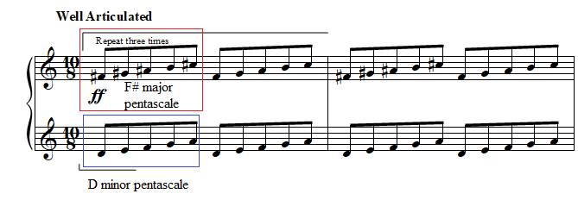
From mm. 1 - 14, the right hand contains six ideas. After the opening F# major pentascale, the right hand plays a Gb major pentatonic scale which oscillates between notes of that collection descending from Ab and Ab an octave lower, followed by a trill figure on Gb and Ab (see Figure 80). Mm. 1 - 4 are repeated twice, another reference to panels 5 - 7 of Ernst’s La Femme (1929) whose text translates to “The landscape changes 3 times.”

Figure 80: Prelude No. 23 “Well Articulated,” mm. 3-4
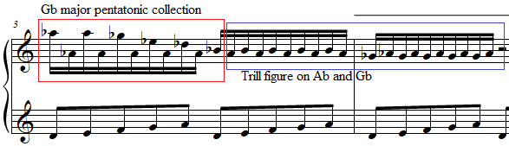

The beginning of the B section, mm. 5 - 7 of the right hand, constitute the third idea, whose extended note values, in comparison with surrounding passage, recall the sparse and chromatic notes from Preludes Nos. 13 and 15. The right hand in m. 5 is the first instance of rhythmic groupings of the measure not divided into four instead of five. This creates a brief polyrhythm at the last eighth note of m. 5 against the quintuplet eighths of the left hand (see Figure 81). The current author simplified this entire section by favoring the 10/8 time signature and employing a quadruplet in the right hand of m. 5 (see Figure 82).
Figure 81: Copyist manuscript for Prelude No. 23 “Well Articulated,” mm. 4-6
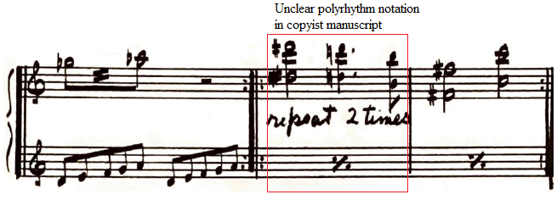

Figure 82: Prelude No. 23 “Well Articulated,” mm. 5-6
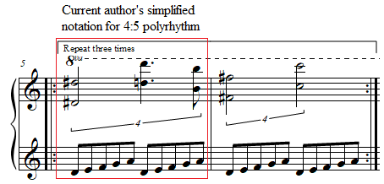

In m. 8, the fourth idea is an ascending Ab major pentascale in quintuplet sixteenth notes, which forms a polyrhythm against the quintuplet eighth notes of the right hand (see Figure 83).
Figure 83: Prelude No. 23 “Well Articulated,” mm. 7-8
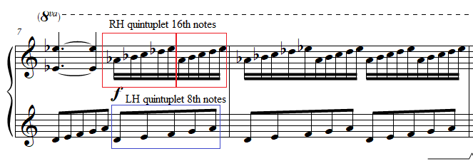
The fifth idea coincides with a change in the left-hand pattern, and a change from (10/8) 4/4 time signature to 7/8. If m. 9 is conceived in 10/8, then the left hand eighth note pulse remains steady as it transitions to 7/8. The right hand plays a pattern of 14 sixteenth notes, all of which fall into the C harmonic minor collection and are played three times in total. At the same time, the left hand continues playing groups of five eighth notes, but now from the F major pentatonic collection. This creates a polyrhythm of 7:5 (see Figure 84). The cycle, which would take five measures of 7/8 to repeat, is left incomplete with only three measures.

Figure 84: Prelude No. 23 “Well Articulated,” mm. 9-11
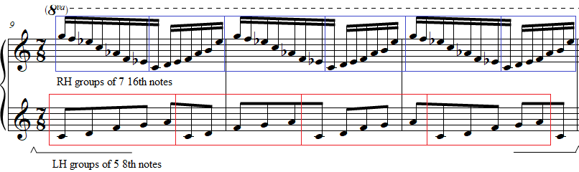

In mm. 13 - 14, the sixth idea in the right hand returns to the Ab major pentascale, but instead it is presented in its descending form in eighth notes. The left hand simultaneously changes patterns, employing two consecutive descending five finger patterns, one using pitches from an F major pentatonic collection and the other using C major pentatonic. This measure is repeated exactly and followed by a copy of the opening two measures, but this time with a piano dynamic decreasing to pianissimo.

Pedagogical Overview:
Prelude No. 23 “Well Articulated” is approachable due to its use of diatonic and pentatonic patterns. It is one of the most accessible uses of bitonality at or below its level 8 difficulty, thanks to its repeated motivic patterns and exciting but pianistic use of polyrhythm.
In teaching Prelude No. 23, 10/8 divided into groups of five eighth notes is the easiest way to conceptualize the meter. The primary rhythmic challenge comes in the form of properly placing the right hand’s eighth note in m. 5, which occurs at the same time as the left hand’s eighth note quintuplet ostinato, creating a brief 4:5 polyrhythm. Since m. 5 contains only one instance of audible polyrhythm, the proper placement of the eighth note can be taught using a simple tapping exercise (see Figure 85). Essentially, the eighth note can be conceptualized as a grace note to the final left-hand quintuplet eighth note of the measure.

Figure 85: Preparation exercise for La Femme 100 Têtes, Prelude No. 23 “Well Articulated”
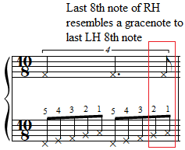

The polyrhythm in mm. 8 - 9 can be practiced by the student easily through slow repetitions, gradually increasing tempo in practice sessions. When these measures are sufficiently practiced, students will find the 7:5 polyrhythm from mm. 10 - 12 easier (see Figure 86 for the current author’s suggested fingering.)

Figure 86: Prelude No. 23 “Well Articulated,” mm. 9-10
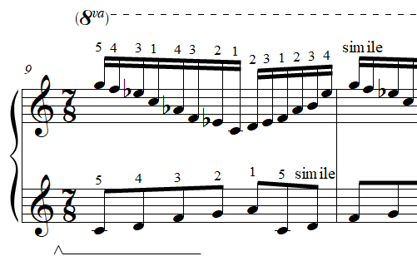

The prelude begins at a forte dynamic, with pedaling marked generically. The high register in addition to the static left-hand ostinato allows students to hold down the sustain pedal throughout the A section from mm. 1 - 9 without causing excessive blur. This effect can be enhanced through clear articulation, hence the expressive marking of the prelude. In the B section, the current author recommends that pedal should be changed in mm. 10 and 13. Changing in m. 10 allows the piano to achieve a mezzo piano dynamic. The return to A in m. 14 also requires a change of pedal on the downbeats of m. 14 and m. 15, to achieve piano and subsequently pianissimo.
An effective performance of Prelude No. 23 “Well Articulated” generates clear melodies through the constant use of pedal. Bell-like tone, used in longer note durations during Prelude No. 13 “Nostalgic, Twisted, Slowly,” is also helpful hear to separate melodic tones from the pedaled eighth note ostinatos throughout. Successful performances of Prelude No. 23 will also maintain a strict eighth note pulse, so that the polyrhythms can be heard clearly. Prelude No. 23 “Well Articulated” is an excellent choice for a student fascinated by rhythms and modern compositional devices such as bitonality.

Chapter 5: Pedagogical Analysis of La Femme 100 Têtes Part 2

Prelude No. 2: “Thoughtfully, Not Too Slow”
Overview
Suggested Tempo: Quarter note = 45 – 58
Key: N/A
Time Signature: 3/4, 2/4
Measures: 19
Pages: 1
Length: 0:50 – 1:00
Level: 8-9
Publication: G. Schirmer (classicalondemand.com), La Femme 100 Têtes
Prelude No. 2 “Thoughtfully, Not Too Slow” is an early advanced prelude, and another one of the five preludes within La Femme 100 Têtes that transcribe a portion of Ballet Mécanique. The tempo marking for Prelude No. 2 is the same as Prelude No. 1 “Thoughtfully, Not Too Slow,” as material from Prelude No. 2 directly follows that of Prelude No. 1 in Ballet Mécanique, resulting in an optional attacca from Prelude No. 1. The piece exhibits Antheil’s “machine aesthetic” in its continuous use of short and spontaneous ideas. At 19 measures long, this piece serves as an excellent follow up to Prelude No. 3 “Faintly Energetic” which it can precede in a concert setting.

Compositional Overview:
Prelude No. 2 is through composed, with three distinct sections that are unrelated thematically, concluding with a coda (see Table 13). The opening A section is unified by an off-beat ostinato on a single note in the LH, while the right hand plays a disjunct melody which gradually becomes contrapuntal. In the B section, the offbeat ostinato ceases, and instead an expanded register and slower rhythmic values create a sense of expansiveness, followed by sudden reference to Beethoven’s Fifth Symphony (see Figure 89). The C section is characterized by a scalar ostinato in the left hand, and a melody in two or three voices in the right hand. The codetta features a percussive chord followed by a bass Ab, followed by a set of sustained tones that lead directly into Prelude No. 3 “Faintly Energetic.”

Table 13: Prelude No. 2 Formal Analysis
A | B | C | Codetta
mm. 1 - 5 | mm. 6 - 9 | mm. 10 - 16 | mm. 17 - 19

The A section of Prelude No. 2 “Thoughtfully, Not Too Slow” consists of two subphrases. Both subphrases contain an ostinato consisting of a diad as the first eighth note followed by the note A on every offbeat. A right-hand melody with a range of an augmented eleventh comprises the first subphrase, from mm. 1 - 3. The melody is unified by a preference for whole steps, or its inversional equivalent, the minor seventh (also known as interval class 2). These intervals occur melodically and harmonically in mm. 1 - 4, and harmonically in (see Figure 87).

Figure 87: Prelude No. 2 “Thoughtfully, Not Too Slow,” mm. 1-4
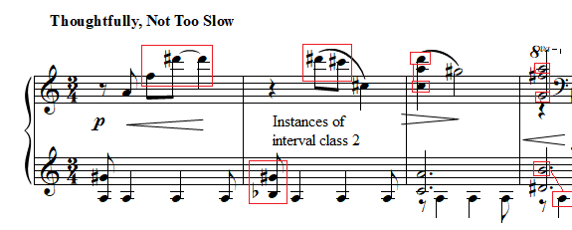

The second subphrase begins with a lead in of a descending minor third with a right-hand crossover. The next two diads in the right hand are related by inversion, a minor ninth on beat one and a major seventh on beat two. This is followed by a major third, which relates to the minor third that began the subphrase (see Figure 88). The phrase ends in m. 6 with a pair of seventh chords, an F major seventh chord and an A-flat major seventh chord with a raised fifth. These two chords are related in that they each contain two major thirds and a minor third.

Figure 88: Prelude No. 2 “Thoughtfully, Not Too Slow,” mm. 4-6
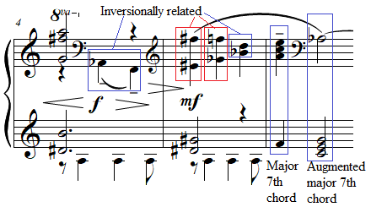

The end of the A section’s second subphrase coincides with the beginning of the B section in m. 6, a section demarcated by the stopping of the left hand’s upbeat ostinato. The B section is characterized by its use of three clefs which, as in Prelude No. 13 “Nostalgic, Twisted Slowly,” delineate voices which should be brought out of the texture. The B section concludes in m. 9 with three chords at a forte dynamic, which mimic Beethoven’s Symphony No. 5, followed by a C-sharp fully diminished seventh chord (see Figure 89). This sudden paroxysm will be referenced in Prelude No. 15 “Slowly” (see Figure 90).

Figure 89: Prelude No. 2 “Thoughtfully, Not Too Slow,” mm. 9
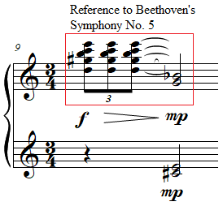

Figure 90: Prelude No. 15 “Slowly,” mm. 15-17
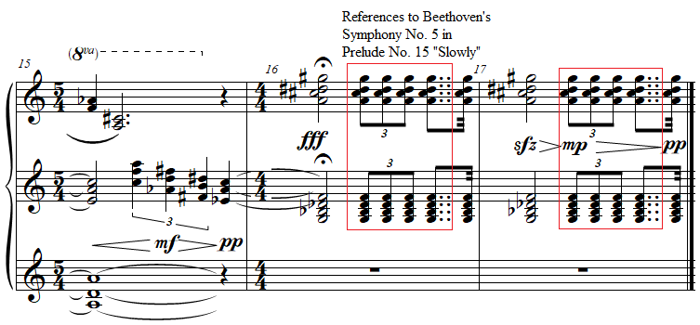

The C section is unified by the relentless left-hand ascending and descending C major scales in mm. 10 - 13, which supports the two-voice and, in m. 13, the three-voice texture of the right hand. M. 15 introduces a group of sixteenth note chords which alternate with a C major pentascale in the left hand. The right-hand chords are nearly all from the F# major collection, with the exception of the F-sharp diminished chord (see Figure 91).

Figure 91: Prelude No. 2 “Thoughtfully, Not Too Slow,” mm. 15-16
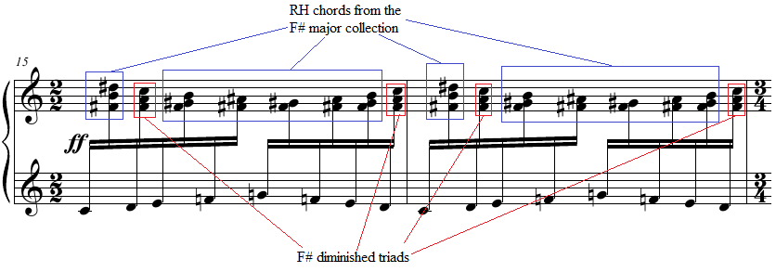

The chord at the downbeat of m. 17 contains both a whole step and a minor ninth, signifying the importance of these two intervals in this prelude. The final half note chord is an Eb major chord. In m. 18 two additional pitches are added, F# and A. This creates two chromatically adjacent minor thirds, occurring simultaneously. The G from this simultaneity can be held to connect to Prelude No. 3 “Faintly Energetic,” which builds on the concept of minor thirds related by a half step (or minor ninth).

Pedagogical Overview:
Prelude No. 9, evaluated at level 8-9, can be a useful piece for teaching a variety of characters and tone colors in the same work. Structured like a miniature suite, early advanced students will enjoy the quick rate of ideas presented. Rhythmically, Prelude No. 2 “Thoughtfully, Not Too Slow” features a ¾ time signature, which regularly alternates with 2/4 and unmarked 4/4 time signatures.
As a preparatory exercise for learning the A section of Prelude No. 3, students can learn the third movement of Robert Muczynski’s Fables, a piece which features similar offbeat accompaniment, but with much less chromaticism, at only a level 6 (see Figure 92).

Figure 92: Fable No. 3 from Fables, op. 21 by Robert Muczynski
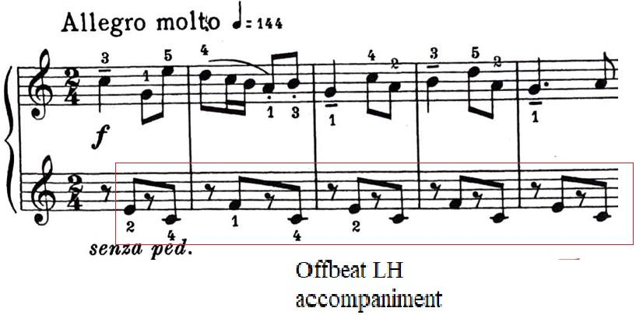

Teachers should share the following choreography with students to aid the right-hand crossover in m. 4 (see Figure 93). The crossovers in m. 5 can benefit from the following choreography (see Figure 93).
Figure 93: Prelude No. 2 “Thoughtfully, Not Too Slow,” mm. 4-6
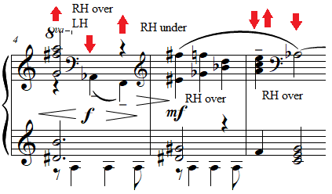
The rapidly alternating thirty second notes in m. 15 require choreography of the hands in and out of the keys to ensure a free hand (see Figure 94).

Figure 94: Prelude No. 2 “Thoughtfully, Not Too Slow,” mm. 15-16
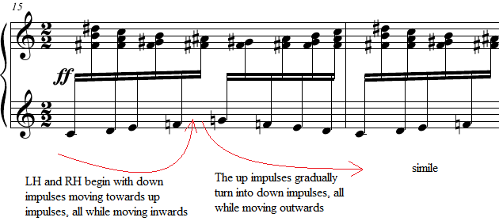

The dynamics in Prelude No. 2 correspond naturally with the keyboard texture and are the least challenging aspect of the piece. When both hands are in the middle range of the keyboard and/or have longer note values, dynamics tend to be softer (see Figure 95). As the hands move to more extreme registers of the piano and/or decrease in note value, dynamics tend to grow.

Figure 95: Prelude No. 2 “Thoughtfully, Not Too Slow,” mm. 1-3
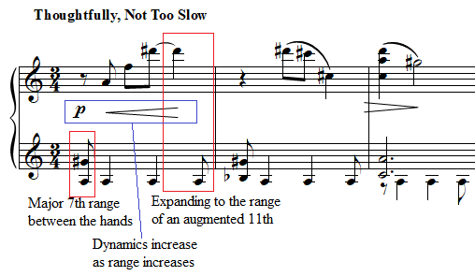
The copyist manuscript marks pedal in only two parts of the prelude, to create special effects at the piano. First, the pedal m. 9 sustains and connects the sudden chordal outburst in beat one with the mezzo piano fully diminished chord on beat two and three. Pedal is also marked in m. 10 during the rapidly ascending and descending C major scales. The repeat measure symbols in the left hand of mm. 11 – 13 of the copyist manuscript imply that pianists can change the pedal at the beginning of each measure allowing the sonority of the complete C major scale to build in each measure.
The notation of Prelude No. 2 implies pedaling in other locations as well. Pianists must pedal m. 4 to sustain the right-hand half note during the right hand’s cross over to the bass clef on beats 2 and 3 (see Figure 96). Students can use this pedal to their advantage by pedaling in both mm. 3 and 4 to contrast the dotted half notes on beat one of both measures with the eighth notes from mm. 1 – 2 (see Figure 96).

Figure 96: Prelude No. 2 “Thoughtfully, Not Too Slow,” mm. 1-4
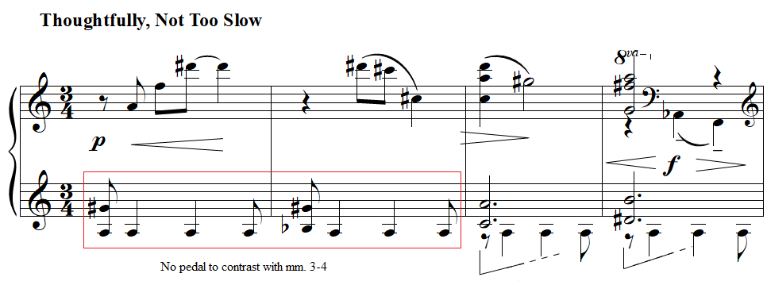
An effective performance of Prelude No. 2 allows the pianistic dynamics shift in accordance with changes of register to shape the rapidly transforming characters within the piece, while crafting a wide variety of dark and occasionally impressionistic tone colors using different levels of pedal. Teachers should also share a recording of Ballet Mécanique with students, so that students can hear the parts of the different instruments Antheil originally used for each section. For example, in the measures from Ballet Mécanique referenced in mm. 10 – 13 of Prelude No. 2, Antheil originally scored the left-hand C major scales for xylophone. It can be a fun challenge for students to try to emulate the sound of the xylophone at the piano through a percussive attack at the keys, while holding Antheil’s marked full pedal. Prelude No. 2 is an excellent choice for students who are bored easily, but who nonetheless possess sensitive musical ears.

Prelude No. 35: “Furioso”
Overview
Suggested Tempo: Quarter note = 45 – 58
Key: Atonal
Time Signature: 4/4
Measures: 7
Pages: 1
Length: 0:15 – 0:20
Level: 8-9
Publication: G. Schirmer (classicalondemand.com), La Femme 100 Têtes
Highly virtuosic in nature, Prelude No. 35 “Furioso” is an abbreviated reprise of Prelude No. 5, whose difficulty is made more accessible through its brevity. The oscillating right-hand 16ths create an effect resembling an alarm. The prelude, while not a transcription of Ballet Mécanique exhibits Antheil’s “machine aesthetic” in a compact form, using aspects of time-canvas technique, but also by using all twelve pitch classes approximately equally á la Schoenberg. At seven measures long, this piece serves as a wonderful showpiece, and an excellent tool for teaching rotation in combination with finger activation.

Compositional Overview:
Prelude No. 35 features a unipartite form concluding with a coda, featuring continuity of texture but neither repetition nor distinct sections (see Table 14). The A section constitutes the majority of the prelude, with a disjunct left-hand melody which quickly descends and expands in register and number of voices. The right hand arpeggiates a dissonant quartal chord (0156) in sextuplets. The coda is reached when the left hand reaches its lowest pitch (Eb 2). The right hand then plays five minor thirds which lead into a repeat of the previous measure. The prelude concludes with a C sharp minor chord over a B flat perfect fifth. The piece is characterized by the juxtaposition of constant motion and stasis at a high dynamic level, both features of the “machine aesthetic.”

Table 14: Prelude No. 35 Formal Analysis
A | Coda
mm. 1 – 4 | mm. 5 – 7

The entire A section of Prelude No. 35 “Furioso” is related in interval content through two tetrachords, (0156) and (0258), which first appear in the right hand and left hand respectively (see Figure 97). Prelude No. 35 “Furioso” begins with a brilliant right-hand ostinato in sextuplets which repeats for the first four measures of the prelude. This ostinato is formed out of a series of three descending intervals (D, G#, D#, A) which then ascend, with the outer intervals both a tritone (interval-class 6) and the middle interval a perfect fourth (interval-class 5), forming together a tetrachord (0156) which contains a highly dissonant interval-class vector, featuring two instances of interval-class 1 and 6 [200022].

Figure 97: Prelude No. 5 “Furioso,” m. 1
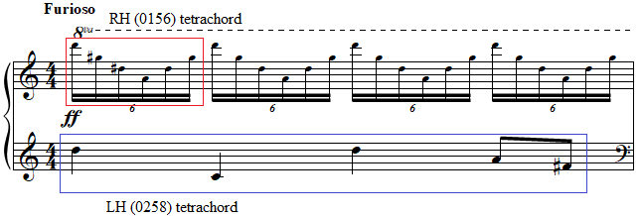

This contrasts with right-hand ostinato in Prelude No. 5 “Furioso,” the nearly identical counterpart to Prelude No. 35. Prelude No. 5 features slightly different descending pitches (C, Ab, Eb, A). This tetrachord, which has the normal form (0147), contains the interval-class vector [102111], and is comparatively much less dissonant (see Figure 98).

Figure 98: Prelude No. 5 “Furioso,” m. 1
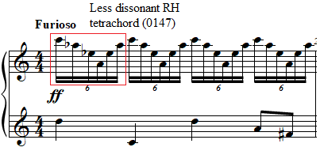

The left-hand melody begins in unison fortissimo notes in the treble clef. The magnitude and sonority suddenly increase in m. 2 as the left-hand changes from unison to octaves, and from fortissimo to fortississimo (see Figure 99).

Figure 99: Prelude No. 5 “Furioso,” mm. 1-2
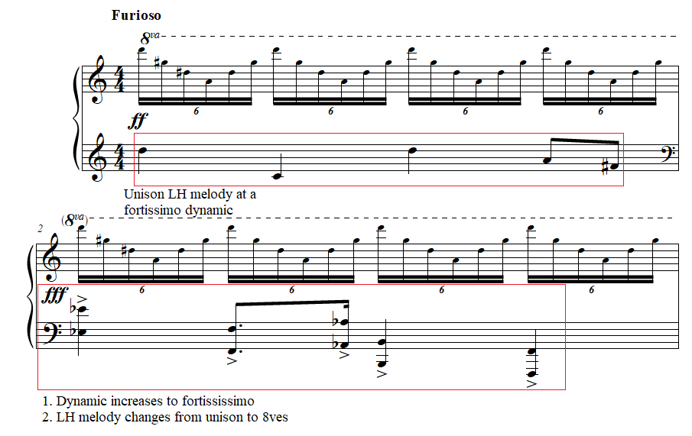
M. 1 contains pitches of a D dominant seventh chord in third inversion creating an (0258) tetrachord, which conveys a quasi-tonal sense of propulsion. The pitches of m. 2 form a half-diminished chord, which inverts into the dominant seventh chord from m. 1 at I₅.
When the left hand reaches its pitch floor in m. 3, it leaps to the treble clef, oscillating between two chords spanning a minor ninth. If the performer holds the Bb on beat one in the pedal, then beat three of the left hand contains a tetrachord composed of Bb, D#, B, and E. In normal form, this tetrachord is (0156), the same highly dissonant tetrachord arpeggiated from mm. 4, thus unifying the entire A section.
The B section can be conceived as bitonal, with the key of B-flat major and C-sharp minor hinted at. Beginning in m. 5, the B section consists of an Eb whole note followed by five minor thirds in eighth notes in the right hand on G# and B. While this enharmonically forms a G-sharp minor chord in second inversion, the notation implies a brief instance of bitonality. The final chord is a C-sharp minor chord over a perfect fifth (Bb, F). These three measures imply C-sharp minor in the right hand and B-flat major in the left hand. These two are related by a minor third and in two different modes. This recalls the similar relationship of the two keys present in Prelude No. 23 “Well Articulated” which begins and ends with a F# major pentascale in the right hand and a D minor pentascale in the left hand. The two uses of bitonality differ in two ways: the right hand in Prelude 23 plays the minor key and the left hand plays the major key, and the two keys are separated by a major third instead of a minor third, as in Prelude No. 35 “Furioso.”

Pedagogical Overview:
Prelude No. 35, evaluated at level 8-9, contains several elements of virtuosity, but its brief length at eight measures long makes it an exciting challenge for students. This prelude is even shorter than its nearly identical counterpart, Prelude No. 5 “Furioso.” It features a 4/4 time signature throughout, with a constant sextuplet sixteenth note ostinato spanning the A section from mm. 1 – 4.
In teaching the A section of Prelude No. 35 and Prelude No. 5, it is crucial for teachers to accurately teach their students the proper coordination required to achieve clarity of rhythm combined with a piercing tone. The rapidly descending and ascending arpeggios which span a perfect eleventh in Prelude No. 35 and a minor tenth in Prelude No. 5 require choreography of vertical, forward-horizontal, and lateral-horizontal motion (see Figure 100). The fifth finger can begin out from the keys and in a high position. The arm should guide the hand as it descends leftwards led by the wrist, creating a counterclockwise motion to reach the thumb’s note. On the ascent, the wrist should complete the ellipse formed by the counterclockwise motion. An inward impulse will allow the wrist to easily ascend back to its original position.

Figure 100: Prelude No. 5 “Furioso,” m. 1
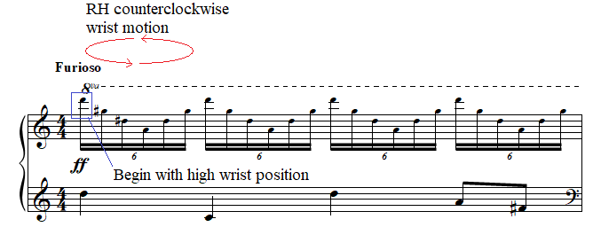

This motion can be taught through the following arpeggiation exercise created by the current author, which lets students address this useful technique out of context, with more familiar pitches (see Figure 101). Teachers should emphasize the importance of a clear and brilliant attack, especially on the fifth finger’s initial note in each arpeggio. Teachers must insist that all students, especially those with smaller hands, release each note as the arm moves laterally. This will ensure that the stretches required locally do not cause discomfort.

Figure 101: Preparation exercise for La Femme 100 Têtes, Prelude No. 5 “Furioso”
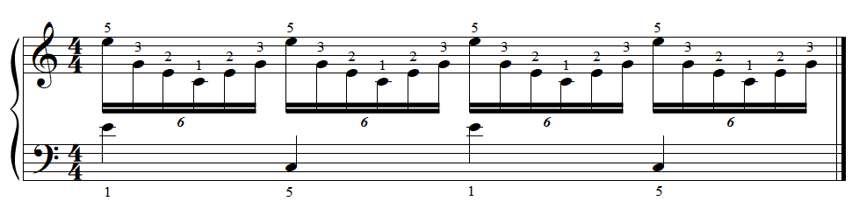

The left hand’s biggest challenge comes in the form of rapidly shifting octaves across two octaves and a fourth. Teachers can mark in the choreography for up and down motion which emphasizes strong beats (see Figure 102).

Figure 102: Prelude No. 5 “Furioso,” m. 2
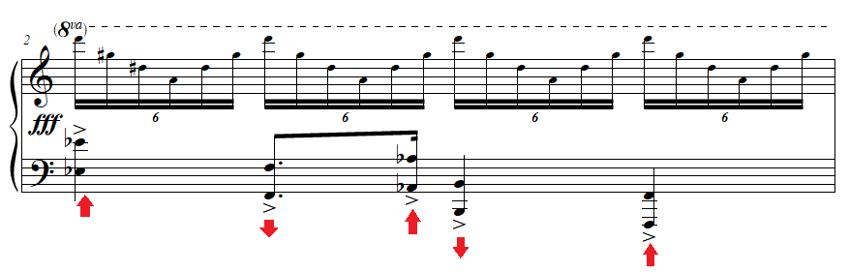
The left-hand chords in mm. 3 and 4, which span a minor ninth, can be arpeggiated. This has the added benefit of mirroring the quick arpeggiations in the right hand.
Dynamics in Prelude No. 35 “Furioso” range from fortissimo to fortississimo, reflecting the violent character of the prelude. This dynamic can be achieved primarily through percussive finger attacks with slightly lifted finger preparations. The accented minor thirds in mm. 5 - 6 can be performed with attacks from the lifted forearm, while the wrist and fingers remain firm but supple. The forearm should strike and immediately rebound, to generate a piercing tone. The final sonority in m. 7 can be struck using an inward impulse from the upper arm, using the elbow as a fulcrum.
Pedal within Prelude No. 35 can be used to add extra resonance. Students can use a touch of pedal on each beat of mm. 1 - 2 to increase dynamic and generate a richer sonority in the right-hand sextuplet ostinato. As stated in the compositional analysis, the bass quarter note in m. 3 can optionally be sustained via the sostenuto pedal until the downbeat of m. 5. This connects the Bb in m. 3 to the Eb in m. 5. A touch of pedal on the downbeats of mm. 5 - 6 allows the bass Eb’s to ring while the accented minor thirds in the right hand remain separated. Teachers and students can discuss their preference for pedaling the final chord or not.
An effective performance of Prelude No. 35 “Furioso” generates a feeling of lack of control without excess physical tension. Clarity in articulation will make even a slower tempo possess the required “Furioso” expression. Special attention should be given to fluency in octaves and arpeggios prior to assigning this prelude. This piece is an excellent choice for students who seek virtuosic keyboard literature but might be unable to handle a larger virtuosic work.

Prelude No. 5: “Furioso”
Overview
Suggested Tempo: Quarter note = 45 – 58
Key: Atonal
Time Signature: 4/4
Measures: 8
Pages: 1
Length: 0:20 – 0:30
Level: 8-9
Publication: G. Schirmer (classicalondemand.com), La Femme 100 Têtes
Prelude No. 5 “Furioso” is shocking and virtuosic, at level 8-9. When La Femme 100 Têtes is performed numerically in order, Prelude No. 5 “Furioso” is the first prelude in La Femme which does not quote Ballet Mécanique. As such, it introduces the “brilliant” style into the work, a style which is reflected in other late intermediate to early advanced preludes from La Femme such as Prelude No. 35, No. 34, and No. 14. This prelude, like Prelude No. 35 “Furioso,” avoids a pitch center through 12-tone compositional techniques. At 8 measures long, this prelude, like Prelude No. 35 “Furioso,” can act as a showpiece for younger students.

Compositional Overview:
Prelude No. 5, being the predecessor and counterpart to Prelude No. 35, features one continuous section followed by a brief coda, with the entire prelude using features of Antheil’s “time-canvas” technique (see Table 15). The prelude is almost identical to Prelude No. 35 “Furioso,” except for subtle changes in pitch, additional patterns in the right and left hand; and Antheil’s utilization of his “time-canvas” technique, changing the right-hand and left-hand textures at different times, a topic explored below.

Table 15: Prelude No. 5 Formal Analysis
A | B
mm. 1 - 3 | mm. 4 - 8

The following chart represents how form in Prelude No. 5 “Furioso” can be deduced differently depending on which hand is given importance in the analysis. This example of Antheil’s “time-canvas” technique gives the listener a sense of confusion, much in the same way that György Ligeti’s Étude No. 1, Book 1 “Désordre” from 1985 would feature patterns changing at different times in the left and right hand (see Figure 103). We can see in Prelude No. 5, a similar manipulation of ostinato to produce disorder and fury, albeit at a slower rate than Ligeti’s late 20th century work (see Figure 104).

Figure 103: Étude 1: Désordre from Études pour piano, premier livre, mm. 5-9
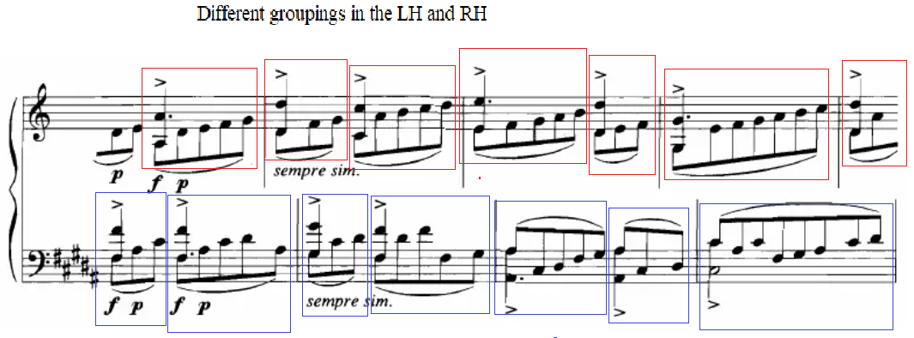
Figure 104: Prelude No. 5 “Furioso,” mm. 1-4
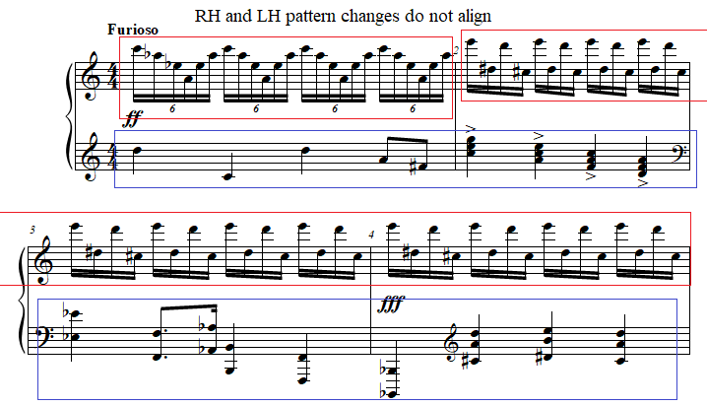

Pedagogical Overview:
Prelude No. 5, evaluated at a level 8-9, functions as an excellent showpiece for students. The shifting ostinati that result from the “time-canvas” technique described above makes this prelude more challenging than Prelude No. 35, but its length and peculiar changes of pattern provides reason for its study as an alternative. Like Prelude No. 35, it features a 4/4 time signature throughout, with note values in the left hand primarily consisting of whole notes, half notes, quarter notes, eighth notes, and sixteenth notes. The right hand alternates between sextuplet sixteenth notes and sixteenth notes.
As stated in the previous analysis, in teaching Preludes Nos. 5 and 35, it is crucial for teachers to emphasize proper coordination required to achieve clarity of rhythm and a piercing tone. In coordinating the descending and ascending arpeggios, the same coordination described in Prelude No. 35 of vertical, forward-horizontal, and lateral-horizontal motion is required, with circular motion vital to alleviate tension and ensure the strength required to produce the proper articulation. The pattern in m. 2 however differs from Prelude No. 35, featuring alternating descending broken minor ninths (see Figure 105). Teachers should emphasize a quick forearm rotation combined with an activation of the thumb on the lower notes, a motion which will aid the return motion of the rotation to minimize excess tension.

Figure 105: Prelude No. 5 “Furioso,” m. 1-2
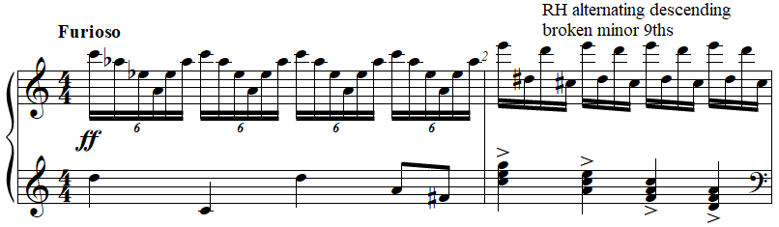

The left hand also proves more challenging than Prelude No. 35. M. 2 features descending accented triads leaping in thirds. These triads should be isolated in a teacher’s introduction to this prelude. Teachers should demonstrate the attack of these chords by modeling an attack from the wrist with an inwards impulse from the upper arm. Like Prelude No. 35, the left hand’s biggest challenge comes chiefly from rapidly shifting octaves across two octaves and a fourth in mm. 3 - 4. As in Prelude No. 35, teachers should mark in vertical choreography to emphasize strong beats in the performances of their students (see Figure 106).
Figure 106: Prelude No. 35 “Furioso,” m. 2
Dynamics in Prelude No. 5 “Furioso” range from fortissimo to fortississimo, reflecting the furious character of the prelude. As in Prelude No. 35, this upper range of dynamics can be achieved primarily through percussive finger attacks with slightly lifted finger preparation.
Pedaling within Prelude No. 5 “Furioso” can add a rich sonority and, as in Prelude No. 35, prolong the tone production of bass notes. On beat one of m. 1 in Prelude No. 5, the sustain pedal can be used after the staccato quarter note in the left hand to allow the virtuosic right hand ostinati to shimmer. In m. 7 the left-hand Eb octave should be caught in the sostenuto pedal if possible. This allows the eighth notes that occur beginning on the upbeat of beat 2 to maintain separation (see Figure 107).

Figure 107: Prelude No. 5 “Furioso,” m. 7
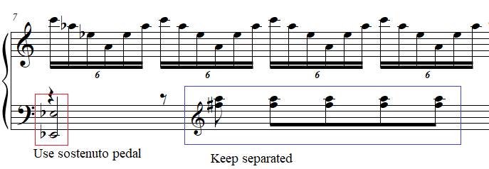

An effective performance of Prelude No. 5 “Furioso” creates a sound that embodies the expressive marking of the prelude with stark tone colors and crisp articulation throughout, created without excessive physical tension. Like Prelude No. 35, the tempo can be lowered without losing its “Furioso” character if special attention is given to articulation. With adequate preparation of octaves and triads, this prelude can be an excellent choice for students seeking a short and virtuosic piece for a contest. Prelude No. 5 “Furioso” can work well combined with a slower prelude, or as the final prelude in a set of three selected preludes.

Prelude No. 34: “Brilliant”
Overview
Suggested Tempo: Quarter note = 45 – 58
Key: C Major, Bb Major
Time Signature: 9/8
Measures: 14
Pages: 1
Length: 0:20 – 0:30
Level: 8-9
Publication: G. Schirmer (classicalondemand.com), La Femme 100 Têtes
Prelude No. 34 “Brilliant,” leveled 8-9, is notable for its humorous take on the “brilliant” style typical of Czerny’s School of Velocity, Op. 299 or The Art of Finger Dexterity, Op. 740. The piece exhibits a neoclassical economy of material, often utilizing diatonic C major scales. The treatment of tertian harmony in a nontonal manner recalls Stravinsky’s Pulcinella (1920). At only 20 measures long, this piece serves as an excellent introduction to neoclassicism for students.

Compositional Overview:
Prelude No. 34 is through composed and features three distinct sections (see Table 16). The introduction in mm. 1 - 4 features scales on white keys in contrary motion. The A section features left hand accompaniment consisting of eighth notes oscillating on octaves, or other stacked perfect intervals, with the right hand occasionally planing across the keyboard. The B section expands the register and features repeated notes in fifths in the left hand and single notes in the right. The piece is characterized by its use of conventional diatonic patterns in a nontonal manner.

Table 16: Prelude No. 34 Formal Analysis
Introduction | A | B
mm. 1 - 4 | mm. 5 - 8 | mm. 9 - 14

Prelude No. 34 is constructed from minimal material taken from tonal harmony, gradually introducing the following tonal concepts: diatonic scalar patterns, perfect intervals, and major thirds which form triads and cadential material. The introduction of each of these concepts defines the structural boundaries of the prelude.
Prelude No. 34 begins with contrary diatonic C major scales. The rhythm resembles the impulse scale, but differs by beginning with a dotted quarter note instead of a quarter note, which begins impulse scales (see Figure 109). From mm. 1 - 4, the first notes of the scales in both hands move inwards by step, similar to Exercise No. 5 from Czerny’s School of Velocity, op. 299 (see Figure 108).

Figure 108: Exercise No. 5 from School of Velocity, op. 299 by Carl Czerny, mm. 48-52
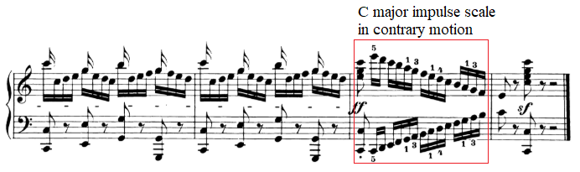
Figure 109: Prelude No. 34 “Brilliant,” mm. 1-3
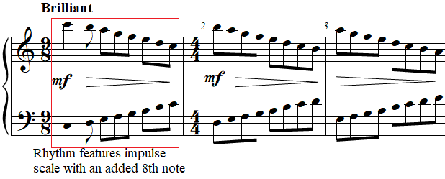

After this introduction, the A section begins with a motif that defines the remainder of this section, groups of two eighth notes leaping over an octave. M. 5 contains ascending leaps of a minor ninth, while the left hand contains descending octaves. In mm. 6 - 8, the left hand plays a repetitive accompaniment alternating between single note and tritones or perfect fifths. Between the outer notes that include tritones in the upper left hand and the low single note, this forms a minor ninth. The right hand from mm. 6 - 8 features open chords spanning an octave, avoiding thirds (see Figure 110). Starting on an F based chord in m. 6, these chords repeat in quarter notes, descend in m. 7, and repeat again on a G based chord in m. 8.
Figure 110: Prelude No. 34 “Brilliant,” mm. 6-8
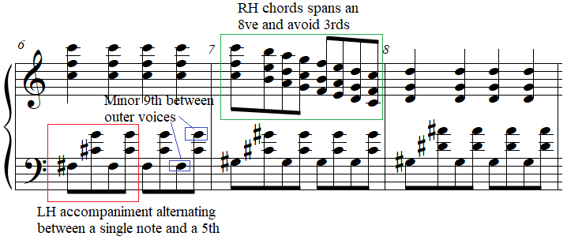

The B section begins in m. 9 with alternating ascending fifths in the left hand, which creates continuity with the previous measure featuring stacked fifths. The right hand introduces alternating descending broken major thirds, the first instance of thirds in the prelude. In m. 10, the left hand includes a perfect fifth on Bb, while the right hand finishes the Bb major triad with the note D. This sudden appearance of a major triad, the first in the prelude, causes a moment of resolution. Both hands play a quarter note, followed by two eighth notes and a half note. The rhythm simplifies further in the next two measures, with straight eighth notes in both hands. Harmonically, m. 11 begins with the Bb major triad from the previous measure, but both hands proceed by disparate intervals, creating more dissonant chords. For example, beat four of m. 11 features a C Lydian chord, and beats one to three of m. 12 feature an Eb phrygian chord followed by a C quintal chord on beat four. M. 13, which changes briefly to 2/4, includes a perfect fifth on F, followed by a repeat m. 10, including the Bb major triad and the quarter note followed by two eighth notes and a half note in both hands. This final harmony harmonic change from an open F perfect fifth to a Bb major triad, gives the piece a sense of harmonic closure, mimicking an imperfect authentic cadence, albeit without a leading tone in the F chord, which serves as the quasi-dominant chord for this prelude.

Pedagogical Overview:
Prelude No. 34, evaluated at level 8-9, is a rewarding and fun parody of music from the classical era. The challenge of its through-composed form is softened by its use of familiar technical patterns, a feature exclusive to the neoclassical preludes within La Femme. Rhythmically, Prelude No. 34 features only eighth notes, quarter notes, dotted quarter notes, half notes, and dotted half notes. Its rhythmic complexity originates from its changing time signatures, which occur without sudden shifts of character, limiting the perception of these changes to the listener.
In teaching the introduction of Prelude No. 34 “Brilliant,” which consists of mm. 1 - 4, it can be helpful to have assigned Exercise No. 5 from Czerny’s School of Velocity, op. 299. This allows the students to gain the proper technical skills to perform this prelude and let them understand the source of the parody.
In the A section, the most difficult passage in the prelude occurs in the form of the descending right-hand chords in m. 7, which span an octave. These should be executed using a combination touch with the wrist bouncing freely while the forearm guides the descent, thus creating a series of short arc movements down the keyboard (see Figure 111). Fortunately, the left hand in m. 7 includes an accompaniment of alternating fifths and unison notes which span an octave. This allows the students to focus visually on the descending right-hand passages.
Figure 111: Prelude No. 34 “Brilliant,” mm. 6-8
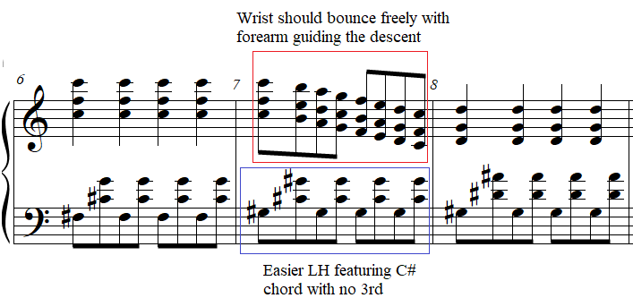
The transition from the A section to the B section, which begins with the introduction of thirds in m. 9, is marked by a large registral leap in the left hand (see Figure 112). This leap should be practiced in isolation to ensure the flow between sections. To avoid unnecessary buildup of tension on the repeated notes from mm. 10-14, teachers should demonstrate a light and bouncing wrist for their students (see Figure 112).

Figure 112: Prelude No. 34 “Brilliant,” mm. 8-11
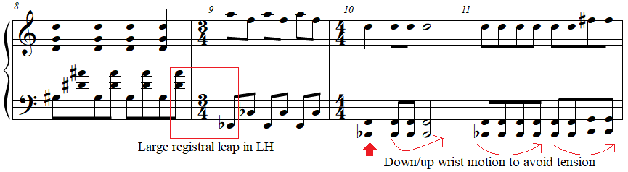

Dynamics in Prelude No. 34 “Brilliant” range from pianissimo only to mezzo-forte, recalling the modest dynamic range from pianos of the late 18th century. Pedaling, to emulate the pedaling required of classical sonatinas, should be kept to a minimum with touches of pedal on dotted quarter notes and half notes only. This manner of pedaling should be combined with a brilliant attack, featuring a percussive but light attack with a short duration. This articulation ensures the production of a brilliant tone color.
An effective performance of Prelude No. 34 emphasizes the Czerny-esque nature of the prelude through classical articulation and pedaling, creating a humorous surprise for the audience as dissonance is introduced in m. 5. Crisp staccatos and accurately interpreted two note slurs create a wide variety of tone colors within the prelude without any radical changes of character during this prelude. This distinguishes Prelude No. 34 from most of the easier preludes from La Femme 100 Têtes which emphasize sudden character changes throughout, extreme dynamic range, high levels of dissonance, and complex rhythmic treatment. This prelude is an excellent choice for a student frustrated with a piece from a classical sonatina, or unable to connect directly with the emotions presented in such a piece. Prelude No. 34 can function as a bridge connecting 20th century music with music from the classical period.

Prelude No. 33: “Mystic Tempo”
Overview
Suggested Tempo: Quarter note = 45 – 58
Key: C Major/G Phrygian, C Aeolian
Time Signature: 4/4
Measures: 34
Pages: 2
Length: 1:30 – 2:00
Level: 8-9
Publication: G. Schirmer (classicalondemand.com), La Femme 100 Têtes
Prelude No. 33 “Mystic Tempo,” is a highly tuneful prelude, leveled 8-9 merely due to consecutive chords spanning an octave. The peculiar tempo marking, “Mystic Tempo,” can be interpreted by students and teachers in either a subdued or an anxious character, which affects the variety of articulation used in the ostinato, a pattern which resembles a bass drum.

Compositional Overview:
Prelude No. 33 is in ternary form, with the addition of a coda (see Table 17). The A section features a right-hand melody in planed chords with no third in the key of C major. The right hand is complimented with a one-measure left hand ostinato implying G phrygian. An expansion of register in both hands builds the prelude towards the climax, until an abbreviated A section returns, finally returning to the opening before an additional nine-measure coda. The piece is characterized by its mechanical but subdued quality created as a result of both the left-hand ostinato and the right-hand open chords.

Table 17: Prelude No. 33 Formal Analysis
A | B | A | Coda
mm. 1 - 10 | mm. 11 - 19 | mm. 20 - 25 | mm. 26 - 34

Prelude No. 33 “Mystic Tempo” begins with the one-measure left-hand ostinato. This ostinato, repeated throughout the A section from mm. 1 - 10, consists of the first three notes of G phrygian alternating with G an octave higher. The rhythm of this ostinato creates a syncopation resembling the tresillo rhythm, a rhythm later used in Latin genres unrelated to this work (see Figure 114). The final beat of each measure is also accented, slightly displacing the importance of the downbeat in each measure (see Figure 113).

Figure 113: Prelude No. 33 “Mystic Tempo,” mm. 1-3
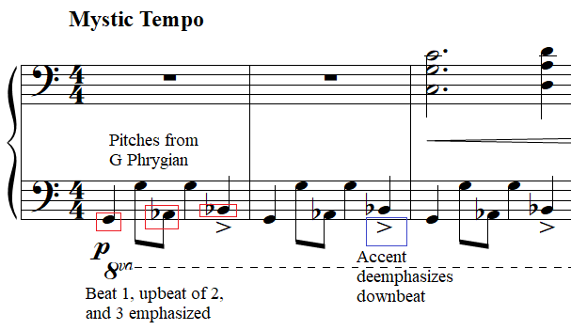

Figure 114: Example of tresillo rhythm
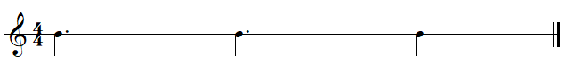
The right hand of the A section consists of a series of open major chords with no third spanning an octave. If a single voice of the right is played separately from mm. 3 - 8, a diatonic C major melody emerges, replete with a descending sequential cadence. Mm. 8 - 10 differ from the diatonicism of mm. 3 - 8 by introducing Bb and Eb and featuring a leap of a minor ninth in between mm. 9 and 10.
The B section is clearly defined through the introduction of the ostinato from the A section modulated from G phrygian to C minor. This transformed ostinato also differs from the original ostinato in that it alternates with D a major ninth above the lowest pitch of this ostinato, C. The rhythm of the ostinato remains the same as the A section from mm. 11 - 15.
Contrasting with the A section, the right hand’s rhythm matches the left hand throughout most of the B section, albeit with added rests. The right hand begins with a descending E minor seventh chord followed by a dissonant ascending leap of a diminished twelfth followed by a descending minor sixth. The melody repeats in m. 15 with the addition of a C minor melody in mm. 13 and 14 preceding it.
Both hands join in unison in mm. 16 - 19. The rhythm changes from the syncopated compound melody from the opening ostinato to a rhythm emphasizing beats 1, 3, and 4 (see Figure 115). The left hand’s pitch content remains the same, and the first two pitches of the right hand in this section are identical to that of the left hand. Beats 3 and 4 create a perfect fifth with the left-hand notes, giving an open timbral color reminiscent of the melodic right-hand chord in the A section.

Figure 115: Prelude No. 33 “Mystic Tempo,” mm. 16-19
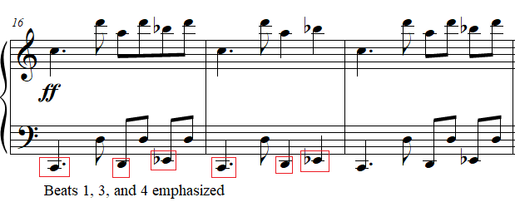

Following this, the A section returns in an abbreviated form through a copy of mm. 5 - 9 in mm. 20 - 26. After mm. 26, the entire prelude is repeated, solidifying its form as a rounded binary. On the second playthrough, mm. 26 is replaced by the coda from mm. 27 - 35.
The coda consists of three arpeggiated chords in the right hand, spanning up to a tenth, with two pitches in between the outer notes. The first right hand chord is a D major seventh chord from mm. 27 - 28 (see Figure 116). The second right hand chord can be conceptualized as an Ab Lydian chord from mm. 29 - 30 (see Figure 116). The third right hand chord is a French augmented sixth chord in the key of D-flat major, from mm. 30 - 31 (see Figure 116).

Figure 116: Prelude No. 33 “Mystic Tempo,” mm. 26-29
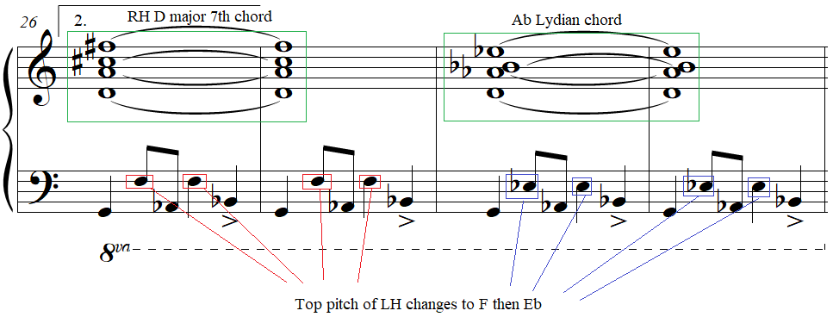

Each chord change in the right hand coincides with a slight change in the left-hand ostinato. During the first right hand chord from mm. 27 - 28, the left hand plays the same ostinato from m. 1 of the prelude except that it alternates with F instead of G (see Figure 116). During the second right hand chord from mm. 28 - 29, the left hand is identical to the previous measures except that the pitches alternate with Eb instead of F (see Figure 116). The third chord of the right hand is accompanied by a change of rhythm in the left hand which emphasizes the Latin tresillo rhythm implied throughout this prelude, featuring a tied eighth note on the upbeat of two (see Figure 117). The pitches of this ostinato form a C augmented triad. In m. 32, this is followed by a measure of descending minor seconds on beats two, three, and four (see Figure 117). This run leads into the final measure, in which the French augmented sixth chord is repeated in the right hand and placed over a minor third on B in the left hand (see Figure 117).

Figure 117: Prelude No. 33 “Mystic Tempo,” mm. 32-34
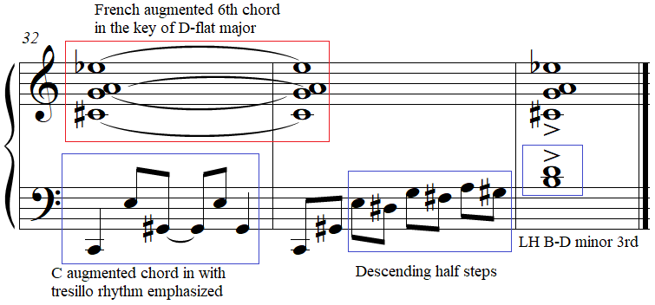

Pedagogical Overview:
Prelude No. 33, evaluated at a level 8-9, is melodically and rhythmically attractive due to its repeating ostinato and tight formal structure. Its ternary form with the addition of the coda lends this prelude additional accessibility, especially for students who can grow frustrated with the preludes from La Femme 100 Têtes which contain numerous consecutive ideas. Rhythmically Prelude No. 33 features eighth notes, quarter notes, dotted quarter notes, half notes, dotted half notes, and whole notes, with familiar rhythms from popular music.
In teaching the A section of Prelude No. 33, the one-measure left-hand ostinato at the beginning should be isolated to introduce forearm rotation into this prelude. The fifth finger can begin the piece at a slight tilt of the forearm, rotating to level to play the G. During the left-hand ostinato in mm. 1 - 15 and 20 - 32, each beat four into the downbeat of the next measure should be performed with a double rotation to restart the coordination required of this ostinato (see Figure 118). The fingers should activate in addition to the forearm rotation to ensure efficiency of motion.

Figure 118: Prelude No. 33 “Mystic Tempo,” mm. 1-2
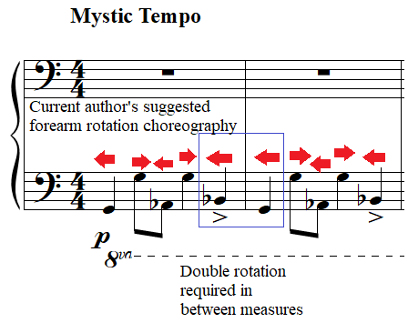

During the A section, the student’s right hand should use the fingering most comfortable for their physique, 1-2-5 or 1-3-5. The chords in the right hand should be disconnected using a vertical and lateral motion of the wrist to lift in between each chord. The leap of a minor ninth between mm. 9 and 10 can be accomplished with the upper arm tracing the leap (see Figure 119).

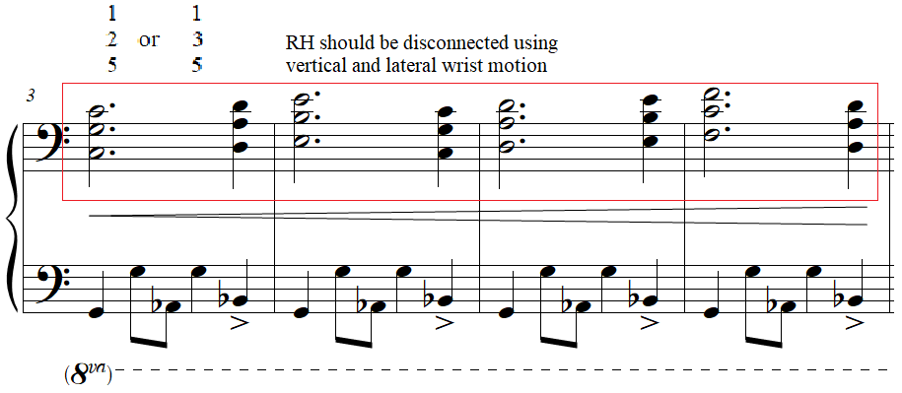
Figure 119: Prelude No. 33 “Mystic Tempo,” mm. 3-6

The B section of Prelude No. 33 is straightforward but contains several large leaps in the right and left hand. The left-hand ostinato in m. 11 leaps a major ninth. Students who have implemented rotation from the previous section can modify that movement to reach an additional step in m. 11. Otherwise, the principles of rotation remain the same.
The right hand of the B section contains several leaps including four leaps of a major ninth and two leaps of a diminished twelfth. Forearm rotation combined with lateral motion from the forearm and upper arm are necessary for the largest of these intervals, the diminished twelfths in mm. 11 and 15 (see Figure 120). Otherwise, mm. 5 - 10 and mm. 20 - 25 are identical, except for the former containing a crescendo in mm. 5 and 6, and the latter containing a diminuendo throughout the entire phrase.

Figure 120: Prelude No. 33 “Mystic Tempo,” mm. 11-12
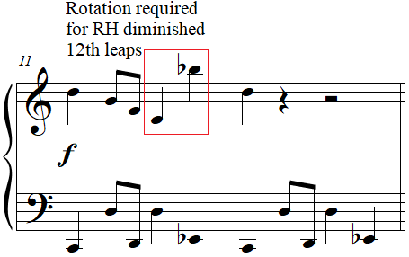

The coda from mm. 26 - 29 contains the left-hand ostinato from the opening of the prelude but with the interval between the outer notes of the pattern decreasing each measure. Teachers should note the sudden change of rhythm and interval pattern beginning in m. 30. Students should be asked to reduce the pitches of the left hand in m. 30 to a smaller position to reveal the chord in that measure as a C augmented triad. Once again, rotation should be used for this leap of a major tenth, and the Es played by the thumb should be given minimal weight to ensure that the G#s played by the third finger remain balanced.
The right hand during this time contains chords which span a tenth. To allow the student to gain an aural conception of the final three harmonies presented in the right hand at m. 26, 28, and 30, teachers should have the students rearrange the notes of the chord to fit into a smaller hand position (see Figure 121). Playing these chords with a decreased hand span as a practice technique allows students to gain an aural understanding of the harmony. It is helpful for students to identify these chordal patterns as D major seventh (m. 26), E Lydian (m. 28), and a French augmented sixth chords in the key of G major (m. 30).

Figure 121: RH chord reduction from Prelude No. 33 “Mystic Tempo,” mm. 26-34
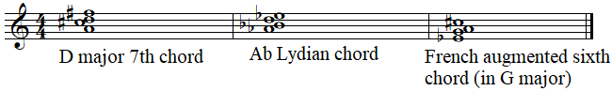

To ease the learning of the left-hand run in m. 31, teachers should connect the first three pitches of m. 31 to the ostinato from m. 28 - 30, both of which contain a C augmented chord (see Figure 122). The following pitches can be arranged in pairs using the fingers 1 and 2 (see Figure 122).

Figure 122: Prelude No. 33 “Mystic Tempo,” mm. 1-2
Dynamics within Prelude No. 33 “Mystic Tempo” are pianistic, and like several other preludes from La Femme, often correspond to register, with a wider register corresponding to a louder dynamic. Beginning at a piano dynamic in m. 1 to depict mystery, the first phrase crescendos from mm. 3 - 6. Afterwards, mm. 7 - 10 decrescendo. M. 11 begins a new phrase and new ostinato with a subito forte dynamic. The fortissimo which follows in m. 16 corresponds with the four-octave range of the prelude and the melody separated by two octaves between the hands. The subito piano in m. 20 diminuendos until either the repeat back to the beginning or, until the end of the coda on the return.
Teachers and students have a wide variety of pedaling interpretations possible with Prelude No. 33. All should depict the central character of the piece, “mystic.” To interpret the left hand as a bass drum of some sort, pedaling exclusively on the accent on beat four should be reflect this aural image. However, students can also experiment with half pedaling the ostinato to create a foggy character during the A sections and the coda, with touches of pedal for downbeats in the B section in mm. 11 – 19.
An effective performance of Prelude No. 33 creates a mysterious character through creative pedaling choices, and extreme dynamic contrast aligning with the registral extremes of the prelude. This piece can be suited to a student who enjoys the continuity of ideas in other late intermediate to early advanced repertoire but is drawn to the invigorating rhythmic pulse of this prelude.

Prelude No. 21: “Slower”
Overview
Suggested Tempo: Quarter note = 45 – 58
Key: D
Time Signature: 3/2
Measures: 12
Pages: 1
Length: 0:30 – 0:45
Level: 8-9
Publication: G. Schirmer (classicalondemand.com), La Femme 100 Têtes
At level 8-9, Prelude No. 21 “Slower” evokes an anxious and frightened character. Although the prelude can be performed individually, the tempo marking indicates its continuity with the previous prelude, Preude No. 20 “Faster,” a topic explored in Appendix B. The anxious character is revealed almost exclusively through rhythmic and intervallic content. This 12-measure prelude can be presented in a set, following Prelude No. 19 “Fast, An Even Piano Throughout,” and Prelude No. 20 “Faster,” three preludes which evoke a stark and bare character in addition to having tempo connections.

Compositional Overview:
Prelude No. 21 is ternary, featuring features of Antheil’s “time-canvas” technique (see Table 18). The opening and closing A sections, at only two measures, bookend the piece, forming the primary unification between the four short ideas presented in the B section. These four ideas occasionally contain textures that bleed over from previous segments of the piece, an example of Antheil’s “time-canvas” technique. The piece is characterized by the disparity of texture between these ideas, and the musical tension created by their juxtaposition.

Table 18: Prelude No. 21 Formal Analysis
A | B | A’
mm. 1 - 2 | mm. 3 - 10 | mm. 11 - 12

Prelude No. 21 “Slower” begins and ends with a texture consisting of two motifs, one in either hand. Both motifs appear in multiple locations across La Femme 100 Têtes in various forms, furthering the concept of a compositional collage central to this piece.
The right hand demonstrates a motif which is central to Antheil’s La Femme 100 Têtes as a whole, a series of ascending intervals including a large skip, a smaller leap, and another large skip (see Figure 123). This genesis of this motif, central to many of the preludes in La Femme which are not transcriptions of Ballet Mécanique, is first found in Prelude No. 5 “Furioso” as the basis for the right hand motif, although the intervallic structure is found in the same pattern until the nearly identical Prelude No. 35 “Furioso” (see Figure 125). It is then referenced in m. 3 of Prelude No. 6 “Floating” (see Figure 126). It is included in several preludes not analyzed in this document including the chords in m. 1 of Prelude No. 10 “Slightly Brutal Tempo,” and throughout Preludes Nos. 22, 26, 29, 31, 36, 37, 39, 41, and 44. Quasi-transpositions of this motif can also be found in the broken chords of Prelude No. 14 “Brilliant, Fast, Tricky”, m. 3 of Prelude No. 20 “Faster,” the coda of Prelude No. 33 “Mystic Tempo,” throughout Prelude No. 24 “Slowly,” Prelude No. 25 “Minuet?,” Prelude No. 35 “Furioso.”

Figure 123: Prelude No. 21 “Slower,” m. 1
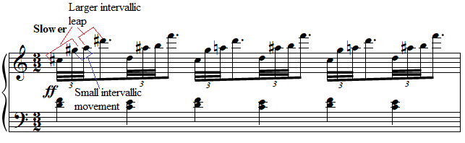
Figure 124: Prelude No. 5 “Furioso,” m. 1
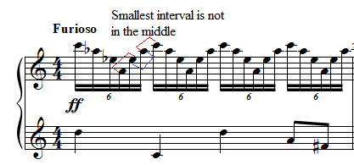

Figure 125: Prelude No. 35 “Furioso,” m. 1
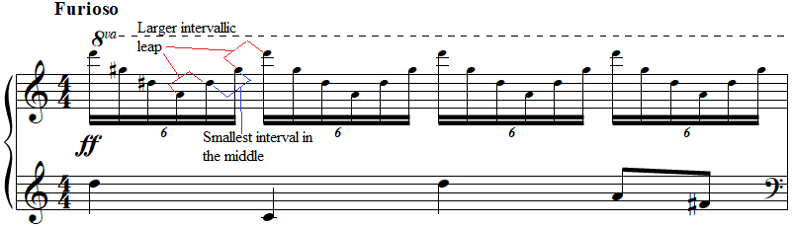

Figure 126: Prelude No. 6 “Floating,” mm. 2-3
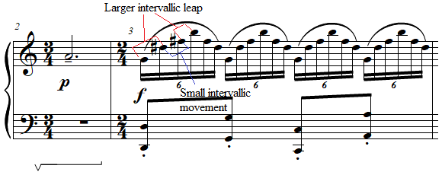
The left hand features pairs of thirds a diatonic second apart. This recalls the ascending thirds motif first discussed in the analysis of Prelude No. 7 “Sad” at the beginning of Chapter Four. Adjacent thirds feature prominently throughout La Femme 100 Têtes, forming the basis of the most consonant episodes within the preludes. In analyzing La Femme 100 Têtes consecutively, the components which constitute the ascending thirds motif first appear in Prelude No. 1 “Thoughtfully, Not Too Slow” in m. 13 (see Figure 127 and Figure 128).

Figure 127: Prelude No. 21 “Slower,” m. 1
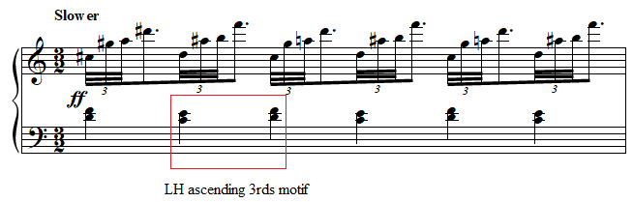

Figure 128: Prelude No. 1 “Thoughtfully, Not Too Slow,” mm. 1-2
Ascending thirds feature prominently in Prelude No. 7 “Sad” and in modified forms in other preludes. For example, the melody of Prelude No. 9 features ascending sixths, the inversion of ascending thirds, with the left hand repeating static thirds (see Figure 129). Prelude No. 3 “Faintly Energetic” features thirds transferred over an octave, and a series of descending chromatic thirds. Prelude No. 8 “Electrical, Spiccato” features broken ascending thirds (see Figure 130). Prelude No. 13 “Nostalgic, Twisted, Slowly” features recurring ascending thirds in mm. 5 and 18. Prelude No. 23 “Well Articulated” features ascending thirds between the hands (see Figure 131). Thus, Prelude No. 21 functions as an intersection between these two motifs.

Figure 129: Prelude No. 9 “Sad,” mm. 1-4
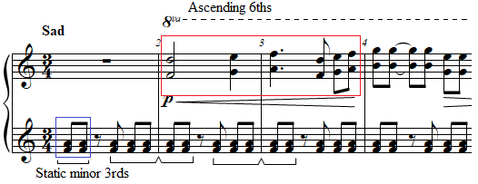

Figure 130: Prelude No. 8 “Electrical, Spiccato,” mm. 1-2
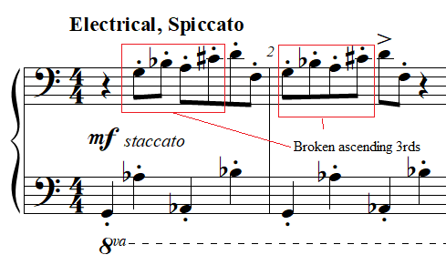
Figure 131: Prelude No. 23 “Well Articulated,” mm. 1-2
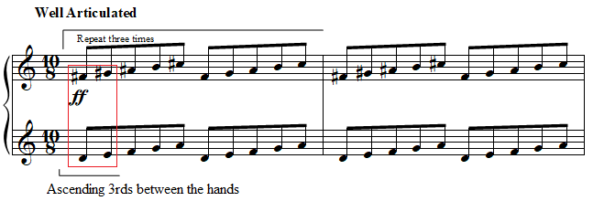

In the beginning of the B section in m. 3, the left hand remains identical to mm. 1 - 2, but the right hand features a B half note tied to an eighth note, followed by a descending minor third and a descending major seventh in triplets (see Figure 132). In m. 4 the right hand plays an F# major pentascale, while the left hand plays a D minor pentascale, both in triplet eighth notes. This not only combines the triplet figure introduced by the right hand in m. 3 with the ascending thirds motif formed by the interaction of the pentascales separated by a third, but also references the same bitonal effect present in Prelude No. 23 “Well Articulated” (see Figure 132).

Figure 132: Prelude No. 21 “Slower,” mm. 3-5
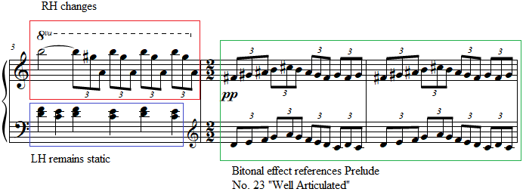
In mm. 6 - 7, the right hand plays ascending and descending B major scales from A# to B a minor ninth above, while the left hand plays an ascending and descending D Dorian mode spanning an octave from D to D. The right hand in sixteenth notes and the left hand in septuplet eighth notes, this forms a 7:8 polyrhythm until a chord is formed in m. 8 and repeated three times. The left hand plays a major third on G while the right hand arpeggiates a chord spanning a perfect eleventh.
Two sudden changes of register occur in m. 9 and 10 with the left-hand repeating Ab octaves in triplets in m. 9, followed by the right hand and left playing treble register Eb major seventh chords in eighth notes in m. 10. In m. 11, this episodic passage is concluded with a sudden major third on C between the hands with the left hand on an octave. Following this, the opening motif of the prelude returns, ending suddenly after three repetitions from m. 11 - 12.

Pedagogical Overview:
Prelude No. 21, evaluated at a level 8-9, despite its brief and highly contrasting episodes is accessible due to its repetition of motivic ideas throughout. Rhythmically, this prelude contains polyrhythm and uncommon groupings of rhythm, although it remains in 3/2 time signature throughout.
The primary rhythmic challenges stem from the opening rhythm in the right hand and the polyrhythm in mm. 6 and 7. The opening rhythm in the right hand features a less common distribution of note values, with the quick notes at the beginning of the beat instead of the end. This rhythm creates a disjunct rhythm similar to the Scotch snap, a rhythm often found in Scottish music and later found in hip-hop (see Figure 133). This opening requires a finger lift both to create a bright tone color for this piece, as well as to activate the fingers quick enough to play the rhythm in tempo. Because the opening pattern spans a major ninth, this finger activity must be accompanied by a lateral movement of the wrist and a slight rotation of the forearm.

Figure 133: Scotch snap rhythm
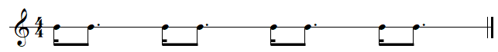

The polyrhythm in m. 6 consisting of a B major scale and a D Dorian scale can be prepared hands separately. When both hands can play their respective scales fluently, it can be easier for students to put the hands together without creating a complicated subdivision for the work. If the scales remain inconsistent, the students can practice the right-hand scale without the initial A sharp and in an identical rhythm to the left-hand septuplets (see Figure 134 and Figure 135). This allows the student to gain the coordination of performing the two scales simultaneously before adding in the extra pitch.

Figure 134: Prelude No. 21 “Slower,” m. 6
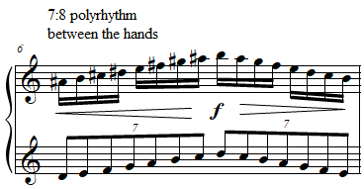
Figure 135: Preparation exercise for La Femme 100 Têtes, Prelude No. 21 “Slower,” m. 6
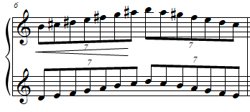
Pedaling in Prelude No. 21 “Slower” should be limited to quarter note and half note values with occasional touches of pedal on the beginning of ascending scalar passages from mm. 4 - 7 (see Figure 136). Dynamically, Prelude No. 21 features primarily the upper range of dynamics, but students should be careful to drop to a pianissimo in mm. 4 - 5, the only passage in which this dynamic occurs.

Figure 136 Prelude No. 21 “Slower,” mm. 3-5
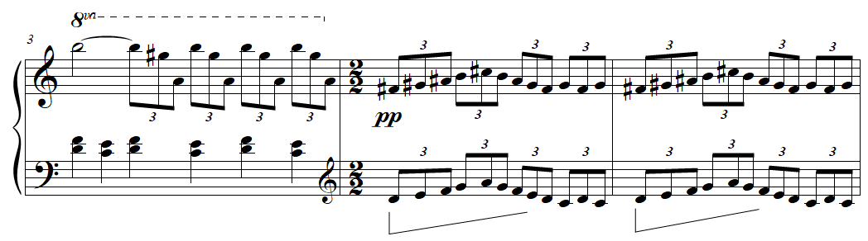
An effective performance of Prelude No. 21 emphasizes the anxious feeling present in the Scotch snap rhythms of the opening while avoiding excess physical tension. This can be accomplished by proper coordination of lateral wrist movements in passages which quickly ascend in register and finding moments to release in physically repetitive passages such as mm. 8 - 10.

Prelude No. 15: “Slowly”
Overview
Suggested Tempo: Quarter note = 45 – 58
Key: A
Time Signature: 4/4
Measures: 16
Pages: 1
Length: 2:00 – 2:15
Level: 8-9
Publication: G. Schirmer (classicalondemand.com), La Femme 100 Têtes
Prelude No. 15 “Slowly,” like its similar counterpart Prelude No. 13 “Nostalgic, Twisted, Slowly,” depicts the stars with its pointillistic sustained tones, and lilting thirds. This prelude is notated in three staves, a feature which not only calls attention to the separate voices in this prelude, but also, with the extensive note lengths, evokes an expansive quality. The piece contains a pitch center of A, but other pitch material is treated atonally, avoiding tertian harmony and further evoking the weightlessness of the notation. The piece works as an excellent recital piece, especially with its surprise ending, which has several creative options for imagery.

Compositional Overview:
Prelude No. 15 loosely follows rounded binary form (see Table 19). The opening A section, which is repeated, features sustained tones gradually building up half-step dissonances while the right hand performs two and three-note slurs connecting thirds and sixths. The B section contrasts with the A section by featuring soloistic lines, alternating with chordal accompaniment, gradually returning to the original texture with an extended left-hand chord which leads directly into the return of A in m. 12. The stillness of the prelude is interrupted with a violent coda in mm. 15 – 16 consisting of two juxtaposed tetrachords, (0137) over (0258), repeated in decreasing dynamics. The piece is characterized by its expansive dissonance, softened by its glacial tempo, and its uniquely shocking coda.

Table 19: Prelude No. 15 Formal Analysis
A | B | A’ | Coda
mm. 1 - 5 | mm. 6 - 11 | mm. 12 - 14 | mm. 15 - 16

Prelude No. 15 begins similarly to Prelude No. 13 with a half note rhythm featured in mm. 1 - 2. Mm. 1 - 2 feature a motif consisting of a large leap, followed by a descending half step, followed by a large leap. This will be interpolated into several preludes including Prelude No. 20 “Faster,” Prelude No. 24 “Slowly,” Prelude No. 25 “Minuet?,” among others. Mm. 3 - 5 feature thirds and sixths descending in leaps, recalling the thirds and sixths of Prelude No. 9 “Sad.” This A section is repeated after the third beat of m. 5.
The pickup to m. 6 features two major thirds resolving to perfect fifths in opposite directions, inverting at I₁₁ (see Figure 137). This is followed by a brief soloistic melody in the right hand which in m. 7 traces a D major ninth chord. In m. 8 the left hand plays two consecutive chords forming the “Petrouchka chord,” F# major and a perfect fifth on C (see Figure 137). The right hand of measure 8 alternates between a D major seventh chord with no fifth and a C# half diminished chord with no third.

Figure 137: Prelude No. 15 “Slowly,” mm. 6-8
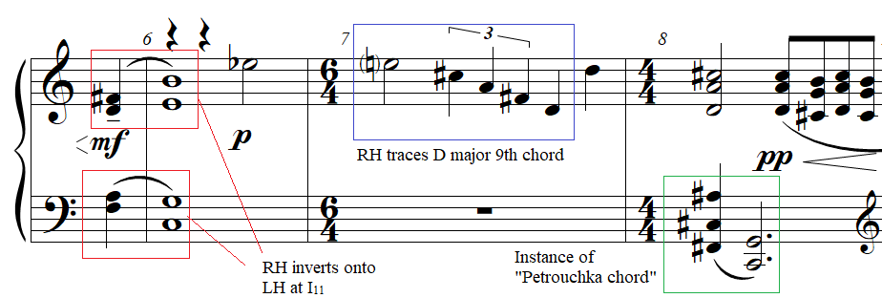

Prelude No. 15, also foreshadows Prelude No. 45 “Percussion Dance,” through its use of triads related by minor thirds. M. 9 consists of three separate chords which hint at separate roots, B major on beat one of the right hand, Ab major on beat two of the right hand, and D major without a third on beat one of the left hand (see Figure 138). Together these form three roots of major keys separated by a minor third. This hints at the motif which forms the basis of the final prelude in La Femme 100 Têtes, Prelude No. 45 “Percussion Dance.” This motif appears in its entirety in m. 12 and consists of four major triads in second inversion descending in minor thirds, thus forming a fully diminished seventh chord out of their consecutive roots (see Figure 138).

Figure 138: Prelude No. 15 “Slowly,” mm. 9-11
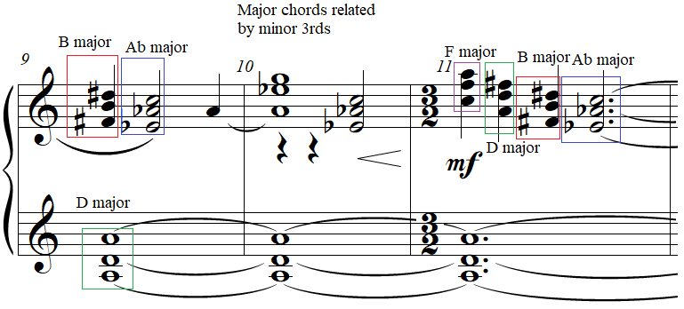

In m. 12 the descending thirds and sixths from mm. 3-5 are repeated, this time over an Ab major triad and an open D major chord in the lower two staves, forming a transposition of the “Petrouchka” chord. In m. 14 the “Percussion Dance” motif consisting of the four major triads descending in minor thirds repeats but in triplet quarter notes instead of quarter notes.
Suddenly, the coda begins in m. 15 with a fortississimo dynamic following the pianissimo dynamic from m. 14. The coda consists of a single chord repeated twelve times in different rhythms and dynamics. The left hand plays a G half diminished chord while the right hand plays the pitches A, C#, D#, G#. This right-hand chord can be conceived either through post tonal analysis or through extended harmony. In terms of post tonal analysis, the right-hand tetrachord in normal form is (0157), which, in contrast to the G half diminished chord, contains no minor thirds (ic3), featuring an interval class vector of [1, 1, 0, 1, 2, 1]. In terms of extended harmony, the pitches of the right hand, although lacking a B in either the right or left hand, can also be conceived as extensions of a B dominant seventh chord. In this interpretation, the A functions as a seventh, the C# as a ninth, the D# as the third, and the G# as a thirteenth (see Figure 139). The familiarity of this chord stems from its position as a standard rootless voicing for dominant chords amongst jazz pianists. The chord is first played in both hands on a half note with a fermata. This is followed by three triplet eighth notes, a double-dotted eighth note and a thirty-second note. M. 15 repeats this rhythm exactly but with different dynamics. In m. 15, the half note receives a sforzando articulation, which decrescendos to a mezzo-piano dynamic. The last beat decrescendos to pianissimo, ending the prelude on an 8-note pianissimo dynamic thirty-second note.

Figure 139: Prelude No. 15 “Slowly,” mm. 16-17
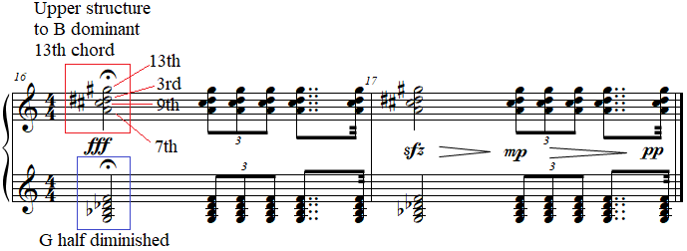

Pedagogical Overview:
Prelude No. 15, evaluated at a level 8-9, falls in a similar category to Prelude No. 13 “Nostalgic, Twisted, Slowly,” featuring imagery depicting the stars. The rounded binary form and consistency of texture in the non-coda material of the piece, makes this prelude rewarding for students, especially since the coda consists of a single chord repeated twelve times. Rhythmically, Prelude No. 15 features primarily eighth notes, quarter notes, half notes, and whole notes, with tied notes being commonplace. The exception to these rhythmic values occurs in mm. 14-16, with m. 14 featuring quarter note triplets, and the coda in mm. 15-16 featuring triplet eighth notes, and double-dotted eighth notes followed by thirty-second notes.
In teaching the A section of Prelude No. 15, teachers should insist on an articulation which occurs from the key to generate a dark tone. The two and three note slurs in mm. 2-6 should be performed with a drop and gradual lift of the wrist (see Figure 140). Proper phrasing can be ensured in the soloistic right hand melody in m. 7 with the use of preparatory rotations of the forearm.

Figure 140: Prelude No. 15 “Slowly,” mm. 3-5
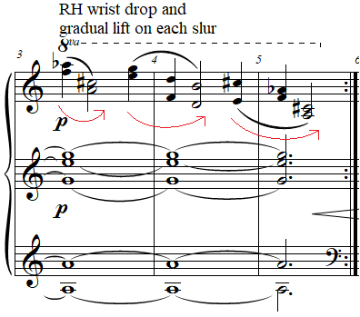
Pedaling should be used to color the long tones throughout. Clarity should be emphasized to avoid pedaling in between slur markings. In m. 6, the pedal should be gradually released to create a smooth transition between the chords in both hands from m. 5 and the rest in the left hand of m. 6. M. 11 can be quarter-pedaled while playing the descending triads with a disconnected touch, creating a steeper perceived decay of the chords.
The pedaling in the coda, to correspond with the decreasing dynamics from mm. 15-16, should decrease over time, ending with no pedal on the final pianissimo thirty-second note (see Figure 141).

Figure 141: Prelude No. 15 “Slowly,” mm. 16-17
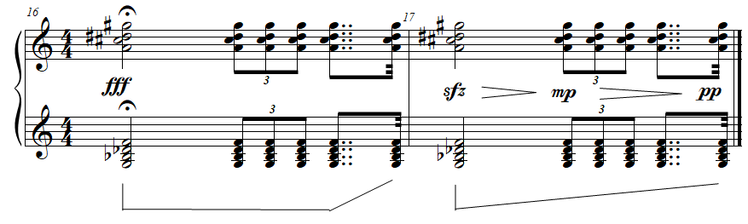

An effective performance of Prelude No. 15 “Slowly” emphasizes legato touch, and smooth movements of the hand to create an ethereal sound quality. Dynamics should be strictly adhered to, especially in mm. 14-16 to create an explosive surprise in the coda. This prelude would be an excellent recital piece for a student who enjoys pieces with unexpected surprises. The prelude would function well at the end of a set of preludes, or just before an intermission due to its exciting and anticipatory ending.

Prelude No. 4: “Floating”
Overview
Suggested Tempo: Quarter note = 45 – 58
Key: N/A
Time Signature: 4/4, 3/4
Measures: 9
Pages: 1
Length: 0:30 – 0:45
Level: 8-9
Publication: G. Schirmer (classicalondemand.com), La Femme 100 Têtes
Prelude No. 4 “Floating” is one of the five preludes which contain transcriptions of a portion of Ballet Mécanique, and so represents Antheil’s “machine aesthetic” in full force. The Prelude contains the expressive marking, “Floating,” a concept which can be illustrated by the performer throughout the piece. The B section of the piece revolves around C as a pitch center, although the prelude begins and ends in an ambiguous pitch center. At only 9 measures long, the copyist manuscript of the prelude contains fascinating markings in the score, which can be valuable to discuss tone color production at the piano.

Compositional Overview:
Prelude No. 4 is essentially through-composed in block form, but it contains elements of rounded binary form (see Table 20.) The prelude is characterized by its ominous drone, which, along with other aspects of the piece, allow it to sound like a soundtrack for a horror movie. This prelude opens with a brief idea consisting of three chords with a different middle chord moving outwards, which, repeated in a varied form in m. 7 with a short codetta. The B section contains a droning perfect fifth on C, which, Antheil marked as “timpani” notes. The right hand oscillates between the lower and the higher chord of the opening idea, until a large arc shaped melody in the right hand in m. 5 is interrupted with the return of A, thus ending the section. The prelude is characterized by its ominous drone, resembling a film score.

Table 20: Prelude No. 4 Formal Analysis
A | B | A’
m. 1 | mm. 2 – 6 | mm. 7 – 9

Prelude No. 4 begins with three chords with the right and left hand moving in contrary motion outwards and then inwards. The first chord consists of two minor thirds between the hands forming a fully diminished seventh chord. This contrary motion is similar to that of mm. 5-6 of Prelude No. 15 “Slowly,” but does not feature an exact inversion, with the right hand’s middle chord being a minor sixth and the left-hand chord being a perfect fifth (see Figure 142).

Figure 142: Prelude No. 4 “Floating,” mm. 1
The B section is unified by right hand chords and melodies over a quarter-note ostinato on C and G in the left hand. The right hand consists of variations of the three-chord motif from the beginning of this prelude. The chords repeat in their original form in A’ section in m. 7 in sixteenth notes instead of eighth notes. This is followed by a sudden A octave on A0 and A1, followed by two fortississimo chords. In this case, the right hand forms an E dominant seventh chord without a fifth. The left hand plays two chords consecutively, with the first being a Db minor chord and the second being three stacked fourths on Gb. The second of these chords forms a relative consonance with the right-hand E dominant seventh chord, with the left hand’s quartal trichord containing the following chord members from an E dominant seventh chord: the ninth (Gb/F#), the fifth (Cb/B), the root (Fb/E).
In m. 8, the A octave on A0 is repeated. The right and left hands respond with a passage originally played on xylophone in Ballet Mécanique, twelve sixteenth notes alternating. The right hand plays a (016) trichord repetitively, which alternates with ascending diatonic triads on the white keys in the left hand (see Figure 143). The left hand steps up to A#, followed by the final chord of the prelude in between the two hands, a redistributed and revoiced French augmented sixth chord in the key of G major.

Figure 143: Prelude No. 4 “Floating,” mm. 8-9
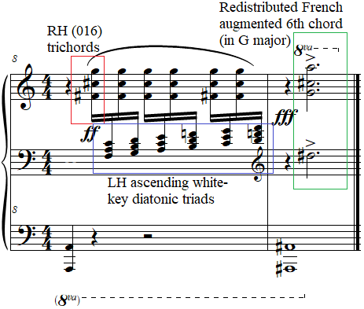

Pedagogical Overview:
Prelude No. 4, evaluated at a level 8-9, is highly dissonant, but can be interesting especially to students with a background in percussion. The use of timpani and xylophone effects are prominent throughout and can be a draw to this prelude. The structure is essentially rounded binary with a coda, but the A material consists of only three chords, lending the prelude to be taught essentially as a through-composed work. Rhythmically, the prelude features the Scotch snap rhythm in m. 7 (see Figure 133 in Chapter 5: Prelude No. 21: “Slower”).
This prelude can be challenging to introduce, in part due to the number of compositional ideas presented in this short work. Two examples of this in mm. 1 and 5 consist of a series of leaps of various intervals. These two passages are near inversions of each other, and the sequence of intervals is seemingly random. Teaching these passages requires careful planning of fingering. For the current author’s suggested fingering, see Figure 144.

Figure 144: Prelude No. 4 “Floating,” m. 1
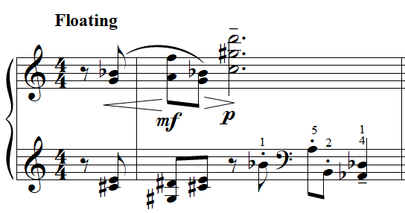

The other prominent difficulty in Prelude No. 4 is the chords spanning a ninth, particularly the tetrachords in mm. 3-4. These can easily be arpeggiated (see Figure 145 the current author’s suggested fingering). The right-hand chords in m. 8 can be redistributed to avoid the need for the hand to stretch a minor ninth (for the author’s suggested redistributions, see Figure 145).

Figure 145: Prelude No. 4 “Floating,” mm 4-5
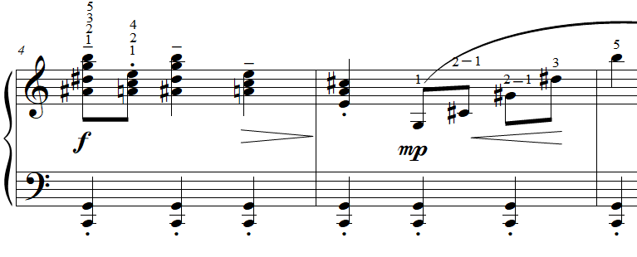
Dynamics in Prelude No. 4 generate the image of the expressive marking “Floating” through brief episodes of hairpin dynamics. From mm. 7-9 dynamics range from fortissimo to fortississimo. To avoid tension in this area, teachers should have students isolate the pairs of chords, making sure the student utilizes down and up motions at the wrist to release the firmness required for the initial fortissimo or fortississimo attack (see Figure 146).

Figure 146: Prelude No. 4 “Floating,” mm 7-9
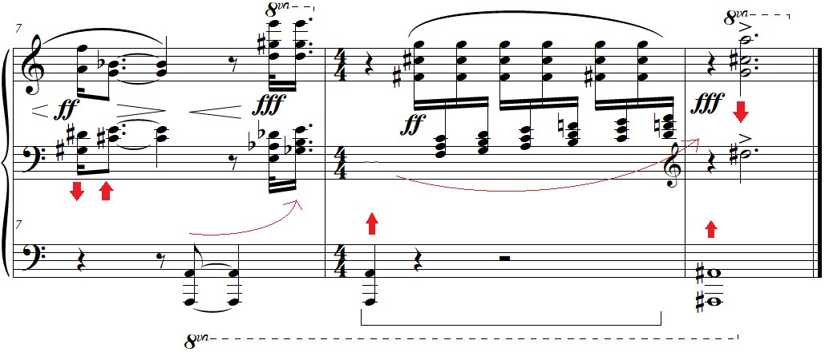

Pedaling throughout the prelude is implied through the slurs and staccato articulation markings, which removal of pedal (see Figure 146). The tenuto “timpani” fifths on C in m. 4 can be pedaled to add a richer sonority to this bass ostinato. The copyist manuscript includes one instance of notated pedaling in m. 8. This allows the “xylophone” sixteenth notes in m. 8 to vibrate. To imitate the decay of a xylophone, quarter pedaling is an excellent choice here.
This prelude is an excellent choice for a student interested in or already a performer of percussion instruments. An effective performance of Prelude No. 4 “Floating” creates a multitude of tone colors in imitation of the percussion instruments used in Ballet Mécanique. The roundness of the timpani and the ringing of the xylophone should be imitated carefully by the student’s performance through differing levels of pedaling, note length, and dynamic. Imitating the tone qualities of various percussion instruments can be a valuable and transferrable skill in other repertoire.

Prelude No. 20: “Faster”
Overview
Suggested Tempo: Quarter note = 45 – 58
Key: F major
Time Signature: 3/4, 4/4, 5/4
Measures: 6
Pages: 1
Length: 0:20 – 0:30
Level: 9
Publication: G. Schirmer (classicalondemand.com), La Femme 100 Têtes
Prelude No. 20 “Faster” is the shortest prelude from La Femme 100 Têtes, whose difficulty at level 9 stems primarily from the chords spanning a tenth. The tempo marking “Faster” reveals its connection to Prelude No. 19 “Fast, An Even Piano Throughout,” a prelude which it can follow in performance (see Appendix B for suggested groupings of the preludes). The piece exhibits neoclassical elements and “machine aesthetic” elements, although its bright and humorous character, emphasized by open fifths and octaves, gives the piece a fanfare quality. At 9 measures long, this piece can serve as a comical encore or can be grouped in the middle of two other preludes for performance.

Compositional Overview:
Prelude No. 20 is through composed in block form, although it contains elements of simple binary (see Table 21). The current author analyzed the form by labeling the short ideas presented sequentially in the prelude. The A section consists of two main ideas: the first presents oscillating octaves in ninths between the hands, oscillating at perfect intervals, using even division of the beat. M. 3 suddenly introduces triplets, with a motif in the right hand that recurs in several other preludes. The B section begins similarly to the A section except that it begins with octaves and introduces triplets immediately. The piece concludes with a bar of cascading triplets descend in arpeggios spanning a ninth. The piece is characterized by its buoyant melodic leaps and its rapidly fluctuating rhythms.

Table 21: Prelude No. 20 Formal Analysis
A | B
mm. 1 - 3 | mm. 4 - 6

The first idea of the A section features oscillations between perfect intervals (see Figure 107). The right hand is identical to the left hand but transposed up a major ninth. In m. 2 this resolves to a chord consisting of stacked fifths, creating a major ninth (see Figure 147). The introduction of Bb gives this measure both a connection to the Bb in m. 1 and hints briefly at G minor 9th chord. At the end of m. 2, the right hand introduces two consecutive ascending sixths, one major and one minor. The sixth will feature prominently in the right hand in mm. 2, 3 and 5, offering contrast to the consistent ninths, fifths, and octaves in the surrounding measures (see Figure 147). The left hand of m. 3 features triplet eighth notes alternating between F octaves and Bb’s. This pattern continues in the left hand through m. 4, with the addition of a pair of quarter notes. The right hand of m. 3 is constructed from ascending pairs of sixths in triplet eighth notes. This contrast of sixths versus perfect intervals, and quarter notes or sixteenth notes versus triplet eighth notes forms the central oppositional forces within this prelude.

Figure 147: Prelude No. 20 “Faster,” mm. 1-3
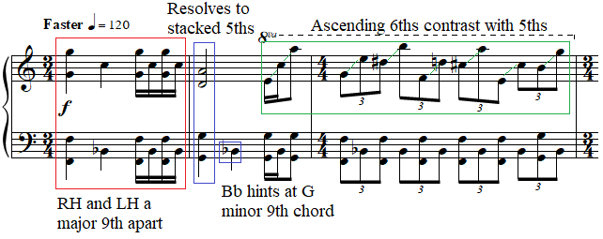

M. 6 features a descending set of triplet eighth notes, each spanning a major ninth all over an F major chord spanning a tenth in the left hand (see Figure 148). The motion of the triplet eighth notes moving towards the end of m. 6 which suddenly ends the piece, generates a humorous lack of resolution.

Figure 148: Prelude No. 20 “Faster,” m. 6
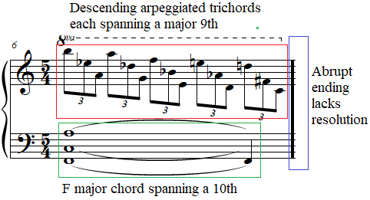

Pedagogical Overview:
At only six measures long, Prelude No. 20 “Faster,” evaluated at a level 9, is challenging primarily for the wide hand span it requires. It contains a sequence of related ideas which are rhythmically distinct through the alternation between quarter note and sixteenth note passages and triplet eighth note passages.
Some of the primary challenges in teaching this prelude are the sudden leaps in register. For example, m. 3 contains ascending leaps in sixths, but also descending leaps jumping up to an augmented eleventh on beat two (see Figure 149). All of these leaps should be performed with a combination of forearm rotation, finger action, and, for the largest leaps, lateral motion guided with the entire arm. Chords spanning a ninth or more can easily be arpeggiated without affecting the musical integrity of the prelude.

Figure 149: Prelude No. 20 “Faster,” mm. 2-4
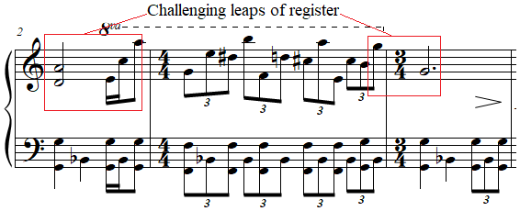

The economy of material of Prelude No. 20 can be brought out through simple choices of dynamics and pedaling. Only two dynamic markings and one decrescendo are given in the prelude. Mm. 1-4 are marked forte, with the final beat of m. 4 decreasing in volume to piano. This soft dynamic lasts from m. 5 to the end of the prelude in m. 6. While the expanded register and doublings of pitches in mm. 1-4 aid in the production of a forte dynamic, the piano dynamic in mm. 5-6 is more challenging to produce given the large register, left hand octaves, and three note chords in the right hand spanning a major ninth (see Figure 150). To create a cold and sharp, sound quality, pedal should be used minimally until the final measure, when pedaling is indicated by Antheil (see Figure 150).

Figure 150: Prelude No. 20 “Faster,” mm. 4-6
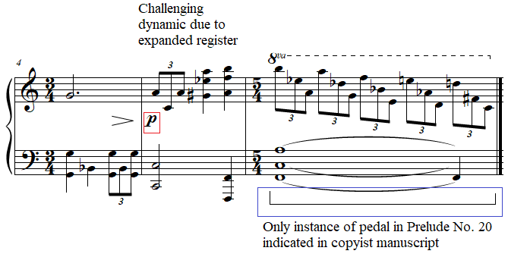
An effective performance of Prelude No. 20 “Faster” relies on a plainness of tone created through consistency of articulation, dynamics and pedaling. Students can attempt to mimic a player piano or a midi piano recording to create a clear sonic image of the required articulation throughout. This piece is suitable for a student with a keen sense of humor, and a large hand span.

Prelude No. 24: “Slowly”
Overview
Suggested Tempo: Quarter note = 45 – 58
Key: N/A
Time Signature: 4/4, 2/4, 3/2
Measures: 16
Pages: 2
Length: 2:00 – 2:30
Level: 9
Publication: G. Schirmer (classicalondemand.com), La Femme 100 Têtes
Resembling a nocturne, Prelude No. 24 “Slowly,” a level 9 piece which takes over 2 minutes to perform, is the longest prelude from La Femme 100 Têtes. The tempo marking, “Slowly,” recalls the tempo marking of Prelude No. 21 “Slowly,” and presents, at least initially, a nocturne texture which gradually evolves into impressionistic flourishes. The prelude contains harmonically unrelated tertian seventh chords in various inversions throughout, quartal arpeggiations, and an episode of polyrhythm. While Prelude No. 24 “Slowly” is only 16 measures, its structure gives it an expansive feeling, allowing it to be performed individually in performance.

Compositional Overview:
Prelude No. 24 contains an opening section resembling a nocturne, followed by a brief ternary structure (see Table 22). The A section features tertian and quartal harmonies in both hands in groups of four eighth notes, with the first of each group double-stemmed, emphasizing the half-note melody. An F# mixolydian scale gradually interrupts the previous texture to introduce an ascending grace-note arpeggiation of a scale which could be described as Messiaen’s third mode of limited transposition (described below). This is followed by a tremolo and a series of arpeggiations on two chromatically adjacent French augmented sixth chords. Immediately prior to A’, mm. 13 – 14 present a sudden change of texture, with a C dominant seventh chord over a left-hand bass melody in octaves. A’ features the return of the arpeggiation and tremolo from m. 9. The prelude’s character is mysterious, calm, and dreamlike.

Table 22: Prelude No. 24 Formal Analysis
Intro | A | B | A’
mm. 1 - 8 | mm. 9 - 10 | mm. 11 - 14 | mm. 15 - 16

The first section of Prelude No. 24 contains groups of four eighth notes. In mm. 1-2, the left hand and right-hand notes spiral outwards, with the right and left hand in contrary motion. Mm. 2-4 feature inward motion, with the right hand decreasing in pitch and the left hand increasing.
Unlike many of the preludes in La Femme, mm. 1-4 begins with extensive tertian harmony. In beats one and two of m. 1, the right hand arpeggiates an E major seventh chord with no third in second inversion, while the left hand arpeggiates a D-flat dominant seventh chord in second inversion (see Figure 151). Beats three and four of m. 1 includes a D major seventh chord in second inversion in the right hand, and a D dominant seventh chord in root position (see Figure 151).

Figure 151: Prelude No. 24 “Slowly,” mm. 1-3
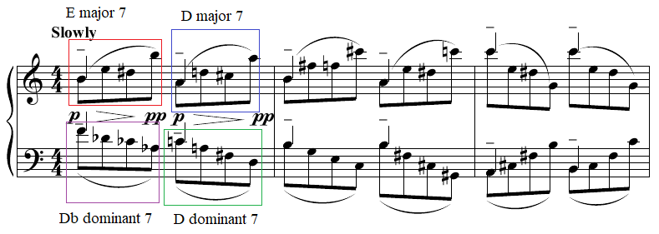
Beginning in m. 2, quartal and quintal harmony gradually replaces the tertian harmony of the opening. The final instance of tertian harmony occurs in the left hand on beats 1 and 2 of m. 2, which arpeggiates a C major seventh chord in root position. The remainder of the opening from mm. 2-4 maintains the same contour as the previous measure, but introduces much more dissonant harmonies. The contour in each of the right-hand groups of four eighth notes reveals the motif mentioned in the analysis of Prelude No. 21 “Faster,” consisting of a large interval, followed by a small interval, and then a larger interval (see Figure 152).

Figure 152: Prelude No. 24 “Slowly,” mm. 1-3
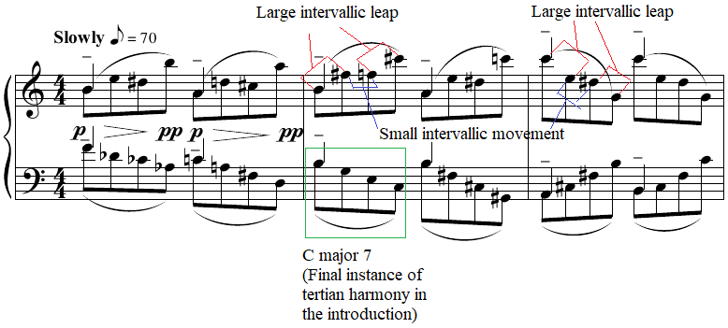

The A section features a 3:4 polyrhythmic structure in m. 5. The emergence of triplet eighth notes, which recalls the same rhythmic juxtaposition in Prelude No. 20 “Faster,” is emphasized with quarter notes at the beginning of each triplet eighth note figure, creating a pulse on each beat that hints at the ascending ninth motif which appeared first in Prelude No. 1 “Thoughtfully, Not Too Slow.” But, Prelude No. 24 “Slowly” the pitch content reveals two chromatic melodies grouped by four eighth notes, one formed from the lowest notes of the right hand, and the other formed from the highest notes of the right hand (see Figure 153). This 3:4 polyrhythm stems from the opening motif, consisting of an ascending leap, a half note descent, and another ascending leap superimposed over triplet eighth notes (see Figure 154).

Figure 153: Prelude No. 24 “Slowly,” mm. 4-5
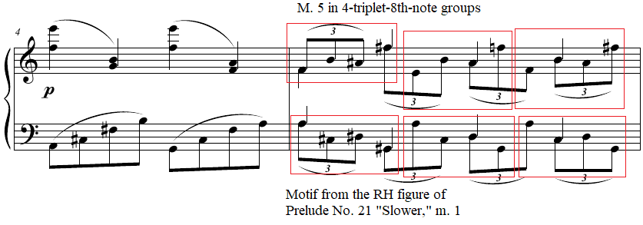

Figure 154: Prelude No. 24 “Slowly,” mm. 4-5
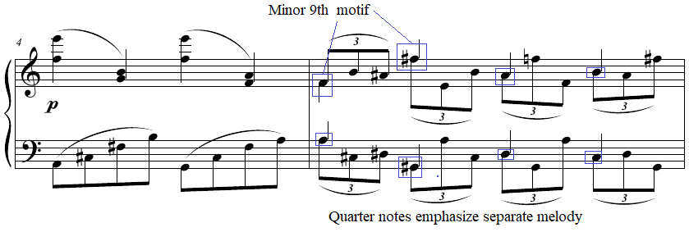

After an ascending F# mixolydian scale in m. 8, the B section begins in m. 9 with a harp-like run. In this run, the left hand plays pitches from the whole tone scale and the right hand’s pitches include the notes of an E-flat dominant seventh chord with the addition of an F#. This right-hand chord then alternates in sixteenth notes with a D natural. This leads directly into the tremolo in m. 10 with consists of a D in the left hand and an A octave in the right hand, decreasing throughout the measure from a forte to a mezzo piano dynamic.
M. 11 consists of a virtuosic run alternating between the hands in thirty-second notes arpeggiating two different French augmented sixth chords, resembling the music of Debussy. The right hand arpeggiates a French augmented sixth chord which could exist in G-flat major, while the left hand arpeggiates the same harmony but in G major (see Figure 155). As this pattern flourishes down then up the piano, the right hand plays an E flat octave half note.

Figure 155: Prelude No. 24 “Slowly,” m. 11
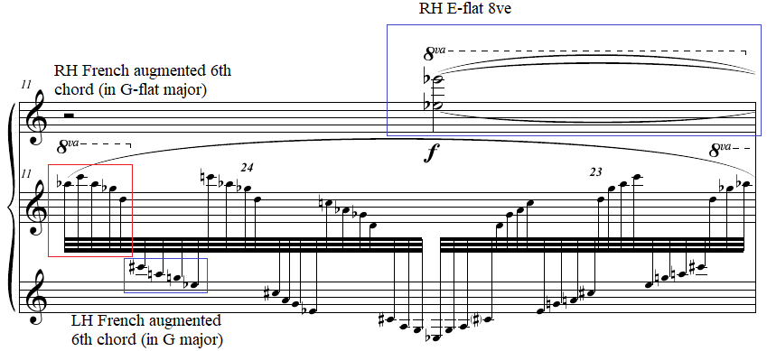

In mm. 13-14, the right hand plays a C dominant seventh chord with no fifth. The left hand in mm. 13-14 plays staccato octaves, the first four of which are a near retrograde of the opening motif (see Figure 156 and Figure 157). The piece ends with a repeat of mm. 9 and 10. This solidifies the entire first section as an introduction to the A section of the prelude which begins in m. 9, creating a disorienting ternary form with an extended introduction.

Figure 156: Prelude No. 24 “Slowly,” mm. 13-14
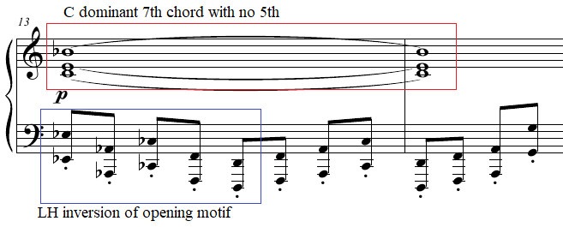

Figure 157: Prelude No. 24 “Slowly,” m. 1
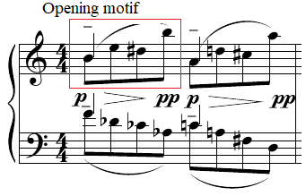

Figure 158: Right hand of Prelude No. 24 “Slowly,” mm. 1, in retrograde
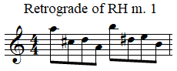

Pedagogical Overview:
Prelude No. 24 “Slowly,” evaluated at a level 9, contains Antheil’s most obvious implementation of Debussy’s compositional style, which can be enticing to students who have played that composer’s music prior to learning this prelude. Rhythmically, this prelude contains sudden transitions from eighth notes to triplet eighth notes, time signature changes, and thirty-second note arpeggiations.
In teaching the introduction to Prelude No. 24 “Slowly,” a nocturne-like quality can be achieved by students through the creation of a velvety tone at the beginning of each group of four eighth notes. According to Otto Ortmann, this tone quality can be achieved through outwards circular motion of the wrist, with a relaxed thumb which begins its note with a gradual increase in pressure, resulting in a low to moderate intensity of tone but with a smooth and soft touch-sensation. The other three notes of each group should be played from the key with a slow attack as the circular motion of the wrist is completed.
The arpeggiated figures of mm. 3-4 should be played using forearm rotation with the notes of the fifth finger that begin each group of four eighth notes played with the forearm at a slight angle and the fourth note of each group played with a level hand.
The 3:4 polyrhythm that occurs in m. 5 as a result of the four eighth note motif at the beginning of the prelude being set over triplet eighth notes can be practiced initially in groups of four eighth notes for students to easier recognize the connection of this passage to the opening.
The tremolos in mm. 9-10 can easily cause excess tension. To avoid this, alternation of fingers can aid the left hand. For example, students can use 4-3-2-1 repetitively to avoid tension in the left hand. The right hand, which repetitively plays pentachords in m. 9 and octaves in m. 10, should allow the wrist to bounce with an upwards impulse. This should be accompanied by a gradual rotation of the upper arm to alleviate the buildup of excess tension.
The thirty-second note arpeggiations in mm. 11-12 can be practiced initially by blocking the two French augmented sixth chords separately (see Figure 159). When this becomes comfortable, the arpeggiations from the two hands can be played using forearm rotations. Students should attempt to find the sensation of trading arm weight between the hands to ensure an absence of false accents.

Figure 159: Preparation exercise for La Femme 100 Têtes, Prelude No. 24 “Slowly,” mm. 11
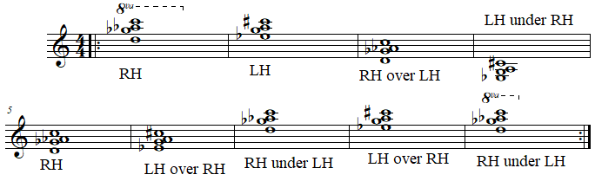

Dynamics in the introduction range from pianissimo to mezzo forte. The close velvety touch mentioned earlier should provide the proper range of dynamics for this section. The most challenging dynamic to achieve comes in m. 13 following the mezzo piano French augmented sixth chord flourishes of mm. 11-12. The left hand drops to a series of octaves in the lower range of the piano marked to be played piano with a staccato articulation. To achieve this, students should play the staccato octaves from the keys, with an immediate upward impulse preparing the next octave. Teachers can have their students ghost over these left-hand octaves to visualize the arc-shaped movement required in between each octave. This should adequately prepare students to perform the staccato octaves with a brief length while remaining at a piano dynamic (see Figure 160).

Figure 160: Prelude No. 24 “Slowly,” mm. 13-14
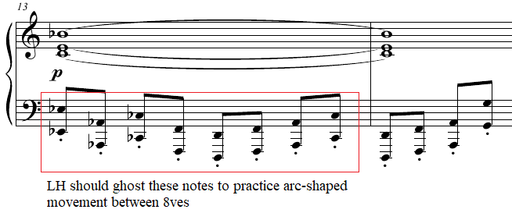

Prelude No. 24 “Slowly” contains several sections which benefit from creative pedaling to emphasize additional tone colors. In the introduction each group of four eighth notes can be pedaled with a decrease in pedal depth. This allows the quarter note to be emphasized with a rich sonority in each grouping and simultaneously lets each grouping decrescendo to pianissimo. Later, in m. 5 students can pedal either with each group of three eighth notes or with every group of four, depending on their personal preference. Pedal should be removed in m. 8 so that separation can be created between each staccato articulation (see Figure 161). The copyist manuscript includes pedal markings in m. 9, allowing the grace notes from the beginning of that measure to ring out for the duration of the tremolos in mm. 9-10 and the French augmented sixth flourishes in mm. 11-12. This creates a stark contrast when pedaling is removed in m. 13 for the aforementioned staccato octaves in the left hand.
Figure 161: Prelude No. 24 “Slowly,” mm. 6-8
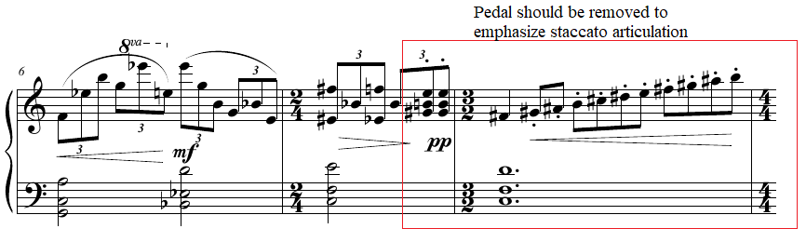

An effective performance of Prelude No. 24 “Slowly” creates a dream-like atmosphere through effective planning of velvety tone colors and the manipulation of the pedal. The variety in this prelude allows it to easily stand alone in performance. Although for more advanced students, teachers can assign this prelude alongside a radically different prelude from La Femme 100 Têtes, such as Prelude No. 35 “Furioso” or Prelude No. 34, both of which contain related motivic material. This piece is an excellent choice for students who enjoy the music of Debussy, but are willing to explore more dissonant harmonies.

Prelude No. 25: “Minuet?”
Overview
Suggested Tempo: Quarter note = 45 – 58
Key: C Mixolydian
Time Signature: 3/4, 4/4, 3/2
Measures: 15
Pages: 1
Length: 0:30 – 0:45
Level: 9
Publication: G. Schirmer (classicalondemand.com), La Femme 100 Têtes
At level 9, Prelude No. 25, which Antheil humorously marked “Minuet?,” mimics the minuet dance for only ten measures before descending into chaos. Antheil’s repurposing of elements from the classical style within this prelude serves the same purpose as Max Ernst’s repurposing of Victorian magazines, creating a surrealistic effect through the newly created context. This 15-measure prelude, while brief, can be performed individually in performance and can provide students with a fun parody of the classical style.

Compositional Overview:
The form of Prelude No. 25 is a parody of minuet form (see Table 23). The minuet section of Baroque Minuet and Trio typically feature a simple binary, with each section repeating (AABB.) In contrast, the A section of Prelude No. 25 repeats incompletely in mm. 7 – 8, and the B section repeats exactly only in the right hand. The C section disrupts this form with an arpeggiated 10-note chord, followed by a section which recalls Prelude No. 24 “Slowly.” Thus, the minuet form is only partially achieved. This prelude is characterized by its sudden references to other preludes, creating a structure resembling a miniature suite.

Table 23: Prelude No. 25 Formal Analysis
A | B | C
mm. 1 - 8 | mm. 9 - 10 | mm. 11 - 15

Prelude No. 25 begins with octave Cs in both hands, with the right hand switching to minor sixths with D and Bb in m. 2. This pattern of octaves in both hands is repeated in mm. 5-6 and mm. 7-8. The rhythm played in all three of these selections resembles the minuet rhythm found throughout the 17th and 18th centuries (see Figure 162 and Figure 163).

Figure 162: Common minuet rhythm
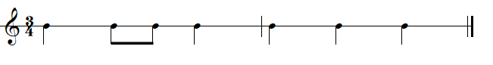

Figure 163: Prelude No. 25 “Minuet,” mm. 5-7
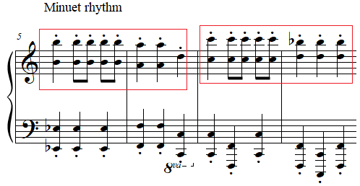

The strict quarter and eighth note rhythms are disrupted in m. 3 of the right hand. This measure consists of two motifs, found throughout La Femme 100 Têtes. Beats one and two include the motif found throughout Prelude No. 15 “Slowly,” Prelude No. 20 “Faster,” and Prelude No. 24 “Slowly,” among others. Beat three resembles the motif found at the opening of La Femme 100 Têtes, the descending sixteenth notes with the largest skip in between the final two pitches (see Figure 164).

Figure 164: Prelude No. 25 “Minuet,” mm. 3-4
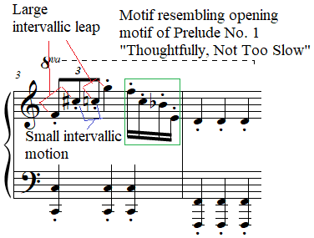

The right hand of mm. 9 - 10 interrupts the constant stream of quarter notes in the prior measures by playing a Scotch snap rhythm on the motif from Prelude No. 24 “Slowly” (see Figure 165). M. 11 references m. 9 of Prelude No. 24 as well, featuring an ascending ten-note arpeggiation followed by a single note in the left hand, trilling with a five-note chord in the right hand (see Figure 165). This left-hand chord is identical in both preludes, consisting of a whole tone collection, although the right hands differ in each. In m. 9 of Prelude No. 24, the right-hand chord includes the notes of an E-flat dominant seventh chord with the addition of an F#, whereas the right hand in m. 11 of Prelude No. 25 includes the pitches of a B major seventh chord with the addition of a G#. This slight difference gives the harmony a subtly different color. This passage is concluded at the end of m. 12 with a glissando which leads directly into the four grace notes in both the left and right hand which begin m. 13. These grace notes which lead to a quarter note reference the opening of Prelude No. 23 “Well Articulated.” Prelude No. 23 begins with an F# major pentascale over a D minor pentascale, the same pitches in either hand of mm. 13 - 15. In contrast to Prelude No. 23, however, Prelude No. 25 varies the rhythm and contour of this bitonal passage with a lower neighbor in both hands added on the upbeat of three. The prelude ends with a pianissimo quarter note staccato chord on the last beat of the last measure. The left hand of this chord features two stacked fifths stretching a major ninth, resembling the intervallic content of Prelude No. 20 “Faster,” which prominently featured quintal harmony.

Figure 165: Prelude No. 25 “Minuet,” mm. 9-11
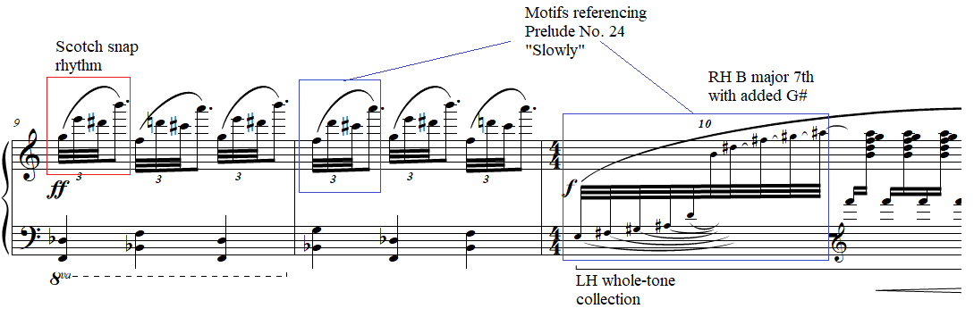

Pedagogical Overview:
Prelude No. 25 “Minuet?,” evaluated at a level 9, features a variety of styles and textures in its brief duration. The piece features some motivic repetition and several references to other preludes from La Femme, which can ease its difficulty for students who have performed other preludes from the set. Rhythmically, the prelude features varied note values including thirty-second notes and dotted eighth notes. The time signature changes from 3/4, 4/4, and 3/2.
In teaching the A section of Prelude No. 25, it is important to demonstrate the brittle sound quality needed for the opening eight measures. A brittle touch can be created on the octaves and sixths of the A section with a sharp percussive attack with an abrupt beginning. The wrist should quickly withdraw the hand from the keyboard to ensure production of a short staccato, indicated at the beginning. This withdrawal doubles as a means for allowing the hand to relax in between this extended series of percussive attacks.
The brief B section in mm. 9 - 10 consists of a pattern lasting two quarter notes but placed into a 3/4 time signature. The challenge in this section stems from playing the motif originally played slowly in Prelude No. 24 “Slowly” with enough rapidity not to let the tempo drop substantially. This Scotch snap rhythm resembles Prelude No. 21 “Slower,” and thus the same technique used in that prelude can be utilized here. Rotating the upper arm can guide the fingers as they leap a tenth (see Figure 166).

Figure 166: Prelude No. 25 “Minuet,” m. 9
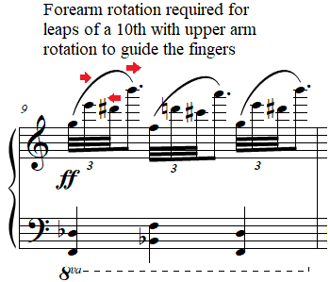
The arpeggiated flourish in m. 11, since it occurs at a forte dynamic, can be played with slightly lifted fingers to create a percussive attack. The final measure requires redistribution to let the penultimate notes of the right and left hands to sustain over the final chord of the piece. For the current author’s suggested fingering see Figure 167.

Figure 167: Prelude No. 25 “Minuet,” m. 15
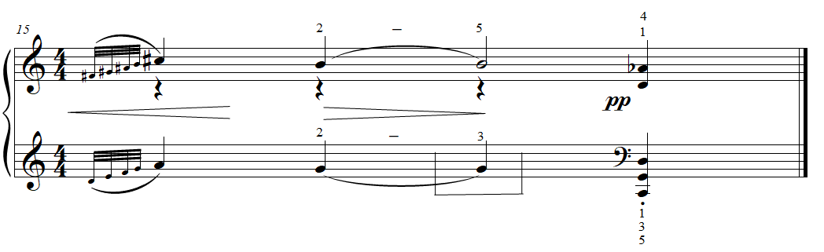
Pedaling in Prelude 25 “Minuet?” should be minimal if not absent in the A section to increase the stark brittle quality of the prelude. In the B section beginning in m. 11, the pedal should be added suddenly from mm. 11 - 12 to catch the arpeggiated figure occurring at the beginning of m. 11, allowing the tremolo in m. 12 to swell to a fortissimo prior to the glissando that concludes the passage. In mm. 13 - 14, students should pedal the final passage which references Prelude No. 23, a prelude with pedal indicated throughout. The pedal should be released on the penultimate notes of the piece to ensure the staccato release of the final chord.
An effective performance of Prelude No. 25 “Minuet?” creates a harsh and brittle tone throughout, but produces this sound without physical tension. This allows students to explore tone colors which are generally either avoided completely or only used sparingly. Students can enjoy the opportunity to familiarize themselves with these tone colors so that they can use it in other 20th century pieces with passages of harsh tone. This prelude is an excellent choice for students who find it difficult to connect with the classical style, or who connect easily with the classical style but are curious about how composers have parodied the style.

Prelude No. 19: “Fast, An Even Piano Throughout”
Overview
Suggested Tempo: Quarter note = 45 – 58
Key: C Mixolydian
Time Signature: 3/8, 2/8, 4/8, 3/4
Measures: 21
Pages: 1
Length: 0:25 – 0:40
Level: 9-10
Publication: G. Schirmer (classicalondemand.com), La Femme 100 Têtes
Prelude No. 19 “Fast, An Even Piano Throughout” imitates a Bach invention, and would likely be easier than some Bach inventions if not for its generous use of large leaps and octaves. The tempo marking, “Fast, An Even Piano Throughout,” is one of three preludes in the collection which Antheil request an even dynamic, the others being: Prelude No. 18 “Banged, An Even Forte Throughout” and Prelude No. 22 “Faster, An Even Fortissimo Throughout.” Instead of implying a mechanical performance, as in Antheil’s Jazz Sonata (1922), which contains a more detailed tempo marking: “as rapidly as it is possible to execute cleanly and with even touch and dynamics like a player piano,” Preludes Nos. 18, 19, and 22 seem to be marked with an even dynamic to encourage pianists to avoid excessive phrasing, creating a restrained affect typical of neoclassicism. At only 21 measures long, this piece works excellently as a competition or recital piece performed individually.

Compositional Overview:
Prelude No. 19 loosely follows rounded binary form, but also hints at Bach’s contrapuntal subject development to a greater degree (see Table 24). The opening A section presents the “subject,” which consists of stepwise sixteenth notes in the right hand repeated three times. The left hand meanwhile presents arpeggiations of extended harmony. The B section begins the “episode” featuring the trading of triplet sixteenth notes between the hands. M. 16 features a brief return of the initial “subject” in m. 16, followed by a coda which foreshadows Prelude No. 20 “Faster.” Prelude No. 19 “Fast, An Even Piano Throughout” is notable for the quiet virtuosity it displays.

Table 24: Prelude No. 19 Formal Analysis
A | B | A’ | Coda
mm. 1 - 4 | mm. 5 - 15 | m. 16 | mm. 17 - 21

The “subject” of Prelude No. 19 consists of a descending step followed by three ascending steps. The left hand in m. 1 could be considered a “counter-subject” of sorts, consisting of a descending skip followed by a leap of a minor seventh in eighth notes (see Figure 168). Aspects of both the “subject” and “counter-subject” are manipulated throughout this prelude.

Figure 168: Prelude No. 19 “Fast, An Even Piano Throughout,” mm. 1-3
In m. 3, the “counter-subject” leaps a minor ninth and then a major tenth in m. 4. The right hand uses a similar leap from the last eighth note of m. 4 to the downbeat of m. 5. In m. 5 the right hand introduces triplet sixteenth notes performing variations of the stepwise opening motif (see Figure 169). These triplet sixteenth notes are traded in m. 6 with the left hand which plays an ascending F Mixolydian scale from F to G (see Figure 169). The leap of a ninth is then introduced into the right-hand triplet sixteenth notes on the downbeat of m. 7. In the second and third eighth notes of m. 7, the right hand performs six notes of a C# Dorian mode, referencing the scalar ascent of the left hand in the previous measure. In m. 8 both hands play six notes of a scale in contrary motion, the left hand playing a descending C major scale beginning on E and the right hand playing the first six notes of a C major scale.

Figure 169: Prelude No. 19 “Fast, An Even Piano Throughout,” mm. 4-6
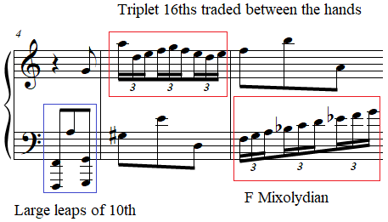

From mm. 9 - 10 both the right hand and the left hand play eighth notes, with the left hand playing a six-note ascending scale beginning on C. By m. 9, both the “subject,” whose only qualities were stepwise motion in sixteenth notes, and the “counter-subject,” whose features consisted of eighth notes leaping, have traded these features, and introduced new intervals. For example m. 14 introduces alternating octaves in triplet sixteenth notes, which later in the piece develop into repeated pitches in m. 18. Thus, nearly all individuality of the “subject” and “counter-subject” over the course of this episode from mm. 5 - 15 dissolves.
The “subject” and “counter-subject” reappear as a brief return of A in m. 16 but with the left hand in octaves. M. 16 is the only restated measure from the beginning. The coda begins in m. 17 with the right hand introducing triplet sixteenth notes with eighth notes in the same measure (see Figure 170). M. 20 is related to the alternating triplet octaves from m. 14, but instead consists of octaves, in both hands a major ninth apart, alternating with a pitch a perfect fourth up from the lowest note of each octave (see Figure 171). M. 21 ends the piece with a C octave in the left and the right hand a major ninth up on D. This exact textural idea forms the basis for the very next prelude in the set, Prelude No. 20 “Faster,” which develops this exact concept. As a result, Prelude No. 19 “Fast, An Even Piano Throughout” and Prelude No. 20 “Faster” can easily be paired together in performance due to their related motivic material.

Figure 170: Prelude No. 19 “Fast, An Even Piano Throughout,” mm. 16-18
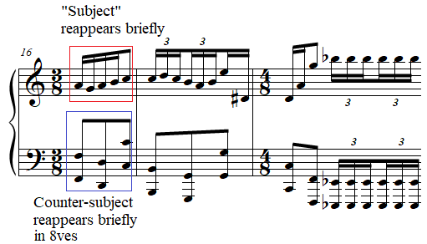
Figure 171: Prelude No. 19 “Fast, An Even Piano Throughout,” mm. 20-21
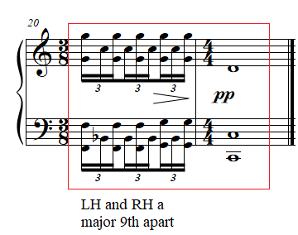

Pedagogical Overview:
Prelude No. 19, evaluated at a level 9-10, is one of the most consonant preludes within La Femme 100 Têtes. Based on motivic and textural development, this prelude functions well as an early excursion into post-tonal music for students. Rhythmically, despite its numerous time signature changes from 3/8, 2/8, 4/8, 3/4, and 4/4, Prelude No. 19 only contains whole notes, quarter notes, eighth notes, sixteenth notes, and triplet sixteenth notes. The greatest rhythmic challenges stem from transitioning from sixteenth notes to triplet sixteenth notes in mm. 17 - 18 (see Figure 172).
Figure 172: Prelude No. 19 “Fast, An Even Piano Throughout,” mm. 17-18
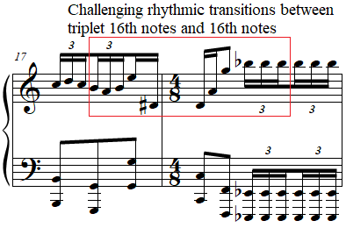

The primary technical challenge arises from the octave eighth notes which leap to intervals spanning an octave, often to unison notes. Teachers can demonstrate the arc-shaped motion required for this prelude. For example, see Figure 173 for the current author’s suggested choreography of the left hand of mm. 3 - 5, a passage which can be difficult without such movements.

Figure 173: Prelude No. 19 “Fast, An Even Piano Throughout,” mm. 3-5
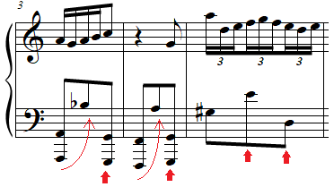
The sudden leaps of a minor ninth in the right hand of m. 7 which are to be played in triplet sixteenth notes can be particularly tricky. A combination of a slight forearm rotation and activation of the fingers can prepare students for this set of leaps.
In mm. 4 and 9, when both hands play in eighth notes, notice should be taken to create silence in between each eighth note, as these passages serve as contrast to the stream of sixteenth notes and triplet sixteenth notes in the remainder of the prelude.
Other challenging transitions occur when multiple kinds of motion are required for a passage. For example, the transition in the left hand from mm. 14 - 15 involves a leap of a fifth to an octave occurring directly after a tremolo on two G’s. Because the tremolo required rotation, it is difficult to reach the C octave. However, lateral motion of the forearm can help create technical ease in this passage. The hands can remain free through the repeated notes in m. 18 through a gradual lift of the wrist and forearm.
Dynamically, the expressive marking indicates “An Even Piano Throughout.” Students should keep an even touch at the piano by going for a crisp, light, but slightly percussive touch. Phrasing should not be overdone, to keep within the piano dynamic. Octave eighth notes, in particular, should be practiced with an upward impulse which prepares each following eighth note octave.
Pedaling should be minimal if not absent to best reflect the neoclassical aesthetic of this prelude. Touches of pedal on the first eighth note of most measures can be a helpful rhythmic delineation for the listener. Pedal can also be used on the quarter notes in m. 19 and the whole note in m. 21 which concludes the piece (see Figure 174 ).
Figure 174: Prelude No. 19 “Fast, An Even Piano Throughout,” mm. 19-21
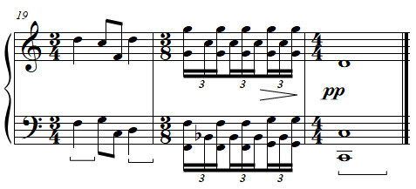
An effective performance of Prelude No. 19 maintains a light and brisk character, with a sparkling touch. Eighth notes should have consistent separation and transitions between sixteenth note and triplet sixteenth note passages should be well-planned. Prelude No. 19 is a wonderful choice for students who have played one or more Bach inventions, due to its parody of the composition of these pieces. Students can be encouraged to search for details that they have seen occur in the Bach inventions which they have studied that are seen in this Prelude.

Prelude No. 14: “Brilliant, Fast, Tricky”
Overview
Suggested Tempo: Quarter note = 45 – 58
Key: N/A
Time Signature: 3/2, 10/4, 3/4
Measures: 14
Pages: 1
Length: 0:25 – 0:40
Level: 10
Publication: G. Schirmer, The Antheil Album
The level 10 Prelude No. 14, whose expressive marking is “Brilliant, Fast, Tricky,” was included in G. Schirmer’s The Antheil Album. Its unison disjunct theme provides a challenge for students. Antheil includes the word “Tricky” in the tempo marking, likely both to imply the character of the constant subito dynamic shifts, and to hint at the prelude’s difficulty, which includes large chromatic leaps within hand positions and large shifts across the keyboard. The work’s dissonance is given order through transpositions of tetrachord sets. Although Prelude No. 14 “Brilliant, Fast, Tricky” is brief, the repetition of its motivic material throughout allows it act as a standout recital finisher when performed individually.

Compositional Overview:
Prelude No. 14 follows a loose variation form, including two variations and a brief codetta (see Table 25). The theme features a highly disjunct melody beginning in unison quarter notes concluding the theme with a march-like section in m. 4 featuring two-note slurs ending on staccato articulations. The first variation begins with the same disjunct melody but adds two-note slurs which then become integral to the entire variation. The second variation begins with similar intervals to the opening theme but on completely different pitches and in eighth notes, with mm. 8 - 10 featuring prominent two-note groupings similar to the first variation. The piece concludes with a march-like section from m. 4 modulated and varied. The prelude is unified by the fragmentation of motivic material throughout.

Table 25: Prelude No. 14 Formal Analysis
A | A’ | A’’ | Codetta
mm. 1 - 4 | mm. 5 - 7 | mm. 8 - 12 | mm. 13 - 14

Rhythmically, Prelude No. 14 groups notes in pairs throughout. Therefore, analysis of intervallic content can be analyzed by these pairs, with tetrachords often creating patterns of diminished, augmented, or minor triads with an added note. The theme increases in dissonance as it progresses, with half step relations increasingly common. This process occurs in each variation to some degree.
For example, the theme of Prelude No. 14 begins with a disjunct melody in unison including four quarter notes and a half note which together form a tetrachord (0236). Notably, this forms a diminished triad (036) with added note, in this case, the pitch A. The beginning of m. 2 also begins with four quarter notes forming a disjunct melody, forming a tetrachord (0248). This tetrachord includes the (048) trichord which forms an augmented triad, with the addition of the pitch E. M. 3 includes descending major and minor sevenths, followed by a D-sharp minor chord (see Figure 175).
Figure 175: Prelude No. 14 “Brilliant, Fast, Tricky,” mm. 3-4
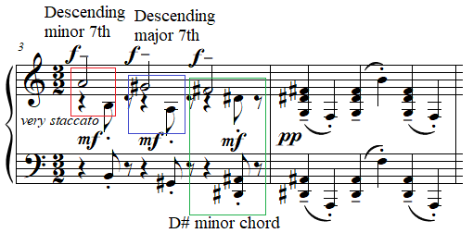

The first variation, A’, begins in m. 5 and starts with the same pitches of m. 1 but with two note slurs added and the final two beats consisting of F and E rather than an F half note. This pattern of two note slurs continues in m. 6 with the two-note slur from D# to B, and then F to F#, which are in half notes. M. 6 forms a tetrachord consisting of a B major triad plus an added F natural (0137), continuing the pattern of the theme. M. 7 is a half note on an F# half diminished chord, which itself forms either an A minor triad with an F# added or an F# diminished triad with an E added.
The second variation, A’, begins with six eighth notes in m. 8, each pair of which forms either a minor or major third (see Figure 176). The last four eighth notes of this measure form the same tetrachord from the first four quarter notes of measure one (0236), unifying the variations. M. 9 increases in dissonance, including two pairs of descending half notes in the first four quarter notes. This dissonance is increased in the m. 10 with an augmented octave. The most dissonant moment in the prelude is m. 11, which forms a seven-note chord (0123679). Coincidentally, the complement of this heptachord is (01367), a pentachord which includes the original tetrachord that the piece is based on (0236) (see Figure 177). This highly dissonant chord is played at a pianissimo dynamic.

Figure 176: Prelude No. 14 “Brilliant, Fast, Tricky,” mm. 3-4
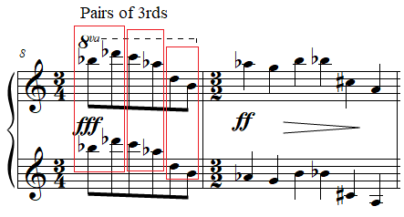

Figure 177: Prelude No. 14 “Brilliant, Fast, Tricky,” mm. 10-11
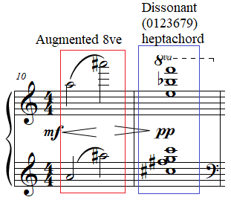

M. 12 is a near transposition of the march-like pattern of m. 4 with the first chord of m. 12 being a Bb major-minor chord and the first chord of m. 4 being a D# major-minor chord, although they differ in their intervallic relation to the second quarter of each pair (see Figure 178). This repeated idea unifies the theme and second variation. The final two measures, mm. 13 - 14, consist of a C octave in the left hand held in the pedal for two measures while both hands reach to the treble clef to play an F# half diminished chord, the same chord from the end of the first variation in m. 7 (see Figure 179). This concludes the prelude by unifying the first and the second variations.

Figure 178: Prelude No. 14 “Brilliant, Fast, Tricky,” m. 4
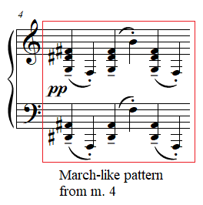

Figure 179: Prelude No. 14 “Brilliant, Fast, Tricky,” mm. 12-13
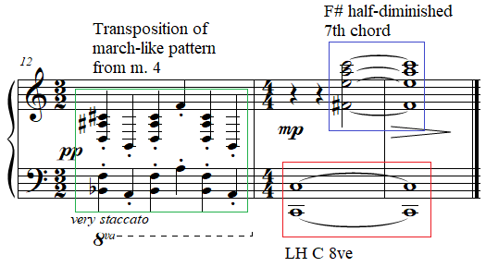

Pedagogical Overview:
Prelude No. 14, evaluated at level 10, is challenging due to its large number of dissonant leaps which are difficult to predict. Its loose variation form can ease its difficulty for students if the teacher points out the repeated patterns throughout the piece. Rhythmically, Prelude No. 14 is one of the simplest preludes, featuring eighth notes, quarter notes, half notes and whole notes, but features numerous time signature changes including 3/2, 10/4, 4/4, 3/4.
In teaching Prelude No. 14, the primary difficulty stems from the dissonant leaps which do not fall into any specific scales or arpeggios a student has likely been taught. Fortunately, every single note or chord in the prelude is paired with another note or chord. This feature can be utilized to create ergonomic fingering choices. For example, see Figure 180 for the current author’s suggested fingering for the first two measures of this prelude. Notice the redistribution on beats 7 and 9 of m. 2. Each of these pairs should be practiced with a down and up motion of the hands. This will aid both the memorization of this prelude and promote a release of physical tension on the up motion of each slur.

Figure 180: Prelude No. 14 “Brilliant, Fast, Tricky,” mm. 1-2
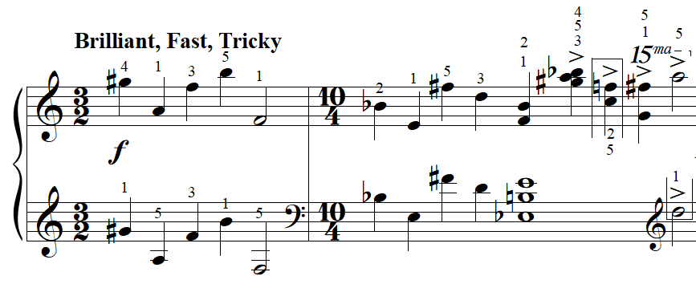
The large number of leaps also present a challenge throughout the prelude, which can be solved through visualization and preparation of the motion required of each leap. Throughout the prelude, leaps of more than an octave occur in between two note slurs. For example, the transition in between mm. 4 and 5 includes a leap of two octaves and an augmented second. Students should practice this transition by preparing the arc-shaped motion required to move from the two hand positions. The upwards impulse from the conclusion of the two-note slur on the sixth quarter note of m. 4 should launch the hand across to the G#s on the downbeat of m. 5. To practice this, students can visualize the arc needed for this leap by tracing the motion with their finger with each hand. Next, students can use the upwards impulse from the last beat of m. 4 to find the G# without playing it, repeating this until the student lands consistently on the G#. At that time, students can begin practicing the piece in rhythm at a slower tempo, ideally being able to find the leap easier. This same practice technique can be used for the other large leaps in the prelude including the transition from the last beat of m. 6 to the downbeat of m. 7 or the transition from the last beat of m. 2 to the downbeat of m. 3.
While not neoclassical in pitch content, the rhythmic content and the regular grouping of notes into pairs and its minimal rhythmic variation, lends itself to a style of pedaling similar to the other neoclassical preludes such as Prelude No. 19 “Fast, An Even Piano Throughout,” the opening of Prelude No. 25 “Minuet?,” or Prelude No. 34 “Brilliant,” all of which benefit from minimal pedal only at points of extended note length. In the case of Prelude No. 14 “Brilliant, Fast, Tricky,” tenuto markings, such as m. 3 (see Figure 181), or note values of a half note length or longer such as mm. 13 - 14, can be pedaled.

Figure 181: Prelude No. 14 “Brilliant, Fast, Tricky,” m. 3
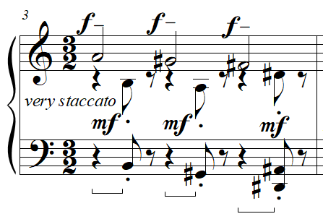
Prelude No. 14 features a wide range of dynamic levels, ranging from pianissimo to fortississimo, which further distinguishes the radical changes in register throughout the piece. In general, as the theme and each variation progresses, dynamics decrease. In this way, the decreasing dynamics over the course of each section correspond to an increase in dissonance (see the compositional analysis above). The most challenging section to play quietly is in m. 11, the most dissonant measure of the entire prelude. To play this chord quietly requires flat fingers with a relaxed wrist, allowing the chord to be articulated by the downwards motion of the hand. This touch allows minimization of finger-percussion and provides an easier method to produce soft tones than a curved finger stroke.
An effective performance of Prelude No. 14 “Brilliant, Fast, Tricky” brings out the relations between each variation by closely adhering to the indicated dynamics, producing percussive tone qualities at the beginnings of themes, and decreasing in volume and percussiveness as each variation progresses. In this way, students can explore gradations between tone colors with this piece, an excellent point of interest for teachers seeking a work which explores these features. Prelude No. 14 can be an excellent choice for students interested in unpredictable melodies, and piano works that can depict rage or fury.

Prelude No. 38: “Broad”
Overview
Suggested Tempo: Quarter note = 45 – 58
Key: A Mixolydian
Time Signature: 3/4, 4/4, 6/8, 2/4
Measures: 23
Pages: 2
Length: 1:45 – 2:15
Level: 10
Publication: G. Schirmer (classicalondemand.com), La Femme 100 Têtes
Prelude No. 38 “Broad” presents an expansive study in voicing melodies and harmonies in disparate parts of the keyboard, at level 10. The “Broad” expressive marking is reflected in both the expansive registers of both hands and foreshadows the grand climax in the center in the B section. Prelude No. 38 “Broad” begins starkly out of character, within the La Femme as a whole, with its extended open harmonies and a mixolydian modality. Like Prelude No. 24 “Slowly,” the variety of textures within the 23 measures of Prelude No. 38 “Broad” allows it to be an excellent teaching piece, serving as a miniature suite full of brief one to three-measure ideas.

Compositional Overview:
Prelude No. 38 is through-composed in block form (see Table 26). The A mixolydian introduction features expansive chords consisting of stacked fourths and fifths built on D, with both hands filling the middle voice with chant-like repeated notes. The A section interrupts the previous section with a repeated motif three eighth notes long, followed by a series of brief ideas related only by descending half step followed by a descending leap present in each. The B section contains large pandiatonic chords using notes from the C major collection under a melody created from an A# octatonic scale beginning with a half step. The final section, like the A section, contains a series of brief ideas connected by the motif from the beginning of the prelude. This includes references to both Preludes Nos. 1 and 2. The piece is mysterious, expansive, varied in material, and unified motivically.

Table 26: Prelude No. 38 Formal Analysis
Introduction | A | B | C
mm. 1 - 4 | mm. 5 - 9 | mm. 10 - 13 | mm. 14 - 23

The introduction of Prelude 38 “Broad,” which lasts from mm. 1 - 4, introduces a texture unlike any other prelude in La Femme 100 Têtes. Both hands play two chords which, through pedaling, last the entire measure. Both hands then fill the rest of the measure with a melody in pulsing sixteenth notes on repeating pitches, creating two inner voices. Harmonically, the opening chord of the prelude consists of three stacked fifths starting on D, with the A doubled in octaves. This quintal harmony gives a sense of openness, and the doubled A provides a pitch center for these opening four measures. The C#s and F#s combined with the G naturals outlines the A mixolydian mode, a mode rarely occurring in La Femme 100 Têtes. The grand texture of the introduction resonating in the pedal bears similarities to Debussy’s prelude for solo piano, “La cathédrale engloutie” (see Figure 183).

Figure 182: “La cathédrale engloutie” by Claude Debussy, mm. 1-3
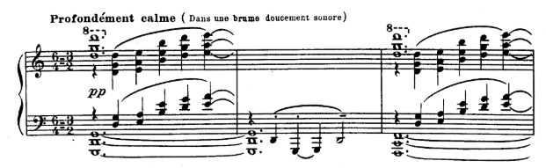

Figure 183: Prelude No. 38 “Broad,” mm. 1-6
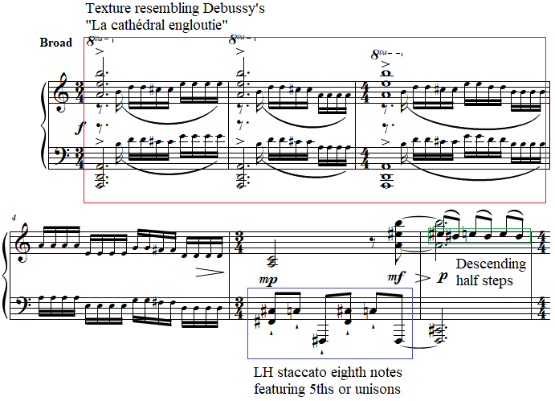

Unlike Debussy’s prelude, which maintains an expansive quality throughout, Antheil quickly dismisses the opening texture, never to return to it in this prelude. M. 5 of the A section begins with staccato eighth notes in the left hand alternating irregularly with fifths and unisons on F# and B# (see Figure 183). This connects to the introduction only in the prominence of descending half steps, which was featured in the D to C# of inner voice’s melody. The pickup eighth note to m. 6 in the right hand is a near replication of the opening stacked fifths from the first measure, but with an E# replacing the E natural and transposed down an octave. M. 6 itself features a series of steps, the first of which is a whole step E# descending to D#, and the second and third being descending half steps from E natural to D#, another instance of the descending half step motif (see Figure 183).
The end of m. 7 references mm. 1 and 18 of Prelude No. 19 “Fast, An Even Piano Throughout” (see Figure 184) and returns to a near transposition of the stacked fifths chord from the opening of Prelude No. 28, but with an Eb instead of an E natural. The left hand of m. 9 references Prelude No. 2 “Thoughtfully, Not Too Slow.”

Figure 184: Prelude No. 38 “Broad,” mm. 7-8
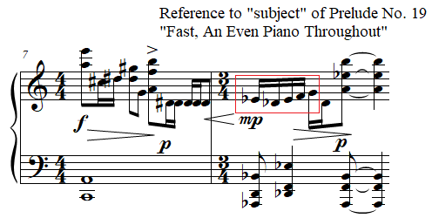

Figure 185: Prelude No. 19 “Fast, An Even Piano Throughout,” mm. 1-3
The B section begins in m. 10 with three staves. In this section from mm. 10 - 13, the left hand and right hand play an ostinato featuring a half note and a quarter note. The half note contains five of the seven notes of a C major scale, avoiding scale degrees three and five, thus giving a hollow and expectant harmony. The half-note chord changes in m. 13 to a trichord consisting of B natural, F and Bb (016) over the original left-hand half note pitches which include C, A, and D. The quarter note in each measure consists of a major sixth on A until m. 13 when the final quarter is a C#, G, and F# forming the inversion of the right hand’s previous chord and therefore forming the same normal form trichord (016).
From mm. 10 - 13, the right and left hand alternate playing an octatonic (OCT_{1,2}) melody in the upper treble clef (see Figure 186).
Figure 186: Prelude No. 38 “Broad,” mm. 10-13
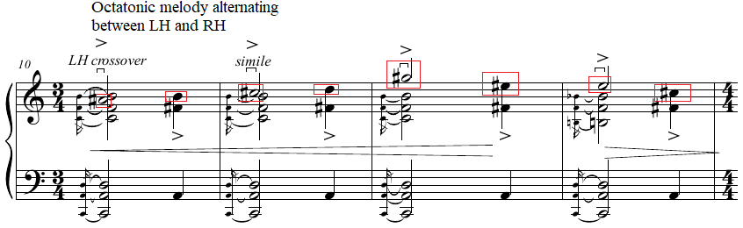

In m. 14, the melody in the top of the right hand is a near transposition of the middle voices in m. 2 of this prelude, including another descending half step and four repeated notes (see Figure 187). The texture from m. 15, which includes a grace note to a dissonance on a quarter note followed by a longer note, references the opening of Prelude No. 16 “Lights Flashing” (see Figure 187).

Figure 187: Prelude No. 38 “Broad,” mm. 14-16
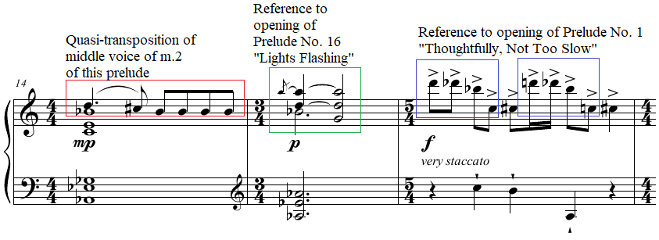
M. 16 to the end contains several references to Prelude No. 1 “Thoughtfully, Not Too Slow,” and Prelude No. 2 “Thoughtfully, Not Too Slow.” M. 16 begins with four descending eighth notes which are near transpositions of the opening sixteenth note motif of Prelude No. 1 “Thoughtfully, Not Too Slow” (see Figure 187). These four eighth notes at the beginning of m. 16 unify the final section of the prelude which lasts from mm. 14 - 23 and act as bookends for this section. The left hand of m. 17 references the accompaniment of m. 1 from Prelude No. 2 (see Figure 188). This accompaniment is unified with the right hand of m. 18, which contains a different quasi-transposition of the opening four sixteenth notes of Prelude No. 1 “Thoughtfully, Not Too Slow,” combining the motivic references to the first two preludes from La Femme. M. 20 also contains a reference to the ascending minor seventh from Prelude No. 2, featuring two consecutive ascending minor sevenths. The final two measures, mm. 21 - 22, repeat the four-note descending motif from m. 16, concluding the piece without any return of the A or B sections.

Figure 188: Prelude No. 38 “Broad,” mm. 17-18
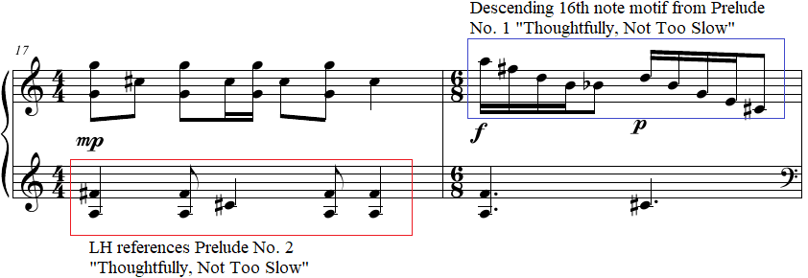

Pedagogical Overview:
Prelude No. 38, evaluated at level 10, is challenging but rewarding for students. The form, which does not significantly repeat motivic material, acts as a miniature suite, with ideas which not only reference other preludes from La Femme, but also textures from other early 20th-century composers such as Debussy and Stravinsky. Rhythmically, Prelude No. 38 features sixteenth notes, eighth notes, quarter notes, dotted quarter notes half notes, dotted half notes, and whole notes. Time signatures include 2/4, 3/4, 4/4, 5/4, and 6/8.
Due to the structure of Prelude No. 38, it can be taught as four separate but brief pieces. If each section is explored thoroughly, students can play the prelude in its entirety to explore how to change characters in between each prelude.
The opening chords, like many of the other chords in La Femme that stretch a ninth or more, can be arpeggiated. In the case of mm. 1 - 3, the top note of the right hand should land on the beat to ensure the chord is accented.
The most substantial challenge of this prelude occurs from mm. 10 - 13, a passage which features three staves and chords spanning a ninth in the left hand. In the copyist manuscript, the left-hand chord in m. 10 and the note to be played by the left hand crossed over the right hand are deceivingly written to occur simultaneously. In fact, this note played by the left hand crossing should occur directly after the chords in the lower two staves (see Figure 189 and Figure 190). This grace-note delay of each melodic note played with the left hand from mm. 10 - 13 gives a sense of grandeur, giving a similar effect to the expansive opening chords from m. 1.
Figure 189: Copyist manuscript of Prelude No. 38 “Broad,” mm. 10-13
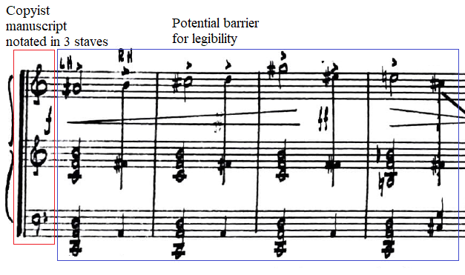

Figure 190: Prelude No. 38 “Broad,” mm. 10-13
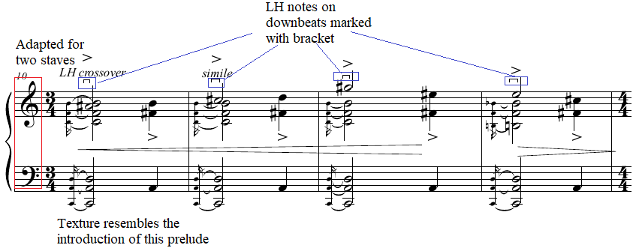

Rotation can be helpful for sections like mm. 7 or 16 where the right hand contains numerous leaps in a short time frame. M. 7 requires careful planning of down and up motion in addition to slight forearm rotation (see Figure 191 for the current author’s suggested choreography). M. 16 requires forearm rotation combined with lateral forearm movement.
Figure 191: Prelude No. 38 “Broad,” mm. 7-8
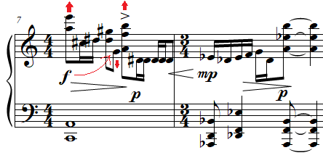

Because of the similarity of the introduction of Prelude No. 38 to Debussy’s “La cathédrale engloutie,” a similarity which arguably extends to mm. 10 - 13, pedaling techniques commonly used in Debussy’s work can be applied in Antheil’s prelude. Joseph Banowetz’s book The Pianist’s Guide to Pedaling includes a masterclass from Walter Gieseking on pedaling in Debussy’s prelude, revealing useful techniques that can be utilized in Prelude No. 38. In the beginning of Debussy’s prelude, Gieseking recommends full pedal to mimic the tolling of a bell, a pedaling technique and image which can be applied to mm. 1 - 2 of Antheil’s Prelude No. 38 “Broad.” Later in the masterclass, Gieseking describes the pedaling required in mm. 5 - 7 of Debussy’s prelude, a passage which begins with the bell-like chords but quickly dissolves into a singular melody (see Figure 192). Gieseking insists that the pedal should be gradually cleared in m. 6 to emphasize the soloistic right-hand melody (see Figure 192). This technique should be applied to m. 4 of Antheil’s Prelude No. 38, which features a similar soloistic melody which arises out of the quintal harmony in m. 3 (see Figure 193).
Figure 192: Example 111 and 113 from The Pianist’s Guide to Pedaling by Joseph Banowetz
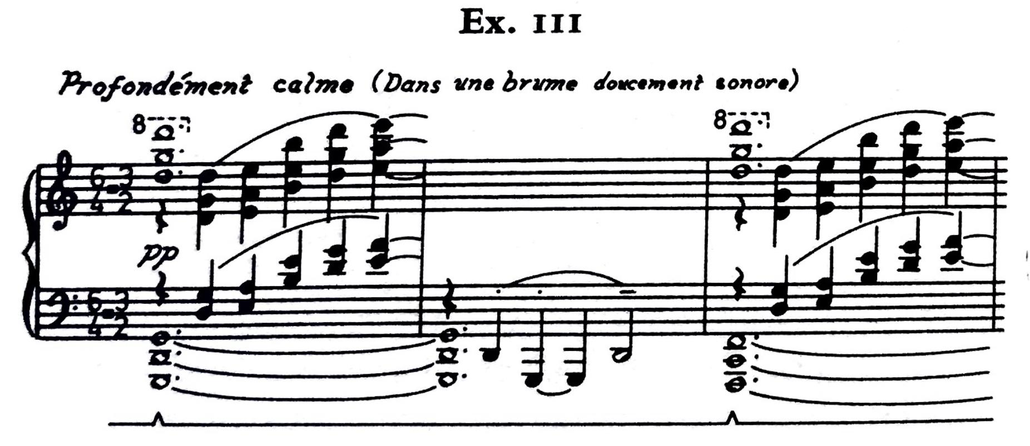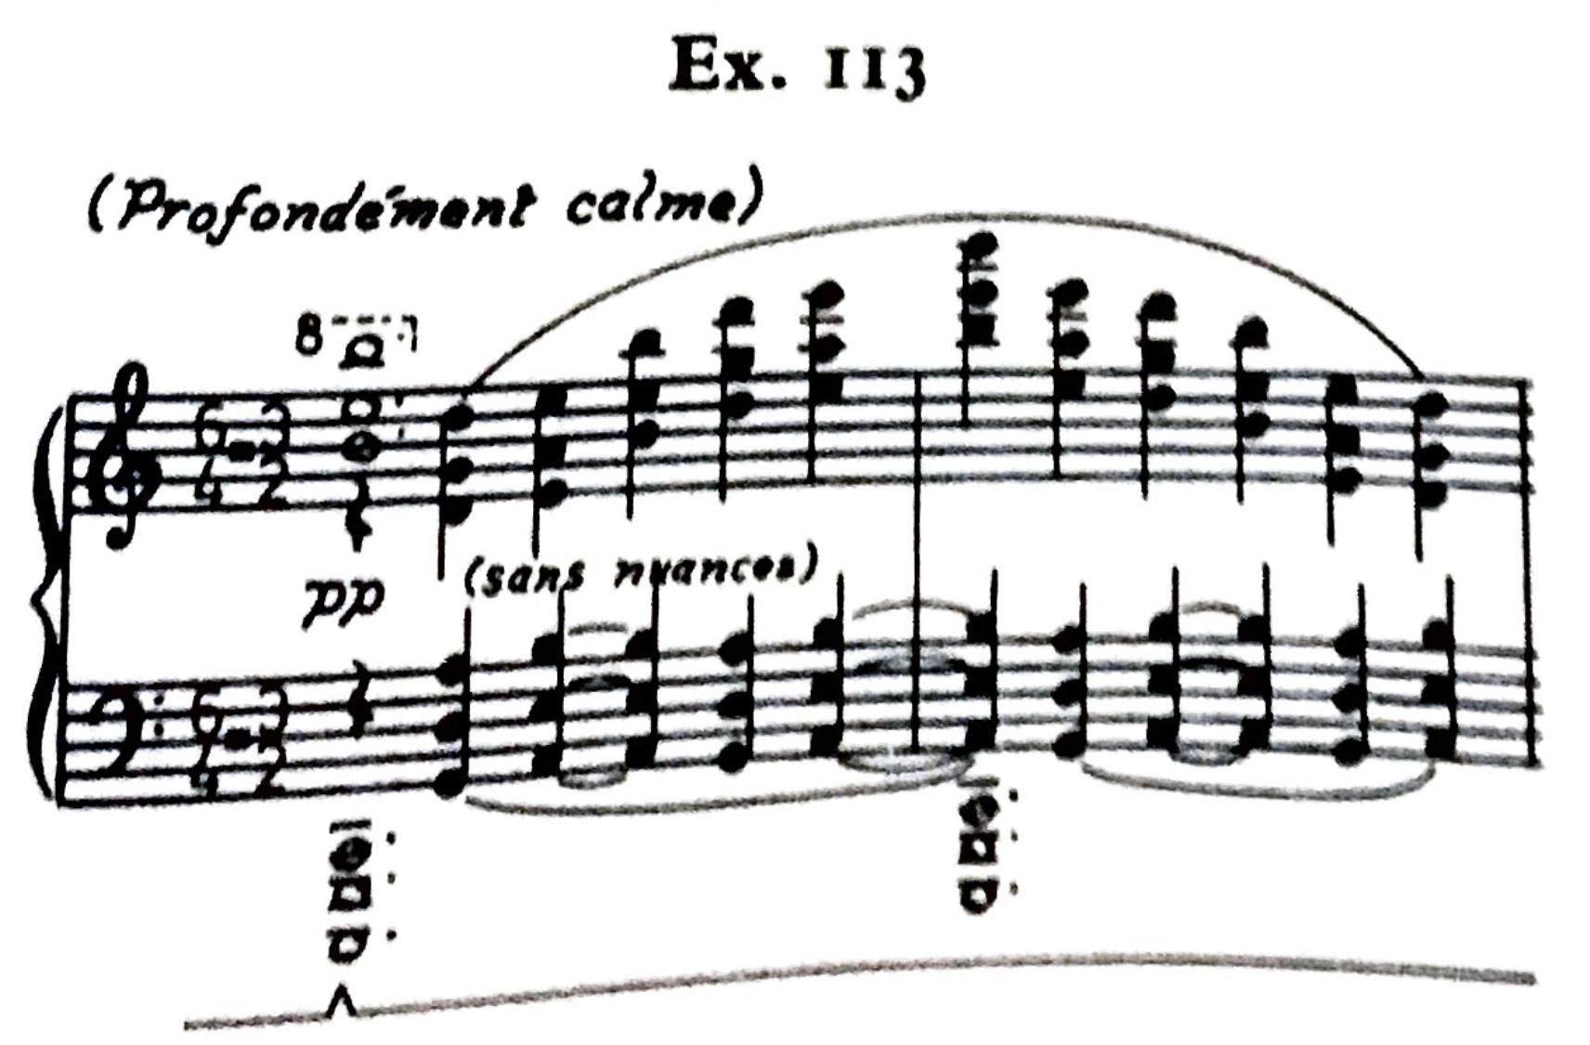

Figure 193: Prelude No. 38 “Broad,” mm. 1-6
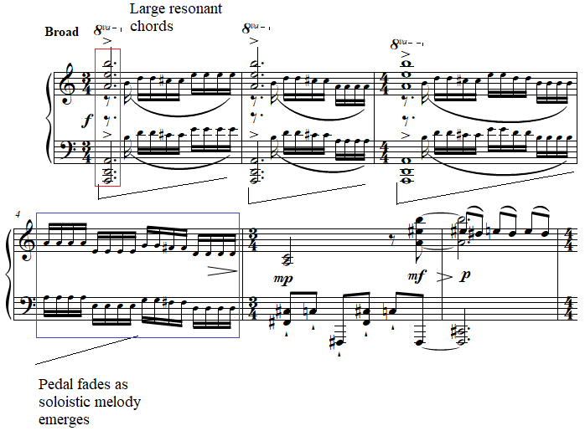

Antheil’s Prelude No. 38 “Broad” has numerous quick decrescendos and crescendos, subito dynamics, and an overall dynamic range from pianississimo to fortissimo. However, most of these dynamics are pianistic to achieve. Throughout the prelude, increases in register generally correspond to increases in dynamic. The chords from m. 1, for example, span over four octaves and are marked with a forte dynamic. M. 10, likewise, begins at a forte dynamic, with the greater leaps of the left hand corresponding with a crescendo.
An effective performance of Prelude No. 38 “Broad” brings a distinct character to each episode within the prelude. The opening chords from mm. 1 - 4 should be round and bell-like with colorful use of pedaling. The A section from mm. 5 - 9 should adhere closely to the marked articulation to ensure a series of sudden shifts in character. The B section, with its three staves and hand crossing should bring a dramatic fervor to the middle section of this prelude. The conclusion of the prelude from mm. 14 - 23 should, like the A section, contain radical shifts in character corresponding to the meticulously marked articulation and dynamics. Students can create a niente effect at the conclusion of this prelude in m. 23, staying still after silence is reached to create an effective musical moment for the audience. This prelude is an excellent choice for students who have played the music of Debussy and are curious to explore a more dissonant use of Debussy’s textures.

Prelude No. 1: “Thoughtfully, Not Too Slow”
Overview
Suggested Tempo: Quarter note = 45 – 58
Key: D Dorian mode
Time Signature: 3/4, 2/4, 5/8, 4/4
Measures: 24
Pages: 2
Length: 1:20 – 1:40
Level: 10
Publication: G. Schirmer (classicalondemand.com), La Femme 100 Têtes
Prelude No. 1 “Thoughtfully, Not Too Slow,” is the first prelude of La Femme 100 Têtes, and also the most difficult of the prelude which contain transcribed passages from Ballet Mécanique. Its expressive marking, “Thoughtfully, Not Too Slow,” opens La Femme with tonally ambiguous sixteenth notes from the middle section of Ballet Mécanique, thus implying to play the opening of this prelude with a nostalgic and thoughtful affect, while not employing excessive rubato or sentimentality. The piece, while exceptionally dissonant, often resolves on lush impressionistic harmonies, which instantly vanish. Prelude No. 1 “Thoughtfully, Not Too Slow” is a challenging but rewarding teaching piece, allowing teachers and students to focus on colorful pedaling, varied articulation, and sudden shifts of dynamic and character.

Compositional Overview:
Prelude No. 1 is composed in block form, although it contains elements of rounded binary form (see Table 27). This prelude begins with the central motif which unifies La Femme 100 Têtes, four sixteenth notes descending first by step and then by leap. This is followed by an ascending step, and bird-like calls on a minor third build on F#. The B section features a series of brief juxtaposed ideas, which vary radically in texture but are unified through their use of motivic content from the opening, a topic explored in detail below. A’ features a return of the central motif of La Femme repeated identically, but with different, more confident dynamics. The prelude, although a transcription of a section from Ballet Mécanique, is reserved and dreamlike, emphasized by Antheil’s expressive marking “Thoughtfully, Not Too Slow,” setting the tone for the surrealistic preludes to follow.

Table 27: Prelude No. 1 Formal Analysis
A | B | A’
mm. 1 - 3 | mm. 4 - 21 | mm. 22 - 24

Mm. 1 - 3 of Prelude No. 1 is features motivic elements which recur throughout the 45 preludes of La Femme 100 Têtes. The first element is formed by the first four sixteenth notes, which include two descending steps followed by two descending leaps consisting of the following sequence of pitches: D, C, Bb, Db, F#. The interval between the first and third pitch forms a minor ninth, a key element throughout La Femme 100 Têtes, appearing in every prelude analyzed in this document (see Figure 194)

Figure 194: Prelude No. 1 “Thoughtfully, Not Too Slow,” mm. 1-2
The ascending whole step F# to G# in m. 2 constitutes the second musical idea used in this prelude and throughout La Femme (see Figure 194). This ascending step reappears throughout La Femme combined with the next element, the minor third which appears on beat three of m. 2 and is repeated twice on beats two and three of m. 3. These two musical ideas combine into the ascending thirds motif, featured in Preludes Nos. 7, 8, 13, 21, 23, and 32, naming only the preludes analyzed in this document.
The fourth and fifth musical ideas are two intervals played in the left hand: the major ninth from beat one of m. 2 and the octave from beat one of m. 3. The major ninth forms a prominent compositional element throughout the piece including Preludes Nos. 16, 5, 34, 33, 21, 4, 20, 24, 19, and 38, for the preludes analyzed in this document. The octave becomes an important feature of the preludes which contain neoclassical influences such as Preludes Nos. 24, 33, 21, 20, 25, and 19.
The B section can be divided into two subsections. The first section, mm. 4 - 15 contains a series of brief episodes lasting a measure with an added or subtracted eighth note. M. 4 consists of two triplet eighth note groups in the right hand which alternate between a D-sharp diminished triad built on two minor thirds with an added Bb and a perfect fourth on D# (see Figure 195). Alternation between these two chords in two sets of triplets creates a hemiola. The left hand plays a D minor triad with an E added a major ninth above followed by a lower D minor chord on beat two.
Figure 195: Prelude No. 1 “Thoughtfully, Not Too Slow,” mm. 4-5
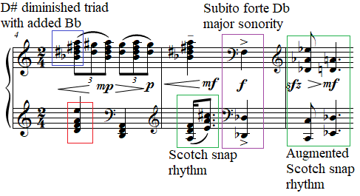

In m. 5, the left hand in the treble clef plays a Scotch snap rhythm with a sixteenth note followed by a dotted eighth note, playing a D minor following by an A major chord. Beat two plays a sudden accented fortissimo major third on Db with an octave Db in the left hand (see Figure 195).
M. 6 features an eighth note on two stacked fifths on Db over a C octave in the left hand. The second chord is a D perfect fifth over an Eb dominant seventh. Both chords are played in a larger Scotch snap rhythm, which relates m. 6 to m. 5 featuring the same rhythm but twice as fast (see Figure 196).
M. 7 begins with a paraphrase of the four descending sixteenth notes followed by two quarter notes ascending by step. Instead of sixteenth notes, m. 7 includes a triplet, removing the stepwise motion of the three opening notes of the piece. The whole step of the opening is also replaced in the paraphrase of m. 7 with a half step (see Figure 196).
Figure 196: Prelude No. 1 “Thoughtfully, Not Too Slow,” mm. 7-8

M. 8 features another Scotch snap rhythm, this time in only the left hand (see Figure 196). Meanwhile, the right hand contains a tremolo on a minor ninth. Likewise, m. 10 includes the same rhythm in the left hand, with a chord featuring a minor ninth in the first eighth note of the right hand. The remaining eighth notes are further diminutions of the triplet from m. 7, including three groups of three triplet sixteenth notes grouped within another triplet, creating a group of nine.
M. 12 begins with an eight-note chord spanning three staves. This is followed by a sudden change of register as the low Db octave from m. 5 returns on beat two of m. 12.
M. 13 features a Scotch snap rhythm, beginning with a chord in the right hand which spans a major ninth. This is followed by the ascending step motif, now harmonized with thirds (see Figure 197).
Figure 197: Prelude No. 1 “Thoughtfully, Not Too Slow,” mm. 13-15
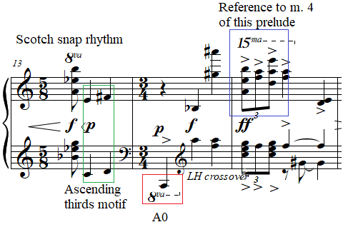

M. 14 begins with a sudden accented quarter note on the lowest note of the piano. This is followed by two quarter note chords, the second of which contains a third in the left hand and a major ninth in the right hand.
M. 15 ends this section with triplet chords that recall m. 4, but now at a fortissimo dynamic and with both hands playing separate chords in triplets.
The second portion of the B section beginning in m. 16 features a much more regular ostinato, creating a completely different character than the previous section.
Mm. 16 - 17 feature a C major chord in the right hand held for two whole notes over inversions of B major seventh chords in the left hand. As the C major chord and the B major seventh chord inversions are held in the pedal, the right hand plays a series of ascending diatonic steps beginning on D and ascending a perfect fourth, foreshadowing the bitonal passages from future preludes such as Prelude No. 23 “Well Articulated.” This pattern begins in eighth notes on the upbeat of beat one of m. 16, changing to sixteenths beginning on beat three of m. 16. This sixteenth note pattern repeats six times.
Mm. 18 features an F major seventh chord between the two hands in root position with the right hand third which includes the notes C and E ascends by step, a reference to the ascending thirds motif. This measure forms one of the most diatonic passages in all of La Femme 100 Têtes (see Figure 198).

Figure 198: Prelude No. 1 “Thoughtfully, Not Too Slow,” mm. 18-21
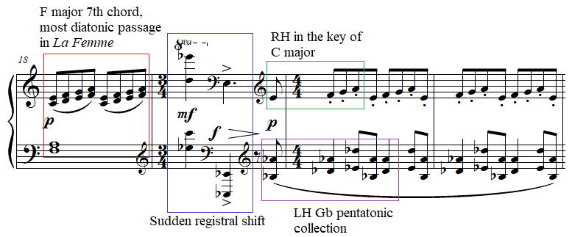

M. 19 recalls the sudden registral shift of the first part of the B section with both hands playing a quarter note chord in the upper part of the piano followed by a sudden drop to the lowest register of the piano on the next beat (see Figure 198). Both of these chords feature minor ninths as well.
Beginning with the pickup eighth note to mm. 20 to m. 21, the right hand plays groups of four eighth notes ascending by step, this time with a staccato articulation (see Figure 198). While the right hand plays this diatonic pattern, the left hand plays a series of minor seventh and perfect fifth intervals that fall within a Gb pentatonic collection, creating another instance of bitonality. The patterns in both hands are repeated four times and come to an abrupt halt at the two quarter rests that begin m. 22.
The final three measures form an exact repeat of the opening three measures but with altered dynamics to reflect a more confident ending. Instead of mezzo piano changing to piano, the ending is marked mezzo forte changing to piano and then gradually decreasing in volume until the end of m. 24.

Pedagogical Overview:
Prelude No. 1, evaluated at a level 10, is challenging due to large number of ideas presented in the prelude, and yet its unique and surreal harmonies and melodies can be rewarding for students. The first three measures of the piece return at the end, creating a ternary form. The B section, however, consists of various consecutive ideas often related only by a similar rhythm, contour or texture. This prelude features 2/4, 3/4, 4/4, and 5/8 time signatures and note values including grace notes, triplet sixteenth notes, sixteenth notes, triplet eighth notes, eighth notes, quarter notes, half notes, whole notes, and numerous tied note values.
In teaching Prelude No. 1, teachers should take extensive care to explore articulation, pedaling, and phrase shaping in the opening three measures. Teachers should take note of each articulation marking and find how to best illustrate each detail. For example, the expressive text “Thoughtfully, Not Too Slow” can be brought out through playing the first note of the piece, which is marked with a tenuto articulation, longer than the other sixteenth notes of that group. This will immediately give listeners a feeling of thoughtfulness, without feeling rushed in any way. The voicing of the first chord in m. 2 requires the right hand on top of the left hand. It is important that students bring out the F# so that when this ascending step motif returns throughout the piece and other preludes it can be heard clearly the first time.
The pickup quarter note to m. 3 contains a grace note which students can play with a combination touch of finger activation from the key and a light but brief rotation of the forearm.
All articulation markings and dynamics should be achieved with a combination of touch, pedal, and dynamics. For example, m. 4 can benefit from the use of pedal on beat one to allow the left-hand chord on beat two to connect to the previous harmony (see Figure 199). This has the doubled effect of allowing the right hand to crescendo through the additional sonority held by the damper pedal.

Figure 199: Prelude No. 1 “Thoughtfully, Not Too Slow,” mm. 4-5
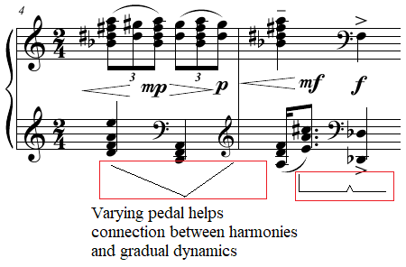

Another effect can be used in m. 5, where the first beat contains a tenuto in the right hand but the second beat contains an accent in a forte dynamic in both hands. This sudden shift of character can be emphasized through a brief break of pedal immediately preceding beat two. The silence functions to add an additional accent to that beat.
In m. 5, students can create a sforzando effect with a decrescendo by playing the first eighth note chord staccato in the pedal but immediately beginning a slow release of pedal, thus creating a decrescendo through its release. This effect can be applied in numerous locations including the first eighth note of m. 13 which requires a less percussive attack, but the same decrescendo pedal effect.
Another break can occur at the end of m. 15, when the fortissimo chords descend in register ending with an accented major second on beat three. The pedal can be released in between mm. 15 and 16 to set the color for the more impressionistic second section of B.
The second section of B is marked with pedal and features lush seventh chord harmonies which can benefit from a slow velvety touch in the left hand and a bell-like tone in the right hand.
Another decrescendo pedal can be used on beats two and three of m. 19.
The pedal and specific fingerings can solve the problem of creating a legato effect in the left hand from mm. 20 - 21 while the right-hand notes stay staccato. For the current author’s suggested fingering and pedaling see Figure 200.

Figure 200: Prelude No. 1 “Thoughtfully, Not Too Slow,” mm. 19-21
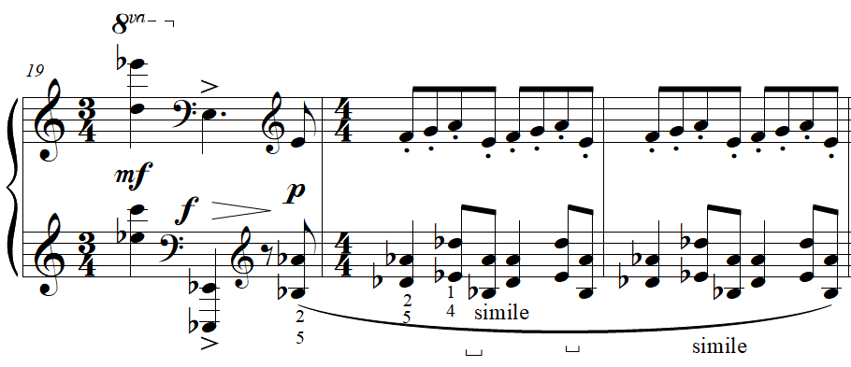

An effective performance of Prelude No. 1 presents a variety of imaginative tone colors through creative musical solutions to the sudden articulatory, dynamic, and registral shifts present in this prelude. These creative decisions can be helpful for pianists in developing artistic autonomy in their study of other repertoire in the future. Prelude No. 1 can be particularly interesting for students who have played other preludes in the set, since it contains many of the motivic ideas that form the basis of other preludes. This can be useful for students to understand how Antheil, or composers in general, transform intervallic and motivic ideas. In addition, the impressionistic harmonies which appear throughout the prelude can be enticing for students interested in the music of Maurice Ravel or Claude Debussy. Prelude No. 1 “Thoughtfully, Not Too Slow,” like many of the preludes from La Femme 100 Têtes, is an excellent choice for a student who enjoys the sound of the piano itself and exploring new tone colors through imaginative uses of pedal, phrasing, and articulation.

Chapter 6: Conclusion
The examination of George Antheil’s (1900-1959) music in this document reveals a complex legacy shaped by his notoriety and innovation but obscured by historical circumstance. Best known for Ballet Mécanique (1924), Antheil also created multiple works that hold significant pedagogical value for developing pianists, particularly Antheil’s largest work for solo piano, the 45 preludes of La Femme 100 Têtes. Despite the unique blend of 20th century compositional styles present in these preludes, 24 of which are suitable for younger pianists, La Femme has not been thoroughly integrated into mainstream piano pedagogy, largely remaining on the periphery of recognized teaching repertoire.
The current study has explored Antheil’s unique blending of artistic disciplines, his exciting incorporation of quickly changing rhythms and textures, and his ability to infuse humor and vitality into his music. La Femme 100 Têtes, inspired by Max Ernst’s collage novel, demonstrates a unique compositional approach and provides valuable yet challenging material for intermediate to early advanced students. This study focuses on providing a pedagogical analysis and promoting the inclusion of Antheil's works in teaching studios, highlighting his unique compositional style and interdisciplinary connections.
The current author leveled 45 preludes from La Femme 100 Têtes using Jane Magrath’s leveling system, with a pedagogical analysis of these selected preludes included in Chapters 4 and 5. The document includes two appendices, featuring a progressive guide to La Femme 100 Têtes and suggested groupings of the preludes for teaching or performance. These resources provide a resource for teachers and students to begin their exploration into La Femme. These preludes combine elements of early-20th-century composers such as Arnold Schoenberg, Claude Debussy, and Igor Stravinsky, making them valuable steppingstones to more technically advanced piano works and more dissonant or abstract music from that time.
Born on July 8, 1900, in Trenton, New Jersey, Antheil moved to Europe in the early 1920s, where he quickly established himself as both a composer and a pianist. In 1924, the French premiere of Antheil's most notable early work, Ballet Mécanique, marked the beginning of his recognition as an innovative composer in Paris. Unfortunately, the later failure of the 1927 American debut of Ballet Mécanique in Carnegie Hall shook his legacy as a composer in the United States and led to much of his music being ignored. Beyond his compositional legacy, he was also an influential author, contributing articles and books on various subjects, including music theory and composition, most of which have fallen into obscurity.
In the 1930s Antheil’s aesthetic pursuits intersected with the artistic movement known as Surrealism, an interest reflected in a series of preludes for solo piano titled La Femme 100 Têtes, inspired by Max Ernst’s collage novel of the same name. Premiered partially at the 2nd Yaddo Festival in 1933, these works exemplify Antheil’s explorations into other disciplines of art, blending visual arts and literature into his musical compositions. While not yet widely recognized, these works provide valuable teaching pieces for intermediate to early advanced pianists due to their brevity, rhythmic vibrancy, and in addition to the range of techniques explored in these preludes.
Antheil’s career and subsequent reception faced challenges, including periods of mixed reviews and fluctuating popularity which have impacted the lasting recognition of his works in piano pedagogy. This document has argued that Antheil’s contributions to the pedagogical repertoire for the piano deserve greater attention. This study calls for a greater pedagogical focus on Antheil’s works and encourages music educators and scholars to reassess and rediscover his compositions.

Recommendations for Further Study
Further research should aim to develop a teaching edition of La Femme 100 Têtes, one that provides a clear digital engraving, suggested fingerings and pedaling, historical background, and a suggested order of study. In addition, developing comprehensive teaching materials and performance guides that could facilitate the inclusion of Antheil’s other works suitable for the intermediate to early advanced pianist in the piano curricula would be beneficial. For example, Piano Pastels (1956), Suite for Piano (1942) and Clown Suite (1923) have not yet been recorded in their entirety, providing an excellent project for further research. Furthermore, at the time of the current research, no recording of Antheil’s complete repertoire for the piano has been completed, offering an excellent endeavor for future pianists.
In addition, the discovery of certain documents related to Antheil’s work could enrich our understanding of his work. As noted earlier in this document, a discovery of Antheil’s copy of Ernst’s La Femme 100 Têtes, provided it had annotations by Antheil, could provide insight into Antheil’s extramusical intentions with the composition of his own La Femme 100 Têtes for solo piano. Additionally, discovery of a manuscript of Antheil and Martha Graham’s ballet Dance in Four Parts could be a valuable document in understanding the transformation of the score of La Femme 100 Têtes over time. Such efforts would enrich the piano repertoire with Antheil’s distinct voice, offering students and professionals alike the opportunity to explore a broader range of 20th-century piano music.

References

Books
Antheil, George. Bad Boy of Music. Garden City, NY: Doubleday, Doran & Company, 1945.
Anderson, Margaret C. My Thirty Years’ War; An Autobiography. Westport, CT: Greenwood Press.
Martha Graham: The Early Years. Edited by Merle Armitage. New York: Da Capo Press, 1969.
Beach, Sylvia. Shakespeare & Company. Lincoln, NE: University of Nebraska Press, 1991.
Burkholder, J. Peter, Donald Jay Grout, and Claude V. Palisca. A History of Western Music. 9th ed. New York: W.W. Norton, 2014.
Chronister, Richard. A Piano Teacher’s Legacy: Selected Writings. Edited by Edward Darling. Kingston, NJ: The Frances Clark Center for Keyboard Pedagogy, 2005.
Earnest, Ernest. Expatriates and Patriots: American Artists, Scholars, and Writers in Europe. Durham, NC: Duke University Press, 1968.
Ernst, Max. The Hundred Headless Woman. Translated by Dorothea Tanning. Mineola, NY: Dover Publications, 2017.
Gopnik, Adam. Americans in Paris: A Literary Anthology. New York: Literary Classics, 2004.
Graham, Martha. Blood Memory: An Autobiography. New York: Doubleday, 1991.
Hinson, Maurice. Guide to the Pianist’s Repertoire. Bloomington and Indianapolis, IN: Indiana University Press, 2000.
Imbs, Bravig. Confessions of Another Young Man. New York: Henkle-Yewdale House, 1936.
Lista, Giovanni. Futurism. Translated by Susan Wise. Éditions Pierre Terrail: Paris, 2001.
Magrath, Jane. The Pianist’s Guide to Standard Teaching and Performance Literature. Van Nuys, CA: Alfred Publishing, 1995.
Magrath, Jane. Piano Literature for Teaching and Performance: A Graded Guide and Annotated Bibliography. Kingston, NJ: Piano Education Press, 2021.
De Mille, Agnes. Martha. Toronto: Random House, 1991.
Pound, Ezra. Antheil: With a Treatise on Harmony. Chicago: Pascal Covici, 1927.
Russolo, Luigi. The Art of Noises. Translated by Doug Skinner. Coppell, TX: Black Scat Books, 2022.
Taruskin, Richard. Music in the Early Twentieth Century. The Oxford History of Western Music. New York: Oxford University Press, 2009.
Thomson, Virgil. Twentieth-Century Composers: American Music Since 1910. New York: Holt, Rinehart and Winston, 1971.
Thomson, Virgil. Virgil Thomson. New York: Alfred A. Knopf, 1967.
Whitesitt, Linda. The Life and Music of George Antheil 1900-1959. Ann Arbor: UMI Research Press, 1983.
Wold, Milo Arlington, Edmund Cykler, Gary Martin, and James Miller. An Introduction to Music and Art in the Western World. 8th ed. Dubuque, IA: Brown & Benchmark Publishers, 1987.

Dissertations and Monographs
Albee, David Lyman. “George Antheil's La Femme 100 Têtes: A Study of the Piano Preludes. (Volumes I and II).” DMA diss., University of Texas at Austin, 1977. ProQuest Dissertations & Theses Global.
Davis, Angharad J. “Objects May Be Less Thrilling Than They Appear: Spectacle, Sensation, and the Failure of Ballet Mécanique.” Conference of the Musicological Society of Australia, Perth, 2018. Academia.edu. www.academia.edu.
Herron, Mary H. “The Art Music of the United States During the 1920s: A Study of the Major Issues in Contemporary Periodical Sources.” DMA diss., University of Colorado, Boulder, 1980. ProQuest Dissertations & Theses Global.
Epstein, Joshua Benjamin. “Sublime Noise: Musical Culture and the Modernist Writer.” Dissertation, Vanderbilt University, 2008. ProQuest Dissertations & Theses Global.
Fena, Christine. “Composing the ‘Land of Sewing Machines and Typewriters’: American Modernist Music and the Piano in the Machine Age 1918-1933.” PhD diss., Stony Brook University, 2011.
Fouse, Kathryn. “Surrealism in the piano music of representative twentieth-century American composers: with three recitals of selected works of Ives, Cowell, Crumb, Cage, Antheil, and others.” DMA diss., University of North Texas, 1992. ProQuest Dissertations & Theses Global.
Kosovich, Liat. “Max Ernst’s Collage-Novels. (Volume 1).” PhD diss., University of Haifa, 2017. ProQuest Dissertations & Theses Global.
Lehrman, Paul David. “The History and Technology of Ballet Mécanique.” PhD diss., Tufts University, 2010. ProQuest Dissertations & Theses Global.
Leland, Hannah. 2015. “The “Bad Boy of Music” in Paris George Antheil's Violin Sonatas.” DMA diss., Arizona State University, 2015. ProQuest Dissertations & Theses Global.
Morales, Jesús Manuel Ortiz. “Le Ballet Mécanique y El Synchrociné: Sobre una causa razonable de la legendaria sincronización imposible, al hilo de una mirada crítica del último intent realizado (Proyecto Schirmer 2001).” DMA diss. Universidad de Málaga, 2008. ProQuest & Dissertations Global.
Stokes, Charlotte Virginia. “La Femme 100 Tetes by Max Ernst.” PhD diss., University of Washington, 1977. ProQuest Dissertations & Theses Global.
Whitesitt, Linda. “The Life and Music of George Antheil (1900-1959).” PhD diss., University of Maryland, 1981. ProQuest Dissertations & Theses Global.

Journals Articles and Periodicals
Alexander, Ben. “The Yaddo Records: How An Institutional Archive Reveals Creative Insights.” English Studies in Canada 30, no. 1 (March 2004): 86–100.
Beck, John H., and James A. Strain. “Percussion music.” Grove Music Online. 10 Jul. 2012; Accessed 2 Dec. 2023. https://www-oxfordmusiconline-com.ezproxy.
lib.ou.edu/grovemusic/view/10.1093/gmo/9781561592630.001.0001/omo-9781561592630-e-1002225030.
Buja, Maureen. “Musicians and Artists: Antheil and Ernst.” Arts. Interlude, published on October 13, 2022. https://interlude.hk/musicians-and-artists-george-antheil-and-max-ernst-la-femme-100-tetes/.
Cross, Charlotte M. “Two Undated Manuscripts from Schoenberg’s ‘Gedanke’ Project,” Theory and Practice 32 (2007): 197.
Dennis, Flora, and Jonathan Powell. “Futurism.” Grove Music Online. 2001; Accessed 2 Dec. 2023. https://www-oxfordmusiconline-com.ezproxy.lib.ou.edu/grovemusic/view/
10.1093/gmo/9781561592630.001.0001/omo-9781561592630-e-0000010420.
Gann, Kyle, and Kurt Stone. “Brant, Henry.” Grove Music Online. 2001; Accessed 2 Dec. 2023. https://www-oxfordmusiconline-com.ezproxy.lib.ou.edu/grovemusic/view/10.1093/
gmo/9781561592630.001.0001/omo-9781561592630-e-0000003850.
Garafola, Lynn. “George Antheil and the Dance.” Ballet Review, published on Academic Commons, May 20, 2015. https://academiccommons.columbia.edu/doi/10.7916/D8TX3DG5.
Jackson, Paul. “Out of and for Machines: Time-Space and Time-Form in George Antheil’s Ballet Mécanique.” Sonic Ideas 2, no. 2. January 1, 2010.
Lippard, Lucy R. “Max Ernst: Passed and Pressing Tensions,” Art Journal 33, no. 1 (1973): 12-17. doi:10.2307/775665.
Marrocco, W. Thomas, and Mark Jacobs. “Weintraub, Eugene.” Grove Music Online. 2001; Accessed 2 Dec. 2023. https://www-oxfordmusiconline-com.ezproxy.lib.
ou.edu/grovemusic/view/10.1093/gmo/9781561592630.001.0001/omo-9781561592630-e-0000030051.
Perlis, Vivian. “Pan American Association of Composers.” Grove Music Online. 15 May. 2009; Accessed 2 Dec. 2023. https://www-oxfordmusiconline-com.ezproxy.lib.ou.
edu/grovemusic/view/10.1093/gmo/9781561592630.001.0001/omo-9781561592630-e-0000020797.
Phillips, Victoria. “Martha Graham’s Gilded Cage: Blood Memory—An Autobiography (1991).” Dance Research Journal. Published online by Cambridge University Press, March 26, 2013. https://www.cambridge.org/core/journals/dance-research-journal/article/
abs/martha-grahams-gilded-cage-blood-memoryan-autobiography-1991/5C96A0E6A509FC8688B1913EEF89F322.
Rickards, Guy. “Antheil Ballet: Dreams; Piano Concerto No 2, Serenade No. 2. Guy Livingston (pno), Philadelphia Virtuosi c. Daniel Spalding.” Tempo 61, no. 239 (2003): 90.
Saddlemyer, Ann. “William Butler Yeats, George Antheil, Ezra Pound: Friends and Music.” Studi irlandesi. A Journal of Irish Studies no. 2 (2012): 55-71. http://www.fupress.com/bsfm-sijis
Shepard, John, and Jessica Payette. “Yaddo.” Grove Music Online. 25 May. 2016; Accessed 2 Dec. 2023. https://www-oxfordmusiconline-com.ezproxy.lib.ou.edu/grovemusic
/view/10.1093/gmo/9781561592630.001.0001/omo-9781561592630-e-1002293375.
Spaeth, Sigmund. “Jazz is not music: A reply to George Antheil in the July Forum.” Forum 80, no. 2 (August 1928): 267. Accessed September 14, 2023. https://www.proquest.com/magazines/jazz-is-not-music/docview/90827212.
Stokes, Charlotte. “Surrealist Persona: Max Ernst’s Loplop, Superior of Birds.” Semiolus: Netherlands Quarterly for the History of Art 13, no. ¾ (1983): 228.
Whitesitt, Linda, Charles Amirkhanian, and Susan C. Cook. “Antheil, George.” Grove Music Online. 2001; Accessed 2 Dec. 2023. https://www-oxfordmusiconline-com.ezproxy.
lib.ou.edu/grovemusic/view/10.1093/gmo/9781561592630.001.0001/omo-9781561592630-e-0000000997.
Whitesitt, Linda. “La Femme 100 Têtes.” Review of La Femme 100 Têtes, by George Antheil. American Music 4, no. 2 (Summer 1986): 235-236. University of Illinois Press. https://www.jstor.org/stable/3051997.

Scores
Antheil, George. Clown Suite for Piano. New York: G. Schirmer.
Antheil, George. Fireworks (1919.) New York: G. Schirmer.
Antheil, George. George Antheil: The Piano Album. ed. Marthanne Verbit, New York: G. Schirmer, 1997.
Antheil, George. The Golden Bird (1921.) New York: G. Schirmer.
Antheil, George. Jazz Sonata (1922.) New York: G. Schirmer.
Antheil, George. Konzert für Klavier und Orchester Nr. 1. New York: G. Schirmer, 2001.
Antheil, George. La Femme 100 Têtes: After Max Ernst. New York: G. Schirmer, 1933.
Antheil, George. La Femme 100 Têtes. El Cerrito, CA: Antheil Press, 1985.
Antheil, George. La Vie Parisienne for Piano. New York: G. Schirmer, 1939.
Antheil, George. Sonata II, “Woman.” New York: G. Schirmer, 1990.
Antheil, George. Sonata No. 5 for Piano (1950.) New York: Antheil Press, 1989.
Antheil, George. Sonata Sauvage (1922.) New York: G. Schirmer, 1986.
Antheil, George. Sonatina für Radio (1929.) New York: Antheil Press, 1987.
Antheil, George. Piano Pastels: 15 Pieces for Jenny. ed. Denes Agay, Weintraub Music Company, 1969.
Antheil, George. Piano Sonata No. 3. New York: G. Schirmer, 1947.
Antheil, George. Two Songs on Texts of Lewis Carroll. New York: G. Schirmer, 1924.
Ligeti, György. Études pour piano premier livre. Mainz, Germany: Schott 1985.
Muczynski, Robert. Collected Piano Pieces. New York: G. Schirmer, 1990.
Rosen, Lawrence. American Classic Masters: A Collection of Works for Piano / Selected and Edited by Lawrence Rosen. New York, NY: Milwaukee, WI: G. Schirmer; Distributed by H. Leonard, 1997.

Reviews
Kuhn, Laura. Review of George Antheil: ‘La Femme 100 Têtes.’ David Albee. Los Angeles Times, January 6, 1985. https://www.latimes.com/archives/la-xpm-1985-01-06-ca-7254-story.html.
Lace, Ian. Review of Antheil: Jazz Symphony; Piano Concerto 1; Archipelago Rhumba; Capital of the World Suite. MusicWeb International, July 2017. http://www.musicweb-international.com/classrev/2017/Jul/Antheil_jazz_C5309.html.
Lewis, David N. Review of George Antheil: The Lost Sonatas, by Guy Livingston. Allmusic.com. https://www.allmusic.com/album/george-antheil-the-lost-sonatas-mw0001838037.
Rickards, Guy. Review of Antheil Ballet: Dreams; Piano Concerto No 212; Serenade No 2, by Guy Livingston, Philadelphia Virtuosi, Daniel Spalding.

Radio Interviews
Livingston, Guy. Interview: Guy Livingston Discusses and Performs Music From His New CD ‘Don’t Stop! 60 Seconds for Piano’. Weekend Edition Sunday, NPR, May 26, 2002.
Livingston, Guy. Interview: Guy Livingston Talks About His New Release ‘The Lost Sonatas’ of American Composer George Antheil. Weekend Edition Sunday, NPR, May 23, 2004.

Historical Newspapers
“Antheil and His ‘Noise’.” New York Times, April 10, 1927, X10. ProQuest Historical Newspapers: The New York Times. https://www.proquest.com/docview/103985310/559437453B1A4609PQ/5?accountid=8363.
Evening Star. (Washington, D.C.), March 12, 1933. “Page 3, Image 37.” Chronicling America: Historic American Newspapers. Lib. of Congress. Accessed November 21, 2023. https://chroniclingamerica.loc.gov/lccn/sn83045462/1933-03-12/ed-1/seq-37/.
Perkins, Francis D. “Jazz Breaks into Society.” The Independent, January 3, 1925: 23. https://www.proquest.com/magazines/jazz-breaks-into-society/docview/90655009/se-2?accountid=8363.
Schwarz, K. Robert. “American Music Shows Off Its Varied Riches: American Music Displays Its Riches.” New York Times, Dec 23, 1984. https://www.proquest.com/historical-newspapers/american-music-shows-off-varied-riches/docview/122390430/se-2?accountid=8363.
The Washington Times. (Washington D.C.), November 15, 1932. “Page 3, Image 3.” Chronicling America: Historic American Newspapers. Library of Congress. Accessed November 21, 2023. https://chroniclingamerica.loc.gov/lccn/sn84026749/1932-11-15/ed-1/seq-3/.

Websites
Antheil.org. “The Schirmer Project.” Accessed November 21, 2023. https://www.antheil.org/schirmer.html.
Piccinini, Mauro. “Antheil and Berlin, part 4.” January 11, 2013. https://mpiccinini.wordpress.com/2013/01/11/antheil-and-berlin-part-4/.

Archives
George Antheil correspondence with Mary Louise Curtis Bok, Music Division, Library of Congress, ML31 A59.
George and Böske Antheil papers, circa 1875-1984, Music Division, Library of Congress, ML31 A58.
George Antheil papers, 1919-1959. Rare Book and Manuscript Library, Columbia University Library.
George Antheil papers. Music Division, The New York Public Library. Accessed November 21, 2023. https://archives.nypl.org/mss/20240.
Antheil, George. Finding Aid for the George Antheil Papers PASC-M.0043. UCLA Library Special Collections.
Yaddo records. Manuscripts and Archives Division, The New York Public Library. Accessed November 21, 2023. https://archives.nypl.org/mss/4795.

Liner Notes
Amirkhanian, Charles. “George Antheil: La Femme 100 Têtes (1933).” Liner Notes for Antheil, George . George Antheil: La Femme 100 Têtes. David Albee. Recorded August 1983. CRI SD 502, 2010. CD-R.
Koehlen, Benedikt. “Bad Boys.” Liner Notes for Piano Pictures: Erik Satie Sports et divertissements; George Antheil La Femme 100 Têtes. Benedikt Koehlen. Recorded January 1991. WWE 1CD, 20010. CD-R.
Nice, James. Liner Notes for Antheil, George, Arthur Laurie, Leo Ornstein. Futurpiano. Daniele Lombardi. Recorded 1995. LTMCD 2541, 1995. Compact disc.

Miscellaneous
Ernst, Max. La Femme 100 Têtes. Toledo Museum of Art. 1979.20. Toledo, Ohio.
John Simon Guggenheim Memorial Foundation. “George Antheil.” Last modified 2023. https://www.gf.org/fellows/george-antheil/.
John Simon Guggenheim Memorial Foundation. “Martha Graham.” Last modified 2023. https://www.gf.org/fellows/martha-graham/.
Bad Boy Made Good. Directed by Paul Lehreman, and Ron Frank. New Haven, Connecticut, 2003, DVD.
La Femme 100 Têtes. Directed by Eric Duviver. Sandoz: 1968. Internet Archive video.
Library of Congress. “Martha Graham, Los Angeles, April 10, 1936.” Created/Published by Merle Armitage, Los Angeles, April 10, 1936. Accessed November 21, 2023. https://www.loc.gov/resource/ihas.200154337.0/?sp=3&st=image.
Steichen, James, '1934–1935', Balanchine and Kirstein's American Enterprise (New York, 2018; online edn, Oxford Academic, 22 Nov. 2018), accessed Nov. 3, 2023. https://doi-org.ezproxy.lib.ou.edu/10.1093/oso/9780190607418.003.0004.

Recordings
Antheil, George. Antheil plays Antheil. Other Minds, OM 1003-04-2, 2000, compact disc.
Albee, David. George Antheil: La Femme 100 Têtes. New World, NWCRL502, 2010, compact disc.
Albee, David. George Antheil: La Femme 100 Têtes. CRL502, 1983, vinyl record.
Helminski, Trevor. “Prelude III from La Femme 100 Têtes.” Track 1 on 8-bit Classical (20th Century Miniature Electronic Arrangements). 2019. Bandcamp audio.
Henck, Herbert. “La Femme 100 Têtes after Max Ernst (1932/33): 44: A Machine.” Track 10 from Piano Music. ECM 1726, 2001, compact disc.
Koehlen, Benedict. La Femme 100 Têtes. Col Legno AU 31501, 1991, compact disc.
Koehlen, Benedict. Piano Pictures. Col Legno WWE1CD20010, 2000, compact disc.
Lombardi, Daniele. Futurpiano. LTMCD 2541, 1995, compact disc.
Nagano, Hideki. Jazz Sonata-Sonatina-La Femme 100 Têtes. Pianovox PIA 511-2, 1999, compact disc.
Rebaudengo, Andrea. Plays George Antheil. Universal Music Italia srL. (Metatron), 2022. Spotify audio.
Verbit, Marthanne. George Antheil: Bad Boy of Music. Albany TROY146, 1994, compact disc.

Appendix A

Progressive Guide to La Femme 100 Têtes by Level (Progressive within Level)

 | Movement Title
Level 6 | Prelude No. 9 “Sad”  Prelude No. 7 “Sad”
Level 7 | Prelude No. 32 “Sad”  Prelude No. 3 “Faintly Energetic”
Level 8 | Prelude No. 6 “Floating”  Prelude No. 8 “Electrical, Spiccato”  Prelude No. 16 “Lights Flashing”  Prelude No. 13 “Nostalgic, Twisted, Slowly”  Prelude No. 23 “Well Articulated”  Prelude No. 2 “Thoughtfully, Not Too Slow”  Prelude No. 35 “Furioso”  Prelude No. 5 “Furioso”  Prelude No. 34 “Brilliant”  Prelude No. 33 “Mystic Tempo”  Prelude No. 21 “Slower”  Prelude No. 15 “Slowly”  Prelude No. 4 “Floating”
Level 9 | Prelude No. 20 “Faster”
Level 10 | Prelude No. 24 “Slowly”  Prelude No. 25 “Minuet?”  Prelude No. 29 “Fast, An Even Piano Throughout”  Prelude No. 14 “Brilliant, Fast, Tricky”  Prelude No. 38 “Broad”  Prelude No. 1 “Thoughtfully, Not Too Slow”
Artist | Prelude No. 40 “Nostalgic”  Prelude No. 27 “Dreaming Thoughtfully”  Prelude No. 19 “Fast, An Even Piano Throughout”  Prelude No. 12 “Brilliant: Clean, Fast”  Prelude No. 17 “Brilliant”  Prelude No. 10 “Slightly Brutal Tempo”  Prelude No. 11 “Bawdy: Ferocious Tempo”  Prelude No. 18 “Banged, An Even Forte Throughout”  Prelude No. 22 “Faster, An Even Fortissimo Throughout”  Prelude No. 26 “Onward Christian Soldiers.”  Prelude No. 44 “A Machine”  Prelude No. 28 “Knocked and Brilliant”  Prelude No. 30 “Brilliant”  Prelude No. 31 “Not Too Slow: Fairly Good Tempo”  Prelude No. 36 “Glittering, Fast”  Prelude No. 37 “Subtle, Tender”  Prelude No. 39 “Brilliant and Naked”  Prelude No. 41 “Brilliant”  Prelude No. 43 “Brilliant, Not Too Fast”  Prelude No. 44 “Cruel, Quick”  Prelude No. 45 “Percussion Dance”

Appendix B

Suggested Groupings of Preludes for Teaching
Level of Entire Group | Movement Titles
Level 10 | Prelude No. 1 “Thoughtfully, Not Too Slow”  Prelude No. 2 “Thoughtfully, Not Too Slow”  Prelude No. 3 “Faintly Energetic”  Prelude No. 4 “Floating”  Prelude No. 5 “Furioso”  Prelude No. 6 “Floating”  Prelude No. 7 “Sad”  Prelude No. 8 “Electrical, Spiccato”  Prelude No. 9 “Sad”
Level 10 | Prelude No. 13 “Nostalgic, Twisted, Slowly”  Prelude No. 14 “Brilliant, Fast, Tricky”  Prelude No. 15 “Slowly”
Level 9 | Prelude No. 19 “Fast, An Even Piano Throughout”  Prelude No. 20 “Faster”  Prelude No. 21 “Slower”
Level 9 | Prelude No. 24 “Slowly”  Prelude No. 25 “Minuet?”
Level 8-9 | Prelude No. 32 “Sad”  Prelude No. 33 “Mystic Tempo”  Prelude No. 34 “Brilliant”
Level 10 | Prelude No. 35 “Furioso”  Prelude No. 38 “Broad”

Jane Magrath, Piano Literature for Teaching and Performance: A Graded Guide and Annotated Bibliography (Kingston, NJ: Piano Education Press, 2021.)
George Antheil, Bad Boy of Music (Garden City, NY: Doubleday, Doran & Company, 1945), 258.
Antheil, Bad Boy of Music, 258.
From La Femme 100 Têtes, the following preludes are considered intermediate to late intermediate: Preludes Nos. 9. 7, 32, 3, 6, 8, 16, 13, 2. The advanced preludes include Preludes Nos. 2, 35, 5, 34, 33, 21, 15, 4, 20, 24, 25, 19, 14, 38, 1.
For a more in-depth publication history of La Femme 100 Têtes, see Chapter 3: Overview of La Femme 100 Têtes, History of Publication.
Antheil’s copyist during the composition of La Femme 100 Têtes was Henry Brant. This version of La Femme 100 Têtes contains corrections in the handwriting of George Antheil, and it is the only extant version of the work.
For a discussion on the meaning of Surrealist music, see Chapter 2: Antheil, Max Ernst, and Surrealism from the current document, or Kathryn Fouse, “Surrealism in the piano music of representative twentieth-century American composers: with three recitals of selected works of Ives, Cowell, Crumb, Cage, Antheil, and others” (DMA diss., University of North Texas, 1992), 1, ProQuest Dissertations & Theses Global.
Linda Whitesitt, The Life and Music of George Antheil 1900 – 1959 (Ann Arbor: UMI Research Press, 1983), 62.
Charles Amirkhanian, George Antheil, George Antheil: La Femme 100 Têtes (1933), David Albee, recorded August, 1983, CRI SD 502, 1983, compact disc, 2, liner notes.
“America’s Young Men of Promise, 1926,” Aaron Copland Collection, Box 197, Folder 10, Music Division, Library of Congress, ML31.C7.
Virgil Thomson, Virgil Thomson (New York: Alfred A. Knopf, 1967), 75.
George Antheil, Bad Boy of Music (Garden City, NY: Doubleday, Doran & Company, 1945), 40.
“Our Young Generation – Ten Years Later, 1936,” Aaron Copland Collection, Box 201, Folder 4, Music Division, Library of Congress, ML31.C7.
Antheil, Bad Boy of Music, 107.
Sylvia Beach, Shakespeare & Company (Lincoln, NE: University of Nebraska Press, 1991), 24, 73, 123.
For further discussion of the connection between Antheil’s La Femme 100 Têtes and dance or visual art, see Chapter 3: Overview of La Femme 100 Têtes.
La femme 100 têtes, directed by Eric Duviver (Sandoz, 1968), Film.
Jane Magrath, Piano Literature for Teaching and Performance: A Graded Guide and Annotated Bibliography (Kingston, NJ: Piano Education Press, 2021.)
David Lyman Albee, “George Antheil's La Femme 100 Têtes: A Study of the Piano Preludes. (Volumes I and II)” (DMA diss., University of Texas at Austin, 1977), 4.
Amirkhanian states that Antheil owned copy 657 of the 1000 in his liner notes to David Albee’s 1984 recording of La Femme 100 Têtes.
Permission from Arthur McTighe, executor of the Antheil Estate to author.
Richard Taruskin, The Oxford History of Western Music: Music in the Early Twentieth Century, (New York: Oxford University Press, 2009), xviii.
J. Peter Burkholder, Donald Jay Grout, and Claude V. Palisca, A History of Western Music, 9th ed. (New York: W.W. Norton, 2014).
Virgil Thomson, Virgil Thomson (New York: Alfred A. Knopf, 1967), 75.
Virgil Thomson, Virgil Thomson.
Virgil Thomson, Twentieth-Century Composers: American Music Since 1910 (New York: Holt, Rinehart and Winston, 1971).
William W. Austin, Music in the 20th Century: From Debussy Through Stravinsky (Toronto: W. W. Norton & Company, 1966).
Christine Fena, “Composing the ‘Land of Sewing Machines and Typewriters’: American Modernist Music and the Piano in the Machine Age 1918-1933” (PhD diss., Stony Brook University, 2011).
Giovanni Lista, Futurism, trans. Susan Wise (Paris: Éditions Pierre Terrail, 2001).
Flora Dennis and Jonathan Powell, “Futurism,” Grove Music Online (2001), accessed 2 Dec. 2023, https://www-oxfordmusiconline-com.ezproxy.lib.ou.edu/grovemusic/view/10.1093/gmo/9781561592630.001.0001/omo-9781561592630-e-0000010420.
John H. Beck and James A. Strain, “Percussion music,” Grove Music Online (10 Jul. 2012), accessed 2 Dec. 2023, https://www-oxfordmusiconline-com.ezproxy.lib.ou.edu/grovemusic/view/10.1093/gmo/9781561592630.001.0001/omo-9781561592630-e-1002225030.
Adam Gopnik, Americans in Paris: A Literary Anthology (New York: Literary Classics, 2004).
Christine Fena, “Composing the ‘Land of Sewing Machines and Typewriters’: American Modernist Music and the Piano in the Machine Age 1918-1933” (PhD diss., Stony Brook University, 2011).
Milo Arlington Wold, Edmund Cykler, Gary Martin, and James Miller, An Introduction to Music and Art in the Western World, 8th ed. (Dubuque, IA: Brown & Benchmark Publishers, 1987).
George Antheil, Bad Boy of Music.
Margaret C. Anderson, My Thirty Years’ War; An Autobiography (Westport, CT: Greenwood Press, 1930).
Bravig Imbs, Confessions of Another Young Man (New York: Henkle-Yewdale House, 1936).
Sylvia Beach, Shakespeare & Company.
Ezra Pound, Antheil: With a Treatise on Harmony (Chicago: Pascal Covici, 1927).
Albee, George Antheil’s La Femme 100 Têtes: A Study of the Piano Preludes (Volume I and II), 1.
Linda Whitesitt, “The Life and Music of George Antheil (1900-1959)” (PhD diss., University of Maryland, 1981), ProQuest Dissertations & Theses Global.
Linda Whitesitt, The Life and Music of George Antheil 1900 – 1959 (Ann Arbor: UMI Research Press, 1983).
George Antheil correspondence with Mary Louise Curtis Bok, Music Division, Library of Congress, ML31.A59 https://lccn.loc.gov/2010561030.
Linda Whitesitt, Charles Amirkhanian, and Susan C. Cook, “Antheil, George,” Grove Music Online (2001), accessed 2 Dec. 2023, https://www-oxfordmusiconline-com.ezproxy.lib.ou.edu/grovemusic/view/10.1093/gmo/9781561592630.001.0001/omo-9781561592630-e-0000000997.
Bad Boy Made Good directed by Paul Lehrman and Ron Frank (2003; New Haven, Connecticut: 2006) DVD.
Paul Lehrman, “The Schirmer Project,” accessed November 21, 2023, www.antheil.org.
Mauro Piccinini, “Antheil and Berlin, part 4,” Mauro Piccinini, accessed January 11, 2013, https://mpiccinini.wordpress.com/2013/01/11/antheil-and-berlin-part-4/.
Ann Saddlemyer, “William Butler Yeats, George Antheil, Ezra Pound: Friends and Music,” Studi irlandesi. A Journal of Irish Studies no. 2 (2012): 55-71, http://www.fupress.com/bsfm-sijis.
Linda Whitesitt, The Life and Music of George Antheil 1900 – 1959, 45.
Hannah Leland, “The 'Bad Boy of Music' in Paris George Antheil's Violin Sonatas” (DMA diss., Arizona State University, 2015), ProQuest Dissertations & Theses Global.
George Antheil, Bad Boy of Music, 204.
Amirkhanian.
Maureen Buja, “Musicians and Artists: Antheil and Ernst,” Arts, Interlude, 13 Oct. 2022, https://interlude.hk/musicians-and-artists-george-antheil-and-max-ernst-la-femme-100-tetes/.
Lynn Garafola, “George Antheil and the Dance,” Ballet Review, published on Academic Commons, 20 May 2015, https://academiccommons.columbia.edu/doi/10.7916/D8TX3DG5.
Ibid., 87.
Merle Armitage, ed., Martha Graham: The Early Years (New York: Da Capo Press, 1969).
Agnes De Mille, Martha: The Life and Work of Martha Graham (New York: Vintage Books, 1992).
Martha Graham, Blood Memory: An Autobiography (New York: Doubleday, 1991).
John Simon Guggenheim Memorial Foundation, “Martha Graham,” https://www.gf.org/fellows/martha-graham/.
John Simon Guggenheim Memorial Foundation, “George Antheil,” https://www.gf.org/fellows/george-antheil/.
Ezra Pound, Antheil: With a Treatise on Harmony (Chicago: Pascal Covici, 1927), 104.
“Antheil and His ‘Noise’,” New York Times, 10 Apr. 1927, X10, ProQuest Historical Newspapers: The New York Times, https://www.proquest.com/docview/103985310/559437453B1A4609PQ/5?accountid=8363.
Cartoon depicting Carnegie Hall Concert. The World (New York), April 12, 1927, Antheil Estate.
Whitesitt, The Life and Career of George Antheil: 1900-1959, 77.
Thomson, Twentieth-Century Composers: American Music Since 1910.
Virgil Thomson, Virgil Thomson (New York: Alfred A. Knopf, 1967).
Thomson, Virgil Thomson,168.
Ian Lace, review of “Antheil: Jazz Symphony; Piano Concerto 1; Archipelago Rhumba; Capital of the World Suite,” MusicWeb International, July 2017, http://www.musicweb-international.com/classrev/2017/Jul/Antheil_jazz_C5309.html.
David N. Lewis, Review of George Antheil: The Lost Sonatas, by Guy Livingston, Allmusic.com, https://www.allmusic.com/album/george-antheil-the-lost-sonatas-mw0001838037.
Guy Rickards, “Antheil Ballet: Dreams; Piano Concerto No 2, Serenade No. 2. Guy Livingston (pno), Philadelphia Virtuosi c. Daniel Spalding,” Tempo 61, no. 239 (2003): 90.
Linda Whitesitt, The Life and Music of George Antheil 1900 – 1959 (Ann Arbor: UMI Research Press, 1983).
Luigi Russolo, The Art of Noises, trans. Doug Skinner (Coppell, TX: Black Scat Books, 2022).
“Manifesto of the Musico-Mechanics,” Box 14, Folder 8, Music Division, Library of Congress, ML31.A59
George Antheil, “Jazz is Music,” Forum 80, no. 1 (July 1928): 64.
The author acquired Volume 80 of Forum magazine, which includes July through December 1928, through a bookseller.
Francis D. Perkins, “Jazz Breaks into Society,” The Independent, 3 Jan. 1925, 23, https://www.proquest.com/magazines/jazz-breaks-into-society/docview/90655009/se-2?accountid=8363.
Sigmund Spaeth, “Jazz is not music: A reply to George Antheil in the July Forum,” Forum 80, no. 2 (Aug. 1928): 267, accessed 14 Sep. 2023, https://www.proquest.com/magazines/jazz-is-not-music/docview/90827212.
Amirkhanian, 1.
Max Ernst, The Hundred Headless Woman, trans. Dorothea Tanning (Mineola, NY: Dover Publications, 2017).
Lucy R. Lippard, “Max Ernst: Passed and Pressing Tensions,” Art Journal 33, no. 1 (1973): 12-17, doi:10.2307/775665.
Charlotte Stokes, “Surrealist Persona: Max Ernst’s Loplop, Superior of Birds,” Semiolus: Netherlands Quarterly for the History of Art 13, no. ¾ (1983): 228.
Liat Kosovich, “Max Ernst’s Collage-Novels (Volume 1)” (PhD. diss., University of Haifa, 2017), ProQuest Dissertations & Theses Global.
Amirkhanian, 3.
Antheil, Bad Boy of Music, 204.
George Antheil, ed. Marthanne Verbit, George Antheil: The Piano Album (New York: G. Schirmer, 1997).
Kathryn Fouse. “Surrealism in the Piano Music of Representative Twentieth-Century American Composers: with Three Recitals of Selected Works of Ives, Cowell, Crumb, Cage, Antheil, and Others” (DMA diss., University of North Texas, 1992), 1, ProQuest Dissertations & Theses Global.
Amirkhanian, 1.
Ben Alexander, “The Yaddo Records: How An Institutional Archive Reveals Creative Insights,” English Studies in Canada 30, no. 1 (March 2004): 86–100.
Yaddo records, Manuscripts and Archives Division, The New York Public Library, accessed November 21, 2023, https://archives.nypl.org/mss/4795.
Angharad J. Davis, “Objects May Be Less Thrilling Than They Appear: Spectacle, Sensation, and the Failure of Ballet Mécanique,” presented at the Conference of the Musicological Society of Australia, Perth, 2018, Academia.edu, www.academia.edu.
Paul David Lehrman, “The History and Technology of Ballet Mécanique” (PhD diss., Tufts University, 2010), ProQuest Dissertations & Theses Global.
Paul Jackson, “Out of and for Machines: Time-Space and Time-Form in George Antheil’s Ballet Mécanique,” Sonic Ideas 2, no. 2 (1 Jan. 2010).
George Antheil, Antheil plays Antheil: George Antheil Centennial (1900-2000), Other Minds OM 1004-2, 2000, compact disc.
Jane Magrath, The Pianist’s Guide to Standard Teaching and Performance Literature (Van Nuys, CA: Alfred Publishing, 1995).
Richard Chronister, A Piano Teacher’s Legacy: Selected Writings, ed. Edward Darling (Kingston, NJ: The Frances Clark Center for Keyboard Pedagogy, 2005).
Magrath, The Pianist’s Guide to Standard Teaching and Performance Literature.
Magrath, Piano Literature for Teaching and Performance: A Graded Guide and Annotated Bibliography.
Chronister, A Piano Teacher’s Legacy: Selected Writings.
Otto Ortmann, The Physiological Mechanics of Piano Technique (Boston: E.P. Dutton, 1962).
William Newman, The Pianist’s Problems (Boston: Da Capo Press, 1986).
Joseph Banowetz, The Pianist’s Guide to Pedaling (Indianapolis: Indiana Press, 1992).
Jeanine M. Jacobson, Professional Piano Teaching, Vol. 1, 2nd edition, (Alfred Music Publishing, 2016).
Jeanine M. Jacobson., Professional Piano Teaching, Vol 2, (Alfred Music Publishing, 2015).
David Albee, George Antheil: CRL502, 1983, vinyl record.
Benedict Koehlen, La Femme 100 Têtes, Col Legno AU 31501, 1991, compact disc.
Marthanne Verbit, George Antheil: Bad Boy of Music, Albany TROY146, 1994, compact disc.
Daniele Lombardi, Futurpiano, LTMCD 2541, 1995, compact disc.
Hideki Nagano, Jazz Sonata – Sonatina – La Femme 100 Têtes, Pianovox PIA 511-2, 1999, compact disc.
“La Femme 100 têtes after Max Ernst (1932/33): 44: A Machine,” track 10 from Piano Music, ECM 1726, 2001, compact disc.
Andrea Rebaudengo, Plays George Antheil, Universal Music Italia srI. (Metatron), 2022, Spotify audio.
“Prelude III from La Femme 100 Têtes,” track 1 on 8-bit Classical (20th Century Miniature Electronic Arrangements), 2019, Bandcamp audio.
Whitesitt, The Life and Music of George Antheil 1900 – 1959, 4.
Antheil, Bad Boy of Music, 22.
Whitesitt, The Life and Music of George Antheil 1900 – 1959, 67, 289.
Whitesitt, The Life and Music of George Antheil 1900 – 1959, 6.
Whitesitt, The Life and Music of George Antheil 1900 – 1959, 6.
Whitesitt, The Life and Music of George Antheil 1900 – 1959, 9.
This phenomenon led to a puzzling output of manuscripts in the hand of Antheil and his copyists, documents which occasionally include the same piece with different titles. For example, Antheil’s solo piano piece from 1923, Mechanisms, has been referenced with several names including Sonata II and Woman Sonata. This brand of ambiguity is common in Antheil manuscripts. This phenomenon will be discussed further in Chapter 3: Overview of La Femme 100 Têtes.
Antheil, Bad Boy of Music, 20.
Antheil, Bad Boy of Music, 22.
Antheil, Bad Boy of Music, 22.
Antheil, Bad Boy of Music, 137.
George Antheil, Death of Machines, George Antheil: The Piano Album, ed. Marthanne Verbit (New York: G. Schirmer, 1997.)
George Antheil, Ballet Mécanique (New York: G. Schirmer, 1986.)
Antheil, Bad Boy of Music, 211, 249.
Antheil, Bad Boy of Music, 30.
Antheil, Bad Boy of Music, 30.
Antheil, Bad Boy of Music, 32.
Antheil, Bad Boy of Music, 30.
Antheil, Bad Boy of Music, 40.
Antheil, Bad Boy of Music, 38.
Whitesitt, The Life and Music of George Antheil 1900 – 1959, 23
George Antheil to Mary Louise Curtis Bok, May 12, 1922, in George Antheil Correspondence with Mary Louise Curtis Bok, Bok 1, Folder 2, Library of Congress, ML31.A59.
Whitesitt, The Life and Music of George Antheil 1900 – 1959, 78.
Whitesitt, The Life and Music of George Antheil 1900 – 1959, 100.
Whitesitt, The Life and Music of George Antheil 1900 – 1959, 201.
Published as Sonata II, “Woman” by Schirmer in 1990.
Whitesitt, 106.
Paul Lehreman, Bad Boy Made Good, Ron Frank (2003; New Haven, Connecticut: 2006) DVD.
Jesús Manuel Ortiz Morales, “Le Ballet Mécanique y El Synchociné: Sobre una causa razonable de la legendaria sincronización imposible, al hilo de una mirada crítica del último intent realizado (Proyecto Schirmer 2001),” (D.M.A, diss. Universidad de Málaga, 2008), ProQuest & Dissertations Global.
Imbs, Bravig. Confessions of Another Young Man (New York: Henkle-Yewdale House), 101.
Antheil, Bad Boy of Music, 112-113.
Prelude No. 5 is not a transcription of Ballet Mécanique, creating the only interruption of the transcription of Ballet Mécanique included in La Femme 100 Têtes.
These connections will be explored in detail in Chapters Four and Five.
See Chapter Four for a discussion on the significance of Antheil including this thematic material four years after his disastrous American premiere.
Whitesitt, The Life and Music of George Antheil 1900 – 1959, xx.
Whitesitt, The Life and Music of George Antheil 1900 – 1959, 226-228.
Russolo, The Art of Noises, 11.
Russolo, The Art of Noises, 35.
Whitesitt, The Life and Music of George Antheil 1900 – 1959, 69.
Whitesitt, The Life and Music of George Antheil 1900 – 1959, 69.
George Antheil, “Musical Neofism 1923,” Box 14, Folder 8, from George and Böski Antheil Papers, Library of Congress.
Mary H. Herron, “The Art Music of the United States During the 1920s: A Study of the Major Issues in Contemporary Periodical Sources” (DMA diss., University of Colorado, Boulder, 1980), 91, ProQuest Dissertations & Theses Global.
Schmidt-Pirro, 412.
Richard Taruskin, Oxford History of Western Music Vol. 5
George Antheil, Bad Boy of Music (Garden City: Doubleday, Doran & Company, 1945), 258.
Amirkhanian, 3.
Charlotte Stokes, “Surrealist persona: Max Ernst’s Loplop, superior of birds,” Semiolus: Netherlands Quarterly for the History of Art Vol. 13, no. ¾ (1983): 228.
Max Ernst, La Femme 100 Têtes. (Toledo Museum of Art. 1979.20. Toledo, Ohio).
Max Ernst, La Femme 100 Têtes. (Mineola, NY: Dover, 1981), 193.
Albee, “George Antheil’s La Femme 100 Têtes: A Study of the Piano Preludes,” 65.
Whitesitt, The Life and Music of George Antheil 1900 – 1959, 50.
Whitesitt, The Life and Music of George Antheil 1900 – 1959, 46.
Whitesitt, The Life and Music of George Antheil 1900 – 1959, 50.
George Antheil to Mary Louise Curtis Bok, March 8, 1938, in George Antheil Correspondence with Mary Louise Curtis Bok, Bok 2, Folder 9, Library of Congress, ML31.A59.
Whitesitt, The Life and Music of George Antheil 1900 – 1959, 62.
Whitesitt, The Life and Music of George Antheil 1900 – 1959, 62.
George Antheil, Antheil plays Antheil, Other Minds, OM 1003-04-2, 2000, compact disc.
Thomson, Twentieth-Century Composers.
Charlotte Virginia Stokes, “La Femme 100 Tetes by Max Ernst” (PHD diss., University of Washington, 1977), 1, ProQuest Dissertations & Theses Global.
David Albee, “George Antheil’s La Femme 100 Tetes: A Study of the Piano Preludes. (Volumes I and II).”
George Antheil, George Antheil: The Piano Album, ed. Marthanne Verbit (New York: G. Schirmer Inc. 1997), 1.
Amirkhanian, liner notes for George Antheil, La Femme 100 Têtes, David Albee, 1.
Letter, Antheil to Bok, July 1, 1933, in Box 2, Folder 2 from George Antheil Correspondence with Mary Louise Curtis Bok, Library of Congress, ML31.A59.
Whitesitt, The Life and Music of George Antheil 1900 – 1959, 137.
Whitesitt, The Life and Music of George Antheil 1900 – 1959, 137.
Amirkhanian, liner notes for George Antheil, La Femme 100 Têtes, David Albee, 1.
Stokes, “Surrealist Persona,” 225.
David Albee, “George Antheil’s La Femme 100 Tetes: A Study of the Piano Preludes. (Volumes I and II),” 12.
David Albee, “George Antheil’s La Femme 100 Tetes: A Study of the Piano Preludes. (Volumes I and II),” 3.
David Albee, “George Antheil’s La Femme 100 Tetes: A Study of the Piano Preludes. (Volumes I and II),” 12.
Joelle Diderich, “Paco Rabanne Auction to Feature Theatrical, ‘Unwearable’ Designs,” Yahoo, April 27, 2021, https://www.yahoo.com/lifestyle/paco-rabanne-auction-feature-theatrical-102424839.html.
Jorge Zulueta and Jacobo Romano. 1988. Arposophie: Opera-Collage. Bern: Kunstmuseum.
Amirkhanian, liner notes for George Antheil, La Femme 100 Têtes, David Albee, 3.
Amirkhanian, liner notes for George Antheil, La Femme 100 Têtes, David Albee, 1. Antheil would premiere 40 of the 45 preludes from La Femme 100 Têtes on September 20, 1933.
David Albee, “George Antheil’s La Femme 100 Tetes: A Study of the Piano Preludes. (Volumes I and II).”
This is not to be confused with Albee’s edited version of La Femme 100 Têtes, which remains unpublished. Interestingly, Albee’s recording follows his own edited 1977 manuscript rather than the copyist manuscript that was published at the same time as his 1983 recording.
Whitesitt, The Life and Music of George Antheil 1900 – 1959, 118.
Charlotte M. Cross, “Two Undated Manuscripts from Schoenberg’s ‘Gedanke’ Project,” Theory and Practice 32 (2007): 197.
Whitesitt, The Life and Music of George Antheil 1900 – 1959, 289.
Strauss, Introduction to Post-Tonal Theory 4th ed., 177.
Whitesitt, The Life and Music of George Antheil, 1900-1959, 8.
David Albee, “George Antheil’s La Femme 100 Tetes: A Study of the Piano Preludes. (Volumes I and II),” 4.
Magrath, The Pianist’s Guide to Standard Teaching and Performance Literature.
Magrath, Piano Literature for Teaching and Performance.
George Antheil, ed. Marthanne Verbit, George Antheil: The Piano Album (New York: G. Schirmer, 1997).
Magrath, Piano Literature for Teaching and Performance.
For suggestions on the grouping of preludes from La Femme 100 Têtes for teaching and performance, see Appendix B.
Preludes Nos. 1, 2, 3, 4, and 6 from La Femme 100 Têtes are transcriptions of Ballet Mécanique.
Ernst, 22-23.
Albee, George Antheil’s La Femme 100 Têtes: A Study of the Piano Preludes (Volume I and II), 235.
Ortmann, Physiological Mechanics, 340.
Ortmann, Physiological Mechanics, 342.
Ortmann, Physical Basis, 156.
Ortmann, Physiological Mechanics, 342.
The copyist manuscript of Prelude No. 23 includes 4/4 as the time signature, and 10/8 in parenthesis. This denotes the consistent quintuplet eighth notes that pervade the prelude.
Ernst, 22-23.
Strauss refers to these two intervals, in addition to major sevenths, as interval class 1, or ic1.
In the extant copyist manuscript, m. 15 is marked with sixteenth notes instead of thirty-second notes. But, Henry Brant (Anheil’s copyist at that time) beamed them in groups of eight, which implies the possibility of a notational error.
Ortmann, Physiological Mechanics, 266.
Ortmann, Physiological Mechanics, 339.
Ortmann, Physiological Mechanics, 187.
Strauss, Introduction to Post-Tonal Theory, 107.
Jamey Aebersold, Jamey Aebersold Jazz, Vol. 3, The II-V7-I Progression, (New Albany, IN 2012), 89-90.
Ortmann, Physiological Mechanics, 340.
Ortmann, Physiological Mechanics, 110.
Ortmann, Physiological Mechanics, 341.
Ortmann, Physiological Mechanics, p. 218.
Strauss, Introduction to Post-Tonal Theory, 4th ed., 249.
Banowetz, The Pianist’s Guide to Pedaling, 280.
Banowetz, 281.

