University of Oklahoma
Graduate College

Latin american music in the
WIND band repertoire:
HISTORICAL CONTEXT, latin AMERICAN
RHYTHMS, AND INTERPRETATive STRATEGIES

submitted to the graduate faculty
in partial fulfillment of the requirements for the
Degree of
DOCTOR OF MUSICAL ARTS

By
ANDREY CRUZ
Norman, Oklahoma
2024

Latin american music in the WIND band repertoire: HISTORICAL CONTEXT, latin AMERICAN RHYTHMS, AND INTERPRETATive STRATEGIES

A DOCUMENT APPROVED FOR THE
SCHOOL OF MUSIC

BY THE COMMITTEE CONSISTING OF:

Dr. Shanti Simon, Chair

Mr. Brian Britt

Dr. Marvin Lamb

Dr. Zoe Sherinian

Dr. Kash Barker

©Copyright by ANDREY CRUZ, 2023
All Rights Reserved.

Acknowledgements

I want to express my deepest gratitude to my wife, María Solera, for her tireless support throughout my career as a conductor. Her patience, understanding, and love have been the cornerstone that allowed me to achieve my goals.
I also want to express my sincere gratitude to my family and friends for their constant belief in me and their unwavering encouragement. Your constant support has been a constant source of motivation.
I wish to honor the memory of my mother, who was always proud of my musical career and whose legacy of love and dedication continues to inspire me every day. Though physically absent, her presence remains a guiding light on my path.
I cannot overlook thanking The University of Oklahoma Bands, comprised of directors Dr. Shanti Simon, Mr. Brian Britt, Dr. Caroline Hand, and the Director of Bands Emeritus Dr. William Wakefield for all the professional growth opportunities they've provided. In particular, I want to express my heartfelt gratitude to Dr. Shanti Simon for supporting and believing in me every step of this journey.

Table of Contents
Acknowledgements iv
List of Figures vii
Abstract ix
Chapter 1 1
Purpose 1
Need for Study 3
Procedures 4
Limitations 7
Chapter 2 10
Survey of Related Literature 10
Chapter 3 26
History and chronicles of the wind instruments brought to America at the end of the Renaissance and during the Baroque: from 1492 to 1750. 26
Chapter 4 37
History of Military Bands in Latin America 37
Chapter 5 53
Latin American Music in the Music Education Curriculum of the United States 53
Chapter 6 65
Musical analysis of four Latin American pieces for wind band and recommendations for music educators 65
1. El Abasto, by Valeria Pelka (b. 1973). 68
2. Preludio y Scherzo, by Vinicio Meza (b. 1968). 77
3. Pachamama, by Oscar Trujillo. 91
4. Bolero Mexicano, by Estrella Cabildo. 103
Chapter 7 114
Conclusions 114
Suggestions for further research 120
References 125
Appendix 132
Copyright Permissions 132

List of Figures

Figure 1. First motif, theme A. 70
Figure 2. Piano ascending line. 70
Figure 3. Secondary motif, theme B. 70
Figure 4. Secondary motif rhythmically elongated, theme B1. 71
Figure 5. Secondary motif holding the resolution with a lower neighbor note. 71
Figure 6. Virtuosity variation of the first motif, theme A1. 72
Figure 7. Secondary rhythmically elongated motif varied and the first motif together. 72
Figure 8. Rhythmical diminution. 73
Figure 9. Tango's syncopated patterns. 75
Figure 10. Tango's long lyrical lines. 75
Figure 11. Accent in the downbeat. 76
Figure 12. Balada Romántica bass rhythm. 79
Figure 13. First theme of the Preludio. 79
Figure 14. Theme B. 80
Figure 15. Introduction of the Scherzo. 81
Figure 16. Theme A of the Scherzo. 81
Figure 17. Low brass triplets and the horns line presented in the introduction. 82
Figure 18. Theme B of the Scherzo. 83
Figure 19. Bridge created with the material presented in the introduction. 84
Figure 20. Theme C on trombones. 85
Figure 21. Recapitulation of the introduction and the three closing measures. 86
Figure 22. Basic rhythmic pattern of Tambito. 89
Figure 23. Emphasis in the last quarter note. 89
Figure 24. Flute solo with Singing B motif. 93
Figure 25. Percussion and all the low voices playing an African-based rhythm. 94
Figure 26. “Pachamama Pachi” song in Aymara language. 95
Figure 27. Accompaniment of theme A3 (rhythmical augmentation). 97
Figure 28. Singing B subsection. 98
Figure 29. Rhythmical exercises to practice singing and clapping. 101
Figure 30. Eight note subdivision in the 6/8 meter. 102
Figure 31. Soft and calm introduction. 105
Figure 32. Theme A in the 1st horn in F. 106
Figure 33. Theme B in the 1st oboe. 106
Figure 34. Theme C in the saxophone quartet. 107
Figure 35. Theme B, trumpet solo. 108
Figure 36. Piano arpeggios that close the transition section. 109
Figure 37. Basic rhythmic pattern of the Bolero Romántico. 111

Abstract

Latin american music in the WIND band repertoire:
HISTORICAL CONTEXT, latin AMERICAN
RHYTHMS, AND INTERPRETATIve STRATEGIES

The rich and diverse musical heritage of Latin America offers an attractive repertoire for wind bands that deserves greater recognition in the United States. Despite proximity and cultural exchange, many exemplary works from Latin America remain unknown to conductors, music teachers, and audiences. This dissertation identifies four exemplary works, provides historical and cultural background of the Latin American music, and offers practical guidance for music teachers and directors to successfully perform this repertoire. Based on these four works by composers from Argentina (Valeria Pelka), Colombia (Oscar Trujillo), Costa Rica (Vinicio Meza), and Mexico (Estrella Cabildo), the research demonstrates the history of these genres, focusing pedagogically on the assimilation of rhythmic styles that evolve from the interaction of Amerindian, African, and European musical practices.
By showcasing the richness and variety of Latin American wind band music, this study encourages its inclusion in the programming and curriculum of wind ensembles in the United States, fostering appreciation for cultural practices that were once alien, but now are part of the broad demographic spectrum of this country. Through exposure to these works, music educators can find new inspiration while modeling an inclusive curriculum, which is critical to progress as a society.

Chapter 1

Purpose

The purpose of this document is to serve as a gateway into the variety of Latin American music and its multifaceted genres and styles, with a primary focus on its integration into the world of wind bands particularly within the United States. By offering an exploration of Latin American musical practices and their rhythmic expressions, this research promotes appreciation and understanding of this heritage among actors involved in wind band culture to enrich their repertoire, encourage cultural diversity in musical performances, and strengthen ties between Latin American communities and the rest of the world.
In this document, band directors, educators and musicians will not only find historical information about four genres/rhythms and compositions from across Latin America but will also acquire the practical knowledge to successfully interpretate and perform these genres. This will ultimately help them to enrich the repertoire and expand the cultural diversity of wind band music.
To begin this journey, we must first understand that the majority of Latin American musical compositions are in a state of underrepresentation in the United States, despite the importance of the demographic growth of Latino community. This underrepresentation is primarily attributed to the limited availability of published materials, making these musical works inaccessible to educators and students alike. The challenge of correctly interpreting the genres/rhythms, finding the right instrumentation, and the general lack of knowledge about the Latin American styles in these works –each of which comes from a different cultural heritage– presents uncharted territory for conductors more accustomed to the western art music-oriented wind band repertoire.
H. Robert Reynolds, in his article “Repertoire Is the Curriculum,” refers to the matter of programing and how the band director must approach this process: “A framed plaque on my office wall reads: ‘Change is inevitable; growth is an option.’ It reminds me that the world is changing, and I must change with it. One is either growing or dying; one is either a part of the past or the future. While much can be gained from honoring the past, one must live for the future.” This reflection serves as a reminder of the importance of remaining open to change in order to continue developing cultural diversity in concert programming. One of those musical pathways to change is to begin to incorporate compositions that also represent the cultural identity of the diverse growing segment of students in educational institutions in the contemporary U.S.
Lack of familiarity with the Latin American styles by band directors can sometimes lead to a sense of intimidation, further reinforcing the hesitation to incorporate these musical works into programs. Consequently, a reservoir of Latin American musical repertoire remains undiscovered, and the opportunity to offer students a broader, more culturally diverse musical education is, at times, unrealized.
This dissertation identifies four exemplary Latin American wind band compositions, provides historical and cultural background to contextualize them, and offers practical guidance for music teachers and directors to successfully perform this repertoire. I demonstrate the history of these genres, focusing pedagogically on the assimilation of rhythmic styles that evolved from the interaction of Amerindian, African, and European musical practices. The four compositions are El Abasto by Valeria Pelka (Argentina), Preludio y Scherzo by Vinicio Meza (Costa Rica), Pachamama by Oscar Trujillo, (Colombia), and Bolero Mexicano by Estrella Cabildo (Mexico). I rehearsed and successfully performed these four pieces with The University of Oklahoma Wind Symphony and Symphony Band, between 2022 and 2023. Based on this experience I will show how to teach syncopation, to interpret 6/8 polyrhythmic Latin American meter, and to develop percussion techniques at the core of this repertoire.
As these examples unfold, they become an embodiment of the principles respect, tolerance, and equity –outlined within the document–, enabling directors to inspire their own ensembles and cultivate a profound appreciation for the cultural and artistic richness that Latin American music possess.

Need for Study

Latin American music represents a rich and diverse cultural heritage with unique musical genres and styles. Studying and performing Latin American music for wind bands contribute to the cultural enrichment of music education programs. There is a need to explore, analyze, and perform this repertoire, offering a more comprehensive music education experience.
While numerous Latin American compositions for bands and wind ensembles exist, a comprehensive guide explaining their unique styles and interpretive characteristics, designed for band directors, remains evidently absent. Although remarkable initiatives like the Mexican Repertoire Collection at Dartmouth and the Institute for Composer Diversity have a large database of Latin American works, they lack the cultural context and interpretive knowledge necessary for a deeper understanding and more appropriate interpretation of these compositions.
Conducting research in this area plays an important role in safeguarding and elevating these musical sources, preventing their potential loss. Simultaneously, it fosters a much-needed infusion of diversity, equity, and inclusivity into both the band repertoire and music education programs. Latin American music has the potential to attract a wide range of audiences due to the energy and passion it has. Understanding this repertoire can benefit wind band directors and performers by expanding their concert programming options and at the same time, engaging bigger audiences.

Procedures

This dissertation focuses on four main areas:
- History and chronicles of the wind instruments brought to America at the end of the Renaissance and during the Baroque (from 1492 to1750):

The research will embark on a substantial exploration of Latin American wind music during the end of the Renaissance and during the Baroque period. It will involve the review of historical documents, manuscripts, and academic literature to demonstrate its cultural significance and artistic evolution and exibit the value of this information to the brass band community.
- History of military bands in Latin America (from 1800-1950):
The historical evolution of wind band music in Latin America has been significantly shaped by the military institutions of each respective country. To articulate and analyze the most important details of this area, research has involved reaching out to local band directors in each of the countries under investigation. These directors have graciously shared articles and documents containing the essential information sought.
- Latin American music in the Music Education Curriculum of the United States:
Drawing upon the demographic data of the Latino community in the United States, it becomes evident that there is a need for a deeper exploration of Latin American culture and the associated implications for social justice. The analysis of this problem in this document is based on a large number of texts and articles examining the musical cultures of minority communities within the United States. These resources serve as the foundation for assessing the critical significance of integrating the Latin American band repertoire into the country's educational framework, all within the predominant political context that defends diversity, equity, and inclusion.

- Musical analysis of four Latin American pieces for wind band and recommendations for music educators:
This chapter is dedicated to the musical analysis of the four Latin American pieces for wind band, which were chosen taking into account the geographical factor, starting from the south of the continent with El Abasto by Valeria Pelka (Argentina), heading then to the north of South America with Pachamama by Oscar Trujillo (Colombia), continuing towards Central America with Preludio y Scherzo by Vinicio Meza (Costa Rica), and ending in North America with Bolero Mexicano by Estrella Cabildo (Mexico). This analysis will provide a detailed explanation of the rhythmic characteristics that these compositions possess and will also offer insights to band directors, explaining how to effectively understand and interpret these musical genres.

Each of these areas will be explored to determine their influence on the Latin American wind band repertoire. For each of them, information found in articles and books available on public online platforms will be used, as well as chronicles of explorers from the time of the Spanish conquest in America and documents of historical rescue and history of the evolution of wind bands in Latin America. To address the linguistic barrier that restricts access to Latin American wind music history, this dissertation will serve as a tool of translation and dissemination of those historical documents and texts from Spanish to English.

Limitations

This research has revealed several inherent limitations stemming from the nature of available information and research gaps:

- Historical Limitations: The principal limitation lies in the historical scope of Latin American wind band music. Usually, this field has been predominantly associated with military traditions, while scarce attention has been dedicated to delving into the historical traces of the Baroque period. Since military bands were an integral element of military and social life in Latin America, there was a greater emphasis on the study and documentation of their music compared to other forms of wind music that might have been more associated with religious or entertainment purposes during the baroque period. While sporadic initiatives have emerged from specific countries, a document that covers the entirety of Latin American territories remains non-existent. This limitation underscores the need for further research to uncover and document this historical heritage broadly.

- Lack of Programming Data: Another significant limitation is the absence of a comprehensive study offering data on the programming of Latin American wind band compositions in the United States. The unavailability of such data obstructs the ability to determine whether the inclusion of this repertoire aligns with demographic and census trends. Given the clear and substantial increase in the Latino population within the United States, the absence of quantitative data on the programming of Latin American works at concerts remains a notable gap that could have enriched this document.

- This research focuses on the history and features of Latin American musical practices. Latin American countries are defined as those that were conquered and colonized by the Spanish and Portuguese from the late 15th century to the 18th century. Latin America is generally understood to consist of the entire continent of South America (with the exception of Guyana, Suriname, and French Guiana), Central America (with the exception of Belize), North America (only Mexico), and the Caribbean islands whose inhabitants speak a Romance language (only Cuba and Dominical Republic). Caribbean countries such as Haiti, Jamaica, Bahamas, Trinidad and Tobago, Grenada, Saint Lucia, Saint Kitts and Nevis, Antigua and Barbuda, Barbados, and Dominica, have different languages than Spanish or Portuguese, and therefore, their musical practices will not be examined in this research, since the non-Hispanic Caribbean is considered outside the geographical reach of the core of Latin America. Clarifying this distinction when defining Latin America will help avoid misconceptions among U.S. music educators less familiar with the complexities of Latin American musical stylistic variations.

- One language limitation must be addressed regarding the extensive use of the term “America” in this study. In the United States, "America" is often used colloquially to refer specifically to the U.S. However, in a broader scope, "America" correctly denotes the completeness of the continent, which includes the four geographic zones into which it is divided: North America, Central America, South America, and the surrounding islands. This Pan-American definition will be applied in debates about the repertoire that represents musical heritage of the continent. Limiting “America” to just the United States erases the shared history and cross-cultural connections of the western hemisphere. Using the term inclusively also provides solidarity when it comes to musical voices across national borders. However, in contexts where the exclusive meaning is irrefutable, the abbreviation “U.S.” will be adopted for “United States of America” for clarity. Navigating these divergent uses avoids an unconscious bias centered on the United States. “America” then can be used to unity amidst diversity throughout the hemisphere.

Acknowledging these limitations, this dissertation has nonetheless endeavored to shed light on the underexplored facets of Latin American wind band music history, highlighting the need for continued research, comprehensive data collection, and an expanded scholarly framework for future investigations in this field.

Chapter 2

Survey of Related Literature

The Latin American repertoire for wind bands reflects the diverse cultures and heritage of the region. In recent years interest in Latin American repertoire for wind bands started to grow. This is because music educators, conductors, and scholars sought to explore its distinct characteristics and contribute to its preservation and dissemination. The following survey of literature on the history of wind bands in Latin America aims to provide a comprehensive overview of existing scholarship on musical practices from the region, its historical roots, and their influence on contemporary wind band repertoire. Through examining the wealth of research and critical historical discourse surrounding style, instruments, musicians, military and religious context, this survey seeks to deepen our understanding of the cultural significance, artistic merit, and potential for further exploration and appreciation of Latin American wind band music.
In the article “Documentación de Interés Musical en el Archivo general de Indias de Sevilla,” in Revista de Musicología XXIV, 1-2, María Gemberro Ustárroz aims to highlight the musical interest found in the preserved documentation at the Archivo General de Indias (Indias General Archive) in Seville, which holds an immense volume of sources generated by the Spanish administration during four centuries of governance in America and the Philippines (ca. 1492-1898). The first part of the study reflects upon the limited impact that the preserved so-called “Indian” documentation in Spain has had on music historiography thus far. The second part of the work presents a selection of eleven documents represented in the Archivo de Indias to demonstrate the possibilities that each of them offers to musicologists. The historical context outlined in this article establishes useful background knowledge for studying Latin American musical tradition in the transition from Renaissance to the beginning of Baroque period.
Javier Marín López’s article “Performatividades Folklorizadas: Visiones Europeas de las Músicas Coloniales” in Revista de Musicología, Enero-Julio 2016, Vol. 39, No. 1 (enero-junio 2016) pp 231-310, delves into various recordings to draw conclusions about a Latin American musical style. The article focuses on the interpretation of colonial music, particularly that of mission origins. It highlights a significant issue: the prevalent use of European performance standards when interpreting colonial repertoire, raising questions about the applicability of European concepts like authorship and composition in this context. It suggests that colonial music's identity becomes more apparent through performance and listening practices rather than through written sources alone. Consequently, some musical ensembles have actively sought to embrace the "Latin American style by incorporating folkloric elements, seen as symbols of authenticity and originality, into their interpretations. This article offers valuable insights for this research on Latin American music for wind band by exploring interpretive paradigms, characteristic elements, and performance practices.
Alejandro Vera Aguilera and Tess Knighton in their article “Music in the Monastery of La Merced, Santiago de Chile, in the Colonial Period” in Early Music, Vol. 32, No. 3 (Aug. 2004), pp. 369-382, focuses on the musical life of the monastery of La Merced, one of the most important in Santiago during the colonial period, thus exploring one of the so far uncharted areas of Chilean music history. The authors intend to show that musical activity was much richer and certainly less incomplete than has been accepted up to now, making it urgent for further research to expand current knowledge, thus allowing us to better understand the history of musical practices in Latin America. The information about the musical developments in this article inform this research on Latin American music over time.
Oscar Hernández Salgar’s article “Colonialidad y Poscolonialidad Musical en Colombia” in Latin American Music Review / Revista de Música Latinoamericana, Autumn - Winter, 2007, Vol. 28, No. 2 (Autumn - Winter, 2007), pp. 242-270, traces the construction in Colombia of some colonial ideas about music, including the imperative of “sound whitening" mestizo or minority music, as well as scientific visions of music. The text aims to show how these ideas contribute to laying the foundations for understanding how Colombians relate to their music today. In this article, it is argued that the postcolonial face of these ideas can be observed in discourses such as multiculturalism and world music that today force Colombian music to debate between tradition and innovation, inclusion, and exclusion, and in some cases, desire and rejection. This dynamic is examined through a specific case: The music of the chonta marimba ensemble from the Colombian Pacific coast, which has been marked from its origins as a symbol of difference, blackness, isolation, and backwardness, and which today experiences a strengthening product of accelerated changes in global/local relationships. This source provides crucial perspective on musical style that will aid the analysis of Latin American repertoire in this dissertation.
In the article El Barroco Musical Hispanoamericano: Los Manuscritos de la Iglesia de san Felipe Neri (Sucre, Bolivia) Existentes en el Museo Histórico Nacional del Uruguay (Contribución al conocimiento del Barroco Musical Hispanoamericano), Lauro Ayestarán posits that musicological studies on Hispanic America are currently at a historical juncture. Since the discovery in 1916 of the manuscript by Fray Gregorio Dezuola from the late 17th century, transcribed by Carlos Vega in 1931, notable examples of the historical music produced in America from the beginning of the Spaniard conquest around 1500 until 1800, have slowly emerged. However, attention must be drawn to two distortions that have arisen when communicating the discovery of this music: a "distortion of historical time" and a "distortion of value judgment." Indeed: (a) Music that corresponds -in terms of its composition and instrumentation- to European Classicism of the second half of the 18th century has sometimes been referred to as "Baroque." (b) Value judgments have not been properly refined, resulting in the publication of some works from this later chronological period (1750-1800) that do not withstand comparison with what was being produced in Europe during that era. Historical documents have been confused with artistic documents. Chronicles of Spaniards conquerors speaking about music and its interpretation in America have been taken as artistic documentation, although they did not have knowledge about the standards of musical practices of the time. These conquerors considered that compared with European composers such as Mozart, Haydn or emerging Beethoven, the composers of Latin America during the colonial period created impoverished sacristy music. This refers to simple, modest musical compositions, primarily for religious use in churches and missions, with a focus on liturgical function rather than stylistic innovation or technical complexity. This source provides crucial perspective on music history of this period that will aid the analysis of Latin American repertoire.
Egberto Bermudez brings important information in his article “The Ministriles Tradition in Latin America: Part One: The Cases of Santafé (Colombia) and La Plata (Bolivia) in the Seventh Century”, in the Journal of the Historical Brass Society, 11, (1999), pp. 149-162. The purpose of this article is to examine the wind band tradition in the cases of Santafé (present Bogotá, Colombia) and La Plata (now Sucre, Bolivia), based on the scarce but significant documentation housed at the Archivo General de la Nación in Bogotá, the Monseñor Taborga Archdiocesan Archive and Library, and the Bolivian National Archive (located in Sucre). The earlier phases of their history coincide, especially as regards the establishment of European musical practice in their cathedrals. This article provides historical documentation and analysis of early wind bands in Latin America that will inform the research on the development of wind music traditions and repertoire across the region.
Camilo Jiménez Vera in his master’s thesis Música Catedralicia Entre Los Siglos XVII y XVIII en Santafé: Análisis, adaptación e interpretación de repertorio colonial a través del corpus sonoro del sacabuche, focused his research on the study of musical activity in the Cathedral of Bogotá during the 17th and early 18th centuries. In it, special attention is paid to the reconstruction of musical practice through the sackbut instrument, and to the various existing connections between minstrel musicians within the musical chapel in a viceroyalty context. Consequently, it is intended to extend the panorama of the study models, as well as to establish concrete links of a certain space and period associated with the cultural reality of the Santafé society. This research which reconstructs period performance practices and the connections between instrumentalists will help inform the understanding of early wind music traditions in colonial Latin America.
Robert Stevenson’s article “The "Distinguished Maestro" of New Spain: Juan Gutiérrez de Padilla”, in The Hispanic American Historical Review, Aug. 1955, Vol. 35, No. 3 (Aug. 1955), pp. 363-373, explains why historians have until recently categorized Neo-Hispanic music (music created in America under European standards during the colonization period) stand as not studied in depth. This suggests that Neo-Hispanic music has been overlooked or marginalized in historical accounts, often receiving less attention compared to European music of the same period. Reasons for ignoring it, or for assuming that music in colonial Mexico, as in Peru, was epigynous and therefore culturally unimportant, can easily be found. First, the music has remained for the most part inaccessible in the cathedral archives where no critic could judge its artistic value. Second, even if it had been available, none of it was written using the tonal center canon practice in Western music or written in a form that could be tested. Third, competent singers and instrumentalists long ago abandoned the churches of Mexico for more commercially profitable stage, opera, and nightclubs, with the result that no performing groups were found who were interested in that music. This article offers several insights into the historical challenges and cultural context surrounding Neo-Hispanic music, providing information required for this research on Latin American Music for wind band and its history.
In the article “Playing the Tune of Citizenship: Indian Brass Bands in the Sierra Norte de Puebla, Mexico,1876-1911”, in Bulletin of Latin American Research, Vol. 27, No. 2 (Apr. 2008), pp. 255-272, Ariadna Acevedo-Rodrigo examines popular citizenship practices among the Indians of the Sierra Norte de Puebla (Mexico), focusing on the brass bands that participated in religious and patriotic festivals. Rather than analyzing the bands as part of the region's popular political pulse, or concentrating on the festival’s nationalistic content, as previous studies have done, it underlines how the band’s organization combined customary Indian practices with more open social regulations and transformed both. This resulted in the successful exercise of citizenship, providing bandsmen with effective participation in face-to-face community. Acevedo-Rodrigo's article broadens the perspective on Latin American wind band repertoire by revealing the transformative power of music in fostering citizenship.
Helena Simonett, in her article “Strike up the Tambora: A Social History of Sinaloan Band Music”, in Latin American Music Magazine, Spring - Summer, 1999, Vol. 20, No. 1 (Spring - Summer, 1999), pp. 59-104, scrutinizes the historical documentation and contemporary comments on music in Sinaloa, Mexico. The focus is on the scarcity of information and brief, non-descriptive references to pre-mid-19th-century music traditions, particularly those of “plebeian” origins. The article also explores the emergence of urban musical life in the second half of the 19th century, with a specific focus on Mazatlán. The presence of zarzuela companies visiting the city theater and open-air concerts performed by the military band signifies a shift in the visibility of musical activities. Additionally, the author delves into the origins and influence of military bands in Mazatlán, examining their role in providing open-air concerts to the citizens. The U.S. naval unit's occupation of Mazatlán in 1847 and its impact on the local musical landscape are also considered, based on a U.S. Lieutenant’s observations of the amiable nature of the occupation. This information will be usefull to understand the history of military bands chapter of this dissertation.
Rafael Antonio Ruiz Torres, in his master’s thesis Histora de las Bandas Militares de Música de México: 1767-1920, reveals the part of the history of music in Mexico that refers to military wind bands. This thesis handles the idea that the military band, both in its repertoire, function, and instrumental endowment, has been a group that has spread in many countries. In Mexico itself, it was in the mid-18th century, when a series of changes carried out by the colonial administration known as the Bourbon Reforms began. The army began to play an increasing role in political and social life therefore the military bands too. The military bands and its instrumentation were similar to those in use in the Spanish and European armies in general: fifes and drums for the infantry, bugles, and kettledrums for the cavalry, and oboes for the dragoons. In addition, the instrumental endowment of the "Harmoniemusik" for chamber music bands was also maintained. This thesis provides important information to understand the interaction between military and civilian musical traditions in the region.
Welfred Augusto Valero Reyes Licenciatura’s thesis La Banda de Marcha: Sistematización de los Componentes Histórico y Metodológico de una Propuesta de Formación Dirigida a Directores de banda de Marcha de la Localidad San Cristobal de Bogotá, suggests that Central American countries, Venezuela, and Brazil have a well-developed and comprehensive culture of marching bands, sharing common foundations in their processes. However, it acknowledges that Colombia possesses a great musical richness that sets it apart. Despite this, Colombian groups have had limited participation at the international level and have acquired a somewhat unfavorable reputation when compared to other musical formats. One key issue identified is the lack of opportunities for training marching band directors and the resulting conceptual and analytical gaps in understanding the practices and training processes associated with those marching bands. In this context, the document presented serves as a valuable tool for the training of band directors, aiming to address the existing gaps and provide a resource for enhancing the quality and expertise of marching band leadership in Colombia.
In his article “Bandas de Música En Colombia: La Creación Musical En La Perspectiva Educativa,” A Contratiempo: Revista de Música En La Cultura, vol. 16, Victoriano Valencia discusses the growth and development of wind bands in Colombia, particularly focusing on the significant expansion in format, level, and coverage of these bands. It highlights the increasing number of band members, the enhanced artistic mastery, and growing community involvement. The document also addresses the diversification and specialization of roles within the bands, such as directors, trainers, instrument repairers, and repertoire creators. This source gives important information for the chapter of this dissertation about the history of military bands in Latin America.
The article “Alajuela Military Band and its Role as National Music Diffuser, an Analysis of Work Logbook from 1938 to 1946: Introduction and Preliminary Results,” by the Costa Rican band director Mauricio Araya, provides evidence that the Costa Rican government actively supports wind and percussion bands, which have played a crucial role in the musical development of the country. Several researchers have delved into Costa Rican history by investigating these musical groups and exploring the musicians and music associated with them. A valuable database maintained by the Military Band of Alajuela (nowadays called Banda de Conciertos de Alajuela) –such as books containing musical programs, punishment records, personal control logs, and those compiled by band directors– combines official information with contributions from various historians. This comprehensive collection facilitates a detailed examination of historical aspects, including the administrative succession of the band, composers and their works, compositional tendencies in relation to genres and styles, performance frequencies, and the significant role of the military band as a promoter of national music. By utilizing these diverse sources, a more nuanced understanding of Costa Rican musical heritage can be achieved.
Also, Mauricio Araya created a second document for his doctoral thesis through the Universidad de Castilla La Mancha, Música en Costa Rica: La Banda Militar de Alajuela y el Compositor Jesús Bonilla Chavarría (1911-1999), Como Difusores del Repertorio Nacional e Internacional. In this thesis, he extends his previous research and offers evidence from the work logs of the Alajuela Military Band that contain diverse data from different chronological periods. One of those blogs considered, Book of programs, 1938-1946, has the information on the repertoire played from May 1st, 1938, until June 30th, 1946. The Costa Rican composer Jesús Bonilla Chavarría served as director of that military band from May 1942 to 1948. The data from the Book of programs mentioned were statistically analyzed to generate a review of the artistic and cultural contributions of the Military Band of Alajuela and its director during the period between May 20th, 1942, and June 30, 1946. The statistical analysis combined with the historiographic and musical work, carries a comprehensive study on the public's contact with the military band and the understanding of artistic and cultural dynamics in relation to historical, political, and sociocultural contexts.
The book De las Fanfarrias a las Salas de Concierto: Música en Costa Rica (1840-1940) (from the fanfares to the concert halls: music in Costa Rica 1840-1940) by musicologist María Clara Vargas Cullell provides an historical reconstruction of the development of bands and band music in Costa Rica since the middle of the 19th century until the first decades of the 20th century. Although the study focuses on the Costa Rican context, its documentary findings and analytical conclusions can be largely extrapolated to the rest of Latin American countries. The text examines in depth the formation and evolution of military bands, school bands, and popular bands, as well as the circulation of repertoires between these groups. Likewise, it analyzes the impact of the bands on informal musical education in the towns where they performed. This historical-contextual perspective of Vargas Cullell will enrich this research by providing greater comparative elements on the origins and developments of Latin American band ensembles in the period studied.
Soledad Miranda interviews the Chilean composer Horacio Salinas and together they published the article “Ritmos y Tiempos de América: entrevista con Horacio Salinas”, in Guaraguao, Winter, 2002, Año 6, No. 15, Música popular de América Latina (Winter, 2002), pp. 102-112. In this article, Salinas looks into the energy, vitality, and rhythmical complexity of Latin American music and its ability to evoke a collective sense of community and celebration. It highlights the common thread that runs through Latin American cultures, encompassing musical genres such as tangos, boleros, cumbias, and rancheras, which serve as a shared heritage for all Latin American peoples. These genres, rich in history and symbolism, transcend national boundaries, uniting the continent in a rhythmic and dance-filled ritual. The complexity of Latin America, marked by the coexistence of both ancient and relatively new cultures, is reflected in its music. The overlapping layers of cultural influences, stemming from the European conquest, resemble a palimpsest of intertwined narratives, some of which are challenging to decipher. Amidst this interplay of cultures and the acceptance of diverse influences, a distinct rhythm and pulse emerge, characterized by an ambiguity of meters that may be attributed to the fundamental rhythmic structure prevalent in Latin American music: 3/4 meter implied in the 6/8 meter. This article provides information on Latin American genres that have the influence of African rhythms with the 6/8 meter, such as Tambito and Abozao, which will be analized in this research.
In the Midwest Clinic of 2004, Glenn Garrido Ph.D. presented his research “Latin American Bands, Music & Composers.” Here, he stated that Latin American population represents the largest minority group of the United States. However, very few band works written by Latin American composers are part of our repertoire in the United States. As the proposed solution, Dr. Garrido suggested that selected band works composed by Latin-American composers should be analyzed and included in our repertoire to make it universal, inclusive, and representative. They may be acquired directly from composers, who can be contacted by email, by commissioning new works, or from some publishers in the US. In order to achieve that goal, band directors can start to introduce this new repertoire making use of the celebrations as Hispanic holidays, Hispanic heritage month, international day, cinco de mayo, and other local Hispanic celebration. This research offers practical ideas to enrich this research on Latin American Music for Wind Band.
In her article “What Prospective Music Teachers Need to Know about Black Music”, in Black Music Research Journal, Vol. 16, No. 2, Educational Philosophy and Pedagogy (Autumn, 1996), pp. 225-238 (14 pages), Rosita M. Sands addresses the intersection of black music within the context of multiculturalism, emphasizing its crucial role in both multicultural music education and the preparation of educators for a multicultural perspective. This work emphasizes the pressing necessity for the inclusion of black music, a historically underrepresented musical genre, within the curricula and materials employed in music education teacher-training programs. A deeper understanding of the relationship between musical characteristics and the cultural significance of black music becomes vital for a comprehensive grasp of this genre. In order for educators to incorporate black music into their curricula and accord it a central role in music programs across all levels and domains, there must first be an appreciation and recognition of its significance. Music educators must develop the necessary skills to analyze and understand black music by delving into its aspects, musical characteristics, and cultural meaning, thereby fostering a more inclusive and enriching musical education experience. This article serves as a foundational guide for this research on diverse music education.
The article "Popular Music in School: Remixing the Issues", in Music Educators Journal, Vol. 93, No. 4 (Mar. 2007), pp. 32-37 (6 pages), by Robert H. Woody, discusses the integration of popular music into United States music education. Woody argues that music education curricula should better reflect the musical world in which we live, and that music educators should be more inclusive of music of our time. He also discusses the issue of authenticity in teaching popular music and argues that teachers should respect the music and its cultural context, and that students should be given opportunities to make important musical decisions for themselves. The author also emphasizes that while students can certainly learn by making music on their own, such activities should serve an underlying learning objective. Woody suggests that inclusion of popular music making can better prepare students for a lifetime of participatory musicianship. Woody’s article provides a crucial foundation for this dissertation on the area of music education in the U.S.
Florencia Guzmán’s article “Bandas de Música de Libertos En El Ejército de San Martín. Una Exploración Sobre La Participación de Los Esclavizados Y Sus Descendientes Durante Las Guerras de Independencia” in Anuario de La Escuela de Historia Virtual, vol. No.7, 2015, pp. 18–36, explores Latin American bands during the Wars of Independence in Argentina during the first decades of the 19th century, focusing on the analysis of military bands associated with the liberating army. Its objective is to demonstrate the broad participation of Afro-descendant individuals, whether slaves or free, in the configuration of transnational republican rhetoric. Music, musicians, and bands serve as a lens to examine how war and revolution provided opportunities for people of African descent to actively participate in republican public spheres. This research provides valuable information on the intersection of music, identity, and political agency within the historical context of Latin American struggles for independence and serves as a key resource for this research on the Latin American repertoire for band.
This review of historical literature offers a panoramic view of the diverse landscape of Latin American music and its repertoire for wind bands. Through the lenses of historical analysis, musical scholarship, and cultural context, researchers and scholars have explored the different features of Latin American music, highlighting its stylistic traits, its role within global musical scenario, and its potential for further exploration and interpretation.
The sources mentioned here provide data on the history of Latin American music from the colonial era to the present and expand knowledge about the musical practices of music for wind instruments and the sociocultural context in which they evolved. In this way, historical data is provided that expands knowledge about Latin American music in the Renaissance and Baroque periods, as well as during the heyday of military bands. Likewise, these sources provide information about current musical practices in the music education curriculum in the United States and manage to provide easy access to advice and strategies to best execute different Latin American musical genres by directors and music educators.

Chapter 3

History and chronicles of the wind instruments brought to America at the end of the Renaissance and during the Baroque: from 1492 to 1750.

The study of the history of wind instruments and music in the Americas during the sixteenth and seventeenth centuries helps us understand the musical traditions and processes related to contemporary musical practices in Latin America. European elements such as instrumentation, harmonic structures, and compositional forms were integrated into the musical practices of the enslaved Africa brought to America, and then performed by Native Americans who added their style to the interpretation. Today, the Latin American musical repertoire continues to show the mix of cultural influences, and this is why the study of the history of wind instruments and musical practices in that period is essential in this research about Latin American repertoire for wind band.
When Christopher Columbus arrived in America in 1492, the lands were already occupied by various native peoples. The Maya civilization stretched across Central America and southern Mexico, with its peak between 250-900 AD. The Inca Empire ruled modern-day Peru beginning around 1400 AD., and the Aztec Empire dominated central Mexico starting around 1325 AD. Prior to these large empires, Native American cultures such as the Olmecs in Mexico (from 1200 BC), the Chavín in Peru (from 1500 BC), and the Anasazi in North America (from 1300 BC) had already established advanced societies across the American continent.
These indigenous civilizations developed their own distinct musical instruments and practices. According to the Sachs-Hornbostel classification system for musical instruments, many of them can be categorized as aerophones, or wind instruments. These include instruments like the pan flute, pifilca (Andean flute), ocarina, and seashell horns, among others. The use of aerophone instruments was widespread among Native American groups, and each culture group developed its own technique of playing instruments such as flutes and whistles.
The European conquest of America brought not only soldiers and explorers across the Atlantic but also the introduction of musical practices of the European (and African) world to the American. This colonization process started in 1492, coinciding with the last hundred years of the Renaissance period –which extends from 1400 to 1600– and the entire Baroque period (1600 to 1750) in Europe.
Characteristics from both of these European style periods heavily influenced the music composed and performed by Latin Americans, while the Baroque style was the most prominent in the new continent. This happened because in the first hundred years of the colonization process of America (1500-1600) the main cities and towns were newly founded. Music and arts were not a priority at that time, as the conquerors were more focused on expanding territories and establishing settlements and religion. The colonialists introduced the Catholicism and once these settlements grew, the construction of churches and cathedrals began, making these the primary institutional context in which baroque qualities were brought to Latin America.
The Baroque period –which dominated European classical music from 1600-1750– provided the aesthetic template for musical works created in the colonies. Composers in the New World assimilated techniques like polyphony, terraced dynamics, and ornamentation characteristic of Baroque music. Churches were an important venue for the development of music and the composition of new Baroque style liturgical music written in the American colonies during the seventeenth and eighteenth centuries. While the native civilizations of America had their long-standing ritual music heritage, the Spanish conquest initiated a transmission of Renaissance and Baroque music across the Atlantic that left an indelible stylistic mark on music in the New World.

The Baroque Period:
The Baroque period refers to the era and dominant style of European classical music composed approximately from 1600 to 1750. This period is generally divided into three overlapping phases - early Baroque from 1580 to 1650, middle Baroque from 1630 to 1700, and late Baroque from 1680 to 1750.
The Catholicism and European royalty played an important role during this period as patrons of composers and musical creations at that time. Claudio Annibaldi states that: “in the Renaissance and Baroque the elite class supported live musical events that were intended to symbolize their patrons' social status through the style used to fulfill their liturgical, ceremonial or recreational function.” These sponsorship practices also traveled with the conquerors, becoming the principal source of new music in the New World during the sixteenth century (early colonial period). This is unsurprising given that the Catholic monarchs Queen Isabella I of Castile and King Ferdinand II of Aragon largely financed the Spanish conquest of America at the time.
The establishment of new settlements went hand in hand with the organization of religious life under Catholic authorities, who received extensive support from the Spanish Crown to evangelize and convert the natives and thus dominate them. For this task of evangelization, chapel masters were sent from Europe to America specifically to perform and teach the existing repertoire. Sacred music was thus transmitted from Europe to the colonies as part of the practice of Catholic liturgy and evangelization efforts: “With the first soldiers and colonizers, missionaries arrived, who spread Christian doctrine among the Indians through music, as did Alonso Barzana (1528-1598) in Tucumán, and San Francisco Solano (1549 -1610) in Alto Parana.”
Bernal Díaz del Castillo’s Historia Verdadera de la Conquista de la Nueva España (The Truly History of the Conquest of New Spain), written around 1568, is an important primary source based on his direct participation in the Mexican colonization campaigns that documents the use of music during the conquest. In his chronicles, Díaz del Castillo recounts that Hernán Cortés assembled a musical ensemble to accompany his expedition in 1524, in which he intended to fight a battle against the rebellious Cristóbal de Olid in Honduras. This ensemble included aerophones such as “shawms, sackbuts, and a bassoon,” The manuscript illustrates how the inculturation of liturgical music, including the adaptation of religious practices to local cultures, was an integral part of the Spanish colonial agenda.
Díaz del Castillo details the grueling conditions that diminished the musical ensemble's ability to perform, writing that after days of exhausting travel with meager rations, the minstrels lacked sufficient breath to play their instruments. This reveals the physical toll of the expedition on the accompanying musicians, especially wind players. Additionally, As Cortés lived in Cuba starting in 1518, he likely brought musicians from Havana to join the initial expeditions to Central America. This suggests musical instruments and European music styles first came to the Caribbean before making their way to the mainland conquests.
Díaz del Castillo's chronicle also provides valuable insight into the adoption of Spanish musical traditions by indigenous peoples in the early colonial period. He notes the high musical proficiency in singing for church services acquired by natives of Guatemala, describing their mastery of vocal registers and four-part harmony. The manuscript also documents the proliferation of European instruments, including organs, flutes, shawms, sackbuts, and dulzainas present in the region. This primary account demonstrates how quickly music took root in the New World, with native communities actively participating in liturgical music and playing imported and adapted instruments, including aerophones, within decades of initial contact.
Díaz del Castillo's account also reveals an intriguing musical encounter during the exchanges of gifts between Cortés and Aztec ruler Moctezuma. He describes celebratory music performed by Moctezuma's court ensembles featuring bone whistles, large seashells, reed flutes, and turtle shell drums, contrasting with the minstrel groups brought by Cortés with their sackbuts, shawms, and European drums. This meeting of civilizations was accentuated by the distinctive sounds of each group's musical instruments. The chronicler's depiction implies that Moctezuma was exposed to and impressed by the unfamiliar timbres of the conqueror’s instruments, just as the Spaniards marveled at the indigenous music. The event encapsulates the syncretism of musical cultures, through instruments, that would unfold across the colonies.
The establishment of chapel ensembles and the circulation of musical materials unleashed a fundamental process in the dissemination of European repertoires in the Spanish colonies of America. This phenomenon not only marked a milestone in the musical history of the region, but also had a profound impact on the cultural interaction between Europe and the New World.
Begoña Lolo describes in her text Cervantes y El Quijote en la Música (Cervantes and Don Quixote in Music), the Spanish viceroyalties quickly built musical chapels across their American domains, facilitating contact and exchange between European masters and colonial musicians. The sharing of musical instruments, books, scores, and performance practices was common between the main and subsidiary chapels within each administrative region of Latin America. This development of chapel ensembles and circulation of materials aided the diffusion of European musical techniques and repertoires throughout the Spanish colonies.
Further evidence of the use of music to evangelize during the early expeditions comes from Cristóbal de Pedraza, the first bishop of Honduras, in his text Relación de la Provincia de Honduras e Higuera (Relationship of the Province of Honduras and Higuera). Pedraza relates that the sole surviving musician from Cortés' ill-fated 1524 voyage, Bartolomé de Medrano, later served as a minstrel at the Cathedral of Toledo starting in 1531. After returning to Spain, Medrano directly confided in Pedraza the horrifying details of the expedition, including acts of cannibalism among the starved Spanish forces. Cristóbal de Pedraza's account of Bartolomé de Medrano shows how musicians were present even on military expeditions and how their musical experience was integrated into subsequent colonial life. Appropriately, In Spain, a carved 1548 pulpit in Toledo Cathedral depicts a mounted sackbut player, perhaps commemorating the role of minstrels in the early colonial conquest missions.
The Spanish friar Bartolomé de las Casas commented on the natives' musical talents in his 1552 Apologética Historia Sumaria (Apologetics Summary History). Las Casas, who had settled in Santiago de Guatemala in 1536, observed the indigenous peoples' aptitude for making and replicating musical instruments, including the sackbut. His first-hand account provides early testimony to the manufacture of European instruments such as the sackbut by Native American craftsmen:
Castillan Spanish:
Ninguna cosa ven, de cualquiera oficio que sea, que luego no la hagan y contrahagan. Luego como vieron las flautas, las cheremias, los sacabuches, sin que maestro ninguno se los enseñase, perfectamente los hicieron, y otros instrumentos musicales. Un sacabuche hacen de un candelero; órganos no se que hayan hecho, pero no dudo que con dificultad bien y muy bien los hagan.

English translation:
There is nothing that they see, of whatever trade it is, that they then do and redo. Then as they saw the flutes, the cheremias, the sackbuts, without any teacher teaching them, they made them perfectly, and other musical instruments. A sackbut made from a candlestick; I don't know what organs have made, but I have no doubt that with difficulty they can make them well and very well.

The introduction of European wind instruments to America during the colonial period triggered an unprecedented musical transformation in the region, marking the beginning of a new era of musical expression that fused indigenous practices with European influences. This rapid adoption and assimilation of European musical practices speaks to the creative dynamism that characterized cultural encounters in the colonial context. Exposing this historical information not only allows us to better understand the evolution of music in Latin America, but also invites us to appreciate the richness and diversity of influences that have shaped the musical identity of the region to this day.

Ministriles (minstrels): Baroque wind players in Latin America.
The term "ministril" (in Spanish) is one of the names given to the musicians, troubadours and minstrels who were in charge of musical performance during the medieval period, from the fourteenth to the sixteenth century throughout Europe. Rooted in the Latin “ministerium” and/or “minister,” it conveys a sense of service and artistry. The ministriles –who were musicians specialized in playing wind instruments– played a crucial role in the dissemination and development of Baroque music in America. Their presence and musical activity contributed to the creation of specific repertoires for wind instruments and the formation of instrumental music ensembles in Latin America.
According to studies by Egberto Bermúdez, in his article “The Ministriles Tradition in Latin America: Part One, South America, 1. The Cases of Santafé (Colombia) and La Plata (Bolivia),” it is possible to identify important information related to the history of minstrels in Colombia, Bolivia, and Peru. Bermudez indicates that the practice of instrumental music began in Santafé (today’s Bogotá, Colombia) after the founding of the cathedral's music chapel, in 1560, with clergymen (and possibly skilled musicians) from Cartagena, Santa Marta and Tunja (Colombia). In La Plata (today’s Sucre, Bolivia) this took place almost simultaneously. Bermudez further recounts in a brief description of the city of Santafé, made by Captain Bernardo de Vargas Machuca (who had recently arrived from Spain in 1598): “the mass in the Cathedral included groups of minstrels with "trumpets" performed by natives,” showing us how wind musical instruments were used in sacred services by that time.
During that era, the designation "trompetillas or trompetas" typically encompassed instruments such as chirimías, cornets, and sackbuts. Noteworthy historical records from the period include mentions of a trumpeter named Francisco Martín, likely of Spanish origin, and Pedro Trompeta. Additionally, Bermúdez's reveals another notarial document from the 1590s, underscoring the participation of unspecified wind instruments alongside vocal elements during services at the Tunja church in Colombia.
Bermúdez states that in 1603, the accounts of the Cathedral of La Plata show payments to five indigenous people for playing the chirimías and for making clothes and hats (probably uniforms for the group of ministriles). Also, commander Juan de Borja and a Jesuit chronicler indicated in an official document and in a chronicle, that while Gonzalo García Zorro was chapel master in Fontibón (Colombia), a celebration was given of parties and colloquiums where the natives arrived marching with flags to the sound of “trumpets and other wind instruments.” This explains the social and cultural context and suggests that wind instruments played a prominent role not only in religious ceremonies but also in secular festivities and communal gatherings.
As we can see, during the European colonization of America, wind instruments were introduced by the colonizers and adapted to local practices. They mixed with indigenous and African instruments, creating distinct musical landscapes. The European influences of the late Renaissance and early Baroque periods clearly mark the practice of performing and teaching these skills. However, what stands out is the remarkable aptitude of the Native Americans, who mastered and rapidly developed the skills to learn and perform this musical art form, sometimes even surpassing their European mentors.
The relevance of studying the history of wind instruments brought from Europe to Latin America during the colonial period (sixteenth and eighteenth centuries) lies in their role as agents of cultural exchange and their contribution to the development of music in the region. These instruments not only served as tools for evangelization and artistic expression within colonial contexts, but also served as vehicles for transculturation, fusing European musical traditions with pre-existing indigenous and African ones.
By understanding the history of these instruments and their impact on Latin American music, we can obtain a clear vision of the cultural and musical diversity of the continent, as well as better appreciate the complexity of its contemporary musical expressions.
This convergence of European influence and indigenous ability gives us the opportunity to understand the musical landscape that Latin America has today, which is reflected in the four works of Latin American composers, and which will be analyzed in depth in chapter 6 of this document.

Chapter 4

History of Military Bands in Latin America

The history of military bands in Latin America is a narrative that brings us closer to the cultural context and sociopolitical dynamics of the region. This chapter delves into the evolution of military bands in Argentina, Colombia, Costa Rica, and Mexico, tracing their origins, development, and influence on musical traditions.
By learning about the rich and varied musical practices of Latin America, band directors can choose pieces that truly represent the region's cultural heritage. When bands in the United States include Latin American compositions in their programs, they not only add variety to their performances but also bring genuine cultural experiences to their audiences. This helps to promote diversity and inclusivity within the band community.
Military bands have a long history in Latin America, which, as we saw in the previous chapter, date back to the era of Spanish colonialism from the sixteenth to eighteenth centuries, coinciding with the Renaissance and the Baroque periods in European classical music. Colonizers from those lands brought European-style military bands to play at official functions, accompany troops, and serve ceremonial purposes. These early bands laid the foundation for the development of military bands throughout Latin America over the following centuries.
By studying the development of military bands in Latin America, musicians and scholars can gain a deeper appreciation of the cultural importance of wind music and its impact on communities throughout history. The historical development of military bands in Latin America has influenced the composition of wind band music in the region. Latin American composers often draw inspiration from their cultural heritage, incorporating rhythms, melodies, and musical instruments from their cultures of origin into their compositions.
After Latin American countries gained their independence throughout the nineteenth century, military bands continued to be an important part of official nationalistic, patriotic, and cultural life. The newly formed republics established state military bands. These bands played a crucial role in the formation of national identity. They performed works by Latin American composers, some of them being members or directors of these bands. Such compositions often reflected regional musical styles, which suited the band's instrumentation. This not only showed the rich diversity of Latin American music but also strengthened the cultural identity of each region.
Over time, different national styles of military bands developed, with influences from local and folk music. Instrumentation expanded from European models to include Latin American and Afro-descendent percussion instruments such as conga drums, bongo, guiro, tambora, shakers, jawbone, teponastles, ocarinas, and seashells –to mention some of them. With these influences, composers began writing specialized music for these syncretic ensembles. Military bands promoted national composers and compositions, disseminating this repertoire to the general public through concerts and ceremonies such as openings of government buildings, inauguration of communal spaces promoted by the state, welcoming and accompanying official delegations that visited different towns, and free concerts in squares in their cities and rural towns.
According to Victoriano Valencia Rincón, in his article Bandas de Música En Colombia: La Creación Musical En La Perspectiva Educativa (Music Bands in Colombia: Musical Creation in the Educational Perspective), the first military bands in Colombia were formed at the end of the 18th century, with the Banda de la Corona (The Crown Band) being the first to be founded, directed by Pedro Carricarte in 1784. These Colombian bands soon expanded to religious environments and then to festivals. Other bands that appeared in the first decade of the nineteenth century were the bands of the Artillery and Militias (possibly the same Band of the Crown, led by Carricarte), and the bands of the Cartagena regiments in the city's dance parties, according to the General Joaquín Gutiérrez Posada in his Historical-Political Memoirs.
The creation of bands naturally involved training musicians on wind instruments. This pedagogical model established a hierarchical relationship between the instructor and the student, creating a social connection in music education that has endured in the Latin American context. At the continental level, cases of apprentices joining bands consolidated the figure of the band director, principal musician, and music teacher, that is, musicians who assumed the functions of music educators empirically. This musical educational service had a dual purpose: to nurture musicians' skills and to promote musical taste among the audience. Therefore, in the late 19th century, band musicians assumed the role of music instructors during the initial phases of formal music education.
In its transformation from a military function to a diverse role encompassing public service and education, the military band as an institution became a fundamental means of disseminating and creating new repertoires and sonic styles. They spread music from diverse contexts by incorporating a wide range of foreign and local musical influences into its repertoire, and by performing at a variety of events and ceremonies –like the previously mentioned. On the other hand, in its cultural and economic integration with community life, the band adopts, reproduces, and recreates local repertoires and musical systems, actively contributing to the sound heritage of the continent.
Valencia Rincón also highlights that this process of incorporating bands into community service –such as free concerts in public spaces, schools, hospitals, nursing homes, participation in civic and cultural events, and collaboration with local charities– required creating repertoires of popular and traditional music, either through transcription, arrangements, or composition. This need –not covered by printed music editions– had to be assumed by music teachers/directors of the ensembles. This added a new skill to the profiles of band teachers/directors: the ability to create or adapt repertoires based on regional music. This task also required musicians familiar with their regional music.
Based on this information, we can see that in Colombia some bands evolved towards the "band-music school" model, with institutional support to train musicians and formally integrate the bands into educational programs. Various teaching methodologies were fused, such as oral teaching, individual and group practice of the instrument, repetition and correction, introduction to reading sheet music, master classes and individual tutorials, to mention a few.
As Rincon concludes, the bands built "aesthetic, historical and territorial meaning for individuals and communities," as well as "sound heritage and source of musical education." This part of the history of Latin American musical education by military bands in the nineteenth century provided a solid foundation for the understanding and appreciation of music in the region. This cultural legacy influenced the musical styles that were subsequently developed and that are still reflected in the current repertoire of wind band music. The previously mentioned teaching methodology used by military bands in the 19th century helped develop the technical skills of musicians, including the performance of wind instruments. These technical skills continue to be relevant in the performance of contemporary wind band repertoire.
To better understand the evolution of military bands in Latin America and their impact on the current repertoire of wind band music, it is essential to explore the specific history of these institutions in countries like Argentina. In the article La Música Militar en la Argentina Durante la Primera Mitad del siglo XIX (Military Music in Argentina During the First Half of the 19th Century), Dr. Diana Fernández Calvo analyzes the development of military bands from the colonial era to the national organization in 1862. In this article, the author describes the Argentinian military band instrumental formation, the military, ceremonial and cultural functions, and the repertoire and performances documented in chronicles and newspapers.
According to Fernández, the history of these bands dates back to their origins in the 16th century: “when the European conquerors brought fifes, drums, and trumpets from for military signals.” Already in the 18th century there are records of more complex groups made up of "drums, fifes or oboes," which fulfilled social functions and participated in religious and popular celebrations.
In the process of seeking independence from Spain (at the beginning of the nineteenth century), the bands accompanied the advance of the troops and also played in battles. The author cites the case of the "tamborcillo” (drumboy) Pedro Ríos, 12 years old, who in Tacuarí battle, guided the march by beating his drum, thus marking the tempo for the troops as they advanced.
According to Dr. Diana Fernándes, the military bands in Agentina performed a varied repertoire that included patriotic hymns, marches, dances and arrangements of overtures and fragments of Italian operas popular at the time, which indicates that the development of the band repertoire –both in Argentina and in the rest of Latin America–was developed under the same influence of the repertoire brought to the America from Europe.
In Bandas de Música de libertos en el ejército de San Martín. Una exploración sobre la participación de los esclavizados y sus descendientes durante las Guerras de Independencia (Music bands of freedmen in the army of San Martín. An exploration of the participation of the enslaved and their descendants during the Wars of Independence), Florencia Guzmán explores the role of bands made up of “libertos” (freed slaves) in the independence army of General San Martín during the Wars of Independence (1810-1824). She specifically analyzes the military bands of the 7th and 8th Infantry Battalions, which were composed mostly of troops of Afro descendent individuals.
Guzmán argues that the participation of afro descendent soldiers in the war them access to "experiences of heroism, virtue and merit." That is, they were able to show bravery and sacrifice on the battlefield, thus receiving recognition previously denied due to their servile and subordinate racial condition. At the same time, as musicians in military bands, they exhibited skills and artistic talent that were highly esteemed. Their presentations raised the morale of the troops and were applauded by the population in parades and patriotic ceremonies.
Those bands that accompanied the infantry and cavalry battalions fulfilled central military functions during the war, beyond mere entertainment. They served to coordinate the movements of troops on the battlefield, indicating with drum rolls and bugle or trumpet calls when to advance, retreat or charge the enemy.
Among the bands of the expeditionary army, those of the 7th and 8th Infantry Battalions stood out for their musicianship and influence on the troops. They were made up mostly of black soldiers led by José Agapito Roco and Matías Sarmiento. Their presentations in patriotic ceremonies and street parades were highly applauded by the public in the cities they traveled through, nationally and abroad, from Mendoza to Lima in Argentina, and Santiago in Chile. This accounts for the popularity and recognition that they also achieved among the local population.
According to Guzman, the formation of these bands allowed society to “visualize the broad and varied participation of the black sectors –enslaved and free– in the revolutionary processes, at the same time that it demonstrates their contribution to the development of a transnational republican rhetoric." That is, the creation and formation of military bands of freedmen allowed society to recognize the broad and varied participation of the afro-descendant sectors, both enslaved and free, in the revolutionary processes, thus demonstrating their contribution to the development of a transnational republican rhetoric.
Military Bands thus became "a privileged window to examine the possibilities that war and revolution meant for vast sectors of enslaved people and their free descendants." That allowed the afro descendent people to access spaces of participation previously prohibited. Although racial and social hierarchies persisted, the war expanded and intensified this participation, enabling greater social mobility for some musicians, such as directors Matías Sarmiento and Dámaso Moyano.
Matías Sarmiento was the director of the renowned band of the 8th Infantry Battalion, composed mainly of black soldier’s troops. He is described as a mulatto –son of a mulatto mother and a black African father. He knew how to read sheet music and also composed. According to the Chilean musician José Zapiola (1810-1885), Sarmiento was "the only one who knew anything about music, since everyone ignored it and learned by ear what he repeated to them." He taught the pieces to his musicians by playing each instrument and its corresponding part. As a result, he was highly regarded among his fellow musicians and the audience for dedication and professionalism.
His activity at the head of the 8th Infantry Battalion band and his stay in Chile and Peru with the expeditionary army earned him recognition and social advancement. For example, chronicles of the time refer to him using the title "don" (equivalent to Mr.) before his last name, an honorific treatment usually reserved for high class people.
Dámaso Moyano was the drum major of the 8th Infantry Battalion. Born in Mendoza and of humble origins, he became first sergeant of the Río de la Plata Regiment. He had a leading role in the Spanish surrender of the Callao fortress in 1824. For this action he was promoted to colonel and then brigadier by the royalists. Moyano’s career is another example of social mobility enabled by the military and artistic merits demonstrated by members of the black infantry bands during the struggle for independence.
In the case of Mexico, the importance of military bands during the nineteenth century was multifaceted and fundamental. Beyond their strategic and motivational roles during wars –which included performances of patriotic anthems and marches in honor of war heroes– these bands were transcendental in the integral cultural development by offering concerts with a varied repertoire.
In “Música y Banda Militar de Música desde la gran Década Nacional hasta el fin del Porfiriato” (Music and Military Band from the great National Decade to the end of the Porfiriato), Rafael Antonio Ruiz reviews the development of military bands in Mexico between 1857-1910, highlighting their strategic and motivational function during wars through playing patriotic anthems and marches dedicated to war heroes. In addition to their musical role, these bands also fulfilled an important cultural role. They performed operas, waltzes, and popular dances during civic ceremonies and public serenades. These public, celebratory performances, entertained people while also exposing them to a range of musical styles. This helped lay the foundation for music and culture to thrive during the coming Porfiriato period.
During the Porfiriato, with the professionalization of the army, "the military band had a predominant role in musical culture; it made the works of the great European and Mexican masters available to the population." One of the most important bands that emerged during this period was the famous Banda del Estado Mayor, a musical symbol of Mexico in national and international events due to its exceptional musical quality and its prestigious career, made up of highly talented musicians and its ability to interpret a wide variety of musical genres with mastery and elegance.
During the War of Reform (1857-1861), music fulfilled a propaganda and motivational function for the warring sides. For example, the author Aniceto Ortega composed the Marcha Riva Palacio (Riva Palacio March) in honor to the General Vicente Riva Palacio, while Jesús Valades wrote the march Al Genio de la Gerra (To the Genius of War) for General Miguel Miramón. It is visible that the creation of marches during this war was proliferative. These musical compositions became part of the country's cultural heritage and therefore, are an important part in the repertoire for wind bands in Latin America.
Since the French intervention and Maximilian's empire in the 1860’s, foreign bands that arrived with the expeditionary armies tried to gain the trust of local citizens. According to Ruiz, the commanders "ordered their bands to offer serenades in the main squares" performing waltzes, operas, and dance music.
This tradition of public serenades by military bands continued in subsequent decades. For example, during the Restored Republic "The Republican Monitor announced the program that the District Battalion would offer" in these presentations.
Regarding genres, Ruiz indicates that the Porfirian military bands performed a repertoire made up of: European concert music arranged for wind instruments; dance genres such as the Viennese waltz, the Cuban habanera, and the Polish mazurka; popular music, both Spanish (pasodobles, jotas) and Mexican (sones, jarabes); and marches, national anthems, and other martial music. This varied musical program, widely disseminated by military bands, influenced music education and shaped the taste of audiences in nineteenth-century Mexico, since they acted as cultural ambassadors bringing music to different regions of the country that otherwise would not have had access to this repertoire.
As we can see, this part of the history of military bands of Mexico is very similar to the history of bands of the United States. In both countries, military bands served as vehicles to bring classical European and national repertoire to populations who did not have access to it through concert halls or more formal musical institutions. This means that military bands acted as cultural mediators by democratizing access to music and bringing it to broader and more diverse communities.
One of the most complete documentations of the formation and evolution of the first Costa Rican wind bands is written by Costa Rican musicologist María Clara Vargas Cullell in her book De las Fanfarrias a las Salas de Conciertos: música en Costa Rica (1840-1940) (From the Fanfares to the Concert Halls: music in Costa Rica). Although Cullell focuses generally on the musical development of the country, she examines with historiographical rigor the emergence of nineteenth-century military bands in the region, establishing interesting parallels with processes that occurred in neighboring countries.
The first Costa Rican bands emerged from the martial activity of the colonial militias. Vargas Cullell points out that in 1808, the battalion of the city of Cartago had the following instruments: “a drum major, four fifes and four clarinets.” She also documents the participation of military bands in public events as religious activities (processions and masses). A curious fact that Vargas Cullell mentions is that at the beginning of the 20th century it is about a problem with the repertoire of the bands during troop masses: “that activity was no longer so appreciated by those attending the masses, especially because of the chosen repertoire, considered inappropriate." Clearly, the attendants complained that those military bands performed works from European Operas who’s thematic did not coincide with the Christian values.
Either way, these groups carried out an outstanding educational task, not only within the military sphere but also in the localities where they performed. In this way, towards the beginning of the twentieth century, bands had already become one of the main vehicles of access and informal musical training for large sectors of the Costa Rican population.
One example of Military Bands and their role in Costa Rican musical education is the Alajuela Military Band, which operated under the General Directorate of Bands of the Ministry of War and Navy until the abolition of the army in 1948. Those seven bands still exist in 2024, but now belong to the Ministry of Culture with the name of Concert Bands. According to historian Pompilio Segura, these military bands "were the most important cultural institutions of the Costa Rican State, before the creation of the National Symphony Orchestra and the Ministry of Culture, Youth and Sports." This is because before the creation of said orchestra, military bands were the only governmental institutions in charge of offering free concerts and retreats throughout the country, thus becoming agents for disseminating musical culture and knowledge.
Mauricio Araya in his article La Banda Militar de Alajuela y su papel como difusora de música nacional. Análisis de las bitácoras de trabajo 1938-1946. Introducción y resultados preliminares (Alajuela Military Band and its role as national music diffuser. Analysis of logbooks from 1938-1946. Introduction and preliminary results), analyzes the role of Costa Rican military bands had in disseminating national music. He explains that the military logbooks of these groups (programs, inventories, punishments, personnel movements) had not previously been studied in depth and can provide valuable information about their history and repertoire that will expand knowledge about wind band culture in Latin America.
Araya Quesada also suggests that studying the historical activity of bands allows us to analyze their impact on the dissemination of cultural values and musical knowledge among the general public. He maintains that they were a vehicle for access and informal musical training throughout the country. In the same way, this document adds to that function of providing data that expands knowledge about the history of military bands in Latin America.
Analyzing the repertoire performed by these Costa Rican military bands, it consisted mostly of European pieces but also included works by national composers. The genres most performed in concerts between 1938 and 1946 by the Alajuela Band were "marches (military and funeral), waltzes, boleros and pasillos, with marches being particularly predominant. Among the most played Costa Rican compositions by the Alajuela military band were three waltzes: Leda by Julio Fonseca, Vals Negro by Gonzalo Sánchez Bonilla, and Vals del Recuerdo by Jesús Bonilla.
The Alajuela Military Band, like other wind bands in Costa Rica, played a leading role in Costa Rican musical life during the first half of the 20th century. Through its frequent public presentations, this government cultural institution managed to disseminate an important repertoire of national works among a broad sector of society. Visionary ideas such as those of Jesús Bonilla promoted national repertoire, projecting the talent of dozens of composers to the international level.
The directors probably programmed and premiered the pieces of these musician-composers during the band's rehearsals and concerts as a way to support their creative work. For example, Jesús Bonilla –who was also the band's director from 1942 to 1952– premiered several of his compositions in that role. However, Bonilla himself also premiered works of many other national composers during his tenure as director. Araya Quesada’s article also identifies more than 50 Costa Rican composers (previously unknown) who were able to see their works premiered thanks to the Alajuela Military Band in that period.
Araya Quesada states that the band served as a platform for several composers in the country to premiere their compositions in public for the first time. Those premiers were facilitated by the fact that some of the musicians in the band itself were also composers, such as Jesús Bonilla, Alfonso Hermes Vanegas, and Camilo Chinchilla. Composers who are considered today a fundamental part of the repertoire history of Costa Rican music and who with their works, expanded the repertoire for wind bands in Latin America.
In summary, military bands played a key role in the development of a musical identity in Latin American countries including Colombia, Costa Rica, Argentina, and Mexico. Although they initially imitated the European models of wind bands (repertoire and instrumentation), they soon incorporated genres and features of popular and regional origin into their programs. This distinctive musical practice laid the foundation for their own stylistic development in the field of band music.
The large number of concerts by these military bands in squares, parks, religious atriums, and national celebrations made it possible to democratize access to musical works that at that time were only played in concert halls, bringing them to audiences of various social classes and remote regions. Thus, operating as agents of sociocultural cohesion, military bands spread aesthetic values –such as, heroism, elegance, and culture– and musical technical knowledge that impacted society, becoming emblems of national identity in several Latin American countries.

Chapter 5

Latin American Music in the Music Education Curriculum of the United States

Latin American music encompasses a wide range of genres, instruments and practices that reflect the region's rich cultural heritage. From Afro-Caribbean rhythms to the indigenous sounds of the Andes and Central America, this music has crossed borders and gained popularity around the world. However, despite the presence and contributions of Latino communities in the United States, music from Latin America has historically been underrepresented in this country’s music curricula.
World Music ensembles run by culture bearers or specialists trained in ethnomusicology are present in dozens of universities and college music programs across the U.S. However, these tend to be siloed from the core curriculum geared toward music majors. Most of the times these courses are available as electives to music education students and others, but often they tend to be oriented towards non-music majors. This document argues that these should be integrated into the core music curriculum, especially for music education majors.
This chapter explores the current landscape of Latin American music pedagogy in the U.S. schools. It discusses the challenges and opportunities in incorporating these diverse musical practices through drawing on case studies of strategies used to integrate popular and African American genres. Incorporating Latin American music into music education curricula, history classes, and cultural studies programs can provide students with a rich and diverse musical experience. This inclusion promotes equity and better representation of this music within modern U.S. music education.
Since emigrating as a student in the United States, I have had this question: Why is it that Latin American composers and their remarkable works, which possess immense value for scholarly study and represent an important demographic group, have hardly been included in the repertory of music education programs (specifically bands programs) in the United States? Certainly, there is no lack of material since the wind band culture in Latin America is enormous. The majority of towns in the different countries of this region have their own wind and percussion ensembles –folk music, symphonic, marching, professional, non-professional, youth and/or educational. This extensive band tradition therefore promotes musical education, the creation of music –whether arrangements or original works–, festivals, concerts, and all types of activities typical of band culture.
In order to answer the previous question, it is necessary to first analyze the sociocultural context of the Latino population in the United States to understand why more evident representation in the educational system is important and necessary, and how this implementation in the curriculum has the power to resonate with students on a personal level. By promoting this type of education, we allow the population of Latino origin to connect with their own cultural heritage and explore musical practices typical of their culture, while the other demographic groups will also be benefited by learning about other cultures, impacting the entire student population emotionally and intellectually, therefore achieving the objectives of equity and a more global vision in the society.
The largest minority in the United States is the Hispanic or Latin American heritage population. According to the 2020 census, Hispanics or Latinos represented approximately 18.7% of the total population of the United States, which is equivalent to about 62.1 million people. With this information in hand, it becomes evident that Latin American culture permeates this society, leaving a profound impact on the multi-cultural identity of numerous locations across the country.
However, when it comes to integrating this Latin American culture and its repertoire in music education, it is necessary to consider the importance of the music of the different Latin American peoples to understand their distinct culture and identity, and how that transcends borders when the individuals migrate and regroup in a different place.
Regrettably, a significant number of Latinos arrive in this country through illegal means, contributing to a widespread social stereotype. This stigma, fueled by ignorance, fear, and conservative political campaigns, falsely portrays these immigrants as criminals fleeing their home countries. Consequently, this narrative erases the fundamental human rights, often as political or climate refugees, that should be extended to this population, leading to their marginalization and oppression.
To better understand this problem, we can draw on Paulo Freire's Pedagogy of the Oppressed, where he addresses the dynamics of oppression and liberation in the context of education. Freire argues that oppression feeds on the dehumanization and denial of the voice and participation of the oppressed. "This struggle is possible only because dehumanization, although a concrete historical fact, is not a given destiny but the result of an unjust order that engenders violence in the oppressors, which in turn dehumanizes the oppressed." In the United States, Latinos often face denied opportunities and rights, are stigmatized, and are marginalized because their different language, culture, and their origin. This results in a lack of recognition of their identity and contributions and limits their ability to fully participate in society.
Freire also stresses the importance of awareness and transformative action as means to overcome oppression: "This, then, is the great humanistic and historical task of the oppressed: to liberate themselves and their oppressors as well." In other words, it is our job –as part of the oppressed– to free the oppressors from the ignorance and prejudices imposed by the system. It is Latin-Americans within education who have the power to transform this societal neglect.
An important factor to take into consideration when programming Latin American music is that we are opening a communication channel for the Latin American population. By encouraging Latin American composers to share their music, and by programming their works at our concerts, we are giving them a voice, or rather amplifying it. This idea is supported by the concept of folklore as a medium of communication, developed by J.T. Appavoo, in his book Folklore for Change. Appavoo helps us understand that there are those who lack access to communicate through hegemonic communication systems and thus have to use ¨unapproved¨ formats and channels” like folk music. However, the programming and implementation of Latin American music in the U.S. curriculum will connect the country of origin of the work with the broad mainstream community. Thus, music school programs can promote the transmission of the message of diverse cultural identity that is typically not transmitted through hegemonic channels: social networks, the internet, television, and radio. Music serves as a powerful medium for composers to convey their ideas and emotions, allowing for profound expression. Latin American wind band composers transmit information about rhythms, traditions, and heritage; information that will be widely shared simply by providing said repertoire to U.S. students and school audiences.
Disseminating the Latin American music to the previously mentioned audiences serves as a vital step toward fostering a more inclusive and diverse musical landscape. In the following discussion, I highlight key studies, their main findings, and proposed solutions to show how some music educators already have promoted these initiatives of teaching music from Latin American, African American, and other minorities in the United States. In this way, any educator who has access to this document –and who is interested in developing a more inclusive music program– will obtain the necessary information about these studies and the necessary references to delve deeper into this topic. Additionally, these initiatives aim to improve multicultural resources within the country's educational system.
In her master’s thesis The Importance of Traditional Latin American Music in the Urban School Music Program, Lourdes Aguilar outlines the obstacles confronted by music educators in urban California schools, including insufficient funding, resources, administrative backing, and parental involvement. She contextualizes the demographics of Los Angeles, where 64.4% of students in public schools are Latino and yet music programs traditionally teach music by white European/U.S. composers. The author raises the need for music education to be culturally relevant in this region with a large and diverse Latino population. In this way, students can be represented as an important part of society by contributing their culture and generating respect for it.
Aguilar states that: "Hispanic music includes an eclectic variety of genre and sounds that derive from different regions in each country. Latin cultures are not homogeneous." To this day, there is still ignorance about Latin American cultures. In order to respect a culture, you have to understand and study it, and that is the purpose of this document: to offer access to information about the different cultural variants that constitute the entirety of Latin American culture, through musical works –for wind band in this case–, while rescuing and transmitting documents that have not been considered in the U.S. musical education system because they are written in Spanish, but that are relevant to the musical history of the entire American continent.
Latin American countries have some similar origins and characteristics, but not all share the same values and practices. It is common for people to wrongly generalize and assume that all Latin culture is the same as the Mexican. However, each country has its own distinct traditions.
In the same chapter, Aguilar analyzes popular Mexican genres such as Mariachi and Mexican Banda as groups that represent Mexican culture and that have been implemented in the musical programs of several institutions in California. Here, the author describes Mariachi as a theatrical and charismatic group with instrumentation that includes trumpet, violin, classical guitar, vihuela and guitarron. She explains: "While performing, the mariachi members sing, dance, and walk into the crowd and encourage the audience to participate for a full cultural experience. This folk music tells stories and is accompanied by folkloric dance. The music is memorized and learned by rote." Looking at it through an interdisciplinary educational lens, integrating Mariachi into our music education syllabus not only addresses the necessity to embrace Latin American culture but also presents a chance to develop a music program that fosters connections across academic disciplines.
The author also explains that one of the most popular Mexican genres is Banda, which has its roots in Mexican military and popular wind bands. The Mexican Banda ensemble uses clarinets, trumpets, saxophones, trombones, euphoniums, and percussion (snare, timbal, bass drum, crash cymbals, and suspended cymbal). This ensemble can be one of the easiest for music educators to access because its instrumentation is typically available at the majority of schools in the United States. Of course, we need training on the style, repertoire, and all the details for setting up this new ensemble. But isn't this similar to the training process we go through for most of the European music we study?
Through a detailed analysis focused on the Los Angeles school district, Aguilar demonstrates the benefits of incorporating traditional Latin American musical genres to empower and motivate minority students. Likewise, she emphasizes how music can and should promote social justice, breaking down barriers, eliminating stereotypes, and building intercultural bridges.
In essence, colleges and universities are responsible for preparing music education students in the musical genres they will encounter in their future professional endeavors and not just European music and repertoire. From a contemporary perspective, music education programs at the university level should include musical genres and styles in the curricula that represent the culture of the demographic groups that make up the broad diversity of their student communities. This begins with addressing the limited education that students receive about their own U.S. popular music genres including jazz, bluegrass, gospel, R&B, hip-hop, among others.
A great resource on integrating popular music education in the United States is found in the article “Popular Music in School: Remixing the Issues”, by Robert H. Woody. The author argues that popular music deserves a more prominent place in school music programs as it can serve to motivate students, as the adoption of popular music learning practices can improve overall music education. According to the author, the way vernacular musicians learn –by ear, singing, repetitions–, may be more in line with the nature of music and learning in general compared to Western Art music methods that use formal analysis and “identification of compositional properties of the music.”
Woody delves into the common omission of popular music from school curricula, noting its adaptation for traditional ensembles like bands and orchestras. He emphasizes the significance of preserving the authenticity of popular genres, contending that active participation is essential and asserting that "the best way to learn about popular music is to make it." Consequently, the author advocates for a pedagogical approach that engages students in active performance within dedicated ensembles of rock, pop, or jazz. Furthermore, Woody explores the informal learning methods of popular musicians, highlighting the importance of “active listening, contextual practice, peer learning, and intrinsic motivation” as pivotal factors in student’s musical development. These methods develop functional listening, improvisation, and musical creativity skills, which are useful for making music throughout life.
The author connects these ideas to the need for music education to better prepare students for ongoing musical participation, not just to become passive consumers. For this issue, we must question whether as music educators we are satisfied with training only passive consumers of certain music (mostly western art music), instead of equipping students with skills for active musical participation throughout their lives. This is where the notion of informal learning practices among popular musicians arises, highlighting the imperative for schools to better equip performers to play their own popular music styles.
The skills developed in these informal environments (such as playing by ear, improvising, composing) are precisely those that allow musiking outside of school, in real-life situations. Therefore, advocating to incorporate more vernacular music and popular styles can fulfill that objective more effectively, it can educate students for continuous musical participation.
To understand the representation of minorities in the music education in the United States, it is also essential to analyze the context of African U.S. culture, since this population has historically faced problems of discrimination and under representation –although never the same– similar to those faced by Latin American culture today. Furthermore, it would be illogical to completely separate two cultures that have a common ancestor: the cultural heritage of the black slaves brought to the America during the colonization period.
Rosita M. Sands delves deeper into the topic of under representation of minorities in the U.S. music education curricula in her article “What Prospective Music Teachers Need to Know about Black Music.” She contextualizes the increasing racial and ethnic diversity in U.S. schools. Given this situation, directives from national organizations such as the National Association of Schools of Music (NASM) have emphasized the need for multicultural music education that reflects diverse cultures.
Sands further emphasizes that African American music "has been traditionally under-represented in the curricula and materials employed in music education teacher-training programs." This supports the position that students preparing to be future music educators need more substantial opportunities to study and interact with African U.S. music during their training. Thus, the article highlights the importance of including specific courses on African American genres such as gospel, blues, jazz, repertoire of black composers, content on the historical evolution, and African influence on this music, among other topics.
Sands also explores pedagogical strategies for effectively teaching this music, advocating an ethnomusicological approach. This involves delving into the context and sociocultural meaning of each “black” genre to fully grasp its deeper meaning. Furthermore, it involves fostering analytical skills that align with the non-European roots of music, while remaining faithful to the aesthetic norms and values of the original cultures. For example, this could involve examining the unique use of blue notes, intricate rhythmic patterns, and the importance of body movement, among other elements.
The author concludes by emphasizing that university music teacher training programs and the teachers who teach them have the primary responsibility of ensuring that future teachers are prepared to teach a multicultural music curriculum. She notes that this new approach will require significant changes to the music curricula typically found in U.S. universities.
With the information provided in this text, we can understand that for a more inclusive and modern music education, students cannot continue to be trained with performance and analysis materials that almost exclusively reflect the Western European musical tradition. Rather, they need opportunities to study and perform music from diverse cultural sources, easily available in the multicultural society of the U.S. Based on this argument, the inclusion of Latin American music further enriches the musical experiences of students, reflecting the diverse cultural heritage of both the students and the educators themselves. Thus, this multicultural preparation becomes a key imperative for current music teacher training in the United States.
Teaching Latin American music in the multicultural landscape of the United States requires addressing complex challenges of representation and inclusion in music education programs. The studies and perspectives of teaching popular U.S. music, African American music, and Latin American music reviewed in this chapter reveal ideas and strategies that are promising and valuable. These include the incorporation into the musical education curriculum ensembles such as mariachi, banda, pop, and jazz music groups, as well as programming Latin American repertoire for wind bands in primary schools, secondary schools, and universities.
Given the vast musical variety of Latin American culture and the demographic significance of Latinos in the United States, incorporating this repertoire in schools is imperative and urgent. It can empower identity, motivate participation, unite societies, and incentives wonderful cultural discoveries that will benefit students of all backgrounds. We know that implementing Latin American genres involves dealing with practical obstacles, from instrumentation to teacher training, but the versatility of the ensembles, the pedagogical passion, and all the artistic rewards discovered by the pioneers of multicultural music education mentioned above highlight the great potential of integrating a broad variety of Latin American music. If we want a more comprehensive music education of the quality expected from one of the most powerful and advanced countries in the world, teacher training programs must urgently address these gaps and encompass a more global vision, giving better tools to obtain greater social justice and the broad participation of all individuals in the next generations.
Including Latin American repertoire in the music education curricula does not just enhance the cultural representation of this culture in our schools, but it also promotes musical diversity, brings the audience closer to these cultures and offers a greater variety of resources –such as the use of rhythms, instruments, and narratives– for music educators.

Chapter 6

Musical analysis of four Latin American pieces for wind band and recommendations for music educators

In order for band directors in the United States to fully understand and properly teach contemporary Latin American wind band music they must be familiar with Latin American genres and their associated rhythmic patterns or “ritmos” (rhythms), as we call them in Spanish.
In Western art music, the word “rhythm” is understood as a fundamental element that works in conjunction with melody to create structure and musical expression. Indeed, we speak of this relationship as melodic rhythm. In other words, rhythm refers to how sounds –particularly melodies– are organized and timed. According to Peter Crossley-Holland:
Rhythm, in music, is the placement of sounds in time. In its most general sense, rhythm (Greek rhythmos, derived from rhein, “to flow”) is an ordered alternation of contrasting elements. The notion of rhythm also occurs in other arts (e.g., poetry, painting, sculpture, and architecture) as well as in nature (e.g., biological rhythms).

Latin American music aesthetically evolves from West African intersectional arts that include drumming, dance, and song. Therefore, analyzing it through the lens of the western arts standards leaves out many of its virtues. To better explain this, John M. Chernoff states the following concept:
African music has a well-known rhythmic priority, and the use of rhythm in African music reflects several characteristics. The basis of these characteristics is polyrhythm. Western music tends to rely on a single metric pulse unified on the downbeat: rhythmic movement is generally straight forward and is often articulated as an attribute of melody. African music tends toward multiple rhythmic lines defined with reference to one another: frequently, the rhythms have different starting points different timing.

In other words, Latin American music inherited many musical qualities from West Africa, which are characterized by the interconnection of drums, dance and singing. Analyzing Latin American music solely through the lens of Western artistic standards may not fully capture its essence, as it has a different cultural orientation and musical organization. This rhythmic complexity, along with the participatory nature of music that involves dance and singing, creates a musical experience different from what we are used to studying, which mostly comes from European musical practices.
The introduction of the concept of "Latin American rhythms" or "rhythm" adds a layer of complexity and diversity to the understanding of the concept of “rhythm” in Western art music. Latin American rhythms encompass a wide range of rhythmic patterns and styles that originate from various cultural practices in Latin America. Therefore, the word “rhythm” (ritmo) in the Latin American context refers not only to a musical concept, but it also embraces different practices such as dance, songs, or even ensembles with specific instrumentation of a regional musical genre. All this was inherited from the cultural “creolization” of African, European, and Native American cultures.
The primary objective of this research is to provide four Latin American works for wind band, which due to their qualities in instrumentation and their level of difficulty can be easily incorporated into the repertoire of high school and college bands. These four Latin American composers and their respective creations are: El Abasto (Argentina) by Valeria Pelka, Preludio y Scherzo (Costa Rica) by Vinicio Meza, Pachamama (Colombia) by Oscar Trujillo, and Bolero Mexicano (Mexico) by Estrella Cabildo.
I led a project at The University of Oklahoma with the Wind Symphony and Symphony Band from 2022 to 2023, where I taught and performed the four pieces mentioned above. This initiative showcased how these works can be integrated into the U.S. educational settings and enrich students' musical experiences.
The future interpretation of the selected Latin American works can be guided by the principles and pedagogical strategies outlined in this document, which are backed by reliable sources and practical experience. These strategies can also be applied to other works within the same musical genre and style, empowering directors to inspire their ensembles and cultivate profound appreciation for the cultural and artistic wealth of Latin American music.
The analysis will focus on specific elements shared by the selected pieces, including rhythmic complexity, melodic and harmonic characteristic, sociocultural context, and rehearsal techniques. Additionally, the analysis of these pieces will highlight genre and style elements such as the fusion of traditional Latin American musical forms with contemporary wind band instrumentation, the incorporation of solos, the prominence of percussion, and the importance of emotional expression.

El Abasto, by Valeria Pelka (b. 1973).
The work El Abasto by Valeria Pelka offers an intimate and nostalgic journey, which summarizes the composer's desire to rekindle her connection with the music of her homeland, her city, and her personal history. Based on the Tango genre, this composition strives to convey the memories and soundscape of Buenos Aires (the capital city of Argentina).
Through variations of rhythm, melody and harmony, the composer offers a different treatment to the traditional Tango. In this way she manages to vary and not present it in its pure form. That is, the main characteristics of Tango such as meter, syncopation, and virtuosic phrasing are maintained but presented with modern variations such as poly harmony, non-traditional chord progressions, and absence of tonal resolutions. The instrumentation also plays a crucial role in this change from the traditional style to that presented in this work, but this is also reinforced by the more modern harmonic sounds used by the composer.
To describe the work, the composer written this program note:

El Abasto expresses my need to reconnect with the music not only of my country and my city but of my own history. That music that surrounded me –as an Argentinian and as a Buenos Aires native– since my childhood and that played on the radio in the kitchen and where my father spent every Sunday morning cooking for the family until noon.
The intention is to address one of the distinctive styles of typical Argentine tango –without presuming stylistic purity– but also allowing the mixture of this style with symphonic music, using tonal harmonies that are developed in a more contemporary perspective. A fusion among many other possible ones.
Dedicated to my dad, who surely would have enjoyed it very much.

Musical Analysis:
Instrumentation: piccolo, flute (2), oboe (2), bassoon (2), clarinet in Eb, clarinet in Bb (3), bass clarinet, trumpet in Bb (3), horn in F (4), tenor trombone (2), bass trombone, euphonium, tuba, double bass, Percussion (5 players: snare drum, triangle, bass drum, cymbals, suspended cymbals, tom-toms, tambourine, glockenspiel, marimba, vibraphone).
The overall structure of El Abasto: Introduction (m. 1– 4), A (m. 5 – 38), Transition (m. 39 – 71), B (m. 72 –79), B1 (m. 80 – 103), B2 (m. 104 – 115), Transition (m. 116 – 131), A1 (m. 132 – 149), Transition (m. 150 – 153), A+B (m. 154 – 57), B3 (m. 158 – 165), Transition (m. 166 – 181), B (m. 182 – 190), Coda (m. 191 – 205).

This work is written in a 2/4 meter (typical of tango style). It starts with a succession of chords that support a vibraphone solo that utilizes rubato from m. 1 to m. 4, holding the resolution of the phrase with a fermata. In m. 5 the tempo gets established to 110 BPM, and the soprano saxophone takes the first theme (theme A) that later in m. 13 will be shared with the first clarinet until m. 30, where the first trumpet has a solo melody that is shaped by a descendent progression of chords that also is treated with a diminuendo that drives the piece to the second section in rehearsal letter A.

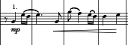
Figure 1. First motif, theme A.
This section from rehearsal letter A to B is used as a rhythmical bridge created by the clarinets and flutes against the brass section. It doesn’t expose a melody. Instead, the composer combines the use of dynamic regulators to create tension with the focus on the rhymical motifs. To end this section the piano does a characteristic tango effect of a quick ascending chromatic scale that connects with the tenor sax solo one measure before rehearsal letter B.
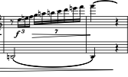
Figure 2. Piano ascending line.

Here, the tenor sax retakes the first theme but with variation. It also does share the theme later in the same section with the bassoons and the alto sax. Again, the piano does the characteristic tango effect of quick chromatic scale but this time, descending. The composer introduces the new theme B played by flutes, Eb clarinet, and the soprano and alto saxes to create a bridge to the next section, which starts in rehearsal letter C.

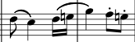
Figure 3. Secondary motif, theme B.

Here, the piccolo, flutes, Eb clarinet, and trumpets develop that secondary motif but with a rhythmical elongation (theme B1). This section evokes a feeling of suffering and struggle, while the clarinets support it by playing a composed rhythmical accompaniment that creates the sensation of a trill. Also, the percussion accentuates the drama of this section by adding the snare drum playing the rhythm of the motif and the suspended cymbal and bass drum answering by accentuating the second quarter note of the triplet.

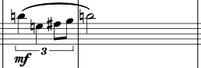
Figure 4. Secondary motif rhythmically elongated, theme B1.

All these emotions are driven to a small but more dramatic repetition of this “struggle” theme from m. 97 to rehearsal letter D. In this new section, the composer retakes the original secondary theme recently introduced but holding the direction of the end of the motif, utilizing a low neighbor note (theme B2).

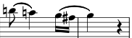
Figure 5. Secondary motif holding the resolution with a lower neighbor note.

There is a transition from m. 116 to rehearsal letter E, where descending chromatic lines create a progression that leads us to the next segment. Starting at rehearsal letter E, the composer adjusts the tempo to 116 BPM and takes the theme A’s harmony and introduces virtuosic variations in the melody line, executed by the Eb clarinet, the soprano sax, the first flute, and the first clarinet, sometimes as solo, sometimes as soli (theme A1).
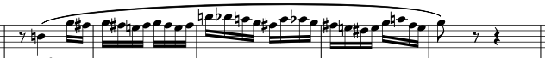
Figure 6. Virtuosity variation of the first motif, theme A1.

After those virtuoso variations of the theme A, there is a transition that starts at letter F, with a slight decrease of the tempo (110 BPM). In this transition the composer utilizes the theme A and its virtuoso variation, combining them. Four measures after that combination (m. 154) appears the secondary theme, rhythmically elongated and varied (as an ascending line), and the first theme together, but this time returning to the 116 BPM tempo (theme A+B).

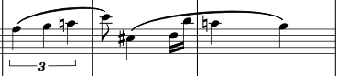
Figure 7. Secondary rhythmically elongated motif varied and the first motif together.

That transition drives us to a ritardando segment highlighted with a trumpet solo starting at m. 158 (theme B3). Immediately after that solo section (m. 166), the composer brings back the rhythmical transition that was previously presented in rehearsal letter A, but this time with a constant crescendo that increases the tension needed for the next section at rehearsal letter G, where the piece recapitulates the “suffering/struggle” (theme B) previously presented at rehearsal letter C, but first in the tonal center of G minor (rehearsal letter G), and then modulating to Am (m. 186).
All this tension is released in m. 191 with a double bass and tuba soli (Coda) based on the first theme motif. This release of tension characteristic of the Tango style. After these basses’ brief participation, the trumpets and trombones intercede with a rhythmical diminution that lands in a Gb-Db perfect fifth. This long note moves to the final Em9 chord in the high woodwinds, horns, euphonium, tuba, and double bass, and it will be sustained for three measures, finishing with the double bass and the tuba in a fermata with a perfect fifth of E and B respectively.

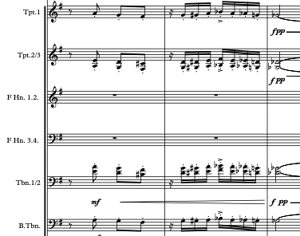
Figure 8. Rhythmical diminution.

Tango rhythm:
The origins of Tango rhythm trace back to the late 19th century in the neighborhoods of Buenos Aires, where it emerged as a reflection of the multicultural context that defined the city. According to Norberto Pablo Cirio, in his article La Historia Negra del Tango (The Black History of Tango) around 1870 the Afro-Porteño "comparsas" emerged that met for candombe and performed European music. The author suggests that tango may have initially developed in this context.
This rhythm initially faced social stigmatization and was associated with marginalized communities of Buenos Aires because of its African origins. However, its popularity grew, and it began to be embraced by the middle and upper classes, being first a social dance practiced just by men in their meetings.
Renowned Tango orchestras and musicians, such as Carlos Gardel, and Astor Piazzolla, emerged from the 1930s to the 1950s, adding their unique styles and innovations to the genre. The Tango became an integral part of Argentinian culture, with elaborate dance halls (milongas) and venues dedicated to Tango performances.
The most important characteristics of Tango are:
Rhythm and Meter: Tango is typically written in a 4/4- or 2/4-time signature, although variations in rhythm and meter are common. It often features syncopated rhythms (African influence), emphasizing off-beat accents, which create a sense of tension and rhythmic complexity. Tango's syncopated patterns and distinctive rhythmic phrasing contribute to its captivating and passionate feel.
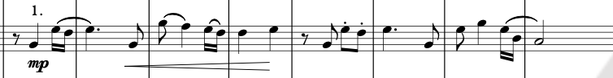
Figure 9. Tango's syncopated patterns.

Melody and Harmony: Tango melodies are characterized by expressive and melancholic qualities, often featuring long, lyrical lines (European influence). The melodies frequently incorporate glissandos and embellishments, adding ornamentation and emotional depth. Tango harmony is typically based on simple chord progressions, often using minor keys to convey a sense of nostalgia and longing.

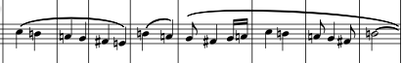
Figure 10. Tango's long lyrical lines.

Instrumentation: The traditional Tango ensemble, known as Orquesta Típica (Typical Orchestra), includes a combination of instruments, such as bandoneón (a type of accordion), violin, piano, and double bass. The bandoneón, with its distinctive sound, is considered the most common Tango instrument, often playing intricate melodic lines, and providing harmonic support. In addition to the core ensemble, Tango may incorporate other instruments like guitar, flute, and various percussion instruments for rhythmic accents.
Recommendations for music educators:
As mentioned before, Tango is a passionate and energetic style of music. It is recommended to the music educator to find or create arrangements of the most typical songs like Por Una Cabeza (Carlos Gardel), A Media Luz (Lenzi & Donato), or La Cumparcita (Gerardo Matos). These songs present all the musical features previously mentioned, but with simple melodies and simple harmonic structures, easy to assimilate by the students. Meanwhile, for more advanced students, Astor Piazzolla or Juan José Mosalini’s music presents higher levels of complexity.
One of the best tips in matter of interpretation of this style of music is to put an accent in every first beat of the measure but immediately changing to play lightly in the subsequent beats. Also, it is recommended to emphasize syncopations with a medium accent but short in duration of the note. If the mood of the song is more melancholic, long legato phrases are encouraged.

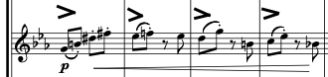
Figure 11. Accent in the downbeat.

Understanding the history and evolution of Tango is essential to interpret it properly. This will help you contextualize the music and capture the essence of the genre. Music educators and conductors must study the history of Tango in order to explain to their students the reasons for the intrinsic passion of this genre. This passion in the Tango genre requires an intense emotional interpretation and this can be achieved by emphasizing dynamic changes, rubato, accents, and body expression to convey deep emotions.
In the same way, students must listen to the recordings of emblematic tango musicians to absorb their style and technique and pay attention to how they interpret the melodies and phrasings characteristic of the genre. Additionally, tango is a genre that often involves improvisation. A very effective exercise is to encourage your students to improvise on tango chord progressions and explore their musical creativity. They can start improvising just rhythmically with one note, then two, and so on.
It is also of great benefit to organize master classes, workshops or concerts focused on tango to give to the students the opportunity to learn from expert musicians in the genre and to fully immerse themselves in that style.

Preludio y Scherzo, by Vinicio Meza (b. 1968).
Originally written in 1995 for a double bass quintet, Preludio y Scherzo has since been adapted for string orchestra, symphonic band, and brass choir. The arrangement examined here is an octet version for brass instruments. The auxiliary percussion for the second movement was added in a version made by the Costa Rica National Symphony Orchestra, for the XII Virtual Season Concert. The two-part work features a slow and lyrical first movement, contrasting with the brisk second movement, which incorporates musical elements from the Costa Rican Tambito rhythm stemming from African roots.
Vinicio Meza is one of the most prolific composers in Latin America today, with a large body of musical compositions. His composing style is unique, and the way he writes for different musical instruments makes all of his works accessible and easy to perform.
This is how he describes Preludio y Scherzo in the program note (translated to English):
Although in the past it has been said that music is composed of three fundamental elements: melody, harmony and rhythm, the truth is that music is much more than that: timbre (color of sound), tempo, nuances, tessitura, etc. Even silence is a very important element and, above all, expressiveness.
I think that the melody encompasses the other elements. The melody can suggest a certain harmony. To sing or play a melody you need the voice or a traditional or technological musical instrument, which will have their own timbre and tessitura. About rhythm, every melody is interpreted with a certain rhythm. A melody can contain rests as well as notes, and this melody can be interpreted at a certain "tempo" and with its respective nuances, depending on what the composer has written and the expressiveness with which the performer interprets it.
All this is mentioned as an introduction to say that one of the most remarkable characteristics in my compositions is the carefully elaborated, coherent and polished development of the melodic element.

Musical Analysis:
Instrumentation: trumpet in Bb (2), horn in F (2), tenor trombone (2), bass trombone, and tuba.

The overall structure of Preludio y Scherzo is:
Preludio: A (m. 1 – 9), A1 (m. 10 – 17), B (m. 18 – 25), A (m. 26 –33), A (m. 34 – 40).
Scherzo: Introduction (m. 41 – 50), A (m. 51 – 61), Transition (m. 62 – 66), A (m. 67 – 79), B (m. 80 – 111), B (m. 112 – 139), Transition (m. 140 – 153), C (m. 154 – 169), D (m. 170 – 181), Transition (m. 182 – 185), E (m. 186 – 227), Introduction (m. 41 – 50), A (m. 51 – 61), Transition (m. 62 – 66), A (m. 67 – 79), B (m. 80 – 111), B (m. 112 – 139), Transition (m. 140 – 43), Coda (m. 228 – 240).

The Preludio (first movement) starts slow, with 60 BPM, in the tonal center of A minor, with the first theme (theme A) on the first trumpet part, which is accompanied by the horns 1&2, and the first trombone with long notes that produce the harmony. The tuba has a rhythm similar to the bass line of a Latin American Balada Romántica, which gives movement and direction to the harmonic progression.

Figure 12. Balada Romántica bass rhythm.

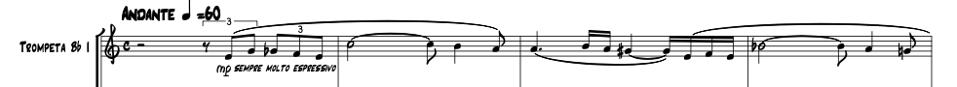
Figure 13. First theme of the Preludio.

At rehearsal number 1, this first theme repeats but this time moved to the second trumpet with some variations in the melody (theme A1), always keeping the same harmonic progression.
The second theme (theme B) appears in rehearsal number 2, at the tonal center of F major. The first trumpet starts it, and then the horns take it and give it more movement by doubling the slow motion of the half and quarter notes to a faster eighth notes.
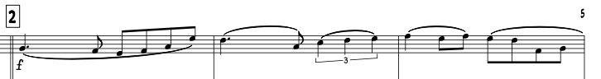
Figure 14. Theme B.

After a ritardando in the last measure of this second theme section –led by the first trumpet– the piece returns to the theme A –in A minor– at rehearsal number 3, but this time in the second trumpet, followed by its repetition at rehearsal number 4 (as it did at the beginning of the movement) with the first trumpet. The whole movement finishes with a fermata in the chord of Bb7 –with a function of a flat 2nd, which works as the substitute dominant chord of E7– that prepares the audience aurally for the second movement.
The second movement, Scherzo, starts quickly, with 132 BPM, still in A minor but in the 6/8 meter, which is one of the most common meters in Latin American music. For this specific piece, the author describes the rhythm of the Scherzo movement as Tambito, which is a Costa Rican (regional) variation of the Latin American Afro-influenced genre based on the meter of 6/8. The energy of this movement is presented from the beginning, with an Intro section with strong triplets in the low brass, followed by the horns and culminating with the trumpets in the high register, driving the tension to a fermata on the dominant chord (E7).

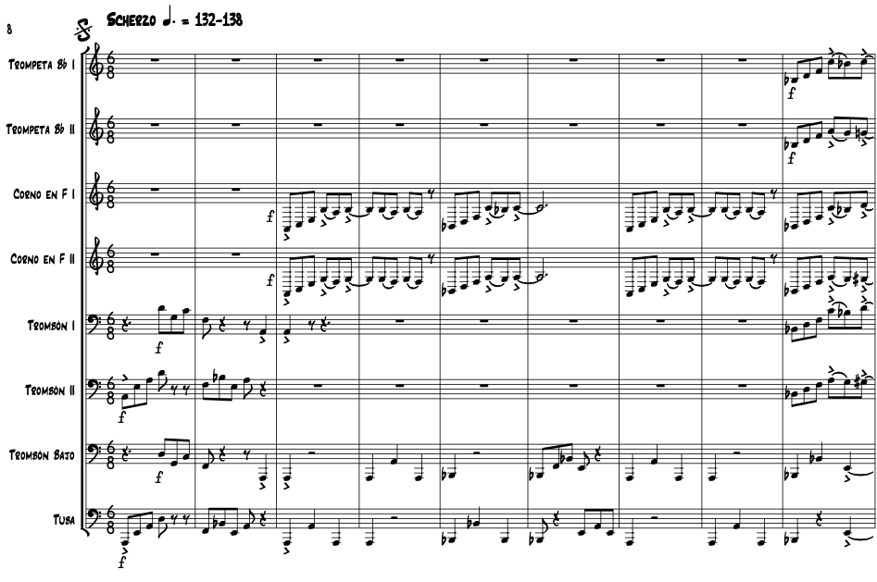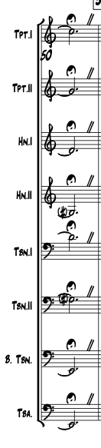
Figure 15. Introduction of the Scherzo.

After the introduction, the trumpets at rehearsal number 5 present the first theme (theme A), accompanied by the horns adding the harmony, and bass trombone and tuba –four measures each one– playing the bass line using a rhythm based on the triplets.

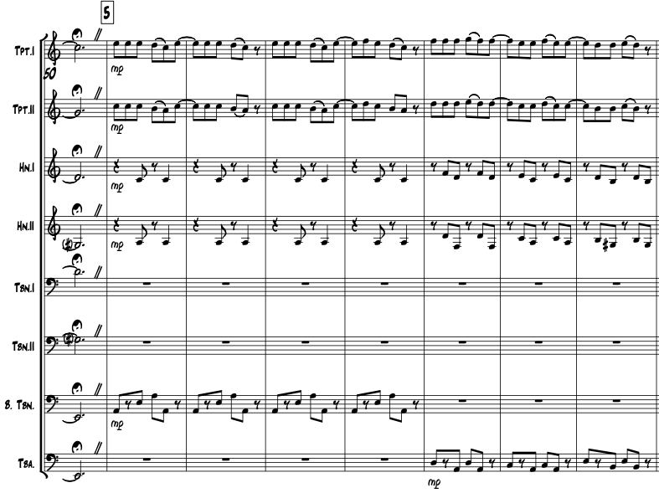
Figure 16. Theme A of the Scherzo.

After the first main melody ends, the composer brings back two brief musical ideas from earlier in the piece to help transition back to repeating that main theme. First, the low brass plays a quick triplet pattern, but only for one measure in the 9/8 meter. Then, the horn section plays the same line that was heard at the very beginning, but this time it's shortened to just four measures. By quickly referencing these previous musical elements, the composer creates a smooth connection that leads back to the repeat of the opening theme.

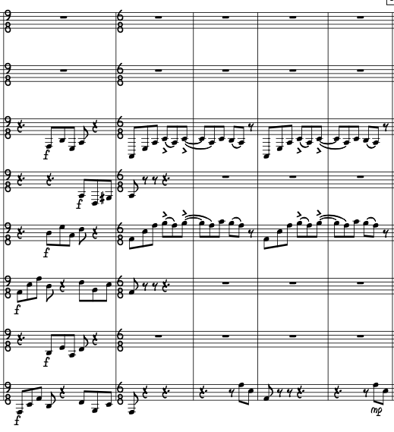
Hrn 1
Hrn 2
Trb 1
Trb 2
B. Trb

Tuba
Figure 17. Low brass triplets and the horns line presented in the introduction.

At rehearsal number 6, the composer repeats theme A –with the trumpets– with almost no variation, but this time the accompaniment is moved to the trombones and the bass line is again shared between the bass trombone and the tuba. Here, the bass trombone moves with just quarter notes, meanwhile the tuba returns with the same rhythm presented previously.
For this repetition of theme A, the trumpets end with another fermata, but now with a Bb It+6 chord in first inversion, using it as a secondary dominant that resolves to A minor at the beginning of the next section –rehearsal number 7–. Here, the composer does not change the meter but uses the musical notation to create the feel of a 3/4 meter (that is always implied in the Tambito rhythm). The first trumpet brings the second theme (theme B) of this movement, with long notes, meanwhile the first and second trombone are exchanged every four measures, serving as the bass, thus creating in this section a constant duo with the trumpet.

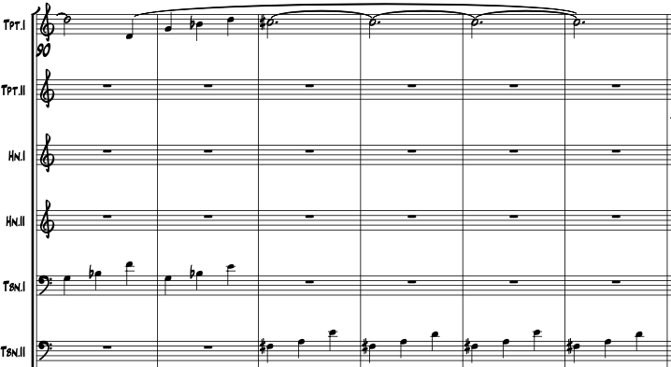
Figure 18. Theme B of the Scherzo.

With a ritardando one measure before rehearsal number 8, the composer prepares a repetition of the same theme B but opening the melody to the first trumpet and the first horn. The first and second trombones keep the same bass-quarter notes idea, and the tuba plays long notes four measures, descending chromatically, that then is passed to the bass trombone. All of these compositional elements are contrasted with the implementation of the percussion that starts to accompany with the Tambito rhythmic patterns.
*Note: It should be mentioned that in the original score there are no percussion parts. As mentioned before, that addition was made by the percussionist of Costa Rica’s National Symphony Orchestra, by taking the band arrangement percussion parts and applying them to this octet version. In the same way, percussion was also added for the performance with the OU Wind Symphony Chamber Ensemble. I suggested to the composer to add percussion to the score.
Returning to the analysis, when it is time for the consequent phrase of this section –m. 128–, the composer uses the second trumpet for it, driving the piece to a transition – at m. 140– created with the material presented in the introduction with the low brass, very focused on the triplets of the 6/8 meter.

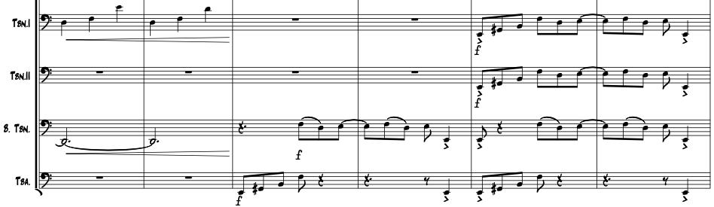
Figure 19. Bridge created with the material presented in the introduction.

Immediately after that transition, the composer brings back the horns followed by the trumpet’s line that drives to the fermata, exactly as he did in the introduction. After that recapitulation of the introduction, a new theme (theme C) –based more on rhythm and syncopation– is presented in trombones 1&2, with the bass trombone carrying the bass line and the percussion keeping the same Tambito rhythm.

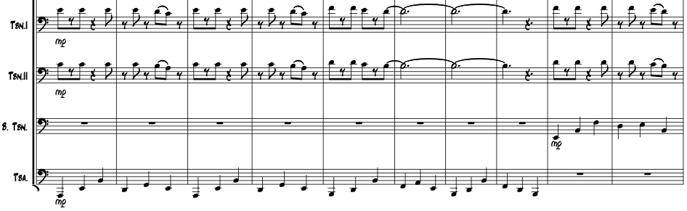
Figure 20. Theme C on trombones.

The horns introduce another new theme (theme D) that moves throughout a new chord progression, at rehearsal number 11. After this new theme D, the composer brings a transition similar to the one in m. 140 but based on the chord of G9 that works as a dominant of C major, which will be the tonal center of the next section. Right here –rehearsal number 12– the two trumpets bring a new melody, but this time in a C major tonal center (theme E), which creates the sensation of a more traditional Latin American style due to the use of thirds between the two trumpets.
The accompaniment this time is based on strict downbeat notes in the trombone and a more dynamic bass trombone based on the triplets. The trombones take the melody and drive it to a big break (m. 204) with the percussion, letting the horns start the ending of this section in m. 208, and then passing it to the trumpets one measure before rehearsal number 14, where they will rest in a long note. Meanwhile the low brass presents again the previously mentioned transition material, concluding the section with a jump to the Da Segno of the movement, which is the beginning of this movement.
Once the piece repeats to Da Segno, it goes through theme A and theme B –as written– and then jumps to the Coda, where it repeats the exact introduction of this Scherzo movement, ending it with the fermata. To finish the piece, the composer brings back the same first two measures of the introduction and closes it with a quarter note on the down beat of a third measure.

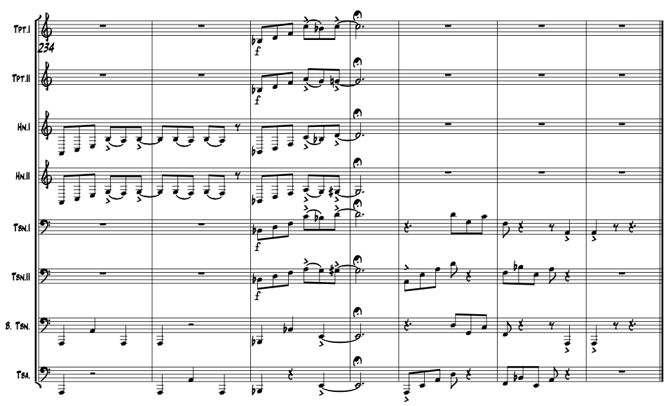
Figure 21. Recapitulation of the introduction and the three closing measures.

Tambito rhythm:
Costa Rica, like many other Latin American countries, has its own rhythm rooted in the 6/8 meter, called Tambito, which is derived from "tambo", that is: "a ranch that is built on the big farms so that the laborers can spend the night and take care of the crops." Based on this definition, it is understandable that Afro-descendant workers –who were brought to the continent as slaves during the sixteenth century– resided in these tambos. As a result of their exposure to the music of the farm owners –primarily direct descendants of Spaniards– these workers began to mix European and African musical styles. Costa Rican musician and researcher Juan José Carazo explains that: "this rhythm is present in the Guanacaste region and, therefore, throughout Costa Rica thanks to the presence of African slaves for five hundred years." This genre is also known as "Parrandera" or "Son Guanacasteco."
One of the principal features of Latin American rhythms based on the Afro-influenced 6/8 meter is the polyrhythm. One theory says that besides the African polyrhythms inherited in America, some European sixteenth century musical practices also influenced these Latin American rhythms during the colony period.
Around that time, European musical performance techniques involved the interpretation of musical pieces in double and triple meters, thus giving the option of changing rhythms and tempos but always based on the same melodic material. For this specific topic, Ruth I. DeFord discusses the ambiguous meaning of relationships between duple and triple time passages. She explains that these proportions could indicate: “precise tempo changes, triple meter regardless of tempo, or a mixture of relationship.”
This ambiguity of meters is also known as Sesquialtera –more commonly called hemiola. Estefanía Cano explains this phenomenon and its influence in the Colombian Bambuco rhythm (one of those based on the 6/8 African meter): “it is characterized by the superimposition of musical elements in two meters, a simple meter (3/4), and a compound one (6/8).” It is for this reason that a lot of Latin American music is written in 3/4 meter but with the melody based on eighth note triplets –as in 6/8. It is also common to find different versions of the same piece, one written in 3/4 meter and then another version in 6/8 meter.
Tambito is one of those rhythms that possesses the combination of the two meters, thus creating syncopations and rhythms that would be said to be complicated for the performer due to its ambiguity. However, it is necessary to remember that the complication exists only because of the western musical notation system we use. That is, rhythmic complexity in the Latin American Afro-influenced 6/8 does not demand a high level of knowledge about syncopation; it is the musical notation that makes the interpretation of these rhythms difficult. In other words, syncopation is present in most popular musical genres (such as pop, jazz, funk, salsa, reggae, among others), but their notation usually uses the meter of 4/4 or 2/4. Having this clear, it is easy to understand that the musician feels more comfortable reading syncopation in those metrics, and that the complications presented by the rhythms in the 6/8 meter resides in the notation and the musician’s lack of exposure to those syncopations.
Leaving aside this possible complication, it is important to say that the Costa Rican Tambito has a great variety of virtues that are worth highlighting. There are elements in this style such as syncopation, polyrhythms and percussion patterns that reflect west African rhythmic practices combined with instruments of the native Costa Ricans, who in turn adapted simple melodies and harmonic structures mostly influenced by European styles.
In Tambito, the lower voice –either a low percussion instrument or a bass voice– is usually based on the 3/4 quarter notes but leaving the first quarter note as a rest, meanwhile the upper voices –accompaniment or melody– are scored in the 6/8 eighth note triplets.
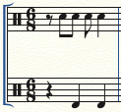
Figure 22. Basic rhythmic pattern of Tambito.

Recommendations for music educators:
To accurately interpret this style, it is essential to emphasize the last quarter note of each measure (as if it were in 3/4), whether in the upper or lower voice. Equally important is the concept of accentuating any notes written on the downbeat of each measure, creating a strong sense of arrival, and establishing the vitality of the energetic pulse. This emphasis on the downbeat also provides space for syncopation that fills the rest of the measure, contributing to the overall dynamics of the rhythm.

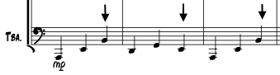
Figure 23. Emphasis on the last quarter note.

As any other popular genre in Latin American music, syncopated rhythms must be played shortly and light. Being a musical genre that comes from dances, the emphasis should be more towards the percussive and rhythmic since that is where its richness lies.
Compared to other Latin American rhythms based on the 6/8 meter, the Costa Rican Tambito has less syncopation. Generally, the rhythmic difference of the melody –based on the eighth note triplet– is very marked, in comparison with the harmonic accompaniment and the bass line (based more on the 3/4 meter). This type of simplification allows for faster assimilation by the performers, making this one of the most accessible musical genres based on the Latin American 6/8 rhythmic pattern.
In its evolution, the Tambito stopped using Afro-descendent drums, with the exception of the conga. Common instrumentation uses a bass drum, crash cymbals (which could be attached to the bass drum), and the bass drum. Other instruments have been adapted into different groups, such as maracas, güiro, donkey jaw, and more recently the drum set.
The music educator should consider reviewing the melodic lines and accompaniment separately during rehearsals, and also go over the rhythmic patterns with the percussion section. It's crucial for students to understand each musical part's role to avoid confusion, especially when dealing with complex rhythms. The music educator should pay close attention to rhythm and work closely with the percussion section to ensure that rhythmic patterns are executed with precision and energy. The student must learn to accentuate the third quarter note of the bass drum line and the cymbals (as mentioned before), to play short and with a good accent on the downbeat –in the case of the snare drum–, and to fill in with minor percussion ornaments in each transition of the piece.
In general, it is recommended that before beginning to rehearse, the music educators should familiarize themselves with the cultural context of the work they are performing. Understanding the history, musical practices, and the specific musical style will help them interpret this music in a better way. Also, it is encouraged to work with the musicians on dynamics, articulation, and phrasing to capture the emotional essence of the piece. Students should explore different sonic colors and nuances to bring the performance to life.
Research and exploration should be stimulated, and the students should be encouraged to delve into this musical genre outside of rehearsals. This may include listening to recordings and studying the culture and history behind the music. The more familiar your musicians are with the genre, the more authentic their performance will be.

Pachamama, by Oscar Trujillo.
Pachamama is a won the National Band Competition in Paipa Colombia, 2016. The word Pachamama means Mother Earth and comes from the Quechua language (which is one of the most popular pre-Columbian languages still used in various regions of South America). Oscar Fernando Trujillo Gómez composed this piece as a reflection on the problems that planet Earth is suffering and the damage that human beings are causing.
This is how he describes Pachamama in the program note:
Pachamama is an invitation to recover the deep respect that the native tribes of America profess for the earth. In the first section of the piece, there is a worship of the earth with a song in Aymará (the typical language of the tribes that worship the Pachamama). In the second section, a poem by Gonzalo Arango describes the poor state the earth is in after having lost the values of the ancestors and apologizes for the harm caused, giving way to the second section, called Allegro. The third section brings a melody that pretends to describe the hope of recovering the lost values.

Musical Analysis:
Instrumentation: piccolo, flute (2), oboe, bassoon, Bb clarinet (3), bass clarinet, alto saxophone (2), tenor saxophone, baritone saxophone, trumpet (3), horn in F (3), trombone (3), euphonium, tuba, double bass, timpani, glockenspiel, xylophone, conga drums, snare drum, bass drum & tambora, hi-hat, guasá (Metallic Shaker).

This is the overall structure of Pachamama:
The piece is divided in three macro sections that are also divided in subsections.
Fist macro section (m. 1 – 100): Flute Cadence (m. 1– 12), Introduction (m. 13 – 20), A (m. 21 – 28), A1 (m. 29 – 36), Singing A1 (m. 37 – 52), B (m. 53 – 68), Transition 1 (m. 69 – 77), B1 (m. 77 – 92), Introduction (recapitulation: m. 93 – 100).
Second macro section (m. 102 – 277): Poem (m. 101 – 109), A3 (m. 110 – 125), A1 (m. 126 – 141), Transition 1.1 (m. 142 – 157), B1 (m. 158 – 173), A1 (m. 174 – 189), Transition 2 (m. 190 – 197), Singing B (m. 198 – 205), Transition 2 (m. 206 – 213), Singing B (m. 214 – 221), Transition 1.1 (m. 222 – 237), B1 (m. 238 – 253), A1 (m. 254 – 269), Transition 2 (m. 270 – 277).
Third macro section (m. 278 – 372): C (m. 278 – 311), Transition 3 (m. 312 – 319), C (m. 320 – 335), A3 (m. 336 – 353), Codetta (m. 354 – 372).
The first macro section starts with a subsection that presents a flute solo played freely with a cadence in A minor, in the 4/4 meter, that is extended for 4 measures, finishing with a fermata on the note E, serving as a half cadence. At measure number 5, the solo starts a new phrase –starting with the note A, which resolves the previous half cadence. This new phrase is the main motif for the first Singing B theme that will be presented and developed later on the piece.

Figure 24. Flute solo with Singing B motif.

The new motif is first played by the flute soloist, and after two repetitions, the second flute joins by playing a second voice below–two times as well–, closing the entire section with a fermata on the notes E (first flute), and A (second flute), which brings the Authentic Cadence in A minor.
The next subsection of the piece starts with the percussion and all the low voices playing an African-based rhythm pattern that combines the 8/8 and 6/8 meters, with a tempo indication of Moderato with 95 BPM (quarter note).

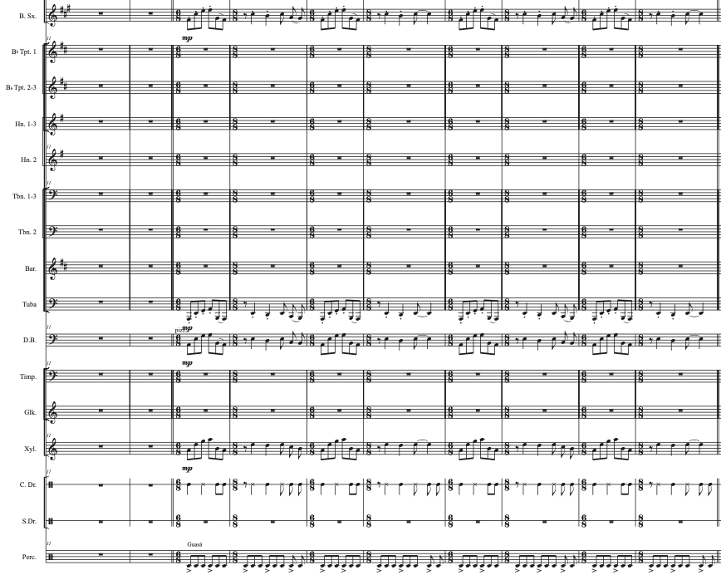
Figure 25. Percussion and all the low voices playing an African-based rhythm.

This subsection works as an introduction for the theme A, that starts at measure 21 with the flutes, oboe, first clarinet, and the first trumpet. The same theme A repeats at measure 29 but this time adding the piccolo, meanwhile the second and third clarinets join the low voice line. Here, the composer also adds the alto and tenor saxophones but with a different accompaniment that supports more the rhythmical patterns and the harmony.
In measure 37, the members of the band have a singing part, still maintaining the composed meter pattern (Singing A subsection). The composer brings a song in Aymara language (language commonly spoken by tribes who revere Pachamama in South America). The lyrics express gratitude to Mother Earth, saying “Pachamama Pachi” (Thanks, Mother Earth). They first sing in unison for eight measures, and then the melody opens to two voices (m. 45) by adding the second one on top of the original one.

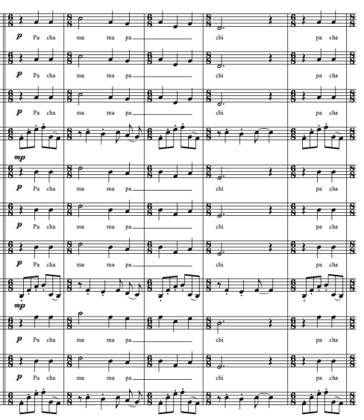
Figure 26. “Pachamama Pachi” song in Aymara language.

Immediately after that singing subsection, the Theme B appears (m. 53) with the flutes, oboe, first trumpet, and xylophone, accompanied by the saxophones reinforcing the rhythmic pattern of the percussion, but now keeping just the 6/8 meter. In the second half of this subsection the horns present a melody that works as a closing motif. After the horn’s appearance, the composer brings the Transition 1 (m. 69), with a small accelerando, that leads to the next subsection establishing the tempo to 104 BPM.
In measure 74, the theme B repeats, but this time in the 6/8 meter. This time the composer uses all the instrumentation to have more accompaniment lines. The same horn melody used before closes the subsection.
The introduction presented before (low voices playing an African rhythm pattern that combines the 8/8 and 6/8 meters) is presented again in measure 93, ending this subsection with a fermata. To finish this first macro section, the composer incorporates a fermata in the conga drum, encouraging the percussionist to use sound effects to imitate the sounds of a tropical forest.
Right here (m. 101), one of the members of the band must recite a poem called La Salvaje Esperanza (The Wild Hope) by Gonzalo Arango. This poem is recited during the percussion fermata, and it depicts the harsh realities of the colonization process.
The poem says:

Éramos dioses y nos volvieron esclavos.
Éramos hijos del Sol y nos consolaron con medallas de lata.
Éramos poetas y nos pusieron a recitar oraciones pordioseras.
Éramos felices y nos civilizaron.

¿Quién refrescará la memoria de la tribu?
¿Quién revivirá nuestros dioses?
Que la salvaje esperanza sea siempre tuya,
querida alma inamansable.
English translation:
We were gods, but they made us slaves.
We were the children of the Sun, but they consoled us with tin medals.
We were poets, but they made us to recite beggar prayers.
We were happy, but they civilized us.

Who will refresh the memory of the tribe?
Who will revive our gods?
May the wild hope always be yours,
dear irrepressible soul.

The second macro section of the piece moves to an Allegro with a tempo of 210 BPM (dotted quarter note) in measure 102, in the meter of 6/8, starting with eight measures of percussion in the rhythm of the Colombian Abozao, which is another of the Latin American Afro-influenced rhythms that is rooted in the 6/8 meter. In measure 110, the composer brings back the theme A, this time with the first flute, the first clarinet, and the first trumpet, accompanied always with the percussion, and adding some strong hits every four measures in the brass, double bass, and timpani, expanding the number of hits with each intervention.

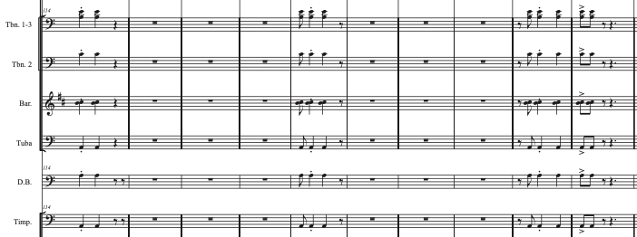
Figure 27. Accompaniment of theme A3 (rhythmic augmentation).

Another repetition of theme A follows the previous one (m. 126) and then the composer inserts the Transition 1.1 (m. 142) with the same melodic material as Transition 1 but changing long durations to short ones –in the oboe, the first clarinet, and the glockenspiel. This change of durations also affects the accompaniment, where previously in Transition 1, the low brass and the double bass played short durations –contrasting with the melody– and now those instruments in Transition 1.1 have long notes with only the conga drum playing the Abozao pattern.
In measure 158, the Theme B is recapitulated, followed by the theme A (m. 174), moving the piece to the first appearance of the Transition 2 (m. 190), which is a small section made of eight measures of the saxophone quartet bringing syncopated rhythms with some dissonances that give a rest from the tonal harmony that the other sections have presented.
The second singing section is introduced in measure 198. This one is based on the melody presented at the beginning of the work with the flute solo. The lyrics this time are in Spanish: “Pachamama, perdona a tus hijos, Pachamama, por tanta maldad” (Mother Earth, forgive your children, Mother Earth, for so much evil).

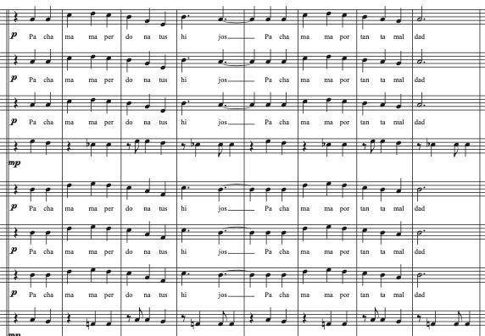
Figure 28. Singing B subsection.

Transition 2 is repeated again at measure 206, as well as the Singing B subsection in measure 214. In order to create a well-balanced structure of the piece, the composer introduces the Transition 1.1 again (m. 222), theme B1 (m. 238), theme A (m. 254), and the small Transition 2 (saxophone quartet with syncopated rhythms) that closes the second macro section.
The new theme C is presented in measure 278, starting here the third macro section of the work. The composer –as he mentioned in the program note– created this new theme to bring a feeling of positivity. For this, the tonal center is moved from A minor to C major, with a clear intention to change the darkness of the previous tonality to a brightest one.
The clarinets and saxophones alto and tenor start a short transition in measure 312 to bring back the theme C in measure 320. After the recapitulation of theme C, the composer solidifies the theme A3 in measure 354, and then ends the work with a three-bar codetta (m. 370) that effectively reinforces the notion of syncopation characteristic of this musical style.

Abozao rhythm:
This musical style comes from the Colombian Pacific region, specifically from the central area of the Chocó department. The Abozao comes from the word “boza”, a short rope or chain used in navigation to hold objects. Therefore, “Abozao” means to tie with bozas, a symbolism that refers to the particular way to dance this rhythm.
Musically, it is one of the Afro-descendent 6/8 rhythms that is present in all Latin America. However, Abozao is distinguished by the inclusion of new instruments that alter the melody and rhythm of the song. The chirimía ensemble –which accompanies the Abozao– is made up of clarinet, snare drum, cymbals, and the instruments of the marimba ensemble (marimba, African drums, shakers).
In the Abozao, the accompaniment of the drums is essential, within the typical Chocó instrumental ensemble, since the rhythmic beats –accentuated by the cymbals– mark the succession and movements of the parts of the dance. In addition to the rhythmic aspects, the melody can also incorporate characteristic elements of the dance, such as musical phrases that emulate the movements of the arms or hips, or motifs that evoke the sensuality and festive nature of the dance.

Recommendations for music educators:
As this is one of the styles that presents the use of sesquialtera and the ambiguity of binary and ternary meters –previously explained in the Costa Rican Tambito context–, it can be understood as difficult to interpret by students.
To face this challenge, the teacher is recommended to work on rhythmic cells typical of this style and variations of it. Even better if the teacher extracts a rhythmic cell from some passage in the piece and make this an exercise with the group.
This technique was used in the rehearsal process of the work Pachamama with the students of the OU Symphony Band. In this case, the following rhythmic exercises were provided. They consist in the teacher showing first the rhythmic cell by clapping the dotted quarter note (below the staff) while singing the rhythms showed in the staff, then the students should repeat the exact exercise as the teacher did.
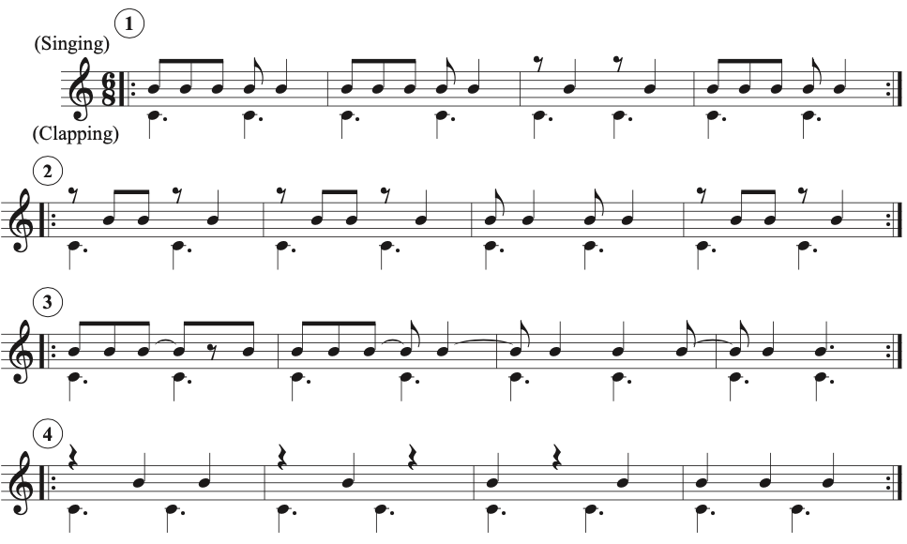
Figure 29. Rhythmic exercises to practice singing and clapping.

It is also encouraged to suggest the students to stand up and mark –as in marching band– the downbeats with their feet, left and right respectively for the first downbeat and the second.
Another exercise to address this difficulty presented by the ambiguity in musical notation is based on memorizing the most complicated passages for the student. In this way, the teacher sings the musical phrase, and the student repeats it by ear. This practice is common in Latin America because a large number of students first learn to play by imitation, that is, they learn the basic operation of the instrument and then a more experienced musician will teach the sequences of notes and specific rhythms of the piece they are learning. This practice is carried out with melodic, harmonic, and percussive instruments as well.
The students should be helped to understand the structure of the 6/8 rhythm by breaking it down into its basic subdivisions, explaining that the 6/8 meter is divided into six eighth notes, grouped into two groups of three beats each, although some phrases – and mostly the bass– can be presented in groups of two eighth notes, creating three quarter note beats in a bar.

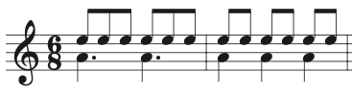
Figure 30. Eighth note subdivision in the 6/8 meter.

To better interpret the Abozao rhythm, research should be encouraged into how the 6/8 meter is used in different Latin American musical genres and how it reflects the cultural identity and diversity of the region.
In addition to the previous suggestions, music educators can incorporate musical examples that use the Latin American 6/8 rhythm as audible material. This may include recordings of Latin American musicians or transcriptions of popular musical pieces that use this rhythm. By following these recommendations, music educators can effectively teach Latin American 6/8 rhythm and help students appreciate and enjoy the musical richness of Latin America.

Bolero Mexicano, by Estrella Cabildo.
In this analysis, we will explore this musical work inspired by the rhythm of the Bolero Romántico (Romantic Bolero), which is characterized by its romantic and captivating melodies, as well as its soft and melancholic air.
The sociologist Evangelina Tapia Tovar explains to us that: "The bolero as the most popular of the romantic languages of Latin America, and the most romantic of its popular languages, has more than a century of life; it has been at the service of love since the end of the 19th century, feeding the most human of us: feelings."
This musical genre is full of emotions and captivating melodies, making it attractive to audiences and musicians alike. By including this rhythm in the wind band repertoire, it diversifies the musical offering and provides a unique listening experience that can resonate with a wide range of audiences. Additionally, Bolero Romántico offers opportunities for band students to explore a more expressive interpretation, enriching their skills and experience as performers.

This is how Estrella Cabildo explain her work in her program note (translated to English):
The main generating idea of the work is based on the bolero genre. The intention was to integrate the most notable characteristics that the genre adopted in Mexican lands, until the crystallization of what is known today as Romantic Bolero, a subgenre that constitutes the essence of the work. The recurring characteristics of the style just mentioned (and that have been integrated into the piece) are the great melodic richness, the expressiveness of the speech, the presence of countermelodies that give contrapuntal interest and variety to the texture, and the breadth of registers.
The sectors that contrast the romanticism of the work merge, evoking the festive character of the typical dances of the state of Veracruz, which have a close relationship with the bolero, such as the son and the danzón. This is produced through the reinterpretation of rhythms and colors that personally merge into a free variation and combination of textures. The melody that until then had constituted the central idea of the work reappears here in an extroverted context. The richness of color provided by the metals is an allusion to the arrangements performed by brass bands in the squares of towns and cities. These arrangements are characterized by rhythmic impulse and festive impetus; The use of the tarola in this last point alludes to the marches that these groups carry out on different occasions.

Musical Analysis:
Instrumentation: piccolo, flute (2), oboe (2), clarinet in Bb (3), bassoon (2), bass clarinet, contrabass clarinet, soprano saxophone, alto saxophone, tenor saxophone, baritone saxophone, horn in F (4), trumpet in Bb (3), tenor trombone (2), bass trombone, euphonium, tuba, timpani, percussion 1 (snare drum, shaker, wind chimes, crash cymbals, suspended cymbal, maracas), percussion 2 (claves, bongos, maracas, hi-hat, wind chimes), piano.

The overall structure of the piece is: Introduction (m. 1 – 8), A (m. 9 – 14), A (m. 15 – 19), Transition (m. 20 – 26), B (m. 27 – 34), A (m. 35 – 41), Transition (m. 42 – 51), C (m. 52 – 56), Development (m. 57 – 92), Transition (m. 93 – 110), B (m. 111 – 117), Transition (m. 118 – 130), C (m. 131 – 138), Coda (m. 139 – 143).

The work begins with an introduction –in the meter of 4/4, with a tempo indication of Allegretto, 100 BPM (quarter note)– that presents a soft harmony in the tonal center in F major, sustained with long notes in the first clarinet, first oboe, and the first flute.

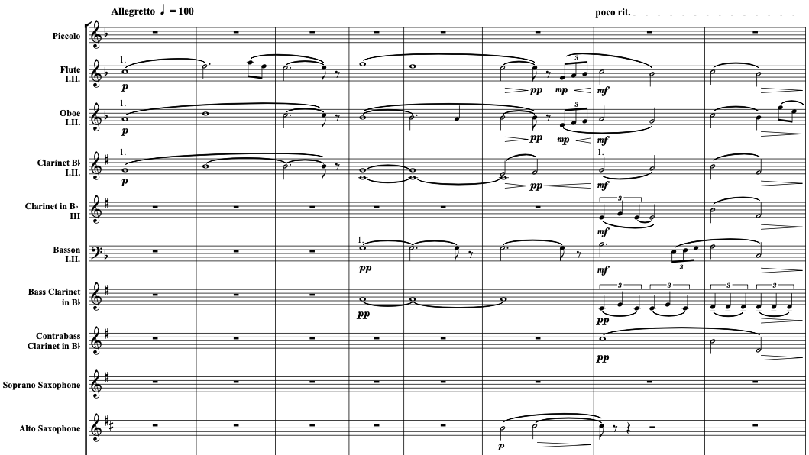
Figure 31. Soft and calm introduction.

After three measures, the bassoon and the bass clarinet join in, and simultaneously, the alto saxophone and the first horn appear, leading to a two-bar ritardando that prepares the arrival of the first big theme.
In measure 9, the composer brings the theme A with the first flute, the first oboe, and the first horn in F. In order to keep the softness presented in the introduction, the dynamic is still piano, and the only percussion instrument used is the shaker. In the last measure of this section, the composer inserts a ritardando that increases the tension just to bring back the same theme, but this time adding the bongo, which is typically used to accompany the Bolero Romántico.

Figure 32. Theme A in the 1st horn in F.
After the repetition of the theme A (m. 15), the composer applies a dramatic transition section, where the piano embraces the protagonist role in the last four measures, just to take us to the new theme B –that is kept in the F major tonal center– played by the first oboe, and accompanied by the clarinet family, with the bongo and the shaker in the percussion. Immediately after the theme B, the composer brings back the theme A (m. 35), but this time in the alto saxophone, with a second voice in the soprano saxophone, and adding tremolos in the tenor and baritone saxophones parts that support the harmony.

Figure 33. Theme B in the 1st oboe.

In measure 42, the work starts to move to a more rhythmical section. For this, the composer creates a transition where the syncopation –helped by staccato notes –is more intense. The molto accelerando indication will bring the piece to a faster new section –indicated Presto, 160 BPM– that also moves to the tonal center of D major.
To start this new section, the composer introduces the theme C, which is constructed as a sequence of arpeggios. This sequence is played by the flutes, oboes, and the soprano, alto, and tenor saxophones, while the low bras and low reeds play syncopated quarter notes.

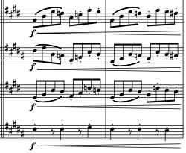
Figure 34. Theme C in the saxophone quartet.

The next big section –Development– starts in measure 57, where the composer takes material from the three themes already discussed and develops it, rhythmically and harmonically. While this development section goes on, the composer extols the virtues of each section of the band; trills on flutes and clarinets, glissandos on trombones, arpeggios in the saxophones, rolls on timpani, and basses maintaining the syncopated quarter notes.
In order to move to the next section, a modulatory transition is presented in measure 93. First, the composer brings the meter of 5/4 to expand the previous measure of 4/4, creating an elongation effect that helps stop the rhythmic energy that the development section brought. Once that energy is decreasing –also moved to the E major tonal center– the piece goes back to the 4/4 meter, regulated with decrescendo and a ritardando, moving it to the Tempo Primo indication –100 BPM– in measure 108.
The Tempo Primo sets the Bolero air over four measures. Harmonically, the tension increases by holding the dominant of F major (C7 chord) in those four measures, thus getting ready to get to the next section in the original tonal center of the work: F major.
Right here (m. 111), the theme B shows up again, but this time in the first trumpet as a solo. The accompaniment is again soft –with long notes and legato– in the flutes, oboes, clarinets, bassoons, and the first trombone. The tuba, bass trombone, and contrabass clarinet play a typical bass line of the Bolero Romántico (quarter notes in the first and third beats of the measure), while the tenor and baritone saxophones answer those beats of the basses (filling the second and fourth beats), all this with the percussion playing the rhythmical pattern of this style, with just maracas and bongo. To close this section, the piccolo, flutes, oboes, and the soprano and alto saxophones answer to the trumpet solo (m. 118) with a melancholic phrase that lands in the next transitional section.

Figure 35. Theme B, trumpet solo.

This new transition (m. 121) is written as a four measure chorale for the saxophone quartet with the progression I-V-I-I (in the tonal center of F major), then it holds long notes in the high woodwinds, tuba, and the first trombone – playing the F major chord in the root position– for about five measures, where the piano intercedes by playing F major arpeggios, closing the entire transitional section with a fermata in the 3rd of that key.
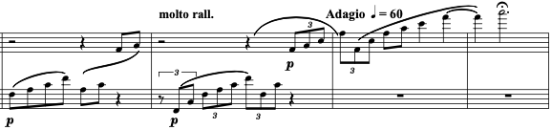
Figure 36. Piano arpeggios that close the transition section.

To finish the piece, the composer brings back the energetic theme C in measure 131 (tempo Presto, 160 BPM, quarter note) for about seven measures, stopping abruptly in the eighth measure to create a two-beat silent pause, followed by a pick-up of ascending sixteenth notes that drives the piece to a Coda that emphasizes the syncopated quarter notes –those presented before, and a final long note that closes on the downbeat of measure 143, the last measure of the piece.

Bolero Romántico rhythm:
This Latin American genre has left a mark on the culture and hearts of many people throughout the continent. Since its origins in Cuba at the end of the 19th century, this genre has evolved and adapted to various regional styles, becoming a symbol of the identity and emotional expression of Latin America. It is also worth mentioning that UNESCO has granted recognition to the Bolero, now considering it as part of the Intangible Cultural Heritage of Humanity.
The Bolero Romántico –whose roots go back to the eastern region of Cuba, specifically to the province of Santiago– has managed to transcend its place of origin to become a continental musical phenomenon. The sociologist Evangelina Tapia explains to us that:
The Cuban bolero is the result of several genres: from the contradanza it inherits the percussion; from the habanera, the singing; from the danzón, the embraced dance style, almost without moving from its place; from the music of Yucatán, the rhythmic scratching of the first guitar and the tonal backing of the second that he strummed, and finally, the influence of the Spanish bolero, which although some consider that it only gives it its name, others do find similarity in the rhythm.

The proximity of the island of Cuba to Mexico –specifically the peninsula of Yucatán– allowed many musicians to emigrate to the from the island. This is how this genre gained more strength and quickly became popular.
This rhythm is one of the easiest to perform, due to its slow tempo in the 4/4 meter. Generally, syncopation –very scarce– occurs only in the melody, leaving the harmonic lines either filled with long notes –if attributed to an ensemble of melodic instruments– or eighth note repetitive patterns –in small ensembles made up of plucked strings. In the case of the Mexican Bolero, it can also include elements from other genres such as Mariachi or Ranchera, which gives it a unique sound identity rooted in the musical practices of Mexico.
It is worth clarifying that the Latin American Romantic Bolero is not the same as the Spanish Bolero. The Spanish Bolero is ternary, that is, it uses the 3/4 meter, while the Latin American Bolero uses the 4/4 meter. Elvira Carrión studied the Spanish Bolero and explains that: “The Bolero was the most popular dance in Spain in the second half of the 18th century, it brought fame to those who danced it, and it was danced mainly in the area of Castilla, Southeast and Southern Spain.”
From the Spanish one, the Latin American Bolero only inherited the name, although it is clear to see that in the Latin American Bolero, the rhythmic pattern of the maracas resembles that of the Spanish castanets.
The percussion in the Bolero Romántico usually uses simple, repetitive rhythmic patterns that provide a smooth and constant accompaniment. These patterns may include the use of maracas, congas, bongos, or other percussion instruments. In the next figure it is notated the basic rhythmic pattern of the Bolero Romántico.

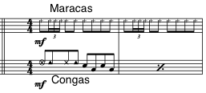
Figure 37. Basic rhythmic pattern of the Bolero Romántico.

Recommendations for music educators:
The recommendations to execute this musical genre in an accurate way and in style is to always keep the dynamics soft. All accompaniments must be subtle. Percussion – although it plays a fundamental role–, must always be below the melody and must have an accompaniment and ornamental character. It is crucial that the music educator focuses on establishing a constant tempo and working on the emotional expressiveness of the piece. This involves paying attention to accentuation and highlighting marked accents in certain measures to give to the rhythm its distinctive character. Additionally, it is recommended to work on synchronization between different instruments and create a solid groove that drives the performance, experimenting with subtle changes in dynamics and texture to add interest and variety.
Also, the teacher or conductor must collaborate closely with the musicians to highlight the melodic expression and convey the emotional depth of the music. This involves working on melodic phrasing and expression of the melodies, as well as ensuring that musicians that play accompaniment are familiar with chords and harmonic changes to create a solid foundation for performance.
In the case of the work analyzed in this document, the use of the bongo is required. This instrument must be hit with the fingers, unlike the conga, which needs to be hit with the palm of the hands and the fingers also. In the Bolero rhythm, the rhythmic pattern of the bongo is more similar to that of the maracas, (illustrated in the figure above).
The work Bolero Mexicano by Estrella Cabildo has sections that are not classified within the Romantic Bolero rhythm; however, the composer did a great job in the instrumentation and development of the compositional material, and therefore it does not present any complications within the interpretation of the students.
This piece features a section where the trumpet takes a solo. It is recommended to work with the student on the sound style of the mariachi trumpet, which should be round and big, with strong attacks and somewhat exaggerated vibrato in each long note. It is also recommended to learn the solo by heart and perform it standing at concert time, as this is a tradition in popular Mexican bands.
It should be clarified that this theme presented by the solo trumpet is played first by the oboe. In this first incursion, the oboe should not assume this mariachi style. This is because the oboe voice itself is just a composition tool. This –in the context of the band's instrumentation– must maintain the same standards of sound and interpretation as with any other work.
Bolero Mexicano is ideal for programming in high school band or in band at the college level.

Chapter 7

Conclusions

At the end of this exploration of Latin American music within the wind band repertoire, it is imperative to reflect on the significant contributions, challenges encountered, and future opportunities that this research has revealed. Throughout this study, we have delved into the cultural richness, stylistic diversity and historical influences that characterize Latin American music. In this concluding chapter, key observations derived from the detailed analysis of four exemplary pieces will be consolidated. Further, recommendations for future research and interpretive practices will be outlined. This reflective process seeks not only to summarize the findings achieved, but also to inspire greater commitment to the study and dissemination of Latin American music in the context of the wind band.
Research about musical practices in America from the end of the Renaissance period to the height of the Baroque has yielded important data. This transitional period in music history is crucial for understanding the evolution of musical styles, techniques, and forms that laid the foundation for later music. The introduction of European wind instruments triggered an unprecedented musical transformation in the Americas, ushering in a new era of musical expression that fused indigenous and African musical practices with European influences.
Chronicles of the time, such as Bernal Díaz del Castillo's La Verdadera Historia de la Conquista de Nueva España, and Bartolomé de las Casas' Apologética Historia Sumaria provide first-hand accounts of the rapid adoption and skills of the indigenous peoples to play European instruments –and their aptitude for making and replicating them. Furthermore, I emphasized how they acquired great musical skills to sing in church masses, describing their mastery of vocal registers and four-part harmony. These chronicles also document the proliferation of European instruments in the region, including organs, flutes, shawms, sackbuts, and dulzainas.
These accounts demonstrate how quickly European music took root in the New World, with native communities actively participating in liturgical music and playing imported and adapted instruments within the first decades of initial contact (sixteenth century) sometimes surpassing their European masters in skill.
The ministriles, musicians who specialized in wind instruments, played a crucial role in the dissemination and development of Baroque music in Latin America. These musicians found great place to develop their musical careers in the American continent. Their presence and musical activity contributed to the creation of specific repertoires for wind instruments that were used in religious activities, and the formation of instrumental music ensembles in the region. Egberto Bermúdez’s findings reveal a document from the 1590s that highlights the participation of wind instruments along with vocal elements during services at the Tunja church in Colombia. This example illustrates the prominent role of minstrels in the history of wind instruments in America and its repertoire, as well as in the colonial musical life of Latin America.
Another aspect highlighted in this document is the history of Latin American military bands –specifically in Argentina, Colombia, Costa Rica, and Mexico– and the crucial role that they played in the cultural and social life of those countries in the nineteenth century. Although these ensembles initially imitated European wind band models, they soon incorporated musical genres of popular and regional origin into their programs. This distinction laid the foundation for his own stylistic development in the field of Latin American band music.
The large number of concerts performed by these military bands in squares, parks, religious atriums, and national celebrations made it possible to democratize access to musical works that at that time were only performed in concert halls in Latin America, bringing them closer to audiences of the spectrum of social classes and remote regions. In this way, military bands spread aesthetic values such as, heroism, elegance, and culture, thereby impacting society and becoming national emblems in their countries.
Military bands served as a platform for several composers in countries like Costa Rica to premiere their compositions in public for the first time. These premieres were facilitated by the fact that some of the band's musicians were also composers, including Jesús Bonilla, Alfonso Hermes Vanegas, and Camilo Chinchilla. With their works they expanded the repertoire for wind bands in Costa Rica and therefore in Latin America.
Band directors programmed and premiered the pieces of these musician-composers during band rehearsals and concerts as a way to support their own creative work. For example, Jesús Bonilla –who was also director of the band from 1942 to 1952– premiered several of his compositions in that position. However, Bonilla also premiered works by many other national composers during his tenure as director.
The history of military bands in Latin America and their role in the dissemination of national music and informal musical education is transformative when studying the repertoire for wind band. Military bands in countries such as Colombia, Costa Rica, Argentina, and Mexico incorporated popular and regional musical genres into their programs, laying the foundation for their own stylistic development that is based on their own musical practices and cultural influences.
Regarding the implementation of Latin American and African American music in music education programs in the United States, chapter 5 of this document highlights how –despite the significant demographic presence of these communities in the country– their music has somehow been devalued within the curriculum. For example, Lourdes Aguilar contextualizes the situation in urban California schools, where 64.4% of students are Latino, but music programs focus primarily on white European and U.S. composers of Anglo heritage. Similarly, Rosita M. Sands emphasizes that African American music has been underrepresented in music teacher training programs. This lack of inclusion not only denies minority students the opportunity to connect with their cultural heritage, but also deprives all students of a truly diverse and representative music education.
Incorporating Latin American musical genres (mariachi, salsa, samba) as well as African American music (gospel, blues, jazz) into the school music education curriculum in the United States has the potential to empower and motivate students from these minorities, allowing them to connect with their cultural heritage and to develop the musicality of all students to play any music in the world. However, to effectively teach these genres, an ethnomusicological approach that examines the deeper sociocultural context of each musical practice is necessary. This involves studying the meaning and roots of each genre, analyzing elements such as the use of blue notes in African American music, or the ambiguous rhythmic patterns of the Latin American 6/8. Educators must be faithful to the aesthetic norms and values of the original cultures, which requires an understanding that goes beyond a simple interpretation of musical pieces from the aesthetic perspective and values of Western art music.
The inclusion of Latin American music in the music education curriculum in the United States not only enriches the musical experience of students, but also allows them to develop technical and expressive skills when facing new interpretive challenges. In this context, the analysis of the four Latin American works for wind band presented in this document (El Abasto, Pachamama, Preludio y Scherzo, and Bolero Mexicano) acquires special relevance. Through detailed study of these works, music educators can gain valuable tools to approach teaching these genres in an informed and effective manner. This analysis not only provides information on the compositional techniques used and the rhythmic characteristics of each genre, but also offers practical recommendations for the interpretation and preparation of ensembles.
The composers of the works analyzed in this research (Valeria Pelka, Vinicio Meza, Oscar Trujillo, and Estrella Cabildo) have effectively incorporate Latin American rhythms into their compositions, while adding modern elements and variations that reflect the evolution of these genres. Through their works, these composers invite us to explore the richness and diversity of Latin American music, showing us how these genres can adapt and transform to fit contemporary sensibilities. Their compositions are evidence to the continued and growing relevance of Latin American music and remind us that these musical practices are not relics of the past, but rather living organisms that continue to evolve and captivate new generations of musicians and listeners throughout the world.
The detailed analysis of each piece presented in this document offers valuable insights into the compositional techniques, instrumentation, and musical structures employed by the composers. This information is very useful for music educators and conductors who wish to prepare and perform these works with their ensembles. By understanding the specific compositional elements of each piece, such as the use of textures, harmonies, melodies, and rhythmic patterns, directors can make informed decisions about the performance and teaching of these works. In this way, culturally informed pedagogical analysis becomes a tool to bring this music from the score to the stage, allowing ensembles to capture the essence and musical intention of each work and offer interpretations in line with the Latin American styles.
In this research I offer recommendations for music educators, such as practicing specific rhythmic pattern exercises, singing, and clapping exercises, and encouraging learning by ear. These pedagogical strategies not only help students master the technical aspects of each work, but also allow them to immerse themselves in the very essence of these musical genres. By internalizing the rhythms through active practice, students can develop a deeper understanding and connection to the musical work. These recommendations help develop a holistic approach to music teaching that goes beyond simply reading notes on a page and delves into the lived experience of music. By following these guidelines, educators can help their students become more expressive performers, capable of transmitting the energy and vitality of Latin American music to their audiences.
The analysis of these works also highlights the importance of collaborating with living Latin American composers, since this encourages the expansion of the wind band global community, facilitating the exchange of ideas, and contributing to the development and promotion of this musical culture. Said collaboration allows for a direct dialogue between composers, conductors, and musicians, leading to a deeper understanding of the composer's intentions and the cultural perspectives behind each work.
This interaction also gives composers the opportunity to receive valuable feedback on their pieces, allowing them to refine and improve their craft. At the same time, conductors and students have the opportunity to learn firsthand about the creative processes and influences that shape these compositions. The collaboration between composers, directors, and students not only enriches the musical experience of all parties involved, but also contributes to the creation of a more diverse and representative repertoire in the world of wind bands. As more Latin American voices are integrated into this repertoire, musical diversity is expanded and a greater appreciation and understanding of Latin American musical practices is fostered.

Suggestions for further research

This document offers valuable insight into the history of wind bands in Argentina, Colombia, Costa Rica, and Mexico. However, to gain a better understanding of this musical practice in Latin America, it is essential to explore its development in other countries in the region. Future research could focus, for example, on the evolution of wind bands in Chile, Peru, Venezuela, Brazil, Bolivia, Guatemala, and other Latin American countries, examining their origins, influences, repertoire, and role in the cultural life of each country. This approach would reveal similarities and differences in wind bands across Latin America, as well as their interaction with the specific social, political, and artistic contexts of each nation.
In addition to expanding the geographical scope of research on wind bands within Latin America, it is equally important to delve into the analysis of the musical repertoire itself. A more comprehensive study of Latin American wind band compositions could tell us more about an even greater range of styles, genres, rhythms, values, and musical influences. Future research could cover works from different historical periods and countries, from early 16th century pieces to contemporary creations, to trace the evolution and diversification of this repertoire over time. By conducting a comparative analysis of a larger set of compositions, researchers could identify common elements and stylistic innovations that have shaped wind band music in Latin America.
Detailed analysis of Latin American works for wind band would not only enrich our understanding of the region's musical practices, but also raise questions about their current representation in wind band programs in the United States. To address this issue, future research could conduct quantitative studies that examine the programming of Latin American music by wind bands in various educational and community contexts in the United States. Collecting data on the frequency, variety, and contexts in which music by Latin American composers is performed would provide a statistical understanding of its presence in the repertoire of United States bands. Additionally, these studies could analyze the relationship between music programming and demographic trends, exploring whether the representation of Latin American music corresponds to the diversity of the communities the bands serve.
While quantitative studies of Latin American music programming in United States wind bands can provide valuable data, it is equally important to explore the experiences and perspectives of conductors and students who perform and learn this repertoire. To complement quantitative analyses, future research could adopt qualitative approaches, such as interviews and observations of rehearsals and performances to understand the meaning pedagogical processes have for performers and teachers.
These studies could further investigate the challenges that conductors face when programming and teaching Latin American music, including scores and sheet music acquisition, familiarity with musical styles, and instrumentation considerations. Additionally, they could explore the pedagogical strategies that educators have found effective in helping students master the rhythms, melodies, and expressiveness characteristic of Latin American works. The students' perspectives would also be invaluable, giving us insight into how encountering this repertoire influences the development of their musicality, understanding of cultures, and sense of identity.
In addition to examining the experiences of conductors and students, it is essential to recognize the role that contemporary Latin American composers play in the evolution and dissemination of the wind band repertoire. To appreciate their contributions, future research could undertake detailed case studies of prominent Latin American composers, exploring their artistic trajectories, influences, compositional processes, and visions for the future of wind band music. These studies could analyze how their works engage with local and global musical genres, how they incorporate new technologies or performance techniques, and how they address social, political, and environmental issues. Additionally, they could examine the strategies these composers employ to promote their works internationally.
Wind band music in Latin America has not evolved in isolation but has maintained a dynamic dialogue with other musical genres in the region, such as popular, folk, military, and religious music. Future research could examine how wind bands have incorporated, adapted, and transformed elements of these other musical styles over time. For example, they might trace how the rhythms, melodies, and forms of Latin American folk music have been integrated into wind band compositions, or how bands have collaborated with popular musicians on arrangements and performances. Additionally, they could explore the role of wind bands in religious contexts, such as performances in masses and processions in both Catholic and evangelical contexts, and how these practices have influenced their repertoire.
To fully understand Latin American wind band music, it is essential to look beyond the scores and consider the performance, pedagogical, and cultural practices that bring it to life. An idea for future research would be to compare these practices between wind bands in Latin America and the United States. Through ethnographic studies, rehearsal observations, and interviews with directors and musicians, researchers could examine how Latin American works are taught, learned, and performed in different cultural contexts. What techniques do conductors use to convey the stylistic nuances and expressiveness of this music? How is student creativity encouraged within these musical practices? Additionally, these studies could suggest exchange and collaboration between Latin American and U.S. wind bands, such as joint festivals, composer residencies, and recording projects.
From exploring the history of wind bands in a broader range of Latin American countries, to detailed analysis of a larger inventory of works, to quantitative studies on current programming and qualitative research on the experiences of conductors and students, these lines of research would provide a more complete vision of Latin American wind band music. Furthermore, the analysis of the role of contemporary composers, the connections with other musical genres and the comparison of pedagogical practices between Latin America and the United States would reveal data on the evolution of wind bands in the American continent. These future investigations would provide valuable information that would help the growth of wind band culture not only at a continental level, but also worldwide.

References

Aguilar, Lourdes. “THE IMPORTANCE of TRADITIONAL LATIN AMERICAN MUSIC in the URBAN SCHOOL MUSIC PROGRAM.” Thesis, 2016. https://scholarworks.calstate.edu/downloads/d791sk330.

Annibaldi, Claudio. “Towards a Theory of Musical Patronage in the Renaissance and Baroque: The Perspective from Anthropology and Semiotics.” Recercare 10 (1998): 173–82. http://www.jstor.org/stable/41692744.

Appavoo, James Theophilus. Folklore for Change. Google Books. Vol. Volumen1 de Culture and communication series. T.T.S. Publications, Tamil Nadu Theological Seminary, 1986.

Ardila Giraldo, Laura Daniela. “El Currulao Y El Abozao: Tradiciones Del Pacífico En Cambio Y Permanencia,” 2017.

Arias Carrera, Sergio Daniel. “‘Blanqueamiento Sonoro’, Occidentalización Del Bambuco En La Segunda Mitad Del XIX.” Artifi Cios. Revista Colombiana de Estudiantes de Historia No. 15, no. 2422-118X (January 2020): 103–16.

Baim, Jo. Tango: Creation of a Cultural Icon. JSTOR. Indiana University Press, 2007. https://www.jstor.org/stable/j.ctt2005v61.8.

Barrientos Nieto, Omar. “Bolero: Historia, Canciones Y Compositores Del Género Patrimonio de La Humanidad.” El País México, December 6, 2023. https://elpais.com/mexico/2023-12-05/bolero-historia-canciones-y-compositores-del-genero-patrimonio-de-la-humanidad.html.

Barriga Monroy, Martha Lucía. “La Educación Musical Durante La Colonia En Los Virreinatos de Nueva Granada, Nueva España Y Río de La Plata.” El Artista No. 3, no. 1794-8614 (November 3, 2006): 6–23. https://doi.org/1794-8614.

Begoña Lolo, Herranz, and Adela Presas. “Cervantes Y El Quijote En La Música Pasado Y Presente.” Comentarios a Cervantes: Actas Selectas Del VIII Congreso Internacional de La Asociación de Cervantistas, Oviedo, 2012, 153–66.

Ben Dunnett. “Hemiola.” Music Theory Academy, September 29, 2022. https://www.musictheoryacademy.com/understanding-music/hemiola/.

Bermudez, Egberto. “‘The Ministriles Tradition in Latin America: Part One, South America, 1. The Cases of Santafé (Colombia) and La Plata (Bolivia).’” Journal of the Historical Brass Society, 1999, pp. 149-162.

———. “Los Instrumentos Musicales En El Barroco (1600-1750).” Texto Y Contexto, 1985, 81–90.

Bermúdez, Egberto. “Los Instrumentos Musicales En El Barroco (1600-1750).” Texto Y Contexto 6 (1985): 81–90.

Britannica, Encyclopaedia. “Bajío | Region, Mexico | Britannica.” www.britannica.com. Accessed February 23, 2024. https://www.britannica.com/place/Bajio.

Bushnell, David. “History of Latin America | Events & Facts.” In Encyclopædia Britannica, 2019. https://www.britannica.com/place/Latin-America.

Cano, Estefanía, Fernando Mora-Ángel, Gustavo A. López Gil, José Ricardo Zapata, Antonio Escamilla, Juan Fernando Alzate, and Moisés Betancur. “Sesquialtera in the Colombian Bambuco: Perception and Estimation of Beat and Meter – Extended Version.” Transactions of the International Society for Music Information Retrieval 4, no. 1 (December 8, 2021): 248. https://doi.org/10.5334/tismir.118.

Carazo Bolaños, Juan José. Las Cimarronas de Santo Domingo de Heredia. 2nd ed., 2021.

Carrión Martín, Elvira. “EL ORIGEN de LA ESCUELA BOLERA: NACIMIENTO DEL BOLERO.” Revista Danzaratte. No.12 (June 12, 2019): 30–44.

Casas, Bartolomé de las. Apologética Historia Sumaria. Universidad Nacional Autónoma de México, 1967.

“Castile | Region, Spain | Britannica.” In Encyclopædia Britannica, 2020. https://www.britannica.com/place/Castile-region-Spain.

Chernoff, John M. “The Rhythmic Medium in African Music.” New Literary History 22, no. 4 (1991): 1093. https://doi.org/10.2307/469080.

Cirio, Norberto Pablo. “La Historia Negra Del Tango.” Www.academia.edu. Accessed February 23, 2024. https://www.academia.edu/37307415/La_historia_negra_del_tango.

Colección de Documentos Inéditos Relativos al Descubrimiento, Conquista Y Colonización de Las Posesiones Españolas En América Y Oceanía, Sacados, En Su Mayor Parte Del Real Archivo de Indias. Madrid: Establecimiento Tipográfico Sucesores de Rivadeneyra, 1867. https://www.cervantesvirtual.com/obra/coleccion-de-documentos-ineditos-relativos-al-descubrimiento-conquista-y-organizacion-de-las-antiguas-posesiones-espanolas-de-ultramar-tomo-num-11-relaciones-de-yucatan-i-0/.

Crossley-Holland, Peter. “Rhythm | Definition, Time, & Meter.” In Encyclopædia Britannica, August 31, 2017. https://www.britannica.com/art/rhythm-music.

DeFord, Ruth I. “Tempo Relationships between Duple and Triple Time in the Sixteenth Century.” Early Music History 14 (October 1995): 1–51. https://doi.org/10.1017/s0261127900001431.

dem.colmex.mx. “Diccionario del Español de México.” Accessed March 23, 2024. https://dem.colmex.mx/ver/plebeyo.

Denniston, Christine. The Meaning of Tango: The Story of the Argentinian Dance. London: Portico, 2015.

Diana, Fernández Calvo. “[PDF] LA MÚSICA MILITAR EN LA ARGENTINA DURANTE LA PRIMERA MITAD DEL SIGLO XIX - Free Download PDF.” silo.tips, 2017. https://silo.tips/download/la-musica-militar-en-la-argentina-durante-la-primera-mitad-del-siglo-xix.

Díaz del Castillo, Bernal. Historia Verdadera de La Conquista de La Nueva España. Edited by Miguel Leon-Portilla. EPub base r1.2. 1632. Reprint, Epulibre, 2016.

Dictionary.com. “Dictionary.com | Meanings & Definitions of English Words.” Accessed March 23, 2024. https://www.dictionary.com/browse/pan-american.

Florian, María Fernanda. “Diferencias Entre Milonga Y Tango.” Jacaranda Centro Cultural. Accessed February 23, 2024. http://blog.culturajacaranda.com/2016/02/diferencias-entre-milonga-y-tango.html.

Freire, Paulo. Pedagogy of the Oppressed. New York, Ny: The Seabury Press, 1970.

Fretes, Federico. “Batalla de Tacuarí.” historiando.org, December 6, 2022. https://historiando.org/batalla-de-tacuari/.

Gerhard Straussmann Masur. “Simon Bolivar | Accomplishments, Biography, & Facts.” In Encyclopædia Britannica, January 30, 2019. https://www.britannica.com/biography/Simon-Bolivar.

Gobernación del Chocó. “Información Departamento Del Chocó | Chocó.” choco.org, February 10, 2015. https://choco.org/informacion-departamento-del-choco/.

Griffin, Robert J. “The Folk Music of Costa Rica: A Teaching Perspective.” Hispania 71, no. 2 (May 1988): 438. https://doi.org/10.2307/343094.

Gutiérrez, Joaquín Posada. Memorias Histórico-Políticas Del Joaquín Posada Gutiérrez. Google Books. Imprenta a Cargo de Foción Mantilla, 1865. https://books.google.co.ve/books?id=T-gtAAAAYAAJ&printsec=frontcover#v=onepage&q&f=false.

Guzmán, Florencia. “Bandas de Música de Libertos En El Ejército de San Martín. Una Exploración Sobre La Participación de Los Esclavizados Y Sus Descendientes Durante Las Guerras de Independencia.” Anuario de La Escuela de Historia Virtual No.7 (2015): 18–36.

hemerotecadigital.uanl.mx. “El Monitor Republicano · Hemeroteca Digital UANL.” Accessed February 23, 2024. https://hemerotecadigital.uanl.mx/collections/show/57.

history.state.gov. “Milestones: 1861–1865 - Office of the Historian,” n.d. https://history.state.gov/milestones/1861-1865/french-intervention#:~:text=In%201863%2C%20Napoleon%20III%20invited.

Hurtado, Salvador. “La Balada Romántica En El Mundo de Habla Hispana.” Atiempo, March 11, 2021. https://www.atiempo.mx/destacadas/la-balada-romantica-en-el-mundo-de-habla-hispana/.

Indiana University. “Quechua: Languages: Center for Latin American and Caribbean Studies: Indiana University Bloomington.” Accessed March 19, 2024. https://clacs.indiana.edu/languages/quechua.html.

Instituto Geográfico Agustín Codazzi. “Chocó: Departamento Del Chocó Colombia.” todacolombia.com, November 11, 2018. https://www.todacolombia.com/departamentos-de-colombia/choco/index.html.

Jáuregui, Luis. “Nueva Historia Mínima de México.” El Colegio de Mexico, 2020. https://www.nhmdemexico.colmex.mx/cap-3.php.

José Zapiola. Recuerdos de Treinta Años (1810-1840). Biblioteca Virtual Universal, 1945.

MacCarthy, Henry. “Zarzuela | Spanish Musical Play.” Encyclopedia Britannica. Accessed March 23, 2024. https://www.britannica.com/art/zarzuela.

Manuel, Peter, and Michael D Largey. Caribbean Currents: Caribbean Music from Rumba to Reggae. Philadelphia, Pennsylvania: Temple University Press, 2016.

Marulanda, Octavio. El Folclor de Colombia. Arteestudio editores, 1984.
mexicanhistory.org. “Restored Republic 1867-76 MexicanHistory.org Mexican History from Ancient Times to Today.” Accessed November 30, 2023. https://mexicanhistory.org/RestoredRepublic.htm.

Ministerio de Defensa. “La Guerra de La Independencia (1810-1824).” Argentina.gob.ar, September 4, 2020. https://www.argentina.gob.ar/armada/nueva-historia-naval/independencia-1810#:~:text=La%20Guerra%20de%20la%20Independencia.

Orquesta Sinfónica Nacional de Costa Rica. “XII Concierto de Temporada Virtual.” www.youtube.com, November 13, 2020. https://www.youtube.com/watch?v=BXc74iFFDk4&t=632s.

Party, Daniel. “Transnacionalización Y La Balada Latinoamericana.” Segundo Congreso Chileno de Musicología. University of Pennsylvania (January 17, 2003).

Pellicer, Clara Bejarano. “JUVENTUD Y FORMACIÓN de LOS MINISTRILES de SEVILLA ENTRE LOS SIGLOS XVI Y XVII.” Revista de Musicología 36, no. 1/2 (January 1, 2013): 57–57. https://doi.org/10.2307/24245717.

Quesada, Mauricio Araya. “La Banda Militar de Alajuela Y Su Papel Como Defensora de La Música Nacional Entre 1938-1946. Análisis de Las Bitácoras de Trabajo.” Revista Herencia 30, no. 1 (July 21, 2017). https://revistas.ucr.ac.cr/index.php/herencia/article/view/29921/29931.

Robert Farris Thompson. Tango: The Art History of Love. Vintage, 2010.

Romero, Angel. “The World of Afro-Uruguayan Candombe Music | World Music Central.” World Music Central, December 28, 2022. https://worldmusiccentral.org/2022/12/28/the-world-of-afro-uruguayan-candombe-music/.

Ruiz, Rafael A. “Música Y Banda Militar de Música Desde La Gran Década Nacional Hasta El Fin Del Porfiriato.” Cuicuilco 23, no. 66 (2016): 95–105. https://www.redalyc.org/articulo.oa?id=35145982006.

Sands, Rosita M. “What Prospective Music Teachers Need to Know about Black Music.” Black Music Research Journal 16, no. 2 (1996): 225. https://doi.org/10.2307/779329.

Secretaría de la Defensa Nacional. “La Guerra de Reforma.” gob.mx, 2015. https://www.gob.mx/sedena/documentos/la-guerra-de-reforma.

Solis, Marcelo. “History of Tango – Part 6: Orquesta Típica. It’s Origins.” Argentine Tango School, March 6, 2016. https://escuelatangoba.com/marcelosolis/history-of-tango-part-6/.

Susan M. Socolow, Susan M. “Liniers y Bremond, Santiago de (1753–1810) | Encyclopedia.com.” www.encyclopedia.com. Accessed November 30, 2023. https://www.encyclopedia.com/humanities/encyclopedias-almanacs-transcripts-and-maps/liniers-y-bremond-santiago-de-1753-1810.

Tapia Tovar, Evangelina. “El Bolero Y La Cultura de La Vida Cotidiana.” FOLCLOR LITERARIO EN MÉXICO. El Colegio de Michoacán/ Universidad Autónoma de Aguascalientes. México (2003): 339–46.

———. “Música E Identidad Latinoamericana: El Caso Del Bolero.” XXVI Congreso de La Asociación Latinoamericana de Sociología. Asociación Latinoamericana de Sociología, Guadalajara., 2007.

The Editors of Encyclopaedia Britannica. “Mazatlán | México | Britannica.” In Encyclopædia Britannica, 2019. https://www.britannica.com/place/Mazatlan.

———. “Minstrel | Definition, History, & Facts.” Encyclopedia Britannica. Accessed March 21, 2024. https://www.britannica.com/art/minstrel.

———. “Porfiriato | History, Facts, & Mexican Revolution.” In Encyclopædia Britannica, 2019. https://www.britannica.com/topic/Porfiriato.

The Editors of Encyclopedia Britannica. “Popular Music.” In Encyclopædia Britannica, February 25, 2019. https://www.britannica.com/art/popular-music.

theonlinemetronome.com. “What Does BPM Mean in Music? | the Online Metronome.” Accessed March 13, 2024. https://theonlinemetronome.com/blogs/13/what-does-bpm-mean.

Valencia, Victoriano. “Bandas de Música En Colombia: La Creación Musical En La Perspectiva Educativa.” A Contratiempo: Revista de Música En La Cultura 16, no. 16 (January 1, 2010): 3.

Vargas Cullell, Maria Clara. De Las Fanfarrias a Las Salas de Conciertos: Música En Costa Rica (1840-1940). 1st ed. San José, Costa Rica: Editorial de la Universidad de Costa Rica, 2004.

Vocabulary.com. “Amerindian - Definition, Meaning & Synonyms.” Accessed March 22, 2024. https://www.vocabulary.com/dictionary/Amerindian.

Wallenfeldt, Jeff. “Mulatto | People | Britannica.” www.britannica.com, n.d. https://www.britannica.com/topic/mulatto-people.

www.britannica.com. “Western Music | Britannica.” Accessed April 16, 2022. https://www.britannica.com/art/Western-music/The-tonal-era-and-after-1600-to-the-present.

www.makingmusic.org.uk. “An Introduction To: Wind Bands | Making Music,” February 13, 2017. https://www.makingmusic.org.uk/resource/introduction-wind-bands.

Zapato, Juan. “‘La Salvaje Esperanza’, Gonzalo Arango.” Juan Zapato el último habitante en la Torre de Babel, June 27, 2013. https://latorredebabel.wordpress.com/2013/06/27/la-salvaje-esperanza-gonzalo-arango/.

Appendix

Copyright Permissions
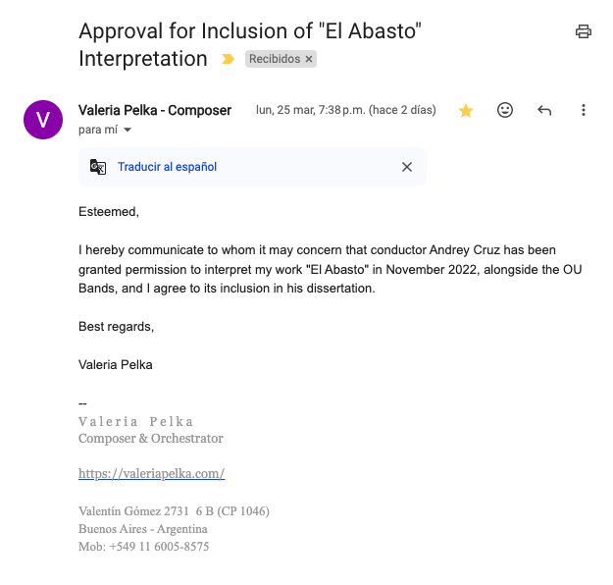
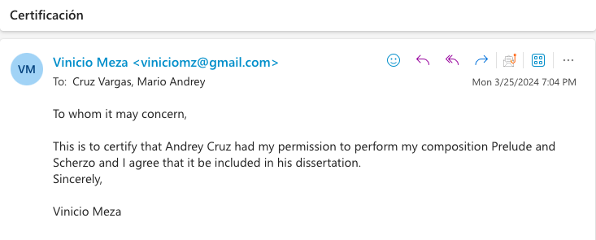

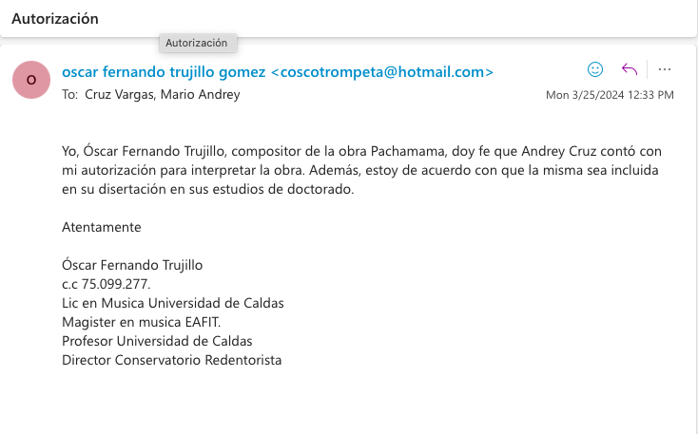


Any member of the peoples living in North or South America before the Europeans arrived. “Amerindian - Definition, Meaning & Synonyms,” Vocabulary.com, accessed March 22, 2024, https://www.vocabulary.com/dictionary/Amerindian.
US Census Bureau, “Las Estadísticas Del Censo Del 2020 Resaltan Los Cambios de Las Poblaciones Locales y La Diversidad Racial y Étnica de Nuestro País,” Census.gov, August 17, 2021, https://www.census.gov/newsroom/press-releases/2021/population-changes-nations-diversity/population-changes-nations-diversity-spanish.html
Reynolds, Heather. “Repertoire is The Curriculum.” Music Educators Journal. SAGE Publishing, July 1, 2000. https://doi.org/10.2307/3399675.
Reynolds, “Repertoire is The Curriculum”. p. 3.
Ed Morales, introduction, in The Latin Beat: The Rhythms and Roots of Latin Music from Bossa Nova to Salsa and Beyond (Cambridge, MA: Da Capo Press, 2003), xi–xii.
“Mexican Repertoire Collection at Dartmouth,” n.d. https://rcweb.dartmouth.edu/~f001m9b/mexican_repertoire/.
Institute for Composer Diversity. “Wind Band Database — Institute for Composer Diversity,” n.d. https://www.composerdiversity.com/wind-band-database.
David Bushnell, “History of Latin America | Events & Facts,” in Encyclopædia Britannica, 2019, https://www.britannica.com/place/Latin-America.
“Dictionary.com | Meanings & Definitions of English Words,” Dictionary.com, accessed March 23, 2024, https://www.dictionary.com/browse/pan-american.
“Starting from the already established imaginary of inferiority that the indigenous and the mestizo had, their music was criticized for not having a theoretical foundation or body of scientific knowledge that legitimized them, increasing the indifference of popular society with regarding chords and harmonies of little relevance, which is why the use of manuals was established to interpret instruments and write music such as: the Diccionario de Música (1867) by Juan Crisóstomo Osorio; Escritura Musical (1869) and Arte de Leer, Escribir y Dictar Música (1885) by Diego Fallón, and Teoría Musical by Vicente Vargas de la Rosa, among others.” Sergio Daniel Arias Carrera, “‘Blanqueamiento Sonoro’, Occidentalización Del Bambuco En La Segunda Mitad Del XIX,” Artifi Cios. Revista Colombiana de Estudiantes de Historia No. 15, no. 2422-118X (January 2020): 103–16.
In societies with a monarchical regime, a person who lacks any title of nobility. adj. That is rude, ignoble or vulgar. “Diccionario del Español de México,” dem.colmex.mx, accessed March 23, 2024, https://dem.colmex.mx/ver/plebeyo.
Mazatlán, city and port, southwestern Sinaloa estado (state), western north-central Mexico. It lies just south of the Gulf of California and directly east of the southern tip of the Baja California peninsula. The Editors of Encyclopaedia Britannica, “Mazatlán | Mexico | Britannica,” in Encyclopædia Britannica, 2019, https://www.britannica.com/place/Mazatlan.
Zarzuela, form of Spanish or Spanish-derived musical theater in which the dramatic action is carried through an alternating combination of song and speech. Henry MacCarthy, “Zarzuela | Spanish Musical Play,” Encyclopedia Britannica, accessed March 23, 2024, https://www.britannica.com/art/zarzuela.
The Bourbon Reforms in Mexico were a series of administrative, economic, and social changes implemented by the Spanish Bourbon monarchy in the viceroyalty of New Spain during the 18th century. These reforms included administrative reorganization, economic modernization, fiscal control, and the strengthening of royal power. Luis Jáuregui, “Nueva Historia Mínima de México,” El Colegio de México, 2020, https://www.nhmdemexico.colmex.mx/cap-3.php.
Popular music, any commercially oriented music principally intended to be received and appreciated by a wide audience, generally in literate, technologically advanced societies dominated by urban culture. The Editors of Encyclopedia Britannica, “Popular Music,” in Encyclopædia Britannica, February 25, 2019, https://www.britannica.com/art/popular-music.
Stuart J. Fiedel, Prehistory of the Americas (Cambridge: Cambridge Univ. Press, 1997).
Von Hornbostel, Erich Moritz, and Curt Sachs. Classification of Musical Instruments, 1914.
“Western Music | Britannica,” www.britannica.com, accessed April 16, 2022, https://www.britannica.com/art/Western-music
Claudio Annibaldi, “Towards a Theory of Musical Patronage in the Renaissance and Baroque: The Perspective from Anthropology and Semiotics,” Recercare 10 (1998): 173–82, http://www.jstor.org/stable/41692744. p. 179.
“Castile | Region, Spain | Britannica,” in Encyclopædia Britannica, 2020, https://www.britannica.com/place/Castile-region-Spain.
Martha Lucía Barriga Monroy, “La Educación Musical Durante La Colonia En Los Virreinatos de Nueva Granada, Nueva España Y Río de La Plata,” El Artista No. 3, no. 1794-8614 (November 3, 2006): 6–23, p. 11.
Bernal Díaz del Castillo, Historia Verdadera de La Conquista de La Nueva España, ed. Miguel León-Portilla, ePub base r1.2 (1632; repr., Epulibre, 2016).
Díaz del Castillo, p. 25.
Díaz del Castillo, p. 1029.
Díaz del Castillo, p. 1040.
Díaz del Castillo, p. 411.
Herranz Begoña Lolo and Adela Presas, “Cervantes Y El Quijote En La Música Pasado Y Presente,” Comentarios a Cervantes: Actas Selectas Del VIII Congreso Internacional de La Asociación de Cervantistas, Oviedo, 2012, 153–66.
Colección de Documentos Inéditos Relativos al Descubrimiento, Conquista Y Colonización de Las Posesiones Españolas En América y Oceanía, Sacados, En Su Mayor Parte Del Real Archivo de Indias (Madrid: Establecimiento Tipográfico Sucesores de Rivadeneyra, 1867), 385–434, https://www.cervantesvirtual.com/obra/coleccion-de-documentos-ineditos-relativos-al-descubrimiento-conquista-y-organizacion-de-las-antiguas-posesiones-espanolas-de-ultramar-tomo-num-11-relaciones-de-yucatan-i-0/
Pedraza, p. 413.
Bartolomé de las Casas, Apologética Historia Sumaria (Universidad Nacional Autónoma de México, 1967). p. 327.
Idem.
Clara Bejarano Pellicer, “Juventud y Formación de los Ministriles de Sevilla entre los Siglos XVI y XVII,” Revista de Musicología 36, no. 1/2 (January 1, 2013): 57–57, https://doi.org/10.2307/24245717.
The Editors of Encyclopaedia Britannica, “Minstrel | Definition, History, & Facts,” Encyclopedia Britannica, accessed March 21, 2024, https://www.britannica.com/art/minstrel.
Egberto Bermudez, “‘The Ministriles Tradition in Latin America: Part One, South America, 1. The Cases of Santafé (Colombia) and La Plata (Bolivia),’” Journal of the Historical Brass Society, 1999, pp. 149-162.
Egberto Bermúdez, p 149.
Egberto Bermúdez, p 150.
Idem.
Egberto Bermúdez, p 151
Idem.
Victoriano Valencia, “Bandas de Música En Colombia: La Creación Musical En La Perspectiva Educativa,” A Contratiempo: Revista de Música En La Cultura 16, no. 16 (January 1, 2010): 3, p. 11.
Joaquín Posada Gutiérrez, Memorias Histórico-Políticas Del Joaquín Posada Gutiérrez, Google Books (Imprenta a Cargo de Foción Mantilla, 1865), https://books.google.co.ve/books?id=T-gtAAAAYAAJ&printsec=frontcover#v=onepage&q&f=false.
Victoriano Valencia, p. 11.
Idem.
Victoriano Valencia, p. 18.
Idem.
Fernández Calvo, Diana, “[PDF] La Música Militar en la Argentina Durante la Primera Mitad del Siglo XIX - Free Download PDF,” silo. tips, 2017, https://silo.tips/download/la-musica-militar-en-la-argentina-durante-la-primera-mitad-del-siglo-xix.
Diana Fernández Calvo, p.31.
Diana Fernández Calvo, p. 32.
The Battle of Tacuarí was the third and last battle of the Belgrano expedition in Paraguay. This battle marked the end of the expedition and the military defeat of Belgrano's forces. Federico Fretes, “Batalla de Tacuarí,” historiando.org, December 6, 2022, https://historiando.org/batalla-de-tacuari/.
Diana Fernández Calvo, p. 49.
Florencia Guzmán, “Bandas de Música de Libertos En El Ejército de San Martín. Una Exploración Sobre La Participación de Los Esclavizados Y Sus Descendientes Durante Las Guerras de Independencia,” Anuario de La Escuela de Historia Virtual No.7 (2015): 18–36.
Ministerio de Defensa, “La Guerra de La Independencia (1810-1824),” Argentina.gob.ar, September 4, 2020, https://www.argentina.gob.ar/armada/nueva-historia-naval/independencia-1810#:~:text=La%20Guerra%20de%20la%20Independencia.
Florencia Guzmán, p. 25.
Florencia Guzmán, p. 33.
Florencia Guzmán, p. 18.
Florencia Guzmán, p. 19.
A person of mixed white and Black ancestry. Jeff Wallenfeldt, “Mulatto | People | Britannica,” www.britannica.com, n.d., https://www.britannica.com/topic/mulatto-people.
José Zapiola, Recuerdos de Treinta Años (1810-1840) (Biblioteca Virtual Universal, 1945). P. 43.
Florencia Guzmán, p. 35.
Rafael A. Ruiz, “Música Y Banda Militar de Música Desde La Gran Década Nacional Hasta El Fin Del Porfiriato,” Cuicuilco 23, no. 66 (2016): 95–105, https://www.redalyc.org/articulo.oa?id=35145982006.
Rafael A. Ruiz, p. 96.
Porfiriato: the period of Porfirio Díaz’s presidency of Mexico (1876–80; 1884–1911). The Editors of Encyclopaedia Britannica, “Porfiriato | History, Facts, & Mexican Revolution,” in Encyclopædia Britannica, 2019, https://www.britannica.com/topic/Porfiriato.
Rafael A. Ruiz, p. 100.
Secretaría de la Defensa Nacional, “La Guerra de Reforma.,” gob.mx, 2015, https://www.gob.mx/sedena/documentos/la-guerra-de-reforma.
Rafael A. Ruiz, p. 97.
In 1862, French Emperor Napoleon III maneuvered to establish a French client state in Mexico, and eventually installed Maximilian of Habsburg, Archduke of Austria, as Emperor of Mexico. “Milestones: 1861–1865 - Office of the Historian,” history.state.gov, n.d., https://history.state.gov/milestones/1861-1865/french-intervention#:~:text=In%201863%2C%20Napoleon%20III%20invited.
Rafael A. Ruiz, p. 97.
The modern history of Mexico begins with the liberal victory of 1867. Juarez immediately set about making economic, political, and educational reforms. “Restored Republic 1867-76 MexicanHistory.org Mexican History from Ancient Times to Today,” mexicanhistory.org, accessed November 30, 2023, https://mexicanhistory.org/RestoredRepublic.htm.
A newspaper of liberal ideology founded by Vicente García Torres, in 1844, in Mexico City. “El Monitor Republicano · Hemeroteca Digital UANL,” hemerotecadigital.uanl.mx, accessed February 23, 2024, https://hemerotecadigital.uanl.mx/collections/show/57.
Rafael A. Ruiz, p. 97.
Rafael A. Ruiz, p. 98.
María Clara Vargas Cullell, De Las Fanfarrias a Las Salas de Conciertos: Música En Costa Rica (1840-1940), 1st ed. (San José, Costa Rica: Editorial de la Universidad de Costa Rica, 2004).
Vargas Cullell, p. 33.
Vargas Cullell, p. 34.
Vargas Cullell, p. 135.
Idem.
Mauricio Araya Quesada, “La Banda Militar de Alajuela Y Su Papel Como Defensora de La Música Nacional Entre 1938-1946. Análisis de Las Bitácoras de Trabajo,” Revista Herencia 30, no. 1 (July 21, 2017), p. 156. https://revistas.ucr.ac.cr/index.php/herencia/article/view/29921/29931.
Araya Quesada, p. 176
Araya Quesada, p. 168
Araya Quesada, p. 170.
US Census Bureau, “Las Estadísticas Del Censo Del 2020 Resaltan Los Cambios de Las Poblaciones Locales y La Diversidad Racial y Étnica de Nuestro País,” Census.gov, August 17, 2021, https://www.census.gov/newsroom/press-releases/2021/population-changes-nations-diversity/population-changes-nations-diversity-spanish.html
Freire, Paulo, 1921-. Pedagogy of the Oppressed. Translated by Myra Bergman Ramos. Introduction by Donaldo Macedo. 30th anniversary ed. New York: Continuum, 2005, p. 44.
Freire, Paulo, 1921-. Pedagogy of the Oppressed, p. 44.
James Theophilus Appavoo, Folklore for Change, Google Books, vol. Volumen1 of Culture and Communication Series (T.T.S. Publications, Tamil Nadu Theological Seminary, Madurai, 1986),
James Theophilus Appavoo, p. 11.
Aguilar, Lourdes: The Importance of Traditional Latin American Music in the Urban School Music Program (Thesis, 2016), p. 14. https://scholarworks.calstate.edu/downloads/d791sk330.
Aguilar, p. 9.
Aguilar, p. 10.
Woody, Robert H. "Popular Music in School: Remixing the Issues." Music Educators Journal 93, no. 4 (2007): 33.
Woody, p. 34.
Woody, p. 35.
Woody, p. 36.
National Association of Schools of Music, https://nasm.arts-accredit.org/
Sands, Rosita M. 1996. “What Prospective Music Teachers Need to Know about Black Music.” Black Music Research Journal 16 (2): 225–38. https://doi.org/10.2307/779329
Sands, p. 230.
Sands, p. 233.
Peter Crossley-Holland, “Rhythm | Definition, Time, & Meter,” in Encyclopædia Britannica, August 31, 2017, https://www.britannica.com/art/rhythm-music.
John M. Chernoff, “The Rhythmic Medium in African Music,” New Literary History 22, no. 4 (1991): 1093, https://doi.org/10.2307/469080. P. 1096. --See if you can find his book African Rhythms and African sensibilities
“The transition from being an African—or a European—to being a Caribbean is a key process in the formation of Caribbean culture and music, embodied in the term “creolization,” which connotes the development of a distinctive new culture out of the prolonged encounter of two or more other cultures.” Peter Manuel and Michael D Largey, Caribbean Currents: Caribbean Music from Rumba to Reggae (Philadelphia, Pennsylvania: Temple University Press, 2016). p. 16.
https://www.youtube.com/watch?v=FlkfKlxVu_c
In music, BPM stands for beats per minute. “What Does BPM Mean in Music? | the Online Metronome,” theonlinemetronome.com, accessed March 13, 2024, https://theonlinemetronome.com/blogs/13/what-does-bpm-mean.
Norberto Pablo Cirio, “La Historia Negra Del Tango,” Www.academia.edu, accessed February 23, 2024, https://www.academia.edu/37307415/La_historia_negra_del_tango.
Initially, candombe was the name given to the dances performed by black artists that incorporated African and European elements. Angel Romero, “The World of Afro-Uruguayan Candombe Music | World Music Central,” World Music Central, December 28, 2022, https://worldmusiccentral.org/2022/12/28/the-world-of-afro-uruguayan-candombe-music/.
Christine Denniston, The Meaning of Tango: The Story of the Argentinian Dance (London: Portico, 2015).
The milonga is a musical genre that is related to the tango. The origin of the word Milonga is African and means entanglement, mess, or problem. María Fernanda Florian, “Diferencias Entre Milonga Y Tango,” Jacaranda Centro Cultural, accessed February 23, 2024, http://blog.culturajacaranda.com/2016/02/diferencias-entre-milonga-y-tango.html.
National Geographic, “¿Cuáles Son Los Orígenes Del Tango?,” National Geographic en Español, August 9, 2018, https://www.ngenespanol.com/traveler/cuales-son-los-origenes-del-tango/.
Marcelo Solis, “History of Tango – Part 6: Orquesta Típica. It’s Origins.,” Argentine Tango School, March 6, 2016, https://escuelatangoba.com/marcelosolis/history-of-tango-part-6/.
https://www.youtube.com/watch?v=s7mkKp-sasc
Orquesta Sinfónica Nacional de Costa Rica, “XII Concierto de Temporada Virtual,” www.youtube.com, November 13, 2020, https://www.youtube.com/watch?v=BXc74iFFDk4&t=632s.
Romantic ballad is a slow tempo love song, usually performed by a solo singer usually accompanied by an orchestra. Daniel Party, “Transnacionalización Y La Balada Latinoamericana,” Segundo Congreso Chileno de Musicología. University of Pennsylvania (January 17, 2003).
Robert J. Griffin, “The Folk Music of Costa Rica: A Teaching Perspective,” Hispania 71, no. 2 (May 1988): p. 440. https://doi.org/10.2307/343094.
Juan José Carazo Bolaños, Las Cimarronas de Santo Domingo de Heredia, 2nd ed., 2021. P. 91.
Idem.
Ruth I. DeFord, “Tempo Relationships between Duple and Triple Time in the Sixteenth Century,” Early Music History 14 (October 1995), p. 1.
“A hemiola is a rhythmic device that involves superimposing 2 notes in the time of 3.” Ben Dunnett, “Hemiola,” Music Theory Academy, September 29, 2022, https://www.musictheoryacademy.com/understanding-music/hemiola/.
Estefanía Cano et al., “Sesquialtera in the Colombian Bambuco: Perception and Estimation of Beat and Meter – Extended Version,” Transactions of the International Society for Music Information Retrieval 4, no. 1 (December 8, 2021): 248, https://doi.org/10.5334/tismir.118.
https://www.youtube.com/watch?v=upN8oDyE2UA
Quechua was the language of the Inca Empire. Today it is the most spoken indigenous language in the Americas, with over 13 million speakers in the Andean republics of South America. Indiana University, “Quechua: Languages: Center for Latin American and Caribbean Studies: Indiana University Bloomington,” accessed March 19, 2024, https://clacs.indiana.edu/languages/quechua.html.
Juan Zapato, “‘La Salvaje Esperanza’, Gonzalo Arango,” Juan Zapato el último habitante en la Torre de Babel, June 27, 2013, https://latorredebabel.wordpress.com/2013/06/27/la-salvaje-esperanza-gonzalo-arango/.
Chocó is one of the thirty-two departments of Colombia, located in the northwest of the country, in the Colombian Pacific region. Gobernación del Chocó, “Información Departamento Del Chocó | Chocó,” choco.org, February 10, 2015, https://choco.org/informacion-departamento-del-choco/.
Octavio Marulanda, El Folclor de Colombia (Arteestudio editores, 1984), p. 279.
Laura Daniela Ardila Giraldo, “El Currulao Y El Abozao: Tradiciones Del Pacífico En Cambio Y Permanencia,” 2017, p. 6.
Octavio Marulanda, p. 297.
Idem.
https://www.youtube.com/watch?v=0vRF4hj5xKE
Evangelina Tapia Tovar, “Música E Identidad Latinoamericana: El Caso Del Bolero.,” XXVI Congreso de La Asociación Latinoamericana de Sociología. Asociación Latinoamericana de Sociología, Guadalajara., 2007, p. 1.
Snare Drum.
Organización de las Naciones Unidas para la Educación, la Ciencia y la Cultura (United Nations Educational, Scientific and Cultural Organization)
Omar Barrientos Nieto, “Bolero: Historia, Canciones Y Compositores Del Género Patrimonio de La Humanidad,” El País México, December 6, 2023, https://elpais.com/mexico/2023-12-05/bolero-historia-canciones-y-compositores-del-genero-patrimonio-de-la-humanidad.html.
Evangelina Tapia Tovar, “El Bolero Y La Cultura de La Vida Cotidiana,” FOLCLOR LITERARIO EN MÉXICO. El Colegio de Michoacán/ Universidad Autónoma de Aguascalientes. México (2003): p. 1.
Evangelina Tapia Tovar, p. 340.
Evangelina Tapia Tovar, p. 5.
Elvira Carrión Martín, “EL ORIGEN de LA ESCUELA BOLERA: NACIMIENTO DEL BOLERO,” Revista Danzaratte. No.12 (June 12, 2019): 30–44. P. 30.
Woody, p. 35.

