University of Oklahoma

Graduate College

OPTIMIZING A PEDESTRIAN LEVEL OF SERVICE ANALYSIS IN OKLAHOMA CITY, OKLAHOMA, USA

A thesis

submitted to the Graduate Faculty

in partial fulfillment of the requirements for the

Degree of

Master of Science

By

MONICA ROSE MUSTAIN
Norman, Oklahoma
2018

oPTIMIZING A PEDESTRIAN LEVEL OF SERVICE ANALYSIS IN OKLAHOMA CITY, OKLAHOMA, USA

A thesis approved for the
Department of Geography and Environmental Sustainability

By

______________________________
Dr. Rebecca Loraamm, Chair

______________________________
Dr. Nicholas Bauch

______________________________
Dr. Thomas Neeson

______________________________
[Prefix] [First and Last Name]

______________________________
[Prefix] [First and Last Name]

© Copyright by MONICA ROSE MUSTAIN 2018
All Rights Reserved.

Acknowledgements
First, I wish to thank my advisor Dr. Rebecca Loraamm who has been an incredible source of patience and guidance throughout my time at the University of Oklahoma. I would also like to thank my committee members Dr. Nicholas Bauch and Dr. Thomas Neeson for their advice on this thesis as well as in their courses Contemporary Geographic Thought and Spatial Statistics. Graduate school would have been much less enjoyable without my fellow DGES graduate students. I want to acknowledge my undergraduate advisor, Dr. Dave Malone who has encouraged and supported me since my freshman year at Illinois State University.
To my eye doctor, Dr. Lederer: thank you for your specialty optometric practice. Your lifelong work has been and continues to be invaluable to countless children and adults. I would not have had the opportunity to be academically successful without your insight and ability to diagnose and correct my vision problems.
Finally, I want to thank my Mom, Dad, and my sister, Julie. Thank you for lifelong love, encouragement, and for always believing in me. Here’s to many more years of adventures.

Table of Contents
Acknowledgements iv
Table of Contents v
List of Tables vii
List of Figures viii
Abstract ix
Chapter 1: Introduction 1
Chapter 2: Background 4
2.1 Motivations for Pedestrian Research in Oklahoma 5
2.2 Pedestrian Level of Service Analysis 8
2.2.1 Pedestrian Level of Service for Elementary School Students 9
2.2.2 Motivation for Selecting a Student Network 15
2.3 Spatial Optimization 16
Chapter 3: Methods 19
3.1 Study Area 19
3.2 Level of Service Analysis 20
3.3 Maximum Coverage Location Problem 24
Chapter 4: Results 29
4.1 Level of Service Analysis 29
4.2 Maximum Coverage Location Problem 32
Chapter 5: Discussion and Conclusion 37
5.1 Benefits to Using an Optimization Approach 37
5.2 Suggestions for Oklahoma City and Putnam City School District 38
5.2.1 Sidewalk Availability 38
5.2.2 Schools Requiring Attention 38
5.2.3 Discussions with Parents 39
5.3 Limitations and Future Work 39
5.3.1 Factors Besides the Pedestrian Network 39
5.3.2 Data Collection 40
5.3.3 Population 40
5.3.4 Incomplete Pedestrian Network 41
5.3.5 Lack of Configuration 41
5.3.7 Pedestrian Directionality 42
References 43

List of Tables
Table 1 31
Table 2 35
Table 3. 36

List of Figures
Figure 1. 19
Figure 2. 20
Figure 3.. 22
Figure 4. 26
Figure 5. 29
Figure 6.. 30
Figure 7. 33
Figure 8. 34

Abstract
Urban areas across the United States have seen an increase in transportation methods beyond the private automobile. Cities such as Minneapolis, Denver, and Charlotte have added or expanded light rail transit, bike lanes, and pedestrian infrastructure to increase the accessibility to alternate transportation methods. This research aims to conduct a level of service analysis to determine the condition of a pedestrian network in Oklahoma City, OK. In the context of transportation planning, level of service (LOS) analyses are a way to describe how well a transportation facility accommodates the users of that transportation network. A pedestrian LOS analysis has been completed for elementary school children traveling to and from school in the Putnam City School District, a predominantly suburban area of Oklahoma City, OK. Preliminary LOS results indicate the locations of moderate to poor pedestrian facilities in a majority of the locations where students have the potential to walk to school. Future studies can use the results of this pedestrian LOS analysis to site high impact locations for pedestrian network improvements.

Chapter 1: Introduction
In recent years, suburban municipalities in the United States have seen an increase in projects which add alternate transportation options to neighborhoods. Improvements to public transportation infrastructure are often more difficult to implement, or are less likely to be completed in suburban areas due to low population density and decentralized origins and destinations (Randall and Baetz, 2001; Warren, 2016). This forces suburban municipalities to focus pedestrian or cycling network improvements towards servicing shorter, local trips (Warren, 2016).
In the suburban context, a variety of factors affect the placement and type of improvements to pedestrian or cycling networks. First, the location of improvements is dependent on the condition of the current network infrastructure. Some suburban pedestrian networks may exhibit consistent sidewalk coverage and therefore may need only strategic placement of crossing structures at busy intersections as an improvement in user safety. Other networks may have limited sidewalk availability; primary improvements in this case would include the addition of sidewalks along underserved road segments.
Another consideration surrounding location for network improvements is the purpose of the network itself (Keeling, 2009). For example, different improvement locations would be selected based on respective network characteristics; where one network’s objective may be to allow students to walk to school, another may seek to allow a majority of suburban residents to converge at a particular destination. Decisions for the location of improvements are further complicated by limited budgets. The type of improvement and location of improvement should be carefully selected based on existing network conditions and the network objectives to ensure the best use of available funding (National Academies Press, 2010).
The planning and policy decisions associated with updates to pedestrian transportation networks are complex and represent tradeoffs among a variety of competing criteria. This complexity combined with the spatial aspect of locating transportation network improvements often lends itself to the application of a spatial optimization approach.
Spatial optimization problems are formulated such that the value of an objective function may be optimized under known constraints, given a set of candidate locations for improvement and a set of locations representing the demand for a particular service across the network (Tong and Murray, 2012). The information returned by these methods often includes a selection of the candidate locations which best optimize the value of the objective function, affording decision makers valuable insight for effective network improvements planning.
For optimization problems dealing with pedestrian infrastructure improvements, the objective is often to maximize pedestrians access and use of the network (Tong and Murray, 2012). Results may include decisions on the optimal locations for improvement; the problem constrains and demand locations are conceptualized as factors describing current conditions of the pedestrian network (Church and Cova, 2000). It is important to select an appropriate optimization problem for the stated objective, and the parameterization of the selected optimization problem has a fundamental effect on the result. Here, proper transition of network conditions to model inputs or constrains is particularly important. These quantitative understandings of the service conditions on the network must closely reflect reality (Tong and Murray, 2012). If an inappropriate optimization model or inaccurate input data is used, the output will not suggest optimal, or even effective improvement locations.
The first component of this research involves a quantitative assessment, through application of a pedestrian level of service analysis, of the current service conditions of pedestrian networks for the Putnam City School District, Oklahoma City, OK. This assessment is completed for children living less than one mile from their elementary school as pedestrian service consumers. The second component of this research applies spatial optimization techniques to determine optimal locations for infrastructure improvements in context with the level of service analysis results. The selected improvement locations represent the optimal set increasing pedestrian safety and network service for children walking to and from school in the Putnam City School District. With improved safety for students traveling to and from school, in tandem with active promotion of walking and biking to schools, the suggested improvements could help increase the number of children safely utilizing the network.

Chapter 2: Background
The passenger automobile represents the primary mode of transportation in the United States (U.S. Department of State Publications). In the United States, 95 percent of households own at least one passenger automobile and 85 percent of Americans commute to work using these vehicles (U.S. Department of State Publications). While use of alternate transportation such as public transportation, cycling, and walking is increasing (Davis et al., 2007; Dill and Carr, 2003; Boarnet et al., 2005) the majority of trips are completed using the private vehicles. Environmental impacts associated with private vehicles include increased air pollution, higher incidence of acid rain, higher energy demand, and runoff of pollutants from vehicles (Davis et al., 2007; Johnson, 2001; Lowe, 1990). The environmental effects associated with passenger vehicles are expected to increase with the growth of urban and suburban populations (Warren, 2016). In addition, frequent road congestion delays present in several areas across the country; congestion in these contexts may increase trip duration even if the origin and destination are in close proximity (Warren, 2016). Contrasting with the negative consequences of private automobile overuse, there are increased health benefits to those who walk or bike as a transportation alternative (Handy et al., 2002; Humpel et al., 2002) and an improved quality of life (Frank, 2000; Jaskiewicz, 2000).
Despite the dependence of the United States on the private automobile, several cities in the United States have invested in alternate transportation networks to facilitate the use of public transportation, walking, and cycling mode choices (e.g., Gallagher, 2013; Greater Oklahoma City Chamber of Commerce, 2013; Staunton et al., 2003; Warren, 2016). Many of these improvements have been met with success. Charlotte, North Carolina, and the San Francisco Bay Area in California have added light rail systems and have experienced associated increases in housing prices along high use light rail routes (Cervero, 2006). A non-profit organization in Minneapolis has introduced a public bike share program resulting in rising numbers of bike share trips; from 101,825 trips in 2010, to over 460,000 trips in 2017 (Nice Ride Minnesota).
Most reported major successes in alternate transportation occur in urban locations where there is a higher population density and centralized downtown destinations (Schneider et al., 2001). Fewer studies look at how suburban areas outside of downtown districts are improving alternate transportation facilities or the effects of such improvements. The most useful improvements in suburban neighborhoods are often targeted at the local, neighborhood trips of pedestrians and cyclists (Warren, 2016). This research explores how to assess the condition of infrastructure in a pedestrian network and use location modeling to determine optimal locations for improvements. The pedestrian network selected for this research services a school district in western Oklahoma City.

2.1 Motivations for Pedestrian Research in Oklahoma
In 1993, the Metropolitan Area Projects (MAPS) initiative was passed with the intent to increase quality of life, create an appealing destination for visitors, create a sense of community, and attract more businesses – especially young entrepreneurs – in Oklahoma City (Oklahoma Chamber of Commerce, 1993). Funding from MAPS would be used for the development and renovation of sports, recreation, entertainment, cultural, and convention center projects as well as for the provision of proper infrastructure for pedestrians traveling within the Oklahoma City central business district (Welcome to Bricktown Nonprofit).
After the original Oklahoma City MAPS initiative in 1993, two more MAPS initiatives projects have been executed. In November 2001, MAPS for Kids was passed, providing $714 million for schools throughout Oklahoma City (Bryan, 2009). The funds would be used for transportation improvement projects, as well as school technology and infrastructure upgrades. A follow up project, MAPS 3 was established in 2009 providing $777 million in funding to be used in support of an ongoing update to the Oklahoma City central business district (Bryan, 2009).
Another example of a pedestrian focused program supporting pedestrian infrastructure research is a federally funded initiative called Safe Routes to School (SR2S). The program website states guiding intent for the program is “to improve safety on walking and bicycling routes to school and to encourage children and families to travel between home and school using these modes.” (National Center for Safe Routes to School Website). This program provides funding for school districts across the country for programs which are intended to encourage children to walk or bike between home and school. Small, pilot programs funded under SR2S began in 1997 and national legislation for the program took effect in 2005 (National Center for Safe Routes to School). National legislation allocated $612 million towards the SR2S program from 2005 to 2009. During those 4 years, each state in the USA received at least $1 million per year in associated discretionary funding, provided the funding is used to support any activity, infrastructure improvement, or event whose purpose is to increase the safety or number of students biking or walking to and from school. As of September 2012, over $1.15 billion has been provided to states through the SR2S program. In July 2012, a bill entitled Moving Ahead for Progress in the 21st Century (MAP-21) was passed as a larger transportation project and under MAP-21, states could apply to receive SR2S funding in fiscal years 2013 and 2014.
Academic research on measuring the success of the SR2S program is ongoing (Staunton et al., 2003; Boarnet et al., 2005; McDonald and Aalborg, 2009; McDonald et al., 2013, Warren, 2016). Boarnet et al. (2005) found that more children walked to school when additional sidewalks and crossing structures were added near the school. In this case, as infrastructure improvements were completed, fliers were simultaneously sent out to parents outlining the health benefits of children who walk to school to raise awareness; illustrating the effectiveness of combined infrastructure improvement and public awareness activities. Warren (2016) described a SR2S program in Boulder, CO where schools saw increased numbers of walking and biking students when improvements of the pedestrian facilities were implemented near public schools and combined with encouragement from school administration for students to walk and bike.
Safe Routes to School catalogs success stories from most states in the US on its website. Additionally, project examples on the SR2S program website describe its effect in Oklahoma. Cleveland Elementary School in Oklahoma City and Henry Zarrow International Elementary School in Tulsa have created Walk to School days under SR2S. In the days approaching a Walk to School day event, these schools distributed fliers that providing the date of the event and an outline of health benefits for children who walk to school. Both events were successful: Cleveland Elementary had over 200 parents and students walk to school (the school has an enrollment of approximately 300) and Henry Zarrow reported 95% of the school’s families participated in the event (National Center for Safe Routes to School). These two events demonstrate that with proper advertisement, it is possible to encourage families to walk to school. However, these are only single day events. The ultimate goal of pedestrian service improvements is to foster habitual pedestrian or cycling transport for students living within a feasible distance to school.
The SR2S and the MAPS initiatives exemplify that a combined governmental and citizen interest is at work creating urban spaces and transportation networks that can be traversed by methods other than cars in Oklahoma City.

2.2 Pedestrian Level of Service Analysis
Measurement of existing pedestrian conditions is a central concern in the design and application of walkability improvements across the urban landscape. One of the ways to determine a measure of walkability for a given study area is to conduct a pedestrian level of service analysis (e.g., National Academies Press, 2010). A Level of Service analysis (LOS) is a classic method in transportation planning used to measure how well a transportation facility performs for a given travel mode choice, from the perspective of users on the facility (National Academies Press, 2010). LOS considers how the conditions of the built environment will impact users of a specific transportation mode, often providing a letter-grade result capturing service quality on the facility under study. Traditionally applied to the automobile mode, LOS is often used to capture the service level of facilities under current traffic patterns. This is done in efforts to perform needs assessment and to provide a probability of success for proposed transportation improvement projects. In practice, LOS analyses can be used to quantitatively justify the need to make infrastructure improvements to a transportation network. As needs surrounding pedestrian and cycling friendly cities continue to grow, LOS analyses are being applied in conjunction with bicycling and pedestrian studies including comprehensive and long range transportation plans (Buehler, 2014; Dixon, 1996).
LOS analyses will typically output a numeric value, which is correlated to an A through F ranking. Segments rated ‘A’ are the highest ranked segments and segments rated ‘F’ are the lowest, or least serving segments for users. This A-F ranking is traditionally used with LOS analyses to more easily communicate results with the public and other parties outside transportation planning disciplines.

2.2.1 Pedestrian Level of Service for Elementary School Students
Before being able to determine how to improve a transportation network, it is necessary to understand what factors influence the decisions and service experience of its users. This understanding is important in justifying improvements; proposed improvements must demonstrate contribution to some specific service goal. In the context of children walking to and from school, a measurable goal would be to increase the number of students who can and will safely walk to and from school. In order to make improvements that increase the number of students who can walk to and from school, the improvements should focus on addressing network factors directly affecting how students and parents use the network. In order to understand the network, research on the target population needs to be completed to identify and explore the factors and conditions important to the target populations’ transportation choices.
In order to quantitatively capture the current conditions of the selected pedestrian network, a pedestrian LOS is conducted on the study area. When selecting a LOS model, it is important that the model parameters reflect concerns associated with the target users of the pedestrian network. In this study, the target pedestrian populations are children traveling to and from school. Model parameters must therefore capture infrastructural factors affecting the mode choice of children (or the guardians who transport them) traveling to and from school.
Here, the concept of a mode choice encompasses the influences, reasoning and decision-making associated with a traveler’s choice of transportation mode. A comprehensive body of literature is available discussing the factors and attitudes determining if children residing within one mile of school will choose to walk to school (Ziviani et al., 2004; Boarnet et al., 2005; McDonald, 2007; McDonald, 2008; Huaguo et al., 2010; McDonald and Deakin, 2010; Napier et al., 2011). There are two general categories of factors determining if children will walk to school: urban form factors and non-urban form factors (McMillan, 2008). Urban form factors pertain to the built environment and include variables such as the presence of a sidewalk, travel time, connectivity of the network, safety of the route, and traffic volumes along the route. Non-urban form factors are perceptions about the built environment or factors completely unrelated to the built environment. Examples of non-urban form factors include perceptions of neighborhood and traffic safety, household transportation options, caregiver attitudes towards walking, social and cultural norms, and socio-demographic factors (McMillan, 2007; McMillan, 2008; Ziviani et al., 2004). Urban form and non-urban form factors have also been described as environmental factors and psychosocial factors (Ziviani et al., 2004) and trip characteristics and household factors (McDonald, 2007); for this research, categories discussed as factors considered in the Level of Service analysis will be referenced as either urban form or non-urban form factors.
For the purposes of this study, urban form, or factors of the built environment will be of primary consideration. There are lists of urban form factors that influence the decision for children to walk to school, but many of the factors overlap and are otherwise intertwined with each other in terms of measurable effect on service. Here, the distinct and quantifiable variables of distance, network infrastructure, and traffic will be outlined.
- Distance: The most prominent factor cited by parents deciding if a child will walk to school is distance (Martin and Carlson, 2005; Schlossberg et al., 2006; McDonald, 2007; McMillan, 2007). Parents also cite travel time as a significant factor as to the mode choice for their children, this effect is known to correlate with distance traveled (McDonald, 2007). Distance is also often a limiting factor because of its relationship with time. For example, if a trip to school takes too long for a particular pedestrian user, it will not matter how safe the available sidewalks are. In a study completed by Huaguo et al. (2010), when examining the percentages of children who walk based on their distance from school, they found that 30% of children who live less than ¼ mile from school walked, about 7% of children who lived between ¾ and 1 mile from school walked, but distances greater than one mile, less than 3% of children would walk as a mode choice. In a study conducted in Oregon, students who lived within one mile were far more likely to walk than those living further than one mile (Schlossberg et al., 2006).
- Network Infrastructure: The availability of a pedestrian network is an environmental factor parents or guardians cite when determining if a child will walk to school (McDonald, 2007; McMillan, 2007; Schlossberg et al., 2006). The availability of a pedestrian network includes the presence of a sidewalk and road crossing aids. Road crossing aids can range from the presence of a crossing guard, a traffic light, a crosswalk, or a combination of these and others. The importance of pedestrian infrastructure in terms of mode choice is shown to vary between studies. Schlossberg et al. (2006) found that only 13% of parents cited that lack of sidewalk was a reason for children not to walk, whereas Huaguo et al. (2010) found that 50% of parents felt sidewalk presence was a determinant for walking to scool. The differences between these two studies could be that Schlossberg et al. (2006) studied a place that had greater amounts of sidewalk than where the Huaguo et al. (2010) study was completed.
- Volume and Speed of Traffic: Another determining factor for mode choice for children traveling to school is the volume and speed of automotive traffic along the route to school (Martin and Carlson, 2005; Seraj et al., 2010). Parents believe that high traffic volumes traveling at high speeds are a danger to their children. Landis et al. (2001) found pedestrians feel less safe with greater speed and volume of traffic adjacent to the pedestrian space.
- Safety: Parents and guardians regularly cite safety as a concern for their children walking to school. However, when more in depth questions are asked, parents describe lack of sidewalks, dangerous intersection crossings, and traffic factors as characteristics indicating walking to school might be dangerous. In the literature, factors including sidewalk connectivity and traffic conditions are often lumped into separate urban form factor categories. Parents also express safety concerns outside the context of traffic safety. These safety concerns focus on the personal safety of children, with respect to crime and their exposure to strangers (Schlossberg et al., 2006). In this sense, presence of strangers is considered a non-urban form factor because it is not part of the built environment. Overlap in definitions and various interpretations of the safety concept exemplifies the ambiguity and complexity of factors determining if a child will walk to school.
Non-urban form factors, or household factors, are perceived or indirect factors influencing parents’ attitudes towards their child walking to school. Examples of non-urban form factors include parents preferring adult supervision of their walking children, fear of strangers, convenience of driving, weight of backpack or other instruments, availability of private vehicle, and child’s age (Schlossberg et al., 2006; Seraj et al., 2010). Surveys that have been sent out to parents and students addressing the deciding factors for the travel mode of students, consistently report that urban-form and non-urban form factors are considerations in deciding how a child will travel to school (Timperio et al., 2006). It is vital to consider non-urban form factors and urban form factors simultaneously in a level of service study. For example, if the parent finds it easier to drive their child to school on their way to work, the availability of a pedestrian network will not be a consideration when determining the mode of transportation for that student, as they will likely be driven to school by their parent. Often, when schools themselves add infrastructure to the pedestrian network, the school is engaged in conversations with parents about the benefits of children walking to school (Boarnet et al., 2005; McDonald et al., 2014). For example, the National Center for Safe Routes to School provides case studies outlining how funding was used in various school districts; in all of these examples schools were communicating with parents about the importance of walking and biking to school (National Center for Safe Routes to School). Non-urban form factors are important in understanding if a child will walk to school and will be discussed in conjunction with the infrastructure improvements to be recommended by this research.
Another factor contributing to the complexity of understanding parents’ attitudes towards children walking to school is the fact that parent responses change between groups of people. The west coast of the United States has higher rates of walking than other regions in the US, especially when compared to the southeast (Schlossberg et al., 2006). This could render otherwise identical child pedestrian programs more effective where applied on the west coast than in other parts of the country, due to an already positive, encouraging attitude toward walking as a mode of transportation. There are also studies that show differences in walking rates between races. However, Seraj et al. (2010) indicated this effect could be the result of covariance with socioeconomic factors associated with race. In addition, Hess et al. (1999) found that people under 18 and minorities were overrepresented as pedestrian network users in relation to the local residential population.

2.2.2 Motivation for Selecting a Student Network
Several factors suggest research is needed in the application of LOS and spatial optimization methodologies on pedestrian networks for children walking to school. These factors highlight the applicability of this approach by identifying potential benefits of more efficient network improvement. First, Zivini et al. (2004) found that children are more likely to walk to school if their parents walked to school. While this is a single study, it shows that walking habits learned as a child can carry over into adulthood. This is important because if a pedestrian network is improved such that greater numbers of current students will walk, it can be reasoned that later in their lives, these students will encourage their children to also walk to school.
Another reason for selecting a pedestrian network of elementary school students is the proximity of students to their schools. Often, elementary schools are smaller in size and located within the neighborhood in which the students reside. In the school district selected for this research, there are 18 elementary schools and 4 high schools. There will be a greater potential number of elementary school students who might walk to school versus high school students, because more elementary schools are present in the study area. Students are also required to be at school 9 months a year. This represents a different situation than a pedestrian electing to take a trip for leisure. This is a daily choice of mode and a trip that students and, often parents, are required to make. Arguably, the potential for a pedestrian network around a school will have a higher chance of being used than a pedestrian network designed for leisure.

2.3 Spatial Optimization
An optimization problem may be applied where there is a quantifiable objective that needs to be attained within a set of limitations. Within these limitations, a decision would need to express the ‘best’ choice, returning the desired outcome. Primary components of an optimization problem include an objective, constraining conditions, and decisions (e.g., Church and Cova, 2000). A classic example of a problem where optimization is applicable is the industrial pet food mixing problem. In this problem, pet food produced must achieve a certain guaranteed mix of nutritional content but must also be affordable to the customer base. Different ingredients are purchased by the pet food manufacturer at varying unit prices, and each ingredient provides a known amount of nutrition (protein, fat, carbohydrates, etc.) per unit given the target nutritional mix. The pet food manufacturer must then develop a product recipe having a certain percentage of each ingredient, where the ingredient mix guarantees the target nutritional content but also minimizes the cost of the food. The objective function in this case is cost of food, where the objective of the optimization problem is the minimization of the value of this function. Additionally, the problem must perform this optimization under a set of constraints, these would include limitations on the acceptable minimums and maximums of crude protein, fat etc. in the finished product. Once all of the objectives, constraints, and decision variables are established, the optimization problem will seek to produce a feasible, or optimal mix for pet food given the constraints of the problem.
In the case of a spatial optimization problem, locations are conceptualized as a set of integer decision variables; these capture the concept of selection or omission of a candidate facility site/location for improvement construction. In contrast to the pet food example above, where the result provided is based on a continuous mix of ingredients (any fraction of a unit of ingredient may be included in the optimal recipe) a spatial optimization problem must select a discrete set of locations for improvement as a result. This set of locations often represents the optimal subset of input location choices for the given spatial optimization problem. Construction of facilities at these locations would optimize the value of the objective function for the problem, for example, maximizing the amount of covered customers for delivery service warehouses.
In a geographic context, optimization techniques can be used to reach an objective dependent on or defined by spatial characteristics. The objective is typically set to maximize or minimize a function such as travel time, the availability of a commodity or service, or user accessibility of a service. The constraining conditions are modeled after the existing limitations that may influence the objective such as cost or distance. The decision returned by a spatial optimization problem is represented as a selection of possible locations for facility construction that best achieve the objective. An applied example for a spatial optimization problem might have the objective of siting a landfill to minimize the cost of waste collection but to also not disturb the local population. Conditions considered may include distance from the metropolitan area, limitations may include factors describing the underlying geology, and the probability of odor complaints in the metropolitan area; the decision returned represents a feasible site for the landfill. Another example of a spatial optimization problem may have the objective of siting fire stations such that that firemen can reach the maximum number of residents in a specified response time, but the problem may be constrained to placement of only two stations due to funding limitations. When running the fire station optimization problem, the configuration of fire stations would change if the applicable number of fire stations would decrease to one or increase to three. Spatial optimization problems are applied to a variety of problems including but not limited to retail geography, transportation geography, political geography, land use planning, etc. (Tong and Murray, 2012).

Chapter 3: Methods

3.1 Study Area
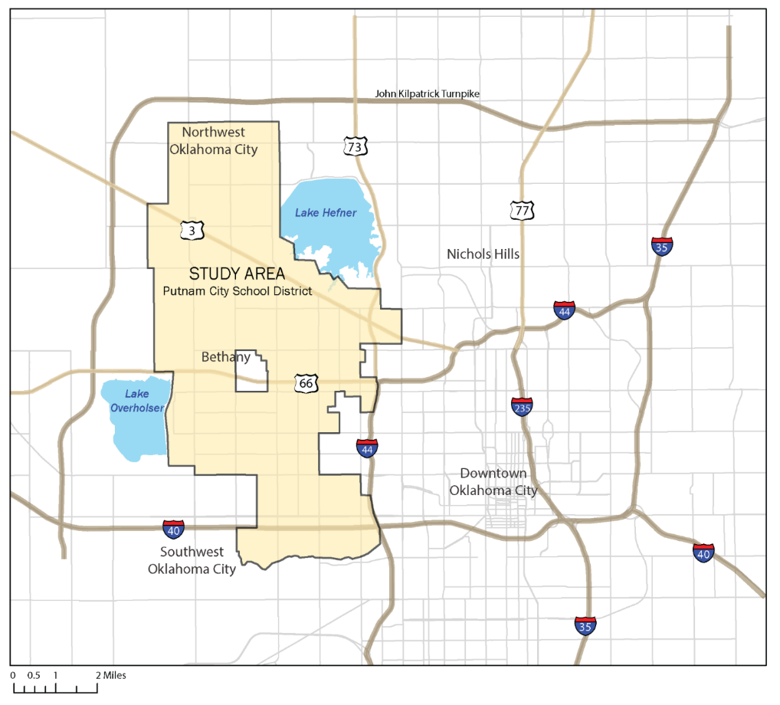
The study area is a pedestrian network serving 18 elementary schools in the Putnam City School District in western Oklahoma City (figure 1). This area is suburban consisting predominantly of single family homes and some multi-family units and apartment complexes. Non-residential land uses are typically comprised of strip malls or small parks. Upon visual inspection of aerial imagery at the study area, coverage of sidewalks or crosswalks in this school district are limited. This study area has been selected for its representative suburban characteristics (in comparison to urban) and has not been a target for any of Oklahoma City’s recent pedestrian network improvement projects.
Figure 1. Map showing the location of the Putnam City School District in Oklahoma City. The central business district is located in downtown Oklahoma City.
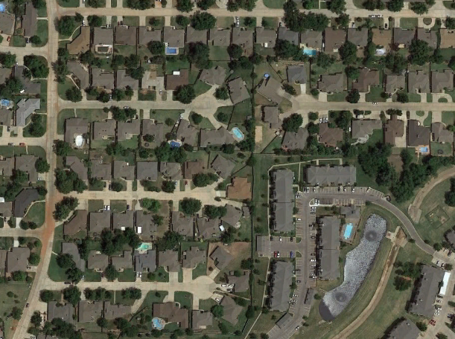
Figure 2. Screenshot from Google Earth as an example to show how the western portion of Oklahoma City is characterized as suburban. Characteristics include predominantly single family houses and small to medium apartment complexes.

3.2 Level of Service Analysis
The pedestrian LOS analysis was completed at the segment level for the study area. This LOS approach used in this research applies a segment-level analysis modeling how comfortable a pedestrian feels when walking along a road segment. The segment-level analysis adapted to this research was first developed and published by Landis et al. (2001). The authors developed this pedestrian LOS model by constructing a walking course and interviewing pedestrians to determine their comfort level while traversing each road segment in the course. Pedestrian responses were modeled using a linear regression approach associating pedestrian comfort responses along road segments with their corresponding segment characteristics. The model results identified major contributing factors determining the comfort of pedestrians along road segments. Figure 3 provides a schematic diagram showing several of the model parameters. The full model presented by Landis et al. (2001) is presented in equation 1:

$$PedLOS= \begin{aligned}-1.2021*ln\left(Wol+Wl+fp*\%OSP+fb*Wb+fsw*Ws\right) \\ + 0.253*\ln{(\frac{Vol15}{L}})+ 0.0005 SPD2+ 5.3876\end{aligned}$$
Where:
Wol = Width of outside lane (feet)
Wl = Width of shoulder or bike lane (feet)
fp = On-street parking effect coefficient (=0.20)
fb = Buffer area barrier coefficient (5.73 for trees spaced 20 feet on center)
Wb = Buffer width (distance between edge of pavement and sidewalk in feet)
fsw = Side walk presence coefficient (6 – 0.3Ws)
Ws = Width of sidewalk (feet)
Vol15 = Average traffic during a fifteen-minute period
L = Total number of lanes on road
SPD = Average running speed of motor vehicle traffic (mi/hr)

Equation 1: Level of service model published by Landis et al. (2001). All inputs are parameters that were found to influence how comfortable pedestrians feel as they travel along road segments.

The model appearing in Landis et al. (2001) will output a numeric result representing the comfort level of pedestrian users of a given road segment. The numeric model result is assigned an alphabetic A-F ranking with A corresponding to the highest quality of pedestrian service, and F being the lowest pedestrian service. This A-F type of conversion is traditionally used with LOS analyses as a means to more easily communicate results with the public. The LOS conversion from numeric to categorical ranking from Landis et al. (2001) is as follows:
Level of service | Numeric Value
A | ≤ 1.5
B | > 1.5 and ≤ 2.5
C | > 2.5 and ≤3.5
D | > 3.5 and ≤ 4.5
E | > 4.5 and ≤ 5.5
F | > 5.5

This LOS approach completed for this research was implemented in ESRI ArcMap using the TIGER Line data provided by the US Census Bureau. Each parameter of the LOS model was saved as an attribute to each road segment (U.S. Census Bureau). The final LOS value for each road segment was calculated from the relevant attributes present at each road segment.
Figure 3. Example diagram showing some of the factors used in the Landis et al., 2001 Pedestrian LOS model. Figure modified from Landis et al. (2001).

LOS variables including roadway width, number of lanes, width of buffer between road and sidewalk, presence and width of sidewalk, width of shoulder and bike lane, and speed limit were collected using Google Earth. Traffic volumes used in the LOS were provided by two sources. First, Average Annual Daily Traffic (AADT) counts for Oklahoma City were provided by the Oklahoma Department of Transportation (ODOT). These AADT values for the roads were divided by 94 to obtain an average 15-minute traffic volume for each segment as required by the Landis model. For segment locations which did not have exact AADT information, a report created by the Florida Department of Transportation (FDOT, 2012) provided AADT estimates based on road type. Personal communications with ODOT confirmed that the estimates from FDOT should be applicable to the Oklahoma City metropolitan area so the estimated AADT values from the FDOT report were used in the LOS reported in this research.
This pedestrian LOS was not completed at every location within the school district. Research indicates that parents typically would not let children walk or bike any distance greater than one mile (McDonald, 2007; Schlossberg et al., 2006) although parental attitudes on this distance vary (Schlossberg et al., 2006). Additionally, there is evidence that the closer children live to school the more likely they are to walk or bike (Huaguo et al., 2010). The pedestrian LOS analysis only evaluated roads within 1 mile of the school (based on network distance), and within the schools’ catchment area. Route analysis tools available in the ArcMap Network Analyst extension were used to determine the set of road segments falling within one mile of each school. The distance of each segment from the school was saved as an attribute to the segment to be used in segment weighting calculations associated with the MCLP application leveraged in this research.

3.3 Maximum Coverage Location Problem
The Maximum Coverage Location Problem (MCLP) is the spatial optimization model selected for this analysis (Church and ReVille, 1974). The MCLP is a Mixed Integer Linear Programming problem widely used in the location of service providers such as hospitals, fire stations, warehouses, and wildlife crossings. The objective of the MCLP is “the maximization of covered demand” where a continuous demand variable is assigned to demand nodes often representing the locations of consumers, or consumer demand for a particular service. A set of candidate facility sites are also considered by the model, representing possible build sites for service providers which satisfy demand. Additionally, each candidate facility site is assigned an effective range, referred to as a service radius. The MCLP is designed to select a best configuration of candidate facility sites such that covered demand is maximized, under a set of constraints including the service radii. The following formalisms for MCLP (Equation 2) appear in Daskin (1995):

INPUTS: | $h_{i}=$demand at location $i$
 | $p=$ number of facilities to locate
$$a_{ij}=1 if candidate facility j can cover demand at location i;$$
0 otherwise

MAXIMIZE: | $$\sum_{i}{h_{i}Z_{i}}$$ |  | (1)
SUBJECT TO: | $$\sum_{j}{a_{ij}X_{j}-}Z_{i}≥0$$ | $$∀i$$ | (2)
 | $$\sum_{j}{X_{j}=p}$$ |  | (3)
 | $$X_{j}=1 if facility j is selected;$$  $$0 otherwise$$ | $$∀j$$ | (4)
 | $Z_{i}=1$ if demand at node i is covered;  0 otherwise | $$∀i$$ | (5)
Equation 2. The objective function (Item 1) notes the goal, to maximize the sum of covered demand. Constraints (Item 2) require demand nodes are marked “covered” only if the model selects facilities having a service radius capable of covering the demand node. Constraint (Item 3) assigns the p number of facilities to locate, in other words, the model will return the p best facility locations. Binary integer constraints are specified for decision variables $X_{j}$ (Item 4) and $Z_{i}$ (Item 5). These restrict the returned values for site selection to “selected for” or “not selected”.

To represent the demand for the MCLP applied in this research, a weight value was calculated and assigned to each demand node in the pedestrian network. Demand nodes were placed at regular intervals of 50 feet along all segments to capture the service conditions at a fine spatial resolution. Candidate facility sites were also derived from identical 50 foot intervals, but carried no appreciable weight value. Each candidate facility is equal to all others in terms of intrinsic value to the optimization process. The inputs to the demand weight calculation are the numeric LOS score of the demand node’s host segment and the distance between the demand node and its nearest school location. The demand weight calculation is as follows:

$$Demand Weight=\left(\frac{Ped LOS}{4.5}\right)*(1-Distance from School)$$

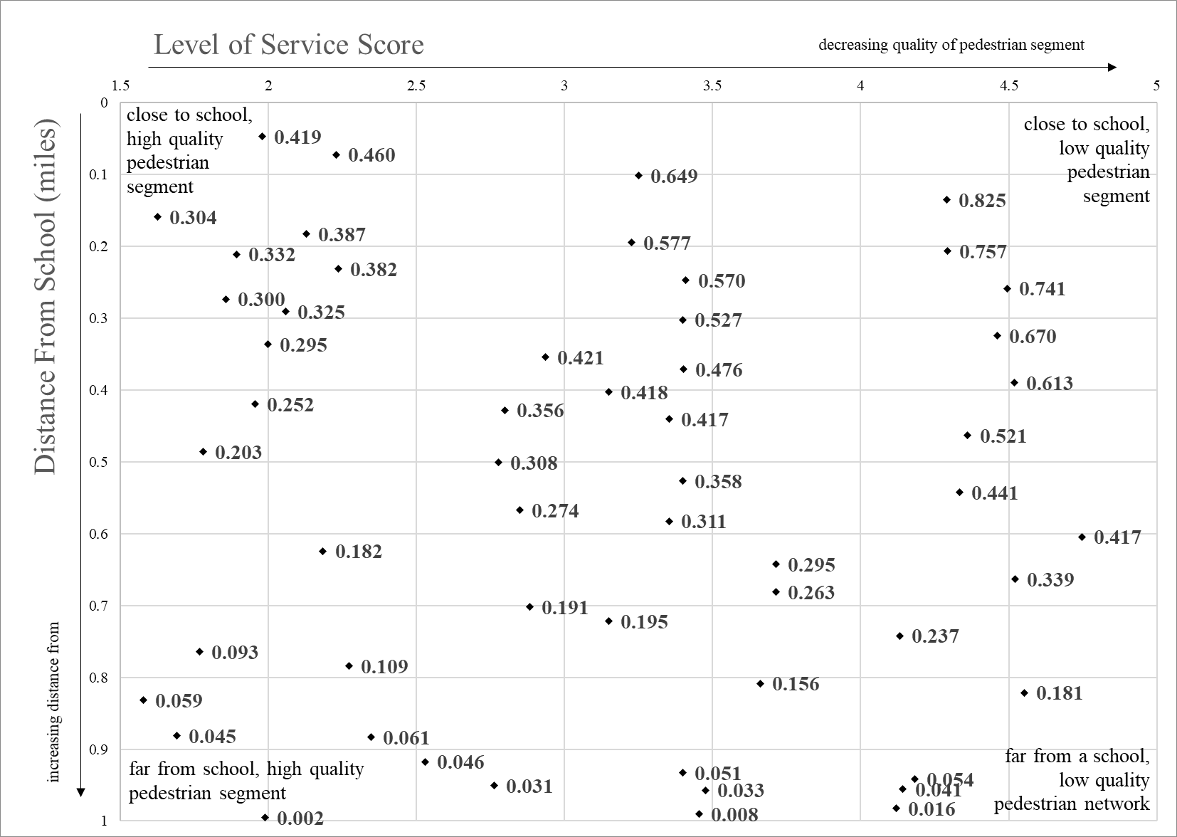
In this calculation, the final LOS score is divided by 4.5 as this was the lowest LOS score available in the study area, placing scores in a range of 0.22 – 1 (the highest rated street segment had a LOS of 1.2). The distance to nearest school for each demand node was originally calculated in feet then converted to miles. All distance calculations were based on network distances. Subtracting the demand node distance from schools from 1 renders locations closest to schools as higher-demand locations (these are considered
Figure 4. Graph plotting level of service score against distance from school; the point labels are the final segment weight. The highest weighted segments are in the top right corner where the location is close to the school and has a low level of service. The l lowest weighted segments are in the bottom left corner where the location is far away from the school and has a high level of service. Points plotted were selected by hand to illustrate the relationship between LOS score, distance from school, and final point weight.
more important in terms of the objective) and demand nodes further away from schools will be assigned lower demand values. The LOS results were normalized on a scale of 0 – 1 such that the LOS weight and the distance weight were combined as equal parts influencing the final demand value. Figure 4 shows a range of final weight values illustrating the relationship between demand node distance from school and the host segment LOS value.
The MCLP analysis presented here was implemented in ESRI ArcMap. Tools available in the Network Analyst extension (location-allocation analysis solver) provided a platform to specify the aforementioned MCLP model in software. The general user procedure involved specification of the analysis network (LOS Network Segments), demand and candidate facility node sets and input for effective range for facilities. Weighting for all candidate facility locations was set to 1, demand nodes received weight values based on their distance from schools combined with the LOS value of their host segment. For each model run, the user selects a value for the p number of desired facilities to be located during the analysis.
When running an MCLP analysis, the user must select the distance a facility will cover demand. To provide a range of planning scenarios, this research ran the MCLP uses facility impact/covering distances of 1000 feet, 1500 feet, and 2000 feet. These distances imply that if a segment of pedestrian network is updated, it will improve all other demand locations up to the specified impact distance. In addition to selecting the impact distance, the user must select how many facilities will be added. In this research the MCLP was run to select 1 through 20 improvement locations. Based on the specified facility impact distance and number of facilities to select, there will be a range of selected facility locations and geometries. For the MCLP applied to the pedestrian network the facilities are the locations of network improvement locations, the distance for covered demand is the length along the pedestrian network that is improved due to the single improvement location, and the number of facilities chosen is the number of network locations that plan to be improved. To provide for a range of planning scenarios, this research ran the MCLP using effective ranges for candidate facilities including 1000 feet, 1500 feet, and 2000 feet. For each effective distance value, scenarios locating p=1 through p=20 facilities were run, resulting in 60 distinct MCLP results sets available for planners to examine.

Chapter 4: Results
This results section is presented in two subsections. The first describes the results of the Pedestrian LOS analysis and discusses some of the data collected to calculate the LOS. The second section describes and explains the results of the MCLP approach.

4.1 Level of Service Analysis
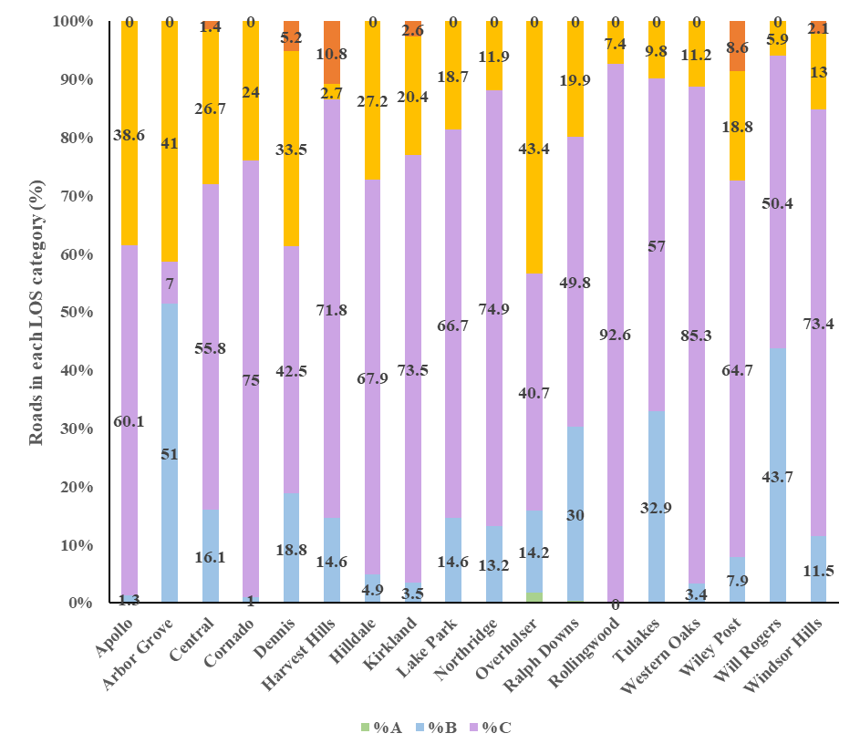
The pedestrian LOS results indicate a quantitative measure of the range of quality in pedestrian service along road segments. After categorization, results ranged from A, or high quality pedestrian serving segments, to E, or low quality pedestrian serving segments. The most common segment rating was a C, with school catchments
Figure 5. Chart showing the breakdown of LOS score by school.
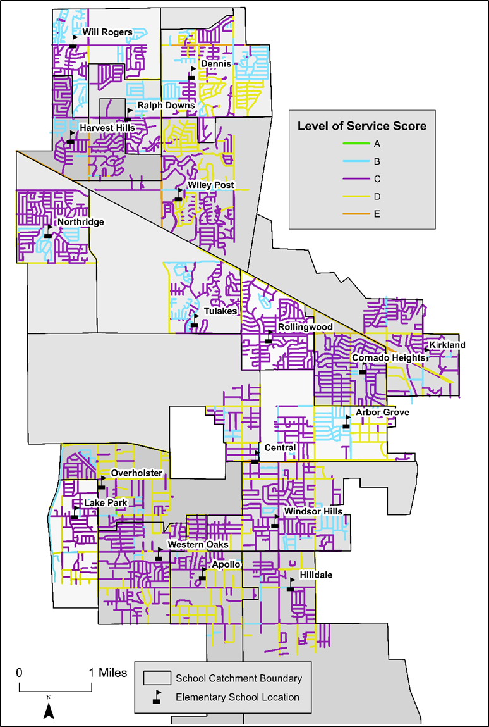
Figure 6. Map of Putnam City School District showing the locations of schools, the school catchment area, and the road segments within one network mile of each school, with the roads symbolized to their LOS score.
Table 1. Table showing the percentage of sidewalk on one or both sides of the road within the one-mile catchment area of each elementary school. The average percentage of roads with sidewalk is 21%, with a minimum of 3% and a maximum of 57%.
School Name | Percentage with Sidewalk
Cornado | 3%
Apollo | 8%
Rollingwood | 8%
Wiley Post | 10%
Kirkland | 10%
Western Oaks | 13%
Hilldale | 14%
Overholser | 16%
Windsor Hills | 17%
Northridge | 18%
Lake Park | 18%
Central | 19%
Harvest Hills | 22%
Dennis | 23%
Tulakes | 33%
Ralph Downs | 39%
Arbor Grove | 51%
Will Rogers | 57%

having an average of 62% of their segments rated at a C. Only two schools had ‘A’ rated segments in their catchment areas: Overholser and Ralph Downs had 0.3% and 1.7%, respectively. Six schools had segments rated ‘E’ in their catchments. Of those schools with an ‘E’ rated segment, the highest percentage of ‘E’ segments is 11% and the average percentage 5%. Figure 5 shows the percentages of road segment ratings by school catchment. Figure 6 shows the location and LOS score of each road segment in the study area. No schools had segments rated ‘F’, which is the lowest pedestrian service value according to the model developed in Landis et al. (2001).
One of the inputs to the pedestrian LOS is the presence of a sidewalk on at least one side of the road. This presence of a sidewalk parameter within the LOS model has the greatest effect on the model output score, and is therefore an important factor when determining pedestrian level of service along road segments. The percentage of streets with sidewalk on one or more sides of the road is shown in table 1. On average, 21% of roads had sidewalk on one or more sides of the road. The maximum percentage of roads with sidewalks among school catchment areas is Will Rogers with 57% of the roads having sidewalk. The catchment with the smallest percentage of roads having sidewalks is Coronado with 3%.

4.2 Maximum Coverage Location Problem
There were 60 individual scenarios evaluated using the MCLP. Each MCLP run requires a user defined p number of facilities to locate and the specification of an effective distance for facilities. The effective distances (service radii) used included 1000, 1500, and 2000 feet. Each distance class was evaluated for p=1 through p=20. Facilities selected; this created a total of 60 planning scenario results.
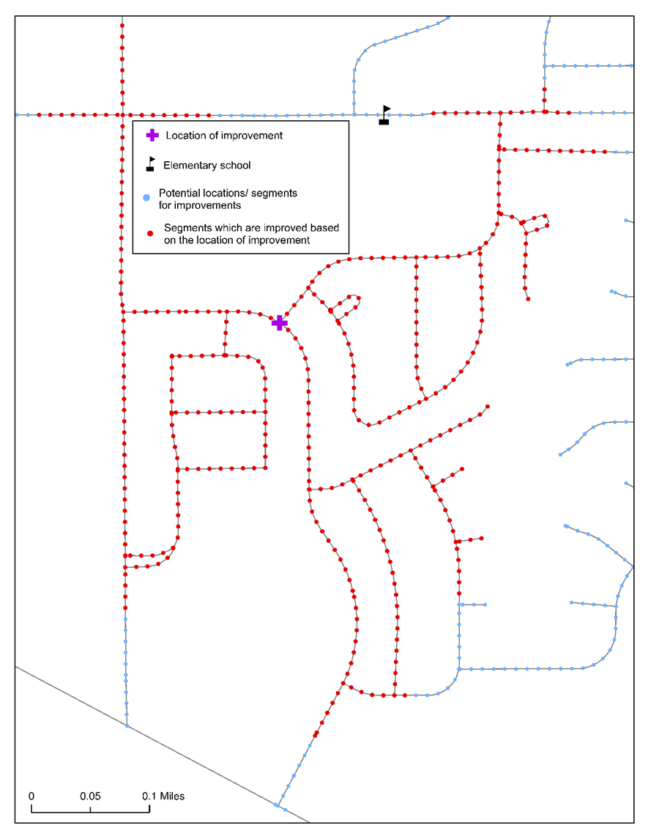
Figure 7 shows an example selected location for improvement in a scenario where the impact distance is 2000 feet and 13 improvement locations were selected. The purple cross denotes the location selected for improvement and the pink dots represent segments that would benefit from the improvement, should the improved facility be constructed.
Figure 7. Map showing an example output of an improvement location (purple cross). All dots are potential locations for improvement as well as demand; the red dots represent all locations that the MCLP assumes will be covered if the location with the purple cross is improved.

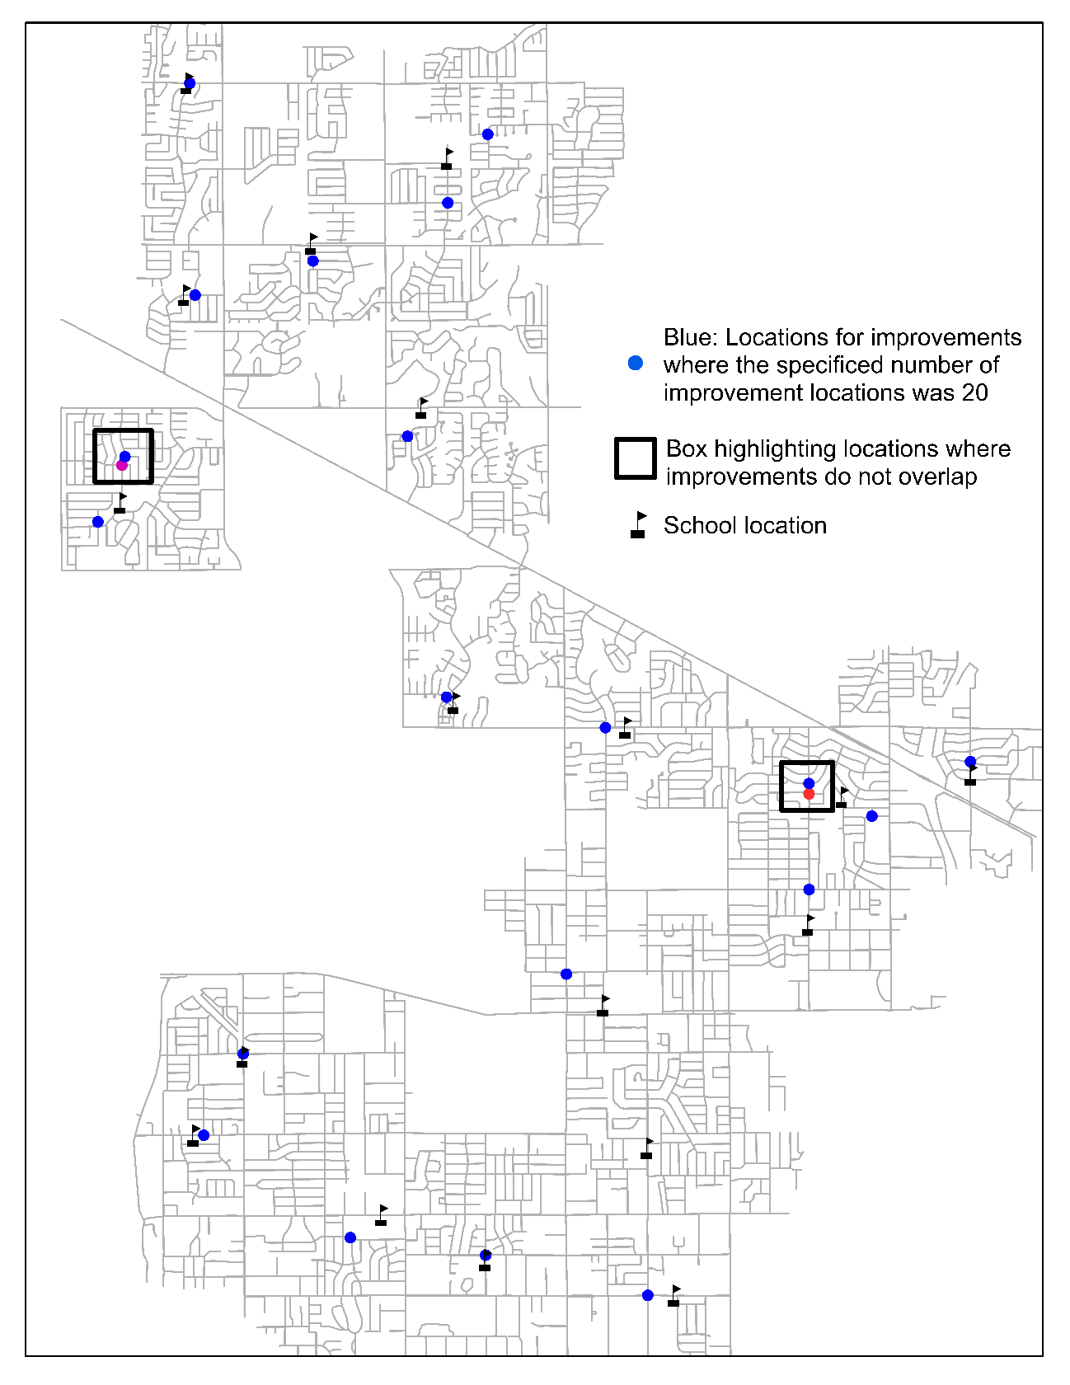
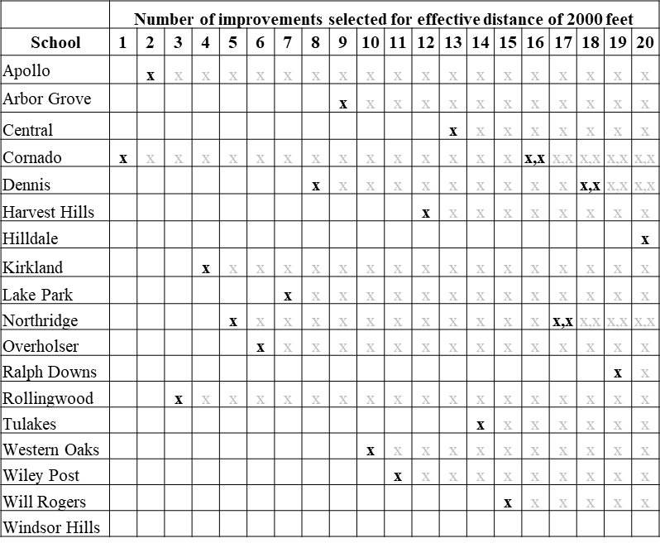
Often in spatial optimization and location modeling, as the number of facilities selected increases (in this case locations for pedestrian infrastructure improvements) the configuration of facilities change (Tong and Murray, 2012). Except for adding a point in each consecutive trial, the location and configuration of points 1 through 20 did not fundamentally change. As facilities were added, the configuration of all prior facilities was generally maintained. Figure 8 is a map showing all selected improvement locations for impact distance of 2000 feet. In this map, most of the points are blue which represent the selected locations when the MCLP solved for 20 improvement locations. All improvement locations from all other trials were also plotted on this map, but most cannot be seen because they are co-located with the 20 improvement locations shown here. There are only two other points (not in blue) which do not overlap the selection. The configuration of facilities selected in scenarios series with impact
Figure 8. Map showing all 20 trials for an effective distance of 2000 feet. There are only two locations where the trials do not overlap. This indicates that there is little to no change in location improvement configuration at this impact distance with 20 improvements.
Table 2. This table shows the order in which each school was selected to have an improvement location within its catchment area. For example, when the effective improvement distance was 1000 feet and set to only select one location for improvement, the improvement was in Kirkland. When the number of selections was increased to two, the second location was in the Apollo catchment area. When the MCLP was set to select 16 locations, a second improvement location was selected for Cornado.
distances of 1000 or 1500 feet behaved similarly.
Table 2 shows the order in which schools had improvement locations selected. In these tables, the bold ‘x’ indicates that this school had an improvement added when the number of allowable improvement locations increased. As the number of improvements increased, facilities sited in prior scenarios remained at the same locations. Table 3 lists the first 5 schools that were selected for improvements. Schools that appear in all three lists include Apollo, Cornado, Kirkland, and Northridge. Rollingwood appears in two lists and Tulakes appears in one.

Number of Improvements | Effective distance = 1000 feet | Effective distance = 1500 feet | Effective distance = 2000 feet
1 | Kirkland | Apollo | Cornado
2 | Apollo | Cornado | Apollo
3 | Tulakes | Kirkland | Rollingwood
4 | Cornado | Rollingwood | Kirkland
5 | Northridge | Northridge | Northridge
Table 3. First 5 schools selected for improvement for each effective distance. Note many of the schools overlap but the order is not the same.

Chapter 5: Discussion and Conclusion
This work was completed to create a level of service analysis for a school district in Oklahoma City and as a pilot study approach to using a pedestrian network in a spatial optimization problem. There are benefits, suggestions, and limitations impacting this work, as outlined below.

5.1 Benefits to Using an Optimization Approach
One of the benefits to using this type of spatial optimization on a district wide scale is that it gives planners an idea where to site improvements over a large area relative to each existing improvement. This district wide approach takes some of the bias out of creating pedestrian network improvements. An entire school district or section of the city may be too large for planners to study, but being able to apply a pedestrian LOS to the area then running the results through a spatial optimization model such as the MCLP, will allow planners to see possible improvement locations on a larger scale.
A further benefit of a spatial optimization approach is the ability to see how the distance from the school and LOS score were connected when selecting locations for improvement. The MCLP analysis selected locations that had varying distances to the school and a range of LOS scores. This optimization approach will take into consideration more than just fixing up the lowest rated segments. The optimization will look at the network as a whole and the weights assigned along the network to select location that are considered most important based on the distance from school and the segment LOS value.

5.2 Suggestions for Oklahoma City and Putnam City School District

5.2.1 Sidewalk Availability
In this school district, there is a range of sidewalk availability from 3% to 57% of roads carrying sidewalks within one network mile of schools. While 8% is on the extreme low end, 57% is still only slightly over half of roads having a sidewalk within these school catchments. When improvements are being made it is important for sidewalks to connect the network; when the model published by Landis et al. (2001) the factor that made the most difference in output model score was the presence of a sidewalk. If there are roads where it is safe for pedestrians to walk without sidewalk, these roads should be connected to larger, busier roads where there are sidewalks present. Policies for new subdivisions require roads to include sidewalks on both sides (Oklahoma City Subdivision Regulations, 2005), with exceptions for short cul-de-sacs. While this is a policy improvement over no sidewalks, it is possible that more developers will include more cul-de-sacs and decrease pedestrian connectedness. Given figure 6, several of the locations in the northern part of the school district are rated ‘B’ and have sidewalks in individual neighborhoods.

5.2.2 Schools Requiring Attention
When comparing the top 5 schools that are selected for improvement by the MCLP and the schools with the least amount of sidewalk there is overlap among several of the schools. Five of the schools, Coronado, Apollo, Rollingwood, and Kirkland have the fewest percentages of sidewalk in their school catchment area. This is related to the significance that the presence of a sidewalk has in relation to LOS model output but also indicates that the MCLP selects schools that need attention.

5.2.3 Discussions with Parents
Most pedestrian projects incorporate updating the pedestrian network and informing users of the benefits of using the network (Schlossberg et al., 2009). For the type of pedestrian network planning presented here, it would be crucial for schools or school districts to inform parents of improvements and the improvement location. Schools can then elaborate on the health and benefits of walking, as well as environmental benefits of walking. This way parents are informed about the changes to the pedestrian network and can reconsider their transportation mode choice for their children.

5.3 Limitations and Future Work

5.3.1 Factors Besides the Pedestrian Network
While improving the network is crucial, there are factors besides the physical pedestrian network that influence the decision to walk. Factors such as convenience for parents, children having heavy backpacks or musical instruments, and weather, are all cited as reasons why parents drive their children to school. Alternatively, it is estimated that different groups of children walk to school due to need, such as their parent only has one car and the child needs to walk to school or the parent is at work when the children come home from school. When planning and implementing pedestrian network improvements as they relate to children walking to school, understanding the attitudes of parents is paramount in determining which individual school catchments should be improved. A survey for parents could be sent home to determine local attitudes and patterns on children walking to school, as this attitude has been recorded to change between regions in the United States (Schlossberg et al., 2006).

5.3.2 Data Collection
One of the challenges when using the Landis et al. (2001) pedestrian level of service analysis is the time-consuming data collection process. It is possible to summarize some neighborhoods based on a single measurement and Oklahoma Department of Transportation (ODOT) provided road widths, but often older roads have more variability in road width and do not follow current ODOT road width standards. True AADT data for all roads in a neighborhood study area would be unavailable due to time and budget constraints. In this work, many of the smaller road segments were given an estimate of 44 cars per 15 minutes, which is likely an overestimate of the true traffic volume in some cases.

5.3.3 Population
A critical factor in updating pedestrian networks is having quantities of people who could possibly use them. In this analysis there are no factors capturing population densities. When adding infrastructure improvements, it would be more logical to add improvements to locations where there are higher population densities so more people have the opportunity to use the new improvements. There are some locations within the school district which have houses on smaller lots or apartment complexes, which would have a higher population density than houses on large lots with no apartment complexes. Before adding improvements, future research would need to incorporate a population density factor to justify the potential use of an improvement.

5.3.4 Incomplete Pedestrian Network
In this work, the only sections of the pedestrian network that were analyzed were the road segments. The underlying network in ArcMap included pedestrian paths not located along road segments and the location where pedestrians would have to cross busy streets. This allowed for the assumption that pedestrians would travel on these paths but the path would not be a possible selection for location improvements.
One of the possibilities for improvements of pedestrian networks is the addition of new street crossings or pedestrian paths. Given the way this spatial optimization methodology is implemented, the model will never select new locations to create a piece of pedestrian network, it will only select from existing locations for improvement. While being able to select locations for improvement is beneficial, it is possible the network could be benefit from the addition of new locations for pedestrian infrastructure.

5.3.5 Lack of Configuration
Typically, when a spatial optimization is conducted, as you change the number of locations selected by the model, the configuration of selected locations changes. In this work, as the number of improvements increased, the configuration of improvements did not change; the selected location was added elsewhere in the study area and none of the other selected locations changed configuration, as seen in figure 8. This could be a result of the study area being so large that the configuration does not come as a factor because there are so many points for improvement that the MCLP will continue to select locations elsewhere in the study area. This is a consideration to note for future research as it is possible that the configuration of improvement locations may change as the model selects more improvements.

5.3.7 Pedestrian Directionality
In future work, it is recommended that instead of using the distance between the segment and the school, to use the number of potential pedestrian routes at each segment location. This would be a count of the number of potential pedestrians at each segment, with segments closer to schools having higher numbers of pedestrian use. This count of potential pedestrian paths would help account for schools that are along the edge of their school boundary and a majority of pedestrians are traveling from specific directions.

References
Boarnet, M. G., Day, K., Anderson, C., McMillan, T., and Alfonzo, M. (2005). California’s safe routes to school program: Impacts on walking, bicycling, and pedestrian safety. Journal of the American Planning Association, 71, 3, 301-317. DOI: 10.1080/01944360508976700
Buehler, Ralph and Hamre, Andrea. (2015). The multimodal majority? Driving, walking, cycling, and public transportation use among American adults. Transportation, 42, 6, 1081-1101. https://doi.org/10.1007/s1111
Bryan, D. (2009). What is MAPS? NewsOK Online. Accessed November 16, 2016. http://newsok.com/article/3405885/
Cervero, R. (2006). Alternative approaches to modeling the travel-demand impacts of smart growth. Journal of the American Planning Association 72(3), pp. 285-295
Church, R.. L., and ReVelle, C. R. (1974). The maximal covering location problem. Papers in regional science, 32(1), 101-118.
Church, R. L., and Cova T. J. (2000). Mapping evacuation risk on transportation networks using a spatial optimization model. Transportation Research Part C: Emerging Technologies, 8, 1-6, pp. 321-336.
Davis, Todd and Hale, Monica. (2007). Public Transportation’s Contribution to U.S. Greenhouse Gas Reduction. American Public Transportation Association and Science Applications Internal Corporation. URL: http://www.apta.com/resources/reportsandpublications/Documents/climate_change.pdf
Dixon, Linda. (1996). Bicycle and Pedestrian Level of Service Performance Measures and Standards for Congestion Management Systems. Transportation Research Record: Journal of the Transportation Research Board. 1538, pp. 1-9.
Dill, J. and Carr, T. (2003). Bicycle commuting and facilities in major U.S. Cities: if you build them, commuters will use them. Transportation Research Record, 1828, 116-123
ESRI. Location-allocation analysis. ArcGIS Desktop Help Articles. Link: http://desktop.arcgis.com/en/arcmap/latest/extensions/network-analyst/location-allocation.htm Accessed January 9, 2018.
Florida Department of Transportation. December 18, 2012. 2012 Florida Quality/ Level of Service Handbook Tables. Table 1: Generalized Annual Average Daily Volumes for Florida’s Urbanized Areas. Accessed October 2016. Link: http://www.fdot.gov/planning/systems/programs/sm/los/pdfs/fdot%202012%20generalized%20service%20volume%20tables.pdf
Frank, Lawrence, D. (2000). Land Use and Transportation Interaction: Implications of Public Health and Quality of Life. Journal of Planning Education and Research, 20, 6-22
Gallagher, Patrick. (2012). Creating a pedestrian level-of-service index for transit stops: evidence from Denver’s Light Rail system. Master’s Thesis, University of Connecticut
Handy, S. L., Boarnet, M. G., Ewing, R., and Killingsworth, R. E. (2002). How the built environment affects physical activity. American Journal of Preventitive Medicine, 23, 64-73. DOI: 10.1016/S0749-3797(02)00475-0
Paul Hess, Anne Moundon, Mary Snyder, Kiril Stanilov. (1999). Site Design and Pedestrian Travel. Transportation Research Record: Journal of the Transportaion Reserach Board, 1674, 2, 9-19. DOI: 10.3141/1674-02
Huaguo Zhou , Jidong Yang , Peter Hsu & Shaoqiang Chen. (2010). Factors affecting students’ walking/ biking rates: Initial findings from a safe route to school survey in Florida. Journal of Transportation Safety & Security, 2, 1, 14-24. DOI:10.1080/19439960903564819
Humpel, N., Owen, N., Leslie, E., 2002. Environmental factors associated with adults' participation in physical activity: a review. Am. J. Prev. Med. 22, 188–199
Jaskiewicz, Frank (2000). Pedestrian Level of Service Based on Trip Quality. Transportation Research Board, G1-G14. URL: http://worldcat.org/issn/00978515
Johnson, Michael P. (2001). Environmental impacts of urban sprawl: a survey of the literature and proposed research agenda. Environment and Planning A, 33, 717-735. DOI:10.1068/a3327
Keeling, David, J. (2009). Transportation Geography: local challenges, global contexts. Progress in Human Geography, 33, 4, 516-526.
Kolko, Jed. (2015). How Suburban are Big American Cities? FiveThirtyEight Blog. Accessed: January 29, 2018. https://fivethirtyeight.com/features/how-suburban-are-big-american-cities/
Landis, B. W. Vattikuti, V. O., Russel, M. D., Guttenplan, M. (2001). Modeling the Roadside Walking Environment: A Pedestrian Level of Service. Transportation Research Board, 1773, 10, 82-88. DOI: 10.3141/1773-10
Lowe, M. D. (1990). Alternatives to the automobile: Transport for livable cities. Worldwatch paper 98. Washington, DC: Worldwatch Institute
Mackett, Roger, L. (2003). Why do people use their cars for short trips? Transportation. 30-3, 329-349.
Martin, S., Carlson, S. (2005). Barriers to children walking to or from school – United States, 2004. Morbidity & Mortality Weekly Report 54, 949–952
McDonald, N. C. (2007). Children’s mode choice for the school trip: the role of distance and school location in walking to school. Transportation, 35, 23-35. DOI:10.1007/s11116-007-9135-7
McDonald, N. C. (2008). Household interactions and children’s school travel: the effect of parental work patterns on walking and biking to school. Journal of Transport Geography, 16, 5, 324-331. DOI: 10.1016/j.jtrangeo.2008.01.002
McDonald, N. C. and Aalborg, A. E. (2009). Why Parents Drive Children to School: Implications for Safe Routes to School Programs. Journal of the American Planning Association, 75:3, 331-342, DOI: 10.1080/01944360902988794
McDonald, N., Deakin, E., and Aaborg, A. E. (2010). Influence of the social environment on children’s school travel. Preventitive Medicine, 50, S65-S68. DOI: http://dx.doi.org/10.1016/j.ypmed.2009.08.016
McDonald, N.C., Yang, Y., Abbott, S. M., and Bullock, A. N. (2013). Impact of the Safe Routes to School program on walking and biking: Eugene, Oregon study. Transport Policy, 29, 243-248, doi:10.1016/j.tranpol.2013.06.007
McDonald, N.C., Steiner, R.L., Lee, C., Smith, T.R., Zhu, X., and Yang, Y. (2014) Impact of the Safe Routes to School program on walking and Biking. Journal of the American Planning Association, 80, 153-167. doi:10.1080/01944363.2014.956654
McMillan T. E. (2007). The relative influence of urban form on a child’s travel mode to school. Transportation Research, Part A, 41, 69–79. DOI: 10.1016/j.tra.2006.05.011
Napier, M. A., Brown, B. B., Werner, C. M., and Gallimore, J. (2011). Walking to school: Community design and child and parent behaviors. Journal of Environmental Psychology, 31, 45-51. DOI: 10.1016/j.jenvp.2010.04.005
National Academies Press. (2010). Development of Levels of Service for the Interstate Highway System. Transportation Research Board National Cooperative Highway Research Program, Report 677. DOI: https://doi.org/10.17226/22909
National Center for Safe Routes to School. Website maintained by National Center for Safe Routes to School and the University of North Carolina Highway Safety Research Center. http://www.saferoutesinfo.org
Nice Ride Minnesota. Historic Data – Station locations by trip records by year. https://www.niceridemn.org/data/. Downloaded on February 2, 2017.
Oklahoma City Chamber of Commerce. Metropolitan Area Projects. Copywrite 2013. http://www.okcchamber.com/index.php?submenu=MetropolitanAreaProjects&src=gendocs&ref=MetropolitanAreaProjects&category=OklahomaCity
Oklahoma City Subdivision Regulations [Handbook]. Planning Department. Adopted by Oklahoma City Planning Commission on January 13, 2005. https://www.okc.gov/home/showdocument?id=2484
Oklahoma Department of Transportation. Traffic Density Data as Average Annual Daily Traffic. Link: http://okdot.maps.arcgis.com/ Downloaded on October 10, 2016.
Randall, T. A. and Baetz, B. (2001). Evaluating Pedestrian Connectivity for Suburban Sustainability. Journal of Urban Planning and Development, 127, 1, 1-15. DOI: 10.1061/(ASCE)0733-9488(2001)127:1(1)
Schneider, R. J., Khattak, A. J., and Zegeer, C. V. (2001). Method of improving pedestrian safety proactively with geographic information systems. Transportation Research Record, 1773, 97-107. DOI: /10.3141/1773-12
Schlossberg, M., Greene, J., Paulsen Phillips, P., Johnson, B., and Parker, B. (2006). School Trips: Effects of Urban Form and Distance on Travel Mode, Journal of the American Planning Association, 72, 3, 337-346. DOI: 10.1080/01944360608976755
Seraj, S., Sidharthan, R., Bhat, C., Pendyala, R., and Goulias, K. (2010). Parental Attitudes Toward Children Walking and Bicycling to School. Transportation Research Record: Journal of the Transportation Research Board, 2323, pp. 46-55. DOI: http://dx.doi.org/10.3141/2323-06
Staunton, C.E., Hubsmith, D., Kallins, W. (2003). Promoting safe walking and biking to school: the Marin County success story. American Journal of Public Health 93-9, 1431-1434
Timperio A, Ball K, Salmon J, Roberts R, Giles-Corti B, Simmons D, Baur LA, Crawford D. (2006). Personal, familial, social and environmental correlates of active commuting to school. American Journal of Preventive Medicine. 30 (1): 45-51. 10.1016/j.amepre.2005.08.047.
Tong, Daoqin and Murray, Alan. (2012). Spatial Optimization in Geography. Annals of the Association of American Geographers, 102:6, 1290-1309, DOI: 10.1080/00045608.2012.685044
U.S. Census Bureau. TIGER Line Files. Link: http://www.census.gov/geo/maps-data/data/tiger-line.html. Downloaded August 2016.
U.S. Department of State, Bureau of International Information Programs. Chase, Robin. Does Everyone in America Own a Car? Link: https://photos.state.gov/libraries/cambodia/30486/Publications/everyone_in_america_own_a_car.pdf
Warren, Roxanne. (2016). Rail and the City: shrinking our carbon footprint while reimagining urban space. Massachusetts Institute of Technology Press
Ziviani, J., Scott, J., Wadley, D., (2004). Walking to school: incidental physical activity in the daily occupations of Australian children. Occupational Therapy International, 11, 1, 1–11.

