UNIVERSITY OF OKLAHOMA
GRADUATE COLLEGE

MYTHOLOGIES OF THE MIGRANT CARAVANS:
RELIGION, IDEOLOGY, AND MIGRATION

A DISSERTATION
Submitted to the graduate faculty
In partial fulfillment of the requirements for the
Degree of
DOCTOR OF PHILOSOPHY

By
Reinaldo Cortes Quantip
Norman, Oklahoma
2022

MYTHOLOGIES OF THE MIGRANT CARAVANS:
RELIGION, IDEOLOGY, AND MIGRATION

A DISSERTATION APPROVED FOR THE
DEPARTMENT OF COMMUNICATION

BY

Dr. Eric Kramer, Chair
Dr. Elaine Hsieh
Dr. Lindsey Meeks
Dr. Justin Reedy
Dr. Charles Kenney

© Copyright by REINALDO CORTES QUANTIP 2022
All Rights Reserved.
Acknowledgments
"Ad Astra per Aspera"
A doctoral thesis is a very special achievement; it involves the efforts of many individuals whom I will call ambassadors of my academic dreams. In this regard, I express my deepest gratitude to my committee, Dr. Lindsey Meeks, Dr. Justin Reedy, Dr. Charles Kenney, Dr. Elaine Hsieh, and my advisor, Dr. Eric Kramer, a real friend and supporter who believed in me when I needed it more. Also, my sincerest thanks to the Department of Communication, The Department of Modern Languages, Literatures, and Linguistics, and the University of Oklahoma for this beautiful experience.
This academic milestone would not have been possible without the unconditional support of my wife, Bella Adriana, and my daughters, Allyson and Andrea, my refuge and strength in this long academic journey.
I also want to dedicate this achievement to my mother, who always encouraged and believed in me.
To my sister Eilin and her husband Omar for being voices and light at the end of the tunnel.
To Fernando Oliveira, Virginia, and Albert Carpenter, above in heaven, thank you.
.
Reinaldo Cortes Quantip

Table of Contents

Chapter 1 Introduction 1
Purpose and significance of the study 5
The Northern Triangle of Central America and migration to the United States: From the migrant Routes to the migrant caravans. 8
The “Programa Frontera Sur” 14
NTCA countries’ reasons for the exodus. 15
Migrant Caravans 18
The 2018 Way of the Cross 21
Migrant caravans as social movements 26
Political polarization in The United States and the migrant caravans 27
Chapter 2 Literature Review 33
Introduction 33
Method 35
The migrant caravans: a migration challenge in the Americas. 37
The migrant caravans: some alternatives to the challenge 40
The migrant caravans as a migration strategy 42
Studies on migrant caravans and collective identity 44
Migrant caravans, advocacy, and Human Rights 47
Representations of the Migrant caravans and migrants in news media 52
2019 53
2020 54
2021 - 2022 55
The migrant caravans in social media 58
Chapter 3 Research design and method 62
Twitter as social media platform 62
Semiotic, symbols and language 65
Hermeneutics as interpretive philosophy 69
Semiotics 71
Sample 73
Research questions 77
Validity 77
Chapter 4 Findings 78
Overview 78
Summary of findings 78
The Migrant Caravan themes and categories of analysis 79
Themes 87
Caravan journey: elements of group identity 87
The concept of America from a semiotic and hermeneutic perspective 90
Forced to leave 118
The violence 121
Religion 129
Demands 138
Threats 152
Chapter 5 Binary opposites in the migrant caravan 171
America as the United States vs. America as the continent 172
Rule of law versus anomie 175
Victims versus victimizers 178
Us versus the destiny 179
Fate versus faith 182
Chaos versus social order 183
Patriots versus traitors 184
Chapter 6 Discussion 186
Migration and religion 188
Messianism, migration, and myths 195
Limitations of this research study 201
Further research 202
Chapter 7 Conclusion 203
References 209
Appendices 233
Appendix #1. 2018 way of the cross migrant caravan claims 234

LIST OF TABLES
Table 1. Tweets retrieved 76
Table 2. Themes and categories 82
Table 3. Tweets coded per hashtag 86
Table 4. Percentages of Tweets coded per hashtag 86

LIST OF FIGURES
Figure 1. Train routes 10
Figure 2. The beast 11
Figure 3. Migrant children 13
Figure 4. Donald Trump first tweet about the migrant caravan 22
Figure 5. Donald Trump second tweet about the migrant caravan 22
Figure 6. Migrant caravan route 25
Figure 7. Democrats and Republicans percentage of agreement 29
Figure 8. What Republicans and Democrats say about each other 30
Figure 9. Method for article search 36
Figure 10. Literature review publications abot migrant caravans 61
Figure 11. Analysis model 75
Figure 12. Via crucis migrante banner 87
Figure 13. Mexico gives humanitarian visas 89
Figure 14. Todos somos America 91
Figure 15. Todos somos America 91
Figure 16. Todos somos America 92
Figure 17. Todos somos America 92
Figure 18. Todos somos America 93
Figure 19. Todos somos America 93
Figure 20. US Capitalism has done much damage to South America 95
Figure 21. Trump threats the migrant caravan 97
Figure 22. Migrant caravan announces high level meeting with Mexican officials 97
Figure 23. South American groups in favor of caravanners 98
Figure 24. Trans migrants and devotees in Mexico 99
Figure 25. Women and children in the migrant caravan 99
Figure 26. Support to the via crucis migrante 102
Figure 27. The most bitter face of the migrant caravan 104
Figure 28. Hondurans migrants in the caravan 104
Figure 29. The caravan arrives to Guadalajara 105
Figure 30. Our country is your country 107
Figure 31. Mexico city of refuge 108
Figure 32. Support the families of the migrant caravan 109
Figure 33. “Dirty work” 110
Figure 34. Migrant caravan on the cargo train to Nayarit 110
Figure 35. Caravanners riding the beast 111
Figure 36. Caravanners riding the beast 111
Figure 37. The migrant caravan completed its journey 113
Figure 38. Activists invite the migrant caravan to visit mural of Trump 114
Figure 39. Migrant caravan arrives to Mexico City 115
Figure 40. Caravanners reject Trump policies in Mexico 115
Figure 41. Build a wall 116
Figure 42. “Mongols” 116
Figure 43. The wall 117
Figure 44. The wall 117
Figure 45. Yensi is Salvadoran 118
Figure 46. Our brothers ans sisters love their countries 120
Figure 47. Little refugees 122
Figure 48. Mr Trump 122
Figure 49. In my country you just wait to be dead 123
Figure 50. Shelter 124
Figure 51. Via crucis migrante 125
Figure 52. Stories of the via crucis migrante 128
Figure 53. Via crucis migrante press release 128
Figure 54. Migrant caravan threatened in Nuevo Leon 130
Figure 55. Migrant caravan ended in Mexico City 131
Figure 56. God is with me 131
Figure 57. Carrying the Cross in Mexico City 132
Figure 58. Migrant prayers 135
Figure 59. Central American migrants depart 136
Figure 60. I do not need a coyote 137
Figure 61. Demands of the migrant caravan 139
Figure 62. Central American migrants suffer 145
Figure 63. Migrant caravanners threatened 145
Figure 64. Migrant caravanners threatened 146
Figure 65. Migrant caravanners in Mexico 146
Figure 66. Mexico a place of destiny 147
Figure 67. In Puebla 147
Figure 68. Trump attacks 149
Figure 69. Trump officials warn 149
Figure 70. Begging Trump 150
Figure 71. Pilgrims 151
Figure 72. 3rd World countries 153
Figure 73. Messianism 154
Figure 74. Make America great again 156
Figure 75. Stop the Invasion 157
Figure 76. Build the wall 157
Figure 77. Patriotism 158
Figure 78. Militias 159
Figure 79. External threats 160
Figure 80. Mexico collusion 162
Figure 81. No DACA deal 163
Figure 82. Build the wall 164
Figure 83. Mexico US satire 167
Figure 84. Democrats as internal threat 168
Figure 85. Democrats as internal threat 169
Figure 86. Democrats as internal threat 169
Figure 87. Democrats as internal threat 170
Figure 88. Governments only want slaves 177
Figure 89. Migrant caravan continues its journey 179
Figure 90. Trump ‘praises’ Mexico 180
Figure 91. Trump followed through on his threat 181
Abstract
This research study is a semiotic and hermeneutic analysis of the tweets published on Twitter about the migratory caravan that occurred in 2018 under the hashtags #viacrucismigrante, #caravanamigrante #caravanscoming, and #migrantcaravan, in Spanish and English from March 25th to April 28th, 2018. The texts of the tweets studied included the caravan's symbols, mythologies, representations, and messages favoring or opposing the migrant caravan. This study’s findings underscore mythological imaginaries about migrant caravans, migration, borders, and nations, elements sometimes linked to ideas of the past and the future. Also, the 2018 migrant caravan incorporated characteristics of a social movement as a strategy to confront the limitations of migration in the region. The migrant caravan used the narrative of the way of the cross to reinforce group identity, and this narrative was contested with the imaginary of an invasion. In the analysis, five themes were identified: a) caravan journey; b) forced to leave; c) religious; d) demands; e) threats. The messages about or against the caravan include imaginaries about the past and the future. Past times are viewed as a romanticized era presented as a paradigm of the future, a time living in the collective memory and needing to be rescued for the greatness of a nation. The future is represented as hope and tied to religious penitence and travel through which redemption will be achieved in the form of a new life. These two myths are expressed in connotations, narratives, religious metaphors, and intertextualities in the texts published on Twitter regarding the 2018 way of the cross migrant caravan during the timeframe studied. Aspects of solidarity were more frequent in the Spanish tweets than in English ones, where the threat theme was more frequent. The context of the caravan was characterized by polarized debate about migration during Donald Trump’s administration as president of the United States.

Chapter 1 Introduction
The goal of this research study is to develop a better understanding of migration caravans as communicative events. It is a semiotic and hermeneutic study of a specific event: the migrant caravan that occurred during March and April 2018—with a focus on digital messaging during the migration, messaging by and about the migrants on Twitter. Specifically, this study analyses the texts (tweets) published on Twitter under the hashtags #migrantcaravan, #caravanamigrante, #viacrucismigrante, and #caravanscoming. This research study includes the tweets posted in English and Spanish of a migration event that received an exceptional amount of attention under the Donald Trump administration as president of the United States (Walker & Frimpong, 2020, p. 4).
Migrant caravans departing Central America and heading to the United States have been occurring for some years. Still, the 2018 migrant caravan received much attention from former US president Donald Trump. In recent years, some migrant caravans developed collective identities and well-organized action plans, like social movements (Della Porta & Diani, 2006). Also, the use of social networks by the migrant caravans has become an essential communication tool for the caravanners to channel their claims, struggles, narratives, and individual and collective identities. Social networks and digital platforms allow migrant caravans to communicate their messages using their own words, language, narratives, and symbols, at their own time and pace. Also, their voices are not mainly filtered by journalists, mass media, or politicians. It could be said that, in recent years, migrant caravans have become an ineludible factor in migration patterns in the Americas. Therefore, what the migrant caravanners say and what is being said about them are worth studying from a communication perspective.
This dissertation concerns the caravans and their members as sources of messaging, as creators of meaning about migration, but also as objects/subjects of messages, meanings, and even mythologies (Barthes, 1999) about them. Therefore, the goal of this research study is the analysis of the messages of and about the migrant caravanners from a semiotic perspective using as a basis the communication model proposed by Harold Lasswell (1948), namely, the multiple-pronged investigative agenda, which says “who, says what, in what channel, to whom, with what effect.” It is essential to clarify that the goal of this study does not include the presumed effects on hypothetical audiences. Rather, the focus is mainly on the messages, and, to some extent, the channels used to communicate such messages. A research study like this must include different dimensions related to the messages, such as, but not limited to, the historical and cultural aspects of symbols used by the messengers when communicating their voices because what and how they express themselves is unique to their existential conditions. In this regard, the semiotic approach and the hermeneutic context are vital to a rigorous analysis of this complex process. In analyzing the migrant caravans’ messages, the starting point is that contexts and messages (meanings) are inextricably linked. In other words, it is impossible to conduct a semiotic analysis if the context is divorced from the messaging. Therefore, the historical, political, economic, religious, and cultural context of the North Triangle of Central America (NTCA) messaging must be considered. In addition, technological mediation must be addressed to understand the communication phenomenon fully. The migrant caravans both communicate and are messages themselves. They are a medium and message. In other words, they are sources of messaging while being messages. These aspects both enable and limit their voices. For instance, access to the Internet, literacy levels, and the structure that various applications such as Twitter and Facebook impose on messaging, just to mention some factors, limit and enable communication. Also, this research study must consider the principle of how the hermeneutic horizon operates. Because just as language is essential for communication, it could be, at the same time, the most significant barrier to overcome when communicating. In sum, communication is affected and limited by the language, the channels used, the context, and the codes, as all those factors enable and limit expression.
Like never before, the caravans studied here could broadcast their stories to the world, even as the stories unfolded. These technologies (Internet, mobile phones, social networks), as Marshall McLuhan (1994) and Lewis Mumford (1934) before him argued, constitute their own message/story, as well as how the content may be changed by diffusing or accompanying written texts with graphic images.
How might the world’s understanding of events have been altered by the media that convey and shape it? Eventually, historians may revise our understandings/interpretations of certain events. However, new consumer electronics and communication capabilities are truncating hindsight. We can see many more immediate events as they happen. This occurs so fast that it impacts policymaking and judicial processes in real-time. For instance, as the 2022 Summit of the Americas was happening, a migrant caravan was on its way to the Southern border of the United States (Torres & Diaz, 2022), and migration in the Americas, more specifically migrant caravans heading to the US Southern border became a topic of debate and deliberation in the agenda of the Summit likely due to the migrant caravan itself. (Wright & Alvarez, 2022).
The notion, promoted by Mumford (1934), McLuhan (1994), Ong (2013), and other medium theorists that new media technologies are shrinking the globe is central to this study and to those in the caravans trying to tell their story, to make sure their perspective is available. To broadcast from an individual perspective in an interconnected digital world suggests a new avenue for the democratization of communication and globalization itself. The new social media are eliminating traditional elites and gatekeepers. The story of the refugees is increasingly told by the refugees themselves, of course, with all the ups and downs that such change in communication implies. We live in an era where access to communication tools and possibilities to make your voice heard is more significant than ever. However, it is also true that many opinions coexisting simultaneously can create an overwhelming sense of options and meanings. Being overwhelmed by messages and various communication inputs may result in a communicational entropy with the consequential result that individuals become encapsulated in bubbles of information tailored to their interests. This does not mean bias is eliminated. It is still there, not mainly in the agenda of the news media, but in social platforms like Twitter, fragmented, individualized, and hashtagged.
As was said before, the “shrinkingness” of the world in terms of communication could be interpreted as a triumph of minority voices and amateur reporting against mainstream broadcasting. For some, a more dynamic (democratic?) communication results in an actual change from high power to a low power distance (Hofstede, 1984) scenario. Nevertheless, the exciting communication changes encouraged by the Internet and social networks must be considered in this landscape. They have become essential for contemporary communication. These new processes, and trends, where each individual or group of individuals willing to convey a message, to create meaning to share a perspective, have the potential to reach a global audience, and trigger endless alternate views, equally enabled and accessible. This reality creates, in turn, a fertile ground for the generation of meanings proliferating and diffusing via intertextualities and even mythologies occurring in real-time on a global scale. Although the central object of study of this research is the migrant caravans and, therefore, to some extent, the migration as discourse on Twitter, the fact that this research study uses Twitter, tweets, and hashtags allow us to approach, at least tangentially, this phenomenon of the generation and sharing of meanings, the mythologies related to these messages and the intertextualities that may occur regarding the migrant caravans.

Purpose and significance of the study
Migrations and human mobility in contemporary times is and will be an area of research that is not only complex but, above all, enriching and necessary in social science research. In the case at hand, migrations have turned out to be a fertile field for studies in sociology, psychology, political science and public policy research, literary and media studies, demography, international law, education, and many other academic disciplines. However, few studies account for migration from a communicational perspective. What communicates a migratory movement, such as migrant caravans, through social networks? What digital presence do they have? How do they build and maintain their digital presence during their journey? What is their discourse, their messaging (intentional and unintentional)? Moreover, what discourses does migration generate against it?
What is the contribution of this study? This research constitutes an advance in our understanding of the texts created by migrants during their journey, real testimonies of their voices, grouped and shared in real-time as their migration occurred. This study also includes how such texts were contested by comparing texts published by caravanners and those who opposed their movement. This study contributes uniquely to our understanding of migrant caravans from a communicational point of view.
The reason for conducting this research is to address the emergent use of social networks and other microblogging services, like Instagram, and Facebook, by social movements like the migrant caravans. Digital spaces have become places where identities are built, negotiated, and fought over. The digital space has become the place where individuals in contemporary society communicate ideas and express themselves on a scale never seen before. Messaging is global in reach. Furthermore, news organizations across the planet monitor these messages, using them as a source to motivate further investigation and as news.
To some extent, the Internet has become a modern and expanded version of the old Greek Agora, a public place where “political, judicial, commercial, social, cultural, and religious activities all found a place together in the heart of Athens” (Camp, 1986, p.6). For this research study, Twitter offers the possibility of direct communication from an individual perspective to a whole digital community. It facilitates the unique sharing of personal accounts, opinions, and beliefs from their perspectives.
Twitter, and most of the available digital platforms and channels, embody the contemporary idea of a global village, once envisioned by Marshall McLuhan (1994), who claimed that “our specialist and fragmented civilization of center-margin structure is suddenly experiencing an instantaneous reassembling of all its mechanized bits into an organic whole. This is the new world of the global village” (p. 93). Communication via Twitter can, at first sight, appear fragmented, aleatory, and to some extent, chaotic. Still, such communicative reality is the context where the “…structured set of all properties of a social situation that are possibly relevant for the production, structures, interpretation, and functions of text and talk.” happen (Van Dijk, 1998, p. 211), and that this research study explores. In doing so, some questions guiding this inquiry are: what is being communicated? What meanings are dominant? How migration, caravanners, and migrant caravans are depicted?
This research study approaches the phenomenon of migrations, specifically the ones known as migrant caravans, from a communicational perspective: what meanings are there? Specifically, those departing from the NTCA and heading to the United States. The importance of this study gains relevance as the migrant caravans occurred in a context where the topics of migrations, asylum seekers, and the reinforcement of borders have become polarizing themes in the transit, destination, and countries of origin of the caravanners.
The caravans and the posts on Twitter offer the opportunity to examine, study, contrast, and glimpse the meanings shared and opposed about the migrant caravans from a semiotic and hermeneutic approach. The meanings and implications of the caravans and the messages they send are contested in the digital public space. The nature of that contestation and the content debates has changed with technology. Therefore, the medium theory is an essential tool communication scholars can bring to the investigation. This study compares the texts posted on Twitter in Spanish and English regarding the migrant caravans. Therefore, this research contributes to our knowledge about the different meanings and narratives regarding collective migrations to the US and the arguments behind such phenomena. Also, the ideologies, myths, and mythologies that dominate will likely continue to dominate the debate of migration in the region for years to come regarding the migrant caravans.
Specifically, this research studies the messages and the meanings about the way of the cross-migrant caravan that occurred during March and April 2018, published under the hashtags #viacrucismigrante, #caravanamigrante, #migrantcaravan, and #caravanscoming in Spanish and English. The selection of these four hashtags would make it possible to compare likely, perspectives favoring and opposing the caravan as languages of the countries where the caravan is either departing or heading. This is relevant as the political debate about migrations in the Americas was very polarized when the caravan occurred.

The Northern Triangle of Central America and migration to the United States: From the migrant Routes to the migrant caravans.
Organized migrant caravans have been occurring for many years, with some reaching thousands of individuals migrating simultaneously (Perlmutter, 2022). In this regard, what are the causes and origins surrounding a migratory flow such as the ones that occur from Central America to the United States? What historical, political, social, cultural, and even economic factors have converged to make migrant caravans the migratory phenomenon it has become since 2018?
The migratory flow from Central America toward the United States is not new. What is new is the characteristics of a migratory movement capable of bringing together thousands of people marching simultaneously, leaving their countries, and migrating in a mass exodus. This exodus of grand proportions makes us wonder; how did this pattern of mobilizations begin?
Migrant caravans involve individuals from different countries, mainly migrants from Guatemala, Honduras, and El Salvador, who migrate simultaneously. However, recently migrants from other latitudes like Haiti, Colombia, Venezuela, Mexico, Nicaragua, Cuba, and even migrants from countries outside the Americas have joined the migrant caravans. According to Torre (2021), migrant caravans can be defined as a form of mobility or migratory transit in which large groups of migrants, each with their migratory objectives, and usually the lowest income people, come together to walk -migrating- together (to have the security of a collective group) towards the northern countries in the Americas. Also, their journey relies on hitchhiking and various temporary shelters, including churches, streets, plazas, and other public places. The caravans are heirs to the migratory transits of Central Americans, particularly Hondurans, who crossed Mexican territory with little or no economic resources, employing a diverse set of strategies to achieve their migratory objectives: selecting specific routes and means of transportation, going to shelters and the services of the network of solidarity with migrants, among others (Torre, 2021).
Recent caravans to the United States included migrants from Africa and Asia or countries as far away as Afghanistan, Eritrea, Bangladesh, Nepal, Pakistan, India, China, Nigeria, and Brazil (Nájar, 2019). However, the Central American countries have traditionally maintained a constant migratory flow to the United States in recent years. Concerning this, what makes the nations of the Northern Triangle of Central America (NTCA): Guatemala, Honduras, and El Salvador, countries that could well be defined as failed states? A region where, for many, the only option seems to migrate. For this research study, it is essential to at least briefly review the roots of the current situation in Guatemala, Honduras, and El Salvador and the migrant routes before the migrant caravans. This history of stagnant or declining economic and political conditions demonstrates that the migrant caravans have become a migration flow that, far from diminishing, seems to continue, at least for some time.
It is known that the migratory flow in the Americas has been more or less constant from the Central American region to the United States. However, this migratory flow was less visible and not clustered in large groups of migrants marching simultaneously. Instead, in the past, migration has involved small, dispersed groups. Also, in parts of the trip that today's caravanners do, walking used to be done by train, as shown in Figure 1.

Figure 1
Train Routes by Intended Entry Point to the United States 2011
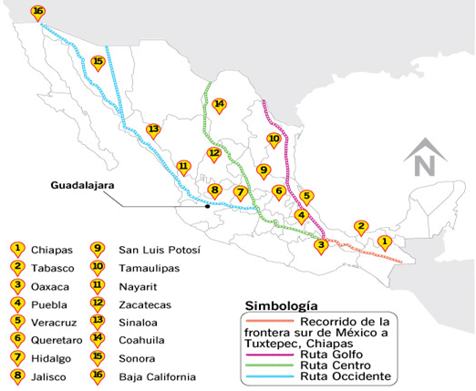
Note. Source Dominguez (2014).
Concerning this, the primary means of transportation for migrants from Central America to the United States used to be la bestia (the beast), a “network of freight trains that runs the length of Mexico, from its southernmost border with Guatemala north to the United States” (Sayre, 2014). For the year 2012, according to Sorrentino (2012), approximately 400,000 to 500,000 migrants, mainly from Guatemala, Honduras, El Salvador, and in a minor proportion from Nicaragua road la bestia. Most of them road on top or between the wagons (see Figure 2) to cover the distance between Tapachula in Sothern Mexico and the Southern border of the United States. This constituted a sojourn across Mexican territory, pursuing the American dream of a new life in the United States. In the process, these are homeless people.
Figure 2
The beast

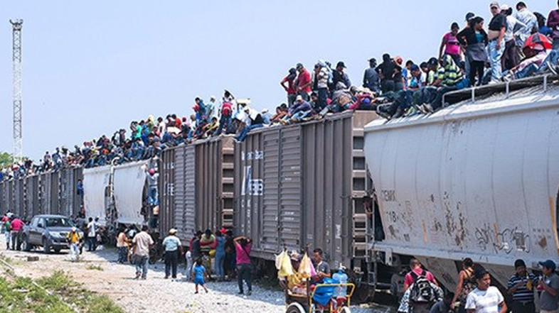
Note. Source: Dannemiller (2014).
According to the Migration Policy Institute (Dominguez, 2014), as many as five hundred thousand Central Americans annually use la bestia on their travel to the United States. In la bestia, the migrants travel on top of the cargo wagons, exposed to weather, speed, wind, and other perils, like violence, sexual abuse, human trafficking, amputations, or even death if they fall from the wagon (Epatko, 2014). Also, to travel via la bestia implies being subject to the violence and extortion of the organized criminal gangs that control the route (Dominguez, 2014). Brutality by predatory organized criminals against those riding la bestia includes extortion, sexual abuse, and even murder, usually by being tossed from the train (McDonnell, 2019).
For those migrants riding la bestia during those years, the Mexican authorities did not fully control the crossing of migrants from Central American to Mexican territory. (Domínguez, 2014). As a result, at least until 2014, most migrants riding la bestia came from Guatemala, Honduras, and El Salvador (the NTCA countries). However, those riding la bestia are not only adults but also unaccompanied children: “In 2011, U.S. border patrol detained around 6,800 undocumented children. In 2012, that rose to 13,000; last year, it was 24,000. Most estimates predict more than 60,000 minors will be detained this year [2014] alone” (Sayre, 2014). In fact, from October 2013 to October 2014, more than 68.000 unaccompanied children aged between 15 to 17 years old were caught crossing the United States border alone. According to Park (2014), more than 75 % of the children came from the poorest towns and regions of the NTCA countries: Guatemala, Honduras, and El Salvador. Children of Mexico used to be a large group but now represent less than 25%, with a small percentage of children from different nationalities (see Figure 3).
Other factors related to the irregular migration from the NTCA are the “coyotes” and criminal organizations capitalizing on smuggling migrants. Coyotes can be described as individuals whose activity is to facilitate and provide guidance for unauthorized or irregular migration (Spener, 2008, p. 93), often as a criminal activity from which a coyote obtains money from smuggling irregular migrants. Spener (2008) refers to “coyotaje” as the process of being smuggled into the United States. This constitutes a strategy often wanted by the irregular migrants themselves (p. 129).
However, by 2006 the coyotaje activity, as a single and fragmented network of individuals smuggling migrants across Mexico, changed to become a significant activity for criminal organizations in the region (Izcara, 2012). Today, irregular migrants coming from the NTCA usually need to use smugglers due to the difficulties derived from the greater control of the southern border of Mexico and the routes of migration and the southern border of the United States (Manaut, 2011, p. 179).
Figure 3
Where are the migrant children coming from?
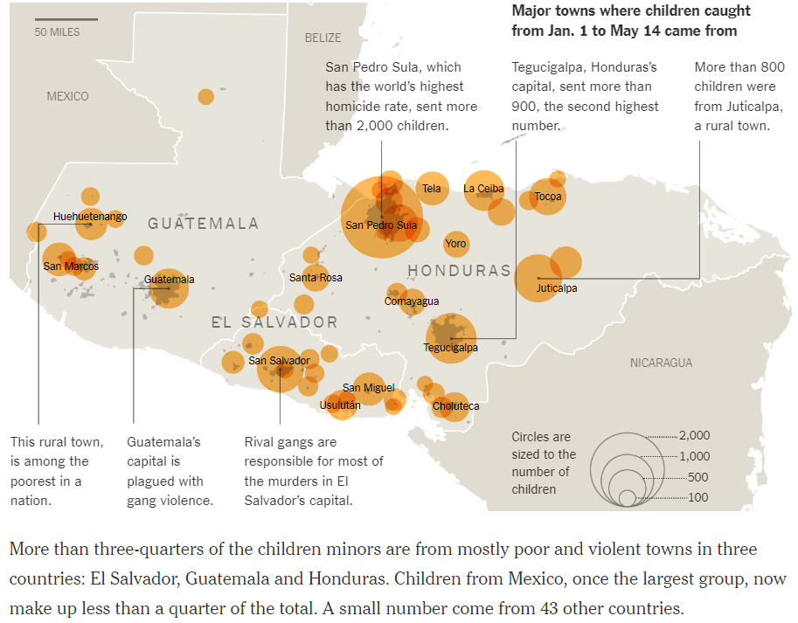
Note. Countries of origin of unaccompanied children from October 2013 to October 2014. Source: Park (2014)
This situation at the Southern border of the United States and the Northern border of Mexico triggered a response from the governments of Mexico and the United States to address the situation. Among the measures were to coordinate federal responses to the humanitarian crisis by approving funds to attend to the urgent needs of the migrating children, the safe repatriation of individuals, and to attack regional criminal organizations. The significant and straightforward goal was to stop illegal migration (The White House, 2014). This last part required the coordination of countries in the region.

The “Programa Frontera Sur”
The use of la bestia and the flow and patterns of migration from the NTCA to the United States drastically changed after 2014 when the former President of Mexico, Enrique Peña Nieto, introduced on July 7, 2014, the “Programa Frontera Sur” (South Border Program). This program meant the militarization of the entire Mexican southern border and the control by the Mexican Army of the railways and roads in the Southern border of Mexico, among them, la bestia. According to the Mexican authorities, the “Programa Frontera Sur” responded to a porous southern border between Mexico, Guatemala, and Belize. At this border, an increasingly substantial number of Central American migrants, families, and unaccompanied children crossed borders into Mexican territory on their journey to the United States. Also, it was a response to the increasing influence of criminal groups in the region in activities such as drug trafficking, smuggling, human trafficking, and extortion, among other criminal activities in the area. These posed a challenge to the security at the southern Mexican border (Wilson & Valenzuela, 2014). According to the Wilson Center (Wilson & Valenzuela, 2014), the “Programa Frontera Sur” had as its main objectives the protection of the migrants entering Mexico and the control of the ports of entry. To do so, the “Programa Frontera Sur” set as its goals a regular and ordered migration; improvements in the infrastructure; protection for the migrants; a regional shared responsibility (between Mexico and the Central American countries to prevent and dismantle criminal groups in the Southern border, and the creation of a migration database); and coordinated response from the governments of the four southern border Mexican States: Campeche, Chiapas, Quintana Roo, and Tabasco and the Ministry of Interior of Mexico (Wilson & Valenzuela, 2014).
Even though migrants from other countries have recently joined the trail of the migrant caravans, which is indicative of the political and social crisis that is being experienced in Latin America, the nations of the Northern Triangle of Central America (NTCA), Guatemala, Honduras, and El Salvador, have maintained a pattern of irregular migration to the United States for years. Also, the NTCA nations shared a common history of challenges and realities in different aspects like economy, history, and even violence. Even in the 2022 Summit of the Americas, it was acknowledged that Guatemala, El Salvador, and Honduras play a leading role in the migration issue for the United States (Pozzebon, 2022). The NTCA (Guatemala, Honduras, and El Salvador) are countries of origin for individuals migrating to the US and a key transit point for even more migrants approaching the southern border of the United States hoping to relocate to the US. According to Anthony Blinken, Secretary of State of the United States during the Joe Biden Administration in the 2022 Summit of the Americas, this situation poses a challenge beyond anyone has seen (Cole & Alvarez, 2022).

NTCA countries’ reasons for the exodus.
The history of the nations of the Northern Triangle of Central America (NTCA), Guatemala, Honduras, and El Salvador, during most of the 20th century, has been characterized by turbulent episodes of political distress, economic challenges, and even natural catastrophes. The political crises include military dictatorships, civil wars, totalitarian or autocratic regimes, and frail democracies and democratic institutions. All those factors have become substantial obstacles for the nations of the NTCA, hurdles to overcome in the construction of efficient, stable, and trustable democracies and democratic institutions (Ianni, 1997), and the development of solid and diversified economies.
According to Ribando (2014), the countries of the NTCA have been experiencing very high levels of violence from gangs, including an unprecedented rise in homicide rates, sexual violence, disappearances, forced recruitment by armed gangs, such as the Mara Salvatrucha (MS-13) and Barrio 18. This situation of violence resulted in 164,000 refugees and asylum seekers, 174.000 individuals internally displaced by violence, 214,000 deportations from the USA and Mexico of NTCA migrants, and about 450,000 irregular migrants from the NTCA who crossed to Mexican territory from the NTCA Guatemala, Honduras, or El Salvador in the year 2017 (United Nations High Commissioner for Refugees, 2017). In addition, the gangs in the NTCA have become a transnational crime, with influence all over the NTCA countries, with at least 100,000 members in Guatemala, Honduras, and El Salvador and up to 500,000 individuals tied or connected to the gangs in the region (Paarlberg, 2021).
For the gangs, any individual in any neighborhood in the areas of the NTCA where they are present is “under their domain and can be forced into some service. This can include giving extortion payments (or ‘rent’) as well as providing information, shelter, transport, or being forced to play some more active role in criminal activities” (Paarlberg, 2021), not to mention that the gangs penetrate the police itself. The perception in the countries of the NTCA is that it is worthless to call the police to report any gang activity, extortion, or violence (Kahn, 2013). Central American organized crime gangs, such as the Mara Salvatrucha or MS-18, constitute today one of the leading security challenges in the NTCA countries and the hemisphere. The Mara Salvatrucha and MS-18 gangs act as transnational criminal organizations, with ramifications in the United States and throughout Central America. Their illegal activities include any crime, drug, arms, and people trafficking, kidnapping, extortion, contract killings, human trafficking, and prostitution, among others. Their power is violence, and the money they generate product from criminal activities. Their control by the Central American police authorities has resulted in a challenge for an institution that is also a victim of corruption and lacks resources and training.
The violence and control exerted by the gangs also impact even the schools and overall education system of the NTCA countries. Carnino (2022) refers that the Barrio 18 and the Mara Salvatrucha have made schools in some areas of Honduras their seedbeds. Schools have become where they recruit new members among young students at a very young age by force of threats and violence. Those who refuse are punished with a death sentence. Paradoxically, those who become gang members are likely destined to die young due to their participation in assaults and clashes with the police. Teachers and school directors are also targets of extortions and threats by the gangs, and, according to ACNUR, teachers and school staff are groups at increased risk of displacement due to their profession in a context where gangs, security, and institutional frailty do not ensure them with protection against the violence (Calderon, Reina, & Rubi 2022). This cycle causes high school dropout rates and the diaspora of unaccompanied minors (Carnino, 2022).
The economy is also a factor of concern in the NTCA. According to Cajina and Orozco (2016), researchers of the Spanish Institute of Strategic Studies, in El Salvador, 28.9 % of the population lives in poverty, and 21,18% in extreme poverty; in Guatemala of 13 million of inhabitants, seven million live in poverty, and two million in extreme poverty; and in Honduras, more than 66% of the population live in poverty, and five of ten inhabitants in extreme poverty (Cajina & Orozco, 2016). This poverty factor becomes another reason to migrate, looking for better opportunities and work in the United States.
To summarize, the Washington Office for Latin America (2018) point out five variables as the main factors related to the increasing migration from the NTCA to the United States: severe insecurity as the NTCA is among the deadliest region in the world; corruption in Central America political class; droughts, floods, and other phenomena linked to climate change; domestic violence; and lack of economic opportunities.

Migrant Caravans
As mentioned before, the migration patterns from the NTCA to the United States through Mexico include diverse motives. Violence, poverty, and lack of employment or economic reasons, including family reunion, natural disasters, and exclusion, are behind the decision to migrate., there have been some changes in the characteristics of the migrants as a group; for instance, the migrant groups are no longer predominantly masculine but diverse, including women, elders, children, teenagers, individuals with disabilities, patients seeking treatment for their illnesses, and LGBTQIA (Alvarado, 2021). Also, the migration from the NTCA has become a collective one. That is, it is no longer a migration of small groups but significant groups of people migrating simultaneously in caravans.
Probably the first antecedent of the caravans as we know them today could be found in 1991 when a Central American Free Mobility Agreement (Convenio Centroamericano de Libre Movilidad CA-4) was signed by the presidents of four Central American nations: Guatemala, Honduras, El Salvador, and Nicaragua. According to the Central American Integration System (SICA: Sistema de la Integración Centroamericana), the purpose of this migration agreement consists in allow the intra-regional transit of the nationals of the signatory countries without the need to use a passport and with expedited immigration instruments. (Sistema de la Integración Centroamericana, 2022). This agreement makes it easier to understand the mobility across the countries of the NTCA, as the individuals are allowed to move across the border of the countries of the NTCA with only their national identity document, being Mexico the first formal international limit they find in their travel, where an international travel document, such as a passport, is required. This partially explains how the migration flow of individuals from Guatemala, Honduras, El Salvador, and to some extent, Nicaragua became a merged one, as the migrants began their travel in one country of the NTCA and people joined freely in the journey across Central America to Mexico. Once in Mexico, the migrants ride la bestia to arrive in the United States. Until then, the migration from the NTCA to the United States was fragmented but constant, mostly of small groups of individuals. This migration pattern changed drastically in 2014 with the “Programa Frontera Sur” in Mexico. With the militarization and greater control of the Mexican South border with Guatemala and Belize, the permeability of the Mexican border and the easiness of Mexico as a transit country riding la bestia changed.
It was then when the migration flows from the NTCA, until then furtive, far from the attention of the media, migration authorities, and public opinion evolved into collective migration groups (Nájera, 2019). This collective migration certainly implied a new strategy that demonstrates, as well as challenges, the ability agency of migrants to achieve their migratory goals (Torre & Mariscal, 2020). This change responds to extra protection, safety, and companionship throughout the journey. Still, also it implied to be visible on a scale that previous migrations from the NTCA were not. The presence of the migrant caravans became no longer a slippery, irregular, and fragmented migration. To be visible is understood here as having thousands of people migrating simultaneously, walking through the NTCA and Mexico, and heading to the US. Such a migratory phenomenon implied awareness in the countries they cross, involving immigration agencies, government agencies, governments, opinion leaders, social movements, and of course, the media and news on an unprecedented international scale. In this regard, the migrant caravans represent the regionalization of the mobilization in the axis of Central America – Mexico – the United States, where Mexico has been traditionally a transit country (Nájera, 2019).
Faced with such a scenario of visibility to the world, it is true that migration from the NTCA has evolved into migrant caravans. Still, other strategies also developed with the attention they have aroused, in the NTCA countries, Mexico and the United States. For instance, migrant caravans know what routes and means of transport to avoid and share information about the risks ahead (González Arias & Aikin Araluce, 2015; Yee Quintero & Torre Cantalapiedra, 2016, as cited in Torre & Mariscal, 2020). Also, traveling in large groups allow accompaniment providing the natural support that travels with relatives and friends offer. This is a “fundamental strategic tactic in terms of material resources—money, food, others—, information—especially spatial orientation and knowledge about the journey—, emotional support and protection” (Villanueva Domínguez, 2012; Parrini Roses & Flores Pérez, 2018 as cited in Torre & Mariscal, 2020, p. 6). Furthermore, to apply for immigration documents in the USA requesting asylum or any other humanitarian relief as well as in Mexico. In this regard, in June 2022, the government of Mexico dissolved a migrant caravan with the issuance of more than seven thousand legal stay permits in Mexico, a stay permit that allows migrants to move freely through Mexico for thirty days, either to regularize their situation or continue their journey through Mexican soil (Clemente & Verza, 2022).
The existence of shelters and a welfare network by “Religious organizations, international organizations, certain state actors and population groups support migrants in transit along migratory routes” (Aikin & Anaya Muñoz, 2013; Candiz & Bélanger, 2018 as cited in Torre & Mariscal, 2020, p. 7), is another strategy that alleviates the transit of the caravanners, providing guidance, medical attention, legal advice, food, water, lodging, clothing and other commodities along the journey of the caravanners (Torre & Mariscal, 2020, p. 7). Using coyotes is another strategy as the migrants reach the Southern border of the United States and must figure out how to cross the border effectively. For Torre and Mariscal (2020), the decision to use coyotes responds to the need for “expertise” about the route to choose and how to reach their destination, decisions that are left to someone with knowledge of the Southern border. To these strategies compiled by (Torre & Mariscal, 2020), at least two more should be added: to have a voice toward media, public opinion, governments, and authorities, and to do so, to act and develop characteristics of a social movement.

The 2018 Way of the Cross
In March 2018, a group of Central American migrants began their journey along the migrants’ trail across Mexico, heading to the northern countries in the hemisphere, Mexico, and the United States. This migratory movement is not new since it has been happening yearly for over a decade (Garcia, 2018). The Way of the Cross migrant caravans have been happening annually around Easter time since 2010; the 2018 Way of the Cross caravan gained media and public opinion attention due to the migration discussion in the United States: “This happens pretty much all year long, non-stop and nobody seems to pay attention until Trump started tweeting about this particular group of people, and the caravan immediately became news” (Garrido & Fidler, 2018). This makes the 2018 caravan one of the most recognizable migration caravans from the NTCA because the news media extensively covered it after being referred to by Donald Trump in his tweets (see Figures 4 and 5).

Figure 4
Donald Trump's first tweet mentioning the caravans
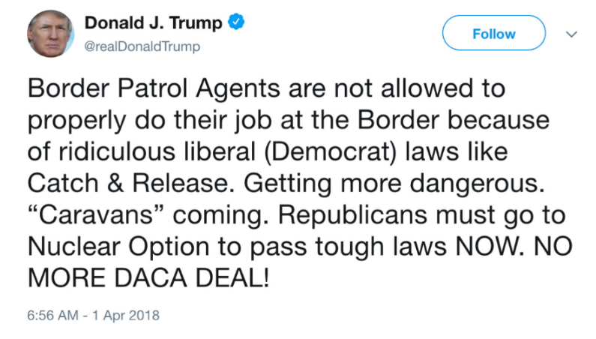
Note. The first tweet mentioning the migrant caravans was published on April 1, 2018, at 6:56 am (Kumar, 2018).
Figure 5
Donald Trump's second tweet about the caravan.
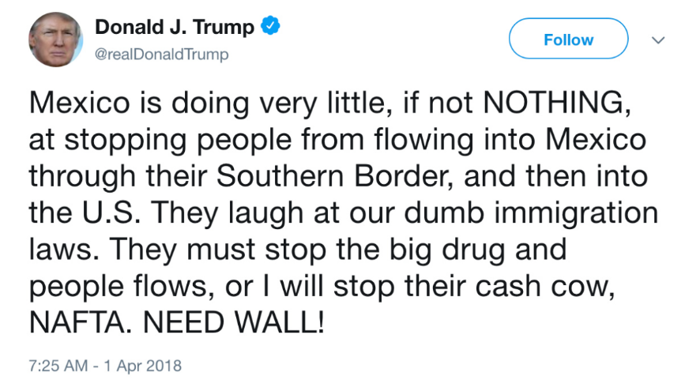
Note. Half an hour later, the second tweet was published the same day (April 1, 2018). (Kumar, 2018)
The caravan occurred specifically during March and April 2018, and it was called by the caravanners “Caravana Via Crucis Migrante” -Way of the Cross migrant caravan- (BBC News, 2018). It began in the NTCA, but it was in Tapachula, Mexico, where most caravanners gathered in a single group of caravanners. In Tapachula, the way of the cross-migrant caravan began its journey on Sunday, March 25, 2018 (BBC News, 2018). March 25, 2018, was a symbolic day as it was Palm Sunday, the first day of the Holy week according to the Catholic Calendar. Palm Sunday is a fundamental day in the Catholic religion. It commemorates the arrival of Jesus Christ to Jerusalem, an event that precedes the celebration of his resurrection on Easter Sunday and the beginning of the Holy week, a time when the passion, suffering, crucifixion, and resurrection of Jesus Christ are commemorated. In Latin America, the holy week is also named “La Semana Mayor” (“The Greater Week”), and it is one of the most revered and essential Catholic holidays in Latin America.
To understand the meaning of Palm Sunday in the Catholic liturgy, it must be first pointed out that it is, above all, a Sunday. Moreover, like every Sunday, the leading Catholic celebration is the Lord's Resurrection. Therefore, Christ's victory over death guarantees our resurrection. Palm Sunday is also the Christian celebration that commemorates the triumphal entry of Jesus into the city of Jerusalem, when a multitude of inhabitants, with olive palms in their hands, received him as the Messiah and son of God. (Cadiz, 2022). In the context of the migrant caravan, to begin the migrant caravan on Palm Sunday is undoubtedly a sign of respect for Jesus Christ, a commemoration of his triumphal entry into Jerusalem, but also the memory of his Calvary, his way of the cross, his passion, crucifixion, and resurrection. The caravan then conveys its members an internal and external message associated with those events. This caravan is a social movement that presents itself and its journey as an ordeal, passion, crucifixion, and faith in the resurrection of a new life for the migrants beyond its current circumstances, borders, and controls. Its situation and hope place this migrant caravan on an epic journey beyond the earthly, bringing it closer to a religious belief, a representation, and a reproduction of the passion of Christ. The symbolism and intertextual elements regarding the 2018 migrant caravan, its name, “2018 way of the cross-migrant caravan”, and its beginning on Catholic Palm Sunday are pointed to express the idea of the caravan as analogous to Jesus Christ’s Way of the Cross, and the promise of resurrection, salvation, and a new life after a journey of passion, transformation, and suffering.
The distance covered by the 2018 way of cross-migrant caravan was long. It began in the NTCA countries, crossing the entire Mexican territory from south to north (Semple, 2018), and ended in the border Mexican city of Tijuana. Tijuana is the northern Mexican city on the Mexico-United States border, as shown in Figure 6. The migrants walked or used trains, trucks, and buses to cover the 2,000 miles between the two cities during their journey.
Most of the procession participants initially expressed their intention to seek asylum in the United States. In contrast, others expressed interest in ending their journey in Mexico (Acevedo, 2018). The caravan finished on April 29, 2018, more than a month after its beginning, in Tijuana. Once in Tijuana, 150 caravanners (which at its peak once numbered more than 1,200 people) requested asylum in the United States (Semple, 2018; Acevedo, 2018). It must be underscored that the 2018 caravan occurred when deportations from the United States and Mexico of migrants from the NTCA were increasing due to changes in migration policies in the United States and Mexico.

Figure 6
Migrants Caravan Route.
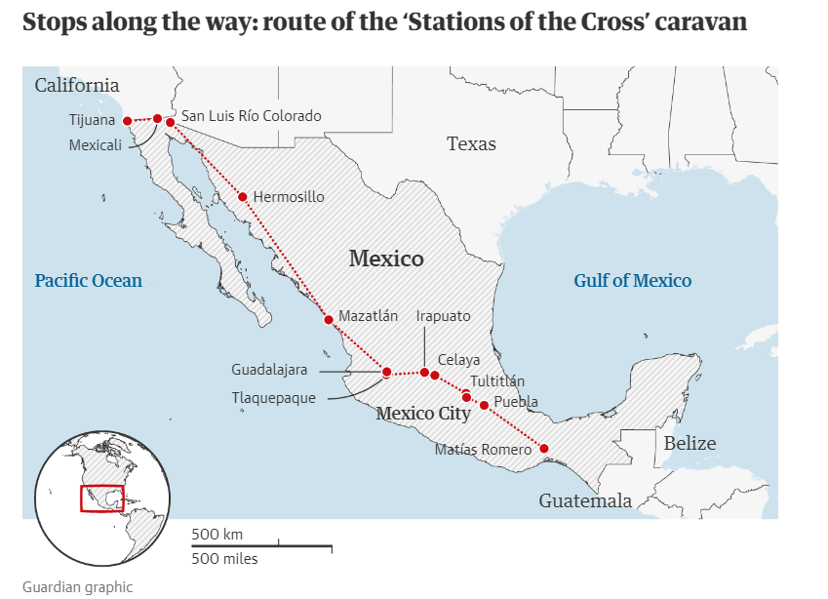
Note. 2018 way of the cross-migrant caravan route. (Garrido & Fidler, 2018)
For this research study, the 2018 way of the cross caravan was distinctive because it was one of the first migrant caravans to make extensive use of the Internet (Twitter) to document its advances and have a voice in a context where irregular migration was a top issue in the United States and Mexico, and the media attention that they were subjected to because of Trump's tweets. Also, in their migration strategy, the 2018 way of the cross caravan used the Internet and social networks to keep caravanners and supporters informed about their progress. Twitter became one of its most important communication channels. The 2018 way of the cross caravan used Twitter to post announcements, press releases, and live coverage. It broadcasted in real-time its goals, advances, and requests, building at the same time a distinctive collective narrative and identity. In this communication process, the 2018 migrant caravan build an audience of supporters and detractors. Through Twitter, the caravan identified and pointed authorities, governments, or political leaders to oppose its mobilization, thus marshaling international support and logistics. This was an effective communication strategy. In sum, the 2018 way of the cross-migrant caravan meant a change in the migrant caravan’s strategy, that is, the use of Twitter and the Internet to convey a message on a regional and even global scale about their migration and to assume a social movement identity, all communication and movement adapted to a context where the United States and Mexico more controlled migration from the NTCA, and contested by Donald Trump.

Migrant caravans as social movements
Della Porta and Diani (2006) define social movements as distinct processes of collective action characterized by “conflictual relations with clearly identified opponents, a dense informal network of connection links, and an identifiable collective identity” (p. 20). Identifying objectives or adversaries encourages a communication environment in which organizers and individuals coordinate and share efforts toward the movement's goal; the collective identity creates a sense of belonging, distinctiveness, and commitment to a cause (Della Porta & Diani, 2006, p. 21). In social movements, collective identity is fundamental in facilitating sharing goals and coordinating actions (Melucci, 1996). The collective identity also implies cognitive definitions like language, rituals, practices, cultural artifacts, effective relationships as an organization, leadership, communication technology, and emotional investment, like passions and feelings relevant and vital to groups as social movements (Melucci, 1996, pp. 70-71). Social movements' communication is crucial as it plays a central role in sharing beliefs, enhancing in-group identity, and coordinating goals or protest demonstrations (Della Porta & Mattoni, 2015). To Torre (2021), the migrant caravans have assumed the characteristics of social movements and embody a form of protest. That is, many of the actions and discourse of the migrant caravans point to protests whose objective is to achieve pragmatics while going through the Mexican territory.
As the migration patterns from the Northern Triangle of Central America to North America have evolved into migrant caravans, their use of social networks as a communication tool also means a way to be covered by news media and make the transit or destination countries' political authorities aware of their transit. Moreover, this communication strategy seems to protect against external threats to the mobilization, for instance, crime, extortion, and corrupted authorities. Beyond the fact that the caravans are related to issues of irregular migration, according to Ataç, Rygiel, and Stierl (2018), refugees and asylum seekers' mobilizations embody “struggles [that] regularly traverse the local and constitute trans-border, trans-categorical, and in fact, social movements” (p. 1).
To recognize elements of a social movement in the 2018 way of the cross migrant, such as specific claims, goals, discourse, and communication strategy, implies, for this research study, to ask ourselves: who are they? What are their claims? What are their longings? Their fears? How do others view the caravanners and their claims? What is their message? What meanings are they conveying? All these questions are the core inquiries of this dissertation.

Political polarization in The United States and the migrant caravans
Likely, most of the migrants in the caravans have as their destination the United States. In the US, migration has always been a hot topic of debate, especially during electoral political campaigns, either for local, regional, or national authorities as the president of the United States. However, in 2018, the US was experiencing an unusual scenario of deep political polarization. According to Iyengar and Westwood (2015), this polarization in the American electorate has increased dramatically in recent years. Furthermore, “hostile feelings for the opposing party are ingrained or automatic in voters' minds, and that affective polarization based on a party is just as strong as polarization based on race” (p. 690). For Abramowitz and McCoy (2019), this scenario of growing polarization in topics like race, ideology, and culture led to the victory of Donald Trump in the 2016 US presidential election, where Trump explicitly appealed to resentment as a way to capture the votes of a white working-class triggering negative partisanship, hostility to the opposite party (Democrats), its leaders, and likeminded individuals (p. 137). Trump's election revealed various aspects of American public opinion and the climate of confrontation that worsened with his election as president. For instance, Trump frequently made doubtful claims, questioned the authenticity and authority of democratic institutions, shared and believed in conspiration theories, pointed to media and journalists as political actors with an agenda against his government, and overall created a long list of adversaries, even within his government, a communication strategy that had on Twitter its most effective communication tool with more than twenty-six thousand tweets written by him during his tenure as president (Dimock & Gramlich, 2021). This dynamic of polarization openly promoted by the president fit perfectly with an environment of growing political polarization where most Americans had the perception that either Republicans or Democrats could not agree on basic facts in an alarming proportion near to 75% (see Figure 7).
This lack of agreement further paved the way for a more profound animosity between Republicans and Democrats. In this regard, “sizable shares of both Democrats and Republicans say the other party stirs feelings of not just frustration, but fear and anger” (Pew Research Center, 2016, p. 2). Moreover, these sentiments were not limited to the parties but personal aspects where stereotyping gained ground, as seen in Figure 8.
Figure 7
Agreement percentage between Democrats and Republicans.
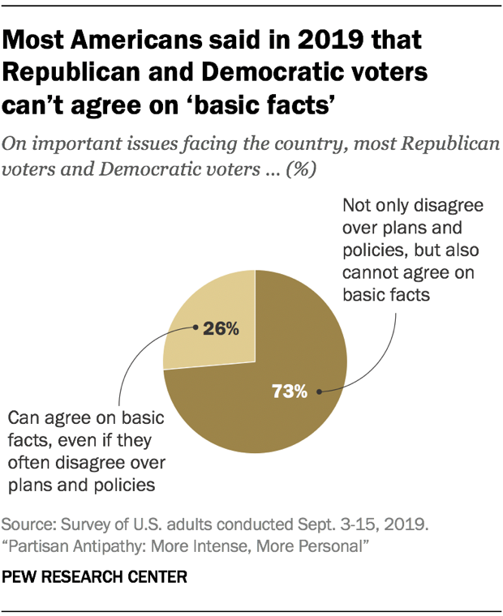
Note. This graph shows the perception of a possible agreement between Republicans and Democrats according to most American voters. Pew Research Center (Dimock & Gramlich, 2021).
Figure 8
What Republicans and Democrats say about each other.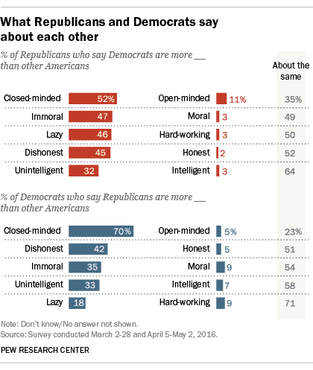
Note. This figure shows the deep gap between Republicans and Democrats (Pew Research Center, 2016).
As a candidate or president, Donald Trump ran on harsh rhetoric about the migrant caravans describing some migrants in the caravans as "stone-cold criminals” (Jansen & Gomez, 2018). This rhetoric in support of his politic to limit migration to the US. from the NTCA reframed the migrant caravans as a threat to the United States and, in some cases, characterized as an invasion: “That’s an invasion. I don’t care what they say. I don’t care what the fake media says. That’s an invasion of our country” (Scott, 2018; Keneally, 2018). The migrant caravans gave Trump a perfect story to tell and to relate to the anxieties about migration to the US, with claims that resonate within the United States by pointing it as an invasion which he will deter and an international agenda as Trump claims, that there will be consequences for the countries of departure and transit of the migrant caravans if such countries do not deter them from coming to the US (Ahmed, Rogers & Ernst, 2018).
The scenario in which the 2018 migrant caravan happened allows us to consider various factors regarding this research study. On the one hand, a change in the mobile strategy of the migrants who come from the NTCA, with enhanced controls and obstacles along the way, made the migration from the NTCA evolve into a collective strategy with better organization and logistics, but more importantly, with use of social networks and Internet that allowed them to have a voice, their message to communicate. On the other hand, a scenario of political polarization in the United States since the election of Donald Trump as president of the United States, with a discourse and government actions about migration, where the migrant caravans became a hot topic in its immigration policy. It is true that Trump is no longer president of the United States and that some Countries in the NTCA are getting involved in attacking the roots of the causes of the diaspora along with the US. For instance, in El Salvador, president Nayib Bukele was elected president with the promise of controlling the gangs. Since then, thousands of gang members have been arrested in El Salvador since Bukele became president (France 24, 2018). However, it is also true that the migration from the NTCA is far from being reduced.
Furthermore, Mario Bucaro, Guatemalan Foreign Minister, diminished one of the agreements of the recent 2022 Summit of the Americas, like reinforcing the borders and facilitating the return of migrants to Central America. He, once back in his country and after the Summit ended, declared that the migration agreements made in the summit were expressions of ‘goodwill,’ not at all binding, adding that the government is not obliged to comply with them (Morales, 2022).
It seems that the migration from the NTCA to the United States will continue as the causes of such migration will require a coordinated effort involving international cooperation to achieve a solution. This situation is a challenge for all the countries involved. It will require the agreement, union, and shared effort of all the NTCA countries, Mexico, the US, and the South American countries. In the meantime, the rise in migrants continues, despite the efforts and initiatives of the United States' different administrations, monetary aid, and even the Plan of Alliance for Prosperity, backed by the US government and the Inter-American Development Bank (Cheatam & Roy, 2022). So far, the efforts to create conditions that reduce the migratory flow has been insufficient to deter the exodus.
Studying then the phenomenon of migrant caravans contributes to the understanding of migrations in the Americas from a communicational point of view and, therefore, a contribution to the field of social sciences that have dealt mainly with human mobilizations, in this case, migrant caravans, mostly from a sociological, economic, political, psychological, and even journalistic and geographical perspective. Moreover, knowing the messages, symbolisms, and narratives generated by the migrants in real-time while crossing international borders brings us closer to reasons, emotions, narratives, mythologies, and imaginaries about the migrant caravans represented as a migratory phenomenon in the Americas.

Chapter 2 Literature Review

Introduction
This chapter reviews the literature on migrant caravans. In this regard, the study of migration in the Americas, specifically the migrant caravans, is disseminated across different fields of study in the social sciences. Therefore, this literature review begins with some studies describing the causes that have originated the migrant caravans, approaching it as an issue, and, to some extent, outlining the reasons behind the migrant caravans’ diasporas in the Americas.
From the starting point of the caravan as a migration issue, different approaches have been used to study the migrant caravans. For instance, numerous investigations have argued that the migrant caravans from the NTCA to the U.S is a migration strategy. Also, in recent years, the research to date has tended to focus on human rights and advocacy of the caravanners as vulnerable and the migrant caravans as migration challenge in the Americas, as well as some alternatives or solutions to the challenge (Alonso, 2021; Camus, Vega & Martínez, 2020; Castro, 2019; Chan-Pech, 2019; Contreras, París & Velasco, 2021; Espín, 2021; Frank-Vitale, & Núñez, 2020; Gandini, de la Reguera, & Gutiérrez, 2020; Garcia, 2020; Hernández-Hernández, 2019; Kudeyárova, 2019; Leyva, 2021; Marchand, 2021; Martínez, 2019; Nájera, 2019; Nájera, 2016; París, 2018; Ruíz & Varela, 2020; Torre, 2022; Trapaga, 2020). Another rich area of research studies the migrant caravans from the perspective of Human Rights and migrants’ rights advocacy as factors related to the migrants' rights (Cordero, 2021; Fuentes, Hernández, & Alcalay, 2022; Giron, 2019; Hernández López, & Porraz Gómez, 2020; Huerta, 2017; Infante, Leyva-Flores, Gutierrez, Quintino-Perez, Torres-Robles, & Gomez-Zaldívar, 2020; Islas, 2019; Izcara & Andrade, 2022; Izcara, 2021; Pradilla, 2019; Rebolledo, 2020; Sandoval, 2019; Schaffhauser, & Inocente, 2021; Stoesslé, Patiño, & Rosales, 2020; Torre, 2020; Villagrana, 2021; Valles, 2020; Vogt, 2012; Yeh, 2019).
Several studies as well are focused on studying the collective identity of the caravans (Anaya, 2015; Hernández, 2020; Kron, 2016; Melucci, 1994; Mendiola, 2021; Ortiz, Castañeda-Camey, & Garcia, 2020; Puga, 2021; Rivera, 2017; Varela, 2020; Varela, 2015; Zecena; 2019). Some other scholars are interested in the representations of migrants, migration, and migrant caravans in news media and social networks (Chattopadhyay, 2019; Contreras, Murguia, & Torres, 2019; De Araujo, 2021; Fabregat, Vinyals-Mirabent, & Meyers, 2020; Frandsen, & Johansen, 2010; Iannacone, 2021; Johansson, 2018; Kenix & Lopez, 2021; Mukhortikova, 2022; Navarro-López, 2021; Pérez, 2020; Portales & Miranda, 2021; Pradilla, 2019; Reid, 2021; Revilak, 2021; Severino, 2020; Sevier, 2019; Tiscareño-Garcia, 2021; Torres, 2019; Záratae, 2020). Some other authors have examined past caravans in the Americas and their relation to the migrant social movements in the region. The study of the possible and attempted solutions to this complex migration issue in the Americas, although quite limited, is an essential contribution to the undertaking of migrant caravans (Baltazar, 2021; Barona & Tejero, 2021; Basok, 2020; Durand, 2019; Gandini, 2020; Núñez, & Dávila, 2022). The migrant caravans as a migration strategy is also a theme of research in the literature reviewed (Castellano, & Martínez, 2021; Gómez & Espinosa, 2020; Hagan, 2008; Huerta & McLean, 2019; Izcara & Andrade, 2022; París, & Montes, 2020; Salazar, 2019; Torre & Mariscal, 2020; Vargas, 2018; Wurtz, 2020).
This proposed order in this literature review is an invitation to read previous research by following the sequence of the description of the problem, the study of solutions, the caravans as migration strategy, religion, the collective identity of the caravans, research about migrant advocacy, human rights, and the migrant caravans, the migrant caravans in the news media, and their representation, and finally the migrant caravans in social media.

Method
The method used to build this literature review used the University of Oklahoma Library website and Google Scholar search engine. In the first stage, the keywords and combination of word criteria were tested to reflect findings and ensure that only the relevant research to this research study was included. The University of Oklahoma website search criteria included “migrant + caravan + social network + social media + social movement + Central + American.” A second search was performed on the University of Oklahoma library website to discard any missing references that could have been omitted in the first search using only the words “migrant + caravan.” The second database consulted for academic references was Google Scholar. The combination of terms used for this search was: “migrant + Caravan.” All the articles selected from the University of Oklahoma library website were compared to the ones obtained in Google Scholar to avoid the repetition of references; see the method in figure 8. The search included academic articles published in journals, master’s theses, doctoral dissertations, book chapters, and books. All the references consulted include English and Spanish publications (see Figure 9).
In the primary searches, all the sources were revised and examined for their initial relevance to the topic of this dissertation. For all academic sources like journal articles, books, thesis, and dissertations, a thorough reading, and analysis made possible the accurate selection of the articles to be included in this literature review. A similar process was followed in selecting the non-academic sources (primarily essays, news articles, and comments about migrations public policies in the NTCA, Mexico, and the United States), paying attention to the relation of the content with this research study. Most articles and resources were curated to include only those relevant to this dissertation.
Figure 9
Method for article search
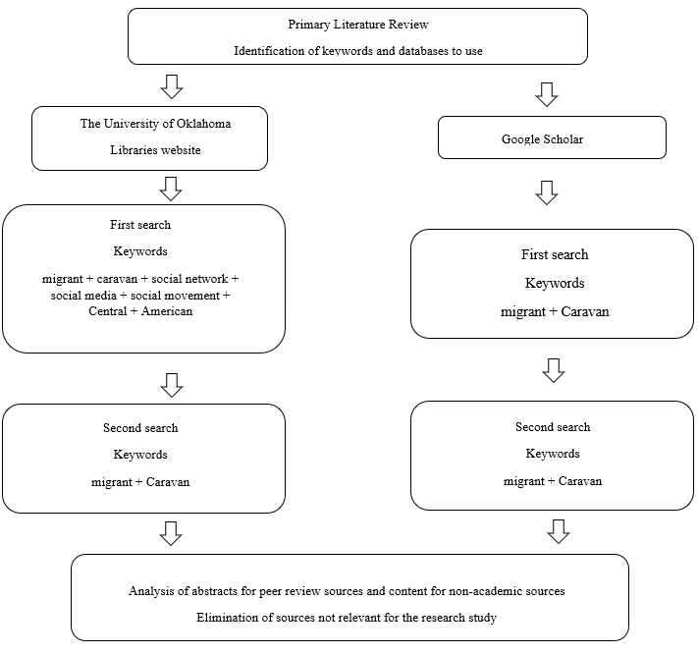
Note. The second search on The University of Oklahoma Libraries website used the exact keywords as the Google search for two reasons, contrast and eliminate duplicates and perform an open search including most of the possible articles by keeping an open two-word combination.

The migrant caravans: a migration challenge in the Americas.
As outlined in the previous chapter, migrations from the NTCA to the United States have become increasingly common, and migrant caravans are a frequent migration event (Alonso, 2021). What used to be an irregular migration flow, usually furtive, with scarce and sporadic coverage in news media, evolved into a collective migration movement characterized by numerous groups of people migrating simultaneously during the same time of the year. Therefore, coverage by news media of the migrant caravans has increased significantly (Fabregat, Vinyals-Mirabent, & Meyers, 2020), not to mention the impact of this mobilization in public opinion and external and internal politics of the departure, transit, or destination countries. Reports from newspapers, TV channels, international news correspondents, and political debates have frequently covered the route and the causes and consequences of this irregular migratory flow that already represents a migratory crisis in the Western Hemisphere.
In the same way, researchers and scholars in the social sciences are developing lines of research exploring this phenomenon from different perspectives. For instance, migrant caravans are a regional issue involving other countries. That is, studying it as a regional crisis and signaling it as a problem in the Americas is an increasing topic of study. Considering this, Torre (2022) claims that most studies are focused on 1) the caravans as a form of mobility, 2) as a social movement, 3) the politicization of these marches by government actors, and 4) the media visibility of the caravans and their presence on social media. Some other studies are interested in the reasons behind the diaspora. For example, Leyva (2021) refers to the concept of uncivil wars, which, unlike civil wars, are not directed to the control and transformation of the political system, but towards maximization of a situation of disorder and chaos, as a reflection of the problems faced by the NTCA countries as reasons for the exodus. Moreover, some other scholars research the demographics of the migrants arriving or in transit to Mexico from the NTCA, finding in general that migrants arriving to the southern border of Mexico are single young males but increasingly married couples, some of them with their children, mmainlyfrom the NTCA, and in some cases from Nicaragua, Venezuela, and Cuba (Hernández-Hernández, 2019).
Indeed, the migrant caravans have impacted international relations between countries. For instance, Espín (2021) analyzes the response of the Mexican State regarding the migrant caravans coming from the NTCA, along with the demands of the United States to stop them in Mexican territory during the Trump administration. The author describes a situation where the migrants coming in the caravans have become a bargaining chip in the trade negotiations between Mexico and the U.S. due to the U.S. demands to control the caravans. However, Espín (2021) do not see a solution to the migrant caravans in the short or midterm due to the issue’s complexity, advocating instead for an approach to them from a strict human rights viewpoint.
The migrant caravans from the NTCA are indeed a challenge for Mexico as a transit and destination country (Gandini, de la Reguera, & Gutiérrez, 2020; Kudeyárova, 2019). Considering this, Nájera (2019) claims that the migrant caravans exemplify the regionalization of migration in the Americas, with Central America as the origin, Mexico primarily as a transit country but increasingly becoming a destination as well, and the United States as the destination for most of the migrants in the caravans. For some authors, in this context of growing migrations from the NTCA and the much stricter border and immigration controls by the United States, Mexico must be prepared to be an alternative migratory option due to its cultural and geographical proximity to the countries of the NTCA (Nájera, 2016). This notion of Mexico as a destination and noa t transit is being explored by some scholars, proposing the ineludible role that Mexico should play aa s receiver of the migrants coming from the NTCA. This proposed role of Mexico as a destination country for the migrants coming from the NTCA implies for Mexico the adequation of its legal framework, request for international assistance in the organization and protection of the human rights of migrants, and avoids the adoption of a US-style migration control over the southern border, along with the repressive policies in the Southern Mexican border (Chan-Pech, 2019; Contreras, Paris, & Velasco, 2021; Garcia, 2020; Martinez, 2019; Paris, 2018; Ruíz & Varela, 2020). Additionally, States are no longer the only factors regarding migration, biopolitics, and transmigration of the migrant caravans. Other non-state actors are gaining importance in what is described as biopolitical struggles triggered by the migrant caravans involving authorities, smugglers, non-state organizations, and civil society (Marchand, 2021; Trapaga, 2020).
There are other challenges related to migrant caravans. For example, xenophobia toward the migrants in transit or arriving at the Southern Mexican border is also studied as another factor in the border dynamic between Mexico and the NTCA. Furthermore, with the high visibility of the migrant caravans, some scholars' research studies (Camus, Vega, & Martínez, 2020; Frank-Vitale, & Núñez, 2020) find that the repercussions of the arrival of the migrant caravan to Mexico are triggering ambiguous expressions of both solidarity and criminalization, or visibility invisibility of the migrants by political authorities. In addition, Castro (2019) studies the rejection of the migrant coming from the NTCA and suggests more research and proposals for more concepts beyond xenophobia or fascism to describe the rise of an alterophobic society better.

The migrant caravans: some alternatives to the challenge
Some studies are focused on solutions for migrant caravans. The focal point of these studies comprises the securitization of the border, plans of development for the NTCA, changes in migration, and policies adjusted to such changes. Also, the importance of dialogue between the involved countries is emphasized. To address the securitization of the Mexican Northern border or the Southern border of the United States, Barona and Tejero (2021) argue that the migrant caravans, as a new type of migration, poses a complex scenario when confronted with the theory of securitization of the borders. For Barona and Tejero (2021), the securitization of the border is an approach furthered by the United States. The authors study the specific case of the migration crisis in Honduras as the first step to comprehending the caravans, not merely from Mexico’s perspective but to understand the NTCA region overall. This line of research is tied with the study of the importance of negotiation between Mexico and the United States (Gandini, 2020), as the crisis is not likely to be solved exclusively with a border security policy but with an approach that implies a mandatory agreement between the countries involved, more importantly, Mexico and the United States.
Moreover, Baltazar's (2021) documental study examines the changes in migration politics in Mexico and the United States. For the author, the migration policies for the Central American region of Mexico and the United States have evolved from development-containment into containment-deportation as reactive strategies to lessen the massive migrations from the NTCA. Baltazar claims these changes respond to Mexico and US national security issues and interests.
Other policies were created to alleviate the migration crisis, for instance, the Frontera Sur Program (South border program) and the Comprehensive Development Plan for Northern Central America and Mexico. For example, Durand's (2019) study examines the migratory policy during the Mexican presidential administration of Enrique Peña Nieto (December 1, 2012 – November 30, 2018). Policies like the Frontera Sur Program, the migrations coming from Central America, and the migrant caravans are the immediate crisis referred to in the study. The author claims that any migratory policy is adjusted to situations. In the case of the Central American situation (referred sometimes in the media and social platforms as a crisis, see Iannacone, 2021) and the migrant caravans, Durand underscores that it is the result of the foreign policy of the United States as Central America was the last scene of the Cold War with the development of weak democracies and high levels of corruption, factors before which migration became the escape valve. This case study uses news reports, official documents, and declarations of the Mexican government.
In the same way, and considering Mexico as a migration hub country, that is, a nation of origin, transit, reception, or destination of migrants, Núñez and Dávila (2022) study how the migrant caravans from the NTCA from 2018 to 2020 represent a challenge to Mexico foreign and internal policies in coping with the migration coming from Central America. To manage the crisis, the authors underscore the Comprehensive Development Plan for Northern Central America and Mexico promoted by Mexico as a solution to the crisis but at the same time acknowledge the scarceness of resources to make the plan work effectively. Also, the growing rejection by the Mexican population of migrants from the NTCA is mainly associated with stereotyping and xenophobia. Finally, the article highlights the complex relationship between Mexico and the United States, where the former frequently follows the migration policies of the latter, especially during the Trump administration.
Other studies have considered the impact of the regularization of migrants from the NTCA in Mexico. Mexico provides specific migration paperwork that makes it easier for some migrants to establish in the country, becoming Mexico a growing option for NTCA migrants (Torre, 2020). However, these temporary status regularization practices do not deal with the long-term needs and aspirations of the migrants looking for safety and stability. Instead, those measures are perceived by the migrants as mechanisms that enable authorities to collect biometric information about them, with a possible consequence of deportation (Basok, 2020).

The migrant caravans as a migration strategy
An ever-increasing body of literature has hypothesized that migrant caravans are just a migration strategy. Using different research methods like semi-structured interviews, participant observation, documental studies, and ethnography, several studies refer to the migrant caravans as a strategy, for adaptation to a growing securitization of the border, in both the United States and Mexico. For some scholars, this strategy provides visibility, ensures survival, provides collective accompaniment, facilitates tactics of territorialization and political incidence, protects from abuse, especially women, and creates physical unit and differentiation in all migration stages: departure, transit, and destiny (Castellano & Martínez, 2021; Garibo & Call, 2020; Gómez & Espinosa, 2020; Huerta, & McLean, 2019; Izcara & Andrade, 2022; París & Montes, 2020; Salazar, 2019; Torre & Mariscal, 2020). Also, Franz (2020) reflects on the tactics used by migrant caravans and their implications. First, the author underscores the use of the words caravans and caravans with the connotation of border crossing. Second, media practices usually refer to undocumented border crossing as the rejection of borders. For Franz, these tactics challenge the notion of state sovereignty as they are conducted under the realm of the right of free assembly. This makes it difficult for the States to manage this migrant movement. The article also states that this makes undocumented migration a form of protest.
Only a few studies in literature examine the migrant caravans as social movements and the scope and connotation of religion for the caravanners and the migrants overall. So far, the literature reviewed has limitations in studies about the role of religion and mythology within and about the migrant caravans. In other words, the importance of religion, narratives, mythologies, and intertextualities in the messages for and about the migrant caravans. Also, comparisons of narratives of the caravan in the context of this study between hashtags in different languages are scarce. This represents limitations to the literature, and this dissertation is an effort to contribute to filling the existing gap. However, it is evolving as a significant factor when studying migrations.
Regarding religion and migrations, Hagan (2008) explores the relevance of religion and migrants either from their decision to migrate or as support for physical and spiritual well-being during a trip that involves long and often dangerous journeys. Hagan interviewed 202 migrants from Mexico, Guatemala, Honduras, and El Salvador who migrated to the United States through Central America and Mexico. Hagan's (2018) research study was particularly inspiring to this dissertation, as her research question: how migrants manage themselves to survive the hardship of such a long journey, resulted in research where religion has a fundamental role in building the resilience of the migrants, a whole new perspective in the studies about the migration in the region. As Hagan (2008) points out: “For many Latinos, including migrants, religion is foremost about practicing folk, popular and domestic activities that, while influenced by institutional context, are often expressed in ways that are shaped by place, time, and circumstance” (p. 157).
Similarly, Wurtz (2020) explores this research topic using an ethnographic method. Wurtz conducted a series of in-depth and semi-structured interviews with caravanners, coordinators, and volunteers for six weeks. During the study, the author became a participant observer, experienced the caravanners' daily routine, and even became a volunteer in helping a migrant advocacy and rights organization. Wurtz found that the caravans, as collective migrations, have a transformative power that allows caravanners to share and witness the experiences suffered by the migrants themselves, giving a sense of resilience, collective struggle, and determination in the journey. The author expresses that the caravan, as collective mobilization, combines religious and collective rituals with political protests, disrupting the isolation and hiddenness usually associated with the violence and fear experienced by the migrants. The author suggests further studies on how and why collective migration facilitates the development of resilience and resistance to collective trauma in the long term. Similarly, Vargas (2018) studied the 2018 migrant caravan via Crucis del Migrante using participant observation. Vargas defines it as a religious performance prone to a migrant social-political movement, one that combines elements of a social movement, politics, and religion.

Studies on migrant caravans and collective identity
Although migrant caravans are defined by principle as groups of individual migrants, their collective identity is migrants, often with different origins but with specific features in common. However, some research highlights that some caravans develop a distinctive collective identity: One that goes beyond the mere definition of migrants and incorporates elements of a unique collective identity. Considering the aspect of collective identity, Varela (2015) proposes the migrant struggles as a new sociology field of study. That is, a research field focused on the study of collective action. To do so, the migrant struggles should be categorized as social movements. In this regard, Huerta (2015) cites Melucci (1996) to enunciate three dimensions under which the study of migrations as a struggle could be conducted: identity or definition of a collective actor, opposition or identification of an adversary, and the cultural orientation between the adversaries.
Caravans are not a novel phenomenon in the Americas. some background on the migrant caravans and collective identity can be found in the first caravans, some claiming justice, rejection of impunity, women, and mothers’ rights, to name a few. For example, Rivera (2017) studies the origins of the 2013 caravan of Central American mothers searching for the disappeared migrants in transit in Mexico. This research studies the Caravan of Central American Mothers searching for disappeared migrants crossing Mexico. Using interviews and participant observation as research methods during December 2013, the author refers to how the caravan generates a process of empowerment of women, mostly poor and from indigenous origins and no experience as political activists. In the article, it is underscored that this process of mothers becoming political activists is better understood as the result of three key moments: a collective identity centered on maternal activism; connection to a network of international human rights nongovernment organizations; and public acts to create awareness of the defenselessness of the migrants’ crossing borders from Central America and migrating through Mexico. Rivera underscores how the collective identity of this movement, which is based on maternal activism, helps to create an effective narrative, as the mothers of the caravan of Central American mothers demonstrate that “legitimacy is mostly rooted in the empathy that its moral cause can attract” (Rivera, 2017, p. 116), underscoring as well the importance of “effective narrative frameworks” (Anaya, 2015 as cited in Rivera, 2017) when presenting their demands. Rivera also reflects on the mother caravanners as individuals who discover that they are not alone in their grievance and solitude but that there are more like them in silence, which helps to agglutinate more mothers of disappeared as well as human rights networks of support, non-government organizations, and civil society in general.
Likewise, Puga (2021) explores the devotional and saintly performances of the annual Caravan of Central American Mothers. A caravan that has been happening yearly since 2006. For the author, this annual caravan showcases the archetypical representation of mothers as passionate, suffering victims forced to leave their domestic realm in search of their lost loved ones in a foreign territory, in this case, Mexico. The caravan of Central American Mothers is organized as a pilgrimage in search of disappeared relatives and family. The article underscores three Central American Mothers Caravan strategies that distinguish it during its journey through Mexico. First, it recreates the transnational journey of the migrants from Central America through Mexico, emphasizing the representation of migrants as victims instead of criminals. Second, the combination of motherhood, and sanctity, activates an archetypical image of victims, combining abnegation, femininity, motherhood, devotion, and the connotation of a group of mothers forced by their circumstances to leave their homes to search for their disappeared sons and daughters due to the lack of response from authorities, and unlinking at the same time migration and drug violence through the portrayal of devoted motherhood and calls for justice and an end to impunity. Third, in some cases, family reunification is staged. It is a representation that communicates a message of persistence, repentance, forgiveness, devotion, and hope for those still waiting for their lost loved ones. The importance of rituals, religion, and a cohesive message and collective identity are important findings of this study. Familyhood and motherhood are referred to as political agency and demonstrate the importance of fundamental concepts and words for political or social movements in legitimizing their struggles and demands (Jelin, 2007; Kron, 2016).
Other scholars’ contributions to the academic field of research on the collective identity of migrant caravans claim that the migrant caravans are better understood from a feminist perspective, where the migrant caravans may be comprehended as rebellion, social movement, insurgence, occurrence, or self-defense strategy, a reality where women are helping in the creation of a feminist concept for future migration policies and programs (Varela, 2020; Mendiola, 2021). Despite the prevalence of certain collective identities regarding the migrant caravans, some studies are including more research focusing on specific collective identities within the caravans. For instance, Hernandez (2020) explores the narratives of the children traveling with the migrant caravan of February 2019. Using interviews as a method of inquiry, the author analyzes the stories told and drawn by the children. These stories relate situations of violence in their home countries, vulnerability during the journey, and criticism of the migration policies of the U.S. Hernandez's findings conclude the relevance of the children as voices in the migrant caravans and, therefore, as a group with a voice in the debate about migration overall.
Also, some research has been performed regarding LGBTQ caravans. Concerning this, the LGBTQ caravans are referred to as performative political intervention. That is, as a strategy to create a shared space for Central American and Mexican trans and gay women and men and to develop or reinforce a network of relations to stimulate solidarity and survive the violence, gendered or sexual, during migration (Zecena, 2019; Ortiz, Castañeda-Camey, & Garcia, 2020).

Migrant caravans, advocacy, and Human Rights
Much literature has been published on advocacy, human rights, non-government organizations, religious charities and migration, and migrant caravans. For example, Vogt (2012) studies the violence and exploitation of Central American women migrating to the United States when passing through Mexico. Using an ethnographic method, the author observes how the migration process signifies a reorder in the relations among migrants regarding country of origin, race, and gender. In the context of this research study, migration, as human mobility, is depicted as a de-humanizing process in which violence and exploitation are omnipresent factors, but at the same time, factors that stimulate solidarity and “political action through social movements around humanitarianism and migrant rights” (Vogt, 2012, p. 10). Vogt underscores the development of a network of Catholic-based migrant shelters and the emergence of feminist social movements centered on women's rights or mothers claiming for their disappeared family members, like the “Comadres” mothers’ social movement in El Salvador.
The vulnerability and human rights of migrants are a line of research highly developed in recent years. Huerta (2017) proposes understanding the Central American diaspora as forced migration, a strategic escape from a trinity of violence: State, market, and patriarchal. A combination of factors makes migration a scape valve for many migrants (Pradilla, 2019). However, the policies enforced by the countries, whether transit or destination, represents an affluent area in the literature. For example, for Giron (2019), the border security policies enforced by the United States result in a regional impact beyond the US-Mexico border. Among the implications of the new border security policy are the cultural productions around the border as the divisive line between nations and the migration movements overall. By studying the migrant caravan of early 2018, supported by “Pueblo sin Fronteras,” the author proposes that the border is better understood as a traveling (dynamic) space rather than a static one. This configuration stimulates forms of human rights activism and global citizenship as a traveling border implies the migrants’ different obstacles and borders across their journey, not limited to border security points but increasing violence and limitations exerted by state or non-state violence. As the border is viewed as a traveling one, dynamic in movement, the narratives of the migrant movements become cultural productions where the narratives openly revolve around human rights advocacy to include the recognition of the migrants as a diverse group.
These narratives include different groups that migrate for different reasons (mothers, victims of domestic violence, LGBTQ community), be they to flee from violence or for recognition of their human rights. Also, these narratives can even be opposed within the same group, but when grouped together under the general identity of migrants and their claims, allow the group to benefit from group identity. Giron underlines how social media provides the migrants a space to create their plan of content beyond the mere use of it for logistics and organization, empowering a kinship among the migrant movement and a global citizenship narrative. This approach to the migrant caravans from the securitization of the border and human rights is also developed by different scholars. Stoesslé, Patiño, and Rosales (2020) studied how migrant advocacy organizations in San Diego, California, and Tijuana, Mexico, contested and resisted the immigration policies advanced by Donald Trump as president of the United States. By interviewing eight organizations with local, binational, or international offices, the article's findings underscore that local organizations and transnational advocacy networks became a counterbalance to Trump’s policies. Among the characteristics of these networks are the use of analogous discourses and the sharing and use of strategic information to generate change in an adverse context for migrants.
The control exerted in Mexico following United States policies and practices regarding migrants crossing Mexican territory. Specifically, the impact of the austerity politic practiced by the federal government of Mexico and the lack of a legal framework resulted in a situation of extreme vulnerability for the migrants crossing Mexico. Those policies also impact the staff members of the non-state organizations that attend Central American migrants (Cordero, 2021; Fuentes, Hernández, & Alcalay, 2022; Islas, 2019; Montes, 2019; Sandoval, 2019; Schaffhauser & Inocente, 2021; Villagrana, 2021). Forms of abuse often take different conditions for irregular migrants. Izcara and Andrade (2022) study the capital forms used by migrants in the migrant caravans to pay coyotes or “polleros” (human traffickers or smugglers) to cross to the United States. Regarding the caravanization of the Central American migration, the authors point out that most migrants do not have enough money to pay smugglers. Therefore, social capital becomes a form of payment. Caravanization, or collective migrations, from the NTCA to the Mexican Northern border result in increased human trafficking smuggling by coyotes and “polleros. In this scenario, young, attractive women are pushed to use their bodies for payment. Women are the most valuable group for smuggling due to their capacity to pay in less time, becoming the preferred group to be smuggled into the United States (Izcara & Andrade, 2022; Izcara, 2021).
The depiction of the caravan as an invasion also has consequences for the migrants. Regarding this depiction, Rebolledo (2020) claims that migration is an essential concept in the imaginary of territory and national identity. Therefore, characterizing migrant caravans from the NTCA to the U.S. Southern border as invaders certainly impacts concepts like national identity, homeland, etc. The false description of the migrant caravans as invasions fuels forms of propaganda. As the caravanners are described and referred to as threats to local communities, as “others” to be avoided, Rebolledo proposes to revise the concept of imago-politics to comprehend better the relevance of fakeness in the imaginary of nationalism and migration.
The anti-migrant sentiments emerging in the transit countries like Mexico are also a research focus. In this regard, a study by Hernandez and Porraz (2020) examines the rejection and solidarity experienced by migrant caravanners arriving in Mexico from October 2018 to January 2019, some of whom were in transit to the U.S. The method used by the authors refers to ethnography, participant observation, and interviews. Also, Hernadez and Porraz (2020) studied some news media in Honduras (UNE TV and “El Heraldo de Honduras”) and Mexico, specifically Tapachula, Chiapas (newspapers “Diario de Tijuana,” “El Imparcial, and “Semanario Zeta”). The article concludes that the migrants are exposed to different discourses: racism, xenophobia, and solidarity. Hernandez and Porraz claim how different the imaginaries in border areas are, even opposed, about the migrants and migration. Infante, Leyva-Flores, Gutierrez, Quintino-Perez, Torres-Robles, and Gomez-Zaldívar (2020) research study examines testimonials of violence experienced by migrants crossing Mexico. This research study combined qualitative and quantitative methods (mixed method). Interviewees were selected from the migrants in the shelters in Mexico. Semi structures interviews were conducted with 58 migrants. The article underscores significant differences in sexual violence regarding gender. Also, the authors relate the high levels of impunity to underreporting, stigma, and normalization of violence. Other research explores the anti-migrant sentiments in the Mexican city of Tijuana in 2018, in the mid of the anti-caravan rhetoric of Donald Trump. For some scholars, Mexican anti-migrant expressions and xenophobia can be related to old undercurrents of class distinction and classism in Mexican society (Valles, 2020; Yeh, 2019). These anti-migrant expressions affect not only the migrant caravanners but pro-migrant organizations and persons. Torre (2020) analyzes the situation of the migrants’ defenders in Mexico. Torres studies the actions and discourse of the Mexican authorities regarding the Pueblo sin Fronteras case, a pro-migrant civil organization. For the author, the Mexican authorities, as well as the U.S. authorities, incur what Torres himself refers to as “coyotizacion” (coyotization as a term to refer that the activity of helping migrants along their journey is equivalent to the same as coyotes and polleros perform in the U.S. – Mexican border). This discourse attacks pro-migrant groups and organizations by building a narrative of the criminalization of their activities.

Representations of the Migrant caravans and migrants in news media
Much literature has been published on news media representations of migrant caravans. Textual and visual analysis, analysis of cultural artifacts, content, discourse, rhetorical analysis, critical discourse analysis, frame studies, and studies of the narratives are among the most used methods to examine migrant caravans. Navarro-López (2021) compiles a series of investigations about migratory phenomena and how they are related to communication as an area of research in social sciences. The author identifies three main areas: studies about the construction by the media of the image of migration and its impact on social media; counter-discourses and visibility strategies of migrants and migration; and narratives about migration and social, geographical, political, historical, and economic contexts.
As a research field, news media and migrant representations are primarily interested in the coverage of news media of the migrant caravan in English and Spanish, analyzing news media of Mexico, Guatemala, Honduras, El Salvador, and the United States. This literature review section offers a chronological approach to the most relevant research about migrant caravans and migrant representations in the news media from 2019 to 2022. The decision to make this part of the literary review chronological lies in the belief that such an approach can show us the different investigative techniques given to the migrant caravan across time. The migrant caravans have been occurring following a linear, chronological timeframe, and their coverage in the news media also follows that chronological pattern typical of the media's informative routines. Therefore, the scholar working with the migrant caravans and their coverage in the media follow a chronological pattern. The information becomes available because of news media coverage of the caravan itself.

2019
In the year 2019, Chattopadhyay (2019) performed a textual analysis of all the thirty-five stories covered by The New York Times from January 2016 to May 2019, finding four types of content: emphasis on the migrant crisis in the Central American region; reports about how Donald Trump is addressing the issue of migration coming from Central America; analysis of Trump initiatives to control such migration crisis; and the changes in the types of migrants coming to the US border. The author reports a shift in the migration patterns in the news analyzed where the migrants are not predominantly single undocumented men but entire groups of families. Chattopadhyay underscores that the stories of The New York Times contributed to the representation of these groups of migrants as homogeneous groups rather than diverse individuals, with the consequent dehumanization and lack of contextualization about the reality from the reality they are fleeing away. Contreras, Murguia, and Torres (2019) analyzed conducted a qualitative Discourse analysis of two news digital media in Mexico: “El Universal” and “Milenio”; and the British news portal BBC News Latin America. The study's time frame analyzed the news published online from October 2018 to December 2018. Contreras, Murguia, and Torres's findings claim the existence of fake news as non-verified news content in the sample studied. The authors observe that such fake news is likely related to racism as an ideology in depicting migrant caravanners.
A different approach to the media representations of migrant caravans is presented by Torres (2019). The author studies 5,952 photos of the migrant caravan between March 20 and November 18, 2018 and is available on the Getty Images website (n.d.). Using a Visual World matrix and a Bag of Visual Words approach (BoVW), the author finds that the most representative topics in the photos are border/fence, crowd, water/sky, shadows/darkness, small groups/portraits, and camps.
Pradilla (2019) compiles in a book a series of chronicles he wrote and published on the digital website “Plaza Pública” between October 15 and November 27, 2018. These chronicles are similar to an ethnography in describing the practical experiences of the irregular migrants traveling as caravanners. Most of the chronicles illustrate the difficulties, disadvantages, perils, and obstacles in the migrant trail. In an ambitious research project, Sevier (2019) examines how cultural artifacts represent the “alien migrant.” Using a discourse analysis method, the author examines a variety of samples covering “from the 1790 Naturalization Act to the present day” (Sevier, 2019, p. 3). The article builds a claim on how the image of the migrant is often a derogatory one in the cultural artifacts studied. However, the size of the period covered, the diversity of the sample examined, and an unclear method of selection for the sample leave the way open for more rigorous research on this topic.

2020
Fabregat, Vinyals-Mirabent, and Meyers (2020) studied how the migrant caravan was covered by the newspaper “La hora Voz del Migrante,” a pro-migrant Guatemalan publication. The sample included published articles from October 15 to December 2, 2018. The content analysis of the 55 articles showcases solidarity between the countries of origin of the migrants, Guatemala, Honduras, El Salvador, and Mexico. Also, the authors claim that the newspaper and the coverage of the migrant caravan represent an alternative to Donald Trump's rhetoric, even though Trump's voice in the debate about the migrant caravan represents a powerful one. In the same research area of migrant representation in news media, Severino (2020) studies intraregional migration in the Americas and its representation in the news media. For this study, the author links the study of 1,690 articles from 16 print and web news media outlets from 2014 to 2018 with interviews with journalists in the countries selected for the study: Chile, Colombia, and Mexico. The article showcases the finding of two significant frames in the news media sampled: a victim-humanitarian-human rights and a political–responsibility–policy solution. The study also underscores that journalists agree to prevent any xenophobia, illegality, or stereotyping in the coverage of these stories. This research is related to the study of the journalist's role when covering the migrant caravan (Zárate, 2020), where it is underscored how the caravan becomes highly visible during the route but becomes invisible or not covered by news media once it arrives at the border.
In a different approach to studying the migrant caravans, Perez (2020) studies the conspirative theories that emerged to explain migrant caravans in route to the United States in October 2018. consulting news media sources, websites, and social networks, the article highlights the relevance of the conspirative theories for some States and public opinion sectors as a form of making sense of the migrant caravans as collective migrations.

2021 - 2022
Kenix and Lopez (2021) conducted a comparative content analysis to study the differences in the reporting of the migrant caravan in the United States and Central America from July 2018 to August 2019. Comparing five newspapers in the U.S. and five in the Central American region, their findings show no significant differences in coverage. For the authors, these results could be due to the similar training that reporters receive in their professional training and know-how of professional journalism. However, the article recommends further research if some newspapers exert a more substantial intermedia agenda-setting effect than others. Tiscareño-Garcia (2021) also conducted a similar study of news coverage of migrant caravans. In this article, the author studies the coverage of the 2018 migrant caravan that occurred on October 19, 2018. To do so, all the articles published by three Mexican national newspapers were collected and studied using a qualitative and quantitative approach to determine the frames and their percentages in the sample. The author's findings report the existence of four main frames (international relations, human rights, conflict, and migrant representation) and 16 subcategories. Coverage of the migrant caravan in media is continued by Revilak (2021), who conducts a critical discourse analysis of the U.S. newspapers The New York Times and The Wall Street Journal, and the Mexican newspapers La Reforma y La Jornada. The sample studied includes articles published from March 2018 to January 2019. Revilak findings include the high reliability of the newspapers studied in government and political sources. Another finding in the Revilak study is the existence of the victimization of migrants as the dominant narrative and the topic of national security issues.
Using the rhetorical arena theory (Frandsen & Johansen, 2010), Iannacone (2021) explores how the global rhetorical arena reacts to, responds to, or communicates about the migrant caravan. Regarding the rhetorical arena theory, Johansen (2018) claims that it can be described as the social space that surges when a crisis bursts and multiple voices participate to either talk about each other, or exert communication to, with, past, or against other active or passive participants. Iannacone's (2021) analysis method includes the study and comparison of news articles published in English and Spanish about the migrant caravan or caravana de migrantes from October 13 to 16, 2018. The article highlights the existence of rhetorical arenas in three realms: a Mexican, a U.S., and a counter-public one. For Iannacone (2021), this shows how the migrant caravan crisis is a construction where different actors respond to different motives. The article suggests a further study into the dynamics of the crisis on a global scale and what voices are likely neglected. Also, Reid's (2021) research study uses critical discourse analysis and post-structuralism to examine the representations of the migrants and the migrant caravans from October 1, 2018, to November 30, 2019, in U.S. and Canadian newspapers. The author's findings show that, in general, migrants were described as threats, criminals, illegals, queue-skippers, fake, and burdens. The findings also included arguments about their language proficiency (English – French) and their possibilities to integrate into the receptor society. In this regard, De Araujo (2021) researched how Donald Trump’s rhetoric on Twitter affected the Mexican news media’s coverage of migrant caravans. Is a study that covers a timeframe from April to December 2018 of Trump tweets and coverage in the Mexican newspaper “El Universal.” Using Nvivo, this mixed research (qualitative and quantitative). Findings of De Araujo state that the news coverage not only exposes the public to Trump’s points of view but also contributes to public opinion.
In recent years, frame studies have been increasingly used to study migrant caravans. For example, Portales & Miranda (2021) studied 120 stories about the migrant caravan published in the Mexican news websites of the states of Nuevo Leon and Chiapas. The authors underscore that migration and migrants as irregular were the predominant frames in the sample. In the same line of research, Mukhortikova (2022) performed a Frame study of two online newspapers: in Mexico, “La Jornada,” and “The New York Times” in the United States. The study's timeframe covered the stories published between October 13, 2018, and November 30, 2018. Mukhortikova's findings show that “The New York Times” coverage was centered on global, geopolitical, and economic aspects, keeping a global perspective. On the other hand, in “La Jornada” from México, the story's perspective underscores the local Mexican management of the caravan, the causes and consequences of the migrant caravans, and the personal stories and testimonies of the migrants.
A summary of the research on the representations of the migrant caravans and migrants in news media underscores the representations of migrants as mainly as groups, and not individuals. Also, the existence of fake news when describing migrant caravanners, related to ideology and racism. When using photos or pictures to describe migrant caravanners, the images mostly associate the caravanners with images of fences, crowds, shadows, darkness, and camps, building to some extent, a derogatory image of the migrant caravanners. Also, such coverage avoids any xenophobic stereotyping of the migrants but highlights the collective characteristic of these migrations as well as the victimization of the migrants. The difference when contrasting media in Spanish and English showcases how media in Spanish underscores local management of the migrant caravan as a crisis, while the media in English tend to highlight economic, global, or geopolitical factors.

The migrant caravans in social media
In recent years, there has been a growing interest in the topic of migrant caravans and their presence in social media. One of the first contributions in this area is presented by Rother (2018). The author studies the voices of migrants on a global scale. That is, as migration has become an essential topic for nations on a global scale, the voices of the migrants have limited participation in the debate. Rother (2018) studies the case of two organizations as spaces where the migrants’ voices are echoed under the principle of letting the migrants talk alone and no other talking for them. The cases studied are the International Assembly of Migrants and Refugees (IAMR) and the Churches Witnessing with Migrants (CWWM). Using a neo-Gramscian approach, the author concludes that even though the States and regional organizations are the dominant actors regarding migration and its regulation policies, the migrant organizations effectively practice counter-hegemonic discourse. A strategy lined up with a Gramscian counter-hegemonic war of positions. However, in Toudert's (2021) quantitative study about the confrontational nature of the public discourse in online media, more precisely, the social network Twitter, the author's findings point out that the texts about the migrant caravan are primarily neutral, transnational, and highly influenced by news media. Toudert uses a quantitative method by collecting tweets with the words “caravana” and “migrante.” The tweets studied are only those published in Spanish from January 1, 2019, to February 15, 2019. The author suggests further research, including more online media.
The presence of migrant caravans on social networks is extended by Rosa and Soto-Vásquez (2022). They studied the representations of the migrant caravan published on Instagram under the hashtags #caravanamigrante and #migrantcaravan from February to April 2020 using a qualitative analysis based on a coding scheme of the identifiable topics in the sample. The authors find that most of the users creating and posting content under the hashtags studied are not migrants themselves., but journalists, organizations, and other individuals who use Instagram to post content about the migrants as others, creating an aesthetics of otherness. This results in a misrepresentation of migrants and social movements related to the migrant caravans. This research is also complemented by Jaramillo-Dent and Pérez-Rodríguez (2021) study of social media as the place where narratives about migration find fertile ground, parallel to mainstream media. By studying the Instagram hashtags #migrantcaravan and #caravanmigrante, the authors explore the representations of migration in the social network. The results of this research study underscore the wall as an essential component in these narratives, along with the otherness and the absence of the migrants' voices. This research uses content and discourse analysis of 105 posts of the hashtags #migrantcaravan and #caravanamigrante from 15 November to 15 December 2018. A novel approach to migrant caravans and social networks is presented by Walker and Frimpong (2020). They, based on their study of the digital life of the hashtag #migrantcaravan from 7 April 2018 to 4 July 2019, claim that Twitter is essentially a spatial technology. That is, Twitter can show the tweet's geographical location in real-time. That explains, to a certain point, the notoriousness of the caravan while traveling to the United States from Central America through Mexico. In other words, for the authors exists a correlation between where the event is happening and the content of the tweet itself. The authors study the digital life of the hashtag #migrantcaravan from 7 April 2018 to 4 July 2019.
Based on the research reviewed, the areas of research, methods, and its inherent limitations, it can be concluded that further study is necessary to expand the literature about migrant caravans. To date, the predominant topics in the literature review about migrant caravans are news media and representation of the migrant caravans in media, migrant advocacy, Human Rights, and the migrant caravan as a problem or challenge to be solved. In a minor proportion, the collective identity of the caravan is also a topic of interest. Studies about solutions and migrant caravans on social media are the least researched topics in the literature reviewed (see Figure 10). The topic of migrant caravans in social media is the less researched theme. However, thus far, and despite several reviews in the literature that address the relevance of the migrant caravans as a topic of research, none of the recent publications have comprehensively examined using a semiotic method of inquiry, the messages generated from and about the migrant caravan itself in a digital platform like Twitter. This dissertation helps fill this gap in the literature.

Figure 10
Literature review publications about migrant caravans.

Note. The total of articles selected as relevant to this dissertation is 94. The articles were then classified according to the topic of research.

Chapter 3 Research design and method

Twitter as social media platform
In recent years, there has been growing interest in conducting research using social media or digital platforms. Stewart (2016) reflects on how modern social media platforms' characteristics, like ubiquity and techno-centricity, make us consider whether researchers using social media in research are, in certain aspects, ethnographers (Turkle, 1995; Green, 1999; Baym, 2000 as cited on Stewart, 2016); virtual ethnographers (Hine, 2000, as noted on Stewart, 2016); or even ethnographers (Schau & Gilly, 2003; Kozintes, 2010 as cited on Stewart, 2016). In any case, Twitter, as a social media platform, can be characterized as an online place where observation and participation are possible. Thus, it can be defined as a participatory culture (Jenkins, 2006, as cited in Stewart, 2016). Twitter is a virtual place where we can find many elements upon which it is possible to build an ethnographic study. However, there is a caveat: Twitter, like most social or digital platforms, is a virtual platform where the identities of the individuals participating in it are often carefully curated and cultivated (Stewart, 2016). Therefore, social platforms like Twitter are virtual spaces where individuals perform assumed identities instead of their genuine selves (Hogan, 2010). These virtual spaces are better understood as stages, as places where individuals perform their actions in social terms. About this, Goffman (1956) claims that a ‘performance’ may be defined as all the activity of a given participant on a given occasion which serves to influence in any way any of the other participants” (p. 8). Thus, Twitter is a virtual space where the presentation of the self is, most of the time, carefully crafted in terms of performance, persuasion, and ultimate goals of the participants. Concerning this, and for this research study, Twitter has become a digital channel through which the spreading of information or news, from individual posts to reports from news media, is possible on an individual scale. It is another addition to the multiple choices of digital communication available, but one that overcomes the limitations of a social network in terms of the scope and reach of an audience if used for information purposes due to some of its affordances. The concept of affordances was first introduced by Gibson (1977), who defines it as a “unique combination of qualities that specifies what the object afford us” (p. 75). This concept was extended by Norman (1988), who explains that affordances are “the perceived and actual properties of the thing, primarily those fundamental properties that determine just how the thing could possibly be used” (p. 9). Concerning social media research, “Social media affordances are the perceived actual or imagined properties of social media, emerging through the relation of technological, social, and contextual, that enable and constrain specific uses of the platforms” (Ronzhyn, Cardenal, & Batlle Rubio, 2022).
Twitter's characteristic use of hashtags is an affordance that facilitates spreading news or content. Hashtags play a crucial role in sharing tweets, reaching many more users, and the organization and experience of how individuals read tweets. For instance, tweets do not necessarily need to be shared or retweeted by the original author to some specific network of contacts on Twitter. Instead, any text, image, or link, can be retweeted by anyone with a Twitter account, creating a chain effect in which users of different profiles but not related to the original person or network of those who initiated it can access it, read it, and even contribute to its diffusion. This dynamic makes it easier to create and share texts as hashtags, words, acronyms, or phrases preceded by the pound sign, which groups tweets related to the same topic. The hashtags are signifiers accompanied by the pound sign (#), under which an entire universe of meanings lies beneath.
When a tweet or hashtag reaches many users, it becomes viral on Twitter. A communication capable of mimicking a viral spread implies that the hashtags can travel from one user to another, connecting unrelated individuals and people's networks on a local, regional, or even global scale. Therefore, Twitter seems to be more on the side of an information platform than a social network (Kwak, Lee, Park, & Moon, 2010). In sum, Twitter has become a communication channel that allows the expression and communication of ideas from any individual anywhere in the world, in their language, in real-time. By doing so, Twitter makes possible dialogues among individuals, connecting people in different communities or countries unrelatable without mediating mainstream media or journalists to express an opinion about a particular topic. In this regard, Hermida (2010) points out that micro-blogging platforms, like Twitter, represent a system of awareness for today’s journalism that can be defined as ambient journalism. That is, the constant, instant, and online dissemination of fragments of information generated by official and non-official sources enables “citizens to maintain a mental model of news and events around them, giving rise to awareness systems” (p. 297).
Therefore, it is relevant to study the 2018 migrant caravan and its tweets in Spanish and English. That is, explore the meanings of the Twitter messages about the 2018 migrant caravan and identify what messages are conveyed and what themes are predominant. The textual objects of study are the tweets published under the hashtags #viacrucismigrante, #caravanscoming, #migrantcaravans, and #caravanamigrante (see figure 11) from March 25 to April 28, 2018, year of via Crucis migrante (way of the cross migrant caravan). These hashtags were selected following the criteria that they were active hashtags during the 2018 migrant caravan. The hashtag #viacrucismigrante was directly related to the way of the cross 2018 migrant caravan; the hashtags #caravanamigrante, and #migrantcaravan facilitate the contrast and comparison as both share the same name but one in English and the other in Spanish. The hashtag #caravanscoming included or retweeted content of the #viacrucismigrante hashtag.
The timeframe is essential as it covers the first caravan referred to by Donald Trump on his Twitter account, triggering media coverage and debates in social networks in a context where Donald Trump was in his second year as President of the United States, and migration, regular or irregular, became a fundamental issue in his political agenda. Boosted by the attention of Trump, this caravan triggers numerous opinions and discourses. An entire inextricable and diverse set of meanings interacting, opposing, and complementing each other simultaneously, creating and recreating meanings, imaginaries, and symbolisms that reconstruct an image of a more profound political polarization in the United States and the Americas.

Semiotic, symbols and language
Carl Gustav Jung claimed that the language of human beings is full of symbols, words, and latent significations, meaningful beyond the immediate and the obvious. Those denotations in the form of words and images offer deep connotations that lie beyond the reach of the reason itself (Jung, von Franz, Henderson, Jacobi, Jaffé, 1964, p. 18). Roland Barthes (1972) also explored the inexhaustible capacity of language, signs, and symbols to convey different meanings. The context, cultural background, history, and society play an important role in creating meaning.
Barthes (1972) claimed that the sign is an entity whose nature is dualistic. The sign can express obvious and direct meanings, direct associations between signifier and signified, or denotation. However, Barthes (1972) dedicated most of his life to studying the virtues of the sign to convey connotations influenced by cultural, social, and historical contexts. In sum, the sign can denote obvious meanings. However, the sign’s capacity to express connotations, to generate new meanings is much more complex. Derrida refers to this as the endless deferral of meaning, the unfolding of meaning via “splicing” and “grafting” signs into new and shifting contexts.
Similarly, Barthes argues that one cannot stop the “turnstile” of meaning once-and-for-all. Texts proliferate meanings. This perspective from a positivist approach could sound like heresy. However, experts in textual analysis argue that the proliferation of meanings is neither good nor bad but is how messaging lives and functions. For instance, De Saussure (Thibault, 2013) first described semiotics as the studying of the life of signs within society. No text is uncontested or ethereally pure. For example, the more important a text is to people, such as the Bible, the more interpretation conflicts occur because meanings proliferate. The intellectual role of a semiotician (who assumes the axiom set out by hermeneutics, namely that all of life is a process of interpretation) is to identify meanings and their contexts.
In this chapter, the semiotic analysis of the tweets published under the hashtags #caravanamigrante, #migrantcaravan, #viacrucismigrante, and #caravanscoming in Spanish and English, respectively, is to explore and analyze the themes and meanings associated with such themes in the tweets of the hashtags studied. Think about the words, images, phrases, representations, or symbols and their denotations and connotations. Also, it foregrounds the meanings of themes and the process of communication of those meanings. This analysis aims to understand how certain representations make sense and what is being said.
Signs as symbols, either words or images, have the exceptional virtue of representing in one expression influences from the consciousness and the unconsciousness, as well as conflicting instinctual and mental forces inside every human being (Chevalier & Gheerbrant, 1988, p. 16). Under specific contexts, symbols encourage certain lectures and readings, appealing to imaginaries and connotations in which historical, cultural, social, and even every aspect of the human experience merge. Symbols can represent, express, and summarize cultural worldviews, worlds of representations, and even ideologies as the “basis of the social representations shared by members of a group” (Van Dijk, 1998, p. 8).
Symbols then help the expression, and communication of social beliefs and basic primal ideas about what should be considered good or bad, just or unjust, and what to do about it (Van Dijk, 1998, p. 8). Nevertheless, symbols can also act as representations from which societies feed their imaginaries, giving meaning and sense to the actions and ways of thinking of entire social groups in specific contexts. Also, symbolic meanings can change and gradually become new meanings or representations, even as opposed to past meanings. For instance, one example is the wall between the United States and Mexico proposed by Donald Trump. The wall became a powerful symbol perceived by some as a necessity to increase security on the southern border of the US or by others as a symbol of an increasing division between the United States and Latin America, the no-dialogue. The context defines the meaning and connotation of the symbols.
In certain aspects and capacities, symbols are like compasses of shared social representations, of “the contents of everyday thinking and the stock of ideas that gives coherence to our religious beliefs, political ideas and the connections we create” (Moscovici, 1988, p. 214). Much of the texts analyzed in this dissertation represent the core symbolic ideas of what are, for instance, migration, society, justice, injustice, territory, institution, law, claims, etc., in these precise times, becoming then social representations (Moscovici, 1988); social imaginary significations (Castoriadis, 1997) of what a society or social group consider valid.
Also, studying the fears and longings expressed in the texts is crucial in answering a question like what is being said. The study of the fears is essential as it highlights nightmares to avoid, images opposed to ideal worlds of representations. The fears play a crucial role in constructing shared dreams, goals, and social representations (Moscovici, 1988) as they reinforce the utopias by contrast. That balance of utopia – dystopia is usually manifested as binary opposites.
Binary opposites represent the building blocks upon which our worlds of signification lie. Fears are essential in the construction of our worlds themselves. Our fears reinforce the utopias upon which we build our views. Those negative images fulfill the function of contrasting idyllic dreams, idealized views whose meaning, by themselves, are not powerful enough if not contrasted with a nightmare represented by an otherness to avoid, as nightmares to circumvent (Perceval, 1995, p. 108). That otherness, in social groups, is often associated with the fear of losing the group's social identity, of becoming something different, strange, unrecognizable, and capable of generating fear and panic in ourselves.
Therefore, to better understand, comprehend, and study the meanings of the messages published as tweets, a semiotic analysis under a hermeneutic interpretive philosophy is proposed as the appropriate method of examining the meanings embedded in a set of texts like the one described before. A semiotic analysis combined with a hermeneutical approach emphasizes the context and the symbol's function within that context. Text and context share a common boundary. Like two rooms with a single wall separating them, both rooms' shape changes if the wall moves. In addition, this research study examines texts published as tweets in Spanish and English, comparing meanings and narratives about the 2018 Way of the Cross in two different languages. This approach is believed to underscore if differences exist between both languages, concerning narratives, storytelling, or the overall content of the messages studied.
Although the nature of the inquiry guiding this research can be quantified, the meanings of the messages are better assessed under a qualitative research study approach. Qualitative research is, by nature, flexible. In other words, it is not outcome-oriented, as quantitative research is, but process-oriented. Here subjectivity of certainly an essential factor in the experience of studying human communication, creation, and sharing of meanings, from a personal point of view (Nunan, 1992, p. 4). Thus, in determining what is communicated, the analysis of the texts undoubtedly includes measuring, but most important, interpretation. This approach allows for uncovering the ‘texts' connotations and exploring the meaning behind the literal message, encouraging a perspective where the texts studied are symbolic materials from which social meaning can be explored (Schreier, 2012, p. 28). In conclusion, the relevance of semiotics as methods of analysis under hermeneutic as interpretive philosophy is deemed essential for this study.

Hermeneutics as interpretive philosophy
Hermeneutics presumes that making sense of every aspect of life, especially signs and symbols, require human interpretation. That is, human life experience is fundamentally meaningful but based on interpretation. Hermeneutics, as a philosophy of interpretation, argues that interpretative action presumes historical, economic, social, cultural, and other vectors of embodied situatedness, making those aspects part of the communication process. Semiotics approaches understanding signs and symbols as organized in codes with syntagmatic and paradigmatic dimensions instead.
For this research study, messages' various vectors and contextual aspects constitute layers of meaning, which faces us with the inquiry of where the meaning lies or even what meaning is. Hermeneutics acknowledges that meaning is not unique but multiple, multilayered, and affected by different factors. Therefore, hermeneutics is understood as a philosophy of interpretation, whose fundamental principle is that everything humans are aware of is an interpretation.
In the early 1800s, hermeneutics as a field of understanding was a positivistic discipline based on the reasoning that prejudices can be eliminated from any act of interpretation. This approach resulted in a delusional effort since the denial of all perspectives or prejudices following the positivism of the time and its ideal of “objectivity” leads to no understanding. Today hermeneutics is mainly a comparative process. One that makes it necessary to examine and include different perspectives and not ascertain the author’s intent, as the author may not even know or have one. Also, the text stands on its own (Ricoeur, 1997), and we cannot be mind-readers.
Additionally, in contemporary hermeneutic research, the author's intention is no longer the basis of the interpretation of the texts. Wimsatt and Beardsley (1954) stated that the author's intention does not determine the reader's interpretation. To do so is to rely on the “intentionalist fallacy” and ignore unintended meanings essential in any interpreting effort.
As Roland Barthes assures (1987), today we know that a text is not made up of a mere row of words, from which a unique meaning, a theological one, in a certain way, emerges from an Author-God, but rather a multi-dimensional space in which various writings converge; a mosaic of meanings creating agreements and contrasts, none of which, are designated as the original meaning: the text is a fabric of quotations from the thousand foci of culture (p. 3). Concerning this, Roland Barthes (2001) ponders on the relationship between text – author in modern times, ensuring that as a text is made up of numerous writings coming from various cultures and that, with each other, establish a dialogue, a parody, a questioning, in such a way that the place where all this multiplicity of elements coincide is not the author, but the reader. It is in the reader where a text finds its meaning. Hermeneutics maintains that the viewer (of art, cinema, TV) completes the work by engaging in it. In other words, the meaning is not in its origin. Still, its destiny, but this destiny can no longer remain personal: the reader (categorically, essentially – phenomenologically) is a being without a specific history, biography, or psychology. There is no one correct perspective. The reader is the space where elements converge and continue the text as a living process (Barthes, 2001, p. 148).

Semiotics
In examining the meanings of the texts studied and the message itself, this study uses semiotics to examine the meanings of the signs and symbols accompanying the narratives and content of the texts studied. Semiotic and hermeneutic are closely related disciplines, as all semiotic systems must be considered mediations at the heart of an experience, in the firm and complete sense of the word (Ricoeur & Aranzueque Sahuquillo, 1997, p. 92).
The idea of signs as capable of suggesting further meaning beyond the objective communicative intention of the sign was proposed in 1964 by Roland Barthes. For Barthes (1999), each sign has two levels of meaning: denotation and connotation, and semiology is a science of forms since it studies the meanings regardless of their content (Barthes, 1999, p. 119). These two levels make signs polysemic entities. That is, signs have a literal meaning referred to by Barthes as denotation level and, at the same time, a second, suggested, subtle, or culturally coded meaning named connotation.
According to Barthes (Barthes & Lavers, 1972), Connotation is the recreation of cultural, mythical, or ideological references or codes. Barthes (Barthes & Lavers, 1972) believed that the interpreter's role was vital in the re-construction of those meaning as the connotation level comprises all the cultural, social, historical, or any other shared codes beyond the sign or message itself (Nöth, 1995). Then, connotation could be referred to as the meanings that arise when combined with cultural, historical, and social codes and the context. Connotation is related to a level of interpretation referred to by Barthes (Barthes & Lavers, 1972) as myths: “constructed from a semiological chain which existed before it: it is a second-order semiological system” (p. 114).
A similar approach to Barthes’s (Barthes & Lavers, 1972) semiology was made by Algirdas Greimas (Greimas & Porter, 1977). Greimas argues that semiotics should is instead a theory of signification rather than a theory of signs. Like Barthes (Barthes & Lavers, 1972), Greimas' concern lies in the understanding of how a sign can trigger, in the reader, different or similar meanings. Greimas advocated for studying the narrative structures in the texts, as he considered those essential
in the signification process (Greimas & Porter, 1977). Greimas' theory of signification does not study the combination of signs using a structure to create meaning but the study of narrative structures in developing meaningful articulated messages (Greimas & Porter, 1977, p. 23).
Expanding the perspective of semiotics as a theory of signs, Julia Kristeva (2002) favors an approach to the discipline not limited to the mere study of the structure of the language of the text or the study of how the structure became meaningful but in the study of the structuration of the message or the sign itself (Chandler, 2002, p. 197). In other words, Kristeva’s (2002) focus is on the structuration itself of the texts. In explaining structuration, Kristeva introduces the concept of intertextuality, in which the role of individuals, as readers, is active, not restricted only as spectators, but as interpreters of multilayered structures or intertwined textures of meanings.
Structuration is “an ongoing process of signifying that goes all its way back to the semiotic plurality, under several layers of the significant. Intertextuality accesses the semiotic, that trans-verbal reality of the psyche from which all meanings emerge” (Kristeva, 2002, p. 9). For Kristeva, semiotic analysis is not only the study of the meanings in the texts or the narratives embedded in it as a process of social exchange, but a process in which new significations emerge in which the reader interacts, and it becomes an active part of the creation of meaning (Nöth, 1995, p. 322).
The migrant caravans offer a unique combination of aspects to consider and analyze using a semiotic method combined with the interpretation philosophy of hermeneutics. Therefore, what is proposed here is a semiotic study using the theories of Roland Barthes, Algirdas Greimas, and Julia Kristeva. Combined with hermeneutic's interpretation philosophy in analyzing the texts published on Twitter about the 2018 migrant caravans.
Thus, this dissertation is an invitation to think about how necessary it is to explore the ideas, imaginaries, representations, and concepts about a specific event, such as migrant caravans, in our particular context and time. The migrant caravans are just a triggering event to explore the meanings embedded in the form of fragmented texts shared via Twitter.

Sample
The sample selected for this study includes all the tweets published under the hashtags #viacrucismigrante, #caravanamigrante, #migrantcaravan, and #caravanscoming during March and April 2018, which the “2018 Via Crucis migrante” caravan occurred. This migrant caravan became an essential topic in the agenda of the news and a topic of debate and discussion in the countries of origin of the caravan, transit, and destination countries. Also, the migrant caravans triggered the debate on national identity, nationalism, migration, migrant flows, and unauthorized or legal migration. It also occurred when the migration policies in the United States aimed to restrict those caravans and define new migration restrictions that would change specific policies toward the US treatment of asylum seekers, refugees, and even authorized migrants. The topic of migrant caravans offers a combination of factors related to national identity, borders, and migration issues. A hermeneutic and semiotic study and analysis of the texts about the migrant caravans helps us understand the manifest and latent meanings behind those caravans' messages in the Americas. This study then researches the words, images, symbols, metaphors, narratives, stories, or any other meaningful text used to structure a message about migration and migrants, and what meanings they communicate, to whom, and how.
The sample studied includes all the tweets and retweets (texts, images, graphs, videos, or external links) published under the hashtags #viacrucismigrante, #caravanscoming, #migrantcaravans, and #caravanamigrante from March 25th to April 28, 2018, timeframe of the 2018 Way of the Cross-migrant caravan. The “Via Crucis migrante” caravan was highly covered by news media in the United States, Mexico, and Central America during this time. It became a topic of discussion and debate for political leaders in the region. The data collection follows these three steps: a) selection of a relevant hashtag associated with the study; b) selection and categorizing the tweets published in Spanish and English under the hashtags selected according to the thematic categories. The data was manually collected during the timeframe mentioned before. The tweets selected were revised to avoid duplications in the data.
Twitter allows retrieving all the tweets published using the advanced search tool. The advanced search feature retrieved each hashtag and the tweets published under it for this research study. Once collected, all the data was revised to identify the themes as units of analysis. The frequency and predominance of a theme as words, images, or symbols, forming a narrative were the criteria to determine whether a theme existed in the sample. Identifying themes is an essential step of the research as it allows the categorization of the core themes to analyze under a hermeneutic and semiotic method. In addition, identifying the core themes as units of analysis in the texts published on Twitter about the migrant caravan makes possible the identification and analysis of the symbolisms used in the narratives to explore, specifically, what is being said (see Figure 11 and Table 1).
The selection of tweets and hashtags published on Twitter was possible using the advanced search feature, which makes it possible to retrieve data specifying the hashtag and the timeframe. Twitter has become a digital place where large amounts of data (big data), or just small samples, can be studied, depending only on the inquiry and research questions' characteristics. For this research study, the sample is purposive or judgment sampling (Neuerdorf, 2002. P. 88); that is, the sample selection is adjusted to the research questions.
Figure 11
Analysis Model Using the Harold Lasswell (1948) Model of communication.
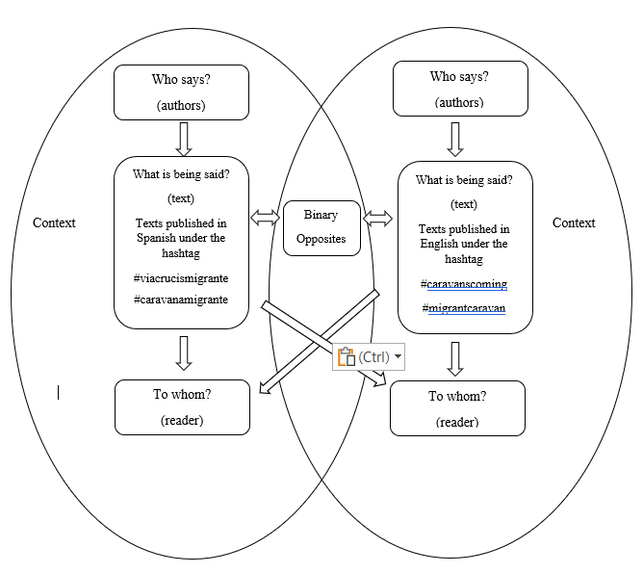
Note. This research study is specifically focused on the study of the messages published as tweets as what is being said, that is, the messages themselves, beyond inquiries about who says, to whom through what channel.
Table 1
Total number of tweets retrieved and coded per hashtag in English and Spanish.
Hashtag | tweets | Language
#caravanamigrante | 449 | Spanish
#viacrucismigrante | 156 | Spanish
#migrantcaravan | 199 | English
#caravanscoming | 137 | English
Total Tweets coded | 941
Note. Tweets retrieved and coded cover the timeframe from March 25 to April 28, 2018.
As this is a qualitative study using a semiotic method for the analysis of the phenomenon of the migrant caravans during a specific timeframe, the context as part of the study itself is essential, and that is why hermeneutics is vital in approaching the interpretation of the context. In this regard, the study begins with the use of the Harold Lasswell (1948) model of communication, identifying who says what in which channel, to whom, and with what effect, but also including aspects of the context which are essential to give sense to the texts studied (see figure 12). Therefore, this research study is focused on what is being said instead of the entire communication process proposed by Laswell's (1948) model.
Because this research study is semiotic and hermeneutic, the focus is only on the messages. Thus, the emphasis is on the messages and not the analysis of who says what, through what channel, and with what effects. For this study, the channel is Twitter, and the study of the who and the effects will imply different studies, which would require the addition and use of alternative research methods to determine authors and possible effects.

Research questions
With the previously exposed, and the review of the literature, the research questions guiding this dissertation are:
Research question 1: What themes are identifiable in the tweets' texts in English and Spanish regarding the migrant caravans and migration?
Research question 2: What are the perceived meanings communicated in English and Spanish on Twitter regarding migrant caravans and migration?
Research question 3: What binary opposites are identifiable in the tweets?

Validity
Comparative semiotics as a method of research in conjunction with hermeneutics epistemology allows the study of the texts without presuming that only one perspective should be taken as dominant, and, at the same time, giving the context its relevance in the analysis of each of the set of texts studied. The dynamics of communication in a digital platform like Twitter generate a universe of meanings that, under specific parameters, are better showcased when semiotically compared and complemented with the interpretive philosophy of hermeneutics. The combination of semiotic, semiotic comparison, and hermeneutic epistemology is valid, coherent, and reliable for this research study, as all the data is accessible and retrievable on Twitter. Also, the results can be replicated using the coding scheme as a base for classifying the tweets for the subsequent semiotic and hermeneutic analysis. Under this approach, this research study contributes to the understanding of the migrant caravans from a qualitative perspective and is affected to some degree by the subjectiveness of the researcher, the context, and the interpretation.

Chapter 4 Findings

Overview
The research that supports this dissertation examines the meanings of the texts published on Twitter about the migrant caravan that occurred in 2018, precisely the way of the cross-migrant caravan. The texts studied included all the tweets posted under the hashtags #viacrucismigrante, #caravanscoming, #migrantcaravans, and #caravanamigrante. These texts were collected and retrieved from March 25 to April 28, 2018. The method chapter of this dissertation offered details about the data retrieved and the qualitative methods used to construe the meanings behind the texts studied. A semiotic and hermeneutic analysis, supported by content analysis to interpret the data obtained and determine the theme of the texts, generated the following findings.
As the goals of this study were to analyze from a semitone and hermeneutic approach the meanings of the texts published on Twitter about the migrant caravan, that is, the analysis of the messages, paying attention to what is being said. Specifically, the objectives of this research study are: (a) identify the themes of the tweets about the migrant caravan (RQ1), (b) study the meanings in English and Spanish about the migrant caravan (RQ2); and (c) what binary opposites are identifiable in the sample texts studied (RQ3).

Summary of findings
This study identified five themes in English and Spanish texts: caravan journey, forced to leave, religion, demands, and threats. A theme can be summarized as “the subjective meaning and cultural contextual message of data” (Vaismoradi & Snelgrove, 2019, p. 2) or “a thread of underlying meanings, within which similar pieces of data can be tied together and within which the researcher may answer the question ‘why’” (Erlingsson & Brysiewics, 2013 as cited in Vaismoradi & Snelgrove, 2019, p. 2). All the texts of the tweets published under the mentioned hashtags were examined to identify the concepts, words, phrases, or images likely to represent a theme. The total number of tweets collected, adding up the four hashtags (#viacrucismigrante, #caravanscoming, #migrantcaravans, and #caravanamigrante), counts for a total of 941 tweets published (see table 1).

The Migrant Caravan themes and categories of analysis
In chapter one, the migrant caravan was depicted along with some historical, cultural, and political factors necessary to understand better the context in which the 2018 migrant caravan occurred. Topics about the migrations in the US and the Americas, the situation in the NTCA countries, and the relationship between the United States, Mexico, and Latin America overall, were all factors catalyzed by the 2016 presidential election of Donald Trump as president of the United States. Trump’s doctrine regarding migration and overall political agenda was an unavoidable factor in examining the migrant caravans and essential in understanding the results of this research study.
It is nothing new to underscore that, at the time of this study, the topic and discourse of migration in the United States, in the news, social media, and by some politicians, was (and still is) a highly polarizing one. The migrant caravans of 2018 occurred in an atmosphere of discussion characterized by extremely polarized points of view, driven by a polarized debate about how to approach this issue from a political and pragmatic perspective in the United States, either by the US government, Congress, or just opinion leaders. Let us remember how during the Trump presidential administration, the confrontation between different American government institutions became a daily routine, permeating the media and social networks, deepening the gap in an already divided political scenario.
In the findings, it becomes clear then the existence of certain discourses in the texts analyzed. For example, migration, security, health, science, the past itself, and the future, to name some. Let us remember that, by definition, discourse is understood here as an “interrelated set of texts, and the practices for their production, dissemination, and reception” (Phillips & Hardy, 2002, p. 3 as cited in Schreier, 2012, p. 45). Also, the findings showcase that the migrant caravan became a trigger event that unleashed a fierce migration debate, contested in online and offline media., and by political leaders or anyone in the public sphere and social networks. As usual, under a context of polarized opinions, conciliatory, intermediary positions are minimized, a fundamental characteristic of a polarized political context (Matar, 2017).
On the other side, and besides the polarized debate, the reality is that the human flow from the NTCA countries to the northern nations in the Americas has been changing. It has evolved from continuous fragmented furtive migrations of constant but small groups, mainly in the shadows, that is, avoiding media attention, to massive migrations of hundreds or even thousands of individuals at the same time, sometimes organized as caravans, or collective social movements (Brigida, 2018, November 2). Moreover, using social networks and the internet for communication and migration and setting up a whole new digital migration era. In the case of the migrant caravan 2018, having the visibility of a collective social movement makes them relevant in the media, reinforces their group identity, and counteracts the arguments against migration. By traveling in big groups, a caravan helps the migrants deal with uncertainty, communicate a story, and help them accomplish their goals.
Furthermore, that is another finding of this research. The migrant caravans are another migration strategy, adapted in response to more extensive and translational controls in the flow of migration in the Americas. Their presence on social platforms made them visible and provided a sense of safety to be in the virtual world, reporting their advances, and struggles and voicing their demands. This mobilization strategy is also founded on developing a narrative, better-said narratives, and a storytelling approach about the caravanners and the 2018 Way of the Cross migrant caravan. For instance, myths, legends, fables, short stories, novels, epic stories, history, tragedy, comedy, drama, and pantomime are all susceptible to be communicated by written, oral, and images (Barthes, 1972). However, also, Twitter is allowing users to reinforce, oppose, or share messages about the migrant caravans, and those communicative actions, per se, constitute the building of a narrative. Those set the creation and re-creation of narratives where the boundaries between reader and writer, or individual and collective, are frequently blurred, as the idea is to create a sense of identification.
The tweets published in the Spanish language under the hashtags #viacrucismigrante, #caravanscoming, #migrantcaravans, and #caravanamigrante during March and April 2018 are a collection of texts that refers to the advances of a group of migrant caravanners, mainly from the NTCA countries, heading to the United States. Most of the texts reflect deeper meanings, narratives, ideas, or imaginaries, some typical of the Latin American identity itself and some about the migration debate and internal and external politics in the United States. Such meanings and imaginaries are recreated using some myths profoundly embedded in both regions, and associated with historical, political, ideological, social aspects, and transfigured in magical and mythical perceptions of the NTCA, Mexico, and the Latin American countries overall, and the US, the region's history, and its culture itself.
After the examination of each of the texts and images, published in English and Spanish on Twitter under the hashtags sampled, five themes emerged from the data collected: the journey of the caravanners, reasons to leave, religiosity, requests and demands, threats, questions about the legality of the caravan. To make a more straightforward classification of the tweets of the caravan and to have a precise orientation about how to recognize a particular tweet as belonging to a specific type, a coding scheme was developed, and the themes were renamed and coded as a) caravan journey; b) forced to leave; c) religious; d) demands; e) threats; and f) not coded. In addition, the categories of the topics and the descriptions of the elements related to each are specified, and examples of tweets are categorized under that topic (see Table 2).
Table 2
Descriptions and examples of theme categories for English and Spanish tweets.
Theme | Description | Example tweets
Caravan Journey | - News, comments, or information about the advances of the migrant caravan.  - Obstacles, odds, unexpected situations faced during the journey.  - Personal testimonies  - Expressions of solidarity about the migrant caravan.  - Expressions of Group identity. | - “Caravana de migrantes llega a la frontera de #EEUU”. (Migrant caravan arrives at the US border)  - “Un grupo del viacrucis migrante fue detenido la madrugada en la comunidad El Encinar”. (A group of the migrant viacrucis was arrested at dawn in the El Encinar community)  - “Desde Honduras llegó Daniel Once a Tijuana” (Daniel Once arrived in Tijuana from Honduras)  - “Reciben migrantes ayuda de autoridades de #gobierno y #sociedad civil”. (Migrants receive help from #government authorities and #civil society)  - “Todos somos América” (We are all America”).
Forced to leave | - Reason to leave the NTCA.  - Vulnerable groups | - “Yensi es salvadoreña, salió de su país porque fue amenazada de muerte tras el asesinato del papá de su bebé de dos años” (Yensi is Salvadoran, she left her country because she received death threats after the murder of her two-year-old baby's father)  - “#Caravanamigrante is in Tijuana awaiting to seek asylum in the US on Sunday, most are women and children” (#Caravana Migrante is in Tijuana awaiting to seek asylum in the US on Sunday, most are women and children)
Religion | - Tweets with expressions of religious symbolisms. | - “Celebran el domingo de ramos en el #ViacrucisMigrante somos un pueblo en movimiento.” (They celebrate Palm Sunday in the #ViacrucisMigrante we are a people on the move)
Demands | - Tweets containing demands or requests from the migrants | - “Asilo politico es un derecho intetnacional dicen migrantes” (Political asylum is an international right, say migrants)
Threats | - Tweets where caravanners or the caravan are described as a threat.  - Tweets where one or more antagonists are named, referred or identified. | - “This invasion from Honduras is the exact reason for the #2A if the government refse to stop them it is up to us as a citizen militia for the security of a free state”.  - “It’s quite clear the Dems have had no intention &have none now to stop any form of immigration. Have you heard even ONE dem statement against this #CaravansComing ?”
Irrelevant/Not coded | - Tweets not related to the migrant caravan (jokes, advertising, tweets without words or images).
Note: Theme categories identified in all the hashtags analyzed: #viacrucismigrante, #caravanscoming, #migrantcaravans, and #caravanamigrante. These texts were collected and retrieved from March 25 to April 28, 2018.
About themes, the first theme identified is the Caravan Journey, which includes the texts about the journey itself, from the beginning to the end, reporting the progress of the caravan, distances traveled, places reached, and to be reached. Also, this theme includes expressions of solidarity and support received by the caravanners or migrants across their journey. The second theme, Forced to Leave, consists of references in the tweets about reasons for the caravanners to leave their home countries. Also included here are the subgroups of individuals within the caravan, which, as vulnerable groups, allege specific reasons to migrate. For instance, LGBTIQA migrants allege intolerance and threats because of their identity. Also, mothers, children, and women are identified as vulnerable groups, justifying migration due to family separation, domestic violence, femicide, hate or intolerance crimes, or having relatives who were victims of violence or threats to their life. Also, some children migrate alone because they want to be reunited with their parents or, in some worst cases, are targeted by gangs as potential recruits for crimes. The third theme identified is Religion, which arises from the religious expressions of faith in divine intervention in the achievement of the objectives of the migrant caravan. Religion as a theme includes any reference, image, words, or connotation of religious nature. Demands, as the fourth theme, include those texts underlining any claims or demands by the migrants. Those tweets include requests to travel across borders free of repression and control by the police, army, or any government agency due to what the caravanners claim are causes beyond their control that force them to leave. Also, this theme includes the texts addressed to specific interlocutors, be they people, individuals, institutions, countries, or NGOs, regarding the caravan's demands as a group of migrants, or just to the reader. Threats as theme groups any mentions of elements threatening the advances of the caravanners in their journey, for instance, transportation, points of control of the authorities across the different countries, groups, individuals, or institutions opposed to the caravan, or any other reason that could add uncertainty to the caravan to come to an end and achieve its goal. Threats are also any texts, images, and pictures published as tweets depicting the migrant caravan, or caravanners, as a threat. Threats include texts depicting any otherness as a potential enemy or threat to the United States, for instance, foreign governments, groups, individuals, political groups, or parties, and possible responses to those threats.
Any other text not related to the topic of this research study was not coded and deemed irrelevant. The tweets classified according to the identified themes were then counted and grouped. This classification allows us to appreciate the predominance of specific topics over others, both in English and Spanish (see Tables 3 and 4). The themes identified here include historical, social, cultural, and even mythological references found as part of the mosaic of meanings published on Twitter by the caravanners, its organizers, supporters, or contesters. Since semiotics is the method of analysis used to examine such connotations, these results guide the analysis to uncover the meanings behind the denoted meaning and the context as an essential part of the analysis.

Table 3
Total Tweets coded per hashtag (#migrantcaravan, #caravanamigrante, #caravanscoming, and #viacrucismigrante)
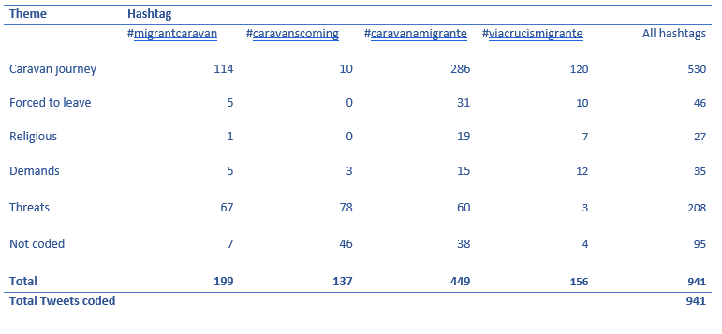
Table 4
Tweets coded per hashtag
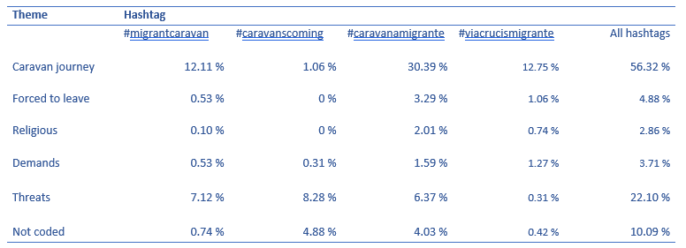

Themes
The first theme to summarize is Caravan Journey. Under this theme, all texts about a) news, comments, or information about the advances of the migrant caravan; b) obstacles, odds, and unexpected situations faced during the journey; c) personal testimonies; d) expressions of solidarity about the migrant caravan; and e) expressions of group identity, are grouped.

Caravan journey: elements of group identity
One phrase that became the caravan motto itself and was carried during the entire journey of the migrant caravan as a banner and appeared in the first tweets at the beginning of the migrant caravan was “Viacrucis Migrante 2018 Todos Somos América No a la Descriminación” [‘Emigrant Way of the Cross 2018. We Are All America. No to Discrimination”] (see Figure 12).
Figure 12
2018 Way of the Cross Via Crucis Migrante banner.
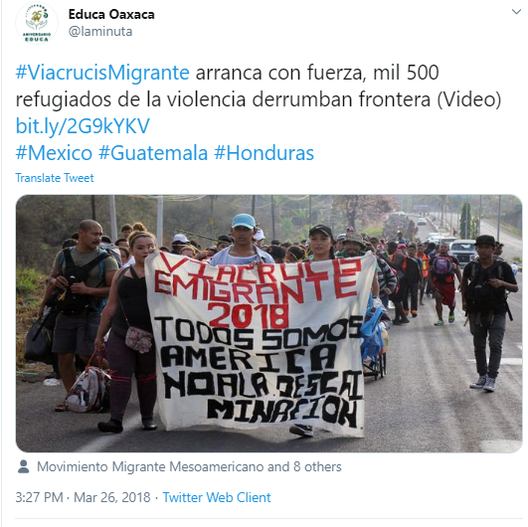
Also, the text accompanying the tweet says: “#ViaCrucisMigrante arranca con fuerza, mil 500 refugiados de la violencia derrumban frontera” (“#ViaCrucisMigrante start with strength, 1,500 refugees from violence tear down the border”). So, we have three elements that communicate and delineate the profile, the group's identity, and the identity of the who: America, refugees from violence, tearing down borders. This phrase, “Todos Somos América” (“we are all America”), evokes a sense of group identity, evoking possible connotations and different ways to read it, depending on the context and the reader itself. First, the phrase denotes the group of caravanners' collective identity, which refers to the caravanners as a group of migrants grouped as the Way of the Cross 2018 caravanners and walking to the United States' southern border. So, the phrase is more like a statement and helps build a sense of belonging and group identity.
Analyzed in fragments, there are at least three elements to showcase. For instance, it communicates some ideas of the meanings, including the idea of America as territory, as a group of nations in the continent, as culture, as people, as caravanners, referring even to the original, primal inhabitants of the American continent. America, the word, in this context, is a polysemic text with connotations that encompasses symbolisms that alludes to historical, political, cultural, and social aspects of Latin America and the United States.
This image of the caravan carrying the banner with the statement: Viacrucis emigrante 2018 Todos Somos América No a la Descriminación”. [‘Emigrant Way of the Cross 2018 We Are All America No to Discrimination”] became a recurrent image and symbol during the caravan (See Figure 13).

Figure 13
Mexico gives humanitarian visas to the migrant caravan
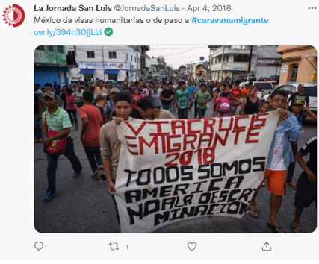

The tweet shown in figure 13 was published on March 26, 2018, early days of the caravan. The image showcases a group of people walking toward the front. The group of people is large, and the extension of the people walking is projected to infinity, to a vanishing point that fades on the far horizon. This group marches from a distant origin to a destination place that appears to be from the observer's point of view. They advance to get closer to the viewer's point of view. Who are they? What do they want? Why do they want to migrate? What is America for them? Is it just the United States? Is it the Continent? This web of questions is addressed below.

The concept of America from a semiotic and hermeneutic perspective

Another phrase added to the banner and shared many times during the caravan journey and posts on Twitter was “Todos Somos América.” Therefore, what does America signify in the messages of the caravan? Are there different meanings associated with it? What meanings could lie behind the phrase: “Todos Somos América” (“we are all America”)? The caravanners, along their journey, carried a banner with this phrase. It was visible in 11 tweets in the hashtags #caravanmigrante and #viacrucismigrante at different times and places of the migrant caravan route (see Figures 14, 15, 16, 17, 18, and 19).
One of the first published tweets published about the 2018 migrant caravan defines at the same time one of the traditional elements of the caravan in terms of its identity and purpose: “We are all America” (“We are all America”). This does not represent something anecdotal or accidental. At the beginning of the caravan, the caravanners carried a banner with the inscription described above as a banner bearer. They brought along the journey of the caravanners, which has a meaning beyond this specific caravan.
The 2018 Way of the Cross happens in a context where restrictions for these migrations are increasing. The transit and destination countries (the United States, Mexico, and even some countries from the NTCA) reinforce their borders to limit migrant caravans. In the United States, the administration of Donald Trump, elected president of the United States for the period 2016-2020, enforced migratory regulations by his promise to implement migration policies to reduce the number of migrants heading to the US. Among those policies, coordination with Mexico's government was part of the agenda to stop and reduce the flow of migrants from the Central American region and use Mexico as a transit territory in their migration to the United States. In this regard, the Programa Frontera Sur referred to in Chapter 1, is one of the most representative efforts to control the migration flow from the NTCA heading to the United States through Mexico.
Figure 14
Via crucis emigrante 2018 Todos somos America
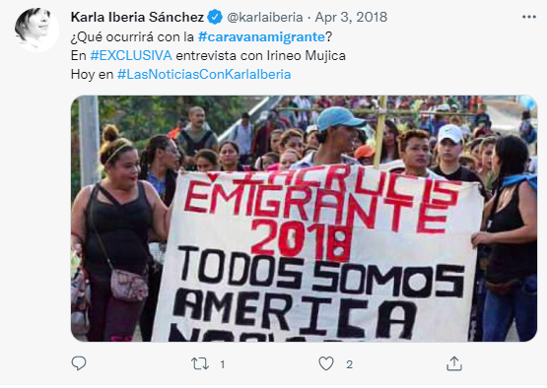
Figure 15
Via crucis emigrante 2018 Todos somos America
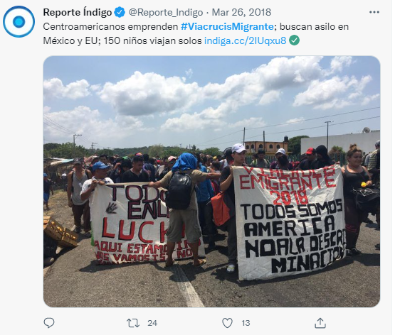
Figure 16
Via crucis emigrante 2018 Todos somos America
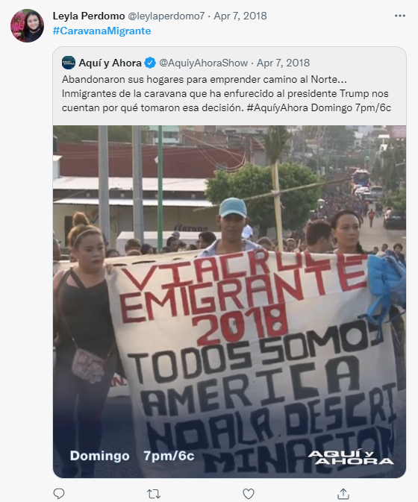
Figure 17
Via crucis emigrante 2018 Todos somos America
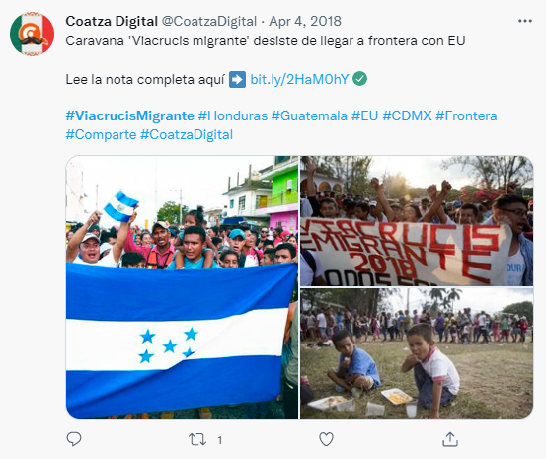
Figure 18
Via crucis emigrante 2018 Todos somos America
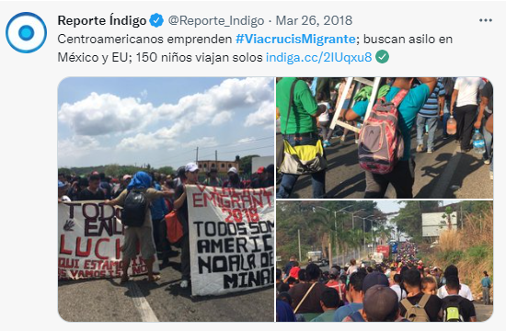
Figure 19
Via crucis emigrante 2018 Todos somos America
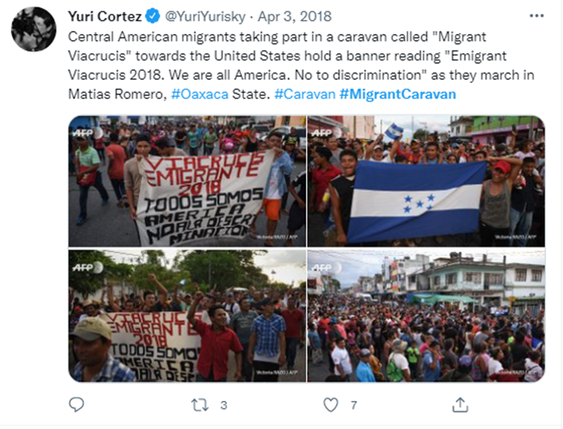
At first glance, the motto of the caravan, “we are all Americans,” appeals to avoid the rejection of the Governments of Mexico and the US of the caravan and the caravanners themselves, to request solidarity with the caravanners during their journey across Mexico. Such a message carries a more profound connotation as it expresses the idea of division in the American region. The phrase We are all America contains a claim, an expression that denotes the existence of various Americas.
Remember that historically in the region, there have been old yearnings for union between nations, especially Latin American ones, to consolidate political, economic, and cultural unions. From the desires of Francisco de Miranda and then Simon Bolivar to create a union of emancipated Hispanic American republics, passing through the failed attempts at Central American integration, the most relevant being the failed creation of a Central American Federal Republic that came to group together the republics of Nicaragua, Costa Rica, El Salvador, Honduras and Guatemala in 1823, until the most recent attempts by Hugo Chávez to consolidate the Bolivarian Alternative for the Americas (ALBA), the Union of South American Nations (USAN or UNASUR in Spanish), or the economic Southern Common Market (Mercado Común del Sur, Mercosur in Spanish), the truth is that many of these attempts have offered lukewarm results if not failed. Also, many of those initiatives are indeed the result of regional associations to counteract the economic and political power and influence of the United States in the region.
Hence, it is thought that this topic may have relevance beyond the anecdotal. This theme is, without a doubt, a claim by and for the Latin American countries and the entire southern hemisphere. As integration has been complex in Latin America, the enormous cultural, linguistic, political, and economic distance that exists between the Latin American countries and the United States has also generated a context in which the division between the former and the latter has become part of that of a claim of recognition of each other under the premise of America as familiar territory. Furthermore, the problematic past between the Latin American countries and the United States has resulted in existing signaling in the Latin American region towards the United States as a factor interested in hindering integration and, therefore, the development of nations in the southern hemisphere. Although the intention of this research study is not in any way the historical analysis of the political past and present of the Americas, it is an essential factor that can help to understand some parts of the present context, therefore, useful in the analysis and the relevance of symbols used to convey meaning about the 2018 migrant caravan.
In this regard, in Latin America, the relationship between Latin America itself and the United States countries is perceived as distant and pragmatic. In other words, in some texts, the connoted meaning is that the US actions are against the interests of the Latin American countries, for instance, by the economy (US Capitalism), backing authoritarian presidents or by facilitating weapons for repression against the population (see Figure 20 and appendix 1).
Figure 20
The principal objective es receding from Central America because for them it means a big misery…US Capitalism has done much damage to South America… Along the way, help has been received from shelters, etc. "”.
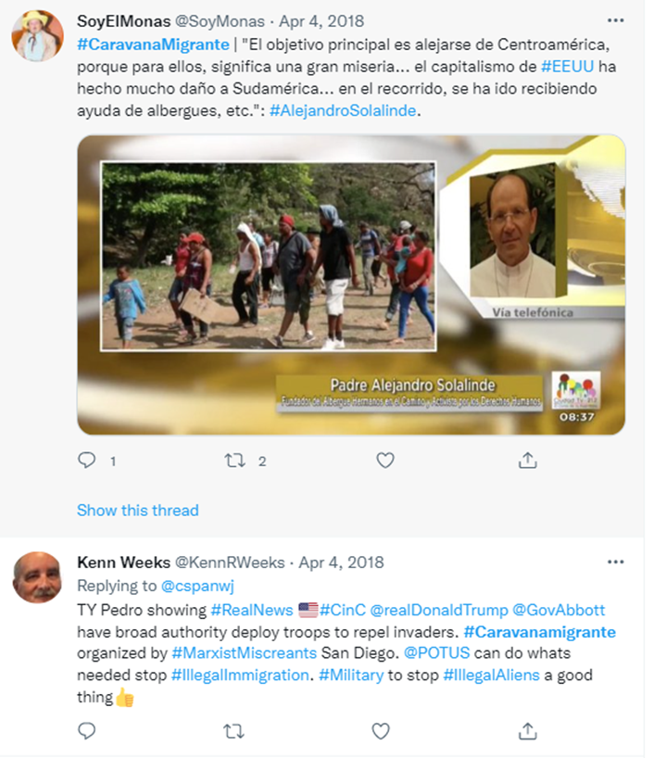
Also, the reason for this complex relationship is that the Latin American countries share common historical origins, the same language, and cultural affinities, as many of them were once colonies of Spain or Portugal. However, the Latin American countries' cultural and historical similarities represent a different story than the United States. The US development as a nation had a different background, resulting in a nation with none or very few affinities with the entire group of Latin American nations, which consequently resulted in a relationship between the two regions deeply influenced by such different cultural and historical backgrounds.
In this context, the 2018 Way of the Cross Migrant Caravan occurred. Emerging as a migratory social movement with a collective identity summarized in the phrase “we are all Americans.” An expression that gathers the group under a common origin and a common goal, a common ground, facilitating the “intersubjectivity and thus provides a framework for meaning-making that allows people to construct a shared representation of their social world, a shared world view, that is normative for their group” (Clark & Brennan, 1991; Higgins, 1992; Thompson & Fine, 1999, as cited on Hogg & Reid, 2006, p. 14). In this regard, the caravanners share their origin and destination as they are mainly from the NTCA countries: Guatemala, Honduras, and El Salvador, with common claims, like the request to migrate freely across borders in the continent in their exodus to reach the northern countries in the hemisphere (see Figures 21 and 22).
As the collective identity of the caravan is summarized in the phrase “we are all America,” the imaginary of America as a unique territory, an initial territorial concept is implicit as well. It seems that, for the caravanners, America is thus a space with no borders, a vast territory, and eclectic but homogeneous land, a symbolic idea of a geographical and cultural space. In other words, America has become a social representation (Moscovici, 1988) within the caravanners.

Figure 21
“Trump government threats the migrant caravan who approaches to the border”
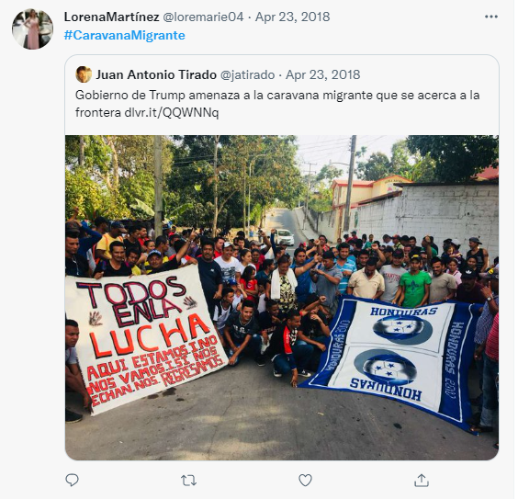
Figure 22
“#caravanamigrante announces high level meeting with [Mexican] officials”
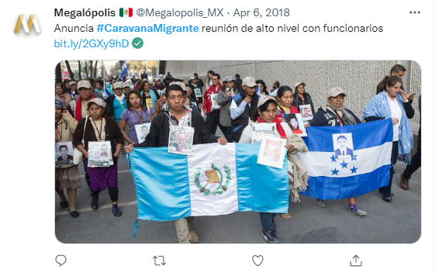
Behind the homogeneous group identity of the, we are all America phrase also coexists a diversity of collective identities of subgroups that contribute to defining a group of migrants. Cohesive in their goal of migrating but diverse in their backgrounds, which go beyond a mere belonging to a land. We are all America phrase becomes then an umbrella. This polysemy encompasses groups of men, women, children, elders, entire families, Afro-descendants, indigenous people, and members of the LGBTQ community fleeing from violence, intolerance, etc., their origin countries, mainly from the Central American nations of the NTCA (see Figures 23, 24, 25).
Figure 23
“Members of the South American groups in favor of #sexual diversity [sexual diversity] were present during the arrival of the #viacrucismigrante to Mexico City.”.
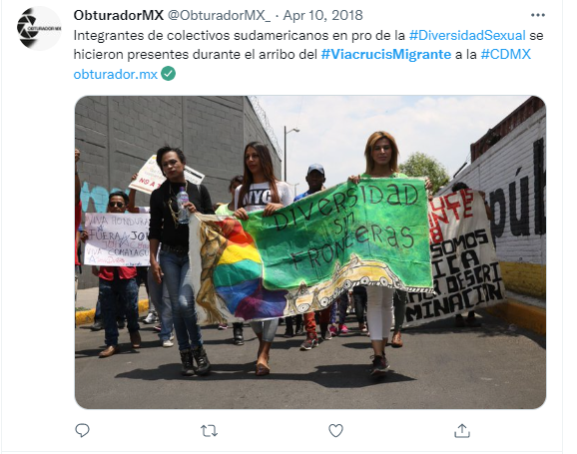
Figure 24
“Trans migrants and devotees stay at Estancia Peregrino, Mexico City” 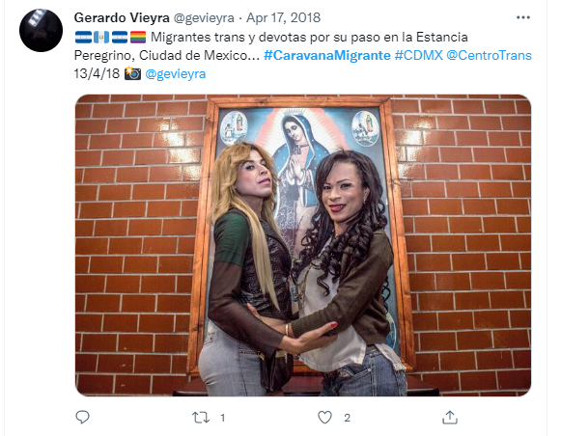
Figure 25
Women and children in the migrant caravan.
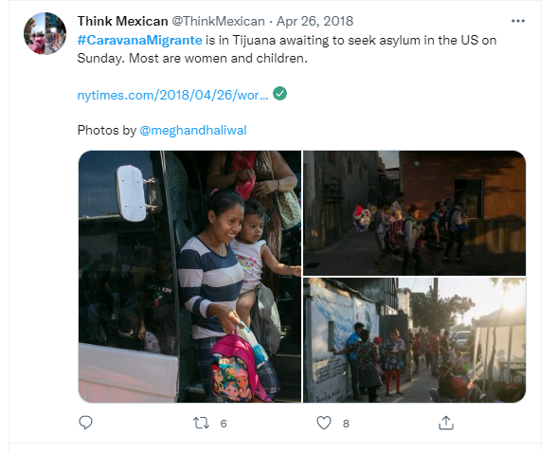
In any case, what is the presence of tweets showing images of a big group of people migrating? For example, the migrant collective, the caravanners, portrays the symbolism of a massive movement united by a common objective. One example of this is shown in Figure 26. This tweet shows four images accompanied by written texts. These are images of people marching in different frames. Two of the images are of big groups of people marching. In one of those pictures, the marching people carry a banner with the text “Via Crucis Emigrante 2018 todos Somos America No a la discriminación” (Migrant Way of the Cross 2018 We Are All America No to Discrimination). In the other image, the people are marching across a road but stopped under a bridge, at the point under the shadow of it. The other two images show women with children marching as part of the group. The other two texts are located as part of the tweets accompanying the tweet.
At first sight, there seems to be a paradigmatic association of meanings in the texts. A paradigmatic association happens when the texts get meaning from their association with other signs. At the same time, the texts complement the images, fulfilling a relay function (Barthes, 1977). The first noticeable text (“support for the #ViacrucisMigrante,
free transit and official protection to the northern border. Mexico is not a sub-branch of the Border Patrol, nor does it share immigration objectives with the Government of the United States”) is located at the top of the original tweet. The font size is larger and fulfills the function of underscoring the most recent message associated with the tweet. In this regard, Twitter allows that content, texts, or images to be quoted and tweeted as a post. By doing so, the original message can be either echoed, complemented, amplified, or specified. In other words, as the texts change, so do the functions associated with the image, and it could fulfill the role of either anchorage or relay (Barthes, 1977) of the image. From top to bottom, the texts published originally in Spanish accompanying the image (see Figure 26) are:
A) “Apoyo total al #ViacrucisMigrante, libre paso y protección oficial hasta la frontera norte. México no es una sucursal de la Border Patrol ni comparte objetivos migratorios con el Gobierno de los ” [United State flag].
B) “¡No somos criminales! Gritan en el viacrucis del migrante en #Chiapas Veracruz”
C) “Viacrucis emigrante 2018 Todos Somos América No a la Descriminación (sic)”
Translated to English, the texts of the tweets of the texts read:
A) “Full support for the #ViacrucisMigrante, free transit, and official protection to the northern border. Mexico is not a sub-branch of the Border Patrol, nor does it share immigration objectives with the Government of the [United States flag].
B) “We are not criminals! They shout in the migrant's way of the cross in #Chiapas Veracruz."
C) "Emigrant Way of the Cross 2018 We Are All America No to Discrimination"
Another element that must be highlighted is the text that accompanies the original tweet, and that was added in the retweet made by “Cecilia Soto” (see Figure 26): “Apoyo total al #ViacrucisMigrante, libre paso y protección oficial hasta la frontera norte. México no es una sucursal de la Border Patrol ni comparte objetivos migratorios con el Gobierno de los Estados Unidos” [“Full support for the #ViacrucisMigrante, free transit and official protection to the northern border. Mexico is not a sub-branch of the Border Patrol, nor does it share immigration objectives with the Government of the United States”].
Also, in the tweet in Figure 26, located in the upper left corner, we see a young woman, a mother, who carries her child in her arms, wrapped in a yellow blanket, and walking in front of the caravan that dominates the frame. It is a lonely mother ahead of the group, with her eyes looking to the horizon. In the following image, three women are on the tweet's lower right side. One of them is in the center of the photograph carrying a little girl on her back and another little girl next to her. Behind this woman, another also carries another girl in her arms. Finally, on the left side, another woman walks alone.
Figure 26
“Total support to the #viacrucismigrante free pass and official protection to north border. Mexico is neither a branch of the US border patrol nor share migratory goals with the US government”.
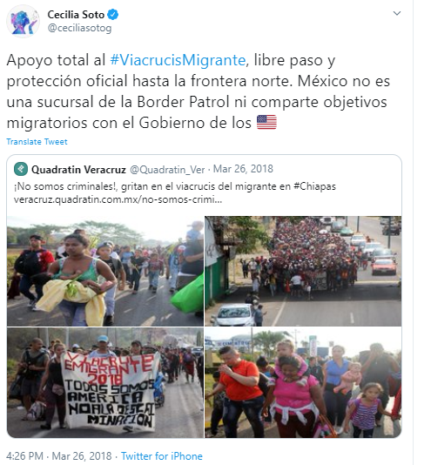

The caravanners are pictured in this collage of pictures as a significant movement, mothers, workers, vulnerable people, and a diaspora of desperate people. The photographs portray faces and postures in a steady effort, walking. The images symbolize a group of individuals in transit immersed in the uncertainty of a trip with an uncertain destination. Neither their faces denote joy nor their attitude demonstrates the peace of mind of knowing they will achieve their goal. The situation, connoted in the set of images, can be defined as being in a sort of limbo. The overall message is that the group of caravanners is stuck in the shadows, marching without the certainty of the achievement, facing barriers in their advance.
Overall, images of women accompanied by little children can be appreciated in many tweets studied. Some examples of these representations are shown in Figures 27, 28, and 29. Although women and children embody part of the group identity of the migrant caravan, their presence is underscored and presented as vulnerable. The message is that they, the mothers, are marching alone in the quest for a better future for themselves and their children.
The fact that women primarily represent the migrant way of the cross caravan appeals to some legitimacy of the caravan's claims. In total uncertainty, identifying the caravan as a group of women, mothers, and fighters who advance in procession toward the search for better living conditions for their families is a way to legitimate their cause. The message thus suggests that women, primarily mothers, are an essential part of this migratory movement. The collective identity is built based on a synecdoche. According to the message, the caravan comprises several vulnerable groups, mainly women and children.

Figure 27
“Children and older women show the most bitter face of the migrant caravan..”
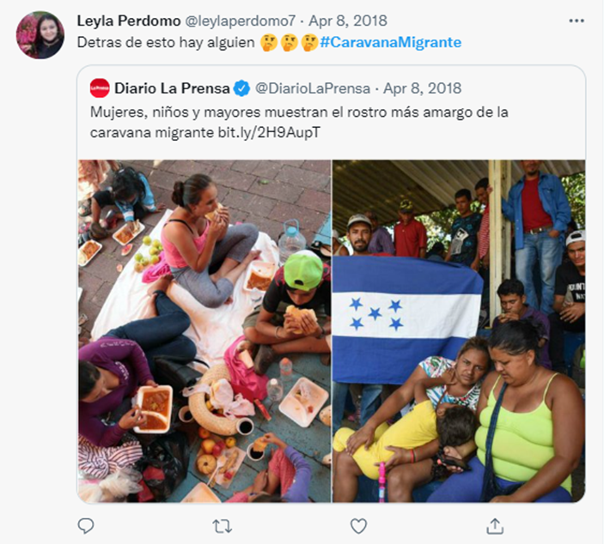
Figure 28
“The message from our Hondurans sisters is clear: we are strong and looking for a decent life”
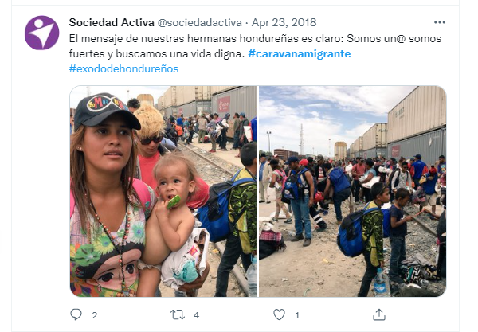
Figure 29
“The caravan arrives to Guadalajara”.
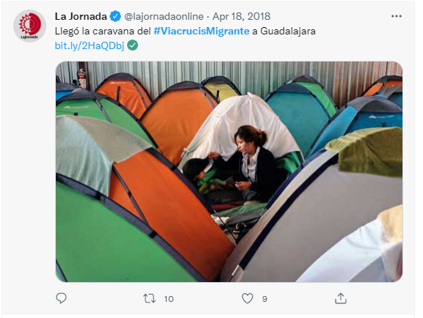
This group identity is reinforced when the images of the women and children as vulnerable groups are accompanied by the phrase accompanying the tweet: "We are not criminals" (“No Somos criminales”), a text which, by contrast, conveys more meaning that, for instance, to say only "we are mothers" (see figure 26). Mothers, as a vulnerable group, as a concept, are already communicated by the images. The texts, in this case, fulfill the function of a relay (Barthes, 1964), as it adds an expanded lecture, one supported in the contrasting of concepts, mothers and children as a group, therefore, harmless, and needed of a support group as opposed to criminals an opposed concept.
The phrase "We are not criminals" is a direct reference to the phrase “bad hombres” (Rudden & Brandt, 2018), which was used during the 2016 presidential campaign in the United States when the former candidate Donald Trump used the phrase to refer to the immigrants coming from the southern border into the United States. During the 2016 United States presidential campaign, the migration topic was a vital debate theme among the candidates. The phrase “bad hombres” was used to describe many of the migrants advancing towards the US border in caravans, meaning that many migrants coming across the Southern border of the US were criminals. Also, when Donald Trump made his remarks announcing his candidacy for President in New York City, he referred to the migration situation with Mexico, saying: “When Mexico sends its people, they're not sending their best. They're not sending you. They're not sending you. They're sending people that have lots of problems, and they're bringing those problems with us. They're bringing drugs. They're bringing crime. They're rapists. And some, I assume, are good people” (The American Presidency Project, 2015). By communicating “we are not criminals” the caravanners refer directly to such words.
Another topic identified in the caravan journey theme is the positive and negative factors related to the journey, for instance, odds, obstacles, and solidarity during the caravan. Tweets expressing solidarity with the caravan and the caravanners along the way represent a big part of the sample analyzed. Solidarity across the caravan's journey, primarily through Mexican territory, appeals to elements of Latin American identity and struggle (see Figures 30, 31, 32, and 33). As the journey represents uncertainty for the caravanners, some other aspects add to this theme. Those include changes in the route of the caravan, transit restrictions, delays, and dangerous ways of transportation (a train route used by many migrants is named “the beast” or “la bestia” in Spanish) (see Figures 34, 35, and 36), repression by police or security forces, restriction by governments, or any factor favoring or against the caravan to continue their journey.

Figure 30
“Our country is your country. Indigenous peoples of Mexico City welcome the #migrantcaravan at the Citlaltépetl shelter”.
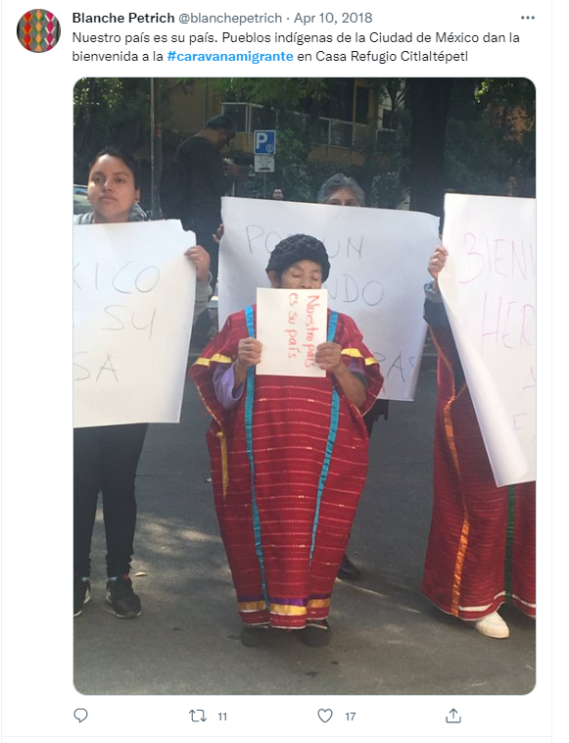
Figure 31
“Mexico must continue to be a city of refuge against the policy of terror that attacks its Central American brothers and threatens Mexicans. We stand in solidarity with the migrant via crucis”.
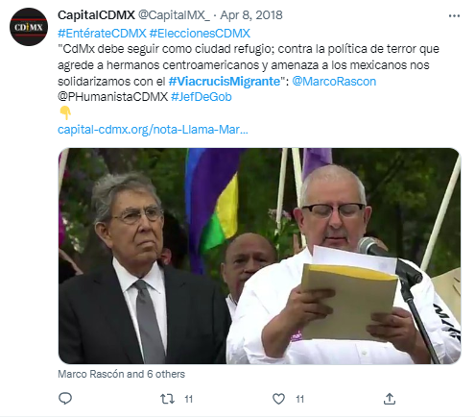

Figure 32
“Do you want to support the families of the #viacrucismigrante? Estancia González y Martínez needs rice, beans, soup, oil, coffee, clothing, and shoes for the people who are arriving in Querétaro. Here more information”.

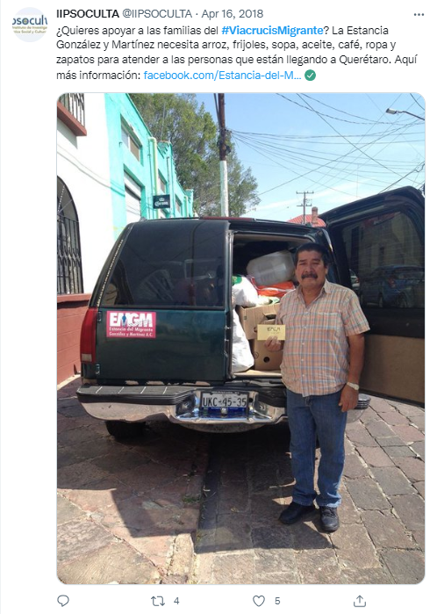

Figure 33
In 13 months, the USA collected data on 30,000 migrants in Mexico. What a shame that our migrant brothers are treated like that. They do the work they ask [of the Mexican authorities], "dirty work"
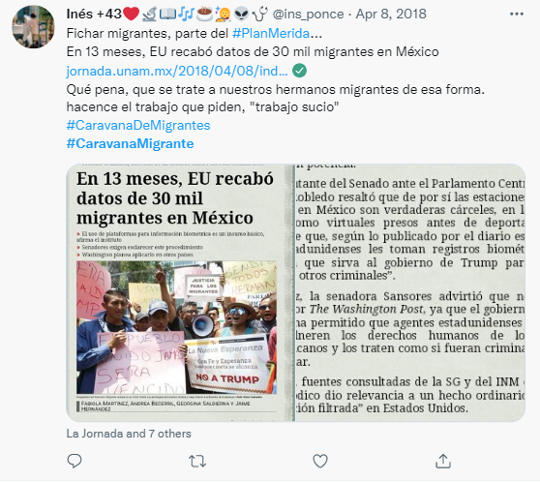
Figure 34
“Migrant caravan on the cargo train [the beast] to Nayarit”.
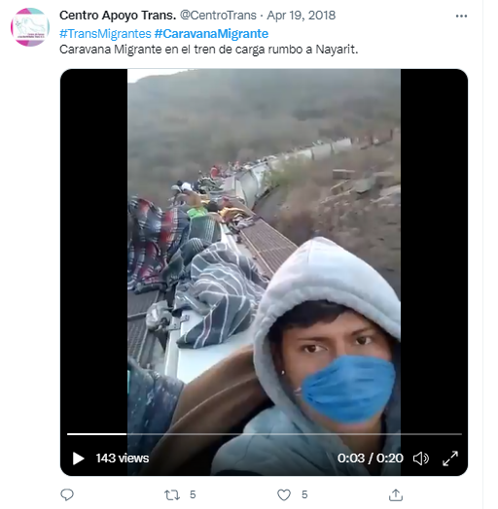
Figure 35
Migrant caravanners riding “the beast”.
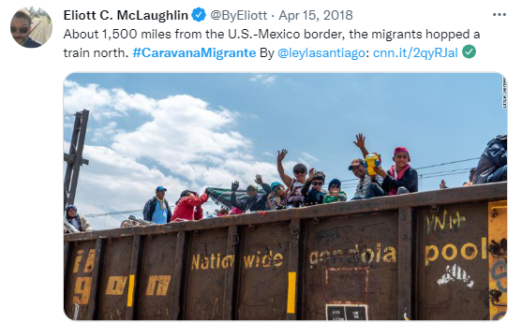
Figure 36
“#FelizDomingo After a trip of 3 thousand kilometers in “La Bestia”, #ViacrucisMigrante Caravan arrives in #Hermosillo”.

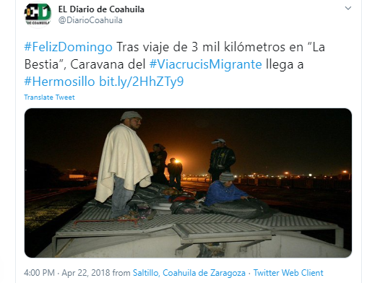
One crucial factor that symbolizes an obstacle for the caravanners is represented by Donald Trump, president of the United States when the caravan occurred. Donald Trump concentrates much of the symbolism of the opposition to the caravan, and many tweets are dedicated to him. As a result, the image of the Republican president of the United States became frequently represented in many of the tweets in which he is portrayed in many ways. Such representations of Trump are caricaturing, ridiculing, or relating him to radical or extreme ideologies. In the Our Journey theme, Donald Trump and the wall represent the main obstacles for the caravanners (see Figures 37, 38, 39, 40, 41, and 42). In the caravanners imaginary, Trump embodies a sort of nemesis, a nightmare representing the most significant obstacle for migrants; therefore, much of the frustration is directed at him. At the same time, Trump is the anti-ideal of a better future, of a new life, and the promised land for the members of the migrant caravan.
Some other obstacles are represented by countries like Mexico, which is identified as subordinated to the US and executing an arm of measures considered restrictive of migration directed explicitly towards the migrant caravan. The wall represents one of the most important symbols as an obstacle. The wall is here referred to as the division proposed by Donald Trump between the United States and Mexico. The wall became a powerful symbol in the imaginary of the caravanners, symbolizing one major odd (see Figures 43 and 44). The wall became a powerful symbol that galvanized the migrant caravanners against what they perceived was one of the most critical obstacles to overcome and the accurate representation of Trump’s migration policy toward the NTCA and the migrant caravanners.

Figure 37
“The migrant caravan completed its journey and arrived in Mexico City”. Text of the photo: “out Donald Trump”.
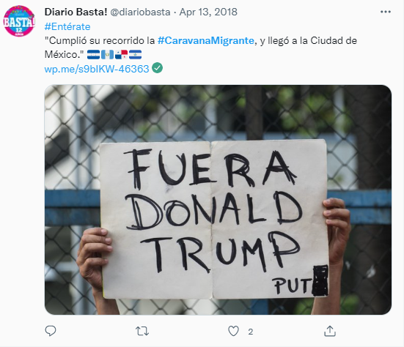

Figure 38
“Activists invite the migrant caravan to visit the Vs Trump mural [in Mexico]”.

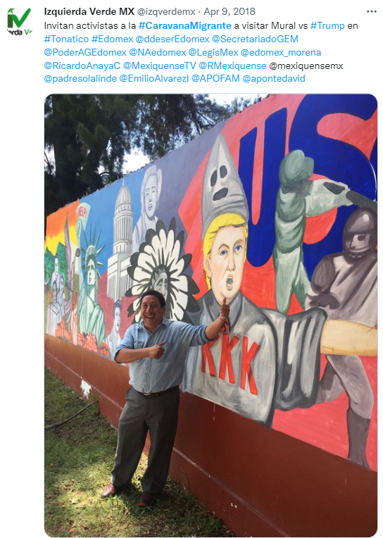

Figure 39
“Migrant caravan arrives to Mexico City marching against Donald Trump [migration] policies”.
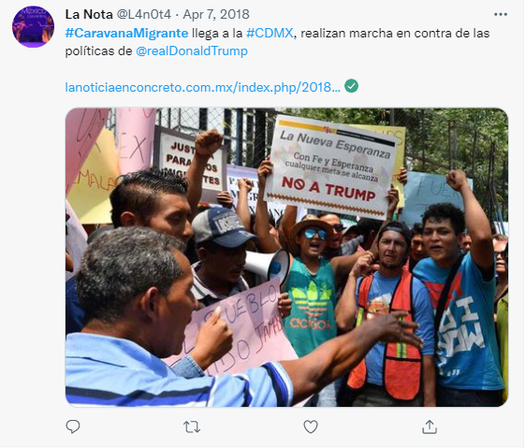
Figure 40
“Migrant caravan migrants reject Trump in Mexico City downtown”.
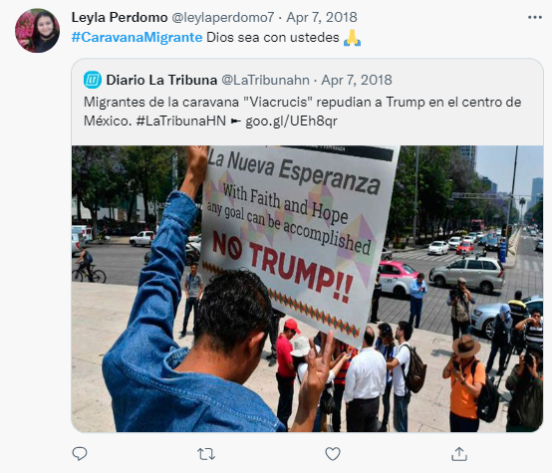
Figure 41
“Build a wall

Figure 42
“Mongols”
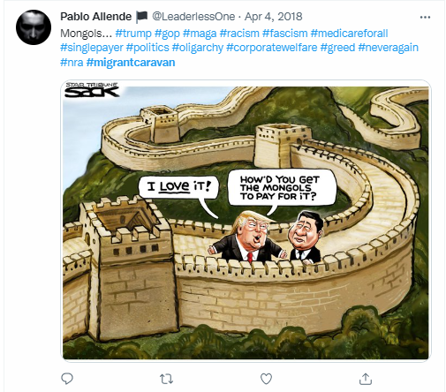
Figure 43
The wall.
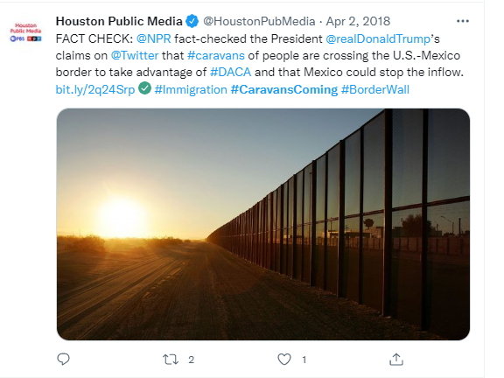
Figure 44
The wall.
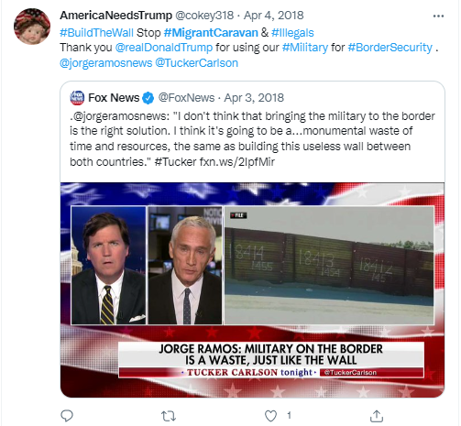

Forced to leave
The texts of the caravan's tweets categorized as forced migration themes underscore the caravanners' reasons to leave their home countries. In this regard, violence is frequently referred to as a reason for forcing the migrants to leave. Under this theme, personal stories about the violence are shared as well as attachments or weblinks of news media reports of the situation in the NTCA (see Figure 45).
Though violence is cited as one, if not the main, reason to leave, in the texts of the tweets analyzed, one latent topic is the lack of control of violence in any of its forms by the NTCA governments. Although it is not explicitly discussed in the tweets, the connoted meaning implies that state institutions in the countries of origin, the NTCA nations, are inefficient, corrupt, or overwhelmed by the gang’s violence, overall crime, and corruption.
Figure 45
“Yensi is Salvadoran, she left her country because she was threatened with death after the murder of the father of her two-year-old baby. #CaravanadeMigrantes #ViacrucisMigrante”.
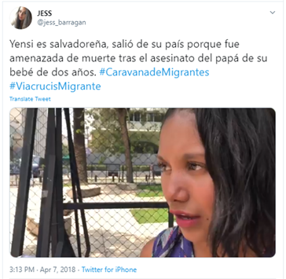

The violence referred to in the texts analyzed has different faces. The migrants usually cite gang violence as one of the main reasons to leave the NTCA. Still, domestic violence and violence against women, in general, are also added as causes to leave their countries. In some tweets, the connotation is the existence of complex, structural violence problems in the societies where the migrants flee and the lack of efficient institutions for its control. Also, the perception of the government as repressive and enslaving is not new, nor is the mistrust in the authorities or institutions in the NTCA countries. The 2018 migrant Via Crucis caravan appeals to reinforce the idea that they flee from a situation of democratic weakness, weak democratic institutions, rulers, and oppression. Overall, the message communicates mistrust. It connotes the idea of unreliable democratic institutions or authorities in their countries of origin. According to this vision, the citizen is subject to be a slave to others' arbitrary will. The idea of ​​the State as an institution is, therefore, weak. It does not represent the law but an abstraction between ineffectiveness and arbitrariness. In sum, there is a total disconnection between society, the individuals, and their representatives, either politicians or institutions. This situation is not new as the lack of trust in democratic institutions by an essential percentage of the citizens in Latin America (see Figure 46).
For instance, in some texts analyzed about the #viacrucismigrante, the high levels of violence in the NTCA countries are referred to as one of the main reasons for the forced migration, but, at the same time, such violence is referred to as to be the consequence of external factors. More specifically, it is suggested that the problem of violence in Honduras, Guatemala, and El Salvador is closely related to the arms sent from the United States. In some other tweets or hashtags, the reason to leave is due to the corruption in the government, for instance, of the Honduran president, Juan Orlando Hernandez, according to some tweets and hashtags of the caravanners, a president backed by the US (see Figure 20).
Figure 46
“Our brothers and sisters love their countries but their governments only want them to be slaves”.
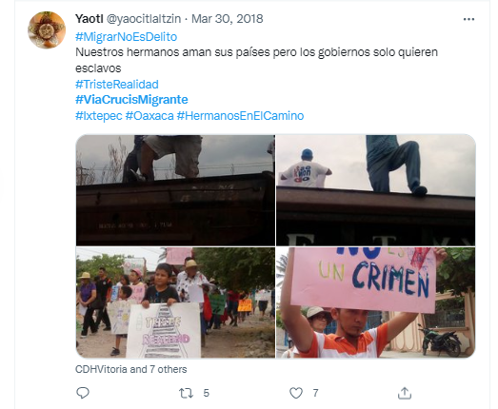
The migration itself is described as a necessary exodus, with no other option than leave, and caused by external factors. The triumphant ending also depends on external factors, which are opposed to the caravan, the caravanners, and their migration journey. The main factors mentioned are Donald Trump, the wall, and Mexico as enforcers of US migration policies.
Overall, the #viacrucismigrante texts published on Twitter in Spanish communicate the message of a group of migrants on a journey with no other option than to be in a sort of limbo, stateless, fleeing from war, corruption, lack of fair institutions in their countries of origin, but with no certainty of success in their quest for the promised land. As their objective seems beyond their immediate control, the narrative of the 2018 way of the cross migrant caravan turns into a faith crusade, one in which their fate lies in external factors, decisions, and individuals, a narrative with connotations of fatalism.

The violence
For this semiotic analysis, one concept recognized as necessary in defining the identity of the group of migrants is the concept of violence. The violence in the caravanners' social imaginary seems to refer to all the factors that dominate their fate, overall external, and a powerful reason for every caravanner to leave their countries and begin an exodus. That concept establishes a common situation and origin contributing to the group identity.
The meaning of violence, as a concept, has a very rich connotation for every culture. This is a universal, polysemic concept that carries virtually endless meanings. The denotation of violence means an increase in self-destructive capacities. The caravanners define themselves as victims of violence (see Figures 47, 48, and 49). For the caravanners, violence, a word, a concept, as symbolic expression, represents a variety of meanings. It can represent any defining conflict for individuals, social groups, nations, or even beyond. This can be temporary or even take the form of a perennial, eternal conflict. Violence can even carry opposed meanings, becoming what Umberto Eco (1998) defines as a fuzzy concept. This means that violence is a polysemic sign that can be used to express various and even opposing meanings. Thus, a word like violence encompasses different possible meanings. It can signify conflict, death, but even life, love, hope, or hate. What is essential here is to acknowledge that the use of certain words is then the establishment or reinforcement of meanings of a semiotic universe.
Figure 47
“Little refugees from Honduras and El Salvador who travel to Puebla play to forget for a moment about the difficult situation of insecurity in their countries”.
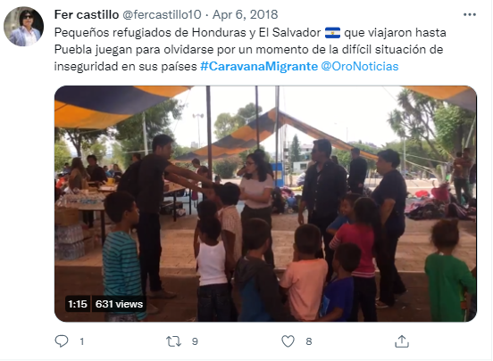
Figure 48
“Mr. trump, stop your show and the violence in our countries”.
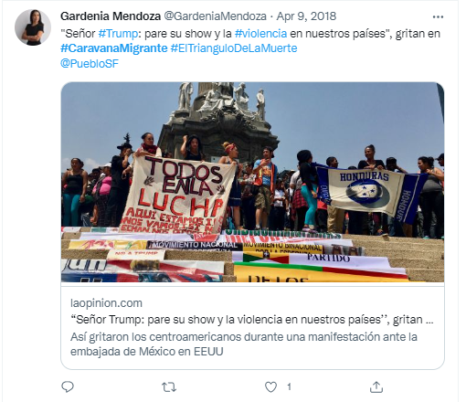

Figure 49
“In my country you just wait to be dead”.
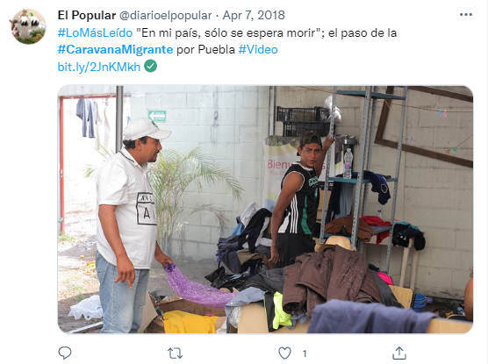
In the case of Central America, such violence has assumed the form of eternal conflicts, endless conflicts, and clashes. It thus comes to mean a sort of original sin from which all the historical, social, and cultural evolution of the societies and countries that are today part of the NTCA will always suffer. This idea also suggests a mythological perspective, where the violence represents a before and an after in the conception of the history of the caravan migrants. In other words, a set of beliefs, an ideology, a mythology. In this mythology, the idea of the past is the idea of a golden past, an idyllic memory of ancient past times, once pure and pristine but corrupted and perverted, at some time in history, by conflicts that unleashed fierce wars and violence. This state of being “fallen,” “corrupted,” thus generates a longing to return to the time before history, a time of natural happiness that now lives only in a collective memory that renders present conditions hellish by comparison (see Figures 50 and 51).

Figure 50
“Church in Puebla, Mexico, is the shelter of more than 800 Central Americans of the migrant caravan who left their countries due to the violence and unemployment”.
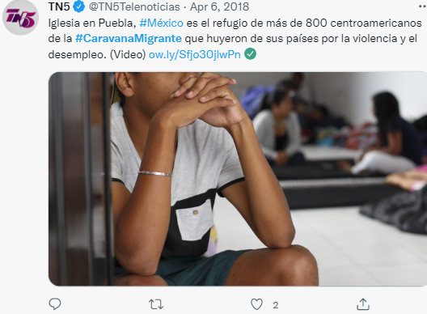

Figure 51
“#viacrucismigrante the walk of our brothers who look for the home and the dreams that the violence and bad governments snatch”.
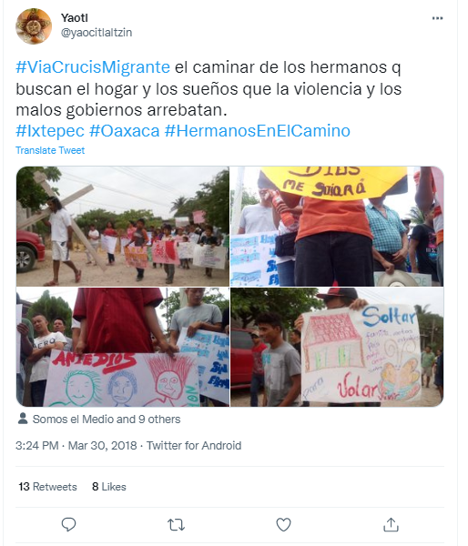

Thus, we have a broad semiotic construct, a framework of binary difference functioning in the collective imaginary. In the case of the caravanners, the violence is portrayed as ageless and timeless, just the idea of the violence as an overall, omnipresent, omnipotent factor. War and violence are then perennial, not temporary, but omnipresent and permanent.
As expressed in the text of the tweets studied, violence evokes past, present, and future events; that is, violence has become a permanent, omnipresent situation. The violence can also assume the face of past or present wars (like the references to the civil wars in El Salvador, Guatemala, and Nicaragua during the eighty’s decade). In other words, not just historical events deeply marked in the collective memory of the caravanners, but rather a set of meanings, changing and evolving. Probably, such wars experienced in the past in some countries of the region have become a world of significations, as “since the object of historical knowledge is itself a meaningful object, or an object constituted by significations, the development of the historical world is ipso facto the unfolding of a world of significations” (Castoriadis, 1997, p. 14).
Concerning this, the connotation of the violence for the migrants from the NTCA and the caravanners embrace diverse significations, a complex set of varied and inextricably linked meanings. The means are linked together under the abstraction of a word. Thus, violence is better described as a polysemic word that refers to diverse realities for the individuals of the caravan. The reference to violence encompasses all the struggles affecting their lives, their decisions, and dominating their fate. The violence symbolizes an entire world of significations, of social representations.
The nations of the NTCA indeed suffered wars and conflicts that resulted in bloody confrontations that left profound scars on the social tissue of the society. Those conflicts were extensions of a global Cold War between the United States and the USSR during the ’80s when the world was divided into the Eastern and Western blocs. Also, it is undeniable that all those conflicts had political, economic, and social consequences in recent years for all the nations of the NTCA. For instance, years of war worsened the poverty levels of the population. In addition, they frustrated the numerous efforts of rebuilding democracies in the region by creating a scenario where the people developed a very high mistrust of political authorities and institutions. Also, the NTCA economies face economic challenges like stagnation, low salaries, and a lack of opportunities. Overall, the most significant contemporary challenge for the countries of the NTCA is violence, specifically gangs. Gangs like the “Mara Salvatrucha” or the “Barrio 18” have become international criminal organizations with branches all over Guatemala, Honduras, and El Salvador. They are responsible for the increasing levels of violence among the countries of the entire NTCA (Farah, 2012). Also, violence from the State, violence against women, and intolerance to minorities.
Thus, the word violence combines all those meanings. In sum, violence includes gangs, corrupted police, crime, weakened state institutions, intolerance, gender violence, the economy, past civil wars, the individual and its surroundings, and its history (see figures 52, 53, and Appendix # 1). Also, the violence could include the inner personal conflicts that each caravanner fights within themselves, not against external enemies, but within themselves, struggling in their daily lives to find a way out of their situation and survive. The violence, then, is a symbolism that permeates the external and the internal, from the past to the present, and the future, from the real to the surreal. A situation where no shelter exists as it lives among everyone, and toward which there seems to be the only possibility to look for an escape, running from themselves, sheltered in religious promises.
Figure 52
“#Stories of the #viacrucismigarnte, displaced by the violence”.

Figure 53
“Release. #viacrucismigrante #refugeecaravan advances to defend the rights”.
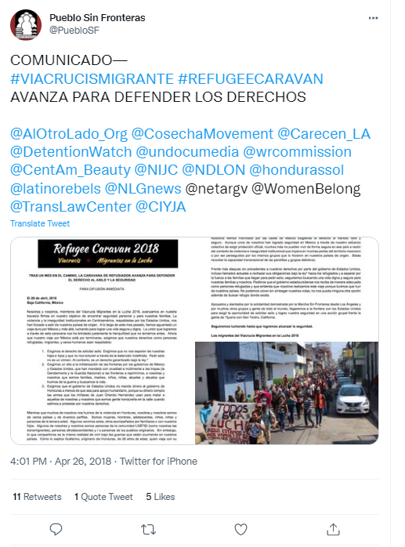
Just as the violence is cited as the fundamental reason behind the exodus of the migrants in the caravan, in some of the texts studied, the responsibility for such violence and weak democracies is attributed to the United States and, by extension, a mindset that the exodus and the migrants' requests are the responsibility of the US as well. The violence, as a phrase, is then a synecdoche, expressing mythology, a mixture of cultural, social, and historical events. By extension, the 2018 Way of the Cross migrant caravan meanings combine the communication of a myth, using the Catholic Passion of the Christ as narrative, where the use of symbols, connotation, metonymy, synecdoche, paradigmatic and syntagmatic relations, communicating (or performing) a broader discourse far beyond the caravan as a specific migratory movement, by merging historical, social, religious, and cultural meanings.

Religion
The migrant caravan is a journey both in a literal sense and a figurative, metaphorical, and symbolic sense. Regarding the journey as a symbolic concept, Chevalier (1999) refers that it represents the sign and the symbol of a perpetual rejection of oneself (p. 1067). The journey as a symbol is perhaps one of the richest ones. It contains many possible meanings. Among others, that of an escape that never ends. It is a journey of discovery, change, and transition; it is also a pilgrimage, a search for the promised land (Chevalier, 1999).
The mere fact of calling it the way of the cross (“via Crucis migrante”) says a lot. It makes the migrant caravan an event directly related in the symbolic to the way of the cross of Jesus Christ. It mimics a journey of suffering, hardship, uncertainty, and the hope of a resurrection in a new life like Christ's passion. Redemption depends on faith. At the same time, achieving the objective depends on a religious perspective, which leaves the achievement of an aim of faith to the intervention of factors beyond the earthly, the human, but instead on divine factors. This is an essential characteristic of the caravan: the request to achieve its objective is outsourced to religious and faith factors. It is not a matter of countries of origin or destination, of local or national authorities, but a question of faith and whose achievement will be the product of divine intervention (see Figures 54, 55, 56, and 57).
Figure 54
“#caravanmigrante faces threats in Nuevo Leon [Mexico]. Groups warn that they will shoot the train where they are traveling”. 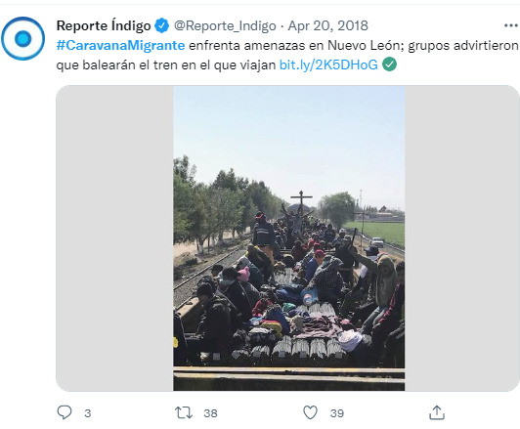

Figure 55
“Way of the cross Central American migrant caravan ended in Mexico City”.
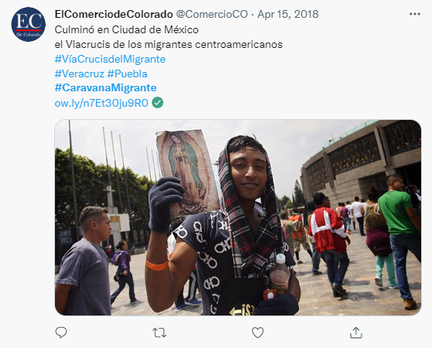
Figure 56
“God is with me”.
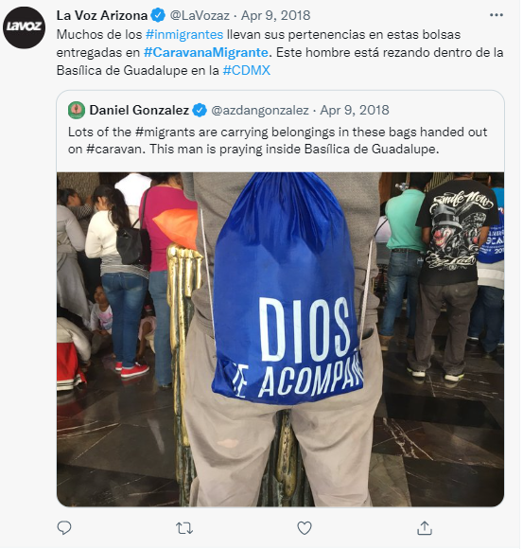
Figure 57
Migrant caravanners carrying the Cross in Mexico City.
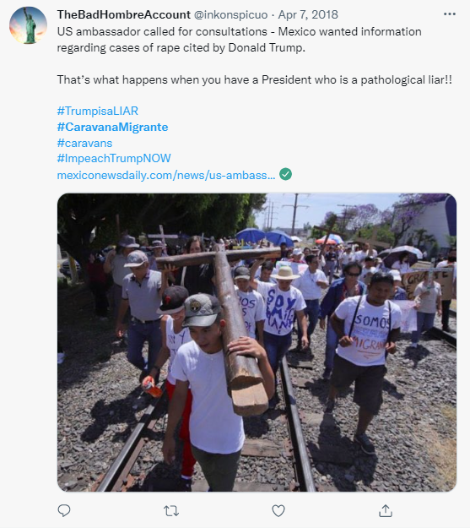
In the first place, the 2018 way of the cross migrant caravan conveys the idea of the caravan as a Way of the Cross. Here we have a group of people migrating together. However, its migration is described and performed as a literal Way of the Cross. A passionate and suffering journey, representing the passion of Jesus Christ. The migrants embodying the suffering of Jesus Christ communicate a dual message of faith and penitence while conveying the belief in a new beginning, in a promised land beyond their current situation, a pilgrimage to a promised land. The decision to attach the narrative to the Catholic Way of the Cross is critical as Latin American countries are predominantly Catholic. This symbolic connection gives the caravan a sense of religious morality, a sacred effort, and a dialogue between the caravanners and the divinity beyond questioning or judgment. That is, a sense and a purpose focused on factors beyond the physical and the earthly and more on the divine, religious, and moral. In the journey searching for such a promised land, the caravanners as penitents are in limbo. According to the Christian Catholic religion, the limbo is a place between heaven and hell, an indeterminate state representing a time and space where penitents await the acquittal of Jesus Christ, a divine intervention, or baptism into the Catholic faith that allows them to access the promised land, to heaven. The limbo is a symbol with solid religious roots and connotations. It is undoubtedly a symbolic space of penance, uprooting, of non-identity.
The “religion” theme includes texts and references in which the caravan is associated with topics where the caravanners express beliefs of their situation as to be trapped in “a world of caprice, manipulated by everything and everyone, in no position to change his or her fate” (Bal, 1995, p. 263). As imaginaries, the worlds of the present texts refer to the reasons for migrating. They also present the events related to the caravan itself as factors beyond the individual or group's desire or control. “Religion” texts are thought to be an expression of religious faith, the purpose of which is to cope with the uncertainty of the journey. The idea of a preconceived plan of destiny or fate is understood as an expression of divinity, as factors reserved solely for the will of divine factors beyond human control or free will.
The 2018 migrant caravan presents itself as a pilgrimage. It is presented as a journey of suffering following the Catholic narrative of the “Via Crucis” (Way of the cross). Its symbolism is of this Catholic remembrance of the passion of Christ as literal pain and suffering. This narrative reinforces the sense of suffering, passion, persistence, and, in the end, the promise of a new life in a better place, far from the adversities they are fleeing. The 2018 migrant caravan represents an example of a magic, highly emotional mode of idolic communication (Kramer & Ikeda, 1998). To represent the migration as a Way of the Cross is a re-presentation and an actual re-creation of a passion. The word passion must be understood here as pain, suffering not as a metaphor (mythic symbolism) but as magic, idolic experience. The text can be read as a set of actions that are political strategy (three-dimensional signalic/perspectival expression), as a metaphor (two-dimensional symbolic mythic expression), and as idolic self-evident experience (manifest magic one-dimensional experience).
The Via Crucis is a narrative, a re-presentation, and a re-creation of suffering, overcoming the odds and persisting, guided by faith. Symbolisms associated with Catholic religious beliefs in this narrative are common in the caravan (see Figure 58). For instance, it is not happenstance that the caravan was set to begin on Palm Sunday (see Figure 59), and its depiction of migrants carrying palms) as it represents a literal commemoration of the Way of the Cross according to the Catholic calendar. Also, during the 2018 caravan, posts with caravanners carrying the cross or pledging God's guidance during the journey are frequently presented. Catholic narrative and symbols in the tweets published under the hashtag #viacrucismigrante are typical in many texts studied. It expresses a group identity as all the caravanners present themselves as carriers of the cross.
Under the Way of the Cross narrative, the caravan delivers a powerful idolic (Kramer, 2002) and symbolic discourse through a narrative deeply rooted in Latin American culture and identity. By appealing to elements of Catholicism, the caravan delivers a powerful message by idolically presenting and symbolically representing the caravan as actual suffering and, at the same time, as an analogy to the passion and crucifixion of Jesus Christ. This message unquestionably brings the narrative of the 2018 migrant caravan closer to elements of fatalism since the aspirations of the caravanners are left to rest on the intervention of religious and external factors. Idolic communication is fatalistic because there is no dissociation between the sign and the signified. It is not conventional. The identification is one-to-one. The suffering is real. It is not symbolic or signalic.
Figure 58
“A woman from Honduras prays inside the Basilica of Guadalupe [Mexico[ with some other migrants”.
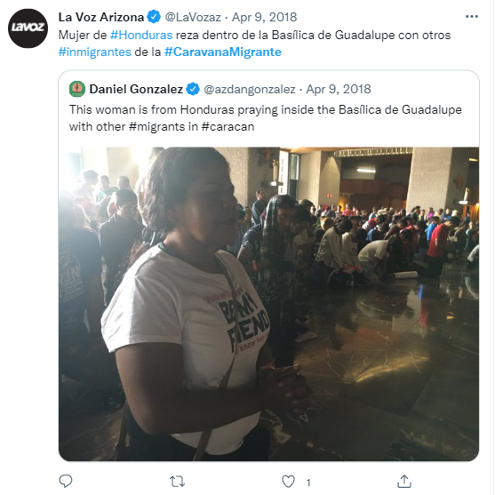

Figure 59
“About one thousand Central American migrants departed today in procession from Tapachula, Chiapas [Mexico] in the named #viacrucismigrante; half of them are women and children”.
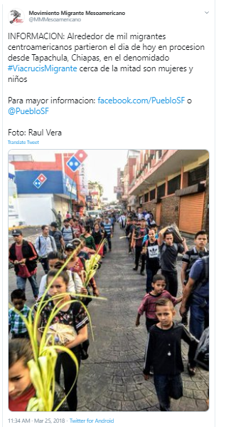
When the migrants refer to the government of their countries, it reflects an overall distrust of their nations' institutions or political leaders, sometimes linked to religious expressions. For example, in one of the images, one of the banners carried by a member of the caravan says, “No necesito ningún coyote, Dios me guiará” (“I do not need a coyote, God will guide me”). The word coyote, in this context, refers to a human trafficking dealer who smuggles migrants across borders, specifically between Mexico and the United States border. Human trafficking in this location is illegal and controlled mainly by the Mexican drug cartels (see Figure 60). According to Kulish (June 30, 2018), “A decade ago, Mexicans and Central Americans paid between $1,000 and $3,000 for clandestine passage into the United States. Now they hand over up to $9,200 for the same journey” (para, 14).
Figure 60
“I do not need a coyote; God will guide me”.
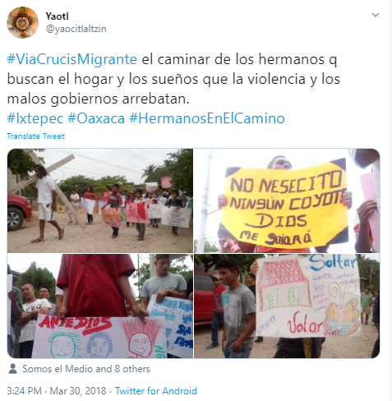

Demands
One of the publications on Twitter better summarizes not only the requests and demands of the 2018 way of the cross caravanners but the majority of the themes identified were made public on April 26, 2018 (see Figure 61 and Appendix # 1). In this tweet, a two-page document in Spanish enunciates the caravanners' reasons, context, requests, and demands. The tweet reads “Comunicado - #viacrucismigrante #refugeecaravan Avanza para defender los derechos” [“Communique #viacrucismigrante #refugeecaravan advances to defend rights”]. The document accompanies a picture of migrants walking across a central road in what looks like a Latin American downtown carrying a handmade banner with the statement in Spanish, “Todos en la lucha. Aquí estamos i no nos vamos i si nos echan nos regresamos” (sic).
The document is divided into seven paragraphs. The first paragraph explains who the migrants are, the reasons for their migration, and their travel across Mexico. The second paragraph poses three specific requests or demands. First, they demand the right to request asylum. Second, they ask that there will not be a military presence at the borders between Mexico and the US. Third, the request that the US government stop financing the government of Honduras. The third paragraph describes the profile of the caravanners. The fourth part describes their efforts to inform international organizations such as the United Nations (UN), the United Nations High Commissioner for Refugees (UNHCR), and the US Embassy in Mexico. The fifth paragraph describes why even though Mexico could be an option to request asylum, some caravanners prefer not to due to security issues in that nation. Finally, the sixth paragraph asks for the ending of the family separation policy by the US government and to be received as refugees.
Figure 61
Demands of the migrant caravan.
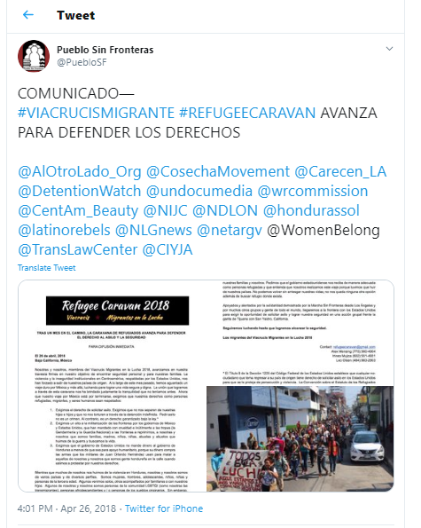

The last paragraph underscores the solidarity of diverse non-governmental organizations in the US and the world regarding their cause. It also underscores their intention to continue to the US border. The document ends with one statement “We will continue to fight until we reach safety. The migrants of the Viacrucis Migrants in the fight 2018” (“Seguiremos luchando hasta alcanzar la seguridad. Los migrantes del Viacrucis Migrantes en la lucha 2018”). Finally, the last part of the document is a footnote concerning the US Federal Code regarding the right to request asylum in the USA.
The group appears to advance down the street without any deterrence. Some men in orange vests appear to be coordinating the caravan route. They seem to be members of the caravan itself, helping to keep the transit path as their gestures and position along the group of walkers suggest such duty. There appears to be no car traffic, no police, no security officers, no supporters, just the caravanners, alone in their travel during a sunny day. The solitude in which the march happens in the image shows no people supporting them, either in the streets or on the balconies. Also, there is an absence of government security or control agencies, such as police or transit control, to either help control transit or the security during their passing. In sum, the image captures the moment of a group of people walking in total freedom of movement, advancing down a street. This denotes that there is no action against their movement. A possible connotation suggests that they do not threaten the city or the country. The caravanners seem to focus on their pilgrimage/migration and not on staying there.
Nevertheless, the meaning of the image published in this tweet is not precisely in the image itself. The image is just a complement to a text that anchors how the image must be read. In this case, the text accompanying the image, a two-page document, communicates the context of the background of this image. For the analysis of this document, the first step is to identify the main ideas, then identify how they are expressed, the literal meaning, and the connotation of such ideas according to the semiotic theory of Roland Barthes (1964). This is particularly challenging as the text is written in Spanish, and the semiotic analysis of it is performed in English. Therefore, the analysis requires an explanation of the subtleties of the Spanish text.
The first aspect perceived in the text is related to the collective identity of the group of caravanners expressed in the text. In this regard, the references about the group identity are present in the third paragraph of the referred document (see figure 74 and appendix # 1). The original excerpt in Spanish says:
…somos de varios paises y diversos perfiles. Somos mujeres, hombres, adolescentes, ninos, niñas, y personas de tercera edad. Algunos venimos solos, otros acompañados por familiares o con nuestros hijos. Algunos de nosotras y nosotros somos personas de la comunidad LGBTQI (como nosotras las transmigrantes) personas afrodescendientes y/o personas de pueblos originarios. Sin embargo, lo que compartimos es la misma realidad de vivir bajo las guerras que están ocurriendo en nuestros países.
[… We are from several countries and different backgrounds. We are women, men, adolescents, boys, girls, and seniors. Some of us come alone. Others of us come with relatives, including our children. Some of us are people from the LGBTQI community (like us transmigrants). Some of us are people of African descent. Some of us are indigenous people. However, we all share the same reality of living under the wars that are occurring in our countries”].
The collective identity of those in the caravan movement is emphasized. The description of the members of the caravan soon becomes a description of a large and diverse group of people, including individuals of all ages, nationalities (most of them are from Guatemala, Honduras, El Salvador, and even Mexico), gender, sexual orientation, race, indigenous origin, and transgender people. A group that is defined in the following phrase as people who “…share is the same reality of living under the wars that are taking place in our countries” [“compartimos la misma realidad de vivir bajo las guerras que están ocurriendo en nuestros países”]. This implies that personal identity, and individuality, are not as important. Instead, their identity is based on the commonality of being victims of “…wars that are taking place in our countries” to be victims of the violence.
The demands expressed in the document extend the perception that the objectives of the migrant march depend exclusively on external factors. The narrative is of a struggle against odds and obstacles. Those odds and obstacles could be the United States government, the president of Honduras, Juan Orlando Hernández (2014-2018 and elected for a second term 2018-2022), or Mexico and the US border patrols. The specific demands are underlined in three points in the second paragraph:
1. Exigimos el derecho de solicitor asilo. Exigimos que no nos separen de nuestras hijas e hijos y que no nos torturen a través de la detención indefinida. Pedir asilo no es un crimen. Al contrario, es un derecho garantizado bajo la ley.
2. Exigimos un alto a la militarización de las fronteras por los gobiernos de México y Estados Unidos, que han mandado con crueldad e inúltimente a las tropas (la gendarmería y la guardia nacional) a las fronteras a reprimirnos, a nosotras y nosotros que somos familias, madres, ninos, niñas, abuelas y abuelos que huimos de la Guerra y buscamos la vida”
3. Exigimos que el gobierno de Estados Unidos no mande dinero al gobierno de Honduras a menos de que sea para poyo humanitario, porque su dinero compra las armas que los militares de Juan Orlando Hernández usan para matar a aquellos de nosotras y nosotros que somos gente hondureña en la calle cuando salimos a protestar por nuestros derechos.
["1. We demand the right to request asylum. We demand that they do not separate us from our daughters and sons and that they do not torture us through indefinite detention. Applying for asylum is not a crime. On the contrary, it is a right guaranteed under the law.
2. We demand a halt to the militarization of the borders by the governments of Mexico and the United States, which have cruelly and uselessly sent the troops (the gendarmerie and the national guard) to the borders to repress us, our families, mothers, children, and seniors who fled the war and looked for life
3. We demand that the United States government not send money to the Honduran government unless it is for humanitarian support because its money buys the weapons that the military of Juan Orlando Hernández uses to kill us, Hondurans on the street when we go out to protest for our rights] (see figure 12 and appendix # 1).
In essence, their requests include the right to request asylum, not to be separated from family members, not to be put into detention indefinitely, to not consider asylum requests as a criminal action, the end of the army presence on the border between Mexico and the United States, and the revision of the high rate of denials of asylum requests of the migrants who arrive there. They also request that the United States defund the government of Honduras by stopping the transfer of funds from the US to the government of Juan Orlando Hernández. He is pointed to as a corrupt president using the money to buy weapons for repression. The meanings, although specific regarding requests and demands, contain a series of connotations.
The first one is that the group requesting the series of demands is perceived as a group of banished people. Of stateless individuals, with no protection from any state. They are responsible for defending themselves and their asylum claims, susceptible to any arbitrariness. The requests are directed to the authorities of the governments of the United States and Mexico, some non-specified consulates, and embassies, along with the United Nations High Committee for Refugees (UNHCR). Also, Honduras is referred to as an unsafe country under the control of Juan Orlando Hernández, who is accused in some tweets of corruption and repression of the caravanners. There are no direct requests to the governments of any of the other nations of the NTCA. Requests are made only to international institutions or countries like Mexico or the US.
In sum, the narrative suggests the story of a group of migrants, banished from their countries, walking in loneliness, stateless, hoping to arrive at a safe destination, believing faith will deliver. The departure from their countries is seen as an inevitable exit. It is portrayed as the only alternative to save their lives. In the Way of the Cross 2018 caravan messages, the United States is referred to as the only possible destination for their journey and connoted as the only alternative to the lives they are leaving behind. The option of a third country as a place to arrive and seek asylum is rejected as, in some messages, neither Mexico nor a country of the Central American region offers the safety the caravanners are looking for (see Figures 62, 63, 64, 65, 66 and 67).

Figure 62
“Central American migrants suffer negative prejudice from Mexicans”.
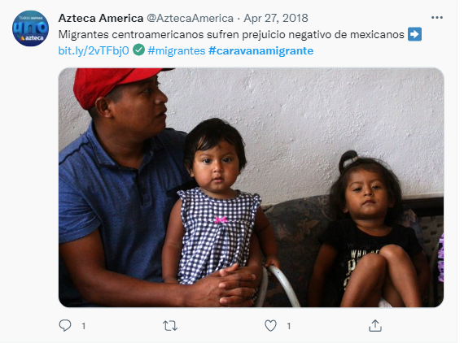
Figure 63
“Threaten the #caravanamigrante with shooting them if they cross Sinaloa [Mexico]”.
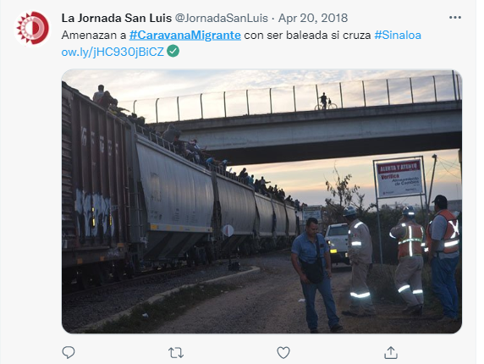

Figure 64
“If the State is related to the fire to the train ways in Hermosillo, Sonora [Mexico], then we are in front of a true complot and alliance with the American government”.
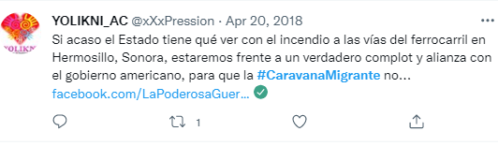
Figure 65
“Migrant caravanners who altered Trump’s nerves began to arrive in Mexico City. Have you thought about the terrible conditions that obligate people to escape Central America and what they live in Mexico?”
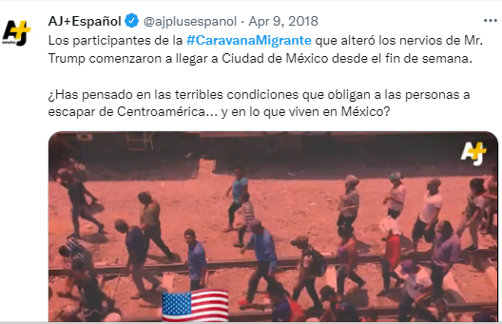

Figure 66
“We continue deporting more than the US. Mexico has become a place of destiny, and the border is more difficult”.
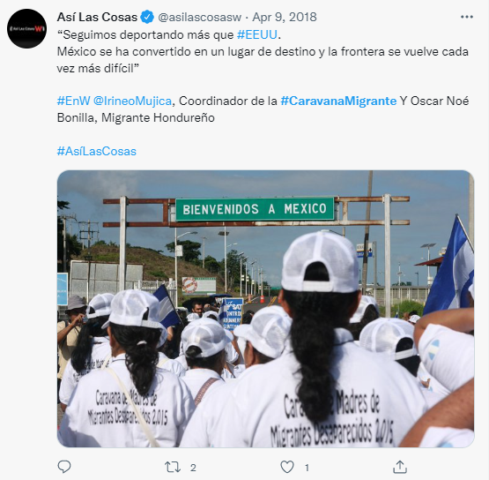
Figure 67
“In Puebla [Mexico] denounce disappearance of 400 [migrants] by ambush of the @INAMI_mx to migrant caravan”.
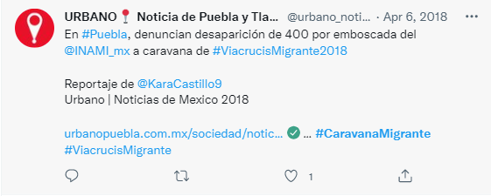
As for the Central American caravanners, the culprit of the problems of their countries of origin is the United States, yet it is also their solution. The caravans' solution is that whoever is responsible for this situation must then take responsibility to correct things. This is undoubtedly a contradiction, but at the same time, it portrays the migrants as in charge, as this being “their” migrant movement. For instance, in one excerpt it is expressed that “We cannot return without risking our lives; we have no other option but to seek refuge where it exists” [“No podemos volver sin arriesgar nuestras vidas; no nos queda ninguna otra opción además de buscar refugio donde exista”] (see figure 73 and appendix # 1). However, in the following paragraph, it is stated that many of them do not have the option to stay in Mexico because of gang violence. Another reason given is the institutional frailty in Mexico.
There is an apparent reference to who opposes their advances: Donald Trump, President of the United States. For instance, in one text excerpt (see figure 71 and appendix # 1), “Stop Donald Trump with the politic of fear!” [“¡Alto Donald Trump con su politica de miedo!”]. Overall, the image of the United States, through the document, describes the country of destination as a place where “a dignified and safe life for our families [“Una vida digna y segura para nuestras familias”] is possible. This message is also present in other texts in the tweets analyzed (see Figures 68, 69, and 70).

Figure 68
Trump attacks.
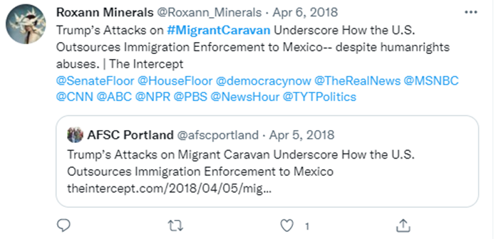
Figure 69
Trump Officials warn.

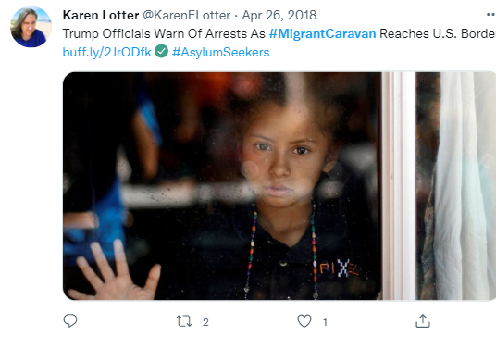
Figure 70
Begging Trump.
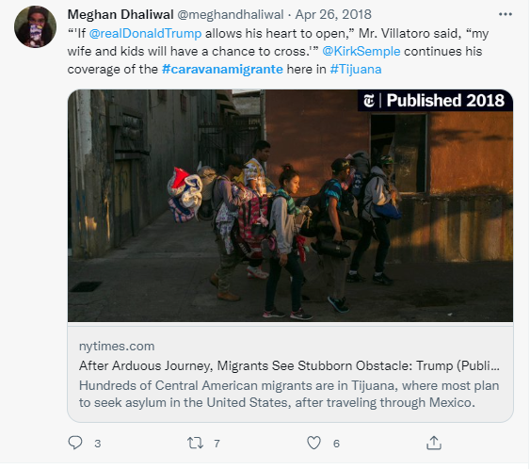
The text's narrative is identifiable as the peregrination of the march of the caravanners as the way of the cross. It is a narrative of suffering and penitence. According to Catholic beliefs, the reward is access to the promised land or heaven. According to the narrative, such access is granted only on the walkers’ penitence and faith. As the caravanners face the dilemma of no other option but “to seek refuge where it exists,” they embody a mythology of the migration in the Americas. They become pilgrims searching for the promised land (see Figure 71). Pilgrims and pilgrimages carry powerful symbolism. For Jean Chevalier (1999), pilgrim refers to a human being living in an environment where he or she feels like as a stranger. Thus, such a place, and their present situation, become a temporary reality, even though such reality could be their entire lives, longing for a promised land and feeling the necessity to search for the ideal city. Pilgrimage expresses the transitory character of a situation and the inner detachment concerning the present, combining a certain unrealism correlated with a sentimental idealism (Chevalier & Gheerbrant, 1999, p. 812).
Figure 71
Pilgrims in search of the promised land.
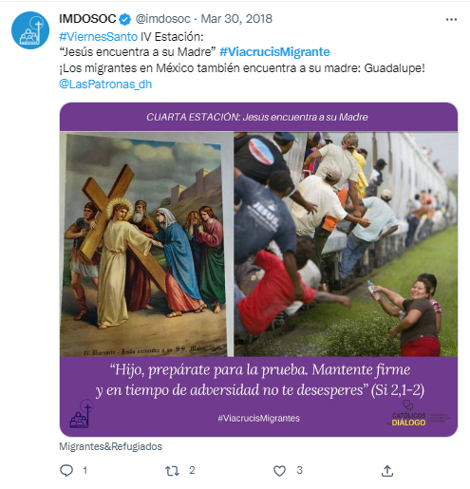

Threats
This part of the analysis analyzes texts in which the caravan is identified as a threat. That is texts where the caravan itself or the caravanners as migrants in transit are depicted as a threat or any other denomination related to it. Also, here are included all the other texts that mention possible threats beyond the caravan itself. In other words, factors that are perceived as facilitators, or colluding to help the migrant caravan advance on its route, are therefore depicted as adversaries or enemies.
The caravan as threat
In the texts coded as a threat, and published under the hashtags #caravanscoming, #caravanmigrante, #migrantcaravan, and #viacrucismigrante, some of the texts, specifically 208 tweets in the sample contain references to the caravan as an illegal activity whose advances are supported by individuals and organizations opposed to the law and the well-being of the United States. Also, the caravan and the caravanners are primarily identified as an invasion or group of invaders, or at least as a group of undesirable people coming from “shit-hole” countries to contaminate the homeland (see Figure 72). Of individuals that must be resisted through the law and repelled with legal and physical barriers. The texts also claim that such a group must be repelled through any action to defend the homeland's territory, even with military force and even through individual defense initiatives called militias. These militias appeal to a sense of patriotism; by extension, patriotism is assumed within this context as a primarily military defense action of the US territory.

Figure 72
3rd world countries.
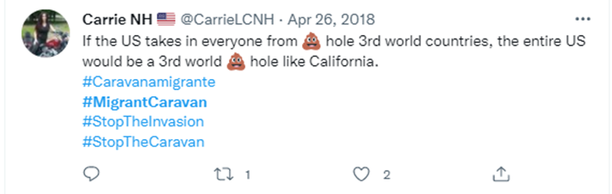
While the migrant caravan is pointed out as an external threat, messages about some democratic institutions in the United States, like the Congress, are accused of being peevish and incapable of confronting the caravan and the caravanners’ advance toward the homeland and stopping the ‘invasion.’ As usual, patriotism, patriots, nation, homeland, and border, to name some, become polysemic concepts or ideas. For instance, in the texts mentioning patriotism, the connotation is the defense of the homeland from external elements, like the caravanners. Surprisingly, the same fierceness is expressed in the rejection of what is depicted as internal enemies: US government institutions, politicians, and lawmakers in the homeland itself. Those are labeled as threats as well (see Figure 84).
A sense of urgency is noticeable for the opposers to the migrant caravan. One of the mottos is that America must be great again, and the enemies of this ideal are external and internal. This appeal to the nation’s past as a great one is connected to the sense that the present time is not great, and the rescue of such a past would be ineffective without the defeat of both external and internal enemies of America. This dualism, grounded in us versus them rhetoric, implies that the meanings behind the phrase make America great again, are frequently cited as texts or hashtags in many tweets and are based on an idealized vision of the past. A pristine and pure past, corrupted in the present. The greatness lies then in the triumph over those threats; the dream is built upon the nightmares to avoid, in these times and context, the caravans and the caravanners, but most importantly, the internal enemies, all those who happen to obstruct the path to that greatness, those who are the obstacles to the return to the glorious past. Here we have a hermeneutic of an imaginal America before minorities gained any power. Here we can perceive the strength of a classic myth: the golden past. The US is cast as a savior in this salvific myth. The current US is the savior of the migrants. The past US is the savior of the present. Moreover, in the latter myth, a sort of messianism is perceived as the Trump figure is used metaphorically as a messiah of the US (see Figure 73).
Figure 73
Messianism.
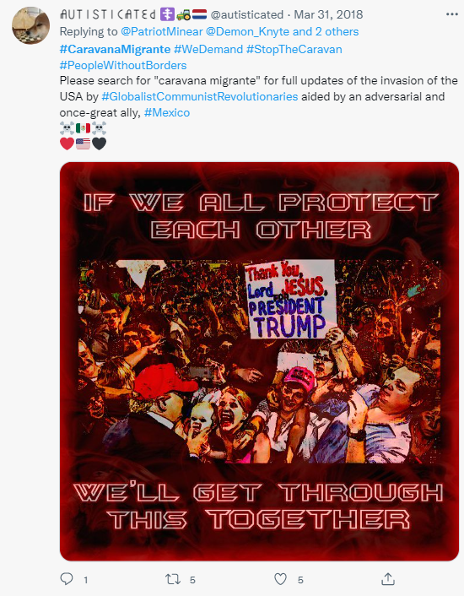

The myth splits, and the immigrants and they are imaginary are segregated and rejected as part of a more fantastic American future. The past is a guide and an emblem of the idea of the future and its construction. Under this imaginary, the future is the past, and the paradigm is to build a future from a present that looks to the past. In other words, in the imaginary of the analyzed texts, the answer to the challenges of the present is found in the past, and this gives meaning and logic to the narrative of being great again; the epic in the narrative of this imaginary is to rescue a past. Here another concept is essential in the imaginary: the homeland. In the context of the 2018 Way of the Cross caravan, us versus them rhetoric, and the idea of external and internal enemies, the homeland connotes a mythical ideological idea of the country. According to the texts analyzed, the patriots are those individuals who revere and honor the mythical communion between the present and the past, between the land, the soil, the past, and themselves. A true patriot is called to rescue the greatness of the homeland. “Great” and greatness become symbolic concepts, polysemic words capable of conveying a whole universe of meanings. Those meanings embody a set of beliefs and practices, an ideology.
For instance, rescuing the greatness of a country connotes (in the context of the texts studied) the reinstatement of a glorious past once lived. It also connotes the commitment to the belief, defense, and construction of a utopia, of the place that does not exist yet, but must be built, the promise of a great future, the return to the glorious past. However, at the same time, it implicitly recognizes the existence of an adverse, unsatisfactory present. “Great” implies a strong concept that encompasses beliefs of immolation for the country. Like the belief that the construction of a utopia faces powerful internal and external enemies, among others, the migrant caravans (see Figures 74, 75, and 76).

Figure 74
Make America great again.
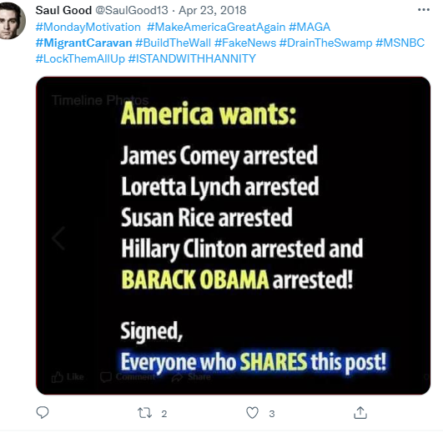

The sense of belonging recognized in those who call themselves patriots is similar to the concept of imagined communities of Anderson (2006), in the sense that the texts extrapolate ideas of belonging to the homeland to the United States based on nationalism. However, such nationalism is prone to the idea of natural law. It implies a sense of discretion regarding the actions of some individuals or groups in a given society. In the context of this analysis, a patriot in the texts is perceived as the one who acts accordingly to restore that glorious past by fighting an ominous present in laying the foundations of a dreamed, utopian future.
Figure 75
Stop the invasion.
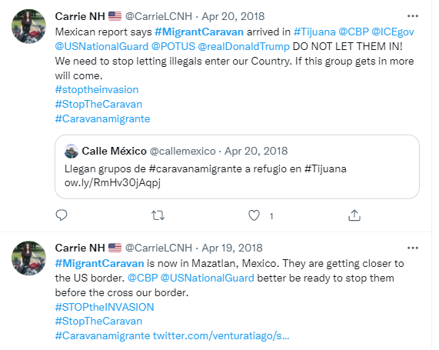

Figure 76
Build the wall.
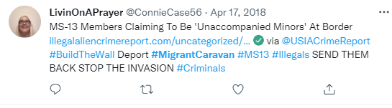

The texts of the hashtags analyzed combine colors and profound symbolism in a social context dominated by the immediacy of social networks and information, giving way to informal organizations of individuals united by an idea of belonging that responds to an ideal of nationhood. In protecting the homeland, certain symbols become especially significant, like walls, clenched fists, and primary colors, all under the context of an invasion. Here we have a powerful symbolic universe that conveys the idea that the United States must confront the migrant caravans using military resources (see Figure 77). Either by the army, the national guard, armed civil militias, or private actions. The concept of patriotism in this context is close to nationalism. It includes the idealization of the homeland, of historical elements, such as a glorious past or future where it can be restored. It also presumes the existence of internal and external enemies, as opposed to the idea of the homeland. (See Figure 78).
Figure 77
Patriotism.
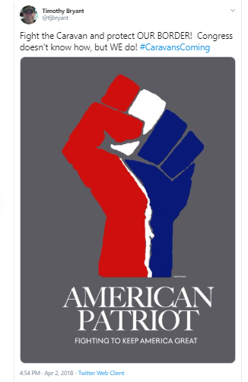
Figure 78
Militias and the 2nd amendment.
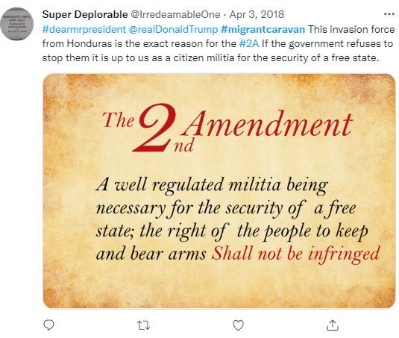

As the caravan is referred to as an external threat and the caravanners as a hostile group of individuals who must be confronted by the army or law enforcement or even by civilian militias, they are described and imagined as projected to become an internal threat if admitted into the United States. For instance, crime, drugs, people looking for social assistance, and cultural assimilation issues are themes and concepts expressed as concerns in some texts.
The topic of cultural assimilation as a concern is even compared to the 2005 riots in France, when unrest in the suburbs of Paris, inhabited mainly by migrants, resulted in a three-week riots rampage with cars and buildings burned and violent attacks on police and surrounding areas. Also, in some Parisian suburbs with a migrant majority population, recurring riots and clashes with the police have been occurring in recent years, unleashing a debate in the French public about migration into that country and cultural assimilation, with the consequential appearance of political leaders with enforceable proposals of stricter laws concerning migrants and migration. This situation has resulted in a topic of political polarization in France (see Figure 79).
Figure 79
External threats.
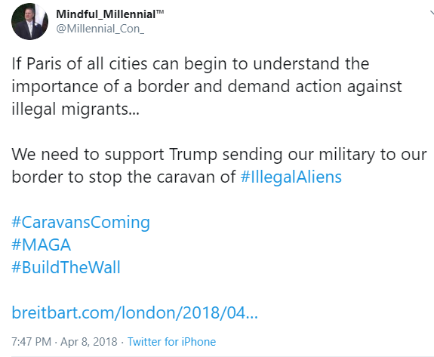

Thus, expedient intertextuality is drawn to form a strawman of the caravanners and how they relate to and threaten the US “homeland” and culture. Thus, the need to deploy all manner of homeland defense is triggered. Nevertheless, even though the immigrants from Latin America are predominantly Catholics and Catholicism is not regarded as a base of terrorist ideology, the analogy with immigration in France, especially in light of issues such as the Charlie Hebdo mass shooting, is made. Religious affiliation is an integral part of ethnic identity. The cold, religious conflict in Europe between Islam and Christianity, dating back to the fall of Constantinople, has nothing to do with current immigration from NTCA countries to the US. However, that analogy creates a narrative that all immigration experiences and issues are similar.
Some other external threats are also pointed out. For instance, the Mexican Government and its authorities are frequently mentioned as either supporters of the caravanners or dismissive by not effectively controlling the advances of the caravan crossing through Mexican territory and heading to the US (see appendix # 1). Therefore, they are depicted as colluding with the irregular migration, Mexican drug cartels, and corrupted or inefficient authorities for human smuggling at the United States and Mexico border.
As pointed out at the beginning, in the analysis of what is being said, the first connotation perceived is the reference to the migrant caravans as illegal and an external threat. Moreover, the response suggested deterring the advances of the caravanners and the migrant caravans themselves. The messaging includes metaphors of various kinds of law enforcement and even military action needed to repel what is referred to as an invasion with the collusion of Mexico. These include texts advocating for building a wall between the United States and Mexico or the complete reform of the migration law in the United States (see Figure 80).

Figure 80
Mexico collusion.
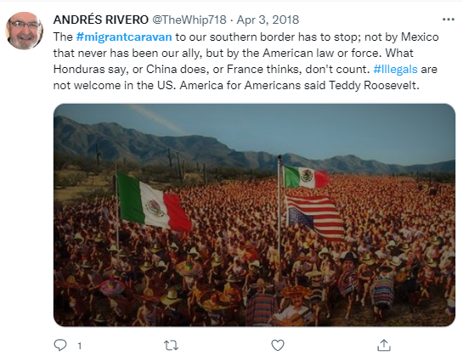
Also, some attached hashtags become part of a more meaningful message: #illegals, #stopthecaravan, #IllegalAliens, #StopTheInvasion, and #buildthatwall. Mentions of DACA (from retweets of original messages from Donald Trump, president of the United States at that time) pointing the Democrat Party as the culprit of no DACA deal or advances (see Figure 81). It must be underscored that Trump and his allies frequently blame the Democrat Party as being responsible for allowing, if not wanting, drugs and crime to enter the United States homeland. This is premised on their alleged support for the caravans and illegal migration. The necessity of immigration reform is also suggested by urging a secure border through stricter legislation.
Figure 81
No DACA deal.
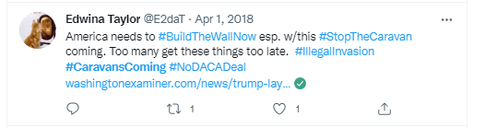
Internal threats are also a salient theme. For instance, in the texts analyzed, the immigration laws in the United States are perceived to be weak, tolerant, and flexible with illegal migration events, such as the caravans. When the law is referred to as an internal threat, the connotation is that it encourages irregular migration to the United States by being accommodating to illegal migration. In sum, the migrant caravan is depicted as a group of people with knowledge of the immigration laws in the US and advancing to take advantage of those laws.
The Democrat political party, Democrats, and Congress itself are depicted as supportive of illegal migration to the US and whose efforts and policies undermine the enactment and application of more stringent and specific laws to confront the unauthorized migration overall; it is also accused of anti-patriotic, and to support political efforts against the best interest of the homeland by some users (see Figure 85). In the texts prevails the idea of the law, and the reform of migration policies, as effective ways to stop illegal migrations, but at the same time, such reforms seem elusive as some political leaders are, pointed as contrary to those legal changes; therefore, some institutions are non-trustable, neither their policies of leaders. In this context, it is perceivable how a polarized discourse is perceivable in the form of culprits and saviors of right and wrong. Under this dualism, some Latin American countries are described as responsible for the migration of caravans due to weak immigration laws and political factors like corrupted parties or politicians. Toward this complex reality confronted in the NTCA countries, the proposed solution is no other than a military response and building a wall between the United States and Mexico, along with stricter immigration laws in the US (see Figure 82).
If external and internal enemies are identified, then what should be protected? In the imaginary of the tweets analyzed, it is possible to identify the idea of a social order that must be protected against those external and internal enemies. The social order is expressed as the value of the law and institutions as society’s order. This is a highly regarded value.
Figure 82
Build the wall.
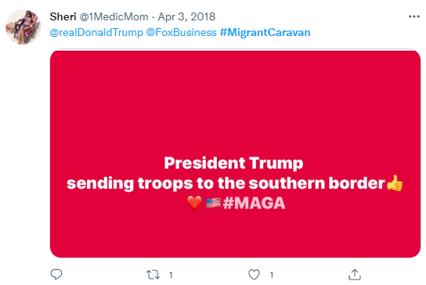

Another element, not entirely symbolic, about the narrative of external enemies is the wall. It is presented and defended as a necessary measure to counteract the advances of migrant caravans and illegal migration. The wall embodies one of the most powerfully symbolic elements within the sample analyzed. It represents a symbol that indeed defines an attitude, a social representation inextricably associated with the migration policy advanced by Donald Trump since he was a candidate for the presidency of the United States. It became not only a landmark in the discourse about migration, but an argument believed to be a necessary measure to counteract the influx of undocumented immigrants into the United States and to neutralize what is claimed in some tweets as a deliberate foreign policy from Mexico and some Latin American countries policy of taking “…advantage of the United States by using illegal immigration to export the crime and poverty in their own country (as well as in other Latin American countries)” (Donald Trump as cited on Baran, 2017, p. 69).
The wall is referred to in the tweets as a barrier to deter external enemies and preserve the internal order of the United States society from foreign groups or individuals labeled as external threats. As the wall is referred to deter the influx of illegal migrants and “bad hombres,” it is also mentioned as opposed by the internal enemies of the United States. As the discourse of the internal enemies is mainly aimed at groups pointed as undermining the order and laws of the US, this generates a paradoxical situation that mimics, yet not at the same level, a certain distrustfulness of the law and lawmakers like the observed in the #viacrucismigrante texts when referring institutions and political groups. Of course, there are some essential differences; At the same time, in the nations of the NTCA, the institutions are perceived as unfair and a reason to leave; in the US, some believe that the institutions and politicians are non-trustable. However, incipient is remarkably present in the revised texts. Reform of the migration law and the replacement of some of the members of the US Congress are dominant in the sample studied. In this scenario, the wall seems to have become a symbol that summarizes the idea of containment of internal and external threats to the United States. In the discourse about migration, the wall has become what Foucault refers to as a discursive practice, that is, a particular “sets of statements acquire set of authority and act as rules, prescribing if and how certain topics should be thematized.” (Molder, 2009, p. 314). In a strict sense, the wall is seen as a sort of panacea, a mantra repeated and defended as the solution to illegal migration.
The discourse of a wall between Mexico and the United States certainly contributes to sharpening the differences between the United States and Latin America. Many countries in the region expressed solidarity with Mexico, reviving the perennial cleavage between the United States and Latin America as a North versus South discourse. This discourse of differentiation between the US and other countries in the area respond not only due to different cultures and languages or, in this case, to immigration issues but also to past historical events like interventions, regional policies, dictatorships, and actions, some of them supported by the United States in the Latin American countries. Such historical events became the roots of profound cultural, political, and even economic divisions between the US and Latin America (see figure 83).
Internal threats include references to individuals or groups supposedly encouraging irregular migration to the United. In groups, the Democrats, a political party in the United States, are frequently referred to as an internal threat. Even supporters of the Democrats' political party of its policies are depicted as responsible for enacting weak immigration laws and political statements or attitudes favoring illegal immigration to the US. The Democrats here are depicted as a Donkey in a feces pit, dressed as the Statue of Liberty, holding a US Taxpayer in his right hand, emptying their pockets of money, and on the other hand, the African continent. In the feces pit, the maps of Mexico, Haiti, El Salvador, and Syria are floating in the feces, and ghostly figures in the form of gases rise. In the feces pit, four human figures stand out: Hillary Clinton, Bill Clinton, a terrorist next to the Syrian map, and George Soros, mentioned in some texts as supporters and financiers of the migrant caravans.
Figure 83
Political cartoon Mexico US satire: “Nobody and nothing is above Mexico dignity”.
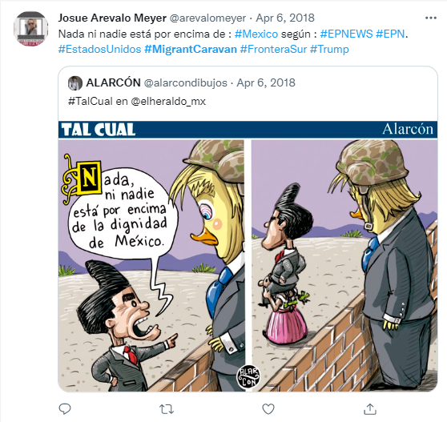
It seems that the tweets published aim at different groups. On one side, to the supporters and leaders of a specific political party in the United States. On the other side, the adversaries, likely the Democrats, as many of the tweets published refer to them as culprits of tolerance with the caravans and illegal migration. On the other hand, it seems that the tweets have as recipients all the people who, in one way or another, could be concerned about the migrant caravans. In any case, the messages shared under a specific hashtag are also directed to all individuals with the same shared ideology and beliefs. That is, individuals with specific opinions about the diversity of topics of the texts. Those topics include references to migration and crime increase, the wall as a measure to counteract illegal migration and caravans, welfare and healthcare access by migrants, US visas, DACA (Deferred Action for Childhood Arrivals), MAGA (Make America Great Again), immigration law reform, education, citizenship, economy, NAFTA (North American Free Trade Agreement), Mexico, the Mexican government, drug cartels, and issues of cultural assimilation (see Figures 84, 85, 86, and 87).
Figure 84
Democrats as internal threat.
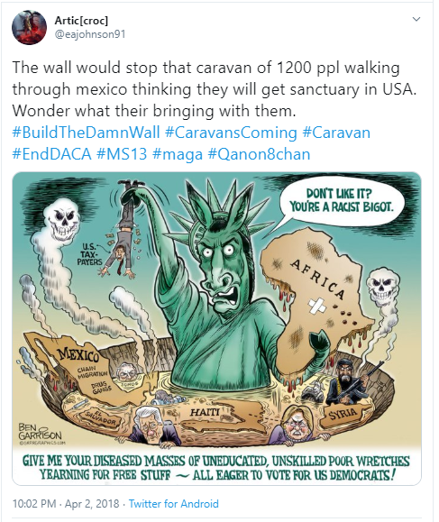
Figure 85
Democrats as internal threat.
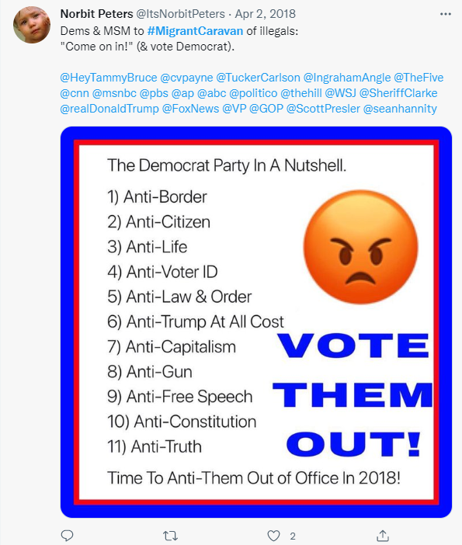
Figure 86
Democrats as internal threat.
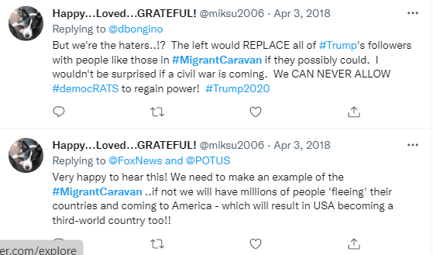

Figure 87
Democrats as internal threat.
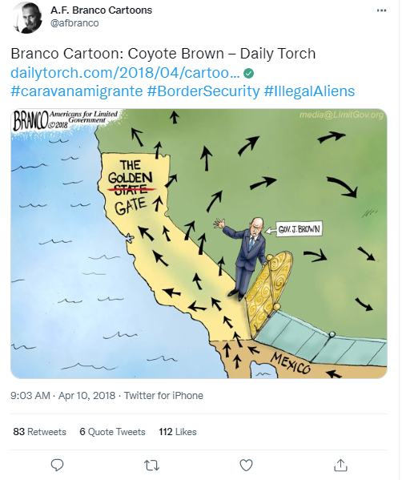

Chapter 5 Binary opposites in the migrant caravan
The narratives embedded in the tweets analyzed are built upon binary opposites, essential elements in understanding the narratives of and about the migrant caravan. The binary opposites comprise the elements in the myths that configure a narrative based on counterparts and are expressed as conflictual relations, allowing a simplification of the narrative by identifying opposite factors as the driving forces of the surrounding world (Mansilla, 2012). The relevance of binary oppositions in the narratives is underscored by Paul Ricoeur (1984), who, in an analysis of Greimas’ structures of signification, claims that a narrative can be configured in a system of relationships where contradictions represent the cornerstone in the narrativization (Ricoeur, 1984, p. 10). Also, for Lévi-Strauss (1981), “…all mythemes [basic units of myth] of whatever kind, must, generally speaking, lend themselves to binary operations, since such operations are an inherent feature of the means invented by nature to make possible the functioning of language and thought (p. 559).
Therefore, a narrative structure is constructed based on a dualistic approach, a sort of Manichean perspective in which dichotomies simplify a narrative. It does so, according to Levi-Strauss, by avoiding ambiguous elements of the narrative itself, by dividing the world into black or white, light or darkness, good or evil. This part of the analysis considers the binary opposites according to the themes identified in the narrative of the migrant caravan. By examining the binary opposites embedded in the narrative, it is possible to understand better the caravan's narrative and the imaginaries upon which those oppositions are built.

America as the United States vs. America as the continent
One of the first binary opposites identified lies under the phrase “Todos somos América” (“we are all America”). Embedded in this short statement is a powerful connotation. It is no accident that this phrase dominates the main message of the caravanners by making it the central message written in the banner carried by the movement’s leaders across the entire journey of the 2018 way of the cross migrant caravan. First, it embraces the idea of territoriality. It reinforces the imaginary of land where the sense of belonging can be traced to the primal ancestors, the primal inhabitants of the region, a connotation of a primal region. In this land, borders are inexistent and senseless. The idea of America in the imaginary of the caravan is the one of land that encompasses the entire region, from its farthest extreme north to the extreme south point of the geographic mass that forms the American continent. However, this imaginary is not an exclusively geographical one. Above all, this imaginary understands America from a primeval perspective. One under which America is a conquered territory. That is, a territory, a geographical space, once pristine, uncorrupted, free, and pure, that was taken away from its native inhabitants by extraneous people, by foreigners coming from outside this magical and mythical geographical space.
A conquest and taking of the territory in which the original inhabitants were overpowered, and their lands, customs, and culture, snatched and despised by the conquerors. . Under this imaginary, national, cultural, and language borders are external and arbitrary impositions, extraneous to the original peoples of the entire Americas, to the spirit of America. The borders, the States, the odds, the claims, and the arbitrariness are echoes and consequences of a still happening conquest, resonating in present times.
This idea of the region as primeval territory underscores a perception of the reality of us versus them dynamic, but also a scapegoat one. That is, we, as the earliest people of America, versus them, the newcomers who snatched the land by force and imposed culture, borders, and States. -- in other words, a cleavage between the indigenous people and you, the conquerors. This vision of America under us versus them dynamic is reinforced by the profound economic, social, and cultural differences between the United States and Latin American countries. As most of what is today Latin America was conquered by Spain, besides the Spanish language, many Latin American countries share a typical spectrum of dilemmas, bonding the Latin American region beyond mere historical and linguistic aspects. These shared dilemmas reinforce a differentiation between more homogeneous than heterogeneous regions, such as Spanish-speaking Latin America and the United States in the American continent.
The us versus them perspective is also influenced by past events that have contributed to a distant and uneasy relationship, where scapegoating has become a permanent factor in the relationship between Latin America and the United States. It is not only that the regions speak different languages, English and Spanish, which poses to some extent a cultural barrier, but the fact that both Latin America and the US have experienced entirely different historical processes that resulted in more significant political, historical, and economic divergences. For diverse reasons, all those factors resulted in the emergence of a rich and diverse political imaginary, one that exalts a Latin American homogeneity or brotherhood against the American power, as stated before, us versus them in the form of a South versus North narrative.
For a long time, the relationship between Latin America and the United States has been marked by episodes of past interventions by the United States in the region. These interventions in different aspects, whether political, militaristic, or economic, showed hard or soft power, along with the explicit or implicit support of dictators of authoritarian regimes in the Latin American region during the twentieth century by some presidential administrations of the United States, became reasons for a division gap. A gap where distance and suspicion were installed in the Latin American political imaginary made a long-term understanding and friendly relationship between the United States and Latin America a challenge. In sum, these past events nourish Latin America’s imaginary of the US as a nation that seeks to hinder the development and growth of the region in many aspects like the economy, civil rights, democracy, and overall development. Under this imaginary, Latin America is subjugated to the economic and political interests of the United States, which in very few cases coincide with the fundamental interests of Latin America. This is a profoundly rooted imaginary in the region, nurturing the idea that the reasons for inequality in Latin America respond to a purposely US foreign policy to negotiate and support Latin American ruling elites and hinder efforts of democratization and economic development of Latin America.
This imaginary began with the Monroe doctrine in 1823, during the James Monroe administration as the fifth president of the United States during 1817 – 1825. This US foreign policy doctrine considered unfriendly any attempt of the European countries to regain control of their former colonies in the Americas. This doctrine was continued by the Theodore Roosevelt administration (1901 – 1909) with his big stick policy: “speak softly and carry a big stick; you will go far” (Platt, 1993, p. 123). During those times, the phrase “America’s backyard” [“el patio trasero de America”] was used to refer to the area under the influence of the United States in the Americas region, more precisely Central, South America, and the Caribbean. The expression “America’s backyard” still echoes nowadays in the Latin American region as a pejorative phrase that connotes a relationship of subordination and dependence of the Latin American region of the United States.
At this point, it makes sense why there are some cues of that imaginary in the narrative of the migrant caravan 2018. In some texts, it is possible to recognize those political, cultural, historical, social, economic, and religious connotations as all aspects of the NTCA and Latin American reality. Various eclectic meanings are blended under the “Todos somos America” metaphor and the Way of the Cross (Via Crucis migrante) narrative. This is an expression of the belief in destiny and external factors, such as divinity, to deal with uncertainty and to underscore elements of the ideas of migrants toward the US and its role in the region. The texts published on Twitter as tweets are, indeed, just fragments, atomized texts, but when combined, offer a more extensive mosaic of meanings. In other words, an expression of a collection of fragments that by themselves do not offer a more significant relationship with the context. However, read as a unity, as a collection, they reconstruct a discourse, an entire imaginary whose reading, whose comprehension offers a better understanding of the region. They express a collective construction of a complex narrative that involves history, economics, geopolitics, and the current weakness in state institutions, especially considering powerful transnational narcoterrorism.

Rule of law versus anomie
The caravanners’ texts express a perception of the situation in their countries as repressive, or, at least, there is an apparent mistrust of the authorities of their countries. They see their countries as not being democratic. Instead, they are seen as flawed regimes. The institutions and the States are perceived as corrupt – criminal -- dangerous. The 2018 migrant Via Crucis communicates the notion that they are fleeing from a situation of chaos, democratic weakness, the overall absence of the rule of law, and weak democratic institutions. The messages of the caravan denote democracy itself, and its institutions in their countries are not trustable, nor are the elected authorities as they are referred to as corrupted and biased towards their interests. This lack of trust pervades the societies of the NTCA countries at all levels, a reality from which fleeing is seen as the only option in search of a better quality of life.
Even in some images, the phrase “Our brothers love their countries, but governments only want slaves” (see figure 88) reinforces the message that to stay in their countries is to be subjected to the arbitrariness will of others, to be slaves of the will of others. The message then denotes the existence of a weak rule of law. The State is a weak institution, which does not represent the law, but an abstraction between ineffectiveness and arbitrariness. In sum, the texts communicate the idea of a total disconnection between the society, the individual themselves, and their representatives, either politicians or institutions, and ultimately, the perception of a social structure immersed in a situation of anomie (Merton, 1938, p. 682).
Anomie is a concept that has its roots in the ideas of Emile Durkheim (2014) and Robert Merton (2002). Anomie means a lack of adherence to norms or rules in a specific society. It also means that such normative constructs reject a person, often denigrating their person (race, gender, religion, age, economic class), competencies, and interests. An alienated person feels like an outsider in their home society – unvalued and unwanted. The rejected often come to perceive social structures with suspicion and disdain. Rejection breeds anger, hopelessness, and despair. In the case of Latin America, this could be related to the existence of a social culture where the laws or norms are not seen as regulators of life in society but rather as an arbitrary imposition of questionable authorities (O’Donnell, 1998). Under this reality, laws and norms are under the shadow of suspicion, which is viewed as unfair or discretional. Therefore, the combination of mistrust and the scarce rule of law have become preconceptions, atomic concepts, “basic building blocks of the evaluations that are involved in social opinions, as attributes that are predicated of any socially relevant object” (Van Dijk, 1998, p. 75).
Figure 88
“Our brothers love their countries, but governments only want slaves” [‘Nuestros hermanos aman sus países pero los gobiernos solo quieren esclavos”]
“Our brothers love their countries, but governments only want slaves”.
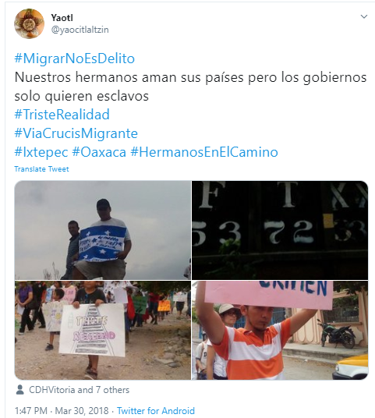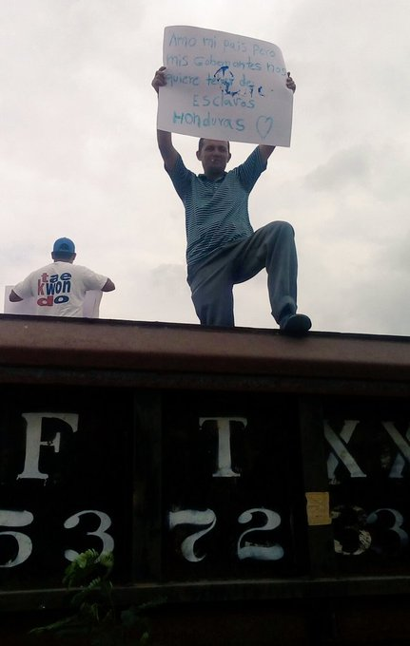
Retrieved from: https://twitter.com/yaocitlaltzin/status/979792225507844098
According to the executive secretary of ECLAC (Economic Commission for Latin America and the Caribbean), Alicia Bárcena, Latin America is facing the challenge of rethinking and generating efficient institutions that regain citizens' trust in its public institutions. This effort is necessary as the indexes of mistrust reach worrying levels of about 75% of the citizens in Latin America, a growing distrust percentage trend of public institutions in recent years (Cepal, 2018, p. 21). The caravan echoes the existence of weak institutions in their countries of origin. This level of mistrust in public institutions also means significant levels of anomie (Merton, 1938) or alienation in the NTCA nations and Latin American societies. In addition, Cueva Perus (2009) explains that a plausible explanation for this topic is found in the historical analysis of Spain's conquest of the Americas. According to Cueva Perus (2009), the idea of rules, law, customs, and habits was infused with the Catholic values brought by the Spanish conquerors. In this regard, Catholicism was effectively used to ensure submission to certain norms and, simultaneously, pardon those who transgressed those norms; thus, the shadow of arbitrariness existed from the beginning (Cueva Perus, 2009, pp. 97-98).

Victims versus victimizers
The context described above is also a breeding ground for another element in the 2018 Way of the Cross caravan texts. It resonates in the Latin American political imaginary: scapegoating. Under this imaginary, the errors, failings, weak institutions, corruption, violence, and even the current historical situation are the direct consequence of someone, usually a foreigner – a would-be usurper. The list commonly includes foreign financial interests, corporations, and governments. The imaginary blames on the foreign power, not domestic corruption and failings. Thus, most of the failures and problems that afflict Latin America are not seen from the perspective of errors to be corrected from a social or individual point of view but as the result of the actions or omissions of someone else who is the culprit (Cuevas Perus, 2009, p. 104).
For instance, the #viacrucismigrante tweets mention the high levels of violence, the absence of effective States, and the weakness of democratic institutions in NTCA countries. They are referred to as the main reasons to migrate, but at the same time, such violence is the consequence of external factors. More specifically, it is suggested that the violence in Honduras, Guatemala, and El Salvador is closely related to the arms sent from the United States. In some other tweets or hashtags, the reason to leave is due to the corruption in the government, for instance, of the Honduras president, Juan Orlando Hernandez, a US-backed president according to some tweets and hashtags of the caravanners (see figure 89):
Figure 89
“The #ViacrucisMigrante caravan continues its journey along the migratory route, #FueraJOH #NoMasArmas sent to #Honduras from the United States” [#outJOH
#nomoreweapons sent to #Honduras from the United States].
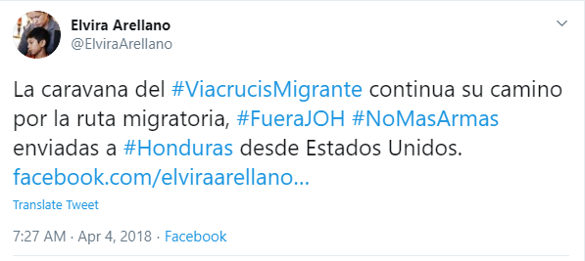

Us versus the destiny
The migration is also portrayed as a forced trip, whose origin is external factors, where the only option is to leave and migrate. However, migration depends on external factors, which are opposed to the caravan, the caravanners, and their migration journey. The main factors mentioned are Donald Trump, the wall, and Mexico as enforcers of US migration policies.
The figure of Donald Trump is frequently identified in the texts of the #viacrucismigrante hashtag as responsible for the migratory policies of other countries in the region, like Mexico. For instance, the text of the tweet in figure 90 says, “Donald Trump 'praises' Mexico's strong immigration laws to control” [@realdonaldtrump ‘alaba’ las Fuertes Leyes migratorias de Mexico para controlar el #viacrucismigrante]. In quotes in the original text, the word ‘praises’ [‘alaba’] suggests the idea of subordination of Mexico to the United States again, and the word ‘strong’ [‘fuertes’] also indicates that those Mexica immigration laws are not entirely the responsibility of Mexico. Also, in figure 91, the tweet’s text says, “Trump followed through on his threat: send the National Guard to the border to curb illegal immigrants.”
Figure 90
“@realDonaldTrump 'praises' Mexico's strong immigration laws to control #ViacrucisMigrante”.
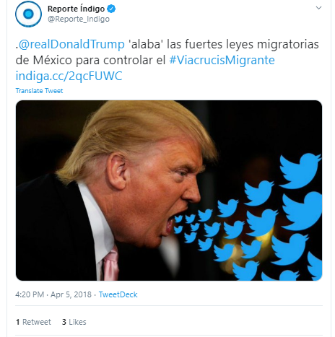

The words chosen to reinforce an imaginary are also crucial in the texts analyzed. For instance, the term ‘threat’ [‘amenaza’] is used in figure 91. As the meaning of the word threat is an expression of intention to inflict pain, injury, evil, or damage, here it is used to refer to the decision of Donald Trump to send the US National Guard to the United States Southern Border. It connotes an arbitrary use of force to impose his will. In both tweets, the figure of Trump is underscored and omnipresent. In figure 90, Donald Trump is shown in profile, with the symbol of Twitter, his “megaphone,” coming from his mouth, denoting anger, and also pointing to the reader with a smirky smile accompanied by images and pictures of the wall, the US National Guard. The way Trump is depicted here connotes the relevance of external factors in the imaginary of the caravan tweets.
Figure 91
“Trump followed through on his threat: send the National Guard to the border to curb illegal immigrants”.
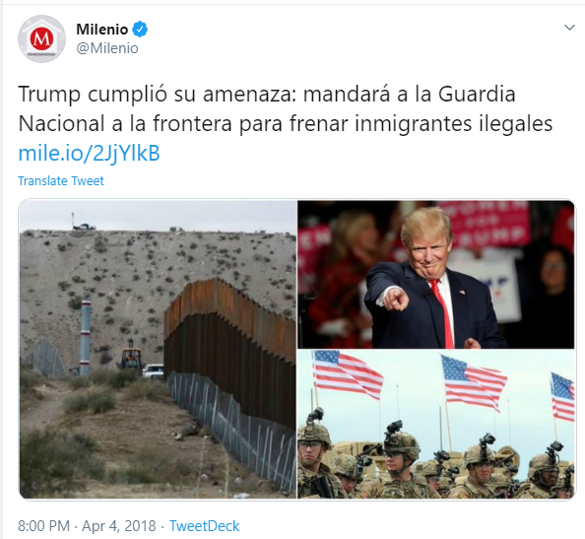

Fate versus faith
Overall, the texts published on Twitter in Spanish (#viacrucismigrante and #caravanamigrante) communicate a set of messages of a group of migrants on a journey with no other option than to be in a sort of limbo, stateless, fleeing from war, corruption, lack of fair institutions in their countries of origin, but with an uncertain destiny toward them. Toward an uncertain fate, the texts express faith as the only resource to their dilemma in reaching their goal: to arrive at their promised land. The promised land is not directly described but hinted at where they will find the opposite reality compared to what they already have in their countries of origin.
However, the promised land is not an inevitable destiny but an elusive one. To arrive, there is beyond their immediate control; thus, the message turns into a faith crusade, represented in the binary opposition of fate versus faith. Fate, as destiny, is here connoted as depending entirely upon external factors, that is, beyond the control and reach of the caravanners, and turned into a matter of faith as a resource to deal with the uncertainty of situations beyond their control. To name the caravan “the way of the cross” (“via Crucis migrante”) represents a well-thought metaphor. The caravan message is intended to mirror a journey of suffering, pain, hardship, uncertainty, and the hope of a resurrection in a new life after such grief. Redemption should come after their long journey.
Above all exists the connotation that things happen more because of destiny, but above all, of the power and decisions of others as external, or even divine, factors. A caravan is a group of individuals with a locus of external control (Rotter, 1966), to some extent, with a fatalistic perspective. To achieve or not their goals is not a matter of human beings’ decisions. Still, they put all their efforts and faith into the intervention of divinity as an external religious factor. A locus of external control refers to a situation where:
When a reinforcement is perceived by the subject as following some action of his own but not being entirely contingent upon his action, then, in our culture, it is typically perceived as the result of luck, chance, fate, as under the control of powerful others, or as unpredictable because of the great complexity of the forces surrounding him. When the event is interpreted in this way by an in dividual, we have labeled this a belief in external control (Rotter, 1966, p. 1).

Chaos versus social order
The perception that the caravans represent an expression of illegal and disorderly migration is latent in many texts analyzed in English. But, beyond this, what is perceived is an assessment of order and law as opposed to what the lack or assumption of it means. In this sense, what predominates then is a narrative that migratory movements such as migrant caravans represent nothing more than an approximation to chaos, as opposed to law and order. The idea of chaos brings us closer to a fear of the unknown, of having contact with novel situations, identities, individuals, and even cultures about which exists just a vague idea.
Just as chaos represents a fear of what is unknown or that breaks with the existing conceptions about migration and laws regarding them, the idea of order, in opposition to that chaos, occupies a privileged place in the imaginary analyzed. The idea of an established order here refers to the rule of law and compliance with agreed rules and regulations in society. The concept of order here also has to do with an established moral and social order. In the face of changes, the social order is idealized as a state in the collective memories and desires of groups and subgroups, which must be preserved from any foreign element that may affect it. In the case of the migrant caravan, they are described as hordes advancing without respect for the law or the established order, seeking to impose themselves in their determination to storm the southern border of the United States. A situation where the order (via force or military action) should be set.

Patriots versus traitors
The ideal described in the previous section about the United States as the land of law and order is reinforced by the notion of America as the land of the American dream. This powerful imaginary also finds its counterpart in constructing binary oppositions within the United States. Just as the caravan is seen and described as a threat to the US national security, a violation of the border integrity, and the country’s laws and regulations, the caravan also triggers the representation of internal threats from entities or factors that threaten the existing order. Those internal threats are a weak migration law, as opposed to the idea of a better-reformed one. Certain groups, politicians, public opinion leaders, or political parties are also part of the imaginary, constituting traitors versus patriots, binary opposition.
The requirement of a solid and effective law adjusted to the realities of migratory movements such as caravans is described as necessary. The law is idealized in that there is a perception that the current law is nothing more than compliant, ineffective, and favorable to illegal immigration. Immigration law as it exists is thus a negative opposite to the need for a new reformed law, which confronts forced, illegal migration that takes advantage of the current one to take advantage of the system itself (see figure). In the texts, the United States allows itself to be fooled at its own game, with its laws and fraudulent migrations by those who know the system to circumvent it. But how do things come to such a situation? If the current law is not adjusted to reality, what has prevented the promulgation of new laws that conform to that ideal? The answer is found in another binary opposition in the texts.
The binary opposition between patriots and traitors is a powerful theme in the texts. Just as the nation, as an imagined community (Anderson, 2006), is built with notions, mostly idealized, in the construction of that ideal, achieved or to be achieved, it is imperative to have a negative image, with a contrast between the idealized and the nightmare of its opposite. In this way, an ideal reinforces itself by identifying opposites that antagonize the maintenance or realization of that ideal. In the case of the texts analyzed, the nation and the homeland model are contrasted with the figure of traitors to the country and the motherland.
Thus, in this way, those who advocate a balanced approach to the migrant situation at the United States' southern border are labeled as traitors and favor private interests or even foreign interests. In the tweets, they are accused of undermining the United States' internal security, allowing the entry of weapons, dangerous migrants, and terrorists, and using public funds for this purpose. Traitors are portrayed as corrupt political leaders, the institutions in which they serve, or individuals supporting social or political movements opposed to the safety and interests of the United States. The traitors are depicted as lawmakers, Democrats, and liberals. Fake news and unverified information across Twitter, and social platforms overall, have also gained relevance in echoing conspiracy theories, many of which are assumed to be accurate by many who believe in restoring the greatness of the country, of the nation.

Chapter 6 Discussion
As Roland Barthes (1986) once claimed, the sign is an entity of a dualistic nature. That is, the sign supposes the existence of two elements in communion: the signifier and the signified. From that perfect communion arise denotations, some obvious, some obtuse (Barthes, 1986), but more importantly, connotations whose meanings can be inexhaustible. These inexhaustible meanings are also intertextual (Kristeva, 2002), the product of the accumulation of layers of meanings, of inextricably linked meanings, breaking barriers of time, space, and context. However, these connotations also assume the identity of narratives (Greimas & Porter, 1977) that galvanize seemingly random texts into a coherent narrative, in other words, into myths, into mythologies (Barthes, 1986).
When analyzing a (symbolic) event such as the migrant caravan, from the point of view of the meanings associated with it, we have an approximation to some mythologies that can reasonably explain a context, a historical, social, political, and cultural time. Then, hermeneutics as a philosophy of interpretation becomes essential, as understanding such meanings, symbols, and mythologies in texts and their meaning and function within specific contexts are unavoidable and fundamental. The migrant caravans studied here are events in which several factors converge in a similar context, such as migration, rights, ideology, religion, borders, nationalism, regionalism, and politics.
From a strict sense, the migrant caravans could be better understood as a migration strategy. One focused on a collective migration in terms of massive mobilizations and the protection a big group of migrants provided against crime, extortion, and other perils in the trail, especially across Mexico, where crime and drug cartels are increasingly involved in human trafficking and kidnapping of migrants. This strategy also implies developing a voice, a narrative about themselves. To make them visible and, by extension, to have a particular influence on local, regional, and even international scale in achieving their goal of migrating. Therefore, the migrant caravans present a scenario where we can witness a fundamental dynamic of power and influence.
Consequently, the study of the migrant caravan is thought to be a political communication research study (Semetko & Scammel, 2012). By performing their collective migration action or developing a narrative and online presence on social media, the migrant caravans triggered a response on different levels, probably, beyond their expectations. In addition, the migrant caravans can also be understood as a political actor, more precisely as a social movement, which interacts with other political actors on a local, regional, national, and even international scale. For example, the governments and authorities of each of the countries of the NTCA, Mexico, and the United States in any of the scales described before. Also, the migrant caravans have been used or referred to as topics of discussion and debate by specific political actors for their political agendas. For instance, Donald Trump, during his term as president of the United States or other leaders like Enrique Peña Nieto, former president of Mexico, and even self-organized groups in social platforms, like pro-migrant organizations, religious charities, and non-government organizations in Mexico, Central America, and the United States.
In this regard, this discussion chapter is focused on a) discussing the implications of this research study, b) providing context to the findings, and c) exploring the limitations and recommendations for future research. To do so, this research study discusses the results of the analysis of texts published as tweets on Twitter about the 2018 migrant caravan under the hashtags #viacrucismigrante, #caravanscoming, #migrantcaravans, and #caravanamigrante from March 25 to April 28, 2018, the timeframe during which the 2018 way of the cross migrant caravan occurred.

Migration and religion
Perhaps one of the most critical aspects of the migrant caravan studied is that it combines religion and politics as a migration strategy. The fact that the migrant caravan has called itself the migrant via Crucis encompasses not only the Catholic symbolism of the passion and resurrection of Jesus Christ but a symbolism beyond its immediate meaning. The migrant caravan effectively performs a re-presentation, a performance of a Catholic rite and belief, but the migrant via Crucis caravan also represents an eclectic fusion of the political, the mythical, and the religious in a series of texts. Politic as claims of rights about migration, refugees, and asylum; mythical in the concept of America as a homogenous territory beyond borders and States (“we are all America”), and religious in the sense of making the caravan a re-presentation a performance of the Catholic rite of the way of the Cross.
It seems that, in the 2018 way of the cross migrant caravan, the meanings of the texts analyzed border on the moral and spiritual, with some references to the legal, all under a mindset, a worldview that responds to the belief in divine factors. The truth is that these narratives reinforce the collective identity that already shares that religious worldview, that Catholic Christian vision, through a polysemic representation such as the Way of the Cross. In this religious discourse, diverse symbols stand out. Not only the cross, as a symbol per se of the Catholic religion, but also other equally symbolic elements such as religious images, visits to temples or churches, pilgrimages, prayers, and banners.
In the representation of the 2018 way of the cross migrant caravan, what exists is a mindset, “a magic worldview [which] manifestly exhibits an idolic incantatory mode of communication” (Kramer, 2013, p. 145). Under this magic idolic mode of communication, worldview a representation is not a representation but an incarnation, an embodiment of what is represented. The 2018 way of the cross caravan is then a way of the cross in a literal sense. This mode of communication can even be interpreted as a certain animism, according to which the cross confers a spiritual and divine protection that shelters migrants on their journey. This is communication to the external, but more importantly, to the internal, that is, to the caravanners themselves. The members of the migrant caravan resort to a paradigmatic relationship of meaning, according to which the sense of the divine, of the religious, is expressed in various related (paradigmatic) ways, from the representation (performance) of the migrant caravan as a way of the cross, to the Catholic symbols such as the cross, or other representations such as expressions of faith and pilgrimages to sites considered sacred.
The issue of migration to the United States from Latin American countries (South America, Central America, and Mexico) has traditionally been researched from the social sciences using perspectives or approaches that privilege specific topics within the social sciences themselves. For example, most of the investigations are focused on studying economic aspects, such as the economic conditions of the countries of origin of the migrants; social issues, such as the social problems that affect the countries of origin of the migrants, like domestic violence, gender violence, exclusion, classism, or even anomie; historical, such as past conflicts that persist in the present in the form of unresolved antagonisms that persist affecting the social fabric; familiar, such as family separation, or the crisis of migrant children arriving alone at the southern border of the United States. However, research on the symbolisms generated by migration, and the meanings generated by the migrants themselves on their journey, have not been that profuse. Much less has been the role of religion and migration. More precisely, what importance does religion have in the decision and action of migrating? What role or importance does religion have in the decision to migrate? What importance and role does it have before, during, and after migration?
In this regard, one of the most relevant investigations is from Jacqueline Hagan (2008). Product of his research on migrations to the United States from Latin America, Hagan (2008) was concerned with knowing not only the reasons for migrating but also wondered about how migrants survived or endured the increasingly difficult conditions and dangers of the trip. The answer obtained by Hagan (2008) was religion. For Hagan (2008), religion per se does not purely explain why someone decides to emigrate, but it does explain how migrants make their decisions, the days they decide to leave, the departure, the times, and how their journey will be. In other words, they will carry out the practices, rituals, and expressions of faith during the trip. Religion, then, is a powerful mediating force that feeds the willpower, resistance, and resilience of migrants (Hagan, 2008, p. 156).
The role of religion within the caravan is essential, but so is the contact that migrants have throughout the journey. For example, in the sample studied, expressions of solidarity played a central role in several tweets. These expressions of solidarity could be tweets about receptions or attention in non-governmental organizations, government organizations, and even more importantly, in shelters of houses managed by Catholic or religious charity organizations. The symbolism of having help and shelter across their journey provided by religious organizations strengthens the importance of religion as a factor of resilience in a long and adverse journey. In addition, such expressions of solidarity are not limited exclusively to the path and reality of migrants. Solidarity is expressed on social platforms like Twitter, by participants and followers in social platforms networks, and by individuals supporting their cause. For those who manage to reach the United States, religion continues to be a powerful mediating force that continues to guide the new journey, which means overcoming the adversities of integrating into a new society and country.
However, although Hagan (2008) offers detailed research about religion and migration, this research does not explore the meanings of the symbols used by the migrants during their journey. In other words, Hagan’s (2008) study lacks explaining the role of religious symbols in the migration journey or the meanings generated from combining a purely religious message or rituals with messages and meanings that go beyond the religious. In other words, the eclectic combinations of messages and texts that combine the religious, the social, the political, the historical, and the cultural. To summarize, this research study of the messages, their narratives, meanings, and intertextualities contributes to expanding the research and literature on migrant caravans from a communicational perspective.
Just as religion galvanizes the migrants in the migrant caravan, fueling their willpower and resilience, other elements are added to help define group identity. For instance, in the analyzed texts of the migrant caravan, elements of national and regional identity can be appreciated. For example, flags and national symbols of the countries of origin of the caravanners are posted in some of the tweets studied. In this way, it is possible to establish that national identity is an essential factor in the group identity of the members of the migrant caravan. Also, within the caravan, some messages and texts underline the presence of migrants who, beyond their origin, highlight them as members of specific vulnerable groups. We speak of minorities or at-risk groups, such as women, children, mothers, and LGBTQIA groups. Perhaps that is the reason behind the various messages published regarding the migrant caravan, mainly under the hashtags analyzed in Spanish (#viacrucismigrante and #caravanmigrante). Specifically, messages that combine such varied elements (religious, political, historical, social). All identities and messages of subgroups that have as a group identity the image of a migrant Via Crucis in the religious aspect, and we are all America as a pan-regional identity.
Just as the migrant caravan builds its narrative on religious elements and collective identity mentioned above, such messages necessarily add other messages that reinforce those same narratives. Such messages and contents reflect some intertextualities. The narrative of the migrant way of the cross describes a group of migrants as pilgrims, in penance, marching towards an uncertain destination, with faith in achieving a goal, reaching redemption, and starting a new life (making the analogy with the catholic symbology of the Way of the Cross of Jesus Christ according to the catholic belief), elements of national, pan-regional, or subgroups identities also unite them About this, every group, or even the whole group, share either a message, or a text, as pilgrims, as to be all America, or as subgroups. In other words, for every single caravanner, the symbolism of the way of the cross becomes a compelling metaphor for their journey. Everyone is carrying their cross, and that is precisely where lies the effectiveness of this narrative, of this mythology.
Nevertheless, any narrative is meaningless if not contrasted with nightmares and obstacles to avoid. Solidarity, and the way of the cross narrative, become weak without a nemesis on whom to focus frustrations and antagonisms. In this sense, various messages reflect the factors that symbolize those nightmares to confront and obstacles to overcome for the caravanners and their cause. For example, one of the factors that stands out is the freight train migrants board to travel part of their journey. The freight train on which the migrants ride is a freight railroad that crosses the entire Mexican territory and reaches the southern border of the United States. On this train, migrants travel in the open on top of the cars, exposed to the weather and violence or crime. Also, accidents have occurred in which migrants fall asleep or slip while trying to board the train and fall onto the railways. As a result, some of them die or are maimed by losing some of their limbs severed by the train itself. This train is always called la bestia (the beast) and is reflected in the texts symbolically, as a beast that must be mastered and overcome. The symbolism of the beast is powerful. He is not only referred to in the Catholic Bible, in the book of the apocalypse, as a figure that will appear at the end of time and that will subjugate and destroy human beings. For Chevalier (1999), the beast is a fundamental figure in the apocalypse. The beast symbolizes the illusion and the blasphemy, and "the demonic principle of the misguidance of human collectivities that accompanies the entire religious history of humanity" (Chevalier, 1999, p. 111).
According to the bible, the beast will be defeated by the lamb (Jesus Christ) and, therefore, by all his followers. The symbolism of the beast (the freight train) seems to be an animist one in the mythical imaginary of the migrants by giving the freight train characteristics of a living being that must be tamed. Perhaps there is an element of intertextuality between this denomination of the freight train as the beast to be tamed and the Greek myth of the Minotaur, that beast that feeds on the flesh of human beings and that lives in an obscure and dark labyrinth in which we all must enter at some point, for, as Daedalus, defeat the beast and pave the way to happiness.
Another main obstacle referred to in the texts is embodied by Donald Trump, former president of the US, and symbol of the symbol towards whom the caravanners direct their claims and frustrations. Donald Trump symbolizes the nemesis that opposes the migrant caravan and all migration. His figure is portrayed in various ways, from satire and caricature to worry and fear. Even his image is associated with extreme ideologies, like the member of the Ku Klux Klan in a mural in Mexico where the migrant caravan passed.
Also, there are several tweets in which the migrants of the caravan display posters with phrases repudiating Trump or asking for his resignation. Donald Trump was indeed the one who issued and ordered the most drastic measures against irregular migration across the southern border. Also, on the political agenda of his government, a drastic reduction in migration was a crucial topic, both as an electoral candidate and as president. Nevertheless, how Trump becomes a symbol towards whom all that frustration of the caravanners is directed. This personalization of Trump as the only person responsible and interlocutor towards whom the caravanners direct their claims is striking in the results obtained. There are no claims against other institutions of the State or government of the United States. Moreover, this draws attention because the same happens in Latin American countries, primarily presidential systems of government, where the president is the focus. In this sense, it seems that the political culture of the caravanners, coming from Latin American countries, remains intact, seeing Trump as the only one responsible, above and beyond other institutions and even the political climate within the United States and before which Trump would be just a reflection of it (Abramowitz & McCoy, 2019).
Another symbol recurrent in the analyzed tweets, both in English and Spanish, is the wall proposed by Donald Trump. The wall is referred to in several tweets as a direct reference or a hashtag. In most of the texts in Spanish, the wall is seen, described, and therefore symbolizes the exclusion and closure of the United States to migration. On the other hand, in most tweets in English, the wall is described as a necessity. This in no way should be interpreted as meaning that English speakers are opposed to migration or that Spanish speakers are automatically opposed to the wall. The reasons and factors for these results are unknown and a reason for further investigation. In any case, the answer to these obstacles, to violence, to the lack of opportunities as a reason to migrate, continues to be religion. The march, in a symbolic way of the cross, communicates beyond the representation itself, making this a form of communication that, although it uses social networks and technological platforms, remains in its essence an animist, magical, idolic communication (Kramer, 2013).
The symbolisms upon which the connotations of the analyzed messages are built present us with opposed worlds in the texts studied. On one side, a group of migrants marching and performing a way of the cross, with religion as their primary resource, and on the other, the mythology of a golden past of Trump, a discourse with hints of messianism. In this sense, the proposed binary oppositions account for these symbolisms based on antagonisms. With its representation and performance of the migrant via crucis, the caravan presents us with idol magic communication traits, which are fatalistic (Kramer, 2013, p. 126) but also collectivist. Magical-idol forms of communication may constitute a form of protection, a way of coping with uncertainty, since "if change comes to a magic community, disrupting the order of things, total panic is the result" (Kramer, 2013, p. 126). The magic is a refuge for migrants who venture in a caravan that crosses several countries and borders without the certainty of achieving an objective. Neither their countries nor their circumstances provide them with certainty, and the eclecticism of the messages of our journey is characteristic. It presents us with narratives, intetextualities, and myths. They are blended in a metaphor in the performance of the migrant via crucis, putting together texts that combine religion, history, and culture.

Messianism, migration, and myths
In 2018 the United States of America was in the second year of the Trump administration. Donald Trump’s policies and opinions about irregular migration became the epitome of a broader ideological, political, and cultural polarization within the American electorate, altering the American party system and the American electorate itself (Abramowitz & McCoy, 2019). Donald Trump’s discourse catalyzed a polarized public opinion both in traditional news media and digital and was echoed by social media platforms on a local, national, and international scale. Donald Trump's discourse finds its maximum expression in the phrase "Make America Great Again.” From the outset, Trump's discourse expresses a mythology of a golden past, thus symbolizing a break with the current state of things. America is not great and must be great again. The current state of America is far from the best; however, according to Trump, it is adverse. The culprits must be marginalized from power and relieved of any position of responsibility in the government. In Trump's discourse about the rescue of America, several factors converge that are worth analyzing for this discussion. The existence of a mythical imaginary based on the return to a golden past is undeniable. Contrasted to that immaculate golden past, there is a corrupted and rotten present time, where the culprits of this mess should also be pointed out and held accountable for their (un)responsibility. According to Schertzer and Woods (2019), Trump's political discourse responds to a combination that brings together elements of populism, nationalism, and ethnicity; that is, Trump’s discourse is an ethno-nationalist populism: "...a form of nationalism that privileges ethnic myths and symbols of common heritage and culture (Zubrzycki 2002, 276 as cited in Schertzer and Woods, 2019, p. 1156). Those myths, such as the purity of the land, ethnicity, and nationalism, create a framework where otherness fulfills a fundamental role. Thus, the enemies in the struggle to restore that glorious past possess or assume different faces. For instance, migrants, political elites, and Muslims, in opposition to whiteness, Christianity, and European background people (Schertzer & Woods, 2019, p. 1168). Trump's irruption in North American politics, his discourse breaking with traditional politics, also fits his profile as a political outsider who presents his proposal as novel and detached from the so-called traditional politicians, or political elites, who in turn are singled out (as otherness) as responsible for the deterioration of America. His figure, preceded by his fame as a New York millionaire and host of famous television programs, combined to give rise to political leadership with overtones of messianism, both in his speeches and his political agenda.
In this way, the role played by symbols, texts, and tweets, especially in an investigation like this research study, is essential to understand better not only the migrant caravan as an event but also as an event that allows illustrating a political and historical era of the United States and its impact on the hemisphere.
One of the essential elements in Trump’s campaign was the proposal to build a wall between US and Mexico. The wall is referred to in many tweets in the sample studied. Most important, its symbolism is present in all sets of tweets in one way or another. The symbolism of the wall is a very rich one. The wall is a symbol of division but also protection. Chevalier (1999) claims that a wall traditionally symbolizes the protective enclosure that enfolds a world and prevents nefarious influences of inferior origin from penetrating there; it has the drawback of limiting the domain it encloses, but the advantage of ensuring its defense; the wall represents the cut off communication with a double psychological incidence, security but also suffocation, defense but also confinement, it also has the symbolic connotation of the feminine and passive of the maternal matrix (Chevalier, 1999, p. 738), a symbolic image that enriches Trump’s vision, and political communication, of protection of the homeland. This rich and sometimes dual symbolism is recognizable in the texts about the wall in the texts studied.
Most importantly, the wall is a symbol that is perfectly adjusted to the political agenda of Donald Trump. As the words “Make America great again” express his motto, the wall symbolizes his ideal. To make America great again is to cut off any exterior influence, favor isolationism, and privilege a sense of America as an ethnonational identity. In this regard, it is understandable why the wall as a symbol is underscored by either Donald Trump himself or his followers in the tweets analyzed. The wall is part of his rhetoric, but it also is the symbol that resembles the construction of the utopia: to restore the past as the future.
Opposed to the vision of making America great again, there are some other salient groups in the tweets studied besides the political elites. For example, the caravanners are depicted as hordes or invaders. In some cases, as undesirable people that will corrupt the homeland, coming from third world countries, and therefore capable of turning the United States into a third world country too (see figure 82). Semantically these eschatological analogies express paradigmatic relations. They are also used to establish associations and put in the same group, all identified as enemies of the utopia of the golden past. For instance, those States in the USA where Democrats are majority or hold power are also included in those paradigmatic relations. Thus, Democrat politicians are described as traitors, favoring illegal immigration, anti-law and order, anti-citizen, and in any case, as the nemesis to defeat and expel from any government or lawmaking position.
Before this discourse of enemies of utopia, the discourse of defenders of such utopia is erected. This takes the form of military prevention and repression. For example, several tweets show the use of military language and symbols in response to the migrant caravan, labeled as an invasion that must be repelled. The border is then a scenario where the only viable option is securitization via the deployment of military units. In this sense, perception of alertness is installed. Within this context, the possibility of defending the territory and the border through citizen militias also appears, with appeals to the second amendment. In such a way, in many tweets exists the perception that the US is facing an invasion or aggression, and the only option is a military one.
The polarization and crudeness of some texts are perhaps one of the most salient aspects of this research because those texts demonstrate that within the United States itself, right now, what exists is not a classic differentiation between Democrats and Republicans in the sense of political parties, or a political parties cleavage (Lipset & Rokkan, 1967), but a more profound division, a fracture, with overtones of extreme polarization under a framework of political populism – messianism in which Trump himself has come to embody a voice that he name the voice of the silent majority (Patenaude, 2019), and who sees in him a leader, with traits of messianism (Oliveira, 2019) whose present vision of the future is a return to an idealized past. In other words, what is perceived is a Trump discourse in which his political world consists of restaurateurs and restoration deniers (of the greatness of America). Not just a division between Democrats and Republicans in terms of political parties but between Trumpism and anti-Trumpism in terms of the personalization of US politics. In this context, the migrant caravans are just one more part of a giant puzzle where the otherness symbolizes everything opposed to the ideal of America.
Just as otherness is fundamental in Trump's speech, it is also fundamental, although more diffusely, for the caravanners as can be seen in the binary oppositions found in this research: a) America as the United States vs. America as the continent; b) the rule of law versus anomie; c) victims versus victimizers; d) us versus the destiny; e) fate versus faith; f) chaos versus social order; and g) patriots versus traitors. These binary oppositions represent the primary blocks upon which the narratives that feed each of the mythologies that are part of this mosaic of texts studied in this research are built.
The decision to investigate the migrant caravans using Twitter obeys the idea that Twitter, and the tweets per se, represent the epitome of our times in terms of communication. Twitter is a communication platform that favors the exchange of short texts, fragments of reality or not, which communicate much more than just one. This communication platform is better described as a mosaic of fragments of information that, seen as a whole, offer a sense of reality. For a person more accustomed to a newspaper or traditional channel of communication or news, Twitter may seem at first as something diffuse, messy, dysfunctional, and even entropic.
Therefore, the purpose of this discussion and this research is to study and underscore the migration trend in the Americas from a communicative perspective. Also, to contribute to the advance of the existing literature in the sense that the research that has been conducted so far offers investigations that have effectively studied the phenomenon of migrant caravans, but without delving into the symbolic aspects of the messages that are generated within the caravans themselves and comparing them with oppositional messages. That is to say, the study and comparison from a semiotic and hermeneutic point of view of the contents generated by contemporary digital social platforms is an area of communication research studies that, in combination with political science, can and should offer perspectives on the myths, ideologies upon which the decisions and behaviors of individuals or groups of them in our societies are made. Especially in a time when undoubtedly digital media platforms ensure democratization and access to the public for the liberty of information and press, we also, as a society, enter into the reign of “data shadows” (Zook, Graham, Stephens, 2013; Graham, 2013; Graham & Shelton, 2013), or more precisely, into an information and communication landscape where “imperfect representations of the world derived from the digital mediation of everyday life” (Shelton, Poorthuis, Graham, & Zook, 2014, p. 167), may happen. This is particularly important if we consider that narratives and imaginaries find in contemporary social platforms, not only Twitter, extraordinary channels of communications through which any individual, or groups of individuals, can contribute to the creation, reinforcement, diffusion, and even change of those imaginaries, myths, and narratives, with a real impact in different aspects, like, for instance, political and cultural, with a societal impact.

Limitations of this research study
One of the most critical limitations of this study is the size of the sample studied and the study’s timeframe. The total amount of tweets studied (941, of those 605 in Spanish and 336 in English) represent just a tiny fraction of all the tweets published with different hashtags about the 2018 Way of the Cross migrant caravan during the time frame of the study. A more significant sample will undoubtedly offer a better and more accurate perspective on the results of this research and the comparison with another migrant collective event. However, the method used here as research (semiotics and hermeneutics) would have made such an investigation a very prolonged effort in time, not to mention that the data studied here was collected manually, without resorting to handling big data with tweet download software. Another significant limitation is that this study was based on the semiotic analysis of the texts published as tweets using the communication model of Harold Lasswell (1948): who says what, in which channel, to whom, and with what effect. In this regard, this study includes only the analysis of what is being said through what channel, not who says it or with what effects.

Further research
As this is a semiotic and hermeneutic study, a qualitative research approach was a logical choice. However, qualitative studies also have significant limitations. While they can offer insights hardly achievable using a different approach, quantitative methods may offer the advantages of a broader study to complement or expand the findings of this research. For instance, geolocation, demographics, sentiment analysis, hashtags frequency, and quantitative map of words may offer a bigger picture of the phenomenon studied here, all researchable using quantitative methods to expand the scope of the findings.
Additionally, it is suggested to expand the comparison of hashtags in the same language about the same topic to confirm the findings in this research. For instance, are the narratives and imaginaries about the 2018 Way of the Cross migrant caravan or migrant caravans the same across different hashtags in the same language? In other words, do migrant caravan hashtags share the same imaginaries? Or do hashtags against migrant caravans have the same or similar imaginaries about migrant caravans? Is the language relevant? Also, it would be interesting to explore the study of the effects of the content expressed in the texts of Twitter regarding the imaginaries, ideas, and information expressed in Twitter about the migrant caravans. In other words, explore what people think about the narratives, storytelling, and imaginaries about migration on Twitter.

Chapter 7 Conclusion
It is vital for communication, political communication, the understanding and study of the role that social networks and digital platforms such as Twitter have gained in the dissemination, creation, and reinforcement of content, meanings, and imaginaries that certainly have an impact in the debate about migration (in the case of this dissertation), but also about the relation between the United States and the Latin American countries, and ultimately about the ideas that exist in our societies about migration, migrants, democracy and democratic institutions. The discussion about the imaginaries and meanings, as well as the characteristics that political or ideological communication assumes in an environment of polarization, is not only pertinent but necessary and imperative.
Investigating and analyzing the imaginaries and the meanings upon which discourses are built will always contribute to advancing the communication literature. In the case of the texts analyzed here, it is believed that inquiring about the narratives, storytelling, in short, the texts that are generated from an event such as the migrant caravan, is an exercise in understanding, comprehension, analysis, and interpretation of reality in two languages of two regions such as the United States of America and the NTCA countries, and to a certain extent Latin America.
For instance, in the case of the migrant caravan, the choice of representing a Way of the Cross to create an analogy with a Catholic rite was, from the beginning, rewarding. The message is compelling and manages to create an affinity between all its members, a collective identity, but also between individuals outside this movement, who see the migrant caravan more than an act of a social movement but as an act of faith and hope from the perspective of the religious message. Also, with the narrative of a Via Crucis, many meanings that are part of the mythology about the idea that Latin America has about the United States are included in the narrative.
This mythology (the relationship with the United States) is not an easy one in the Latin American region. It brings together a series of historical, social, cultural, linguistic, economic, military, and even mythical elements that give the United States a frequently negative connotation in the region. Within the meanings shared in the sample analyzed, the United States is like a powerfully uncomfortable neighbor with whom you must dialogue. The Latin American countries are aware of the importance of the relationship with the United States but suspicious of its past actions in the region. Thus, the meanings and imaginary in many of the texts are primarily based on pre-existing beliefs, symbolisms, ideas, stereotypes, attitudes, and feelings with continuous and innumerable allusions to a mythical, historical, and even religious nature, about the migration, migrants, the United States and the NTCA. From the mythology of America as a unique and whole land, as a kind of mythical land that was conquered, taken away, and subjugated by foreign powers, to the idea that the dilemmas and failures in the region stem from a sort of original sin, which the Conquest of America embodies. Thus, past and present merge in creating and maintaining a narrative of imaginaries that continue to reinforce the mythology of Latin America's image of itself and its relationship with the United States.
However, just as some texts studied eclectically combine various mythologies, other narratives in the sample also combine diverse meanings. First, the caravan, or the caravanners, are mostly referred to as a threat to the United States. Here, the mythology concerns traitors, lawmakers, and complacent presidential administrations toward migration. The texts highlight a narrative of conspiracies, invasions, traitors, and patriots in constructing a dream: a mythical return to a glorious past. It is the representation of an old myth: the myth of the golden age.
To some extent, this myth is analogous to the Latin American one. In such a way, two opposing narratives meet in imaginaries and mythologies: their ideas of a reconquest of the past.
Much has been written about the past’s fascination with us as individuals and how, in many senses, the past guides our actions in searching and constructing utopias or dreams. However, rhetoric exists in some texts where the caravan is posed as a threat, and a concerning polarization is perceived. Especially in some respects within American Society.
Nevertheless, like all texts produced in a context of political polarization, such as the one experienced by the United States during and after the presidency of Donald Trump, it is, to some extent, logical to find metaphors of battles and enemies to be defeated, of heroic deeds and a great past to rescue. Here it is essential to underscore that, from the very beginning, as a republican presidential candidate, Donald Trump summarized his project political project with the phrase “make America great again.” Thus, for Trump, it was essential to use a discourse with metaphors of battles, epic confrontations, wars, and internal and external enemies in defense of a political project whose backbone is the offer to revive a glorious past hidden by internal and external enemies of the nation. The present then becomes a parenthesis, a perfectly equidistant limbo between a glorious past, great, and a future of greatness, in other words, mythology. Paradoxically, the idea of a perfect future is a glorified past, or better said, the society of the future lies in the past.
Separate mention deserves the fact that this mythology of the great past is perfectly inserted in a context in which non-traditional political figures find acceptance and frequently gain space for leadership and political representation, supported by a citizenry that is inclined towards new proposals of breaking with a present to propose a future on already existing symbols and myths of past lost greatness. In conclusion, the imaginary and the mythology in these texts are influenced by the rhetoric and ideology (doctrine, perhaps?) of Donald Trump, where it is critical to identify and point out enemies to defeat, archetypes of evil, conspirations, and enemies of the greatness of a country to be rescued.
The comparison of the tweets in English and Spanish underscores how relevant it is for this analysis to understand some of the mythologies on which is based the division between the United States and the Latin American countries, profoundly affected by past events or interventions by the US in the NTCA and Latin American countries. Those events from the past are still implicitly referred to in the texts analyzed. Also, the symbolism of a dividing wall between the US and the rest of the countries south of the border is a powerful reinforcer of the imaginary division between Latin America and the United States. The wall as a symbol to deter the migration of Latin American migrants connotates and nurtures, even more, the Latin American imagery about how Latin American countries and societies understand their relationship with the USA as a division.
In any case, those imaginaries, the ones referred to in the texts studied, have had, have, and will have relevance in the political, cultural, and social imaginary of Latin America and the United States. In the case of Latin America, the imaginary of the relationship with the US is not a new one. This is one old imaginary, nourished by diverse factors: idiomatic, cultural, social, economic, and even military, creating a division in the relationship between Latin America (and, in the case of this dissertation, the NTCA) and the United States of America. Also, it could be said that the 2018 way of the cross migrant caravan, and Trump’s communication via Twitter, are both communication and political-populist strategies. The caravan, with its religious mobilization, public and digital presence to encourage their visibility, and Trump’s doctrine of security and fear in constructing a dream of making America great again.
An interesting finding of this research is the level of polarization that has been installed in some sectors of the United States society and reflected in some tweets where the caravan is portrayed as a threat. This rhetoric of division, discontent, and traitors in defense of a dream of making a country great again has created an imaginary division in the US political society. All this polarization and mistrust are based on a mythology opposed to trusting in democratic institutions and elected leaders and, unfortunately, fake news. This seems to be an imaginary that will affect US politics for a long time.
Finally, although Twitter does not have the power of traditional mass media, it is a perfect example of how digital platforms become channels through which opinions and arguments can be communicated on a massive scale. However, Twitter has also become a digital place where opinions of any nature are likely to be shared by like-minded groups, generating isolated spaces and where individuals are likely exposed to their own beliefs and views but not to alternate opinions. This encourages the resonance and diffusion of specific topics, a network of common interests, and a digital wall or bubble that isolates individuals from opposing arguments. In a media landscape like this, the susceptibility to spreading unverified or false information increases as dissemination increases. False information or fake news has become an issue in digital platforms where groups of individuals are unlikely to be exposed to networks different than their own and not open to debate and discussion. Fake news in such close networks of individuals becomes a source of polarization. It represents, to some extent, alternate realities and breeding grounds for non-verified information, conspiracy theories, myths, and mythologies like those examined in the two hashtags studied.
We certainly live in hyperconnected digital societies, but to be exposed to such ubiquitous communication and information makes us live in the kingdom of transience, under the dominion of the ephemeral, the fast, and the fragmented. It is also the reign of the mottos and slogans in the form of hashtags. Our digital reality encourages the exposition and consumption of vast amounts of information in the form of capsules and pills of information. This is a reductionism under which fragments construct our everyday reality. Nowadays, our reality is a mosaic of little pieces, but such bits of reality are often biased, abridged, succinct, and susceptible to manipulation. In the end, the absolute risk that we, as a society, are exposed to is no other than higher levels of misinformation, and polarization, all factors related to social conflict and political violence. The social networks, Twitter, and our digital world have become a sort of palimpsest, a world in constant rewriting, ethereal, liquid (Bauman, 2013), and entropic.
In a certain way, the migrant caravanners and Trumpism look alike. Both seek worlds that do not exist and are lost in their imaginaries and psyche. Those worlds share the exact nature of being imaginaries, divine, metaphysical.
Myths and mythologies are the driving forces that guide many of our actions and decisions as human beings. If everything is interpretation, our interpretation of the world itself will always be guided by the compass of our myths, ideologies, and imaginaries, in the form of narratives and storytelling. Like the sails of a ship that travels in the ocean, our sails make up our symbolic worlds, our imaginaries, and they move following the winds of our contexts.

References
Abramowitz, A., & McCoy, J. (2019). United States: Racial Resentment, Negative Partisanship, and Polarization in Trump’s America. The Annals of the American Academy of Political and Social Science, 681(1), 137-156.
https://doi-org.ezproxy.lib.ou.edu/10.1177/0002716218811309
Acevedo, N. (2018, April 04) Who's Pueblo Sin Fronteras, the group behind the migrant caravan that drew Trump's ire? NBC News. Retrieved from: https://www.nbcnews.com/news/latino/who-s-behind-migrant-caravan-drew-trump-s-ire-n862566
Ahmed, A., Rogers, K., & Ernst, J. (2018, October 24) How the migrant caravan became a Trump election strategy. New York Times. https://www.nytimes.com/2018/10/24/world/americas/migrant-caravan-trump.html
Alonso, G. (2021). Los éxodos centroamericanos 2014-2020. Antecedentes y consecuencias de la caravana con destino a Tijuana de 2018. Polis, 17(2), 97-124.
Alvarado, A. (2021), Caravanas de migrantes centroamericanos en México. Origen, tránsito y destino, Universidad Autónoma Benito Juárez de Oaxaca/Juan Pablos Editor, México, 192 pp., ISBN: 978-607-9061-95-1.
Anaya, A. (2015) Violaciones a los derechos humanos por parte de actores no estatales y presión trans-nacional," pp. 139-163 in Ariadna Estévez and Daniel Vázquez (eds.), Derechos humanos y trans- formación política en el contexto de violencia. Mexico City: FLACSO
Ataç, I., Rygiel, K., & Stierl, M. (Eds.). (2018) The Contentious Politics of Refugee and Migrant Protest and Solidarity Movements: Remaking Citizenship from the Margins. Routledge.
Baltazar, M. (2021). Analysis of the Evolution of Migration Policies in Mexico and the United States, from Development to Containment: A Review of Migrant Caravans from the Northern Triangle of Central America during the Period 2014 to 2020. [Master thesis. Prague University of Economics].
Bauman, Z. (2013). Liquid modernity. John Wiley & Sons.
Barona, C., Tejero, N. (2021). Central American Caravans: A New Model of Migration?. In Cedillo González, C., Espín Ocampo, J. (eds) Human Displacement from a Global South Perspective. Palgrave Pivot, Cham. https://doi.org/10.1007/978-3-030-64819-0_2
Barthes, R. (1986) Lo obvio y lo obtuso. Paidos: Barcelona.
Barthes, R. (1999) Mitologías. Siglo Ventiuno Editores s.a. de c.v
Barthes, Roland (1977), The Rhetoric of the Image in Heath, Stephen (Trans) Image, Music, Text. New York: Hill and Wang. pp. 32-51. Retrieved from: https://williamwolff.org/wp-content/uploads/2014/08/Barthes-Rhetoric-of-the-image-ex.pdf
Barthes, R. (1972) Mythologies. The Noonday Press – New York.
Basok, T. (2020). Documentar a las personas migrantes en México: ¿Protegiendo a los vulnerables o disciplinando a los “ingobernables”? In C. S. García (Ed.), Puentes, no muros: contribuciones para una política progresista en migraciones (pp. 73–94). CLACSO. https://doi.org/10.2307/j.ctv1gm022b.9
BBC News (2018, May 1) Migrant caravan: Eight cross the US-Mexico border. BBC News. https://www.bbc.com/news/world-us-canada-43964813
Cadiz, I (2022) El significado de las Palmas benditas. ¿Qué significado tienen las palmas benditas del Domingo de Ramos? Catholic.net. https://es.catholic.net/op/articulos/56811/cat/1075/el-significado-de-las-palmas-benditas.html#modal
Cajina, R., & Orozco, L. (2016) Falacias y realidades de una crisis humanitaria y política. Menores centroamericanos que migran en busca del “sueño americano”. bie3: Boletín IEEE, (1), 459-472. https://dialnet.unirioja.es/servlet/articulo?codigo=5992480
Calderon, B., Reina, J., & Rubi, M. (2022, January 24) Docentes en Honduras se enfrentan a la violencia de las pandillas tanto dentro como fuera de las aulas. Alto Comisionado de las Naciones Unidos para los Refugiados ACNUR. https://www.acnur.org/noticias/videos/2022/1/61eecfcc4/docentes-en-honduras-se-enfrentan-a-la-violencia-de-las-pandillas-tanto.html
Camp, J. M. (1986). The Athenian Agora. Excavations in the heart of classical Athens, 38.
Camus, M., Vega, H., & Martínez, I. (2020). Tensiones en la gestión de las caravanas migrantes por Guadalajara. EntreDiversidades. Revista de ciencias sociales y humanidades, 7(1), 62-91.
Cantalapiedra, E. (2021, December 15) Caravanas de migrantes: forma de movilidad y movimiento social. Revista Nexos. https://migracion.nexos.com.mx/2021/12/caravanas-migrantes-forma-de-movilidad-y-movimiento-social/#:~:text=Las%20caravanas%20han%20constituido%20una,las%20personas%20de%20m%C3%A1s%20bajos
Carnino, S. (2022, June 9) Escuelas libres de violencia: la lucha pacífica de los docentes contra las pandillas en Honduras. El País. https://elpais.com/planeta-futuro/2022-06-10/escuelas-libres-de-violencia-la-lucha-pacifica-de-los-docentes-contra-las-pandillas.html?utm_source=Twitter&ssm=TW_CM_INT&s=03#Echobox=1654959387-1
Castellano, C., & Martínez, D. (2021). La caravana migrante centro americana: pobreza, violencia y miedo bajo el prisma de los derechos humanos. Derecho global. Estudios sobre derecho y justicia, 6(17), 133-165.
Castro, Y. (2019). Las caravanas de migrantes. Racismo y ley en los éxodos masivos de población. Iberoforum. Revista de Ciencias Sociales de la Universidad Iberoamericana, 14(27), 8-48.
Chan-Pech, C. (2019). Flujos migratorios en el sur de Chiapas: una narrativa local del impacto de las caravanas migrantes y los grupos africanos. Revista Política, Globalidad y Ciudadanía, 5(10), 43-62.
Chattopadhyay, S. (2019). Invited Article: "You are Not Welcome Here!" Understanding News Coverage of Central American Migrant Families in Trump's America. Journal of Family Communication, 19(3), 177-190.
Cheatam, A., & Roy, D. (2022, June 22) Central America’s Turbulent Northern Triangle. Council on Foreign Relations. https://www.cfr.org/backgrounder/central-americas-turbulent-northern-triangle
Chevalier, J. & Gheerbrant, A. (1999) Diccionario de los símbolos. Barcelona: Herder.
Clemente, E., & Verza, M. (2022 June 11) México da documentos a 7.000 migrantes; finaliza caravana. Los Angeles Times. https://www.latimes.com/espanol/mexico/articulo/2022-06-11/mexico-da-documentos-a-7-000-migrantes-finaliza-caravana
Cole, D., & Alvarez, P. (2022, Junio 9) Blinken dice que los desafíos de inmigración que enfrenta EE.UU. en la frontera sur están "más allá de lo que nadie haya visto antes". CNN. https://cnnespanol.cnn.com/2022/06/09/blinken-desafios-migracion-frontera-sur-cumbre-americas-trax/
Contreras, C., Murguia, P., & Torres, O. (2019). Fake News: Creando una ficción de la caravana migrante. Discurso mediático y audiencias: Una aproximación crítica a la comunicación de masas. Retrieved from: https://www.google.com/books/edition/Discurso_medi_tico_y_audiencias_una_apro/z27NDwAAQBAJ?hl=en&gbpv=1&dq=caravanas+migrantes&pg=PA99&printsec=frontcover
Contreras, C., Paris, M., & Velasco, L. (2021) Caravanas migrantes y desplazamientos colectivos en la frontera México-Estados Unidos. El Colegio de la Frontera Norte. Mexico. https://www.researchgate.net/profile/Laura-Velasco-Ortiz/publication/351461965_Salir_de_las_sombras_La_visibilidad_organizada_en_las_caravanas_de_migrantes_centroamericanas/links/6099a088299bf1ad8d908c49/Salir-de-las-sombras-La-visibilidad-organizada-en-las-caravanas-de-migrantes-centroamericanas.pdf
Cordero, B., (2021). Caravanas de migrantes y su impugnación a la cara humanitaria de la violencia fronteriza norteamericana. REVISTA IUS, 15(47).
Dannemiller, K. (2014, May 10) Train they ride. https://www.keithdannemiller.com/gallery.html?gallery=Migrants%2fLaBestia&folio=Selected%20Portfolios#/22
De Araujo, V (2021) Immigration in Trump’s Twitter Era: How His Framing on Twitter Affected Mexican News Coverage of the Central American Migrant Caravans. [Master thesis. San Diego State University].
Della Porta, D., & Diani, M. (2006) Social movements: An introduction. Malden, MA: Blackwell.
Della Porta, D., & Mattoni, A. (2015). Social Movements. The International Encyclopedia of Political Communication, 1-8.
Dimock, M., & Gramlich, J. (2021). How America changed during Donald Trump’s presidency. Pew Research Center. Retrieved from: https://www.pewresearch.org/2021/01/29/how-america-changed-during-donald-trumps-presidency/
Dominguez (2014, September 10) Central American Migrants and “La Bestia”: The Route, Dangers, and Government Responses. Migration Policy Institute. https://www.migrationpolicy.org/article/central-american-migrants-la-bestia
Durand, J. (2019). Política migratoria: entre el discurso, la práctica y la coyuntura. Foro internacional, 59(3-4), 1021-1047. http://www.scielo.org.mx/pdf/fi/v59n3-4/0185-013X-fi-59-3-4-1021.pdf
Epatko, L. (2014, July 9) Migrants seeking security in US often encounter violence along their route. PBS News Hour. https://www.pbs.org/newshour/world/migrants-seeking-security-often-encounter-violence
Espín, J. (2021). Las caravanas de migrantes en las relaciones entre México y Estados Unidos. Revista UNISCI, 19(55), 159-180.
Fabregat, E., Vinyals-Mirabent, S., & Meyers, M. (2020). "They Are Our Brothers": The Migrant Caravan in the Diasporic Press. The Howard Journal of Communications, 31(2), 204-217.
France 24 (2022, June 6) El Salvador's popular millennial president waging war on gangs. France 24. https://www.france24.com/en/live-news/20220601-el-salvador-s-popular-millennial-president-waging-war-on-gangs
Frandsen, F., & Johansen, W. (2010). Crisis communication, complexity, and the cartoon affair: A case study. In W. T. Coombs, & S. J. Holladay (Eds.), The handbook of crisis communication (pp. 425–448). Blackwell Publishing.
Frank-Vitale, A., & Núñez, M. (2020). “Lady Frijoles”: las caravanas centroamericanas y el poder de la hípervisibilidad de la migración indocumentada. EntreDiversidades. Revista de ciencias sociales y humanidades, 7(1), 37-61.
Franz, M. (2020). Contesting the place of protest in migrant caravans. First Amendment Studies, 54(2), 181-189.
Fuentes, M., Hernández, C., & Alcalay, S., (2022). Situations of Vulnerability to Human Trafficking in Mobile and Resident Populations in the Municipality of Tapachula in the Context of the 2018-2019 Migrant Caravans. Frontera Norte, 34, 1-21.
Gandini, L. (2020). Caravanas migrantes: de respuestas institucionales diferenciadas a la reorientación de la política migratoria. REMHU: Revista Interdisciplinar da Mobilidade Humana, 28, 51-69.
Gandini, L., de la Reguera, A. F., & Gutiérrez, J. C. N. (2020). Caravanas. UNAM, Secretaría de Desarrollo Institucional.
Garcia, J. (2018) “Trump nos ha hecho un favor con sus tuits”. El País. https://elpais.com/internacional/2018/04/04/mexico/1522800897_313873.html?event_log=go
Garcia, M. (2020) Discurso y poder: la coyuntura de las caravanas de migrantes centroamericanos y la retórica desde el poder de mentir. Movilidad humana en tránsito: retos de la Cuarta Transformación en política migratoria, 185.
Garibo, M. & Call, T. (2020). Caravanas de personas migrantes como expresiones contradictorias de tácticas de sobrevivencia y prácticas de subjetivación política. EntreDiversidades, 7(2 (15)), 59-93.
Garrido, E., & Fidler, M. (2018, May 9) Refugee odyssey – photographing Mexico's Viacrucis Migrante. The Guardian. https://www.theguardian.com/artanddesign/2018/may/09/refugee-odyssey-photographing-mexicos-viacrucis-migrante
Getty Images (n.d.) https://www.gettyimages.com/
Gibson J. (1977) The concept of affordances. In: Shaw R and Bransford J (eds) Perceiving, Acting, and Knowing: Toward an Ecological Psychology. New York: Johne Wiley & Sons, pp. 67–81.
Giron, M. E. (2019). Frontera Sin Barreras: The Significations of Traveling Borders and Bodies. University of California, Davis.
Goffman, E. (1956). The presentation of self in everyday life (Monograph no. 2). Edinburgh, UK: University of Edinburgh Social Sciences Research Center.
Gómez, C., & Espinosa, F. (2020). Transformaciones en las migraciones contemporáneas en México (2000-2019). Acercamiento a las violencias y solicitudes de refugio. Estudios Políticos, (58), 17-44.
Hagan, J. (2008). Migration miracle: Faith, hope, and the undocumented journey / Jacqueline Hagan. Cambridge, Mass.: Harvard University Press.
Hermida, A. (2010) Twittering the news. Journalism Practice, 4(3), 297-308.
Hernández López, R., & Porraz Gómez, I. (2020). De la xenofobia a la solidaridad: Etnografías fronterizas de la caravana migrante. Frontera Norte, 32(32), 1-24.
Hernandez, O. (2020). Politicas de la memoria de ninas y ninos en caravana de migrantes centroamericanos. Frontera Norte, 32(32), Frontera norte, 2020-01-01, Vol.32 (32).
Hernández-Hernández, O. M. (2019). Caravana de migrantes centroamericanos en Reynosa y Matamoros, 2019. Matamoros: El Colegio de la Frontera Norte. Retrieved from: https://www.comecso.com/wp-content/uploads/2019/05/Reporte-Caravana-Reynosa-y-Matamoros.pdf
Hine, C. (2000). Virtual Ethnography. London, UK: Sage Publications.
Hofstede, G. (1984). Culture's consequences: International differences in work-related values (Vol. 5). Sage.
Hogan B. (2010) The Presentation of Self in the Age of Social Media: Distinguishing Performances and Exhibitions Online. Bulletin of Science, Technology & Society. 30(6):377-386. doi:10.1177/0270467610385893.
Hogg, M., & Reid, S. (2006). Social Identity, Self-Categorization, and the Communication of Group Norms. Communication Theory, 16(1), 7-30.
Huerta, A. (2017). La trinidad perversa de la que huyen las fugitivas centroamericanas: violencia feminicida, violencia de estado y violencia de mercado. Debate feminista, 53, 1-17.
Huerta, A. V., & McLean, L. (2019). Caravanas de migrantes en México - Migrant caravans in Mexico: nueva forma de autodefensa y transmigración. Revista CIDOB d’Afers Internacionals, 122, 163–186. https://www.jstor.org/stable/26843350
Iannacone, J. (2021). Negotiating crises interpretations: The global rhetorical arena of the 2018 migrant caravan “crisis”. Public Relations Review, 47(2), 102034.
Ianni, O. (1997). El laberinto latinoamericano. UNAM.
Infante, C., Leyva-Flores, R., Gutierrez, J., Quintino-Perez, F., Torres-Robles, C., & Gomez-Zaldívar, M. (2020). Rape, transactional sex and related factors among migrants in transit through Mexico to the USA. Culture, Health & Sexuality, 22(10), 1145-1160.
Islas, A. (2019). Caravanas de migrantes y refugiados en México / Caravans of migrants and refugees in Mexico. Barataria (Olías Del Rey), 25, 131-146.
Iyengar, S., & Westwood, S. (2015). Fear and Loathing across Party Lines: New Evidence on Group Polarization. American Journal of Political Science, 59(3), 690-707.
Izcara, S. (2021). Las caravanas de migrantes, las economías de tráfico humano y el trabajo excedente. Andamios (Mexico City, Mexico), 18(45), 21-45 .
Izcara, S., & Andrade, K. (2022). Migración y violencia: las caravanas de migrantes centroamericanos. Revista Colombiana de Sociología, 45(2). https://doi.org/10.15446/rcs.v45n2.95765.
Izcara, S. (2012) Coyotaje y grupos delictivos en Tamaulipas. Latin American Research Review, 47(3), 41-61.
Jansen, B., & Gomez, A. (2018, November 26) President Trump calls caravan immigrants 'stone cold criminals.' Here's what we know. USA Today. https://www.usatoday.com/story/news/2018/11/26/president-trump-migrant-caravan-criminals/2112846002/
Jaramillo-Dent, D., & Pérez-Rodríguez, M. (2021). MigrantCaravan: The border wall and the establishment of otherness on Instagram. New Media & Society, 23(1), 121-141.
Jelin, E. (2007). Víctimas, familiares y ciudadanos/as: las luchas por la legitimidad de la palabra. Cuadernos pagu, 37-60. https://www.scielo.br/j/cpa/a/x8Pb4S35jKhkmbqrMXyBffd/?format=pdf&lang=es
Jenkins, H. (2006). Convergence culture: Where old and new media collide. Cambridge, MA: MIT Press.
Johansson, B. (2018). Expressing opinions about the refugee crisis in Europe: The spiral of silence and crisis communication. Journal of International Crisis and Risk Communication Research, 1, 57–82. https://doi.org/10.30658/jicrcr.1.1.4.
Kahn, C. (2013, June 12) Honduras Claims Unwanted Title Of World's Murder Capital. National Public Radio NPR. https://www.npr.org/sections/parallels/2013/06/13/190683502/honduras-claims-unwanted-title-of-worlds-murder-capital
Keneally, M. (2018, October 31) Is Trump 'stoking fear' portraying caravan as an 'invasion' or responding reasonably? Views differ. ABC News. https://abcnews.go.com/Politics/trump-stoking-fear-portraying-caravan-invasion-responding-views/story?id=58848197
Kenix, L., & Lopez, J. (2021). Representations of refugees in their home countries and abroad: A content analysis of la caravana migrante/the migrant caravan in Central America and the United States. Newspaper Research Journal, 42(1), 48-73.
Kozinets, R.V. (2010). Netnography: Doing ethnographic research online. London, UK: Sage.
Kramer, E. M. (2013). Dimensional accrual and dissociation: An introduction. In J. Grace & E. M. Kramer (Eds.), Communication, comparative cultures, and civilizations (Vol. 3, pp. 123-184). Hampton Press.
Kron, S. (2016). ‘Nacimos de la nada’: border struggles and maternal politics in Mexico. Citizenship studies, 20(5), 579-594.
Kudeyárova, N. Y. (2019). Caravanas de migrantes: crisis del sistema regional de regulación migratoria. Iberoamérica, (1), 65-87.
Kumar A. (2018, April 3) Halting the ‘Caravans’. Atlantic Council. https://www.atlanticcouncil.org/blogs/new-atlanticist/halting-the-caravans/
Kwak, H., Lee, C., Park, H., & Moon, S. (2010) What is Twitter, a social network or a news media? In Proceedings of the 19th international conference on World wide web. 2010. 26–30 Apr. 2010. Raleigh, NC. Retrieved from: http://www.ambuehler.ethz.ch/CDstore/www2010/www/p591.pdf
Lasswell, Harold. D., (1948) The structure and Function of Communications in Society, In Bryson Lyman(ed) The Communication of Ideas, New York: Harper.
Levi-Strauss, C. (1955). The Structural Study of Myth. The Journal of American Folklore, 68(267), 428.
Leyva, H. (2021). Las caravanas centroamericanas: guerras inciviles, migración y crisis del estatuto de refugiado.
Lipset, S.M. and Rokkan S. (1967) Party Systems and Voter Alignments. Cross-National
Manaut, R. B. (2011). México, Centroamérica y Estados Unidos: migración y seguridad. Migración y seguridad: nuevo desafío en México, México, Colectivo de Análisis de la Seguridad con Democracia, 180-182. Retrieved from: https://www.casede.org/PublicacionesCasede/MigracionySeguridad/cap10.pdf
Marchand, M. (2021). The caravanas de migrantes making their way north: problematising the biopolitics of mobilities in Mexico. Third World Quarterly, 42:1, 141-161, DOI: 10.1080/01436597.2020.1824579
Martínez, I. (2019). El paso de las caravanas de migrantes por México. Un recuento en el contexto regional. Retrieved from: https://rei.iteso.mx/bitstream/handle/11117/5889/S3%20El%20paso%20de%20las%20caravanas%20de%20migrantes.pdf?sequence=2
McDonnell, P. (2019, June 2) As Mexico cracks down on migrants, more risk the dangerous train known as La Bestia. Los Angeles Times. https://www.latimes.com/world/mexico-americas/la-fg-mexico-la-bestia-20190602-story.html
McLuhan, M., & McLuhan, M. A. (1994). Understanding media: The extensions of man. MIT press.
Melucci, A. (1994), “Asumir un compromiso: identidad y movilizaciones en los movimientos sociales”, en Marisa Revilla (comp.), Movimientos sociales, acción e identidad. Zona Abierta núm. 69, Madrid. Siglo XXI, pp. 153-180.
Melucci, A. (1996) Challenging codes: Collective action in the information age. (Cambridge cultural social studies). Cambridge; New York: Cambridge University Press.
Mendiola, D. (2021). La feminización de los derechos migratorios: Mujeres activistas y una visión feminista para la protección de las personas migrantes de Centroamérica. Anuario De Estudios Centroamericanos, 47, Anuario de estudios centroamericanos, 2021-01-01, Vol.47.
Moscovici, S. (1988). Notes towards a description of social representations. European journal of social psychology, 18(3), 211-250. Retrieved from: https://onlinelibrary.wiley.com/doi/epdf/10.1002/ejsp.2420180303
Morales, S. (2022, June 21) Las cifras que nos muestran que la migración desde Guatemala está incontenible. Prensa Libre. https://www.prensalibre.com/guatemala/migrantes/las-cifras-que-nos-muestra-que-la-migracion-desde-guatemala-esta-incontenible/
Mukhortikova, T. (2022). La caravana migrante en las noticias de La Jornada y The New York Times. Comunicación y Medios, 31(45), 24-36.
Mumford, L. (2010). Technics and civilization. University of Chicago Press.
Nájar, A. (2019, April 24) Caravanas de migrantes: la "histórica" oleada de indocumentados de todo el mundo que está llegando a México. BBC News Mundo. https://www.bbc.com/mundo/noticias-america-latina-48033101
Nájera, J. (2016). El complejo estudio de la actual migración en tránsito por México: Actores, temáticas y circunstancias. Migraciones internacionales, 8(3), 255-266.
Nájera, J. (2019). La caravana migrante en México: origen, tránsito y destino deseado. Coyuntura Demográfica, 15, 67-74. Retrieved from: http://coyunturademografica.somede.org/wp-content/uploads/2019/10/najera.pdf
Navarro-López, E. (2021). La construcción de narrativas sobre fenómenos de movilidad humana en redes sociales: un estado de la cuestión. Estudios sobre el Mensaje Periodístico 27 (1), 177-190. https://dx.doi.org/10.5209/esmp.71408
Norman D. (1988) The Psychology of Everyday Things. New York: Basic Books.
Núñez, S., & Dávila, M. (2022). New Migration’s Gordian Knot: Mexico and the Caravans of the Northern Triangle of Central America. Revue Internationale De Politique De Développement, 14, Revue internationale de politique de développement, 2022, Vol.14. https://journals.openedition.org/poldev/5143
Oliveira, M. (2019). Sacralización política o mesianismo? Los liderazgos políticos de Néstor Kirchner, Hugo Chávez, Donald Trump y Jair Bolsonaro. Tla-melaua, 13(47), 322-342.
Ong, W. J. (2013). Orality and literacy. Routledge.
Ortiz, K., Castañeda-Camey, N., & Garcia, R. (2020). Migrantes LGBT+ en las caravanas centroamericanas hacia Estados Unidos: dilemas y posibilidades para la construcción de redes de hospitalidad. REMHU: Revista Interdisciplinar da Mobilidade Humana, 28, 71-94.
Paarlberg, M. (2021, August 26) Gang Membership in Central America: More Complex than Meets the Eye. Migration Policy Institute. https://www.migrationpolicy.org/article/complexities-gang-membership-central-america#:~:text=In%20Central%20America%2C%20estimates%20of,roughness%20of%20any%20such%20estimates
Paris, M. (2018). Las caravanas de migrantes, su representación política y los derechos humanos de los migrantes. Observatorio de legislación y política migratoria de El Colef. Retrieved from: https://observatoriocolef.org/wp-content/uploads/2018/10/BOLETIN-DOLORES.pdf
París, M., & Montes, V. (2020). Visibilidad como estrategia de movilidad: el éxodo centroamericano en México (2018-2019). EntreDiversidades. Revista de ciencias sociales y humanidades, 7(1), 9-36.
Park, H. (2014, October 21) Children at the Border. The New York Times. https://www.nytimes.com/interactive/2014/07/15/us/questions-about-the-border-kids.html
Patenaude, W. (2019). Modern American Populism: Analyzing the Economics Behind the “Silent Majority,” the Tea Party, and Trumpism. The American Journal of Economics and Sociology, 78(3), 787-834.
Perez, J. (2020). Consideraciones sobre las teorias conspirativas aplicadas a las caravanas de migrantes. Frontera Norte, 32(32), Frontera norte, 2020-01-01, Vol.32 (32).
epatkomutter, L. (2022, June 3) Up to 15,000 may join largest ever migrant caravan to walk through Mexico to US. The Guardian. https://www.theguardian.com/us-news/2022/jun/03/migrant-caravan-tapachula-mexico-biden
Perspectives, New York: The Free Press
Pew Research Center (2016). Partisanship and political animosity in 2016. Partisanship and Political Animosity in 2016. https://www.pewresearch.org/politics/2016/06/22/partisanship-and-political-animosity-in-2016/
Portales, G., & Miranda, O. (2021). Cobertura y tratamiento de la Caravana Migrante 2018 en la prensa digital de Nuevo León y Chiapas. Global Media Journal México, 18(34), 7.
Pozzebon, S. (2022, June 11) La Casa Blanca quiso abordar de nuevo la migración, pero los actores clave no se encontraban por ninguna parte en la Cumbre de las Américas. CNN. https://cnnespanol.cnn.com/2022/06/11/analisis-cumbre-de-las-americas-migracion-estados-unidos/
Pradilla, A. (2019). Centroamérica huye de sí misma. Interciencia, 44(10), 46-52.
Pradilla, A. (2019). Caravana: Cómo el éxodo centroamericano salió de la clandestinidad. Debate. Retrieved from: https://www.google.com/books/edition/Caravana/KmGXDwAAQBAJ?hl=en&gbpv=1&dq=caravanas+migrantes&pg=PT4&printsec=frontcover
Puga, A. (2021). The Caravana of Central American Mothers in Mexico: Performances of Devotional and Saintly Motherhood on a Transnational Stage-in-Motion. Theatre Research International, 46(3), 266-284.
Rebolledo, C. (2020). Imago-politics of migration: Mexicanities, xenophobia & the fake “other”. Im@go, (14), 160-171.
Reid, L. T. (2021). The portrayal of central american migrants in north american media: A critical discourse analysis (Order No. 29020253). Available from ProQuest Dissertations & Theses Global. (2652591528) [Master thesis. University of Regina - Canada].
Revilak, T. (2021). Quiénes Son? A Critical Discourse Analysis of Media Coverage of the 2018 Central American Migrant Caravans by US and Mexican News Media Outlets. [Master thesis. The University of Arizona].
Ribando, C. (2014 February 20) Gangs in Central America. Congressional Research Service. https://www.unhcr.org/uk/585a987a4.pdf
Rivera, R. (2017). Making Absence Visible: The Caravan of Central American Mothers in Search of Disappeared Migrants. Latin American Perspectives, 44(5), 108-126.
Ronzhyn, A., Cardenal, A., & Batlle Rubio, A. (2022). Defining affordances in social media research: A literature review. New Media & Society, New Media & Society, 2022.
Rosa, F., & Soto-Vásquez, A. (2022). Aesthetics of Otherness: Representation of #migrantcaravan and #caravanamigrante on Instagram. Social Media Society, 8(1), Social media society, 2022-03, Vol.8 (1).
Rother, S. (2018). Angry birds of passage - migrant rights networks and counter-hegemonic resistance to global migration discourses. Globalizations, 15(6), 854-869.
Ruíz, V., & Varela, A. (2020). Caravanas de migrantes y refugiados en tránsito por México: el éxodo de jóvenes hondureños que buscan, migrando, preservar la vida. EntreDiversidades. Revista de ciencias sociales y humanidades, 7(1), 92-129.
Salazar, S. (2019). Las caravanas migrantes como estrategias de movilidad. Iberoforum. Revista de Ciencias Sociales de la Universidad Iberoamericana, 14(27), 111-144.
Sandoval, E. (2019). Los migrantes centroamericanos: entre las amenazas de Trump y las promesas de AMLO. Cahiers des Amériques latines, (91), 7-14.
Sayre, W. (2014, June 5) Riding 'The Beast' Across Mexico To The U.S. Border. National Public Radio NPR. https://www.npr.org/sections/parallels/2014/06/05/318905712/riding-the-beast-across-mexico-to-the-u-s-border
Schaffhauser, P., & Inocente, Y. (2021). El camino de los sin trabajo: comprender las caravanas de “migrantes” centroamericanos, 2018-2019. Intersticios sociales, (21), 235-270.
Schau, H.J. & Gilly, M.C. (2003). We are what we post? Self-presentation in personal web space. Journal of Consumer Research, 30(4), 384–404.
Schertzer, R., & Woods, E. (2021). Nationalism: The ethno-nationalist populism of Donald Trump's Twitter communication. Ethnic and Racial Studies, 44(7), 1154-1173.
Scott, E. (2018, November 8) Before the midterms, Trump harped on the migrant caravan. Since then, he hasn’t brought it up. The Washington Post. https://www.washingtonpost.com/politics/2018/11/08/before-midterms-trump-harped-migrant-caravan-since-then-he-has-barely-mentioned-it/
Semetko, H. A., & Scammell, M. (Eds.). (2012). The sage handbook of political communication. SAGE Publications, Limited.
Semple, K. (2018, April 4) Inside an Immigrant Caravan: Women and Children, Fleeing Violence. The New York Times. https://www.nytimes.com/2018/04/04/world/americas/mexico-trump-caravan.html?ref=nyt-es&mcid=nyt-es&subid=article
Severino, F. (2020). Immigration news in the global south: A comparative analysis of media content and journalistic decisions and practices in latin america (Order No. 28091817). Available from ProQuest Dissertations & Theses Global. (2460826999
Sevier, H. (2019). Articulating aliens: Discursive crossover and the figure of the migrant (Order No. 13905122). Available from ProQuest Dissertations & Theses Global. (2305944788). [University of Hawaii at Manoa].
Sistema de la Integración Centroamericana (2022) Convenio Centroamericano de Libre Movilidad (CA-4). Sistema de la Integración Centroamericana https://www.sica.int/ocam/ca4
Sloan, L., & Quan-Haase, A. (2017). The Sage handbook of social media research methods. Thousand Oaks, CA: SAGE.
Sorrentino, J. (2012, November 26) Train of the Unknowns. Commonweal. https://www.commonwealmagazine.org/train-unknowns
Spener, D. (2008). El apartheid global, el coyotaje y el discurso de la migración clandestina: distinciones entre violencia personal, estructural y cultural. Migración y Desarrollo, (10), 127-156. http://www.scielo.org.mx/pdf/myd/n10/n10a6.pdf
Stewart, B. (2016). Twitter as method: using twitter as a tool to conduct research. In L. Sloan, & A. Quan-Haase The SAGE Handbook of social media research methods (pp. 251-265). SAGE Publications Ltd, https://dx.doi.org/10.4135/9781473983847.n16
Stoesslé, P., Patiño, V., & Rosales, Y. (2020). Transnational Advocacy Networks of Migrants and Asylum Seekers’ Human Rights: The San Diego—Tijuana Border in the Trump
The American Presidency Project (2015, June 16) Donald Trump Remarks Announcing Candidacy for President in New York City. https://www.presidency.ucsb.edu/documents/remarks-announcing-candidacy-for-president-new-york-city
The White House (2014, August 1) The Obama Administration’s Government-Wide Response to Influx of Central American Migrants at the Southwest Border. Office of the Press Secretary. https://obamawhitehouse.archives.gov/the-press-office/2014/08/01/obama-administration-s-government-wide-response-influx-central-american-
Thibault, P. J. (2013). Re-reading Saussure: The dynamics of signs in social life. Routledge.
Tiscareño-Garcia, E. (2021). Encuadres noticiosos sobre la Caravana Migrante del 2018 en periodicos digitales mexicanos/News frames about the Migrant Caravan of 2018 in Mexican digital newspapers. Estudios Sobre El Mensaje Periodístico, 27(1), 281.
Torre, E. & Mariscal, D. (2020). Crossing borders: migratory strategies in transit of participants in migrants caravans. Estudios fronterizos, 21, e047. Epub 15 de enero de 2021. Retrieved from: http://www.scielo.org.mx/scielo.php?pid=S0187-69612020000100105&script=sci_arttext&tlng=en
Torre, E. (2020). Coyotes o defensores de migrantes? Criminalización del activismo promigrante en tiempos de caravanas. Revista Interdisciplinar Da Mobilidade Humana, 28(58), 51-67.
Torre, E. (2021, December 15) Caravanas migrantes: forma de movilidad y movimiento social. Nexos. https://migracion.nexos.com.mx/2021/12/caravanas-migrantes-forma-de-movilidad-y-movimiento-social/
Torre, E. (2022) El estudio de las caravanas migrantes en México. Norteamérica, Revista Académica del CISAN-UNAM, 17(2).
Torre, E., & Mariscal, D. (2020). Batallando con fronteras: Estrategias migratorias en tránsito de participantes en caravanas de migrantes. Estudios Fronterizos, 21(21), Estudios fronterizos, 2020-04-22, Vol.21 (21). http://www.scielo.org.mx/pdf/estfro/v21/2395-9134-estfro-21-e047.pdf
Torres, J., & Diaz, L. (2022, June 7) Migrant caravan in Mexico heads for U.S. border as Americas Summit starts. Reuters. https://www.reuters.com/world/us/migrant-caravan-mexico-heads-us-border-americas-summit-starts-2022-06-06/
Torres, S. (2019). A visual political world: Determinants and effects of visual content (Order No. 13856170). Available from ProQuest Dissertations & Theses Global; Worldwide Political Science Abstracts. (2208513354).
Toudert. D., (2021). Migrant Caravan Crisis: Some Realities About the Public Discourse on Twitter. Migraciones Internacionales, 12, 1.
Trapaga, I. (2020). Las migraciones como pandemias Normalización y normativización de los cuerpos migrantes en el México contemporáneo. Runa (Buenos Aires, Argentina), 41(1), 51-69.
United Nations High Commissioner for Refugees (2017) Situación del Triangulo Norte de Centroamérica. United Nations High Commissioner for Refugees UNHCR. https://www.acnur.org/fileadmin/Documentos/BDL/2017/11040.pdf
Valles, D. (2020). "Cuando llegaron los Haitianos": Black and Central American Migration, Respectability, and the Asylum Crisis in Tijuana, México. Journal of Latin American Geography, 19(2), 288-298. https://muse.jhu.edu/article/751971/pdf
Van Dijk, T. (1998) Ideology: A multidisciplinary approach. London; Thousand Oaks, Calif.: Sage Publications.
Varela, A. (2015). “Luchas migrantes”: Un nuevo campo de estudio para la sociología de los disensos. Andamios (Mexico City, Mexico), 12(28), 145-170.
Varela, A. (2020). Caravanas de migrantes y refugiados centroamericanos. Un feminismo para abrazar las fugas de quienes buscan preservar la vida. Revista De Antropología Social, 29(2), 245.
Vargas, F. (2018). El vía crucis del migrante: demandas y membresía. Trace (México, DF), (73), 117-133.
Villagrana, A. (2021). Rethinking immigration justice: Mexican community activism while serving migrants in transit (Order No. 28650261). Available from ProQuest Dissertations & Theses Global. (2582806505). [University of Arkansas].
Vogt, W. A. (2012). Ruptured journeys, ruptured lives: Central American migration, transnational violence, and hope in southern Mexico. The University of Arizona. https://www.proquest.com/docview/1037816391?pq-origsite=gscholar&fromopenview=true
Walker, M., & Frimpong Boamah, E. (2020). The digital life of the #migrantcaravan: Contextualizing Twitter as a spatial technology. Big Data & Society, 7(2), Big data & society, 2020-12, Vol.7 (2).
Washington Office for Latin America (2018, October 22) 9 Questions (and Answers) About the Central American Migrant Caravan. The Washington Office for Latin America WOLA. https://www.wola.org/analysis/9-questions-answers-central-american-migrant-caravan/
Wilson, C., & Valenzuela, P. (2014) Mexico’s Southern Border Strategy: Programa Frontera Sur. Wilson Center. https://www.wilsoncenter.org/sites/default/files/media/documents/publication/Mexico_Southern_Border_Strategy.pdf
Wright, J., & Alvarez, P. (2022, June 6) Harris' tough task addressing migration to the southern border not getting any easier one year later. CNN. https://www.cnn.com/2022/06/06/politics/kamala-harris-summit-of-the-americas/index.html
Wurtz, H. (2020). A movement in motion: Collective mobility and embodied practice in the central American migrant caravan. Mobilities, 15(6), 930-944
Yeh, R. (2019). De-border Yourself/Desfronterízate. New Global Studies, 13(3), 394-403. doi: https://doi.org/10.1515/ngs-2019-0034
Zárate, J. (2020). Informar/representar la migración centroamericana: el papel del periodista en Caravana, de Alberto Pradilla. Amerika. Mémoires, identités, territoires, (20). Retrieved from: https://journals.openedition.org/amerika/11436
Zecena, R. (2019). Migrating Like a Queen. Women's Studies Quarterly, 47(3/4), 99-118.

Appendices
Appendix #1. 2018 way of the cross migrant caravan claims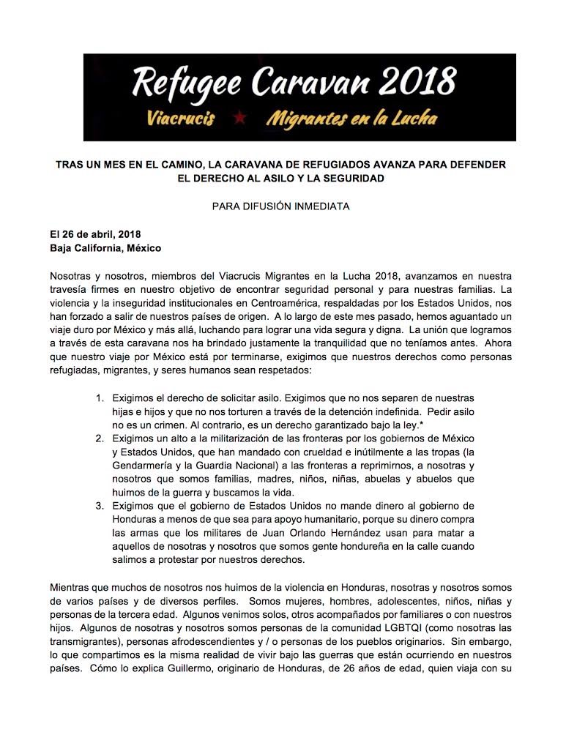

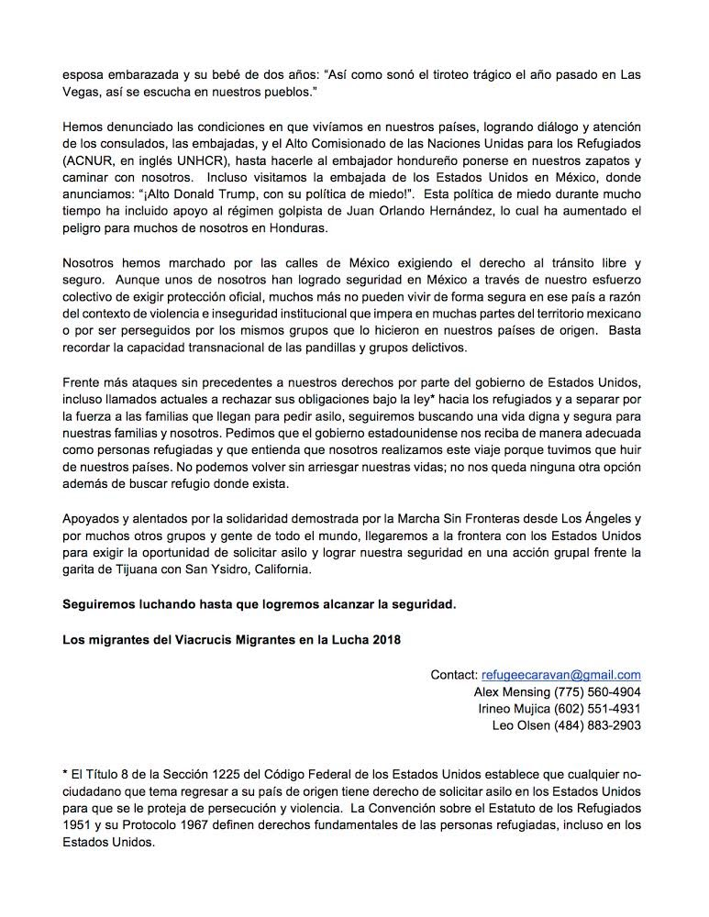

There is a misspelling in the word discrimination. In Spanish is “Discriminación” (Discrimination), no descriminación.
The correct spelling of the word discrimination in Spanish is ‘discriminación’, in the banner appears as ‘descriminacion’.
The banner has spelling mistakes in the correct writing of the Spanish language, for instance, instead of “y” as and in English they use “i”

