University of Oklahoma
Graduate College

Choice and Patterns in Midwife Use
in the United States

A THESIS
SUBMITTED TO THE GRADUATE FACULTY
in partial fulfillment of the requirements for the
Degree of
Master of Arts

By
KELSEY STEWART
Norman, Oklahoma
2019

CHOICE AND PATTERNS IN
MIDWIFE USE
IN THE UNITED STATES

A THESIS APPROVED FOR THE
DEPARTMENT OF ANTHROPOLOGY
BY

Dr. Kermyt G. Anderson, Chair

Dr. Paul Spicer

Dr. Lori L. Jervis

© Copyright by Kelsey Stewart 2019
All Rights Reserved.
Table of Contents
List of Tables
List of Figures
Abstract
Chapter I – Introduction ………………………… 1
Background ………………………… 2
Midwives in the United States ………………………… 4
OB-GYN/CNM Collaboration ………………………… 8
Benefits of Midwifery ………………………… 9
Synopsis ………………………… 11
Chapter II – Theoretical Framework ………………………… 13
Authoritative Knowledge in Childbirth ………………………… 14
Chapter III – Quantitative Analysis ………………………… 18
Data ………………………… 18
Methods ………………………… 20
Results and Discussion ………………………… 21
Race/Ethnicity ………………………… 23
Method of Payment ………………………… 25
Mother’s Education Level ………………………… 29
Marital Status ………………………… 31
Maternal Age ………………………… 34
Body Mass Index ………………………… 35
Previous Cesareans and VBACs ………………………… 37
Conclusion ………………………… 39
Chapter IV – Qualitative Analysis ………………………… 40
Theoretical Framework ………………………… 40
Authoritative Knowledge ………………………… 43
Methods ………………………… 44
Study Design ………………………… 44
Participants ………………………… 44
Interviews ………………………… 45
Results ………………………… 46
Desired Care and Barriers ………………………… 46
Influencing Factors ………………………… 50
Conclusion ………………………… 54
Chapter V – Conclusion ………………………… 55
Bibliography ………………………… 59

List of Tables

Table 3.1 – Summary Table ………………………… 22
Table 3.2 – Attendant Type by Race/Ethnicity
………………………… 25
Table 3.3 – Attendant Type by Pay Type by Race/Ethnicity
………………………… 27
Table 3.4 – Attendant Type by Pay Type ………………………… 28
Table 3.5 – Attendant Type by Education ………………………… 29
Table 3.6 – Attendant Type by Marital Status by Race/Ethnicity
………………………… 31
Table 3.7 – Marital Status by Race/Ethnicity ………………………… 32
Table 3.8 – Attendant Type by BMI ………………………… 36
Table 4.1 – Attendant Type by Preference Type ………………………… 46
Table 4.2 – Influencing Factors by Preference Type ………………………… 49

List of Figures

Figure 3.1 – Attendant Type by Race/Ethnicity
………………………… 24
Figure 3.2 – Attendant Type by Pay Type ………………………… 27
Figure 3.3 – Attendant Type by Education ………………………… 30
Figure 3.4 – Attendant Type by Marital Status
………………………… 32
Figure 3.5 – Attendant Type by Marital Status by Race/Ethnicity
………………………… 33
Figure 3.6 – Attendant Type by Age ………………………… 35
Figure 3.7 – Attendant Type by BMI ………………………… 37
Figure 3.8 – Delivery Route by Attendant Type
………………………… 38

Abstract
This study explores the factors that influence women’s decisions about their pregnancy and birth, what kinds of value and beliefs tend to suggest a preference towards midwives, and, demographically, which women are mostly likely to obtain midwife care. By examining these tendencies, as well as the ways in which authoritative knowledge and social and structural contexts interact with one another, anthropologists can gain a better understanding of how women think about and make decisions regarding their birth attendant. One portion of the study focuses on broad demographic patterns across the United States, using the 2017 Public Use Natality File, collected and released by the CDC. The second section focuses on more individualized and personal concerns, including qualitative data from interviews with eight women that focus on why they made the choices they did during their most recent pregnancy and birth. I suggest that, with this new understanding, there are ways in which practical access to midwifery care and information about their options can be increased and improved for women who want to choose the care of a midwife.

Chapter I
Introduction

In the United States, most births are delivered by physicians, while only a small portion are delivered by midwives. According to my calculations using birth certificate data, collected by the Center for Disease Control and Prevention (CDC) in 2017, in the United States, 88.9% of births were attended by medical doctors and doctors of osteopathy (CDC, 2018). Only 9.5% of births were attended by certified nurse midwives (CNM), and less than 1% were attended by other kinds of midwives (Chapter III). At one time nearly all births were attended by some form of midwife, but in the early twentieth century, the process of birth underwent a rapid and intense medicalization (Panazzolo and Mohammed, 2011). Doctors became the primary attendants, and by the 1950s births shifted from taking place in the home to occurring almost exclusively in hospitals (Panazzolo and Mohammed, 2011). However, with the rise of the feminist movement and the natural birth movement of the 1960s, the number of births attended by midwives began to increase. According to United States birth certificate data, collected since 1989, this upward trend in the use of midwives, especially CNMs, has been ongoing for the past several decades, and continues to do so (Declercq, 2012).
I argue that this increased use of midwifery is an act of agency by pregnant women. It is an act of resistance towards the overmedicalization of their bodies and a reclamation of the experience of birth. However, not all women in the United States have equal access to this act of resistance, nor do all women desire to express their agency by resisting the biomedical authority. The decisions that women make around their birth and pregnancy experience balance the health and safety of the mother and infant, access to different kinds of care, family values, cultural values, and time and money constraints. With the ever-growing list of methods and technologies that exist to assist women in controlling and anticipating their pregnancies and births, these decisions are becoming increasingly complex. These decisions are further complicated by the practical availability of these technologies and the cultural norms surrounding pregnancy and childbirth. These factors work to shape how women imagine their “ideal birth.” Along with a host of additional situational and circumstantial factors, these influence the way women think about, and make decisions regarding, their pregnancy and birth experience.

Background
Compared to most non-human animals, humans have a unique birth experience. For humans, birth is, comparatively, extremely dangerous. The combination of a large-brained infant and a narrow, bipedal pelvis make human parturition a physically difficult and painful process that requires the infant to twist and turn through the birth canal, and ultimately emerge in an occiput anterior position, facing the mother’s back (Trevathan, 2010). Additionally, labor, birth, and the immediate postpartum period include a complex hormone feedback loop between the mother and infant. Epinephrine and adrenaline, associated with stress, anxiety, and fear, can disastrously disrupt this feedback loop (Rutherford et al., 2019; Trevathan, 2010). The emotional and physical stress associated with parturition can slow down the process of labor, causing an even more lengthy, painful, and difficult birth with a higher risk of complications (Trevathan, 2010). The difficulties faced by a laboring woman along with the risk of complications has led to the development of an interesting behavioral safety net, so to speak. Contrary to most animals, who generally give birth in relative isolation, human childbirth is typically a social event (Ellison, 2001; Trevathan, 2010). The presence of a supportive individual, or individuals, is not only strongly encouraged by the awkward positioning of the infant at the moment of birth, the presence of a trusted and emotionally supportive person can help the childbirth progress more quickly and smoothly (Rutherford et al., 2019).
There are a number of ways to refer to these supportive individuals, depending on their training and their role in the birth. For the purpose of this study, I have identified and defined the associated terminology in the following ways.
A birth participant refers to any person who is present for the birth. This could include, but is not limited to, the woman’s family, her husband or partner, friends, spiritual advisors, nurses, doulas, midwives, students, obstetric gynecologists (OB-GYNs), and family doctors. Birth attendant refers to the medical personnel or team overseeing the labor and birth and usually includes the person who delivers the baby, including doctors, nurses, midwives, and traditional attendants. A traditional birth attendant refers specifically to a person attending a birth in a role that centers on some cultural or spiritual significance rather than biomedical training or skill. The term in generally applied to attendants who do not have a background in Western medicine, although some traditional birth attendants may have this training also. A doula is someone, usually a woman, who typically is not medically trained. A doula’s primary responsibilities are to educate, comfort, and provide support for the laboring woman. A midwife is a person, who is trained to assist with childbirth. This training can be cultural, medical, or both, but in all cases, midwives focus on the physiological progression of labor and birth and minimize unnecessary medical interventions (Rutherford et al., 2019). In the United States, midwives can receive certification through a number of schools to become licensed or registered midwives, and several categories of midwives are legally recognized. A certified nurse midwife, or CNM, is a midwife who has received and completed Western biomedical training and holds a degree in nursing as well as specific training in midwifery. A certified midwife, or CM, is medically trained as a midwife, but not as a nurse, and typically practices within a hospital setting with hospital privileges and prescriptive authority (Rutherford et al., 2019). A certified professional midwife, or CPM, like a CM, is a medically trained midwife, but not a nurse. CPMs generally practice outside of hospitals, at birthing centers and in homes, where they are not afforded the same medical privileges and authorities as CMs (Rutherford et al., 2019).
Because the CDC dataset that I use for this study only specifies the primary or supervising attendant, I will use attendant to refer to the person who oversees a particular birth. For this study, the types of attendants will be broken into two broad categories. The first are doctors, including medical doctors and doctors of osteopathy. The second are midwives, including traditional midwives, CMs, CPMs, and CNMs, unless otherwise specified. As CNMs exhibit striking differences from other midwives in some regards, they may be referred to separately as CNMs.

Midwives in the United States
In the United States, Western biomedicine is the current authoritative knowledge on pregnancy and parturition. Childbirth typically takes place in a hospital setting, where obstetricians, doctors, and labor and delivery nurses manage and monitor the progression of labor with myriad medical technology, and surgeons and anesthesiologist are on standby should something go wrong. Doctors in the United States recognize numerous factors that mark a labor as abnormal, and thus are quick to classify labors as in need of intervention (Irwin and Jordan, 1987). While these technologies and interventions can be lifesaving and valuable when there is a clear medical need, they can be encouraged by doctors when medical indication is ambiguous, resulting in their unnecessary overuse (Irwin and Jordan, 1987). This creates a highly medicalized and technologically reliant image of birth.
For many women in the United States this is representative, in some ways, of their imagined ideal birth: in a clean, hospital setting, under the attention of highly trained medical professionals, preferably a medical doctor with obstetric specialization, with access to anesthesia, like epidurals, and readily available medical interventions if the doctor deems it necessary. While this is a perfectly valid imagining of birth, which I term the biomedical model in Chapter IV, it is troubling that this form of imaging birth occupies such a dominant position in the United States that other models of birth are marginalized. The rising trend in midwife usage and the sentiments of several women I interviewed (Chapter IV) suggest this prevalence of the preference for the biomedical model of birth may be artificially inflated, due specifically to the fact Western biomedicine is the dominant authority in the United States and may be the only model of childbirth with which some women are familiar or to which they have practical access.
Some social scientists, including anthropologists, as well as women who prefer a more naturalist approach to birth, have accused this system of being dangerously and unnecessarily overmedicalized, structured for the convenience of physicians, and unconcerned with the humanistic and psychosocial impacts of birth and associated medical interventions (Bergeron, 2007; Irwin and Jordan, 1987; Mutryn, 1993; Wendland, 2007). However, while Western biomedicine is the dominant model, it is not the only form of knowledge about childbirth the United States.
As mentioned in above, birth in the United States underwent a rapid period of medicalization in the early to mid-1900s. In part, this was due to new government restrictions on medical licensing and medical practices, which worked to push “alternative health care providers,” like midwives, from the market beginning in the early twentieth century, though other factors may also have contributed, such as increased urbanization and reliable transportation (Craven, 2005:194). At the time of the shift, midwives were looked down upon as obsolete, dangerous, and a lower standard of care (Panazzolo and Mohammed, 2011). Another factor that contributed to the shift of births from homes into hospitals was the advent and popularization of the use of anesthesia, like epidurals, during childbirth (Wolf, 2009). In 1900 less than 5% of births in the United States occurred in hospitals, and by the 1950s, nearly all births, 95%, took place in a hospital, under the care of a medical doctor (Wolf, 2009). However, with the rise of the feminist movement, and the associated female empowerment of natural childbirth, in the 1960s and 1970s, this trend of medicalization began to reverse, though nowhere near as rapidly nor as completely as the move into hospitals (Craven, 2005). Since the 1980s, the percentage of births attended by midwives in the United States has increased. For example, one report, in 2006, placed the rate of midwife usage at around 7% of births (Borquez and Wiegers, 2006). Based on my own research, using the Public Use Natality File from the Center for Disease Control and Prevention, I estimate around 10.2% of births in the United States were attended by a midwife in 2017 (Chapter III).
Today in the United States, CNMs primarily work within hospitals, in either midwife-led delivery units or OB-GYN/CNM collaborative programs, while other kinds of midwives are concentrated in birthing centers or at private practices that cater to homebirths, though some hospitals extend privileges to non-CNM midwives, such as CMs. In hospital settings, midwives can help to cultivate a more welcoming environment for laboring women and a more holistic form of care than OB-GYNs and other doctors tend to create, while also complying with certain stipulations put forth by insurance companies and hospital policies. Even in high-risk or emergency settings, in which an OB-GYN is the primary attendant, CNMs and other hospital-based midwives can work to provide holistic care as members of a collaborative birth attendant team. In non-medicalized settings, such as homebirths or in birthing centers, midwives can provide a knowledgeable and safety-conscious presence that often combines the security of Western medical training and the sense of control and comfort for the mother and her family of a non-medical setting, though these kinds of practices are not covered by all insurance types. In both types of settings, midwives and CNMs can offer valuable services and insights.
In the United States, midwife and CNM regulations, are controlled at the state level, rather than at the federal level (Kennedy et al., 2018). CNMs are recognized in all fifty states, but non-nurse registered midwives can only be licensed in five (Kennedy et al., 2018). Additionally, only half of the states allow midwives full-practice authority, and six states require the supervision of a physician over midwife practices (Kennedy et al., 2018). As a result, the availability and the types of midwives vary wildly across states borders, creating geographic inequalities in the availability of midwives of all kinds.
The state of Oklahoma, where the majority of my individual interviews took place, licenses CNMs, but does not license or regulate CMs, CPMs, or other kinds of midwives. Additionally, according to the American College of Nurse Midwives (ACNM), the state of Oklahoma requires state recognized CNMs to work in a collaborative capacity with a physician (ACNM, 2018). In 2017, Oklahoma state senator Yen introduced a bill that would severely restrict the practice of midwives in the state of Oklahoma. Oklahoma Senate Bill 747 (2017), ultimately failed to pass, but it would have made it unlawful for anyone other than state licensed CNMs to use the professional title “midwife,” and made it unlawful for a state licensed midwife to participate in a vaginal delivery after a previous cesarean (VBAC) outside of a hospital setting.

OB-GYN/CNM Collaboration
As mentioned previously, the majority of CNM-attended births occur in hospitals. This is largely due to programs within hospitals that promote collaboration between OB-GYNs and CNMs. Programs like this provide the benefits of midwifery practice, like holistic care and support for natural birthing, along with the security of a hospital setting and OB-GYN support in the event of emergencies. OB-GYN/CNM collaborative programs are also noted to save money for the hospitals that house them (Ogburn et al., 2012). According to the United States Department of Labor, Bureau of Labor Statistics, the nurse midwife profession is projected to grow by 20.7% between 2016 and 2026 (U.S. Department of Labor). However, hospitals with these programs vary in number and prominence from state to state. For example, despite national growth in the profession, in Oklahoma, where the majority of my research took place, the University of Oklahoma Medical Center and Mercy Hospital, two hospitals in the Oklahoma City metro area, had recently shut down their CNM programs, leaving the Chickasaw Nation Medical Center, in Ada, and the W.W. Hastings Indian Hospital, in Tahlequah, as two of the only major hospitals in the state with CNMs on staff. In fact, OB-GYN/CNM collaborative programs have roots in the Indian Health Services (IHS).
In the 1960s, the IHS started a program of collaboration between CNMs and OB-GYNs (Ogburn et al., 2012). This program was designed to increase the number of rural Native women giving birth in medical facilities by allowing culturally sensitive, or culturally similar, midwives to oversee most of the births in select IHS hospitals, while OB-GYNs would only intervene in high-risk pregnancies and births, or when dangerous complications arose. The first hospitals to do this were Shiprock Indian Hospital and Fort Defiance Indian Hospital, both on the Navajo reservations, followed by the Alaska Native Medical Center in Bethel, Alaska (Ogburn et al., 2012). These Navajo hospitals saw a dramatic increase in the number of Diné women giving birth in Western medical facilities (Begay, 2009). However, it is unclear whether there is a causal relationship between the increase in women using the Indian hospitals and the introduction of the CNM collaboration program, and if there is such a relationship, in which direction it goes. Additionally, while IHS facilities are associated with increased use of CNMs (see Chapter III), it is unclear if this is representative of Native women’s preferences, and thus an expression of agency, or if it is simply a manifestation of IHS policy.

Benefits of Midwifery
There is a plethora of benefits to having a midwife present during labor and birth, both in a Westernized medical setting and in a non-medicalized setting. One of the primary benefits of having a midwife is the significant decrease in unnecessary medical interventions (Kozhumannil et al., 2015; Dunham, 2016; Rutherford et al., 2019). Minor obstetric interventions, like episiotomies and the administration of anesthesia and other non-essential drugs, are employed at decreased rates by midwives than by physicians, as well as more major interventions like cesarean delivery (Dunham, 2016; Kozhumannil et al., 2015; McCourt et al., 2016; Rutherford et al., 2019). By decreasing the rates at which these interventions are employed, midwifery practices also decrease exposure to, and the risk for, the various morbidities with which interventions are associated. Episiotomies are often associated with more damage and longer healing times than tearing, while anesthesia is associated with increased tearing and a greater risk for requiring a cesarean due to failure to progress (Wu et al., 2013). Cesareans, like other major abdominal surgeries, also increase risk of hematoma at the incision site, infection, hemorrhage, anesthetic complications, urinary tract infections, and trauma that may necessitate a hysterectomy, as well as an increased risk for postpartum depression (Latham and Norwitz, 2009; McFarlin, 2004; Miesnik and Reale, 2007; Burcher et al., 2016). While these interventions can be, undeniably, lifesaving in dire circumstance, many feel that these interventions are overused in the United Sates despite their potential for negative consequences (Dunham, 2016). With more extensive and accessible midwife care the need for, and use of, these kinds of interventions can be decreased.
In addition to decreasing the use of medical interventions, midwives also tend to create an environment that is more comfortable, and family-oriented, and that affords laboring women more control. As mentioned above, the emotional state of the laboring woman and the associated hormone response are crucial to the progression of labor. By cultivating a comfortable environment and easy communication, midwives help women to approach birth with more information, greater familiarity and less fear and anxiety (McCourt et al., 2016). In an OB-GYN-led setting, a laboring woman is often limited in her freedom of movement; due to monitoring equipment, she must choose between a few birthing positions agreeable to the physician, and, especially in cases of extensive medical interventions, there is often a period of separation between the mother and infant in the neonate period. In a midwife-led setting, however, the laboring woman is encouraged to try a variety of birthing positions to find one with which she is most comfortable. Midwives also typically encourage women to move about freely, which helps the fetus to naturally descend in the pelvis. Each of these practices engaged in by midwives work to encourage labor and birth to progress more quickly and with fewer interventions (Rutherford et al., 2019). Women whose births were attended by a midwife tended to report being more satisfied with, more in control of, and less traumatized by, their birth experience (Dunham, 2016; Kozhimannil, 2015).

Synopsis
With this study, I explore what factors tend to influence women’s decisions about their birth attendants, what kinds of value and beliefs tend to suggest a preference towards midwives, and, demographically, which women are mostly likely to obtain midwifery care. By examining these tendencies, as well as the ways in which authoritative knowledge and social and structural contexts interact with one another, anthropologists can gain a better understanding of how women think about and make decisions regarding their birth attendant. I suggest that, with this new understanding, there are ways in which practical access to midwife care and information about their options can be increased and improved for women who want to choose the care of a midwife. If it is understood why women choose to use midwives, an argument can be made, or a social out-reach plan formulated, to encourage the growth and extension of the midwifery trend. The theoretical foundation behind this inquiry is included in Chapter II.
I have taken two approaches to exploring these ideas. The first approach is a quantitative analysis, in Chapter III. This portion of the study focuses on broad demographic patterns across the United States. Using the 2017 Public Use Natality File, collected and released by the Center for Disease Control and Prevention (CDC), I’ve included a number of statistical analyses that help to identify demographic patterns in midwife use in the United States. The second approach is a qualitative analysis, in Chapter IV. This section focuses on more individualized and personal concerns. In this chapter, I include qualitative data from interviews with eight women that focus on why they made the choices they did during their most recent pregnancy and birth.
Through this study, I have found a number of factors that may be contributing to the increasing trend in midwifery use in the United States. In part, this may be due to an increase in the number of hospitals that maintain a policy of collaboration between obstetric gynecologists (OB-GYNs) and on-staff CNMs, as discussed in previously. Additionally, in Chapter IV, several of the women interviewed emphasized a mistrust of medical professionals to have their best interest in mind during birth, as well as a desire for a more natural process. The analyses in both Chapter III and Chapter IV suggest that one of the largest barriers women face in obtaining midwife care, if they want it, is financial, placing lower income women at a greater disadvantage. I conclude with a discussion of how midwife care may become more accessible for women across the United States and why it is important for women to have these options available (Chapter V).

Chapter II
Theoretical Framework

I argue that the upward trend in midwife use in the United States is an act of agency by women who seek to resist the overmedicalization of their bodies and actively participate in their childbirth experience. For the purpose of this study, I am using the term agency in both a sense of individualism and autonomy, as well as in the sense of enacting power and self-determination. For many women, these are the values that midwifery practices and the midwife-led model of birth represent (Craven, 2005). Two general factors that act to limit and shape the expression of agency as I discuss it are one’s imaginings of an “ideal birth” and the preferences and inclinations that shape it, which influence the formation of one’s desires and goals, and the external authorities and powers under which one acts, which determine the parameters and practical limitations within which one must act (Ortner, 2006).

Authoritative Knowledge
The concept of authoritative knowledge is heavily associated with feminist anthropology and the anthropology of childbirth. Feminist anthropologist Brigitte Jordan, in particular, has worked extensively with different forms of knowledge and authority surrounding pregnancy and birth (Davis-Floyd and Sargent, 1997; Irwin and Jordan, 1987; Jordan, 1992; Jordan, 1993).
Authoritative knowledge is a term that is used to describe the different paradigms of knowledge that exist within a system concerning the same practice or subject (Irwin and Jordan, 1987). It is typical in most social systems for one form of knowledge to become the dominant authority on a subject, either by maintaining a better explanation for a phenomenon or due to the power structures in place (Davis-Floyd and Sargent, 1997).
In some cases, this can be problematic, such as cases in which a dominant authority on knowledge, backed by a power structure, reaches a level at which it makes other forms of knowledge scarce and inaccessible to those who subscribe to them. In situations such as this, the dominant form of knowledge comes to be thought of by the cultural majority as correct, natural, and legitimate, while other forms of knowledge are thought of as backwards, primitive, and superstitious (Davis-Floyd and Sargent, 1997; Irwin and Jordan, 1987). This devaluation of nondominant forms of knowledge tends to create a positive feedback loop of disparities in both power and access to care that work to keep the authoritative knowledge in a position of power (Jordan, 1993). In this way, well-established forms of authoritative knowledge backed by a power structure can hold sway over the formation of individual preference.
Authoritative knowledge is often used in anthropology to describe power structures, how they come to be ingrained in a social context, and how they affect those that follow them as well as those who ascribe to other ways of knowing. In the anthropology of childbirth, authoritative knowledge is often used to discuss the limiting of the options available to women during pregnancy and childbirth, especially if the authoritative knowledge being referenced is the Western biomedical paradigm.
In the context of childbirth, individuals may create an imagined ideal birth. This ideal varies between cultures and between individuals within a culture. Individual preference, authority, and circumstantial factors all play profound roles in informing one’s image of the ideal birth, about when, where, how, and with whom to give birth (Broda et al., 2018; Miller and Shriver, 2012).
Preference regarding pregnancy and childbirth is formed from a variety of different kinds of social inputs. An individual’s exposure to birth plays a defining role in the ways they think about, and plan for, birth (Munro et al., 2009). For example, a woman working as a paralegal who focuses on malpractice cases, will have one perception of birth and social disposition regarding the risks involved in the process that emphasizes potential dangers (Ecker, 2013). However, a woman who has attended the births of a number of women in her community, will have a very different, perhaps more comfortable, image of birth and will perceive the risks differently (Miller and Shriver, 2009). Additionally, factors like media representation of birth, medical attitudes towards birth, and the types of care available, can all affect the preferences women hold towards pregnancy and birth (Logsdon and Smith-Morris., 2017; Miller and Shriver, 2009; Munro et al., 2009). However, personal preferences are not the only things to consider when planning or discussing an ideal birth.
Authoritative knowledge in childbirth plays a large role in determining what kinds of care, settings, and attendants are available to pregnant and laboring women. Dominant forms of knowledge have the power and social support to provide widely available services. Additionally, as with Western biomedical authoritative knowledge, these forms of care for childbirth are ingrained in other systems affecting availability, such as insurance coverage, which can further limit availability for some women (Bergeron, 2007). For example, vaginal deliveries after a previous cesarean (VBACs) were once common practice (Bergeron, 2007). However, liability concerns have prompted many hospitals and physicians to refuse women wishing to attempt a VBAC (Bergeron, 2007). Policies like this are then written into medical insurance policies. With the availability of facilities that accommodate various birth attendants and the insurance coverage for those attendants both acting to decrease the accessibility of non-standard birthing options, women find that their range of options is severely limited (Bergeron, 2007). In this way, authoritative knowledge can either be an advantage or a hinderance in achieving one’s ideal birth. If a woman ascribes to the dominant knowledge paradigm, then it may be easier for her to achieve her ideal birth, or it may at least be more readily accessible. On the other hand, if she follows a form of knowledge that does not claim the dominant authority, achieving her ideal birth can be exponentially more difficult, due to inaccessibility and to social barriers. In addition, situational circumstances, like medical emergencies, can influence how women conceive of the ideal birth and affect its practicality and attainability.
The inaccessibility of culturally appropriate care and the loss of valuable ways of knowing are the some of the biggest problems that result from an overbearing and unyielding paradigm of authoritative knowledge (Davis-Floyd and Sargent, 1997). Even for those who do accept an authoritative knowledge structure, certain aspects of care that could be beneficial are lost as nonauthoritative knowledge systems are devalued and excluded (Deitrick and Draves, 2008). As mentioned previously, this was largely the case with midwifery practices during the period of medicalization of births in the twentieth century.
The recognition of the inherent value within, and the preservation of, ways of knowing about pregnancy and childbirth that exist outside of the Western biomedical complex is crucial in the globalizing world. Particularly as Western biomedical technology becomes more widely available around the world, it is important to integrate different knowledge forms as equals and complementary, rather than allowing Western biomedicine to simply overshadow other ways of knowing. For midwives, this process began with the IHS collaborative model that introduced CNMs into the hospital setting.
The following chapter is a statistical analysis of broad demographic patterns and how they correlate to midwife use. While choosing a midwife as a birth attendant may be an act of agency for a woman, the following analysis will help to reveal which demographic groups pursue an ideal birth outside of the dominant authority of Western biomedicine and may hint at which groups have the power and desire to do so.

Chapter III
Quantitative Analysis

This chapter consists of a quantitative analysis of midwife use in the United States, exploring a broad perspective of demographics and midwifery use patterns. This chapter takes a statistical approach, based on analyses which focus on uncovering demographic variables that corelate with greater use of midwives. By examining these patterns, we gain a broad understanding of who, in the United States, makes use of midwives.

Data
The dataset I use for this analysis is a subset the 2017 Natality Public Use File released by the United States Center for Disease Control and Prevention (CDC) and collected via birth certificates data, including information extracted from medical records and a survey issued to parents. This dataset is deidentified but includes every birth for which a birth certificate was issued in the United States in 2017. The data was trimmed by randomly sampling 1/6 of the non-Hispanic white, Asian, Black, and Hispanic cases, resulting in a decrease from the original n = 3,864,754 to an n = 772,387. This reduction was made because the original dataset, at 230 megabytes, was too large for ready analysis on the available equipment. The reduced file, at 46 megabytes, balanced the tradeoffs between sample size and memory requirements to allow for statistical analysis; the subsample retains the full sample for small race/ethnicity groups, such as American Indian/Alaska Native (AI/AN), Native Hawaiian and other Pacific Islander (NHOPI), and multiracial women, as well as those whose race/ethnicity was unknown or not stated, while reducing in size the more populous groups such as whites, Blacks, Asians, and Hispanics. Despite this reduction of the sample, neither means nor distributions were meaningfully affected.
This dataset includes several important limitations. First, there is a large amount of missing data. In most cases this is just an occasional missing variable, but some individual cases are missing entire sections. Compounding this issue, not all variables are reported in every state. For example, the state of California does not report on the breastfeeding variable, used to indicate whether or not the infant was breastfed at discharge. Missing data was particularly problematic when the attendant type or the mother’s race/ethnicity category were missing. In the analyses below, cases were omitted if the relevant data was missing.
Second, the use of midwives tends to be underreported. In some cases, in hospital-based settings, a physician is always listed as the primary attendant even if a midwife performed the delivery. This indicates that my estimates of midwife use may be conservative.
Furthermore, the dataset lacks geographic data of any kind. This made some kinds of analyses impossible. For example, information about in which state each birth occurred would have offered valuable insight into the effects of state legislation on accessibility to midwifery practices and midwife use. Previous research by Eugene Declercq shows that the portion of births attended by CNMs varies widely by state. In 2009, New Mexico had the highest portion of births attended by CNMs at 23.9%, Maine and Vermont followed, each at just over 18% (Declercq, 2012). The states with the lowest portion of CNM-attended births were Arkansas, at 0.8% and Louisiana and Alabama, both under 2% (Declercq, 2012). In Oklahoma, in 2009, 4.2% of births were attended by CMNs (Declercq, 2012). Additionally, I suspect that rural and urban locality would produce noticeable effects on attendant type preference and midwife availability, with both preference and availability increasing in urban areas and possibly extremely rural areas (Craven, 2007). However, this could not be tested.

Methods
The majority of the variables considered were categorial in nature. The primary variable in question is attendant type. Attendant type was examined with a variety of social and medical variables to determine which women, statistically, were the most likely to make use of midwife services. The attendant types included in this study are Doctors of Medicine (DM), Doctors of Osteopathy (DO), certified nurse midwives (CNM), other midwives, and others. In some analyses, as noted below, CNMs and other midwives are examined as a single category and simply called midwives, while all other attendant types are grouped together. The terms CNM and midwife are used as they are defined in Chapter I. A doctor of osteopathy refers to a licensed physician, distinct from medical doctors, with specialized training in musculoskeletal structures and holistic and hands-on care.
The primary social variables examined include the mother’s race/ethnicity, the method by which the birth was paid for, the mother’s level of educational attainment, and the mother’s marital status. The race/ethnicity variable includes categories for AI/AN, Asians, Blacks, Hispanics, NHOPI, whites, and more than one race. The payment type variable includes seven categories: Civilian Health and Medical Program of the Uniformed Services (CHAMPUS)/Tricare (often written TRICARE, the more recent name given to the health care program for military personnel and their dependents), Medicaid, Indian Health Service (IHS), private insurance, self-pay, other government payment services, and other. Education is broken into seven categories: less than a high school education, a high school diploma or general educational development (GED), some college, an Associate’s degree, a Bachelor’s degree, a Master’s degree, and a doctorate or professional degree.
The medical variables include the mother’s age broken into three-year intervals, the mother’s body mass index (BMI), and whether the mother had undergone a previous cesarean delivery. BMI is separated into six categories: underweight (BMI < 18.5), normal (BMI between 18.5-24.9), overweight (25.0-29.9), obesity I (30.0-34.9), obesity II (35.0-39.9), and extreme obesity III (BMI ≥ 40).
Associations between attendant type and the various social and medical variables were tested for statistical significance using Pearson’s chi-squared tests. These were followed by additional chi-squared tests to examine for statistically significant differences between variable groups. Values were considered significant if p < 0.05. Most analyses were performed separately by the mother’s race/ethnicity.

Results and Discussion
Each of the variables presented above exist in connection with one another and interact in ways that are impossible to disentangle. The analyses presented here do not necessarily address cause and effect between the variables examined. Instead they suggest broad patterns and demographic trends that correlate with midwife use.
The central tendencies of this dataset are as follows (See Table 3.1). Of the women surveyed, the majority are white (42.92%), followed by Hispanic women (19.58%), Black women (12.07%), Asian women (5.43%), AI/AN women (3.88%), NHOPI women (1.22%), and 10.68% of women listed more than one race. For a small percentage of women race was unknown or not recorded (4.23%). For the purpose of this analysis, women of more than one race and women whose race is not listed are excluded, unless otherwise stated.
The youngest mother’s age included is 12 years. Women aged 50 years or older were grouped in the original data at 50 years. The mean maternal age is 28.70 years. The majority of women included were married (58.81%).
The most common attendant types are MDs, attending 80.77% of births in the sample, at 623,867 cases. CNMs, at 9.66% and 74,640 births, are the second most common. Following are DOs, attending 7.77%, at 59,536 births. Other kinds of midwives attend 0.80% of the births in the sample, 6,201 cases. Other attendants attended 0.96% of cases, 7,437 births. 706 births, at 0.09%, did not have an attendant recorded or were listed as unknown. For this analysis births with unknown or unstated attendants are excluded.
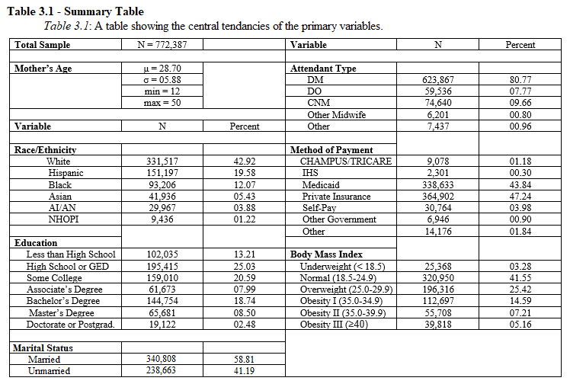
Private insurance was the most common method of payment (47.24%), followed by Medicaid (43.84%). The remaining 8.92% is divided between IHS, CHAMPUS/TRICARE, out-of-pocket pay, and other forms of payment.
Women with a high school diploma or equivalent are most common, at 25.03%, followed by women with some college (20.59%), and women with bachelor’s degrees (18.74%). Women with doctorates of professional degrees are among the smallest minority, at 2.48%).
Normal weight is the most common BMI category, with 41.55% of women, followed by the overweight category with 25.42% of women. The smallest group is the underweight category with 3.28% of women.

Race/Ethnicity
The race/ethnicity of the mother is significantly correlated with the attendant type recorded (χ² = 8752.98, p < 0.0001). See Figure 3.1 and Table 3.2. For this analysis, those with unknown race/ethnicity and those with unknown attendant types were excluded. AI/AN women show the highest percent usage of CNMs, at 19.86% of births, and the lowest usage of MDs, at 68.60%, followed by white women, at 9.58%. Asian women, on the other hand, have the lowest percent usage of CNMs, at 7.47%, and the highest use of MDs, at 86.53%. As mentioned in Chapter I, there can be notable differences in the training and licensing of CNMs and other kinds of midwives. White women have the highest percent use of non-CNM midwives, at 1.17% (Figure 3.1). These trends, however, are fairly recent. While AI/AN women have shown higher rates of CNM use for decades, as recently as 2009 Hispanic women had the next highest rates of CNM use (Declercq, 2012; Parker 1994). In the early 1980s, white women were the race/ethnicity category with the lowest rates of midwife use (Parker, 1994). Since then, however, rates of midwife use for white women have increased rapidly (Declercq, 2012).
Overall, the race/ethnicity of the mother is significantly correlated with whether or not a midwife was the attendant (Table 3.2). However, several of the race/ethnicity groups were not significantly different from one another in their use of midwives. While Asian women had the lowest use of midwives, the rates of midwife use for Black women was statistically similar to that of Asian women. Additionally, Hispanic women and NHOPI women used midwives at statistically similar rates to one another. White women were significantly different in their use of midwives than all other race/ethnicity groups, higher than Asian, Black, Hispanic, and NHOPI women, and lower than AI/AN women. AI/AN women used midwives at significantly higher rates than women of all other race/ethnicity categories. For this analysis, CNMs and other midwives were considered together as midwife = yes, and all other attendant types were
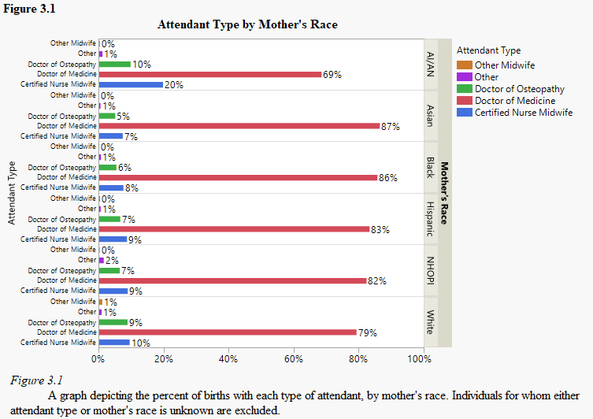
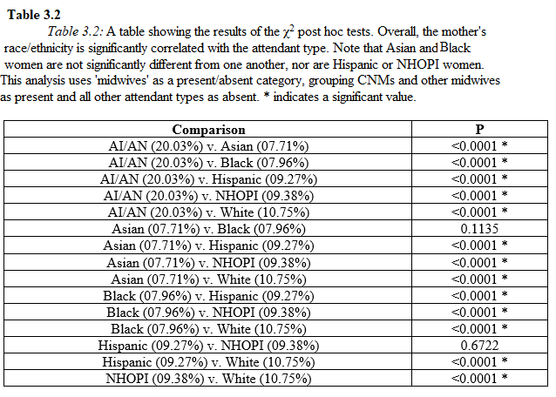
considered as a group, midwife = no. The percentages represented in Table 3.2 are the percent of each race/ethnicity category that used a midwife of any kind.
As noted above, Asian women are the least likely race/ethnicity group to make use of midwives. Asian women are also more likely to have children at later ages and to achieve high levels of education, both of which are also associated with decreased use of midwives. On the other hand, AI/AN women are the most likely to have a CNM as their birth attendant. As mentioned in Chapter I and above, CNMs are associated with IHS, therefore the correlation between AI/AN women and CNMs may be due to IHS policies rather than individual choice.

Method of Payment
The method of paying for the birth is significantly correlated with the type of attendant at the birth (χ² = 44049.73, p < 0.0001). See Figure 3.2 and Table 3.4. Those with unknown or unlisted attendant types and those with unknown or unlisted payment method are excluded from this analysis. CNMs attended 30.20% of births paid for by IHS, representing the highest usage of CNMs for any pay type. However, self-payment has the highest usage of other kinds of midwives, at 10.28%. These two categories, IHS and self-pay, also have the lowest percent use of MDs, at 60.71% and 69.09% respectively. Medicaid and private insurance both exhibit the highest rates of MD attendants, at 81.73% and 82.45% respectively, and the lowest rates of CNM use, at 9.12% and 9.15% respectively.
Overall, the method of paying for a birth was significantly correlated with whether or not a midwife was the attendant. However, several payment types are not significantly different from one another. With the lowest rates of midwife use, Medicaid and private insurance are statistically similar. The “other” category of payment is statistically similar to both CHAMPUS/TRICARE and “other government” forms of payment, though CHAMPUS/TRICARE and other government payments are significantly different. Self-payment and IHS have the highest rates of midwife delivery, and both are statistically significantly different from the other payment methods and each other. While self-payment correlates with a higher usage of non-CNM midwives (Figure 3.2), IHS shows a stronger preference for midwives overall (Table 3.4). For this analysis, CNMs and other midwives were considered together as midwife = yes, and all other attendant types were considered as a group, midwife = no. The percentages represented in Table 3.4 are the percent of each payment category that used a midwife of any kind.
Payment type is still correlated with attendant type when examined within each race/ethnicity category separately. (Table 3.3) Asian women were more likely to pay for their birth out-of-pocket than white women. Despite that self-pay is one of the payment types most
associated with midwife use, Asian women use midwives less than any other race/ethnicity
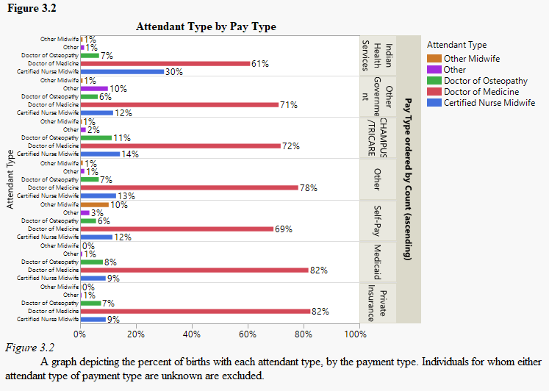
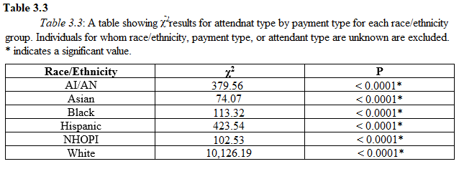
group. This indicates that the difference in midwife use in this case may be due to some other factor, such as cultural preference or the slightly older age at which Asian women tend to give birth.
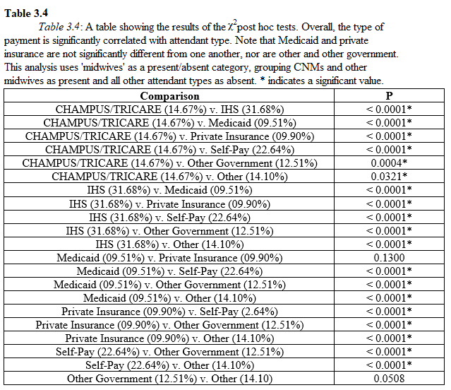
The method of paying for a birth is likely a strong predictor of attendant type. Because money and insurance policy can be a strong influencing factor in women’s decisions on birth attendant, it is important to consider this as possibly limiting women’s autonomous choice and agency during childbirth. For example, some types of insurance do not cover midwives, especially non-CNMs, so women who want to make use of midwifery services may have to find alternative ways of paying for their birth. As self-pay is linked the most strongly to non-CNM midwives, this may indicate that these types of attendants, which are often excluded by hospitals and insurance policy-makers, are not as accessible to women who cannot pay for their birth out-of-pocket. Another possibility is that for women who do not have health insurance, paying out-of-pocket for a midwife may be a more affordable option than a hospital birth. As discussed in Chapter IV, the issue of money and financing was important in several women’s decisions about their birth attendant.
Mother’s Education Level
The education level achieved by the mother is significantly correlated with the type of attendant at the birth (χ² = 100.39, p < 0.0001). See Table 3.5 and Figure 3.3. Individuals with unknown or unlisted education level or attendant type were excluded. The rates of MDs as birth attendants rises as education levels go up, from around 80% at less than a high school education, to 85%, for women with a doctorate or professional degree, while the use of CNMs decreases with increasing education, from about 10%, at less than a high school education, to 8% for
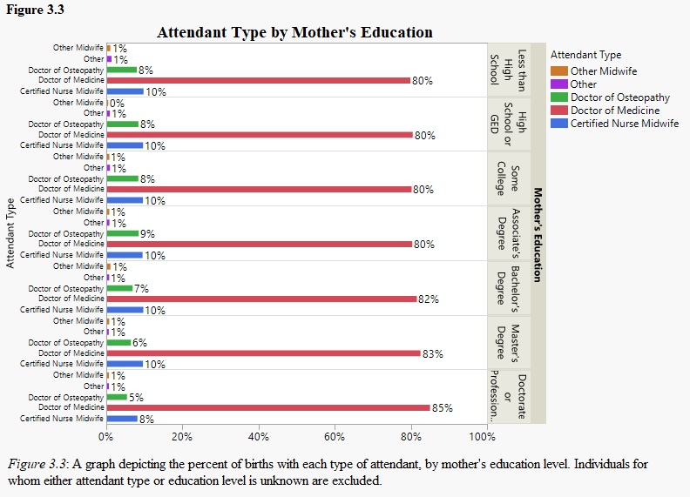
women with a doctorate or professional degree. The use of other kinds of midwives stays fairly constant, around 1%. Mother’s education level is significantly associated with midwife use, 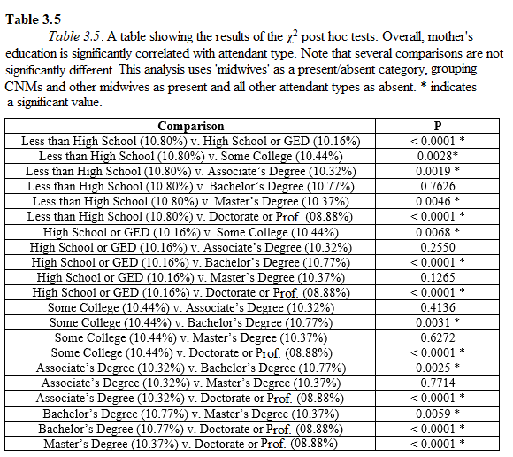overall; the rates of midwife use for women with a high school diploma or GED, some college, an Associate’s Degree, or a Master’s degree are all statistically similar. Only those with less than a high school degree and those with a doctorate or a professional degree are statistically significantly different from all other categories (Table 3.5). For this analysis, CNMs and other midwives were considered together as midwife = yes, and all other attendant types were considered as a group, midwife = no. The percentages represented in Table 3.5 are the percent of each education level category that used a midwife of any kind.
It is difficult to determine the role that education plays in influencing the choice of birth attendant. For one thing, women with higher levels of education tend to be older when having children, which is associated with increased risks of adverse outcomes and thus more use of doctors and less use of midwives. Women with higher levels of education may have more ability to pay for their birth out-of-pocket, allowing for more freedom of choice when choosing a birth attendant. However, other factors may constrain practical access to midwifery care, like geographic barriers. From this data alone, it is impossible to say if the higher rates of MD use among more highly educated women are a result of personal preference or due to some other factor, such as geographic barriers, age, or the risk status of the pregnancy.

Marital Status
Marital status is significantly correlated with attendant type (χ² = 153.282, p < 0.0001). Individuals for whom attendant type or marital status are unknown are excluded. This analysis groups CNMs and other midwives together against all other attendant types, but Figure 3.4 breaks down the five categories of attendant. The majority of women included in the study are married, and each attendant type sees more married women than unmarried (Table 3.1). However, the only race/ethnicity categories in which married women represent the majority of women giving birth are Asian and white (Figure 3.4 and Table 3.7). While married women are the majority for each attendant type, non-CNM midwives a considerably larger number of married women than unmarried.
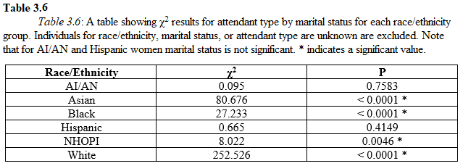
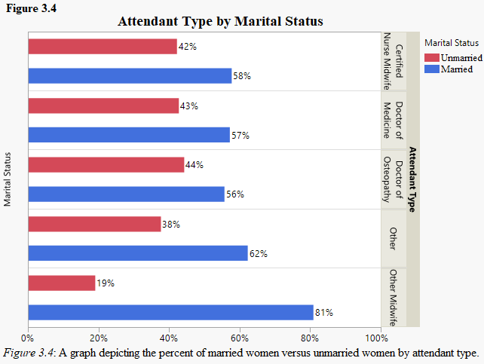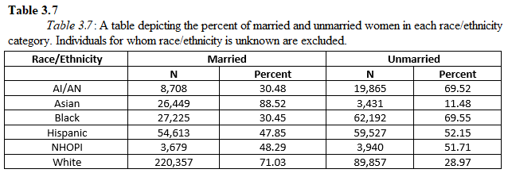
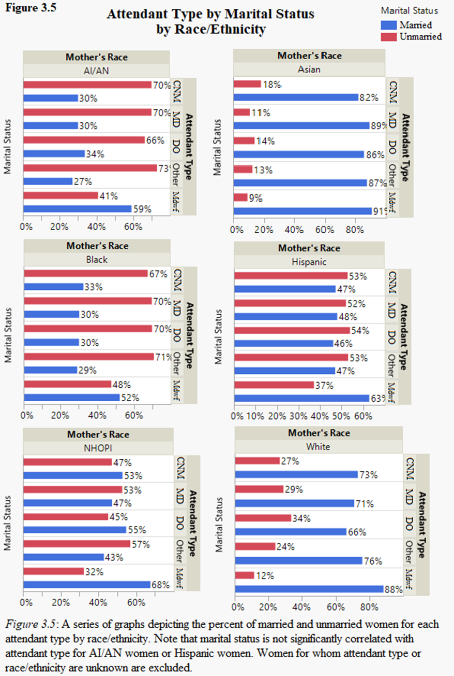Examined individually by race/ethnicity category, marital status is not statistically significantly correlated with attendant type for AI/AN women (χ² = 0.04, p = 0.85) or Hispanic women (χ² = 0.62, p = 0.43). See Table 3.6 and Figure 3.5.
This difference could be due to a number of factors. First, married women are more likely to have the social support necessary to seek care that deviates from the mainstream, as discussed in Chapter IV. Second, married women are more likely to have the financial security to pay out-of-pocket for a midwife, which is the most common payment method for non-CNM midwives (Figure 3.2).

Maternal Age
Mother’s age is significantly correlated with attendant type (χ² = 500.86, p < 0.0001). This variable was recoded into three-year groups. Individuals for whom the attendant type is unknown are excluded. Midwife use decreases as the mother’s age increase, while MDs as attendants increase with the mother’s age. See Figure 3.6. The use of CNMs is around 10% of births for the youngest group of women, 12 years of age through 14, and around 11% for 15 years through 17 and 18 years through 20. The use of CNMs drops to 3% by the oldest age group, 48 years of age through 50+. The use of MDs has the opposite trend, around 78% for the youngest group and 92% for the oldest. The youngest three age groups are statistically similar, while the remaining groups are all statistically significantly different (details not shown). The only race/ethnicity group for which maternal age is not significantly correlated with attendant type is NHOPI (not shown)
The increase of MDs as attendants with increased maternal age is possibly due to an increased risk associated with pregnancy and birth at older ages. Women are generally considered of advanced materal age when they are pregnant at age 35 years or older. This is associated with increased occurances of risk factors including multiple births, gestational diabetes, chromosomal abnormalities in the fetus, and preterm birth, which are, in turn, associated with a greater need for obstetric interventions (Bayrampour and Heaman, 2010).
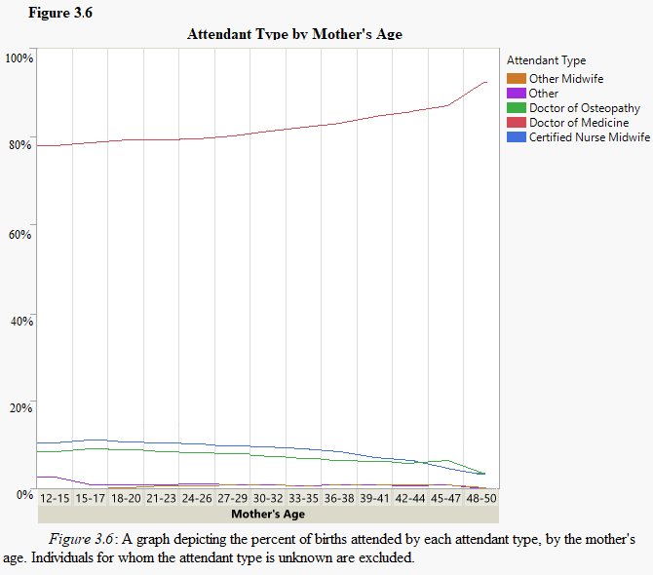

Body Mass Index
The mother’s BMI category is significantly correlated with attendant type (χ² = 1737.69, p < 0.0001). Individuals for whom the attendant type or BMI is unknown are excluded. For this analysis, CNMs and other midwives were considered together as midwife = yes, and all other attendant types were considered as a group, midwife = no. Midwife use for women classified as underweight and those classified as normal weight did not differ significantly (Table 3.8). All other BMI categories were significantly different, with midwife use decreasing as the mother’s BMI increased (Figure 3.7).
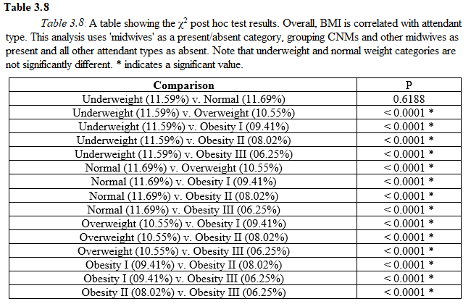
BMI was significantly associated with attendant type for all race/ethnicity categories, except Asian (χ² = 4.53, p = 0.48) (not shown). This may be a function of BMI distribution among Asian women. Asian women had the lowest percentages of all three obesity categories and the overweight category, as well as the highest percentage of the underweight category. Despite favoring the BMI categories with the highest midwife use, Asian women have some of the lowest use of midwives, indicating that the reason for this may be some other factor like cultural preference or practical accessibility.
As with advanced maternal age, obesity is associated with higher risks during pregnancy, including diabetes and gestational diabetes, eclampsia and preeclampsia (related to high-blood pressure that may result in seizures or a coma), thromboembolisms (blood clots that may result in a cardiac event), and macrosomia (an abnormally large infant that may result in difficulty during labor) (Bautista-Castaño et al., 2013). These risk factors may be the reason that women with higher BMIs seek, or are limited to, the care of MDs and DOs rather than midwives.

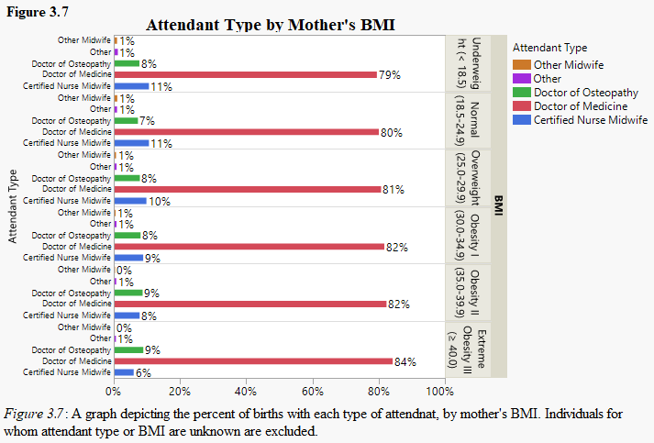

Previous Cesareans and VBACs
For this analysis, both attendant type and delivery route were simplified into present/absent categories. Attendant type was divided into CNMs and other midwives as present and all other attendant types as absent. Delivery route was divided into vaginal birth after a previous cesarean (VBAC) and all other delivery routes. First births and all subsequent births were examined separately. VBACs were found to be significantly correlated with midwife use, with first births excluded (χ² = 28044.53, p < 0.0001). Individuals for whom attendant type or previous cesarean status are unknown are excluded.
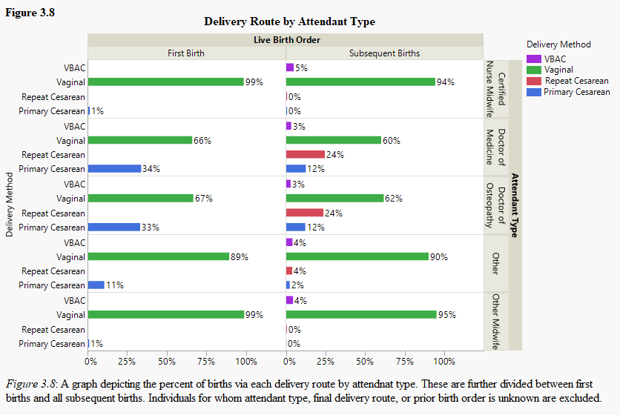
VBACs are often seen as dangerous births, associated with higher risks of (though still rare) uterine rupture and placental abnormalities like placenta previa and placenta accreta, due to the scar tissue left from the previous cesarean delivery (Latham and Norwitz, 2009; Williams, 2008). As a result, some hospitals do not provide, some doctors don’t condone, and some insurance policies do not cover, VBACs.
For women who wish to avoid a repeat cesarean, especially if they felt the pressured into their first cesarean (Chapter IV), seeking out the care of a midwife is one possible way to increase their chances of a successful VBAC (Figure 3.8). It is important to note, however, that midwife use does not necessarily have a causal relationship with vaginal births or VBACs, as women with high risk of complications that necessitate a cesarean may be directed towards doctors and cesareans, even by midwives themselves.
Conclusion
This analysis of the broader trends of midwife use in the United States begins the discussion of what factors may influence women’s decisions in choosing a birth attendant as well as the kinds of demographic factors that corelate to the use of midwives. Race and payment type are two of the strongest variables seen in this analysis. Additionally, of the variables seen here, the method of paying for the birth may be one of the most important factors, as it is also supported by narrative evidence in the following chapter. For these reasons, it seems that the decision to choose a midwife is largely cultural and financial. However, as mentioned above, these variables are complex and interwoven. Chapter IV works to address this by seeking individual input from women on the factors that influenced their decisions.

Chapter IV
Qualitative Analysis

The previous chapter, with a focus on statistic correlations with midwife use, explores a broad perspective of midwife use patterns in the United States. This chapter takes a qualitative approach, based on a series of interviews which focused on how the interviewed women perceived their birth experience, how they felt about the care they received, and what they felt were the biggest influences in the decisions they made. By examining these narratives, we gain a better understanding of midwife use in the United States than what statistics alone can provide.

Theoretical Framework
Pregnancy and childbirth are characterized by a series of complex, and sometimes stressful, decisions for pregnant women and their families. These decisions pertain to considerations and concerns of health and safety, family values, money constraints, cultural values, and the accessibility of different models of care. These factors together influence the way in which women imagine their “ideal birth”. While this imagined ideal may vary between individuals, there are recognizable patterns.
In analyzing the following interviews, I have identified two concepts that help to organize general patterns in women’s birth experiences and decisions. The first is preference, which allows for the development of a typology of value sets that influence a woman’s choice of birth attendant and birth location. Second, ideas of authoritative knowledge examine the availability of options women have practical access to regarding their birth decisions. Together, preference and authority, in addition to situational circumstances, shape women’s conceptions of their ideal birth and influence its practical attainability.

Preference Framework
Preference framework, as I use the term here, refers to a structuring of social beliefs and cultural understandings which guide peoples’ actions and behaviors. Preference frameworks can be important tools for examining social differences in belief and behavior. People with similar social and demographic backgrounds, including education, race/ethnicity, economic class, age, and nationality, may have similar preference frameworks, due to the shared social exposures and histories. This tendency allows for creation of the typologies in decision making priorities that I delineate below.
It should be noted, however, that this modeling of preference is not intended to be deterministic. Changing social conditions and exposure to new experiences can change one’s preferences, and ultimately people act and react in a physical world and within social circumstances that may limit their expressions of agency (Miller and Shriver, 2012).
In the context of childbirth, certain preferences can influence the creation of one’s ideal birth. This ideal can include when, where, how, and with whom one gives birth. Personal preference regarding these factors is informed by a number of points of social input, including factors like one’s exposure to childbirth, one’s previous interactions with the medical system, and one’s knowledge of alternative models of childbirth (Miller and Shriver, 2009; Munro et al., 2009).
For the purpose of analyzing the interviews from this study, I have identified a spectrum of ideal births ranging from an extreme biomedical interventionist model to an extreme naturalist model. Using this spectrum, I project three broad preference types onto the women interviewed. The first, which I call the biomedical framework, is characterized by a faith in the knowledge of the medical system and a belief that following hospital protocol and deferring to their doctor will result in the best outcome for them and their baby. The second I call the naturalist birth framework. This type is characterized by a desire to labor and give birth without medical intervention, a faith in the physiological process of birth, a desire for personal control, and a tendency towards a mistrust that the standard biomedical system has the patient’s best interest in mind. The third category exists between the first two. The moderate framework is characterized by a trust in the physiological process of birth balanced with a desire to ensure that the biomedical system is available to intervene if something goes wrong. It is important to note that these categories are not separate and distinct; rather they are fluid and exist on a spectrum. Nor are they natural, pre-existing categories, I have developed this typology based on a review of the literature and my own research observations. A person in any one category remains dynamic, in that motion into a different category is possible with a change in circumstance or new information.

Authoritative Knowledge
Authoritative knowledge, a theoretical foundation of feminist anthropology and the anthropology of childbirth, refers to the tendency for one form of knowledge to become the culturally dominant form, to such an extent that it marginalizes all other forms of knowledge on a given subject, within that culture (Irwin and Jordan, 1987). Authoritative knowledge can become problematic in cases in which the dominant form of knowledge is backed by a power structure, and as a result, other ways of knowing become repressed and less accessible. As discussed in Chapter II, this limits the access people have to other forms of knowledge (Davis-Floyd and Sargent, 1997). In this way, dominant forms of knowledge can influence the formation of individual preferences.
In the context of childbirth, authoritative knowledge can also dictate what kinds of care are available for women, what facilities and attendants they have access to, and what the practical and feasible expectations for their imagined ideal birth are. In the United States, the current dominant authority on childbirth is the Western biomedical system. This system is characterized by birth under the surveillance of a medical doctor or obstetric gynecologist, a hospital setting, and a mechanical understanding of the body and a pathological conception of birth. As such, the majority of American women find that both their personal preferences and their practical options of birth choices reflect this biomedical authority (Miller and Shriver, 2012). However, this limitation on choices does not affect all women equally. As we saw in the quantitative analyses of Chapter III and as we will see in the interview analysis below, disparities in education, income, differences in medical insurance, and even geographic location, influence the kinds of childbirth care that women can practically access, regardless of to which birth model type they ascribe.
Between the preference types suggested by women’s expressed concerns and priorities when imagining their ideal birth and the practical limitations imposed by the dominant, culturally recognized authorities on childbirth, much of the narrative influences on women’s childbirth decisions can be accounted for. To further explore these theories, the following is a brief study considering why women did or did not choose to seek the assistance of a midwife during their pregnancy and birth.

Methods
Study Design
This component of the study is qualitative, designed to provide a narrative lens through which attendant type preference and access can be viewed. It consists of loosely structured, participant-led interviews. Participants were asked to complete a single interview about their birth experience and the decisions they made about giving birth. These interviews were completed between September 2018 and February 2019. Recruitment of participants occurred primarily through the use of flyers and word of mouth. These flyers were posted on the University of Oklahoma campus, in baby-oriented stores in Norman, Oklahoma, Moore, Oklahoma, and Ponca City, Oklahoma, and on Facebook pages dedicated to natural birthing and midwifery.

Participants
Recruitment targeted women ages eighteen years to forty years of age, who had given birth within the last four years. Eight women were interviewed in total. Six of the interviews took place in person, while two were held over the phone. All but one participant consented to the audio recording of their interview.
Of the eight women interviewed, four delivered with the assistance of a midwife and four delivered under the care of an obstetric gynecologist (OB-GYN). All four OB-GYN-attended births occurred in a hospital. Of the midwife-attended births, one occurred in a hospital, two occurred in the participants’ homes, and one occurred in a free-standing birth center.
These participants exhibited a range of demographic characteristics, though this demographic data was only collected if offered by the participant, rather than as a systematic part of the interview process. Participant education ranged from high school diplomas and GEDs to post-graduate degrees. Both participants with the highest educational attainment, an attorney and a psychologist, used midwives. Both participants with the lowest levels of educational attainment, one with a GED, used an OB-GYN. While this is contrary to the results of the statistical analysis of Chapter III (Figure 3.3), it is possible that this is in part due to factors like geographic location, payment type, or random chance due to the small sample size. Both women in the qualitative sample who used a midwife gave birth in larger cities, Washington D.C. and Oklahoma City, and expressed less concern about their financial ability to pay for their births, while the two women who used an OB-GYN gave birth in a smaller rural town, Ponca City, and experienced greater financial restrictions.
This study sample included two individuals enrolled in federally recognized Native American tribes. One of them was attended by a midwife and one by an OB-GYN. Neither made extensive use of IHS for their pregnancy or birth due to their distance from an IHS hospital. Race/ethnicity was not addressed for the remaining participants.
Five of the eight participants currently live in, and gave birth in, the state of Oklahoma, one participant gave birth in Washington, D.C. (midwife-attended), one participant is from the state of Connecticut (midwife-attended), and one participant did not disclose their state of residence (midwife-attended).

Interviews
The interviews consisted primarily of the participants’ recounting of their experience of pregnancy and of giving birth. This was then followed up with questions targeted to draw out the specifics of why a participant chose to use the birth attendant they did, influences and obstacles they experienced in creating their ideal birth, what they did or did not like about the care they received, and their perceptions of midwifery and birth. Following are some of the patterns that emerged from these interviews and a discussion of how they connect to expressions of agency, forms of authority, and individual preference types.

Results
Due to the small sample size of this study, statistical analyses of the interview data are not particularly useful. Instead I offer a narrative and qualitative discussion of the interview results.

Desired Care and Barriers
As stated above, of the eight women interviewed, four women gave birth with an OB-GYN attendant and four with a midwife attendant. However, the delivery attendant each woman uses does not necessarily align with the preference category into which each woman fit for her birth. Of the four women who gave birth under the care of an OB-GYN, only two expressed sentiments that placed them in the biomedical birth framework. The other two women indicated a desire to give birth with a midwife but were held back from achieving this by other factors. One of these women was placed into the moderate category and the other into the naturalist birth category. Of the four women who gave birth with a midwife, three were placed into the naturalist birth category, while one was placed in the moderate category. See Table 4.1.

Of the two women who followed the biomedical birth framework, both expressed trust in their OB-GYN attendant. Neither expressed any hardship in finding their provider or with their medical insurance covering their provider. While their actual birth experience may not always match their ideal, women who follow the biomedical perspective have an easier time finding and receiving the care that they desire because that care aligns with the cultural norm and the dominant authority on childbirth in the United States.
On the other hand, of the six women who prescribe to the naturalist births model and the moderate preference type, all of whom expressed a desire for, or interest in, midwife care, only four were able to have a midwife as their attendant. The two women who wanted to use a midwife, but were unable to, both noted that their locations and the local available facilities were major hinderances keeping them from receiving the care that they wanted. In addition, one of these women also noted that money and a lack of insurance coverage for midwifery practices were also barriers to receiving midwifery care. This is consistent with quantitative data from Chapter III, suggesting that private insurance and Medicaid, the two payment types with the lowest rates of midwife use do not cover all midwife practices. One participant, who had managed to find a practicing midwife in Stillwater, Oklahoma, noted:

When I figured out it [a local midwife practice] wasn’t covered under my insurance, I saw that I had to go the doctor route…In places like Austin, it’s [the use of midwives] covered under insurance, and it’s pretty well encouraged in Texas, but not so much here… I started to listen to like, a lot of birth podcasts. And a lot of the ladies who were from Texas, were like, ‘yeah, it’s super easy. You’ve got your pick of the hospitals.’ … It’s pretty well encouraged, in like, the more metropolitan areas. But not even in OKC or Tulsa, from what I’ve researched.

These structural barriers are not spread equally across the United States. All three women who wanted a midwife in the state of Oklahoma expressed that money or location were barriers. However, both women who desired a midwife outside of Oklahoma – one in Washington D.C. and the other in the state of Connecticut – noted that their insurance covered midwifery care. This difference in insurance coverage may be due to the fact that one was under the care of a certified nurse midwife (CNM) in a hospital and the other was in a birthing center. “My insurance covers the midwife practice, probably because they’re not a home birth midwife practice,” noted one participant. Another woman stated that insurance coverage for hospital-based CNMs was one of the major factors in deciding against a home birth:

One of the reasons I didn’t do a home birth with midwives – because that was another option in my area, though it’s more expensive. It wasn’t gonna be covered by insurance. I could have, and I had many friends who did, have a midwife come to their home and deliver at home.

Again, the dominant authority on childbirth plays a role in determining these barriers, both in the spatial accessibility of midwifery facilities and the monetary accessibility of midwives, in and out of hospitals. This is another aspect for which geographic data on midwife trends would offer valuable insight. These accounts from participants suggest that state legislation on midwifery and insurance policy do influence the accessibility of midwives regionally. Anecdotally, it seems that urban centers offer more of a variety of attendant types than rural areas. However, no data on extremely rural or remote areas were included due the limited size of this qualitative study.
In addition to structural barriers, several women who desired the assistance of a midwife experienced social barriers in the form of unsupportive family members. See Table 4.2. Of the six women who wanted to use a midwife, only one stated that her family was supportive of her decision from the beginning. Four mentioned either their family was unsupportive or had to be talked into the idea.
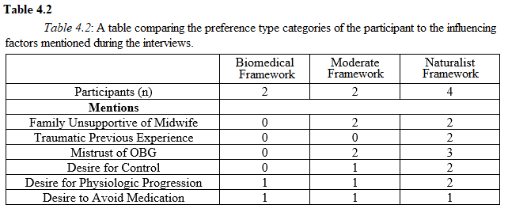
Two women noted that unsupportive family members were a primary influencing factor in not pursing a midwife at all or in only considering hospital-based midwifery care. One woman noted that her sister’s opinion influenced her to compromise between the home birth she wanted, and the hospital birth her sister encouraged, by choosing a hospital-based CNM:

My sister is a NICU [neonatal intensive care unit] nurse, and she basically was like, adamantly against it [midwife-led home birth] and like thought it was a really bad idea. And I have to admit, that really influenced me. Like, I didn’t want to go against what my sister thought, and I just like, almost didn’t have it in me to like, push. So, I did feel like I kind of had to prove that I had like, made this responsible choice.

On the other hand, however, one woman, who wanted care from an OB-GYN, noted that several friends and family members attempted to persuade her into seeking the care of a midwife.
Social barriers to midwife care, like unsupportive family members, are not easily interpreted from the statistical analysis of Chapter III. However, this may provide narrative support for the suspected cultural factors that drive the differences in midwife use between the different race/ethnicity categories.

Influencing Factors
Several patterns of common points emerged in the influencing factors women noted as important to their decisions. In general, the six women who desired to use a midwife made more and stronger remarks about influences in choosing a midwife, while the two women who did not desire a midwife were less adamant in justifying their choices. See Table 4.2.
Two of the six women who expressed a desire for a midwife noted a negative or traumatic experience with a previous birth under the care of an OB-GYN. For these women, this previous birth experience was a primary influencing factor that prompted them to choose a midwife. One participant recounted the scare tactics her attending OB-GYN used to pressure her into a cesarean delivery:

She [participant’s eldest daughter] was what I thought was an emergency c-section, but apparently, looking back at my records they put it elective. When I went into labor with my first, she [participant’s doctor]… told me that the baby was too big, and that I needed a c-section, or I would break her shoulders.
And I said, ‘Well, can we have an ultrasound to like, just confirm that she is big, before we go ahead and…’
And they were like, ‘Nope, we can’t do that. So, you either need a c-section or you can choose to break your baby, but I’m letting you know, you know, you’ll do shoulder damage to her.’
So, of course, new, young, and scared, I said, ‘Go ahead, take her!’
And she was tiny. She fit in preemie clothes. She was seven pounds. So, that was really traumatic for me. And I knew after that, that whatever child I had after that I would go to a practice that was more, mom focused, that was a little less medical focused.

An additional three women expressed a mistrust of OB-GYNs or a fear of not being listened to or respected in a hospital setting. One woman discussed the importance of communication and consent in medical practices, and notes a lack of these as a primary reason for not only giving birth under the care of a midwife, but also switching her entire well-women health care to a midwifery practice:

I remember one OB-GYN, who had a practice here in Norman… talking about me like I wasn’t there. [The OB-GYN] didn’t even address me at all, during my own exam… So, I’m a psychologist, so consenting is huge for us, like every step of the way. Consent is a part of everything we do... And I just really, as a health care provider myself, I really strive to have a person-centered model. And a lot of research shows that that’s the best care you can give someone. And so, I found that when I switched to midwives, and it’s not really there with an OB-GYN.

Along these lines, three women noted a desire for control over their laboring and birth as major factors in their desire for a midwife, and two emphasized specifically a desire for freedom of movement during labor. One woman described how moving about her home helped her through the pain of labor:

I would walk around the house, and I was bouncing on a ball, and kind of just trying to push through things… I did like some squats, I did like – through my contractions I was doing squats – and then I did some lunges on each side, and then I laid on the bed, with my knee up for like – I feel like that was forever, that was the most painful, just lying in bed in general was so painful. Like, I could totally understand why women in hospitals, like want an epidural so badly, because the lying in bed part was the worst part for me. Like, being able to walk through and, you know, trying to work through my pain, but like whenever you’re, like, constricted to a bed – no way!

Another participant noted that, even in a hospital setting, maintaining some freedom of movement was very important:

I was attached [to fetal monitors]. Which kind of sucked in terms of my laboring, because I would get up and it’d be a little bit of a hassle to get onto the ball or get into a different position and stuff. But they were longer cords so it wasn’t terrible… I wish I could have gone with, like, intermittent monitoring. Because I couldn’t really get in the shower, I couldn’t really get in the tub or anything. I had to pee, I would just rip them [fetal monitor cords] out… I didn’t care. I literally just ripped them out of the thing, carried them, peed. The first time they [the nurses] came in really concerned.

For many of the participants, midwife care was generally associated with community, attentiveness, and holistic care. One woman commented on the comfortable and relaxing environment cultivated by her midwife, even in a hospital setting:

I just didn’t want this scratchy [hospital] gown on me. Um, and she [labor nurse] kept like, trying to get this gown on me, and the midwife was like, ‘It’s fine.’ You know. ‘She can just do, you know, like – It’s fine.’ And, the midwife turned off the lights. The room was dim… They didn’t have the overhead lights on until after the birth. They had to turn them on, because I had a lot of tearing and the OB had to come in and do some surgical repair… The midwife was creating a really different environment in the room. This midwife had a strong, kind of spiritual presence. Which I think was also part of, like, her program that she really felt strongly about bringing to the leadership role

While neither of the women in the biomedical birth framework group mentioned these factors, both women in the moderate category and two of the four women in the naturalist birth category did.
Three of the six women who wanted a midwife, as well as one of the women who did not, noted a desire for a natural birth (i.e., without medical intervention). For most of these women this indicated a desire to listen to their bodies and to allow the physiological process of labor to progress unassisted. Three women made particular mention of a desire to avoid medications like Pitocin and epidural anesthesia.

Conclusion
The eight interviews of this study offer a window, narrow though it may be, into the trends of midwife use observed from the statistical data presented previously. The three preference types, biomedical, moderate, and naturalist birth, hold true for the eight women interviewed here, but without a larger and more diverse sample, it is impossible to say if this typology holds true elsewhere. However, this typology does allow for a discussion of birthing models and a changing of cultural norms in the United States. Additionally, the acknowledgement of the dominant authoritative knowledge on childbirth, the Western biomedical system, highlights these cultural shifts towards a more holistic care system for women who want more of a voice in their pregnancy and birth experiences.
The small sample size of these interviews makes it unwise, if not impossible, to draw broad generalizations about the state of midwifery in the United States. However, they lend a narrative lens through which to examine more qualitatively the statistical evidence presented in the previous chapter.

Chapter V
Conclusion

Choosing a midwife as a birth attendant can be an act of agency by pregnant women, through which they offer resistance to the overmedicalization of their bodies and reclaim the experience of birth. Not all women in the United States, however, wish to express their agency through resistance to medicalized birth, nor do all women experience the biomedical model of birth as an infringement on their agency. Additionally, of the women who do wish to choose a midwife, not all have the means or the practical access to carry out this expression of agency. Or, as indicated in Chapter III, midwives may be the most practical or affordable option for some women, making the choice a practical one rather than one of resistance per se. Preference framework (including internal values, beliefs, and cultural conceptions), authoritative knowledge (representative of power structures and social norms), and situational circumstances (the practical considerations and unexpected complications) are all interwoven in ways that shape and inform the decisions women make about pregnancy and birth.
I have taken two approaches to exploring the kinds of factors that influence women to choose a midwife as their birth attendant. The quantitative analysis, in Chapter III, explores, demographically which women are mostly likely to obtain midwifery care. The qualitative analysis, in Chapter IV, explores the kinds of value and beliefs that suggest a preference towards midwives.
The first approach is a quantitative analysis, presented in Chapter III. Based on the 2017 Public Use Natality File, collected and released by the Center for Disease Control and Prevention (CDC), this analysis allows for the identification of broad demographic patterns that correlate with higher rates of midwife use. This analysis of the broader trends of midwife use in the United States offers insight into which women in the United States seek midwifery care and which demographic factors hold the most influence over their ability or inclination to do so. I found that race/ethnicity and payment type are two variables included in the dataset most strongly correlated with attendant type. American Indian/Alaska Native women were the most likely to use a certified nurse midwife, while white women were the most likely to use other kinds of midwives. Asian and Black women were the least likely to use a midwife. Indian Health Service and self-pay made the most use of midwives. Additionally, I found that midwife use tended to decrease with higher education attainment and with increased maternal age.
The second approach is a qualitative analysis, presented in Chapter VI. Based on interviews with eight women, focusing on what influenced their decision in regard to their choice of attendant during their last pregnancy and birth, analysis helps to identify important influencing factors and values from an individualized, narrative perspective. I found that a desire for a natural birth and a mistrust or dislike of medical professional were two factors that influenced women to seek midwife care, while financial concerns, geographic inaccessibility, and lack of support from family were three of the most common barriers women encountered.
Examining these patterns and tendencies, as well as the ways in which authoritative knowledge, preference, and social and structural contexts interact with one another, has provided insight into how and why women make their decisions regarding their pregnancy and birth, though causality is still unclear.
I found several factors that may contribute to and help explain the rising trend of midwife use in the United States. One factor may be the increase in the number of hospitals that maintain a policy of collaboration between obstetric gynecologists (OB-GYN) and on-staff certified nurse midwives (CNM), discussed in Chapter I. Both the quantitative analysis in Chapter III and the qualitative analysis in Chapter IV suggest that financial concerns are one of the largest barriers women face in obtaining midwife care. This places lower income women at a disadvantage and limits their practical options in choosing a birth attendant to fit their values and desires. Narrative evidence from Chapter IV also suggests that geographic variability in midwife practices and state regulations may also be a determining factor in who has practical access to midwives; however, the dataset used in Chapter III lacks information that could support or disprove this. Additionally, both analyses suggest that cultural factors and social support can influence whether or not a woman chooses to use a midwife as her birth attendant.
By understanding the factors that influence women to choose a midwife, the variables that correlate with midwife use, and the barriers that prevent them from doing so, practical access to midwife care and information about the various options for pregnancy and labor care can be increased and improved for women who would want to choose the care of a midwife. Based on the analyses presented here, I suggest that the best way to increase practical access to midwives is to promote state legislation and regulation for midwives that would encourage hospitals to work with midwives and allow insurance companies to accept certain kinds of midwife practices. This would help to decrease both the financial hurdle women face and any possible geographic disparities in midwife availability.
It is important to address these barriers to midwife care in order to maximize the number viable options women have available in planning their births. Different personal preferences that women hold within the United States necessitate the inclusion of a many of ways of knowing about birth, to allow each woman to choose the options that best fit her individual circumstances, values, and beliefs.

Bibliography
American College of Nurse-Midwives. 2018. “2017 Annual Report.” Silver Spring, Maryland.
Bautista-Castaño, Inmaculada, Patricia Henriquez-Sanchez, Nestor Alemán-Perez, Jose J. Garcia-Salvador, Alicia Gonzalez-Quesada, Jose A. García-Hernández, and Luis Serra -Majem. 2013. “Maternal Obesity in Early Pregnancy and Risk of Adverse Outcomes.” Public Library of Science One, 8(11):1-6.
Bayrampour, Hamideh and Maureen Heaman. 2010. “Advanced Maternal Age and the Risk of Cesarean Birth: A Systematic Review.” Birth, 37(3):219-226.
Begay, R. Cruz. 2009 “Navajo Birth: A Bridge Between the Past and the Future,” in Childbirth Across Cultures: Ideas and Practices of Pregnancy, Childbirth, and the Postpartum edited by Helaine Selin and Pamela K. Stone, 245-253. New York: Springer, 2009.
Bergeron, Veronique. 2007. “The Ethics of Cesarean Section on Maternal Request: A Feminist Critique of the American College of Obstetricians and Gynecologists’ Position on Patient-Choice Surgery.” Bioethics, 21(9):478-487.
Borquez, Heather A. and Therese A. Wiegers. 2006. “A comparison of Labour and Birth Experiences of Women Delivering in a Birthing Centre and at Home in the Netherlands.” Midwifery, 22:339-347
Broda, Anja, Juliane Krüger, Stephanie Schinke, and Andreas Weber. 2018. “Determinants of Choice of Delivery Place: Testing Rational Choice Theory and Habitus Theory”. Midwifery, 63:33-38.
Burcher, Paul, Melissa J. Cheyney, Kalie N. Li, Shazeen Hushmendy, and Kevin C. Kiley. 2016. “Cesarean Birth Regret and Dissatisfaction: A Qualitative Approach.” Birth: Issues in Perinatal Care, 43(4):346-352.
Center for Disease Control and Prevention. 2017 Natality File. Public-use data file and documentation. https://www.cdc.gov/nchs/data_access/VitalStatsOnline.htm#Births. 2018.
Craven, Christa. 2007. “A ‘Consumer’s Right’ to Choose a Midwife: Shifting Meanings for Reproductive Rights Under Neoliberalism.” American Anthropologist, 109(4):701-712.
Craven, Christa. 2005. “Claiming Respectable American Motherhood: Homebirth Mothers, Medical Officials, and the State.” Medical Anthropology Quarterly, 19(2):194-215.
Davis-Floyd, Robbie, and Carolyn Sargent, editors. 1997. Childbirth and Authoritative Knowledge. Berkeley: University of California Press.
Declercq, Eugene. 2012. “Trends in Midwife-Attended Births in the United States, 1989-2009.” Journal of Midwifery and Women’s Health, 57(4):321-326.
Deitrick, Lynn, and Patrick Draves. 2008. “Attitudes Towards Doula Support During Pregnancy by Clients, Doulas, and Labor-and-Delivery Nurses: A Case Study from Tampa, Florida”. Human Organization, 67(4)397-406.
Dunham, Bria. 2016. “Home Birth Midwifery in the United States.” Evolutionary Origins and Modern Challenges.” Human Nature 27:471-488.
Ecker, Jeffery. 2013. “Elective Cesarean Delivery on Maternal Request.” Journal of the American Medical Association, 309(18):1930-1936.
Ellison, Peter T. 2001. On Fertile Ground: A Natural History of Human Reproduction. Cambridge: Harvard University Press.
Irwin, Susan and Brigitte Jordan. 1987. “Knowledge, Practice, and Power: Court-Ordered Cesarean Sections.” Medical Anthropology Quarterly, 1(3):319-334.
Jordan, Brigitte. 1993. Birth in Four Cultures: A Crosscultural Investigation of Childbirth in Yucatan, Holland, Sweden, and the United States, 4th edition, revised by Robbie Davis- Floyd. Long Grove: Waveland Press.
Jordan, Brigitte. 1992. Technology and Social Interaction: Notes on the Achievement of Authoritative Knowledge in Complex Settings. Palo Alto: Institute for Research on Learning.
Kennedy, Holly Powell, Jo Anne Myers-Ciecko, Katherine Camacho Carr, Ginger Breedlove, Tanya Bailey, Marinah V. Farrell, Mary Lawlor, and Ida Darragh. 2018. “United States Model Midwifery Legislation and Regulation: Development of a Consensus Document.” Journal of Midwifery and Women’s Health, 63(6):652-659.
Kozhimannil, Katy B., Laura B. Attanasio, Y. Tony Yang, Melissa D. Avery, and Eugene Declercq. 2015. “Midwifery Care and Patient-Provider Communication in Maternity Decisions in the United States.” Maternal and Child Health Journal, 19:1608-1615.
Latham, Stephen and Errol Norwitz. 2009. “Ethics and ‘Cesarean Delivery on Maternal Demand.” Seminars in Perinatology, 33(6):405-409.
Logsdon, Katie, and Carolyn Smith-Morris. 2017. “An Ethnography on Perceptions of Pain in Dutch “Natural” Childbirth”. Midwifery, 55:67-74.
McCourt, Christine, Juliet Rayment, Susanna Rance, and Jane Sandall. 2016. “Place of Birth and Concepts of Wellbeing: An Analysis from Two Ethnographic Studies of Midwifery Units in England.” Anthropology in Action, 23(3):17-29.
McFarlin, Barbara. 2004. “Elective Cesarean Birth: Issues and Ethics of an Informed Decision.” Journal of Midwifery and Women’s Health, 49(5):421-429.
Miesnik, Susan R. and Barbara J. Reale. 2007. “A Review of Issues Surrounding Medically Elective Cesarean Delivery.” Journal of Obstetric, Gynecologic, and Neonatal Nursing, 36(6):605-615.
Miller, Amy Chasteen, and Tomas Shiver. 2012. “Women’s Childbirth Preferences and Practices in the United States”. Social Science and Medicine, 75:709-716.
Munro, Sarah, Jude Kornelsen, and Eileen Hutton. 2009. “Decision Making in Patient-Initiated Elective Cesarean Delivery: The Influence of Birth Stories.” Journal of Midwifery and Women’s Health, 54(5):373-379.
Mutryn, Cynthia. 1993. “Psychosocial Impact of Cesarean Section on the Family: A Literature Review.” Social Science and Medicine, 37(10):1271-1281.
Ogburn, Joseph A., Eve Espey, Marilyn Pierce-Bulger, Lisa Allee, William H.J. Haffner, and Jean Howe. 2012. “Midwives and Obstetrician-Gynecologists Collaborating for Native American Women’s Health.” Collaborative Practice in Obstetrics and Gynecology 39(3):359-366.
Ortner, Sherry. 2006. Anthropology and Social Theory. Durham: Duke University Press.
Panazzolo, Michelle and Ritchlyn Mohammed. 2011. “Birthing Trends in American Society and Women’s Choices.” Race, Gender, & Class, 18(3):268-283.
Parker, Jennifer. 1994. “Ethnic Differences in Midwife-Attended US Births.” American Journal of Public Health, 84(7):1139-1141.
Rutherford, Julienne N., Ifeyinwa V. Asiodu, and Kylea L. Liese. 2019. “Reintegrating Modern Birth Practice within Ancient Birth Process: What High Cesarean Rates Ignore about Physiologic Birth.” American Journal of Human Biology, 31.
Trevathan, Wenda. 2010. Ancient Bodies, Modern Lives: How Evolution has Shaped Women’s
Health. New York: Oxford University Press.
U.S. Department of Labor, U.S. Bureau of Labor Statistics. 2017. “Employment by Industry, Occupation, and Percent Distribution, 2016 and Projected 2026: '29-1161 Nurse midwives.” Employment Projections Program.
Wendland, Claire. 2007. “The Vanishing Mother: Cesarean Section and ‘Evidence-Based Obstetrics’.” Medical Anthropology Quarterly, 21(2):218-233.
Williams, Helen O. 2008. “The Ethical Debate of Maternal Choice and Autonomy in Cesarean Delivery.” Clinics in Perinatology, 35(2):455-462.
Wolf, Jacqueline H. 2009. Deliver Me from Pain: Anesthesia and Birth in America. Baltimore: John Hopkins University Press.
Wu, Lin Chieh, Rahul Malhotra, John Carson Allen Jr., Desiree Lie, Thiam Chye Tan, and Truls Østbye. 2013. “Risk Factors and Midwife-Reported Reasons for Episiotomy in Women Undergoing Normal Vaginal Delivery.” Archives of Gynecology and Obstetrics, 288:1249-1256.

