University of Oklahoma

Graduate College

USING COGNITIVE TASK ANALYSIS TO DESCRIBE SPATIAL REASONING PROCESSES

A Dissertation

submitted to the Graduate Faculty

in partial fulfillment of the requirements for the

Degree of

Doctor of Philosophy

By

MATTHEW REYES
Norman, Oklahoma
2017

USING COGNITIVE TASK ANALYSIS TO DESCRIBE SPATIAL REASONING PROCESSES

A Dissertation approved for the
Department of Educational Psychology

By

______________________________
Dr. Barbara Greene, Chair

______________________________
Dr. Doo Hun Lim

______________________________
Dr. H. Michael Crowson

______________________________
Dr. Theresa Cullen

______________________________
Dr. Xun Ge

© Copyright by MATTHEW REYES 2017
All Rights Reserved.
This is dedicated to amazing wife, Naomi, and my wonderful kids, Abby, Jacob, and Robby. I will never understand why the Lord saw fit to bless me with such an incredible family. You are far better than anything I could have asked for and much more than I deserve. I love you all more than I could ever express.

Acknowledgements
I would like to acknowledge the support that I have received from my chair and advisor. Dr. Greene, I know it was a bit of a risk taking on a doc student like me that came from a different discipline. I have never taken that for granted and am proud to have studied under you. Not only have you guided me through the process of this project but also have been an invaluable mentor as you have taught me how to navigate this profession and served as a guiding light so many times. I will forever be grateful for you and will spend my career following what you have modeled for me.
I also had the good fortune of working with and for some outstanding administrators, staff, and faculty in the Construction Science division and in the College of Architecture. Thank you all for your support and encouragement. Ken, Richard, and Charles – thank you for believing in me and supporting me, I would not be where I am without your mentorship.
Naomi, Abby, Jacob, and Robby – I could have never completed this without your love and support. Your patience with me, your encouragement of me, and your enduring love for me have been an unending source of inspiration through this journey. I am so blessed to get to run this race with you.
More than anything else, I feel thankful. Thankful for colleagues that encourage me. Thankful for an advisor that mentors and guides me. Thankful for a family that supports me. Most of all, I am thankful for a Creator that loves me boundlessly, despite the fact that I have merited none of it. I am thankful that He chose to pay the ransom for me that I could never pay myself. Though I will never fully understand the depths of such love, I will never cease to be amazed by it and grateful for it.

Table of Contents
Acknowledgements iv
List of Tables x
List of Figures xi
Abstract xii
Chapter 1: Introduction 1
Background 2
The Role of Spatial Skills 3
Societal Perceptions of Spatial Skills 3
Purposeful Instruction for Spatial Reasoning Strategies 4
Gaming as a Possible Instructional Solution 5
Designing a Game to Teach Spatial Skills 7
Cognitive Task Analysis 8
Purpose of the Study 9
Organization of the Dissertation 10
Chapter 2: Literature Review 11
The Role of Spatial Skills 11
Defining Spatial Skills 11
Significance of Spatial Skills 12
Gender and Other Influences on Spatial Ability 14
Malleability of Spatial Skills 17
Practices for Teaching Spatial Skills 18
Spatial Skills Development for Construction Science Students 24
Games and Spatial Skills 25
Historical Context of Games 26
Defining Games 26
Types of Games 28
Goal of Educational Games 30
Using Games in the Classroom 31
Fidelity and Task Authenticity 33
Student Motivation 34
Blending New and Old Methods of Instruction 35
Gaming and Gender 36
Student Perceptions of Technology 37
Best Practices for Effective Educational Games 38
Incorporating Feedback in Games 39
Integrating Games into the Classroom Setting 40
Designing a Game to Teach Spatial Skills 40
Overview of Cognitive Task Analysis 42
Historical Context of Cognitive Task Analysis 45
The Role of Experts in Cognitive Task Analyses 46
The Cognitive Task Analysis Procedure 49
Steps to Carry Out a Cognitive Task Analysis 50
Specific Protocols for the Data Collection 51
Summarizing the Role of a Cognitive Task Analysis in an Educational Game Designed to Enhance Spatial Skills 56
Chapter 3: Methodology 58
Research Questions 58
Method 59
Design Overview and Method Rationale 59
Context and Participants 60
Tasks for Participant Problem-Solving 63
Task Selection Rationale 66
Data Sources and Output 68
Procedure 70
Chapter 4: Results 75
Overview of Data Analysis 75
Research Question #1: What are the specific cognitive tasks involved in solving four different types of spatial visualization problems? 75
Research Question #2: Is there a coherent profile for problem-solving strategies at the three levels of expertise analyzed? 76
Research Question #3: How do the cognitive tasks differ between people who are novices, early practitioners, and experts? 76
Research Question #4: Can we infer how solving the tasks develops from novice to expert level problem-solving by comparing these three stages of problem-solving? 76
Research Question #5: Can the resulting information be used by an instructional game designer to develop a game? 76
Overview of Task Completion by Participants 77
Research Question #1 78
Research Question #2 82
Research Question #3 84
Research Question #4 89
Research Question #5 92
Results Summary 93
Chapter 5: Results Interpretation 94
Results Interpretation Method 94
Mental Images Used to Check Work 95
Mental Image Used to Organize a Solution 95
Mental Images as a Problem-Solving Bridge 96
Continuous Use of Mental Images Throughout Problem-Solving 97
Given Image Obviates Need for Mental Image 98
Cognitive Task Analysis as an Instructional Tool 99
Instructional Tools for Spatial Reasoning Tasks 101
Construction Management: 3-D Site Contours. 101
Construction Management: Vertical Site Layout. 102
Construction Management: Horizontal Site Layout. 102
Construction Management: Simple 4-D Planning & Sequencing of a Basketball Court. 103
Construction Management: Complex 4-D Planning & Sequencing of a Building Foundation. 104
Construction Engineering: Shear and Moment Diagrams. 105
Construction Engineering: Load Tracing. 105
Interpretation Summary 106
Chapter 6: Conclusion 108
Effectiveness of Cognitive Task Analysis for Data Collection 108
Appropriateness of an Educational Game 110
The Use of Spatial Reasoning 112
General Recommendations for Instructional Tool Development 113
Importance of Metacognition 114
Limitations 116
Recommendations for Further Research 117
Final Conclusion 118
References 119
Appendix A: Task Descriptions 132
Appendix B: Participant Charts 140

List of Tables
Table 1 Task Summaries 64
Table 2 Mean Time for Task Completion by Expertise Category 78
Table 3 Visual Tools for Construction Management: 3-D Site Contours 79
Table 4 Visual Tools for Construction Management: Vertical Site Layout 79
Table 5 Visual Tools for Construction Management: Horizontal Site Layout 80
Table 6 Visual Tools for Construction Management: Simple 4-D Planning & Sequencing of a Basketball Court 80
Table 7 Visual Tools for Construction Management: Complex 4-D Planning & Sequencing of a Building Foundation 80
Table 8 Visual Tools for Construction Engineering: Shear and Moment Diagrams 81
Table 9 Visual Tools for Construction Engineering: Load Tracing 81
Table 10 Visual Tools Used by Novices on Each Task 86
Table 11 Visual Tools Used by Early Practitioners on Each Task 87
Table 12 Visual Tools Used by Experts on Each Task 88

List of Figures
Figure 1 Participant output for vertical site layout task from novice N-3 and early practitioner EP-5 71
Figure 2 Participant output for horizontal site layout task from novice N-3 and early practitioner EP-1 72
Figure 3 Participant output for simple 4-D sequencing of a basketball court task from novice N-5 and expert EXEN-2 72
Figure 4 Participant output for complex 4-D sequencing of a building foundation task from novice N-2 and expert EXEN-1 73
Figure 5 Participant output for shear and moment diagram task from novice N-6 and expert EXEN-1 73
Figure 6 Participant output for load tracing task from novice N-4 and expert EXEN-2 74

Abstract
This study is rooted in the idea that the ability to navigate a three-dimensional environment, both in reality and virtually, the ability to imagine and manipulate three-dimensional objects, and the ability to visualize one’s own orientation with respect to an object are important skills. These spatial skills are critical for solving problems and operating in the world. Like many skills, spatial skills can be taught and improved. Educational games are explored as a possible instructional tool for teaching these skills. In order to better understand how such an educational game should be designed, the cognitive components that are involved in solving spatial reasoning tasks were investigated through the use of a cognitive task analysis.
A total of 20 participants performed a series of tasks that involve spatial reasoning. The tasks were all in the domain of Construction Science and were in either construction management or construction engineering categories. The participants were from three different levels of expertise, some students and some working professionals. The participants consisted of six novices, five early practitioners, and nine experts. Using retrospective think-aloud procedures for the cognitive task analysis, each participant reviewed their work while explaining their through processes and answering probing questions, with special attention paid to the mental images they used to solve the problems.
The findings indicate that there are common strategies individuals use to solve problems and that these tools change as expertise develops. Recommendations are made for instructional tools that may foster the development of spatial skills within the domain of Construction Science. The findings indicate that educational games may be a good fit for teaching some skills but not others. One key finding is the potential value of the cognitive task analysis itself as a helpful instructional intervention.

Chapter 1: Introduction
There are a variety of academic tracks and careers that require well-developed visual-spatial skills. These skills include being able to imagine three-dimensional objects, mentally manipulate the imagined objects, and visualize one’s own orientation with respect to an object. Most science, technology, engineering, and math (STEM) careers require good visual-spatial reasoning (Gilbert, 2005; National Research Council, 2006) and some level of the skill is essential for navigating one’s own environment on a daily basis. There has been some discussion in the past about whether spatial skills are strictly innate or can be learned (e.g., Lord, 1985). To be sure, few studies explicitly state that these skills are innate. However, with the focus of many studies being characteristics such as sex or ethnicity, the clear inference that can be drawn is that there is an underlying assumption that these abilities are innate (e.g., Battista, 1990; Ganley & Vasileyva, 2011). Much like math or reading, spatial skills are necessary to thrive in the world. Unlike math and reading, however, there is no societal call for them to be explicitly included in any school curriculum.
Despite the implicit assumption of innateness, there is much evidence that spatial skills can be improved upon (e.g., Ben-Chaim et al., 1988; Stericker & Le Vesconte, 1982; Zavotka, 1987). Throughout this document I will be using the term spatial skills rather than spatial ability to make clear the distinction between something that can be acquired and improved upon as opposed to something that is innate. Even with the evidence that spatial skills can be improved with practice, there have not been concerted efforts in K12 or high-education to do such training. The goal of the present research is to develop the groundwork for such training in the field of Construction Science.

Background
My interest in this topic began through my experience teaching a Construction Surveying course. A key component of surveying is to use equipment to mark out areas of a field and indicate how the terrain must change. This requires that the students have a good understanding of the current lay of the land, but more importantly it requires that they visualize how it may look in the future as the terrain changes with progress of the construction project. The need to form a mental image of an object (site terrain in this instance) was a barrier for some students in my teaching experience. The students that struggled to visualize how the site will look in the future also struggled to carry out the computations that inform how they place the field markings with the equipment. This struggle often leads to disengagement from the current activity. Since the course is structured such that each topic builds on the previous one, disengagement at any point can lead to poor achievement outcomes in the course.
In order to maintain engagement and increase achievement across all topics in the course, it was apparent that some sort of instructional intervention was necessary to serve as a bridge to get across a particular point in the curriculum where they struggle so that they will still be able to succeed in subsequent course topics. The intervention would be focused on improving the students’ ability to visualize the problem. This mental image of what is currently existing and what will exist in space is a crucial skill for Construction Surveying. It is this cognitive aspect of spatial visualization that will be the focus of the instructional intervention.

The Role of Spatial Skills
The process of holding the image of an object in our mind’s eye and manipulating it is an important skill that enables problem-solving in a variety of domains. Referred to as spatial reasoning, visuo-spatial thinking, spatial cognition, and spatial intelligence among other terms (e.g., Hsi, Linn, & Bell, 1997; National Research Council, 2006; Thorndyke & Goldin, 1983; Uttal et al., 2013), this skill is an accumulation of other sub-skills. At a minimum, there are the distinct abilities of spatial relation and spatial visualization. Spatial relation refers to the ability to imagine the rotation of objects as intact bodies and also how one’s own body is oriented relative to an object. Spatial visualization refers to the ability to imagine how objects are modified by folding or unfolding (Martín-Dorta, Saorín, & Contero, 2008). While there are distinct skills under the broader category of spatial cognition, an individual that is a high achiever in one is often a high achiever in the other (Sorby, Nevin, Behan, Mageean, & Sheridan, 2014). The distinction between the subskills is important as they may require unique methods of construction.

Societal Perceptions of Spatial Skills
Our culture places a high value on an individual’s spatial skills as evidenced by commonly recognized measures of intelligence. Many of these tests include a section specifically designed to measure spatial ability, such as the Wechsler Adult Intelligence Scale’s perceptual reasoning index and visual processing measure that includes items related to block design, visual puzzles, and picture completion (Coalson, Raiford, Saklofske, & Weiss, 2010; Lichtenberger & Kaufman, 2009; Sprandel, 1985). The Differential Aptitude Test that includes items that "require mental manipulation of objects in three-dimensional space” (Bennett, Seashore, & Wesman, 1952, p. 7) and the Stanford-Binet Intelligence Scale includes visual-spatial processing as one of its five cognitive factors assessed (Roid & Barrman, 2004). Indeed, “some kind of spatial component [is present in] virtually every intelligence test” (National Research Council, 2006, p. 273) which is an indicator of the degree to which our society values spatial skills.
Spatial skills also play a key role in a person’s vocation and educational pursuits and there is also a link to creative thinking potential (Kell, Lubinski, Benbow, & Steiger, 2013). Even given the importance of spatial skills for success in school and life, research suggests that more than half of the adult population in the nation struggle with iconic image control and manipulation (Lord, 1985). While there are some fields that have obvious demands on spatial reasoning, namely STEM disciplines, it is an important skill in many areas that do not have obvious requirements for such skills (Thorndyke & Goldin, 1983). For example, reading a map or simply finding one’s way around in a new town or city involves spatial reasoning.

Purposeful Instruction for Spatial Reasoning Strategies
The predominant theme I found in the literature on spatial skills is that everyone stands to gain from the development of training to enhance the development of spatial skills since the skills are crucial to many cognitive tasks not the least of which is the ability to interact with our environment. An individual’s genetics play a role her spatial ability but many of the factors that lead to well-developed spatial skills are learned and thus the skillset can be improved with practice (e.g., Lohman & Nichols, 1990; Uttal et al., 2013; Verdine et al., 2014). Since spatial skills play a role in the success of a student in and out of the classroom, can impact retention in STEM fields (Sorby, 2006), and can even improve a person’s ability to verbally express himself (Hostetter & Alibali, 2007), it is vital for there to be a component of education that is designed to enhance the spatial skills of students. While a course specifically designed to teach spatial thinking has been shown to be successful (Sorby & Baartmans, 2000), it is true that there are multiple methods of training and instruction that are possible. The instruction must be tailored to the specific learning goals (Uttal et al., 2013) and thus, it seems that instruction that can be tailored to different domains would be ideal.
As there are a variety of domains in which spatial skills can be taught, the time spent tailoring such instruction may prove to be a high demand on resources. There is competition for curricular time and thus it is a challenge to fit in specific instruction on spatial learning strategies (McKeachie, 1984). Additionally, complex cognitive processes such as spatial reasoning tasks require practice and repetition before an individual can begin to gain expertise and reach automaticity when performing tasks.
An instructional tool that promotes repetitive practice would be the preferable tool for teaching spatial skills. A well-designed game is fun for the user and fosters practice through engagement with the game. An educational game, therefore, is potential solution to meet the need of practice for skill building without a heavy demand on resources.

Gaming as a Possible Instructional Solution
The development of spatial skills requires a good deal of repetition and practice before the learned strategies can be applied effectively to problem-solving scenarios (McKeachie, 1984). This need for repetition and practice is something that games are well-suited to provide. Games serve many functions including “tutoring, amusing, helping to explore new skills, promoting self-esteem, practicing existing skills, drilling existing skills, automatizing, or seeking to change an attitude” (Dempsey, Rasmussen, & Lucassen, 1994, p. 3). Most common among these are games as used for practicing existing skills and learning new skills. With the goal of facilitating problem-solving by participants, educational games have the potential to impact both the cognitive and affective domains (Smith, 1979). Game designers rely on learning theories and include goal-directed gameplay to encourage engagement (Schaaf, 2012; Squire, 2007).
A learning experience is most fruitful for the learner when it is fun and the learner can experience a state of flow, losing himself in the act of the experience (Csikszentmihalyi & Nakamura, 1989). To further optimize the experience, the learner must feel a sense of autonomy and have a sense of competence and relatedness (Garaizar, Peña, & Romero, 2013). A well-designed game can elicit all of these in a learner and foster an environment where learning can take place. Games engage the learners in the content as they play and do. Games offer the advantage of facilitating a higher frequency of engagement and greater persistence by the learner as compared to other methods of instruction (Tobias & Fletcher, 2011).
Efforts have been made in the past to use existing, off-the-shelf games to enhance spatial skills with results being mixed. There is evidence suggesting that games prepare for specific knowledge transfer when it comes to spatial skills meaning that playing a game can result in an improvement of only the skills required to by the game (Adams, 2013; Pilegard & Mayer, 2016). The idea that games are most beneficial when gameplay is closely related to the desired skill or learning outcome suggests a particular type of game that targets specific desired skills. Such a game would enable instruction on specific learning objectives that have a high demand on spatial cognition. Learners that enter with varying degrees of spatial ability can engage with the game at appropriate levels that will support them in their stage of knowledge development. These targeted games, or various levels in a single game, enable the specific transfer of skills to classroom learning objectives. Perkins and Salomon (1988) note that transfer is not a foregone conclusion and that learners will not necessarily be able to apply knowledge learned in new contexts. This is particularly true of higher order cognitive skills. Perkins and Salomon (1988) recommend that instruction should be designed such that it parallels, or hugs, the skill that is the target of transfer. An off-the-shelf game will not necessarily lead to the desired transfer and should be carefully designed for the transfer goals in mind. An educational game that uses support and enhances concepts that require spatial skills could serve to support students that enter the learning environment with low spatial ability and struggle when encountering a concept with high demand on that ability. This instructional bridge can serve to benefit students that may otherwise disengage from the learning context.

Designing a Game to Teach Spatial Skills
Since instructional games are most effective when targeted at a particular learning objective and since spatial ability is composed multiple distinct skills, a game that is intended to improve a student’s ability to visualize what is happening in a particular course such as Construction Surveying would have to be very carefully designed. In order to design a game that will improve achievement on tasks requiring spatial visualization, the discrete tasks involved in the overarching activity must be clearly identified. Once identified, these tasks can be used in the design and development of the game activities and user experience. These discrete tasks are not apparent to observers and are often not made explicit when an individual is carrying out a task driven by spatial visualization. This cognitive task must be broken down into its components by observing and interacting with an individual that is carrying out such a task.

Cognitive Task Analysis
A cognitive task analysis (CTA) is a “set of methods for identifying cognitive skills, or mental demands, needed to perform a task proficiently” (Militello & Hutton, 1998, p. 1618). The primary purpose of a CTA is to capture what the mind is doing during a complex task, and to capture cognition. The researcher has the goal of understanding and describing the way that the expert views and makes sense of the events in the problem-solving scenario (Crandall, Klein, & Hoffman, 2006).
Via a mix of interviews and observations, CTA has been shown to take expert cognitive processes and incorporate them into training materials more effectively than other approaches. In the context of this project, the CTA data will be used to identify discrete tasks and will be represented in a cognitive demands table (Militello & Hutton, 1998) that will succinctly identify the discrete subtasks and the methods of solving the associated problems. The ultimate purpose of the data in the cognitive demands table will be to use the identified tasks to inform the design of an educational game to serve as an instruction intervention to improve spatial visualization skills.

Purpose of the Study
The overarching purpose of this study is to conduct a cognitive task analysis in order to eventually investigate a method of enabling Construction Science students to improve their spatial skills to support better problem-solving in the classroom and in the field. The eventual instructional intervention will be an educational game that provides repetition and practice on spatial tasks. In order to design such a game that includes the relevant tasks for repetition, the discrete subtasks that are involved in solving a spatial problem need to be identified. As the instructional game will be targeted at novices, the problem-solving methods of individuals at various levels of expertise must be studied. This understanding of how individuals at various levels of expertise solve spatial problems is critical. Much research is centered on how to get novice learners to think like experts. However, it may be the case that there is a stage of development where individuals that are on the path to expertise rely on different problem-solving strategies than experts do. Experts have internally automatized many of their cognitive processes (Cooke, 1994) to an extent that novices and those just beyond the novice level are not able to do. This lack of automaticity may require different strategies and thus different instruction. This progression of problem-solving techniques will be an essential part of how the instructional game is designed and developed.
Thus, the present study focuses on the following research questions:
- What are the specific cognitive tasks involved in solving four different types of spatial visualization problems?
- Is there a coherent profile for problem-solving strategies at the three levels of expertise analyzed?
- How do the cognitive tasks differ between people who are novices, early practitioners, and experts?
- Can we infer how solving the tasks develops from novice to expert level problem-solving through comparing these three stages of problem-solving?
- Can the resulting information be used by an instructional game designer to develop a game?

Organization of the Dissertation
The next chapter will include a review of the literature focusing on procedures and uses of cognitive task analyses. Also included will be review of literature about spatial visualization skills and the distinct abilities identified as this will inform the specifics of the cognitive task analysis. The literature review will begin with a discussion of spatial skills and their importance and be followed by a discussion of games, specifically how they might relate to teaching spatial skills. The literature will close with a discussion of cognitive task analysis and how it might be used to inform the design of an educational game for teaching spatial skills.
The third chapter will be comprised of a description of the study design and methodology. The details of the study will be described in that chapter. This will be followed by a presentation of the results in the fourth chapter. Following the results will be a fifth chapter to discuss the interpretation of the results. The dissertation will close with a sixth chapter that presents a conclusion and a discussion of the implications.

Chapter 2: Literature Review
Although the importance of well-developed spatial skills in many academic and professional settings has been demonstrated, there is still no commonly used instructional method to foster the development or improvement of these skills. Instructional games are becoming more commonplace in education and could serve as a suitable tool for teaching these skills. However, in order to properly design a game that would serve to teach problem-solving with spatial skills, the cognitive processes used during these processes must be clearly identified. These cognitive processes cannot be identified with traditional task analysis methods which are behavior based. Therefore, to identify and analyze these unobservable processes, a cognitive task analysis is the preferred method for collecting and analyzing data in order to identify the target processes. The goal of this dissertation is specifically to identify the cognitive processes involved in solving problems that require spatial reasoning and are pertinent to Construction Science students. This chapter will provide a review of the relevant literature beginning with the role and importance of spatial skills. This will be followed by a discussion of educational games and the process of a cognitive task analysis.

The Role of Spatial Skills

Defining Spatial Skills
Although an exact definition of spatial skills is a matter of contention (Uttal, Meadow, Tipton, Hand, Alden, & Warren, 2013), a commonly agreed upon definition is the ability to imagine how objects are modified by folding or unfolding (Martín-Dorta, Saorín, & Contero, 2008). Commonly used terms include spatial reasoning, spatial ability, spatial skills, spatial cognition, spatial intelligence, visuo-spatial reasoning, environmental cognition, cognitive mapping, and others (National Research Council, 2006). These terms are often treated as synonyms and used interchangeably although there is evidence that they are nuanced differences in some of the terms (McCuen, 2015). For the purposes of this study, I will use the term spatial skills to bolster the idea that these are skills like any other that can be learned, developed, and improved upon. This is in contrast to the term spatial ability that may carry with it the idea that it is merely an innate feature. I will use the term spatial reasoning is used to refer to the general concept of visualizing and working with mental images, removed from the level of skill of an individual person.

Significance of Spatial Skills
An individual’s spatial skill “not only plays a unique role in assimilating and utilizing preexisting knowledge, but also plays a unique role in developing new knowledge” (Kell, Lubinski, Benbow, & Steiger, 2013, p. 1836). Gardner (1983) conceptualized spatial skills as a distinct intelligence that enables humans to perceive our environment visually and mentally transform those images even if the actual visual stimulate are absent. A key factor in spatial reasoning is the mental manipulation of objects or, more strictly, the manipulation of the mental image of an object that has been viewed or imagined. During this mental manipulation people adjust the iconic image in their mind as the external object changes. The neural control of the image is the primary factor separating high and low spatially skilled individuals. That is to say, the ability to clearly form a mental representation of a three-dimensional external object and to perform actions on the image is the crux of what defines a person’s spatial ability (Lord, 1985). Among the factors impacting an individual’s spatial skills are the ability to think abstractly and the ability to construct an iconic representation of an object. The level of ability varies based on the degree to which the individual can describe the object and manipulate it in space (Zavotka, 1987).
The importance of spatial skills is apparent for studying a topic such as physics or engineering where the underlying aspect of the subject is to analyze how objects relate and interact with one another in space. Sorby (2006), demonstrated a correlation between spatial skills and student scores in mathematics courses and the National Council of Mathematics explicitly encourages the teaching of spatial skills to K-12 students. Beyond the classroom, the ability to reason spatially is critical to success in a variety of careers as well. Vocations that involve map making and interpretation, reading x-rays, creating and using construction drawings, and various forms of art all rely on spatial skills. Making sense of maps, charts, graphs, and other visual cues is critical in everyday life and involves visuo-spatial thinking. In addition to the importance of aiding in the physical navigation of spaces, spatial thinking is thought to be an essential complement to verbal thinking (Newcombe & Frick, 2010). Spatial thinking thus serves a purpose beyond simply enabling individuals to navigate their environment. It also plays a role in thought development and verbal communication and even fosters creativity. Indeed, there is a link between spatial skills and creativity in a variety of domains, not just ones traditionally associated with creativity. According to Sternberg (1994), Albert Einstein “claimed that he achieved insights by means of thought experiments on visualized systems of waves and physical bodies in states of relative motion” (Sternberg, 1994, p. 1000), demonstrating that spatial thinking can enable imagination and creativity.
Even though individuals begin to develop a sense of space at a young age (Piaget & Inhelder, 1956) which is foundation for the development of spatial skills, many students reach the college level without highly developed spatial skills (Sorby, 2006; Sorby, 2009). Among those entering STEM disciplines, many college students lack the ability necessary to understand and accurately interpret diagrams, models, and architectural and engineering drawings (Sorby & Veurink, 2010) and it has been shown that spatial skills are a predictor of achievement in STEM disciplines (Wai, Lubinski, & Benbow, 2009). There is a higher likelihood that these students will to switch to a major that requires less spatial reasoning or to even drop out of school altogether. These students’ poorer performance is not due to a lower intelligence than their peers but rather to a lack of encouragement to develop the skills necessary to imagine and manipulate images (Lord, 1985). Given the multi-faceted impact of an individual’s spatial reasoning on other cognitive skills, mastery of educational topics, and vocational pursuits, it is critical that a system of teaching and enhancing these skills be developed. In order to better approach how to teach these skills, it is important to understand the factors that may impact an individual’s skill level.

Gender and Other Influences on Spatial Ability
A commonly held belief is that males are inherently better at spatial tasks than females. This is a common theme in the literature (Voyer, Voyer, & Bryden, 1995) and many studies take different approaches to examining this gender link with spatial skills (Battista, 1990; Casey, Nuttal, & Pezaris, 1997; Eliot & Fralley, 1976; Halpern, 2000; Tatre, 1990). While the idea that males are better than females at spatial tasks is often taken as a self-evident truth, the reality is that there is a large degree of variation of spatial skills within gender that is demonstrated by many studies (Uttal et al., 2013). It has been theorized that spatial ability is a sex-linked trait and through studies of twins there is some evidence that this might be the case (Eliot & Fralley, 1976) but this is not a proven fact and it is unclear whether the male-female disparity in spatial task performance is a result of biological differences or experiential factors historically linked with one sex or the other (Sternberg, 1994).
Many studies use a mental rotation test to measure individuals’ ability to recognize an object as being the same when it has been rotated in space. Results from this type of test invariably show that the more an object has been rotated, the longer it takes for a subject to recognize it as a match (Shepard & Metzler, 1971), giving insight into the cognitive process involved in rotating the iconic image. Voyer and Bryden (1990) found that girls were actually faster at mental rotation than their male classmates. Females have also been shown to match males in spatial ability after training using a video game that requires the navigation of a three-dimensional environment (Spence, Yu, Feng, & Marshman, 2009).
Ganley and Vasileyva (2011) studied the correlation between gender and mental rotation ability as it relates to math achievement in eighth grade students. While no gender differences were observed in math achievement, the boys outperformed the girls in the mental rotation test. Interestingly, the boys’ mental rotation test score was a significant predictor of math achievement whereas with the girls, it did not have predictive power. The close relationship between spatial skills and math achievement in middle school boys demonstrated in this study may indicate that boys use spatial reasoning to solve math problems while girls may not. While the reason for these different approaches is not clear, there is speculation that it is related to how males and females interact socially and, more significantly, the different types of activities that boys and girls are encouraged to participate in. While the relationship between math achievement and spatial ability is documented, the exact role that spatial ability plays in math aptitude is unclear. It is thought that spatial visualization is highly important to math learning (Battista, Wheatley, & Talsma, 1982). Therefore, it is important for educators to encourage the development of spatial skills and facilitate the application of the skills to problem-solving scenarios in domains such as math and science.
Gender is not the only predictor that has been studied. There are other less common predictors of spatial ability that may be helpful in the development of instruction for spatial ability improvement. One predictor is the degree to which individuals engage in gestures while they speak and thus physically manifest the internal spatial thinking that is going on during speech (Hostetter & Alibali, 2007). Reading skill is also a potential predictor of spatial skill and the orthography of a language, particularly in relation to the language’s visual density, can impact the rate at which children learning to read develop spatial skills (McBride-Chang, et al., 2011). Other life experiences were also thought to impact an individual’s spatial ability. Participation in activities such as playing with building toys, playing certain types of video games, and other activities, such as sports, that involve hand-eye coordination are linked to well-developed spatial ability (Sorby, 2007; Sorby & Veurink, 2012). Many of the activities and life experiences that are more associated with males which could explain why males tend to develop spatial ability ahead of their female counterparts. The underlying skills required for these activities can form the basis for instruction in spatial skills while taking into consideration gender and cultural issues.
The key factor to consider when reflecting on gender and culture differences as they relate to spatial skills is that there is no evidence of an inherent difference in individuals’ potential to acquire spatial skills. While instruction may need to be tailored to a particular audience based on gender, culture, or other socioeconomic traits, there is no group that is incapable of improving spatial skills.

Malleability of Spatial Skills
Acquiring and improving upon spatial skills is no different than any other skill, improvement comes through practice, particularly by participating in a variety of activities that require the skill (Anderson, 1976; Uttal et al., 2013). While spatial skills may be learned in a formal educational setting, they follow a pattern in their natural development. According to Sorby (2009), Piaget theorized that spatial skills are acquired in three stages moving from the concrete to the abstract. It begins with the topological stage in which young children learn how an object fits in its environment and how it relates to other objects. Understanding at this point is typically in two dimensions. The next stage is marked by an individual’s ability to perceive a three-dimensional object and visualize what it would look like from a different point of view or if it were rotated. The third stage involves developing the ability to synthesize shifting dimensional (area, volume, distance) and transformational (translation, rotation, reflection) attributes of objects (Piaget, as cited in Sorby, 2009).
Most individuals have acquired the skills associated with the second stage by adolescence when dealing with familiar objects. However, it is not uncommon for high school and college students to struggle with the visualization of unfamiliar objects. Theories abound as to why some develop better spatial skills than others. Factors such as playing with construction related toys during childhood and playing 3-D video games, among others, have been found to play a part in individuals’ development of advanced spatial skills (Sorby, 2009). The common thread through all such factors is the involvement in activities that require spatial visualization and conceptualization. Perhaps the repetition of such visualization with familiar objects transfers to an ability to conceive of novel objects. Since many aspects of studies and vocations that involve spatial reasoning will oftentimes have novel objects, it is important that students advance to this third stage of spatial skill development.
There is, however, a lack of specific instruction within the educational system that teaches these skills or purposefully fosters the development and improvement of them. The mere fact that there are many terms used by academics to describe this singular cognitive process could be indicative of a lack of consensus on how to treat this topic in education. Understanding the ways that spatial skills are learned naturally should inform how they can be taught. Rather than waiting for an engineering student to spontaneously develop the requisite skills to perform in classes that demand visuo-spatial thinking, instructional interventions can be implemented. By gleaning from the natural ways that the skills are acquired, these interventions can be developed to better fit within an instructional context.

Practices for Teaching Spatial Skills
Although manipulating a mental image is considered one of the most critical aspects of higher cognitive function, many find it to be a difficult task. There is a misconception that spatial skills are an all-or-nothing set of skills that one is born either with or without. In fact, there is evidence that spatial skills can be learned and improved (e.g., Ben-Chaim et al., 1988; Filipowicz, & Chang, 2014; Lohman & Nichols, 1990; Stericker & Le Vesconte, 1982; Verdine, Golinkoff, Hirsh-Pasek, Newcombe, Zavotka, 1987). Training for this skill has been shown to be effective and durable (Uttal et al., 2013).
Spatial skills are not only developed and improved through traditional training, they are also highly dependent on individual experiences (Sternberg, 1994) and even personal interests (Bennet & Cruikshank, 1942). While a lot of practice is required before one can effectively apply spatial strategies to solve problems (McKeachie, 1984), even infants can benefit from activities that enhance spatial abilities such as purposeful use of media and play that refines motor skills and fosters imagination (Newcombe & Frick, 2010). When designing instruction for spatial skills, the variety of ways they are developed and the various ways thy are applied should be considered.
The teaching and fostering of spatial skill development should also not be restricted to specific areas of study. This type of instruction can be successful for various disciplines. Milner-Bolotín and Nashon (2012) summarized a variety of studies involving undergraduate engineering students, middle school and high school geography students, undergraduate biochemistry students, and undergraduate biology students. Using intervention methods that were situated in the context of each student group’s field of study, students from all fields were able to improve their spatial skills. The interventions included practice with manipulating two-dimensional objects, interpreting geographic information system images, using software for visual representations of biochemical structures, and computer animation to demonstrate the change in a three-dimensional object over time. Other studies have focused on the role of practice with manipulating three-dimensional objects (Duesbury & O’Neil, 1994; Sorby, 1999) and sketching (Alias, Black, & Gray, 2002; Ben-Chaim, Lappan, & Hougang, 1988; Sorby, 1999) as methods to enhance spatial ability. Sketching was often found to be a superior method (Ben-Chaim, Lappan, & Hougang, 1988; Sorby, 1999) but being shown the relationship between the two-dimensional and three-dimensional features of objects was also helpful in enhancing spatial skills (Duesbury & O’Neil, 1994). The key idea is that spatial skills can be improved through practice, but the particular type of practice is important and must be considered when designing instruction.
Since spatial skills are tied to procedural knowledge, instruction that follows the premises of Anderson’s (1996) Adaptive Control of Thought – Rational (ACT-R) has potential for success. ACT-R is a theory designed to explain the development of procedural knowledge and has clear implications for the instruction of new procedures. Instruction should begin by enabling an elaborate declarative representation of the procedure. The instruction should then allow for feedback and self-reflection during the practice phase, which could be critical to success. However, instruction should be designed to carry students at different levels through the various stages of learning posited by ACT-R. The instruction should first focus on the cognitive stage where knowledge is declarative, that is, based on discrete facts, and focused on those declarative components of the procedure. The instruction should then move on to a focus on learners in the associative stage of working out the skill through feedback, and ultimately to the autonomous stage may be challenging. The specific types of activities also differ and a single individual may be at various stages of development from one activity to another.
One important skill for students and professionals in engineering design, construction, architecture, and various types of fabrication is the ability to perform mental rotation of three-dimensional objects and to interpret orthographic drawings (Baartmans & Sorby, 1996). Orthographic drawings are a conglomerate of three views in two-dimensions of a three-dimensional object. They are used to fully describe what the solid three-dimensional object looks like. In fields such as architecture, engineering, and construction, it is often necessary to interpret or create these drawings. However, many students lack the necessary skills to interpret orthographic drawings. In order to fully interpret an orthographic drawing, an individual must be able to rotate an object to another plane, change an object from 2-D to 3-D, and alter the object’s size.
While the ability to interpret orthographic drawings and perform mental rotation tasks is something that individuals in science and engineering education and industry deal with directly and regularly, one research study tested whether students from another domain could improve their skills to carry out these tasks could be improved. Zavotka (1987) tested a group of home economics students to find out whether exposure to computer drawings improved spatial test scores using orthographic view tests and mental rotation test. Researchers exposed subjects to various combinations of two-dimensional and three-dimensional solid and wire frame objects in varied orders using both canonical objects (those with a clear top and bottom) and non-canonical objects (no clear top or bottom). This suggests that spatial skills in a particular environment are enhanced through continued experiences in that same environment. For example, spending a lot of time playing the video game Tetris will improve one’s ability to manipulate Tetris-like objects but may not aid in the ability to navigate an unfamiliar three-dimensional space. This indicates that there is no general transfer of knowledge and the transfer is highly context specific. The study also showed that exposure to the images and the animation of them transforming improved test scores on both tests. Instructional sequencing was found to be important with the ideal sequence being that which is most natural (wireframe 2-D, wireframe 3-D, solid 2-D, solid 3-D). There are two significant findings from this study with respect to instruction. First, since the knowledge transfer is specific, the target behavior must be carefully considered when designing instructional interventions. Secondly, it gave more evidence that spatial skills can be improved with practice but showed that the sequencing of practice is important. This is a significant finding since it emphasizes the fact that the order of instruction will impact the students’ learning of the material even when it comes to an abstract topic such as spatial skills.
Lord (1985) studied college students majoring in biology. After attending their regular lectures, an experimental group participated in 12 weekly interactive sessions intended to develop visuo-spatial awareness. The sessions focused on activities involving planes through solid in which the students would visualize a three-dimensional object being bisected by a two-dimensional plane. Students were given physical three-dimensional objects and asked to close their eyes and visualize the object being sliced with a blade in a particular direction before drawing the resulting cross-section on paper. Post-tests showed that the experimental group learned the task and also significantly improved their understanding of spatial matters and demonstrated an increased in spatial ability as compared to the control group. The researchers also looked at how students with high spatial ability (as determined by pre-tests) and low spatial ability were able to interact with various objects and forms. It was found that subjects with high spatial ability have no trouble envisioning even complex forms while those with weak spatial ability struggle with complex forms (Lord, 1985). This is akin to the Zavotka (1987) finding regarding canonical and non-canonical objects in that experience in a single environment only enhances skill in that same environment. The biology students in the Lord experiment with high spatial skill likely had that developed skill because of previous experience with various types of objects so they were able to excel at interaction with complex forms. This is additional evidence that practice in a variety of domains is crucial.
Although spatial skills can be learned and improved upon, there is no formal method of teaching these skills in the educational system and thus there is no assurance that a student that graduates from high school today will have well-developed set of spatial skills as he or she enters college. In response to this void, a course was developed at Michigan Technological University with the goal of improving these skills for students entering an engineering major scoring low on the required test of spatial ability. The course materials consisted of topics including, among others, isometric and orthographic drawings, pattern development, object rotation, and cross sections of solids (Sorby & Baartmans, 2000). Students that went through the course also had higher retention rates in engineering. Because of its success with engineering students, the course developers also suggest a course that focuses on improving spatial skills should be considered as a gateway course for engineering students to go along with the traditional gateway courses of calculus and physics (Sorby, 2009). While this course has demonstrated improved scores on measures of spatial reasoning among the students that complete the course, it is possible that the students are not actually improving their skills but rather are getting better at taking the test that measures those skills. There is some evidence that spatial skills training on one subset of the skill can transfer to other subsets (Uttal et al., 2013), the degree to which there is transfer across domains is uncertain which indicates a need for specialized training methods for the domain in which the skills will be applied.

Spatial Skills Development for Construction Science Students
In a field such as Construction Science, students and practitioners need to solve problems in various areas that draw on spatial visualization. One area is related to engineering and physics in the arrangement of structures. Another area is related to four-dimensional reasoning as it is required in planning for the sequencing and management of work to be done on a construction site in multiple places over time. There is also the area of three-dimensional visualization that is used in site surveying and layout that is crucial for the physical planning of the space. The most commonly used problem for spatial visualization is in the area of using a two-dimensional drawing to construct a three-dimensional building. Students and practitioners in this field stand to gain a great deal from having adept spatial skills. However, while they stand to naturally develop their skills as they are exposed to the construction process, there are no instructional tools or curricula designed to improve the spatial skills of this group of individuals. As Construction Science programs in universities across the country are moving toward more use of electronic tools in the classroom (Reyes, Ghosh, Perrenoud, & Goldman, 2015), an electronic instructional game would be an ideal fit for this type of instruction.

Games and Spatial Skills
Games are particularly well suited as an instructional method for improving student spatial skills as they promote engagement and allow for repetitive practice and can be designed to foster skill transfer. There are myriad commercial games available but since I am interested specifically in tasks that require a high degree of spatial skills, it is likely that a customized educational game must be developed. A well-designed game can target specific procedures that make up spatial reasoning and offer feedback to learners at a variety of stages, allowing for individualized pacing. Efforts have been made in the past to use existing games to enhance spatial skills and have yielded mixed results with evidence suggesting that games prepare for specific knowledge transfer when it comes to spatial skills (Adams, 2013; Jabbar & Felicia, 2015; Mayer, 2014; Pilegard & Mayer, 2016). The idea that games are most beneficial when gameplay is closely related to the desired skill or learning outcome suggests a particular type of game that targets specific desired skills. Such a game would enable instruction on specific learning objectives that have a high demand on spatial cognition. Learners that enter with varying degrees of spatial ability can engage with the game at appropriate levels that will support them in their stage of knowledge development. These targeted games, or various levels in a single game, enable the specific transfer of skills to classroom learning objectives which does not happen inevitably (Perkins & Salomon, 1988). An educational game that supports and enhances concepts that require spatial skills could serve to support students with low spatial ability. This type of game would also help those students that struggle when encountering a concept with high demand on that ability. This instructional bridge can serve to benefit students that may otherwise disengage from the learning context.

Historical Context of Games
As old as culture itself, play is a critical part of life. Animals play instinctually just like humans do (Huizinga, 1970). Games, however, are a unique human endeavor while still being very closely linked to the idea of play. In Spanish, the phrase juego un juego means I play a game and is indicative of something common in many languages in that the concept of a game and play are not distinguished linguistically. Games have been connected to play since ancient times and have been associated with enjoyment, recognized as being distinct from work. This distinction, however, led to a long history of a paradigm of games not only being viewed as separate from work and learning but being required to remain separate (Ifenthaler, Eseryel, & Ge, 2012; Suits, 1978).

Defining Games
Games are a subset of play. One definition of a game is “a system in which players engage in an artificial conflict, defined by rules, that results in a quantifiable outcome” (Salen & Zimmerman, 2004, p. 80). Since a game is a system, the essence of a game goes beyond its components. A deck of cards does not constitute a game of solitaire or poker. The playing cards are merely a part of the system. Therefore, a digital (or “electronic” or “computer”) game is not the game itself but rather the method of interactivity and interface for the player.
Schell (2015) defines games as “a problem-solving activity, approached with a playful attitude” (p. 47). Suits (1978) notes that to play a game is to voluntarily submit oneself to a set of rules, sometimes arbitrary rules, and obstacles that must be overcome. In playing the game, the aim is to achieve an objective “using only means permitted by rules, where the rules prohibit more efficient in favour or less efficient means and where the rules are accepted just because they make possible such activity” (Suits, 1978, p. 34). These objectives are the sought after ending state that can be described independently of the game, such as jumping high or getting a ball into a net. The rules that limit the actions of the players are known as constitutive rules that provide structure and are what move the initial objectives from being merely an activity into a game. The willing acceptance of the rules and constraints by the players, known as a lusory attitude, indicates that the game means something. This belief that the game means something is what motivates players to voluntarily restrict themselves to the actions only permitted by the constitutive rules.
These three aspects of games are critical in understanding what games are and especially in designing a game. Much like how an instructional designer must define his learners, the educational game designer must clearly define the users’ initial objectives and ensure that they align with the desired outcome of the users’ experience. The constitutive rules will be somewhat defined by the learning outcomes but must be further defined to ensure that the game is understandable, fun to play. A good educational game will not present information but foster interactivity and allow for knowledge construction (Squire, 2017). If the game has instructional goals, they should be overtly stated to the player so that their attention is drawn to the main instructional focus and the cognitive resources devoted to other things is reduced (Pilegard & Mayer, 2016). Having clearly understandable goals and objectives within the world of the game itself will do much to motivate the user to engage with the game (Tobias & Fletcher, 2007).

Types of Games
Games, specifically of the digital variety, take on many different forms. The type of game that accounts for a significant amount of internet traffic is the Massively Multiplayer Online Game (MMOG) and a variant that is the Massively Multiplayer Online Role-Playing Game (MMORPG) (Chen, Huang, Huand, & Lei, 2005). These games connect players from all over the world and immerse them in a virtual environment. Some of the MMOGs are games in the true sense in that they include an objective and with rules and competition. Games like Call of Duty where players assume the role of a soldier and team up with other soldiers to fight against a common enemy fall into this category. There are others that in the MMORPG category wherein a player assumes the role of a customized character. Platforms such as Second Life had players with avatars with the goal of just socializing and other games such as World of Warcraft involve both socializing and the added gaming dimension of embarking on questions to earn rewards. These types of games have educational promise in that they allow for players to connect virtually and enable the establishment of communities of practice.
These games often occur in a virtual three-dimensional world. Other games that do not necessarily involve connecting to a community are also popular. These virtual environment games such as Zelda and Minecraft require the navigation of a three-dimensional space. Some are simpler and are only two-dimensional but still require the manipulation of objects in space. Games such as Tetris and Angry Birds exist only in two dimensions but require that the player control and predict the interaction of multiple two-dimensional objects.
Not all games are as complex as these. Many games involve simple drill-and-practice techniques. Games targeted at younger players, such as the variety of offerings from Starfall, include the successful completion of math problems or spelling words. In order for these to truly be games and not just a replacement of pen and paper, they are enhanced with features that end up with the player piecing together a character with each successive math problem-solved or uncovering a portion of a photograph with each word spelled correctly.
The common distinction between games that are purely played for fun and those that are designed with the intent of learning is the descriptor “serious” games. Serious games are “games constructed for complex problem-solving processes, situated cognition, and collaborative learning in a digital environment” (Scalise & Wilson, 2012, p. 287).
Each type of game serves a unique purpose. For the type of learning outcomes that I am hoping for, a combination of three-dimensional and two-dimensional environments will work best. For learners to be able to improve their ability to visualize a problem they must practice navigating a space where this type of task takes place. The game will provide a virtual version of that space and enable learners to form schemata for the virtual spaces that will then enable them to visualize the task when faced with it in the real world.

Goal of Educational Games
The primary goal of an educational game is to facilitate problem-solving by the participant and to provide the user with “the opportunity to apply subject matter knowledge in a new context” (Gredler, 2004, p. 576). This is done by arranging various inputs and emphasizing how they relate to one another and to the desired outcome. A game, digital or otherwise, is by nature interactive as it requires input from users based on feedback that they receive from the results of previous input, the actions of other users, or the response of the game interface itself. This interactive input-feedback process requires that the user attend to the relationships among the various inputs and feedback and guides the user toward a desired end.
Widely believed to enhance cognitive learning, many educators also believe that gaming has the potential to impact the affective domain (Dormann, Whitson, & Neuvians, 2013; Smith, 1979). Following constructivist theories that view learning as constructed or reconstructed by the learner, learning is most effective when the learner engages in creating a meaningful product as part of the learning activity. This idea has informed the development of games that involve participants constructing digital artifacts (Games & Squire, 2011). This aligns with broader game design theory in that items that give the user a sense that they are moving toward a goal or creating something tends to motivate them to engage and continue playing. These items can come in the form of points, badges, or achievement recognitions (Kapp, 2012).
It remains to be demonstrated that games are a superior method of instruction as compared to more traditional methods of instruction although it is not necessarily the case that one method must be superior over the other. A game is only effective if it can activate a learner’s interests, goals, and needs (Mayer, 2014). Educational games can be used as a supplemental tool in a traditional setting or can be used to complement classroom instruction. Of principal importance in using games for educational and training purposes is achieving transfer of the knowledge gained while playing the game to the context that the learners will experience in school, work, or other life situations outside of the gaming environment (Tobias & Fletcher, 2011).

Using Games in the Classroom
Games are commonly used for practicing existing skills and learning new skills (Dempsey et al., 1994). Games have been proven very effective at teaching predetermined content to players through drill and practice scenarios. The drill activities are typically aimed at lower order thinking skills and are founded on educational goals (Charsky, 2010). Based solely on trial and error, players of drill and practice games simply modify their actions, namely their interaction with or input into the game, until their scores improve or they advance to a higher level (Chiu, Kao, & Reynolds, 2012). The main idea behind the success of games is that it is a way for students to learn by doing. Games engage the learners in the content as they play and do. An advantage that games have is that they facilitate a higher frequency of engagement and greater persistence by the learner as compared to other methods of instruction (Tobias & Fletcher, 2011).
In a post-graduate course for students seeking a certificate in school district leadership, Wabma et al. (2007) experimented with how to teach the students to do action research. Action research involves systematic reflection on teaching practices using research methodologies. The researchers and class facilitators found that the students thrived in an environment where they engaged in “[doing] research in order to learn action research” (Wamba et al., 2007, p. 5) as opposed to learning about research so that they could then go and do it. This concept typifies the idea that there are certain contexts and domains where it is appropriate to offer students the opportunity to engage in a task related to the domain not after they have learned it but rather as a way of learning it. This fits the concept of gaming as it is by its very nature “doing.”
In another example of learning by doing, Smith (1979) sought to investigate the change in attitudes of students in a business ethics class. Students into the class were split into a traditional group, where they learned the material through lectures and case studies, and an experimental group, where they had the same lectures and case studies but also had the additional activity of participating in a computer based game in which they managed the case studies. This gaming scenario created a more dynamic and interactive way of engaging with the case studies. The results showed that the experimental group that worked through the cases studies and learned about business ethics by actively making decisions with ethical ramifications experienced a greater change in attitudes regarding business ethics as compared to the control group that had a more traditional experience.
In this framework of learning by doing, an instructional game can be seen as a tool to create an environment where students “do” in order to learn various concepts. The game need not be limited to a tool for review of content but, when appropriate, can be the mechanism for learning the content.
Games can be used effectively for instruction beyond grade school students and lower level undergraduates. A study carried out by Peterson, Mauriello, and Caplan (2000) investigated the effectiveness of gaming environment to as senior dental hygiene students reviewed for their board certification exams. Students in the review course were divided into two groups an only one group participated in the gaming environment. Researchers found that the gaming environment was at least as effective as the more traditional method. The gaming group was more likely to report that they had an interesting and stimulating experience and a majority of both groups indicated a preference for a more interactive format for the instruction. Similar studies have been carried out with nursing students that found that the use of gaming in instruction was effective and well received by student participants (Peterson, Mauriello, & Caplan, 2000).

Fidelity and Task Authenticity
After identifying the type of game that is best suited for the learning objectives, instructional and game designers must also identify the kind of fidelity that is best suited for the game and learning environment. The fidelity of a game or simulation describes how accurately it represents the objects, tasks, and situations in the real world (Davies, Dean, & Ball, 2013; Hays & Singer, 1989). There is some evidence that a high amount of fidelity or task authenticity is crucial for learning, especially for learning in 3-D environments (Dalgarno & Harper, 2004). However, many studies have found that increased fidelity doesn’t necessarily increase learning and transfer (Alexander, Brunye, Sidman, & Wall, 2005). In fact, a study (Toups, Kerne, Hamilton, & Shazad, 2011) that tested the effect of a zero-fidelity simulation for fire emergency response found that the lack of fidelity did not prevent learning among the team that engaged in the game-like simulation.
A significant advantage of digital games is that they can be designed with varying degrees of fidelity. The early levels that are for the earliest of novices can be abstract and thus low- or zero-fidelity. This abstract nature would limit distractions and help the learner attend to the appropriate items. As the learner and game user advances in skill and to higher levels in the game the fidelity of the user experience can increase. This increased fidelity would lead to the learning being situated in a more authentic environment.

Student Motivation
A well-designed game is fun and challenging to play, fosters intrinsic motivation, and can facilitate the improvement of skills and knowledge (Hogle, 1996; Mayer, 2014). Game elements encourage learners to solve problems and resolve conflicts when a solution seems attainable. Game designers use challenge, fantasy, and curiosity to motivate players (Malone, 1981). For students that might otherwise disengage from the instructional content, games can serve as motivation for engagement (Jabbar & Felicia, 2015; Steinkuehler & Squire, 2014). Games that incorporate competition to increase engagement have been shown to increase student learning performance (Burguillo, 2010).
Since games involve adherence to arbitrary rules, they are by nature engaged with for their own sake, which is a key tenet of intrinsic motivation. This engagement can be disrupted and requires supportive conditions (Ryan & Deci, 2000). This is particularly important in the case of serious games or games with instructional objectives. While the game player may not be playing for the sake of an external reward, a byproduct of an educational game is potentially the learning that transfers from the gameplay to the classroom or other environments outside the game. Including game elements that motivate users to engage and remain engaged in the play are important considerations in the design as these types of games can have a positive impact on cognition (Hoffman & Nadelson, 2010).

Blending New and Old Methods of Instruction
Since electronic devices and their associated games are becoming more and more ubiquitous, the “gaming” often carries with it the assumption that said games are of the electronic, and possibly mobile, variety. However, games of all kinds exist and they are not all electronic and they do not all use the latest in digital technology. Some use traditional methods elements in combination with tools and elements afforded by new digital technology (Garaizar, Peña, & Romero, 2013).
Recognizing that the skills that today’s children are learning to interact with their environment are increasingly tied to the interfaces of mobile electronic devices, skills that do not transfer to interaction with real-world objects, researchers at the University of Deusto in Spain developed a hybrid interface of sorts (Garaizar, Peña, & Romero, 2013). The result was 3DU Blocks, a game system that uses traditional toy building blocks and combines them with a mobile gaming application. The game system allows users and learners to participate in block layout games and even a problem-solving game in which the blocks are arranged to correspond with musical notes. This tangible user interface, the authors and developers argue, reduces a learner’s cognitive load by providing multiple modes for engagement and also enhances haptic and proprioceptive skills that help learners’ process abstract concepts.

Gaming and Gender
Just as there is much discussion about the role that gender plays in an individual’s spatial ability, there is also discussion about how males and females might embrace games as instructional tools. While males and females demonstrate equal interest in computer and video games at a young age, as they mature the girls are more likely to have a lessened interest. While older boys will play games with great interest, it is often nothing more than a passing interest for most girls as early as first grade and at least by the time they are teenagers (Agosto, 2004). The reasons for this are not clear but theories range from the fact that females are represented negatively in computer and video games to the thought that games are marketed to boys. It has been shown that girls’ preferences for the way that games are designed and for the content that is in them differs from boys’ preferences (Agosto, 2004; Inkpen et al., 1994).
It has been shown (Gorriz & Medina, 2000) that girls can be engaged in electronic games if the software developers make design decisions that are appropriate. Incorporating elements such as collaboration instead of competition, the ability to create, and the inclusion of a storyline are all shown to be more likely to engage girls in the game. The different preferences displayed by male and female students, at least generally speaking, is important for game developers and educators to keep in mind. Educational games should be diverse enough in their aesthetic design and in their content that they will encourage all students to engage deeply enough that they realize the benefits of the game’s educational content.

Student Perceptions of Technology
If games involve the introduction of new technologies into the classroom, it stands to reason that the very act of introducing this new technology could impact student behaviors and perceptions of the learning environment. The current generation of college students grew up around computers. What many older adults consider new technologies, they consider the norm. However, while there is an assumption by some that more exposure to technology necessarily leads to a higher skill level with technology (Oblinger & Oblinger, 2005). However, simply being exposed to digital technologies does not necessarily lead to digital literacy and current college students’ abilities can be overestimated (Murray & Perez, 2014). Exposure to digital technologies does often lead to a higher comfort level in using the technologies, regardless of how technology-adept students might be, and there is a willingness to experiment with technologies that fit their needs and their programs of study (Conole, De Laat, Dillon, & Darby, 2008; Davies, Dean, & Ball, 2013).
Even given the digital and technological exposure that today’s students have, it is not a safe assumption that they prefer to use technology in the classroom as a rule. Many students prefer a moderate use of technology in the classroom and value the benefit they receive from face-to-face interaction with instructors and peers (Jones, 2002) and often feel apprehensive when required to use new technologies in the classroom (Gikas & Grant, 2013). Therefore, deciding how to integrate games into the educational setting should be informed by the student desire for modest integration of technology. Based on student attitudes toward technology in general, the correct response seems to be to incorporate games that rely on new technologies in a sparing manner. Games are appropriate in many settings but only insofar as they do not come at the expense of personal relationships between student and instructors and between students and their peers.

Best Practices for Effective Educational Games
Educational games should be designed carefully to maximize the learning experience but gameplay is oftentimes naturally an endeavor in learning whether intentionally designed into the game or not. Even off-the-shelf games can promote critical thinking and learning (Steinkeuhler & Squire, 2014). Games do not need to be a substitute for classroom experiences but rather a supplement. In fact, playing games can prepare students to learn more from lectures (Steinkuehler & Squire, 2014). Another advantage of incorporating games into the educational context is that they afford the ability to embed learning into meaningful situations that arise from the environment of the game itself. The learning environment can be enhanced when the learners are able to immerse themselves in a meaningful experience that they view as instrumental to their tasks and to their learning (Wideman et al., 2007). Games also allow for students to engage in an interactive environment. This interactive scenario enhances problem-solving skills and enables the learner to advance at a pace that is comfortable for them.
Gee (2013) enumerated several ways in which games teach the person playing them. They take the learner through a procedure rather than just displaying facts. They provide clear goals and present a problem that must be solved. Once the problem is presented, the game provides the user with tools, sometimes in the form of peer interactions, for solving the problem. Games offer a low cost of failure and allow for exploration and seeking out new methods to solve problems. Games can give a lot of feedback and allow for constant self-judgment and self-evaluation which are key to becoming a self-regulated learner (Zimmerman, 2002). Games also present new problems that increase the challenge level and build upon previous experiences. This building up of challenges is known as the “cycle of expertise” (Gee, 2013, p. 18). Along with allowing for the user to regulate his own learning through game feedback, it is helpful if an instructor is able to monitor the progress of students playing an educational game.

Incorporating Feedback in Games
Games should be rewarding and give continuous feedback to the player, whether it is implicit or explicit. In addition to being a critical instructional tool, feedback is a key component of maintaining the engagement of the user in the content of the game (Mayer & Johnson, 2010). Tobias and Fletcher (2011), in their review of gaming research, mentioned that games should provide continuous feedback, and that the type of feedback is important. The feedback should be explanative in order to maximize learning. As Anderson (1996) posits in his ACT-R theory, having an opportunity for feedback is critical to the acquisition of procedural knowledge. Consistent with this theory, successful educational games should provide feedback (Tobias & Fletcher, 2011) and the feedback should be explanative to clarify misconceptions and enhance learning (Mayer & Johnson, 2010). This explanative feedback typically comes in the form of a response from the game or software that details either how the student arrived at the correct response or how they could have arrived at the correct response.

Integrating Games into the Classroom Setting
New technologies must be introduced with care. Parasuraman (2000) investigated consumers’ attitudes toward new technologies that companies implement to interface with customers. He found that there is commonly frustration on the part of the consumer as they deal with the new technologies. He proposed a technology readiness index. Technology readiness is defined as an individual’s “propensity to embrace and use new technologies for accomplishing goals” (p. 308).
Introducing new technologies in the classroom can yield similar effects. Students may have varying levels of technology readiness. If a game is to be used for educational purposes, it is important to limit the degree of newness to the students. While the game itself may be new, the platform on which it is played should not be. For example, if iPads are in a classroom now that students are familiar with them and accustomed to how to use them, it would not present a problem. However, if iPads had been used in a classroom shortly after their initial market release in April of 2010, it is likely that students would have experienced frustration in trying to engage in an educational game with an iPad. The basic computing system (e.g., operating system) should also be familiar to the prospective participants (Parasuraman, 2000).

Designing a Game to Teach Spatial Skills
The development of an electronic game, which entails the writing of the software for the device on which it will be played, requires a detailed game design document containing the specifics of what the game will do, how the user will experience it, and the tasks that the user will carry out. In order to identify the game tasks, the processes involved in solving a spatial problem need to be made explicit. The target audience for the game proposed here, the Construction Science students, will be novices that are working toward the development of expertise. Therefore, the processes that individuals across various levels of expertise use to successfully solve problems must be explicated before a game can be developed. The inclusion of problem-solving techniques used across expertise levels will allow the game to be designed such that, as users advance, different techniques and strategies are encouraged as part of the gameplay.
In order to identify the steps and decisions that novices, early practitioners, and experts use as they work through spatial problems, the use of a cognitive task analysis is ideal. A novice is defined, for this study, as an individual that is beginning to learn a new concept. An early practitioner, in this study, is an individual that has learned a concept and is beginning to apply it outside of the classroom and an expert is one that has mastered the application of a concept. The cognitive task analysis is specifically designed to elicit those unseen cognitive elements of a task. The resulting data is then organized to represent the knowledge or procedure being analyzed so that it can be shared with others. The results of this study will be organized with the intent of incorporating them into a game design document for the development of an instructional game that will foster those cognitive process involved in solving a spatial problem. However, to describe the problem-solving process, the cognitive process that underlies the problem-solving must first be analyzed. The best method for clearly identifying and investigating these types of problem-solving strategies is cognitive task analysis that has the explicit purpose of eliciting knowledge from individuals.

Overview of Cognitive Task Analysis
In his ACT-R theory, Anderson (1996) explained human cognition as a system of simple mechanisms responding to the complex network of human knowledge. In this framework, the cognitive functions of humans consist of discrete and definable operations and intelligence is nothing more than “the simple accrual and tuning of many small units of knowledge that in total produce complex cognition” (p. 356). If a cognitive process is made up of smaller units of functions, then those functions can be identified and represented.
In order to carry out this representation, the proper tool must be employed. Dreyfus and Dreyfus (1986) referred to a process they called knowledge engineering. This process, they claimed, was designed to find out how leading experts in a variety of domains make judgments in their area of expertise with the ultimate goal of codifying the knowledge so that computers could be programmed to make decisions in similar situations. A cognitive task analysis (CTA) is the tool to carry out this knowledge engineering. The phrase CTA is used as a broad description for a variety of research and data analysis methods that are used to understand or describe the cognitive processes underlying proficient performance. These methods serve to uncover patterns of human reasoning, problem-solving, and decision making with a predominant focus on individuals with particular expertise and skill (Hoffman & Militello, 2009; Militello & Hutton, 1998). A CTA is used to elicit knowledge but more specifically procedural knowledge. Knowledge can be broken down into at least two different categories. There is declarative knowledge, the knowledge about facts, and procedural knowledge, the knowledge of how to do something (Anderson, 1976). In contrast to other types of task analyses, CTAs are used to analyze a procedural process and its components.
A CTA is done to break down the cognitive processes that an individual must carry out to achieve a goal. There are three predominant applications of CTA. The most common applications are the design of computer interfaces, the improvement of employee work procedures, and the design of new or improved training or instructional content (Lesgold, 2000). CTAs have been used in a variety of domains that require problem-solving and decision making. Some successful applications have been in classroom based topics such as physics problem-solving and medical diagnosis (Clark, 2014; Ericsson, 2004; Hoffman & Lintern, 2006), in workplace interactions such as market research and human resources problems (Crandall, Klein, & Hoffman, 2006), and in hobbies and leisure activities such as playing chess (Charness, 1981) or bird watching (Hoffman & Lintern, 2006). For this study I will focus on the third type of application, the design of new instructional content. While the long-term goal is to develop digital content, this computer interface is not to replicate a cognitive process, which is the primary purpose of the first type of application above, but rather to serve as an instructional tool.
The objective of a single analysis is not to just extract knowledge from the participant being studied but rather to elicit it through collaboration between the analyst and the participant (Hoffman & Lintern, 2006). The analyst assists the participant “in the retrieval and recounting of a procedure that may be highly automated, and therefore not generally available for conscious inspection" (Clark, Pugh, Yates, & Sullivan, 2008, p. 3). A CTA is not just an interview where an individual describes a procedure to an analyst. When merely describing how to complete a complex procedure, without prompts or other direction, even an expert in the procedure in question can omit up to 70% of the steps involved in the procedure (Clark, Pugh, Yates, & Sullivan, 2008). This is because the expert no longer needs to access her declarative knowledge while doing the complex procedure (Anderson, 1996).
On a larger scale, the purpose of a CTA is to improve something (Schraagen, 2006) and to enrich our understanding of human cognition, problem-solving, and reasoning (Hoffman & Militello, 2009). The primary use of CTA is to gather information that will be used to develop “better training, better technologies, and better teams to support cognitive work and the achievement of proficiency” (Hoffman & Militello, 2009, p. 5). The researcher has the goal of understanding and describing the way that the expert views and makes sense of the events in the problem-solving scenario (Crandall, Klein, & Hoffman, 2006).
CTA has been a major contributor to instructional technology and has supplemented behavioral task analysis as a means of informing instructional design. Much instruction involves the teaching of cognitive process that require problem-solving and decision making. These processes and decisions are not observable but must still be broken down into discrete steps for the design of the instruction. CTA builds on historical methods of task analysis and serves to capture and describe the knowledge that experts use to perform complex tasks (Hoffman & Lintern, 2006). These complex tasks, which require an integrated use of controlled and automatic knowledge over an extended period of time, are often accomplished by experts using covert mental processes. The experts themselves are often unaware of many of their own decision making and cognitive strategies. This lack of awareness makes a traditional structured interview a difficult means of developing instructional tools (Clark, Feldon, van Merriënboer, Yates, & Early, 2008). Since traditional interview techniques may not yield the desired results, a more pointed technique must be used to get at the underlying cognitive elements.

Historical Context of Cognitive Task Analysis
Historically, the process for capturing information from experts on how to complete a task or procedure was a behavioral task analysis largely based on observations (Clark, Feldon, van Merriënboer, Yates, & Early, 2008). These observations fell short when tasks that involved complex processes and decision making were targets for automation with computer controlled machines. In the early 1970s, computer scientists began developing software systems to mimic the work of experts. Task analysis began to take on a more cognitive form in mid-20th century, initiated by the development of computing systems. The development of these systems put humans in a supervisory role over the instruments of their work where the instruments had previously been manually controlled (Schraagen, 2006). This environment in which automation had to be supervised made human knowledge and cognition more important. This work was more complex and involved more problem-solving and decision making as opposed to a linear sequence of actions. These tasks are unobservable cognitive functions that are not observable behaviors. Particularly problematic were atypical cases and complex decisions. In order to train someone for the task, the thought process that underlies the observable elements of a task performance must first be identified (Clark, Feldon, van Merriënboer, Yates, & Early, 2008; Hoffman & Lintern, 2006).
When the phrase cognitive task analysis first started appearing in print, it was in an effort to express the need for a method to analyze cognitive components of work (Hoffman & Militello, 2009). Its use in parlance began in the educational technology literature to in the context of the role of computers in education (Annett, 2000). The first published instance of cognitive task analysis was in 1979 when Gallagher (1979) used it in the context of a discussion on how cognitive processes influence instructional design.
Modern CTA evolved from a behaviorist approach to analyzing performance. In a behaviorist model, the actions that make up performance are observed and documented. The approach for this behavioral task analysis has historically been to decompose complex tasks into subtasks then analyze them with quantitative methods to optimize the performance of the task (Schraagen, 2006). However, there are some tasks that involve actions that are not observable. Many problem-solving and decision-making processes take place in the mind only with no verbal or physical manifestations. For these types of tasks, the behavioral task analysis applications were incomplete and CTA was developed to capture components of the problem-solving process not directly observable (Clark, Feldon, van Merriënboer, Yates, & Early, 2008).

The Role of Experts in Cognitive Task Analyses
In the early implementations of CTA to decompose complex procedures, one underlying goal was to identify how novices could be taught to think and perform like experts and there still exists a thread of CTA research in expertise studies (Hoffman & Militello, 2009). Some sources go so far as to define CTA as a process for “extracting implicit and explicit knowledge from experts” (Clark, Feldon, van Merriënboer, Yates, & Early, 2008, p. 578) thereby working under the assumption that CTA is primarily, if not solely, designed for studying experts. The vast majority of studies that use CTA as the data collection tool are based on how experts perform (e.g., Clark, 2014; Lesgold, Rubinson, Feltovich, Klopfer, & Wang, 1988). Much of the literature that is devoted to the study of the CTA process itself presupposes that experts will be the intended participants of the analysis will be experts (e.g., Ericsson & Simon, 1993; Ericsson, 2006a). This targeting of experts for CTA studies is likely because they are the very ones with the knowledge of how to successfully complete a complex procedure which is exactly the knowledge that we want to elicit and analyze and this experience that we want to learn from. Additionally, since it is often the case that experts have reached a point of automaticity when carrying out tasks in their domain of expertise, they are often unaware of the underlying cognitive processes and strategies that guide their problem-solving (Clark & Estes, 1996; Cooke, 1994). Therefore, it is expert practitioners that are in most need of CTA procedures and protocols to enable them to share their knowledge and need help to make their knowledge explicit.
Extensive experience is a prerequisite for developing expertise, but it is not a guarantee of expertise. While experience in an area does tend to lead to at least an acceptable level of proficiency, an individual with a lot of experience in a domain is not assured to achieve expertise. There is some debate over why some experienced individuals become experts and others do not. The type of experience, specifically the type of practice, is likely a significant contributing factor (Ericsson, 2004). Becoming an expert involves engaging in deliberate practice to develop automaticity which then reduces the cognitive load that one experiences while carrying out a complex task (Ericsson, 2006b). Mathematician and philosopher Alfred Whitehead (1911) noted the importance of reaching automaticity. He stated that "civilization advances by extending the number of important operations which we can perform without thinking about them" (p. 61). Without actually using the term, Whitehead was encouraging the reduction of cognitive load by relying on automaticity and asserted that thinking should be done sparingly and only at decisive moments. The downside of automaticity, however, in instances where one needs to explain or teach his knowledge, is that makes it difficult for an expert to explain his thought process while solving a problem since this process is automated and, therefore, non-conscious (Bartholio, 2010).
Investigating the development of expertise and the stages that people go through as they become experts, Dreyfus and Dreyfus (1986) developed a model of how individuals acquire skills and proposed five phases as one progresses from novice to expert. However, there is a lack of investigation into how individuals process in their domains between novices and experts. When the goal is to develop training and instruction, a preponderance of the research focuses on experts to identify how they approach solving problems in their domain. There is some research that includes novices (de Groot, 1978; Lesgold et al., 1988; Schraagen, 2006) but there is a clear lack of any consideration of the individuals in the middle. This leaves a large gap in the research especially given that much of the time spent on the path to expertise is in this middle stage. Indeed, there are many people that never leave this middle stage after advancing beyond the novice level in many domains. As Simon and Chase (1973) noted in their study on skill development and expertise in chess, the key to becoming an expert at something is simply "practice - thousands of hours of practice" (p. 403). At some point along this multi-thousand-hour journey, however, individuals will have spent much time past the novice stage but have not yet achieved a level of expertise.
Therefore, there is a gap in the literature concerning how non-experts solve problems and this is a key component of this dissertation. Experts and novices represent knowledge differently (Smith, 1990) and likely use different problem-solving strategies as a result. It is also the case that individuals can progress beyond the novice stage but never achieve expertise (Dreyfus & Dreyfus, 1986) and may have unique strategies for solving problems that could inform instruction. In solving spatial problems, novices may be able to successfully solve a problem while relying on different visualization techniques than an expert does. Using the CTA methodology, I will focus on the variation in visualization techniques used by individuals at different levels of expertise. This will serve to address a gap in the literature regarding problem-solving processes by individuals at various levels of expertise, specifically in the domain of spatial reasoning tasks.

The Cognitive Task Analysis Procedure
Cooke declared that "the most direct way to find out what someone knows is to ask them" (as cited in Clark, Feldon, van Merriënboer, Yates, & Early, 2008, p. 580). However, experts are not always capable of explaining their thought process and the strategies that they use when solving problems and it is questionable experts are able to accurately report their strategies in hindsight. This is likely because, as experts, the process of working through a problem is automatic and the discrete steps that they work through are not overt, even to them. Inconsistencies can be found when experts give retrospective verbal reports of their problem-solving method and their reports do not always match up with observed behavior. In order to better manage this knowledge elicitation, it is best to have the expert think aloud while engaged in a problem-solving process (Ericsson, 2006). When expert participants verbally report their thinking, greater insight is available to the research analyst than otherwise would be through other methods such as observations or just asking the expert about her thought process. This data collection technique leads to a better demonstration of the expert's thought process and previous research indicates that the thought process is the same for those thinking aloud or silently with the only difference being that it may take longer to work through a problem while thinking aloud (Ericsson & Simon, 1993).
Knowledge elicitation in a CTA can be done via interviews, self-reports, observations, or automated collection of behavioral data. There are many different ways to carry out the knowledge elicitation step but the key idea of a CTA is to move from knowledge elicitation to knowledge representation (Crandall, Klein, & Hoffman, 2006).

Steps to Carry Out a Cognitive Task Analysis
At the outset of a CTA, analysts must first gather preliminary information about the domain and the tasks to be performed so that they are familiar with the procedures. The initial stage also includes identifying the types of knowledge required to perform the task and how it will be represented. These preliminary steps enable the analyst to craft the data collection process to fit the task. The data collection portion of the CTA begins with applying knowledge elicitation methods with the participants in the study. Once data have been collected from participants in the form of enumerated unobservable cognitive steps to the procedure, it can be analyzed and ordered. The results of the analysis are then formatted for the intended application such as training materials or gold-standard protocols (Clark, Pugh, Yates, & Sullivan, 2008; Clark, Feldon, van Merriënboer, Yates, & Early, 2008).
Once a set of data has been collected that depicts the knowledge and cognitive processes of the participants, it can be analyzed with commonly used qualitative inquiry. Patterns in the data are combined and reduced to create themes (Shank, 2002). While this is similar to a qualitative approach that may involve affective data, the cognitive task data is more focused on the processes themselves rather than the experiences of the participants.
The CTA process ends with the data representation. A common method of data representation is with a cognitive demands table (Militello & Hutton, 1998). This table consolidates and synthesizes the data in such a way an instructional designer can use it in the development of curricula. A cognitive demands table may include categories such as the difficult cognitive elements, the explanation for why they are difficult, the common errors committed, and the cues and strategies that are useful when approaching the particular element of the task. The key feature is that the table portrays the thought process of the participant such as situational assessments, decisions to be made, and strategies selected. This is in contrast to a procedural checklist that merely lists the actions to be done, all of which can be learned through observation (Sullivan et al, 2008).

Specific Protocols for the Data Collection
Cooke (1994) identified 70 techniques for knowledge elicitation, not just CTA, and placed them under three broad categories. The first category is that of observations and interviews that consists simply of watching and talking to participants. This commonly used method involves probing the participant for made the decisions that they did. It does not allow for a deep analysis of the cognitive processes but does enable provide a glimpse at strategy selection and decision making. The second category is process tracing which is an effort to capture the participant’s performance on a task through either think-aloud protocol or a retrospective analysis of their procedure. The third category involves the use of conceptual techniques with the goal of identifying interrelated representations of relevant concepts within a domain. This category of knowledge elicitation is typically used when the goal is to represent how various concepts, theories, and ideas in a domain are interrelated such as the information that a concept map would provide.
With the goal of this dissertation being the identification and representation of the cognitive processes involved in solving spatial reasoning based problems, the most fitting category of knowledge elicitation is that of process tracing. One of the suggested methods of process tracing is a think-aloud protocol (Cooke, 1994). This method one of the primary methods used by researchers to elicit knowledge and in the psychological exploration of expertise (Hoffman & Militello, 2009). The essence of how the think-aloud method works is that the participant is asked to audibly talk through their thought process as they solve a problem. They are reminded, if necessary, to verbalize whatever comes to their mind while performing the task. This method does not involve any questions, prompts, or other interruptions by the analyst so that the participant is able to focus on the task (van Someren, Barnard, & Sandberg, 1994). Since nearly all of the participant’s conscious effort is focused on the task, there is no cognitive bandwidth remaining for reflecting on what they are doing or answering questions. Having the participant explain their thoughts rather than just verbalize them interrupts their thought process since they are attending to details that they typically do not during task performance. Generally speaking, verbalizing one’s thoughts during task performance does not create interference with the process (Ericsson, 1993) so the problem-solving strategies of the participant remain intact when thoughts are verbalized concurrently with the task performance.
In some cases, experts have trouble verbalizing their thoughts during the performance of a task but are able to make their knowledge explicit in a discussion afterwards (Lesgold et al., 1988). Additionally, there are some procedures where thinking aloud can be intrusive, namely procedures where multitasking is required (Zachary, Ryder, & Hicinbothom, 2000). In a study of training for Navy personnel prior to deployment, Zachary and colleagues (2000) observed field exercise simulations where participants were working in teams. The high cognitive load of the activity, particularly the dynamic of working in a team, made think aloud protocols intrusive. Their solution was to record the exercise and immediately afterward they played back the recording for the participants and some other experts. At that point, the participants were guided through a think aloud protocol and were asked some probing questions about their thought processes during the exercise. The probing questions were acceptable at this stage since the cognitive demand of actually performing the task was not a concern. This retrospective technique of recording and playing back a participant’s performance was recommended by Cooke (1994) in response to the concern that there is some loss of information regarding the details of the cognitive processes once the task is complete. Cooke (1994) further recommended that the retrospective verbal commentary be completed by the participant immediately after the completion of the task if possible.
Sullivan et al. (2008) collaborated with a medical school to assess how instructional material was developed for teaching medical students how to perform a colonoscopy. The researchers worked with three physicians, which they recommend as the preferred number of CTA participants, on methods of gathering the information required to teach the procedure. The surgeons first demonstrated the procedure to a class of medical students and described the procedure in as much detail as possible. They then participated in a free recall session with the analysts where they described the procedure in detail. Lastly, they watched a recording of themselves performing the procedure. During the playback of the recording, the surgeons were asked probing questions (known as stimulated recall) so that the analysts could assess their cognitive processing. The surgeons were consistently better at conveying declarative knowledge than procedural knowledge. This ability to better describe what to do than how to do it could likely be attributed to the automated nature of their procedural knowledge. Once a skill has reached the point of automaticity the expert carries out these procedures largely unconsciously which makes it difficult to demonstrate. When the participant watches a recording of the procedure and is allowed ample time to comment on why particular decisions were made, the procedural knowledge becomes much more illuminated.
Using a different approach to CTA, Chao and Salvendy (1994) studied a group of students considered to be expert computer programmers in order to assess their cognitive processes while solving problems in their domain. They used a variety of methods including a think-aloud protocol. The researchers worked with six participants and documented how much information each participant added to the aggregate amount that the analysts had identified from previous participants. Using a think-aloud protocol, a single expert provided 27% to 40% of the procedural knowledge required to complete one of three computer programming analysis tasks. After the third expert was interviewed, that range of knowledge provided was between 46% and 69%. While the knowledge provided increased as the number of experts interviewed increased, with a maximum range of 62% to 88% for six experts, Chao and Salvendy (1994) indicated that the ideal number of participants for a CTA to acquire the knowledge and skills necessary to complete a complex task is three. A lot of additional information is gained by adding a second expert and more is added with a third. However, there is a point of diminishing return on adding participants to a study. In other words, saturation is often reached with three experts (Chao & Salvendy, 1994; Clark, Feldon, van Merriënboer, Yates, & Early, 2008; Lee & Reigeluth, 2003). The marginal benefit for including more than three experts is minimal and may not be worth the additional cost.
In a variation of a retrospective analysis, Hunt and Joslyn (2000) studied public safety dispatchers and gave them a series of simulated scenarios to work through on a computer. Their performances were analyzed and scored to indicate decision making skills. The recording of the discrete steps that the participants took as recorded by the computer allowed the researchers to look into the decision-making processes of the dispatchers. This type of retrospective analysis would be very fitting for studying spatial reasoning problem-solving. Working through a spatial reasoning task does not involve actions that an audio-video recording would capture as it would in a military exercise simulation or in a surgical procedure. Tasks requiring spatial reasoning are often worked out with pen and paper and therefore a recording of the pen strokes would allow participants to review their work as it unfolded and comment on their thought process in solving the problem at hand at what they were visualizing at critical decision points.

Summarizing the Role of a Cognitive Task Analysis in an Educational Game Designed to Enhance Spatial Skills
Spatial skills are a critical component of academic and professional success in a variety of domains. These skills can be improved upon with practice and one potential mechanism for providing this practice is the repetition afforded by an instructional game. The ultimate goal of this dissertation is to identify the steps, particularly the use of visualization, in the process of solving a spatial problem in such a way that they can be used in the design of an instructional game. The solving of spatial problems is not a task that can be decomposed into subtasks by observing an individual work through the process as it is an unseen cognitive process. Tobias and Fletcher (2007) recommended conducting a cognitive task analysis when designing an instructional game. Since the cognitive processes that stand to be improved by games are often domain specific and may not be generalizable to processes that are not in the game, it is important to clearly identify the cognitive processes the game engages. The best tool for identifying these processes is a cognitive task analysis (Tobias & Fletcher, 2007). Therefore, a cognitive task analysis is the ideal method of data collection and analysis for this study.
One great benefit of a game is that it is able to grow with the learner. A game can be programmed to guide a user from simple to more complex steps and techniques. In order to gain a clear understanding of how individuals progress across the spectrum of expertise, individuals at various levels of expertise must be analyzed. Therefore, a cognitive task analysis of individuals at various expertise levels from a domain requiring well-developed spatial skills is the ideal method of generating the results needed for the design and development of such a game. Therefore, the current study will involve the analysis of three different levels of expertise in Construction Science. The next chapter will present the details of the study.

Chapter 3: Methodology
The goal of this study was to use a cognitive task analysis (CTA) as a tool to develop a model of how individuals visualize problems as they are working through the steps of solving them. A CTA is a technique used by researchers to develop a blueprint for how someone works through a complex cognitive task. This blueprint then becomes the model of how the complex task should be taught. For this study, the problems to be solved were centered on tasks that require the use of spatial reasoning skills. The model that is subsequently developed is critical in identifying the discrete steps that learners go through to solve these problems. The model can then be used as a reference to build tasks for an educational game to be designed for teaching the tasks.

Research Questions
Through this study, I sought to answer the following questions:
- What are the specific cognitive tasks involved in solving four different types of spatial visualization problems?
- Is there a coherent profile for problem-solving strategies at the three levels of expertise analyzed?
- How do the cognitive tasks differ between people who are novices, early practitioners, and experts?
- Can we infer how solving the tasks develops from novice to expert level problem-solving by comparing these three stages of problem-solving?
- Can the resulting information be used by an instructional game designer to develop a game?

Method

Design Overview and Method Rationale
Wei and Salvendy (2004) categorized the varied methods of cognitive task analysis into four families that each contain related methods, all geared toward complex cognitive skills that are used to perform a cognitive task. The first family the authors identified is observations and interviews which includes direct observations and discussions with participants. The second family is process tracing that includes methods based on tracking particular task processes. The third family is conceptual techniques including more indirect methods and reliance on representations of domain concepts. The fourth family is family models that includes methods that rely on mapping cognitive processes onto formal models of cognition.
The method for this study comes from the process tracing family. This family of methods is recommended when a task can be readily defined that is representative of the actual task scenario. More importantly, this family is recommended when there is a specific aspect of the task performance to be tracked (Wei & Salvendy, 2004). This is applicable in this study as visualization is the aspect of the problem-solving process that is of interest. The specific method used was a protocol analysis. Generally, a protocol analysis is characterized by participants verbalizing their thoughts as they work though a problem-solving task. Also known as think-aloud problem-solving (Ericsson & Simon, 1993; Hoffman & Militello, 2009; Van Den Haak, De Jong, & Schellens, 2003), this method involves the analyst interviewing and observing a participant while solving a problem. The analyst then infers cognitive processes based on a coding scheme developed from the collected observation and interview data (Wei & Salvendy, 2004).
Since the ultimate goal for the use of these data is in the design of an instructional game for spatial tasks that will have many visual cues, it was important to identify which visual cues and tactics participants used during the problem-solving process. Participants were chosen to be from various stages of expertise so that the strategies used by individuals at differing levels of expertise could be analyzed.

Context and Participants
Since my interest is specifically in problems, and ultimately games, as they relate to the Construction Science field, the participants in this study came from that domain. More specifically, the participants for this study were students studying Construction Science and people practicing in the construction and engineering industries. The engineers were structural engineers as their primary role is in design work for construction projects. Participants were selected from each of three categories: 1) Novices, 2) Early Practitioners, and 3) Experts. The rationale behind the selection of three groups was to get a better spectrum of expertise than is typically studies using CTA. While some CTA studies investigate novices (de Groot, 1978; Schraagen, 2006; Lesgold et al., 1988), most are focused solely on experts (e.g., Clark, Feldon, van Merriënboer, Yates, & Early, 2008; Ericsson, 2006a; Hoffman & Militello, 2009). No previous studies included participants in between novice and expert. The inclusion of all three levels of expertise in this study will allow for the analysis of problem solving of individuals as they develop expertise.
The novices were Construction Science students at the University of Oklahoma with junior standing that had just recently learned how to solve certain types of construction management and construction engineering problems (namely from a Construction Surveying course, a Construction Scheduling course, and a Statics and Strength of Materials course which are, respectively, construction site management, construction project management, and construction engineering courses). The early practitioners were students that were within one or two weeks of graduating with a bachelor’s degree in Construction Science. All of them had completed an internship working in the construction industry after completing the same coursework that the novices had. The reason for this criterion was to ensure that the participants had the opportunity to apply, while working on a construction project, the concepts that were the basis of the cognitive tasks. The experts were individuals working in the construction or engineering professions, each of whom had a minimum of 10 years of experience working in their field. Some of the tasks were more suited to one or the other profession so the expert group was broken down further into construction professionals and engineers. Since the experts focused on the tasks specific to their area of expertise, either construction or engineering, there were more expert participants than novices and early practitioners.
The total sample of 20 participants consisted of six novices, five early practitioners, five engineering experts, and four construction experts. The sample size was selected based on the recommendations of Chao and Salvendy (1994) and Lee and Reigeluth (2003) to use a minimum of three participants from each group. To ensure that saturation was indeed reached and no new information was being uncovered, an additional participant was included from each group. It was the case with each group that saturation was reached by the fourth participant. However, all individuals from the recruited groups of potential participants that volunteered were allowed to participate and thus three of the four groups had more than the minimum required.
Participants were recruited through convenience and snowball sampling. They came from my contacts among construction and engineering professionals and students in the Construction Science department at The University of Oklahoma. All of the student participants, both novices and early practitioners, were in a class that I was teaching that had the entirety of the junior and senior classes (and therefore all potential novices and early practitioners in the program) enrolled in it. Per suggestions of the Institutional Review Board (IRB), a third party came into the classroom and explained the study and recruited students to participate in it while I was not in the room. The students were sent a link to a cloud-based spreadsheet to sign up for a time slot to participate. Six juniors volunteered to participate as novices and five seniors volunteered to participate as early practitioners. As they were currently enrolled in a class of mine and could not remain anonymous since I would be doing the interviews, the IRB required that all interviews be completed after the semester was over and they were no longer my students so that potential participants would not feel coerced to participate. All interviews with the student participants were carried out after the final exam for my class (the agreed upon ending of the class with IRB) and before they left for the summer for their jobs and internships. This meant that these 11 individual data collection sessions occurred within a span of 10 days.
The expert participants were recruited via contacts that I have in the design and construction industry. The construction professionals were all recruited via direct contact. Once I reached the requisite four participants I stopped contacting potential participants in the construction industry. I then contacted three engineers directly and recruited them to participate, all of whom agreed to. After participating, one of them suggested an additional engineer that may participate and another mentioned the study to a colleague that participated immediately afterward. The combination of convenience and snowball sampling yielded a total of four construction expert participants and five engineering participants.

Tasks for Participant Problem-Solving
Participants worked through tasks that are crucial to their domain and require visualization and spatial reasoning. There were four tasks divided into two main categories – engineering and construction – and included a progression of simple to more advanced tasks as is recommended for a CTA (Van Den Haak et al., 2003) with the tasks being neither too easy nor too difficult for participants (Chao & Salvendy, 1994). Since construction professionals are responsible for coordinating the implementation of an engineer’s design, Construction Science students are taught structural engineering principles in all programs accredited by the American Council for Construction Education (ACCE, 2014), which is the accrediting body for The University of Oklahoma’s Construction Science program. There were two tasks within each of the construction and engineering categories. The first construction task consisted of three discrete components and was centered on construction surveying and involved solving problems about the nature of a site and objects on the site. The second construction task consisted of two discrete components and was based on using four-dimensional planning and involved using a two-dimensional drawing of a building to plan the sequence of the installation of three-dimensional building components. The engineering category had one task based on calculating the forces on a single body or component of a building and the other task involved calculating the forces on a structural system. Table 1 summarizes the tasks that the participants carried out. See Appendix A for the exact tasks that participants received.
Table 1
Task Summaries
Table 1 Task Summaries
 | Construction Management | Construction Engineering
Simple Task | 3-D Site Contours and Layout | Shear and Moment Diagram
Complex Task | 4-D Planning and Sequencing | Load Tracing

Construction Management Tasks. Managing the field work on a construction project requires the coordination of many different people and materials. These people and materials must be physically and logistically planned for. The physical planning often begins with surveying a site to first assess current conditions and then to lay out markings for where specific items will go. The logistical planning is done by breaking down the required work into discrete activities that can be organized into a schedule. Participants in this study carried out one of each of these types of planning activities.
Three-Dimensional Site Contours Task. The pre-existing conditions of a site are often communicated through a contour map that indicates the slopes and contours of a site. This is displayed to the user with an aerial sketch of the site using contour lines that indicate varied elevations. These two-dimensional drawings represent the three-dimensional shape of the site. The task for participants was to match an image of the aerial contour view of a site with the image of the section view of the same site as if viewing a slice of the site from the side. The task concluded with participants creating a simple section view contour that would match a given contour image.
Three-Dimensional Site Layout Task. The physical planning of a construction project through measurement (observations based on existing physical conditions) and layout (markings based on what needs to be installed) is a three-dimensional task as it requires work in both horizontal and vertical planes. The task for participants involved using given information, which mimicked what would be collected by a surveyor, to make calculations that a surveyor would make to properly mark a site for material installation. This required participants to make calculations for both vertical measurement and horizontal layout.
Four-Dimensional Planning and Sequencing Task. The logistical planning of a construction project requires coordinating people and materials in a three-dimensional space over time. The task for participants involved reviewing a small set of construction plans that they used to make a plan for a how to construct it. Participants began with a simple outdoor basketball court project and then finished with a more complex but smaller in scope project that included planning the construction of the foundation for a commercial building. Participants indicated how they thought the activities should be sequenced and organized to complete the project with the most efficiency.
Construction Engineering Tasks. While the design of buildings is done by licensed architects and engineers, it is construction professionals that coordinate and oversee the installation of all structural components. It is common for decisions to be made on the construction site that pertain to possible modifications or revised sequencing of structural elements. It is therefore crucial that construction professionals have a working understanding of how structural systems work. This importance is reflected in the requirement for structural systems courses by accrediting bodies of construction management programs (ACCE, 2014).
When designing a structure, engineers consider forces acting on a structure in multiple ways. Designers must consider how different forces act on both single elements and systems of a structure. Two common problems to work through are shear and moment calculations and load tracing.
Single Object Task: Shear and Moment Diagram. When designing a vertical column or horizontal beam, engineers must determine the forces that act on the single element. Two commonly calculated forces are shear, the tendency of an element to break across its narrow dimension, and moment, the tendency of an object to fail by bending or rotating. These forces are often diagrammed while making the calculations. The task for participants involved a series of four problems of increasing complexity that are solved by sketching a diagram showing the shear and moment forces.
System Task: Load Tracing. When designing a flooring system, all loads that act on the floor must be divided into constituent parts and a structural element must be designated to manage that load and this process continues as the load is traced all the way to the ground. This system approach is known as load tracing. The task for participants involved a problem that required them to trace the loads on a structural system and assign them to the particular structural element.

Task Selection Rationale
Four types of tasks were selected for this study in order to allow for an analysis of how individuals solve different kinds of spatial reasoning tasks. Of particular interest was the impact of the problem-solving processes on potential instructional tools. Each task within the four categories of tasks was chosen specifically for its fit to the study.
The 3-D construction management tasks were selected because they are concepts that are commonly taught in Construction Science curricula because they help the students learn how to visualize the layout of a construction site (ACCE, 2014). Tasks such as interpreting site contours and gathering data on vertical and horizontal layout is common in the classroom and in the construction management practice (Nathanson, Lanzafama, & Kissam, 2010). By nature of the fact that the tasks involve solving problems that occur in a three-dimensional space, spatial skills are crucial to their mastery.
The 4-D construction management tasks were included because they involve solving a problem in a three-dimensional space and thus require the participant to use spatial reasoning but in a more complex way since it is over time as well. Construction managers routinely undertake the planning and scheduling of the work on a construction project on both simple and complex projects and for the project as a whole as well as discrete portions of the work (Newitt, 2009). The specific tasks were chosen so that all participants would be familiar with the scenarios. Both the simple basketball court task and the more complex foundation task consist of components that all of the participants would be familiar with. Even the practicing engineers, whose main line of expertise is not in planning and scheduling the work on construction projects, are very familiar with foundations as they are typically design the building foundations and make occasional visits to the construction site to inspect the foundation components as they are installed. These tasks required participants to use their spatial skills to solve them, are relevant to the discipline, and are solvable by all the categories of participants studied.
Construction Science students only learn the engineering concepts that are relevant to managing the construction process (ACCE, 2014). The construction engineering tasks, shear and moment diagrams and load tracing tasks, are among only a few types of tasks that incorporate many of these concepts. They were selected specifically because they are among tasks that Construction Science students learn and are relevant to practicing engineers (Onouye & Kane, 2012) and they involve spatial reasoning.

Data Sources and Output
The raw data were the written output, either a paper hard copy of their final solutions or a digital recording of what they wrote on the tablet computer, from participants as they worked through solving problems normally. These data were further examined via interviews and observations. I took notes while observing the participants work through the problems and then took detailed notes of the participants’ comments during the interview after the problems were solved. Immediately after each participant session, I made general notes about the session in a research journal in order to document details of the procedure and any overall observations. The observation notes, interview notes, and journal notes were all summarized and organized into individual spreadsheets for each participant. These participant spreadsheets were referred to for the analyses.
The interviews and observations were similar to a think-aloud protocol where participants complete a set of tasks while verbalizing their thoughts as they work through each task. Think-aloud protocols rely on observing performances and unpacking the processes by the performers themselves and they have considerable face validity (Jonassen, Tessmer, & Hannum, 1999). However, a downside of a think-aloud protocol where participants verbalize their thoughts concurrently with the problem solving is that talking through the problem while solving the problem may interfere with the participant's ability to attend to the one or the other (Jonassen, Tessmer, & Hannum, 1999). In this study, a concurrent think-aloud protocol would have been problematic since the participants were asked about the specific ways that they visualize the steps involved in the task. If participants were asked to work through a problem, discuss their thought process, and answer questions about what they are visualizing, there was some concern about overloading the participants' working memory as they would have been required to attend to information that is not typically an explicit step in the task performance (Ericsson & Simon, 1993).
Therefore, a retrospective think-aloud protocol (RTAP) was used for this study. In an RTAP, the participants work through the problem in their normal fashion and their work is captured while doing so. The participant then reviews the recording of the task performance with the analyst while answering probing questions and being guided through a think-aloud protocol (Zachary et al., 2000). RTAP procedures have also been found to allow participants to give richer information while providing explanations of their processes whereas with concurrent methods participants typically only provide descriptions of processes (Van Den Haak et al., 2003). For this study, the probing questions were focused on the visual tools that the participant used while working through particular steps in the problem-solving process.
As described in the procedure below, there was a briefing before the tasks, the execution of the tasks was observed, and an interview with probing questions was done after the tasks were completed. The data were similar to interview transcript data with a focus on the problem-solving strategies used with specific emphasis on the visualization techniques. The data were combined and reduced into themes and is represented with a table. The table allows for easy comparison of how the individuals vary across their levels of expertise when it comes to solving spatial problems.

Procedure
Before beginning the task, the participant and I reviewed the informed consent form regarding the study, how their responses would be protected, and how their data would be analyzed and used. Once they agreed to continue to be in the study, the participants were given a task that comes from the construction or engineering domain that they are either studying or working in. Tasks, as described above, were similar to math or physics problems such as determining the load that a beam can carry or describing the steps to find a point in space on a construction site given only the two-dimensional set of construction drawings. Before beginning the first task, participants completed a warm-up task where they describe how they arrived at work or school that day and were prompted to report visual cues that they rely on. This task served to prime the participants to think aloud while describing a task and to attend to visual elements (Ericsson & Simon, 1993).
Participants were presented with a hard copy of the task description and completed the task problems while working through the problem uninterrupted. All of the novice and early practitioner participants completed their work using a stylus on a tablet computer with screencast program Educreations running that captured all of their work as it happened, recording and saving each solution as a separate file. Two of the nine expert participants did their work on the tablet computer and the remaining seven did their work with paper and pen. The screencast playback allowed me to capture the order in which the participants worked through each problem. After the second expert completed the tasks on the tablet, it was clear that the playback did not add value as their work was carried out very linearly and thus the order of their work was apparent on a static sheet of paper. Due to the additional time that the screencast required and the hesitance of some expert participants to work on a tablet, the use of the tablet was discontinued after the second expert participant.
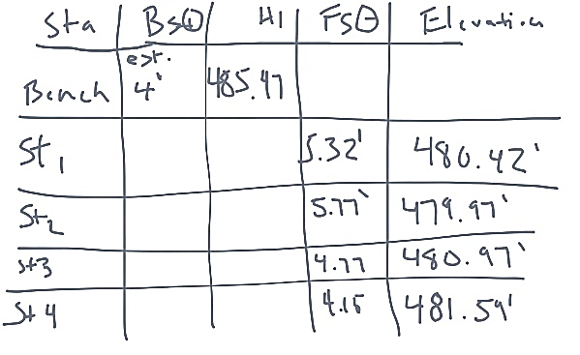
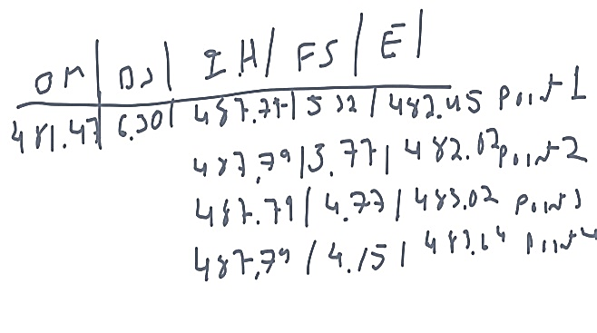
Participants were not given instruction on how to solve the problems so as not to bias them toward any particular problem-solving or visualization strategies. After the completion of the tasks, I either played back the screencast or reviewed the hard copy with the participants, asking probing questions as to why they made certain decisions and what specifically they were visualizing as they worked through the process. With this procedure, member checking was built into the methodology. These post-task interviews of the participants became the raw data used for analysis. Examples of participant output on the tasks is shown in Figures 1-6.
Figure 1 Participant output for vertical site layout task from novice N-3 and early practitioner EP-5
Figure 1. Participant output for vertical site layout task from novice N-3 (left) and early practitioner EP-5 (right).

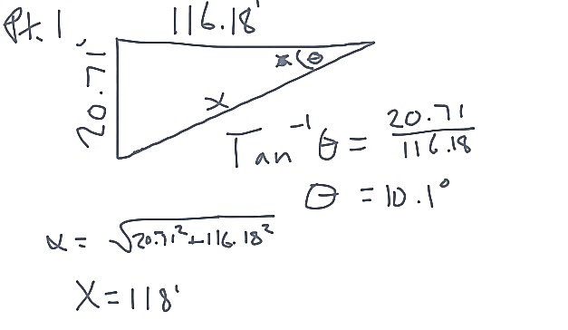
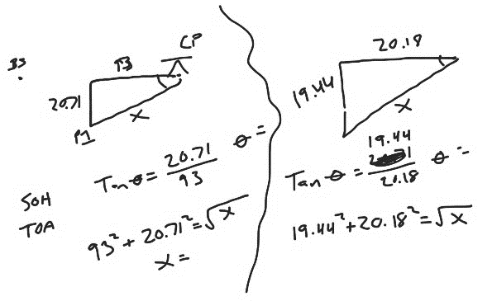
Figure 2. Participant output for horizontal site layout task from novice N-3 (left) and early practitioner EP-1 (right).
Figure 2 Participant output for horizontal site layout task from novice N-3 and early practitioner EP-1
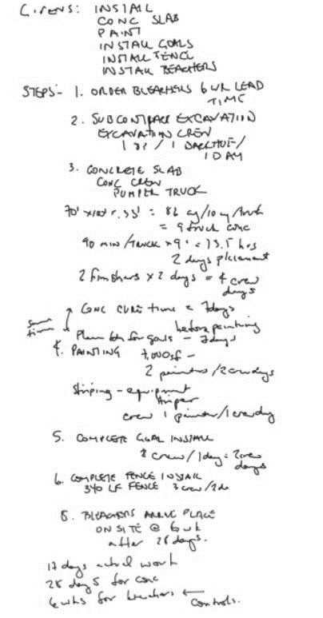

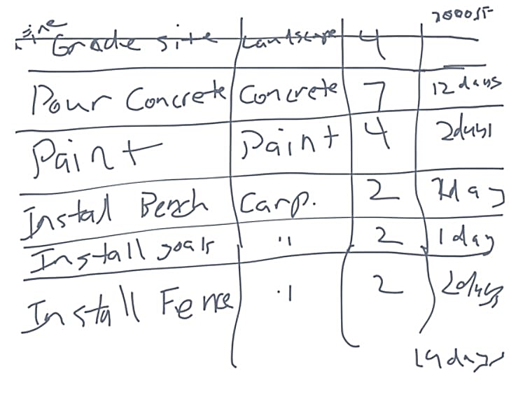
Figure 3 Participant output for simple 4-D sequencing of a basketball court task from novice N-5 and expert EXEN-2

Figure 3. Participant output for simple 4-D sequencing of a basketball court task from novice N-5 (left) and expert EXEN-2 (right).
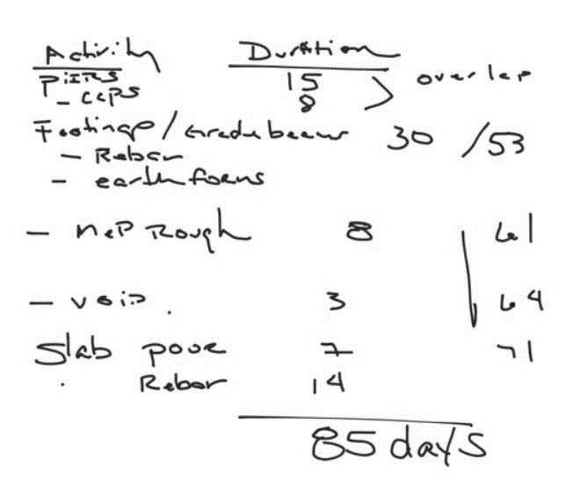
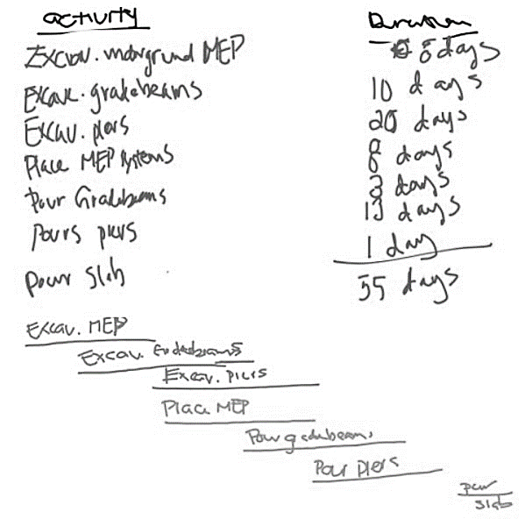
Figure 4. Participant output for complex 4-D sequencing of a building foundation task from novice N-2 (left) and expert EXEN-1 (right).
Figure 4 Participant output for complex 4-D sequencing of a building foundation task from novice N-2 and expert EXEN-1
Figure 5 Participant output for shear and moment diagram task from novice N-6 and expert EXEN-1
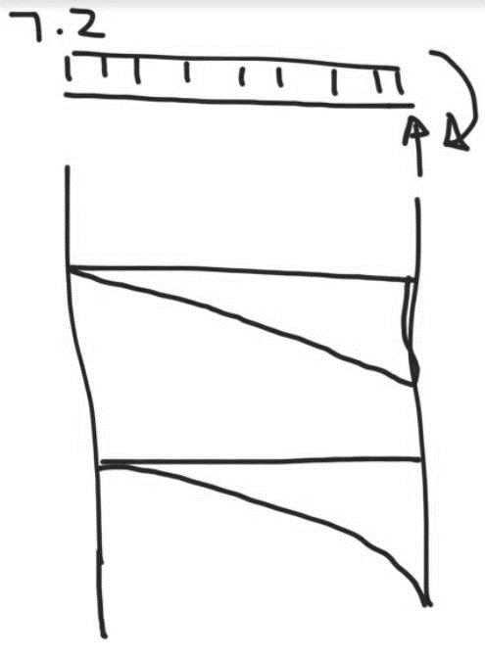
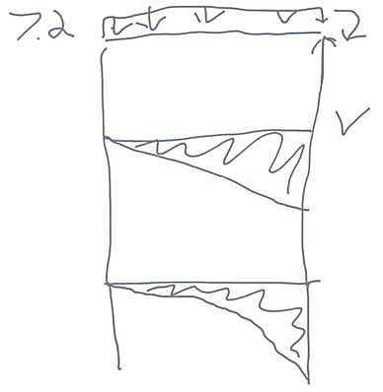

Figure 5. Participant output for shear and moment diagram task from novice N-6 (left) and expert EXEN-1 (right).

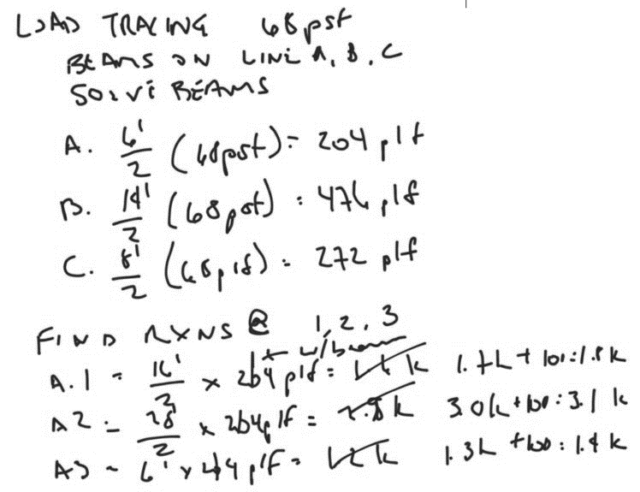
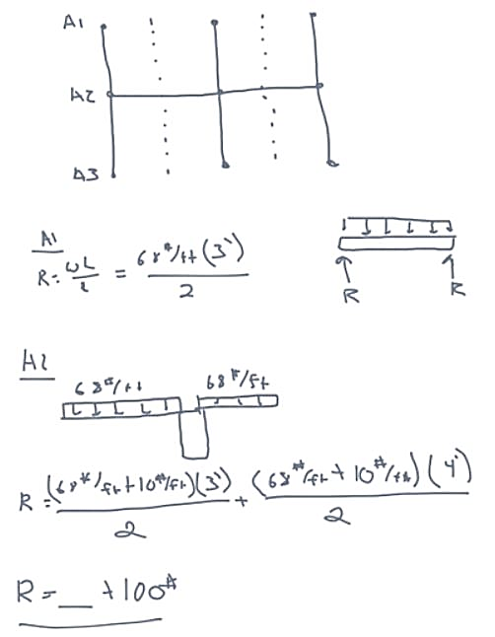
Figure 6 Participant output for load tracing task from novice N-4 and expert EXEN-2

Figure 6. Participant output for load tracing task from novice N-4 (left) and expert EXEN-2 (right).

Chapter 4: Results
The data collected for this study were distilled into discrete responses and organized first by participant, then by expertise category, by cognitive task, and lastly was organized into larger themes across categories and tasks. Presented in this chapter are the findings of the study, as directly related to each research question.

Overview of Data Analysis
The primary source of data was what the participants produced during the problem-solving sessions, namely the written solutions to problems. The primary data were further examined via interviews with the participants with the retrospective think-aloud protocol. The data that were directly analyzed were the notes and commentary from the interviews. After data were collected, the participant responses during the retrospective think-aloud protocol were organized by participant, by expertise category, and by task. Common themes were identified based on the unit of analysis, namely expertise category, task, and sub-task. Specific attention was given to themes as related to mental visual tools the participants reported using during problem-solving. The term “tool” is used here and throughout to refer to a cognitive tool. Results are reported based on one or more of these groupings. The data were organized to answer each of the five research questions. The research questions were answered in the following manner.

Research Question #1: What are the specific cognitive tasks involved in solving four different types of spatial visualization problems?
The data were analyzed for themes among the completed cognitive processes that the participants report carrying out while solving the given problems. After being reduced into themes, the data were organized into categories for each level of expertise.

Research Question #2: Is there a coherent profile for problem-solving strategies at the three levels of expertise analyzed?
Once the cognitive tasks were organized into categories for each level of expertise, the tasks within these groups (i.e., level of expertise) were compared. Using this comparison within groups, a profile was developed that depicts how individuals at various expertise levels solve spatial problems.

Research Question #3: How do the cognitive tasks differ between people who are novices, early practitioners, and experts?
Using the profiles developed in answering research question two, the groups, which are levels of expertise, were compared to one another. Similarities and differences among the problem-solving strategies used by each group are highlighted.

Research Question #4: Can we infer how solving the tasks develops from novice to expert level problem-solving by comparing these three stages of problem-solving?
To answer this question, the highlighted similarities and differences in problem-solving strategies across groups from the previous analysis were examined. Specifically, patterns were analyzed that progress across the three groups.

Research Question #5: Can the resulting information be used by an instructional game designer to develop a game?
Using the taxonomy created, the participant profiles, and the strategy progression, a list of recommendations was made for how an instructional game could be developed and whether an instructional game appears to be an effective tool for learning.

Overview of Task Completion by Participants
A summary of the participants and the mean time for each expertise category to complete each task is shown below in Table 2. The amount of time that it took each participant to complete the tasks is indicative of how deeply they processed the information and how quickly they were able to access the visual tools needed to solve the problem. For the construction management problems, four of the five followed the pattern of the novices having a shorter completion time than the early practitioners but a longer completion time than the experts. This pattern of mean time for completion is slightly different for the construction engineering tasks. Both tasks followed the pattern that the mean novice time was the shortest, followed by the mean early practitioner time, and then followed by the mean expert time. It is likely that the initial problem-solving steps follow the same pattern as the time to completion as the construction management tasks but for the engineering tasks the act of writing out a deep solution takes longer, namely in making a neat and detailed graph.
A full list of the participants and time spent on each task is included in Appendix B. Each participant is described by an identifier through the remainder of this document. Novices are identified with the prefix N, early practitioners by EP, engineering experts by EXEN, and construction experts by EXCO.

Table 2
Mean Time for Task Completion by Expertise Category
Table 2 Mean Time for Task Completion by Expertise Category
Participant Description | n | Mean Time for Task Completion (minutes)
Participant Description | n | CON 3D | CON VL | CON HL | 4D BB | 4D FOUND | ENG SM | ENG LT
Novices | 6 | 1.76 | 4.60 | 4.83 | 5.89 | 10.28 | 7.31 | 6.44
Early Practitioners | 5 | 2.12 | 3.65 | 9.13 | 7.29 | 11.39 | 9.03 | 8.12
Experts - Engineer | 5 | - | - | - | 7.53 | 13.56 | 9.80 | 9.39
Experts - Construction | 4 | 1.69 | 2.38 | 3.38 | 3.38 | 7.63 | - | -
Note: Task identifier abbreviations are as follows.
CON 3D – Construction Management: 3-D Site Contours
CON VL – Construction Management: Vertical Site Layout
CON HL – Construction Management: Horizontal Site Layout
4D BB – Construction Management: Simple 4-D Sequencing of a Basketball Court
4D FOUND – Construction Management: Complex 4-D Sequencing of a Building Foundation
ENG SM – Construction Engineering: Shear and Moment Diagrams
ENG LT – Construction Engineering: Load Tracing

After aggregating and summarizing the data, additional analyses were carried out to answer the five research questions. The data were organized based on the unit of analysis pertinent to each research question.

Research Question #1
The first goal of the study was to identify the specific cognitive tasks involved in solving the different types of spatial visualization problems. To answer this question, the data were organized under the heading of the task performed. All participant responses from the interviews, across all levels of expertise, were combined and the specific visual tools used by participants were distilled into themes. From these themes, the primary cognitive task that the participants carried out to complete the given task was described. Tables 3 – 9 below summarize the commonly observed visual tools that the participants used and the associated underlying cognitive task. The common specific visual tools are listed in order beginning with the most common at the top of the list.
Table 3
Visual Tools for Construction Management: 3-D Site Contours
Table 3 Visual Tools for Construction Management: 3-D Site Contours
Cognitive Task | Common Specific Visual Tools
- identify the mental manipulation of the image of contoured land | - static and dynamic images of looking at or being on a hill  - imagined manipulation of a model of a hill  - image of the aerial and section views overlaying and interacting

Table 4
Visual Tools for Construction Management: Vertical Site Layout
Table 4 Visual Tools for Construction Management: Vertical Site Layout
Cognitive Task | Common Specific Visual Tools
- mentally compare the relative height of two objects and use simple math to calculate the exact difference | - image of being in the field from the perspective of the person taking measurements  - very brief image of field conditions  - no visual at all

Table 5
Visual Tools for Construction Management: Horizontal Site Layout
Table 5 Visual Tools for Construction Management: Horizontal Site Layout
Cognitive Task | Common Specific Visual Tools
- use of visualization from ground and aerial perspective to determine the correct right triangle for calculations | - image of being in the field standing at the tool to take measurements  - image of triangles overlaying the site or a drawing of the site

Table 6
Visual Tools for Construction Management: Simple 4-D Planning & Sequencing of a Basketball Court
Table 6 Visual Tools for Construction Management: Simple 4-D Planning & Sequencing of a Basketball Court
Cognitive Task | Common Specific Visual Tools
- use of a dynamic image of the work as it happens to identify the discrete steps in the process to be planned | - dynamic image of doing the work oneself  - dynamic abstract and detailed images of the work unfolding

Table 7
Visual Tools for Construction Management: Complex 4-D Planning & Sequencing of a Building Foundation
Table 7 Visual Tools for Construction Management: Complex 4-D Planning & Sequencing of a Building Foundation
Cognitive Task | Common Specific Visual Tools
- use of dynamic and static images of the work from different vantage points as it happens to identify the discrete steps in the process to be planned | - series of static images of the work unfolding  - dynamic image of the work unfolding from a nearby vantage point  - dynamic image of the work unfolding around oneself
Table 8
Visual Tools for Construction Engineering: Shear and Moment Diagrams
Table 8 Visual Tools for Construction Engineering: Shear and Moment Diagrams
Cognitive Task | Common Specific Visual Tools
- identify the points vulnerable to failure by visualizing the stressed points on a loaded structural member | - complete lack of any visual tool  - abstract image of a structural member being loaded and deformed  - detailed image of a structural member being loaded and deformed

Table 9
Visual Tools for Construction Engineering: Load Tracing
Table 9 Visual Tools for Construction Engineering: Load Tracing
Cognitive Task | Common Specific Visual Tools
- use a visualization of part or all of a structure to account for where the loads on the structure are carried | - abstract image of a portion of a loaded structure  - abstract image of an entire loaded structure  - detailed image of a structural connection in reality and on construction drawings

The results for the first analysis indicate that each of the tasks has a unique cognitive task associated with it. Some of the problems involved similar cognitive tasks such as vertical and horizontal layout on a construction site. While the exact details of the cognitive tasks for these two problems were different, they are similar in that both cognitive tasks include reliance on a visualization of a field condition to set up a simpler math problem. Similarly, the two 4-D sequencing problems, while varied in complexity and in specific cognitive tasks, had nearly identical cognitive tasks. For both problems, participants reported visualizing a project come together over time that they would mentally play and pause as the steps to the plan and schedule were laid out. There was not the same convergence on the engineering tasks. On the simple engineering task of drawing shear and moment diagrams, participants worked to identify vulnerable locations on a loaded beam by imagining a beam being deformed or warped by loads. In the more complex engineering task of load tracing, participants relied on a visualized structure both at the detail and big picture levels to account for all the loads in the structure.

Research Question #2
The second goal of the study was to identify whether there is a coherent profile for problem-solving strategies at the three levels of expertise analyzed. To answer this question, the problem-solving strategies and associated visual tools were organized by expertise level. The overall problem-solving strategies tended to be the same across all tasks. The visual tools used to solve the problems did differ among expertise levels.
The novice participants used simpler mental images than the other two groups. The images they used were often abstract or static. In some instances, the novices used no visual tool at all or one that was not appropriate. For example, on the Horizontal Site Layout task, three of the novices reported visualizing themselves standing at the equipment and turning the tool to measure the angle. While this may make the scenario more realistic and may provide some of the information for the angle calculation, it does not help the participant solve for the value of the angle or to visualize and solve for the distance needed. On the sequencing tasks, novices were more likely to report the use of static images as they imagined the work for the project coming together. On the engineering tasks, if the novices used any visual tools they were abstract and only of partial structures. As a whole, the problem-solving strategy for novices can be described as simple and incomplete.
The early practitioners tended to use more robust imagery to solve the problems. There were still instances of using no visual tools however this was less common. They were more likely to use multiple images. Just like the novices, on the Horizontal Site Layout task three of the early practitioners reported visualizing themselves standing at the equipment and turning the tool to measure the angle. However, two of them used this visual only momentarily then supplemented it with an image of triangle overlaying the site so that the angle and distance to be solved for were apparent. On the sequencing tasks, the early practitioners tended to use dynamic and detailed images of the projects being built yet from a distant vantage point. On the engineering problems, there was a movement from the novices’ complete lack of visual tools to the use of abstract ones and from the novices’ use of partial images to a use of more complete and realistic images. Overall, the early practitioners’ problem-solving strategy can be described as detailed from a distance.
The experts used much richer and more detailed mental images to solve the problems but only for as long as they served their purpose. On all of the 3-D construction management tasks, the experts relied on mental images to set up a problem then abandoned the image and solved the problem strictly using math. On the 4-D sequencing construction management tasks, the experts reported visualizing themselves in the middle of the construction projects as active participants. The engineering experts relied on visuals of realistic structural members and construction drawings to solve the problems. Overall, the experts’ problem-solving strategy can be described as rich, detailed, and immersive.

Research Question #3
The third goal of the study was to identify how the cognitive tasks differ between people who are novices, early practitioners, and experts. To answer this, the visual tools as identified by the participants were combined by expertise category and the overarching theme of each category was identified. Each task had very specific visual tools associated with it and varied across expertise levels. The engineering tasks had sub-tasks that varied in complexity but the visual tools were very similar or identical across the sub-tasks. The sub-tasks were left grouped together in the data summaries. The construction management tasks also had sub-tasks that varied in complexity but the visual tools varied from task to task. For this reason, the sub-tasks are divided in the data representation and given their own description under the heading of the main task.
The results indicate the common theme that as the level of expertise increases, one of two things would happen. Either the participants would form a richer and more detailed visual of the problem scenario that they were working on or they would drop the use of the visual altogether as it was not needed. The differences in strategy were particularly salient in the construction management tasks. On the 3-D construction site conditions tasks, novices would use fairly detailed visuals, early practitioners would use more abstract visuals, and experts tended not to use visuals at all. On the 4-D planning and scheduling task, the trend moving from novices to experts was to use a more detailed and vivid image of the site conditions and experts were much more likely to report that they imagined themselves doing the work that they were planning.
The results for this research question are summarized in three tables, Tables 10, 11, and 12, below. Each table represents an expertise category and identifies the overarching theme for the visual tools used on each task by each expertise category.

Table 10 Visual Tools Used by Novices on Each Task
Table 10 | Visual Tools Used by Novices on Each Task | General Visualization Strategies Used | static images of a hill | brief image of being in field with tools | image of self standing with tools and of triangles overlaid on site plan | image of self doing the work or watching it come together from a nearby vantage point | image of work unfolding from afar with few details | no visuals used by any participants | if visual used, image of previously seen portion of a structure
Table 10 | Visual Tools Used by Novices on Each Task | Task | 3-D Site Contours | Vertical Layout with Builder's Level | Horizontal Layout with Total Station | Simple 4-D Planning & Sequencing of a Basketball Court | Complex 4-D Planning & Sequencing of a Building Foundation | Shear and Moment Diagrams | Load Tracing
Table 10 | Visual Tools Used by Novices on Each Task | Task Category | Construction Management |  |  |  |  | Construction Engineering
Table 10 | Visual Tools Used by Novices on Each Task | Expertise Category | Novice
Table 11 Visual Tools Used by Early Practitioners on Each Task
Table 11 | Visual Tools Used by Early Practitioners on Each Task | General Visualization Strategies Used | mostly dynamic images of a hill | brief image of being in field with tools | image of self standing with tools and of triangles overlaid on site plan | image of self doing the work or watching it come together from a nearby vantage point with lots of detail | image of work coming together from afar in detail | few participants used visuals, the ones used were of very abstract structural conditions | if visual used, image of an entire structure seen before
Table 11 | Visual Tools Used by Early Practitioners on Each Task | Task | 3-D Site Contours | Vertical Layout with Builder's Level | Horizontal Layout with Total Station | Simple 4-D Planning & Sequencing of a Basketball Court | Complex 4-D Planning & Sequencing of a Building Foundation | Shear and Moment Diagrams | Load Tracing
Table 11 | Visual Tools Used by Early Practitioners on Each Task | Task Category | Construction Management |  |  |  |  | Construction Engineering
Table 11 | Visual Tools Used by Early Practitioners on Each Task | Expertise Category | Early Practitioner
Table 12 Visual Tools Used by Experts on Each Task
Table 12 | Visual Tools Used by Experts on Each Task | General Visualization Strategies Used | all dynamic images of a hill | brief abstract image of field conditions or no image | image of site and site plan overlaid with triangles | imagine self immersed in the work as it unfolds with detailed visuals | imagine self immersed in the work as it unfolds with detailed visuals | image of work coming together in vague detail | image of the project from a structural inspection or structural drawing details perspective | image a literal stick being deflected or a diagram representing it | image of how a structural connection would look in reality and in construction drawings
Table 12 | Visual Tools Used by Experts on Each Task | Task | 3-D Site Contours | Vertical Layout with Builder's Level | Horizontal Layout with Total Station | Simple 4-D Planning & Sequencing of a Basketball Court | Complex 4-D Planning & Sequencing of a Building Foundation | Simple 4-D Planning & Sequencing of a Basketball Court | Complex 4-D Planning & Sequencing of a Building Foundation | Shear and Moment Diagrams | Load Tracing
Table 12 | Visual Tools Used by Experts on Each Task | Task Category | Construction Management |  |  |  |  | Construction Management |  | Construction Engineering
Table 12 | Visual Tools Used by Experts on Each Task | Expertise Category | Experts: Construction |  |  |  |  | Experts: Engineering

Research Question #4
The fourth goal of the study was to determine whether we can infer how solving the tasks develops from novice to expert level problem-solving by comparing these three stages of problem-solving. To answer this question, the profiles identified in answering the second research question were considered along with additional information that participants provided during the interviews regarding their strategies for solving the problems. Based on the group profiles, there is a clear pattern in the way that problems are solved, particularly in the way that participants use mental images as problem solving tools. It begins with novices using simple and abstract images that are often incomplete. The novice participants typically imagine a setting in which they are observing a scene related to the task from a removed perspective. As an example, on the building foundation sequencing task, novice N-2 discussed an image of animated tractors from an aerial perspective moving in rows to perform the work on the foundation. The early practitioners begin to add detail to these images and will supplement them with additional images to make a more complete visual tool. They also tend to mentally move closer to the image. A typical example of this is when early practitioner EP-4 discussed imagining watching from afar as people, equipment, and material were in action while working through the building foundation sequencing task. The experts begin with a more robust set of images that already include this supplemental information. Their imagined conditions are highly realistic and they occur from a very close perspective as if they are in the middle of the image. The way that experts tended to approach the building foundation sequencing task was typified by expert EXCO-1 as he described how he imagined being in the middle of the work as it unfolded with lots of detail of the site making up the image. The overarching pattern is a movement from simple, abstract, and distant to detailed, realistic, and immersive.
When considering the additional details that participants provided during the interviews, this pattern is further explained. There is a direct link between participants’ problem-solving strategies and their previous experience. For all participants on all tasks, what was visualized, down to the details of what they imagined and how they perceived themselves to be physically related to the visual image, was highly dependent on their previous experiences. Previous experiences influenced whether the imagined scenario was of realistic or abstract scenes, and of static or dynamic situations. Also influenced was whether participants viewed the scene from an aerial perspective, from a ground level but somewhat removed perspective, or from the perspective of one in the middle of the action. Of the 20 participants, ten of them explicitly stated (often regarding more than one task) that the visual tools they used were based on their previous experiences. The remaining ten participants gave examples of situations that were based on their own previous experiences. Additionally, the lack of participants’ previous relevant experience also showed.
The lack of previous experiences related to a given task proved to be a stumbling block. All the novices and two of the early practitioners refrained from using any mental images in solving the engineering shear and moment diagram task. Not having experienced with how beams respond to being loaded led to difficulty creating a mental image of the scenario which in turn led to difficulty solving the problem. This lack of experience also appeared in the sequencing tasks. After providing a fairly detailed solution to the basketball court sequencing task, novice participant EP-2 noted the difficulty of the next task by stating, “The durations [for the building foundation activities] were harder to figure out because I’ve never poured grade beams or drilled piers.”
The type of experience was also a contributing factor. This factor was most clearly seen on the 4-D sequencing tasks and was apparent in the both the details that participants described their mental images as having and the perspective of those images. The basketball court sequencing task is a simple construction project with fewer discrete activities involved. While none of the participants reported ever working on or observing the construction of an outdoor basketball court, many had seen or even physically done the work involved. This led to more participants across all levels of expertise reporting an image of doing the work themselves or closely watching others do the work that they were planning. The building foundation sequencing task was more complex and involved a larger scale project with discrete activities that are more detailed and more numerous. Fewer participants had observed this type of project as compared to the basketball court project and even fewer had worked directly on one. This resulted in different mental images for the two sequencing tasks. On the building foundation sequencing task, the novices all reported visualizing the work from afar and the early practitioners. The early practitioners also all reported imagining it unfold from a somewhat removed vantage point but with more detail than the novices. The engineering experts followed this same pattern on this task and in fact acted more like early practitioners on the construction sequencing activities since construction management is not their domain of expertise. The construction experts all reported using very detailed images of the people, equipment, and materials as the work unfolded. Two of the four construction experts reported that their mental images were from a very close vantage point and the other two reported that their imagined vantage point was of someone being in the middle of the work as it unfolded around them. Early practitioner participant EP-5 summarized this concept well in stating that, “If I’ve done the work before, I imagine myself doing it. If I haven’t done it them I imagine others doing it.”

Research Question #5
The fifth and final goal of the study was to determine whether the resulting information can be used by an instructional game designer to develop a game. To answer this question, results of the analyses to answer the first four research questions were considered as a whole and the types of tasks performed were considered as it relates to the instructional material that would be developed. The tasks performed by participants were chosen specifically for the important role that spatial visualization plays in solving the problems. Some participants explicitly pointed out this fact. One construction expert, participant EXCO-2, discussed the importance of visualizing things when making plans and solving problems in this context and in the greater context of construction projects. Novice participant N-4 mentioned that even the simpler tasks were “confusing if you don’t visualize them.” An early practitioner, participant EP-2, stated that, “If you told me I couldn’t visualize it, I wouldn’t be able to do it,” when discussing the sequencing tasks. Because of the role of spatial visualization in solving these problems, any instructional material related to these tasks, game-related or otherwise, would rely heavily on fostering spatial visualization skills of the learner.

Results Summary
Simply stated, the results of this study can be used to design a game and other instructional materials to foster spatial skill development. However, in order to fully explain how the results of this study could be used in instructional design and game design, some themes that were apparent in the data must first be described. These themes are further described in the following chapter as the results are interpreted.

Chapter 5: Results Interpretation
The previous chapter was a discussion of the direct results of the CTA and was specifically aimed at answering the research questions originally posed. The primary goal was to analyze the participants’ problem-solving strategies on specific tasks. This chapter differs in that it is a discussion of overarching themes that are woven through the problem-solving strategies used by participants at all expertise levels on all the tasks completed. These are the overall problem-solving strategies that directly inform how instruction may be developed. The chapter begins with a discussion of the method used for interpretation followed by descriptions of the overarching themes identified. The second half of this chapter is a discussion of recommendations for instructional tools as informed by the themes covered in the first half.

Results Interpretation Method
The interview data were initially analyzed based on overall performance of the participants. The primary element analyzed was the mean time for task completion on each task for each expertise level group. Especially noticeable on the construction management tasks was the pattern that the novices had a shorter completion time than the early practitioners but longer completion time than the experts. The reason for this pattern is likely that, when solving the construction management problems, the novices take a while to develop the image to solve the problem but the image, along with the solution, is shallow. The early practitioners also take a while to develop the image but it is a richer image as is the solution. The experts, however, are able to quickly develop a rich mental image and provide a correspondingly deep solution. This distinction between novices and experts on shallow versus deep problem-solving is consistent with what is found in the literature regarding novices and experts (Karp & Wilkins, 1989; Ericsson, 2004; Chi, 2006).
Further interpretation was carried out based on the results of the analyses. The interpretation was done with the end goal of using the results for the design of instructional material. However, there were also some larger themes that were evident when considering all of the analyses. These themes are discussed in this chapter.

Mental Images Used to Check Work
Many participants worked through a problem with little or no visual tools only to make use of them at the end. On the problems that are heavily math based, namely the vertical and horizontal layout tasks, some participants worked through them in their entirety without making use of a mental image. However, once they had written down the solution, they created an image and used it to check their work. Novice participant N-1 worked through the calculations on the vertical layout task then at the end he visualized himself looking at a grade rod to be sure that his math was right. Early practitioner participant EP-1 calculated an angle and then visualized what it would look like. Once confident that it was a reasonable solution, he proceeded to the next task. Novice participant N-6 calculated an angle and then imagined turning that angle in the field. When the image revealed that the solution did not make sense he reworked the problem.

Mental Image Used to Organize a Solution
Many participants would create a mental image and then once they were comfortable with how the scenario was set up and with the specific tactics they would use to solve the problem they would drop the image and begin solving. This was most apparent on the 3-D site contours task and the horizontal site layout task. On the former, participants would look at the given contour lines, create a visual of what the hill would look like and interact with that image, and then return to the page to determine what the cross section would look like. On the latter, participants computed the distance of a point along a line and its angle from another line. Several participants reported imagining triangles overlaid upon a site or a site plan drawing. This image was created at the outset and was used to set up the problem solution. Once the solution was set up, the image of the triangles was discarded and the participants would proceed with solving the problem.

Mental Images as a Problem-Solving Bridge
Another common strategy wherein participants used mental images temporarily was to use them as a bridge from one step to another in the problem-solving process. This strategy was apparent in the vertical site layout task and the engineering shear and moment diagram task. On the vertical layout task, participants would begin to set up the problem by identifying and writing down the relevant numbers. Then they would create a mental image that would inform them of which numbers to add to and which to subtract from the baseline number. Once the image had served its purpose and the participants knew which numbers to add and subtract, they would discard the mental image and crunch the numbers to complete the solution. Regarding this vertical layout task, novice participant N-4 described feeling comfortable with the numbers but that using a visual long enough to get the formula right was helpful. On the engineering shear and moment diagram task, the expert engineers would set up the problem solution then imagine a physical beam to help them conceptualize how the diagrams should look. Once they had this conceptualized they would continue with drawing the diagrams to provide the solution. The novice participants that did not use this visual struggled to move from solution setup to the final solution.
This practice of discarding a mental image when possible, whether the image was used to initially set up the problem or brought in as a bridge, was common. Mental images constitute a significant load on working memory. Attempting to solve a problem while carrying a mental image is cumbersome and therefore the image is discarded whenever possible once it has served its purpose.

Continuous Use of Mental Images Throughout Problem-Solving
Some tasks required that participants carry a mental image throughout the problem-solving process. This concept was most apparent in the construction sequencing tasks and the engineering load tracing task. On the sequencing tasks, participants needed to determine all the activities on a construction project, list them in a logical sequence, and assign durations to them. Such a task involved participants playing a series of activities, ranging from abstract and static for novices to realistic and dynamic for experts, and then list the activities as they are imagined occurring. This poses a heavy working memory load and as a result is a difficult task to master.
The engineering load tracing task also required the use of a continuous or near-continuous image. In this task, participants had to account for the all of the loads in the structure and therefore the image of the structure had to be present all or most of the time that the loads throughout the structure were calculated. The most common challenge reported by novices and early practitioners and identified by the experts as a potential trouble spot for learners for the load tracing task was keeping track of all the loads. Several novices and early practitioners reported that they struggled to keep track of where they were in accounting for all the loads. This is likely due to the working memory load of visually tracking the loads while simultaneously accounting for them in the solution.

Given Image Obviates Need for Mental Image
Some of the tasks descriptions included a physical still image in the given task description. For the basketball court sequencing task, the simpler of the two sequencing tasks, participants were given a small color photograph of the finished product of the basketball court for which they planned work. Additionally, the engineering load tracing task description included a simple sketch of the structure for which they identified loads. Five experts stated that the given physical image served as the visual tool they used to solve the problem rather than creating a mental image. On the basketball court sequencing task, three engineering experts and one construction expert reported that the given physical image of the court was what they referred to as their primary visual tool. The given image did not provide all the information needed to solve the problem, specifically the work that happens underneath and behind the visible elements and the order in which it the activities occur. The participants did imagine dynamic things happening as they solved the problem, such as people and equipment installing materials. However, they did not generate their own mental image to begin with. On the engineering load tracing problem, one engineering expert noted that the given sketch was the primary visual tool used. The sketch also did not provide all the information needed or even display all the structural members that carry loads to be accounted for. This expert, EXEN-1, commented that in solving the problem she interacted with the mental image by mentally loading the structure and visualize how those loads make their way to earth but she did not generate an image to begin with.
This finding further demonstrates that experts understand the value of using images, whether given physical images or created mental images, in solving problems. Whether the experts were conscious of the cognitive load resulting from creating and carrying a mental image was not clear. It was evident though, that the experts were less likely to create a mental image if it was not needed. The way novices and early practitioners approached these tasks indicates either that they are less consciously aware of the value of images in problem solving or are not as apt to use and build on a given image.

Cognitive Task Analysis as an Instructional Tool
Perhaps the most unexpected result of this study was the revelation that the cognitive task analysis (CTA) itself demonstrated potential for use as an instructional tool. None of the participants was asked about their thoughts on the CTA, it was merely used as a data collection tool and I never mentioned it outside of explaining the process at the beginning. Despite not having been asked about it, several participants commented on how they enjoyed the process or that they found it interesting. At the end, novice participant N-6 said, “This was cool. We don’t ever really stop to think about what we learn or how we think.” Novice N-5 commented that, “This was really interesting. I never really think about why I think of things.” The theme was not confined to the novices either; as early practitioner EP-1 said upon the conclusion of the CTA, “This was fun. No one really every asks us how we think. They just give us a problem and tell us whether we’re right or wrong.” The fact that they were able to think through their problem-solving process and that someone else demonstrated an interest in it was clearly valuable to many participants. This phenomenon was also apparent in experts in their area of expertise. Engineering expert EXEN-1, after discussing her process of solving the load tracing task, said, “I never think about the visual tools I use.” This demonstrated that even an individual working in her area of expertise can effectively deploy mental images without being aware of what they are doing.
This idea speaks clearly to the fact that active metacognition is commonly underutilized. Simply asking participants to discuss their problem-solving process did not necessarily lead them to verbalize them or even be aware of the tools they used. It was only through the probing questions that participants were able to verbalize their process. When reviewing the work on the basketball court sequencing task, early practitioner EP-2 said, “I wouldn’t have known that I was thinking that if you hadn’t asked me.” The value of metacognition was apparent while reviewing participants’ work. Occasionally they would identify an error that they had not noticed until reviewing the work. There were also some that identified problematic strategies with visual tools that either led to incorrect solutions or the need to rework a task in order to arrive at the correct solution. There were some participants that identified during the CTA the trouble with not using visual tools. While reviewing his work for the engineering shear and moment diagram task, novice participant N-6 commented on his struggles with the concept as a whole and said, “I should visualize what shear means but I don’t.”
This recognition of incomplete or ineffective strategies is a significant benefit of the CTA as it requires participants to go through the metacognitive process. The process of dissecting one’s own problem-solving steps is hugely beneficial and was often reported as a fun and enjoyable exercise.

Instructional Tools for Spatial Reasoning Tasks
The final research question regarding whether the CTA data can be used to design an educational game is most fully answered by building on the answers to the first four research questions and the additional themes discussed above. Simply answered, the data gathered robustly captures the discrete cognitive tasks involved in the selected spatial reasoning tasks as novices move toward expertise and therefore can be incorporated into a game to encourage learners to incorporate these tasks into their own problem-solving repertoire. However, for many of the tasks studied the design, development, and deployment of a game does not appear to be the best use of resources. The following are recommendations for the type of instruction that would best.

Construction Management: 3-D Site Contours.
The predominant visual tool used for this was the mental image of a hill that had the contours as described by the participants across all expertise levels. While the detail of the hill and how participants interacted with the mental image became more detailed as expertise increased, the fundamental problem-solving strategy was the same with only minimal increases in intricacy. For this type of task, a game is not likely to yield a high return on investment. It has been demonstrated (Zavotka, 1987) that watching a dynamic animation helps learners understand the spatial relations of the animated object. To help students learn to read, understand, and create contour maps, an animation is likely the most effective tool. An animation showing a two-dimensional contour map morph into a three-dimensional site would help learners understand how the two are linked. It would also teach the type of visual that is effective for this problem.

Construction Management: Vertical Site Layout.
The most common visual tool used for the vertical layout task was an image of oneself standing at the builder’s level tool and looking toward the grade rod. While a game that allowed users to interact with the tools on varying grades would be helpful it is not likely necessary to teach the concept. This is particularly true since most participants reported the visual being used only fleetingly to set up the problem and verify that it was being done correctly. The important element for instruction in this is that the learner knows which visual tool is appropriate. The preferred method would be to give the learner an opportunity to use the tools for vertical site layout and then explain how what they are seeing can be used to verify that their math is correct as the calculations are commonly carried out after the measurements have been taken and the tools have been put away. If the tools are not available a simple animation or series of sketches could convey the importance of using the correct visual tools to set up and solve the problem.

Construction Management: Horizontal Site Layout.
While the visual tools for the two site layout tasks were different, the instructional solution is very similar. The most common visual tools used for the horizontal layout task were the mental image of triangles overlaying a site and of standing at the total station tool to decide which way to turn it. The key to the instruction for this task is that the learner knows that, while imagining themselves standing at the tool might help with some orientation, it does not suffice as a visual tool like it does for the vertical layout task. Since the solution requires the calculation of an angle and distance, the best way to solve for these is to create a right triangle that has the desired distance as its hypotenuse and the desired angle as one of its angles. Therefore, the learner needs to create a mental image of where this triangle would be and needs to imagine the site from an aerial perspective to do so. Similar to the vertical layout task, the preferable method would be to allow learners to use the tools to measure horizontal angles and distances with a site plan for reference so they can see how the triangles fit the scenario. Absent the availability of the equipment, as in the previous task, a series of simple animations and sketches could adequately convey the importance of and proper way to use the visual tools.

Construction Management: Simple 4-D Planning & Sequencing of a Basketball Court.
Participants commonly reported imagining themselves watching the work for the project unfold from either a nearby vantage point or doing the work themselves. The way that they imagined the work was highly dependent on their own personal experiences with similar work. For a simple sequencing task such as this one, an effective instructional tool would be to simulate a project that would in turn simulate a real-world experience. Vivid images used by experts are only available to those that have experienced and spent time doing similar work but a simulated environment could help a learner move beyond the novice stage.
An educational game would be a good fit for this type of task. A game would allow for an immersive and interactive experience. A construction sequencing game could begin with projects and their associated activities with all the data about the activities, namely their durations and temporal relation to other activities preset and static. Learners could interact with the activities as they came together to form a complete project. Moving from a distant to immersed vantage point would mimic how individuals conceptualize the problem as they move to expertise.

Construction Management: Complex 4-D Planning & Sequencing of a Building Foundation.
As in the simple sequencing task, participants used mental images of work on a site unfolding. For this more complex task, there was more distinction between the three levels of expertise. Whereas the types of images were fairly similar on the simple sequencing task, the participants’ images on this task ranged from abstract and distant by novices to realistic and detailed and from an immersed perspective by experts. Additionally, in contrast to the simple sequencing project, some of the expert participants reported using images of construction drawings in conjunction with the work itself to solve the problem.
A game that builds on the construction sequencing game mentioned above (perhaps even an advanced level within the same game) would be a good fit for teaching this task. Adding to the project with predefined activities, learners could define the durations and relationships among activities to see how making changes to these impacts the overall project. Adding the element of construction drawings to the game would help learners connect how details on construction drawings impact activities as they are installed.

Construction Engineering: Shear and Moment Diagrams.
The consensus from participants is that shear and moment diagrams do not clearly demonstrate what is happening to the loaded beam being analyzed. Essentially, shear and moment diagrams on their own are not effective ways to teach the concepts of shear and moment. Multiple participants noted that the diagrams do not align with what is happening to the beam. Engineering expert EXEN-1 summarized the issue when discussing the moment diagram specifically by explaining that even though the concept of moment, the tendency of a structural member to rotate, is easier to visualize than the concept of shear, the tendency of a structural member to break in the direction of the load, the moment diagram is much harder to grasp since the diagram does not match up with what is actually happening.
While a series of animations could begin to convey the concepts, a game that allowed for interactivity would be a better instructional solution. A game that allowed learners to manipulate various loads on a beam and then see the resulting shear and moment diagrams could be very effective. The scenario could then be reversed in the game with users manipulating a pair of shear and moment diagrams to then see the resulting load condition of a beam, and if such a condition is possible. Adding gaming elements of matching load conditions with diagrams and making predictions could keep the game interesting but more importantly would convey the connection between the diagrams and the actual conditions.

Construction Engineering: Load Tracing.
It was most unclear on this task how the visual tools tied to the problem solving. Many participants reported imagining a structure either in abstract or realistic form. The experts tended to imagine a connection detail. Neither of these visuals has a clear link to how the problem is solved. This type of problem was described as a bookkeeping or accounting problem by engineering experts EXEN-2 and EXN-5, respectively. The most common challenge reported by novices and early practitioners was the difficulty in keeping track of everything. Experts identified the same thing as a common source of challenge on this type of problem.
It is probable that a mental image is not an effective tool to use for this type of problem. There is already a significant cognitive load inherent in the problem since there are many things to keep track of. The added cognitive load of carrying a mental image may be too cumbersome. For this task, animations, sketches, or even a game are not likely useful instructional tools. Since this problem calls for tracking and accounting for a series of loads, it may be that the most effective strategy is to discourage learners from trying to visualize the conditions the whole time they solve the problem. An initial mental image would be useful to provide context for the problem but should be physically sketched out at the beginning and the mental image abandoned to free up working memory. The most effective instructional tool for this task is an organized spreadsheet or other method to carry out the accounting problem.

Interpretation Summary
The results from the data analyses were presented while keeping the goal of instructional material development, specifically as it relates to educational games, in mind. The results were broken down into themes with recommendations for instruction on specific tasks described. It was found that, overall, a cognitive task analysis is a useful tool for gathering data that can then be used for instructional design. The implications of the findings of this study are discussed further in the following chapter.

Chapter 6: Conclusion
The purpose of this study was to use the results from a cognitive task analysis (CTA) to identify spatial reasoning problem-solving strategies. The end goal was to inform instruction that would enable Construction Science students to improve their spatial skills and support better problem solving in both the classroom and the field. Educational gaming was explored as a possible platform for this instruction and used as a baseline when offering suggestions for the instructional strategy that is most appropriate for each of the various spatial tasks that were investigated. The suggestions for instructional strategies were all based on the data from the CTA and laid out in such a way as to foster the problem-solving techniques and spatial skills that participants used across levels of expertise.

Effectiveness of Cognitive Task Analysis for Data Collection
The CTA was identified as an effective tool for identifying the unobservable processes and cognitive functions of individuals as they work through a problem (Ericsson & Simon, 1993; Militello & Hutton, 1998). Prior research identified that the most successful method of eliciting this procedural knowledge is through collaboration between the participant, whose knowledge is sought, and an analyst (Clark, Pugh, Yates, & Sullivan, 2008; Hoffman & Lintern, 2006). For this study, the CTA proved to be effective for identifying the cognitive processes that participants carried out while solving the problems they were given. In many cases, the CTA served to elicit details of the problem-solving process that the participants were not aware of themselves.
The suggested procedure for CTAs is to include three participants (e.g., Chao & Salvendy, 1994; Lee & Reigeluth, 2003) in the data collection process. For this study, I used more than the suggested minimum participants for each group being studied. I found that the recommendation of three participants was adequate for reaching saturation.
The retrospective think-aloud procedure was recommended and exemplified in the literature (Hunt & Joslyn, 2000), specifically the recording and immediate playback and review of the problem solution (Cooke, 1994). While reviewing their problem solutions and reflecting upon their cognitive processes, participants were able to explain their own cognitive processes in response to probing questions. This retrospective technique proved to be successful. The concerns about overloading participants’ working memory while solving a problem and discussing their cognitive processes (Ericsson & Simon, 1993) would have been a particular problem in this study. When responding to questions about visual images they used, participants would often pause to think about the depth to which they visualized some aspects. These pauses would have interrupted a fluid completion of the tasks but when done after the task was completed the participants were able to provide detailed descriptions of their cognitive processes, particularly of the mental images they used as problem-solving tools.
This led to a robust model of the processes of the participants as individuals and as groups. The data, similar to interview transcripts, were fitting to be organized thematically for analysis. The goal of a CTA should be to improve something (Schraagen, 2006) by increasing our understanding of things such as problem-solving and reasoning (Hoffman & Militello, 2009). The CTA for this study yielded results that can be used to inform instruction in the field of Construction Science, specifically in topics that require spatial reasoning to solve problems.

Appropriateness of an Educational Game
A primary impetus for this study was to investigate whether an educational game could potentially be a solution for teaching spatial skills. The results differed across the various tasks that were complete by participants. As discussed in Chapter 5, a game appeared to be a good fit for the processes in some of the tasks while other tasks involved processes better suited to other instructional tools. Instructional tools such as animations or a series of narrated sketches are most fitting for some of the task processes, not because they are better than a game but rather because they would be equally as effective and are significantly less demanding on resources to create, distribute, and use.
There was much in the literature about the effectiveness of games in providing a platform for increased engagement with learning content (Tobias & Fletcher, 2011), enabling learners to learn by doing (Dempsey et al, 1994), and fostering intrinsic motivation (Mayer, 2014). While the methods to make an effective game are commonly found in the literature (e.g., Gee, 2013; Steinkuehler & Squire, 2014; Wideman et al., 2007), the specific tasks or skills best suited for an educational game are not covered.
It is not obvious whether an educational game is a good instructional tool for various learning goals. It is up to the instructional designer to determine the best instructional practices for the desired learning outcomes, including whether a game is an appropriate tool. For the learning goals considered in this study, namely ones that require the use of spatial reasoning, the overriding determiner of whether a game is a good solution is if the task requires interactivity. Tasks such as four-dimensional planning and sequencing require mental interaction with the environment being planned for. Participants carried mental images throughout the problem-solving process so that they could interact with the image. This type of task lends itself very well to a game as it would allow for various iterations of a problem and help learners to create the correct mental image and demonstrate how to carry it and use it throughout the task.
Other tasks, however, do not require a constant mental image and learners would be equally well-served by an instructional tool that helps them set up a problem with a mental image. There are still other tasks for which learners would likely be worse off with a game. The load tracing task in this study was one such task. While the expert participants referred to a mental image to conceptualize the problem, they did not use the image to set up or solve the problem, only to orient themselves with the problem scenario. Novices and early practitioners that tried to use a mental image to solve the problem struggled to complete it.
Three categories of tasks were identified in this study when considering what type of instructional tool would be most effective. There are tasks where games are recommended, tasks where visual tools simpler than games are recommended, and tasks for which a different approach that does not encourage visualization are recommended. Before investing in instructional materials, especially games, it is critical that game and instructional designers carry out a CTA to identify where various tools are best suited. While games are good at helping learners build associations between problems and strategies to solve them (Mayer, 2014), there are other instructional tools that can be used to achieve this same goal.

The Use of Spatial Reasoning
It is abundantly clear from previous research that spatial skills can be learned and improved (e.g., Ben-Chaim et al., 1988; Lohman & Nichols, 1990; Stericker & Le Vesconte, 1982; Verdine, Golinkoff, Hirsh-Pasek, Newcombe, Filipowicz, & Chang, 2014). No longitudinal data were gathered for this study so conclusions cannot be drawn regarding how particular individuals improved their spatial skills. However, the participants that were further along in their development of expertise in their field were better at visualizing problems and using mental images to solve problems. In line with prior findings that cognitive skills are context bound (Perkins & Salomon, 1989), the literature suggests that spatial skills are domain specific and instruction on spatial skills should prepare learners for specific knowledge transfer (Adams, 2013; Jabbar & Felicia, 2015; Pilegard & Mayer, 2016; Zavotka, 1987). The transfer of knowledge was not measured in this study, but the concept of specific transfer was apparent. The participants were much better at using visual tools in their area of expertise. This was most clearly seen in the foundation sequencing task. A structural foundation was chosen intentionally because it is something that engineers are very familiar with from the design side. However, they are not accustomed to planning and sequencing the work. The engineering experts were not as good at visualizing the problem as the construction experts were and in fact behaved similarly to early practitioners. This is indicative of the engineering experts not developing a specific visualization skill used for planning and sequencing even though they perform expertly in visualization tasks.

General Recommendations for Instructional Tool Development
Instructional tools for teaching spatial skills, as with other skills, should be chosen carefully based on the underlying cognitive processes. When selecting the best instructional device for teaching spatial skills to novice learners, the key consideration is that it clearly demonstrates the importance of using a visual tool and give examples of visuals. It should offer a starting point for visuals that are appropriate for the task. In fact, the visuals should follow a scaffolding model.
The participants that had more expertise used mental images more judiciously. This manifested either as fewer images used or a more intentional use of them. Any instructional tool for spatial skills should scaffold the visuals. Scaffolding is an instructional principle in which novice learners are provided with an abundance of information and examples and support is removed as expertise increases and learners become independent and competent (Kalyuga, 2014; Lajoie, 2014; Wood, Bruner, & Ross, 1976). As suggested by the scaffolding principle, the instructional tool should provide many clear visuals in the early stages. The given visuals should become less frequent and eventually disappear altogether. As the learners advance they will then need to use images they create. This aligns with the finding that when participants were given a physical image they were less likely to create a mental image to help them solve the problem. The scaffolded images can serve to show the learners what types of visuals are useful; then as the learners gain more experiences, they will be equipped to create their own images to solve problems.
This reliance on prior experience is another common theme that must be considered when creating an instructional tool. A major finding of this study was that people rely heavily on their prior experiences to form their mental images as they solve problems. Instructional tools should either simulate experiences or indicate to learners what experiences are appropriate to use in their problem-solving. More specifically, novices tend to use mental images based heavily on how they learned the concept and sparingly use images although in an abstract form. Early practitioners tend to use visuals based partially on how they learned a concept and partially on things they have seen and done themselves. In contrast, experts rely heavily on their previous experiences to develop the mental images that they use during the problem-solving process. The complexity of the problem and their previous experience with it directly influences how they visualize the steps to solving the problem.
Just as spatial skills as a whole are influenced by experiences (Sternberg, 1994), the specific application of using visual tools to solve problems is also based on experience. In short, what novices need is more practice working in the environment where they are solving problems. Any instructional tools should be designed to foster real-world interactions with the environment or so simulate those experiences with virtual ones.

Importance of Metacognition
The finding that a CTA is a potentially effective tool was largely due to the fact that it fosters metacognition among the participants. Metacognition is the process of monitoring and reflection upon one’s own cognitive processes (Land & Greene, 2000). When the participants, particularly the novices and early practitioners, were forced to think about their own cognitive processes during the CTA, they became aware of the cognitive strategies they used and can identify weaknesses in the strategies. Land and Greene (2000) had a similar finding with a studying involving verbal protocol data. Their participants voiced their metacognition during the think-aloud procedure and that facilitated their examination of their strategies. Knowing about and using the correct cognitive strategies is important but so is having the proper domain knowledge. The relationship between the use of cognitive strategies and the possession of domain knowledge is complex and it is not entirely clear which one is more important to teach first (Land & Greene, 2000). Novices use superficial problem-solving techniques as they do not have the necessary domain knowledge for the new content area (Greene & Land, 2000). A hallmark of expertise, however, is having the domain knowledge and knowing the cognitive strategies to use. The early practitioners were characterized by having some domain knowledge and some awareness of cognitive strategies to use.
While the CTA does not provide any additional domain knowledge, it does help build awareness of the cognitive strategies that are effective. As students gain more experience, either in the classroom or outside of it, their domain knowledge will increase and instruction that helps to enhance cognitive strategies will lead to better problem-solving abilities. Better metacognitive knowledge, even without increased domain knowledge, can help novices to perform better and behave as intelligent novices (Land & Greene, 2000). Indeed, Land and Greene found that there were instances in which metacognition seemed to compensate for low-domain knowledge.
A CTA can be a very useful tool to help build up the cognitive strategies that students have available to solve problems. The CTA not only helps students identify new cognitive strategies but, more importantly, it helps them to identify errors in their own cognitive strategies. It is an easily implemented tool and an instructor or their assistant could be trained to carry out a CTA with struggling students.
This is perhaps the most significant finding of the study. In an effort to use CTA to identify steps in cognitive processes to inform instruction, a potential instructional intervention was identified. Using CTA as an instructional tool has potential benefits in how it may enhance cognitive strategies and is further appealing as it has a low demand on resources.

Limitations
The process of CTA is a proven data collection method and was carried out in this study according to recommended practices. The resulting data were robust and rich. One limitation, however, is that I was the only one performing the participant interviews. If the participants had been split between two interviewers, there would have been more assurance that the results were not biased by the interviewer.
The task difficulty level may have also presented a limitation. For this study, I wanted to compare how individuals at different expertise levels solved the same problems. In order for the focus to be on the problem-solving strategies and how they compared across participants, the tasks themselves were held constant. This necessitated selecting tasks that were not so difficult that the novices would be unable to complete them. This may have led to overly simple tasks for the experts whose problem-solving strategies may have changed on a more difficult task.
Another limitation is that participants were placed into only three categories of expertise. Individuals likely experience expertise on a continuum rather than discrete categories. I believe that the categories are meaningful and having the participants separated into three categories was useful for the analysis, however, it is possible that some participants’ expertise doesn’t fit neatly into one of the categories.
Additionally, validation of the data interpretation has not yet been completed. Although member checking occurred when participants explained their work, follow up member checking has not been done yet. The methodology has elements of triangulation, as in multiple sources of data, but further triangulation processes are currently in progress.

Recommendations for Further Research
Although there is not enough evidence in the data to report it as a finding, there was a hint that the participants’ beliefs about the value of the task impacted the problem-solving process. This perceived instrumentality, the degree to which one believes a task is useful as a means to achieving future goals, has been demonstrated to influence student motivation (Greene, Miller, Crowson, Duke, & Akey, 2004). Greene and her colleagues found that perceived instrumentality directly and indirectly influences strategy use which in turn influences achievement. An off-hand note written by one participant was the first indicator that perceived instrumentality might be a factor. Early practitioner EP-1 began the first engineering task by writing “call engineer” on the tablet. When asked about it, he stated that he believes this type of problem is important for someone else to know how to do. Another participant stated it more clearly. When novice N-6 was asked about how he conceptualizes one of the engineering problems, he stated, “I never took the time to understand it at a deep level because I don’t know how I’ll need it.” Future research can explore how perceived instrumentality may influence cognitive strategies in the domain of Construction Science.
Another thread for future research is in developing and testing the instructional tools recommended. The results can be used to design and develop a game and to design and develop the animations discussed. These instructional tools can them be tested in interventions and their efficacy compared against traditional methods.

Final Conclusion
There were two major findings from this study. The first was related to what was being investigated. The interview data were used to describe the cognitive processes used to solve spatial reasoning problems. While the processes differed across tasks and levels of expertise, a common theme was that people rely on their prior experiences to create mental images used for problem-solving. This finding is useful in informing how instruction for these tasks should be designed. The second significant finding was not something that was being looked for.
When beginning this study, I fully expected the next step would be the development of a game designed using the results. While this is still a long-term goal, the next step will be to test whether a CTA as an intervention has an instructional benefit. The principal result from this finding is the recommendation to do a cognitive task analysis as an instructional intervention

References
Adams, D. M. (2013). Exploring the effect of video game playing on static and dynamic spatial cognition skills (Doctoral dissertation). Retrieved from ProQuest LLC. (UMI 3559770).
Agosto, D. E. (2004). Girls and gaming: A summary of the research with implications for practice. Teacher Librarian, 31(3), 8-14.

Alexander, A. L., Brunye, T., Sidman, J., & Wall, S. A. (2005). From gaming to training: A review of studies on fidelity, immersion, presence, and buy-in and their effects on transfer in pc-based simulations and games. Technical report developed for DARWARS Training Impact Group. Woburn, MA: Aptima, Inc.

Anderson, J. R. (1976). Language, memory, and thought. Hillsdale, NJ: Lawrence Erlbaum Associates.

Anderson, J. R. (1983). The architecture of cognition. Cambridge, MA: Harvard University Press.

Anderson, J. R. (1985). Cognitive psychology and its implications. New York: Freeman.

Anderson, J. R. (1996). ACT: A simple theory of complex cognition. American Psychologist, 51(4), 355-365.

Annett, J. (2000). Theoretical and pragmatic influences on task analysis methods. In J. M. Schraagen, S. F. Chipman, & V. L. Shalin (Eds.), Cognitive task analysis (pp. 25-37). Mahwah, NJ: Lawrence Erlbaum Associates.

Baartmans, B. G., & Sorby, S. A. (1996). Making connections: Spatial skills and engineering drawings. The Mathematics Teacher, 89(4), 348-357.

Bailey, W. A. & Kay, D. J. (1987). Structural analysis of verbal data. In J. Carroll & P. Tanner, (Eds.), Human factors in computing systems and graphics interface (pp. 297-301). London: Academic Press.

Bartholio, C. W. (2010). The use of cognitive task analysis to investigate how many experts must be interviewed to acquire the critical information needed to perform a central venous catheter placement. (Doctoral dissertation). Retrieved from ProQuest LLC. (UMI 3434398).

Battista, M. T. (1990). Spatial visualization and gender differences in high school geometry. Journal for Research in Mathematics Education, 21(1), 47–60. DOI:10.2307/749456.

Burguillo, J. C. (2010). Using game theory and competition-based learning to stimulate student motivation and performance. Computers & Education, 55, 566-575. DOI:10.1016/j.compedu.2010.02.018

Ben-Chaim, D., Lappan, G., & Hougang, R. T. (1988). The effect of instruction on spatial visualization skills of middle school boys and girls. American Educational Research Journal 25, 51–71. http://www.jstor.org/stable/1163159

Bennett, G. K. & Cruikshank, R. M. (1942). A summary of manual and mechanical ability tests. New York: The Psychological Corporation.

Bennett, G. K., Seashore, H. G, & Wesman, A. G. (1952). Differential aptitude tests: Manual (2nd ed.). New York: The Psychological Corporation.

Carroll, J. B. (1993). Human cognitive abilities: A survey of factor-analytic studies. Cambridge: Cambridge University Press.

Casey, M. B., Nuttall, R., & Pezaris, E. (1997). Mediators of gender differences in mathematics college entrance test scores: A comparison of spatial skills with internalized beliefs and anxieties. Developmental Psychology, 33(4), 669-680. DOI: 10.1037/0012-1649.33.4.669

Chao, C. J., & Salvendy, G. (1994). Percentage of procedural knowledge acquired as a function of the number of experts from whom knowledge is acquired for diagnosis, debugging, and interpretation tasks. International Journal of Human-Computer Interaction, 6(3), 221-233.

Charness, N. (1981). Search in chess: Age and skill differences. Journal of Experimental Psychology: Human Perception and Performance, 7(2), 467-476. DOI: 10.1037/0096-1523.7.2.467

Charsky, D. (2010). From edutainment to serious games: A change in the use of game characteristics. Games and Culture, 5(2), 177-198.

Chen, K., Huang, P., Huand, C., & Lei, C. (2005). Game traffic analysis: An MMORPG perspective. Proceedings of the International Workshop on Network and operating systems support for digital audio and video, 19-24.

Chi, M. T. H. (2006). Laboratory methods for assessing experts’ and novices’ knowledge. In K.A. Ericsson, N. Charness, P. Feltovich, & R. R. Hoffman (Eds.), The Cambridge handbook of expertise and expert performance (pp. 167-184). New York: Cambridge University Press.

Chipman, S. F., Schraagen, J. M., & Shalin, V. L. (2000). Introduction to cognitive task analysis. In J. M. Schraagen, S. F. Chipman, & V. L. Shalin (Eds.), Cognitive task analysis (pp. 3-23). Mahwah, NJ: Lawrence Erlbaum Associates.

Chiu, Y., Kao, C., & Reynolds, B. L. (2012). The relative effectiveness of digital game-based learning types in English as a foreign language setting: A meta-analysis. British Journal of Educational Technology, 43(4), E104-E107.

Clark, R. E. (2014). Cognitive task analysis for expert-based instruction in healthcare. In J. Spector, M. D. Merrill, J. Elen, & M. J. Bishop (Eds.). Handbook of research on educational communications and technology, 4th edition (pp. 541-551). New York: Springer. DOI: 10.1007/978-1-4614-3185-5_42

Clark, R. E., & Estes, F. (1996). Cognitive task analysis. International Journal of Educational Research, 25(5), 403-417.

Clark, R. E., Feldon, D. F., van Merriënboer, J. J., Yates, K. A., & Early, S. (2008). Cognitive task analysis. In J. Spector, M. Merrill, J. van Merriënboer, & M. Driscoll (Eds.), Handbook of research on educational communications and technologies, 3rd ed., (pp. 577-593). New York: Lawrence Erlbaum.

Clark, R. E., Pugh, C. M., Yates, K. A., Inaba, K., Green, D. J., & Sullivan, M. E. (2012). The use of cognitive task analysis to improve instructional descriptions of procedures. Journal of Surgical Research, 173, e37-342. DOI: 10.1016/j.jss.2011.09.003

Clark, R. E., Pugh, C. M., Yates, K. A., & Sullivan, M. (June 2008). The use of cognitive task analysis and simulators for after action review of medical events in Iraq. Technical Report 5-21-2008 developed for the Center for Cognitive Technology, University of Southern California, Los Angeles, CA.

Coalson, D. L., Raiford, S. E., Saklofske, D. H., & Weiss, L. G. (2010). WAIS-IV: Advances in the assessment of intelligence. In L. G. Weiss, D. H. Saklofske, D. L. Coalson, & S. E. Raiford, (Eds.), WAIS-IV Clinical Use and Interpretation: Scientific Practitioner Perspectives (pp. 3-23). London: Academic Press.

Conole, G., De Laat, M., Dillon, T., & Darby, J. (2008). ‘Disruptive technologies’, ‘pedagogical innovation’: What’s new? Findings from an in-depth study of students’ use and perception of technology. Computers & Education, 50(2), 511-524.

Cooke, N. J. (1994). Varieties of knowledge elicitation techniques. International Journal of Human-Computer Studies, 41, 801-849.

Crandall, B., Klein, G., & Hoffman, R. R. (2006). Working minds: A practitioner’s guide to cognitive task analysis. Cambridge, MA: The MIT Press.

Csikszentmihalyi, M., & Nakamura, J. (1989). The dynamics of intrinsic motivation: A study of adolescents. In C. Ames & R. Ames (Eds.), Research on motivation in education: Goals and cognitions, volume 3 (pp. 45-71). New York: Academic Press.
Dalgarno, B., & Harper, B. (2004). User control and task authenticity for spatial learning environments. Australasian Journal of Educational Technology, 20(1), 1-17.
Davies, R. S., Dean, D. L., & Ball, N. (2013). Flipping the classroom and instructional technology integration in a college-level information systems spreadsheet course. Educational Technology Research Development, 61(4), 563-580.
Dempsey, J. V., Rasmussen, K., & Lucassen, B. (1994). Instructional gaming: Implications for instructional technology. Proceedings from Annual Meeting of the Association for Educational Communications, Nashville, TN.
de Groot, A. D. (1978). Thought and choice in chess. The Hague, The Netherlands: Mouton Publishers.
Dormann, C., Whitson, J. R., & Neuvians, M. (2013). Once more with feeling: Game design patterns for learning in the affective domain. Games and Culture, 8(4), 1-23. DOI: 10.1177/1555412013496892

Dreyfus, H. L., & Dreyfus, S. E. (1986). Mind over machine. New York: The Free Press.

Eliot, J., & Fralley, J. S. (1976). Sex differences in spatial abilities. Young Children, 31(6), 487-498.

Eliot, J., & Smith, I. M. (1983). An international directory of spatial tests. Windsor, Berkshire: NFER-Nelson.

Ericsson, K. A. (2004). Deliberate practice and the acquisition and maintenance of expert performance in medicine and related domains. Academic Medicine, 79(10), S70-S81.

Ericsson, K. A. (2006a). Protocol analysis and expert thought: Concurrent verbalizations of thinking during experts' performance on representative tasks. In K.A. Ericsson, N. Charness, P. J. Feltovich, & R. R. Hoffman (Eds.), The Cambridge handbook of expertise and expert performance (pp. 223-241). New York: Cambridge University Press.

Ericsson, K. A. (2006b). The influence of experience and deliberate practice on the development of superior expert performance. In K.A. Ericsson, N. Charness, P. Feltovich, & R. R. Hoffman (Eds.), The Cambridge handbook of expertise and expert performance (pp. 685-706). New York: Cambridge University Press.

Ericsson, K. A. & Simon, H. (1993). Protocol analysis: Verbal reports as data (revised edition). Cambridge, MA: MIT Press.

Flynn, C. L. (2012). The relative efficiency of two strategies for conducting cognitive task (Doctoral dissertation). Retrieved from ProQuest LLC. (UMI 3561771).

Gallagher, J. P. (1979). Cognitive/information processing psychology and instruction: Reviewing recent theory and practice. Instructional Science, 8, 393-414. http://www.jstor.org/stable/23368243
Games, A., & Squire, K. (2011). Searching for the fun in learning: A historical perspective on the evolution of educational video games. In S. Tobias & J. D. Fletcher (Eds.), Computer games and instruction (pp. 17-46). Charlotte, NC: Information Age Publishing.
Garaizar, P., Peña, O., & Romero, J. A. (2013). Swiping fingers on a screen is not enough! Dusting off toy blocks to build new gaming experiences through mobile apps. Proceedings from IEEE Global Engineering Education Conference, Berlin, Germany.
Gardner, H. E. (1983). Frames of mind. New York: Basic Books.

Gee, J. P. (2003). What video games have to teach us about learning and literacy. Computers in Entertainment, 1(1), 1-4. DOI: 10.1145/950566.950595

Gee, J. P. (2013). Games for learning. Educational Horizons, 91(4), 16-20. DOI: 10.1177/0013175X1309100406

Gikas, J., & Grant, M. M. (2013). Mobile devices in higher education: Student perspectives on learning with cellphones, smartphones, & social media. Internet and Higher Education, 19, 18-26.

Gilbert, J. (2005). Visualization: A metacognitive skill in science and science education. In J. Gilbert (Ed.), Visualization in science education (pp. 9-27). Dordrecht, The Netherlands: Springer.

Gorriz, C. M., & Medina, C. (2000). Engaging girls with computers through software games. Communications of the ACM, 43(1), 42-49.

Gredler, M. (1996). Educational games and simulations: A technology in search of a (research) paradigm. In D. Jonassen (Ed.), Handbook of Research for Educational Communications and Technology, (pp. 521–540). Bloomington, IN: Association for Educational Communications and Technology.

Gredler, M. (2004). Games and simulations and their relationships to learning. In D. Jonassen (Ed.), Handbook of Research on Educational Communications and Technology, 2nd ed., (pp. 571-581). Mahwah, NJ: Lawrence Erlbaum.

Greene, B. A., & Land, S. M. (2000). A qualitative analysis of scaffolding use in a resource-based learning environment involving the world wide web. Journal of Computing Research, 23(2), 151-179.

Greene, B. A., Miller, R. B., Crowson, H. M., Duke, B. L., & Akey, K. L. (2004). Predicting high school students’ cognitive engagement and achievement: Contributions of classroom perceptions and motivation. Contemporary Educational Psychology, 29(4), 462-482. DOI: https://doi.org/10.1016/j.cedpsych.2004.01.006

Halpern, D. F. (2000). Sex differences in cognitive abilities, 3rd ed. Hillsdale, NJ: Erlbaum Associates.

Hays, R. T., & Singer, M. J. (1989). Simulation fidelity in training system design: Bridging the gap between reality and training. New York: Springer-Verlag.

Hoffman, B. & Nadelson, L. (2010). Motivational engagement and video gaming: A mixed methods study. Educational Technology Research & Development, 58, 245-270. DOI: 10.1007/s11423-009-9134-9

Hoffman, R. R. (1998). Use of the critical decision method to elicit knowledge: A case study in the methodology of cognitive task analysis. Human Factors, 40(2), 254-276.

Hoffman, R. R., & Lintern, G. (2006). Eliciting and representing the knowledge of experts. In K.A. Ericsson, N. Charness, P. J. Feltovich, & R. R. Hoffman (Eds.), The Cambridge handbook of expertise and expert performance (pp. 203-222). New York: Cambridge University Press.

Hoffman, R. R., Shadbolt, N., Burton, A. M., & Klein, G. A. (1995). Eliciting knowledge from experts: A methodological analysis. Organizational Behavior and Human Decision Processes, 62, 129-158.

Hoffman, R. R. & Militello, L. G. (2009). Perspectives on cognitive task analysis. Mahwah, NJ: Erlbaum.

Hoffman, R. R., & Woods, D. D. (2000). Studying cognitive systems in context: Preface to the special section. Human Factors, 42(1), 1-7.

Hogle, J. G. (1996). Considering games as cognitive tools: In search of effective "edutainment." (ERIC No. ED425737). Retrieved from http://files.eric.ed.gov/fulltext/ED425737.pdf

Hsi, S., Linn, M. C. & Bell, J. E. (1997). The role of spatial reasoning in engineering and the design of spatial instruction. Journal of Engineering Education, 86(2), 151–158. DOI:10.1002/j.2168-9830.1997.tb00278.x

Huang, W. H., Huang, W. Y., & Tschopp, J. (2010). Sustaining iterative game playing processes in DGBL: The relationship between motivational processing and outcome processing. Computers & Education, 55, 789-797.

Huizinga, J. (1970). Homo ludens: A study of the play-element in culture. New York: Harper.

Hunt, E. & Joslyn, S. (2000). A functional task analysis of time-pressured decision making. In J. M. Schraagen, S. F. Chipman, & V. L. Shalin (Eds.), Cognitive task analysis (pp. 119-132). Mahwah, NJ: Lawrence Erlbaum Associates.

Ifenthaler, D., Eseryel, D. & Ge, X. (2012). Assessment for game-based learning. In D. Ifenthaler, D. Eseryel, & X. Ge (Eds.), Assessment in game-based learning: Foundations, innovations, and perspectives (pp. 1-8). New York: Springer.

Inkpen, K., Upitis, R., Klawe, M., Lawry, J., Anderson, A., Ndunda, M., Sedoghian, K., Leroux, S., & Hsu, D. (1994). "We have never-forgetful flowers in our garden": Girls' responses to electronic games. Journal of Computers in Mathematics and Science Teaching, 13, 383-383.

Jabbar, A. I. A., & Felicia, P. (2015). Gameplay engagement and learning in game-based learning: A systematic review. Review of Educational Research, 85(4), 740-779. DOI: 10.3102/0034654315577210

Jones, S. (2002). The internet goes to college. Washington, D.C.: Pew Internet & American Life Project.

Kalyuga, S. (2014). The expertise reversal principle in multimedia learning. In R. E. Mayer (Ed.), The Cambridge handbook of multimedia learning (2nd ed.) (pp. 576-597). New York: Cambridge University Press.

Kapp, K. M. (2012). The gamification of learning and instruction: Game-based methods and strategies for training and education. San Francisco, CA: Pfeiffer.

Karp, P. D., & Wilkins, D. C. (1989). An analysis of the distinction between deep and shallow expert systems. International Journal of Expert Systems, 2(1), 1-32.
Kell, H. J., Lubinski, D., Benbow, C. P., & Steiger, J. H. (2013). Creativity and technical innovation: Spatial ability’s unique role. Psychological Science, 24(9), 1831-1836. DOI: 10.1177/0956797613478615
Knapp, R. R., Knapp, L, & Michael, W. B. (1977). Stability and concurrent validity of the career ability placement survey (CAPS) against the DAT and GATB. Educational and Psychological Measurement, 37(4), 1081-1085.
Lajoie, S. P. (2014). Multimedia learning of cognitive processes. In R. E. Mayer (Ed.), The Cambridge handbook of multimedia learning (2nd ed.) (pp. 623-646). New York: Cambridge University Press.
Land, S. M., & Greene, B. A. (2000). Project-based learning with the world wide web: A qualitative study of resource integration. Educational Technology Research and Development, 48(1), 45-68.

Lee, J. Y., & Reigeluth, C. M. (2003). Formative research on the heuristic task analysis process. Educational Technology Research and Development, 51(4), 5-24.

Lesgold, A. M. (2000). On the future of cognitive task analysis. Introduction to cognitive task analysis. In J. M. Schraagen, S. F. Chipman, & V. L. Shalin (Eds.), Cognitive task analysis (pp. 451-465). Mahwah, NJ: Lawrence Erlbaum Associates.

Lesgold, A. M., Rubinson, H., Feltovich, P., Klopfer, D., & Wang, Y. (1988). Expertise in a complex skill: Diagnosing x-ray pictures. In M. T. H. Chi, R. Glaser, & M. J. Farr (Eds.), The nature of expertise (pp. 311-342). Hillsdale, NJ: Lawrence Erlbaum Associates.

Lichtenberger, E. O., & Kaufman, A. S. (2009). Essentials of WAIS-IV assessment, 2nd edition. New York: Wiley.

Linn, M. C., & A. C. Petersen. (1985). Emergence of characterization of sex differences in spatial ability: A meta-analysis. Child Development, 56(6):1479–1498.

Lohman, D. F. (1979). Spatial ability: A review and reanalysis of the correlational literature. Stanford, CA: Aptitude research Project, School of Education, Stanford University Technical Report No. 9.

Lohman, D. F., & Nichols, P. D. (1990). Training spatial abilities: Effects of practice on rotation and synthesis tasks. Learning and Individual Differences, 2, 69-95.

Lord, T. R. (1985). Enhancing the visuo-spatial aptitude of students. Journal of Research in Science Teaching, 22(5), 395-405.
Malone, T.W. 1980. What makes things fun to learn? A study of intrinsically motivating computer games. (Report CIS-7). Palo Alto, CA: Xerox Palo Alto Research Center.
Martín-Dorta, N., Saorín, S. J., & Contero, M. (2008). Development of a fast remedial course to improve the spatial abilities of engineering students. Journal of Engineering Education, 97(4), 505-513. DOI: 10.2190/EC.42.3.a
Mayer, R. E. (2014). Computer games for learning: An evidence-based approach. Cambridge, MA: The MIT Press. DOI: 10.1080/02667363.2015.1027042
Mayer, R. E. & Johnson, C. I. (2010). Adding instructional features that promote learning in a game-like environment. Journal of Educational Computing Research, 42(3), 214-265.
McCuen, T. (2015). Investigating the predictors of spatial skills essential for construction science student success in the digital age. (Unpublished doctoral dissertation). University of Oklahoma, Norman, OK.
McKeachie, W. J. (1984). Spatial strategies: Critique and educational implications. In C. D. Holley & D. F. Dansereau (Eds.), Spatial learning strategies: Techniques, Applications, and related issues (pp. 301-312). Orlando: Academic Press.
Militello, L. G. & Hutton, R. J. B. (1998). Applied cognitive task analysis (ACTA): A practitioner's toolkit for understanding cognitive task demands, Ergonomics, 41(11), 1618-1641. DOI: 10.1080/001401398186108

Miller, R. B., DeBacker, T. K., & Greene, B. A. (1999). Perceived instrumentality and academics: The link to task valuing. Journal of Instructional Psychology, 26(4), 250-260.

Murray, M. C., & Perez, J. (2014). Unraveling the digital literacy paradox: How higher education fails at the fourth literacy. Issues in Informing Science and Information Technology, 11, 85-100.

National Research Council. (2006). Learning to think spatially: GIS as a support system in the K–12 curriculum. Washington, DC: National Academic Press.

Nathanson, J. A., Lanzafama, M., & Kissam, P. (2010). Surveying fundamentals and practices (6th ed.). Upper Saddle River, NJ: Prentice Hall.

Newitt, J. S. (2009). Construction scheduling: Principles and practices (2nd ed.). Upper Saddle River, NJ: Prentice Hall.

Oblinger, D. G., & Oblinger, J. L. (2005). Is it age or IT: First steps toward understanding the net generation. In D. G. Oblinger & J. L. Oblinger (Eds.), Educating the net generation (pp. 2.1-2.20). Louisville, CO: EDUCAUSE.

Ontario Ministry of Education. (2014). Paying attention to spatial reasoning. Ontario: Queen's Printer for Ontario.

Onouye, B., & Kane, K. (2012). Statics and strengths of materials for architecture and building construction, 4th edition. Boston: Prentice Hall.

Parasuraman, A. (2000). Technology readiness index (TRI): A multiple-item scale to measure readiness to embrace new technologies. Journal of service research, 2(4), 307-320. DOI: 10.1177/109467050024001

Peterson, C. A., Mauriello, S. M., & Caplan, D. J. (2000). The use of gaming in a dental hygiene review course. Journal of Dental Education, 64(4), 294-297.

Perkins, D. N., & Salomon, G. (1988). Teaching for transfer. Educational Leadership, 46(1), 22-32.

Perkins, D. N., & Salomon, G. (1989). Are cognitive skills context-bound? Educational Researcher, 18(1), 16-25.

Piaget, J., & Inhelder, B. (1956). The child’s conception of space. New York: The Humanities Press.

Pilegard, C., & Mayer, R. E. (2016). Improving academic learning from computer-based narrative games. Contemporary Educational Psychology, 44-45, 12-20. DOI: http://dx.doi.org/10.1016/j.cedpsych.2015.12.002

Reyes, M., Ghosh, S., Perrenoud, A., & Goldman, J. (2015). Teaching plan reading to construction students: The effect of using tablet computers. Associated Schools of Construction 2015 conference proceedings.

Roid, G. H., & Barrman, R. A. (2004). Essentials of Stanford-Binet intelligence scales (SB5) assessment. New York: Wiley.

Ryan, R. M., & Deci, E. L. (2000). Self-determination theory and the facilitation of intrinsic motivation, social development, and well-being. American Psychologist, 55(1), 68-78. DOI: 10.1037/0003-066X.55.1.68

Salen, K. & Zimmerman, E. (2004). Rules of play. Cambridge, MA: The MIT Press.

Scalise, K. & Wilson, M. (2012). Measurement principles for gaming. In D. Ifenthaler, D. Eseryel, & X. Ge (Eds.), Assessment in game-based learning: Foundations, innovations, and perspectives (pp. 287-305). New York: Springer.

Schaff, R. (2012). Does digital game-based learning improve student time-on-task behavior and engagement in comparison to alternative instructional strategies? Canadian Journal of Action Research, 13(1), 50-64.

Schell, J. (2015). The art of game design: A book of lenses, 2nd ed. Pittsburgh, PA: CRC Press.

Schraagen, J. M. (2006). Task analysis. In K.A. Ericsson, N. Charness, P. J. Feltovich, & R. R. Hoffman (Eds.), The Cambridge handbook of expertise and expert performance (pp. 185-201). New York: Cambridge University Press.

Simon. H. A., & Chase, W. G. (1973). Skill in chess: Experiments with chess-playing tasks and computer simulation of skilled performance throw light on some human perceptual and memory processes. American Scientist, 61(4), 394–403.

Sims, V. K., & Mayer, R. E. (2002). Domain specificity of spatial expertise: The case of video game players. Applied Cognitive Psychology, 16(1), 97–115. DOI: 10.1002/acp.759
Smith, J. (1979). Gaming and attitudinal change. Insights into Experiential Pedagogy, 6, 231-234.
Sorby, S. (2006). Developing 3-D spatial skills for K-12 students. Engineering Design Graphics Journal, 70(3), 1-11.
Sorby, S. (2009). Educational research in developing 3-D spatial skills for engineering students. International Journal of Science Education, 31(3), 459-480. DOI: 10.1080/09500690802595839
Sorby, S. A., Nevin, E., Behan, A., Mageean, E., & Sheridan, S. (2014). Spatial skills as predictors of success in first-year engineering. Paper presented at the 44th ASEE/IEEE Frontiers in Education Conference, Madrid, Spain.
Sprandel, H. (1985). The psychoeducational use and interpretation of the Wechsler adult intelligence scale-revised. Springfield, IL: Charles C. Thomas.
Squire, K. (2007). Games, learning, and society: Building a field. Educational Technology, 47(5), 51-54.

Squire, K. (2017). Innovation in times of uncertainty. On the Horizon, 25(4), 293-308.

Steinkuehler, C., & Squire, K. (2014). Videogames and learning. In R. K. Sawyer (Ed.) The Cambridge Handbook of the Learning Sciences, 2nd ed. (pp. 377-395). New York: Cambridge University Press.

Stericker, A. & Le Vesconte, S. (1982). Effect of brief training on sex-related differences in visual-spatial skill. Journal of Personality and Social Psychology, 43(5), 1018-1029.

Sternberg, R. J. (Ed.), (1994). Encyclopedia of human intelligence: Volumes 1–2. New York: Macmillan.

Suits, B. (1978). The grasshopper: Games, life, and utopia. Toronto, Canada: University of Toronto Press.

Sullivan, M. E., Ortega, A., Wasserberg, N., Kaufman, H., Nyquist, J., & Clark, R. (2008). Assessing the teaching of procedural skills: Can cognitive task analysis add to our traditional methods? The American Journal of Surgery, 195(1), 20-23.
Thorndyke P.W., & Goldin S.E. (1983) Spatial Learning and Reasoning Skill. In: Pick H.L., Acredolo L.P. (eds) Spatial orientation (pp. 195-217). Springer, Boston, MA. DOI: 10.1007/978-1-4615-9325-6_9

Tobias, S., & Fletcher, J. D. (2007). what research has to say about designing computer games for learning. Educational Technology, 47(5), 20-29.

Tobias, S. & Fletcher, J. (2011). Review of research on computer games. In S. Tobias & J. D. Fletcher (Eds.), Computer games and instruction (pp. 127-215). Charlotte, NC: Information Age Publishing.

Toups, Z. O., Kerne, A., Hamilton, W. A., & Shazad, N. (2011). Zero-fidelity simulation of fire emergency response: Improving team coordination learning. Proceedings of the SIGCHI conference on human factors in computing systems. Vancouver, BC, Canada, 1959-1968.

Uttal, D. H., Meadow, N. G., Tipton, E., Hand, L. L., Alden, A. R., Warren, C., & Newcombe, N. S. (2013). The malleability of spatial skills: A meta-analysis of training studies. Psychological Bulletin, 139(2), 352. DOI: 10.1037/a0028446

van Someren, M. W., Barnard, Y. F., & Sandberg, J. A. C. (1994). The think aloud method: A practical guide to modelling cognitive processes. London: Academic Press.

Van Den Haak, M. J., De Jong, M. D. T., Schellens, P. J. (2003). Retrospective vs. concurrent think-aloud protocols: Testing the usability of an online library catalogue. Behaviour & Information Technology, 22(5), 339-351. DOI: 10.1080/0044929031000

Verdine, B., Golinkoff, R., Hirsh-Pasek, K., Newcombe, N., Filipowicz, A., & Chang, A. (2014). Deconstructing building blocks: Preschoolers’ spatial assembly performance relates to early mathematical skills. Child Development, 85(3), 1062-1076. DOI: 10.1111/cdev.12165

Voyer, D., Voyer, S., & Bryden, M. P. (1995). Magnitude of sex differences in spatial abilities: A meta-analysis and consideration of critical variables. Psychological Bulletin, 117(2), 250–270. DOI: 10.1037/0033-2909.117.2.250

Wai, J., Lubinski, D., & Benbow, C. P. (2009). Spatial ability for STEM domains: Aligning over 50 years of cumulative psychological knowledge solidifies its importance. Journal of Educational Psychology, 101(4), 817-835. DOI: 10.1037/a0016127

Wamba, N., Murphy, M., Murray, K., Castellano, J., Jeanty, Y., Macoon, B., Pedicini, M. & Wilson, P. (2007). Learning by doing: An action research-based pedagogy. Ontario Action Researcher, 10(1), 1-8.
Wechsler, D. (1955). Wechsler adult intelligence scale. New York: Psychological Corporation.

Wei, J. and G. Salvendy (2004). The cognitive task analysis methods from job and task design: Review and reappraisal. Behaviour & Information Technology, 23(4), 273-299.

Wideman, H. H., Owston, R. D., Brown, C., Kushniruk, A., Ho, F., & Pitts, K. C. (2007). Unpacking the potential of educational gaming: A new tool for gaming research. Simulation & Gaming, 38(1), 10-30. DOI: 10.1177/1046878106297650

Whitehead, A. N. (1911). An introduction to mathematics. London: Williams and Nortgate.
Wood, D., Bruner, J. S., & Ross, G. (1976). The role of tutoring in problem solving. Journal of Child Psychology and Psychiatry, 17, 89-100.
Zachary, W. W., Ryder, J. M., & Hicinbothom, J. H. (2000). Building cognitive task analyses and models of a decision-making team in a complex real-time environment. In J. M. Schraagen, S. F. Chipman, & V. L. Shalin (Eds.), Cognitive task analysis (pp. 365-383). Mahwah, NJ: Lawrence Erlbaum Associates.
Zavotka, S. (1987). Three-dimensional computer animated graphics: A tool for spatial skill instruction. Educational Communication and Technology, 35(3), 133-144. DOI: 10.1007/BF02793841
Zimmerman, B. J. (2002). Becoming a self-regulated learner: An overview. Theory into Practice, 41(2), 64-70.

Appendix A: Task Descriptions
Task 1: Construction Management: 3-D Site Contours
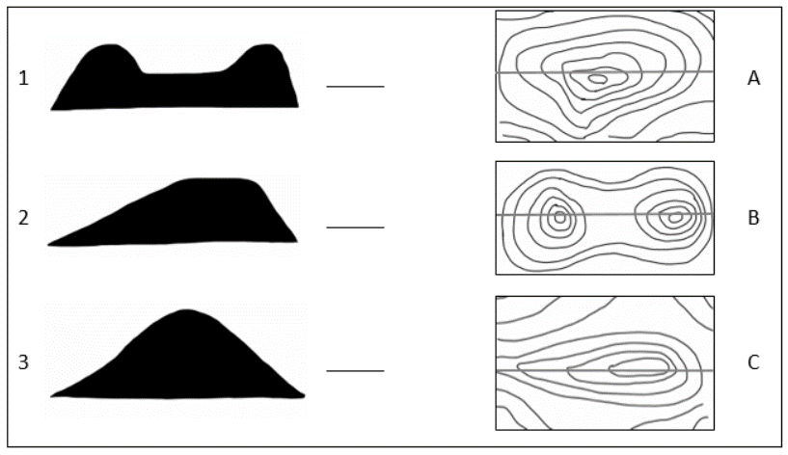
As a warm-up task, look at the two groups of site contours and their section views. Treating each group separately, match the contours with the correct sections. The red line indicates where the section view cut is. You can do this part on this paper by just filling in the blank next to the plan view.

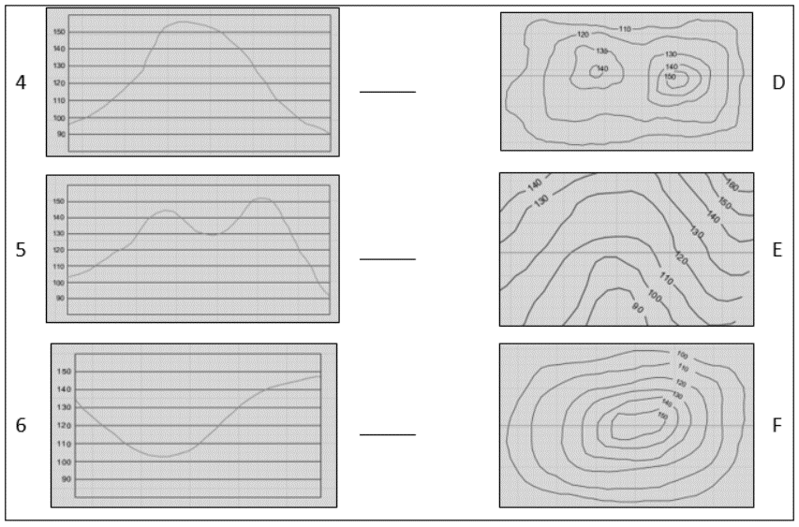

For this next part of the task, look at each contour map below. For each one individually, draw the section view of the site through at the location indicated by the red line. Show your work for this on the iPad.
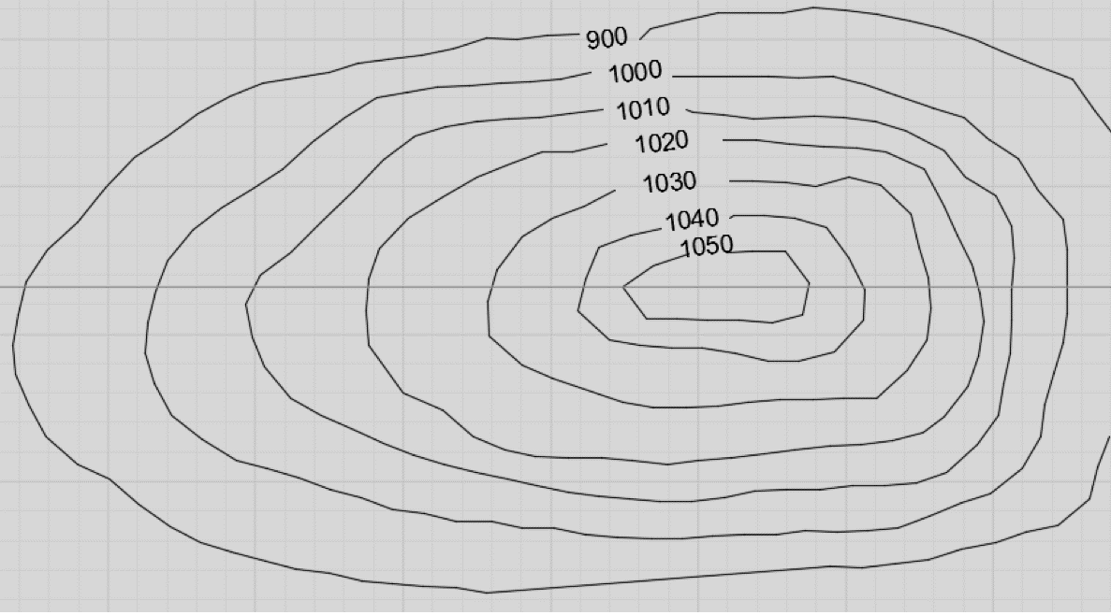
CONTOUR 1

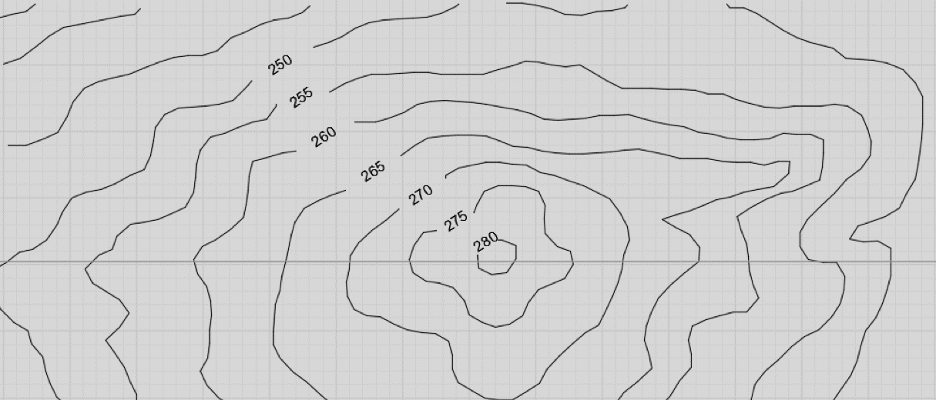
CONTOUR 2

Task 2: Construction Management: Vertical Site Layout
Refer to the attached site plan (C2.1) for the next section. In the scenario, you have just mobilized on site. You have set up a builder’s level on the site indicated by the symbol
and you are spot checking four existing grade elevations to verify the information on the grading plan (C3.1). The benchmark is across the street from the site to the southeast. The benchmark elevation is 481.47’. The backsight and foresights taken from the builder’s level are indicated for each location.
Determine the elevations of all four of the spot check locations. Show your work on the iPad.
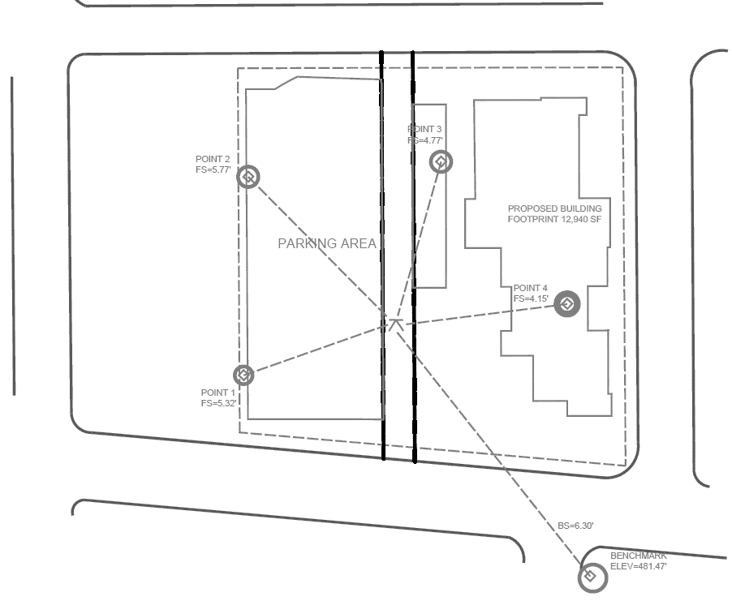
Note: The above image is a representation of the site plan (C2.1) and grading plan (C3.1) with the annotations that the participants were given.

Task 3: Construction Management: Horizontal Site Layout
Refer again to the attached site plan (C2.1) for this section. In the scenario, you have completed mass excavation and are beginning to lay out building corners. You are starting with the NE and NW building corners. You have set up your total station indicated by the symbol at the NE property corner and used the NW property corner as a backsight. The dimensions from the property line are shown on the site plan. Note the 3.00’ R.O.W. offset from the property line.
Determine what angle you need to turn and the distance you need to shoot in order to lay out these two building corners. Show your work on the iPad.
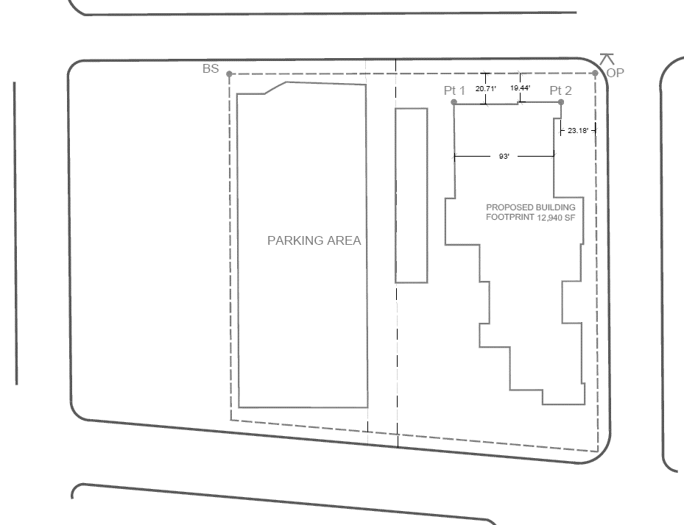
Note: The above image is a representation of the site plan (C2.1) with the annotations that the participants were given.

Task 4: Construction Management: Simple 4-D Sequencing of a Basketball Court
In this scenario, you are planning the construction of an outdoor basketball court. Refer to the images and information below. Assume that no work has yet been done. List the following:
Activity … Crew Name … Crew Size … Duration

Assume that there is only one activity happening on site at any given time. What is the total duration for this project?
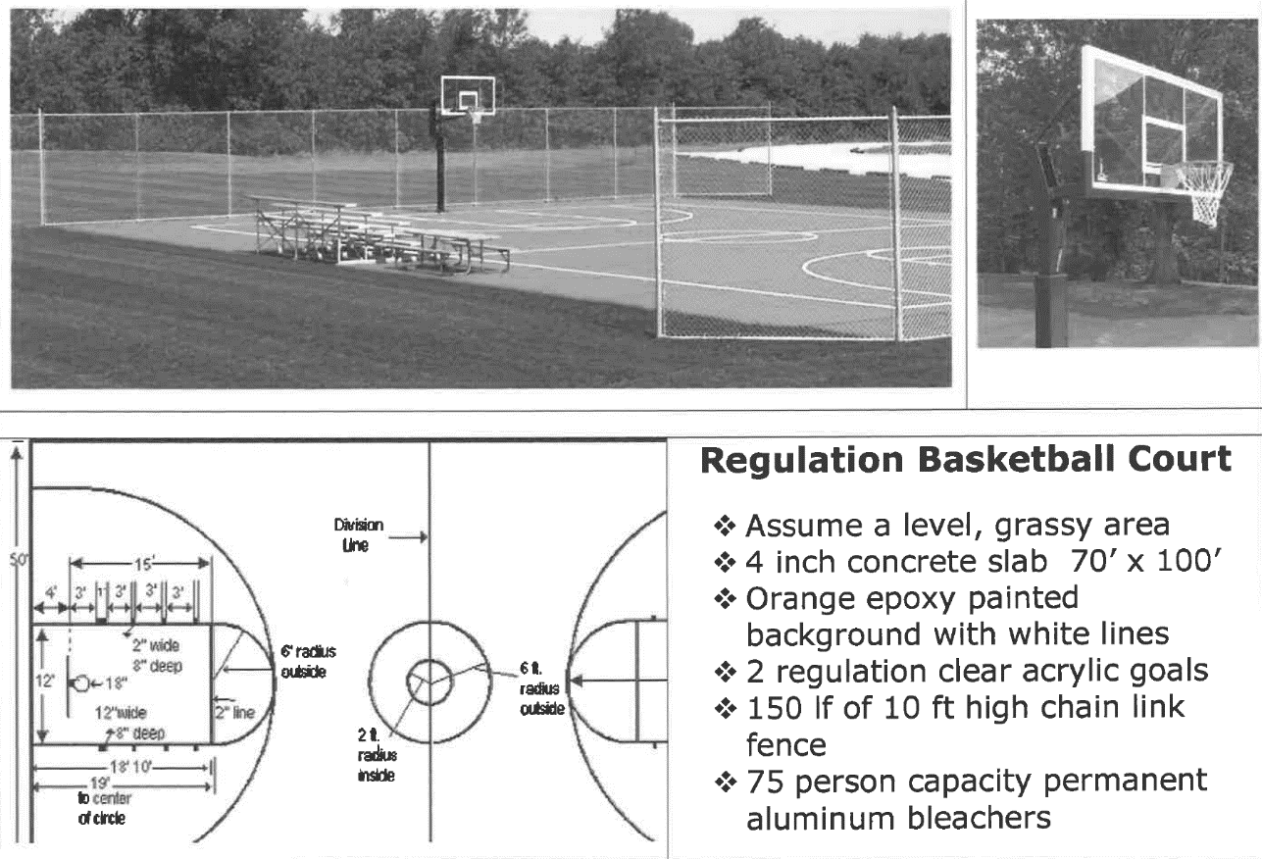

Task 5: Construction Management: Complex 4-D Sequencing of a Building Foundation
Refer to the given construction drawings for this portion – specifically S2.1, S3.1, and S3.2. These drawings are for a two-story building. The slab is a total of 12,940 square feet.
For this task, you will plan the schedule and sequence of the foundation work. Assume that you are beginning with the pad having been built and rough graded. You will be planning for activities from this point up through having the slab poured. Do not break out the MEP items, just include a single lump sum item for the underground MEP rough-in. List out the following in the order that they will occur:
Activity … Approximate Duration

If these activities occur sequentially with no overlap, how long will the foundation work take?
Next, think through how you might sequence these activities to most efficiently complete the foundation work. What is the new duration for the foundation work?

Note: Sheets S2.1-Foundation Plan, S3.1-Foundation Details, and S3.2-Foundation Details are copyrighted and thus not included here. All three sheets were given to the participants for reference during this task.

Task 6: Construction Engineering: Shear and Moment Diagrams
For this task, refer to the four problems from the Onouye & Kane book. Example problems with solutions are provided for reference. Showing your work on the iPad, work out the following:
Draw shear and moment diagrams using the equilibrium method. Indicate the magnitudes of V_{max} and M_{max}.
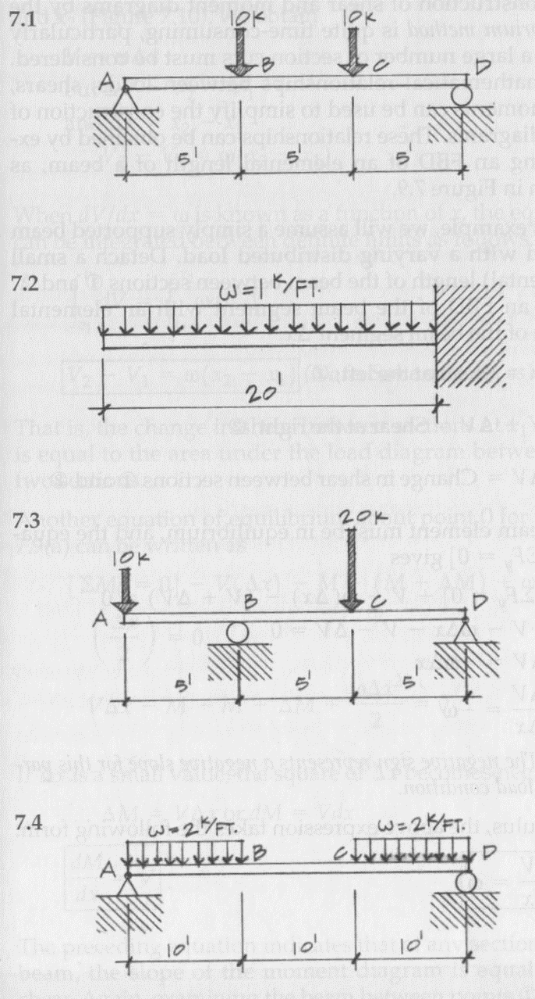

Note: The above image is from a course textbook (Onouye & Kane, 2012).

Task 7: Construction Engineering: Load Tracing
For this task, refer to the problem from the Onouye & Kane book. An example problem with solutions is provided for reference. This problem is a continuation of the reference problem. Showing your work on the iPad, work out the following:
In a multiple bay post-and-beam deck, the planks are 1’-0” wide and each spans a single bay. The columns are located at grids A/1, A/1, A/3, B/1, B/2, B/3, C/1, C/2, and C/3. Note the uneven column spacing (A-B = 6’; B-C = 8’, 1-2 = 16’; 2-3 = 12’. Determine the loads developed in each column support. given the following information.

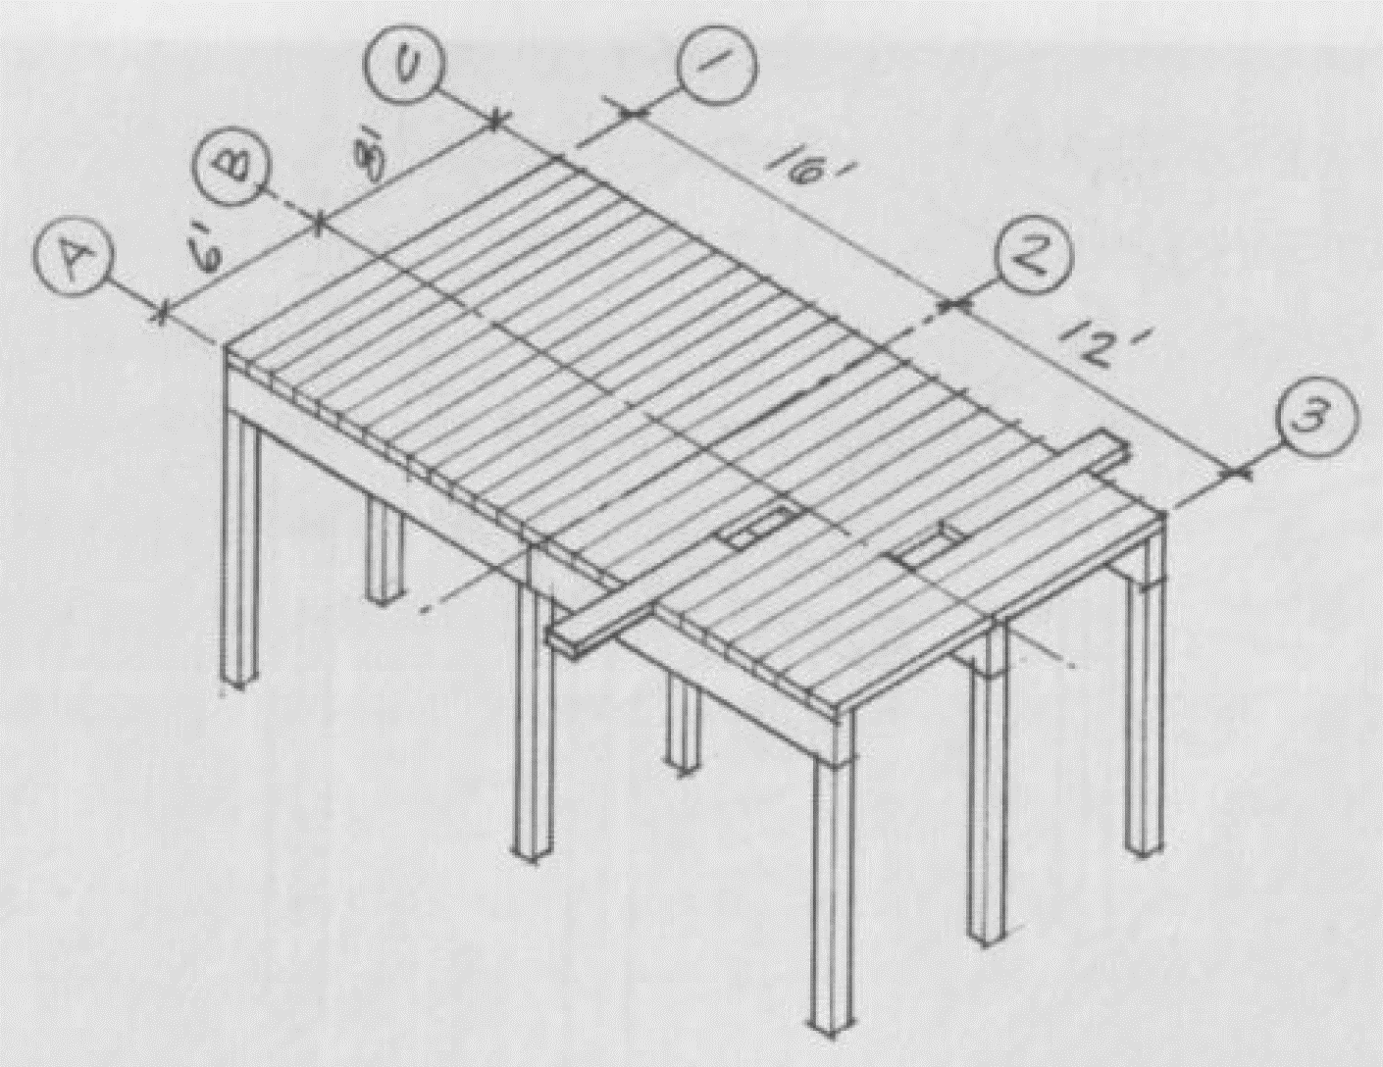
Load on the deck (live load) = 60 psf Beam self-weight = 10#/ft.
Deck weight (dead load) = 8 psf Column self-weight = 100#
TOTAL LOAD (LL + DL) = 68 psf
Note: The above image is from a course textbook (Onouye & Kane, 2012).

Appendix B: Participant Charts
Novices: Task Durations (minutes)
Identifier | CON 3D | CON VL | CON HL | 4D BB | 4D FOUND | ENG SM | ENG LT | Total Problem-Solving Duration
N-1 | 2.05 | 8.27 | 6.10 | 7.77 | 15.53 | 6.90 | 3.57 | 50.19
N-2 | 2.25 | 6.10 | 4.25 | 4.40 | 9.77 | 10.03 | 6.97 | 43.77
N-3 | 1.42 | 3.90 | 5.47 | 5.02 | 12.63 | 9.30 | 7.92 | 45.66
N-4 | 1.75 | 3.07 | 3.12 | 7.70 | 9.52 | 6.32 | 5.42 | 36.90
N-5 | 1.53 | 2.73 | 3.97 | 4.65 | 4.42 | 4.37 | 6.95 | 28.62
N-6 | 1.53 | 3.52 | 6.08 | 5.80 | 9.80 | 6.93 | 7.80 | 41.46
Note: Task identifier abbreviations are as follows (typical for all tables).
CON 3D – Construction Management: 3-D Site Contours
CON VL – Construction Management: Vertical Site Layout
CON HL – Construction Management: Horizontal Site Layout
4D BB – Construction Management: Simple 4-D Sequencing of a Basketball Court
4D FOUND – Construction Management: Complex 4-D Sequencing of a Building Foundation
ENG SM – Construction Engineering: Shear and Moment Diagrams
ENG LT – Construction Engineering: Load Tracing

Early Practitioners: Task Durations (minutes)
Identifier | CON 3D | CON VL | CON HL | 4D BB | 4D FOUND | ENG SM | ENG LT | Total Problem-Solving Duration
EP-1 | 1.40 | 3.13 | 3.58 | 5.25 | 8.18 | 4.00 | 10.13 | 35.67
EP-2 | 2.32 | 5.13 | 7.00 | 10.00 | 14.55 | 6.22 | 7.13 | 52.35
EP-3 | 1.92 | 2.53 | 6.90 | 3.18 | 6.47 | 7.28 | 4.00 | 32.28
EP-4 | 1.87 | 2.32 | 10.55 | 5.02 | 8.93 | 12.22 | 9.55 | 50.46
EP-5 | 3.08 | 5.12 | 17.62 | 13.00 | 18.80 | 15.42 | 9.77 | 82.81

Engineering Experts: Task Durations (minutes)
Identifier |  | CON 3D |  | CON VL |  | CON HL |  | 4D BB |  | 4D FOUND |  | ENG SM |  | ENG LT | Total Problem-Solving Duration
EXEN-1 |  | - |  | - |  | - |  | 6.87 |  | 11.55 |  | 8.18 |  | 6.78 | 33.38
EXEN-2 |  | - |  | - |  | - |  | 8.80 |  | 16.23 |  | 5.83 |  | 4.17 | 35.03
EXEN-3 |  | - |  | - |  | - |  | 8.00 |  | 18.00 |  | 10.00 |  | 8.00 | 44.00
EXEN-4 |  | - |  | - |  | - |  | 7.00 |  | 11.00 |  | 9.00 |  | 6.00 | 33.00
EXEN-5 |  | - |  | - |  | - |  | 7.00 |  | 11.00 |  | 16.00 |  | 22.00 | 56.00
Construction Experts: Task Durations (minutes)
Identifier | CON 3D |  | CON VL |  | CON HL |  | 4D BB |  | 4D FOUND |  | ENG SM |  | ENG LT |  | Total Problem-Solving Duration
EXCO-1 | 2.25 |  | 1.50 |  | 3.50 |  | 3.00 |  | 5.00 |  | - |  | - |  | 15.25
EXCO-2 | 0.50 |  | 2.00 |  | 3.00 |  | 3.50 |  | 4.50 |  | - |  | - |  | 13.50
EXCO-3 | 1.00 |  | 2.00 |  | 3.00 |  | 4.00 |  | 13.00 |  | - |  | - |  | 23.00
EXCO-4 | 3.00 |  | 4.00 |  | 4.00 |  | 3.00 |  | 8.00 |  | - |  | - |  | 22.00

