UNIVERSITY OF OKLAHOMA
GRADUATE COLLEGE

THE DEVELOPMENTAL TRAJECTORY OF FRIENDSHIP JEALOUSY IN ADOLESCENCE:
THE ROLE OF ATTACHMENT SECURITY AND EMOTION REGULATION

A DISSERTATION
SUBMITTED TO THE GRADUATE FACULTY
In partial fulfillment of the requirements for the
Degree of
DOCTOR OF PHILOSOPHY

By
QI DAI
Norman, Oklahoma
2023

THE DEVELOPMENTAL TRAJECTORY OF FRIENDSHIP JEALOUSY IN ADOLESCENCE:
THE ROLE OF ATTACHMENT SECURITY AND EMOTION REGULATION

A DISSERTATION APPROVED FOR THE
DEPARTMENT OF PSYCHOLOGY

BY THE COMMITTEE CONSISTING OF

Dr. Lara Mayeux, Chair
Dr. Erin Freeman
Dr. Hairong Song

Dr. Kendra Williams-Diehm

© Copyright by QI DAI 2023
All Rights Reserved.

Acknowledgements

First, I would like to thank my advisor and my role model, Dr. Lara Mayeux. Thank you for everything. Thank you for giving me the chance to work with you. Thank you for mentorship, support, encouragement, patience, and humor. I did learn a lot from you, not only about research. I would also like to thank my committee, Dr. Hairong Song, Dr. Erin Freeman, and Dr. Kendra Williams-Diehm. Thank you to Dr. Song for not giving me up and for taking care of me like a family member. Thank you to Dr. Freeman for guidance and support in both research and teaching. And thank you to Dr. Willians-Diehm for your kind feedback and encouragement.

Thank you to my parents and my grandma, Jibo Dai, Li Wang, and Xiuhua Zhuang. Family is what inspires my interest in Developmental Psychology, and thank you for supporting me to start my journey in psychology and supporting me to continue this journey in the United States. I would never be where I am today without you.

Thank you to my colleagues and friends, Xiaohang Du, Shanyue Zhang, Ya Gao, Youjia Guo, and Baoping Ma. As someone who studies friendships, I knew how important friends are before I read the literature, because of you. Thank you for being my friends, always providing me support, and being my Muse in research.

Finally, to my partner, Baoqi Du, thank you for loving me, being my most effective strategy to regulate my emotions, and providing me the environment where I can do whatever I want to. Thank you for your humor and for always making me happy. You make my life more joyful than I ever imagined.

Table of Contents
List of Tables vi
List of Figures vii
Abstract ix
Introduction 1
Friendship Jealousy 3
Attachment Security 9
Emotion Regulation 14
Current Study 19
Method 23
Participants 23
Procedure 23
Measures 24
Analysis Plan 25
Results 26
Preliminary Analyses 26
Latent Growth Curve Modeling 30
Structural Equation Modeling 32
Discussion 36
Limitations and Future Directions 44
Conclusion 45
References 47

List of Tables

Table 1. Cronbach’s Alpha of Measures at Each Wave………………..………...……………….62
Table 2. Means and Standard Deviations of Attachment Security, Emotion Regulation, and Friendship jealousy at Each Wave………………...…………………………………....……...…63
Table 3. Independent Samples T-Test of Gender Differences with Means and SDs………...…....64
Table 4. Correlations among Attachment Security, Emotion Regulation and Friendship jealousy in the Overall Sample.………………………………………………………………………………65
Table 5. Correlations among Attachment Security, Emotion Regulation, and Friendship Jealousy by Genders………………….……………………………………………………………………66
Table 6. Goodness-of-Fit Indicators of Confirmatory Factor Analysis Models for IPPA-Mother at Each Wave………………………………….……………………………………………………67
Table 7. Standardized Factor Loadings of Confirmatory Factor Analysis Models for IPPA-Mother at Each Wave…………….………………………………………………………………….……68
Table 8. Goodness-of-Fit Indicators of Confirmatory Factor Analysis Models for IPPA-Father at Each Wave…………………………………….…………………………………………………69
Table 9. Standardized Factor Loadings of Confirmatory Factor Analysis Models for IPPA-Father at Each Wave………………………..………………………………...…………………….……70
Table 10. Goodness-of-Fit Indicators of Confirmatory Factor Analysis Models for IPPA-Close Friends at Each Wave.….…………………...……………………………………...…….………71
Table 11. Standardized Factor Loadings of Confirmatory Factor Analysis Models for IPPA-Close Friends at Each Wave.….……………………...……………………….……………………...…72
Table 12. Goodness-of-Fit Indicators of Confirmatory Factor Analysis Models for CAMS at Each Wave.….………………………………………………………………...……………….………73
Table 13. Standardized Factor Loadings of Confirmatory Factor Analysis Models for CAMS at Each Wave.….…………………………………...………………………………………………74
Table 14. Goodness-of-Fit Indicators of Confirmatory Factor Analysis Models for CSMS at Each Wave.….…………………………………………………………………………………………75
Table 15. Standardized Factor Loadings of Confirmatory Factor Analysis Models for CSMS at Each Wave.….…………………………………………...………………………………………76
Table 16. Goodness-of-Fit Indicators of Confirmatory Factor Analysis Models for FJQ at Each Wave.….…………………………………………………………………………………………77
Table 17. Standardized Factor Loadings of Confirmatory Factor Analysis Models for FJQ at Each Wave.….…………………………………………………………………...……………….……78
Table 18. Goodness-of-Fit Indicators of Growth Curve Models for Study Variables………....….79
Table 19. Parameter Estimates of Growth Curve Models for Study Variables.….………….....…80
Table 20. Goodness-of-Fit Indicators of Structural Equation Modeling for Parental Attachment Security Predicting Emotion Regulation in General and Friendship Jealousy.……………..….…81
Table 21. Goodness-of-Fit Indicators of Structural Equation Modeling for Attachment Security with Close Friends Predicting Emotion Regulation in General and Friendship Jealousy.…...……82

List of Figures

Figure 1. Linear Growth Curve Modeling for Studied Variables.…………….………..…………83
Figure 2. Structural Equation Modeling to Test the Relationship Among Parental Attachment Security, Emotion Regulation in General, and Friendship Jealousy.………………………..……84
Figure 3. Structural Equation Modeling to Test the Relationship Among Attachment Security with Close Friends, Emotion Regulation in General, and Friendship Jealousy….……………..………85
Figure 4. Structural Equation Modeling to Test the Relationship Among Parental Attachment Security, Emotion Regulation in Anger and Sadness, and Friendship Jealousy...………...………86
Figure 5. Structural Equation Modeling to Test the Relationship Among Attachment Security to Close Friends, Emotion Regulation in Anger and Sadness, and Friendship Jealousy.……..…..…87
Figure 6. Confirmatory Factor Analysis Model of IPPA-Mother……………………..…….……88
Figure 7. Confirmatory Factor Analysis Model of IPPA-Father………………...…………..……89
Figure 8. Confirmatory Factor Analysis Model of IPPA-Close Friends……………...……..……90
Figure 9. Confirmatory Factor Analysis Model of CAMS…………………………………..……91
Figure 10. Confirmatory Factor Analysis Model of CSMS…….….……………….……….……92
Figure 11. Confirmatory Factor Analysis Model of FJQ…….….…………………….…….……93
Figure 12. Structural Equation Modeling to Test the Relationship Among Parental Attachment Security, Emotion Regulation in General, and Friendship Jealousy at Time 1…….………...……94
Figure 13. Structural Equation Modeling to Test the Relationship Among Parental Attachment Security, Emotion Regulation in General, and Friendship Jealousy by Gender at Time 1…......…95
Figure 14. Structural Equation Modeling to Test the Relationship Among Parental Attachment Security, Emotion Regulation in General, and Friendship Jealousy at Time 2………….…...……96
Figure 15. Structural Equation Modeling to Test the Relationship Among Parental Attachment Security, Emotion Regulation in General, and Friendship Jealousy by Gender at Time 2…...…...97
Figure 16. Structural Equation Modeling to Test the Relationship Among Parental Attachment Security, Emotion Regulation in General, and Friendship Jealousy at Time 3……….……...……98
Figure 17. Structural Equation Modeling to Test the Relationship Among Parental Attachment Security, Emotion Regulation in General, and Friendship Jealousy by Gender at Time 3…......…99
Figure 18. Structural Equation Modeling to Test the Relationship Among Parental Attachment Security at Time 1, Emotion Regulation in General at Time 2, and Friendship Jealousy at Time 3…….….………………………………………………………………………………………..100
Figure 19. Structural Equation Modeling to Test the Relationship Among Parental Attachment Security at Time 1, Emotion Regulation in General at Time 2, and Friendship Jealousy at Time 3 by Gender.…….….……………………………………………………………………………..101
Figure 20. Structural Equation Modeling to Test the Relationship Among Attachment Security with Close Friends, Emotion Regulation in General, and Friendship Jealousy at Time 1…...…..102
Figure 21. Structural Equation Modeling to Test the Relationship Among Attachment Security with Close Friends, Emotion Regulation in General, and Friendship Jealousy by Gender at Time 1…….….…………………………………………………………………...…….……………..103
Figure 22. Structural Equation Modeling to Test the Relationship Among Attachment Security with Close Friends, Emotion Regulation in General, and Friendship Jealousy at Time 2......…...104
Figure 23. Structural Equation Modeling to Test the Relationship Among Attachment Security with Close Friends, Emotion Regulation in General, and Friendship Jealousy by Gender at Time 2…….….……………………………………………...………………………………………...105
Figure 24. Structural Equation Modeling to Test the Relationship Among Attachment Security with Close Friends, Emotion Regulation in General, and Friendship Jealousy at Time 3.…...….106
Figure 25. Structural Equation Modeling to Test the Relationship Among Attachment Security with Close Friends, Emotion Regulation in General, and Friendship Jealousy by Gender at Time 3…….….……………………………………………………………………………...………...107
Figure 26. Structural Equation Modeling to Test the Relationship Among Attachment Security with Close Friends at Time 1, Emotion Regulation in General at Time 2, and Friendship Jealousy at Time 3.…….….………………………………………………………………………….…...108
Figure 27. Grade Differences in Boys’ and Girls’ Friendship Jealousy from Parker, Kruse, and Aikins (2010).…….….…………………………………………….…………………………...109

Abstract
The current study investigated the developmental trajectory of friendship jealousy across a one-year interval during adolescence. It also explored the association of attachment security with friendship jealousy while testing the potential mediating role of emotion regulation. A total of 1,158 middle school students participated in this study at three time points. A set of self-report questionnaires were adopted to assess attachment security to mother, father, and close friends, emotion regulation in general, emotion regulation for anger and sadness, and friendship jealousy. Friendship jealousy tended to be stable for girls from 7th to 8th grade. There were negative associations between parental attachment security and friendship jealousy at all three time points, but parental attachment security did not predict friendship jealousy one year later. Attachment security to close friends negatively predicted friendship jealousy concurrently and one year later. The mediating role of emotion regulation was not supported in the longitudinal analyses.
Keywords: friendship jealousy, attachment security, emotion regulation, SEM
The Developmental Trajectory of Friendship Jealousy in Adolescence: The Role of Attachment Security and Emotion Regulation
Friendship, as a close, mutual, and dyadic relationship, has been shown to have developmental significance throughout the lifespan (Bukowski & Hoza, 1989; Hartup & Stevens, 1997). Individuals begin to seek friendships from early childhood, and friendships are highly valued for children, adolescents, and adults to fulfill one’s needs in interpersonal relationships (Hartup & Stevens, 1997; Klinger, 1977). The central role of friendships in humans’ happiness, health, and well-being has been well illustrated (e.g., Krems, Williams, Aktipis, & Kenrick, 2020). For example, having friends protects individuals against both physical and mental diseases (e.g., breast cancer, heart disease, and loneliness), as well as facilitates happiness and longevity (see Dunbar, 2018 for review). Youth with a reciprocated friendship show better psychological well-being than youth who lack a mutual friend (Bukowski, Hoza, & Boivin, 1994). Compared with youth who do not have friends, children and adolescents who have friends are reported to be more sociable, cooperative, altruistic, and self-confident, and less like to seek clinical assistance for psychosocial problems (Garmezy & Rutter, 1983; Newcomb & Bagwell, 1995). Having close friends also benefits youth in terms of both short-term and long-term socioemotional functioning (Buhrmester & Furman, 1986; Sullivan, 1953), in which children with close friends have higher self-esteem, and are more sociable, less depressed, and less anxious (Buhrmester, 1990). Beyond simply having friends, research also suggests that the quality of youth’s friendships matters: High friendship quality also contributes to social adjustment during adolescence (e.g., less aggressive behaviors and high self-esteem; Stotsky & Bowker, 2018), where low-quality friendships predict depression, loneliness, low self-esteem, low perceived social competence, and other internalizing problems (Nangle et al., 2003; Rubin et al., 2004).
However, friendships may also have some negative influences on adolescent development. Based on the similarity-attraction dynamic, youth tend to make friends with others who share similarity with them (Gremmen et al., 2019; Hartup & Stevens, 1997). Hartup and Steven (1997) argued that beginning from early childhood, youth both model behaviors for their friends and simultaneously receive reinforcement for behaviors from their friends. Brown, Clasen, and Eicher (1986) concluded that being friends with antisocial and poorly socialized peers can increase the risks of social maladaptation, in which they found that antisocial behaviors increased over time among antisocial youth and their friends. Similar findings have also been shown on delinquent behaviors, cigarette use, and alcohol use (Engels, et al., 2004; Fisher & Baumann, 1988; Kandel, 1978). Having low-quality or unhealthy friendships can also be problematic, for example, Berndt (1989) found that conflict with friends is linked to negative attitudes toward school, more alcohol use, delinquent behaviors, and depression. Moreover, there are also some negative experiences within interactions with friends, such as friendship jealousy, which may link to friendship dissolution and aggressive behaviors (Kraft & Mayeux, 2018; O’Mealey, 2021). Although friendship jealousy has been demonstrated to be a risk factor in healthy friendship development (Parker, Kruse, & Aikins, 2010), the etiology of friendship jealousy is less clear. The current study aims to explore the development of individual differences in friendship jealousy through examining the influence of attachment security and emotion regulation, along with tracking the developmental trajectory of friendship jealousy during adolescence.

Friendship Jealousy
Friendship jealousy is an important construct in friendships and peer relations (Deutz, Lansu, & Cillessen, 2015). It refers to negative emotional, cognitive, and behavioral reactions triggered by a friend’s anticipated or actual interest in a relationship with another person (Parker, Low, Walker, & Gamm, 2005). It is important to note that the involvement of a third party, who is usually called an interloper, is a key characteristic of friendship jealousy (Parker et al., 2005). Only when the individual believes that the interloper is a threat to his or her friendship, will the experience of friendship jealousy occur (Kraft & Mayeux, 2018). Even though individuals may understand that their friendship will continue, they may still feel jealous because of the possibility of decreased exclusivity with the friend (Parker et al., 2005) or losing friendship rewards or privileges associated with the friend, such as peer status (Worley & Samp, 2014).
The general vulnerability for friendship jealousy during childhood and adolescence is usually measured by the Friendship Jealousy Questionnaire (FJQ; Parker et al., 2005). The FJQ is a self-report measurement including 15 items, and participants rate their feelings on a 5-point Likert scale ranging from (0) would never be jealous over that to (4) would definitely be really jealous. Each item is an imaginary scenario. Some example situations are “How jealous would you be if you invited your best friend to go see a movie, but he or she was already going with another kid from your group?”, “How jealous would you be if you found out that your best friend got into a fight with his or her parents, and called or texted another kid from your group for advice and didn’t talk to you about it?”, and “How jealous would you be if your best friend had a secret and didn’t tell you first?”
Friendship jealousy arises from the feeling of threat and the prospective loss of close relationship with friends (Deutz et al., 2015; Lavallee & Parker, 2009), and it links to a lack of a sense of security within the relationship and concerns about maintaining the friendship (Sharpsteen & Kirkpatrick, 1997). It is sensitive to the value of friendship closeness and the type of threat, in which youth have a stronger feeling of jealousy on the prospective loss of best friends than close friends and others, and it is stronger for a potential replacement threat (interloper usurps one’s place in the friendship) than a potential time threat (friends spending more time with the interloper; Krems et al., 2020). Since jealousy has been known to occur at any age and in the context of any relationship with significant others (Parker et al., 2005), friendship jealousy can be understood as a normative feature of child and adolescent friendships (Lavallee & Parker, 2009).
Friendship jealousy usually occurs when youth face threats of losing a friendship, uncertainty within the relationship, or a decrease in closeness with a friend, which causes negative emotional reactions, such as anger, sadness, anxiety, and embarrassment (Parker et al., 2005). These negative emotions are usually stronger when experiencing friendship jealousy compared with other types of disappointment in friendships (Parker et al., 2010) and can lead to the motivation to take actions to preserve the friendship and deter the interloper (Parker et al., 2005). Several strategies to protect the relationship have been documented, such as surveillance, integrative communication, distributive communication, negative affect expression, and conflict (Bevan, 2004; Lavallee & Parker, 2009); however, these coping behaviors usually do not produce positive results, but rather negative interactions with friends (Deutz et al., 2015). For example, conflicts due to jealousy have been demonstrated to play a prominent role in friendship dissolution and the formation of mutual antipathies (Casper & Card, 2010), and positive associations have been reported between friendship jealousy and friendship dissatisfaction as well as between friendship jealousy and low closeness within the friendship (Lavallee & Parker, 2009; Parker et al., 2005).
Negative behavioral reactions linked to jealousy not only impact friendship status, but also influence an individual’s social adjustment (Parker et al., 2010). Previous literature has illustrated that friendship jealousy significantly predicts low peer acceptance, victimization, reputation for jealousy, dissatisfaction with peer experiences in general, and more mutual peer enemies (Lavallee & Parker, 2009; Parker et al., 2005). Empirical evidence has shown that friendship jealousy is associated with aggression (Culotta & Goldstein, 2008; Feng & Wang, 2017), in which youth who are known to be the most jealous by peers are also known to be the most aggressive by their peers (Parker et al., 2005). Jealous individuals are most likely to use relational aggression, such as social exclusion, spreading rumors, and gossip, to hurt an interloper’s self-esteem and social status and to make themselves feel better (Parker et al., 2010). Further, these effects are moderated by gender and peer status. For example, Kraft and Mayeux (2018) found a positive association between friendship jealousy and relational aggression for popular middle schoolers, but a negative association between friendship jealousy and relational aggression for unpopular youth. Girls low in peer acceptance also showed a positive link between friendship jealousy and relational aggression, while the association was negative for poorly accepted boys.
Researchers have also argued that although friendship jealousy has been defined as a negative reaction and experience in general, there might also be benefits to some extent (Deutz et al., 2015). Experiencing or expressing friendship jealousy might be a signal that individuals care deeply about their friend, highly value their friendships, and are motivated to stay involved in their relationships (Bringle, Renner, Terry, & Davis, 1983; Guerrero & Eloy, 1992). Krems and colleagues (2020) also proposed that friendship jealousy may be an overlooked tool of friendship maintenance. They argue that friendship jealousy is a psychological mechanism in response to the potential threats from the interloper; by adopting friend-guarding behaviors to mitigate these threats, they may be able to protect the closeness and exclusivity of the friendship. Friendship jealousy has also been found to be associated with proactive prosocial behavior (e.g., lending things to others to get what the individual wants), which jealous adolescents may use as a form of social manipulation or to balance their relationally aggressive behaviors to achieve their goal (e.g., maintain their friendships; Culotta & Goldstein, 2008).
Developmental Trajectories.
Previous literature has indicated that there is a typical developmental trajectory of friendship jealousy from childhood to adolescence that is consistent with the dynamic changes of friendships. Based on Sullivan’s (1953) interpersonal theory, individuals at different stages of the lifespan require different close relationships to fulfill their central needs. Relationships with parents and other caregivers are primary for infants and young children; peer relationships become central from middle childhood until adolescence; and later, romantic relationships gain importance (Sullivan, 1953). Sullivan (1953) also argued that during preadolescence, the closest of youth’s peer relationships, their friendships, are crucial to fulfilling their needs. Empirical evidence has suggested that adolescents desire close friendships with a strong sense of both intrinsic and extrinsic motivation (Berndt, 1982; Ojanen, Sijtsema, Hawley, & Little, 2010). Not only does the role of friendships shift to becoming essential during early adolescence, but the process of friendship formation also varies between early childhood and adolescence (Buhrmester, 1990). For preschool and elementary school-aged children, friendships centrally revolve around playmate activities and group acceptance, in which an ideal friend is viewed as knowing good games to play, being a fun play partner, and sharing, helping, and protecting their friends (Asher, 1983). However, friendships in adolescence require higher levels of intimacy between each other, including more frequent companionate exchanges, more self-disclosure, and more provision of emotional support (Buhrmester & Furman, 1987; Gottman & Mattetal, 1987; Steinberg, 1989).
Friendship jealousy tends to be most pronounced during early adolescence based on the rapid change in the nature and significance of friendship for adolescents (Berndt, 1982; Buhrmester & Furman, 1986; Parker et al., 2005). Parker and colleagues (2005) compared grade differences in friendship jealousy from fifth to ninth grade students in the United States and found that as grade increased, the level of friendship jealousy decreased but with significant and stable individual differences from one academic year to the next. Selman (1980) observed that while children usually do not express their feeling of jealousy over friends, young adolescents do begin to take actions when experiencing jealousy, probably because of their awareness of the threat from the interloper to their friendships. Friendship jealousy increases at the beginning of adolescent years and then declines across adolescence (e.g., Sullivan, 1953; Parker et al., 2005). However, there remains very limited empirical evidence of the developmental trajectory of friendship jealousy during adolescence. Thus, the first goal of this study is to identify the developmental trajectory of friendship jealousy across a one-year period in middle adolescence.
Gender Differences
The nature of same-sex friendships has been shown to be different for boys and girls (Parker et al., 2005). Girls begin to develop close friendships at early adolescence, and their friendships tend to be characterized by emotional dependence and support, intimate self-disclosure, and expectations of loyalty and empathy (Buhrmester, 1996), where friendships of boys usually show a lower level of emotional intimacy (Maccoby, 1990). Rose and Rudolph (2006) proposed a peer-socialization model to understand sex differences in peer relationship processes between boys and girls. They argued that girls are more focused on dyadic relationships (i.e., friendships), whereas boys are more focused on the larger peer groups. Therefore, boys and girls view their friendships differently and behave differently with their friends (Rose & Rudolph, 2006).
Empirical evidence supports this idea. Girls have been shown to report higher levels of loyalty and emotional support in friendships than boys, and have stronger feelings of anger and sadness when their friendship expectations are violated (Culotta & Goldstein, 2008). Compared with boys, adolescent girls have also been reported to be more likely to make social comparisons and particularly like to make negative social comparisons (Harter, 1990). Exclusivity is higher in girls’ friendships compared with boys’ friendship (Berndt, 1982); boys are more likely to include outsiders in their conversations and activities (Berndt, 1982). Girls also reported more concerns about their friendship status and more prosocial behaviors with their best friends, which consequently benefits the maintenance of the friendship (Rose & Rudolph, 2006), and boys are more likely to engage in behaviors which may damage their friendships (Brendgen et al., 2001), such as criticism, negative affect, and conflict.
Higher concern about the status of their friendships may also make the friendships of girls feel more fragile (Benenson & Christakos, 2003). Several studies have demonstrated that adolescent girls are more vulnerable to jealousy than adolescent boys are (Culotta & Goldstein, 2008; Deutz et al., 2015; Parker et al., 2010), which may be due to the fact that girls highly value their friendships and tend to feel more threatened in the relationship (Culotta & Goldstein, 2008). Although there are no studies showing gender differences in friendship satisfaction and stability between boys and girls, friendship jealousy is associated with more conflict, lower observed friendship quality, less prosocial behavior, and more negative behaviors for adolescent girls than boys (Deutz et al., 2015; Parker et al., 2010). Thus, the first goal of the current study is to explore the dynamic changes of friendship jealousy across the middle adolescent years but also examine potential gender differences in the trajectories.
Attachment Security and Friendship Jealousy
Attachment theory defines a pattern of relational expectations, emotions, and behaviors for humans in close relationships (Brenning & Braet, 2012), and the attachment system has been shown to have functioning influence across the life span (Allen, Grande, Tan, & Leob, 2018). Individuals develop their own attachment styles based on key attachment experiences after birth with their caregivers. According to attachment theory (Bowlby, 1969), infants seek proximity to caregivers for emotional comfort, support, and protection from harm, and in turn, caregivers offer a secure base from which infants can explore the environment (Cooper, Shaver, & Collines, 1998). Over time, patterns in these early caregiving experiences form an internalized working model that provides a prototype for future relationships with significant others (Bowlby, 1969), and which also indicates that the attachment system is active and effective across the life course (Mikulincer & Shaver, 2016). The stability of the attachment system has been illustrated, that attachment patterns with others are relatively stable from infancy to adulthood, but it is possible that attachment-relevant life experiences may change the attachment styles in later life (Cronin, Pepping, & O’Donovan, 2018; Fraley, 2002). The attachment system also shows consistency, in which individuals who formed insecure attachment with caregivers tend to display similar attachment patterns in friendship and romantic relationships (Fraley, Hudson, Heffernan, & Segal, 2015).
Based on attachment theory, attachment security refers to individuals’ confidence and trust in their attachment figures, typically the parents, to provide comfort and support whenever they need them (Cassidy & Shaver, 2016). A secure early attachment relationship is generally thought to be promoted by a warm parental response in which the caregiver consistently shows availability to the child’s needs, is supportive and helpful, and provides a secure base from which the child can explore (Ainsworth et al., 1978). Rooted in these positive early experiences with caregivers, a securely attached individual is characterized as confident, trustful, socially competent, and having a positive sense of self-worth and self-esteem (Sroufe, 2005).
During infancy and early childhood, attachment security is usually measured by laboratory or home observation-based methods, where researchers observe and rate the infant's or child’s behaviors during their interactions with parents or separations and reunions with caregivers (e.g., the Strange Situation Procedure, Ainsworth, Blehar, Waters, & Wall, 1978; Attachment Q-Sort, Waters & Deane, 1985; and Attachment Doll Play, Main, Kaplan, & Cassidy, 1985). For adolescents and adults, self-report questionnaires are commonly used to assess attachment security (e.g., Inventory of Parent and Peer Attachment, Armsden & Greenberg, 1987; Adolescent Attachment Questionnaire, West, Rose, Spreng, & Keller, 1998; and Experiences in Close Relationships-Revised, Fraley, Waller, & Brennan, 2000).
Bowlby (1980) proposed that the attachment system serves two fundamental functions: to protect individuals from potential threats and to regulate subsequent negative influences. Thus, the lack of secure attachment in infancy, childhood, and adolescence can contribute to the development of both internalizing and externalizing disorders (Simpson, Collins, Tran, & Haydon, 2007). Cooper, Shaver, and Collins (1998) concluded, based on their findings with a large sample of adolescents, that secure attachment is consistently linked with better psychological and social adjustment, where insecure attachment is associated with higher levels of loneliness, depression, anxiety, anger, resentment, shame proneness, paranoia, pathological narcissism, somatic symptoms, and lower level of self-esteem and self-confidence. Anxious youth have also been reported to exhibit more risk-taking behaviors and have poorer self-concepts.
Friendship Jealousy and Parental Attachment Security
Attachment theory has proposed that individuals construct internal working models of themselves, others, and relationships based on early experiences with caregivers – usually parents (Bowlby, 1980). The internal working models, as guidelines of expectations in subsequent close relationships with significant others, have been illustrated to play an important role in self-worth, trust in others, and social behaviors (Bowlby, 1980; Liable, 2007). Accordingly, high attachment security with parents may link to less proneness to friendship jealousy for adolescents through several ways. First, secure attachment with parents forms internal working models in which youth may have a stronger feeling of security in the relationship with the partner (e.g., friendships), and then youth may view the existence of the interloper as less threatful. Second, adolescents with secure attachment to parents have higher levels of self-worth and trust in others, so they may tend to be less vulnerable to making negative social comparisons with the interloper and trust their partner (e.g., friends) more, compared to those with insecure attachment to parents.
Based on the theory, the effect of parental attachment on children’s social functioning with peers has been well demonstrated, along with the role of important mediator and moderator variables. For example, self-worth mediated the relationship between parental attachment security and social competence, including coping behaviors, among children aged 10 years old, where higher security in parental attachment was linked to better social competence through higher levels of self-worth (Booth-Laforce et al., 2006). It has also been argued that insecure attachment with parents along with difficulties with trust may facilitate adolescents’ sensitivity to interlopers and, consequently, their experience of jealousy in friendships (Voulgaridou & Kikkinos, 2020). Lower security of attachment to parents has been shown to predict lower levels of self-esteem (Pinquart, 2022), where lower self-esteem has been found to contribute to higher jealousy in friendships for adolescents, probably due to unfavorable social comparisons, the overestimation of the partner’s attraction, and stronger feelings of threat (Kim et al., 2017).
Research specifically focusing on the link between attachment and friendships, and more specifically friendship jealousy, is very sparse. Kim, Parker, and Marciano (2017) have argued that friendship jealousy may be preceded by insecurity in parental attachment for adolescents, based on their finding that higher levels of maternal psychological control is associated with more jealousy in friendships for both boys and girls. Emotional insecurity with parents has been found to be associated with lower levels of friendship satisfaction via more friendship insecurity and mistrust with partners (Cook, Buehler, & Fletcher, 2012). To my best knowledge, there is only one study which directly tested the relationship between parental attachment security and friendship jealousy. In a six-month longitudinal study with a large sample of adolescents aged from 13 to 16 years old, both availability and dependency with both mother and father predicted lower friendship jealousy over time (Voulgaridou & Kokkinos, 2020). This suggests that parental attachment security may foster resilience against the development of friendship jealousy for adolescents (Voulgaridou & Kokkinos, 2020). However, potential mechanisms and explanations for the effect of maternal and paternal attachment on friendship jealousy were not explored in the study. Thus, the second goal of the current research is to examine the relationship between attachment security with parents and friendship jealousy during the adolescent years.
Friendship Jealousy and Attachment Security to Close Friends
Several studies, based on the concept of internal working models, have indicated that youth present consistent patterns of attachment security across relationship types (e.g., parents and peers; Liable, 2007). However, adolescents experience rapid changes in both cognitive capacity and social relationships, which may consequently shape the existing attachment organization (Allen & Miga, 2010). La Guardia and colleagues (2000) examined the within-person variability in attachment security and confirmed that the variation in parental attachment and attachment to close friends is substantial. The nature and function of attachment security have also shown different patterns with parents and peers during adolescence (Allen et al., 2018; Liable, 2007). Thus, in order to understand the effect of attachment security on friendship jealousy, it may be necessary to examine the influence of attachment security with parents and attachment security with close friends separately.
At the transition to adolescence, it has been demonstrated that peer relationships begin to serve as an important context to fulfill one’s attachment needs (Liable, 2007), in which close friends sometimes replace the role of parents as attachment figures (Markiewicz, Boyle, & Brendgen, 2001). Compared to parent-child relationships, peer relations are characterized as more mutually reciprocal (Youniss, 1980), and due to the unique nature of peer relations, it has been suggested that interactions with peers are a stronger influence on youth social adjustment (Youniss, 1980). Research has indicated that higher attachment security to friends predicts better friendship quality (Markiewicz et al., 2001), and attachment security to peers is positively associated with social and emotional competence, including more emotional awareness, higher empathy, more prosocial behaviors, and less aggressive behaviors (Liable, 2007). Given the fact that attachment security to close friends promotes socioemotional competence, it is reasonable to assume that youth with a more secure attachment relationship to close friends are less prone to feel jealousy in their friendships. However, to my best knowledge, there is no empirical evidence testing the relationship between attachment security to close friends and friendship jealousy. To fill this gap, the current research also includes the exploration of whether and how attachment security to close friends may affect friendship jealousy during adolescence.
Emotion Regulation
In addition to investigating links between attachment security and friendship jealousy, I also explore a potential mediator: emotion regulation. Emotion regulation has been defined as the extrinsic and intrinsic processes of monitoring, evaluating, and modifying the intensity, duration, and latency of emotional reactions (Thompson, 1994), which typically involves the change of current ongoing emotional responses or the onset of a new emotional response (Mert, 2020). Emotions can be helpful or harmful based on the social context (Gross, 2015), such that regulating negative emotions is a common strategy for individuals to cope with negative events (Gross, 1999), while regulating positive emotions is typically used in maintaining positive affective experiences (Gross, 2001). Consequently, emotion regulation strategies allow individuals to accomplish their social goals and are also an indicator of emotional competence, which is a foundation of positive youth socio-emotional adjustment (Miller-Slough & Dunsmore, 2019), and emotion regulation is also associated with psychological resilience and well-being (Goodall, 2015). Individuals adopt various strategies to moderate their emotions (John & Gross, 2007), and the ability to regulate emotion flexibly helps children to maintain their social relationships (Campos, Mumme, Kermoian, & Campos, 1994). Empirical evidence also supports the idea that emotion regulation plays an important role in mental health, positive social relationships, and academic success (Lopez et al., 2005; Wang, Liang, Zhou, & Zou, 2019). For example, Eisenberg and colleagues (2004) suggested that there is a positive association between emotion regulation and relationship quality based on their findings that children who cannot regulate their emotions behave unconstructively, while children with better emotion regulation strategies show adequate behaviors in social contexts. The positive relationship between emotion regulation and friendship quality has also been indicated with a sample of young adolescents (Schwarz, Stutz, & Ledermann, 2012).
Emotion Regulation and Attachment Security
Like attachment security, emotion regulation begins to develop in early childhood in the context of the parent-child relationship. Research shows that attachment security is linked to the development of emotion regulation skills in important ways. For example, securely attached children have a more insightful understanding of emotion and develop emotional regulation strategies earlier than insecurely attached children (Waters & Thompson, 2016). According to parental socialization perspectives, children learn emotion regulation strategies based on how their parents respond to different emotions (Saarni, 1990). For example, children become aware that sadness is a conveyance of requests for help and support, and that the expression of anger may cause significant others to leave or withdraw (Izard, 1991). Thus, children may learn to control their anger in order to maintain the smooth functioning of relationships, but express sadness when they need help.
Attachment theory argues that early interactions with attachment figures form a critical context for later emotion regulation processes (Bowlby, 1980). Cooper, Shaver, and Collins (1998) also proposed that attachment patterns serve as unwritten rules for individuals to experience, express, and cope with their emotions. The emotion regulation model of attachment states that youth who have different attachment styles with parents will utilize different modes of regulating emotions (Cassidy, 1994). As mentioned previously, when trying to attain their goals, children learn emotion regulation strategies through their interaction with parents. Based on the concept of internal working models, youth with a secure attachment style should believe that their emotion signals will be consistently responded to, where youth with a more insecure attachment should think that their emotion signals will be selectively attended to (Brenning & Braet, 2012).
Further, securely attached individuals combine both affective and cognitive resources to promote adaptive responses to emotions, but insecurely attached individuals apply maladaptive emotion regulation strategies (Goodall, 2015). Empirical studies with infants, children, adolescents, and adults have obtained consistent findings that different attachment styles are associated with different emotion regulation strategies (e.g., Brenning & Braet, 2012; Cronin, Pepping, & O’Donovan, 2018; Mikulincer & Shaver, 2007; Spangler & Grossmann, 1993). Insecurely attached individuals report experiencing positive emotions less often (Goodall, 2015), while securely attached individuals report (or are observed to display) more adaptive and flexible emotion regulation strategies (Brenning & Braet, 2012). Different levels of attachment quality lead individuals to adopt different strategies to regulate their emotions, which consequently contribute to their social and emotional adjustment (Zimmermann, Maier, Winter, & Grossmann, 2001). For example, it has been found that heightening and suppressing strategies predict poor social adjustment and negative interpersonal functioning for early adolescents (Brenning & Braet, 2012). Negative interaction with mothers is associated with weaker communication skills and more conflictual behavior with friends during adolescence (Shomaker & Furman, 2009). The lack of secure attachment has also been shown to be associated with internalizing (e.g., depression and anxiety) and externalizing problems (e.g., aggression) both directly and indirectly through different emotion regulation strategies (Brenning & Braet, 2012; Wei, Vogel, Ku, & Zakalik, 2005).
During adolescence, close friends have also been known as one of the primary sources to provide emotional support to fulfill one’s attachment needs (Nickerson & Nagle, 2005), and friendships provide many opportunities for discussing, managing, and expressing emotions. Secure attachment to close friends may foster adolescents’ effective emotion regulation via positive experiences with intimacy, self-disclosure, and emotional reciprocity in the relationship with friends (Lindsey, 2020). However, to my best knowledge, there is only one study testing the relationship between attachment security with friends and emotion regulation directly. Cronin and colleagues (2018) found positive correlations between insecure attachments to friends (including anxiety and avoidance) and difficulties in emotion regulation among individuals between 15 and 53 years old (M_{age} = 20.91). More evidence has been provided on how friendships facilitate emotion regulation (see Lindsey, 2020 for review). For example, von Salisch and colleagues (2005, 2018) have conducted a set of studies examining the influence of friendships on anger regulation. On the one hand, interaction with friends provides opportunities for youth to practice their emotion regulation strategies to manage anger (von Salisch & Vogelgesang, 2005). On the other hand, having friendships predicts lower use of ineffective strategies in regulating anger during adolescence (von Salisch & Zeman, 2018).
Emotion Regulation and Friendship Jealousy
Based on the fact that friendship jealousy is defined as an emotional reaction to a perceived threat from an interloper, emotion regulation is expected to influence friendship jealousy through adolescents’ ability to manage the duration, intensity, expression, and behavioral reaction to the feelings of jealousy (Kim et al., 2017; Saarni, 1990). There is one empirical study that supports this idea: Kim and colleagues found a negative association between emotion regulation skills and friendship jealousy in a study of young adolescents (Kim et al., 2017). However, the authors noted that how emotion regulation contributes to friendship jealousy, including how it influences different kinds of emotional experiences, remains to be learned (Kim et al., 2017). Thus, the third goal of current study is to test the mediating role of emotion regulation in the association between attachment security and friendship jealousy from two perspectives, described below.
The first perspective is that emotion regulation strategies can be viewed as general functional processes (including emotion reappraisal and expressive suppression) that show individual differences across development. During middle childhood and adolescence, peer relations serve as a social context where children can generalize their self-regulatory skills learned in the family (Brenning & Braet, 2012), and with the development of language abilities and cognitive capabilities, youth adopt more sophisticated forms of emotion regulation (Gross, 2015). Previous literature has indicated the significant contribution of emotion regulation in adolescents’ friendship and peer relations (e.g., Eisenberg et al., 204). For example, proficient emotion regulation abilities help adolescents to manage their own emotions and respond adequately to others’ emotions, which can benefit their level of social acceptance by peers and facilitate the establishment and maintenance of friendships (Schwarz, Stutz, & Ledermann, 2012). Friendship jealousy may be understood as a form of negative peer influence from the interloper (threat or potential rejection from the partner; Kim et al., 2017) that often leads to conflict with friends (Deutz et al., 2015). However, emotion regulation has been suggested as an effective pathway to cope with social stressors (e.g., conflict with peers; Gross, 2015) and avoid negative peer influence (Herd & Kim-Spoon, 2021). Thus, emotion regulation as a more general set of regulatory skills will be explored as a mediator of the association between attachment security and friendship jealousy.
The second relevant perspective views emotion regulation as comprised of strategies that target specific emotions. In the case of understanding the development of friendship jealousy, the emotions of anger and sadness are two typical emotional experiences related to friendship jealousy. Anger is triggered by feelings of betrayal by the friend and rivalry with the interloper, where uncertainty over the status of the relationship and fears about the loss of the friendship elicit feelings of sadness (Kim et al., 2017). Thus, youth who can regulate their feelings of anger and sadness may report lower level of friendship jealousy. A recent study found that during adolescence, attachment security to parents is associated with less dysregulation of sadness and anger, where insecure attachment is associated with more dysregulation and suppression of sadness and anger (Clear & Zimmer-Gembeck, 2017). However, it has been well-established that among youth, there are individual differences in the dysregulation and suppression of sadness and anger due to their different natures as emotions (e.g., Brenning & Braet, 2012; Buss & Kiel, 2004; Shipman, Zeman, Nesin, & Fitzgerald, 2003). Thus, the regulation of anger and sadness will also be examined separately in this study, as mediators of the association between attachment security and friendship jealousy.
Current Study
To summarize, research focusing on adolescent peer relations indicates that friendship jealousy is a normative feature of youth’s friendship experiences. It is associated with both positive and negative behavioral responses as a means of friendship-guarding (Krems et al., 2020) and shows important links to peer status and other indices of social functioning (e.g., Kraft & Mayeux, 2018). However, to date, sparse research has focused on the antecedents of friendship jealousy; we know very little about why some adolescents develop a strong tendency to be jealous in the face of potential threats, while others do not (Kim et al.,2017; Parker et al., 2010). The current research aims to explore the developmental trajectory of friendship jealousy during adolescence and to better understand individual differences in vulnerability to friendship jealousy from an attachment perspective. In order to explore these research goals, a longitudinal research design with three time points will be utilized. The same group of junior high school students will participate in the study over three sequential semesters, from the Spring of 7th grade to the Spring of 8th grade, with a six-month gap between each wave of data collection. Research questions and hypotheses are proposed as follows.
The first research question of the current study is to investigate the developmental trajectory of friendship jealousy across a one-year interval in middle adolescence and to determine whether there are significant gender differences in the developmental pattern. I hypothesize that there is a development trajectory of friendship jealousy during adolescence where boys and girls show similar pattern but with some significant differences. To be more specific, I expect that friendship jealousy will increase across all the three waves in data collection, which is consistent with previous observations (e.g., Selman, 1980). Given the significant gender differences in friendship and friendship jealousy (e.g., Deutz et al., 2015; Parker et al., 2005), compared with boys, the increase of friendship jealousy is predicted to be steeper for girls.
The second research question of this study is to explore the relationship between friendship jealousy and attachment security to parents and close friends. Although it has been well-documented that attachment security with caregivers, usually parents, strongly influences an individual’s interactions with significant others (Bowlby, 1980), there is limited research investigating whether attachment security would influence friendship jealousy, as a component of interactions with friends and peers. Previous literature has indicated that high attachment security is usually associated with more social support and high levels of trust in others (Liable, 2007; Rubin et al., 2004). Thus, I hypothesized that adolescents’ parental attachment security will be negatively associated with their level of friendship jealousy at each time point, and parental attachment security in the Spring of 7th grade will negatively predict friendship jealousy in the Spring of 8th grade. Similarly, it was also hypothesized that youth attachment security to close friends will be negatively linked to friendship jealousy at each time point, and attachment security to close friends at the Spring of 7th grade will negatively predict friendship jealousy at the Spring of 8th grade. This research can contribute to the limited existing literature on how parental attachment and attachment to peers contribute to children’s emotional adjustment.
The last research question of the current research is to investigate the mediating role of emotion regulation in the association between attachment security and friendship jealousy. That attachment security can influence individual’s emotion regulation has been well illustrated (Waters & Thompson, 2016), and given the fact that friendship jealousy is defined as a complex emotional response (Parker et al., 2005), the feeling of friendship jealousy should be directly affected by emotion regulation abilities. Adolescents with more secure attachments develop more effective emotion regulation strategies (Clear & Zimmer-Gembeck, 2017), and adolescents who struggle less with regulating their emotions can better manage the experience and expression of jealousy (Kim et al., 2017). Based on the literature on romantic jealousy during adulthood, the feeling of jealousy is a multidimensional construct (Dibello, Neighbors, Rodriguez, & Lindgren, 2014), where the first dimension is that jealousy can trigger negative emotions (e.g., anger and sadness; Zheng et al., 2019). By including a measure of emotion regulation as a cognitive tool and a measure of emotion regulation targeting two specified and most relevant emotions, anger and sadness, this research can, on the one hand, help us understand how individual differences in emotion regulation can influence friendship jealousy where jealousy is a complex of emotions, and on the other hand, further explore how emotions (anger and sadness) can contribute to vulnerability to friendship jealousy. Thus, I hypothesized that emotion regulation will mediate the association between attachment security and friendship jealousy, and moreover that emotion regulation measured at Wave 2 for both approaches will mediate the association between attachment security at Wave 1 and friendship jealousy at Wave 3.
The Significance of the Current Study
In addition to the interpersonal challenges associated with the experience of friendship jealousy, friendship jealousy has also been shown to link with several intrapersonal difficulties for children and adolescents (Kim et al., 2017). The experience of jealousy in friendships damages an individual's self-esteem through making unfavorable social comparisons with the interloper and through inferred rejection by their friends (Parker et al., 2005). Both boys and girls who experienced friendship jealousy also report higher levels of loneliness, unhappiness, and ruminativeness (Parker et al., 2010). Thus, it is important to explore the antecedents of friendship jealousy during adolescence, which would not only contribute theoretically to understand the mechanism of etiology of friendship jealousy, but also have practical implications for both parenting behaviors and providing guidance in peer interactions to the reduction of friendship jealousy and protect vulnerable children and adolescents.

Method
Participants
A total of 1,158 students participated in this study, including 685 boys (59%) and 473 girls (41%). 222 (19.17%) students completed all three waves of data collection, 158 (13.64%) students completed two waves of data collection, and 778 (67.18%) students completed one wave of data collection. In the first wave of data collection, participants were 612 7th grade students (242 female, M_{age} = 13.12 years old, SD = .60) from a junior high school in a northeastern city of China. Most participants reported living with parents (92%) and having at least one sibling (69%). The average number of close friends reported by participants was 6.85 (SD = 3.31). For the second wave, 696 8th grade students (292 female, M_{age} = 13.52 years old, SD = .65) participated in the study six months after the initial data collection. The demographic information for this wave was similar to the first wave, with most participants living with parents (93%) and having at least one sibling (71%). At this time point, the average number of close friends was 7.90 (SD = 3.31). In the third wave of data collection, 452 8th grade students (187 female, M_{age} = 14.08 years old, SD = .58) completed the study six months after Wave 2. 93.8% of participants were living with parents at Wave 3, and 69.5% had at least one sibling. The average number of close friends at this time point was 6.79 (SD = 3.58).
Procedure
The research was approved by the Institutional Review Board of the University of Oklahoma and the principals from the participating junior high school. Participants completed a self-report online survey during their computer class at each time point. Students were asked to focus on the completion of their own survey and not to discuss the questions and answers after class. Prior to data collection, the survey was reviewed by a local psychology professor and mental health teacher from the junior high school for appropriateness. Data were collected at three time points in three sequential semesters after the midterm examination, including Spring of 7th grade (Time 1), Fall of 8th grade (Time 2), and Spring of 8th grade (Time 3).
Measures
Attachment Security. The Chinese version of the Revised Inventory of Parent and Peer Attachment was used to assess attachment security with parents and peers (IPPA-R; Armsden & Greenberg, 1987; Gullone & Robinson, 2005). There are 25 items measuring attachment security to mother and father, and 24 items in the subscale of attachment security with peers. Participants were asked to rate their feelings about their mother, father, and peers on a 5-point scale ranging from (1) almost never or never true to (5) almost always or always true. Some example statements are: “My mother respects my feelings,” “My father accepts me as I am,” and “I trust my friends.” The sum score of each subscale was calculated as the final scores. Excellent reliability was obtained at each wave (.87 ≤ α ≤ .91 for mothers; .89 ≤ α ≤ .92, for fathers; .90 ≤ α ≤ .92 for peers; see Table 1).
Emotion Regulation. The Chinese version of the Emotion Regulation Questionnaire for Children and Adolescents (ERQ; Chen, Liu, & Zhang, 2016; Gross & John, 2003) was used to measure emotion regulation strategies. Participants were asked to rate their agreement with 10 items about their emotional life on a 7-point scale ranging from (1) strongly disagree to (7) strongly agree. Some example statements are: “I keep my emotions to myself” and “When I want to feel more positive emotion, I change the way I’m thinking about the situation.” The sum score was calculated as the final score. The measure has shown excellent reliability and validity in a Chinese sample (Chen, Liu, & Zhang, 2015), and the reliability at each wave of this study was acceptable (.79 ≤ α ≤ .92; see Table 1).
Emotion regulation for anger and sadness were assessed by the Children’s Sadness and Anger Management Scales (CSMS, CAMS; Zeman, Shipman, & Penza-Clyve, 2001). There are 11 items in the anger scale (CAMS) and 12 items in the sadness scale (CSMS). Participants were asked to rate what they usually do when they are feeling mad or sad on a 3-points scale ranging from (1) hardly ever to (3) often. Some example statements are: “I can stop myself from losing my temper when I’m mad” and “I’m afraid to show my sadness.” The average score was calculated as the final score, and the reliability of this measure was acceptable at all waves (.67 ≤ α ≤ .74 for anger; .73 ≤ α ≤ .75 for sadness; see Table 1).
Friendship Jealousy. The Chinese version of the Friendship Jealousy Questionnaire (FJQ; Parker, Low, Walker, & Gamm, 2005) was adopted to measure proneness to friendship jealousy. Participants were asked to rate their feelings of jealousy in reaction to 15 vignettes using a 5-point scale ranging from (0) would never be jealous over that to (4) would definitely be really jealous. One example of the vignettes is “How jealous would you be if you overheard two kids from your group talking and one of them told the other one that they were best friends with your best friend?” The sum score was calculated as the final score, and the reliability of this measure was excellent at all three waves (.96 ≤ α ≤ .99; see Table 1).
Analysis Plan
All data analyses were performed in IBM SPSS Statistics version 29.0 (IBM co., Armonk, NY, USA) and Mplus version 8.10 (Muthén & Muthén, 1998/2023). The last 8 digits of the resident identification number were collected to identify participants in the connection of each data wave. The full-information maximum likelihood estimation was used to deal with missing data. Analyses are presented in three sections below. First, the descriptive statistics, including means, standard deviations, and intercorrelations among all studies variables at all three waves, were obtained, along with the tests for gender differences. Because IPPA-R, CAMS, CSMS, and FJQ were translated by the researcher, three sets of Confirmatory Factor Analysis (CFA) were also conducted as preliminary analyses. Second, growth curve modeling was used to address the trajectory of friendship jealousy across the three waves, and although attachment security and emotion regulation tend to be stable across one and half school years (e.g., Cronin, Pepping, & O’Donovan, 2018; Gross, 2015), the stabilities of attachment security and emotion regulation were also evaluated (see Figure 1). Third, structural equation modeling (SEM) including path analysis was used to evaluate the concurrent and longitudinal associations between attachment security and friendship jealousy, as well as the moderating role of emotion regulation (see Figure 2, 3, 4, 5). The models for boys and girls were tested based on the results of significant gender differences in friendship jealousy at all three waves.

Results
Preliminary Analyses
Means and standard deviations of measured variables are reported in Table 2. A set of independent samples t-test were conducted to test for gender differences in measured variables, (see Table 3). Girls consistently scored higher on friendship jealousy than boys across all three waves (t₁ = -6.75, p < .01, d = 12.97; t₂ = -4.00, p < .01, d = 15.34; t₃ = -3.70, p < .01, d = 15.81), and boys reported better emotion regulation abilities than girls in general (t₁ = 5.72, p < .01, d = 11.17; t₂ = 4.18, p < .01, d = 12.92; t₃ = 4.35, p < .01, d = 13.77), for anger (t₁ = 2.94, p < .01, d = .38; t₂ = 2.87, p < .01, d = .37; t₃ = 4.37, p < .01, d = .34), and for sadness (t₁ = 5.49, p < .01, d = .38; t₂ = 6.75, p < .01, d = .36; t₃ = 7.92, p < .01, d = .35) across all waves of data collection. Significant gender differences were also found in attachment security with parents (t = 1.74, p < .05, d = 16.28 for mother; t = 3.65, p < .01, d = 19.29 for father) and close friends (t = 1.90, p < .05, d = 18.14) at Time 1 and attachment security with father (t = 2.27, p < .05, d = 18.18) at Time 3. In both cases, boys showed higher levels of security in attachment relationships than girls.
Table 4 presents correlations among attachment security, emotion regulation, and friendship jealousy for all waves, and these correlations were also computed separately by gender (see Table 5). Significant, moderate positive correlations were found for friendship jealousy across all waves (.28 ≤ r ≤ .44 for the overall sample; .46 ≤ r ≤ .53 for girls; .26 ≤ r ≤ .37 for boys), except for the correlation between friendship jealousy at Time 2 and friendship jealousy at Time 3 among boys. Within each time point, friendship jealousy was negatively correlated with attachment security with mother (-.26 ≤ r ≤ -.18 for the overall sample; -.24 ≤ r ≤ -.17 for girls; -.27 ≤ r ≤ -.16 for boys), father (-.24 ≤ r ≤ -.18 for the overall sample; -.16 ≤ r ≤ -.13 for girls; -.29 ≤ r ≤ -.16 for boys), and close friends (-.21 ≤ r ≤ -.20 for the overall sample; -.21 ≤ r ≤ -.16 for girls; -.24 ≤ r ≤ -.17 for boys). At Time 1, friendship jealousy was negatively correlated with all measures of emotion regulation (r = -.08, p < .05 for ER in general; r = -.24, p < .01 for ER for anger; r = -.22, p < .01 for ER for sadness) in the overall sample. For girls, friendship jealousy was negatively correlated with emotion regulation for anger (r = -.29, p < .01) and for sadness (r = -.26, p < .01). For boys, friendship jealousy was only negatively correlated with emotion regulation for anger (r = -.16, p < .01). At Time 2, friendship jealousy was negatively correlated with emotion regulation for anger and for sadness for the overall sample (r = -.18, p < .01 for anger; r = -.17, p < .01 for sadness) and for girls (r = -.23, p < .01 for anger; r = -.23, p < .05 for sadness), where boys showed similar pattern with Time 1 (r = -.11, p < .05). At Time 3, negative correlations were found between friendship jealousy and emotion regulation for anger (r = -.13, p < .01) and between friendship jealousy and emotion regulation for sadness (r = -.15, p < .01) in the overall sample; however, friendship jealousy was not significantly correlated with emotion regulation for either boys or girls at Time 3.
For the overall sample, friendship jealousy at Time 2 was negatively associated with attachment security with mother (r = -.15, p < .05), father (r = -.12, p < .05), and close friends (r = -.21, p < .01) at Time 1, and emotion regulation for anger (r = -.13, p < .01) and for sadness (r = -.18, p < .01) at Time 1. Friendship jealousy at Time 3 was also negatively correlated with attachment security with mother (r = -.15, p < .05) and close friends (r = -.17, p < .05) at Time 1, all attachment security measures (r = -.23, p < .01 for mother; r = -.24, p < .01 for father; r = -.16, p < .01 for close friends) at Time 2, and emotion regulation for anger (r = -.16, p < .01) and for sadness (r = -.19, p < .01) at Time 2. For girls, friendship jealousy at Time 2 was negatively correlated with emotion regulation for anger (r = -.24, p < .01) and for sadness (r = -.29, p < .01) at Time 1, and friendship jealousy at Time 3 was negatively correlated with attachment security with mother (r = -.28, p < .01) and father (r = -.29, p < .01) at Time 2 and all measures of emotion regulation (r = -.21, p < .05 for ER in general; r = -.23, p < .05 for ER for anger; r = -.24, p < .01 for ER for sadness) at Time 2. For boys, a negative correlation was found between attachment security with close friends at Time 1 and friendship jealousy at Time 2 (r = -.25, p < .01), and all measures of attachment security at Time 2 were negatively correlated with friendship jealousy at Time 3 (r = -.21, p < .01 for mother; r = -.20, p < .05 for father; r = -.18, p < .05 for close friends).
Confirmatory Factor Analyses. Three sets of confirmatory factor analysis were conducted to determine whether the measures assessed the true unobserved construct(s). The first set of confirmatory factor analysis models were tested for the validity of the Revised Inventory of Parent and Peer Attachment (IPPA-R) at each wave. Based on the authors’ suggestion (Armsden & Greenberg, 1987), a three-factor model was applied for the subscale of attachment security with mother (see Figure 6). The model fit indices and standardized factor loadings are presented in Table 6 and Table 7 separately. For the first wave of data collection, the model fit was acceptable (CFI = .86, TLI = .89, SRMR = .08) with factor loadings ranging from .11 to .90, -.13 to .83, and .56 to .73 for each factor. For Wave 2, the model fit was acceptable (CFI = .81, TLI = .79, SRMR = .13), however, the factor loading of item 3 was not significant. After removing item 3 (see wave 2 – reduced), the model fit indices were relatively similar (CFI = .81, TLI = .79, SRMR = .13), and the changes of AIC and BIC were relatively small. Given the fact that IPPA-R have shown great validity in both Western and Chinese samples (e.g., Gullone & Robinson, 2005; Zhang et al., 2011) and the inconsistent findings in this sample from Wave 1 to Wave 3, item 3 was retained in calculating the final score of attachment security with mother at Wave 2 and at Wave 3.
The same three-factor model was applied for the subscale of attachment security with father (see Figure 7). Table 8 presents the model fit indices, and Table 9 presents the factor loadings. All items were retained to calculate the final score at each wave based on the same reason for the CFA models of attachment security with mother at Wave 2.
A different three-factor model was applied for the subscale of attachment security with close friends based on the theory, including trust, communication, and alienation (Armsden & Greenberg, 1987; see Figure 8). Table 10 and Table 11 presents the model fit indices and factor loadings separately. All items were retained in this subscale as well.
The second set of confirmatory factor analysis models were applied to test the validity of the Children’s Sadness and Anger Management Scales (CSMS, CAMS) in this sample. Based on theory (Zeman et al., 2001), a three-factor model (see Figure 9) was applied for CAMS with acceptable model fits at each wave (.85 ≤ CFI ≤ .87; .80 ≤ TLI ≤ .82; .10 ≤ SRMR ≤ .11; see Table 12). At Wave 1, factor loadings ranged from .57 to .84, .21 to .86, and .63 to .75 for each factor; at Wave 2, factor loadings ranged from .70 to .91, .07 to .87, and .71 to .82 for each factor; at Wave 3, factor loadings ranged from .77 to .90, .51 to .85, and .77 to .90 for each factor (see Table 13). The validity of CSMS was tested on a three-factor model (see Figure 10). The model fits at each wave were also acceptable (.78 ≤ CFI ≤ .84; .71 ≤ TLI ≤ .79; .07 ≤ SRMR ≤ .10; see Table 14). Factor loadings at Wave 1 ranged from .53 to .78, .45 to .76, and .48 to .64 for each factor; factor loadings at Wave 2 ranged from .69 to .83, .51 to .80, and .59 to .75 for each factor; factor loadings at Wave 3 ranged from .76 to .85, .60 to .84, and .72 to .81 for each factor (see Table 15). Thus, all items were retained in the final score of both measures for each wave.
In last set of confirmatory factor analysis models, the validity of Friendship Jealousy Questionnaire (FJQ) was tested at each wave (see Figure 11). Model fit indices were reported in Table 16, and factor loadings were reported in Table 17. At Wave 1, the model fit was excellent (CFI = .93, TLI = .91, SRMR = .04) with factor loadings ranging from .71 to .85. At Wave 2, the model fit was also excellent (CFI = .91, TLI = .90, SRMR = .03) with factor loadings ranging from .89 to .94. At Wave 3, the model fit was acceptable (CFI = .87, TLI = .85, SRMR = .03) with factor loadings ranging from .90 to .96. The results indicated that FJQ showed great validity in assessing friendship jealousy in this Chinese sample.
Developmental Trajectory of Friendship Jealousy: Latent Growth Curve Modeling
In order to explore the developmental trajectories of all variables across the three waves of data collection, Latent Growth Curve Modeling (LGCM) was used. LGCM has been suggested as a common tool to investigate individual changes as a function of time in developmental research (McArdle, 2004). It provides opportunities to study within-person growth of the interested variable, including both the progress and individual differences (Grimm & Ram 2018). LGCM includes several steps in the analytical procedure (McArdle & Grimm, 2010). In this study, I started with the testing of the linear growth model, in which the loadings of the linear slope factor were all set as 1. Secondly, the latent growth model was tested with setting the linear slope factor loadings as 0, random, and 1. Lastly, the quadratic growth model was tested, in which the loadings of the linear slope factor are set as 1, 2, 3 and the loadings of the quadratic slope factor were set as 1, 4, 9. The model fit indices, including RMSEA and its confidence interval, CFI, TLI, and SRMR, were used to evaluate the adequacy of each model and compare models. The full-information maximum likelihood estimation was used to deal with missing data.
Linear growth models, latent growth models, and quadratic growth models were tested separately for each variable, including attachment security with mother, attachment security with father, attachment security with close friends, emotion regulation in general, emotion regulation for anger, emotion regulation for sadness, and friendship jealousy. Models were tested for boys and girls separately for friendship jealousy. None of the models converged for attachment security with father, attachment security with close friend, emotion regulation in general, friendship jealousy for the overall sample, and friendship jealousy in boys. Emotion regulation in anger, emotion regulation in sadness, and friendship jealousy in girls showed linear stability across these three time points, while the score of attachment security with mothers showed a linear decrease (see Figure 1). Model fit indices and estimate parameters are reported in Table 18 and Table 19 separately. Other models were not converged for these variables.
For adolescent girls, the average baseline score on friendship jealousy was 31.05 without significant individual differences at this time point (p > .05). Neither the mean or the variance of the slope was significant, indicating that the change on the score of friendship jealousy was not statistically significant and there was not variability in change across individuals. Consequently, the correlation between intercept and slope was not significant either.
Prediction of Friendship Jealousy from Attachment Security: Structural Equation Modeling
Four sets of structural equation models (SEM) were applied to understand the relationship between attachment security and friendship jealousy, along with the investigation of the mediating role of emotion regulation. Model 1 tested the association between parental attachment security and friendship jealousy with emotion regulation in general as a mediator (see Figure 2). Model 2 used path analysis to examine the association between attachment security with close friends and friendship jealousy mediated by emotion regulation in general (see Figure 3). Model 3 also investigated the relationship between parental attachment security and friendship jealousy but with emotion regulation for anger and sadness as mediators (see Figure 4). Model 4 examined the relationship between attachment security with close friends and friendship jealousy with emotion regulation for anger and sadness as mediators (see Figure 5).
Each model was tested four times, including the cross-sectional analysis at each wave and how attachment security at Time 1 may influence friendship jealousy at Time 3 with emotion regulation at Time 2 as mediator. However, none of the model fit indices were acceptable for model 3 and model 4. For model 1 and model 2, based on the significant gender differences in friendship jealousy, multiple group SEM was also conducted for each model with gender as the grouping variable. The multiple group SEM started with the invariant model, in which all variables were assumed to be identical across the two groups, followed by a series of models in which each path was allowed to vary by gender. However, after allowing the paths to vary (e.g., means of tested variables were allowed to be different for boys and girls), the models could not be converged anymore. Thus, only the invariant models were reported for both model 1 and model 2.
Model 1: Parental Attachment Security -> Emotion Regulation in General -> Friendship Jealousy. Model fit indices are reported in Table 20. At Time 1, the model fit was excellent (CFI = 1.00, TLI = 1.01, SRMR < .01). Parental attachment security was negatively associated with friendship jealousy (b = -.21, p < .01) and this association was not mediated by emotion regulation in general (see Figure 12). For the multiple group SEM at Time 1 (see Figure 13), the model fit was acceptable (CFI = .94, TLI = .87, SRMR = .06). Emotion regulation in general did not mediate the negative association between parental attachment security and friendship jealousy among boys (b = -.18, p < .01), but it significantly mediated the negative effect of parental attachment security on friendship jealousy among girls (b = -.25, p < .01). More secure attachment with parents linked to better emotion regulation abilities in general (b = .41, p < .01) and better emotion regulation linked to higher level of friendship jealousy (b = .36, p < .01).
At Time 2, the model fit was excellent (CFI = 1.00, TLI = 1.01, SRMR < .01). There was a direct effect from parental attachment security to friendship jealousy (b = -.23, p < .01; see Figure 14). Moreover, parental attachment security was positively associated with emotion regulation in general (b = .29, p < .01), and the better emotion regulation was associated with higher level of friendship jealousy (b = .09, p < .05). The model fit of multiple group SEM at Time 2 was also excellent (CFI = .98, TLI = .96, SRMR = .04), and similar patterns were obtained (see Figure 15). For both boys and girls, parental attachment security was negative associated with friendship jealousy (b = -.21, p < .01 for boys; b = -.27, p < .01 for girls) and positively linked to emotion regulation in general (b = .27, p < .01 for boys; b = .34, p < .01 for girls), and emotion regulation was positively associated with friendship jealousy (b = .10, p < .05 for boys; b = .15, p < .01 for girls).
At Time 3, excellent model fit was obtained again (CFI = 1.00, TLI = 1.00, SRMR = .01). There was a negative association between parental attachment security and friendship jealousy (b = -.29, p < .01), and emotion regulation did not mediate this relationship (see Figure 16). The model fit of multiple group SEM model was also excellent (CFI = .97, TLI = .94, SRMR = .05). For boys, parental attachment security negatively linked to friendship jealousy (b = -.31, p < .01), and emotion regulation was not significantly associated with either parental attachment security or friendship jealousy (see Figure 17). For girls, parental attachment security was negatively associated with friendship jealousy (b = -.25, p < .01) and positively associated with emotion regulation (b = .20, p < .05), but emotion regulation in general did not mediate the relationship between parental attachment security and friendship jealousy.
For the longitudinal model, the model fit was excellent (CFI = .99, TLI = .97, SRMR = .03). Parental attachment security at Time 1 was a positive predictor of emotion regulation at Time 2 (b = .22, p < .01). No other significant relationships were found in this model (see Figure 18). For the multiple group SEM model, excellent fit was observed (CFI = .96, TLI = .93, SRMR = .06) (see Figure 19). Parental attachment security at Time 1 positively predicted emotion regulation at Time 2 for both boys (b = .24, p < .01) and girls (b = .31, p < .01). Friendship jealousy was not explained by parental attachment security or emotion regulation for both groups.
Model 2: Attachment Security with Close Friends -> Emotion Regulation in General -> Friendship Jealousy. Table 21 represents model fit indices for both path analysis models and multiple group SEM models. At Time 1, the model fit was excellent (CFI = 1.00, TLI = 1.00, SRMR < .01). A negative association was found between attachment security with close friends and friendship jealousy (b = -.19, p < .01; see Figure 20). There was a positive association between attachment security with close friends and emotion regulation in general (b = .22, p < .01), but the relationship between emotion regulation and friendship jealousy was not significant. The model fit of the multiple group SEM model was acceptable (CFI = .85, TLI = .70, SRMR = .05), and similar patterns were obtained (see Figure 21). Attachment security with close friends was negatively associated with friendship jealousy (b = -.22, p < .01for boys; b = -.12, p < .05 for girls) and positively linked to emotion regulation (b = .23, p < .05 for boys; b = .21, p < .01 for girls). The relationship between emotion regulation and friendship jealousy was not significant for either group.
At Time 2, excellent model fit was obtained (CFI = 1.00, TLI = 1.00, SRMR < .01). The negative association was found between attachment security with close friends and friendship jealousy (b = -.24, p < .01; see Figure 22). Moreover, more secure attachment with close friends was associated with better emotion regulation abilities in general (b = .33, p < .01), and emotion regulation positively linked to friendship jealousy (b = 10, p < .05). For the multiple group SEM model, the model fit was also excellent (CFI = 1.00, TLI = 1.04, SRMR = .02). For boys, attachment security to close friends negatively linked to friendship jealousy (b = -.31, p < .01), and this relationship was mediated by emotion regulation (see Figure 23). For girls, attachment security to close friends was negatively associated with friendship jealousy (b = -.18, p < .05), and emotion regulation did not mediate this relationship.
At Time 3, the model fit was also excellent (CFI = 1.00, TLI = 1.00, SRMR < .01). There was a negative association between attachment security with close friends and friendship jealousy (b = -.21, p < .01), and a positive association between attachment security with close friends and emotion regulation (b = .30, p < .01). The relationship between emotion regulation and friendship jealousy was not significant (see Figure 24). The model fit of the multiple group SEM was excellent (CFI = 1.00, TLI = .99, SRMR = .04). For both boys and girls, attachment security to close friends was negatively associated with friendship jealousy (b = -.28, p < .01 for boys; b = -.15, p < .01 for girls) and positively associated with emotion regulation in general (b = .34, p < .01 for boys; b = .25, p < .01 for girls). Emotion regulation was not significantly associated with friendship jealousy (see Figure 25).
For the longitudinal model, the model fit was excellent (CFI = 1.00, TLI = 1.00, SRMR < .01). Attachment security with close friends at Time 1 negatively predicted friendship jealousy at Time 3 (b = -.17, p < .05), however, this relationship was not mediated by emotion regulation in general at Time 2 (see Figure 26). The model fit for the multiple group SEM model was not acceptable.

Discussion
The current study aims to investigate the individual differences in friendship jealousy for adolescents from an attachment theory perspective, along with the examination of the developmental trajectory of friendship jealousy across a one-year period during adolescence. Significant gender differences were found in friendship jealousy and emotion regulation. Girls consistently reported higher scores on friendship jealousy, and boys scored higher on emotion regulation both as general functioning processes and in anger and sadness. Among adolescent girls, friendship jealousy tended to be stable from 7th to 8th grade, but the developmental pattern of friendship jealousy could not be examined for either the overall sample or boys’ group. Parental attachment security was negatively associated with friendship jealousy within each time point, but did not predict friendship jealousy one year later. Higher levels of attachment security with close friends consistently predicted less jealousy in friendships both concurrently and one year later. Although emotion regulation in general mediated the relationship between attachment security and friendship jealousy in some of the cross-sectional models, it did not mediate this association in both longitudinal analyses for parental attachment security and attachment security with close friends separately, and emotion regulation in anger and sadness did not mediate these associations either.
The findings on gender differences in friendship jealousy are consistent with previous literature, where adolescent girls consistently reported more vulnerability to friendship jealousy. The pattern has been widely demonstrated in Western samples (e.g., Culotta & Goldstein, 2008; Deutz et al., 2014; Parker et al., 2010) and also shown in one study with a sample of Chinese students (Wu et al., 2016). Since friendship jealousy is a relatively new concept in the literature of friendships, to my best knowledge, there are only two studies focused on friendship jealousy conducted in China, and gender differences in friendship jealousy were not examined in the other study with a sample of 7th to 12th grade students (Feng & Wang, 2017). Thus, these findings further contribute to the literature of individual differences in friendship jealousy in Chinese culture and may also suggest that there are similar gender norms in friendship jealousy during adolescence in Western and Eastern samples.
As mentioned previously, during adolescence, girls are more concerned with their friendships, while boys are involved in more large peer group activities (Rose & Rudolph, 2006). It was also shown in current study that girls consistently reported fewer close friends than boys across all three waves (see Table 3). Compared with boys, adolescent girls exhibit higher levels of emotional intimacy with their friends (Maccoby, 1990), and their friendships are characterized by intimate self-disclosure, emotional dependence, and expectations of loyalty and emotional support (Buhrmester, 1996). Thus, it may be more threatening for girls to potentially lose a close friend with whom secrets and other emotional self-disclosure have been shared, because the friend may share their secrets with new friends. And because of the expectations of high loyalty, girls may also feel more jealousy if their friend is sharing the same emotional intimacy with someone else. Due to the different nature of peer relations, adolescent girls are more prone to feel jealousy in their friendships.
Moreover, this study also found significant gender differences in emotion regulation, in which boys consistently reported better emotion regulation abilities across all three waves. Emotion regulation was measured by the Emotion Regulation Questionnaire in this study. Some example items include “When I am faced with a stressful situation, I make myself think about it in a way that helps me stay claim” and “I control my emotions by changing the way I think about the situation I am in.” It is possible that boys are less vulnerable to be jealous in friendships because of their better emotion regulation skills in dealing with the threats from the interloper through thinking about it differently (Kim et al., 2017).
Contrary to our hypothesis, the developmental pattern of friendship jealousy among adolescent girls was shown to be stable from 7th to 8th grade, which is consistent with previous literature that is, to my best knowledge, the only empirical evidence tracking the change in friendship jealousy for boys and girls separately. Parker and colleagues (2010) examined grade differences in friendship jealousy by gender using data aggregated from five studies, and the final sample included 1,899 5th to 12th grade Western students. The results were presented in a line chart (see Figure 27), and neither the numeric information nor the statistical tests were provided. Although the authors concluded that the vulnerability of friendship jealousy declined from 5th to 8th grade for both genders, based on the graph, it seems like there was not a rapid change on the level of jealousy from 7th to 8th grade (or even 9th grade) for girls. Selman (1980) proposed that from preadolescence to adolescence, youth would be less likely to feel jealous along with their cognitive development, which is the only theory targeting the trajectory of friendship jealousy. However, it does not explain the findings from our study, and further research may be necessary.
In tracking the trajectory of friendship jealousy for the overall sample or for boys, none of the models with different developmental patterns were converged using LGCM techniques, which indicates that the data cannot be described by the linear growth model, the latent growth model, or the quadratic growth model. General rule-of-thumb has suggested that three measurement occasions is required as the minimum in LGCM, and more complicated shapes need more measurement occasions (Ram & Grimm, 2007). The three occasions of measurement in current study meet the minimum requirement in LGCM, however, the changes of friendship jealousy for the overall sample and for boys may have complex processes which require more information to be obtained.
Though the LGCM models were not converged, other evidence speaks to the stability of friendship jealousy. For the overall sample, the average levels of friendship jealousy were 25.61, 25.23, and 25.09 for each wave separately but with increasing standard deviations. The correlation coefficients were .44 for friendship jealousy at Time 1 and Time 2, .39 for friendship jealousy at Time 1 and Time 3, and .28 for friendship jealousy at Time 2 and Time 3. Although the correlation tests indicated significant relationships, the relatively modest coefficients suggest considerable change over time. The same is true for boys. The average levels of friendship jealousy were 22.75, 23.25, and 22.78 at the three waves, with increasing standard deviations for each wave. Modest and significant correlation coefficients were obtained for friendship jealousy at Time 1 and Time 2 (r = .37), and at Time 1 and Time 3 (r = .26), but the correlation was not significant for friendship jealousy at Time 2 and Time 3 (r = .05). Based on these findings, the whole picture of the developmental trajectory of friendship jealousy for these two groups may be relatively stable but have important within-person variability. It is partially consistent with a previous finding that Parker and colleagues (2005) have also demonstrated stable and significant individual differences in their study of changes in friendship jealousy during adolescence by comparing grade differences. Although the developmental trajectory of friendship jealousy was not clear from these analyses, the current research is the first longitudinal study investigating the changes in friendship jealousy across a one-year interval in middle adolescence, in which a stable pattern was shown for girls and complex shapes were suggested for the overall sample and boys.
As hypothesized, parental attachment security was negatively associated with concurrent vulnerability to friendship jealousy at all three time points for both boys and girls. The findings are consistent with the internal working model that attachment with parents can modulate youth perceptions of their interactions with others (Liable, 2007). For adolescents who lack secure attachment with parents, their needs usually are not fulfilled by parents (Bowlby, 1969). For example, these parents may not be aware of their children’s negative emotions and may not provide sufficient comfort. These emotionally insecure experiences with parents can consequently elevate friendship jealousy for adolescents via feelings of mistrust with their friends, high sensitivity to the interloper, and a strong perception of threats (Tuggle, Kerpelman, & Pittman, 2014). It is also possible that friendships may be valued more closely for adolescents with low parental attachment security, where friends may be the only secure source that they can rely on for emotional and social support. Thus, they may have a stronger feeling of jealousy because of the potential threats in losing a close friend.
For the overall sample, parental attachment security was significantly and negatively correlated with friendship jealousy six months later. Similarly, Voulgaridou and Kokkinos (2020) demonstrated that parental attachment was a significant negative predictor of friendship jealousy six months later in their study of Greek junior high school students. However, this association was not apparent across a longer-term interval of one year. One possible reason is that the measure of attachment security, IPPA-R, may reflect more on the temporal experience of the parent-child relationship instead of the actual attachment pattern with parents (Pace, Martini, & Zavattini, 2011). Thus, this study only found a concurrent negative association between parental attachment security and friendship jealousy, but did not illustrate the influence of parental attachment security on friendship jealousy one year later.
Consistent with hypotheses, attachment security with close friends was found to be a significant predictor of friendship jealousy in both cross-sectional and longitudinal analyses. It is not surprising that youth who have more secure relationships with close friends are less likely to feel jealous in their friendships. Adolescents build secure attachments with close friends who consistently provide social and emotional support and satisfy their need to belong (Liable, 2007). This type of friendship may be characterized by high trust and closeness. These positive friendship features may consequently mitigate the threat of an interloper and the potential risk of losing the friendship, thus contributing to lower friendship jealousy. The findings in this regard are novel in that they provide evidence of a developmental antecedent to friendship jealousy; in addition, they provide further evidence that attachment security with close friends has long-term benefits on socioemotional functioning.
Emotion regulation in general mediated the association between attachment security and friendship jealousy in some of the cross-sectional models, but the consistent finding of a positive association between emotion regulation and friendship jealousy was quite surprising. The significant mediating role of emotion regulation was mainly found at Wave 2, which is also the only period among all three waves of data collection that participants spent time quarantined at home due to the peak of COVID-19 in China. It may be the case that spending time away from friends amplified individual’s emotions, and the positive association between emotion regulation and friendship jealousy may reflect strong emotional reactions in general. Emotional awareness has been known as an essential ability for the development of emotion regulation (Lane & Pollermann, 2002), where better emotion regulation abilities may embody clearer awareness of emotions and consequently link to stronger feelings of jealousy. The positive association between emotion regulation and friendship jealousy here may also support the argument from Krems and colleagues (2020) that friendship jealousy may be an overlooked tool of friendship maintenance. A high level of friendship jealousy may reflect the high value an individual places on the friendship, how deeply they care about the relationship with the partner, and the willingness to protect the friendship, which may indicate that friendship jealousy, to some extent, may be a positive construct in peer relations.
It is also quite surprising that emotion regulation did not predict friendship jealousy in longitudinal analyses testing the roles of parental and close friend attachment security, but similar findings have been presented in previous research. Brockman and colleagues (2016) examined the influence of emotion regulation on daily affect with 187 college students by using the ERQ, which was also used in the current study. ERQ measures the ability to regulate emotions through two significant strategies – cognitive reappraisal and emotion suppression (Gross & John, 2003). It was highlighted in their findings that cognitive reappraisal tended to have no benefit on the regulation of negative affect in half of the sample, and age moderated the positive association between cognitive reappraisal and negative emotions (Brockman, Ciarrochi, Parker, & Kashdan, 2006). Gross (2015) also suggested that emotion regulation strategies are sensitive to personality and contextual variables. It is possible that emotion regulation may affect concurrent feelings of jealousy but does not influence the tendency to experience friendship jealousy over time.
The models testing the mediating role of emotion regulation of anger and sadness in the association between attachment security and friendship jealousy were not converged. However, for the overall sample, negative correlations were found between friendship jealousy and emotion regulation of anger and sadness within all three waves, and emotion regulation of anger and sadness were negatively correlated with friendship jealousy six months later for the overall sample and for girls. These findings may indicate that better emotion regulation of anger and sadness, as the two most relevant emotions, link to less friendship jealousy. The negative correlations were also obtained between friendship jealousy and emotion regulation of anger for boys at Time 1 and Time 2, which may indicate that for adolescent boys, friendship jealousy is more associated with the feeling of anger. Previous literature has also suggested that when youth face friendship disappointments due to the existence of interlopers, strong and mixed emotional responses were reported, in which anger and sadness are two of the most pronounced reactions that experienced along with friendship jealousy (Parker, et al., 2010). However, it is also possible that these two feelings may occur after the experience of being jealous, rather than before. As mentioned previously, jealousy has been defined as a complicated construct which contains several dimensions (Dibello et al., 2014), and it can trigger the feelings of anger and sadness (Zheng et al., 2019). Thus, emotion regulation to anger and sadness may not modulate the proneness of friendship jealousy but mitigate the feelings that follow.
Limitations and Future Directions
The findings of current study should be interpreted under some certain limitations, and the limitations also suggest some directions for future research. First, the current study solely depended on self-report. Although all of the measures used here are popular tools in assessing these variables, it cannot avoid response biases, such as misunderstanding the item and bias caused by social desirability, in self-report data (Rosenman, Tennekoon, & Hill, 2011). The IPPA-R has shown great reliability and validity in previous research (e.g., Gullone & Robinson, 2005), but it is also known as a controversial measure of attachment security, as mentioned previously. Thus, using a different measure may provide a better understanding on the effect of parental attachment security on friendship jealousy in future studies.
Secondly, this longitudinal study included three time points, which may be not quite sufficient to illustrate the complex longitudinal shapes of friendship jealousy. As mentioned previously, three measurement occasions meet the minimum requirement of LGCM, but it may not afford enough information to model complicated trajectories. The time interval is a one-year period in this study, and research with more time points across a longer period can offer a more complete picture of the developmental trajectory of friendship jealousy.
The mediating role of emotion regulation on the relationship between attachment security and friendship jealousy was not consistently found in this study. It is necessary to explore the reason behind these findings and investigate other factors which may explain this relationship, such as trust, self-esteem, and self-worth. The current study also suggests that emotion regulation in anger and sadness may mitigate jealous feelings after they are experienced, which is difficult to test. It is also possible that emotion regulation may mediate the effect of friendship jealousy on subsequent behaviors, such as prosocial behaviors and aggression. Moreover, the current study tested the antecedents of friendship jealousy from an attachment perspective, but there may be other perspectives from which to examine this association.
Conclusion
The ongoing Harvard Study of Adult Development has illustrated that close relationships are a key factor that affect individual’s health across the lifespan (“Good genes are nice, but joy is better”, 2017). George Vaillant, one of the project’s team members, has emphasized that “when the study began, nobody cared about empathy or attachment. But the key to healthy aging is relationships, relationships, relationships (“Good genes are nice, but joy is better”, 2017).” One cannot deny the immense influence of relationships with family and peers on an individual’s development across the lifespan. Under this umbrella, the current study explored the developmental trajectory of friendship jealousy across a one-year period in adolescence and examined the influence of attachment security on friendship jealousy, which is the first study to explore these research questions and provide significant empirical evidence. The level of friendship jealousy was stable from 7th to 8th grade for adolescent girls and tended to be stable overall and for boys, but with important individual differences. Parental attachment security was negatively associated with concurrent friendship jealousy but did not predict friendship jealousy one year later. Attachment security was a negative predictor of friendship jealousy, but emotion regulation did not explain this relationship. Although some researchers suggested friendship jealousy may be a positive construct in peer relations (e.g., Krems et al., 2020), more evidence was provided on its positive association with inter- and intra-personal difficulties (see Kim et al., 2017). The current research further highlighted the considerable individual differences in friendship jealousy, the special role of emotion regulation for adolescents in model their feelings, and the essentiality of attachment security on individual’s health development.

References
Ainsworth, M. D. S., Blehar, M. C., Waters, E., & Wall, S. (1978). Patterns of attachment: A psychological study of the Strange Situation. Erlbaum.
Allen, J. P., Grande, L., Tan, J., & Loeb, E. (2018). Parent and peer predictors of change in attachment security from adolescence to adulthood. Child Development, 89(4), 1120-1132.
Allen, J. P. & Miga, E. M. (2010). Attachment in adolescence: A move to the level of emotion regulation. Journal of Social and Personal Relationships, 27, 181-190
Armsden, G. C. & Greenberg, M. T. (1987). The inventory of parent and peer attachment: Relationships to well-being in adolescence. Journal of Youth and Adolescence, 16(5), 427-454.
Asher, S. R. (1983). Social competence and peer status: Recent advances and future directions. Child Development, 54, 1427-1434.
Benenson, J. F. & Christakos, A. (2003). The greater fragility of females’ vs. males’ closest same-sex friendships. Child Development, 74, 1123-1129.
Berndt, T. J. (1982). The features and effects of friendships in early adolescence. Child Development, 53, 1447-1460.
Berndt, T. J. (1989). Obtaining support from friends during childhood and adolescence. In D. Belle (Ed.), Children's social networks and social supports (pp. 308–-31). John Wiley & Sons.
Bevan, J. L. (2004). General partner and relational uncertainty as consequences of another person’s jealousy expression. Western Journal of Communication, 68(2), 195-218.
Booth-Laforce, C., Oh, W., Kim, A. H., Rubin, K. H., Rose-Krasnor, L., & Burgess, K. (2006). Attachment, self-worth, and peer-group functioning in middle childhood. Attachment and Human Development, 8(4), 309-325.
Bowlby, J. (1969). Attachment and Loss: Vol. 1. Attachment. New York, NY: Basic Books.
Bowlby, J. (1980). Attachment and Loss: Vol. 3. Sadness and Depression. New York, NY: Basic Books.
Brendgen, M., Markievicz, D., Doyle, A. B., & Bukowski, W. M. (2001). The relations between friendship quality, ranked-friendship preference, and adolescents’ behavior with their friends. Merrill-Palmer Quarterly, 47, 395-415.
Brenning, K. M. & Braet, C. (2012). The emotion regulation model of attachment: An emotion-specific approach. Personal Relationships, 20, 107-123.
Bringle, R.G., Renner, P., Terry, R. L., & Davis, S. (1983). An analysis of situation and person components of jealousy. Journal of Research in Personality, 17, 354-368.
Brockman, R., Ciarrochi, J., Parker, P., & Kashdan, T. (2016). Emotion regulation strategies in daily life: Mindfulness, cognitive reappraisal and emotion suppression. Cognitive Behaviour Therapy. http://dx.doi.org/10.1080/16506073.2016.1218926
Brown, B. B., Clasen, D. R., & Eicher, S. A. (1986). Perceptions of peer pressure, peer conformity dispositions, and self-reported behavior among adolescents. Developmental Psychology, 22(4), 521-530.
Buhrmester, D. (1990). Intimacy of friendship, interpersonal competence, and adjustment during preadolescence and adolescence. Child Development, 61(4), 1101-1111.
Buhrmester, D. (1996). Need fulfillment, interpersonal competence, and the developmental contexts of early adolescent friendships. In W. M. Bukowski, A. F., Newcomb, & W. W. Hartup (Eds.), The Company They Keep: Friendship in Childhood and Adolescence (pp. 158-185). New York, NY: Cambridge University Press.
Buhrmester, D. & Furman, W. (1986). The changing functions of friendship in childhood: A neo-Sullivanian perspective. In V. J. Deriega & B. A. Winstead (Eds.), Friendship and Social Interaction (pp. 41-62). New York: Springer-Verlag.
Buhrmester, D. & Furman, W. (1987). The development of companionship and intimacy. Child Development, 58, 1101-1113.
Bukowski, W. & Hoza, B. (1989). Popularity and friendship: Issues in theory, measurement, and outcome. In T. J. Berndt & G. W. Ladd (Eds.), Peer Relations in Child Development: Wiley Series on Personality Processes (pp. 15-45). New York: Wiley.
Bukowski, W. M., Hoza, B., & Boivin, M. (1994). Measuring friendship quality during pre- and early adolescence: The development and psychometric properties of the Friendship Qualities Scale. Journal of Social and Personal Relationships, 11(3), 471-484.
Buss, K. A. & Kiel, E. J. (2004). Comparison of sadness, anger, and fear facial expressions when toddlers look at their mothers. Child Development, 75, 1761-1773.
Campos, J. J., Mumme, D. L., Kermoian, R., & Campos, R. G. (1994). A functionalist perspective on the nature of emotion. In N. A. Fox (Ed.), The development of emotion regulation: Biological and behavioral considerations. Mongraphs of the Society for Research in Child Development, 59(Serial No. 240), 284-303.
Casper, D. M. & Card, N. A. (2010). “We were best friends, but…”: Two studies of antipathetic relationships emerging from broken friendships. Journal of Adolescent Research, 25(4), 499-526.
Cassidy, J. (1994). Emotion regulation: Influences of attachment relationships. Monographs of the Society for Research in Child Development, 59(2/3), 228-249.
Cassidy, J., & Shaver, P. R. (Eds.). (2016). Handbook of attachment: Theory, research, and clinical applications. Guilford Publications.
Chen, L., Liu, W., & Zhang, X. (2016). Chinese revision of emotion regulation questionnaire for children and adolescents. Chinese Journal of Clinical Psychology, 24(2), 259-263.
Cook, E. C., Buehler, C., & Fletcher, A. C. (2012). A process model of parenting and adolescents’ friendship competence. Social Development, 21(3), 461-481.
Cooper, M. L., Shaver, P. R., & Collins, N. L. (1998). Attachment styles, emotion regulation, and adjustment in adolescence. Journal of Personality and Social Psychology, 74(5), 1380-1397.
Cronin, T. J., Pepping, C. A., & O’Donovan, A. (2018). Attachment to friends and psychosocial well-being: The role of emotion regulation. Clinical Psychologist, 22, 158-167.
Culotta, C. M. & Goldstein, S. E. (2008). Adolescents’ aggressive and prosocial behavior: Associations with jealousy and social anxiety. Journal of Genetic Psychology, 169(1), 21.
Deutz, M. H. F., Lansu, T. A. M., & Cillessen, A. H. N. (2015). Children’s observed interactions with best friends: Associations with friendship jealousy and satisfaction. Social Development, 24(1), 39-56.
DiBello, A. M., Nighbors, C., Rodriguez, L. M., & Lindgren, K. (2014). Coping with jealousy: The association between maladaptive aspects of jealousy and drinking problems is mediated by drinking to cope. Addictive Behaviors, 39(1), 94-100.
Dunbar, R. I. M. (2018). The anatomy of friendship. Trends in Cognitive Sciences, 22(1), 32-51.
Eisenberg, N., Spinrad, T. L., & Smith, C. L. (2004). Emotion-related regulation: Its conceptualization, relations to social functioning, and socialization. In R. Feldman & P. Philoppot (Eds.), The regulation of emotion (pp. 277-306). Mahwah, NJ: Erlbaum.
Engels, R. C. M. E., Vitaro, F., Blokland, E. D. E., de Kemp, R., & Scholte, R. H. J. (2004). Influence and selection processes in friendships and adolescent smoking behaviour: The role of parental smoking. Journal of Adolescence, 27, 531-544.
Feng, K. & Wang. J. (2017). Mediating effects of moral disengagement and self-esteem on relationship between friendship jealousy and aggression in middle school students. Chinese Mental Health Journal, 31(10), 803-808.
Fisher, L. A. & Baumann, K. E. (1988). Influence and Selection in the Friend-Adolescent Relationship: Findings from Studies of Adolescent Smoking and Drinking. Journal of Applied Social Psychology, 18, 289-314.
Fraley, R. C. (2002). Attachment stability from infancy to adulthood: Meta-analysis and dynamic modeling of developmental mechanisms. Personality and Social Psychology Review, 6, 123-151.
Fraley, R. C., Hudson, N. W., Heffernan, M. E., & Segal, N. (2015). Are adult attachment styles categorical or dimensional? A taxometric analysis of general and relationship-specific attachment orientations. Journal of Personality and Social Psychology, 109, 354-368.
Fraley, R. C., Waller, N. G., & Brennan, K. A. (2000). An item-response theory analysis of self-report measures of adult attachment. Journal of Personality and Social Psychology, 78, 350-365.
Garmezy, N. & Rutter, M. (Eds.). (1983). Stress, coping, and development in children. Johns Hopkins University Press.
Goodall, K. (2015). Individual differences in the regulation of positive emotion: The role of attachment and self-esteem. Personality and Individual Differences, 74, 208-213.
Gottman, J. M. & Mettetal, G. (1987). Speculations about social and affective development: Friendship and acquaintanceship through adolescence. In J. M. Gottman & J. G. Parker (Eds.), Conversations of Friends: Speculations on Affective Development (pp. 192-240). New York: Cambridge University Press.
Gremmen, M. C., Berger, C., Ryan, A. M., Steglich, C. E. G., Veenstra, R., & Dijkstra, J. K. (2019). Adolescents’ friendships, academic achievement, and risk behaviors: Same-behavior and cross-behavior selection and influence processes. Child Development, 90(2), e192-e211.
Grimm, K. J. & Ram, N. (2018). Latent growth and dynamic structural equation models. Annual Review of Clinical Psychology, 14, 55-89.
Gross, J. J. (1999). Emotion regulation: Past, present, future. Cognition and Emotion, 13, 551-573.
Gross, J. J. (2001) Emotion regulation in adulthood: Timing is everything. Current Directions in Psychological Science, 10, 214-219.
Gross, J. J. (2015). Emotion regulation: Current status and future prospects. Psychological Inquiry, 26(1), 1-26.
Gross, J. J. & John, O. P. (2003). Individual differences in two emotion regulation processes: Implications for affect, relationships, and well-being. Journal of Personality and Social Psychology, 85, 348-362.
Guerrero, L. K. & Eloy, S. V. (1992). Relational satisfaction and jealousy across marital types. Communication Reports, 5, 23-31.
Gullone, E. & Robinson, K. (2005). The inventory of parent and peer attachment-revised (IPPA-R) for children: A psychometric investigation. Clinical Psychology & Psychotherapy, 12, 67-79.
Harter, S. (1990). Self identity and development. In S. S. Feldman & G. R. Elliott (Eds.), At the Threshold: The Developing Adolescent. Cambridge, MA: Harvard University Press.
Hartup, W. W. & Stevens, N. (1997). Friendships and adaptation in the life course. Psychological Bulletin, 12 (3), 355-370.
Herd, T. & Kim-Spoon, J. (2021). A systematic review of associations between adverse peer experiences and emotion regulation in adolescence. Clinical Child and Family Psychology Review, 24, 141-163.
Huelsnitz, C. O., Farrell, A. K., Simpson, J. A., Griskevicius, V., & Szepsenwol, O. (2018). Attachment and jealousy: Understanding the dynamic experience of jealousy using the response escalation paradigm. Personality and Social Psychology Bulletin, 44(12). 1664-1680.
Izard, C. E. (1991). The Psychology of Emotions, New York, NY: Plenum.
John, O. P. & Gross, J. J. (2007). Individual differences in emotion regulation strategies: Links to global trait, dynamic, and social cognitive constructs. In J. J. Gross (Ed.), Handbook of Emotion Regulation (pp. 351-372). New York: Guilford Press.
Kandel, D. B. (1978). Similarity in real-life adolescent friendship pairs. Journal of Personality and Social Psychology, 36(3), 306-312.
Kim, H., Parker, J. G., & Marciano, A. R. W. (2017). Interplay of self-esteem, emotion regulation, and parenting in young adolescents’ friendship jealousy. Journal of Applied Developmental Psychology, 52, 170-180.
Klinger, E. (1977). Meaning and void: Inner experience and the incentives in people’s lives. Minneapolis: University of Minnesota Press.
Kraft, C. & Mayeux, L. (2018). Associations among friendship jealousy, peer status, and relational aggression in early adolescence. Journal of Early Adolescence, 38(3), 385-407.
Krems, J. A., Williams, K. E. G., Aktipis, A., & Kenrick, D. T. (2021). Friendship jealousy: One tool for maintaining friendships in the face of third-party threats? Journal of Personality and Social Psychology: Interpersonal Relations and Group Processes, 120(4), 977-1012.
La Guardia, J. G., Ryan, R. M., Couchman, C. E., & Deci, E. L. (2000). Within-person variation in security of attachment: A self-determination theory perspective on attachment, need fulfillment, and well-being. Journal of Personality and Social Psychology, 79(3), 367-384.
Lane, R. D., & Pollermann, B. (2002). Complexity of emotion representations. In L. F. Barrett & P. Salovey (Eds.), The Wisdom in Feeling: Psychological Processes in Emotional Intelligence (pp. 271-294). New York: Guilford Press.
Laible, D. (2007). Attachment with parents and peers in late adolescence: Links with emotional competence and social behavior. Personality and Individual Differences, 43, 1185-1197.
Lavallee, K. L. & Parker, J. G. (2009). The role of inflexible friendship beliefs, rumination, and low self-worth in early adolescents’ friendship jealousy and adjustment. Journal of Abnormal Child Psychology, 37(6), 873-885.
Lindsey, E. W. (2020). Relationship context and emotion regulation across the life span. Emotion, 20(1), 59-62.
Lopes, P. N., Salovey, P., Cote, S., Beers, M., & Petty, R. E. (2005). Emotion regulation abilities and the quality of social interaction. Emotion, 5(1), 113-118.
Maccoby, E. E. (1990). Gender and relationships: A developmental account. American Psychologist, 45, 513-520.
Main, M., Kaplan, N., & Cassidy, J. (1985). Security in infancy, childhood, and adulthood: A move to the level of representation. In I. Bretherton and E. Waters (Eds.), Growing points in attachment theory and research. Monographs of the Society for Research in Child Development, 50 (1–2, Serial No. 209), 66-104.
Markiewicz, D., Doyle, A. B., & Brendgen, M. (2001). The quality of adolescents’ friendships: Association with mothers’ interpersonal relationships, attachments to parents and friends, and prosocial behaviors. Journal of Adolescence, 24, 429-445.
McArdle, J. J. (2004). Latent growth curve analysis using structural equation modeling techniques. In D. M. Teti (Ed.), The Handbook of Research Methods in Developmental Psychology (pp. 340-466). New York: Blackwell Publishers.
McArdle, J. J., & Grimm, K. J. (2010). Five steps in latent curve and latent change score modeling with longitudinal data. In K. van Montfort, J. Oud, & A. Sattora (Eds.), Longitudinal research with latent variables (pp. 245–273). New York: Springer.
Mert, A. (2020). Attachment styles and emotion regulation as predictions of peer relations in secondary school students. Education, 140(4), 194-206.
Mikulincer, M. & Shaver, P. R. (2016). Attachment in Adulthood: Structure, Dynamics, and Change. (2nd ed.). New York: The Guilford Press.
Miller-Slough, R. & Dunsmore, J. C. (2019). Longitudinal patterns in parent and friend emotion socialization: Associations with adolescent emotion regulation. Journal of Research on Adolescence, 29(4), 953-966.
Mineo, L. (2017, April 11). Good genes are nice, but joy is better. The Harvard Gazette. https://news.harvard.edu/gazette/story/2017/04/over-nearly-80-years-harvard-study-has-been-showing-how-to-live-a-healthy-and-happy-life/
Nangle, D.W., Erdley, C.A., Newman, J.E., Mason, C.A., & Carpenter, E.M. (2003). Popularity, Friendship Quantity, and Friendship Quality: Interactive Influences on Children's Loneliness and Depression. Journal of Clinical Child & Adolescent Psychology, 32, 546-555.
Newcomb, A. F. & Bagwell, C. L. (1995). Children's friendship relations: A meta-analytic review. Psychological Bulletin, 117(2), 306-347.
Nickerson, A., & Nagle, R. (2005). Parent and peer attachment in late childhood and early adolescence. Journal of Early Adolescence, 25, 223-249.
Ojanen, T., Sijtsema, J. J., Hawley, P. H., & Little, T. D. (2010). Intrinsic and extrinsic motivation in early adolescents’ friendship development: Friendship selection, influence, and prospective friendship quality. Journal of Adolescence, 33(6), 837-851.
O’Mealey, M. (2021). Friendship dissolutions and relational aggression in adolescence and emerging adulthood: The mediating role of friendship jealousy. [Doctoral Dissertation, University of Oklahoma].
Pace, C. S., Martini, P. S., & Zavattini, G. C. (2011). The factor structure of the Inventory of Parent and Peer Attachment (IPPA): A Survey of Italian adolescents. Personality and Individual Differences, 51(2), 83-88.
Parker, J. G., Kruse, S. A., & Aikins, J. W. (2010). When friends have other friends. In S. L. Hart & M. Legerstee (Eds.), Handbook of Jealousy: Theory, Research, and Multidisciplinary Approaches (pp. 516-546). Malden, MA: Wiley-Blackwell.
Parker, J. G., Low, C. M., Walker, A. R., & Gamm, B. K. (2005). Friendship jealousy in young adolescents: Individual differences and links to sex, self-esteem, aggression, and social adjustment. Developmental Psychology, 41(1), 235-250.
Pinquart, M. (2022). Associations of self-esteem with attachment to parents: A meta-analysis. Psychological Reports, 0(0), 1-18.
Ram, N., & Grimm, K. (2007). Using simple and complex growth model to articulate developmental change: Matching theory to method. International Journal of Bhevaioral Development, 31(4), 303-316.
Rose, A. J. & Rudolph, K. D. (2006). A review of sex differences in peer relationship processes: Potential trade-offs for the emotional and behavioral development of boys and girls. Psychological Bulletin, 132, 98-131.
Rosenman, R., Tennekoon, V., & Hill, L. G. (2011). Measuring bias in self-reported data. Int. J. Behavioral and Healthcare Research, 2(4), 320-332.
Rubin, K. H., Dwyer, K. M., Booth-LaForce, C., Kim, A. H., Burgess, K. B., & Rose-Krasnor, L. (2004). Attachment, friendship, and psychosocial functioning in early adolescence. Journal of Early Adolescence, 24(4), 326-356.
Saarni, C. (1990). Socialization of emotion. In M. Lewis & J. Haviland (Eds.), Handbook of Emotions (pp. 435-446). New York, NY: Guilford.
Schwarz, B., Stutz, M., & Ledermann, T. (2012). Perceived interparental conflict and early adolescents’ friendships: The role of attachment security and emotion regulation. Journal of Youth and Adolescence, 41, 1240-1252.
Selman, R. I. (1980). The Growth of Interpersonal Understanding. New York, NY: Academic Press.
Sharpsteen, D. J. & Kirkpatrick, L. A. (1997). Romantic jealousy and adult romantic attachment. Journal of Personality and Social Psychology, 72(3), 627-640.
Shipman, K. L., Zeman, J., Nesin, A. E., & Fitzgerald, M. (2003). Children’s strategies for displaying anger and sadness: What works with whom? Merrill-Palmer Quarterly, 49, 100-123.
Shomaker, L. B. & Furman, W. (2009). Parent-adolescent relationship qualities, internal working models, and attachment styles as predictors of adolescents’ interactions with friends. Journal of Social and Personal Relationships, 26(5), 579-603.
Simpson, J. A., Collins, W. A., Tran, S., & Haydon, K. C. (2007). Attachment and experience and expression of emotions in romantic relationships: A developmental perspective. Journal of Personality and Social Psychology, 92(2), 355-367.
Spangler, G. & Grossmann, K. E. (1993). Biobehavioral organization in securely and insecurely attachment infants. Child Development, 64(5), 1439-1450.
Sroufe, L. A. (2005). Attachment and development: A prospective, longitudinal study from birth to adulthood. Attachment & Human Development, 7(4), 349-367.
Steinberg, L. (1989). Adolescence. New York: Alfred A. Knopf.
Stotsky, M. T., & Bowker, J. C. (2018). An examination of reciprocal associations between social preference, popularity, and friendship during early adolescence. Journal of Youth and Adolescence, 47(9), 1830-1841.
Sullivan, H. S. (1953). The Interpersonal Theory of Psychiatry. New York: Norton.
Thompson, R. A. (1994). Emotion regulation: A theme in search of definition. In N. Fox (Ed.), The development of emotion regulation, biological, and behavioral considerations. Monographs of Society for Research in Child Development, pp. 25-52.
Tuggle, F. J., Kerpelman, J. L., & Pittman, J. F. (2014). Parental support, psychological control, and early adolescents’ relationships with friends and dating partners. Family Relations, 63, 496-512.
von Salisch, M., & Vogelgesang, J. (2005). Anger regulation among friends: Assessment and development from childhood to adolescence. Journal of Social and Personal Relationships, 22, 837-855.
von Salisch, M., & Zeman, J. L. (2018). Pathways to reciprocated friendships: A cross-lagged panel study on young adolescents’ anger regulation towards friends. Journal of Youth and Adolescence, 47, 673-687.
Voulgaridou, I. & Kokkinos, C. M. (2020). The mediating role of friendship jealousy and anxiety in the association between parental attachment and adolescents’ relational aggression: A short-term longitudinal cross-lagged analysis. Child Abuse & Neglect, 109, 104717.
Wang, M., Liang, Y., Zhou, N., & Zou, H. (2019). Chinese fathers’ emotion socialization profiles and adolescents’ emotion regulation. Personality and Individual Differences, 137, 33-38.
Waters, E., & Deane, K.E. (1985). Defining and assessing individual differences in attachment relationships: Q-methodology and the organization of behavior in infancy and early childhood. In I. Bretherton and E. Waters (Eds.), Growing points in attachment theory and research. Monographs of the Society for Research in Child Development, 50 (1-2, Serial No. 209), 41-65.
Waters, S. F. & Thompson, R. A. (2016). Children’s perceptions of emotion regulation strategy effectiveness: Links with attachment security. Attachment & Human Development, 18(4), 354-372.
Wei, M., Vogel, D. L., Ku, T. Y., & Zakalik, R. A. (2005). Adult attachment, affect regulation, negative mood, and interpersonal problems: The mediating roles of emotional reactivity and emotional cutoff. Journal of Counseling Psychology, 52, 14-24.
West, M., Rose, M. S., Spreng, S., & Keller, A. (1998). Adolescent attachment questionnaire: A brief assessment of attachment in adolescence. Journal of Youth and Adolescence, 27(5), 661-673.
Worley, T. R. & Samp, J. (2014). Friendship characteristics, threat appraisals, and varieties of jealousy about romantic partners’ friendships. Interpersona, 8(2), 231-244.
Wu, L., Wang, J., & Qi, X. (2016). Validity and reliability of the Friendship Jealousy Questionnaire in primary and middle school students. China Mental Health Journal, 30(2), 133-137.
Youniss, J. (1980). Parents and peers in social development: A Sullivan–Piaget perspective. Chicago, IL: University of Chicago Press.
Zeman, J., & Shipman, K., & Penza-Clyve, S. (2001). Development and initial validation of the children’s sadness management scale. Journal of Nonverbal Behavior, 25(3), 187-205.
Zhang, Y., Zhang, Y., Zhang, Y., Wang, J., & Huang, C. (2011). Reliability and Validity of Chinese Version of Revised Inventory of Parent and Peer Attachment in Junior Student. Chinese Mental Health Journal, 25(1), 66-70.
Zheng, X., Luo, L., Li, J., Xu, L., Zhou, F., Zhao, G., Becker, B., & Kendrick, K. M. (2019). A dimensional approach to jealousy reveals enhanced fronto-striatal, insula and limbic responses to angry faces. Brain Structure and Function, 224(9), 3201-3212.
Zimmermann, P., Maier, M. A., Winter, M., & Grossmann, K. E. (2001). Attachment and adolescents’ emotion regulation during a joint problem-solving task with a friend. International Journal of Behavioral Development, 25(4), 331-343.

Table 1.
Cronbach’s Alpha of Measures at Each Wave
 | # of items | Wave1  (n = 612) | Wave2  (n = 696) | Wave3  (n = 452)
IPPA - Mother | 25 | .89 | .91 | .87
IPPA - Father | 25 | .92 | .92 | .89
IPPA - Close Friends | 24 | .92 | .92 | .90
ERQ | 10 | .79 | .88 | .92
CAMS | 11 | .73 | .74 | .67
CSMS | 12 | .73 | .75 | .73
FJQ | 15 | .96 | .99 | .99

Table 2.
Means and Standard Deviations of Attachment Security, Emotion Regulation, and Friendship jealousy at Each Wave
 | Wave1 (n = 612) |  | Wave2 (n = 696) |  | Wave3 (n = 452)
 | Mean | SD | Mean | SD | Mean | SD
AS w/ Mother | 100.82 | 16.30 | 97.22 | 18.06 | 95.72 | 16.85
AS w/ Father | 98.60 | 19.48 | 95.40 | 19.82 | 93.10 | 18.26
AS w/ Friends | 93.03 | 18.18 | 93.93 | 16.91 | 90.55 | 16.70
ER in General | 49.89 | 11.46 | 50.92 | 13.08 | 52.63 | 14.04
ER in Anger | 2.31 | .38 | 2.27 | .37 | 2.28 | .35
ER in Sadness | 2.19 | .39 | 2.16 | .37 | 2.19 | .38
Friendship Jealousy | 25.61 | 13.44 | 25.23 | 15.50 | 25.09 | 16.03

Table 3.
Independent Samples T-Test of Gender Differences with Means and SDs
 | Boys |  | Girls
 | Mean | SD |  | Mean |  | SD | Welch’s t |  | p |  | Cohen’s d
Time 1 Sample Size | 370 |  | 242
# of Close Friends 1 | 7.27 | 3.29 |  | 6.21 |  | 3.24 | 3.92 |  | <.001 |  | 3.28
AS w/ Mother 1 | 101.75 | 15.32 |  | 99.40 |  | 17.64 | 1.74 |  | .04 |  | 16.28
AS w/ Father 1 | 100.90 | 17.67 |  | 95.08 |  | 21.53 | 3.65 |  | <.001 |  | 19.29
AS w/ Friends 1 | 94.16 | 17.38 |  | 91.31 |  | 19.25 | 1.90 |  | .03 |  | 18.14
ER in General 1 | 51.98 | 11.80 |  | 46.69 |  | 10.13 | 5.72 |  | <.001 |  | 11.17
ER in Anger 1 | 2.34 | .37 |  | 2.25 |  | .39 | 2.94 |  | <.01 |  | .38
ER in Sadness 1 | 2.26 | .35 |  | 2.08 |  | .43 | 5.49 |  | <.001 |  | .38
Friendship Jealousy 1 | 22.75 | 12.15 |  | 29.99 |  | 14.14 | -6.75 |  | <.001 |  | 12.97
Time 2 Sample Size | 404 |  | 292
# of Close Friends 2 | 7.42 | 3.28 |  | 6.17 |  | 3.57 | 4.75 |  | <.001 |  | 3.41
AS w/ Mother 2 | 95.51 | 17.75 |  | 96.82 |  | 18.51 | .50 |  | .31 |  | 18.07
AS w/ Father 2 | 96.22 | 19.33 |  | 94.26 |  | 20.45 | 1.29 |  | .10 |  | 19.81
AS w/ Friends 2 | 93.80 | 16.95 |  | 94.11 |  | 16.88 | -.24 |  | .41 |  | 16.92
ER in General 2 | 52.66 | 13.89 |  | 48.51 |  | 11.45 | 4.18 |  | <.001 |  | 12.92
ER in Anger 2 | 2.31 | .36 |  | 2.23 |  | .38 | 2.87 |  | <.01 |  | .37
ER in Sadness 2 | 2.24 | .36 |  | 2.05 |  | .37 | 6.75 |  | <.001 |  | .36
Friendship Jealousy 2 | 23.25 | 14.96 |  | 27.97 |  | 15.84 | -4.00 |  | <.001 |  | 15.34
Time 3 Sample Size | 265 |  | 187
# of Close Friends 3 | 7.37 | 3.43 |  | 5.98 |  | 3.63 | 4.12 |  | <.001 |  | 3.52
AS w/ Mother 3 | 96.40 | 15.87 |  | 94.76 |  | 18.16 | 1.01 |  | .16 |  | 16.85
AS w/ Father 3 | 94.73 | 17.04 |  | 90.79 |  | 19.68 | 2.27 |  | .01 |  | 18.18
AS w/ Friends 3 | 91.07 | 16.86 |  | 89.82 |  | 16.48 | .78 |  | .22 |  | 16.70
ER in General 3 | 55.00 | 13.66 |  | 49.28 |  | 13.91 | 4.35 |  | <.001 |  | 13.77
ER in Anger 3 | 2.34 | .32 |  | 2.20 |  | .36 | 4.37 |  | <.001 |  | .34
ER in Sadness 3 | 2.30 | .31 |  | 2.03 |  | .41 | 7.92 |  | <.001 |  | .35
Friendship Jealousy 3 | 22.78 | 15.35 |  | 28.36 |  | 16.44 | -3.70 |  | <.001 |  | 15.81

Table 4.
Correlations among Attachment Security, Emotion Regulation and Friendship jealousy in the Overall Sample
 | 1. | 2. | 3. | 4. | 5. | 6. | 7. | 8. | 9. | 10. | 11. | 12. | 13. | 14. | 15. | 16. | 17. | 18. | 19. | 20. | 21.
1. Mother 1
2. Father 1 | .67**
3. Friends 1 | .47** | .51**
4. ERQ 1 | .20** | .22** | .22**
5. Anger 1 | .23** | .23** | .13** | .32**
6. Sadness 1 | .16** | .16** | .11** | .32** | .53**
7. Jealousy 1 | -.18** | -.18** | -.20** | -.08* | -.24** | -.22**
8. Mother 2 | .53** | .41** | .24** | -.05 | .07 | .14* | -.18**
9. Father 2 | .43** | .52** | .25** | -.03 | .05 | .11 | -.19** | .79**
10. Friends 2 | .35** | .35** | .41** | -.01 | .07 | .09 | -.18** | .63** | .62**
11. ERQ 2 | .12 | .23** | .11 | .09 | .04 | .11 | -.08 | .26** | .27** | .33**
12. Anger 2 | .24** | .27** | .18** | -.03 | .39** | .33** | -.18** | .36** | .36** | .39** | .35**
13. Sadness 2 | .20** | .20** | .08 | .08 | .26** | .45** | -.18** | .23** | .22** | .22** | .40** | .66**
14. Jealousy 2 | -.15* | -.12* | -.21** | -.10 | -.13** | -.18** | .44** | -.18** | -.18** | -.21** | .02 | -.18** | -.17**
15. Mother 3 | .47** | .42** | .19** | -.07 | .06 | .08 | -.10 | .49** | .40** | .42** | .13* | .23** | .22** | -.21**
16. Father 3 | .39** | .48** | .24** | -.02 | .13 | .16* | -.07 | .42** | .46** | .42** | .06 | .21** | .19** | -.19** | .77**
17. Friends 3 | .22** | .27** | .47** | -.06 | .05 | .08 | -.09 | .26** | .23** | .46** | .16** | .25** | .19** | -.18** | .56** | .58**
18. ERQ 3 | .01 | .04 | .14 | .23** | .25** | .22** | -.05 | .04 | .06 | .10 | .22** | .10 | .21** | -.06 | .12* | .14** | .30**
19. Anger 3 | .07 | .17* | .09 | .14* | .35** | .31** | -.27** | .05 | .08 | .07 | .05 | .47** | .36** | -.22** | .26** | .31** | .30** | .37**
20. Sadness 3 | .06 | ,11 | .12 | .16* | .19** | .38** | -.23** | .08 | .07 | .10 | .13 | .30** | .46** | -.22** | .17** | .18** | .18** | .44** | .63**
21. Jealousy 3 | -.15* | -.11 | -.17* | .03 | -.11 | -.08 | .39** | -.23** | -.24** | -.16** | -.12 | -.16** | -.19** | .28** | -.26** | -.24** | -.21** | -.04 | -.13** | -.15**
** p < .01; * p < .05

Table 5.
Correlations among Attachment Security, Emotion Regulation, and Friendship Jealousy by Genders
 | 1. | 2. | 3. | 4. | 5. | 6. | 7. | 8. | 9. | 10. | 11. | 12. | 13. | 14. | 15. | 16. | 17. | 18. | 19. | 20. | 21.
1. Mother 1 |  | .72** | .52** | .16** | .29** | .22* | -.16** | .43** | .34** | .27** | .15* | .19* | .24** | -.13 | .46** | .43** | .25** | .02 | -.06 | -.11 | -.07
2. Father 1 | .60** |  | .53** | .14** | .26** | .16** | -.16** | .39** | .39** | .21** | .24** | .27** | .19* | -.13 | .43** | .46** | .19* | -.06 | -.03 | -.12 | -.12
3. Friends 1 | .40** | .48** |  | .19** | .23** | .17** | -.17** | .18* | .14 | .39** | .08 | .23** | .14 | -.25** | .17 | .20* | .41** | .19* | .04 | .04 | -.13
4. ERQ 1 | .23** | .28* | .25** |  | .24** | .27** | .02 | -.06 | -.07 | -.02 | -.00 | -.07 | -.03 | -.02 | -.15 | -.11 | -.18 | .03 | -.07 | -.04 | .20
5. Anger 1 | .15* | .17* | -.00 | .41** |  | .48** | -.16** | .01 | -.02 | .14 | -.02 | .25** | .07 | -.03 | .12 | .20* | .16 | .18 | .14 | .09 | -.11
6. Sadness 1 | .06 | .10 | .02 | .32* | .57** |  | -.09 | .08 | .06 | .15 | .06 | .19* | .23** | -.06 | .09 | .12 | .07 | .09 | .11 | .28** | -.06
7. Jealousy 1 | -.17** | -.13* | -.21** | -.10 | -.29** | -.26** |  | -.07 | -.08 | -.09 | -.04 | -.06 | -.08 | .37** | -.11 | -.10 | -.12 | -.03 | -.25** | -.17 | .26**
8. Mother 2 | .67** | .47** | .32** | .00 | .18 | .24* | -.34** |  | .83** | .67** | .26** | .37** | .25** | -.16** | .43** | .40** | .25** | .01 | .01 | -.00 | -.21**
9. Father 2 | .54** | .70** | .40** | .04 | .15 | .19 | -.34** | .75** |  | .64** | .24** | .37** | .20** | -.18** | .38** | .42** | .22** | -.03 | -.01 | -.08 | -.20*
10. Friends 2 | .48** | .56** | .44** | .08 | .05 | .06 | -.32** | .58** | .60** |  | .36** | .51** | .32** | -.24** | .44** | .46** | .49** | .18* | .12 | .10 | -.18*
11. ERQ 2 | .05 | .17 | .14 | .16 | .10 | .09 | -.03 | .24** | .32** | .30** |  | .33** | .38** | .07 | .05 | .01 | .14 | .20* | -.04 | .00 | -.03
12. Anger 2 | .30* | .24* | .12 | -.02 | .53** | .46** | -.28** | .33** | .34** | .23** | .34** |  | .67** | -.11* | .33** | .29** | .36** | .07 | .34** | .22** | -.07
13. Sadness 2 | .16 | .12 | -.03 | .07 | .43** | .62** | -.13 | .21** | .24** | .11 | .37** | .65** |  | -.06 | .17* | .17* | .21* | .13 | .24** | .30** | -.08
14. Jealousy 2 | -.17 | -.09 | -.15 | .07 | -.24* | -.29** | .53** | -.21** | -.18** | -.16** | .02 | -.23** | -.23* |  | -.12 | -.12 | -.17* | .00 | -.11 | -.05 | .05
15. Mother 3 | .50** | .44** | .23* | .05 | .02 | .10 | -.16 | .56** | .44** | .40** | .24** | .11 | .25** | -.29** |  | .83** | .61** | .08 | .32** | .13* | -.27**
16. Father 3 | .35** | .51** | .31** | .09 | .03 | .19 | -.07 | .44** | .55** | .40** | .09 | .09 | .18 | -.22* | .71** |  | .67** | .12 | .34** | .15* | -.29**
17. Friends 3 | .19 | .35** | .54** | .05 | -.05 | .08 | -.06 | .29** | .24** | .43** | .18* | .13 | .13 | -.17 | .49** | .49** |  | .40** | .41** | .30** | -.24**
18. ERQ 3 | -.07 | .09 | .05 | .41** | .23* | .27 | .03 | .10 | .16 | .04 | .27** | .10 | .26** | -.07 | .16* | .11 | .17* |  | .31** | .45** | -.02
19. Anger 3 | .14 | .34** | .13 | .34** | .50** | .48** | -.23* | .10 | .20* | .05 | .14 | .61** | .46** | -.28** | .19* | .25** | .15* | .37** |  | .59** | -.09
20. Sadness 3 | .14 | ,29** | .17 | .27* | .28* | .42** | -.15 | .17 | .24** | .11 | .23* | .36** | .55** | -.27** | .20** | .18* | .05 | .39** | .65** |  | -.07
21. Jealousy 3 | -.20 | -.10 | -.20 | -.09 | -.10 | -.60 | .51** | -.28** | -.29** | -.15 | -.21* | -.23* | -.24** | .46** | -.24** | -.16* | -.16* | .00 | -.111 | -.12
** p < .01; * p < .05
Note: Upper triangle represents boys, and lower triangle represents girls.
Table 6.
Goodness-of-Fit Indicators of Confirmatory Factor Analysis Models for IPPA-Mother at Each Wave
 | χ² (df) | RMSEA | RMSEA 90%CI | CFI | TLI | SRMR | AIC | BIC
Wave 1 | 1303.55**(272) | .08 | [.07, .08] | .86 | .89 | .08 | 42446.66 | 42791.17
Wave 2 | 2683.32**(272) | .11 | [.11, .12] | .81 | .79 | .13 | 48083.25 | 48437.79
Wave 2 - reduced | 2684.34**(273) | .11 | [.11, .12] | .81 | .79 | .13 | 48082.28 | 48432.27
Wave 3 | 2259.57**(272) | .13 | [.12, .13] | .78 | .76 | .15 | 31443.40 | 31764.26
Wave 3 - reduced | 2261.13**(274) | .13 | [.12, .13] | .78 | .76 | .15 | 31440.95 | 31753.59

Table 7.
Standardized Factor Loadings of Confirmatory Factor Analysis Models for IPPA-Mother at Each Wave
 | Wave 1 | Wave 2 | Wave 2 - Reduced | Wave 3 | Wave 3 - Reduced
Trust
Item 1 | .76**(.02) | .82**(.01) | .82**(.01) | .80**(.02) | .80**(.02)
Item 2 | .64**(.03) | .73**(.02) | .73**(.02) | .68**(.03) | .68**(.03)
Item 3 | .11**(.04) | -.04(.04) | - | -.11*(.05) | -.11*(.05)
Item 4 | .67**(.02) | .73**(.02) | .73**(.02) | .74**(.02) | .74**(.02)
Item 9 | .25**(.04) | .18**(.04) | .18**(.04) | -.05(.05) | -
Item 12 | .77**(.02) | .75**(.02) | .75**(.02) | .84**(.02) | .84**(.02)
Item 13 | .81**(.02) | .81**(.01) | .81**(.01) | .90**(.01) | .90**(.01)
Item 20 | .90**(.01) | .87**(.01) | .87**(.01) | .87**(.01) | .87**(.01)
Item 21 | .84**(.01) | .88**(.01) | .88**(.01) | .91**(.01) | .91**(.01)
Item 22 | .75**(.02) | .80**(.02) | .80**(.02) | .80**(.02) | .80**(.02)
Communication
Item 5 | .52**(.03) | .65**(.02) | .65**(.02) | .70**(.03) | .70**(.03)
Item 6 | .29**(.04) | .21**(.04) | .21**(.04) | -.03(.05) | -
Item 7 | .68**(.02) | .80**(.02) | .80**(.02) | .76**(.02) | .76**(.02)
Item 14 | -.13**(.04) | -.30**(.04) | -.30**(.04) | -.37**(.04) | -.37**(.04)
Item 15 | .83**(.02) | .86**(.01) | .86**(.01) | .88**(.01) | .88**(.01)
Item 16 | .73**(.02) | .80**(.02) | .80**(.02) | .82**(.02) | .82**(.02)
Item 19 | .83**(.02) | .76**(.02) | .76**(.02) | .89**(.01) | .89**(.01)
Item 24 | .30**(.02) | .38**(.03) | .38**(.03) | .43**(.04) | .43**(.04)
Item 25 | .71**(.02) | .77**(.02) | .77**(.02) | .77**(.02) | .77**(.02)
Alienation
Item 8 | .56**(.03) | .65**(.02) | .65**(.02) | .68**(.03) | .68**(.03)
Item 10 | .73**(.03) | .82**(.02) | .82**(.02) | .77**(.02) | .77**(.02)
Item 11 | .62**(.03) | .73**(.02) | .73**(.02) | .62**(.03) | .62**(.03)
Item 17 | .68**(.03) | .86**(.01) | .86**(.01) | .87**(.02) | .87**(.02)
Item 18 | .59**(.03) | .84**(.01) | .84**(.01) | .88**(.01) | .88**(.01)
Item 23 | .62**(.03) | .75**(.02) | .75**(.02) | .74**(.02) | .74**(.02)

Table 8.
Goodness-of-Fit Indicators of Confirmatory Factor Analysis Models for IPPA-Father at Each Wave
 | χ² (df) | RMSEA | RMSEA 90%CI | CFI | TLI | SRMR | AIC | BIC
Wave 1 | 1588.54**(272) | .09 | [.08, .09] | .87 | .86 | .10 | 42443.44 | 42787.95
Wave 2 | 3228.20**(272) | .13 | [.12, .13] | .81 | .79 | .14 | 46288.48 | 46643.01
Wave 2 - reduced | 3230.75**(273) | .13 | [.12, .13] | .81 | .79 | .15 | 46289.03 | 46639.02
Wave 3 | 2410.04**(272) | .13 | [.13, .14] | .79 | .77 | .17 | 30951.56 | 31272.43
Wave 3 - reduced | 2415.62**(275) | .13 | [.13, .14] | .79 | .78 | .17 | 30951.14 | 31259.67

Table 9.
Standardized Factor Loadings of Confirmatory Factor Analysis Models for IPPA-Father at Each Wave
 | Wave 1 | Wave 2 | Wave 2 - Reduced | Wave 3 | Wave 3 - Reduced
Trust
Item 1 | .87**(.01) | .88**(.01) | .88**(.01) | .81**(.02) | .81**(.02)
Item 2 | .76**(.02) | .82**(.01) | .82**(.01) | .76**(.02) | .76**(.02)
Item 3 | .15**(.04) | .06(.04) | - | -.04(.05) | -
Item 4 | .75**(.02) | .80**(.02) | .80**(.02) | .80**(.02) | .80**(.02)
Item 9 | .16**(.04) | .18**(.04) | .18**(.04) | .06(.05) | -
Item 12 | .86**(.01) | .83**(.01) | .83**(.01) | .80**(.02) | .80**(.02)
Item 13 | .84**(.01) | .88**(.01) | .88**(.01) | .87**(.01) | .87**(.01)
Item 20 | .91**(.01) | .86**(.01) | .86**(.01) | .94**(.01) | .94**(.01)
Item 21 | .85**(.01) | .92**(.01) | .92**(.01) | .91**(.01) | .91**(.01)
Item 22 | .80**(.02) | .84**(.01) | .84**(.01) | .86**(.01) | .86**(.01)
Communication
Item 5 | .67**(.02) | .80**(.01) | .80**(.01) | .79**(.02) | .79**(.02)
Item 6 | .40**(.04) | .24**(.04) | .24**(.04) | -.09(.05) | -
Item 7 | .77**(.02) | .82**(.01) | .82**(.01) | .78**(.02) | .78**(.02)
Item 14 | -.20**(.04) | -.22**(.04) | -.22**(.04) | -.30**(.04) | -.30**(.04)
Item 15 | .88**(.01) | .92**(.01) | .92**(.01) | .90**(.01) | .90**(.01)
Item 16 | .82**(.02) | .85**(.01) | .85**(.01) | .87**(.01) | .87**(.01)
Item 19 | .90**(.01) | .80**(.02) | .80**(.02) | .89**(.01) | .89**(.01)
Item 24 | .40**(.04) | .45**(.03) | .45**(.03) | .42**(.04) | .42**(.04)
Item 25 | .76**(.02) | .84**(.01) | .84**(.01) | .84**(.02) | .84**(.02)
Alienation
Item 8 | .61**(.03) | .73**(.02) | .73**(.02) | .76**(.02) | .76**(.02)
Item 10 | .80**(.02) | .87**(.01) | .87**(.01) | .79**(.02) | .79**(.02)
Item 11 | .67**(.03) | .74**(.02) | .74**(.02) | .73**(.02) | .73**(.02)
Item 17 | .77**(.02) | .88**(.01) | .88**(.01) | .87**(.01) | .87**(.01)
Item 18 | .67**(.03) | .85**(.01) | .85**(.01) | .88**(.01) | .88**(.01)
Item 23 | .67**(.03) | .73**(.02) | .73**(.02) | .79**(.02) | .79**(.02)

Table 10.
Goodness-of-Fit Indicators of Confirmatory Factor Analysis Models for IPPA-Close Friends at Each Wave
 | χ² (df) | RMSEA | RMSEA 90%CI | CFI | TLI | SRMR | AIC | BIC
Wave 1 | 1533.52**(272) | .12 | [.12, .13] | .82 | .80 | .10 | 20306.75 | 20597.19
Wave 1 - reduced | 1541.15**(276) | .12 | [.12, .13] | .82 | .80 | .10 | 20306.38 | 20581.92
Wave 2 | 3365.06**(272) | .18 | [.18, .19] | .71 | .68 | .27 | 20372.13 | 20672.60
Wave 2 - reduced | Not converged
Wave 3 | 2366.97**(272) | .19 | [.18, .19] | .70 | .77 | .25 | 13558.50 | 13825.30
Wave 3 - reduced | 2379.77**(274) | .18 | [.18, .19] | .70 | .67 | .26 | 13558.29 | 13818.25

Table 11.
Standardized Factor Loadings of Confirmatory Factor Analysis Models for IPPA-Close Friends at Each Wave
 | Wave 1 | Wave 1 - Reduced | Wave 2 | Wave 3 | Wave 3 - Reduced
Trust
Item 5 | .87**(.02) | .87**(.02) | .94**(.01) | .89**(.01) | .89**(.01)
Item 6 | .86**(.02) | .86**(.02) | .91**(.01) | .92**(.01) | .92**(.01)
Item 8 | -.63**(.04) | -.63**(.04) | -.63**(.03) | -.71**(.03) | -.71**(.03)
Item 12 | .82**(.02) | .82**(.02) | .83**(.02) | .88**(.02) | .88**(.02)
Item 13 | .85**(.02) | .85**(.02) | .91**(.01) | .88**(.02) | .88**(.02)
Item 14 | .89**(.01) | .89**(.01) | .92**(.01) | .92**(.01) | .92**(.01)
Item 15 | .89**(.01) | .89**(.01) | .96**(.01) | .91**(.01) | .91**(.01)
Item 19 | .87**(.02) | .87**(.02) | .82**(.02) | .88**(.02) | .88**(.02)
Item 20 | .94**(.01) | .94**(.01) | .90**(.01) | .92**(.01) | .92**(.01)
Item 21 | .00(.06) | - | .08(.05) | -.18**(.07) | -.18**(.07)
Communication
Item 1 | .81**(.02) | .81**(.02) | .85**(.02) | .81**(.02) | .81**(.02)
Item 2 | .89**(.01) | .89**(.01) | .89**(.01) | .86**(.02) | .86**(.02)
Item 3 | .89**(.02) | .89**(.02) | .89**(.01) | .86**(.02) | .86**(.02)
Item 7 | .84**(.02) | .84**(.02) | .93**(.01) | .86**(.02) | .86**(.02)
Item 16 | .90**(.01) | .90**(.01) | .91**(.01) | .95**(.01) | .95**(.01)
Item 17 | .09(.06) | - | .09(.05) | -.17**(.07) | -.17**(.07)
Item 24 | .78**(.02) | .78**(.02) | .83**(.02) | .91**(.01) | .91**(.01)
Item 25 | .09(.06) | - | .06(.05) | -.05(.07) | -
Alienation
Item 4 | -.10(.06) | - | .33**(.05) | .54**(.05) | .54**(.05)
Item 9 | .23**(.06) | .23**(.06) | .83**(.02) | .78**(.03) | .78**(.03)
Item 10 | .21**(.06) | .21**(.06) | .91**(.02) | .86**(.03) | .86**(.03)
Item 11 | .87**(.02) | .87**(.02) | .15**(.06) | -.13(.07) | -
Item 18 | .40**(.05) | .40**(.05) | -.19**(.06) | -.48**(.06) | -.47**(.06)
Item 22 | .14*(.06) | .15*(.06) | .82**(.02) | .85**(.03) | .85**(.03)
Item 23 | .82**(.02) | .82**(.02) | .10(.06) | -.26**(.07) | -.24**(.07)

Table 12.
Goodness-of-Fit Indicators of Confirmatory Factor Analysis Models for CAMS at Each Wave
 | χ² (df) | RMSEA | RMSEA 90%CI | CFI | TLI | SRMR | AIC | BIC
Wave 1 | 438.68**(41) | .13 | [.12, .14] | .85 | .80 | .10 | 12732.71 | 12891.71
Wave 2 | 732.30**(41) | .16 | [.15, .17] | .85 | .80 | .11 | 12345.75 | 12509.38
Wave 3 | 551.04**(41) | .16 | [.15, .18] | .87 | .82 | .10 | 7491.26 | 7639.35

Table 13.
Standardized Factor Loadings of Confirmatory Factor Analysis Models for CAMS at Each Wave
 | Wave 1 | Wave 2 | Wave 3
Coping
Item 1 | .84**(.02) | .91**(.01) | .90**(.01)
Item 3 | .80**(.02) | .90**(.01) | .88**(.01)
Item 8 | .69**(.02) | .76**(.02) | .82**(.02)
Item 10 | .57**(.03) | .70**(.02) | .77**(.02)
Inhibition
Item 2 | .86**(.02) | .87**(.01) | ,85**(.02)
Item 5 | .55**(.03) | .07**(.02) | .76**(.03)
Item 7 | .50**(.03) | .60**(.03) | .77**(.03)
Item 11 | .21**(.04) | .27**(.04) | .51**(.04)
Dysregulated Expression
Item 4 | .75**(.03) | .79**(.02) | .86**(.02)
Item 6 | .74**(.03) | .82**(.02) | .90**(.02)
Item 9 | .63**(.03) | .71**(.02) | .77**(.02)

Table 14.
Goodness-of-Fit Indicators of Confirmatory Factor Analysis Models for CSMS at Each Wave
 | χ² (df) | RMSEA | RMSEA 90%CI | CFI | TLI | SRMR | AIC | BIC
Wave 1 | 609.48**(51) | .13 | [.13, .14] | .78 | .71 | .10 | 15292.88 | 15465.14
Wave 2 | 966.09**(51) | .16 | [.15, .17] | .80 | .74 | .10 | 14665.99 | 14843.26
Wave 3 | 671.99**(51) | .16 | [.15, .18] | .84 | .79 | .07 | 9085.94 | 9246.38

Table 15.
Standardized Factor Loadings of Confirmatory Factor Analysis Models for CSMS at Each Wave
 | Wave 1 | Wave 2 | Wave 3
Coping
Item 1 | .69**(.03) | .77**(.02) | .83**(.02)
Item 3 | .78**(.02) | .83**(.02) | .85**(.02)
Item 6 | .53**(.03) | .69**(.02) | .76**(.02)
Item 8 | .68**(.03) | .82**(.02) | .83**(.02)
Item 10 | .65**(.03) | .72**(.02) | .77**(.02)
Inhibition
Item 2 | .69**(.04) | .75**(.04) | .83**(.02)
Item 5 | .72**(.03) | .77**(.03) | .80**(.02)
Item 7 | .76**(.03) | .80**(.03) | .84**(.02)
Item 12 | .45**(.04) | .51**(.04) | .60**(.04)
Dysregulated Expression
Item 4 | .60**(.04) | .59**(.03) | .73**(.03)
Item 9 | .64**(.04) | .75**(.03) | .81**(.03)
Item 11 | .58**(.05) | .75**(.03) | .72**(.03)

Table 16.
Goodness-of-Fit Indicators of Confirmatory Factor Analysis Models for FJQ at Each Wave
 | χ² (df) | RMSEA | RMSEA 90%CI | CFI | TLI | SRMR | AIC | BIC
Wave 1 | 622.37**(90) | .10 | [.10, .11] | .93 | .91 | .04 | 21460.11 | 21658.87
Wave 2 | 1580.90**(90) | .15 | [.15, .16] | .91 | .90 | .03 | 16455.49 | 16660.03
Wave 3 | 1850.67**(90) | .21 | [.20, .22] | .87 | .85 | .03 | 9325.85 | 9510.96

Table 17.
Standardized Factor Loadings of Confirmatory Factor Analysis Models for FJQ at Each Wave
 | Wave 1 | Wave 2 | Wave 3
Item 1 | .71**(.02) | .90**(.01) | .93**(.01)
Item 2 | .75**(.02) | .92**(.01) | .92**(.01)
Item 3 | .81**(.02) | .90**(.01) | .90**(.01)
Item 4 | .85**(.01) | .90**(.01) | .96**(.01)
Item 5 | .81**(.02) | .90**(.01) | .92**(.01)
Item 6 | .82**(.01) | .91**(.01) | .95**(.01)
Item 7 | .78**(.02) | .92**(.01) | .96**(.00)
Item 8 | .73**(.02) | .91**(.01) | .93**(.01)
Item 9 | .78**(.02) | .92**(.01) | .95**(.01)
Item 10 | .72**(.02) | .91**(.01) | .90**(.01)
Item 11 | .77**(.02) | .94**(.01) | .92**(.01)
Item 12 | .78**(.02) | .93**(.01) | .94**(.01)
Item 13 | .78**(.02) | .89**(.01) | .93**(.01)
Item 14 | .82**(.01) | .91**(.01) | .92**(.01)
Item 15 | .78**(.02) | .91**(.01) | .94**(.01)

Table 18.
Goodness-of-Fit Indicators of Growth Curve Models for Study Variables
 | χ² (df) | RMSEA | RMSEA 90%CI | CFI | TLI | SRMR
AS w/ Mother | 4.69*(1) | .06 | [.01, .11] | .98 | .94 | .03
ER in Anger | 2.17(1) | .03 | [.00, .10] | .99 | .97 | .02
ER in Sadness | 6.11*(1) | .07 | [.02, .12] | .97 | .90 | .03
FJ in girls | .77(1) | .00 | [.00, .12] | 1.00 | 1.01 | .02

Table 19.
Parameter Estimates of Growth Curve Models for Study Variables
 |  |  | Estimate | Std. Error | p
AS w/ Mother  (n = 1158) | Intercept | Mean | 102.66 | .91 | .00
AS w/ Mother  (n = 1158) | Intercept | Variance | 241.23 | 80.72 | .00
AS w/ Mother  (n = 1158) | Slope | Mean | -2.64 | .42 | .00
AS w/ Mother  (n = 1158) | Slope | Variance | 10.74 | 16.78 | .52
AS w/ Mother  (n = 1158) | Covariance: intercept - slope |  | -.61 | .16 | .00
ER in Anger  (n = 1158) | Intercept | Mean | 2.31 | .02 | .00
ER in Anger  (n = 1158) | Intercept | Variance | .09 | .04 | .03
ER in Anger  (n = 1158) | Slope | Mean | -.02 | .01 | .08
ER in Anger  (n = 1158) | Slope | Variance | .01 | .01 | .43
ER in Anger  (n = 1158) | Covariance: intercept - slope |  | -.01 | .02 | .43
ER in Sadness  (n = 1158) | Intercept | Mean | 2.17 | .02 | .00
ER in Sadness  (n = 1158) | Intercept | Variance | .11 | .04 | .01
ER in Sadness  (n = 1158) | Slope | Mean | -.00 | .01 | .95
ER in Sadness  (n = 1158) | Slope | Variance | .01 | .01 | .45
ER in Sadness  (n = 1158) | Covariance: intercept – slope |  | -.02 | .02 | .39
FJ in girls  (n = 473) | Intercept | Mean | 31.05 | 1.27 | .00
FJ in girls  (n = 473) | Intercept | Variance | 133.91 | 101.35 | .19
FJ in girls  (n = 473) | Slope | Mean | -1.12 | .61 | .07
FJ in girls  (n = 473) | Slope | Variance | .62 | 20.88 | .98
 | Covariance: intercept – slope |  | -6.00 | 43.632 | .89

Table 20.
Goodness-of-Fit Indicators of Structural Equation Modeling for Parental Attachment Security Predicting Emotion Regulation in General and Friendship Jealousy
 | χ² (df) | RMSEA | RMSEA 90%CI | CFI | TLI | SRMR
Time 1 (n = 612) | .30(1) | .00 | [.00, .09] | 1.00 | 1.01 | .003
Time 2 (n = 696) | .15(1) | .00 | [.00, .07] | 1.00 | 1.01 | .002
Time 3 (n = 452) | .69(1) | .00 | [.00, .12] | 1.00 | 1.00 | .01
Overall (n = 1158) | 3.21(1) | .04 | [.00, .10] | .99 | .97 | .03
Time 1 – Sex | 33.07**(6) | .12 | [.08, .16] | .94 | .87 | .06
Time 2 – Sex | 22.61**(6) | .09 | [.05, .13] | .98 | .96 | .04
Time 3 – Sex | 21.35**(6) | .11 | [.06, .16] | .97 | .94 | .05
Overall - Sex | 20.21**(6) | .06 | [.04, .10] | .96 | .93 | .06

Table 21.
Goodness-of-Fit Indicators of Structural Equation Modeling for Attachment Security with Close Friends Predicting Emotion Regulation in General and Friendship Jealousy
 | χ² (df) | RMSEA | RMSEA 90%CI | CFI | TLI | SRMR
Time 1 (n = 612) | .00(0) | .00 | [.00, .00] | 1.00 | 1.00 | .00
Time 2 (n = 696) | .00(0) | .00 | [.00, .00] | 1.00 | 1.00 | .00
Time 3 (n = 452) | .00(0) | .00 | [.00, .00] | 1.00 | 1.00 | .00
Overall (n = 1158) | .00(0) | .00 | [.00, .00] | 1.00 | 1.00 | .002
Time 1 – Sex | 9.92*(3) | .09 | [.03, .15] | .85 | .70 | .05
Time 2 – Sex | .65(3) | .00 | [.00, .04] | 1.00 | 1.04 | .02
Time 3 – Sex | 3.20(3) | .02 | [.00, .12] | 1.00 | .99 | .04

Figure 1.
Linear Growth Curve Modeling for Studied Variables.

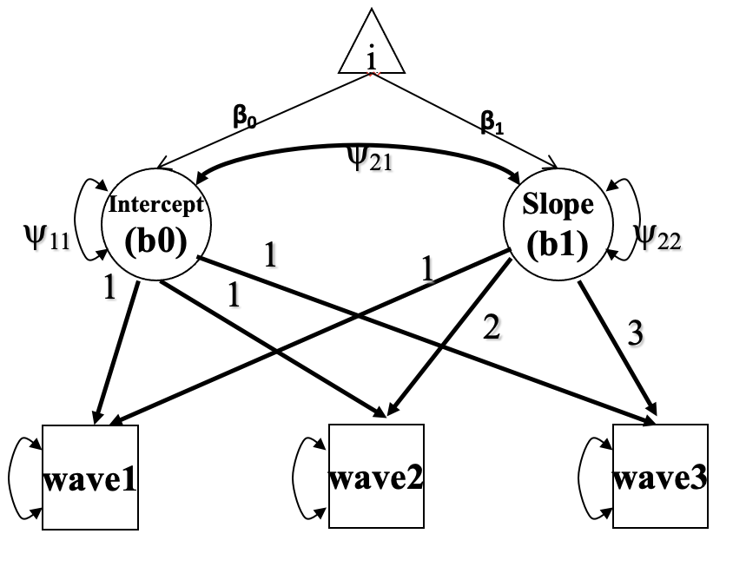
Note: i represents variables at interests, including attachment security with mother, emotion regulation in anger, emotion regulation in sadness, and friendship jealousy in girls.

Figure 2.
Structural Equation Modeling to Test the Relationship Among Parental Attachment Security, Emotion Regulation in General, and Friendship Jealousy.
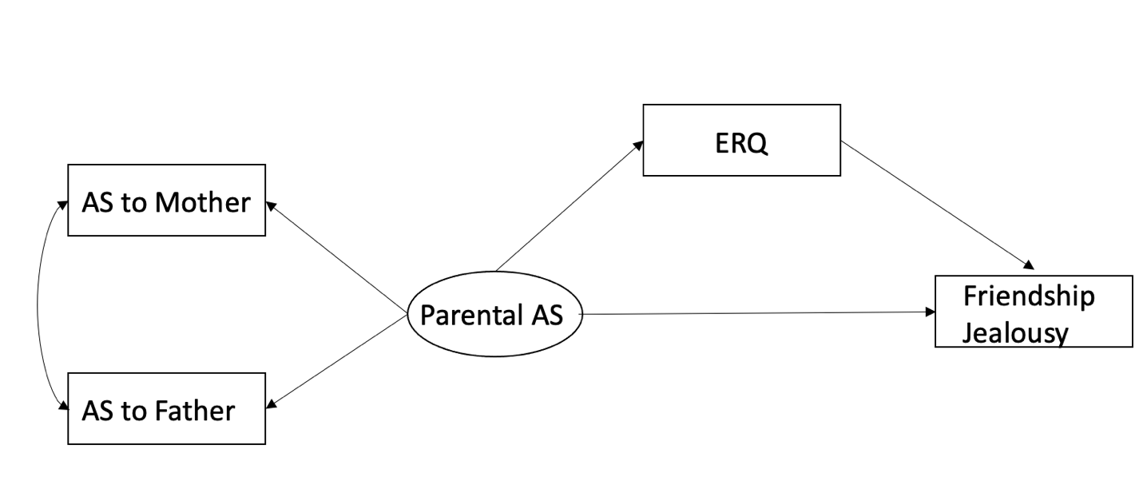

Figure 3.
Structural Equation Modeling to Test the Relationship Among Attachment Security with Close Friends, Emotion Regulation in General, and Friendship Jealousy.

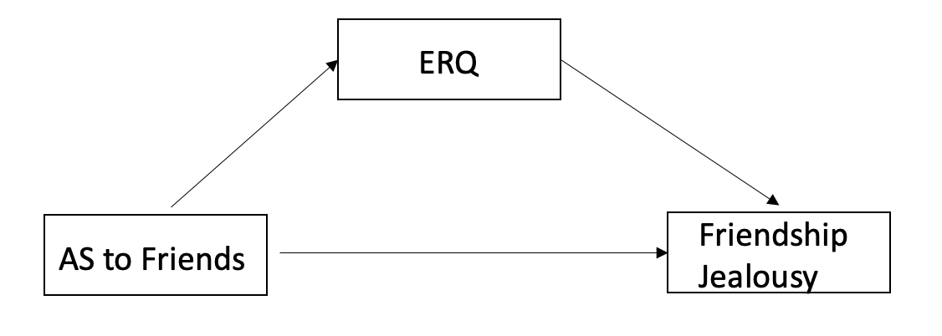

Figure 4.
Structural Equation Modeling to Test the Relationship Among Parental Attachment Security, Emotion Regulation in Anger and Sadness, and Friendship Jealousy.
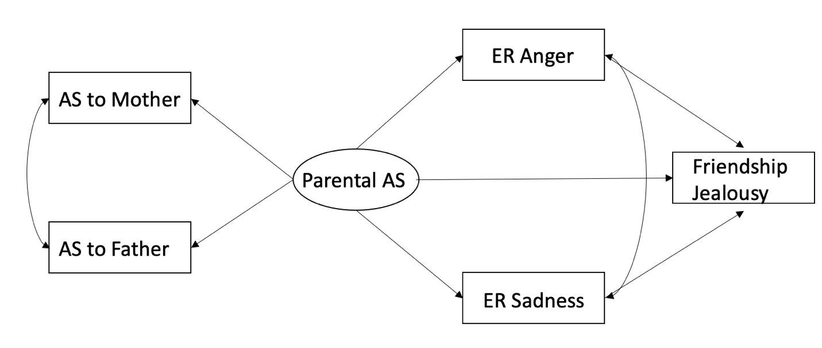

Figure 5.
Structural Equation Modeling to Test the Relationship Among Attachment Security to Close Friends, Emotion Regulation in Anger and Sadness, and Friendship Jealousy.
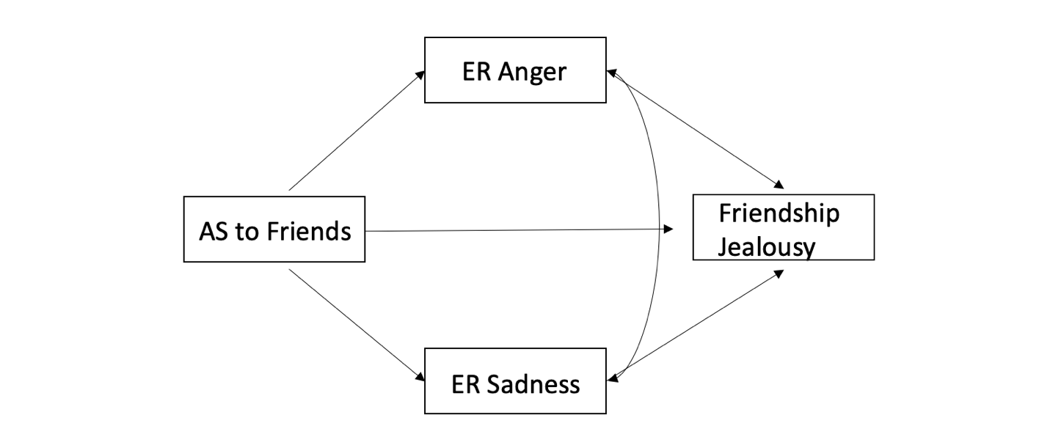

Figure 6.
Confirmatory Factor Analysis Model of IPPA-Mother.

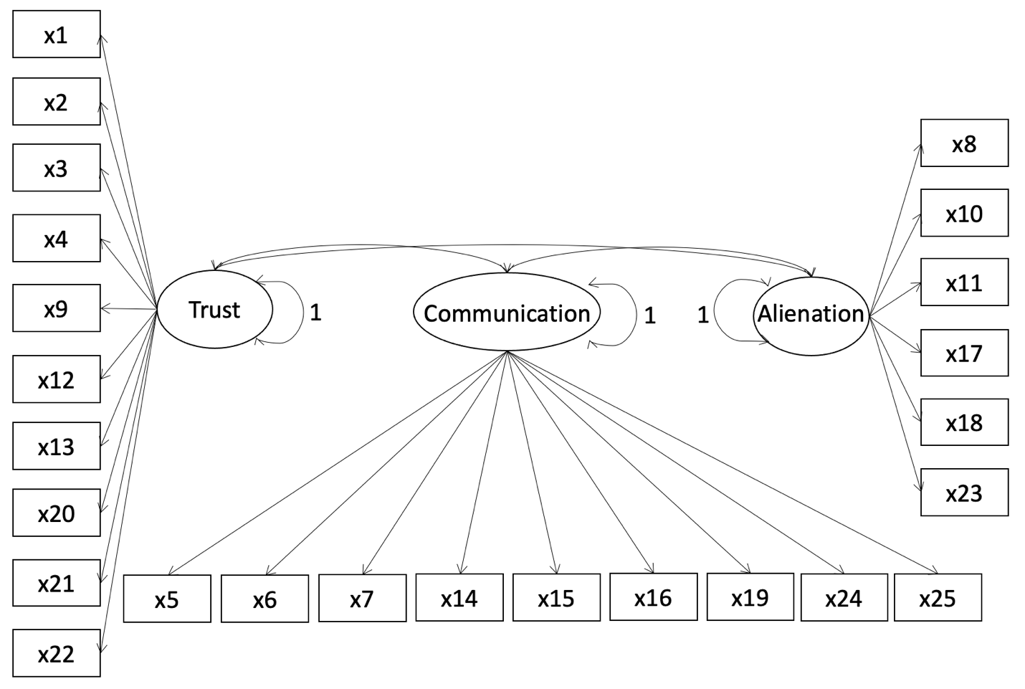

Figure 7.
Confirmatory Factor Analysis Model of IPPA-Father.

Figure 8.
Confirmatory Factor Analysis Model of IPPA-Close Friends.

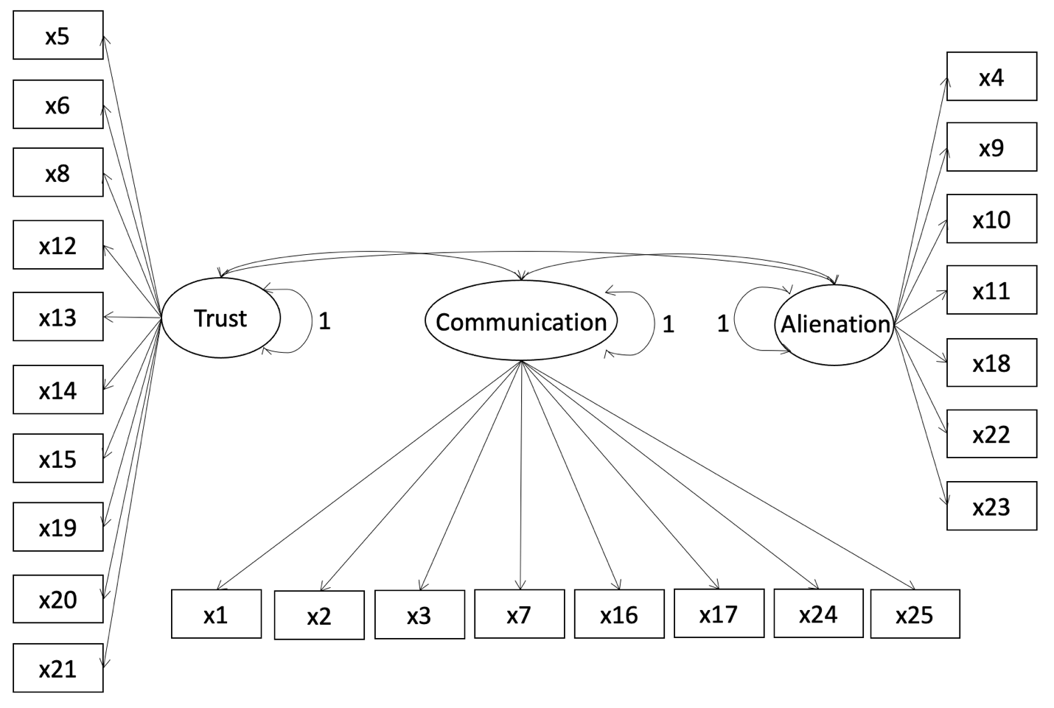

Figure 9.
Confirmatory Factor Analysis Model of CAMS.

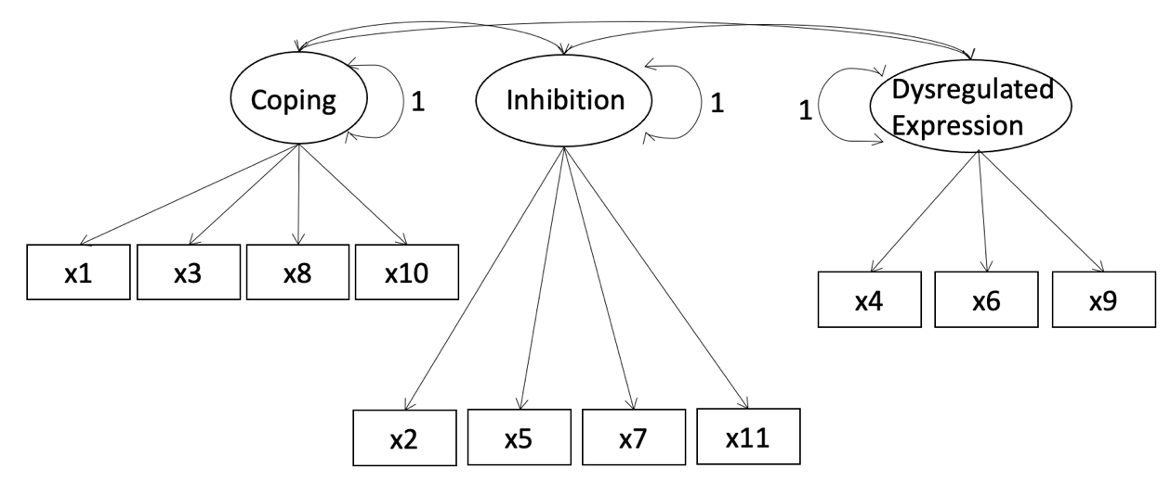

Figure 10.
Confirmatory Factor Analysis Model of CSMS.

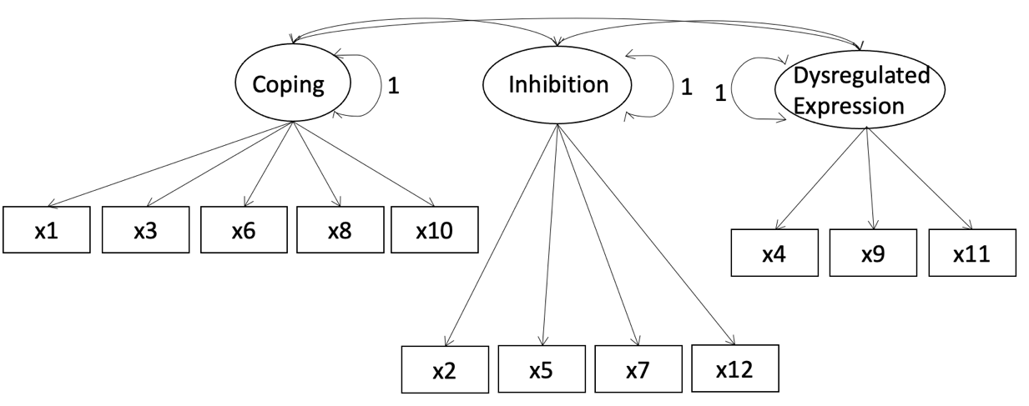

Figure 11.
Confirmatory Factor Analysis Model of FJQ.

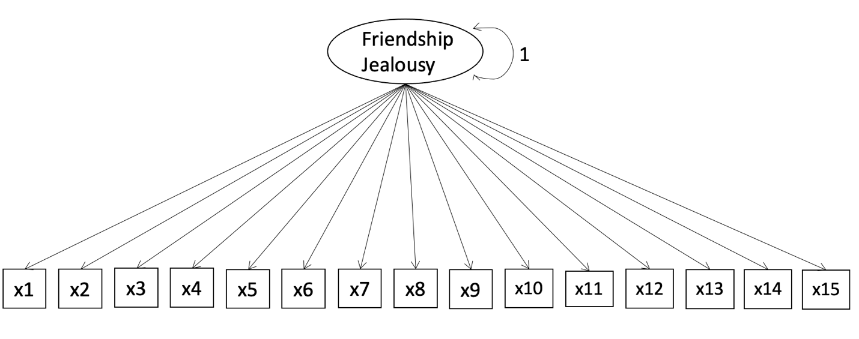

Figure 12.
Structural Equation Modeling to Test the Relationship Among Parental Attachment Security, Emotion Regulation in General, and Friendship Jealousy at Time 1.
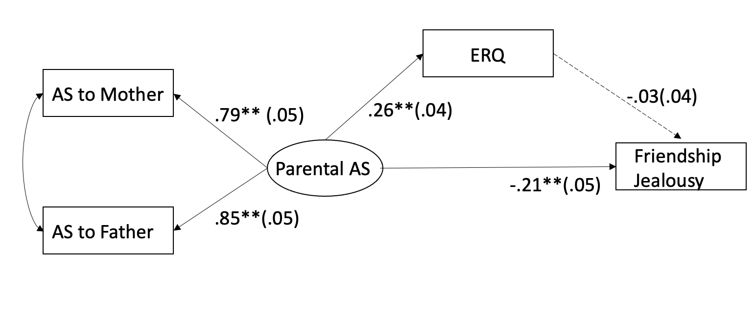

Figure 13.
Structural Equation Modeling to Test the Relationship Among Parental Attachment Security, Emotion Regulation in General, and Friendship Jealousy by Gender at Time 1.

Boys:
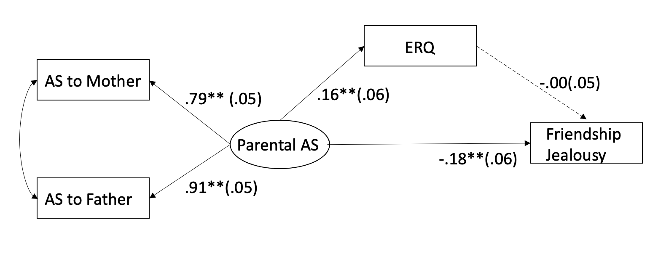
Girls:
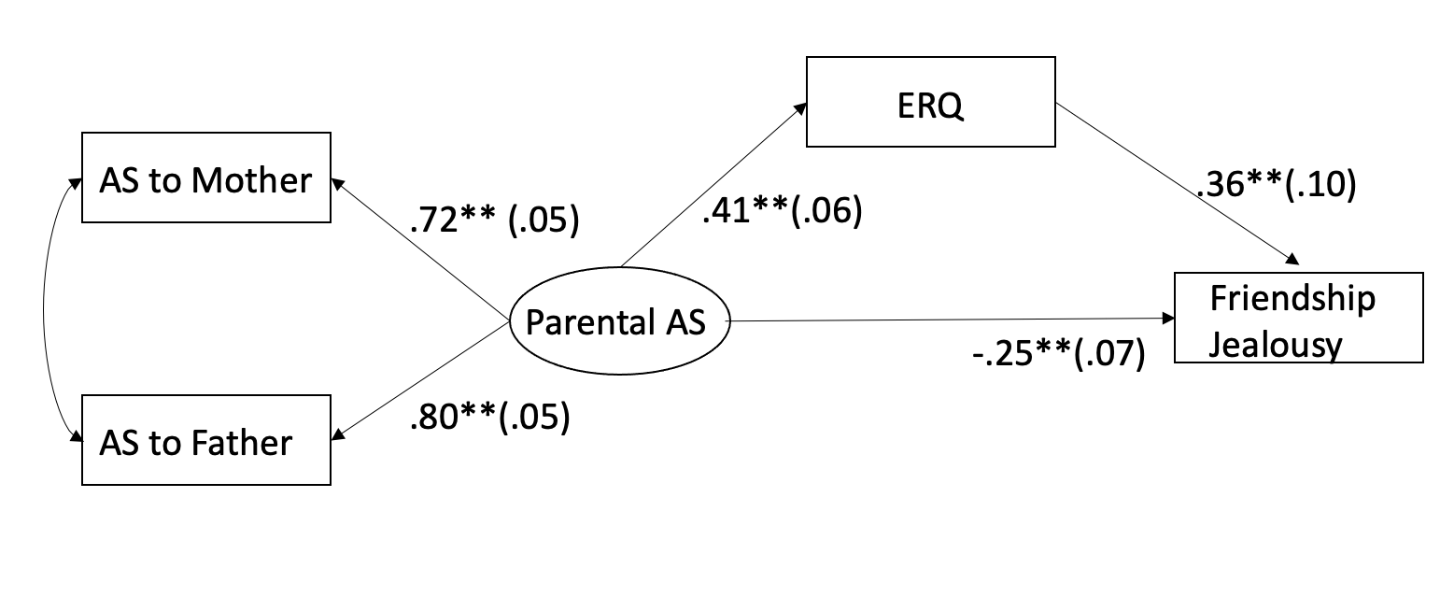

Figure 14.
Structural Equation Modeling to Test the Relationship Among Parental Attachment Security, Emotion Regulation in General, and Friendship Jealousy at Time 2.
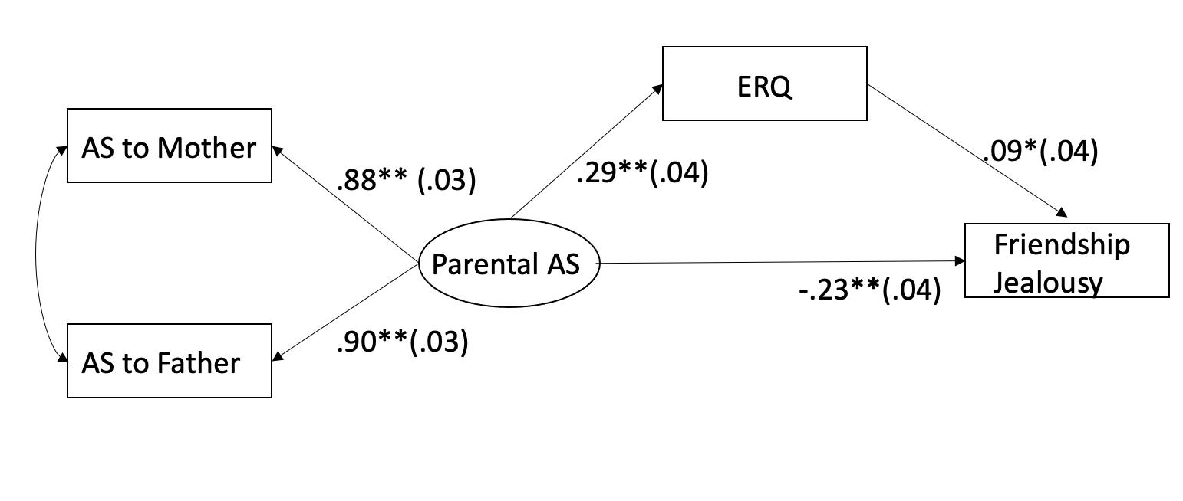

Figure 15.
Structural Equation Modeling to Test the Relationship Among Parental Attachment Security, Emotion Regulation in General, and Friendship Jealousy by Gender at Time 2.

Boys:
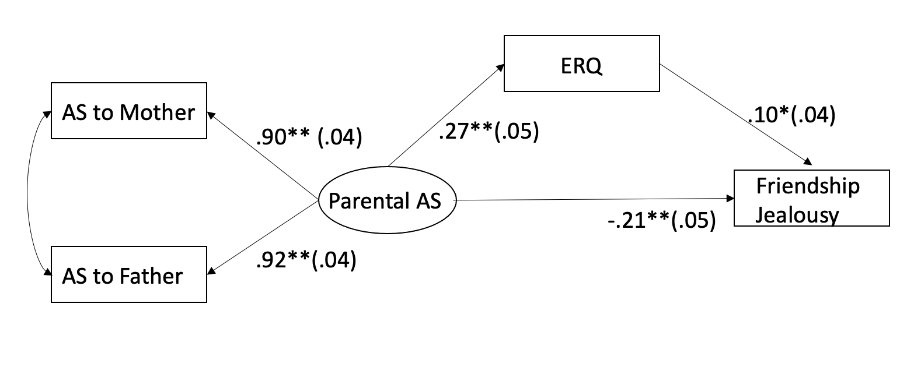
Girls:
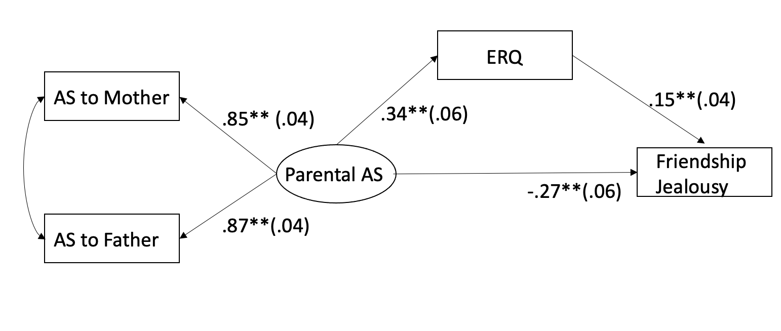

Figure 16.
Structural Equation Modeling to Test the Relationship Among Parental Attachment Security, Emotion Regulation in General, and Friendship Jealousy at Time 3.
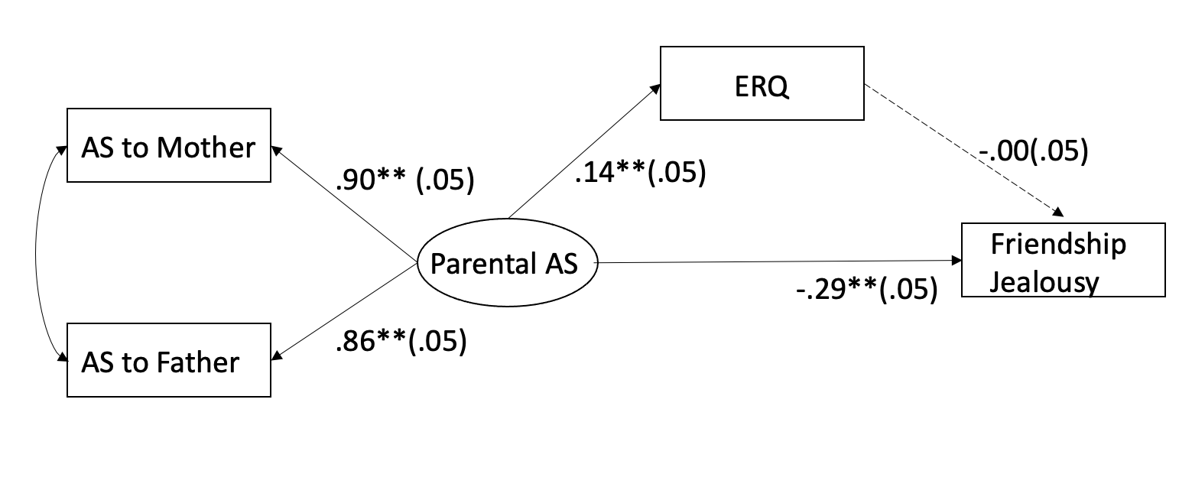

Figure 17.
Structural Equation Modeling to Test the Relationship Among Parental Attachment Security, Emotion Regulation in General, and Friendship Jealousy by Gender at Time 3.

Boys:
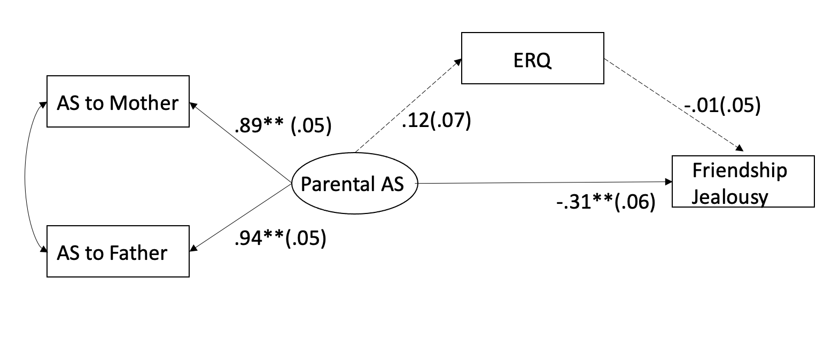
Girls:
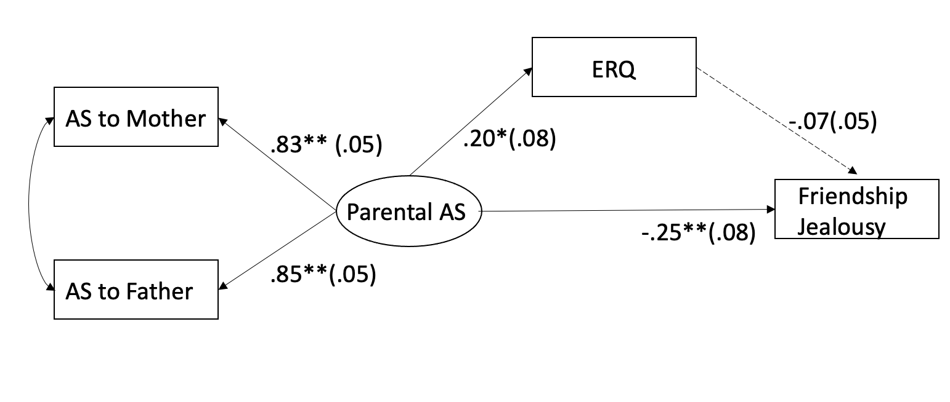
Figure 18.
Structural Equation Modeling to Test the Relationship Among Parental Attachment Security at Time 1, Emotion Regulation in General at Time 2, and Friendship Jealousy at Time 3.
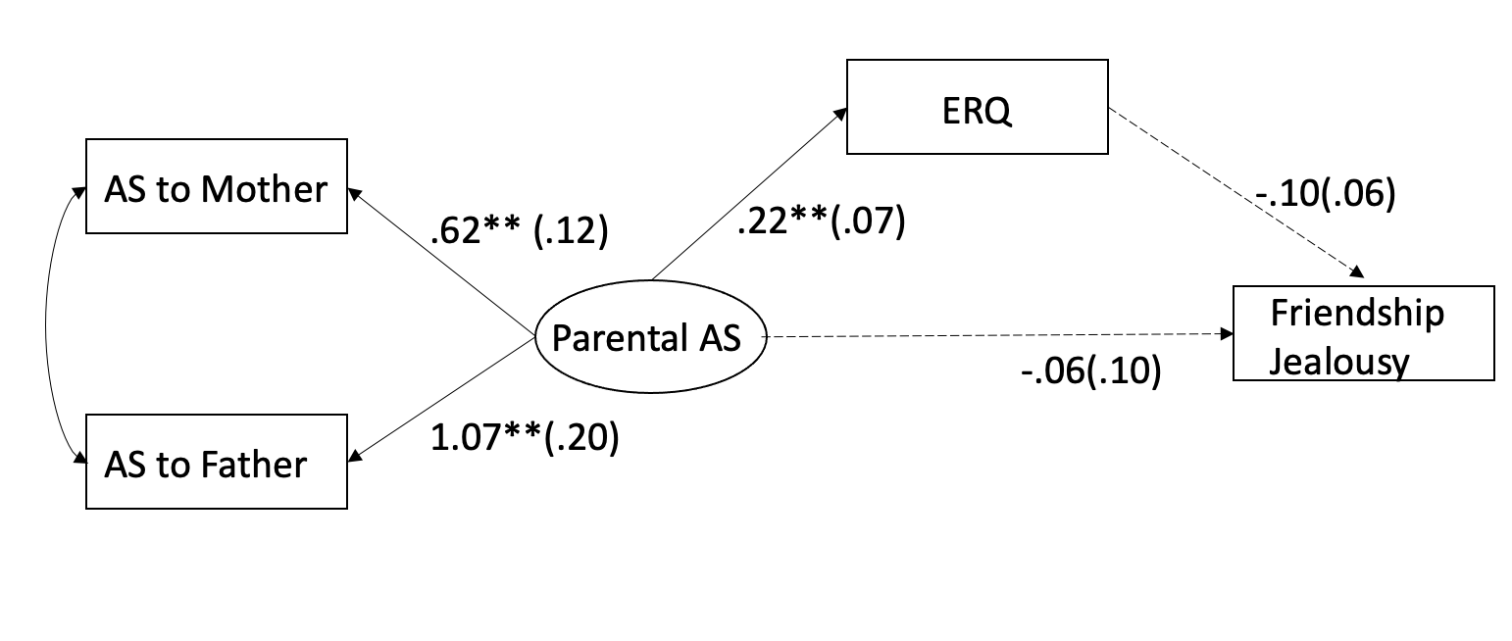
Figure 19.
Structural Equation Modeling to Test the Relationship Among Parental Attachment Security at Time 1, Emotion Regulation in General at Time 2, and Friendship Jealousy at Time 3 by Gender.

Boys:
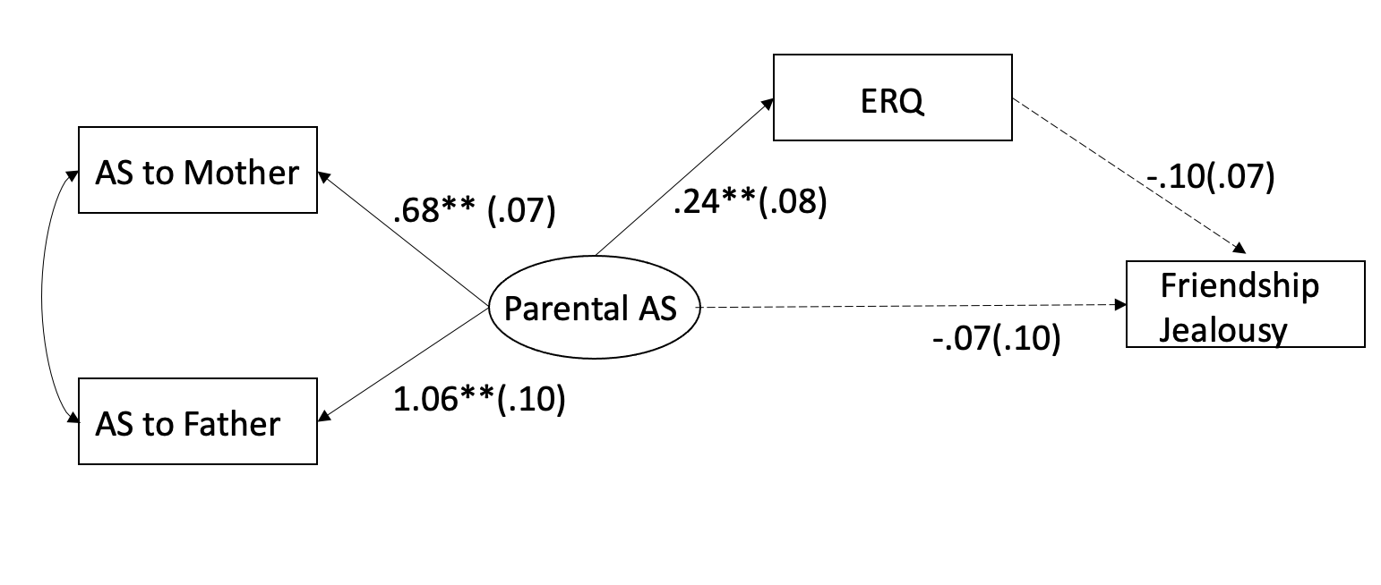
Girls:
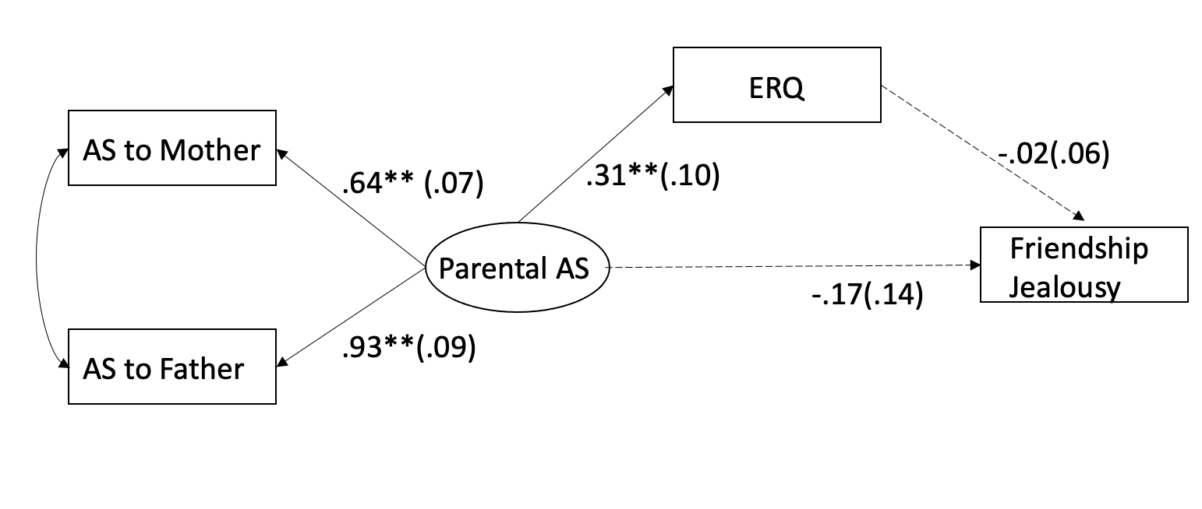

Figure 20.
Structural Equation Modeling to Test the Relationship Among Attachment Security with Close Friends, Emotion Regulation in General, and Friendship Jealousy at Time 1.

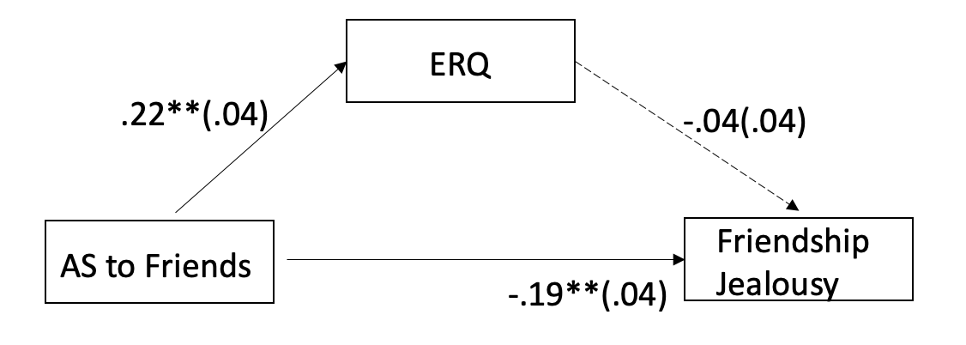

Figure 21.
Structural Equation Modeling to Test the Relationship Among Attachment Security with Close Friends, Emotion Regulation in General, and Friendship Jealousy by Gender at Time 1.

Boys:
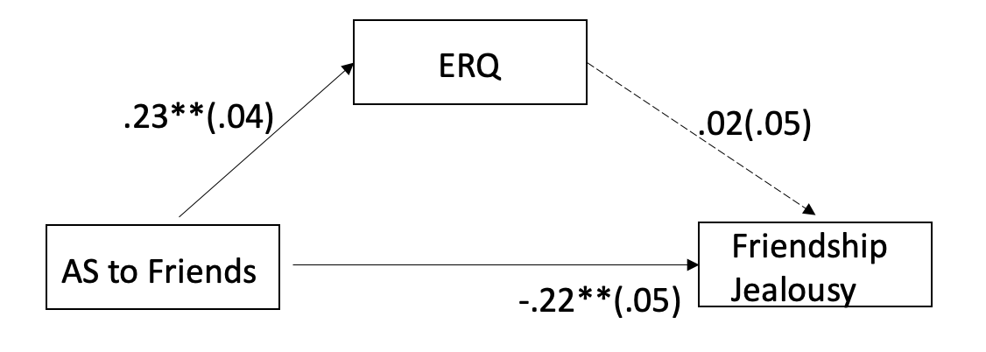
Girls:
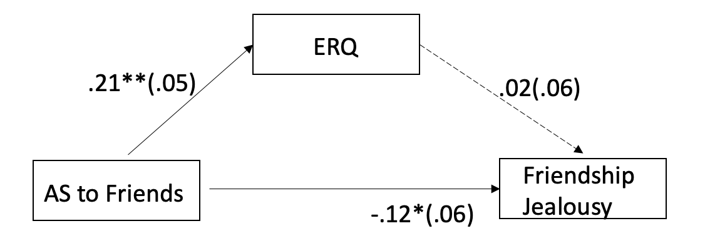

Figure 22.
Structural Equation Modeling to Test the Relationship Among Attachment Security with Close Friends, Emotion Regulation in General, and Friendship Jealousy at Time 2.

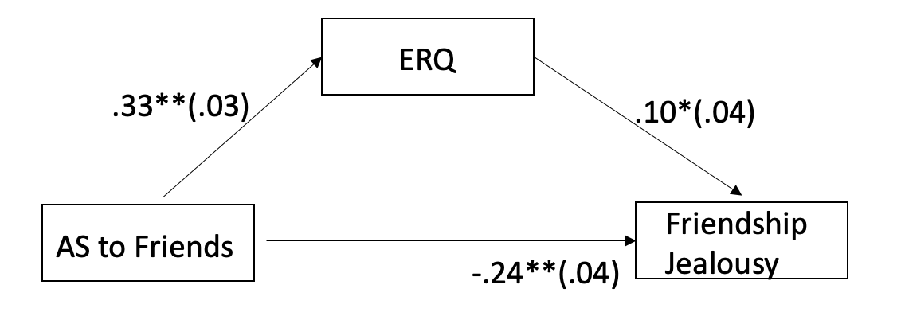

Figure 23.
Structural Equation Modeling to Test the Relationship Among Attachment Security with Close Friends, Emotion Regulation in General, and Friendship Jealousy by Gender at Time 2.

Boys:
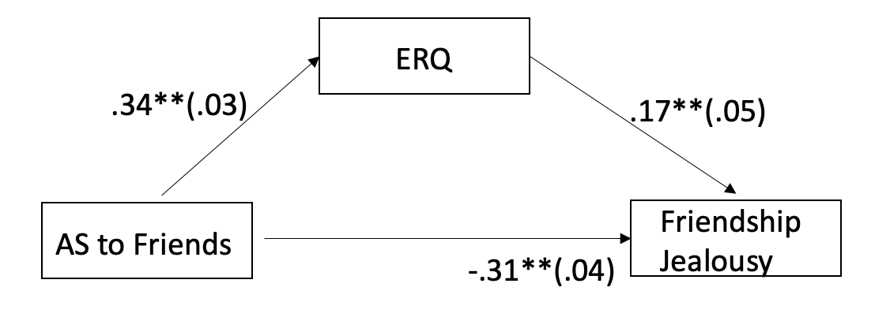
Girls:
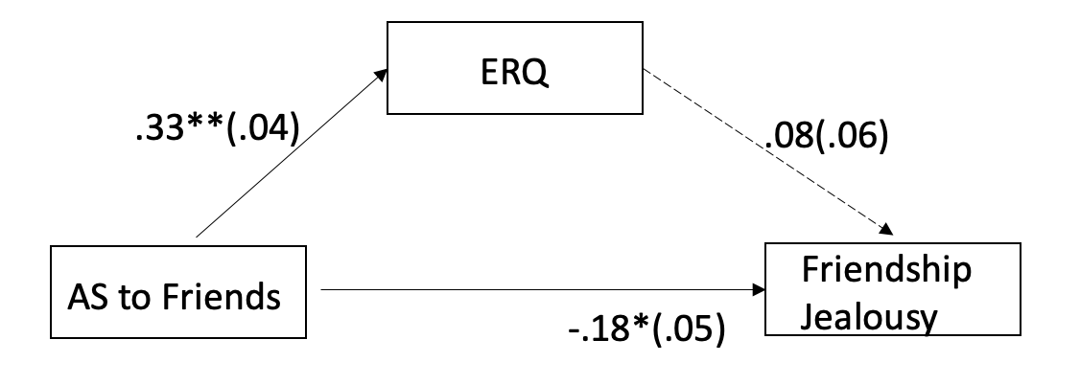

Figure 24.
Structural Equation Modeling to Test the Relationship Among Attachment Security with Close Friends, Emotion Regulation in General, and Friendship Jealousy at Time 3.

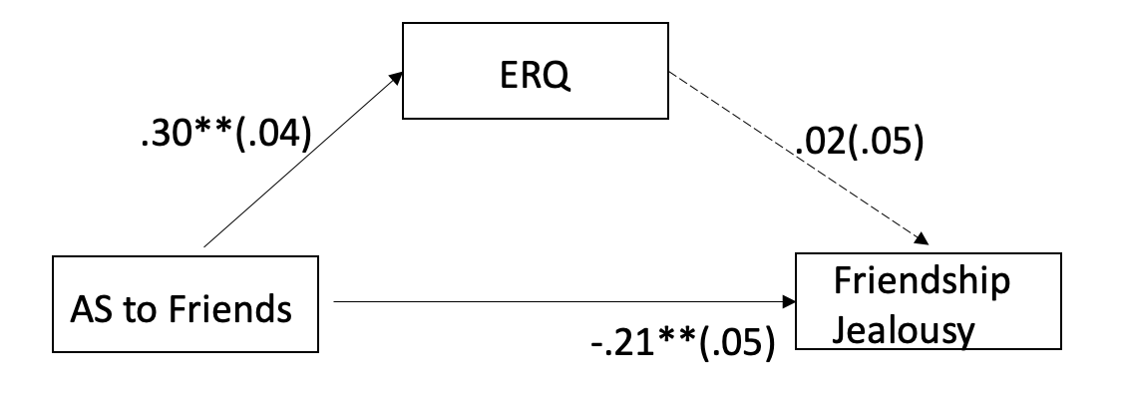

Figure 25.
Structural Equation Modeling to Test the Relationship Among Attachment Security with Close Friends, Emotion Regulation in General, and Friendship Jealousy by Gender at Time 3.

Boys:
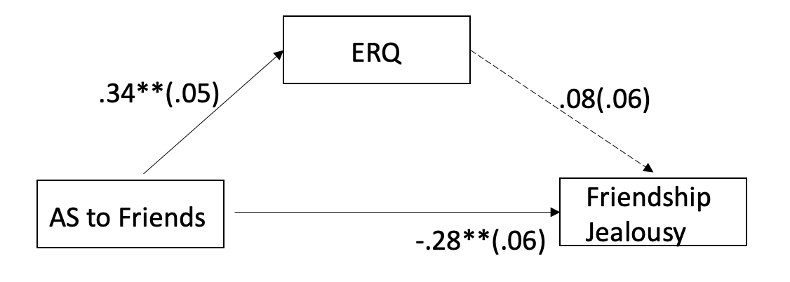
Girls:
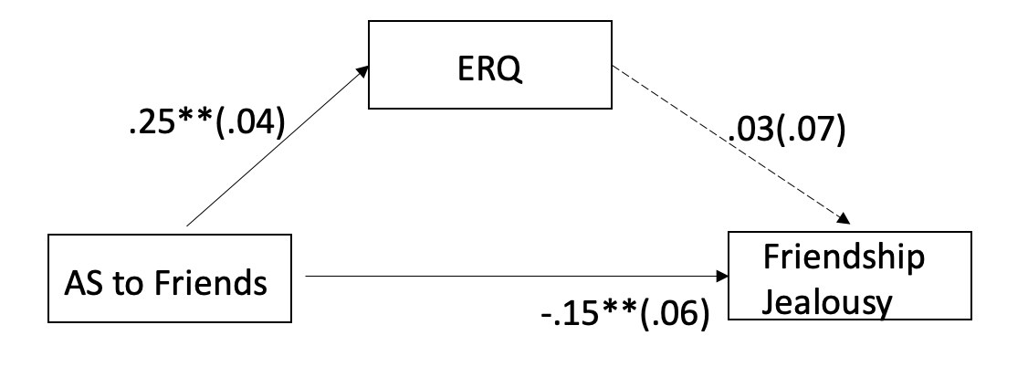

Figure 26.
Structural Equation Modeling to Test the Relationship Among Attachment Security with Close Friends at Time 1, Emotion Regulation in General at Time 2, and Friendship Jealousy at Time 3.

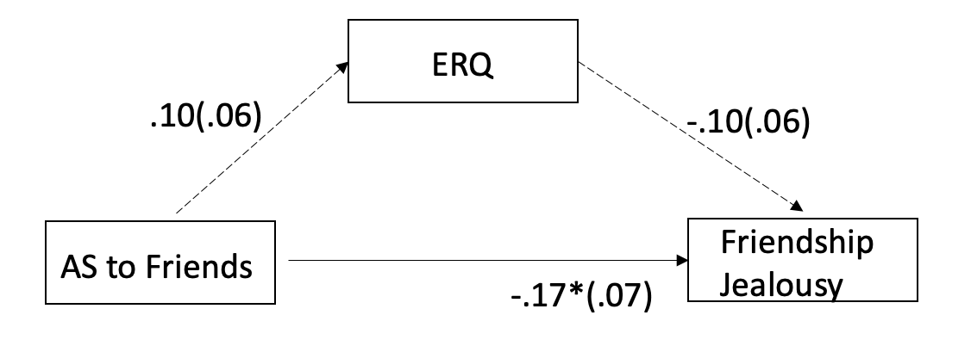

Figure 27.
Grade Differences in Boys’ and Girls’ Friendship Jealousy from Parker, Kruse, and Aikins (2010).

