University of Oklahoma

Graduate College

the effects of a carbohydrate mouth rinse on central and peripheral fatigue following high and low intensity fatiguing exercise

A thesis

submitted to the Graduate Faculty

in partial fulfillment of the requirements for the

Degree of

Master of Science

By

Kody R. haskins
Norman, Oklahoma
2018

the effects of a carbohydrate mouth rinse on central and peripheral fatigue following high and low intensity fatiguing exercise

A thesis approved for the
Department of Health and Exercise Science

By

______________________________
Dr. Chris D. Black, Chair

______________________________
Dr. Rebecca D. Larson

______________________________
Dr. Michael G. Bemben

© Copyright by Kody R. Haskins 2018
All Rights Reserved.

TABLE OF CONTENTS
List of Tables ………………………………………………………..…………………vi
List of Figures …………………………………………………..…………………….vii
Abstract ……………………………………..………………………………………..viii
Chapter I: Introduction ………………………………………….……………………1
Background Information ...…………………………………..……………………1
Purpose …………………………………………………………..…………………4
Primary Question ………………………………………………………………….4
Sub-Questions …………………………………………………..………………….5
Primary Hypothesis ……………………..………………….….…………………..5
Secondary Hypotheses …………………………………….….……………………5
Significance of the Study ………………………………….….……………………5
Delimitations …………………………………………………….…………………6
Limitations …………………………………………………….…………………...6
Assumptions …………………………………………………..……………………6
Operational Definitions ………………………………………..…………………..7
Chapter II: Review of Literature …………………………………..…………………8
CHO Mouth Rinse Effects on Aerobic Exercise …………………………..……..9
CHO Mouth Rinse Effects on Maximal Muscular Strength and Endurance....14
Chapter III: Methodology ………………………………….………………………..19
Participants …………………………………….…………………………………19
Experimental Design ……………………………….…………………………….19
Assessment of Resting Twitch Torque …………………….….…………………20
Assessment of Maximal Voluntary Isometric Strength …………………….….21
Fatiguing Exercise and Mouth Rinse Administration …………………….…...21
Statistical Analysis ………………………….………….…………………………22
Chapter IV: Results ……………………………….……….…………………………23
Group Characteristics …………………………..………………………………..23
MVC ………………………..……………………………………………………...23
Voluntary Activation Percentage ……………………………..…………………27
Twitch Torque ……………………………….…………………………………...28
Rate of Torque Development …………………………….…….………………...30
Rate of Torque Relaxation …………………………….….……………………...31
Chapter V: Discussion ………………………………………..………………………34
Conclusion …………………………………….……….………………………….37
References ……………………………………………….……………………………38
Appendix A: IRB Approval Letter ……………………………………….…………41
Appendix B: Informed Consent Form …………………………………..…………..42
Appendix C: Health Status Questionnaire ……………………………..…………...46
Appendix D: HIPAA ………………………………….……………………………...48
Appendix E: Physical Activity Readiness Questionnaire ………………….………51
Appendix F: International Physical Activity Questionnaire ………..……………..53

LIST OF TABLES
Table 1: Mean maximal isometric torque, voluntary activation, twitch torque, rate of torque development, rate of torque relaxation for both PLA and CHO conditions prior to and following fatiguing exercise at 20% and 80% of MVC…………..……………….26

LIST OF FIGURES
Figure 1: Mean maximal voluntary isometric strength collapsed across PLA and CHO conditions prior to and following fatiguing exercise at 20% and 80% of MVC……….25

Figure 2: Mean voluntary activation collapsed across PLA and CHO conditions prior to and following fatiguing exercise at 20% and 80% of MVC………………………..….28

Figure 3: Mean twitch torque collapsed across PLA and CHO conditions prior to and following fatiguing exercise at 20% and 80% of MVC…………….………………….29

Figure 4: Mean rate of torque development collapsed across PLA and CHO conditions prior to and following fatiguing exercise at 20% and 80% of MVC…………..……….31

Figure 5: Mean rate of torque relaxation collapsed across PLA and CHO conditions prior to and following fatiguing exercise at 20% and 80% of MVC………..………….33

ABSTRACT
Fatigue is the primary cause of the decline in performance during exercise. A carbohydrate (CHO) mouth rinse has been shown to have a beneficial effect during long duration, aerobic exercise. However, the effects of a CHO mouth rinse on resistance exercise is not well understood. PURPOSE: The primary purpose of this study was to determine the effects of a CHO mouth rinse on torque production and voluntary activation following high and low intensity isometric exercise performed to fatigue. METHODS: A total of 11 participants were recruited for this study who were all physically active. Each participant completed 6 visits, with 2 visits of familiarization, and 4 testing visits. A total of 9 maximal isometric contractions (MVC) were performed each visit. Three were performed prior to a high or a low-intensity fatiguing protocol. Three more were performed immediately after a fatiguing protocol and rinsing the mouth with either a CHO solution or placebo. The final 3 MVC’s were performed 5 minutes following the mouth rinsing. RESULTS: There were no significant interactions (p=0.31) between exercise intensity, time, and rinse condition on maximal torque. A significant intensity x time interaction (p = 0.004) on maximal torque was found. All six post-fatigue MVC’s were found to be significantly reduced over time following both the 20% (p < 0.003) and 80% (p < 0.01) fatiguing intensities. The 5-minute post fatigue MVC’s were found to be significantly different from the iPost MVC’s (p < 0.001). There were no significant findings for the 3-way interaction (rinse condition x fatigue intensity x time) on VA% (p = 0.59). A significant interaction (p = 0.005) was found for intensity x time. A one-way ANOVA showed a decrease in VA% over time following both the 20% (p < 0.001) and 80% (p = 0.02) fatiguing intensities. A significant main effect for time (p = 0.01) was found on TT. The three-way interaction of rinse condition x fatiguing intensity x time on RTD values was not significant (p = 0.47). The two-way interaction of fatiguing intensity x time was significant (p = 0.01) on RTD. RTD was not significantly different (p = 0.06) at the 20% of MVC fatiguing intensity over time. All six post-fatigue MVC’s were found to be significantly different from Pre (p < 0.03) for the 80% exercise intensity. RTD decreased for all three iPost MVC’s but increased compared to Pre and all iPost (p < 0.001) time points after 5-min of rest after the 80% exercise intensity. A one-way ANOVA showed no differences in RTD between the two exercise intensities for the seven time-points. The three-way interaction of rinse condition x fatiguing intensity x time on RTR values was not significant (p=0.41). The two-way interaction between fatiguing intensity and time on RTR was found to be significant (p = 0.002). When the data across the CHO and PLA conditions were collapsed the one-way ANOVA for the 20% fatiguing intensity over time was significant (p < 0.001). RTR in all three iPost time points were reduced in the 20% exercise intensity compared to Pre (p < 0.01) and compared to all three 5-min Post time points (p < 0.001). The three 5-min Post values for RTR were increased compared to Pre (p < 0.01). The one-way ANOVA for the 80% fatiguing intensity over time was significant (p < 0.001). The three initial iPost values for RTR were significantly reduced compared to Pre (p < 0.001) and compared to each of the three 5-min Post values (p < 0.001 for each; Figure 5). The three 5-minute Post values of RFR were not found to be significantly different (p > 0.29) from Pre. When compared between the 20% and 80% fatiguing protocols at each time point RFR values differed between the 20% and 80% protocols at iPost1 (p = 0.001), iPost2 (p = 0.004), iPost3 (p = 0.001), and 5-min Post3 (p = 0.03), but not 5-min Post 1 & 2 (p > 0.08). CONCLUSIONS: We were successful in eliciting both central and peripheral fatigue with our exercise conditions. However, rinsing the mouth with a CHO solution was found to not have a significant effect on maximal torque production or muscle recruitment.

Chapter I
Introduction
Athletes and coaches are always looking for means of improving exercise performance. Endurance exercise performance is determined by a host of physiological characteristics [1], including VO₂ max, cardiac output, muscle fiber type, mitochondrial density, lactate threshold, movement economy, and critical power/velocity. Over the course of an event fatigue may occur and lead to a decline in performance. Fatigue can be broadly categorized into central and peripheral components with central fatigue originating with the central nervous system (CNS) and peripheral fatigue originating within the muscle fibers. Central fatigue is often characterized by a decrease in voluntary activation (%VA) (i.e. recruitment) of muscle fibers that results from impairments within the CNS such as a decreased descending corticomotor output, afferent feedback from muscles as a result of an increased presence of metabolites, muscle pain, and/or a decreased excitation of muscle spindles. Peripheral fatigue results from impairments in ion gradients in the motor axon, decreased acetylcholine release/binding at the NMJ intramuscular factors as well as diminished calcium release from the sarcoplasmic reticulum (SR) leading to fewer cross-bridges.
Endurance athletes typically consume food or beverages rich in carbohydrates (CHO) in an effort to counteract fatigue. CHO ingestion is a well-accepted practice for delaying fatigue and improving performance during exercise lasting greater than an hour. Ingestion of CHO during prolonged exercise acts to maintain blood glucose levels, increase exogenous CHO oxidation, and spares muscle and liver glycogen stores which in turn delays fatigue[2]. CHO ingestion during high-intensity, short duration exercise can improve performance as well. Ingestion of CHO during shorter duration exercise works to improve performance may facilitate improvements in performance via facilitation of CNS function rather than by increasing exogenous CHO oxidation. In a study by Jeukendrup et al. [3], the researchers found an increase in performance by decreasing the time it takes to complete a set amount of work when exercising at a high-intensity despite no increase in exogenous CHO oxidation. Carter et al. [4], found no increase in CHO oxidation rates when infusing CHO into the bloodstream rather than ingestion and no subsequent increase in performance.
It has been suggested that the presence of CHO in the mouth stimulate oral receptors and in turn the regions of the brain associated with motivation, arousal, and motor control [5]. Thus, it has been hypothesized that only the presence of carbohydrates in the mouth may be needed to influence the CNS. Using a CHO mouth rinse has been shown to increase time to exhaustion during moderate aerobic exercise [6, 7] . Rollo et al. [8], found that rinsing the mouth with a CHO solution increased the total distance covered by 1.7% compared to a PLA in a 30-minute time trial. Rinsing the mouth with a CHO solution was found to increase performance by 3.7% during a 1-hour time trial in comparison with mouth rinsing with a PLA [9]. The time it took to perform a specific amount of work has been shown to be reduced when rinsing with a CHO solution compared to a PLA [10]. A possible explanation for the increase in performance has been suggested to be a decrease in perceived exertion after rinsing with a CHO solution. However, in many studies ratings of perceived exertion (RPE) were not reduced when rinsing with a CHO solution compared to a placebo (PLA) [5, 8, 9, 11].
The majority of studies that investigated the effects of a CHO mouth rinse during long-duration aerobic exercise performance rather than shorter term strength and power exercise. Some studies have shown CHO mouth rinsing improves short term sprint performance [11, 12] while others have found no effect [13-16]. Similarly, equivocal results have been shown in relation to resistance exercise. CHO mouth rinsing has been shown to increase in maximal strength [17] and repetitions to failure [18] and to offset the decline in maximal strength following fatiguing exercise [19]. Conversely, others have shown CHO mouth rinsing to have no beneficial effects on maximal strength [20-22] be it 1-RM, maximal isometric strength (MVC), or multiple dynamic contractions to failure [20-22]. Jensen et al. [19] suggested the lack of effect of CHO mouth rinsing on strength/power performance, when clear improvements are observed during longer term endurance exercise, may be related to a lack of the presence of central fatigue when maximal strength, repetitions to failure, and sprint performance were assessed. If CHO mouth rinsing works via a central mechanism, then it would likely only improve performance when a central deficit is present.
In an effort to test this supposition, Jensen et al. [19] assessed the effects of CHO rinsing on maximal strength after holding an isometric contraction at 50% MVC to fatigue—hoping to induce central fatigue. CHO rinsing reduced the decline in MVC by 3% after fatiguing exercise compared to a PLA. However, EMG analysis showed no differences in net neuromuscular activation between the CHO and the PLA conditions. This finding suggests that central drive to the muscle was similar and the differences in post-fatigue strength were not due to an influence on the CNS, but rather CHO may have exerted a peripheral effect—however implausible that was. In an attempt to further clarify this finding Black et al. [23] used a similar study design and measured voluntary activation and resting twitch torque to more precisely quantify central and/or peripheral contributions to strength. They found CHO rinsing had no effect on maximal strength, voluntary activation, or resting twitch torque following a fatiguing contraction held at 50% MVC to failure. Furthermore, there were no decrements in voluntary activation following the fatiguing exercise protocol. This suggests a lack of central fatigue which may account for the lack of effect of CHO rinsing on strength performance.
Previous research has demonstrated an inverse relationship between contraction intensity and the presence of central fatigue. When exercise is performed at an intensity above 35-45% of MVC, declines in voluntary activation have been minimal [24, 25]. As such, inducing central fatigue by altering the relative intensity of fatiguing exercise could provide further insight into the effects of CHO rinsing on short term strength performance.
Purpose of the Study
The primary purpose of this study was to compare the effects of a carbohydrate mouth rinse on torque production and voluntary activation following fatiguing exercise designed to induce high (20% of MVC) and low (80% of MVC) levels of central fatigue.
Primary Question
- Does CHO mouth rinsing, compared to a placebo (PLA) attenuate the decline in maximal torque and voluntary activation following fatiguing isometric exercise to a greater extent when greater amounts of central, rather than peripheral fatigue are present?
Sub-Questions
- Does CHO mouth rinsing alter markers of peripheral fatigue?
- Does high (80% of MVC) and low (20% of MVC) intensity isometric exercise alter markers of central and peripheral fatigue in a similar manner?
Primary Hypothesis
- A CHO mouth rinse will attenuate the decline in MVC and VA% following exercise at 20% of MVC, but not following exercise at 80% of MVC.
Secondary Hypotheses
- CHO mouth rinsing will not alter markers of peripheral fatigue (twitch torque, rate of torque development and relaxation) following either exercise bout.
- Exercise at 20% of MVC will induce greater declines in MVC VA% compared to exercise at 80% of MVC.
- Exercise at 20% of MVC will evoke similar declines in markers of peripheral fatigue (twitch torque, rate of torque development and relaxation) compared to exercise at 80% of MVC.
Significance of the Study
There is current research on the effects of a carbohydrate mouth rinse on high and low intensity aerobic training. Little research has been performed on the effects a mouth rinse has on resistance exercise. More research is needed to understand how the presence of CHO in the mouth can affect force production following the onset of fatigue. If evidence is found supporting the theory that CHO presence in the mouth can attenuate fatigue it can give an alternate solution to increase performance at the onset of fatigue.
Delimitations
- Participants were physically active male individuals between the ages of 18 and 30 years.
- Participants were free of neuromuscular and musculoskeletal disorders.
- Participants had no recent (within the previous 6 months) injuries to their knee extensors of their dominant leg.
Limitations
- The study may not be generalizable to populations other than physically active male individuals.
- Participants may not have given his best/maximal effort.
- Results are only generalizable to the knee extensor muscle group
- Results are only generalizable to an 8% CHO mouth rinse solution
Assumptions
- Each participant gave his best/maximal effort.
- The muscle stimulation electrodes were placed properly.
- The equipment was calibrated and functioning properly.
- Each participant performed the muscle action with proper form.
- The participants answered the health screening truthfully.
Operational Definitions
- Isometric Contraction—A muscle contraction where force is produced with no change in muscle length or joint angle.
- Maximal Voluntary Contraction (MVC)—The maximal force produced by a muscle during an isometric contraction.
- Voluntary Activation (%VA)—The level of neural drive from the CNS which assesses the completeness of skeletal muscle activation during a voluntary contraction [26].
- Twitch Torque—The force produced by a muscle from a single evoked twitch.
- Interpolated Twitch Technique—A procedure used to determine %VA by comparing superimposed twitch torque evoked during a voluntary contraction to the resting twitch torque evoked from a relaxed muscle.
- Carbohydrate mouth rinse—A solution of distilled water, 8% maltodextrin, and .2% sucralose that is rinsed throughout the mouth and expelled after 20 seconds.
- Placebo—A solution of water and artificial sweetener meant to have no therapeutic effect but act as a control for comparison of exercise conditions.
- Fatigue—A failure to maintain the required or expected force [27].

Chapter II
Review of Literature
Introduction
The primary purpose of this study is to determine the effects of a carbohydrate mouth rinse on torque production and voluntary activation following high and low-intensity isometric exercise performed to fatigue. It is well established that CHO ingestion during exercise bouts lasting longer than an hour can increase performance. There is still debate on the efficacy of ingesting CHO during shorter duration exercise due to the little to no increase in the exogenous oxidation of CHO but some research has shown that supplementing with CHO during shorter duration exercise can improve performance. Rather than increasing the oxidation of CHO, ingestion during short duration exercise possibly works to improve central drive. Most studies investigating the effects of a CHO mouth rinse on resistance exercise have found that it has little positive effect.
The potential findings of this study could help us better understand why mouth rinsing with a CHO solution often has a positive effect on long duration exercise and what role it could play in delaying fatigue. This chapter will be used to review previous literature concerning the effects of a CHO mouth rinse on moderate and high-intensity aerobic exercise performance and also its influences on resistance exercise.

Carbohydrate Mouth Rinse Effects on Aerobic Exercise
Bastos-Silva et al. (2016)
The purpose of this study was to investigate the effects of a CHO mouth rinse on %VA, and time to exhaustion during both moderate and high-intensity aerobic exercise. On the first visit the participants’ maximal oxygen uptake (VO_{2max}) and peak power output (PPO) were determined. The high-intensity exercise tests were performed at 110% of PPO and the moderate-intensity exercise tests were performed at 80% of the subjects’ respiratory compensation point. The mouth rinses were administered before and every 15 minutes until exhaustion during both exercising conditions. EMG analysis was used to assess %VA in the vastus lateralis (VL) and rectus femoris (RF).
Time to exhaustion was significantly increased in the moderate-intensity exercise test when mouth rinsing with the CHO solution in comparison to the PLA trial by about 11 minutes. EMG analysis showed an increase in muscle activity for the VL at the 30-minute mark and at exhaustion during the moderate-intensity exercise test. However, no differences in EMG activity were found between the CHO and PLA trials for the RF. No differences were found between the CHO and PLA trials for either time to exhaustion or %VA during the high-intensity exercise tests.
Rollo et al. (2008)
The primary purpose of this study was to determine the effects of a CHO mouth rinse on self-selected treadmill running speeds. Ten endurance-trained individuals completed a 30-minute treadmill run at a speed they selected equivocal to an RPE of 15. VO_{2max} was determined on the first visit and the subjects were familiarized with the testing protocol on the second. The following two experimental visits the participants performed the 30-minute treadmill run and mouth rinsing with either the CHO solution or PLA every 5-minutes during the test.
Running speed and distance covered were significantly greater following rinsing with the CHO solution compared to rinsing with the PLA in the first 5-minute interval of the test. Running speed and distance covered in the other 5-minute intervals were not found to be significantly different but overall there was a significant increase (1.7%) in the distance covered following the 30-minute test.
Fraga et al. (2015)
The researchers’ purpose for this study was to determine if rinsing the mouth with a CHO mixture could increase exercise time to exhaustion when running at an intensity equal to 85% of the subject’s VO_{2max}. Each subject reported to the lab on four separate occasions, the first being to determine VO_{2max}, and the following three the experimental visits. Each subject performed the same test while either rinsing their mouth with a CHO mixture or a PLA, or ingesting a CHO drink.
Both ingesting and rinsing the mouth with a CHO mixture was found to increase running time by 29% compared to mouth rinsing with the PLA. The increase in performance when rinsing the mouth without ingestion of the CHO mixture suggests that there could be a central mechanism involved.

Pottier et al. (2009)
The primary purpose of this study was to examine the effects of ingestion and rinsing the mouth with a CHO mixture on a high-intensity 1-hour time trial on a cycle ergometer. This study consisted of 6 visits to the lab with the first visit having the subjects perform a stepwise incremental VO_{2max} test. The second visit was to familiarize the subjects with the testing protocol where they performed work equal to 1 hour of cycling as quickly as possible. The following four visits the subjects performed the same protocol as in the second visit but with either ingesting or mouth rinsing with a PLA or CHO solution.
The results of the study showed a statistically significant 3.7% decrease in completion time coupled with an increase in mean power output when mouth rinsing with the CHO solution in comparison to rinsing with the PLA. Performance with the ingestion of the CHO drink was not found to be statistically different than performance when ingesting the PLA.
Krings et al. (2017)
The purpose of this study was to observe the effects of ingestion and rinsing the mouth with a CHO solution on performance during repeat bouts of maximal sprints on a cycle ergometer. The participants completed one familiarization trial and four experimental visits with each subject either rinsing or ingesting a CHO or PLA solution. The sprints performed were five maximal 15-s sprints with four minutes of pedaling at 50 watts intervened between each sprint to promote active recovery. The solutions were given prior to the 5-minute warm-up and 45 seconds before each sprint to either rinse or ingest.
Ingestion of the CHO was found to significantly enhance performance compared to rinsing with the CHO solution. Mouth rinsing with the CHO solution was found to have no significant impact on performance compared to rinsing or ingesting the PLA. A possible reason for the difference between ingestion and rinsing of the CHO solutions given by the authors was due to the amount of time during the active recovery between sprints coupled with the possible increase in exogenous CHO resulting ingestion of the CHO solution.
Jeffers et al. (2015)
The purpose of this study was to determine the effects a CHO mouth rinse has on cycling performance and neural mechanisms following fatigue. On the first visit the participants performed a graded exercise test to determine VO_{2max}. For the two experimental visits the subjects performed a 45-minute cycling preload at 70% maximum power output followed by a 15-minute time trial in which the subjects tried to accomplish as much work as possible. A PLA or CHO mouth rinse was administered prior to and every 7.5 minutes during the initial 45-minute cycling preload. The mouth rinse was also given immediately before and midway through the 15-minute cycling test. MVC was assessed prior to, and immediately after the initial 45-minute test and the 15-minute time trial.
Twitch interpolation was used to help determine %VA and possible fatigue following the 45-minute cycling exercise and the 15-minute cycling test. The electrical stimulation eliciting maximal twitch force was determined prior to any testing. Transcranial magnetic stimulation was used to induce MEP. %VA of muscle and MEP amplitude saw a significant decrease from baseline measures for both experimental conditions suggesting a possible central mechanism for the reduction in MVC post-exercise.
As expected a decrease in MVC occurred following the two cycling protocols in both conditions. However, a significantly greater decrease in MVC was seen when mouth rinsing with the PLA compared to the CHO. No differences were observed between conditions for %VA of muscle suggesting that the attenuated decrease in force production seen after rinsing with the CHO was not due to an increase in central drive.
Summary
Most research concerning the effects of a CHO mouth rinse on aerobic exercise has shown that it can have a positive effect on performance by delaying fatigue and increasing power output. The lack of an increase in exogenous CHO oxidation indicates a possible central mechanism in improving performance but some studies using EMG analysis or twitch interpolation techniques to analyze central drive have not shown much difference between PLA and CHO trials. Most studies investigating the effects on CHO mouth rinsing on aerobic exercise do not employ methods of determining central drive.

Carbohydrate Mouth Rinse Effects on Maximal Muscular Strength and Endurance
Gant et al. (2010)
In this investigation the researchers aimed to determine if CHO ingestion and mouth rinsing had an effect on maximal force production and the motor cortex. This study was separated into two experiments. In the first experiment the researchers compared the effects of ingesting a carbohydrate or PLA drink on maximal force production and motor evoked potentials (MEP). The results showed an immediate significant increase in force production following ingestion of the CHO drink paired with a decrease in force production following ingestion of the PLA. MEP amplitude increased by 30% following ingestion of the CHO drink whereas no change occurred when the PLA was consumed.
For experiment 2 the researchers examined the effects of a CHO mouth rinse on MEP amplitude from the first dorsal interosseous muscle of the right arm. Each subject held three solutions in their mouth while performing either an isometric contraction or resting. Water, a CHO mixture, and a PLA were the three solutions. The CHO mixture elicited a significantly higher MEP amplitude compared to both water and the PLA when voluntarily activating the muscle.
This study provides evidence that CHO ingestion can increase performance by increasing corticomotor excitability. A 9% increase occurred in MEP amplitude during experiment 2 when the muscle was fresh. The 30% increase in MEP amplitude in experiment 1 suggests that CHO has a greater effect when the muscle is fatigued.
Painelli et al. (2011)
The researchers’ purpose of this study was to examine the effects a CHO mouth rinse has on maximum upper body strength and endurance. Subjects were familiarized with the maximum muscle strength (1-RM) and endurance tests on the first two visits to the lab. The next 6 visits were the experimental visits. Each subject was tested three times for maximal strength and muscular endurance. Prior to each test the subjects rinsed their mouths with either a CHO mixture, a PLA, or none at all to be used as a control trial. On visits 3-5, the subjects were tested on their maximal strength and visits 6-8 the subjects performed the muscular endurance test. On the strength endurance testing days, the participants performed 6 sets to failure at an intensity equal to 70% 1-RM.
The results showed that mouth rinsing with the CHO mixture did not increase maximal force production or muscular endurance. This study was performed on resistance trained individuals. The researchers suggest the reasoning for the lack of difference in conditions was because of the high neural activation that resistance trained individuals typically show and propose that untrained subjects might respond better to the increased neural drive as a result of the CHO mouth rinse.
Dunkin & Phillips (2016)
Similar to the study by Painelli et al. (2011), the researchers’ purpose of this study was to determine if mouth rinsing with a CHO solution can improve upper-body muscular strength and endurance. The participants reported to the lab a total of four times. Each visit started with the determination of the participants’ 1-RM with the mouth rinsing occurring prior to the first 1-RM attempt. Following 1-RM assessment each subject mouth rinsed with either the CHO solution or PLA and performed a set to failure at an intensity equal to 40% 1-RM. The subjects were familiarized with the testing procedures and equipment on the first visit.
No significant differences were found between mouth rinsing with the CHO solution, PLA, or the control group for maximal strength, muscular endurance, or total exercise volume.
Clarke et al. (2015)
The purpose of this study was to determine the effects of CHO and caffeine mouth rinses on maximal strength and muscular endurance. The researchers also investigated the effects of a combined CHO and caffeine mouth rinse on muscular strength and endurance. Each subject performed a 1-RM and a set to failure at a weight equivalent to 60% 1-RM on five separate days. Four mouth rinses were used (CHO, PLA, caffeine, and CHO + caffeine) and no mouth rinse was used on the remaining day to serve as a control. Each mouth rinse was washed in the mouth for 10 seconds and expectorated into a container.
No significant results were found between each exercise and mouth rinsing condition. Similar to other studies the researchers found that a CHO mouth rinse has no effect on muscular endurance or 1-RM.
Jensen et al. (2014)
The researchers hypothesized that rinsing the mouth with a CHO solution would increase torque output following a fatiguing protocol. The fatiguing protocol consisted of holding an isometric contraction at 50% of MVC until torque dropped by at least 10% for more than 5 seconds. Prior to performing the fatiguing protocol each subject completed a 15-minute warm-up on a cycle ergometer and then MVC was determined by performing a 5-second maximal isometric contraction 3 times. Following volitional exhaustion, each subject mouth rinsed with either the PLA or CHO solution for 10 seconds and performed 3 post-fatigue MVCs with a 10 second rest between each MVC.
The results of this study showed that force decrement was reduced after mouth rinsing with a CHO solution compared to a PLA following fatigue. A significant difference between CHO mixture and PLA was only found following the first post-fatigue MVC. The authors suggest that CHO mouth rinsing has only a short-lasting effect and might not be beneficial for repeated bouts. No post-fatigue differences were found for surface EMG between experimental conditions suggesting that the attenuation in fatigue following the CHO mouth rinse was not due to central mechanisms.
Black et al. (2018)
In order to replicate the findings of Jensen et al., 2014, this study also performed an isometric contraction at 50% MVC to fatigue to study the effects of a mouth rinse with a CHO solution on maximal force production following fatigue. Instead of using EMG analysis to assess central drive, this study utilized a twitch interpolation protocol to determine motor unit recruitment. The current used to stimulate a maximal muscle twitch was determined prior to each subject’s MVC. Each subject then performed three MVCs to determine the force production that must be held during the fatiguing contraction. Following fatigue, each subject mouth rinsed with either a CHO or PLA solution and again performed three MVCs to determine if a decline in force production or motor unit recruitment occurred.
In contrast to Jensen et al., 2014, the researchers found no difference in force production or motor unit recruitment following rinsing with the CHO solution in comparison with the PLA. These results indicate that little to no change in %VA occurred due to mouth rinsing with CHO solution.
Summary
Much of the research on the effects a CHO mouth rinse has on resistance exercise has been shown to have little to no effect on increasing performance. Most research suggests that central fatigue needs to be present in order to see an increase in performance following mouth rinsing with a CHO solution. The increase in MEP amplitude seen during activation of both fatigued and fresh muscle when mouth rinsing lends credence to the theory that stimulation of oral receptors can influence central drive. An increase in central drive during long duration exercise, when fatigue is often present, improves motor unit recruitment and in turn increases force production. In fresh muscle %VA is often high and an increase in central drive is likely to have little to no effect. More research inducing central fatigue is needed to determine the possible link between CHO mouth rinsing and improving performance.

Chapter III
Methodology
Introduction
The primary purpose of this study was to compare the effects of a carbohydrate mouth rinse on torque production and voluntary activation following fatiguing exercise designed to induce high (20% of MVC) and low (80% of MVC) levels of central fatigue. Research has shown that rinsing the mouth with a CHO mixture improves performance during long-duration endurance exercise. However, mixed results have been found concerning the effect of a mouth rinse on short duration, high-intensity endurance exercise. This chapter will cover the participant description, experimental design, instrument and measurement protocols, and the statistical analysis utilized.
Participants
Eleven individuals between the ages of 18 and 30 years volunteered to participate in this study. Each participant will be physically active but not aerobically trained.
Experimental Design
A randomized, counterbalanced, placebo controlled, cross-over design was used in this study. This study consisted of six visits to the lab. The first two visits were to familiarize the participants with the electrical stimulation protocol and the performance of an MVC using their knee extensors. Four experimental testing sessions were performed in a randomized, counterbalanced order: 1) CHO rinsing following high-intensity exercise (80% of MVC held to fatigue), 2) PLA rinsing following high-intensity exercise, 3) CHO rinsing following low intensity exercise (20% of MVC held to fatigue), and 4) placebo rinsing following low intensity exercise. Each visit was separated by a minimum of 48-hours and performed at approximately the same time of day. The experimental sessions began with the assessment of the participant’s resting twitch torque (TT) and maximal voluntary isometric strength (MVC). Following the assessment of the participant’s TT and MVC, a fatiguing protocol was performed at one of the two intensities. The participants then performed a 20-second mouth rinse with either the CHO mixture or PLA. MVC was reassessed immediately following the mouth rinse and again five minutes post mouth rinse.
Assessment of Resting Twitch Torque
Participants sat on an isokinetic dynamometer with their hip at 90˚ flexion and their knee fixed at an angle of 60˚ below horizontal. Straps were placed around the ankle to attach the lower leg to the lever arm. To record torque production, the lever arm was connected to a force transducer (model SB-500; Transducer Techniques, Temecula, CA). Once the participant was placed in the seat and strapped down, stimulation electrodes (3” x 4”; PALS Platinum; Axelgaard; Fallbrook, CA) were placed on the distal vastus medialis and the proximal vastus lateralis. After the electrodes were placed, TT was determined. Electrical stimulation consisting of paired 0.2 ms pulses with an inter-pulse interval of 10 ms were applied to the quadriceps muscle group beginning with a current of 40 mA. Twenty seconds of rest was given between electrical stimulations and the current was increased by 20 mA for each stimulation. A constant current stimulator (model DS7AH; Digitimer, Hertfordshire, England) controlled by a custom written program using Biopac Acknowledge software v.4.3 was used to apply the electrical stimulation. Stimulations continued in this manner until torque production reached a plateau. The current which elicited a plateau in torque was recorded and used during subsequent stimulations on that specific testing day. This process was repeated for each experimental session.
Assessment of Maximal Voluntary Isometric Strength
Following the assessment of TT, each participant performed three MVCs for a duration of three seconds. A rest period of two minutes occurred between each MVC attempt. A paired-pulse electrical stimulation was applied (using the previously determined current value) to the quadriceps 2.5 seconds into the MVC with participants continuing torque production throughout stimulation. Participants then relaxed their quadriceps muscles and electrical stimulations were applied to the knee extensors 2 and 4 seconds following relaxation. The electrical stimulation eliciting TT was the stimulation applied during and following each MVC. Any observed increase in torque above maximal voluntary effort generated by the electrical stimulation during the contraction was recorded as the interpolated torque (ITT). Voluntary activation (%VA) was calculated for each contraction using the following equation: %VA = 1-(ITT/TT).
Fatiguing Exercise and Mouth Rinse Administration
Following MVC determination the participant received a 3-minute rest period. Each participant then held an isometric contraction equivalent to 20% or 80% of their MVC until volitional exhaustion occurred. Exhaustion was defined as a decline of torque by 10% or more for more than 5 seconds. Participants were provided visual feedback of their torque production during the exercise and received strong verbal encouragement. The participants were shown a line on the computer screen that corresponded with the desired torque output and were instructed to match their torque to this line. Immediately following volitional exhaustion, the participants were given a 25-mL mouth rinse of either the CHO mix or the placebo to rinse in their mouth for 20 seconds and then expel into a container. The CHO rinse consisted of 8% maltodextrin and 0.2% sucralose artificial sweetener. The placebo consisted of water and 0.2% sucralose in order to match the taste of the placebo to the CHO solution.
Statistical Analysis
Statistical analysis was performed using SPSS Statistics version 23.0. A 2 condition (CHO vs PLA) x 2 fatiguing exercise intensity (20% vs. 80%) x 7 time points (Pre, immediately Post rise 1, 2,3 [iPost MVC1, iPost MVC2, iPost MVC3], and 5-minutes post rinse 1, 2, 3 [5 Post MVC1, 5 Post MVC2, 5 Post MVC3]) completely within participant repeated measured ANOVA was used. Main effects were interpreted in the absence of a significant interaction. Post hoc comparisons were performed using LSD correction for multiple comparisons. In the absence of a 3-way interaction, each 2-way interaction was investigated and followed up by 1-way ANOVA’s and LSD corrected analysis for simple effects. The alpha level was set at p = 0.05.

Chapter IV: Results
Group Characteristics
A total of 11 physically active males participated in this study. Overall, the participants in this study were 22.5 + 2.3 years of age with an average height of 183.5 + 6.5 cm and weight of 82.2 + 13.9 kg.
MVC
Values from all conditions and time points can be seen in Table 1. A three-way ANOVA was performed to determine if there was an interaction between exercise intensity, time, and condition on maximal voluntary strength of the knee extensors. There were no significant interactions (p=0.31) found following this analysis. Subsequently, three two-way ANOVA’s were performed. There was not a significant condition x time interaction (p = 0.52) or a significant intensity x condition interaction (p = 0.23). When collapsing the data across the PLA and CHO conditions the one-way ANOVA showed a decrease in MVC torque following both the 20% and 80% fatiguing intensities (p < 0.001). All six post-fatigue MVC’s were found to be significantly reduced (p < 0.003; Figure 1) from the value at Pre after holding an isometric contraction at 20%. The 5-minute post fatigue MVC’s were found to be significantly different from the immediately post-fatigue MVC’s (p < 0.001; Figure 1).
All six post-fatigue MVC’s were also found to be significantly reduced (p < 0.01; Figure 1) from the pre MVC values when performing the 80% fatiguing protocol. The 5-minute post fatigue MVC’s were also found to be significantly different from the immediately post MVC’s (p < 0.001; Figure 1). There was no significant difference between the pre-MVC values for the 20% and 80% exercise conditions (p = 0.43; Figure 1). The 3 iPost fatiguing exercise MVC’s and the 1st MVC following 5-min of rest exercise were reduced (p < 0.04 for each; Figure 1) in the 20% fatigue condition compared to the 80% condition. The second (p = 0.073) and third (p = 0.29) MVC’s following 5-min of rest were not found to be significantly different between exercise intensities. For both the 20% and 80% fatiguing conditions all 3 5-min Post MVC’s differed from all 3 iPost MVC’s at the corresponding fatiguing intensity (p < 0.001 for each). MVC values differed between the 20% and 80% protocols at iPost1 (p = 0.001), iPost2 (p = 0.001), iPost3 (p = 0.008), and 5-min Post1 (p = 0.04), but not 5-min Post 2 & 3 (p > 0.07).

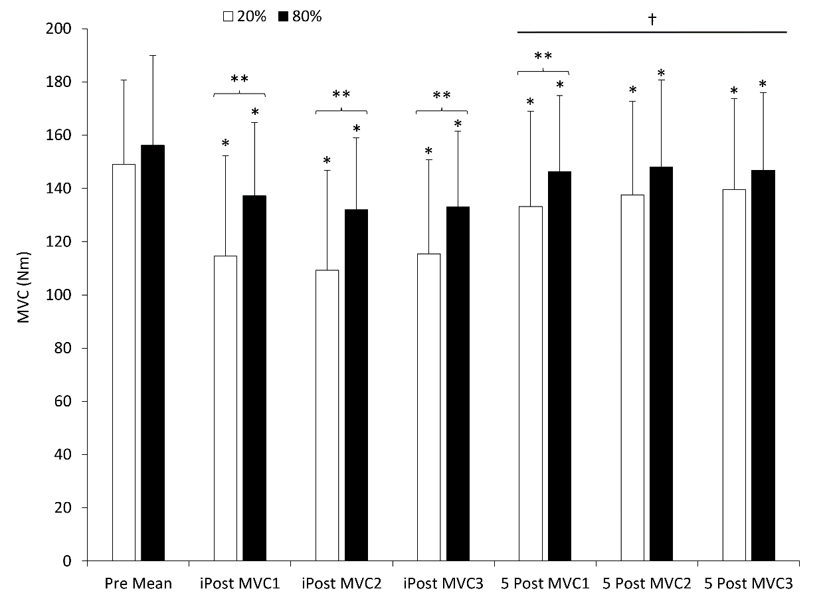
Figure 1. Mean maximal voluntary isometric strength collapsed across PLA and CHO conditions prior to and following fatiguing exercise at 20% and 80% of MVC. * indicates a significant difference (p < 0.05) from Pre at that fatiguing intensity; ** indicates a significant difference (p < 0.05) between the 20% and 80% fatiguing intensities at that time point. † indicates a significant difference (p < 0.05) for all 5-min Post time points in both the 20% and 80% conditions from each time point of the corresponding intensity at the iPost time points. Values are mean ± SD.

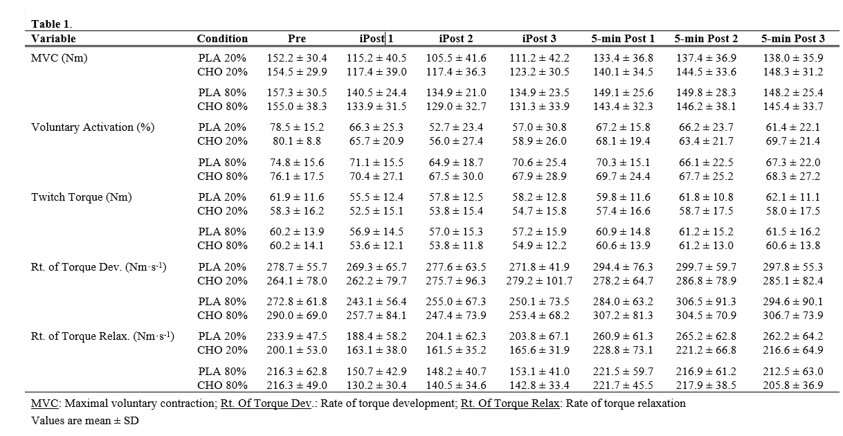
Voluntary Activation Percentage
Values from all conditions and time points can be seen in Table 1. There were no significant findings for the 3-way interaction (rinse condition x fatigue intensity x time) on VA% (p = 0.59). Three two-way ANOVA’s were run and significant interactions were not found for condition x time (p = 0.71) or intensity x condition (p = 0.74). A significant interaction (p = 0.005) was found for intensity x time. A significant interaction (p<0.001) was found for both exercise intensities on VA%. When collapsing the data across the PLA and CHO conditions the one-way ANOVA’s showed a decrease in VA% over time following both the 20% (p < 0.001) and 80% (p = 0.02) fatiguing intensities. Post-hoc analysis showed that VA% was found to be significantly reduced for all 6 post-fatigue MVC’s compared to the pre-values in the 20% fatigue condition (p < 0.001 for each) and the 80% fatigue condition (p < 0.01 for each; see Figure 2). In the 20% fatigue condition, VA% for the second and third iPost MVC’s immediately were significantly lower in comparison with the first iPost MVC (p < 0.013; Figure 2). VA% recovered following 5-min of rest such that all 5-min Post MVC’s were higher than the 2nd and 3rd iPost efforts (p < 0.02; Figure 2). No differences were observed when the three iPost MVC’s were compared to the three 5-min Post efforts following the 80% fatiguing protocol (p > 0.05). Comparing VA% among the seven time-points between the 20% and 80% fatiguing conditions, Pre (p = 0.13), the initial iPost (p = 0.22), and all three 5-min Post time points (p > 0.41) did not differ. However, a greater reduction in VA% was observed following the 20% fatiguing protocol at iPost 2 (p = 0.003) and iPost (p = 0.002) as can be seen in Figure 2.
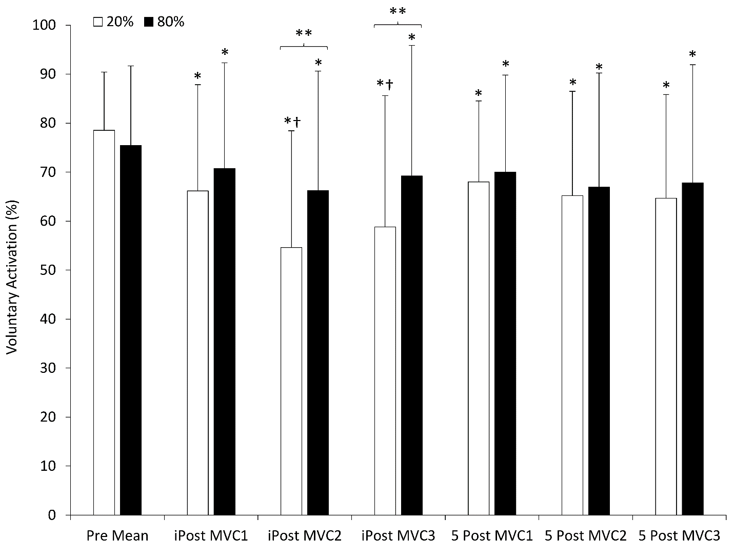
Figure 2. Mean voluntary activation collapsed across PLA and CHO conditions prior to and following fatiguing exercise at 20% and 80% of MVC. * indicates a significant difference (p < 0.05) from Pre at that fatiguing intensity; ** indicates a significant difference (p < 0.05) between the 20% and 80% fatiguing intensities at that time point. † indicates a significant difference (p < 0.05) for iPost 1 and all 5-min Post time points in the 20% condition. Values are mean ± SD.

Twitch Torque
Values from all conditions and time points can be seen in Table 1. The three-way interaction of rise condition x fatiguing intensity x time on TT values was found to be non-significant (p = 0.37). None of the two-way interactions were found to have a significant effect on TT—condition x time (p = 0.21), intensity x time (p = 0.18), and intensity x condition (p = 0.61). Main effects for rinse condition (p = 0.19) and fatiguing intensity (p = 0.77) were also not significant. A significant main effect for time (p = 0.01; Figure 3) was found. Post-hoc testing of main comparisons showed that TT was reduced compared to Pre at iPost 1 (p = 0.02) and iPost 2 (p = 0.047; Figure 3). No other time points differed from Pre (p > 0.05). Additionally, all three 5-min post values for TT were higher than all three iPost values (p < 0.05 for each; Figure 3).
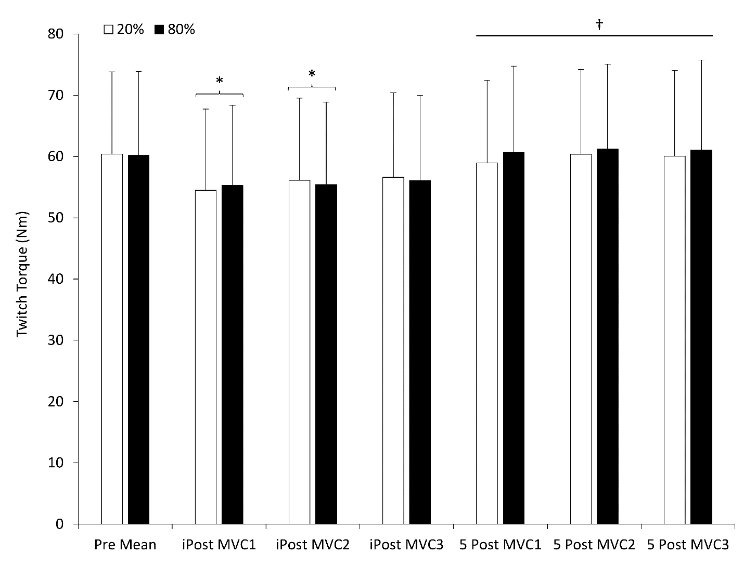
Figure 3. Mean twitch torque collapsed across PLA and CHO conditions prior to and following fatiguing exercise at 20% and 80% of MVC. * indicates a significant difference (main comparison p < 0.05) from Pre; † indicates a significant difference (main comparison; p < 0.05) from all iPost values. Values are mean ± SD.

Rate of Torque Development
Values from all conditions and time points can be seen in Table 1. The three-way interaction of rinse condition x fatiguing intensity x time on RTD values was not significant (p = 0.47). The two-way interactions of rinse condition x time (p = 0.80) and fatiguing intensity x condition (p = 0.41) were both not significant. The two-way interaction of fatiguing intensity x time was significant (p = 0.01). When data were collapsed across the PLA and CHO conditions, the one-way ANOVA over time was not significant (p = 0.06) at the 20% of MVC fatiguing intensity (see Figure 4). The one-way ANOVA over time for the 80% of MVC fatiguing intensity was significant (p < 0.001). Post-hoc analysis showed that all six post-fatigue MVC’s were found to be significantly different from Pre (p < 0.03 for each; Figure 4). Interestingly, RTD decreased for all three iPost MVC’s, but increased compared to Pre and all iPost (p < 0.001) time points after 5-min of rest. Comparisons of RTD values between the 20% and 80% fatiguing at each time point revealed no differences (p > 0.08). The one-way ANOVA showed no differences in RTD between the two exercise intensities for the seven time-points (see Figure 4).
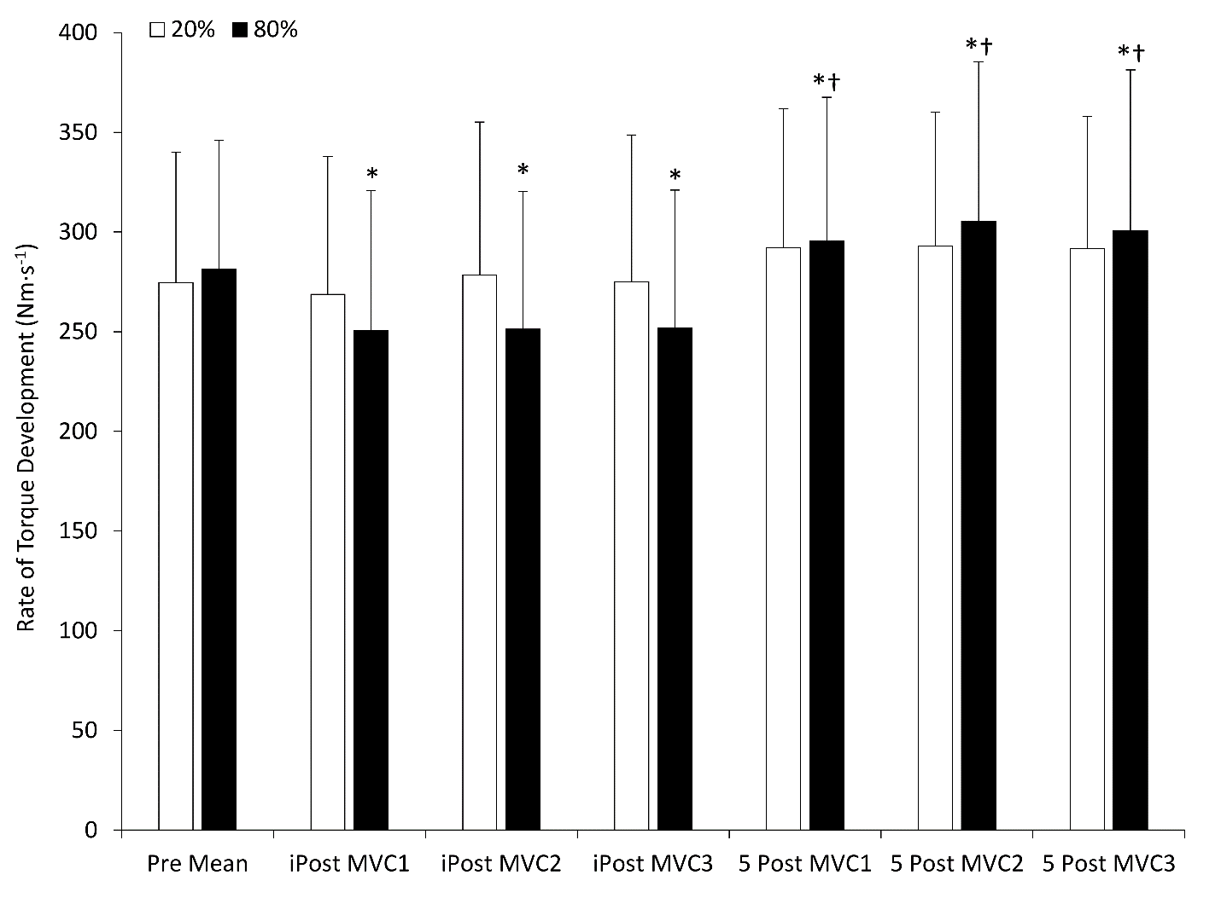
Figure 4. Mean rate of torque development collapsed across PLA and CHO conditions prior to and following fatiguing exercise at 20% and 80% of MVC. * indicates a significant difference (p < 0.05) from Pre at that fatiguing intensity; † indicates a significant difference (p < 0.05) from all the three iPost values in the 80% condition. Values are mean ± SD.

Rate of Torque Relaxation
Values from all conditions and time points can be seen in Table 1. The three-way interaction of rinse condition x fatiguing intensity x time on RTR values was not significant (p=0.41). The two-way interactions of rinse condition x time (p = 0.66) and fatiguing intensity x rinse condition (p = 0.11) were both found to be not significant. The two-way interaction between fatiguing intensity and time on RTR was found to be significant (p = 0.002). When the data across the CHO and PLA conditions were collapsed the one-way ANOVA for the 20% fatiguing intensity over time was significant (p < 0.001; Figure 5). RTR in all three iPost time points were reduced compared to Pre (p < 0.01; Figure 5) and compared to all three 5-min Post time points (p < 0.001; Figure 5). The three 5-min Post values for RTR were increased compared to Pre (p < 0.01; Figure 5). The one-way ANOVA for the 80% fatiguing intensity over time was significant (p < 0.001; Figure 5). The three initial iPost values for RTR were significantly reduced compared to Pre (p < 0.001; Figure 5) and compared to each of the three 5-min Post values (p < 0.001 for each; Figure 5). The three 5-minute Post values of RTR were not found to be significantly different (p > 0.29; Figure 5) from Pre. When compared between the 20% and 80% fatiguing protocols at each time point RTR values differed between the 20% and 80% protocols at iPost1 (p = 0.001), iPost2 (p = 0.004), iPost3 (p = 0.001), and 5-min Post3 (p = 0.03), but not 5-min Post 1 & 2 (p > 0.08).
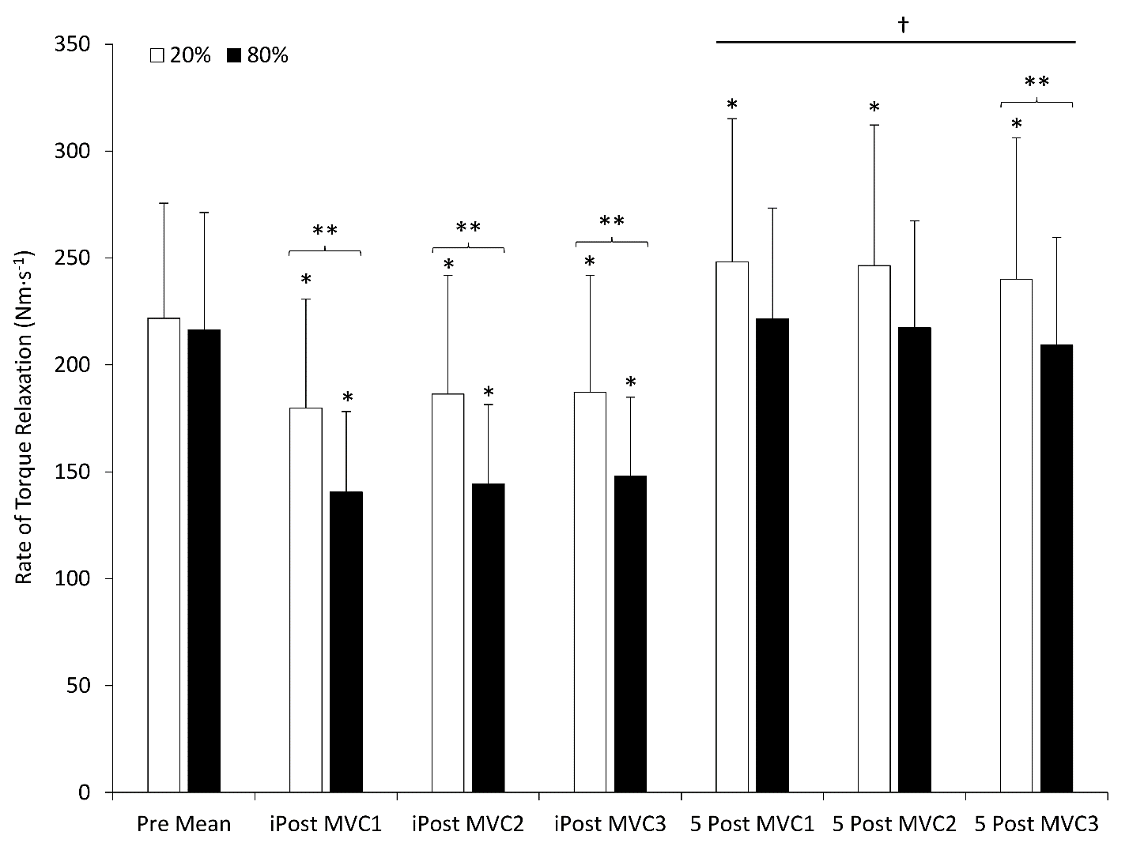
Figure 5. Mean rate of torque relaxation collapsed across PLA and CHO conditions prior to and following fatiguing exercise at 20% and 80% of MVC. * indicates a significant difference (p < 0.05) from Pre at that fatiguing intensity; ** indicates a significant difference (p < 0.05) between the 20% and 80% fatiguing intensities at that time point. † indicates a significant difference (p < 0.05) for iPost 1 and all 5-min Post time points in the 20% condition. Values are mean ± SD.

Chapter V: Discussion and Conclusions
The primary findings of this study are that a carbohydrate (CHO) mouth rinse did not attenuate the decline in torque production or VA% in comparison with a placebo following high and low-intensity fatiguing exercise. It is well documented that mouth rinsing improves aerobic performance by increasing time-to-exhaustion [6, 7], power output [28], and decreasing the time to complete a specific amount of work [10]. The effects of a CHO mouth rinse on strength/power exercises remains somewhat unclear. Studies have shown that the CHO mouth rinse can improve maximal strength [17], sprint performance [11, 12] and multiple dynamic contractions performed to volitional failure [18]. On the contrary, other studies have found that maximal strength [20-22], sprint performance [13-16], and multiple dynamic contractions to volitional failure [20-22] were not improved by mouth rinsing with a CHO solution. Jensen et al. [19] suggested that in order for a CHO mouth rinse to improve strength/power performance that central fatigue would need to be present since the mouth rinse acts via a central mechanism [17]. To that end a recent study [23] from our laboratory found that when isometric exercise performed at 50% of MVC was held to fatigue, that no central fatigue occurred, and as would be expected CHO rinsing did not alter torque loss or VA%.
The aim of this study was to ensure central fatigue was elicited by using low-intensity exercise (20% of MVC) and to compare that to results from high-intensity exercise (80%) and to determine if a CHO mouth rinse could attenuate the decline in torque and VA%. Following both the 20% and 80% protocols central fatigue was observed as noted by a significant decline in VA% at all time points. However, the low-intensity exercise, as expected, elicited greater declines in MVC during the iPost MVC’s and greater declines in VA% during 2 of the 3 immediately post exercise MVC’s. Despite the observed declines in VA% in both protocols, the CHO mouth rinse did not attenuate the decline in maximal torque and VA% compared to PLA in either fatigue condition as values were not significantly different from each other. This clearly suggests that the CHO mouth rinse employed in the present study did not increase central neural drive to the fatigued muscles. Previous researchers [5] suggest that the CHO stimulate oral receptors and influence the CNS to improve neural drive to skeletal muscle. Perhaps the decrements in central drive were not large enough in the present study to allow for stimulation of the oral CHO receptors to improve VA%.
Similar to the findings by Black et al. [23], this study saw changes in contractile properties of the fatigued muscles—indicating development of peripheral fatigue. Rate of torque development, the speed at which torque develops over time, is determined by the amount and rate of calcium that is released from the sarcoplasmic reticulum (SR) and the speed of the myosin ATPase enzyme. This study did not observe changes in RTD following the low-intensity fatiguing exercise. The low-intensity fatiguing exercise demonstrated a decrease in VA%, which was the primary cause of the decline in maximal torque production. However, this study showed a change in rate of torque relaxation, which is the speed of muscle relaxation also an indicator of peripheral fatigue. RTR relies on the breaking of cross-bridges and the reuptake of calcium into the sarcoplasmic reticulum by the calcium ATPase (SERCA) pump. RTR for the three iPost were significantly slower than the pre-RTR values which is likely due the presence of metabolites in the muscles hindering the action of the SERCA pump. Additionally, electrically evoked twitch torque was also significantly lower in the first two iPost MVC’s in the 80% fatiguing protocol than the pre-TT values another indicator of peripheral fatigue. As expected, the CHO mouth rinse had no effect on any marker of peripheral fatigue following either exercise protocol.
The high-intensity fatiguing protocol elicited a greater effect on peripheral fatigue than central fatigue. At high intensities anaerobic metabolism becomes the primary source for creating adenosine triphosphate (ATP). However, through anaerobic pathways, metabolites such as lactate, inorganic phosphates, and hydrogen ions are produced. These metabolites inhibit the ryanodine receptors on the membrane of the sarcoplasmic reticulum and prevent the release of the calcium by the SERCA pump. They also stimulate afferent receptors that inhibit the motoneurons from innervating the working muscle [29, 30]. The ability to clear these metabolites from the working muscle is essential in recovering from peripheral fatigue. Following the 5-minute rest break the quadriceps’ ability to generate torque and recover improved to match and even exceed the pre-values.
This study has some limitations/experimental considerations. The first limitation is that the sample size was too small. We did not reach the goal of having at least 15 participants. Additionally, within the sample, some participants were resistance trained while others had little to no experience with resistance training. Limiting criteria to permitting only resistance trained individuals could allow for more consistent maximal contractions.

Conclusion
The primary purpose of this study is to determine the effects of a CHO mouth rinse on torque production and voluntary activation following high and low-intensity isometric exercise performed to fatigue. We measured recruitment by stimulating the quadriceps during a maximal contraction and during rest and used the superimposed torque and the resting torque to calculate voluntary activation. We were successful in causing both central and peripheral fatigue but we were not able to attenuate the decline in maximal torque or VA%.

REFERENCES
1. Coyle, E.F., Physiological determinants of endurance exercise performance. Journal of Science & Medicine in Sport, 1999. 2(3): p. 181-9.

2. Coggan, A.R. and E.F. Coyle, Reversal of fatigue during prolonged exercise by carbohydrate infusion or ingestion. J Appl Physiol (1985), 1987. 63(6): p. 2388-95.

3. Jeukendrup, A., et al., Carbohydrate-electrolyte feedings improve 1 h time trial cycling performance. Int J Sports Med, 1997. 18(2): p. 125-9.

4. Carter, J.M., et al., The Effect of Glucose Infusion on Glucose Kinetics during a 1-h Time Trial. Medicine & Science in Sports & Exercise, 2004. 36(9): p. 1543-1550.

5. Chambers, E.S., M.W. Bridge, and D.A. Jones, Carbohydrate sensing in the human mouth: effects on exercise performance and brain activity. J Physiol, 2009. 587(Pt 8): p. 1779-94.

6. Bastos-Silva, V.J., et al., Carbohydrate Mouth Rinse Maintains Muscle Electromyographic Activity and Increases Time to Exhaustion during Moderate but not High-Intensity Cycling Exercise. Nutrients, 2016. 8(3): p. 49.

7. Fraga, C., et al., Carbohydrate mouth rinse enhances time to exhaustion during treadmill exercise. Clin Physiol Funct Imaging, 2017. 37(1): p. 17-22.

8. Rollo, I., et al., The influence of carbohydrate mouth rinse on self-selected speeds during a 30-min treadmill run. Int J Sport Nutr Exerc Metab, 2008. 18(6): p. 585-600.

9. Pottier, A., et al., Mouth rinse but not ingestion of a carbohydrate solution improves 1-h cycle time trial performance. Scand J Med Sci Sports, 2010. 20(1): p. 105-11.

10. Carter, J.M., A.E. Jeukendrup, and D.A. Jones, The Effect of Carbohydrate Mouth Rinse on 1-h Cycle Time Trial Performance. Medicine & Science in Sports & Exercise, 2004: p. 2107-2111.

11. Rollo, I., et al., The Influence of Carbohydrate Mouth Rinse on Self-Selected Intermittent Running Performance. Int J Sport Nutr Exerc Metab, 2015. 25(6): p. 550-8.

12. Beaven, C.M., et al., Effects of caffeine and carbohydrate mouth rinses on repeated sprint performance. Applied Physiology, Nutrition, & Metabolism = Physiologie Appliquee, Nutrition et Metabolisme, 2013. 38(6): p. 633-7.

13. Chong, E., K.J. Guelfi, and P.A. Fournier, Effect of a carbohydrate mouth rinse on maximal sprint performance in competitive male cyclists. Journal of Science and Medicine in Sport, 2011. 14(2): p. 162-167.
14. Pribyslavska, V., et al., Influence of carbohydrate mouth rinsing on running and jumping performance during early morning soccer scrimmaging. Eur J Sport Sci, 2016. 16(4): p. 441-7.

15. Dorling, J.L. and C.P. Earnest, Effect of carbohydrate mouth rinsing on multiple sprint performance. J Int Soc Sports Nutr, 2013. 10(1): p. 41.

16. Krings, B.M., et al., Effects of Carbohydrate Ingestion and Carbohydrate Mouth Rinse on Repeat Sprint Performance. Int J Sport Nutr Exerc Metab, 2017. 27(3): p. 204-212.

17. Gant, N., C.M. Stinear, and W.D. Byblow, Carbohydrate in the mouth immediately facilitates motor output. Brain Res, 2010. 1350: p. 151-8.

18. Clarke, N.D., et al., Carbohydrate mouth rinse improves morning high-intensity exercise performance. Eur J Sport Sci, 2017. 17(8): p. 955-963.

19. Jensen, M., T. Stellingwerff, and M. Klimstra, Carbohydrate Mouth Rinse Counters Fatigue Related Strength Reduction. Int J Sport Nutr Exerc Metab, 2015. 25(3): p. 252-61.

20. Clarke, N.D., E. Kornilios, and D.L. Richardson, Carbohydrate and Caffeine Mouth Rinses Do Not Affect Maximum Strength and Muscular Endurance Performance. Journal of Strength & Conditioning Research, 2015. 29(10): p. 2926-31.

21. Dunkin, J.E. and S.M. Phillips, The Effect of a Carbohydrate Mouth Rinse on Upper-Body Muscular Strength and Endurance. J Strength Cond Res, 2017. 31(7): p. 1948-1953.

22. Painelli, V.S., et al., The effect of carbohydrate mouth rinse on maximal strength and strength endurance. Eur J Appl Physiol, 2011. 111(9): p. 2381-6.

23. Black, C.D., et al., Carbohydrate Mouth Rinsing Does Not Prevent the Decline in Maximal Strength Following Fatiguing Exercise. J Strength Cond Res, 2018.

24. Eichelberger, T.D. and M. Bilodeau, Central fatigue of the first dorsal interosseous muscle during low-force and high-force sustained submaximal contractions. Clin Physiol Funct Imaging, 2007. 27(5): p. 298-304.

25. Yoon, T., et al., Mechanisms of fatigue differ after low- and high-force fatiguing contractions in men and women. Muscle Nerve, 2007. 36(4): p. 515-24.

26. Cadigan, E.W.J., et al., Maximal Voluntary Activation of the Elbow Flexors Is under Predicted by Transcranial Magnetic Stimulation Compared to Motor Point Stimulation Prior to and Following Muscle Fatigue. Front Physiol, 2017. 8: p. 707.

27. Edwards, R.H., Human muscle function and fatigue. Ciba Found Symp, 1981. 82: p. 1-18.
28. Lane, S.C., et al., Effect of a carbohydrate mouth rinse on simulated cycling time-trial performance commenced in a fed or fasted state. Appl Physiol Nutr Metab, 2013. 38(2): p. 134-9.

29. Kniffki, K.D., E.D. Schomburg, and H. Steffens, Convergence in segmental reflex pathways from fine muscle afferents and cutaneous or group II muscle afferents to alpha-motoneurones. Brain Res, 1981. 218(1-2): p. 342-6.

30. Windhorst, U., et al., Effects of neurochemically excited group III-IV muscle afferents on motoneuron afterhyperpolarization. Neuroscience, 1997. 76(3): p. 915-29.

APPENDIX A: IRB APPROVAL LETTER

APPENDIX B: INFORMED CONSENT FORM
Consent Form
University of Oklahoma Health Sciences Center (OUHSC)
University of Oklahoma – Norman (OU)
Study Title: | The Effects of a Carbohydrate Mouth Rinse on Central and Peripheral Fatigue Following High and Low Intensity Fatiguing Exercise
Principal Investigator: | Christopher Black, PhD.
Department: | OU Health and Exercise Science - Norman

This is a research study. Research studies involve only individuals who choose to participate. Please take your time to make your decision. Discuss this with your family and friends.

Why Have I Been Asked To Participate In This Study?
You are being asked to volunteer for this research study because you are a healthy, young adult (age 18-30) and are recreationally active, but have not engaged in vigorous aerobic training 3 times per week or more in the previous 3 months.

Why Is This Study Being Done?
The purpose of this study is to examine the effect of a carbohydrate (CHO) mouth rinse on maximal strength of the thigh muscles and the brain’s ability to activate the muscles of the thigh following fatiguing exercise.

What is the Status of the Drugs Involved in this Study?
There are no investigational drugs being used in this study. The mouth rinse is not considered to be a drug.

How Many People Will Take Part In The Study?
About 15 people will take part in this study, all at the Sensory and Muscle Function Laboratory in the OU Health and Exercise Department on the Norman campus.

What Is Involved In The Study?
If you agree to be in this study, you will be asked to fill out 4 screening questionnaires that will take approximately 20-30 minutes to fill out about your health. If you still qualify to be in the study after the questionnaires, you will be asked to complete two familiarization sessions, each lasting approximately 30 minutes to 1 hour, where you will practice performing maximal isometric knee extension (kicking out with your leg as hard as you can) and practice the procedure for determining the brain’s ability to activate the muscles of the thigh. To do this a series of brief electrical currents will be applied to your thigh muscles via electrodes placed on your skin. You will receive ~10-30 electrical stimulations each lasting approximately 0.2 milliseconds. The number and the level of the electrical stimulations you will receive will depend on how strong your thigh muscles are. The strength of the stimulations will be gradually increased until the strength of the contraction it produces plateaus. You will also practice holding a contraction at 20% or 80% of your maximal strength until your muscle fatigues.

After familiarization has occurred, you will perform 4 additional days of testing. On these testing days you will be asked to perform the maximal strength and electrical stimulation procedures you practiced during familiarization. You will then hold a muscle contraction equivalent to 20% or 80% of your maximal muscle strength until you can no longer maintain that level of strength production. After you have fatigued, you will then rinse a solution of 8% maltodextrin and 0.2% artificial sweetener (sucralose) or a placebo (water with artificial 0.2% sweetener) in your mouth for 10 seconds and then spit it out. You will then perform 3 more MVCs, rest for 5 minutes and then perform 3 MVCs, again. On two of the four testing days you will rinse with the maltodextrin solution and on the other two testing days you will rinse with the placebo solution. You will not be told which solution you rinsed with on each testing day until you have completed all four testing days. The researchers will flip a coin to determine which solution you will receive on the first testing day (this is termed randomization). You will then consume the other solution on your second testing day

How Long Will I Be In The Study?
We think that you will be in the study for 6 testing sessions that will take approximately 30 minutes to 1 hour per session over the course of 1 to 2 weeks. It should take approximately 3 months to recruit and test all the participants.

There may be anticipated circumstances under which your participation may be terminated by the investigator without regard to your consent. These may include, but are not limited to:

- You fail to follow study requirements.
- The researcher is concerned about your health and well-being
- It is deemed too risky to test you based upon your medical history

You can stop participating in this study at any time. However, if you decide to stop participating in the study, we encourage you to talk to the researcher and your regular doctor first.

What Are The Risks of The Study?
Resistance training promotes a potential risk of injury to muscles or joints. However, this study does not intend to put you through high intensity, strenuous exercise. The testing sessions require you to perform isometric maximal voluntary contractions (MVC) with your dominant leg; isometric exercise presents very minimal risk of developing soreness or resulting in other types of injuries to bones and joints. The electrical stimulation used to assess motor-unit recruitment may be uncomfortable and/or painful, but it also presents minimal risks of any type of tissue damage or injury. Any long-lasting soreness or any other noticeable issue pertaining to the testing muscles should be reported to Kody Haskins or Dr. Chris Black as soon as possible.

Are There Benefits to Taking Part in The Study?
If you agree to take part in this study, there may or may not be direct medical benefit to you. We hope that the information learned from this study will benefit others in the future. You will learn about the maximal strength in your dominant leg.

What Other Options Are There?
You may choose not to participate in the study.

What about Confidentiality?
Efforts will be made to keep your personal information confidential. You will not be identifiable by name or description in any reports or publications about this study. We cannot guarantee absolute confidentiality. Your personal information may be disclosed if required by law. You will be asked to sign a separate authorization form for use or sharing of your protected health information.

There are organizations outside the OUHSC that may inspect and/or copy your research records for quality assurance and data analysis. These organizations include the US Food & Drug Administration and other regulatory agencies. The OUHSC Human Research Participant Program office, the OUHSC Institutional Review Board, and the OUHSC Office of Compliance may also inspect and/or copy your research records for these purposes.

What Are the Costs?
There is no cost to you if you participate in this study.

Will I Be Paid For Participating in This Study?
You will be reimbursed with a $20 gift card for your time and participation after you have completed this study.

What if I am Injured or Become Ill While Participating in this Study
In case of injury or illness resulting from this study, emergency medical treatment is available. However, you or your insurance company will be expected to pay the usual charge from this treatment. The University of Oklahoma-Norman and the University of Oklahoma Health Sciences Center have not set aside any funds to compensate you in the event of injury.

What Are My Rights As a Participant?
Taking part in this study is voluntary. You may choose not to participate. Refusal to participate will involve no penalty or loss of benefits to which you are otherwise entitled.
If you agree to participate and then decide against it, you can withdraw for any reason and leave the study at any time. You may discontinue your participation at any time without penalty or loss of benefits to which you are otherwise entitled.

We will provide you with any significant new findings developed during the course of the research that may affect your health, welfare, or willingness to continue your participation in this study.

You have the right to access the medical information that has been collected about you as a part of this research study. However, you may not have access to this medical information until the entire research study has completely finished. You consent to this temporary restriction.

Whom Do I Call If I have Questions or Problems?
If you have concerns or complaints about the research, the researcher(s) conducting this study can be contacted at 405-249-3371 or Kody.R.Haskins-1@ou.edu and Dr. Chris Black can be contacted at 706-255-3750 or cblack@ou.edu. Contact the researcher(s) if you have questions, or if you have experienced a research related injury

If you cannot reach the Investigator or wish to speak to someone other than the investigator, contact the OUHSC Director, Office of Human Research Participant Protection, at 405-271-2045.

For questions about your rights as a research participant, contact the OUHSC Director, Office of Human Research Participant Protection at 405-271-2045.

Signature:
By signing this form, you are agreeing to participate in this research study under the conditions described. You have not given up any of your legal rights or released any individual or entity from liability for negligence. You have been given an opportunity to ask questions. You will be given a copy of this consent document.

I agree to participate in this study:

_________________________________ _______________________ _________
PARTICIPANT SIGNATURE (age >18) Printed Name Date

_________________________________ _______________________ _________
SIGNATURE OF PERSON Printed Name Date
OBTAINING CONSENT

APPENDIX C: HEALTH STATUS QUESTIONNAIRE

APPENDIX D: HIPAA

AUTHORIZATION TO USE or SHARE

HEALTH INFORMATION THAT IDENTIFIES YOU FOR RESEARCH
An Informed Consent Document for Research Participation may also be required.
Form 2 must be used for research involving psychotherapy notes.

Title of Research Project: The Effects of a Carbohydrate Mouth Rinse on Central and Peripheral Fatigue Following High and Low Intensity Fatiguing Exercise.
Leader of Research Team: Christopher D. Black, PhD
Address: 1401 Asp Ave., #110 HHC, Norman, OK 73019
Phone Number: 706-255-3750 (cell); 405-325-7668 (office)
If you decide to sign this document, University of Oklahoma Health Sciences Center (OUHSC) researchers may use or share information that identifies you (protected health information) for their research. Protected health information will be called PHI in this document.
PHI To Be Used or Shared. Federal law requires that researchers get your permission (authorization) to use or share your PHI. If you give permission, the researchers may use or share with the people identified in this Authorization any PHI related to this research from your medical records and from any test results. Information used or shared may include all information relating to any tests, procedures, surveys, or interviews as outlined in the consent form; medical records and charts; name, address, telephone number, date of birth, race, government-issued identification numbers and nothing else.
Purposes for Using or Sharing PHI. If you give permission, the researchers may use your PHI to determine if it is safe for you to participate in the exercise used in this study.
Other Use and Sharing of PHI. If you give permission, the researchers may also use your PHI to develop new procedures or commercial products. They may share your PHI with other researchers, the research sponsor and its agents, the OUHSC Institutional Review Board, auditors and inspectors who check the research, and government agencies such as the Food and Drug Administration (FDA) Department of Health and Human Services (HHS), and when required by law. The researchers may also share your PHI with your physician and/or a University of Oklahoma physician in the event of a serious health risk or adverse event that occurs during the study.
Confidentiality. Although the researchers may report their findings in scientific journals or meetings, they will not identify you in their reports. The researchers will try to keep your information confidential, but confidentiality is not guaranteed. The law does not require everyone receiving the information covered by this document to keep it confidential, so they could release it to others, and federal law may no longer protect it.
You understand that your Protected Health Information may include information regarding a communicable or noncommunicable disease.
Voluntary Choice. The choice to give OU researchers permission to use or share your PHI for their research is voluntary. It is completely up to you. No one can force you to give permission. However, you must give permission for OU researchers to use or share your PHI if you want to participate in the research and, if you cancel your authorization, you can no longer participate in this study.
Refusing to give permission will not affect your ability to get routine treatment or health care unrelated to this study from OU.
Canceling Permission. If you give the OU researchers permission to use or share your PHI, you have a right to cancel your permission whenever you want. However, canceling your permission will not apply to information that the researchers have already used, relied on, or shared or to information necessary to maintain the reliability or integrity of this research.
End of Permission. Unless you cancel it, permission for OU researchers to use or share your PHI for their research will never end.
Contacting OU: You may find out if your PHI has been shared, get a copy of your PHI, or cancel your permission at any time by writing to:
Privacy Official or Privacy Board
University of Oklahoma Health Sciences Center University of Oklahoma Health
PO Box 26901 Sciences Center
Oklahoma City, OK 73190 PO Box 26901
Oklahoma City, OK 73190

If you have questions, call: (405) 271-2511 or (405) 2712045

Access to Information. You have the right to access the medical information that has been collected about you as a part of this research study. However, you may not have access to this medical information until the entire research study is completely finished. You consent to this temporary restriction.
Giving Permission. By signing this form, you give OUHSC and OUHSC’s researchers led by the Research Team Leader permission to share your PHI for the research project listed at the top of this form.

Participant Name (Print): _________________________

__________________________________________ _______________
Signature of Participant Date

or Parent if Participant is a minor

Or

__________________________________________ _______________
Signature of Legal Representative** Date

**If signed by a Legal Representative of the Participant, provide a description of the relationship to the Participant and the authority to act as Legal Representative:

_______________________________________________________________________
OUHSC may ask you to produce evidence of your relationship.

A signed copy of this form must be given to the Participant or the Legal Representative at the time this signed form is provided to the researcher or his representative.

APPENDIX E: PHYSICAL ACTIVITY READINESS QUESTIONNAIRE
PAR-Q & YOU
(A Questionnaire for People Aged 15 to 69)
Regular physical activity is fun and healthy, and increasingly more people are starting to become more active every day. Being more active is very safe for most people. However, some people should check with their doctor before starting to become much more physically active.
If you are planning to become much more physically active than you are now, start by answering the seven questions in the box below. If you are between the ages of 15 and 69, the PAR-Q will tell you if you should check with your doctor before you start. If you are over 69 years of age, and you are not used to being very active, check with your doctor.
Common sense is your best guide when you answer these questions. Please read the questions carefully and answer each one honestly: check YES or NO.
YES NO
1. Has your doctor ever said that you have a heart condition and that you should only do physical activity recommended by your doctor?
2. Do you feel pain in your chest when you do physical activity?
3. In the past month, have you had chest pain when you were not doing physical activity?
4. Do you lose your balance because of dizziness or do you ever lose consciousness?
5. Do you have a bone or joint problem (for example, back, knee or hip) that could be made worse by a change in your physical activity?
6. Is your doctor currently prescribing drugs (for example, water pills) for your blood pressure or heart condition?
7. Do you know of any other reason why you should not do physical activity?

If  you  answered | YES to one or more questions
If  you  answered | Talk to your doctor by phone or in person BEFORE you start becoming much more physically active or BEFORE you have a fitness appraisal. Tell your doctor about the PAR-Q and which questions you answered YES.  - You may able to any activity you want – as long as you start slowly and build up gradually. Or, you may need to restrict your activities to those which are safe for you. Talk with your doctor about the kinds of activities you wish to participate in and follow his/her advice.  - Find out which community programs are safe and helpful to you.
NO to all questions |  |  | DELAY BECOMING MUCH MORE ACTIVE:
If you answered NO honestly to all PAR-Q questions, you can be reasonably sure that you can:  - start becoming much more physically active – begin slowly and build up gradually. This is the safest and easiest way to go.  - Take part in a fitness appraisal – this is an excellent way to determine your basic fitness so that you can plan the best way for you to live actively. It is also highly recommended that you have your blood pressure evaluated. If your reading is over 144/94, talk with your doctor before you start becoming much more physically active. |  |  | - If you are not feeling well because of a temporary illness such as a cold or a fever – wait until you feel better; or  - If you are or may be pregnant – talk to your doctor before you start becoming more active.
 |  | PLEASE NOTE: If your health changes so that you then answer YES to any of the above questions, tell your fitness or health professional. Ask whether you should change your physical activity plan.
Informed use of the PAR-Q: The Canadian Society for Exercise Physiology, Health Canada, and their agents assume no liability for persons who undertake physical activity, and if in doubt after completing this questionnaire, consult your doctor prior to physical activity.
No changes permitted. You are encouraged to photocopy the PAR-Q but only if you use the entire form.
NOTE: If the PAR-Q is being given to a person before he or she participates in a physical activity program or a fitness appraisal, this section may be used for legal or administrative purposes.
“I have read, understood and completed this questionnaire. Any questions I had were answered to my full satisfaction.”
NAME
SIGNATURE DATE
SIGNATURE OF PARENT WITNESS
Or GUARDIAN (for participants under the age of majority)
Note: This physical activity clearance is valid for a maximum of 12 months from the date it is completed and becomes invalid if your condition changes so that you would

APPENDIX F: INTERNATIONAL PHYSICAL ACTIVITY QUESTIONNIARE
INTERNATIONAL PHYSICAL ACTIVITY QUESTIONNAIRE
(October 2002)

LONG LAST 7 DAYS SELF-ADMINISTERED FORMAT

FOR USE WITH YOUNG AND MIDDLE-AGED ADULTS (15-69 years)

The International Physical Activity Questionnaires (IPAQ) comprises a set of 4 questionnaires. Long (5 activity domains asked independently) and short (4 generic items) versions for use by either telephone or self-administered methods are available. The purpose of the questionnaires is to provide common instruments that can be used to obtain internationally comparable data on health–related physical activity.

Background on IPAQ
The development of an international measure for physical activity commenced in Geneva in 1998 and was followed by extensive reliability and validity testing undertaken across 12 countries (14 sites) during 2000. The final results suggest that these measures have acceptable measurement properties for use in many settings and in different languages, and are suitable for national population-based prevalence studies of participation in physical activity.

Using IPAQ
Use of the IPAQ instruments for monitoring and research purposes is encouraged. It is recommended that no changes be made to the order or wording of the questions as this will affect the psychometric properties of the instruments.

Translation from English and Cultural Adaptation
Translation from English is encouraged to facilitate worldwide use of IPAQ. Information on the availability of IPAQ in different languages can be obtained at www.ipaq.ki.se. If a new translation is undertaken we highly recommend using the prescribed back translation methods available on the IPAQ website. If possible please consider making your translated version of IPAQ available to others by contributing it to the IPAQ website. Further details on translation and cultural adaptation can be downloaded from the website.

Further Developments of IPAQ
International collaboration on IPAQ is on-going and an International Physical Activity Prevalence Study is in progress. For further information see the IPAQ website.

More Information
More detailed information on the IPAQ process and the research methods used in the development of IPAQ instruments is available at www.ipaq.ki.se and Booth, M.L. (2000). Assessment of Physical Activity: An International Perspective. Research Quarterly for Exercise and Sport, 71 (2): s114-20. Other scientific publications and presentations on the use of IPAQ are summarized on the website.
INTERNATIONAL PHYSICAL ACTIVITY QUESTIONNAIRE
We are interested in finding out about the kinds of physical activities that people do as part of their everyday lives. The questions will ask you about the time you spent being physically active in the last 7 days. Please answer each question even if you do not consider yourself to be an active person. Please think about the activities you do at work, as part of your house and yard work, to get from place to place, and in your spare time for recreation, exercise or sport.
Think about all the vigorous and moderate activities that you did in the last 7 days. Vigorous physical activities refer to activities that take hard physical effort and make you breathe much harder than normal. Moderate activities refer to activities that take moderate physical effort and make you breathe somewhat harder than normal.

PART 1: JOB-RELATED PHYSICAL ACTIVITY

The first section is about your work. This includes paid jobs, farming, volunteer work, course work, and any other unpaid work that you did outside your home. Do not include unpaid work you might do around your home, like housework, yard work, general maintenance, and caring for your family. These are asked in Part 3.
1. Do you currently have a job or do any unpaid work outside your home?

Yes

No Skip to PART 2: TRANSPORTATION
The next questions are about all the physical activity you did in the last 7 days as part of your paid or unpaid work. This does not include traveling to and from work.
2. During the last 7 days, on how many days did you do vigorous physical activities like heavy lifting, digging, heavy construction, or climbing up stairs as part of your work? Think about only those physical activities that you did for at least 10 minutes at a time.
_____ days per week

No vigorous job-related physical activity Skip to question 4
3. How much time did you usually spend on one of those days doing vigorous physical activities as part of your work?

_____ hours per day
_____ minutes per day

4. Again, think about only those physical activities that you did for at least 10 minutes at a time. During the last 7 days, on how many days did you do moderate physical activities like carrying light loads as part of your work? Please do not include walking.

_____ days per week

No moderate job-related physical activity Skip to question 6
5. How much time did you usually spend on one of those days doing moderate physical activities as part of your work?

_____ hours per day
_____ minutes per day

6. During the last 7 days, on how many days did you walk for at least 10 minutes at a time as part of your work? Please do not count any walking you did to travel to or from work.

_____ days per week

No job-related walking Skip to PART 2: TRANSPORTATION

7. How much time did you usually spend on one of those days walking as part of your work?

_____ hours per day
_____ minutes per day

PART 2: TRANSPORTATION PHYSICAL ACTIVITY

These questions are about how you traveled from place to place, including to places like work, stores, movies, and so on.

8. During the last 7 days, on how many days did you travel in a motor vehicle like a train, bus, car, or tram?

_____ days per week

No traveling in a motor vehicle Skip to question 10

9. How much time did you usually spend on one of those days traveling in a train, bus, car, tram, or other kind of motor vehicle?

_____ hours per day
_____ minutes per day

Now think only about the bicycling and walking you might have done to travel to and from work, to do errands, or to go from place to place.

10. During the last 7 days, on how many days did you bicycle for at least 10 minutes at a time to go from place to place?

_____ days per week

No bicycling from place to place Skip to question 12
11. How much time did you usually spend on one of those days to bicycle from place to place?

_____ hours per day
_____ minutes per day

12. During the last 7 days, on how many days did you walk for at least 10 minutes at a time to go from place to place?

_____ days per week

No walking from place to place Skip to PART 3: HOUSEWORK, HOUSE MAINTENANCE, AND CARING FOR FAMILY

13. How much time did you usually spend on one of those days walking from place to place?

_____ hours per day
_____ minutes per day

PART 3: HOUSEWORK, HOUSE MAINTENANCE, AND CARING FOR FAMILY

This section is about some of the physical activities you might have done in the last 7 days in and around your home, like housework, gardening, yard work, general maintenance work, and caring for your family.

14. Think about only those physical activities that you did for at least 10 minutes at a time. During the last 7 days, on how many days did you do vigorous physical activities like heavy lifting, chopping wood, shoveling snow, or digging in the garden or yard?

_____ days per week

No vigorous activity in garden or yard Skip to question 16

15. How much time did you usually spend on one of those days doing vigorous physical activities in the garden or yard?

_____ hours per day
_____ minutes per day

16. Again, think about only those physical activities that you did for at least 10 minutes at a time. During the last 7 days, on how many days did you do moderate activities like carrying light loads, sweeping, washing windows, and raking in the garden or yard?

_____ days per week

No moderate activity in garden or yard Skip to question 18
17. How much time did you usually spend on one of those days doing moderate physical activities in the garden or yard?

_____ hours per day
_____ minutes per day

18. Once again, think about only those physical activities that you did for at least 10 minutes at a time. During the last 7 days, on how many days did you do moderate activities like carrying light loads, washing windows, scrubbing floors and sweeping inside your home?

_____ days per week

No moderate activity inside home Skip to PART 4: RECREATION, SPORT AND LEISURE-TIME PHYSICAL ACTIVITY

19. How much time did you usually spend on one of those days doing moderate physical activities inside your home?

_____ hours per day
_____ minutes per day

PART 4: RECREATION, SPORT, AND LEISURE-TIME PHYSICAL ACTIVITY

This section is about all the physical activities that you did in the last 7 days solely for recreation, sport, exercise or leisure. Please do not include any activities you have already mentioned.

20. Not counting any walking you have already mentioned, during the last 7 days, on how many days did you walk for at least 10 minutes at a time in your leisure time?

_____ days per week

No walking in leisure time Skip to question 22

21. How much time did you usually spend on one of those days walking in your leisure time?

_____ hours per day
_____ minutes per day

22. Think about only those physical activities that you did for at least 10 minutes at a time. During the last 7 days, on how many days did you do vigorous physical activities like aerobics, running, fast bicycling, or fast swimming in your leisure time?

_____ days per week

No vigorous activity in leisure time Skip to question 24

23. How much time did you usually spend on one of those days doing vigorous physical activities in your leisure time?

_____ hours per day
_____ minutes per day

24. Again, think about only those physical activities that you did for at least 10 minutes at a time. During the last 7 days, on how many days did you do moderate physical activities like bicycling at a regular pace, swimming at a regular pace, and doubles tennis in your leisure time?

_____ days per week

No moderate activity in leisure time Skip to PART 5: TIME SPENT SITTING

25. How much time did you usually spend on one of those days doing moderate physical activities in your leisure time?
_____ hours per day
_____ minutes per day

PART 5: TIME SPENT SITTING

The last questions are about the time you spend sitting while at work, at home, while doing course work and during leisure time. This may include time spent sitting at a desk, visiting friends, reading or sitting or lying down to watch television. Do not include any time spent sitting in a motor vehicle that you have already told me about.

26. During the last 7 days, how much time did you usually spend sitting on a weekday?

_____ hours per day
_____ minutes per day

27. During the last 7 days, how much time did you usually spend sitting on a weekend day?

_____ hours per day
_____ minutes per day

This is the end of the questionnaire, thank you for participating.

Protected Health Information includes all identifiable information relating to any aspect of an individual’s health whether past, present or future, created or maintained by a Covered Entity.

