UNIVERSITY OF OKLAHOMA
GRADUATE COLLEGE

GENERATIVE DESIGN, CHARACTERIZATION, AND TESTING FOR ADDITIVE MANUFACTURING OF LIGHTWEIGHT STRUCTURES

A THESIS
SUBMITTED TO THE GRADUATE FACULTY
in partial fulfillment of the requirements for the
Degree of
MASTER OF SCIENCE

By
ALENE BASMADJIAN
Norman, Oklahoma
2023

GENERATIVE DESIGN, CHARACTERIZATION, AND TESTING FOR ADDITIVE MANUFACTURING OF LIGHTWEIGHT STRUCTURES

A THESIS APPROVED FOR THE
SCHOOL OF AEROSPACE AND MECHANICAL ENGINEERING

BY THE COMMITTEE CONSISTING OF

Dr. Yingtao Liu, Chair
Dr. Zahed Siddique, Co-Chair
Dr. Iman Ghamarian

© Copyright by ALENE BASMADJIAN 2023
All Rights Reserved.

I would like to dedicate this thesis to my family and friends. Without their support, I would not be able to accomplish the accelerated master’s in mechanical engineering with a thesis. I would like to thank them for always encouraging me and pushing me through the challenges to achieve my goals.
Acknowledgements
I would first like to thank my advisor and committee chair, Dr. Yingtao Liu for his encouragement and support throughout my entire masters and thesis. I truly found a passion for additive manufacturing through the various courses I have taken and for his continued passion and strive for knowledge in the field.
I would also like to thank Chris Billings and Dr. Yingtao Liu research lab for their continuous encouragement and help throughout my research within the lab. Chris Billings has supported me through helping me with various equipment and supporting me in my research.
I would also like to thank Dr. Zahed Siddique and Dr. Iman Ghamarian for being part of my thesis committee and their support throughout my research.

Table of Contents
List of Tables vii
List of Figures viii
Abstract x
1 Introduction 1
1.1 Background and Literature Reviews 2
1.2 Fusion 360 Software 7
1.3 Additive Manufacturing Methods 8
1.4 Structure of Thesis 8
2 Method in Fusion 360 Software’s to Create I Beams 10
2.1 Design Features and Steps to Create Original Beam 10
2.2 Simulation Features and Steps to Analyze Original Beam 17
2.3 Generative Design Features and Steps to Creating a Generative Designed Beam from the Original Beam 27
2.4 Cura Software Features, Steps and Slicing for PLA 3D Printing 31
2.5 Chitubox Software Features, Steps and Slicing for Resin 3D Printing 33
3 Additive Manufacturing Procedure and Property Characterization 35
3.1 Fused Deposition Modeling Procedure and Outcomes 35
3.2 Stereolithography Printing Procedure and Outcomes 40
3.3 Instron Set Up, Procedure and Testing for I beams 44
4 Results and Discussion of Fusion 360 Developed, Additive Manufactured, and Tested I Beams 49
4.1 Timeline of Various I Beam Designs in the Design, Simulation and Generative Design Features of Fusion 360 49
4.2 3-Point Bending Test and FEM Results Comparison for the PLA and Resin I Beams 60
4.3 Volume, Density, and Porosity of PLA Original Beam 73
5 Conclusion and Future Work 75

List of Tables
Table 1: Material Properties for PLA 15
Table 2: Material Properties for Blu Tough Resin 15
Table 3: PLA Beams FEM vs Testing Comparison 66
Table 4: Resin Beams FEM vs Testing Comparison 72

List of Figures
Figure 1: Generative Designed Beam (9) 6
Figure 2: Sketch of I Beam 11
Figure 3: Extrude of I Beam 12
Figure 4: Roller Supports 13
Figure 5: Loading Component 13
Figure 6: First Beam Designed 16
Figure 7: Second Beam Designed 16
Figure 8: Third Beam Designed with Testing Rig Components 17
Figure 9: Simulation Set Up for Resin Beam without Testing Rig 20
Figure 10: Simulation Set Up for Resin Beam with Testing Rig 21
Figure 11: Stress vs Strain Curve (12) 22
Figure 12: Features in Ansys 23
Figure 13: Ansys Tree Outline in Model 24
Figure 14: Mesh on Beam in Ansys 26
Figure 15: Generative Design of Beam at Iteration 24 31
Figure 16: Cura Setting and Slicing for Original Beam 33
Figure 17: Chitubox Settings and Slicing of Generative Design Beam 34
Figure 18: Failure During PLA 3D Printing 37
Figure 19: Warping of the PLA Print 38
Figure 20: PLA 3D Printed Original Beam Side View 39
Figure 21: PLA 3D Printed Generative Design Beam Front View 39
Figure 22: Resin Printing Process on the 3D Printer 41
Figure 23: Curing and Heating Chamber for Resin Parts 42
Figure 24: Resin 3D Printed Original Beam Design Front View 43
Figure 25: Resin 3D Printed Generative Design Beam Front View 43
Figure 26: Instron 3-Point Bending Test Set Up 46
Figure 27: Second Beam PLA Safety Factor Simulation at 7kN force 50
Figure 28: Second Beam PLA Safety Factor Simulation at 8.4kN force 51
Figure 29: Second Beam PLA Generative Design Set Up with 8.4kN Force 52
Figure 30: Second Beam PLA Generative Design at 8.4kN Force 53
Figure 31: Second Beam Resin Safety Factor Simulation at 1800N Force 54
Figure 32: Second Beam Resin Generative Design at 1800N Force 55
Figure 33: Third Beam Resin Safety Factor Simulation at 18500N Force 57
Figure 34: Third Beam Resin Generative Design Set Up at 18500N Force 58
Figure 35: Third Beam Resin Generative Design at 18500N Force 58
Figure 36: Third Beam Resin Generative Design Multiple Outcomes 1 59
Figure 37: Third Beam Resin Generative Design Multiple Outcomes 2 60
Figure 38: Load vs Extension 3- Point Bending Test of PLA Original Beam 61
Figure 39: PLA Original Beam Fracture at Maximum Force 62
Figure 40: Load vs Extension 3-Point Bending Test of PLA Generative Design Beam 63
Figure 41: PLA Generative Designed Beam Fracture at Maximum Force 64
Figure 42: Load vs Extension 3-Point Bending Test of Resin Original Beam 67
Figure 43: Fractured Resin Original Beam at Maximum Load 68
Figure 44: Safety Factor of Resin Original Beam 68
Figure 45: Displacement of Resin Original Beam 69
Figure 46: Load vs Extension 3-Point Bending Test of Resin Generative Design Beam 70
Figure 47: Fractured Resin Generative Design Beam at Maximum Load 71

Abstract
Generative design has developed over the years through various CAD software’s and has changed the industry in new ways. Generative design has opened a new aspect of engineering that can change industries through design created with artificial intelligence technology. Through generative design, various components and characteristics of materials and objects can be reinvented to make them lighter weight and more cost effective within the industry.
Within this thesis, the aspects of Fusion 360, a CAD software, has been reviewed and utilized when creating an I beam. The I beam has ran through various simulations to understand the forces and constraints applied on it to see the force the beam will break at. The safety factor allows for the understanding of when the beam will break and how the force can be withstood with a new design. With the known forces, the beam was placed in the generative design component of the software to redesign the beam based on the given information and requirements. The generative design portion of the software and artificial intelligence created a new object via iterations to be evaluated. Through additive manufacturing the beam was printed with PLA and resin materials. This thesis discusses the processes of 3D printing and testing of the I beam and generative designed I beam. Through testing, the analysis of the displacement, mass, and force of the I beams was evaluated with the Fusion 360 results to see if the requirements was met during the redesign.

1 Introduction
When looking at 3-dimensional printing and computer-aided design (CAD) software's, the industry has changed and grown throughout the years. The industry has adapted to societies needs and the growth of technology. Technology has changed from virtually no computers to computers that can create digital designs which allow for additive manufacturing processes more effectively. Back in the day, people would create designs by hand and continuously improve and change the designs until the designs met the requirements needed. This would be a tedious and inefficient process and would continue to happen until the user or company “ran out of time and money” (1; 2). When creating the designs and improving them by hand, the manufacturing aspect of the process would not be evaluated closely which would cause issues in the future production of the object (1).
3D design has developed and taken from within CAD software’s as users are able to utilize simple shapes to create intricate designs. These unique designs are turned from 2D shapes to 3D shapes within the CAD software. These software’s not only allow for design, but they hold various other features that incorporate simulations to understand the safety factor, stress, displacement, etc. within the design and constraints on the design.
The combination of 3D printing and 3D designs evolve into the technique of generative design. Generative design is a concept which takes objects and make them more cost effective along with optimizing their design by changing the stiffness or mass. Generative design looks at forces and constraints on the object and uses the software and artificial intelligence to redesign the object with inputted requirements. The overall goal of generative design is to redesign an existing part to meet various requirements and overall improve the manufacturing and cost of the object.

1.1 Background and Literature Reviews
When looking at 3D printing and generative design, the industry has grown and developed throughout the years. The industry of 3D printing starts with additive manufacturing. Additive manufacturing encompasses “rapid prototyping, rapid manufacturing and three-dimensional printing” (3; 4). With additive manufacturing, various shapes, designs and geometries created digitally can be physically developed to tangible parts. With the growing topic of additive manufacturing, new methods have been found to optimize the parts. Optimization also includes the software and processes for designing and manufacturing the parts. Generative design paired with additive manufacturing allows for the best of both worlds in optimization in design, the process and manufacturing.
Some background on generative design starts with Gerald L. Delon who founded the origins of generative design back in 1970 (3).The article “A Methodology for Total Hospital Design” lay out the techniques that were created to form this concept of generative design (3). The techniques used back in the day combined computer methods, cost of manufacturing, and lay out different iterations of new designs which can be formed. This article explains how these techniques were implemented to apply to “a hypothetical pediatric hospital of 100 beds” (3). The main goal was redesigning hospital beds allow for a reduction of cost and materials to allow for better traffic control in hospitals (3). Through generative design techniques, the formation of iterations allow for the software to look at the design and understand how it can be transformed between different iterations to create the best design possible while meeting the requirements assigned.
When looking at generative design, one of the earliest projects involved various architecture that incorporated techniques of generative design. The article titled “A Generic Shape Grammar for the Palladian Villa, Malagueira House, and Prairie House” allowed for the analysis of shape grammar, a technique within generative design, which reinvented architecture during that time. (4). These projects were founded in 1978 and reinvented plans for various architecture buildings including the Palladian Villas (4). This specific article focuses on shape grammar technique of generative design. Back in the day most architecture buildings and foundations followed a set of rules and only allowed for a specific design. In recent years, the concept of shape grammar allowed for new foundation designs while following the same set of rules in place which allow for generative design to successfully be implemented into architecture and foundation design (4).
Multiple reviews on generative design has been conducted as generative design is essential to the new developing technologies in the additive manufacturing industry. Generative design can be used in many different industries including architecture and aerospace. In simple terms, generative design allows for 3D models and designs to be “created and optimized by computer software” (5). Generative design allows for the user to lay out the requirements of the object or design needed but then allows the software to generate a design and solution while still meeting the requirements (6). This is essential to how new designs through AI software’s can develop unimaginable designs that humans may not even be able to think of. Generative design focuses on generating new designs based on different requirements which include cost, material, and manufacturing. Using AI technology allows for a whole new realm of design with specific manufacturing requirements in place to allow for better efficiency in creating the part. Besides the effectiveness of meeting different requirements, the positive attributes of generative design include creating lighter weight products. By creating lighter weight products, a reduction of material and mass will be allotted to then lower the cost of manufacturing the part (6). This allows for a greater impact on waste by reducing the amount of material used. Cost reduction of manufacturing allows generative design to be a fascinating and effective method of redesigning parts. Through additive manufacturing techniques like 3D printing in different materials, unique parts can be created without the burden of figuring various manufacturing tools. Along with that, various generative design software’s also allow the features of selecting specific tools and create a part that can be tooled a specific way even with unique designs (6).
With completing more research, generative design and topology are popular topics within the additive manufacturing industry. Some may think that generative design and topology are the same thing, but they are different in many ways. An article about topology and generative design states that topology optimization focuses on optimizing “the size and the shape” (7). Topology deals with optimization through human knowledge and removing parts from an already created part. Generative design involves redesigning a part which can include removing parts and material but uses AI to redesign the original design (7). The main difference is that topology needs the original solution and redesigning can continue from the solution, but generative design doesn’t need an original solution (6). Generative design can take a part and form a new one that meets the requirements of the object (6). When looking at topology and generative design the idea of deep learning allows for the designs to continuously be improved by the AI system and software continuously learns how to redesign and improve the optimization. This allows for the different iterations of designs as the software goes through different designs to best meet the requirements and optimize the shape or size (8).
With topology vs generative design, the user can influence the design and the software can drive the design. A journal article goes over the different processes for redesigning an airplane beam (9). At first the design is improved through optimization of the lattice design. The lattice design focuses on taking away material in simple shapes like triangles. This is simple to do in a beam and take away the material where less force is applied to it. With generative design, the beam can be redesigned without the lattice constraints and allows for unique designs that may not be simple designs as seen in Figure 1 (9).
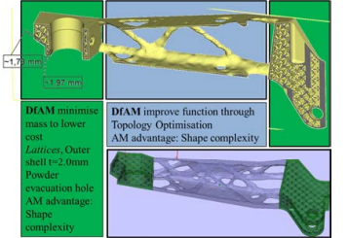
Figure 1: Generative Designed Beam (9)

1.2 Fusion 360 Software
When learning Fusion 360, there were minor nuances between this software and other software’s which made it pretty easy to pick up. Within Fusion 360 there are various tools that can be used to create a design. First, there is the design aspect where tools can be used to design objects within a 3-dimensional workspace. The next tool in Fusion 360 includes generative design where objects can be optimized by removing material in areas of low importance in achieving the requirements in place. Additionally, rendering, animation, simulation, manufacturing, and drawings can be computed for a design object in Fusion 360 (10). Within this study, the design, simulation, and generative design tools will be used on an I beam created.
The Fusion 360 software is unique in the fact that the various features include saving different versions that you can refer back to along with creating titles of different milestones within the design. With Fusion 360 advanced technology, the software communicates with the cloud to be able to run fast and accurate simulations and results. Fusion 360 is the only major software with the generative design feature which runs on the cloud and locally which makes it top tier when compared to other software’s (11). At the University of Oklahoma, Fusion 360 is not required to be taught as a CAD software in the mechanical engineering course plan. With the benefits this software has to offer, professors may be more inclined to use this software when teaching students new concepts in CAD design. Throughout my research, I used the free student software license for a year. Within the paper, the discussion of the Fusion 360 design process, 3D printing and testing will be laid out through an experiment.

1.3 Additive Manufacturing Methods
When looking at additive manufacturing (AM) within lightweight structures, the characteristics of various 3D printing methods through Fused Deposition Modeling (FDM) and Stereolithography (SLA) allow for the analysis of different material within complex designs. The various methods create lightweight and small-scale structures which can be mechanically tested to understand the structure of the material and strength of the design.
FDM printing incorporates looking at 3D printing with PLA material. This allows for filament to be melted down and layered into patterns to create unique designs and parts. SLA printing allows for top-down printing through resin printers. Resin printing incorporates curing the resin through UV light at each layer after the printing bed is dipped in the resin. Other additive manufacturing methods available include binder jetting, power bed fusion and metal 3D printing.

1.4 Structure of Thesis
Within this thesis, the structure is laid out through the sections of Methods in Fusion 360 Software’s to Create I Beams, Additive Manufacturing Procedure and Property Characterization, and Results and Discussion of Fusion 360 Developed, Additive Manufactured, and Tested I Beams. The Methods in Fusion 360 Software’s to Create I Beams sections will go through how the Fusion 360 software utilizes design, simulation, and generative design to create a new designed part with similar requirements and constraints. The Additive Manufacturing Procedure and Property Characterization section goes through the different printing and testing methods used when looking at the I Beams. The Results and Discussion of Fusion 360 Developed, Additive Manufactured, and Tested I Beams section evaluates and compares the 3-point bending test results of the original and generative designed beam with the FEM results through Fusion 360. Lastly, the conclusion and future work will be discussed when analyzing the topics in generative design characteristics and additive manufacturing.

2 Method in Fusion 360 Software’s to Create I Beams
Transitioning from the design to a physical part, various steps and methods go into the process of creating, testing, validating, and generating a new design within it. This section lays out the design, simulation, generative design, and 3D printing software’s.

2.1 Design Features and Steps to Create Original Beam
Within Fusion 360, the design tool incorporates a variety of functions which include sketching, extruding, modifying, assembling, and constructing in a 3D space. When using the design component of the software, it was a learning curve as I was still trying to understand the software as it was different than what I have used before. To start the design of the beam, I started by sketching a rectangle on the bottom plane.
Figure 2 shows the sketch of the I beam created. The beam is then extruded as seen below in Figure 3. This beam can be sketched and extruded in various ways, but sketching the design on the side plane and extruding it horizontally was the most logical way when designing. To ensure the object is printed correctly, the edges of the beam need to be filleted or rounded out. The fillets were originally 0.10mm but were changed to 0.2mm later in the design. The fillets were changed based off of the results in the simulation. Fillets were needed to ensure that it reflects how real-life parts look like and how they are manufactured. During the manufacturing process, it is hard to create and test parts that have sharp edges and can be harmful to the user. If other objects were being created, the other tools like revolve, hole, sweep or rib could have been used. If the object being designed needed threads in it, the thread function can create that pattern within the design to fit the thread and screw needed in the object. The inspecting function has features which include measuring and testing interference in the design.
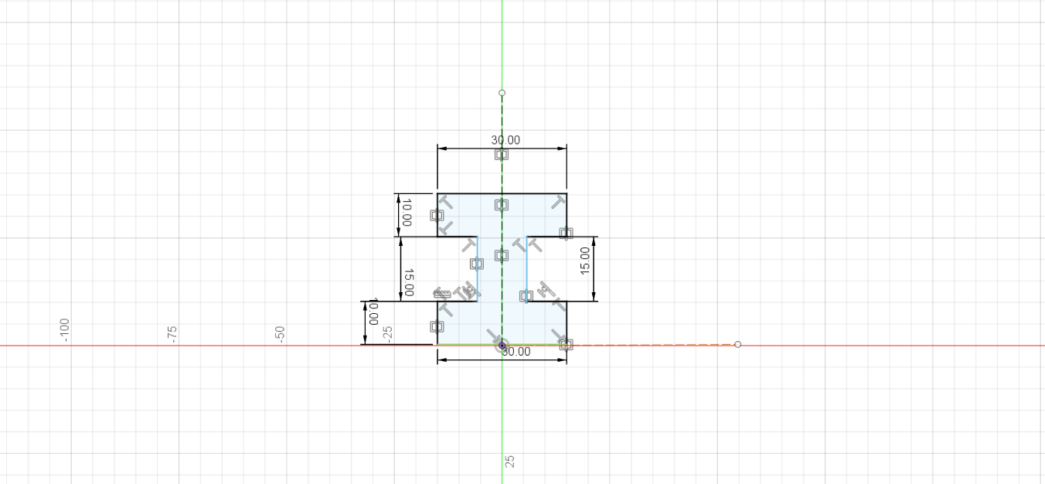
Figure 2: Sketch of I Beam
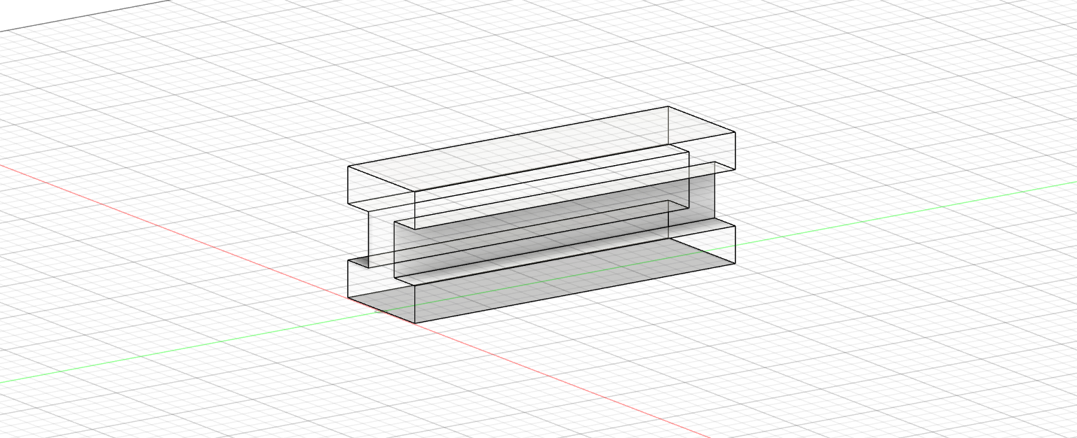
Figure 3: Extrude of I Beam
To see the design process and family tree, reference the lower lefthand corner to edit various functions used. A warning may appear if features from previous parts of the family tree are changed or broken. When creating the testing rig components and incorporating it into the design, I used the assemble feature and selected new component. This is where you can create a new part while connecting and forming assemblies in a separate window which referencing the starting design. This is helpful when trying to understand and connect the main feature to the other components. By referencing the starting design, features like tangent relationship and align can be utilized. The components can be referenced with planes to use the align feature or with the starting component to use the tangent relationship. These features are similar to how other software’s mating tool works. The roller supports as seen in a half circle and connecting a rectangle. This sketch was extruded, and all of the measurements were used from the testing rig. Figure 4 can be created using the sketching tool of a circle. The circle diameter was measured in comparison to the testing rig roller supports diameter on the 3-point bending test attachment. The loading component was also created on the software as seen in Figure 5. The loading component was created by forming a sketch of a half circle and connecting a rectangle. This sketch was extruded, and all of the measurements were used from the testing rig.
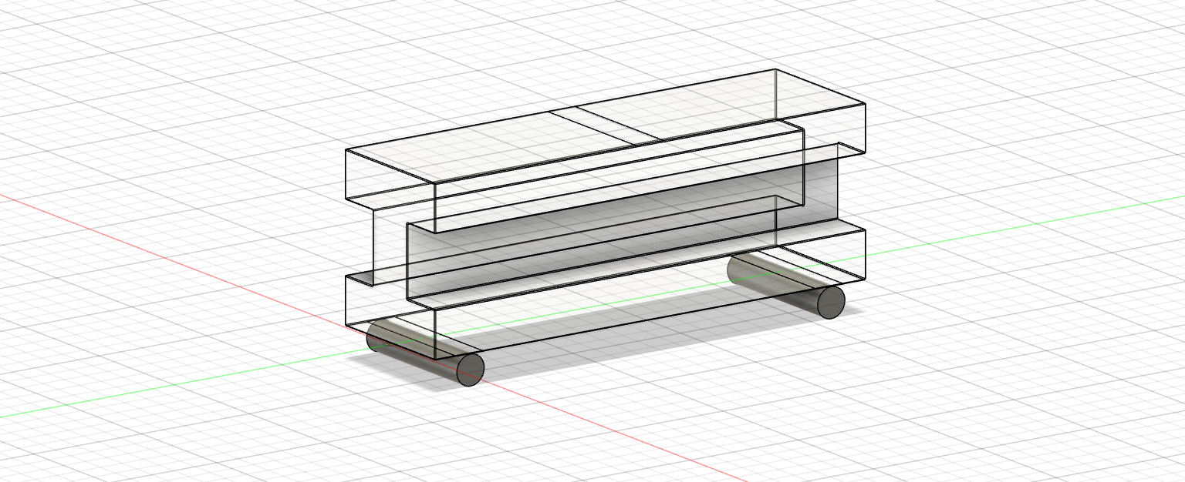
Figure 4: Roller Supports
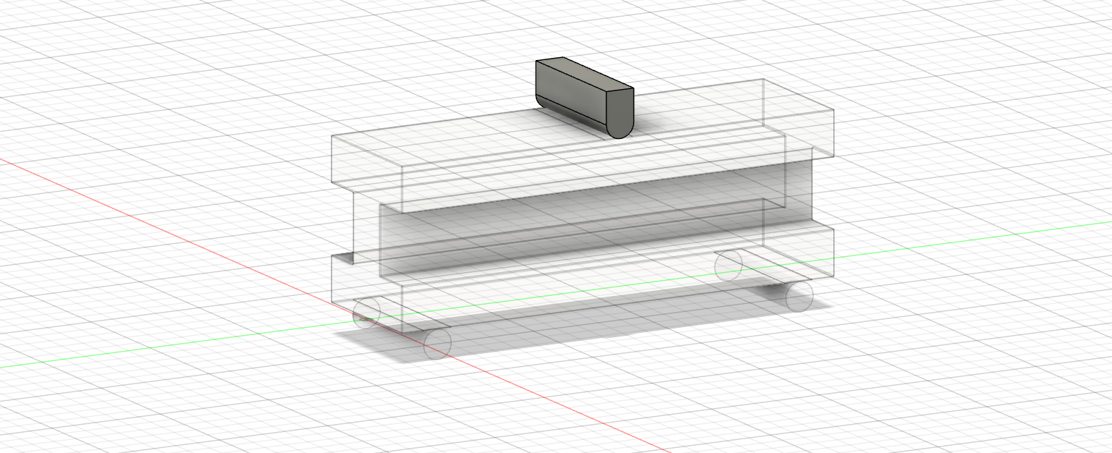
Figure 5: Loading Component
Other items that were used in the design component of the software was the material settings. For each of the 4 components created, the material was defined in the physical material by left clicking on the name of the part. This is where materials can be added and edited. The materials were assigned to each of the parts by dragging and dropping the material on the part that needed to be defined. The material was defined for two different beams for simulation, generative design, printing, and testing. The material for the first beam was only used on the main body and it was standing PLA from the PLA used with Hatchbox. The material used for the main body in the second beam with the testing rig components was the Blu Tough Resin defined by Siraya Tech. The material properties for PLA and resin can be seen in Table 1 and Table 2. These material properties were not accurate or reflective to the material properties of the Blu Tough Resin specifications when first designing the beam. Some of the material properties for the Blu Tough Resin was found from previous tensile testing in Dr. Yingtao Liu’s Lab. The material used for the roller supports and the loading component was regular stainless steel.

Table 1: Material Properties for PLA
Properties | Value
Thermal Conductivity (W/(m*K)) | 1.60E-01
Specific Heat (J/(g*℃)) | 1.50
Thermal Expansion Coefficient $(μm/$(m*℃)) | 85.70
Young’s Modulus (GPa) | 2.24
Poisson’s Ratio | 0.38
Shear Modulus (MPa) | 805.00
Density $({g/cm}^{3}$) | 1.06
Yield Strength (MPa) | 20.00
Tensile Strength (MPa) | 29.60

Table 2: Material Properties for Blu Tough Resin
Properties | Value
Thermal Conductivity (W/(m*K)) | 4.68E-01
Specific Heat (J/(g*℃)) | 1.00
Thermal Expansion Coefficient $(μm/$(m*℃)) | 39.80
Young’s Modulus (GPa) | 2.00
Poisson’s Ratio | 0.30
Shear Modulus (MPa) | 769.23
Density $({g/cm}^{3}$) | 1.41
Yield Strength (MPa) | 60.00
Tensile Strength (MPa) | 60.00

When I first designed the I beam, I did not have the correct measurements and the beam was too long and did not fit into the 3D printing bed dimensions as seen in Figure 6. After understanding that the beam was not designed based off of the dimensions, I went to the Instron testing machine and measured the dimensions of the 3-point bending testing rig. This allowed me to make a more accurate design for the beam as seen in Figure 7. After creating the second beam design, I ran the simulation, generative design and realized that the beam did not perform as well as it could of. The second beam was tested with both the PLA and resin material. At this point, I went back into Fusion 360 and created the beam with the testing rig application in place. This allowed for a more realistic representation of the beam with the testing rig in place as seen in Figure 8 and resulted in more accurate final results within the Fusion 360 software. I ran the testing with the third beam with resin material specified.
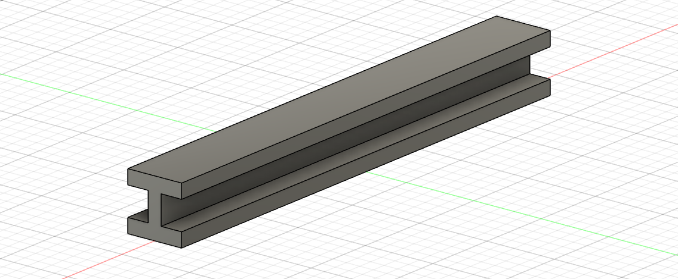
Figure 6: First Beam Designed
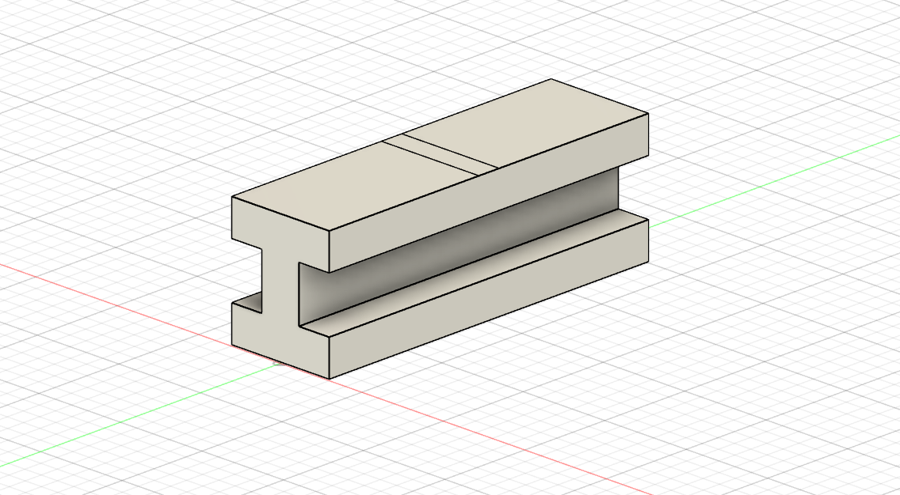
Figure 7: Second Beam Designed
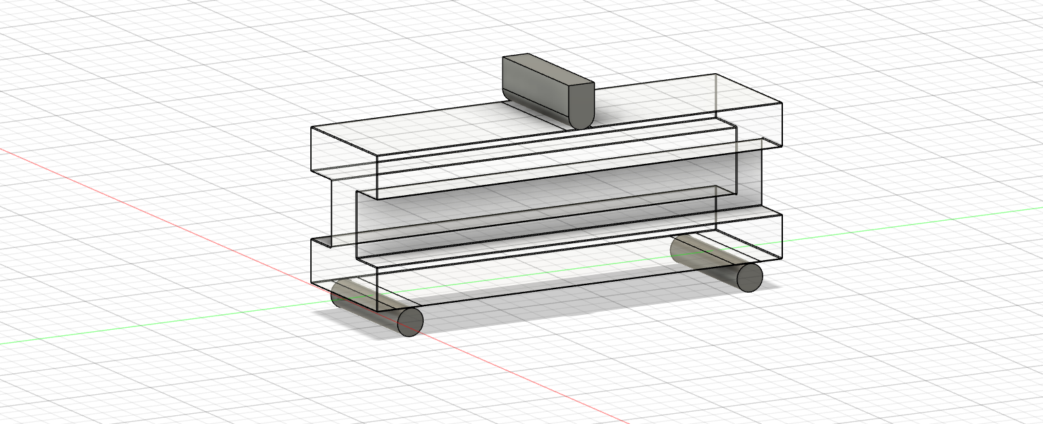
Figure 8: Third Beam Designed with Testing Rig Components

2.2 Simulation Features and Steps to Analyze Original Beam
After designing the beam, simulation or FEM analysis was ran on the beam to understand how it will perform when being tested. Simulation allows for a realistic computerized approach to how the beam can change based off of different properties. The simulation allows for various components to be defined on the beam and a force can be displayed. The simulation allows for analysis of what will happen to the beam before it is enacted in mechanical testing.
In Fusion 360, various features are in the simulation part of the software. After designing the object created, different tests can be run to understand the stress, displacement, safety factor and forces on the object. When applying the simulation, different studies can be created which include static stress, modal frequencies, electronics cooling, thermal stress, dynamic event simulation and much more. For the simulation of the beam, static stress was applied and used. The static stress study analyzed the deformation along with the stress of the object based on the loads and constraints applied. All of the results will be displayed on the results tab after the simulation is ran.
When opening up the simulation, the object should appear in the design space. On the left-hand side, in the simulation various model components appear and can be selected. Next, the study materials can be observed, and the drop-down menu allows for different materials to be applied to the object created. The material properties can be changed and edited in the simulation. Loads can also be applied to the object. The loads applied can be placed to replicate the different mechanical tests being done. The common structural loads that can also be placed are force, pressure, or moment. When simulating the object, the mechanical test associated with the object is a 3-point bending test. Constraints associated with the object are placed in the areas that reflect the boundary conditions. These boundary conditions have changed throughout the simulation and testing process. The common constraints which can be applied in the software include fixed, pinned, or frictionless. The contacts section explains how different bodies of the design interact with each other. The different contact types which can be applied include bonded, separation, sliding, or rough constraints. Meshing is another feature which a scale can be adjusted based on what the average element size should be on the beam. This feature allows for more in depth refinement of the beam and elements for analysis. After imputing all of the information and parameters for the object, the results can be simulated. The simulation takes a couple of minutes to run before it can provide accurate results. The results show the safety factor, displacement, stress, strain, and other items about the object observed. In the simulation results, different areas of the 3D object can be probed, and the values can be understood along with the maximum and minimum values.
The beam simulation was run for the PLA material and the resin material. After further analysis, the simulations talked about below only deal with the resin material. After understanding how the simulation in Fusion 360 works, I applied the simulation to the second beam as seen in Figure 9. The second beam did not have the testing rig components attached to it, so the loads and constraints were applied differently to the beam. The fixed supports are attached to the sides of the beam and the force in applied as a distributed load on the top of the beam. There were no contacts applied to this simulation and the mesh was not refined. The material which was applied to the beam design was the Blu Tough Resin.
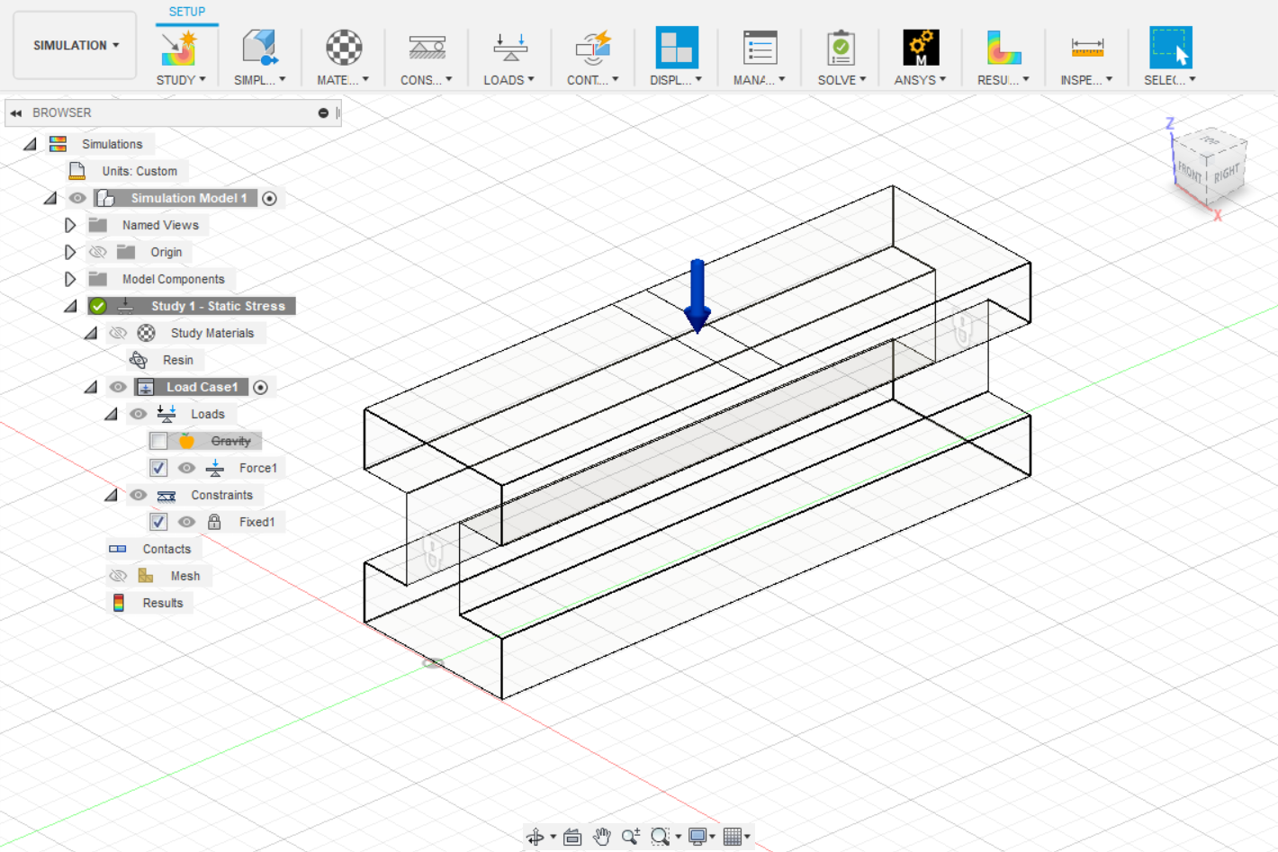
Figure 9: Simulation Set Up for Resin Beam without Testing Rig
After performing testing, I realized that the simulation may have been incorrect on the beam because of how the beam performed in the mechanical tests when compared to the simulation results. Next, I implemented the simulation loads and constraints onto the third beam created which incorporated the testing rig as seen in Figure 10. This allowed for a more realistic approach to how the beam will sit and perform in the testing rig. New boundary conditions were placed in this simulation as fixed points were assigned to the rollers and a sliding contact was assigned to the roller and beam connections. The mesh was also refined to 4% for the simulation as that provided the best refined meshing results on the beam. With the third beam in the simulation, I first made sure the material had the correct resin properties to ensure the previous set up was not messed up because of that. The resin properties were a little different than what was originally placed in the simulation with the second beam. The resin properties were then changed and reflected based on the Blu Tough Resin specifications. When applying the material to the beam, I later understood what Ultimate Tensile Strength vs Yield Strength meant when selecting material. As seen in Figure 11 the UTS can be found at the top of the curve. The UTS can either be the largest force the beam obtains in the simulation, or it is near the point of failure. Some simulation results were not accurate because the simulation was calculating and taking into account YS which was not near the failure point.
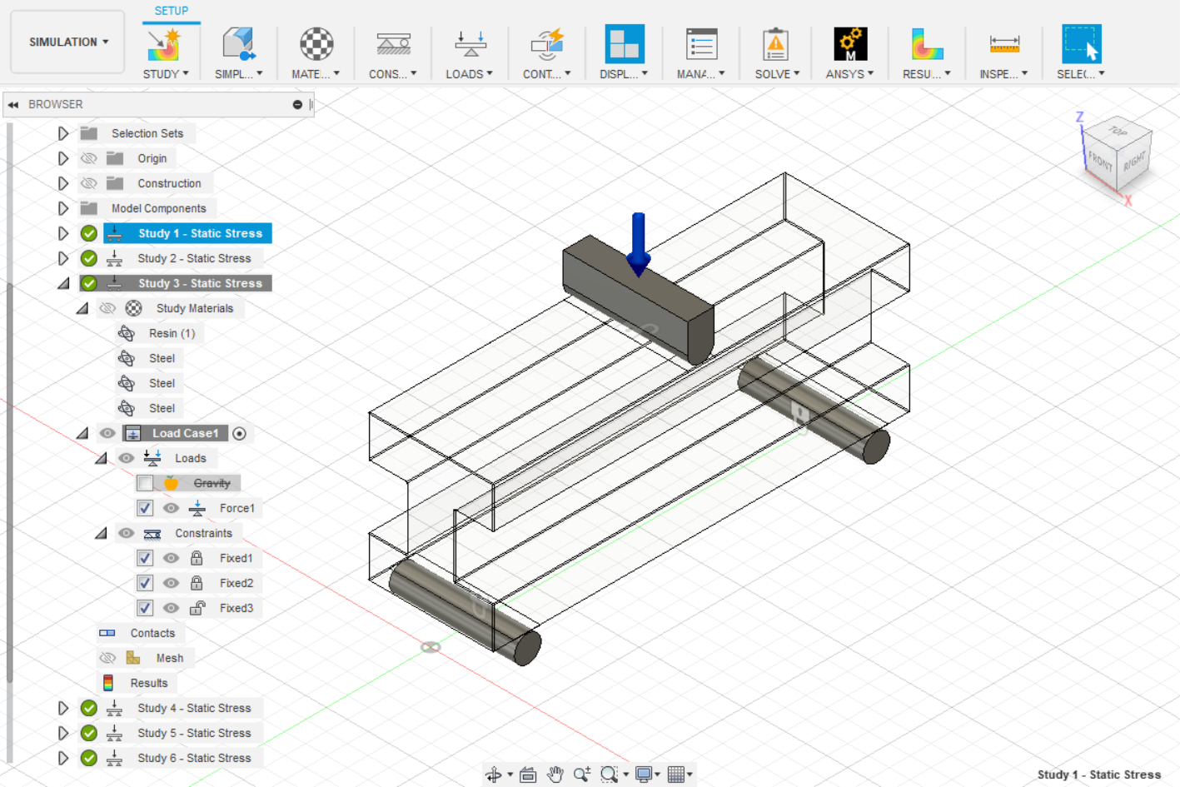
Figure 10: Simulation Set Up for Resin Beam with Testing Rig

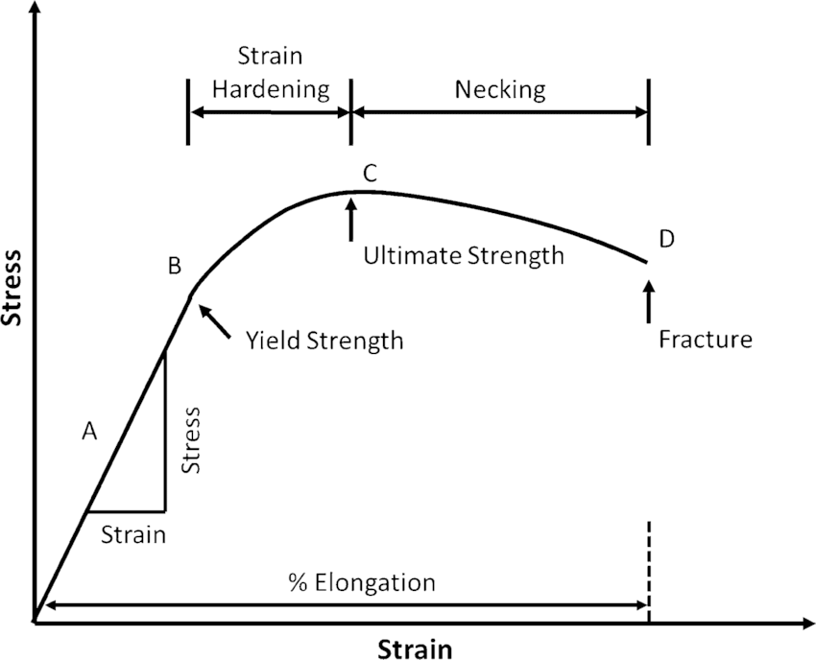
Figure 11: Stress vs Strain Curve (12)
When verifying the results of the simulation, Ansys was another software that was used to look at the beam designed and simulate what the beam would do during a the 3- point bending mechanical test. Ansys was used as a verification tool to check if the Fusion 360 software matched to what Ansys said. The goal of using Ansys was to understand how the features in this software differ from Fusion 360 and how the simulation can be improved when using another simulation method.
To set up a simulation in Ansys, steps need to be taken to start the simulation process, first the static structural analysis system needs to be selected. When that is selected various components of this system appear like engineering data, geometry, model, setup, solution, and results. To set up the geometry, I left clicked on geometry in the project schematic box and selected edit geometry in Designer model. This is where I was able to import my model and the geometry from Fusion 360 via a STL file. As seen in Figure 12, different features can be assigned to the design including material through engineering data and model by assigning boundary conditions, forces and improving the mesh of the beam. When running the simulation in Ansys, I only simulated the newest version of the beam with the Resin and Structural Steel material and not the PLA material.
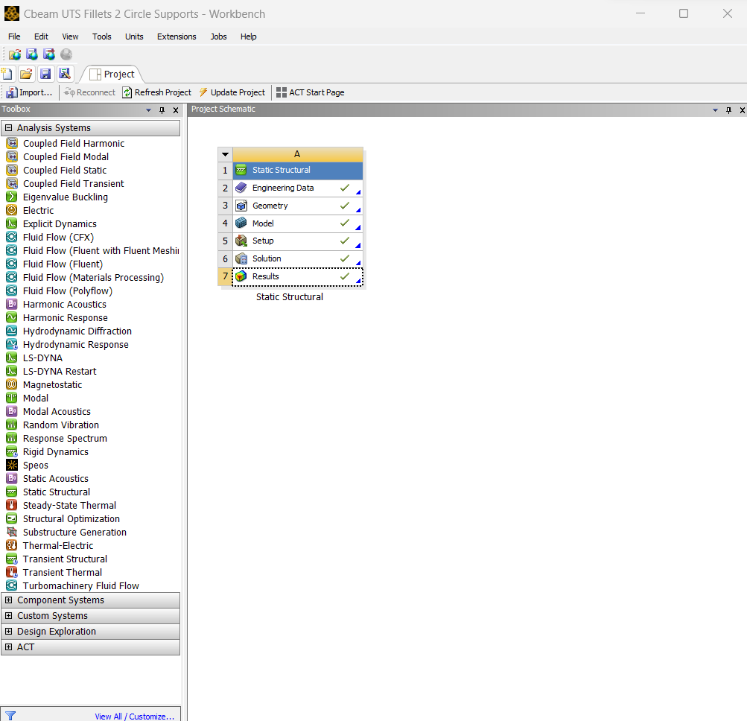
Figure 12: Features in Ansys
After the material properties were added, the model component can be opened in the Designer Model software. On the lefthand side of the window, the tree outline allows the user to see all of the components within that program set up as seen in Figure 13. The tree outline will show if the user has completed the steps for each step in the simulation or if the user has not along with if items in the tree outline need to be updated or if there are errors.
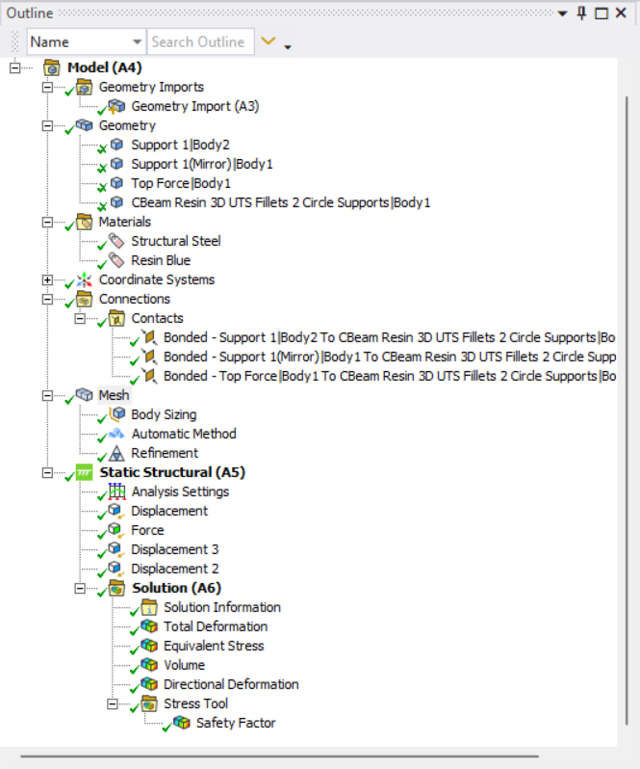
Figure 13: Ansys Tree Outline in Model
After the geometry has been imported into the modeler design space, the material can be assigned to different bodies in the design. Next contacts can be assigned based on the boundary conditions. Three different options are available in the software for this which include bonded, frictionless, or friction.
Next item in the outline tree is mesh which focuses on how defined the beam components are when the simulation is ran. The more refined the mesh is in high stress areas, the better the results will be in the simulation. Within mesh the term elements and nodes are closely related. Elements in the mesh design make up 3 nodes to form a tetrahedral on the object. Nodes are the points on the beam to make up the surface of the beam. When the software reads the mesh, the mesh can be changed by the number of nodes which correspond to the elements to refine the mesh. The mesh was refined in the filleted areas under the top part of the beam because the simulation was reading that area as a high stress component. When doing the 3-point bending test, the high stress area focus is on the top and middle part of the beam instead of the edges. The use of automatic meshing with refinement allowed for the beam and mesh to be formed based off what the software found was best for the object as seen in Figure 14.
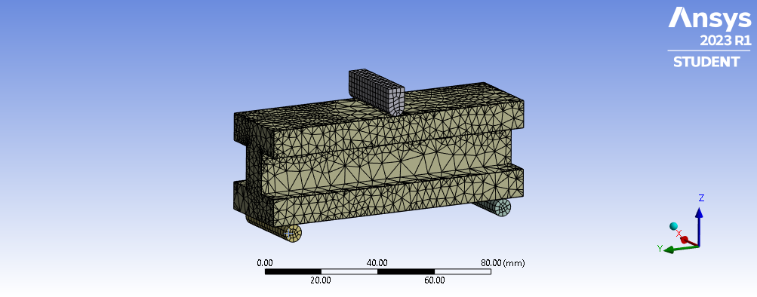
Figure 14: Mesh on Beam in Ansys
The static structural section allows the user to add in displacement and force settings which allow for boundary conditions to be formed. Boundary conditions are the loads and constraints in the design which allow for simulations to occur in certain ways depending on how the user wants the beam to deform. The solution tab allows for the different values and features to be solved from the design. Trial and error occurred in the simulation process in Ansys as some of the components and constraints selected were not able to be generated to provide results. When comparing Ansys with Fusion 360, both software’s provide sufficient results, but Ansys has a more refined and advanced meshing features. This allows the stress to be applied in the correct areas as seen in mechanical testing.

2.3 Generative Design Features and Steps to Creating a Generative Designed Beam from the Original Beam
The goal of generative design is to create a new part from an original design to see where material can be rearranged based on various constraints and requirements. Some requirements that was assigned to the beam created was to keep a safety factor of 1. The significance of a safety factor of 1 is that is the point where the beam with break and hit the failure point. Basing the generative design on making sure the design has a safety factor of 1, the original beam and the generative design beam will break at the same force. This will then prove that the original design can be redesigned with the objective of removing some material and keeping the same forces and constraints originally assigned.
When utilizing the Fusion 360 generative design feature, the design is sent to a cloud system to be computed. While other platforms may have a feature like generative design, Fusion 360 enhances the design process through the cloud system. The software utilizes artificial intelligence and other techniques to create new designs and utilizes the process to reduce the amount of computation time to do this redesign. The reduction of time has never been this effective but thanks to AI systems people can obtain real time data on their designs and design changes in generative design. Generative design through Fusion 360 allows for a multitude of iterations and new designs to be created which cannot be even imaginable with human knowledge. When humans do topology or generative design alike features, it takes multiple iterations and tries and knowledge to be able to create a new design that meets the requirements at hand which may include reduction of mass.
Within generative design, the various steps and features within Fusion 360 include assigning preserved and obstacle geometry, selecting the objectives, manufacturing techniques and the boundary conditions. The generative design feature allows for the user to implement various requirements and constraints to be able to actually create and produce the generative design object created. When importing the design, different components on the design can be selected as preserved geometry. Preserved geometry is selected on the components that need to be kept when the beam is being redesigned. Obstacle geometry can be placed on components that the user does not want in the final redesign. Next, starting shape can be added as the user can tell the software what the original design was and help the AI to better redesign the object. There is also a section for unassigned geometry if the user decides to not assign geometry which was in the original design. The original geometry can also be removed in the editing model section in the top feature bar. The components that have the greatest effect on the redesigned model is the objectives and limits that are selected. The user can select minimize mass or minimize stiffness as an objective when redesigning. The limits can also be selected to ensure the new design has a target safety factor. The target safety factor on my beam was 1 as that is where the object fractures. Next the manufacturing method can be selected through milling, additive manufacturing or unrestricted. The generative design software is unique because the manufacturing method can tell the AI software what tools or limits there are to the way the new design can be manufactured. Various materials can also be selected at this time for the object being redesigned. Lastly, the load cases can be placed on the object like loads and constraints.
Some differentiations between the simulation and the generative design spaces are that in the generative design space the contacts specification is not available. This may make the boundary conditions different between the two design spaces. When first putting preserved and obstacle geometry on the beam for redesign, I made the testing rig components preserved geometry which allowed for it to be in the final redesign, and I later opened up the final design in the design space and removed those components. With the final design, I placed the testing rig in the obstacle geometry category so it would not be in the redesign. Some items to note when placing forces and constraints on the object for redesign, the load cases can only be placed on preserved geometry.
When computing and given the results of the design after selecting generate, the iterations can be seen on how the AI software decides to form the new beam. Within the explore feature, the designs are given based on if they converged or completed, the materials which were used, and what manufacturing method was selected. The results which converged meant that the AI software was able to redesign the original part which avoiding obstacles and preserving geometry. The converged models met all of the limits and aimed to create the designs to meet the objectives. When the design completed, that meant the AI software had issues redesigning the original object to meet the requirements. By allowing more area and less preserved geometry on the original object, the generative design software will have more creative design freedom to make a new part. When opening up a part which has been redesigned, iterations will be available to view. The iterations are different designs that the AI software has created which meet the requirements given. These iterations may start will a large mass but then slowly move into a more condensed shape. These designs may look different to what a human would design because these designs are created through AI and advanced technology. Each generative design study to provide different design results takes about 2-4 hours as it is sent to the cloud server.
When creating the final design which will be used for testing, various factors play a part in how the limits or objectives will be achieved. The limits were achieved in the final design as the new redesigned object converged and met the limits which were assigned like force, boundary conditions and a safety factor of 1. When deciding the best beam to use for testing, the objective of reducing the mass came into effect. By creating a new design which also reduces mass allows for more cost-effective manufacturing. That means that the new design created uses less material which is better for the product being created and its cost. The generative design beam which was selected was at iteration 24 as seen in Figure 15. This was chosen out of the other designs given because of the reduction in mass and affect design choice for the testing set up and experiment.
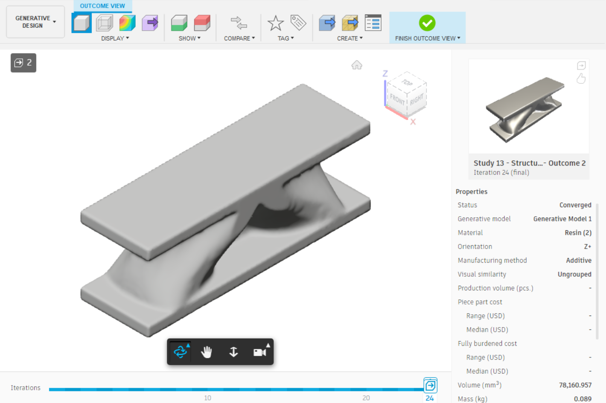
Figure 15: Generative Design of Beam at Iteration 24

2.4 Cura Software Features, Steps and Slicing for PLA 3D Printing
After having the designs created on the Fusion 360 software, the original beam design and generative beam design were placed in the Cura Software. This software is a common slicing software used to translate designs and objects into g code to print on a 3D printer. This software was used to print the beam and generative design beam with PLA on a Ender 3D printer. This allows for a g code to be created and then transferred and sent to the 3D printer. This software is free to download and utilize. The software allows for various options of different printers that can be used and has set parameters in place for the specific printer which is utilized.
The Cura software is pretty simple to use as a design can be uploaded on the software through a STL file. Once the file is uploaded, different printer settings can be set and selected. This filament was fed through a nozzle which was set to 200 degrees C. The printer bed was set to 50 degrees C which allow for the print to adhere and be formed. Different patterns and the amount of filament inside the object can also be determined in the slicing software. For the original beam and generative design beam, I selected the object to have a 100% infill which means it should be solid on the inside by using a cubic design when laying down the filament onto the printing bed. When creating the design, supports could be selected in the slicing software to allow help when creating unique shapes that don’t always start from the print bed as seen in Figure 16. Supports can be easily removed and will not be a part of the end design of the object. After selecting the settings, slicing will occur and each layer of how the print will be created can be seen in the software.
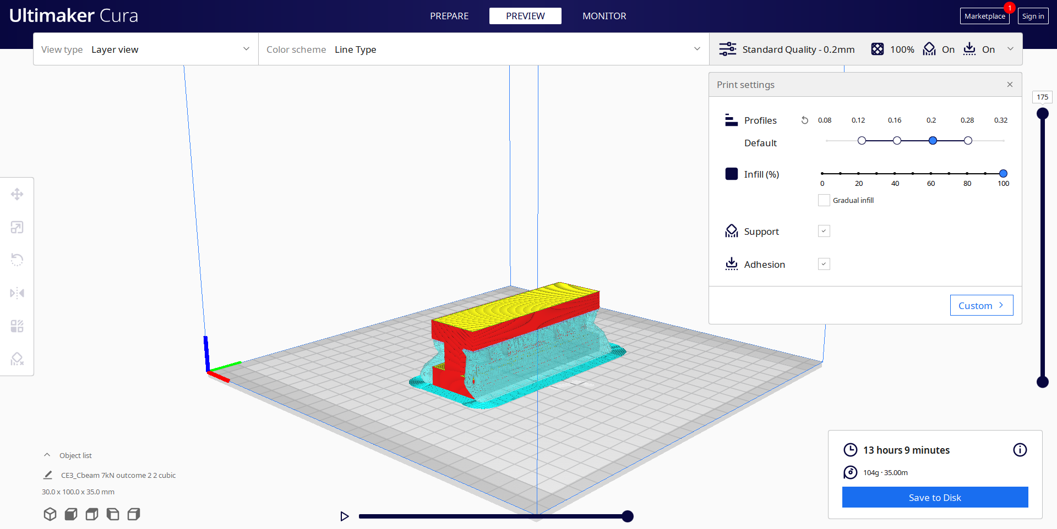
Figure 16: Cura Setting and Slicing for Original Beam

2.5 Chitubox Software Features, Steps and Slicing for Resin 3D Printing
The Chitubox software is similar to the Cura software but has a couple different features and is unique to use with resin 3D printing. The software can be downloaded and utilized for free when working with resin printing. Some features within this software include importing designs, copying, and arranging the lay out of the designs on the print bed, moving and rotating designs. These designs can be customized to the printing criteria along with adding supports in places where printing may experience issues.
The Chitubox software works by importing a STL file of the design. The software allows the user to move around the design and the placement of the design to add multiple designs on the printing bed. With resin 3D printing, the time it takes to print is not affected by how many designs you place at once on the printing bed unlike PLA 3D printing. This is not affected because of the way resin printers work. The supports can be added automatically everywhere on the part determined by the software, or the user can add parts on their own. These supports are thin pieces of printed resin which can be easily removed from the original part design after the printing process. After the supports are added, settings can be put in place for the specific printer and resin type being used. To put in those settings, a profile will need to be uploaded from the resin manufacturers website. After the setting and design is adjusted, the design will be sliced, and the layers can be seen on how the software will create the part on the printer in Figure 17.
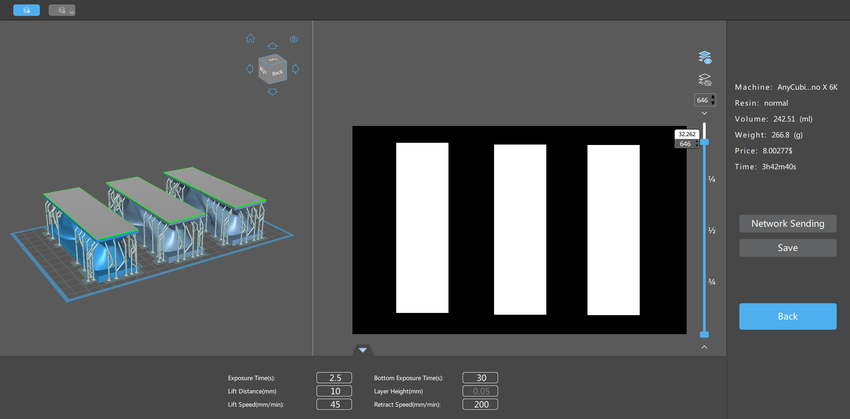
Figure 17: Chitubox Settings and Slicing of Generative Design Beam

3 Additive Manufacturing Procedure and Property Characterization
The procedure for the experiment includes taking the original beam design and the generative beam design and 3D printing them to then have physical objects to test. The process involves taking a digital design and implementing it into a printing software to create a tangible object. With the tangible objects of the original beam design and the generative beam design, testing can be conducted to determine if the software's analysis for generative design and mechanical tests are accurate and similar.

3.1 Fused Deposition Modeling Procedure and Outcomes
The Ender 3D printer consists of printing with Polylactic Acid (PLA) material through extrusion-based 3D printing. The technology used with 3D printing is also called Fused Deposition Modeling (FDM). FDM involves melting filament to create layers which form the design and object over time. The filament used was “Hatchbox Blue” which was in a solid form with a 1.75mm diameter. During the slicing process of the design on the Cura software, the settings set were transferred over to the 3D printer for the printing process.
To start the printer, the user will turn it on and insert the microSD card to upload the G-code file for the sliced design. The file needed will be selected on the screen of the printer. The file will consist of all the settings and the design which will tell the printer how to operate and move. Before starting the print, the printer will need to be checked to make sure there is ample filament to complete the print without failing. The nozzle and z height of the print bed will be checked to make sure when the print starts, everything is level to prevent any printing failures. After making sure everything is set up properly, the file can be selected and printed. During this time, the printing bed will heat up to 50 degrees C and the nozzle will heat up to 200 degrees C which was set based on the parameters in the slicing software. The printing process will start, and the filament will melt and the nozzle will move in the x and y direction to form the starting shape of the design. Throughout this process, the speed of the belt with the nozzle component can be adjusted and changed based on the rate it takes for the filament to solidify on each layer. The first layer of the design may contain a brim, trim or other design to help the initial layer of the object and design to adhere to the printing bed. This also helps when removing the object from the printing bed and the excess trim can be easily removed from the part. Throughout the process, the nozzle will continuously release filament at a flow rate and the nozzle will move in the z axis at each layer to slowly build up the part being created. After some time, the design will be completed as all of the layers are combined to create the object.
When trouble shooting the printer, it can be paused or stopped if the printer messes up. This will allow the user to restart the print or fix the issues within the print through the slicer software. The printer can be paused if the filament needs to be changed out. This may affect the continuation of the filament that was started on that specific layer. Throughout my printing process, I had a couple of failures which one can be seen in Figure 18. Some of the failures were caused by the z axis not being levelled properly or the layers were not sticking together well. Sometimes the filament would not solidify properly on the layer and the layers may then get out of place and the filament will just keep melting out. With my beam prints, the bed of the printer was not adhesive enough, so it did not initially stick the first layer of the print well as seen in Figure 19. That affected the next layers as the print started to warp and the layers were not even with each other. This was fixed by applying some craft glue to the bed to make sure the filament adhered properly.
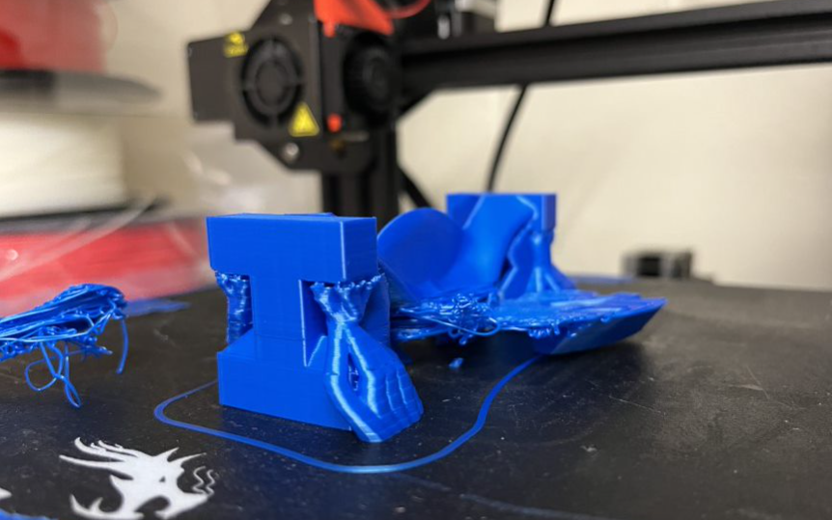
Figure 18: Failure During PLA 3D Printing
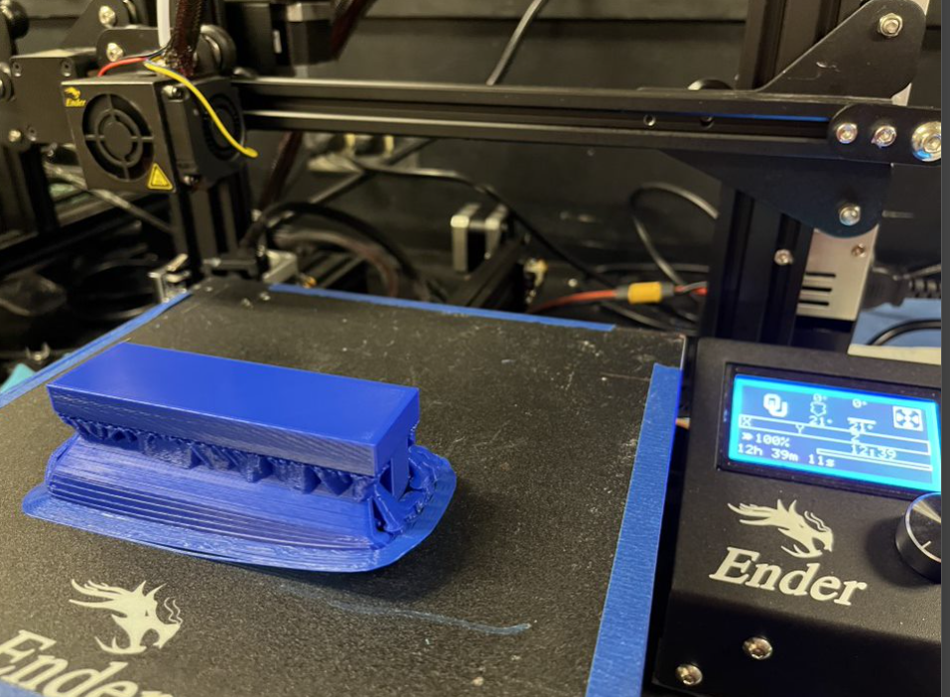
Figure 19: Warping of the PLA Print
My prints took about 12-13 hours for 1 original beam print and about 7 hours for a generative design print with supports. This time was reduced between the 2 prints because of how much material was being used and printed in each design. Most 3D printing times vary based on the infill and the size of the design. Since my design used 100% infill based on the Fusion 360 solid design, the print time was longer. When using the Ender 3D printer, I printed the original beam and the generative design beam in PLA which was designed in Fusion 360. The original beam printed pretty well but because of the 100% infill and issue with adhering to the printing bed, the final print warped a little bit in the corner as seen in Figure 20. Since there was a 100% infill for the original beam and it needed to be solid, some of the layers got off and the layer lines were too heavy and squished them together. The generative designed beam which was printed can be seen in Figure 21. This design printed well but needed supports to help print and build up some areas in the design.
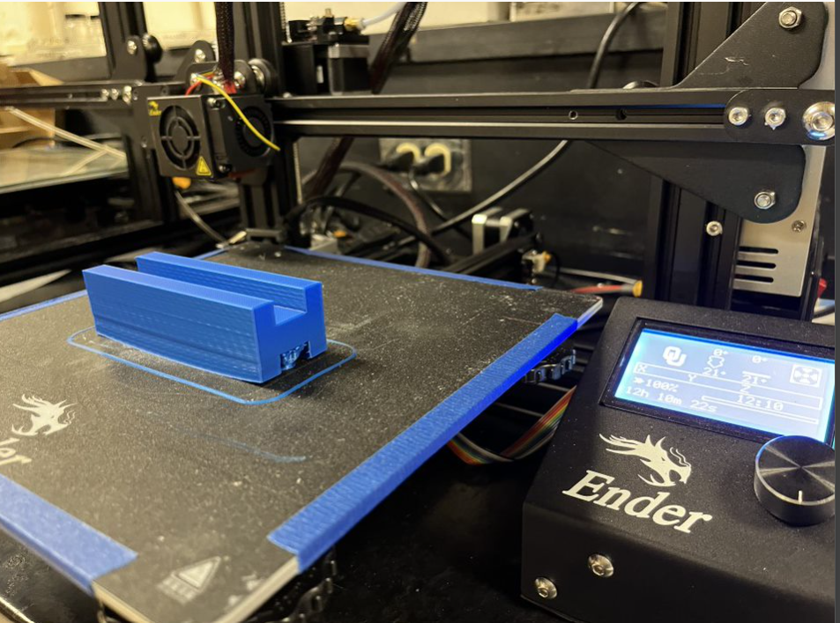
Figure 20: PLA 3D Printed Original Beam Side View
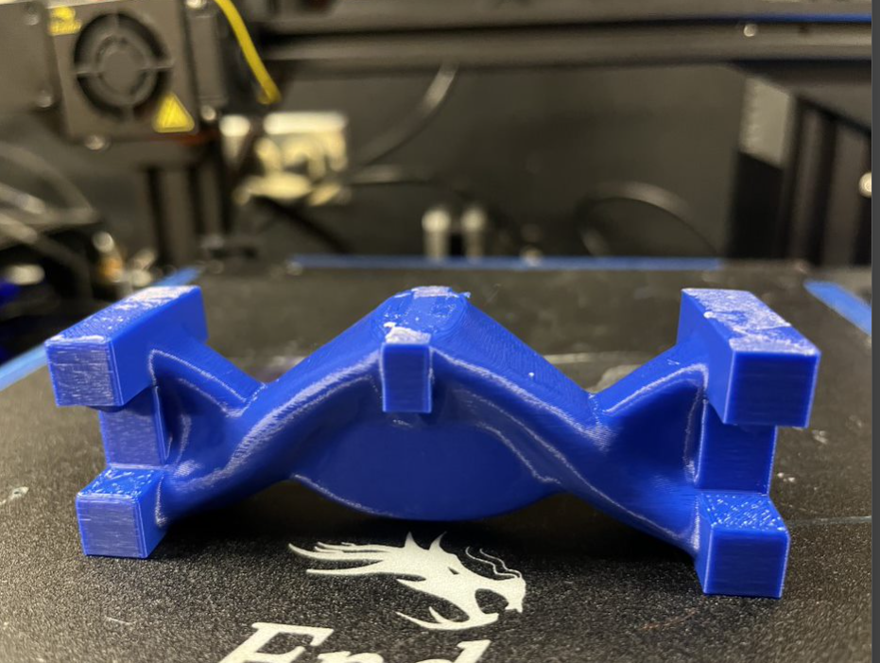
Figure 21: PLA 3D Printed Generative Design Beam Front View

3.2 Stereolithography Printing Procedure and Outcomes
The Photon Mono X 6K 3D printer was used to 3D print the beam designs with different type of resin. The resin which was used was the Siraya Tech Blu Tough Resin. This printer uses stereolithography (SLA) printing as it uses UV light to cure the resin at different layers. This printer allows for top-down printer as the printer dips the printing bed in the resin and cures the resin. Some printers allow for the UV light to shine as a projection onto the build plate or shine only through the non-black shape on the screen under the printing bed. This method allows for seamless combination of the different layers in the design. Resin printing benefits include printing multiple designs at once and completing the print with a solid body. The time it takes to print multiple objects on a resin printer is the same as printing one object unlike FDM printing. The prints will consist of 100% infill and become solid bodies as it cures as a whole and in the seamless layers.
The process to 3D print with resin includes setting up the printer and uploading the design. First the design needs to be sliced on Chitubox to the correct format of PWMB and should be uploaded to the USB drive on the resin printer. The resin printer will then be set up and the heating and cooling portion of the machine needs to be turned on as it connects to the resin printer device. The correct type of resin can be poured in the printing container and filled to the max line. This allows for the printing bed to be dipped into the resin and the design to be cured at different layers.
After the machine is set up, the file can be selected on the screen of the printer. Once the print has started, the printing bed will lower into the resin pool container. The machine will then read the file and cure the resin based off the specific design of that layer. The resin will be cured with a UV light in the machine and will raise up out of the resin after the curing is completed as seen in Figure 22. This process will continue with the different designs created at each layer until the final design is formed. The UV light will cure the resin at longer times at the beginning of the print to make sure that the resin will cure and adhere to the printing bed. After about 25 layers, the curing time decreases so the UV light shines less than before to cure the resin. My prints took about 5-7 hours to print depending on the complexity and layer height of the design. After the print is done, the printing bed will raise, and the machine can be disassembled.
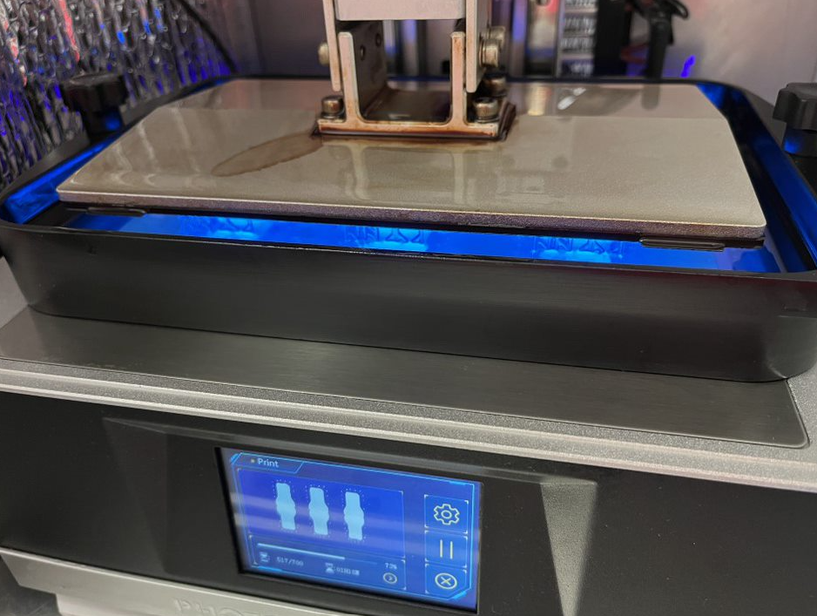
Figure 22: Resin Printing Process on the 3D Printer
To remove and clean the object and the resin, isopropyl can be used to clean the part off of the printing bed and the resin off of the machine to then be used for the next print. The parts need to be cleaned from the excess resin and then placed in a UV curing and heating chamber as seen in Figure 23. The time placed on the UV curing and heating chamber was 45 to 55 minutes set at 60 degrees Celsius. After the resin has been cured, the resin is good to touch and handle on the object. The original beam design can be seen in Figure 24 and the generative beam design can be seen in Figure 25.
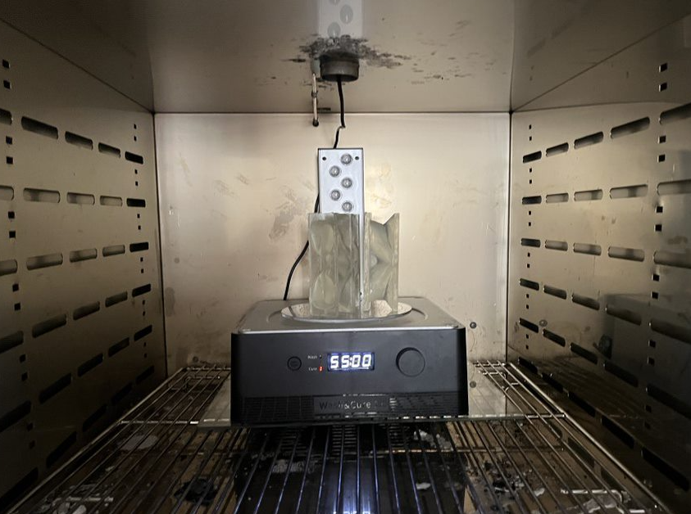
Figure 23: Curing and Heating Chamber for Resin Parts
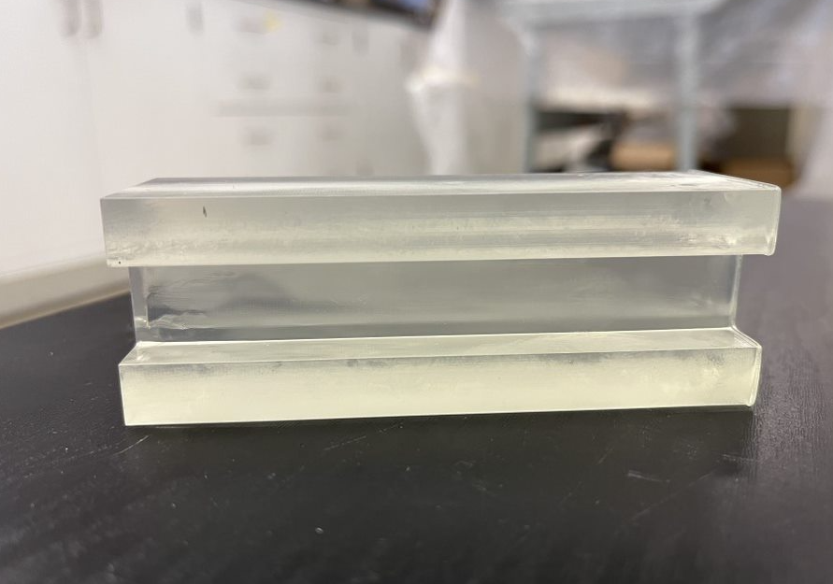
Figure 24: Resin 3D Printed Original Beam Design Front View
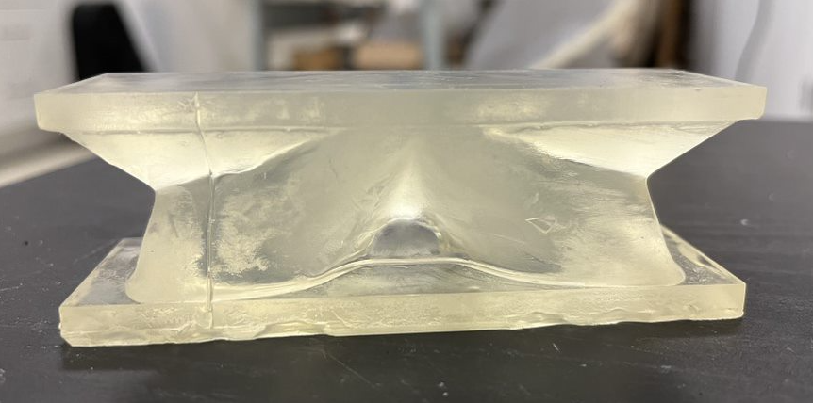
Figure 25: Resin 3D Printed Generative Design Beam Front View
While working with the resin 3D printer machine, gloves will need to be worn at all times as the resin material is abrasive to the skin. After printing a couple of samples, the prints failed. The first print failed because there was not enough resin in the container. The resin comes in liquid form and the resin had not been filled up all the way to the top line. The second failure I encountered was the printing bed and resin not adhering well. The half-cured resin part fell into the pool of resin, and I had to increase the time the printing bed cured at the first couple of layers. The third issue which was encountered was that the printing bed had adhered too much to the printing bed and I had to freeze and burn the printing bed to try to get the print off of the bed. The object ended up breaking off of the printing bed, but a flexible layer was placed which can be easily removed to pop off the objects.

3.3 Instron Set Up, Procedure and Testing for I beams
The Instron 5969 is a mechanical device which allows for various types of testing to be conducted which include but not limited to compression and tensile tests. To start the testing process on the Instron, the device needs to be connected to a computer with the Instron Bluehill software to run the program and connect the machine with the computer. The Instron Bluehill software will be selected on the computer and the Instron machine will need to be turned on with the on/off switch on the right side of the device.
When operating the Instron, various controls and features are on the machine. The screen with dials allow for the load cell and top of the machine to be moved up and down depending on how large the sample is and where it needs to be placed before starting the testing. When enacting the compression test and 3 point bending test, the following equipment was used: the 50kN load cell, the loading component, and the 3-point bending testing rig. The load cell which was used was 50kN as that is the highest load cell which reaches the necessary loads to break the beam. When operating the device, there are some important safety precautions that need to be taken. First, the components need to be secured into the device as that will affect the results of the test and can cause damage to the user or machine if not secured well. When the test is running, make sure no hands or other components are in the testing rig area. This can cause damage when computing the compression test or tensile test. The testing set up can be seen in Figure 26. I also placed a box and wore safety glasses which performing the tests for the resin 3D printed beams as the resin pieces may go flying when breaking the beam.
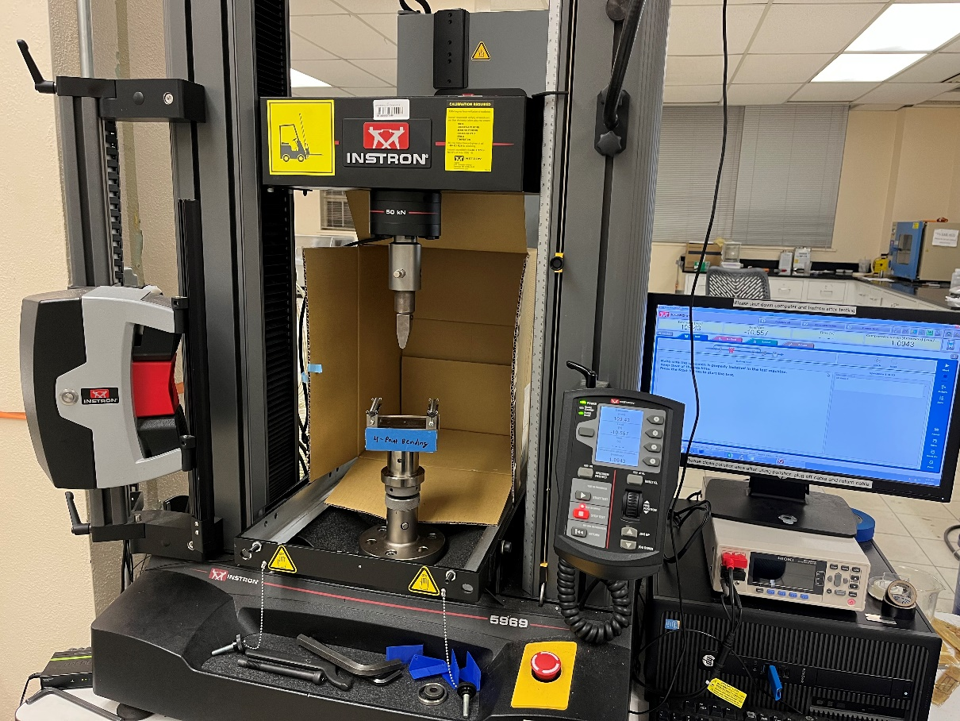
Figure 26: Instron 3-Point Bending Test Set Up
After the testing rig and Instron is on and set up, the software components of the testing can be set up. To set up a new test, a method needs to be created for the test which is being computed. Since I am performing a 3-point bending test, the compression method needs to be utilized to inform the Instron machine how to perform. When creating the method, different features will appear where values and information will need to be inputted. To specify the properties of the beam I created, the geometry selected was irregular as it was a unique shape not defined in the software. Since I did not exactly have the values for the area or anvil height, I was able to input those at a later time. Next, the measurements category allows for different measurements to be imported into the excel and computed when running the tests. The measurements which were selected for my tests were time, extension, load, compressive strain, compressive extension, and compressive stress. Calculations were then set up by selecting the information wanted in the excel raw data after the testing was done. The calculations selected were break, elongation after fracture, modulus, peak first (load 10%), maximum load, and yield (zero slope). Lastly, the export category allows the user to select what they want to be exported and what results it will output into the raw data.
When all of the information is in the software’s testing method, the testing can begin. Load the specimen onto the testing rig and use the dial to move the loading component to touch the top of the beam. This allows for the beam to be in place and sit on the two roller supports while the loading component sits in the middle of the beam. Once the testing rig and specimen is in place, the balance all button can be selected to reset the load and extension on the machine to zero before starting the test. The test can be started by inputting notes, if necessary, along with the height and area for various calculations and then selecting the start button. A graph will then appear on the computer screen which shows the load vs extension graph. This graph visually shows the change in the specimen at each load. The screen on the Instron also allows for different values and change in values to be seen. The testing will run until the beam breaks or unless the loading component loses contact with the specimen. Once all of the tests have been completed, the data can be exported as an excel and saved onto a flash drive or the computer by selecting save as and finish to exit out of the test and software.

4 Results and Discussion of Fusion 360 Developed, Additive Manufactured, and Tested I Beams

4.1 Timeline of Various I Beam Designs in the Design, Simulation and Generative Design Features of Fusion 360
When creating the simulations for the different designs to understand the forces and safety factor applied to the beam, the material, boundary conditions and other factors affected the results. Throughout the experiment, mistakes and learning experiences were made throughout the process of simulation and generative design. After creating my original beam and redesigning it to meet the size of the testing rig, I was able to apply forces onto the beam and test the safety factor of the beam to see when it broke. The goal was to achieve a safety factor of 1 which is where the beam will break and reach the failure point. Since I did not know the force which needed to be applied to the beam to reach the safety factor of 1, I tested different forces until the beam simulation showed the breaking point. The force I found and applied to the beam was 7kN which I had thought I found the breaking point of the beam and a safety factor of 1. When creating the simulation, the material properties also affected the results. The material properties which was placed for the 3D printed beam was Tough 2000 because that was the closest material, I could find to PLA in the material properties. As seen in Figure 27, the beam showed the safety factor at the force of 7kN with the Tough 2000 material properties. The boundary conditions were assigned as a distributed downward force being enacted in the middle of the top of the beam and fixed points on the side of the beam. These boundary conditions were initially assigned before I fully understood the 3-point bending testing set up. None of the other properties on the simulation were edited as the main focus was on the force and safety factor needed to break the beam.
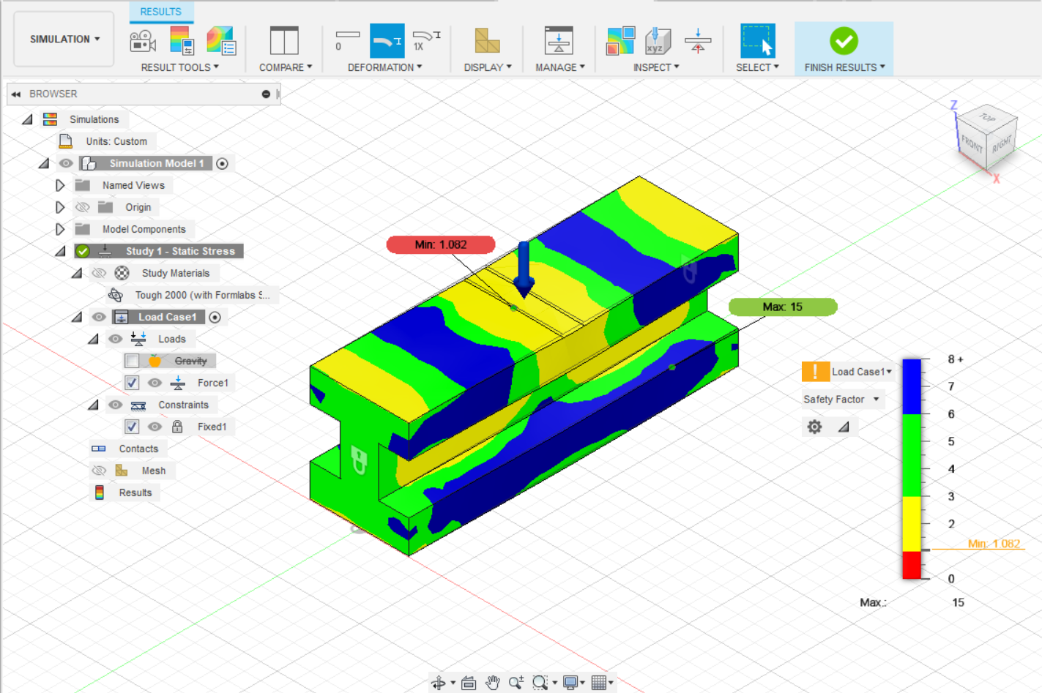
Figure 27: Second Beam PLA Safety Factor Simulation at 7kN force
After realizing the material properties did not match the material being used to 3D print the beam, the material properties changed in the simulation and the PLA properties were imported and assigned to the beam. The same boundary conditions were assigned to this beam. The force changed to 8.4kN distributed downward on the top of the beam. As seen in Figure 28, the force changed a little bit to achieve the minimum safety factor of 1 which will be where the beam broke.
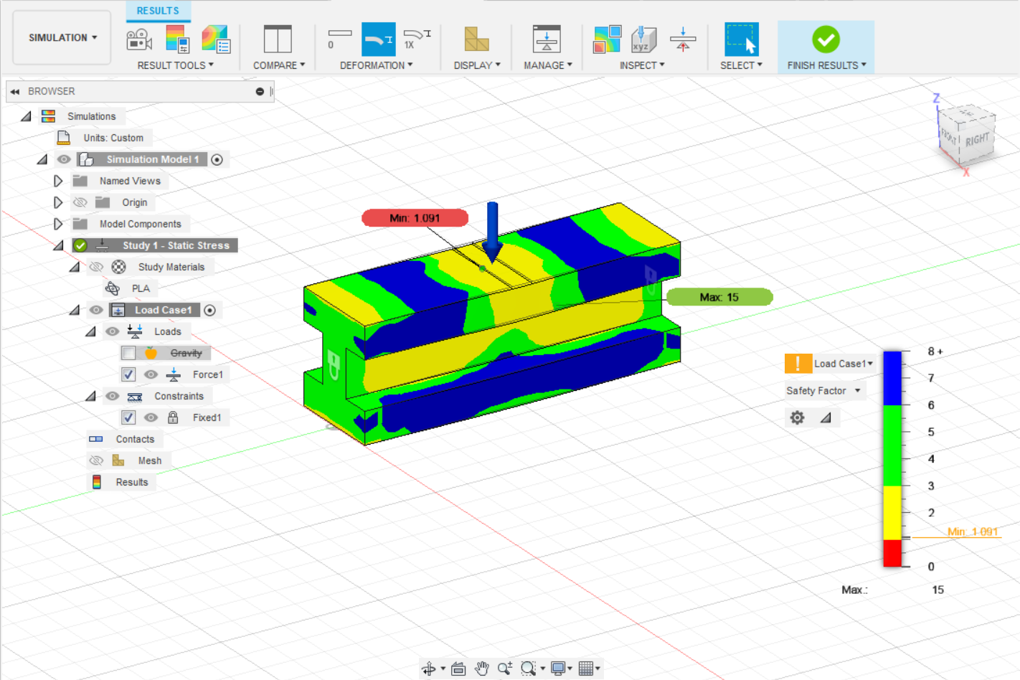
Figure 28: Second Beam PLA Safety Factor Simulation at 8.4kN force
After doing that analysis, the new design of the beam is created through the generative design software using the PLA material. Different preserved geometry and obstacle geometry was assigned and tested with the Tough 2000 beam but seen in Figure 29, the beam with the correct PLA material was placed in the generative design software. In the generative design software, the preserved geometry was placed at the fixed ends and at the top which allow the software to understand to keep those components and shapes. Obstacle geometry was placed at the top and bottom of the beam to make sure the new design looks similar to what was given in the software. In this generative design study created, the middle part and original beam design was placed as unassigned geometry which means the software does not look at that component.
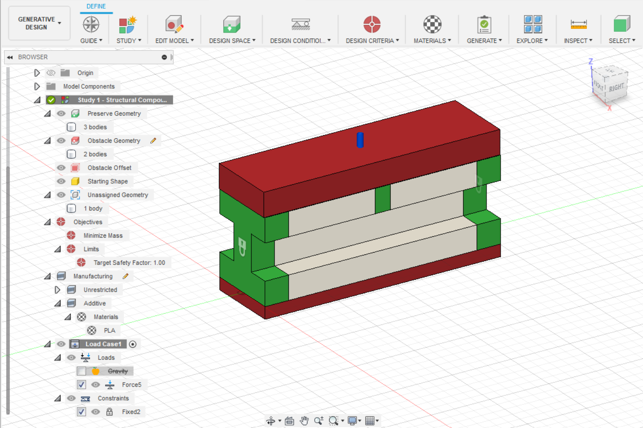
Figure 29: Second Beam PLA Generative Design Set Up with 8.4kN Force
When the generative design computed, the software provided many results which included different iterations of the design for the PLA material and the best design was selected out of the iterations. These iterations converged which meant that the software was able to create a new design but keep the same constraints, forces, safety factor of 1 and keep the material properties. Figure 30 shows the best design at iteration 30 in the set of iterations which was then used to be tested.
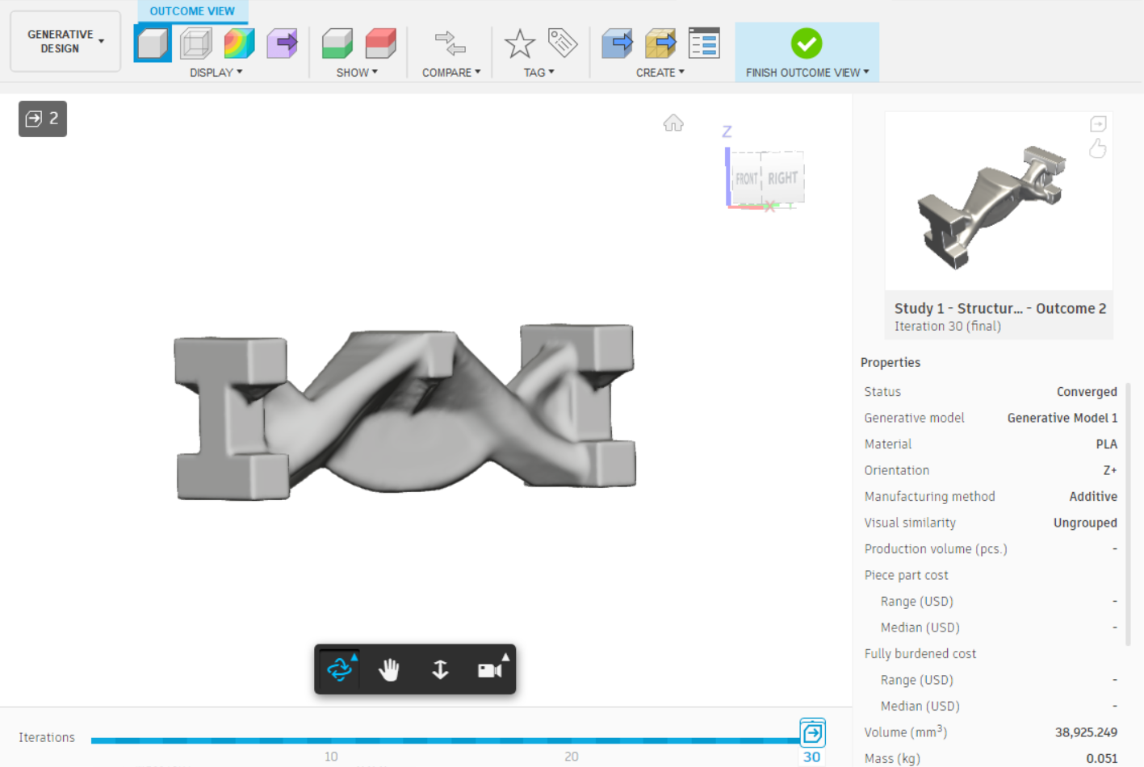
Figure 30: Second Beam PLA Generative Design at 8.4kN Force
After testing with the PLA material, I moved over to working with resin material. I placed the original beam into the simulation and assigned the resin material to the beam. The material properties changed the way the beam performed so the force needed to be reevaluated and was changed to 1800N based on the safety factor found. Through resin and SLA 3D printing, the structures are created differently than FDM printing which affect how the beam performs overall. As seen in Figure 31 the beam’s force was tested and the force of was applied to the beam. The boundary conditions also stayed the same with the simulation on this design. After understanding UTS vs YS in the simulation stage, the resin material was set to calculate UTS when computing.
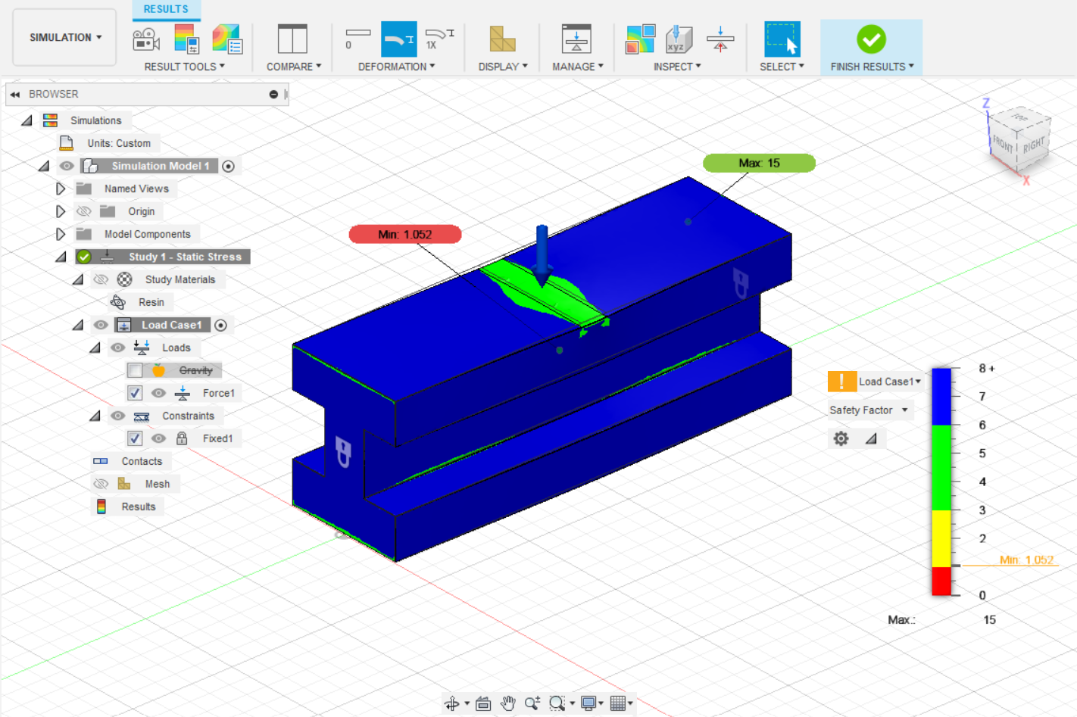
Figure 31: Second Beam Resin Safety Factor Simulation at 1800N Force
After the simulation was ran on the original beam design, the same forces and boundary conditions were placed on the beam in the generative design component of the software. This allowed the beam to be redesigned and create a new design which will meet all of the constraints and forces given and was set up similar to the PLA beam in the generative design software. The best iteration created was at iteration 30 as seen in Figure 32 This iteration converged using the additive manufacturing process and provided a new mass and design to meet the constraints.
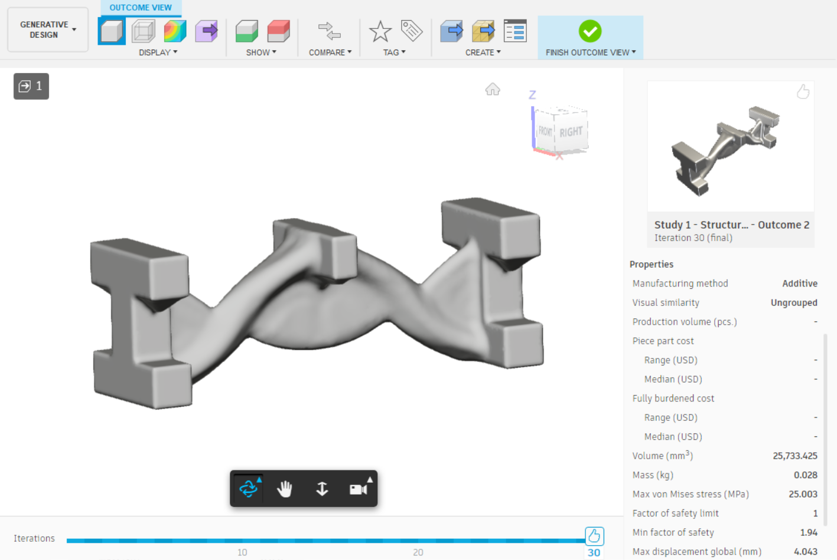
Figure 32: Second Beam Resin Generative Design at 1800N Force
After running the tests and understanding the results as seen in 4.2 3-Point Bending Test and FEM Results Comparison for the PLA and Resin I Beams, the results from the mechanical testing were not similar to what the simulation had shown. After going back into the simulation part of the software, the design was changed to include the testing rig set up and components. This allowed for the beam to be simulated closer to what it would look like in the testing rig. Once the components were added, the boundary conditions changed. These boundary conditions changed to where the bottom roller components were fixed, and the force was placed on the top of the top force component as a distributed load being applied downward. This allowed for a more realistic approach to the beam on the testing rig. As seen in Figure 33, the force was changed to 18500N as that was a more realistic value to how much the beam could hold before breaking at the safety factor of 1 near the top component. During this time, the material properties for resin was reevaluated and the shear modulus changed based on the young’s modulus and Poisson’s ratio. This did not have much effect on the force given to the beam as the beam’s deflection changed a little bit in the simulation. The contacts part of the simulation was also utilized, and the sliding condition was placed between the rollers and the bottom of the beam. This allowed for the beam to be simulated as free to move on the 3-point bending testing rig like in the testing set up. The top component with the force applied onto it, had the contact assigned to as bonded so the top force always had contact with the beam when running the simulation. The mesh was also an important factor to the simulation of the beam. The mesh was set to 4% to better define the beam and elements when creating a more accurate simulation. All other features were kept the same including evaluating the material based on UTS.
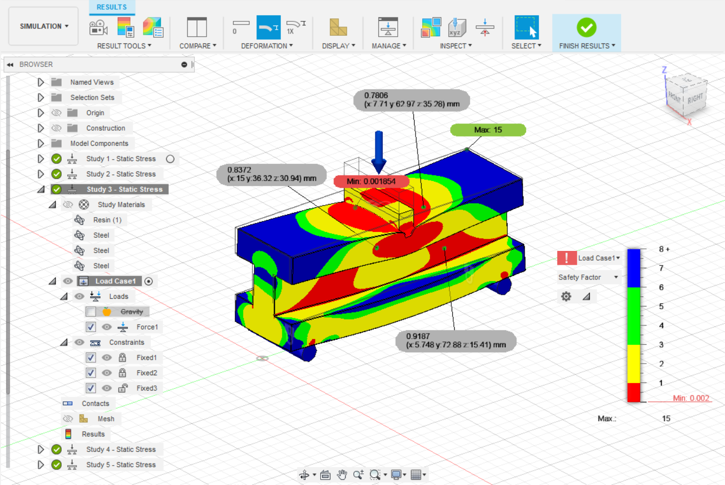
Figure 33: Third Beam Resin Safety Factor Simulation at 18500N Force
After simulating the beam and understanding the correct forces applied and boundary conditions, the constraints and components were placed into the generative design software as seen in Figure 34. The generative design software allowed for the beam to be redesigned with the testing rig components in place and more defined constraints. As seen in Figure 35 the generative designed beam converged and created different iterations which allowed for the beam to be redesigned while meeting the requirements explained through the software. The mass of this beam did weigh more than the original beam as the software did not allow the design to meet the object but did allow it to meet the requirements of force and safety factor.
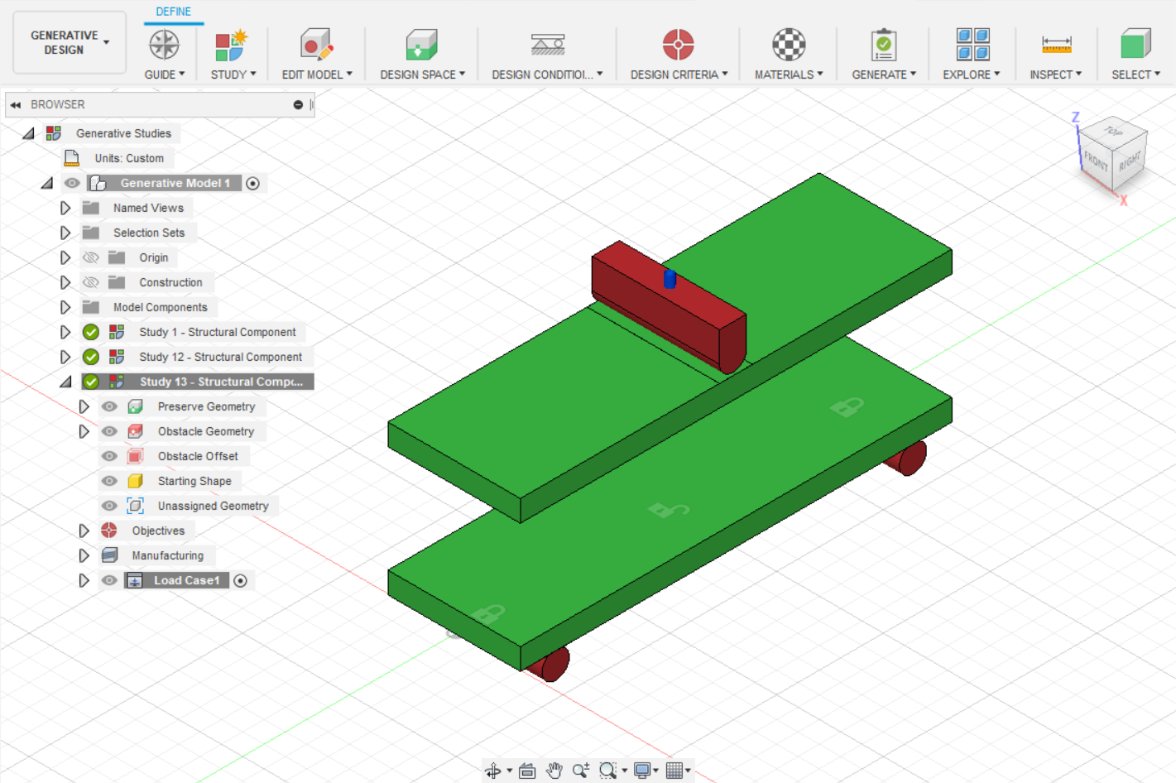
Figure 34: Third Beam Resin Generative Design Set Up at 18500N Force
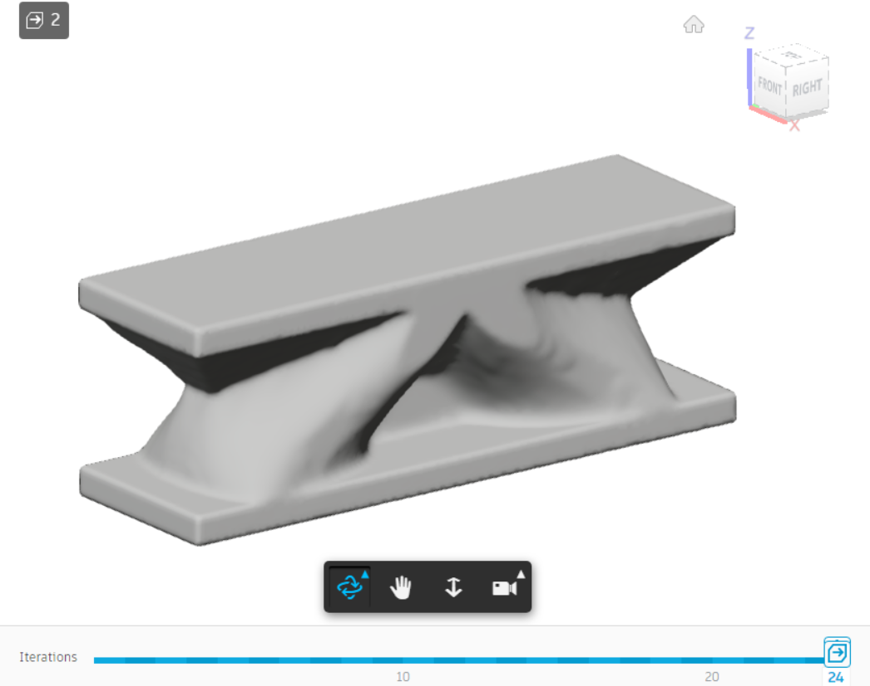
Figure 35: Third Beam Resin Generative Design at 18500N Force
While deciding which generative design beam was the best fit and design, different iterations and simulations were set up. As seen in Figure 36 and Figure 37, the obstacle and preserved geometry was placed in different areas to provide different outcomes. Some of the outcomes converged and others were completed which means they did not complete the requirements which were assigned by the software.
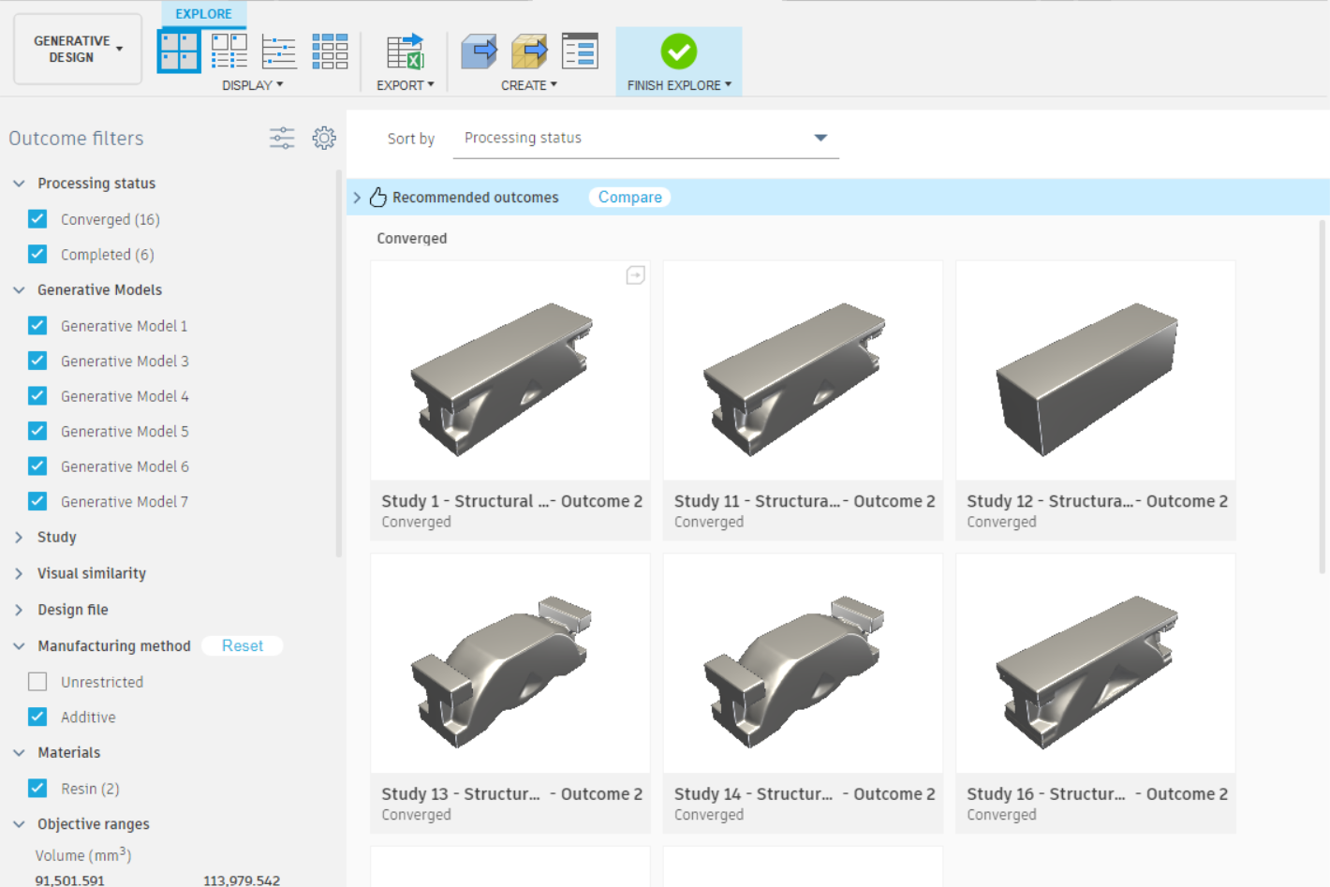
Figure 36: Third Beam Resin Generative Design Multiple Outcomes 1
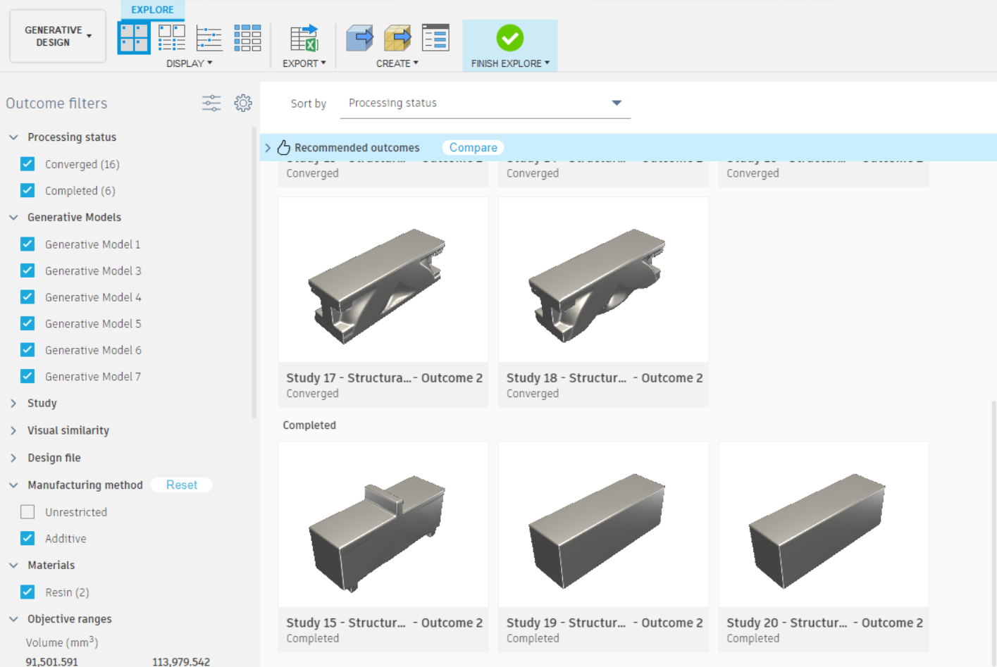
Figure 37: Third Beam Resin Generative Design Multiple Outcomes 2
These designs were further evaluated, and some other designs could have been tested and understood but the design which was tested was explained in 4.2 3-Point Bending Test and FEM Results Comparison for the PLA and Resin I Beams. After further analysis, the design that was chosen met the goal of reducing mass, converging, and maintaining the force requirement.

4.2 3-Point Bending Test and FEM Results Comparison for the PLA and Resin I Beams
After testing, the 3 point bending test results and raw data were observed. 3-point bending tests observe the elasticity of the object and material. The testing rig enacts a downward force on the object and record the extension and the displacement. These 3-point bending tests can be compared to FEM analysis results to determine if the software has properly redesigned the original beam.
From the excel data, the load, time, and extension was seen throughout the test. Figure 38 shows the load vs extension of the 5 PLA original beams. The trend was similar at the beginning between all the beams as the load increased along with the displacement increasing. When testing the PLA original beams, the layer lines affected the results and the maximum force obtained. Since there was not a clean cut in the beam, it is hard to understand when the beam truly fractured. The highest beam and odd sample out was sample 5 which reached a load of 1600N and an extension of 5.8mm.
Figure 38: Load vs Extension 3- Point Bending Test of PLA Original Beam
When evaluating the beam, the beam deformed as the force enacted on the middle top of the beam and broke at the layer lines in the middle. This showed that testing with PLA material and 3D printing was not as accurate when compared to other additive manufacturing methods. Figure 39 shows the beam breaking at the layer lines as the filament did not combine well enough to hold the force enacted on the beam. This breakage at layer lines gave inaccurate maximum force results.
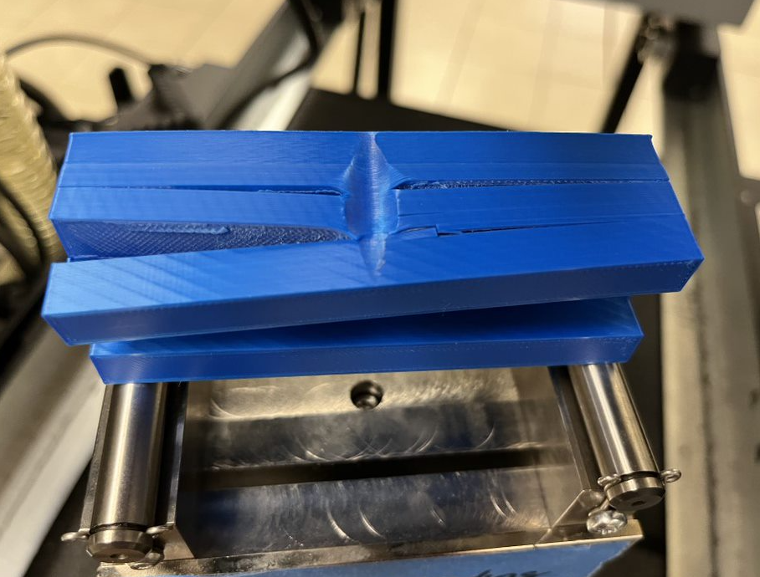
Figure 39: PLA Original Beam Fracture at Maximum Force
Figure 40 shows the load vs extension of the 5 PLA generative design beams. The trend on this graph is similar between all of the samples. Each sample increases extension while the load increases. When each beam reaches the force of around 2300N and 4mm for extension, the results start to decrease. These results do not show a clear fracture point, but it does show the maximum UTS at the top of the curve.
Figure 40: Load vs Extension 3-Point Bending Test of PLA Generative Design Beam
The beam was able to deform during testing and the failure areas were in the bottom corners as seen in Figure 41. The layer lines did stretch as the failure area was seen on the generative designed beam. When looking at the FEM analysis, the beam deformed similar to how the beam deformed in testing. The FEM analysis showed high stress areas in those bottom corners. The beam tested shows no breakage, just strain which is similar to the results in the graph above.
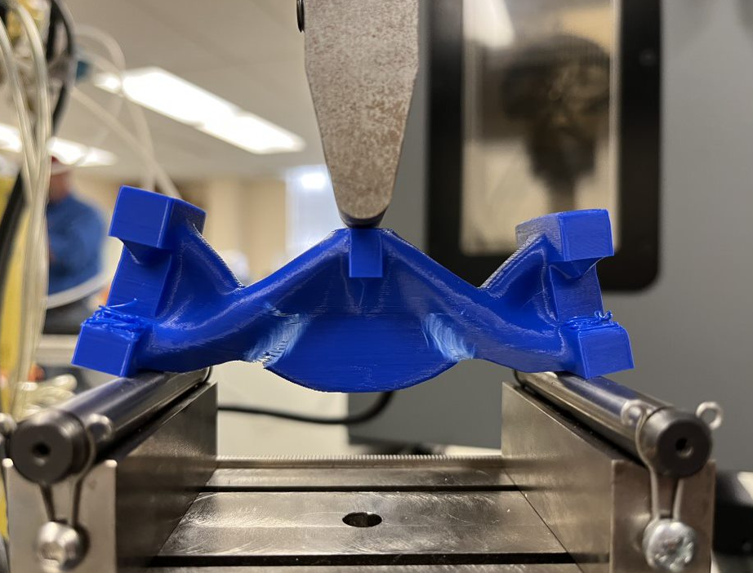
Figure 41: PLA Generative Designed Beam Fracture at Maximum Force
These results were not very accurate when compared to the FEM results as the beam deformed more than the true point of fracture in the beam. As seen in Table 3, the maximum force and displacement and mass was compared as an average. After seeing the values of the maximum force, the generative designed beam did not reach the same force as the original beam. That proved that there were issues in the software simulation and analysis since the goal of generative design is to create a new design of the object but keep the same forces and constraints. These values differ from each other because of the boundary conditions enacted during the testing verses the boundary conditions in the FEM simulation analysis. There are also differences in the FEM analysis as the maximum force read on the FEM results were calculating yield strength and not ultimate tensile strength. The displacement was around 4mm for the original beam and generative designed beam. The FEM results showed an entirely different displacement which was reached which helped confirm that the simulation set up was incorrect. The force reached between the original beam and the generative designed beam were not comparable at all which also proved that generative design did not work in this analysis. The mass was compared between the FEM analysis and the physical printed beams. The mass was similar the models created on Fusion 360 which shows the software may have been a little off on the material properties or the printed beam may had extra material or some flaws. After understanding the differences in the FEM analysis and the testing results, the changes were made to the beams created in the resin material as PLA provided inaccurate results because of the layer lines and FDM printing.

Table 3: PLA Beams FEM vs Testing Comparison
Type of Analysis | Force (N) | Displacement Z Direction/ Extension (mm) | Mass (g) | Safety Factor
3- Point Bending Test Original Beam | 9926.359 | 4.576 | 87.269 | N/A
FEM Original Beam | 8400.000 | 0.6879 | 81.880 | 1.051
3 – Point Bending Test Generative Design Beam | 2462.675 | 3.788 | 44.877 | N/A
FEM Generative Design Beam | N/A | N/A | 50.674 | N/A

Next the original beam was tested with resin material. Figure 42 shows the load vs extension of the 5 resin original beams. This graph has a linear trend, and the fracture point can be clearly seen. All of the samples performed the same which allow the results to be accurate in the graph. Sample 5 shows the highest load at 18500 N and extension of 7.3 mm. The drop off point on the graph shows the fracture point.
Figure 42: Load vs Extension 3-Point Bending Test of Resin Original Beam
During the test, the beam broke right in the middle and shattered everywhere. Figure 43 shows the fractured beam after the maximum force had been reached. Figure 44 shows the safety factor of the original resin beam in the FEM analysis on Fusion 360. This shows the beam reaching a safety factor of 1 right underneath the top of the beam which is similar to how the beam performed in the mechanical tests. Figure 45 shows the displacement of the beam as it deformed based on the load in the Simulation component of Fusion 360.
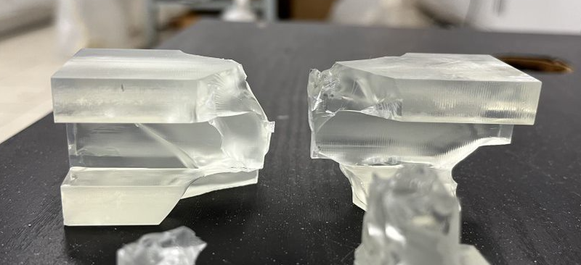
Figure 43: Fractured Resin Original Beam at Maximum Load
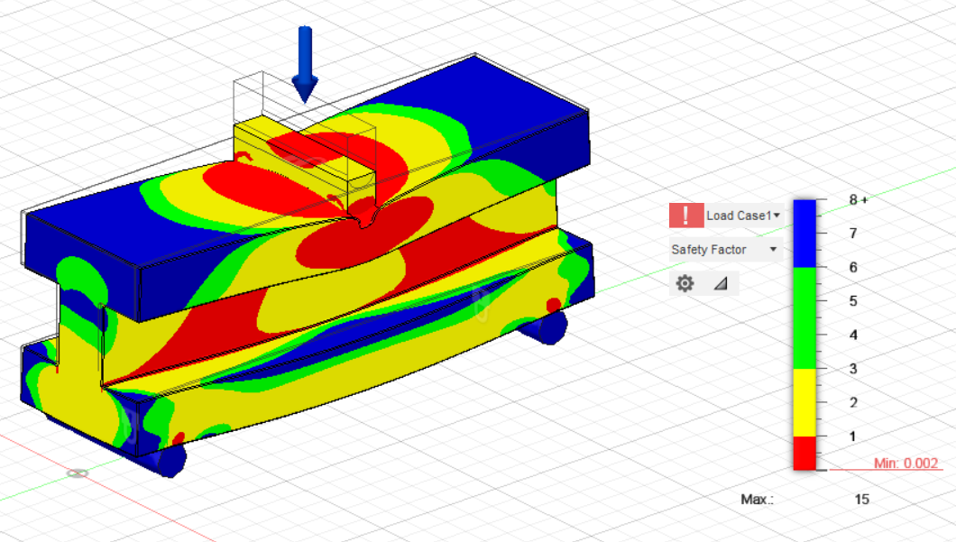
Figure 44: Safety Factor of Resin Original Beam
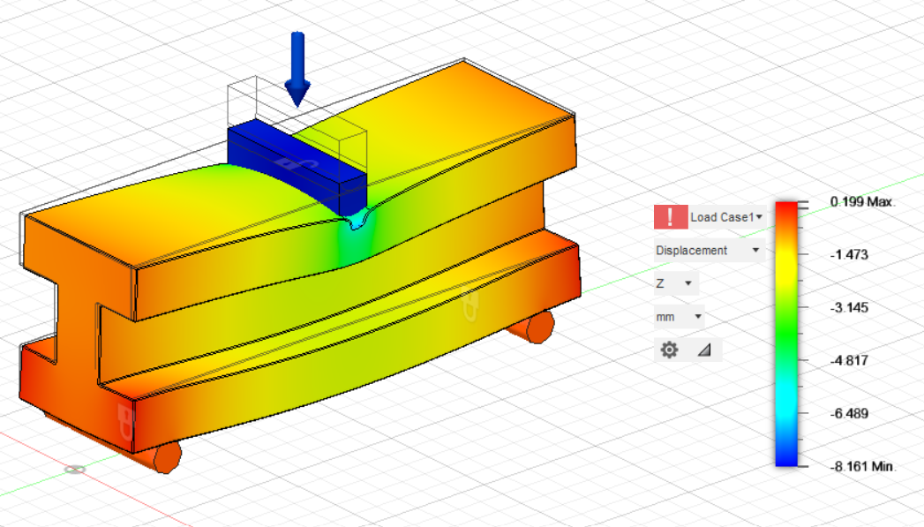
Figure 45: Displacement of Resin Original Beam
Figure 46 shows the load vs extension of the 5 resin generative design beams. The older generative designed beams that did not meet the goals of the generative design software were also tested and the data was also collected and observed. As seen in Figure 46 the 5 generative design beams exceeded the required amount of force needed to break the beam when compared to the FEM analysis and the force the original resin beam broke at. Each of the samples had similar trends with two which were different. This may have been caused by an invalid balance of the extension before the test started. The highest load that was reached was at 24000 N and a extension of 5.2 mm for sample 2. The similar trends and drop off points show accurate results with the generative designed beam during testing.
Figure 46: Load vs Extension 3-Point Bending Test of Resin Generative Design Beam
Figure 47 shows the results from the testing for the generative design resin beam. The beam was able to handle a larger force then that of the original beam. That could have been because of the greater mass or the design of the beam. When the AI software designs the beam, it looks at areas of weakness from the simulation set up and created more strength in those parts. This beam had a clean cut in the middle for one of the samples.
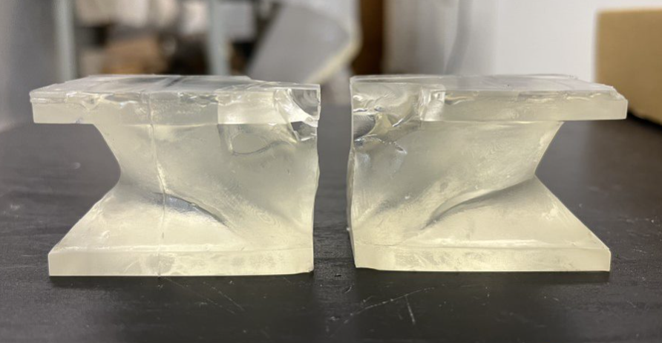
Figure 47: Fractured Resin Generative Design Beam at Maximum Load
The FEM comparison analysis with the testing results were evaluated for the resin beam as seen in Table 4. The resin beam material had better material properties which allowed it to undergo a high force than that of PLA. This force was seen in the original beam and an even higher force was seen in the generative designed beam. These forces were similar to what the FEM analysis and simulation stated. This proves that both beams compared similarly to the FEM results because of the boundary conditions in place. The simulation also had the correct material properties and calculated the materials and safety factor based on the UTS value. The values in the analysis were closer in comparison as the resin material allowed for a clean break and seamless layers in the design which made the material 100% infilled and solid. The displacements and forces of the two beam designs and the FEM analysis were all similar by reaching around 7.5 mm. The force was also similar between the FEM analysis and the original beam mechanical tests reaching 18500 N but the generative designed beam reached 21469 N. The mass was similar but a little off when compared. The mass calculated for the original beam and generative design beam on the model was less than what was weighted. This may have been caused by the prints having a extra layer on the bottom which was printed because of the supports needed to construct the beam.
Table 4: Resin Beams FEM vs Testing Comparison
Type of Analysis | Force (N) | Displacement Z Direction/ Extension (mm) | Mass (g) | Safety Factor
3- Point Bending Test Original Beam | 18520.340 | 7.715 | 93.817 | N/A
FEM Original Beam | 18500.000 | 7.406 | 88.059 | 0.945
3 – Point Bending Test Generative Design Beam | 21469.560 | 7.505 | 98.824 | N/A
FEM Generative Design Beam | N/A | N/A | 89.276 | N/A

4.3 Volume, Density, and Porosity of PLA Original Beam
When looking at the 3D printed beam with PLA filament, the beam’s volume and porosity has effect on the overall results. Porosity means the object has little voids or spaces which may or may not be seen. These voids allow for liquid and air to flow through which is analyzed on the beam printed. Because of the nature of 3D printing, the filament cannot create a 100% infilled object. This is caused by the printing pattern of the machine. The printing patterned used for the PLA beams was cubic as it printed in a cubic pattern trying to fill in all areas of the inside of the beam. As the 100% infill setting was selected, the steps below lay out an experimental test and results to see if there were areas of porosity in the beam because of the inaccurate 100% infill printing.
To test this, the beam will be placed in a beaker of water. This water line will be measured before the beam is placed inside and after it is placed inside to understand the difference in the water levels. After leaving the beam in the water for about an hour, the beam will then release air and retrieve water. If the beam were to have areas of voids, then water will fill up resulting in the beam becoming heavier. This allows for the understanding if the voids are affecting the overall volume and mass of the beam along with the performance of the beam in 3-point bending tests. To find the volume in the beam, the difference in water level allows for the volume of the beam to be seen. When finding the density, the mass can be divided by the volume to see how the density will affect the overall porosity.
Overall, the porosity decreases with the higher the infill is. So if the software says that the infill is 100% then there should be a 0% porosity in the object. After doing the analysis and seeing a cross section of the beam, voids were in the object being analyzed. This shows that there is porosity in the PLA filament printed beam which can then be affecting the overall results. The density found in the PLA printed beam was 1342.603 $\frac{kg}{m^{3}}$ and the Fusion 360 software explained the beam to have a density of 1454.487 $\frac{kg}{m^{3}}$. This difference in density makes sense because of the different amount of infill and filament in the object. The Fusion 360 Software calculates the actual density of 100% infill vs the physical 3D printed object which did not obtain the 100% infill, and which contains flaws.

5 Conclusion and Future Work
When conducting a study over generative design, the Fusion 360 software, additive manufacturing, and testing allows for analysis of its characteristics and abilities for implementation in the industry. Generative design has capabilities unimaginable by redesigning objects to meet requirements and constraints. This allows a new design through AI software’s to provide multiple design options in the matter of hours. These designs focus on meeting the requirements while providing a design that may have taken humans years to come up with. Within the study, the Fusion 360 Software was analyzed through the design, simulation, and generative design components. These components together allowed for the analysis and comparison of the original beam and the generative designed beam. The Fusion 360 has some unique features that allowed generative design to be implemented into additive manufacturing. Using FDM and SLA Additive Manufacturing techniques, these unique beam designs were able to be printed and tested. The printed beams were tested using a 3-point bending test method to ultimately prove that generative design does work on a beam and through additive manufacturing techniques. The generative designed beam does meet the requirements and the maximum load as the original beam which proves that the Fusion 360 generative design software is able to redesign objects to meet the needs of the user. By redesigning objects, the cost of the product and materials can go down as less material can be used to achieve the same goal.
The future work associated with generative design consists in the industry. Generative design analysis can be utilized in multiple industries including engineering, technology, and architecture. Generative design can be placed on the additive manufacturing of more complicated parts which include windmill wings, brackets for solar panels, wearable sensors and aerospace parts (15; 16; 17). These future works can change the industry by lowering the manufacturing cost and being able to use the software to design parts around how they will be manufactured (18).

References
1. Harvard Business Review. The Next Wave of Intelligent Design Automation. s.l. : Harvard Business Publishing, 2018. pp. 1-8.
2. 3D Printed Highly Porous and Flexible Conductive Polymer Nanocomposites with Dual-Scale Porosity and Piezoresistive Sensing Functions. Abshirini, M., Marashizadeh, P., Saha, M.C.*, Altan, M.C., Liu, Y. 11, 2023, Vol. 15. 14810 – 14825.
3. Optimal Design for Additive Manufacturing: Opportunities and Challenges. Doubrovski, Zjenja, Verlinden, Jouke C. and Geraedts, Jo M.P. Washington, DC, USA : s.n., 2011. Proceedings of the ASME 2011 International Design Engineering Technical Conferences & Computers and Information in Engineering Conference. Vol. 9, pp. 635-646.
4. Development of Ultrastretchable and Skin Attachable Nanocomposites for Human Motion Monitoring via Embedded 3D Printing. Herren, B., Saha, M.C., Altan, M.C., Liu, Y. 200, s.l. : Composites, Part B: Engineering, 2020. 108224.
5. A Methodology for Total Hospital Design. Delon, Gerald L. 1970, Health Services Research, pp. 210-223.
6. A Generic Shape Grammar for the Palladian Villa, Malagueira House, and Prairie House. Benros, Deborah, Hanna, Sean and Duarte, Jose Pinto. 2014, Research Gate, pp. 321-340.
7. McClintock, Cat. A Beginner's Guide to Generative Design. PTC. [Online] January 6, 2023. [Cited: February 20, 2023.] https://www.ptc.com/en/blogs/cad/beginner-guide-generative-design.
8. Miles, Dan. What is Generative Design, and How Can It Be Used in Manufacturing? Redshift by Autodesk. [Online] January 28, 2022. [Cited: February 20, 2023.] https://redshift.autodesk.com/articles/what-is-generative-design.
9. State of the art of generative design and topology optimization and potential research needs. Tyflopoulos, Evangelos, Flem, David Tollnes and Olsen, Anna. 2018, NordDesign, pp. 1-15.
10. Deep Generative Design: Integration of Topology Optimization and Generative Models. Oh, Sangeun, et al. 2019, Journal of Mechanical Design, Vol. 141, pp. 1-13.
11. (Re)Design for Additive Manufacturing. Hallgren, Sebastian, Pejryd, Lars and Ekengren, Jens. s.l. : Elsevier B.V., 2016, Procedia CIRP 50, pp. 246-251.
12. Research and Application of Autodesk Fusion360 in Industrial Design. Song, P P, Qi, Y M and Cai, D C. Tianjin : IOP, 2018. International Conference on Computer Information and Automation Engineering. pp. 1-7.
13. Comparison of CAD systems for generative design for use with additive manufacturing. Junk, Stefan and Burkart, Lukas. 2021, Procedia CIRP, Vol. 100, pp. 577-582.
14. Hoag, Stephen W. A typical stress–strain curve for polymer film undergoing tensile strain testing. Plasticizer Effects on Physical–Mechanical Properties of Solvent Cast Soluplus® Films. 2013.
15. Highly Sensitive Compression Sensors using 3D Printed Polydimethylsiloxane/Carbon Nanotube Nanocomposites. Charara, M., Abshirini, M., Saha, M., Altan, M.C., Liu, Y. 8, s.l. : Journal of Intelligent Material Systems and Structures, 2019, Vol. 30. 1216–1224.
16. 3D Printing of Highly Stretchable Strain Sensors based on Carbon Nanotube Nanocomposites. Abshirini, M., Charara, M., Liu, Y.*, Saha, M., Altan, M.C. 10, s.l. : Advanced Engineering Materials, 2018, Vol. 20. 1800425.
17. Optimization of 3D printing parameters for BaTiO3 piezoelectric ceramics through design of experiments. Renteria, A.*, Fontes, H., Diaz, J.A., Regis, J.E., Chavez, L.A., Tseng, T.L.B., Liu, Y. and Lin, Y. 8, s.l. : Materials Research Express, 2019, Vol. 6. 085706.
18. Particle Size Influence on Material Properties of BaTiO3 Ceramics Fabricated using Freeze-Form Extrusion 3D Printing. Renteria, A., Diaz, J., He, B., Renteria-Marquez, I., Chavez, L., Regis, J., Liu, Y., Espalin, D., Tseng, T.L., Lin, Y. 11, s.l. : Materials Research Express, 2019, Vol. 6. 115211.

