University of Oklahoma

Graduate College

EXPERIMENTAL EVALAUATION OF a CENTRIFUGAL PACKER-TYPE DOWNHOLE SEPARATOR

A thesis

submitted to the Graduate Faculty

in partial fulfillment of the requirements for the

Degree of

Master of Science

By

ASHUTOSH sHARMA
Norman, Oklahoma
2019

EXPERIMENTAL EVALAUATION OF a CENTRIFUGAL PACKER-TYPE DOWNHOLE SEPARATOR

A thesis approved for the
Mewbourne School of Petroleum and Geological Engineering

BY THE COMMITTEE CONSISTING OF

Dr. Hamidreza Karami, Chair

Dr. Ramadan Ahmed

Dr. Catalin Teodoriu

© Copyright by Ashutosh sharma 2019
All Rights Reserved.

ACKNOWLEDGEMENTS

I am deeply indebted to my mentor and advisor, Dr. Hamidreza Karami, for providing me an opportunity to work with him under his able guidance at a unique, humongous research laboratory, WCTC. He gave me so much freedom and resources to conduct my research experiments. He really encouraged me to learn more, expand my knowledge database, and advance my skillset to be a better petroleum engineer. He has been a true motivation for me as a Petroleum engineer because of his young age and his ocean of knowledge. He inspired me to be calm and composed in every situation of my life.
I take this opportunity to thank Dr. Catalin Teodoriu for his continued guidance over time. I would also like to thank Dr. Ramadan Ahmad for his continuous help and guidance during installation and experiments. He has always inspired me to work hard.
I want to thank Mr. Jeff McCaskill for his true support and help throughout my research work. He taught me everything regarding installation of my setup. I want to give my special thanks to my research partner, Platin, for his consistent help and support throughout my research work. I also want to thank Mr. Rida Elgadaffi for his consistent support during my research. I also want to thank my lab mates for their encouragement and support, especially Shawgee, Musaab, and Caesar. Special thanks to my friends away from home: Aditya, Saurabh, Ashish, Nachiket, Sanchay, Deepankar, Ishank, Bhairav, Abhishek, Raymos, Nabe, Karo, Amita, Mansi, Tarek and Autumn.
I have always had the love and unwavering support of my parents, sisters, and rest of my family. I will always be grateful and obliged to them for their incessant love and support.
TABLE OF CONTENTS

ACKNOWLEDGEMENTS iv
LIST OF TABLES viii
LIST OF FIGURES viii
ABSTRACT xiii
CHAPTER 1: INTRODUCTION 1
1.1 Overview 1
1.2 Problem Statement 2
1.3 Main Objectives of the Study 3
CHAPTER 2: LITERATURE REVIEW 5
2.1 Introduction to Downhole Separators 5
2.1.1 Natural gas separator 7
2.1.2 Poor boy separator 7
2.1.3 Modified Poor boy separator 8
2.1.4 Packer-type separator 9
2.2 Previous Research 10
2.2.1 Centrifugal downhole separator 10
2.2.2 Downhole separator based on gravity separation 12

CHAPTER 3: EXPERIMENTAL STUDY; DESIGN AND CONSTRUCTION 15
3.1 Gas Inlet Line 17
3.2 Water Inlet Line 21
3.3 Horizontal Section 24
3.4 Vertical Section 27
3.5 Tubing Return Line to water tank 32
3.6 Casing Return Line 35
3.7 Wiring and Instrumentation 38
3.8 Facility Control Program 42
3.9 Test Procedure 45
3.10 Scope of Work 47
CHAPTER 4: RESULTS AND DISCUSSIONS 48
4.1 Experimental Observation 48
4.2 Separation Efficiency trend of random tests 50
4.3 Separation Efficiency Sensitivity Analysis 59
4.3.1 Gas Rate Effects 59
4.3.2 Liquid Rate Effects 63
4.4 Overall Separation Efficiency Analysis 66
4.4.1 Overall Separation Efficiency with Liquid Flowrate 67
4.4.2 Overall Separation Efficiency with Gas Flowrate 68
4.4.3 Overall Gas-Liquid Ratio (GLR) Change by Separator 70
CHAPTER 5: CONCLUSIONS AND RECOMMENDATIONS 73
5.1 Summary and Conclusions 73
5.2 Future Work Recommendations 74
REFERENCES 75
APPENDIX 78

LIST OF TABLES
Table 3.1: Wiring details for equipment in multiphase flow setup 41
Table 3.2: Test Matrix 47
Table 4.1: Separation efficiency for different gas rate ranges 60
Table 4.2: Separation efficiency for different liquid rate ranges 64
Table 4.3: Average separation efficiency of the separator 72

LIST OF FIGURES

Figure 1.1: Oil and gas production forecast 1
Figure 2.1: Tubing conveyed downhole separator working through gravity separation 6
Figure 2.2: Natural gas separator 7
Figure 2.3: Poor boy separator 8
Figure 2.4: Modified poor boy separator 9
Figure 2.5: Conceptual drawing for installation of centrifugal downhole separator 11
Figure 2.6: Two-stage separator within separator configuration 13
Figure 3.1: Multiphase Flow Schematic 16
Figure 3.2: Gas Inlet Line Section 18
Figure 3.3: Picture of Different Elements of Gas Inlet Line 19
Figure 3.4: Picture of the T-section connecting air and water inlet lines to test section 20
Figure 3.5: Picture of the applied screw-type compressor 21
Figure 3.6: Water Inlet Line Schematic 21
Figure 3.7: Progressive cavity pump schematic 22
Figure 3.8: Picture of the components of water inlet line 23
Figure 3.9: Horizontal Section Schematic 25
Figure 3.10: Detailed Picture of Horizontal Section 26
Figure 3.11: Detailed Picture of Horizontal Section connecting to vertical section 27
Figure 3.12: Vertical Test Section schematic 28
Figure 3.13: Picture of different elements of vertical section 29
Figure 3.14: Picture of installed downhole separator at the vertical section 30
Figure 3.15: Installed downhole separator schematic 31
Figure 3.16: Tubing return line schematic 34
Figure 3.17: Detailed picture of Casing and Tubing return line 35
Figure 3.18: Casing return line schematic 36
Figure 3.19: 3-in. Hose Pipes connecting wellhead to the casing and tubing return lines 37
Figure 3.20: Detailed wiring picture 39
Figure 3.21: Wiring of DAQ card for sensors with voltage or current output 40
Figure 3.22: DAQ card workflow 43
Figure 4.1:Image of fluid flow at 16gpm liquid rate and gas rate of 212,000 scf/day 48
Figure 4.2: Image of fluid flow at 6gpm liquid rate and gas rate of 212,000 scf/day 49
Figure 4.3: Image of fluid flow at 10gpm liquid rate and gas rate of 146,000 scf/day 50
Figure 4.4: Inlet and Outlet liquid flowrate trend with respect to time 52
Figure 4.5: Gas Flowrate at inlet and return lines with respect to time 53
Figure 4.6: Pressure in the casing & tubing line measured at wellhead and casing control valve opening % with respect to time 54
Figure 4.7: Separation efficiency of the separator for the test with respect to time 55
Figure 4.8: Liquid separation efficiencies of the three tests with respect to time 57
Figure 4.9: Gas separation efficiencies of the three tests with respect to time 58
Figure 4.10: Casing control valve operation for the three tests with respect to time 59
Figure 4.11: Gas separation efficiency of separator as a function of liquid flowrate for three different gas flowrate ranges 61
Figure 4.12: Liquid separation efficiency of separator as a function of liquid flowrate for three different gas flowrate ranges 63
Figure 4.13: Gas separation efficiency of separator as a function of gas flowrate for three different liquid flowrate ranges 65
Figure 4.14: Liquid separation efficiency of separator as a function of gas flowrate for three different liquid flowrate ranges 66
Figure 4.15: Overall separation efficiency of the separator as a function of liquid flowrate 68
Figure 4.16: Overall separation efficiency of the separator as a function of gas flowrate 69
Figure 4. 17: Outlet vs Inlet Gas liquid ratio (GLR) 71
Appendix
Figure A.1: Inlet and Outlet liquid flowrate trend with respect to time 78
Figure A.2: Gas Flowrate at inlet and return lines with respect to time 79
Figure A.3: Pressure in the casing & tubing line measured at wellhead and casing control valve opening % with respect to time 79
Figure A.4: Separation efficiency of the separator for the test with respect to time 80
Figure A.5: Inlet and Outlet liquid flowrate trend with respect to time 81
Figure A.6: Gas Flowrate at inlet and return lines with respect to time 81
Figure A.7: Pressure in the casing & tubing line measured at wellhead and casing control valve opening % with respect to time 82
Figure A.8: Separation efficiency of the separator for the test with respect to time 82
Figure A.9: Inlet and Outlet liquid flowrate trend with respect to time 83
Figure A.10: Gas Flowrate at inlet and return lines with respect to time 84
Figure A.11: Pressure in the casing & tubing line measured at wellhead and casing control valve opening % with respect to time 84
Figure A.12: Separation efficiency of the separator for the test with respect to time 85
Figure A.13: Inlet and Outlet liquid flowrate trend with respect to time 86
Figure A.14: Gas Flowrate at inlet and return lines with respect to time 86
Figure A.15: Pressure in the casing & tubing line measured at wellhead and casing control valve opening % with respect to time 87
Figure A.16: Separation efficiency of the separator for the test with respect to time 87
Figure A.17: Inlet and Outlet liquid flowrate trend with respect to time 88
Figure A.18: Gas Flowrate at inlet and return lines with respect to time 89
Figure A.19: Pressure in the casing & tubing line measured at wellhead and casing control valve opening % with respect to time 89
Figure A.20: Separation efficiency of the separator for the test with respect to time 90
Figure A.21: Inlet and Outlet liquid flowrate trend with respect to time 91
Figure A.22: Gas Flowrate at inlet and return lines with respect to time 91
Figure A.23: Pressure in the casing & tubing line measured at wellhead and casing control valve opening % with respect to time 92
Figure A.24: Separation efficiency of the separator for the test with respect to time 92

ABSTRACT

With the ever-increasing decline in production of oil wells, application of artificial lift techniques is becoming inevitable. Beam pumps and electrical submersible pumps are two of the most common artificial lift methods for low and high oil production rates. But these techniques are always susceptible to high gas-oil ratios in production stream. Various types of downhole separators have been designed recently upstream of the pump to resolve this issue and improve the pump efficiency. The objective of this study is to evaluate the performance of a centrifugal downhole separator. For this purpose, a state-of-art experimental facility is constructed to simulate the flow in an oil well with varying gas-oil ratios.
The experimental multiphase flow setup is designed, fabricated and constructed in an efficient and automated way to simulate a typical horizontal wellbore. The well trajectory includes a 31-ft horizontal section, inclinable to ±10º, followed by a 27-ft vertical section. The casing ID is 6-in., and a 2-in. ID tubing is placed inside of it, with end-of-tubing at the bottom of vertical. The casing and tubing streams are each led to a return column, where gas and liquid flows are separated and metered. Automated and modulated control valves are used to monitor the pressure and production from casing and tubing streams. Five Coriolis flow meters quantify density and flow rate of different streams. The experiments are performed with air, supplied by a screw-type compressor, and water, supplied by a Progressive cavity pump.
The tested downhole separator is an innovative design, applying gravity and centrifugal effects to perform the separation. Tests are conducted at a water flowrate range of 17-700 bpd to simulate the cases with both rod pump and ESP operations. Various air-water ratios are tested to identify the range of separator effectiveness. Flow rates of air and water in casing and tubing return lines show the efficiency of the separator in sending the liquid into tubing and gas into casing stream. Experiments indicate that separation efficiency of this novel separator is high. Average gas separation efficiency of the separator is 93% and average liquid separation efficiency is 96%. This separator is suitable for use in horizontal as well as vertical wells, if separator is placed in the vertical section of the well, to stimulate artificial lift equipment`s performance.

CHAPTER 1: INTRODUCTION

1.1 Overview
The need for energy is continuously growing day by day and is supported by new discoveries of oil and gas fields across the world. Hydrocarbon exploitation of conventional and unconventional reservoirs is equally important in our dynamic resilient industry. Currently tapping of unconventional reservoirs is increasing day by day. The oil and gas industry is facing the heat of a recession, making it necessary to acknowledge digital solutions as a way to optimize economics of hydrocarbon production. Figure 1.1 shows production and consumption of hydrocarbons is currently increasing and it will increase in 2020 as well.
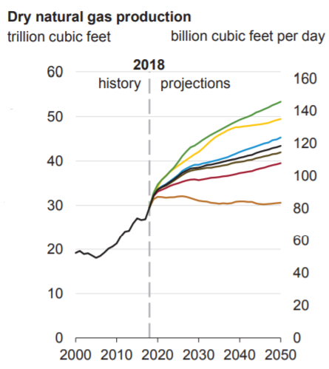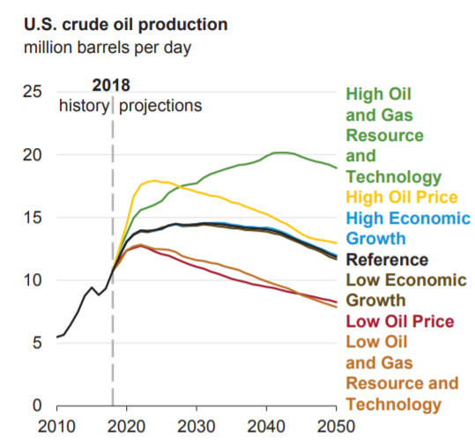
Figure 1.1: Oil and gas production forecast (U.S. EIA 2019)
The increasing energy consumption trends bolster the fact that there will be more exploration for oil and gas fields and more production of hydrocarbon (U.S. EIA 2019). Recently, Permian basin has surpassed the oil production of Ghawar, largest oil field in the world located in Saudi Arabia. Also, Oil and gas production has increased in the past two decades due to technological advancements in production from unconventional reservoirs and hydraulic fracturing.
Artificial lift systems are widely accepted to improve production of oil and gas and. Artificial lift is becoming inevitable over the period of wells’ life as the fields are becoming more mature. Efficiency of pumping artificial lift techniques like beam pumps and electrical submersible pumps is hugely dependent on presence of gas. As the volumetric gas fraction in the pumps exceeds a critical value the pump efficiency gets diminished. So, there is a need for an equipment before the pump to segregate gas and liquid, send the gas to the annulus, and only allow the liquid into the pump. This equipment is a downhole separator. Downhole separators therefore increase the efficiency of the artificial lift equipment.

1.2 Problem Statement
Artificial lift equipment are inevitable for every oil and gas field around the world. Presence of gas affects the performance of the Artificial lift equipment and hence, decrease the production of the well. From Echometer, we received a prototype centrifugal packer-type downhole separator which has not been used in the field before. It was needed to measure the liquid and gas separation efficiency of this separator in our lab by performing experiments. The efficiency was desired under different flow conditions, including gas flowrates and liquid flowrates. The separation efficiency of the separator was needed to be measured, so that company can start using this separator on fields.
To measure separation efficiency of this separator, there was a need of building multiphase flow setup to simulate normal well conditions along with flowmeters to quantify the separated fluid stream. This facility was designed to simulate the production from a wellbore with tubing and casing sections. The measurements were focused on liquid and gas flow rates to properly rate the separator’s performance. The downhole separator was installed in the vertical section of the facility, and its performance was tested with different liquid and gas flow rates.

1.3 Main Objectives of the Study
With the increasing rate of production from mature fields and gradual decline in life of the wells the need for applying artificial lift techniques is increasing every day. This forces the operators to apply artificial lift techniques under more adverse circumstances, such as wells with higher gas-oil ratios. As a result, downhole separators are becoming a vital piece to maintain the performance efficiency of pumping artificial lift methods. They can seriously expand the operating envelopes for beam pumps and ESPs to much larger gas-liquid ratios.
The main objective of this study is to experimentally investigate the performance efficiency of a newly proposed centrifugal packer-type separator under varying liquid and gas rates. The separator was designed and provided by Echometer. For this purpose, a large-scale experimental facility was designed and constructed capable of simulating production of a horizontal well with changing liquid and gas rates. For all the conducted tests, efficiency of separator in sending the liquid to the tubing and the gas to the casing-tubing annulus stream was evaluated.

Overall, the motivation for this study can be divided into three sections:
(a) The goal: The goal was to evaluate the efficiency of a prototype centrifugal packer-type downhole separator. The efficiency was desired under different flow conditions, including gas flowrates and liquid flowrates.
(b) The method set to reach the goal: In order to evaluate the separator’s performance, a large-scale facility was fabricated. This facility was designed to simulate the production from a wellbore with tubing and casing sections. The measurements were focused on liquid and gas flow rates to properly rate the separator’s performance.
(c) The Accomplishments to reach the goal: The designed multiphase facility was constructed and instrumented. The downhole separator was installed in the facility, and its performance was tested with different liquid and gas flow rates. The results provided a realistic evaluation of separator’s efficiency.

CHAPTER 2: LITERATURE REVIEW

2.1 Introduction to Downhole Separators
A downhole gas separator, also known as a gas anchor, is installed below the lift pumps to separate the free gas and liquid in production stream. The free gas is separated from liquid and produced through the casing-tubing annulus. Pump`s working efficiency is affected by the presence of gas and solids, and that is what makes downhole separators vital in a pumping artificial lift design. However, design inefficiency is widespread for gas anchors and a proper guideline does not exist for design of gas anchors (Bohorquez et al. 2009).
Error! Reference source not found.1 shows a downhole separator with gravity separation installed prior to the pump. The outer barrel has an opening through which the produced liquid and some gas enter the downhole separator. The small diameter dip tube is installed inside the outer barrel that allows the separated liquid to enter the pump barrel due to gravity. As expected, a less dense phase has a higher upward velocity compared to a denser phase. In a production stream, gas moves up as the less dense phase, while liquid falls down. The gas bubbles present in the annulus between the dip tube and the outer barrel move upward with a velocity relative to liquid, called slip velocity. Realistically, separation efficiency is not 100% and some gas bubbles enter the dip tube and produce through the tubing as well (Bohorquez et al. 2009). This makes it important to evaluate separator’s efficiency and estimate the gas volumetric fraction entering the pump.
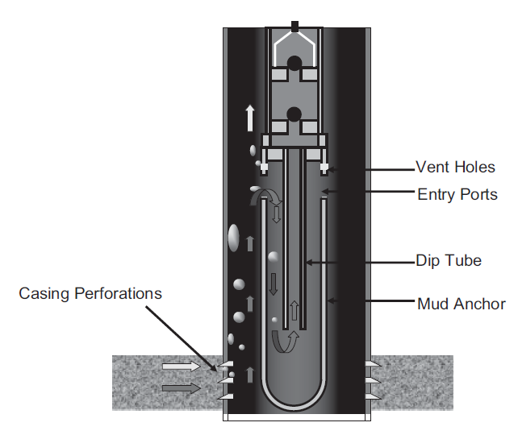
Figure 2.1: Tubing conveyed downhole separator working through gravity separation
(Bohorquez et al. 2009)

Effective separation means that free gas is produced through the casing-tubing annulus and liquid is produced through the tubing. Large area of annulus provides sufficient space for liquid and gas to separate effectively by gravity. If the pump intake is placed below the perforation interval, the gas is supposed to flow up through annulus. However, if the pump intake is set above the perforation interval, a downhole separator is needed for liquid and gas separation. The downhole gas separator should be designed in a way that downward liquid velocity is slower than gas bubble rise velocity. This allows the gas to flow up in the casing-tubing annulus. Gas bubble rise velocity in the annulus is directly proportional to the diameter of gas bubble. Larger gas bubbles rise faster while moving up in the annulus (Bohorquez et al. 2009). There are five major types of downhole gas separator available in the industry. These types are categorized as following:
- Natural gas separator
- Poor boy separator
- Modified poor boy separator
- Packer-type separator
- Special separators (twister, cups)

2.1.1 Natural gas separator
In a natural gas separator (Error! Reference source not found.2), the intake of the pump is placed below the perforation interval to achieve the most effective separation of liquid and gas. This way gas gets separated and flows up the annulus unless liquid velocity exceeds 6 in/s as a thumb rule. The area between the casing and tubing is available for separation of liquid and gas. The tubing inlet at the bottom must be placed at least 8 ft below the casing perforation (Raglin 2013).
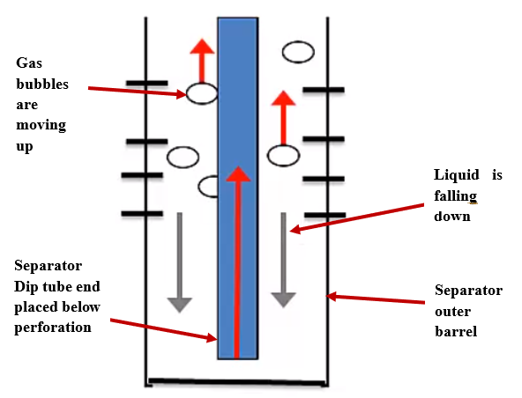
Figure 2.2: Natural gas separator (Raglin 2013)

2.1.2 Poor boy separator
Error! Reference source not found. shows the schematic of a poor boy separator or mud anchor. A downhole separator built with simplistic models and material and easily available is called a “poor boy separator”. It is installed using a dip tube at the bottom of rod pump assembly. Outside the dip tube, a tubing joint is installed that is slotted and capped at the bottom using a bull plug. Tubing joint installed at the top prevents perforated sub to lay against the casing wall. Gas and liquid mixture flowing from the perforation interval enter the separator through the slots made on the tubing joint. The gas separates out and flows upward through the casing-tubing annulus. Liquid flows down through the annulus between the tubing slots and dip tube, and then moves upward to the intake of the pump. If solids get accumulated hindering the flow of the fluid to pump intake, the bull plug can be replaced with a spring valve to dump the extra solids. This type of separator is suitable for low capacity wells (Raglin 2013).
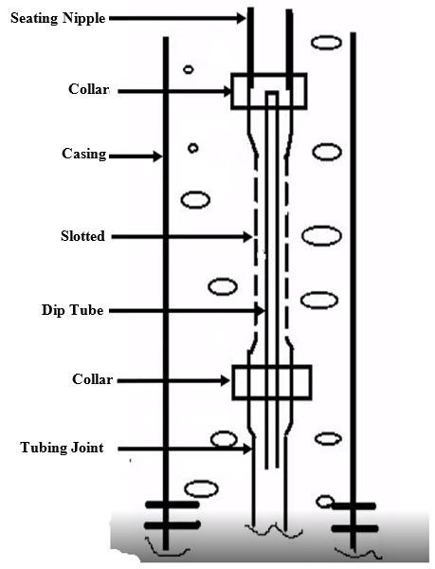
Figure 2.3: Poor boy separator (Raglin 2013)

2.1.3 Modified Poor boy separator
Modified poor boy separator (Error! Reference source not found.4) is similar to a poor boy separator. However, the outer barrel is enlarged for high capacity liquid and gas separation. Also, a long dip tube is used to reduce pressure drop at the bottom of the dip tube. Thus, it restricts the gas that comes out of the solution between the separator and the pump.
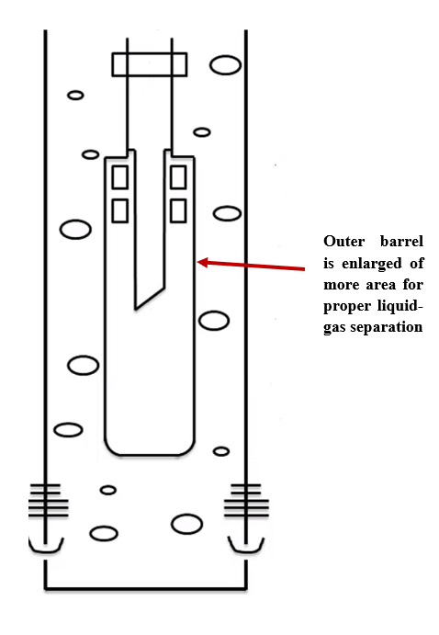
Figure 2.4: Modified poor boy separator (Raglin 2013)

2.1.4 Packer-type separator
A packer-type separator uses gravity separation method to segregate liquid and gas like a poor boy separator. The packer is installed below the separator inlet to direct the fluid to the bottom of separator. The packer-type separator with tail pipe is very efficient and tends to increase well production when pump is set above the pay zone. But dip tube is commonly long in this type of separator that results in pressure drop and release of gas bubbles from liquid. Here, fluid from pay zone flows upward through the packer to the inlet of separator. Then, fluid flows upward from concentric separator annulus to the outlet of the separator and gets discharged into the casing annulus. The gas then rises through the annulus and liquid falls down and enters the tubing. The separator shroud helps in pushing the liquid to the tubing and pump inlet (Raglin 2013).

2.2 Previous Research
The 1990s decade witnessed development of downhole separation technology as a new water management tool. This downhole separator tool was used to segregate oil and gas from water, oil and gas mixture stream and inject separated water into the disposal zone. Based on different fluid handling criteria of the separator, they were categorized into two types of downhole oil-water separators (DOWS) and downhole gas-water separators (DGWS). These separators use two segregation techniques, hydrocyclone and gravity method. An average success rate for downhole separators around the world is estimated at only 60%. To improve the efficiency of downhole separators, it is inevitable to understand the downhole conditions in which separator gets installed and details of the injected zone (Gao et al. 2007).
Laboratory testing of downhole separators is continued in a few research labs since 2005 using full scale wellbore models. Commonly, the separator is constructed using transparent pipes to observe fluid movement and segregation. Air and water are used to make two-phase flow in the system. Bohorquez et al. showed that 100% separation efficiency was achieved when dip tube was placed 1-2 ft. below the bottom most casing perforation port. Results also show that optimum dip tube length is 5.5 ft. for optimum segregation of free gas from produced liquid (Bohorquez et al. 2009).

2.2.1 Centrifugal downhole separator
A few national laboratories have worked on development of centrifugal downhole separator in the past. These developed units were used for surface treatment of produced water and water generated during environmental clean-up process. Bench scale separators were used for early testing to evaluate separation efficiency for different types of crude oil. The resulting information were used to design and develop large-scale separators with larger height/diameter ratios. Here, the tested crude oil had API gravity of 34⁰. Large volume of wastewater is generated during oil and gas production from wells in every field. Discharge of this wastewater is always under scrutiny from government bodies like Environment protection agency (EPA) in USA. Due to these regulations, operation is impacted in oil and gas fields. So, there is a need to reduce the amount of wastewater produced from wells using downhole separation. Walker and Cummins used a centrifugal downhole separator to separate oil and water efficiently. The oil was separated at the downhole using the separator and pumped to the surface, while another pump was used to inject separated produced water into the formation as shown in Error! Reference source not found.5 (Walker and Cummins 1999).
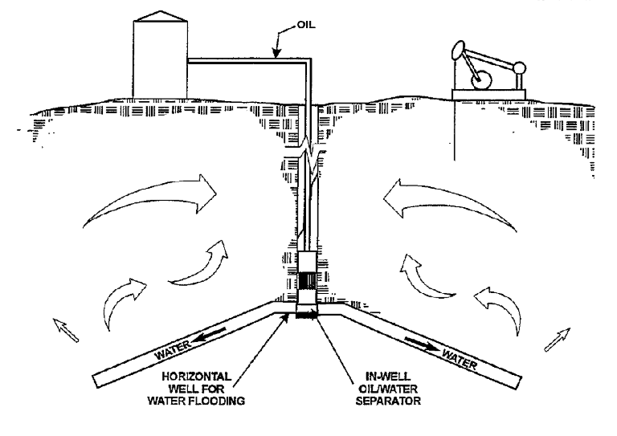
Figure 2.5: Conceptual drawing for installation of centrifugal downhole separator
(Walker and Cummins 1999)

Downhole gas separator is considered as a challenging component of beam pumping systems. Laboratory and field data indicate that its success depends on pressure of the fluid and well and design of the separator used. Earlier, separation was achieved using gravity and without any other mechanism like centrifugal force. So, forces like turbulence and drag proved to be causing inefficiency in the separation process, especially in higher production rates. Early separators were natural gas separators, achieved by installation of pump below perforation interval. When it is not possible to place the pump below pay zone, downhole separators are installed for proper separation of liquid and gas at the bottom (McCoy et al. 2007).

2.2.2 Downhole separator based on gravity separation
Error! Reference source not found.6 below shows downhole separation process in two stages. The details of this separator type were explained in the previous section. The gas amount that enters the dip tube and further to the pump is drastically reduced due to gravity separation process in the separator. The amount of liquid flowing into the dip tube and pump also depends on the production liquid fraction. Here, pressure drop in the system is directly dependent on size and length of the dip tube (McCoy et al. 2007).
Inefficiency in gas separators installed with beam pump can be identified using acoustic liquid level tests. These tests show highly gaseous liquid column above the pump. The analysis is performed periodically to have verification that downhole separator is working efficiently (McCoy and Podio 1999).

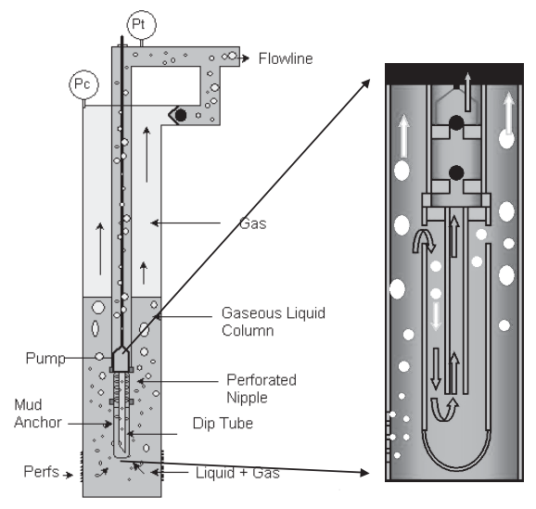
Figure 2.6: Two-stage separator within separator configuration (McCoy et al. 2007)
The first successful installation demonstration performed outside of North America was in 1997 at Eldingen field in Germany. This well was producing high water cut oil from a sandstone reservoir. Sucker rod was used to produce the fluid. A new completion technique was suggested with hydrocyclone and submersible pumps for production and separation of produced water. Water was separated from the produced fluid stream using a hydrocyclone downhole oil-water separator and then re-injected using a submersible pump. After introduction of separator at the bottomhole and recompletion process, production from the well was increased by 300%, while water production decreased by 64%. After a few years however, water increase was observed in the well (Verbeek et al. 1998).
Peachey and Matthews (1994) introduced a novel downhole separator to improve production from heavy oil reservoirs with high water-oil ratio (WOR). The idea was to separate water from oil and re-inject it in injection zone using a downhole separator. This idea proved to be cost effective for various operators around the world especially in North America and Southeast Asia. This system proved to be helpful for wells that produce more water and less oil. It allows the well to produce for long time and increases the oil production (Peachey and Matthews 1994).
Electric submersible pumps are also badly affected by the presence of free gas in the fluid stream. Free gas causes gas locking, which means gas bubbles block the fluid from passing through the impeller of the ESP. This causes non-productive time and economic loss for the operators. Nicholson et al. used carbon dioxide (CO₂) as an enhanced oil recovery method. CO₂ was gathered from a production well and re-injected through an injection well forming a closed loop system. Installation of separators reduced the shutdown time by 99% and caused an increase in total fluid production by 16%. The goals of this completion technique were to avoid, separate and handle gas. A long dip tube was used connecting the pump intake to the perforation below and collecting liquid from below perforation interval depth. This allows more area for separation of liquid and gas (Nicholson et al. 2019).
Downhole separators have been used in unconventional wells with high gas-oil ratio (GOR) at Permian basin. This is to remediate the reduced pump efficiency with increasing free gas. Innovative downhole gas separator designs are used to overcome the corresponding challenges. Gonzalez and Loaiza used a shrouded ESP system with double gas separation stages at the bottom of shroud to mitigate gas problems. This avoided the gas from entering the pump intake and diverted it to casing-tubing annulus. After the pump parameters were analyzed, it was found that production from the well and pump efficiency were increased (Gonzalez and Loaiza 2019).

CHAPTER 3: EXPERIMENTAL STUDY; DESIGN AND CONSTRUCTION

The main objective of this study was to experimentally investigate flow behavior in the wellbore and performance of downhole separators. For this purpose, a large-scale facility was constructed at Well Construction Technology Center of the University of Oklahoma. The facility was designed to simulate and visualize two-phase liquid-gas flow in a horizontal well. This chapter describes the general structure of the facility, and then outlines the main parts of this facility in details.
Error! Reference source not found. shows the general schematic of the facility, drawn using Microsoft Visio. This flow schematic was designed to test a centrifugal downhole separator installed in vertical test section. Every equipment was diligently installed to provide proper conduct of experiments. The facility construction was the most time-consuming part of the project, considering the scale of the facility and equipment. Installation of the equipment was challenging, especially mounting of the 6-in control valve, the flowmeters in the vertical section and return lines, horizontal section stand, and vertical section.
There are five Coriolis flow meters and five control valves, installed to measure flow parameters like flow rate, density and temperature and to control flow rates. This schematic was designed by keeping in mind safety as the most important factor. There are eight pressure transducers and one temperature transducer installed in this setup to have measurement of pressure and temperature in real time.
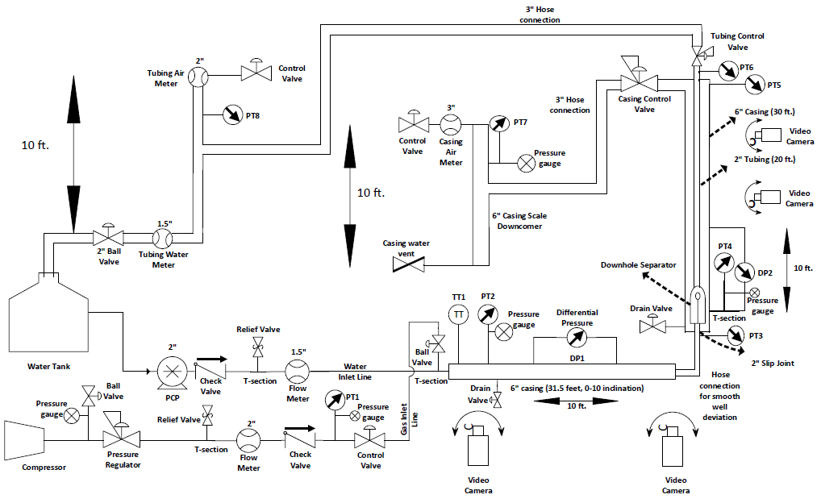
Figure 3.1: Multiphase Flow Schematic
Manual pressure gauges were installed along with pressure transducers to have a better visual observation of the pressure in the system. Also, a manual pressure regulator was installed at the gas inlet line to regulate the pressure of the gas coming from air compressor. Two differential pressure transducers were also installed in the horizontal and vertical sections to check the pressure drop in the lines. Smooth transition from horizontal to vertical section was achieved by a flexible hose pipe.
All the sensors in the system were properly wired to the two data acquisition (DAQ) cards to record data in real time and quickly operate the control valves through a control computer. Visual Basic programming was used to record and store data in real time in Microsoft Excel. VBA programming easily opens and closes control valves, most importantly the casing control valve installed at the top of the vertical section. VBA records these data along with pressure data from transducers and flow meter data for further analysis. Data is coming from five flow meters, five control valves, eight pressure transducers, two differential pressure transducers, a pump VFD, and a temperature transducer. In total, twenty-five input data are coming in and six output data are going out of the computer through the two DAQ cards.
This multiphase flow experimental setup was divided into six sections, each playing an important role in experiments. These six sections are as follows:
- Gas inlet line
- Water inlet line
- Horizontal section
- Vertical section
- Tubing return line up to water tank
- Casing return line
The main characteristics of these sections are described in further details as follows:

Gas Inlet Line
The gas inlet line in the setup consists of the compressor, pressure gauge, venting valve, pressure regulator, relief valve, flow meter, check valve, pressure transducer, control valve, and a ball valve before the test section. All of these equipment are connected using metal nipples, 3-in hoses (pressure rating of 150psi) running from compressor and to the test section, as shown in Error! Reference source not found.. Screw-type air compressor (q_{max} = 1600 cuft/min) was used to attain target gas flow rates in the test section (Figure 3.5).
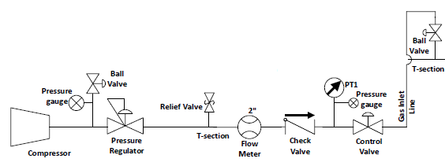
Figure 3.2: Gas Inlet Line Section
For safety reasons, one manually operated pressure regulator (1.5-in, p_{max} = 300 psig, T_{max} = 160º F) was installed in the line to keep the pressure in the flow loop in the desirable range. Before the pressure regulator, a pressure gauge and a ball valve were installed for safety. To ensure safety, the ball valve is opened before opening of hose pipe to release any pressure in the line. The relief valve is set to pop open at pressures above 100 psig, facing downward to avoid any possible damages. In this way we will be able to protect our 2-in flowmeter from getting damaged if the pressure in the line exceeds beyond certain limit. After the relief valve, the 2-in Coriolis flow meter (Q_{max} = 100 lb/min, T_{max} = 302º F) is used to measure flowrate, temperature, and density of the inlet gas. Coriolis flowmeter is widely used in oil/gas fields across the globe. It has been considered as the most accurate form of flow measurement after its invention in 1980`s. Error! Reference source not found. shows a picture of the air inlet section.
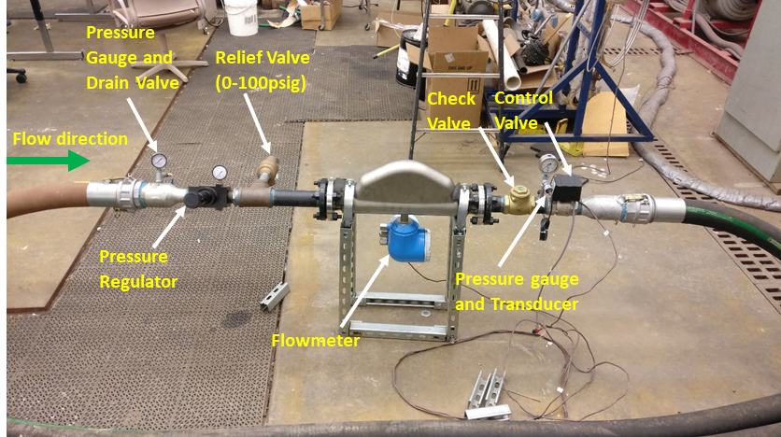
Figure 3.3: Picture of Different Elements of Gas Inlet Line
The principle behind working of Coriolis flow meter is motion mechanics. Fluid is allowed to pass through a vibrating tube, where it is accelerated as it achieves peak amplitude vibration. During operation, oscillation of the tubes generates voltage from each peak off and creates a sine wave. The measured time delay between two sine waves is directly proportional to the mass flow rate. The amplitude of the waves is a representative of fluid density. All of these equipment are wired to the DAQ card and then, to the computer.
A pressure gauge (pressure range = 0-60 psig) and a pressure transducer (pressure range = 0-100 psig) were installed after the flow meter to measure and monitor pressure in the line. A check valve was also installed after the flow meter to prevent the flowback of water to the flowmeter, especially when system shuts down, and prevent damage to it. A control valve (2-in, Input/output = 0-10 vdc) was installed after the flow meter, which is automatically operated and allows the desirable gas flowrate to enter the horizontal section. The gas enters the horizontal section through a 3-in T-section as shown in Error! Reference source not found., after passing a manually controlled 3-in. ball valve. Error! Reference source not found. shows the compressor that supplies gas to the air inlet line.
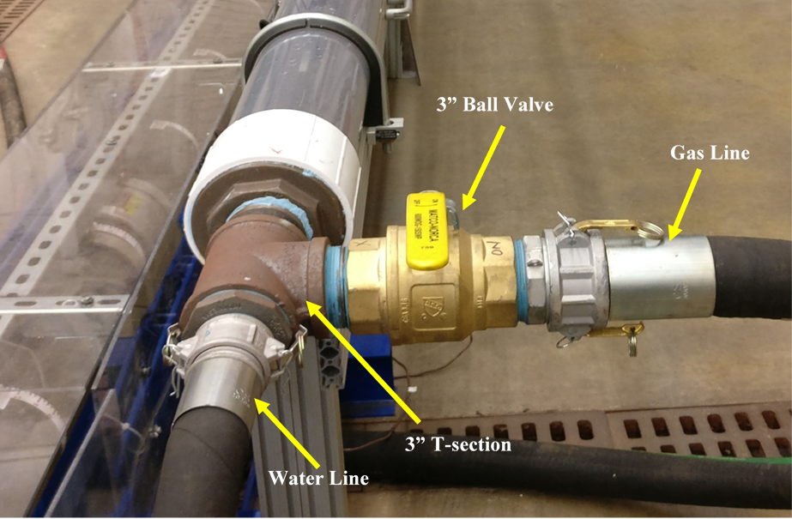
Figure 3.4: Picture of the T-section connecting air and water inlet lines to test section
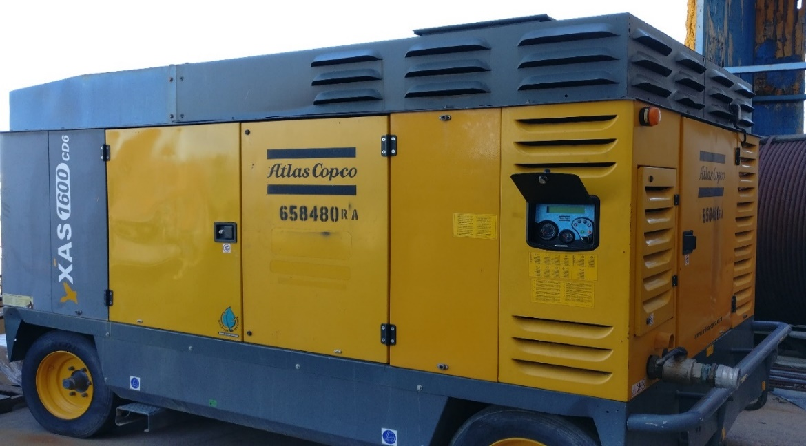
Figure 3.5: Picture of the applied screw-type compressor

Water Inlet Line
The water inlet line in the setup consists of a water tank, a progressive cavity pump (PCP), a check valve, a relief valve, and a flow meter, all connected with metal nipples and a 2-in hose pipe running from the flow meter to the 3-in T-section, as shown in Error! Reference source not found.. A water tank with capacity of 150 gallons was used to provide water supply. 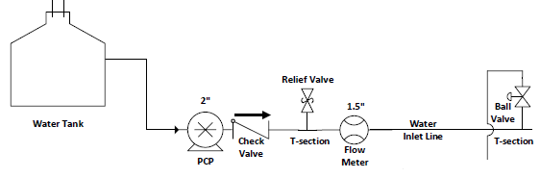
Figure 3.6: Water Inlet Line Schematic
A progressive cavity pump, also known as Moyno pump, is a positive displacement pump consisting of a rotor and stator assembly as shown in Error! Reference source not found.. The rotor is helical shaped and rotates inside the stator to push the fluid from inlet to discharge point. The stator is made up of flexible material. This assembly creates a temporary chamber, which draws fluid from inlet side. The fluid progresses through the helical section of the pump to the discharge side.
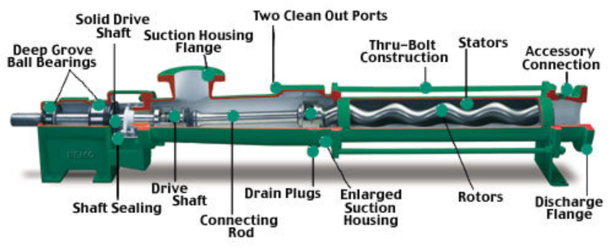
Figure 3.7: Progressive cavity pump schematic (Source: researchgate.net)
2-in metal pipes and a 2-in hose pipe were used to connect the water tank to the 2-in progressive cavity pump (Q_{max} = 60 GPM) inlet, as shown in Error! Reference source not found.. The PCP was controlled using a variable frequency drive (VFD) for the desired water flowrate of 1-20 gpm (~ 30-700 bpd). The primary function of VFD, also known as variable speed drive, is to control the speed of a pump. This is accomplished by varying motor input frequency and voltage. By controlling the pump speed, it eventually controls flow rate of the liquid in the system. So, Progressive cavity pump’s speed was controlled by VFD via the computer as the VFD is connected to the computer through the DAQ card for automatic control of the pump. In VBA programming, a linear proportional–integral–derivative (PID) controller scheme was used to achieve the desired liquid flowrate by automatically adjusting the VFD frequency, and consequently, the pump speed.
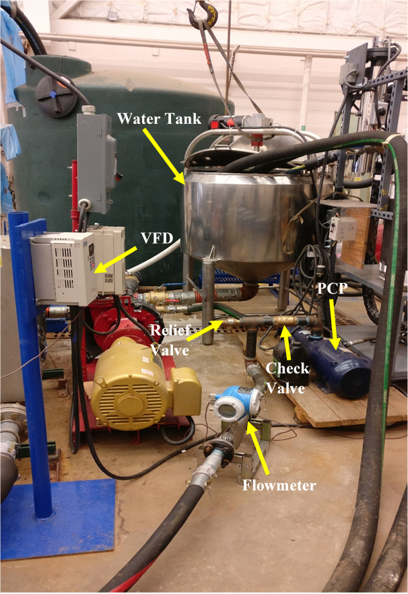
Figure 3.8: Picture of the components of water inlet line
PCP malfunctions if there is a backflow of water into it. A 2-in. check valve was included in the line to prevent the backflow of water. Then, a 2-in. relief valve (pressure rating = 100 psig) was included through a T-section to prevent extreme pressures. The relief valve would pop open facing downwards, if the pressure in the line exceeds 100 psig. Then, the 1.5-in water Coriolis flowmeter (Q_{max} = 330 lb/min, T_{max} = 302º F) is installed through metal bushings and nipples, as shown in Error! Reference source not found.. This flowmeter provides the liquid mass rate, temperature and density values directly transmitted to the computer via the DAQ card. The flowmeter works on the principle of motion mechanics as explained in the gas inlet line section. The readings from this flowmeter are compared to another Coriolis flowmeter in the tubing return line, to evaluate the efficiency of the downhole separator. The electricity for all the sensors is provided through the power switches and the DAQ card. The flowmeters can also be directly configured by a computer without accessing their touch screens, through an ethernet cable connection. After the flowmeter, a 2-in hose pipe (pressure rating = 150 psi) was included to connect the water inlet line to the 3-in T-joint at the test section inlet, as shown in Error! Reference source not found..

Horizontal Section
The horizontal section in the setup consists of a 3-in metal nipple, a 3 to 6-in metal bushing, a 6-in PVC collar, three joints of 6-in pvc pipes, a high strength aluminum frame stand, metal and straub clamps, a 6 to 2-in pvc bushing, a 2-in metal nipple, a hose pipe to connect the horizontal and vertical sections, and a differential pressure transducer, as shown in Error! Reference source not found.. Water inlet and gas inlet lines are merged at a 3-in T-section at the inlet of the horizontal section and get mixed. Horizontal section represents a typical “hold section” of a horizontal well drilled in an unconventional reservoir. At this section, 6-in pvc pipes are used to simulate the flow in casing of horizontal wells. The horizontal section has the following functions:
- It allows multiphase flow to develop,
- It simulates the flow path from the last perforation section (toe) to vertical section,
- It allows to visualize flow at test section inlet.
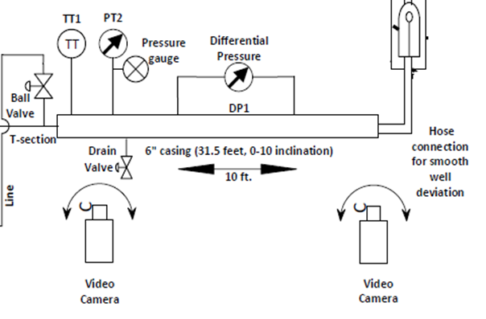
Figure 3.9: Horizontal Section Schematic
The horizontal section can be slightly inclined (±5°) in order to simulate typical horizontal wellbore conditions. Inclination can be provided with the help of pulley and chain system. However, the inclination was kept at 0° for this work. The horizontal section is 31 ft long, including three joints of PVC pipes with 6-in inside diameter (ID), as shown in Error! Reference source not found.. These joints of pipes are glued and connected through 6-in collars and two straub clamps. The PVC pipes were selected for lucid observation of fluid movement. Straub clamps are flexible, lightweight, and useful in handling pipe misalignment and vibration. This helps in making the horizontal section mobile and flexible.
One temperature and one pressure transducer were added to measure temperature and pressure at the test section inlet. A differential pressure transducer was also added to measure the pressure gradient in the horizontal section for further two-phase flow evaluation. Visual observation of the flow in this section was also done regularly through video recordings.
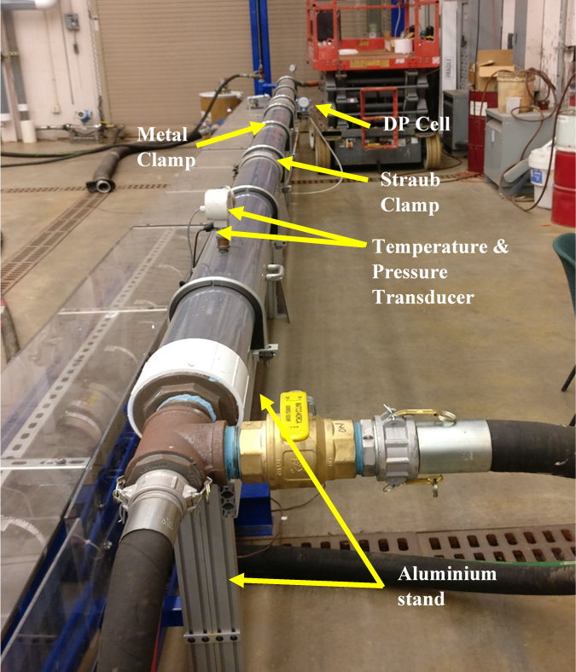
Figure 3.10: Detailed Picture of Horizontal Section
This horizontal section was mounted on a 32-in. high lightweight high-strength aluminum structure, designed specifically to hold the weight of heavy transparent 6-in PVC pipes. Eight metal band clamps and two straub clamps were used to fix the pipes firmly on the horizontal structure and avoid any kind of vibration and movement. This structure also allows for easy displacement of the section, connecting to other flow loops, or change of the section length if required. A 2-in hose pipe is connected from horizontal section to the inlet of vertical section to provide smooth well deviation and simulate horizontal well deviation. Then, a 6 to 2-in. pvc bushing was installed, which acts as a packer for the well as shown in Error! Reference source not found..
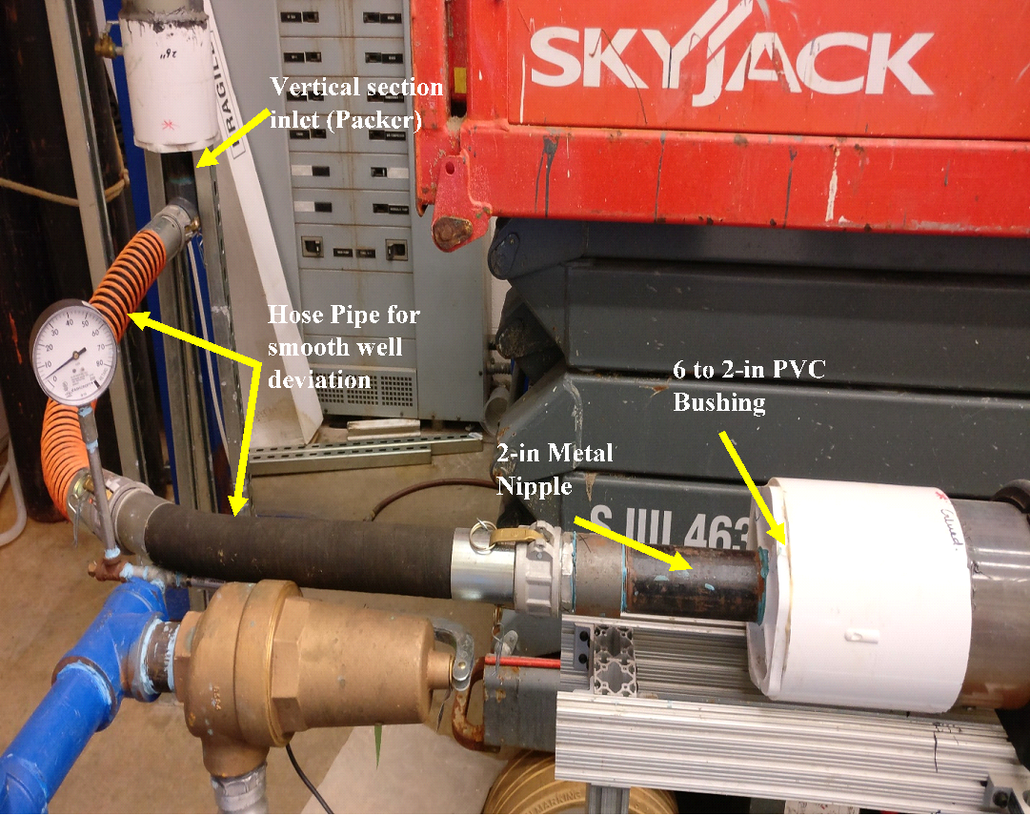
Figure 3.11: Detailed Picture of Horizontal Section connecting to vertical section

Vertical Section
The vertical test section consists of 6-in casing, 2-in tubing, 6 to 2-in bushing which acts as a packer at the inlet, a 2-in slip joint, a downhole separator, a differential pressure cell, four pressure transducers, a pressure gauge, a drain valve, 6-in casing control valve and 2-in tubing control valve, as shown in Error! Reference source not found.. Also, Error! Reference source not found. shows a picture of the vertical section, detailing different elements of this section.
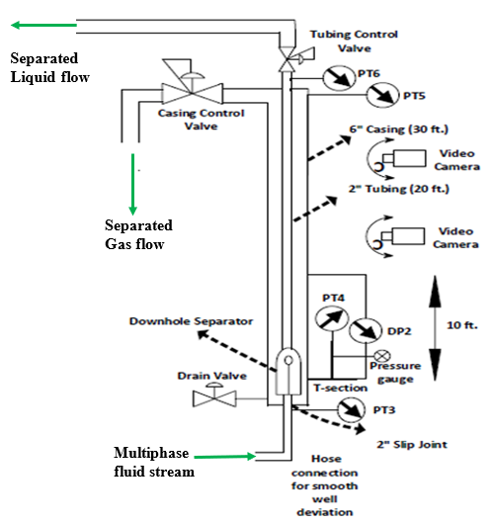
Figure 3.12: Vertical Test Section schematic
The inlet packer basically channels the flow into the 2-in tubing and separates casing and tubing zones. In order to add the capability to change the downhole separator, a 2-in slip joint was connected along with straub clamps after the packer. This structure makes the bottom part of tubing and casing flexible to open by sliding the slip joint and increasing the clearance. Straub clamps are also used with slip joint to open vertical section. Just above the downhole separator in the tubing string, a 2-in pvc union is installed to open the whole section of tubing string below it after opening the straub clamp and slip joint.

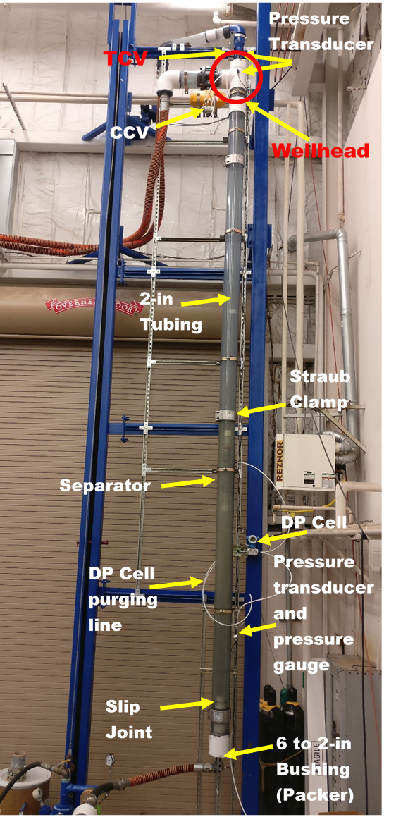
Figure 3.13: Picture of different elements of vertical section
The downhole separator was provided by Echometer company and is shown in Error! Reference source not found.. This downhole separator is a centrifugal packer-type separator, which is used in oil wells to segregate gas from liquid before it enters the artificial lift pumps and reduce their efficiency. This kind of separator is applicable for high gas-oil ratio wells and horizontal wells to eliminate the problems of poor artificial lift performance and gas lock. This separator has no moving parts and it is helpful in decreasing non-productive time (NPT) for operators. The inlet stream enters the centrifugal section through two ports (shown in green and red in schematic). The rotational movement of liquid and gas and the imposed centrifugal force at the outlet of the separator throws the liquid droplets to the inner walls of the casing. This helps in separation of liquid and gas at the separator outlet. The separated liquid droplets fall down in the casing, and are led into the shroud. Then the liquids rise through the annulus between tubing and shroud, and get to two tubing inlet ports (shown in yellow in schematic). The gas on the other hand, flows up and gets produced through the casing.
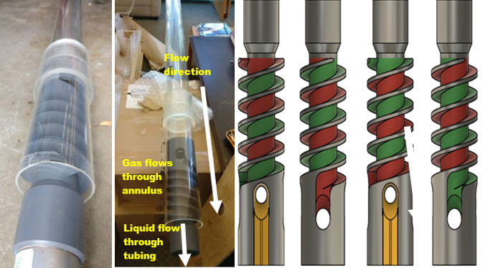
Outlet of separator
Inlet of separator
Figure 3.14: Picture of installed downhole separator at the vertical section
The separator inlet and outlet connections were of EUE threads, as shown in Error! Reference source not found.. Thread converters were installed to change into NPT thread as the other connections used NPT threads. The separator section installed in the tubing string is 96-in long as its schematic is shown in Error! Reference source not found..
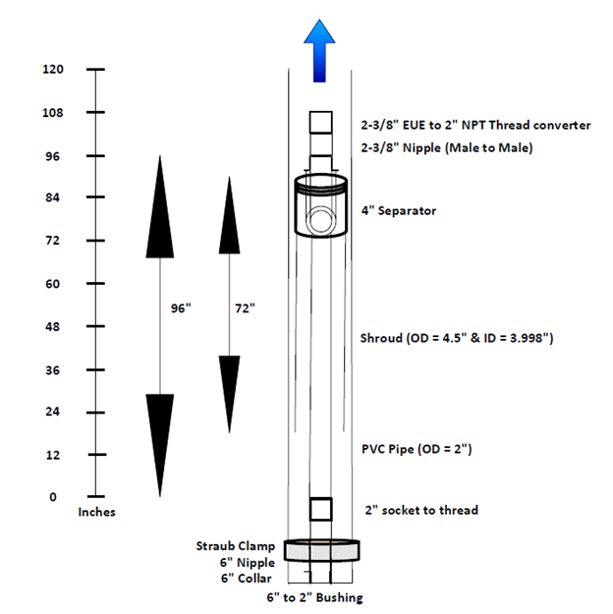
Figure 3.15: Installed downhole separator schematic

Four pressure transducers were installed to measure the pressure of the fluid before and after separation. Firstly, a pressure transducer was installed before the packer at the inlet of the vertical section. Another was installed in the casing at the level of the separator shroud. The last two are installed in the vertical section outlet at the well head to monitor pressure in the tubing and casing (annulus), as shown in Error! Reference source not found.. Also, a differential pressure transducer is installed to measure pressure drop across the 10-ft interval of the separator.
The vertical section structure was fabricated through welding of struts. The casing control valve needed a unique structure, which was installed 30-ft above the ground. This control valve of Omega company is a pneumatically operated valve and its air line is connected to a small lab compressor. One pneumatic controller (Input: 4-20 mA, supply: 18-100 psig) is installed with this control valve. This controller allows the control valve to open and close automatically through the voltage it receives. This valve is connected to the DAQ card and is modulated from 0% to 100% open, based on the voltage transmitted by the DAQ card.
Similarly, a 2-in control valve is installed at the tubing line outlet. This is an automatic control valve that acts as a choke to provide backpressure on the system. This control valve was kept fully open for all the tests of this study, using the casing control valve to control the test section pressure.

Tubing Return Line to water tank
Tubing return line (10-ft) includes a 4-in pvc pipe divided into two sections of 5-ft each, a pressure transducer with pressure gauge, 2-in. air flowmeter at the top, 1.5-in. control valve, 1.5-in. water flowmeter at the bottom, 1.5-in. ball valve and 2-in hose pipe from the flowmeter to the water tank, as shown in Figure 3.16. A 3-in. hose pipe is used to connect the wellhead in the vertical section to the middle of the tubing return line for air and water mixture flow as shown in the Figure 2.19. This hose pipe is connected to the return column using a 3 to 4-in metal bushing and a 2-ft long pvc nipple.
Air and water mixture from wellhead enter the tubing return line at the middle of the 4-in pvc pipe through a 4-in elbow. The return stream from wellhead is visually monitored to inspect separation. Due to gravity, water goes down in the vertical pipe, where it passes a 4-in. elbow, a 4-in. pvc nipple, 4 to 2-in pvc bushing, and a 2-in. hose pipe to reach the water flowmeter. A 1.5-in. flowmeter (Q_{max} = 330 lb/min, T_{max} = 302º F) is used to measure water flow rate in the tubing return line. If the test section’s downhole separator is fully efficient, this flow rate has to be equal to the inlet water flow rate. After flowmeter, a 1.5-in. ball valve is installed to create backpressure in the system, if needed. In early testing period, this ball valve was used in pressure testing the flow setup up to 60 psia of pressure. After the flow meter and ball valve, a 2-in hose pipe is used to connect the water return line to the supply water tank (Error! Reference source not found.), creating a closed loop for water recirculation.
At the top of the tubing return line as shown in Error! Reference source not found., a 4 to 2-in. pvc bushing and a 2-in. metal nipple are used to connect a 2-in. air flow meter (Q_{max} = 30 lb/min, T_{max} = 302º F). This flow meter is installed to measure flowrate of the gas that is produced through the tubing. In a real wellbore production, this will be the gas volume that is passing through the pump downstream of the downhole separator. Also, a pressure transducer is installed before the flow meter to measure the pressure in the tubing return line. The mechanical structure of the tubing return line section is properly clamped to three struts, as shown in Error! Reference source not found..
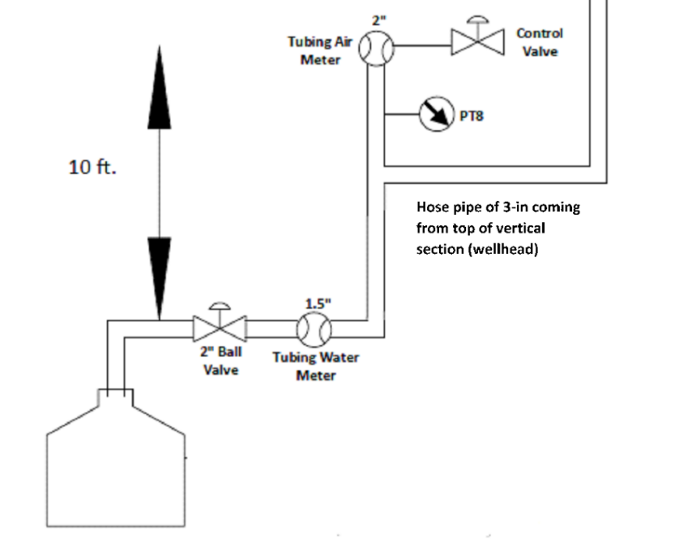
Figure 3.16: Tubing return line schematic
After the air flow meter, a 1.5 to 2-in. swage nipple is used to install a 1.5-in. control valve. Control valve installed at the top can act as a choke and maintain back pressure on the system, if so desired. This valve is connected to the DAQ card, and its opening can be controlled through the voltage it receives from the DAQ card. The air passes through this valve and gets vented to atmosphere. For the tests of this study, this valve was kept fully open, resulting in near-atmospheric pressure in the tubing return line. Majority of water is expected to flow through the tubing and into the tubing return line. This is quantified with the help of flow meter and shows the performance of the downhole separator. It is expected that separation efficiency of the downhole separator is high. So, majority of inlet water and small amounts of gas are produced through the tubing return line.

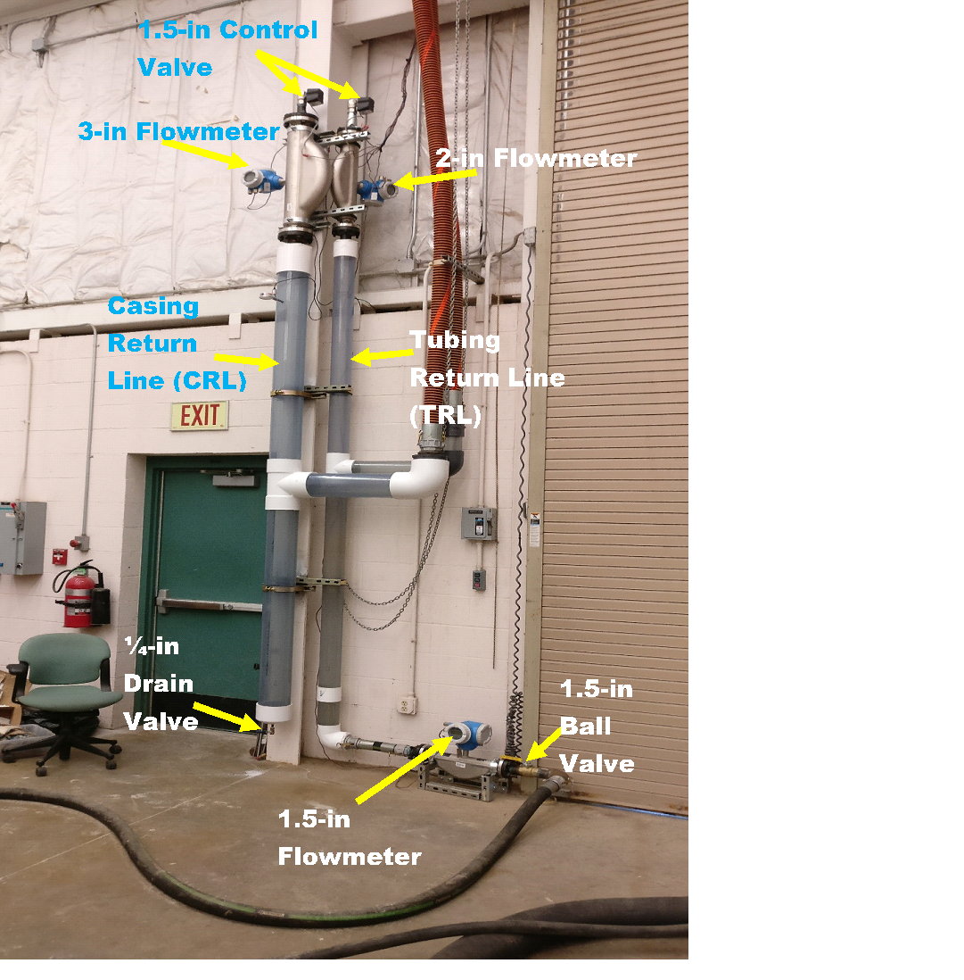
Figure 3.17: Detailed picture of Casing and Tubing return line

Casing Return Line
Casing return line is installed parallel to the tubing return line and is also 10 ft long. It is made up of 6-in pvc pipe and divided into two sections of 5-ft length. It also includes a pressure transducer with a pressure gauge, a 3-in. flowmeter, a 1.5-in. control valve, a 6-in cap and a ¼-in. metal nipple & drain valve at the bottom as shown in Error! Reference source not found.. The vertical section’s casing flow stream is directed to the middle of this column through a 3-in. hose pipe, as shown in the Error! Reference source not found..
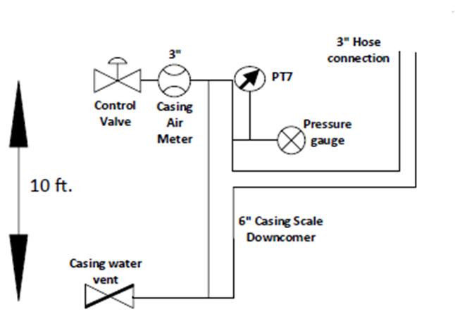
Figure 3.18: Casing return line schematic
Water and air mixture enter the casing return line at the middle of the 10-ft long 6-in. PVC pipe. The connection from the 3-in. hose pipe includes a 6-in. elbow, a 6 to 3-in. metal bushing, and 2-ft long pvc nipple installed after the elbow for fluid settling and visual observation. The sections are glued using a 6-in. tee. Due to gravity, water is sent down in the return column, where it can get drained through a 1/4” metal nipple and drain valve. This is the water that is carried as mist along with the air through the casing. For most of the tests of this study, the amount of water collected at the casing return line was relatively insignificant.
The casing return line air flow meter (Q_{max} = 100 lb/min, T_{max} = 302º F) is installed at the top for constant monitoring of the separator performance. Flowmeter measures flowrate, density, and temperature of the gas rising in the vertical section’s casing. These measurements are monitored and recorded through the data acquisition system in the control computer. In addition, a pressure transducer is installed just below the flow meter to measure pressure in the return line. After the flow meter, a 1.5-in automated control valve is installed, using a 3 to 1.5-in. metal bushing and a 1.5-in. metal nipple. This valve is used to act as a choke and maintain back pressure on the system, if required. The valve’s opening is a function of the voltage that it receives, and it is controlled from the control computer through the DAQ card. Similar to the tubing return line, this valve was kept fully open for the tests of this study. After passing the valve, the air is vented from top to the atmosphere. The casing return line section is properly clamped to three struts, as shown in Error! Reference source not found..
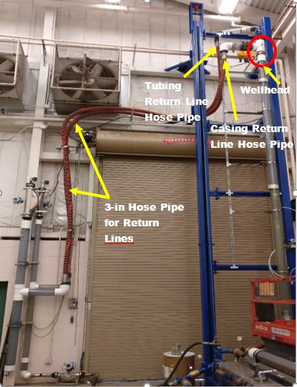
Figure 3.19: 3-in. Hose Pipes connecting wellhead to the casing and tubing return lines

Majority of water is expected to flow through the tubing and to tubing return line, while majority of air is expected to flow to the casing return line. For this reason, no water flowmeter was installed at the bottom of the casing return line. The ratio of gas produced from casing and tubing return line depends on the separation efficiency of the downhole separator. The results for most of the experiments of this study showed most of the gas producing from the casing line, implying very high separation efficiency of the tested downhole separator.

Wiring and Instrumentation
Wiring and instrumentation was the most demanding and intriguing of the facility construction process. The box including the instrument power supplies and data acquisition systems is shown in Error! Reference source not found.. Every instrument installed in the facility requires a specific output of current or voltage as well as a specific wiring technique. Overall, there are 22 instruments incorporated in this multiphase flow setup. Out of those, 16 instruments send voltage or current signals to the DAQ card, including pressure, temperature, and differential pressure transducers, and flow meters. Flow meters send three signals, proving flow rate, density and temperature, and therefore, they each occupy three ports in a DAQ card. Considering current output and positive and negative terminals for each parameter, each flow meter requires six wires for parameters’ measurement and two wires for power supply. On the other hand, 6 instruments receive voltage or current signals from the DAQ card output ports, including the control valves and VFD.
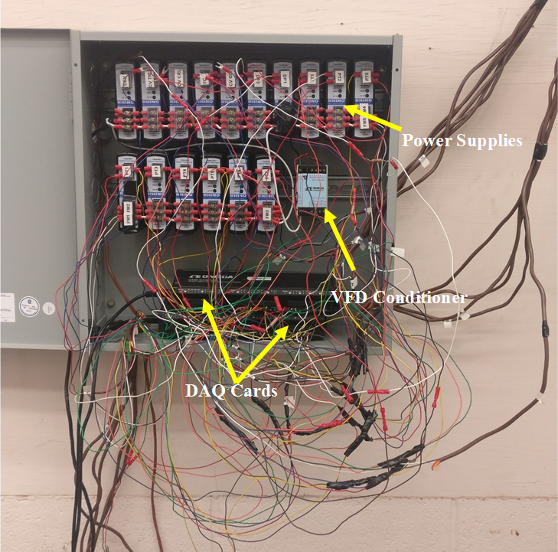
Figure 3.20: Detailed wiring picture
Data acquisition systems (DAQ cards) are from Omega OMB-daq-3000 series. Each DAQ card has 16 ports for voltage input from sensors and four ports for voltage output. There are two DAQ cards installed for our multiphase flow setup. Instruments with voltage output are directly connected to the DAQ cards to record their data during experiments. Instruments with current output must be connected to DAQ cards with a resistor in the circuit. Knowing the resistance, the current can then be converted into voltage. A simple schematic of the steps taken for sensors with voltage or current output is shown in Error! Reference source not found..

DAQ Card
Equipment with voltage output

Equipment with current output

Resistor
Directly connected to DAQ card
Connected with resistor to DAQ card
Figure 3.21: Wiring of DAQ card for sensors with voltage or current output
All of the control valves use voltage inputs, except the wellhead casing control valve. They are connected to the output ports of the DAQ cards. Pneumatic controller of the 6-in. wellhead casing control valve uses current output, and is connected to the output port of DAQ card through a resistor. The variable speed drive (VFD) controlling the water pump is installed with voltage output, and is connected to the DAQ card through a VFD conditioner as a gateway. This is to protect the DAQ card from being corrupted by the VFD signals. The conditioner acts as a protection layer for the DAQ card and prevents it from malfunctioning. Error! Reference source not found. shows the list of all the 22 sensors and valves connected to the DAQ cards in this setup.
Table 3.1: Wiring details for equipment in multiphase flow setup
Flowmeters Wiring
Sensor no. | Flow meter | Output
1 | FM1 (gas inlet line) | Current
2 | FM2 (water inlet line) | Current
3 | FM3 (casing return line air meter) | Current
4 | FM4 (tubing return line air meter) | Current
5 | FM5 (tubing return line water meter) | Current
Pressure Transducer Wiring
6 | PT1 (gas inlet line) | Voltage
7 | PT2 (horizontal section inlet) | Current
8 | PT3 (vertical section inlet) | Voltage
9 | PT4 (vertical section, bottom of casing) | Voltage
10 | PT5 (wellhead-casing) | Voltage
11 | PT6 (wellhead-tubing) | Voltage
12 | PT7 (casing return line) | Voltage
13 | PT8 (tubing return line) | Voltage
Control Valve Wiring
14 | CV1 (gas inlet valve) | Voltage
15 | CV2 (vertical section tubing outlet) | Voltage
16 | CV3 (vertical section casing outlet) | Current
17 | CV4 (casing return column outlet) | Voltage
18 | CV5 (tubing return column outlet) | Voltage
Temperature Transducer Wiring
19 | TT1 (horizontal section inlet) | Current
DP Wiring
20 | DP1 (horizontal section) | Current
21 | DP2 (vertical section, casing) | Current
VFD
22 | VFD | Voltage

Facility Control Program

Visual Basic programming was used to record and store data in real time in Microsoft Excel. The DAQ cards are connected to the control computer, and installed through the DAQView software. The VBA program reads the voltage signals from various ports of the DAQ cards through this software. It records these data from all the sensors for future analysis. It can also send desired voltages from the output ports of the DAQ cards. Using that, the program controls the VFD and control valves. The most important valve controlled by the program is the wellhead casing control valve, used to maintain a balance between casing and tubing pressures.
Data are coming from 5 flow meters, 8 pressure transducer, 2 differential pressure transducers, and a temperature transducer. Overall, 15 parameters are measured from 5 flow meters through the DAQ cards. This means a total of 26 input data are recorded in the program via DAQ cards, while 6 output data are transmitted from the DAQ cards. The sensors send signal to the DAQ card in voltage form, which is then converted to counts when read by the computer. The program converts the counts to data in different units, as shown in the Error! Reference source not found.. Similarly, control valves and VFD, receive signal from DAQ card in voltage. Firstly, VBA program sends signal to these output ports in counts, and DAQ card converts the counts to voltage and sends the signal. Minimum and maximum values of the parameters for flowmeters and transducers are used to calculate the values in the programming. VBA programming uses these value in the excel file to get the final adjusted output values of different parameters from flowmeters and transducers like flowrate, density, temperature and pressure.

For Output Ports
For Input Ports
Figure 3.22: DAQ card workflow
In order to achieve the maximum efficiency from the downhole separator, the liquid has to be produced from the tubing, while the gas is produced from the casing. For this purpose, the liquid-gas interface in the casing has to be at a fixed level, preferably below the downhole separator’s centrifugal section. If this interface level is fixed and we neglect the frictional pressure losses in casing and tubing, the casing-tubing system acts like a U-tube. This means that the difference between the wellhead casing pressure (measured as PT5) and tubing pressure (measured as PT6) is mainly a function of the gas-liquid interface level.
At this study, the difference between casing and tubing pressures was considered as a target parameter and was controlled by adjusting the opening of the wellhead casing control valve, using linear PID controlling schemes. This means that if the casing control valve’s opening percentage is too low, the valve acts as a choke and puts a high back pressure on the fluids, which in turn pushes the interface down towards the tubing inlet at the bottom of casing. Eventually, the gas finds its way and blows out through the tubing. At the same time, the difference between casing and tubing pressures increases. In this case, the casing control valve’s opening needs to be increased to reduce the casing pressure. In contrast, if the valve’s opening percentage is too high, both liquid and gas can rise and eventually get produced through the casing. In this case, interface level moves up and liquid is produced from casing return line, causing overflow from casing. Therefore, the valve’s opening needs to be decreased to increase the back pressure and lower the gas-liquid interface. Overall, based on the difference of casing and tubing pressures, casing control valve is opened and closed optimally. This lets the air flow out from casing and liquid from tubing and thus, maintains gas-liquid interface constant in the annulus.

Equation used for the closing and opening of casing control valve are following:
- For closing of casing control valve
Target opening = <100%
Target opening = Target opening + (casing and tubing pressure difference – Target difference) * (Target difference - 0.01) / (75 - 0.1)
- For opening of casing control valve
Target opening = Target opening + (casing and tubing pressure difference – Target difference) * Target difference * 0.25

Similarly, a linear PID controlling scheme was used to adjust and control the liquid flowrate at a desired value using the VBA program. This desired rate was entered in Excel and was used as the target parameter, and VFD frequency was automatically adjusted to achieve it. So, if the recorded flow rate from the inlet water flow meter is higher than the desired value, the VFD frequency would decrease. The VFD frequency would increase, if the flow rate is higher than the desired value.
Equation used in program file to operated variable frequency drive to control liquid rate from PCP is following:
Adjusting Liquid rate in gpm = Voltage in VFD + (Target liquid rate – Liquid rate) * (Constant – 0.01) / (75 - 0.1)

Test Procedure
Step 1: Provide electricity to the equipment by connecting main line to the electric plug, switch on computer and start compressor.
Step 2: Switch-on VFD and press its reverse button and fill the water tank.
Step 3: Open in-lab gas line (connected with in-lab compressor) to control casing control valve and set its pressure around 100psig. Check all drain valves are closed or not.
Step 4: Open Excel programming file.
Step 5: Enter desire liquid flowrate and control valve opening percentage for gas inlet line in the excel file.
Step 6: Open VBA programming file and change gas inlet control valve opening. Also, change Target difference accordingly for control casing control valve in the programming file.
Step 7: Come to the Excel file again and press START button.
Step 8: Wait for around 5 seconds and open 3-in ball valve installed at the inlet of horizontal section for gas to enter in the setup.
Step 9: Wait for 3-4 minutes for stabilizing of gas-liquid interface in the annulus. Meanwhile, if liquid starts coming in the return lines very fast and causing overflowing, Close the 3-in ball valve first installed at the inlet of horizontal section and then press STOP button in the programming.
Step 10: If gas-liquid interface stabilized in first few minutes, then run the test atleast for 20 mins for medium flowrates and for low flowrates, run the test for atleast 40mins to observe better separation efficiency trend.
Step 11: Press STOP button to stop the test.
Step 12: Drain water from the vertical/test section through drain valve installed at the bottom of test section after experiments.
Step 13: Drain water from horizontal section through drain valve installed at the lower side of the horizontal section closer to pressure transducer after experiment.
Step 14: Shut down VFD, drain water tank, close ball valve which provides gas to the casing control valve and remove power plug which provides electricity to the entire installed equipment and shutdown computer.

Scope of Work
Gas and liquid separation efficiencies of the centrifugal packer-type separator proved to be very high in the 106 tests conducted. The overall test matrix is shown in Table 3.2 for different liquid and gas rates, including the tests conducted and the tests not conducted due to time restrictions. The test matrix was designed to simulate the production rate of a given well, with liquid flow rates ranging between 17-680 bpd and gas flow rates ranging between 30-230 MSCFD. This test matrix provides a wide range of production rate and gas-liquid ratios in pumped wells. Gas inlet line control valve (GIL_CV) shows gas flowrate at inlet point at different control valve opening.
Table 3.2: Test Matrix
 | GIL CV (%)
 | 25 | 30 | 35 | 40 | 45 | 50 | 55
Liquid Flowrate (GPM) | 0.5 | 0.5 | 0.5 | 0.5 | 0.5 | 0.5 | 0.5
Liquid Flowrate (GPM) | 1 | 1 | 1 | 1 | 1 | 1 | 1
Liquid Flowrate (GPM) | 2 | 2 | 2 | 2 | 2 | 2 | 2
Liquid Flowrate (GPM) | 3 | 3 | 3 | 3 | 3 | 3 | 3
Liquid Flowrate (GPM) | 4 | 4 | 4 | 4 | 4 | 4 | 4
Liquid Flowrate (GPM) | 5 | 5 | 5 | 5 | 5 | 5 | 5
Liquid Flowrate (GPM) | 6 | 6 | 6 | 6 | 6 | 6 | 6
Liquid Flowrate (GPM) | 7 | 7 | 7 | 7 | 7 | 7 | 7
Liquid Flowrate (GPM) | 8 | 8 | 8 | 8 | 8 | 8 | 8
Liquid Flowrate (GPM) | 9 | 9 | 9 | 9 | 9 | 9 | 9
Liquid Flowrate (GPM) | 10 | 10 | 10 | 10 | 10 | 10 | 10
Liquid Flowrate (GPM) | 11 | 11 | 11 | 11 | 11 | 11 | 11
Liquid Flowrate (GPM) | 12 | 12 | 12 | 12 | 12 | 12 | 12
Liquid Flowrate (GPM) | 13 | 13 | 13 | 13 | 13 | 13 | 13
Liquid Flowrate (GPM) | 14 | 14 | 14 | 14 | 14 | 14 | 14
Liquid Flowrate (GPM) | 15 | 15 | 15 | 15 | 15 | 15 | 15
Liquid Flowrate (GPM) | 16 | 16 | 16 | 16 | 16 | 16 | 16
Liquid Flowrate (GPM) | 17 | 17 | 17 | 17 | 17 | 17 | 17
Liquid Flowrate (GPM) | 18 | 18 | 18 | 18 | 18 | 18 | 18
Liquid Flowrate (GPM) | 19 | 19 | 19 | 19 | 19 | 19 | 19
Liquid Flowrate (GPM) | 20 | 20 | 20 | 20 | 20 | 20 | 20
 | Test Performed |  |  | Test not Performed

CHAPTER 4: RESULTS AND DISCUSSIONS

4.1 Experimental Observation
The two-phase flow pattern of fluid in the tubing string (vertical section) upstream of the separator has been shown in Error! Reference source not found.. This test was performed at a liquid flow rate of 16 gpm and a gas flow rate of 212,000 scf/day. The flow pattern in the tubing is churn flow, with oscillatory movement of liquid and gas. Gas bubbles and liquid droplets of different sizes can be observed within the two-phase flow structure. Due to high liquid flowrate and gas flowrate liquid-gas interface level was not stable around the separator and flow is turbulent.
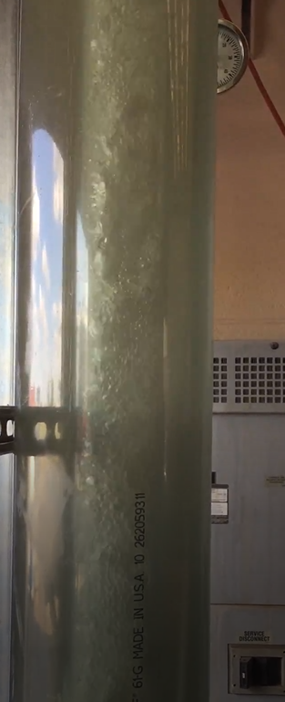
Figure 4.1:Image of fluid flow at 16gpm liquid rate and gas rate of 212,000 scf/day
Error! Reference source not found. shows actual flow behavior of fluid around downhole separator installed in the vertical section. This test was performed at 6 gpm liquid rate and 212,000 scf/day of gas rate. It is observed that after passing through centrifuge section in a vortex flow, fluid stream separates into water and gas. Water falls down as we can see liquid level just below the centrifugal section and gas goes up through the casing-tubing annulus.
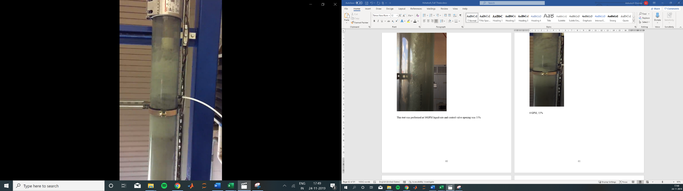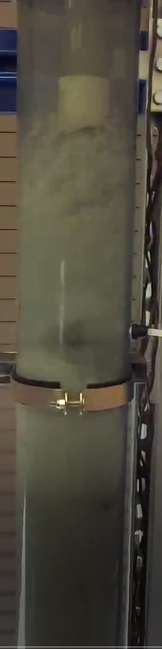
Liquid level
Downhole Separator
Flow direction
Figure 4.2: Image of fluid flow at 6gpm liquid rate and gas rate of 212,000 scf/day
Actual flow pattern of fluid around the downhole separator installed in the vertical section has been shown in Error! Reference source not found.. This is for a test conducted at 10 gpm liquid rate and 146,000 scf/day of gas rate. It can be observed that fluid enters the downhole separator centrifugal section through vent holes and separation occurs after passing through this section. Liquid falls down and gas moves up in the annulus.
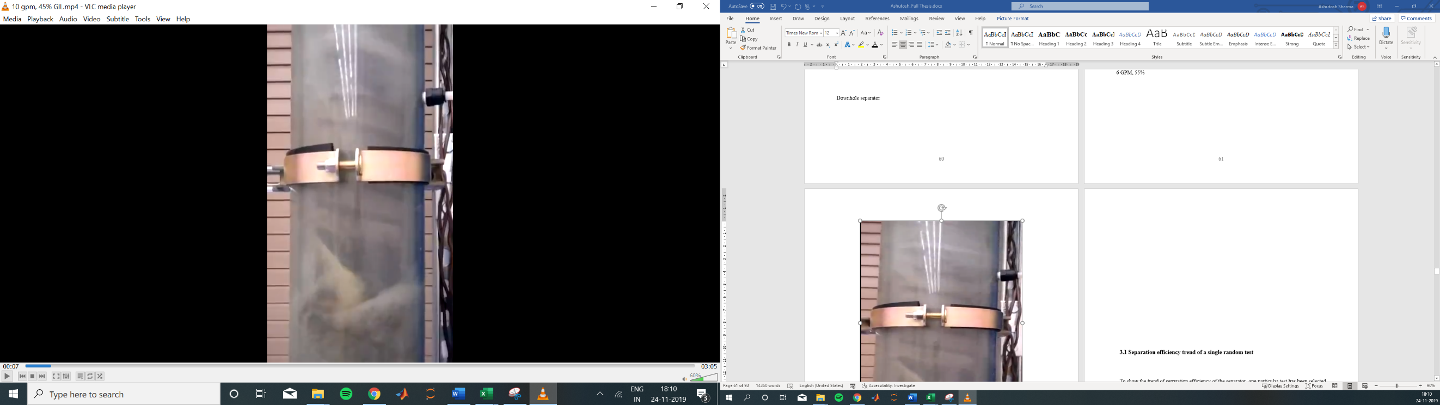
Downhole separator vent hole before centrifugal section
Centrifugal section
Figure 4.3: Image of fluid flow at 10gpm liquid rate and gas rate of 146,000 scf/day

4.2 Separation Efficiency trend of random tests
To show the trend of separation efficiency of the separator, one particular test has been selected out of 106 tests conducted. This test was conducted on 11th October. Details for this test are following:
- Test No. 5_11th October
- Average Liquid rate = 171 bbl/day (5gpm)
- Control valve at gas inlet line (GIL) opening = 55%
- Average Gas rate = 175,126 scf/day
- Gas Separation Efficiency = 96%
- Liquid Separation Efficiency = 99%
Before we discuss about separation efficiency trend of the downhole separator, we will discuss about how separation efficiency of the downhole separator is calculated from experimental tests.
Liquid and gas separation efficiency
Separation efficiency of gas is calculated through gas flowrate at gas inlet line and gas flowrate at casing return line (through FM3) as shown in Error! Reference source not found. and liquid separation efficiency of the separator is calculated through liquid flowrate at water inlet line and liquid flowrate at tubing return line (through FM5) as shown in Error! Reference source not found.. When fluid stream flows through separator, it separates the fluid mixture into liquid and gas in the vertical section and let the gas to flow through casing-tubing annulus to casing return line (gas output) and liquid to flow through tubing to tubing return line (liquid output). Flowmeters installed in the return line measure gas and liquid flowrate and we use these flowrate values to calculate separation efficiency of the downhole separator.
- Gas separation efficiency of separator in % = $\frac{Qcasing return line (\frac{scf}{d})}{Qgas inlet line (\frac{scf}{d})}$ X 100

- Liquid separation efficiency of separator = $\frac{Qtubing return line (\frac{scf}{d})}{Qwater inlet line (\frac{scf}{d})}$ X 100
The trend of liquid flowrate at inlet and outlet points have been represented in Error! Reference source not found.. Inlet liquid flowrate is measured through flowmeter (FM2) installed in the water inlet line and outlet liquid flowrate is measured through flowmeter (FM5) installed at the bottom of the tubing return line. Here, graph shows that inlet liquid rate and outlet liquid rate match very closely for 20 minutes of test duration as test was conducted for almost twenty minutes. During first two minutes, we can observe that inlet and outlet liquid flowrates are not matching, because casing control valve was taking time to stabilize the gas-liquid interface in the annulus during this period.

Figure 4.4: Inlet and Outlet liquid flowrate trend with respect to time
The gas flowrate at tubing and casing return lines and inlet point have been shown in Error! Reference source not found.. Inlet flowrate is measured at flowmeter (FM1) installed in gas inlet line and casing and tubing return line gas flowrate was measured through flowmeters (FM3 & FM4) installed in their respective lines. Here, Small amount of gas is produced at TRL for first 3-4 mins. After 3-4mins, gas is separated from fluid stream and produced only through annulus via casing return line. As observed in the above graph, majority of the gas is produced from casing return line showing remarkable efficiency of the separator. Gas separation efficiency for the separator is 96% in this case.

Figure 4.5: Gas Flowrate at inlet and return lines with respect to time
Pressure measured through transducer in the annulus (PT5) and pressure measured in the tubing line (PT6) along with casing control valve opening with respect to time have been shown in Error! Reference source not found.. This casing control valve is the most important valve controlled by the program, used to maintain a balance between casing and tubing pressures. In order to achieve the maximum efficiency from the downhole separator, the liquid has to be produced from the tubing, while the gas is produced from the casing. For this purpose, the liquid-gas interface in the casing has to be at a fixed level, preferably below the downhole separator’s centrifugal section. If we neglect the frictional pressure losses in casing and tubing and this liquid-gas interface is kept constant, this entire system will act like a U-tube. This means that pressure difference between wellhead casing pressure (PT5 pressure value) and wellhead tubing pressure (PT6 pressure value) is a function of gas-liquid interface level.

Figure 4.6: Pressure in the casing & tubing line measured at wellhead and casing control valve opening % with respect to time
Here, Casing control valve took around 3 mins to stabilize gas-liquid interface. We set the wellhead casing and tubing difference of 5psi for this test. Error! Reference source not found. indicates the remarkable separation efficiency of the downhole separator for this test. We can conclude through this graph that liquid and gas separation efficiencies of the separator are more than 85% at majority of data points except for first 2-3 mins, when casing control valve is stabilizing the gas-liquid interface. Average liquid and gas separation efficiency for 231 data points in this 20mins test are 99% and 96% respectively.

Figure 4.7: Separation efficiency of the separator for the test with respect to time
In order to show the gas and liquid separation efficiency trends of the separator more clearly, three random tests are selected out of total 106 tests performed. Comparison of separation efficiency with time gives more insight for the separator performance. The details of the tests which have been selected for the analysis are following:
- Test No. 5_4th November
- Average Liquid rate = 171 bbl/day (5GPM)
- Control valve at gas inlet line (GIL) opening = 40%
- Average Gas rate = 121,273 scf/day
- Gas Separation Efficiency = 95%
- Liquid Separation Efficiency = 98%
- Test duration = 18.9 mins
- Test No. 1_5th November
- Average Liquid rate = 343 bbl/day (10 GPM)
- Control valve at gas inlet line (GIL) opening = 40%
- Average Gas rate = 130,777 scf/day
- Gas Separation Efficiency = 95%
- Liquid Separation Efficiency = 99%
- Test duration = 26.3 mins
- Test No.5_5th November
- Average Liquid rate = 617 bbl/day (18 GPM)
- Control valve at gas inlet line (GIL) opening = 40%
- Average Gas rate = 117,289 scf/day
- Gas Separation Efficiency = 94%
- Liquid Separation Efficiency = 94%
- Test duration = 20.2 mins

Time-dependent liquid separation efficiencies of the three cases mentioned above have been shown in below Error! Reference source not found.. Average liquid separation efficiency of the separator for 5,10 and 18 gpm are 98, 99 and 94% respectively. We observed comparatively low liquid separation efficiency for 18 gpm because during first 3-4 mins of the test, casing control valve takes time to manage liquid-gas interface in the annulus due to high liquid rate. Therefore, for this duration liquid starts producing from annulus via casing return line and thus, reducing liquid separation efficiency of the separator. Here, overall liquid separation efficiencies of the separator in all the three cases are high. Experiments indicated that liquid separation efficiency of the separator reduces marginally above 14 gpm of inlet liquid rate. For first 3-4 mins in every case, instabilities are observed in the separation efficiency because casing control valve takes time to stabilize the liquid-gas interface in the annulus and maximize efficiency of the separator. This time period is considered as unsteady state phase.

Figure 4.8: Liquid separation efficiencies of the three tests with respect to time
Time-dependent gas separation efficiency of the separator for the three cases mentioned above have been shown in below Error! Reference source not found.. Average gas separation efficiency of the separator for 5,10 and 18 gpm cases are 95, 95 and 94%, respectively. Separation efficiencies of the separator for the three cases are overlapping, and majority of test points have efficiencies higher than 80%. For the first 3-4 minutes, we can observe instability in data points but after that efficiency values are consistent with time indicating high efficiency of the separator. The inlet gas rates for the three tests are in the same range. Inconsistencies are observed in gas and liquid separation efficiency values for the case with 18 gpm liquid rate because at higher liquid rates, casing control valve takes time to stabilize liquid interface in the annulus.

Figure 4.9: Gas separation efficiencies of the three tests with respect to time
Casing control valve operation with respect to time has been shown in Error! Reference source not found. below for three different liquid flowrates. It can be observed that at low liquid flowrate, casing control valve stabilizes the liquid-gas interface very quickly, while this takes very long at higher liquid flowrate case. This is the reason why separation efficiencies are consistent for the test points at low liquid rate (5 gpm). However, for 18 gpm liquid rate, casing control valve is unable to stabilize the gas-liquid interface for long time in the annulus resulting in larger fluctuations in liquid separation efficiencies. For 10 gpm case, casing control valve is stabilized after 3-4 mins and the opening percentage of the valve is very consistent thereafter.

Figure 4.10: Casing control valve operation for the three tests with respect to time

4.3 Separation Efficiency Sensitivity Analysis
To better analyze the separation efficiency trends, a few groups of tests are picked with similar ranges of liquid or gas flow rates. The main objective is to observe how liquid and gas separation efficiency trends look as a function of gas rate or liquid rate alone.

4.3.1 Gas Rate Effects
Liquid and gas separation efficiencies at different selected gas flowrate ranges has been shown in Error! Reference source not found.1. Three gas rate ranges are selected: low rate (48000-72000 scf/day), medium rate (101,000-116,00 scf/day) and high rate (209,000-215,000 scf/day). Maximum gas separation efficiency is observed at liquid flowrate of 686 bbl/day and gas flowrate of 71000 scf/day and maximum liquid separation efficiency is observed at liquid flowrate of 412 bbl/day and gas flowrate of 211,000 scf/day.
Table 4.1: Separation efficiency for different gas rate ranges
Test No. | Average liquid flowrate (bbl/day) | Average gas flowrate (scf/day) | Separation efficiency of gas (%) | Separation efficiency of liquid (%)
1 | 34 | 48962 | 94.7 | 87.8
2 | 17 | 57051 | 86.5 | 77.3
3 | 240 | 63788 | 81.8 | 97.8
4 | 103 | 64107 | 85.1 | 98.1
5 | 205 | 64309 | 81.0 | 98.6
6 | 172 | 65314 | 82.2 | 96.6
7 | 274 | 65945 | 84.8 | 99.3
8 | 137 | 68046 | 73.2 | 96.1
9 | 686 | 71041 | 97.7 | 98.8
10 | 549 | 72540 | 96.6 | 96.4
11 | 137 | 101592 | 96.3 | 99.7
12 | 103 | 101782 | 96.5 | 98.5
13 | 412 | 103538 | 92.4 | 98.2
14 | 69 | 113684 | 95.7 | 93.6
15 | 309 | 114159 | 95.2 | 97.9
16 | 34 | 114753 | 96.7 | 95.7
17 | 206 | 114941 | 91.6 | 94.9
18 | 240 | 115458 | 91.9 | 99.8
19 | 686 | 115756 | 92.2 | 96.4
20 | 274 | 116150 | 97.3 | 98.3
21 | 549 | 209578 | 89.2 | 88.8
22 | 206 | 210292 | 95.8 | 99.1
23 | 515 | 210637 | 95.5 | 71.7
24 | 480 | 210689 | 95.2 | 96.9
25 | 446 | 210805 | 93.0 | 99.2
26 | 412 | 211049 | 94.1 | 99.8
27 | 240 | 213639 | 93.9 | 98.9
28 | 343 | 215214 | 93.6 | 98.6
29 | 342 | 215403 | 88.1 | 98.4
30 | 377 | 215474 | 93.8 | 98.2

Gas separation efficiency of the separator with respect to liquid flowrate for three gas flowrate ranges mentioned above has been shown in below Error! Reference source not found.. Error bar percentage in gas separation efficiency has also been shown in this graph for tests at different gas flowrate. Standard deviation for gas separation efficiency is around 5 means gas separation efficiency values can vary +/-5 for all tests. So, standard deviation value of 5 have been used in the graph to show error margin in the values of gas efficiency.Maximum average gas separation efficiency is observed in medium gas flowrate range (101,000-116,000 scf/day) and minimum average gas separation efficiency is observed in low gas flowrate range (48,000-72,000 scf/day). All the tests have gas separation efficiencies of more than 80% except one case with liquid flowrate of 137 bbl/day. At this test liquid separation efficiency is 96% and gas separation efficiency is 73%. This is possibly because of low gas flowrate and medium liquid flowrate, result in longer required time for casing control valve to stabilize the liquid-gas interface, reducing the gas separation efficiency.

Figure 4.11: Gas separation efficiency of separator as a function of liquid flowrate for three different gas flowrate ranges
Liquid separation efficiency of the separator with respect to liquid flowrate for three gas flowrate ranges mentioned above has been shown in Error! Reference source not found.. Error bar percentage in liquid separation efficiency has also been shown in this graph for tests at different gas flowrate. Standard deviation for liquid separation efficiency is around 6 means liquid separation efficiency values can vary +/-6 for all tests. So, standard deviation value of 6 has been used in the graph to show error margin in the values of liquid efficiency. Maximum average liquid separation efficiency of 99.8% is observed in gas flowrate ranges of 101,000-116,00 scf/day and 209,000-215,000 scf/day and minimum average liquid separation efficiency of 71.7% is observed in gas flowrate range of 209,000-215,000 scf/day. All the tests have liquid separation efficiencies higher than 80% except two cases with liquid flowrates of 17 bbl/day and 515 bbl/day. We calculated the efficiency eliminating the first 5mins of tests in which flow remains unstabilized. At low liquid rate, we observe intermittent flow of liquid throughout the test for 20mins through tubing to tubing return line. Here, at 17bbl/day liquid rate, gas flow rate is 72000 scf/day (CV_GIL opening = 30%). Despite of casing control valve stabilization after 4-5mins, liquid production to tubing return line was intermittent, thus reducing the liquid separation efficiency of the separator for this test. At test with liquid flowrate of 515 bbl/day, part of low liquid separation efficiency can be because the liquid rates are high, so the turbulence is also too high and gas bubbles ger dispersed in liquid and get in the tubing. Also, due to high liquid rate there is intermittent flow of liquid through annulus to casing return line and reduces the liquid separation efficiency of the separator for this test.

Figure 4.12: Liquid separation efficiency of separator as a function of liquid flowrate for three different gas flowrate ranges

4.3.2 Liquid Rate Effects
Error! Reference source not found. shows separation efficiencies of liquid and gas at different liquid flowrate ranges. We have selected 102-137 bbl/day, 308-342 bbl/day and 617-685 bbl/day gas rate ranges to observe liquid and gas separation efficiency curve trend. Maximum gas separation efficiency is observed at liquid flowrate of 686 bbl/day and gas flowrate of 71000 scf/day and maximum liquid separation efficiency is observed at liquid flowrate of 137 bbl/day and gas flowrate of 101,000 scf/day.
Table 4.2: Separation efficiency for different liquid rate ranges
Test No. | Average liquid flowrate (bbl/day) | Average gas flowrate (scf/day) | Separation efficiency of gas (%) | Separation efficiency of liquid (%)
1 | 103 | 229858 | 96.1 | 97.7
2 | 103 | 164240 | 93.7 | 96.8
3 | 103 | 43445 | 92.2 | 97.1
4 | 103 | 101782 | 96.5 | 98.5
5 | 103 | 132578 | 95.3 | 96.5
6 | 103 | 64107 | 85.1 | 98.1
7 | 137 | 101592 | 96.3 | 99.7
8 | 137 | 164721 | 94.0 | 98.8
9 | 137 | 45250 | 94.7 | 98.2
10 | 137 | 80388 | 96.3 | 99.1
11 | 308 | 92915 | 95.2 | 98.5
12 | 308 | 42001 | 95.3 | 98.6
13 | 309 | 114159 | 95.2 | 97.9
14 | 309 | 217530 | 87.5 | 98.8
15 | 309 | 78679 | 97.1 | 97.6
16 | 309 | 220676 | 93.1 | 97.1
17 | 342 | 215403 | 88.1 | 98.4
18 | 343 | 75182 | 94.9 | 98.9
19 | 343 | 34985 | 92.1 | 98.5
20 | 343 | 159383 | 92.2 | 99.6
21 | 617 | 98762 | 93.3 | 98.3
22 | 617 | 117289 | 94.2 | 94.3
23 | 617 | 152588 | 92.3 | 97.8
24 | 617 | 73235 | 96.1 | 95.1
25 | 617 | 43542 | 85.5 | 90.2
26 | 651 | 43730 | 87.5 | 94.7
27 | 685 | 151595 | 90.8 | 99.5
28 | 686 | 71041 | 97.7 | 98.8
29 | 686 | 35385 | 81.8 | 80.9
30 | 686 | 115756 | 92.2 | 96.4

Error! Reference source not found. below shows gas separation efficiency of the separator with respect to gas flowrate for three different liquid flowrate ranges mentioned above. Maximum average gas separation efficiency is observed in liquid flowrate range of 102-137 bbl/day and minimum average gas separation efficiency is observed in liquid flowrate range of 617-685 bbl/day. Every gas flowrate point has gas separation efficiency of more than 80%. At one test (CV_GIL = 25% open, liquid rate = 20gpm, gas rate = 35,000 scf/day), gas separation efficiency is 82%. Its maybe because of high liquid rate and low gas flowrate, gas dispersed in the liquid phase due to high turbulence and gets produced from tubing return line, reducing gas separation efficiency in this case.

Figure 4.13: Gas separation efficiency of separator as a function of gas flowrate for three different liquid flowrate ranges

Liquid separation efficiency of the separator with respect to gas flowrate for three different liquid flowrate ranges mentioned above has been shown in Error! Reference source not found.. Maximum average liquid separation efficiency of 98.4% is observed in liquid flowrate range of 308-342 bbl/day and minimum average liquid separation efficiency of 94.6% is observed in liquid flowrate range of 617-685 bbl/day. Every liquid flowrate point has liquid separation efficiency of more than 80%. At one test (CV_GIL = 25% open, liquid rate = 20 gpm, gas rate = 35,000 scf/day), liquid separation efficiency is 82%. It is because of high liquid rate, there is intermittent flow of liquid through annulus to casing return line and reduces the liquid separation efficiency of the separator for this test. Also, at high liquid flowrate, casing control valve stabilizes the gas-liquid interface sometimes during tests and during this stabilizing phase liquid produces from annulus to casing return line and reduce the overall liquid separation efficiency of the separator.

Figure 4.14: Liquid separation efficiency of separator as a function of gas flowrate for three different liquid flowrate ranges

4.4 Overall Separation Efficiency Analysis
To show liquid and gas separation efficiency trend of the separator, we have used data of 106 tests conducted. Average gas separation efficiency of the separator for all the test is 93% and average liquid separation efficiency of the separator for all tests is 96%.

4.4.1 Overall Separation Efficiency with Liquid Flowrate
Overall liquid and gas separation efficiencies with respect to change in liquid flowrates for all tests have been indicated in Error! Reference source not found.. Gas separation efficiency is increasing with increase in liquid flowrate. Two lower values of gas efficiencies of 67% at 68bbl/day (liquid rate= 2gpm, CV_GIL= 25%open) and 73% at 137 bbl/day (liquid rate= 4gpm, CV_GIL = 30 %open). Its due to lower values of gas flowrates and lower liquid flowrates. At very low liquid and gas rates, casing control valve stabilizes gas-liquid interface several times, even after 4-5mins and gas starts producing from tubing to tubing return line. If we would perform these tests for more than 20mins, like 40-45 mins, separation efficiencies of the separator would have been increased.
Liquid separation efficiency is also increasing with increase in liquid flowrate. One lower value of 54% liquid separation efficiency at 34 bbl/day (1GPM, CV_GIL = 25% open). One lower value of 54% liquid separation efficiency at 34 bbl/day (1GPM) because at lower values of liquid flowrate of 0.5 and 1GPM, Casing control valve takes longer time to stabilize gas-liquid interface. Due to lower control valve opening of 25%, gas is not able to lift liquid from tubing to tubing return line. Also, liquid flowrate is very low, which takes time to flow from tubing to Tubing return line. This test was conducted for 20mins and liquid started coming out in tubing return line after 10mins of experiments and even after 10mins of test, liquid production was intermittent to tubing return line. If we would have performed test for 40-50mins, liquid separation efficiency would be higher.

Figure 4.15: Overall separation efficiency of the separator as a function of liquid flowrate

4.4.2 Overall Separation Efficiency with Gas Flowrate
Gas separation efficiency increases with increase in gas flowrate as shown in Error! Reference source not found.. Two lower values of gas separation efficiency at 43600 scf/day (liquid rate=2 gpm, CV_GIL=25% open, liquid efficiency= 92%) and 68000 scf/day (liquid rate = 4gpm, CV_GIL= 30% open, liquid efficiency = 96%) because of lower liquid and gas rates of 2 and 4gpm & 43,000 and 68,000 sf/day. Because of lower liquid and gas rate, casing control valve takes longer time to stabilize gas-liquid interface and tries to push liquid level down in casing and produces water through tubing return line.

Figure 4.16: Overall separation efficiency of the separator as a function of gas flowrate
As we can observe higher liquid separation efficiency in these two cases. At every other gas flowrate, gas separation efficiency is always more than 75%. After 75000 scf/day, we can observe consistent increase in gas separation efficiency, or our separation efficiency values are stable above this gas flowrate value. Liquid separation efficiency is increasing with increase in gas flowrate as shown in Error! Reference source not found., except at two gas flowrates of 35000 scf/day and 210,000scf/day. It is because at higher liquid flowrate, it takes some time for casing control valve to stabilize gas-liquid interface (longer than 4-5 mins) and hence, for first few minutes most of the liquid flows from annulus to casing return line, reducing liquid separation efficiency of separator. Also, due to high liquid rate liquid gets produced intermittently through casing return line and decreases the overall liquid separation efficiency. In lower liquid rate as well as lower gas rate, it takes around 10-15mins to stabilize gas liquid interface by casing control valve.

4.4.3 Overall Gas-Liquid Ratio (GLR) Change by Separator
Error! Reference source not found. shows Outlet GLR increases with increase in Inlet GLR. Due to high efficiency of separator, at few inlet GLR points, outlet GLR is zero. Overall outlet GLR is very less for all inlet GLR values. As we can observe in the Error! Reference source not found., that outlet GLR value are very low at most of the test data points. It is because our downhole gas separator, separates the gas from liquid-gas stream and directs the gas via annulus after separation from separator to the casing return line where flowmeter is installed to quantify the gas flowrate. Here, outlet GLR has been calculated using flowrate measured at tubing return line gas flowmeter (FM4). As we know majority of the gas is produced in the casing return line (high gas liquid ratio at CRL), that’s why gas liquid ratio calculated values at tubing return line are very low. Average inlet gas liquid ratio is 846 scf/day and Average outlet gas liquid ratio is 35 scf/day.

Figure 4.17: Outlet vs Inlet Gas liquid ratio (GLR)
The conducted tests were divided into several categories based on the ranges of liquid and gas rates. This was done to have a clear insight into separation efficiency of the separator. The results of this analysis are averaged and summarized as shown in Error! Reference source not found.3. The first two sections of the table show the separator’s efficiency for low, medium and high ranges of gas flowrates. It can be seen that average liquid and gas separation efficiencies are over 90% for all the range of gas rates. The efficiencies are slightly lower at lower gas rates, but this can be simply due to limited experimental times. The last two sections of the table show the average separation efficiencies at low, medium and high liquid rates. Again, the average liquid and gas separation efficiencies are all above 90%. In comparison, the separator seems to be most efficient for medium liquid rates in the range of 200-400 bpd.
Table 4.3: Average separation efficiency of the separator
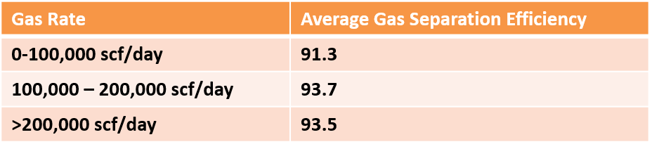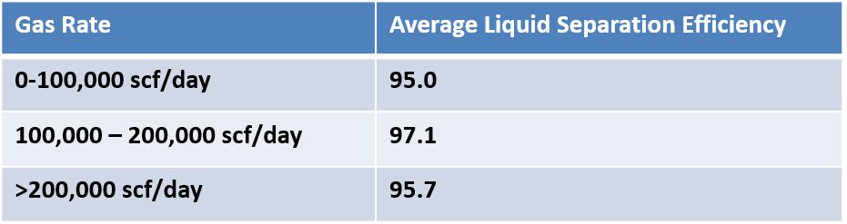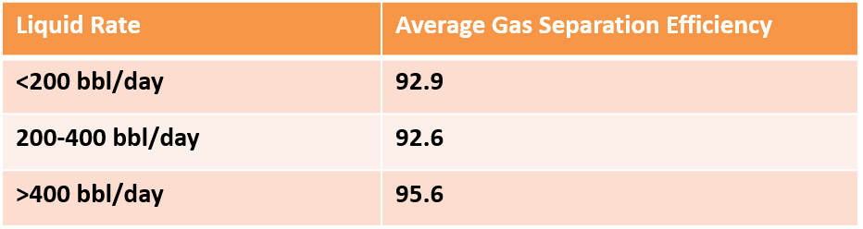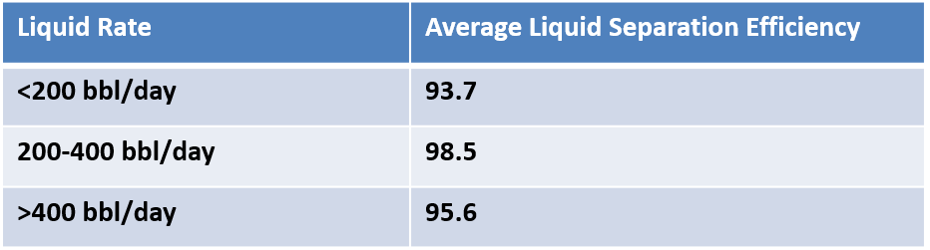

CHAPTER 5: CONCLUSIONS AND RECOMMENDATIONS

5.1 Summary and Conclusions
This research introduces an experimental investigation of the liquid and gas separation efficiency of the centrifugal packer-type downhole separator. The combination of experimental facility, multiphase flow equipment and programming provided insight into the separation efficiency capability of the separator. Under aforementioned experimental results obtained, following are my conclusions: We Constructed a state-of-art experimental facility to evaluate performance of a centrifugal packer-type downhole separator and Conducted 106 experiments to evaluate the separation efficiency of the separator and observed that calculated separation efficiency of the separation is remarkable. Average inlet liquid flowrate for all tests is 298 bbl/day and average inlet gas flowrate for all tests is 113,000 scf/day
- Average gas separation efficiency of the separator is 93% and average liquid separation efficiency of the separator is 96%
- Better trend of liquid and gas separation efficiencies are observed when plotted family of curves
- Liquid and gas separation efficiencies increase with increasing flowrate
- As inlet GLR increases, gas separation efficiency of the separator increases
- Low outlet GLR values for all tests indicate the high separation efficiency of the separator as it is expected to receive lower gas flowrates at tubing return line for good separation efficiency of the separator
- Average inlet gas liquid ratio is 846 scf/day and Average outlet gas liquid ratio is 35 scf/day. From Figure 4.17, outlet gas liquid ratio is 3.8% of the inlet gas liquid ratio.

5.2 Future Work Recommendations
Separation efficiency of the separator depends on the time duration of the tests conducted at different liquid and gas flowrates especially at very low liquid and gas flowrates. These are recommendations on further research:
- More tests can be conducted at higher liquid flowrate of upto 60gpm to observe efficiency trend of separator
- More tests can be conducted at higher gas flowrate of upto 300,000 scf/day to observe efficiency trend of separator
- Tests at low liquid and gas flowrate can be run for more time duration of 50-60mins
- Tests which shows lower efficiency of the separator can be conducted again for better clarity of separator separation behavior
- Tests can be conducted by providing backpressure in the tubing line by using control valves installed in the return lines to observe separator separation behavior
- To simulate actual downhole fluid condition, crude oil can be used for experiments with different gas oil ratio
- To observe fluid flow behavior in the system especially around downhole separator installed in the vertical section, very slow-motion video camera can be used

REFERENCES
Gao C, Rivero M, Nakagawa E, Sanchez G (2007) Downhole Separation Technology—Past, Present and Future. APPEA J 47:283. https://doi.org/10.1071/aj06019
U.S. EIA (2019) Annual Energy Outlook 2019 with projections to 2050. Annu Energy Outlook 2019 with Proj to 2050 44:1–64. https://doi.org/DOE/EIA-0383(2012) U.S.
Bohorquez R, Ananaba V, Alabi O, et al (2009) Laboratory testing of downhole gas separators. SPE Prod Oper 24:499–509. https://doi.org/10.2118/109532-PA
McCoy JN, Podio AL, Rowlan OL, Becker D (2015) Evaluation and performance of packer-type downhole gas separators. SPE Prod Oper 30:236–242. https://doi.org/10.2118/164510-PA
McCoy JN, Podio AL (1999) An improved downhole gas separator. Annu Tech Meet 1999, ATM 1999
McCoy JN, Patterson J, Podio AL (2005) A laboratory study with field data of downhole gas separators. Can Int Pet Conf 2005, CIPC 2005
McCoy JM, Patterson J, Podio AL (2007) Downhole gas separators - A laboratory and field study. J Can Pet Technol 46:48–54. https://doi.org/10.2118/07-05-05
Gas Separator Presentation_Jim McCoy
Raglin JM (2013) Down-Hole Gas Separator
(2019) Quantifying a New Horizontal Well Gas Anchor Performance. Texas Tech
downhole-gas-separation @ www.don-nan.com
Walker JF, Cummins RL (1999) Development of a Centrifugal Downhole Separator. Proc Annu Offshore Technol Conf 3:649–659. https://doi.org/10.4043/11031-ms
downhole-gas-separators @ www.upstreampumping.com
Kolle JJ, Theimer K, Theimer A, Scherschel SR (2007) Development of a downhole separator and intensifier for coiled tubing jetting. Can Int Pet Conf 2007, CIPC 2007. https://doi.org/10.2118/2007-169
Kobylinski LS, Taylor FT, Brienan JW (1985) Development and Field Test Results of an Efficient Downhole Centrifugal Gas Separator. JPT, J Pet Technol 37:1295–1304. https://doi.org/10.2118/11743-pa
Verbeek PHJ, Smeenk RG, Jacobs D (1998) Downhole separator produces less water and more oil. Proc Eur Pet Conf 1:429–432. https://doi.org/10.2118/0399-0070-jpt
Campbell JH, Brimhall RM (1989) An engineering approach to gas anchor design. Soc Pet Eng - SPE Prod Oper Symp POS 1989 71–80. https://doi.org/10.2523/18826-ms
McCoy JN, Podio AL, Lisigurski O, et al (2007) A laboratory study with field data of downhole gas separators. SPE Prod Oper 22:20–40. https://doi.org/10.2118/96619-pa
Wlhekds T, Mbrarian W (1997) SPE 50617 Downhole Separator Produces Less Water and More Oil
Peachey BR, Matthews CM (1994) Downhole Oil/Water Separator Development. J Can Pet Technol 33:. https://doi.org/10.2118/94-07-01
Nicholson BL, Tyler C, Yicon C, et al (2019) SPE-194396-MS Downhole Gas Separation in a High-GLR CO 2 Application CO 2 Flood – Enhanced Oil Recovery ( EOR ). 1–13
Gonzalez G, Loaiza C (2019) Improving gas separation in ESP for unconventional wells in 5-1/2 casing case studies in the Permian basin. Soc Pet Eng - SPE Gulf Coast Sect Electr Submers Pumps Symp 2019, ESP 2019 1–23. https://doi.org/10.2118/194418-ms
Mazzanti D, Services G, Dixon D, et al (2016) SPE-181230-MS Artificial Lift System for Horizontal Wells and Other Wells with Problematic Lift Conditions Setting the Pump High to the Reservoir Frictional Forces
Kennedy SC, Madrazo ZT, Rhinehart C, et al (2017) New ESP gas separator for slugging horizontal wells
(2015) Effect of fluid rheology and flow rate on wellbore cleanout process in horizontal and directional wells
Progressive-cavity-pump_fig11_318672607 @ www.researchgate.net

APPENDIX

Case 1: Liquid rate = 172 bbl/day (5 gpm), Gas rate = 42,000 scf/day (25% gas inlet line control valve opening)

Figure A.1: Inlet and Outlet liquid flowrate trend with respect to time

Figure A.2: Gas Flowrate at inlet and return lines with respect to time

Figure A.3: Pressure in the casing & tubing line measured at wellhead and casing control valve opening % with respect to time

Figure A.4: Separation efficiency of the separator for the test with respect to time

Case 2: Liquid rate = 343 bbl/day (10 gpm), Gas rate = 42,000 scf/day (25% gas inlet line control valve opening)

Figure A.5: Inlet and Outlet liquid flowrate trend with respect to time

Figure A.6: Gas Flowrate at inlet and return lines with respect to time

Figure A.7: Pressure in the casing & tubing line measured at wellhead and casing control valve opening % with respect to time

Figure A.8: Separation efficiency of the separator for the test with respect to time

Case 3: Liquid rate = 549 bbl/day (16 gpm), Gas rate = 42,000 scf/day (25% gas inlet line control valve opening)

Figure A.9: Inlet and Outlet liquid flowrate trend with respect to time

Figure A.10: Gas Flowrate at inlet and return lines with respect to time

Figure A.11: Pressure in the casing & tubing line measured at wellhead and casing control valve opening % with respect to time

Figure A.12: Separation efficiency of the separator for the test with respect to time

Case 4: Liquid rate = 172 bbl/day (5 gpm), Gas rate = 212,000 scf/day (55% gas inlet line control valve opening)

Figure A.13: Inlet and Outlet liquid flowrate trend with respect to time

Figure A.14: Gas Flowrate at inlet and return lines with respect to time

Figure A.15: Pressure in the casing & tubing line measured at wellhead and casing control valve opening % with respect to time

Figure A.16: Separation efficiency of the separator for the test with respect to time
Case 5: Liquid rate = 343 bbl/day (10 gpm), Gas rate = 212,000 scf/day (55% gas inlet line control valve opening)

Figure A.17: Inlet and Outlet liquid flowrate trend with respect to time

Figure A.18: Gas Flowrate at inlet and return lines with respect to time

Figure A.19: Pressure in the casing & tubing line measured at wellhead and casing control valve opening % with respect to time

Figure A.20: Separation efficiency of the separator for the test with respect to time

Case 6: Liquid rate = 549 bbl/day (16 gpm), Gas rate = 212,000 scf/day (55% gas inlet line control valve opening)

Figure A.21: Inlet and Outlet liquid flowrate trend with respect to time

Figure A.22: Gas Flowrate at inlet and return lines with respect to time

Figure A.23: Pressure in the casing & tubing line measured at wellhead and casing control valve opening % with respect to time

Figure A.24: Separation efficiency of the separator for the test with respect to time

