University of Oklahoma

Graduate College

Charro: The transnational History of a Cultural Icon

A Dissertation

submitted to the Graduate Faculty

in partial fulfillment of the requirements for the

Degree of

Doctor of Philosophy

By

Gary Moreno
Norman, Oklahoma
2014

Charro: The Transnational History of a Cultural Icon

A Dissertation approved for the
Department of History

By

______________________________
Dr. Sterling Evans, Chair

______________________________
Dr. James Cane-Carrasco

______________________________
Dr. Raphael Folsom

______________________________
Dr. José Juan Colín

______________________________
Mr. Byron Price

© Copyright by Gary Moreno 2014
All Rights Reserved.

Table of Contents

List of Figures vi
Abstract viiiv
Introduction 1
Chapter 1: From Chinaco to Charro: Hombres a caballo in Nineteenth Century Art and Literature 9
Horsemen on Canvas 11
Maximilian I of Mexico 20
Horsemen on the Page 22
From the Page to the Stage 27
Chapter 2: El Célebre Torero: Ponciano Díaz and the Popularization of the Mexican Charro 31
"The Celebrated Mexican Swordsman" 39
Mexican Charros Conquer Spain 48
Ponciano and the Print Industry 53
Return of the Bullfighter 58
The Mexican Charro Goes North 71
Chapter 3: Crossing Cultural Frontiers: Mexicans in the Wild West Shows 75
From Puebla to the Plains 78
"Go back to the Gringo, go lick at hees boots!" 84
From Toreros to Vaqueros 87
"Daring Western Girls and Mexican Señoritas" 95

Where the Buffalo Roam 106
A Frontier Memory 111
Chapter 4: Becoming Good Neighbors: Leo Carrillo and Cinematic Charros 114
"Where the Wild West Meets the Ocean" 118
Mr. California 121
From Bandido to Caballero 130
"The Cisco Kid Was a Friend of Mine" 144
"Goodbye Amigos" 150
Chapter 5: Inventing a National Sport: The Mexican State and the Creation of Charrería 153
Charro Landscapes 158
The First Associations 160
El Duque de Regla 166
Expansion and Federation 171
Charro Diplomacy 174
Cinematic Charros 183
The Corruption of the Charro 188
"One foot in the stirrup and the other in the grave" 194
Conclusion 196
References 202
Primary Bibliography 202
Secondary Bibliography 218

List of Figures

Figure 1. Claudio Linati’s Criollo on Horseback 12
Figure 2. V. Debray’s Attack of the Stagecoach 14
Figure 3. Edouard Pingret’s Herrador 16
Figure 4. Manuel Serrano’s Tailing in the Field 17
Figure 5. Frederic Remington’s Coming to the Rodeo 19
Figure 6. Mexico City 1883 33
Figure 7. Ponciano Díaz in traje de luces 42
Figure 8. Ponciano Díaz in traje de charro 43
Figure 9. Water Hydrant at Plaza de Bucareli 47
Figure 10. Ponciano Díaz in La lidia 54
Figure 11. Ponciano Díaz Songbook 58
Figure 12. Mazzantini at Bucareli 61
Figure 13. Vicente Oropeza c. 1896 79
Figure 14. “Scenes From the Strenuous Life of Pawnee Bill’s Wild West” 82
Figure 15. José Barrera on Horseback 90
Figure 16. José Barrera and Mexicans in Pawnee Bill’s Wild West Show 95
Figure 17. Effie Cole Barrera in Costume for the Lady Riders 97
Figure 18. May Lillie in Costume for the Lady Riders 99
Figure 19. “Toreador pants! No ‘Bull’.” 115
Figure 20. Warner Baxter as the Cisco Kid 120

Figure 21. Leo and Edith Carrillo 126
Figure 22. Leo Carrillo with Governor Goodwin Knight 130
Figure 23. Jorge Negrete in “¡Ay Jalisco no te rajes!” 138
Figure 24. Duncan Renaldo as the Cisco Kid 142
Figure 25. Leo Carrillo at Chicago Music Festival 145
Figure 26. Emiliano Zapata in Charro Suit 155
Figure 27. Ernesto Icaza’s Preparing to Tail a Bull 159
Figure 28. First Board of Directors – National Charro Association 162
Figure 29. Carlos Rincón Gallardo 167
Figure 30. El Mariachi Coculense Cirilo Marmolejo 184
Figure 31. Abel Quezada’s Charro Matias 190

Abstract
This is a transnational cultural history of the charro horseman in Mexico and the United States. It begins with an analysis of the archetype in nineteenth century art and literature, exploring various works of visual and literary culture. The dissertation continues with the popularization of the image through the spectacle of mass entertainment and the emergence of celebrity through bullfighting. This study crosses the border with performers of the secondary acts of Mexican bullfighting in the Wild West shows of the United States. As some of the first migrant laborers who crossed into the United States on railroads, these trick riders and ropers left a significant impact on popular culture north of the border. With the expansion of industrial cinema in the 1920s, Wild West show performers transitioned to film where they spread the image of rope-wielding charros much wider than before. The career of Leo Carrillo parallels many of the political and social developments that allowed the charro archetype to function like a tool of cultural diplomacy between Mexico and the United States. Finally, the appropriation of the image by elite charrería rodeo associations and the post-revolutionary state made the figure a national symbol that unified diverse regions and ethnicities of Mexico. The symbol lost potency as post-revolutionary governments aged and accusations of corruption, fraud, and repression increased, allowing youth in the counterculture to re-appropriate the image as a critique against the state. Today, the image remains an important marker of cultural identity for communities on both sides of the border.

Introduction

Equestrian figures serve as the archetype of various cultures and nations. Historical and cultural literature often compare Mexican charros -- horsemen distinguished by tapered trousers, wide-brimmed sombreros, and elaborately embroidered bolero jackets with southern variants of American cowboys. While both figures are rooted in vaquero culture, the Mexican charro is not a cowboy. Besides obvious variations in dress, issues of class and social status separate them. While cowboys are often defined as working ranch hands, the charro is usually associated with wealthy hacendados (landed elites) or their caporal (boss man). Although older than cowboys in literature, similarly, charros became celebrated figures from nineteenth century art and literature who transitioned to cinema and television in the twentieth century. More so than cowboys, the link between current celebrity status and mass entertainment sustains an important archetype in Mexican popular culture.
For the past century charro equestrians have been considered Mexico’s national symbol, equal to the flag and reflecting a patriotic character. However, this dissertation is a transnational study that spans Mexico and the United States, across two centuries. From Mexico in the early nineteenth century, men on horseback traveled northward and influenced the development of equestrian cultures and cowboy labor in regions that eventually became the southwestern United States. After careful consideration, a cycle of cultural exchange becomes evident that allows the transfer of representations from Mexico to the Borderlands where they are reinterpreted with American influences before they are redistributed back to Mexican consumers. In this manner, literary and visual works that describe Mexican men on horseback crept into narratives and descriptive works in the United States. Similarly, toreros (bullfighters) brought the secondary acts of Mexican bullfighting to the border and the Wild West shows. In turn, a different variant of the charro archetype, the American charro, developed alongside a distinct style of rodeo in the United States, eventually affecting the regulation and practice of charrería in Mexico.
Although the charro has been associated with Mexican national identity, the figure is inherently transnational and exists as an important figure in the Borderlands. Both in Spain and in Mexico, charros have multiple points of origins. In Spain, the Basque Country, Andalusia, Navarre, and Salamanca are all possible cradles of the charro just as the Highlands of Jalisco, Hidalgo, Michoacán, the Tierra Caliente (Hot Lands) of Morelos, and Mexico City often turn up in the lore and literature of the Mexican variant. The Salamanca charro is just one of many predecessors of the Mexican charro. Each generation interprets Mexican men on horseback as dynamic figures, from Salamanca to Los Altos de Jalisco (The Highlands of Jalisco), from chinacos to charros. They are at once Spanish, Mexican, and American. As a hybrid image charros reflect the cultures that surround them. Although there are many mutations from its origins in the Old World to its present form, the charro is more than just a horseman from Salamanca.
Yet, while men on horseback have their origins in the countryside, charros are more of an urban construct than they ever were a rural reality. The roots of charrería are not solely located in the haciendas and ranchos as claimed by past historians and practitioners. From the countryside, writers and letrados (literate people) interpreted folksongs and corridos (ballads) as charro literature in the cities, where some of the more important innovations of the archetype took form. The writers and literary types who helped describe the character in the last half of the 1800s, such as Luis Inclán, Ignacio Altamirano, and Manuel Payno, expressed a nostalgia for fading folkloric forms that developed in the urban centers. Additionally, across cities in the late nineteenth century, Mexican bullfighters dressed in charro clothing popularized and commercialized the figure among the urban poor. Regardless, charrería rodeo practitioners claim that their sport was transplanted to the cities from rural communities, mainly to participate in patriotic ceremonies and attract tourists.
Additionally, by locating the charros’ origins in Jalisco, a west-central region of Mexico that received a large quantity of European and mestizo settlers, the figure became associated with whiteness. By selecting the charro from Jalisco as a prototype, other regional and ethnic variants faded into obscurity in preference of a racially hybrid figure. In their attempt to establish a European style folk hero, elite equestrians disguised the class oppression and political marginalization of diverse ethnic groups. However, attempts to associate the charro archetype with a mestizo identity developed gradually over the course of the nineteenth and twentieth centuries.
Advertisers used the image of charros promote all sorts of consumer products, tourist attractions, civic celebrations, and professional mariachis. As a product of mass consumption, the emergence of modern celebrity parallels the commercialization of the image. Through mass entertainment and portrayals in different mass media, broadsheets, newspapers, illustrated magazines, cinema, and television have continually reinvented the charro archetype. Each generation reinterpreted the character in a distinct manner that reflects significant transnational cultural, political, economic, and social trends. In the twentieth century, the figure made the transition to cinema, becoming a prime commodity as a singing charro during the Golden Age of Mexican film production. These celebrity personalities associated with mariachi groups that exported “canción ranchera” (country song) and elite rodeo clubs known as charrería associations, traveling abroad as missionaries of cultural diplomacy, selling an economic miracle to foreign investors.
The first chapter of this dissertation explains the evolution from chinaco to charro in the art and literature of the nineteenth century. From Independence in 1821, chinacos countered negative representations of Mexicans abroad and served as a unifying national symbol. The patriotic significance of Mexican men on horseback in popular culture was initiated by Claudio Linati and countered anti-Mexican sentiments, especially after the execution of Emperor Maximilian I. Throughout the nineteenth century, the image was commercialized as the means of mass communication developed. Popularized through mass entertainment, charros attracted tourists to Mexico. Itinerant transnational characters, these literary and visual figures inspired writers and artists in the United States. Frederic Remington and O. Henry represent the adoption of the charro archetype in the literature and art north of the border.
With noticeable adjustments to clothing in the mid-1860s, the modern charro came to light in 1865 inspired by the elite styles of Europe. That same year, Luis Inclán published Astucias, Leader of the Brotherhood of the Leaf or The Charro Smugglers of the Bough, the first literary treatment of the charro archetype in a melodramatic serial novel. Inclán is among the first writers to use the word “charro” in Mexico, marking the transition from chinaco to charro. Despicable and noble bandidos spread throughout the literary world in the 1880s and 90s. Ignacio Altamirano warned against the silver bandits in El Zarco, (The Blue Eyed Bandit) and Manuel Payno added an epic tale of two distinct characters in The Bandits of Cold River.
In the second chapter, the commodification of the charro archetype in Mexican popular culture is explained through the life and times of Ponciano Díaz, a bullfighter in the late 1880s and 90s, and the first modern Mexican celebrity. Studies of Mexican celebrity rarely venture beyond cinema, but the type of fame associated with the charro archetype and commonly linked to the cultural projects of the post-Revolutionary state, has origins in the market oriented figure of bullfighters in the 1880s and 90s. Díaz’s career as a Mexican bullfighter who wore charro attire and refused to shave his moustache, reveals several interesting cultural and economic trends in Mexico. Additionally, his tour through Spain expanded the transnational character of the charro archetype and initiated an international touring circuit that would be followed and expanded by ethnic Mexican performers in the coming decades.
Chapter three explores the untold account of Mexican performers in the Wild West shows in the United States between 1880 and 1940. These performers were among the earliest Mexican migrant laborers who crossed into the United States on railroads. They maintained a transnational process of cultural exchange initiated by Ponciano Díaz, with performers like Vicente Oropeza and José Barrera permanently establishing the charro archetype in American popular culture. Once again serving as a defense against anti-Mexican sentiments, performers defied misrepresentations in the program text and subverted negative stereotypes by enacting the roles of hacendados, bullfighters, or noble bandidos. Ethnic Mexican performers in the Wild West shows left a significant cultural impact on popular culture in the United States. Despite discrimination, these performers helped create the American charro, often depicted as a violent bandido or greaser.
Chapter four looks at Hollywood film industry producers and their adaptation of Mexican characters from the Wild West shows. Focused on Leo Carrillo, a Mexican-American actor, the transformation of bandido characters under his guidance resulted in the popularization of “good bandidos.” In response to Mexican film productions of singing charros, popular throughout Latin America, American film producers adapted the format of the comedia ranchera (ranch comedy). In response, the Mexican government continued to influence American productions by censoring and prohibiting offending scenes and films. The Good Neighbor policy permanently changed American representations of Mexican bandidos, who transformed into caballero archetypes, taking on positive qualities and wearing “caballero costumes”. Like Vicente Oropeza and José Barrera, Leo Carrillo embodied the spread and development of the charro archetype in American popular culture. Re-evaluating his legacy and reinterpreting the manner in which he reflected the sentiments of Mexican-Americans of his generation, yet while subverting the margins of his performance with coded messages, Carrillo’s career deserves reconsideration. He represents the formation of a chicano cultural consciousness that, following Américo Paredes, can be termed “proto-chicano.”
The last chapter explores the invention of charrería rodeo and the “fiesta charra” that became the charreada. Starting with the organization of elite equestrian associations in the 1920s, the post-Revolutionary state countered the potential menace of armed militias of elites by incorporating them into the pageantry of the state. In support of “revolutionary nationalism,” associations and various presidential administrations transformed charros into national symbols, reserving a special place in defining the patriotic figure for elites. Regardless of national significance, charrería spread via missionaries who traveled throughout Mexico and abroad with some associations experiencing difficulties establishing themselves in the United States. In Mexico, the fear of foreign influences on equestrian cultures gained strength as associations spread north, leading to strict regulations and the rewriting of histories. This initiative resulted in the altering of the origins of the female equestrian group known as the escaramuzas (skirmishes), synchronized riders of the charreada.
In the 1950s, the charro buffoon re-emerged as a potent symbol to criticize the corruption of the post-Revolutionary state. From these jokes and comedic interpretations arose a type of countercultural charro that marked a reappropriations of the symbol as a national icon, and aging archetype of the state, mass media, mass entertainment, and tourism industries. At the turn of twenty-first century, the countercultural charro is violent, an urban resident of the border who operates in a corrupt world of druglords far removed from the happy haciendas of the Golden Age. In defense of Mexican identity the modern charro continues to ride into combat against anti-Mexican sentiments, crossing boundaries in his transnational wandering. This dissertation explores this history, beginning with the art and literature of the nineteenth century.

Chapter 1:

From Chinaco to Charro:

Hombres a caballo in Nineteenth Century

Art and Literature

Since the introduction of horses during the conquest, riding traditions in the New World underwent significant transformations that blended imported Spanish practices with native customs and led to the development of distinct equestrian cultures. In New Spain, one of the first places to receive livestock during the colonial period, native people defied prohibitions against riding horses and adapted their talents wielding ixtle fiber ropes to the task of capturing cattle. From this unique combination of European and indigenous practices arose a markedly different style of horse riding. The horsemen who practiced cattle management were known by several names over the centuries, such as cuerudos (leathermen) or the preferred hombres a caballo (men on horseback). However, sometime around the early 1800s a new figure arose from among the caballeros (cavaliers) and vaqueros (cowboys). Chinacos strutted into existence wearing bell bottom trousers and short midriff jackets. In time, this distinct horseman, usually in the capacity of a caporal (foreman) on a hacienda, took up arms in support, or opposition, to the insurgency against the crown. Dressed in a distinct manner and remembered as patriots, these prototypes of the modern charro came to symbolize the new republic of Mexico.
Over the course of the nineteenth century, artists and writers, a middle and upper class group termed “letrados” by Angel Rama, used the figure of the chinaco to express a distinct national character. The popularization of this archetype through lithographs, painting, and literature focused mainly on middle class consumers of illustrated newspapers and melodramatic serial novels. According to Benedict Anderson, in the 1800s, the reading public located in cities across Latin America existed as a vital component of the “nationally imagined community” that depended upon a unifying common language. Over the course of the century, rising literacy rates, urbanization, the development of transportation infrastructure, and means of mass communication helped spread elite and middle class culture to the vast majority of the lower classes. Throughout Latin America, costumbrista writers and painters explored local and regional customs, attempting to create national themes and characters. In Mexico, representations of men on horseback facilitated the creation of a suitable hero of mixed mestizo ethnicity. This figure countered negative representations of Mexicans as barbarous people and provided an example of assimilation for natives. For letrados concerned with the degeneracy of the masses, this figure also promoted a unified national identity. Additionally, the commercialization of the chinaco through art and literature, was part of the attempt to rescue and preserve fading folkloric traditions rooted in rural communities and threatened with extinction by rapid modernization.

Horsemen on Canvas
Despite the patriotic significance attached to the chinaco archetype, the figure also inspired foreigners, serving as an obvious marker of difference, and entertaining their curious vision of the new Mexican citizen. Claudio Linati was one of the first artists to depict and export images of Mexican men on horseback to European audiences in the nineteenth century. The lithographs of this Italian artist, printed in Brussels in 1828, initiated a transnational phenomenon. After studying under Jacques-Louise David in France, Linati, a committed and anti-clerical republican abolitionist, fled Spain under threat of execution, and settled in Mexico. The romantic revolutionary introduced lithography and created various representations of social types that made up the new nation. Following a year in exile, Linati returned to Europe where he published his collection of forty-eight images in a series of twelve issues of La Gazzette des Pays Bas. These lithographs were later compiled and printed as Civil, Religious, and Military Costumes of Mexico.
Linati’s figures, accompanied by a descriptive text, represent the first widely circulated representations of Mexican equestrians abroad. Among the heroes of independence, vendors, tradesmen, indigenous, and other ethnic types are five lithographs representing chinacos. The first installment of La Gazzette included the image of a hacendado, a “criollo landlord,” sporting an embroidered sombrero and goatskin jacket, the “opulent rancher” also wears bell-bottom trousers open at the base. For the image of Miguel Hidalgo, the artist claimed to have modeled his likeness after obtaining a suit and wax figure of the father of Mexican independence. However, it is unlikely the priest ever wore the extravagant bell-bottoms Linati depicted.
Criollo on Horseback is among the few action sequences portrayed by Linati and circulated as one of his most recognizable images. (Fig.1)
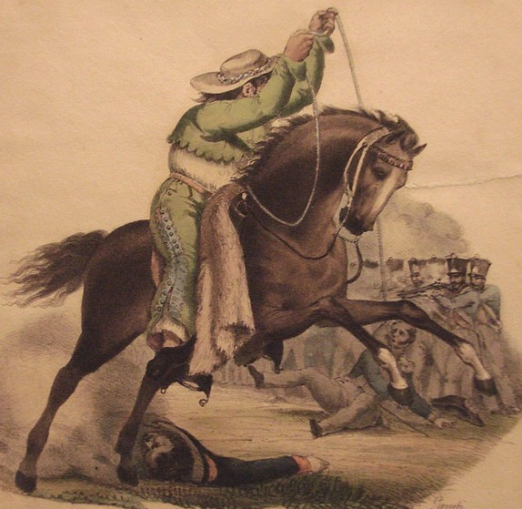
Figure 1. Criollo on Horseback (1828) by Claudio Linati clearly represents a chinaco horseman with bell-bottom calzoneras, short mid-riff jacket, and a flat brimmed sombrero typical of the early 1800s. This lithograph from, Civil, Religious, and Military Costumes of Mexico, represents the first mass circulated image of the chinaco abroad.

In the midst of battle, a horseman faces off against a row of Spanish infantry, throwing his lasso and capturing an officer, knocking him to the ground. Linati wrote, “the same rope that he uses on wild bulls serves him well.” The last two lithographs that feature chinacos deal with gambling, a common vice among Mexicans, according to Linati. In Group of Gamblers the artist portrays several chinacos, one wearing large spurs, hunched over a game of cards. Near the end of the series, Cockfight clearly shows two of the figures about to release their roosters before a crowd of cheering and betting spectators. Although created for a European audience, Linati’s prints also gained wide acceptance in Mexico. Nearly one hundred years after the first printing, El Universal, one of the main dailies in Mexico City, published reproductions of Linati’s work as part of the centennial celebrations commemorating victory over Spain in the War of Independence.
In the coming decades, several artists followed Linati’s example and represented chinacos in their works. Gathering together some of the most renowned Mexican writers, V. Debray published a series of lithographs titled, Mexico and Surroundings: Collection of Monumental Vistas, Landscapes, and Costumes of the Country in 1869. Such literary luminaries as Francisco González Bocanegra, Manuel Payno, and José T. de Cuéllar joined lithographers Casimiro Castro, Juan Campillo, and G. Rodríguez in describing depictions of men on horseback wearing various styles of bell-bottomed calzoneras with flat- crowned sombreros typical of the period.
Besides a scene depicting a gathering at a working class home where people dance a lively fandango, Attack of the Stagecoach is one of the most impressive images in the series. (Fig.2)
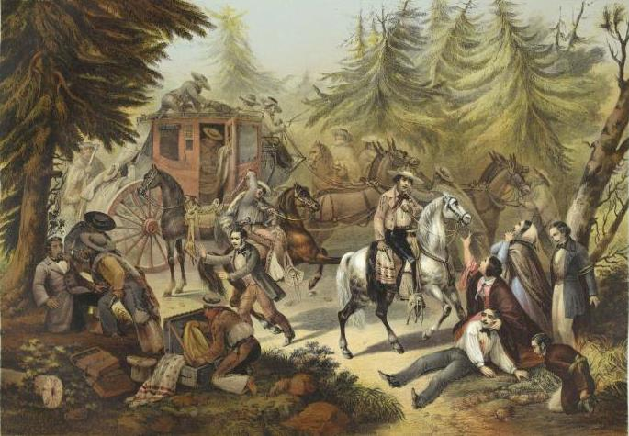
Figure 2. This 1869 lithograph by Manuel J. Serrano in V. Debray’s, Mexico and Surroundings: Collection of Monumental Vistas, Landscapes, and Costumes of the Country, details an attack on a stagecoach by bandits dressed in chinaco clothing. This scene was repeated in visual and literary productions throughout the nineteenth century, such as Manuel Payno’s, The Bandits of Cold River.

In this scene, bandidos dressed in chinaco clothing assault a carriage on the highway, tying up, wounding, and robbing male passengers while women plea for mercy. At mid-century, insecurities on the road and robbery by bandits was a real problem for travelers who armed themselves to protect their lives and property. When Karl Heller, an Austrian botanist, traversed a similar path in 1846, he wrote, “we readied all our weapons in order to sell our lives as dearly as possible if need be.” These types of incidents, vividly captured in Debray’s publication, served as the foundation of the legend of the bandits known as Los Plateados, (the Silver Bandits), who rode around terrorizing communities with their distinctive chinaco clothing. The scene of chinaco-clad bandits assaulting a stagecoach was repeated throughout the art and literature of the nineteenth century and also exported via the narrative of Wild West shows in the United States.
While lithographs reached a wide circulation, both abroad and in Mexico, oil paintings of men on horseback were produced for a more exclusive audience. Regardless of this difference, foreign artists such as Antoine Devere, Fracois Grenier de Saint Martin, Octavien Laballez, Paul Edouard Alfred Darras, Víctor Pierson, Carl Nebel, Paul Fischer, James Walker, F. Berriozábal, and Ernest Ibbetson painted chinacos and charros for wealthy patrons throughout the 1800s. Johan Maritz Rugendas, a German who traveled throughout Mexico between 1831 and 1834, created landscapes that included distant horsemen engaged in the typical activities and the pastimes of cattle management. Edouard Pingret’s misnamed but commanding Herrador (Blacksmith) appears to be one of the first full-length oil paintings that featured a hacendado dressed in chinaco clothing. (Fig. 3)
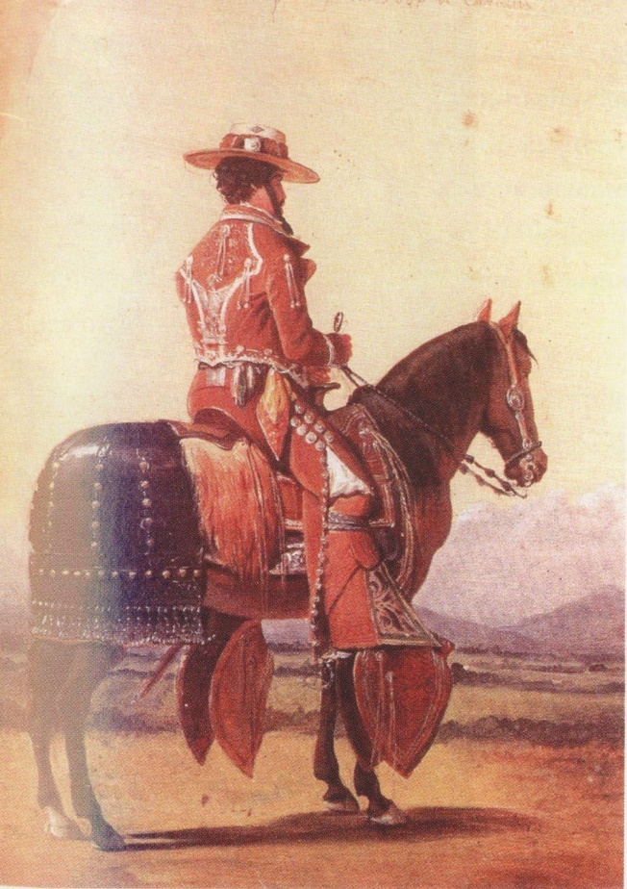
Figure 3. Edouard Pingret’s, Herrador (Blacksmit), Note the chinaco bell-bottoms and decoration that signified elite status. Pingret’s, Arriero, (Muleteer) is posed in a similar manner but wears a simple suit typical of working ranch hands. His, Pareja a Caballo, Couple on Horseback, bears a striking resemblance to Linati’s, Muchacha a caballo con su caballero, Young Lady on Horseback with Her Cavalier.

Similarly, Daniel Thomas Egerton, a British lithographer, prominently depicted a finely clad hacendado for his series of Mexican prints. Although the horses and landscapes of Manuel J. Serrano, a Spanish painter, appear unrefined, he created some of the most vibrant and colorful images of horsemen, such as Chinacos in the Mountains, and Branding the Horses during the mid-1800s. (Fig. 4)
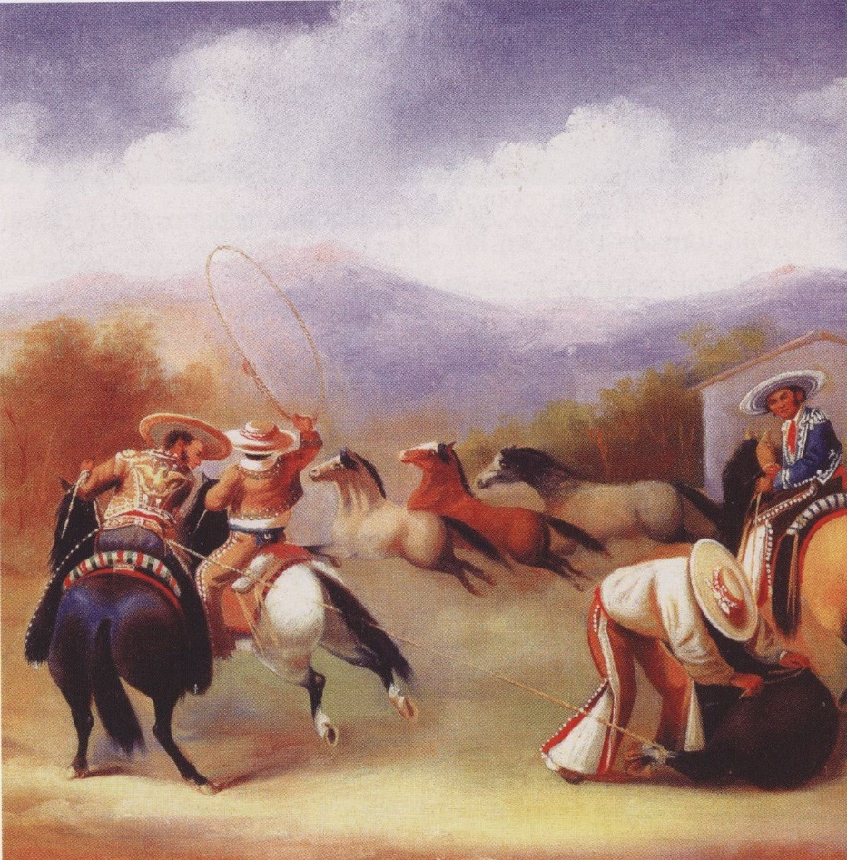
Figure 4. Manuel Serrano’s Coleando a campo (Tailing in the field). Note the rich attention to the details of the costumes. Serrano depicted chinaco style equestrians with bell-bottom trousers, flat brimmed sombreros, and short mid-riff jackets.

Classically trained Mexican painters followed in the footsteps of foreign instructors who taught landscape and historical painting at the Academy of San Carlos in the capital, renamed the National School of Fine Arts after the French occupation. Alumni of this institution include Manuel Ocaranza from the state of Michoacán. Other Mexican artists who treated the subject of men of horseback include Luis Coto, José Albarrán, Nicanor González from the state of Jalisco, and Guadalupe Morales who may also be identified as G. Mora. Special recognition goes to Fidel Alfaro, the “charro painter of charros,” who depicted various feats of horsemanship and the unique act of banderillando a caballo, considered a favored style of Mexican bullfighting. These artists served as the predecessors of Ernesto Icaza, “the charro painter,” who practiced bull tailing in addition to selling his works to wealthy patrons and collectors abroad in the early twentieth century. Consistently transnational figures, Mexican men on horseback fascinated foreigners and eventually crossed the northern border and inspired travelers, writers, and artists from the United States. Frederic Remington contributed an impressive collection of images and descriptions of Mexican equestrians whom he observed while visiting northern Mexico in the 1880s and 1890s. Titled under various names such as vaqueros, Rurales, greasers, “ladrone,” horse trader, ranger, “haciendero,” punchers, and “patron,” Remington immortalized these figures in wood engravings, oil paintings, watercolors, and ink drawings.
Published in a number of magazines, Remington also submitted several stories to Harpers Weekly. In “Outpost of Civilization,” the narrative recounts Remington’s visit to the hacienda at San José de Baricova in Chihuahua, where he describes a dance with musicians playing fiddles, harp, and guitar, in a “strange, wild music.” In this story, “The gaudy vaquero and his trappings and his pony are the actors on this noble stage.” More descriptive in “A Rodeo at Los Ojos” the artist noted,
They were clad in terra-cotta buckskin, elaborately trimmed with white leather, and around their lower legs wore heavy cowhide as a sort of legging. They were fully armed, and with jingling spurs, their flapping ropes and buckskin strings, and with their gay serapes tied behind their saddles, they were as impressive a cavalcade of desert-scampers as it has been my fortune to see.

He goes on to describe bull-tailing, shooting matches, and footraces that made up some of the entertainment at a cattle round-up near San Miguel. He concludes,
Such is the life of the vaquero, a brave fellow, a fatalist, with less want than the pony he rides, a rather thoughtless man, who lacks many virtues, but when he mounts his horse or casts his riata all men must bow and call him master.

Such descriptions also reinforced depictions of Mexicans as bandidos and greasers in the United States.
“Rodeo at Los Ojos,” published in Harpers Monthly in 1894, was illustrated with several reproductions of works of art by Remington. Coming to the Rodeo (1893) is the first and most impressive in the series. (Fig. 5)
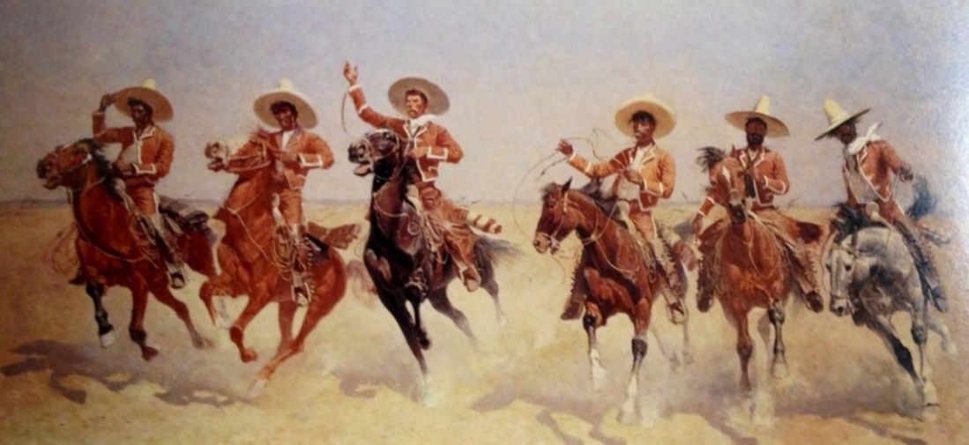
Figure 5. Coming to the Rodeo (1893) by Frederic Remington represents Mexican “vaqueros” in Buffalo Bills Wild West show. The scene portrays the performers riding into the arena with their reatas held high as they salute the audience. The charro costumes he depicted in this oil painting were modeled on a suit he owned and represented in various works of art.

A line of six horsemen, dressed in the costumes that Remington described, gallop towards the viewer, inspired by performers in Buffalo Bill’s Wild West Shows that toured throughout the country during this time period and which Remington undoubtedly witnessed. Other important works by the artist include Toro, Toro! (1890), published in Harpers Weekly in 1890 and A Mexican Duel, reproduced in Century Magazine in 1891. The Monte Deal at Ojo Caliente (1891), also in Harpers, bears a resemblance to Linati’s Group of Gamblers and while less detailed, On the Mountains (1893), illustrating the story, “In the Sierra Madre with the Punchers,” may have drawn inspiration from Pingret’s Herrador.

Maximilian I of Mexico
While artists depicted men on horseback on canvas, the early republic was plagued by political instability and financial difficulties at mid-century. The War of Reforms and French occupation mark a distinct turning point in the history of equestrian cultures in Mexico. Adapting traditional styles to European costumes, the French imposed Emperor, Ferdinand Maximillian of Austria, reportedly transformed the chinaco into a modern charro by significantly altering the clothing they wore. Maximilian I of Mexico, an avid equestrian, dressed in a suit with tapered leggings, without a bell at the base, and in an unprecedented manner, ordered his outfit made of fine black material. Practitioners of charrería rodeo widely consider this the first traje de gala (gala suit) used for the most formal occasions, such as state functions and weddings, and later adopted, in a uniform manner, by mariachi groups as they professionalized in the 1920s and 30s. Although it is unclear if the embroidery was gold or silver, this suit served as a model for future equestrians.
The Emperor and Empress Carlotta also organized bull tailing contests and outfitted rural militias in similar costumes. Although bell-bottoms persisted into the late nineteenth century, the closing of calzonera trousers stands as a definite marker of the emergence of the modern charro equestrian, along with the extension if the sombrero crown in a style called piloncillo (conical sugar lumps) as well as the elongation of the jacket. Tight fitting trousers became the norm popularized by the Guardia Rural, bullfighters, and equestrian performers who toured with Wild West shows in the United States. In essence, the tapering of bell-bottoms was a Europeanization that gradually popularized in the
late nineteenth century. However, bell-bottoms came back into style in the 1920s with early cinematic productions and again in the 1960s with the emergence of a youth-oriented counterculture.

Horsemen on the Page
Following the withdrawal of French forces and the stabilization of national boundaries that allowed the free flow of goods and the circulation of commodities, a new national culture began to take form. The end of foreign occupation also marks a milestone in the literary realm with the emergence of the charro archetype in melodramatic serial novels. The costumbrista writer of the last half of the nineteenth century transformed folktales from the lower classes into literary works. Thus, narratives in songs about love and tragedy served as the foundation of the charro literary genre. From these serial melodramas a new type of hero was invented who “no longer moves in the realm of the supernatural but rather in the space of the real and the possible.” Through these works, the charro archetype was mythologized by literary elites who associated the character with cowhands, insurgents, bandits, and gamblers. Similarly, Domingo Faustino Sarmiento explored the Argentine national character, the gaucho, in Facundo: Civilization and Barbarism, published in 1845. Although critical of unintelligent and brutish gauchos who retarded the progress of urban civilization through their rural backwardness, Sarmiento also explored distinct types and included the pathfinder, the trackers, the “bad gaucho,” and the singer. José Hernández followed Sarmiento in 1872 with his epic poem, Martín Fierro, capturing the demise of life on the open range and generating a nostalgic rural ideal of vigorous manhood and virtue.
In Mexico, the first writer to seriously treat Mexican men on horseback as central literary figures was Luis Inclán, a printer from the capital with mulatto heritage. A horseman himself, Inclán’s early years are shrouded in mystery but sometime around the mid-1850s he operated a printing and lithograph shop where he published popular songs, religious images, and other broadsides. In 1860 the former cowhand circulated a manual of equestrian feats titled, Rules by Which a College Boy can Tail and Rope, Remembrance of Chamberín, a tribute to one of his favorite horses, and a cockfighting manual in 1870. However, Astucias, Leader of the Brotherhood of the Leaf or The Charro Smugglers of the Bough firmly established the charro archetype as a character for the consumption of the reading public in 1865.
Approved by imperial censors, and accompanied by thirty-three lithographs, the action adventure story combines elements of romanticism and realism, evoking Alexander Dumas’ Three Musketeers. Written in a “ranchero dialect,” the first half of the book narrates the exploits of the Brotherhood of the Leaf, a group of six tobacco smugglers who dress like charros. Perhaps most significant, Inclán was among the first to use the word charro, “a national type by excellence,” to describe the horsemen in his stories. Originally meant to identify equestrians from the Salamanca region of Spain, charro carries pejorative meanings throughout Latin America. Possibly related to the Basque word txar that signifies bad, defective, weak, and small, the first uses date to the early fifteenth century. Mexicanizing the term filled a psychological need to legitimate the origins of the figure in the New World and differentiate it from the Salamanca variant. Recast as proto-charros, chinacos remained a popular designation for men on horseback for much of the rest of the century. In the 1920s the term re-emerged with the development of elite rodeo associations and the publications of manuals for the sport of charrería. These charrería practitioners recovered Inclán’s literary legacy, and highly regarded his Rules by Which a College Boy can Tail and Rope.
Inclán countered negative representations of charros by differentiating between noble ranchers and more despicable bandidos, in essence creating “noble bandidos”. He established the charro archetype in literature as a virtuous outlaw and middle class rancher who spoke in a simple language. After studying Incláns works, the eminent folklorist Américo Paredes concluded,
Like American cowboy heroes, Inclán’s charros are passing riders, who help those in distress and then gallop away. They are frank, simple men, preferring action to words but following a code of chivalry and fair play which makes them gallant to women and just even to their enemies. They use their resourcefulness, their bravery and strength and their keenness of judgment to get justice for themselves and others, though at times they must use extralegal methods, the illegality of which all right-thinking people are only too willing to ignore.

Ahead of his time, almost twenty years passed before other writers featured Inclán’s charros in their works but by the end of the century several important novels, a bullfighting superstar, and even a gameboard, commodified the cultural archetype.
A few decades afterwards, a radical liberal of indigenous descent from the state of Guerrero, Ignacio Altamirano, called on his countrymen to do what Inclán had already done: create a national literature with the “voz campirana” of rural people. Between trips to Spain in the 1880s acting as Consul General for the Mexican government, Altamirano wrote the manuscript for El Zarco (The Blue Eyed Bandit). Similar to Sarmiento’s treatment of gauchos, Altamirano negatively described the bandits known as plateados, those “demons vomited from hell.” Set between the War of Reforms and the French Occupation, the anti-hero, El Zarco, is a tall, light skinned “charro,” who vainly wears a dark suit overdecorated with silver embroidery. Although he elopes with Manuela, he had a perverse sensuality and “he loved nobody, but he also hated the whole world.”
This character stands in stark contrast to Nicolás, a humble and simple dark-skinned horseman who embodies a good charro. For Altamirano, the austere Guardia Rural differed greatly from degenerate and flamboyantly dressed bandits. In the end, El Zarco is wounded, captured, executed by firing squad and, as a warning to others, hung from a tree. Scholars note that El Zarco is a, “foundational fiction [that] gives order to the national future,” where dark-skinned heroes celebrate mestizo identity, expounding a social message that educates the reading public, and attempts to build a national conscience.
Although El Zarco was not published until 1901, in 1888, Manuel Payno, a friend of Altamirano, added an epic novella to the developing mythos of charros, The Bandits of Cold River. Like Altamirano, Payno presented two opposing characters who dress like charros, a term used twice in the narrative. Evaristo Lecuona is a cowardly bandit prone to violence and murder. After beating and killing several women, he forms a gang of thieves on the highway between the capital and Veracruz, along the Río Frío, and near the place noted by Karl Heller as an area where robbers attacked travelers. As if modeled on the 1869 lithograph, Attack of the Stagecoach published by Debray, Evaristo and his men brutally assault the carriages along this famous road to Puebla, causing an international incident when they shoot the nose off an English woman. Unlike Altamirano, Payno described the charro-clad Guardia Rural as a band of outlaws, a point made when local authorities recruit Evaristo as a captain to patrol the area.
In contrast to Evaristo, Juan Robreño is gallant, brave, and educated military officer who falls in love with Mariana. When they have a child out of wedlock, Juan deserts his post, becoming a hunted man by authorities and forced into the life of a fugitive. Unable to marry due to the cruelty of Don Diego, Mariana’s father, Juan returns to the narrative as Pedro Cataño. Pretending to be an hacendado, he performs admirably at a bullfight during the fiestas of Tepetlaxtoc. Recalling the outfit worn by Maximilian,
He was dressed decently, but plainly, maybe his suit was austere. Tight fitting trousers, long jacket, and black vest with dark buttons. White sombrero, very fine, from Puebla, without an exaggerated brim.

Fitting into the role of a social bandit, Juan robbed from the rich to give to the poor, or, at least, promised that he would free them from the tyranny of the gachupines. Juan eventually saves Don Diego from deadly Comanches, gaining his approval and is finally reunited with Mariana and his son. At the end of the novel, Payno wrote a postscript and claims that he based his work on real events during the Santa Anna period. Perhaps truth, or merely invention, the author also states that Juan’s and Mariana’s son traveled to France where he studied ranching and returned to Mexico with good breeds of cows, bulls, donkeys, and other animals.

From the Page to the Stage
From the moment Claudio Linati published his lithographs of Mexican subjects for European audiences in 1828, Mexican men on horseback became transnational figures. This attribute of the chinaco and charro archetypes prevailed throughout the next two centuries. Created, in part, to entertain foreigners and attract tourists to the new republic, images of Mexican equestrians spread throughout visual and literary mediums. Costumbristas painters and writers utilized the image to portray degenerate bandidos and gallant hacendados, two stereotypes of the modern Mexican citizen. In this manner, the charro archetype was commodified for mass consumption by the literate classes and consumers of lithographic prints.
Itinerant transnational travelers, charros spread across the border and into the national narrative of the United States, first as performers in bullfights and Wild West shows, and later as cinematic characters. However, the American charro also had roots in art and literature, often feature as “vaqueros” and “punchers” in the works of Frederic Remington. More influential, O. Henry wrote “The Caballero’s Way,” a short story published in 1907 and the basis of the Cisco Kid serials popularized in cinema and television. The character is a degenerate American by the name of Goodall living along the south Texas border, between the Frío and the Río Grande, who took on Mexican features with his dark hair and complexion. The figure recalled El Zarco and Evaristo in Los Bandidos de Río Frío, because, “he killed for the love of it, because he was quick tempered, to avoid arrest, for his own amusement, any reason that came to his mind would suffice.”
Despite the adoption of the charro archetype by artists and writers in the United States, the patriotic significance of the character increased in the twentieth century. Initially created as a means to counter negative representations of Mexicans abroad, the figure received a new appearance after the execution of Emperor Ferdinand Maximilian. Attempting to preserve fading folkloric traditions, and rejecting the Spanish origins of the figure, writers and artists tried to promote a national identity that unified diverse ethnic groups through the equestrians they represented. However, it was not until the 1920s that the transformation from chinaco to charro was complete and formalized with the establishment of elite equestrian associations in the capital. Promoted through charrería rodeo and state sponsored civic celebrations, the patriotic significance of the figure was firmly established in the aftermath of the Mexican revolution (1911-1920) and spread much wider than ever before, lifting the image to the status of an official national icon.
The commercialization of Mexican men on horseback was also initiated in the nineteenth century. Throughout this period, upper and middle class consumers of the chinaco and charro archetypes in print and the visual arts gradually popularized the character via the spread of commercial printing presses. Claudio Linati, V. Debray, Luis Inclán, Manuel Manilla, and José Guadalupe Posada were among the middle class letrados that commodified this cultural product. Additionally, bullfighters like Ponciano Díaz popularized the character through mass entertainment within the republic and tours abroad. With a firm foundation in the visual and literary arts, and commercialization through cheap broadsides and native bullfighters, the mass appeal of Mexican equestrians continued in the first decades of the twentieth century with adaptations in film.

Chapter 2:
“El Célebre Torero”:
Ponciano Díaz and the Popularization
of the Mexican Charro

In the late 1880s a popular bullfighter named Ponciano Díaz became Mexico’s first modern celebrity. For the first time, the conditions were right for the emergence of such unprecedented fame: newspaper circulation increased, railroads carried information farther than ever before, and bullfighting emerged as the first form of mass entertainment. Unlike the Spanish bullfighters that toured Mexico during this period, Díaz was proudly Mexican, and conveyed that nationalist sentiment to his audience, mainly the lower classes, through his equestrian feats and style of clothing. The charming young torero (bullfighter) appeared striking in a wide-brimmed sombrero, riding pants fringed with silver buttons, and an elaborately embroidered charro jacket.
In 1886, the municipal government of Mexico City prompted Díaz’s rise to fame by lifting a ban on bullfighting in the capital. Prohibited since the time of Benito Juárez, residents of Mexico City swarmed the plazas de toros (bullfighting arena). Commodified through ticket and print sales, images of rope slinging charros gained wide popularity. This was the first time nationwide celebrity and national identity was commercially linked to the image of charros. In modern Mexico, this pattern is repeated according to changes in technological and mass communication media.
Ponciano Díaz was the first modern celebrity who took the charro archetype described by writers like Luis Inclán, Ignacio Manuel Altamirano, and Manuel Payno, making it popular for the vast majority of the urban underclasses. In the 1880s, Díaz distinguished himself with charro regalia, ornate saddles, and a large moustache. His recognizable image circulated in newspapers, illustrated magazines, broadsides, and songbooks. The torero’s career marks the beginning of the mass commercialization of the charro image later associated with advertising, mariachis, tourism, and the época de oro (golden age) of film. Situated between literary representations and cinema, bullfighters, such as Ponciano Díaz, contributed to the formation of a “visual archetype” of the charro late in the nineteenth century. The type of celebrity associated with the charro archetype, and commonly linked to the cultural projects of the post-Revolutionary state, predates to bullfighters in the 1880s and 90s. Clearly, modern celebrity emerged in the Porfiriato (1876-1911) resulting from processes of mass migration, national development, and market forces.
The Porfirian state rose alongside Positivist thought including the ideas that scientific knowledge and the importation of foreign models provided a clear path to develop a modern nation. For elites and middle classes a “Porfirian Persuasion” helped spread modern European ideas, attitudes, and practices. Disapproving of traditional societies, Catholicism, and the urban poor who were considered culture-less, elites transplanted foreign fashion and norms. Additionally, by attempting to encourage European immigration, the Porfirian state meant to bring much desired skills and talents. Skeptical of elites, the lower classes found pleasure in their own special type of festivities, art forms, and recreational activities. The underclasses that congregated in the cities mediated their own experiences and created appealing hybrid forms that expressed their particular sense of national identity. (Fig. 6)
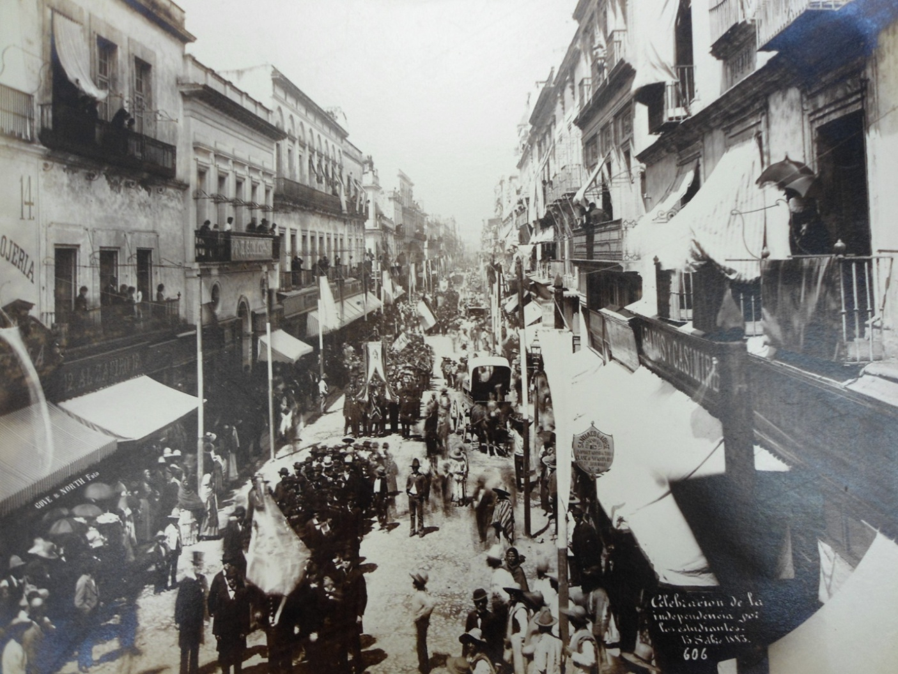
Figure 6. 1883 Independence Day celebrations. Urban crowding in Mexico City during the mid-1880s facilitated the emergence of commercial mass entertainment. Lawrence Jones Postcard Collection c.1900, Nettie Lee Benson Library, Austin.

Recent migrants crowded the colonias (colonies), barrios (neighborhoods), and vecindades (tenements) in Mexico City, creating a consumer market for mass entertainment. Filling a gap in the historiography, this chapter attempts to understand the popular culture of the corridas (bullfights) via the lower classes. Following the commercialization of the bullfights in Spain in the first half of the 1800s, corridas in Mexico in the late 1800s also assembled large audiences, raising capital for varied enterprises. Supported by revenues generated by the urban underclasses, the popularity of native toreros rose and fell with the masses. However, while the lower classes idolized Díaz, elites suggested that he conform to foreign standards. At the plazas, the rich, poor, and middle sectors came together to enjoy the bullfights, and in the process, they fought to define the celebrated bullfighter. Díaz acted as a mediator between these social divides, and negotiated the middle ground separating the preferences of elites and new migrants in the cities. This resulted in the creation of a hybrid popular culture that incorporated aspects of both classes.
In time, Diaz’s admirers came to know him simply as “Ponciano.” Loudly and aggressively, poncianistas (supporters of Ponciano) rallied around a sense of nationalism and shouted anti-foreign slogans. All agreed, bullfighting charros stood in stark contrast to Spanish toreros. Therefore, the plazas functioned as a site where class loyalties, cultural tastes, and nationalist sentiment were publicly contested. But, while elites attempted to establish Spanish forms of bullfighting, the lower classes shouted insults across the sand in defense of the national style and their favored torero, Ponciano.
Ponciano Díaz’s real biography is the story of a dislocated world. Besides an audience for mass entertainment, bullfighters depended upon transportation networks, such as railroads and steamboats, which facilitate touring and spread fame. Faster and more efficient than a mule or stagecoach, migrants rode the rail lines into the capital. While many settled in Mexico City, some also ventured north, attracted by new destinations and better wages. During the first years of operation, Mexico’s Central railroad that connected Ciudad Juárez to the rest of the country, offered extremely low passage rates. Additionally, during the mid-1880s, adventurous tourists from the United States traveled southward on trains destined for the interior of the country. Trenes de recreo (recreational trains) also carried spectators to the bullfights and allowed the long distance transfer of renowned bull breeds. For celebrities like Díaz, transportation technologies expanded fame on an unprecedented scale. For the first time ever, a local bullfighter from Atenco, the hacienda where Díaz was born, could achieve national recognition via the rails and telegraph wire. Serviced by such transportation networks, nineteenth-century bullfighters also attained international recognition.
Additionally, in the closing decades of the nineteenth century, celebrity was created through popular media outlets. Supported by a growth in consumer culture and industrial development the print industry at the center of this transformation included broadsheets, penny presses, and cheap serial novels. Pages dedicated to the corridas printed detailed images made possible by the high-speed printing press, linotype, and eventually photo reproduction. Through these technologies, hand-drawn prints, engravings and photographs of bullfighters circulated throughout Mexico. Finding audiences and consumers in new urban communities, newspapers, many partial to individual bullfighters, followed personalities and made possible the creation of devoted “fanatics” or “aficionados.”
In the attempt to modernize, many of the Porfirian elites regarded bullfighting as a barbarous and plebian pastime. As mentioned previously, upper-class aficionados of the corrida, generally preferred the style and technique of Spanish toreros while Díaz appealed to the lower classes when he dressed as a charro. Evidently, among urban underclasses a cultural retrenchment occurred. Threatened by displacement, modernization, and foreign tastes, rural migrants in the capital, and cities like Guadalajara, rallied around local bullfighters. A torero who wore a charro suit, a bushy moustache, and performed Mexican equestrian feats held broad appeal. In addition to adopting this fashion and style, Díaz won the public’s heart by accentuating his Mexican features. For those who saw him perform, the dark complexioned bullfighter proved his talents before the upper classes and foreigners who tried conceptualizing Indians and mestizos as Europeans. While the president of the republic powdered himself to appear white, Ponciano challenged the social order by taking pride in his distinct Mexican features. Lower class mestizos and indigenous people, prohibited from fighting bulls for most of the colonial period, recognized the subtle inversion of racial structures and enthusiastically supported the bronze star.
Despite many social, cultural, and political changes in the late nineteenth century, bullfighting was hardly in decline. The law prohibiting bullfights in the capital that dated to 1868, followed strict implementation in Mexico City. Although enforcement varied, some states such as Veracruz, Oaxaca, Michoacán, Jalisco, Guerrero, Tabasco, Zacatecas, Sinaloa, Chihuahua, Tamaulipas, and Coahuila, enacted their own policies while reformers managed to affect some municipalities. Accusations of cruelty to animals and warnings against unruly spectators date as far back as the Bourbon period. At the close of the nineteenth century, a foreign observer noted that attempts to limit the bullfights in Chihuahua eventually led to the realization that “the peon deprived of his blood in one way must have it in another.” During Porfiro Díaz’s second term in office, the Chamber of Deputies decided to repeal the Juárez ban shortly before Christmas, 1886. Congressional Deputies ignored the pleas of those opposed on religious principles and protestors who warned against “fanaticism.” The Ayuntamiento of Mexico City imposed its own tax on ticket sales. Evidently, the city council was in need of funds for a public works project to drain floodwaters from the capital.
Focusing on prohibitions ignores the actual popularity of the bullfights. The wide distribution of plazas, temporary and shoddy wooden arena, indicates the real state of bullfighting in Mexico. Throughout the early nineteenth century, from Yucatán to Texas and California, different regions of Mexico, and what became the American Southwest, held distinct fiestas, corridas, tailing contests known as coleadas, and equestrian events called jaripeo. By the last decades of the nineteenth century, a series of plazas from Veracruz to Chihuahua created a touring circuit for Spanish and Mexican bullfighters. In the capital, lifting the Juárez prohibition allowed the development of a mass entertainment venues in the late 1880s and 90s. In 1887, private funders quickly raised four plazas: San Rafael, El Paseo, Colón, and Coliseo. Construction of Plaza de Bucareli occurred the following year. In constant need of maintenance and repair, most would be demolished within a few years. Despite prohibitions, plazas de toros surrounded the capital in places such as Toluca, Texcoco, Puebla, Tlalnepantla, Pachuca, Ameca, and Cautitlán.
In Mexico City, most plazas were located off Paseo de la Reforma. Satirically deemed frijoleras (pots of beans) by one journalist, construction of arenas cost a considerable sum. Bucareli, partially built by juveniles in a correctional school, cost over 85,000 pesos. Capacities varied at each arena. Plaza de San Rafael held 12,000 spectators and rivaled the largest plazas of Madrid. Coliseo seated 7,000, Bucareli accommodated 6,500, and Paseo, the smallest, had room for 2,000. With a capacity of nearly 30,000 people, the combined plazas could accommodate almost ten percent of the total population in the capital. Shortly after the repeal of the prohibition, newspapers noted crowds of people who overran arenas. One reporter wrote, “three times the multitude busted the doors and many entered without paying one cent.” Eventually, municipal authorities learned how to manage the corridas after a series of riots, fires, scams, and collapses. Regardless of the level of safety, there was no denying that bullfighting had returned with a vengeance, and the moment was right for revelry.

“The Celebrated Mexican Swordman”
Es bonito ir á los toros
Con su bonita muchacha,
Aver á Ponciano Díaz
Hasta mero Tlalnepantla

The man destined to become the idol of fanatics was born in 1858, the son of Guadalupe Díaz and Mariá de Jesús Salinas. Appropriately, Ponciano entered this world at Atenco, a hacienda renowned for the breeding of fierce bulls. Owned by D. Rafael Barbabosa, bulls were raised for use in corridas in nearby Toluca. Guadalupe, a talented bronc rider known as “el caudillo,” (the boss man) worked as a vaquero ranch hand for Barbabosa. Much later, Ponciano claimed that his father taught him feats of horsemanship while instilling an appreciation for los toros … the bulls. As a teenager, a scrawny Ponciano received his first formal training from the Hernández brothers (about whom no information exists). At twenty, fighting alongside Lino Zamora, the young bullfighter experienced his first taste of fame upon receiving an ovation at the plaza de Tlalnepantla.
Shut out from the capital due to the prohibition, Díaz relocated to Puebla, the defacto center of bullfighting. He finished his training under the apprenticeship of a gruff old Spaniard, Bernardo Gaviño. On Easter 1879, Gaviño’s apprentice received the alternativa (confirmation) and achieved the title of matador after successfully leading his own cuadrilla (team) of bullfighters. Throughout the 1880’s he fought in cities such as Aguascalientes, Zacatecas, San Luis Potosí, Mazatlán, and Guadalajara. In 1883 he toured Sinaloa and Durango. When the bullfighting prohibition in Mexico City expired in 1887, he quickly descended on the capital. At the age of twenty-nine, “the most celebrated of all the bullfighters,” opened the season at the grandest plaza in Mexico City. Dormant in the capital for nearly a generation, 12,000 spectators filled the Plaza del Paseo Nuevo for a rare spectacle.
While familiar with the maneuvers commonly associated with the Spanish style, Díaz made a name for himself by mastering the peculiar art of mounted bullfighting. He practiced the secondary feat known as banderillar a caballo, or “sticking picks while mounted,” requiring a rider to place banderillas at the nape of the bull’s neck, near the shoulder muscles. In Mexico, banderillando a caballo was considered a national feat, a form of toreo campero (rural bullfighting). Before Díaz, Pedro Nolasco also executed the banderillas on horseback. While Díaz tried to learn fighting on foot throughout his career, he never strayed far from the equestrian style that pleased the home crowd, particularly the spectators who bought cheap tickets in the sun. Popular among the lower classes, elites often thumbed their noses at what they considered his unrefined technique. By the late nineteenth century fighting on foot, or tauromaquia moderna (modern bullfighting), was the main attraction in Spain. Aficionados attempted to establish the modern style in Mexico by denigrating national acts. Díaz repeatedly attempted to please elites by performing on foot but while many were antagonistic, some aficionados applauded him and pledged their support.
The “improbable and fantastic figure” of Mexican bullfighters noted by Spanish journalists required a special wardrobe. The traje de luces (illuminated suit) of Spanish bullfighters that dates to the late eighteenth century serves toreros who fight on foot and are skilled at the intricacies of elaborate capework. (Fig 7)
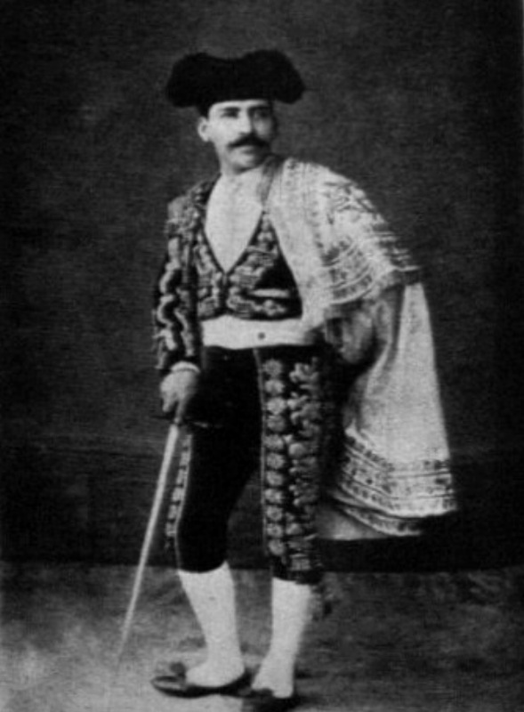
Figure 7. Ponciano in traje de luces. The traje de luces distinguished bullfighters who fought on foot in the modern style. Ponciano Díaz bought several suits from touring Spanish toreros. Despite attempts to make him conform to Spanish styles, el torero con bigote repeatedly ignored pleas to shave his moustache. In Maria y Campos Ponciano: El Torero con Bigotes (Mexico, Ediciones Xochitl, 1943)

However, the contortions necessary in mounted bullfighting required less restrictive clothing. Like Pedro Nolasco and Anastasio Hernández, Díaz wore a traje de charro to perform while mounted. Performers adopted the flashy attire of rural hacendados and the Guardia Rural to display the unique feats of bullfighting in Mexico. Another reason that Mexican toreros used charro suits relates to the scarcity of traje de luces. In fact, many performers dressed in a hybrid form, piecing together elements of both types of costumes. Mexican toreros sometimes wore a charro jacket and sombrero with traditional Spanish tights. Because Spanish bullfighters dressed in traje de luces, the traje de charro came to distinguish their Mexican counterparts. Apperantly, Díaz received some training as a tailor and occasionally cut and decorated his own suits. (Fig. 8)
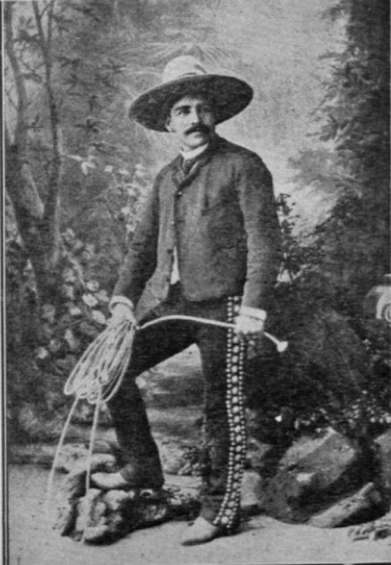
Figure. 8 ¡Ujua Ponciano! At the height of his fame in 1888, Ponciano Díaz wears a traje de charro. This fashion signals the practice of “toreo campestre,” rural bullfighting such as jaripeo bronc riding, laceo trick roping, and banderillando a caballo. In Manuel Horta Ponciano Díaz (Silueta de un torero de ayer) (Mexico City, unknown publisher, 1943)

His sombreros, one reportedly costing 500 pesos, were elaborately embroidered at the reputed “Casa Zolly.” Eventually recognizing the trend, some Spanish bullfighters, such as Juan Jiménez “El Ecijano,” adopted charro attire while touring in Mexico. By wearing the suit associated with Mexican bullfighters, Spanish toreros in Mexico recognized the significance of the style and likely hoped to gain the approval of spectators. For audiences, seeing revered Spanish bullfighters in a charro costume may have further validated the style.
Ponciano Díaz created an image to suit the tastes and expectations of his main audience, the lower classes. When elites wanted him to fight on foot, he dressed in a traje de luces, but on horseback, he became a charro. Additionally, while performers from the Iberian Peninsula were traditionally clean-shaven, Mexican bullfighters preferred full moustaches. Díaz’s conscious selection of clothes and facial hair represented a gesture to the crowd and functioned as a reference to styles established by earlier bullfighters, most notably Pedro Nolasco and Lino Zamora.
Toreros who dressed like charros often roused a patriotic sentiment among the lower classes. Much like the Spanish movement known as majismo, in which brash young men known as majos swaggered about in form-fitting clothes rejecting the French pretensions of Spanish elites, the charro/torero tapped a similar current in Mexican culture. The behaviors and norms adopted by majos were traditionally conservative and represented a retrenchment in Spanish culture that originated among the urban lower class. The masculine ideal of the majo was the bullfighter who risked his life, fought submission, gambled, drank, and womanized. The shared characteristics with the dastardly charro archetype are evident. However, opposition to foreignness remains the most important common elements between the majo/torero and the charro/torero.
During the Porfiriato, the charro evolved as a national image guarding against the cultural threats posed by foreigners - in this case, Spain. True to form, Ponciano Díaz repeatedly utilized language and rhetoric that roused nationalist sentiments. Indeed, lower class spectators were hostile towards Spanish bullfighters and at a bullfight in Puebla in 1887, poncianistas attacked a group of foreign toreros. While the crowd threatened the Spaniards, who required armed protection, Ponciano basked in an ovation from a terrace. Patriotic poncianistas frequently acted like a gang of soccer hooligans, garnering much publicity and press attention. In March of 1887, a small riot broke out when disenchanted audience members began throwing seats - causing havoc, requiring security forces to intervene with drawn machetes and pointed rifles. Luis Mazzantini, the Spanish bullfighter who debuted that afternoon, fled the plaza with shouts of “¡Muera Mazzantini! ¡Viva Ponciano!” ringing in his head. A writer in one daily lamented that Díaz was merely popular among the “plebe.”
These sorts of outbursts naturally alarmed municipal authorities regarding the problems of violence caused by the lower classes, los malcriados (ill raised), the majority of spectators sitting in the sun. Security details sometimes used excessive force, further aggravating tense situations in the stands. Moreover, much of the rage was fueled by pulque --a mildly alcoholic drink that was often a staple of the bullfights. “There is nothing more brotherly than the bullfights and pulque,” sneered one observer. On the day of the corrida, from six in the evening until six in the morning, pulquerías (taverns) opened their doors to men and women with a little money to spare. Flavored and prepared in various forms, the fermented agave juice inebriated enough hotheads to cause multiple fights in the stands. For some, a few cups of sangre de conejo (rabbit blood – red pulque), or mezcal, wound them tight enough to jump over the fence and onto the sand to tease the bulls. Stomping their feet in unison, the plebian section with fifty-centavo seats repeatedly raised the concern of the “gente decente,” or elites sitting in the shade. Authorities intent on proletarianizing the lower classes worried about work stoppages and absenteeism in shops, factories, markets, and schools. Among the Ayuntamiento members, José Limantour, a prominent statesman and presidential advisor, agreed, “It is alarming, the heights reached by the passion for the bullfights.”
Besides accidents caused by unruly behavior, injury awaited spectators in many forms. For example, in the fall of 1887, a sword deflected from a bull’s horn stabbed a man sitting in the front rows. In Mérida, tragedy struck the wealthy when a child fell from the luxury terrace. Scooped up from the sand, he died a few hours later. These incidents point to a lack of safety measures in the construction of plazas. Municipal authorities attempted to regulate the disorder by requiring permits for every bullfight and sent engineers to inspect the plazas for warped wood or weak structural supports. These public servants recommended measures to safeguard spectators and diminish tragedies. One of the first improvements was a requirement to install catch fencing to protect the first rows. After a tragic fire, hydrants became compulsory. (Fig. 9)
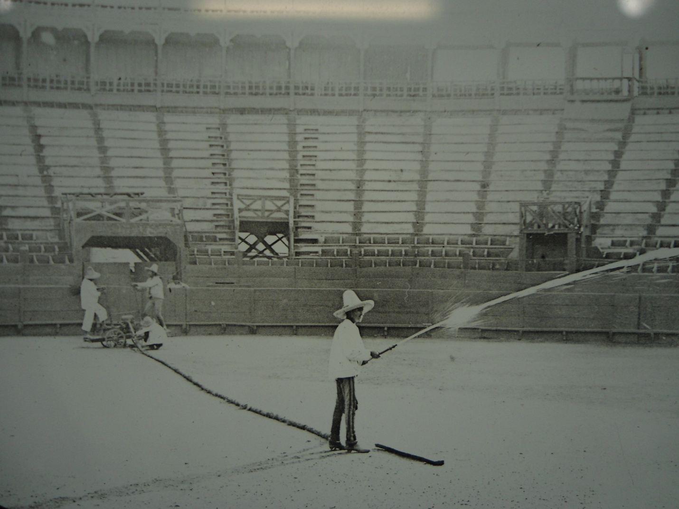
Figure 9. Plaza de Bucareli. Wooden arenas, like Bucareli, required constant maintenance, repair, and vigilance. Fire was among the main safety concerns at the plazas. Municipal authorities regulated arenas to avoid unnecessary injuries and fatalities. Complying with water hydrant regulations allowed organizers to dampen the sand in order to keep down dust. Charles B. Waite & William Scott. December 27, 1897. Albert J. Schmidt Collection of Lantern Slides c.1904-1921, Nettie Lee Benson Library, Austin.

Authorities also raised an issue over the lack of medical aid. Additionally, the butchering of bulls brought up sanitation concerns. Meat shortages routinely threatened the food supply in the capital, thus, the free distribution of slaughtered bulls added a little chunk of protein to the meals of many spectators. The city council passed public health regulations stating that quartering should take place over cement floors and the carcass hung on hooks. Apparently, the pestilence caused by butchering bulls over sand became unbearable.

Mexican Charros Conquer Spain
En la plaza de Lisboa
Tuvo gran aceptación
Y á París irá á las fiestas
De la gran Exposición
Causando la admiración
Del público en general
Va este diestro sin igual
Más agrandando su fama
Y por eso se llama
El soberbio caporal.

Meanwhile, the lower classes were not the only people paying attention to Díaz’s meteoric rise. With cheap broadsides littering the streets, aficionados of the bullfights found Ponciano’s populist approach distressing. As a countermeasure, they welcomed the Spanish influence and urged Díaz to master fighting on foot. Friends and journalists encouraged Ponciano to travel to Spain. Publishing an invitation in the press, José Sánchez de Neira promised a warm reception. Encouraged, Díaz sailed to Europe in 1889. Arriving on the steamship Alfonso XII in late June, he presented himself as a charro. Delighted, one observer noted,
Ponciano, dressed in the manner of his country, attracted extraordinary attention, equally for the unusualness and costliness of his clothing and sombrero.

Díaz disembarked with his cuadrilla and his horses, “El General” and “El Avión.” He declared that he planned to learn fighting on foot and desired to present Mexican-style bullfighting to Spanish audiences.
While yelping Chihuahuas fascinated Parisians, madrileños for their part, became intrigued by the strangely dressed charros and their unusual style of bullfighting. Audiences in Madrid were long accustomed to unusual acts by performers in the bullring, but the secondary acts of nineteenth-century Mexican bullfighting constituted novelties of an entirely different order. The coleada, bull tailing, requires a rider to grab a bull’s tail, wrap it around an outstretched leg and toss the animal, sometimes tearing off the tail or breaking a leg. Spanish spectators found this objectionable. The young bull required for the act prompted one spectator to shout, “Something else! Something else! That does not amuse us! That should not be called tailing but corruption of minors!”
Astonished by the dexterity and control of the reata (rope), Spanish audiences marveled at the trick roping, somehow claiming it facilitated the capture of wild buffalo. However, they were aghast when witnessing the complete immobilization of a bull in preparation for the riding feat known as jaripeo. At the plaza in Madrid, Ponciano Díaz and Agustín Oropeza threw their ropes; one caught the head of a bull while the other seized the legs, bringing down the beast. A Spanish critic who perceived an unfair human advantage labeled the act “repulsive” and “painful.” The same commentator registered additional disgust when he witnessed the use of sand to blind the bull’s eyes. Misperceptions often led to allegations of animal cruelty, a charge repeatedly directed against Mexican bullfighters by foreigners.
Whether or not the charros fought dirty, a majority of the Spanish audience enjoyed Díaz’s unique style. Regardless, critics continued to show contempt. They claimed Díaz threatened the classical form of the corrida, accusing him of “assassinating” bulls and using illegal lances and picks. A journalist acerbically noted,
Go back to Mexico, say that they have praised bull tailing and horse catching, but only by the decorum of the aficionados of Spain, and do not take seriously the applauses you heard yesterday.

Paco “Media-Luna,” tried to convince himself that the crowd lacked the comprehension to appreciate foreign events but generally liked the results, which appeared visually pleasing. The bad press continued to mount when Díaz executed bulls on foot. In his Grand Dictionary of Bullfighting, José Sánchez de Neira praised Díaz’s horsemanship but noted his lackluster performance in toreo español (Spanish bullfighting). Determined to master the red cape, or muleta, Díaz resigned himself to fighting in the Spanish style. However, many in the audience continued to encourage him to perform on horseback but authorities firmly rejected the requests coming from the stands. Despite the disdain from critics, banderillando a caballo became a crowd favorite in Madrid and soon gave rise to an imitator, Bernardo Pardal, “El Niño.”
Unbowed, Díaz peeled off his charro suit and buckled down to the task of winning over Spanish elites. Awkwardly handling the muleta, he performed on foot for the last half of his tour. Most aficionados decried his constant movement, especially his footwork and lack of grace with the cape. Generally, this reflected a belief that Mexican bullfighters were brave but not artistic. However, Ponciano was a true showman. At one bullfight, He accomplished the laudable feat of placing three picks at once. After piercing the bull’s back, multicolored ribbons with the national colors of Spain and Mexico burst from the banderillas. Justifiably, Díaz needed to please Spanish aficionados because on July 28, 1889, “el primer espada de Mexico” finally received confirmation as a matador at the Plaza de Madrid. He was the first Mexican bullfighters to receive the alternativa in Spain. In a traditional ceremony, Franscuelo, the most renowned Spanish bullfighter of the era, presented Ponciano with a sword and muleta.
The transfer of techniques from the former colony to the madre patria (mother country) merits a moment of consideration. While the late nineteenth century is commonly considered a period in which foreign mimicry defined the cultural tastes of the upper class in Mexico, wholesale assimilation of Spanish norms does not indicate the hybrid forms of bullfighting that emerged in the 1880s. Perhaps, a Porfirian persuasion contributed to the preference for Spanish styles, however, a hybrid assimilation distinguished the relationship between distinct bullfighting traditions. In the cities, folk cultures fused with European styles while performers worked together and affected each other’s acts and routines. Therefore, José Machío knew how to kill bulls in the manner preferred by Mexicans, with an in-and-out sword thrust, as well as the method favored in his native Spain, inserting the blade without withdrawal.
Ponciano’s trip to Spain is significant regarding several points. First, by obtaining official confirmation in Madrid, Díaz legitimized Mexican bullfighting in the birthplace of the corrida. He was the first torero from the Americas to receive the alternativa in Spain with only a few following in the coming decades. By capturing the spotlight overseas this trip validated his celebrity status at home and maintained the transnational character of the charro archetype. Additionally, by presenting himself dressed as a charro and sporting a moustache, he also expressed a unique form of Mexican identity abroad. Thus, the bullfighter was at the forefront of a cultural trend that characterized Mexican nationalism as a charro. Preceded by Linati’s lithographs, a few oil paintings, and a handful of books in Spanish the image was virtually unknown to the vast majority of Europeans. Over the course of the next few decades Wild West shows from the United States spread this image across Britain, Belgium, France, Italy, and Spain. Thus, Díaz initiated the touring circuit that future performers would follow.

Ponciano and the Print Industry
Siempre con trajes lucidos
salía, pues, al redondel,
y los vivas á Ponciano
Era lo que había de ver.

Ponciano Díaz knew how to fight with more than bulls. His success owed much to his talent for utilizing the print industry. Businesses across the Mexico City displayed images pulled from magazines such as El arte de la lidia and El diario del hogar. A previous biographer recalled workshops and homes decorated with portraits and altars of the bullfighter. La lidia, a Spanish magazine noted for its scenes of the corrida, printed a set of illustrations featuring the torero. A resounding endorsement, the series began with an image of Ponciano executing his signature feat. Offset, a portrait shows him with disheveled hair, thick moustache, butterfly bowtie, and embroidered charro jacket. The palm fronds that frame the portrait and the unwound lasso that hangs underneath indicate the exotic nature of his style of bullfighting.
A few weeks later, a second illustration featured Díaz roping a bull. Dressed in green, he received assistance from Celso González, a plucky youngster who excelled at riding bulls. The third image featured González as he rode a brown bull. Suspended in mid-air, the animal attempts to throw the daredevelish rider. As figure five shows, the last panel of the series caught Díaz, banderillando a caballo. He holds the reins in his left hand, leaning out to the right – avoiding contact with the bull’s horns as he grips the horse with his legs and releases his left foot from the stirrup. The figure is half jockey, half acrobat. With expert precision, full concentration, and enough force, Ponciano strikes a pair of banderillas into the shoulders of the charging bull. (Fig. 10)
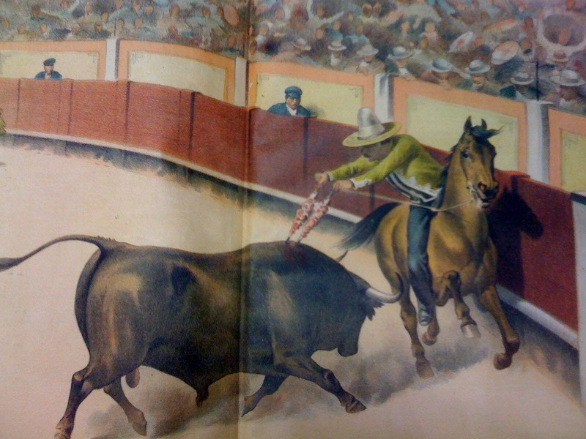
Figure 10. Banderillando a caballo in Spain. Newspapers in Spain and Mexico illustrated Ponciano’s Iberian tour. Many engravers reproduced “Sr. Redondo’s” image of Díaz. Some changed certain elements, like the placement of the horse’s legs or the position of Ponciano’s body. Varying in styles, most replicated the same basic pose. Sr. Redondo, La lidia, August 26, 1889. George B. Smith Collection, Los Angeles Public Library, Central Branch, Rare Books Collection.

For those who could afford costly foreign magazines like La lidia, the foldout tucked between the pages functioned like a pin-up poster. “Sr. Redondo” created these images to commemorate Díaz’s Spanish tour. Undoubtedly, Manuel Manilla, an engraver from Mexico City, came across these images shortly after they reached Mexico. The engraver produced a broadsheet featuring Díaz and evident upon comparison, Sr. Redondo’s image is rendered in Manilla’s hand. Manilla posed rider, horse, and charging bull in a similar manner to Sr. Redondo. The main difference is that Manilla’s rendition appears more at ease, carelessly leaning back without holding the reigns. In another image by Manilla, Díaz appears to be shooting fire from his hands as he places banderillas. The poster child of Mexican bullfighting gained devoted followers through these cheap and inexpensive broadsides.
Díaz’s celebrity was also enlarged through print and throughout his early career, the famed torero drew extensive coverage. One journalist glowingly described him,
Celebrated master of regular height, congenial facial features and intelligence. His brown skin, crowned with curly hair, features a dark moustache. He is extremely likeable, and expresses himself with great clarity and facility.

Another reporter observed, “He does not reveal himself in appearance to a man of strength or great musculature although one initially notices a body with resilience and ferocity.” Ponciano’s image further endeared him to the Mexican lower class, with whom he undoubtedly shared many features. Despite this appeal among the lower strata of society, the bullfighter also drew support from middle sectors. Throughout the nineteenth century, literate urbanites made up of professionals, students, merchants, clergy, and government bureaucrats, helped define forms of nationalism throughout Latin America. Via the literate classes, the emergence of modern celebrity and national identity experienced a parallel development. Upon comparison, one scholar concludes; “Both memorialize their subjects. Both generate new models of consciousness and identification. Both are based on regimes of publicity and spectacle.” Thus, early celebrities, like bullfighters, represented figures that embodied the national aspirations of middle sectors of society.
Although literature played a significant role in the development of a Mexican national identity in the last half of the nineteenth century, newspapers contributed most significantly to the expansion of a mass readership. While the penny press contributed to the formation of a class consciousness among workers, other papers reported on the exploits of bandits like Chucho el Roto. Murders, crimes, suicides, love triangles, scandals, natural disasters, bullfights, gorings, and folk heroes resonated among the urban poor. Although circulation was limited during this period, the variety of newspaper publications constituted a significant increase for Mexico. From 1888 to 1898, the total number of periodicals doubled. In the minds of many, newspaper reviews of bullfights allowed charros to step from the printed page onto the national stage, or the arena.
For the majority of people living in the capital, local newspapers were cheap and readily available. Journals imported from Spain could cost almost ten times the original cover price. Therefore, inexpensive local dailies and broadsheets circulated more widely than foreign publications. Most residents of the capital came across these broadsides on their way to local markets. Corridos and décimas (ten stanza verses) dedicated to bullfighters, often paired with a representations of figure in action, appeared on single sheets of paper colored with vegetable dyes. Bullfighters gained wide recognition and popularity through these songs and images while the most popular verses were compiled in small booklets and sold on the streets. Although illiteracy rates in the capital hovered around 60% in 1895, the lower classes grasped the concept of celebrity from printed images and heard about it when someone read aloud or musicians sang.(Fig. 11)
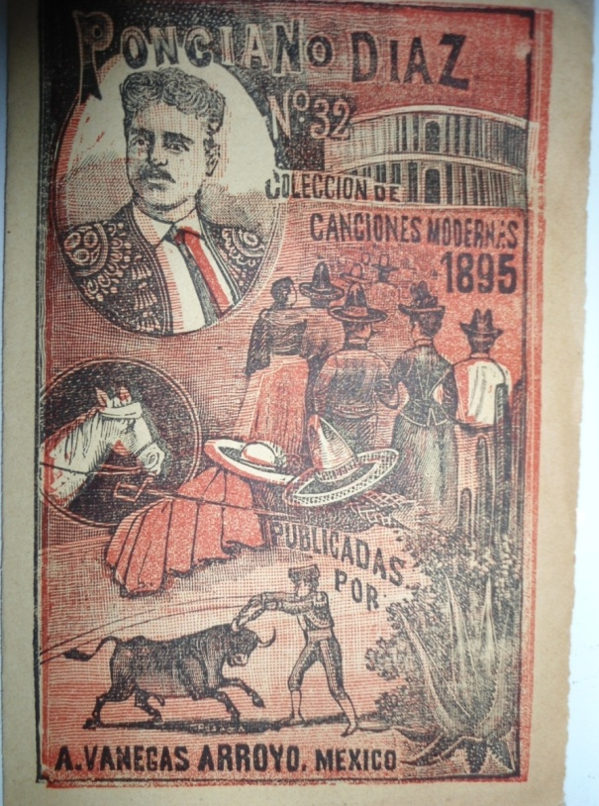
Figure 11. 1895 songbook. Corridos of famous bullfighters such as Lino Zamora and Bernardo Gaviño circulated on the streets of Mexico City. Popular in content and form, songs were compiled in inexpensive booklets. Imprenta de Antonio Venegas Arroyo “Ponciano Diaz no. 32, coleccion de canciones modernas,” 1895. Mercurio López Casillas Personal Collection.

Return of the Bullfighter
No temas, Ponciano Díaz,
El que se eclipse tu luz
Ni que te pueda ganar
Ningun torero andaluz.

On November 10, 1889, Ponciano Díaz boarded a steamship at the port of Cádiz. Bound for Cuba with Celso González and Agustín Oropeza, the group closed five months of touring on the Iberian Peninsula. After fighting twice in Madrid, once in Seville, and once in the Portuguese cities of Lisbon and Porto, the bullfighters packed up and sold their horses. Although some controversy surrounded the trip, significant cultural exchange occurred between Mexico and Spain. Díaz claimed that contractual obligations required a speedy return to Mexico but took advantage of the opportunity to perform in Havana. Situated between Spain and Mexico, Havana held a distinguished position in the international bullfighting circuit. Early in December, Ponciano fought at the renowned Plaza de Carlos III. Organizers shipped fourteen bulls from breeders in Nopalapan, Veracruz.
After the Cuban performance, Ponciano sailed for Veracruz. Taking his bows and arriving in Mexico shortly before Christmas Eve, Díaz headed directly to the capital. Hours before his arrival, admirers streamed into the Buenavista train station. A collective cheer erupted when the enthusiastic crowd heard the train whistle from a great distance. As firecrackers popped, the train eased into its berth. Friends greeted Ponciano as a band struck up a rousing bullfighters march. Traveling in an open carriage, Díaz made his way through the crowd. The “Society of the Swordman Ponciano Diaz,” celebrated the return of their hero on Revillagigedo Street while the bullfighter received well-wishers late into the night.
Far from Spanish critics, Ponciano returned to utilizing the local press in Mexico City. For example, a sensational story circulated in the fall of 1891 that recounted how Díaz was gravely wounded in a quarrel with a Spanish bullfighter. According to the account, blows were exchanged after Ponciano implied Spanish toreros were cowardly. Reportedly, Díaz was severely wounded with a machete and his life hung in the balance. A few days after the incident newspapers announced he died. The retraction issued a week later seems almost irrelevant. Raised from the dead, Ponciano held a benefit corrida a few days later. The story proved to be a fabrication, but more importantly, it may have helped fill seats. The rivalry between Spanish and Mexican bullfighters helped raise the emotions of the crowd and rouse sentiments of nationalism. In the arena and the tabloids, Díaz cultivated an image of belligerence towards Spaniards that rallied the Poncianistas to his defense. In the process, a popular sense of national identity associated with the charro came to signify patriotism and anti-foreign sentiment for fanatical supporters of the torero with a mustache.
Much like today, rivalries served to create hype for sporting events. Díaz’s main rival was Luis Mazzantini, a Spanish bullfighter, stage actor, and later politician who was favored by much of the upper class. Their competition was mostly cordial. The showmen attended each other’s fights, embraced before spectators, dedicated bulls to one another, and offered public praise. Although they remained deferential, vicious slanders in the newspapers and street fights between poncianistas and mazzantinistas (followers of Mazzantini) characterized much of the uproar. As a result, Mazzantini often needed an armed escort to accompany him to the arena when he performed in Mexico. (Fig. 12)
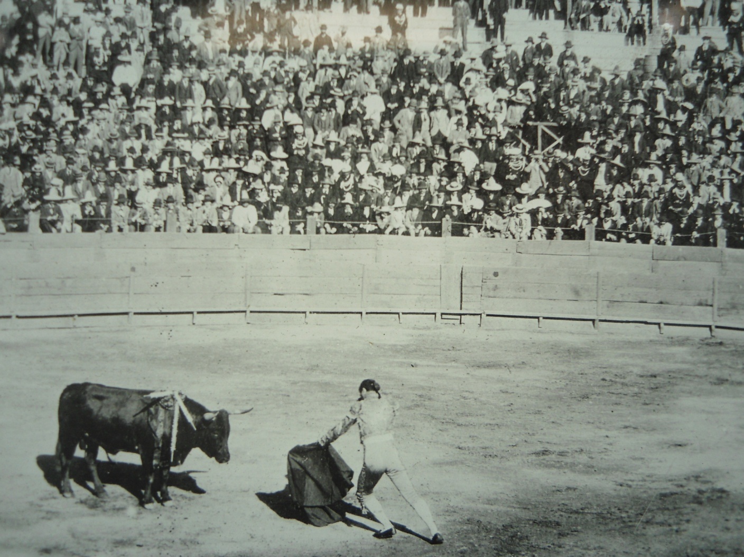
Figure 12. Mazzantini at Bucareli. Despite Mazzantini’s initial troubles with rowdy poncianistas, he returned to Mexico. An acquaintance and favorite of President Porfirio Díaz, Mazzantini garnered much praise from aficionados. While he executed a kill in the Spanish form at Bucareli, two American photographers snapped some of the first action shots of bullfighting in Mexico. Charles B. Waite & William Scott, December 27, 1897. Albert J. Schmidt Collection of Lantern Slides c.1904-1921, Nettie Lee Benson Library, Austin.

In the late nineteenth century fame depended upon exceptional talent, outstanding achievements, hard work, quality, and deserved respect. Additionally, in the Porfirian era, celebrity required public adherence to notions of upstanding virtue and modesty. For the most part, Díaz meticulously tended his public image by avoiding controversy. However, contrary to previous assertions by scholars and biographers, Ponciano Díaz’s name was regularly tarnished by gossip and scandal. For example, in 1887 organizers of a bullfight fled the capital after using the bullfighter to promote a bogus benefit. People complained about paying for tickets and finding no available seating and one frustrated attendee recalled how 200 people were barred from entry. In the summer of 1888, the bullfighter felt compelled to address more slanderous accusations. Publishing an apology in one of the major dailies, Díaz denied selling more tickets than available capacity at Bucareli. In the confusion, unruly crowds overran his plaza and alarmed ticket holders hesitated entering the packed arena. Díaz refuted claims that the crowd trampled a spectator to death. In order to avoid additional bad press, the bullfighter declared free admission for unredeemed ticket holders at his next corrida. Accusations of overselling available seating followed Díaz throughout much of his career.
Fame made Díaz cautious of public scrutiny and quickly paying off an offense to quiet critics seemed to work well. Among the highest paid performers of the period, Díaz amassed a considerable fortune earning 450 pesos per corrida. Comparatively, veterinarians earned three pesos per fight while advertisers received two to paste promotional bills all over the city. At this rate, they earned enough to buy a seat in the shade with a few centavos to spare for pulque. Díaz’s income from bullfighting alone may have topped 13,000 pesos in 1888. Carlos Borrego “El Zocato,” the next most prolific bullfighter earned around 6,000 pesos while Mazzantini received half that amount.
Perhaps more than wealth and image, Díaz drew appeal from the themes of risk and bodily harm. The boldness necessary for bullfighting helped form the image of Mexican toreros late in the nineteenth century. A leg injury in Durango in 1883, as well as a nasty fall and facial wounds in Spain, remind us that Díaz was not immune from the hazards of bullfighting. The torero received a cogida, a goring caused by a bull’s horn, at Santiago Tianguistengo. Roping maneuvers could also end in broken or severed fingers. In numerous plazas, poor medical care hastened fatalities. A cogida in the abdomen left little hope for recovery, as one amateur from Ciudad Juárez discovered in 1905. The young man attempted to place banderillas when he received an unfortunate goring in the groin. While not all cogidas proved to be life threatening, infection and gangrene were real health risks.
Although mortality rates were lower than many other professions, illustrated magazines reveled in the tabloid gore. The cogida became a favorite subject of artists - usually captured at the moment of impact. Memorializing the death of toreros like Juan Romero Fernández “Saleri,” Bernardo Gaviño, and Juan Jiménez “El Ecijano,” artists paid tribute to foreigners who died fighting in Mexican arenas. As photography replaced illustrations, the spectacle became more graphic. One bullfighter had no reservations about raising his shirt so a photographer could snap a picture of a ghastly wound with sutures across his stomach.
Among sportsmen, notions of manhood, influenced by the culture of health and attitudes regarding the body, reinforced displays of physical dominance and contests of skill. For the audience the desire for success functioned within a critique that often subverted the fantasy of triumph. Quite possibly, the attraction to violence revolved around witnessing failure or the observation of pain, injury, and death. Much like the present, attraction and revulsion both reinforced and subverted notions of celebrity. Thus, it is conceivable that spectators cheered as Díaz was hurt, gored, trampled, and possibly killed.
In late nineteenth century Mexico, bullfighting generally functioned as a male sport. Although women comprised a small portion of spectators and critics, more often they appeared as toreras wearing the traje de luces. In the business of bullfighting, toreras attracted audiences. In 1887, a newspaper noted the presence of a torera from Morelos at the fiestas of Tixtla, south of the capital. Later, the paper proclaimed, “A young mexicana impassioned by the art of the sword, will debut shortly at a plaza in this capital. She promises much by her valor.” A few months later two cuadrillas composed entirely of toreras and under the direction of Francisco Jiménez “Rebujina,” staged a dress rehearsal. An excited commentator remarked, “Oh fathers of the nation, how much happiness you grant to Mexico with our mischief.”
Some of these toreras, like Ignacia Fernández, “La Guerrita,” hailed from Spain, others like Susana Duval were from Mexico. Among Mexican toreras, Maria Aguirre, “La Charrita,” was the most renowned. Like Ponciano, she traveled to Spain in 1896 and performed the banderillas on horseback. However, she distinguished herself by riding sidesaddle and wearing a skirt. Songs celebrated “the Mexican charra that offers pleasures, that incites love.” Although many toreras joined all-female cuadrilla, like the Hermanas Chiquis, some rose through the ranks of male cuadrillas. Attracted to more than the thrill of the fight and applause of the audience, many toreras married toreros. Most toreras appeared in novilladas, a minor league of sorts that often omitted the act of slaying a bull. In the Porfiriato, professional opportunities for elite women included commerce and the medical field. Like their upper class sisters, busting seams and inverting gender norms through bullfighting allowed some lower class women to gain a degree of professional respectability. Comparable to “Lady Riders” in the Wild West shows, toreras attained renown, traveled, fell in love, and made a living touring on the bullfighting circuit.
Despite the intrusion of toreras, bullfighters lived and worked in an environment built for men. The spaces they inhabited, the arenas, cantinas, clubhouses, and cafés, were largely places of male bonding where toreros formed social networks. In the arena, the performance of violence and opposition to submission enacted by bullfighters supported an ideal of masculine honor. However, this heterosexual model of masculinity is at odds with rumors of Díaz’s private life. Although he attracted the attention of the ladies, the bullfighter was devoted to his mother, Doña María, and he never married. Although reports exist of an amorous affair with a woman, one scholar claimed Díaz had a relationship with an English stage actor. After foreign invasions weakened the country in the middle of the century, elites and the lower classes alike, perceived a national crisis of masculinity in the Porfiriato. Homosexual males upset the social order and threatened the nation’s political stability. As a result, Porfirian criminologists linked “sexual deviancy” with delinquency and reformers attempted to educate deviants to follow “gender-scripted roles.” Understandably, Díaz maintained his privacy.
As the first person to popularize the charro archetype through mass media and mass entertainment, Ponciano Díaz embodied a masculine ideal. Charges of effeminate behavior or homosexual association regularly surface with regards to toreros. Just as there is a mujer macha in cancion ranchera (country songs) such as Lucha Reyes and Chavela Vargas, there is a corresponding image in the gay charro, performed by such artists like Juan Gabriel and a few professional mariachis. Often lampooned as a character that serves as a companion to a more masculine lead role, the gay charro serves to reinforce the traits of the macho. It appears as through from its initial commodification for mass entertainment in the late nineteenth century, the charro archetype carried elements of gay identity.
Unfortunately for all bullfighters, officials in Mexico City reestablished a prohibition on bullfighting in 1890; a response provoked after a policeman was injured by a mob. Because of the renewed ban in the capital, bullfighters, once again, migrated to surrounding cities and pueblos. Northern cattle states like Chihuahua profited and developed a considerable reputation as important regional venues, attracting Spanish bullfighters like Francisco Alonso. Bullfighters also sought employment abroad. In the 1890s, they traveled north to the United States and found seasonal employment in various Wild West shows. During this period, bullfighting gained popularity throughout Latin America, in nations such as Guatemala, Nicaragua, Colombia, Venezuela, Ecuador and Argentina. Popularized internationally, French, Portuguese, Italians, North Americans, and Japanese joined the ranks of bullfighters.
Following the renewed ban in Mexico City, Ponciano Díaz decided to focus on his business ventures. He built, owned, and lived at Plaza de Bucareli, the premiere bullfighting arena in the city. Used as a stable during prohibitions, when band were not in effect Díaz occasionally fought bulls in his arena. However, he continued experiencing successes and failures. The prohibition in the capital was reinstated, repealed, and again reinstated before bullfighting gained some permanency in 1895. Throughout the 1890s, the banderillero struggled to fascinate the crowd as he once did. Unfortunately, popular tastes changed and the crowds no longer cheered for the mustachioed bullfighter. Elites and aficionados succeeded in establishing and popularizing “tauromaquia moderna” (modern bullfighting). Manuals detailing the different forms of Spanish bullfighting, and board games with images of the appropriate acts spread among the literate. Additionally, municipal authorities who tired of the mayhem established strict regulations. Increasingly, unique national acts became secondary features or disappeared altogether.
In the 1890s Díaz tried to focus on his entrepreneurial ventures. Organizing corridas in surrounding pueblos and managing Plaza de Bucareli, he regularly submitted permits to the Ayuntamiento. Aware of their concerns, he promised to accommodate police and provide adequate medical services. As before, he used nationalist rhetoric, declaring, “I will gather new talent that will work against that which comes from Spain.”
However, it appears as though the distinguishing feature of Díaz’s managerial style was carelessness. Records indicate he ceded control of the business to José Díaz, his brother. Over the course of their business dealings with the Ayuntamiento the Díaz brothers fell out of favor with the councilors who turned down an extension of their permit in 1895. Trying to smooth over tensions, the brothers offered a fifty percent cut of ticket sales but this failed to entice the authorities. Unable to avoid controversies, police attempted to arrest Díaz in 1895 after a poor performance instigated a riot. The disturbance caused the reinstatement of another prohibition in the capital and precipitated an order to return the entrance fees of spectators. Complaints concerning oversold seats and false advertisement continued to mount and Díaz’s correspondence with the council worsened. In the last official communication of 1898, authorities reprimanded the bullfighter over conditions at Bucareli. They admonished, “It is your obligation to constantly tend to the conservation of The Plaza.”
In his late thirties, Ponciano Díaz, Mexico’s first modern celebrity, was on a downward spiral. Unable to adapt to changing trends and the onslaught of Spanish bullfighters promoted by aficionados, Díaz stumbled down a dark and lonely road. Once revered for his sobriety, Ponciano began to frequent cantinas. If not at “La Fama Italiana,” he would often lock himself up at Bucareli, along with the desiccated head of the bull that killed his padrino, Bernardo Gaviño. In the winter of 1897, Díaz fainted while performing at Santiago Tianguistengo. As he collapsed, the bull hooked his clothing and dragged him over the sand. After his recovery, the frail bullfighter visited his infirm mother and promised to withdraw from the arena, slicing off his coleta (braid) -- traditionally cut upon retirement from bullfighting. Death came soon to Doña María and the loss reportedly aggravated Ponciano’s health. The bullfighter developed hepatitis, agonizing for several months until his cirrhotic liver failed. In the spring of 1899, Ponciano breathed his last breath. Falling silent, his surviving siblings held a wake in the main hall at Bucareli, once the scene of so many thunderous ovations. No longer at center stage, only a handful of newspapers curtly noted his passing. However, José Guadalupe Posada, an unabashed poncianista, eulogized the bullfighter in a famous broadside:
Tuvo su época brillante
El público lo aplaudía
Palmas y galas le daban Con la más grande alegría.

Bandas, coronas, y flores
Le enviaban al redondel,
Y á estas pruebas de cariño
Les sabia corresponder.

Todo el Interior anduvo
Demostrando su valor
Lidió toros de los buenos
Que jamás no desmintió.

Mas todo toca á su fin
Y todo nomás es humo
Así le paso a Ponciano
Se apartó de nuestro mundo.

Fittingly, the first modern “ídolo Mexicano” lies buried atop the hill where the Virgen of Guadalupe appeared before Juan Diego. With religious pilgrims gathered at the base of the hill, Ponciano’s grave overlooks an adoring mass of faithful followers and the city he once charmed.

The Mexican Charro Goes North
Se acabaron los toreros
De aquella época pasada,
En que había diestros muy buenos
Y deveras se lidiaba.

Despite the sale and demolition of Bucareli two months after the death of Ponciano, bullfighting continued to thrive late into the Porfiriato. Plenty of new bullfighters, amateurs, and impersonators spread across Mexico, Latin America, Europe, and the United States. Juan Silvetti, Ponciano’s heir, regularly attended fiestas and corridas dressed in charro suits and wearing a sombrero with embroidered skulls, while Rodolfo Gaona, trained in the Spanish style, eventually surpassed Díaz as the favored national performer in the early twentieth century. However, a torero from Puebla radically altered the script. Vicente Oropeza, brother of Agustín - Ponciano’s former picador, picked up the mantel, or rather, the reata rope of the charro/torero personified by Ponciano. As will be discussed in the next chapter, Oropeza traveled north, to the United States, and found employment performing in Buffalo Bill’s Wild West Show. He dedicated himself to horse catching and trick roping, gaining top billing as “The Greatest Roper in the World” when touring Europe.
Oropeza, however, did not reach the heights of national celebrity attained by Díaz. However, in the late nineteenth century toreros and vaqueros exported unique acts of Mexican bullfighting, and in the process, popularized commercial images of charros in the United States. Before films introduced cinematic charros, Wild West performers reached a wide international audience across the Americas and Europe. This second generation of performers expanded the international touring circuit first established by Díaz. Oropeza’s seasonal migration north represents larger trends. Inspired by Ponciano and skilled in trick roping and riding, performers acted as agents in a transnational process of cultural exchange. Riding along the railroads tracks and crossing the ocean in steamers, Wild West shows soon spread the image of the Mexican charro farther than ever.
In Mexico, revolution and civil war reordered the national landscape. As Emiliano Zapata, who often dressed in charro attire, was assassinated at Chinameca in 1919, elites organized associations and invented charrería rodeo in cities across the republic. As will be discussed in chapter five, upper class charrería associations formalized the acts of jaripeo, manganeo, and laceo and broke completely with bullfighting. These organizations also modified plazas into keyhole shaped lienzos that accommodate a long corridor for bull tailing. Across Mexico and eventually into the United States, charrería associations’ reinvented taurine acts previously deemed unrefined by critics. Institutionalizing the pageantry, President Abelardo Rodríguez declared charrería the national sport of Mexico in 1932. This was followed by President Pascual Ortiz Rubio who declared the traje de charro a national symbol.
Despite the creation of charrería, bullfighting continued to thrive in Mexico. The economic boom that began in the 1940s allowed Mexico City to compete with Madrid for the largest plaza in the world. In 1946, Plaza México with a 41,000 seating capacity, nearly doubled the size of the previous record holder and became the largest bullfighting arena in the world. Regardless of increased attendance at the corridas, the silver screen eventually brought down the final curtain on bullfighting megastars. As will be discussed in chapter four, film celebrities such as Tito Guízar and Jorge Negrete eclipsed the toreros. Like their bullfighting predecessors, the public embraced the cinema charros who remained at the forefront of the Mexican stage for over half a century. In 1936 Columbia Pictures attempted to revive Ponciano’s legacy with ¡Ora Ponciano!,(Hey Ponciano!) a romantic story of forbidden love and Porfirian class divisions. In order to avoid offending the “artistic sentiment of aficionados,” the lead actor performed on foot – ignoring tribute to Ponciano’s superb skill banderillando a caballo.
In the mid-1880s, notions of personal identity underwent significant changes with urban migration, the development of mass entertainment, and printing. Thus, the production of celebrity, with its reliance on mass entertainment and newspaper print, functioned like a commercial industry. Selling newspapers, broadsides, and tickets, business interests dominated the bullfights. As literacy increased and popular images spread so did notions of national identity. However, people in the shade and those in the sun articulated contending visions of Mexican identity. Elites attempted to refashion Ponciano Díaz according to Spanish norms while the recently arrived lower classes swarmed the plazas and cheered the antics of the mustachioed torero.
Lifting the ban on bullfighting allowed the construction of mass entertainment venues, magnificent plazas, to witness the acts of luminary performers. While both the rich and poor filled these arenas, a physical barrier prevented intermingling and reinforced class distinctions that determined where one sat and who one applauded. Although they mingled outside among the vendors who sold pastries, candies, and nuts, they entered the arena at different gates. As residents of the capital watched the bullfighters, experiences varied with some spectators shouting “olé,” “ujua,” and “epá,” encouraging the performance of bronc riding and rope-twirling charros. Buying tickets and newspapers, in addition to fighting in the streets, audiences participated in the mass commercialization of a familiar literary and artistic symbol - the modern Mexican charro.

Chapter 3:
Crossing Cultural Frontiers:
Mexicans in the Wild West Shows

Although histories of performers in the Wild West shows include studies of Indians and cowboys, no literature exists concerning Mexicans. This chapter on the transnational history of the charro archetype aims to address this historical oversight. Mexicans who toured the United States in the 1880s working as performers in the Wild West shows were among the earliest migrant laborers who traveled across the border on railroads. In 1884 the rail crossing between El Paso and Ciudad Juárez linked the United States and Mexico for the first time and another would follow at Laredo in 1888. Increasingly, Americans found themselves in central Mexico while Mexicans ventured into the American west. Since the premiere season of Buffalo Bill’s Wild West show in 1883, Mexican bullfighters and vaqueros (cowboys) gained seasonal employment during the circus season that ran from spring to fall. Although their numbers were generally small and their stay often temporary, these entertainers contributed to the transfer of bullfighting acts and styles from Mexico. These performers left a significant impact on American popular culture by enacting the ethnic archetype of the modern Mexican charro. Twirling ropes and riding bucking broncos, Mexicans in the Wild West shows enacted personal representations that defied distortions in the programs and subverted prevailing anti-Mexican sentiments. Eventually, the image of rope wielding charros spread across the United States, the capitals of Europe, and the rest of the world.
Like L.G. Moses explored with regards to Native American performers, ethnic Mexicans employed in the Wild West shows were part of a “transitional generation.” They expanded their horizons by traveling the world, joined the wage labor economy, and attained status through employment. Additionally, Linda Scarangella McNelly noted that Native performers negotiated the personal meaning of their representations, maintained family units, gained considerable independence, and sustained traditional practices. Ethnic Mexicans experienced similar circumstances while employed in Buffalo Bill’s Wild West show. This study aims to explore the forgotten history of these performers who crossed cultural frontiers as mediators in a transnational process of cultural exchange.
South of the border, northern cattle states like Chihuahua drew bullfighters when the state lifted a ban prohibiting bullfighting in the 1880s. This legislative action converted the region into a magnet for toreros (bullfighters) from the interior of Mexico. Additionally, prohibiting the corridas (bullfights) in Mexico City had the effect of distributing bullfighters to outlying regions in the 1880s and 90s. Catching a ride on either the Central or Mexican National rail line extending to the border, migrants from central Mexico increasingly settled north along the Texas border where a variety of employment opportunities existed. Fleeing low wages, temporary employment, and limited industrial development, migrations patterns flowed north, across the border at Laredo and on to cattle and horse markets in San Antonio.
On the American side of the Rio Grande, Mexicans followed a similar trail into the Midwest. Trying to supplement their income in the cattle industry that drew thousands of vaqueros north for seasonal employment, Mexicans found work in the Wild West shows. Besides the demand for Mexican performers created by touring circuses, Americans across the border organized bullfights in the United States. One of the earliest bullfights was held by civic leaders from Dodge City in 1884. Drawing a full crowd, Gregorio Gallardo from Chihuahua and his team of bullfighters were a true novelty and a financial success. In the 1890s, Pawnee Bill toured with Romero Díaz, a Mexican bullfighter. This was followed by the 1901 Pan-American Expo in Buffalo, New York, that included a bloodless bullfight as part of the program. A few years later a Wild West show in St. Louis was shut down when it became apparent that a bullfight was in process. In 1910, Los Angeles held a bloodless bullfight to commemorate Mexico’s centennial. The festivities came to a premature close when the bull jumped the railing, prompting a barrage of gunfire from the sheriffs and leading to a fistfight between the bullfighter and the organizer. For many, it was a wild west indeed.
Bullfighters and other equestrian performers attracted north of the border often brought along their families. Like Indians in the Wild West shows, relatives traveled and performed together. Thus, in an age of increased social fragmentation, employment in the Wild West shows had the positive effect of promoting cohesion. The Esquivel’s were some of the most renowned Mexican performers in the long history of the Wild West shows. Although their exact relation remains a mystery, Pedro led the Mexican, gaucho, and cowboy contingent for most of the 1890s. Tony and Joe, two brothers from San Antonio, joined Buffalo Bill in the early 1880s with Joe leading the cowboys into the first decade of the twentieth century. Similarly, Domicio, Bernardo, and Trinidad Ramos who toured with the show between 1896 and 1900, may have been brothers, cousins, or maybe father and sons. Louie and Agapito Alba traveled together in 1899. The following years Louie returned without Agapito. The Muñoz family had such a presence during the 1911 season that they made up nearly the entire Mexican cast.

From Puebla to the Plains
Of all the ethnic Mexicans who played a version of themselves for audiences at the Wild West shows, Vicente Oropeza stands out as an exemplary figure. (Fig. 13)
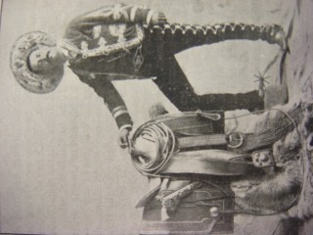
Figure 13. Vicente Oropeza posing with his saddle and coiled lasso. Oropeza dressed in the fashion accustomed by ethnic Mexican bullfighters, adopting a flashy version of the modern charro suit. Circus World Museum Parkinson Library, Baraboo, Buffalo Bill route book, 1896.

He was the first performer to introduce trick roping, a secondary act of Mexican bullfighting. Charming but not proficient in the Spanish style of bullfighting, Oropeza was known to fight bulls in the Mexican manner, banderillando a caballo or, sticking picks while mounted. Oropeza inaugurated the Coliseo arena in Mexico City after the repeal of a prohibition on bullfighting in 1886. After gaining a reputation in his native Puebla and later in San Luis Potosí, he travelled north and contracted with William Cody’s Wild West Show. In the process, Oropeza radically altered the script of Mexican performers in the United States. Wearing a charro suit like Ponciano Díaz, an acquaintance he admired, Oropeza exported the latest styles of Mexican bullfighting. For sixteen seasons, Oropeza put on his charro suit and travelled to Cody’s ranch in Wyoming, all the way from Puebla to tour across prairies and oceans.
With a twirly upturned moustache, Oropeza was renowned for his accuracy with the rope and the great distance he could throw while retaining control. Some claimed he had a wire hidden in his lasso. Pitching his wondrous reata (lasso), he made a loop large enough for a horse to pass through and when a second horse ran past, Oropeza cinched the loop to catch it. This was known as “The Salute.” “The Umbrella” consisted of him throwing a loop over his head then letting it fall around his body as he dances and gyrated inside. With this enchanted lasso, “Oropeza’s Dream” gave the illusion of a suspended wheel rolling around the performer in mid-air. The performer also competed in early rodeo competitions such as the steer roping contest held in St. Louis, in 1899. After he won first place at the “World Championship of Trick and Fancy Roping,” held in New York City in 1900, Oropeza was promoted at “The Greatest Roper in the World.” He obtained top billing as, “The Wonder of Mexico and His Feats with the Lasso,” when the show toured France.
With exaggerated claims plastered on the walls of towns along the tour route, Wild West shows operated as a “powerful factory of images.” Promotional billboards, posters, and banners constituted a considerable portion of the imagery generated by these circuses. The costs of advertising often topped expenses. Representations of Mexicans most often included figures roping or riding. The earliest depictions illustrated vaqueros with bell-bottomed calzoneras, often catching bison. Mexicans almost always wore large moustaches and were often pictured smoking. One of the most common images featured a Mexican dancing inside a twirling rope. (Fig. 14)
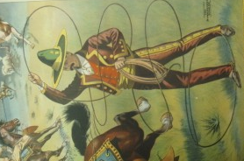
Figure 14. One of the most frequently reproduced image of Mexicans in the Wild West shows featured them dancing inside twirling ropes. “Cowboy Sports and Pastimes. “Scenes From the Strenuous Life of Pawnee Bill’s Wild West,” n.d., Circus World Museum Parkinson Library, Baraboo.

This was followed by riders who jumped, raced, and performed tricks on horseback. Like many of the other ethnic groups, representations of Mexicans with firearms are rare and those that exist aim rifles at bandits, Indians, or buffalo. Thus, the vision of Pawnee Bill’s Wild West show conceptualized Mexicans as allies in the Anglo-American struggle against Indians on the frontier. After witnessing Buffalo Bill’s Wild West show, Frederic Remington produced several images of performers. Besides Coming to The Rodeo (1893), the venerated Western artist published The Great Mexican “Top Roper of the World” (1897) in New York World. The ink drawing shows Oropeza in his conical sombrero pitching a loop towards the viewer, a pose he often struck for photographers.
Despite billboards, paintings, and drawings set in idyllic landscapes, and featuring Mexican performers, Buffalo Bill’s program chided the vaquero “half-breed” who appeared “dandy in the style and get-up of his attire.” Most distinctly, through his “buckskin trousers, slit from the knee to the foot and ornamented with rows of brass or silver buttons.” Undoubtedly true, when he rides into town, “the first thought of an Eastern man is that a circus has broken loose.” Ordinarily peaceful, unless whisky was making the rounds, Buffalo Bill’s program warned that vaqueros became dangerous and reckless while drinking. A bit remorseful, the program declared Mexicans were superb horsemen and skilled at catching animals, after all, “at heart he is not bad.” Even the lasso carried a certain degree of cultural assumptions. Like the bow and arrow used by Indians, Mexican roping was perceived as a primitive skill far inferior to the technological mastery associated with Anglo-American firearms.

“Go back to the Gringo, go lick at hees boots!”
Prevailing anti-Mexican sentiment was reinforced in these programs. Historical references to past conflicts were interwoven in the script, from Indian battles to the Civil War and the Spanish-American War. Less explored is the link to the Texas Revolution and the Mexican War. Undoubtedly, Mexicans remained in the public consciousness of Americans. Often remembered as vanquished foes, “greasers” that interbred with Indians and blacks were mongrels, uncivilized, pagan, depraved, filthy, hedonistic, violent, cruel, ignorant, and indolent. In Texas, episodes such as the Cortina Revolt of 1859, the Cattle Wars of the 1870s, the Catarino Garza movement of the 1890s, and the infamous Gregorio Cortez manhunt of 1901 helped reinforce the notion that Mexicans could not assimilate, were violent, and prone to dissent. When revolution erupted along the border in 1910, Mexicans became refugees, subversives, thieves, and insurrectionist, further supporting anti-Mexican sentiment.
Although the image of the “bad” Mexican endured, a certain degree of attraction, possibly allure for a delinquent image, or the appeal of an exoticized “other,” sensualized Mexican performers. Using the rich style and fashion of the bullfights, performers also enacted the role of “good” Mexicans. Their charro costumes conjured images of noble toreros, hacendados, and the flashy Guardia Rural. These costumes functioned as a reference to a romantic past, a vanishing rural ideal of “Old Mexico,” in part associated with the high culture of the French occupation. When Mexican performers swaggered into the arena it is likely they conceived of themselves in these terms. Performance was a medium of self-representation and for the Mexicans who dressed in the manner of bullfighters, landed elites, and militias personal meanings may have differed from those of the audience. Although programs ridiculed Mexicans, Oropeza put on an excellent show. The skilled performance of a professional entertainer subverted the text. The bullfighter from Puebla knew how to work the arena and appeared satisfied with his image. While touring Brooklyn in 1894 the New York Times reported that Oropeza was one of the main attractions of the show. Traveling through San Antonio, crowds treated him exceptionally well. A rodeo historian notes that locals, “long accustomed to watching expert ropers recognized that Oropeza was in a class by himself.”
Like Indians, Mexican performers left few records of their time in the Wild West shows. Therefore, research often relies upon their faded memory in the writings of others. Especially notable is Oropeza’s influence on Will Rogers’ early career. After watching him perform at the Columbia World exposition in 1893, Rogers stood next to Oropeza for a photograph at the St. Louis Annual Fair in 1899. He credited Oropeza with inspiring his routine and incorporated many of his tricks. Rogers’ first published work concerned roping and Oropeza’s influence. Twenty years after he first watched him perform, “The Cherokee Kid,” recalled, “He was the first roper that any of the present fancy ropers ever saw, and up to this day I have never seen a man exhibit the same accuracy and style that he did.” Dane Coolidge remembered,
Oro Peso [Sic.] was more than a trick roper. When he was traveling with Buffalo Bill’s Wild West Show He was always posted at the gate while the cowboys and cowgirls rode their bronks, and if any were thrown and dragged by their mounts it was Oro Peso who roped them. He never failed.

Joseph Mayer, one of the original Rough Riders, stated “the first roper we had with the show was Vincenzo Oripesa [sic.], a Mexican who was a lot better than Will Rogers.”
The greatest historical recovery came from Frank Dean, a Wild West roper and historian. In 1962, Dean traveled to Puebla searching for what remained of Vicente Oropeza. After publishing an inquiry in El Sol de Puebla Dean received a response from some of Oropeza’s surviving children. Over the holidays, letters were exchanged in which Dean learned to pay tribute to Oropeza’s legacy as one of the pioneers of “charrería.” Dean received a photograph of Oropeza which he published in the article, “Maguey, Myths, and Men,” in The Western Horseman. Through his work Dean corrected the misspelling for Oropeza that included Orespo, Oro Peso, and Oripesa. Eventually, Dean’s efforts advanced Oropeza’s induction to the Rodeo Hall of Fame in 1975. The first Mexican honoree, Oropeza received praise for being the “father of trick and fancy roping in rodeo north of the border.” The Rodeo Hall paid tribute to “the Wild West show and the Mexican charro, both of whom, rodeo’s heritage owes much credit.” As the fortieth anniversary of this induction approaches, no other Mexican performer has received similar honors.

From Toreros to Vaqueros.
In 1909 Buffalo Bill’s creditors caught up with the old circus star. Gordon “Pawnee Bill” Lillie stepped in to save his former employer. That same year, the two combined their shows, recast as “The Two Bills Wild West Show,” which also served as a farewell tour for Buffalo Bill. Although native troupes merged, Mexican performers fragmented and Oropeza lost his position as leader of the “Mexicans” to José “Mexican Joe” Barrera. Taller and a more imposing presence, Barrera was younger than the portly and aging Oropeza. After sixteen seasons with Buffalo Bill, the bullfighter put down his lasso and retired from the Wild West show circuit. He returned to his native Puebla and disappeared from the historical record. Whatever thoughts Oropeza held concerning the new “Chief of the Mexicans” are lost. Regardless of rancor or indifference, José Barrera, Oropeza’s replacement, recognized his predecessor when he stated, “nobody teach me, Oropeza and me, we learn ourself.” Fading into the past, Oropeza’s later years are a mystery. However, he died in his native Puebla surrounded by family on December 5, 1923.
While some Mexican performers returned south during the off-season, others were enticed by opportunities for social and economic mobility in the United States. Although the turnover rate was high, many Mexican performers in the Wild West shows enjoyed the seasonal work and steady employment. Mexicans in the Wild West shows were some of the first migrant laborers who traveled across the border on railroads, where some found a place of refuge, and others, a means to travel. Although anti-Mexican sentiments persisted north of the border, these performers were able to counter these attitudes through their skillful performance and ornate costumes. The image defied misperceptions and allowed people to communicate across cultural frontiers. In the process, performers founded transnational communities and established the Mexican charro as a cultural icon. As explored in the next chapter, this figure eventually transitioned to cinema.
The “Two Bill’s” show signals a shift in Wild West circus performance. Henceforth, the last great Wild West shows operated out of Oklahoma, recently granted statehood in 1907 after a prolonged territorial period. With operations headquartered in the state, the Wild West shows matured in one of the last remnants of the frontier. Between the 1880s and 1930s, spectacular circuses traveled along the railroads reaching out from the southern plains. No other show featured more culture from south of the border than Pawnee Bill’s Historic Wild West, and Mexican Hippodrome. Mexican knife-throwers, “riding señoritas,” a Mexican band of twelve pieces, bullfighters, and “vaqueros” entertained millions. Of the various Mexicans performing with “Pawnee Bill” Lillie, perhaps it was José Barrera whose career provides the best glimpse into the lives of these nineteenth century migrants. Traveling in the wake of railroad workers, Mexican performers in the Wild West shows followed a path that would be traversed by industrial and agricultural migrants in the twentieth century. If bullfighters like Ponciano Díaz and Vicente Oropeza represent the popularization of the charro and the export of this national archetype, then José Barrera represents the permanent establishment of this figure in American popular culture. As a result, Oklahoma became a major conduit in the dissemination of the charro archetype in the United States.
Born around 1878, Barrera’s birthplace is unknown. Later in life, He claimed he was born on the U.S. side of the border, sometimes designating a cow camp or San Antonio as his place of birth. Documents indicate Barrera spent time in Monterrey, Nuevo León during the off-season. This, coupled with the fact that he spoke broken English suggests he grew up on the Mexican side of the border. Regardless of his citizenship, Barrera was born into an equestrian lifestyle. According to legend, Gordon Lillie was amazed by Barrera’s skill with the rope when the young vaquero delivered stock for his show in San Antonio in 1894. A second account alleges Barrera begged Lillie for a job after being repeatedly turned down, probably, because he was too young. Well within the demographic of horsemen for hire, José Barrera ran away with the circus and became “Mexican Joe,” leader of the Mexican troupe in Pawnee Bill’s Wild West Show. (Fig. 15)
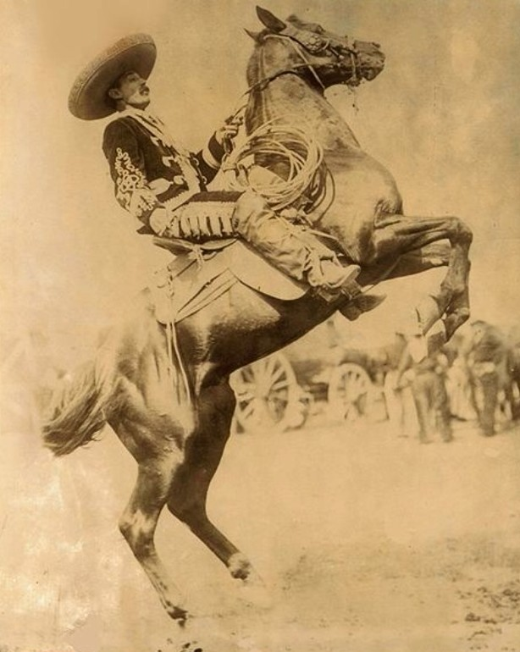
Figure 15. One of the most popular images of José “Mexican Joe” Barrera. He often blended different costumes. Note his knee length riding boot and the cigar he casually holds in his right hand. Pawnee Bill Ranch and Museum, Pawnee, photographic collection.

Over the course of his half century career, he was billed as “Mexico Jo,” “Borraro,” “Borrero,” “Bararo,” “Barroa,” and sometimes “Baran.”
Mexican performers in the Wild West Shows traversed a cultural borderland that defied political boundaries. Along with cotton pickers, railway workers, coal miners, and vaqueros, Wild West performers comprise an important component of Mexican migration to Oklahoma. From cow camps along the Rio Grande, vaqueros regularly traveled north to markets in San Antonio. Reduced in numbers by fencing, the expansion of railroads, refrigeration technology, overproduction, overgrazing, and eventually drought, the decade between 1886 and 1897 was the worst for cowboys.
Additionally, starting in the 1880s migrants from central Mexico increasingly settled north along the Texas border, where a variety of employment opportunities existed. In Texas, ranchers seasonally employed thousands of vaqueros to drive cattle north. Migration patterns flowed northward from Monterey, across at Laredo, and on to San Antonio where Mexicans continued on to Austin, Dallas, Oklahoma, Kansas City, St. Louis, and Chicago. Following the same railway connections, it is probable that many of the Mexicans who performed in the Wild West shows traveled a similar path. In such a manner, seasonally employed cow hands supplemented their income by touring with big tent acts. In Oklahoma, scarce work may have attracted Mexicans from colonies in the south, such as Anadarko, north towards Pawnee and Ponca City, the home of the last great Wild West shows. It is through the extensive use of railroads that Mexican performers in the shows made a living. These migrant laborers were among the most traveled members of their communities, their work as entertainers allowing them to see the world, in part, as tourists.
Organizers had difficulty recruiting and maintaining Mexican performers. If conditions proved unfavorable, many left the shows to search for employment elsewhere. Thus, organizers sarcastically noted,
Three Mexicans think they can make more money selling hot tamales than they get with the show, so they close with us here. D. Wallace left three days ago to get three Mexicans at El Paso.

After lamenting the loss of “our Fat Mexican” in Ohio, another was let go “on account of mis-fit or non-fit.” Those looking for work included bullfighters that came to the region attracted by bullfighting arenas in northern Mexico. Many of these toreros, like Francisco Alonso, were Spanish.
Regardless of nationality, anyone who wore a sombrero with an elaborately embroidered jacket assumed a “Mexican” persona. Wearing a red velvet suit, Will Rogers became, “The Mexican Rope Artist.” William Cody and Gordon Lillie also enjoyed dressing in the elaborate costume worn by Mexican vaqueros. The sombreros and silver buttons especially attracted Buffalo Bill. He wore chinaco style bellbottoms when he killed the Cheyenne chief Yellow Hair. Perhaps the oddest transformation occurred with the Italians from Philadelphia that comprised the “Mexican Band of Twelve Pieces,” sometimes referred to as the “Mexican Military Band.” In turn, ethnic Mexicans could also cross cultural boundaries by performing as cowboys. Thus, Heck Quinn, “King of the Cowboys,” often dressed in a charro costume and was sometimes billed as Hector Quinn, a possible variant of Quinto, Quintana, or Quintanilla. Quinn was an expert with the rope and occasionally performed riding feats with other Mexicans. Similarly, the Esquivel brothers held the key position as cowboys in Buffalo Bill’s Wild West Show for many years. Occasionally, Mexicans took on the role of Argentine gauchos swinging a bolos, a traditional catching instrument.
Mexican troupes were often a strange cast of characters. “Mexican Rufus,” had a giant “R” sewn on the chest of his costume. Some performers such as “Donzeanno” hoped to conjure the great fame of Ponciano Díaz, others chose titles like “Señor Pedro,” or “Señor Francisco.” A few added a place name to their titles, such as “Vera Cruz Valdez.” Although the turnover rate was high, many like Rufus Cardoza, Victor Torres, Quentin Portillo, and Hilario Cerrilo returned year after year.
As migrating seasonal workers, Mexican performers in the Wild West shows operated within the boundaries provided by their employers. Codes of conduct attempted to regulate behaviors backstage and alcohol was strictly prohibited. Nonetheless, “mashes,” referred to as “tangle-foot” or “the ghost,” were a real problem. At best, inebriated performers caused a few black eyes, at worst, they led to fatalities. By enforcing temperance, employers hoped to prevent calamity and establish harmony between various ethnicities.
In many respects, shows functioned like military camps, company towns, and corporations all at once. Dining tents with food services provided regular meals that consisted of sausages, pancakes, and coffee for breakfast. For lunch and supper, beef, beans, and chili often appeared on the menu. Employers hired butchers and outfitted refrigerated wagons to store whole sides of meat. Another cart supplied fresh water for basic necessities while electric generators provided illumination at night. Occasionally, a barber provided grooming services. Performers developed seasonal work patterns, often returning to the same show year after year. In many cases, Anglo-American employers adapted the patron-client relationship accustomed by hacendados south of the border. In this manner, Gordon Lillie became a constant presence in José Barrera’s life.
While some Mexican horsemen returned south during the off-season, others, such as Barrera, found continual employment in the United States. Enticed by opportunities for social and economic mobility, many stayed. As “Leader of the Mexicans,” Barrera may have functioned like an intermediary between employers and employees. (Fig. 16)

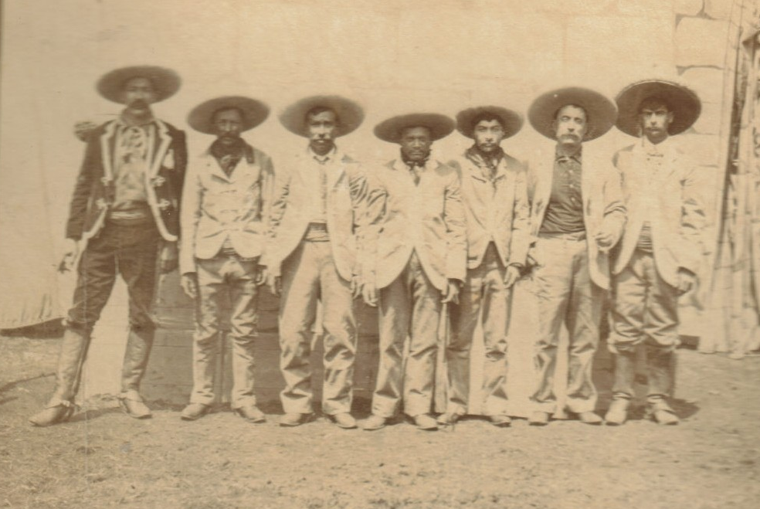
Figure 16. José “Mexican Joe” Barrera with the Mexican cast of Pawnee Bill’s Wild West show c. 1890s. Turnover rates were high and the cast often changed dramatically from year to year. Pawnee Bill Ranch and Museum, Pawnee, photographic collection.

Perhaps he explained the terms of service, shot the breeze about the difference between chile and chili or barbacoa and barbeque. More than likely, he told anecdotes about his tours through Europe. Regardless of his ability to master English, Barrera decided to spend most of his time in the United States. Off-season trips to Mexico were eventually replaced by a job taking care of the circus animals during the winter months. Enticed by permanent employment and pretty girls, Barrera gradually settled in the United States.

“Daring Western Girls and Mexican Señoritas”
With stories in broken English, José Barrera, the tall dark vaquero with a moustache, charmed the people he met. In the spring of 1905, Barrera decided marry. It was not his first marriage. In 1901 while touring Iowa, Barrera tied the knot an unidentified woman. Disappointed, someone noted,
The cool weather we are having at present is no doubt responsible for the fact that Mexican Joe today is seized with an insane idea to pay a woman’s board for life. It is reported that he today tied the nuptial knot.

Perhaps they divorced or maybe the circus cowboy abandoned her. Regardless, a few years later while wintering stock in Beverly, Ohio, Barrera eloped with Effie Cole, the daughter of a local school custodian. Commonly referred to as “rapto” in Mexico, Effie’s family was not present at the wedding. Regardless of parental misgivings concerning the Mexican cowboy, the newlyweds honeymooned in a neighboring town before sneaking back home. Eventually, Effie’s parents accepted the marriage before the young couple departed on tour with Pawnee Bill’s Wild West Show.
Effie Cole exemplifies the female performers of the Wild West shows. Circus performance allowed young girls and women to travel, enter the wage labor workforce, escape parental authority, marry, fall in love, and meet people from different backgrounds and ethnicities. Although it was difficult and tragic at times, many female performers experienced success balancing performance and family life. Before raising a daughter together, Joe taught Effie to trick ride and rope. He bought a costume for her to perform with the “Lady Riders.” (Fig. 17)
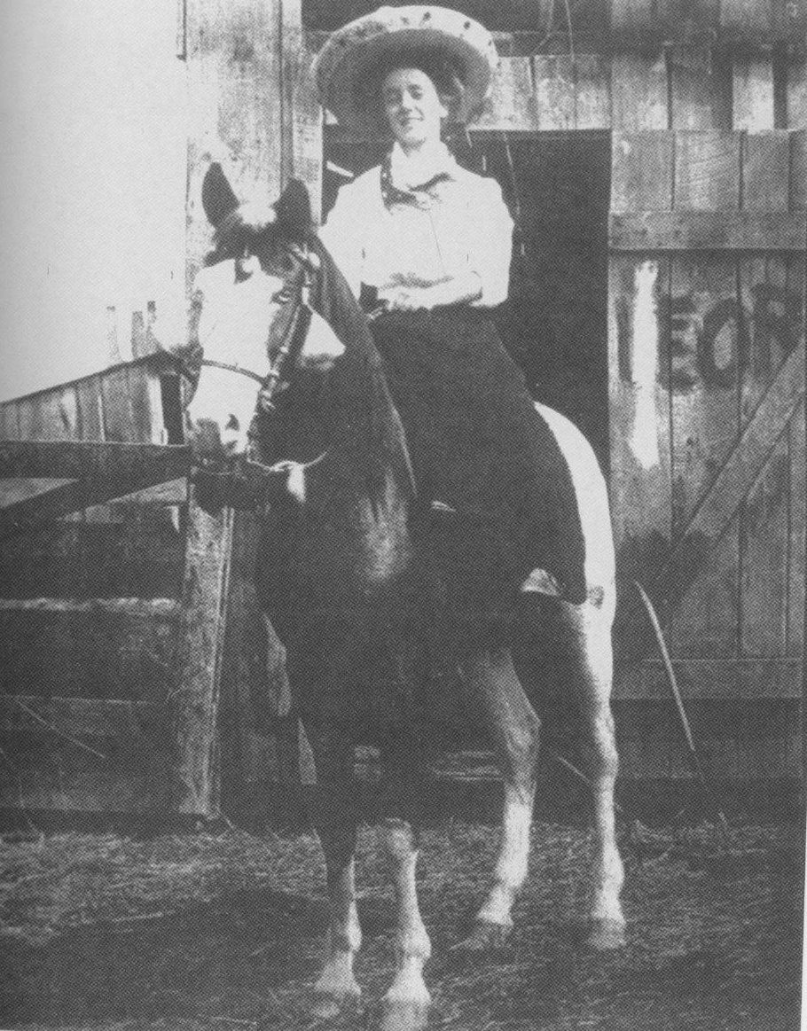
Figure 17. Effie Cole Barrera, in her costume when she performed with the “Lady Riders” in Pawnee Bill’s Wild West Show. Note her decorated sombrero. Although many of the women in the show rode astride, some, such as Señorita Rosalia, performed riding side-saddle. Effie Barrera’s career was comparable to the experiences of May Lillie and Annie Oakley. Pawnee Bill Ranch and Museum, Pawnee, photographic collection.

Effie joined cowgirls like Edna May and Lulu Parr. She jumped hurdles, drove a chariot in one of the acts, and played the calliope in parades.
Lady riders were a diverse cast. In a poster from 1896, the artists depicted, “Beautiful Daring Western Girls and Mexican Señoritas in a Contest of Equine Skill.” Blonde and dark haired girls performed equestrian acts while wearing sombreros. One program noted, “Particular attention is called to the costuming of these people and to the singular beauty of the senoritas and younger girls of the party.” Like Annie Sheaffer and Adele Von Ohl Parker in Buffalo Bill’s Wild West show, these performers busted broncos, jumped obstacles, spun rope tricks, and executed riding feats. Female performers regularly presented bronco riding and trick roping, as well as “picking-up” that required riders to lean over the side of a horse, while galloping at top speed, and grab a handkerchief from the ground. Traditionally played with a live chicken in a gruesome type of mounted rugby, the contest was cleaned up north of the border.
In the 1890s, Gordon Lillie also featured “Señorita Rosalia.” Billed as “The only lady who dares to ride – wild mustang.” She was depicted with almond-shaped eyes, cascading curly hair, large hoop earrings, and sometimes, busty cleavage. Carrying a whip and riding sidesaddle, the 1895 program noted,
Senorita Rosalia is a splendid specimen of the Mexican beauty, and graceful as a princess should be. With flashing eyes, almost blue black hair, attired in the fanciful costumes of her people. She can ride – all Mexican girls can ride well, that is, all of them from the region whence comes Senorita Rosalia.

A “fandango” dance described as “seductive and wild,” probably featured other Mexican performers in the show such as Ida Rodrigo, Señorita Mijares, and “Texas Rose.” More than likely, this ballet combined aspects of Mexican zapateado (Mexican stomp dance) and Spanish flamenco (Roma dance from Spain). Female performers were, in part, sensualized by taking on “Spanish” characteristics. Like their male counterparts, these women negotiated the middle ground between positive and negative stereotypes.
Performers blended wardrobes in a hybrid fashion. May Lillie, distinguished herself with a green embroidered bolero jacket inspired by bullfighters and a long skirt. During the 1893 season, Lillie was featured on a poster, one of the earliest graphic representations of the modern traje de charra. (Fig. 18)
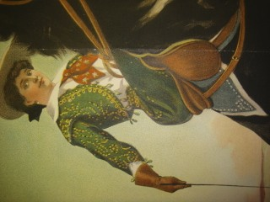
Figure 18. May Lillie dressed in the ornate style of Mexican bullfighting. A vest from this costume survives at the Pawnee Bill Ranch and Museum. This outfit from the 1893-94 season is the earliest prototype of the modern traje de charra (charra suit). Circus World Museum Parkinson Library, Baraboo, Wisconsin.

It is likely she adapted this fashion from Mexican performers in the show such as “Señorita Rosalia.” Other female equestrians in the show also wore bullfighting jackets with shoulder pads and elaborate buckskin skirts. Many performers mixed styles, sporting bullfighting jackets with more practical riding trousers.
Although no direct documentation exists for lady bullfighters in the show, male bullfighters evidently joined these circuses. During this period, a considerable number of toreras (lady bullfighters) regularly appeared in bullfights across Mexico. Some, such as the all-female group Las Noyas, came from as far away as Spain to tour the Americas. Others, such as Susana Duval and Maria Aguirre “La Charrita,” were Mexican. As mentioned in the previous chapter, Aguirre crossed the Atlantic with her husband, a Cuban bullfighter, in 1896 to perform in Spain. It is conceivable that toreras also traveled north with toreros, affecting the development of hybrid styles and techniques north of the border. May Lillie’s costume from the 1893 season is clearly an early prototype of the modern traje de charra. The intricate embroidery on Lillie’s vest recalls the decorations on a bullfighter’s suit, the illuminated suit, worn by Spanish bullfighters. Her costume counters the assertion that the style originated in Mexico in the late 1930s. Evidently, the traje de charra was tailor-made for the spectacle of the Wild West.
While the culture of bullfighting traveled north from Mexico, a corresponding influence flowed south from the Wild West shows. The best example of this regards the style and techniques of the “Mexican Contra Dance.” Often billed as the “Virginia Reel on Horseback” or “Quadrille on Horseback” in Buffalo Bill’s Wild West show, the “Mexican Contra Dance” was a regular feature of Pawnee Bill’s show. Midway through the program, Gordon and May Lillie led several pairs of riders out into the arena. Cowgirls and Mexican performers like Ida Rodrigo, Hector Quinn, “Señor Francisco,” and “Mexican Rufus,” had prominent roles in this act. Four couples maneuvered their horses in synchronization to an orchestral tune, more than likely, played by the “Mexican Band.”
Equestrian acts from the Wild West shows are predecessors of modern rodeo competitions. The synchronized riding of the Contra Dance bears a striking resemblance to the escaramuzas (skirmishes) of charrería rodeo in Mexico. Debate continues as to their place of origin, with a credible claim from Houston, Texas. It is possible that the escaramuzas formed north of the Rio Grande, not far from Oklahoma and the home of the last great Wild West shows. Besides the blended fashion of lady riders, the link between the Contra Dance and the escaramuzas indicates the existence of a cultural cycle that received traditions from Mexico, modified practices, and diffused back across the border, establishing a reciprocal pattern eventually picked up by film producers.
While eroticized lady riders filled the imaginations of American audiences, Mexican men also negotiated the middle ground between positive and negative stereotypes. They often played bandits in elaborate skits about the perils of frontier life. In the early twentieth century, a rise in anti-Mexican sentiment along the border supported popular notions of “bad” Mexicans. Pancho Villa’s raid on Columbus, New Mexico, in 1916 reinforced these negative views. Revolutionaries and bandidos terrorized the imagination of Americans traveling throughout the border region. Conversely, “good” Mexicans were associated with the martial Guardia Rural, bullfighters, and hacendado elites. Performers who wore charro attire allayed some of the fears of spectators. Like bullfighters, these men were dashing, brave, skilled, a bit reckless, and charming.
José Barrera played characters in scripted scenes choreographed with horse races, gun-fights, and rope tricks; recounting plots that often included kidnappings, robberies, and shoot-outs. In the late 1890s, Barrera and Hector Quinn played members of a “vigilante committee” charged with hunting down horse thieves. After a final stagecoach hold-up the cowboys and Mexicans hung the captured horse thief. In 1908, while at an extended engagement at the Wonderland theme park, the show featured “Mexican road agents” that assault a mule train and, in the script, a Mexican bandido was killed. Mexicans often fought against Indian adversaries in Wild West narratives like in the “Burning of Trapper Tom’s Cabin.”
For audiences watching the performance of Mexicans, significance was also embedded in program texts. Character descriptions and biographies conveyed idealized histories. A program for Pawnee Bill’s show explained how Mexican horsemen were,
Gay Caballeros, men who were toreadores or bull fighters, swashbuckling, sun-tanned Vaqueros, and individuals whose physiognomies and physiques denote their Indian ancestry.

Apparently, “vaqueros have no rival with the lasso. They live by it.” Promoters later compared,
The Mexican character known as the Vaquero is to that country what our cowboy is to our country. He is a frontiersman, a scout, a herder and a hunter. His bright, silver be-decked, laced-trimmed uniform gives him the appearance of effeminacy, but he is as fearless, daring and as tireless as is our own ‘pet of the plains,’ the cowboy.

The passage also suggests these “vaqueros” were “Rurales,” but regardless of the false claims, the association was reinforced. The legend about Señor Francisco epitomized the fantasy of the good Mexican. Borrowing from Manuel Payno’s Los bandidos de Río Frío, The Bandits of Cold River, Señor Francisco claimed he once rescued his patron after Comanche marauders kidnapped him and maintained that he brought the bandit Pedro López to justice.
Despite the image, physical injury constantly threatened performers. Riding bucking broncos was particularly dangerous. In 1893, Señor Antonio and Señor Francisco both suffered leg injuries after being thrown off their horses. A few years later several Mexicans were knocked unconscious while riding “buckers.” “Dynamite,” was particularly ornery. After trampling a member from the band, he threw Barrera into the reserve seats. On a different occasion, Barrera broke his leg after being yanked to the ground by a runaway horse, but he was back in the saddle in two days. Unlucky, he was bucked into the stands several weeks later. The danger was potentially life threatening when out-of control horses crashed into tents and tepees. In 1903 Isador González died while performing with Buffalo Bill in England. Playing with guns was dangerous as well, such as when Mexican Rufus narrowly escaped injury after a shotgun was accidentally discharged in the dressing tent.
The danger was not limited to performers. Spectators regularly experienced accidents as well. On one occasion, a man collapsed after being shot in the chest with a .45 caliber discharge by a performer. Incredibly, Barrera claimed a real bullet was accidentally mixed in with blanks. Similarly, during the 1895 season, Heck Quinn rode “Cyclone” straight into the audience. The performer injured an elderly woman, initiating a $1,000 legal suit against the show.
For those brave enough to tempt fate at the circus, José Barrera stood out among the performers. He did not amaze spectators with fancy trick roping like Vicente Oropeza but did wield physical power and special skills when catching animals. During his performances, his signature act included catching six horses in one throw. He was renowned for his ability to rope steer, bison, and occasionally a hog. According to legend, he once lassoed a runaway tiger and a rampaging elephant. While touring Ohio in 1898, an amazed observer noted,
Mexican Joe figured prominently in a runaway this morning. Just before the parade started a horse and buggy started around the race track. The occupant jumped out. Joe started after the runaway on horse back, and caught him with his lasso, making a very pretty throw.

Barrera enjoyed playing a hero on and off-stage, stopping a group of ruffians who attempted to rush the arena in Haverstraw, New York. Throwing rocks and attempting to enter without paying, the hoodlums retreated after they noticed a contingent of “Indians,” “Cowboys,” and “Mexicans” blocking their path. Although charming, the tall vaquero had the specter of a man one did not mess with. On the same tour, Barrera roughed up some college students at Princeton University who attempted to prevent a parade from passing through campus, throwing firecrackers and eggs. Barrera and other horsemen ran down the preppies and fired blanks into their ranks. More thrilled than upset, many students attended the show that evening.
At times, competition among performers was fierce and sometimes resulted in assaults backstage. In such an environment violence between ethnic groups could develop and heighten racial tensions. While touring Pennsylvania in 1895 a Mexican and unidentified workman, “got in a rumpus with some colored folk.” They were each fined $13.50. A couple years earlier, while touring Canada, Andrew Gorman and Cherokee Jim drank too much whiskey and quarreled over some unknown cause. Keeping everybody awake, Gorman pistol-whipped Jim. This unleashed the anger of the Indians and Mexicans until A.G. Shaw, the “Mexican” knife thrower and Indian interpreter, intervened. In the end, Jim was fined $10.

Where the Buffalo Roam
The combined circuses that debuted in Madison Square Garden in 1909 proved lucrative but straining on the friendship of William Cody and Gordon Lillie. In constant need of money, Cody took out a secret loan of $20,000 offering Lillie’s show as collateral. In July of 1913, creditors caught up with them in Denver and seized all the property mid-show. Devastated, betrayed, broke, and unemployed, Gordon Lillie packed his saddle and returned to his ranch in Oklahoma. Regretful that he had ignored his wife’s misgivings about Cody, the old circus star dedicated himself to ranching and oil drilling. Later, the Miller Brothers from the 101 Ranch in nearby Ponca City acquired most of the circus property, dominating as the last of the great Wild West shows.
As for José Barrera, he decided to settle down from a constant life on the road after the birth of his daughter Mary Louise in the spring of 1915. The Barrera’s, ended a tour with the Ringling Brothers Circus and secured employment with the Miller Brothers at the 101 Ranch, allowing José to remain in Oklahoma. Touring with circuses and Wild West shows supplemented the income earned by working on Lillie’s buffalo ranch near Pawnee. There, his skills proved useful when caring for the bison herd, becoming a key figure of Lillie’s buffalo ranching business and instrumental in tasks such as castrating the bulls and establishing pure and cross breeding programs. Packed on to refrigerated cars, he also helped ship whole sides of bison meat across the country.
However, Barrera remained a performer at heart. He appeared in his first film, “Trail Dust,” in 1920 while working with the Miller Brothers. In 1929, Barrera attempted to break into the movies once again but the aging performer was now in his fifties. Pursuing a movie career, Barrera moved his family to Texas where he was swindled out of his money. Left penniless, the stock market crash worsened their fortunes along with a drop in attendance at the Wild West shows. Effie maintained a household on handouts and credit. At the onset of the Great Depression, Barrera accepted Lillie’s offer for the foreman position on his ranch and the family moved into the old log cabin near the barn.
Gordon Lillie’s various business dealings included the construction of “Old Town” outside of Pawnee, Oklahoma. This tourist destination provided an idealized version of the Old West. Besides the “Dodge City-style saloon,” the main features included an Indian Trading Post where tourists could buy souvenirs such as sarapes, lassos for trick roping, and “Oaxaca Indian chief robes” for eighty dollars. The more frugal tourist looking for something “Mexican” could find pottery for a quarter, carved canes, and hand-made leather bags. When Barrera gave C.G. Wilson one of his lassos, he used a certificate of authenticity printed with a logo of the Indian Trading Post. Despite the consumerism, Lillie claimed he built Old Town as a, “monument to the pioneers.” More important, Lillie provided jobs for some of his former employees, with the Barreras’, including an adolescent Mary Louise, regularly performing for crowds. Mysteriously, as economic conditions improved, Old Town burned to the ground.
With help from friends like the Lillies’ the Barreras overcame economic hardship. However, negotiating the social and political cultures of Oklahoma proved difficult. Racial antagonism between whites, natives, and blacks marked the history of Oklahoma. In the 1920s, small Mexican communities in the state totaled only a few hundred people and alarmingly nativist sentiments were on the rise. Just over fifty miles east from the Lillie’s ranch, the Ku Klux Klan gained strength around Tulsa with membership in the organization peaking at over 100,000 in the middle of the decade. Authorities on both sides of the border were on alert when a Mexican shot a sheriff in Anadarko, Oklahoma. The incident roused the concern of President Porfirio Díaz, who protested the mistreatment of Mexicans in his communications with Washington. The Barreras had a cause to be nervous. With differences in language, religion, and culture, ethnic Mexicans were evidently foreign and Barrera was undocumented. For many, the Wild West narratives of white supremacy may have rouse anti-Mexican sentiment.
All of these conditions compelled “Mexican Joe” to deny his heritage. While some sources suggest that Barrera grew up on a ranch in northern Mexico, others indicate he was born in San Antonio, Texas. Friends and family denied his Mexican citizenship. An early biographer noted,
He is a native born American citizen; however, at one time when on a trip to Mexico, he had difficulty in getting back over the line. The officials were hard to convince that they were dealing with a born Americano.

Although they denied it, José Barrera was undocumented. Those around him rewrote Barrera’s past, repeatedly asserting that he was a “true type Spanish American.” Late in life, Mary Louise Barrera continued to believe that it was derogatory to be called “Mexican.” Thus, Mexican Joe’s daughter created a fantasy Spanish heritage. Compromising somewhat between Spain and Mexico, she declared the family descended from Canary Island colonists.
Despite discrimination against Mexicans, Barrera continued to supplement his work as a foreman with a career on the road in the 1930s. In 1936, an organizer of bullfights in Mexico City hired him, resulting in a tour of Mexico and Cuba before he traveled to Spain with a group of Indian performers. The venture was a disaster, worsening economic conditions in Spain led to low attendance and the confiscation of horses by the dictator Francisco Franco’s forces. Barrera was old and this was his last foreign tour, he could no longer ride the buckers.
That same year, May Lillie, Pawnee Bill’s wife, died in a tragic car accident. Henceforth, Barrera provided the widower Lillie assistance and companionship. With some describing their relationship in paternalistic terms. The two former circus stars tended a garden, received guests, and regularly sat on the porch at Blue Hawk Peak enjoying a cigar. Sometimes, Barrera herded the buffalo near the barn so Lillie could catch a glimpse from his window when confined indoors.
When Gordon Lillie died in 1942, Barrera followed the casket with an escort of six riders. He was the second designee on Lillie’s will. Although it caused resentment among Lillie’s surviving siblings, Barrera received $1,000 while Mary got $500 and a horse. The Boy Scouts obtained ownership of the ranch but Barrera continued tending the buffalo herd as he had always done. Coming full circle in his twilight years, Barrera continued earning a living from raising stock.
In 1945, the old vaquero moved out of the log cabin and into a new house at the eastern edge of the ranch, gifted to the Barreras by Lillie before he died. However, José’s wife, Effie, died suddenly in the new home that same year. Mary Louise cared for her father and on July 4th 1949, the 70 year old performer put on his charro costume for the last time. At the Pawnee Bill Memorial Rodeo spectators witnessed the last appearance of a circus star as he roped four horses in one throw. Later that fall, Barrera was hospitalized after developing a case of pneumonia. Legend claims the old vaquero negotiated with the doctor to delay treatment in order to watch a western on television. Barrera died on November 16, 1949.

A Frontier Memory
Long before Barrera’s death, Gordon Lillie and C.G. Wilson paid tribute to his legacy when they wrote “The Roper,”
A builder of loops is Mexican Joe-
The lasso genius of Pawnee Bill’s show;
Son of the plains from whence he came-
Guided by Lillie to roping fame-,
Spreading his loops in many lands
Equally accurate with foot or hands.
Thousands have watched his errorless throw-
Catch one at a time or six in a row.
A pioneer roper who has paved the way
For many roping acts which are seen today.
As a Frontier memory he’ll linger on
When the last sage brush has vanished and gone.

Although only a few hundred Mexicans worked in the Wild West shows, these performers left a significant cultural impact. The transfer of bullfighting techniques from Mexico made Oklahoma an important conduit in the dissemination of the charro archetype in the United States. While some performers returned to Mexico, many stayed in the United States to build a life and settle down.
Regarding this period in migrant studies, Mexican railroad workers predominate in the historical literature, however, Wild West shows performers represent an overlooked subjects of migrant communities in the late nineteenth century. Barrera provides a worthy representative of the small Mexican community in Oklahoma and stands as a notable figure to celebrate. In many respects, the communities formed in the Wild West shows represent multicultural societies. They are ideal transnational communities that arose with the push towards modernization. In this context, the performance of Mexican identity makes them important and influential in expressing notions of ethnic and national identity that resulted in a hybrid figure… the American charro. Like Mary Louise Barrera, the daughter of “Mexican Joe,” the character was a mestizo mix of Mexican and American traits.
Not content to watch from the sidelines, lady riders adopted many of the same Mexican acts and styles appropriated by the cowboys. In the process, female equestrian performers gained some opportunities mixed with uncertainty maintaining families in a rapidly changing society. Along with Effie Cole, José Barrera created a small family and decided to settle in Oklahoma, despite heightened racial tensions. Although, anti-Mexican sentiment persisted and eventually led Barrera to reject his ethnic identity for an invented Spanish heritage. Performing a noble version of Mexican men on horseback, the hacendado, the ace bullfighter, the bandit hero, a mounted soldier, Barrera overcame discrimination when he stepped into the arena. In this manner, a vaquero with an unknown past, permanently established the charro archetype north of the border.
José Barrera was born several generations before cinema captured the popular imagination. Nonetheless, as inheritor of Vicente Oropeza’s legacy, Barrera commanded the performance of the Mexican charro until screenwriters and movie directors appropriated the character. While some young performers, like Will Rogers, easily transitioned to cinema, sound films eventually led to the decline of the Wild West shows, as people increasingly attended movie theaters and ticket sales dropped at the circuses. Eventually, celluloid characters such as the Cisco Kid, reinterpreted the vaqueros, bullfighters, bronco riders, and trick ropers first portrayed by Vicente Oropeza and José Barrera. When Wild West shows broke up after World War I, Mexican charros and señoritas followed the media industry and headed to where the Wild West met the Pacific Ocean. Under the shine of the California sun, bandidos were transformed into caballeros and señoritas became movie stars, ideal chicas modernas.

Chapter 4:
Becoming Good Neighbors:
Leo Carrillo and Cinematic Charros

Peon Pants

See the guy who passes by,
With the pants shaped like a
bell;

As he struts he seems to think
He’s a toreador swell;
But the truth, it must be told,
In a language up to date;
That the style is beastly vile
And is quite effeminate

He looks a siss, more than this:
A he-flapper all the while;
For the people gaze at him
With a slow, disgusted smile:
And they say he curls his hair
With a paste that’s very slick;
But the cure -it’s swift and sure-
Is a well directed kick!

His trouserette, pantalette,
Makes him girlish in a way;
But the girls all hate his tribe
And they call him popinjay;
So he smirks with sheepish grin,
As he ambles down the street,
Attracting scorn that is born
Of his foolish, vain conceit.

Homer York

In the summer of 1922 a strange fashion spread from the neighborhoods of East Los Angeles. Youths at Lincoln High School popularized “toreador trousers,” or “peon pants,” made of tight fitting corduroy, accented with a large bell-bottom split from the knee to the base with an inlay of pink or blue silk, complete with gussets and laces along the outside length of the leg. Originally worn by teenagers as markers of seniority, the trend spread to San Pedro, Long Beach, Venice, and Hollywood. Slicking their hair into a curly pompadour, and wearing checkered shirts open at the chest, the girls from the neighborhood claimed the bell bottoms made local boys look … “cute.” At the time, the Boyle Heights area was a mix of ethnic cultures that included Anglo, Mexican, Japanese, Filipino, and Jewish communities. Inspired by cinematic representations of bandidos projected from nearby Hollywood, and local equestrian cultures established during the colonial period, Mexican-American youths in East Los Angeles marked their ethnic identity by fashioning trousers inspired by chinaco bell bottoms, what some people termed “charro.” (Fig. 19)
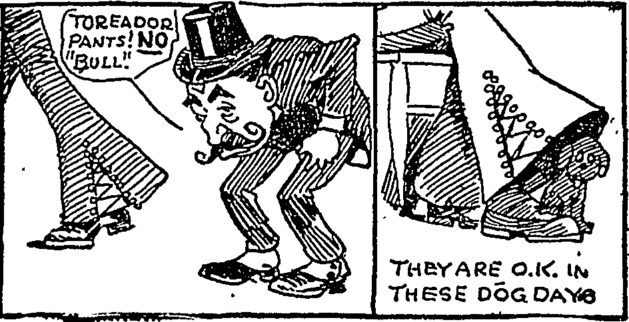
Figure 19. This cartoon of “toreador pants” was featured on the front page of the Los Angeles Times under the title, “Peon Pants Local Horror.”

A predecessor to the “Zoot Suit Riots” of 1943, the “Peon Pants” controversy of 1922 spiraled out of control when school administrators, the Los Angeles Times, and business owners attempted to eradicate the style. Many considered ornate bell-bottoms effeminate and when the trend spread to Anglo communities negative attacks in the press followed. Consequently, Arthur Evers of Burbank experienced discrimination when he showed up to the Venice Ballroom in his toreador trousers. The owner took offense to the speech, actions, dancing, and appearance of the youth in “Valentino panties,” kicking him out. Across high schools and universities fights erupted throughout the fall semester as youths in offending bell-bottoms were bullied, ostracized, stripped, and assaulted. Under threat by the Ku Klux Klan, a young boy pleaded for a permit to carry a gun. Eventually, the uproar subsided when large numbers of teenagers cut their hair and discarded their trousers. Henceforth, bell-bottoms remained associated with a youth counter culture, later revived in California in the 1960s. One exasperated journalist noted, “It represents a revolt against conventions, parents, history, physics and ethics. Youth is so radical.”
The “Peon Pants” controversy of 1922 reveals several interesting transnational cultural trends among Mexican communities on both sides of the border. In the 1920s, Hollywood, like the Wild West shows of previous generations, became a center for disseminating images of charros. These cinematic projections of “greasers” and bandidos had a profound effect on the cultural identification of Mexican communities. Influenced by these images, Mexican-American youth expressed a collective sense of identity by reproducing the costumes they saw onscreen, in a way, enacting the roles of bandidos themselves. Few ethnic Mexican actors were as popular as Leo Carrillo, a former Broadway comedian who specialized in elocution and impersonations. His brownface depictions were some of the most popular representations of Mexicans characters in the 1930s. Adored in the United States, his roles often raised the concern of Mexican diplomats, journalists, and politicians who called for the prohibition of his films. As a result, in the 1930s and into the 1940s Carrillo altered his portrayals to conform with the foreign policy initiatives of the Office of Inter-American Affairs (CIAA). Coinciding with the rise of the “charro cantor” (singing charros) in Mexico, this diplomatic strategy broadly transformed the depiction of ethnic Mexicans in Hollywood and more precisely altered portrayals of the charro. In line with this initiative and along with fellow Latino actors, Carrillo introduced new features that permanently changed representations of these characters in the United States. Stripped of menace and softened with charm, Hollywood bandidos dressed in charro suits completed their transformation from greasers to caballeros under his guidance. Henceforth, American cinematic charros became archetypes of good rather than evil. Like Vicente Oropeza and José Barrera, Leo Carrillo’s life paralleled the developments that spread the image of Mexican charros in American popular culture.

“Where the Wild West Meets the Ocean”
By 1928, Los Angeles sustained the largest Mexican population in the United States. Many, including some of the most renowned Mexican actors of the era such as Ramón Novarro, Dolores del Río, and Gilbert Roland, were northern Mexican refugees displaced by Pancho Villa’s forces during the Revolution (1911-1920). In the 1920s, the growing Mexican population in Los Angeles created evident social tensions as railroads brought increasing numbers from cities like San Antonio to labor in agricultural jobs and work in factories. Many within the growing barrios tried to retain aspects of their culture and resist Americanization. Additionally, starting in the 1910s through the 30s, southerners and midwesterners increasingly settled in California bringing Anglo-American culture. Increasingly outnumbered, backlashes against the Mexican community came in the form of deportations in the 1930s and urban unrest in the 1940s.
Despite attacks, Mexican culture experienced a renaissance in California during the 1920s. Economic exchange and tourism between Mexico and the United States normalized throughout the decade. The great Mexican muralists, Diego Rivera, Jose Clemente Orozco, and David Alfaro Siqueiros left their mark on the Golden State in the early 1930s. Perhaps more influential was Herbert Eugene Bolton’s “Spanish Myth” of the old Spanish borderlands that spread among academics and students at Berkeley. Through history, Bolton created a pastoral hispanocentric colonial past for California. He witnessed a similar effort in the restoration of the colonial missions and received support from Charles Fletcher Lummis. Renewing the aesthetic appeal of the colonial era coincided with attempts to revive the legends and narratives of old California. Thus, bell-bottomed chinacos reemerged as potent symbols alongside the adobe forms of the “Mission Revival” style.
The Golden Age of Hollywood occurred in the midst of this Mexican vogue. In the late 1910s, film producers migrated from the East Coast locations and places like the Pawnee Bill and 101 Ranch in Oklahoma to southern California. Initially, some of the earliest nickelodeon shorts from back east featured Wild West ropers, such as Edison Kinetoscope’s, Pedro Esquivel and Dionecio Gonzalez: Mexican Duel from 1894. With the birth of the western genre in the first decade of the twentieth century, film producers appropriated bandidos and greasers from characters in the Wild West Shows. Some of the early films that reinforced this association include, Broncho Billy and the Greasers (1914), The Greaser’s Revenge (1914), Scarlet Days (1919), and The Border Terror (1919). Eventually, Wild West show performers like Will Rogers and Tom Mix became movie stars featuring the styles and techniques of Mexican ropers, with Rogers attaining cinematic celebrity in the Roping Fool (1922). On the West Coast the film industry functioned like a factory, producing images for the mass consumption of the rest of the country and export abroad. Some of the first films set in bucolic California landscapes include The Girl of the Golden West (1923), Rose of the Golden West (1927), and a version of Helen Hunt Jackson’s romantic novella Ramona (1928). In Old Arizona (1929), the first sound western, sparked a series of romantic bandido movies such as, South of the Rio Grande (1932) with Buck Jones, The Texas Bad Man (1932) featuring Tom Mix, The Tia Juana Kid (1936) starring Patric Carlyle, and The Robin Hood of El Dorado (1936) portrayed by Warner Baxter. (Fig. 20)
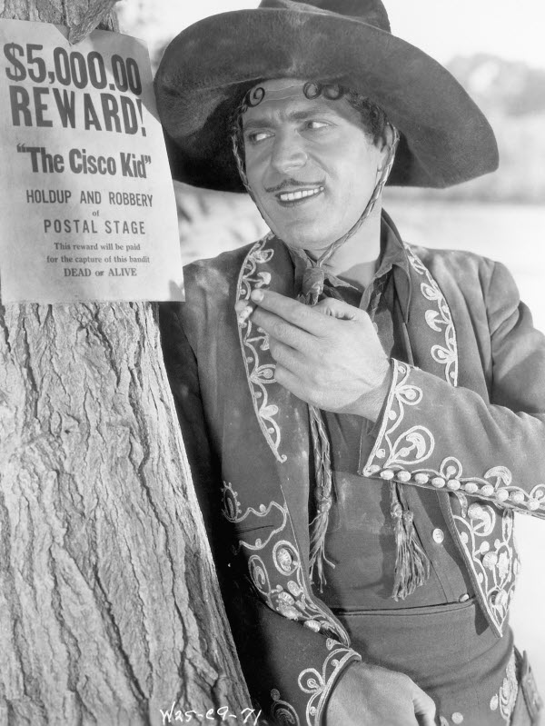
Figure 20. Warner Baxter wearing a charro suit as the Cisco Kid in the 1929 feature, In Old Arizona. This film, the first major sound western, sparked a series of romantic bandido movies and won Baxter an Academy Award for Best Actor.

In the late 1920s, the advent of sound changed the production and distribution of films in Hollywood. Audiences appeared to listen and heard “Mexican” actors speak, as they did, with horrible accents. As a countermeasure, and in conjunction with dubbing and subtitles, producers used Hispanic actors to attract Mexican and Latin-American moviegoers. Although the need for spoken Spanish and genuine accents created opportunities for a variety of ethnic Mexican actors in Hollywood, sound complicated the export of “talkies” south of the border, eventually leading to a rejection of American films. Many Latin Americans took offense with the jumbled Spanish of American productions and some countries such as Mexico and Argentina, initiated their own film industries as a response. The solution for Hollywood came in the form of a whole generation of crossover actors that include Ramón Novarro, Dolores Del Rio, Tito Guízar, Lupe Vélez, Gilbert Roland, and Pedro Armendáriz. Among them, the life and times of Leo Carrillo is indicative of the processes that sustained representations of charros across cinematic frontiers.

Mr. California
Leopoldo Carrillo was born in an old adobe overlooking the plaza of the pueblo of Los Angeles. Once the center of a ranching community, in 1880 the plaza served as the town’s vice district. In 1871, a massacre of Chinese residents unsettled the small neighborhood around the Calle de los negros or “Nigger Alley.” Leopoldo’s father, Juan José Carrillo, a former police chief, and mother, Francisca, raised the boy and his siblings in the surrounding streets. Later in life he claimed, “I suppose, looking back on it now, that I must have associated daily with the opium smokers, opium peddlers, and murderers.”
The Carrillo family fled the inner city when Leo was a young boy. Unlike most of the recent Mexican migrants who settled east of the Los Angeles River, they moved west to Santa Monica. Further back in their history, the Carrillo’s were among the first colonial settlers of Southern California, ranging between San Diego and Santa Barbara. In the 1830’s they vastly extended their landholdings and rose to the heights of political power serving the new republic of Mexico. Leo’s great-grandfather included a governor and a great-uncle who led the resistance of local chinaco lanceros (lancers) against the American invaders. The war between Mexico and the United States split the family along generational divides. Fiercely patriotic, Carrillo’s forefathers waved different flags with his grandfather embracing American nationality in the same manner that his great grandfather embraced Mexican citizenship upon independence from Spain.
As a child, Leo played among the alisos (sycamores) and arroyos (streams) of his uncle’s ranch. With the aid of lassos, his father, uncle, and brothers rounded up cattle and sheep in addition to hunting rabbits, quail, and mountain lions. As the city spread around him, the young man saw thousands of memories paved over. Selling off their lands to developers due to misfortune, the Carrillos were reduced to wage labor in the 1890s. In Santa Monica, they moved into a house adjoining a saloon and took in boarders. Francisca clothed her children in flower-sack underwear and fed them with the catch they collected off the pier. Sleeping on a hammock and running around barefoot, Leo filled his belly with fish tacos and frijoles. Looking back in amazement, he claimed, “We kids never knew how poor we were.”
Fleeing a struggling household, Leo left home at sixteen. After working as a translator for Chinese workers employed by the Southern Pacific Railroad, Carrillo settled in San Francisco, a city that seemed cosmopolitan, and enrolled in art school. Growing despondent as his savings dwindled, he eventually gained employment as a cartoonist for the San Francisco Examiner. Between steady jobs and rounds at local bars, Carrillo developed a talent for improvisational acting. He joked, “If I wasn’t an actor I might be selling tamales in the Plaza at Los Angeles.”
In San Francisco, Carrillo created a stage routine base on comedic impersonations and monologues. He was an elocutionist, adept at accents, and he impersonated Italians, Chinese, and Mexicans in his “dialect stories.” Encouraged by friends and family Carrillo took his ethnic humor to stages in Los Angeles, Chicago, and eventually New York in 1913. On the East Coast he took vaudeville by storm before appearing on Broadway and eventually reaching the heights of celebrity as one of the most popular stage satirists of the 1920s. Although colored in “grease paint,” Carrillo was a pioneer of Mexican stand-up comedy and like black actors in a minstrel show, the celebrated comedian prospered within the confines of his ethnic humor.
Despite ethnic divides, Carrillo initiated a close friendship with Will Rogers, a fellow vaudeville actor and stage-roper from Oklahoma. They shared a love for Mexican roping and riding and both of their careers were marked by portrayals of vaqueros and charros. Both comics projected a public image based on their Western roots, Rogers as Oklahoma’s “Cherokee Kid” and Carrillo as California’s “Son of the Dons.” Undoubtedly, their affinity for the trappings of a Western aesthetic brought them together. The cowboy and the caballero were heirs to the legacy of Wild West show performance left by Vicente Oropeza and José Barrera. Of all the performers featured in this study, Will Rogers enjoyed the closest friendship with Leo Carrillo and in the mid-1920s, both bought acreage in Santa Monica Canyon. Earning their fortunes, the actors settled down to raising their families, pursuing their careers in cinema, and participating in Sunday polo matches. Growing wealthy, perhaps Carrillo felt as though he recovered his forefather’s former glory.
In the late 1920s, the advent of sound cinema created a new medium for Carrillo to apply his vocal talents. Returning to Los Angles amid a revival of colonial architecture, the craze for Spanish styles was evident everywhere. In 1926, civic elites initiated efforts to preserve the old plaza at Olvera Street, Carrillo’s birthplace. After removing undesirable Mexicans, Chinese, and a few Communists, La Placita opened in 1930, attracting non-Hispanic tourists. This sanitized “heritage site” referenced a romantic vision of “Old Mexico” populated by “good” Mexicans. The consumer fantasy was far removed from the realities of Mexican communities and the social tensions associated with them.
Understandably, Carrillo supported efforts to preserve what he perceived as his family legacy. In 1924 he pleaded,
I have a message for the people of California. Protect the old Spanish houses that are left; keep the Spanish names of streets and towns. Don’t change them for new fangled, high-sounding names. These old names all have meanings. They are landmarks, just as the adobe houses and the old missions are landmarks in the history of the State. It cuts me to the heart every time I see a workman dig a pick into an adobe wall.

With this in mind, Carrillo built a colonial style adobe on acreage he purchased in the 20s. Although he claimed to build it for his wife Edith and adopted daughter Antoinette, Los Elisos, was custom made to Leo’s tastes. A portrait of an ancestor hung in each room and the beamed ceilings with beehive chimneys were reproduced from childhood memories. He regularly entertained guests, such as Will Rogers, on his patio. Not content with this reproduction, Carrillo purchased a real colonial era adobe ranch house in 1937. Nestled in the coastal foothills of Northern San Diego County, near the town of Carlsbad, the actor restored a century-old ranch and renamed it Rancho Los Quiotes, or Ranch of the Spanish Daggers, named after the prolific yucca plants that surrounded the estate where lavish Hollywood parties took place. For Carrillo, this project served as a means to live out his pastoral fantasy, the “Spanish Myth” he created for himself. (Fig. 21)
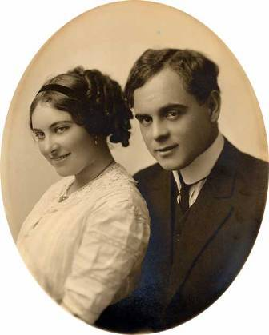

Figure 21. Leo and Edith Carrillo shortly after they met and married on the East Coast. This was during Leo’s heyday as one of the most popular stage comics on Broadway

Maintaining a decorative theme in his homes, the clothes Carrillo wore reveal much about the California aesthetic that pervaded the Golden Era of Hollywood. In 1930, Carrillo drew a caricature of himself wearing bell-bottoms but, onscreen, he preferred a costume with straight leg trousers, elaborately embroidered shirts, and thick leather wristbands. Like Gilbert Roland who rarely wore a bolero top because plain white shirts appeared better on black and white film, Carrillo rarely donned a charro jacket. Stitched in Hollywood, these “caballero costumes,” directly descended from the outfits of Wild West show performers. Some had shoulder epaulets derived from bullfighters that once brought equestrian acts from Mexico. Among a variety of costumes, this style of suit appeared in parades and civic “fiestas” held across towns and cities in California. Equestrian groups such as Los Rancheros Visitadores (Visiting Ranchers), Los Caballeros Amarillos (Yellow Cavaliers), Los Caballeros Rojos (Red Cavaliers), and Las Hijas de California (Daughters of California) helped popularize the state’s fantasy heritage by tailoring velvet costumes to ride in these pageants.
Wearing a wide-brimmed sombrero, heirloom spurs, and riding atop a decorated Mexican saddle, Carrillo rarely missed an opportunity to join such processions. A friend once famously teased, “If an Eskimo funeral passed Leo’s house, he’d rush out to lead it.” As a founding member of Los Rancheros Visitadores, Carrillo took part in an annual trek from the town of Santa Barbara over mountain passes to the Mission at Santa Ynez. Taking pleasure in his role as parade leader, Carrillo roared with laughter and called everyone “brother” as the raucous party made up of friends like Will Rogers and members of the Bohemia Grove Club drank champagne as they rode.
The program for Santa Barbara’s Spanish Days Festival included historical dramas, roving musicians, a banquet, and parade with floats. Organizers of the first festival secured horses, riders, and costumes from Hollywood studios. The señoritas wore flamenco dresses and china poblana costumes while many of the caballeros wore costumes inspired by colonial chinacos and Wild West performers. In 1937, before leading these festivities as master of ceremonies, Carrillo served as Grand Marshall at the forty-ninth Tournament of Roses parade in Pasadena.
While authorities restricted many traditional Mexican amusements such as the bullfights and cockfights, some sanctioned civic celebrations, such as the “fiestas,” and parades incorporated less violent equestrian acts. Events such as the jaripeo, bareback riding, and manganeo horse catching were paired with “wild cow milking.” Carrillo was a skilled rider who learned to appreciate horses as a child. In his biography, he remembered that members of the Freeman and Machado families taught him about the cala de caballo (horse test) and “picking-up.” Into his mid-fifties, the actor continued to perform his own equestrian stunts. At Los Quiotes, he invited friends to calf-branding “parties” where inebriated revelers played vaqueros, awkwardly handling lassos. Carrillo regularly participated in rodeo events and while living on the East Coast, he organized a Wild West show, playing a posse member alongside Will Rogers in a “horse thief” skit. He commissioned an equestrian portrait with his prized Sun Sui, representing his horse poised on hind legs and kicking excitedly into the air, with Carrillo calmly riding atop in a trick he performed at parades. Carrillo had a profound love for equestrian culture and when the Palomino horse craze spread throughout the Southwest, he secured a colt that he named Conquistador. The horse held a special place in his heart and, according to legend, when Conquistador died, Carrillo supposedly buried him at Los Quiotes and erected a giant white cross over his grave.
As a result of his many parade appearances, Carrillo gained a reputation as “Mr. California.” Additionally, his celebrity received support from speaking engagements at various civic affairs. Famous throughout the state, and following in the footsteps of his forefathers, the actor decided to run for governor in 1938 and 1940. Although encouraged by friends, he failed to gain popular support in the packed primary races. Likely, his career as a comedian dissuaded serious support and probably led to his enrollment in political science courses at the University of Southern California. Undeterred, he served as campaign manager for the Republican candidates, Earl Warren. Warren, a good friend, appointed Carrillo to the Parks and Recreation Board and eventually chose him to lead an investigation into the Zoot Suit Riots. Carrillo’s thoughts on desegregation are unknown but he certainly tired of the complications surrounding integration. The actor was a Democrat in the manner of the early Ronald Reagan and also participated in the blacklisting of alleged communists in Hollywood, likely denouncing Dolores del Río and destroying her career in the United States. (Fig. 22)
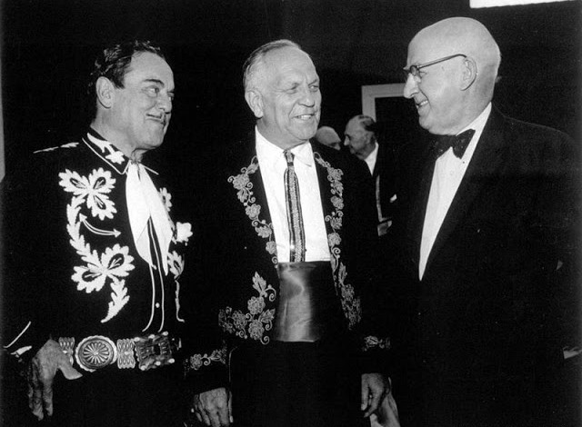
Figure 22. Leo Carrillo with Governor Goodwin Knight and Raymond Moley sometime in the mid-1950s. Note Carrillo’s uniquely embroidered shirt and Gov. Knight’s Spanish style bolero jacket used to promote California’s Fantasy Heritage.

From Bandido to Caballero
In the 1930s, actors like Leo Carrillo and equestrian groups like the Rancheros Visitadores attempted to counter negative portrayals of Hispanics. In southern California, outlaws such as Joaquín Murieta, Tiburcio Vásquez, and Juan Flores personified the bandido image in the last half of the nineteenth century. Additionally, in the late nineteenth and early twentieth century, portrayals of Mexicans in Wild West shows reinforced negative stereotypes that identified them as drunkards, violent, and effeminate. As alluded to earlier, anti-Mexican sentiments also persisted with a series of “greasers” films produced in the 1910s.
The reinvention of cinematic bandidos required a concerted initiative by ethnic Mexican actors and producers. However, besides their goodwill, Hollywood’s main challenge in the negative representation of Mexicans came from films across the border. Unlike Hollywood, the cinematic charro of Mexico is firmly rooted in the style and imagery of the bullfights. In the summer of 1897, Ponciano Díaz became one of the first subjects of the new medium. A few decades later, as Revolution raged across Mexico, theaters packed the house with bullfighting marathons. Partially due to a prohibition in the capital reinstated by Venustiano Carranza, corridas (bullfights) became a favored subject in film and Rodolfo Gaona, the famous torero, served as Mexico’s first cinema celebrity. As in the United States, documentary reels of Mexican equestrian acts with finely dressed charros were also featured at movie houses.
Although newsreels of bullfights were popular, Mexican cinema was unable to keep pace with Hollywood. Limiting factors included costs, training, and technology. However, journalists and cineastes expressed optimism concerning the future of the Mexican motion picture industry. Carlos Noriega Hope, sometimes known as Silvestre Bonnard, a screenwriter and journalist, wrote that the first successful Mexican film to attain international success would, “bring incalculable benefits to the government and people of Mexico.” He believed there was an “absolute and dense” ignorance concerning Mexico abroad and blamed Hollywood productions that, “appear like California apples. They make you hungry, look good, wrapped up in flimsy colored paper. But have no taste!” According to him, American films about Mexico mainly featured bandidos, miserable Indians, and little adobe homes. In a diatribe, he railed against unoriginal and formulaic films with no argument that depended upon love triangles, violence, and happy endings. For Noriega Hope, Hollywood studios made good stories into bad films so that only one in a hundred was acceptable.
In addition to newsreels of bullfighters and Rurales on parade, the charro archetype became a favored subject in feature-length narratives during the first half of the 1920s. Primarily used as a means to counter negative representations in Hollywood, the charro in Mexican cinema supported “revolutionary nationalism” promoted by the state and meant to encourage tourism. In the summer of 1920, Partido Ganada, (Match Win), became the first Mexican silent movie to star a charro in a primitive story about violence, cockfights, jarabes (stomp dance), and mariachis. Reassembled in various combinations, these types of scenes had a profound influence on subsequent charro films. That fall, and adaptation of Ignacio Manuel Altamirano’s El Zarco (The Blue Eyed Bandit) introduced another fundamental element of the genre; as in the novel, the protagonist acted as the leader in a gang of bandits from the region of Yuatepec, Morelos. One of the most anticipated and significant films was released the following summer. El Caporal (Bossman) by Miguel Contreras Torres, a pioneer of Mexican cinema and founder of the charro genre, introduced the backdrop of a Porfirian hacienda in a bucolic setting. Advertised as “a truly Mexican production” and “the most accurate reproduction of the national soul” Contreras Torres played Nicolás, a rancher. Filmed on location in Uruapán and Morelos, it romanticized haciendas and the pre-Revolutionary social order.
By 1923 film production in Mexico declined due to the onslaught of American films and the oversaturation of charro features. The genre was exhausted as demonstrated by El Fantasma del Ranchero (Ghost of the Rancher) a film from 1924 prohibited from exhibition in Mexico and abroad by the Ministry of the Interior. Resembling the bandido character popularized in American cinema, the “ranchero,” a cowardly thief, attempts to rape a woman only to suffer defeat by an Anglo. For the remainder of the 1920s, Mexican cinema and the charro genre lay dormant, only to be revived by the advent of sound. Besides a few critically acclaimed productions, Mexican audiences continued to prefer American characters over national archetypes.
Concerned with correcting demeaning representations of Mexicans in American films, President Álvaro Obregón created the Department of Cinematic Censure in 1920. A scene in which Gloria Swanson is nearly raped by a group of Mexicans in Her Husband’s Trade Mark (1921) initiated the first prohibition by Mexican authorities. This was followed by a ban on Golden Dreams and Rio Grande in 1922 and El Niño Fidencio (Fidencio the Child Saint) in 1928. Especially upset by “films of squalor” coming from the United States, the Mexican government attempted to ban all films that portrayed Mexicans as villains but this proved unenforceable. Instead, the deletion of offending scenes rendered many American films suitable for national viewing. However, the limited reach of the Department of Cinematic Censure was bound by national boundaries, negative films about Mexico endured with distribution abroad from the United States.
Initially, Mexican film producers and the national government were unable to counter the importation of American features during the first half of the 1930s. However, the adoption of sound technologies, training abroad, state funding, and an industrial studio system paid off in the second half. Following the production of the first Mexican “talkie” in 1931, Mano a Mano (Hand to Hand) directed by Arcady Boytler, introduced the sound era charro in 1932. The film centered on a love triangle with scenes of a cantina, jaripeo, bullfight, shoot-out, and Lorenzo Barcelata with the Trovadores Tamaulipecos singing las mañanitas. The following year, Fernando de Fuentes released El Tigre de Yuatepec (Tiger of Yuatepec) to much fanfare. Starring Pepe Ortiz, the popular bullfighter, as “El Tigre,” the leader of a gang of singing bandits. Although he robs a stagecoach, and kidnaps passengers, El Tigre, dressed in a chinaco suit, is a good bandit who falls in love with Dolores, played by Lupita Gallardo. Every day for two weeks before its premiere, El Universal, one of the principal dailies in Mexico City, featured a story on the main characters. Despite all the anticipation, attendance by foreign dignitaries at the premiere, and the curiosity of Cecil B. de Mille, the formula for international success continued to elude producers.
After weak enthusiasm for El Tigre de Yuatepec, Allá en el Rancho Grande, (Over at the Big Ranch) took everyone by surprise in 1936. The film by Fernando de Fuentes stars Tito Guízar, a Hollywood trained actor, as José Francisco a caporal boss man on the hacienda of his childhood friend, Don Felipe, played by René Cardona. Once again the audience is treated to a love story with scenes of a jarabe and cockfight, followed by a singing duel that angers José Francisco and leads to conflict with Don Felipe Perhaps its popularity over El Tigre de Yuatepec hinges on the setting in a not so distant past and the exaltation of an idealized Porfirian social order. The film lasted one week at box offices before it was sent to theaters across Latin America, where it proved to be a blockbuster and Mexico’s first international hit. Stunned and intrigued, producers returned the film to screens in Mexico where it made nearly 600,000 pesos in one month. For the first time, producers added English subtitles and exported reels to the Unites States.
As a result, Allá en el Rancho Grande launched industrial cinema in Mexico, standardized the highly reproduced genre of the “comedia ranchera” (ranch comedy) and firmly established the “charro cantor” (singing charro) as a pop culture icon. By the mid-1930s Mexico made an average of twenty films a year. Heeding the call of journalists, President Lázaro Cárdenas gave government support to producers through tax exemptions, loans, and regulations that required theaters to show Mexican films. By 1938 cinema was the second largest industry in the country. Increasingly, Hollywood studios invested in Mexican productions, hiring local talent, providing technical training, and facilitating the distribution of films. By the mid-1940s movie theaters in New York, Los Angeles, San Antonio, and Chicago featured Mexican productions. Reversing cultural trends, the comedia ranchera gained currency in the export market with the cinematic charro functioning like a prime commodity.
Domestically, the comedia ranchera supported the “revolutionary nationalism” initiated by the state. Although introduced during a time of increasing modernization and leftist politics the comedia ranchera reflected the rising influence of reactionary politics in the 1930s. It envisaged a nostalgic pre-revolutionary rural society centered on the hacienda, idyllic landscapes, and happy people. The genre reinforced patriarchal social structures, celebrated the macho, and upheld the Catholic faith. Fernando de Fuentes reinvented Hollywood’s bandido as a singing charro that is quintessentially good and wholesome. This genre fulfilled an escapist fantasy for those alienated and confused by the process of modernization.
Allá en el Rancho Grande generated the “ola ranchera” (ranchero wave) that swept up Mexican cinema during the Golden Age. Films such as Adiós Nicanor (Farewell Nicanor) with Emilio Fernández, Jalisco Nunca Pierde (Jalisco Never Loses) by Chano Urueta, En Rancho Alegre (At Happy Ranch) by Rolando Aguilar, and the Charro Negro (Black Charro) series with Raúl de Anda followed. (Fig. 23)
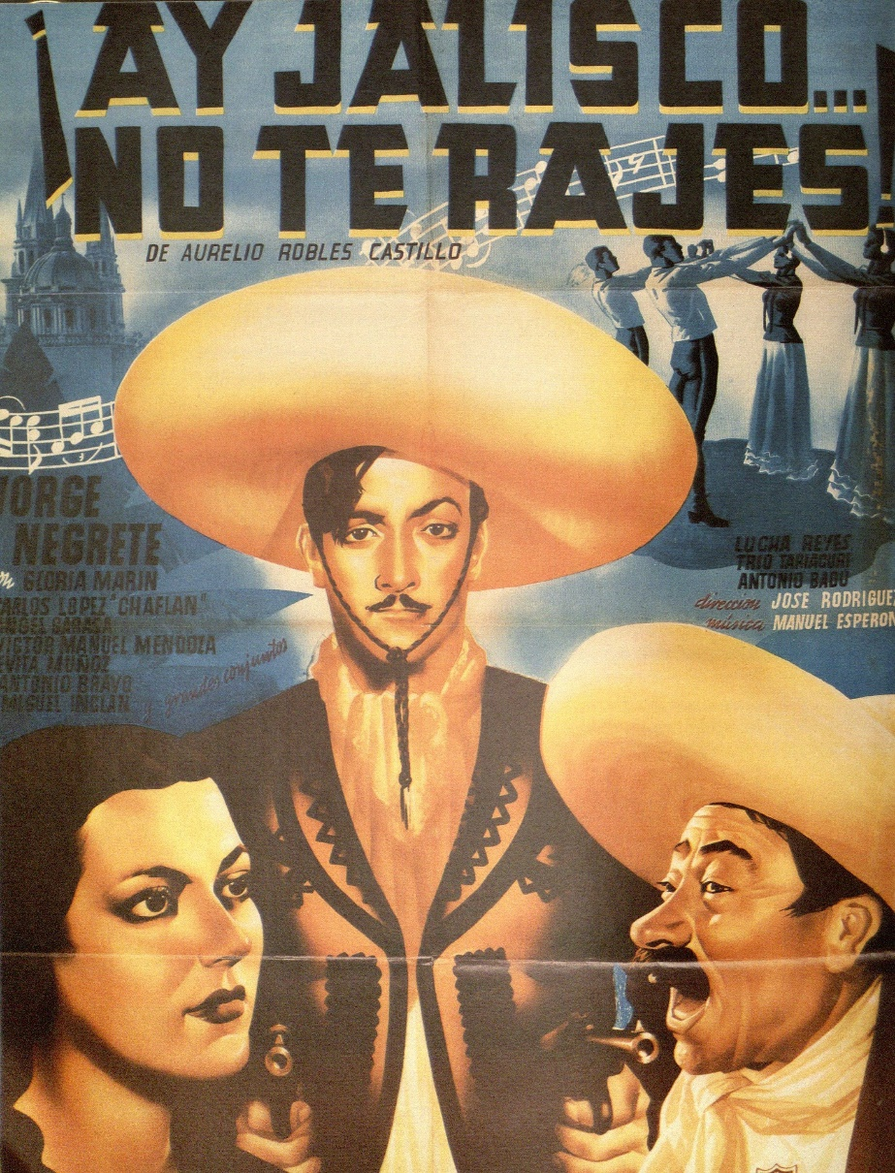
Figure 23. Jorge Negrete as “El Ametralladora” in ¡Ay Jalisco no te rajes! (Hey Jalisco Don’t Cut Out!). This was his breakout role and firmly established him as Mexico’s premiere cinematic charro cantor in the 1940s and 50s.

Despite his wholesome good looks, Tito Guízar failed to gain popularity and the task of personifying the epic and tragic figure of the “charro macho” fell to Jorge Negrete, the “first national hero.” Although he appeared in several low budget productions, ¡Ay Jalisco No Te Rajes! (Hey Jalisco Don’t Cut Out!) was the opera singer’s breakout role in 1941. The film revolves around El Ametralladora (The Machine Gunner), a charro who is quick with a gun and seeks vengeance for the slaying of his family. Aloof and cocky, Negrete’s reign as Mexico’s charro cantor completed the opposing characteristics that make up Mexico’s cinematic archetype. More complex than the foppish bandidos perpetuated by Hollywood producers, Mexico’s charro cantor holds both good and band tendencies. Like Negrete portrayed and actor/director Emilio “El Indio” Fernández repeated, the charro macho could kill, cause havoc, and also romance a girl, serenading her with a mariachi as she swooned by her balcony. This figure had a precedent in literary bandits like Juan Robreño in Manuel Payno’s Los Bandidos de Río Frío (The Bandits of Cold River) and El Zarco (The Blue Eyed Bandit) by Ignacio Altamirano.
Despite the success of Mexico’s film industry, the Department of Cinematic Censure continued to protest and ban offensive American films into the 1930s. One of the greatest controversies surrounded Viva Villa, an MGM release from 1934. Filmed in Chihuahua, and including Leo Carrillo in the cast, a journalist claimed that it made Mexicans look like criminals and served only as “an instrument for yanqui cinematographers that splatter Mexico with mud.” Before the film left the country to be edited in Hollywood, journalists called for the seizure of the rolls at the border. Many rejoiced when the Panamerican plane carrying some of the negatives went down in flames near El Paso. This controversy followed a ban on The Girl of the Rio in 1932 in which Carrillo played Señor Tostado, a violent and greedy character who attempts to blackmail a young woman, portrayed by Dolores del Río. The Mexican government also objected when he reprised the same role in a 1939 remake titled, The Girl and the Gambler. Between 1937 and 1939, Mexico censored twenty American films and banned four.
The uproar was so detrimental to U.S.-Mexican relations that in 1940, President Franklin Roosevelt appointed Nelson Rockefeller as Coordinator of Inter-American Affairs (CIAA) to deal with these issues. Preparing for war, the Roosevelt administration attempted to foster hemispheric unity and advance Pan-Americanism by strengthening cultural exchange with Latin American nations. Sending raw film stock and equipment to allies, the major American studios supported the development of industrial cinema in Mexico. Besides providing training, technology, and film, the CIAA also encouraged Hollywood stars to travel to Latin America. After Douglas Fairbanks offended his hosts, Hispanic stars such as Duncan Renaldo, Caesar Romero, and Leo Carrillo joined the ranks of goodwill ambassadors. One of the most notable achievements of this partnership came in the form of animated features by Walt Disney. After arranging a tour of Latin America with the help of the CIAA, animators traveled to Mexico City, stopping at Rancho del Charro, the national arena for the exhibition of charrería rodeo. A narrator noted, “the gentlemen riders of Mexico,”
These business and professional men ride to their charro clubs on Sunday dressed in the costumes of old Mexico and here they preserve the traditions of Mexico in sports and feats of horsemanship.

In Saludos Amigos (1943) and The Three Caballeros (1945), Disney featured “Panchito” the Rooster, a gun toting charro who gives Donald Duck a tour of South America. Flying on a magic serape they first travel to Patzcuaro before heading to Veracruz, then Acapulco and finally Mexico City, coming to a close with a psychedelic jarabe with a charra dressed in costume reminiscent of the Wild West shows.
Maintaining partnerships initiated in the late 1930s, Good Neighbor policies strengthened cooperation between film producers and authorities on both sides of the border in addition to significantly altering representations of charros in the United States. Nelson Rockefeller stated that the objective of the CIAA was, “to remove and correct sources of irritation and misunderstanding arising in this country – as when our motion pictures burlesque Central and South American characters.” As a consequence, Hollywood film producers attempted to adapt positive representations of singing charros, originally exported from Mexico.
Perhaps the person who did the most to alter the bandido image to fit this objective was Duncan Renaldo, a Spanish born star of the early talkies. When President Roosevelt grew concerned with the friction caused by the cinema industry, he pardoned Renaldo from a sentence for immigration violations and sent him to Mexico City to meet with representatives of the CIAA. There he pitched an idea to save the faltering Cisco Kid film franchise by reinventing the character as Miguel de Cervantes’s Don Quixote, fighting on the side of justice without resorting to violence. Like Renaldo, Carrillo also introduced enduring elements that changed representations of Mexican characters, especially bandidos in the United States. Carrillo’s childlike buffoonery endeared the bandido character to a whole new generation. Stripped of menace and softened with charm, Hollywood bandidos dressed in charro suits completed their transformation to caballeros under Carrillo’s guidance. (Fig. 24)
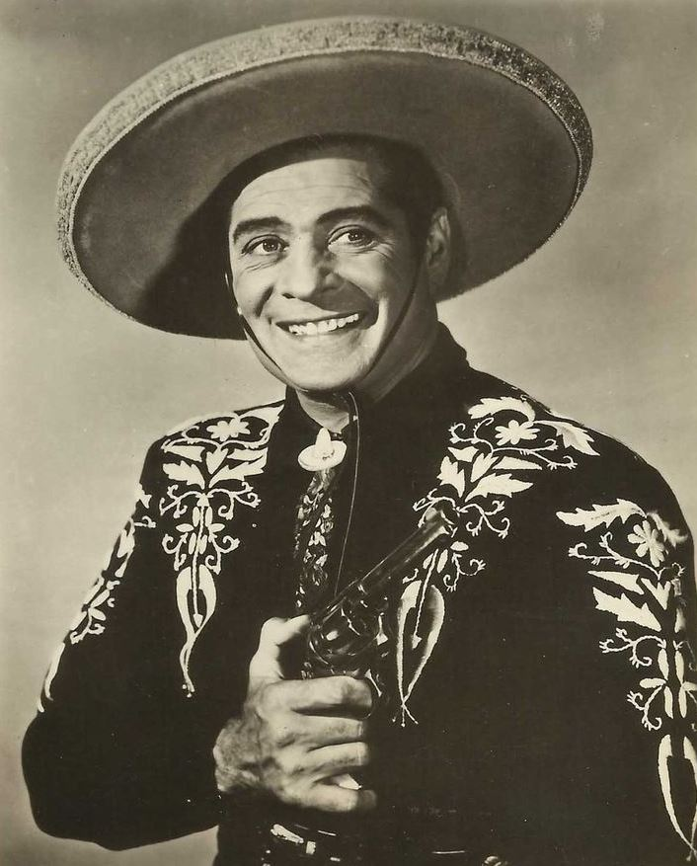
Figure 24. Duncan Renaldo, the stage name for Renault Renaldo Duncan, a Spanish born actor who reinvented the failing Cisco Kid film series and masterminded the transition to television. Once considered a “new Valentino,” Renaldo created one of the most positive and popular portrayals of Mexican charros in Hollywood.

Carrillos permanently established himself as a cinema actor in 1931 with the release of Lasca of the Rio Grande, “riding over the same hills that his grandfather rode, wearing the same sash and blouse of the brave ‘dons’ of their time.” He reprised similar roles as a bandido in Girl of the Rio (1932), Viva Villa! (1934), La Fiesta de Santa Barbara (1935), The Gay Desperado (1936), Girl of the Golden West (1938), The Girl and the Gambler (1939), and Riders of Death Valley (1941). However, in the mid-1930s a fundamental shift occurred in Carrillo’s portrayal of Mexican characters. The Gay Desperado, a musical comedy set along the border, stars Carrillo as the bandit leader Pablo Braganza. In the film, which opens with an audience watching a movie, Braganza loudly encourages his henchmen to act like the violent Italian mobsters onscreen, causing a riot when a free-for-all fist fight breaks out. Over the course of the film, Braganza kidnaps several foreigners, holding them ransom and threatening those who oppose him. Eventually, he grows tired of acting like a boorish criminal and declares his plan was a mistake. Prancing and maneuvering his horse before riding off into the saguaro desert, Braganza frees his captives. The Gay Desperado, released in 1936, brought together Carrillo’s dual film roles as Mexican bandido and Italian gangster. However, the resolution of the feature hinges on the rupture of these two characters. Henceforth, Carrillo’s filmic bandidos were usually friendly and clownish miscreants. None was as phenomenally popular as the rascally “Pancho” of the Cisco Kid serials.

“The Cisco Kid was a friend of mine”
Created by O.Henry, the Cisco Kid is a dangerous bandido, the anti-hero of The Caballero’s Way (1907), who gradually transformed through cinematic interpretations by a variety of actors. Most notable is Gilbert Roland and Duncan Renaldo who redefined the character as a protagonist on the side of the law who did not drink, smoke, or curse. Diplomatic initiatives between Mexico and the United States improved portrayals of Mexicans north of the border and restrained the Cisco Kid’s negative traits. Reluctant to take on another controversial role, Carrillo agreed to play “Pancho”, Cisco’s sidekick, after Duncan Renaldo made a comparison to Sancho Panza from Don Quixote and explained the commitment to non-violence.
An academic of cinema in Latin America notes that the Cisco Kid and Zorro essentially replaced bandidos in American westerns. In 1951, the Cisco Kid film series took on new dimensions as it transitioned to television and became one of the most successful children’s programs of the 1950s. In his seventies, Carrillo enjoyed more fame than ever, touring the country with Renaldo and making appearances at state and country fairs, exhibitions, civic celebrations, grand openings, parades, rodeos, and music festivals. (Fig. 25)
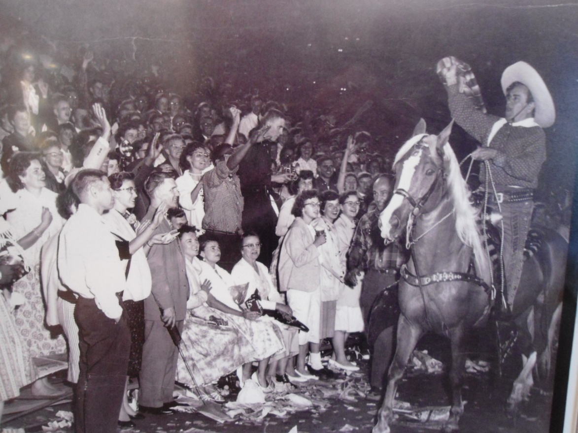
Figure 25. Leo Carrillo at the Chicago Tribune Music Festival at Soldier Field, with 78,000 people in attendance.

He was extremely popular with children and once stated,
It is a wonderful experience; nothing I have done has given me greater satisfaction. It’s worth it to stand for hours giving out pictures to kids. You see the love in their eyes for the character of Pancho. They want to hug and kiss you.

For example, at the Utah State Fair in 1955, 51,000 people attended their appearance with 30,000 photographs distributed to the crowd. Recalling the vaqueros in the Wild West shows, Duncan Renaldo joined the Clyde Beatty circus in 1957, touring with them seven months of the year.
After the television show came to an end in 1955, Carrillo officially retired from cinema in 1959, at the age of seventy nine. That summer he held “a genuine Mexican barbecue” at Los Quiotes, with a mariachi, roasted meats, frijoles, tamales, beer, and tequila. An acquaintance did some trick roping and a few other acts followed that evening. Long after midnight, the fog rolled in mixing with the odor of damp eucalyptus and the smell of burning wood. This was one of the last parties hosted at the ranch; Carrillo’s health was in poor condition. In the summer of 1961 doctors ordered him to stay in bed and confined him to his home in Santa Monica. Recovering in August, his health declined again in September. Surrounded by Antoinette and his brother Ottie, Carrillo died of cancer on Sunday, September 10, 1961. Although he completed his biography, The California I Love, earlier that year he did not live to see a published copy. At the next Tournament of Roses, Antoinette rode a Palomino in her father’s place behind the Santa Monica float, an eleven foot figure of “Mr. California” riding Conquistador.
Throughout his career, Carrillo generated controversy but his death allowed a thorough discrediting of his legacy by a new generation of Chicano scholars. Carey McWilliams, activist, author, and historian, criticized Carrillo in Southern California: An Island on the Land (1946), and North of Mexico (1948). McWilliams denounced Santa Barbara’s Spanish Days celebrations as “pathetic” and cast doubt on Carrillo’s identification with Mexicans. Other scholars joined by targeting the Cisco Kid radio program, claiming that children who played and repeated the mispronunciations conjured negative stereotypes of Mexican-Americans. Additionally, for the children who grew up watching him on television in the 1950s, Pancho was a favorite character. Understandably, when they grew up and realized he was not real, that his plastic surgery hid an ailing body, they were disappointed.
Like many Mexican-Americans of his generation, Carrillo rejected his Mexican ethnicity in preference of a Spanish personae in order to whiten himself before Anglo audiences. Despite his repeated casting as a bandido, Carrillo’s complex views concerning his own identity merit consideration. Like José Barrera, he rejected his Mexican culture to claim a Spanish heritage. Carrillo’s views concerning his invented heritage reflect contemporary views held by many Mexican-Americans. It was common for that generation to claim Spanish identity as a means of deflecting discrimination. Charles Bukowski noted,
Half the Mexicans I have worked with in factories have claimed they were born in Spain. It’s an act; Spain is the father, the ace-bullfighter, the Big Dream of old.

Regardless of their fantasies, this generation of old Californios, including Luis Ortega and members of the López family, rejected their Mexican identity and mixed mestizo heritage. A previous biographer shrewdly noted, this reinvention served Carrillo’s “pressing need to sublimate his Mexican/mestizo identity during an era in which anti-Mexican bigotry pervades social institutions.”
Like Gilbert Roland and Lupe Vélez, Carrillo subverted roles and countered negative representations of Mexican-Americans, often turning demeaning roles into parodic performances. Thus, “bad” bandidos often took on the qualities of good or clever Mexicans. In his most renowned acting role as Pancho, Carrillo embedded coded messages for Mexican audiences that understood his Spanglish “Panchoisms,” such as “lezwent.” By speaking pidgin English, and saying “tortillas y frijoles con queso” like someone who truly ate it for breakfast, Carrillo endeared himself to Mexican-American audiences that recognized the subtleties of his humor. In The Gay Amigo (1949), Cisco, played by Duncan Renaldo, and Pancho, Leo Carrillo, ride along the international boundary line and ponder,
Pancho: You know Cisco, there is something I don’t
understand something about.

Cisco: What is the trouble now Pancho?

Pancho: This rock. This rock say this is the
borderline between the United States and
Mexico. Borderline. I look all over! I don’t
see no line!

Cisco: Pancho, sometimes the things you do not see are
more than the things you do see.

In this exchange, Carrillo assimilates the landscape around him, essentially suggesting that Mexico and the United States exist as one place. For Mexican-American children watching this on television in the 1950s, their own path towards cultural assimilation may have been validated through such scenes.
Similarly, Gilbert Roland, playing the Cisco Kid in Riding the California Trail (1947), sits down at a cantina, after his obligatory shot of tequila, and orders a plate of beans. Confused that he did not choose from the savory Mexican dishes on the menu, the bar tender retorts, “beans!?” In this scene, Cisco’s proud identification with his Mexican identity is related through a preference for frijoles. Additionally, it is difficult not to indulge in a fantasy of role reversal when Pancho barks, “ándale,” punching or pointing a gun at an Anglo villain as he swaggers with self-confident pride. Misunderstood for over half a century, Carrillo’s acute sense of history and cultural identification is conveyed in “The Footprints of the Padres,” published in The California I Love,
Then you crowded all around us
inch by inch you hemmed us in.
Till we’d scarcely room to breathe in
it really seemed a sin.
Then you took away our señoritas
see the answer is quite plain:
Now the children of the daughter
whose grandad’s blood was Latin
Are scattered from Point Loma
clear back to Manhattan
It’s just a simple story
from your amigo in the West
I couldn’t help a telling you
just to get it off my chest
Damne Yanquis!

In this poem, Carrillo essentially suggests that the pastoral ideal his family enjoyed before the invasion of “Damne Yanquis” was preferable to being “hemmed in” and “crowded,” with a corresponding dispersal from his homeland and a dilution of ethnic traits.
Mexican-Americans who watched Carrillo on the big screen and television undoubtedly also repressed their ethnicity when confronted with institutionalized discrimination. Thus, Mexican-American youths facing off against school administrators, newspapers, business owners, and hate groups learned that bell-bottomed corduroys with laces and silk were not cool. This generation of teenagers grew up seeing Carrillo, one of their own, reach the heights of celebrity. They became familiar with him and perceived his comedic parodies within the confines of their own limitations. Undoubtedly, the youth of Boyle Heights saw themselves reflected in his act and may have felt pride that one of their own represented them onscreen.

“Goodbye amigos!”
Exploring the history of Mexican-American communities across borders allows a greater understanding of the formation of the charro archetypes in the national cinema of both Mexico and the United States. The majority of studies of the cinematic charro are limited by national boundaries, and in the United States, overemphasize representations of bandidos and the Cisco Kid, in the process overstating Hobsbawm’s social bandit thesis. Additionally, in Mexico associations of the character with revolutionaries ignores the historic influence of Wild West performers north of the border in creating the cinematic image. A transnational framework allows a broader perspective of the cultural differences contested across national boundaries. Focusing on Carrillo’s career permits a careful investigation of the trends that facilitated the reproduction of cinematic bandidos and caballeros between the 1920s and 1950s.
Through his acting, Carrillo placed himself at the center of a transnational cultural debate regarding representations of Mexicans, partially conveyed via his sombrero and trousers. With a long career in Hollywood, his credits span the cinematic charro’s trajectory from “bad” to “good” archetypes. Fittingly, he titled the last section of his memoir, “Reincarnation of the Caballero.” After his death, self-reflective Chicano critics claimed Carrillo portrayed imbecilic characters that exaggerated Mexican speech and manners. Although true, a reexamination of Carrillo’s films reveals that he also subtly subverted the margins of these performances. Like the folklorist and poet, Américo Paredes, the bandidos they explored influenced the formation of Chicano cultural consciousness. Like Paredes, Carrillo expressed a “proto-Chicano” identity.
Regarding the popularization of the charro archetype in film, several trends initiated by mass entertainment in the 1880s continued into the twentieth century and adapted well to cinematic technologies. This includes a reinforcement of the commercial nature and mass consumption of the image. Additionally, hostility towards foreigners remained a defining feature of the bandidos represented on screen until diplomatic initiatives changed their representation to caballeros. The adaptability of the charro archetype allowed the inclusion of some American features, such as Duncan Renaldo’s clean shaven face and use of a pistol. Finally, the association of celebrity status with the charro archetype was reinforced by cinema and portrayals by Pedro Infante, Javier Solís, Pedro Armendáriz, Antonio Aguilar, Emilio Fernández, Luis Aguilar, and much later, Vicente Fernández.
At the conclusion of the Mexican Revolution, several cultural trends converged that allowed the Mexican state to focus considerable efforts on converting the charro archetype into a national figure comparable to Uncle Sam or John Bull. Successful for a limited time, the association of the charro with national identity was supported by the entertainment industry, national government, and elites. Incorporated into the pageantry of the post-Revolutionary state, charrería rodeo associations organized across the country, marching in Independence Day parades and entertaining foreign dignitaries. Taking offense with the crass and sentimental drunks portrayed in cinema, charrería associations claimed the exclusive right to define the Mexican charro archetype. Increasingly associated with the corruption of the state as the post-revolutionary regime matured, charros underwent a countercultural transformation between the 1950s and 80s.

Chapter 5:
Inventing a National Sport:
The Mexican State and the Creation of Charrería.

Por estos charros, señores,
Que en su caballo sin par,
Altivos y vencedores;
Lazan a los invasores
Si no los pueden matar.

Por ese charro guerrero,
De traje deslumbrador;
Que es jinete en el potrero,
En el monte guerrillero,
Y en el estrado señor.

Alfredo B. Cuéllar
1928

When Emiliano Zapata met Pancho Villa in Mexico City in the winter of 1914, he wore a black charro suit. Popular among Zapatista leaders, charro attire showed status and wealth, but it is unlikely that Zapata dressed in such a fancy suit on his difficult march to the hacienda at Chinameca in 1919. Engaged in a “war of images” in the press throughout the Revolution and civil war that raged between 1910 and 1919, Zapata’s charro suit particularly impressed his followers who lived in the region around the Cuautla River, only twenty five kilometers from where he was born and one of the first places he seized in 1911.
On April 10, 1919, Zapata met General Jesús Guajardo, a Constitutionalist defector who delivered much needed munitions to the struggling Zapatistas. Hesitant and tense, Zapata refused the beer offered by the general and delayed an invitation to join him at the hacienda. Ignoring the warnings of his spies, Zapata jumped on his horse, a sorrel mare named Golden Ace, and crossed the gates of the compound into the dusty courtyard. As bugles announced his arrival, the guards assembled to pay him honors. Guajardo came out to meet him while the last notes fell, then the men raised their rifles, pointed them at their target, and unleashed two rounds. Bullets riddled Zapata’s body, knocking him from his horse and, according to legend, killing him before he hit the ground. This is how one of the last real charros, the final heir of nineteenth-century chinaco insurgents, came to a violent end in the spring of 1919. (Fig. 26)
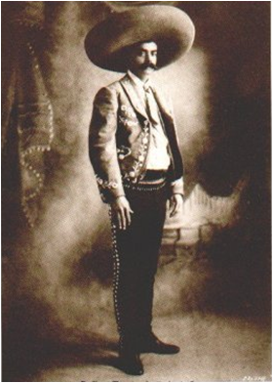
Figure 26. Zapata in a charro suit.

Emiliano Zapata’s assassination in 1919 was more than incidental and portent to cultural, as well as political, change. The following year, elites in Guadalajara organized the first charrería rodeo club, shortly afterwards, the first charro association assembled in Mexico City in 1921. In a post-revolutionary society, armed charros, such as Zapata, posed a threat to the fragile political order and required elimination. The danger resurfaced with the accusation that a founding member of the first association, Ricardo Mondragón, funneled money, arms, and men to Delahuertista rebels. In theory, one charrería association in each state could,
Count, at least, with five hundred charros, we could have a contingent of more than fourteen thousand well mounted men, well-armed men that in the face of the sun and a well-placed heart, occupy the position as the vanguard, like they did in 1862, those charros of General Ignacio Zaragoza.

Much later, the Institutional Revolutionary Party [PRI] countered the potential menace of charro associations by designating them as Mexico’s reserve military force, an honorary title, and allowed them openly to carry arms. As the danger posed by armed insurgents diminished, the post-revolutionary state supported several cultural initiatives that transformed charros into national symbols. Forgetting old fears of the “Attila of the South,” associations of elites in the capital eventually honored Zapata by remembering him as an ideal charro, a patriot adept at riding, bull tailing, and the training of horses.
Additionally, with the development of mass media technologies such as film, radio, and television in the first half of the twentieth century, the patriotic significance of charros increased on an unprecedented scale. Throughout the institutional phase of the Revolution (1920-1946) the governments of Álvaro Obregón, Pascual Ortiz Rubio, Abelardo Rodríguez, Lázaro Cárdenas, and Miguel Ávila Camacho co-opted elite charrería associations and incorporated charros into the pageantry of the state. Over the course of these administrations, charrería associations received patronage through state sanctioned parades and festivities that showcased their distinct style and displays of horsemanship. This initiative culminated in the 1930s with the declaration of charrería as the national sport and the designation of the charro suit as the traje nacional.
The rebirth of the charro archetype and the invention of charrería in the 1920s conformed to government-sponsored programs meant to unify diverse and contentious regions of the country through “revolutionary nationalism.” Secretary of Education José Vasconcelos initiated this cultural project with his “cosmic race” theory that extolled his brand of mestizaje, the assimilation of indigenous people, and idealized certain aspects of Hispanic heritage and culture. For intellectuals like Samuel Ramos, these efforts brought about the creation of a new Mexican man, unhindered by the intervention of foreign ideas, and firmly rooted in the national landscape.
In the past, charros were associated with the west-central region of the country known as the Bajío, but more specifically with the area of Jalisco known as Los Altos, the Highlands. Increasingly, people at state functions dressed in charro attire typical of Jalisco and, in the process, the figure gained supremacy over other regional stereotypes such as the Huasteco and Yaqui Indian. In search of a suitable national symbol, associations and agents of the state transformed the character from a regional stereotype, blurring diverse ethnicities, and imposing an officially sanctioned national archetype. Regardless of regional provenance, a renowned charro gushed,
All us Mexicans carry within ourselves the hidden soul of a charro. All of us have felt, at a moment of our lives attraction for the irresistible force that has made us poets, mystics, guerillas, or charros.

Charro Landscapes
As revolution spread throughout parts of Mexico, Ernesto Icaza, the “charro pintor,” created some of the most important oil paintings and murals depicting charros. Born in 1866, the final year of the French occupation of Mexico, Icaza descended from conservative elites who included colonial administrators and diplomats of the republic. However, he rebelled against his upbringing, refused an education, and developed a carefree fondness for alcohol. Fascinated by horses and the rural life he experienced at the haciendas of friends and family, Icaza took up the lasso and learned equestrian feats; he was particularly adept at bull tailing. In 1910, as the murmurs of political discontent spread, Icaza also took up painting at the advanced age of fifty and over the course of the next nineteen years created dozens of works that firmly established him as the most important painter of charros in the twentieth century. (Fig. 27)
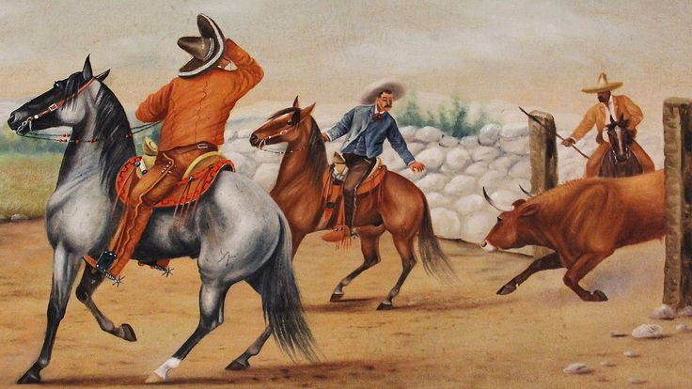
Figure 27. This oil painting by Ernesto Icaza, the “charro painter,” is titled Preparing to Tail a Bull (c. 1910s), and represents one of the traditional acts that comprises charrería rodeo. Icaza was heir to nineteenth century costumbrista painters and the most important artist who depicted Mexican charros in the twentieth century.

Underappreciated as an artist in his own lifetime, Icaza’s landscapes seemed quaintly old-fashioned to his contemporaries and were soon surpassed by cinematic images. His untutored style appeared similar to the crude landscapes painted on the walls of pulquería taverns. Successor to great artists like Claudio Linati, Manuel J. Serrano, Francisco Gálvez, and Edouard Pingret, and contemporary with Tomás Ballesteros, and José Albarran, Icaza’s works provides a bridge between nineteenth century traditions and the development of modern charrería in the 1920s. Additionally, his close attention to details in dress and the execution of various acts serve as documentary records of the styles and techniques that were popular during this period. An acquaintance of José Díaz, brother of the famed bullfighter Ponciano Díaz, Icaza enjoyed the Mexican style of bullfighting, banderillando a caballo. Devoid of any reference to the bloody conflict that devastated much of Mexico, Icaza’s idyllic landscapes represent the conservative ideals of his class and the perspective of the founders of charrería. Although Icaza died forgotten and rejected by his former patrons, his vision of the “fiesta charra” was profoundly influential. Long before charrería associations, the national government, film producers, and advertisers adopted the image, Icaza celebrated the charros that became commonplace for Mexicans in post-revolutionary society.

The First Associations
Besides the cessation of armed hostilities and the initiation of national unification, several factors contributed to the formation of the first charrería association in 1921. Prime among them was the precarious state of bullfighting in the capital, which endured a partial ban instituted by President Venustiano Carranza in 1917. As in the era of Ponciano Díaz, spectators traveled to surrounding venues while the government occasionally allowed benefit novilladas to raise funds for charitable causes. Once again, opponents of the bullfights raised their concerns, decrying the “bloody spectacle that creates disastrous consequences for the education of the people,” and railed when stands collapsed at an arena in Toluca, killing five people and injuring forty others.
Continuing a trend initiated during the presidency of Porfirio Díaz, the secondary acts of Mexican bullfighting divorced from the controversial spectacle of killing bulls for sport after the revolution. On June 4, 1921, thirty enthusiasts concerned with the disappearance of traditional Mexican equestrian acts and unhappy with Spanish bullfighting and English style horseracing met at the home of Marcos E. Raya to organize a national association. At this first meeting of the Asociación Nacional de Charros, National Association of Charros [ANC], also known as “la Nacional,” members elected a board of directors followed by an open invitation to all charros devoted to the “typical national sport.” A few weeks later, the first “Gran Jaripeo” took place at a bullfighting arena in the capital. Still linked to the corrida (bullfight), this event reversed the traditional order of acts, featuring bull riding, tailing, and catching after the bullfight. (Fig. 28)
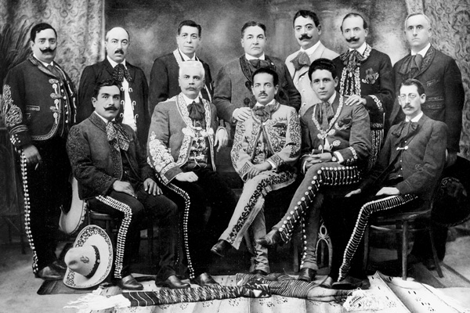
Figure 28. First Board of Directors of the ANC in 1921. Ricardo Mondragón, the suspected Delahuertista, stands to the far left of the back row. Ramón Cosío González, highly esteemed founding member, is seated in the front row, second from the left. Note, that many wear their moustaches in a twirly upturned manner, similar to the style used by Ponciano Díaz.

More important than the Gran Jaripeo were the centennial celebrations of 1921 that commemorated victory over Spain in the War of Independence. In large part, the ANC came together to participate in these “typical fiestas” that occurred in the capital over the course of several days. After midnight on the morning of September 16, one hundred of the best dressed charros led a torch-lit parade followed by a bus load of female musicians in traditional costumes playing popular songs. A few days later, ANC members escorted the float carrying María Uribe, the winner of El Universal’s India Bonita contest in the “fiesta floral.” At a bullfight on the 20th, charros and chinas poblanas, the queens of the event, paraded around the arena before occupying a special place in the stands. The press encouraged thousands to attend in their best charro attire. It was a grand spectacle attended by President Álvaro Obregón, the diplomatic corps, Rodolfo Gaona, the famous bullfighter, and the Orquesta Típica of Miguel Lerdo de Tejada that played Mexican compositions and dressed in charro suits. Finally, the ANC organized its own “fiesta charra” with a jaripeo and a competition for the best dressed charro and china, also attended by President Obregón. For those who missed the extravaganza, film reels of the festivities soon circulated in movies theaters, adding credits to the appearance of charros in footage of the Guardia Rural. In the weeks leading up to the centennial, and much of the rest of the decade, a wave of advertising images featured charros and chinas selling everything from cigarettes and toothpaste to stockings and harmonicas.
Significantly, the centennial celebrations of 1921 initiated a close partnership between the post-revolutionary state and charrería associations. Organizers of the events presented charrería practitioners as patriots, reserving a special place for them at parades, banquets, historic re-enactments, Independence Day celebrations, and eventually November 20th, Revolution Day. The fiesta charra became part of the national government’s cultural program and received support by the attendance of the president of the republic and foreign dignitaries. Additionally, the various events of the festivities served as a template for the official ordering of the charreada.
Perhaps the most important contribution to the development of this sport was the creation of the first lienzo. While the plaza de toros (bullfighting arena) served as an appropriate venue for bullfights, charrería required a different structure. With government support, organizers of the celebrations undertook the task of building the keyhole-shaped arena that served as a model, approximating the appropriate dimensions to make the events of the charreada look good. On rural haciendas, the first grandstands, depicted by Ernesto Icaza in many of his oil paintings, were large wooden platforms covered with large canvases under which people gathered to peer into crude stone corrals. In cities, more permanent facilities were necessary and in due time lienzos morphed with bullfighting arenas. In the 1920s, lienzos sprung up throughout Mexico City and the rest of the republic. Many of these prototypes eventually required improvements, but others like the wooden lienzos in Mazatlán and Toluca, were finely crafted structures worthy of admiration. These efforts culminated with the building of El Rancho del Charro, the national lienzo, constructed throughout the 1930s and finally inaugurated in 1943. Anthropologist, Kathleen Mullen Sands notes that at the charreada the lienzo becomes a symbolic landscape that recreates historic battlefields and idyllic ranches.
After the centennial festivities came to an end and before the ANC established a permanent home in the capital, members set out to the far regions of the republic encouraging equestrians to organize their own associations. In 1922 Manuel Paredes Arroyo received instructions to found associations in Guadalajara, San Juan del Río, Querétaro, and Puebla. Similarly General Luciano Ángel Peralta traveled to Durango and Coahuila, states he knew well from recent political upheavals, and founded associations. In 1926, Ramón Cosío González, among the most important founding members of the ANC, toured Michoacán with the same objective as his predecessors. When the association of Guadalajara became the first regional branch incorporated into the ANC, General Lázaro Cárdenas, a major supporter of charrería, attended the festivities. However, not all regions of Mexico received charrería missionaries at the same time; the remoteness of Tabasco impeded the organization of the first association until 1964.

El Duque de Regla
If Emiliano Zapata represents the extinct charro insurgent then Carlos Rincón Gallardo, the “Duque de Regla” (Duke of Rules) among many honorific titles, represents his military opponent in the Guardia Rural. Born into a distinguished family that included General Pedro Rincón Gallardo, a governor of the Federal District who repealed the ban on bullfighting in 1893, Carlos descended from elite equestrians. Well known within the upper class social circles that formed charrería in the 1920s, his family owned a few haciendas and commissioned Ernesto Icaza to paint landscapes with figures representing different family members. Educated in England, Carlos returned to Mexico to lead the Guardia Rural as Inspector General. Finding comfort in the lavish hacienda lifestyle, he became good friends with Icaza who, through his oil paintings, also idealized the “vida de campo” (rural lifestyle). Concerned with the foreign influences that crept into the national equestrian culture, Rincón Gallardo undertook efforts to preserve “horse-riding as practiced in Mexico, my beloved country.” Over the course of his prolific literary career, he became one of the most important proponents and embodiments of the charro archetypes in Mexico. (Fig. 29)
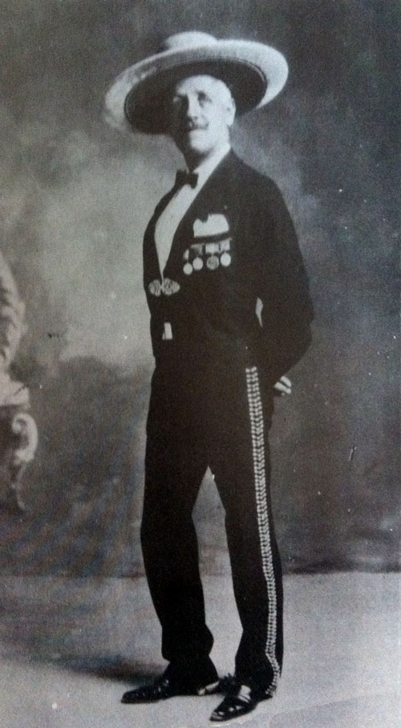
Figure 29. Carlos Rincón Gallardo, a former commander of the Guardia Rural educated in England, who went on to have an important role in the formation of charrería rodeo. Descended from colonial elites, the Duke of Rules had many honorific titles that included the Marqués de Guadalupe.

Rincón Gallardo compiled a long list of accomplishments that includes designing the first lienzo, election as president and honorary member of the ANC, and cinematic appearances in features like La boda de Rosario, Rosario’s Wedding (1929), in which he played an hacendado who saves his girlfriend from being dishonored by kidnappers. Most important, he wrote several seminal works on charrería and the charro. La equitación Mexicana, Mexican Horsemanship (1923) is considered the “bible of charrería” and the first of many manuals on the most significant points regarding horses, saddles, suits, training, and the acts that became the official program of the charreada. In the end Rincón Gallardo warned against foreign influences coming from Europe and the United States and expressed anxiety over the loss of Mexican equestrian traditions. He called for the revival of the Guardia Rural and pleaded with fathers to, “educate your children in our manly charro school, and do not allow our traditional customs, that we inherited from our ancestors, to be forgotten.”
Among the most prolific writers on charrería during this early period, Rincón Gallardo’s ideas concerning the charreada were instructive to a whole generation of enthusiasts who came after him. He exerted some of his greatest influence as a regular columnist for El Universal in the 1930s, where he discussed some of the most important issues concerning the sport. From this medium he communicated his thoughts on the proper dimensions of a lienzo, horse training, American rodeo, differences between tailing and catching, regulations, origins of the sport, and the exact order of events. El libro del charro mexicano, The Book of the Mexican Charro, his most important work, published in 1939, repeats familiar themes such as the return of the Rurales and the preservation of fading traditions. However, this work, is more concerned with resisting foreign influences, especially regarding the “exotic clothing,” that appeared “anticharro,” like those who incorporated elements of cowboy attire. In El libro, which appears to be a training guide for soldiers, Rincón Gallardo explains his ideas concerning appropriate colors, embroidery motifs, styles, and pistols. His reflections preoccupied charrería enthusiasts that understood his concern over the corruption of the charro traditions. In this manner, associations attempted to regulate charro suits and gradually, variants and regional styles receded or disappeared.
The founding members of the ANC and leadership of other associations of this era were known as “new charros” and considered themselves saviors of fading equestrian traditions and the restorers of the charro in the national pantheon of heroes. Among those who considered themselves students of Rincón Gallardo, Alfredo B. Cuéllar figured prominently as a founding member and president of the ANC who published Charrerías in 1928. The word “charrería” used to describe the sport and pageantry of the charreada, derived from this publication and Cuéllar should be considered the innovator of the term that replaced “fiesta charra”. This collection of essays, poems, anecdotes, articles, histories, literary works, and biographies concerning charrería was followed by José Álvarez del Villar’s history that notes the adoption of formal black suits by Emperor Maximilian. Álvarez del Villar joined José Ramon Ballesteros in arguing that the Mexican charro suit was not influenced by the Spanish variant from Salamanca. Ballesteros claims, “In our case, its origins are eminently criollo and indigenous, with Spanish imitations reduced to the simple reproduction of minimal details.” More mundane concerns included the prohibition of gaudy colors, styles, and capes as well as the stipulation that the only appropriate type of time-piece for a charro was a pocket watch.
While the debate over charro suits generated considerable discussion, it is worth noting that a similar argument occurred simultaneously with regards to the origin of the word “mariachi.” Scholars and commentators claimed the word derived from the indigenous Coca language, once spoken in Jalisco, and made reference to wooden dance floors used in stomp dancing, the tarima, foot drum, that existed among ancient people like the Anazasi and more contemporary indigenous cultures spread from Nayarit to California. This theory defied the popular notion that mariachi derived from the French word for marriage and alluded to music played at wedding ceremonies. However, while the debate appeared to focus on linguistics, its true nature revolved around ethnicity. Was mariachi an indigenous creation or an imported European orchestra?
As mariachi groups debated their roots, and professionalized adopting formal charro attire, a parallel effort to locate the origins of the charro in Mexico occurred among charrería practitioners who attempted to historicize the sport. This effort conformed to intellectual, political, and cultural initiatives to identify and celebrate what was “netamente mexicano,” (truly Mexican) often termed “lo nuestro” (ours), or “lo nacional” (the national). However, while the debate over the ethnic origins of the word mariachi centered on the dance floor, the debate over the origins of charrería focused on dress. Much of the anxiety emerged with the embellishment of costumes for film. Additionally, over the years, charrería associations eliminated many foreign accessories, such as tassels and shoulder pads, derived in part from Wild West shows in the United States.

Expansion and Federation
The success of the ANC and its partnership with post-revolutionary governments allowed the expansion of charrería across much of Mexico and eventually into the United States. However, throughout the 1930s, “La nacional” struggled to find a suitable home in the capital. Early in the decade, the military demolished the lienzo used by the ANC, condemning members to wander until President Pascual Ortiz Rubio secured office space near the National Palace where the association held fundraising balls. Selling their old plot of land to the military, the ANC members secured a lot in the foothills of Chapultepec, in proximity to where they regularly gathered for festivities and the place that eventually served as their permanent home. After initial construction difficulties, the lienzo and casino were completed on March 27, 1943, with President Ávila Camacho attending the dedication. Over the decades, a hall, chapel, offices, stables, restaurant, school, corrals, asphalt, electric substation, water treatment facilities, stadium roofing, and a series of busts of renowned members were added to the grounds, always accompanied by a fiesta charra at the unveiling. Although President Avila Camacho preferred polo, he signed decree number 373, which deeded the property to the ANC for ninety-nine years, a commitment renewed by President Carlos Salinas de Gortari in 1991.
The travails of securing a permanent home and the support given to the ANC by the national government indicates the intimate partnership between associations and the state. Close collaboration was supported by civic celebrations, as well as proximity to centers of power, but also through the declaration making the charreada Mexico’s official national sport. Bolstered by these initiatives, associations rapidly expanded throughout the 1920s and made evident the need for regulation under one governing body, the Confederation of Mexican Sports [CDM]. In 1933, forty-three charrería associations gathered at the Hidalgo Theater in Mexico City to organize under the CDM, prompting the creation of the Federación Nacional de Charros [FNC].
For post-revolutionary administrations, sports served as a component of domestic policy and foreign initiatives that facilitated social organization, national unification, and friendly competition. Once integrated into the CDM, President Abelardo Rodríguez took the bold measure of declaring charrería Mexico’s national sport on August 29, 1933, to revive the “typical customs that descend from our ancestors”. This followed the pronouncement by President Pascual Ortiz Rubio that the traje de charro was Mexico’s “national symbol.” The president expressed sympathy with aficionados like Fernando Ramírez de Aguilar (Jacobo Dalevuelta) who proposed that the Mexican charro should be a national symbol on par with the flag and comparable to John Bull in Britain or Uncle Sam in the United States.
Before the organization of associations under the FNC and CDM the first “Día del Charro,” Day of the Charro, was declared on September 14, 1932. The ANC organized festivities at the nearly complete Rancho del Charro and graciously invited, “all social classes,” to enjoy a parade, mariachis, dances, banquet, exhibit, charreadas, cockfights, bullfights, horse races, and the gruesome spectacle of the “cock race.” President Abelardo Rodríguez was unable to attend but sent representatives to present the head of the ANC with an official standard. Juan Silvetti, the famous bullfighter who often dressed in charro regalia made an appearance at the ball, where a contest for the best dressed charro and china, along with a jarabe tapatio, “the national dance,” occurred. Perhaps fearful of intermingling with the masses, organizers stipulated that women dressed as chinas, those “beautiful mounted amazons,” be persons of good reputation.
Associations across the country joined in the spirit, initiating their own fiestas to celebrate the Day of the Charro which allowed some associations to put aside their petty differences and gather for one afternoon of fraternal bonding. The Day of the Charro. In the spirit of collaboration the ANC and the FNC came together in 1935 for the first national championship to determine the best team of charros. The proximity of Day of the Charro to Independence Day celebrations is no coincidence; from its inception the Day of the Charro became part of the “fiestas patrias” (Independence Day festivities) and further intertwined the charro archetype to the nation building project of the post-Revolutionary state.

Charro Diplomacy
The expansion of charrería in the 1930s and 40s served the foreign policy initiatives of various Mexican presidents from both the political left and right. Supporting the film industry through loans and regulations, President Lázaro Cárdenas encouraged the export of the charro cantor (singing charro) initiated by Allá en el Rancho Grande, Over at the Big Ranch (1936). A corresponding effort occurred with charro associations that exhibited across much of Latin America, Europe, and the United States. In their capacity as charrería missionaries abroad, these members followed in the footsteps of Ponciano Díaz and Vicente Oropeza. In turn, the national government reinforced the international relations formed by charrería emissaries by hosting dignitaries at the Rancho del Charro, the national lienzo. As agents of charro diplomacy, associations eventually spread to the United States, to places like Los Angeles, San Antonio, and Brownsville, Texas. These transnational associations contributed their own style and technique to the events of the charreada; the escaramuzas, skirmishes, in part descended from the lady riders and “Mexican Señoritas,” of the Wild West shows.
The first tour abroad by practitioners of the secondary acts of Mexican bullfighting occurred with Ponciano Díaz’s travels to Spain in 1889. Across much of the United States and Europe, Vicente Oropeza followed Díaz’s foootsteps, performing with Buffalo Bill’s Wild West Show. In the 1920s, bullfighters were joined by charrería practitioners such as José Velázquez who toured Texas, Chicago, Philadelphia, Cuba, Argentina, and Peru. José de la Torre “El Coyote,” traveled to California from Guadalajara, making a name for himself presenting charrería to “los pochos y norteamericanos” (Mexican-Americans and Americans). In the 1930s Guadalupe Bustamante Juvenal and Arturo Bañales presented the feats of the charreada in Panama, Guatemala, Honduras, Costa Rica, and Colombia. Members of the ANC traveled to Chicago, performing before thousands at Southernfield in one of their first excursions abroad in 1933. Others traveled to Europe performing in Portugal, Spain, and Morocco. In 1939, the Ortega brothers, along with Audomaro Becerril and Miguel Aceves Galindo performed at Madison Square Garden. At the end of the Cárdenas administration, charrería missionaries traveled to Guatemala, Panama, Colombia, Ecuador, Peru, and Chile aboard the goodwill ship, Durango. Accompanying the delegation of sportsmen, the Orquesta Típica of Miguel Lerdo de Tejada performed in charro uniforms and played the title song to Alla en el Rancho Grande.
Throughout the 1950s and 60s, charrería served several presidential administrations as a tool of cultural diplomacy. In 1950, charros toured Venezuela, Colombia, and Peru. In September of 1962 former President Miguel Alemán traveled with a contingent of charros to New York. Spain, Chile, Canada, and Nicaragua also received charrería emissaries in the 1960s. Napoleón Reséndiz, winner of the Golden Spur in 1964 at the paso de la muerte (leap of death), toured Spain with Amalia Herández’s dance troupe and one-hundred charros from the FNC before suffering a cranial fracture. With limited international travel in the 1970s and 80s, excursions to Japan, France, and Italy occurred in the 1990s.
While charrería diplomats traveled across the globe, the fiesta charra and the charreada became a regular activity when receiving friendly missions from aboroad. The Brazilian ambassador to Mexico was among the first to be so honored by the ANC in 1923, followed in 1927 by Felix Tschiffely, a renowned horseman from Argentina. In the 1930s, the ANC hosted the President of Panama and President Manuel L. Quezon of the Philippines. President Lázaro Cárdenas and Carlos Rincón Gallardo accompanied the Phillipine head of state and after they listened to a mariachi and watched a jarabe, then President Quezon put on a charro suit and sombrero. Mexican officials encouraged the donning of charro suits by diplomats, a strange precedent and ritual throughout this period. When the former president of Bolivia, Enrique Peñaranda, attended a banquet at Rancho del Charro in 1943 he threw a serape over his shoulder and grinned under a wide-brimmed sombrero. Even the King of Spain and Lord Mountbatten could not avoid wearing the costume of Mexican knights. Dignitaries who visited Rancho del Charro include Indonesian President Ahmed Sukarno, Belgian Prince Albert and Princess Paola, the commander of the Royal Canadian Mounted Police, the Parliament of Ethiopia, “Tito” of Yugoslavia, and Pope John Paul II in 1979. When President John F. Kennedy visited Mexico in the winter of 1962 an escort of charros accompanied his motorcade.
Besides entertaining dignitaries in the capital, the demonstration of charrería abroad had a profound effect on the organization of associations in the United States. Cities in the Southwestern United States received some of the first charrería missionaries from Mexico. Additionally, civic parades and festivals, such as Spanish Days in Santa Barbara, maintained some of the equestrian traditions and typical dress of the colonial period alive. Similarly in Brownsville, the Charro Days festival of 1938 sparked an annual festival with a charreada, “Fiesta Mexicana,” and bullfight across the border in Matamoros. In 1947, the San Antonio Charro Association became the first foreign association recognized by the FNC.
In Los Angeles, equestrian cultures originated and survived along the San Gabriel River, near the site of the original Mission and the place of the last battle for California in 1847. In the 1920s and 1930s the fiestas patrias helped preserve some of the equestrian styles and techniques of the colonial period as well as serving as the sites where charrería rodeo would be established from abroad. Congregating in the canyons around he Montebello hills for weekend jaripeos, Mexican-American equestrians dressed by piecing together elements of charro and cowboy attire, inspired by cinema costumes. Concerned with the disappearance of traditional styles, clubs organized contests to reward the most authentic outfits. However, even after the FNC recognized the Los Angeles Charrería Association in the summer of 1962, the club experienced discrimination when a sheriffs group opposed the building of the Pico Rivera Sports Arena, also known as “Horseman’s Park” and one of Los Angele’s first lienzos, charging animal cruelty and the contamination of groundwater. Despite the crackdown on particular acts of the charreada in the United States, such as “horse tripping,” associations in the California and Texas grew from a handful in the 1950s and 60s to include chapters in Colorado and Illinois by the 1970s.
Concerned that the practice of the charreada abroad might precipitate a dilution of standards, associations in Mexico strictly regulated the sport through the FNC. In the process of Mexicanizing all aspects of charrería, associations in Mexico rewrote the history of female equestrians known as escaramuzas and sparked a debate that continues today. Reminiscent of the argument over the features derived from the Salamancan charro, the debate over the origins of female equestrians focuses on style. Charras in Mexico derive, in part, from lower class toreras (lady bullfighters) who fought at the Sunday bullfights. As noted in chapter two, María Aguirre, “La Charrita,” traveled to Spain and performed the banderillas on horseback, riding sidesaddle and wearing a skirt. In the United States, “Señorita Rosalia” entertained audiences who attended Pawnee Bill’s Wild West show between the 1890s and into the 1900s. Performing the secondary acts of Mexican bullfighting and riding astride, “Mexican señoritas” entertained audiences across the United States, Canada, Europe, and Latin America. The Mexican Contra Dance, which bears a striking resemblance to the precision riding of the escaramuzas, was a regular feature of several Wild West shows. Additionally, on the west coast female equestrian groups like Las Hijas de California (The Daughters of California), predecessors of Las Angelinas, performed at civic parades and festivals throughout Southern California.
In Mexico, the first escaramuzas, Las Coronelas, debuted at Rancho del Charro in 1953, occurring at the same time that women gained the vote. Derived from childrens’ groups and the “reina charra,” (charra queen), beauty pageant of 1925, their appearance in the capital served as the basis of a claim that the escaramuzas originated in Mexico. However, a credible counterclaim comes from José Valero Silva who states that Luis Ortega Ramos first observed a team of synchronized female riders at the Houston Stock Show and replicated the act at Rancho del Charro. It is likely that the lady riders seen in Houston by Ortega Ramos were influenced by female equestrian performers from nearby regions, such as Oklahoma, the home of the Miller Brothers 101 Ranch Wild West show which toured the area until the 1930s. Female performers like Effie Cole Barrera, May Lillie, and “Señorita Rosalia” set an example for future equestrian acts. Whatever their origins, the escaramuzas were a success and many associations on both sides of the border tried forming teams of women on horseback. However, the escaramuzas were not officially recognized until 1989 and incorporated into the program as a segregated act, exhibiting without scoring or effecting the official outcome of the competition.
The debates regarding the participation of women in charrería also includes an argument over the origins of the first traje de charra (charra suit). This costume is distinct from the blouse and sequin skirts of the colonial era china poblana (china from Puebla) and the other female participants of the fiesta charra, the Porfirian adelitas who wear lacy, high-necked dresses with long sleeves and shoulder puffs. As a feminized version of the masculine suit, the traje de charra dates back to the mid-1800s. However, one of the oldest prototypes exists in Oklahoma; May Lillie’s green costume from 1893 which was worn while performing in Pawnee Bill’s Wild West Show. The ANC erased the history of Mexican equestrian performers in the United States and attempted to locate the origins of the charra suit in Mexico. Members claimed the first charra suit was made for Rosita Lepe in 1937. Born into charrería royalty, Rosita was the daughter of Filemón Lepe, a founding member of “la nacional,” first chief of the charro-clad Guardabosques de Chapultepec (Forestguards of Chapultepec), and instructor to Hollywood stuntmen. This spurious claim by the ANC, reinforced the Mexicanization of the charro.
By altering the history of female acts and costumes, associations erased their foreign origins, invented a popular history, and tempered their erotic appeal -- an aspect of their allure in the United States. The buxom women in these shows and the lower class toreras who took up the slaying of bulls threatened the conservative foundations of charrería associations that preferred to re-envision the escaramuzas as national heroines, virginal daughters, and dedicated mothers of the upper classes -- ideal models of conservative Mexican womanhood. While machos decided what female participants of the charreada could wear, musicians such as Rita Vidauri subverted the strict regulation of the traje de charro. Cross-dressing and enacting the role of the mujer macha (macho woman) or dama macha (macho lady), the realm of music allowed some transgression of gender norms for performers like Lucha Reyes, Chabela Vargas, and more recently, Ana Gabriel and Jenny Rivera. Those who sing wearing the traje de charra can often take on masculinized traits, or as in the case of Juan Gabriel, use the traje de charro to challenge aspects of machismo, through the performance of the maricón (gay male) or marimacha (gay female). Following in the footsteps of their sisters in the canción ranchera (country songs), escaramuzas must play a new role in the national sport. Additionally, association should support their full integration into competitive scoring, board of directors, and participation regardless of marital status.

Cinematic Charros
In their attempt to mexicanize charrería, associations granted themselves exclusive authority to define the charro archetype and resented representations from film industries. Once again, much of the anxiety centered on the corruption of the character by the lower classes. Alfredo B. Cuéllar complained,
We have let the popular classes guard this inheritance of criollismo and we are happy with the ‘folk-lore’ coming from the country and the neighborhoods, ascending towards the theater marquee.

Repackaged for mass consumption, crass celluloid charros like Jorge Negrete and Pedro Infante, and most definitely Leo Carrillo, dishonored the conservative ideals and moral code of charrería practitioners who took offense with the gambling, hard drinking, womanizing, violent, macho, sentimental, gaudy, and inappropriately dressed figures projected onscreen. Gustavo Motiel Pagés wrote,
Mexican cinema is “charro” in the crudest pejorative meaning of the term. In it come together, without remedy, the unnecessary outbursts of the most bitter folklore, the inevitable sobs of drunken crying, the uncertain explosions of the false passions of machismo.

While post-revolutionary governments supported all forms of performance, both on stage and on screen, associations refused to relinquish their claim as the true embodiment of the charro archetype. However, while associations and films envisioned a similar nostalgic past, cinema extended the diffusion of the charro archetype much wider than the equestrian mission of charrería practitioners.
Resentful of cinema charros, charrería practitioners also raised protests over the use of the suit by mariachis. In the 1930s, these ambulating orchestral groups adopted the formal black gala suit as they professionalized, recorded, and appeared in cinema for the first time. The Mariachi of Cirilo Marmolejo, Mariachi Vargas de Tecalitlán, and the “Typical Orchestras” of Miguel Lerdo de Tejada and Juan N. Torreblanca were among the firsts to take up the style. Alterations made for film and live performances convinced the associations that the mariachis, like actors, denigrated the national suit, usually due to the use of strange fabrics and bright colors. (Fig. 30)
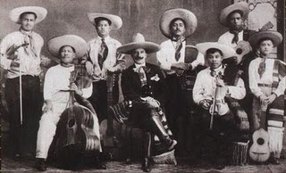
Figure 30. One of the first professional mariachis to adopt formal charro attire was El Mariachi Coculense Cirilo Marmolejo from Jalisco. Marmolejo, the light complexioned band leader, sits in the center dressed in a charro suit while his musicians, of mestizo and indigenous appearance, appear in more ordinary manta cloth.

However, cinematic charros inspired the greatest condemnation by charrería practitioners. Montiel Pagés suggests that cinema charros were foreign to Mexico, derived from Hollywood cowboy westerns and the worst kind of Spanish popular theater. Anxieties about the audiences that watched the boorish actors on screen had some relation to the idea that movie theaters were sites where the lower classes could assert and subvert gendered performances. In their own distorted personal fantasies, women might enact the role of chicas modernas or in the case of men, charros machos. Noting the prevalence of these images in his diary, Salvador Novo notes that the actor/director Emilio “Indio” Fernández, was disagreeable to be around when he played a charro because he enjoyed staying in character after the cameras stopped rolling. According to Carlos Monsiváis, the famed cultural critic, mass culture industries removed charros from their historical context and repackaged them as products for consumption. Machismo, in this setting, is perceived to be a lower class form of behavior. However, not all charrería practitioners were antagonistic towards film. Many also received exposure through cinema productions that hired equestrian stuntmen such as Miguel Lara Guerrero who appeared as an extra in films with Jorge Negrete, Emilio Fernández, Pedro Infante, Luis Aguilar, Ricardo Montalbán, and according to legend, posed for Diego Rivera’s portrait of Zapata.
The fear that true sportsmen would be eclipsed by those mainly interested in acting and pageantry led to the accusation that the board of directors of the FNC suffered such a fate between 1934 and 1938. José Álvarez del Villar claimed the leadership of the FNC was “completely foreign to vaquero labor, they have never felt between their hands a good rope and much less tasted the joy of our sport, so beautifully dangerous.” As early as the mid-1920s, the poor performance of members of the ANC demonstrated the need for a charrería curriculum, prompting the cry,
The charreada, as a sport, is something too beautiful, too big, and over all, too ours, to be deformed attempting a mascaraed like what we had to watch yesterday morning.

As a result, the ANC established schools in the 1940s and 50s to teach novices, especially children, the true equestrian feats of the charreada. In the FNC, the “school for minor horsemen,” or the “charro school for children,” opened in 1933 with good enrollment. A few days after the inauguration, children under fifteen years of age could participate in a “jaripeo infantil,” (children’s jaripeo). However, these schools are often closed to non-members, in effect, prohibiting the lower classes from enrollment. Future author of La charrería: tradición Mexicana, Octavio Chávez, and the son of President Lázaro Cárdenas, little Cuauhtémoc, joined such schools.
Besides attempts to regulate and educate novices concerning the moral code of the charro, cinema maintained the greatest influence over the minds of most Mexicans. In due time, some members of associations became producers and actors in film and eventually relented, ordering the cinema charros in a well-ordered pantheon. First among them is Pedro Infante, “The last popular myth,” which the ANC honors with a memorial charreada each year. It may have been Infante’s 1947 role in Soy Charro de Rancho Grande (I am a Charro From the Big Ranch) playing a charro from Jalisco who became famous when he traveled to Mexico City to compete against charros from the capital that made him a favorite among practitioners of equestrian feats. The passing reference to charrería associations, and his charismatic onscreen persona, was enough to seal his destiny as the most popular singing charro. Second place might go to Antonio Aguilar, who played wholesome characters similar to the Cisco Kid in U.S. cinema, or Vicente Fernández, a working-class charro from Jalisco, muy macho (very macho). From there preferences vary until it bottoms out with Jorge Negrete, the smooth city slicker who enjoyed English style riding to the glories of the national sport.
While cinematic actors misrepresented the archetype, the role of the charro macho became synonymous with the Golden Age of Mexican cinema, first portrayed by Jorge Negrete, as the “Machine Gunner,” in ¡Ay Jalisco no te Rajes! According to Rincón Gallardo, a true charro does not drink or smoke, but Negrete’s performance broke these rules. The boozing, brawling, macho image has many of the characteristics of a villain, similar to the bandidos and greasers of early American silent features. This archetype of Mexican nationalism could easily be interpreted as the charro malo, (bad charro) a corrupt figure that leapt from the screen to union halls in the late 1940s. Punctuated by the tragic deaths of Jorge Negrete and Pedro Infante in the 1950s, the charro archetype lost potency as a national symbol in the second half of the twentieth century.

The Corruption of the Charro
In the late 1940s, the word “charro” gained a new meaning. Among laborers, “charrismo” referred to the corrupt relationship between union leaders and employers, conjuring memories of the ruthless Jesús Díaz León, “El Charro” of the National Railway Workers Union who often appeared at meetings dressed in the national suit. During this time period and throughout Mexican popular culture, the “líder charro” (charro leader) became synonymous with the dishonest collusion of unions leaders and the national government. In this condition, charrería associations curbed their partnership with the state, reducing the number of missions abroad and the hosting of dignitaries. By the time of the emergence of a counter-culture of the 1960s, artists, primarily cartoonists and filmmakers, ridiculed charros as bumbling machos, concerned mainly with kickbacks and appearing good on camera. An aging archetype of the state, mass media, mass entertainment, and tourism industries, the charro buffoon reemerged as a potent symbol of the corruption of the state and society, from the 1950s and through most of the 1980s. In Mexico, the charro’s fortunes rose with an economic miracle and fell with the brutality of the post-revolutionary state.
The lampooning of the charro by satirists dates back to the 1920s and the Sunday comic strips. Don Catarino y su apreciable familia (Don Catarino and his Lovely Family) by Hipólito Zandejas and Salvador Pruneda ran in El Demócrata and El Nacional. The serial, which started in 1921, relates the tales of a recent migrant to the city, Don Catarino, who dressed like a rural charro. This format was copied by Hugo Tilghmann and Jesús Acosta in Mamerto y sus conocencias (Mamerto and His Wisdoms). Starting in 1927, Mamerto Albondiguilla entertained readers of El Universal with his rural speech, pronouncing “f”s like “j”s, “b”s like “gü”s, and repeatedly using words like pos (well), pa (for), and ansina (like that). The fat little charro is a country bumpkin who became rich and left his home in the pueblo of Chipicuaro to migrate to the city. Regardless of wealth, Mamerto’s uncouth manners, gullible nature, and natural stupidity get him into trouble.
Don Catarino and Mamerto were the predecessors of Abel Quezada’s Charro Matías, a fat, ugly, cowardly charro who shamelessly seeks office or a job in the movie industry. Hoping to get elected or to attain some kind of appointment, Charro Matías organized a political party, the CHDP, Charros del Pasado, Charros of the Past. Matías went on to propose that all charros should carry little chocolate guns because they never really kill anybody, after all, they are more “nutritious,” prompting his expulsion from Rancho del Charro by association members. In the 1950s, Quezada’s comics were a direct criticism of the state and mass culture industries that popularized charros. (Fig. 31)
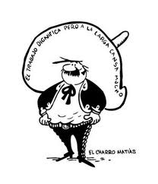
Figure 31. Abel Quezada’s, Charro Matías lampooned cultural industries and corruption of politicians. Note the round coins carried by Matias under his shirt and the words on his sombrero that reads, “work dignifies but in the end tires you.” The implication is that rather than work, Matías is content to steal and conceal.

Taking political humor to the extreme left, Eduardo del Río, Rius, made his entry into the comic world in 1964 with Los supermachos, a serial that satirized the single party political system and the rhetoric of revolutionary nationalism. Machos, in the pueblo of San Garabato, are often gun-carrying charros who are violent, drunk, and mainly for the consumption of American tourists. Like Tilghmann and Acosta, much of the comic relief in Rius’s work depended upon the playful use of language with appropriate mispronunciations and the copious use of country speech, adding an “n” or “ito” to the end of some words.
One of the most humoristic takes on the charro archetype was penned by Francisco D’egremy in 1975. Accompanied with caricatures by Luis Coutelin, El psicoanálisis del charro, The Psychoanalysis of the Charro is a satirical psychoanalysis of the character who embodied many of the anxieties and frustrations of Mexicans. For D’egremy, short little charros dressed in a flamboyant manner to hide their inferiority complex before foreigners. Regarding the sombrero, he wrote,
It is the phallic crown that confers power and domination, security and expansion. The loss of the sombrero would equate to the amputation of the fecund appendage and the annihilation of a substratum of pride.

Along with these vision of castration, phallic references and allusion to sexual penetration are also proposed for the pistol and mounting a horse. Additionally, the reata, which is not always functional and often decorative, betrays anxieties over social isolation and serves as the umbilical cord that ties the charro to society. Regarding cinema, D’egremy states,
Narcissistic and capricious, the filmic charro spruces up too much, he gets a ‘manicure,’ plucks his eyebrows, uses make-up, puts on a corset to attain a better figure, and customizes pants tight enough to see the enlarged roundness of his butt.

Although cinematic charros do not faithfully reflect Mexican people, D’egremy claims that the character’s violent behavior and fondness for alcohol reflect paternal abandonment and a regression to childhood.
While cartoonists, authors, newspapers, and publishers heaped scorn on the charro archetype in the 1960s and 70s, reflecting the decline of the symbol as a national icon, some of Mexico’s most renowned comics interpreted the charro buffoon in film. In 1920, one of the first Mexican comic feature, Viaje Redondo (Return Trip) related the misadventures of a country bumpkin who dressed like a charro. In the 1920s and 30s, actors like Carlos López, “Chaflán” and Leo Carrillo personified the charro buffoon in early cinema. However, the character of the clumsy charro received a new life with Germán Valdés “Tin-Tan” and his 1949 production, Soy Charro de Levita (I’m a Little Charro). Wearing a ridiculous moustache and a strange zoot/charro suit, Valdés dreamed of great fame on Broadway as he toured with a vaudeville style carpa. In the end, Valdés reunited Carmelita, Carmen Molina, with her true love while he haphazardly defeated a group of charro outlaws who terrorized a town. In 1951, Mario Moreno “Cantinflas” followed with El Siete Machos (The Seven Machos). As charros wrecked the railway, petroleum, and mining unions, Cantinflas parodied the popular comedia ranchera (ranch comedy) film format that featured singing charros.
Receding with the decline of the cinema industry in the late 1950s, comedic charro films reappeared in full force in the 1980s as the Mexican economy faltered and single-party politics were broadly undermined. The subgenre reemerged with Roberto Gómez Bolaños’s, El Charrito (The Little Charro) in 1985. Known for his roles as El Chavo and Chespirito, Bolaños plays El Charrito, an inept actor who performs the role of a villain in a film production and whose only talent is his ability to cause havoc. Vicente Fernández, Mexico’s premiere singing charro for much of the past four decades, added El Macho (The Macho) to his comedic credits in 1987. As Lindoro Marmolego, a poor and lazy farmer from Jalisco, Fernández steals a charro suit and horse at a charreada and sets off on a series of misadventures. Violent and abusive, Lindoro barks,
If I take off this suit I will become what I once was, a man dying of hunger and eating corn on the cobb. But, like this, everyone does my will and I make them walk like puppets.

Comedic critiques of cinematic charros also crossed the border in the 1980s. Unfortunately banned by censors in Mexico, The Three Amigos brought together the talents of Lorne Michaels, John Landis, Steve Martin, Chevy Chase, and Martin Short. Set in 1916, three unemployed American actors who played charros onscreen in Hollywood, travel to Mexico where they attempt to reprise their roles for the town of Santo Poco. Initially cowards, the three amigos, eventually gain courage and defend the town against the depredations of “El Guapo,” Alfonso Arau. Crossing the boundaries of cinematic traditions, this film is an insightful parody of the Cisco Kid serials and the singing charros of Mexican productions.

“One foot in the stirrup and the other in the grave.”
From the inception of charrería in the 1920s, the trope of decline and resurgence has been central to the historical vision of association members. As landed elites, the founders opposed the Mexican Revolution and considered it the cause of the rise of “agraristas” (agrarian land reformers) and the breakup of their hacienda properties. Besides the historical disjuncture that such a view entails, they also thought of themselves as the saviors of fading crafts and tradesmen such as saddle makers, leather workers, rope manufacturers, and tailors of charro suits. Mullen Sands observed,
As a folk tradition and expression of ethnic identity, charrería always exists on the brink of extinction… it must be reinvented and reinterpreted by each new generation.

After associations established a close partnership with the national government, who sought to reduce the potential threat of dissatisfied elites, charros spread throughout Mexican popular culture, experiencing a second wave of popularity after the first wave of the late nineteenth century.
Besides the transnational nature of the charro archetype, the expansion of charrería abroad in the 1940s and 1950s could not prevent the emergence of a counter-cultural critique of a figure so closely associated with the Mexican government. Evidently, as the fortunes of the post-revolutionary state declined, so did the mass appeal of its symbols. Appropriating the image, comics and cartoonists used the charro to lampoon the state and the cultural industries that popularized them. At the same time, lucha libre (wrestling), an allegory of the corruption of the state where the bad often win by cheating, surpassed the fiesta charra as the favored sporting event of the lower classes.
Responding to the corruption of the charro in popular culture, associations curtailed their partnership with the state between the 1960s and the 80s. However, the national and patriotic meanings of the charro archetype survived the collapse of the post-revolutionary state and the single party political system. True to form, charrería underwent a resurgence in the 1990s as travel abroad increased and presidential visits to Rancho del Charro attained a new prominence. In the twenty first century, attendance records at Rancho del Charro were broken. During the presidency of Vicente Fox, a self-styled vaquero from the north and member of the center-right National Action Party [PAN], state functionaries and diplomats flocked to the charreadas. In time, the ANC, “retook the position that corresponds to the most important charro association in the country.” With the election of Enrique Peña Nieto in 2012, the Institutional Revolutionary Party [PRI] regained the presidency and as the centennial anniversary of the ANC approaches, time will tell if the old cultural alliance with charrería associations will be reestablished.

Conclusion
In 1992 Robert Rodríguez, a young Mexican-American filmmaker from Texas, introduced El Mariachi, a new interpretation of the cinematic charro archetype. Inspired by Sergio Leone and the “Dollars” trilogy, Rodríguez set the film along the border, on the Mexican side in Ciudad Acuña. Here, El Mariachi captures the distinct qualities that made up the counter-cultural charro: an antimodern troubadour who suffers from a case of mistaken identity. With a quick reference to the Cisco Kid and Allá en el rancho grande (Over at the Big Ranch) Rodríguez treats the viewer to a low-budget shoot-out and what amounts to a re-invention of the charro archetype. The counter-cultural charro takes on the qualities of a road warrior when he laments,
All I wanted was to be a mariachi like my ancestors. But the city that I thought would bring me luck brought me perdition. I lost my guitar, my hand, and her. With this wound I don’t know if I will ever play the guitar and without her I don’t have love. But with the dog and these guns I’m prepared for the future.

The counter-cultural charro that Rodríguez celebrates in his “surreal take on Mexico and its culture and its iconic imagery,” emerged in the late 1940s when the word “charro” and “charrismo” gained a new meaning referencing the corruption of the Mexican federal government. Mexican comics reinvented the charro buffoon as a means to criticize the state, mass media, rhetoric of revolutionary nationalism, tourism industries, and the promises of economic prosperity. However, the characteristics of the counter-cultural charro archetype are not new. What is fresh and relevant to contemporaries is the particular combination of these various characteristics and their commentary regarding society. This includes a transnational nature, particularly the American variant, existing on the border of two countries. Unlike previous depictions, the twenty-first-century charro lives in an urban world of corrupt politicians and drug lords, an environment far removed from the happy haciendas of the Golden Age. Always a custodian of Mexican identity, the figure continues to combat anti-Mexican sentiments abroad. Finally, new representations liberated the countercultural charro from sartorial vestiges like the sombrero and the ubiquitous moustache that identified previous generations.
The cinematic character created by Robert Rodríguez clearly reflects the changing significance of the archetype as distinguished from the singing charros of “ranch comedies.” Although this trilogy did not sparks a series of romantic bandido knock-offs and represents a cinematic outlier, it fundamentally change depictions of charros in the United States. Interpreted by Antonio Banderas, who wears a black charro suit decorated with a scorpion, El Mariachi reprises his violent and vengeful roles in Desperado (1995), and Once Upon a Time in Mexico (2003). Moving like a “bullfighter” or a “Flamenco dancer,” Banderas hoped to add a little Spanish flavor to this “operistic musical comedy without music.” In one opening sequence, a villain uneasily replies, “The man is a myth, a legend.” With several interesting parallels to Manuel Payno’s Bandits of Cold River, El Mariachi defends the president of Mexico from a coup staged by a corrupt general. In the ensuing firefight at the government palace, El Mariachi offers the president protection as a “Son of Mexico.” After the plaza has been thoroughly sacked by drug cartels and the military, El Mariachi retires from the scene and is intercepted by Carolina, his love interest. Carolina repeats El Mariachi’s catchphrase, “Que quieres de la vida,” (“What do you want from life”) and in an obvious reference to corrupt politics and the violence of the drug wars, he replies, “Liberty.”
In the past twenty years, new and competing discursive on Mexican identity have emerged. Regional archetypes such as Yaqui Indian and Huastecos from the Gulf Coast increasingly gain relevance as markers of ethnic identity. However, for some, a globalizing world upsets traditional national identities and leads to a crisis of culture. Cristina Palomar has asked the questions: Is the charro as relevant today as when it emerged as a cultural symbol? Does it continue to convey contemporary Mexican identity? She believes the charro is in danger of losing validity in a rapidly globalizing context with the rise of multicultural perspectives that relegate the discussion of the charro as a national symbol into open debate. However, previous interpretations are transformed in this environment until they reflect new meanings and lead to the creation of hybrid figures that deviate from traditional forms.
These questions can be answered with recent controversies surrounding representations of charros. In the summer on 2013, Sebastián De La Cruz, “El Charro de Oro” (The Golden Charro), an eleven year old mariachi vocalist, put on his grey charro suit to perform before thousands of fans in San Antonio for the third game of the NBA playoffs. Performing the “Star Spangled Banner,” De La Cruz unleashed a torrent of anti-Mexican sentiments across social media sites on the internet. Clearly, the controversy was incited not by ethnicity or language but dress. For many in the audience and those watching at home, the sight of a performer wearing a charro suit and singing the national anthem roused intense nationalistic feelings, especially regarding recent immigration debates. Aldo López tweeted, “There’s an 11 year old Mexican boy singing the national anthem, He’s probably illegal.” Despite De La Cruz’s American nationality, people in the United States, and Mexico, remain unaware that the charro archetype is also an American construct with San Antonio serving as one of the cradles of modern charrería rodeo and mariachi music. As charros enter the digital age, their image circulates faster than ever before, and the reaction to their likeness remains a visceral source of pride or anti-Mexican sentiment. To answer Palomar’s first question; the charro remains a relevant cultural symbol, after all, De La Cruz ignored the backlash and put on his charro suit for an encore a few days later.
Evidently a source of pride, nearly a year after “El Charro de Oro” caused a controversy, Hubertus von Hohenlohe created another at the Sochi 2014 Winter Olympics. As the only delegate from Mexico in the winter Olympics, this publicity-seeking skier of German descent received extensive media coverage after he revealed the design of his ski suit, a black mariachi style gala charro suit. The speed suit, by an Italian designer, was inspired by a bandido themes outfit with bandoliers and chaps that Von Hohenlohe wore for the 2010 Winter Olympics in Vancouver. Although Von Hohenlohe had no real chance of winning a medal, his conscious choice of attire was meant to attract attention and sparked a negative reaction from people who claimed that the German playboy barely qualified for Mexican citizenship, much less competition at the Olympics. Regardless of his colorful suits, many considered Von Hohenlohe a bad representation of Mexico abroad -- revealing the high regard Mexicans continue to have for the traje nacional (national suit). So, to answer Palomar’s second question, the charro continues to convey a sense of national identity and patriotic pride for contemporary Mexicans.
As proven by recent history, charros remain at the forefront of the Mexican stage and continue to provide a sense of cultural and national identity for many people. Although features have changed over the past two hundred years, the hybrid and transnational figure maintains a relevance that surpasses Uncle Sam and John Bull. Transcending the state-sanctioned charros promoted during the age of revolutionary nationalism, the countercultural charro emerged as the most significant variant of the archetype in the last half of the twentieth century. Artists, musicians, authors, and other cultural producers have utilized the figure for a host of social, economic, cultural, environmental, and political critiques. Whenever Juan Gabriel performs the canción ranchera (country songs) dressed as a charro, gesturing in a manner that implies homosexuality, the “national suit” serves as a middle ground where issues of sexual identity are contested. Similarly, when Sergio Arau, the musician and actor, dons a mariachi suit with a gas mask to protest pollution in Mexico City, the contemporary relevance of the suit becomes starkly obvious.
Undoubtedly, charros may change over the centuries, but Mexican men on horseback will always maintain a cultural importance that outweighs their brief duration as actual heroes on haciendas or in Independence and Revolutionary movements. At least since their transfer to the New World, charros exist as transnational figures. These archetypes of Mexican identity traveled south and north of the U.S.-Mexico border, spreading their image farther than ever before. As I have attempted to show here, charros also became commodified as cultural products throughout the nineteenth and twentieth centuries, first as toreros (bullfighters) in the mass spectacle of the bullfights and later as singing charros during Mexico’s Golden Age. Besides some stylistic innovations, the transnational nature and commodification of the character are two of the defining characteristics of the modern charro. As new representations emerge, a counter cultural archetype has taken form and stands ready to carry on the traditions of his ancestors.

References
Primary Bibliography

101 Ranch route book, 1911. Circus World Museum and Parkinson Library, Baraboo (herein: CWMPL).

Actas de cabildo: Articulos 24-26, April 1, 1898, 83-88. Archivo Municipal de Guadalajara, Guadalajara.

Aguila, Guz. Soy Charro de Rancho Grande, DVD, Joaquín Pardave,Azteca Studios, Alfredo Ripstein, 1947.

Aguilar, Juan C. Recuerdos de Bernardo Gaviño, Rasgos biográficos de su vida y trágic muerte por el toro Chicharron, en la plaza de Texcoco el 31 de Enero de 1886. Versos de su testament y cancion popular á Ponciano Díaz. Orizaba: Tipo Popular, 1888.

Alcoriza, Janet, et al., El Siete Machos, DVD, Miguel M.Delgado, Churubusco, Luis Bustos, 1951.

Alejandro Aragón. “De cine en cine.” El Universal, June 25, 1933.

Alejandro Aragon. “De cine en cine.” El Universal, September 10, 1933.

Altamirano, Ignacio. El zarco. Mexico City: Editorial Porrúa, 1966.

Álvarez del Villar, José. Historia de la charrería. Mexico City: Imprenta Londres, 1941.

Álvarez del Villar, José. La charrería mexicana, su historia ypráctica. Mexico City: Panorama Editorial, 1987.

Ames, Walter. “Eligible Gals Look for Eligible Boys.” LosAngeles Times, February 29, 1956.

“A Message From Pawnee Bill to You” 1930s n.d., Gordon Lillie File, Oklahoma Historical Society (herein: OHS).

“Andres Martinez, el jefe de la defensa que capturo al Tigre de Yuatepec.” El Universal, November 20, 1933.

“Apuntes del natural: toros.” El Universal, February 10, 1920.

Arabia’s Shrine Circus flyer. November 21-26, 1938. C.G. WilsonFiles, National Cowboy and Western Heritage Museum, Oklahoma City.

Asociación nacional de charros: estatutos. Mexico City: Argo Artes Gráficas, 2006.

“A Thrilling and True Representation of Mexico’s National Sport The Bull Fight.” Cincinnati: The Strobridge Lithograph Company, 1896. Pawnee Bill Ranch and Museum, Pawnee
(herein: PBRM).

“Aviso a los charros mexicanos.” Excélsior, June 3, 1921.

“Bajo una lluvia de flores.” El Universal, September 28, 1924.

Ballesteros, José Ramón. Origen y evolución del charro mexicano. Mexico City: Librería de Manuel Porrúa, 1949.

“Beach Amigo Day Scheduled.” Los Angeles Times, February 23, 1958.

“Beatty Circus to Debut in New Spot Wednesday.” Los Angeles Times, March 18, 1956.

“Bellos festejos con motive de haberse intituído el día del charro.” El Universal, September 15, 1932.

Birinsky, Leo. The Gay Desperado. DVD. Rouben Mamoulian. Tucson: United Artists, 1936.

Bonnard, Silvestre. “Desde la capital del cine: Los fotodramaturgos.” El Universal, February 6, 1920.

Bonnard, Silvestre. “La mejor propaganda para México es la del cinematógrafo.” El Universal, February 9, 1920.

Bowen, Mrs. Clyde to Randy Ledford. May 18, 2000, Hestand Collection, PBRM.

Bracken Lee, J. to Leo Carrillo. September 22, 1955. Leo Carrillo Ranch and Museum, Carlsbad (herein: LCRM).

“Brillante desfile y jaripeo el día del charo en Puebla.” El Universal, September 9, 1932, 6.

Brightman, Homer. The Three Caballeros. DVD. Directed by Norman Ferguson. Burbank: Walt Disney Studios, 1944.

Buffalo Bill program: 1886, 1887, 1893, 1895, 1896, 1899, 1903

Buffalo Bill route books: 1899, 1900, 1901, 1902

Buffalo Bill and Pawnee Bill program: 1909

Buffalo Bill and Pawnee Bill route book: 1911

“Buffalo Bill Tours Britain.” Billboard, December 5, 1903. George L. Chindahl Papers, CWMPL.

Bukowski, Charles. Notes of a Dirty Old Man. San Francisco: City Lights Publishing Company, 1969.

Campobello, Nellie. “La pelicula ‘Viva Villa’ es insultante para Mexico: Urge evitar que salgan de Mexico las fotografias.” El Universal, November 21, 1933.

“Cancion y versos a Ponciano Diaz.” Mexico City: Imprenta de Antonio Vanegas Arroyo, n.d. Mercurio López CasillasCollection (herein: MLCC).

Carrillo, Eulogio to Leo Carrillo. Notes, January 22, 1953. LCRM.

“Carrillo in Vaudeville.” Indianapolis Sunday Star, November 21, 1920.

Carrillo, Leo. “Longing.” self-published, February, 1954. LCRM

Carrillo, Leo. The California I Love. Englewood Cliffs: Prentice-Hall, 1961.

Carroll, Harrison. “Behind the Scenes in Hollywood,” Burlingame Times & Daily News – San Mateo, December 10, 1937.

Carroll, Harrison. “Leo Carrillo for Governor.” Lowell Sun, June 30, 1938.

“‘Chinacos’ y ‘camisas negras’ combatieron ayer contra los ‘zuavos’ en el Cerro del Peñón.” El Universal, June 11, 1923.

“City Opens Birthday Fete.” Los Angeles Times, September 5, 1931.

“Colorful Character, Greatest Roper, Mexican Joe Heads For Last Round-Up.” newspaper clipping, n.d., Hestand Collection, PBRM.

“Como es la pelicula Americana ‘Viva Villa’.” El Universal, November 24, 1933.

“Concierto extraordinario de la Excélsior-Parker para hoy.” Excélsior, June 29, 1925.

Coolidge, Dane. Old California Cowboys. New York: E.P. Dutton and Co. Inc., 1939.

“Corrida de toro.” Mexico City: Imprenta de Antonio Vanegas Arroyo, n.d.

“Court Allows Renaldo to Take Daughter on Trip.” Los Angeles Times, October 14, 1953.

“Cow Punchers in the Arena: An Exciting Exhibition of a Great Western Sport Astonishing Feats of Horsemanship and Thrilling Rough-Riding After Cattle – How The Steers Were Thrown and Tied” St. Louis Post-Dispatch, October 8, 1899, in PWR, Vol. I, 181-183.

Cox Redd, Mazie. “Joe Barrera’s Story Told.” newspaper clipping, n.d.

“Crema dentrifica Colgate.” Excélsior, June 4, 1925.

Cuéllar, Alfredo B. Charrerías. Mexico City: Imprenta Azteca, 1928.

Dalevuelta, Jacobo. “El charro Mexicano como símbolo nacional. El Universal, September 16, 1933.

“Daring Feats by Horsemen: Some of the Remarkable Features of the Wild West Show.” New York Times, May 10, 1894.

Dávila Garibi, José Ignacio. “Los famosos mariachis de Cocula, El vocablo ‘mariachi’.” in Los mariachis de mi tierra… noticias, cuentos, testimonios, y conjeturas: 1925-1994, ed. Jesús Járegui. Mexico City: Dirección General de Culturas Populares, 1992.

De Aragón, Armando. Mano a Mano. VHS. Arcady Boytler. Mexico Nuevo Studio: British Olympic News, 1932.

“Dedicación a la fiesta del 17 de febrero de 1923.” in Cuéllar, Charrerías, 246.

D’egremy, Francisco. El psicoanálisis del charro. Mexico City: Editores Asociados, 1975.

Del Río, Eduardo. Los Supermachos de San Garabato. Mexico City: Editorial Meridiano, 1967.

Del Río, Eduardo. Mis Supermachos. Mexico City: Editorial Grijalbo, 1990.

Del Todo y Herrero, M. “Nuestro dibujo.” La lidia, August 18, 1889.

DeWitt, Meredith. “Days of Dons Recalled in Spanish Fete.” Los Angeles Times, August 20, 1937.

Diario del hogar: periodico de las familias

“Diaz Again Demands Action on Lynching.” New York Times, November 14, 1910.

Diversiones públicas: toros, Vol.857 Ex.116, Archivo Hístorico del Distrito Federal, Mexico City. (henceforth: AHDF)

Doscher, Luelyne. “Birth of a Stereotype.” Hollywood Quarterly, (Autumn, 1947): 90-93.

“Don Ramon, hacendado que fue victima de El Tigre de Yuatepec.” El Universal, November 18, 1933.

“Doña Lupita, madre del Tigre de Yuatepec y victima de los forajidos.” El Universal, November 19, 1933.

Doñan, Juan José. “Por mi raza hablaré: Jorge Negrete.” Artes de Mexico (2000)

Durante de Cabarga, Guillermo. “Desairada resulta la fiesta efectuada ayer por la mañana en la plaza el toreo.” El Demócrata, January 21, 1924.

“Ecos de la inaguración de la escuela charra de niños.” El Universal, July 20, 1933.

“Ediciones Camus – Mexico Presenta ‘Las Grandes Fiestas del Centenario’.” El Universal, Sepetember 22, 1921.

E.G.B. “Rancho Grande.” Modern Language Journal, (May 1939), 637.

“El alma de México se mostro anoche, como el ave fenix, en el resurgimiento de los charros que desfilaron por las avenidas llenas de luz y congestionadas de un grande entusiasmo.” El Demócrata, September 16, 1923.

El arte de los toros

“El bandido enmascarado.” Excelsior, June 10, 1925.

“‘El Caporal,’ una nueva película de marcado carácter nacional.” El Universal, June 23, 1921.

“El Caporal.” El Universal, June 26, 1921.

“El Caporal.” El Universal, June 27, 1921.

“El Caporal.” El Universal, June 28, 1921.

“El centenario Hohner.” El Universal, June 2, 1923.

“El concurso de chinas y de charros en Chapultepec.” El Universal, September 14, 1932.

El correo military.

“El derecho de los caballos.” El Universal, January 26, 1920.

El enano: boletín de lotería de toros.

El heraldo de Madrid.

El liberal.

“El niño huracán.” Excelsiór, June 5, 1925.

“El pagare de la charrita Mexicana.” Mexico City: Imprenta de Antonio Vanegas Arroyo, 1915.

El pais.

“El primer paso para fundar la confederación deportiva.” El Universal, July 13, 1933.

“El Pueblo, dando muestra de la más sana alegría, recorrió anoche las calles de la ciudad.” El Universal, June 16, 1921.

El sinapismo: revista de toros, teatros y demas espectáculo.

“El Tigre de Yuatepec fue estrenado ayer.” El Universal, November 23, 1933.

El toreo.

“En ocasión de su onomástico, el General Roberto Cruz recibió muestras de simpatía y aprecio.” Excélsior, June 11, 1925.

“Esta es La Nana, un personaje en la cinta ‘El Tigre de Yuatepec’.” El Universal, November 21, 1933.

“Esta es la segunda parte de los versos a Ponciano y un recuerdo de sus hechos a este diestro Mexicano.” Mexico City: Imprenta de Antonio Vanegas Arroyo, 1899. MLCC.

“Están prohibidas las novilladas, pero habrá mañana.” El Universal, February 4, 1920.

“Este es el ‘Rayado’ lugarteninete de El Tigre de Yuatepec.” El Universal, Novemeber 16, 1933.

“España (provincia de Salamanca) charra y charro.” La Ilustración: Revista Hispano-Americana, August 18, 1889.

Ferguson, Jo O. The Cleveland American Newspaper, Nov. 27, 1941. in Pawnee Chief, April 12, 1995.

“Fiesta charra de la asociación de Zacatecas.” El Universal, September 27, 1933.

“Fiestas del Centenario.” El Universal, September 20, 1921.

Flores C., Miguel. “El Charro” en U.S.A.. Glendora: Associated Publications, 1984.

“Funebres recuerdos de Ponciano, el distinguido toreroMexicano.” Mexico City: Imprenta de Antonio Vanegas Arroyo, c. 1899. MLCC.

“Gangas de venta especial México.” El Universal, September 22, 1921.

“Glorioso exito de Ponciano Diaz y de sus valientes charros en las Plazas de Madrid.” Mexico City: Imprenta de Antonio Vanegas Arroyo, c. 1888. MLCC.

“Gobernacion habla sobre la pelicula ‘Viva Villa’.” El Universal, November 26, 1933.

Gómez Bolaños, Roberto. El Charrito, DVD, Roberto Gómez Bolaños, Cuautla, Oaxtepec, Televicine, 1985.

González Ramírez, Eulalio. “Piporro”, El Macho, DVD, Rafael Villaseñor Kuri, Jalisco, Estudios América, Gregorio Walerstein, 1987.

“Gored by Bull.” The Sulphur (Oklahoma) Post, February 17, 1905.

“Gran charreada de gala en homenaje al ídolo de México, Pedro Infante.” Poster Collection, Rancho del Charro, Mexico City.

“Grandes festejos para el día de los charros.” El Universal, September 12, 1932.

Guzmán Aguilera, Antonio, and Juan García. Soy Charro de Levita, DVD, Gilberto Martínez Solares, Churubusco, Felipe Mier, 1949.

Guzmán de Arellano, Luz, and Guz Aguila. Allá en el Rancho Grande. VHS. Fernando de Fuentes. Studio Lab, 1936.

“Hay gran entusiasmo por la fiesta charra de hoy.” Excélsior, June 21, 1925.

“He aqui a la Comanche que fue nodriza del Tigre de Yuatepec.” El Universal, November 17, 1933.

Heller, Karl Bartolomeous. Alone in Mexico: The Astonishing Travels of Karl Heller, 1845-1848, trans. Terry Rugeley. Tuscaloosa: The University of Alabama Press, 2007.

Henry, O. The Complete Writings of O. Henry, Vol. IV, Heart of the West in Francis M. Nevins, and Gary D. Keller. The Cisco Kid: American Hero, Hispanic Roots. Tempe: Bilingual Press, 2008.

“Here’s Why Mexico’s Hubertus von Hohenlohe May be the ‘World’s Most Interesting Olympian’.” Huffington Post, accessed January 27, 2014, http://www.huffingtonpost.com/2014/01/27/hubertusvonhohenlohe-mexico-olympian_n_4676470.html

Hernández, José. Martín Fierro. Buenos Aires: Editorial Losada, 1941.

“Héroe por casualidad.” Excelsior, June 18, 1925.

Hestand, Mary. Pawnee Chief, February 5, 1977. Hestand Collection, PBRM.

Hoge, Bill. “Oolagah Oozing.” World’s Most Unusual Newspaper, January 8, 1950.

Honoree Release, February 9, 1976. NCWHM.

“Horse Park’s Effect on Water Purity Questioned.” Los Angeles Times, November 30, 1975.

“Hubertus von Hohenlohe: Most Interesting Olympian in World.” National Broadcasting Company News, accessed December 31, 2013, http://www.nbcolympics.com/news/hubertus-von-hohenloh-most-interesting-olympian-world#sthash.38If1DNG.dpuf.html

“Hubertus von Hohenlohe Prepares to Wrap up His Fifth Olympics Skiing for Mexico.” Los Angeles Times, accessed February 26, 2010, http://latimesblogs.latimes.com/laplaza/2010/02/vancouver-olympics-hubertus-von-hohenlohe-mexico-prince-german-royalty-latin-america.html#sthash.xh8sOsOP.dpuf.html.

“Jaripeo Infantil.” El Universal, July 22, 1933.

Judah, Charles, and George Winston Smith. Chronicles of the Gringos: The U.S. Army in the Mexican War, 1846-1848, Accounts of Eyewitnesses and Combatants. Albuquerque: University of New Mexico Press, 1968.

Kingsley, Grace. “Hobnobbing in Hollywood.” Los Angeles Times, January 10, 1934.

“La bestia humana desencadena en Toluca.” El Universal, February 10, 1920.

“La celebración de las fiestas en Los Ángeles, California.” El Universal, September 28, 1921.

La correspondencia de España.

“La corrida del centenario fue un acontecimiento.” El Universal, September 21, 1921.

“La corrida de toros.” Mexico City: Imprenta de Antonio Vanegas Arroyo, n.d.

La crónica.

La dinastía.

La época.

“La fiesta charra de mañana promote resultar bellisima.” Excélsior, June 20, 1925.

“La fiesta de la charrería sera alta apotheosis de nacionalismo.” Excélsior, June 17, 1925.

“La fiesta de toros sento sus reales en Tlalnepantla.” El Universal, February 2, 1920.

“La fiesta floral del domingo 18.” El Universal, September 29, 1921.

“La función de gala en honor del maestro Torreblanca.” El Universal, June 10, 1921.

La Iberia.

La lidia.

“La marca del zorro.” Excelsior, June 26, 1925.

“La noche mexicana en el círculo chihuahuense result bellisima.” El Universal, June 10, 1923.

“La organización del club de charros Mexicanos es acogida con entusiasmo.” El Universal, June 12, 1921.

“Las Corridas de Toros.” El estado de Jalisco: organo official del gobierno, October 23, 1880.

“Las Peliculas Denigrantes.” El Universal, November 22, 1933.

Leal Solares, Luis, and Aurelio Robles Castillo. ¡Ay Jalisco No Te Rajes!. DVD. Joselito Rodrígues. Producciones Rodrígues Hermanos, 1941.

“Leo Carrillo, 80, Dies of Cancer.” Los Angeles Time, September 11, 1961.

“Leo Carrillo’s Daughter Now Leads Parade.” Oakland Tribune, December 31, 1961.

“Leo Carrillo Makes a Habit of Parades.” Oakland Tribune, January 22, 1955.

“Leo Carrillo’s Star Rose at Santa Monica.” Los Angeles Times, July 28, 1918.

Lewis, Jack. “Leo Carrillo, Rancher.” The Western Horseman, April 1950.

Lillie, Gordon W., and C.G. Wilson, “The Roper,” C.G. Wilson Files, NCWHM.

Linati, Claudio. Trajes civiles, militares, y religiosos de México, trans. Justino Fernández. Mexico City: Imprenta Universitaria UNAM, 1956.

“Los festejos para el día del charro.” El Universal, September 8, 1932.

Mann, May. “Going to California: To Run for Governor.” Ogden Standard-Examiner, April 11, 1940.

Manheim, Harold. “Leo Carrillo – Son of the Dons.” The Catholic Motion Picture Guild News. (July/August 1931)

Martin, Steve, Lorne Michaels, and Randy Newman ¡The Three Amigos! DVD, John Landis, Universal Studios, Steve Martin, and Lorne Michaels, 1986.

“Meet the Old Rough Riders” newspaper clipping, Oklahoma City, Nov. 20, 1932. Harold Keith Collection. University of Oklahoma Western History Collection

“Mexican Olympian Hubertus von Hohenlohe Debuts Mariachi Ski Suit.” Los Angeles Times, accessed January 29, 2014, http://www.latimes.com/fashion/alltherage/la-ar-mexico-olympian-hubertus-von-hohenlohe-debuts-mariachi-ski-suit-20140129,0,4835161.story#ixzz2yKhqyv2m.html.

“México, en corto plazo será la meca del cinematógrafo.” El Universal, October 17, 1933.

“Miss May Lillie Premiere Equine Educator, Pawnee Bill’s Petite Protégé, Introducing Her Marvelous High School Menage Horse ‘Colombo’.” 1893-94, CWMPL.

Molina, Diana. Photograph Collection, 1989, Nettie Lee Benson Latin American Collection, University of Texas, Austin.

“National Anthem Kid’s Pitch Perfect Response to Twitter Racists,” Gawker, accessed June 13, 2013. http://gawker.com/national-anthem-kids-pitch-perfect-response-to-twitter-513175272.html.

Noriega Hope, Carlos. “La censura de las películas cinematograficas ¡Es necesario hacer algo!.” El Universal, February 17, 1920.

“Número 12, el mejor cigarro Mexicano.” El Universal, December 23, 1923.

Oropeza, Napoleon to Frank Dean, December 11, 1962.

Oropeza Reyes, Vicente to Frank Dean, December 21, 1962.

Oropeza de Sánchez, Eva to Frank Dean, December 10, 1962.

Oropeza de Sánchez, Eva to Frank Dean, January 10, 1963.

Osacar, Francisco. Apuntes Para El Toreo No. 1, 2, & 3. Mexico City: Antonio Venegas Arroyo, n.d.

Othman, Frederick C. “Where Wild West Meets the Ocean.” newspaper clipping, August 17, 1959, LCRM.

Overton, Gwendolen. “The Bull-Fight of Fact: An American View of the Traditional Sport of Mexico.” Los Angeles Times, April 16, 1899.

“Parade of the Golden West Sets New Ventura Mark.” Los Angeles Times, May 26, 1935.

Parsons, Harriet. “Keyhole Peek At Carrillo.” Examiner, May 20, 1934.

Pastor, Tolly. “Viaje á Méjico.” La época, May 2, 1887.

“Pawnee Bill Buried as Friends from Far and Near and Pets Mourn.” newspaper clipping, February 6, 1942. OHS.

Pawnee Bill handbill, ca. 1890s

Pawnee Bill’s Historic Wild West program, 1889-1890.

Pawnee Bill’s Old Town and Indian Trading Post merchandize list
1930s n.d., Gordon Lillie File, OHS.

Pawnee Bill’s Old Town Indian Trading Post certificate, October 16, 1938, C.G. Wilson Collection, NCWHM.

Pawnee Bill program: 1889-1890, 1893, 1895, 1905, 1907, 1908.

Pawnee Bill route book: 1893, 1894, 1895, 1898, 1899, 1900, 1901.

“Pawnee Woman Has Fond Memories of Circus Life.” Newspaper clipping, n.d., Hestand Collection, PBRM

Payno, Manuel. Los Bandidos de Río Frío. Mexico City: Editorial Época, 2004.

“Peñaranda objeto de agasajos y homenajes.” La Prensa, May 25, 1943.

“Peon Pants Local Horror.” Los Angeles Times, August 30, 1922.

“Peon Pants on Freshman Start Class Battle.” Los Angeles Times, September 23, 1922.

“Peon Pants Threatened by Ku Klux.” Los Angeles Times, October 23, 1922.

Pérez, Jorge. El tigre de Yuatepec. VHS. Fernando de Fuentes, Producciones FESA, 1933.

Photographic collection, Hestand Collection, PBRM

“Plaza de toros ‘el toreo’.” Excélsior, June 25, 1921.

“Plaza de toros ‘el toreo’.” El Universal, June 24, 1921.

Posada, José Guadalupe. “Los charros contrabandistas juego de dados.” Mexico City: Imprenta de A Venegas Arroyo, n.d. MLCC.

“Preparativo para el Gran Jaripeo.” El Universal, September 15, 1921.

“Pupils Put Peon Pants Under Ban.” Los Angeles Times, September 15, 1922.

“Quedan prohibidas también las novilladas.” El Universal, January 31, 1920.

“Quedo inaugurada ayer la exposición Alemana de muestras, con bello éxito.” Excélsior, June 30, 1925.

“Quedo instalada la asociación nacional de charros.” Excélsior, June 5, 1921.

Quezada, Abel. El Charro Matías. Mexico City: Editorial Planeta Mexicana, 1999.

Ramírez de Aguilar, Fernando. El charro símbolo. Unknown publisher, 1932.

Ramírez Cárdenas, Manuel. “Merecen estimulo las películas mexicanas.” El Universal, October 18, 1933.

Ramos, Samuel. El perfil del hombre y la cultura en México. Mexico City: Colección Austral, 1934.

Rawitch, Robert. “Cisco Kid: Role Changed His Life.” Los Angeles Times, January 7, 1973.

“Recuerdo Al Valiente Ponciano Diaz: Coleccion De Canciones Modernas.” Mexico City: Imprenta de Antonio Vanegas Arroyo, 1891. MLCC.

Remington, Frederic. Pony Tracks: Written and Illustrated by Frederick Remington. Norman: University of Oklahoma Press, 1961.

“Renaldo Joins Beatty Circus,” Los Angeles Times, February 29, 1956.

Rincón Gallardo, Carlos. “Comentarios sobre charrería.” El Universal, September 25, 1933.

Rincón Gallardo, Carlos. “Comentarios sobre charrería.” El Universal, November 6, 1933.

Rincón Gallardo, Carlos. El libro del charro mexicano. Mexico City: La Imprenta Regis, 1939.

Rincón Gallardo, Carlos. “Juicios sobre los concursos charros.” El Universal, October 16, 1933.

Rincón Gallardo, Carlos. “Juicios y comentarios sobre el deporte charro.” El Universal, June 28, 1933.

Rincón Gallardo, Carlos, Romero de Terreros. La equitación Mexicana. Mexico City: Talleres Linotipográficos, 1923.

Rincón Gallardo, Carlos. “Notas de equitación: calar, mover o bullir el caballo.” El Universal, December 11, 1933.

Rincón Gallardo, Carlos. “Temas sobre equitación.” El Universal, July 24, 1933.

Respetable publico: semanario illustrado de espectáculos, October 18, 1908.

Rodríguez, Robert. “10 Minute Film School.” Desperado. DVD. Robert Rodríguez. Ciudad Acuña: Columbia Pictures, Robert Rodríguez, Carlos Gallardo, and Bill Borden, 1995.

Rodríguez, Robert. El Mariachi. DVD. Robert Rodríguez. Ciudad Acuña: Columbia Pictures, Robert Rodríguez, Carlos Gallardo, 1992.

Rodríguez, Robert. Once Upon a Time in Mexico. DVD. Robert Rodríguez. Guanajuato, San Miguel de Allende, Querétaro: Columbia Pictures, Robert Rodríguez, Carlos Gallardo, and Elizabeth Avellán, 2003.

Rogers, Will. “Various Styles of Roping.” The Stampede, August 9-16, 1913 in PWR, Vol. III, 308.

Roping Fool. DVD. Directed by Clarence G. Badger. Hal Roach Studios: Pathé Exchange Inc., 1922.

Rosaldo, Renato. “México y sus películas.” The Modern Language Journal, (February, 1952): 84-88.

“Rose Parade Line-up Set.” Los Angeles Times, December 31, 1937.

“Rotograbado.” El Universal, November 22, 1933.

Sánchez de Neira, José. Gran Diccionario Taurómaco. Madrid: R. Velasco, 1896.

Sarmiento, Domingo Faustino. Facundo: Civilization and Barbarism, trans. Kathleen Ross. Berkeley: University of California Press, 2003.

“Sartorial Note For Flippers,” Los Angeles Times, August 28, 1922.

Schroeder, Doris. The Gay Amigo. DVD. Wallace Fox. Pioneertown: United Artists, 1949.

Sears, Ted. Saludos Amidos. DVD. Directed by Wilfred Jackson. Burbank: Walt Disney Studios, 1943.

“Se celebró en Guadalajara el día del charro, con entusiasmo.” El Universal, September 18, 1932.

Secretaria de Gobernación. Expedient 313. 1-g4, January 1927, Archivo General de la Nación (herein: AGN.)

“Segunda parte de la canción y versos dedicados á Ponciano Díaz.” Mexico City: Imprenta de Antonio Venegas Arroyo, n.d. MLCC.

“Se han hecho en México algunas buenas películas.” El Universal, November 13, 1933.

“Se nombro la directive del club de charros mexicanos.” El Universal, June 5, 1921.

“Se quemó ¡Viva Villa!” El Universal, November 22, 1933.

“Shooting at Wild West Show Held to be an Accident.” Newspaper clipping, n.d., Hestand Collection. PBRM.

“Shoots Mad Bull in Frantic Crowd.” Los Angeles Times, September 17, 1910.

Sigüenza Orozco, Salvador. “Del mariachi y la china poblana como identidad nacional en el siglo XX a lo diverso y heteregéneo en el siglo XXI.” in Avatares del nacionalismo cultural. Cinco ensayos, ed. Ricardo Pérez Montfort. Mexico City: CIHHEM, CIESAS, 2000.

“Sólo dos días para ver ‘El tigre de Yuatepec’.” El Universal, November 27, 1933.

Soria, Gabriel. ¡Ora Ponciano! VHS. Jesús Solórsano. Mexico: Columbia Pictures, 1936.

“Spurs’ Eleven-Year-Old National Anthem Singer Sparks Racist Comments on Social Media.” FOX News, accessed on June 12, 2014 http://latino.foxnews.com/latino/news/2013/06/12/spurs-11-year-old-national-anthem-singer-sparks-racist-comments-on-social-media/.html.

“Students Ruin Pants.” Los Angeles Times, October 6, 1922.

“Su majestad Ana María recibio de sus súbditos el rendido y público homenaje a su hermosura.” El Universal, June 23, 1925.

“Surgery Makes Knee Breeches of ‘Peon’ Pants.” Los Angeles Times, September 16, 1922.

Takahashi, Keith. “County Rescinds CRA Compromise.” Los Angeles Times, September 22, 1977.

Takahashi, Keith. “Horsemen’s Park Project Pico Rivera Snagged.” Los Angeles Times, September 18, 1975.

Takahashi, Keith. “Pico Rivera Council Acts to Clear Park Project Snag.” Los Angeles Times, September 25, 1975.

Taylor, Frank. “The Golden Horse.” Collier’s Magazine, July 27, 1940.

“Teatro Lírico.” El Universal, June 14, 1921.

“Tequila, pulque, y toros en Tlalnepantla.” El Universal, February 9, 1920, 5.

“Terrible desgracia en Mérida.” El mundo, August 25, 1903.

Tilgmann, Hugo, and Jesús Acosta, “Mamerto y sus conocencias.” El Universal, September 18, 1932.

Tilgmann, Hugo, and Jesús Acosta, “Mamerto y sus conocencias.” El Universal, September 25, 1932.

Tilgmann, Hugo, and Jesús Acosta, “Mamerto y sus conocencias.” El Universal, June 4, 1933.

Tilgmann, Hugo, and Jesús Acosta, “Mamerto y sus conocencias.” El Universal, June 18, 1933.

Tilgmann, Hugo, and Jesús Acosta, “Mamerto y sus conocencias.” El Universal, June 25, 1933.

Tilgmann, Hugo, and Jesús Acosta, “Mamerto y sus conocencias.” El Universal, September 3, 1933.

Tilgmann, Hugo, and Jesús Acosta, “Mamerto y sus conocencias.” El Universal, September 10, 1933.

Tilgmann, Hugo, and Jesús Acosta, “Mamerto y sus conocencias.” El Universal, October 15, 1933.

Tilgmann, Hugo, and Jesús Acosta, “Mamerto y sus conocencias.” El Universal, October 29, 1933.

“Tipos populares de 1828.” El Universal, September 21, 1921.

“To Save Reminders of Past.” Los Angeles Times, May 18, 1924.

“Tres charros robaron a una bella joven en la carretera de Puebla.” El Universal, September 1, 1933.

Turner, Timothy G. “The Genesis of Peon Pants.” Los Angeles Times, September 28, 1922.

“Two Important Land Deals Attest Realty’s Activity.” Los Angeles Times, April 18, 1937.

“Una escuela para jinetes menores fue inaugurada.” El Universal, July 17, 1933.

“Una fiesta charra.” El Universal, October 26, 1933.

“Un brillante radioconcierto por la estación de ‘Excélsior’.” Excélsior, June 14, 1925.

Upson Young, Clarence. Riding the California Trail. DVD. William Nigh. Monogram Pictures, 1947.

“Us Boys Carry Daggers.” Los Angeles Times, August 31, 1922.

“Vagrant Stirs Carrillo to Action.” Los Angeles Times, April 21, 1929.

Valero Silva, José. El libro de la charrería. Mexico City: Imprenta Londres, 1941.

War, “The Cisco Kid.” in The World is a Ghetto. United Artists Recordings, 1972.

Webster, Pat. “She’s One of the Last from a Golden Age.” newspaper clipping, June 22, 1979.

“Wild Rivalries of Savages, Barbarous, and Civilized Races.” n.d., CWMPL.

Wilson, C.G. “Jose Barrera – Mexican Joe.” 1938. C.G. Wilson Collection, NCWHM.

Wofford, Linda. “Woman’s Father was Colorful Performer.” newspaper clipping, n.d., Hestand Collection, PBRM.

York, Homer. “Peon Pants.” Los Angeles Times, October 22, 1922.

Zamora Valdés, José. “Recuerdos del tiempo viejo: Los hermanos Oropeza.” Mexico Charro, January 15, 1945.

Secondary Bibliography

Abernathy, Francis E. Charreada: Mexican Rodeo in Texas. Denton: University of North Texas Press, 2002.

Agrasánchez, Rogelio. Cine Mexicano: Posters from the Golden Age 1936-1956. San Francisco: Chronicle Books, 2001.

Agraz García de Alba, Gabriel. Filemón Lepe, célebre charro mexicano. Mexico City: Biblioteca Tecolotlense, 1986.

Alameda, José. Crónicas de Sangre: 400 cornadas mortales y algunas más. Mexico City: Editorial Grijalbo, 1981.

Anderson, Benedict. Imagined Communities: Reflections on the Origins and Spread of Nationalism. New York: Verso, 1983.

Arellano Quintanar, Soledad et al. Las asociaciones de charros en Tabasco: 40 años de historia. Mexico City: Compañía Editorial Impresora Distribuidora S.A., 2005.

Arizmendi, Yareli. “Whatever Happened to the Sleepy Mexican? One Way to Be a Contemporary Mexican in a Changing World Order.” TDR (Spring, 1994): 106-118.

Ballou May, Dale. “The Adobe is My Birthstone,” Report for the City of Carlsbad, August 1988.

Beezley, William H. Judas at the Jockey Club and Other Episodes of Porfirian Mexico. Lincoln: University of Nebraska Press, 1987.

Benjamin, Thomas. “Rebuilding the Nation.” in The Eagle and the Virgin: Nation and Cultural Revolution in Mexico 1920-1940, eds. Mary Kay Vaughan and Stephen Lewis. Durham: Duke University Press, 2006.

Benjamin, Thomas. La Revolución: Mexico’s Great Revolution as Memory, Myth, and History. Austin: University of Texas Press, 2000.

Blackstone, Sarah J. Buckskins, Bullets, and Business: A History of Buffalo Bill’s Wild West. New York: Greenwood Press, 1986.

Boado, Emilia, and Fermin Cebolla. Las señoritas toreras: Historia erótica y política del toreo femenino. Madrid: Punto Critico, 1976.

Boardman, Andrea. “The U.S.-Mexican War and the Beginnings of American Tourism in Mexico.” in Holiday in Mexico: Critical Reflections on Tourism and Tourists Encounters, Editors Dina Berger, Andrew Grant Wood. Durham: Duke University Press, 2010.

Boone, Elizabeth. “Bullfights and Balconies: Flirtation and Majismo in Mary Cassatt’s Spanish Paintings of 1872-73.” American Art (spring, 1995)

Briggs, Peter M. “Daniel Mendoza and sporting celebrity: a case study.” in Romanticism and Celebrity Culture, 105.

Brown, Erin. “Surpassing in Truthfulness: Pawnee Bill’s Vision of the American West.” Paper presented at the Oklahoma Historical Society’s Annual Meeting and Conference, Oklahoma City, Oklahoma, April, 2012.

Brunk, Samuel. Emiliano Zapata: Revolution and Betrayal in Mexico. Albuquerque: University of New Mexico Press, 1995.

Brunk, Samuel. The Posthumous Career of Emiliano Zapata: Myth, Memory, and Mexico’s Twentieth Century. Austin: University of Texas Press, 2008.

Buffington, Rob. “Los jotos. Visiones antagónisticas de la homosexulidad en México modern.” in Sexo y Sexualidades, Editors Daniel Balderston, Donna J. Guy. Mexico City: Editorial Paidós, 1998.

Burns, Bradford. The Poverty of Progress: Latin America in the Nineteenth Century. Berkeley: University of California Press, 1983.

Cárdenas Noriega, Joaquín. José Vasconcelos: caudillo cultural. Mexico City: CONACULTA, 2008.

Carreño King, Tania. El Charro: la construcción de un estereotipo nacional 1920-1940. Mexico City: INEHRM, Federación Mexicana de Charrería, 2000.

Carreño King, Tania. “Yo soy Mexicano: Mi tierra es bravia,” Artes de Mexico, (2000)

Chassen-López, Francine R. “A Patron of Progress: Juana Catarina Romero, the Nineteenth-Century Cacica of Tehuantepec.” Hispanic American Historical Review (August, 2008): 393-426

Chávez, Octavio. La Charrería: Tradición Mexicana. Toluca: Instituto Mexiquense de Cultura, 1991.

Cisneros, José. Riders Across the Centuries: Horsemen of the Spanish Borderlands. El Paso: Texas Western Press, 1984.

Coatsworth, John H. Growth Against Development: The Economic Impact of Railroads in Porfirian Mexico. DeKalb: Northern Illinois University Press, 1981.

Dabove, Juan Pablo. “El bandido social mexicano, entre el bárbaro y el soberano ilustrado: El caso de ‘Astucias’ de Luis Inclán (México, 1865).” Latin American Literary Review. (Spring, 2005): 47-72.

Dary, David. “The First ‘Real’ Bullfight in the United States,” True Tales of Old-Time Kansas. Lawrence: University Press of Kansas, 1984.

Dean, Frank. “Maguey, Myths, & Men,” The Western Horseman (March, 1966)

Dean, Frank and Nacho Rodríguez. Trick and Fancy Roping in the Charro Style. Las Vegas: Wild West Arts Club, 2003.

De Carmen Millán, María. introduction to El Zarco by Ignacio Altamirano. Mexico City: Editorial Porrúa, 1966.

De la Fuente, Ariel. Children of Facundo: Caudillo and Gaucho Insurgency During the Argentine State-Formation Process (La Rioja, 1853-1870). Chapel Hill: Duke University Press, 2000.

De Leon, Arnoldo. They Called Them Greasers: Anglo Attitudes Towards Mexicans in Texas, 1821-1900. Austin: University of Texas Press, 1983.

De los Reyes, Aurelio. Filmografía del cine mudo mexicano 1896 1920. Mexico City: Filmoteca UNAM, 1986.

De los Reyes, Aurelio. Filmografía del cine mudo mexicano volumen II 1920-1924. Mexico City: Dirección General de Actividades Cinematográficas UNAM, 1994.

De los Reyes, Aurelio. Filmografía del cine mudo mexicano volumen III 1924-1931. Mexico City: Dirección General de Actividades Cinematográficas UNAM, 2000.

Delphar, Helen. “Mexican Culture 1920-1945.” in The Eagle and the Virgin: Nation and Cultural Revolution in Mexico 1920-1940, Editors Mary Kay Vaughan, and Stephen Lewis. Durham: Duke University Press, 2006.

Delphar, Helen. The Enormous Vogue of Things Mexican: Cultural Relations Between the United States and Mexico, 1920-1935. Tuscaloosa: University of Alabama Press, 1995.

De Maria y Campos, Armando. Ponciano, el torero con bigotes. Mexico City: Ediciones Xochitl, 1943.

Denhardt, Robert M. The Horse of the Americas. Norman: University of Oklahoma Press, 1947.

Díaz, María Elena. “The Satiric Penny Press for Workers in Mexico, 1900-1910: A Case Study in the Politicisation of Popular Culture.” Journal of Latin American Studies (Oct, 1990)

Doñán, Juan José. “Por mi raza hablaré: Jorge Negrete.” Artes de México (2000)

Doremus, Anne T. Culture, Politics, and National Identity in Mexican Literature and Film, 1929-1952. Madison: University of Wisconsin, 1998.

Estrada, William D. “Los Angeles’ Old Plaza and Olvera Street: Imagined and Contested Space.” Western Folklore, (Winter 1999): 107-124.

Evans, Sterling. Bound in Twine: The History and Ecology of the Henequen-Wheat Complex for Mexico and the American and Canadian Plains (1880-1950). College Station: Texas A&M University Press, 2007.

Farnum, Allen. Pawnee Bill’s Historic Wild West: A Photo Documentary of the 1900-1905 Show Tours. West Chester: Schiffer Publishing, 1992.

Fein, Seth. “Myths of Cultural Imperialism and Nationalism in Golden Age Mexican Cinema.” in Fragments of a Golden Age: The Politics of Culture in Mexico Since 1940, eds. Gilbert Joseph, Anne Rubenstein, and Eric Zolov. Durham: Duke University Press, 2001.

Fernández, Justino. “La pintura en la charrería.” Artes de Mexico (1960): 19-29.

Fox, Charles Philip, and Tom Parkinson. Billers, Banners and Bombast: The Story of Circus Advertising. Boulder: Pruett Publishing Company, 1985.

Frank, Patrick. Posada’s Broadsheets: Mexican Popular Imagery, 1890-1910. Albuquerque: University of New Mexico Press, 1998.

Frederikson, Kristine. American Rodeo: From Buffalo Bill to Big Business. College Station: Texas A&M University Press, 1985.

García Canclini, Néstor. Consumers and Citizens: Globalization and Multicultural Conflict. Minneapolis: University of Minnesota Press, 2001.

García, Gustavo, and Rafael Aviña. Época de oro del cine mexicano. Mexico City: Editorial Clio, 1997.

Garza, James A. “Dominance and Submission in Don Porfirio’s Belle Époque: The Case of Luis and Piedad.” in Masculinity and Sexuality. Eds. Macías-González, Rubenstein

Garibay Anaya, Federico, Guillermo Ramirez Parra. Drama y tragedia de Guadalajara en el toreo. Guadalajara: Editorial Dolmen S.A., 1984.

Garner, Paul. Porfirio Díaz. New York: Pearson Publications, 2001.

Gillespie, Jeanne L. “Gender, Ethnicity and Piety: The Case of the China Poblana.” in Imagination Beyond Nation: Latin American Popular Culture, eds. Eva P. Bueno, and Terry Caesar. Pittsburg: University of Pittsburg Press, 1998.

Glantz, Margo. “¿Charros, contrabandistas, o arrieros?.” Artes de Mexico (1960): 52-53

Goldsmith, Jason. “Celebrity and the spectacle of nation.” in Romanticism and Celebrity Culture, 1750-1850. ed. Tom Mole New York: Cambridge University Press, 2009.

Gregory, James N. American Exodus: The Dust Bowl Migration and Okie Culture in California. New York: Oxford University Press, 1989.

Griswold del Castillo, Richard. The Los Angeles Barrio, 1850 1890: A Social History. Berkeley: University of California Press, 1974.

Haces, Carlos, and Marco Antonio Pulido. Los Toros de José Guadalupe Posada. Mexico: Imprenta Madero, 1985.

Hambric, Julia. “La Escaramuza,” in Abernathy, Charreada Mexicana, 72-75.

Hassrick, Peter H., and Melissa J. Webster. Frederic Remington: A Catalogue Raisonne of Paintings, Watercolors, and Drawings. Seattle: University of Washington Press, 1996.

Henderson, Debbie. Cowboys and Hatters: Bond Street, Sagebrush, and the Silver Screen. Yellow Springs, Wild Goose Press, 1996.

Hirsch, James S. Riot and Remembrance: America’s Worst Race Riot and Its Legacy. New York: Houghton Mifflin, 2002.

Hobsbawm, Eric. Primitive Rebels: Studies in Archaic Forms of Social Movement in the 19th and 20th Centuries. New York: Norton, 1959.

Hobsbawm, Eric. Bandits. London: Weidenfeld, 1969.

Horta, Manuel. Ponciano Díaz (Silueta de un torero de ayer). Mexico City: no publisher listed, 1943.

Hurtado, Albert. Herbert Eugene Bolton: Historian of the American Borderlands. Berkeley: University of California Press, 2012.

Hurtado, Albert. Intimate Frontiers: Sex, Gender, and Culture in Old California. Albuquerque: University of New Mexico Press, 1999.

Islas Escárcega, Leovigildo. Anecdotario charro (cincuenta episodios humoristicos de la vida del campo y de la ciudad). Mexico City: Imprenta Mexitapa, 1963.

Islas Escárcega, Leovigildo, and Rodolfo García-Bravo y Oliveras. Diccionario y refranero charro. Mexico City: Joaquín Porrúa, 1969.

Járegui, Jesús. “El mariachi-tarima, un instrumento musical de tradición Amerindia.” Arqueología Mexicana (2008)

Katz, Friedrich. “Labor Conditions on Haciendas in Porfirian Mexico: Some Trends and Tendencies.” Hispanic American Historical Review (February, 1974): 32-37.

Kasson, Joy S. Buffalo Bill’s Wild West: Celebrity, Memory, and Popular History. New York: Hill and Wang, 2000.

Kennedy, Courtney. “Vivas for Kennedy: John F. Kennedy’s 1962 Presidential Visit to Mexico City.” M.A. thesis, The University of Texas at Dallas, 2012.

Kiddle, Amelia M. “Ambassadors Afloat: Mexico’s Goodwill Embassy Durango and Cardenista Diplomacy in Latin America.” Paper presented at the Rocky Mountain Conference for Latin American Studies, Santa Fe, New Mexico, April 6-9, 2011.

King, John. Magical Reels: A History of Cinema in Latin America. New York: Verso, 2000.

Knopp, Anthony, and Manuel F. Medrano and Priscilla Rodríguez. Charro Days in Brownsville. Charleston: Arcadia Publishing, 2009.

Kurland, Catherine L., and Enrique R. Lamadrid. Hotel Mariachi: Urban Space and Cultural Heritage in Los Angeles. Albuquerque: University of New Mexico Press, 2013.

Larocque Tinker, Edward. The Horsemen of the Americans and the Literature They Inspired. Austin: University of Texas Press, 1967.

LeCompte, Mary Lou. “The Hispanic Influence on the History of Rodeo.” Journal of Sports History (spring, 1985)

Levi, Heather. “Masked Media: The Adventures of Lucha Libre on the Small Screen,” in Fragments of a Golden Age, eds. Gilbert Joseph, Anne Rubenstein, and Eric Zolov.

List, Christine. Chicano Images: Refiguring Ethnicity in Mainstream Film. New York: Garland Publishing, 1996.

López Casillas, Mercurio. Manilla: Monografía de 598 Estampas de Manuel Manilla Grabador Mexicano. Palermo: Artes Gráficas Palermo, 2005.

López, Rick A. “The India Bonita Contest of 1921 and the Ethnicization of Mexican National Culture.” Hispanic American Historical Review (2002): 291-328.

Maciel, David. El bandolero, el pocho y la raza: imágenes cinemato gráficas del chicano. Mexico City: Paradigma Editorial, 1994.

Malasombra, Pepe, Francisco Montellano Ballesteros, and José Francisco Coello Ugalde. Mano a mano en Bucareli: primer foto-reportaje taurino. Mexico City: Ficticia, 2001.

Martín-Barbero, Jesús. Communication, Culture, and Hegemony: From the Media to Mediations. London: Sage Publishing, 1993.

Masiello, Francine. “Género, vestido, y mercado: El comercio de la ciudadanía en América latina.” in Sexo y sexualidades en América latina, eds. Daniel Balderston, and Donna J. Guy. Buenos Aires: Editorial Paidós, 1998.

May, Russell. Go West Young Girl, Go West! Lowell: self published, 1998.

Medina de la Serna, Daniel. Las prohibiciones de la fiesta de toros en el Distrito Federal. Mexico City: Bibliófilos Taurinos de México, 1990.

Monsivaís, Carlos. Días de guardar. Mexico City: Biblioteca Era, 1985.

Monsiváis, Carlos. Escenas de pudor y liviandad. Mexico City: Editorial Grijalbo, 1992.

Montejano, David. Anglos and Mexicans in the Making of Texas, 1836-1986. Austin: University of Texas Press, 1987.

Montiel Pagés, Gustavo. “El charro en el cine.” Artes de México (1980).

Mora, Carl J. Mexican Cinema: Reflections of a Society, 1896-2004. Jefferson, McFarland & Company, 2005.

Moses, L.G. Wild West Shows and the Images of American Indians 1883–1933. Albuquerque: University of New Mexico Press, 1996.

Mraz, John. Looking for Mexico: Modern Visual Culture and National Identity. Durham: Duke University Press, 2009.

Mullen Sands, Kathleen. Charrería Mexicana: An Equestrian Folk Tradition. Tucson: University of Arizona Press, 1993.

Murià, José M. Orígenes de la charrería y de su nombre. Mexico City: Miguel Ángel Porrúa, 2010.

Nájera Ramírez, Olga. “The Racialization of a Debate: The Charreada as Tradition or Torture.” American Anthropologist, 1993.

Nevins, Francis M., and Gary D. Keller, The Cisco Kid: American Hero, Hispanic Roots. Tempe: Bilingual Press, 2008.

Nevins, Jeff. Virtuoso Mariachi. Lanham MD, University Press of America, 2002.

Oropesa, Salvador A. The Contemporáneos Group: Rewriting Mexico in the Thirties and Forties. Austin: University of Texas Press, 2003.

Ortiz Macedo, Luis. Ernesto Icaza: El charro pintor. Mexico City: Miguel Ángel Porrúa, 1995.

Ortiz Macedo, Luis. Ernesto Icaza: El charro pintor. Mexico City: Círculo de Arte, 2005.

Palomar Verea, Cristina. “Patria, Mujer, y Caballo.” Artes de Mexico, (2000): 41-49.

Palomar, Cristina. “El papel de la charrería como fenómeno cultural en la construcción del Occidente de México” Revista Europea de Estudios Latinoamericanos y del Caribe (2004): 93

Papers of Will Rogers Vol. 1, Editors Wertheim, Arthur Frank, and Barbara Bair. Norman: University of Oklahoma Press, 1998

Paredes, Américo. “Luis Inclán: First of the Cowboy Writers.” American Quarterly (spring, 1960): 55-70.

Paredes, Américo. “The Mexican Corrido: Its Rise and Fall” in Madstones and Twisters. Editors Mody C. Boatwright, Wilson M. Hudson, and Allen Maxwell, Folklore and Culture on the Texas Mexican Border. Editor Richard Bauman. Austin: Center for Mexican American Studies, 1993.

Paredes, Américo. “The Mexico-Texan,” in Between Two Worlds. Houston: Arte Publico Press, 1991.

Paredes, Américo. “The United States, Mexico, and Machismo.” Journal of the Folklore Institute (1971) in Américo Paredes Folklore and Culture on the Texas-Mexican Border, Editor Richard Bauman. Austin: Center for Mexican American Studies, 1993.

Paredes, Américo. With His Pistol in His Hands: A Border Ballad and Its Hero. Austin: University of Texas Press, 1958.

Payno, Manuel. Los Bandidos de Río Frío. Mexico City: Editorial Época, 2004.

Penyak, Lee M. “Obstetrics and the Emergence of Women in Mexico’s Medical Establishment.” The Americas (July, 2003): 59-85.

Pérez, Vincent. Remembering the Hacienda: History and Memory in the Mexican American Southwest. College Station: Texas A&M Press, 2006.

Pilcher, Jeffrey M. Cantinflas and the Chaos of Mexican Modernity. Wilmington: Scholarly Resources, 2001.

Pilcher, Jeffrey. “Fajitas and the Failure of Refrigerated Meatpacking in Mexico: Consumer Culture and Porfirian Capitalism.” The Americas (Jan., 2004).

Pilcher, Jeffrey. “The Gay Caballero: Machismo, Homosexuality, and the Nation in Golden Age Films.” in Masculinity and Sexuality in Modern Mexico, eds. Víctor M. Macias González, and Anne Rubenstein. Albuquerque: University of New Mexico Press, 2012.

Pilcher, Jeffrey. The Sausage Rebellion: Public Health, Private Enterprise, and Meat in Mexico City 1890-1917. Albuquerque: University of New Mexico Press, 2006.

Rama, Ángel. The Lettered City (Post-Contemporary Interventions). Chapel Hill: Duke University Press, 1996.

Ramírez Berg, Charles. Latino Images in Film: Stereotypes, Subversion, and Resistance. Austin: University of Texas Press, 2002.

Rankin, Monica. Mexico, la patria! Propaganda and Production During World War II. Lincoln: University of Nebraska Press, 2010.

Rendon, Al, Julia Hambric, Brian Woolley, and Francis Edward Abernathy. Charreada: Mexican Rodeo in Texas. Denton: University of North Texas Press, 2002.

Reyes, Luis, and Peter Rubie. Hispanics in Hollywood: An Encyclopedia of Film and Television. New York: Garland Publishing, 1994.

Rhodes, Gary D. “Early Cinema and Oklahoma.” The Chronicles of Oklahoma, (Winter 2011-2012.): 388-429.

Rincón Gallardo, Alfonso. “Suertes charras.” Artes de Mexico (1960): 72-75.

Rivero Torres, José Manuel. Hidalguenses a caballo. Pachuca: Gobierno del Estado de Hidalgo, 2000.

Robinson, Amy. “Mexican Banditry and Discourses of Class: The Case of Chucho el Roto.” Latin American Research Review (2009)

Rodríguez Barrón, Daniel. “Las sorpresas que guarda el Museo de la Charrería.” Centro: guia para caminantes (2006): 66-71.

Rojas, A.J.. California Vaquero Fresno: Academy Library Guild, 1953.

Rosell, Lauro E. Plazas de toros de México: historia de cada una de las que han existido en la capital desde 1521 hasta 1936. Mexico City: Talleres Graficos de Excelsior, 1946.

Rowlands, Mark. Fame. Stockfield: Acumen, 2008.

Rubestein, Anne. Bad Language, Naked Ladies, and Other Threats to the Nation: The Political History of Comic Books in Mexico. Durham: Duke University Press, 1998.

Rubenstein, Anne. “Theaters of Masculinity: Moviegoing and Male Roles in Mexico Before 1960.” Eds. Víctor M. Macías González, and Anne Rubestein Masculinity and Sexuality in Modern Mexico. Albuquerque: University of New Mexico Press, 2012.

Ruiz Quiróz, Leonardo Luis. Anuario Taurino de Mexico. Naucalpan: BIT Editores, 1993.

Sanchez, George J. Becoming Mexican American: Ethnicity, Culture, and Identity in Chicano Los Angeles, 1900-1945. New York: Oxford University Press, 1993.

Sanchez, Thomas. “Cisco and Pancho Ride Again!,” LCRM

Saragoza, Alex. “The Selling of Mexico: Tourism and the State, 1929-1952.” in Fragments of a Golden Age: The Politics of Culture in Mexico Since 1940, eds. Gilbert Joseph, Anne Rubenstein, and Eric Zolov. Durham: Duke University Press, 2001.

Scaragella NcNelly, Linda. Native Performers in Wild West Shows: From Buffalo Bill to Euro Disney. Norman: University of Oklahoma Press, 2012.

Schnitman, Jorge. Film Industries in Latin America. Norwood, Ablex Publishing, 1984.

Serna, Enríque. Jorge el Bueno. Mexico City: Editorial Clio, 1993.

Sheeby, Daniel Edward. Mariachi Music in America: Experiencing Music, Expressing Cultures. New York: Oxford University Press, 2006.

Sloan, Kathryn A. Runaway Daughters: Seduction, Elopement, and Honor in Nineteenth-Century Mexico. Albuquerque: University of New Mexico Press, 2008.

Smith, Michael M. The Mexicans in Oklahoma. Norman: University of Oklahoma Press, 1980.

Shirley, Glenn. Pawnee Bill: A Biography of Major Gordon W. Lillie. Stillwater: Western Publications, 1993.

Shirley, Glenn. “Mexican Joe: The Roper.” Western Horseman, 1964.

Shubert, Adrian. Death and Money in the Afternoon: A History of the Spanish Bullfight. New York: Oxford University Press, 1999.

Slatta, Richard W. Cowboys of the Americas. New Haven: Yale University Press, 1990.

Slatta, Richard W. Gauchos and the Vanishing Frontier. Lincoln: University of Nebraska Press, 1983.

Solano, Rafael. “Verduguillo,” Tres décadas del toreo en méxico. Mexico City, Bibliofilos Taurinos de México A.C., 1990.

Speckman Guerra, Elisa. “De Barrios y Arrabales: Entorno, Cultura Material y Quehacer Cotidiano (Ciudad de México, 1890-1910)” in Historia de la Vida Cotidiana en México Editor Aurelio de los Reyes. Mexico City: El Colegio de México, 2006.: 38-39.

Stoeltje, Beverly J. “Rodeo: From Custom to Ritual.” Western Folklore, (July, 1989): 244-255.

Stormes, Chuck, and Don Reeves, Luis Ortega’s Rawhide Artistry: Braiding in the California Tradition. Norman: University of Oklahoma Press, 2010.

Torres San Martin, Patricia. “Crónicas tapatías del cine mexicano,” El cine en jalisco 3, Editor Cristina Martín. Guadalajara: Universidad de Guadalajara, 1993.

Truett, Samuel. Fugitive Landscapes: The Forgotten History of the U.S.-Mexico Borderlands. New Haven: Yale University Press, 2006.

Valero Silva, José. El libro de la charrería. Mexico City: Gráficas Montealbán, 1987.

Vanderwood, Paul. Disorder and Progress: Bandits, Police, and Mexican Development. Lincoln: University of Nebraska Press, 1981.

Vargas, Deborah R. “Rita’s Pants: The Charro Traje and Trans sensuality.” Women & Performance: A Journal of Feminist History (2010).

Vigil, Alyce. “Same Traditions, New Reasns: Experiences of American Indian Women in Pawnee Bill’s Wild West Shows.” The Chronicles of Oklahoma, (Summer 2013.): 132-149.

Villalba, Angela. Mexican Calendar Girls. San Francisco: Chronicle Books, 2006.

Viqueira Albán, Juan Pedro. Propriety and Permissiveness in Bourbon Mexico. Wilmington, DE: Scholarly Resources Inc. 1999.

Wallis, Michael. The Real Wild West: The 101 Ranch and the Creation of the American West. New York: St. Martin’s Press, 1999.

Warren, Louis. Buffalo Bill’s America: William Cody and the Wild West Show. New York: Random House, 2005.

Wasserman, Mark. Capitalists, Caciques, and Revolution: The Native Elite and Foreign Enterprise in Chihuahua, Mexico 1854-1911. Chapel Hill: University of North Carolina Press, 1984.

Wellard, Ian. Sports, Masculinities, and the Body. New York: Rutledge, 2009.

Widdifield, Stacie G. The Embodiment of the National in Late Nineteenth Century Mexican Painting. Tucson, University of Arizona Press, 1996.

Wilt, David E. “Westerns.” The Mexican Film Bulletin (September, 2008).

Woll, Allen. The Latin Image in American Film. Los Angeles: UCLA Latin American Center Publications, 1980.

Womack, John. Zapata and the Mexican Revolution. New York: Vintage Books, 1968.

Chinaco: Mexican horsemen distinguished by bell bottom trousers, flat crowned sombreros, short midriff jackets, and usually armed with a lance or machete (1800-1865).
See chapter one.
José Ramón Ballesteros, Origen y evolución del charro mexicano (Mexico City: Librería de Manuel Porrúa, 1949), 170-171.
Rick A. López, “The India Bonita Contest of 1921 and the Ethnicization of Mexican National Culture,” Hispanic American Historical Review (2002): 302.
Although the use of bell-bottoms declined in the last half of the 1800s, calzoneras came back into style in the 1920s with cinematic productions and again in the 1960s with the youth oriented counter-culture.
See chapter one.
Although Leo Carrillo claimed a Spanish-American identity descended from colonial Californio forefathers, his ancestors embraced and prospered under Mexican citizenship. This is the basis to my claim that Leo Carrillo is ethnically Mexican-American.
Américo Paredes, With His Pistol in His Hands: A Border Ballad and Its Hero (Austin: University of Texas Press, 1958)
Robert M. Denhardt, The Horse of the Americas (Norman: University of Oklahoma Press, 1947), 15-29, 121-141.
Ixtle: Fiber made of agave and yucca plants used in the production of ropes. For more on transnational fiber production see Sterling Evans, Bound in Twine: The History and Ecology of the Henequen-Wheat Complex for Mexico and the American and Canadian Plains (1880-1950) (College Station: Texas A&M University Press, 2007).
Chinaco: Mexican horsemen distinguished by bell bottom trousers, flat crowned sombreros, short midriff jackets, and usually armed with a lance or machete (1800-1865). Possibly related to the indigenous word, “tzinácatl,” that means butt flesh or exposed butt; José Cisneros, Riders Across the Centuries: Horsemen of the Spanish Borderlands (El Paso: Texas Western Press, 1984), 74, 97, 99, 113, 115, 116, 123, 127, 140, 143, 144, 151, 155, 173, 176, 181, 186, 198.
Charro: Mexican horsemen distinguished by tapered trousers, conical and wide brimmed sombreros, bolero jackets, and usually armed with a six-shooter (1865-present); Francine Masiello, “Género, vestido, y mercado: El comercio de la ciudadanía en América latina.” In Sexo y sexualidades en América latina, ed. Daniel Balderston, Donna J. Guy (Buenos Aires: Editorial Paidós, 1998), 316-326.
Letrados: literate people; Ángel Rama, The Lettered City (Post-Contemporary Interventions) (Chapel Hill: Duke University Press, 1996).
Jesús Martín-Barbero, Communication, Culture, and Hegemony: From the Media to Mediations (London: Sage Publishing, 1993), 55, 134.
Benedict Anderson, Imagined Communities: Reflections on the Origins and Spread of Nationalism (New York: Verso, 1983), 36.
Martín-Barbero, Communication, Culture, and Hegemony, 99.
Costumbrista: extolling local customs and manners; Stacie G. Widdifield, The Embodiment of the National in Late Nineteenth Century Mexican Painting (Tucson, The University of Arizona Press, 1996).
Ibid., 11.
Bradford Burns, The Poverty of Progress: Latin America in the Nineteenth Century (Berkeley: University of California Press, 1983).
Claudio Linati, Trajes civiles, militares, y religiosos de México, trans. Justino Fernández (Mexico City: Imprenta Universitaria UNAM, 1956).7-68.
Criollo: Ethnic Spaniard born in the New World.
Linati, Trajes civiles, militares, y religiosos, 74, 86.
Ibid., 91, 104, 117.
“Tipos populares de 1828,” El Universal, September 21, 1921.
Calzoneras: bell-bottom trousers with a split at the base of the leg accented with a fine fabric with elaborate embroidery.
Fandango: Animated dance in triple time and predecessor of the jarabe stomp.
“Dorothy Sloan – Books,” last modified 2013, http://www.dsloan.com/Auctions/A23/item-castro-mexico-6666.html.
Karl Bartolomeous Heller, Alone in Mexico: The Astonishing Travels of Karl Heller, 1845-1848, trans. Terry Rugeley (Tuscaloosa: The University of Alabama Press, 2007), 132.
Luis Ortiz Macedo, Ernesto Icaza: El charro pintor (Mexico City: Miguel Ángel Porrúa, 1995), 116-159.
Ortiz Macedo, Ernesto Icaza, 118-121; José M. Murià, Orígenes de la charrería y de su nombre (Mexico City: Miguel Ángel Porrúa, 2010), 107
Ortiz Macedo, Ernesto Icaza, 134-137.
Ibid., 139-143; Margo Glantz, “¿Charros, contrabandistas, o arrieros?” Artes de Mexico (1960), 50.
Widdifield, The Embodiment of the National, 4.
Ortiz Macedo, Ernesto Icaza, 144-146.
Ibid., 143-159; Margo Glantz, “¿Charros, contrabandistas, o arrieros?,” Alfonso Rincón Gallardo, “Suertes charras,” in Artes de Mexico (1960), 52-53, 72-75.
Banderillando a caballo: sticking picks while mounted; Justino Fernández, “La pintura en la charrería,” in Artes de Mexico (1960), 19-29.
Macedo, Ernesto Icaza, 38-39.
George Winston Smith, Charles Judah, eds., Chronicles of the Gringos: The U.S. Army in the Mexican War, 1846-1848, Accounts of Eyewitnesses and Combatants (Albuquerque, University of New Mexico Press, 1968), 313.
Peter H. Hassrick, Melissa J. Webster, Frederic Remington: A Catalogue Raisonne of Paintings, Watercolors, and Drawings (Seattle: University of Washington Press, 1996), 169, 194, 328, 329, 383, 384, 470, 471, 482, 483.
Frederic Remington, Pony Tracks: Written and Illustrated by Frederick Remington (Norman: University of Oklahoma Press, 1961), 50, 52.
Ibid., 54, 61.
Hassrick, Webster, Frederic Remington, 370, 384, 387, 489.
Several theories exist regarding the utilitarian aspects of bell bottoms including as padding for loading and unloading mules and as protection from underbrush while riding; José Ramón Ballesteros, Origen y evolución del charro mexicano (Mexico City: Librería de Manuel Porrúa, 1949), 103.
José Álvarez del Villar, Historia de la charrería (Mexico City: Imprenta Londres, 1941), 308.
Alfredo B. Cuéllar, Charrerías (Mexico City: Imprenta Azteca, 1928), 102; José Valero Silva, El libro de la charrería (Mexico City: Imprenta Londres, 1941), 308.
Valero Silva, El libro de la charrería, 67-70; Carlos Rincón Gallardo, Romero de Terreros, La equitación mexicana (Mexico City: Talleres Linotipográficos, 1923), 33, 34.
Guardia Rural: President Porfiro Díaz’s personal constabulary force who dressed in gray charro suits with numbered sombreros designating units. See Paul Vanderwood, Disorder and Progress: Bandits, Police, and Mexican Development (Lincoln: University of Nebraska Press, 1981).
See chapter four.
Américo Paredes, “The Mexican Corrido: Its Rise and Fall” in Madstones and Twisters ed. Mody C. Boatwright, Wilson M. Hudson, and Allen Maxwell, Folklore and Culture on the Texas Mexican Border, ed. Richard Bauman (Austin: Center for Mexican American Studies, 1993), 129-141; Edward Larocque Tinker, The Horsemen of the Americans and the Literature They Inspired (Austin: University of Texas Press, 1967) 73-95.
Jesús Martín-Barbero, Communication, Culture, and Hegemony: From the Media to Mediations (London: Sage Publications, 1993), 113-138.
Domingo Faustino Sarmiento, Facundo: Civilization and Barbarism, trans. Kathleen Ross (Berkeley: University of California Press, 2003), 64-67; Ariel de la Fuente, Children of Facundo: Caudillo and Gaucho Insurgency During the Argentine State-Formation Process (La Rioja, 1853-1870) (Chapel Hill: Duke University Press, 2000), 115-137.
José Hernández, Martín Fierro (Buenos Aires: Editorial Losada, 1941); Richard W. Slatta, Gauchos and the Vanishing Frontier (Lincoln: University of Nebraska Press, 1983), 180-192.
Cuéllar, Charrerías, 136-206.
Américo Paredes, “Luis Inclán: First of the Cowboy Writers,” American Quarterly (spring, 1960), 55-70.
“España (provincia de Salamanca) charra y charro,” La Ilustración: Revista Hispano-Americana, August 18, 1889, 524-526.
José M. Murià, Orígenes de la charrería y de su nombre (Mexico City: Miguel Ángel Porrúa, 2010), 36-39, 41, 54, 87, 100, 104.
Carlos Rincón Gallardo, Romero de Terreros, La equitación mexicana (Mexico City: Talleres Linotipográficos, 1923).
Noble Bandidos is the name a conference and museum exhibit organized by the University of Arizona in collaboration with the Gene Autry Museum of Western Heritage in Los Angeles, (2008-2010).
Juan Pablo Dabove “El bandido social mexicano, entre el bárbaro y el soberano ilustrado: El caso de ‘Astucias’ de Luis Inclán (México, 1865),” Latin American Literary Review (spring, 2005) 47-72; Margo Glantz, “Contrabandistas o arrieros: ‘Astucias,’ de Luis G. Inclán,” Artes de Mexico (1960), 49-57.
Américo Paredes, “Luis Inclán,” 68.
Murià, Orígenes de la charrería, 59-84; José Guadalupe Posada, “Los charros contrabandistas juego de dados,” (Mexico City: Imprenta de A Venegas Arroyo, n.d.) Mercurio López Collection; see chapter two.
Voz campirana: county speech; Widdifield, The Embodiment of the National, 40-41, 123-124.
María de Carmen Millán, introduction to El Zarco by Ignacio Altamirano (Mexico City: Editorial Porrúa, 1966), x-xxv.
Ignacio Altamirano, El Zarco (Mexico City: Editorial Porrúa, 1966), 10.
The word “charro” is only used twice in the novel, “the horseman was dressed like the bandits of that era; and like our charros, the most charro of today.” Ibid., 16.
Ibid., 24,
Widdifield, The Embodiment of the National, 123-124.
Synonyms include: rancheros (ranchers), cuerudos (leathermen), monteros (mounted men), enmascarados (masked men), traje paisano (conutryman’s suit), hombres bien vestidos (well-dressed men), vestidos al estilo del país (dressed in the national style), valentones (brave ones), Cosacas (Cossacks), dorados (golden men), Rurales (Rural Guard), and chinacos.
Manuel Payno, Los Bandidos de Río Frío (Mexico City: Editorial Época, 2004), 205; Heller, Alone in Mexico, 102-103.
Ibid., 274, 310.
Ibid., 466.
Ibid., 537.
Gachupines: derogatory slang term for Spaniards; Payno, Los Bandidos de Río Frío, 551; Eric Hobsbawm, Primitive Rebels: Studies in Archaic Forms of Social Movement in the 19th and 20th Centuries (New York: Norton, 1959); Eric Hobsbawm, Bandits (London: Weidenfeld, 1969).
Ibid., 666.
See chapter three and four.
O. Henry, The Complete Writings of O. Henry, Vol. IV, Heart of the West in Francis M. Nevins, Gary D. Keller, The Cisco Kid: American Hero, Hispanic Roots, (Tempe: Bilingual Press, 2008), 24.
See chapter five.
See chapter two.
See chapter four.
John Mraz, Looking for Mexico: Modern Visual Culture and National Identity (Durham: Duke University Press, 2009), 134.
William H. Beezley, Judas at the Jockey Club and Other Episodes of Porfirian Mexico (Lincoln: University of Nebraska Press, 1987).
Adrian Shubert, Death and Money in the Afternoon: A History of the Spanish Bullfight (New York: Oxford University Press, 1999).
Néstor García Canclini, Consumers and Citizens: Globalization and Multicultural Conflict (Minneapolis: University of Minnesota Press, 2001).
Pepe Malasombra, Francisco Montellano Ballesteros, José Francisco Coello Ugalde, Mano a mano en Bucareli: primer foto-reportaje taurino (Mexico City: Ficticia, 2001).
John H. Coatsworth, Growth Against Development: The Economic Impact of Railroads in Porfirian Mexico (DeKalb: Northern Illinois University Press, 1981)
Andrea Boardman “The U.S.-Mexican War and the Beginnings of American Tourism in Mexico” in Holiday in Mexico: Critical Reflections on Tourism and Tourists Encounters, eds. Dina Berger, Andrew Grant Wood (Durham: Duke University Press, 2010), 21-46.
“Recuerdo Al Valiente Ponciano Diaz: Coleccion De Canciones Modernas” (Mexico City: Imprenta de Antonio Vanegas Arroyo, 1891) Mercurio López Casillas Collection. (henceforth: MLCC)
Jesús Martín-Barbero, Communication, Culture and Hegemony: From the Media to Mediations (London: Sage Publications, 1993), 97-108.
A note regarding terms: “fanatics” is mainly used to describe the lower classes, usually illiterate, while “aficionado” refers to bullfighting critics from the literate middle and upper classes.
Stacie G. Widdifield, The Embodiment of the National in Late Nineteenth-Century Mexican Painting (Tucson: University of Arizona Press, 1996)
Patrick Frank, Posada’s Broadsheets: Mexican Popular Imagery, 1890-1910 (Albuquerque: University of New Mexico Press, 1998), 130.
Daniel Medina de la Serna, Las prohibiciones de la fiesta de toros en el Distrito Federal (Mexico City: Bibliófilos Taurinos de México, 1990); “Las Corridas de Toros,” El estado de Jalisco: organo oficial del gobierno, October 23, 1880.
Juan Pedro Viqueira Albán, Propriety and Permissiveness in Bourbon Mexico (Wilmington, DE: Scholarly Resources Inc. 1999), 18-20.
Gwendolen Overton, “The Bull-Fight of Fact: An American View of the Traditional Sport of Mexico,” Los Angeles Times, April 16, 1899, 4.
La crónica, December 25, 1886, 3.
Medina de la Serna, Las prohibiciones, 6.
Lauro E. Rosell, Plazas de toros de México: historia de cada una de las que han existido en la capital desde 1521 hasta 1936 (Mexico City: Talleres Graficos de Excelsior, 1946), 27-89.
La época, May 2, 1887, 3.
Diario del hogar: periodico de las familias, October 27, 1887, 3, December 18, 1887, 3.
El toreo, December 10, 1888, 4.
El diario del hogar, August 9, 1887.
It is lovely going to the bulls/ With the pretty girls/ To see Ponciano Díaz/ All the way to Tlalnepantla. -, “Cancion y versos a Ponciano Diaz,” (Mexico City: Imprenta de Antonio Vanegas Arroyo, n.d.), MLCC.
Manuel Horta, Ponciano Díaz (Silueta de un torero de ayer) (Mexico City: no publisher listed, 1943), 26.
Juan C. Aguilar, Recuerdos de Bernardo Gaviño, Rasgos biográficos de su vida y trágic muerte por el toro Chicharron, en la plaza de Texcoco el 31 de Enero de 1886. Versos de su testament y cancion popular á Ponciano Díaz (Orizaba: Tipo Popular, 1888).
Leonardo Luis Ruiz Quiróz, Anuario Taurino de Mexico (Naucalpan: BIT Editores, 1993), 53.
Medina de la Serna, Las prohibiciones, 5; El enano: boletín de lotería de toros, January 18, 1886, 4.; Armando de Maria y Campos, Ponciano, el torero con bigotes (Mexico City: Ediciones Xochitl, 1943), 100.
El enano: boletín de loterías y de toros, April, 3, 1887.
El toreo, February 7, 1887, 4.
Maria y Campos, Ponciano, 13.
Malasombra, Montellano Ballesteros, Coello Ugalde, Mano a mano en Bucareli, 15-22.
Diario del hogar, September 23, 1887, 2.
El liberal, July 27, 1889, 3.
Maria y Campos, Ponciano, 82-85.
Horta, Ponciano Díaz, 69-70, 97.
Federico Garibay Anaya & Guillermo Ramirez Parra, Drama y tragedia de Guadalajara en el toreo (Guadalajara: Editorial Dolmen S.A., 1984), 24.
Mitchell, Blood Sport, 56-67., Elizabeth Boone, “Bullfights and Balconies: Flirtation and Majismo in Mary Cassatt’s Spanish Paintings of 1872-73,” American Art (spring, 1995).
El enano, April 3, 1887, 3.
Malasombra, Ballesteros, Ugalde Mano a mano en Bucareli, 25.
Tolly Pastor, “Viaje á Méjico,” La época, May 2, 1887, 3.
El diario del hogar, August 9, 1887, 2.
Elisa Speckman Guerra, “De Barrios y Arrabales: Entorno, Cultura Material y Quehacer Cotidiano (Ciudad de México, 1890-1910)” in Historia de la Vida Cotidiana en México ed. Aurelio de los Reyes (Mexico City: El Colegio de México, 2006), 38-39.
Actas de cabildo: articulos 24-26, April 1, 1898, 83-88. Archivo Municipal de Guadalajara, Guadalajara. (henceforth: AMG)
Diversiones públicas: toros, June 28, 1887. Vol.857 Ex.116, Archivo Hístorico del Distrito Federal, Mexico City. (henceforth: AHDF)
“Terrible desgracia en Mérida,” El mundo, August 25, 1903, 4.
Diversiones públicas: toros, April 6, 1888. Vol.857 Ex.122, AHDF.
Diversiones públicas: toros, December 10, 1887. Vol.857 Ex.108, AHDF, Actas del cabildo: articulo 20, 33, 92-96, April 1, 1898, 83-88. AMG.
For more on the meat industry and public health initiatives see Jeffrey Pilcher, The Sausage Rebellion: Public Health, Private Enterprise, and Meat in Mexico City 1890-1917 (Albuquerque: University of New Mexico Press, 2006).; Pilcher, “Fajitas and the Failure of Refrigerated Meatpacking in Mexico: Consumer Culture and Porfirian Capitalism,” The Americas (Jan., 2004).
Diversiones públicas: toros, February 7, 1888. Vol.857 Ex.121, AHDF.
At the plaza in Lisbon/ He had great approval/ And in Paris will go to the festivals/ Of the grand Exposition/ Gaining the admiration/ Of the general public/ Goes this master without equal/ Spreading his fame/ And that is why he is named/ The superb horseman. - “Glorioso exito de Ponciano Diaz y de sus valientes charros en las Plazas de Madrid” (Mexico City: Imprenta de Antonio Vanegas Arroyo, c. 1888) MLCC.
El diario del hogar, December 17, 1887, 2.
La correspondencia de España, July 11, 1889, 1.
La lidia, August 5, 1889, 3.
El diario del hogar, October 8, 1887, 3.
El liberal, July 27, 1889, 3.
M. del Todo y Herrero, “Nuestro dibujo,” La lidia, August 18, 1889, 4; M. del Todo y Herrero, “Nuestro dibujo,” la lidia, August 26, 1889, 4.
La Iberia, July 29, 1889, 3.
La Iberia, October 18, 1889, 3.
El toreo, July 29, 1889, 2.
José Sánchez de Neira, Gran Diccionario Taurómaco (Madrid: R. Velasco, 1896), 234-235.
Red capes of various lengths used while performing on foot in the Spanish style.
El toreo, October 17, 1889, 3.
La correspondencia de España, October 21, 1889, 3.
La lidia, December 22, 1889, 3.
El pais, July 29, 1889, 2.
La alternativa, or “confirmation,” is a formal ceremony in which the lead matador, padrino, sponsors a young bullfighter. The padrino yields the right to kill the first bull of the afternoon.
Sánchez de Neira, Gran Diccionario Taurómaco, 234-235.
Maria y Campos, Ponciano, 104.
Always with splendid suits/ He appeared, thus, in the arena/ And praise for Ponciano/ Is what should be seen. - “Funebres recuerdos de Ponciano, el distinguido torero Mexicano,” (Mexico City: Imprenta de Antonio Vanegas Arroyo, c. 1899), MLCC.
Frank, Posada’s Broadsheets, 135-140.
Maria y Campos, Ponciano, 90, 177.
Horta, Ponciano Díaz, 126.
La lidia, August 5, 1889, 2-3.
La lidia, August 18, 1889, 2-3.
La lidia, August 26, 1889, 2-3.
La lidia, September 9, 1889, 2-3.
“Glorioso exito de Ponciano Diaz y de sus valientes charros,” MLCC.
Mercurio López Casillas Manilla: Monografía de 598 Estampas de Manuel Manilla Grabador Mexicano (Palermo, Artes Gráficas Palermo, 2005), 95.
Frank, Posada’s Broadsheets.
La Iberia, July 28, 1889, 3.
M. del Todo y Herrero, “Nuestro Dibujo,” La lidia, August 5, 1889, 4.
Angel Rama, The Lettered City (Post Contemporary Interventions) (Durham: Duke University Press, 1996); Benedict Anderson, Imagined Communities: Reflections on the Origin and Spread of Nationalism (New York: Verso, 1983), 50.
Jason Goldsmith, “Celebrity and the spectacle of nation,” in Romanticism and Celebrity Culture, 1750-1850. ed. Tom Mole (New York: Cambridge University Press, 2009), 21.
María Elena Díaz, “The Satiric Penny Press for Workers in Mexico, 1900-1910: A Case Study in the Politicisation of Popular Culture,” Journal of Latin American Studies (Oct, 1990); Amy Robinson, “Mexican Banditry and Discourses of Class: The Case of Chucho el Roto,” Latin American Research Review (2009).
Frank, Posada’s Broadsheets.
Paul Garner, Porfirio Díaz (New York: Pearson Publications, 2001), 123-124.
El arte de los toros, August 12, 1897, 8.
“Glorioso exito de Ponciano Diaz,” MLCC.
“Cancion y versos a Ponciano Diaz,”; “Segunda parte de la canción y versos dedicados á Ponciano Díaz,” (Mexico City: Imprenta de Antonio Venegas Arroyo, n.d.)., MLCC.
Do not fear, Ponciano Díaz/ That your brilliance be eclipsed/ Nor be defeated/ By any Andalusian bullfighter. - “Segunda parte de la canción y versos,” MLCC.
Banderillar a caballo as practices by Ponciano Díaz was similar in style to rejonear á la portuguesa. Further study is needed to gauge the Portuguese reaction to Mexican forms of bullfighting; La lidia, November 4, 1889, 3; El toreo, November 11, 1889, 4.
More research is necessary to determine the Cuban response to Díaz’s performance; El toreo, November 11, 1889, 4; El toreo, November 28, 1889, 4; El toreo, December 9, 1889, 4; El toreo, December 19, 1889.
El toreo, January 27, 1890, 3.
El heraldo de Madrid, October 21, 1891, 3; La correspondencia de España, October 28, 1891, 1; La dinastía, October 30, 1891, 2-3; El correo militar, November 3, 1891, 3; El país, November 4, 1891, 2; El toreo, November 9, 1891, 3; El país, November 26, 1891, 2.
La correspondencia de España, November 17, 1891, 3.
Peter M. Briggs, “Daniel Mendoza and sporting celebrity: a case study.” in Romanticism and Celebrity Culture, 105.
La iberia, January 31, 1888, 4.
Rafael Solano, “Verduguillo,” Tres décadas del toreo en méxico, (Mexico City, Bibliofilos Taurinos de México A.C., 1990), 3.
Maria y Campos, Ponciano, 135.
For a critique of present day fame, and the mediocrity that it entails, see Mark Rowlands, Fame (Stockfield: Acumen, 2008), 8-14.
El diario del hogar, October 11, 1887, 3; August 28, 1888, 2.
El diario del hogar, August 30, 1888
El diario del hogar, November 19, 1887, 2.
Maria y Campos, Ponciano, 165-166.
El sinapismo: revista de toros, teatros y demas espectáculo, November 10, 1889, 2.
La lidia, August 5, 1889, 4.
“Gored by Bull,” The Sulphur (Oklahoma) Post, February 17, 1905, 1.
El diario del hogar, October 29, 1887, 3.
José Alameda, Crónicas de Sangre: 400 cornadas mortales y algunas más, (Mexico City: Editorial Grijalbo, 1981)
Respetable publico: semanario illustrado de espectáculos, October 18, 1908, 3.
Ian Wellard, Sports, Masculinities, and the Body (New York: Rutledge, 2009), 11-15.
Shubert, Death and Money in the Afternoon, 100.
El diario del hogar, August 6, 1887, 3; El diario del hogar, December 1, 1887, 3; El diario del hogar, December 2, 1887, 3; El diario del hogar, December 15, 1887, 3.
Emilia Boado, Fermin Cebolla, Las señoritas toreras: Historia erótica y política del toreo femenino (Madrid: Punto Critico, 1976), 62-63, 109.
“El pagare de la charrita Mexicana,” (Mexico City: Imprenta de Antonio Vanegas Arroyo, 1915), MLCC.
Carlos Haces, Marco Antonio Pulido, Los Toros de José Guadalupe Posada (Mexico: Imprenta Madero, 1985), 4.
Novilladas: Minor league that featured small bulls between two and four years old.
Francine R. Chassen-López, “A Patron of Progress: Juana Catarina Romero, the Nineteenth-Century Cacica of Tehuantepec,” Hispanic American Historical Review (August, 2008), 393-426; Lee M. Penyak, “Obstetrics and the Emergence of Women in Mexico’s Medical Establishment,” The Americas (July, 2003), 59-85.
Masculinity and Sexuality in Modern Mexico, eds. Víctor M. Macías-González, Anne Rubenstein (Albuquerque: University of New Mexico Press, 2012).
Diario del hogar, November 11, 1887, 1.
Frank, Posada’s Broadsheets, 140.
Masculinity and Sexuality, eds. Macías-González, Rubenstein.
Rob Buffington “Los jotos. Visiones antagónisticas de la homosexulidad en México moderno” in Sexo y Sexualidades, eds. Daniel Balderston, Donna J. Guy (Mexico City: Editorial Paidós, 1998), 185-204; James A. Garza, “Dominance and Submission in Don Porfirio’s Belle Époque: The Case of Luis and Piedad,” in Masculinity and Sexuality, eds. Macías-González, Rubenstein.
For more on the roots of machismo see Américo Paredes, “The United States, Mexico, and Machismo,” Journal of the Folklore Institute (1971) in Américo Paredes Folklore and Culture on the Texas-Mexican Border, ed. Richard Bauman (Austin: Center for Mexican American Studies, 1993), 215-234.
Medina de la Serna, Las Prohibiciones, 7-8.
For further information on the cattle industry in Chihuahua see Mark Wasserman, Capitalists, Caciques, and Revolution: The Native Elite and Foreign Enterprise in Chihuahua, Mexico 1854-1911 (Chapel Hill: University of North Carolina Press, 1984); El diario del hogar, November 4, 1887, 2; El toreo, March 12, 1900, 2-3.
El toreo, November 19, 1894, 4; El toreo, December 10, 1894, 3.
Francisco Osacar, Apuntes Para El Toreo No. 1, 2, & 3 (Mexico City: Antonio Venegas Arroyo, n.d.); “La corrida de toros” (Mexico City: Imprenta de Antonio Vanegas Arroyo, n.d.); “Corrida de toros” (Mexico City: Imprenta de Antonio Vanegas Arroyo, n.d.), MLCC.
Actas del cabildo: articulos 58-90, April 1, 1898, 83-88. AMG.
The banderillas on horseback remained a popular event into the twentieth century; Leovigildo Islas Escárcega, Anecdotario charro (cincuenta episodios humoristicos de la vida del campo y de la ciudad) (Mexico City: Imprenta Mexitapa, 1963), 47.
Diversiones públicas: toros, June 23, 1894, March 19, 1894. Vol.857 Ex. 135-136, AHDF.
Diversiones públicas: toros, June 26, 1895. Vol.857 Ex. 150, AHDF.
Medina de la Serna, Las prohibiciones, 9.
Diversiones públicas: toros, December 17, 1897. Vol.857 Ex. 171, AHDF.
Diversiones públicas: toros, March 4, 1898, October 11, 1898. Vol.857 Ex. 177, 182, AHDF.
María y Campos, Ponciano, 212-213.
Horta, Ponciano Díaz, 180-187.
“Funebres recuerdos de Ponciano” MLCC.
He had his shining period/The public applauded/ They gave applauses and celebrations/ With the greatest joy/ Ribbons, crowns, and flowers/ They tossed into the arena/ To these shows of affection/ He knew what to respond/ He traveled all over the interior/ Demonstrating his valor/ He fought good bulls/ Which he never rejected/ Everything reaches its end/ Everything is only smoke/ It happened to Ponciano/ He departed our world. - “Esta es la segunda parte de los versos a Ponciano y un recuerdo de sus hechos a este diestro Mexicano,” (Mexico City: Imprenta de Antonio Vanegas Arroyo, 1899), MLCC.
Gone are the bullfighters/ Of the past era/ They were skilled and good/ And truly fought bulls. - “Funebres recuerdos de Ponciano,” MLCC.
José Manuel Rivero Torres, Hidalguenses a caballo (Pachuca: Gobierno del Estado de Hidalgo, 2000), 193-195; Islas Escárcega, Anecdotario charro, 113-116.
Kathleen Mullen Sands, Charrería Mexicana: An Equestrian Folk Tradition (Tucson: University of Arizona Press, 1993), 77.
Octavio Chávez, La Charrería: Tradición Mexicana (Toluca: Instituto Mexiquense de Cultura, 1991), 53.
Gabriel Soria. ¡Ora Ponciano! VHS. Jesús Solórsano. Mexico: Columbia Pictures, 1936.
John H. Coatsworth, Growing Against Development: The Economic Impact of Railroads in Porfirian Mexico (DeKalb: Northern Illinois University Press, 1981).
L.G. Moses, Wild West Shows and the Images of American Indians 1883–1933 (Albuquerque: University of New Mexico Press, 1996).
Linda Scaragella NcNelly, Native Performers in Wild West Shows: From Buffalo Bill to Euro Disney (Norman: University of Oklahoma Press, 2012).
Coatsworth, Growing Against Development; Friedrich Katz, “Labor Conditions on Haciendas in Porfirian Mexico: Some Trends and Tendencies,” Hispanic American Historical Review (February, 1974) 32-37.
David Montejano, Anglos and Mexicans in the Making of Texas, 1836-1986 (Austin: University of Texas Press, 1987), 54.
David Dary, “The First ‘Real’ Bullfight in the United States,” True Tales of Old-Time Kansas (Lawrence: University Press of Kansas, 1984).
“A Thrilling and True Representation of Mexico’s National Sport The Bull Fight,” (Cincinnati: The Strobridge Lithograph Company, 1896) Pawnee Bill Ranch and Museum, (herein: PBRM) Pawnee.
Mano a mano en Bucareli: primer foto-reportaje taurino, eds. Pepe Malasombra, Francisco Montellano Ballesteros, José Francisco Coello Ugalde (Mexico City: Ficticia, 2001).
Adrian Shubert, Death and Money in the Afternoon: A History of the Spanish Bullfight (New York: Oxford University Press, 1999), 13-14.
“Shoots Mad Bull in Frantic Crowd,” Los Angeles Times, September 17, 1910.
Scaragella NcNelly, Native Performers in Wild West Shows, 60-65.
Buffalo Bill program, 1896; Buffalo Bill route books, 1899, 1900, 1902, Circus World Museum Parkinson Library, (herein: CWMPL) Baraboo,
Louis Warren, Buffalo Bill’s America: William Cody and the Wild West Show (New York: Random House, 2005), 401-402.
Buffalo Bill program, 1896; Buffalo Bill route book, 1900., CWMPL
Buffalo Bill route books, 1899, 1900, 1902. CWMPL.
Buffalo Bill and Pawnee Bill route book, 1911. CWMPL.
Lauro E. Rosell, Plazas de toros de México: historia de cadauna de las que han existido en la capital desde 1521 hasta 1936 (Mexico City: Talleres Gráficas de Excelsior, 1946).
José Zamora Valdés, “Recuerdos del tiempo viejo: Los hermanos Oropeza,” Mexico Charro, January 15, 1945, 8-9.
Dane Coolidge, Old California Cowboys (New York: E.P. Dutton and Co. Inc., 1939), 144.
Papers of Will Rogers (Herein: PWR) Vol. 1, eds. Arthur Frank Wertheim, Barbara Bair (Norman: University of Oklahoma Press, 1998), 522.
“Cow Punchers in the Arena: An Exciting Exhibition of a Great Western Sport Astonishing Feats of Horsemanship and Thrilling Rough-Riding After Cattle – How The Steers Were Thrown and Tied” St. Louis Post-Dispatch, October 8, 1899, in PWR, Vol. I, 181-183.
PWR, Vol. I, 154.
Warren, Buffalo Bill’s America, 229, 349.
Charles Philip Fox, Tom Parkinson, Billers, Banners and Bombast: The Story of Circus Advertising (Boulder: Pruett Publishing Company, 1985).
Calzonera trousers were chinaco style bell-bottoms with a split from the knee to the base and a fine embroidered fabric between the fold.
Buffalo Bill programs, 1886, 1887. CWMPL.
“Wild Rivalries of Savages, Barbarous, and Civilized Races,” n.d., CWMPL.
Warren, Buffalo Bill’s America, 244; Pawnee Bill program, 1895; Pawnee Bill program, n.d.; Pawnee Bill handbill, ca. 1890s., PBRM.
Pater H. Hassrick, Melissa J. Webster, Frederic Remington: A Catalogue Raisonne of Paintings, Watercolors and Drawings, Volume I (Seattle: University of Washington Press, 1996), 646.
“Vaqueros of the Southwest,” Buffalo Bill programs, 1886, 1887, 1893, 1895, 1899, 1903. CWMPL.
Warren, Buffalo Bill’s America, 73.
Américo Paredes, “The Mexico-Texan,” in Between Two Worlds (Houston: Arte Publico Press, 1991), 26-27.
Joy S. Kasson, Buffalo Bill’s Wild West: Celebrity, Memory, and Popular History (New York: Hill and Wang, 2000).
Arnoldo De Leon, They Called Them Greasers: Anglo Attitudes Towards Mexicans in Texas, 1821-1900 (Austin: University of Texas Press, 1983).
Samuel Truett, Fugitive Landscapes: The Forgotten History of the U.S.-Mexico Borderlands (New Haven: Yale University Press, 2006), 170-176.
See Paul Vanderwood, Disorder and Progress: Bandits, Police, and Mexican Development, (Lincoln: University of Nebraska Press, 1981).
Scaragella NcNelly, Native Performers in Wild West Shows, 70-96.
“Daring Feats by Horsemen: Some of the Remarkable Features of the Wild West Show,” New York Times, May 10, 1894.
Mary Lou LeCompte, “The Hispanic Influence on the History of Rodeo,” Journal of Sports History (spring, 1985), 32.
PWR, Vol. I, 146.
Will Rogers, “Various Styles of Roping,” The Stampede, August 9-16, 1913 in PWR, Vol. III, 308.
Coolidge, Old California Cowboys, 144.
“Meet the Old Rough Riders” newspaper clipping, Oklahoma City, Nov. 20, 1932. Harold Keith Collection. University of Oklahoma Western History Collection (herein: OUWHC), Norman.
Charrería is Mexican rodeo developed in the 1920s; See chapter five.
Eva Oropeza de Sánchez to Frank Dean, December 10, 1962; Napoleon Oropeza to Frank Dean, December 11, 1962; Vicente Oropeza Reyes to Frank Dean, December 21, 1962; Eva Oropeza de Sánchez to Frank Dean, January 10, 1963., National Cowboy and Western Heritage Museum (herein: NCWHM,) Oklahoma City.
Frank Dean, “Maguey, Myths, & Men,” The Western Horseman (March, 1966).
Honoree Release, February 9, 1976. NCWHM.
Glenn Shirley, Pawnee Bill: A Biography of Major Gordon W. Lillie (Stillwater: Western Publications, 1993), 177-211.
Buffalo Bill and Pawnee Bill program, 1909. CWMPL.
Arabia’s Shrine Circus flyer, November 21-26, 1938. C.G. Wilson Files, NCWHM.
Dean, “Maguey, Myths, & Men,” 3.
A note regarding terms: In the Wild West shows, “vaquero” is the term most often employed to describe Mexican horsemen who dressed like charros. Occasionally, allusions were made to the “Ruralies,” [sic.]. However, this is an incorrect association unsupported by documentary evidence and repeated in much of the historical literature.
Pawnee Bill route book, 1900, 127. CWMPL.
Jo O. Ferguson, The Cleveland American Newspaper, Nov. 27, 1941. In Pawnee Chief, April 12, 1995. 4. Hestand Collection, PBRM.
Michael M. Smith, The Mexicans in Oklahoma (Norman: University of Oklahoma Press, 1980), 4-10, 17-51.
Montejano, Anglos and Mexicans, 56, 103, 66-67.
Katz, “Labor Conditions on Haciendas,” 32-37.
Montejano, Anglos and Mexicans, 54-56, 216; Katz, “Labor Conditions on Haciendas in Porfirian Mexico,” 1-24.
More research is necessary to determine the relationships between local Mexican communities in Oklahoma, such as Anadarko, and possible employment in Wild West shows.
Pawnee Bill route book, 1895. 29, 57, 87, CWMPL.
El diario del hogar, November 4, 1887. 2; El toreo, March 12, 1900, 2-3.
“Peon Pants Local Horros,” Los Angeles Times, August 30, 1922. II, 1.
PWR, Vol. I, 436.
For more on the popularization of the wide-brimmed sombreros see, Debbie Henderson, Cowboys and Hatters: Bond Street, Sagebrush, and the Silver Screen (Yellow Springs, Wild Goose Press, 1996), 22-29.
Warren, Buffalo Bill’s America, 25-26, 118, 170.
Pawnee Bill route books, 1893, 1894; Pawnee Bill program, n.d. CWMPL.
Pawnee Bill route book, 1900. CWMPL.
Buffalo Bill route books, 1899, 1900, 1902. CWMPL.
Pawnee Bill route book 1898, 40, 51. Gordon W. Lillie Collection, OUWHC.
Allen Farnum, Pawnee Bill’s Historic Wild West: A Photo Documentary of the 1900-1905 Show Tours (West Chester: Schiffer Publishing, 1992), 40.
101 Ranch route book, 1911. CWMPL.
Pawnee Bill route books, 1893, 1899, 1900, 1901. CWMPL; Pawnee Bill route book, 1898, OUWHC.
Warren, Buffalo Bill’s America, 452.
Farnum, Pawnee Bill’s Historic Wild West, 54-56, 82, 99.
Buffalo Bill route book, 1901, 62. CWMPL.
Kathryn A. Sloan, Runaway Daughters: Seduction, Elopement, and Honor in Nineteenth-Century Mexico (Albuquerque: University of New Mexico Press, 2008).
Russell May, Go West Young Girl, Go West! (Lowell: self-published, 1998), 31-38.
See also, Alyce Vigil, “Same Traditions, New Reasns: Experiences of American Indian Women in Pawnee Bill’s Wild West Shows,” The Chronicles of Oklahoma, (Summer 2013.), 132-149.
“Pawnee Woman Has Fond Memories of Circus Life,” newspaper clipping, n.d., Hestand Collection, PBRM.
Pawnee Bill’s Historic Wild West program, 1889-1890, 8. PBRM.
Warren, Buffalo Bill’s America, 254, 520-523.
This is similar to the game of pato (duck) played by gauchos in Argentina and Chile. For more on gauchos see, Richard W. Slatta, Gauchos and the Vanishing Frontier (Lincoln: University of Nebraska Press, 1983). Richard W. Slatta, Cowboys of the Americas (New Haven: Yale University Press, 1990); Pawnee Bill program, 1895. PBRM.
Pawnee Bill program, n.d., PBRM.
Pawnee Bill program, 1895, 13. PBRM.
Pawnee Bill program, 1889-1890, 8. PBRM.
Pawnee Bill program, 1907. PBRM.
Feminized version of the traje de charro worn by Mexican bullfighters;
El diario del hogar, August 6, 1887, 3; December 1, 1887, 3; December 2, 1887, 3; December 15, 1887, 3.
Emilia Boado, Fermín Cebolla, Las señoritas toreras: Historia erótica y política del toreo femenino (Madrid: Punto Crítico, 1976).
“Miss May Lillie Premiere Equine Educator, Pawnee Bill’s Petite Protégé, Introducing Her Marvelous High School Menage Horse ‘Colombo’,” 1893-94, Circus World Museum Parkinson Library, Baraboo, Wisconsin.
Pawnee Bill route books, 1893, 1894-95, 1900, 1901; Pawnee Bill programs, 1905, 1908. CWMPL,
Pawnee Bill route book, 1898, 40. Gordon W. Lillie Collection, OUWHC.
Pawnee Bill route books, 1894-95, 1901. CWMPL.
Al Rendon, Julia Hambric, Brian Woolley, Francis Edward Abernathy, Charreada: Mexican Rodeo in Texas (Denton: University of North Texas Press, 2002); José Valero Silva, El libro de la charrería (Mexico City: Gráficas Montealbán, 1987), 153-54.
Cristina Palomar Verea, “Patria, Mujer, y Caballo,” Artes de Mexico, (2000), 41-49.
See chapter four.
Shirley, Pawnee Bill, 168.
Pawnee Bill route book, 1898, 1899. CWMPL.
Pawnee Bill program, 1908. CWMPL.
Pawnee Bill route book, 1900. CWMPL.
Pawnee Bill program, 1893, 8, 20. OHS.
Pawnee Bill program, 1905, 23. PBRM.
Manuel Payno, Los Bandidos de Río Frío (Mexico City: Editorial Época, 2004), 666; Pawnee Bill program, 1893, 20. OHS.
Pawnee Bill route book, 1893, 15, 18. CWMPL.
Pawnee Bill route book, 1894-95, 29, 88. CWMPL.
Pawnee Bill route book, 1894-95, 88-89. CWMPL; Pawnee Bill route book, 1898, 93. OUWHC.
Shirley, Pawnee Bill, 145.
“Buffalo Bill Tours Britain,” Billboard, December 5, 1903, 25. George L. Chindahl Papers, CWMPL.
Pawnee Bill route book, 1898, 80. OUWHC.
“Shooting at Wild West Show Held to be an Accident,” newspaper clipping, n.d., Hestand Collection, PBRM.
Pawnee Bill route book, 1894-95. CWMPL.
Gordon W. Lillie, C.G. Wilson, “The Roper,” C.G. Wilson Files, NCWHM.
Arabia’s Shrine Circus flyer, November 21-26, 1938, C.G. Wilson Files, NCWHM.
Pawnee Bill route book, 1898, 107. OUWHC.
Pawnee Bill route book 1899, 45-46, 72. CWMPL.
Sarah J. Blackstone, Buckskins, Bullets, and Business: A History of Buffalo Bill’s Wild West (New York: Greenwood Press, 1986) 78-81.
Pawnee Bill route book 1895, 57. CWMPL.
Pawnee Bill route book 1893, 44. CWMPL.
Shirley, Pawnee Bill, 176-215.
May, Go West Young Girl, 132-133.
Mazie Cox Redd, “Joe Barrera’s Story Told,” newspaper clipping, n.d.; Pat Webster, “She’s One of the Last from a Golden Age,” newspaper clipping, June 22, 1979. Hestand Collection, PBRM.
May, Go West Young Girl, 165.
Webster, “She’s One of the Last,” newspaper clipping, June 22, 1979. Hestand Collection, PBRM.
Pawnee Bill’s Old Town and Indian Trading Post merchandize list 1930s n.d., Gordon Lillie File, OHS.
Pawnee Bill’s Old Town Indian Trading Post certificate, October 16, 1938, C.G. Wilson Collection, NCWHM.
“A Message From Pawnee Bill to You” 1930s n.d., Gordon Lillie File, OHS.
Webster, “She’s One of the Last,” newspaper clipping, June 22, 1979. Hestand Collection, PBRM.
Smith, The Mexicans in Oklahoma, 26-29.
See James S. Hirsch, Riot and Remembrance: America’s Worst Race Riot and Its Legacy (New York: Houghton Mifflin, 2002), 162-167.
“Diaz Again Demands Action on Lynching,” New York Times, November 14, 1910, 4.
Warren, Buffalo Bill’s America, 233, 254, 400, 424.
Linda Wofford, “Woman’s Father was Colorful Performer,” newspaper clipping, n.d., Hestand Collection, PBRM.
Jo O Ferguson, Cleveland American Newspaper, November 27, 1941, in The Pawnee Chief, April 12, 1995. Hestand Collection, PBRM.
C.G. Wilson, “Jose Barrera – Mexican Joe,” 1938., C.G. Wilson Collection, NCWHM; Bill Hoge, “Oolagah Oozing,” World’s Most Unusual Newspaper, January 8, 1950; “Colorful Character, Greatest Roper, Mexican Joe Heads For Last Round-Up,” newspaper clipping, n.d., Hestand Collection, PBRM.
Mrs. Clyde Bowen, Cushing, to Randy Ledford, Pawnee. May 18, 2000, Hestand Collection, PBRM.
Linda Wofford, “Woman’s Father was a Colorful Performer,” newspaper clipping, n.d. Hestand Collection, PBRM.
Ferguson, The Cleveland American Newspaper, Nov. 27, 1941 in Pawnee Chief, April 12, 1995. 4., Hestand Collection, PBRM.
May, Go West Young Girl, 176-177.
Photographic collection, Hestand Collection, PBRM.
Mary Hestand, Pawnee Chief, February 5, 1977. Hestand Collection, PBRM.
“Pawnee Bill Buried as Friends from Far and Near and Pets Mourn.” newspaper clipping, February 6, 1942. OHS.
Glenn Shirley, “Mexican Joe: The Roper,” Western Horseman, 1964, 1-3., Hestand Collection, PBRM.
Mazie Cox Read, “Joe Barrera’s Story Told,” newspaper clipping, n.d.; Ferguson, The Cleveland American Newspaper, Nov. 27, 1941. in Pawnee Chief, April 12, 1995, 4. Hestand Collection, PBRM.
Gordon W. Lillie & C.G. Wilson, “The Roper,” C.G. Wilson Collection, NCWHM.
Mixed race, usually designating a blend of Indigenous and European heritage.
Homer York, “Peon Pants,” Los Angeles Times, October 22, 1922. 4.
“Sartorial Note For Flippers,” Los Angeles Times, August 28, 1922. 1; “Peon Pants Local Horror,” Los Angeles Times, August 30, 1922. 1.
“Students Ruin Pants,” Los Angeles Times, October 6, 1922. 1.
Chinaco: Nineteenth century equestrian and predecessor of the modern charro. Directly descended from the historic lanceros (lancers) and cuerudos (leathermen) of the colonial period.
“Us Boys Carry Daggers,” Los Angeles Times, August 31, 1922. 1.
“Pupils Put Peon Pants Under Ban,” Los Angeles Times, September 15, 1922. 1; “Surgery Makes Knee Breeches of ‘Peon’ Pants,” Los Angeles Times, September 16, 1922. 2; “Peon Pants on Freshman Start Class Battle,” Los Angeles Times, September 23, 1922. 7.
“Peon Pants Threatened by Ku Klux,” Los Angeles Times, October 23, 1922.
Timothy G. Turner, “The Genesis of Peon Pants,” Los Angeles Times, September 28, 1922, 4.
Christine List, Chicano Images: Refiguring Ethnicity in Mainstream Film (New York: Garland Publishing, 1996.), 32; David Maciel, El bandolero, el pocho y la raza: imágenes cinemato gráficas del chicano, (Mexico City: Paradigma Editorial, 1994), 32.
Frederick C. Othman, “Where Wild West Meets the Ocean,” newspaper clipping, August 17, 1959, Leo Carrillo Ranch and Museum (hereafter: LCRM).
George J. Sanchez, Becoming Mexican American: Ethnicity, Culture, and Identity in Chicano Los Angeles, 1900-1945 (New York: Oxford University Press, 1993).
Sanchez, Becoming Mexican American, 64-124.
James N. Gregory, American Exodus: The Dust Bowl Migration and Okie Culture in California (New York: Oxford University Press, 1989).
Helen Delpar, The Enormous Vogue of Things Mexican: Cultural Relations Between the United States and Mexico, 1920-1935 (Tuscaloosa: University of Alabama Press, 1995).
Albert Hurtado, Herbert Eugene Bolton: Historian of the American Borderlands (Berkeley: University of California Press, 2012).
Michael Wallis, The Real Wild West: The 101 Ranch and the Creation of the American West (New York: St. Martin’s Press, 1999), 377-384, 402-410; Erin Brown, “Surpassing in Truthfulness: Pawnee Bill’s Vision of the American West,”, Paper presented at the Oklahoma Historical Society’s Annual Meeting and Conference, Oklahoma City, Oklahoma, April, 2012., 6.
Allen Woll, The Latin Image in American Film (Los Angeles: UCLA Latin American Center Publications, 1980), 7.
Luis Reyes, Peter Rubie, Hispanics in Hollywood: An Encyclopedia of Film and Television (New York: Garland Publishing, 1994), 5.
Roping Fool. DVD. Directed by Clarence G. Badger. Hal Roach Studios: Pathé Exchange Inc., 1922; Gary D. Rhodes, “Early Cinema and Oklahoma,” The Chronicles of Oklahoma, (Winter 2011-2012.), 388-429.
Francis M. Nevins, Gary D. Keller, The Cisco Kid: American Hero, Hispanic Roots (Tempe: Bilingual Press, 2008)
Carl J. Mora, Mexican Cinema: Reflections of a Society, 1896-2004 (Jefferson, Mc Farland & Company, 2005), 29-31.
Patricia Torres San Martin, “Crónicas tapatías del cine mexicano,” El cine en jalisco 3, ed. Cristina Martín (Guadalajara: Universidad de Guadalajara, 1993), 21-29.
Richard Griswold del Castillo, The Los Angeles Barrio, 1850-1890: A Social History (Berkeley: University of California Press, 1974), 70, 141-150.
Leo Carrillo, The California I Love (Englewood Cliffs: Prentice-Hall, 1961), 24-31.
Eulogio Carrillo to Leo Carrillo, Notes, January 22, 1953. LCRM.
“A Memorial and Biographical History of the Counties of Santa Barbara, Ventura.” LCRM.
Geneaology. LCRM.
Eulogio Carrillo to Leo Carrillo, notes, January 22, 1953. LCRM.
Harold Manheim, “Leo Carrillo – Son of the Dons,” The Catholic Motion Picture Guild News, (July/August 1931).
Eulogio Carrillo to Leo Carrillo, notes, January 22, 1953. LCRM.
Carrillo, The California I Love, 32.
Carrillo, The California I Love, 165-168.
“Vagrant Stirs Carrillo to Action,” Los Angeles Times, April 21, 1929. 19.
Carrillo, The California I Love, 111.
“Leo Carrillo’s Star Rose at Santa Monica,” Los Angeles Times, July 28, 1918. 13.
“Carrillo in Vaudeville,” Indianapolis Sunday Star, November 21, 1920. LRCM.
Leo Carrillo, “Longing,” self-published, February, 1954. LCRM.
Harriet Parsons, “Keyhole Peek At Carrillo,” Examiner, May 20, 1934. LCRM.
William D. Estrada, “Los Angeles’ Old Plaza and Olvera Street: Imagined and Contested Space,” Western Folklore, (Winter 1999), 107-124.
“To Save Reminders of Past,” Los Angeles Times, May 18, 1924. 25.
Grace Kingsley, “Hobnobbing in Hollywood,” Los Angeles Times, January 10, 1934. A9.
Dale Ballou May, “The Adobe is My Birthstone,” Report for the City of Carlsbad, August 1988. LCRM.
Parsons, “Keyhole Peek at Carrillo,” newspaper clipping. LCRM.
“Two Important Land Deals Attest Realty’s Activity,” Los Angeles Times, April 18, 1937. E2.
Jack Lewis, “Leo Carrillo, Rancher,” The Western Horseman, April 1950.
Caricature, 1930. LCRM.
“City Opens Birthday Fete,” Los Angeles Times, September 5, 1931. 1
“Leo Carrillo Makes a Habit of Parades,” Oakland Tribune, January 22, 1955.
Thomas Sanchez, “Cisco and Pancho Ride Again!,” LCRM.
Frank Taylor, “The Golden Horse,” Collier’s Magazine, July 27, 1940.
“China poblana” refers to a legend and style of dress. See chapter five.
Meredith DeWitt, “Days of Dons Recalled in Spanish Fete,” Los Angeles Times, August 20, 1937. 1; “Rose Parade Line-up Set,” Los Angeles Times, December 31, 1937. 1.
Griswold del Castillo, The Los Angeles Barrio, 115-116.
“Parade of the Golden West Sets New Ventura Mark,” Los Angeles Times, May 26, 1935. D8.
Carrillo, The California I Love, 52-55.
Harrison Carroll, “Behind the Scenes in Hollywood,” Burlingame Times & Daily News – San Mateo, December 10, 1937.
Photographic Collection. LCRM.
Carrillo, The California I Love, 238-239; Photographic Collection. LCRM.
Estimated value of $25,000; Taylor, “The Golden Horse,” Collier’s Magazine.
Harrison Carroll, “Leo Carrillo for Governor,” Lowell Sun, June 30, 1938.
May Mann, “Going to California: To Run for Governor,” Ogden Standard-Examiner, April 11, 1940.
Carrillo, The California I Love, 191.
Carrillo, The California I Love, 249.
Aurelio de los Reyes, Filmografía del cine mudo mexicano 1896-1920 (Mexico City: Filmoteca UNAM, 1986).
Daniel Medina de la Serna, Las prohibiciones de la fiesta de toros en el Distrito Federal (Mexico City: Bibliófilos Taurinos de México, 1990), 10-11; Rafael Solano Tres décadas del toreo en México (Mexico City: Bibliófilos Taurinos de México, 1990), 57-76.
De los Reyes, Filmografía del cine mudo mexicano.
John King, Magical Reels: A History of Cinema in Latin America (New York: Verso, 2000), 20-31.
Silvestre Bonnard, “La mejor propaganda para México es la del cinematógrafo,” El Universal, February 9, 1920. 1.
Silvestre Bonnard, “Desde la capital del cine: Los fotodramaturgos,” El Universal, February 6, 1920. 5.
Aurelio de los Reyes, Filmografía del cine mudo mexicano volumen II 1920-1924 (Mexico City: Dirección General de Actividades Cinematográficas UNAM, 1994) 14-114.
“‘El Caporal,’ una nueva película de marcado carácter nacional,” El Universal, June 23, 1921, 5; “El Caporal,” El Universal, June 26, 1921, 4; “El Caporal,” El Universal, June 27, 1921, 4; “El Caporal,” El Universal, June 28, 1921, 4.
De los Reyes, Filmografía del cine mudo mexicano volume II.
Ibid, 263-264.
“El niño huracán,” Excelsiór, June 5, 1925, 6; “El bandido enmascarado,” Excelsior, June 10, 1925, 6; “Héroe por casualidad,” Excelsior, June 18, 1925, 6; “La marca del zorro,” Excelsior, June 26, 1925, 6.
King, Magical Reels, 19.
Aurelio de los Reyes, Filmografía del cine mudo mexicano volumen III 1924-1931 (Mexico City: Dirección General de Actividades Cinematográficas UNAM, 2000), 151-191.
Woll, The Latin Image in American Film, 17-40.
Carlos Noriega Hope, “La censura de las películas cinematograficas ¡Es necesario hacer algo!,” El Universal, February 17, 1920, 9.
Traditional serenade reserved for birthday celebrations; Armando de Aragón. Mano a Mano. VHS. Arcady Boytler. Mexico Nuevo Studio: British Olympic News, 1932.
Jorge Pérez. El Tigre de Yuatepec. VHS. Fernando de Fuentes, Producciones FESA, 1933.
“Este es el ‘Rayado’ lugarteninete de El Tigre de Yuatepec,” El Universal, Novemeber 16, 1933, 9; “He aqui a la Comanche que fue nodriza del Tigre de Yuatepec,” El Universal, November 17, 1933, 8; “Don Ramon, hacendado que fue victima de El Tigre de Yuatepec,” El Universal, November 18, 1933, 4; “Doña Lupita, madre del Tigre de Yuatepec y victima de los forajidos,” El Universal, November 19, 1933, 10; “Andres Martinez, el jefe de la defensa que capturo al Tigre de Yuatepec,” El Universal, November 20, 1933, 8; “Esta es La Nana, un personaje en la cinta ‘El Tigre de Yuatepec’,” El Universal, November 21, 1933, 7.
“El Tigre de Yuatepec fue estrenado ayer,” El Universal, November 23, 1933, 9; “Sólo dos días para ver ‘El Tigre de Yuatepec’,” El Universal, November 27, 1933, 5.
Luz Guzmán de Arellano, Guz Aguila. Allá en el Rancho Grande. VHS. Fernando de Fuentes. Studio Lab, 1936.
Gustavo García, Rafael Aviña, Época de oro del cine mexicano (Mexico City: Editorial Clio, 1997), 13-14.
E.G.B., “Rancho Grande,” Modern Language Journal, (May 1939), 637.
King, Magical Reels, 44.
Alejandro Aragón, “De cine en cine,” El Universal, June 25, 1933; Alejandro Aragon, “De cine en cine,” El Universal, September 10, 1933; “México, en corto plazo será la meca del cinematógrafo,” El Universal, October 17, 1933, 1; Manuel Ramírez Cárdenas, “Merecen estimulo las películas mexicanas,” El Universal, October 18, 1933, 5; “Se han hecho en México algunas buenas películas,” El Universal, November 13, 1933, 6; Jorge Schnitman, Film Industries in Latin America (Norwood, Ablex Publishing, 1984), 41.
King, Magical Reels, 47.
Reyes and Rubie, Hispanics in Hollywood, 17; Renato Rosaldo, “México y sus películas,” The Modern Language Journal, (February, 1952), 84-88.
Jeffrey Pilcher, “The Gay Caballero: Machismo, Homosexuality, and the Nation in Golden Age Films,” in Masculinity and Sexuality in Modern Mexico, eds. Víctor M. Macias-González, Anne Rubenstein (Albuquerque: University of New Mexico Press, 2012), 222; Rogelio Agrasánchez, Cine Mexicano: Posters from the Golden Age 1936-1956 (San Francisco: Chronicle Books, 2001), 57-78.
Anne T. Doremus, Culture, Politics, and National Identity in Mexican Literature and Film, 1929-1952 (Madison: University of Wisconsin, 1998), 80-105; Mora, Mexican Cinema: Reflections of a Society, 1896-2004, 45-47.
Doremus, Culture, Politics, and National Identity, 6.
García, Aviña, Época de oro, 14.
Tania Carreño King, “Yo soy Mexicano: Mi tierra es bravia,” Artes de Mexico, (2000), 60-61; David E. Wilt, “Westerns,” The Mexican Film Bulletin (September, 2008).
Aviña, Época de oro, 15; Juan José Doñan “Por mi raza hablaré: Jorge Negrete,” Artes de Mexico (2000), 67.
Luis Leal Solares, Aurelio Robles Castillo. ¡Ay Jalisco No Te Rajes!. DVD. Joselito Rodrígues. Producciones Rodrígues Hermanos, 1941.
King, Magical Reels, 48.; Enríque Serna, Jorge el Bueno (Mexico City: Editorial Clio, 1993); John Mraz, Looking for Mexico: Modern Visual Culture and National Identity (Durham: Duke University Press, 2009), 107-151.
See chapter one.
Nellie Campobello, “La pelicula ‘Viva Villa’ es insultante para Mexico: Urge evitar que salgan de Mexico las fotografias,” El Universal, November 21, 1933, 1, 6; “Las Peliculas Denigrantes,” El Universal, November 22, 1933, 3; “Como es la pelicula Americana ‘Viva Villa’,” El Universal, November 24, 1933, 1, 8; “Gobernacion habla sobre la pelicula ‘Viva Villa’,” El Universal, November 26, 1933, 1, 6.
“Se quemó ¡Viva Villa!” El Universal, November 22, 1933. 1.
Woll, The Latin Image, 33.
Monica Rankin, Mexico, la patria! Propaganda and Production During World War II (Lincoln: University of Nebraska Press, 2010), 7.
Schnitman, Film Industries in Latin America, 27-47; Seth Fein, “Myths of Cultural Imperialism and Nationalism in Golden Age Mexican Cinema,” in Fragments of a Golden Age: The Politics of Culture in Mexico Since 1940, eds. Gilbert Joseph, Anne Rubenstein, Eric Zolov (Durham: Duke University Press, 2001), 159-198.
Woll, The Latin Image, 40-62; Carrillo, The California I Love, 266; Reyes, Rubie, Hispanics in Hollywood, 18.
Charrería rodeo is the subject of chapter five; Rankin, Mexico, la patria!, 172.
Ted Sears. Saludos Amidos. DVD. Directed by Wilfred Jackson. Burbank: Walt Disney Studios, 1943.
Female equestrian dressed in a feminized version of the traje de charro; Homer Brightman. The Three Caballeros. DVD. Directed by Norman Ferguson. Burbank: Walt Disney Studios, 1944.
King, Magical Reels, 34.
Robert Rawitch, “Cisco Kid: Role Changed His Life,” Los Angeles Times, January 7, 1973.
Nevins, and Keller, The Cisco Kid, 146; Manheim, “Leo Carrillo – Son of the Dons,” The Catholic Motion Picture Guild News (July/August 1931), 1.
Leo Birinsky. The Gay Desperado. DVD. Rouben Mamoulian. Tucson: United Artists, 1936.
War, “The Cisco Kid,” in The World is a Ghetto, (United Artists Recordings, 1972)
Rawitch, “Cisco Kid: Role Changed His Life,” Los Angeles Times, January 7, 1973.
King, Magical Reels, 19.
“Court Allows Renaldo to Take Daughter on Trip,” Los Angeles Times, October 14, 1953; LCRM, Leo Carrillo, “Longing,” self-published, February, 1954; “Official Line-up for Today’s Parade,” Los Angeles Times, January 1, 1955, 2; “Beach Amigo Day Scheduled, Los Angeles Times, February 23, 1958.
“Leo Carrillo Makes a Habit of Parades,” Oakland Tribune, January 22, 1955.
J. Bracken Lee to Leo Carrillo, September 22, 1955. LCRM.
Walter Ames, “Eligible Gals Look for Eligible Boys”; “Renaldo Joins Beatty Circus,” Los Angeles Times, February 29, 1956; “Beatty Circus to Debut in New Spot Wednesday,” Los Angeles Times, March 18, 1956.
Othman, “Where Wild West Meets the Ocean.”
“Leo Carrillo, 80, Dies of Cancer,” Los Angeles Time, September 11, 1961, 1, 2, 25.
“Leo Carrillo’s Daughter Now Leads Parade,” Oakland Tribune, December 31, 1961.
Vincent Pérez, Remembering the Hacienda: History and Memory in the Mexican American Southwest (College Station: Texas A&M Press, 2006).
Luelyne Doscher, “Birth of a Stereotype,” Hollywood Quarterly, (Autumn, 1947), 90-93.
Charles Bukowski, Notes of a Dirty Old Man (San Francisco: City Lights Publishing Company, 1969).
Albert Hurtado, Intimate Frontiers: Sex, Gender, and Culture in Old California (Albuquerque: University of New Mexico Press, 1999), 25; Chuck Stormes, Don Reeves, Luis Ortega’s Rawhide Artistry: Braiding in the California Tradition (Norman: University of Oklahoma Press, 2010); Catherine L. Kurland, Enrique R. Lamadrid, Hotel Mariachi: Urban Space and Cultural Heritage in Los Angeles (Albuquerque: University of New Mexico Press, 2013).
Pérez, Remembering the Hacienda, 116, 145.
Charles Ramírez Berg, Latino Images in Film: Stereotypes, Subversion, and Resistance (Austin: University of Texas Press, 2002), 90-101.
Carrillo’s invented phrase for “let’s go” in past tense.
“Tortillas y frijoles con queso”: “Corn cakes and beans with cheese”
Doris Schroeder. The Gay Amigo. DVD. Wallace Fox. Pioneertown: United Artists, 1949.
Clarence Upson Young. Riding the California Trail. DVD. William Nigh. Monogram Pictures, 1947.
Carrillo, The California I Love.
Eric Hobsbawm, Primitive Rebels: Studies in Archaic Forms of Social Movement in the 19th and 20th Centuries (New York: Norton, 1959); Eric Hobsbawm, Bandits (London: Weidenfeld, 1969).
See chapter five.
For these charros, sirs,/ On their horse without equal,/ Haughty and victorious; / They capture the invaders/ If they cannot kill them./ For that charro warrior,/ With dazzling suit;/ That is a horseman on the open range,/ In the mountain a fighter,/ And on the stage a lord. Alfredo B. Cuéllar, Charrerías (Mexico City: Imprenta Azteca, 1928), 236.
Samuel Brunk, Emiliano Zapata: Revolution and Betrayal in Mexico (Albuquerque: University of New Mexico Press, 1995), 23.
John Womack, Zapata and the Mexican Revolution (New York: Vintage Books, 1968), 226.
Samuel Brunk, The Posthumous Career of Emiliano Zapata: Myth, Memory, and Mexico’s Twentieth Century (Austin: University of Texas Press, 2008), 31
Womack, Zapata and the Mexican Revolution, 325.
Samuel Brunk, Emiliano Zapata, 224-225.
Charrería: elite rodeos organized in the 1920s that descended from the secondary acts of Mexican bullfighting which includes bull tailing, catching, and riding. Term originally coined by Alfredo B. Cuéllar in 1928; For a history of cowboy associations in the United States see Kristine Frederikson, American Rodeo: From Buffalo Bill to Big Business (College Station: Texas A&M University Press, 1985); Beverly J. Stoeltje “Rodeo: From Custom to Ritual,” Western Folklore (1989): 244-255.
“Tres charros robaron a una bella joven en la carretera de Puebla,” El Universal, September 1, 1933, 9; Cristina Palomar, “El papel de la charrería como fenómeno cultural en la construcción del Occidente de México,” Revista Europea de Estudios Latinoamericanos y del Caribe (2004): 93.
Rebellion initiated by Adolfo de la Huerta against president Álvaro Obregón and his successor, Plutarco Elías Calles; Secretaria de Gobernación, Expediente 313. 1-g4, January 1927, Archivo General de la Nación (herein: AGN.)
“Dedicación a la fiesta del 17 de febrero de 1923,” in Cuéllar, Charrerías, 246.
Alex Saragoza “The Selling of Mexico: Tourism and the State, 1929-1952,” in Fragments of a Golden Age: The Politics of Culture in Mexico Since 1940, eds. Gilbert Joseph, Anne Rubenstein, Eric Zolov (Durham: Duke University Press, 2001), 91-115.
Kathleen Mullen Sands, Charrería Mexicana: An Equestrian Folk Tradition (Tucson: University of Arizona Press, 1993), 69-70, 204, 224.
Traje nacional: national costume.
Thomas Benjamin, “Rebuilding the Nation,” Helen Delphar, “Mexican Culture 1920-1945,” in The Eagle and the Virgin: Nation and Cultural Revolution in Mexico 1920-1940, eds. Mary Kay Vaughan, Stephen Lewis (Durham: Duke University Press, 2006).
Mestizaje: mixed race that usually implies a combination of indigenous and European heritage. For more on José Vasconcelos see Joaquín Cárdenas Noriega, José Vasconcelos: caudillo cultural (Mexico City: CONACULTA, 2008).
Samuel Ramos, El perfil del hombre y la cultura en México (Mexico City: Colección Austral, 1934).
Several credible claims attempt to root the charro and charrería in various regions such as the modern state of Hidalgo. While many may disagree, it is likely that the Mexican charro had multiple points of origin; José Manuel Rivero Torres, Hidalguenses a caballo (Pachuca: Gobierno del Estado de Hidalgo, 2000).
Tania Carreño King, El Charro: la construcción de un estereotipo nacional 1920-1940 (Mexico City: INEHRM, Federación Mexicana de Charrería, 2000).
Cuéllar, Charrerías, 109.
Charro pintor: charro painter.
Luis Ortiz Macedo, Ernesto Icaza: El charro pintor (Mexico City: Miguel Ángel Porrua, 1995); Luis Ortiz Macedo, Ernesto Icaza: El charro pintor (Mexico City: Círculo de Arte, 2005).
Ortiz Macedo, Ernesto Icaza, 58-60, 76-78, 106-110.
Banderillando a caballo: Sticking picks while mounted; Justino Fernández, “La pintura en la charrería,” Artes de México (1960): 18-29; Ortiz Macedo, Ernesto Icaza, 43.
Like Ponciano Díaz, Icaza is buried at the hill of El Tepeyac; Angela Villalba, Mexican Calendar Girls (San Francisco: Chronicle Books, 2006); Ortiz Macedo, Ernesto Icaza, 37-45.
“El derecho de los caballos,” El Universal, January 26, 1920, 3; “Quedan prohibidas también las novilladas,” El Universal, January 31, 1920, 1; Daniel Medina de la Serna, Las prohibiciones de la fiesta de toros en el Distrito Federal (Mexico City: Bibliófilos Taurinos de México, 1990), 10-11.
Novilladas: a type of bullfight with young bulls and sometimes omitting the act of slaying; “La fiesta de toros sento sus reales en Tlalnepantla,” El Universal, February 2, 1920, 5; “Están prohibidas las novilladas, pero habrá mañana,” El Universal, February 4, 1920, 1; “Tequila, pulque, y toros en Tlalnepantla,” El Universal, February 9, 1920, 5.
Corrida: bullfight; “El derecho de los caballos,” El Universal, January 26, 1920; “La bestia humana desencadena en Toluca,” El Universal, February 10, 1920, 3; “Apuntes del natural: toros,” El Universal, February 10, 1920, 3.
“Aviso a los charros mexicanos,” Excélsior, June 3, 1921; “Se nombro la directive del club de charros mexicanos,” El Universal, June 5, 1921, 8; “Quedo instalada la asociación nacional de charros,” Excélsior, June 5, 1921; “La organización del club de charros Mexicanos es acogida con entusiasmo,” El Universal, June 12, 1921, 6.
Gran jaripeo; Great bull-riding, tailing, and catching contest. “Plaza de toros ‘el toreo’,” El Universal, June 24, 1921, 5; “Plaza de toros ‘el toreo’,” Excélsior, June 25, 1921.
Tania Carreño King, “Yo soy Mexicano: mi tierra es bravia,” Artes de México (2000): 52.
“Quedo instalada la asociación nacional de charros,” Excélsior, June 5, 1921.
“El Pueblo, dando muestra de la más sana alegría, recorrió anoche las calles de la ciudad,” El Universal, June 16, 1921.
“La fiesta floral del domingo 18,” El Universal, September 29, 1921; For more of the India Bonita contest see Rick A. López, “The India Bonita Contest of 1921 and the Ethnicization of Mexican National Culture,” Hispanic American Historical Review (2002): 291-328.
China poblana: A legendary woman and style, traditionally associated with female patriots of the Independence period, and identified by embroidered blouses and long skirts; Jeanne L. Gillespie, “Gender, Ethnicity and Piety: The Case of the China Poblana,” in Imagination Beyond Nation: Latin American Popular Culture, eds. Eva P. Bueno, Terry Caesar (Pittsburg: University of Pittsburg Press, 1998), 19-37.
“Fiestas del Centenario,” El Universal, September 20, 1921, II, 3; “La corrida del centenario fue un acontecimiento,” El Universal, September 21, 1921, II, 6.
For more on the professionalization of mariachi music and the adoption of charro suits see Salvador Sigüenza Orozco, “Del mariachi y la china poblana como identidad nacional en el siglo XX a lo diverso y heteregéneo en el siglo XXI,” in Avatares del nacionalismo cultural. Cinco ensayos, ed. Ricardo Pérez Montfort (Mexico City: CIHHEM, CIESAS, 2000), 179-184; Jeff Nevins, Virtuoso Mariachi, (Lanham MD, University Press of America, 2002); Daniel Edward Sheeby, Mariachi Music in America: Experiencing Music, Expressing Cultures (New York: Oxford University Press, 2006); Catherine L. Kurland, Enrique R. Lamadrid, Hotel Mariachi: Urban Space and Cultural Heritage in Los Angeles (Albuquerque: University of New Mexico Press, 2013).
“Ediciones Camus – Mexico Presenta ‘Las Grandes Fiestas del Centenario’,” El Universal, Sepetember 22, 1921, II, 4; Aurelio de los Reyes, Filmografía del cine mudo Mexicano 1869-1920 (Mexico City: Filmoteca UNAM, 1986), 11.
“Número 12, el mejor cigarro Mexicano,” El Universal, December 23, 1923 II, 8; “Crema dentrifica Colgate,” Excélsior, June 4, 1925, 7; “Gangas de venta especial México,” El Universal, September 22, 1921, II, 8; “El centenario Hohner,” El Universal, June 2, 1923, II, 3.
“La noche mexicana en el círculo chihuahuense resulto bellisima,” El Universal, June 10, 1923, II, 3; “‘Chinacos’ y ‘camisas negras’ combatieron ayer contra los ‘zuavos’ en el Cerro del Peñón,” El Universal, June 11, 1923, II, 2; “El alma de México se mostro anoche, como el ave fenix, en el resurgimiento de los charros que desfilaron por las avenidas llenas de luz y congestionadas de un grande entusiasmo,” El Demócrata, September 16, 1923, II, 1; “En ocasión de su onomástico, el General Roberto Cruz recibió muestras de simpatía y aprecio,” Excélsior, June 11, 1925, II, 6.
A note regarding terms: Charreada refers to the actual rodeo event that formalized in the 1920s; Charrería refers to the sport in addition to the costumes, tack, and all other artistic forms that comprise the charreada.
Lienzo: a long corridor for bull tailing and name given to the keyhole shaped arena used for charreadas.
“Preparativo para el Gran Jaripeo,” El Universal, September 15, 1921. II, 6; Carlos Rincón Gallardo, Romero de Terreros, La equitación mexicana (Mexico City: Talleres Linotipográficos, 1923), 96-98.
José Álvarez del Villar, Historia de la charrería (Mexico City: Imprenta Londres, 1941), 233-239.
Mullen Sands, Charrería Mexicana, 201.
“Fiesta charra de la asociación de Zacatecas,” El Universal, September 27, 1933, 6.
Photographic Archive, Rancho del Charro, Mexico City; Leovigildo Islas Escárcega, Anecdotario charro (Cincuenta episodios humorísticos de la vida del campo y de la ciudad) (Mexico City: Imprenta Mexitapa, 1963), 9-12.
Soledad Arellano Quintanar et al., Las asociaciones de charros en Tabasco: 40 años de historia (Mexico City: Compañía Editorial Impresora Distribuidora S.A., 2005).
Medina de la Serna, Las prohibiciones, 8; Rincón Gallardo, Terreros, La equitación, 8.
Ortiz Macedo, Ernesto Icaza, 24, 30, 41-43.
Rincón Gallardo, Terreros, La equitación, 118.
Rincón Gallardo suffered a terrible collision with another rider in 1922 that left one horse dead, and both riders in a long recovery with contusions, lacerations, and broken bones; Islas Escárcega, Anecdotario charro, 8-39.
Carreño King, “Yo soy mexicano,” 57.
Rincón Gallardo, Terreros, La equitación, 117.
Carlos Rincón Gallardo, “Juicios y comentarios sobre el deporte charro,” El Universal, June 28, 1933, 6; “Temas sobre equitación,” El Universal, July 24, 1933, 5; “Comentarios sobre charrería,” El Universal, September 25, 1933, II, 2; “Juicios sobre los concursos charros,” El Universal, October 16, 1933, II, 6; “Comentarios sobre charrería,” El Universal, November 6, 1933, II, 2; “Notas de equitación: calar, mover o bullir el caballo,” El Universal, December 11, 1933, II, 3.
Carlos Rincón Gallardo, El libro del charro mexicano (Mexico City: La Imprenta Regis, 1939), 8.
Mullen Sands, Charrería Mexicana, 75.
Cuéllar, Charrerías; Islas Escárcega, Anecdotario charro, 21-23.
Álvarez del Villar, Historia de la charrería, 291-325; Cuéllar, Charrerías, 78.
José Ramón Ballesteros, Origen y evolución del charro mexicano (Mexico City: Librería de Manuel Porrúa, 1949), 99, 117, 119-120; José Álvarez del Villar, La charrería mexicana, su historia y práctica (Mexico City: Panorama Editorial, 1987), 8-9.
Jesús Járegui, “El mariachi-tarima, un instrumento musical de tradición Amerindia,” Arqueología Mexicana (2008): 66-75.
José Ignacio Dávila Garibi, “Los famosos mariachis de Cocula, El vocablo ‘mariachi,’” in Los mariachis de mi tierra… noticias, cuentos, testimonios, y conjeturas: 1925-1994, ed. Jesús Járegui (Mexico City: Dirección General de Culturas Populares, 1992), 141.
Carreño King, El charro, 11.
Asociación nacional de charros: estatutos (Mexico City: Argo Artes Gráficas, 2006), 13-15.
José Valero Silva, El libro de la charrería (Mexico City: Gráficas Montealbán, 1987), 147.
Asociación nacional de charros, 12, 27.
Islas Escárcega, Anecdotario charro, 9.
“El primer paso para fundar la confederación deportiva,” El Universal, July 13, 1933, 2.
Eventually, the FNC regulated all charrería associations abroad; Valero Silva, El libro de la charrería, 156; Carreño King, El charro, 35; Octavio Chávez, La charrería: tradición Mexicana (Mexico City: Instituto Mexiquense de Cultural, 1991), 53-55; Álvarez del Villar, Historia de la charrería, 381-387.
Thomas Benjamin, La Revolución: Mexico’s Great Revolution as Memory, Myth, and History (Austin: University of Texas Press, 2000), 110.
Asociación nacional de charros, 15.
Fernando Ramírez de Aguilar, El charro símbolo (Unknown publisher, 1932); Jacobo Dalevuelta, “El charro Mexicano como símbolo nacional,” El Universal, September 16, 1933, IV, 3.
The ANC briefly changed its name to the Confederación Nacional de Charro; Álvarez del Villar, Historia de la charrería, 384.
“Los festejos para el día del charro,” El Universal, September 8, 1932, 10.
“Grandes festejos para el día de los charros,” El Universal, September 12, 1932, 1; “Bellos festejos con motivo de haberse intituído el día del charro,” El Universal, September 15, 1932.
Jarabe tapatio: indigenous stomp dance from the coastal regions of west-central Mexico and usually associated with the modern state of Jalisco. Francisco D’egremy suggests that the choreography recalls the courting rituals of a rooster and a hen; For more on the jarabe tapatio see Cuéllar, Charrerías, 129-135; Islas Escárcega, Anecdotario charro, 114; Francisco D’egremy, El psicoanálisis del charro (Mexico City: Editores Asociados, 1975), 149.
“El concurso de chinas y de charros en Chapultepec,” El Universal, September 14, 1932, 2.
“Brillante desfile y jaripeo el día del charro en Puebla,” El Universal, September 9, 1932, 6; “Se celebró en Guadalajara el día del charro, con entusiasmo,” El Universal, September 18, 1932, 11.
Concerned with the legacy of charrería, the FNC opened a Museum of Charrería in the mid-1930s, moving into a sixteenth century church in 1973; Daniel Rodríguez Barrón, “Las sorpresas que guarda el Museo de la Charrería,” Centro: guia para caminantes (2006), 66-71.
Escaramuzas: skirmishes and name of team of lady riders, usually sixteen, who perform a combination of eleven different maneuvers in synchronized riding patterns.
See chapter two.
See chapter three.
Valero Silva, El libro de la charrería, 149-150.
A.J. Rojas, California Vaquero (Fresno: Academy Library Guild, 1953), 90; Islas Escárcega, Anecdotario charro, 97, 127.
Valero Silva claims this tour led to the introduction of time limitations, eight minutes, on acts in the charreada, a probable influence of American style rodeo; Valero Silva, El libro de la charrería, 149-150.
Amelia M. Kiddle, “Ambassadors Afloat: Mexico’s Goodwill Embassy Durango and Cardenista Diplomacy in Latin America,” (Paper presented at the Rocky Mountain Conference for Latin American Studies, Santa Fe, New Mexico, April 6-9, 2011).
Valero Silva, El libro de la charrería, 155.
Paso de la muerte: leap of death and traditional final act of the charreada. A dangerous event in which the participant leaps from the bare back of one horse onto another while speeding at a gallop. Rivero Torres, Hidalguenses a caballo, 275-279.
Asociación nacional de charros, 20-30.
Cuéllar, Charrerías, 244-245,248-260.
“Una fiesta charra,” El Universal, October 26, 1933, 5; Cuéllar, Charrerías, 244-245; Asociación nacional de charros, 15.
Fondo Fotográfico Enrique Díaz, Fototeca, AGN; “Peñaranda objeto de agasajos y homenajes,” La Prensa, May 25, 1943, 2.
Valero Silva, El libro de la charrería, 150.
Asociación nacional de charros, 20-30; For further reading on Kennedy’s visit to Mexico see Courtney Kennedy, “Vivas for Kennedy: John F. Kennedy’s 1962 Presidential Visit to Mexico City,” (M.A. thesis, The University of Texas at Dallas, 2012).
Frank Dean and Nacho Rodríguez, Trick and Fancy Roping in the Charro Style (Las Vegas: Wild West Arts Club, 2003).
Anthony Knopp, Manuel F. Medrano, Priscilla Rodríguez, Charro Days in Brownsville (Charleston: Arcadia Publishing, 2009).
Francis E Abernathy, Charreada: Mexican Rodeo in Texas (Denton: University of North Texas Press, 2002), 4.
See chapter four.
“La celebración de las fiestas en Los Ángeles, California,” El Universal, September 28, 1921, 8; “Rotograbado,” El Universal, November 22, 1933; Miguel Flores C. “El Charro” en U.S.A. (Glendora: Associated Publications, 1984), 9, 12.
Keith Takahashi, “Horsemen’s Park Project Pico Rivera Snagged,” Los Angeles Times, September 18, 1975; Keith Takahashi, “Pico Rivera Council Acts to Clear Park Project Snag,” Los Angeles Times, September 25, 1975, 6; “Horse Park’s Effect on Water Purity Questioned,” Los Angeles Times, November 30, 1975; Keith Takahashi, “County Rescinds CRA Compromise,” Los Angeles Times, September 22, 1977, 8; Flores, “El Charro” en U.S.A., 19; Olga Nájera Ramírez “The Racialization of a Debate: The Charreada as Tradition or Torture,” American Anthropologist (1993): 505-511.
Diana Molina Photograph Collection, 1989, Nettie Lee Benson Latin American Collection, University of Texas, Austin; Mullen Sands, Charrería Mexicana, 244-245.
Álvarez del Villar, La charrería mexicana, 70-71; Rivero Torres, Hidalguenses a caballo, 225-239.
Emilia Boado and Fermin Cebolla, Las señoritas toreras: Historia erótica y política del toreo femenino (Madrid: Punto Critico, 1976), 62-63, 109; “El pagare de la charrita mexicana,” (Mexico City: Imprenta de Antonio Vanegas Arroyo, 1915), Mercurio López Collection.
See chapter three.
Mullen Sands, Charrería Mexicana, 165; See chapter four.
Asociación nacional de charros, 19-30.
“La fiesta de la charrería sera alta apotheosis de nacionalismo,” Excélsior, June 17, 1925, 1, 8; “La fiesta charra de mañana promote resultar bellisima,” Excélsior, June 20, 1925, II, 6; “Hay gran entusiasmo por la fiesta charra de hoy,” Excélsior, June 21, 1925, 4; “Su majestad Ana María recibio de sus súbditos el rendido y público homenaje a su hermosura,” El Universal, June 23, 1925, 1; Cuéllar, Charrerías, 55-56.
Valero Silva, El libro de la charrería, 153-54.
See chapter three.
Mullen Sands, 155-185; Rivero Torres, Hidalguenses a caballo, 243.
Traje de charra: female version of the traje de charro with a short bolero jacket, sombrero, and ankle-length skirt.
In the colonial period, china dress was a marker of sympathy for the insurgents that won independence from Spain; The adelita is often associated with soldaderas who fought as patriots in the Revolution; Julia Hambric, “La Escaramuza,” in Abernathy, Charreada Mexicana, 72-75.
A women’s leather jacket from the late 1800s exists in the exhibit, Arte en la Charrería: The Artisanship of Mexican Equestrian Culture; “Miss May Lillie Premiere Equine Educator, Pawnee Bill’s Petite Protégé, Introducing Her Marvelous High School Menage Horse ‘Colombo’,” Circus World Museum Parkinson Library, Baraboo, Wisconsin, 1893-94.
Mullen Sands, Charrería Mexicana, 181.
Gabriel Agraz García de Alba, Filemón Lepe, célebre charro mexicano (Mexico City: Biblioteca Tecolotlense, 1986), 32, 41, 42-45; “Bajo una lluvia de flores,” El Universal, September 28, 1924.
Mullen Sands, Charrería Mexicana, 155.
Deborah R. Vargas, “Rita’s Pants: The Charro Traje and Trans-sensuality,” Women & Performance: A Journal of Feminist History (2010): 3-14.
Mullen Sands, Charrería Mexicana, 155-185.
Nájera Ramírez, “Engendering Nationalism,” 8-9,11.
Cuéllar, Charrerías, 78.
Gustavo Montiel Pagés, “El charro en el cine,” Artes de México (1980).
Carreño King, El charro, 87-88.
“La función de gala en honor del maestro Torreblanca,” El Universal, June 10, 1921, 8; “Teatro Lírico,” El Universal, June 14, 1921, 4; “Un brillante radioconcierto por la estación de ‘Excélsior’,” Excélsior, June 14, 1925, 11; “Concierto extraordinario de la Excélsior-Parker para hoy,” Excélsior, June 29, 1925, II, 3; “Quedó inaugurada ayer la exposición Alemana de muestras, con bello éxito,” Excélsior, June 30, 1925, II, 9.
Juan José Doñán, “Por mi raza hablaré: Jorge Negrete,” Artes de México (2000): 68.
Anne Rubenstein “Theaters of Masculinity: Moviegoing and Male Roles in Mexico Before 1960,” eds. Víctor M. Macías González, Anne Rubestein Masculinity and Sexuality in Modern Mexico (Albuquerque: University of New Mexico Press, 2012), 132-151.
Salvador A. Oropesa, The Contemporáneos Group: Rewriting Mexico in the Thirties and Forties (Austin: University of Texas Press, 2003), 130.
Carlos Monsiváis, Escenas de pudor y liviandad (Mexico City: Editorial Grijalbo, 1992), 109-122; Américo Paredes, “The United States, Mexico, and Machismo,” Journal of the Folklore Institute (1971) in Américo Paredes Folklore and Culture on the Texas-Mexican Border, ed. Richard Bauman (Austin: Center for Mexican American Studies, 1993), 215-234.
Rivero Torres, Hidalguenses a caballo, 205-223.
Álvarez del Villar, Historia de la charrería, 385-386.
Guillermo Durante de Cabarga, “Desairada resulta la fiesta efectuada ayer por la mañana en la plaza el toreo,” El Demócrata, January 21, 1924, 4.
Islas Escárcega, Anecdotario charro, 79; Asociación nacional de charros, 17, 19, 22.
“Una escuela para jinetes menores fue inaugurada,” El Universal, July 17, 1933, II, 1, 6; “Ecos de la inaguración de la escuela charra de niños,” El Universal, July 20, 1933, II, 2.
“Jaripeo Infantil,” El Universal, July 22, 1933, I, 7.
Chávez, La charrería, 53; Carreño King, El charro, 37. Rivero Torres, Hidalguenses a caballo, 156.
“Gran charreada de gala en homenaje al ídolo de México, Pedro Infante,” Poster Collection, Rancho del Charro, Mexico City; Carlos Monsivaís, Días de guardar (Mexico City: Biblioteca Era, 1985), 351.
Guz Aguila, Soy Charro de Rancho Grande, DVD, Joaquín Pardave, Azteca Studios, Alfredo Ripstein, 1947.
Mullen Sands, Charrería Mexicana, 239, 245-246, 248-249.
Olga Nájera Ramírez, “Engendering Nationalism,” 10.
José M. Muriá, Orígen de la charrería y de su nombre (Mexico City: Miguel Ángel Porrúa, 2010), 33-35; Jeffrey M. Pilcher, Cantinflas and the Chaos of Mexican Modernity (Wilmington: Scholarly Resources, 2001), 143-145.
Carreño King, “Yo soy mexicano: Mi tierra es bravia,” (2000), 56.
Hugo Tilgmann, Jesús Acosta, “Mamerto y sus conocencias,” El Universal, September 18, 1932; Tilgmann, Acosta, “Mamerto y sus conocencias,” El Universal, September 25, 1932; Tilgmann, Acosta, “Mamerto y sus conocencias,” El Universal, June 4, 1933; Tilgmann, Acosta, “Mamerto y sus conocencias,” El Universal, June 18, 1933; Tilgmann, Acosta, “Mamerto y sus conocencias,” El Universal, June 25, 1933; Tilgmann, Acosta, “Mamerto y sus conocencias,” El Universal, September 3, 1933; Tilgmann, Acosta, “Mamerto y sus conocencias,” El Universal, September 10, 1933; Tilgmann, Acosta, “Mamerto y sus conocencias,” El Universal, October 15, 1933; Tilgmann, Acosta, “Mamerto y sus conocencias,” El Universal, October 29, 1933.
Abel Quezada, El Charro Matías (Mexico City: Editorial Planeta Mexicana, 1999).
Anne Rubestein, Bad Language, Naked Ladies, and Other Threats to the Nation: The Political History of Comic Books in Mexico (Durham: Duke University Press, 1998), 152-161.
Eduardo del Río, Los Supermachos de San Garabato (Mexico City: Editorial Meridiano, 1967); Eduardo del Río, Mis Supermachos (Mexico City: Editorial Grijalbo, 1990).
D’egremy, El psicoanálisis del charro, 6, 25.
Ibid., 41-62, 73-74, 98.
Ibid., 105-124.
Aurelio de los Reyes, Filmografía del cine mudo Mexicano volume II, 1920-1924 (Mexico City: Dirección General de Actividades Cinematográficas UNAM, 1994), 51-54.
Carpa: Variety stage show preferred by the lower classes.
Antonio Guzmán Aguilera, Juan García, Soy Charro de Levita, DVD, Gilberto Martínez Solares, Churubusco, Felipe Mier, 1949.
Janet Alcoriza, et al., El Siete Machos, DVD, Miguel M. Delgado, Churubusco, Luis Bustos, 1951.
Pilcher, Cantinflas, 143-145; See chapter four.
Roberto Gómez Bolaños, El Charrito, DVD, Roberto Gómez Bolaños, Cuautla, Oaxtepec, Televicine, 1985.
Eulalio González Ramírez “Piporro”, El Macho, DVD, Rafael Villaseñor Kuri, Jalisco, Estudios América, Gregorio Walerstein, 1987.
Steve Martin, Lorne Michaels, and Randy Newman ¡The Three Amigos! DVD, John Landis, Universal Studios, Steve Martin, Lorne Michaels, 1986.
Leovigildo Islas Escárcega, Rodolfo García-Bravo y Oliveras Diccionario y refranero charro (Mexico City: Joaquín Porrúa, 1969), 125.
Mullen Sands, Charrería Mexicana, 221.
Heather Levi, “Masked Media: The Adventures of Lucha Libre on the Small Screen,” in Fragments of a Golden Age, eds. Gilbert Joseph, Anne Rubenstein, Eric Zolov, 330-372.
Asociación nacional de charros, 31.
Robert Rodríguez. El Mariachi. DVD. Robert Rodríguez. Ciudad Acuña: Columbia Pictures, Robert Rodríguez, Carlos Gallardo, 1992.
Robert Rodríguez, “10 Minute Film School,” Desperado. DVD. Robert Rodríguez. Ciudad Acuña: Columbia Pictures, Robert Rodríguez, Carlos Gallardo, Bill Borden, 1995.
Ibid.
Robert Rodríguez. Once Upon a Time in Mexico. DVD. Robert Rodríguez. Guanajuato, San Miguel de Allende, Querétaro: Columbia Pictures, Robert Rodríguez, Carlos Gallardo, Elizabeth Avellán, 2003.
Ibid.
Cristina Palomar, “El papel de la charrería como fenómeno cultural en la construcción del Occidente de México,” Revista Europea de Estudios Latinoamericanos y del Caribe (2004): 92-93.
“Spurs’ Eleven-Year-Old National Anthem Singer Sparks Racist Comments on Social Media,” last modified June 12, 2014. http://latino.foxnews.com/latino/news/2013/06/12/spurs-11-year-old-national-anthem-singer-sparks-racist-comments-on-social-media/.html; “National Anthem Kid’s Pitch Perfect Response to Twitter Racists,” last modified June 13, 2013. http://gawker.com/national-anthem-kids-pitch-perfect-response-to-twitter-513175272.html.
“Hubertus von Hohenlohe: Most Interesting Olympian in World,” last modified December 31, 2013, http://www.nbcolympics.com/news/hubertus-von-hohenlohe-most-interesting-olympian-world#sthash.38If1DNG.dpuf.html; “Here’s Why Mexico’s Hubertus von Hohenlohe May be the ‘World’s Most Interesting Olympian’,” last modified January 27, 2014, http://www.huffingtonpost.com/2014/01/27/hubertus-von-hohenlohe-mexico-olympian_n_4676470.html; “Mexican Olympian Hubertus von Hohenlohe Debuts Mariachi Ski Suit,” last modified January 29, 2014, http://www.latimes.com/fashion/alltherage/la-ar-mexico-olympian-hubertus-von-hohenlohe-debuts-mariachi-ski-suit-20140129,0,4835161.story#ixzz2yKhqyv2m.html.
“Hubertus von Hohenlohe Prepares to Wrap up His Fifth Olympics Skiing for Mexico” last modified February 26, 2010, http://latimesblogs.latimes.com/laplaza/2010/02/vancouver-olympics-hubertus-von-hohenlohe-mexico-prince-german-royalty-latin-america.html#sthash.xh8sOsOP.dpuf.html.
Yareli Arizmendi, “Whatever Happened to the Sleepy Mexican? One Way to Be a Contemporary Mexican in a Changing World Order,” TDR (Spring, 1994), 106-118.

