University of Oklahoma

Graduate College

Investigation of the effect of temperature on low-salinity waterflooding

A thesis

submitted to the Graduate Faculty

in partial fulfillment of the requirements for the

Degree of

Master of Science

By

Mohamed Mansi
Norman, Oklahoma
2019

INVESTIGATION OF THE EFFECT OF TEMPERATURE ON LOW-SALINITY WATERFLOODING

A thesis approved for the
MEWBOURNE SCHOOL OF PETROLEUM AND GEOLOGICAL ENGINEERING

By

Dr. Mashhad Fahes, Chair

Dr. Zulfiquar Reza

Dr. Hamidreza Karami

© Copyright by Mohamed Mansi 2019
All Rights Reserved.

I dedicate this thesis to my family, and friends

Acknowledgements

I would like to express my deepest gratitude to the petroleum engineering department at Mewbourne college of earth and energy for giving the opportunity to obtain this degree.

I owe my deepest gratitude to my advisor, Dr Fahs Mashhad, the best advisor any student can possibly have. Her continuous optimism towards this work, enthusiasm, support, encouragement and her unlimited patience made this work possible.

I am deeply grateful to Dr Zulfiquar Reza and Dr Hamidreza karami to have accepted to serve in my committee.

This thesis would not have been possible without Gary Stowe who helped me to figure out my way into the laboratory and I am beyond grateful. I would like to thank all my colleagues in the PERL lab for their guidance and assistance.

I humbly thank my friends, Mohamed Mehana, Tarek Sabry, Sergio Gomez, Mohamed Elsafeeh, and everyone who supported me academically and emotionally in the completion of this work.

Table of Contents

Acknowledgements v
Table of Contents vi
List of Tables ix
List of Figures x
Abstract xiii
Chapter I: Introduction 1
1. Research Objective 1
2. Organization of the work 1
Chapter II: Literature Review 2
1. Total Salinity of Different Brines. 2
2. Low-Salinity Water-flooding Effect. 2
3. Mechanisms of low-salinity waterflooding 4
3.1 Multi-component Ion Exchange (MIE) 4
3.2 Chemical Mechanism, 6
3.3 Double-Layer Expansion (DLE) 6
3.4 Increased pH and reduced IFT similar to alkaline flooding 8
3.5 Fine mobilization 9
3.6 Mechanism in play 9
4. Temperature effect 9
5. Favorable conditions for LSE 12
6. Cases of Non-successful LSW 12
7. Evolution of LSW 12
8. Flow Assurance Issue 13
Chapter III: Thermodynamic Modelling of the Temperature Impact on Low-salinity Waterflooding Performance in Sandstones 14
1. Abstract 14
2. Introduction 14
3. Methodology 16
3.1 Surface Complexation Model 16
3.2 Sandstone Surface Reactivity 19
3.3 Acid and Base Number 19
3.4 Model Details 20
4. Results 21
4.1 Species Concentration on Oil and Rock Surfaces 21
4.2 Bond Product Summation 24
4.3 Surface Potential 25
5. Comparing to experirmetal results 28
6. Conclusion 30
Chapter IV: Experimental Investigation of Temperature Effect on low-Salinity Waterflooding in Sandstones 31
1. Introduction 31
2. Methodology 32
2.1 Rocks 32
2.2 Fluids 33
2.3 Saturation process. 34
2.4 Imbibition setup 36
2.5 Core-flooding setup 36
3. Results 37
3.1 Imbibition results 37
3.2 Core-flooding results. 38
3.3 Discussion. 43
3.4 Conclusion 44
Chapter V: Conclusions and Recommendations 45
1. Conclusions 45
2. Recommendations 45
References 47

List of Tables

Table 1: Reaction kinetics for surface complexation model for both oil and kaolinite surfaces 21
Table 2: Mineral composition of sandstone samples used. 32
Table 3: Dimensions and physical properties of sandstone core samples. 33
Table 4: Measured Crude-oil properties at 25ºC. 33
Table 5: Concentration and composition of brines. 34

List of Figures

Fig. 1- LSE in a secondary recovery mode (After Ashraf et al., 2010) 3
Fig. 2- LSE in a tertiary recovery mode (After RezaeiDoust et al., 2011) 4
Fig. 3-: The main bridging mechanisms observed during low-salinity waterflooding 5
Fig. 4-: Schematic of Electrical Double Layer EDL (After Subtech 2014) 7
Fig. 5-: Schematic of DLE (After Myint and Firoozabadi 2015), (a) Counterions adsorbed to the negatively-charged brine/oil and brine/rock interfaces. The potentials at the two interfaces are estimated by the zeta potentials ζ1 and ζ2. (b)when the brine salinity is decreased, the screening from the counterions becomes weaker. (c) The double-layer expansion (DLE) appears as a thicker brine film that is indicative of a more water-wet state. 7
Fig. 6-: saponification mechanism of elevated pH and removal of harmful multivalent cations due to low salinity injection. (After McGuire et al. 2005) 8
Fig. 7-: Role of potentially mobile fines in Crude Oil/Brine/Bock interactions and increase 11
Fig. 8-: Important Oil/Sandstone electrostatic attraction pairs. (After Brady et al., 2012) 15
Fig. 9-: Kaolinite mineral presents as discrete particles in sandstone pores along with SEM images (modified after Neasham, 1977) 19
Fig. 10-: Species concentration on kaolinite surface 22
Fig. 11-: The concentration of -NH+ for different TBN/TAN, a) TBN/TAN = 1/3 b) TBN/TAN = 1/1 c) TBN/TAN = 3/1 24
Fig. 12-: The concentration of -COOCa+ for different TBN/TAN, a) TBN/TAN = 1:3 b) TBN: TAN = 1/1 c) TBN: TAN = 3/1 24
Fig. 13-: The bond product between the different molecular species at 50ºC for a) TBN/TAN= 1:3 b) TBN/TAN = 1:1 c) TBN/TAN = 3:1 (the right) and the summation of all three significant concentration products observed (the left) 26
Fig. 14-: The difference between the bond product summation for low and high salinity. The blue color indicates positive impact for low salinity while the orange refers to negative impact. a) TBN/TAN = 1/3 b) TBN/TAN = 1/1 c) TBN/TAN = 3/1 27
Fig. 15: The impact of temperature on the difference in surface potential between the low salinity and high salinity cases (low minus High) for a) kaolinite, b) oil with TBN:TAN =1:1 c) oil with TBN:TAN = 3:1 and d) oil with TBN:TAN = 1:3 27
Fig. 16 Core-flooding test for a sandstone reservoir core at 110°C. (After Aghaeifar et al. 2015) 28
Fig. 17 Core-flooding test from a sandstone outcrop core at different displacing temperatures. (After Cissokho et al. 2010) 29
Fig. 18: CoreTest Automated Permeameter/Porosimeter AP608 32
Fig. 19: Metrohm autotitrator (model 848) tritino plus with two exchangeable units, and a solvotrode electrode 34
Fig. 20: Anton Paar, MCR-72 Rheometer. 35
Fig. 21: Vacuum saturation cell. 36
Fig. 22: Amott cell used for imbibition tests. 37
Fig. 23: Schematic of the core-flooding setup 38
Fig. 24: Oil recovery and pressure drop of injecting high salinity brine in the secondary mode at 55ºC, and low salinity brine in the tertiary mode at 55ºC, then low salinity brine at 25ºC, core GB-03. 39
Fig. 25: Oil recovery and pressure drop of injecting high salinity brine in the secondary mode at 55ºC, and low salinity brine in the tertiary mode at 55ºC, then low salinity brine at 25ºC, core GB-04 40
Fig. 26 Oil recovery and pressure drop of injecting high salinity brine in the secondary mode at 55ºC, and low salinity brine, with pH of 3, in the tertiary mode at 55ºC, core GB-05. 41
Fig. 27 Oil recovery and pressure drop of injecting low salinity brine in the secondary mode at 25º, core GB-06. 42
Fig. 28 Oil recovery and pressure drop of injecting low salinity brine in the secondary mode at 55ºC, followed by low salinity brine injection at 25 ºC, core GB-07. 42

Abstract
Even though Low-Salinity Waterflooding (LSW) has been under investigation as a promising Enhanced Oil Recovery (EOR) technique for almost three decades, most of the studies in the literature are focused on investigating the controlling mechanism, while the effect of temperature was rarely studied systematically. So, it is crucial to understand the effect of temperature on LSW to see if LSW can be applicable at elevated reservoir temperatures.
The present work investigates the effect of temperature on LSW in sandstones integrating thermodynamic modeling and core-flooding experiment. In the thermodynamic front, we used Surface Complexation Modeling (SCM) to study the effect of salinity and temperature on the adherence of crude oil to sandstone surface over a range of temperatures up to 150ºC. Two brines have been used to represent the case of high and low salinity. In addition, the heterogeneity of the crude oil composition has been considered by using three crude oils with different Total Base Number to Total Acid Number ratio (TBN/TAN). On the other hand, we introduced a core-flooding workflow to determine the impact of temperature on LSW in sandstones. Gray Berea sandstone that have around 9% clay content has been used in core-flooding tests at different displacing temperatures 55ºC and 25 ºC.
The results from SCM show that temperature has a clear effect specially in Crude-oil/Brine/Rock system that has basic or neutral oil. In other words, any experimental work done at low temperatures might give a misleading result about the success of LSW projects, and further investigation at elevated reservoir temperatures should be done. On the other hand, experimental results from core-flooding experiment wasn’t very conclusive. However, it gives an indication that the Low salinity waterflooding is not effective as a secondary recovery mode for the used system.

Chapter I: Introduction
Low salinity waterflooding has been proven as a successful EOR technique in laboratory and the field. Many experimental studies have been implemented to investigate the mechanisms involved and the favorable conditions. On the other side, the number of studies that investigated the temperature effect is not enough to capture the impact. This work is devoted to improving the current understanding of the effect of temperature on the mechanisms governing LSW.

Research Objective
On a broad scale, the study’s aim is to investigate the effect of temperature and salinity on LSW in sandstones.
The objectives of this work can be classified as follows:
- Examining the feasibility of LSW as an EOR technique in sandstones at relevant elevated reservoir temperatures.
- Investigating the effect of crude-oil heterogeneity on the performance of LSW.

Organization of the work
The present work is divided into 5 chapters including the current introduction. The Following chapter presents a literature review on the impact of LSW in sandstones, proposed mechanisms, and temperature effect. Chapter III discusses the thermodynamic model used and the obtained results. Chapter IV presents the experimental workflow followed and interpretation of the results. Finally, chapter V summarizes the key findings and suggested recommendations for future work.

Chapter II: Literature Review
Waterflooding is one of the most widely applied Improved Oil Recovery (IOR) techniques, the main aim of waterflooding when firstly applied was to maintain the reservoir pressure and fortunately this technique has been evolved over the years. Morrow and his co-workers [1, 2, 3, and 4] reported a positive impact on crude oil recovery with lowering the total salinity of the injected water. As a result, Low Salinity Waterflooding (LSW) technique has gained a great attention and many experimental works was implemented to investigate this technique and gain more understanding of the mechanisms involved. In general, LSW has exhibited significant enhancement in oil recovery in several lab and field studies [5, 6, 7, 8, and 9]. it has been reported to have a positive effect using water with salinity up to 5,000 ppm [10].

Total Salinity of Different Brines.
Low salinity brine usually has a total salinity lower than 5000 ppm [10]. Whereas, the total salinity of sea water is approximately around 35000 ppm, while in some cases the total salinity of formation brine could exceed 200,000 ppm [9].

Low-Salinity Water-flooding Effect.
Low-Salinity Effect (LSE) term is coined to describe the case at which decreasing the salt content of the injected water leads to an increase in the recovered oil. LSE has been reported in both secondary and tertiary recovery mode in many experimental studies. For instance, Tang and Morrow (1997) reported LSE in secondary recovery mode, where the oil recovery factor increased by 6% when the salinity of the injected brine was reduced from 240,000 ppm to around 240 ppm in Berea sandstone cores [11]. In the meantime, more tangible impact was observed in other experimental work, using also Berea sandstone cores. Ashraf et al. (2010) reported a 20% increase in the oil recovery factor when the injected brine salinity was decreased from around 250,000 ppm to around 250 ppm, as shown in Fig. 2 [12]. On the other hand, LSE was reported also in a tertiary recover mode in many experimental studies [13,14]. In the same vein, recent attention is paid to optimization of the water salinity used in hydraulic fracturing operations. For instance, Mehana et al. (2018) experimentally investigated the impact of the salinity on water dynamics in shale reservoirs. They also studied the fluid/rock interactions and physiochemical mechanisms impact on the well performance [15,16]. It is worth noting that in some cases decreasing the salinity of the injected brine in both secondary and tertiary recovery mode didn’t result in enhancement in the oil recovery. The extensive different results obtained from experimental studies, which are sometimes contradictory highlights the complexity of the mechanisms responsible for LSE. This leads to the importance of discussing the controlling factors and involved mechanisms.
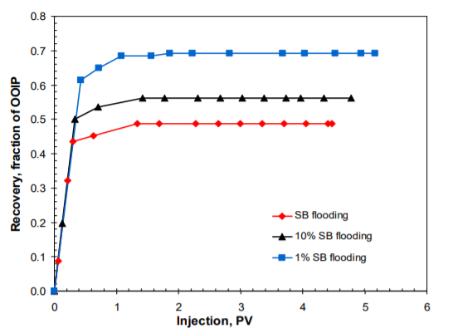

Fig. 1- LSE in a secondary recovery mode (After Ashraf et al., 2010)

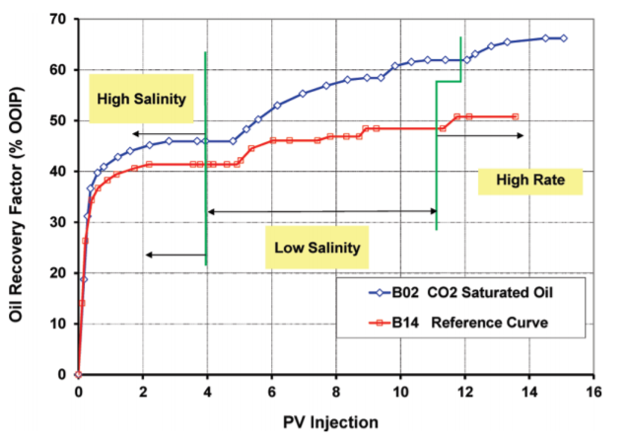

Fig. 2- LSE in a tertiary recovery mode (After RezaeiDoust et al., 2011)

Mechanisms of low-salinity waterflooding
Despite more than three decades of research, the mechanisms underpinning LSE is still debatable. The complexity of the subsurface system and the heterogeneity of the crude oil composition have posed several research challenges where a multitude of mechanisms are tangled [17, 18, 68, 69]. For instance, sheng, in his critical review, listed seventeen mechanisms for the IOR observed during LSW [19]. Most of these mechanisms suggest that LSW alters the wettability to a state more favorable for oil recovery [20]. In this section, I briefly discuss the most agreed-upon mechanisms:

3.1 Multi-component Ion Exchange (MIE)
Multi-component Ion Exchange (MIE) is one of the most agreed-upon mechanisms [17]. MIE is based on the cation exchange between the mineral surface and the formation brine [21, 22]. Naturally, the divalent cations adsorbed on the mineral surface act like bridges between oil molecules and the mineral surface, forming organometallic complexes. MIE suggests that these bridges could be broken when the divalent ions are exchanged with monovalent ones. Reducing the interactions between the oil and rock leads to a more water-wet state and a better oil recovery.
Lager et al. (2008) proposed four kinds of bridges that form between oil and mineral surfaces as shown in Fig. 3. These bridges are highly affected by the water composition [23].
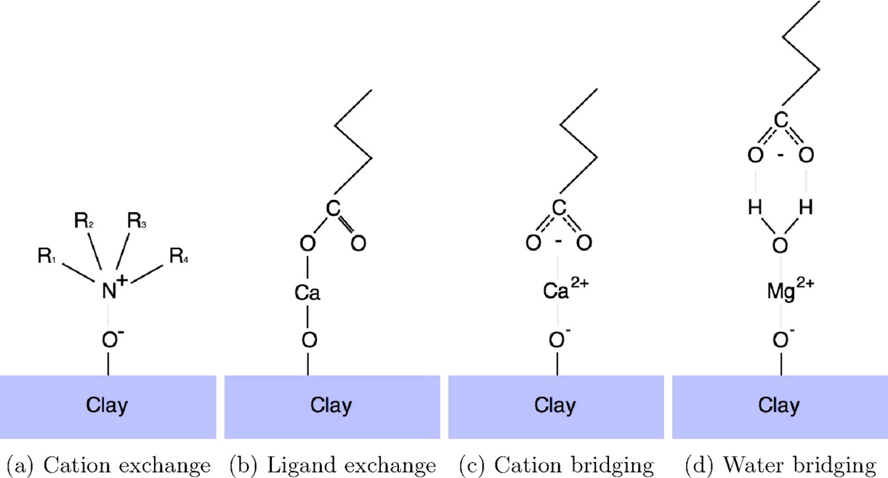
Recently, statistical thermodynamics studies have been probing various subsurface phenomena [24, 25]. Underwood et al. (2015) observed that these bridges are independent of water salinity in their molecular simulations [26]. Greathouse et al. (2017) also observed slight impact for the salinity on the organic adsorption and ion pairing [27]. On the other hand, classical thermodynamics have extensively contributed to the current understanding of low-salinity. For instance, Myint and Firoozabadi (2015) studied the thin film dynamics in relation to the water salinity [28]. However, most of these contributions are relying on the surface complexion model to estimate the surface charge and potential in contact with varying salinity water.

Fig. 3-: The main bridging mechanisms observed during low-salinity waterflooding
(After Underwood et al., 2015)

3.2 Chemical Mechanism,
This chemical mechanism has been proposed by Austad and his co-workers [8, 13, 29]. This mechanism can be summarized in the following steps: 1-when low salinity brine is introduced to displace the high salinity brine, the H⁺ ions replace Ca ²⁺ at the negative sites of the clay surface, this results in an increase in the pH near the clay surface. This reaction is an exothermic reaction, so an increase in the temperature supposed to suppress this replacement reaction. 2- The accompanied increase in the pH to LSW results in desorption of basic and acidic materials from the clay surface.

3.3 Double-Layer Expansion (DLE)
This mechanism was first proposed by lightelm et al. (2009), after a set of experiments they concluded that cation exchange might be partially responsible for LSE. However, the expansion of electrical double layers due to the decrease in the ionic strength is the main mechanism beyond LSE [30]. Electrical Double Layer (EDL) is based on the fact that minerals have a charged surface when they become in contact with aqueous solutions. This charge is neutralized by attracting oppositely charged particles [31], as shown in Fig. 4. For sandstone reservoirs, usually both the rock and crude oil surface are negatively charged, which means that oil will not bind to the rock surface due to having the same charge. In the case of high salinity brine, there are enough cations in the brine to screen off the negative charge on both crude oil and rock surfaces. This screening causes a decrease in the negative electrical potential at the slipping plane between the brine solution and the charged surface, which is known as zeta potential. This suppression of the electrical repulsive forces between the rock and crude oil surface, enables the oil to interact with the rock surface causing local oil wetness. On the other hand, low-salinity brine reduces the screening potential of the cations in the brine solution. This leads to an expansion in the diffuse electrical layer around the oil and rock particles and increases the zeta potential of both surfaces and the electrical repulsive forces between the oil and rock surfaces, resulting in releasing the oil from the rock surface. Fig. 5 presents a schematic that summarizes this mechanism.
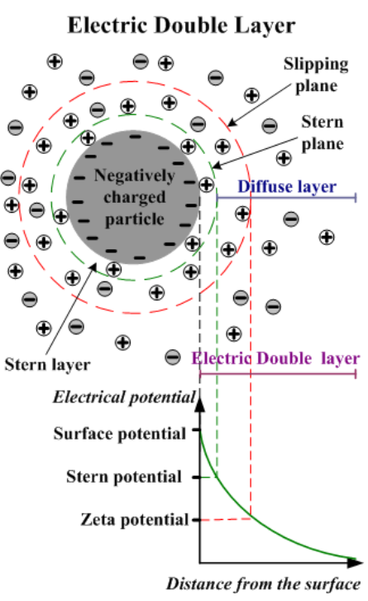

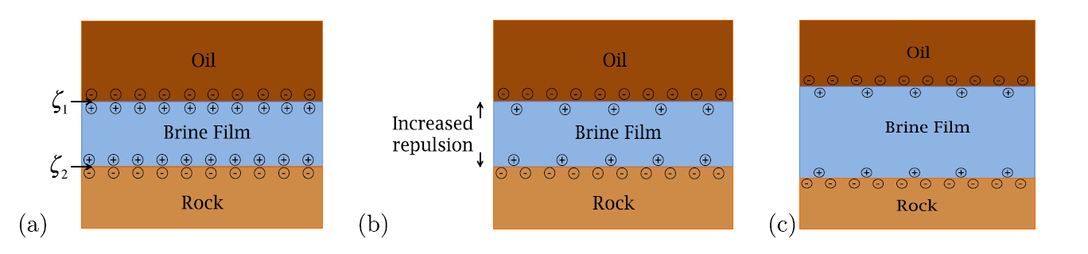
Fig. 4-: Schematic of Electrical Double Layer EDL (After Subtech 2014)
Fig. 5-: Schematic of DLE (After Myint and Firoozabadi 2015), (a) Counterions adsorbed to the negatively-charged brine/oil and brine/rock interfaces. The potentials at the two interfaces are estimated by the zeta potentials ζ1 and ζ2. (b)when the brine salinity is decreased, the screening from the counterions becomes weaker. (c) The double-layer expansion (DLE) appears as a thicker brine film that is indicative of a more water-wet state.
In a subsequent work, Nasralla and Nasr-El-Din (2014) concluded that zeta potential measurements could be correlated to contact angle measurements and core-flooding tests for brine solutions of different salinity and pH values, which made them conclude that electrical double layer expansion could be the primary mechanism for LSE [32]. On the other hand, Mehana and Fahes (2018) suggested limited impact of DLE mechanism based on their molecular scale investigation [33].

3.4 Increased pH and reduced IFT similar to alkaline flooding
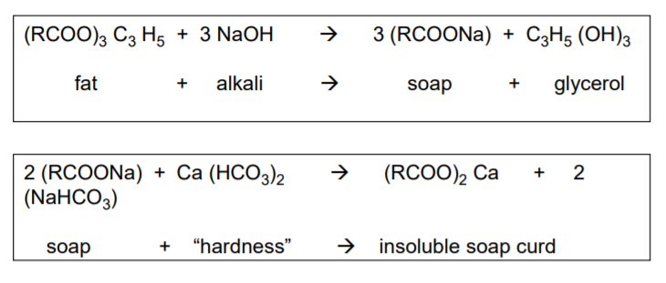
McGuire et al. (2005) proposed that formulation of surfactant from the residual crude oil, due to elevated pH that accompanies the low-salinity waterflooding and the resulted decrease in interfacial tension between the crude oil and brine, might be the main mechanism of having LSE [34]. They related the increase in pH to the generation of hydroxyl ions resulted from the interaction with the rock minerals. Evidences of increasing the pH during low-salinity waterflooding leaded to their conclusion that low salinity waterflooding behaves in a similar fashion to alkaline flooding. Having this condition of high pH, the alkaline reactive components are saponified by the reaction showed in Fig. 6. On the other hand, they argued that low-salinity waterflooding is more effective than alkaline flooding due to the lack of divalent cations in low salinity brines, which makes the created surfactant due to saponification more effective

Fig. 6-: saponification mechanism of elevated pH and removal of harmful multivalent cations due to low salinity injection. (After McGuire et al. 2005)

3.5 Fine mobilization
Tang and Morrow (1999) proposed fine mobilization as a possible mechanism beyond LSE [36]. They attributed the mobilization of fines to the expansion of the electrical double layer (EDL). Introducing the low salinity brines expands the electrical double layer in the aqueous phase between particles, which increases the tendency for stripping of fines and so oil recovery is increased. They correlated having LSE from several core-flooding experiment to having potential mobile fines. As they tried different sandstones that have different clay contents, and they found that the effect of low salinity waterflooding is greatly reduced in the case of low clay contents. Furthermore, they found that stabilizing mobile fines by firing eliminates the LSE. A schematic for this mechanism is shown in Fig. 7.

3.6 Mechanism in play
None of the proposed mechanisms could solely justify having LSE in all the cases. For each mechanism there are some experimental evidences that confirm being involved. Whereas, many other evidences indicate that the same mechanism is not involved other cases where LSE was witnessed. So, it is commonly believed that a combination of those mechanisms is responsible for having LSW [35].

Temperature effect
One of the main factors that still need further investigation is the effect of temperature on low-salinity waterflooding. RezaeiDoust et al. (2010) investigated the effect of aging temperature on low-salinity waterflooding in sandstone samples from a field in the North Sea [37]. After several core-flooding experiments, they found that there is no LSE from the core samples that were aged at 60ºC and 130ºC, whereas when the aging temperature was 90ºC, there was a noticeable low-salinity effect (LSE) at different displacing temperatures (60, 90 and 130ºC). They concluded that there is an optimum aging temperature to have a LSE which in their case was 90ºC.In a subsequent work, Aksulu et al. (2012) investigated the effect of temperature on a newly proposed chemical mechanism for the LSW [29]. The mechanism proposes an exothermic reaction which involves the desorption of active cations from the mineral surface as a main factor controlling the wettability alteration process. Therefore, the temperature would have a substantial effect on the performance. After several core floods using two reservoir cores, they concluded that the desorption rate of the active cation from the clay surface is positively correlated with the temperature.

Gamage and thyne (2011) also studied the effect of temperature using Berea sandstone. They found that the effect of LSW on the rock samples that are aged and displaced at the same temperature in the tertiary recovery is decreasing with increasing the temperature [38]. In the same vein, Aghaeifar et al. (2015) concluded that the combination of high reservoir temperature above 100ºC and formation water with a high salinity is most likely not favorable for observing LSW EOR effects [39]. Along the same line, Xie et al. (2017) concluded that water chemistry controls crude/Brine/Rock interaction in the case of LSW rather than temperature [40]. They also suggested that LSW can work at high temperature reservoirs in the case of high Acid Number, above 2 mg KOH/g.
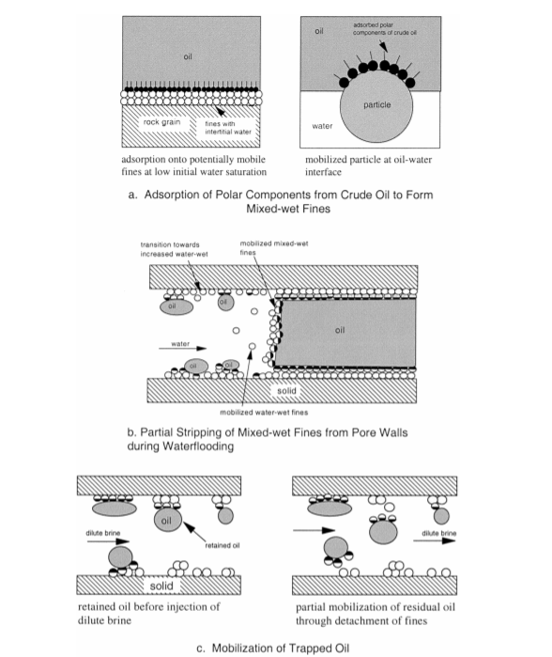
Fig. 7-: Role of potentially mobile fines in Crude Oil/Brine/Bock interactions and increase
in oil recovery with decrease in salinity. (After Tang and Morrow 1999)

Favorable conditions for LSE
As a result, for the observations of the experimental investigation on LSW in sandstones, a number of necessary conditions have been suggested as necessary conditions to have LSE. Morrow & Buckley (2011) and Jackson et al. (2016) listed the following conditions [10, 9]:
- Significant clay Fraction.
- Presence of formation water.
- Significant reduction in salinity of injection brine.
- Exposure to crude oil containing acid or basic polar components to create mixed- or oil-wet initial conditions.
- Presence of multivalent ions in the connate water.
These conditions are necessary; however, they are not sufficient criteria to evaluate the success of LSW. In some cases, where those conditions are satisfied no LSE was observed [9].

Cases of Non-successful LSW
As mentioned in the previous section, in some cases even when all the reported favorable conditions for LSW exist, no LSE was witnessed. This is a direct indication about the complexity of this EOR mechanism [32, 41, 42].

Evolution of LSW
Recently, several published studies investigated new hybrid EOR techniques that incorporate LSW with other commonly known techniques. As an example, the combination of LSW and surfactant flooding has been investigated as an emerging hybrid EOR technique [43, 44]. This indicates the importance and the potential of LSW as a standalone EOR technique and a key player in other hybrid EOR techniques.

Flow Assurance Issue
An important factor that should be taken into consideration is the effect of total salinity and salt types of the injected brine. Many studies investigated the effect of salinity on forming a stable crude-oil/water emulsion, and in most of the cases it was reported that low ionic strength brines tend to form more stable emulsions [45, 46]. This issue can be a serious problem specially in the case of using Electrical Submersible Pump (ESP), which can provide the required energy to mix the crude oil with the brine and form very stable emulsion. This can cause serious flow assurance issue.

Chapter III: Thermodynamic Modelling of the Temperature Impact on Low-salinity Waterflooding Performance in Sandstones

Abstract
Low-Salinity Waterflooding (LSW) has emerged as an innovative technique to improve oil recovery. Extensive research has been devoted to providing a better-understanding of the mechanisms involved and to optimize its performance. Among those mechanisms, Multi-component ion Exchange (MIE) mechanism explains the coordination of surface complexes in a way that highlights the essence of LSW. However, the temperature impact on LSW is still poorly understood. We used Surface Complexation Modeling (SCM) to study both oil/brine and mineral/brine interfaces up to a temperature of 150ºC. Given the heterogeneity of the oil interface, we studied three oil interfaces with varying TBN/TAN ratios (1:3, 1:1, and 3:1). We found that temperature is a critical factor in estimating the LSW performance. While temperature reduces the pH range at which LSW yields positive effect for basic oil, it shifts the pH window at which LSW has potentially negative results to lower pH values for neutral oil. In addition, the temperature magnifies the ability of LSW in enhancing the surface potential. Our results support the need of conducting experimental work at the relevant reservoir temperature to evaluate the performance of LSW.

Introduction
Brady et al. (2012) used SCM to study the performance of LSW in sandstone at different pH values and at temperatures up to 100ºC [47]. They investigated the LSW effect on both rock/brine and oil/brine interfaces. Using coordination chemistry, they studied the impact of both ion type and concentration on the complexes formed at oil/brine and rock/brine interfaces where the attraction between these complexes is used as a proxy for oil adhesion to the rock. They also introduced the concept of bond product, which represents the product of the concentration of oppositely-charged complexes on the interfaces. Consequently, high concentration product means high oil adhesion. Brady et al. (2013) extended their scope to examine the effect of kaolinite impurity and the dissolution of calcite in sandstone [48]. They found that kaolinite impurity could induce a negative charge on the kaolinite basal planes which could coordinate to the oil. Besides, the dissolution of calcite decreases the efficiency of LSW since the divalent nature of the calcium ions would trigger a number of bridges between the oil and the rock.
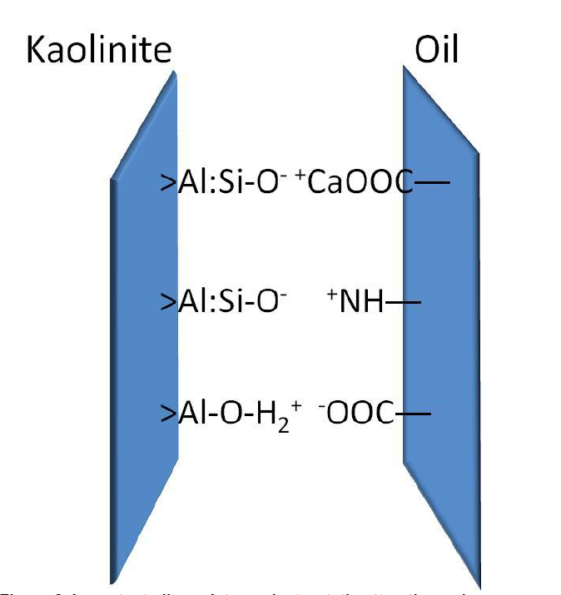

Fig. 8-: Important Oil/Sandstone electrostatic attraction pairs. (After Brady et al., 2012)

In another dimension, Brady et al. (2015) used SCM to investigate the impact of oil properties on LSW performance in sandstone [49]. Their results highlighted the significance of the accurate estimation of oil properties in forecasting LSW performance. Using the same approach, Brady et al. (2016) optimized the properties of fracturing fluids (pH, salinity, and hardness) to enhance oil recovery [50]. They observed that oil/rock adhesion is inversely proportional to both salinity and pH for basic crude. On the other hand, oil/rock adhesion is enhanced upon the addition of calcium ions in the case of acidic crude. Mahani et al. (2017) used SCM to estimate the electrokinetics of calcite where the surface potential of the calcite surface is calculated and validated by experimental measurements [51]. Many other studies used SCM to study fluid/rock interactions [52-56].
This work aims to provide a better understanding of the impact of temperature on LSW performance using SCM. The rest of the study is organized as follows: in the methodology section, a brief background is presented about the modelling approach and the input parameters used; in the results section, the impact of temperature on the molecular species, LSW performance, and the surface potential is discussed; and at the end, the final remarks are summarized in the conclusions.

Methodology
In this section, we briefly present the thermodynamic model used along with the input parameters and model details.

3.1 Surface Complexation Model
Surface complexation model (SCM) describes the sorption of species from solution on the mineral surface at the equilibrium state. The main principle is that water molecules and dissolved species form bonds with exposed lattice-bound ions at mineral surfaces [57]. While simulating the equilibrium the model takes into account the mass balance in the system including the sorption surface sites, as long as the electrical charge of the surfaces that varies greatly with pH, ionic strength, and solution composition. These sorption site behaves much like a complexing ligand in solution, having the surface area and sites density, this gives the concentration/activity of sorption sites. Then, using the equilibrium constants of the reactions between that site and various ions, we will have a number of mass action equations that can be solved to give the concentrations of surface species as well as those of the usual aqueous species [58]. However, as the solid phase will be charged when it becomes in contact with water, the equilibrium constants should be adjusted to account for having the sorption sites in a charged field. The electro-kinetics of the interface is described assuming either constant capacitance, double layer, or triple layer theories. However, the double layer model is widely-used for LSW modelling due to its simplicity. We used SCM in this study using PHREEQC [59].
The surface sites with the complexes that will form control the charge of the surface that could be positive or negative. A second layer that separates the sorbing surface from the bulk solution called the diffuse layer. The role of the diffuse layer is to make screening to the surface charge to achieve local charge balance [32], which means that the net charge of the diffuse layer should be opposite to the sorbing surface charge [60]. During sorption, the ions should move through a charged electrical field and react chemically at the surface, so we should take into account the electrostatic and chemical contributions to the free energy change of the reaction [60], using the following equation:
${∆G}_{tot}= {∆G}_{ads}+zFψ$
Where G is Gibbs free energy and the subscripts tot and ads stands for total and chemical adsorption energy, Z is the charge number (unitless) of the sorbed species, F is Faraday constant, and ψ is the potential. An equilibrium constant K represents the chemical effects on free energy. Multiplying K by the Boltzmann factor, gives a complete account of the reaction’s free energy, including electrostatic effects [2], Boltzman factor:
$$exp⁡(-\frac{∆zFψ }{RT_{K}})$$
Where, ∆z is the change over the reaction in the charge on surface species, R is the gas constant (8.3143 J mol⁻¹ K⁻¹), and T_{K} is absolute temperature (K).
The main equations in PHREEQC are mole-balance equation, aqueous mass balance equations, activity coefficient model and saturation index. Relating the equilibrium constant for each species formation reaction after taking into account electrostatic effects to the activity product of each reaction, we can build mass action equation that will be solved in way to keep constant mass for all the components at the system and make the diffuse layer charge balance the sorbing surface [61]. The activity coefficients are calculated according to the extended Debye-Huckel equation [62],
$$\log\left(γ_{i}\right)= -\frac{AZ_{i}^{2}\sqrt{I}}{1+Ba_{i}\sqrt{I}}+ b_{i}I$$
where A and B are the temperature-dependent coefficients, whereas a_{i} and b_{i} are the ion-specific fitting parameters. The ionic strength, I, can be described as where Z_{i} is the charge number of ionic species i in solution and n is the total number of ionic species i in aqueous solution.
$$I=\frac{1}{2}\sum_{i=1}^{n}{C_{i}Z_{i}^{2}}$$
The main equations to be solved in a SCM are mole-balance, aqueous mass balance, activity coefficient model, and saturation index. Initially, the electrostatic effects are overlooked, where the intrinsic thermodynamic constants are used to solve the mass action and balance equations for surface reactions. After the concentrations of surface species are determined, the surface charge and potential are estimated respectively. Having the surface potential, we recalculate the apparent thermodynamic constant which takes into account the electrostatic effects. Consequently, the previous steps are repeated till a convergence is achieved.

3.2 Sandstone Surface Reactivity
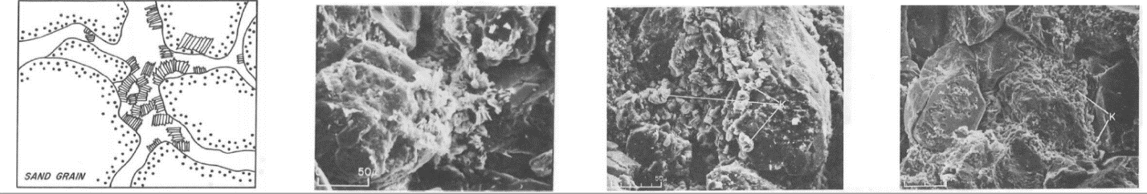
Given the morphology of the sandstone pores, the reactive surface area is dominated by clay minerals [20]. Clay minerals possess large specific surface area which is 100-1000 times that of quartz [48, 60]. Therefore, we used kaolinite as a proxy for sandstone, which is in line with the literature [40, 47, 48]. Kaolinite minerals usually occur as discrete particles in sandstone pores as shown in Fig.2.44

Fig. 9-: Kaolinite mineral presents as discrete particles in sandstone pores along with SEM images (modified after Neasham, 1977)

3.3 Acid and Base Number
Total Acid Number (TAN) is a measure of the quantity of base required to titrate a sample, in a specific solvent to a specific end-point, expressed in milligrams of potassium hydroxide per gram of oil [64]. On the other hand, Total Base Number (TBN) is a measure of the quantity of a specific acid required to titrate a sample, in a specific solvent to a specific end-point, expressed in milligrams of potassium hydroxide per gram of oil [65]. The TBN/TAN ratio is an essential parameter that should be identified in order to understand the interactions between the oil interface and water or rock. Dubey et al. (1993) reported a positive correlation between the TBN/TAN ratio and both the wetting reversal pH and the isoelectric point [66]. The TBN/TAN ratio controls the wettability state of the rock since it affects the type and magnitude of charge on the oil/water interface. This leads to a water-wet state in the case of similar charges on both interfaces or moving toward a more oil-wet condition in the case of opposite charges.

3.4 Model Details
We used the SCM proposed by brady and Krumhansi (2012 & 2013), where the diffuse Layer model is used to account for the interactions between the crude oil and sandstone [47, 48]. The inputs include the type and density of surface sites, water composition, and the geochemical reactions. The parameters used in our work are adopted from Brady et al. and are summarized at Table 1, [47]. Kaolinite surface is modeled using two surface sites, >Al-O-H and >Si-O-H. On the other hand, the oil surface contains two functional groups, namely carboxylate group and nitrogen base group. To represent the heterogeneity of oil composition, we modelled several scenarios having different concentrations of the functional groups.
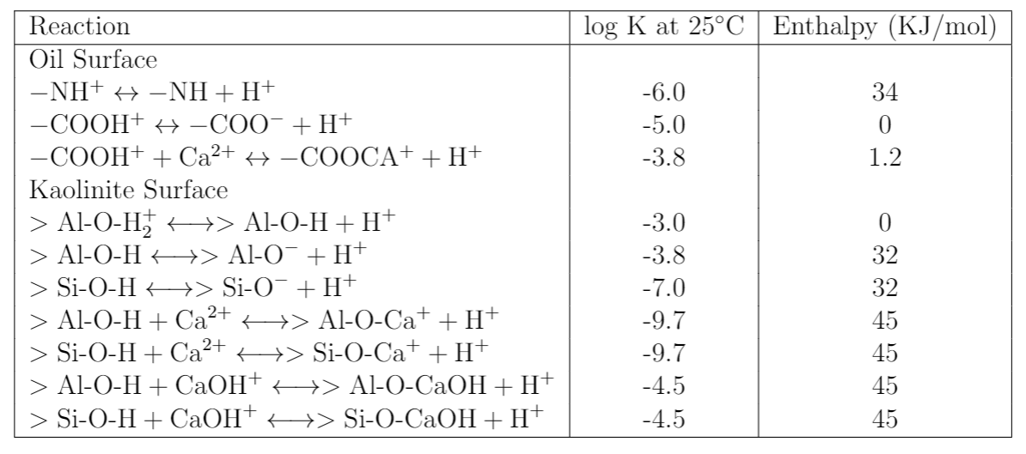
In this study, the high salinity brine has 0.4 M NaCl and 5 mmol CaCl₂ and represents connate water. On the other hand, low salinity water, which represents the injected water, is diluted 20 times. We investigated two scenarios, the native case where only connate water is in contact with the oil and rock surfaces, and the injection scenario where a mixture of connate and injected water with 5 and 95 % respectively is used. We studied the temperature effect up to 150ºC. Three TBN/TAN ratios of 1:1, 1:3 and 3:1 are employed, Keeping the total site densities on the oil surface to be 3.34 μmol/m². We collected the surface potential and the concentration of surface complexes at the oil/water and rock/water interfaces, then we calculated the Bond Product Summation (BPS). After that, we estimated the difference in PBS product by subtracting the low salinity value from the high salinity one; a positive difference is equivalent to a potential for enhancement in oil recovery.
Table 1: Reaction kinetics for surface complexation model for both oil and kaolinite surfaces

Results
In this section, we discuss the impact of temperature on the complexes formed on the rock and oil interfaces, the adhesion between the interfaces, and the surface potential.

4.1 Species Concentration on Oil and Rock Surfaces
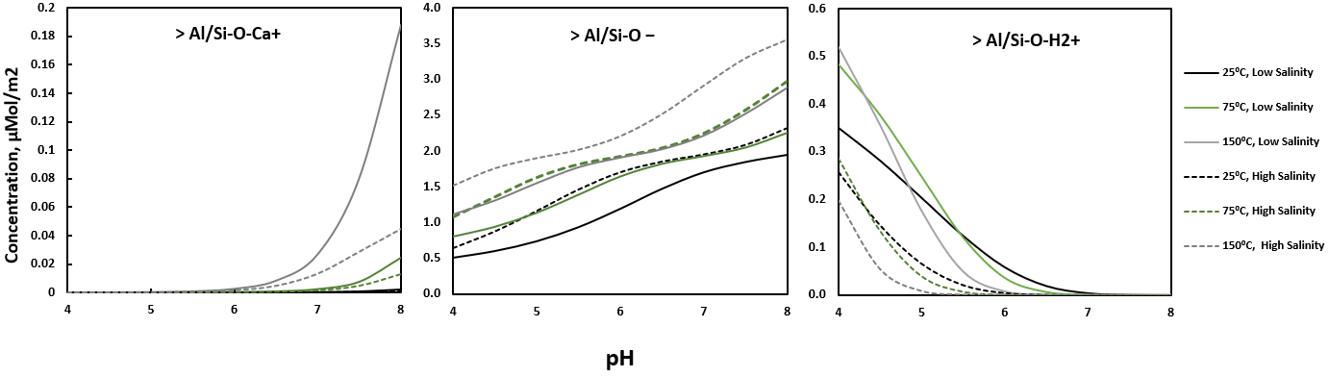
The main three species that form on the kaolinite surface are >Al/Si-O⁻, >Al/Si-O-H₂⁺ and >Al/Si-O-Ca⁺, as shown in Fig. 10. The results show that the concentration of >Al/Si-O⁻ and >Al/Si-O-Ca⁺ increases with increasing the pH, whereas the concentration of >Al/Si-O-H₂⁺ concentration is at its maximum value at lower pH values. Note that >Al/Si-O⁻ is the dominating species over the whole range of pH with values around an order of magnitude more than the other two species, and since it is negatively changed, it is reasonable to conclude that the positive species on the oil surface will control the binding of the oil to the rock surface. This is in line with the fact that several minerals have a negatively charged surface when they become in contact with aqueous solutions. This negative charge is neutralized by attracting positively charged particles [23]. At the same temperature, the high salinity condition tends to have a higher concentration of >Al/Si-O⁻ and a lower concentration of >Al/Si-O-Ca⁺ than the low salinity condition. We also observed that he differences between the recorded concentrations in the cases of low and high salinity is higher at higher temperatures in most of the cases investigated in this study. It is worth noting that the low salinity condition tends to have a higher concentration of >Al/Si-O-H₂⁺ than the high salinity condition at a given pH value regardless of the temperature.
Fig. 10-: Species concentration on kaolinite surface

On the other hand, the main three species that form on the oil surface are −COO⁻, −NH⁺ and −COOCa⁺ as shown in Fig.11 and 12. -NH⁺ is dominant at low pH values, while −COOCa⁺ and −COO⁻ are dominant in case of high pH values, which is in line with the kinetics of the reactions. For example, in case of high pH, which means a low H+ concentration, the reactions at the oil surface are directed towards the products’ side. However, in the case of low pH, a high H⁺ concentration is present, and the reactions on the oil surface are directed toward the reactants’ side, which leads to high concentrations of -NH⁺. In the coming sections we will discuss the trends of positive species only since they are the ones that can be attracted to the rock surface, as mentioned earlier.
In the case of oil with a TBN/TAN ratio of 1:1, shown in Fig. 11b, we observe a reduction in the concentration of -NH+ as temperature increases for any given salinity or pH condition. The concentration of -NH+ is a key factor in estimating the efficiency of LSW since it binds to the rock surface specially at low pH conditions; A lower concentration boosts the efficiency of the waterflooding operations. This is in line with Brady et al. conclusion, that low-salinity waterflooding can have a positive effect by decreasing the bridges that can form by attracting -NH+ on the oil surface to the negative sites on the rock surface [47].
We also note a critical pH value at which the concentration plots of -NH+ for the cases of low and high salinity overlap. Below this value, high salinity brine yields higher concentrations of -NH+, while low salinity dominates above it. Interestingly, this pH value is temperature-dependent, since it decreases as the temperature increases. In lay words, higher temperature hinders the efficiency of the low salinity brine since it shrinks the pH interval over which the low salinity is effective in reducing the concentration of -NH⁺. The transition point is located at the approximate pH values of 5.4, 5, 4.7 for the temperatures of 25, 75,150º C respectively. In this case of TBN/TAN ratio of 1:1, the scenario of high salinity results in higher concentrations of -COOCa⁺ as shown in Fig.5b. This could be attributed to the abundance of calcium ions.
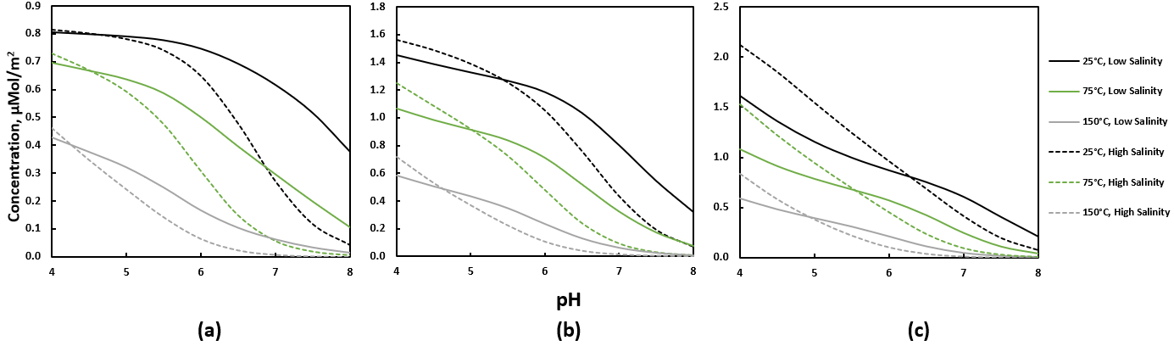
For TBN/TAN ratios of 1:3 and 3:1, the concentration of -NH⁺ follows the same trend as that observed in the case of 1:1 ratio. However, the TBN/TAN ratio affects the critical value. As the ratio of TBN to TAN increases, the critical pH value seems to increase at all the temperatures considered. Note that the pH window over which low salinity waterflooding can enhance oil recovery expands for higher TBN/TAN ratios. Regarding the concentration of -COOCa⁺, we observed that at low TBN to TAN ratios, higher salinity consistently results in higher concentrations for a given pH value, while at high TBN to TAN ratios, the effect of salinity on concentration is not as evident. the effect of temperature on the concentration in this case is also highly dependent on the salinity and pH condition.
Fig. 11-: The concentration of -NH⁺ for different TBN/TAN, a) TBN/TAN = 1/3 b) TBN/TAN = 1/1 c) TBN/TAN = 3/1
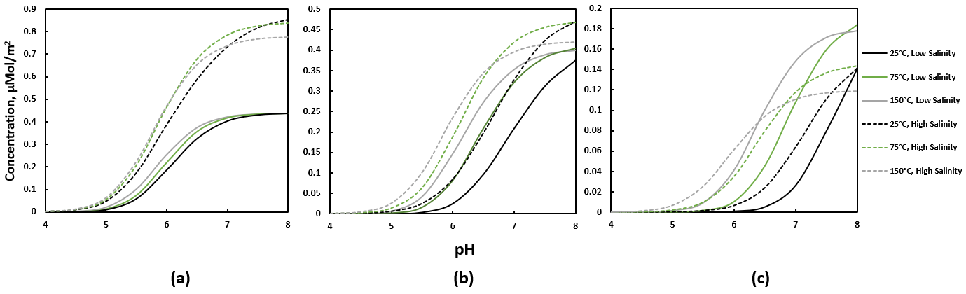
Fig. 12-: The concentration of -COOCa⁺ for different TBN/TAN, a) TBN/TAN = 1:3 b) TBN: TAN = 1/1 c) TBN: TAN = 3/1

4.2 Bond Product Summation
According to the coordination chemistry principles, the oppositely-charged complexes formed over oil/brine and rock/brine interfaces should attract each other’s. To study the oil adhesion to the rock, we used the bond product summation (PBS) concept, which represents the product of the concentration of oppositely-charged complexes on the oil/brine and the rock/brine interfaces. Higher BPS translates to more oil adhesion, which is not a favorable condition for oil recovery. In the case of a TBN/TAN ratio of 3:1, the dominant concentration product is [-NH⁺][>Al/Si-O⁻], as shown in Fig. 13 for the case of 3:1 TBN/TAN ratio at 50ºC . We estimated the difference in PBS between low and high salinity water at different conditions of temperature and pH. This difference is used to create diagnostic maps as shown in Fig. 14, where we blue-colored the regions that lead to positive impact for LSW and orange-colored the negative ones. Positive impact for LSW is observed for most of the pH and temperature conditions in the case of acidic oil (TBN to TAN ratio of 1:3), except for a small region around a pH of 5 and a temperature higher than 120ºC. On the other hand, we observed a channel of negative impact separating positive impact regions for oil with a TBN to TAN of 1:1. This channel comprises of high pH conditions at low temperature and low pH conditions at high temperature. For the basic oil, we mainly observed positive impact at low pH conditions. The detailed graph that used to generate the diagnostic map are presented in the appendix.

4.3 Surface Potential
We observed a reduction in the magnitude of the surface potential as the salinity increases for all surfaces, which is consistent with experimental observations [32]. The difference between the surface potential at low and high salinity is presented in figure Fig.8 for both rock and oil surfaces. Regarding the rock surface, the temperature is enhancing the low-salinity to magnify the potential for all pH. However, the extent of the salinity impact on the surface potential is dependent on the pH. We took into account the heterogeneity of the oil composition by considering three interfaces with TBN/TAN ratio of 1/3, 1/1 and 3/1. The temperature enhances the low-salinity effect at higher pH and diminishes it at lower pH. Acritical effect is observed for the temperature on the low-salinity effect for the basic crude. For instance, at low temperature similar effect is observed for both PH of 4 and 8, and pH of 7 and 5. However, at higher temperature, this effect was weakened for both pH of 4 and 5 and enhanced for both 7 and 8. In a broad view, the temperature would enhance the performance of the low-salinity floods for all cases except cases with lower pH of 4 and 5.

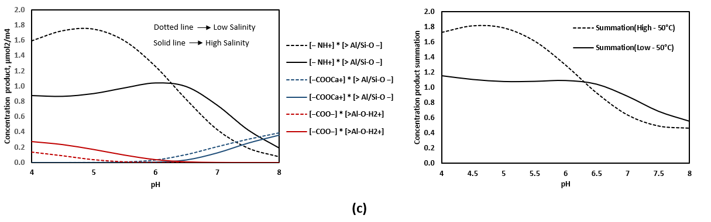
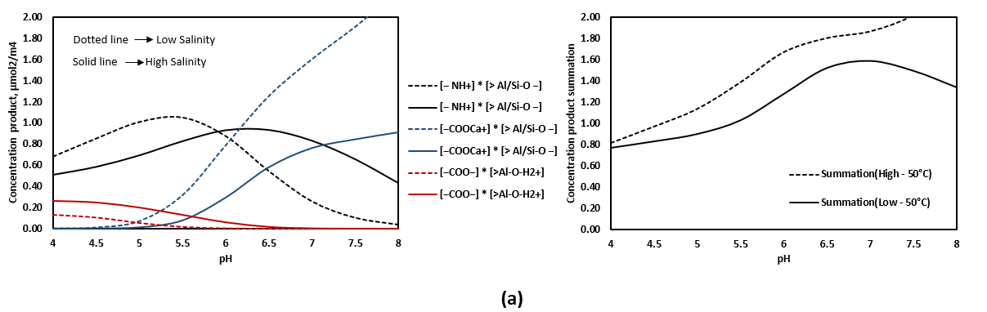
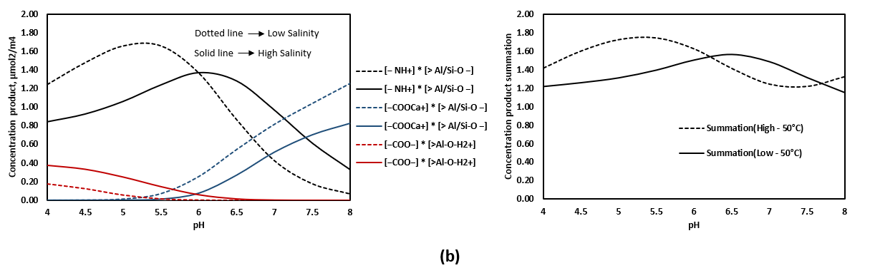
Fig. 13-: The bond product between the different molecular species at 50ºC for a) TBN/TAN= 1:3 b) TBN/TAN = 1:1 c) TBN/TAN = 3:1 (the right) and the summation of all three significant concentration products observed (the left)

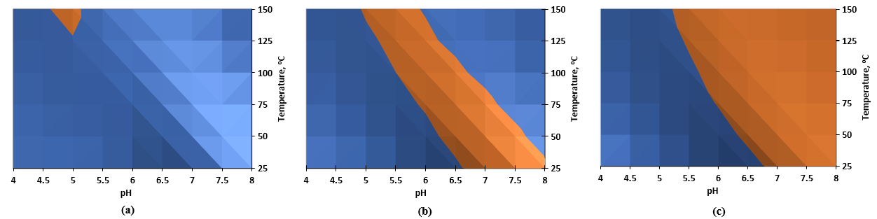
Fig. 14-: The difference between the bond product summation for low and high salinity. The blue color indicates positive impact for low salinity while the orange refers to negative impact. a) TBN/TAN = 1/3 b) TBN/TAN = 1/1 c) TBN/TAN = 3/1
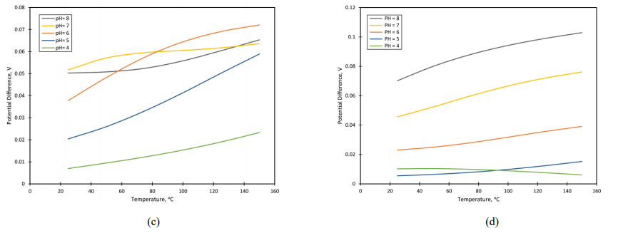
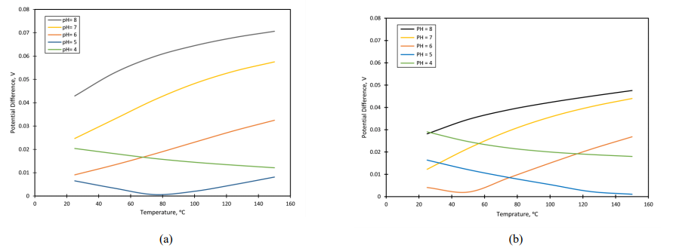
Fig. 15: The impact of temperature on the difference in surface potential between the low salinity and high salinity cases (low minus High) for a) oil with TBN: TAN = 1:1, b) oil with TBN:TAN =3:1, c) kaolinite and d) oil with TBN:TAN = 1:3 and

Comparing to experirmetal results
The experimental results used in this section doesn’t have the same exact conditions used in the thermodynamic modeling, they are used to show that the conclusions we got from our model is comparable to what is present in the literature.
- Core-flooding experiment from Aghaeifar et al. (2015): core-flooding result is shown in Fig. 16. The oil used in this experiment is a basic oil with TBN and TAN equal to 1.17 and 0.25 mg of KOH/g respectively. High salinity formation water was injected at a secondary recovery mode, then sea water, after that 50 times diluted sea water. No LSE was witnessed in this case, where the displacement temperature was 110ºC. This is inline with the results from our model, which shows that for a system that has a basic oil, LSE can be witnessed only in case of low pH brine solutions.
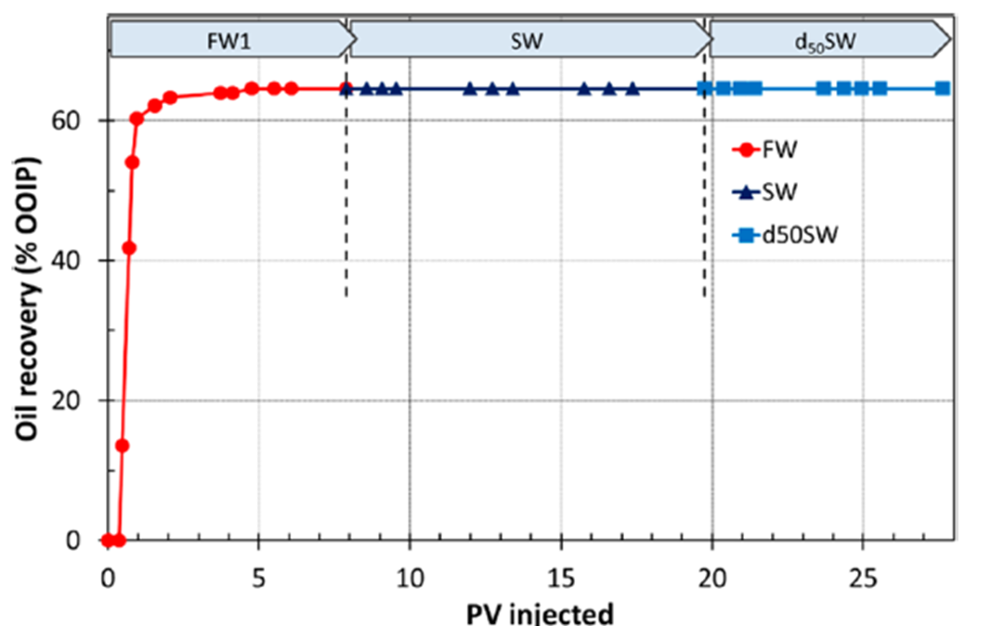

Fig. 16 Core-flooding test for a sandstone reservoir core at 110°C. (After Aghaeifar et al. 2015)

- Core-flooding experiment from Cissokho et al. (2010): core-flooding result is shown in Fig. 17. The crude oil used in this experiment was also a basic oil with TBN and TAN equal to 0.95 and 0.17 mg of KOH/g respectively. The results show a similar trend to our model for the basic oil. For a certain brine solution with a specific pH value, increasing the temperature could result in a great decrease in the LSE or even diminishing the LSE. This trend is depicted in the surface map for BPS difference for basic oil in Fig. 14C.
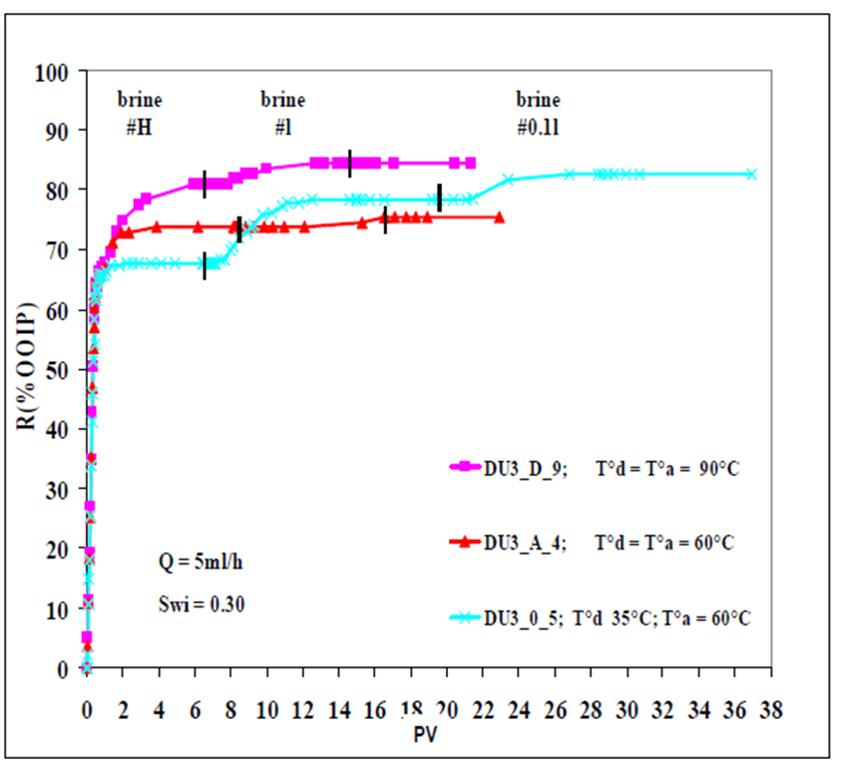

Fig. 17 Core-flooding test from a sandstone outcrop core at different displacing temperatures. (After Cissokho et al. 2010)

Conclusion
We used a thermodynamic modelling approach to investigate the impact of temperature on the performance of LSW. The following remarks summarize the main findings observed:
- Temperature enhances the concentration of the -NH+ complex on the oil interface for all TBN/TAN ratios studied. On the other hand, it reduces the concentration of the-COOCa⁺ complex. For the kaolinite surface, the concentration of >Al/Si-O⁻ and >Al/Si-O-Ca⁺ are amplified, while non-monotonic impact is observed for >Al/Si-O-H₂⁺.
- Limited impact is observed for temperature on acidic oil. However, the temperatures steadily shift the pH window at which the LSW is negatively affecting the oil recovery to lower values in the neutral oil. For the basic oil, the temperature decreases the pH region at which LSW is positively affecting the oil recovery.
- The temperature mostly magnifies the LSW in enhancing the surface potential of both oil and kaolinite surface.
- This work highlights the significance of considering temperature in both conducting lab experiments or designing field project. The natural extension of the current work includes studying other solid surfaces while considering dynamic conditions

Chapter IV: Experimental Investigation of Temperature Effect on low-Salinity Waterflooding in Sandstones

Introduction
The number of studies devoted to investigating the impact of temperature on LSW doesn’t reflect the attention paid for this promising technique over the last three decades. Furthermore, the conclusions derived from those studies are in some cases controversial. The different conclusions could be attributed to the complexity of LSW, as any difference in the properties, or even small change in the procedure followed from one core sample to another can greatly affect the results. In previous studies, the temperature effect was investigated by performing several core-flooding tests at different temperatures for similar core samples, or by applying incremental increase on the displacing temperature during the core-flooding experiment. We think that those core-flooding workflows cannot give the most accurate results. Hence, we devise a new experimental workflow that we believe can produce more accurate results.
In this study, LSW was investigated at room temperature and at 55ºC. At the beginning, sandstone core fully saturated with crude oil was flooded using the same high salinity brine at the same aging temperature (55ºC). After that, low salinity brine was injected at a tertiary recovery mode at the same displacing temperature until the crude oil production ceased. Then, the displacing temperature was lowered to 25ºC and the oil recovery was monitored. After that, two core samples saturated with both high salinity brine and crude oil were flooded the same previous way. Then, another two core samples also saturated with both high salinity brine and crude oil were flooded the same way except that there was no high salinity brine injection at the beginning. We believe that this workflow can provide more accurate conclusions about the impact of temperature on LSW, as it can determine whether an exothermic reaction, discussed in some details in chapter 2 section 3.2, is responsible for releasing oil from sandstone surface, which is one of the mechanisms proposed in the literature, or not. As, increasing the displacing temperature by itself increases the recovered oil, so any additional oil recovery cannot be attributed to the temperature impact on LSW, and comparing the oil recovered from two similar core samples flooded at low and high temperatures might not be conclusive due to the complexity of mechanisms governing LSW. Whereas, increasing oil recovery with decreasing the displacing temperature, gives a direct indication that high temperature suppresses the LSE.

Methodology

Rocks
Mineral | Quartz | Illite | Kaolinite | Pyrite | Mixed Clay | Albite | Siderite | Apatite | Aragonite
Percentage | 70 | 0.5 | 1.5 | 4 | 7 | 12 | 2.5 | 0.5 | 2
Gray Berea sandstone was used in this study. The mineral composition was determined using FTIR. The mineral composition was measured for five samples that were taken from different locations from the sandstone block. Averaged mineral composition is presented in Table 2.
Table 2: Mineral composition of sandstone samples used.
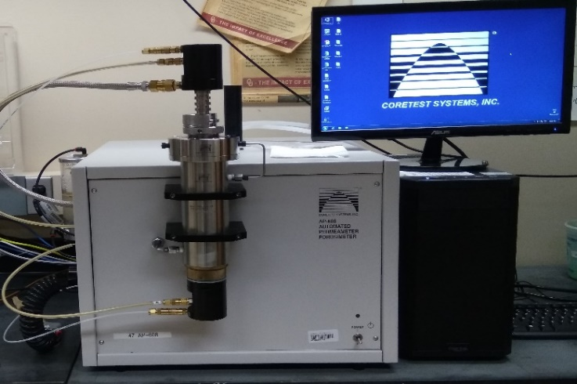
Cylindrical samples were cut from a sandstone block. Porosity and air permeability for used sandstone core samples were measured using CoreTest Automated Permeameter/Porosimeter AP608, shown in Fig. 18 Measured properties of sandstone cores are presented in Table 3.

Fig. 18: CoreTest Automated Permeameter/Porosimeter AP608
Core | Length, Inch | Diameter, Inch | Initial. Oil saturation  % | Initial Water saturation % | Porosity, % | Air permeability, md | Aging Temp,  ºC
GB-01 | 1 | 1 | 100 | 0 | 19.24 | 209.5 | 55
GB-02 | 1 | 1 | 100 | 0 | 19.24 | 209.5 | 55
GB-03 | 3 | 1 | 100 | 0 | 19.04 | 202 | 55
GB-04 | 3 | 1 | 71.9 | 28.1 | 19.01 | 196.5
GB-05 | 3 | 1 | 72.6 | 27.4 | 18.64 | 176 | 55
GB-06 | 3 | 1 | 70.7 | 29.3 | 19.08 | 177.8 | 55
GB-07 | 3 | 1 | 66.6 | 33.4 | 18.9 | 195.6 | 55
Table 3: Dimensions and physical properties of sandstone core samples.

Fluids
Crude oil from a wellhead in midland, Texas was used in this study. Measured properties of crude-oil are listed in Table 4. TBN and TAN of crude-A were measured using Metrohm auto-titrator (model 848) tritino plus with a solvotrode electrode, shown in Fig. 19, according to the procedures in ASTM D664 and D2896. Viscosity of the crude oil was measured at 25ºC and 55 ºC using Anton Paar Rheometer MCR-72, shown in Fig. 20. Viscosity of crude oil was measured to be 3 cp at 55ºC. Two brines with different salinities were prepared to represent high and low salinity, the concentration and composition of used brines are listed in Table 5. The salts used to prepare the brines are from are from Sigma-Aldrich.
Density (g/cc) | Viscosity (cP) | TAN (mgKOH/g) | TBN (mgKOH/g)
0.8489 | 12 | 0.115 | 0.56

Table 4: Measured Crude-oil properties at 25ºC.
Brine | Concentration g/l | NaCl (%W) | CaCl2 (%W) | 2-Acrylamido-2-methylpropanesulfonic acid, (%W)
High salinity brine (HB) | 50 | 90 | 10 | 0
Low salinity brine (LB) | 1 | 95 | 5 | 0
Slick water | 7 | 0 | 0 | 100
Table 5: Concentration and composition of brines.

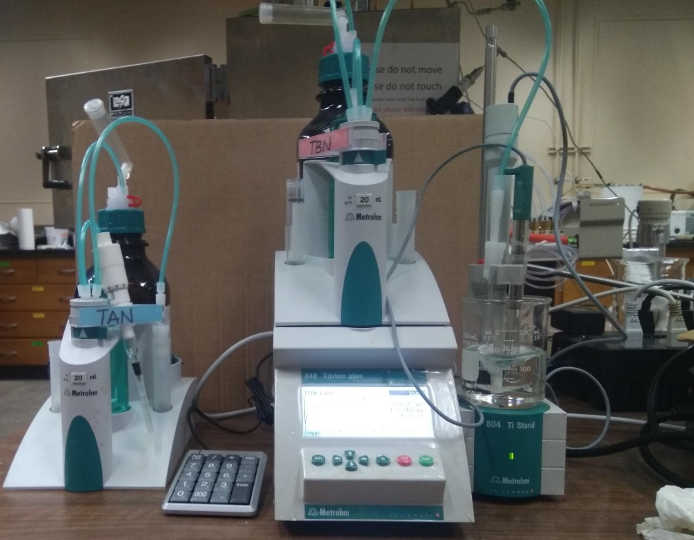

Fig. 19: Metrohm autotitrator (model 848) tritino plus with two exchangeable units, and a solvotrode electrode

2.3 Saturation process.
The dry weight of each core-sample was recorded, then the following steps were followed:
- Cores saturated with Crude oil only: Cores were vacuumed using a vacuum pump for at least 4 hours, after that the crude-oil was introduced to the cores. The weight of the core after saturation was recorded and compared to the dry weight to confirm that the core is 100% saturated.
- Cores Saturated with both Brine and Crude oil: Cores were vacuumed using a vacuum pump for at least 4 hours, then high salinity brine (HB) was introduced to the core sample. Then, the weight of brine-saturated sample was recorded. After that, the core was placed in the core-holder and the same HB was injected at different flow-rates (1, 1.5, and 2 cc/min), where the liquid permeability was calculated at each flowrate. Next, crude oil was injected into the core for at least 5 pore volumes and until no further brine was produced. The weight difference was used to determine the residual brine saturation and oil saturation. After that, the cores were kept in crude oil at the required temperature for two weeks for aging.
The Vacuum cell used in the saturation process is shown in Fig. 21, whereas the injection process where implemented using the core-flooding set-up shown in Fig. 23.
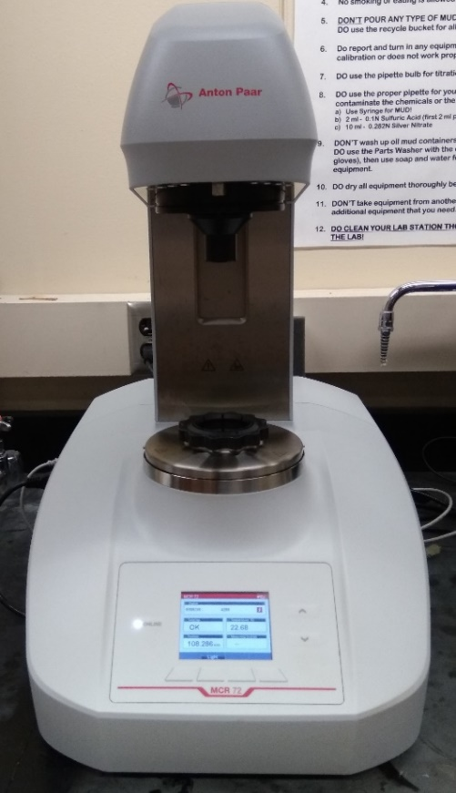

Fig. 20: Anton Paar, MCR-72 Rheometer.

2.4 Imbibition setup
Amott cell was used for imbibition tests, where sandstone cores saturated with crude-oil was placed in brines with different salinities. The volume of the recovered oil from each core sample was monitored over time. Amott cell used is shown in Fig. 22.

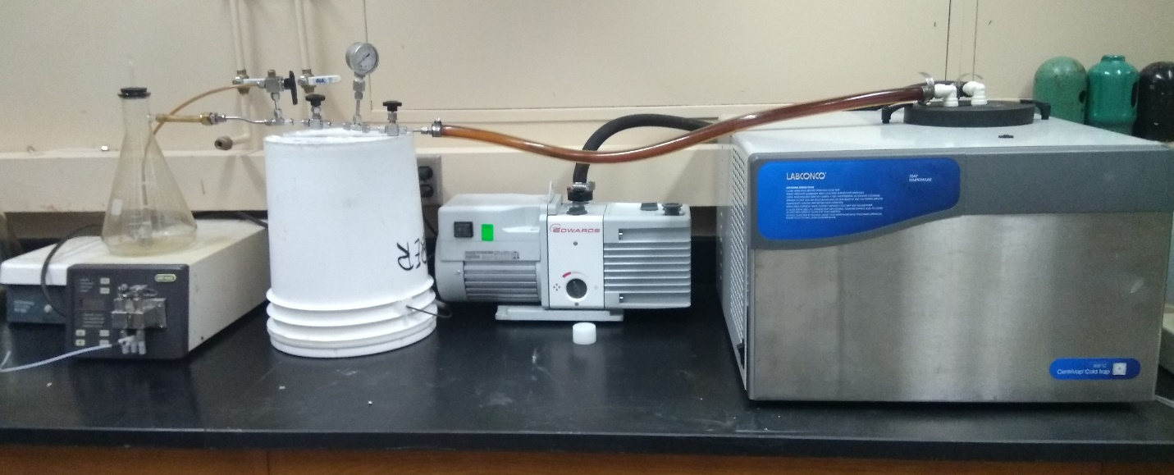
Fig. 21: Vacuum saturation cell.

2.5 Core-flooding setup
The core-flood setup consists of one core holder, three accumulators (for crude oil, low salinity brine and high salinity brine), and four ISCO pumps (three of them are to control the injection rate from each accumulator and the fourth is to apply the confining pressure to the core-holder). The core-holder is placed inside an oven which is adjusted to the required temperature. The connections that transmit different injected fluid was made in the form of coils, in order to increase the path and ascertain that the fluid reach the required temperature before reaching the core sample. The pressure at the inlet was recorded using pressure transducer, where the pressure at the outlet was kept at atmospheric pressure. During each core-flooding test, the confining pressure adjusted to be 1500 psi. Schematic of the used core-flooding setup is shown in Fig. 23.
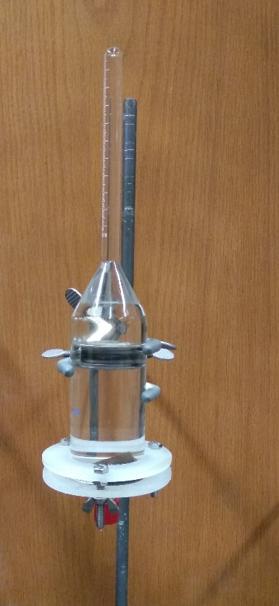

Fig. 22: Amott cell used for imbibition tests.

Results

3.1 Imbibition results
We used two similar core GB-02, and GB-03 for imbibition tests. GB-02, and GB-03 were saturate with crude oil only and kept aging in crude oil for 7 weeks. The imbibition test was done before the core-flooding test, to give an indication about the best brine concentrations to be used in the core-flooding experiment.
- Core sample GB-01, kept it in a high salinity brine (HB) for three days and the oil recovery monitored, there was no oil recovered along this time. Then, we put it in a low salinity brine (LB) with added 0.7% by weight friction reducer (2-Acrylamido-2-methylpropanesulfonic acid), to expedite the imbibition process, and again there was no oil recovered during the whole time.
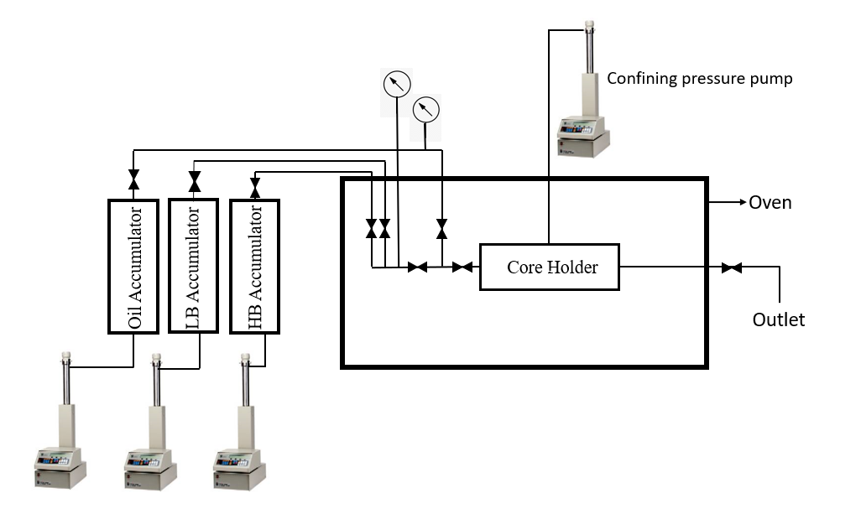
Fig. 23: Schematic of the core-flooding setup

- Core sample GB-02, the sample was kept in slick water for 3 days, and there was very low oil recovery. However, the volume of the recovered oil was very low to track and record over time. As a result, we decided to go on with the LB with the given concentration as it is on the lower end of the LSW salinity range.

3.2 Core-flooding results.
- Core sample GB-03: the sample was saturated with crude-oil only and kept in crude oil for aging for 7 weeks at 55ºC. The core sample was flooded first with HB at 55ºC till no more oil was produced. Then, flooded with LB at the same displacing temperature, after that, the oven was turned off and the LB injection was kept running. Total oil recovery during HB injection at 55ºC was 75.5% from the original oil in place. Then, the recovery from LB injection at 55ºC was very low, around 1%. Then, when the temperature lowered to 25 ºC, there was no more oil recovery noticed.
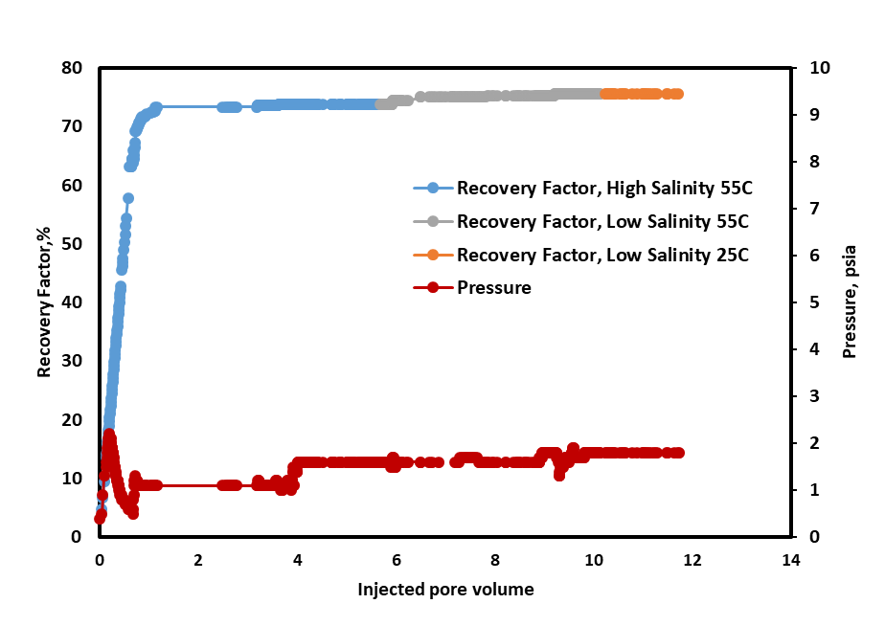
Fig. 24: Oil recovery and pressure drop of injecting high salinity brine in the secondary mode at 55ºC, and low salinity brine in the tertiary mode at 55ºC, then low salinity brine at 25ºC, core GB-03.

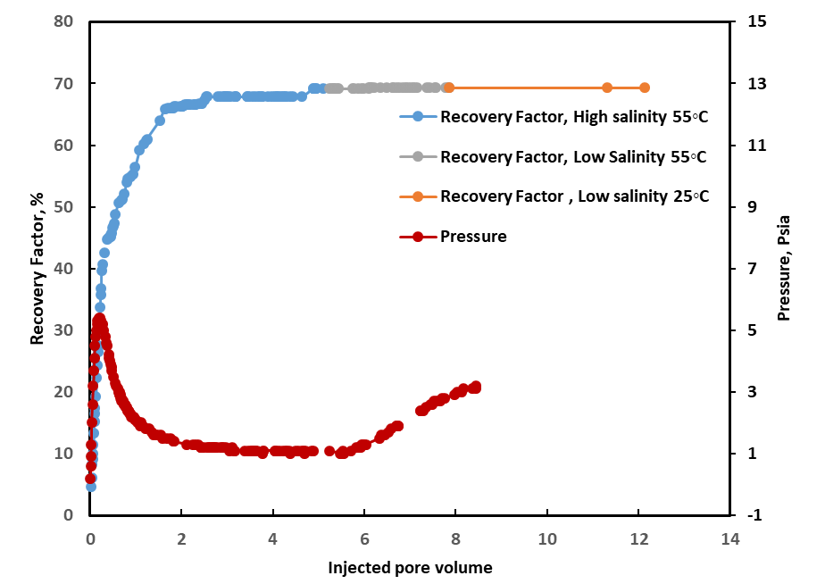
- Core sample GB-04: The same core-flooding workflow implemented for GB-04 was applied on this core sample. The only difference is that the core sample was saturated with both HB and crude oil and kept in crude oil for aging for two weeks. The recovery factor for the HB injection was about 69%. No increase in the oil recovery was witnessed when low salinity brine was injected in the tertiary recovery mode. Also, decreasing the temperature to the room temperature didn’t have any impact on oil recovery.
Fig. 25: Oil recovery and pressure drop of injecting high salinity brine in the secondary mode at 55ºC, and low salinity brine in the tertiary mode at 55ºC, then low salinity brine at 25ºC, core GB-04

- Core sample GB-05: The saturation and aging for this core sample was like GB-04. The same core-flooding workflow implemented on GB-05 was followed, However, the pH value for the LB was lowered to 3 by adding 10% HCL solution to LB. During HB injection, oil recovery reached about 74.2%. Then, a very slight amount of oil was recovered during LB injection, this amount is equivalent to about 0.8% from original oil in place. The rapid increase in the pressure indicates rock damage.
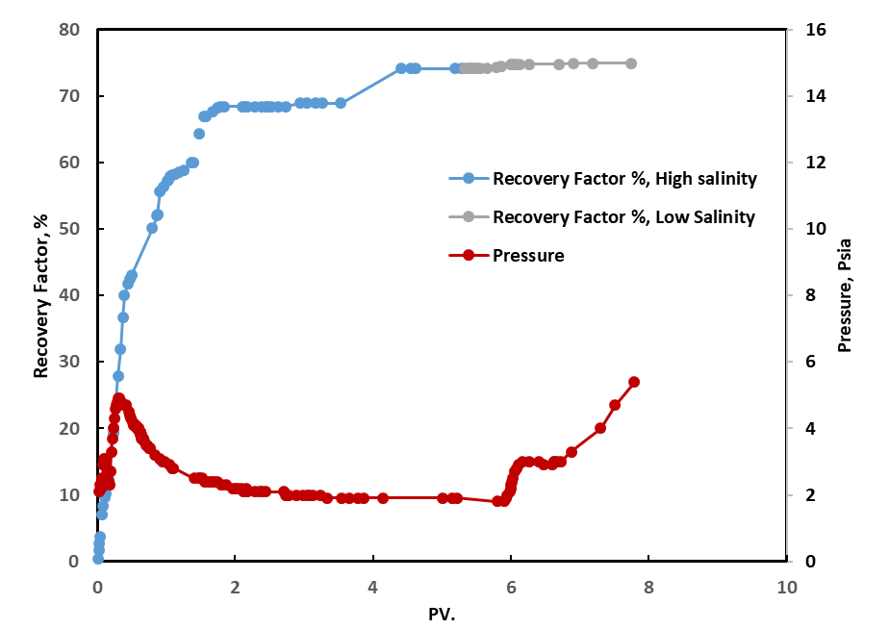
Fig. 26 Oil recovery and pressure drop of injecting high salinity brine in the secondary mode at 55ºC, and low salinity brine, with pH of 3, in the tertiary mode at 55ºC, core GB-05.

Going through the previous results, the effect of LSW was not witnessed or in some cases were very slight. One factor that might hinder having any impact for LSW is the relatively high recovery factor obtained by high salinity brine injection. As a result, we injected low salinity brine in a secondary recovery mode, in order to compare to the case of high salinity, and to investigate the impact of temperature on LSW in case of secondary recovery.

- Core sample GB-06 & GB-07: For these two core samples, we injected LB in the secondary recovery mode. For core GB-06, the displacement temperature was 25 ºC. After injecting around 7.5 pore volumes, the oil recovered was about 45.4% from the
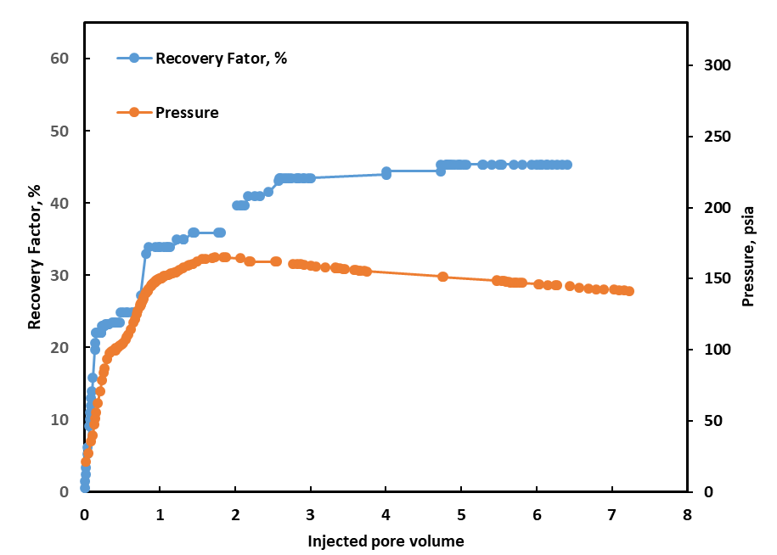
Fig. 27 Oil recovery and pressure drop of injecting low salinity brine in the secondary mode at 25º, core GB-06.
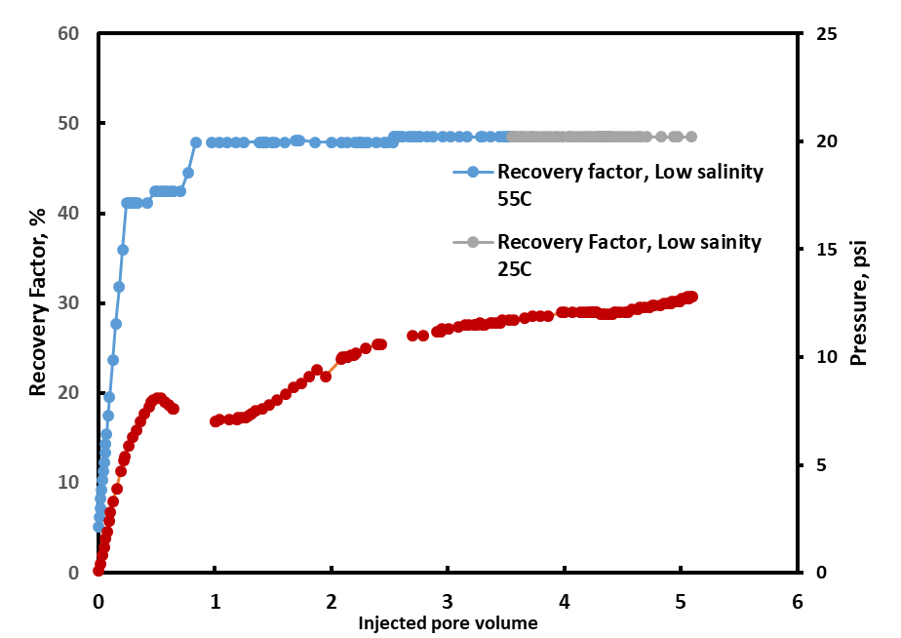

Fig. 28 Oil recovery and pressure drop of injecting low salinity brine in the secondary mode at 55ºC, followed by low salinity brine injection at 25 ºC, core GB-07.
original oil in place. For core GB-07, the displacement temperature was 55 ºC, then when no more oil recovered, the temperature lowered to 25 ºC. The recovery factor was slightly higher than the room temperature case, with a recovery factor round 48.52%. Also, when shifting to a lower temperature no increase in the oil recovery was witnessed.

3.3 Discussion.
In general, LSW didn’t show a perceptible impact on oil recovery in the tertiary recovery mode. In case of using LB without modifying the pH of the brine solution, there was a slight increase in the recovery factor, around 2%, for the core sample fully saturated with crude oil. Whereas, no enhancement was noticed in case of the core sample saturated with both HB and crude oil. On the other hand, in case of injecting LB in a secondary recovery mode, the recovery factor was 45.4% and 48.5 % for GB-06 and GB-07 respectively. Which is much lower than the oil recover factor reached due to the injection of HB in a secondary recovery mode, which was in the vicinity of 70% for GB-03, GB-04 and GB-05. Also, lowering the temperature from 55ºC to room temperature didn’t show any increase in the oil recovered for cores GB-03, GB-04 and GB-07. However, we believe that this is not an enough evidence to conclude that there is no exothermic reaction responsible for having LSE, since in GB-03 and GB-04 the oil recovery factor after the injecting HB was relatively high. Also, for core GB-07, LB was injected at the low temperature for about 2 pore volumes, which might not be enough to derive such a conclusion as it has been mentioned in the literature that this exothermic reaction is a slow reaction, so it is recommended that for the future work this step should be done for at least 5 pore volumes. In addition, comparing the results from GB-06 and GB-07, it is noticed that increasing the temperature from 25ºC to 55 ºC increased the oil recovery factor by about 3%. Also, the increase in the temperature increased the percentage of oil recovered before the water breakthrough.

3.4 Conclusion
The conclusions from the experimental work is summarized in the following points:
- LSE was not witnessed in a tertiary recover mode. Nevertheless, no solid conclusion could be derived from the experimental results due to the relatively high oil recovery reached after injecting HB in the secondary recovery mode.
- LSW is not favorable for our system of Crude Oil/Brine/Rock in a secondary recovery mode.
- LB with decreased pH value didn’t show a perceptible enhancement in the oil recovery.
- For LSW in a secondary recovery mode, the higher the displacing temperature the more oil recovered.

Chapter V: Conclusions and Recommendations

Conclusions
SCM can be used to qualify the effectiveness of LSW in sandstone at different temperatures. Results obtained from SCM suggest that temperature has an impact on LSW in sandstones. However, this effect is dependent on the Crude-oil/Brine/rock system. Temperature effect is more tangible in systems that have neutral or basic crude oil. On the other hand, no perceptible effect was noticed in the case of acidic crude oil. In the pH range that is normally encountered in oil reservoirs, the temperature increase has a negative effect on oil recovery by in case of basic oil, as it decreases the range of pH over which LSW can be productive. On the other hand, the results for the neutral oil indicates that LSW can be productive at high pH at low temperatures. Whereas at higher temperatures, LSW is effective at lower pH. These results ascertain that any experimental work implemented to assess the effectiveness of LSW project should be done at relevant reservoir temperature, as experiments at low temperatures might be greatly different.
Experimentally, LSW didn’t show a perceptible impact in a tertiary recovery mode at 55ºC. On the other hand, LSW seems to be not effective in a secondary recovery mode compared to high salinity brine injection for our Crude Oil/Brine/Rock. Our results from core-flooding are not conclusive enough to derive a conclusion about the involvement of an exothermic reaction in the mechanism responsible for having LSE.

Recommendations
The following are recommended future work for the thermodynamic modelling of LSW:
- Accounting for impurity of Kaolinite that could happen in nature, which could make the oil adhere to the basal planes as well as kaolinite edges
- Considering other clay minerals as a proxy for sandstone like illite.
- Apply SCM on carbonate to investigate the effect of temperature on LSW.

The following are recommended future experimental work to further investigate the effect of temperature:
- Using a different combination of Crude oil and rock that shows a noticeable LSE, this would be the best system to investigate the temperature effect.
- Investigating the effect of crude oil composition heterogeneity by using different oil with varying TBN and TAN.
- Examining the effect of formation brine by having different total salinity and salt composition and simulate real formation brines.
- Sandstones that have different clay content could be used.
- Elevated temperature above 100ºC can be tried to simulate the case of high temperature reservoirs.
- The same core-flooding workflow can be used with carbonates core to experimentally investigate the temperature effect on LSW.

References
- Jadhunandan, P. P. (1990). Effects of brine composition, crude oil, and aging conditions on wettability and oil recovery. Department of Petroleum Engineering, New Mexico Institute of Mining & Technology.
- Jadhunandan, P. P., & Morrow, N. R. (1991). Spontaneous imbibition of water by crude oil/brine/rock systems. In Situ;(United States), 15(4).

- Jadhunandan, P. P., & Morrow, N. R. (1995). Effect of wettability on waterflood recovery for crude-oil/brine/rock systems. SPE reservoir engineering, 10(01), 40-46.
- Yildiz, H. O., & Morrow, N. R. (1996). Effect of brine composition on recovery of Moutray crude oil by waterflooding. Journal of Petroleum science and Engineering, 14(3-4), 159-168.
- Tang, G. Q., & Morrow, N. R. (1997). Salinity, temperature, oil composition, and oil recovery by waterflooding. SPE Reservoir Engineering, 12(04), 269-276.
- Lager, A., Webb, K. J., Black, C. J. J., Singleton, M., & Sorbie, K. S. (2008). Low salinity oil recovery-an experimental investigation1. Petrophysics, 49(01).
- Ligthelm, D. J., Gronsveld, J., Hofman, J., Brussee, N., Marcelis, F., & van der Linde, H. (2009, January). Novel Waterflooding Strategy By Manipulation Of Injection Brine Composition. In EUROPEC/EAGE conference and exhibition. Society of Petroleum Engineers.
- Austad, T., RezaeiDoust, A., & Puntervold, T. (2010, January). Chemical mechanism of low salinity water flooding in sandstone reservoirs. In SPE improved oil recovery symposium. Society of Petroleum Engineers.
- Jackson, M. D., Vinogradov, J., Hamon, G., & Chamerois, M. (2016). Evidence, mechanisms and improved Seccombe, J. C., Lager, A., Webb, K. J., Jerauld, G., & Fueg, E. (2008, January). Improving wateflood recovery: LoSalTM EOR field evaluation. In SPE symposium on improved oil recovery. Society of Petroleum Engineers.
- Morrow, N., & Buckley, J. (2011). Improved oil recovery by low-salinity waterflooding. Journal of Petroleum Technology, 63(05), 106-112.
- Tang, G. Q., & Morrow, N. R. (1997). Salinity, temperature, oil composition, and oil recovery by waterflooding. SPE Reservoir Engineering, 12(04), 269-276.
- Ashraf, A., Hadia, N., Torsaeter, O., & Tweheyo, M. T. (2010, January). Laboratory investigation of low salinity waterflooding as secondary recovery process: effect of wettability. In SPE Oil and Gas India Conference and Exhibition. Society of Petroleum Engineers.
- RezaeiDoust, A., Puntervold, T., & Austad, T. (2011). Chemical verification of the EOR mechanism by using low saline/smart water in sandstone. Energy & Fuels, 25(5), 2151-2162.
- Cissokho, M., Bertin, H., Boussour, S., Cordier, P., & Hamon, G. (2010). Low salinity oil recovery on clayey sandstone: Experimental study. Petrophysics, 51(05).
- Mehana, M., Al Salman, M., & Fahes, M. (2018). Impact of Salinity and Mineralogy on Slick Water Spontaneous Imbibition and Formation Strength in Shale. Energy & fuels, 32(5), 5725-5735.
- Mehana, M., & El-Monier, I. (2015). Numerical Investigation of the Osmatic Flow Impact on the Load Recovery and Early Well Performance. Journal of Petroleum Engineering and Technology, 5(03).
- Mehana, M., & El-monier, I. (2016). Shale characteristics impact on Nuclear Magnetic Resonance (NMR) fluid typing methods and correlations. Petroleum, 2(2), 138-147.
- Mehana, M., Fahes, M., & Huang, L. (2017, October). System Density of Oil-Gas Mixtures: Insights from Molecular Simulations. In SPE Annual Technical Conference and Exhibition. Society of Petroleum Engineers.
- Sheng, J. J. (2014). Critical review of low-salinity waterflooding. Journal of Petroleum Science and Engineering, 120, 216-224.
- Myint, P. C., & Firoozabadi, A. (2015). Thin liquid films in improved oil recovery from low-salinity brine. Current Opinion in Colloid & Interface Science, 20(2), 105-114.
- Lager, A., Webb, K. J., Black, C. J. J., Singleton, M., & Sorbie, K. S. (2008). Low salinity oil recovery-an experimental investigation1. Petrophysics, 49(01).
- Lee, S. Y., Webb, K. J., Collins, I., Lager, A., Clarke, S., O'Sullivan, M., ... & Wang, X. (2010, January). Low salinity oil recovery: increasing understanding of the underlying mechanisms. In SPE improved oil recovery symposium. Society of Petroleum Engineers.
- Mehana, M. (2016). On the Fate of the Fracturing Fluid and Its Impact on Load Recovery and Well Performance. Master Thesis at the University of Oklahoma
- Mehana, M., Fahes, M., & Huang, L. (2019). Asphaltene Aggregation in Oil and Gas Mixtures: Insights from Molecular Simulation. Energy & Fuels.
- Mehana, M., Fahes, M., & Huang, L. (2018). The Density of Oil/Gas Mixtures: Insights From Molecular Simulations. SPE Journal
- Underwood, T., Erastova, V., Cubillas, P., & Greenwell, H. C. (2015). Molecular dynamic simulations of montmorillonite–organic interactions under varying salinity: an insight into enhanced oil recovery. The Journal of Physical Chemistry C, 119(13), 7282-7294.
- Greathouse, J. A., Cygan, R. T., Fredrich, J. T., & Jerauld, G. R. (2017). Adsorption of aqueous crude oil components on the basal surfaces of clay minerals: molecular simulations including salinity and temperature effects. The Journal of Physical Chemistry C, 121(41), 22773-22786.
- Myint, P. C., & Firoozabadi, A. (2015, September). Thermodynamics of Flat Thin Wetting Films with Applications to Low-Salinity Waterflooding. In SPE Annual Technical Conference and Exhibition. Society of Petroleum Engineers.
- Aksulu, H., Håmsø, D., Strand, S., Puntervold, T., & Austad, T. (2012). Evaluation of low-salinity enhanced oil recovery effects in sandstone: Effects of the temperature and pH gradient. Energy & Fuels, 26(6), 3497-3503.
- Ligthelm, D. J., Gronsveld, J., Hofman, J., Brussee, N., Marcelis, F., & van der Linde, H. (2009, January). Novel Waterflooding Strategy By Manipulation Of Injection Brine Composition. In EUROPEC/EAGE conference and exhibition. Society of Petroleum Engineers.
- Zhu, C., & Anderson, G. (2002). Environmental applications of geochemical modeling. Cambridge University Press.
- Nasralla, R. A., & Nasr-El-Din, H. A. (2014). Double-layer expansion: is it a primary mechanism of improved oil recovery by low-salinity waterflooding?. SPE Reservoir Evaluation & Engineering, 17(01), 49-59.
- Mehana, M., & Fahes, M. M. (2018, April). Investigation of Double Layer Expansion in Low-Salinity Waterflooding: Molecular Simulation Study. In SPE Western Regional Meeting. Society of Petroleum Engineers.
- McGuire, P. L., Chatham, J. R., Paskvan, F. K., Sommer, D. M., & Carini, F. H. (2005, January). Low salinity oil recovery: An exciting new EOR opportunity for Alaska's North Slope. In SPE western regional meeting. Society of Petroleum Engineers.
- Mehana, M. (2019). TOWARDS A BETTER UNDERSTANDING OF THE RELATIONSHIP BETWEEN MOLECULAR FORCE AND HYDROCARBON RECOVERY. Diss. University of Oklahoma, 2019.
- Tang, G. Q., & Morrow, N. R. (1999). Influence of brine composition and fines migration on crude oil/brine/rock interactions and oil recovery. Journal of Petroleum Science and Engineering, 24(2-4), 99-111.
- RezaeiDoust, A., Puntervold, T., & Austad, T. (2010, January). A discussion of the low-salinity EOR potential for a North Sea sandstone field. In SPE Annual Technical Conference and Exhibition. Society of Petroleum Engineers.
- Gamage, P., & Thyne, G. (2011, April). Systematic investigation of the effect of temperature during aging and low salinity flooding of Berea sandstone and Minn. In IOR 2011-16th European Symposium on Improved Oil Recovery.
- Aghaeifar, Z., Strand, S., Austad, T., Puntervold, T., Aksulu, H., Navratil, K., ... & Håmsø, D. (2015). Influence of formation water salinity/composition on the low-salinity enhanced oil recovery effect in high-temperature sandstone reservoirs. Energy & Fuels, 29(8), 4747-4754.
- Xie, Q., Brady, P. V., Pooryousefy, E., Zhou, D., Liu, Y., & Saeedi, A. (2017). The low salinity effect at high temperatures. Fuel, 200, 419-426.
- Alotaibi, M. B., Azmy, R., & Nasr-El-Din, H. A. (2010, January). A comprehensive EOR study using low salinity water in sandstone reservoirs. In SPE improved oil recovery symposium. Society of Petroleum Engineers.
- Shaker Shiran, B., & Skauge, A. (2012, January). Wettability and oil recovery by low salinity injection. In SPE EOR Conference at Oil and Gas West Asia. Society of Petroleum Engineers.
- Mirchi, V. (2018, September). Pore-scale investigation of the effect of surfactant on fluid occupancies during low-salinity waterflooding in carbonates. In SPE Annual Technical Conference and Exhibition. Society of Petroleum Engineers.
- Alagic, E., & Skauge, A. (2010). Combined low salinity brine injection and surfactant flooding in mixed− wet sandstone cores. Energy & fuels, 24(6), 3551-3559.
- Wang, X., & Alvarado, V. (2012). Effects of aqueous-phase salinity on water-in-crude oil emulsion stability. Journal of Dispersion Science and Technology, 33(2), 165-170.
- Gomez, S., Mansi, M., & Fahes, M. (2018, November). Quantifying the Non-Monotonic Effect of Salinity on Water-in-Oil Emulsions towards a Better Understanding of Low-Salinity-Water/Oil/Rock Interactions. In Abu Dhabi International Petroleum Exhibition & Conference. Society of Petroleum Engineers.
- Brady, P. V., & Krumhansl, J. L. (2012). A surface complexation model of oil–brine–sandstone interfaces at 100 C: Low salinity waterflooding. Journal of Petroleum Science and Engineering, 81, 171-176.
- Brady, P. V., & Krumhansl, J. L. (2013). Surface complexation modeling for waterflooding of sandstones. SPE Journal, 18(02), 214-218.
- Brady, P. V., Morrow, N. R., Fogden, A., Deniz, V., & Loahardjo, N. (2015). Electrostatics and the low salinity effect in sandstone reservoirs. Energy & Fuels, 29(2), 666-677.
- Brady, P. V., Bryan, C. R., Thyne, G., & Li, H. (2016). Altering wettability to recover more oil from tight formations. Journal of Unconventional Oil and Gas Resources, 15, 79-83.
- Mahani, H., Keya, A. L., Berg, S., & Nasralla, R. (2017). Electrokinetics of carbonate/brine interface in low-salinity waterflooding: Effect of brine salinity, composition, rock type, and pH on ζ-potential and a surface-complexation model. Spe Journal, 22(01), 53-68.
- Elakneswaran, Y., Shimokawara, M., Nawa, T., & Takahashi, S. (2017, November). Surface Complexation and Equilibrium Modelling for Low Salinity Waterflooding in Sandstone Reservoirs. In Abu Dhabi International Petroleum Exhibition & Conference. Society of Petroleum Engineers.
- Takeya, M., Shimokawara, M., Elakneswaran, Y., Nawa, T., & Takahashi, S. (2019). Predicting the electrokinetic properties of the crude oil/brine interface for enhanced oil recovery in low salinity water flooding. Fuel, 235, 822-831.
- Sanaei, A., Tavassoli, S., & Sepehrnoori, K. (2019). Investigation of modified Water chemistry for improved oil recovery: Application of DLVO theory and surface complexation model. Colloids and Surfaces A: Physicochemical and Engineering Aspects, 574, 131-145.
- Erzuah, S., Fjelde, I., & Omekeh, A. V. (2018). Wettability Estimation Using Surface-Complexation Simulations. SPE Reservoir Evaluation & Engineering.Sanaei, A., & Sepehrnoori, K. (2018, September). Implication of Oil/Brine/Rock Surface Interactions in Modeling Modified Salinity Waterflooding in Carbonate and Sandstone Reservoirs. In SPE Annual Technical Conference and Exhibition. Society of Petroleum Engineers.
- Duffy, T. S., Raman, B., Hall, D. M., Machesky, M. L., Johns, R. T., & Lvov, S. N. (2019). Experimentation and modeling of surface chemistry of the silica-water interface for low salinity waterflooding at elevated temperatures. Colloids and Surfaces A: Physicochemical and Engineering Aspects, 570, 233-243.
- Van Cappellen, P., Charlet, L., Stumm, W., & Wersin, P. (1993). A surface complexation model of the carbonate mineral-aqueous solution interface. Geochimica et Cosmochimica Acta, 57(15), 3505-3518.
- Zhu, C., & Anderson, G. (2002). Environmental applications of geochemical modeling. Cambridge University Press.
- Parkhurst, D. L., & Appelo, C. A. J. (1999). User's guide to PHREEQC (Version 2): A computer program for speciation, batch-reaction, one-dimensional transport, and inverse geochemical calculations. Water-resources investigations report, 99(4259), 312.
- Langmuir, D. (1997). Aqueous environmental. Geochemistry Prentice Hall: Upper Saddle River, NJ.
- Bethke, C. (1996). Geochemical reaction modeling: Concepts and applications. Oxford University Press on Demand.
- Appelo, C. A. J., & Postma, D. (2004). Geochemistry, groundwater and pollution. CRC press.
- Neasham, J. W. (1977, January). The morphology of dispersed clay in sandstone reservoirs and its effect on sandstone shaliness, pore space and fluid flow properties. In SPE Annual Fall Technical Conference and Exhibition. Society of Petroleum Engineers.
- ASTM Committee D-2 on Petroleum Products, Liquid Fuels, and Lubricants. (2011). Standard test method for acid number of petroleum products by potentiometric titration. ASTM international.
- D2896, A. Annual Book of Standards 2007.
- Dubey, S. T., & Doe, P. H. (1993). Base number and wetting properties of crude oils. SPE Reservoir Engineering, 8(03), 195-200.
- Subtechs. 2014. Stabilization of colloids, http://www.substech.com/dokuwiki/ doku.php?id=stabilization_of_colloids (accessed 5 January 2014).
- Kumar, D., Masouleh, S. F., Ghassemi, A., Riley, S., & Elliott, B. (2018, August). A 3D Geomechanical Analysis of Horizontal Well Refracturing and “Frac-Hits”. In 52nd US Rock Mechanics/Geomechanics Symposium. American Rock Mechanics Association.
- Mohamed, T. (2019). COALBED METHANE COMPREHENSIVE CHARACTERIZATION AND MODELING–BIG GEORGE COAL, POWDER RIVER BASIN, WYOMING.

Appendix A: Figures
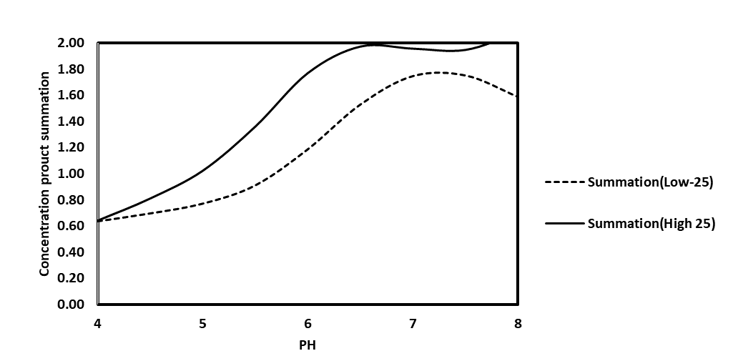
Fig. A.1: The bond product Summation for high and low salinity at 25ºC, for
TBN/TAN = 1:3

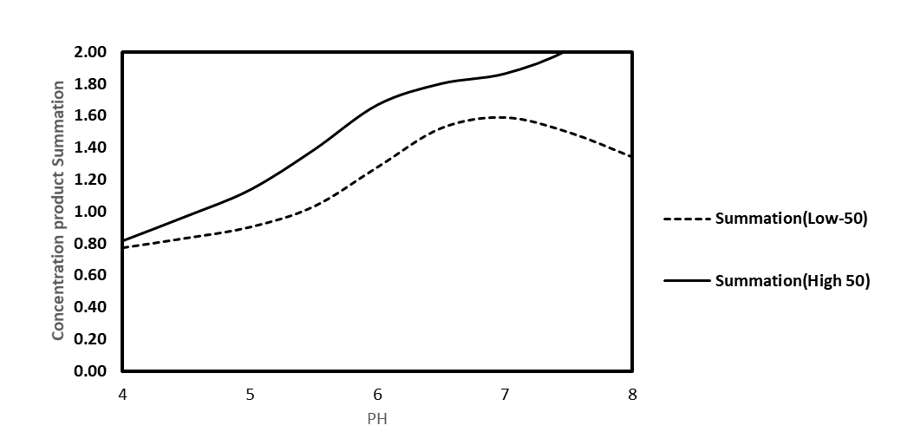
Fig. A.2: The bond product Summation for high and low salinity at 50ºC, for
TBN/TAN = 1:3

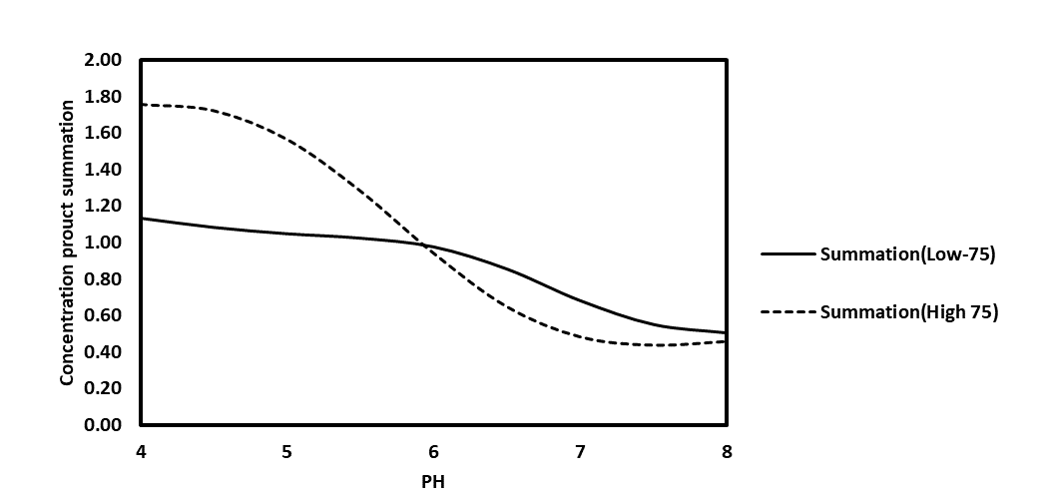
Fig. A.3: The bond product Summation for high and low salinity at 75ºC, for
TBN/TAN = 1:3
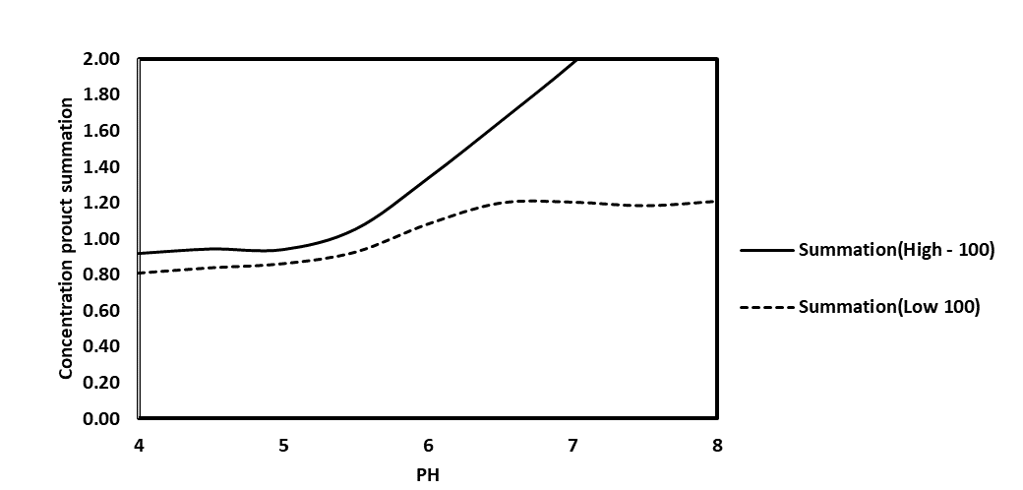
Fig. A.4: The bond product Summation for high and low salinity at 100ºC, for
TBN/TAN = 1:3

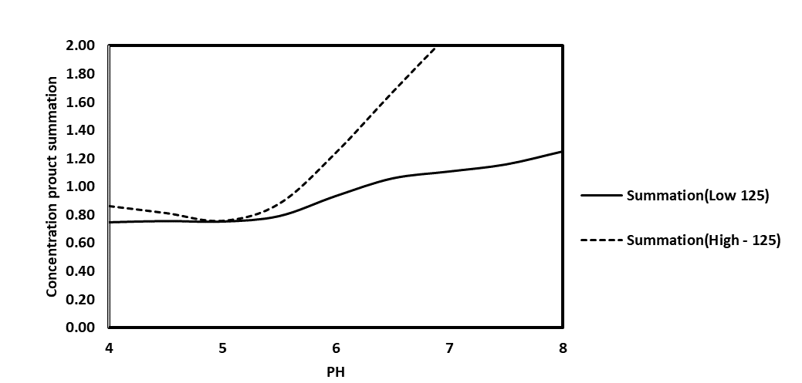
Fig. A.5: The bond product Summation for high and low salinity at 125ºC, for TBN/TAN = 1:3
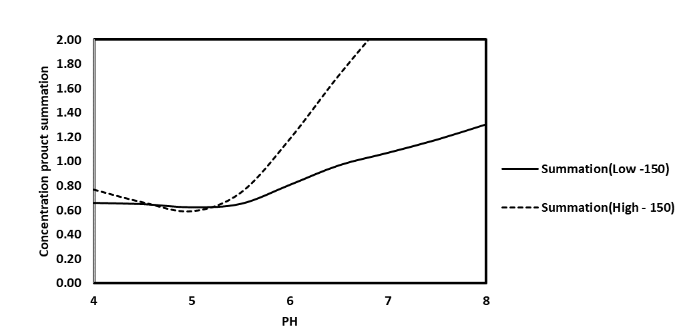
Fig. A.6: The bond product Summation for high and low salinity at 150ºC, for
TBN/TAN = 1:3

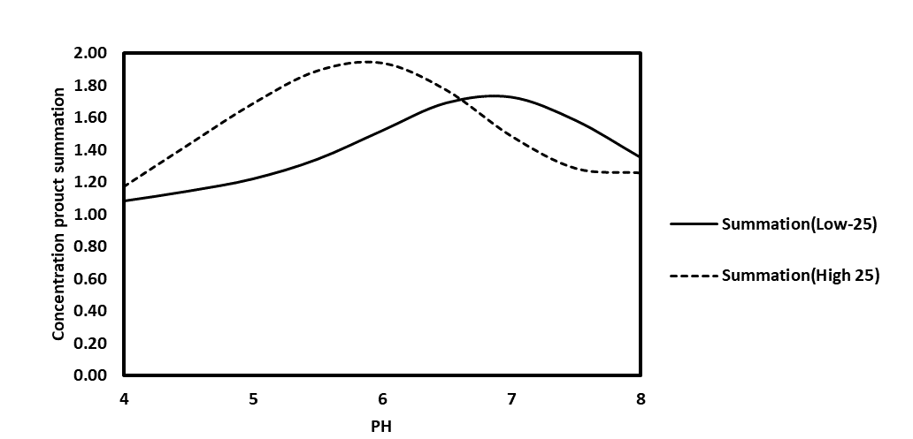
Fig. A.7: The bond product Summation for high and low salinity at 25ºC, for
TBN/TAN = 1:1
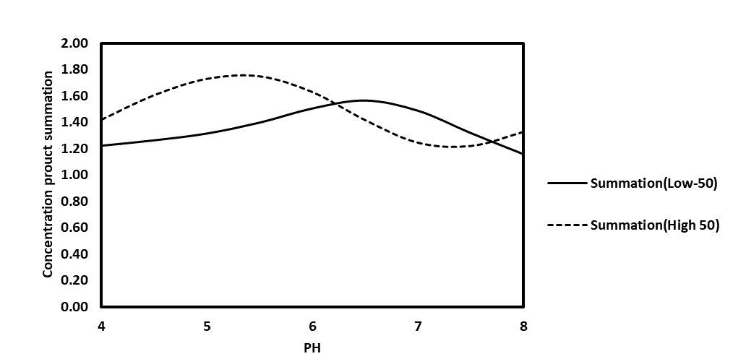
Fig. A.8: The bond product Summation for high and low salinity at 50ºC, for
TBN/TAN = 1:1

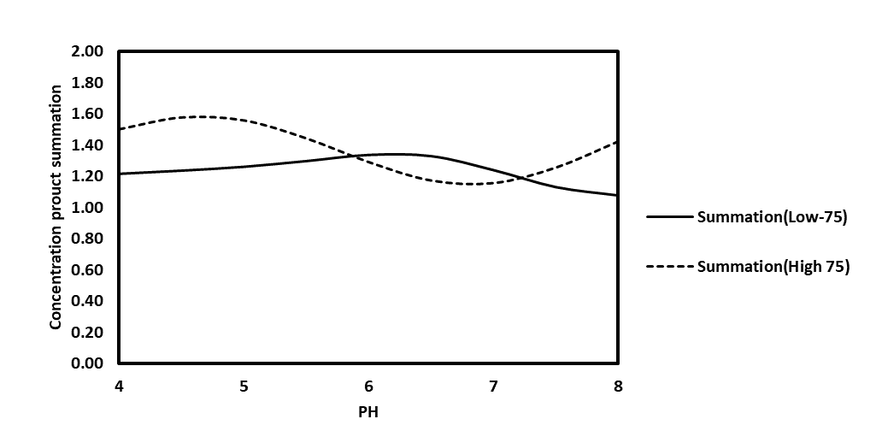
Fig. A.9: The bond product Summation for high and low salinity at 75ºC, for
TBN/TAN = 1:1

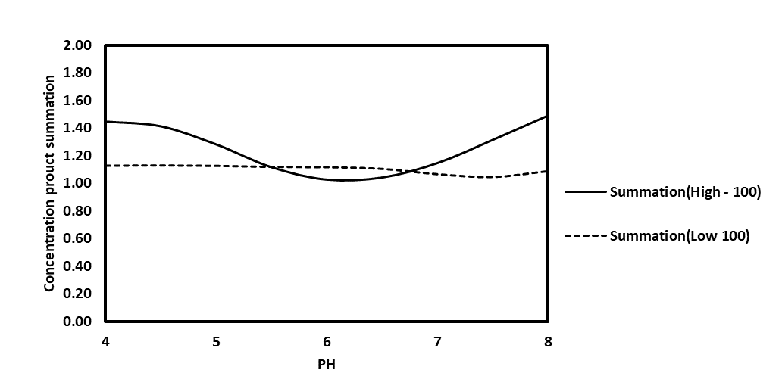
Fig. A.10: The bond product Summation for high and low salinity at 100ºC, for
TBN/TAN = 1:1

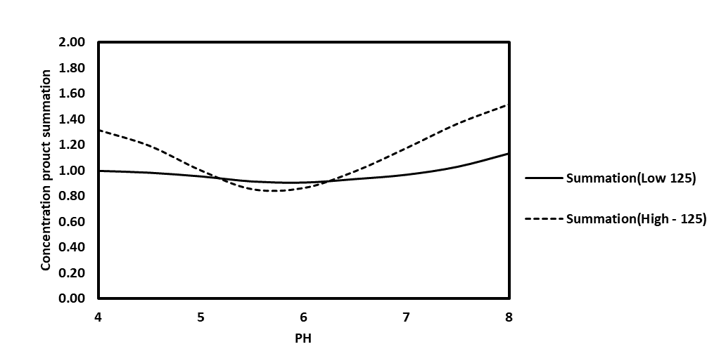
Fig. A.11: The bond product Summation for high and low salinity at 125ºC, for
TBN/TAN = 1:1

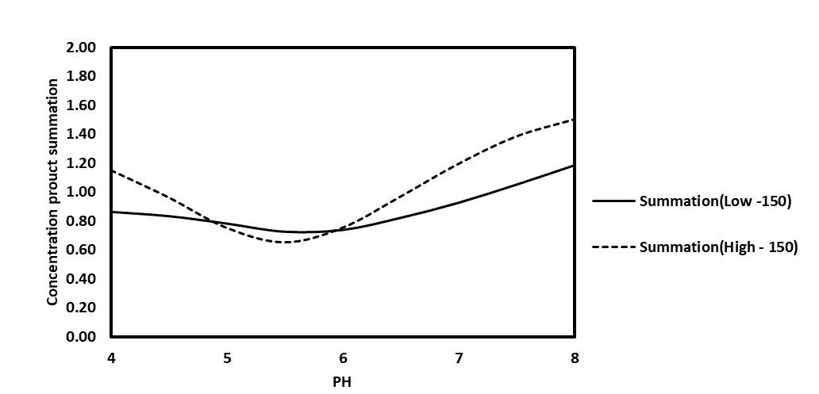
Fig. A.12: The bond product Summation for high and low salinity at 150ºC, for
TBN/TAN = 1:1

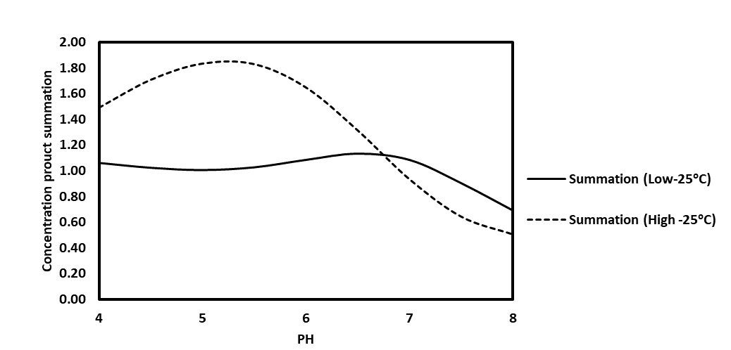
Fig. A.12: The bond product Summation for high and low salinity at 25ºC, for
TBN/TAN = 3:1

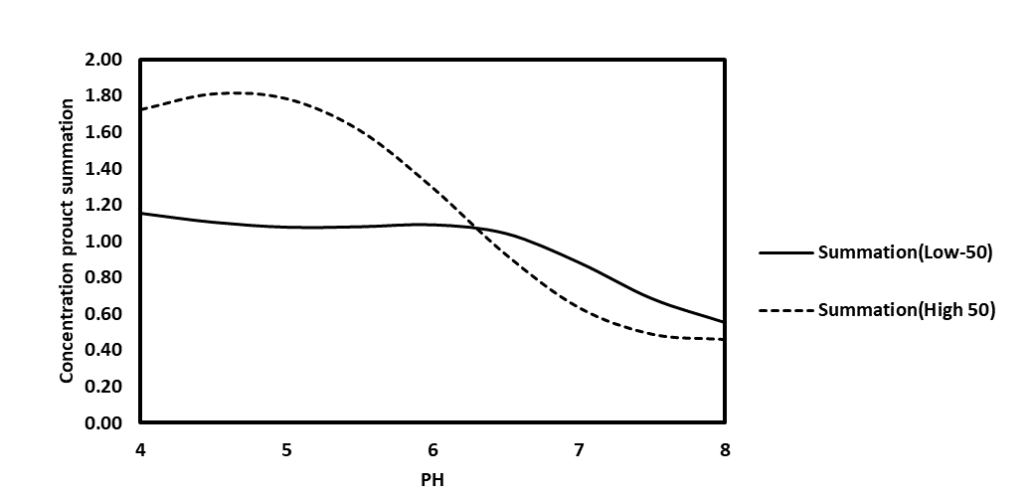
Fig. A.13: The bond product Summation for high and low salinity at 50ºC, for
TBN/TAN = 3:1

Fig. A.14: The bond product Summation for high and low salinity at 75ºC, for
TBN/TAN = 3:1

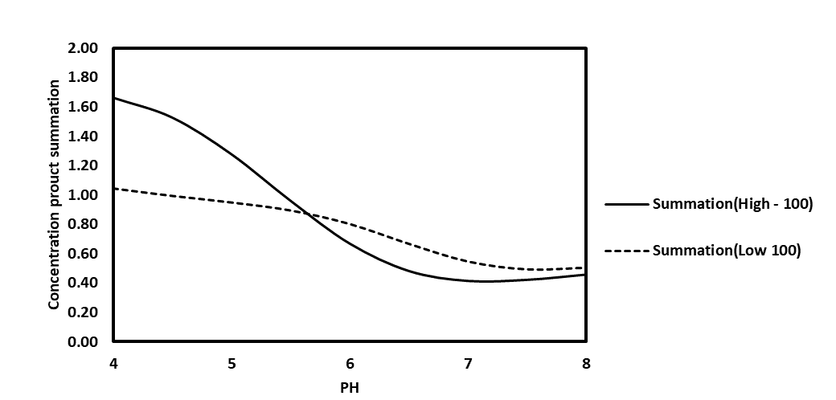
Fig. A.15: The bond product Summation for high and low salinity at 100ºC, for
TBN/TAN = 3:1

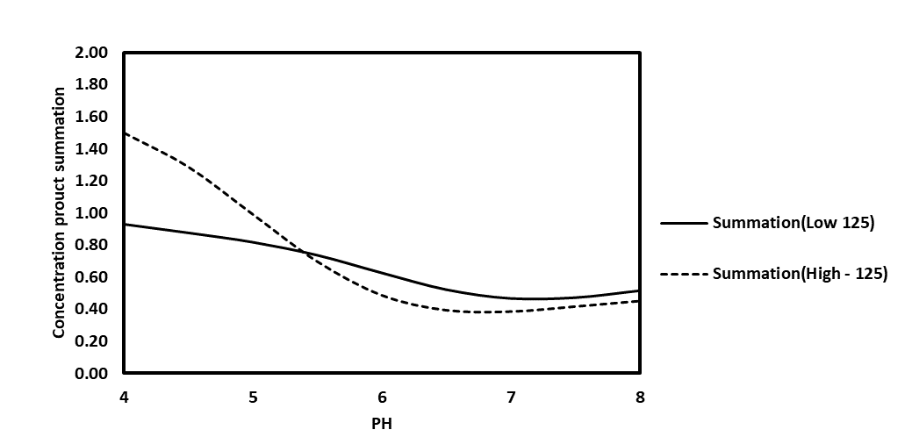
Fig. A.16: The bond product Summation for high and low salinity at 125ºC, for
TBN/TAN = 3:1
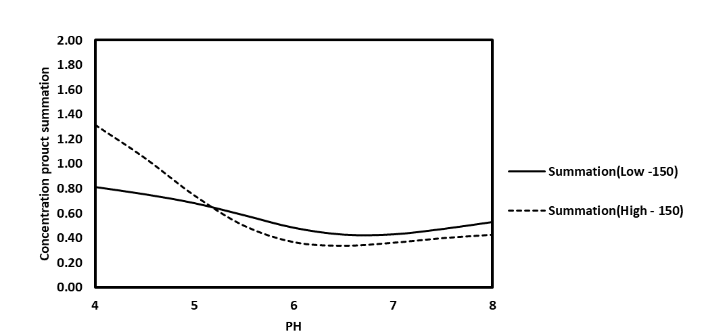
Fig. A.17: The bond product Summation for high and low salinity at 150ºC, for
TBN/TAN = 3:1

