UNIVERSITY OF OKLAHOMA
GRADUATE COLLEGE

A VETERAN SOCIAL STUDIES TEACHER’S JOURNEY TO MEET THE NEEDS OF HER STUDENTS

A THESIS
SUBMITTED TO THE GRADUATE FACULTY
In partial fulfillment of the requirements for the
Degree of
MASTER OF EDUCATION

By
SARAH K. PEARCY
Norman, Oklahoma
2023

A VETERAN SOCIAL STUDIES TEACHER’S JOURNEY TO MEET THE NEEDS OF HER STUDENTS

A THESIS APPROVED FOR THE DEPARTMENT OF INSTRUCTIONAL LEADERSHIP AND CURRICULUM

BY THE COMMITTEE CONSISTING OF

Dr. Kristy Brugar, Chair

Dr. Heidi J. Torres

Dr. Crag A. Hill

©Copyright by SARAH K. PEARCY 2023
All rights reserved
DEDICATION
To my TMS Social Studies Family.

ACKNOWLEDGEMENTS
“As we express our gratitude, we must never forget that the highest appreciation is not to utter words, but to live by them.” (John F. Kennedy) To all my professors during this graduate journey, thank you for your scholarship, time, expertise and kindness. You have inspired me and I hope to be able to continue to teach, advocate and live in a way that honors the lessons learned from this journey.

To my advisor, Dr. Kristy Brugar: I am grateful for your continuous and unwavering support. There are not enough words to adequately thank you. Your generosity and encouragement made this journey possible, and without you I wouldn't have survived. Having you as a resource to learn from has been invaluable. You have been a role model for how to be a better teacher and researcher. Thank you!
To my committee members, Dr. Crag A. Hill and Dr. Heidi J. Torres: Thank you. I always felt that you “had my back” and were there to lift me up and help me be successful. Dr. Hill, I want to extend a special thank you for always having a kind word to say and for your constructive feedback. Dr. Torres thank you for your strong support and kindness. I found a “home” in your classroom. You always made me and all of your students feel valued. I am grateful for that.
To Dr. Neil O. Houser: Thank you for challenging me to see things in a different way. For introducing me to Paulo Freire, and teaching me to question everything. I am grateful for, and changed by you and your courses.
To my parents: Thank you for always encouraging me. You have always been my most enthusiastic supporters. Thank you for nurturing a love of learning in me and helping me to meet all my goals.
To Aron: Thank you for encouraging me and for always being there to lift me up and provide support. Thank you for taking over so many things and allowing me time to engage fully in this graduate journey. I don’t have enough space to list all of the ways you continually support me. I am forever grateful for the partnership that we have. Thank you. I love you.
To Kate: Thank you for always supporting me and allowing me to chase my dreams. Thank you for being understanding and always being there to offer a hug. I am so proud of you. I love you.

To Amy Williams: Thank you for being an amazing friend, who was always there to listen, add some humor and encourage me. You have always been there to help with whatever project or assignment I was working on. “Just let me know when, where or what.” You have no idea how much it has meant to me during this journey. Thank you!
To Preston Medley: Thank you for being my reading partner and for the hallway discussions about the course readings. I could not have completed this journey without you.
List of Illustrations/Figures
Four Corner Graphic Organizer – Simplify the Journey: Gaining Shared Clarity, the four corners are labeled to guide teachers as they complete the graphic organizer. 31
6th grade Western Hemisphere Geography completed Simplify the Journey: Gaining Shared Clarity 32
7th grade Eastern Hemisphere Geography completed Simplify the Journey: Gaining Shared Clarity 33
8th grade American History grade completed Simplify the Journey: Gaining Shared Clarity 33
Graphic organizers used for primary sources before being introduced to QFT 34
The QFT Process 36
Student Questions generated during the Manifest Destiny QFT Lesson 38
Popsicle Sticks with student’s names 42
Tell ALL Summative Assessment 44

Abstract
This autoethnography discusses the ways in which I, a veteran and ambitious social studies teacher, can evolve as a teacher and learner to meet all the needs of her students. The literature shows that being a social studies teacher today, is not an easy task. An ambitious social studies teacher must know their subject matter, create a classroom that balances rigor and higher order thinking with kindness, know their students well, both inside and outside the classroom, and give their students a sense of belonging and value. I will address the need for teachers both veteran and novice to grow and evolve as teachers and learners. To illustrate this, I use three poignant instances from my classroom to discuss the challenges and rewards of embedding the competencies necessary to be an ambitious social studies teacher into everyday classroom practice.
Keywords: Social Studies, Veteran Teacher, Autoethnography

Table of Contents

Chapter 1 1
Introduction 1
Chapter 2 8
Literature Review 8
Social Studies 9
Teacher Learning/Professional Development 10
Pedagogical Practices in Social Studies 12
Academic/Content Specific Vocabulary 14
Content/Disciplinary Area Literacy 17
Inquiry and Culturally Responsive Teaching 20
Theoretical Framework 22
Chapter 3 24
Methods 24
Positionality 27
Chapter 4 29
Findings 29
Instance 1, PLC Academic Vocabulary 29
Instance 2: QFT (Question Formulation Technique) and Inquiry 34
Instance 3: Assessments 40
Chapter 5 45
Discussion/Conclusion 45
References 49
APPENDICES 62
Appendix A 63
Appendix B 64
Appendix C 65
Appendix D 66

Chapter 1

Introduction
I am passionate about producing students who can do more than pass an American History test. I want to produce a student who can be successful in all aspects of life. This passion led me to graduate school and drives my decisions as a middle school social studies teacher. How does a veteran middle school social studies teacher, like me, meet the ever-changing needs of their students? How can they prepare their students to be successful citizens in today’s world? These questions have taken me on a journey, with no end, but with a great reward.
Today’s increasingly diverse and rapidly changing society creates enormous challenges for teachers and schools. Schools are being asked to educate the most diverse student body in our history (Darling-Hammond, 1999; Aronson & Laughter, 2016; Ladson-Billings, 2021). “One of the cardinal rules of effective teaching is to ‘know your students’” (Hinton, 2021, p. 1). This is difficult for many teachers because of their lack of experience with different cultures and lack of knowledge of their own background (Aronson & Laughter, 2016; Walters et. al., 2009). The question then becomes, what should teachers and teacher education programs do to combat against this issue?
Culturally relevant education (CRE), requires cultural competence and understanding, and is connected with increases in academic outcomes across content areas (Aronson & Laughter, 2016; Ladson-Billings, 2021). However, the majority of teachers entering the profession do not come from or understand on a deep level the diverse cultures and communities in which they will teach. This is particularly true in minority-majority schools. Teacher education/preparation programs must ensure their educators are equipped with the knowledge, skills, strategies, and attitudes necessary to work effectively with children, families and communities with diverse cultural backgrounds (Stachowski & Mahan, 1998). Teacher education/preparation programs can do this by creating opportunities for novice teachers to spend time in the communities that they will teach. This can help teachers understand the “culture” of the community and how the community serves the families and children in their classrooms. This could help bridge the disconnect between the changing student population and the not-so changing teacher population.
Although classrooms have gotten more diverse, the teachers teaching have not. “Over 80% of America’s public school teachers are middle-class Euro-American White women from rural areas, small towns or suburbs, who grew up in largely White neighborhoods and graduated from largely White high schools” (Walters et. al., 2009, p. 1). This lack of readiness creates a problem. Many studies show negative effects associated with a failure to align student culture and teacher practice (Mahon, 2006; Aronson & Laughter, 2016; Ladson-Billings, 2021). Also, a lack of cultural confidence and perceived competence may impact where teachers teach, as well as how they teach (Walters et. al., 2009). So many educators choose to teach in schools and communities that they are familiar with, or that they completed their teacher education program in and that is often an urban or suburban area because typically universities are not in rural areas. Therefore, urban schools are studied and researched more often. “Most of the work published by educational historians focuses on the urban experience, for it was in the nation’s capital cities that the advantages and disadvantages of establishing free school systems were debated” (Theobald, 2016, p. 165). This lack of attention led to many misconceptions of rural life and in turn rural education.
“Stereotypes and assumptions about rural communities and people are laced throughout popular culture and perpetuated by mainstream media” (Tieken, 2014, p. 7). “Rural” is backwoods, and backward, its residents are ignorant, lawless, and territorial. Or a romantic nostalgia: this “rural” is uncomplicated and simple. Woven throughout both of these myths is the assumption that “rural” means white farming family or poor white trash. The state of Oklahoma is a rural state, with rich diversity. However, rurality is often seen as something to overcome or work through as opposed to a strength or benefit. “These myths serve to ensure the status of rural communities as either relics or wretches in the public imagination, and they obscure rural complexities and realities—inaccuracies that lead to marginalizing entire communities of people and forgetting entire schools of children” (Tieken, 2014, p. 7)
According to the Oklahoma State Department of Education (2020) more than half of Oklahoma’s public schools serve rural communities. Compared to the national average of 15%, 29% of Oklahoma’s public school students attend rural schools. The 205,945 Oklahoma students in rural districts rank third in the nation in terms of racial diversity, 43.18% of rural students are American Indian, black, Hispanic, multi-race, or Asian. Oklahoma ranks second in the nation in Native American population with 523,360 Native Americans, which comprises 13.36% of Oklahoma’s population (worldpopulationreview.com/state-rankings). Oklahoma rural schools and teachers have additional challenges. Oklahoma has the third highest rate of students receiving special education services and 57.51% of rural students are economically disadvantaged (Oklahoma Department of Education, 2020). “Poverty is, in fact, greater in rural areas than in any other setting.” (Applegate, 2008, p. 20).
“Rural education advocates have argued for decades that rural students represent a forgotten minority, and that preparing teachers to meet the needs of rural learners marginalized by poverty and geographic isolation takes differentiated, specialized training” (Azano & Stewart, 2015, p. 1). Mara Casey Tieken in her 2014 book Why rural schools matter, compares her experience student teaching in an urban school district and her teaching experience in a rural school;
Cultural relevance meant four wheeling and country music and hunting, never hip-hop or subways or high rises. I couldn’t have avoided knowing my students if I’d wanted to. But other issues seemed strikingly, terribly similar: transience, poverty, drug and alcohol abuse. Rural teaching had all of the challenges and hard questions of urban teaching, yet remained somehow distinctive… (p. 4).
Oppression and challenges of poverty that rural schools struggle to understand and confront are also faced by urban schools. “Rural schools, then, are consequential for urban schools, too, consequential in the possibilities they suggest and commonalities they share” (Tieken, 2014, p. 8). Yet, rural schools are often forgotten and, with today’s one-size-fits-all education reforms, they remain underserved (Tieken, 2014; Theobald, 2016). I want to use social studies and the understandings that come with it to bring attention to the underserved rural students in my classroom through humanizing pedagogical practices and strategies.
“Social studies is at the center of a good school curriculum because it is where students learn to see and interpret the world - its people, places, cultures, systems, and problems; its dreams and calamities - now and long ago” (Parker, 2017, p. 3). The field of social studies has many contrasting meanings and is often misunderstood. It tends to fall to the bottom of the list when core school subjects (math, language arts, science, social studies) are discussed. Yet, the demands placed on social studies teachers are heavy - for example they must have a firm grasp on content area knowledge which can require knowledge of thousands of years events, people and ideas, content area and academic vocabulary, as well as content and disciplinary literacy, while still providing rigor and challenging students to move from dependent to independent learners. In addition to all the previously mentioned, they must be attentive to their school context and the cultures of their students and communities, as well as, meet the “demands” of administration and other school leadership. This autoethnography discusses the ways in which I, a veteran and ambitious social studies teacher, can evolve as a teacher and learner to meet all the needs of her students.
In this introductory chapter, I will briefly discuss my journey to becoming an ambitious social studies teacher, school/team leader and lifelong learner. In the following chapters, I will also share a review of the literature, a description and the significance of autoethnography and this type of study for classroom teachers, school leaders and teacher education programs. The findings for this study will be found in Chapter 4 in which I share poignant instances in my journey toward ambitious social studies teaching. Lastly, I will talk through some of the limitations of this type of research and writing.
In 1986, Lee Shulman published Knowledge and Teaching: Foundations of the New Reform, in the prologue he talks about ‘A Portrait of Expertise’ (Shulman, 1986 as cited in Crocco & Livingston, 2017, p. 5). “This portrait provides a glimpse into the forms of expertise distinctive to teaching. Calls for educational reform, then and now, rest on a felt need to improve the quality of teaching by expanding the knowledge base for teacher educations” (Crocco & Livingston, 2017, p. 5-6). Shulman (1987) studied beginning teachers as they moved from teacher education programs to their own classrooms and at the same time investigated the work of well-regarded veteran teachers. He did this to show what skills novice teachers should emulate.
That special amalgam of content and pedagogy that is uniquely the province of the
teacher…It represents the blending of content and pedagogy into an understanding of
how particular topics, problems or issues are organized, represented or adapted to the
diverse interests and abilities of learners, and presented for instruction (p. 8).
In order to maintain the “special amalgam” a teacher must be willing to reflect and then evolve. They must learn on their own, through professional learning, their colleagues and their students. The traditional sage on the stage does not equal expertise in today’s classroom.
Teacher education programs are improving, but cannot provide the real-life experience needed and professional development often fails to provide authentic learning and useful tools for teachers. Teachers are also weary of theory overload. As a veteran teacher, I have been through many initiatives and buzzwords. Many educators are cautious to accept advice or implement new strategies when they come from someone who is not directly connected to the classroom. Thus, teachers tend to focus on immediate classroom needs and battles. Teachers are in a constant battle with all of the daily demands that are placed upon them and that makes it difficult for a teacher, both veteran and novice, to not allow some factors to affect their pedagogical choices.
Multiple factors often affect pedagogical choices. “Teacher beliefs and biography, student's socio-economic class and family educational backgrounds, persistent patterns of race and class biases - these factors and more may influence the kinds of teaching and learning that develop in classrooms” (Grant & Gradwell, 2009, p.7-8). A teacher today must evolve to understand and meet the needs of her students, despite and through all of these factors, many that lie outside of a teacher’s control. “Ambitious teachers take seriously those conditions but, in contrast to their less ambitious peers, they carve out pedagogical paths that aim toward more powerful teaching and learning” (Grant & Gradwell, 2009, p. 7).
Given all of these factors and the disconnect between theory and practice, how can a veteran social studies teacher evolve and be attentive to the needs of all of her students? In other words, be attentive to content knowledge, content/academic vocabulary, while using culturally relevant teaching strategies that humanize their students and provide the rigor and skills needed to be successful citizens? The purpose of this autoethnography is to explore my journey as a veteran social studies teacher to better meet the needs of my students. Hopefully, this will provide some clarity and a map of possibilities for other teachers who seek to be ambitious teachers.
As classroom teachers we face ever changing conditions, expectations and standards both in and outside of the classroom. This makes our jobs even more significant. As a social studies teacher we cannot settle for effectiveness as the ultimate measure of success. We must produce active citizens who can think critically and disrupt unjust systems. Studying and researching the ways teachers evolve to move beyond the “effective” can provide a road map for others to follow. If we as teachers took the time to reflect, adjust, evolve and learn we can meet the goal of producing citizens that can truly change the world.
We must judge ourselves by a higher standard than effectiveness, the standard called
faithfulness. Are we faithful to the community on which we depend, to doing what we
can in response to its pressing needs? Are we faithful to the better angels of our nature
and to what we call forth from us? Are we faithful to the eternal conversation of the
human race, speaking and listening in a way that takes us closer to truth? Are we
faithful to the call of courage that summons us to witness to the common good, even
against great odds? When faithfulness is our standard, we are more likely to sustain our
engagement with tasks that will never end: doing justice, loving mercy, and calling the
beloved community into being (Walsh, 2017, p. xv).

Chapter 2

Literature Review
The National Council for the Social Studies (NCSS, 1994) states that, “The primary purpose of social studies is to help young people make informed and reasoned decisions for the public good as citizens of a culturally diverse, democratic society in an interdependent world.” As I consider myself an ambitious teacher, I am curious about what a social studies teacher needs to know, and what actions they should take to become an ambitious teacher and produce the type of citizen described by the NCSS. Grant and Gradwell (2009) state that, “ambitious teachers must navigate a rocky road, one that includes the need to seize control of the curriculum, come to terms with the evolutionary nature of one’s teaching practice, and respond to administrative realities” (p. 1). Ambitious social studies teachers are defined by Grant and Gradwell (2009) as:
- know their subject matter well and see within it the potential to enrich students’ lives; (2)
know their students well, which includes the kinds of lives their students lead, how these
youngsters think about and perceive the world, and that they are far more capable than they
and most others believe them to be; and (3) know how to create the necessary space for
themselves and their students in environments in which others (e.g., administrators, other
teachers) may not appreciate their efforts (p. 2).
This is a daunting task that requires constant reflection, learning (professional, content/discipline, pedagogical) as well as a great deal of patience and perseverance. There is no endpoint in the journey to effective, and ambitious social studies teaching (Grant & Gradwell, 2009).
In the following sections I present research that shows the motivations and challenges faced by social studies teachers as they work to meet students’ needs and prepare students for life beyond the classroom. I will also address the need for teachers both veteran and novice to grow and evolve as teachers and learners. Grant and Gradwell (2009) suggests, “it is the interplay of teachers’ deep subject knowledge, knowledge of their students, and the challenging contexts they teach in which makes them ambitious teachers” (p. 1).

Social Studies
“Most educational historians consider social studies to be an American invention and its origins as a subject can be traced back to the early twentieth century in the United States” (Coleman, 2021, p. 6). There is a great deal of inconsistency and ambiguity around the terminology and definitions of social studies and where it is considered to sit in the curriculum. There has also been variety in the way that social studies are defined. The 1916 bulletin by the U.S. Department of Education defined social studies in this way; “the social studies are understood to be those whose subject matter relates directly to the organization and development of human society, and to man as a member of social groups'' (US Bureau of Education, 1916, as cited in Coleman, 2021, p. 9). Barr et. al. (1977) gave this definition: “social studies is an integration of experience and knowledge concerning human relations for the purpose of citizenship education” (p. 69). The NCSS (1994) defines social studies as:
The integrated study of the social sciences and humanities to promote civic competence.
Within the school program, social studies provides coordinated, systematic study drawing
upon such disciplines as anthropology, archaeology, economics, geography, history, law,
philosophy, political science, psychology, religion, and sociology, as well as appropriate
content from the humanities, mathematics, and natural sciences. The primary purpose of
social studies is to help young people make informed and reasoned decisions for the public good as citizens of a culturally diverse, democratic society in an interdependent world. (p. 3)
J. Nelson (2001) identified three categories of definitions and gives examples:
- Defining social studies in terms of the basic purpose, for example citizenship, social criticism, social responsibility.
- Defining social studies in terms of knowledge structures dimensions, for example history, law education, social science, humanities, integrative social knowledge.
- Defining social studies in terms of instructional or curricular criteria, for example critical thinking, issues-centered, multicultural studies.
There are also varying definitions in the Cambridge, and Merriam-Webster dictionaries. These definitions highlight the various ways in which social studies is defined and its place within the school curriculum. This leads to significant variation in content and structure of social studies curriculum. Making the task of teaching social studies complicated and often misunderstood (Coleman, 2021). To add to difficulties in social studies, large-scale research on teacher quality and quality teaching in social studies is scarce (Conklin, 2010; Fitchett & Heafner, 2018).

Teacher Learning/Professional Development
The NCSS has published standards for the preparation of social studies teachers. The most recent standards were released in 2002. “The twenty standards articulated in the 2002 edition focused the efforts of social studies teacher education on the ability of candidates to demonstrate subject matter knowledge and perform professionally” (NCSS, 2002). These standards call on social studies teacher preparation programs to create learning experiences that prepares future social studies teachers to recognize how content/discipline knowledge, students, and contexts influence each other in the preparation of youth to recognize and push against barriers and challenges that impede democratic life (Castro & Knowles, 2017; NCSS, 2018). The NCSS lists 5 Core Competencies for Social Studies Teacher Education: 1. content knowledge, 2. application of content through planning, 3. design and implementation of instruction and assessment, 4. social studies learners and learning, 4. professional responsibility and informed action (NCSS, 2018). All of these competencies are required to be an ambitious teacher. As I consider myself to be an ambitious teacher who strives for more than effectiveness, I will give examples of instances when I use/used these competencies. I will also discuss the challenges and rewards of embedding these competencies into everyday classroom practice.
Any teacher, whether veteran or novice, if asked, will give you a combination of issues with professional development. Some of the most common I have heard and “felt” over the years are; not applicable to my class/subject/grade level/students/etc., my time could be better spent (grading, planning), I already know this, this is so theoretical, how does this actually apply to my classroom? Unfortunately, professional development tends to be a “one-size-fits all” presentation that does not meet teachers' needs and leaves them with some or all of the issues/questions mentioned above (Chiappetta, 2023; Farah & Barnett, 2021).
“Theory is important, but it must translate into action. Busy educators can’t afford to simply sit and listen. They need the time, space, and support to apply whatever they learn” (Farah & Barnett, 2021, p. 2). According to the Gates Foundation (2017) 18 billion dollars is spent annually across the United States on teacher professional development, but how much of that time results in changes to teaching or student outcomes? As a veteran teacher, who has set through thousands of hours of professional development, I can say that very little transformed or made a significant impact in my classroom. Research shows that traditional professional development rarely achieves substantial positive impacts on teacher performance or student outcomes and that a large gap exists between the experiences that teachers get and the actual real life classroom experience on a daily basis. Even when the professional development is content specific, it tends to be short lived, compared to the general “all content” activities and experiences (Short & Hirsh, 2021).
However, when I was afforded professional learning opportunities through my work with NCHE (National Council of History Education), The College Board, and my ILAC Social Studies graduate work, my classroom was transformed and impacted in very significant ways.
In contrast, professional learning, when designed well, is typically interactive, sustained, and customized to teachers' needs. It encourages teachers to take responsibility for their own learning and to practice what they are learning in their own teaching contexts (Scherff, 2018). The pay-off of switching from “development” and “training” to learning is substantial for all involved. “When teachers participated in curriculum-based professional learning, their students’ test scores improved by 9 percent of a standard deviation — about the same effect caused by replacing an average teacher with a top performer or reducing class size by 15 percent” (Short & Hirsh, 2020, p. 8).

Pedagogical Practices in Social Studies
Social studies literacies are the meaning-making processes that allow students to understand and engage in the world around them (NCSS, 2016). Given students’ reading needs and school curricula, vocabulary learning skills are clearly important for all students’ reading comprehension as well as overall academic success for all grades and all content areas (Harmon et al., 2005, Nagy & Scott, 2000). Universal skills like reading, writing and speaking should be practiced daily across the disciplines. As a matter of fact: “assigning a reading and telling students to talk or write is not enough. We need to continue to teach kids how to read through the years - helping them advance in using literacy strategies, annotating, or taking notes” (Pribble, 2018, p. 1-2). Social studies is a logical place to teach vocabulary, literacy skills and disciplinary learning strategies, because students can learn how to be strategic thinkers and learners while gaining content knowledge (Anderson & Nagy, 1984, as cited in Harmon et. al., 2005).
Thus, educators have an interest in helping students read like historians. On the other hand, there is much evidence that students rarely engage in critical reading practices in middle school social studies. Some researchers contend that the overuse of social studies textbooks limits opportunities for students to read like historians. But even when teachers provide the types of materials historians typically use (i.e., primary source documents), students do not spontaneously use higher-order content reading and literacy skills. Even when students were given a choice, students often placed greater trust in the textbook than more reliable sources. They simply do not question its authority (Nokes, 2011).
For more than a decade historians and educators have called for the use of primary sources in social studies classrooms to help students develop and engage in disciplinary literacy practices (Barton, 2005). Unfortunately, the use of primary sources in each of these settings often reveals misconceptions about social studies and social studies specific literacy. In some instances, scholars and teachers who have little experience with historical/social studies methods appear to be passing along mistaken ideas about what historians do. In other cases, the use of primary sources seems to be driven less by a concern with historical authenticity than by demands for standards and accountability. The misunderstandings that arise from these practices, if not addressed, will result in classroom procedures that are not only inauthentic but irrelevant and ineffective (Barton, 2005). How do social studies teachers remain attentive to these issues and use primary sources to produce authentic, relevant and effective literacy instruction and critical thinking?
The College, Career and Civic Life (C3) Framework says that, “social studies teacher candidates must understand how the disciplines -- civics, economics, geography, and history, and the social/behavioral sciences - - create knowledge through disciplinary inquiry to inform action in civic life” (The C3 Framework, NCSS). In order to meet the standards established by NCSS and the C3 Framework teachers must understand disciplinary literacy and other discipline specific skills (The C3 Framework, NCSS). Social studies requires the ability to ask questions, solve problems, puzzles, curiosities, and mysteries. “Like detectives working intently on solving the mystery at hand, historians face questions and puzzles that direct their scholarship, giving it meaning and providing coherence” (Bain, 2005, p. 181).
Seeking the answers to questions does more than simply make social studies engaging; working with problems also helps students select, organize, and structure their learning and knowledge. “It is no surprise, therefore, that most attempts to reform history education urge teachers to begin with “big” questions” (Bain, 2005, p. 181). If social studies teachers are driven to learn content by their questions, so, too, might students find social studies and inquiry engaging, relevant, and meaningful. Students, like social studies teachers, can use “problems” to organize data and direct their inquiries and studies. Therefore, creating and using good questions is essential for social studies teachers and students.

Academic/Content Specific Vocabulary
“Students who lack the vocabulary to express and understand subject ideas not only become subject inarticulate and mute participants in the exchange of thoughts, but also face an uncertain future” (Palumbo et.al., 2015). The vocabulary gap, specifically in academic/content vocabulary in secondary education has become a serious issue that hinders the future of some students. Hirsch (2013) noted that, “correlations between vocabulary size and life chances are as firm as any correlations in educational research” (p. 15).
Beck et. al., (2002) system sorts vocabulary words this way: Tier 1 words are basic words that do not require instruction for native speakers, Tier 2 are high-frequency, high-utility words for mature language users, and Tier 3 includes low-frequency words usually found, and best learned, in content areas (Flanigan & Greenwood, 2007). Domain/content vocabulary is vocabulary that is specific to a content area, like social studies, language arts, math or science. Also referred to as Tier 3 words. Marzano and Pickering (2008), presented the terms central tendency, mean, median, mode, range and standard deviation as examples of domain/content specific vocabulary in the field of statistics. It can often be confused with academic vocabulary words. These are “test words” like Larry Bell’s Twelve Powerful words; trace, analyze, infer, evaluate, formulate, describe, support, explain, summarize, compare, contrast and predict. Also known as Tier 2 words.
Domain/content specific words repeat in a student’s curriculum throughout the secondary years. Research shows that the earlier and more frequently academic/content specific vocabulary words are taught the less difficulty students have discussing content material. Even more so when the students are asked to apply or use the word at a higher level (Palumbo et. al., 2015). “My whole philosophy on literacy in the social studies or history classroom, is that it’s actually impossible to begin to understand these concepts if you don’t have a really good grasp of the vocabulary” (Kenna et. al., 2018, p. 224).
When core subject teachers are asked about the importance of effective vocabulary instruction, the majority of them recognize it as an important instructional component. But, “despite the fact that many teachers cite vocabulary instruction as an important instructional component, it appears that teachers do not always incorporate best practices into their own instruction” (Flanigan & Greenwood, 2007, p. 230). Why? I believe part of this is due to the challenge of defining what academic/content area vocabulary is and then deciding what words to teach, and just how to teach them with all of the other demands placed on secondary content teachers.
Many teachers continue to struggle with the decision of what to teach. It may seem simple, but deciding what words are domain/content and then which of those to teach can be a daunting task (Bauman & Graves, 2010).
Which words should we choose to teach for a particular lesson? Were there words we could skip directly to teaching? What did this particular group of students already know about particular concepts? How deeply did our students need to explore each of the words? What, specifically, did we want the students to know about each word? How much time should we spend teaching each concept? Which strategies should we use to teach each word? (Flanigan & Greenwood, 2007 p. 227).
All of these decisions are piled upon an already full workload. It is not a surprise that many core subject teachers outside of language arts spend less time on vocabulary, specifically the more difficult to understand domain/content vocabulary words.
The bulk of vocabulary and domain/content literacy research is done in the elementary years, specifically in the late elementary years. Very few in middle or high school years. The disappointing levels of reading achievement have led to more studies and emphasis on reading and literacy instruction at the secondary level (Carnegie Council on Advancing Adolescent Literacy, 2010, Swanson et. al. 2016), but it is still far behind the number of elementary level studies. Moje (2002) states that, “youth culture and literacy almost always remain invisible as most funding efforts are directed at either early children’s literacy learning or at programs designed to remediate adults who have not had access to literacy instruction” (p. 211).
Secondary schools provide an “untapped” field for academic/content vocabulary researchers in many ways. “The structure of secondary schools, then, introduces complexity to literacy learning and use and thus offers the possibility for studying how people make sense of the school-based disciplines and the literacy practices privileged in them” (Moje, 2002, p. 220). Moje (2002) argues that the labeling of middle school students as hormonal and a focus on the negative stereotypes of adolescents has scared off or discouraged many researchers. This is unfortunate and has left a gap in the literature.
Historically, a strong link exists between vocabulary knowledge and reading skills and comprehension. However, this link created the idea that teaching simple word meaning would solve the problem. That proved to be mostly ineffective. (McKeown, et. al., 2018). But if we hope to make an improvement in education, then teachers need to change their focus and approach.

Content/Disciplinary Area Literacy
Content literacy and disciplinary literacy are often confused or misunderstood. This immediately creates a barrier for educators both novice and experienced. According to Timothy Shanahan (2017), “Content area reading aims to build better students, while disciplinary literacy tries to get them to grasp the ways literacy is used to create, disseminate, and critique information in the various disciplines” (Shanahan, 2017, March 15). The International Literacy Association (2017), says that content literacy is not about literacy in a content area, but rather about what is the same across the disciplines and how we support those similarities.
The notion that all teachers can be literacy teachers has slowed the improvement of adolescent literacy development in non-language arts classrooms. In her piece titled Disciplinary Literacy Adapt Not Adopt, Victoria Gills argues that teachers should adapt their content literacy skills to the needs of their content area and students and not just adopt every literacy practice presented. “Every teacher is not a teacher of reading.” (Gills, 2014, p. 614) She speaks about being a veteran science teacher and her feelings about being told by a reading teacher how to teach science. “It was in my attempt to show the reading supervisor that she could not tell me how to teach science that I discovered the power in appropriate disciplinary literacy practices in science” (Gills, 2014, p. 614).
Teachers do not always feel equipped with the knowledge necessary to teach literacy. “Many teachers lack the appropriate toolbox to infuse daily literacy into their classrooms” (Sprinkle, 2013, p. 1). Secondary teacher education requires teachers to complete a course in content reading and writing. But the classes have not proven effective (Shanahan et. al., 2011). Teachers were more likely to teach literacy if they felt it “fit” or had a previous positive experience (Rosko et. al., 2013). According to Moje (2008), “the failure to successfully teach literacy in secondary schools range from explanations rooted in knowledge, beliefs, or cultural values among teachers and students to the structures of secondary schools and the dominance of subject norms” (p. 98).
Core subject teachers, especially those in highly tested areas tend to look at literacy as less necessary than other skills. Quite often this leads teachers to have to make difficult choices. Even if they believe content literacy is important, they give in to testing pressures.
I want them to be fluent and fluid thinkers and I used to be good at that and I’m not anymore because I am fighting standardized testing because that is not what standardized testing tests. It tests whether you can pick “c” better than you can pick “b” (Kenna et. al., 2018, p. 229).
Language arts and social studies teachers were more likely to agree to the importance of teaching literacy and vocabulary in general. I believe this to be because their classrooms and subjects are more “text centered” and are more easily adapted to reading, vocabulary and literacy practice instruction, especially since the introduction of the Common Core Standards/C3 Standards. The CCSS (Common Core State Standards) reflect new literacy demands that students must meet in English language arts as well as other academic disciplines, such as social studies. To be successful in content area classes, students must master basic/foundational literacy skills. But even the development of basic literacy skills does not guarantee that students will comprehend what they read.
Many content area teachers are reluctant to use some literacy strategies because of the content area/discipline specific demands they already face (O’Brien et. al., 1995). Many teachers just do not feel it is their job to teach reading and literacy skills and that it is better left to English teachers. “Additionally, some teachers have communicated that practicing these strategies will take time away from content area instruction, and to them, the trade-off is not worth it (O’Brien et al., 1995).
The “old school” methods for increasing literacy scores are not working. Most recent NAEP (National Assessment of Educational Progress) results show that only 39% of 8th graders read proficiently (McKeown et. al., 2018). The national assessment shows similar issues with 12th graders. 35% of 12th graders score in the proficient range in reading ability (National Center for Education Statistics, 2015). The Panel of Experts at the 2018 NAEP conference agreed that changes to literacy instruction needed to be implemented. Just one more addition to an already full and ever-changing work load for content area teachers.

Inquiry and Culturally Responsive Teaching
Barton and Avery (2016) presented three areas of social studies instruction that positively impact student learning. These areas are “inquiry, discussion, and source analysis” (p. 1002). Research shows that pedagogy requiring the use of multiple texts, structured discourse, and student-oriented instruction rather than traditional teacher-centered instruction are the most effective strategies (Hess & McAvoy, 2015; Hicks et. al., 2004). The C3 Framework, NCSS and the recent National Standards for the Preparation of Social Studies Teachers recommends and encourages the use of disciplinary thinking toward inquiry-based instruction and civic minded educational aims both in curriculum development and teacher preparation (Fitchett & Heafner, 2018, p. 4). “While the use of inquiry-based instruction has been encouraged for many years, it continues to be the exception rather than the norm” (Thacker & Friedman, 2018, p.1).
The C3 Framework’s inquiry arc is popular in social studies. It involves four dimensions: questioning, applying disciplinary concepts and tools, evaluating sources, and communicating conclusions, and taking informed action (Brugar & Roberts, 2022, p. 2; C3 Framework). “Each dimension fosters curiosity, flexibility, and independence, all of which are important for learning in and beyond social studies” (Brugar & Roberts, 2022, p. 2). Through inquiry students are able to tell their own stories and to explore histories that matter to them. Shifting the focus from being a dependent learner to an independent learner (Hinton, 2021). “Students’ cultural capital is also valued and leveraged, along with evidence and reasoning, to drive a standards-aligned inquiry process grounded in complex thinking and reasoning, which encourages independent higher-level thinking” (https://www.abc-clio.com).
Culturally responsive teaching includes thinking beyond teaching content to thinking about teaching students (Gay, 2018). It involves ways of educating students based on principles of social justice. A key purpose of culturally responsive teaching is to provide all students with learning opportunities, regardless of their gender, race, ethnicity, or first language (Ladson-Billings, 1995, 2021). Gay (2010), described culturally responsive teaching as “using the cultural knowledge, prior experiences, frames of reference, and performance styles of ethnically diverse students to make learning encounters more relevant to and effective for them” (cited in Hinton, 2021, p. 2).
Culturally responsive inquiry is a blend of inquiry and culturally responsive teaching. When combined together it forms a high cognitive demand, student-centered learning experience that actively engages students (Hinton, 2021). “While there are many interpretations of CRE, researchers agree that curricular resources and instruction should affirm the lived experience of students. Inquiry-based classrooms center on student voice, choice, and high expectations, which are central components of CRE” (https://www.abc-clio.com).
Teachers often feel overwhelmed and when they have been in education for a long time, they have heard and been exposed to many different trends or buzzwords. “Educators may be inundated with initiatives that can feel disjointed, but research shows us that the areas of inclusive CRE and inquiry-based instruction are strongly linked” (https://www.abc-clio.com). It is vital that we show teachers the power found in culturally responsive inquiry. CRE inquiry-based instruction is a powerful tool that is directly linked to education research and has been shown to transform the student experience.

Theoretical Framework
I identify myself with constructionist epistemology. According to Crotty (2021), constructionism claims “that meanings are constructed by human beings as they engage with the world they are interpreting” (p. 43). I agree with the idea that people can interpret things differently and apply different meanings to the same thing, idea or event. I do not believe that there is only one truth. “What constructionism drives home unambiguously is that there is no true or valid interpretation. There are useful interpretations, to be sure, and these stand over against interpretations that appear to serve no useful purpose” (Crotty, 2021, p. 47).
I identify with symbolic interactionism. When looking at secondary core teachers, you cannot remove them from their background, beliefs, experiences and interactions with students and other teachers. This framework began with George Herbert Mead, but was given its name by Herbert Blumer (Crotty, 2021). He provided three basic assumptions. First, humans naturally assign meaning to people and things. And we act accordingly with these meanings assigned. Also, meaning emerges from social interaction and the language used. Meanings come from people not objects. Lastly, according to Blumer, one’s own thought process is used to develop his or her own interpretation of symbols. The epistemology of Constructionism and the theoretical framework Symbolic Interactionism can help inform my research topic. “Symbolic interactionism explores the understandings abroad in culture as the meaningful matrix that guides our lives” (Crotty, 2021 p. 71). Anyone in education will tell you there is not just one correct/successful way to teach anything. Nor are there any two students who learn in the exact same way.
American classrooms today are more diverse than ever, teachers may come from a culture quite different from that of their students, resulting in cultural clashes and barriers that can lead to gaps in learning. For teaching and learning to take place, there must be connections between the home-community and school cultures. This connection demonstrates the value of cultural and social capital that students bring with them to school. Such intentional inclusion of students’ backgrounds creates an important distinction between difference and deficiency. In other words, difference does not imply nor translate as deficit. Furthermore, acknowledging the home-community environments of students in teaching and learning supports CRP (culturally relevant pedagogy). According to Moll et. al., (1992), “it is the teacher, not the anthropologist, who is ultimately the bridge between the students’ world, theirs and their family’s funds of knowledge and the classroom experience” (p. 137).
The theory of CRP was developed by Gloria Ladson-Billings (1994) to push back against dominant pedagogies. Ladson-Billings (2014) provides three “successful” pedagogies: academic success, cultural competence, and sociopolitical consciousness. Academic success refers to the growth both intellectually and academically of students. Cultural competence means that students not only study their own culture but seek to deeply understand other cultures. Sociocultural competence is a real-world application of a students’ in-school knowledge (Ladson-Billings, 2014, 2021). Ladson-Billings (1995, 2014, 2021) and CRP re-center the educational experience for students, by placing the student at the center of the educational and learning process.

Chapter 3

Methods
According to Denzin and Lincoln (2000), “qualitative researchers study things in their natural settings, attempting to make sense of, or interpret, phenomena in terms of the meaning people bring to them” (p. 3). As a qualitative research method, autoethnography attempts to center/re-center the researcher’s experience as vital in and necessary to the research process and is founded on the researcher’s self-reflexivity (Tracy, 2020). “Autoethnography, expands the lens of study to ‘accommodate subjectivity, emotionality, and the researcher’s influence on the research, rather than hiding from these matters or assuming they don’t exist'' (Ellis, et al., 2011; Steiner, 2018 p. 1). Autoethnographers often rely on various methods of data collection and research tools that are common to other qualitative research methods. These include participant observation, interviews, conversational engagement, focus groups, narrative analysis, artifact analysis, archival research, journaling, field notes, thematic analysis, description, context, interpretation, and storytelling. That makes autoethnography unique because, “as a method, autoethnography is both process and product” (Ellis et. al., 2011, p. 1).
Autoethnography arose out of field ethnography as a way to include the researcher’s experiences and insights of the phenomenon being studied. According to Adams et. al. (2015), autoethnography should include six things: 1. a researcher’s personal experience to describe and critique cultural beliefs, practices, and experiences, 2. acknowledges and values a researcher’s relationships with others, 3. deep and careful self-reflection—typically referred to as “reflexivity”—to name and interrogate the intersections between self and society, the particular and the general, the personal and the political, 4. shows people in the process of figuring out what to do, how to live, and the meaning of their struggles, 5. balances intellectual and methodological rigor, emotion, and creativity, 6. strives for social justice and to make life better.
This form of narrative research gives others access to learners’ private worlds and can provide rich data. This will allow other teachers “access” to my classroom. And since the researcher is myself, I can call directly on data from or about my own experiences. Some have listed this as a limitation, but Ellis and Bochner (1996) consider this to be an advantage, “If culture circulates through all of us, how can autoethnography be free of connection to a world beyond self?” (p. 24). I believe this autoethnography has the potential to contribute to other teachers' understanding and practice by encouraging reflection, connection and empathy. Through reading accounts of an experience, they may become aware of realities that have not been thought of before. By using this form of research, I hope to connect others with personal experiences and hopefully inform and educate others who do not “live” in my world. What matters is the way in which the story enables the reader to enter the private world of the teller - to see the world from her or his point of view. This form of research allows me, the researcher, to tell my story. It allows the researcher to write first person accounts which enable his or her voice to be heard, and thus makes them an insider in the research. Therefore, autoethnography represents an opportunity for me and others to tell the “truth” without waiting for others to express what they know and understand.
Autoethnography, “pushes against '' the traditional forms of doing and writing research. This approach allows the researcher to expand and open a wider lens on the world, using their own experiences, and ways of knowing and throws out the rigid definitions of what is meaningful and useful research and helps us understand the world around us (Adams, 2005). Through my deep examination and research of my own teaching practices, I was able to see and explain where and how I evolved in my teaching practices and I was able to share and help others in my school come to an understanding as well.
Autoethnography is a combination of several qualitative methods that utilizes data about self and one's context to obtain an understanding of the connectivity between self and others within the same context. This self-study does not happen within a “vacuum.” (Ngunjiri, 2010, p. 1). Following this idea, I used my own classroom and school district to conduct my research. In Living autoethnography: Connecting life and research by Ngunjiri et. al., (2010) the authors explain:
This multiplicity of others exists in context where a self inhabits; therefore, collecting data about self ultimately converges with the exploration of how the context surrounding self has influenced and shaped the make-up of self and how the self has responded to, reacted to, or resisted forces innate to the context (p. 2).
When someone reflects-in-action, they become a researcher in the practice context. They are not dependent on the categories of established theory and technique, but constructs a new theory of the unique case. “The inquiry is not limited to a deliberation about means which depends on a prior agreement about ends. They do not keep means and ends separate, but define them interactively as they frame a problematic situation. They do not separate thinking from doing” (Schon, 1983, p. 68).
Miller (2009) encourages researchers to question the self as singular to reveal how people are complicit in maintaining the status quo. This autoethnography approach involving careful reflection has helped me overcome some of my personal barriers that were blocking my use of high-impact educational practices and also revealed how much I had evolved as a teacher, as well as how far I still have to go.
Autoethnography offers a great opportunity for the researcher. But it also creates some limitations. Because the researcher is researching themselves, it is often difficult to be neutral. “The researcher is the autoethnographer, researching their own selves as the subject; subjectivity is allowed and personal experience is privileged” (White, 2006, p. 11). According to Ellis and Bochner (2011), “narrative is always a story about the past, and that’s really all field notes are - one selective story about what happened written from a particular point of view for a particular purpose” (p. 750). This autoethnography is written and designed with my point of view, because it is a narrative about my personal experience as a social studies teacher, school leader and graduate student.

Positionality
As a veteran social studies teacher, I need to thoughtfully and cautiously integrate “new” and “old” ideas around teaching. I cannot start anew each academic year but must adapt curricular needs of my students with research-based best practices. Balance is necessary in the art of education - that delicate balance is what most teachers spend a majority of their career searching for. It's the way we learn, grow, improve and evolve, all based on the desire to find what's best for students and ourselves.
I grew up in this area and I am in my 11th year here and I teach 8th grade American History/Pre-AP American History. I also act as department chair/social studies team leader. In the past 3 years, I have led several professional development activities for the middle school, upper elementary and high school. In addition, I serve on several committees. I chose to go back to school in the fall 2019. At this point I had been in the classroom for many years, but I felt as though I needed more knowledge to move forward for myself and my students. I began my ILAC (Instructional Leadership and Curriculum) Social Studies Masters work, and immediately began to learn that I had grown too comfortable with my current classroom practices and that some serious self-reflection, questioning and learning was needed.
The district I teach in is Title I district. Our district receives free breakfast and the majority of our students also qualify for free and reduced lunch. The district also has a large Native American population. We are a 4A school when using the OSSAA ranking system. So, we are not really small, but not large either. By some definitions we are considered rural and others we are not. I consider my district to be rural. The majority of our students are connected daily to agriculture and do not live in neighborhoods, but on land/acreage. I believe most “experts” and scholars would categorize our town as rural fringe, because of our proximity to several large cities. Most students have a 15-minute drive to “get to town”.
I want to be the best possible teacher I can be for my students, and therefore I sought out opportunities to learn and grow. Through my graduate experiences, I have started on a journey to evolve to meet the needs of all of my students. The three instances that I will share are examples of my evolving thought process and pedagogical practice.

Chapter 4

Findings
In Pedagogy of Freedom: Ethics, Democracy, and Civic Courage, Paulo Freire (1998) says, “Whoever teaches learns in the act of teaching, and whoever learns teaches in the act of learning” (p. 31). Social studies is about understandings. These understandings will lead students to become compassionate, honest, and perhaps even curious about not just questions of "what," but also questions of "how" and "why." I believe that learning the content of social studies is about creating knowledge, not memorizing facts. Students certainly require factual information to construct knowledge, but that is only the beginning.

Instance 1, PLC Academic Vocabulary
My school district has decided to give PLC (Professional Learning Communities) another try. As a district we attempted the process 5 years ago, but it was not well received and fizzled out and faded away. In spring 2022 we were told that our district was giving PLC another try and 70% of our staff grades k-12 were sent to a conference to learn all about the process. My district has hired a PLC consultant and he comes to our school twice a month to meet with our administrators and teachers. Our PLC teams are subject area teams. As a team we meet each week, our meeting day is Friday. We meet during our plan time from 8:15-8:50 am. The meetings include the five social studies teachers, an administrator (usually our head principal) and our instructional coach. The agendas are created by me, our head principal and instructional coach. We meet in my classroom because I am the team leader. The first 5-10 minutes of the meeting are taken up by our administrator and instructional coach. They usually share general housekeeping items. Then as a team we meet and discuss. The first half of this school year our meetings involved going through the standards and deciding what was essential and then creating the graphic organizers that broke down the essential standards. This semester we moved to developing CFAs (common formative assessments) and this 9 weeks we have begun giving them and discussing data. As team leader I meet with the other team leaders twice a month after school. Each team leader talks about their team meetings, issues and successes. Part of this process is determining exactly what standards, ideas and concepts that we as a department and social studies teachers deem non-negotiable and absolutely must be taught; a guaranteed viable curriculum.
Our social studies team consists of five teachers, four females and 1 male. Our years of experience range from 5 years to 21 years. We teach 6th grade/Pre-AP Western Hemisphere Geography, 7th grade/Pre-AP Eastern Hemisphere Geography and 8th grade/Pre-AP American History (following Oklahoma State Standards). The five of us sat down together and went through this process. This process took us about 4 weeks to complete. We met on Friday mornings for 40 minutes at a time. We all participated, even if we did not teach that grade or subject. Although, the final decision making power was given to the teachers that currently teach that subject. For example, the 6th grade geography teachers had final say on what would be considered an essential standard for 6th grade geography and so on. We were then provided a graphic organizer to be used to break down each of the standards that we had deemed essential (See Figure 1.).

Figure 1. Four Corner Graphic Organizer – Simplify the Journey: Gaining Shared Clarity, the four corners are labeled to guide teachers as they complete the graphic organizer.
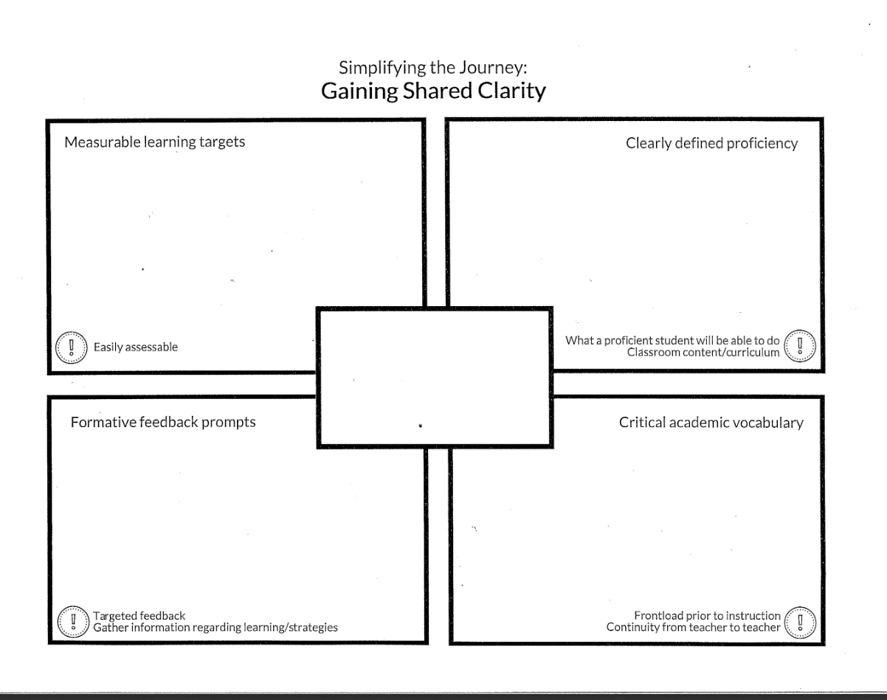
The graphic organizer has a rectangle in the middle and four large rectangles around it. We were told by our PLC coordinator/Solution Tree Representative, our head principal, and instructional coach to write the essential standard in the middle rectangle. The other four rectangles are labeled; Measurable learning targets/Easily accessible, Formative feedback prompts/Targeted Feedback (Gather information regarding learning strategies), Critical academic vocabulary/Frontload prior to instruction (Continuity from teacher to teacher) and Clearly defined proficiency/What a proficient student will be able to do (Classroom content/curriculum). We again worked together as a team to complete the graphic organizer for each grade level. A pattern began to emerge. The amount and difficulty of the critical academic vocabulary and the assumptions (mostly pessimistic) of the students’ prior knowledge/background knowledge of these words. These critical words seemed to grow as we moved up from 6th grade to 7th and then finally to 8th grade.
At some point during the process all 5 of us wondered how we would find the time and what strategies we would use to teach all of these words. This topic came up over and over again. This was a concern because we also have a great deal of content to teach and social studies tends to get the most class interruptions. Social studies is also unique in that we have all students in our classroom. Meaning we may have a student on an individualized education plan (IEP) with a student who reads at a high school or college level in the same classroom. I have 2 of our severe profound students in my regular education social studies class. So how do we meet the needs of all the students in all of our classes? How do we help each student reach their full potential? It all seems/seemed overwhelming. (See Figures 2, 3, & 4)
Figure 2. 6th grade Western Hemisphere Geography completed Simplify the Journey: Gaining Shared Clarity
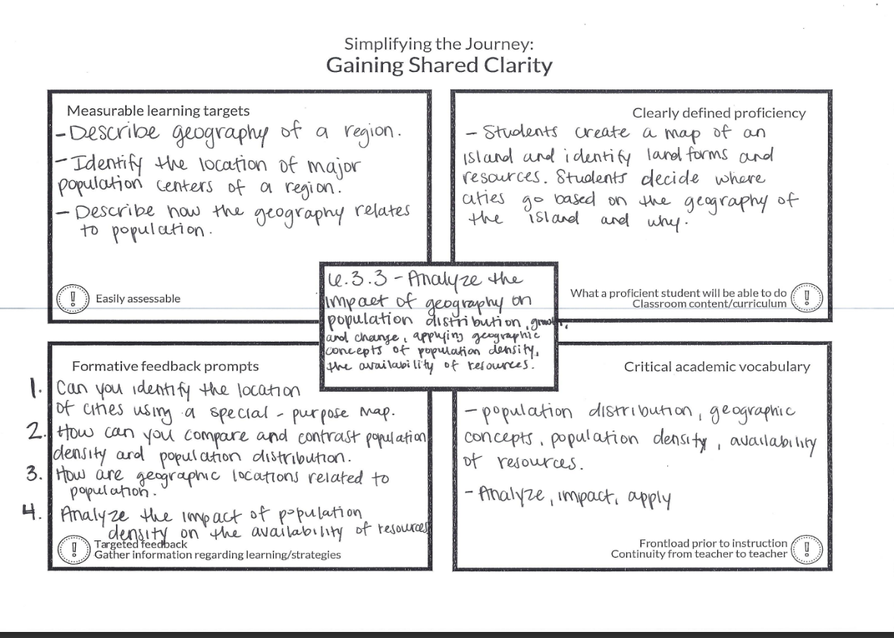
Figure 3. 7th grade Eastern Hemisphere Geography completed Simplify the Journey: Gaining Shared Clarity
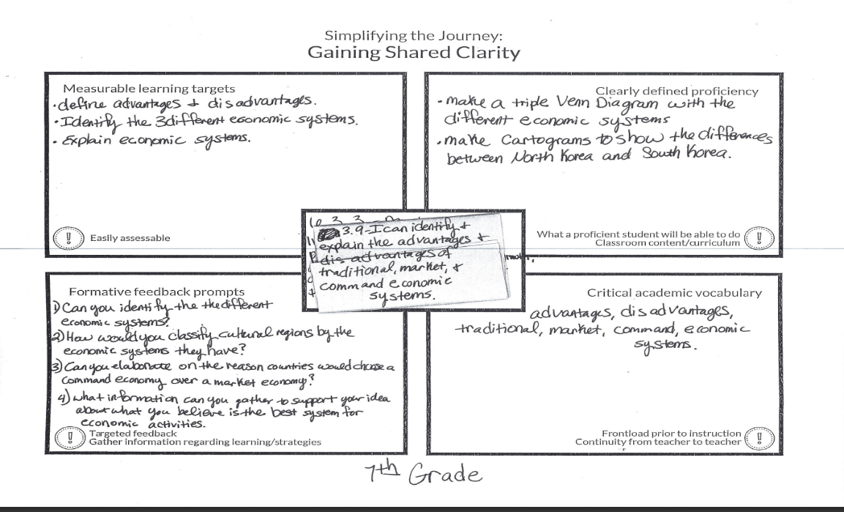
Figure 4. 8th grade American History grade completed Simplify the Journey: Gaining Shared Clarity
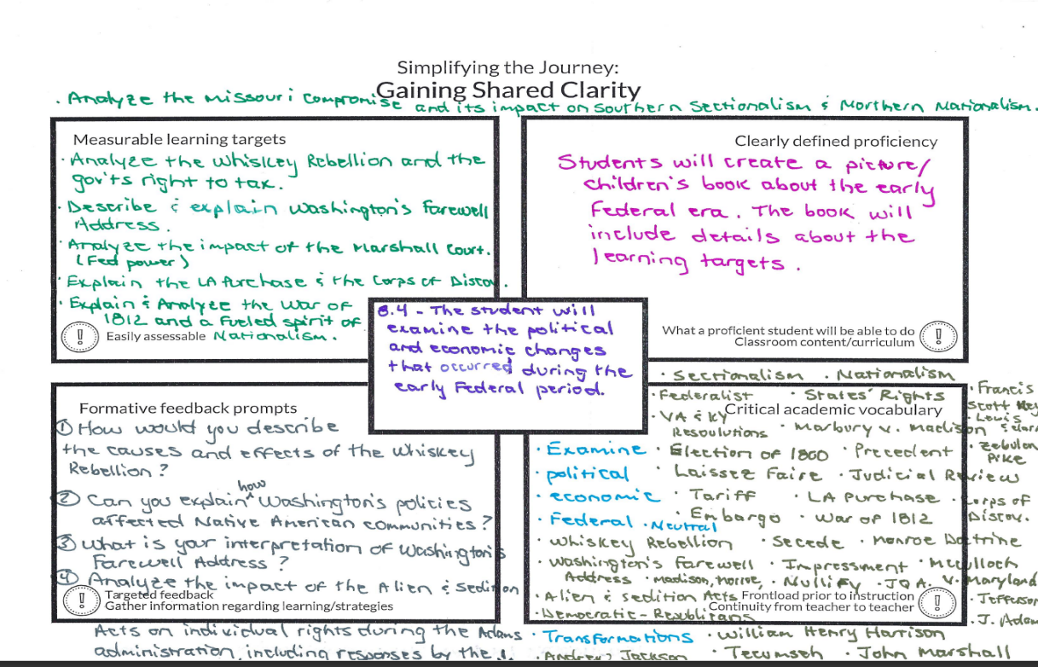

Instance 2: QFT (Question Formulation Technique) and Inquiry
As a social studies teacher, I often use primary sources in my classroom. My old approach was to give students a template or some other organization tool to guide them and their “thinking.” I asked the “questions” and directed them in a certain/correct direction. I also found myself frequently spending a great deal of instruction time defining words or explaining events, people and ideas before they interacted with the primary source. I used such strategies like T.A.C.O.S (time, action, caption, objects, summary), O.P.T.I.C (overview, parts, title, interrelationships, conclusion), APPARTS (author, place and time, prior knowledge, audience, the main idea, significance), or a basic graphic organizer (See Figure 5.). Each of these strategies prompted/encouraged students to analyze and think about the primary source but did not allow them to create their own meanings through questioning and curiosity. I already did the organizing and most of the early thinking for them and therefore, they were not allowed to move from dependent learners to independent learners.
Figure 5. Graphic organizers used for primary sources before being introduced to QFT
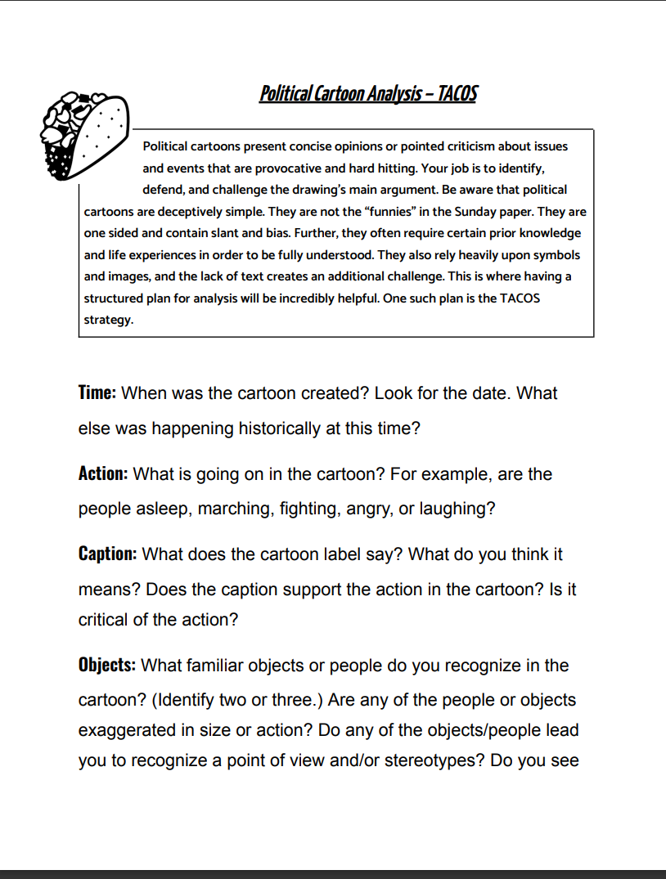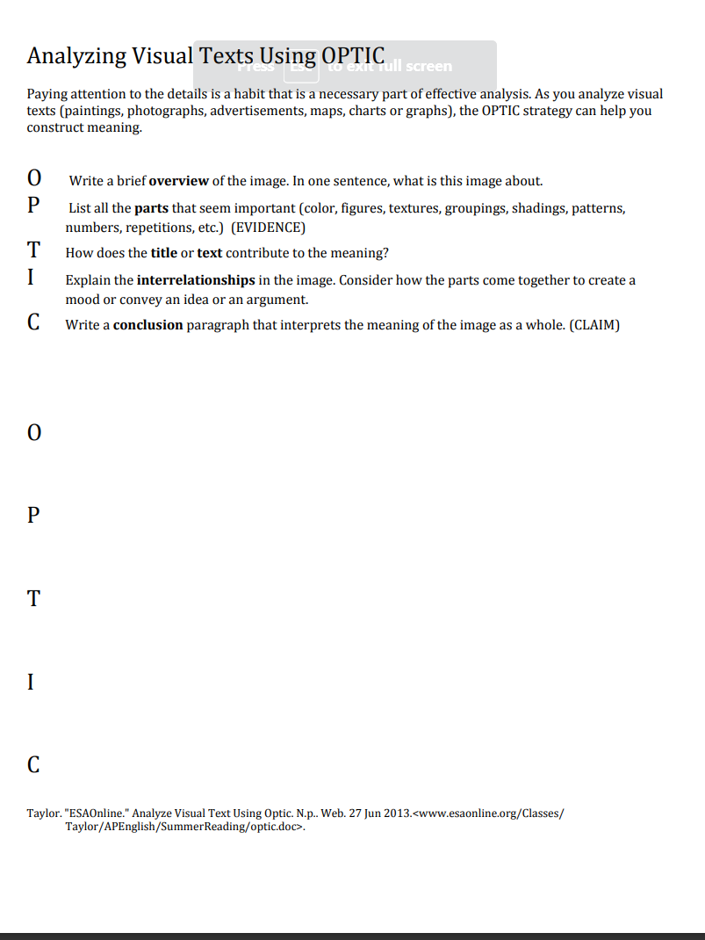
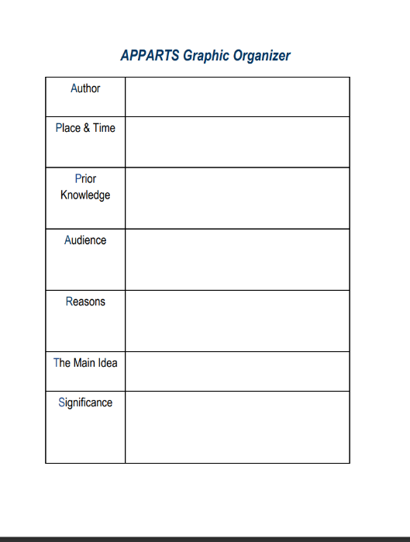
I became involved in a grant sponsored by the National Council of History Education (NCHE) titled The Rural Experience in America: Community Civics Through Historical Inquiry (Appendix A). AS part of this grant, I worked through a 6-week module course, Teaching with Primary Sources Basics, and the Right Question Institute 4-week module course, Teaching Students to Ask their Own Primary Source Questions. During the 10 weeks we learned how to use the Teaching with Primary Sources Teachers' Network TPS, a free professional social media platform that is funded by a grant from the Library of Congress, and focused on using primary sources to improve student learning through questioning and inquiry. (Appendix B)
Through the Library of Congress, I was introduced to the Question Formulation Technique. As part of this experience I learned an inquiry strategy called Question Formulation Technique (QFT). This strategy was presented by the Library of Congress and the Right Question Institute as a way to use primary sources in the classroom and for teachers to help students learn to ask questions. The QFT creates an environment that promotes student “ownership,” and creates a classroom where students feel comfortable participating. Students are taught how to begin historical inquiry by coming up with/creating their own questions, and through their own curiosity students become more engaged learners. They are naturally going to be more engaged because they are driving the lesson, it is them and not me. As part of the strategy, students generate questions, think critically about their questions, work to refine and prioritize their questions, and then reflect on the process while continuing to use their questions as the lesson or unit progresses (See Figure 6.).
Figure 6. The QFT Process
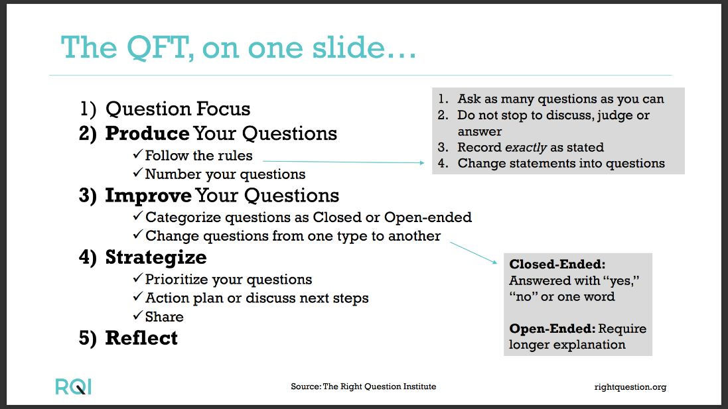
I began this QFT lesson on Manifest Destiny (Appendix C) by displaying John Gast’s painting American Progress on the board in the front of the classroom (Appendix D). I didn’t tell the students anything about the painting. The students began asking questions as they got their supplies and settled into class. I then told them that we were going to do QFT. Since this is not the first time, they did not need too many pre-instructions. I handed out the QFT instruction reminder sheet, a large yellow sticky note/paper, and an individual copy of the painting in black and white. I read over the instructions for the first step and made sure that each group had its designated writer. Set the timer for 5 minutes and we began. I walked around the room and listened to the students. Most of the early questions focused on the “angel woman.” Then they moved to where are the people going? Where are they coming from? Where are the women? Why don’t they have clothes on? When the 5 minutes ran out. I reset the timer and reminded them again the difference between an open and closed question. I set the timer for 3 minutes and they determined if their questions were open questions or closed questions. When that was complete, I did a quick show of hands to see if they had more open questions or closed questions. They had more open questions in most of my classes. So, this was an indicator to me that their thinking and wondering was definitely engaged. I sat the timer once again for 5 minutes and asked them to change 2 of their closed questions to open and 2 of their open questions to closed questions. Then we had a quick discussion about what we thought so far. I allowed them to do the majority of the talking. After our class conversation, I asked them to prioritize their questions. I asked them to pick the 5 most important questions. It was again timed, I put 4 minutes on the timer. Once they finished prioritizing questions I asked them to compare and contrast their “top 5” with another group. I did not time this. I walked around and listened to conversations and redirected when necessary. Most of the groups discovered that they had very similar questions. The final step was for each student to pick 2 of their groups priority questions and look up/research the answer. They should be prepared to share what they discovered. The next day we continued seeking out answers. When each student had discovered their answer, I instructed them to share with at least three other students who were not in their original group. They were not required to share with me or in front of the class. But I was able to “assess” where they were and determine what readings, activities, and assignments needed to be completed by walking around the room and participating in the student-led conversations during this lesson. (See figure 7.)
Figure 7. Student Questions generated during the Manifest Destiny QFT Lesson
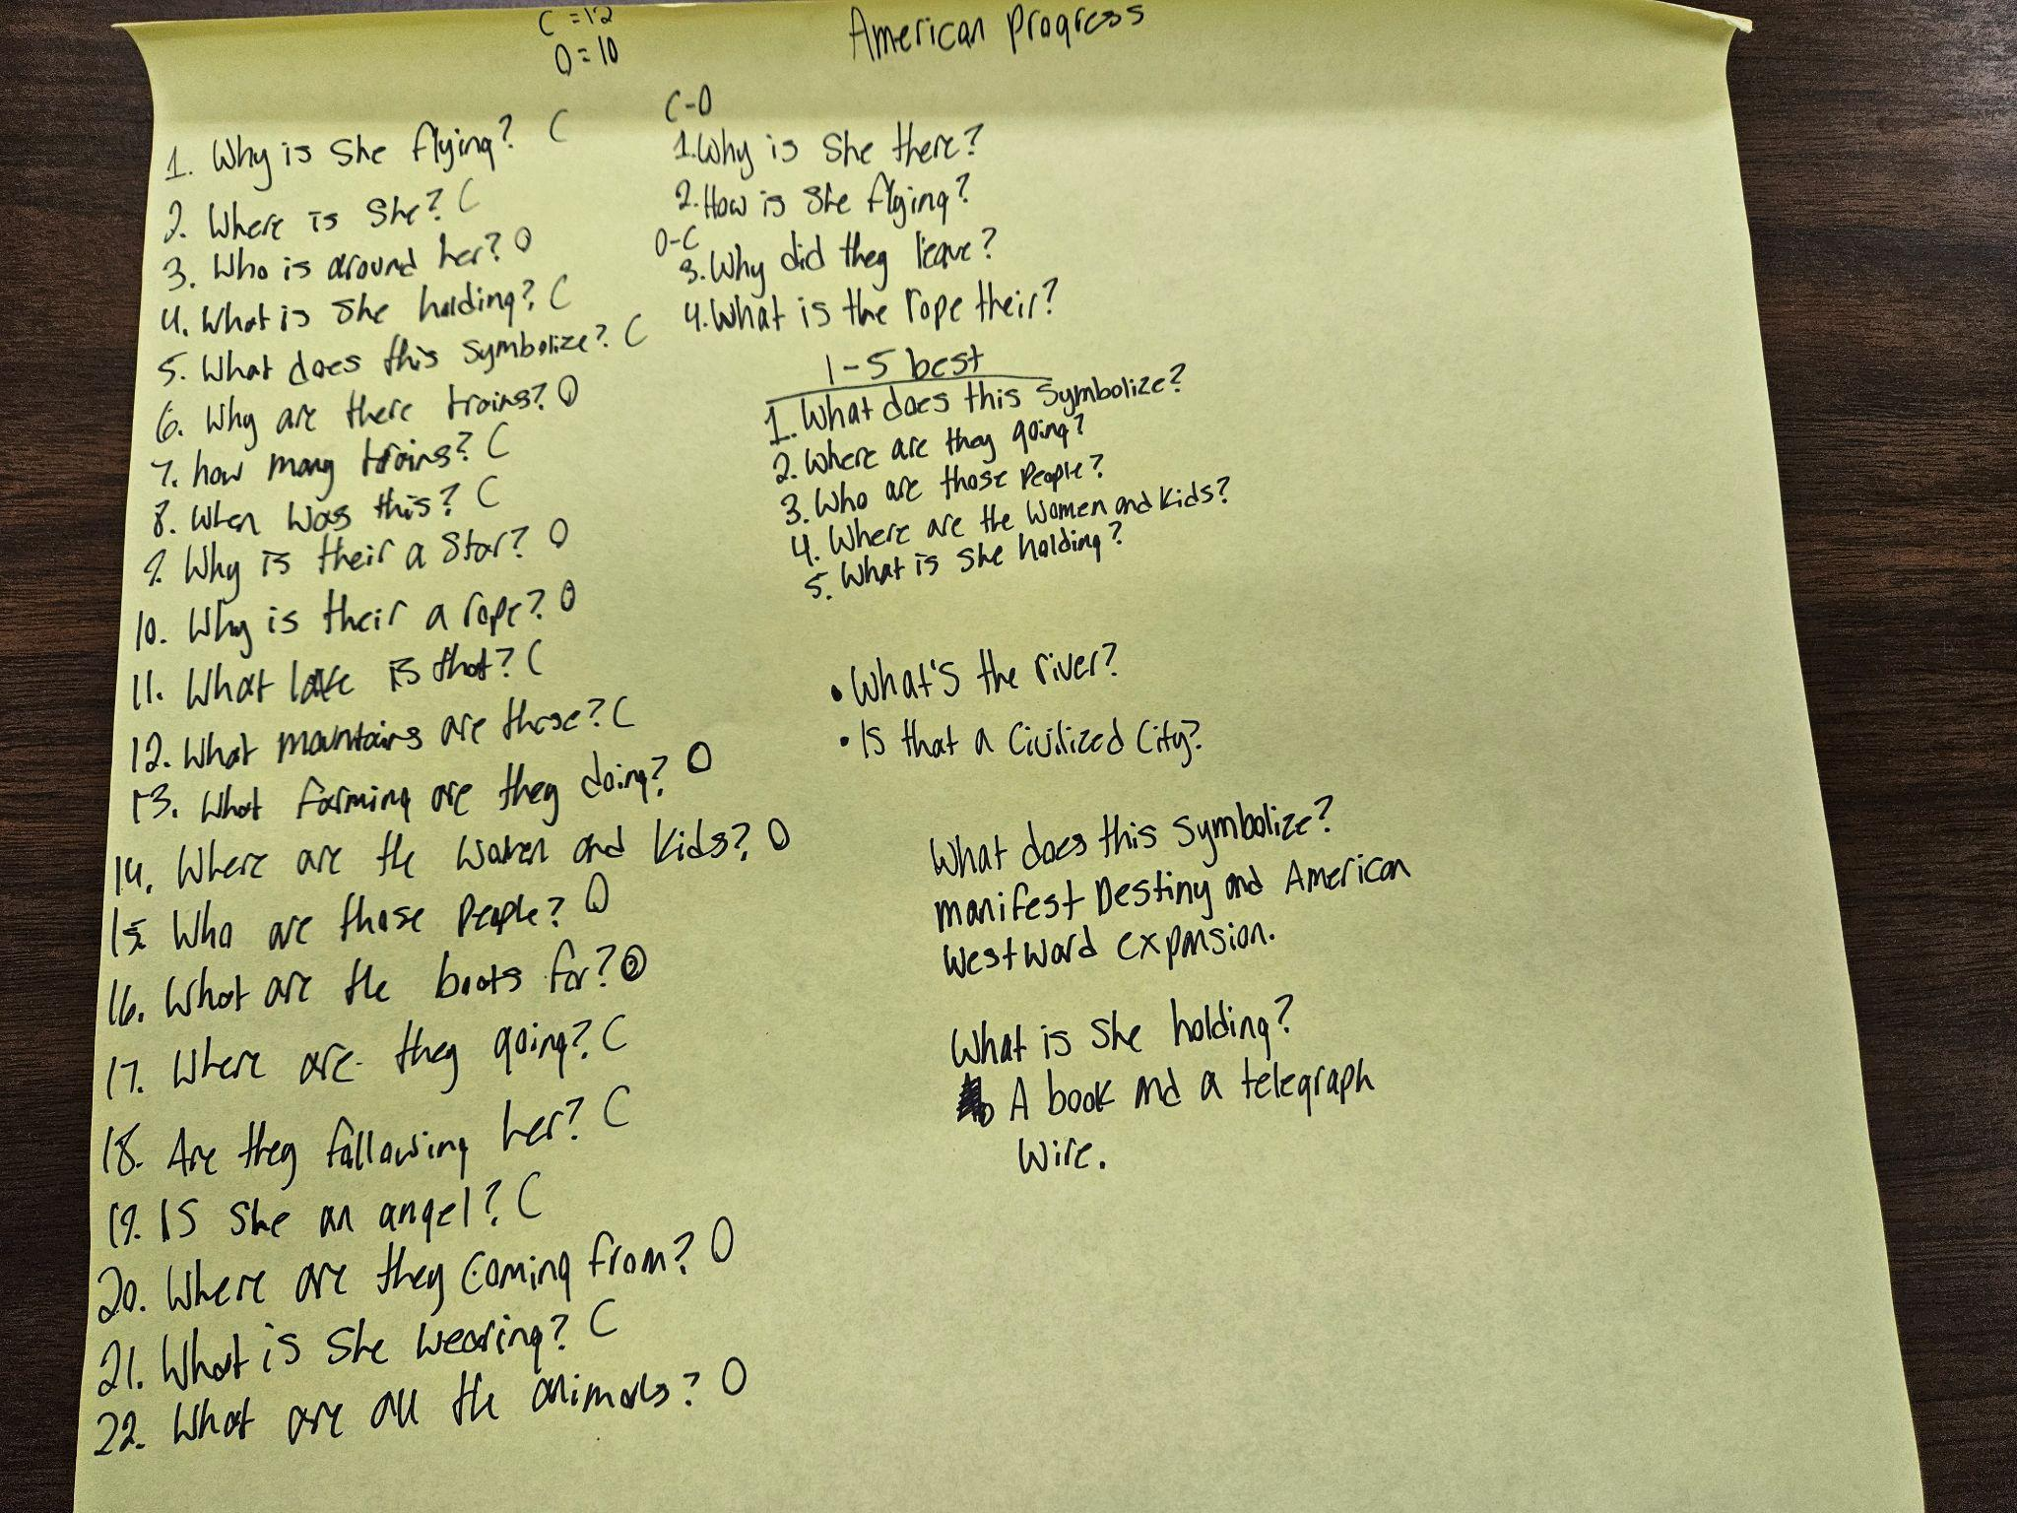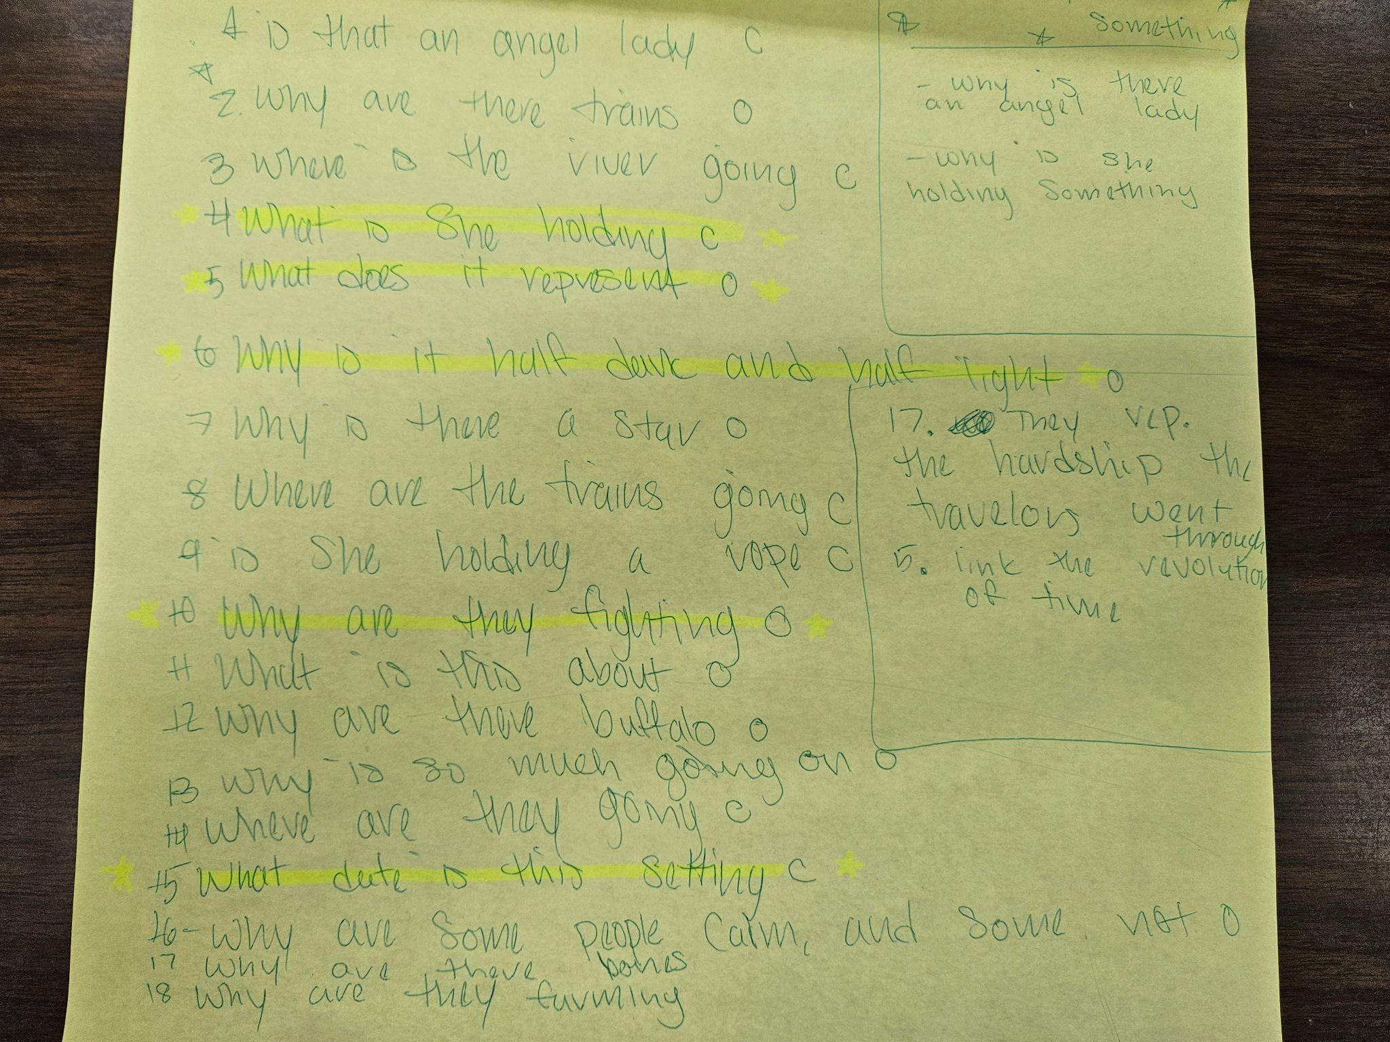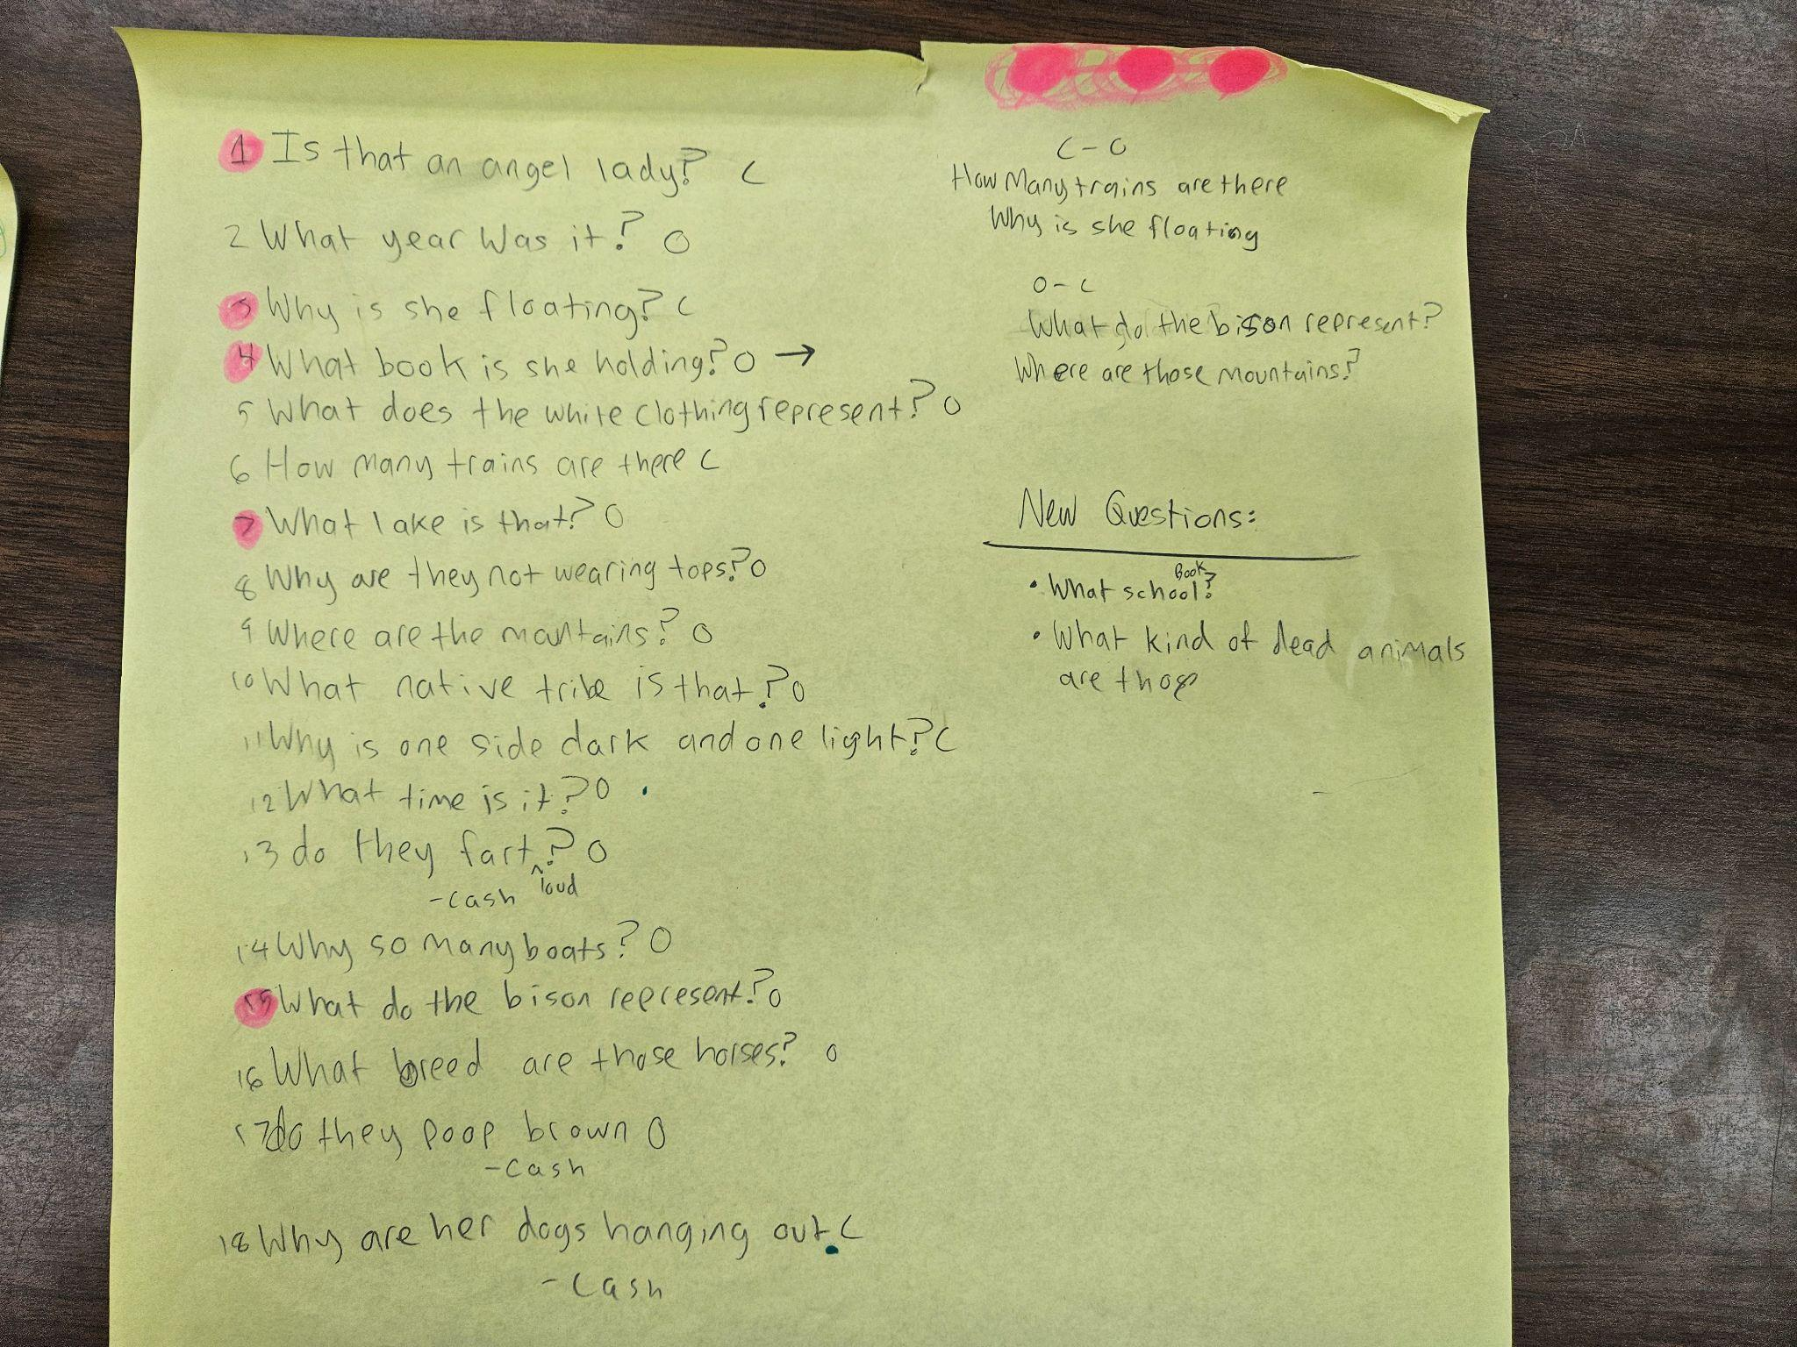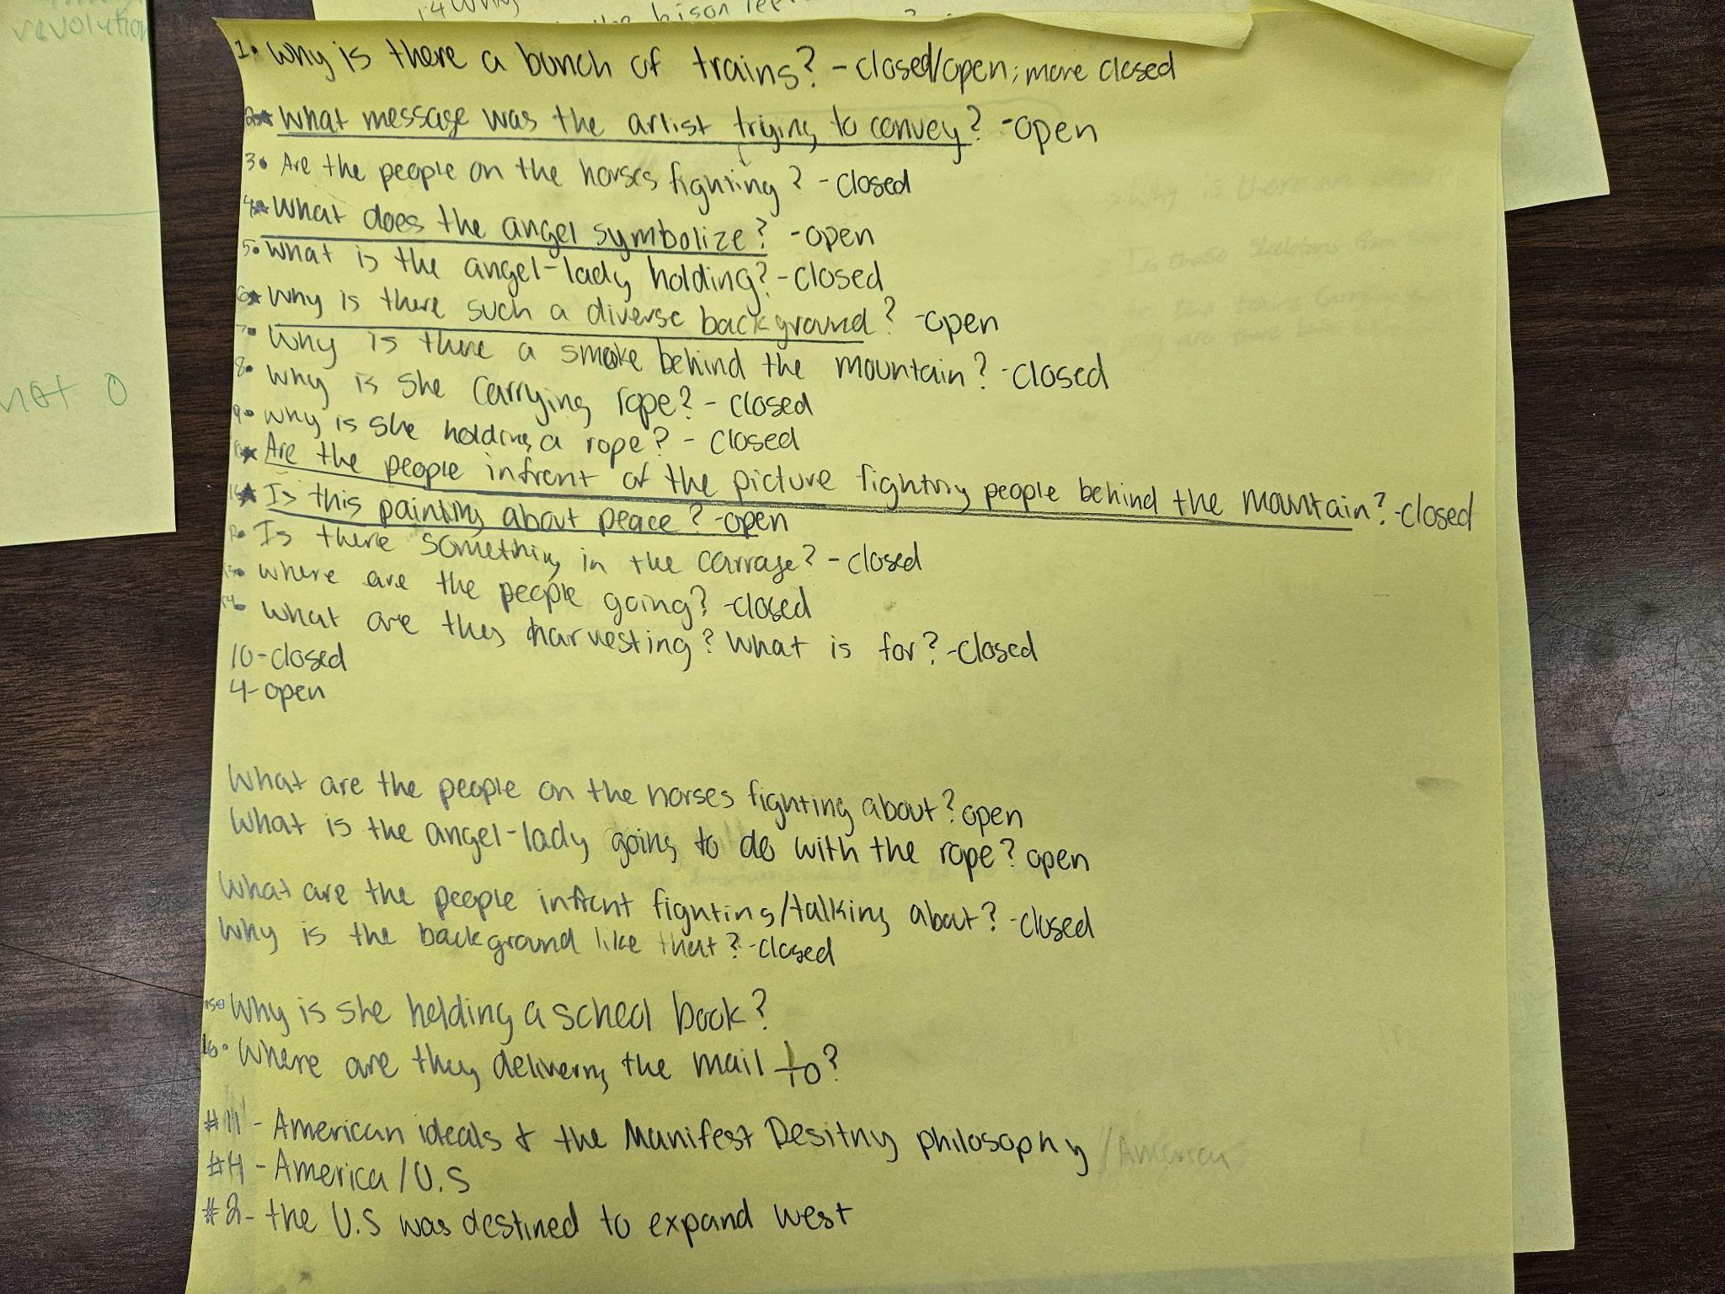
QFT allows students to drive the instruction and teach me what direction to go or what they understand and what needs more instruction. When the students come up with the questions and the answers, I can now use language such as “our” questions, or “our” understanding because we as a class have created the lesson. I provided the source and they determined the content. They now have equal ownership. Because of this, QFT fits well into the CRP model. QFT provides students an opportunity to use their own funds of knowledge and at the same time use critical thinking skills to identify, analyze, and think critically about the world around them. It is also accessible to every learning level and core school subject.

Instance 3: Assessments
As I have traveled through three years of graduate school, I have been fortunate to be exposed to and allowed to experience many new strategies and pedagogies. I have also been privileged to a wealth of new knowledge. Because of this graduate school journey, I have moved away from multiple choice/true false questions for formative and summative assessments. I have adapted a formative/summative assessment strategy that I learned while on my graduate school journey. Every professor I have had during my graduate journey has used some form of the “new assessment” strategy that I have created and now use. It is important to understand the difference between formative and summative assessments before I discuss my “new assessment” strategies.
Formative assessment is a collection of strategies that teachers use to gain clarity and understanding on what they will be teaching and to assess how well or if students learned what they are teaching (Knight, 2013). Formative assessments include three basic components; 1. Knowing how well your students are learning, 2. Ensuring your students know how well they are learning, 3. Using the data gathered from the assessments to modify teaching to ensure students mastered their learning (Knight, 2013). Summative assessment is given at the end of a unit of study, term, course or year. “In other words, what makes an assessment ‘summative’ is not the design of the test, assignment, or self-evaluation, per se, but the way it is used—i.e., to determine whether and to what degree students have learned the material they have been taught” (The Glossary of Educational Reform). I was exposed to and allowed to experience new ways to assess my students and provide feedback.
In Dr. Torres’s Multicultural and International Children’s Literature Class as well as her Understanding Different Cultures class, all of the assessments both formative and summative have the word you and give general guidelines but are not so rigid as to place a limit on individuality or cultural capital.
During the course of this semester, you will be asked multiple times to write short reflective responses related to the texts assigned that week…. The idea is that these reflections are not simply a summary of the readings but what they mean for your understanding of multicultural and international children’s literature, either professionally or personally (Torres, 2021, Course Syllabus).
The power of choice led to a sense of agency and community. Community with Dr. Torres as well as the other students. This created engagement and ownership in the class curriculum and content. This excitement is what drove me to take this idea and the feelings it created back to my classroom. I began to reflect and question the formative assessment that I was using in my classroom.
I have used exit slips over the years, but not consistently. Another formative assessment that I used to use often was general questioning of the class. Things like give me 3 questions or ask your table mates questions. This usually resulted in no response, or response from the same few students. I also used popsicle sticks with students' names on them almost daily. (See Figure 8.) Recently, I found myself having to prompt and cajole students to get a response. Students who are confused risk academic embarrassment, and the questions and popsicle sticks fail to give students enough time and space to share effective feedback about the lesson. Even if a few students respond, it doesn’t help differentiate between kids who partially understand and others who are completely lost. I still use them, but not as frequently and students now seem to take them more seriously.
Figure 8. Popsicle Sticks with student’s names
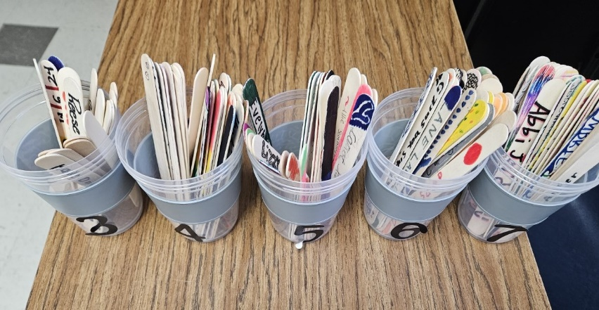
For formative assessments I now use quick writes. These are very similar to Dr. Houser’s CBJ’s (Closed Book Journals). To be fair, I completed similar exercises/assessments in all of my graduate classes. But Dr. Houser was the “inspiration” behind my initial idea. In the syllabus Dr. Houser stated that;
The closed-book journal includes unannounced written discussions of films and reading materials assigned for homework. Upon class you should be prepared to explain, without notes: (1) the overall thesis (main argument, including problem and solution) and major concepts; and (2) the implications of the thesis and major concepts for education in general and for your own teaching in particular (Houser, 2021, 2022, Course Syllabus).
Following this example and modifying it to fit 8th graders, I encourage students to “brain-dump” as much information as they can about a subject or topic. Typically, it will be please share with me your understanding of this or that. Or I will ask them to tell me how they felt about something or if they could connect it to themselves or something else we have talked about/learned in class. Sometimes I will give a graphic organizer for them to unload information into. If I do not have as much time, I will then ask students to give me a question or two that they have. It can be something that they do not understand or it can be a question that seeks deeper understanding or connection. I try to be flexible on these. Allowing students to give me the information in a way that works for them (sentences, bullet points, a picture/illustration, paragraph, text conversation, etc.). I do not use answer out loud formative assessments. These assessments are almost always timed, completed silently and completed individually on their Chromebook in our LMS (learning management system) Canvas. This allows me to give written and verbal feedback easily without having to meet with students individually. I have learned that silent individual assessment and feedback provides more authentic data on learning and allows me to gain a better understanding of my student’s progress. It does take more time and effort on my part, but the pay-off is worth it. This change has come gradually as I read, studied and collaborated with my graduate colleagues/other teachers and professors over the last 3 years.
For summative assessments, I use something I now call a “Tell ALL” in place of a standard test (multiple choice, true/false, matching and so on). Again, this was “inspired” by Dr. Houser and other professors during my graduate journey. For my “regular” classes, I provide a word bank and then 2-3 prompt choices. I ask the students to respond to 1 prompt using a certain number of words from the word bank. For my Pre-AP, I do not provide a word bank, but ask them to respond to the prompt. My instructions are to tell me all you know about whatever the prompt is, “tell me everything you know about the causes of the American Revolution,” or “tell me about the groups that contributed to the American victory in the American Revolution.” Again, I am flexible. I allow students to answer in paragraph form, list, graphic organizer or whatever works best for them. I have discovered that the results are much more authentic. (See figure 9)
Figure 9. Tell ALL Summative Assessment
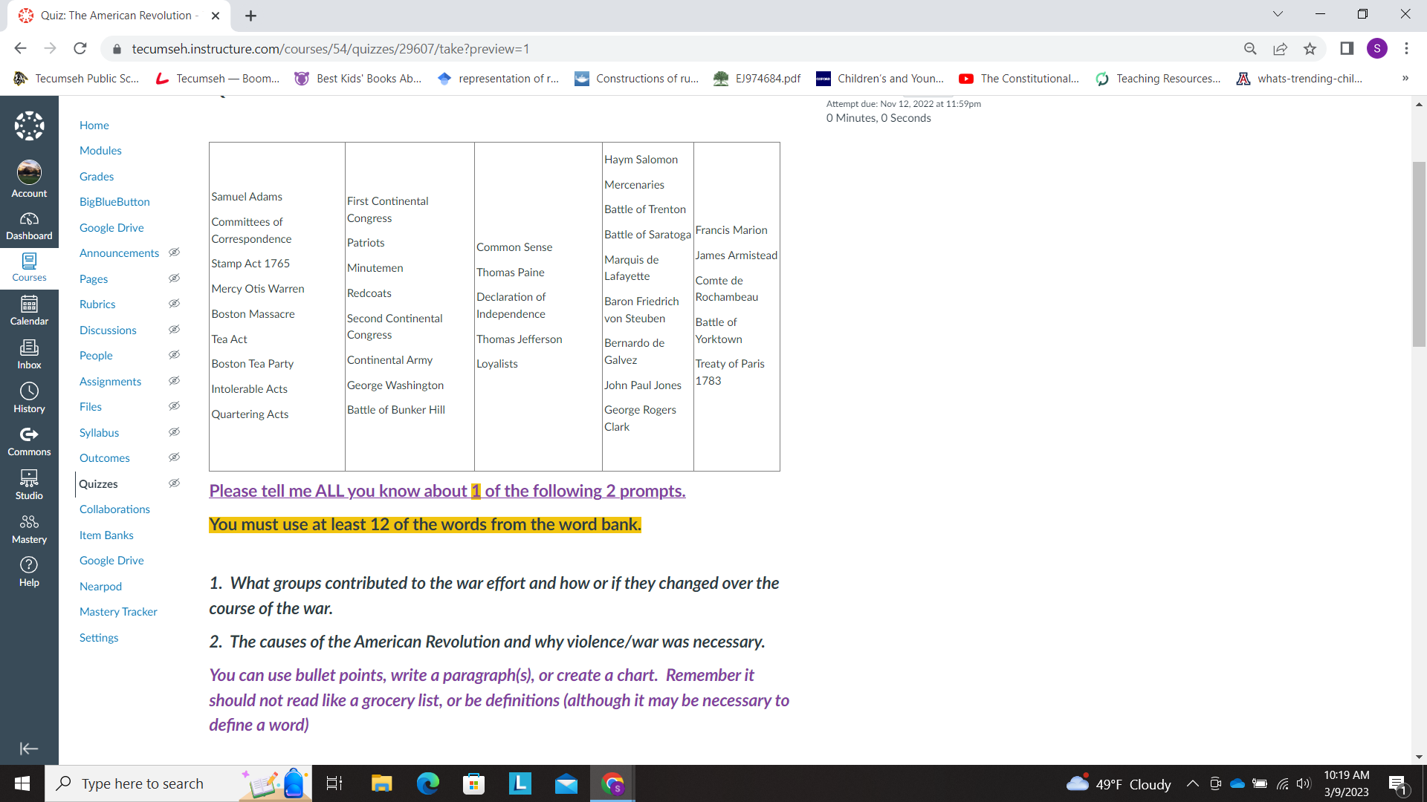
Because I use this method now for both formative and summative assessments, students seem much more comfortable and the assessments become more of a conversation. Also, by having them tell me what they know (Tell me all you know about, etc.…) they have a say in the curriculum and the content taught. I am not deciding what is important or what needs to be learned. They tell me what is important and what they learned. It is easy for me to then reflect and actually see what was learned/not learned. And what I unknowingly emphasized or thought that I emphasized and did not.

Chapter 5

Discussion/Conclusion
Teaching is easy, but teaching well is tough and being an ambitious teacher is even harder still. Ambitious teaching is a process and must be taken on as such. But the real challenge comes from, “grappling with the choices in front of you, reflecting on your mindset and how you can change them for the better, and converting the initial seeds of awareness into viable and lasting action steps” (Jensen, 2019, p. 209). According to the Merriam-Webster dictionary a professional is; a calling requiring specialized knowledge and often long and intensive academic preparation and a teacher as; one whose occupation is to instruct (merriam-webster.com). An ambitious teacher is both of the previously mentioned but they also have an understanding of themselves, their students and the context in which both exist. They also seek to humanize the curriculum and content.
My teaching and classroom improved because I stepped back and gave up some control to allow the students to direct the learning and move from dependent learners to independent learners. Ladson-Billings (1995) has defined culturally relevant teaching as “a pedagogy of opposition not unlike critical pedagogy but specifically committed to collective, not merely individual, empowerment” (p. 160). This allowed me to teach the students what they actually wanted to and needed to know. I was the teacher but also a student of my students. It was not easy to relinquish so much control, but it has provided huge gains.
I have become so excited about the QFT strategy that it is now the one that I use with primary sources (at least initially) and have done PD’s (professional development) for our upper elementary teachers, middle school teachers and high school teachers, teaching this strategy. These PD’s have allowed me to evolve as well. Farah and Barnett (2021) share these thoughts:
We reflected on our experiences as teachers and realized that, like our students, our fellow educators need more relevant PD: training that is personalized, efficient, and actionable. PD like this hasn’t been easy to create—it’s much more convenient to sit educators down and talk at them. But, in training our peers, we’ve done our best to emulate the differentiated, learner-centric practices that we developed for our students (p. 1).
By presenting what I thought was so valuable and sharing my funds of knowledge, I have learned to reflect on my pedagogical practices. Self-reflection is a really powerful tool. Also, the other teachers (of all grades and subject areas) have asked me some amazing questions that have provided me with the knowledge to evolve in my classroom and as a school/teacher leader. In Pedagogy of the Oppressed Paulo Freire (1973, 1993, 2000) says,
Education which is able to resolve the contradiction between teacher and student takes
place in a situation in which both address their act of cognition to the object by which
they are mediated. Thus, the dialogical character of education as the practice of freedom
does not begin when the teacher-student meets with the students-teachers in a
pedagogical situation, but rather when the former first asks herself or himself what she
or he will dialogue with the latter about (p. 66).
There are many advantages to this type of research, but there are also some limitations. For example, the feelings induced in readers may be unpleasant since the connections readers make to narratives cannot be predicted (Ellis & Bochner, 1996). Another limitation is the exposure it implies of the researcher’s inner thoughts and feelings. Which requires honesty on the part of the researcher and that is not an easy task. Another criticism is of the reality of that personal narratives or autoethnographies represent. The impact of the researcher's presence is generally considered to be a problem in which a researcher's biases cause him or her to unconsciously influence both process and outcome. But in order to be an effective and ambitious teacher you must research your own teaching. When instructors engage in reflective teaching, and they research themselves they are dedicating time to evaluate their own teaching practice, examine their curricular choices, consider student feedback, and make revisions to improve student belonging and learning. I believe the benefits and advantages outweigh the limitations and disadvantages.
For a veteran social studies teacher to meet the needs of their students they must continually reflect and evaluate the effects of their choices and actions. An ambitious teacher would create a student-centered curriculum and a class. They would develop a relationship with their students as well as the community. Each student’s ideas and opinions would be valued within their classroom. Students would feel safe to express their feelings and learn to respect and listen to others. This ambitious teacher creates a welcoming learning environment for all students and realizes that the expectations she has for her students greatly affect their achievement; she/he knows that students generally give to teachers as much or as little as is expected of them. They also teach and reteach the ability to think critically. Communication skills between teacher and student are taught to allow reasoning skills, information processing skills and to enable the students to give reasons for their opinions and actions. Students are taught and encouraged to use inquiry to ask questions to extend the critical thinking process. Lastly, an ambitious teacher inspires students with their passion for education and for the course material. They constantly renew themselves as a professional on their quest to provide students with the highest quality of education possible. This teacher has no fear of learning new teaching strategies or incorporating new technologies into lessons, and always seems to be the one who is willing to share what they have learned with colleagues.
I encourage teachers to take a journey in search of ambitious teaching and to seek out the ways to meet all their student’s needs. It will not be easy and their will be many obstacles and barriers along the way. But as you travel on this journey, “focus on the journey, not the destination. Joy is found not in finishing an activity but in doing it” (Greg Anderson).

References
About: NAEP. About | NAEP. (n.d.). Retrieved April 11, 2023, from https://nces.ed.gov/nationsreportcard/about/
Adams, T. E., Jones, S. H., & Ellis, C. (2014). Autoethnography Research Design and Philosophy. In Autoethnography understanding qualitative research (pp. 21–45). essay, Oxford Univ. Press.
Adolescent literacy and textbooks - education. (n.d.). Retrieved March 31, 2023, from https://files.eric.ed.gov/fulltext/ED535323.pdf
Applegate, P. J. (2008). The qualities that differentiate high-achieving and low-achieving high-poverty rural high schools: A transformative mixed methods study. (dissertation). ProQuest Dissertations & Thesis, Norman, OK.
Aronson, B., & Laughter, J. (2016). The theory and practice of culturally relevant education: A synthesis of research across content areas. Review of Educational Research, 86(1), 163–206. https://doi.org/https://doi.org/10.3102/0034654315582066
Azano, A. P., & Stewart, T. T. (2015). Exploring place and practicing justice: preparing pre-service teachers for success in rural schools. Journal of Research in Rural Education, 30(9), 1–12.
Bain, B. (2005). They thought the world was flat? Applying principles of how people learn in teaching high school history. In S. Donovan & J. Bransford (Eds.), How students learn: History in the classroom (pp. 179–215). essay, National Academy Press.
Barr, R. D., Barth, J. L., & Shermis, S. S. (1977). Defining the social studies. National Council for the Social Studies.
Barton, K. C. (2005). Primary sources in history: Breaking through the myths. Phi Delta Kappan, 86(10), 745–753. https://doi.org/https://doi.org/10.1177/003172170508601006
Barton, K. C., & Avery, P. G. (2016). Research on Social Studies Education: Diverse students, settings, and methods. Handbook of Research on Teaching, 985–1038. https://doi.org/10.3102/978-0-935302-48-6_16
Baumann, J. F., & Graves, M. F. (2010). What is academic vocabulary? Journal of Adolescent; Adult Literacy, 54(1), 4–12. https://doi.org/10.1598/jaal.54.1.1
Beck, I. L., McKeown, M. G., & Kucan, L. (2013). Bringing words to life: Robust vocabulary instruction (2nd ed.). The Guilford Press.
Brugar, K., & Roberts, K. (2022, June 14). Using inquiry to channel the natural curiosity of all students. Edutopia. Retrieved April 3, 2023, from https://www.edutopia.org/article/using-inquiry-channel-natural-curiosity-all-students/
Burton, M., Brown, K., & Johnson, A. (2013). Storylines about rural teachers in the United States: A narrative analysis of the literature. Journal of Research in Rural Education.
Carnegie Corporation of New York. (n.d.). Time to act: An agenda for advancing adolescent literacy for college and Career Success. Carnegie Corporation of New York. Retrieved March 31, 2023, from https://www.carnegie.org/publications/time-to-act-an-agenda-for-advancing-adolescent-literacy-for-college-and-career-success/
Castro, A., & Knowles, R. T. (2017). Democratic citizenship education. In M. M. G. Manfra (Ed.), The Wiley Handbook of Social Studies Research (pp. 287–318). essay, Wiley.
Chiappetta, E. (2023, February 1). Protocol for teacher-focused PD. edutopia. Retrieved March 20, 2023, from https://www.edutopia.org/article/critical-friends-group-protocol-pd/
Coleman, V. (2021). What is (or are) social studies? Research Matters, 32, 6–21.
College, career, and Civic Life (C3) framework for Social Studies State Standards. Social Studies. (n.d.). Retrieved April 3, 2023, from https://www.socialstudies.org/standards/c3
Common core state standards. Common Core State Standards |. (n.d.). Retrieved April 11, 2023, from http://www.corestandards.org/
Conklin, H. G. (2010). Purposes, practices and sites: a comparative case of two pathways into middle school teaching. American Educational Research Journal, 46(2), 463–500. https://doi.org/https://doi.org/10.3102/0002831208326558
Crocco, M. S., & Livingston, E. (2017). Becoming an "expert" social studies teacher: Teacher cognition, teacher education, and professional development. In M. M. G. Manfra (Ed.), The Wiley Handbook of Social Studies Research (pp. 1–40). essay, Wiley.
Crotty, M. (2021). The foundations of social research: Meaning and perspective in the research process (1st ed.). Routledge.
Darling-Hammond, L. (1999). Target time toward teachers. Journal of Staff Development, 20(n2), 31–36.
Denzin, N. (2000). The discipline and practice of qualitative research. In Y. Lincoln (Ed.), Handbook of Qualitative Research (pp. 1–32). essay, Sage; Thousand Oaks.
Diverse learners- diverse learners. Oklahoma State Department of Education. (2020, May 8). Retrieved April 3, 2023, from https://sde.ok.gov/diverse-learners-diverse-learners
Ellis, C., & Bochner, A. P. (1996). Composing ethnography: Alternative forms of qualitative writing. Sage.
Ellis, C., Adams, T. E., & Bochner, A. P. (2011). Autoethnography: An overview. Social Research, 12(1), 1–10.
Farah, K. (2021, August 12). Teachers need more relevant PD options. Edutopia. Retrieved April 10, 2023, from https://www.edutopia.org/article/teachers-need-more-relevant-pd-options/
Ference, R. A., & Bell, S. (2004). A cross-cultural immersion in the U.S.: Changing preservice teachers attitudes toward Latino ESOL students. Equity and Excellence in Education, 37, 343–350.
Fitchett, P. G., & Heafner, T. L. (2018). Teacher quality or quality teaching? Eighth Grade Social Studies Teachers’ professional characteristics and classroom instruction as predictors of U.S. history achievement. RMLE Online, 41(9), 1–17. https://doi.org/10.1080/19404476.2018.1514826
Flanigan, K., & Greenwood, S. C. (2007). Effective content vocabulary instruction in the middle: Matching students, purposes, words, and strategies. Journal of Adolescent; Adult Literacy, 51(3), 226–238. https://doi.org/10.1598/jaal.51.3.3
Freire, P. (1973). Pedagogy of the oppressed. The Seabury Press.
Freire, Paulo. (1998). Pedagogy of freedom: Ethics, democracy, and Civic Courage. Rowan &
Littlefield.
Gay, G. (2018). Culturally responsive teaching: Theory, research, and Practice (2nd ed.). Teachers College Press.
Gillis, V. (2014). Disciplinary literacy. Journal of Adolescent & Adult Literacy, 57(8), 614–623. https://doi.org/10.1002/jaal.301
The glossary of education reform. The Glossary of Education Reform. (n.d.). Retrieved April 1, 2023, from https://www.edglossary.org/
Grant, S. G., & Gradwell, J. M. (2009). The road to ambitious teaching: Creating big idea units in history classes. Journey of Inquiry and Action in Education, 2(1), 1–26.
Harmon, J. M., Hedrick, W. B., & Wood, K. D. (2005). Research on vocabulary instruction in the content areas: Implications for struggling readers. Reading and Writing Quarterly, 21(3), 261–280. https://doi.org/10.1080/10573560590949377
Hess, D. E., & McAvoy, P. (2015). The political classroom: Evidence and ethics in democratic education (Vol. 1). Routledge.
Hicks, D., Doolittle, P., & Lee, J. K. (2004). Social Studies Teachers' use of classroom-based and web-based historical primary sources. Theory Research in Social Education, 32(2), 213–247. https://doi.org/10.1080/00933104.2004.10473253
Hinton, J. (2021, July 8). Culturally responsive inquiry learning. edutopia. Retrieved March 31, 2023, from https://www.edutopia.org/article/culturally-responsive-inquiry-learning/
Home. ABC. (2023, February 27). Retrieved April 11, 2023, from https://www.abc-clio.com/
International Literacy Association Hub - Wiley Online Library. (n.d.). Retrieved April 2, 2023, from https://ila.onlinelibrary.wiley.com/doi/full/10.1002/jaal.875
Kena, G. (2015, May 28). The condition of education 2015. National Center for Education Statistics (NCES) Home Page, a part of the U.S. Department of Education. Retrieved April 11, 2023, from https://nces.ed.gov/pubsearch/pubsinfo.asp?pubid=2015144
Kenna, J. L., Russell III, W. B., & Bittman, B. (2018). How secondary social studies teachers define literacy and implement literacy teaching strategies: A qualitative research study. History Education Research Journal, 15(2), 216–232. https://doi.org/10.18546/herj.15.2.05
Ladson-Billings, G. (1995). Toward a theory of culturally relevant pedagogy. American Educational Research Journal, 32(3), 465–491. https://doi.org/10.3102/00028312032003465
Ladson-Billings, G. (2014). Culturally relevant pedagogy 2.0: A.k.a. the remix. Harvard Educational Review, 84(1), 74–84. https://doi.org/10.17763/haer.84.1.p2rj131485484751
Ladson-Billings, G. (2021). Culturally relevant pedagogy: Asking a different question. Teachers College Press.
Marzano, R. J., Pickering, D. J., & Pollock, J. E. (2008). Classroom instruction that works: Research-based strategies for increasing student achievement. Association for Supervision and Curriculum Development.
McKeown, M. G., Crosson, A. C., Moore, D. W., & Beck, I. L. (2018). Word knowledge and comprehension effects of an academic vocabulary intervention for middle school students. American Educational Research Journal, 55(3), 572–616. https://doi.org/10.3102/0002831217744181
Merriam-Webster. (n.d.). Dictionary definition & meaning. Merriam-Webster. Retrieved April 3, 2023, from https://www.merriam-webster.com/dictionary/dictionary
Miller, A. (2009). Pragmatic radicalism: An autoethnographic perspective on pre-service teaching. Teaching and Teacher Education, 25(6), 909–916. https://doi.org/10.1016/j.tate.2009.01.012
Moje, E. B. (2002). Re‐Framing Adolescent Literacy Research for New Times: Studying Youth as a Resource. Reading Research and Instruction, 41(3), 211–228. https://doi.org/10.1080/19388070209558367
Moje, E. B. (2008). Foregrounding the disciplines in secondary literacy teaching and Learning: A call for change. Journal of Adolescent &; Adult Literacy, 52(2), 96–107. https://doi.org/10.1598/jaal.52.2.1
Moll, L. C., Amanti, C., Neff, D., & Gonzalez, N. (1992). Funds of knowledge for teaching: Using a qualitative approach to connect homes and classrooms. Theory Into Practice, 31(2), 132–141. https://doi.org/10.1080/00405849209543534
Nagy, W. E., & Anderson, R. C. (1984). How many words are there in printed school English? Reading Research Quarterly, 19(3), 304–330. https://doi.org/10.2307/747823
Nagy, W. E., Scott, J. A., Barr, R., & Pearson, P. D. (2000). Vocabulary Processes. In M. L. Kamil (Ed.), Handbook of Reading Research (Vol. 3, pp. 269–284). essay, Lawrence Erlbaum Associates Publishers.
National Council for the Social Studies. (1994). National curriculum standards for social studies: Introduction. Social Studies. Retrieved March 24, 2023, from https://www.socialstudies.org/standards/national-curriculum-standards-social-studies-introduction
National standards for the preparation of Social Studies Teachers. Social Studies. (n.d.). Retrieved April 10, 2023, from https://www.socialstudies.org/standards/national-standards-preparation-social-studies-teachers
National standards for the preparation of Social Studies Teachers. Social Studies. (n.d.). Retrieved March 31, 2023, from https://www.socialstudies.org/standards/national-standards-preparation-social-studies-teachers
Ngunjiri, F. W., Hernandez, K.-A. C., & Chang, H. (2010). Living Autoethnography: Connecting life and research [Editorial]. Journal of Research Practice, 6(1), 1–9. https://doi.org/http://jrp.icap.org/index.php/jrp/article/view/241/186
Ngunjiri, F. W., Hernandez, K.-A. C., & Chang, H. (2010). Living autoethnography: Connecting life and research. Journal of Research Practice, 6(1), 1–15.
Nokes, J. D. (2011). Recognizing and addressing the barriers to adolescents' "Reading Like Historians". The History Teacher, 44(3), 379–404. https://doi.org/https://www.jstor.org/stable/41303991
Noonoo, S. (2022, November 1). 4 positive alternatives to problematic teaching practices. Edutopia. Retrieved February 27, 2023, from https://www.edutopia.org/article/4-positive-alternatives-to-problematic-teaching-practices
O'Brien, D. G., Stewart, R. A., & Moje, E. B. (1995). Why content literacy is difficult to infuse into the secondary school: Complexities of curriculum, pedagogy, and school culture. Reading Research Quarterly, 30(3), 442–463. https://doi.org/10.2307/747625
Office of Education, United States Department of the Interior. (1918, November 30). Educational directory 1916-1919. United States Bureau of Education, Department of the Interior. Retrieved March 25, 2023, from https://eric.ed.gov/?id=ED619470
Palmer, P. J. (2017). The Courage to Teach (1st ed., Vol. 3). by Jossey-Bass a Wiley Brand.
Palumbo, A., Kramer-Vida, L., & Hunt, C. (2015). Teaching vocabulary and morphology in intermediate grades. Preventing School Failure, 59(2), 109–115.
Piros, G. (2019, March 27). Sparking change in teaching practices. Edutopia. Retrieved February 27, 2023, from https://www.edutopia.org/article/sparking-change-teaching-practices/
Pribble, A. (2018, November 15). Balancing instruction in social studies: The difficult challenge of teaching reading, writing, and speaking in addition to social studies content and skills. edutopia. Retrieved March 20, 2023, from https://www.edutopia.org/article/balancing-instruction-social-studies/
Reflecting on your teaching. Wilfrid Laurier University. (n.d.). Retrieved February 27, 2023, from https://researchcentres.wlu.ca/teaching-and-learning/teaching/reflecting-to-evolve-practice.html
Roscoe, R. D. (2013). Self-monitoring and knowledge-building in learning by teaching. Instructional Science, 42(3), 327–351. https://doi.org/10.1007/s11251-013-9283-4
Scherff, L. (2018, January 4). Regional Educational Laboratory Program (REL): Pacific. Institute of Education Sciences (IES) Home Page, a part of the U.S. Department of Education. Retrieved April 2, 2023, from https://ies.ed.gov/ncee/edlabs/regions/pacific/blogs/blog2_DistinguishingProfLearning.asp
Schön Donald A. (1983). From Technical Rationality to Reflection in Action. In The reflective practitioner: How professionals think in action (pp. 30–78). essay, Basic Books.
Shanahan on Literacy. (2017, March 15). Disciplinary literacy: The basics. Shanahan on Literacy. Retrieved February 27, 2023, from https://www.shanahanonliteracy.com/blog/disciplinary-literacy-the-basics#sthash.irsOTSP3.1l7dn3nF.dpbs
Shanahan, C., Shanahan, T., & Misichia, C. (2011). Analysis of expert readers in three disciplines. Journal of Literacy Research, 43(4), 393–429. https://doi.org/10.1177/1086296x11424071
Short, J., & Hirsh, S. (2020). The elements: Transforming teaching through curriculum-based Professional Learning: Professional Learning for Educators. Carnegie Corporation of New York. Retrieved March 31, 2023, from https://www.carnegie.org/our-work/article/elements-transforming-teaching-through-curriculum-based-professional-learning/
Shulman, L. S. (1986). Those who understand: Knowledge growth in teaching. Education Researcher, 15(2), 4–14. https://doi.org/ http://www.jstor.org/stable/1175860.
Social Studies. Oklahoma State Department of Education. (n.d.). Retrieved April 11, 2023, from https://sde.ok.gov/social-studies
Sprinkle, P. (2013, January 17). Literacy in the social studies classroom. Retrieved April 3, 2023, from https://www.uft.org/news/teaching/teacher-teacher/literacy-social-studies-classroom
Stachowski, L. L., & Mahan, J. M. (1998). Cross-cultural field placements: Student teachers learning from schools and communities. Theory into Practice, 37(2), 155–162.
Steiner, S. (2018, January 25). How using autoethnography improved my teaching. scholarlyteacher. Retrieved April 1, 2023, from https://www.scholarlyteacher.com/post/autoethnography-to-improve-teaching
Swanson, E., Wanzek, J., McCulley, L., Stillman-Spisak, S., Vaughn, S., Simmons, D., Fogarty, M., & Hairrell, A. (2015). Literacy and text reading in middle and high school social studies and English language arts classrooms. Reading and Writing Quarterly, 32(3), 199–222. https://doi.org/10.1080/10573569.2014.910718
Teacher, T. S. (2018, January 25). How using autoethnography improved my teaching. scholarlyteacher. Retrieved February 27, 2023, from https://www.scholarlyteacher.com/post/autoethnography-to-improve-teaching
Teachers know best: Teachers' views on Professional Development. U.S. Program. (2021, February 9). Retrieved April 2, 2023, from https://usprogram.gatesfoundation.org/News-and-Insights/Articles/Teachers-Know-Best-Teachers-Views-on-Professional-Development
Thacker, E., & Friedman, A. (n.d.). Three Social Studies Teachers' design and use of inquiry modules. CITE Journal. Retrieved April 4, 2023, from https://citejournal.org/volume-17/issue-3-17/social-studies/three-social-studies-teachers-design-and-use-of-inquiry-modules/
Theobald, P. (2016). Education in a rural context. In B. Theobald (Ed.), The Routledge History of Rural America (pp. 165–179). essay, Routledge.
Tieken, M. C. (2014). Why rural schools matter. University of North Carolina Press.
Tracy, S. J. (2020). Developing Contextual Research That Matters. In Qualitative research methods: Collecting evidence, crafting analysis, Communicating Impact (pp. 2–18). essay, John Wiley and Sons, Inc.
US states - ranked by population 2023. (n.d.). Retrieved April 3, 2023, from https://worldpopulationreview.com/states
Walsh, D. C., & Palmer, P. J. (2017). Foreword to the twentieth anniversary edition. In The Courage to Teach (pp. ix-xv). foreword, Jossey-Bass a Wiley Brand.
Walters, L. M., Garli, B., & Walters, T. (2009). (rep.). Learning globally, teaching locally: Incorporating international exchange and intercultural learning into pre-service teacher training (pp. 1–10). College Station, Texas.

APPENDICES

Appendix A
Rural Experience in America: Community Civics Through Historical Inquiry
Tecumseh Tales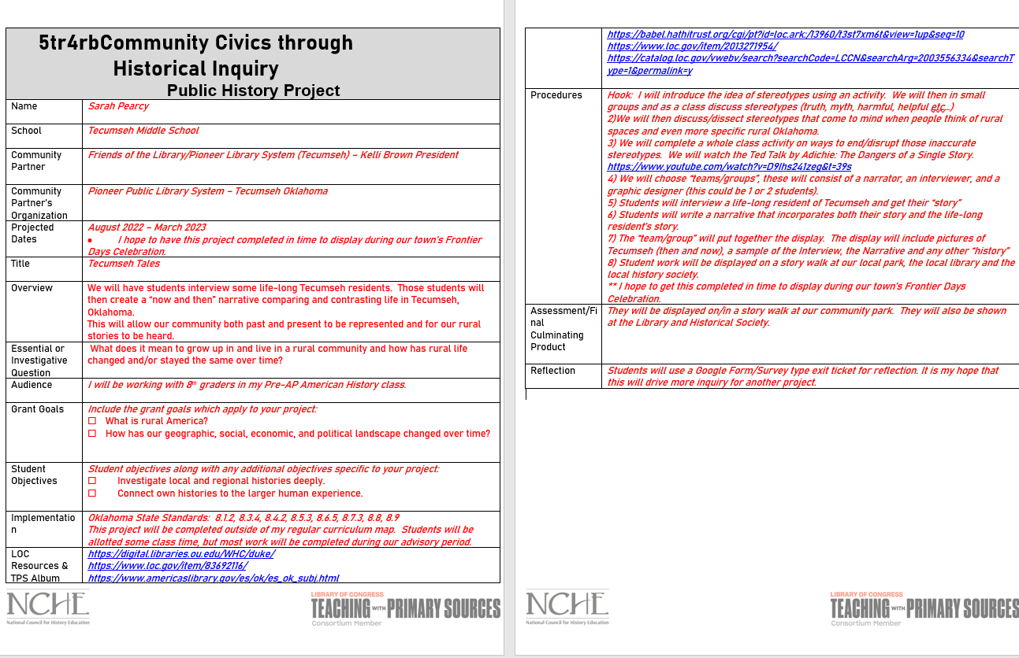

Appendix B
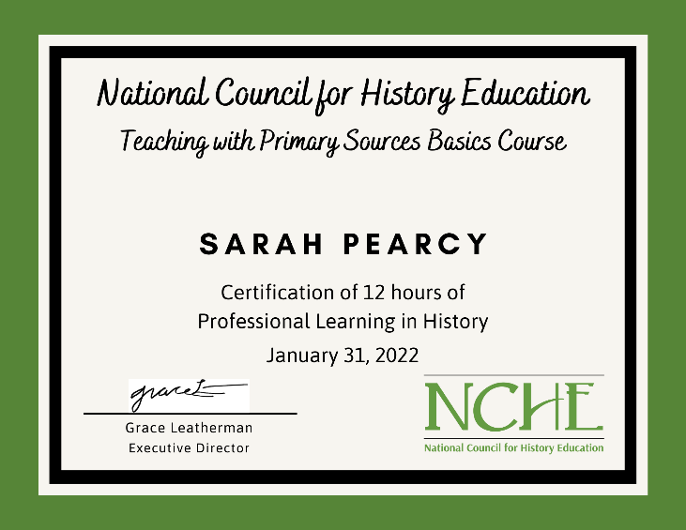
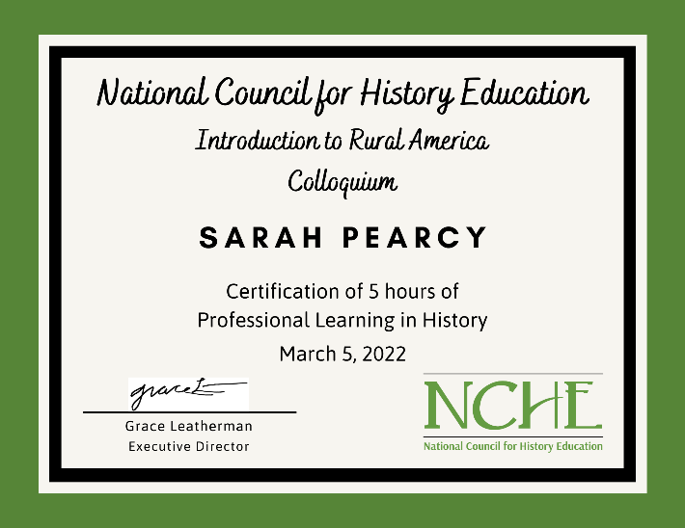
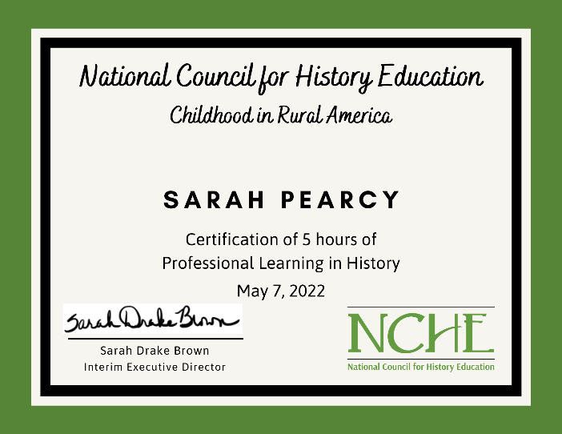

Appendix C
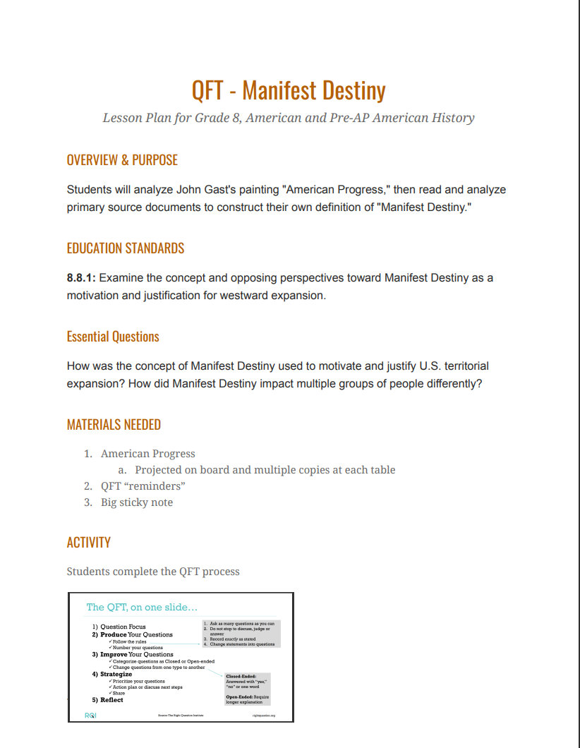

Appendix D
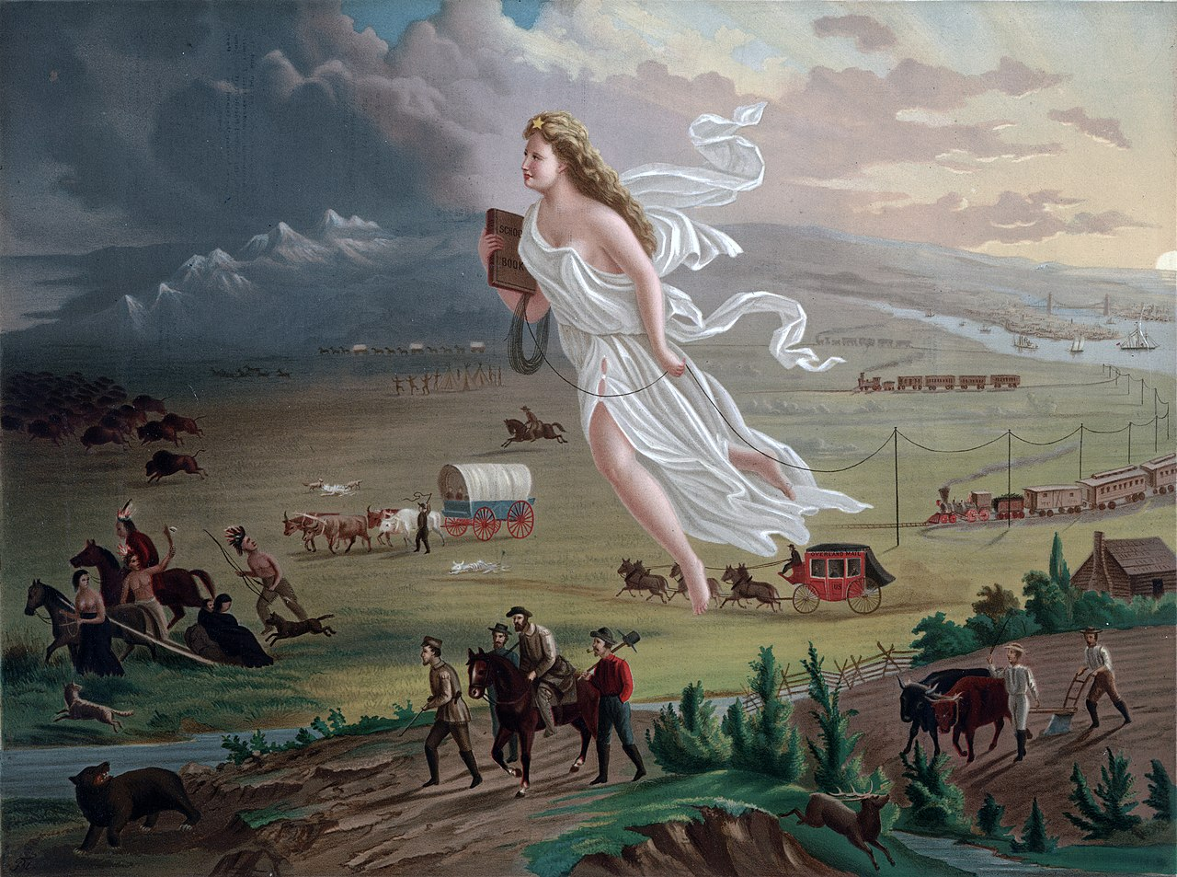
John Gast – American Progress, 1872

