UNIVERSITY OF OKLAHOMA
GRADUATE COLLEGE

THE INTEGRATION OF HOTEL INTERACTIVE LIGHTING SYSTEMS TO SUPPORT USERS’ VISUAL COMFORT AND ACTIVITY NEEDS

A THESIS
SUBMITTED TO THE GRADUATE FACULTY
In partial fulfillment of the requirements for the
Degree of
MASTER OF SCIENCE IN INTERIOR DESIGN

By
SIYAO LI
Norman, Oklahoma
2022

THE INTEGRATION OF HOTEL INTERACTIVE LIGHTING SYSTEMS TO SUPPORT USERS’ VISUAL COMFORT AND ACTIVITY NEEDS

A THESIS APPROVED FOR THE
CHRISTOPHER C. GIBBS COLLEGE OF ARCHITECTURE

BY THE COMMITTEE CONSISTING OF

Mia Kile, Chair
Dr. Negar H. Matin
Dr. Chris Weaver

© Copyright by SIYAO LI 2022
All Rights Reserved.

Table of Contents
Abstract vii

Introduction 1
Background and Problem Statement 1
Purpose Statement 2
History 2
Lighting Brightness Units 3
Lighting in the Future 5

Literature Review 6
Traditional Lighitng 6
Traditional Lighitng Limitations 6
Interactive Lighting 8
Technological Innovations by LEDs 11
Lighting System Complexity 14
Digital Control Technology 18
User Interface 21
Universal Design 24
Research Questions 27
Research Objectives 27

Research Methodology 28
Measurement Methods and Judging Criteria 29
Field Lux Level Measurements: 30
Lighting Observation: 31

Case Studies 32
Case Study Background Information: 32
Case Study (1):Hilton New Orleans Riverside 34
Case Study (2):Loews New Orleans Hotel 41
Case Study (3):Harrah’s New Orleans Hotel 46
Findings 52

Discussion 57

Recommendations 61

Conclusion 63

Limitations 64
Future Direction 64

References 66

Abstract
This study explores the standards of interactive lighting systems in the hospitality industry, specifically those spaces found in hotels, to enhance the experience for customers. Case study analysis was selected as the research methodology to evaluate the lighting quality and capabilities of three commercial hotels in New Orleans as they may inform new hotel interactive lighting capabilities. The study considers three aspects: first, the lighting source, second, the lighting control system, and third, the lighting system structure. Lighting sources are evaluated as they pertain to universal design characteristics. The study focuses on principles 2 and 4 of the seven universal design principles. Principle 2, Flexibility in Use, considers whether the light can be adjusted according to the different needs of users. Principle 4, Perceptible Information, evaluates whether the lighting system can provide sufficient lighting required to support the activities within the space such as route guidance and legibility of important information (Connell et al., 1997). Lighting control is evaluated from the aspect of the user interface considering minimal switching to more state-of-the-art technology to control the lighting quality within a given space. In the lighting structure, the lighting system gradually removes the traditional lighting line based on the single point structure into a wireless chip based on the systematic regional module structure, reducing the difficulty of adjustment, and overall enhancing the efficiency of lighting control. This paper suggests a design standard for interactive lighting systems in hotels based on human behavior patterns and perception levels.
Keywords: Interactive Lighting, Lighting Design Standard, Commercial Lighting System, Light Emitting Diodes, Remote, and Wireless Control.

Introduction
Background and Problem Statement
In the 21st century, the lighting industry has become indispensable as it increases the standard of living and improves the quality of life for many individuals. With advancements in technology, lighting can be controlled to enhance the environment and various user needs. Lighting has become increasingly important in the commercial sector, especially in the hospitality industry, characterized by a diverse clientele. Modern technology companies have continued to improve and innovate commercial interior design technologies, including the intelligent application of lighting systems. However, it is still worth exploring and researching the various features a hotel's interactive lighting system should have to meet the diverse needs of hotel guests.
Hotel lighting systems by nature have been consistently innovative and as technology has advanced, interactive lighting systems have gradually replaced traditional ones. As technology companies apply interactive lighting systems to different areas of the hospitality industry, the specific criteria for interactive lighting systems to meet human visual comfort are still being explored and defined (Katona, Pattison and Paolini, 2016). This thesis will provide a design standard for interactive lighting systems in hotels based on users’ visual satisfaction and activities.

Purpose Statement
The advancements in lighting over the past decade, it is essential to develop interactive lighting standards for the hospitality lighting industry. Because of personal visual preferences for lighting, adjustments to lighting system parameters vary from user to user. While lighting design, as it is applied to the built environment varies by building type and user needs (Magielse, Hengeveld, & Frens, 2013), this study considers lighting within the hospitality framework and can be used to inform lighting design for other building types beyond hospitality. The interactive lighting standard explored in this study identifies problems within existing hotel lighting environment. and provides recommendations to improve the lighting to support the users’ visual comfort experience and activities in hotel environments. As a framework, the study examines the interactive lighting systems as compared to industry standards for lighting such as those published by the Illuminating Engineering Society (IES).

History
Mankind has relied on alternative lighting sources beyond that of natural daylight for many millennia. Lighting has evolved over time from the simple combustion of fuel to make fire to arc lighting from electricity and then to digital modern LED intelligent lighting and control systems (DiLaura, 2008). Each stage of lighting advancement corresponds with other major developments in science. Over 4,500 years ago, during the plant grease lighting era, lighting was created by the burning of olive oil. The early 18th-century brought about candles which were developed using a grass or flax wick soaked in animal fat. Early gas lamps in the mid-18th century in the gas lighting stage, were developed by distilling the combustible gas obtained from coal. In the first part of the 19th century, we see the development of kerosene lamps (DiLaura, 2008). Through the distillation of coal, people obtain "gas" and "kerosene," and the use of kerosene burning for lighting became an important stage in the history of the development of light. In the mid-19th century, with the application of electricity, electric light sources were developed which literally revolutionized lighting. Electric lighting sources have evolved from the incandescent lamps using carbonization of bamboo wire to "rare-earth" elements of fluorescent and phosphor light discharge used in the fluorescent lamps. With the conversion of electrical energy into light energy through inorganic semiconductor materials for lighting, solid-state lighting also known as Light Emitting Diode (LED) was created. The advancements in LED lighting have resulted in a higher quality of light, lower energy consumption, and the ability to control and adjust the light source has made LED a current leader in the lighting industry (Zhang, et al., 2020).

Lighting Brightness Units
Along with the continuous development of lighting equipment, the lighting industry evolved to set standards to assess the quality of lighting such as the concept of luminosity to measure the brightness of the light from the light source (Livingston, 2014). The higher the lumen level, the lighter output the lamp produces and the lower the lumen level, the less light the lamp produces. Light falling on a surface is measured in footcandles (fc) or lux. Lux is used as international unit of measurement whereas footcandles are the imperial unit of measurement typically used in the United States. Understanding the lighting levels, a source provides aids in the design process when considering which lamp to recommend supporting specific functions. For instance, reading a book or conducting detailed work requires lighter than navigating a space.
The quality of light is also measured through color temperatures measured in kelvin units whereas the higher the kelvin unit, the cooler the light, the lower the kelvin unit the warmer the light. Note that an incandescent bulb typically has a lower kelvin temperature (2500k+/-), fluorescent lights typically produce a cooler kelvin temperature (6500k+/-), and LED lighting could adjust across all visible temperature ranges.
The ability of a light source to render materials in their true color is measured using the Color Rendering Index (CRI) and is evaluated on a scale from 0-100. The higher the CRI the better the quality of the light to render materials accurately. Typically, a rating from 80-100 is considered acceptable ranges where color is important such as in retail, hair and makeup salons, and healthcare environments.
Adjustable and tunable lighting provides the opportunity to control lighting and can be used to mimic natural daylighting and account for the various lighting changes that may occur throughout the day. With the latest advances in technology, the quality of lighting is improving and as a result, the quality of life within the built environment is also improving with regards to lighting.

Lighting in the Future
With more and more lighting options for users, how do we predict the future of lighting? In the researcher's vision, further developments in lighting will inevitably be accompanied by a shift in the way people think about lighting spaces and will mean that lighting is no longer limited to a fixed form of expression (no longer limited to just one or one type of light) but is discussed as part of the spatial experience. The study of interactive lighting should go beyond meeting the basic needs of users but should also anticipate the future needs beyond a single use. Therefore, the primary purpose of the study is to explore the interactive lighting to meet the human pursuit of a comfortable hospitality experience.

Literature Review
Traditional Lighting
In Designing with Light published by Livingston in 2014, the author introduced basic lighting types and functions of traditional lighting, respectively including Downlight, Recessed Light, Wall Washer, Wall Grazer, Track Lighting Systems, Fluorescent Strip, Cove, and special Theatrical Luminaries. Each light has its own unique features and functions to meet the various lighting requirements of the certain space or condition. However, most of their parameters are fixed and many have limitations for adjustment. The types and amounts of the lights have been increasing with the increase of the need in different scenes. Accordingly, the controlling mode varies from the simple switch to complex console, and the demand to improve the quality of the lighting environment.

Tradition Lighting Limitations
For various reasons such as the rising costs for maintenance, and stricter energy codes to name a few, traditional lighting sources such as the incandescent and florescent lamps are being replaced by the solid-state lights (Katona, Pattison and Paolini ,2016). Nowadays, in each different scenario and to accommodate the different age groups of users, the design for the lighting environment requires complex considerations. For instance, the warm and cold tones of light, the intensity of light, and the location of the light source differ based on the needs and abilities of the users. The overhead, traditional lighting system is more in line with the previous fixed area of a particular kind of work (parameters fixed and difficult to adjust). The functionality of individual lights in the traditional lighting systems are limiting in that many are controlled as a system often with the inability to control separately. However, contemporary systems have the ability to address individual components allowing for more dynamic settings and control.
With the improvement of technology, the simple switch of traditional lighting has gradually failed to meet the interactive needs of people in the era of intelligence (Offermans, Van Essen and Eggen, (2014). While traditional lighting systems required simple and basic operations and were easy to use, they were limiting in the control of lighting within the environment such as, turning on and off from a wall plate switch or dimming the lamps using a rheostat located on the switch. The pleasure and ritual of space brought by such a simple operational process is limited such as turning on lights after returning home and turn off the lights before sleep. Prior rituals are being replaced by interactive technologies most associated with smart devices such as phones, computers, and tablets (Chew, et al., 2017). The ability to control one’s lighting environment by removing the ritual process of lighting and replacing it with unconscious control based on personal preferences gained from algorithms is afforded in interactive lighting systems (Tan, Caicedo, Pandharipande, & Zuniga, 2018). Human behavior theory suggests that behavior is learned and based on conditioning and as such the act of turning off on a light when leaving a room becomes a learned condition (Park, Dougherty, Fritz, & Nagy, 2019). For the specific lighting environment and the shaping of the space atmosphere, traditional lighting required tedious and complex artificial adjustments; however, most traditional lighting parameters are fixed and cannot be modified. The corresponding result is that people choose to accept the existing lighting and choose to accept the existing lighting
atmosphere.
Finally, obvious limitations have emerged regarding traditional fixed lighting. Especially in modern interior spaces with a mixture of multiple spatial attributes, lighting carries a far greater mission than before. Taking the human living environment as an example, under the situation of COVID-19 in 2021, the role of apartment or house is no longer just a rest space, but also it assumes a variety of spatial properties such as work and play. The traditional lighting associated in residential functions, can no longer meet human lighting needs. Thus, many choose to increase the number of lights needed in order to enhance the interior lighting environment resulting in more expense, effort to install, and more energy consumption (Park, Dougherty, Fritz, & Nagy, 2019).

Interactive Lighting
In the field of interactive lighting, light is no longer only a supplement to the lack or absence of daylight but is also performed as a living element to help people achieve better quality of life. For the users, the interactive lighting system is the human perception of daily life, such as daily life atmosphere creation and immersion experience of relaxation. But for the designers, the interactive lighting system during the design of the interior space is a kind of speculation based on the user's future life trajectory and behavior pattern. However, with the increase in the variety of indoor activities, it becomes more difficult for the designers to project the variety of user needs and design accordingly to accommodate those needs thus a potentially resulting in ineffective design outcomes.
The inclusivity of interactive lighting is compatible with the daily lighting needs of most space users. In the existing studies, lighting has been classified into three different types: functional, central, and peripheral, and in each case, there are additional lighting requirements (Offermans, Essen and Eggen, 2014). Taking LED lighting as an example of interactive lighting system, Katona, Pattison and Paolini (2016) suggested that among the developed LEDs, there is a variety of form factors and input powers (0.2 to 40+ W). Such wide applicability has allowed LEDs to be applied in almost all lighting, street lighting, stadium lighting, the ever-present commercial linear lighting, etc.
Also, lighting systems must confront the energy consumption or more specifically, economic costs problem. The parameters of conventional lighting are fixed (consumption is fixed and unlimited), and people often have only few certain choices concerning the type of lighting. Therefore, the energy consumption of conventional lighting often depends on the number of uses and the amount of time it is used. In this process, people often unconsciously ignore the energy consumption in order to pursue factors such as brightness. For this problem, interactive lighting systems show great potential for energy savings. Research conducted by Krioukov, Dawson-Haggerty, Lee, Rehmane and Culler (2011) found that under the same spatial lighting condition, the overall lighting energy consumption of interactive lighting system was reduced by 50% to 70% compared to traditional one, over a 12-week deployment of interactive lighting systems and comparative data analysis.
Meanwhile interactive lighting technologies have shown their potential to influence people's emotions and behavior and are more attractive than conventional lighting systems. Moreover, interactive lighting systems have also shown to some degree that it could influence people's health status, including the physical health as well as mental health. This was evidenced by the fact that the color and brightness of light can have an arousing or inhibiting effect on mood (Kim, Ahn, Park and Whang, 2013). And to a certain degree, light will have influence on people's behavior patterns in their lives. In the lighting research of Zupko & El-Nasr's (2009), it was also found that lighting can control emotions, stimulate emotions, and also has the potential to direct visual interest and intention. Thus, the role of lighting in people's lives goes far beyond the imagination. In a study by Cremonesi, Rienzo, Garzotto, Oliveto and Piazzolla (2016) related to smart light technologies, it was demonstrated that light can positively influence people's behavior in terms of its social significance. These studies also demonstrate that interactive lighting systems can act as living factors to guide people's behavior patterns and improve their quality of life.
The continuous evolution of lighting technology, lamp sizes are becoming smaller and more adaptable. In a study by Magielse, et.al, (2011), it was suggested that new light sources can already be embedded in indoor environments and objects. At the same time, the control of light by new digital technologies, are no longer limited to simple lighting functions, but can be more adapted to the creation of spatial ambience and the use of specific functions.

Technological Innovations by LEDs
LED lighting is the best representative of the interactive lighting system technology. Thus, we can have a better understanding of the characteristics of the interactive lighting through the study of LED. The development of the interactive lighting technology was due to the overall popularity and continuous development of LED technology. In the process of lighting evolution, LED has become the industry standard and are changing the entire lighting design (Montoya et al., 2017). Historically speaking, LED lighting for commercial considerations were first realized by Holonyak and Ceaford almost half a century ago (Pust, Schmidt, & Schnick, 2015). Nakamura, Akasaki and Amano invented commercially available blue and white LEDs in the early 1990s. In 2001, further developments in LEDs came with the appearance of high-power white LEDs of an input power greater than or equal to 1W. Its popularity was benefited by its high adaptability. LED chips were only the size of a grain of salt (0.3 mm x 0.3 mm to 2 mm x 2 mm) and are based on the principle that the phosphorescent material of the LED light absorbs blue photons and converts them into longer wavelength yellow and red photons, which were then combined to produce white light. Dijkhuis, Offermans, and Bakker (2015) suggested that LED technology has matured over the last decade. This technology has changed the way light is presented and has opened up endless possibilities for research into new types of lighting. LED technology not only increases the freedom of lighting use, but also allows a high degree of freedom to make various adjustments to various parameters of lighting (Offermans, Essenand Eggen, 2014). LED lighting has been applied in various settings, from home decoration to urban beautification.
In 2016, Katona, Pattison and Paolini suggested that LEDs were changing the way lighting was integrated in buildings, enabling interactive lighting applications at a level higher than previous installations. Compared to traditional lighting, LEDs have a longer lifespan (minimal light replacement required) and use less energy to produce the same level of lumens resulting in economic savings. Manufacturers of LEDs typically provide operating life expectancies of 6,000 to 10,000 hours at temperatures up to 105 degrees. As a comparison, the life of a 25,000-hour A lamp of LED can already extend 10 times longer than existing incandescent technology.
Benefited by adjustable parameters such as color, brightness, and saturation, and by ongoing lighting research (Dijkhuis, Offermans, and Bakker, 2015), researchers such as Magielse, Hengeveld and Fren, (2013) suggested that future lighting systems will consist of many intelligent LED lights, and each light can be controlled independently. A whole new interactive lighting system can be built based on these lights. At the same time, LEDs do not require a fixed standard form factor, and due to the diversity of LED lights, its development in the lighting industry is much less limited in technologies than previous. LEDs with multiple colors (in the visible spectrum) are readily available as well as controls which can address independent lamps within a multiarray (Katona, Pattison and Paolini, 2016).
The continued development of LEDs does not only represent lighting possibilities, but more importantly offer a new way of thinking about the modularity of lighting and thus the construction of systematic lighting. Compared to traditional lighting, the energy cost savings and long life of LED lighting has led people to think about the possibility of universal application of LEDs (Katona, Pattison and Paolini, 2016). As the technology matures, people are entering a phase of acceptance and mass use of this technology.
The new type of lighting represented by LEDs transforms light from simply providing task light and ambient light to one that is centered on user visual needs, enhances the user’s living experience and comes with many new features, such as improved health which is not associated with lighting previously. In a study by Katona, Pattison and Paolini (2016), it was shown that the development of LEDs does not only represent an increase in human requirements for brightness and aesthetics, but also a new integrated orientation of the product value based on factors such as user experience, health status, and productivity. The cases in the research are the lighting products of different perspectives accompanied by the convergence of technologies from various fields (semiconductors, biology, software, communications, big data, etc.). These products could give definition to new standards for lighting systems and extend beyond spatial illumination to value creation.
With the development of a large number of interactive lighting systems and the ability to easily make adjustments the integration of lighting systemization to create value will be adopted across various industries. Therefore, in the field of lighting, more and more people are focusing on how to operate lighting in a deeper way. As with most new technologies, early adopters will lead the path and others industry will follow. Educating the end users on how use and to control lighting scenes is an important factor in the adoption of such systems.

Lighting System Complexity
In the modern lighting environment, interactive lighting has not only provided space brightness, but also a diversity of applications such as atmosphere creation. But the accompanying problem of how to reduce the operational difficulty of interactive lighting is also on the radar of designers. In the study by Offermans, Essen, and Eggen (2014), it was proposed that to let people feel the full potential of the interactive lighting system, the interactive lighting system needs new modes of interaction. The control mode was all about the freedom of control and the effort that people put in controlling. In the aspect of lighting systems, the greatest expectation of the user is to have control of the light with little effort. Under the circumstance of more and more complex lighting systems, simplicity becomes challenging.
With the development of science and technology, more and more studies refer to the complexity of lighting interactions. Offermans, Essen, Eggen (2014) proposed that lighting interactions can be divided into four design stages according to their complexity as follows, from less effort and control to more effort and control as you can see in Figure 1.
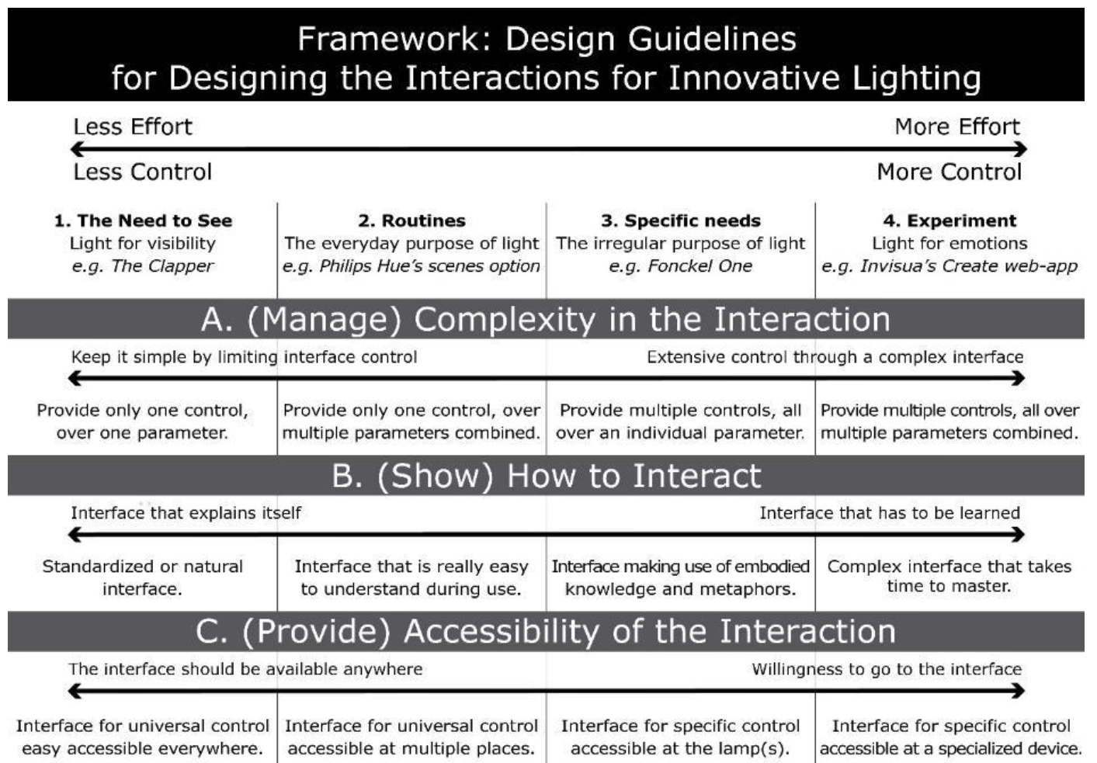
Figure 1: Innovative Lighting Design Framework (Jip, 2018)
The first stage is the basic human requirement for light, so it is the least complex and the most feasible stage of light. Since the existence of light at least needs to meet the visual needs of humans, such as the ability to clearly see the existence of things. So, it only requires lighting to have the effect of enhancing the brightness of space. The interaction pattern of this stage is universal and can be applied throughout, so for the designer, the equipment of lighting is the only requirement in this stage.
The second stage is the one that people need light most of the time. In this stage most of the lighting parameters are pre-set and the scenarios for the use of these lights are fixed. The control of this type of lighting becomes a routine operation. These lights can meet the daily needs of the user (different needs for different places) and can be used for most scenarios. For example, study and work scenarios require brighter lighting and rest areas require relatively dim lighting. It demands that the designer should have a basic understanding of lighting, which is to distinguish between the different meaning of various scenes’ lighting.
The third stage considers the user’s ability to customize the lighting environment. In this stage, the lighting is modified or customized to meet the specific requirements of the user, and lighting in this stage is required to have specific interaction patterns to target specific areas and activities. This stage focuses on users who have specific visual needs for lighting and therefore requires additional parameter adjustments to ensure that users get the lighting effects they want. For example, the lighting panels used by designers or professional draftsmen for hand-drawing should have more parameters and effects than fixed lights. The designer should focus on the task at hand and the required lux to complete the task before determining the light source to best address the needs of the user.
In the fourth stage, experimental capabilities of the lighting system are more preferred, where the key points include the suppression and stimulation of light for emotion, or the creation of a specific atmosphere. During this period, the presence of light shifts from providing a change in light to a form of expression that goes beyond satisfying basic human visual needs and becomes a means of altering the human emotional experience. This stage not only requires a specific mode of interaction, but also requires specific devices to integrate the variety of lighting controls and specific knowledge to implement the various effects and desired outcomes. For example, the different atmospheres created by different stage lighting, supporting the stage performance, stimulates the audience to produce different emotions. Designers at this stage not only need to have a very high understanding of lighting knowledge, but also need to have the ability of transdisciplinary information integration and application in order to achieve desired emotions and experiences.

Digital Control Technology
Because of the multi-layered complexity of interactive lighting, lighting researchers continue to devote their attention to new modes of lighting control as lighting continues to evolve, hoping that these control methods will reduce the effort required for lighting users. Digital lighting control techniques are representative among many interactive lighting control techniques. In Shira’s (2007) study of lighting digital control technology, the various properties of this interactive lighting control technology are underlined.
What comes first is the principle of digital lighting control technology (Yang et al., 2020). Through the interaction between different devices in the system, users can manipulate the lighting scene. A much more detailed design principle is the electrical signal through the wire (communication cable) or wireless (microwave, radio) to achieve the command transmission of different lighting equipment. The whole process can be adjusted automatically by controlling the logic set by the sensors, or manually by the user directly through the main controller for real-time adjustment of the lighting equipment.
The whole digital system consists of three parts - control sensor, the main controller (secondary independent controller), and the light output device. The system's control process for lighting is also based on these three components (Yang et al., 2020). Firstly, the information is received from the control sensors (switches, operation panels, detectors, sensing devices), and the information is transmitted to the controller, which is converted into lighting control command information through the logic operation of the controller and sent to each lighting output device. In the whole lighting control process, the master controller can control the whole lighting system directly or according to individual controllers. As a practical example, whenever the natural daylighting conditions are not ideal, the user can not only adjust the space brightness directly through the controller, but also through the photo sensor. The photo sensor can be set to send a signal to the controller to automatically adjust the lamps when lighting conditions change thus maintaining even illumination throughout the day.
The digital lighting technology has several outstanding advantages over traditional technology. First of all, compared to the traditional single controller to operate a single lighting device, digital lighting technology achieves a high degree of integration of lighting control through the information exchange for each device. Secondly, the ability to address individual lighting fixtures through digital controls allow for the fixtures to be reassigned to accommodate the reconfiguration of spaces easily. Digital control system can also regulate each light through the adjustment of lighting lumen levels over time using photo sensors to adjust as daylighting parameters change, thus avoiding the specific individual spatial adjustment of each lighting controller typically used in traditional lighting. Through the careful adjustment of each light output device, the user can achieve a variety of lighting strategies through the main controller, avoiding the need to bear the physical cost of traditional lighting adjustment. Finally, through the intervention with the monitoring equipment, the digital control technology can develop real-time monitoring of the indoor lighting status.
The lighting control mode represented by digital control technology is no longer simply for changing the brightness of the space by controlling the light switch, but also a kind of human interaction with the light, and a kind of regulation process of lighting system through the logic. Magielse, Hengeveld and Fren (2013) in their study proposed a new way of thinking; the researchers suggested that the intelligent (sensor) algorithms should be introduced into the interaction between the lighting system and the user to help people interact with light in a ‘intelligent’ way, further reducing the operational difficulty of the lighting system. This is also a great improvement of the interactive lighting compared to traditional lighting. The lighting system no longer take on the roles of simple on and off, but it is in the process of human interaction with the lighting system, and also constantly upgraded logic computing, to facilitate lighting environments more in line with people's behavior patterns and living habits. At the same time, through these new control modes, interactive lighting users also have the possibility to pay less effort but acquire full control of lighting.
Represented by digital control technologies, these interactive lighting operating systems with intelligence and interactivity are designed with the intention of creating more than just aesthetics and comfort on a visual level. In a study by Kim, Ahn, Park and Whang (2013), it was suggested that many interactive lighting environments and systems are not only thought to help increase the emotional immersion of users, but also allow users to manage and improve their habits by interacting with lights and applications. The researchers also pointed out that the mode of interaction with lighting determines how the lighting system will respond to different user situations and needs, and how it will generate ‘appropriate’ lighting parameters based on the user's current state. These changes in user data (mood changes, life state adjustments) that accompany the use of the system (changes in the number of lights used, changes in the number of light adjustments) can also be used to study the impact of lighting on the user’s psychological or emotional state.

User Interface
The user interface is an integral part of digital control technology. The user interface not only enables users to adjust the parameters of the lighting system, but also provides feedback on the data of the lighting system. The development of control systems represents the potential for interactive lighting systems to be used in daily life. What users use the most frequently in daily life and the most intuitive display of the control system is the lighting controller, which lighting researchers usually refer to as the user interface.
The user interfaces mentioned in the study are not necessarily limited to tangible interfaces, but also can be present in the user’s life through intangible means. For example, in an experiment conducted by Kim, Ahn, Park and Whang (2013), researchers used personal emotional states as the control method for a lighting system, this immersive experience for study participants engaged them in a deeper understanding of lighting possibilities based on personal habits. With the increasing possibilities of control panel design, the corresponding user interfaces will need to take on more responsibility and account for functionality, such as that found in the work conducted by Offermans, Van Essen and Eggen (2014) which examined the potential of user interfaces in practical applications.
In the experiment of Werff, Lotringen, Essen and Eggen (2019) on new interactive lighting in offices, the researchers demonstrated the difference in lighting control effects and user experience of two different lighting user interfaces. Over the period of ten weeks, 43 subjects made adjustments to the interactive lighting system arranged in the environment via applications on their smartphones and the room control panel. The researchers suggested that the user interface has features that affected the overall lighting system experience and the features that the degree of freedom of the user interface to control the entire system affects the user's experience of lighting control. The main manifestation was that too much freedom leaded to complicated operation, and too little freedom did not induce the user's desire to interact. At the same time, the user interface was initially designed to facilitate lighting control rather than make it more difficult. In the experiment, however, it was shown by the fact that the user could not adjust the lights because he did not have his phone with him (or his phone was broken), and that the user interface required tedious operations that reduced the possibility of use (authentication, user login lights). This experiment showed that the user interface plays a much larger role in the new lights than a simple light controller and became an important factor in whether or not the user uses and adjusts the new lights.
In addition, in Jip’s (2018) study, the researchers suggested that users can develop a more detailed control of the lighting system by developing a targeted approach to lighting control by the designer, in response to the increasing number of different environmental lighting scenarios. This produced the lighting environment that the user really needs. In a study by Offermans, Essen-based, and Eggen (2014), it was also suggested that the visibility of the interface and the degree to which it matches the sensory capabilities will greatly influence the experience of use. That is, a user interface that matches the user's behavior patterns can directly enhance the user's interaction experience; in other words, a user interface that goes against the user's habits will negatively affect the user experience. It also indicated that in order to enhance the user experience, the interface should be integrated naturally and be easy to use. Similar conclusions were also suggested in the study by Magielse et al. (2011), where the researchers suggest that user interfaces shouldn’t be noticed.

Universal Design
In the rapid development of lighting technology, lighting situations for persons in the built environment are becoming generally more varied and complex, which makes them more difficult for researchers to evaluate. To better understand this concept, this thesis cogitates the principles of universal design. Universal design considers design that can support the various characteristics of the user. The Principles of Universal Design, Version 2.0 (Connell et al., 1997), expressed that universal design products should be inclusive and supportive of user and environmental differences (Table 1). The study uses this theme to determine the role and limitations of interactive lighting and traditional lighting in each environment. Universal design also aims to minimize the use of various assistive technologies so that the products fit each individual's usage habits. This study also determines whether the lighting system can be integrated into people's daily lives.
The specific criteria for judging the lighting system refers to the 7 design principles in Principles of Universal Design, Version 2.0 by Connell et al. (1997); (Table 1). Through case studies, this thesis evaluates the criteria of the lighting system, and extends the understanding of these principles combined with lighting elements. The following seven understandings of the combination of universal design and lighting design principles are used to explore the criteria for interactive systems to meet the pursuit of people's comfort. In each case study, the universal design evaluation is included in the findings section.
The Principles of Universal Design, Version 2.0
Principle 1: Equitable Use
The design is useful and marketable to people with diverse abilities.
Principle 2: Flexibility in Use
The design accommodates a wide range of individual preferences and abilities.
Principle 3: Simple and Intuitive Use
Use of the design is easy to understand, regardless of the user’s experience, knowledge, language skills, or current concentration level.
Principle 4: Perceptible Information
The design communicates necessary information effectively to the user, regardless of ambient conditions or the user’s sensory abilities.
Principle 5: Tolerance for Error
The design minimizes hazards and the adverse consequences of accidental or unintended actions.
Principle 6: Low Physical Effort
The design can be used efficiently and comfortably and with a minimum of fatigue.
Principle 7: Size and Space for Approach and Use
Appropriate size and space is provided for approach, reach, manipulation, and use regardless of user’s body size, posture, or mobility.
Table 1. The Principles of Universal Design, Version 2.0 (Connell et al., 1997)
Principle 1, Equitable Use. For different users to operate the lighting system, the lighting system can display a consistent lighting function and effect. Lighting system’s ability to support the different and varied performance needs from the people who use the systems is consistent for all.
Principle 2. Flexibility in Use. Whether the lighting system can be illuminated according to the different needs of the user. The lighting system can be adjusted and set according to the user's specific situation.
Principle 3. Simple and Intuitive Use. Whether the lighting system meets the level of people's daily operation. Specifically, the lighting system does not require users to learn further how to control, and users do not need a lot of lighting expertise when making lighting adjustments.
Principle 4: Perceptible Information. Can the lighting system accomplish the functions that lighting should have in the space in different indoor environments? This principle is expressed in terms of space lighting, route guidance, and specific functions' value-added.
Principle 5: Tolerance for Error. The lighting system helps users to reduce the likelihood of various accidents and hazards. Specifically, the light will not distract the user's attention, and the lighting system highlights the area where the danger may occur.
Principle 6: Low Physical Effort. The user can easily adjust the lighting system. Specifically, whether the user can accept the cost required to achieve the ideal lighting state.
Principle 7: Size and Space for Approach and Use. The size, shape, and position of the light in a space affect the user's daily life. This principle is reflected in whether the light takes up much space and whether the light blocks the user's view.
The previous literature has shown the full potential of interactive lighting system to support the users’ needs in hotel environment, but it is still unclear what the quality of light sources in interactive lighting should have to support users’ actives in hotels and the principle of universality that the control model should have. To explore these questions, the current study considers the following questions through three case studies and provides recommendations for future lighting applications.

Research Questions
1. How does the light source of interactive lighting meet human lighting needs in hospitality spaces?
2. How does applying universal design principles to lighting interaction assist humans with lighting control?
3. Are the lighting levels in hospitality settings consistent with IES standards?

Research Objectives
1. Study and analyze existing lighting conditions in the hotel environment.
2. Explore the universal lighting characteristics of three similar hotels to support hotel guests’ experiences.
3. Measure, record and compare the brightness of the hotel lighting system and IES lighting standards and give advice on changes.

Research Methodology
This study used case studies as the main method. There are several reasons for choosing this methodology. First, the real existing hotel lighting conditions could be observed effectively through case studies. Secondly, case studies offered a chance for researcher to experience whether the hotel lighting environment supports the activities and visual comfort of the users. Finally, the researcher was able to experience the process of lighting adjustment in each area of the hotel. Furthermore, case studies are beneficial in archiving comprehensive and authentic understanding about existing hotel lighting environments, which supports the study. With the goal to determine which aspects of hotel lighting systems are needed to improve and support the users’ visual comfortable experience and activity needs.
As a convenience sample, three hotels located in New Orleans, Louisiana, were used in this study, which was conducted in March of 2022, the week following Mardi Gras and prior to St. Patrick’s Day. The timing and location were chosen primarily for convenience but also because many people from all over the world visit New Orleans for the rich heritage and traditions centered in the region. The hotels between these times are typically at full capacity and are representative of the actual state of the hotel's lighting for customers. Therefore, conducting case studies of hotels lighting systems in New Orleans provided a suitable scenario to study hotel interactive lighting systems.

Measurement Methods and Judging Criteria
The case study is divided into two parts: Field Lux Level Measurements and generalized observation of lighting systems. Because humans were not part of this study, institutional review board (IRB) approval was not pursued.
The researcher contacted the management of five hotels in New Orleans, LA one week prior to conducting the case studies. During the phone call, objectives to conduct a study of the existing hotel environment for a Masters’ Thesis and data collection for case studies were explained. Three of the five hotel managers gave verbal consent to measure the lighting levels in the indoor environment, take photographs, make observations, and develop case studies for a thesis. After the researcher arrived at each hotel between March 3rd and March 5th, 2022, the researcher reconfirmed with the front desk before conducting the study. The process for each case study included field lux level measurements, lighting observations, and taking photographs of the lighting environment in each hotel. After these measurements were completed, the collected lighting brightness data was compared and analyzed in tables and graphs through Excel, and the information observed in each hotel was recorded and analyzed.
Field Lux Level Measurements
The study used PHOTONE Lighting Meter (Figure 1) software to measure the hotel lighting levels. According to the official information provided, the software of test results error is less than 5%. (GmbH, 2022), The measurement area includes nine essential areas of the hotel - the entrance area, lobby, lounge, front desk, restaurant, bar, meeting room, hallway, and guest room. By measuring and recording the data of each area, the maximum and minimum values of the lighting brightness of the area are obtained. The current illuminance (light level) recommendations of the Illuminating Engineering Society (IES) were used to compare the values (Kaufman & Christensen, 1984). The study compared data to assess whether the existing lighting system had the right light level in a natural hotel environment as compared to recommended levels by IES (Figure 2). Additionally, observations determined whether the existing lighting systems met IES recommended lighting levels in comparison between the three hotels.
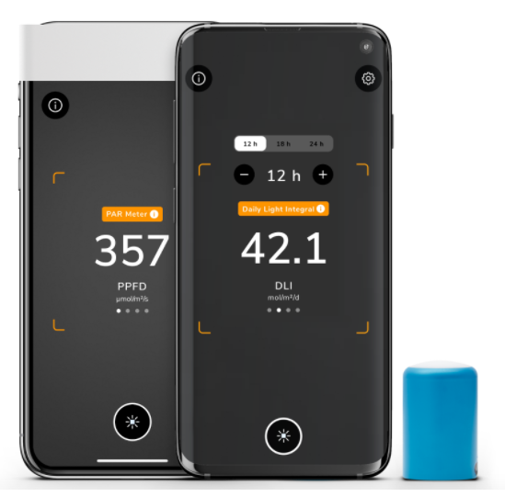
Figure 1 PHOTONE Lighting Meter Application (GmbH, 2022)
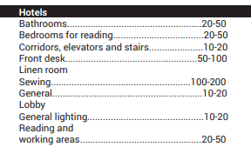
Figure 2 IES illuminance (Light Level in Footcandles) recommendations (Kaufman & Christensen, 1984)
Lighting Observation
Simultaneously with the lighting area brightness measurements, the application of universal design as it pertains to the lighting system were observed. Three critical observation criteria evolved from seven principles of universal design (Connell et al., 1997). The observation of the existing lighting system control mode was first analyzed to assess principle 6 of universal design – Low Physical Effort, by focusing on how users should control existing lighting system and the effort that users cost to achieve the visual comfort and activities needs in lighting environments. Secondly, the observation of the existing lighting system maintenance and adjustment was used to assess principle 2 of universal design – Flexibility in Use, by focusing on observing whether the hotel lighting system in each area could be adjusted according to the user’s visual comfort and activities needs and the resources cost in the process of making lighting adjustments. Last, the observation of the existing lighting system value creation was assessed using principle 4 of universal design – Perceptible Information, by focusing on the observation of whether the lighting function effectively supports users’ visual comfort and activates, such as the lighting brightness to support the reading task, the specific atmosphere creation, emergency route guidance, and the specific functional requirement for specific areas. The above are the key references in the hotels lighting observation. There are more universal design principles were referred to analyze the existing hotel lighting system conditions in the finding part.
Case Studies
Case Study Background Information
Case Study Location: New Orleans City
Time: 03/02/2022 ~ 03/05/2022

Case Study 1: Hilton New Orleans Riverside
Visited Time: 14:30 ~ 16:00 03/03/2022
Weather Condition: Sunny
Backgrounding Information
Hilton New Orleans Riverside hotel is located at Two Poydras street. This hotel is unique among the Hilton Premier chain because of its large number of meeting rooms and showrooms for large conferences and ceremonies. The hotel consists of 37 meeting rooms, 74 suites, and over 1,500 rooms to accommodate guests. In addition, the hotel also includes a 24-hour reception, a gym, a swimming pool, and a restaurant and bar. The total area of the hotel is over 130,000 square feet.
Case Study 2: Loews New Orleans Hotel
Visited Time: 14:00 ~ 16:00 03/04/2022
Weather Condition: Sunny
Backgrounding Information
Loews New Orleans Hotel is located at 300 Poydras Street. The hotel comprises 285 rooms, including 12 suites, and has 12 meeting rooms. The hotel also includes a front desk, lounge area, gym, swimming pool, restaurant, bar, banquet hall, and business center. The hotel covers an area of over 17,500 square feet, with a reception, lounge area, restaurant, and bar on the first floor. The second floor contains the banquet hall and meeting rooms. The guest rooms, gym, and suites are on the third floor.
Case Study 3: Harrah’s New Orleans Hotel
Visited Time: 14:00 ~ 16:00 03/05/2022
Weather Condition: Sunny
Backgrounding Information
Harrah's New Orleans Hotel is located at 228 Poydras Street. In 2006, the hotel consisted of 26 floors with 450 rooms, including 98 suites and 11 meeting rooms. The hotel also includes a front desk lounge area, a gym, and a restaurant. The first floor of the hotel is the front desk and lounge area. The second floor is the meeting room and business center, while the third floor and above are the guest rooms.
Outcomes:
Case Study 1: Hilton New Orleans Riverside
Floor Plan
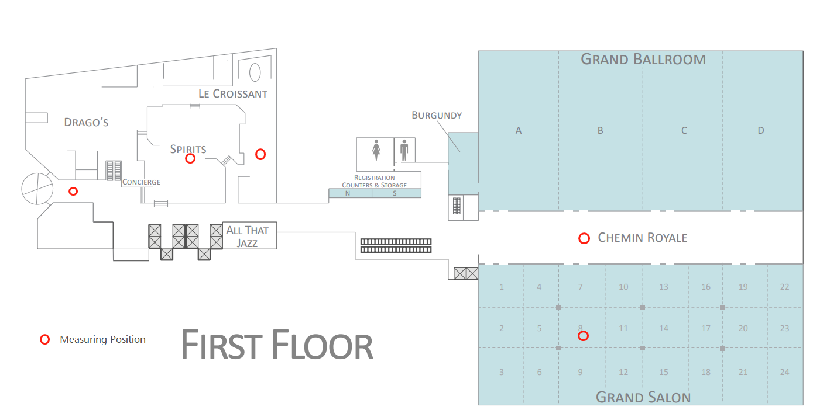
Figure 3 Hilton New Orleans Riverside 1st Floor Plan with the Measuring Positions (Cevent, 2000)
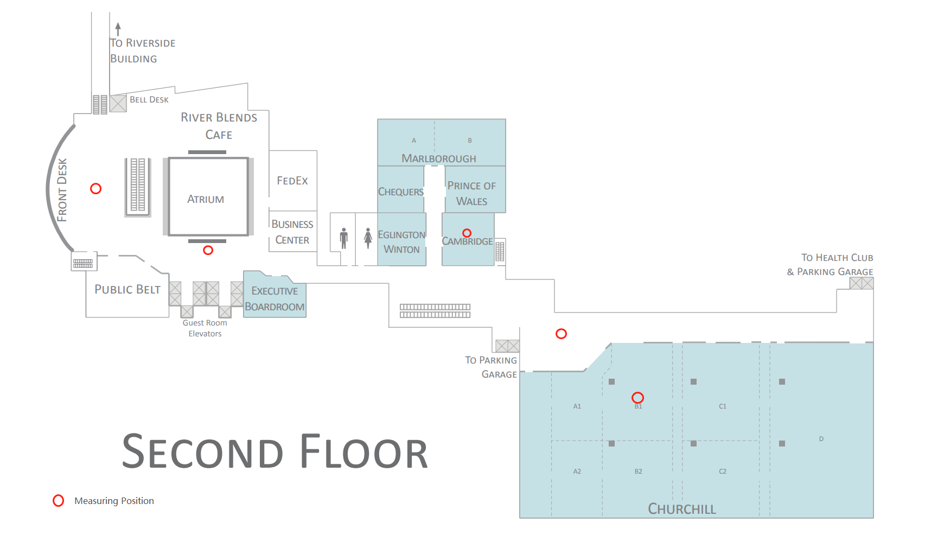
Figure 4 Hilton New Orleans Riverside 2nd Floor Plan with the Measuring Positions (Cevent, 2000)
Part 1: Hilton New Orleans Riverside Lux Level
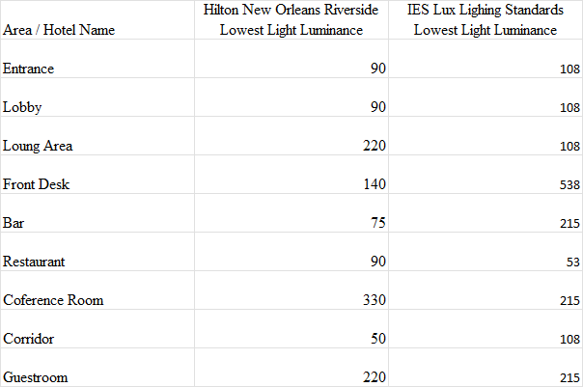
Table 2 Comparison of Hilton New Orleans Riverside and IES Lighting Standard Lux Level
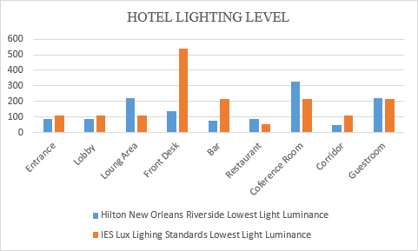
Chart 1 Comparison of Hilton New Orleans Riverside and IES Lighting Standard Lux Level
Of the nine areas tested, five areas did not meet the minimum brightness of IES lighting (table 2 and chart 1). Measurements were taken under full daylight conditions. The maximum light brightness difference appears in the front desk area, and the area's minimum brightness is lower than the minimum standard 398 lux. The minimum light brightness difference appears in the entrance and lobby area, and the minimum area brightness is lower than the minimum standard of 18 lux.
To demonstrate the lighting luminance differences between the IES recommendations and actual measured conditions, computer generated modeling software (REVIT) and rendering software (Vray) was used to make a visual representation of the lighting scenario. The aim was to visualize the luminance difference between the hotel lighting system and the lighting standard (figure 5, 6). The model used for the rendering did not belong to one of the three hotels, it was a Vray model designed by the researcher for observing the front desk environment.
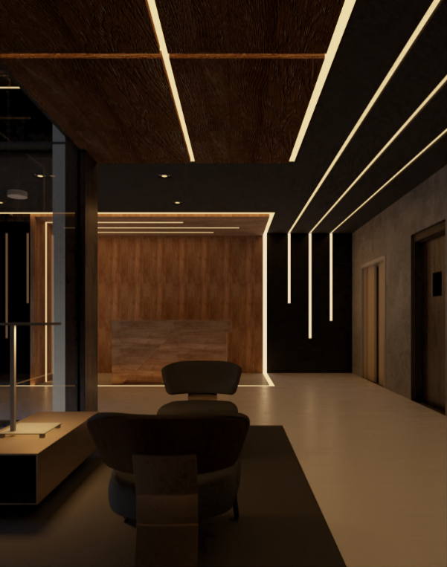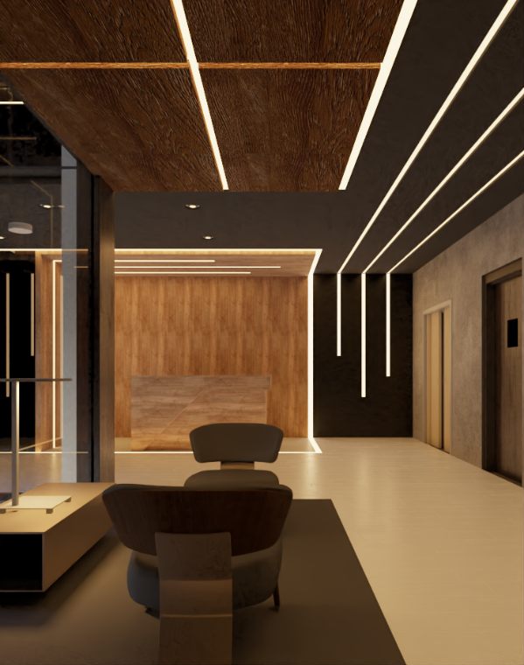
Figure 5 & 6 A Comparison Between Lux Level of 140 (left) and Lux Level of 538 (Right) by Using BIM Model Designed by Researcher
Part 2: Hotel lighting system generality judgment
Hotel Pictures
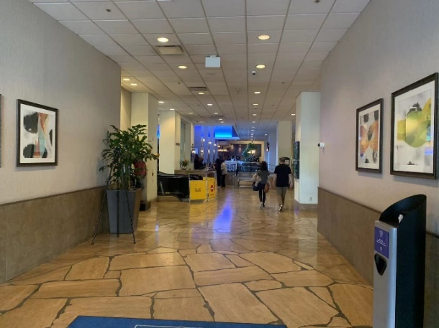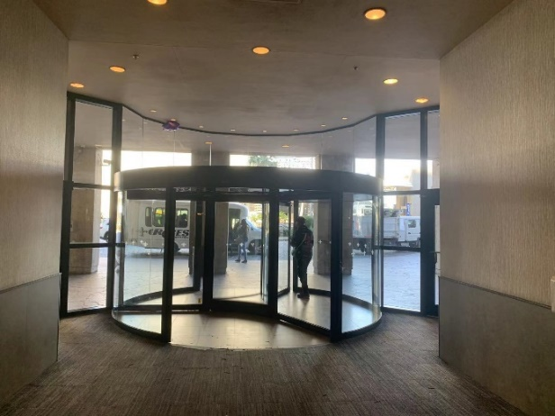Image 2 & 3 Hilton New Orleans Riverside Entrance
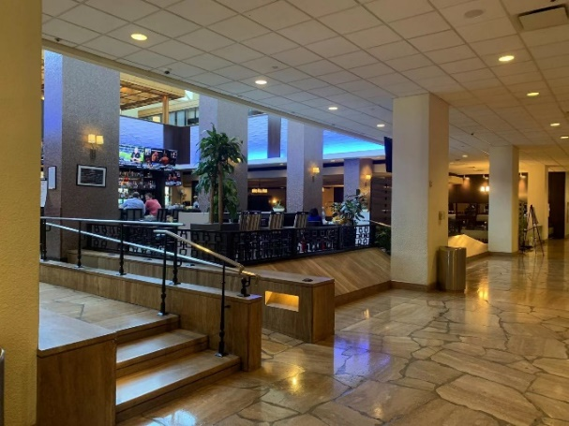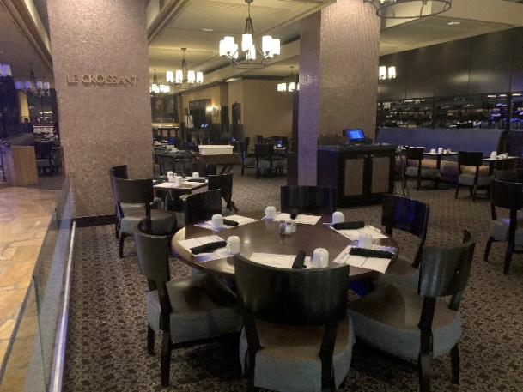
Image 4 & 5 Hilton New Orleans Riverside Bar and Restaurant Areas
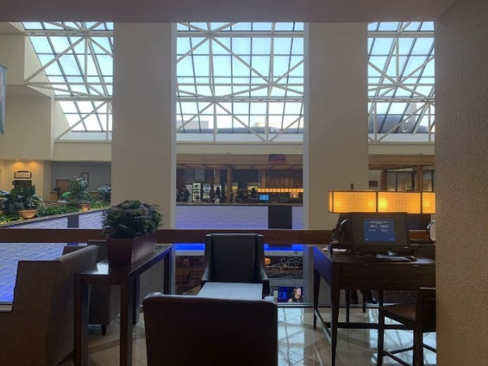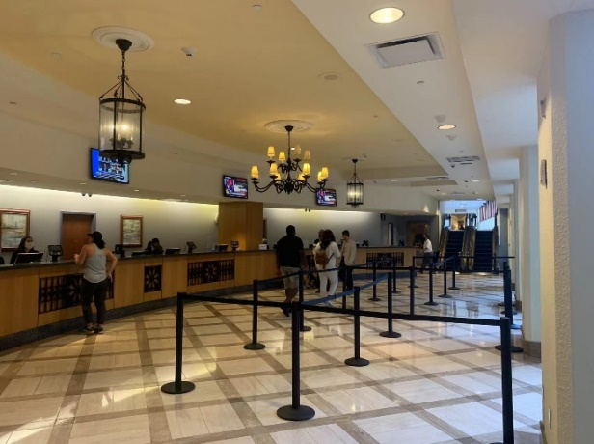
Image 6 & 7 Hilton New Orleans Riverside Lounge and Front Desk Areas
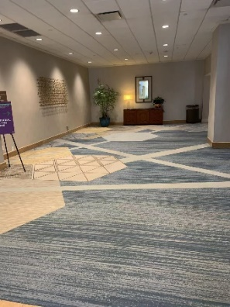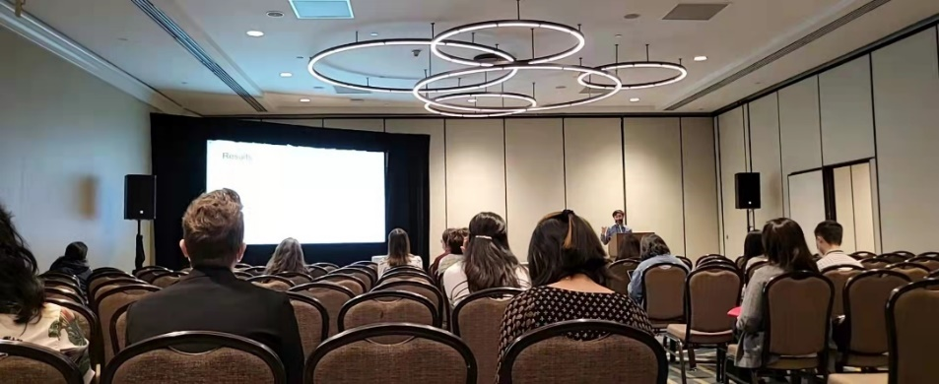
Image 8 & 9 Hilton New Orleans Riverside Conference Corridor and Conference Room
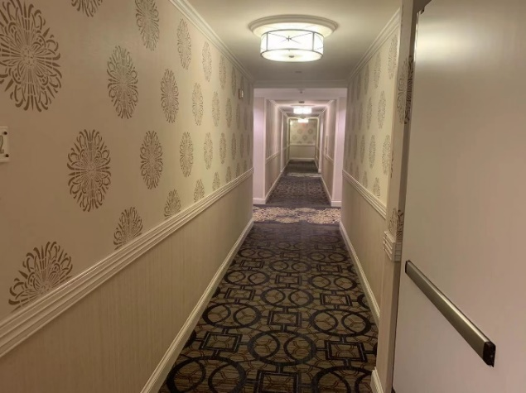
Image 10 & 11 Hilton New Orleans Riverside Corridors and Guest Room (Cevent, 2000)
Control Mode
Hotel room lighting through the traditional switch to control lighting. Users need to be close to the lighting equipment to turn on or off the lights (image 11). Room lighting does not have the function of parameter adjustment. It can only simply turn on or off. At the same time, the lighting equipment of the hotel rooms is independent of each other, and customers cannot control multiple lights simultaneously. Computer terminals control the lighting system in public areas (image 6,7). Each lighting equipment area has fixed parameters and cannot be adjusted to the lighting equipment for light and darkness or angle. The hotel's only equipment that can be adjusted to the lighting parameters is located in the conference room (image 8,9). The conference room area lighting can be adjusted according to customer demand for the degree of light and darkness.
Lighting Maintenance and Adjustment
In the hotel room lighting maintenance and adjustment, the hotel needs to individually replace the light bulb for each light or replace the entire lighting equipment (image 11). Public area lighting maintenance and adjustment requires higher labor costs. The hotel needs to remove the ceiling or wall to find out the corresponding lighting lines, modify the lighting routes and adjustments, and finally replace or adjust the lighting equipment in the public areas (image 1, 2).
Value Creation
The lighting in the hotel rooms has been aging, and the floor lamps and wall lamps have been weakened (image 11). Furthermore, because of the uneven distribution of light in the space, some shadows affect the user's visual experience when the customer reads and writes. In the corridor and public areas, the hotel lights do not play the role of route guidance, and the security exit lights are not noticeable (image 10). The LED light band around the bar area renders a casual atmosphere in the bar and restaurant area (image 4). Nevertheless, the brightness of the lights in the area is not enough to support customers to read the menu in the bar (image 5).
Case Study 2: Loews New Orleans Hotel
Floor Plan
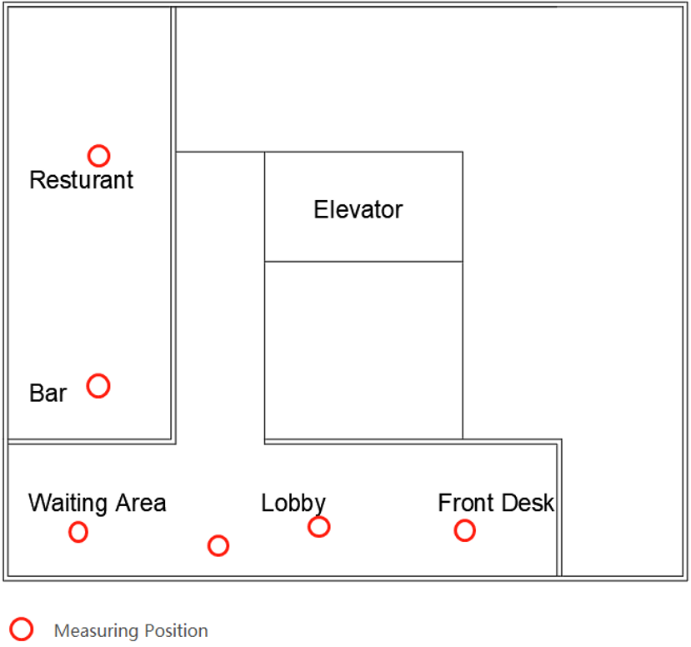
Figure 7 Loews New Orleans Hotel 1st Floor Plan with the Measuring Positions
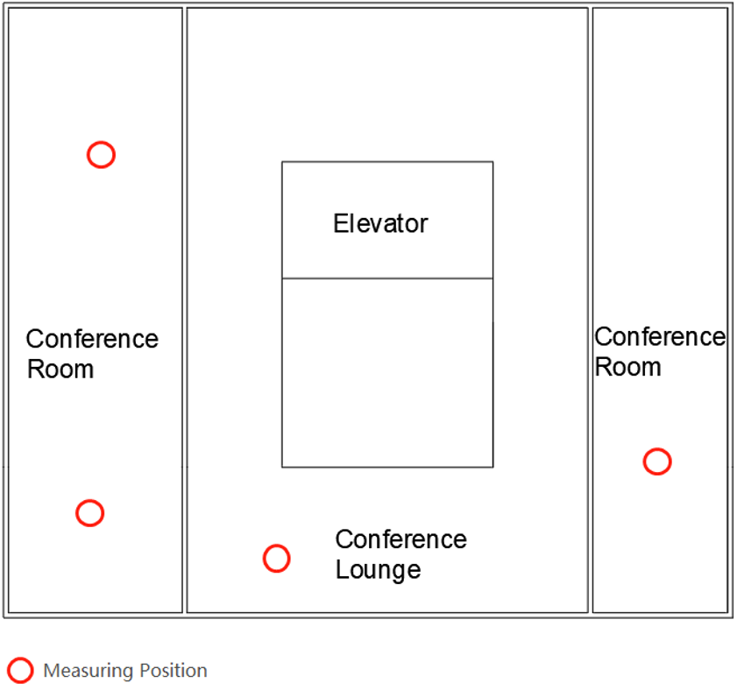
Figure 8 Loews New Orleans Hotel 2nd Floor Plan with the Measuring Positions

Part 1: Loews New Orleans Hotel Lux Level
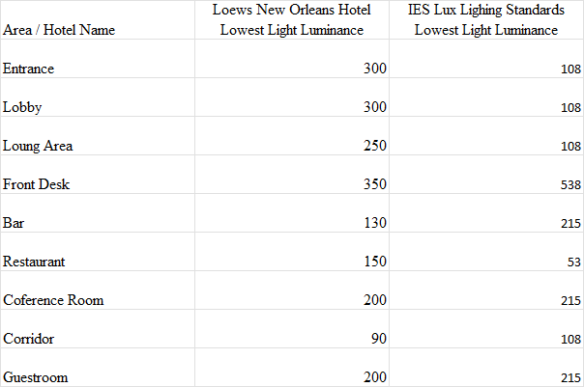
Table 3 Comparison of Loews New Orleans Hotel and IES Lighting Standard Lux Level
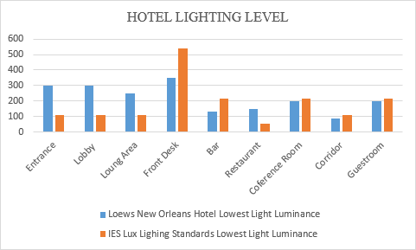
Chart 2 Comparison of Loews New Orleans Hotel and IES Lighting Standard Lux Level
Of the nine areas tested, five areas did not meet the minimum brightness of IES lighting (table 3 and chart 2). In the case of sufficient daylight. The most considerable light brightness difference appeared in the front desk area. The area's minimum brightness is lower than the minimum standard of 188 lux. The lowest light brightness difference appeared in the guest room, and conference room area, the area's minimum brightness is lower than the minimum standard 15 lux.
To demonstrate the lighting luminance differences between the IES recommendations and actual measured conditions, computer generated modeling software (REVIT) and rendering software (Vray) was used to make a visual representation of the lighting scenario. The aim was to visualize the luminance difference between the hotel lighting system and the lighting standard (figure 9, 10). The model used for the rendering did not belong to one of the three hotels, it was a Vray model designed by the researcher for observing the front desk environment.
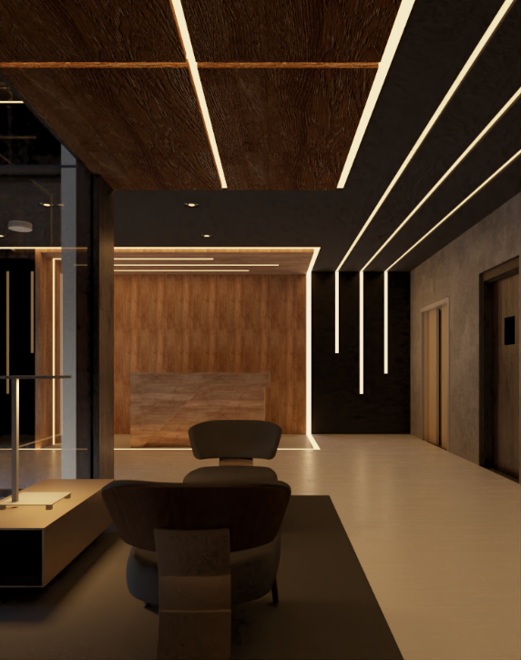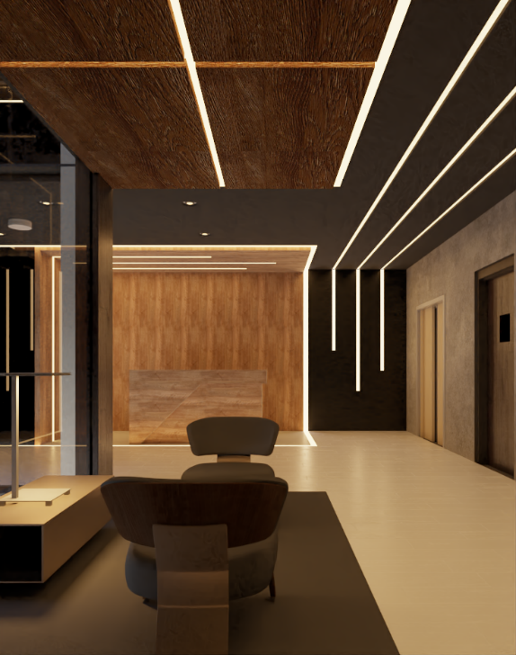
Figure 9 & 10 A Comparison Between Lux Level of 350 (left) and Lux Level of 538 (Right) by Using BIM Model Designed by Researcher
Part 2: Hotel lighting system generality judgment
Hotel Pictures
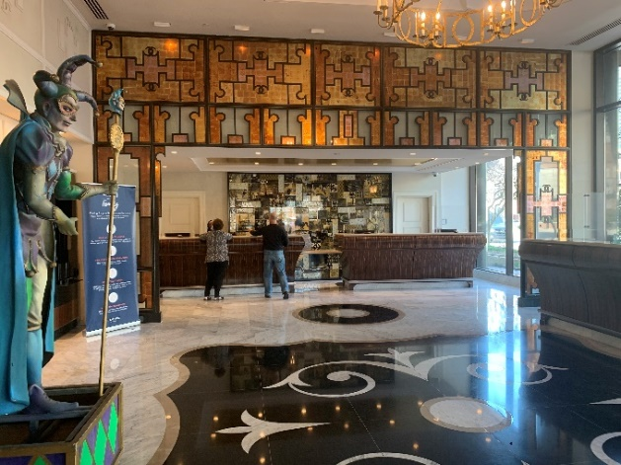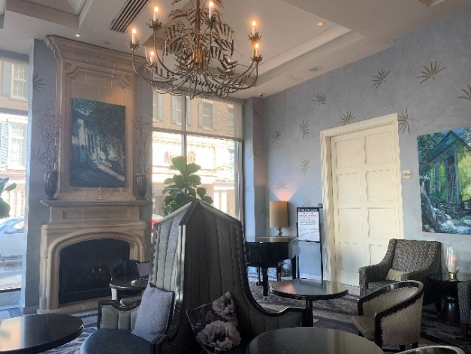
Image 12 & 13 Loews New Orleans Hotel Lobby, Front Desk and Lounge Areas
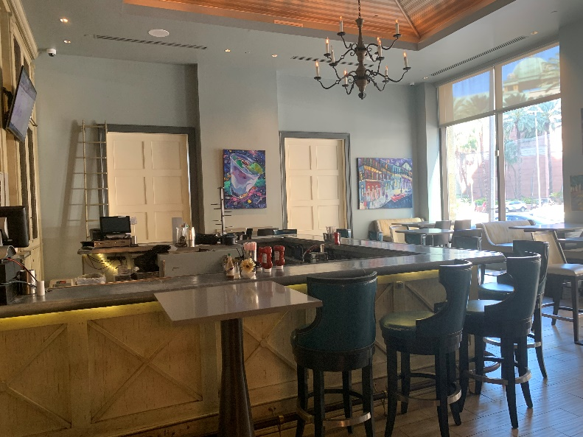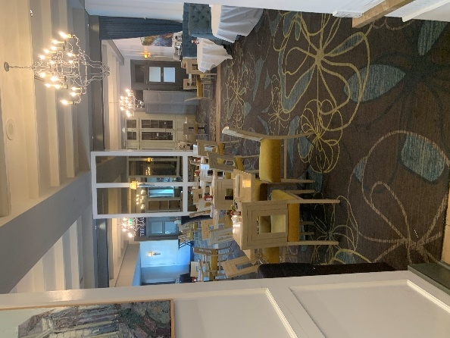
Image 14 & 15 Loews New Orleans Hotel Bar and Restaurant
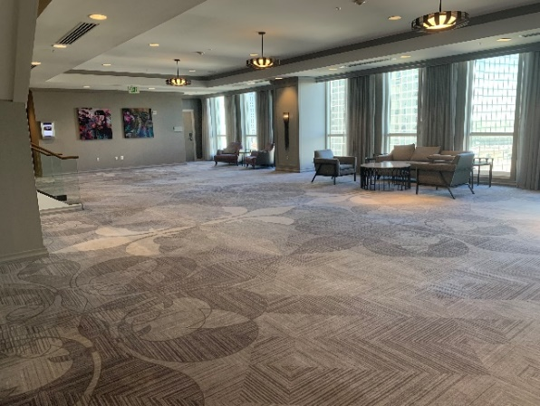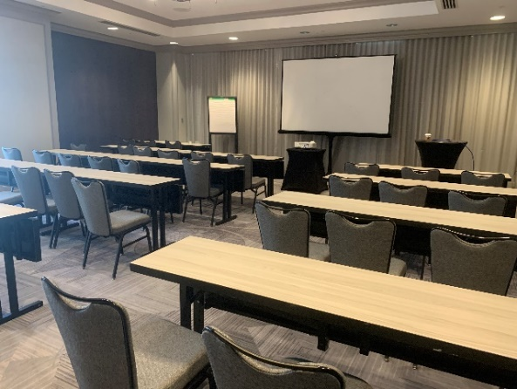
Image 16 & 17 Loews New Orleans Hotel Conference Lounge and Conference Room
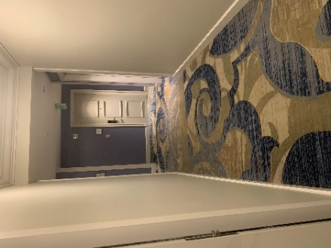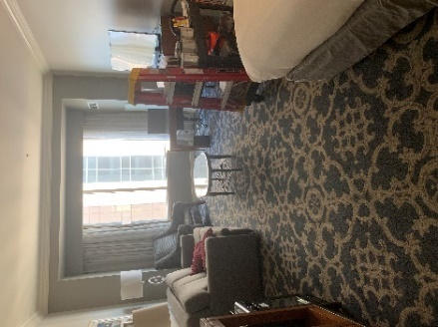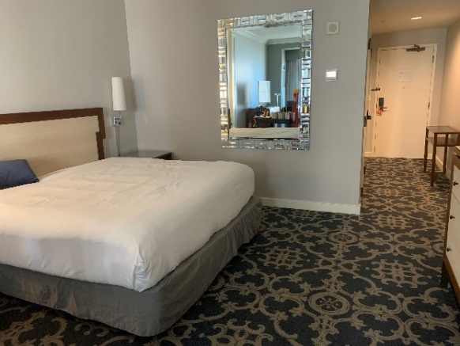
Image 18 & 19 & 20 Loews New Orleans Hotel Corridors and Guest Room
Control Mode
The lights in the hotel rooms are controlled by traditional switches, requiring users to be close to the lights for lighting control (image 19,20). Among them, the bedside position of the light can adjust the degree of light and darkness. Other areas of the room lights have fixed parameters, and the user can only turn on or off the lights. The lights in the public areas are controlled remotely through the central computer, and the lights in these areas have fixed parameters, and the central computer controls the lighting system to turn on and off (image 12,13,14). The conference room lighting is regulated by a dimmer switch, which can enhance or reduce the brightness of the area lighting (image 16,17).
Lighting Maintenance and Adjustment
Regarding the hotel room lighting adjustment and maintenance, the hotel needs to replace the light bulbs or directly replace the overall lighting equipment (image 19,20). Lighting in public areas requires light bulb replacement to achieve essential lighting maintenance. If further adjustments are required, many labor and resource costs are required, including removing ceilings and manually re-sorting lighting lines to achieve lighting adjustments (image 14,15).
Value Creation
The hotel room was lit in the provision of essential lighting simultaneously to create a comfortable atmosphere (image 19). Light distribution location is relatively uniform, but there are still differences in brightness in different room areas (image 20). (The main reason is that the brightness of each kind of light has differences.) The safety exit lights in the public area are obvious, and these lights can effectively provide directional guidance in case of danger or emergency (image 18). The lighting in the public spaces is shaped and arranged following the local culture of New Orleans, and the uniform style effectively connects the various public spaces and creates an overall relaxing atmosphere belonging to the local culture.
Case Study 3: Harrah’s New Orleans Hotel
Floor Plan
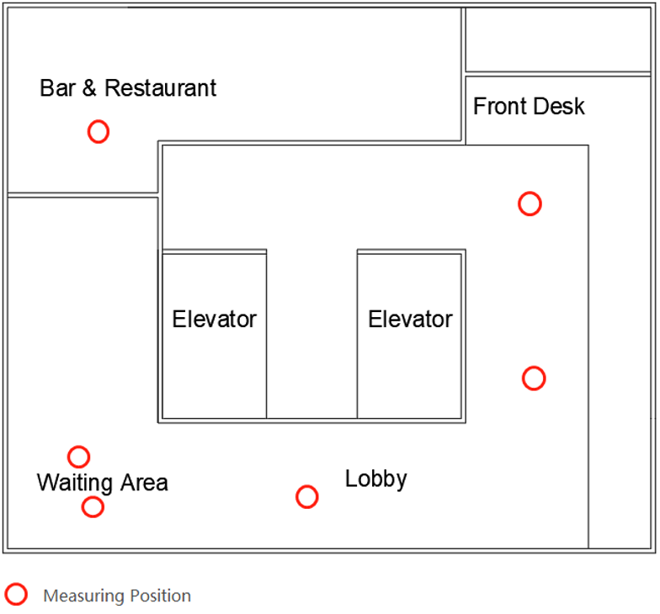
Figure 11 Harrah’s New Orleans Hotel 1st Floor Plan with the Measuring Positions
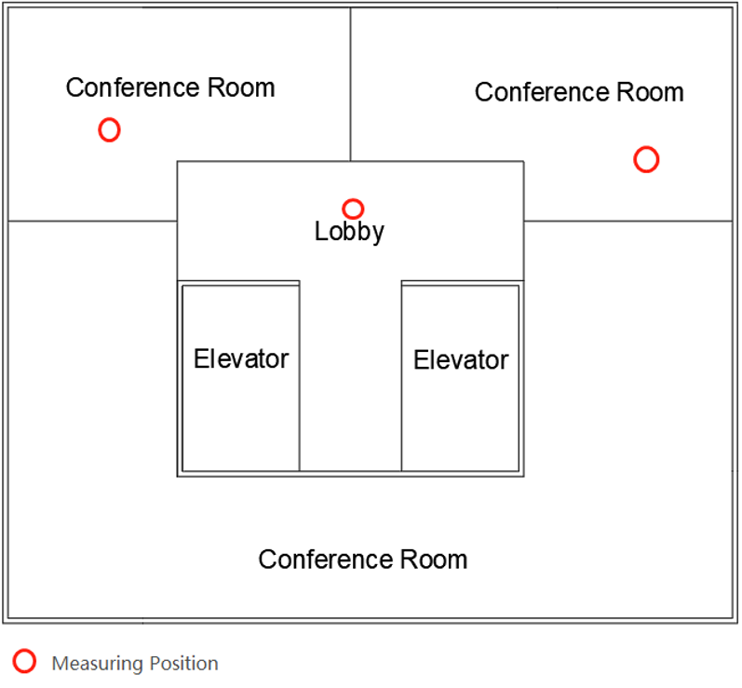
Figure 12 Harrah’s New Orleans Hotel 2nd Floor Plan with the Measuring Positions
Part 1: Harrah’s New Orleans Hotel Lux Level
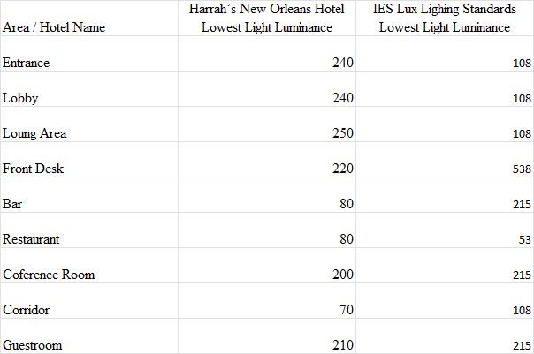
Table 4 Comparison of Harrah’s New Orleans Hotel and IES Lighting Standard Lux Level
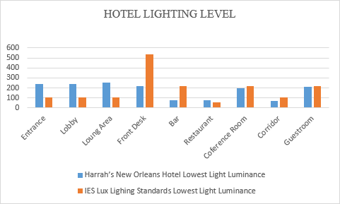
Chart 3 Comparison of Harrah’s New Orleans Hotel and IES Lighting Standard Lux Level
Of the nine areas tested, five areas did not meet the minimum brightness of IES lighting (table 4 and Chart 3). In the case of sufficient daylight. The maximum light brightness difference appeared in the front desk area. The area's minimum brightness is lower than the minimum standard, 318 lux. The lowest light brightness difference appeared in the guest room area. The area's minimum brightness is lower than the minimum standard 5 lux.
To demonstrate the lighting luminance differences between the IES recommendations and actual measured conditions, computer generated modeling software (REVIT) and rendering software (Vray) was used to make a visual representation of the lighting scenario. The aim was to visualize the luminance difference between the hotel lighting system and the lighting standard (figure 13, 14). The model used for the rendering did not belong to one of the three hotels, it was a Vray model designed by the researcher for observing the front desk environment.
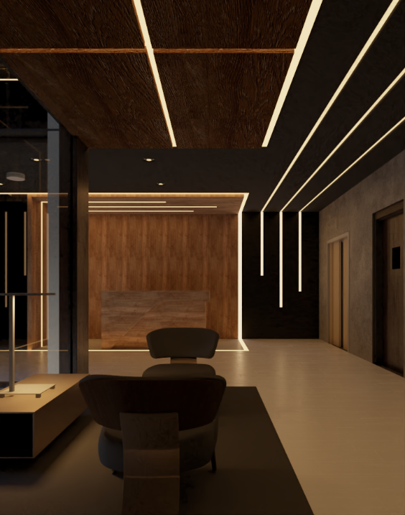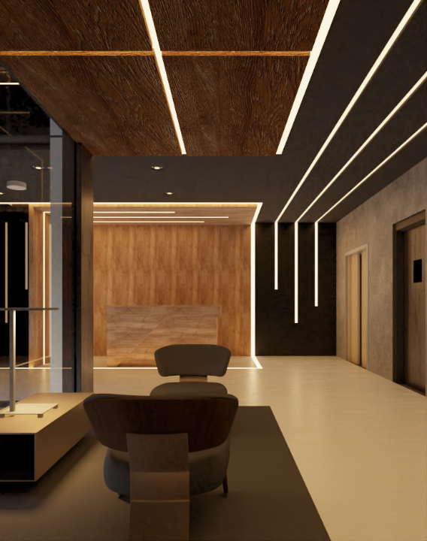
Figure 13 & 14 A Comparison Between Lux Level of 220 (left) and Lux Level of 538 (Right) by Using BIM Model Designed by Researcher
Part 2: Hotel lighting system generality judgment
Hotel Images
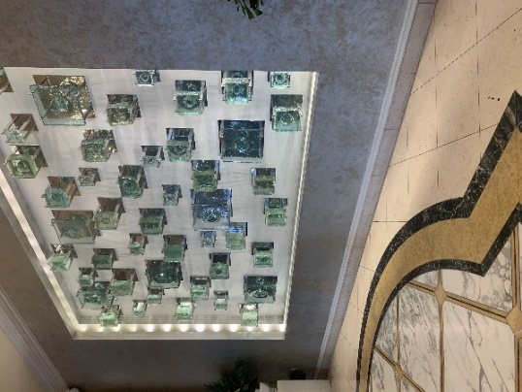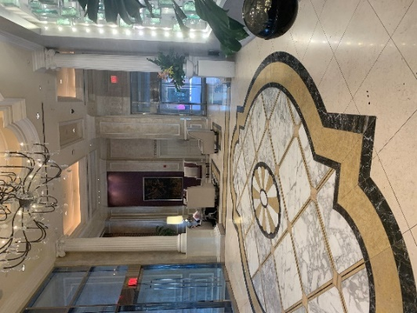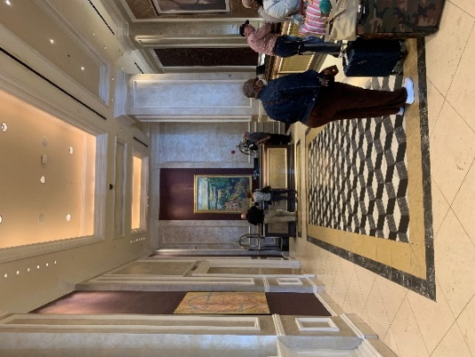
Image 21 & 22 & 23 Harrah’s New Orleans Hotel Entrance, Lounge and Front Desk Areas
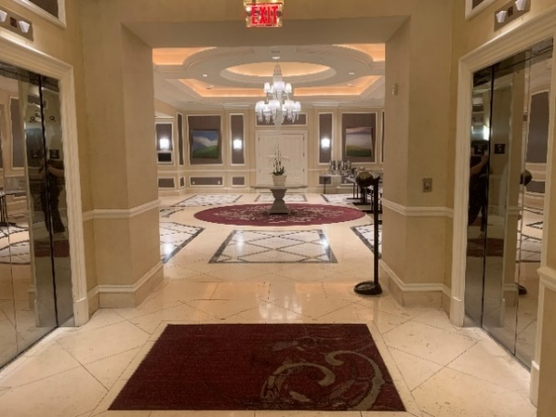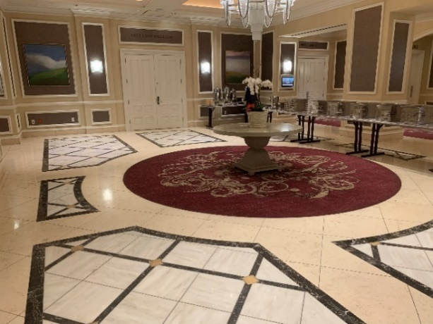
Image 24 & 25 Harrah’s New Orleans Hotel Conference Areas
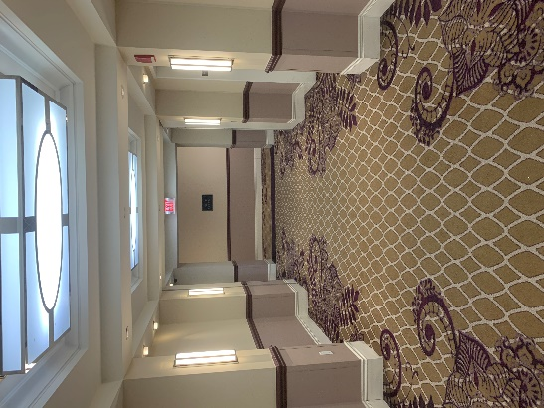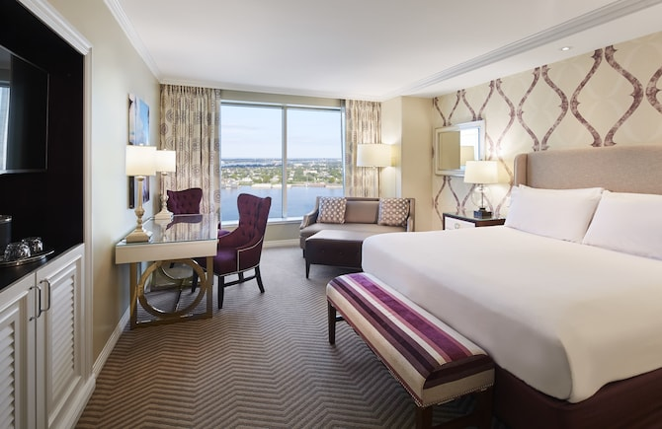
Image 26 & 27 Harrah’s New Orleans Hotel Corridor and Guest Room (Caesars Entertainment, 2021)
Control Mode
Hotel room lighting equipment through the traditional switch control, desk lamps, and floor lamps require users to walk to the lighting equipment near the operation. (Image 27) A fixed switch position controls the top light. Bedside lighting has some ability to adjust the light and dark. The rest of the locations of the lights are only included in the open and close two options. A central computer controls the lights in the public areas (image 22,23). Most of the lights in the public areas have fixed parameters, while the central computer can adjust the hidden LED strips in many areas for color temperature and brightness (image 23). The lighting in the meeting rooms can also be adjusted via a dimmer switch (image 25).
Lighting Maintenance and Adjustment
Lighting adjustment in the hotel rooms requires individual maintenance (bulbs or shades) or overall replacement of each light. Furthermore, the maintenance and adjustment of lighting equipment in public areas require the reinstallation and adjustment of the entire area lighting system. Lighting in bars and restaurants can be adjusted easily via lighting tracks.
Value Creation
The lighting in the hotel rooms provides an even distribution of light, with no apparent differences in light and dark between the various areas, while the lighting atmosphere of the entire room space is very balanced due to the almost uniform height of the lighting equipment (image 27). The safety exit indicators in the public areas are undeniable, and these lighting devices can effectively provide more straightforward route guidance in a dangerous situation (image 26). However, the hotel has many repetitive wall lights in the corridors and exchange spaces between different areas, leading to a risk of disorientation for customers. The recessed overhead lighting in the corridor area effectively reduces the oppressive feeling of the enclosed space by imitating the color temperature of natural light (image 26).

Findings
Insufficient light brightness
According to the measurements table, 56% of the areas in all three hotels did not have the minimum light brightness. In summary, all these areas show a large amount of insufficient light brightness.
The most significant difference in lighting is at the front desk, which creates visual errors when customers register personal information or check-in information. Even needing customer signatures or documents to read, the lack of light brightness caused a lack of visibility or overlooked important information. Two of the three hotels did not meet the minimum lighting brightness requirements in the room area. The room area is where the customer spends the most time, so insufficient lighting in the room will directly negatively impact the customer's stay.
The main reason for the lack of lighting brightness is the aging of the lights. In Case 1, the lights in the guest room hotel show significant aging and wear, and the brightness of the lights has been significantly reduced.
Independent Control
The study also identified a second problem in the existing lighting system, independent lighting control, through the generalizability report obtained from field observations. In all three hotel rooms, most lighting equipment required the user to be close to the lighting equipment for manual control, which might cause the following problems.
First, the customer could not adjust the lights in real-time for each position. There may be a risk of not being able to turn on the lights in fixed positions at night to produce visual blind spots, which objects may trip over.
Second, when the customer is not satisfied with the current lighting environment or atmosphere, the customer will respond to the current situation by actively adjusting or passively adapting. The lighting equipment in the three hotel rooms in the case study is mostly independently controlled. It requires a certain amount of human effort (walking to the corresponding location) to adjust, which will reduce people's enthusiasm for lighting adjustment and thus passively accept the existing lighting environment. Besides, this situation will make the customer less satisfied with the lighting environment and the room's atmosphere.
Finally, the existing hotel room light switch does not meet the sixth of the universal design principles - Low Physical Effort. This is reflected in the higher level of effort required by the customer to achieve full control of the hotel room.
Uneven light distribution
Uneven light distribution occurs in the lighting systems of all three hotels, with emphasis on the guest room area in case 1 and case 2. In the general observation of the room area, the room lighting appears in different degrees of light shadows and backlighting situations, which will cause negative effect on the customer's activity experience in different room areas. The second is in the lobby area of case three. Due to its unique design of the entrance area of the high brightness lighting backdrop, users in the area of the wall facing position will face higher lighting brightness than others. Therefore, it will be possible for the customers to have adverse visual reactions such as glare when they enter the door for check-in.
Finally, the hotel room lighting distribution does not meet the fifth universal design principles - Tolerance for Error. The actual performance is light shadows, backlighting and glare situation caused by uneven distribution in three hotels, which may lead to some risks for customers, such as slipping or crushing.
Excessive lighting adjustment difficulty
In the three hotels where the case studies were conducted, several situations arose regarding the adjustment and maintenance of the lighting systems. First, most of the room areas in the three cases were individually lit. If the room lighting needs to be adjusted and maintained, each lighting needs to be adjusted individually (by replacing the light bulbs or directly replacing the lighting equipment). Secondly, the lighting of the public areas, case 1 and case 2 of all lighting parameters and angles positions, are fixed. Therefore, making substantial adjustments to the existing lighting is very complicated. First, the hotel needs to cover the lighting lines of the walls or ceilings, followed by the need to reorganize the lighting lines for individual locations. In summary, it requires a lot of labor and resource costs. If the hotel wants to achieve the desired lighting effect, it often needs to go through several debugging.
Finally, the difficulty of the hotel lighting adjustment does not reach the second universal design principle - Flexibility in Use. the actual situation is that the hotel lighting systems cannot be effectively adjusted according to customer needs or actual conditions (weather, time).
Inadequate traditional light switch
The hotel lighting system switches are still maintained in the traditional switch in the three completed hotel case studies. Although the overall keeps the straightforward operation and reduces the customer for the effective control of indoor lighting degree (customers cannot effectively adjust the lighting). Due to the diversity of the hotel industry contact guests, the hotel lighting simple open and close has not been adequate for different guests lighting atmosphere needs. Therefore, to a large extent, the limitations of the traditional switch have harmed the guest's hotel comfort experience.
Secondly, due to the fixed shape of traditional lighting and wired transmission method, the lighting switch is often limited to the vicinity of the lighting equipment. Therefore, when users want to control or adjust the lighting, they need to pay a particular human cost. Furthermore, the need to be close to the lighting equipment to operate the lighting system itself has limitations in an unfamiliar environment will increase the complexity of customers using the lighting system, thereby reducing the comfort of the customer experience and satisfaction.
Finally, the hotel room lighting distribution does not reach the first principle of universal design - Equitable Use, which is manifested by the traditional light switch in the room can only be fixed to turn on or off the light, unable to meet the different customer needs of the lighting environment.

Discussion
After completing the analysis of the lighting brightness and pervasiveness of the experience in the three hotels, the study has identified the shortcomings and limitations of the existing hotel lighting systems. The article will discuss and explore the characteristics of interactive lighting systems in hotel environments through these case studies that show the shortcomings, combined with literature reviews. From the above case studies, the limitations of the existing hotel lighting system can be divided into three categories. They are lighting source, lighting system control, and lighting system structure.
Lighting source
In the three case studies that have been conducted, the hotel lighting system generally appears to be insufficient brightness. The root cause is the service life of the traditional light source and the limitations of the material. Combined with the technical innovation brought about by LED lighting in the literature analysis can effectively optimize or even solve the problem of aging hotel lighting. The focus is on LED technology relative to the traditional incandescent technology ten times the working life (Katona, 2016). Due to the rapid development of LED technology in recent years, manufacturing, energy, and maintenance costs will show sufficient advantages in new lighting field.
The second problem with the existing hotel lighting source is over fixed lighting parameters. Compared with other industry sectors, the hotel's need to face the customer base is complex and extraordinary. Especially for each customer for a comfortable stay in the definition and standards are different under the premise of a more flexible light source is undoubted to provide more in line with customer preferences for the lighting environment. The LED lighting has adjustable parameters, and dynamic properties can better provide customer-centric lighting. Therefore, instead of traditional lighting technology becoming the lighting characteristics of the hotel's interactive lighting system, LED lighting technology is desirable.
Lighting control system
The study completed in the case report can be found in the existing hotel lighting system in the control mode. There are pronounced limitations. Among the actual performance is that guests cannot effectively regulate the lighting equipment and the hotel in the lighting to adjust the serious difficulty and high cost. Through case analysis, the study found that although the traditional lighting switch has the advantage of intuitive and straightforward operation, the traditional switch has a single attribute that only controlling a lighting device on or off in the increasingly complex lighting scenario has appeared limitations. Especially in the case of multiple lighting devices in different areas of the room, the operation process of the traditional switch shows a high effort to pay, which causes customers need to be close to each switch for lighting control. Manual type switch often leads to customers giving up the initiative to adjust the lights and choose to accept the existing lights, which reduces the comfort of the customer's lighting experience in the hotel. The previous study on the complexity of lighting interactions (Jip, 2018) also shows the greater complexity of a higher quest for lighting. Nevertheless, along with the popularity of digital control technology in literature studies (Kim, Ahn, and Prk, 2013), remote wireless switches connected to lights via chips have gradually been able to effectively reduce the user's effort in using lights and successfully achieve control of all lights in one location in the room.
Digital control technology represents the remote and wireless control of lighting and the possibility of more profound lighting control. At the same time, along with the literature review mentioned for the user interface research (Offermans, Van Essen & Eggen, 2014) continues to deepen, the user interfaces to replace the traditional switch to control people's lights more and more likely. In contrast to the literature where people use cell phone software to adjust the lights (Werff, Lotringen, Essen and Eggen, 2019) and the three case studies where the lighting system requires manual adjustment, it can be understood that when the user interface replaces the traditional switch as part of the interactive lighting system, it represents a real sense of people being able to get the desired lights through a simple control.
Lighting system structure
From the three case studies, it is easy to find that the existing hotel lighting system is still many lights to maintain a single point of control structure. Even if using central computer control of public area lighting, most lighting equipment is still maintained between the independent control and does not form an interrelated lighting system. This point in the case focuses on the hotel for lighting maintenance and adjustment of the part. The hotel still needs to go through many times to an area of the lights one by one independent adjustment to achieve the expected lighting state. The labor and resources included in the cost are immense, and adjustment and maintenance are challenging. Furthermore, for this to improve, the need to do is to the entire hotel lighting system for aggregation and integration, the formation of literature review mentioned in the lighting system, and modularity. Intelligent lighting interactive systems use many single lighting data into regional visual effects to real-time feedback and adjustment to achieve a significant reduction in the operation of the lighting system and the difficulty of adjustment.
Moreover, the light wholly systematized constraints also include another reason: the existing lighting equipment maintains a wired connection, which is also the main reason for the enormous cost of lighting maintenance in the three cases whenever it occurs (lighting adjustment requires line combing, removal of walls, and ceilings). Combined with the lighting, as mentioned earlier, equipment connected to the network through the chip digital control technology (Magielse, Hengeveld & Fren, 2013), wiring grooming can be skipped. Furthermore, using digital control technology to form some lighting parameters in absolute time control can be more intuitive to the entire lighting adjustment area. (Yang et al., 2020) Therefore, introducing digital control technology as an interactive lighting system structure connection can effectively reduce the difficulty of lighting adjustment and the formation of an entire lighting system.
The current study focused on the qualities required for interactive lighting system to improve based on the inadequacy of existing hotel lighting system, but it is not limited to the innovation of a typical lighting system. Meanwhile, this study also paid attention on the users higher pursuit of visual comfort lighting environments and higher satisfaction with the process of lighting use, which consequently explored the customer-centric customized future lighting for interior designers.

Recommendations
After completing the case studies for the three hotel lighting systems, the study will make recommendations for designing interactive lighting systems in the hotel room areas and public areas, respectively.
In the hotel room area, the study firstly recommends adjusting the light source and selecting new solid-state light as the light source (LED as an example). Reduce lighting energy consumption, extend the service life of indoor lighting, enhance the overall brightness of the guest room space, and provide the function of lighting parameter adjustment. Next is integrating the lighting system control in the guest room through a removable control panel or cell phone application to achieve wireless remote control, allowing users to realize the switch control of lights anywhere in the room and be able to make comprehensive adjustments to the room lighting according to their own visual needs.
In the hotel's public areas, the study first recommends restructuring the lighting system in the public space. Add digital control technology, smart chips, and ambient light sensors. The lighting in the public areas can be adjusted automatically with the change of natural light. For example, in the case of sufficient daylight at noon, the indoor lights will be automatically dimmed to reduce energy consumption. In the case of a lack of natural light at night, turn on more lights or increase the lighting power to maintain sufficient space brightness. The second is to open part of the hotel staff's public area lighting operation rights. For example, the front desk staff can adjust the lighting parameters of the front desk area through the sub-control panel. In the case of customers or employees needing to read data or check-in information, employees can quickly adjust the area lighting in real-time and effectively according to the actual situation.

Conclusion
In conclusion, this study's focus aims to clarify what criteria need to be met by interactive lighting systems to satisfy the need to better support customer needs in a commercial environment. This study can summarize and review these criteria by combining literature review and case studies.
First is the light source. LED technology has interactive lighting system characteristics represented by the lighting system to achieve a diverse lighting experience. The interactive lighting system aims to achieve increased parameter adjustment and lighting dynamics. The specific lighting performance improves the customer's customized lighting environment experience. Second, in the mode of operation. User interface instead of traditional switches to increase the universality of the interactive lighting system. Specific performance remote and flexible lighting adjustment allow customers to control the lighting completely—finally, the lighting system integration. Using chip-based digital control technology to connect each lighting device in the interactive lighting system forms a hierarchical distribution of integrated lighting systems. Specific performance of the lighting system from a single point of control gradually transformed into a system module control, from the adjustment of independent lighting equipment through the lighting data converted to adjust the regional lighting parameters through visual effects. Reduce the complexity of the lighting system's operation while enhancing the user's control efficiency for the lighting system.
The research on interactive lighting systems represents a new design framework and people's expectations for a higher quality hotel lighting environment. Moreover, along with the continuous development of lighting technology, people's expectations for a comfortable hotel lighting environment experience will only get higher and higher, and interactive lighting systems will continue to refine and evolve along with these expectations.

Limitations
As a limitation of case studies, the current research only considered three hotels located in one geographic location, and measurements and observations were taken in two-hour periods over one day, which may introduce variance when conducting the study in different hotels and cities or during other times of the day, days of the year, and in different weather conditions. Further studies should explore these various aspects in order to achieve more comprehensive results to inform design recommendations.

Future Direction
In the future, researchers may consider the effectiveness of interactive lighting systems and the suggestions made in this study from the aspect of hotel management. There may be some conflicts between users’ needs of visual comfort and the actual operation mode of hotels. It is important to make the balance of both sides.
It is also necessary to conduct research in different (e.g., residential, educational, hospital and other public areas) indoor environments on their application of interactive lighting systems. How does interactive lighting system improve individuals’ daily life quality compared with traditional lighting systems?

References
Amano, H., Kito, M., Hiramatsu, K., & Akasaki, I. (1989). P-type conduction in MG-doped gan treated with low-energy electron beam irradiation (Leebi). Japanese Journal of Applied Physics, 28 (Part 2, No. 12). https://doi.org/10.1143/jjap.28.l2112
Amano, H., Sawaki, N., Akasaki, I., & Toyoda, Y. (1986). Metalorganic vapor phase epitaxial growth of a high quality gan film using an ALN buffer layer. Applied Physics Letters, 48(5), 353–355. https://doi.org/10.1063/1.96549
Caesars Entertainment. (2021). Harrah's New Orleans Hotel & Casino - Caesars Entertainment. Retrieved May 6, 2022, from https://www.caesars.com/harrahs-new-orleans
Center for Universal Design, Principles of Universal Design, Version 2.0, Raleigh: Center for Universal Design, North Carolina State University, 1997.
Cevent, I. (2000). Hilton New Orleans Riverside. Virtual, in-person & hybrid event technology. Retrieved April 27, 2022, from https://www.cvent.com/venues/new-orleans/hotel/hilton-new-orleans-riverside/venue-3ef5476https://www.cvent.com/venues/new-orleans/hotel/hilton-new-orleans-riverside/venue-3ef5476c-00cb-4638-8f6f-54fb9f8197dfc-00cb-4638-8f6f-54fb9f8197df
Chew, I., Karunatilaka, D., Tan, C., & Kalavally, V. (2017). Smart lighting: The way forward? Reviewing the past to shape the future. Energy and Buildings, 149, 180-191.
Craford, M. G., Shaw, R. W., Herzog, A. H., & Groves, W. O. (1972). Radiative recombination mechanisms in GAASP diodes with and without nitrogen doping. Journal of Applied Physics, 43(10), 4075–4083. https://doi.org/10.1063/1.1660876
Cremonesi, P., Di Rienzo, A., Garzotto, F., Oliveto, L., & Piazzolla, P. (2016). Dynamic and interactive lighting for fashion store Windows. Proceedings of the 2016 CHI Conference Extended Abstracts on Human Factors in Computing Systems. https://doi.org/10.1145/2851581.2892461
Dijkhuis, S., Offermans, S., & Bakker, S. (2015). VUUR: Exploring shared interaction with light. Machines, 3(4), 296–316. https://doi.org/10.3390/machines3040296
DiLaura, D. (2008). A brief history of lighting. Optics and Photonics News, 19(9), 22. https://doi.org/10.1364/opn.19.9.000022
Guzsvinecz, T., Szucs, V., & Sik-Lanyi, C. (2019). Suitability of the Kinect sensor and Leap Motion Controller—a literature review. Sensors, 19(5), 1072. https://doi.org/10.3390/s19051072
Holonyak, N., & Bevacqua, S. F. (1962). Coherent (visible) light emission from ga(as1−xpx) junctions. Applied Physics Letters, 1(4), 82–83. https://doi.org/10.1063/1.1753706
Janlert, L.-E., & Stolterman, E. (2017). Things that keep us busy the elements of interaction. The MIT Press.
JinJiang, G. (2016). Shanghai Metropolo Metropolo Classiq Shanghai Bund Circle Hotel. Jinjiang Metropolo Hotel classiq Shanghai bund circle - official website, online booking discount. Retrieved November 15, 2021, from http://www.metropolehotelshanghai.com/index.htm.
Jip, A. (2008). Domestic Lighting of the Future (Unpublished Master Project). Malmo University
Katona, T. M., Pattison, P. M., & Paolini, S. (2016). Status of Solid State Lighting Product Development and future trends for general illumination. Annual Review of Chemical and Biomolecular Engineering, 7(1), 263–281. https://doi.org/10.1146/annurev-chembioeng-080615-034625
Kim, A. A., Wang, S., & Mccunn, L. J. (2019). Building value proposition for interactive lighting systems in the workplace: Combining energy and occupant perspectives. Journal of Building Engineering, 24, 100752. doi: 10.1016/j.jobe.2019.100752
Kim, D. K., Ahn, S., Park, S., & Whang, M. (2013). Interactive emotional lighting system using physiological signals. IEEE Transactions on Consumer Electronics, 59(4), 765–771. https://doi.org/10.1109/tce.2013.6689687
Krioukov, A., Dawson-Haggerty, S., Lee, L., Rehmane, O., & Culler, D. (2011). A Living Laboratory study in personalized automated lighting controls. Proceedings of the Third ACM Workshop on Embedded Sensing Systems for Energy-Efficiency in Buildings - BuildSys '11. https://doi.org/10.1145/2434020.2434022
Loews Hotels & Co. (2021). Downtown New Orleans Hotel: Loews New Orleans Hotel. Loews Hotels & Co. Retrieved May 6, 2022, from https://www.loewshotels.com/new-orleans
Magielse, R., Hengeveld, B. J., & Frens, J. W. (2013). Designing a light controller for a multi-user lighting environment. In Proceedings of the 5th International Congress of International Association of Societies of Design Research (IASDR 2013), 26-30 August 2013, Tokyo, Japan
Magielse, R., Ross, P., Rao, S., Ozcelebi, T., Jaramillo, P., & Amft, O. (2011). An interdisciplinary approach to designing adaptive lighting environments. 2011 Seventh International Conference on Intelligent Environments. https://doi.org/10.1109/ie.2011.28
Mason, Jon, & Engelen, Dirk. (2019, March 17). Beyond the Switch - Can Lighting Control Provide More Than Illumination? https://doi.org/10.5281/zenodo.2596532
Montoya, F., Peña-García, A., Juaidi, A., & Manzano-Agugliaro, F. (2017). Indoor lighting techniques: An overview of evolution and new trends for energy saving. Energy and Buildings, 140, 50-60.
Nakamura, S. (1991). Gan growth using GAN buffer layer. Japanese Journal of Applied Physics, 30(Part 2, No. 10A). https://doi.org/10.1143/jjap.30.l1705
Nakamura, S., Senoh, M., Iwasa, N., & Nagahama, S. (1995). High‐Power Ingan single‐quantum‐well‐structure blue and violet light‐emitting diodes. Applied Physics Letters, 67(13), 1868–1870. https://doi.org/10.1063/1.114359
Nakamura, S., Senoh, M., & Mukai, T. (1993). High‐Power ingan/gan double‐heterostructure violet light emitting diodes. Applied Physics Letters, 62(19), 2390–2392. https://doi.org/10.1063/1.109374
Offermans, S. A., van Essen, H. A., & Eggen, J. H. (2014). User interaction with everyday lighting systems. Personal and Ubiquitous Computing, 18(8), 2035–2055. https://doi.org/10.1007/s00779-014-0759-2
Park, J., Dougherty, T., Fritz, H., & Nagy, Z. (2019). LightLearn: An adaptive and occupant centered controller for lighting based on reinforcement learning. Building and Environment, 147, 397-414.
Philips Corp. 2015. Philips’ fourth quarter and annual results 2014. Accessed Aug. 11, 2015. http://www.newscenter.philips.com/main/corpcomms/news/press/2015/philips-fourth-quarter-results-2014.wpd#.VcpkaﬂVhBc
Pust, P., Schmidt, P., & Schnick, W. (2015). A revolution in lighting. Nature Materials, 14(5), 454-458.
Reid, R. (2015, August 21). Exclusive: GE issues HID, incandescent, fluorescent & induction luminaire discontinuation notice – effective January 1, 2016. EdisonReport. Retrieved November 8, 2021, from https://edisonreport.com/exclusive-ge-issues-hid-incandescent-fluorescent-induction-luminaire-discontinuation-notice-effective-january-1-2016/.
Smith, K. H., & E., P. W. F. (2011). Universal Design Handbook. McGraw-Hill.
Shira, R. R. (2009). Digital Lighting Controls (thesis).
Smart lighting. Philips Hue. (n.d.). Retrieved November 8, 2021, from https://www.philips-hue.com/en-us.
Tan, F., Caicedo, D., Pandharipande, A., & Zuniga, M. (2018). Sensor-driven, human-in-the-loop lighting control. Lighting Research & Technology (London, England: 2001, 50(5), 660-680.
Ultraleap. (n.d.). Digital Worlds that feel human. Ultraleap. Retrieved November 8, 2021, from https://www.ultraleap.com/.
van de Werff, T., van Lotringen, C., van Essen, H., & Eggen, B. (2019). Design considerations for Interactive Office Lighting. Proceedings of the 2019 CHI Conference on Human Factors in Computing Systems. https://doi.org/10.1145/3290605.3300640
Weichert, F., Bachmann, D., Rudak, B., & Fisseler, D. (2013). Analysis of the accuracy and robustness of the leap motion controller. Sensors, 13(5), 6380–6393. https://doi.org/10.3390/s130506380
Yamada, M., & Stober, K. (2015). Adoption of light-emitting diodes in common lighting applications. https://doi.org/10.2172/1374108
Yang, F., Liang, P., Cai, Z., & Lan, D. (2020). Mode control system of Intelligent Lighting scene. Journal of Physics: Conference Series, 1673(1), 012037. https://doi.org/10.1088/1742-6596/1673/1/012037
Zhan, Z. (2019). A Wind in Your Sails House Design. Introduction of A Wind in Your Sails House Design. Retrieved November 15, 2021, from https://www.kujiale.com/design/3FO4K2HBVJSC?kpm=qkWL.af73334b22a32b18.12eb6b8.1636780924632&utm_pageblock=designquery-filterlist.
Zhang, R., Campanella, C., Aristizabal, S., Jamrozik, A., Zhao, J., Porter, P., Ly, S., Bauer, B. (2020). Impacts of Dynamic LED Lighting on the Well-Being and Experience of Office Occupants. International Journal of Environmental Research and Public Health, 17(19), 1.
Zupko, J., & El-Nasr, M. S. (2009). System for automated interactive lighting (SAIL). Proceedings of the 4th International Conference on Foundations of Digital Games - FDG '09. https://doi.org/10.1145/1536513.1536554

