UNIVERSITY OF OKLAHOMA
GRADUATE COLLEGE

FROM THE GRAVEYARD SHIFT TO THE BENZENE PLUME: VISUALIZING EMBODIED WORK EXPERIENCE AT THE FORMER B.F. GOODRICH TIRE FACTORY IN MIAMI, OKLAHOMA

A THESIS
SUBMITTED TO THE GRADUATE FACULTY
in partial fulfillment of the requirements for the
Degree of
MASTER OF SCIENCE

By

VALERIE DOORNBOS
Norman, Oklahoma
2023

FROM THE GRAVEYARD SHIFT TO THE BENZENE PLUME: VISUALIZING EMBODIED WORK EXPERIENCE AT THE FORMER B.F. GOODRICH TIRE FACTORY IN MIAMI, OKLAHOMA

A THESIS APPROVED FOR THE DEPARTMENT OF GEOGRAPHY AND ENVIRONMENTAL SUSTAINABILITY

BY THE COMMITTEE CONSISTING OF

Dr. Laurel Smith, Chair
Dr. Jennifer Koch
Dr. Bryce Lowery

© Copyright by VALERIE DOORNBOS 2023
All Rights Reserved.

Acknowledgments
This thesis is dedicated to the community of Miami, Oklahoma, and all of those who took the time to sit down and share their stories and experiences with me and the other members of the Air, Water, and Work team. I am immensely grateful and honored to have the opportunity to collect and showcase the stories and experiences of the people who worked at and interacted with the Miami B.F. Goodrich Tire Factory. It is also dedicated to Jerry Wyrik, who unfortunately passed in 2022.
There are many people to whom I owe my gratitude. First and foremost, I would like to recognize Rebecca Jim and the staff of the Local Environmental Action Demanded (LEAD) Agency. Rebecca, it has truly been a pleasure working with you and I am so happy to have met you. You are an inspiration to me, and I am eternally grateful to you for selflessly sharing your knowledge with grace and compassion. This thesis truly could not have been completed without your support: whether I needed a place to stay during a trip to Miami, a sounding board for an idea, an introduction to a contact or a home-cooked meal. I am proud to have been a part of this project.
Second, my immense thanks to Dr. Laurel Smith and Bailey (aka: Moriah) Stephenson. Bailey, thank you for being a member of the AW&W team and for your guidance and insights on qualitative research methods for this project. Laurel, thank you for selecting me to be one of your graduate students and for your continuous support. The countless meetings, trips to Miami, and guidance on maneuvering through the graduate process did not go unnoticed. You are a large part of what made my time at the University of Oklahoma special.
I also want to thank my other graduate committee members: Dr. Bryce Lowery and Dr. Jennifer Koch. Dr. Lowery, thank you for providing me with your valuable ArcGIS Pro insight. Dr. Koch, thank you for patiently answering all of my questions on data storage and GIS as well as on tips on formatting. It made my life MUCH easier. Also, a big thank you to Claire Curry at OU Libraries for being willing to meet with me whenever I needed help or had a data question.
Mom, Dad, Ben, and Angie, thank you for your unwavering support; it has meant the world to me. Mom, thank you for always being my biggest fan and for the sacrifices you made so that I could achieve my dreams. Dad, your courage through these cancer treatments has given me inspiration to continue to succeed. I remember our deal! Ben, thank you for being an awesome brother and being always willing to help me, even if it meant traveling to Oklahoma and moving apartments during 100-degree-plus weather. Angie, thank you so much for serving as my support system in Oklahoma and for being my home-away-from-home. I could not have done this without all of you.
Alice, thank you for your continued support as a mentor and friend. You have been a guiding light as I stepped into the worlds of sustainability, graduate school, and beyond. It has been an honor to learn from you.
Also, a special shoutout to my friends in the department, the Ripon College Gang, and Lizzie. You all have continued to support me through the ups and downs of graduate school and life, and I am so thankful for your friendship.

Table of Contents
Acknowledgments iv
Table of Contents v
Abstract vi
Table of Figures vii
Table of Tables viii
1. Situating This Study 1
1.1. Locating the Author 2
1.2. The Air, Water and Work Project 3
1.3. Study Area: Ottawa County, Oklahoma 6
1.4. Mining in Ottawa County and the Tri-State Area 7
1.5. Thesis Overview 10
2. Framing This Research 12
2.1 Industrial Contamination in U.S. Cities 12
2.1.1. Deindustrialization and U.S. Cities 15
2.1.2. Researching the Impacts of Slow Violence on Communities 19
2.1.3. Government Agencies Tasked with Remediation 22
2.2 Qualitative Research Methods 25
2.3 What are ArcGIS StoryMaps? 30
3. The Miami B.F. Goodrich Plant (1946 – 1986) 33
3.1 B.F. Goodrich Corporation and the Miami Tire Plant 33
3.2 B.F. Goodrich and Tire Manufacturing 34
3.3 B.F. Goodrich in Miami, Oklahoma 38
3.4 Working at B.F. Goodrich 46
3.5 Areas of Concern 60
3.6 Future Plans for the Site 85
4. Discussion and Conclusions 89
4.1 Key Findings 89
4.2 Implications 90
4.3 Limitations 91
4.4 Future Research 94
References 96

Abstract
From the time of its construction in 1944, to its eventual closure on February 28, 1986, the B.F. Goodrich Tire Factory in Miami, Oklahoma has played an important role in the community. During its 40-year lifetime, it was one of the largest employers in the Ottawa County and Tri-State region (Oklahoma, Kansas, and Missouri), employing over 2,000 workers at its peak. As one community member has noted, “when people got a job at B.F. Goodrich, they thought they had a job for life.” However, this was not to be. On August 23, 1985, a company executive announced that the plant would close in six months, citing increasing competition from foreign producers. In the years following the closure, the site switched owners numerous times while becoming dilapidated. There are also concerns surrounding the use of various chemicals in the production process and an unclear situation regarding who is responsible for cleanup. As a result, the residents of Miami continue to face the consequences of lasting environmental degradation and health concerns.
As part of my MS thesis project, I am undertaking multi-faceted mixed-method analysis that seeks to answer the question: how can a Miami community-based organization’s archival materials be incorporated into a StoryMap to engage a community, illustrate the embodied work experience, and introduce the environmental impacts of the five key areas of concern stemming from the plant closure?
Through the use of a variety of quantitative and qualitative data and methods, this research showcases the stories of those who lived, worked, and interacted with the B.F. Goodrich Tire Factory (in the following referred to as “the plant"), where five key items contribute to environmental contamination concerns: Benzene, Asbestos, Carbon Black, Underground Storage Tanks (USTs), and a Solid Waste Disposal Site. To examine these materials and their impacts, I (and others) have conducted a series of interviews with community members about their experiences with environmental contamination and the slow violence resulting from lengthy clean-up endeavors, as well as important areas within the factory site. Additionally, I have organized and analyzed a series of related documents (primarily court proceedings, images, and corporate correspondence) and interviews. I used this qualitative data combined with point locations derived from on-site photographs, to create a community-based B.F. Goodrich ArcGIS Story Map that visualizes work experience at the plant and highlights the environmental and societal impacts stemming from the closure.
After conducting this analysis, I found that: 1. Contamination is a very slow process and slow remediation and observation efforts are needed to address this. 2. Deindustrialization in the United States creates lingering negative societal and environmental impacts. 3. Participatory research (including archival and interviews) that centers the voices of residents via the creation of a StoryMap is a promising strategy for visualizing the events of the Miami plant.
By highlighting community stories, we gain a better understanding of deindustrialization and its connections to places such as Miami across the United States.

Table of Figures
Figure 1 Map of Tribal Jurisdictions in Oklahoma 6
Figure 2 Map of Oklahoma Counties 7
Figure 3 Map of the Tri-State Mining District 8
Figure 4 Postcard of the EaglePicher Central Mill Circa 1965 9
Figure 5 Chat piles near Picher, OK 10
Figure 6 Petrochemical factories in Louisiana 14
Figure 7 The Rust Belt of the United States and Canada 16
Figure 8 Valerie’s StoryMap Title Page 31
Figure 9 The Miami, OK B.F. Goodrich Tire Factory Prior to Closure 34
Figure 10 The Tire Manufacturing Process 36
Figure 11 The Miami, OK B.F. Goodrich Tire Factory in 1957 39
Figure 12 B.F. Goodrich Executives at the Miami Plant in November 1957 40
Figure 13 A Map of the Soil Contaminated with Benzene 64
Figure 14 Asbestos Inside of the Powerhouse During a Site Tour in October 2022. 70
Figure 15 The Remaining Carbon Black Tank Interior and Exterior 75
Figure 16 A Remaining UST Found During the October 2022 Site Visit 79
Figure 17 Remnants of the Solid Waste Disposal Site 81
Figure 18 Oklahoma 2019 Opportunity Zones 86

-

-

-

Table of Tables

Table 1 List of Interviews Conducted 26
Table 2 List of OSU Interviews Used 27
Table 3 Timeline for ODEQ MPE/AS Benzene Remediation 69
Table 4 Key Dates and Events Following SOCE’s Acquisition of the Plant 72
Table 5 Estimate of Daily Contributions to the Solid Waste Disposal Site 82
Table 6 Preliminary Solar System Cost 85

Situating This Study
Industry has long held a complicated relationship with the United States of America. Those in favor of industrial progress often cite the fact that industry brings jobs, promotes patriotism (buy American-Made products to enhance the American economy), and supports the USA’s consumer-based culture. However, industrial actions often come at the cost of environmental contamination and negative impacts on human health. This is especially true when communities have relied on one or two industries to support economic growth, and these leave, causing deindustrialization and its resulting impacts Doyle (2002). When communities face deindustrialization, they often experience economic turmoil and environmental contamination. The northeastern corner of the State of Oklahoma is no exception.
In this chapter, I discuss how I came to be interested in the confluence of industry and the environment and how I became involved in and contributed to the Air, Water, and Work Project. I introduce Ottawa County and Miami, Oklahoma and provide a brief overview of the historical toxic legacies of industry in this region, including the Tar Creek Superfund Site and the former B.F. Goodrich Tire Factory. I then delve deeper into the legacies of industrial contamination in the United States and the ongoing process of deindustrialization in U.S. cities. I evaluate the scholarship that influences my research and provide a basis for many of the definitions used in this analysis. I also outline the work that federal, state, and local governmental agencies are doing in terms of remediation efforts at these locations. I then conclude with the research questions that shape my study.

Locating the Author
I am from Grand Rapids, Michigan, which is a prime example of a Rust Belt city (it was formerly known for furniture manufacturing and graphite mining). I come from a family with a long history of industrial labor and have seen the resulting health implications caused by poor working conditions. My maternal grandfather was a sailor in the Navy for many years prior to working as a train engineer for the Chessie System (eventually CSX railway). He was diagnosed with (and eventually passed from) a variety of respiratory illnesses possibly resulting from his exposure to asbestos in train brakes and insulation on his naval ship.
To support his large family, my paternal grandfather worked for Calvinator (a company that built stoves and refrigerators) for many years. My father is a tool and die machinist and was diagnosed with non-Hodgkin’s lymphoma, possibly from his working environment. One of my cousins has worked at the General Motors (GM) plant outside of Flint, Michigan for over 30 years, and is just now beginning to face the effects of a hazardous working environment. We also have several close family friends that have worked in various industrial settings for many years and/or have been the victim of an industrial accident and continue to suffer from lasting health impacts.
These stories greatly impacted me as I continued with my educational career through high school and my undergraduate studies. At Ripon College, I developed a passion for learning about environmental contamination and deindustrialization. I would take the Pere Marquette Amtrak train home from Wisconsin to Michigan during breaks; the train passes through the industrial city of Gary, Indiana. My train trips led to fascination with the toxic legacies of the steel industry in this area. I wanted to increase my knowledge of the impacts of deindustrialization and the resulting environmental injustices, so I conducted my Baccalaureate research project on the Gary Works United States Steel Mill and the regions surrounding Gary, Indiana. Gary is an excellent example of a Rust Belt city that is in the process of ongoing deindustrialization following the collapse of the American steel industry in the 1970s and 1980s due to increasing foreign competition. Throughout the course of this research, I learned more about the lingering environmental impacts of heavy industry and how -- despite deindustrialization -- these impacts have caused lasting damage to community and environmental health. Given my personal history and connection to industry, these stories about the toxic legacies of industry in Gary only furthered my passion.
As I progressed into graduate school at the University of Oklahoma, I became fascinated with learning more about the process of deindustrialization. I was especially interested in communities outside of the traditional Rust Belt. This interest fits nicely with the work Dr. Laurel Smith has been doing on the Air, Water, and Work (AW&W) Project. After talking about potential thesis projects, Laurel strongly suggested that I join AW&W, and I excitedly agreed.

The Air, Water and Work Project
As noted in our IRB proposal (approved in April 2022), the objective of the AW&W, is to “learn about people's experiences in relation to air, water, and work as well as plants and animals in Ottawa and Delaware Counties.” To do so, our team (consisting of Dr. Laurel Smith, Moriah “Bailey” Stephenson, Loren Waters, Rebecca Jim, and me), have been conducting a series of interviews with Miami and Ottawa County residents to identify which stories they wished to share publicly. In addition to interviews, we have also collected and analyzed documents of importance to these stories. We deemed any document that Rebecca Jim had collected and provided as important. Our goal is to create a website that is accessible for everyone and that features “interview excerpts, maps, and images of any material items participants would like to also include as evidence of their experiences with air, water, and work as well as the plants and animals related to them.” Besides being part of collecting these stories, I add an interdisciplinary perspective that provides a ‘proof of concept’ or prototype for the project through the creation of an ArcGIS StoryMap that visualizes the embodied work experience in the region.
The foundations of the AW&W project began with Rebecca Jim, founder of the non-profit organization the Local Environmental Action Demanded (LEAD) Agency. Rebecca has long been passionate about collecting the stories of Miami residents (many of whom are sick or elderly). Laurel and Rebecca have known each other for many years, and Rebecca asked if Laurel would be interested in collecting these stories. Laurel agreed and AW&W was formed. Rebecca has been an essential part of the project since then: helping us to establish and meet goals and most importantly, to develop relationships Rebecca Jim is a Cherokee woman, who is a revered environmental activist, farmer, and former high school counselor. She has dedicated the past thirty years or so of her life to the pursuit of environmental justice. Rebecca’s involvement in Tar Creek and the Tar Creek Superfund Site (located in Ottawa County) began in the late 1970s, when the color of the creek turned an unnatural and vibrant shade of orange and fish began to die off in masses. In one of the many profiles of Rebecca and her work, Rebecca observes, “One of my students had been fishing the day before [Tar Creek turned orange]. The next day all the fish were dead. It was a shock to see it ruined” Meadows (2019, 30). Since that time, Rebecca has been paramount in furthering environmental justice and remediation initiatives in Ottawa County (the county where Tar Creek and B.F. Goodrich are located). Her passion is what led to the creation of the Miami-based LEAD Agency in 1997. Miami, Oklahoma itself (pronounced my-am-uh) is named after the Miami Nation and was founded in 1891 The City of Miami, OK (n.d.). It is the county seat of Ottawa County and has a population of 12,969 as of the 2020 census. The median income is $39,248, the poverty rate is 24.1%, 85.4 % of the population 25 years and older have a high school diploma, and 17% of the population 25 years and older have a bachelor’s degree or higher U.S. Census Bureau (2020). Much like Picher, Miami is known for its connection to industry.
According to its website, the mission of the LEAD Agency is to, “educate our diverse communities [on] the potential human health and environmental harms of human caused contaminants in our environment” LEAD Agency (n.d.) Prior to the founding of LEAD Agency, there was very little in the way of environmental justice initiatives for the residents impacted daily by Tar Creek. Rebecca emphasizes, “We’re the ones leading the way for environmental justice. Tar Creek is very expensive to clean up, and this is a small, poor community with very little political clout” Meadows (2019, 30). Despite these challenges, Rebecca’s dedication and creativity have led to the development and implementation of several successful projects, including a partnership with Dr. Robert Nairn of the University of Oklahoma to develop a passive water treatment system for the polluted water coming from the creek Meadows (2019, 33). One of Rebecca’s many interests is the former B.F. Goodrich Tire Factory that operated in Miami from 1946-1986. Upon learning of this factory, I immediately became excited and knew that this was what I wanted to focus on for my thesis.

Study Area: Ottawa County, Oklahoma
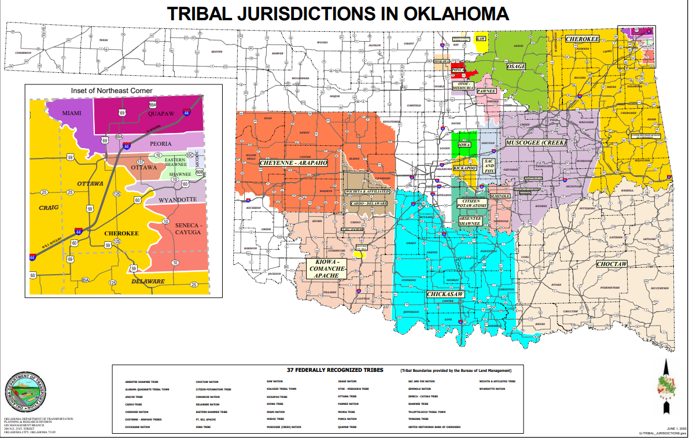
Ottawa County comprises roughly 500 square miles of the northeast corner of Oklahoma, where the Osage Plains meet the Ozark Plateau O’Dell (n.d.). The Osage lived with this land of forest, rivers, and prairie until the start of the 19th century, when the United States forced them to cede their territory (again) to make way for Cherokees, who were being relocated (again) from elsewhere O’Dell( n.d.) (Figure 1).
Figure 1:Map of Tribal jurisdictions in Oklahoma
Source: Oklahoma Department of Transportation (ODOT), (2005)
Following the passage of the Indian Removal Act in 1830, the signage of reprehensible treaties (many of which required immediate relocation and sold traditional homelands), and the increasing encroachment of white settlers moving westward, many Tribes were forcibly moved to Ottawa County (Figure 2).
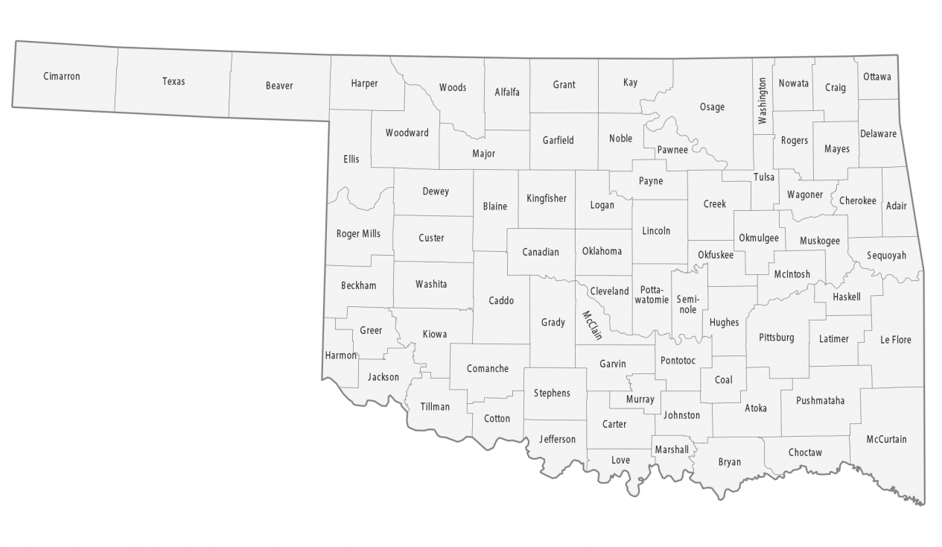
Figure 2:Map of Oklahoma Counties
Source: GISGeography (2022)
Here, the Tribes native to this region were forced to share their lands with others who were sent to Oklahoma (often as a last-ditch effort by the government to remove them from more desirable land). As a result, Ottawa County became the new homelands for the Quapaw Nation, Miami Nation, Peoria Nation, Ottawa Nation, Shawnee Nation, Eastern Shawnee Nation, Modoc Nation, Wyandotte Nation, Seneca-Cayuga Nation, and the Cherokee Nation.

Mining in Ottawa County and the Tri-State Area
As settlers continued to arrive and demand for raw materials increased with growing industrialization, lucrative mining opportunities for lead and zinc were discovered in the northeastern corner of Oklahoma O’Dell (n.d.). So much so, that the area became known as the Tri-State Mining District and encompassed the northeastern corner of Oklahoma, southeastern corner of Kansas, and much of southwestern Missouri (Figure 3).
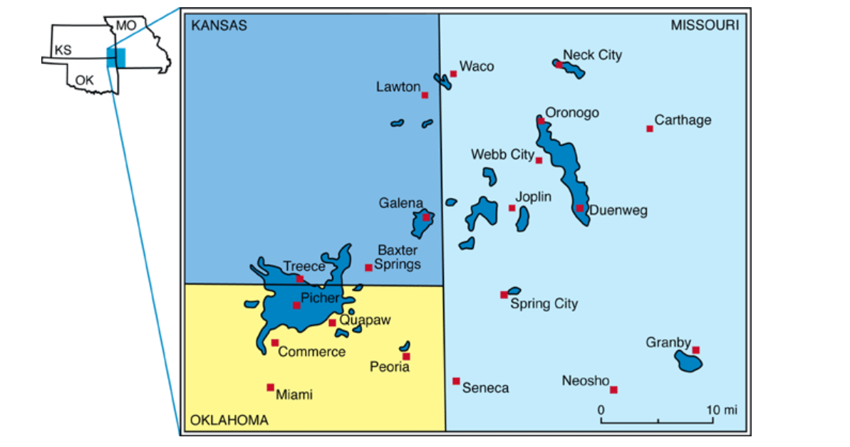
Figure 3 Map of the Tri-State Mining District
Source: Brosius and Sawin (2001)
To serve the needs of miners, boomtowns quickly sprung up. One such town was Picher, Oklahoma. Robertson (2006, 121) describes the explosive growth of this town: “Ore was discovered in the Picher region in 1914 and within three years, the settlement’s population exceed 20,000. Picher was [known as] the largest mining town in the Tri-State Mining District.” This new town attracted thousands of people from around the region and generations of families worked in the mines or in nearby mills processing the ore. Picher was the crown jewel of the mining district in terms of production, as ninety percent of the output of the Tri-State Mining District after 1915 came from there Morris (1982, 119).
Picher’s showcase was the EaglePicher Mine. The lead mine was in operation from 1913-1967, with 1926 being the peak year of production Everett (n.d.). The EaglePicher corporation and mine grew to be so large that it began buying up competing smelters and mines and was the leading producer for lead. In total EaglePicher operated, “38 of the important mines and milled 14,000 tons of ore each day” Morris (1982, 126). As the United States became involved in World Wars I and II, the demand for lead and zinc for use in bullet casings skyrocketed. The Eagle-Picher mine became known as one of the leading suppliers of lead for war efforts. In fact, “more than 50 percent of the lead and zinc metal consumed in World War I came from the Picher Field” C. Allan Mathews and Wood (n.d.). By the mid-to-late 1950s and early 1960s, however, the heyday was over. The Tri-State Mining District faced foreign competition, prices plummeted, and the mine was classified as a “marginal area,” meaning that only low-grade ore remained Morris (1982, 128-129). By 1965, the EaglePicher Mine had closed, and Picher and the surrounding region was left to contend with its toxic legacies (Figure 4).
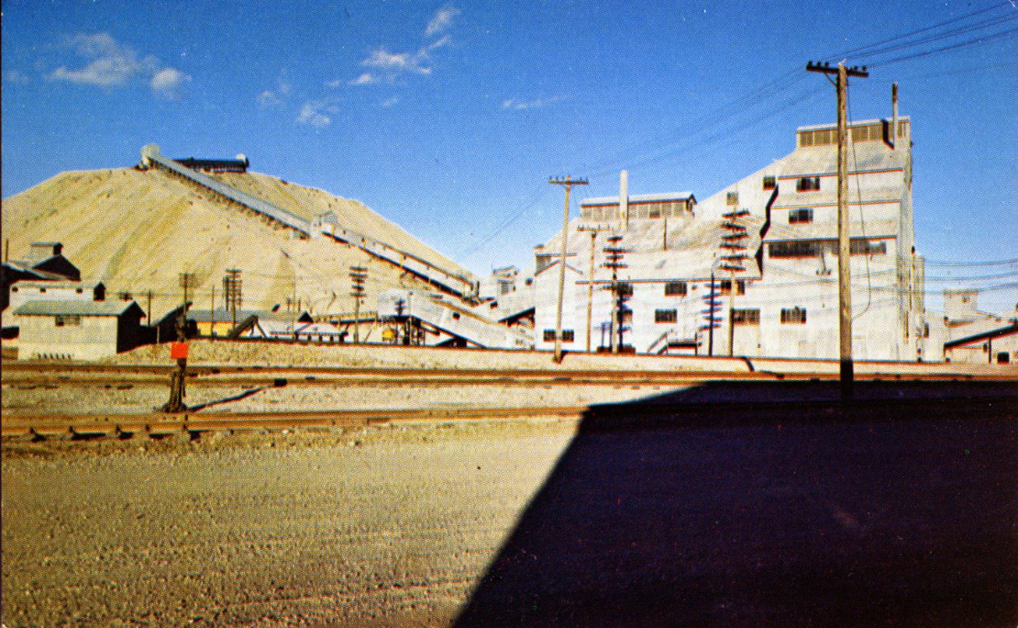
Figure 4 Postcard of the EaglePicher Central Mill circa 1965
Source: W.C. Pine Co. (2019)
The mine’s closure brought many lingering environmental issues. One of the main concerns facing Ottawa County is acid-mine runoff. As many of the mining sites were located near groundwater reserves, pumps operated during mining operations to keep the water out. Once the mine closed, the pumps were also shut down. Water accumulated rapidly and began to collect heavy metals, including zinc, iron, cadmium, and many others "Tar Creek" US EPA (n.d.) Eventually, the mine shafts could hold no more water, so the water began to spill into nearby Tar Creek, which leads directly into Grand Lake, a popular boating and swimming destination. Additionally, there are massive piles of chat scattered around the region. Chat is “the mill tailings…consist[ing] of fine gravel-sized and coarse sand-sized rock fragments [remaining after ore extraction]”"Tar Creek" US EPA (n.d.) (Figure 5).
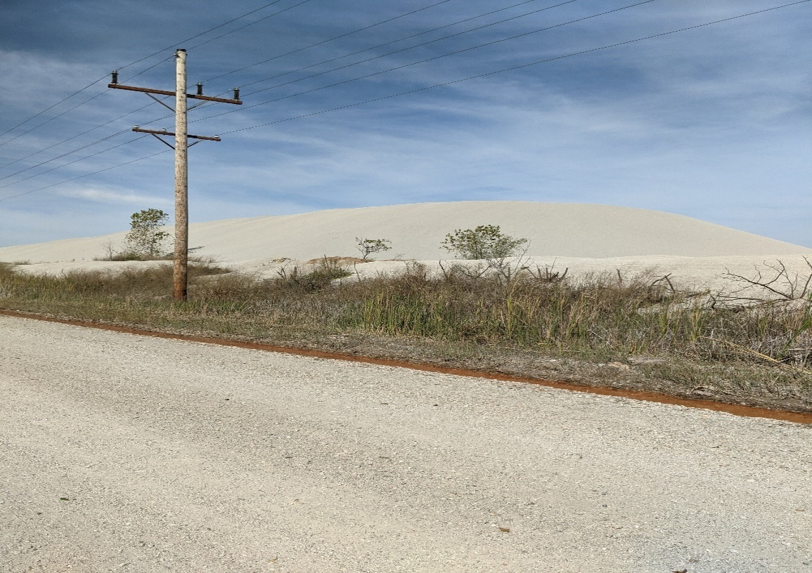
Figure 5 Chat piles near Picher, OK
Source: Valerie Doornbos (October 2021)
The acid-mine runoff and scope of the problem led the EPA to declare the area a Superfund Site and place it on the National Priorities List (NPL) in 1983. NPL Sites are “sites of national priority among the known releases or threatened releases of hazardous substances, pollutants, or contaminants throughout the United States and its territories” US EPA (2015). These legacies of industry have scarred the region and the county seat of Ottawa County: Miami, Oklahoma.

Thesis Overview
When the EaglePicher Mine closed, many people were unemployed, and desperately seeking new opportunities. One of the most lucrative opportunities was a job as a tire builder at the B.F. Goodrich Tire Factory Okeson (2016). A welcomed economic engine in the region, the B.F. Goodrich plant operated between 1946 and 1986. Many moved their families from Picher to Miami to work in the plant, and a large portion of Miami’s economy revolved around the tire industry. As The Oklahoman reported, “For years, the factory dominated the economic landscape of northeast Oklahoma. Generations worked there, creating the post-World War II middle class in Miami. It was hard, hot work…but paid well and allowed families to enjoy the comfortable trappings of middle-class life” Monies (2006). Unfortunately, due to increasing foreign competition in the late 1970s and early 1980s, B.F. Goodrich executives made the decision to close the plant in 1986 Okeson (2016). The closure of the plant decimated the region, continued the process of deindustrialization, and created the lasting economic, social, and environmental impacts that are still felt to this day.
This thesis focuses on the B.F. Goodrich plant in Miami, Oklahoma, which replaced mining as the key economic engine for Ottawa County. The following structure shapes my thesis. In this introductory chapter I have situated myself and explained why I have an interest in deindustrialization. I also provide a brief background on my study region of Ottawa County, Oklahoma. Chapter 2 reviews the literature that frames my project. It also introduces the research methods and methodologies featured in this thesis. In Chapter 3, I describe the emergence, flourishing, and closure of the B.F. Goodrich plant. I draw on interviews and archival materials to paint portraits of these events. This chapter also provides much of the textual content for my StoryMap including the five key areas of concern: benzene, asbestos, carbon black, UST’s, and the solid waste disposal site/incinerator. Finally, in Chapter 4, I discuss my key findings and lessons learned in greater detail. I also consider my limitations and possible areas for future research.

Framing This Research
Before delving further into the problems brought about by the closure of the B.F. Goodrich Tire Factory in Miami, it is important to get a broader sense of deindustrialization and industrial contamination in the United States. Many of the trends and patterns that emerge on a national scale resemble the processes occurring in Miami. This chapter discusses the literature and definitions that influence my study. I begin by reviewing the legacies of industrial contamination in various U.S. cities, define “legacy,” and provide an example of a community suffering from industrial contamination. I then detail the impacts of deindustrialization, defining the process, providing some of the leading causes, and listing its lasting impacts. Next, I explore the concepts of “slow violence” and “participatory historical geography,” and examine community organizing and how it has brought attention to local environmental concerns. I also describe the local, state, and federal government agencies that are tasked with the lengthy process of remediation. I cite some of the notable literature and define terms such as slow violence, legacy, and participatory historical geography. I end by discussing the qualitative research methods and methodologies that I utilized in this project and how I created my StoryMap.

Industrial Contamination in U.S. Cities
Beginning with the American Industrial Revolution in the 19th century, the United States of America has depended on industry and commerce to fuel its economy, political objectives, and international affairs. This was especially noticeable during and after World Wars I and II, when industrial production increased rapidly Hurley (1995, 7). Along with a rapid increase in production, new products and manufacturing technologies entered the market. While they fueled economic development, these industrial technologies introduced synthetic compounds that exacerbated environmental damage and contamination. Hurley (1995, 7) notes,
Many technologies that were developed during World War II and were later applied to industrial production introduced even more long-lasting and far-reaching hazards. The postwar boom in plastics, chemicals, drugs, food additives, fabrics, and pesticides, for example, introduced a host of synthetic compounds into the environment. Unlike the wastes emitted by older, heavier industries, these synthetic materials tended to decompose more slowly and therefore remained in a hazardous state much longer.

One great cost of growing reliance on new industrial methods was the lasting toxic legacy left behind. In Miami, this meant the leftover mine waste and chemicals from the B.F. Goodrich factory.
The word ‘legacy’ itself is important to define when discussing industrial contamination in U.S. cities. Boudia et al. (2022, 22) argue that,
legacy denotes inheritance, the absence (often death) of the giver, and the involuntariness of the receiver. Legacies are long-term and usually irrevocable. Legacy also holds a particular currency in regulatory terminology-namely, that ‘legacy pollutants’ are chemicals that remain in the environment long after release and whose harms were not known at the time of use.

The most important items to note from this definition are: 1. The “involuntariness of the receiver” and 2. the “irrevocable” and “long-term” properties of the legacy of industry. Those who were/are burdened by the legacies of industry never voluntarily take it upon themselves to have these lingering contaminants in their neighborhoods. The health, concerns, and needs of people negatively impacted by industrialization were set aside in favor of continuing access to industrial profit.
Industrial progress is often justified with the ideals of colonialism. Sacrifice is okay, if industrial gain can continue. Liboiron (2021) centers colonialism as a structure for validating industrial progress. They highlight the “assumption” that more-than-human resources are always and inevitably available for use (be it research or industrial extraction). They argue that “Colonization is not just about having access - it is also about eliminating other types of relations that might threaten that access” Liboiron (2021, 96). Eliminating these “relations” meant that colonized people were/are forced to not only change their lifeways, but also contend with the lingering residues of contamination for many years, while others could/can profit. Taking this into consideration, I define the ‘legacy’ of industry as the unevenly distributed and lasting impacts of industrial activities in an area that are deep-rooted in the environment, and toxic to the human and more-than-human environment.
Another byproduct of the legacy of industrial contamination in the United States are the impacts on human and environmental health. As Boudia et al. (2022, 11) observe, “we interact with residues all the time, and chronic exposure to a little poison every day can add up to a lot of poison over the course of a human lifetime - or – when we are dealing with heritable mutations – over generations.” The impacts of this contamination on the human body do not just disappear as time passes; they continue to linger and accumulate. Perhaps one of the most recognizable cases is that of the petrochemical industry in Louisiana; an area known as Cancer Alley (Figure 6).
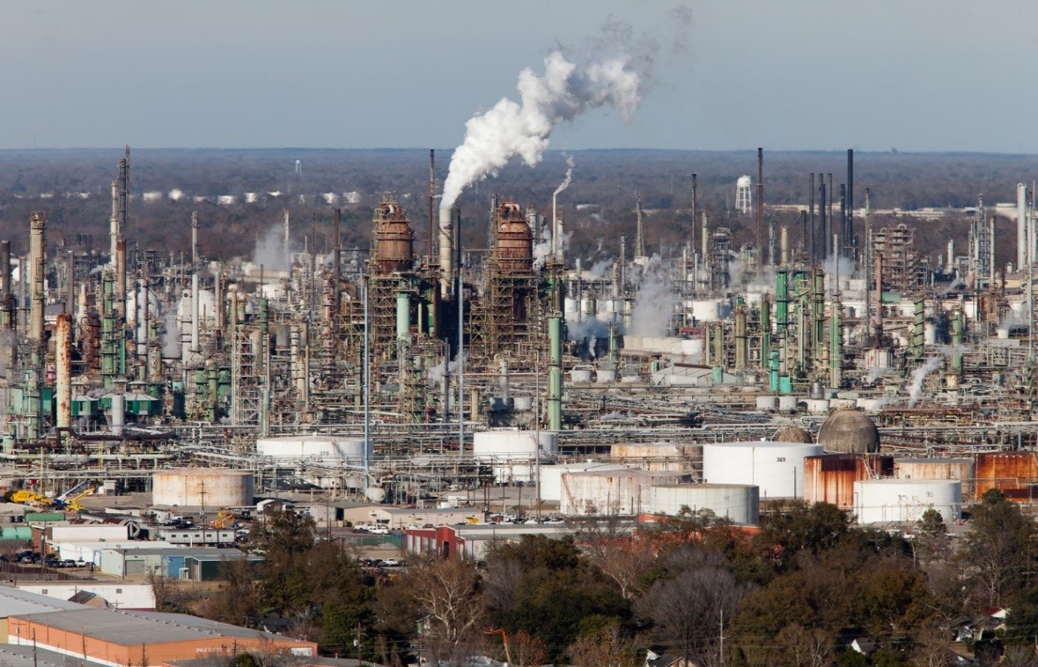
Figure 6 Petrochemical factories in Louisiana
Source: Nobel (2017)
Adeola (1998, 85) classifies Cancer Alley as the “over 800 chemical and petrochemical manufacturing plants, oil refineries, paper mills, and toxic waste facilities lining the 120-mile stretch along the Mississippi River from Baton Rouge to New Orleans” Adeola also emphasizes that “long-term residency in this area may be directly related to a high degree of exposure to toxicant and various incidence of environmentally related illnesses” (86). Cancer Alley is not the only region suffering from the impacts of industrial contamination. Cities such as Globe, Arizona (contamination from copper mining), Bethlehem, Pennsylvania (contamination from steel making), Youngstown and Cleveland, Ohio (contamination from heavy industry including steel and oil refining), Gary, Indiana (contamination from steel industry), Wynnewood, Oklahoma (contamination from oil refining), and many others experience similar concerns.

Deindustrialization and U.S. Cities
For decades, industry was a part of the identity for millions of Americans. Industrial jobs provided a way for a comfortable middle-class lifestyle, financial stability, and a sense of national pride. “Blue-collar” workers, as many of them were known, bragged about how they carried the economy of the United States on their shoulders. Many cities became known for the type of industry they supported. Gary, Indiana’s nickname is “Steel City.” Pittsburgh, Pennsylvania is known as “Iron City,” and the logo and name of their football team, the Pittsburgh Steelers, were created by U.S. Steel. Detroit, Michigan’s nickname, “Motor City” comes from its legacy of automobile manufacturing. These regions and many others depended on one or two types of industry to support much of their local economy Hurley (1995).
Starting in the late 1960s and especially in the 1980s, the industrial might of the United States began to fade. Increasing foreign competition, outdated infrastructure, and massive job loss characterized the beginnings of deindustrialization in many regions. Doyle (2002) notes how deindustrialization
sometimes came with little warning to workers, as factories suddenly closed or moved to less unionized areas. There was a reduction in jobs as corporations failed to invest in improved plans and technology.

As these processes started to unfold in the U.S., areas that had relied on one or two industries, suddenly found themselves without a major source of economic income. These communities then began to face the impacts of deindustrialization: shuttered businesses, intensified social inequities, the toxic legacies of industrial pollution leaking from abandoned sites, and many others. In fact, the impacts of deindustrialization in the Northeastern United States were so prominent that the region became known as the “Rust Belt” (Figure 7).
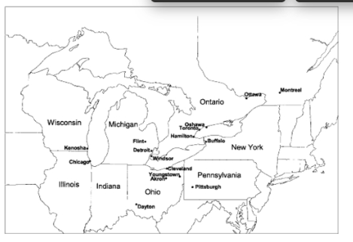
Figure 7 The Rust Belt of the United States and Canada
Source: High (2003)
Mah (2012) demonstrates how industrial ruination is a “lived process” that is constantly in motion. The book examines this concept in three post-industrial locations: Niagara Falls Canada/USA, Newcastle upon Tyne, UK, and Ivanovo, Russia. Her research is unique in that it centers on place-based communities facing the impacts of deindustrialization instead of broader groups based on type of industry or interest. Her book “highlights the impacts of deindustrialization on place-based communities and focuses on residential areas adjacent to sites of industrial ruination” Mah (2012, 4). This is similar to my research in that I also focus on the community and the lived experiences of people who worked at or lived next to the B.F. Goodrich plant. One of her central arguments is that the physical locations of deindustrialization, such as old factory sites, do not simply die and get forgotten. Rather, there is always some process occurring with which people cannot avoid interaction. Mah (2012, 8) details how “over time, landscapes of industrial ruination will become landscapes of regeneration, reuse, demolition, or ruination once again…and these [landscapes] are experienced by people.” People drive or take a train past these landscapes, some work in these landscapes, and others call them home. Furthermore, she explains that there are different types of relationships/experiences at these sites including informal activities and memories/perceptions. Informal activities are the undertakings such as: drug/alcohol use, vandalism, theft of materials, and arson that commonly occur at sites after closure. Memories/perceptions are how people mentally interact with the site after closure including past work histories and feelings towards industrial ruination. Memories can also “reflect much of the unease and difficulty experienced by people coping with the transition from an industrial past to an uncertain post-industrial future” Mah (2012, 13-14). Regardless of how many years have passed since the closure, these sites still have an active presence in the minds, activities, and structures of the community.
An impact of deindustrialization that is often overlooked is the emotional toll of the process of losing a job held for many years. High (2003, 42) describes how, “the emotional loss [workers] continue to feel from this upheaval, even decades later, illustrates the devastating impact of plant closings.” When former industrial workers were asked how they felt upon hearing about the imminent loss of their jobs, many responded with tales of emotional anguish and grief. Clem Smereck, an Ohio steelworker who worked a blast furnace for 32 years, recounted the demolition of his steel mill as, “the second saddest day of my life, the first being the day the mill closed” High (2003, 3). Another displaced foreman from the Open-Hearth Department at Campbell Works in Youngstown, Ohio, George Richardson, said, “When I read those headlines [about the mill closure in 1977], it made me sick. It makes me sick now to drive down Poland Avenue to see those empty spaces where the blast furnaces used to be” High (2002, 6).
In Miami, Oklahoma, the closure of the B.F. Goodrich Tire Factory brought about similar gut-wrenching responses. Charley Rollins, president of United Rubber Workers (URW) Local 318 related how, “when that first group of workers left for good on Jan. 10, 1986, it was like a spike being driven into your heart” Industry Week (1986, 52). Others feared they would have to learn an entirely new skillset. In the employee assistance center set up after the plant closed, one worker muttered, “I can’t go back to school. I’m too old” Industry Week (1986, 52). B.F. Goodrich offered employees counseling, but what workers wanted was jobs. James Graves, a former plant foreman, observes how people “came to work out of high school, and all they ever knew how to do was build a tire. They didn't know how to do anything else.” A large part of the emotional struggle for the community was trying to figure out how to replace the jobs lost. As Miami’s mayor remarked at the time, “We’d been fat cats around here for a long time. Lots of people are learning to think about doing things differently” Industry Week (1986, 52). The emotional legacies of deindustrialization continue to linger, long after the industries have shut down.
Deindustrialization has underlying emotional impacts Industry Week (1986, 52). People have connections to work, and when job loss occurs, it often leaves them in a tailspin. As we have seen earlier, people facing job loss described feeling ‘sick’, ‘angry’, or ‘depressed.’ These feelings continue to emerge as remediation efforts take place. Furthermore, the legacies of industrial contamination continue to linger long after the factory has produced its last item. This is where slow violence concerns occur.

Researching the Impacts of Slow Violence on Communities
Communities comprise the center point of environmental endeavors. Community advocacy is often what brings public, state, and federal attention to the environmental issues of an area “LEAD Agency: Who We Are” (n.d.). In addition, the onset of “slow violence” exacerbates the lingering environmental concerns of industrial ruination. People who live near the B.F. Goodrich plant today are primarily low-income residents. Many of them do not have a voice in how the Oklahoma Department of Environmental Quality and the City of Miami are remediating the plant site by removing or redressing the impact of the toxins. These residents continue to ask questions, but they are often ignored and belittled, leaving them out of a process that has a direct impact on their lives. Participatory historical geography is one potential way to address slow violence and emphasize the voices of the community. This section delves further into the literature surrounding these concepts.
The word ‘community’ can be difficult to define, as its meaning can vary from person to person and place to place. The California Department of Public Health (CDPH) defines community as “a complex social construct that…may not only be defined by its geographical area, but also by the social ties or relationships, common perspectives, shared identity, language, culture, similar individual characteristics, or shared health impacts of its members” California Department of Public Health (2021, 10). The community I will focus on in this research are the residents of Miami, Oklahoma, especially those who have interacted with the former B.F. Goodrich Tire Factory at some point during their lifetime.
An additional framework for this project is “participatory historical geography/research.” Participatory research can be defined as, “the growing practice of working with research ‘subjects’ as collaborators in defining questions, selecting methods, analyzing data and disseminating findings with the goal of pursuing social justice and change directly” Smith et al. (2009, 512). In other words, participants are collaborators in the research throughout the lifecycle of the project. Questions and ideas posed by participants help researchers gauge the accuracy and relevance of their research to the community. In the case of my thesis research, Rebecca Jim drew on her experience as longtime director of LEAD Agency to suggest a study of the former B.F. Goodrich factory site, identify and introduce people to interview, present new questions to consider, and serve as our main point of contact in the community.
DeLyser (2014) notes that participatory research has four key objectives:
First, it seeks to bring a community-engaged, action-oriented dimension into academic work. Second, participatory research seeks to empower local people and reverse discriminatory and exclusionary policies and practices. Third, participatory researchers seek to engage in collaborative efforts that give voice to research participants, validating and even prioritizing their knowledge (rather than academic ‘expert’ knowledge). And fourth, participatory research demands a different model for research assessment because for participatory researchers, participation is research.

My research project heeds each of these key objectives. The basis of the project is to visualize embodied experience and inspire community engagement and action via the StoryMap. It is my hope that community members who read the map will see that their stories, and the stories of their friends and neighbors, are valued and honored. Perhaps they will then be inspired to join the LEAD Agency to work toward remediating B.F. Goodrich and addressing the other environmental concerns Ottawa County is facing. Secondly, the StoryMap will hopefully empower the community by providing a tool to collect and display these stories, and thus ensure that resident voices are heard. It could facilitate dialog by having residents learn from others and share their own experiences and stories, thereby giving power and recognition back to those who have faced these challenges daily. This goal fits nicely into the third objective, prioritizing resident knowledge over academic knowledge. The community are the ones who will use this information, and they are the ones who will benefit. Historically, much research has disregarded the viewpoints and needs of the communities. The desires and objectives of community organizations or leaders were ignored in favor of the research and publication goals of the investigator. I consider myself to be the organizer of the data for the community. While I will benefit from the information Rebecca shared with me and the stories community residents have shared with us (via the submission and defense of my thesis), it is Miami’s information first and foremost. Finally, participatory research takes into account the multiple epistemologies or ways of knowing in a community that traditional methods may fail to consider. While scientific research is important, it can leave out the human side of environmental concerns. Therefore, participatory historical geography is a promising way to collaboratively research lived experiences of community members.
Observed environmental changes often happen slowly in a community. It can take many years for chemicals in a body to build up to a toxic level that will drastically impact one’s health. This lengthy process of buildup can be defined as ‘slow violence’ because these chemicals constantly impact one’s body as exposure continues. Davies (2018, 1540) argues that ‘slow violence’ is a major contributor to environmental concerns and that ‘slow observation’ is necessary to understand these changes. He defines the term ‘slow violence’ as “a form of late-modern necropolitics, where communities are exposed to the power of death-in-life.” Many environmental changes brought about by pollution do not happen rapidly; therefore, it is essential to approach this in a way that allows us to perceive these changes. According to Davies (2018, 1537), “the idea of ‘slow observation’ is…a useful counterpoint to slow violence and the permanent wounding of toxic pollution.” Most policies addressing environmental injustices are based on environmental and resident observations of past and current conditions. Yet many residues of industrial process can take years to emerge. Because of this, Davies (2018, 1541) insists that, ‘slow observations’ are best to observe ‘slow violence.’
It is extremely important to clarify what is meant by slow observation. Slow observation is a privilege for those who do not need to face the toxic impacts of industrial contamination on a quotidian basis Davies (2018, 1541). Slow observation does not mean that an agency is able or encouraged to drag their feet and postpone clean-up efforts. Instead, the agency should continue to return to the site for a lengthy period of time. Slow observation means that it is not possible to understand the true extent of contamination or impact in one visit. Multiple visits are needed. This idea is implemented in my research project. We are not done collecting these stories and perhaps this will spur a call-to-action in the community. Rebecca and the LEAD Agency are attempting to spearhead this through their efforts to get people to care about the risks associated with exposure to chat piles and flooding, and to hold responsible parties and agencies accountable. The agencies tasked with these remediation efforts will be detailed in the following section.

Government Agencies Tasked with Remediation
When industry closes, it often leaves a toxic legacy of pollution and contamination behind that drastically impacts the environment and communities residing there. Holding the corporations who created the issue in the first place responsible can be difficult. Many of them are either bankrupt, “grandfathered in” (i.e., they are not responsible for updated pollution and modernization standards because they existed before these regulations were in place), or they have found other ways to circumvent liability. The responsibility for clean-up and remediation efforts is then passed on to the government. As Boudia et al. (2022, 11) observe, “it is often governments, rather than companies, who are on the hook to clean up waste sites after the fact.” Remediation efforts are often combined between state and federal environmental agencies.
From a federal perspective, the government agency that is often tasked with remediation and the enforcement of regulations concerning toxic emissions is the United States EPA. Founded in 1970 under the Nixon administration, the mission of the EPA is to “protect people and the environment from significant health risks, sponsors and conducts research, and develops and enforces environmental regulations” US EPA (n.d.). The EPA has policies and regulations in place to address industrial clean-up. The most important of these is the 1980 Comprehensive Environmental Response, Compensation, and Liability Act (CERCLA), which developed the Superfund program. CERCLA was intended to provide funding for large-scale environmental remediation efforts. As Boudia et al. (2022, 47) point out, CERCLA “charged EPA with administering a cleanup program of highly contaminated hazardous waste in what were termed ‘Superfund sites.’”
The EPA typically breaks down contaminated sites into two different categories: Superfund and Brownfield. There are two key differences between Superfund and Brownfield sites: 1. The level of contamination and 2. federal involvement. The EPA defines Superfund sites as, “uncontrolled or abandoned sites or properties where hazardous waste or other contamination is located.” A contaminated site is generally considered a "Superfund site" if the federal government is – or plans to be – involved in cleanup efforts” US EPA (2015). The Superfund sites most contaminated or dangerous to human health, are placed onto the National Priorities List (NPL). Appearing on the NPL merits higher access to funding, monitoring, and remediation endeavors US EPA (2015). As of January 31, 2023, there are 1,877 Superfund Sites in the United States, and 1,329 of those are NPL sites. One well-known Oklahoma example is the Tar Creek Superfund Site (see Section 1.4), which has been on the NPL since 1983 and has an extensive history of federal remediation efforts. The EPA defines a brownfield as properties for which “the expansion, development, or reuse…may be complicated by the presence or potential presence of a hazardous substance, pollutant, or contaminant.” Generally, the federal government is not involved in brownfields. Rather, state and Tribal response programs play a significant role in cleaning up and helping to revitalize these sites” OLEM US EPA (2013). Brownfields are a gray area because some sites might meet brownfield criteria but have not been officially added to the EPA’s list for a variety of reasons. For instance, brownfields are typically the responsibility of local or state governments, and many states, like Oklahoma, have their own brownfields division. The former B.F. Goodrich Tire Factory is locally considered to be a brownfield but has not been officially added to the brownfield list. The responsibility of cleaning up this site has fallen largely to the Oklahoma Department of Environmental Quality (ODEQ) and local organizations, except for an asbestos cleanup by the EPA in 2018-2019 (see section 3.5).
In Oklahoma, the agencies that are tasked with remediation are the Oklahoma Department of Environmental Quality (ODEQ) and the Oklahoma Corporation Commission. ODEQ has an office dedicated to brownfields of all types and sizes; it offers a Targeted Brownfields Assessment (TBA) program for those who wish to have their site tested for contaminants. This TBA program provides businesses with low-interest loans for cleaning up their site, supplies education and outreach materials for residents, and offers many other services DEQ (n.d.). The Oklahoma Corporation Commission is responsible primarily for oil and gas brownfields. They offer liability relief and clean-up solutions to property owners. As stated on their website, this agency “provide[s] a process for individuals, companies, non-profits, cities and towns, and other entities to voluntarily investigate and, if necessary, clean up properties that may be contaminated with oil and gas or petroleum storage tank wastes, returning the sites to productive use” Oklahoma Corporation Commission (n.d.). While these remedial governing organizations differ somewhat, their main objective is to be able to have these sites reused in the future.
There are three major lessons I took away from the literature: 1. Contamination is a very slow process and slow remediation efforts and observations are needed to address this. 2. Deindustrialization in the United States creates lingering negative societal and environmental impacts. 3. Participatory research (including archival and interviews) that centers the voices of residents via the creation of a StoryMap is a promising strategy for visualizing the events of the Miami plant.

Qualitative Research Methods
My research methodology centers on the stories of community members and entails the use of interviews, archival research, and StoryMaps. This mixed-methods approach responds to the multi-faceted problem of industrial pollution. Elwood (2009, 95) defines mixed method approaches as “those that rely upon multiple types of data, modes of analysis, or ways of knowing, but may use these elements in a variety of ways in relationship to one another, for multiple intellectual and analytical purposes.” My research requires a mixed methodology because the impacts of industrial contamination encompass both numerical data and societal impacts. As Boudia et al. (2022, 125) note, “Residues connect. To track them, we need combined approaches of the natural sciences, the social sciences, and the humanities to research residual states of matter.”
My qualitative research for this project consists of two cornerstones: unstructured interviews and extensive archival analysis. Interviews are an excellent way to gain information that other forms of qualitative research might lack. Dunn (2016, 150) observes that interviews allow researchers to detect how meanings, opinions, and experiences vary among people of different class, ethnicity, age, and sexuality. The interviews shaping my project were conducted with people who had worked and interacted with the plant in a variety of ways; they capture different experiences. Upon approval of the IRB in April 2022, the AW&W team interviewed six people who had a connection to B.F. Goodrich (Table 1). I complimented these with interviews with recorded interviews from Oklahoma State University (OSU)’s Oral History Project (Table 2). Interviews were conducted during numerous trips to Miami. We would first ask Rebecca, our community partner, for a list of names and contact information for those whom she thought would be interested in speaking with us. Once we had reached out and confirmed that they agreed to be interviewed, we scheduled a time for an interview.
Table 1 List of Interviews Conducted
Name of Interviewee | Date of Interview | Connection to B.F. Goodrich
Ben Bingham | November 2022 | His father had worked at the plant for many years.
Fredas Cook | May 2022 | Former B.F. Goodrich tire builder and foreman. Began work on August 9, 1965.
James Graves | April 2022 | Hired as a floor foreman but became a senior foreman. Started working at B.F. Goodrich in 1972.
Dennis “Dale” Taylor | April 2022 | Worked at the B.F. Goodrich Plant for about a year.
Larry Tippit | May 2022 | Tire builder who became a research and design engineer at the plant.
Jerry Wyrik | May 2022 | Former B.F. Goodrich stock worker and tire builder began August 14, 1963. He worked until they closed in 1986 and then transferred to Tuscaloosa, AL for 10 years.

Table 2 List of Interviews Used. Source: Oklahoma State University (OSU) Oral History Project, 2012-2016
Name of Interviewee | Name(s) of Interviewer(s) | Date of Interview | Connection to B.F. Goodrich
Dena Anders | Tanya Finchum and Alex Bishop | May 06, 2015 | Owner of Anders Shoe Store which serviced many families who had a member working at the plant.
Charles Kirkendoll | Tanya Finchum | August 04, 2016 | Former B.F. Goodrich tire builder from 1974 until the plant closed.
John Mott | Latasha Wilson | April 20, 2012 | Tire builder at the plant, began work on June 23rd, 1945, soon after the plant opened.

We would then meet these individuals at a comfortable location to begin the interview process. Our first step was to obtain their consent to be interviewed, recorded, and to have their quotes shared on our website. We would have them read or read to them the consent form letting them know that they were free to stop participating in our study at any time, without consequence. As many of our participants were sharing sensitive life information, it was imperative that we conducted ethical interviews. Upon their granting of consent, we would then move into the interview process and start a recording. Prior to beginning interviews, we had submitted a list of our key questions regarding Air, Water, and Work to the IRB for review. These questions were generated from group discussion with other members of the team. These questions included everything from: what was your position at B.F. Goodrich to were you ever in any danger at work?
As interviews unfolded, we moved through these questions, selecting whichever ones we thought were most appropriate. We decided to utilize such an unstructured interview format because we wanted to focus on the stories of participants and let them direct how the interviews would go. Dunn (2016, 160) notes that the questions asked in unstructured interviews are “almost entirely determined by the informant’s responses.” Unstructured interviews were most appropriate for our purpose, and we would sometimes only need to ask a couple of questions. Many participants wanted to talk extensively about a certain subject or subjects and asking them different questions would have interrupted their train of thought. We would typically end the interview by asking them if they knew of anyone else who might be willing to talk with us, a process known as ‘snowball sampling.’
After we completed our interviews, we had the audio recordings transcribed by GoTranscript’s transcription service. We sent a paper copy of the transcript to the interviewee to make sure that it all looked correct and that they were comfortable with what had been recorded. Once we had their approval, I then manually went through each transcription to identify themes (codes) and select quotes to use in my thesis. I analyzed the interviews focusing on stories of accidents that had occurred, everyday experiences, connections, or experiences with the five key environmental contaminant concerns, as well as memories of the plant closure. I then synthesized the interview data to augment information I gathered from document and archival analysis. Fortuitously, I also discovered that several interviews conducted as part of Oklahoma State University’s Oral History project throughout Oklahoma have a connection to B.F. Goodrich (Table 2).
In addition to conducting and analyzing interviews, I also conducted an extensive archival analysis. Archival research is a necessary component to this project because it provides a historical background of the study site and provides context to the interview responses. Roche (2016, 228) explains how studying archives allow us to “re-evaluate taken-for-granted concepts and to develop a comparative perspective.” The LEAD Agency has several filing cabinets and a flash drive full of various documents related to B.F. Goodrich that I organized and evaluated. The documents included everything from handwritten notes, bits and pieces of various court cases, company memos, Oklahoma Department of Environmental Quality (ODEQ) and EPA correspondence, site remediation reports, newspaper clippings, and photographs. Because the material had not been previously organized, I needed to sift through everything and organize it in the manner I found most effective and conducive to my research.
First, I digitized the LEAD agencies archival materials by scanning each one. This was a vital step because I was based in Norman and the LEAD Agency is located in Miami, a three-hour drive away, which was not convenient if I needed to examine a certain document. Also, I wanted to read through and annotate each item, and I did not want to wreck the original copies. Bailey and I spent a full day carefully scanning documents using the printer provided at the LEAD Agency. We scanned each page of each item individually because some had different materials on the front and back of the same page. I then uploaded everything to the flash drives that I had brought with me.
Once I returned to Norman, I printed out everything so that I could carefully read and make notes. I then evaluated and annotated each item, organizing them by prominent/recurring topics, including carbon black, underground storage tanks (USTs), site monitoring reports, Rebecca’s notes, EPA documents, hazardous information sheets, asbestos, benzene contamination, and lawsuits. I also identified and listed priority documents with valuable information or contained stories that would be an asset to a specific section. Inevitably, this was an incomplete archive, as many materials were missing certain sections or titles, and this made organizing a bit more difficult.
While extensive research has been conducted on the Tar Creek Superfund Site, not many are familiar with the Miami B.F. Goodrich factory. In terms of the B.F. Goodrich corporation itself, research has been conducted on plants in Tuscaloosa, Alabama and Akron, Ohio, but not in Miami, Oklahoma. My research bridges this gap. It draws on stories and lived experiences, along with demographic and environmental data, to tell the story of this specific plant and its lasting impact on Miami.

What Are ArcGIS StoryMaps?
As is illustrated above, my research contains multiple components including textual and archival analysis. When looking for a way to visualize all this qualitative data, I came across ESRI mapping program known as StoryMaps. ESRI defines StoryMaps as “a web map that has been thoughtfully created, given context, and provided with supporting information so it becomes a stand-alone resource. It integrates maps, legends, text, photos, and videos and provides functionality that helps users to explore this content” ESRI (2019). One of the many benefits to using StoryMaps to showcase qualitative and quantitative data is that you can incorporate different items together to tell a story. For example, my StoryMap includes maps, figures, videos, charts, and text analysis (Figure 8 ).
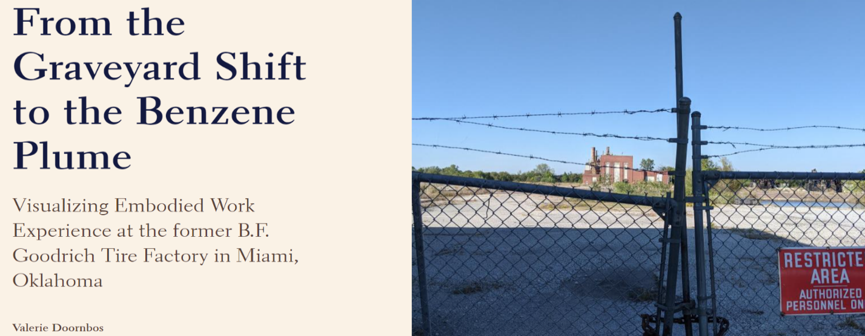
Figure 8 Valerie’s StoryMap Title Page
Source: Doornbos (2023)
On their help page, ESRI notes that there are a number of key components which make a successful StoryMap Szukalski (2019). The three items that I found to be the most helpful were: 1. include clear and compelling titles and text 2. pick a thumbnail and title image that speaks to what you are trying to convey 3. have multiple people review your map. When creating my map, I did my best to include all of these as a visually appealing map will help to attract and keep an audience’s attention.
The title of my StoryMap “From the Graveyard Shift to the Benzene Plume: Visualizing Embodied Work Experience at the Former B.F. Goodrich Tire Factory in Miami, Oklahoma” includes an attention-grabbing phase at the beginning, clearly emphasizing that the map will be about work experience at B.F. Goodrich. The thumbnail and title image both feature the entrance to the plant that was taken during the October 2022 site visit. I selected this image specifically because it showcases some of the key features of the plant (the powerhouse and Banbury Mixers). The fence in the foreground and contrast between shadows and sun help to capture the viewer’s attention. Finally, I have had several people review my map and provide feedback and comments to make sure that it is accessible and understandable. Reviewers have included Rebecca and Laurel as well as Miami residents and former workers. Rebecca and the LEAD Agency plan to use my StoryMap as part of their toolkit to honor these stories, attract additional attention to the environmental issues facing Ottawa County, and promote increased community engagement.
The above literature, methodology, and mixed methods approach played a vital role in the development of my key research question: how can a Miami community-based organization’s archival materials be incorporated into a StoryMap to engage a community, illustrate the embodied work experience, and introduce the environmental impacts of the five key areas of concern stemming from the plant closure?

The Miami B.F. Goodrich Plant (1946 – 1986)
In this chapter, I examine the Miami B.F. Goodrich Plant in detail. I begin with an introduction to the B.F. Goodrich corporation and describe the tire construction process. I then transition to a discussion of B.F. Goodrich in Miami and what working at the plant was like on a daily basis. Next, I identify five key environmental risk concerns associated with the plant: Benzene, Asbestos, Carbon Black, Underground Storage Tanks (USTs), and the Solid Waste Disposal Site/Incinerator. These concerns emerged as major themes during my archival analysis. I also examine the various remediation efforts that have taken place to address these concerns and share stories of how residents have been negatively impacted. I end the chapter with a future use assessment and describe the plans and goals for the site.

B.F. Goodrich Corporation and the Miami Tire Plant
Easily recognizable with its distinctive remaining carbon black tank, faded yellow siding, and brick-lined powerhouse, the site of the Miami B.F. Goodrich Plant (Figure 9), located on Goodrich Boulevard, is a testament to the workers who once toiled here in pursuit of the American Dream. Although today mostly reduced to rubble, open pits, and scattered bits of metal, B.F. Goodrich’s Miami Tire Plant once served as one of the largest employers in Ottawa County. Thousands came from Oklahoma, Kansas, Missouri, and Arkansas to work in its offices, curing rooms, X-Ray research labs, tire building areas, part warehouses, and shipping bays. In operation for forty years, the plant churned out a series of farm equipment, off-road vehicle, car, and earth-moving equipment tires. The Miami factory was not B.F. Goodrich’s largest plant (that would be the one in Tuscaloosa, Alabama), but it was still a vital economic engine for the region. Its closure in 1986, caused by increased foreign competition and outdated infrastructure, dealt a blow to Miami. The closure devastated the economy, created lasting emotional tolls, and left the community to deal with its toxic legacies.
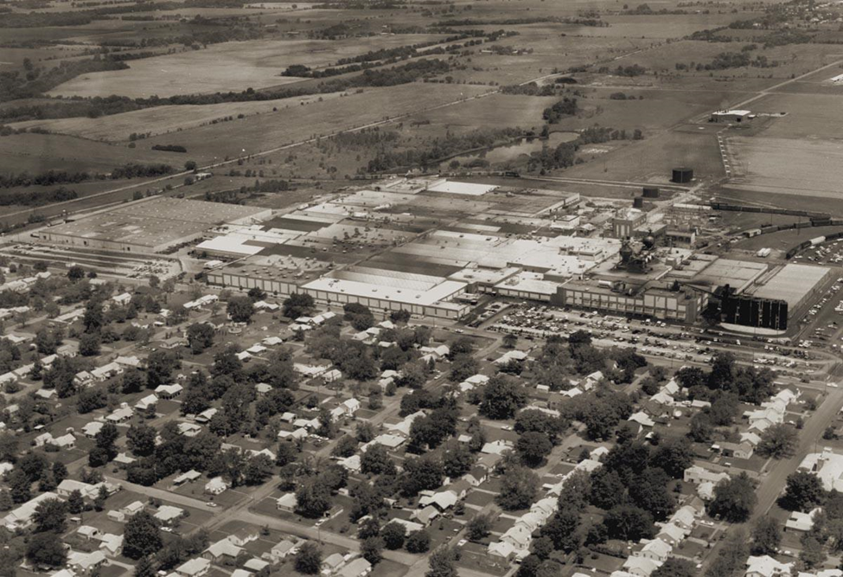
Figure 9 The Miami, OK B.F. Goodrich Tire Factory Prior to Closure in 1985
Source: (Rebecca Jim)

B.F. Goodrich and Tire Manufacturing
The B.F. Goodrich tire company itself, founded in 1869, was named after Dr. Benjamin Goodrich, a Civil War surgeon-turned businessman. He established his tire company in Akron, Ohio, after being offered $13,600 to relocate there from New York Ohio History Central (n.d.). While B.F. Goodrich’s corporate offices were in Akron, they operated several manufacturing plants around the United States. B.F. Goodrich was known for its tires for cars, trucks, offroad, earth-moving equipment, and farm vehicles. They also dabbled in the aviation industry. In fact, the tires on Charles Lindbergh’s plane used in the 1926 ocean crossing were made by B.F. Goodrich Okeson (2016). Although not as large as some of its competitors, B.F. Goodrich employed a massive workforce. In 1945, the year the Miami plant was opened, the company employed 55,500 workers Okeson (2016). The Miami plant was in operation 24 hours a day, 7 days a week. There were three shifts: morning, noon, and evening, which was more commonly known, the “graveyard shift.” When the plant closed in 1986, it “employed 1,900 people and had a payroll of $55 million” Luthy (2005). The large payroll supported much of Miami and Ottawa County’s economy.
In 1995, Michelin acquired B.F. Goodrich in a corporate merger, making Michelin one of the largest manufacturers of tires in the United States. Uniroyal B.F. Goodrich then made the transition from being an independent company to one of Michelin’s brands. As part of the transition, Michelin inherited all of B.F. Goodrich’s manufacturing plants Duhon (2006). This meant that all pollution responsibilities and remediation efforts fell on Michelin, and the Uniroyal B.F. Goodrich Corporation was no longer responsible. As a 1995 court case noted, “Defendants UGTC and Michelin own in part or whole the Defendant BFG, or otherwise exercise control over the actions of Defendant BFG and/or the subject property, or otherwise have assumed responsibility for environmental claims relating to the property” Petition for Injunctive Relief and Civil Penalties (1995). In other words, concerned citizens facing environmental issues would need to go through the Michelin Corporation instead of B.F. Goodrich.
Tire Manufacturing
To understand the origins of the environmental concerns stemming from tire manufacturing, it is necessary to understand the tire manufacturing process itself. While all tires begin their lives as stacks of rubber bales harvested from rubber trees, the next manufacturing steps taken depend on the type of tire which is being produced. The following demonstrates the production process for steel-belted tires, i.e., tires that have a metal ring inside of them (Figure 10). Steel belted tires are often used on farm equipment or other vehicles riding on rough terrain, as they are less susceptible to puncture.
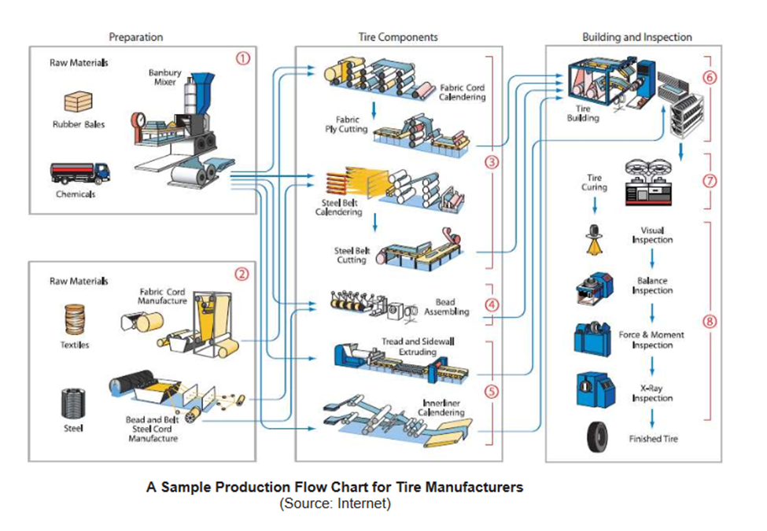
Figure 10 The tire manufacturing process.
Source: Rockwell Automation (2014)
The first step in the manufacturing process is to take raw material (rubber) and heat and mix it together with various types of chemicals and compounds (including carbon black, oils, and other additives) until it forms the desired consistency. The exact mixture used is considered a trade secret by many manufacturers. However, this mixture typically includes chemicals used for abrasion resistance (to help stop the tires from falling apart when rubbing on the surface of the road) and others depending on the use of the tire. In Miami, this mixing was done in a machine known as a Banbury Mixer After the mixture meets required safety and company standards, it is then “sent to machines for further processing into the sidewalls, treads or other parts of the tire” U.S. Tire Manufacturers Association (n.d.).
The next step is to build the tire. While these steps can fluctuate depending on the type of tire being constructed, typically the first item to be placed on the tire building machine is the innerliner, “a special rubber that is resistant to air and moisture penetration and takes the place of an inner tube” U.S. Tire Manufacturers Association (n.d.). After this, come the body plies and belts (often made from polyester and steel respectively). Plies and belts are an extremely important component in a tire because they, “give the tire strength while also providing flexibility” U.S. Tire Manufacturers Association (n.d.). Once the innerliner, body plies and belts have been assembled, it is time for the bead (bronze-coated strands of steel wire) to be manufactured. The bead is implanted into the sidewall (the side portion of the tire featuring tire information) and “assures an airtight fit with the rim of the wheel” U.S. Tire Manufacturers Association (n.d.). Finally, all the different sections are added together to create a “green” (uncured) tire. The U.S. Tire Manufacturers Association (n.d.) indicates that “the tread [the surface of the tire with groves in it) and sidewalls are put into position over the belt and body plies, and then all the parts are pressed firmly together.” Once this has been completed, curing can take place.
The final stage in the tire manufacturing process is curing or heating the tire to a specific temperature to bond all the components together. In this process, “the ‘green’ tire is placed inside a mold and inflated to press it against the mold, forming the tread and tire identification information on the sidewall” U.S. Tire Manufacturers Association (n.d.). Once the tire is inside the mold, the mold is then heated to an extremely high temperature. On average, tires are heated, “at more than 300 degrees Fahrenheit for twelve to fifteen minutes, vulcanizing it to bond the components and cure the rubber” U.S. Tire Manufacturers Association (n.d.).
At the Miami plant, benzene would often be added to the curing process. As molten rubber is extremely sticky, benzene would be sprayed in the interior of the mold prior to the addition of the green tire. It helped to ensure that the tire would not stick to the edges of the mold and be easier to remove. The curing time largely depends on the type of tire being produced. Passenger car tires can take twelve to fifteen minutes, but larger farm and tractor tires can take up to a day to cure U.S. Tire Manufacturers Association (n.d.). Once the tire has completed curing, quality control takes place. Tires are x-rayed, cut apart, road tested for flaws, submerged in water to check for leaks, or run through other tests to make sure that they are safe for usage. Once the tires pass these tests, they are either stored in large warehouses or shipped via truck or train car to various tire stores and facilities around the nation.
The B.F. Goodrich Miami plant produced a large variety of tires. The Dobson Historical Society’s exhibit on B.F. Goodrich details how “in addition to a full line of car tires, the Miami plant produced all sizes of truck and tractor tires and the largest tires ever made by Goodrich. These huge tires were off-the-road tires produced for the LeTourneau earth moving equipment. [The] tires measured 11 feet tall and weigh[ed] in at 7,000 pounds” Dobson Historical Society (n.d.). This tire production fueled Miami and Ottawa County’s economy for many years.

B.F. Goodrich in Miami, Oklahoma
As local legend has it, it was a twist of fate that led B.F. Goodrich to construct a tire factory in Miami, Oklahoma. Okeson (2016) reports the following origin story:
C.H. Mullendore, the acting executive director of the First National Bank [in Miami], read a survey in September 1943 sent by a Cleveland engineering firm that was looking for a site for a new industrial plant for an unnamed firm and dropped the letter in the trash. Mullendore later fished the papers out of the trash, reread the letter and called the Chamber of Commerce. B.F. Goodrich selected Miami over cities including Hutchinson, Kansas, and Dennison, Texas.

Upon securing approval from the Chamber of Commerce and The City of Miami, construction began on the plant in 1944 Okeson (2016). Miami was so excited to have B.F. Goodrich in the community that they provided an old pasture northwest of the city for them to build on (Figure 11). With construction complete, the plant began operating in 1945, continuing to function until February 28, 1986 Dobson Historical Society (n.d.).
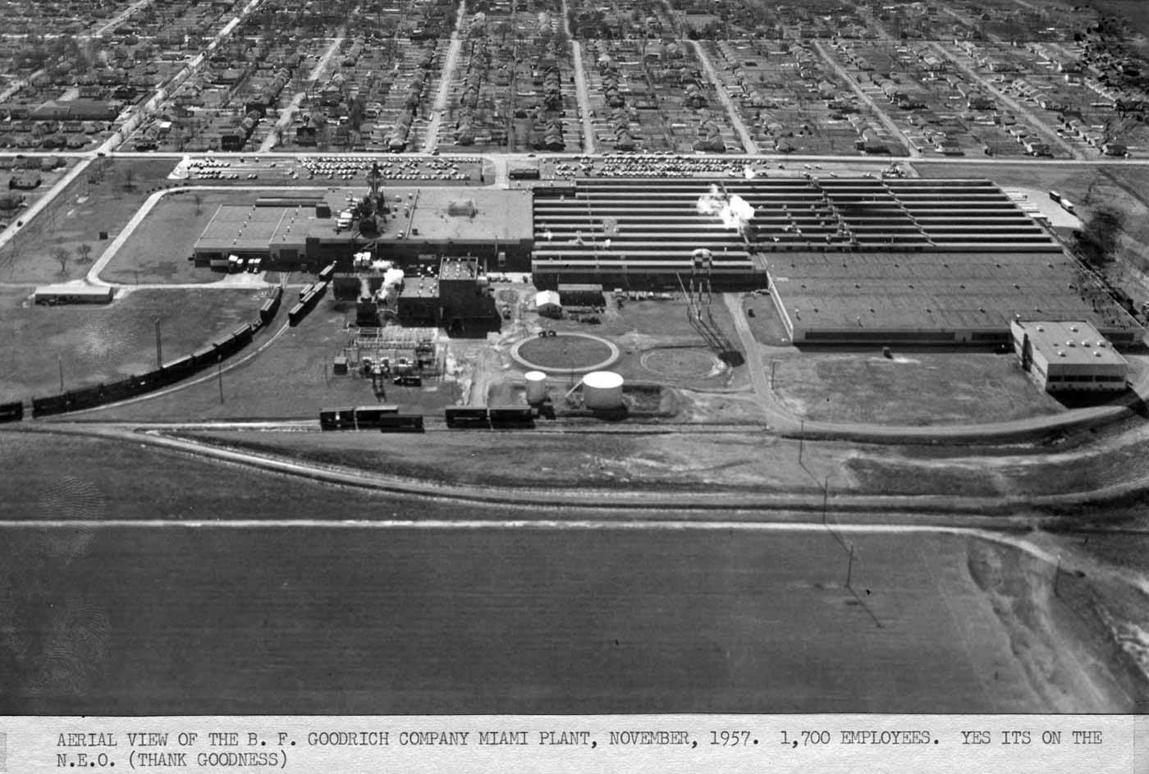
Figure 11 The Miami, OK B.F. Goodrich Tire Factory in 1957.
Source: Rebecca Jim
During these roughly forty years, the plant was in operation 24 hours a day, 7 days a week with a large workforce and numerous commuters. As the Dobson Museum notes, “At its peak, the Miami B.F. Goodrich plant employed nearly 2000 workers who commuted from all over northeast Oklahoma, southeast Kansas and southwest Missouri” Dobson Historical Society (n.d.) (Figure 12).
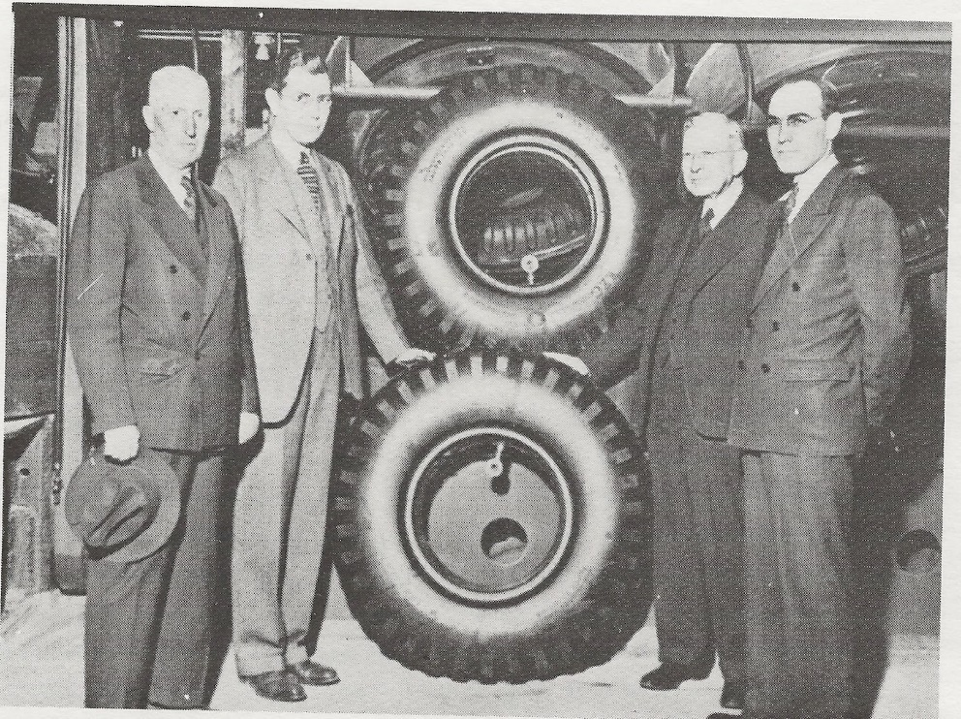
Figure 12 B.F. Goodrich Executives at the Miami Plant in November 1957
Source: Dobson Museum (1957)
Many applied for jobs at the plant because of the salary. The starting salary at the plant was $6.15/hour, which enabled workers to live a comfortable middle-class lifestyle Okeson (2016). As former tire builder Jerry Wyrik explained in his May 2022 interview, “[Working at B.F. Goodrich] was a good way to make a living, especially in this area.” Some workers left their other jobs to come and work at the plant because of the salary. In his August 4, 2016 interview with OSU, Charles Kirkendoll said he left his previous job at a bakery to work at B.F. Goodrich because, “[it] was more money, way more money” Finchum (2016). Others came to B.F. Goodrich from Picher once the Eagle-Picher Mine began to slow down. As John Mott noted in his 2012 interview, “My dad went to work at Goodrich the first of June, ’45 [because of the pay]. He quit driving his truck over there at the [mine]. He’d worked there for fifteen years” Wilson (2012). The influx of money from the plant helped local businesses as well. As long-time Ottawa County resident Dena Ander, owner of Anders Shoe Store in downtown Miami, recounted, “Oh, Goodrich that made our [business]. People spent. First started by trying to outdo each other. They’d buy cars, and they’d take vacations. They’d buy boats and homes. They had good money. Then when Goodrich left, we’ve had nothing since” Finchum and Bishop (2015). These quote illustrate the significant economic impact the B.F. Goodrich plant had on the region.
After many years of prosperity, the Miami plant faced increasing foreign competition and outdated infrastructure in the beginning of the 1980s. Foreign corporations with newer technologies were able to mass produce tires for far cheaper than B.F. Goodrich. For the first time in its history, workers and residents began to get the sense that major changes were on the horizon. The first signal that the plant might be in trouble came in November of 1981, when B.F. Goodrich laid off 1,800 hourly-paid production workers. Their justification for doing so was that it would help to “reduce inventory” Oklahoman (1981). Continued downward trends characterized tire manufacturing and demand in 1982-1984. Amid continued rumors of economic troubles, everything finally came to a head in 1985. In July that year RAFA, the plant was closed for a week due to “a weak tire market” AP News (1985). Concerns and rumors were building among employees, but executives and plant managers assured them that the Miami plant was not going to be permanently closed.
Less than one month later, however, Miami’s worst fears came true on a day that came to be known locally as “Black Friday.” At 7:15 am on August 23rd, employees were informed by executive George Brown that the plant would be closing for good in six months. It was an abrupt announcement as, “employees on the day shift were told first, meeting in small groups as they came to work” Nelson and Hayden (1985). Everyone was in complete shock at how quickly the plant was slated for closure, especially because less than a month earlier, everyone had been assured that it would continue operations. As Charles Rollins, president of the United Rubber Workers (URW) Union Local 318 described, “the announcement came as a complete surprise. It’s a real shock to our membership. There were no advance discussions about this move” Okeson (2016). For his role in the announcement, George Brown was dubbed “Shut ‘Em Down Brown,” a name that continues to be typically uttered in an undertone and with a few expletives thrown in Okeson (2016). The official reasoning for the closure was given as “loss of the market for farm machinery and foreign imports, [especially since] the Miami plant [was] the company’s only facility producing large tires” Nelson and Hayden (1985).
The closure of the plant made national news. A 1986 LA Times article on the closure reported how “Goodrich Tire Group President Robert A. Eisentrout said that the company has been losing money in the large-tire segments of the overall tire market, primarily because of depressed market conditions and the growing number of imports sold in the United States” LA Times Archives (1985). Eisentrout also mentioned how ”more than 50 percent of the off-the-road-tires and radial heavy-duty truck tires sold in the replacement market in this country are imported” AP News (1985). The closure of the plant followed closures experienced in other industries around the United States, especially in the steel and automotive industries.
Following the announcement about the Miami plant’s closure, panic quickly set in. A manager at the Goodrich credit union described how following the morning announcement, “employees had withdrawn more than $100,000 by mid-afternoon” Nelson and Hayden (1985). Regional and city officials were highly concerned about what the lingering economic impacts and job loss totals would be. When an industry closes, it is not just the workers who suffer. Other businesses and workers face hardship because no one has the money to spend to support these businesses. As Grover Phillips, industrial director for the Oklahoma Economic Development Department, explained, “Every time you create 100 jobs in that type of manufacturing, you actually create 164 places, 64 of them elsewhere. [Therefore], the loss in terms of real unemployment will be at least 3,100” Nelson and Hayden (1985). The closure was especially devastating because many employees had worked there for several years, were making a substantial salary, and were very close to retirement with benefits. As Jerry Wyrick articulated, “What made the closure worse, was that many of the employees had worked there for most of their lives, and were either very close to retiring, or were in the top pay scale.” Phillips detailed how the shutdown is, “going to be one of the largest closings we’ve had in Oklahoma in a long time [and that the] impact [will be] horrendous because many of the employees have worked at the plant all their lives and are at top scale” AP News (1985).
The emotional toll on workers losing long-held jobs was also evident. Many were angry that foreign competitors had taken their jobs. URW president Charley Rollins emphasized how, “[the American tire industry] is under attack by foreign imports and they are devouring us” Nelson and Hayden (1985). Others sank into depression. James Graves recalled in his interview how, “so many men, six I knew, committed suicide [because] all of a sudden they couldn’t pay for their car [or house].” Others became frantic at the thought of trying to find some way to meet bills and provide for their families. As a plant supervisor, Graves was often at the forefront of tough conversations with employees being laid off. As he described, “I’ve had men break down and cry. They didn’t know what they were going to do or how to handle it. They were going to lose everything they had.” Many workers were left with nowhere to turn and limited employment options.
January 10, 1986 is a day that many workers will remember for the rest of their lives. On this day, the knowledge that the plant was going to close became reality, as the first group of layoffs went into effect. For many in the region, it was extremely painful and emotional. Charley Rollins, president of the United Rubber Workers (URW) Local 318 union, tearfully described how, “when that first group of workers left for good on Jan. 10, it was like a spike being driven into your heart” Industry Week (1986, 52). As time progressed and increasing numbers of people found themselves without a job, B.F. Goodrich attempted to remedy the situation by setting up an employee assistance center. However, many were worried that it would be difficult to get another job because they had a limited skillset after building tires for most of their lives. Beverly Pierce, a Goodrich spokesperson said that, “many skilled workers, such as electricians and machinists, would be able to find jobs in other industries [but] it is doubtful [that] any of the employees would be relocated to the 44 other Goodrich plants in the U.S. and abroad” Nelson and Hayden (1985). There were a select few employees that were offered the opportunity to go to another B.F. Goodrich plant in Tuscaloosa, Alabama; however, many quickly left Alabama. Wyrick was one of these employees and he described how “originally, there were about 125 of us who went down there, but a few of them didn’t stay, a few of them just needed a couple of years to retire, and a few of their wives just couldn’t adjust to the life down there and they quit and came back.”
Following the closure, the ownership of the plant and property changed many times. In 1986, a group of investors started a joint-venture partnership with Uniroyal Tire Corporation and B.F. Goodrich, called Uniroyal Goodrich Tire Company (UGTC). As part of this venture, “tire business assets were transferred to UGTC, and the deed to the Miami property, the BFG tradename and non-tire business operations remained with BFG, which continued restructuring efforts under that name” Plaintiff’s Brief in Support of Motion for Injunctive Relief (1996, 2). This partnership was quite convenient for the B.F. Goodrich corporation, as it eliminated any liability (environmental and otherwise), kept a good reputation, and eliminated financial responsibility. In the agreement Plaintiff’s Brief in Support of Motion for Injunctive Relief (1996, 2),
UGTC agreed to assume and pay, perform, and discharge the obligations of the B.F. Goodrich Company, of every kind and description whether accrued, absolute or contingent, or whether existence on the date hereof or arising hereafter, relating to, or arising out of the Goodrich Tire business…including the Miami, Oklahoma Tire Plant formerly operated by Goodrich.

The agreement lasted for two years until the B.F. Goodrich corporation began to run into some financial concerns. In 1988, “BFG sold its 50% interest in UGTC to an investor group formed by Clayton and Dubilier” Plaintiff’s Brief in Support of Motion for Injunctive Relief (1996, 2). The B.F. Goodrich trademark and name remained, but B.F. Goodrich was no longer a corporation. In 1990, “Michelin [Tire Corporation] acquired UGTC” Plaintiff’s Brief in Support of Motion for Injunctive Relief (1996, 2). In 1995, the merger between UGTC and Michelin was completed. As a result of this acquisition, Michelin now retained the right to use the B.F. Goodrich trademark and name and was automatically responsible for any and all environmental concerns.
Prior to the Michelin acquisition, B.F. Goodrich decided to “donate” the Miami property to a charity as a “goodwill gesture” for ten dollars. The plant transferred ownership, “on September 16, 1993, [when] BFG ‘donated’ the Miami property for $10.00 to Foundation to Save Our Children’s Environment, Inc. (SOCE), a nonprofit corporation formed 12/92, whose President is Wayne Ford” Plaintiff’s Brief in Support of Motion for Injunctive Relief (1996, 2-3). However, the donation came with some stipulations from BFG. According to the donation agreement, “BFG retained possession and control of the building until March 16, 1994, for the purpose of completing the sale of equipment. Fixtures or equipment not sold and waiting shipment by 3/16/1994 went to SOCE/Ford” Plaintiff’s Brief in Support of Motion for Injunctive Relief (1996, 3). During this time SOCE conducted a “rip-and-run,” where they took all salvageable materials off, and left asbestos scattered everywhere. Wayne Ford and SOCE owned the plant for a couple of years until they went bankrupt from costs associated with court cases, asbestos cleanup, and site remediation Plaintiff’s Brief in Support of Motion for Injunctive Relief (1996, 2).
After SOCE foreclosed on the plant, it was purchased by “Ottawa Management Co., a Jonesboro, Ark.- based company that [bought] it in the mid-1990s” Balaban (2006). Ottawa Management Co. owned the plant until 2005. On May 12, 2005, “Allan and Wanda Kaspar of Nixa, Mo. purchased the former B.F. Goodrich plant for $2.85 million” Balaban (2006). The couple planned to use the remaining buildings as a warehouse area, but that plan never materialized. The length of time that the Kaspars owned the plant is unclear. There are hints in some of the documents of possible sales that fell through, but nothing definite has emerged. Eventually, the plant was sold in 2014 to George Blakeney with Alabama-based Real Estate Remediation, LLC. The company began to raze the plant in June 2014, with expected demolition of 75% of the site AP News (2014). The demolition process was completed, but Real Estate Remediation, LLC. fell behind on their taxes on the site. During my October 2022 visit to Miami, City Commissioner Mike Furness said that after repeated warnings and ultimate failure to pay taxes, ownership of the property was transferred back to the City of Miami. Today, the City owns part of the property, and the rest of it is owned by Miami Warehouse and Storage.

Working at B.F. Goodrich
Descriptions of day-to-day activities and stories of workers and residents are a vital component of my research. The following section recognizes this by delving a bit further into the personal work experiences of some interviewees to provide a glimpse of what life in Miami and at the factory was like. In addition to providing new details about how the plant operated, the interviews touch on the personal aspect of work and the connection people have to their jobs. During the interview sessions, people were excited to share what their first few years on the job were like, the friends they made, impactful events and accidents that occurred, and what happened after the plant closed. It is in these small details that the true story and lived experiences of B.F. Goodrich’s Miami plant emerge.
John Mott
John Mott started building truck tires on June 23, 1945, soon after the plant opened. Describing his first few days on the job, he said, “they allow you twenty-six days to learn to do the job. After seven days, I made my quota. I was drawing top money.” He also provided an interesting perspective of how the end of the war impacted American industry. He noted how “That year after the war, they shut those military truck tires down and started building commercial tires for the trucks on the road. Of course, we had to change over the factory, and while we were changing over, I built farm service tires, the big ones.” Mott also had the interesting opportunity to be a teacher for the influx of servicemen being hired after returning from the war. As he fondly recollected, “I was eighteen, and I was teaching these servicemen when they were getting out of the service to build truck tires. Boy, I worked for two years, working and teaching tire building. I could communicate with them and talk to them, but they weren’t used to an eighteen-year-old telling them what to do (laughs).” Mott also provided perspective into what it was like to build a truck tire and how hard the work was. As he detailed,
To build these truck tires, you have a drum, a big drum, and it’s running around. You have to take these bands and put it over that drum. You have to push a lever down, a foot pedal, and it starts that thing rolling. It starts off slow, and then you have to take that roller and put it in there, and you force that band onto that drum at high speed. It is kind of hairy.
Mott was especially proud of how he had mastered manufacturing many different types of tires, stating how “I’d do other things in the plant, so I learned to do everything like curing tires. I could work an extra shift somewhere [and learn something new]. When I left there, I could build passenger tires, truck tires, farm service, off-the-road, and cure tires also.” Mott’s story is especially interesting because it provides a glimpse into what working at the factory was like right after it opened.
James Graves
James Graves began working at the Miami Plant in 1972. He was originally hired in as a floor foreman but rose through the ranks to become a senior foreman. During his interview, he provided a perspective on the management and tire storage operations at the plant. The tire storage process itself was extremely complex. As he described,
We had tires stacked in the warehouse that were four palates high. We had to use a forklift to access them, and they would pick up two at a time. When the tires came into the warehouse, they had a staging area in the bay, especially for passenger tires. We tried to keep the same tires together in the warehouse, because we were paying shippers to go get them and load the train cars and trucks. A man would come down the ramp in the warehouse hauling tires two at a time, while another man would keypunch that particular tire. We keypunched everything until we filled up a storage module, then we’d go to the next one. The warehouse man would tell the keypunch operator, “Hey, that fills that bay up now.”
James was also able to provide insight on some of the steps B.F. Goodrich took to protect air quality. The tire curing process releases fumes which can be toxic in large quantities. As he noted, “a lot of people don’t know that tires, when they come to stores, to the warehouse, need to have their air quality checked continuously with air samples. The reason for this is that the tires are still curing from the actual rubber. And it’s still curing and still hot, and we’re storing 100,000 tires down here. So, it was very important that they do air samples.” As a floor manager, he had quite a few responsibilities and often worked overtime.
As head of all three shifts, I was responsible for all the foremen that worked there in the shipping warehouse. If I had a foreman sick, I’d go work half of whatever his shift was. Well, half of a shift at Goodrich wasn’t four hours. It was more, what with the paperwork I had to get done ahead of time, and I had to stay and close out everything. So many times, I would be there for 14, 16 hours. I also had to answer phone calls from companies who wanted to know how many tires were in that train car. When is it leaving? When will it get to its destination?
As a plant supervisor in the shipping warehouse, Graves needed to be in constant contact with corporate officials. This meant that he was one of the first people to learn about B.F. Goodrich’s planned closure of the Miami plant. During his interview, he was able to provide new details about the events leading up to the closure and the resulting aftermath. Graves recalled,
There was [a man] by the name of George Brown who was a vice-president at Goodrich. We nicknamed him ‘Shut ‘Em Down Brown’. He came to Miami, and we all had to go up to a meeting with the managers of each department in the plant. And Brown came and said that the plant was closing. But what was sad about the closing was that Goodrich was counseling people instead of finding them new jobs. Someone came to work out of high school, and all they ever knew how to do was build a tire. They didn’t know how to do anything else. When we started going downhill, and all the propaganda came out, Goodrich said that we were going to do great things. But our tire machines, heavy duty off the road stuff, were old. Michelin had brand new machines, new plants. And we couldn’t keep up with them.
James also describes how other companies could build tires faster and cheaper than B.F. Goodrich. A key indicator for the beginning of deindustrialization for many companies, not just the tire industry, was the fact that they could no longer produce goods in a cost-effective manner, often due to outdated machinery and/or foreign competition. A lack of profit meant that corners would need to be cut, resulting in plant closures and massive layoffs. James’ stories provide an example of upper plant management as well as a glimpse into the panic and despair that set in after the closure was announced.
Larry Tippit
Larry Tippit began by working as a tire builder at B.F. Goodrich but eventually became involved in tire research and development. When developing new tires, engineers would often send their build sheets and specifications to the tire builders to be constructed. Whenever Larry had some free time, he would start talking with the engineers who came to supervise the build. Eventually, they began to show him how they tested the tires. As he recalled,
I worked primarily as a builder on off-the-road tires, large off-the-road, small off-the-road, and farm service tires. At that time, they had no research and development engineers within the plant. When they had a test tire or an experimental tire to build, they would send the specs down to the engineer that had that tire line. Then they would gather the test components and oversee the build. Because I had some 'free time', (I had about six people working under me), those engineers would come down and they'd get me to go follow on their test builds. They actually taught me how to engineer those test builds. The engineers also had to check different aspects of the build or the compounds. To do so, they had to cut that tire up to analyze it. However, we developed a process using lead-based salts, which prevented us from having to cut open the tires. With this technique, we could take measurements on different aspects of the build on the tire by exposing those lead-based salts with X-ray.
Eventually, Larry’s work caught the eye of B.F. Goodrich executives, who needed a Research and Development engineer at the plant. They posted the job three times, and Larry applied for each one, but he was rejected because he did not meet the educational requirements - an engineering degree. There was a high turnover rate and B.F. Goodrich needed someone to fill in, so he was offered the job.
After a few years, I got so involved that Akron decided they needed a full-time research and development engineer in-house. They posted the job and I applied for it. When I was interviewed, they said, "You do not have an engineering degree and the job requires a bachelor’s degree in engineering”. They hired a guy right out of college, and they brought him to my plant, and they put him with me for 90 days to train. He lasted a year, and he went on to bigger and better things. They posted the job again and I applied for it the second time. I was told the same thing, "You don't have an engineering degree." They hired another guy, and they brought him down and put him with me for 90 days to train. He lasted a little over a year and he went on to bigger and better things. When they posted the job the third time I said, "The heck with it." They called me and asked me if I would fill in until they found someone for the position. My supervisor said, "It can't hurt your resume if you would." I responded, "Well, do you know what? I feel mad about it because I've tried to apply for the job and they told me they couldn't use me, and now they want me to fill in until they can hire somebody." He said, "You need to think about it because it'll help your resume." I finally agreed to take it.
Larry thoroughly enjoyed working on tire design and had many accomplishments. One of his keystone moments was working on the 3651 tire (the largest tire being built at B.F Goodrich, at 13 feet tall and 6,200 pounds). As Larry’s success continued, B.F. Goodrich executives began to take notice and give him other projects. While they could not promote him to the engineering position, they compensated him in other ways, including paying him to travel around the U.S. looking at mining equipment tires.
At that time, Yokohama Tire (one of our competitors) was the target tire (the one that was able to run for the longest amount of time and provide the best service). We were asked to analyze that tire, which was one of the first projects I had. After about six months, the tires we were building became the target tire. B.F. Goodrich needed to fill the tire testing position so a vice president from BF Goodrich flew down to Miami on a corporate jet and asked me if I would take the job. He called me and said, "I can't hire you as an engineer, but I can hire you at the highest rate as a technician, and I will make up the difference in salary in other ways." I took the job and I worked for about five years as an R&D engineer on a technician basis, but he did what he said. He would send me out to different mines for a week to test the tires that we built. He would tell me, “You’re going to go and inspect the tires in this mine” or, “I’m going to bring you to Akron and we're going to put you through a compounding, fabric, or construction course." To test the tires on the mine equipment, we'd put the tires on the machinery until they either went through failure or ran for a certain number of hours. Once these requirements were met, we'd bring them back in and cut them up and analyze them. My job was to go to the mine and check wear patterns, hot fractures, cracks, or wear on compounds, or whatever it took. It was very interesting.
When the plant closure was announced, it devastated the workforce because many were close to retiring and now had to start over. Jerry’s story is unusual because he found a way to finish his tenure with B.F. Goodrich and receive full retirement benefits. As he was friends with his supervisor in Akron, he went over the heads of Miami officials and stayed for nine days past the official closing date.
Whenever they announced the plant was going to be shut down, I was two or three weeks shy of having my retirement tenured. And so, I called my supervisor in Akron. I can't think of his name... I asked him, "Is there any way I can stay and make sure that my retirement is tenured?" He said, "I'll make sure that we get that done." He did. He kept me 9 days past the closing date. It was funny because corners were being cut (to make things faster), but then Miami plant leadership called me into the office to request that I didn’t go over their head.
Following the plant closure, Jerry transitioned from tire manufacturing to horses. As he would need to compete with everyone looking for a new job, Jerry figured it was best to find something that he and his wife both enjoyed and were knowledgeable about. This turned out to be horses. As he explained, “when Goodrich shut down, my wife was very upset; she said, ‘What are we going to do?’ I said, ‘Well, there's going to be 2,100 other guys on the sidewalks looking for jobs. Let's do something we like to do.’ She was raised with horses, and I put myself though school shoeing horses. I said, “Let's go into the horse business.” Larry’s stories provide information on an unusual hiring path and insight into manufacturing processes at B.F. Goodrich.
Fredas Cook
Fredas Cook is a long-time Ottawa County resident. He grew up in Cardin, Oklahoma, a town very close to the former EaglePicher Mine and Tar Creek Superfund Site. He made his career at B.F. Goodrich building tires. He began work on August 9, 1965, and worked his way up through the ranks to become a foreman. When the plant closed in 1986, he was one of the last ones to leave. During his interview, Fredas provided information about working conditions at the plant. An item that stuck with him throughout his time at B.F. Goodrich, was the excessive heat he had to deal with, especially during the summer months. As he described,
I thought I had been hot before that, but I hadn't. It was miserable working conditions. Mm-hmm. And then if you go into the place where curing occurs, it gets even worse. There's steam coming from the curing machines and that mixes with the hot air from outside, making it even hotter. Oh yeah, it was well over a hundred degrees in there.
In addition to the heat, Fredas also had to work the night shift at the factory. The night shift is often one of the worst shifts to work because it is hard for the body to adjust to working throughout the night and then having to find some way to block out the light coming from the windows to be able to sleep.
I worked all three shifts in different times in different positions, but yeah, the night shift was the worst. I had to put tin foil on the windows to keep the light out, so it was mostly dark. Working the night shift really took a toll on my body.
With observations such as this one, former workers provide us with further insight on what it was like to work different shifts, adding to our understanding of the embodied work experience at the plant.
Dale Taylor
Dale Taylor’s story at B.F. Goodrich began when he got out of the army. He knew a couple of people who worked there--his family had worked at the plant for decades--and he was given a military hiring preference. He asked some of his buddies if they were able to get him in and they did. However, he soon discovered that he did not like factory work and left after about a year. As he recalled,
My dad worked at the plant, my father-in-law worked there 40-something years, and I knew quite a few people who worked there. I asked to see if my friends could get me in and they did. I got the call from Goodrich and went to work. I had just gotten out of the army, and they kind of gave you a little bit of preference if you had been in the service. I worked for Goodrich for about a year, until they had a big layoff of hundreds of people.
Dale also described how challenging the job was. He was hired as a tire builder for model farm fronts (the very small tires on the front of some tractors), but he did not like it at all.
It's a very hard job. My job was to build 40’s (model farm fronts), which were little bitty tractor tires. I had to build 109 of them every night. I don't and didn’t like factory work. That's how come I got out of it when they started laying people off. I hated it.
Similar to Fredas, Dale recounted how miserably hot the plant was during the summers, especially near the curing room. He would work the 4 pm-midnight shift, and he was right by the curing area, which was one of the hottest parts of the plant. He would often be dripping with sweat by the time he headed back to his car at the end of the night.
I worked the evening shift, from 4:00 to midnight. During the summer months, when it gets very hot, the inside of the plant by the curing machines was almost unbearable. They cured those tires with heat, and my machine was right by the curing area. Many nights, I would walk from the parking lot to my machine or the machine to my car, and I would be totally soaked by the time I got back there. It was so hot. It was absolutely miserable.
Dale’s interview describes the working conditions in the plant throughout various times of the year, as well as the hiring process for veterans returning from the war. Stifling heat in the summer would have made it extremely challenging to work and would cause further strain on a body already facing hazardous working conditions.
Jerry Wyrick
Jerry Wyrick worked as a B.F. Goodrich stockroom worker and tire builder. He began his career there on August 14, 1963, and worked until they closed in 1986. When the plant closed, he was transferred to Tuscaloosa, Alabama, where he worked for ten years until his retirement was finalized. As he worked at the plant for close to 20 years, he was knowledgeable about different departments and processes of tire manufacturing. He knew exactly where events took place, the different shifts at the plant, and how the hiring process worked. Jerry began by working as a stockboy and tire builder. As he detailed,
When I hired on, there were five departments: small OTR (off-the-road), large OTR, farm service, passenger tires, and heavy-duty (truck tires). I wasn't the only stock boy. I just did 8060 and small OTR. I worked third shift (the graveyard shift) for many years. The graveyard shift was from midnight to eight o'clock in the morning. We were allowed to clock in about 15 minutes before shift time.
Jerry also discussed additional details related to the hiring process. There were certain jobs that were far more desirable than others. Desirable jobs often included “clean” ones such as plant management, stockroom detail, and the shipping department. Undesirable jobs were the “dirty” and “hot” ones such as curing, tire building, or working over in the carbon black section. Seniority often decided job assignments, i.e., the longer one had worked at the plant, the greater the likelihood of attaining a desirable position. As Jerry explained,
Hiring at B.F. Goodrich was all based on seniority. How this process worked was that you found a job that you wanted to bid on. You would place your bid, and if you were the most senior person, you were the one who got it. There were a bunch of crappy jobs that nobody wanted. Curing was one of these jobs. I took a job in the curing department to stay on the day shift one time. It was horrible, hot, and dirty.
Jerry was also knowledgeable about what being a B.F. Goodrich tire builder entailed. His work experience and stories augmented the stories of other tire builders, such as Fredas Cook, to provide a clearer picture of the tire building department. One of the items that Jerry mentioned a couple of times was the payment process. There were two different types of payment at the plant: salary and piece work. Salaried work was typically paid on an hourly basis and was reserved for the upper levels of plant management. More common was what was known as piecework, i.e., getting paid a specific rate for every item built. As Jerry explained during his interview,
Normally, a salaried rate at Goodrich meant bosses and similar upper-level management. When I was a stockboy, I received an average salary. I wasn’t a boss, but I received a flat rate because I had no control over how much I was allowed to make. Now, when I went to tire building, it was piece work. This was sometimes an unfair system because certain tires took a lot longer to build and cure than others. Some tires would take me four hours to build, while I could build four of another type of tire in one hour. You might only work on one tire your whole shift, which meant that you would only be paid for that one tire.
Jerry also provided additional details on what took place in the curing department. He described feeling very rushed sometimes because if one tire was curing, the cureman needed to have the next one lined up and ready to be put into the machine.
In the curing room, there were these massive steam domes. They opened up and you put the green tire in there and it came down and shaped the tire. The presses in these molds were extremely hot. When the tires came out of the press, they were too hot to handle. You had to wear gloves. Over in large OTR, they had pot heaters, which could fit three or four different molds at one time. Some of the tires in these molds were in there for 12-16 hours. While the green tires were curing, you had to get the next round of tires ready. You needed to make sure that everything was lined up, so that when you pulled out the completed tires, you had more to put in.
Jerry’s knowledge of the different parts and location of departments also provided input to the digital map of the plant and an overview of the location of events and the general layout of the tire plan.
Over at the east end was where they stored all of the components (carbon black, oils, acids, and others) that they used together to create the fabric for the tires. This was an extremely dirty portion of the plant. The people who worked in this section had to wear coveralls because carbon black got everywhere. Part of this area had two levels. The maintenance shop was on the lower level and the plant manager’s offices were upstairs. The northeastern corner of the plant housed the incinerator. It was almost completely off of the property and serves as a transfer station now. The western part of the plant was where all of the warehouses were located. One of the warehouses is still standing down there, and I believe it is currently being used by a trucking company.
When the plant closed in 1986, Jerry was about ten years out from retiring with full benefits. Jerry’s supervisor asked him if he would be willing to move down to the plant in Tuscaloosa to work until he met the retirement requirements. Jerry accepted and he and his wife moved to Alabama with a few others. Many of the people who relocated to Tuscaloosa soon left because they either retired or because they did not like the climate. Jerry, however, stayed at the plant for ten years until he retired. In Tuscaloosa, he transferred from building off-the-road tires to passenger tires. He enjoyed working in Alabama because it was cooler than in Miami. It was not extremely cold, but B.F. Goodrich found that their materials worked better if they were colder.
In Miami, I was responsible for building off-the-road tires. When I went to Alabama, I had to build passenger tires. B.F. Goodrich finally figured out in Alabama that if they kept it somewhat of a constant temperature, their material worked better. I'm not telling you it was air-conditioned when I left there, but it was a lot cooler than here in Miami.

Jerry’s recollections fill in gaps in information from other interviews. For example, he provided a thorough explanation of how salary varied among individuals.
Accidents at the Plant
Many interviewees mentioned how dangerous tire construction and storage can be. There were several stories of accidents and near misses that interviewees had witnessed or heard about during their time at the plant. John Mott described how his spear bar got stuck in a machine and threw him around. As he recalled,
These ladies that were building the bands were supposed to cement them together where they wouldn’t come apart. This one lady didn’t use her cement like she was supposed to. When I stuck the tire into the machine, my spear bar got caught between the bands. There I was, going up and down, and I got my wings that day (laughs). It didn’t hurt me, but, boy, I learned a lot in that minute.
James Graves had similar stories to share. One of the key items he mentioned was hearing loss resulting from the excessive noise of constantly running machinery. As he detailed,
The noise levels in the plant were tremendous. I had 37 tractors down there running 24 hours a day, seven days a week. Also, there was noise from shipping and warehousing operations. You have to realize that it is a lot of noise. A lot of people didn’t like to wear safety devices like hearing aids. And I was one of them, because if I could run from my shipping office and be back in 10 minutes, I wouldn’t bother to put hearing protection in. However, sometimes I’d get down there and it would take a lot longer because somebody else had something new to take care of. What was really sad though, was that Goodrich had you checked for hearing, but it wasn’t really an accurate test. When you went into a clinic, they would talk really loudly so you could hear them. Then they would tell you that your hearing was fine.
James also mentioned how B.F. Goodrich was a dangerous and sometimes deadly place to work. As he noted, “one of the things you find out when you work at Goodrich for a while, is that they’re not a company that has a lot of people that retire from there. Because they don’t live long enough to do so.” This quote clearly illustrates what a dangerous job factory life could be. Many people joined B.F. Goodrich because it was a way to make a good living. However, few of these workers were aware of the toll that their work would take on their bodies.
Larry Tippit described a couple of accidents in his interview, some of which were deadly. The first item he detailed was how people were at risk of being scalded from the hot water inside of the pot heaters as part of the tire curing process. Finished tires would sometimes come out of the pot heaters with massive blisters on them. If people popped them, the water would immediately turn to steam and burn.
Tires were cured in pot heaters stacked on top of each other. The water inside was between 272 -278 degrees and under pressure. What would happen is that the water bag would bust, and that water under pressure would be forced out into the rubber. This created a tire with blisters on it. If it had blisters on it, and you busted one of them, it’d scald you. The water would just immediately turn to steam. I had two friends that were killed that way. The tire came out and it had blisters on it, and they were standing over it. One of them punctured it with an awl and it scalded both of them, and they both died. Then my supervisor at that time, Harry Matthews, did the same thing. He punctured a blister on a tire. It scalded his chest. He was in the hospital for an extended period of time.
Larry also recounted another incident where a tire almost crushed him to death. As the tires he was working on were extremely large and heavy, there was great danger if one fell over. One day, when he was inspecting one, it fell off the mechanism designed to hold it, fell onto his body, and crushed two of the discs in his back. He recalled how,
One day, I was inspecting a field engineering tire that I had built. It was leaning against the rail. It was a 3651. That was the big tire. I was checking the liner splice in it. Across the way from me, an SQC man (quality control), had picked up a 2100 tire on a jack stacker. The job of the jack stacker was to pick the tire up and raise it off the ground while the SQC inspected it. The snout on it rotated, so the tire would rotate, and he could inspect it with a flashlight. Anyway, on that day, I'm behind that 2100, looking at the 3651. That jack stacker is supposed to have a safety plate on the end of the snout so the tire can't come off. This jack stacker didn't have that safety plate on it. I'm inspecting the tire and I hear somebody yell, "Look out!" I started to turn to my left, and that 2100 fell off of that jack stacker and it crushed me from the small of my back, to my knees – against that other tire, bang! They quickly got that tire off of me. I was down on the floor. I said, "Okay. I'm going to give you your emergency evacuation course, right now!" I talked him through how to put me on the backboard and get me out of there. I had two crushed discs.
Thankfully, Larry was not killed when the tire fell on him, but his story provides further evidence of how dangerous working around tires can be.
Jerry Wyrick also mentioned the excessive levels of noise and the dangers of the hot steam, especially if a tire mold blew a gasket. While steam leaks were one of the major sources of noise in the plant (steam was transported around the factory in piping), they were not the only ones. There was a buildup of different noises that created a deafening roar. As he described,
It was just a multitude of different noises and when you got them all together, it was deafening. They came from everywhere. If I dropped a wrench; it made noise. There was a conveyor belt throttle that made a lot of noise. There were cracks in the floor that forklifts would run over, and they bounced up and down. Along with the noise, there was the danger of hot steam, especially if one of the molds blew a gasket. Each mold had a rubber gasket around it, and if that gasket got old, there would be so much pressure that it might blow a hole through the mold. Steam would come out and it would be extremely loud. You did not want to get near the steam because it would burn and boil your skin.
Rebecca Jim, our research partner, also described the loud noise of the plant. She worked for many years as a school counselor at Will Rodgers High School in Miami. Throughout the year, students and staff at the school could hear the noise from the plant. As she detailed, “I worked at Will Rogers, which was about a block away from the plant. You could hear the noise of the plant from the school.” The plant operated 24 hours a day, 365 days a year, which meant that the noise was non-stop.
In addition to providing new details about how the plant operated, the interviews touched on the personal aspect of work and the connection people have to their jobs. A job is a livelihood and way to support a family, but it is also a place where people spend a large portion of their lives. From these people, we can learn more about salary, the hiring process, how to build a tire, what accidents occurred, and many others. It is in these small details that the true story and lived experiences of B.F. Goodrich’s Miami plant come to life.

Areas of Concern
The 1986 plant closure was disastrous for several reasons. In addition to devastating the regional economy, causing societal turmoil, and altering the work landscape of Miami and Ottawa County, the closure also took an environmental toll. As mentioned above, tire manufacturing uses a variety of different compounds. A June 1991 site report provides further elaboration on how many toxic and non-toxic substances were stored and used during manufacturing in Miami. Waldemar S. Nelson and Company (1991a, 1) detail how
The primary raw materials used by BFG during tire manufacturing were blocks of raw rubber (natural and synthetic), sulfur, zinc oxide, carbon black and organic acids. These materials were blended and mixed in the manufacturing process to meet specific recipes for rubber compounds. The materials were used as liquids and dry goods. Raw materials were stored in dry sacks, drums, above and below ground storage tanks, and large dispensing hoppers.
Prior to the closure, some workers were aware that the substances they were being exposed to at work were potentially toxic. However, in the years immediately following the shutdown, residents and former workers began to become increasingly concerned about the lingering toxins on the site. Miami residents knew that the plant was causing health concerns, especially after many workers were given medical cards stating that they had worked at B.F. Goodrich, which made it easier for doctors to identify the root causes of medical problems. As the years progressed and the plant changed ownership, the environmental hazards at the plant became increasingly notable and concerning. In addition to lingering contaminants, new worries from failed remediation efforts emerged. Both the interviews and numerous other documents detail a variety of environmental issues at the plant. Five main areas of concern emerged: benzene, asbestos, carbon black, underground storage tanks (USTs), and the solid waste disposal site/incinerator.
Concern #1: Benzene
In recent years, the usage of benzene in an industrial setting has decreased due to its classification as a carcinogen. The United States Environmental Protection Agency (EPA) recognizes benzene as a Class A carcinogen, which means that they are certain that the chemical causes cancer in humans and animals Petition for Injunctive Relief and Civil Penalties (1995, 5-6). However, Benzene can still be found in a number of household products including but not limited to: glue, paint, furniture wax, and some dry shampoos. Exposure to benzene for extended time periods (greater than one year) is known to lead to a variety of health concerns, especially in terms of blood-related processes and cancers. Benzene directly targets the immune system. It causes, “harmful effects on the bone marrow and a decrease in red blood cells, leading to anemia. It can also lead to excessive bleeding and can affect the immune system, increasing the chance for infection” Petition for Injunctive Relief and Civil Penalties (1995). Furthermore, as mentioned above, benzene is a known carcinogen: “The International Agency for Research on Cancer (IARC)…notes that benzene exposure has been linked with acute lymphocytic leukemia, chronic lymphocytic leukemia, multiple myeloma, and non-Hodgkins’s lymphoma” Petition for Injunctive Relief and Civil Penalties (1995). Many of these cancers are chronic, meaning that they are uncurable (they will never go away).
Benzene plumes are one of, if not the largest, issues impacting the remediation of the former B.F. Goodrich plant. The substance can be described as, “a natural constituent of crude oil and an organic chemical liquid compound that is either colorless or light yellow, highly flammable, and has a sweet smell” Miami News-Record (2014). Benzene was often used in the manufacturing process at the Miami plant. One of the most frequent applications was at the tire molds themselves. Freshly mixed rubber was often very sticky and would adhere to the molds and the hands of the workers removing the tires. To reduce the stickiness, benzene would be applied inside of the machine and to the arms and hands of workers. As former worker Larry Tippit explained, “tire builders did everything but bathe in it. In fact, we washed our hands with it at the end of each shift.” Dale Taylor also mentioned how benzene was used to fix mistakes while building tires. At every machine there was, “a five-gallon bucket that was used to fix mistakes. If you stuck a part of the tread on wrong, you’d have to use benzene to help pull it apart to redo it. Every night, we washed up with benzene because that was the only thing that would take the rubber off. Everybody did it for years and years.” Additionally, excess benzene was sometimes disposed of directly into the street via the storm drain. Rebecca Jim mentioned how former workers told her that people at the end of their shifts would take buckets of benzene and dump them down the storm drainage system. Some would also dump it outside near the solid waste disposal.
Several people with whom I spoke or who interviewed with the Miami News-Record newspaper described how benzene personally impacted either their health or that of a family member. Many workers mentioned how they noticed skin irritation from the benzene. Larry Tippit recalled how,
I knew one man who had to work days in order to support his daughter after his wife died in a plane crash at the end of Goodrich Boulevard. The only job that would guarantee him days was building tires, and his hands were terrible from the benzene. His skin looked like a leper or something. I and another foreman tried and tried to get him to take another job, but he always refused because he was worried he would lose his job. Yeah, benzene would make your skin peel.

In addition to the skin concerns Larry mentioned, other workers were diagnosed with cancers likely due to their exposure to benzene. Dale Taylor was diagnosed with kidney cancer. He said, “I’ve lost a kidney from the cancer. There’s benzene at the plant and I think it was probably the benzene that caused my cancer.” Workers with cancer often had to try and find some way to pay for the costs of their treatment because they did not have health insurance; when the plant closed all benefits went with it. This creates an additional burden to handle.
Benzene in the working environment was not the sole source of contamination in and around the B.F. Goodrich plant. Within the last couple of decades, benzene has been discovered in the groundwater, likely from an old underground storage tank that had leaked during a hurried removal after the plant closed in 1986. Benzene contamination at the site began to become a notable environmental problem for the State of Oklahoma during monitoring in 2009, when it was discovered that an underground storage tank had ruptured, spilling it into the ground. ODEQ found benzene, “during routine monitoring at the plant. Tests in October revealed benzene had seeped into ground water south of the plant” Miami News-Record (2010). However, resident concerns began long before the official discovery in 2009. The unease around benzene began in 1986 with the removal of corroded storage tanks visibly leaking their contents. During a November 1994 site inspection, Terry Butterfield, a former Miami B.F. Goodrich plant manager, described in detail how in 1986, “underground storage tanks (containing solvents [such as benzene]) were pulled from underground. Some were leaking. They had to pump water in order to get rid of the fumes” Deposition Exhibit #1: Site Inspection (1994).
As ODEQ refused to acknowledge or act on concerns around benzene in the groundwater, desperate residents reached out to Congressman Mike Synar in 1988 with complaints about groundwater contamination US EPA (1988). After repeated testing in the following decades, benzene was confirmed to be present. Miami News-Record (2015) reported that “the benzene present in the groundwater is confined to a one to five feet thick permeable sand and gravel layer. This permeable layer generally extends from a depth of approximately 14 to 24 feet below ground surface.” The permeability of the layer to which the benzene is currently located means that it can easily continue to move deeper into the soil and contaminate further aquifers (Figure 13).
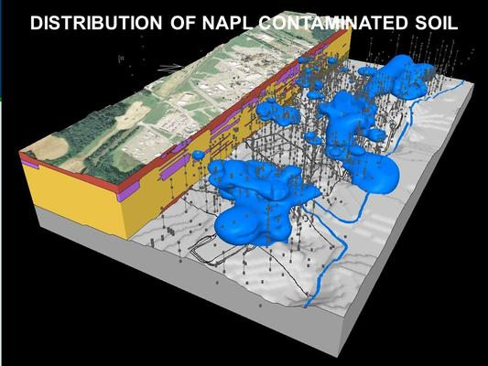
Figure 13 A map of the soil contaminated with Benzene (a non-aqueous phase liquid (NAPL)
Source: (Rebecca Jim, 2021)
In addition to groundwater contamination, residents living close to the plant or homes with basements, crawl spaces, tornado shelters, or other underground structures are at risk of buildup from benzene fumes. As Don Davis, a project manager for remediation company URS explained, “underground structures could pose a hazard because benzene vapors could build up in a basement or cellar” Miami News-Record (2010). As underground structures are usually not well-ventilated, fumes are given time to accumulate to dangerous levels. Unaware persons are then exposed to high levels of contamination, increasing their risk of health implications such as cancer. When health issues eventually emerged from exposure, it resulted in job loss and further aggravation of an already terrible situation. As long-time Miami resident and Miami Heights Subdivision homeowner described, “we were never made aware of the dangers lurking in the contaminated groundwater. My wife has had a lot of medical diagnosis and tests and everything and a lot of it has been linked to over exposure to benzene; it’s cost her her job” Utecht (2017). Not only do residents need to worry about the health concerns stemming from their living environments, but they also must face the corresponding job loss that occurs when working is no longer feasible due to poor health.
The existence of benzene on the factory site can also decrease the value of neighboring homes, making it harder for resale and investment. The 1995 Michelin Court Petition explained how, “the existence of benzene further poses a serious risk to the property of Plaintiffs as well as others, rendering it less useful and/or decreasing its value.” Petition for Injunctive Relief and Civil Penalties (1995). Many who purchased homes in this region were not aware of the issue. Once they expressed concern, they were informed that they were no longer eligible for compensation or help of any sort. On a sunny Saturday afternoon in October of 2022 during a trip to Miami, I had the opportunity to have a conversation with a nearby resident who described this issue in detail. Martin, (Rebecca Jim’s co-worker), Rebecca Jim, and I were walking along the outside of the fencing surrounding the plant, and I was taking pictures. Noticing that the gates were open (they are usually closed because of the danger of open pits), a nearby homeowner drove by in his truck. Seeing us, he pulled up and asked if we were thinking of buying the site. I said no and began to talk about my thesis project and that I was a student at the University of Oklahoma. As we chatted, he mentioned that he had purchased his first home in the Miami Heights Subdivision (neighborhood right next to the plant) about three years ago, but no one had told him about the benzene contamination. Neighbors said that he was too late to get in on the compensation, so he should just keep his mouth shut and not let his kids play in the dirt. “Don’t let them play in the dirt, '' he said, shaking his head in disbelief, “they're kids, I can’t keep them out of the dirt!” He also mentioned how he had noticed an oily shine on the surface of the water in his sump pump. He expressed frustration that no one had told him about the benzene. Had he known, he probably would never have purchased the house. He was now stuck because he could not afford to buy a new one. A simple home purchase then became a compounding issue because in addition to taking a loss on his home, he now the additional burden of worrying about the safety and health of himself and his children.
The class-action lawsuit in question was filed in 2017 against Michelin/BFG by 112 residents who lived or formerly lived in the Miami Heights Housing Subdivision across from the B.F. Goodrich plant. Former worker and resident Dale Taylor was one of the people who initiated the lawsuit. He described how underhanded and cold the entire process was. As Dale explained,
We took them to court. I was the start of it. It began when an attorney from Oklahoma City beat on my door one night, and he described the issue and the potential for compensation. I said that I was interested, and we began pulling other residents on board. We got most of the neighborhood involved, but the case dragged on for years. We got a settlement, but it wasn’t enough. Many people that were a part of the lawsuit were cut out. Michelin used the shabby excuse that they weren’t close enough, or this or that. At the end, a lot of people who thought they were going to get money didn’t because they missed being in the area of concern by a couple of feet.

One issue that has caught the attention of former workers such as Dale, is just how ruthless Michelin was during the case. On the flipside of that experience, they feel that all Michelin cared about was meeting the bottom line and avoiding having to pay residents, instead of caring about what they had already gone through or health concerns that they had.
Well, I learned one thing from filing a lawsuit against a big corporation, the job of their attorneys was to ensure that they did not have to pay us. They flew attorneys to Miami specifically to fight against us. Basically, anything our attorneys brought up; they had a fallback for. We just didn't feel like it was really done right. Michelin was ruthless. I just hated going through that deal.
Many former workers are convinced that Michelin used every avenue to avoid paying restitution. Also, according to community lore, many members in the communities signed “gag order” documents and can no longer discuss benzene. Whether or not this is indeed the case, what really matters is how many community members perceive a lack of agency and lack faith in the ability to challenge large corporations.
Once benzene was confirmed, residents and the City of Miami began to place increased pressure on ODEQ and Michelin to create a plan to remediate the benzene. Several site visits by the DEQ in the 1990s enhanced this. During a 1994 tour, former manager Terry Butterfield put a match to a soil sample contaminated with benzene; and it burned for ten minutes Deposition Exhibit #1: Site Inspection (1994). Afterwards, officials renewed pressure. In the early months, Michelin stalled for as long as possible, trying to delay action. They hired contractors who claimed that the benzene issue was not really that bad, or that benzene had no way of getting into the drinking water. City officials became increasingly frustrated with the inaction and accused Michelin of stalling efforts in an attempt to not have to pay Duhon (2006). Officials eventually gave Michelin an ultimate deadline of August 11, 2006, to have a workplan submitted to the City and the State. City attorney Erik Johnson noted that,
Michelin said it will have a response by Aug. 11, leaving city and state officials little time to maneuver before the statute of limitations holding Michelin responsible expires. The delay continues to be the latest in a series of “stall tactics” by Michelin. I will know on Aug. 11 whether Michelin is truly with us and acting in good faith or if they want to continue playing games with this serious situation Duhon (2006).
As it turned out, Michelin did not submit their workplan until July of 2007. Once it was approved, remediation efforts began on the site, and they continue to this day. “Contaminated soil was excavated from the former underground storage tank pit in 2007” and the OKDEQ approved the workplan on “August 3, 2007” Miami News-Record (2014). On March 15, 2010, “the Groundwater Remediation Work Plan prepared by United Research Services (URS), the contractor Michelin hired, was accepted Miami News-Record (2014). Remediation efforts then proceeded for several years. In 2013, an amendment specifying progress and new concerns, “was added to the Settlement Agreement on September 25, 2013” Miami News-Record (2014). In the years following 2013, Michelin developed a new remediation plan to monitor the movement of benzene plumes through the groundwater. In 2014, Michelin and the DEQ developed a new remediation plan that, “proposes putting in additional wells at the site and injecting different chemicals to mitigate the compounds. They plan to put in 14 injection wells starting in 2015 and to monitor them for three years. They will also close specific monitoring wells where the concentrations have diminished” Miami News-Record (2014). These monitoring wells were installed in 2015 and continue to be monitored somewhat regularly.
Remediation work was limited during the COVID-19 pandemic, but in January 2021, Michelin and the ODEQ came together to establish a new remediation plan known as Multi-Phase Extraction/Air Sparge (MPE/AS). MPE/AS is a relatively new remediation technique whereby air is pumped through wells to enhance the biodegradation of benzene. As the ODEQ explained in a May 24, 2022, community briefing,
MPE involves the pumping, extraction, and treatment of both groundwater and subsurface soil vapor which contain mineral spirits and benzene. Air sparging, which is the injection of air, will provide oxygen to the subsurface to promote the removal of mineral spirits and benzene and enhance biodegradation of the ground water plume Hatfield (2022).
The briefing also provided a timeline of various procedures that would take place, along with their estimated date of competition (Table 3).
Table 3 Timeline for ODEQ MPE/AS Benzene Remediation from May 24, 2022.
Source: Hatfield (2022)
Procedure | Estimated Completion Date
Equipment Procurement, Permitting, and Coordination | March – April 2022
MPE/AS Equipment Construction (out-of-state) | March – April 2022
Well Location Survey | March 29, 2022
MPE/AS Well Installation | April 18 - 29, 2022
MPE/AS System Delivery and Installation | May/June 2022
MPE/AS System Startup | June/July 2022

After these items are completed, monitoring is expected to continue. However, “during the winter months of late 2022/early 2023, operation of the MPE/AS will be temporarily halted to prevent system damage due to freezing and to evaluate the effectiveness of the system” Hatfield (2022). The DEQ then plans to run the system for as long as needed or until the benzene contamination reaches “safe” levels.
However, some residents are wary, and wonder if the remediation system will cause further harm. As Lance Hines inquired, “in 10 years are we going to hear oh, the chemical that we used to treat the benzene is actually worse for you” Utecht (2017) Other residents felt that their voices and opinions were not being considered. As Dale Taylor detailed, “That whole place is still sitting over there. I saw trucks, and occasionally they’ll send somebody from ODEQ to drill wells and check, but I wish it was just all torn down. I don’t guess it ever will be.” This quote demonstrates how many residents want to be made aware of information on concerns, current actions, and progress.
Concern #2: Asbestos
Asbestos at the B.F. Goodrich plant has been a health risk and barrier to remediation efforts. The EPA defines asbestos as “a mineral fiber that was commonly used in a variety of building construction materials for insulation, and as a fire-retardant. Because of its fiber strength and heat resistant properties, asbestos was used for a wide range of manufactured goods…[and] must be airborne to cause a health risk through inhalation” US EPA, OSC (2019). Asbestos had many uses at the plant. It was commonly found in piping, especially in the powerhouse and autoclave regions (Figure 14). It was also used as a fire-retardant in high-risk areas and to insulate items such as curing machines and molds. As it was often wrapped around items, it would sometimes fall off onto the floor. As James Graves recalled in his interview, “whenever a large chunk of asbestos would fall, a janitor would be sent to clean it up. They would be exposed and often get sick.”
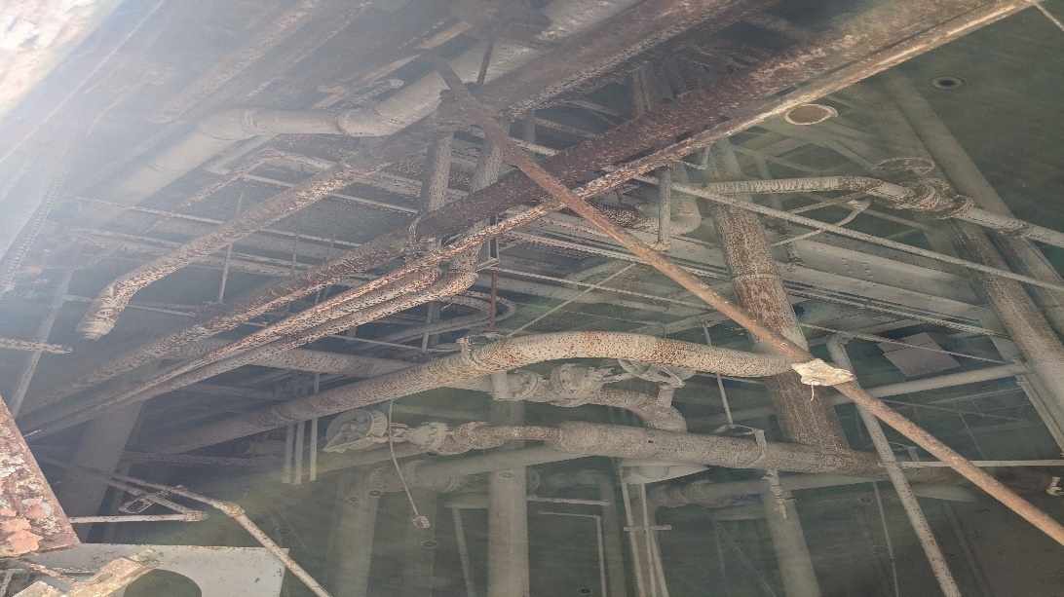
Figure 14 Asbestos from piping inside of the powerhouse during a site tour in October 2022.
Source: Valerie Doornbos
Asbestos is generally defined as being either friable or non-friable. The key difference is whether or not the dry material can be crumbled using hand pressure. “Friable asbestos material, when dry, can be crumbled, pulverized, or reduced to powder by hand pressure.” Non-friable asbestos, “when dry, cannot be crumbled, pulverized, or reduced to powder by hand pressure” State of Oklahoma, (n.d.). Asbestos is an airborne hazard. If it can crumble easily, the fibers get into the air, and be inhaled directly into the lungs causing severe damage. As they are inhaled, “the fibers become trapped in the lung tissues. The human body attempts to eliminate asbestos fibers by producing acid. Due to the chemically resistant nature of asbestos fibers, the acid has little effect, instead causing scarring of the surrounding tissue. Over time, these scars reduce lung function” State of Oklahoma, (n.d.). If large amounts were inhaled, it can often lead to the development of mesothelioma (a type of lung cancer). Asbestos is prevalent in older buildings and factories around the nation, and both types of asbestos have been found at the plant.
The asbestos concerns began to emerge after B.F. Goodrich donated the plant site to Mr. Wayne Ford, president of Save Our Children’s Environment (SOCE). Initially, this transfer seemed to be a charitable move on BFG’s part. In November of 1993, B.F. Goodrich held an auction at the plant where, “equipment and fixtures containing asbestos were sold to third parties and proceeds paid to BFG. Asbestos was stripped from fixtures and equipment at the plant before shipping” Plaintiff’s Brief in Support of Motion for Injunctive Relief (1996). Once this transfer and auction had taken place, Wayne Ford/SOCE began to conduct what is known as a “rip-and-run” at the plant in March of 1994. Essentially, a “rip-and-run” is a process whereby any salvageable materials (copper wiring, steel piping, and machinery) are stripped from the plant and scrapped. However, many of these materials, especially the piping, were covered in asbestos. Ford/SOCE simply pulled off the asbestos, stuffed it into black plastic trash bags, and left it piled in various corners of the plant. The asbestos was then left out in the elements, allowing it to blow around and become airborne, exposing nearby residents to the toxic fibers. As inspectors noted during a February 23, 1996, site tour of the plant,
Severely deteriorated and friable asbestos insulation and dust was observed throughout the buildings. In certain circumstances, the material is crumbling onto the floor. Turbulent/moderate velocity winds experienced throughout the buildings as a result of inferior exterior shelter integrity increases the potential for fugitive emissions within the buildings. In addition, asbestos is being significantly deteriorated by stormwater pouring through the faulty roof. The emissions generated within the buildings are significant enough to generate a health risk to occupants, inspectors, etc. Plaintiff’s Brief in Support of Motion for Injunctive Relief (1996).

Neighbors submitted numerous complaints about asbestos to Mr. Clyde Mason at the Miami office of the Oklahoma Department of Environmental Quality (ODEQ). The ODEQ began to conduct site inspections and investigations, and it soon became apparent that there was a massive concern. ODEQ stated that Wayne Ford was responsible for cleaning up the asbestos. This quickly escalated into a situation whereby Wayne Ford accused B.F. Goodrich/Michelin of failing to disclose the costs of remediation Plaintiff’s Brief in Support of Motion for Injunctive Relief (1996) and said that they, not he, should not be responsible. Wayne Ford then hired two remediation companies Asbestos Removal and Maintenance, Inc. (ARMI) and Schoonover to assist in clean-up initiatives Plaintiff’s Brief in Support of Motion for Injunctive Relief (1996). These clean-up initiatives mainly focused on collecting the asbestos into black plastic trash bags or piling up in the corner. Meanwhile, he tried to get ODEQ to force him to stop so that he would not be held responsible. ODEQ refused and told him that the asbestos situation on the property was his responsibility. The situation then deteriorated to the point where Wayne Ford locked the gates and refused to allow inspectors access (Table 4). When access was eventually granted, inspectors found piles of asbestos haphazardly scattered throughout the plant. In 1997, residents had had enough and filed a lawsuit against SOCE/BFG/Michelin to stop salvage operations and receive compensation for damages. The following is a table of key events leading up to the lawsuit.
Table 4 Key Dates and Events Following SOCE’s Acquisition of the Plant. Source: (Plaintiff’s Brief in Support of Motion for Injunctive Relief (1996)
Date | Event
March 1994 | SOCE/Ford begins stripping the building of salvageable materials, ie. copper wiring, steel piping and machinery.
August 4, 1994 | Two people from the DEQ inspect the plant and observe material believed to contain friable asbestos. They tell SOCE officials to clearly mark and barrier off the areas to prevent workers from disturbing the suspect material.
January 19, 1995 | Clyde Mason receives an initial complaint from a nearby resident who reports that metal salvaging is occurring at the BFG plant and bags of material are being piled inside and outside.
January 24, 1995 | Two officials from ODEQ conduct another site tour and find three bags of material containing asbestos in the basement of the autoclave room.
March 29, 1995 | ODEQ Waste Management Division employees meet with representatives of BFG, Michelin of North America, and WSNCo (remediation company) for the purpose of reaching an agreement to investigate and clean up the contamination at the plant.
August 15, 1995 | The ODEQ receives a letter from BFG, saying that they had ‘tendered’ this matter to UGTC which was ‘solely responsible for any further investigation or other action concerning potential contamination at the site.’
August 16, 1995 | ODEQ officials following up on a resident complaint observe workers of Asbestos Removal and Maintenance, Inc. (ARMI) and KDS Environmental Services, Inc. (KDS) preparing one area of the BFG plant for asbestos abatement and workers removing lighting and conduit from another area of the building where asbestos survey and abatement had not occurred.”
August 25, 1995 | The DEQ received a letter from UGTC, saying that there was ‘no basis’ for the State to name UGTC in any potential administrative Order forcing them to cover cleanup costs and stating that BFG and Uniroyal were having an ‘internal disagreement.’
Mid-September 1995 | Wayne Ford meets with ODEQ and asks them to order him to stop work at the BFG plant so that he cannot be held responsible. He is instead informed that the asbestos should be cleaned up and disposed of properly.”
Mid-September 1995 | Immediately after the meeting with ODEQ, Wayne Ford falsely informs the asbestos abatement company (KDS) and the demolition company (Schoonover) that DEQ had ordered all activities to cease at the plant.
September 29, 1995 | Wayne Ford locks the gates to the property.
October 6, 1995 | Wayne Ford refuses to allow the ODEQ access to the BFG plant.
October 12, 1995 | The Ottawa County District Court grants a Temporary Restraining Order against SOCE/Wayne Ford et al. which includes an order to allow the DEQ access to the property.
December 1, 1995 | The Attorney General’s office files the Petition in this case.

Residents were ultimately successful in stopping salvage operations, but cleanup never occurred because there was no funding left. There were some attempts to remove asbestos in the following years, but by late 2014, “the owner filed Chapter 11 bankruptcy” Hefner and Robbie (2021). Residents continued to alert the ODEQ about the asbestos situation and their concerns, and ODEQ eventually involved the EPA due to the large scope of the problem.
In 2018-2019, “EPA conducted a $4.6 million emergency removal action to remove asbestos debris piles and several structures due to the amount of asbestos-containing materials scattered across the site and inside abandoned structures” Hefner and Robbie (2021). In addition to remediating a large amount of asbestos, the EPA also removed other hazardous substances (including paints and acids) that had been left over from earlier efforts. In total 25,120.74 tons of asbestos-containing material were removed, 53.82 tons of carbon black were disposed of, and 1,675 trucks worth of waste was carted away McAteer (2019). Following the EPA’s involvement, ownership of the site was transferred to the City of Miami. While most of it is gone, there is still some asbestos that remains in piping in the powerhouse and in the warehouse buildings in the southwest corner of the plant.
Concern #3: Carbon Black
Carbon black is the third major area of concern at the former B.F. Goodrich plant. The U.S. Department of Labor (1989) defines carbon black as, “a pigment used for rubber tires that serves as a reinforcing filler for rubber and improves various properties of mixes (breaking, tear, and abrasion resistances).” In addition to providing the standard black color of tires, it increases abrasion resistance. This helps to stop the tire from falling apart as it rubs on the surface of the road. Outside of its use in tire manufacturing, carbon black is used to color electrical wiring and leather.
Carbon black is a known carcinogen, skin irritant and can easily enter the airways and cause respiratory illness. The Wisconsin Department of Health describes how “inhaling carbon black particles can irritate the lungs and cause coughing. When people are exposed to high levels of carbon black over many years, the particles may lodge deep in their lungs, causing cancer or respiratory disease” Wisconsin Department of Health Services (2018). Federal standards set in 1989 recommend that people limit their exposure to 3.5 mg/m3 for a 10-hour shift, 40-hour workweek U.S. Department of Labor (1989). Carbon black would reportedly get onto almost everything, and was often airborne, making it extremely challenging to meet the CDC’s recommended guidelines.
At the Miami B.F. Goodrich plant, carbon black was stored in large towers on the northeastern corner until it was transported by conveyor belt to a hopper for use in the plant (Figure 15).
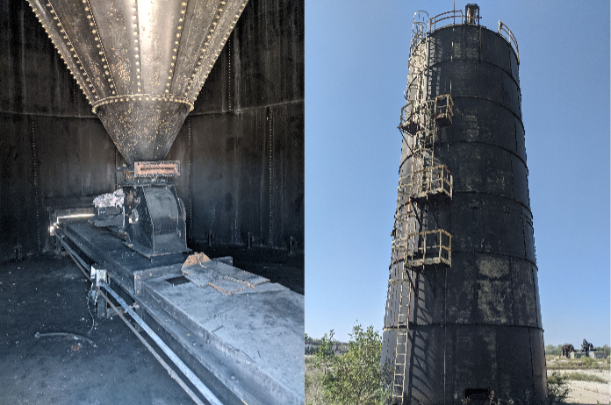
Figure 15 The remaining carbon black tank interior (left) and exterior (right)
Source: Valerie Doornbos, (2021)
Carbon black was also used in addition to other compounds such as soapstone. Jerry Wyrick described how “soapstone was a silicon-type material that made it easier to put tires into the mold to cure them. In the east end of the plant, they used soapstone and other different compounds such as carbon black in the rubber manufacturing process.” Larry Tippit mentioned how people who used to work in that department would need to wear heavy coveralls and black T-shirts to avoid having it wreck their clothes. Ben Bingham’s father worked at the plant, and he would often share stories of managers getting “carbon blacked.” Workers would get on the roof of the plant with a bucket of carbon black. Once the unsuspecting person walked below, the bucket would be dumped on top of them, covering them in carbon black. Many people reported that if they parked their cars in the lot on the east end of the plant, it was not uncommon for them to walk back and find their cars covered in carbon black. Rebecca Jim mentioned how carbon black would get on cars that were parked a block away at the school.
During meetings with interviewees and informal conversations with community members, many recalled carbon black as a part of daily life, especially for those living near the plant. Long-time Miami, OK resident Carolyn Cook Sweeney recalled how, “growing up two blocks from the plant, I remember how our roof was always black from the powdered carbon black they used in the tires.” Another resident, Pam Grunewald Keyes, recalled “yeah, during the summertime, you couldn’t play barefoot in the grass in that neighborhood without your soles getting as black as if you’d been playing in a coal mine.” Jerry Wyrick remembered how “there was always carbon black on the grass. It was a fine powder and it just got in the air and then all over everything.” Others expressed how they could run their fingers along the siding on their house and pick up a noticeable residue of carbon black on their fingertips or hang laundry out to dry and come out to find that it had accumulated a light grayish black coating.
Although carbon black accumulation while the plant was in operation was notable, the greatest concern emerged when the plant was being demolished. During the demolition process, the carbon black storage tanks were taken down by letting them fall and then cutting them into sections. However, there were concerns that not all of the residual carbon black had been removed prior to demolition. When the tanks fell, there was a massive cloud of residual dust noticeable from the road. “[The tanks] were emptied of product. But what they found out was when they cut up the towers into sections, there was a residue of carbon black that clung to the insides of the towers. And so, when they dropped the pieces of metal, that carbon black then was released into the air” "Schoonover Carbon Black Report,” (n.d., 34) As Clyde Mason, an ODEQ official and local resident noted, “I did drive by at one time when the towers were being cut up and saw a cut piece of tower being dropped. And you could see the carbon black dust from the street coming off the product, as it was visible from the public road” "Schoonover Carbon Black Report,” (n.d., 34).
Residents quickly began to file complaint reports with the ODEQ to try and bring attention to the issue. Many noticed it on their patio furniture, house siding, garages, and other outdoor locations. A report on August 24, 1995, provides details on the extent of carbon black fugitive dust from the demolition. It details how, “there is a fine, black powdery substance present on patio furniture, outdoor carpet, metal storage buildings, house siding and other items on the complainants’ properties” ODEQ (1995). There was a total of six carbon black towers that needed to be removed. However, five had been demolished when the complaints started to come in from concerned residents and staff members. Heeding these concerns, ODEQ stopped demolition immediately, and told Schoonover (the demolition company) to not remove the last tank ODEQ (1995). This frustrated many because it not only served as a reminder of the lingering environmental concerns the community faced, but also posed a safety hazard. If the tank rusted enough, it could collapse, sending additional carbon black into the air and possibly injuring someone. Jerry Wyrick detailed in his interview.
I don’t know why they haven't torn that other carbon black tower down. I semi-blame the neighbors on that one. They threw a fit and it’s just sitting there. If they’d just let the cleanup people do their job for one more day, that tower would've been down and gone. Now it's sitting there, and it's going to rust and fall one of these days. Why didn't they just wait one more day and then gotten rid of the last one?
Different people in the community can have different concerns depending on where they are located. Some may be in areas that are facing water pollution, whereas a few blocks away, air pollution may be the chief concern. Also, pollutants do not have boundaries. Just because carbon black has been found in one area does not mean that it cannot travel to another area if picked up by the wind. Therefore, when conducting remediation efforts, officials need to be aware of what areas are experiencing which problems and how to best provide the resources and support needed to remedy these.
Concern #4: Underground Storage Tanks
Another concern emerging during the various remediation processes at the site are the Underground Storage Tanks (USTs). The EPA’s UST program notes how, “The greatest potential threat from a leaking UST is contamination of groundwater, the source of drinking water for nearly half of all Americans” US EPA (2013b). Groundwater contamination from leaking USTs has occurred at the Miami plant. The benzene plume that now exists resulted from a leaking UST, as mentioned above. Other tanks have been found in numerous locations underneath the plant. These storage tanks were typically used for waste oil, benzene, and acids needed in the tire manufacturing process Waldemar S. Nelson and Company (1991a).
While B.F. Goodrich had removed most of the tanks in 1985, they have not removed all of them (Figure 16).
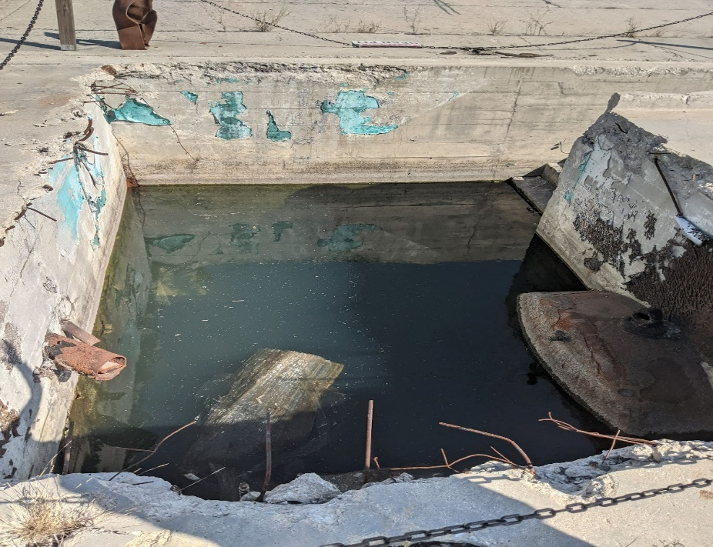
Figure 16 A remaining UST (bottom right corner) found during the October 2022 site visit.
Source: (Valerie Doornbos, 2022)
Additionally, there were feedlines (pipes that ran materials around the plant) that had either not been drained or contained residue. During a 1995 site tour, inspectors saw a “nearby storage tank where the bottom had rusted out and sulfuric acid had spilled out all over the floor” Deposition Exhibit #1: Site Inspection (1994). Additionally, the plant manager who led the tour, Terry Butterfield, expressed concern about exactly how much material had leaked from the tanks due to the extremely strong odor present in the area. Butterfield, “showed us a gravel covered area where he indicated three underground storage tanks had been pulled out of the ground and solvents (wastes from the tire process including benzene) had leaked into the ground.” When industrial hygienists and contractors came to the plant to test the soil, they had to drill holes. Butterfield reported that, “the contractors only drilled one hole. He had to tell them to stop after only one hole since the smell coming out was so strong that he was concerned about the possibility of an explosion” Deposition Exhibit #1: Site Inspection (1994). This statement is especially worrisome because if there was enough material to warrant concern of an explosion, chances are that there are similar concentrations of other materials scattered around the site.
While many UST were removed prior to the plant closure, remaining tanks began to leak over time. Remediation company Waldemar S. Nelson & Co. detailed in their Phase 1 Environmental Assessment how, “the Underground Storage Tanks (UST’s) that stored gasoline, diesel fuel and fuel oil were removed in 1985, just prior to the plant closing” Waldemar S. Nelson and Company (1991a). When the tanks were removed, residues of previous chemicals stored there remained. In addition, B.F. Goodrich decided to utilize lead-infused chat to fill in the holes left behind by the tanks. Erik Johnson, the City of Miami’s attorney, reported “chat was brought in to fill the site after the tanks were removed. The chat has since been tested “hot” for lead, indicating that the fill material exceeds the state’s acceptable level of lead-content” Miami News-Record (2007). This poses a compounding problem of the residue of whatever had been stored in the UST, as well as the possibility of lead from the chat getting into the groundwater. The discovery of these tanks and chat slowed the remediation process at the site. Johnson detailed how, “the discovery of the lead contamination, concerns of an unidentified source flowing into the pit site and objections raised by the current owners regarding plans to treat contaminated soil on site slowed the launch of Michelin’s work plan Miami News-Record (2007).
Not only are these leaking tanks contributing to the benzene concerns at the site, but they are also hindering remediation efforts and the potential reuse of the site in the future. It is costly and time-consuming to find and remove all tanks and subsequent piping. Manufacturers will not want to purchase the site if they know that they might be responsible for any cleanup or damage associated with further issues. Therefore, Miami not only loses out on the economic benefits that use of the site would provide but is also forced to continue to bear the burden of environmental contamination from leaks.
Concern #5: Solid Waste Disposal Site/Incinerator
The final concern at the site has two parts: the solid waste disposal site and the incinerator. B.F. Goodrich operated a solid waste disposal site from 1976 to 1983 (Figure 17).
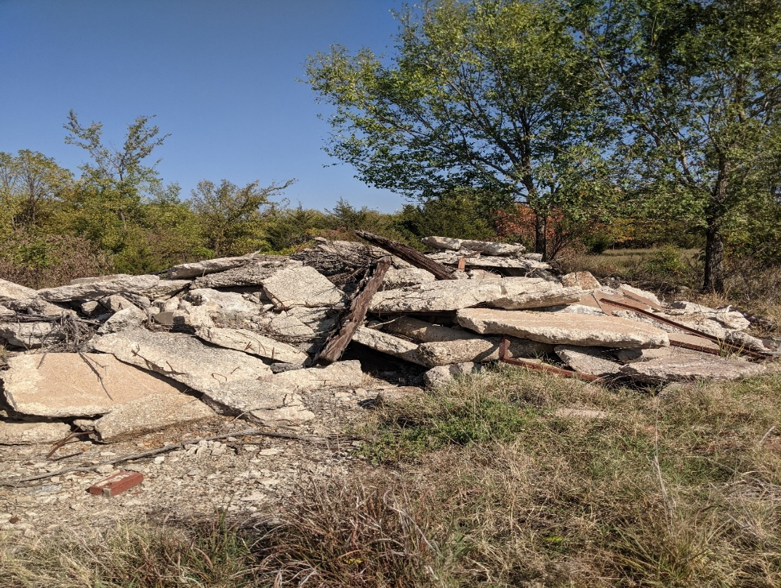
Figure 17 Remnants of the solid waste disposal site.
Source: Valerie Doornbos, (2022)
The main purpose of this site was to collect waste materials such as tires and fabric scraps. The open-pit incinerator was built later, after production increased and other measures were needed to dispose of waste. In the late 1970s, there was a need for on-site disposal of waste, as shipping it elsewhere had become too costly. The B.F. Goodrich landfill was permitted (Permit #3558014) on October 26, 1976, for, “the disposal of scrap rubber tires, fabric, wastepaper, and any trash generated from the plant. The waste was transported to the landfill in company-owned trucks” Waldemar S. Nelson and Company (1991, 11) . The following is an estimate of what and how much was contributed to the disposal each day (Table 5):
Table 5 Estimate of Daily Contributions to the Solid Waste Disposal Site. Source: Waldemar S. Nelson and Company (1991, 11)
Type of Material | Estimated Contribution Amount
Rubber Tires | 11,000 lbs./day
Rubber Other Than Tires | 1,200 lbs./day
Scrap Fabric | 7,200 lbs./day
Polyethylene | 1,000 lbs./day
Scrap Paper, Wood, etc. | 8,000 lbs./day

Employees and sometimes other members of the community would dump their waste in the disposal as well. In 1979, B.F. Goodrich officials received a letter from ODEQ officials congratulating them for a productive and safe landfill. “As all citizens benefit from such programs, we would like to congratulate you on providing this service and encourage you to continue to provide your employees with an environmentally acceptable solid waste system” Oklahoma Department of Health (1979). There were also unconfirmed reports from former employees that abandoned mine shafts and several waste pits had been used for dumping while the plant was in operation Waldemar S. Nelson and Company (1991, 1). There was an investigation into the shafts and pits, but nothing definite emerged and other concerns (such as benzene) took precedence.
In late 1980, B.F. Goodrich found that the landfill was nearing capacity and was becoming extremely expensive to operate. Therefore, in 1981, B.F. Goodrich applied to close the disposal site. Operations ceased in mid-1981 and “final closure was received from the Ottawa County Health Department in June of 1982” Waldemar S. Nelson and Company (1991, 11). As part of the agreement for operating a landfill, B.F. Goodrich had to apply for a National Pollutant Discharge Elimination System (NPDES) permit (permit # OK0001040) and send monthly monitoring reports to ODEQ. If this was not completed, Goodrich risked having to pay fines and the possibility of forced closure. Compliance was maintained up until the plant closed, but reports went missing after that. In 1988, ODEQ sent a letter to B.F. Goodrich alerting them that, “Discharge Monitoring Reports have not been received for July-September 1988, which constitutes a violation of the conditions of your NPDES permit” ODEQ (1988). In the confusion following the sale and B.F. Goodrich’s attempt to transfer permit responsibility to Wayne Ford/SOCE, many of these monitoring reports were not conducted. This meant that there was no record of how much discharge was going into the nearby Neosho River and eventually to Grand Lake.
After the closure of the landfill, B.F. Goodrich needed to find an alternative way of disposing of waste, especially very large defective tires. They investigated a variety of options including a shredder, transport to another landfill, and an incinerator. At the time, the shredder and incinerator seemed to be the best options. “Initially, very little interest existed due to the cumbersomeness of landfilling whole tires. Only one firm was interested if BFG would shred or slit the tires circumferentially” B.F. Goodrich (1981). B.F. Goodrich then decided to purchase a Saturn Model 62-40, 300 H.P. Shredder. The shredder, “will destroy tires up to and including large farm tires and is scheduled for installation in January 1982” B.F. Goodrich (1981) The shredder remained in use until the plant closed in 1986.
In addition to disposing of waste via shredder or landfill, B.F. Goodrich also operated an incinerator. B.F. Goodrich initially planned to use the incinerator during the rainy season as, “the landfill being utilized at this time is inaccessible” B.F. Goodrich Petition for Variance-Incinerator (1972). However, it soon became a useful tool for getting rid of bulky tires, recovering expensive materials, and producing steam to generate electricity. As Noble Rose, a former plant manager explained, “the incinerator was used to recover curing water bag valves, which are extremely expensive to replace” B.F. Goodrich Petition for Variance-Incinerator (1972). James Graves mentioned that the incinerator was also used to produce steam. “At the incinerator, they burned tire scrap besides the city’s household garbage. Goodrich would use this steam in their manufacturing process.”
While beneficial for Goodrich, usage of the incinerator was detrimental to the surrounding neighborhoods. As resident Twyla Stanley Yandell recalled, “we had to be aware of when the incinerators were operating before we hung laundry out to dry. Our home was two blocks from the north end of the plant, and the incinerator would bring soot to our yard and dirty the clothes.” The incinerator was smokey and sooty because of the oil in the burned tires. This generated a series of complaints, and the Oklahoma Department of Health came to investigate. The Department ultimately decided that the poor air quality resulting from burning was significant, resident complaints were warranted, and landfill operations should be prioritized over incinerator usage. Therefore, “the landfill operation should be continued at all times, especially in light of public complaints that have been received when burning was utilized” B.F. Goodrich Petition for Variance-Incinerator (1972).
To my knowledge, there have been little-to-no remediation efforts taking place at the site of either the solid waste disposal or incinerator. Rebecca Jim and the LEAD Agency are very worried about what could be lurking in these areas, especially because waste acids and benzene were put into barrels and dumped there. Leaking barrels could be another source of groundwater contamination.

Future Plans for the Site
One of the main questions on the minds of residents, officials, and remediation companies is: what’s next for Miami and the site? In the Fall of 2019, following the EPA’s asbestos remediation project, Community Involvement Coordinators (CIC)’s and the Remedial Project Manager (RPM) conducted a site remediation assessment and a series of conversations with community members on what they would like to see the site become. It was noted that the site was located in a prime area with access to rail (the rail spurs could be redone) and I-44, a major thoroughfare for commerce in Oklahoma Hefner and Robbie (2021).
During these conversations, it came to light that the site might be ideal for solar power usage. The Grand River Dam Authority (GRDA) has expressed interest in broadening their portfolio to include more sustainable means of electricity generation. The site features a large concrete base, which would provide an adequate foundation for solar panels. There is also an electrical substation which was recently upgraded and could handle the load that a solar farm would require. Hefner and Robbie (2021). Table 5 is an estimate of what the cost and expected output would be for installing a solar farm on the factory site.
Table 6 Preliminary Solar System Cost. Source: Hefner and Robbie (2021)
Estimated Size | Estimated Output | Installed Costs | Annual O&M Costs
5 MW | 7,180,000 kWh/year | $10M - $12.5 M | $50K - $75K

While it can be relatively expensive to install, there are programs which could make it more feasible. One of these is the EPA’s Brightfields program. Brightfields are meant to, “encourage productive use of brownfields and advance the use of clean and climate-friendly energy technologies, and the Department of Energy is working with local governments and industry to link solar energy technologies to brownfields redevelopment” US EPA (2012). Brightfields have been implemented at former factory sites across the country and are an excellent solution to the issue of how to repurpose a brownfield site for good. In Miami, a solar farm at B.F. Goodrich would not only create desperately needed jobs (technicians would be needed to install and maintain the panels), but it would be a clean source of energy and economic growth for the county.
In 2019, Miami was also named one of Oklahoma’s 119 Opportunity Zones (Figure 10).
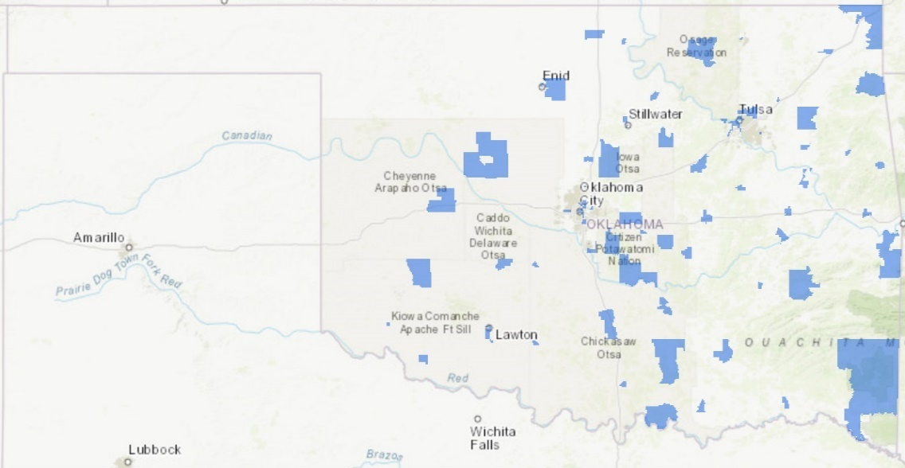
Figure 18 Oklahoma 2019 Opportunity Zones.
Source: Rebecca Jim, (2019)
Opportunity zones are areas, “designed to stimulate long-term private investment in low-income urban and rural communities by allowing investors to realize significant federal tax benefits through investing capital gains in Qualified Opportunity Funds” Oklahoma Department of Commerce (n.d.). In other words, this program tries to attract industry and business to areas where it might be faltering. This is sometimes easier said than done. Dale Taylor mentioned that there was a company called Canoo who was trying to establish operations in the Miami area. However, “they’ve been talking about making a fortune, but it recently came out that they might not be able to make their first van before they go broke.” Besides the possibility of installing a solar farm, there are a few warehouses which can be rented out for storage on the site. Miami Warehouse is currently located there and when I made my trip up in October, I saw that they were in the process of fixing up the warehouses to use for local trucking companies.
Regardless of whatever happens with the site, any plan should include the voices and desires of residents and what they would like to see the site become. They have an intimate knowledge of what is and is not possible or wanted, and they can bring this to the table during discussions. The EPA spoke with residents and summarized their findings in the City of Miami Comprehensive Plan. When asked what they thought the community needed the most, many highlighted more jobs. As the report described, “residents view more jobs as central priorities. There is a desire for jobs that contribute to quality of life and enhance Miami’s sense of place. High quality jobs that pay a living wage are viewed as imperative to Miami’s long-term economic sustainability” Hefner and Robbie (2021). The people I interviewed echoed this. Dale Taylor said, “our population's declined here, and I hate to say that. We need manufacturing jobs.” James Graves echoed this by saying, “I hope we get more jobs in here because if we don’t, it’s going to drive people away. That's what I’m more concerned about than anything. We’ve got to have jobs because we’re losing our youth. They’re having to go out to other places, other towns.” If people leave for elsewhere, Miami loses out on that income and the population of the town will continue to decrease.
The B.F. Goodrich Tire Factory has and continues to have a complex history with Miami and Ottawa County. During the course of several decades, it transitioned from being a leading economic engine to a source of environmental contamination and concern. For many, the factory was a part of everyday life. They worked there, were directly impacted by its pollution, or served the workers in Miami’s many businesses. The closure of the plant devastated the economy and caused lasting societal and environmental issues. While various remediation efforts have occurred, there is still much work to be done, and many are hoping that the new Brightfields initiative will prove to be the boost that Miami needs.

Discussion and Conclusions
This chapter discusses the key findings, implications, limitations, and possibilities for future research that emerged during the course of this project. I begin by detailing the key findings of this project. I then move on to the implications of this research and highlight why the work I have done matters. This work is important because no previous research has been conducted on the Miami B.F. Goodrich factory and because it showcases stories and items that have never been brought to light and have meaning in the community. I next discuss the limitations of the project and explain what I would change or adjust if given the opportunity to conduct this research again. Finally, I end by discussing how I envision this research project continuing in the future.

Key Findings
Conducting this research has been eye-opening for me in a number of different ways. I have been able to immerse myself in the literature and experiences surrounding the phenomenon of deindustrialization. My three key findings from the literature review and my archival and interview analysis are:
1. Contamination is a very slow process and slow remediation and observation efforts are needed to address this.
2. Deindustrialization in the United States creates lingering negative societal and environmental impacts.
3. Participatory research (including archival and interview analysis) that centers the voices of residents via the creation of a StoryMap is a promising strategy for visualizing the events of the Miami plant.
From these findings, I am able to answer my research question: how can a Miami community-based organization’s archival materials be incorporated into a StoryMap to engage a community, illustrate the embodied work experience, and introduce the environmental impacts of the five key areas of concern stemming from the plant closure? The archival materials provided me with an understanding of the background of the site and the processes that took place. From these, and my interviews, I was able to construct a timeline of events and identify the five key areas of concern that were featured in my StoryMap. A StoryMap provides numerous ways to honor these stories, empower residents, and incorporate elements such as videos and maps, that might be left out of demonstrating the embodied work experience.

Implications
One of the key questions asked in many research projects is: why does this research matter? This research project matters because it fills a gap in knowledge and visualizes and honors the embodied work experience of B.F. Goodrich. This research fills a gap by situating the Miami B.F. Goodrich plant in the wider context of deindustrialization in the United States. As far as I know at the time of writing this thesis, no study has focused on the former Miami B.F. Goodrich tire plant. There is an oral history project being conducted by Oklahoma State University (OSU), but it focuses on the entire state instead of a specific region. They did interview a few Miami residents (which I have included in Chapter 2), but they did not focus on work experiences specifically. Additionally, extensive environmental and medical research has been conducted on the nearby Tar Creek Superfund Site, but none of it has examined the other forms of industry in the region. Highlighting this plant and Miami’s connections to industry honors everyone who has lived and worked here.
This research also matters because it honors and showcases stories of embodied work experience while bringing new information to light. As Rebecca Jim, our community partner noted, “We're asking for these stories because nobody knows about these details. Nobody’s written it down. I'm getting a picture now of stuff I never knew. That’s cool.” While I was able to learn quite a bit from the archival analysis, the interviews I conducted helped me to fill in many of the gaps or questions in my knowledge. I was able to learn how hiring worked and how different positions calculated pay (e.g., tire building was piecework, but managerial positions had an hourly salary); items that were not mentioned in the archive. Additionally, many of the residents who interacted with the plant in some form are either sick or elderly. The AW&W project and this participatory thesis research is the last chance many of them will have to share their experiences and knowledge with others in the community. By capturing and showcasing these stories, current and future residents will be able to enjoy and learn from their experiences.

Limitations
Although I was able to identify some key patterns and showcase the stories of those who worked and interacted with the plant, there are still a few items that I wish I would have been able to address if given more time. Unfortunately, two years of a master’s program pass quickly, and there is so much to learn and read about regarding the plant. The following are some of the main limitations I encountered:
Classified Materials and Missing Documents
The archive that Rebecca had collected was extensive and contained many important documents that were vital to my understanding of the plant. However, there were a few materials that I was legally unable to access. These included the cost of various remediation efforts, some components of the benzene and asbestos court cases, and classified EPA or ODEQ data and information. I could have put in a request to see if I was able to obtain access, but there is typically a very long turn-around (two years is not uncommon). Given that my entire thesis project needed to take place in under two years, this was not a feasible option. There were also a few documents that were missing pages, especially in relation to the Benzene court case. It is possible that these sections contained confidential information and were removed. However, it was very frustrating as a researcher to find portions of a document that mentioned various people, but provided no explanation as to who they were or why they mattered. Not having access to these documents means that I might have missed out on important information to help me fill in the gaps in the story of B.F. Goodrich. Unfortunately, the reality of research is that as hard as you might try, it is impossible to gather every single piece of information on a subject.
The Potential for Misinterpretation
Another key limitation to this project is the potential for misinterpretation. This research project is the first time I have been introduced to the world of tire manufacturing and B.F. Goodrich in general. I have some previous research experience with manufacturing (my bachelor’s project on Gary and familial connections), but I had to teach myself much of the industrial jargon and functions of the plant. I had no idea what many terms such as “autoclave” and “electrical substation” meant, so I had to rely on other sources including quick internet searches. While I did my best to be accurate, it is entirely possible that some of these terms may be used incorrectly.
Furthermore, some of the documents contained conflicting rhetoric and reports, making it very difficult to determine which story is correct. Take the issue of chat being dumped into pits on the BFG site as an example. Documents from contractors hired to assess and remediate the site indicated that there had never been illegal dumping, but interviews and statements from former plant workers indicated that there had been dumping going on. As some of these contractors were hired by B.F. Goodrich, it is possible that they were trying to present the plant in the best possible light and covered up/ignored these issues. Unfortunately, I cannot be entirely certain. Along these same lines, as pollution concerns began to emerge in the community and legal action was taken, many residents signed non-disclosure agreements. This meant that they were legally unable to talk to me about their experiences. As a result, I may have missed out on more information.
Another source of potential misinterpretation is my archival analysis. When conducting the analysis, I was the sole person responsible for sorting through the documents and determining what was important and what was not. I pulled quotes and details that I thought were important in understanding the history of the plant. It is entirely possible, however, that someone else might read through this information and come up with a completely different conclusion. One of my key sources of frustration was trying to keep track of who owned the plant and when. The details became very murky after SOCE lost the court case and went bankrupt. There is a period of roughly twenty years where talk of selling the plant circulated, but nothing definite emerged. I had to make my best educated guess about what occurred, but it is possible that this is incorrect.
Plant Tour
During the course of collecting interviews and archival materials for this project, I was hoping to walk the site with someone who had worked there instead of relying on my knowledge. Unfortunately, that never came to fruition. I was able to gain access to the site and take pictures at the plant. During this “tour” I recognized some of the areas (carbon black tank, powerhouse, and Banbury mixers), but had to make my best guess about what had taken place in other regions. For example, I had previously thought that there were only two rail spurs but after chatting with an interviewee and walking around the site, I discovered that there were actually three. Perhaps future AW&W researchers could take a site tour and correct any discrepancies.
Time Constraints
Time constraints were the final limitation to this research project. This was especially true when attempting to collect demographic data. I worked with Claire Curry (an OU research librarian) to try and find demographic data for Miami and Ottawa County as a whole. Unfortunately, because the region has a very small population, easily accessible data was limited. I scheduled a meeting with someone from the U.S. Census Bureau, but he said that it could take up to five years to get the data I requested due to a lengthy backlog. As I mentioned above, given that I had under two years to complete this project, that would not be feasible. Additionally, it was very challenging at times to juggle the responsibilities of being a Graduate Teaching Assistant and graduate student with the responsibilities of research. While it would have been wonderful if I could have dedicated all of my time to focusing on research, this simply was not possible. I started off with a very broad idea of what I wanted to do, and then narrowed it down over time. I had originally contemplated doing a lengthy qualitative and quantitative analysis, but eventually realized that I would not be able to complete everything in time. Therefore, I needed to make pragmatic decisions on what I would be able to do.

Future Research
There are some other areas on the site that should be explored further for other contaminants. There are a couple of waste lagoons that have not been explored. Also, it is not clear if and what other chemicals were used besides the ones listed in my analysis. For example, the first time I heard about Soapstone was through an interview participant. It had not been mentioned anywhere else. There was also passing mention made of the toxicity of various chemicals used in helping to waterproof the tires such as 6PPD. Residents hinted that other former B.F. Goodrich plant locations were looking into this, but nothing definite has emerged as of the time of writing.
I am hopeful that that story of B.F. Goodrich will not end with the conclusion of my thesis and will instead continue to expand and include other stories. This analysis and StoryMap will be a crucial part of the planned Air, Water, and Work website that Dr. Laurel Smith is creating. Also, Rebecca and the LEAD Agency plan to use my StoryMap as part of their toolkit to honor these stories, promote well-being, attract additional attention to the environmental issues facing Ottawa County, and encourage increased community engagement. Ideally, community members will be able to access the map and see their stories recorded and accessible for everyone to learn from. Perhaps this will spark discussions among other community members and Ottawa County residents and show them that their voices and stories matter and are highly valued.

References
Adeola, Francis O. 1998. “Environmental Injustice in the State of Louisiana?: Hazardous Wastes and Environmental Illness in the Cancer Corridor.” Race, Gender & Class 6 (1): 83–108.
AP News. 1985. “Goodrich Closing Major Plant.” AP NEWS. August 23, 1985. https://apnews.com/article/f748e054548a345d8e8a48067584cc3a.
———. 2014. “Crews Discover Giant Beehive at Former Tire Plant.” Joplin Globe. August 18, 2014. https://www.joplinglobe.com/news/crews-discover-giant-beehive-at-former-tire-plant/article_5272e004-26f9-11e4-8798-0019bb2963f4.html.
Archives, L. A. Times. 1985. “B. F. Goodrich Will Close an Oklahoma Tire Plant.” Los Angeles Times. August 24, 1985. https://www.latimes.com/archives/la-xpm-1985-08-24-fi-26293-story.html.
Balaban, RC. 2006. “B.F. Goodrich Plant Purchased.” Joplin Globe. April 8, 2006. https://www.joplinglobe.com/news/local_news/b-f-goodrich-plant-purchased/article_bc1a721a-0516-5743-b55c-04e865977579.html.
B.F. Goodrich. 1972. “B.F. Goodrich Petition for Variance-Incinerator.” November 10, 1972.
———. 1981. “Action Plan to Close the BFG Sanitary Landfill.” September 23, 1981.
Boudia, Soraya, et.al. 2022. Residues: Thinking Through Chemical Environments. Rutgers University Press. https://www.rutgersuniversitypress.org/residues/9781978818019/.
Brosius, Liz, and Robert S. Sawin. 2001. “KGS Pub. Inf. Circ. 17--Part 1 of 3.” Kansas Geological Survey, Public Information Circular (PIC) 17. October 2001. https://www.kgs.ku.edu/Publications/pic17/pic17_1.html.
C. Allan Mathews, and Frank D. Wood. n.d. “Picher | The Encyclopedia of Oklahoma History and Culture.” Oklahoma Historical Society | OHS. Accessed April 5, 2023. https://www.okhistory.org/publications/enc/entry?entry=PI002.
California Department of Public Health. 2021. “Engaging Communities for Health Equity and Environmental Justice.” https://www.cdph.ca.gov/Programs/CCDPHP/DEODC/EHIB/CDPH%20Document%20Library/Guide-Engaging_Community_for_Health_Equity_and_EJ_ADA.pdf.
City of Miami, OK. n.d. “Miami, OK - Official Website | Official Website.” Accessed April 5, 2023. https://www.miamiokla.net/.
Davies, Thom. 2018. “Toxic Space and Time: Slow Violence, Necropolitics, and Petrochemical Pollution.” Annals of the American Association of Geographers 108 (6): 1537–53. https://doi.org/10.1080/24694452.2018.1470924.
DeLyser, Dydia. 2014. “Towards a Participatory Historical Geography: Archival Interventions, Volunteer Service, and Public Outreach in Research on Early Women Pilots.” Journal of Historical Geography 46 (October): 93–98. https://doi.org/10.1016/j.jhg.2014.05.028.
Deposition Exhibit #1: Site Inspection. 1994 1–4.
DEQ. n.d. “Brownfields.” Oklahoma Department of Environmental Quality. Accessed April 5, 2023. https://www.deq.ok.gov/land-protection-division/cleanup-redevelopment/brownfields/.
Dobson Historical Society. n.d. “B.F. Goodrich- Dobson Museum.” Accessed April 5, 2023. http://www.dobsonmuseum.com/goodrich.php.
Doyle, Rodger. 2002. “Deindustrialization.” Scientific American 286 (5): 30–30.
Duhon, Krista. 2006. “ODEQ to Address Benzene Plume.” Miami News-Record, August 4, 2006.
Dunn, Kevin. 2016. “Interviewing.” In Qualitative Research Methods in Human Geography, 149–88. Oxford University Press.
Elwood, Sarah. 2009. “Mixed Methods: Thinking, Doing, and Asking in Multiple Ways.” In The SAGE Handbook of Qualitative Geography, 94–97. SAGE.
ESRI. 2019. “What Can You Do with a Story Map?” Esri (blog). February 7, 2019. https://www.esri.com/about/newsroom/arcuser/what-can-you-do-with-a-story-map/.
Everett, Diana. n.d. “Tri-State Lead and Zinc District | The Encyclopedia of Oklahoma History and Culture.” n.d. Oklahoma Historical Society | OHS. Accessed April 5, 2023. https://www.okhistory.org/publications/enc/entry.php?entry=TR014.
Finchum, Tanya. 2016. “Oral History Interview with Charles Kirkendoll, Jr.” August 4, 2016. https://cdm17279.contentdm.oclc.org/digital/collection/glasshouse/id/24/rec/2.
Finchum, Tanya, and Alex Bishop. 2015. “Oral History Interview with Dena Ander.” May 6, 2015. https://cdm17279.contentdm.oclc.org/digital/collection/hundred/id/2170/rec/1.
GISGeography. 2022. “Oklahoma County Map.” GIS Geography. May 25, 2022. https://gisgeography.com/oklahoma-county-map/.
Hatfield, Erin. 2022. “Remediation Efforts to Begin at the Former BFGoodrich Site.” Oklahoma Department of Environmental Quality (blog). May 24, 2022. https://www.deq.ok.gov/2022-news-releases/remediation-efforts-to-begin-at-the-former-bfgoodrich-site/.
Hefner, Alisa, and Matt Robbie. 2021. “B.F. Goodrich Reuse Situation Assessment Report.”
High, Steven. 2003. “Introduction.” In Industrial Sunset, 3–17. The Making of North America’s Rust Belt, 1969-1984. University of Toronto Press. https://www.jstor.org/stable/10.3138/j.ctt1287xpv.5.
Hurley, Andrew. 1995. Environmental Inequalities: Class, Race, and Industrial Pollution in Gary, Indiana, 1945-1980. Univ of North Carolina Press.
Industry Week. 1986. “The Sun Sets on Miami.” Industry Week, April 28, 1986.
“LEAD Agency: Who We Are.” n.d. L.E.A.D. Accessed April 5, 2023. https://www.leadagency.org/team.
Liboiron, Max. 2021. Pollution Is Colonialism. Duke University Press. https://doi.org/10.2307/j.ctv1jhvnk1.
Luthy, Brenda. 2005. “Missourians Purchase Former Goodrich Plant.” Tulsa World, May 12, 2005.
Mah, Alice. 2012. Industrial Ruination, Community and Place: Landscapes and Legacies of Urban Decline. University of Toronto Press.
McAteer, Mike. 2019. “EPA B.F. Goodrich Remediation Notes.” 2019.
Meadows, Robin. 2019. “The Death & Life of Tar Creek | Rebecca Jim, Tar Creekkeeper.” Waterkeeper, 2019. https://waterkeeper.org/magazines/volume-15-issue-1/the-death-life-of-tar-creek-rebecca-jim-tar-creekkeeper/.
Miami News-Record. 2007. “Michelin Contractors Begin Removal of Soil Soaked with Benzene and Lead,” May 3, 2007.
———. 2010. “Tire Plant Tests Shown,” September 27, 2010.
———. 2014. “Michelin Benzene Plume at B.F. Goodrich Clean up Addressed-Council Vows to Stay on Top of the Issue,” March 27, 2014.
———. 2015. “City Addresses BF Goodrich Benzene Plume- Possible Affects on Proposed School Site Discussed,” February 25, 2015.
Monies, Paul. 2006. “Miami Begins Rolling Back after Tire Plant Shutdown.” The Oklahoman. February 5, 2006. https://www.oklahoman.com/story/news/2006/02/05/miami-begins-rolling-back-after-tire-plant-shutdown/61902652007/.
Morris, John W. 1982. “Drill Bits, Picks, and Shovels: A History of Mineral Resources in Oklahoma.” In The Gateway to Oklahoma History, 119–220. Oklahoma Historical Society. https://gateway.okhistory.org/ark:/67531/metadc862889/m1/131/.
Nelson, Mary Jo, and Don Hayden. 1985. “Goodrich to Close Plant; 1,900 Workers Affected.” The Oklahoman. August 24, 1985. https://www.oklahoman.com/story/news/1985/08/24/goodrich-to-close-plant-1900-workers-affected/62754142007/.
Nobel, Justin. 2017. “The Louisiana Environmental Apocalypse Road Trip.” Longreads. July 13, 2017. http://longreads.com/2017/07/13/the-louisiana-environmental-apocalypse-road-trip/.
O’Dell, Larry. n.d. “Ottawa County | The Encyclopedia of Oklahoma History and Culture.” Oklahoma Historical Society | OHS. Accessed April 5, 2023. https://www.okhistory.org/publications/enc/entry?entry=OT003.
ODEQ. 1988. “NPDES Permit No. OK0001040.” December 23, 1988.
———. 1995. “ODEQ Report Against Schoonover.”
Ohio History Central. n.d. “B.F. Goodrich Company - Ohio History Central.” Accessed April 5, 2023. https://ohiohistorycentral.org/w/B.F._Goodrich_Company.
Okeson, Sarah. 2016. “Former Miami B.F. Goodrich Workers Gathering 30 Years after Plant Closing.” Joplin Globe. February 25, 2016. https://www.joplinglobe.com/news/local_news/former-miami-b-f-goodrich-workers-gathering-30-years-after-plant-closing/article_9298e89a-d7a6-580a-9736-793018fbee35.html.
Oklahoma Corporation Commission. n.d. “Brownfields.” Oklahoma Corporation Commission. Accessed April 5, 2023. https://oklahoma.gov/occ/divisions/oil-gas/pollution-abatement-department/brownfields.html.
Oklahoma Department of Commerce. n.d. “Federal Opportunity Zones.” Oklahoma Department of Commerce. Accessed April 7, 2023. https://www.okcommerce.gov/doing-business/business-relocation-expansion/incentives/federal-opportunity-zones/.
Oklahoma Department of Health. 1979. “Oklahoma Department of Health Letter to B.F. Goodrich,” July 24, 1979.
Oklahoman. 1981. “Miami Goodrich Plant to Close For Week; 1,800 Will Be Idled.” The Oklahoman. November 26, 1981. https://www.oklahoman.com/story/news/1981/11/26/miami-goodrich-plant-to-close-for-week-1800-will-be-idled/60364710007/.
Petition for Injunctive Relief and Civil Penalties. 1995.
Plaintiff’s Brief in Support of Motion for Injunctive Relief. 1996.
Robertson, David. 2006. “Picher.” In Hard as the Rock Itself, 121–84. Place and Identity in the American Mining Town. University Press of Colorado. https://www.jstor.org/stable/j.ctt46nsmf.8.
Roche, Michael. 2016. “Historical Research and Archival Sources.” In Qualitative Research Methods in Human Geography, 225–45. Oxford University Press.
Rockwell Automation. 2014. “Tire Curing Press Machine.” Rockwell Automation. 2014. https://literature.rockwellautomation.com/idc/groups/literature/documents/wp/oem-wp016_-en-p.pdf.
Schoonover. n.d. “Schoonover Carbon Black Report.”
Smith, S., Rachel Pain, Sallie Marston, and J.P. Jones. 2009. “The SAGE Handbook of Social Geographies,” Introduction: Doing Social Geographies, January., 507-517. https://doi.org/10.4135/9780857021113.
State of Oklahoma. n.d. “Oklahoma Asbestos Abatement Procedure.”
Szukalski, Bern. 2019. “10 Essential Steps for Story Map Success.” Esri (blog). February 6, 2019. https://www.esri.com/about/newsroom/arcuser/10-essential-steps-for-story-map-success/.
U.S. Census Bureau. 2020. “U.S. Census Bureau QuickFacts: Miami, Oklahoma.” U.S. Census Bureau. 2020. https://www.census.gov/quickfacts/fact/table/miamicityoklahoma/SBO050217.
U.S. Department of Labor. 1989. “U.S. Dept. of Labor Carbon Black Fact Sheet.”
US EPA. 1988. “Response to Mike Synar,” December 20, 1988.
———. 2012. “Brightfields Initiative | DOE | Catalog of Environmental Programs 2012.” 2012. https://archive.epa.gov/oig/catalog/web/html/141.html.
———. n.d. “Environmental Protection Agency | USAGov.” Accessed April 5, 2023a. https://www.usa.gov/federal-agencies/environmental-protection-agency.
———. n.d. “TAR CREEK (OTTAWA COUNTY) Site Profile.” Accessed April 5, 2023b. https://cumulis.epa.gov/supercpad/SiteProfiles/index.cfm?fuseaction=second.Cleanup&id=0601269#bkground.
US EPA, OLEM. 2013a. “Brownfields.” Collections and Lists. November 14, 2013. https://www.epa.gov/brownfields.
———. 2013b. “Underground Storage Tanks (USTs).” Collections and Lists. December 19, 2013. https://www.epa.gov/ust.
———. 2015. “Superfund: National Priorities List (NPL).” Overviews and Factsheets. August 17, 2015. https://www.epa.gov/superfund/superfund-national-priorities-list-npl.
US EPA, OSC. 2019. “Site Profile - Goodrich Asbestos - EPA OSC Response.” Goodrich Asbestos. June 10, 2019. https://www.epaosc.org/site/site_profile.aspx?site_id=13990.
U.S. Tire Manufacturers Association. n.d. “How A Tire Is Made | U.S. Tire Manufacturers Association.” Accessed April 6, 2023. https://www.ustires.org/howatireismade.
Utecht, Veronica. 2017a. “Miami Residents File Lawsuit Against Former Tire Plant.” KOAM News Now. October 23, 2017. https://www.koamnewsnow.com/news/miami-residents-file-lawsuit-against-former-tire-plant/article_dd366f58-6d12-5609-9b61-6b803b10110f.html.
———. 2017b. “Miami Residents File Lawsuit Against Former Tire Plant,” October 23, 2017.
Waldemar S. Nelson and Company. 1991a. “Phase 1 Environmental Assessment.”
———. 1991b. “Phase 2 Environmental Assessment.”
W.C. Pine Co. 2019. “Eagle-Picher Central Mill.” Postcard. The Gateway to Oklahoma History. United States - Oklahoma - Ottawa County - Miami. April 11, 2019. https://gateway.okhistory.org/ark:/67531/metadc1473644/.
Wilson, Latasha. 2012. “Oral History Interview with John Mott.” April 20, 2012. https://cdm17279.contentdm.oclc.org/digital/collection/Spot/id/598/rec/1.
Wisconsin Department of Health Services. 2018. “Carbon Black.” Wisconsin Department of Health Services. January 2, 2018. https://www.dhs.wisconsin.gov/chemical/carblack.htm#:~:text=The%20most%20likely%20effect%20of,lodge%20deep%20in%20their%20lungs.

The exact location of the Rust Belt is often debated but it typically includes the states of New York, Pennsylvania, West Virginia, Ohio, Michigan, Illinois, Indiana, and Wisconsin.
While the Miami plant produced steel-belted tires, it is important to mention that these were not the only variety. For clarity, I have chosen to highlight the steel-belted tire manufacturing process, as it is relatively easy to understand.
Unfortunately, there is no clear record of every owner of the plant. The above summary is what I could surmise from reading the documents I had access to.
More will be discussed about the failed remediation efforts in a later section.

