UNIVERISTY OF OKLAHOMA

GRADUATE COLLEGE

FINDING BALANCE: THE IMPACT OF EMOTIONAL VARIABILITY ON THE STRESS AND WELL-BEING OF COLLEGIATE DANCE STUDENTS

A DISSERTATION

SUBMITTED TO THE GRADUATE FACULTY

in partial fulfillment of the requirements for the

Degree of

DOCTOR OF PHILOSOPHY

By

KELSEY A. RICHELS
Norman, Oklahoma
2021

FINDING BALANCE: THE IMPACT OF EMOTIONAL VARIABILITY ON THE STRESS AND WELL-BEING OF COLLEGIATE DANCE STUDENTS

A DISSERTATION APPROVED FOR THE
DEPARTMENT OF PSYCHOLOGY

BY THE COMMITTEE CONSISTING OF:

Dr. Eric Day, Chair
Dr. Mark Bolino
Dr. Shane Connelly
Dr. Lori Snyder
Dr. Hairong Song

© Copyright by KELSEY A. RICHELS 2021
All Rights Reserved.

To Michael Golling. Thank you for calling, even when I didn’t pick up. Thank you for grounding me, even when my mind was a million miles away. And thank you for believing in me, even when I didn’t believe in myself.

Acknowledgements
There are many people who were instrumental in getting this dissertation over the finish line. First, I want to thank my advisor Dr. Eric Day for providing support and pushing me to my highest ability. I have accomplished more than I ever thought I could have through being your student and am leaving this program with a greater understanding of my own abilities. Second, I want to thank my committee members, Dr. Mark Bolino, Dr. Share Connelly, Dr. Lori Snyder, and Dr. Hairong Song, along with Dr. Michael Kramer, for providing valuable feedback and support throughout this process. Third I want to thank the members of my lab—in particular, Ashley Jorgensen—for being sounding boards and troubleshooters. Fourth, I’d like to thank Michael Bearden, his staff, and his students for welcoming me into their fold and providing me the lens through which this work was done.

Lastly, I must thank my friends and family who made this possible through their endless support. Thank you to my parents, grandparents, aunts, uncles, and cousins who spent years pretending to be interested in academia. Thank you to my friends who monitored my sanity from a distance— Devin Aune, Courtney and Kody Holen, Brooke Metcalf, Cortney Mongeon, and Rachael Wessman. Thank you to my friends who saw my insanity up close and still decided to stick around—Allyson Finken and Keegan McMillin. And thank you to my dogs—Sunny and Miller—for being the reason that my sanity never escaped completely.

Table of Contents

Dedication iv
Acknowledgements v
List of Tables x
List of Figures xii
Abstract xiii
Finding Balance: The Impact of Emotional Variability on the Stress and Well-Being of Collegiate Dance Students 1
Performance Arts and the Role of Personality 3
Emotions & Stress 3
Transactional Stress Model 5
Affect Variability and Perceptions of Emotions and Emotional Experiences 6
Primary Appraisal 10
Coping Strategies 12
Stress and Well-Being 13
Differences Between Ballet and Modern Dancers 14
The Potential Impact of Emerging Research Questions 16
Method 16
Context and Background 16
Preliminary Information Gathering 18
Participants 19
Procedures and Measures 20
Early-Semester Survey 20
Distribution Procedure 20
Demographics and Personal Contextual Variables 21
Subjective Well-Being 21
Qualitative Data 22
Additional Non-Substantive Measures 22
Repeated, Daily Surveys 23
Distribution Procedure 23
Daily Affect, Surface Acting, and Strain 23
Qualitative Data 25
Later-Semester Survey 25
Distribution Procedure 25
Role Conflict, Emotion Regulation Strategies, and Subjective Well-Being 26
Qualitative Data 27
Additional Non-Substantive Measures 28
Affect Spin and Pulse 28
Mixed Method Approach 30
Coding Methodology 31
Initial Inductive Coding 33
Primary Investigator Familiarization 33
Primary Investigator History and Potential Biases 34
Primary Investigator Inductive Coding 35
Compilation 36
Code Book Review 36
Focused Coding 37
Analysis & Axial Coding 37
Final Results Review and Feedback 38
Interpreting Qualitative Data 38
Incorporating Qualitative Data 40
Data Visualization 40
Results 41
Bottom-Up Approach 41
Disadvantages of Being Emotional 42
Research Question 1 42
Loss of Balance 43
Amplifying Strain 46
Research Question 2 48
Research Question 3 49
Quantitative Analyses 49
Qualitative Analyses 50
Advantages of Being Emotional 52
Research Question 4 52
Research Question 5 54
Research Question 6 56
Quantitative Analyses 57
Qualitative Analyses 58
Primary Appraisal 60
Research Question 7 60
Negative Events 60
Positive Events 64
Research Question 8 67
Experience of Emotional Events 67
Affect Spin 68
Negative Events 68
Positive Events 71
Affect Pulse 73
Negative Events 73
Positive Events 75
Emotion Regulation 77
Research Question 9 77
Research Questions 10 and 11 78
Affect Spin 79
Affect Pulse 81
Outcomes 83
Research Question 12 83
Strain 83
Subjective Well-Being 84
Role Conflict 84
Emphasis Comparison 85
Perceptions of Emotional Utility 85
Research Question 13 85
Research Question 14 86
Emotional Experiences 88
Research Question 15 88
Negative Events 88
Positive Events 92
Affect Variability 94
Research Question 16 94
Emotion Regulation 95
Research Question 17 95
Research Questions 18 and 19 95
Outcomes 97
Research Question 20 97
Strain 97
Perceived Well-Being 98
Role Conflict 98
Discussion 99
Affect Variability 102
Differences between Modern and Ballet Dancers 107
Practical Implications 109
Limitations and Future Research 111
Conclusion 116
References 118
Appendix A: Recruitment Materials 172
Appendix B: Survey Distribution Communications 176
Appendix C: Later-Semester Survey Open-Ended Questions 181
Appendix D: Individual Concept Maps 182

List of Tables

Table 1. Coding Methodology 130
Table 2. Plan of Analysis by Research Question and Measure(s) 131
Table 3. Codes Used to Describe Harmfulness of Emotional Fluctuations 132
Table 4. Positive, Negative, and Nuanced Impact of Emotions 133
Table 5. Positive, Negative, and Nuanced Impact of Emotions by Affect Spin and Pulse 134
Table 6. Sub-Sample Counts and Percentages of the Types of Emotions Felt During Negative Events by Affect Variability 135
Table 7. Codes Used to Describe Helpfulness of Emotional Fluctuations 136
Table 8. Sub-Sample Counts and Percentages of the Types of Emotions Felt During Positive Events by Affect Variability 137
Table 9. Characterization Codes for Daily Emotional Events 138
Table 10. Counts and Percentages of the Context of Emotional Events by Valence (Full Sample) 139
Table 11. Counts and Percentages of Characterization of Negative and Positive Events (Full Sample) 140
Table 12. Affect Spin Sub-Group Counts and Percentages of the Context of Emotional Events by Valence 141
Table 13. Affect Spin Sub-Group Counts and Percentages of the Characterization of Negative Events 142
Table 14. Affect Spin Sub-Group Counts and Percentages of the Characterization of Positive Events 143
Table 15. Affect Pulse Sub-Group Counts and Percentages of the Context of Emotional Events by Valence 144
Table 16. Affect Pulse Sub-Group Counts and Percentages of the Characterization of Negative Events 145
Table 17. Affect Pulse Sub-Group Counts and Percentages of the Characterization of Positive Events 146
Table 18. Affect Spin Sub-Group Counts and Percentages of the Types of Emotion Regulation Strategies Used During Emotional Events 147
Table 19. Affect Pulse Sub-Group Counts and Percentages of the Types of Emotion Regulation Strategies Used During Emotional Events 148
Table 20. Positive, Negative, and Nuanced Impact of Emotions by Emphasis 149
Table 21. Sub-Sample Counts and Percentages of the Types of Emotions Felt During Positive and Negative Events by Emphasis 150
Table 22. Emphasis Sub-Group Counts and Percentages of the Context of Emotional Events by Valence 151
Table 23. Emphasis Sub-Group Counts and Percentages of the Characterization of Negative Events 152
Table 24. Emphasis Sub-Group Counts and Percentages of the Characterization of Positive Events 153
Table 25. Emphasis Sub-Group Counts and Percentages of the Types of Emotion Regulation Strategies Used During Emotional Events 154

List of Figures

Figure 1. Emotions measured in the present study clustered based on activation potential and valence 155
Figure 2. Concept map of the harmful effects of emotions on success in collegiate dance 156
Figure 3. Daily fluctuations of self-reported strain levels by affect spin and affect pulse 157
Figure 4. Concept map of the helpful effects of emotions on success in collegiate dance 158
Figure 5. Concept map of the characterization of positive and negative emotional experiences (Full Sample) 159
Figure 6. Concept map of the characterization of negative emotional experiences by levels of affect spin 160
Figure 7. Concept map of the characterization of negative emotional experiences by levels of affect spin 161
Figure 8. Concept map of the characterization of negative emotional experiences by levels of affect pulse 162
Figure 9. Concept map of the characterization of negative emotional experiences by levels of affect pulse 163
Figure 10. Comparison of emotion regulation strategy use by level of affect spin and affect pulse 164
Figure 11. Concept map of the use of emotion regulation strategies for those lower in spin and higher in spin 165
Figure 12. Concept map of the use of emotion regulation strategies for those lower in pulse and higher in pulse 166
Figure 13. Concept map of the characterization of negative emotional experiences by emphasis 167
Figure 14. Concept map of the characterization of positive emotional experiences by emphasis 168
Figure 15. Comparison of emotion regulation strategy use by emphasis 169
Figure 16. Daily fluctuations of self-reported strain by emphasis 170
Figure 17. Comparison of perceived well-being scores by emphasis 171

Abstract

The purpose of this qualitative longitudinal study involving 18 undergraduate dance majors was to address the gaps in the empirical literature regarding the potential impact of emotional variability on the stress and well-being of collegiate dance students. Specifically, using daily, repeated measures over the course of 4 weeks in the Fall semester of 2020, combined with additional surveys early and later in the semester, I examined how differences in affect spin and affect pulse were related to differences in well-being, including but not limited to measures of stress (both distress [i.e., strain] and eustress [i.e., thriving, challenge]), subjective well-being, and role conflict. In particular, the use of robust qualitative data gathered from open-ended questions regarding emotional experiences and perceptions of the impact (i.e., harm versus benefit) of emotions were examined in tandem with the quantitative data in order to produce a full understanding of the experience of emotional fluctuations in dance. Additionally, I examined if differences exist between ballet (n = 10) and modern dancers (n = 8). In general, dancers reported experiencing a plethora of stressors, primarily associated with the experience of negative emotions. These negative emotions impacted their ability to succeed as collegiate dance students by impacting their ability to maintain a sense of balance and by amplifying feelings of existing strain. On the positive side, emotions were perceived by dancers in the current study to contribute to their emotional artistry, which participants considered to be a key aspect of their performance. Results showed greater strain and negative emotional events by those higher in affect variability, particularly affect spin. This extended into emphasis effects, with those majoring in modern dance exhibiting higher levels of affect spin as well as more negative outcomes in terms of strain and less well-being compared to ballet majors. Results are discussed in terms of future considerations for continued research and practical intervention.
Finding Balance: The Impact of Emotional Variability on the Stress and Well-Being of Collegiate Dance Students

Art by nature is emotional, and the study of the relationship between art and emotion goes back to the era of Plato (Loytonen, 2008). One particular form of art—performance art—is a unique profession that can require years of technical training in order to reach a level of mastery. Although a plethora of research has examined the role of emotions in more traditional professions, little research has focused on the unique challenge faced by individuals who study and work in a field that emphasizes the experience and portrayal of various emotional states.
A common perception held in society is that artists are highly emotional (Loytonen, 2008). However, even within the artistic world, the experience and display of emotions may play a complicated role. For example, in dance there is the expectation that dancers can and should display emotions while performing. At the same time, the physical and technical components of dance require a stringent study and practice schedule that often borders on monotony. In these situations, extreme emotional states may hinder one’s ability to successfully focus for extended periods of time. This dual expectation when it comes to emotion is reflected in previous research on dancers’ emotional stability, where it has been shown that a high percentage of dancers experience rapid changes in their emotional states (Fetisova, 1993). Some dancers have even argued that emotional instability is a key feature of their profession, and there is a belief that it benefits their ability to perform (Fetisova, 1993; Loytonen, 2008).
The competing expectations of both expressing emotion and maintaining composure prompts an important research question: What is the impact of emotional variability on collegiate dance students? While previous research has suggested that emotional fluctuations are detrimental to adjustment (Beal & Ghandour, 2011), particularly in performance contexts (Richels, Day, Jorgensen, & Huck, 2020), it is possible that these findings do not extend to the unique population that is collegiate dance students. Therefore, the current research approached the issue of affect variability in collegiate dance students with an exploratory mindset, aiming to uncover the nuanced effects of emotional fluctuations on a population that has incompatible demands in terms of emotional displays.
This study utilized a qualitative, longitudinal design, featuring 20 repeated, daily measures in which a sample of collegiate dance students (n = 18) responded during a Fall semester to Likert self-report measures of affect and perceptions of strain and open-ended self-reports of specific emotional experiences and coping strategies. Responses to these repeated, daily measures were analyzed along with scores from early- and late-semester self-report batteries that also involved a combination of Likert and open-ended self-reports. An Interpretative Phenomenological Analysis (IPA) method (Eatough & Smith, 2017) was used to code the responses to the open-ended self-reports. This longitudinal approach and combination of Likert and open-ended measures provided content-rich data regarding the experience and impact of various emotional states in dance is a unique to a growing literature on affective variability, as well as to the limited body of research on collegiate dance students. Furthermore, by splitting the sample by discipline (ballet versus modern dance), this study teased out the differences in emotional experiences, coping methods, and comfort with expressing emotion that exist between the two disciplines. By examining the associations of affect variability with stress and well-being, I sought to not only extend theory on emotion and stress by shedding light on the nuances of emotional fluctuations in dance, but also to inform recommendations on how to better support collegiate dance students, which is a population that faces a distinctive set of stressors.

Performance Arts and the Role of Personality
Previous research has established that the personality profile of a successful elite athlete differs from the general population. Specifically, according to the Iceberg Model, elite athletes score below average as compared to the general population on measures of anger, confusion, depression, fatigue, and tension, and above average on measures of vigor (Morgan, 1985). Although dancers are considered performing artists rather than elite athletes, it is not difficult to imagine that the personality profile of a successful dancer also differs from that of the general population in terms of mood and emotional states.
Empirical research on dancers is rather sparse, particularly in the area of personality, yet several studies propose the general profile of a typical dancer. For instance, dancers and dance students show higher levels of achievement motivation and drive toward achievement than sedentary adults and other students (Alter, 1984; Bakker, 1988; Bakker, 1991). However, dancers, particularly those practicing ballet, are also generally more anxious, unhappy, and obsessive, with lower levels of self-esteem (Bakker, 1988; Bakker, 1991; Marchant-Haycox & Wilson, 1992). Given the high level of structure within ballet training, capturing a typical personality profile of someone with a ballet background is thought to be more feasible as compared to a dancer with a more unstructured training background (Biasi, Bonaiuto, Giannini, & Chiappero, 1999). Specific to the current study, dancers are also more emotionally intense and unstable than their non-dance peers (Bakker, 1988; Bakker, 1991), even as compared to other performing artists (Marchant-Haycox & Wilson, 1992).
Emotions and Stress
As emotion and dance are entangled, so are emotion and stress. Not only can emotions be expected as a direct outcome of the experience of stress, but they have also been shown to influence the exposure and reactivity to stressful events, as well as subsequent coping effectiveness (Bolger & Zuckerman, 1995; Zautra, Affleck, Tennen, Reich, & Davis, 2005). Dancers in general face a plethora of stressors, including the constant risk of injury, body image issues, eating disorders, and the pressure to reach perfection (Abraham, 2006; Anshel, 2004; Appleton, Hall, & Hill, 2010; Cumming & Duda, 2012; Hamilton, Hamilton, Warren, Keller, & Malnar, 1997; Hamilton, 1998; Hall & Hill, 2012; Oliver, 2008; Pickard, 2012; Pollatou, Bakall, Theodorakis, & Goudas, 2010). On top of these stressors that dancers at all levels face, many collegiate dance students pursue second majors, and thus face additional constraints on their time and attention (i.e., role conflict). Additionally, dance students may feel further pressure relating to their future as professional performers, as many consider the age of 20 to be a cut-off to begin a professional career as a dancer (Kventon-Bohnert, 2017).
However, the experience of strain as a result of any of these stressors is likely to vary as a function of individual differences, particularly those involving personality or temperament. For example, perceived role conflict in student athletes has been shown to have between-person differences, with two athletes in the same program experiencing different levels of role conflict depending on their personal perspectives (Isis, Sellers, & Damas, 2002). Additionally, previous research on elite athletes shows that optimal moods and emotions for athletes vary depending on between-person individual differences (Ruiz, Raglin, & Hanin, 2017). Specifically, each athlete has his/her own individual zone of optimal functioning (IZOF), which determines the unique emotional pattern that is most beneficial to that individual (Hanin, 1995). As the conclusions of the emotional variability literature (i.e., that emotional variability is detrimental to coping and performance) directly contradict the viewpoint of many within the field of dance (i.e., that emotional variability is both necessary and beneficial to dancers), empirical research is needed to provide a clearer understanding of the experience of emotional variability within dance. It is possible that, given the need to display and project a variety of emotions as a dancer, those with higher levels of emotional variability may feel better equipped to meet the emotional demands that come with being a dance major.
Transactional Stress Model
The idea that perceptions of strain can vary person by person as a function of individual differences is a major component of the Transactional Stress Model, which involves two types of appraisal of potentially stressful situations (Lazarus & Folkman, 1984). Primary appraisal involves an initial assessment of an event as either a threat or an opportunity, while secondary appraisal involves an assessment of available resources to deal with the event (Lazarus & Folkman, 1984). Specifically, the secondary appraisal guides the selection of coping strategies, which dictate how the person attempts to mitigate the situational demands of the event (Decker & Borgen, 1993; Lazarus & Folkman, 1984, Schuster, Hammitt, & Moore, 2006). Strain occurs when the event is perceived as a threat and it is perceived to be unresolvable with the current resources available, which in turn leads to increased levels of negative affect (Lee-Flynn, Pomaki, DeLongis, Biesanz, & Puterman, 2011; Nezlek, Vandsteelandt, Van Mechelen, & Kuppens, 2008).
Previous research has demonstrated the impact of personality variables, specifically the Big Five (e.g., Penley & Tomaka, 2002; Tong, 2010), on the association between stress and coping. For example, those who are higher in neuroticism (i.e., low emotional stability) have been shown to cope less well with stressors (Gunthert, Cohen, & Armeli, 1999; O’Brien & DeLongis, 1996), to have maladaptive coping styles (Tong, 2010), and to have stronger reactions to negative events (Suls, Martin, & David, 1998). Additionally, those high in extraversion, conscientiousness, and openness are more likely to use engagement coping, in which the stressor or related emotions are attempted to be resolved, while those high in neuroticism are more likely to use disengagement coping, where the stressor or related emotions is ignored (Carver & Connor-Smith, 2010). However, there is still a large gap in the literature in terms of other personality variables that could impact the appraisal of and subsequent coping with potentially stressful events (Tong, 2010), and the relationships observed thus far have been modest in magnitude (Richels et al., 2020).
Affect Variability, and Perceptions of Emotions and Emotional Experiences
Although it is widely acknowledged that emotion and stress are intertwined (Lazarus & Cohen-Charash, 2001), much research in the domain of stress and emotion fails to examine the relationship in its entirety. Neither emotions nor stress occur in a vacuum; rather, they are dynamic experiences that fluctuate over time. By examining the impact of emotions discretely, the current literature fails to adequately capture the potential influence of intensity and frequency of both positive and negative emotions on the stress process (Folkman & Moskowitz, 2000). Even other, more traditional methods of capturing trait levels of variability in emotion, such as the Big Five measure of emotional stability, fail to fully capture the changes that occur throughout time. Thus, the current study focused on the individual difference variables affect spin and affect pulse, which uniquely capture the between-person differences in emotion fluctuation—in other words, affect variability (Kuppens, Van Mechelen, Nezlek, Dossche, & Timmermans, 2007; Moskowitz & Zuroff, 2004). By using a repeated measures design to capture affect spin and pulse, this study fully utilized the unique experience of emotion across time.
Affect variability, in particular, likely has a significant impact on more than one aspect of the Transactional Stress Model. Emotions have been shown to impact the exposure and reactivity to stressful events and the choice of subsequent coping strategies and their effectiveness (Bolger & Zuckerman, 1995; Zautra et al., 2005). By considering the variability of emotions in type and intensity over time, affect variability provides a more holistic understanding of how fluctuations in emotional experience can impact the ability to successfully cope with and manage stress.
To better conceptualize emotional variability, this study examined two of its aspects—affect spin and affect pulse. Uniquely able to capture the intraindividual variability in affect that is experienced across time (Kuppens et al., 2007; Moskowitz & Zuroff, 2004), affect spin refers to variability in pleasantness and activation potential of affective states, whereas affect pulse refers to variability in intensity of affective states, regardless of pleasantness or activation potential (Kuppens et al., 2007). Utilizing measures of affect variability provided additional insight into the impact of personality above and beyond what can be gleaned through traditional measures of personality, such as common Big Five measures (Fleeson & Jayawickreme, 2015). In this way, the current research builds upon and extends Whole Trait Theory, which argues there are fluctuations in expressions of traits across time, even those that are considered to be fairly stable (e.g., the Big Five), and that these fluctuations are important in relation to a wide variety of behavioral outcomes (Fleeson & Jayawickreme, 2015). By better capturing the daily within-person fluctuations of emotions, the current research project provides a more nuanced understanding of how dancers are able (or unable) to cope in a field that simultaneously requires emotional expression and regulation.
A third aspect of affect variability—affect flux—was not a focus in the current research project. Affect flux, similar to affect pulse, measures the within-person levels of variability in intensity of affect; however, it focuses on only one dimension in the affective space rather than considering the entire affect circumplex (Chester, Clark, & DeWall, 2020; Kuppens et al., 2007). Given the wide range of potential varieties of affect flux (e.g., positive valence, negative valence, positive activation, and negative activation, as well as any particular discrete emotion or behavioral display; e.g., Chester et al., 2020; Kuppens et al., 2007; Moskowitz & Zuroff, 2004; Sadikaj, Moskowitz, & Zuroff, 2015), the current project focused on affect spin and affect pulse because they are more consistently examined in the empirical literature.
Support for the meaningfulness of affect spin and pulse as distinct personality traits has been shown in several ways. First, research has established the temporal stability of spin and pulse (Moskowitz & Zuroff, 2004). Additionally, although affect spin has a relationship with some of the Big Five variables (specifically, negative relationships with emotional stability, conscientiousness, and extraversion; Kuppens et al., 2007; Richels et al., 2020), both spin and pulse have been shown to predict outcomes above and beyond what is predicted by the Big Five (Richels et al., 2020). Affect pulse shows no consistent relationships with any of the Big Five variables (Kuppens et al., 2007). Although affect spin and pulse per se have not been measured in a population of dancers, previous research on the high levels of emotional intensity and instability in dancers points to the likelihood of dancers also exhibiting higher levels of affect spin and pulse (Bakker, 1988; Bakker, 1991).
It should be noted that the affect variability literature has focused almost exclusively on affect spin, with less attention being given to the potential effects of affect pulse (e.g., Beal, Trougakos, Weiss, & Dalal, 2013; Park, 2015). Thus, many of the assumptions made below are driven by empirical knowledge of affect spin, as affect pulse is not as well understood. However, while affect pulse is conceptually related to emotional stability (Richels et al., 2020), empirically affect pulse appears to be a distinct personality construct (Bolger & Zuckerman, 1995; Kuppens et al., 2007; Richels et al., 2020). Given that affect spin and pulse are not highly correlated and their correlations with other constructs do not always follow the same pattern (Richels et al., 2020), the current study contributed to the empirical literature by providing a better understanding of the distinctiveness of affect pulse as it compares to affect spin.
Despite literature showing that dancers on average experience many negative outcomes and face a plethora of stressors (Abraham, 2006; Anshel, 2004; Appleton et al., 2010; Cumming & Duda, 2012; Hamilton et al., 1997; Hamilton, 1998; Hall & Hill, 2012; Oliver, 2008; Pickard, 2012; Pollatou et al., 2010), there is limited research that examines potential underlying factors that could be causing and/or exacerbating these negative outcomes. By examining the roles of affect spin and pulse, this study improves our understanding of dancers who may be at an even higher risk of experiencing negative outcomes due to their extreme fluctuations in affect. Thus, the following research questions were addressed:
Research Question 1: In what ways might emotional fluctuations be harmful?

Research Question 2: What emotions do collegiate dance students in general characterize
as harmful?

Research Question 3: Do those higher in spin or pulse report differences in which emotions are harmful?

Alternatively, it could be the case that dancers uniquely benefit from having higher levels of affect variability. Individuals who are high on affect variability likely experience fluctuations in their emotions during all facets of their life, not just while dancing. Thus, they may feel the need to attempt to regulate these emotions more frequently than their peers with more stable affect, either to reduce negative or uncomfortable feelings or to stay within a social-norm of emotion projection. Should those higher in affect variability indeed have more experience with regulating emotions, it may be the case that the emotion regulation component of their dance career feels more comfortable and normal as compared to those who do not need to use emotion regulations strategies outside of the dance world. For example, although research shows that those higher in affect spin do experience strain as a result of surface acting (an emotion regulation technique designed to shield one’s true emotions from others), those higher in affect spin also recover from the fatigue caused by surface acting at a quicker rate than those low on affect spin, likely due to their extensive experience with emotion regulation (Beal et al, 2013).
Additionally, the profile of someone high in affect spin is generally negative in nature—low emotional stability, low extraversion, low conscientiousness, high pessimism, and low optimism (Kuppens et al., 2007). Should those higher in affect variability experience more extremes in negative emotions than their peers who are low in affect variability, it may be the case that those students have adapted to this negative profile and are able to utilize strategies to effectively channel negative emotions into their dance. Again, this notion can be tied to the individual zone of optimal functioning (IZOF), which states that individuals have unique emotional patterns that are most beneficial to their performance (Hanin, 1995). Thus, the following research questions were addressed:
Research Question 4: In what ways might emotional fluctuations be helpful?
Research Question 5: What emotions do collegiate dance students in general characterize
as helpful?

Research Question 6: Do those higher in spin or pulse report differences in which emotions are helpful?

Primary Appraisal
During primary appraisal, stressful events are initially perceived as either a threat or an opportunity. A situation is determined to be a threat when it is (a) goal relevant and (b) unable to be resolved using available resources (Blascovich & Tomaka, 1996; Lazarus & Folkman, 1984). A situation is determined to be an opportunity (or challenge) when it is (a) goal relevant and (b) able to be addressed using available resources (Blascovich & Tomaka, 1996; Lazarus & Folkman, 1984). Previous research has linked affective responses to each of these appraisals, with those appraising a situation as a threat showing high negative affect and those appraising a situation as a challenge showing positive affect and/or low negative affect (Tomaka, Blascovich, Kibler, &Ernst, 1997). Although research has focused on emotions that occur as a result of appraisal (David, Schnur, & Belloiu, 2002; Lazarus & Smith, 1988), little research has attempted to examine how individual differences in emotional fluctuations impact the primary appraisal of stressful events.
A defining characteristic of those high in affect variability is a heightened reaction to affective effects (Beal & Gandour, 2011). Importantly, these findings stand even after accounting for other affectively-laden traits such as emotional stability and trait negative affect. In addition, those with high affect variability tend to show personality profiles associated with maladjustment, including higher levels of neuroticism, lower levels of agreeableness, and the tendency to hold negative outcome expectations for the future (Kuppens et al., 2007). Given that the nature of dance is in itself affective, combined with the high-stress environment in which many dancers operate, it is likely that dancers are frequently faced with events that could be characterized as being affectively-charged. Given the negative profile of those high in affect variability, it is likely that these affectively-charged events may be perceived as uncontrollable or unable to be dealt with using current resources. Thus, those dancers with higher levels of affect variability may be more likely to initially perceive these events as a threat, as opposed to an opportunity. In order to address this, the following research questions were addressed:
Research Question 7: How do collegiate dance students in general characterize their
emotional experiences in a given semester?

Research Question 8: Do those higher in spin or pulse characterize their emotional
experiences in a given semester differently?

Coping Strategies
Following secondary appraisal, a coping strategy is chosen to help manage or eliminate stress (Lazarus & Folkman, 1984). Coping strategies are typically placed into one of two categories: emotion-focused and problem-focused (Gross, 1998). In previous research on the impact of personality on the use of coping strategies, it was found that neuroticism and openness predicted the use of emotion-focused strategies (Hooker, Frazier, & Monahan, 1994; McCrae & Costa, 1986; O’Brien & DeLongis, 1996; Watson & Hubbard, 1996), while extraversion predicted the use of problem-focused strategies (McCrae & Costa, 1986; Watson & Hubbard, 1996). Along these lines, given the negative profile associated with higher levels of affect variability, these individuals may be prone to utilizing emotion-focused coping strategies, as these strategies are used when it is perceived that no action can be taken to alter the situation and instead attempts are made to lower the amount of emotional distress experienced.
Due to the need to both project a specific type of emotion during performance and the need to maintain an even composure during practice sessions or in non-dance day-to-day social activities, the current study focused on the coping strategy of surface acting. Surface acting involves hiding one’s true affective state and/or presenting a false affective state (Grandey, 2000; Hohschild, 1983). Inherent in high levels of affect variability is the experience of frequent fluctuations in emotions, and thus these emotional states are more unpredictable (Beal, et al., 2013). Should a person be facing frequent and unpredictable changes in emotions across time, they likely require high levels of daily emotion regulation, in particular surface acting, in order to stay within the acceptable ranges of emotion projection for their field or any social context. Thus, the following research questions were addressed:
Research Question 9: Do those higher in spin or pulse engage in more surface acting?

Research Question 10: Do those higher in spin or pulse report differences in how to
regulate certain harmful emotions?

Research Question 11: Do those higher in spin or pulse report differences in how to
increase certain helpful emotions?

Stress and Well-Being
The outcome variable of the Transactional Model of Stress is the perceived experience of strain itself (Lazarus & Folkman, 1984). While it may seem counterproductive, previous research shows that the selection of certain coping mechanisms can actually lead to higher levels of perceived strain. Surface acting, specifically, requires effortful regulation which may limit one’s ability to engage in other emotion regulation and coping strategies (Muraven & Baumeister, 2000). It can also lead to increases in psychological strain, as it is difficult to continuously fake or hide true feelings and emotions (Gross, 1998; Harris, 2001; Roberts, Levenson, & Gross, 2008).
Surface acting has been shown to be especially taxing for those high in affect variability, above and beyond what would be normally expected (Beal et al., 2013). Given the tendency for those high in affect spin to react more strongly to affective events (Beal & Ghandour, 2011), it is likely that this is due to an increased need to engage in surface acting in order to stay within expected ranges of emotion. It is also possible that the extreme range of emotions in which those high in affect variability function requires more intense levels of surface acting, whereas those with relatively stable experiences of emotion may only have to adjust slightly (Beal et al., 2013).
Additionally, many dancers face additional constraints with regards to balancing the responsibilities of being both a dancer and a traditional student. As a result, they may experience role conflict, which has been shown to increase levels of strain (Buda & Lenaghan, 2005; Lenaghan & Sengupta, 2007; Rothbard, 2001). Given that many dancers pursue a second major, it is likely that the pressures and time commitments associated with being a dance major interfere with the ability to focus on and dedicate proper time to their additional role as a traditional student, which likely would lead to increased feelings of strain (Bartolome & Evans, 1979; Greenhaus & Beutell, 1985; Lenaghan & Sengupta, 2007; Lobel, 1991). Thus, the following research question was addressed:
Research Question 12: Do those higher in spin or pulse experience different levels of
- strain, (b) subjective well-being, and (c) role conflict?

Differences Between Ballet and Modern Dancers
Furthermore, although limited in number, the studies that do exist on the impact of personality and emotion on dancers focus primarily on the experiences of ballet dancers (e.g., Alter, 1984; Bakker, 1988; Bakker, 1991; Fetisova, 1993). The current study was unique in that it contrasted the experiences of ballet dancers with those studying modern dance, rather than comparing a sample of ballet dancers to a sample of non-dancers.
At large, there are some sweeping similarities between ballet and modern dancers. For example, all collegiate dancers, regardless of form, likely experience strain as it relates to the intense physical demands of training, role conflict derived from being both a dancer and a traditional student, and concerns about the feasibility of a professional career in dance (Clabaugh & Morling, 2004; Schnitt & Schnitt, 1988). However, there are also commonly accepted differences between the two forms that may translate into differing experiences as it relates to affective experiences, emotional regulation strategies, and strain.
The common perception is that ballet involves more rigidity and formality as compared to modern dance, in both instruction and performance techniques (Mazo, 2000; Noice & Noice, 2006). Ballet performance tends to lean more toward showcasing classical, traditional ballets, where performances in key roles are compared to the performances of those who have filled the exact same role in previous decades (Sussmann, 1990). Modern dance, by definition, does not rely on classic performances; rather, the emphasis is placed on new and innovative choreography, where the dancer is allowed more freedom for personal interpretation without the constraint of repeating classic and familiar choreography (Clabaugh & Morling, 2004; Mazo, 2000).
In the context of the current study, those in the modern dance program may feel more open to expressing a wider range of emotions, and thus may not experience the same levels of strain as it relates to emotional control. However, training for modern forms of dance still involves high levels of intense formal instruction (Noice & Noice, 2006), and it is possible that there are common stressors as it relates to expressing and/or regulating emotions across the two dance forms. Along with contrasting experiences of those high and low in spin and pulse, this study also sought to extend the understanding of potential differences and similarities between dance forms in terms of affect variability, emotion regulation, and associated strain. Thus, the following research questions were addressed:
Research Question 13: Do ballet students and modern dance students report differences in which emotions are harmful?

Research Question 14: Do ballet students and modern dance students report differences in which emotions are helpful?

Research Question 15: Do ballet students and modern dance students characterize their emotional experiences in a given semester differently?

Research Question 16: Are there differences between ballet students and modern dance students characterize in terms of (a) affect spin and (b) affect pulse?

Research Question 17: Do ballet students and modern dance students engage in different amounts of surface acting?

Research Question 18: Do ballet students and modern dance students report differences in how to regulate certain harmful emotions?

Research Question 19: Do ballet students and modern dance students report differences in how to increase certain helpful emotions?

Research Question 20: Do ballet students and modern dance students experience different levels of (a) strain, (b) perceived well-being, and (c) role conflict?

The Potential Importance of Emerging Research Questions
Given the paucity of empirical research on the impact of individual differences within the college dance world and the delimiting nature to adhering strictly to research questions generated prior to data collection, I also looked for patterns and themes in the data that could lend themselves to unanticipated insights. In this way, as the qualitative data were better understood and digested via the IPA process and existing trends in the quantitative data were identified, additional research questions were considered (Fischer, 2009; Smith, 2007). By combining my examination of pre-existing questions with an examination of emerging questions grounded in empirical data, I hoped to provide the most comprehensive insight I could regarding the impact of affective variability on the stress and well-being of collegiate dancers.
Method
Context and Background
Participants were recruited from the University of Oklahoma School of Dance, which is considered to be a leading program within the United States (School of Dance, 2021). This program offers Bachelor’s in Fine Arts (B.F.A.) in both Ballet Performance and Modern Dance Performance, as well as Master’s in Fine Arts (M.F.A.) in Dance. Admittance to the dance program requires an audition process, and graduation requires a combination of general education, technique, and performance credits. Many dance students also pursue a second major, which may or may not be related to their dance major.
It should also be noted that data were collected during the Fall semester of 2020, during which the University of Oklahoma, the state of Oklahoma, and the world at-large was in the midst of the global COVID-19 pandemic. This may have impacted participation, data collection, and the data itself in many ways. It is possible that, given the additional constraints put into place by COVID-19 safety measures, the dance students felt that they did not have the capacity to complete a daily survey and thus did not volunteer to participate. The same logic lends to the possibility that response rates were lower than they would have been under normal conditions. Additionally, there is no denying that COVID-19 itself, coupled with the protective measures put in place to protect the community’s health, had an impact on the types of stressors and subsequent levels of strain experienced by the dance students.
For example, the space outside of the Gallery and Pilates Studio in the building in which dance students have their classes was restricted to function only as a walkway. In previous semesters, dance students would use these areas to socialize and relax prior and following rehearsal. Dancers were also encouraged to limit their time in their dressing room and were instructed to limit their time in the studio to 5 minutes prior and following scheduled rehearsal time. While limiting social contact helped to combat the spread of COVID-19, it also limited the social support that the dancers had access to via their peer group.
Additionally, although preventive measures were taken, there were several outbreaks of COVID-19 during the semester. The first of these occurred prior to data collection but following the recruitment meeting. If students who attended in-person classes tested positive, the effects of this trickled to others in the class, as they were required to quarantine if they had come into contact with the positive case, and classes were moved online. By the beginning of the first week of data collection (i.e., during the Early-Semester Survey distribution), five students within the School of Dance had tested positive, affecting at least eight in-person courses.
Preliminary Information Gathering
Prior to data collection, the research team met with representatives of the School of Dance, including the Director and a dance student who has since graduated and did not participate in the subsequent data collection process. The purpose of these meetings was to create a better understanding of the mutual goals of this research project and to identify specific needs, stressors, and coping strategies currently at play within the School of Dance. Specifically, the Director and his student communicated that the dancers deal with immense amounts of pressure, and as a result, many dancers report struggling with high levels of strain and an inability to effectively work through their emotions.
Following these conversations, an online survey was distributed to School of Dance alumni, faculty, and recently graduated seniors (as of Spring semester of 2020). The purpose of this survey was to better understand the specific stressors impacting dance majors at the University of Oklahoma. Additionally, the survey guided the study design by asking questions pertaining to what limitations might exist to dance students’ ability to complete a daily survey. The information gathered from this online survey was consistent with information gleaned from the Director and the aforementioned student and confirmed that the measures selected for data collection were relevant to the experience of dance majors at the OU School of Dance. The information also suggested that the researchers’ understanding of the scope of the issues was thorough, and that the design of the data collection was reasonable given existing time demands placed on dance students.
Participants
Dance students were recruited via both email and telecommunications (i.e., Zoom). Although initial plans involved in-person classroom visits, COVID-19 safety measures restricted recruitment to an online platform only. In order to reach all dance majors within the same meeting, the research team attended the Mandatory Majors Meeting at the beginning of the Fall semester, which was required for all dance majors. This meeting took place over Zoom and was held on the first Friday of the Fall semester of 2020.
Prior to the scheduled Mandatory Majors Meeting, the School of Dance Program Assistant and School Liaison distributed an email to all dance majors that informed them that the research team for this project would be attending the meeting. Attached to this email was a study overview document, which outlined the study purpose, procedure, and project team. This document also included a confidentiality statement (see Appendix A). Based on the preliminary information gathered, it was important to emphasize that no identifying information would be shared with the University of Oklahoma School of Dance instructors or administration.
There were approximately 70 total dance majors at the Mandatory Majors Meeting. Following general introductions, the research team was introduced to the group and presented information regarding the study. Building off the project overview sent via email prior to the meeting, the presentation covered the purpose of the project, an in-depth walk-through of the proposed research plan, and what exactly participation would require from the participants. Students were then allowed the opportunity to ask clarifying questions. The presentation, including the question-and-answer portion, took approximately 10 minutes. Students were instructed to contact the primary investigator if they were interested in participating in the study or if they had any further questions. Contact information was provided both in the meeting itself and in the study overview distributed via email. Participation was voluntary, with no compensation or quid pro quo for participation.
Twenty dance students volunteered for the study (approximately 28.5% of the School); however, data from two of the participants were removed before analysis due to incomplete data (i.e., less than 60% of daily surveys completed). The removal of this data resulted in a final sample of 18 female collegiate dance students: 10 emphasizing ballet and eight emphasizing modern dance. The age range of participants was from 18 to 28 years (M = 19.56, SD = 2.50). The majority of the sample reported their ethnicity as White (n = 11; 61.1%), three reporting multiple ethnicities (16.7%), and one participant reporting Asian, Hispanic/Latino, African American, and Native American each (5.6% each). Eight students reported their grade level as Freshman status (44.4%), five as Sophomore status (27.8%), three as Junior status (16.7%), and one as Senior status (5.6%). One additional participant was enrolled at the graduate level (5.6%). By design, all participants were majoring in dance; however, 61.1% of the sample (n = 11) were also pursuing a second major outside of dance.
Procedure and Measures
Early-Semester Survey
Distribution Procedure. This survey was administered through Qualtrics beginning the Monday following the Mandatory Majors Meeting, with the Qualtrics link being distributed via email on Monday morning (see Appendix B). Each participant received the link to this survey via a personalized email from the primary investigator in response to their email volunteering to the study. Thus, participants had varying access to the first survey depending on the time they initially volunteered. The first participants completed the survey on the second Tuesday of the Fall semester, while others did not volunteer and have access to the survey until later in that same week. The survey took approximately 30 minutes to complete, and the response rate among participants for the Early-Semester Survey was 100% (n = 18).
Demographics, and Personal Contextual Variables. Participants began by taking an “Early-Semester Survey,” which began by gathering demographic information, self-reported ACT/SAT scores, measures of the Big Five personality traits, and trait affect. The Big Five was measured using a shortened version of the International Personality Item Pool (IPIP; Donnellan, Oswald, Baird, & Lucas, 2006). Using a five-point Likert-type scale (1 = very inaccurate, 5 = very accurate), participants rated a list of 20 items in terms of how accurately they feel the statements describe themselves. Each of the five factors consists of 4 items, with a scale score consisting of the average of the respective ratings (α ranges from .65 to .82; Donnellan et al., 2006).
Scores for trait affect were based on responses to a 16-item version of the Positive and Negative Affect Schedule that was adapted for the context of the current study (PANAS; Watson, Clark, & Tellegren, 1988). Using the same set of 16 emotions as the daily measure listed below, participants were instructed to answer according to how they felt during the previous 24 hours, responding on a 9-point Likert-scale (1 = very slight/not at all, 3 = a little, 5 = moderately, 7 = quite a bit, 9 = extremely). Scores were averaged to create trait positive and negative affect.
Subjective Well-Being. General subjective well-being was assessed using a 29-item measure on a 7-point Likert-type scale (1 = Strongly Disagree, 7 = Strongly Agree; Lui & Fernando, 2018). This scale assessed five dimensions of subjective well-being: Financial, physical, social, eudaimonic, and hedonic, as well as provide a single aggregated score of overall well-being (α ranges from .79 to .85; overall well-being α = .92; Lui & Fernando, 2018). Sample items include “I am physically healthy” and “I find time to do things that are fun and interesting.”
Qualitative Data. This survey also provided the first piece of qualitative data. Specifically, participants were asked to respond to two questions regarding their feelings about the forthcoming semester, in terms of both positive and negative emotions. Specifically, participants were asked to describe what upcoming events or aspects of the Fall semester were (1) sparking excitement, and (2) which were causing anxiety. Two questions were included in the pre-survey: “Please describe what you are most excited for or looking forward to in this upcoming semester.” and “Please describe what you are nervous or worried about in this upcoming semester.”
Additional Non-Substantive Measures. Although not germane to the purpose and research questions of my study, this survey also collected information regarding initial reaction to the participant’s casting in the annual public performance scheduled for later in the semester. Specifically, participants were asked whether their role was worse or better than expected, using a five-point Likert-type scale (1 = Much worse than expected, 5 = Much better than expected). Participants were also asked to complete questions designed to measure perceived distributive justice, customized to reflect the perceived fairness of the final casting. Perceived justice was measured using a Full-Range Distributive Justice Scale (α = .98; Colquitt, Long, Rodell, & Halvorsen-Ganepola, 2015). The 8-item measure was assessed using a 7-point Likert-type scale (1 = Not at all, 7 = To a great extent), with participants instructed to answer the items in relation to what they think about their casting for the upcoming production. Sample questions include “Does your casting reflect what you have contributed to dance?” and “Is your casting justified, given your performance?”
It should be noted that, although roles are traditionally cast after an in-person audition during the first week of the semester, constraints related to COVID-19 necessitated a change in this standard process. Instead, casting was done before the semester started, and students were notified of casting decisions via email before returning to campus. Major Fall performances rotate between a ballet or a modern dance show, with Fall 2020 landing on modern dance. However, ballet students are often utilized in the modern dance shows, and vice versa. Within the current sample, all 10 of the ballet majors were cast in the annual Fall performance and all but one of the eight modern dance majors were cast.
Repeated, Daily Surveys
Distribution Procedure. To provide adequate time for students to both volunteer and complete the Early-Semester Survey, repeated measures data collection began 2 weeks after the recruitment meeting. This phase of data collection spanned 4 weeks, starting on Monday of fourth week of the Fall semester and ending on Friday of the seventh week of the Fall semester. The survey was hosted on the Qualtrics platform, and survey links were distributed via email each weekday (Monday through Friday) at 4 p.m., with a reminder email sent at 9 p.m. (see Appendix B). Surveys closed the following day at 8 a.m. There was a total of 20 repeated measures surveys, with an average response rate of 84.4% or 17 completed surveys per participant on average (SD = 2.5, Max = 20, Min = 12). Each daily survey took approximately 5 to 10 minutes to complete.
Daily Affect, Surface Acting, and Strain. Daily experiences of affect were captured using a 16-item version of the Positive and Negative Affect Schedule that was adapted for the context of the current study (PANAS; Watson et al., 1988). Each day, participants were instructed to answer according to how they felt during the previous 24 hours, responding on a 9-point Likert-scale (1 = very slight/not at all, 3 = a little, 5 = moderately, 7 = quite a bit, 9 = extremely). The scale measured four different areas of affect by utilizing 16 different emotions which vary with respect to valence and activation potential. The adjectives enthusiastic, excited, happy, and proud were used to assess positive activating (PA) emotions. The adjectives calm, content, peaceful, and relaxed were used to assess positive deactivating (PD) emotions. The adjectives angry, anxious, frustrated, and irritated were used to assess negative activating (NA) emotions. The emotions bored, disappointed, discouraged, and sad were used to assess negative deactivating (ND) emotions (see Figure 1).
Surface acting was measured using a five-item Surface Acting scale (α = .74; Grandey, Frone, Melloy, & Sayre, 2019). Participants were instructed to address the items in terms of how often they engaged in various types of surface acting during the last 24 hours, using a 5-point Likert-type scale (1 = Never, 5 = Always). The items assessed three facets of surface acting: amplifying positive/caring emotions, faking positive/caring emotions, and suppressing negative emotions.
Daily experience of strain was measured using an adapted version of the General Health Questionnaire-12 (GHQ-12; α = .89; Goldberg, N.D.; Makikangas et al., 2006). 10 items were used to assess to what extent participants felt various indicators of stress, such as “Feeling able to concentrate” (reverse coded) and “Enjoying day-to-day activities” (reverse coded). The scale used a 9-point Likert-type scale (1 = Never, 9 = Always). The standard GHQ-12 has 12 items, but given the nature of our repeated measures, the items “Reasonably happy” and “Unhappy and depressed” were replaced with data from the daily PANAS. The scale was scored such that higher scores reflected greater strain.
Qualitative Data. Daily survey open-ended questions were designed to capture the daily experience of situations that caused a particularly strong emotion, and any subsequent use of emotion regulation strategies. If the participant indicated on a daily survey that she wished to share more information about an emotionally-charged event that had occurred that day, she was presented with the following open-ended questions:
“Briefly describe the situation.”
“What emotions did you feel during this situation?”
“Describe what you did to deal with your emotions during this situation.
It should be noted that these open-ended questions were optional, and thus respondents did not provide qualitative data on each of the 20 repeated measure occasions. No qualitative data were collected if the participants either reported not experiencing a situation that caused a particularly strong emotion that day, or, if they did experience an emotionally-charged situation but preferred to not share any additional information regarding that situation.
Later-Semester Survey
Distribution Procedure. Lastly, participants took a final survey toward the end of the Fall 2020 semester, the week prior to leaving campus for winter break. Due to COVID-19, this week fell earlier in the semester than it historically has, as in-person classes were moved online for the final weeks of school following Thanksgiving break. Thus, this “Later-Semester Survey” was open during the duration of the thirteenth week of the Fall semester. While the timing of the survey intersected with other potential critical events (such as preparation for traveling for the break and the Virtual Fundraiser Gala that was held mid-week), the timing of the survey was chosen to allow the participants to reflect upon their semester as a whole. Thus, it was advantageous to open the survey during the last week of in-person classes. The survey was hosted on the Qualtrics platform, and the survey link was distributed via email at 8 a.m. on Monday, with reminder emails sent at 4 p.m. on Wednesday and Friday (see Appendix B). The Later-Semester Survey took approximately 30 to 45 minutes to complete, and the response rate was 83.3% (n = 15).
Role Conflict, Emotion Regulation Strategies, and Subjective Well-Being. Role conflict was assessed using a 4-item measure on a 5-point Likert-type scale (1 = Not at all, 5 = A great deal; α = .74; Gignac, Backman, Davis, Lacaille, Cao, & Badley, 2013). Participants were asked to rate the extent to which they experience role conflict when considering their responsibilities as both a dancer and a student. Items include the extent to which they have “Chosen between roles,” “Given up time for one role over the other,” “Had difficulty balancing roles,” and “Perceived that you have too many role responsibilities.” Items were aggregated to create a single role conflict score for each participant.
In order to assess the use of various strategies of emotion regulation beyond surface acting, a one-time measure was given in the post-survey. This Emotion Regulation Strategies measure assessed eight different strategies: Rumination, Reappraisal, Acceptance, Problem solving, Suppression of emotional expression, Suppression of emotional experience, Avoidance, and Social support (α ranges from .81 to .89; Izadpanah, Barnow, Neubauer, & Holl, 2019). Participants were asked to rate 28 items in terms of the extent to which the statements applied to them within the past 4 weeks, using a 5-point Likert-type scale (1 = Never, 5 = Always).
General subjective well-being was again assessed using the same 29-item measure as the Early Semester survey (Lui & Fernando, 2018). Items were aggregated to create a single later-semester general subjective well-being score for each participant.
Qualitative Data. Open-ended questions included several groups of questions designed to assess how emotions might harm or help success as a collegiate dance student, the strategies used to regulate emotions (both beneficial and destructive), and the nuances of emotion in dance. Sample questions include “What emotions, if any, do you feel [increase/negatively impact] your ability to be successful as a collegiate dance student? In what ways are these emotions [helpful/harmful] to your success?” and “In what ways might it be [helpful/harmful] to be emotional as a collegiate dance student?” Additionally, the following two questions were included in order to contrasted expected positive and negative experiences from the pre-survey to actual positive and negative experiences: “Reflecting back on the semester thus far, what experiences have been exciting for you?” and “Reflecting back on the semester thus far, what experiences have caused you anxiety or stress?” Participants were also given the opportunity to provide any additional information that they believed was necessary for the research team to have access to.
Additionally, participants had the opportunity to discuss which emotions they felt may have a more nuanced impact on their success as a collegiate dance student. Using the list of 16 emotions that were included in the Repeated, Daily Surveys (see Figure 1), participants were asked to rate the each emotion by its impact on their experience as a collegiate dance student, using a 5-point Likert-type scale (1 = Very harmful, 5 = Very beneficial). To tap into the more individualistic side of emotions, recognizing that each dancer likely has unique preferences and optimal zones of functioning (Hanin, 1995; Ruiz, Raglin, & Hanin, 2017), the participants were asked the following open-ended question:
“Are there any emotions from the list above that you feel have a more nuanced impact on your ability to succeed as a collegiate dance student? If so, please explain.”
Appendix C shows the full list of open-ended questions used in the Later-Semester Survey.
Additional Non-Substantive Measures. To determine if any changes occurred following initial casting and subsequent rehearsal, participants were asked the following question: “Compared to when you were first casted, how have your feelings about your assigned role changed?” Responses were on a five-point Likert-type scale (1 = Much less happy, 5 = Much more happy).
Affect Spin and Pulse
Scores for spin and pulse will be based on responses to the 16-item version of the Positive and Negative Affect Schedule that was described in the aforementioned Repeated, Daily Surveys section. Prior to calculating affect spin and pulse, valence and activation scores will be calculated for each participant for each assessment. Valence is calculated as (PA + PD) – (NA + ND) (Kuppens et al., 2007). Activation is calculated as (PA + NA) – (PD + ND) (Kuppens et al., 2007).
Affect spin will be calculated using the framework provided by Moskowitz and Zuroff (2004) and following the procedure of Kuppens et al. (2007). Defined as “the circular standard deviation of responses,” affect spin represents how frequently a participant moves “between different angles in the core affect space” (Kuppens et al., 2007, p. 266). Calculations will begin by finding the unit vector for each session.
$\left(\frac{valⅇnce_{t}}{\sqrt{valence_{t}^{2}+activation_{t}^{2}}} \right.$, $\left.\frac{activation_{t}}{\sqrt{valence_{t}^{2}+activation_{t}^{2}}} \right)$
Next, the vector of all observations for one given participant, R, will be calculated as follows:
$\left(\sum_{t=1}^{n}{ }\frac{valⅇnce_{t}}{\sqrt{valence_{t}^{2}+activation_{t}^{2}}} \right.$, $\left.\sum_{t=1}^{n}{ }\frac{activation_{t}}{\sqrt{valence_{t}^{2}+activation_{t}^{2}}} \right)$
The length of R will then be calculated as
$$\sqrt{\frac{\sum_{t=1}^{n}{ } \frac{valence_{t}}{valence_{t}^{2}+activation_{t}^{2}}+\sum_{t=1}^{n}{ }\frac{activation_{t}}{valence_{t}^{2}+activation_{t}^{2}}}{n}}$$
The length of R ($\frac{\left\|\vec{R}\right\|}{n}$) can range from 0 to 1. If angles are widely enough dispersed to cancel each other out, then $\frac{\left\|\vec{R}\right\|}{n}$ approaches 0. If there is no variability in the angles, then $\frac{\left\|\vec{R}\right\|}{n}$ will equal 1 (Kuppens et al., 2007). The final calculation of spin will involve finding the standard deviation of the angles of the unit vectors, calculated as
$$\sqrt{-2ln\left(\frac{\left\|\vec{R}\right\|}{n}\right)}$$

The final calculation of affect spin can range from 0 to infinity (Kuppens et al., 2007).
Affect pulse will also be calculated using the framework of Moskowitz and Zuroff (2004) and following the procedure of Kuppens et al. (2007). Defined as the “within-person standard deviation of the distances” between reports of emotion (Kuppens et al., 2007, p. 266), affect pulse is calculated as
$$\sqrt{{valence}_{t}^{2}+ {activation}_{t}^{2}}$$

To determine which dancers were considered “higher” or “lower” in affect spin and pulse, z-scores were calculated for the spin and pulse scores of all dancers. Extreme scores are those that fall outside +/- 0.75 standard deviations away from the mean. For affect spin, there were five dancers that I considered low in spin (mean z-score = -1.39, SD = 0.29) and five dancers high in spin (mean z-score = 1.06, SD = 0.24). For affect pulse, there were six dancers that I considered low in pulse (mean z-score = -1.11, SD = 0.15) and four dancers high in pulse (mean z-score = 1.39, SD = 0.27).
Mixed Method Approach
Although a small sample size is not sensible in terms of traditional, inferential statistical analyses, it was a benefit to understanding and fully appreciating the qualitative data. Working with a smaller sample size allowed me to become more familiar with the unique story told across time by each participant. Using this approach, the emphasis was not only on how individuals are the same, but also on how they uniquely differ (Eatough & Smith, 2017). After all, this is a critical component to the human experience; events are filtered through the lens of the experiencer, and no two people will experience an identical event in the same way.
By focusing only on the general similarities that occur across all of the participants of the study as a whole, the richness of individual differences can be lost. Embracing small samples coupled with extensive and repeated qualitative measures can help address what some believe is a gap in psychological research, (Eatough & Smith, 2017):
“An entire population (the larger the better) is put into the grinder and the mixing is so expert that what comes through is a link of factors in which every individual has lost his identity.” (Allport, 1940, p. 17)
This may be particularly true for experiences of affect, as even common and well-known language used to describe emotions may have individual meaning that reflects a unique personal experience (Chodorow, 1999). Additionally, when reporting on experiences of emotionally-charged situations, it is possible that taking the qualitative data at face-value may fail to identify underlying themes, as, even while reflecting upon emotional experiences, participants may be unconsciously engaging in emotion regulation strategies or impression management (Carter & Henderson, 2005).
As such, open-ended questions were used to collect robust, qualitative data during all three phases of the current study (i.e., Early-Repeated; Repeated, Daily; and Later-Semester Surveys). Several comparisons were made using qualitative analysis methods. Similarities and differences between (a) those high and low in affect spin, (b) those high and low in affect pulse, and (c) participants of different dance forms (i.e., ballet and modern dance) were compared, and qualitative data were analyzed within-person across time, to determine if any distinct patterns emerged.
Coding Methodology
To fully appreciate both the specific and the general within the qualitative data, the coding methodology for the current project followed the recommendations of Interpretative Phenomenological Analysis (IPA). With the understanding that general statements can only be built by first fully understanding the specifics, IPA is first concerned with the analysis and digestion of individual cases, before examining the data for patterns and themes that exist between-person (Eatough & Smith, 2017). As a qualitative data analysis method, IPA is growing in popularity and can be found in use in several areas relevant to the current project, such as organizational studies (e.g., de Miguel, Lizaso, Larranage, & Arrospide, 2015; Tomkins & Eatough, 2014), education (e.g., Denovan & Macaskill, 2013; Thurston, 2014), sports science (Smith, 2016), mental health (Rhodes, Hackney, & Smith, 2019) and COVID-19 (Suhail, Iqbal, & Smith, 2020). The full IPA coding process, as applied to the current study, can be found in Table 1.
IPA attempts to look beyond the description of an event to determine what it is about that specific event that had an impact for that specific person (Eatough & Smith, 2017). For example, instead of only focusing on the what of emotionally-charged events reported by participants in this study, the use of IPA also allowed the current research to focus on the why of the emotionally-charged events, which may vary between participants, even in relatively similar scenarios. By capitalizing on the repeated measures structure of the current project, coding expanded its scope outside of specific responses and examined those responses in the context of a participant’s experience across time. Further, the idea of the experience of emotions were considered within the context of the individual, rather than using the general assumptions that are attached to various emotional experiences. By starting first at an individual-level understanding of the data, and then moving into broad generalizations, the current research retained the unique experience of each individual in the small sample, while also creating a baseline for more broad generalizations of patterns that may exist across groups of similar individuals (Thackeray, 2015).
The purpose of the IPA process is to become extensively familiar with each individual set of data, both as stand-alone pieces of information and as the sum of its parts (Eatough & Smith, 2017). By becoming intimately familiar with the data, the researcher can begin to not only see the data for what it plainly describes but may also begin to see what is missing and what is concealed within the data (Kearney, 1994). Then, this knowledge is used to create key themes within each participant, which can then be compared across participants. By taking this approach, IPA avoids the pitfall of starting with a top-down processes, where critical information may be missed because it does not neatly fit within the researchers’ theory (Eatough & Smith, 2017). Instead, IPA is, at some level, exploratory. Thus, additional research questions may rise as the data is interpreted and original assumptions and understandings are challenged (Fischer, 2009; Smith, 2007).
Initial Inductive Coding
As data were being collected during the Fall 2020 semester, a set of six trained research assistants at the University of Oklahoma coded the qualitative data. Using a PowerPoint presentation, research assistants were instructed on the purpose and key terms of qualitative research and open coding, using excerpts and structure from Saldaña (2013). The PowerPoint was shared during a weekly lab meeting, and research assistants were given sample data and feedback on which to practice generating codes (Saldaña, 2013).
Using an inductive approach, meaning that codes were generated independently by each research assistant (Saldaña, 2013), research assistants were instructed to examine the data, participant by participant, and generate short phrases or words that would act as symbols for each key phrase, pattern, or theme. This coding process was done independently, meaning that each research assistant was responsible for generating his/her own codes, without assistance or input from other research assistants or the primary investigator.
Primary Investigator Familiarization
As a first step for the in-depth IPA coding process, the data were considered in terms of each individual participant’s experience (n = 18). Data were considered in terms of both singular measurements and in terms of the entirety of the data collection process. No coding was completed during the familiarization process; rather, the primary investigator used this step to become intimately familiar with the qualitative data without any pre-conceived notions or confirmatory biases that could lead to missing key data points.
Primary Investigator History and Potential Biases. The intimate familiarization with the data was done through my lens as the primary investigator. As such, it is important to acknowledge my own history within the realm of sports and performance, as well as address any potential biases I may have, whether conscious or unconscious. As an undergraduate student at the University of North Dakota, I competed as a member of their Division I Swimming & Diving team for four years, with an additional semester acting as a supporting staff member on a fifth-year athletic scholarship. While this experience allows me to be more familiar with the constraints and demands of balancing academic and physical performance, it may have also led to some potential biases regarding the interpretation of qualitative data. Namely, differences exist between being a performance major and a student-athlete. While I was expected to perform at high levels, I was not judged or graded by my coaches in the same way that dance majors are by their instructors. Additionally, athletic and academic scholarships, in combination with team funding, allowed me to focus on my athletics and academics without financial burden, which is likely not the case for many dance majors.
My previous experience as a student-athlete may have also left me with preconceived notions about the role of emotions and emotion regulation in sports and athletics. As an athlete, I myself found the delicate balance of emotions difficult to perfect. In a sport such as swimming, where the difference between winning and losing can be one-hundredth of a second and some races can be finished before the fast-twitch muscle energy supply is depleted, it is essential that the body is ready to perform the second the race begins. For many swimmers, myself included, this requires some amount of negative activating emotion (such as anxiety or anger) in order to be “in the zone” and ready to perform. However, becoming too anxious or angry before a race or a practice could lead to a failure to properly execute strategy (e.g., becoming overly-anxious before a longer race and starting off too quickly to sustain) or could distract from the task at hand (e.g., focusing more on the anger you are feeling during practice than you are on technique). While my experience attempting to find the perfect balance of emotional-experience during my years as a student-athlete provided me some insight into how it may feel to be emotional as a collegiate dance student, it was important for me to remember that the perceived benefits of these negative activating emotions in my swimming career may not translate as readily into the dance world, where performers often must be in complete control of their bodies.
Additionally, in my personal experience, swimming does not require as much emotion regulation as dancing does. Not only do traditional sports not require the art of communicating and displaying emotion to the audience, as does dance, swimming in particular provides a blanket of security by hiding the athletes’ faces during the majority of practice and competition. In other words, there is no worry of displaying negative emotions to other teammates or coaches when hidden underwater. While the idea of surface acting did exist within the world of swimming (e.g., before and after competition, outside of the pool, or within the pool immediately following a race), there are far less situations in which it may be required and it is not essential to our performance.
Primary Investigator Inductive Coding
Next, key themes were created for each participant, looking at each participant’s responses across all measurement occasions and focusing on repeating patterns as well as shifts that may occur as the study progressed. Using a card sort method where key words and phrases were each written on an individual note card, these note cards were then be grouped into higher order headings by collapsing those cards that contain similar information (Burnard, 1991; Dey, 1993; Downe-Wamboldt, 1992; Elo & Kyngas, 2007). Any key themes that were similar in two or more participants were noted; however, individual patterns that were unique to a singular participant were not necessarily discarded and were instead considered in terms of its individual contribution to the literature and understanding of collegiate dance students.
Next, the data were examined not as a data set across all measurements of a single individual, but rather as a data set of all measurements within a single time period. For example, data from all participants who completed the Early Semester Survey were examined to determine if any additional themes emerged across the entire sample at a particular measurement occasion. This process, focused on both common experiences from multiple participants within the sample and unique, individual experiences, comprehensively captured consistent themes for the entire sample. It also helped retain the unique experiences of each individual in the sample, providing a more robust and full understanding of the intricacies of dance and emotion. Findings from individual inductive coding by the primary investigator were then compared and aggregated with inductive coding completed by the undergraduate research team in Fall of 2020.
Compilation
Codes from the primary investigator were then combined with the inductive codes submitted by the undergraduate research assistants. Similar codes were combined and titled, while uncommon or unsuitable codes were dropped. This process resulted in the first draft of a focused code book.
Code Book Review
All focused codes were then reviewed with two other graduate-level members of the research team, including getting feedback from an Industrial-Organizational Psychology doctoral graduate student at the University of Oklahoma with extensive experience in professional dance. This graduate student earned her Master’s in Performance Psychology from the University of Edinburgh, with a thesis titled, Excellence in Classical Ballet: An Exploration of the Psychological Attributes Leading to Success in Classical Ballet Dancers. She has a long history in ballet, and has trained in classical ballet, folk and character dance, ethnic dance, jazz, ballroom, and social dancing. She trained professionally in the Vaganova method at the Kirov Academy of Ballet (Washington D.C.) and City Ballet School (San Francisco, CA). She attended the Rimsky-Korsakov Conservatory in Saint Petersburg, Russia for a Certificate in Ballet Mastery. Her subject matter expertise was utilized to ensure the sensibility of the codes identified.
Focused Coding
In the next phase, the qualitative data went through a round of focused coding (Corbin & Strauss, 2008). Based on the themes generated during the first phase of inductive qualitative coding, both from the undergraduate coding and the principal investigator coding, refined and focused codes were generated and compiled into a codebook. Utilizing a group of seven undergraduate research assistants formally trained in the coding process, all responses were re-coded using the focused codes to ensure agreement. Three of these undergraduates had prior familiarity with the data, having participated in the aforementioned Initial Inductive Coding of the data as it was collected. Their coding was compared to the coding of four new research assistants who had not yet been exposed to the data. Average rater agreement across all questions was 79.5% (min. = 69.5%, max. = 96%), with no notable differences in agreement when comparing returning versus new research assistants.
Analysis & Axial Coding
Up to this point in the coding process, participants were de-identified in terms of levels of affect spin and pulse, as well as dance form. This allowed for an initial understanding of the data without any potential biases that may have stemmed from pre-conceived notions of the effects of affect variability or the differences that exist between the forms of ballet and modern dance. Thus, the next step of the IPA process was to begin analyzing data in the scope of the proposed research questions. Following the analysis plan in Table 2, data were thoroughly examined and considered by the primary researcher. Data were considered through the scope of the proposed research questions of the current study. Within these research questions, key findings were compared across several groups to determine if and what differences exist. These comparisons included:
- High versus low affect spin
- High versus low affect pulse
- Ballet versus modern dance
As the findings emerged from thorough and close examination of the data, the final step of coding was axial coding, which involves linking previously separate codes together into a higher dimension (Strauss & Corbin, 1998). Given the expansive scope of the current project, axial coding allowed me to streamline and simplify key findings for the ease of interpretability.
Final Results Review and Feedback
Finally, all findings from the IPA coding were then reviewed for a second time with same graduate-level research team. Again, the Graduate Student subject matter expertise was utilized to ensure the sensibility of the themes identified. Additionally, input was provided regarding the conclusions drawn and the logical next steps for future research.
Interpreting Qualitative Data
The analysis of qualitative data, by function of design, is largely unstandardized. While some qualitative researchers argue against the use of strict counts and frequencies (Creswell, 2013), others believe that these counts can bridge the gap to non-qualitative research domains (Elliott, 2018). Considering a formal recommendation of considering those codes that represent at least one quarter of participants (Harding, 2013) and a limited sample size, frequencies for the current study are provided to provide relative context but will not be further analyzed for statistical significance. Rather, significance will be determined through a combination of count frequency and researcher discretion. Given the tenets of IPA, specifically that fully understanding participants’ data goes beyond a face-value understanding (Eatough & Smith, 2017), I feel it is appropriate to follow the guidance of previous qualitative researchers and emphasize researcher understanding over the quantitative descriptors assigned to data (Saldaña, 2016).
Adding to the complexity of directly comparing and analyzing the qualitative data is the retention rate from the Early-Semester Survey to the Later-Semester Survey. All participants were required to take the Early-Semester Survey as a primary step of joining the study and thus the response rate was 100% (n = 18 initial participants). As to be expected, the overall response rate dropped during the Later-Semester Survey to 83% (n = 15 participants retained). Thus, qualitative counts will hold differential weights across the early- and later-semester results. This is of particular importance when examining smaller sub-groups, whose natural attrition resulted in smaller sample sizes than would be expected in a traditional quantitative study. Retention rates were relatively similar when examining across ballet (n = 8 participants retained; 80%) and modern dance (n = 7 participants retained; 88%), as well as across high pulse (n = 3 participants retained; 75%) and low pulse (n = 4 participants retained; 67%). There was a notable difference between those with varying levels of affect spin, with those with lower spin showing a perfect retention rate (n = 5 participants retained; 100%) and those with higher spin showing the lowest retention rate (n = 3 participants retained; 60%).
Incorporating Quantitative Data
Quantitative data (e.g., strain, subjective well-being, surface acting, etc.) were compiled into means, with daily and study-long averages. Due to a low sample size (n = 18), the current study lacks sufficient statistical power to conduct inferential statistical analyses. The quantitative data were instead used to complement the results of the analysis of the qualitative data (i.e., open-ended responses) and provide basic comparison data between comparison groups (e.g., ballet versus modern). Interpretation of quantitative results were thus made based on the magnitude of the effects rather than statistical significance, following common standards for Cohen’s d (0.20 = small; 0.50 = medium; 0.80 = large; Cohen, 1992). In particular, I used 0.80 as the criterion for determining if an observed effect was meaningful. Nevertheless, for the sake of completeness, statistical significance for quantitative comparisons is still reported.
Data Visualization
Following the identification of key themes, data were visualized using concept mapping. Not only does concept mapping help the reader understand the meaningful connections and conclusions drawn by the researchers, but it also assists in the process of understanding and making connections in the data by the researchers themselves (Derrington, 2018; Glesne, 2016; Kvale, 1996). Concept maps were utilized in several ways. First, a unique concept map was created for each participant using the qualitative data collected throughout the study. Not only did this approach allow for researchers to examine the collective experience of a single participant within one map (reducing the amount of data needed to understand the story told by the data), but the comparison of individual maps highlighted similarities and differences that were not evident simply by comparing the raw data (Williams, 1998). In addition to the qualitative data embedded within the map, each individual map also includes a key containing the participants’ dance form, double major status, Big Five trait information, z-scores for affect spin, pulse, and strain.
Additionally, concept maps were used to determine key themes that occur for the sample as a whole (see Figures 2, 4, and 5), as well as sub-groups involved in this study (i.e., high/low affect spin, high/low affect pulse, and ballet/modern focus; see Figures 6-9 and 11-14). By creating connections between key themes and sorting the individual maps into groups based the individual differences listed above, researchers made connections that are common between members of the same group (Williams, 1998). From there, comparisons were made between groups, displaying both how the groups differ, as well as where they are similar (Williams, 1998).
Some participants responded similarly across the various open-ended questions, resulting in multiple responses coded under the same theme. However, the frequencies presented in figures and tested in analyses represent a count of the number of individuals who mentioned the theme at least once in any of their responses to open-ended questions, rather than a total count of each theme, as this would include duplicate responses from participants. Thus, the data following each code represents either the number of participants who discussed that particular code or the number of occurrences in which that code appeared in the full data set.
Results
Bottom-Up Approach
As the basics of the IPA process call for extensive familiarity of each individual set of data, first as stand-alone pieces of information and then as the sum of its parts (Eatough & Smith, 2017), I first examined the data at the individual level. From this perspective, I was able to first understand each unique, individual experience as a complete journey before identifying those experiences that may be common across groups. As shown in Appendix C, individual concept maps were created for each of the 18 participants. These concept maps serve as a full-picture view of participant experiences across the course of the study, their subsequent emotions as a result of those events, and their approach to emotion regulation.
Although there are robust conclusions and insights that may be drawn for examining these concept maps as stand-alone pieces of data, the scope of the current set of research questions focuses primarily on the key themes and similarities that occur within groups of similar affect variability or dance emphasis. As such, individual concept maps were compiled into key themes that occur for the sample as a whole, as well as sub-groups involved in this study (i.e., high/low affect spin, high/low affect pulse, and ballet/modern focus. Additionally, qualitative codes were quantified into code counts, which can be found in Tables 3 through Table 25. The following sections outline key themes I observed, using a combination of quantitative data and a robust understanding of and familiarity with the qualitative data gained by the primary researcher.
Disadvantages of Being Emotional
Research Question 1
Research Question 1 asked, “In what ways might emotional fluctuations be harmful?” The potential harmful effects of being emotional as a collegiate dance student were gleaned from the qualitative coding of the open-ended responses. Specifically, responses to the items from the later-Semester Survey, “In what way(s) might it be harmful to be emotional as a collegiate dance student?,” “What emotions, if any, do you feel negatively impact your ability to be successful as a collegiate dance student?,” “In what ways are these emotions harmful to your success?,” and “Are there any emotions that you feel have a more nuanced impact on your ability to succeed as a collegiate dance student?” were examined in order to identify key themes that were consistent across the sample. To supplement these key themes, supporting qualitative data containing similar content were pulled from the voluntary responses of daily emotional events. Overall, the results suggested that there were two major harmful impacts of being emotional as a collegiate dance student: (1) loss of balance (coded as “control,” n = 8 participants, 53%; or “extreme emotions,” n = 6 participants, 40%) and (2) amplification of strain (coded as “amplifying stress,” n = 8 participants, 53%). The relative frequencies of all codes (focused and axial) for this question can be found in Table 3. Figure 2 shows a summary concept map with example quotes.
Loss of Balance. Loss of balance included sentiments that discussed feeling out of control due to emotions (coded as “control,” n = 8 participants; 53%), being overwhelmed by extreme emotions (coded as “extreme emotions,” n = 6 participants; 40%), or the impact of extreme emotions on their decision-making skills (coded as “decision-making,” n = 3 participants; 20%). When asked why being emotional may be harmful, several participants discussed the feelings of loss of control due to the experience of extreme emotions.
“Sometimes it can be too overwhelming to have powerful emotions taking over your headspace.”

“It feels very tiring. It makes you feel helpless and out of control because we so often experience everything in extremes.”

This sense of being overwhelmed by emotion appeared particularly relevant when experiencing negative emotions, with dancers feeling as though it impacts their ability to be successful.
“I am easily overwhelmed and often anxious which leads to [me] being scared of the future.”

“Emotions such as anger, loss of control…are emotions that I feel prevent me from being successful.

“Feeling like everything you do is wrong is something that can break a dancer down over time.”

“Keeping our emotions under control is a beneficial tool that will make us better dancers.”

These strong emotions require resources to regulate, which distracts from dancers’ ability to focus on other key tasks.
“Stress and anxiety… take away from your time in the studio because your focus is in the wrong place.”

“Emotions are harmful because they sometimes distract me from putting energy into improving myself.”

“[Emotions] block me from enjoying the moment and enjoying dance.”

Not only does this impact the dancers in the studio and on the stage, but it can also have negative impacts on the intrinsic aspects of dance (coded as “creativity,” n = 2 participants; 13%):
“[Strong emotions] can take away from the experience; the joy and love of your art can get lost.”

“Even if you are able to produce great work from your pain, you still had to suffer.”

Within the daily emotional experience data, there were several participants who verbalized this loss of control and feelings of being overwhelmed during the scope of the study.
“My emotions have been uncontrollable lately. I’ve cried uncontrollably way too much this past weekend.”

“[I’m] already feeling a surge of emotions and working to calm those, I then became overwhelmed.”

“I get overwhelmed and have been extremely emotional lately.

Dancers also discussed potential downstream implications of this loss of control, including the potential impact on judgment and decision-making (coded as “decision-making,” n = 3 participants; 20%).
“The emotions might get so strong, they cloud your judgment.”

“You make last minute decisions or choices when you have not sought out time to sort out of your emotions, which can ultimately lead to poor decisions.”

Again, this theme was present in the Repeated, Daily Surveys.

“I was just very overwhelmed about a variety of different things…I’m second guessing major decisions that I have made.”

Another contribution to this loss of balance was the competing demands of the various roles that dancers fill within the realm of dance itself. The impact of various emotions likely varies by context, rather than being consistently helpful or harmful. Of note, these nuanced effects of emotions were reported only with negative emotions:
“I find [sadness] beneficial when the choreography leaves ample room for interpretation and expressing emotion. In this way, sadness can definitely fuel my dancing and inspire artistic choices. Other times, sadness is harmful for me when I am in technique class and when I have to be energetic. When I have to focus on technique more so than artistry and emotion, sadness can be hindering and it encourages the negative, harmful, destructive emotions.”

“I feel as if many emotions can go both ways, sometimes negative emotions do create negative results or effects but sometimes they do fuel you or cause you to look differently at situations.”

“I feel [I perform my best] when I am able to be creative and consistent. These are helpful for me to think outside the box and explore having fun, but also at the same time keep a schedule and be orderly.”

Additionally, dance majors also deal with competing responsibilities from their schoolwork, particularly those who are pursuing a second major outside of dance. Extreme emotions likely increase already present feelings of imbalance due to role conflict (n = 3 participants; 20%).
Balancing responsibilities and schoolwork is really difficult when you feel overwhelmed.
In summary, many dancers feel as though extreme emotions can make them lose their sense of balance, which is essential to successfully walking the line that exists between dance and academia, as well as performance and rehearsal.
Amplifying Strain. Being emotional was also considered to be harmful in the case of amplifying existing strain. Consistent with the literature, the dancers in the current sample faced a plethora of stressors. Across the scope of the study, the full sample reported a total of 31 negative events that involved stressors (representing 60% of all negative events reported; see Table 11), including issues with role conflict (n = 9 events; 17% of all negative events reported), a lack of self-confidence (n = 8 events; 15% of all negative events reported), and internal competition with others dancers (n = 7 events; 13% of all negative events reported).
Combining this information with data gathered from the open-ended responses regarding the potential harmful impacts of being emotional, participants indicated that being overly emotional can increase or exacerbate these daily experiences and feelings of strain (coded “amplifying stress,” n = 8; 53%; see Table 3). When considering how emotions had a negative impact on success, some dancers talked about the intensifying effects that emotions can have on already stressful situations:
“In a way they make each other worse because you hate how you look, so you fixate on that, which in turn distracts you from class so then you’re upset as to why you’re miserable and nothing is improving and then you look back at your body upset that it’s not doing what you want it to be.”

“When I have too much self-doubt I get closed off and it can make a class feel terrible because I feel like I am doing really badly.”

Within the daily emotional experience data, there were several participants who verbalized this feeling of amplified strain during the scope of the study in response to the experience of stressors, including receiving negative feedback and experiencing role conflict:
“I was getting corrected in class (which is really no big deal) but today it felt massive and a lot.”

“I feel extremely stressed and I feel like this is an insurmountable problem and it isn’t the only thing I have to complete today either.”

As cogently described by one dancer,

“Being overly emotional makes the lows lower and the highs higher.”
To examine this notion quantitatively, standard deviations of daily repeated measures of strain were compared for those higher in spin and pulse (i.e., “overly emotional”) to those lower in spin and pulse (i.e., not “overly emotional). As seen in Figure 3, those with higher levels of affect spin (top tertile, n = 5) experienced substantially higher fluctuations in their levels of strain, as reflected by their within-person standard deviations of the repeated measures of strain (M = 1.31, SD = 0.49, min. = 0.84, max. = 1.96) compared to the within-person standard deviations for their lower-spin peers (bottom tertile, n = 5, M = 0.90, SD = 0.31, min. = 0.44, max. = 1.20). The same pattern holds when comparing levels of affect pulse, with those with higher levels of affect pulse experiencing meaningfully higher fluctuations in their daily reports of strain, again represented by within-person standard deviation of strain (top tertile, n = 4, M = 1.35, SD = 0.24, min. = 1.17, max. = 1.69) compared to their lower-pulse peers (bottom tertile, n = 6, M = 0.88, SD = 0.37, min. = 0.44, max. = 1.39).
To summarize, the collegiate dance majors in this dataset felt that emotional fluctuations are harmful when they cause a dancer to lose the delicate balance between displaying and controlling emotions or when extreme emotions exacerbate existing feelings of strain. Strain may be driven in part by these fluctuations of emotions, with those higher in affect variability also experiencing more variability in their experience of strain, to be discussed further below.

Research Question 2
Research Question 2 asked, “What emotions do collegiate dance students in general characterize as harmful?” The perceived harmful impact of various emotions was first directly examined quantitatively by comparing impact scores for the 16 emotions from the Later-Semester Survey (see Figure 1). Participants responded on a 5-point Likert scale (1 = very harmful, 2 = somewhat harmful, 3 = neutral, 4 = somewhat beneficial, 5 = very beneficial). The results showed that dancers as a whole felt that negative emotions (regardless of activation) are harmful to their success as college dance students, as indicated by a substantially lower mean rating (M = 1.82, SD = 0.38) compared to the mean rating for positive emotions (M = 4.52, SD = 0.39; t(14) = –18.21, p < .001; d = –7.01). When comparing mean ratings of impact within valence by activation potential (e.g., negative activating versus negative deactivating), the results indicated that negative activating emotions (e.g., angry, frustrated: M = 1.71, SD = 0.47) were viewed as slightly more harmful than negative deactivating emotions (e.g., sad, discouraged: M = 1.92, SD = 0.42; t(14) = –1.67, p = .12; d = –0.47).
Dancers were also more likely to report emotionally-charged daily events that were negative in nature (n = 54 total negative reported events; M = 3.18, SD = 2.50) versus positive (n = 16 positive reported events; M = 0.94, SD = 1.21, t(16) = 3.31, p < .01, d = 1.13), indicating that negative emotions were perceived as more intense or emotionally-charged, and consequently more harmful, compared to positive emotions.
This research question was also approached through a qualitative lens, using responses to the same Later-Semester Survey questions examined for Research Question 1. Consistent with the quantitative results, negative emotions, both activating (n = 10 participants; 67%) and deactivating (n = 11 participants; 73%), stood out as being harmful, with no participants reporting positive emotions (regardless of activation) as being harmful to their success as a collegiate dance student (see Table 4):
“I struggle a lot with anxiety, so making sure that is under control is something I know will help me succeed.”

“I can get extremely frustrated in class, and then this frustration leads to sadness by the end of class…It sometimes gets so bad I cry after class.”

“Being discouraged can impact my vision of my future success and lead to a downward mental spiral.”

In summary, collegiate dancers in this dataset perceived negative emotions, regardless of activation potential, as harmful to their success.
Research Question 3
Research Question 3 asked, “Do those higher in spin or pulse report differences in which emotions are harmful?” Using the same approach as Research Question 2, impact ratings were compared across levels of spin and pulse (low and high) and the qualitative data mentioned above regarding the perceptions of negative emotions were analyzed.
Quantitative Analyses. Although none of the observed effects for spin and pulse were large (i.e., above 0.80) and thus did not meet the criterion for a “meaningful” difference, the results did show a pattern where those higher in spin and pulse perceived negative deactivating differently than their peers who were lower in spin and pulse. Specifically, the results for affect spin revealed that those with higher spin perceived negative deactivating as more harmful (M = 1.90, SD = 0.45) than did their lower-spin peers (M = 2.10, SD = 0.42; t(8) = –.72, p = .49; d = –0.46). However, this same difference was not seen when considering the perceived harmful effects of negative activating emotions (high spin: M = 1.70, SD = 0.69; low spin: M = 1.75, SD = 0.31; t(8) = –0.15, p = .89; d = –0.09). The results for affect pulse also revealed moderate to small differences between those higher and lower in pulse. Those with higher pulse perceived negative deactivating emotions as more harmful (M = 1.75, SD = 0.29) than did their lower-pulse peers (M = 1.95, SD = 0.41; t(7) = –0.82, p = .44; d = –0.55). However, those with higher pulse did not perceive negative activating emotions to be as harmful to their success (M = 1.81, SD = 0.31) compared to their lower-pulse peers (M = 1.70, SD = 0.57; t(7) = 0.35, p = 74; d = 0.24).
Qualitative Analyses. Responses to the items from the Later-Semester Survey, “In what way(s) might it be harmful to be emotional as a collegiate dance student?,” “What emotions, if any, do you feel negatively impact your ability to be successful as a collegiate dance student?,” “In what ways are these emotions harmful to your success?,” and “Are there any emotions that you feel have a more nuanced impact on your ability to succeed as a collegiate dance student?” were examined in order to identify key themes that may indicate a difference between those with varying levels of affect variability. While the counts of the qualitative codes did not show a notable difference in the reporting of harmful effects for negative activating (higher spin: n = 2 participants, 66%; lower spin: n = 3 participants, 60%) or negative deactivating (higher spin: n = 2 participants, 66%; lower spin: n = 4 participants, 80%; see Table 5), qualitative results highlighted the perceived harmful effects of negative emotions for dancers higher in affect spin, with responses focusing on feelings of prolonged discouragement or helplessness:
“I am easily overwhelmed and often anxious, which leads to me being scared of the future.”

“I often feel down on myself and extremely discouraged and I have little faith in myself and my capabilities.”

“…Not feeling like you can adequately do anything to make professor[s] pleased or happy.”

Dancers lower in spin, however, spoke about the impact that negative emotions, activating in particular, have on their ability to focus on the task at hand:
“Stress and anxiety…take away from your time in the studio because your focus is in the wrong place.”

“[Emotions negatively impact me] when I get too much into my head or start to compare myself to others.”

“Emotions such as anger, loss of control, and extreme stress are emotions that I feel prevent me from being successful.”

When examining self-reports of daily emotional events that occurred across the course of the study, dancers with higher spin reported similar numbers of negative activating (n = 11 events; 79%) and negative deactivating (n = 8 events; 57%) emotions compared to self-reported emotions by dancers lower in spin for negative activating (n = 5 events; 83%) and negative deactivating (n = 4 events; 67%) emotions (see Table 6).
For pulse, the qualitative analysis of the later survey data showed no clear difference in themes for either negative activating (high pulse: n = 3 participants, 100%; low pulse: n = 2 participants; 50%) or negative deactivating emotions (high pulse: n = 2, 66%; low pulse: n = 3 participants, 75%; see Table 5). However, when examining the self-reported data from the Repeated, Daily Surveys (see Table 6), there was a notable difference in the presence of negative deactivating versus negative activating emotions during negative events when comparing those with higher and lower affect pulse. Specifically, those with higher pulse reported feeling negative deactivating emotions during all negative emotional experiences (n = 9 events; 100%), which was markedly more frequent than in their lower spin peers (n = 5 events; 36%).
“I felt disappointed, irrelevant, frustrated, and worthless.”
“I felt discouraged and forgotten.”
“[I felt] sad, lonely, emptish.”
In summary, although the quantitative data showed no meaningful differences in how dancers higher in spin or pulse perceive which emotions to be harmful, the qualitative data did reveal some differences. Specifically, dancers higher in spin perceived negative emotions as particularly harmful in terms of prolonged discouragement or helplessness, while those lower in spin perceived negative emotions, activating especially, to be harmful in terms of their near-term focus. Those higher in pulse perceived negative deactivating emotions to be particularly harmful compared to their lower-pulse peers.
Advantages of Being Emotional
Research Question 4
Research Question 4 asked, “In what ways might emotional fluctuations be helpful?” The potential benefits of being emotional as a collegiate dance student were gleaned from the qualitative coding of the open-ended responses. Specifically, responses to the items from the Later-Semester Survey, “In what way(s) might it be beneficial to be emotional as a collegiate dance student?,” “What emotions, if any, do you feel increase your ability to be successful as a collegiate dance student?,” “In what ways are these emotions helpful to your success?,” and “Are there any emotions that you feel have a more nuanced impact on your ability to succeed as a collegiate dance student?” were examined in order to identify key themes that were consistent across the sample. To supplement these key themes, supporting qualitative data containing similar content was pulled from the voluntary responses of daily emotional events. The relative frequencies of all codes (focused and axial) for this question can be found in Table 7. Figure 4 shows a summary concept map with example quotes.
The results showed that there was one major benefit of being emotional as a collegiate dance student—ability to inject emotion into performance and improve artistry—that stood out amongst all the data (coded as “performance,” n = 14 participants, 93%; or “creativity,” n = 10 participants, 67%; see Table 7). Across the sample, there was consensus that emotion is a necessary component to any dance performance. In fact, it appeared that being emotional is a core component of what the dancers in the current sample consider to be their art.
“Dance is most often described as the expression of emotion, so if you don’t have emotion it’s kind of pointless.”

“Being emotional helps us be better artists. Without emotion we would just be doing tricks like other athletes do. It is the emotion that makes dance so beautiful.”

“As an artist, you need to be in touch with your emotions.”
Comments indicated that the ability to be in touch with emotions allows dancers to inject emotion into their performances, connecting with the audience and improving their emotional artistry. Several dancers also discussed the concept of tapping into their emotions or their emotional experiences and using those feelings as inspiration for their dance projects.
“[Being emotional allows you to] improve your artistry when performing.”
“[Being emotional allows you] to connect to the audience.”
“Emotion brings out creativity and sometimes can inspire dance projects.”
Beyond the ability to inject emotions into performance, comments indicated that being emotional also provides the experiences to add additional depth to the emotions shown during dance, in terms of both positive and negative emotions.
“It’s very helpful because it opens up my range of emotional vulnerabilities that I can access while dancing.”

“If I can connect to my deeper emotions while dancing I can express thoughts and feelings that I maybe can’t exactly say out loud.”

“I think being emotional could (in some instances) bring more passion and artistry into choreography when one is actually dancing. I think if a dancer uses their emotions wisely, something really special could happen.”

“[Being emotional] gives you appreciation for all ends of the spectrum that you experience, happy and sad.”

“For me personally, strong emotions are really beneficial for my dancing. So for example happiness and sadness are both helpful for me because I can express what I’m feeling through my movement.”

The importance of adding emotional depth was also demonstrated in the responses to the Repeated, Daily Surveys, with dancers often discussing how they poured their emotions into their dance:
“I put my extra energy into dancing the best I ever have in these rehearsals!”
“I danced really well and had a lot of energy and happiness.”
“I…smiled and then continued to pour everything into the small bits of choreography I have.”

Overall, the results indicated that the dancers perceived being emotional as a key aspect to their artistry, and they believed that experiencing a range of emotions allows them to better connect to the full range of their material and the audience. Regardless of any potential negative impact (see the results above for Research Question 1), these collegiate dancers reported that emotionality is essential to their artistry.
Research Question 5
Research Question 5 asked, “What emotions do collegiate dance students in general characterize as helpful?” As with Research Question 2, the perceived helpful impact of various emotions was first directly examined quantitatively by comparing impact scores for the 16 emotions from the Later-Semester Survey (1 = very harmful, 2 = somewhat harmful, 3 = neutral, 4 = somewhat beneficial, 5 = very beneficial). As mentioned above in the results for Research Question 2, the results showed that dancers as a whole felt that positive emotions (regardless of activation) are helpful to their success as college dance students, as indicated by a higher mean rating of impact for positive emotions (M = 4.52, SD = 0.39) compared to the mean rating for negative emotions (M = 1.82, SD = 0.38; t(14) = 18.21, p < .001; d = 7.01).
When comparing mean ratings of impact across valence (e.g., positive activating versus positive deactivating), in contrast to the results for negative emotions mentioned above for Research Question 2 where there were no large differences in ratings of harmfulness between negative activating and negative deactivating emotions, the ratings for the helpful effects of positive emotions did vary by valence. Specifically, positive activating emotions (e.g., happy, excited, M = 4.70, SD = 0.41) were viewed as more helpful than positive deactivating emotions (e.g., calm, relaxed, M = 4.33, SD = 0.41; (t(14) = 2.75, p < .05; d = 0.80). In other words, for positive emotions, higher activation potential was associated with greater perceived benefits.
The positive effects of emotions were also examined through a qualitative lens. Specifically, responses to the items from the Later-Semester Survey, “In what way(s) might it be helpful to be emotional as a collegiate dance student?,” What emotions, if any, do you feel increase your ability to be successful as a collegiate dance student? In what ways are these emotions helpful to your success?” and “Are there any emotions that you feel have a more nuanced impact on your ability to succeed as a collegiate dance student?” were examined in order to identify key themes that were consistent across the sample. Again, positive activating emotions stood out as being particularly helpful to success (n = 12 participants, 80%; see Table 4):
“Being excited and enthusiastic about the work you are doing makes it so much easier.”

“I feel so empowered and happy when I feel proud of myself, I want to keep my head up and seeing the positive in even hard times.”

“When you’re happy and confident, it feels like you’re improving faster and overall more successful.”

“I feel that I am able to dance better when I am feeling confident, excited, and motivated to dance.”

Although rated as less beneficial, the qualitative results did highlight the perceived benefits of positive deactivating emotions, although mentioned at a notably lower rate (n = 4 participants, 27%; see Table 4). Dancers noted that positive deactivating emotions can provide feelings of stability and control:
“The more calm I am, and the more control I feel over a situation that pertains to dance, the better I perform and feel afterwards.”

“Being able to stay calm while sorting through a big, complex schedule has helped me to get work done more efficiently.”

It should be noted that although many dancers indicated that positive emotions contributed more to success, they were able to identify the nuanced benefits of negative emotions, both negative activating (n = 2 participants, 13%) and negative deactivating (n = 3 participants, 20%; see Table 4):
“I feel as if many of the emotions can go both ways. Sometimes negative emotions do create negative results or effects but sometimes they do fuel you or cause you to look differently at situations.”

“Some of the negative emotions like feeling sad or disappointed are both harmful and helpful to me. In one way they make me work hard in order to find success so as to not feel them much. But on the other hand, they can hind[er] me and make me get in my head really bad. They never make me stop trying though. I always keep trying.”

Overall, the results showed that positive emotions were perceived by the dancers as greatly more beneficial to success compared to negative emotions. In particular, dancers felt that positive activating emotions, such as excitement or happiness, are the most helpful to their success. However, the qualitative results also showed an appreciation for the benefits of negative deactivating emotions and the nuanced benefits of negative emotions in general.
Research Question 6
Research Question 6 asked, “Do those higher in spin or pulse report differences in which emotions are helpful?” Using the same approach as Research Question 5, impact ratings were compared across levels of spin and pulse (bottom and top tertiles) and qualitative results regarding the perceptions of positive emotions were analyzed.
Quantitative Analyses. The results showed a notably large difference in perceptions of the impact of positive emotions (regardless of activation potential) between dancers with higher levels of affect spin rating positive emotions as more helpful (M = 4.80, SD = 0.19) compared to their lower-spin peers (M = 4.10, SD = 0.21; t(8) = 5.60, p = < .05; d = 3.50). This pattern followed when positive emotions were further divided by activation potential, with those higher in affect spin rating positive activating emotions (M = 5.00, SD = 0.00) and positive deactivating emotions (M = 4.60, SD = 0.38) as more helpful to their success compared to their lower-spin peers in terms of both positive activating emotions (M = 4.25, SD = 0.40) and positive deactivating emotions (M = 3.95, SD = 0.45). These differences were very large for both positive activating (t(8) = 4.24, p < .05; d = 2.65) and positive deactivating emotions (t(8) = 2.48, p < .05; d = 1.56).
In contrast, no meaningful differences were observed between those with higher levels of affect pulse (M = 4.59, SD = 0.33) compared to those lower in affect pulse (M = 4.48, SD = 0.46; (t(7) = 0.43, p = .68, d = 0.27). This pattern of no meaningful differences followed when broken down by negative activating (higher pulse: M = 4.63, SD = 0.32; lower pulse: M = 4.65, SD = 0.55; t(7) = –0.08, p = .94, d = –0.04) and negative deactivating (higher pulse: M = 4.56, SD = 0.43; lower pulse: M = 4.30, SD = 0.48; t(7) = .85, p = .42, d = 0.57).
Based on the quantitative analyses, overall the results showed that spin but not pulse yielded a meaningful difference in the perceived helpfulness of positive emotions with dancers higher in spin perceiving greater benefit from positive emotions (both activating and deactivating) compared to the lower-spin peers.
Qualitative Analyses. Responses to the items from the Later-Semester Survey, “In what way(s) might it be helpful to be emotional as a collegiate dance student?,” “What emotions, if any, do you feel positively impact your ability to be successful as a collegiate dance student?,” “In what ways are these emotions helpful to your success?,” and “Are there any emotions that you feel have a more nuanced impact on your ability to succeed as a collegiate dance student?” were examined in order to identify key themes that may indicate a difference between those with varying levels of affect variability.
Although difference scores for varying levels of affect spin did show a large effects for the differences in perceived helpfulness of both positive activating (d = 2.65) and positive deactivating emotions (d = 1.56), no qualitative differences between those with varying levels of spin was noted in the qualitative data. Across both groups, there was a preference for noting the beneficial impact of positive activating emotions (higher spin: n = 3 participants, 100%; lower spin: n = 4 participants, 80%; see Table 5). When examining the types of emotions felt during positive events reported in the Repeated, Daily Surveys, positive activating emotions were frequent for both dancers higher in spin (n = 6 events, 86%) and dancers lower in spin (n = 4 events, 100%; see Table 8). Positive deactivating emotions were present but less common for both groups (high spin: n = 1 event, 14%; low spin: n = 2 events, 50%; see Table 8).
Of note, dancers higher in spin were more likely to mention negative emotions, both activating (n = 4 events; 57%) and deactivating (n = 2 events, 29%; see Table 8), when describing their experience of a positive event. Examining this qualitative data, often times this represented a blend of emotions in response to a singular event:
“I was very excited for technique class this morning…I felt really happy when I was dancing in the studio…I was also a little bit anxious for rehearsal because I have not been able to rehearse the spacing with everyone else.”

“I felt overall pretty good, my body really hurts but I still enjoyed class and the small successes…I got a little embarrassed when the other girl obviously did better than I [did] but it didn’t stay with me for too long.”

“I felt good when praised…yet when I was corrected or when I made mistakes and was called out, or when I was told I should have done this or that it made me feel very bad and down on myself.”

Examining results by levels of affect pulse, dancers higher in affect pulse demonstrated an equal preference for both positive activating (n = 2 participants, 66%) and positive deactivating emotions (n = 2 participants; 66%; see Table 5). Those lower in pulse, however, were more likely to perceive positive benefits from positive activating emotions (n = 3 participants, 75%) over positive deactivating emotions (n = 1 participant; 25%; see Table 5). Examining the types of emotions felt during positive events reported in the Repeated, Daily Surveys, dancers higher in pulse showed an exclusive experience of positive activating emotions (n = 4; 100%), while dancers lower in pulse reported both positive activating (n = 1 event; 25%) and positive deactivating (n = 2 events; 50%) emotions (see Table 8). However, an examination of the descriptions of the events did not reveal any clear themes that might explain why dancers higher in pulse exclusively experienced positive activating emotions during positive events.
In summary, dancers with higher levels of affect spin appeared to have a more nuanced relationship with positive emotions compared to their lower-spin peers. Specifically, dancers higher in affect spin perceived more benefit from experiencing positive emotions compared to their lower-spin peers. Additionally, qualitative data indicated that dancers with higher spin may be more likely to associate negative emotions with their positive emotions when reflecting back on largely positive experiences. In contrast, there were no meaningful differences in the perceptions of helpful emotions between those with varying levels of affect pulse in either the qualitative data or the quantitative data.
Primary Appraisal
Research Question 7
Research Question 7 asked, “How do collegiate dance students in general characterize their emotional experiences in a given semester?” During initial focused coding, research assistants were asked to code for eight areas: scope, valence, focus, emotional typology, characterization, emotion, emotion regulation, and outcomes. Based on the frequency of codes and in order to streamline analyses and focus on the most critical aspects of primary appraisal, the responses were subsequently coded in terms of the emotion valence, context, and characterization:
- Valence – Was the response/event (a) positive or (b) negative?

- Context – What area of the participant’s life is the primary focus in the response – (a) dance, (b) academics, (c) personal, (d) physical, or (e) other?

- Characterization – What specifically is the participant discussing?

Table 9 shows the full list of codes with example quotes. Figure 5 shows a concept map of how the dancers in the current study characterized their emotional experiences in terms of negative events or anxiety-inducing issues (i.e., negative valence) and positive events or excitement-inducing issues (i.e., positive valence), with some events and issues associated with both negative/anxiety and positive/excitement valences.
Negative Events. The appraisal of negative events was analyzed using qualitative data from the Early-Semester Survey (i.e., “Please describe what you are nervous or anxious about in this upcoming semester”), self-reported emotional events in the Repeated, Daily Survey (coded as “negative valence”, n = 52 events), and the Later-Semester Survey (i.e., “Reflecting back on the semester thus far, what experiences have caused feelings of anxiety for you?”). In terms of valence in the daily emotional events, there was a strong tendency to report negative emotional events (coded as “negative,” n = 52 events) as opposed to positive emotional events (coded as “positive,” n = 19 events; see Table 10). While dance (n_{positive} = 9 events; n_{negative} = 23 events) and personal contexts (n_{positive} = 8 events; n_{negative} = 12 events) showed some split between positive and negative valence, the contexts of academics (n = 14 events) and physical (n = 9 events) were observed only with respect to negative emotional events (see Table 10).
Responses for negative events from the current sample focused overwhelmingly on the context of dance (coded as “dance”), at the beginning of the semester (n = 15 participants; 83%), during the Repeated, Daily Surveys (n = 22 events; 33%), and toward the end of the semester (n = 8 participants, 53%; see Table 10). Negative events covered a broad variety of stressors, discussed below, which lead to feelings of inadequacy or low self-confidence (coded as “self-confidence,” n = 8 events; 15%; see Table 11).
“This [negative event] made me feel like a bad dancer.”
“I just had an off day and the whole time I felt that I didn’t deserve to be in the OU dance program.”

Events that had the potential to cause stress (i.e., “Stressors” such as social comparison, casting issues, etc.; see Table 9 for an overview of all sub-codes) were more likely to be viewed as an opportunity at the time of the Early-Semester Survey:
“I am hoping to learn from [the other dancers] and use them as motivation to learn something new and different than what I only know.”

“I … look forward to pushing myself with new styles and perspectives.”

“The fast and neo-classical movements are challenging for me, but I think it is pushing me to become a better dancer.”

“I have been chosen to learn soloist roles, which is challenging, but great for me!”

“I’m always very good at feeling the music and showcasing it well. I am not, however, as good at making my technical skills as consistent as others. I’m looking forward to honing in on these technical skills and making myself a more reliable dancer.”

However, during the time of the Repeated, Daily Surveys, there was a shift in mindset. Rather than viewing failure as an opportunity for improvement, there was a tendency to give up or become overwhelmed in the face of stress. Specifically, participants focused on the potential for failure, both in the early–semester responses (coded as “fear of failure,” n = 8 participants; 44%) and in the Repeated, Daily Surveys the semester (n = 4 events; 8% of all negative reported events; see Table 11). Looking at fear of failure, the anxiety stemmed from two different directions. In the minority, a few respondents discussed the fear of disappointing oneself:
“I am worried that I will not meet my high expectations.”
“I am nervous to … not be able to do my best.”
“I feel like I’m failing myself.”

“…this essay is 20% of our final grade, and I feel like I am not going to do very well and I will let myself down.”

In the majority, dancers discussed their fear of potentially disappointed others, primarily their instructors:
“I am worried that I won’t live up to my instructors’ expectations or hopes for me.”
“I am nervous to be perceived as bad at dancing.”
“I am worried I will not live up to the expectations that others have for me.”

“I … worry that the professors will already be disappointed in me

Examining responses in the Repeated, Daily Surveys, this fear of failure manifested itself in mental blocks during rehearsal that decreased dancers’ chances of success:
“When asked to demonstrate and [I] failed miserably, even if it was a new concept, I was immediately upset and hit a few mental blocks that wavered in and out of my head during class.”

“Even though we are here to learn … In learning new steps in class I easily became frustrated with myself.”

Another key theme for negative events was dancers comparing themselves to their peers. Again, this was present in the Early-Semester Survey (coded as “social comparison,” n = 6 participants, 33%), Repeated, Daily Surveys (n = 4 events, 8% of all reported negative events), and during the Later-Semester Survey (n = 3 participants, 20%; see Table 11). Social comparison involved two different directions: downward and upward. In the minority, some dancers reported positive events, deriving positive emotions from performing better compared to their peers.
“I was given a positive correction/word of appraisal by a choreographer/professor in rehearsal, saying that I was the “only one” doing something correctly.

“My choreographer in rehearsal today chose me for a part … because they liked what I had made up when they asked [the class] to make up a phrase.”

However, this positive framing was not as common as upward social comparisons, where strong negative emotions often stemmed from feeling less-than a peer or failing in front of other students. Comparisons focused on areas such as technical ability, physical appearance, and casting.
“I am worried that I may have gotten in over my head because I am not a technically talented dancer and I have no professional experience, as everyone else in the program does.”

“I am worried of being overlooked when it comes to casting.”
“This one student today jumped in front of several other dancers and completed the combo in a boastful manner to prove something. So when I was asked to demonstrate a step, I tried twice and had a bit of difficulty. The very next second the student [did the] step and was immediately praised.”

“I made a fool [of myself] not being able to do something … it was an honor to be called and I heckin failed.”

Related to social comparisons is the premise that dancers must internally compete for limited resources, including roles and instructor/choreographer attention. Perceptions that these internal resources were not fairly being distributed led to negative emotional reactions during the course of the study (coded as “internal competition, n = 7 events, 13% of all negative reported events; see Table 11).
I just feel as if the professors favor the men over the females which is blatant sexism. It makes us women feel worthless and not valued.

[My role] got taken away from me today and given to a dancer who doesn’t even know the dance.

“I was in ballet and was working hard, yet I felt unnoticed.”
Another large focus was role conflict and the stressors which surround being a non-typical major with dual responsibilities, which included codes such as role conflict (axially coded as both “role conflict,” n = 9 events, 17% of all negative reported events; and “time management,” n = 2 events, 4% of all negative reported events; see Table 11).
“I was already struggling in class. I am stressed over dance and academics so I started the class really not even wanting to be there and struggling to be thankful this morning.”

“I … have a math exam and ballet exam tomorrow and feel very unprepared as I have no time to actually just sit down and review.”

“I am already feeling like I’m falling behind with readings in class and worry that the professors will already be disappointed in me for not planning better. I am just usually too tired from work.”

To summarize, dancers experienced negative events across a variety of contexts, including dance, academics, personal, and physical issues, leading to feelings of strain and inadequacy. Primary drivers of negative feelings of anxiety included issues surrounding the fear of failure, social comparison, and role conflict. Common drivers of negative feelings also included stressors familiar to the dance world, including issues of injury, body image, and a lack of self-confidence.
Positive Events. The appraisal of positive events was analyzed using the same methods as the appraisal of negative events, using qualitative data from the Early-Semester Survey (i.e., “Please describe what you are excited for in this upcoming semester”), self-reported emotional events in the Repeated, Daily Survey (coded as “positive valence”, n = 16 events), and the Later-Semester Survey (i.e., “Reflecting back on the semester thus far, what experiences have been exciting for you?”).
As with negative events, positive events focused overwhelmingly on the context of dance (coded as “dance”), including at the beginning of the semester (n = 17 participants; 94%), in the Repeated, Daily Surveys (n = 9 events; 14% of all reported events), and toward the end of the semester (n = 11 participants, 73%; see Table 10). Comparing responses within-participant across the Early- and Later-Semester Surveys, participants were largely in alignment with what events they were excited for and which events eventually did bring enjoyment. Specifically, dancers were excited about the possibility for improvement in dance (coded as “improvement,” n = 12 participants; 67%), working towards achieving their goals in dance (coded as “goal setting/success,” n = 8 participants; 44%), and returning to performing (coded as “performance,” n = 5 participants; 28%; see Table 11).
“I’m excited to become a better dancer and for the opportunities this school can give me.”

“I am hoping that I can finally start to refine the creativity that I think I have and use it to get me closer to my goal of working professionally in the dance world.”

“The most exciting experience was getting back on stage and performing. But also, seeing and feeling small amounts of progress in my movement.”

Early in the semester, dancers demonstrated a positive outlook for the future, and responses were largely focused on themselves and their own performance.
“[I’m excited for] the roles I will be performing as well as really working toward future goals.”

“I am … excited to perform and advance my ballet technique to prepare me for a professional career.”

However, when reflecting back on those subsequent exciting experiences in the Later-Semester Survey, responses showed a tendency to be more extrinsically-driven, focusing more on casting (n = 4 participants; 27%) and performance (n = 7 participants; 47%; see Table 11) than technique or artistry. For example, consider the following pairs of responses.
Dancer A

Early-Semester Survey: “I look forward to becoming a better person first, becoming more creative, confident, and accepting.”

Later-Semester Survey: “[I was excited about] being cast in a featured duet, which I had never had the opportunity to prior to this point.”

Dancer B

Early-Semester Survey: “[I am excited about] hopefully being able to achieve a better technique in ballet as well as better artistry.”

Later-Semester Survey: “I was [excited when I was] able to be part of a dance project where we filmed a piece outside and collaborated with a film crew.”

Of note, within the context of dance, even the positive responses had a tendency to be framed in terms of their relationship with previous negative events. In other words, rather than focusing on approaching these positive feelings, many participants were more focused on moving away from negative feelings.
“I am choreographing for the show and struggle with the process a lot. It has been causing a lot of stress and I have a rehearsal this week so I was able to finally lock in and concentrate. This was a good feeling.”

“Since I have been forced to quarantine for the past few weeks…today was the first day I was able to return to the studio for class and rehearsal.”

Looking at positive events that occurred in the context of the participants’ personal lives (n = 8 events, 12% of all reported emotional events; see Table 10), the same framing in terms of the avoidance of negative emotions was not observed. Instead, participants were able to view their positive emotions as a beneficial event without feeling the need to contrast it to a negative event. Additionally, whereas the positive feelings felt in dance seemed not to impact other contexts and the benefits appeared more fleeting, positive events in personal lives were often framed in terms of how they may have benefited dance later in a day or week.
“I saw family and loved ones this weekend and this made me feel very positive in dance class.”

“I spent a lot of time this weekend resting, sleeping, and catching up on taking care of myself. This helped me to feel so refreshed and energized starting this week.”

“Normally [my boyfriend and I] don’t get to see one another until the weekends but today we just had lunch together. It made my day.”

To summarize, dancers experienced positive events primarily in the areas of dance and their personal lives. Often, the positive feelings associated with either of these contexts crossed into each other, providing positive benefit both professionally and personally. Primary drivers of positive feelings included interpersonal relationships, goal setting, and seeing or anticipating improvement in dance.
Research Question 8

Research Question 8 asked, “Do those high in spin or pulse characterize emotional experiences in a given semester differently?” Using the same method as Research Question 7, responses regarding emotional experiences were compared across levels of spin and pulse (i.e., higher versus lower based on a tertile split).
Experience of Emotional Events. Before examining the qualitative data, it is important to note some patterns in the way participants with varying levels of affect variability responded to Repeated, Daily Survey. Specifically, those who were higher in affect spin on average reported more days where they experienced an event that caused strong emotions (M = 6.4 days, SD = 5.03) than did their peers with lower affect spin (M = 2.4 days, SD = 2.51; t(8) = 1.59, p = .15). In total, dancers with higher affect spin shared more information about emotional events (n = 22 total events shared for those with higher affect spin) compared to their lower-spin peers (n = 9 total events shared for those with lower affect spin). Those with various levels of affect pulse, however, were more similar in their emotional experiences, with those higher on pulse reporting an average of 5.25 days where they experienced an event that caused strong emotions (SD = 3.30) and those lower on pulse experiencing an average of 5.17 emotional days (SD = 2.93; t(8) = 0.04, p = .97). Both higher pulse and lower pulse participant pools voluntarily shared qualitative information about the same number of emotional events (ns = 13 events per group). Taking into consideration the differential response patterns, particularly between those higher and lower in affect spin, it is important to examine both what is present in the data (as presented below), but to also consider what may be missing and how to better capture this information in the future (to be considered in the Discussion).
Affect Spin. Analyses for comparisons as a function for level of affect spin was done by comparing responses from those in the top tertile of affect spin in the current sample (i.e., “higher spin”, n = 5) to those in the bottom tertile of affect spin in the current sample (i.e., “lower spin,” n = 5).
Negative Events. The appraisal of negative events was analyzed using qualitative data from the Early-Semester Survey (i.e., “Please describe what you are nervous or anxious about in this upcoming semester”), repeated, daily self-reported emotional events (coded as “negative valence”), and the Later-Semester Survey (i.e., “Reflecting back on the semester thus far, what experiences have caused feelings of anxiety for you?”). Figure 6 provides a summary concept map comparing how dancers higher and lower in affect spin characterized their negative emotional experiences.
Compared to their lower-spin peers, dancers higher in spin were more likely to report experiencing negative events (n = 18 total negative events, representing 82% of all reported emotional events for those higher in affect spin) compared to their lower-spin peers (n = 6 negative events, representing 60% of all reported events for those lower in affect spin; see Table 12). The context of these negative experiences, as with the full sample, focused primarily on dance in the earlier semester for both those higher in affect spin (n = 4 participants; 80%) and lower in affect spin (n = 4 participants; 80%). However, from the Repeated, Daily Surveys of emotional events, those higher in affect spin showed more diversity in the context of their emotional experiences (dance: n = 11 events, 50%; academic = 5 events, 23%; personal: n = 3 events, 14%) compared to their lower-spin peers who focused primarily on dance (n = 3 events; 30%) and personal contexts (n = 3 events; 30%; see Table 12). Responses regarding stressful experiences from participants higher in affect spin reflected the experience of strain across these various contexts:
“There have been a lot…too many to name.”

“Dance, academics, COVID[-19], some professors at times, demands of dance physically, demands of dance mentally, demands of both school and dance at times, drama with the dancers, casting, some rehearsal processes, quarantines.”

While dancers higher and lower in spin did experience some similar negative emotional events, for example, feeling a lack of self-confidence (high spin: n = 5 events, 28%; low spin: n = 2 events, 33%) and being afraid of failure (high spin: n = 3 events, 17%; low spin: n = 1 event, 17%; see Table 13), those with higher spin reported more frequent experiences with emotional events involving stressors compared to their lower-spin peers. Specifically, those higher in spin reported a total of 12 negative events that involved at least one stressor (67% of reported negative events for those with higher spin) compared to two negative events that involved at least one stressor for those lower in spin (33% of reported negative events for those with lower spin; see Table 13). Dancers higher spin particularly struggled with the following stressors during the course of the study:
Self-Confidence (n = 5 negative events; 28%): “[I have been] filled with doubt or insecurities and overanalyzing and overthinking situations.”

Burnout (n = 4 negative events; 22%): “I have been generally overwhelmed.”
Internal Competition (n = 3 negative events; 17%): “I was asked to demonstrate a step. I tried twice and had a bit of difficulty. The very next second [another] student [did the step] and was immediately praised.

Role Conflict (n = 3 negative events; 17%): “So much homework, extra assignments…as well as dance classes and rehearsals which are very time and energy consuming.”

For those higher in spin, rehearsals also appeared to be a frequent source of strain (n = 4 events; 22% of all negative events) compared to their lower-spin peers (n = 1 event; 17% of all negative events; see Table 13). Those with higher affect spin spoke of the pressure they felt to perform during rehearsal:
“When learning new combos and new material dancers often feel pressured to execute perfectly and feel they are judge[d] for not doing so. We place this pressure on ourselves…even though we are here to learn. So in learning new steps in class I easily became frustrated with myself.”

“In rehearsal after technique class it started well, I was singled out for not doing something exactly right and embarrassed, then I had to do it several times and be told to continue to work on it.”

Examining the language used to describe the striving toward and achievement of extrinsic goals (coding as “goal setting,” n_{High} = 3 total events [all negative], n_{Low} = 2 total events [both positive]; see Tables 13 and 14, respectively), those higher in spin were more likely to discuss goal setting through a negative valence, focusing on their inability to achieve or reach set standards.
“I have an essay due tonight at midnight… and I feel like I am not going to do very well and I will let myself down.”

“[I] received my biology exam grade [and was disappointed] because I studied literally my butt off so so much.

In summary, while those with higher and lower spin experienced some of the same stressors (e.g., a lack of self-confidence and a fear of failure), those higher in affect spin experienced these stressors at a higher frequency compared to their lower-spin peers. Additionally, they appeared to face additional pressure when it came to rehearsals, and experienced more role conflict, burnout, and internal competition. Those higher in affect spin were also more likely to approach goal setting through a negative lens.
Positive Events. Figure 7 provides a summary concept map comparing how dancers higher and lower in affect spin characterized their positive emotional experiences. Few distinctions were found between those with higher or lower affect spin in terms of the characterization of the exciting events (see Table 14). When it came to anticipating potential future exciting events, participants across all levels of affect spin (high spin: n = 5 participants, 100%; low spin: n = 4 participants; 80%; see Table 12) focused primarily on the context of dance. Personal events were also a driver of positive emotions for both groups, particularly during the Repeated, Daily Surveys (high spin: n = 2 events, 9% of all emotional events; low spin: n = 4 events; 80%; see Table 12).
Of note, those with higher levels of affect spin were more likely to use both positive and negative emotions to describe an event, and thus had several events that were characterized as both positive and negative. For example, those with higher affect spin highlighted positive emotions and experiences by comparing them to negative emotions or experiences:
“[My boyfriend and I] are both very busy and have quite a bit of responsibilities to handle…today we just had lunch together. It made my day.”

“There’s been drama, stress in technique class, rehearsals, and academic work stress so its been building up… but since Tuesday I’ve been trying to find peace [and]…enjoy the little things.”

Those high in spin were also able to identify situations in which situations that normally would elicit strain—such as internal competition (n = 3 positive events; 50% of all reported positive events for those higher in spin), role conflict (n = 1 positive event; 17% of all reported positive events for those higher in spin), or social comparison (n = 1 positive event; 17% of all reported positive events for those higher in spin)—and found perceived benefit in events that may have normally caused strain:
“Today I got some positive attention and was asked to demonstrate again and even though I went across with another girl who executed it better than I, it was still a good class.”

For those low in spin, performing was a key driver of excitement (n = 3 participants; 60%).
“Definitely coming back from quarantine and getting back into performing again.”
“Getting to perform again for the first time in awhile!”
“Being cast in a featured duet.”
Of note, while those low in spin initially indicated that they were excited about their interpersonal relationships in the Early-Semester Survey (n = 2 participants; 40%), those who experienced actual excitement from interpersonal relationships experienced during the course of the study were those higher in spin (n = 2 participants; 66%), whereas there was fewer mention of interpersonal relationships by those lower in spin (n = 1 participant; 20%). Common themes for those higher in affect spin, such as performance (n = 2 participants, 66%), were filtered through the experience of performing with and being connected to others.
“Being in a more professional dance setting was very exciting for me, especially feeling connected to the larger dance world.”

“Finally get to perform with [a professional troupe].”

To summarize, there were few differences in the experience and characterization of positive events between those with higher and lower levels of affect spin. However, those with higher levels of spin were more likely to blur the lines between positive and negative events and were more likely to identify positive aspects of typical stressors as compared to their peers who were lower in spin.
Affect Pulse. Analyses for comparisons as a function for level of affect spin was done by comparing responses from those in the top tertile of affect pulse in the current sample (i.e., “higher pulse”, n = 4) to those in the bottom tertile of affect pulse in the current sample (i.e., “lower spin,” n = 6).
Negative Events. Figure 8 provides a summary concept map comparing how dancers higher and lower in affect pulse characterized their negative emotional experiences. When examining affect pulse, the valence pattern observed in the affect spin participants flips, with those lower on affect pulse focusing more on their negative experiences (n = 12 events; 92% of reported events for those with low pulse) as compared to their peers with higher affect pulse (n = 9 events; 69% of all reported events for those with high pulse; see Table 16).
As with affect spin, those higher in affect pulse reported experiencing more stressors (n = 7 negative events; representing 78% of all negative events reported by those with high pulse) as compared to their low pulse peers (n = 3 negative events, representing 25% of all negative events reported by those with low pulse. When examining specific patterns of stressors between the two groups, the focus on interpersonal relationships again comes out, with those with high pulse primarily reporting on stressors that pertain to their experiences with others. Specifically, common stressors for those high in pulse include the experience of internal competition (n = 4 negative events), social comparison (n = 3 negative events) and a lack of self-confidence (n = 3 negative events; see Table 16). Reflecting back on the semester, for those higher in pulse, rehearsals were a common space for these stressors to occur (n = 3 participants; 100%) as compared to their lower pulse peers (n = 1 participant, 25%).
“Our dance professor didn’t pay attention to anyone on zoom whatsoever. We all felt forgotten and irrelevant.”

“[My role] got taken away from me today and given to a dance who didn’t even know the dance.”

“I’m not at my peak right now… and I feel like I am failing myself.”

Additionally, those higher in pulse struggled more with their mental health (n = 2 participants; 66%) as compared to those lower in pulse (n = 0 participants).
“Rehearsals cause me great anxiety.”
“Wearing the costumes for our show also gave me a few panic attacks.”
Those who were higher in pulse were also more likely to experience strain surrounding their levels of self-confidence (n = 3 participants) as compared to their low pulse peers.
“Being overwhelmed by classwork.”
“Exams/tests have definitely been the root cause of my anxiety.”
“All of it.”
However, those with lower pulse were more likely to doubt their capabilities at the beginning of the semester, exhibiting high levels of fear of failure at the Early-Semester Survey (n = 4 participants; 67%; see Table 16).
“I am worried that I may have gotten in over my head.”
“I am worried that I will not meet my high expectations.”
“I am nervous and worried that … [my] body will not allow me to be all the dancer that I want to be.”

Over the course of the semester, those with lower pulse appeared to be more focused on the practical side their stressors, focusing primarily on the experience of role conflict (n = 3 negative events; see Table 16).
“I am already struggling in class, I am stressed over dance and academics.”

“I had a break in between dance classes today and I knew I needed to get a lot of work done for my academic classes, but for some reason I just couldn’t get to work.”

In summary, those higher in pulse are more likely to experience negative emotions as a result of stressors that are more interpersonally-based, such as social comparison, internal competition, and a lack of self-confidence. As with their higher spin peers, they appear to specifically struggle in the rehearsal space, and as a result show higher levels of negative emotions as related to their mental health when compared to their low spin peers. These low spin peers appear to be more focused on some practical stressors, such as role conflict, and begin to worry about failure earlier in the semester as compared to their higher pulse peers.
Positive Events. Figure 9 provides a summary concept map comparing how dancers higher and lower in affect pulse characterized their positive emotional experiences. Unique between the two levels of affect pulse was the experience of positive events. For those high in pulse, positive events existed within the realm of their personal lives (n = 4 positive events, representing 31% of all events reported by those with high pulse). Those with lower pulse, however, did not report any positive events as it related to their relationships with others (n = 0 positive events; n = 1 negative event; see Table 17). When reflecting back upon the semester, experiences that caused excitement for those higher in pulse also included references to their interpersonal relationships (n = 2 participants; 66%).

Repeated, Daily Surveys:
“My boyfriend of 3 going on 4 years is finally coming to visit me!”
“I was able to go shopping with some friends to decompress.”
Later-Semester Survey:
“I get really excited when I have a good time with my friends in dance class. I also get excited when my family comes to watch me for a performance.”

“I have loved working with new people, in a new space.”

Across the board, those with higher levels of pulse appear to be more in-tune to their experiences with others, reporting on emotional experiences regarding interpersonal relationships more frequently than their low pulse peers, both for positive experiences (n_{High} = 3 total positive events, 23%; n_{Low} = 0 total positive events) and negative experiences (n_{High} = 3 total negative events, 23%; n_{Low} = 1 total negative event; 7%; see Tables 16 and 17).
Those with lower pulse, however, were able to find more positives as it related to dance (n = 3 positive events, n = 4 negative events) as compared to their high pulse peers (n = 0 positive events, n = 4 negative events; see Table 17). Specifically, those with low pulse discussed their positive experiences as it came to class and rehearsal:
“I have rehearsal this week [and] I was finally able to lock in and concentrate. This was a good feeling.”

“Today was the first day that I was able to return to the studio for rehearsal.”

Those with higher pulse, however, were more likely to reflect on positive feelings surrounding performance (n = 2 participants, 66%) as compared to their peers with lower pulse (n = 1 participant, 25%; see Table 17).
“[I was excited about] getting back into performing again.”

“[I was excited about] performing and getting to know the faculty.”

As compared to the rest of the sample, those low in pulse were particularly able to retain their focus on goal setting and improvement across the course of the study. Whereas many participants focused on the external rewards of their semester when considering what caused excitement (e.g., being cast in a specific role, positive feedback), those who were lower in pulse were more likely to consider the intrinsic aspects of improvement (n = 2 participants, 50%) and goal setting (n = 1 participant, 25%).
“[I was excited about] feeling myself get stronger.”
“[I was excited about] seeing and feeling small amounts of progress in my movement.”
“Experiences that are exciting for me are when I do really well on exams and see improvement in ballet class.”

In summary, the dancers higher in affect pulse characterized positive experiences as those that involve personal, interpersonal relationships. While those higher and lower in pulse both experienced positive emotions as it related to dance, those higher in pulse demonstrated a preference for performance while those lower in pulse demonstrated a preference for rehearsal. In addition, those lower in pulse were able to maintain their focus on improvement and goal setting in dance throughout the semester.
Emotion Regulation
Research Question 9
Research Question 9 asked, “Do those higher in spin or pulse engage in more surface acting?” To address this question directly, surface acting scores from the Repeated, Daily Survey were examined. The results showed that dancers higher in affect variability (both spin and pulse) did not engage in more surface acting compared to their lower-variability peers. For affect spin, the difference in levels of surface acting between high (M = 2.50, SD = 0.31) and low spin participants (M = 2.43, SD = 0.58) was negligible (t(8) = 0.23, p = .82; d = 0.15). For affect pulse, there was a moderate effect size difference (d = –0.67) with those higher in pulse (M = 2.49, SD = 0.50) reporting less surface acting compared to those lower in pulse (M = 2.79, SD = 0.51), although this difference did not reach traditional levels of statistical significance (t(8) = 1.06, p = .32).
To further examine this research question, qualitative data were pulled from the Repeated, Daily Survey question “Describe what you did to deal with your emotions during this situation.” and the Later-Semester Survey questions, “Briefly describe any strategies you use to increase these beneficial emotions” and “Briefly describe any strategies you use to manage/regulate these destructive emotions.” As shown in Tables 18 and 19 for spin and pulse respectively, there was relatively little mention of the use of surface acting for any of the sub-groups, including those with higher spin (n = 1 negative event; 6%) or pulse (n = 1 negative event, 11%; 1 positive event; 25%) and those with lower spin (n = 1 negative event; 17%) or pulse (n = 1 negative event; 8%). Surface acting was also infrequently mentioned in the Later-Semester Survey responses to prompts regarding emotion regulation strategy use, with no participants from either pulse sub-group reporting use of surface acting (see Table 19) and only one participant with lower spin indicating that she uses surface acting to attempt to manage destructive emotions (see Table 18):
“I try to increase positive emotions, but not very effectively most of the time.”
In summary, data from the current study does not support the notion that those higher in spin or pulse engage in more surface acting compared to their lower in spin or pulse peers.
Research Questions 10 and 11
Research Question 10 asked, “Do those higher in spin or pulse report differences in how to regulate certain harmful emotions?” Research Question 11 asked, “Do those higher in spin or pulse report differences in how to increase certain helpful emotions?” To examine these research questions, responses to several measures on the Later-Semester Survey were examined. First, responses to the emotion regulation measure were quantitatively examined. Then, to supplement differences in strategies between groups and to delineate between strategies used for regulating harmful emotions versus increasing positive emotions, supporting qualitative data containing similar content was pulled from the Later-Semester Survey item, “Briefly describe any strategies you use to manage or regulate (increase) these harmful (helpful) emotions.” Additionally, supplemental data were pulled from the voluntary reports of daily emotional events.
Affect Spin. As seen in Figure 10, Panel A, the quantitative results did not show large differences between those higher and lower in spin in terms of reported usage of various emotion regulation strategies (ds = –0.31 to 0.62). Moderate effects were seen for several strategies with those higher in spin reporting higher usage of the strategies of reappraisal (M = 3.67, SD = 0.85), acceptance (M = 3.67, SD = 0.27), and rumination (M = 3.42, SD = 1.05) compared to their peers lower in spin, who were less likely to use the strategies of reappraisal (M = 3.20, SD = 0.70; t(6) = 0.73, p = .49; d = 0.62), acceptance (M = 3.33, SD = 0.76; t(6) = 0.63, p = .55; d = 0.53), and rumination (M = 2.90, SD = 0.90; t(6) = 0.64, p = .55; d = 0.55).
Table 18 and Figure 11 together summarize the results from the qualitative data. When looking for patterns in the qualitative data, none of the emotion regulation strategies stood out as more used by those higher in affect spin to manage negative emotions. Rather, it was evident that higher-spin dancers used a greater variety of strategies, including suppression (n = 5 events, 28%), showing a physical response (n = 4 events, 22%), and immersion, problem solving, self-care, and social support (each, n = 3 events, 17%). This greater variety of strategies used compared to those lower in spin, who reported primarily using suppression (n = 3 events, 50%) and experiencing a physical response (n = 4 events; 67%), suggests dancers higher in affect spin switch more between emotion regulation strategies. Indeed, one higher-spin dancer mentioned this explicitly:
“Sometimes, I try to concentrate my focus internally and forget about my surroundings and the people around me and just go for it. Sometimes, I try to point out things that I am doing well instead of simply focusing on all the things I could be doing better. Other times, I try to just focus on dancing, and not necessarily myself. I try to concentrate on the emotions dance brings me and I try to lose myself in choreography.”

Those higher in affect spin also reported failing to use or choosing not to use an emotional regulation strategy at all when dealing with negative emotions (coded “None,” n = 2 events, 11%; see Table 18), which may have acted as a precursor to later rumination that was not effectively captured in the Repeated, Daily Surveys:
“I need to take control of my thoughts – sometimes a terribly hard task when you feed yourself only negative thoughts.”

“I tried to push those [negative] thoughts away, but then I just let them be.”

In this way, while differences in rumination per se were not evident in the counts from the Repeated, Daily Surveys, the statements shared by those higher in spin reflected a nuanced interplay between aspects of rumination and reappraisal. Those higher in affect spin reported more time thinking about and looking back on negative emotional events and redirecting their focus away from the negatives and toward the positives (coded as “reappraisal”; n = 2 negative events, 18%; see Table 18).
“I tell myself it is okay if I am not perfect and tomorrow is a new day.”

“I have to remind myself that I am here to learn and be thankful that I am still getting to dance and enjoy dancing…reminding myself of the positives and the bigger picture helps me calm down and not stay in a state of frustration.”

In addition to using reappraisal to reframe a negative event, those higher in affect spin also spoke of using reappraisal as a technique to regulate emotions prior to a potentially stressful event, turning that potential stressor into a positive (coded as “reappraisal”; n = 2 positive events, 33%; see Table 18):
“When I was anxious [before] rehearsal, I tried to calm my nerves by reassuring myself with confidence that I knew the choreography, and any issues that I would come across in rehearsal would be related to spacing. Rehearsal ended up running smoothly so I was happy about that.”

To summarize the quantitative and qualitative together, those higher in spin used a greater variety of emotional regulation strategies overall with a moderately greater emphasis on rumination, acceptance, and reappraisal compared to their low spin peers. There was also greater variety in how reappraisal and immersion were used by higher-spin dancers.
Affect Pulse. As seen in Figure 10, Panel B, the quantitative results showed that those with higher levels of affect pulse were more likely than their lower-pulse peers to use problem solving, avoidance, reappraisal, and acceptance strategies. In other words, those higher in pulse were more likely to try to avoid situations that could cause strong emotions (M = 3.78, SD = 0.16) compared to their lower-pulse peers (M = 2.83, SD = 0.37; t(5) = 3.50, p = .02; d = 3.13). When those with higher pulse did encounter emotional events, they were more likely to accept the emotions that came with these events (M = 3.89, SD = 0.68) compared to their lower-pulse peers (M = 3.00, SD = 0.71; t(5) = 1.41, p = .22; d = 1.27) and attempt to reappraise (M = 3.58, SD = 0.62) these strong emotions compared to their lower-pulse peers (M = 2.69, SD = 0.48; t(5) = 1.81, p = .13; d = 1.65). Those higher in pulse were also more likely to try to solve the issues that were causing these strong emotions in the first place (M = 4.17, SD = 0.24) compared to their lower-pulse peers (M = 3.63, SD = 0.74; t(5) = 1.03, p = .35; d = 0.91).
However, the results from the qualitative data, summarized together in Table 19 and Figure 12, did not reflect the same pattern of differences. Those lower in pulse were more likely make comments about accepting their negative emotions (n = 3 negative events; 25%) or using problem solving strategies (n = 3 negative events; 33%). In contrast, those higher in pulse reported more frequent physical responses to emotional events (n = 3 negative events; 33%), which were frequently paired with suppression (n = 5 negative events; 56%). This may indicate that those higher in pulse were more willing to feel and outwardly exhibit their emotions, but they were also eager to either hide or reappraise these negative emotions:
“I cried and then didn’t talk about it.”
“I cried a lot.”
“I walked out of the room, went to the bathroom, and cried for 2 min [sic] and went back to class.”

“I try to find the beauty in the little things. In class where I can find those moments where I’m reminded why I love to dance, I feel alive.”

“I had to tell myself to calm down – actively making my day better…will be something I work on for a long time.”

“I try to remind myself that dance isn’t my life.”

“I try to mostly focus on myself as what I can do to improve in class so that I don’t have time to judge myself or compare myself to others.”

Reflecting back upon emotion regulation later in the semester, while not a popular strategy for either group as reflected in the means from the quantitative data, those lower in affect pulse were more likely to report suppressing their emotions (M = 2.60, SD = .52) compared to their higher-pulse peers (M = 2.13, SD = 0.43; t(7) = 1.47, p = 0.19; d = 0.82; see Figure 10). These findings were corroborated by qualitative data from the repeated, daily reports of emotion regulation used by those lower in pulse (n = 5 events; 42% of all negative events for those lower in pulse; see Table 19):
“Once I arrived [to rehearsal] I put my emotions off to the side and performed the best that I could.”

“Today I have done nothing to deal with these emotions other than suppress them and move on.”

“I took a nap to just not have to think about the pain and what I’m going to do about it.”

“I try to ignore [my emotions] so that I do not build up anxiety.”

To summarize, differences were observed between dancers higher versus lower in pulse. However, the quantitative and qualitative data did not reflect the same pattern of differences. Nevertheless, altogether, the data showed how those higher in affect pulse showed a preference for emotion regulation strategies that helped them avoid or reframe negative emotions and were more likely to experience negative physical responses to strain. When possible, they implemented problem solving strategies to attempt to decrease the experience of negative emotions but would accept their emotions when changing them was not possible. While not a commonly used strategy overall, those with lower pulse reported suppressing their emotions more than their higher-pulse peers.
Outcomes
Research Question 12
Research Question 12 asked, “Do those higher in spin or pulse experience different levels of (a) strain, (b) subjective well-being, and (c) role conflict?” To examine this question, strain was measured with the daily repeated survey, and subjective well-being was measured at the Early- and Later-Semester Survey, where role conflict was also measured. First, responses to the strain, subjective well-being, and role conflict measures were quantitatively examined. Then, data containing similar content were pulled from the voluntary reports of daily emotional events to provide more insight to any meaningful differences observed in the quantitative data.
Strain. Quantitative results showed that those with higher levels of affect spin experienced meaningfully higher levels of strain during the four weeks when the daily survey was administered (M = 4.63, SD = 0.57) compared to their lower-spin peers (M = 3.61, SD = 0.88; t(8) = 2.18, p = .06; d = 1.39).
“I haven’t done anything to help with the stress because I’m not sure that there is much I can really do.”

“I am stressed over dance and academics.”
“[I feel] stressed, incompetent, embarrassed.”
“I’ve been…fragile with stress.”
“I’m stressed and overwhelmed, not a stress that is energetic it’s a tired state of stress.”
In contrast, the results showed that those with higher levels of affect pulse did not experience meaningfully different levels of strain (M = 3.97, SD = 1.09) compared to their lower-pulse peers (M = 4.14, SD = 0.59; t(8) = 0.33, p = .75; d = 0.21).
Subjective Well-Being. The results showed no meaningful differences in subjective well-being either early (M = 5.33, SD = 0.97) or later in the semester (M = 5.43, SD = 1.26) for those higher in affect spin compared to their lower-spin peers (early: M = 5.50, SD = 0.68; t(8) = –0.32, p = .75; d = –0.20; later: M = 5.82, SD = 0.45; t(8) = –0.66, p = .53; d = –0.41). Similarly, the results also showed no meaningful difference as a function of affect pulse, both early in the semester (higher pulse: M = 5.83, SD = 0.67; lower pulse: M = 5.63, SD = 0.29; t(8) = 0.65, p = .54; d = 0.39) and later in the semester (higher pulse: M = 5.93, SD = 0.60; lower pulse: M = 5.97, SD = 0.25; t(7) = –0.14, p = .89; d = –0.09).
Role Conflict. Although the results showed that those with higher affect spin reported more role conflict (M = 3.70, SD = 1.04) compared to their lower-spin peers (M = 3.15; SD = 1.04), the difference was moderate in size (t(8) = 0.84, p = .43, d = 0.53). Thus, there was not a meaningful difference in role conflict as a function of affect spin. The results for affect pulse were similar to those for spin with those higher in pulse reporting more role conflict compared to their lower-pulse peers, but the difference was moderate in size (t(7) = 0.91, p = .39, d = 0.57). Thus, there was no meaningful difference in role conflict as a function of affect pulse.
In summary, overall, the pattern of results showed more strain, less subjective well-being, and more role conflict for those higher in spin compared to those lower in spin, but the only large difference was for the strain scores. None of the differences for affect pulse were large, and there was no consistent pattern in the direction of effects across all the comparisons.
Emphasis Comparison
Perceptions of Emotional Utility
Research Question 13. Research Question 13 asked, “Do ballet students and modern students report differences in which emotions are harmful?” Using the same approach as Research Question 3, impact ratings were compared across emphasis (ballet and modern) and the qualitative data regarding perceptions of negative emotions were analyzed. Responses to the items from the Later-Semester Survey, “In what way(s) might it be harmful to be emotional as a collegiate dance student?,” “What emotions, if any, do you feel negatively impact your ability to be successful as a collegiate dance student?,” “In what ways are these emotions harmful to your success?,” and “Are there any emotions that you feel have a more nuanced impact on your ability to succeed as a collegiate dance student?” were also examined in order to identify any key themes that may indicate a difference between ballet and modern dancers.
The results showed that both ballet and modern students felt that negative emotions (regardless of activation) are harmful to their success as college dance students, as indicated by a substantially lower mean ratings for negative emotions (ballet: M = 1.90, SD = 0.35; modern: M = 1.69, SD = 0.42) compared to positive emotions (ballet: M = 4.42, SD = 0.36; modern: M = 4.67, SD = 0.41). Pertinent to the research question, modern dance students indicated that negative activating emotions, such as anger or anxiety, were more harmful to their success (M = 1.46, SD = 0.37) compared to ballet dancers (M = 1.89, SD = 0.43; t(13) = 1.77, p = .10; d = –1.05).
“I can get extremely frustrated in class…It sometimes gets so bad that I cry after class.”
“…I get extremely upset when I am not complimented or the best in my class.”
“You’re upset [because] you’re miserable and nothing is improving.”
Although the modern and ballet dance students meaningfully differed in their perceptions of negative activating emotions, they did not meaningfully differ in their perceptions of negative deactivating emotions, such as sad and discouraged (ballet: M = 1.92, SD = 0.35; modern: M = 1.92, SD = 0.47; t(13) = 0.00, p = 1.00; d = 0.00). Aligned with the quantitative results, both majors focused on the negative impact of negative activating (ballet: n = 5 participants, 56%; modern: n = 5 participants; 83%) and negative deactivating emotions (ballet: n = 5 participants, 56%; modern: n = 6 participants; 100%; see Table 20). Neither group discussed potential negative impacts of positive emotions, either activating or deactivating.
In summary, both ballet and modern dancers perceived negative emotions to be harmful to their success as dancers. While modern dancers indicated that negative activating emotions are particularly harmful compared to the perceptions of ballet dancers, qualitative results showed that both groups perceive negative impacts of both types of negative emotions.
Research Question 14. Research Question 14 asked, “Do ballet students and modern students report differences in which emotions are helpful?” Using the same approach as Research Question 4, impact ratings were compared across emphasis (ballet and modern) and the qualitative data regarding perceptions of positive emotions were analyzed. Responses to the items from the Later-Semester Survey, “In what way(s) might it be helpful to be emotional as a collegiate dance student?,” “What emotions, if any, do you feel increase your ability to be successful as a collegiate dance student?,” “In what ways are these emotions helpful to your success?,” and “Are there any emotions that you feel have a more nuanced impact on your ability to succeed as a collegiate dance student?” were also examined in order to identify any key themes that may indicate a difference between ballet and modern dancers.
The results showed that both ballet and modern students felt that positive emotions (regardless of activation) are helpful to their success as college dance students, as indicated by a substantially higher mean ratings for positive emotions compared to negative emotions. Pertinent to the research question, modern dance students indicated that positive deactivating emotions, such as calm and relaxed, were particularly helpful to their success (M = 4.58, SD = 0.37) compared to ballet dance students (M = 4.17, SD = 0.50; t(13) = 1.75, p = .11; d = 0.90).
“Feeling confident and calm always increases my ability to be successful as a dance student.”

“[When I am comfortable I am] able to dance and create better.”
Although the modern and ballet dance students meaningfully differed in their perceptions of positive deactivating emotions, they did not meaningfully differ in their perceptions of positive activating emotions, such as happy and proud (ballet: M = 4.67, SD = 0.35; modern: M = 4.75, SD = 0.46; t(13) = 0.59, p = .56; d = –0.20). For both groups, qualitative discussions of the positive impact of emotions centered largely around positive activating emotions (ballet: n = 6 participants, 67%; modern: n = 6 participants; 100%).
Of note, several ballet students were able to identify the positive benefits of negative activating emotions (n = 2 participants; 22%; see Table 20). Specifically, negative activating emotions drive these participants to push through difficult situations.
“So many times I have felt defeated and questioned my role and impact as a dance student, yet I know that it is these rough days that make me even stronger to keep fighting for my passion.”

In summary, both ballet and modern dancers perceived positive emotions to be helpful to their success as dancers. While modern dancers indicated that positive deactivating emotions are particularly helpful as compared to the perceptions of ballet dancers, qualitative results showed that both groups perceived positive impacts particularly from positive activating emotions. Moving outside of positive emotions, ballet students were also able to uniquely identify the potential positive impact of negative activating emotions.
Emotional Experiences
Research Question 15. Research Question 15 asked, ““Do ballet students and modern dance students characterize their emotional experiences in a given semester differently?” Using the same method as Research Question 8, responses regarding emotional experiences were compared across ballet and modern dance students, examining data in terms of emotion valence, context, and characterization codes. See Tables 21 through 24 for a summary of the results broken down by valence overall, context by valence, characterization of negative events, and characterization of positive events, respectively.
Negative Events. The appraisal of negative events was analyzed using qualitative data from the Early-Semester Survey (i.e., “Please describe what you are nervous or anxious about in this upcoming semester”), repeated, daily self-reported emotional events (coded as “negative valence”), and the Later-Semester Survey (i.e., “Reflecting back on the semester thus far, what experiences have caused feelings of anxiety for you?”). Both ballet and modern dancers were more likely to focus on negative events when self-reporting, with 71% of events for ballet students and 84% of events for modern dance students involving negative emotions (see Table 21). The context of these negative experiences, as with the full sample, focused primarily on the context of dance (see Table 22). Figure 13 provides a summary concept map comparing how ballet and modern dance students characterized their negative emotional experiences.
Modern dance students in particular were negatively affected by two events more often than their ballet peers: internal competition with other dancers (n_{Ballet} = 0 events, 0%; n_{Modern} = 8 events; 25%) and issues of self-confidence (n_{Ballet} = 3 events, 15%; n_{Modern} = 6 events; 19%). These often went hand-in-hand, with modern dance students comparing themselves to the performance and opportunities of other dance classmates:
“[My part] got taken away from me today and given to a dancer who didn’t even know the dance.”

“I was … working hard, yet I felt unnoticed.”

“I was asked to demonstrate a step … had a bit of difficulty [then] the very next second [another] student did the step and was immediately praised.”

Modern dance students also differed from their ballet peers in that they reported more anxiety as it related to their mental health (n = 3 participants; 50%) and issues of self-confidence with their body image, even at the early point in the semester just as classes had begun (n = 3 participants; 38%), as compared to their peers in ballet (n = 0 participants, 0%). These issues with self-confidence for modern dance students continued over the course of the semester, with several modern dance participants reporting feelings of anxiety stemming from issues of self-confidence or body image that resulted in a physical response to strain:
“It even gave me a couple of panic attacks before rehearsal because I was nervous to go in there and feel worse about myself.”

“Wearing the costumes for our show gave me a few panic attacks.”
“[I experienced anxiety from] the demands of dance mentally.”
For modern dance students, many of these negative events occurred within the rehearsal space (n = 9 negative events; 28%), and looking back on the course of the semester, several modern dance students mentioned negative experiences that involved interactions with their dance instructors (n = 2 participants; 33%).
“Our dance professor didn’t pay attention to anyone on zoom whatsoever… we all felt forgotten and irrelevant.”

“I was getting corrected in class…and I ended up crying a few times in class out of frustration.”

“I started [rehearsal] not even wanting to be there and struggling to be thankful.”

However, modern dance students were also uniquely able to find the positives in what many would normally consider stressors in these particular areas, reporting several positive emotionally-charged experiences dealing with social comparison (n = 1 event; 13%) and internal competition (n = 3 events; 28%; see Table 23):
“I was given a positive correction/word of appraisal by a choreographer/professor in dress rehearsal, saying I was the ‘only one’ doing something correctly.”

“Today I got some positive attention and was asked to demonstrate again.”
Modern dance students were also more likely to discuss their academic experiences outside of the dance classroom, in comparison to their ballet peers who reported no events regarding their academic goals, either in a positive or negative light (n_{Positive} = 0 events, 0%; n_{Negative} = 0 event; 0%). Unfortunately, for modern dancers, these academic experiences were limited to only negatively-charged events (n = 5 events; 16%; see Table 23):
“I am having a difficult time in calculus.”
“I have an essay due tonight at midnight, and I am feeling really stressed about it… I feel like I am not going to do very well and will let myself down.”

Ballet students, on the other hand, struggled more with negatively-charged emotional events involving physical injury or illness (n = 6 events; 30%) as opposed to their modern dance peers (n = 2 events; 6%; see Table 23). These events were often framed in the context of how they would affect the participant in terms of dance, either currently or in the future:
“I have a migraine today causing me to miss rehearsal which is stressful and disappointing.”

“I have been battling a continuous problem with my [physical health] for the past 2 years now that makes it even difficult to walk sometimes, yet I can’t just stop dancing because it is my life.”

Modern students, on the other hand, were more straight forward about their injuries and primarily focused on the present problem at hand:
“I hurt my foot somehow and don’t know what is wrong.”
“I kicked the bed really hard and hurt my foot.”
Ballet students were also more focused on the potential impacts of COVID-19, as compared to their peers in Modern dance, particularly early in the semester (n_{Ballet} = 6 participants, 60%; n_{Modern} = 3 participants, 38%). As to be expected, there was the concern about getting sick from COVID-19:
“I am worried about my physical health with COVID[-19].”
“Coronavirus… getting sick.”
However, there was also concern surrounding how COVID-19 safety procedures and protocols could potentially impact their ability to dance:
“I am very worried about going back online for the semester. Dance is such a tactile sport, and study, that being online greatly prohibits our learning abilities.”

“I am nervous about what can change if the university has to shut down and go online again.”

“I am also nervous about the possibility of the ballet department moving to online…possibly having to go back to dancing online frustrates and worries me.”

Ballet dancers were also focused on negative interpersonal experiences, but, compared to their peers in modern dance who experienced these negative impersonal interactions across various domains (with other dancers: n = 2 events, 6%; with instructors: n = 1 event, 3%; personal: n = 3 events; 9%), ballet students only reported negative interpersonal experiences within their personal lives (n = 6 events, 30%; see Table 23):
“I didn’t get to talk to my boyfriend…almost all day…and when we finally got on the phone at the end of the day he didn’t wanna [sic] talk and seemed disconnected. It made me upset…”

“Having no friends right now is really hard.”

In summary, modern dance students within the context of this study reported negative experiences that related to a lack of self-confidence, stemming from issues of body confidence and internal competition with other dancers. They were also more likely to report issues related to their academics outside of dance. Ballet dancers, on the other hand, reported more frequent negative events surrounding physical injury or illness and were more cautious and anxious about the COVID-19 pandemic compared to their modern dance peers, particularly at the beginning of the semester. Additionally, they were more likely to focus their negative feelings around interpersonal interactions on their relationships within their personal lives compared to their peers in modern dance.
Positive Events. The appraisal of positive events was analyzed using qualitative data from the Early-Semester Survey (i.e., “Please describe what you are excited about in this upcoming semester”), repeated, daily self-reported emotional events (coded as “positive valence”), and the Later-Semester Survey (i.e., “Reflecting back on the semester thus far, what experiences have caused feelings of excitement for you?”). Figure 14 provides a summary concept map comparing how ballet and modern dance students characterized their negative emotional experiences. Following the pattern of the full sample, both groups reported fewer positive events as compared to negative events, and thus differences between the two groups are less stark as compared to negative events.
As mentioned above, modern dance students were uniquely able to identify positive emotions that related to the typical stressor of internal competition (n = 3 positive events; 38%). This was often in connection with positive feedback (n = 2 event; 25%) in which a student was given praise that contrasted them to another peer or was rewarded over others in the class:
“My choreographer in rehearsal today chose me for a part within a CDO piece because they liked what I had made up when they asked us to make up a phrase.”

“I was given a positive correction/word of appraisal by a choreographer/professor in rehearsal, saying that I was the ‘only one’ doing something correctly.”

Modern dancers were more likely than their ballet peers to frame exciting events in the light of reducing feelings of strain or stemming from avoiding stressors. This is indicated by the presence of stressors codes (e.g., “role conflict,” “social comparison,” etc.) in responses to the question “Reflecting back on the semester thus far, what experiences have been exciting for you?” Responses included:
“Any days I have nothing expected of me.”
“I feel as if I am able to really work on myself and usually not compare myself to others too much.”

Reflecting back on the semester, both ballet and modern students focused primarily on the positive emotions brought by dance. While both groups spoke about positive experiences linked to formal performances (ballet: n = 5 participants, 56%; modern: n = 4 participants; 66%), modern dance students also spoke of their positive experiences in rehearsal (n = 3 participants; 50%; see Table 24):
“I’ve been excited…whenever I have a really successful day in class.”

“[I was excited about] being back in the studio in general, class and rehearsals at times.”

“This semester…classes have been more enjoyable.”

Ballet students, on the other hand, focused on positive emotions stemming from casting (n = 2 participants; 22%) and performance (n = 5 participants; 56%).
“[I was excited about] being cast in Nutcracker with a professional ballet company.”

“[I was excited about] getting to perform again for the first time in awhile! [And] being cast in a featured duet, which I had never had the opportunity to prior to this point.”

In summary, few differences existed when comparing positive experiences of those in ballet versus modern dance. Both groups experienced positive emotions in response to successful performance days and interpersonal relationships with other dancers, instructors, and within their personal lives. Dancers within the modern dance program were more positively impacted by positive feedback, particularly when it was combined with a positive social comparison.
Affect Variability
Research Question 16. Research Question 16 asked, “Are there differences between ballet students and modern dance students in terms of (a) affect spin and (b) affect pulse?” The results showed the modern dance students were meaningfully higher on affect spin (M = 1.47, SD = 0.27) compared to their peers in ballet (M = 1.14, SD = 0.38; t(16) = 2.06, p = .06; d = 1.00). That is, modern students experienced more fluctuations in their emotional experiences in terms of valence and activation compared to ballet students. On the other hand, there was not a meaningful difference in affect pulse between modern dance (M = 2.49, SD = 0.50) and ballet students (M = 2.69, SD = 0.67; t(16) = 0.69, p = .50; d = –0.34).

Emotion Regulation
Research Question 17. Research Question 17 asked, “Do ballet students and modern dance students engage in different amounts of surface acting?” To answer this question, surface acting scores from the daily repeated survey were compared. The results showed that modern dance students engaged in more surface acting (M = 2.89, SD = 0.40) compared to their ballet peers (M = 2.32, SD = 0.54; t(16) = 2.48, p = .03; d = 1.20). Supplementing this with qualitative data, modern dance students reported using surface acting across the course of the semester to deal with both negative emotions (n = 3 negative events; 8%) and positive emotions (n = 1 positive event; 13%), while ballet students did not report using surface acting to regulate either negative or positive emotions (ns = 0 events; 0%; see Table 25).
Positive: “I haven’t really told anyone how excited I am because I don’t want to be annoying, so I have just kept it to myself. But I am so excited I could scream.”

Negative: “I kind of just bottled [my negative emotions] up.”

Negative: “[To deal with my negative emotions I] just took a few breaths because class kept going and I didn’t want to make a scene.”

Research Question 18 and 19. Research Question 18 asked, “Do ballet students and modern dance students report differences in how to regulate certain harmful emotions?” Research Question 19 asked, “Do ballet students and modern dance students report differences in how to increase certain helpful emotions?” To examine these research questions, responses to several measures on the Later-Semester Survey were used. First, responses to the emotion regulation measure were quantitatively examined. Then, to supplement differences in strategies between groups and to delineate between strategies used for regulating harmful emotions versus increasing positive emotions, supporting qualitative data containing similar content were pulled from the Later-Semester Survey items, “Briefly describe any strategies you use to manage or regulate these harmful emotions.” and “Briefly describe any strategies you use to increase these beneficial emotions.” Additionally, supplemental data were pulled from the voluntary reports of daily emotional events.
As seen in Figure 13, the quantitative results did not show any large differences between ballet and modern dance students in terms of reported usage of various emotion regulation strategies (ds = –0.68 to 0.69). Moderate effects were seen for several strategies with modern dance students being more likely to use rumination (M = 3.75, SD = 0.96) compared to their ballet peers (M = 3.17, SD = 0.76; t(13) = 1.22, p = .25; d = 0.69), and ballet students being more likely to use avoidance (M = 3.74, SD = 0.62) compared to their peers in modern dance (M = 3.33, SD = 0.58; t(13) = 1.20, p = .25; d = 0.68).
Examining qualitative data, modern dance students reported more frequently using suppression (n = 6 events; 16%) and surface acting (n = 3 events; 8%) to control negative emotions compared to their ballet peers (suppression: n = 2 events, 7%; surface acting: n = 0 events, 0%; see Table 25). The choice of using emotion regulation strategies in the moment that do not address the root of the issue may contribute to higher rumination on the part of modern dance students down the line.
“I kind of just bottled it up and moved on.”
“I cried and then didn’t talk about it.”
“I just kept working…I kind of just bottled it up.”
Ballet students, on the other hand, preferred to address their negative emotions using self-care (n = 4 events; 14%) and social support (n = 4 events; 14%).
“I took a nap and then called my parents…and this helped me to keep things in perspective.”

“I cried a lot and called a very good friend of mine and we talked about things.”

“I called my boyfriend on the way [to rehearsal] and expressed how I was feeling to blow off some steam, which helped.”

When regulating positive emotions, both modern dance students and ballet students indicated that they immerse themselves in these positive emotions. In particular, ballet students were able to pour these positive emotions back into dance (n = 5 positive events; 63%) more frequently than their modern dance peers (n = 1 event; 13%; see Table 25).
“I put my extra energy into dancing the best I ever have in these rehearsals!”
“I danced really well and had a lot of energy and happiness.”
“I let myself use the happiness as motivation to rehearse the choreography.”
In summary, modern dance students were more likely to use strategies that helped them temporarily remove themselves from negative emotions, such as suppression or surface acting. Ballet students, however, were more likely to explore their negative emotions through strategies such as social support. Ballet students were also more likely to pour positive emotions back into their dance.
Outcomes
Research Question 20. Research Question 20 asked, “Do ballet students and modern dance students experience different levels of (a) strain, (b) perceived well-being, and (c) role conflict? Using the same approach as Research Question 12, scores from the strain, subjective well-being, and role conflict measures were compared. Then, to supplement these quantitative data, supporting qualitative data containing similar content were pulled from the voluntary reports of daily emotional events.
Strain. The quantitative results showed that modern dance students experienced higher levels of strain across the duration of the study (M = 4.50, SD = 0.92) compared to their peers in the ballet program (M = 3.86, SD = 0.81; t(16) = 1.57, p = .14; d = 0.74). As seen in Figure 14, those who were majoring in modern dance showed higher levels of strain across the four week study (Min = 3.00, Max = 6.60, Average SD = 1.06) compared to their peer majoring in ballet (Min = 3.30, Max = 5.94, Average SD = 1.10). Although the quantitative results did not reach the 0.80 criterion set for this investigation, the qualitative data similarly supported the notion that modern dancers exhibited more strain in that they reported more negatively-charged emotional events (n = 38 negative events) compared to their peers in ballet (n = 28 negative events). They also experienced more stressors (n = 17 events; 53%) compared to their peers in ballet (n = 9 events; 45%).
“I am feeling very stressed and anxious.”
“I feel extremely stressed and feel like this is an insurmountable problem.”
“[Rehearsal] has been causing a lot of stress.”
Perceived-Well Being. The quantitative results showed that modern dance majors started the semester with lower levels of subjective well-being (M = 5.25, SD = 0.67) compared to their peers majoring in ballet (M = 5.70, SD = 0.56; t(16) = –1.54, p = .14; d = –0.73). This trend continued when measured later in the semester, with modern dancers again showing lower levels of subjective well-being (M = 5.24, SD = 1.06) compared to their peers majoring in ballet (M = 5.91, SD = 0.39; t(13) = –1.76, p = .10; d = –0.92; see Figure 15). This finding is complementary to the finding of increased strain experienced by modern dance majors (see above) and is reflected similarly in the qualitative data.
“Stress, anxiety, bad body image issues…they take away from your time in the studio because your focus is in the wrong place.”

Role Conflict. The quantitative results showed that there was not a meaningful difference in the experience of role conflict when comparing modern (M = 3.50, SD = 0.88) and ballet majors (M = 3.47, SD = 0.97; t(13) = 0.06, p = .96; d = 0.03). To further examine the potential effects of major, particularly considering the number of double majors in the sample (n = 11 participants; 61%), I also compared double majors to single majors. As with dance emphasis, no meaningful difference was found when comparing double majors (M = 3.58, SD = 0.90) to those whose singular major was dance (M = 3.33, SD = 0.97; t(13) = 0.51, p = .62; d = 0.27). The qualitative results showed that both ballet students and modern students experienced role conflict at a similar rate across the semester (Ballet: n = 4 events, 20%; Modern: n = 5 events, 16%).
Ballet: “I was just very overwhelmed about a variety of different things.”
Modern: “I had a break in between dance classes today and I knew I needed to get a lot of work done for my academic classes, but for some reason I just couldn’t get to work.”

In summary, modern dance students from the current sample experienced higher levels of strain and lower feelings of subjective well-being compared to their peers in ballet. However, these poorer outcomes for modern dancers do not appear to be driven by role conflict, which was experienced at relatively equal levels for both modern and ballet students.
Discussion
“Dance is a war between emotion and intellect manifested through movement. When dance becomes too intellectual and ignores the passions and emotions instead of maintaining an awareness of them, it becomes sterile, and lacking in substance. Seek balance in your pursuit of dance, not polarization.” –Safi A. Thomas

This study contributes to the existing literature by exploring the delicate balance that collegiate dance students must maintain between expressing and regulating emotions. Although previous research has examined the role of emotions in more traditional professions, the current study extended this understanding into a more complex work environment that by nature requires the presence of emotions as a key job characteristic. At the same time, traditional demands regarding the structure and formality of dance training narrow the window for true emotional expression, instead forcing collegiate dance students to find an often difficult balance between outright emotional expression and norm-bound emotional regulation.
While emotional instability is considered a natural side effect of participating in dance and to many, a key aspect of performance (Fetisova, 1993; Loytonen, 2008), dancers also face a plethora of stressors above and beyond what is expected for a typical college student (Abraham, 2006; Anshel, 2004; Appleton, Hall, & Hill, 2010; Cumming & Duda, 2012; Hamilton, Hamilton, Warren, Keller, & Malnar, 1997; Hamilton, 1998; Hall & Hill, 2012; Oliver, 2008; Pickard, 2012; Pollatou, Bakall, Theodorakis, & Goudas, 2010). In general, dancers reported experiencing a plethora of stressors, primarily associated with the experience of negative emotions. These negative emotions impacted their ability to succeed as collegiate dance students by impacting their ability to maintain a sense of balance and by amplifying feelings of existing strain.
Emotional instability may be a key aggravating factor in increasing the strain experienced as a result of these stressors. Indeed, dancers in the current study spoke of the necessity of emotions for their art form, without which they felt their performance would lack artistry and they would fail to connect with the audience in an emotionally authentic way. However, they also spoke of the harmful effects of emotions; specifically, that strong emotions can cause them to feel as though they are losing control and that they amplify existing feelings of strain. Strong emotions, particularly negative emotions, can shift dancers’ focus away from what is truly important, impacting their love of dance as an art form and their ability to make sound decisions. Dancers felt this was particularly true in situations such as rehearsal or in class, where feeling focused, calm, and collected led to better perceived outcomes. In other words, in order to be successful, dancers felt competing demands that required them to maintain a balance between their artistry (i.e., requiring the expression of emotions) and honing their craft (i.e., requiring the regulation of emotions).
Previous research within the world of dance has clearly defined common stressors and has begun to build a profile of a typical dancer; however, it has failed to consider how individual differences and non-traditional personality variables (e.g., those outside of the Big Five) could contribute to understanding the experience of those stressors. The current study contributes to the effort to extend our understanding by beginning to explore the relationship between stressors, strain, and emotional variability over time. Importantly, the dancers in the current study were able to shine light on the nuances and complexities that occur when existing in a space that requires both emotional expression and emotional regulation. Given the unique stressors and constraints faced by collegiate dance students, the current study revealed the specific nuances of the particular relationship between emotion and dance, and how that relationship in turn contributes to perceptions of stress—strain—and well-being of collegiate dance students.
Results can be used to inform general practice as it relates to the relationship between emotional variability and stress, targeted toward the unique experience of being a collegiate dance major, as well as to build theory in areas such as the individual zone of functioning (IZOF; Hanin, 1995), the transactional stress model (Lazarus & Folkman, 1984), and Whole Trait theory (Fleeson & Jayawickreme, 2015). In the following sections, I review the theoretical and practical implications of this study, with specific considerations regarding affect spin, affect pulse, and the differences between ballet and modern dance students. Additionally, I review the limitations of the current research and proposed future research to supplement and build upon the current study.

Affect Variability
Art is by nature emotional (Loytonen, 2008), and performance artists who choose to pursue art as a career in turn, by nature, experience emotions while performing their jobs. As opposed to a more “typical” occupation, performance art requires the experience and portrayal of various emotions states. Particularly for the realm of dance, where the balance of emotional expression shifts between personal time, rehearsal, and performance spaces, previous research likely was inadequate in capturing the potential influence of intensity and frequency of both positive and negative emotions on the stress process (Folkman & Moskowitz, 2000). Dance students in the current study reinforced perceptions of the complicated relationship between dance and emotions. Although they indicated that the ability to express a wide variety emotion was a cornerstone of their artform, they also recognized that emotional fluctuations were also harmful to their well-being. Specifically, they spoke of the harmful impact of losing the delicate balance between displaying and controlling emotions and the exacerbation of existing strain by extreme emotions.
Measures of affect variability, in particular, have potential as more robust indicators of emotional instability compared to traditional Big Five measures that are uniquely able to capture the intraindividual variability in affect that is experienced across time (Kuppens et al., 2007; Moskowitz & Zuroff, 2004). Given that emotion and stress are intertwined (Lazarus & Cohen-Charash, 2001), it is reasonable to expect that those that experience larger fluctuations and shifts in their experience of emotions may also experience differential and elevated relationships between the experience of emotion and perceptions of strain. Indeed, the current study indicates that those with higher levels of affect variability, particularly spin, differentially experience strain across the course of the semester, in several different ways. In general, those higher in affect variability—both spin and pulse—reported more stressors in comparison to their peers lower in affect variability, although generally exposed to same rigor, schedules, and vagaries of being a collegiate dance student as their lower affect variability peers. Specifically, they qualitatively reported more daily experiences that involved issues of self-confidence, internal competition, and role conflict.
This finding contributes to our theoretical understanding of the individual differences which may drive perceptions of stressors and the experience of strain, above and beyond what has been established with the Big Five personality variables (e.g., Penley & Tomaka, 2002; Tong, 2010). Specifically, given the parallels between dance and sport, findings from the current study may be applied to the theory of the individual zone of functioning (IZOF; Hanin, 1995), which posits that individuals will experience strain differently as a direct result of individual differences and may find their ideal state of functioning to also vary as a result. Although those with various levels of affect variability were exposed to similar levels of role conflict and reported similar experiences with the stressors commonly experienced by collegiate dance students, those with higher affect variability felt that they experienced these stressors at a higher rate and experienced greater negative outcomes in terms of strain than did their peers with lower affect variability. This indicates that affect variability may be a key individual difference when considering ideal conditions for top performance, particularly for those within the world of dance.
Specifically, those with higher levels of affect spin appear to be more greatly impacted by strong emotions compared to their peers with lower levels of affect spin. In the current study, those with higher levels of affect spin perceived negative emotions as being particularly harmful in comparison to their peers with lower spin. Additionally, those higher in affect spin reported more emotional days than did their peers lower in spin, including a higher rate of perceived negative emotional events. However, they also perceived greater benefit from positive emotions (both activating and deactivating) compared to their lower-spin peers. This indicates that those higher in affect spin may have a different individual zone of functioning compared to their peers lower in spin. They may be more likely to thrive in situations where they experience positive emotions and may perceive more distress and threats to their well-being compared to lower-spin peers when encountering negative emotions.
The current research also builds upon and extends Whole Trait Theory, which argues there are fluctuations in expressions of traits across time, even those that are considered to be fairly stable (e.g., the Big Five), and that between-person differences in fluctuations are important in relation to a wide variety of behavioral outcomes (Fleeson & Jayawickreme, 2015). The extreme fluctuations in emotions seen in those with higher affect variability appear to be tied to greater fluctuations in the experience of strain. This is likely due to the extremes with which those higher in affect variability experience the world. Not only do those higher in affect variability experience lower lows, as indicated by scores on repeated measures of strain, but they also likely experience higher highs. For example, those higher in affect spin found more benefit in positive emotions (regardless of activation potential) compared to their peers who were lower in spin. Those higher in spin, in particular, appear to interact with stressors in inconsistent ways that may drive ineffectiveness in emotion regulation. Specifically, dancers higher in spin in the current study used a greater variety of emotional regulation strategies compared to their peers lower in spin. This inconsistency in approach, which may in part be driven by more extreme fluctuations in emotion and a general lack of stability compared to lower-spin peers, supports Whole Trait Theory, demonstrating that fluctuations in the expression of personality, the experience of emotions in particular, may also be reflected in outcomes typically associated with emotions, such as strain and well-being.
These fluctuations may also drive dancers to interact differently with stressors at various points along the Transactional Stress Model. For instance, shifting experiences of the type and intensity of emotions may drive initial perceptions of an event being defined as an opportunity or a threat during primary appraisal. A defining characteristic of those high in affect variability is a heightened reaction to affective effects (Beal & Gandour, 2011). Indeed, dancers higher in affect variability in the current study showed a heightened tendency to react to negative events. For example, those higher in affect variability in the current study were more likely to report more experience with various stressors.
Examining the experience of stressors more closely, in the current study, those higher in affect variability experienced stressors at an overall higher frequency compared to their lower-variability peers. They reported feeling more pressure compared to their peers in areas such as rehearsal, and they qualitatively reported more experiences involving role conflict, burnout, and internal competition. While it is possible that those higher in affect variability are, in reality, experiencing more stressors, it is unlikely that this is the case given they follow similar schedules and have similar day-to-day experiences as those peers lower in affect variability. Rather, it may be the case that those higher in spin are more likely to interpret stressful events as a threat versus an opportunity (Lazarus & Folkman, 1984). Given that strain occurs when an event is perceived as a threat and to be unsolvable with current resources available (Lee-Flynn, Pomaki, DeLongis, Biesanz, & Puterman, 2011; Nezlek, Vandsteelandt, Van Mechelen, & Kuppens, 2008), this negative perception of events by those higher in affect variability may be driving higher levels of reported strain across the course of the study, the difference of which was particularly clear between those higher and lower in affect spin. The experience of strain in turn leads to the experience of negative affect (Lee-Flynn, Pomaki, DeLongis, Biesanz, & Puterman, 2011; Nezlek, Vandsteelandt, Van Mechelen, & Kuppens, 2008), which for those higher in affect spin, can be particularly impactful on their perceptions of well-being. In this way, a circular experience of strain, loss of control, and experience of negative emotions may cause dancers higher in spin and pulse to feel trapped in their experience of strain.
Those higher in affect spin indicated that negative emotions were particularly harmful in terms of driving prolonged feelings of discouragement or helplessness. Thus, it is unsurprising that those higher in affect spin were more likely than their peers lower in spin to experience negative emotions even during events that were largely positive, and vice versa. Those with higher levels of spin were more likely to blur the lines between positive and negative events, indicating that they may struggle to initially identify an event as being either a threat or an opportunity. These blurred lines may drive the finding that those higher in affect variability also showed more fluctuation and less stability in terms of their choice of emotion regulation strategy. The lack of predictability in how those higher in affect variability regulate strong emotions, particularly negative emotions, may contribute to their relative ineffectiveness in dealing with common stressors.
Examining those lower in affect variability, the benefits of emotional stability particularly come through during times of rehearsal. It is commonly accepted that dance rehearsal and class instruction involve intense formal instruction (Mazo, 2000; Noice & Noice, 2006). As such, there is a benefit to being able to stay collected and put together when working in these spaces. Indeed, those lower in affect variability, particularly spin, reported more positive experiences when it came to class and rehearsals compared to their peers higher in affect variability. Those lower in spin felt that negative emotions impacted their ability to stay focused on the task at hand and focused on suppressing emotions that they felt were distractions. Those lower in pulse, on the other hand, focused more internally and were uniquely able to retain their focus on goal setting and improvement across the course of the study compared to their peers higher in pulse. Overall, dancers lower in affect variability were better able to stay collected and focus on the task at hand during rehearsal than their peers higher in affect variability.
It should be noted that the affect variability literature has focused almost exclusively on affect spin, with less attention given to the potential effects of affect pulse (e.g., Beal, Trougakos, Weiss, & Dalal, 2013; Park, 2015). While the current study certainly highlighted effects for affect spin, differential effects of affect pulse also presented themselves in the current study. For example, those higher in pulse were particularly impacted by negative deactivating emotions such as sadness or disappointment and were more likely to report experiencing strain from events involving social comparison, internal competition, and a lack of self-confidence. These differential findings indicate that affect pulse provides additional information above and beyond what is provided by affect spin. However, it should be noted that effects were, in general, smaller in magnitude and less frequent than for affect spin. Given the rich data collected in the study and the multitude of angles at which the research questions were examined, findings for affect spin provided showed a more robust and strong relationship with stress and well-being than did findings for affect pulse.
Differences between Modern and Ballet Dancers
Within the current study, two subgroups of dancers were examined: those focusing in ballet and those focusing in modern dance. Examining existing perceptions of the differences between the two forms, it is commonly accepted that modern dancers have more freedom of expression than do ballet dancers. The modern dance artform itself emphasizes improvisation and allows for more freedom and personal interpretation than does ballet (Calbuagh & Morling, 2004; Mazo, 2000). Interestingly, this increased freedom of expression was reflected in results of primary measures from the current study. Specifically, those students majoring in modern dance demonstrated higher levels of affect spin compared to their peers in ballet, meaning that modern students more frequently moved between various emotional states compared to ballet students. However, modern dance students were also more sensitive to heightened experiences of emotions, reporting more perceived harm of negative activating emotions and more perceived benefit of positive deactivating emotions compared to their peers in ballet. While those in modern dance may experience more frequent and varied emotional experiences, data from the current study indicate that those in ballet may be better equipped to deal with strong emotions, particularly if they are negative.
Specifically, modern dance students reported more frequent experiences of negative emotional events, higher levels of strain, and lower levels of perceived well-being compared to their peers in ballet. Modern dance students within the context of this study reported negative experiences that related to a lack of self-confidence, stemming from issues of a lack of body positivity and internal competition with other dancers. They were more likely to experience negative emotions during rehearsals, particularly involving their interaction with instructors. Potentially as a result of their higher levels of affect spin, those majoring in modern dance were also more likely to engage in surface acting and suppression compared to their peers in ballet. It may be the case that strategies of disengagement, versus taking a more direct approach to resolving negative emotions, in part drove the finding that modern dance students from the current sample experienced higher levels of strain and lower feelings of subjective well-being compared to their peers in ballet.
Ballet dancers, on the other hand, experienced more frequent negative events surrounding the more typical stressors associated with dance, including physical injury and illness. Previous research has specifically highlighted increased feelings of pressure when it comes to maintaining an ideal, and often unhealthy, body weight and shape for those in ballet above and beyond what is expected for modern dance students (Schluger, 2010). Related, ballet students were also more cautious and anxious about the COVID-19 pandemic compared to their modern dance peers, particularly at the beginning of the semester. Although ballet students experienced negative emotions, they were more readily able to capitalize on these negative feelings compared to their peers in modern dance. Not only did they show lower levels of strain and higher levels of well-being, but they also were able to uniquely identify the potential positive impact of negative activating emotions. It is possible that these differences are driven by the different atmospheres in which these students rehearse and perform. The common perception is that ballet involves more rigidity and formality compared to modern dance, in both instruction and performance techniques (Mazo, 2000; Noice & Noice, 2006). This formality may play a role in perceptions of the utility of negative emotions during rehearsal and class work, as they may have had more direct experience with these types of emotions during previous rehearsal time, and it is possible that the ballet students in the current study have learned to adjust and capitalize on these experiences.
Practical Implications
From a practical standpoint, the present findings first suggest that collegiate dance students would likely benefit from additional support when it comes to managing common dance stressors and dealing with strong emotions. While the current study indicates that those higher in affect variability—particularly those who are majoring in modern dance—were less equipped to properly deal with these stressors, it is likely that practical interventions would provide relief across the board, regardless of emphasis or level of affect variability, but that modern dance majors and dancers high in affect spin may especially benefit from additional support. Practically, collegiate dance students may benefit from targeted interventions that provide them strategies to process emotional events in such a way that they are able to compartmentalize and deal with their emotions in a systematic way.
Specifically, collegiate dance students may benefit from training that emphasizes the double-edged nature of emotions in dance while providing practical tools for maintaining balance between emotional expression and regulation. While emotion regulation training has been shown to be effective in other domains, such as critical care nursing (Saedpanah, Salehi, & Moghaddam, 2016) and mid-level management (Thory, 2013), careful consideration may be needed when designing an emotion regulation training for those who work within fields where the full range of emotions are not only present, but also required as part of the job. While emotions must be present in order to maintain artistry, strong emotions also come with many associated negative outcomes. Thus, the double-edge sword of working within the world of dance means that, by nature of the profession, dancers cannot simply remove or minimize the experience of strong negative emotions. Rather, they would benefit from training that allows them to embrace these emotions in ways that maximize the perceived benefits while minimizing perceived harm.

Limitations and Future Research
There are several limitations that should be considered when interpreting the results of the current study. First, although within normal standards for qualitative research, the sample size for the current study was relatively small. As such, traditional, high-powered quantitative analyses were not applicable. Results may have been overly influenced by a smaller sub-set of dancers, and thus replication in other dance samples, larger ones in particular, are needed to build a firmer understanding of the experience of emotional variability, strain, coping, and well-being among collegiate dancers. It should also be noted that there was a plethora of rich, longitudinal data that was not fully examined under the scope of the current study. Future researchers may wish to capitalize on this rich data set, using quantitative analyses to examine trends in the data from the Repeated, Daily Surveys. For example, generalized estimating equations could be used to determine the average changes in perceptions of strain over time and the impact of emotions on these changes. Using an autoregressive correlation structure, which assumes that measures of emotions would have a stronger correlation to measures of strain that exist closer in time, a better understanding of the longitudinal relationship between emotional experience and strain could be explored, despite a smaller sample size (Ma, Mazumdar, & Memtsoudis, 2012).
Next, as is common in repeated-measures investigations, missing data is a concern. There was a total of 20 Repeated, Daily Surveys, with an average response rate of 84.4% or 17 completed surveys per participant on average (SD = 2.5, Max = 20, Min = 12). This left 54 days of data completely unaccounted for. Given the context of the study, it is possible that many of the days that were missed may be those days that were especially stressful or involved an emotional event. Additionally, participants were not required to complete the open-ended questions posed at the end of each survey. Related, there were 36 instances where participants reported experiencing a strong emotional event but opting not to provide any additional qualitative data. Again, this potentially led to missing key qualitative data of both positive and negative emotional events. Potential differences between sub-groups may have been missed and/or exaggerated. For example, results in the current study indicate that modern dancers experienced more interpersonal issues with their dance instructors. However, it is possible that ballet students also experienced this issues but were unwilling or more hesitant to share that information with researchers. Without a more robust understanding of why that additional data was not shared, it is difficult to estimate how the missing data might mislead conclusions drawn from the results reported herein.
In the same vein, the survey design of the current study also had several limitations. Participants were asked to repeat the same survey several times over the course of the study, often within a 24-hour period, which may have led to feelings of survey fatigue or a failure to take proper care when completing surveys. Additionally, all questionnaires reflected a participant’s perception of events, which by nature injects a level of subjectivity into results. Results may have been skewed by attitudinal reactions to dance rehearsal or academic classes that day, by personality traits such as anxiety, or by common-method variance due to similar methods of measurement between strain and well-being (Greinger, Ragland, Krause, Syme, & Fisher, 1997). Thus, it would be fruitful for future research to adjust the measurement tools used in the current study to capture objective measures of strain and well-being more effectively. However, this may be difficult as many objective measures of strain (e.g., GSR and heart rate) are physiologically based (Watson, Pennebaker, & Folger, 1987), which would likely be incompatible with measurements taken before or after dance sessions. However, when it comes perceptions of strain and the impact of emotions, it may be the case that perceptions are just as if not more critical to outcomes than the objective occurrence of events.
An additional limitation was that the quantitative and qualitative data did not always tell the same story. The most clear-cut example of this in the current study was the differences between the qualitative data for self-reported emotion regulation use that took place at the end of the semester, compared to the qualitative self-report data submitted regarding use of emotion regulation in the Repeated, Daily Surveys earlier in the semester. For example, the quantitative results for emotion regulation at the end of the semester indicated that those higher in affect pulse were more likely to use problem solving strategies, while qualitative results from the earlier repeated surveys indicated that it is those lower in pulse who were more likely to report using problem solving strategies. There are several potential reasons for this discrepancy. The timing of the Later-Semester Survey may have truly captured a shift in strategy use by participants in the study that naturally occurred across time. Alternatively, the quantitative survey may have more accurately captured strategy use than did self-reported qualitative data and subsequent coding, which was subjective based on researcher interpretation. Additionally, providing additional information was not required when experiencing a strong emotional event and when it was provided, it was done so within the same time frame of said emotional event. It is possible that strategy use during the time of the Repeated, Daily Surveys was not fully captured due to this missing data, or that the use of emotion regulation strategies did not occur until outside the scope of the daily survey. Future research should dive further into this divergence, posing the questions of whether experiences were truly perceived and experienced differently than they were reported quantitatively, or if measurement adjustments need to be made to fully capture the emotion regulation experience of participants. Further research with continued collection and analysis of data may shine more light on this issue.
When initially coding data, interpretation was limited by novel jargon used on the part of dance students, as well as generalities or brevities that limited researcher understanding. For example, a dancer who submits a comment about strain experienced in “class” could be referring to an academic course, a dance education or theory course taught entirely in the classroom, or a typical dance class held in a rehearsal space. This may have limited interpretation in terms of context (i.e., what area of the participant’s life is the primary focus in the response?) and characterization (i.e., what specifically is the participant discussing?). While there were many consistencies across groups in these two areas, a more accurate representation would only provide additional insight and confidence in the results. Future research should take into consideration these nuances and, where possible, inject structure into survey responses that allows third-party researchers to interpret these submissions in a more confident manner. More importantly, follow-up interviews or focus groups would also have provided an additional opportunity to clarify any points of information and should be included in the study design for any future research stemming from the current project.
The timing of the study should also be taken into consideration as additional context when interpreting results. Trends identified in the data, particularly between ballet students and modern dance students, were interpreted as being stable differences between the two groups. However, it is possible that these results were driven more by the timing of the semester and less by subgroup differences. Specifically, the timing of the study meant that the major yearly performance was a modern dance production. This increased pressure may have driven differential results between modern and ballet students, with modern students in particular experiencing higher levels of strain, lower levels of well-being, and higher instances of strain as related to rehearsal and social comparison. However, it is important to note that, given that affect variability is considered to have temporal stability (Moskowitz & Zuroff, 2004), the findings of modern dancers exhibiting higher levels of affect spin compared to their peers in ballet would likely stay consistent across time. Combined with the generally negative profile associated with those higher in affect spin (Kuppens et al., 2007), it is entirely feasible that these negative outcomes are indeed associated with the higher levels of affect spin. Replicating research within a semester that focuses on a ballet production, versus modern dance, would shine additional light on the potential moderation effects that the yearly production has on the experience of stress and well-being as related to affect variability.
Additionally, interpretation was based on comparisons within the sample of dancers at one particular institution. Future research would benefit from not only comparing dance students across various institutions, but also to non-dance students. While conclusions were drawn surrounding the typical experience of a collegiate dance student, with unique stressors identifiable from the current study as well as supported by existing literature, comparing these results to a similar data collection involving non-dance collegiate students would allow for further dissemination of the unique stressors faced by those majoring in dance compared to a more typical academic majors. Specifically, this comparison may assist in the determination of the profile of a dancer above and beyond a typical collegiate student. While there are perceptions that dancers are less emotionally stable compared to others outside the field (Bakker, 1988; Bakker, 1991), comparing them directly to a sample of non-dance peers would help determine if and to what extent they demonstrate higher levels of affect variability and related consequences.
Lastly, a major limitation for all studies conducted during this time period is the impact of the global COVID-19 pandemic. In-person participant recruiting was suspended, impacting the ability of researchers to reach participants and develop rapport, which likely contributed to an overall smaller sample size. This may also have contributed to missing data, with dancers potentially being leery of promises of confidentiality without having built a relationship with the research team, particularly given the vulnerable and emotional nature of the personal experiences being shared. Additionally, the pandemic likely contributed to increased strain across the board as many dancers dealt with the uncommon stressors and increased pressure of quarantine, required testing, and the fear of falling ill. In a study that primarily examines perceptions of strain and well-being, the impact of a large scale, worldwide global pandemic should not be ignored.
Conclusion
In summary, the results of the present study indicate that affect variability, particularly affect spin, influences the ways in which collegiate dance students characterize, regulate, and experience emotions. Those higher in affect variability did experience higher highs than their peers, but they also experienced lower lows that were unsuccessfully targeted with unsystematic approaches to emotion regulation. Those higher in affect variability were more likely to experience negative emotional events, and qualitatively reported more frequent experiences involving issues of self-confidence, internal competition and social comparison, and role conflict. This was particularly true for modern dance students, who, along with exhibiting higher levels of affect variability as compared to their peers in ballet, also reported more negative emotional experiences, lower subjective well-being, and higher levels of strain.
While it is tempting to draw the conclusion that affect variability is a detriment to performance, it is also important to consider the context of the study; specifically, the performance arts. These results support the notion that emotions and dance are intertwined; many times, it is to the detriment of the dancer herself, but occasionally to the benefit of the dancer’s artistry and ability to emotionally connect with the audience. It is my hope that the present study encourages future research that examines the complex relationship between affect variability, strain, coping, and well-being. In particular, I believe it is important to continue this research within the realm of dance, as collegiate dance students face unique and elevated stressors above and beyond what is expected from a typical collegiate student. Future research in this area should not only continue to contribute to extending theories of personality and emotion, but should also contribute to targeted, practical interventions designed to improve the quality of life and perceptions of well-being for collegiate dance students. Given that dance and emotions are so closely intertwined and have been for centuries (Loytonen, 2008), it is important that researchers and practitioners focus not on eliminating strong emotional experiences, but rather, provide collegiate dance students with the resources to address negative emotions in such a way that still allow them to be experienced and capitalized on, while simultaneously attempting to minimize potential harm that comes with losing one’s delicate balance between emotional regulation and expression.

References
Abraham, S. (2006). Characteristics of eating disorders among young ballet dancers. Psychopathology, 29, 223-229.
Allport, G. W. (1940). The psychologist’s frame of reference. Psychological Bulletin, 37, 1-28.
Alter, J. B. (1984). Creativity profile of university and conservatory dance students. Journal of Personality Assessment, 48, 153-158.
Anshel, M. H. (2004). Sources of disordered eating patterns between ballet dancers and non-dancers. Journal of Sport Behaviors, 27, 115-133.
Appleton, P. R., Hall, H. K., & Hill, A. P. (2010). Family patterns of perfectionism: An examination of elite junior athletes and their parents. Psychology of Sport and Exercise, 11, 363-371.
Bakker, F. C. (1988). Personality differences between young dancers and non-dancers. Personality and Individual Differences, 9, 121-131.
Bakker, F. C. (1991). Development of personality in dancers: A longitudinal study. Personality -and Individual Differences, 12, 671-681.
Bartolome, F. & Evans, P. A. (1979) Must success cost so much? Harvard Business Review, 58, 137-148.
Beal, D. J. & Ghandour, L. (2011). Stability, change, and the stability of change in daily workplace affect. Journal of Organizational Behavior, 32, 526-546.
Beal, D. J., Trougakos, J. P., Weiss, H.M., & Dalal, R. S. (2013). Affect spin and the emotion regulation process at work. Journal of Applied Psychology, 98, 593-605.
Biasi, V., Bonaiuto, P., Giannini, A. M., & Chiappero, E. (1999). Personological studies on dancers: Motivations, conflicts, and defense mechanisms. Empirical Studies of the Arts, 17, 171-186.
Blascovich, J. & Tomaka, J. (1996). The biopsychosocial model of arousal regulation. Advances in Experimental Social Psychology, 28, 1-51.
Bolger, N. & Zuckerman, A. (1995). A framework for studying personality in the stress process. Journal of Personality and Social Psychology, 69, 890-902.
Buda, R. & Lenaghan, J.A. (2005). Engagement in multiple roles: An investigation of the student-work relationship. The Journal of Behavioral and Applied Management, 6, 211-224.
Burnard, P. (1991). A method of analysing interview transcripts in qualitative research. Nurse Education Today, 11, 461-466.
Carter, S. & Henderson, L. (2005). Approaches to qualitative data collection in social science. In A. Bowling & S. Ebrahim (Eds.), Handbook of health research methods: Investigation, measurement, and analysis (pp. 271-305). Open University Press: London.
Carver, C. S., & Connor-Smith, J. (2010). Personality and coping. Annual review of psychology, 61, 679-704.
Chester, D. S., Clark, M. A., & DeWall, C. N. (2020). The flux, pulse, and spin of aggression-related affect. Emotion. Advance online publication.
Chodorow, N. (1999). The power of feelings: Personal meaning in psychoanalysis, gender, and culture. Yale University Press.
Clabaugh, A., & Morling, B. (2004). Stereotype accuracy of ballet and modern dancers. The Journal of Social Psychology, 144, 31-48.
Cohen, J. (1992). A power primer. Psychological Bulletin, 112, 115.
Colquitt, J. A., Long, D. M., Rodell, J. B., & Halvorsen-Ganepola, M. D. (2015). Adding the “in” to justice: A qualitative and quantitative investigation of the differential effects of justice rule adherence and violation. Journal of Applied Psychology, 100, 278.
Corbin, J., & Strauss, A. (2008). Strategies for qualitative data analysis. Basics of Qualitative Research. Techniques and procedures for developing grounded theory, 3.
Cumming, J. & Duda, J. L. (2012). Profiles of perfectionism, body-related concerns, and indicators of psychological health in vocational dance students: An investigation of the 2 × 2 model of perfectionism. Psychology of Sport and Exercise, 13, 729-738.
David, D., Schnur, J., & Belloiu, A. (2002). Another search for the “hot” cognitions: Appraisal, irrational beliefs, attributions, and their relation to emotion. Journal of Rational-Emotive and Cognitive-Behavior Therapy, 20(2), 93-131.
de Miguel, M. S., Lizaso, I., Larranaga, M., & Arrospide, J. J. (2015). Women bus drivers and organizational change. Journal of Organizational Change Management.
Derrington, M. L. (2018). Qualitative longitudinal methods: Researching implementation and change (Vol. 54). SAGE Publications.
Dey, I. (1993). Qualitative Data Analysis: A User-Friendly Guide for Social Scientists. Routledge, London.
Decker, P. J., & Borgen, F. H. (1993). Dimensions of work appraisal: Stress, strain, coping, job satisfaction, and negative affectivity. Journal of Counseling Psychology, 40, 470.
Denovan, A., & Macaskill, A. (2013). An interpretative phenomenological analysis of stress and coping in first year undergraduates. British Educational Research Journal, 39, 1002-1024.
Donnellan, M. B., Oswald, F. L., Baird, B. M., & Lucas, R. E. (2006). The Mini-IPIP Scales: Tiny-yet-effective measures of the Big Five Factors of Personality. Psychological Assessment, 18, 192-203.
Downe-Walboldt, B. (1992). Content analysis: Method, applications, and issues. Health Care for Women International, 13, 313-321.
Eatough, V., & Smith, J. A. (2017). Interpretative phenomenological research. Qualitative research in Psychology. London: Sage.
Elo, S. & Kyngas, H. (2007). The qualitative content analysis approach. Journal of Advanced Nursing, 62, 107-115.
Fetisova, Y. V. (1993). The psychological portrait of a ballet dancer. Soviet Journal of Psychology, 12, 63-73.
Fischer, C.T. (2009). Bracketing in qualitative research: Conceptual and practical matters. Psychotherapy Research, 19, 583-590.
Fleeson, W. & Jayawickreme, E. (2015). Whole trait theory. Journal of Research in Personality, 56, 82-92.
Folkman, S., & Moskowitz, J. T. (2000). Positive affect and the other side of coping. American psychologist, 55, 647.
Gignac, M. A., Backman, C. L., Davis, A. M., Lacaille, D., Cao, X., & Badley, E. M. (2013). Social role participation and the life course in healthy adults and individuals with osteoarthritis: are we overlooking the impact on the middle-aged?. Social Science & Medicine, 81, 87-93.
Glesne, C. (2016). Becoming qualitative researchers: An introduction. Upper Saddle River, New Jersey: Pearson.
Goldberg, D. P. (N.D.). General Health Questionnaire-12 [Database record]. Retrieved from PsycTESTS.
Grandey, A. (2000). When “the show must go on”: Surface acting and deep acting as determinants of emotional exhaustion and peer-rated service delivery. Academy of Management Journal, 46, 86-96.
Grandey, A. A., Frone, M. R., Melloy, R. C., & Sayre, G. M. (2019). When are fakers also drinkers? A self-control view of emotional labor and alcohol consumption among U.S. service workers. Journal of Occupational Health Psychology, 24, 482.
Greenhaus, J. H. & Beutell, N. J. (1985). Sources of conflict between work and family roles. Academy of Management Review, 10, 76-88.
Greiner, B. A., Ragland, D. R., Krause, N., Syme, S. L., & Fisher, J. M. (1997). Objective measurement of occupational stress factors – an example with San Francisco urban transit operators. Journal of Occupational Health Psychology, 2, 325-342.
Gross, J. J. (1998). The emerging field of emotion regulation: An integrative review. Review of General Psychology, 2, 271-299.
Gunthert, K. C., Cohen, L. H., & Armeli, S. (1999). The role of neuroticism in daily stress and coping. Journal of personality and social psychology, 77(5), 1087.
Hall, H. K. & Hill, A. P. (2012). Perfectionism, dysfunctional achievement striving and burnout in aspiring athletes: The motivational implications for performing artists. Theatre, dance, and performance training, 3, 216-228.
Hamilton, L. H., Hamilton, W. G., Warren, M. P., Keller, K., & Molnar, M. (1997). Factors contributing to the attrition rate in elite ballet students. Journal of Dance, Medicine, & Science, 1, 131-138.
Hamilton, L. H. (1998). Advice for dancers: Emotional counsel and practical strategies. San Francisco: Jossey-Bass.
Hanin, Y. L. (1995). Individual zones of optimal functioning (IZOF) model: An idiographic approach to performance anxiety. Sport psychology: An analysis of athlete behavior, 3, 103-119.
Harris, C. R. (2001). Cardiovascular responses of embarrassment and effects of emotional suppression in a social setting. Journal of personality and social psychology, 81(5), 886.
Hohschild, A. R. (1983). The managed heart: Commercialization of human feeling. Berkeley: University of California Press.
Hooker, K., Frazier, L. D., & Monahan, D. J. (1994). Personality and coping among caregivers of spouses with dementia. The Gerontologist, 34, 386-392.
Isis, I. H., Sellers, R. M., & Damas, A. Jr. (2002). One role or two? The function of psychological separation in role conflict. Journal of Applied Psychology, 87, 574-582.
Izadpanah, S., Barnow, S., Neubauer, A. B., & Holl, J. (2019). Development and validation of the Heidelberg Form for emotion regulation strategies (HFERST): Factor structure, reliability, and validity. Assessment, 26, 880-906.
Kearney, R. (1994). Modern Movements in European Philosophy. 2nd edition. Manchester: Manchester University Press.
Kuppens, P., Van Mechelen, I., Nezlek, J. B., Dossche, D., & Timmermans, T. (2007). Individual differences in core affect variability and their relationship to personality and psychological adjustment. Emotion, 7, 262-274.
Kvale, S. (1996). The 1,000-page question. Qualitative inquiry, 2(3), 275-284.
Kventon-Bohnert, L. A. (2017). The voices of classical ballet dancers: Alleviating maladaptive prefectionism through resilience, mindful learning, and self-compassion (Doctoral dissertation). Available from ProQuest (10278171)
Lazarus, R. S., & Cohen-Charash, Y. (2001). Discrete emotions in organizational life. Emotions at work: Theory, research and applications for management, 4584.
Lazarus, R. S., & Folkman, S. (1984). Stress, appraisal, and coping. Springer publishing company.
Lazarus, R. S., & Smith, C. A. (1988). Knowledge and appraisal in the cognition—emotion relationship. Cognition & Emotion, 2(4), 281-300.
Lee-Flynn, S. C., Pomaki, G., DeLongis, A., Biesanz, J. C., & Puterman, E. (2011). Daily cognitive appraisals, daily affect, and long-term depressive symptoms: The role of self-esteem and self-concept clarity in the stress process. Personality and Social Psychology Bulletin, 37(2), 255-268.
Lenaghan, J. A. & Sengupta, K. (2007). Role conflict, role balance, and affect: A model of well-being of the working student. Journal of Behavioral and Applied Management, 9, 88-109.
Lobel, S. A. (1991). Allocation of investment in work and family roles: Alternative theories and implications for research. Academy of Management Review, 16, 507-521.
Loytonen, T. (2008). Emotions in the everyday life of a dance school: Articulating unspoken values. Dance Research Journal, 40, 17-30.
Lui, P. P., & Fernando, G. A. (2018). Development and initial validation of a multidimensional scale assessing subjective well-being: The Well-Being Scale (WeBS). Psychological reports, 121, 135-160.
Ma, Y., Mazumdar, M., & Memtsoudis, S. G. (2012). Beyond repeated measures ANOVA: Advanced statistical methods for the analysis of longitudinal data in anesthesia research. Regional Anesthesia and Pain Medicine, 37, 99-105.
Makikangas, A., Feldt, T., Kinnunen, U., Tolvenen, A., Kinnunen, M. & Pulkkinen, L. (2006). The factor structure and factorial invariance of the 12-item General Health Questionnaire (GHQ-12) across time: Evidence from two community-based samples. Psychological Assessment, 18, 444-451.
Marchant-Haycox, S. E. &Wilson, G. D. (1992). Personality and stress in performing artists. Personality and Individual Differences, 13, 1061-1068.
Mazo, J. H. (2000). Prime movers: The makers of modern dance in America. Princeton Book Company Pub.
McCrae, R. R., & Costa Jr, P. T. (1986). Personality, coping, and coping effectiveness in an adult sample. Journal of personality, 54(2), 385-404.
Morgan, W. P. (1985) Selected psychological factors limiting performance: A mental health model. In D. H. Clarke & H. M Eckert (Eds.), Limits of human performance. Champaign, IL: Human Kinetics. Pp. 70-80.
Moskowitz, D. S. & Zuroff, D. C. (2004). Flux, pulse, and spin: Dynamic additions to the personality lexicon. Journal of Personality and Social Psychology, 86, 880-893.
Muraven, M., & Baumeister, R. F. (2000). Self-regulation and depletion of limited resources: Does self-control resemble a muscle?. Psychological bulletin, 126, 247.
Nezlek, J. B., Vansteelandt, K., Van Mechelen, I., & Kuppens, P. (2008). Appraisal-emotion relationships in daily life. Emotion, 8(1), 145.
Noice, H. & Noice, T. (2006). What studies of actors and acting can tell us about memory and cognitive functioning. Current Directions in Psychological Science, 15, 14-18.
O'Brien, T. B., & DeLongis, A. (1996). The interactional context of problem‐, emotion‐, and relationship‐focused coping: the role of the big five personality factors. Journal of personality, 64, 775-813.
Oliver, W. (2008). Body image in dance class: Dance educators can and should help their dancers develop and maintain a positive body image. Journal of Physical Education, Recreation, & Dance, 79, 18-41.
Park, I. (2015). The role of affect spin in the relationships between proactive personality, career indecision, and career maturity. Frontiers in Psychology, 6, 1-10.
Penley, J. A., & Tomaka, J. (2002). Associations among the Big Five, emotional responses, and coping with acute stress. Personality and individual differences, 32, 1215-1228.
Pickard, A. (2012). Schooling the dancer: The evolution of an identity as a ballet dancer. Research in Dance Education, 13, 25-46.
Pollatou, E., Bakall, N., Theodorakis, Y., & Goudas, M. (2010). Body image in female professional and amateur dancers. Research in Dance Education, 11, 131-137.
Rhodes, J. E., Hackney, S. J., & Smith, J. A. (2019). Emptiness, engulfment, and life struggle: An Interpretative Phenomenological Analysis of chronic depression. Journal of Constructivist Psychology, 32, 390-407.
Richels, K. A., Day, E. A., Jorgensen, A., Huck, J. T., & Westlin, J. Keeping calm and carrying on: Relating proactive personality, affect spin, and affect pulse to learning and adaptive task performance. Frontiers in Psychology, 11, 1-17.
Roberts, N. A., Levenson, R. W., & Gross, J. J. (2008). Cardiovascular costs of emotion suppression cross ethnic lines. International Journal of Psychophysiology, 70, 82-87.
Rothbard, N. P. (2001) Enriching or depleting? The dynamics of engagement in work and family roles. Administrative Science Quarterly, 46, 655-668.
Ruiz, M. C., Raglin, J. S., & Hanin, Y. L. (2017). The individual zones of optimal functioning (IZOF) model (1978–2014): Historical overview of its development and use. International Journal of Sport and Exercise Psychology, 15(1), 41-63.
Sadikaj, G., Moskowitz, D. S., & Zuroff, D. C. (2015). Intrapersonal variability in negative affect as a moderator of accuracy and bias in interpersonal perception. Journal of Personality Disorders, 29, 468-485.
Saedpanah, D., Salehi, S., & Moghadda, L. F. (2016). The effect of emotion regulation training on occupational stress of critical care nurses. Journal of Clinical and Diagnostic Research, 10, 1-4.
Schluger, A. E. (2010). Disordered eating attitudes and behaviors in female college dance students: Comparison of modern dance and ballet dance majors. North American Journal of Psychology, 12, 117-128.
Schnitt, J. M., & Schnitt, D. (1988). Psychological aspects of dance. Science of Dance Training, 239-267.
School of Dance. (2021). School of Dance. dance.ou.edu/about/school-of-dance
Schuster, R., Hammitt, W. E., & Moore, D. (2006). Stress appraisal and coping response to hassles experienced in outdoor recreation settings. Leisure Sciences, 28(2), 97-113.
Smith, J.A. (2007). Hermeneutics, human sciences and health: linking theory and practice. International Journal of Qualitative Studies on Health and Well Being, 2, 3–11.
Smith, J. A. (2016). Interpretative phenomenological analysis in sport and exercise: Getting at experience. In Routledge handbook of qualitative research in sport and exercise (pp. 241-251). Routledge.
Strauss, A., & Corbin, J. (1998). Basics of qualitative research: Techniques and procedures for developing grounded theory. Thousand Oaks, CA: Sage Publications.
Suhail, A., Iqbal, N., & Smith, J. (2020). Lived experiences of Indian Youth amid COVID-19 crisis: An interpretative phenomenological analysis. International Journal of Social Psychiatry. Online.
Suls, J., Martin, R., & David, J. P. (1998). Person-environment fit and its limits: Agreeableness, neuroticism, and emotional reactivity to interpersonal conflict. Personality and Social Psychology Bulletin, 24(1), 88-98.
Sussmann, L. (1990). Recruitment patterns: Their impact on ballet and modern dance. Dance Research Journal, 22, 21-28.
Thackeray, L. (2015). Sharing life with a developmentally disabled young adult: A hermeneutic phenomenological exploration of the familial experience. Unpublished PhD. Birkbeck University of London.
Thory, K. (2013). Teaching managers to regulate their emotions better: Insights from emotional intelligence training and work-based application. Human Resource Development International, 16, 4-21.
Thurston, M. (2014). ‘They think they know what’s best for me’: An interpretative phenomenological analysis of the experience of inclusion and support in high school for vision-impaired students with Albinism. International Journal of Disability, Development and Education, 61, 108-118.
Tomaka, J., Blascovich, J., Kibler, J., & Ernst, J. M. (1997). Cognitive and physiological antecedents of threat and challenge appraisal. Journal of personality and social psychology, 73(1), 63.
Tomkins, L., & Eatough, V. (2014). Stop ‘helping’ me! Identity, recognition and agency in the nexus of work and care. Organization, 21(1), 3-21.
Tong, E. M. (2010). Personality influences in appraisal–emotion relationships: The role of neuroticism. Journal of Personality, 78(2), 393-417.
Watson, D., & Hubbard, B. (1996). Adaptational style and dispositional structure: Coping in the context of the Five‐Factor model. Journal of personality, 64(4), 737-774.
Watson, D., Clark, L. A., & Tellegren, A. (1988). Development and validation of brief measures of positive and negative affect: The PANAS scales. Journal of Personality and Social Psychology, 54, 1063-1070. doi: 10.1037/0022-3514.54.6.1063
Watson, D., Pennebaker, J. W., & Folger, R. (1987). Beyond negative affectivity: Measuring stress and satisfaction in the workplace. Journal of Organizational Behavior Management, 8, 141-158.
White, S. B., Philpot, A., Green, A., & Bemben, M. G., (2004). Physiological comparison between female university ballet and modern dance students. Journal of Dance Medicine & Science, 8, 5-10.
Zautra, A. J., Affleck, G. G., Tennen, H., Reich, J. W., & Davis, M. C. (2005). Dynamic approaches to emotions and stress in everyday life: Bolger and Zuckerman reloaded with positive as well as negative affects. Journal of personality, 73, 1511-1538

Table 1
Coding Methodology
Coding Steps | Completed By
1. Initial Inductive Coding | Undergraduate Research Assistants (n = 6)
2. Familiarization | Primary Investigator
3. Inductive Coding | Primary Investigator
- By individual
- By time period
4. Compilation | Primary Investigator
Codes were compared and combined from
Steps 1 and 3
5. Code Book Review and Feedback | Graduate-level Research Team
6. Focused Coding | Undergraduate Research Assistants
 | Returning (n = 3)
 | New (n = 4)
7. Analysis and Axial Coding | Primary Investigator
- By Research Question
- High/low spin
- High/low pulse
- Focus (ballet vs. modern)
8. Final Results Review and Feedback | Graduate-level Research Team

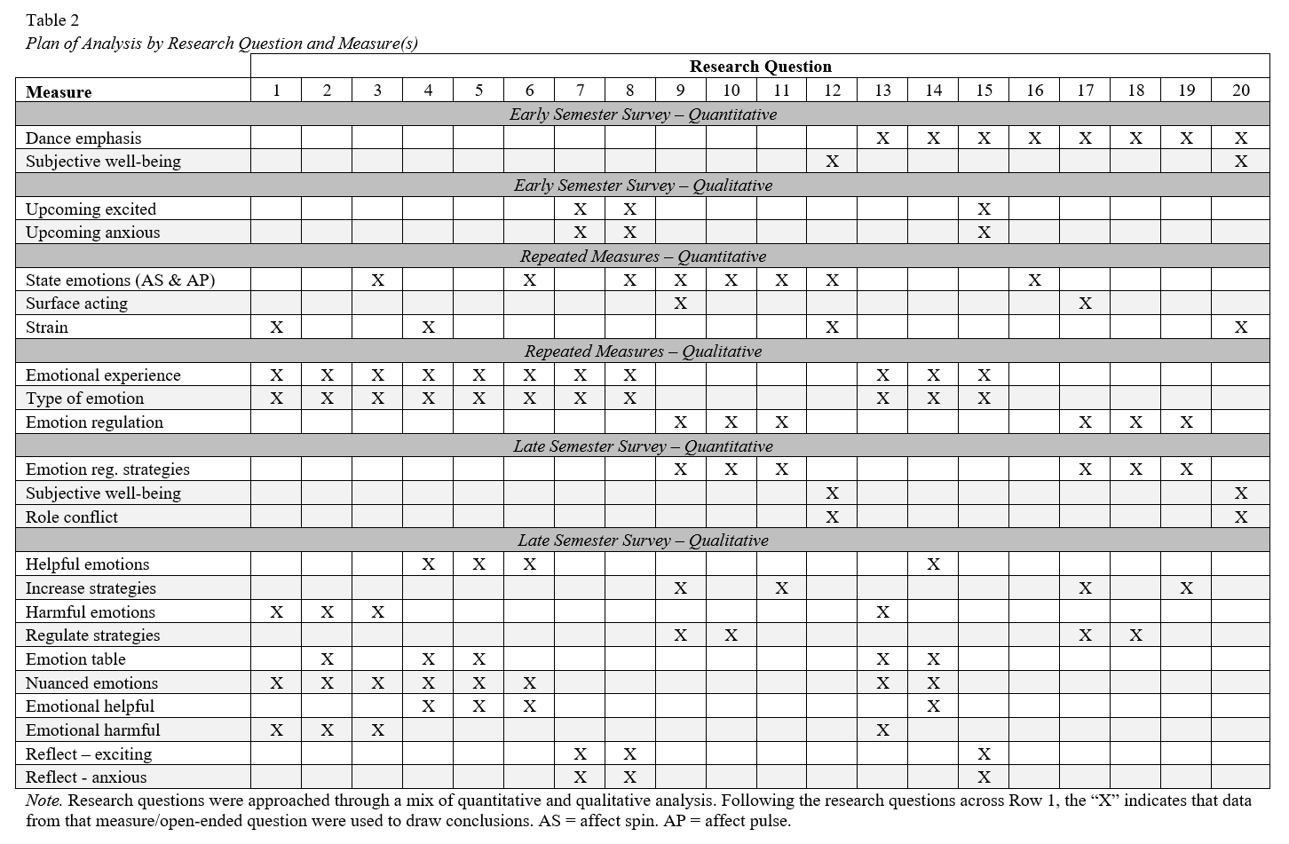
Table 3
Codes Used to Describe Harmfulness of Emotional Fluctuations
Axial Code | Focused Code & Sample Quote | Count | Percentage
Balance | Control | 8 | 53
Balance | If someone isn’t in control of their emotions and can’t channel them or manage them, then I think it is all too easy to get overwhelmed. | 8 | 53
Balance | Feeling Extreme Emotions | 6 | 40
Balance | Sometimes it can be too overwhelming to have powerful emotions taking over your headspace. | 6 | 40
Amplifying Strain | Amplifying Stress | 8 | 53
Amplifying Strain | I will let situations get the best of me and becomes bigger than they even were. | 8 | 53
Outcomes | Decision-Making | 3 | 20
Outcomes | The emotions might get so strong, they cloud your judgment. | 3 | 20
Outcomes | Role Conflict | 3 | 20
Outcomes | Balancing responsibilities and schoolwork is really difficult when you feel overwhelmed. | 3 | 20
Outcomes | Performance | 2 | 13
Outcomes | Keeping our emotions under control a beneficial tool that will make us better dancers. | 2 | 13
Outcomes | Creativity | 2 | 13
Outcomes | It can take away from the experience; the joy and love of your art can get lost. | 2 | 13
Outcomes | Strain | 1 | 7
Outcomes | Even if you are able to produce great work from your pain, you still had to suffer. | 1 | 7
Outcomes | Learned Helplessness | 1 | 7
Outcomes | It makes you feel helpless and out of control because we so often experience everything in extremes. | 1 | 7
Note. Question coded was the Later-Semester Survey question, “In what ways might emotional fluctuations be harmful?” Counts reflect the number of participants whose responses were coded using the particular code. N = 15.
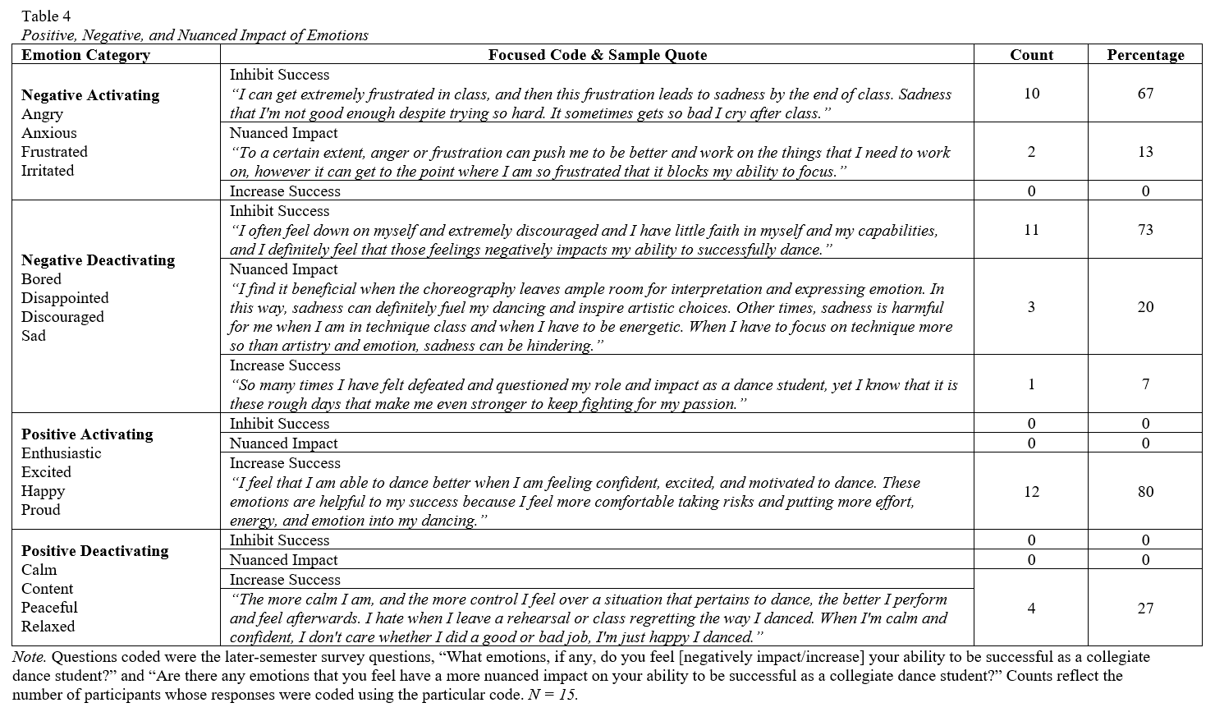
Table 5
Positive, Negative, and Nuanced Impact of Emotions by Levels of Affect Spin and Pulse
 | Affect Spin |  |  |  |  |  | Affect Pulse
 | High Spin  n = 3 participants |  |  | Low Spin  n = 5 participants |  |  | High Pulse  n = 3 participants |  |  | Low Pulse  n = 4 participants
Impact | Count | % |  | Count | % |  | Count | % |  | Count | %
Inhibit Success
Negative Activating | 2 | 66 |  | 3 | 60 |  | 3 | 100 |  | 2 | 50
Negative Deactivating | 2 | 66 |  | 4 | 80 |  | 2 | 66 |  | 3 | 75
Positive Activating | 0 | 0 |  | 0 | 0 |  | 0 | 0 |  | 0 | 0
Positive Deactivating | 0 | 0 |  | 0 | 0 |  | 0 | 0 |  | 0 | 0
Increase Success
Negative Activating | 0 | 0 |  | 0 | 0 |  | 0 | 0 |  | 0 | 0
Negative Deactivating | 0 | 0 |  | 0 | 0 |  | 0 | 0 |  | 1 | 25
Positive Activating | 3 | 100 |  | 4 | 80 |  | 2 | 66 |  | 3 | 75
Positive Deactivating | 1 | 33 |  | 0 | 0 |  | 2 | 66 |  | 1 | 25
Nuanced Impact
Negative Activating | 0 | 0 |  | 2 | 40 |  | 2 | 66 |  | 1 | 25
Negative Deactivating | 1 | 33 |  | 1 | 20 |  | 2 | 66 |  | 0 | 0
Positive Activating | 0 | 0 |  | 0 | 0 |  | 0 | 0 |  | 0 | 0
Positive Deactivating | 0 | 0 |  | 0 | 0 |  | 0 | 0 |  | 0 | 0
Note. Questions coded were the Later-Semester Survey questions, “What emotions, if any, do you feel [negatively impact/increase] your ability to be successful as a collegiate dance student?” and “Are there any emotions that you feel have a more nuanced impact on your ability to be successful as a collegiate dance student?” Affect spin and pulse groups were determined based on a top-bottom tertile split.

Table 6
Sub-Sample Counts and Percentages of the Types of Emotions Felt During Negative Events by Affect Variability
 |  | Affect Spin |  |  |  |  |  | Affect Pulse
 |  | High Spin  n events = 14 |  |  | Low Spin  n events = 6 |  |  | High Pulse  n events = 9 |  |  | Low Pulse  n events = 14
Emotion  Dimension | Count |  | % |  | Count | % |  | Count | % |  | Count | %
Negative Activating |  | 11 | 79 |  | 5 | 83 |  | 7 | 78 |  | 14 | 100
Negative Deactivating |  | 8 | 57 |  | 4 | 67 |  | 9 | 100 |  | 5 | 36
Positive Activating |  | 4 | 29 |  | 0 | 0 |  | 0 | 0 |  | 0 | 0
Positive Deactivating |  | 1 | 7 |  | 0 | 0 |  | 0 | 0 |  | 0 | 0
Note. Counts represent the number of events that mentioned an emotion for a particular emotion dimension, while percentage (%) represents the percentage of the events that mentioned an emotion for a particular emotion dimension. The coding of any event was not limited to a single emotion, and thus the sum of the counts across the four emotion dimensions could exceed the total number of emotional events reported. Affect spin and pulse groups were determined based on a top-bottom tertile split.

Table 7
Codes Used to Describe Helpfulness of Emotional Fluctuations
Axial Code | Focused Code & Sample Quote | Count | Percentage
Injecting Emotions into Performance & Improving Artistry | Performance | 14 | 93
Injecting Emotions into Performance & Improving Artistry | [Emotions help you] improve your artistry when performing. | 14 | 93
Injecting Emotions into Performance & Improving Artistry | Creativity | 10 | 67
Injecting Emotions into Performance & Improving Artistry | Emotion brings out creativity and sometimes can inspire dance projects. | 10 | 67
Injecting Emotions into Performance & Improving Artistry | Experience | 3 | 20
Injecting Emotions into Performance & Improving Artistry | It’s very helpful because it opens up my range of emotional vulnerabilities that I can access while dancing. | 3 | 20
Balance | Control | 4 | 27
Balance | Someone who is aware of their emotions is usually in control. | 4 | 27
Balance | Feeling Extreme Emotions | 1 | 7
Balance | In dance and most art, it is usually common for great work to come from difficult times in life. | 1 | 7
Outcomes | Role Conflict | 1 | 7
Outcomes | [Being emotional] reminds you that you are human during this stressful life period of being in college and a dance student. | 1 | 7
Note. Question coded was the Later-Semester Survey question, “In what ways might emotional fluctuations be helpful?” Counts reflect the number of participants whose responses were coded using the particular code. N = 15.

Table 8
Sub-Sample Counts and Percentages of the Types of Emotions Felt During Positive Events by Affect Variability
 | Affect Spin |  |  |  |  |  |  | Affect Pulse
 | High Spin  n events = 7 |  |  |  | Low Spin  n events = 4 |  |  | High Pulse  n events = 4 |  |  | Low Pulse  n events = 4
Emotion Dimension | Count |  | % |  | Count | % |  | Count | % |  | Count | %
Negative Activating | 4 |  | 57 |  | 0 | 0 |  | 0 | 0 |  | 1 | 25
Negative Deactivating |  | 2 | 29 |  | 0 | 0 |  | 0 | 0 |  | 0 | 0
Positive Activating | 6 |  | 86 |  | 4 | 100 |  | 4 | 100 |  | 1 | 25
Positive Deactivating | 1 |  | 14 |  | 2 | 50 |  | 0 | 0 |  | 2 | 50
Note. Counts represent the number of events that mentioned an emotion for a particular emotion dimension, while percentage (%) represents the percentage of the events that mentioned an emotion for a particular emotion dimension. The coding of any event was not limited to a single emotion, and thus the sum of the counts across the four emotion dimensions could exceed the total number of emotional events reported. Affect spin and pulse groups were determined based on a top-bottom tertile split.

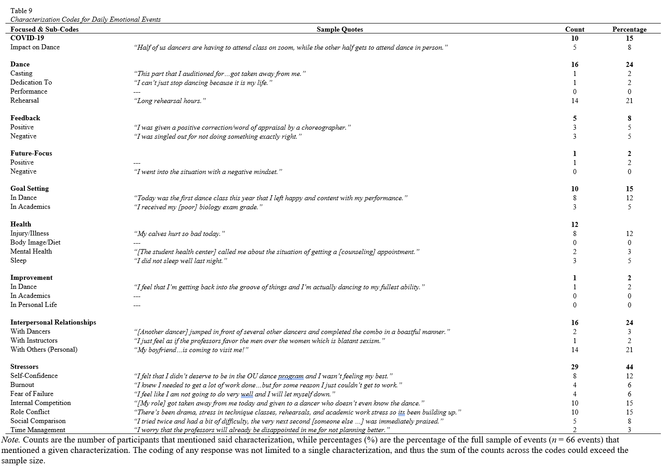
Table 10
Counts and Percentages of the Context of Emotional Events by Valence (Full Sample)
 |  | Early-Semester  Survey  n participants = 18 |  |  | Daily, Repeated  Survey  n events = 66 |  |  |  | Later-Semester  Survey  n participants = 15
Context |  | Count | % |  |  | Count | % |  | Count | %
Negative Events |  |  |  |  |  | 52 | 79
Dance |  | 15 | 83 |  |  | 22 | 33 |  | 8 | 53
Academics |  | 4 | 22 |  |  | 14 | 21 |  | 6 | 40
Personal |  | 1 | 6 |  |  | 12 | 18 |  | 6 | 40
Physical |  | 5 | 28 |  |  | 9 | 14 |  | 5 | 33
Other |  | 0 | 0 |  |  | 0 | 0 |  | 1 | 7
Positive Events |  |  |  |  |  | 19 | 29
Dance |  | 17 | 94 |  |  | 9 | 14 |  | 11 | 73
Academics |  | 3 | 17 |  |  | 0 | 0 |  | 1 | 7
Personal |  | 5 | 28 |  |  | 8 | 12 |  | 4 | 27
Physical |  | 1 | 6 |  |  | 0 | 0 |  | 1 | 7
Other |  | 0 | 0 |  |  | 0 | 0 |  | 1 | 7
Note. Counts are the number of participants that mentioned said context, while percentages (%) are the percentage of the relevant sample (i.e., participants or events) that mentioned a given context. The coding of any response was not limited to a single context or valence, and thus the sum of the counts across the contexts could exceed the sample size.

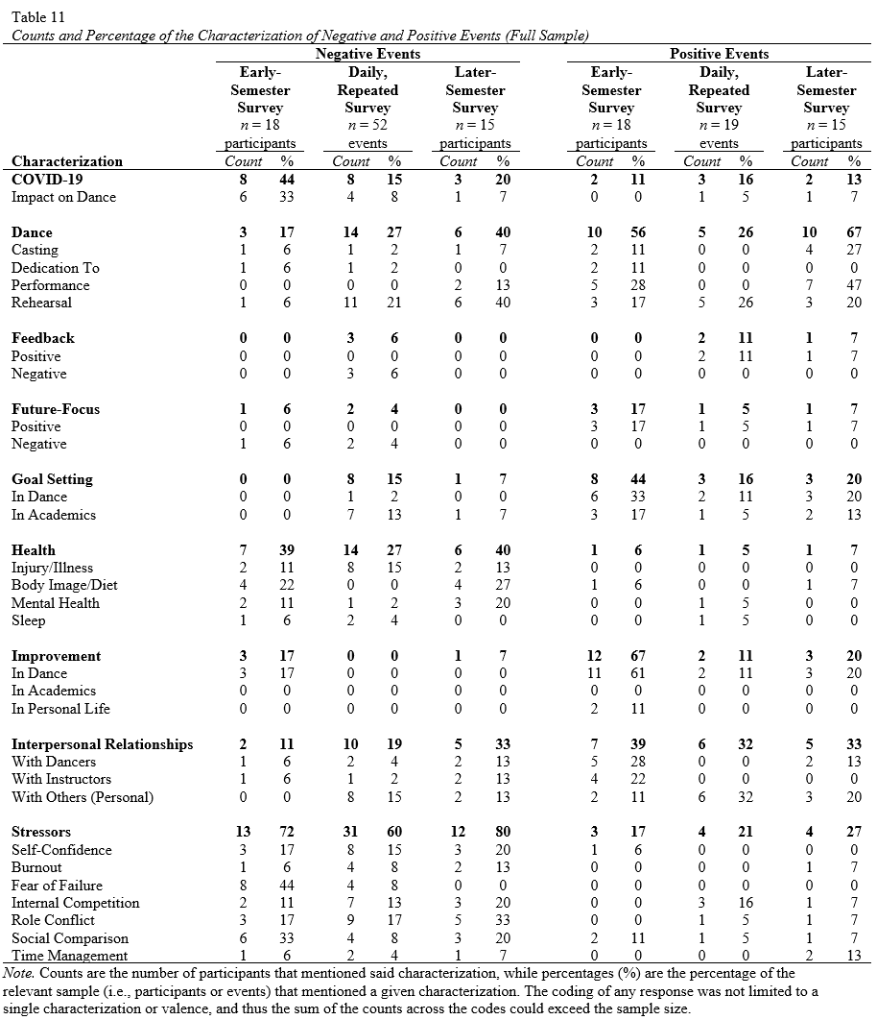

Table 12
Affect Spin Sub-Group Counts and Percentages of the Context of Emotional Events by Valence
 |  | Higher Spin |  |  |  |  |  |  |  |  | Lower Spin
 |  | Early-Semester Survey |  |  | Daily, Repeated Survey |  |  | Later-Semester Survey |  |  | Early-Semester Survey |  |  | Daily, Repeated Survey |  |  | Later-Semester Survey
 |  | n = 5 participants |  |  | n = 22 events |  |  | n = 3 participants |  |  | n = 5 participants |  |  | n = 10 events |  |  | n = 5 participants
 |  | Count | % |  | Count | % |  | Count | % |  | Count | % |  | Count | % |  | Count | %
Negative |  |  |  |  | 18 | 82 |  |  |  |  |  |  |  | 6 | 60
Dance |  | 4 | 80 |  | 11 | 50 |  | 1 | 33 |  | 4 | 80 |  | 3 | 30 |  | 3 | 60
Academic |  | 2 | 40 |  | 5 | 23 |  | 1 | 33 |  | 0 | 0 |  | 0 | 0 |  | 3 | 60
Personal |  | 0 | 0 |  | 3 | 14 |  | 1 | 33 |  | 0 | 0 |  | 3 | 30 |  | 2 | 40
Physical |  | 2 | 40 |  | 0 | 0 |  | 1 | 33 |  | 2 | 40 |  | 1 | 10 |  | 2 | 40
Positive |  |  |  |  | 6 | 27 |  |  |  |  |  |  |  | 4 | 40
Dance |  | 5 | 100 |  | 4 | 18 |  | 3 | 100 |  | 4 | 80 |  | 1 | 10 |  | 3 | 60
Academic |  | 2 | 40 |  | 0 | 0 |  | 0 | 0 |  | 0 | 0 |  | 0 | 0 |  | 0 | 0
Personal |  | 2 | 40 |  | 2 | 9 |  | 1 | 33 |  | 1 | 20 |  | 3 | 30 |  | 0 | 0
Physical |  | 0 | 0 |  | 0 | 0 |  | 0 | 0 |  | 1 | 20 |  | 0 | 0 |  | 1 | 20
Note. Counts are the number of participants that mentioned said context, while percentages (%) are the percentage of the relevant sample (i.e., participants or events) that mentioned a given context. The coding of any response was not limited to a single context or valence, and thus the sum of the counts across the contexts could exceed the sample size. Affect spin groups were determined based on a top-bottom tertile split.

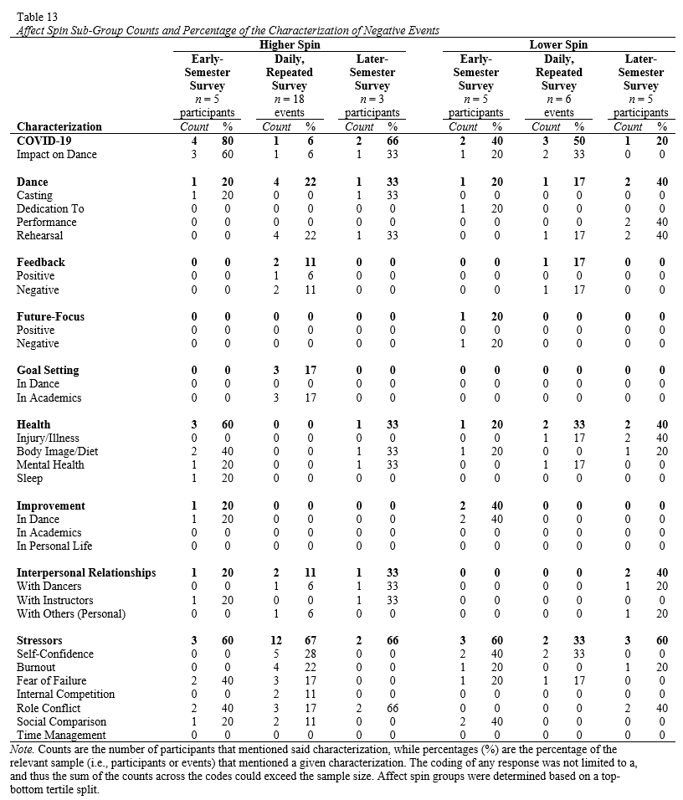

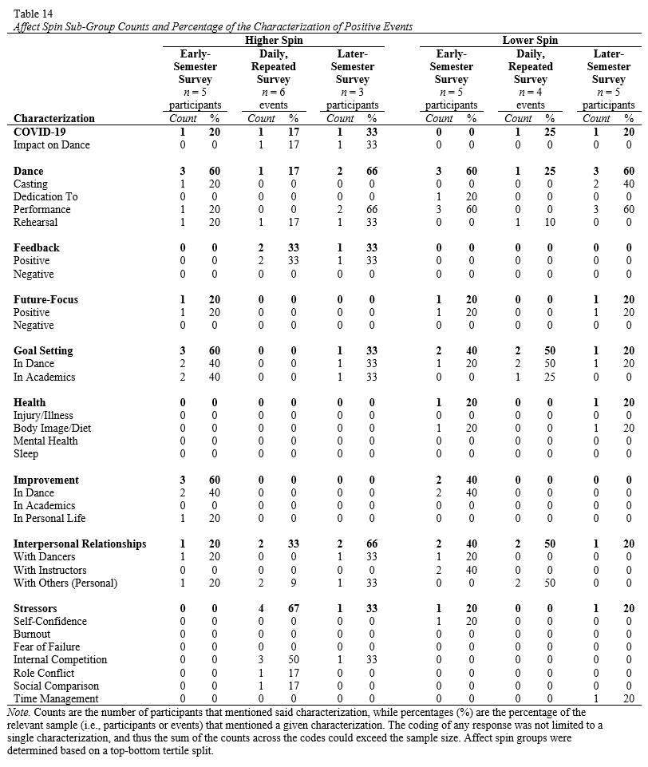

Table 15
Affect Pulse Sub-Group Counts and Percentages of the Context of Emotional Events by Valence
 |  | Higher Pulse |  |  |  |  |  |  |  |  | Lower Pulse
 |  | Early-Semester Survey |  |  | Daily, Repeated Survey |  |  | Later-Semester Survey |  |  | Early-Semester Survey |  |  | Daily, Repeated Survey |  |  | Later-Semester Survey
 |  | n = 4 participants |  |  | n = 13 events |  |  | n = 3 participants |  |  | n = 6 participants |  |  | n = 13 events |  |  | n = 4 participants
 |  | Count | % |  | Count | % |  | Count | % |  | Count | % |  | Count | % |  | Count | %
Negative
Dance |  | 4 | 100 |  | 4 | 31 |  | 3 | 100 |  | 5 | 83 |  | 4 | 31 |  | 1 | 25
Academic |  | 0 | 0 |  | 1 | 8 |  | 1 | 30 |  | 2 | 33 |  | 4 | 31 |  | 2 | 50
Personal |  | 0 | 0 |  | 5 | 38 |  | 1 | 30 |  | 1 | 17 |  | 1 | 8 |  | 2 | 50
Physical |  | 1 | 25 |  | 0 | 0 |  | 1 | 30 |  | 2 | 33 |  | 4 | 31 |  | 0 | 0
Positive
Dance |  | 4 | 100 |  | 0 | 0 |  | 3 | 100 |  | 5 | 83 |  | 3 | 23 |  | 2 | 50
Academic |  | 0 | 0 |  | 0 | 0 |  | 0 | 0 |  | 1 | 17 |  | 0 | 0 |  | 1 | 25
Personal |  | 0 | 0 |  | 4 | 31 |  | 1 | 33 |  | 2 | 33 |  | 0 | 0 |  | 1 | 25
Physical |  | 0 | 0 |  | 0 | 0 |  | 0 | 0 |  | 1 | 17 |  | 0 | 0 |  | 1 | 25
Note. Counts are the number of participants that mentioned said context, while percentages (%) are the percentage of the relevant sample (i.e., participants or events) that mentioned a given context. The coding of any response was not limited to a single context or valence, and thus the sum of the counts across the contexts could exceed the sample size. Affect pulse groups were determined based on a top-bottom tertile split.

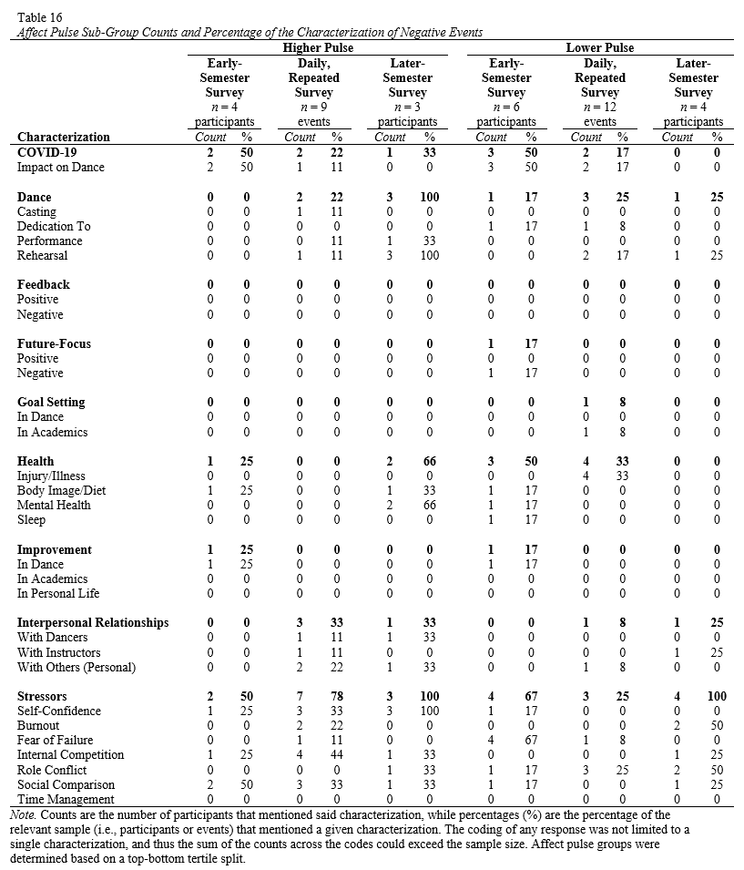

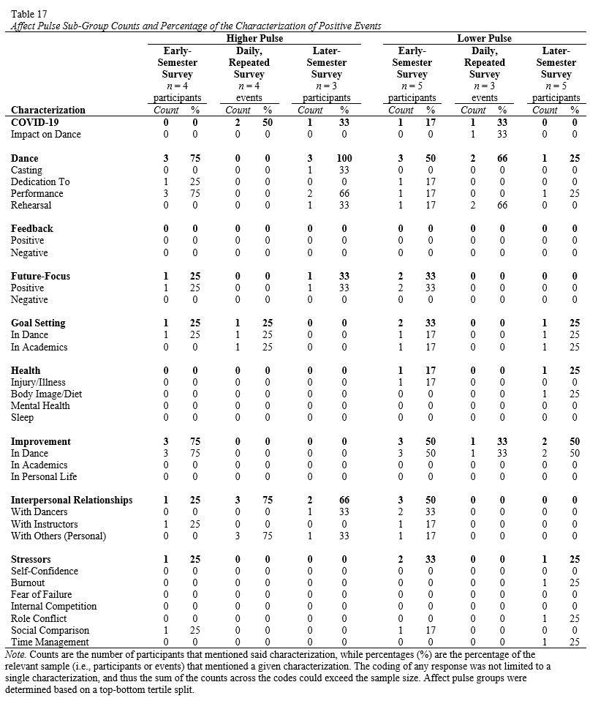

Table 18
Affect Spin Sub-Group Counts and Percentages of the Types of Emotion Regulation Strategies Used During Emotional Events
 | Negative Events |  |  |  |  |  | Positive Events
 | High Spin  n events = 18 |  |  | Low Spin  n events = 6 |  |  | High Spin  n events = 6 |  |  | Low Spin  n events = 4
Emotion Regulation Strategy | Count | % |  | Count | % |  | Count | % |  | Count | %
Acceptance | 1 | 6 |  | 0 | 0 |  | 1 | 17 |  | 0 | 0
Avoidance | 2 | 11 |  | 0 | 0 |  | 1 | 17 |  | 0 | 0
Dance | 1 | 6 |  | 0 | 0 |  | 1 | 17 |  | 1 | 25
Immersion | 3 | 17 |  | 0 | 0 |  | 3 | 50 |  | 0 | 0
Physical Response | 4 | 22 |  | 4 | 67 |  | 1 | 17 |  | 0 | 0
Problem Solving | 3 | 17 |  | 0 | 0 |  | 2 | 33 |  | 0 | 0
Reappraisal | 2 | 11 |  | 1 | 17 |  | 2 | 33 |  | 0 | 0
Rumination | 0 | 0 |  | 0 | 0 |  | 0 | 0 |  | 0 | 0
Self-Care | 3 | 17 |  | 0 | 0 |  | 1 | 17 |  | 0 | 0
Social Support | 3 | 17 |  | 2 | 33 |  | 0 | 0 |  | 2 | 50
Suppression | 5 | 28 |  | 3 | 50 |  | 1 | 17 |  | 0 | 0
Surface Acting | 1 | 6 |  | 1 | 17 |  | 0 | 0 |  | 0 | 0
None | 2 | 11 |  | 0 | 0 |  | 0 | 0 |  | 0 | 0
Note. Counts represent the number of events that mentioned an emotion regulation strategy for a particular emotional event, while percentage (%) represents the percentage of the events that mentioned an emotion regulation strategy for a sub-group of affect variability. The coding of any event was not limited to a single emotion regulation strategy or valence, and thus the sum of the counts across the listed emotion regulation strategies could exceed the total number of emotional events reported. Affect spin groups were determined based on a top-bottom tertile split.

Table 19
Affect Pulse Sub-Group Counts and Percentages of the Types of Emotion Regulation Strategies Used During Emotional Events
 | Negative Events |  |  |  |  |  | Positive Events
 | High Pulse  n events = 9 |  |  | Low Pulse  n events = 12 |  |  | High Pulse  n events = 4 |  |  | Low Pulse  n events = 3
Emotion Regulation Strategy | Count | % |  | Count | % |  | Count | % |  | Count | %
Acceptance | 0 | 0 |  | 3 | 25 |  | 0 | 0 |  | 1 | 33
Avoidance | 0 | 0 |  | 1 | 8 |  | 0 | 0 |  | 0 | 0
Dance | 0 | 0 |  | 1 | 8 |  | 0 | 0 |  | 2 | 66
Immersion | 1 | 11 |  | 0 | 0 |  | 0 | 0 |  | 0 | 0
Physical Response | 3 | 33 |  | 0 | 0 |  | 1 | 25 |  | 0 | 0
Problem Solving | 0 | 0 |  | 3 | 25 |  | 0 | 0 |  | 0 | 0
Reappraisal | 1 | 11 |  | 0 | 0 |  | 0 | 0 |  | 1 | 33
Rumination | 0 | 0 |  | 0 | 0 |  | 0 | 0 |  | 0 | 0
Self-Care | 1 | 11 |  | 2 | 17 |  | 0 | 0 |  | 0 | 0
Social Support | 3 | 33 |  | 2 | 17 |  | 2 | 50 |  | 0 | 0
Suppression | 5 | 56 |  | 5 | 42 |  | 0 | 0 |  | 0 | 0
Surface Acting | 1 | 11 |  | 1 | 8 |  | 1 | 25 |  | 0 | 0
None | 1 | 11 |  | 1 | 8 |  | 0 | 0 |  | 1 | 33
Note. Counts represent the number of events that mentioned an emotion regulation strategy for a particular emotional event, while percentage (%) represents the percentage of the events that mentioned an emotion regulation strategy for a sub-group of affect variability. The coding of any event was not limited to a single emotion regulation strategy or valence, and thus the sum of the counts across the listed emotion regulation strategies exceeded the total number of emotional events reported. Affect pulse groups were determined based on a top-bottom tertile split.

Table 20
Positive, Negative, and Nuanced Impact of Emotions by Emphasis
 | Ballet |  |  |  |  |  |  | Modern
 | n = 9 participants |  |  |  |  |  |  | n = 6 participants
Impact | Count |  |  |  | % |  |  | Count |  |  | %
Inhibit Success
Negative Activating | 5 |  |  |  | 56 |  |  | 5 |  |  | 83
Negative Deactivating |  | 5 |  |  | 56 |  |  | 6 |  |  | 100
Positive Activating | 0 |  |  |  | 0 |  |  | 0 |  |  | 0
Positive Deactivating | 0 |  |  |  | 0 |  |  | 0 |  |  | 0
Increase Success
Negative Activating | 2 |  |  |  | 22 |  |  | 0 |  |  | 0
Negative Deactivating |  | 0 |  |  | 0 |  |  | 0 |  |  | 0
Positive Activating | 6 |  |  |  | 67 |  |  | 6 |  |  | 100
Positive Deactivating | 2 |  |  |  | 22 |  |  | 2 |  |  | 33
Nuanced Impact
Negative Activating | 1 |  |  |  | 11 |  |  | 1 |  |  | 17
Negative Deactivating |  | 1 |  |  | 11 |  |  | 2 |  |  | 33
Positive Activating | 2 |  |  |  | 22 |  |  | 1 |  |  | 17
Positive Deactivating | 0 |  |  |  | 0 |  |  | 0 |  |  | 0
Note. Questions coded were the Later-Semester Survey questions, “What emotions, if any, do you feel [negatively impact/increase] your ability to be successful as a collegiate dance student?” and “Are there any emotions that you feel have a more nuanced impact on your ability to be successful as a collegiate dance student?”

Table 21
Sub-Sample Counts and Percentages of the Types of Emotions Felt During Positive and Negative Events by Emphasis
 | Ballet |  |  |  |  |  |  | Modern
 | Negative  n events = 20 |  |  |  | Positive  n events = 8 |  |  | Negative  n events = 32 |  |  | Positive  n events = 8
Emotion Dimension | Count |  | % |  | Count | % |  | Count | % |  | Count | %
Negative Activating |  | 13 | 65 |  | 1 | 13 |  | 16 | 50 |  | 0 | 0
Negative Deactivating |  | 8 | 40 |  | 1 | 13 |  | 16 | 50 |  | 0 | 0
Positive Activating |  | 0 | 0 |  | 7 | 88 |  | 0 | 0 |  | 8 | 100
Positive Deactivating |  | 0 | 0 |  | 0 | 0 |  | 0 | 0 |  | 50 | 25
Note. Counts represent the number of events that mentioned an emotion for a particular emotion dimension, while percentage (%) represents the percentage of the events that mentioned an emotion for a particular emotion dimension. The coding of any event was not limited to a single emotion, and thus the sum of the counts across the four emotion dimensions could exceed the total number of emotional events reported. Affect spin and pulse groups were determined based on a top-bottom tertile split.

Table 22
Emphasis Sub-Group Counts and Percentages of the Context of Emotional Events by Valence
 |  | Ballet |  |  |  |  |  |  |  |  | Modern
 |  | Early-Semester Survey |  |  | Daily, Repeated Survey |  |  | Later-Semester Survey |  |  | Early-Semester Survey |  |  | Daily, Repeated Survey |  |  | Later-Semester Survey
 |  | n = 10 participants |  |  | n = 28 events |  |  | n = 9 participants |  |  | n = 8 participants |  |  | n = 38 events |  |  | n = 6 participants
 |  | Count | % |  | Count | % |  | Count | % |  | Count | % |  | Count | % |  | Count | %
Negative
Dance |  | 9 | 90 |  | 10 | 36 |  | 4 | 44 |  | 6 | 75 |  | 12 | 32 |  | 4 | 66
Academic |  | 3 | 30 |  | 3 | 11 |  | 5 | 56 |  | 1 | 13 |  | 8 | 21 |  | 1 | 17
Personal |  | 1 | 10 |  | 5 | 18 |  | 2 | 22 |  | 0 | 0 |  | 7 | 18 |  | 4 | 66
Physical |  | 3 | 30 |  | 6 | 21 |  | 2 | 22 |  | 2 | 25 |  | 3 | 8 |  | 3 | 50
Positive
Dance |  | 9 | 90 |  | 5 | 18 |  | 6 | 56 |  | 8 | 100 |  | 4 | 11 |  | 5 | 83
Academic |  | 2 | 20 |  | 0 | 0 |  | 1 | 11 |  | 1 | 13 |  | 0 | 0 |  | 0 | 0
Personal |  | 3 | 30 |  | 4 | 14 |  | 1 | 11 |  | 2 | 25 |  | 4 | 11 |  | 3 | 50
Physical |  | 1 | 10 |  | 0 | 0 |  | 1 | 11 |  | 0 | 0 |  | 0 | 0 |  | 0 | 0
Note. Counts are the number of participants that mentioned said context, while percentages (%) are the percentage of the relevant sample (i.e., participants or events) that mentioned a given context. The coding of any response was not limited to a single context or valence, and thus the sum of the counts across the contexts could exceed the sample size.

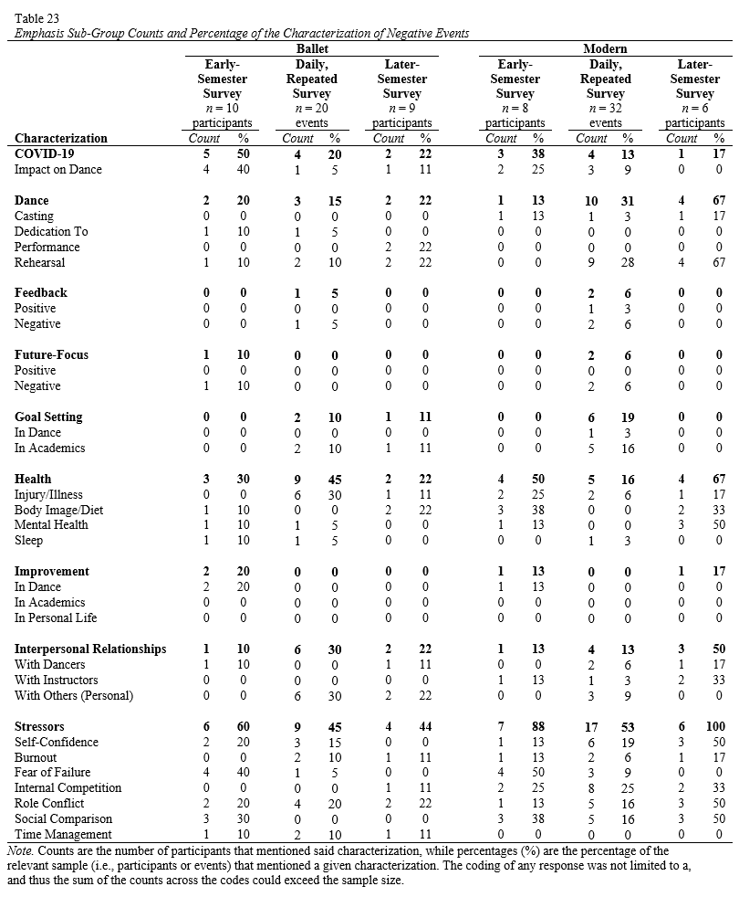

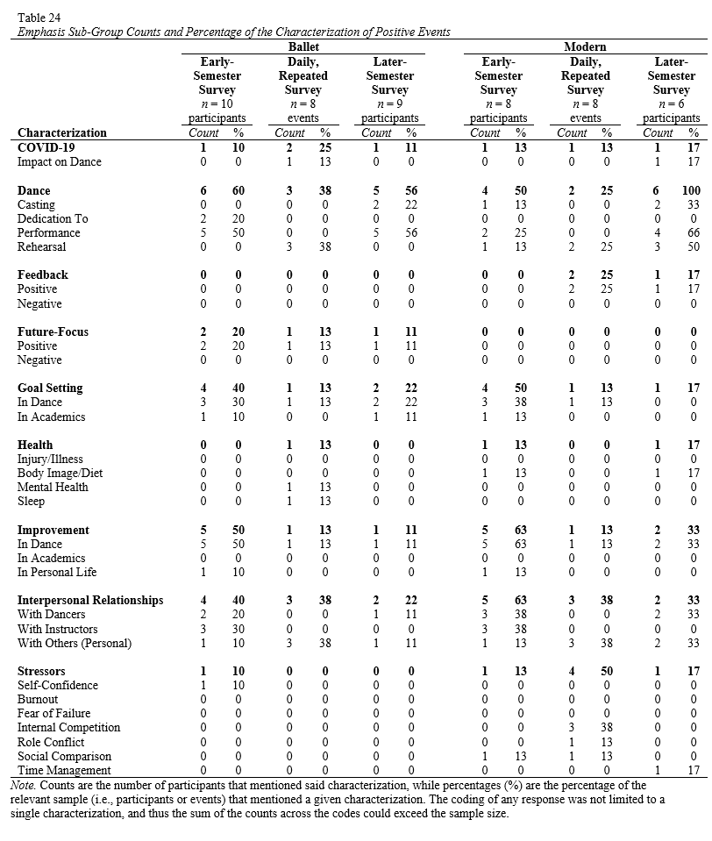

Table 25
Emphasis Sub-Group Counts and Percentages of the Types of Emotion Regulation Strategies Used During Emotional Events
 | Negative Events |  |  |  |  |  | Positive Events
 | Ballet  n events = 28 |  |  | Modern  n events = 38 |  |  | Ballet  n events = 8 |  |  | Modern  n events = 8
Emotion Regulation Strategy | Count | % |  | Count | % |  | Count | % |  | Count | %
Acceptance | 1 | 4 |  | 3 | 8 |  | 0 | 0 |  | 1 | 13
Avoidance | 3 | 11 |  | 0 | 0 |  | 0 | 0 |  | 0 | 0
Dance | 0 | 0 |  | 0 | 0 |  | 5 | 63 |  | 1 | 13
Immersion | 0 | 0 |  | 1 | 3 |  | 3 | 38 |  | 0 | 0
Physical Response | 4 | 14 |  | 5 | 13 |  | 0 | 0 |  | 1 | 13
Problem Solving | 1 | 4 |  | 2 | 5 |  | 0 | 0 |  | 0 | 0
Reappraisal | 2 | 7 |  | 1 | 3 |  | 3 | 38 |  | 0 | 0
Rumination | 0 | 0 |  | 0 | 0 |  | 0 | 0 |  | 0 | 0
Self-Care | 4 | 14 |  | 1 | 3 |  | 0 | 0 |  | 0 | 0
Social Support | 4 | 14 |  | 2 | 5 |  | 2 | 25 |  | 0 | 0
Suppression | 2 | 7 |  | 6 | 16 |  | 1 | 13 |  | 0 | 0
Surface Acting | 0 | 0 |  | 3 | 8 |  | 0 | 0 |  | 1 | 13
None | 1 | 4 |  | 1 | 3 |  | 0 | 0 |  | 1 | 13
Note. Counts represent the number of events that mentioned an emotion regulation strategy for a particular emotional event, while percentage (%) represents the percentage of the events that mentioned an emotion regulation strategy for a sub-group of affect variability. The coding of any event was not limited to a single emotion regulation strategy or valence, and thus the sum of the counts across the listed emotion regulation strategies could exceed the total number of emotional events reported. Additionally, responses were voluntary and not all participants self-reported an emotion regulation strategy.

 |  | Valence
 |  | Positive | Negative
Activation Potential | Low | - Calm  - Content  - Peaceful  - Relaxed | - Bored  - Disappointed  - Discouraged  - Sad
Activation Potential | High | - Enthusiastic  - Excited  - Happy  - Proud | - Angry  - Anxious  - Frustrated  - Irritated

Figure 1. Emotions measured in the present study clustered based on activation potential and valence.

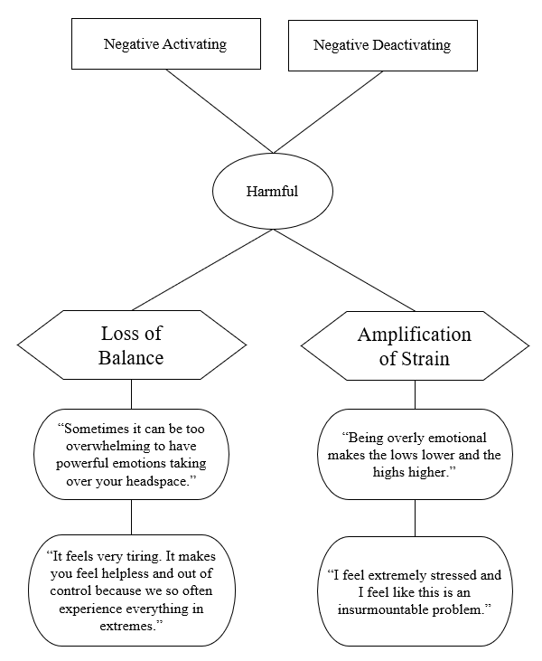

Figure 2. Concept map of the harmful effects of emotions on success in collegiate dance. Rectangular boxes indicate sub-codes, circles indicate the context of the research question at hand, hexagons indicate axial codes, and rounded rectangles indicate participant quotes.

Figure 3. Daily fluctuations of self-reported strain by levels of affect spin (Panel A) and affect pulse (Panel B).

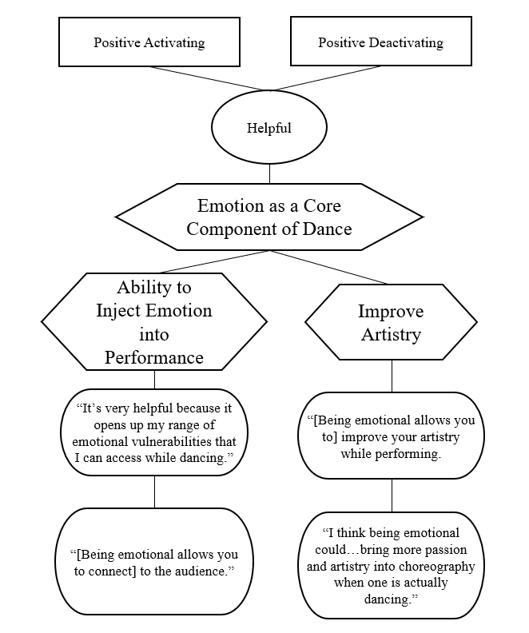

Figure 4. Concept map of the helpful effects of emotions on success in collegiate dance. Rectangular boxes indicate focused codes, circles indicate the context of the research question at hand, hexagons indicate axial codes, and rounded rectangles indicate participant quotes.

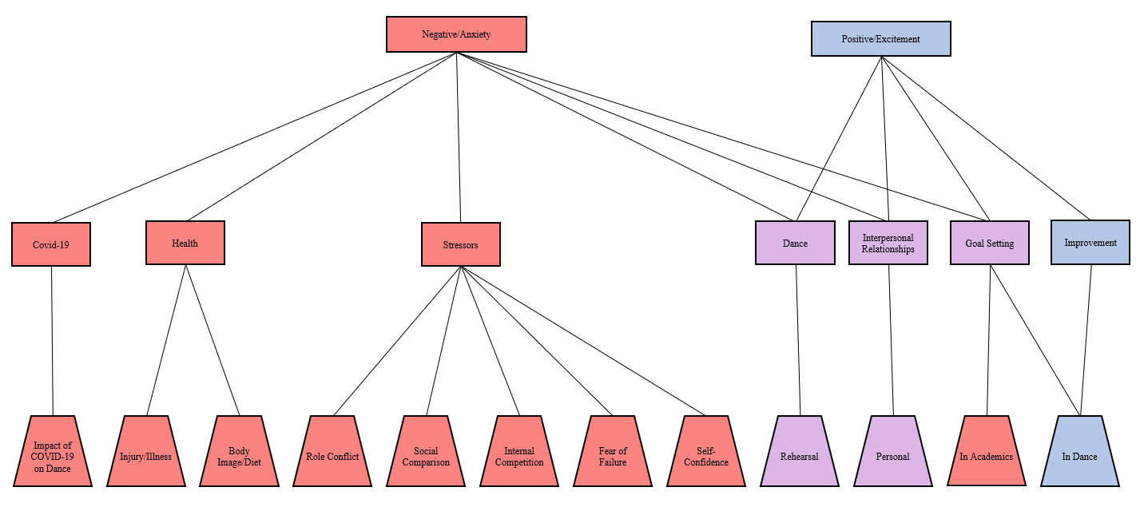
Figure 5. Concept map of the characterization of positive and negative emotional experiences (Full Sample). Rectangular boxes indicate focused codes and trapezoids indicate sub-codes. Shapes colored red indicate the presence of only negative emotions, shapes colored blue indicate the presence of only positive emotions, and shapes colored purple indicate the presence of both negative and positive emotions.

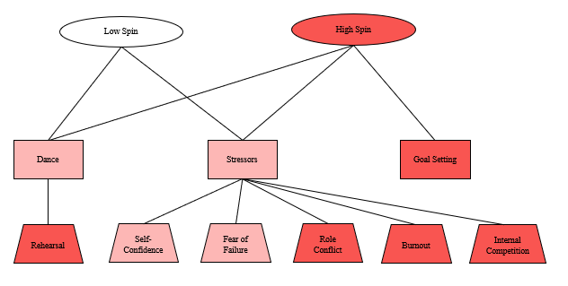

Figure 6. Concept map of the characterization of negative emotional experiences by levels of affect spin. Rectangular boxes indicate focused codes and trapezoids indicate sub-codes. Circles indicate the context of the research question at hand. Shapes colored dark red indicate negative events experienced only by those higher in spin, shapes colored white indicate negative events experienced by those lower in affect spin, and shapes colored light red indicate negative events experienced by both groups.

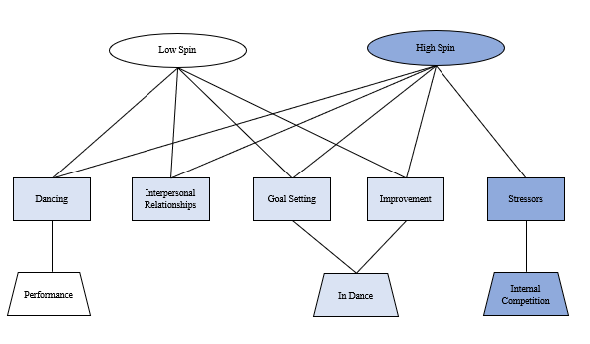
Figure 7. Concept map of the characterization of positive emotional experiences by levels of affect spin. Rectangular boxes indicate focused codes and trapezoids indicate sub-codes. Circles indicate the context of the research question at hand. Shapes colored dark blue indicate positive events experienced only by those higher in spin, shapes colored white indicate positive events experienced by those lower in affect spin, and shapes colored light blue indicate positive events experienced by both groups.

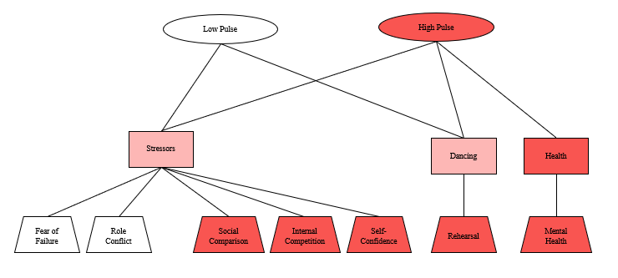

Figure 8. Concept map of the characterization of negative emotional experiences by levels of affect pulse. Rectangular boxes indicate focused codes and trapezoids indicate sub-codes. Circles indicate the context of the research question at hand. Shapes colored dark red indicate negative events experienced only by those higher in pulse, shapes colored white indicate negative events experienced by those lower in affect pulse, and shapes colored light red indicate negative events experienced by both groups.

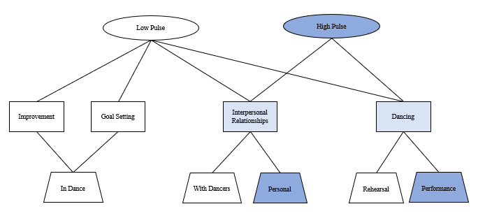

Figure 9. Concept map of the characterization of positive emotional experiences by levels of affect pulse. Rectangular boxes indicate focused codes and trapezoids indicate sub-codes. Circles indicate the context of the research question at hand. Shapes colored dark blue indicate positive events experienced only by those higher in pulse, shapes colored white indicate positive events experienced by those lower in affect pulse, and shapes colored light blue indicate positive events experienced by both groups.

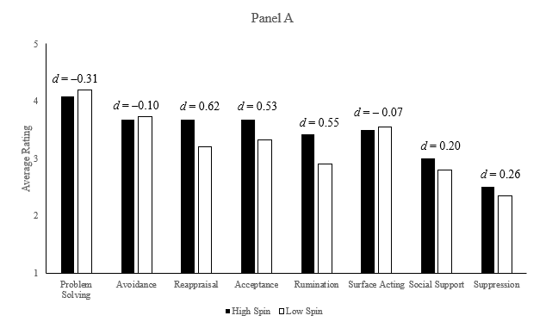
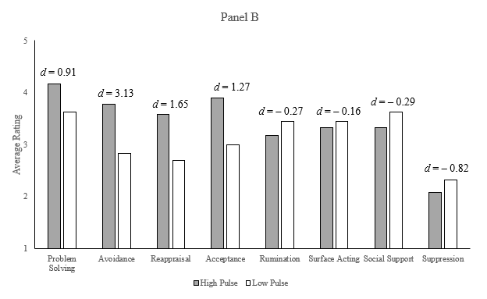

Figure 10. Comparison of emotion regulation strategy use by level of affect spin (Panel A) and affect pulse (Panel B). Participants were asked to self-report their usage of each strategy in the last 4 weeks, with major scale anchors at 1 = never and 5 = always.
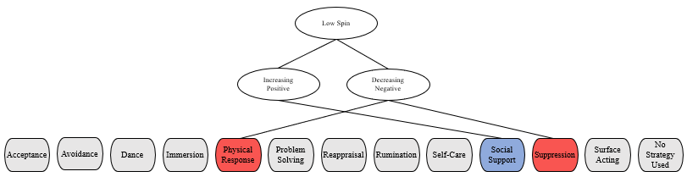
Panel A

Panel B
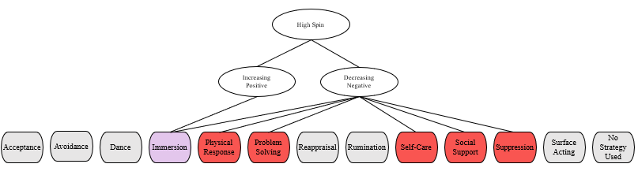

Figure 11. Concept maps of the use of emotion regulation strategies for those lower in spin (Panel A) and higher in spin (Panel B). Rectangular boxes indicate focused codes and circles indicate the context of the research question at hand. Within the emotion regulation strategies, red boxes indicate that the strategy is used only to regulate negative emotions, blue boxes indicate that the strategy is used only to regulate positive emotions, and purple boxes indicate that the strategy is used to regulate both positive and negative emotions. Gray boxes indicate that the strategy was not mentioned at all or not mentioned often enough to be considered in analysis.
Panel A

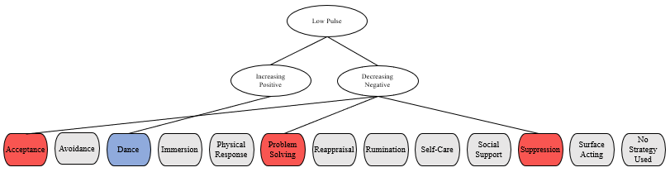
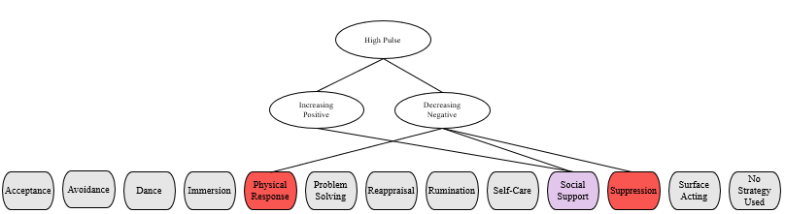
Panel B

Figure 12. Concept maps of the use of emotion regulation strategies for those lower in pulse (Panel A) and higher in pulse (Panel B). Rectangular boxes indicate focused codes and circles indicate the context of the research question at hand. Within the emotion regulation strategies, red boxes indicate that the strategy is used only to regulate negative emotions, blue boxes indicate that the strategy is used only to regulate positive emotions, and purple boxes indicate that the strategy is used to regulate both positive and negative emotions. Gray boxes indicate that the strategy was not mentioned at all or not mentioned often enough to be considered in analysis.

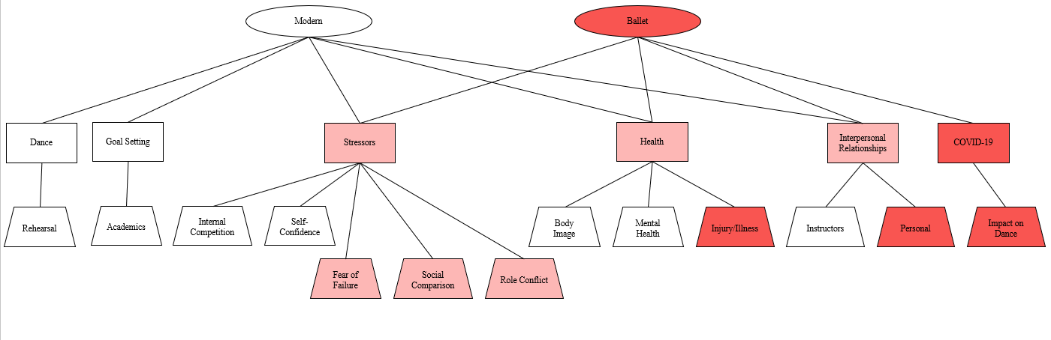

Figure 13. Concept map of the characterization of negative emotional experiences by emphasis. Rectangular boxes indicate focused codes and trapezoids indicate sub-codes. Circles indicate the context of the research question at hand. Shapes colored dark red indicate negative events experienced only by ballet students, shapes colored white indicate negative events experienced by modern students, and shapes colored light red indicate negative events experienced by both groups.

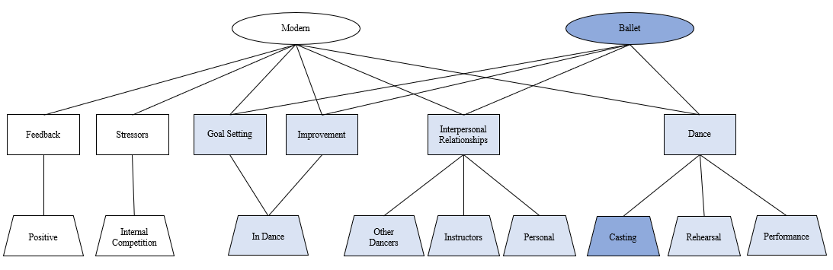

Figure 14. Concept map of the characterization of positive emotional experiences by emphasis. Rectangular boxes indicate focused codes and trapezoids indicate sub-codes. Circles indicate the context of the research question at hand. Shapes colored dark blue indicate positive events experienced only by ballet students, shapes colored white indicate positive events experienced by modern students, and shapes colored light blue indicate positive events experienced by both groups.

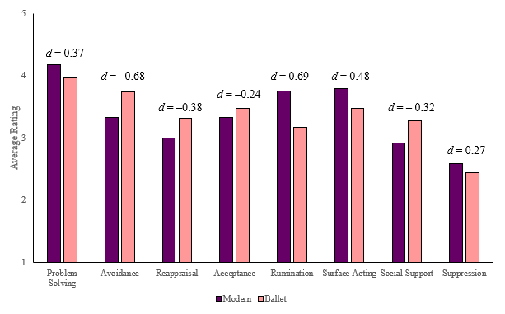

Figure 15. Comparison of emotion regulation strategy use by emphasis. Participants were asked to self-report their usage of each strategy in the last 4 weeks, with major scale anchors at 1 = never and 5 = always.

Figure 16. Daily fluctuations of self-reported strain by emphasis.

d = –0.92
d = –0.73

Figure 17. Comparison of perceived well-being scores by emphasis, for both the earlier and later semester measurement occasions.

Appendix A
Recruitment Materials

Students of the OU School of Dance,

My name is Kelsey Richels, and I am a fifth-year doctoral student in the Department of Psychology. I am reaching out to you in hopes that you would be willing to participate in my upcoming study, which will serve as the basis for my dissertation.

The study aims to examine the impact of emotion on stress and well-being. As dance students, I understand that you face additional pressures above and beyond that of a typical student. As such, my research team and I believe it is particularly important to better understand how your emotions and your strategies for dealing with those emotions impact your ability to cope with stress.

Your participation in the study is strictly voluntary, and your choice to participate will not influence your education or grade in any classes. No information collected during this study will be linked to you, nor will it be shared with your instructors.

Your role as a study participant will involve completing a series of surveys. A “Beginning of the Semester” survey will be administered following your agreement to participate. Then, over the course of four weeks, you will be asked to complete brief, daily surveys that are designed to measure your emotions and stress levels. Lastly, you will complete a “Follow-Up” survey to collect additional information about your experiences this semester. Estimated time for your participation is as follows:
Beginning of the Semester Survey: 30-45 minutes; one-time administration
Repeated Measures Surveys: 5-10 minutes; Monday – Friday, four weeks
Follow-Up Survey: 30-45 minutes; one-time administration

Attached you will find a more detailed overview of my study, along with biographies of myself and my research team.

We will be attending the School of Dance Mandatory Majors Meeting on August 28th, and we look forward to answering any questions you may have. In the meantime, if you have any questions about the project, please feel free to email me at Kelsey.a.richels@ou.edu.

STUDY PURPOSE
Art is by nature emotional, and the study of the relationship between art and emotion goes back to the era of Plato. However, little research has examined the unique challenges faced by individuals who study and work in a field that emphasizes the experience, portrayal, and suppression of various emotional states. Thus, the purpose of the upcoming survey study is to examine the effects of emotional variability on the well-being and coping ability of collegiate dance students.
CONFIDENTIALY STATEMENT
All the information collected from you throughout this study will be kept confidential and will not be shared with anyone outside of the immediate research team. Identifying information will not be shared with your instructors or OU School of Dance administration. STUDY PROCEDURE
Data collection will be split into four primary stages: Stage 1: Recruitment All major students within the OU School of Dance will be recruited to participate in this study. The project team will attend the OU School of Dance school-wide mandatory meeting on Friday, August 28th, 2020, via Zoom to briefly present the project and answer any questions. You are not required by your instructors to participate in the study and are allowed to cease your participation at any point should you feel it necessary. Stage 2: Beginning of the Semester Survey After volunteering to participate in the study, you will be emailed an informed consent form and pre-survey designed to collect background and demographic information as well as information regarding aspects of your personality. Stage 3: Repeated Daily Survey In order to accurately measure emotion fluctuation across time, you will be administered daily surveys (Monday through Friday) for a period of four weeks. These short surveys will be sent via email daily at 4 p.m., and will close each following morning at 8 a.m. These surveys will ask about your day’s emotions and perceptions of stress. Stage 4: Follow-Up Survey At a point near the end of the semester, you will receive the link to one final survey. This survey will include measures to assess your use of emotion regulation strategies and will give you the opportunity to provide more robust, descriptive answers to a series of questions regarding the benefits and detriments of emotions as a collegiate dance student. You will be given a window of time to complete this survey. PROJECT TEAM
Project Lead: Kelsey Richels, M.S.
Kelsey is a fifth-year doctoral study in Industrial/Organizational (IO) Psychology. She will be using this project to write her dissertation. She received her Master’s Degree in 2016, with a thesis titled Keeping Calm and Carrying On: Relating Proactive Personality, Affect Spin, and Affect Pulse to Learning and Adaptive Task Performance. She has a history in athletics and swam for the University of North Dakota Division I swim team for four years.
Faculty Advisor: Eric Day, Ph.D.
Eric is Department Chair and a Professor of Psychology, where he is part of the doctoral program in IO. He earned his Ph.D. in IO Psychology from Texas A&M University, a M.S. in IO Psychology from the University of Central Florida, and a B.S. in Psychology from James Madison University. His research involves the study of human performance and complex skill learning with emphases on individual differences in the ability and motivation, self-regulation, retention and transfer, and team-based training. He is an avid runner.
Graduate Researcher: Justine Rockwood, M.S.
Justine is a second-year student in the IO doctoral program. She earned her Master’s in Performance Psychology from the University of Edinburgh, with a thesis titled, Excellence in Classical Ballet: An Exploration of the Psychological Attributes Leading to Success in Classical Ballet Dancers. Justine has a long history in ballet, and has trained in classical ballet, folk and character dance, ethnic dance, jazz, ballroom, and social dancing. She trained professionally in the Vaganova method at the Kirov Academy of Ballet (Washington D.C.) and City Ballet School (San Francisco, CA). She attended the Rimsky-Korsakov Conservatory in Saint Petersburg, Russia for a Certificate in Ballet Mastery.

Appendix B
Survey Distribution Communications
Subject: Early-Semester Survey

Hi [Name],

Thank you for volunteering to participate in my study! I understand how busy you are with your regular semester, so I really appreciate you volunteering your time to assist me with my dissertation project.

As a first step, please complete the “Beginning of the Semester” survey linked here. We ask that you complete this survey by Sunday, September 13th.

On this survey and all future surveys, you will be asked to input a “Participant ID Number.” This is the fourth letter of your last name and the last four digits of your OU ID Number. By using the same identification number on all surveys, we can link your data together without using your name. If you have any questions about how to create this Participant ID, please let me know!

If you have any questions or concerns about the study, please do not hesitate to contact me at Kelsey.a.richels@ou.edu or (701) 899-1253.

Subject: Psychology Study: Day 1 (9/14)
Good afternoon,

Today marks the first day of our repeated measures for the next four weeks (Monday through Friday). Please follow the link below to complete your first daily survey. These surveys are brief and should take no longer than 5-10 minutes of your time. Survey links will be sent each day at 4 p.m., with a reminder at 9 p.m. Please complete these daily surveys at any point before 8 a.m. the following morning.

These surveys should reflect your experiences so far today. Please make sure to read all instructions carefully and answer accordingly.

Daily survey link: https://ousurvey.qualtrics.com/jfe/form/SV_0wfzzE2uPaSjIoJ

If you have not yet taken the pre-survey:

Please do so before taking the first daily survey. The pre-survey link can be found here: https://ousurvey.qualtrics.com/jfe/form/SV_eL302mxArgGBy97

FAQs

What should I do if the survey link does not work? If your survey link does not work, please email me at kelsey.a.richels@ou.edu or call/text me at (701) 899-1253.

What happens if I miss a day? Although we would love to have full participation, it is not the end of the world to miss a survey. Should you miss a daily survey, please skip that day and continue to respond to daily surveys on the next day. In other words, if you miss a few surveys - please continue to respond in the future! It is not an all-or-nothing situation.

As always, if you have any other questions, please let me know!

Subject: Psychology Study Day [#]: [Month/Day]
Good afternoon,

Please follow the link below to complete today's daily survey. Please complete these daily surveys before 8 a.m. the following morning.

These surveys should reflect your experiences so far today. Please make sure to read all instructions carefully and answer accordingly.

Survey link: https://ousurvey.qualtrics.com/jfe/form/SV_0wfzzE2uPaSjIoJ

As always, if you have any questions, please let me know!

Subject: REMINDER: Psychology Study Day [#] ([Month/Day])
Good evening,

This is a friendly reminder to complete your daily survey, if you have not yet done so!

This survey should reflect your experiences so far today. Please make sure to read all instructions carefully and answer accordingly.

Survey link: https://ousurvey.qualtrics.com/jfe/form/SV_0wfzzE2uPaSjIoJ

As always, if you have any questions, please let me know!

Subject: Final Survey: Psychology Study

Good morning,

I want to start this email by thanking you for your participation in my study up to this point. I fully recognize how busy you are as both a dancer and a student, and I really appreciate the time you have already spent on this study.

I kindly request that you use the link below to complete one final survey for this study. This survey will involve completing a series of assessments and answering several open-ended questions about your perceptions of emotions and dance. This survey is slightly longer than what you are used to with the daily survey and may take up to 45 minutes to an hour to complete. If possible, I ask that you complete this survey by Friday, November 20th.

Link: https://ousurvey.qualtrics.com/jfe/form/SV_0qxmo16l9E51j6J

As always, if you have any questions, please do not hesitate to reach out. And again, thank you so much for your participation. I look forward to continuing to work with you and your department.

Appendix C
Later-Semester Survey Open-Ended Questions
- What emotions, if any, do you feel increase your ability to be successful as a collegiate dance student? In what ways are these emotions helpful to your success?
- Briefly describe any strategies you use to increase these beneficial emotions.
- What emotions, if any, do you feel negatively impact your ability to be successful as a collegiate dance student? In what ways are these emotions harmful to your success?
- Briefly describe any strategies you use to manage/regulate these destructive emotions.
- Are there any emotions from the list above [not shown] that you feel have a more nuanced impact on your ability to succeed as a collegiate dance student? If so, please explain.
- In what way(s) might it be helpful to be emotional as a collegiate dance student?
- In what way(s) might it be harmful to be emotional as a collegiate dance student?
- Reflecting back on the semester thus far, what experiences have been exciting for you?
- Reflecting back on the semester thus far, what experiences have caused you anxiety or stress?
- Is there anything else you would like to share about your experiences as a student of the OU School of Dance?

Appendix D
Individual Concept Maps

The following pages contain individual concept maps for all 18 participants from the current study. Maps include a brief summary of reported emotional experiences, associated emotions, and emotion regulation strategies. Each map also contains demographic information, including emphasis, double major status, and Big Five variables. Scores for affect spin, pulse, and strain are reported in z-score format, with highlighted regions indicating those who fall in the top and bottom tertiles. Daily experiences of emotion are reflected in valance and activation plots of repeated PANAS measures.

