UNIVERSITY OF OKLAHOMA

GRADUATE COLLEGE

MECHANICAL PROPERTIES OF CLASS H CEMENT AT ROOM AND ELEVATED TEMPERATURES AND THE EFFECT OF GILSONITE AND MICROCELLULOSE ON ITS MECHANICAL PROPERTIES

A THESIS

SUBMITTED TO THE GRADUATE FACULTY

in partial fulfillment of the requirements for the Degree of

MASTER OF SCIENCE

By

FERNANDO AARON RINCON SILIAS
Norman, Oklahoma
2022
MECHANICAL PROPERTIES OF CLASS H CEMENT AT ROOM AND ELEVATED TEMPERATURES AND THE EFFECT OF GILSONITE AND MICROCELLULOSE ON ITS MECHANICAL PROPERTIES

A THESIS APPROVED FOR THE
MEWBOURNE SCHOOL OF PETROLEUM AND GEOLOGICAL ENGINEERING

BY THE COMMITTEE CONSISTING OF

Dr. Catalin Teodoriu, Chair

Dr. Ahmed Ramadan

Dr. Ahmad Ghassemi

© Copyright by FERNANDO AARON RINCON SILIAS 2022
All Rights Reserved.

  - ACKNOWLEDGEMENTS
I would like to express my gratitude to Dr. Catalin Teodoriu who has guided me through my graduate studies at The University of Oklahoma and trusted in me at the beginning to become part of his research group helping me to accomplish one of my dreams and gave me the opportunity to demonstrate my capabilities, more than my advisor, Dr. Catalin Teodoriu has become my mentor and friend. To Mr. Gary Stowe whom I served as T.A for more than a year and allowed me to learn and work from him, acquiring valuable lab hands on experience with a unique perspective.

I would also like to thank my family who has supported me even in the distance through all this time and that has made my journey smooth and special. Thanks to my fiancé for supporting me unconditionally and encouraging me to always give the best of me in all my projects.

Finally, I would like to thank to The University of Oklahoma and the Mewbourne School of Geological and Petroleum Engineering and their great staff for providing me with all the resources and expertise to make this possible.

To all my friends and colleagues who kindly supported me and helped me to make this process so smooth and enjoyable.

Sooner Boomer!

Fernando Rincon

Table of Contents
LIST OF FIGURES vi
LIST OF EQUATIONS ix
ABSTRACT xi
1.- Introduction 1
1.1 Problem Statement 1
1.2 Well Construction and Well integrity 5
1.2 Objectives 9
1.3 Scope of work 10
2.- Cement Overview 11
2.1 Well Cement 11
2.2 Hydration stages of cement 14
2.3 Effect of temperature on cement setting 15
2.4 Effects of curing 15
2.5 Classification of Portland cements 16
2.6 API classification systems 17
2.7 Cement Additives 19
2.8 Cement Testing Standards 26
3.- Methodology 33
3.1 Materials and Methods 33
3.2 Mold Preparation 33
3.3 Sample preparation 34
3.4 Mixing procedure 35
3.5 Curing process 36
3.6 UCS measurements 37
3.7 Ultrasonic Measurements 39
4.1 Cubes vs Cylinders at room and elevated temperatures 42
4.1 H neat 48
4.1 Micro Cellulose 51
4.2 Gilsonite 54
5.- Discussions 58
5.1 Micro Cellulose 59
5.2 Gilsonite 61
5.3 Gilsonite vs Microcellulose 63
6.- Conclusions and recommendations 66
Bibliography 68

LIST OF FIGURES

Figure 1.- Changing nature of global energy markets (BP, 2022) 1
Figure 2.- Total wells by production rate (EIA, 2018) 2
Figure 3.- U.S total horizontal wells by production rate (EIA, 2018) 3
Figure 4.-compressive strength for Gilsonite modified cement with or without additional water at 70°F. Mix_1 represents slurries mixed without additional water. Mix_2 represents slurries mixed with additional 0.04 gallon water per pound of Gilsonite (Liu, 2014) 24
Figure 5.-Compressive strength v/s NCS concentration for 12 ppg Slurry (without Bentonite) at 1 curing day at 170F (Kumar, Bhaisora, & Dange, 2021) 26
Figure 6.- Approximate effects of multiaxial stresses in the cylinder and cube specimens (Elwell & Fu, 1995) 29
Figure 7.-Ofite-20 cement mixer used for the mixing process. 35
Figure 8.-Curing of the samples at room temperature. 37
Figure 9.-Test mark Compressive Strength testing machine. 38
Figure 10.-ProceqTM Ultrasonic Device for the UPV test. 40
Figure 11.-UCS of the cube and cylinder cure at room temperature for the time period of 21 days. 43
Figure 12.-UPV vs UCS for cubes and cylinders at room temperature Error! Bookmark not defined.
Figure 13.-UCS of cube and cylinder samples cured at high temperature 45
Figure 14.-UPV vs UCS of cubes vs cylinders cured at high temperature. Error! Bookmark not defined.
Figure 15.- UCS and UPV relation for cubes and cylinders cured at RT, note that UPV values for cubes and cylinder are the same hence only one curve is shown. 47
Figure 16.- UCS and UPV relation for cubes and cylinders at HT, note that UPV values for cubes and cylinder are the same hence only one curve is shown. 48
Figure 17.- Mechanical properties of class H cement at room temperature 49
Figure 18.-Mechanical behavior of class H neat cement at high temperature 50
Figure 19.-UCS comparison of class H cement at room vs elevated temperature 51
Figure 20.-Compressive strength and UPV for class H cement + 4% MC at room temperature 52
Figure 21.-UCS and UPV H+4% MC at HT 53
Figure 22.-Comparison between room and high temperature of class H Cement + 4% MC 54
Figure 23.- UCS and UPV of class H + 4% Gilsonite at RT 55
Figure 24.- UCS and UPV for class H+4% Gilsonite at HT 56
Figure 25.- Comparison of class H + 4% cement at room and elevated temperatures 57
Figure 26.-Error in UCS between cubes and cylinders at room and high temperature. 59
Figure 27.-Comparison of class H neat vs H + 4% MC at RT 60
Figure 28.-Comparison of class H neat vs H + 4% MC at HT 61
Figure 29.-Comparison of H neat RT vs H+4% Gilsonite RT 62
Figure 30.-Analysis of H neat HT vs H+4% Gilsonite HT 63
Figure 31.-Comparison of H + 4% MC RT vs H+4% Gilsonite RT 64
Figure 32.-Comparison of H + 4% MC HT vs H+4% Gilsonite HT 65
LIST OF TABLES

Table 1.-Mineralogical Composition of Classic Portland Cement Clinker (NELSON & GUILLOT,2006) 12
Table 2.-Portland Cement Composition (Fink, 2015) 17
Table 3.-Typical Composition and Fineness of API Cements (Nelson & Guillot, 2006) 18
Table 4.-Gilsonite applications by different authors 22
Table 5.-Application of Microcellulose by several authors 25
Table 6.-Various sample shapes and sizes recommended by practice manuals for the compressive strength 28
Table 7.-Mixing ratios for cements used in the research. 34

LIST OF EQUATIONS

$σ= FA$ Equation 1 38
y = 14.717ln(x) + 6.1353 Equation 2 42
y = 8.2567ln(x) + 9.3369 Equation 3 43
y = 1E+07x^{-4.713} Equation 4 44
y = 2E+06x^{-4.084} Equation 5 44
16.266ln(x) + 25.807 Equation 6 44
y = 4872.3e− 0.321x Equation 7 45
UCS = 10.28ln(x) + 36.146 Equation 8 48
UPV = 14.023e^{-0.001x} Equation 9 49
UCS = 3.7112ln(x) + 42.439 Equation 10 49
UPV = -0.157ln(x) + 15.113 Equation 11 49
UCS = 11.69ln(x) + 14.42 Equation 12 51
UPV = -1.622ln(x) + 19.96 Equation 13 51
UCS = 6.0852ln(x) + 7.66 Equation 14 52
UPV = -0.872ln(x) + 19.119 Equation 15 52
UCS = 11.447ln(x) + 16.037 Equation 16 54
UPV = -2.076ln(x) + 21.362 Equation 17 54
UCS = 3.423ln(x) + 32.241 Equation 18 55
UPV= -0.382ln(x) + 16.751 Equation 19 55
$error=UCS1-UCS2UCS1*100$ Equation 20 58

ABSTRACT
With an increase in global energy demands, the importance of well integrity and the oilfield cements has become more important than ever as it guarantees the continuous supply of fossil fuel to fulfill the requirement of the world. Drilling operations in recent years have gone into much deeper depths to meet the global demands in hydrocarbons, geothermal, gas storage and carbon sequestration purposes. In well integrity, cement plays a crucial role as it seals/isolates the troublesome formation or thief zone meanwhile protect the casing from corrosion and giving structural support to it. Therefore, it is necessary that cement slurry characteristics should be designed according to the subsurface environment, thus a proper characterization of the mechanical properties of cement in the laboratory is mandatory get to know its behavior when exposed to downhole conditions, and cubes and cylinders are the most commonly used shapes to characterized the mechanical properties, nevertheless, American Petroleum Institute (API) does not have a recommendation for cylinders, moreover, a review of American Society for Testing and Materials (ASTM) and British standards (BS) for the UCS is given, hence a study to determine if a correlation between cubes and cylinders can be achieved is studied.

Though there are many conventional additives in the market but unconventional additives like Gilsonite and Microcellulose is not extensively studied. Gilsonite is a naturally occurring additive that is derived from hydrocarbons classified as asphaltite. It has been used in water-based drilling fluid and sometimes with an oil base mud as a treatment for filtration and sloughing shale problems. Given the useful properties of Gilsonite such as impermeability, low specific gravity and its great corrosive and acidic resistance it has been used as a loss of circulation material in cement applications. Micro-cellulose (MC) has been reported as a great additive in geothermal well fluid loss curing solutions. Given the recent success of using Micro-Cellulose in curing loss circulation and providing Wellbore Strengthening, addition of some amount to the cement slurry could inevitably be an option for cement fluid loss cure. However, the Micro-Cellulose can change the hydration process on the cement due to its natural characteristics, decreasing the compressive strength of the cement at the early stages; this phenomenon will be further described in the paper
This paper shows the results of more than 100 tests conducted on cement cubes and cylinders to determine if a correlation between cubes and cylinders can be obtained, cubes and cylinders samples of class H cement at room and elevated temperature were prepared, and an investigation of more than 500 test was performed to show the effect of age (up to 120 days) and temperature (23c and 75c) on class H neat, H + 4% Microcellulose and 4% Gilsonite to investigate the effect of those additives in the mechanical properties of the cement.
It was observed that variation in the results existed in the UCS when cubes are compared with the cylinder, which raises the importance of the development of the new standard. The results showed the high compressive strength of the cube as much as 50% and 35% for the sample cured at high and room temperature respectively. Moreover, no correlation existed between the cylinder cured at high temperature and UCS or UPV. Whereas the cube sample was able to give a logarithmic or exponential correlation for all the testing scenarios. Hence a better understanding of the cylindrical sample is needed and the data from this research can help to compare the results from these two geometries.
This research also focuses on the evaluation of mechanical properties of Gilsonite and Microcellulose (MC) cement composite and compared with neat Class H cement. The compressive strength of the cement is measured through a direct and indirect method. Samples were cured at high temperatures (75°C) and at ambient conditions for the period of 1, 3, 7, 14, 21, 28, 35, 60, 90 and 120 days. It was found that at high temperature (HT) the development of compressive strength in 4% Gilsonite cement composite was very rapid with the UCS going as high as 42MPa within three days of curing. Whereas 4% MC shows an identical behavior as Gilsonite at room temperature, but a decrease in strength at HT when compared to Gilsonite or neat class H cement.

1.- Introduction
This chapter covers the main concepts targeted in this thesis research, an overall overview of the problem is detailed and described. Then, the main objectives set to address with regards to this problem are presented. Finally, the scope of the work required to reach the objectives is explained.

Problem Statement
Worldwide energy consumption is currently driven by an important change in the energy resources who were mainly driven by oil and gas representing together more than 45% of the whole energy consumption by 2020 and being dominated by oil since the 70’s and slowly decreasing representing less than 25% of the total energy consumption by 2050. The current predictions made by BP (BP 2020) indicates that an overcome by renewals such as wind, solar, geothermal, bio, hydro is expected by 2030, decreasing the use of oil by then, and moving to a green energy consumption powered by wind, solar, geothermal, bio and hydro.

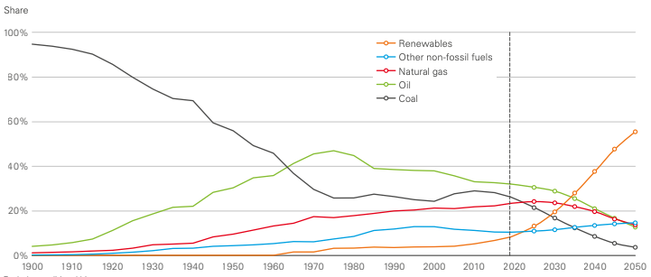
Figure 1.- Changing nature of global energy markets (BP, 2022)

Moreover, with the more than 900,000 wells (Figure 2) currently producing in the U.S, it is necessary to guarantee the well integrity of those wells, designing new technologies for plug and abandonment and guaranteeing the integrity of the wells over time for the opportunity to achieve geothermal or carbon sequestration with the current existing wells.

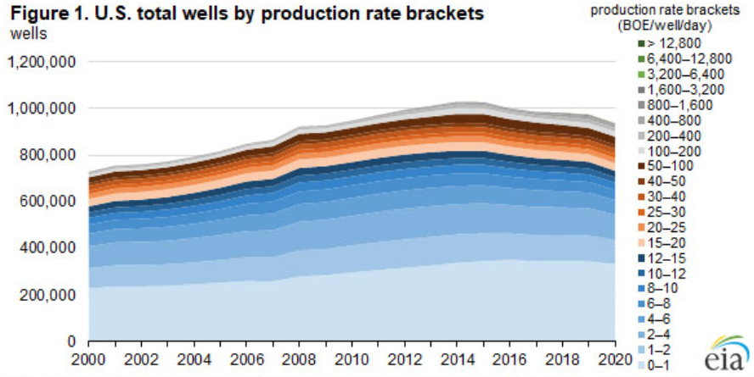
Figure 2.- Total wells by production rate (EIA, 2018)
Drilling and completion are challenging, and expensive procedures conducted in order to connect reservoir to surface to produce hydrocarbons, those processes involve drilling from surface to the target reservoir, cementation of the annular space and completion of the well in order to reach the objectives of the drilling process, whether reach a reservoir to recover hydrocarbons, Geothermal purposes or carbon sequestration. In those processes several problems might be encountered such as loss of circulation in drilling mud while drilling or in cementation due to naturally fracture formations, high permeable formations or caverns that might cause an increase in drilling and completion time at the rig and therefore money.

Due to the increased demand on fossil energy, it has become mandatory to explore new horizons, therefore drilling and completing deeper in different harsh environments has become a common practice for today’s standards. In conventional well design, the cement sheath acts as one of the primary barriers of protection in the well integrity matrix. Once the wellbore cement is set, the well is exposed to various conditions and environments over time which can impact the integrity of the cement.

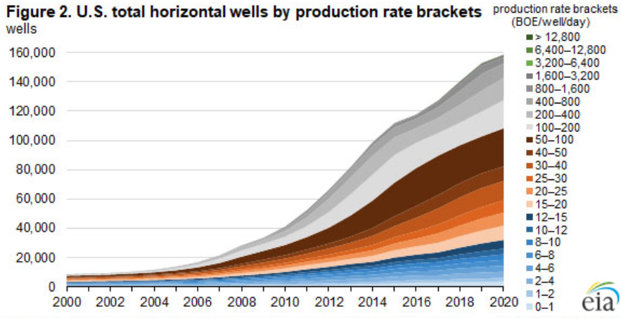
Figure 3.- U.S total horizontal wells by production rate (EIA, 2018)
Well cement is considered one of the most important operations as it ensures well integrity and works as a primary barrier for the casing, seals/isolates the troublesome formation or thief zone meanwhile protect the casing from corrosion and giving structural support to it. Therefore, the quality of the cement with the respect to the fluid loss, thickening time, mechanical, transfer (permeability and porosity), and rheological properties should be according to the subsurface conditions to which the cement is exposed for the long term. Otherwise, the poor cementing job will lead to remedial and squeeze cementing that will not be economically feasible because of the nonproductive time. In the worst-case scenario, a bad cementing job can lead to blowouts which will cause the loss of well completely and personals casualties (Al-Yami et al., 2017). Hence properties of cement can be modified by the addition of additives. Though there are many conventional additives in the market but unconventional additives like Gilsonite and Micro Cellulose (MC) are not extensively studied specially when referred to the effect of temperature on its mechanical behavior and UCS.

Overall, data shown in different energy outlooks leads that drilling activities along with plugging and abandonment operations are increasing in complexity and number: whether exploration or production, geothermal wells, oil and gas, water wells or carbon capture and storage; will encounter well construction process and production phases. Therefore, it is mandatory to drill in an economically and safe way in order to complete, produce and abandon wells, thus a better understanding of well components in necessary.

One of the main components in wellbore construction and well integrity is the oilwell cement, whether referring to hydrocarbons and a safe way to producing and provide structural support, plugging and abandonment, assuring a seal for an undetermined period of time, geothermal wells, providing economical viability to the project, gas storage wells, providing high cyclic loads integrity or carbon storage and sequestration wells providing seal to underground deposits, cement operations and mechanical properties are key components that will define the success of the project.

It is commonly observed a lack of understanding on the develop of the mechanical properties of cement on time and temperature, this lack of data available might jeopardize the appropriate selection of cement. This research attempts to provide a better understanding of the mechanical properties of cement developed over time, at different temperatures, understanding the setting mechanisms involved, leading into the assessment of well integrity
First, the well construction process in described, followed by a detailed description of the oilfield cement along with its characteristics and manufacturing process is described, followed by the testing methods with a focus on the experimental methods used in this research. Chapters 5 and 6 cover a discussion of the results, their implication, recommendations for future work, and conclusions.

1.2 Well Construction and Well integrity
Well construction is commonly referred as the actions related to communicate the surface to a predetermined target at a certain depth in the most safely and economically way; these common actions consist of drilling followed by run and set the casing that might include surface casing to prevent any migrations and contamination from aquifers, intermediate casing and production casing and then cementing. The end of the well construction stage is marked when the production casing is set.

Well integrity is a mixture of several disciplines integrated with the objective of preventing well control incidents during the life cycle of a well, it is directly related with the construction phase of the well and reflects the ability of a well to produce fluids in a controlled way, diminishing the possibility to present any unwanted fluids that has migrated beyond the well system and generally consists in a two barriers system including the casing and the cement (Torbersgen, et al., 2012).
Well integrity can also be defined as the “application of technical, operational and organizational solutions to reduce the risk of uncontrolled release of formation fluids throughout the entire life cycle of a well” (NORSOK, 2013); while The American Petroleum Institute refers as this process as the installation of well equipment in order to protect and isolate any groundwater, in order to isolate the produced fluids from those outside the well barriers (American Petroleum Institute, 2016)
Well barriers integrity is highly impacted by the degradation of the elements downhole that played a role related to well construction, such as drilling and completion fluids, cement, and tubulars and the lack of understanding of the role of those barriers and their impact of temperature and pressure will define the success of a well design. (Bachu , Bennion, & Celia , 2009; Lavrov., 2016; Zhang & Bachu, 2011)
Cement is very well known in the industry as the main mechanism in the annular providing isolation to the casing and sealing method between formations to avoid any migration between formations; thus, plays an important role in well integrity
Cement has always been used in the industry as the annular isolation and casing to formation sealing method for better well productivity and well integrity assurance, whether referring to oil and gas, geothermal or carbon storage. Nevertheless, the cement sheath due to a lack of understanding on its properties does not provide an acceptable long term solution for the current drilling environments to withstand the develop of new technologies and demanding needs of deeper wells and long horizontal sections, although advances on cement have been improved in the last decade, a demand for long term and precise characterization of the mechanical properties of cement at room and elevated temperature is required to improve the quality of the wells and extend their operating life.
Wellbore construction process starts in planification of the well in order to design and create a pathway to reach the objectives for the specific project and it is finished when the production casing has been cemented and therefore is ready for the completion of the well.
Every element of the well construction plays a very important role since they will create a barrier and will bring support to all the producing activities. A description of the elements of well construction will be described.
Casing is defined as a large diameter pipe that is lowered into an open hole and cemented in place, being the duty of the well designer to design the casing to withstand casing forces that might be encountered downhole such as collapse pressure, burst and tensile-compressive failure, as well as corrosives fluids. Casing must be run in place to comply with different requirements that include but are not limited to protect freshwater formations, isolate return zones or to isolate formations with an important different pressure gradient. Running pipe is a term commonly used to define the operation in which the casing is put into the wellbore, the strength of the casing is defined by the material of which has been produced, being steel and stainless steel the most used materials for casing, but depending on the specific needs of downhole conditions it might include aluminum, titanium fiberglass and other materials. (Schlumberger, 2022)
Casing has also been defined for Bourgoyne (Bourgoyne Jr, Millheim, Chevenert, & Young Jr., 1991) as a seamless steel tubular engineered to withstand internal, external and axial loads in form of burst and collapse pressures, and the cemented case helps into the prevention of freshwater contamination, prevention of formation cave-ins and soft formation fracturing due to high drilling fluid density in deep wells, aiding to zonal isolation problem segments and control of downhole pressures during drilling and production.
Once the casing is set in hole, cementing operations will start. Cements used in the oil and gas industry are manufactured complying with American Petroleum Institute Spec 10A (API, 2005) that is also detailed in Chapter 2: Cement Overview, and tested according to API 10B-2 (API, 2013)
Primary cementing is the technique of placing the cement slurry through the annular space between casing an formation, once the cement is set, it hardens and forms an hydraulic seal in the wellbore in order to prevent any fluid migrations, being then primary cementing a very important task that demands a consideration of several factors encountered downhole and therefore must be planned an executing with a high attention to detail, in order to guarantee well integrity over the life of a well. In addition to zonal isolation, cement must work along the casing to provide support to the producing casing, while preventing corrosion to the casing. Cement is pumped from surface through the inside of the string, displacing any remaining drilling mud.
Secondary cementing operations by the other hand, are those operations that describe actions that employ cement to remediate a variety of problems existing in any well and can be divided in two main categories, including plug cementing and squeeze cementing, plug cementing refers to the action of placing a cement slurry in a wellbore, allowing it to set, whereas squeeze cement consists of forcing cement slurry through holes, splits or fissures into the casing/wellbore (Nelson & Guillot, 2006)

Once the slurry has been placed and the wait on cement has passed, the cement bonds to casing and formation, becoming now a fundamental element part of well integrity and must withstand the predicted loads through the life of the well, the effectiveness of the cementing job will result in a poor primary cementing job, leading into a remedial cementation job.
Moreover, the mechanical and thermal properties of cement together are poorly studied and are not commonly available, especially when trying to replicate downhole conditions, resulting in a need to do research and characterize the cement properties at downhole conditions.

1.2 Objectives
The main objective of this research is to analyze and examine the effect of Gilsonite Microcellulose on the mechanical properties of class H at room and elevated temperatures, determining if cubes or cylinders are the best way to test the mechanical properties.
The specific objectives of this research includes:
- Document the effect of the shape of the samples on the characterization of the mechanical properties of the cement at room and elevated temperatures
- Determine if a correlation of UPV and UCS between cubes and cylinders can be obtained
- Analyze the effect on the compressive strength of cement samples with Micro Cellulose and Gilsonite at room and elevated temperatures (75 C)
- Define the correlation between Uniaxial Compressive Strength (UCS) and Ultrasonic Pulse Velocity (UPV) for Gilsonite and Micro Cellulose
- Provide with analysis of possible applications of Gilsonite and MC from the mechanical properties acquired

1.3 Scope of work
The scope of this research includes experimental investigation and analysis of the mechanical properties of cement with Gilsonite and MC as additives at room and elevated temperature and its correlation with non-destructive methods, in this case Ultrasonic Pulse Velocity (UPV). For the first part of this research cubes and cylinders of class H neat will be prepared following current API recommendations and standards, cured at room and elevated temperature and then tested using a Uniaxial Compressive Strength machine and Ultrasonic Pulse velocity. Results will be analyzed and interpretated in order to assess the potential of a correlation between cubes and cylinders with the current standards.

The second part of this study focuses of the effect of Gilsonite and Micro Cellulose as additives when added to class H cement at room and elevated temperature, samples will be prepared in compliance of API regulations and cured properly over time up to 120 days, assessing its long-term properties and strength, the effect of temperature on the samples will be assessed and provided, specifics on preparation process will be further described.

2.- Cement Overview
This section provides an overview of the cement manufacturing process, composition of the cement, classification of cement by its properties and composition and how all the components play an important role in the hydration process and how it gets affected by temperature. Furthermore, description and properties of cement additives are also included.

2.1 Well Cement
Oilwell cement is mainly composed of Portland cement which is manufactured by the process that consists of burning and grinding a mixture of calcareous and argillaceous materials such as limestone and clay, the mix is then heated to temperatures from 1426 °C up to 1540 °C throughout this process clinker is obtained, which is then cooled down with the addition of different products like gypsum and then Portland cement is formed.

For the oil and gas industry API has classified cement into 8 categories from A to H. These classifications are made depending on the resistance toward the hydrogen sulfide and the depth in which cement will be deployed (API, 2005) . While (API, 2013) has defined a specific water-to-cement ratio that should be used when mixing the given class of cement (Al-Yami, Wagle, Mukherjee, Al-Badran, & Aljubran, 2017).

Ordinary Portland Cement (OPC) is considered to be the most used and basically most produced material, the term “ordinary” means that is produced in a rotary kiln from a variety of selected and specific quantities of ingredients consisting mainly of calcareous (e.g. limestone) and argillaceous (e.g. clay) materials.

OPC is the preferred option to cement oil wells and it is a clear example of a hydraulic cement, meaning that cement sets and develops compressive strength as result of a hydration process, with a chemical reaction between the compounds of the cement and the water used to mix the OPC while settling or cured in air but also when submerged in water. This hydration process is a predictable uniform and relatively fast depending on the specific recipes and cement used and the conditions of pressure and temperature while curing.

Portland cement is manufactured by pulverizing clinker that is the burned material that exists in the rotary kiln in the cement plant and consists mainly by derivates from calcium. The final Portland product depends on the mineralogical composition of the clinker

The mineralogical composition of Portland cement clinker is shown in the following table (Table 1.) Is worth to mention that special cements might differ significantly in the content of C3A and C4AF

Mineralogical Composition of Classic Portland Cement Clinker
Oxide Composition | Cement Notation | Common Name | Concentration (wt%)
3CaO*SiO₂ | C3S | Alite | 55-65
2CaO*SiO₂ | C2S | Belite | 15-25
3CaO*Al₂O₃ | C3A | Aluminate | 08-14
4CaO*Al₂O_{3*Fe} | C4AF | Ferrite phase | 08-12
Table 1.-Mineralogical Composition of Classic Portland Cement Clinker (NELSON & GUILLOT,2006)
The overall process of producing Portland cement starts by pulverizing the raw material to guarantee an even and specific distribution to comply with the correspondent composition for Portland cement.
Before the calcination in the kiln, the raw materials are pulverized and blended to guarantee that the bulk composition matches the specific Portland Cement and the quality of the clinker, and the final cement depends on the cooling rate and thermal profile along with the final amount of added gypsum that might vary from 3% to 5% total.
The best clinker is obtained by cooling from the original kiln temperature (1426-1540 C) slowly to about 2,282°F [1,250°C], followed by rapid cooling, usually 32° to 36°F/min [18 to 20°C/min]. (Nelson & Guillot, 2006)
Slower cooling rate results in a high crystallinity degree, providing less hydraulically active cement. When hydrated at room temperature develops early high compressive strength whereas in long term evaluation, the ultimate strength is lower.
Once the cement clinker is cold down and the amount of gypsum (3% to 5%) is added, the clinker is ground in tubular mills filled with steel balls up to a given fineness, the particle size of the resulting cement grans varies from 1 to 100 nm.
Portland cement due to the nature of the blend of burning and calcined materials results as a very moisture-sensitive material maintaining its quality indefinitely if kept dry but when in contact with air or moisture, it develops an overall less strength and sets slowly over time.
The compounds contained in Portland cement are considered anhydrous, therefore when is in contact with water they decomposed transforming into hydrated compounds

2.2 Hydration stages of cement
The hydration process of Portland cement can be divided into four main stages than comprehends preinduction, induction, acceleration and diffusion period that will be further described.
Preinduction period comprehends the period during mixing and the first couple of minutes of setting, upon contact with water, the cement starts a rapid hydration reaction between C3s and water, in this process a large exothermal reaction is observed
Induction period is characterized by little hydration activity, heat liberation rate is considerably reduced when compared to preinduction period.
During acceleration and deacceleration period, that could also be known as “Setting period” is the period of most rapid hydration, Ca(OH)2 is crystallized during the acceleration period therefore the resulting hydrates resulted from the deposition into the water filled space, intergrows and forms a cohesive network hence development of the compressive strength is developed in this stage.
Diffusion period is characterized by a slow decrease of the porosity into the matrix; hence the cement becomes denser over time and the strength is developed on this stage
The hydration of Portland Cement should be co considered as a multicomponent system, overlapping of chemical reactions among its components such as clinker, calcium sulfate and water. This process results in a continuous thickening and hardening of the cement.

2.3 Effect of temperature on cement setting
Curing temperature conditions is considered one of the most important factors affecting the hydration process of cement, directly affecting the nature, stability, and morphology are dependent upon this parameter. Elevated temperatures, accelerates the hydration of cement.
When high temperature curing conditions are encountered the induction and setting period is shortened, as seen in previous research (Rincon, Rickard, & Teodoriu, Effect of Micro-Cellulose on Mechanical Properties of Class C and H Cement at Room and Elevated Temperature, 2022; Rincon , Abid, Arbad, & Teodoriu, 2022) in which is observed that the compressive strength develops faster at elevated temperatures. when compared to room temperature
It has been reported by (Nelson & Guillot, 2006) that up to 104°F [40°C], the hydration process stays virtually equal than those reported at ambient conditions, whereas at elevated temperatures of 230°F [110°C] and more, important structural changes are observed, such a more fibrous consistence and a higher degree of silicate polymerization is observed.

2.4 Effects of curing
Once the cement mixture is prepared and set, the mechanical properties of cement develops over time, being temperature the main component that accelerates the hydration process, aging becomes an important parameter that determines along with temperature compressive strength and properties of the cement
The performance of Portland cement could be directly influenced by several factors during storage in the sacks or silos, the exposure to atmosphere and high temperatures are the main influencing factors to modify the following properties (Silk, 1986):
- Increased thickening time
- Decreased compressive strength
- Decreased heat of hydration
- Increased slurry viscosity

During the storage process, especially in elevated temperature regions or environment, the gypsum contained in Portland cement can be dehydrated, resulting in the probability to exhibit the phenomenon of false set, therefore, storage conditions is a very important factor.
Surface area is a very important parameter that largely impacts the cement reactivity and rheology of slurry, fineness is obtained by the measure of air permeability over a small layer of compacted cement, this method is known as Blaine method and is used to obtain the theoretical surface area. This surface area generally is an important factor, correlated with the cement strength (Bakchoutov, 1980; Frigione & Marra, 1976) and the water to cement ratio required to wet the cement particles is directly related to the surface area. (Sprung , Kuhlmann, & Ellerbrock, 1985)

2.5 Classification of Portland cements
Portland cement is manufactured following certain chemical and physical standards that will depend on the application, these standards were defined in order to guarantee consistency among manufacturers, and defined by different associations, the best knowns are those stablished by ASTM international (ASTM International, 2002) and API (API, 2002). Relative distribution of the main clinker phases, known as the “potential phase composition.” is the principal chemical criterion for classifying Portland cements

Compound | Percentage
CaO – Calcium oxide (burnt lime) | 60-69
SiO2 – Silicon dioxide (silica) | 18-24
Al2O3 + TiO2 - Aluminum + Titanium oxide (alumina and titania) | 4-8
Fe2O3 – Iron oxide (ferric oxide) | 1-8
MgO – Magnesium oxide (magnesia) | <5
K2O, Na2O – Potassium and Natrium oxide | <2
SO3 – Sulfur trioxide (sulfite) | <3
Table 2.-Portland Cement Composition (Fink, 2015)

2.6 API classification systems
Well cement requirements are different and more rigorous than those for construction cements. This is due to the fact that construction cements do not encounter such harsh conditions like those found downhole in a well.
There are currently eight classes of API Portland cements, designated A through H. They are arranged according to the depths at which they are placed and the temperatures and pressures to which they are exposed.
Within some classes, cements with varying degrees of sulfate resistance (as determined by C3A content) are sanctioned: ordinary (O), moderate sulfate resistance (MSR), and high sulfate resistance (HSR) (Nelson & Guillot, 2006).
- Class A: Is the cement used when there are not special requirements needed, it is only available on grade O and it is designed for a depth up to 6000 ft
- Class B: Specially designed for moderate or high sulface resistance and for depths around 6000 ft.
- Class C: Designed to develop early strength and deeper requirements rounding from 6000 ft to 10000 ft; being available in ordinary, medium and high resistance to sulfates
- Class D: cement developed to cover depths rounding 6000 ft to 10000 ft, able to support moderately high temperatures and pressures. Available in HSR or MSR
- Classes G and H: Designed to be used as basic well cements (as manufactured) or over a wider range of wells if used with additives. They are available in both MSR and HSR types.

API Class | ASTM Type | Potential Phase Composition (wt%) |  |  |  | Fineness (cm²/g)
API Class | ASTM Type | C₃S | C₂S | C₃A | C₄AF | Fineness (cm²/g)
A | 1 | 45 | 27 | 11 | 8 | 1600
B | 2 | 44 | 31 | 5 | 13 | 1600
C | 3 | 53 | 19 | 11 | 9 | 2200
D | - | 28 | 49 | 4 | 12 | 1500
E | - | 38 | 43 | 4 | 9 | 1500
G | Nominal 2 | 50 | 30 | 5 | 12 | 1800
H | Nominal 2 | 50 | 30 | 5 | 12 | 1800
Table 3.-Typical Composition and Fineness of API Cements (Nelson & Guillot, 2006)

Classes G and H:
Classes G and H were developed in response to the improved technology in slurry acceleration and retardation by chemical means. The cement manufacturer is prohibited from adding special chemicals, such as glycols or acetates, to the clinker. Such chemicals improve the efficiency of grinding but have been shown to interfere with various cement additives. Classes G and H are by far the most commonly used well cements today.

2.7 Cement Additives
Cementing additives control different properties and modify the behavior of the cement slurry under different conditions, which is crucial to run a proper cementing job. They can be classified in (Fink, 2015; Nelson & Guillot, 2006):
- Accelerators: Will reduce the wait on cement (WOC), a good example for accelerators are salts or sea water
- Retarders: Increase the cement setting time; commonly used in high-temperature environments, examples or retarders include sugar and lignosulphonates, hydroxycarboxylic acids, inorganic compounds, and cellulose derivatives
- Extenders: Will lower the density and increase the yield strength of set cements; is commonly used in weak formations; examples of extenders are water, gilsonite, bentonite, sodium silicates, nitrogen, ceramic microspheres, and furnace slag.
- Weighting agents: Increase the density of the cement / slurry; examples of weighting agents are barite and hematite
- Dispersants: Are regularly polymers used for a better particle distribution and the improvement of the particle distribution.
- Fluid-loss additives: Largely used to reduce the cement loss on cementing operations during highly permeable formations or naturally fracture formations, good examples of fluid loss additives are polymers, gilsonite and cellulose
- Lost circulation control agents
- Strength retrogression: additives used at temperatures higher than 230°F, where
- cement’s permeability increases and its strength decreases – Silica Flour (usually 30 – 40% by weight of cement (BWOC))
- Miscellaneous agents: anti-foam agents, fibers, latex

The incorporation of additives in cement has a significant impact on its properties. The type and quantity of the additive incorporated in the cement depend upon the depth and subsurface condition to which it will be exposed (Broni, Joel, & O, 2016) There are some conventional additives that alter the properties of cement such as calcium and sodium chloride act as an accelerator and increase the hydration rate of the cement. Whereas, to slow down the hydration process lignosulfonate or hydroxycarboxylic acids can be used. Henceforth, there are many chemicals that can be used as extenders, heavy weighing agents, dispersants, fluid loss, anti-foaming or expansion additives. While to increase the strength of the cement, pozzolanic materials like fly ash, rice hush ash (RHA), and palm oil fuel ash (POFA) can be used (Khizar, Gholami, & Mutadir, A pozzolanic based methodology to reinforce Portland cement used for CO2 storage sites, 2020) . Hence in this research, unconventional additives like gilsonite and Microcellulose will be used in the cement and their effect on the compressive strength is to be observed.

Gilsonite is a crystallized naturally occurring hydrocarbon bitumen that occurs in dikes (veins), sills, fracture fillings, and disseminated blebs, commonly found in oil shale and tar sand (Boden & Tripp, 2012). Elemental analysis of Gilsonite shows 74% carbon, 7.1% hydrogen, 0.67% nitrogen, 3.1% oxygen, and 4% sulfur (Nasrekani, Naderi, Nakhaei, & Mahmoodinia, 2016) showing the presence of hydrocarbons in its chemical composition. It is reported by (Tripp, 2004)that good quality Gilsonite can be found in the mines of the Uinta Basin of Utah and Colorado.

Gilsonite was initially used as a lost circulation material for water-based drilling fluids and was later used as a low-density lost circulation cement additive (Slagle & Carter). Error! Reference source not found. shows some of the applications of Gilsonite reported by different authors.
Author | Application
(Slagle & Carter) | Gilsonite was used as a lost circulation control agent for cement and water-based drilling fluids and was able to lower the density of cement slurry. The scouring action of the Gilsonite was utilized to remove mud cake from the borehole.  It was concluded that Gilsonite cement composite can be used in primary or secondary cement jobs.
(Radenti & Ghiringhelli, 1972) | Gilsonite was able to reduce the filtration by 40%
(Vural Kök, Yilmaz, & Guler, 2011) | Used as a modifier to improve the high-temperature performance of base (unmodified) binder.
(Raha, 2016) | Provide density control, scouring action for mud removal, enhances compressive and cement bond strength, and improves the isolation characteristics while decreasing the vertiginous gas flows.
(Idier, Radonjic, & Du, 2018) | Due to the presence of light hydrocarbons in its structure, Gilsonite possesses self-healing property when it encounters gas or light hydrocarbons
(William, V, & Radnojic, 2019) | Gilsonite cement composites showed the capability to restrict the hydrocarbon migration through the Cement/ Casing or Cement/ Formation interface
(American Gilsonite, 2022) | One of the most used pozzolanic material that improves the compressive strength of the cement is Fly Ash. However, it has its own limitation but the incorporation of the Gilsonite in the cement not only improves the compressive strength but also overcome Fly Ash drawbacks. Such as, Gilsonite cement composite reduces the cracking tendency of the cement, acts as a bridging material that helps in healing of the micro fissures, decreases permeability, improves cement bond strength, assures zonal isolation, eliminates the need for blenders or batch mixers onsite, prevent pump cavitation, and removes the need for wetting and defoaming agents
Table 4.-Gilsonite applications by different authors

As observed in Error! Reference source not found., some characteristics such as mechanical strength development, loss circulation, density, and filtration control agent, are shared among different authors which shows the useful application of Gilsonite. Due to its characteristics, it has been used in different operations which are as follows (Slagle & Carter)
- Primary cementing through lost-circulation zones
- Squeeze cementing
- Re-cementing above inadequate fill-up
- Plugging back to reestablish drilling-fluid circulation

The properties shown in Error! Reference source not found., represents a possibility to use Gilsonite in HPHT and geothermal wells, especially in the geothermal wells which have a serious loss circulation problem due the presence of naturally fractured formations located in those basins. Moreover, due to its affinity to hydrocarbons, it has been also reported as a solution to hydrocarbon migration through the Cement/ Casing or Cement/ Formation interface (William, V, & Radnojic, 2019).
Moreover, the mechanical properties specially UCS are not extensively investigated, resulting in a poor short- and long-term characterization, although some data is available (Figure 4) is not concluding the effect on the mechanical properties at short and long term, the current research of Gilsonite is focused on the fluid loss circulation properties along some other properties excluding the compressive strength

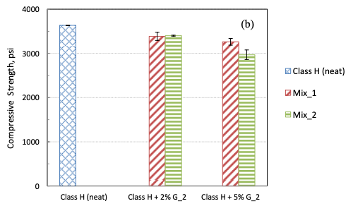
Figure 4.-compressive strength for Gilsonite modified cement with or without additional water at 70°F. Mix_1 represents slurries mixed without additional water. Mix_2 represents slurries mixed with additional 0.04 gallon water per pound of Gilsonite (Liu, 2014)
Moreover Microcellulose have been used in many areas of the petroleum engineering industry and has been reported to be used as enhanced oil recovery drilling fluid, fracturing, and cementing and it has been reported to enhance the compressive strength of cement and to improve the cement slurry properties and cement durability specially at elevated temperatures (Abbas, 2020)
Moreover it has been by Ferreira 2021 reported that the addition of cellulose improved the mechanical properties of paste at 7 days but a decrease when cured at 28 days, improving by 10% and 45% the compressive strength and 20% and 32% the stiffness at 7 and 28 days respectively, and according to its results increases the compressive strength and stiffness of cement pastes (Ferreira , Ukrainczyk, Carmo e Silva, & Silva, 2021)
It has also been shown that the presence of fibers with a cellulose base reduces the effect of cracks, especially propagation of microcracks on cement composites (Korniejenko, Fraczek, Pytlak, & Adamski, 2016)
Error! Reference source not found. summarizes common applications of Cellulose of several authors, and their implications on the cement properties
Author | Application
(Buelichen & Plank, 2011) | HEC as cement fluid loss additive
(Brandl, Windal, Magelky, & Baker Hughes, 2012) | Cellulose as single additive controls fluid loss better than commonly used fluid loss additives at temperatures up to 170 °F while also controlling free fluid and performing as an extender
(Kumar, Bhaisora, & Dange, 2021) | Increases tensile strength and mechanical properties of cement
Sakulich, 2011 | Suppresses all brittle behavior and enhances ductility
Korniejenko & Mikula, 2015; Korniejenko, Mikula, & Lach, 2015) | Increases the flexural strength of composites
Tan, Santos, Savastano, & Soboyejo , 2012 | Minimize the problem of cracking, increases the impact toughness, flexural strength, and changes the nature of fracture of brittle materials towards more ductile cracking resistance
Shepelenko, Sarkisov, Gorlenko, Tsvetkov, & Zubkova, 2016; Zibarev, Zubkova, Shepelenko, & Nedavnii, 2006 | Slows down the hydration of cement-based mixtures
Table 5.-Application of Microcellulose by several authors

However, it has been reported that the chemical components and soluble sugars contained in plant fibers and cellulose slow down the hydration of cement-based mixtures (Shepelenko, Sarkisov, Gorlenko, Tsvetkov, & Zubkova, 2016; Zibarev, Zubkova, Shepelenko, & Nedavnii, 2006) and confirmed in Figure 5 in which it is observed that an increase in the concentration of cellulose leads in a decrease of the compressive strength nonetheless, mechanical properties of cement with the addition of Cellulose is not largely studied, leading in a need of the characterization of its properties at long term.

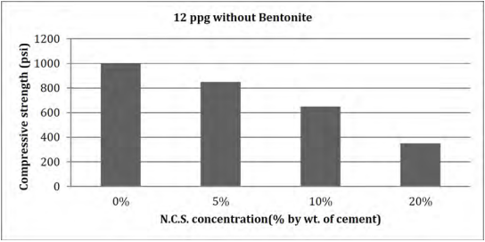
Figure 5.-Compressive strength v/s cellulose concentration for 12 ppg Slurry (without Bentonite) at 1 curing day at 170F (Kumar, Bhaisora, & Dange, 2021)

The properties summarized in Error! Reference source not found. leads to possible to high pressure- high temperature wells and geothermal wells due to its loss of circulation properties, those properties along with minimizing of cracking and cement durability makes Microcellulose comparable to Gilsonite, therefore a comparison of the addition of those additives and a characterization of the mechanical properties of the cements will lead to a better understanding of the properties and a correct selection that will be more appropriate depending of subsurface conditions.

2.8 Cement Testing Standards

The compressive strength of the cement is dependent upon the homogeneity of the cement matrix, its composition, loading rate, and geometry of the tested sample (Gul, 2016). The cement composition is designed according to the downhole conditions while the homogeneity in the cement matrix is the function of the mixing strategy and slurry design. While the change in the loading rate, shape, and size of the specimen can yield different results from the same mixing batch of cement samples.

The accuracy of compressive strength measurement of the cement cube depends on the parallelism and planarity of the UCS machine loading face and the perpendicularity of the sample sides to those faces. For the uniform stress distribution, it is necessary that the sample and the plates of the UCS machine should have clean contact with each other. Moreover, it should be noted that the material and elastic mismatch between the sample and the plates of the hydraulic press can create a frictional constraint and can cause the restriction towards the lateral expansion of the sample during the test. (Kim & Yi, 2002; Gul, 2016)
Literature on wellbore cement shows that it is a common practice to use different shapes for cement samples (Kumari, 2015) deviating from the specifications of the American Petroleum Institute (API, 2002). As defined previously API states that the UCS should be measured on 50.88 mm cubes, however, some authors have reported the use of cylinders with different diameter-to-length ratios (Tiong, Gholami, Khizar, & Rahman, 2020; Khizar, Gholami, & Mutadir, A pozzolanic based methodology to reinforce Portland cement used for CO2 storage sites, 2020; Che, 2011; Gonnerman, 1925; Hamad, 2015; Malaikah, 2005; Newman, 1964) While for triaxial testing the cylindrical samples are the preferred option, especially for high-pressure, high-temperature (HPHT) cement testing

Standard | Sample Type | Sample Composition
API 10B | 2 inch cubes | Oilwell cement
ASTM 109-08 | 2 inch cubes | Cement mortar
ASTM C39/39 | 6 x 12 inch cylinders | Concrete
BS EN 196-1:2005 | 40 mm cubes | Cement mortar
BS 1881:131:1998 | 100 mm cubes | Concrete
Table 6.-Various sample shapes and sizes recommended by practice manuals for the compressive strength
Almost every country has its own standards for concrete testing, nonetheless, the geometry of the specimen used is either cube or cylinder. In Australia, Canada, France, New Zealand, and the United States cylinder with a standardized size of 6 inches in diameter and 12 inches in height are used (Kumari, 2015). On the other hand, cubes are widely used in Europe with 150 mm or 100 mm for each side. Although there are some variations in assembling these shapes for the test, the most important is casting and capping, since the molds for cubes are made for the required size, they are plane and parallels to the hydraulic testing machine plates.
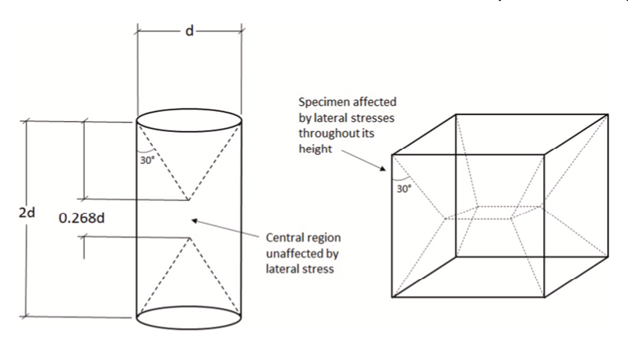
Figure 6.- Approximate effects of multiaxial stresses in the cylinder and cube specimens (Elwell & Fu, 1995)
Due to the distribution of the lateral stresses, the geometry of the sample becomes very crucial as shown in Figure 6. The main factors influencing the cylinder/cube strength ratio for concrete according to Elwell and Fu (Elwell & Fu, 1995) and Kumari (Kumari, 2015) are:
1. Casting and testing procedures
2. Specimen geometry
3. Level of strength
4. Direction of loading and machine characteristics
5. Aggregate grading
While for the measurement of rocks compressive strength some authors (Hatheway, 2009) suggest standardized testing for cylindrical rock specimens regarding sample end preparation, slenderness, and diameter to grain size ratio. These considerations are as follows.
- Cylinders with a suggested height-diameter ratio between 2.5 and 3.0
- Samples must be drilled with a diamond bit
- Physical analysis of the sample before testing
- Specimen diameter should be 10 times larger than the largest grain in the sample
Before the API standard procedures, and specifications for the performance of cement were defined by the American Society for Testing Materials (ASTM), however, it did not account for the temperature and pressure condition to which most of the oil well cement is exposed. Therefore, API in 1953 issued the first tentative standard designated as standard 10-A was developed which was modified through time (Calvert & Smith, 1990). The latest revision was made in 2013 under “API-RP-10B Recommended Practice for Testing Oil-well Cements”.
American Petroleum Institute has developed standards for more than 85 years for petroleum industries. API collaborates with 685 standards and recommended practices which are followed by some international organizations for their testing standardization. It must be understood that API does not guide on how to simulate borehole conditions, instead, API focuses on making the experiments replicable and consistent. Hence, API 10A and 10B are recommended practices for the testing of the cement and have some guidelines on physical and chemical requirements such as:
• Viscosity
• Thickening time
• Compressive Strength
• Free fluid

For viscosity and thickening time, the slurry must remain in a pumpable state so that it can be cemented properly in the annulus space between the casing and the formation/casing. While the compressive strength of the cement continues to increase with its hydration during its curing period, it will assist in holding the casing in place and give resistance against the shock loads. However, during the drilling operation, the wait in cement (time required for the cement to solidify before the next drilling phase starts) should be kept at a minimum to reduce the nonproductivity time. As for the free fluid API, 10-A suggests that for Class G and H it should be less than 5.90% (API, 2002).

Anya et al. (2020) (Anya, Hossein, & Marshall, 2020) suggest that in oil well cement testing according to the API Standard, there might be a possibility that the perfect cube of 50.88 mm is not achieved. To show its effect a series of compressive strength tests were conducted on the samples that varied slightly from the API standard cube size. It was found that the slight variation in the shape and size did not have a considerable effect on the achieved strength values as compared to the control sample (50.88 mm cube). However, it was also recommended that the test conducted for the low strength sample test the cube dimensions directed by API should be strictly followed. For all other cement samples, efforts should be made to make the slenderness value (variation of the sample from the perfect cube and can be found by length*length/width*height) close to 1 for better results of the UCS.

Apart from the guideline presented by the API for the compressive strength test (cube of 50.88 mm), different researchers have taken different approaches that correspond to the American Section of the International Association for Testing Materials (ASTM) or British Standard European Norm (BS EN). This is because the majority of available research on the compressive strength of cement has been conducted for civil engineering purposes which are guided by ASTM and BS EN. Table 3 lists different types of samples recommended by API, ASTM, and BS EN for compressive strength tests. The difference in the geometry of the tested specimen has an impact on compressive strength and studies have shown different ratios between the strength of cubes and cylinders (Che, 2011; Gonnerman, 1925; Hamad, 2015; Malaikah, 2005).

Some authors (Elwell & Fu, 1995) reported a relationship of 0.65–0.90 for concrete cylinders compared to cubes (Kusumawardaningsih & Ekkehard, 2015) , observed a relation of 1.0–1.12 for cylinders, while some other research (Kumari, 2015) shows that the cube strength is 1.25 times the cylinder strength. According to British Standards, the strength of cylinders is equal to 0.8 times the strength of cubes (BS 1881, 1983) . Although data from previous research (Che, 2011; Gonnerman, 1925; Hamad, 2015; Malaikah, 2005; Majeed, 2011; Plowman, Smith, & Sheriff, 1974) can be used as a reference, however, the test conducted in these studies are referred to the cement mortar and concrete while the effect of geometric changes in oil well cement is still not investigated in detail. Therefore, to understand the effect of shape and size on the compressive strength of oil well cement, UCS tests were conducted with class H cement as it is one the most commonly used cement in the petroleum industry of the United States.

Two different size and shape samples, 50.88 mm cubes and 1 x 2-inch (diameter to length) cylinders are used for the compressive strength and the UPV test. The main focus of this research is to make an empirical correlation between the compressive strength and curing days of cylinders and cubes. Moreover, a relation was devised between the UCS and UPV for different sample geometry.

3.- Methodology

3.1 Materials and Methods
This section will describe the materials and methodology used throughout the experiments, sample preparation methods and the equipment used to test the samples. The proposed methodology is following the same steps that has been used in the past for preparation of other cement recipes some of which have been also presented (Ichim et al., 2017, Teodoriu et al. 2014a, 2014b)

3.2 Mold Preparation
Samples were prepared in stainless steel molds with 2 inches for each side in accordance with ASTM C109, molds were greased prior cement pouring. Same grease and preparation procedure was used for all samples. Cubes are used as per API RP 10B-2. While for the cylinder, cement was poured into small containers and then drilled with a conventional bit with 1 inch ID, then cut in 2 inches length to maintain the recommended ratio of 2:1 as directed by the ASTM.
Since the distribution of the loads in the specimen geometry plays a very important role in the results, special emphasis was taken into cutting at exactly 90 degrees in order to avoid any uneven surface that could result in early sample failure and polishing the specimens in order to guarantee a 2-inch length and an even contact area surface with the sample, completely perpendicular to the load applied force on the UCS testing machine to avoid any influence into load distribution.
This is also comparable to the cube shapes that are tested in the sides that are directly touching the sides of the metallic mold, guarantying the perpendicularity and the uniform load distribution over the cubes

3.3 Sample preparation
The sample preparation was conducted by API RP 10B-2: Recommended Practice for Testing Well Cements, Distilled water was used in the mixing process in order to maintain consistency, especially since it has been shown that the cement properties are directly affected by the water quality (Saleh, Rivera, Salehi, Teodoriu, & Ghalambor, 2018). The water cement ratio and the amount of additive are shown in Table 7. GRC consultants have reported that 2 to 4% by volume of added MC to drilling muds have shown the best efficiency in curing mud losses. Thus 4% MC by Weight of Cement has been proposed for the current experiments with the addition of 5% extra Weight of Water, in order to make Gilsonite comparable 4% of Gilsonite by weight of cement has been used for this study and same 5% of water extra is added
The 4% of MC came from Industry experience from the manufacturing company who advised for class H cement + 4% MC, while also being shown by Kumar (Kumar, Bhaisora, & Dange, 2021) that an abrupt change in the mechanical properties (UCS) is observed that the addition of over 5% MC affected the mechanical properties of cement by more then 65% percent, along with this, previous research made by Liu (Liu, 2014) showed a comparison between 2% and 5% Gilsonite added to a certain class H cement, such results indicate that little difference is observed on the mechanical properties of cement, nevertheless in order to make this test consistent, it was opted for 4% Gilsonite as well, which showed barely the same effect than 2% up to 5% Gilsonite.
Cement class | Cement (gr) | Water (gr) | Additive (gr)
H Neat | 860.26 | 326.9 | NA
H + 4% MC | 860.26 | 343.345 | 34.41
H + 4% Gilsonite | 860.26 | 343.345 | 34.41
Table 7.-Mixing ratios for cements used in the research.

3.4 Mixing procedure
Digital scales were used to measure the correct amount of water and cement used in the mixture and mixed at a constant speed using OFITE-20 Constant Speed Blender which satisfies the requirements of API specifications. The amount of cement, water, micro cellulose is described in the Table 7. The amount of water was increased by 5% to compensate for the MC water needs
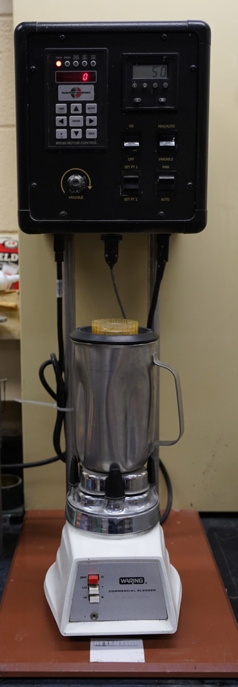
Figure 7.-Ofite-20 cement mixer used for the mixing process.
Following API recommendations, the cement was poured into the mixing cup shown in Figure 7 with the correspondent distilled water in the first 15 seconds, it is important to remind that the blender runs at constant speed of 4000 rpm within the first 15 seconds, after that the blend increase and maintains the speed of 12,000 rpm for the next 35 seconds.

3.5 Curing process
The mix coming from the mixing cup is poured into previously greased molds until half full, then the air is removed from the samples by shaking the mold to avoid any air contained in the mixture, then the other half of the molds is filled in the case of cubes, cylinders followed the same procedure with the exception of being poured in cups and then cored at lengths of 2 inch and 1 inch in diameter, following the recommendations of ASTM (ASTM International, 2002).
The samples are then submerged into a container with pure distilled water for the samples at room temperature, for the high temperature samples, special baths with regulated temperature are used. The curing time for room temperature for is 1, 3, 7, 14 ,21 days, whereas for high temperature 1, 3, 7, 14, 21 days test were performed for the first part of this study, referring to cylinders, whereas the study of the mechanical properties of class H neat, class H+ 4% Mc and 4% Gilsonite were cured for 1, 3 , 7 , 14, 21, 28, 35, 60, 90 and 120 days. Same curing time for room and elevated temperature.
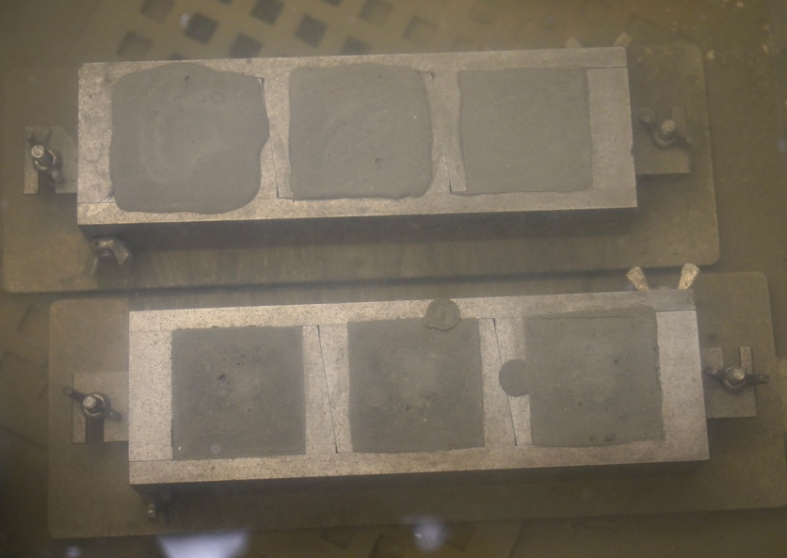
Figure 8.-Curing of the samples at room temperature.

3.6 UCS measurements
Destructive and non-destructive tests were performed at the same time, having priority for the non-destructive test. Destructive test is conducted by Test Mark Compressive Strength test machine after the non-destructive test. The sample is placed between the plates and a uniaxial load applied to the sample until failure, the values are directly screened and recorded.
Compression testing machine CM-2500 (Figure 9) manufactured and calibrated by Test Mark Industries, to determine the unconfined compressive strength of the cement cube specimens. According to the manufacturer, the machine has an accuracy of ± 0.5%. The device applies a uniaxial load to the cement cube at a rate of 72 kN ± 7 kN per minute and measures the force necessary to generate a permanent (or plastic) deformation of the cube. Then, the compressive strength is calculated by dividing the maximum applied force by the measured surface area, which was in complete contact with the load-bearing plate of the load frame. Results are reported to the nearest 0.3 MPa (50 psi) and averaged among samples from the same slurry and tested at the same time (when applicable), according to API RP 10B-2.
$σ= \frac{F}{A}$ Equation 1

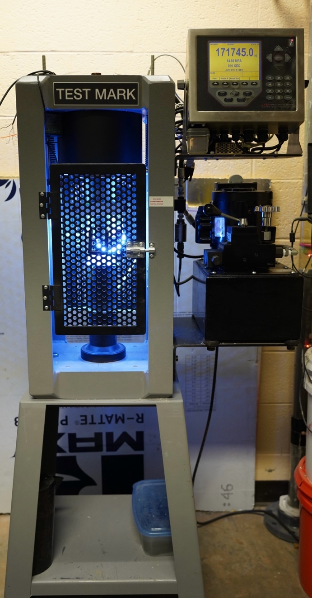
Figure 9.-Test mark Compressive Strength testing machine.

3.7 Ultrasonic Measurements
Ultrasonic measurements are a commonly used non-destructive method to determine the strength of cement, it was first used in the 1980’s by Rao (Rao, David, Jerry, & Cunningham, 1982).
The Ultrasonic Pulse Velocity test was performed using ProceqTM Ultrasonic Device (Figure 10) with an accuracy of ± 2%. The UPV data was use as a prescreening of the samples prior destructive tests.

The principal of ultrasonic measurements consists by the emission and reception of longitudinal and traverse waves at high frequencies across the sample lengths, this practice has been standardized through ASTM C597, API 10 B-2 and ASTM E494 and are recommended for samples with thickness larger than 5 mm, a smooth and parallel surfaces are a requirement in order to determine modulus of elasticity, Poisson’s ratio, acoustic impedance, shear modulus, bulk modulus, reflection, and transmission coefficients.

Measurements are usually performed in the laboratory, nevertheless performing in-situ measurements has become a common practice with the use of modern logging tools. Depending on the propagation medium, the waves travel a different speeds and then is usually related to the strength of the cement. Alternative applications are observed to determine thickness of components, for example, to measure the wall thickness of steel pipes.

The ultrasonic testing apparatus used in this investigation consist of a transmitter and a receiver, along with a screen that shows the electric signals related to ultrasonic waves. In order to facilitate the transit of the waves from the transmitter to the sample and sample to the receiver, a special ultrasonic couplant , PosiTectorTM was used to measure the longitudinal waves.
Transducers with a frequency of 250 kHz were used for the experiments. Before each set of measurements, the system was calibrated with a reference sample with a transient time of 25.4 μs. Error! Reference source not found. shows the ProceqTM device used in the present research. The limitations of this device are the testing frequency, temperature and pressure, which are 35°C and atmospheric pressure.

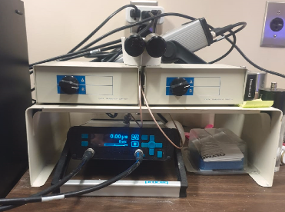
Figure 10.-ProceqTM Ultrasonic Device for the UPV test.

Testing approach of this study consisted in the characterization of class H cement on cubes and cylinders in the first, mixing the appropriate quantities according to API 10 B2 and pouring the cement as indicated in metal molds and cups depending on cube or cylinder, cured for a specific time frame and then testing, in the case of cylinders, after 1 day of curing, will be cored to 2 inch length and 1 inch diameter. Once that the testing starts, it consist of measuring the area of the cylinder in order to performed accurate the UCS test since it is very sensitive to small changes in area, three measurements per side will guarantee a correct sampling, then the UPV test starts by applying a gel to generate a good contact area between the sample and the transducer, then the results are displayed in 2 ways, the velocity in ns and m/s, an example of the results obtained could be:

12.9 ns | 3876 m/s

The test is repeated in each side of cube twice in order to guarantee the quality of the results; UCS measurement is performed by setting the sample between the parallel plates until the cement shows a displacement referring to a plastic deformation and sample breaks, the values recorded include:

A value in Newtons, Mpa and sec for example:
- 171745 N
- 64.66 MPA
- AVG: 6177 N SEC

Once this process is done, the sample has been tested successfully

4.- Results
Detailed in this section, the results will be shown, using mainly graphs to represent the mechanical properties of the cement at different curing times and temperatures. A correlation for UCS and UPV is also provided. The implementation of additives on the cement and the impact on the mechanical properties will be shown.

4.1 Cubes vs Cylinders at room and elevated temperatures
The results for the investigation of class H cement cubes and cylinders are presented in the following figures, for room and elevated temperature.

The cylindrical and cubical samples cured for the different time periods at room temperature were exposed to the destructive compressive strength test. From Figure 11 it was observed that at the early age of curing not much difference of UCS was observed between the cylinder and the cubical sample. However, as the age of the samples was increased the difference starts to appear. After 7 days of curing the compressive strength of the cylinder was 10.78% less than that of the cube whereas this difference increased to 35.5% after 14 days of curing. However, a logarithmic correlation exists between the curing days of the sample and the compressive strength. The empirical equations are as follows.
For cubes
y = 14.717ln(x) + 6.1353 Equation 2
For cylinders
y = 8.2567ln(x) + 9.3369 Equation 3
whereas y is the UCS (MPa), and x is the number of curing days.

Figure 11.-UCS of the cube and cylinder cure at room temperature for the time period of 21 days.

Error! Reference source not found. shows the results of the cube and cylinder with the non- destructive (UPV) and destructive (UCS) tests. It can be seen that an exponential relation exists between the UPV and UCS. Moreover, it was observed that the UPV results of the cubes were lower than that of the cylinder after 14 days of curing, which shows that the compressive strength of the cubes was higher than that of the cylinder. In the UPV the lower the value of transit time the higher is the compressive strength as the ultrasonic waves can travel faster in the consolidated matrix and hence the transit time reduces. The correlation equation between the UCS and UPV for the cube and cylinder cured in RT are as followed.

For Cubes
y = 1E+07x^{-4.713} Equation 4
For cylinders
y = 2E+06x^{-4.084} Equation 5

whereas y represents UCS (MPa), and x represent UPV (microsecond).

Figure 14
Figure 12 shows the results of UCS between cubes and cylinder of class H cured at high temperature. It was observed that as the curing days increased the compressive strength increased. As seen from the previous result the compressive strength of the cube was higher than that of the cylinder in this case as well. After 21 days of curing the strength of the cube was more than 50% of that of the cylinder. It was also observed that the compressive strength development in the cylindrical sample showed a very low level of correlation with the days cured having the r squared value of 0.45. While for the cube, a logarithmic correlation existed and equation of which is as followed.

For cubes
16.266ln(x) + 25.807 Equation 6

Figure 12.-UCS of cube and cylinder samples cured at high temperature

The correlation of UPV and UCS of class H cubes and cylinders at high temperature is shown in Error! Reference source not found., it showed the same trend as that shown in Error! Reference source not found.. It can be seen that cubes show an exponential behavior as expected, whereas cylinders show a large dispersion in the data set. The exponential correlation for cube exits whose equation is as follows.
For cube
y = 4872.3e− 0.321x Equation 7

Figure 13.-UPV vs UCS of cubes vs cylinders cured at high temperature.

Comparison between the compressive strength of class H cement cubes and cylinders cured at RT can be seen in Figure 14. It can be observed that the samples have the same UPV values at all points in time, nonetheless, different values for UCS were reported.

Figure 14.- UCS and UPV relation for cubes and cylinders cured at RT, note that UPV values for cubes and cylinder are the same hence only one curve is shown.

The correlation of UPV and UCS of class H cubes and cylinders at high temperature is shown in Figure 15, it showed the same trend as that shown in Figure 14. It can be seen that cubes show an exponential behavior as expected, whereas cylinders show a large dispersion in the data set. The exponential correlation for cube exits whose equation is as follows.

For cube

y = 4872.3e− 0.321x

Comparison between class H cement cubes and cylinders cured at HT and RT can be seen in Figure 15 and Figure 14. It can be observed that the samples have the same UPV values at all points in time, nonetheless, different values for UCS were reported. Whereas a large variation for UCS between cubes and cylinders cured at elevated temperatures was recorded (see Figure 15)
Figure 14

Figure 15.- UCS and UPV relation for cubes and cylinders at HT, note that UPV values for cubes and cylinder are the same hence only one curve is shown.

4.1 H neat
H neat cement at room temperature (Figure 16) shows an initial compressive strength of around 40 MPa at the first day of curing, evenly increasing over time up to 80 MPa at 120 days, a good correlation for UCS and UPV is observed.

The empirical equations obtained for class H neat at room temperatures are as follow:
UCS = 10.28ln(x) + 36.146 Equation 8

UPV = 14.023e^{-0.001x} Equation 9

Figure 16.- Mechanical properties of class H cement at room temperature

Figure 17. Shows the mechanical behavior of class H cement at elevated temperature, observing a fast increase in compressive strength in the first three days of hydration and evenly increasing up to 60 MPa at 120 days

The empirical equations obtained for class H neat at elevated temperatures are as follow:

UCS = 3.7112ln(x) + 42.439 Equation 10
UPV = -0.157ln(x) + 15.113 Equation 11

Figure 17.-Mechanical behavior of class H neat cement at high temperature

Figure 18 shows the difference in mechanical behavior of cement at room and elevated temperatures, observing that the class H cement at room temperatures will have a faster strength developed in the first three days of hydration, resulting in a lower compressive strength at long term when compared to class H cement cured at room temperature

Figure 18.-UCS comparison of class H cement at room vs elevated temperature

4.1 Micro Cellulose
This section will show the results on the test performed with class H cement with the addition of 4% Microcellulose, a full description of the mechanical behavior will be provided.
Figure 19 shows the behavior of the mechanical properties of class H cement with the addition of 4% MC at room temperature, it is shown that a low compressive strength of 12 MPa is obtained at the first day of curing and it rapidly increases up to around 35 MPa at day 7, reaching a maximum compressive strength of around 70 MPa at 120 days of curing
The empirical equations obtained for class H + 4% MC at room temperatures are as follow:

UCS = 11.69ln(x) + 14.42 Equation 12

UPV = -1.622ln(x) + 19.96 Equation 13

Figure 19.-Compressive strength and UPV for class H cement + 4% MC at room temperature
The next figure (Figure 20) describes the mechanical behavior and UPV of class H cement at elevated temperature, observing a rapid increase on the first three days reaching 25 MPa increasing over time, reaching up to 37 MPa at 120 days

The empirical equations obtained for class H + 4% MC at elevated temperatures are as follow:
UCS = 6.0852ln(x) + 7.66 Equation 14

UPV = -0.872ln(x) + 19.119 Equation 15

Figure 20.-UCS and UPV H+4% MC at HT

Figure 21 compares the compressive strength of class H cement + 4% Microcellulose at room and elevated temperature, observing that the UCS of the samples cured at HT are lower than those at room temperature

Figure 21.-Comparison between room and high temperature of class H Cement + 4% MC

4.2 Gilsonite
In the following section the experimental results obtained from class H cement + 4% Gilsonite are shown, additionally to the compressive strength, UPV results are provided
In the following figure (Figure 22), the compressive strength and its UPV correlation is shown, exhibiting an accelerated developed of compressive strength continuing up to 35 days at around 58 MPa, reaching a maximum compressive strength at 120 days with a value of 68 MPa.

The empirical equations obtained for class H + 4% Gilsonite at room temperatures are as follow:
UCS = 11.447ln(x) + 16.037 Equation 16

UPV = -2.076ln(x) + 21.362 Equation 17

Figure 22.- UCS and UPV of class H + 4% Gilsonite at RT

In Figure 23, the UCS and UPV of class H cement + 4% Gilsonite at elevated temperature is provided, observing a rapid increase in the first 3 days of curing, stabilizing after that point at around 45 MPa.

The empirical equations obtained for class H + 4% Gilsonite at room temperatures are as follow:
UCS = 3.423ln(x) + 32.241 Equation 18
UPV= -0.382ln(x) + 16.751 Equation 19

Figure 23.- UCS and UPV for class H+4% Gilsonite at HT

In Figure 24, a comparison between class H cement + 4% Gilsonite is shown, observing a higher compressive strength at elevated temperatures, reaching a UCS of 60 MPa at 120 days, whereas when cured at room temperature the maximum compressive strength is at around 45 MPa.

Figure 24.- Comparison of class H + 4% cement at room and elevated temperatures

5.- Discussions

Considering the cube UCS as a reference, the error percentage of the experiment is shown in Figure 25. The formula used for the error calculation is as follows:

$error=\frac{UCS1-UCS2}{UCS1}*100$ Equation 20

where:
UCS1= UCS value for cubes.
UCS2= UCS value for cylinder.
An increase in the error for UCS error can be seen in Figure 25 when cylinders are compared to cubes in high temperature curing conditions. However, regardless of the sample curing temperature, this error kept on increasing as the time period increased and UCS. The large error obtained for room temperature at 7 days curing is attributed to possible cement batch inconsistency.

Figure 25.-Error in UCS between cubes and cylinders at room and high temperature.
According to Figure 25 it is accurate to say that current norms does not take in consideration the exponential increase in the difference in compressive strength between cubes and cylinders which result in a need for new standards from API in order to take this in consideration or stick to cubes when testing compressive strength to predict downhole behavior. It is also worth to mention the implications of an inaccurate relationship between UCS and UPV in the case of cylinders, as shown in Figure 14 - UCS and UPV relation for cubes and cylinders at HT, note that UPV values for cubes and cylinder are the same hence only one curve is shown. Figure 15.- UCS and UPV relation for cubes and cylinders at HT, note that UPV values for cubes and cylinder are the same hence only one curve is shown. In which this effect is increased when cured at elevated temperatures, reflecting a lack of accuracy

5.1 Micro Cellulose
Microcellulose shows in Figure 26 a negative effect on the compressive strength of the cement when compared to class H neat cement at room temperature, resulting in a decrease in UCS from day 1 resulting in only 42% of the strength at the initial phases of hydration when compared to neat class H cement at the same curing temperature, strength at curing time of 120 for class H with 4% MC is 85% of the strength developed for class H neat.

Figure 26.-Comparison of class H neat vs H + 4% MC at RT

The same effect observed in Figure 26 is amplified in Figure 27, observing a larger difference in compressive strength and even a decrease in strength on elevated temperatures which might result contra intuitive if we observe the results of class H neat cement RT vs HT (Figure 18) in which the compressive strength at the first 3 days of hydration at elevated temperatures results in a higher compressive strength of the samples cured at room temperature, same process that Is not observed here.

MC affect the hydration process and results in a decrease in compressive strength in elevated temperatures, at day 1, class H cement + 4% MC develops only 25% of the strength of a neat class H cement at HT, at 120 days of curing only 62% of the compressive strength of class H cement is achieved.

Figure 27.-Comparison of class H neat vs H + 4% MC at HT

Overall, the addition of MC decreases the compressive strength developed in all samples, regardless of the curing temperature, varying from 25% in the scenario of larger difference up to 85% of the strength at room temperature.

5.2 Gilsonite

The addition of 4% Gilsonite shows (Figure 28) a decrease in compressive strength when compared with class H cement neat at room temperature, in the initial stage (first 3 days of curing) only 25% (11 MPa) of the compressive strength of neat cement is observed with the addition of Gilsonite at the same curing time, at longer curing times (120 days) 82% of the strength of class H cement neat is obtained with the addition of Gilsonite.

Figure 28.-Comparison of H neat RT vs H+4% Gilsonite RT

Figure 29 describes the behavior of class H cement vs class H cement + 4% Gilsonite, it is observed that a continuous decrease is observed along every curing time, resulting in a 90% of the compressive strength of class H neat cement is obtained at elevated temperatures in the early stages of hydration, it is also observed that at 120 days, cement with the addition of Gilsonite reaches up to 70% of the strength of neat class H cement.

Figure 29.-Analysis of H neat HT vs H+4% Gilsonite HT

Overall, the addition of Gilsonite results in a moderate decrease in compressive strength of cement, ranging from 70% to 90%, this decrease being less noticeable at early stages of hydration and gradually increasing towards the late stages (120 days)

5.3 Gilsonite vs Microcellulose
Figure 30compares the behavior between class H cement + 4% MC and H cement + 4% Gilsonite, it is shown that the behavior of both cement type at room temperature is very similar, resulting in Gilsonite developing a slightly higher compressive strength in the first 60 days, being overcome by MC at curing ages over 60 days.

Figure 30.-Comparison of H + 4% MC RT vs H+4% Gilsonite RT

Figure 31 compares the behavior of class H cement + 4% MC and H cement + 4% Gilsonite at elevated temperature and is shown that the compressive strength of the cement with the addition of MC results in a decrease in compressive strength from the early hydration stages, representing a decrease in strength of around 60% of that cement with the addition of 4% Gilsonite; in the late stages of hydration the difference in compressive strength is less noticeable, with a strength of around 86% of the cement with the addition of Gilsonite.

Figure 31.-Comparison of H + 4% MC HT vs H+4% Gilsonite HT

Overall, Gilsonite develops a larger compressive strength when compared to Microcellulose at elevated temperature and virtually the same UCS at room temperatures.

6.- Conclusions and recommendations

This research shows a dedicated structured investigation on cement UCS measurements using cubical and cylindrical samples along with comprehensive research on the mechanical properties of cement class H neat, class H + 4 % MC and class H cement + 4% Gilsonite at room and elevated temperatures. The following conclusions can be drawn:

- Cubes and cylinders are not directly related as some authors suggest, due to the exponential increase in the difference in UCS.
- Samples cured at high temperature showed a higher difference in the UCS measurement between the cube and cylinder. This shows that the high-strength samples are much sensitive to the geometry of the sample when UCS measurement is done.
- Results for cylinders show a non-reliable source of information in relation to UPV. Further testing is needed to determine an ultimate UCS–UPV correlation
- All data directs that cylinders show a much lower UCS starting with 3 days of cement curing as compared to the cubes.
- MC is currently used successfully in curing fluid loss situations in geothermal drilling, and the addition to cement could enhance the ability to cement geothermal wells with some fluid loss issues.
- The data have shown as expected a decrease of the UCS of the cement when compared with neat cement at both room temperature and elevated (75°C) temperature.
- Our tests have shown that the high temperature UCS is lower than the UCS at room temperature for class H slurry + 4% MC, which is induced by the hydration rate reduction induced by the MC grain size that interferes with the crystallization of the matrix of the cement at elevated temperatures.
- The strength development of the Gilsonite cement composite exposed to the ambient condition has almost the same compressive strength as that of the neat class H cement. Therefore, in addition to its filtration control property, it can also provide good compressive strength to the cement.
- Degradation of the compressive strength was observed in the 4% Gilsonite cement composite cured in the HT condition. This can be due to the reason that Gilsonite is not properly amalgamated with the cement matrix because of the sharp increase in the UCS within 3 days of curing where the compressive strength goes to 42 MPa and then remain more or less constant.
- When comparing the mechanical properties of class H cement with 4% MC and class H cement with 4% Gilsonite, the addition of Gilsonite provides with a better compressive strength behavior at elevated temperature, this along with the properties mentioned by several authors described in this research, makes Gilsonite a great additive with good mechanical behavior at room and elevated temperatures.

Bibliography
Abbas, G. (2020). Application of cellulose-based polymers in oil well cementing. ournal of Petroleum Exploration and Production Technology.
Al-Yami, A., Wagle, V., Mukherjee, T., Al-Badran, M., & Aljubran, M. (2017). Consideration to Batch Mixing time Improves API Recommedation for Testing Cement Slurries and Prevents Cement Failures: Lab Testing and Field Application. SPE Kingdom of Saudi Arabia Annual Technical Symposium and Exhibition. Dammam: SPE.
American Gilsonite. (2022). American Gilsonite Company. Retrieved 8 2, 2022, from American Gilsonite Company: https://www.americangilsonite.com/end-markets/oil-gas/cementing/
American Petroleum Institute. (2016). Annular Casing Pressure Management for Onshore Wells Recommended Practice 90-2; RP 90-2. API.
Anya, A., Hossein, E., & Marshall, W. (2020). Effect of size and shape of oil well cement test specimen in uniaxial compressive strength measurements. J. Petrol. Sci. Eng.
API. (2002). API 10A.
API. (2002). Specification for Cements and Materials for Well Cementing (API Spec 10A). Washington, D.C: API.
API. (2005). API Specication 10-A. API.
API. (2013). API Recommended Practice 10B-2.
ASTM International. (2002). Standard Specification for Portland Cement. Pennsylvania, USA: ASTM International.
Bachu , S., Bennion, D. B., & Celia , M. A. (2009). Experimental assessment of brine and/or CO2 leakage through well cements at reservoir conditions. Int. J. Greenh. Gas Control 3.
Bakchoutov, V. S. (1980). Study of the Grain Composition of Oil-Well Cements. 7th Congress on the Chemistry of Cement,, (p. 5). Paris, France.
Boden, T., & Tripp, B. T. (2012). Gilsonite Veins of the Uinta Basin, Utah. UTAH GEOLOGICAL SURVEY. Retrieved from https://ugspub.nr.utah.gov/publications/special_studies/ss-141.pdf
Bourgoyne Jr, A. T., Millheim, M. E., Chevenert, M. E., & Young Jr., F. S. (1991). Applied Drilling Engineering. Richardson, Texas: Society of Petroleum Engineers.
BP. (2022). BP. Retrieved 10 29, 2022, from BP: https://www.bp.com/content/dam/bp/business-sites/en/global/corporate/pdfs/energy-economics/energy-outlook/bp-energy-outlook-2022.pdf
Brandl, A., Windal, S. B., Magelky, C., & Baker Hughes. (2012). Improving Well Cementing Quality with an Environmentally Preferred Multifunctional Polymer. SPE.
Broni, B., Joel, O., & O, G. (2016). Oil Well Cement Additives: A Review of the Common Types. Oil and Gas Research.
BS 1881. (1983). Testing Concrete-Part 120: Method for Determination of the Compressive Strength of Concrete Cores. British Standards Institution.
Buelichen, D., & Plank, J. (2011). Formation Of Colloidal Polymer Associates From Hydroxyethyl Cellulose (HEC) And Their Role To Achieve Fluid Loss Control In Oil Well Cement . SPE.
Calvert, D., & Smith, D. (1990). API oilwell cementing practices. J. Petrol. Technol.
Che, Y. (2011). Effect of specimen shape and size on compressive strength of concrete. Advanced Materials Research.
EIA. (2018). U.S Energy Information Administration. Retrieved October 29, 2022, from U.S Energy Information Administration: https://www.eia.gov/outlooks/aeo/section_issues.php#grt
Elwell, D., & Fu, G. (1995). Compression testing Of concrete: cylinders VS. Cubes. Retrieved from Trid.trb.org: https://trid.trb.org/view/496307.
Ferreira , S. R., Ukrainczyk, N., Carmo e Silva, K. D., & Silva, L. E. (2021). Effect of microcrystalline cellulose on geopolymer and Portland cement pastes mechanical performance. Construction and Building Materials.
Fink, J. (2015). Petroleum Engineer's Guide to Oil Field Chemicals and Fluids. Elsevier.
Frigione, G., & Marra, S. (1976). Relationship Between Particle Size Distribution and Compressive Strength in Portland Cement. Cement and Concrete Research .
Gonnerman, H. F. (1925). Effect of Size and Shape of Test Specimen on Compressive Strength of Concrete. Structural materials research laboratory.
Gul, M. (2016). Effect of Cube Size on the Compressive Strength of Concrete. IJEDR.
Hamad, A. J. (2015). Size and Shape Effect of Specimen on the Compressive Strength of HPLWFC Reinforced with Glass Fibers. Journal of King Saud University- Engineering Sciences.
Hatheway, A. (2009). The complete ISRM suggested methods for rock characterization. Environmental and Engineering Geoscience,.
Idier, A., Radonjic, M., & Du, H. (2018). The Wellbore Cement Additive, Gilsonite, a Solution to Leaky Gas Wells. 52nd U.S. Rock Mechanics/Geomechanics Symposium. Seattle: SPE.
Khizar, A., Gholami, R., & Mutadir, G. (2020). A pozzolanic based methodology to reinforce Portland cement used for CO2 storage sites. Journal of Natural Gas Science and Engineering 103062.
Khizar, A., Gholami, R., & Mutadir, G. (2020). A pozzolanic based methodology to reinforce Portland cement used for CO2 storage sites. Journal Natural Gas Science Engineering.
Kim, J., & Yi, S. (2002). Application of Size Effect to Compressive Strength Concrete Members.
Korniejenko, J., & Mikula, L. M. (2015). Fly ash based fiber-reinforced geopolymer composites as the environmental friendly alternative to cementitious materials. International Conference on Bio-Medical Engineering and Environmental Technology. London (UK).
Korniejenko, K., Fraczek, E., Pytlak, E., & Adamski, M. (2016). Mechanical properties of geopolymer composites reinforced with natural fibers. Elsevier.
Korniejenko, K., Mikula, J., & Lach, M. (2015). Characterization of mechanical properties of short glass fiber-reinforced geopolymer composites. 10th International Conference on Composite Science and Technology. Lisboa.
Kumar, A., Bhaisora, D., & Dange, M. (2021). Effect of Nanocellulose in Cement Systems. SPE.
Kumari, R. (2015). Review paper based on the relation between the strength of concrete cubes and cylinders. Int. J. Eng. Res. Appl. .
Kusumawardaningsih, Y., & Ekkehard, I. (2015). UHPC compressive strength test specimens: cylinder or cube? . Procedia Eng.
Lavrov., A. (2016). Impact of Voids on Mechanical Stability of Well Cement. Energy Procedia. Elsevier Ltd.
Liu, X. (2014). Zonal Isolation Improvement through Enhanced Cement-Shale Bonding. Austin: The University of Texas at Austin.
Majeed, S. A. (2011). Effect of specimen size on compressive, modulus of rupture and splitting strength of cement mortar. J. Appl. Sci. .
Malaikah, A. S. (2005). Effect of specimen size and shape on the compressive strength of high strength concrete. J. Sci. & Technology.
Nasrekani, A. A., Naderi, K., Nakhaei, M., & Mahmoodinia, N. (2016). High Temperature performance of gilsonite-modified asphalt binder and asphalt concrete. Petroleum Science and Technology.
Nelson, E. B., & Guillot, D. (2006). Well Cementing. Sugar Land, Texas, United States: Schlumberger.
Newman, K. (1964). Concrete control tests as measures of the properties of concrete. Proc. Of a Symposium on Concrete Quality. Cement and Concrete Assoc, (pp. 120-138). London.
NORSOK. (2013). Norsok Standard D-010 Well Integrity in Drilling and Well Operations. Norsok.
Plowman, J. M., Smith, W., & Sheriff, T. (1974). Cores, cubes and the specified strength of concrete. Struct. Eng.
Radenti, G., & Ghiringhelli, L. (1972). Cementing materials for geothermal wells. Geothermics, 119-123.
Raha. (2016). Gilsonite is a Critical Component in Cementing Oil well. Retrieved 8 2, 2022, from Rahaoil: https://rahaoil.com/gilsonite-cementing-oil-well/#:~:text=Gilsoite%20is%20a%20special%20type,to%20support%20compressive%20strength%20development.
Rao, P. P., David, L. S., Jerry, D. C., & Cunningham, W. C. (1982). An Ultrasonic Device for Nondestructive Testing of Oilwell Cements at Elevated Temperatures and pressures. Journal of Petroleum Technology .
Rincon , F., Abid, K., Arbad, N., & Teodoriu, C. (2022). A comprehensive analysis of class H cement Unconfined Compressive Strength using cubical and cylindrical samples. Journal of Petroleum Science and Engineering.
Rincon, F., Rickard, B., & Teodoriu, C. (2022). Effect of Micro-Cellulose on Mechanical Properties of Class C and H Cement at Room and Elevated Temperature. Stanford Geothermal Workshop. California: Stanford University.
Sakulich, R. (2011). Reinforced geopolymer composites for enhanced material greenness and durability. Sustainable Cities and Society.
Saleh, F. K., Rivera, R., Salehi, S., Teodoriu, C., & Ghalambor, A. (2018). How does mixing water quality affect cement properties. SPE International Conference and Exhibition on Formation Damage Contro. Lafayette, Lousiana: SPE.
Schlumberger. (2022). Schlumberger Energy Glossary. Retrieved October 30, 2022, from Schlumberger: https://glossary.slb.com/en/terms/c/casing
Shepelenko, T. S., Sarkisov, U. S., Gorlenko, N., Tsvetkov, N., & Zubkova, O. A. (2016). Structure-forming processes of cement composites, modified by sucrose additions. Mag. Civ. Eng.
Silk, I. M. (1986). Exposure to Moisture Alters Well Cement. Petroleum Engineering International.
Slagle, K. A., & Carter, G. L. (n.d.). Gilsonite a unique additive for oil-well cements. Spring Meeting of the Pacific Coast District. Halliburton Oil Well Cementing Co. Retrieved from Slagle, Knox A. , and L. Gregory Carter. 1959. "Gilsonite a unique additive for oil-well cements." Spring Meeting of the Pacific Coast District. Halliburton Oil Well Cementing Co.
Sprung , S., Kuhlmann, K., & Ellerbrock, H. G. (1985). Particle Size Distribution and Properties of Cement—Part II: Water Demand of Portland Cement. Zement-Kalk-Gips .
Tan, T., Santos, S. F., Savastano, H., & Soboyejo , W. O. (2012). Fracture and resistance-curve behavior in hybrid natural fiber and polypropylene fiber reinforced composites. J. Mater. Sci.
Tiong, M., Gholami, R., Khizar, A., & Rahman, M. (2020). Nanomodification: an efficient method to improve cement integrity in CO2 storage sites. J. Nat. Gas Sci. Eng.
Torbersgen, H. E., Haga, H. B., Aadnoy, B. S., Saeby, J., Johnsen, S., Rausand, M., & Lundeteigen, M. A. (2012). An Introduction to Well Integrity.
Tripp, B. T. (2004). GILSONITE – AN UNUSUAL UTAH RESOURCE. Retrieved from Utah Geological Survey.: https://geology.utah.gov/map-pub/survey-notes/gilsonite-an-unusual-utah-resource/.
Vural Kök, B., Yilmaz, M., & Guler, M. (2011). Evaluation of high temperature performance of SBS + Gilsonite modified binder. Fuel, 3093-3099.
William, B., V, D., & Radnojic, M. (2019). Nature’s solution to wellbore gas-leakage: Gilsonite. 3rd U.S. Rock Mechanics/Geomechanics Symposium.
Zhang, M., & Bachu, S. (2011). Review Of Integrity of Existing Wells in Relation to CO2 Geological Storage: What do we Know? Int. J. Greenh. Gas Control 5.
Zibarev, P. V., Zubkova, O. A., Shepelenko, T. S., & Nedavnii, O. I. (2006). Gas chromatographic control of toxic organic microimpurities in water via the method of concentration on modified porous polymer sorbents. Russ. J. Nondestruct. Test.

