UNIVERSITY OF OKLAHOMA
GRADUATE COLLEGE

MATERNAL SOCIAL ENVIRONMENT SHAPES YOLK TESTOSTERONE ALLOCATION AND EMBRYONIC NEURAL GENE EXPRESSION IN TREE SWALLOWS

A THESIS
SUBMITTED TO THE GRADUATE FACULTY
in partial fulfillment of the requirements for the
Degree of
MASTER OF SCIENCE

By
LEIGH BAILEY
Norman, Oklahoma
2024
MATERNAL SOCIAL ENVIRONMENT SHAPES YOLK TESTOSTERONE ALLOCATION AND EMBRYONIC NEURAL GENE EXPRESSION IN TREE SWALLOWS

A THESIS APPROVED FOR THE SCHOOL OF BIOLOGICAL SCIENCES

BY THE COMMITTEE CONSISTING OF
Dr. Alexandra Bentz, Chair
Dr. Laura Stein
Dr. Gavin Woodruff

© Copyright by LEIGH BAILEY 2024
All Rights Reserved.

TABLE OF CONTENTS
Page
Title Page………………………………………………………………………………….v
Abstract…………………………………………………………………………………...vi
Chapter 1: Maternal social environment shapes yolk testosterone allocation and embryonic neural gene expression in tree swallows...…………………………………….1
Acknowledgements………………………………………………………………………22
Funding…………………………………………………………………………………..22
Data deposition…………………………………………………………………………..22
References……….……………………………………………………………………….22
Figure legends ………….………………………………………………………………..38
Figures………….………………………………………………………………………...40

Maternal social environment shapes yolk testosterone allocation and embryonic neural gene expression in tree swallows

M. Leigh Baileyª, Cameron Nixonª, Douglas B. Rusch^{b}, Aaron Buechlein^{b}, Kimberly A. Rosvall^{c}, and Alexandra B. Bentz^{a,c*}

ªSchool of Biological Sciences, University of Oklahoma, Norman, OK 73019, USA
^{b}Center for Genomics and Bioinformatics, Indiana University, Bloomington, Indiana, USA
^{c}Department of Biology, Indiana University, Bloomington, IN 47405, USA

Abstract
Offspring from females breeding in competitive social environments are often exposed to more testosterone (T) during embryonic development, which can affect traits from growth to behavior in potentially adaptive ways. Despite the important role of maternally derived steroids in shaping offspring development, the molecular mechanisms driving these processes are currently unclear. Here, we use tree swallows (Tachycineta bicolor) to explore the effects of the maternal social environment on yolk T concentrations and genome-wide patterns of neural gene expression in embryos. We measured aggressive interactions among females breeding at variable densities and collected their eggs at two timepoints, including the day laid to measure yolk T concentrations and on embryonic day 11 to measure gene expression in whole brain samples. We found that females breeding in high-density sites experienced elevated rates of physical aggression and their eggs had higher yolk T concentrations. A differential gene expression and weighted gene co-expression network analysis indicated that embryos from high-density sites experienced an upregulation of genes related to hormone, circulatory, and immune processes, and these gene expression patterns were correlated with yolk T levels and aggression. Genes implicated in neural development were additionally downregulated in embryos from high-density sites. These data highlight early neurogenomic processes affected by the maternal social environment and provide new insights into how offspring phenotypic plasticity could arise later in life.

Introduction
A female’s behavioral and physiological response to her environment can have long-lasting effects on the phenotype of her developing offspring, potentially providing a way to prepare them for the current environment (Mousseau, 1998; Uller, 2008). For example, hormone-mediated maternal effects, in which maternal hormones prenatally influence offspring phenotype, are seen across taxa, including fish (McCormick, 1999), reptiles (Uller et al., 2007), mammals (Dantzer et al., 2011; Dloniak et al., 2006), and insects (Crocker & Hunter, 2018); however, birds tend to be the best studied due to the relative ease of manipulating and measuring hormones in their externally developing embryos (Groothuis et al., 2005). One well-studied hormone-mediated maternal effect occurs in response to the social environment. In many species, females breeding in more competitive environments with enhanced aggression lay eggs that have a higher concentrations of yolk testosterone (T) (Bentz et al., 2013; Bentz et al., 2016a; Hargitai et al., 2009; Mazuc et al., 2003; Navara et al., 2006a; Pilz & Smith, 2004; Schwabl, 1997; Whittingham & Schwabl, 2002). Offspring that are exposed to elevated yolk T experience numerous phenotypic changes, including faster juvenile growth (Bentz et al., 2013; Eising et al., 2001; Navara et al., 2006b; Pilz et al., 2004; Schwabl, 1996), modified immune function (Navara et al., 2005; Navara et al., 2006b), and increased aggressive behaviors that persist into adulthood (Bentz et al., 2021a; Eising et al., 2006; Partecke & Schwabl, 2008; Strasser & Schwabl, 2004). Despite the wide-ranging and potentially adaptive impacts of maternally derived steroids on offspring, the mechanisms by which T causes these effects remains unclear (Groothuis & Schwabl, 2008).
Few studies have examined the molecular mechanisms that underlie hormone-mediated maternal effects on offspring (Groothuis et al., 2019). Thus far, candidate-gene studies have focused on neural sex steroid receptors. Competitive maternal environments that elevate yolk T may cause lasting modifications to the neural expression of estrogen receptors (ER) (Bentz et al., 2016b) and injecting eggs with T leads to altered androgen receptor (AR) expression in the brain (Pfannkuche et al., 2011). Work across diverse taxa highlights a conserved role for these steroid receptors in mediating aggressive behaviors (Nelson & Trainor, 2007) and growth (Chang et al., 1995; Nilsson & Gustafsson, 2002), which could explain the pleiotropic effects of this maternal effect on offspring. However, this past work was done in juveniles, which is beyond the prenatal window of exposure to the maternal hormones thought to mediate these effects. Evidence from embryonic stages suggests that steroid receptor expression in the head and body is not responsive to yolk T during early development (Kumar et al., 2019a). Critically, maternally derived T is metabolized early in development to etiocholanolone (ETIO) (Campbell et al., 2020; Kumar et al., 2019b), which does not bind to AR (Fang et al., 2003) but can exert numerous non-genomic effects (Irving et al., 1976; Levere et al., 1967; Wang et al., 2023a; Wang et al., 2023b). Thus, maternally derived T may be acting through more diverse mechanisms to affect offspring phenotype.
To date, one of the best studied mechanisms linking early life exposure to steroids and later adult traits involves immune signaling. Sexual differentiation of the brain leads to life-long differences in behavior and involves a complex interplay between perinatal exposure to gonadal steroids, inflammatory signals, and the resident immune cells of the brain (microglia) (Arambula & McCarthy, 2020; Delage & Cornil, 2020; Nelson & Lenz, 2017). Microglia-mediated inflammatory signaling can affect neural proliferation, apoptosis, and synaptic connectivity during development to create lasting changes in neural function (VanRyzin et al., 2020). Beyond sexual differentiation, other early life experiences that influence later-life cognition and behavior similarly affect neuroimmune responses (e.g., maternal infection, Bilbo & Schwarz, 2009; prenatal stress, Gómez-González & Escobar, 2010). Thus, there may be a role for genes and processes beyond steroid receptors in facilitating prenatal maternal effects, and a transcript-wide approach would help to clarify these potentially diverse mechanisms. Yet, to date only one study has explored transcriptomic changes in relation to yolk T and this was in adult offspring (Bentz et al., 2021a), making it difficult to discern the actions of yolk T during the critical window of exposure.
Here, we explore the effects of the maternal social environment on yolk T concentrations and genome-wide patterns of neural gene expression in tree swallow (Tachycineta bicolor) embryos. We predicted that if the maternal environment elevates yolk T, then genes associated with androgenic processes (e.g., AR) and/or neuroimmune processes would be affected. Tree swallows are a good model for social maternal effects as females are highly territorial (Rosvall, 2008) and show transcriptomic (Bentz et al., 2021b; Bentz et al., 2022) and hormonal changes (George et al., 2022) in response to competition. Furthermore, elevated yolk T is found in response to competition, including elevated breeding density (Bentz et al., 2013) and natural territorial intrusions (Whittingham & Schwabl, 2002), and offspring exposed to elevated yolk T show faster growth and enhanced competitive ability as juveniles (Bentz et al., 2013). In this study, we observed a population of free-living tree swallows breeding in nest boxes at sites with variable breeding densities. We collected eggs at two timepoints, including the day laid to measure yolk T concentrations and eggs incubated to embryonic day (ED) 11 to measure gene expression in whole brains with RNA-seq. We assessed patterns of yolk T allocation across breeding density and determined the degree to which the maternal social environment relates to patterns of gene expression in the embryonic brain. Embryos included both males and females because yolk T can have sex-specific effects on growth, begging rate, and survival (Ruuskanen & Laaksonen, 2010; Sockman et al., 2008). Our data highlight several key genes and biological processes linked to variation in breeding density and yolk T that point to potential mechanisms by which the maternal social environment could impact phenotypic plasticity in offspring.

Methods
Study system
We monitored breeding tree swallows across eight sites near Bloomington, IN (39°9 N, 86°31 W) between March and July 2020. Nests were checked every 3-5 days for breeding activity. This study was approved by the Bloomington Institutional Animal Care and Use Committee under protocol 18-004, as well as all relevant federal, state, and local permits.

Breeding density
Field sites had 7-34 nest boxes (average: 20 boxes ± 3.7 SE) spaced approximately 20m apart, because previous work done on female tree swallows found density-dependent patterns with conspecific interactions and yolk T levels at this range (Bentz et al., 2013). All field sites were >300m apart, which is beyond the tree swallow home range (100-300m) (McCarty & Winkler, 1999). Breeding density was calculated for each tree swallow pair as the number of boxes occupied by conspecifics within a 100m radius of the focal box during the 5 days preceding the date of the first laid egg (i.e., the period of rapid yolk deposition; Ardia et al. 2006). Final breeding densities following settlement ranged from 2-23 pairs within a 100m radius (average 12.8 pairs ± 2.0 SE).

Behavioral observations
To quantify rates of physical aggression, we performed 20 min observations at field sites from 0730-1230 during territory establishment (April 2 to May 2), resulting in n=29 observations (mean = 2.6 observations per field site). During each observation, the observer scanned across visible nest boxes to record the number of aggressive actions that resulted in physical contact between conspecifics, including hits, pecks, and grappling fights. Rates of physical aggression were calculated using a modified protocol from Bentz et al. (2021b). The number of minutes in which physical aggression occurred was divided by the total minutes of the observation. Observations in which only one box was occupied were removed from the analysis (n=2 observations). A box was considered occupied if an individual was present at the box for ≥10% of the observation. A linear mixed-effects model was used to test the main effects of average site breeding density, time of day, and proportion of boxes occupied during the observation on physical aggression rates, with field site as the random effect.

Sample collections and dissections
One egg per nest (the third egg laid) was collected either the morning it was laid (ED0; n=19 eggs) or after 11 days of incubation (ED11; n=14 eggs). To facilitate collection of the third egg, the first egg date for each nest was recorded and eggs were marked daily with a non-toxic sharpie as they were laid to indicate laying order. Incubation was considered to start on the day prior to clutch completion, but nests were checked daily to confirm the start of incubation (i.e., warm eggs and/or female on the nest). All egg collections occurred in the morning from 0800 to 1200 and they were stored at -80ºC until further analyses. Egg masses at collection ranged from 1.4 to 1.8g (average 1.6g ± 0.03 SE) and all eggs were laid within a ~2wk period from May 6 to May 22.
Eggs collected at ED0 were thawed and yolk was collected and stored at -80ºC until hormone analyses. For ED11 eggs, extra-embryonic tissues were washed from the embryo with phosphate buffered saline (PBS) and stored at -80ºC to be used for molecular sexing. Using a stereoscope, embryos were staged according to Murray et al. (2013) (average stage = 39.4 ± 1.0 SE). Developmental stage was not significantly related to breeding density (linear mixed model: p=0.92). Whole brains were collected and stored at -80ºC to be used for RNA-seq.

Yolk testosterone analysis
Eggs collected on ED0 were used to measure the concentration of T prior to embryonic metabolism and endogenous steroid production. Yolk T was extracted from homogenized yolk samples with an ethanol extraction according to Kozlowski et al. (2009). Briefly, 50 mg of yolk was homogenized with 200 µl of distilled water and then incubated for 1 h at 37°C. Then, 500 µl of 100% ethanol was added to each sample, homogenized for 1 min, and incubated for 5 min on a plate shaker at 500 rpm at room temperature. Samples were then centrifuged at 15,800g for 10 min and the supernatant was collected and dried under nitrogen. Dried samples were treated with 50 µl of 100% ethanol and 300 µl of assay buffer and stored overnight at 4°C. We quantified T with a commercial enzyme immunoassay (EIA) kit from Enzo Life Sciences (ADI-900-065) following the manufacturer’s protocol. We performed several validations, including testing percent recovery with a spike-and-recovery and parallelism with a serial-diluted pooled tree swallow sample. For parallelism, we fit a linear model with sample type (pooled tree swallow sample vs standard curve), log dilution factor, and the interaction between the two with percent binding as the response variable. The interaction term was not significant (F=1.04; p=0.348) while log dilution was (F=270.20; p < 0.001), suggesting there were no matrix effects. Yolk T concentrations averaged 1.33 pg/mg ±0.04 SE (range: 0.99 – 1.66 pg/mg) and recoveries averaged 81.8% (±10.7 SE). Average intra-assay variation was 2.97%. We used a linear mixed-effects model to test the main effects of focal nest breeding density and time of day the egg was collected on yolk T concentrations, with field site as the random effect.

DNA/RNA extractions and RNA sequencing
DNA and total RNA were extracted from ED11 brain and extra-embryonic tissues using the Quick-DNA/RNA Microprep Plus Kit (Zymo Research), following the manufacturer’s protocol. Genomic DNA was resuspended in water, and quality and quantity were analyzed with spectrophotometry (Epoch Take3; BioTek Instruments, Inc.). Total RNA was resuspended in water and concentration of RNA was ascertained via fluorometric analysis on a Qubit fluorometer (ThermoFisher Scientific, USA). Overall quality of RNA was verified using an Agilent Tapestation instrument (Agilent Technologies, Santa Clara, CA). All RIN values were >7.6. Total RNA from ED11 brain tissue was submitted to University of Oklahoma’s Consolidated Core Lab for cDNA library construction using the xGen RNA Library kit (Integrated DNA Technologies, USA) according to the manufacturer’s protocol. Sequencing was performed at the Oklahoma Medical Research Foundation Clinical Genomics Center using an Illumina NovaSeq 6000 with PE150 reads.

Molecular sexing
Extracted genomic DNA from ED11 extra-embryonic tissues was used for molecular sexing following the Bento Bioworks Ltd. protocol (https://bento.bio/). Briefly, we used polymerase chain reaction (PCR) to amplify a region of the CHD1-Z and CHD1-W genes on the Z and W sex chromosomes using the CHD1F/CHD1R primer set. PCR products were visualized on 3% agarose gels stained with GelGreen DNA Stain (Bento Bioworks, Ltd.). Samples with two distinct bands were considered female and those with one band were male. Our dataset included 7 female and 7 male day 11 embryos.

RNA-seq mapping and differential gene expression
Reads were trimmed using fastp (version 0.20.1) (Chen et al., 2018). The resulting reads were mapped to the reference tree swallow transcriptome obtained previously by Bentz et al. (2019) using Bowtie2 version 2.4.4 (Langmead & Salzberg, 2012). Results were sorted and indexed using Samtools version 1.16.1 (Li et al., 2009). Custom scripts utilizing Samtools version 1.16.1 were used to include reads mapped in proper pairs and to count mapped reads to transcripts. Approx. 16.1 million read pairs per sample were mapped to the entire transcriptome accounting for ~73% (range 65-78%) of the total trimmed read pairs. When mapped against a high-quality protein-only subset of the transcriptome, approx. 5.3 million read pairs per sample were mapped, which accounts for ~25% of the total trimmed read pairs (Table S1). By design, the high-quality subset maps directly to a specific gene. RNA-seq data have been deposited into NCBI’s Gene Expression Omnibus (GSE246544).
We performed a differential gene expression analysis between ED11 brain tissues collected from high- and low-breeding densities, which we categorized using a median split (a density of 12 breeding pairs) resulting in 7 high- and 7 low-density samples. Transcripts with <10 counts in >10% of the samples were filtered out (n = 9,816 transcripts retained). Using the DESeq2 package (version 1.16.1) in R/Bioconductor (R version 3.4.1), we fit a negative binomial generalized linear model with a fixed effect for breeding density for each transcript and calculated per-transcript Wald test statistics to identify significant differences (Love et al., 2014). Sex was excluded from the model as a principal component analysis indicated genes did not cluster by this variable. P-values were corrected using Benjamini-Hochberg corrections and genes with an FDR≤0.05 and log fold change ≥ |0.5| were considered statistically differentially expressed. Up- and down-regulated differentially expressed genes (DEGs) were separately assessed for enrichment of biological process Gene Ontology (GO) terms using PANTHER (Mi et al., 2021) with a Fisher’s Exact test and a cut-off of FDR ≤ 0.05. GO terms were further summarized with REVIGO (http://revigo.irb.hr/), which clusters GO terms based on semantic similarity (similarity threshold=0.7).

Construction of weighted gene co-expression networks
We also performed a weighted gene co-expression network analysis (WGCNA) to determine how whole networks of putatively co-regulated genes, rather than individual genes, respond to variation in the maternal social environment (Langfelder & Horvath, 2008). Using the normalized counts from DESeq2, we filtered out genes with low counts (<10 norm counts in >10% of the samples) and low variability (25% least variable genes) (n=7,310 genes retained). We generated a signed hybrid network by selecting a soft threshold power (β) = 7 in accordance with scale-free topology (Fig. S1). We used a biweight midcorrelation (bicor) function and modules were calculated using a minimum module size of 30. A threshold of 0.25 was used to merge modules in Dynamic Tree Cut (Fig. S2). Genes not assigned to a module were classified to the color gray.

Finding modules of interest
Expression levels for each module were summarized by the first principal component (module eigengene), which we used to test for an association between modules and traits of interest (i.e., focal nest breeding density, embryo sex, and site averages for aggression and yolk T concentrations) using the cor function. We additionally included field site and developmental stage to account for these potentially confounding variables. We assessed each trait-associated module for enrichment of biological process GO terms using PANTHER (Mi et al., 2021). We only assessed genes with a significant (p<0.05) module membership (MM; the correlation between the gene expression profile and module eigengene) and a significant (p<0.05) trait-based gene significance (GS; the absolute value of the correlation between the gene and trait) for the trait(s) of interest.
We identified intramodular hub genes in trait-associated modules, as these genes are potential drivers of the patterns highlighted in these modules. We defined intramodular hub genes as those with a high trait-based GS (> |0.20|) and high MM (> 0.60) (Horvath & Dong, 2008), and visualized these genes in Cytoscape (Shannon et al., 2003). Genes are represented as nodes and interactions between nodes are edges, which are defined by intramodular connection strengths (weights) obtained from WGCNA. We only show high confidence interactions that are supported by evidence obtained from the Search Tool for the Retrieval of Interacting Genes/Proteins (STRING) online database (https://string-db.org/) (Szklarczyk et al., 2023), thus networks depict relationships supported by likely interactions among gene products. To further identify densely connected regions within the larger network, we used the Cytoscape tool clusterMaker (Morris et al., 2011) to perform a community cluster (GLay) algorithm (Su et al., 2010).

Results
Breeding density, aggression, and yolk testosterone
Rates of physical aggression significantly increased with average site breeding density (β=0.01 ± 0.003, F=15.71, p=0.003; Fig. 1A), but were not significantly related to time of day or proportion of boxes occupied during the observation (all p>0.29). Yolk T also significantly increased with breeding density (β=0.02 ± 0.01, F=6.57, p=0.031; Fig. 1B) and time of day, such that eggs collected later in the day had lower yolk T concentrations (β<0.001 ± 0.000, F=6.99, p=0.027).

Differentially expressed genes
Whole brains from ED11 had n=1,223 DEGs between high- and low-density breeding sites (n=326 genes downregulated and n=897 upregulated; Fig. 2A; Table S2). The most significant DEG was glutamine-fructose-6-phosphate transaminase 2 (GFPT2) (log2 fold change = 1.66; Table S2), which is an enzyme involved in glutamate metabolism.
Upregulated DEGs were enriched for GO biological processes related to the growth of new blood vessels (‘vasculogenesis’, n=13 genes, FDR=0.001; ‘stimulation of angiogenesis’, n=27, FDR<0.001), immune response (‘inflammatory response’, n=45, FDR=0.002; ‘activation of apoptosis’, n =43, FDR=0.001; ‘regulation of leukocyte migration’, n=22, FDR=0.024; ‘myeloid leukocyte differentiation’, n=15, FDR=0.026), and endocrine function (‘endocrine system development’, n=15, FDR=0.021; ‘response to estrogen’, n=12, FDR=0.005; ‘response to progesterone’, n=8, FDR=0.014; ‘regulation of steroid hormone biosynthetic process’, n=5, FDR=0.030; ‘response to peptide hormone’, n=29, FDR=0.039) (Fig. 2B; Table S3). Notable genes among the DEGs involved in endocrine processes were growth hormone receptor (GHR) and glucocorticoid receptor (NR3C1).
Downregulated DEGs were enriched for GO biological processes related to neuron function and structure (‘chemical synaptic transmission’, n=21, FDR=0.001; ‘regulation of axon extension”, n=10, FDR=0.001; ‘dendrite morphogenesis’, n=7; FDR=0.016), with possible implications for learning and memory (‘hippocampus development’, n=9, FDR=0.003; ‘learning or memory’, n=14, FDR=0.025) (Fig. 2C; Table S3).
Given the number of immune-related processes, we explored whether these DEGs were specifically enriched in genes associated with the resident immune cells of the brain (i.e., microglia), which are implicated in the perinatal programming of later-life behaviors (Arambula & McCarthy, 2020; Bilbo & Schwarz, 2009; Delage & Cornil, 2020; Nelson & Lenz, 2017). The DEGs were compared against a list of core conserved microglia-specific genes identified in a cross-species single-cell analysis (n=822 genes in cluster 1 from Geirsdottir et al., 2019) of which n=642 were identified in our dataset. These core conserved microglia-related genes were more likely to be found among upregulated DEG (9.88%, 77 of 856 genes) vs all other genes (7.24%, 565 of 8,374 genes) (chi-square test of independence; X² = 6.07, p = 0.014). Conversely, microglia-related genes were less likely to be found among downregulated DEG (3.27%, 10 of 316) vs all other genes (7.63%, 632 of 8,914) (X² = 7.27, p = 0.007).

Trait-associated modules in embryonic brain gene networks
The WGCNA constructed 18 modules, not including the gray module of unassigned genes (Fig. 3; Table S4). The maroon module was significantly positively correlated with focal nest breeding density, site average yolk T, and site average rates of aggression (Fig. 3). The navy module was also positively correlated with breeding density and the cyan module was negatively correlated with breeding density (Fig. 3). Additionally, the lime and pink modules were negatively correlated with embryo sex (i.e., higher in females), while beige was positively correlated (i.e., higher in males; Fig. 3).
The maroon module had n=631 genes that increased with breeding density (Fig. 4A) and these were largely enriched for processes related to blood vessel development (‘angiogenesis’, n=36, FDR<0.001; ‘blood circulation’, n=30, FDR<0.001), immune responses (‘inflammatory response’, n=40, FDR<0.001; ‘regulation of leukocyte migration’, n=20, FDR=0.002; ‘phagocytosis’, n=16, FDR=0.003; ‘cytokine-mediated signaling pathway’, n=25, FDR=0.01; ‘apoptotic process’, n=54, FDR=0.006), and extracellular matrix functions (‘collagen fibril organization’, n=14, FDR<0.001; ‘cell-matrix adhesion’, n=16, FDR<0.001; ‘basement membrane organization’, n=6, FDR=0.01; ‘maintenance of blood-brain barrier’, n=8, FDR=0.002) (Fig. 4B; Table S5). A number of differentially expressed intramodular hub genes were also found to be differentially expressed or methylated in the brains of adult songbirds exposed to prenatal T injections in past work (Bentz et al., 2021a), including CAV1, FGFR2, CD74, HMOX1, and SLK (Fig. 4B). Genes in the maroon module with high MM and GS for breeding density were visualized as a network (Fig. S3). The navy module also had n=12 genes that significantly increased with breeding density, but these had no significant functional enrichment.
The cyan module had n=59 genes that jointly decreased with breeding density (Fig. 5A), and these were enriched for processes related to neural development (‘neuron differentiation’, n=13, FDR=0.006; ‘cerebral cortex development’, n=5, FDR=0.01; ‘neural precursor cell proliferation’, n=5, FDR=0.006) and gene regulation (‘chromatin organization’, n=10, FDR=0.004; ‘regulation of transcription’, n=23, FDR<0.001; ‘histone H3-K14 acetylation’, n=3, FDR=0.001) (Fig. 5B; Table S5). Genes in the cyan module with high MM and GS for breeding density were visualized as a network (Fig. S4).
The lime module had n=37 genes with a significant negative correlation with sex (males tended to have lower expression) and high MM. These were enriched for ‘lysosomal transport’ (n=5, FDR=0.045) (Table S5). The pink module also had n=104 genes with a significant negative correlation with sex and high MM. These were enriched for ‘rRNA metabolic process’ (n=10, FDR=0.001) and ‘ncRNA processing’ (n=11, FDR=0.010) (Table S5). The beige module had n=23 genes with a significant positive correlation with sex (males tended to have higher expression) and high MM, but these had no significant enrichment.

Discussion
Maternal breeding density was related to patterns of yolk T and neural gene expression in ED11 whole brains. Female tree swallows breeding in higher density sites experienced elevated rates of physical aggression and their eggs contained higher concentrations of yolk T compared to those at low-density sites, consistent with prior research (Bentz et al., 2013; Bentz et al., 2016a; Hargitai et al., 2009; Mazuc et al., 2003; Pilz & Smith, 2004; Schwabl, 1997; Whittingham & Schwabl, 2002). A gene network analysis indicated that co-expressed modules of genes related to circulatory and immune processes were positively correlated with breeding density, yolk T, and aggression, while processes related to neural development were negatively correlated with breeding density. Several intramodular hub genes overlapped with genes that were found to be differentially regulated in prior work showing neural changes in adult zebra finches in response to experimentally elevated yolk T (Bentz et al., 2021a), suggesting these genes could be part of a lasting response to prenatal T exposure. Our findings apply to both male and female embryos, in conjunction with additional sex-related variation in neural gene expression. Below, we highlight several key genes and processes related to breeding density and/or yolk T that could contribute to phenotypic plasticity in offspring.
Prior work has understandably emphasized changes in sex steroid receptor expression as a putative mechanism mediating T-based maternal effects, yet AR and ER expression was not related to density or yolk T in our study. This differs from prior work linking yolk T and sex steroid receptor expression in juveniles in other bird species (Bentz et al., 2016b; Pfannkuche et al., 2011). In the present study, both receptors had low expression, and past work in embryos found no relationship between the expression of these receptors and yolk T (Kumar et al., 2019b), but it is possible that transcriptomic changes could arise later in life. A gene that regulates androgen responsiveness via ligand-dependent AR activation (CAV1) (Lu et al., 2001) was a differentially expressed hub gene in the maroon module and was also differentially regulated in adult songbirds subjected to yolk T injections (Bentz et al., 2021a), hinting at a lasting mechanism by which androgen sensitivity could be influenced by the early hormone environment. We additionally found metabolic enzymes, like CYP1B1 (metabolizes T to 6β-hydroxytestosterone) and TSPO (associated with cholesterol transport in steroidogenic tissues), upregulated in embryos from high-density sites. Beyond sex steroids, the glucocorticoid receptor (NR3C1) and growth hormone receptor (GHR) were also upregulated in offspring from high-density sites, with the latter being a hub gene in the maroon module. NR3C1 plays an important role in mediating responses to environmental stressors and is sensitive to early-life effects (Champagne, 2013; Oberlander et al., 2008; Ridout et al., 2020). Past work suggests yolk T may alter stress-related glucocorticoid responses in offspring (Schwabl & Partecke, 2020), and our data highlight a potential mechanism underlying this phenotypic change. GHR is critical in mediating growth rate early in development (Schwartzbauer & Menon, 1998) and yolk T is associated with rapid early juvenile growth (Bentz et al., 2013; Eising et al., 2001; Navara et al., 2006b; Pilz et al., 2004; Schwabl, 1996). Thus, our data show that while the maternal environment can upregulate key genes involved in the hormonal regulation of growth and stress responsiveness, few other transcriptomic changes associated with hormone-related genes or processes are seen.
Many of the genes with higher expression in embryos from high-density sites are linked to immune processes, including inflammatory response, cytokine-mediated signaling, and various leukocyte and apoptotic processes. Approximately 10% of the upregulated DEGs, many of which were found in the maroon module, are considered to be core microglia-related genes identified in a cross-species single-cell analysis (Geirsdottir et al., 2019). Notably, CSF1R, a microglia-specific marker that regulates the self-renewal process, and SPI1, a marker specific to developing microglia, were differentially expressed maroon hub genes (Garcia-Morales et al., 2014; Satoh et al., 2014), and thus potentially affected by the maternal environment and/or yolk T levels. Microglia are the resident immune cells of the brain that respond to inflammation, but they also play a critical evolutionarily conserved role in shaping synaptic plasticity during development (Mosser et al., 2017; VanRyzin et al., 2020). Microglia are derived from the yolk sac during hematopoiesis and migrate to the brain during early development, where they remain as a self-renewing population (Ajami et al., 2007; Ginhoux et al., 2010), suggesting that effects occurring during early development can continue to persist throughout life. Microglia-mediated neuroinflammation is thought to play a critical role in sexual differentiation of the brain and behavior (Arambula & McCarthy, 2020; Delage & Cornil, 2020; Lenz et al., 2013; Nelson & Lenz, 2017), as well as lasting cognitive and behavioral effects arising from maternal infection (Bilbo & Schwarz, 2009) and prenatal stress (Gómez-González & Escobar, 2010). There is strong evidence that exposure to yolk T can also cause lasting changes to behavior, like enhanced aggression (Bentz et al., 2021a; Eising et al., 2006; Partecke & Schwabl, 2008; Strasser & Schwabl, 2004), and our data suggest early inflammation and microglia could likewise play a role. Indeed, even some of the steroid-related genes mentioned above have strong relationships with neuroinflammation. For example, upregulation of neural TSPO is linked to neuroinflammation and activation of microglia (Cheung et al., 2023) and conversion of T to 6β-hydroxytestosterone via CYP1B1 is associated with neural hypertension and inflammation (Singh et al., 2020), thereby underscoring the need to better understand the role neuroimmune processes play in T-mediated maternal effects.
Circulatory processes were also significantly enriched in the maroon module and upregulated DEGs. This finding could be linked to past work showing yolk T and its primary metabolite ETIO cause increased embryonic metabolism and heart rate (Wang et al., 2023a; Wang et al., 2023b). ETIO, the effects of which cannot be separated from T in the current study, has also been shown to promote red blood cell production by increasing heme (Irving et al., 1976; Levere et al., 1967). Heme is an inflammatory molecule in excess (Figueiredo et al., 2007; Lin et al., 2012; Wagener et al., 2001). While we did not measure heme, HMOX1 was a differentially expressed maroon module hub gene associated with both circulatory and immune processes. This gene is upregulated in response to elevated heme to promote its degradation to prevent heme-induced inflammation (Wu & Hsieh, 2022). Thus, our findings may be indicative of a possible response to elevated heme in embryos from high density and one potential mechanism underlying the upregulation of genes associated with inflammation and immune processes. If elevated yolk T can cause inflammation via its metabolite’s actions on early blood cells, then this offers an intriguing connection to microglial activation and the later behavioral effects that frequently arise as a result of yolk T exposure in competitive maternal environments.
Processes related to neural development, including learning and memory and hippocampal development, were enriched in downregulated DEGs and the cyan module. Prior studies show that prenatal T can have a positive effect on memory and learning (Bertin et al., 2009; Gurzu et al., 2008), although the cyan module was not significantly correlated with yolk T. While we did not measure yolk corticosterone, there is some evidence that it is also sensitive to the maternal environment (Love et al. 2008; Schmaltz et al. 2016; but see Bentz et al. 2013) and we did find that the glucocorticoid receptor was upregulated in embryos from high density. The hippocampus is particularly vulnerable to glucocorticoids (McEwen et al. 2018) and prenatal stress can cause learning deficits through impaired neurogenesis in the hippocampus (Lemaire et al. 2000). Among the downregulated DEGs were TMEM108 and DCLK2, which are associated with neurogenesis (Boseret et al., 2007; Yu et al., 2019). Future work should explore hippocampal-dependent learning in the context of the maternal social environment, although yolk T may not mediate these effects.
We found few neurogenomic processes that differed by sex. No modules related to breeding density were also related to sex, but two modules containing genes related to transport and metabolic processes were downregulated in males. It is important to note that our data were acquired using whole brain samples, suggesting there are few sex-related differences across the entire brain. This does not exclude specific brain regions from being affected in a sex-specific manner. Additionally, steroid-induced sex differentiation of the brain in birds does not occur until the first week post-hatching (Adkins-Regan et al., 1994), thus, it is possible that ED11 is too early to detect sex-specific effects.

Conclusion
Using free-living tree swallows, we found several genes and processes within the embryonic brain that exhibit connections to the maternal social environment and yolk T. Specifically, our data show an upregulation of genes related to circulatory and immune processes in embryos from high-density sites, characterized by elevated yolk T, while genes related to neurodevelopmental processes were downregulated. These observations offer potential mechanisms driving phenotypic plasticity in offspring although future work should explore relationships within specific brain regions as opposed to whole brain to better clarify causal links. Furthermore, as we did not experimentally manipulate yolk T, we cannot rule out other egg components as the drivers of the patterns shown here, like yolk corticosterone (Love et al. 2008; Schmaltz et al. 2016; but see Bentz et al. 2013) and antioxidants (Verboven et al. 2004; but see Hargitai et al. 2009; Safran et al. 2010), although the evidence for these being socially sensitive is variable. Future experimental work should clarify the relationships between maternally derived T and the key genes identified here, many of which are modulators of neuroinflammation.

Acknowledgements
We thank SE Wolf, EM George, TA Empson, AM Turner, A Weber, and SE Lipshutz for facilitating fieldwork. We also acknowledge the Indiana University Research and Teaching Preserve, the Indiana Department of Natural Resources, and Cikana State Fish Hatchery for access to field sites.

Funding
M.L.B. was supported by the George Miksch Sutton Scholarship in Ornithology. A.B.B. and K.A.R. were supported by the National Institutes of Health [T32HD049336]. Additional support came from NSF IOS-1656109 and IOS-1942192. C.N. was supported by the Provost’s Summer Undergraduate Research and Creative Activities (UReCA) Fellowship. Its contents, including findings, conclusions, opinions, and recommendations, are solely attributed to the author(s) and do not necessarily represent the views of the Provost’s Office.

Data deposition
RNA-sequencing datasets can be obtained from the Gene Expression Omnibus database (GSE246544).

References
Adkins-Regan, E., Mansukhani, V., Seiwert, C., Thompson, R., 1994. Sexual differentiation of brain and behavior in the zebra finch: critical periods for effects of early estrogen treatment. J. Neurobiol. 25, 865–877.
Ajami, B., Bennett, J.L., Krieger, C., Tetzlaff, W., Rossi, F.M.V., 2007. Local self-renewal can sustain CNS microglia maintenance and function throughout adult life. Nat. Neurosci. 10, 1538–1543. https://doi.org/10.1038/nn2014
Ardia, D.R., Wasson, M.F., Winkler, D.W. 2006. Individual quality and food availability determine yolk and egg mass and egg composition in tree swallows Tachycineta bicolor. J. Avian Biol. 37, 252-259.
Arambula, S.E., McCarthy, M.M., 2020. Neuroendocrine-immune crosstalk shapes sex-specific
brain development. Endocrinology 161, bqaa055.
Bentz, A.B., Navara, K.J., Siefferman, L., 2013. Phenotypic plasticity in response to breeding density in tree swallows: An adaptive maternal effect? Horm. Behav. 64, 729–736. https://doi.org/10.1016/j.yhbeh.2013.08.009
Bentz, A.B., Becker, D.J., Navara, K.J., 2016a. Evolutionary implications of interspecific variation in a maternal effect: A meta-analysis of yolk testosterone response to competition. R. Soc. Open Sci. 3, 160499. https://doi.org/10.1098/rsos.160499
Bentz, A.B., Sirman, A.E., Wada, H., Navara, K.J., Hood, W.R., 2016b. Relationship between maternal environment and DNA methylation patterns of estrogen receptor alpha in wild Eastern Bluebird ( Sialia sialis ) nestlings: A pilot study. Ecol. Evol. 6, 4741–4752. https://doi.org/10.1002/ece3.2162
Bentz, A.B., Thomas, G.W.C., Rusch, D.B., Rosvall, K.A., 2019. Tissue-specific expression profiles and positive selection analysis in the tree swallow (Tachycineta bicolor) using a de novo transcriptome assembly. Sci. Rep. 9, 15849. https://doi.org/10.1038/s41598-019-52312-4
Bentz, A.B., Niederhuth, C.E., Carruth, L.L., Navara, K.J., 2021a. Prenatal testosterone triggers long-term behavioral changes in male zebra finches: Unravelling the neurogenomic mechanisms. BMC Genomics 22, 158. https://doi.org/10.1186/s12864-021-07466-9
Bentz, A.B., George, E.M., Wolf, S.E., Rusch, D.B., Podicheti, R., Buechlein, A., Nephew, K. P., Rosvall, K.A., 2021b. Experimental competition induces immediate and lasting effects on the neurogenome in free-living female birds. Proc. Nat. Acad. Sci. 118, e2016154118. https://doi.org/10.1073/pnas.2016154118
Bentz, A.B., Empson, T.A., George, E.M., Rusch, D.B., Buechlein, A., Rosvall, K.A., 2022. How experimental competition changes ovarian gene activity in free-living birds: Implications for steroidogenesis, maternal effects, and beyond. Horm. Behav. 142, 105171. https://doi.org/10.1016/j.yhbeh.2022.105171
Bertin, A., Richard-Yris, M.-A., Möstl, E., Lickliter, R., 2009. Increased yolk testosterone facilitates prenatal perceptual learning in Northern bobwhite quail (Colinus virginianus). Horm. Behav. 56, 416–422. https://doi.org/10.1016/j.yhbeh.2009.07.008
Bilbo, S.D., Schwarz, J.M., 2009. Early-life programming of later-life brain and behavior: A critical role for the immune system. Front. Behav. Neursci. 3, 670. https://doi.org/10.3389/neuro.08.014.2009
Boseret, G., Ball, G.F., Balthazart, J., 2007. The microtubule-associated protein doublecortin is broadly expressed in the telencephalon of adult canaries. J. Chem. Neuroanat. 33, 140–154. https://doi.org/10.1016/j.jchemneu.2007.02.002
Campbell, N.A., Angles, R., Bowden, R.M., Casto, J.M., Paitz, R.T., 2020. Characterizing the timing of yolk testosterone metabolism and the effects of etiocholanolone on development in avian eggs. J. Exp. Biol. 223, jeb210427 https://doi.org/10.1242/jeb.210427
Champagne, F.A., 2013. Early environments, glucocorticoid receptors, and behavioral epigenetics. Behav. Neursci. 127, 628.
Chang, C., Saltzman, A., Yeh, S., Young, W., Keller, E., Lee, H.-J., Wang, C., Mizokami, A., 1995. Androgen receptor: An overview. Crit. Rev. Eukaryot. Gene Expr. 5, 97–125. https://doi.org/10.1615/CritRevEukarGeneExpr.v5.i2.10
Chen, S., Zhou, Y., Chen, Y., Gu, J., 2018. fastp: An ultra-fast all-in-one FASTQ preprocessor. Bioinformatics 34, i884–i890. https://doi.org/10.1093/bioinformatics/bty560
Cheung, G., Lin, Y.C., Papadopoulos, V., 2023. Translocator protein in the rise and fall of central nervous system neurons. Front. Cell. Neursci. 17, 1210205. https://doi.org/10.3389/fncel.2023.1210205
Crocker, K.C., Hunter, M.D., 2018. Environmental causes and transgenerational consequences of ecdysteroid hormone provisioning in Acheta domesticus. J. Insect Physiol. 109, 69–78. https://doi.org/10.1016/j.jinsphys.2018.06.003
Dantzer, B., McAdam, A.G., Palme, R., Humphries, M.M., Boutin, S., Boonstra, R., 2011. Maternal androgens and behaviour in free-ranging North American red squirrels. Anim. Behav. 81, 469–479. https://doi.org/10.1016/j.anbehav.2010.11.021
Delage, C.I., Cornil, C.A., 2020. Estrogen‐dependent sex difference in microglia in the developing brain of Japanese quail (Coturnix japonica). Dev. Neurobiol. 80, 239-262.
Dloniak, S.M., French, J.A., Holekamp, K.E., 2006. Rank-related maternal effects of androgens on behaviour in wild spotted hyaenas. Nature, 440, 1190–1193. https://doi.org/10.1038/nature04540
Eising, C.M., Eikenaar, C., Schwabl, H., Groothuis, T.G.G., 2001. Maternal androgens in black-headed gull (Larus ridibundus ) eggs: Consequences for chick development. Proc. R. Soc. B 268, 839–846. https://doi.org/10.1098/rspb.2001.1594
Eising, C.M., Müller, W., Groothuis, T.G.G., 2006. Avian mothers create different phenotypes by hormone deposition in their eggs. Biol. Lett. 2, 20–22. https://doi.org/10.1098/rsbl.2005.0391
Fang, H., Tong, W., Branham, W.S., Moland, C.L., Dial, S.L., Hong, H., Xie, Q., Perkins, R., Owens, W., Sheehan, D.M., 2003. Study of 202 natural, synthetic, and environmental chemicals for binding to the androgen receptor. Chem. Res. Toxicol. 16, 1338–1358. https://doi.org/10.1021/tx030011g
Figueiredo, R.T., Fernandez, P.L., Mourao-Sa, D.S., Porto, B.N., Dutra, F.F., Alves, L.S., Oliveira, M.F., Oliveira, P.L., Graça-Souza, A.V., Bozza, M.T., 2007. Characterization of heme as activator of toll-like receptor 4. J. Biol. Chem. 282, 20221–20229. https://doi.org/10.1074/jbc.M610737200
Garcia-Morales, C., Rothwell, L., Moffat, L., Garceau, V., Balic, A., Sang, H.M., Kaiser, P., Hume, D.A., 2014. Production and characterisation of a monoclonal antibody that recognises the chicken CSF1 receptor and confirms that expression is restricted to macrophage-lineage cells. Dev. Comp. Immunol. 42, 278–285. https://doi.org/10.1016/j.dci.2013.09.011
Geirsdottir, L., David, E., Keren-Shaul, H., Weiner, A., Bohlen, S.C., Neuber, J., Balic, A., Giladi, A., Sheban, F., Dutertre, C.-A., Pfeifle, C., Peri, F., Raffo-Romero, A., Vizioli, J., Matiasek, K., Scheiwe, C., Meckel, S., Mätz-Rensing, K., Van Der Meer, F., Thormodsson, F.R., Stadelmann, C., Zilkha, N., Kimchi, T., Ginhoux, F., Ulitsky, I., Erny, D., Amit, I., Prinz, M., 2019. Cross-species single-cell analysis reveals divergence of the primate microglia program. Cell, 179, 1609-1622. https://doi.org/10.1016/j.cell.2019.11.010
George, E.M., Wolf, S.E., Bentz, A.B., Rosvall, K.A., 2022. Testing hormonal responses to real and simulated social challenges in a competitive female bird. Behav. Ecol. 33, 233–244. https://doi.org/10.1093/beheco/arab129
Ginhoux, F., Greter, M., Leboeuf, M., Nandi, S., See, P., Gokhan, S., Mehler, M.F., Conway, S. J., Ng, L.G., Stanley, E.R., Samokhvalov, I.M., Merad, M., 2010. Fate mapping analysis reveals that adult microglia derive from primitive macrophages. Science 330, 841–845. https://doi.org/10.1126/science.1194637
Gómez-González, B., Escobar, A., 2010. Prenatal stress alters microglial development and distribution in postnatal rat brain. Acta Neuropathol. 119, 303-315.
Groothuis, T.G.G., Müller, W., Von Engelhardt, N., Carere, C., Eising, C., 2005. Maternal hormones as a tool to adjust offspring phenotype in avian species. Neurosci. Biobehav. Rev. 29, 329–352. https://doi.org/10.1016/j.neubiorev.2004.12.002
Groothuis, T.G.G., Schwabl, H., 2008. Hormone-mediated maternal effects in birds: Mechanisms matter but what do we know of them? Philos. Trans. R. Soc. Lond. B Biol. Sci. 363, 1647–1661. https://doi.org/10.1098/rstb.2007.0007
Groothuis, T.G.G., Hsu, B.-Y., Kumar, N., Tschirren, B., 2019. Revisiting mechanisms and functions of prenatal hormone-mediated maternal effects using avian species as a model. Philos. Trans. R. Soc. Lond. B Biol. Sci. 374, 20180115. https://doi.org/10.1098/rstb.2018.0115
Gurzu, C., Artenie, V., Hritcu, L., Ciobica, A., 2008. Prenatal testosterone improves the spatial learning and memory by protein synthesis in different lobes of the brain in the male and female rat. Cent. Eur. J. Biol. 3, 39-47.
Hargitai, R., Arnold, K.E., Herényi, M., Prechl, J., Török, J., 2009. Egg composition in relation to social environment and maternal physiological condition in the collared flycatcher. Behav. Ecol. Sociobiol. 63, 869–882. https://doi.org/10.1007/s00265-009-0727-4
Horvath, S., Dong, J., 2008. Geometric interpretation of gene coexpression network analysis. PLoS Comput. Biol. 4, e1000117. https://doi.org/10.1371/journal.pcbi.1000117
Irving, R.A., Mainwaring, W.I.P., Spooner, P.M., 1976. The regulation of haemoglobin synthesis in cultured chick blastoderms by steroids related to 5β-androstane. Biochem. J. 154, 81–93. https://doi.org/10.1042/bj1540081
Kozlowski, C.P., Bauman, J.E., Hahn, D.C., 2009. A simplified method for extracting androgens from avian egg yolks. Zoo Biol. 28, 137–143. https://doi.org/10.1002/zoo.20221
Kumar, N., Lohrentz, A., Gahr, M., Groothuis, T.G.G., 2019a. Steroid receptors and their regulation in avian extraembryonic membranes provide a novel substrate for hormone mediated maternal effects. Sci. Rep. 9, 11501. https://doi.org/10.1038/s41598-019-48001-x
Kumar, N., Van Dam, A., Permentier, H., Van Faassen, M., Kema, I., Gahr, M., Groothuis, T.G.G., 2019b. Avian yolk androgens are metabolized instead of taken up by the embryo during the first days of incubation. J. Exp. Biol. jeb.193961. https://doi.org/10.1242/jeb.193961
Langfelder, P., Horvath, S., 2008. WGCNA: An R package for weighted correlation network analysis. BMC Bioinformatics 9, 559. https://doi.org/10.1186/1471-2105-9-559
Langmead, B., Salzberg, S.L., 2012. Fast gapped-read alignment with Bowtie 2. Nat. Methods 9, 357–359. https://doi.org/10.1038/nmeth.1923
Lemaire, V., Koehl, M., Le Moal, M., Abrous, D., 2000. Prenatal stress produces learning deficits associated with an inhibition of neurogenesis in the hippocampus. Proc. Nat. Acad. Sci. 97, 11032-11037.
Lenz, K.M., Nugent, B.M., Haliyur, R., McCarthy, M.M., 2013. Microglia are essential to masculinization of brain and behavior. J. Neurosci. 33, 2761–2772. https://doi.org/10.1523/JNEUROSCI.1268-12.2013
Levere, R.D., Kappas, A., Granick, S., 1967. Stimulation of hemoglobin synthesis in chick blastoderms by certain 5beta androstane and 5beta pregnane steroids. Proc. Nat. Acad. Sci. 58, 985–990. https://doi.org/10.1073/pnas.58.3.985
Li, H., Handsaker, B., Wysoker, A., Fennell, T., Ruan, J., Homer, N., Marth, G., Abecasis, G., Durbin, R., 1000 Genome Project Data Processing Subgroup, 2009. The sequence alignment/map format and SAMtools. Bioinformatics 25, 2078–2079. https://doi.org/10.1093/bioinformatics/btp352
Lin, S., Yin, Q., Zhong, Q., Lv, F.-L., Zhou, Y., Li, J.-Q., Wang, J.-Z., Su, B., Yang, Q.-W., 2012. Heme activates TLR4-mediated inflammatory injury via MyD88/TRIF signaling pathway in intracerebral hemorrhage. J. Neuroinflammation 9, 548. https://doi.org/10.1186/1742-2094-9-46
Love, M.I., Huber, W., Anders, S., 2014. Moderated estimation of fold change and dispersion for RNA-seq data with DESeq2. Genome Biol. 15, 550. https://doi.org/10.1186/s13059-014-0550-8
Love, O.P., Wynne-Edwards, K.E., Bond, L., Williams, T.D. 2008. Determinants of within-and among-clutch variation in yolk corticosterone in the European starling. Horm. Behav. 53, 104-111.
Lu, M.L., Schneider, M.C., Zheng, Y., Zhang, X., Richie, J.P., 2001. Caveolin-1 interacts with androgen receptor. J. Biol. Chem. 276, 13442–13451. https://doi.org/10.1074/jbc.M006598200
Mazuc, J., Bonneaud, C., Chastel, O., Sorci, G., 2003. Social environment affects female and egg testosterone levels in the house sparrow (Passer domesticus). Ecol. Lett. 6, 1084–1090. https://doi.org/10.1046/j.1461-0248.2003.00535.x
McCarty, J.P., Winkler, D.W., 1999. Foraging ecology and diet selectivity of tree swallows feeding nestlings. Condor 101, 246–254. https://doi.org/10.2307/1369987
McCormick, M.I., 1999. Experimental test of the effect of maternal hormones on larval quality of a coral reef fish. Oecologia 118, 412–422. https://doi.org/10.1007/s004420050743
McEwen, B.S., Gould, E.A., Sakai, R.R., 1992. The vulnerability of the hippocampus to protective and destructive effects of glucocorticoids in relation to stress. Br. J. Psychiatry 160, 18-23.
Mi, H., Ebert, D., Muruganujan, A., Mills, C., Albou, L.-P., Mushayamaha, T., Thomas, P.D., 2021. PANTHER version 16: A revised family classification, tree-based classification tool, enhancer regions and extensive API. Nucleic Acids Res. 49, D394–D403. https://doi.org/10.1093/nar/gkaa1106
Morris, J.H., Apeltsin, L., Newman, A.M., Baumbach, J., Wittkop, T., Su, G., Bader, G.D., Ferrin, T.E., 2011. clusterMaker: A multi-algorithm clustering plugin for Cytoscape. BMC Bioinformatics 12, 436. https://doi.org/10.1186/1471-2105-12-436
Mosser, C.-A., Baptista, S., Arnoux, I., Audinat, E., 2017. Microglia in CNS development: Shaping the brain for the future. Prog. Neurobiol. 149, 1–20. https://doi.org/10.1016/j.pneurobio.2017.01.002
Mousseau, T., 1998. The adaptive significance of maternal effects. Trends Ecol. Evol. 13, 403–407. https://doi.org/10.1016/S0169-5347(98)01472-4
Murray, J.R., Varian‐Ramos, C.W., Welch, Z.S., Saha, M.S., 2013. Embryological staging of the Zebra Finch, Taeniopygia guttata. J. Morphol. 274, 1090–1110. https://doi.org/10.1002/jmor.20165
Navara, K.J., Hill, G.E., Mendonça, M.T., 2005. Variable effects of yolk androgens on growth, survival, and immunity in Eastern bluebird nestlings. Physiol. Biochem. Zool. 78, 570–578. https://doi.org/10.1086/430689
Navara, K.J., Siefferman, L.M., Hill, G.E., Mendonça, M.T., 2006a. Yolk androgens vary inversely to maternal androgens in Eastern Bluebirds: An experimental study. Funct. Ecol. 20, 449–456. https://doi.org/10.1111/j.1365-2435.2006.01114.x
Navara, K.J., Hill, G.E., Mendonça, M.T., 2006b. Yolk testosterone stimulates growth and immunity in house finch chicks. Physiol. Biochem. Zool. 79, 550–555. https://doi.org/10.1086/501054
Nelson, L.H., Lenz, K.M., 2017. The immune system as a novel regulator of sex differences in brain and behavioral development: Immune system, sex differences, and brain and behavioral development. J. Neurosci. Res. 95, 447–461. https://doi.org/10.1002/jnr.23821
Nelson, R.J., Trainor, B.C., 2007. Neural mechanisms of aggression. Nat. Rev. Neurosci. 8, 536–546. https://doi.org/10.1038/nrn2174
Nilsson, S., Gustafsson, J.-Å., 2002. Biological role of estrogen and estrogen receptors. Crit. Rev. Biochem. Mol. Biol. 37, 1–28. https://doi.org/10.1080/10409230290771438
Oberlander, T.F., Weinberg, J., Papsdorf, M., Grunau, R., Misri, S., Devlin, A.M., 2008. Prenatal exposure to maternal depression, neonatal methylation of human glucocorticoid receptor gene (NR3C1) and infant cortisol stress responses. Epigenetics 3, 97–106. https://doi.org/10.4161/epi.3.2.6034
Partecke, J., Schwabl, H., 2008. Organizational effects of maternal testosterone on reproductive behavior of adult house sparrows. Dev. Neurobiol. 68, 1538–1548. https://doi.org/10.1002/dneu.20676
Pfannkuche, K.A., Gahr, M., Weites, I.M., Riedstra, B., Wolf, C., Groothuis, T.G.G., 2011. Examining a pathway for hormone mediated maternal effects – Yolk testosterone affects androgen receptor expression and endogenous testosterone production in young chicks (Gallus gallus domesticus). Gen. Comp. Endocrinol. 172, 487–493. https://doi.org/10.1016/j.ygcen.2011.04.014
Pilz, K.M., Smith, H.G., 2004. Egg yolk androgen levels increase with breeding density in the European Starling, Sturnus vulgaris. Funct. Ecol. 18, 58–66. https://doi.org/10.1111/j.1365-2435.2004.00811.x
Pilz, K.M., Quiroga, M., Schwabl, H., Adkins-Regan, E., 2004. European starling chicks benefit from high yolk testosterone levels during a drought year. Horm. Behav. 46, 179–192. https://doi.org/10.1016/j.yhbeh.2004.03.004
Ridout, K.K., Coe, J.L., Parade, S.H., Marsit, C.J., Kao, H.-T., Porton, B., Carpenter, L.L., Price, L.H., Tyrka, A.R., 2020. Molecular markers of neuroendocrine function and mitochondrial biogenesis associated with early life stress. Psychoneuroendocrinology 116, 104632. https://doi.org/10.1016/j.psyneuen.2020.104632
Rosvall, K.A., 2008. Sexual selection on aggressiveness in females: Evidence from an experimental test with tree swallows. Anim. Behav. 75, 1603–1610. https://doi.org/10.1016/j.anbehav.2007.09.038
Ruuskanen, S., Laaksonen, T., 2010. Yolk hormones have sex-specific long-term effects on behavior in the pied flycatcher (Ficedula hypoleuca). Horm. Behav. 57, 119–127. https://doi.org/10.1016/j.yhbeh.2009.09.017
Satoh, J., Asahina, N., Kitano, S., Kino, Y., 2014. A comprehensive profile of ChIP-seq-based PU.1/Spi1 target genes in microglia. Gene Regul. Syst. Biol. 8, GRSB.S19711. https://doi.org/10.4137/GRSB.S19711
Safran, R.J., McGraw, K.J., Pilz, K.M., Correa, S.M. 2010. Egg‐yolk androgen and carotenoid deposition as a function of maternal social environment in barn swallows Hirundo rustica. J. Avian Biol. 41, 470-478.
Schmaltz, G., Quinn, J.S., Schoech, S.J. 2016. Maternal corticosterone deposition in avian yolk:
Influence of laying order and group size in a joint-nesting, cooperatively breeding species. Gen. Comp. Endocrinol. 232, 145-150.
Schwabl, H., 1996. Maternal testosterone in the avian egg enhances postnatal growth. Comp. Biochem. Physiol. A 114, 271–276. https://doi.org/10.1016/0300-9629(96)00009-6
Schwabl, H., 1997. The contents of maternal testosterone in house sparrow Passer domesticus eggs vary with breeding conditions. Naturwissenschaften 84, 406–408. https://doi.org/10.1007/s001140050418
Schwabl, H., Partecke, J., 2020. Developmental programming of the adrenocortical stress response by yolk testosterone depends on sex and life history stage. J. Exp. Biol. 223, jeb220152. https://doi.org/10.1242/jeb.220152
Schwartzbauer, G., Menon, R.K., 1998. Regulation of growth hormone receptor gene expression. Mol. Genet.Metab. 63, 243–253. https://doi.org/10.1006/mgme.1998.2685
Shannon, P., Markiel, A., Ozier, O., Baliga, N.S., Wang, J.T., Ramage, D., Amin, N., Schwikowski, B., Ideker, T., 2003. Cytoscape: A software environment for integrated models of biomolecular interaction networks. Genome Res. 13, 2498–2504. https://doi.org/10.1101/gr.1239303
Singh, P., Dutta, S.R., Song, C.Y., Oh, S., Gonzalez, F.J., Malik, K.U., 2020. Brain testosterone-CYP1B1 (cytochrome P450 1B1) generated metabolite 6β-Hydroxytestosterone promotes neurogenic hypertension and inflammation. Hypertension 76, 1006–1018. https://doi.org/10.1161/HYPERTENSIONAHA.120.15567
Sockman, K.W., Weiss, J., Webster, M.S., Talbott, V., Schwabl, H., 2008. Sex-specific effects of yolk-androgens on growth of nestling American kestrels. Behav. Ecol. Sociobiol. 62, 617–625. https://doi.org/10.1007/s00265-007-0486-z
Strasser, R., Schwabl, H., 2004. Yolk testosterone organizes behavior and male plumage coloration in house sparrows (Passer domesticus). Behav. Ecol. Sociobiol. 56, 491–497.
Su, G., Kuchinsky, A., Morris, J.H., States, D.J., Meng, F., 2010. GLay: Community structure analysis of biological networks. Bioinformatics 26, 3135–3137. https://doi.org/10.1093/bioinformatics/btq596
Szklarczyk, D., Kirsch, R., Koutrouli, M., Nastou, K., Mehryary, F., Hachilif, R., Gable, A.L., Fang, T., Doncheva, N.T., Pyysalo, S., Bork, P., Jensen, L.J., von Mering, C., 2023. The STRING database in 2023: Protein–protein association networks and functional enrichment analyses for any sequenced genome of interest. Nucleic Acids Res. 51, D638–D646. https://doi.org/10.1093/nar/gkac1000
Uller, T., Astheimer, L., Olsson, M., 2007. Consequences of maternal yolk testosterone for offspring development and survival: Experimental test in a lizard. Funct. Ecol. 21, 544–551. https://doi.org/10.1111/j.1365-2435.2007.01264.x
Uller, T., 2008. Developmental plasticity and the evolution of parental effects. Trends Ecol. Evol. 23, 432–438. https://doi.org/10.1016/j.tree.2008.04.005
VanRyzin, J.W., Marquardt, A.E., Pickett, L.A., McCarthy, M.M., 2020. Microglia and sexual differentiation of the developing brain: a focus on extrinsic factors. Glia 68, 1100-1113.
Verboven, N., Evans, N.P., D’Alba, L., Nager, R.G., Blount, J.D., Surai, P.F., Monaghan, P. 2005. Intra-specific interactions influence egg composition in the lesser black-backed gull (Larus fuscus). Behav. Ecol. Sociobiol. 57, 357-365.
Wagener, F.A., Eggert, A., Boerman, O.C., Oyen, W.J.G., Verhofstad, A., Abraham, N.G., Adema, G., Van Kooyk, Y., De Witte, T., Figdor, C.G., 2001. Heme is a potent inducer of inflammation in mice and is counteracted by heme oxygenase. Blood 98, 1802–1811. https://doi.org/10.1182/blood.V98.6.1802
Wang, Y., Riedstra, B., Hulst, R., Noordhuis, R., Groothuis, T., 2023a. Early conversion of maternal androgens affects the embryo already in the first week of development. Biol. Lett. 19, 20220593. https://doi.org/10.1098/rsbl.2022.0593
Wang, Y., Riedstra, B., Groothuis, T., 2023b. Embryonic heart rate is affected by yolk androgens and egg laying sequence, and correlates with embryonic tissue growth: A study in rock pigeons. Gen. Comp. Endocrinol. 333, 114213. https://doi.org/10.1016/j.ygcen.2023.114213
Whittingham, L.A., Schwabl, H., 2002. Maternal testosterone in tree swallow eggs varies with female aggression. Anim. Behav. 63, 63–67. https://doi.org/10.1006/anbe.2001.1889
Wu, Y.H., Hsieh, H.L., 2022. Roles of heme oxygenase-1 in neuroinflammation and brain disorders. Antioxidants 11, 923.
Yu, Z., Lin, D., Zhong, Y., Luo, B., Liu, S., Fei, E., Lai, X., Zou, S., Wang, S., 2019. Transmembrane protein 108 involves in adult neurogenesis in the hippocampal dentate gyrus. Cell Biosci. 9, 1-9. https://doi.org/10.1186/s13578-019-0272-4

Figure Legends
Figure 1. Relationship between (A) rate of physical aggression (number of minutes with physical aggression / minutes observed) and (B) yolk testosterone (pg/mg) with nest site density.

Figure 2. (A) Heatmap depicting differentially expressed genes (DEG) between embryonic day 11 whole brains from high- (black) and low- (gray) density. Each column is an individual (males are purple and females are yellow) and each row is a gene. Rows are scaled to allow for comparisons of gene expression across individuals. Color indicates log(norm count+1); with lower (blue) and higher (red) relative expression. Barplot of the top 15 most significant Gene Ontology (GO) Biological Processes enriched in (B) upregulated and (C) downregulated DEGs.

Figure 3. Module-trait relationships determined by Pearson correlation tests in a WGCNA. Statistical associations are presented for focal nest breeding density, site average yolk testosterone (T), site average rate of aggression, embryo sex, field site, and embryo developmental stage. Correlation coefficients and associated p-values in parentheses are shown for all p-values ≤ 0.10. P-values ≤ 0.05 are denoted with a black box.

Figure 4. (A) Expression profile of intramodular hub genes in the maroon module. For each gene, Z-score = (x-μ)/σ, where μ and σ are the average expression and standard deviation of a gene across all samples, respectively, and x is the expression of the gene in a specific sample; the y axis therefore represents relative expression levels. Samples are arranged in increasing order of focal nest breeding density and embryo sex is indicated in parentheses (M = male; F = female). (B) GOChord plot of maroon module hub genes linked to their assigned Gene Ontology Biological Process via colored ribbons. Genes are ordered according to the observed log₂ fold change (logFC) across breeding density, which is displayed in descending intensity next to each gene. All of the genes were DEG in the current study; asterisks denote those that were also DEG or differentially methylated in an earlier study on adult songbirds treated with prenatal T (Bentz et al., 2021a).

Figure 5. (A) Expression profile of intramodular hub genes in the cyan module. For each gene, Z-score = (x-μ)/σ, where μ and σ are the average expression and standard deviation of a gene across all samples, respectively, and x is the expression of the gene in a specific sample; the y axis therefore represents relative expression levels. Samples are arranged in increasing order of focal nest breeding density and embryo sex is indicated in parentheses (M = male; F = female). (B) GOChord plot of cyan hub genes linked to their assigned Gene Ontology Biological Process via colored ribbons. Genes are ordered according to the observed log₂ fold change (logFC) across breeding density, which is displayed in descending intensity next to each gene. Underlining denotes DEG in the current study; asterisks denote genes that were also DEG or differentially methylated in an earlier study on adult songbirds treated with prenatal T (Bentz et al., 2021a).

Figures
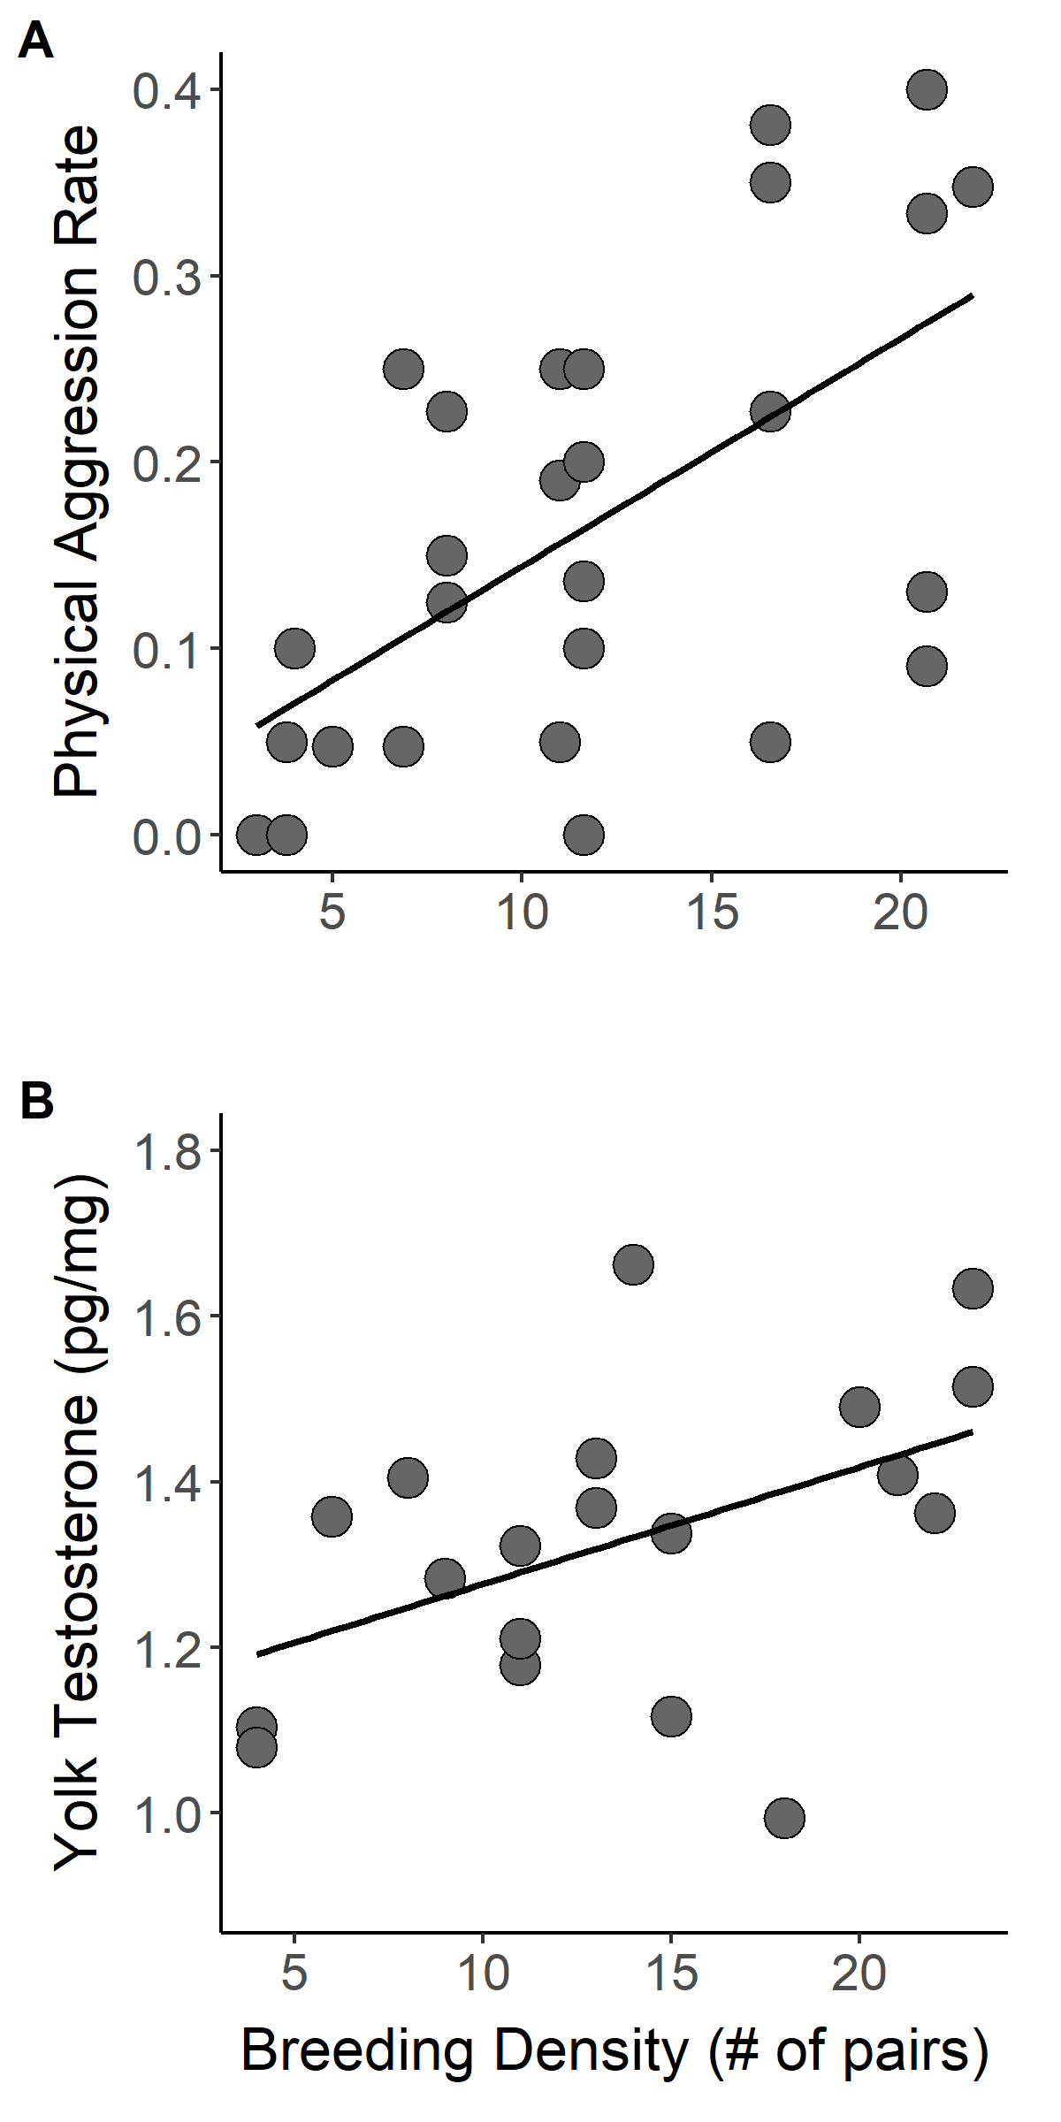
Figure 1.
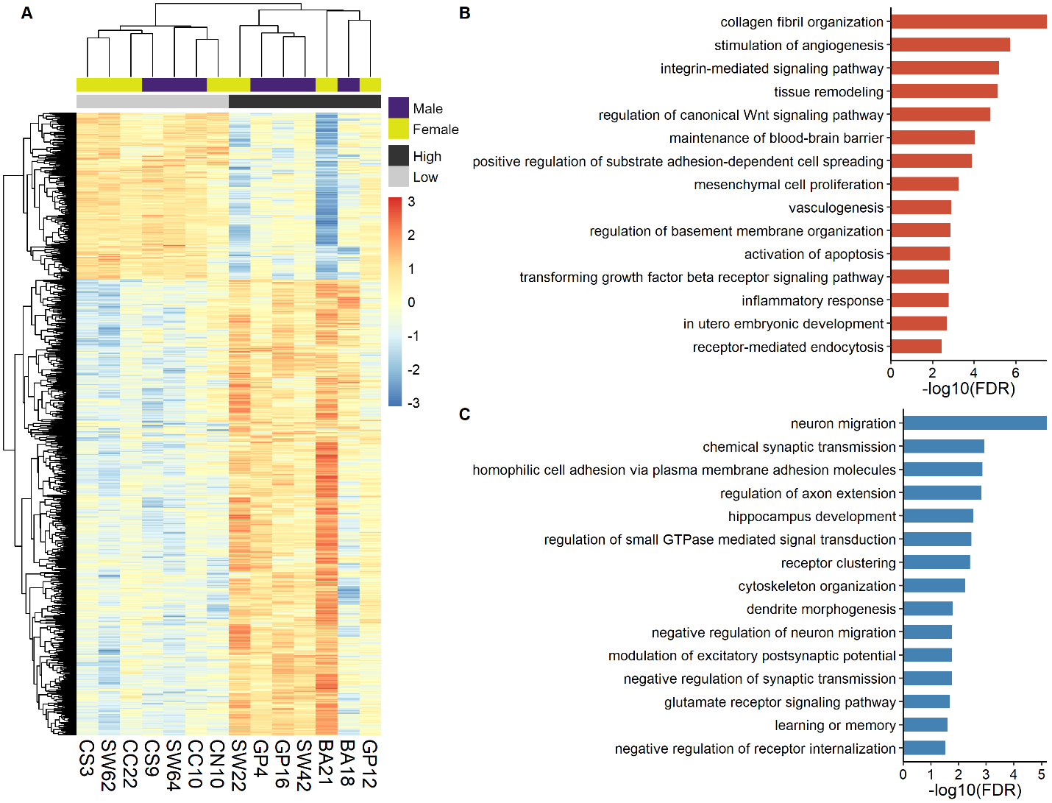
Figure 2.

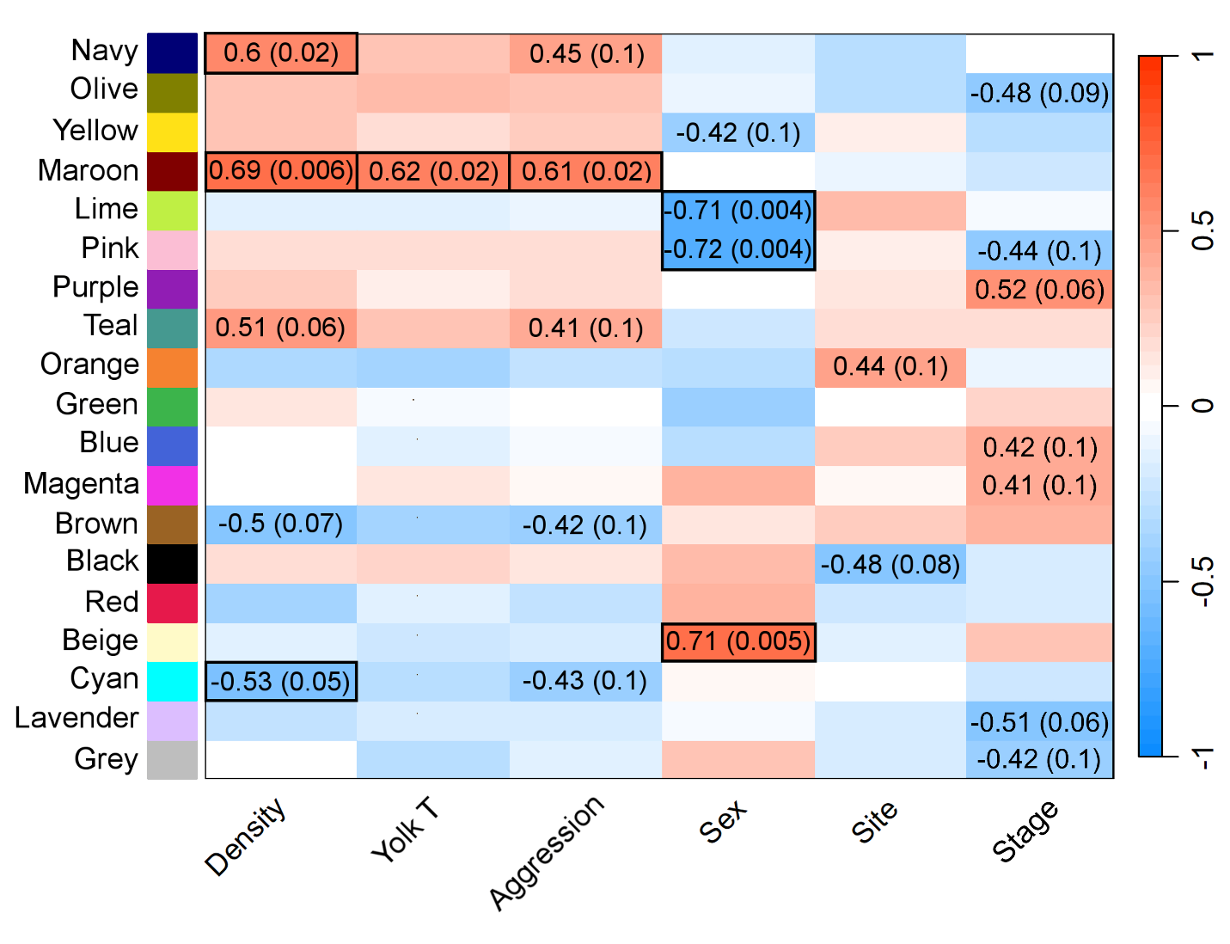Figure 3.

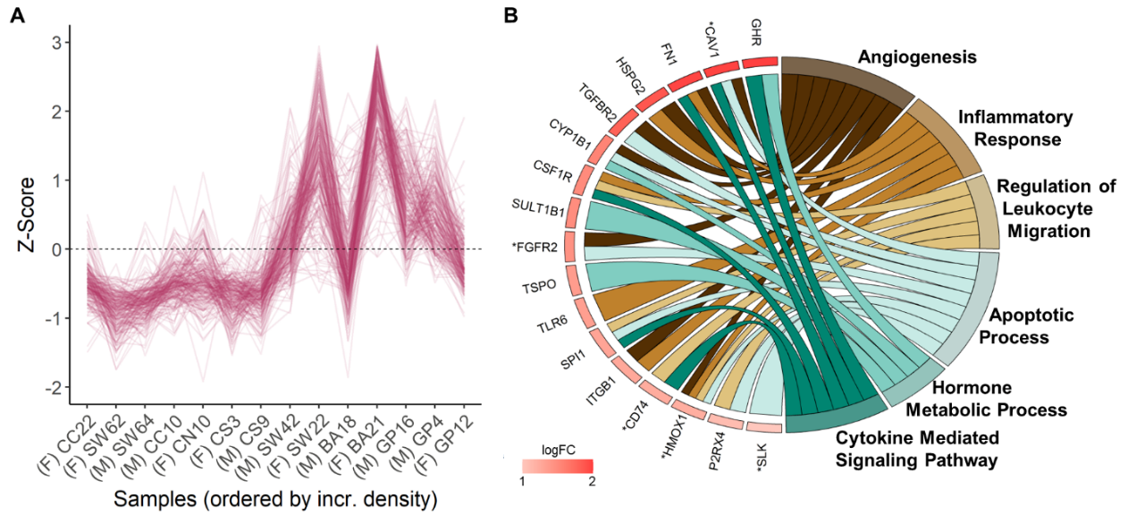
Figure 4.

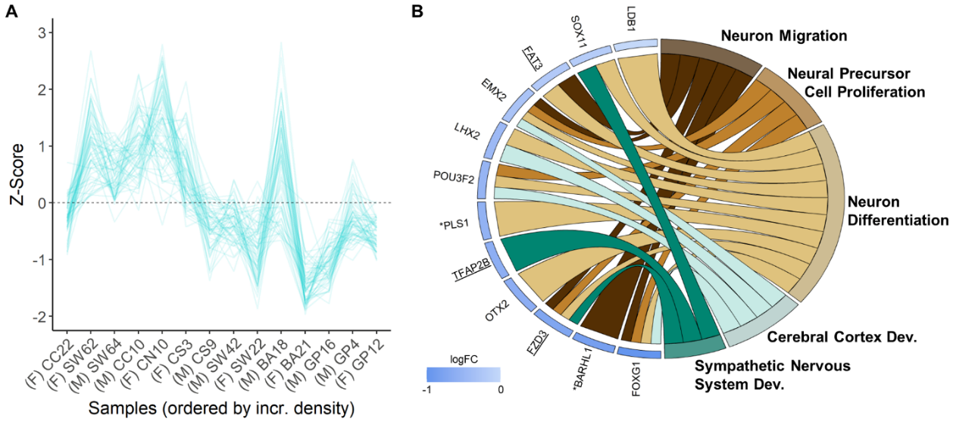
Figure 5.

