University of Oklahoma

Graduate College

THE ADDITION OF VALENCE AND NARRATIVE ENDINGS’ INFLUENCE ON THE RISK CONVERGENCE MODEL

A DISSERTATION

submitted to the Graduate Faculty

in partial fulfillment of the requirements for the

Degree of

DOCTOR OF PHILOSOPHY

By

KATHRYN L. LOOKADOO
Norman, Oklahoma
2017

THE ADDITION OF VALENCE AND NARRATIVE ENDINGS’ INFLUENCE ON THE RISK CONVERGENCE MODEL

A DISSERTATION APPROVED FOR THE
DEPARTMENT OF COMMUNICATION

By

______________________________
Dr. Norman Wong, Chair

______________________________
Dr. Elena Bessarabova

______________________________
Dr. Ioana Cionea

______________________________
Dr. Patrick Meirick

______________________________
Dr. Marshall Cheney

© Copyright by kATHRYN L. LOOKADOO 2017
All Rights Reserved.
This dissertation is dedicated to my parents, Donald and Marilyn Lookadoo.

Acknowledgements
I am immensely grateful for my advisor, Dr. Norman Wong. I have enjoyed partnering with you on studies throughout my time at OU. I loved our weekly office meetings in which we discussed projects, potential research ideas, and television recommendations. I am appreciative especially of your continued support as I worked on my dissertation. I feel so fortunate to have your insight throughout the process and I thank you for your flexibility and understanding as I worked on the dissertation long-distance.
Thank you to my committee members who encouraged and guided me throughout the dissertation process. Dr. Ioana Cionea, thank you for holding my hand through my dark days of confirmatory factory analyses. I truly value your patience and commitment to helping me understand what I was doing. Additionally, thank you for your keen editing eye when it came to pointing out ways to improve my manuscript and thank you for using a cheerful pen color. It eased the pain. Dr. Elena Bessarabova, thank you for your consistent encouragement to improve the quality of my work. Your honest and accurate critiques of my project pushed me to produce a better end result. Dr. Pat Meirick, thank you for you feedback on my work. Your suggestions throughout the process were thoughtful and helpful. Dr. Marshall Cheney, I could not have asked for a better outside member. Your constant encouragement was a morale booster and your “outsider’s” perspective helped me explain my work in a more accessible way.
Graduate school is a place that really bonds you with people. I am incredibly fortunate to have such an amazing and supportive cohort. I owe a special thank you to the ladies of the group for years of laughter and commiserating. It’s been a privilege to be in the graduate school trenches with you. In particular, thank you Eryn for serving as a sounding board for my ideas and concerns, proofreading my drafts, and appreciating my dark humor as I trudged through dissertation. Knowing you were just a text message or phone call away was a true comfort.
This dissertation would not have been possible without the support of my family. Thank you to my parents, Donald and Marilyn, who have always gone above and beyond in supporting me. I am blessed to be you daughter. To my sister, Elizabeth, thank you for cheering me on from afar, checking in on me via FaceTime, and taking the time to visit me at school (with at least one of my nephews in tow). Finally, to my husband, Jim, I am done! I think you are happier than I am. Thank you enduring the peaks and valleys of graduate school with me. I appreciate your encouragement and sacrifices throughout my master’s and doctorate. I love you. I promise I will not get another degree.

Table of Contents
Acknowledgements iv
List of Tables x
List of Figures xiii
Abstract xv
Chapter 1: Introduction 1
Chapter 2: Narrative Persuasion 5
Entertainment-Education 6
Frameworks of Narrative Persuasion 8
Chapter 3: Media Effects and Risk 11
Cultivation Theory 12
Impersonal and Differential Impact Hypotheses 15
Chapter 4: Background of Risk Convergence Model 17
Construal Level Theory 18
Optimistic Bias 21
Third-Person Effect 22
Chapter 5: Risk Convergence Model 24
The Convergence Process 25
Narrative Engagement Variables 27
Identification 27
Transportation 29
Perceived Realism 31
Personal Relevance 33
Replacing Personal Relevance with Self-Referencing 35
PSI, PSR, and Valence 37
Narrative Features and Risk Consequences 43
Duration of Effects 49
Chapter 6: Method 50
Study Design 50
Pilot Study 50
Participants 50
Procedures 51
Character Valence Manipulation 53
Video Stimuli 54
Measures 55
Results 60
Conclusions 64
Main Study 65
Participants 65
Procedures 66
Chosen Stimuli 68
Measures 68
Chapter 7: Results 75
Data Cleaning 76
Data Transformations 76
Confirmatory Factor Analyses 78
Descriptives and Reliabilities 96
Manipulation Checks 99
Character Valence Manipulation 99
Hypothesis Tests and Research Questions 100
Risk Convergence 100
Narrative Engagement and the RCM 105
Valence and the RCM 123
Affective Disposition and the RCM 126
Narrative Endings and Duration of Effects 129
Chapter 8: Discussion 132
Risk Convergence 132
Narrative Engagement and the RCM 135
Self-Referencing 136
Perceived Realism 137
Parasocial Phenomena 137
Valence and the RCM 139
Affective Disposition and the RCM 140
Narrative Endings and Duration of Effects 142
Limitations and Future Directions 144
Conclusion 148
References 149
Appendix A: Pilot Study 166
Appendix B: Main Study 182
Appendix C: Delayed Posttest 202
Appendix D: Variable Labels 209

List of Tables
Table 1. Pilot Study: Drinking Demographics 56
Table 2. Pilot Study: Descriptive Statistics and Cronbach’s Alpha for Variables 61
Table 3. Pilot Study: Descriptive Statistics for Paragraph Valence and Narrative Endings 63
Table 4. Main Study: Drinking Demographics 69
Table 5. Main Study: Experience with Health Topic 70
Table 6. Main Study: Skewness and Kurtosis Values Pre- and Post-Transformations. Values of k and λ in the Transformation Equation Y* = (Y + k)^{(λ)} 76
Table 7. Main Study: Confirmatory Factor Analyses Fit Indices 94
Table 8. Main Study: Reliability Scores of Initial Scales and of Revised Scales 97
Table 9. Main Study: Descriptive Statistics for Variables 98
Table 10. Hierarchical Regression of Social Distance on the Discrepancy between Risk Perceptions 101
Table 11. Hierarchical Regression of Social Distance on Perceived Self-Risk 103
Table 12. Model Coefficients for Mediation of Perceived Social Distance on the Relationship between Identification and Risk Discrepancy 108
Table 13. Model Coefficients for Mediation of Perceived Social Distance on the Relationship between Transportation and Risk Discrepancy 109
Table 14. Model Coefficients for Mediation of Perceived Social Distance on the Relationship between Perceived Plausibility and Risk Discrepancy 110
Table 15. Model Coefficients for Mediation of Perceived Social Distance on the Relationship between Perceived Realism (Perceptual Quality) and Risk Discrepancy 112
Table 16. Model Coefficients for Mediation of Perceived Social Distance on the Relationship between Perceived Typicality and Risk Discrepancy 113
Table 17. Model Coefficients for Mediation of Perceived Social Distance on the Relationship between Perceived Narrative Consistency and Risk Discrepancy 114
Table 18. Model Coefficients for Mediation of Perceived Social Distance on the Relationship between Perceived Narrative Coherence and Risk Discrepancy 115
Table 19. Model Coefficients for Mediation of Perceived Social Distance on the Relationship between Self-Referencing and Risk Discrepancy 116
Table 20. Model Coefficients for Mediation of Perceived Social Distance on the Relationship between Cognitive PSI and Risk Discrepancy 118
Table 21. Model Coefficients for Mediation of Perceived Social Distance on the Relationship between Affective PSI and Risk Discrepancy 119
Table 22. Model Coefficients for Mediation of Perceived Social Distance on the Relationship between PSR Character and Risk Discrepancy 120
Table 23. Hierarchical Regression of PSR Character on Cognitive PSI 121
Table 24. Hierarchical Regression of PSR Character on Affective PSI 123
Table 25. Model Coefficients for Moderation of Character Valence on the Relationship between Cognitive PSI and Social Distance 124
Table 26. Model Coefficients for Moderation of Character Valence on the Relationship between Affective PSI and Social Distance 125
Table 27. Model Coefficients for Moderation of Character Valence on the Relationship between PSR with the Character and Social Distance 126
Table 28. Model Coefficients for Mediation of Identification on the Relationship between Affective Disposition and Social Distance 127
Table 29. Model Coefficients for Mediation of Deservedness on the Relationship between Affective Disposition and Personal Risk Perception 129
Table 30. Model Coefficients for Moderation of Uncertain Video Condition on the Relationship between Social Distance and Risk Discrepancy 130
Table 31. Model Coefficients for Moderation of Denial Video Condition on the Relationship between Social Distance and Risk Discrepancy 131

List of Figures
Figure 1. Mediation of perceived social distance on the relationship between identification and risk discrepancy. 108
Figure 2. Mediation of perceived social distance on the relationship between transportation and risk discrepancy. 109
Figure 3. Mediation of perceived social distance on the relationship between perceived realism (plausibility) and risk discrepancy. 110
Figure 4. Mediation of perceived social distance on the relationship between perceived realism (perceptual quality) and risk discrepancy. 111
Figure 5. Mediation of perceived social distance on the relationship between perceived realism (typicality) and risk discrepancy. 113
Figure 6. Mediation of perceived social distance on the relationship between perceived realism (narrative consistency) and risk discrepancy. 114
Figure 7. Mediation of perceived social distance on the relationship between perceived realism (narrative coherence) and risk discrepancy. 115
Figure 8. Mediation of perceived social distance on the relationship between self-referencing and risk discrepancy. 116
Figure 9. Mediation of perceived social distance on the relationship between cognitive PSI and risk discrepancy. 118
Figure 10. Mediation of perceived social distance on the relationship between affective PSI and risk discrepancy. 119
Figure 11. Mediation of perceived social distance on the relationship between PSR character and risk discrepancy. 120
Figure 12. Moderation model of character valence on the relationship between cognitive PSI and social distance. 124
Figure 13. Moderation model of character valence on the relationship between affective PSI and social distance. 125
Figure 14. Moderation model of character valence on the relationship between PSR with the character and social distance. 126
Figure 15. Mediation of identification on the relationship between affective disposition and social distance. 127
Figure 16. Mediation of deservedness on the relationship between affective disposition and social distance. 129
Figure 17. Moderation of uncertain video condition on the relationship between social distance and risk discrepancy. 130
Figure 18. Moderation of denial video condition on the relationship between social distance and risk discrepancy. 131

Abstract
The risk convergence model (RCM) was developed as a theoretical framework to organize research on media effects and narrative persuasion (So & Nabi, 2013). The model identifies social distance to a fictional character as a key mechanism through which narrative engagement variables impact media users’ personal risk perceptions. However, the model has only been tested twice (So & Nabi, 2013; So & Shen, 2015). This dissertation expands the RCM by adding parasocial relationship (PSR) with the character to the model. Additionally, the study tests the effects of character valence and affective disposition on social distance with an at-risk character. This dissertation also explores the influence of narrative ending types on risk perceptions. Finally, the study examines the duration of effects for personal risk perceptions.
An experiment was conducted in which participants (N = 272) were randomly assigned to a character valence condition (positive or negative) and a narrative ending condition (uncertain, denial, or apology). Results indicated that a reduction in social distance to an at-risk character led to risk convergence. The study supported the addition of PSR with the character to the RCM because social distance mediated the relationship between PSR and character- and self-risk discrepancy. Character valence did not work with the narrative engagement variables, whereas results for affective disposition indicated a future role it could play in the RCM. Finally, narrative ending types did not significantly affect risk perceptions. Overall, this study’s results offer support for the RCM and offer new components to consider when testing the model in the future.

Chapter 1: Introduction
People face a number of risks every day and are consistently reminded of those risks to an overwhelming extent (Berry, 2004). Despite this constant communication about risk, the Centers for Disease Control and Prevention (CDC, 2014) report that, in the United States, 20 to 40 percent of premature deaths from each of the five leading causes of death—diseases of the heart, cancer, chronic lower respiratory diseases, cerebrovascular diseases (stroke), and unintentional injuries— could have been prevented. Modifiable risk factors are primarily responsible for each of the five causes of death (CDC, 2014). Modifiable factors include lifestyle behaviors such as tobacco use, poor diet, alcohol use, lack of seatbelt use, and lack of physical activity (CDC, 2014). Effective risk communication can play a role in reducing this death toll. Risk communication is communication that focuses on risk-related knowledge, perceptions, attitudes, and behaviors (Edwards & Bastian, 2001). This type of communication does not have to be face-to-face, and often occurs through mass media. Research demonstrates that media can influence risk perceptions (Binder, Cacciatore, Scheufele, & Brossard, 2015; Snyder & Rouse, 1995) and because of this, many media effects theories (e.g., cultivation theory, impersonal-impact hypothesis) have been proposed to explain how mediated depictions of risk affect risk perceptions. However these theories primarily focus on social risk perception rather than personal risk perception (So & Nabi, 2013). Research on narrative media has brought a focus to individual risk perceptions by identifying narrative engagement conditions (e.g., transportation, identification, parasocial interaction) that impact personal risk perceptions when individuals are exposed to a mass mediated risk narrative. However, much of the research on media and risk perception does not provide a cohesive explanation for why media influence personal risk perceptions.
In an effort to organize disjointed research on media effects and narrative persuasion, So and Nabi (2013) proposed the risk convergence model (RCM). The process model posits that reduction of perceived social distance to a fictional character serves as a mechanism to explain how different forms of narrative engagement influence media users’ personal risk perceptions. A variety of narrative engagement processes reduce the social distance between viewers and an at-risk character. This reduction in distance then prompts viewers’ personal risk perception to converge or move closer to the high-risk level of the at-risk character. Although the RCM has received empirical support from past tests (So & Nabi, 2013; So & Shen, 2015), limited research has been conducted with the model, and there is room for expansion, as the RCM has only been tested on perceived risk of acquiring a sexual transmitted disease (STD).
This dissertation seeks to improve understanding about the mechanisms involved in the RCM model and test how its principles work with a different health issue. This project advances research on the RCM in multiple ways. First, this dissertation tests the convergence process of the RCM using a different health issue, drinking and driving, which is a salient health problem in the United States. According to the National Center for Statistics and Analysis (NCSA; 2015), a driver is considered to be “alcohol-impaired” when his or her blood alcohol concentration (BAC) is .08 grams per deciliter (g/dL) or higher. In 2014, almost ten thousand (9,967) people died in alcohol-impaired driving crashes, accounting for 31 percent of all motor vehicle traffic fatalities in United States. Of these fatalities, 64 percent were alcohol-impaired drivers, 15 percent were passengers riding with those drivers, 12 percent were occupants of other vehicles, and 8 percent were non-occupants such as pedestrians and cyclists (NCSA, 2015). Additionally, in the same year, 1,764 people died in crashes in which a driver had been drinking (BAC between .01 to .07 g/dL) but was not considered to be alcohol-impaired (NCSA, 2015). Thus, drinking and driving is a major health issue in the United States.
Testing the RCM with a different health issue is important because previous tests of the model used the issue of STDs exclusively. As So and Shen (2015) noted, although STDs are contagious, they are easily treatable, and rarely fatal. The findings from previous RCM studies may not generalize to noncontagious health issues or issues that are more deadly. One of the contributions of this study is to observe if the RCM works differently due to differences in level of involvement in the risk event and the severity of consequences associated with the event. The expectation is that the model performs similarly with a different issue.
Second, the project also considers the role of the RCM’s five narrative engagement variables on the relationship between narrative exposure and personal risk perception. In this reconsideration of variables, self-referencing replaced personal relevance because self-referencing is associated more with message content than with personal relevance.
Third, this dissertation proposes adding parasocial relationships (PSRs) with characters to the RCM as an additional narrative engagement variable. PSRs occur outside the viewing process but can influence other narrative engagement variables, particularly parasocial interactions (PSIs; Schramm & Hartmann, 2008). People’s long-term relationships and background knowledge of characters experiencing risk behaviors could decrease their social distance and increase their perceived personal risk because the viewers with a PSR already have a connection with the character and could be more affected by the character’s experience of the risk event.
Fourth, another addition to the model is the consideration of character valence and affective disposition toward the character as moderators in the relationships between perceived social distance and the parasocial variables and perceived social distance and identification, respectively. Often, narrative engagement research focuses on interactions with likeable characters. However, researchers have emphasized the significance of considering how engagement with negative characters impacts narrative persuasion theories (Konijn & Hoorn, 2005). The addition of these moderators will contribute to the RCM because they account for both positive and negative engagement with the character. This study aims to test if these moderators influence social distance and the subsequent convergence process in different ways.
Fifth, this project explores how different narrative endings affect risk perception, specifically examining at the role of explicit or implicit consequences and the character’s acceptance of those consequences portrayed in the narrative. This study uses the same narrative storyline but ends the stimuli with different outcomes: uncertainty regarding the character’s fate, denial of responsibility from the character, and acceptance and apology from the character concerning the need to change the risky behavior. Narrative endings are important to consider because they may impact the level of social distance a viewer perceives between themselves and the character, which could, in turn, influence risk convergence.
Finally, this project also considers the duration of media effects on risk by including a posttest follow-up two weeks after the initial stimulus exposure. Most media effects studies measure attitudes after immediate exposure (Green & Clark, 2013). More scholars are considering media’s long-term influence on attitudes toward health behaviors (e.g., Moyer-Gusé & Nabi, 2010; Vaughan, Rogers, Singhal, & Swalehe, 2000). The follow-up posttest component of the project attempts to add to research on the durability of risk convergence effects in a narrative format.
This dissertation begins with a literature review of narrative persuasion, media effects and risk, the theoretical foundation of the RCM, and the explanation of the RCM itself. Next, additions to the model are proposed, culminating with a series of hypotheses. Then the hypotheses are tested in an experimental setting, described in the method. Finally, the dissertation concludes with a summary of the results and a discussion of the findings’ theoretical and practical significance.

Chapter 2: Narrative Persuasion
A narrative is “a representation of connected events and characters that has an identifiable structure, is bounded in space and time, and contains implicit or explicit messages about the topic being addressed’’ (Kreuter et al., 2007, p. 222). A large body of research has established that both written and audiovisual fictional narratives can impact media users’ attitudes, beliefs, intentions, and behaviors (e.g., Appel & Richter, 2007; Green, 2004; Green & Brock, 2000; S. E. Morgan, Movius, & Cody, 2009; Moyer-Gusé & Nabi, 2010; Strange & Leung, 1999; Wang & Calder, 2006). This chapter will cover a specific area of narrative persuasion that focuses on changing social and health behaviors, entertainment-education (E-E). With this frame of reference, the chapter will then cover the specific frameworks of narrative persuasion. Entertainment-education is relevant to the RCM because it demonstrates how entertainment can affect attitudes and behaviors toward a variety of social and health issues using narrative engagement processes. The strategy’s success has led to a growing body of research on how people’s connection to the narrative and characters influence persuasion.

Entertainment-Education
Entertainment-education is an intervention strategy that intentionally embeds educational content into entertainment programming (Singhal & Rogers, 2004). This strategy has been used in over 40 countries to create awareness of and change attitudes and behaviors regarding a vast amount of social and health issues such as HIV/AIDS prevention, domestic violence, and reproductive health (Sherry, 2002; Singhal, Cody, Rogers, & Sabido, 2004). E-E “programming” can include radio and television series, talk radio, music, participatory theatre, interactive websites, and video games (Singhal et al., 2004). However, most research has concentrated on the use of radio and television serials (Cody & Sabido, 2008).
Traditional E-E campaigns originate from Miguel Sabido’s E-E programing in the 1970s, which used long-running telenovelas to encourage adult literacy and family planning in Latin America, using Bandura’s (1986) social cognitive theory (Singhal & Rogers, 2004). Traditional E-E interventions specifically create entertainment programming using message design and persuasion theories and rigorously test the programming (Singhal et al., 2004). Many of these programs have demonstrated positive results. An example of a successful E-E program is Tinka Tinka Sukh (Happiness Lies in Small Things), a 104-episode, radio soap opera that aired from 1996 to 1997 in India. An estimated 36 to 40 million people listened to the program which focused on a message of promoting community harmony and women’s causes like antidowry, women’s empowerment, and gender equality (Papa et al., 2000). In a case study on a community that listened to the program, researchers found that the show inspired interpersonal discussion about issues depicted in the show, and motivated some listeners to come together to solve community problems (Papa et al., 2000). The United States has only had a small number of coordinated, cross-media campaigns (Hether, Huang, Beck, Murphy, & Valente, 2008). For instance, the Harvard Alcohol Project sought to reduce drunk driving by advocating the use of designated drivers through a coordinated E-E campaign. The campaign, which began in 1998, embedded messages into over 160 entertainment television series. Survey results demonstrated a 10 percent increase in respondents’ reports of using a designated driver all or most of the time (Winsten & DeJong, 2001).
E-E programming in the United States often does not use the traditional model of E-E campaigns in which message designers carefully construct a program around a health issue (Singhal & Rogers, 2004). Rather, in the United States, educational stories are often embedded in already established entertainment programming by advocacy groups or the show’s writers (Greenberg, Salmon, Patel, Beck, & Cole, 2004). This form of E-E appears in countries like the United States where the government has little control over media content, and where there are a large number of media outlets competing for viewers’ attention (Moyer-Gusé & Nabi, 2010; Sherry, 2002). Although traditional E-E programing has a long running storyline regarding a health or social issue, E-E in the United States could consist of just one educational scene, an episode-long storyline, or a brief story arc because the story is at the discretion of the writers and producers (Greenberg et al., 2004). These types of E-E differ in their goals as well. While traditional E-E works to change durable attitudes and behaviors, E-E in the United States may have a smaller scope that can focus on merely informing viewers about an issue, or seeking to change attitudes and behaviors (Moyer-Gusé & Nabi, 2010).
Evidence demonstrates that health messages embedded into entertainment programming can change media users’ knowledge, attitudes, and behaviors (Bae & Kang, 2008; Brodie et al., 2001; Hether et al., 2008; Murphy, Frank, Moran, & Patnoe-Woodley, 2011). However, because implementers assess E-E studies through mass surveys and content analyses, the results usually do not provide detailed evaluations that explain which specific mechanisms of E-E lead to persuasive effects. Thus, Slater and Rouner (2002) recommended that scholars attempt to understand E-E better through experiments that examine how E-E content impacts beliefs, attitudes, and behaviors. Current narrative persuasion research follows this suggestion and focuses on the underlying mechanisms of narrative persuasion (e.g., transportation, identification).

Frameworks of Narrative Persuasion
Narrative persuasion does not function in the same manner as non-narrative or analytical persuasion (Dal Cin, Zanna, & Fong, 2004). Scholars examine analytical models of persuasion using frameworks such as the elaboration likelihood model (ELM; Petty & Cacioppo, 1986) and the heuristic-systematic model (HSM; Chaiken, 1980, 1987). These models explain that an individual decides whether or not to accept a message’s claim by carefully evaluating arguments or relying on heuristic or superficial cues. The individual’s level of scrutiny depends on his or her motivation and ability to process the message. In contrast, narrative persuasion works to involve people affectively in a message so that they focus on the story rather than counterarguing (van Laer, de Ruyter, Visconti, & Wetzels, 2014). While analytical persuasion involves overtly persuasive messages, narrative persuasion embeds the persuasive messages in a story so that they are not as obvious (van Laer et al., 2014). Current literature proposes two principal models of narrative persuasion: the extended elaboration likelihood model (E-ELM; Slater, 2002; Slater & Rouner, 2002) and the entertainment overcoming resistance model (EORM; Moyer-Gusé, 2008; Moyer-Gusé & Nabi, 2010).
Slater and Rouner (2002) proposed the E-ELM to advance E-E theorizing. The E-ELM suggests that while issue involvement is an important factor in non-narrative persuasion theories like the ELM, involvement in the narrative is an important element in narrative persuasion (Slater & Rouner, 2002). Specifically, persuasive narratives can reduce resistance to persuasion by facilitating absorption in the narrative. This idea of absorption involves both narrative and character involvement. Narrative involvement refers to transportation, which is sometimes referred to as narrative absorption. Transportation is a concept of engagement that describes how a media user can get so involved in a narrative that he or she becomes unaware of his or her surroundings (Green & Brock, 2000). Character involvement refers to identification, which occurs when a media user temporarily adopts a media character’s identity and perspective (Cohen, 2001). The E-ELM asserts that transportation into the story and identification with characters results in people being in a less critical state, which reduces counterarguing of and resistance to persuasive messages (Dal Cin et al., 2004; Slater & Rouner, 2002).
In an effort to consider how E-E programs can overcome other forms of resistance besides counterarguing, Moyer-Gusé (2008) proposed the EORM. The EORM incorporates the E-ELM’s proposition regarding counterarguing while also considering other forms of resistance that might cause persuasive messages to fail. For instance, the EORM considers entertainment features of E-E narratives that may reduce different types of resistance (e.g., psychological reactance and selective avoidance) and overcome optimistic bias (Moyer-Gusé, 2008). Similar to the E-ELM, the EORM identifies narrative engagement processes like transportation, identification, and PSI as mechanisms to overcome resistance to persuasion (Moyer-Gusé, 2008). For instance, the EORM posits that the narrative structure of E-E messages reduces a media user’s perception of persuasive intent because he or she views the intent of the message is to entertain, which, in turn, minimizes reactance (Moyer-Gusé, 2008; Moyer-Gusé & Nabi, 2010). Additionally, the EORM asserts that reactance can be reduced through PSI with a character (Moyer-Gusé & Nabi, 2010). PSI, which will be discussed in greater detail in relation to RCM, is a character engagement variable that describes a media user’s positive, “seemingly face-to-face” interaction with a media figure (Horton & Wohl, 1956, p. 215). According to the EORM, PSI reduces reactance because the media user feels like the character with whom he or she has a PSI is more similar to a peer (Giles, 2002), and, therefore, less authoritative and threatening to their attitudinal and behavioral freedom (Moyer-Gusé & Nabi, 2010).
To change social and health behaviors, narrative persuasion frameworks have identified the importance of overcoming people’s resistance. These types of resistance can include counterarguing and reactance (Moyer-Gusé, 2008; Slater & Rouner, 2002). Media research pinpoints the importance of narrative structure and engagement as keys to overcoming this resistance. The risk convergence model takes these assertions and suggests how engagement variables work through social distance to influence personal risk perceptions. However, it is important to understand past research on media and risk perceptions prior to discussing the RCM.

Chapter 3: Media Effects and Risk
Risk judgment or perception is conceptualized as the way a person characterizes and assesses danger (Slovic, 1987). These judgments contain two dimensions: cognitive and affective. The cognitive dimension pertains to how people assess the likelihood of experiencing a hazard, and the affective dimension describes the concern that arises from that assessment (Dunwoody & Neuwirth, 1991). In addition to involving individuals’ beliefs, feelings, attitudes, and judgments, social and cultural values and norms impact risk perceptions (Pidgeon, Hood, Jones, Turner, & Gibson, 1992). Health communication researchers have emphasized the importance of understanding and influencing individuals’ perceived risk because behavior change theories and research demonstrate that people’s risk perceptions are greater determinants of their behaviors than their actual risk levels (Turner, Skubisz, & Rimal, 2011). As mentioned in the introduction, there are two types of risk perceptions: social and personal. Perceived social risk refers to an individual’s belief about the risk to society or “others,” whereas perceived personal risk refers to an individual’s perceived personal vulnerability (Roberto, Goodall, & Witte, 2009). This difference is important because perceived personal risk, as opposed to social risk, is more likely to motivate people to take action to defend against possible risk (Aiken, Gerend, & Jackson, 2001; Janz & Becker, 1984). This chapter reviews media effects theories that relate to social and personal risk perceptions.

Cultivation Theory
Gerbner (1969) presented cultivation theory as a way to study the persistent, dynamic interplay between television and culture (Morgan, Shanahan, & Signorielli, 2009). This theory views television as society’s main institutional storyteller. As such, television provides a system of messages to a mass audience, however these messages present a distorted reality. For instance, a number of constructs (e.g. crime, violence, chances of surviving cardiopulmonary resuscitation (CPR), stereotypical representations of women, and occupations like doctors) are overrepresented and exaggerated on television (Busselle, 2003; Gerbner, Gross, Morgan, Signorielli, & Shanahan, 2002; Gerbner & Gross, 1976; Van den Bulck, 2002). Cultivation research demonstrates that long-term exposure to television’s messages can have a small, but significant effect on how people perceive their social world or reality (Bilandzic, 2006; Morgan & Shanahan, 2010). Therefore, the more people watch television, the more their perceptions, values, and beliefs align with the messages portrayed on television. In regard to risk perception, cultivation research has found that heavy viewing is correlated with increased anxiety and fear (Bryant, Carveth, & Brown, 1981).
Cultivation does not focus solely on television’s influence on risk perceptions but, as a theoretical foundation, has spurred a lot of risk research. In particular, the relationship between television’s portrayal of violence and people’s fear of crime, is a major research area of cultivation theory (Morgan & Shanahan, 2010). Cultivation effects can be separated into two process-indicators: first- and second-order. First-order effects signify media consumers’ perceptions, or quantitative estimates, of real world parameters (e.g., overestimating crime rates in society, social risk perceptions). Second-order effects represent viewers’ attitudes, values, and perceptions about society (e.g., the world is a mean place and people cannot be trusted; Shrum, 2009; Shrum & Bischak, 2001; Weimann, 2000). Although some cultivation studies examine personal risk perceptions, cultivation theory primarily focuses on social risk perceptions. This concentration on social risk perception fits the cultivation perspective that television is more likely to impact a person’s view of society, in general, than directly influence one’s personal perceptions of his or her life, which is more intimate and known to that person (Morgan & Shanahan, 2010). Cultivation researchers still care about the effect television has on personal risk perception. However, early research did not distinguish between the two types of risk perception in their measures and, therefore, cannot offer evidence of how media affect social and personal risk perceptions separately (e.g., Gerbner, 1969; Gerbner, Gross, Jackson-Beeck, Jeffries-Fox, & Signorielli, 1978). Recently, media researchers have started comparing cultivation’s influence on the different types of risk perception (i.e., social and personal risk). For instance, Ye (2010) found that television viewing was positively correlated with both personal and social risk perceptions of health issues, such as cancer, stroke, diabetes, HIV/AIDS, and infectious diseases.
Additionally, cultivation researchers are beginning to look at how narrative variables impact risk perceptions. For example, Bilandzic and Busselle (2008) attempted to examine transportation’s role in facilitating cultivation. Despite their operationalization issues, the overall results suggested narrative engagement variables could affect cultivation. Additionally, Custers and Van den Bulck (2013) found Flemish women’s perceived personal risk was positively associated with exposure to Flemish crime dramas, negatively related to news viewing, and not significantly related to exposure to American crime dramas. This finding is interesting because it suggests that narrative engagement processes, such as identification with characters, could play a role in cultivation effects of risk perception. Also, for Flemish viewers, Flemish characters may generate more identification than American characters, which would account for the differences in perceived risk (Custers & Van den Bulck, 2013).
Cultivation is an important theory that connects media effects to risk perceptions. Traditionally, cultivation research focuses on media’s influence on social risk perception. However, some scholars have considered media’s impact on personal risk. This limited amount of research in these two areas merits more attention, especially given that perceived personal risk is more likely to motivate people to act than perceived social risk is (Aiken et al., 2001) . More recent cultivation research is moving beyond just studying cumulative effects of how frequency of media exposure affects risk perceptions but to considering how intensity of media exposure influences personal risk perceptions. Cultivation theory informs this dissertation by providing further evidence for the importance of narrative engagement in changing personal risk perceptions. Past cultivation research supports the predictions in this study that the intensity of media exposure (i.e., narrative engagement), positively influences personal risk perceptions.

Impersonal and Differential Impact Hypotheses
The impersonal impact hypothesis (Tyler, 1980; Tyler & Cook, 1984) differs from cultivation theory by focusing on media’s effect on risk perceptions and establishing a clear difference between social and personal risk perception. The impersonal impact hypothesis postulates that mass media have a greater influence on people’s social risk perceptions than personal risk perceptions (Shrum & Bischak, 2001; Tyler & Cook, 1984). Additionally, the hypothesis proposes that, while mass media influence perceived social risks, interpersonal communication (which is more likely to focus on more personal stories of risk) influences perceived personal risk. This hypothesis has been supported in contexts like crime (Hughes, 1980) and drunk driving (Tyler & Cook, 1984).
However, not all research on the impersonal impact hypothesis supports the assertions that mass media only influence social risks (Coleman, 1993; Snyder & Rouse, 1995). For instance, Coleman (1993) found that mass media affected both social and personal risk perceptions. Building on this research, Snyder and Rouse (1995) proposed that, when media are separated into informative and entertainment categories, media effects on personal risk emerge. Their study found that entertainment media viewing significantly predicted perceived personal risk. These two studies’ findings support the differential impact hypothesis, which proposes that, under certain conditions, media can influence perceived personal risk. Snyder and Rouse (1995) argued that the level of drama and vividness in media portrayals affects risk judgment. More specifically, they emphasized that entertainment media’s dramatic presentation could impact personal risk perceptions, whereas more informative media (e.g., news) would be more likely to influence social risk perceptions. So, Cho, and Lee (2011) expanded Snyder and Rouse’s (1995) work and reported that genre-specific media exposure (e.g., entertainment, news, health infotainment, and medical documentary) differentially affected participants’ social and personal risk perceptions about smoking risks.
Additional research supports the differential impact hypothesis by suggesting that certain conditions and individual differences influence risk perceptions. For example, Basil and Brown (1997) found that identification with a celebrity diagnosed with HIV/AIDS positively correlated with personal and social risk perceptions. Also, variables like personal relevance can affect personal and social risk perceptions (Sussman et al., 1989) by allowing individuals to relate to the issue portrayed in the narrative (Tyler & Cook, 1984) and seeing how the issue applies to them. These variables will be discussed in more detail in chapter five.
Although, the impersonal impact hypothesis proposes that interpersonal communication has a greater role in influencing personal risk perception than media, the differential impact hypothesis suggests that message differences and individual differences play a key role in risk perception. These conclusions emphasize the importance of narrative engagement variables’ influence on personal risk perceptions. For instance, many studies have found that parasocial relationships are similar to interpersonal relationships in formation, feelings of attachment, and termination (Cohen, 2009). Further, media can take the connection with media figures beyond a feeling of kinship and connection, through mechanisms such as identification and transportation. These variables can give a media user the feeling he or she is like the character or is in the narrative, respectively. This immersion could allow a media user to feel a connection to a risk event beyond what he or she could experience through interpersonal communication. Media’s ability to facilitate personal connections between media characters with users, and potentially influence personal risk perceptions is a key consideration of the RCM.

Chapter 4: Background of Risk Convergence Model
In 2013, So and Nabi introduced the RCM to explain why narratives affect personal risk perceptions. The authors argued that social distance worked as the common mechanism to explain how narrative engagement processes influenced audiences’ personal risk perceptions. The RCM proposes that narrative engagement processes can reduce perceived social distance with an at-risk character. This reduced social distance then allows audience members’ perceived personal risks to converge with the character’s risk, which personalizes the risk for the audience member. Given the model’s recent introduction, understandably, only a few scholars have tested its premises (So & Nabi, 2013; So & Shen, 2015). Therefore, this project will further explore the components and boundaries of the RCM. This section provides a review of the theory behind the RCM by tracing the model’s foundation in construal-level theory (CLT; Trope & Liberman, 2010) and connections to optimistic bias and third-person effect.

Construal Level Theory
CLT (Liberman & Trope, 1998; Trope & Liberman, 2003) is a theory examining psychological distance’s effects on thinking, decision making, and behavior. CLT is based on the idea that people use schematic mental models when thinking and making decisions; psychological distance affects the formation of these models (Trope & Liberman, 2010). When something (e.g., an object or event) is psychologically distant, that means it is beyond a person’s direct experience of the present reality (Liberman, Trope, & Stephan, 2007). That direct experience serves as the psychological distance’s reference point and anything beyond an individual’s direct experience of the here-and-now is psychologically distant (Liberman et al., 2007). A person can recall or imagine something, but he or she still does not experience it directly. According to the theory, there are four dimensions of psychological distance: social, temporal, spatial, and hypothetical. The different dimensions represent reasons for that distance. For instance, something may be socially distant because it belongs to another person (e.g., the way a friend or a stranger experiences an event). Things may be temporally distant because they happened in the past (e.g., high school graduation) or will happen in the future (e.g., me publishing this dissertation study as an article). Spatial distance refers to other places (e.g., Peru, the moon). Finally, hypothetical distance refers to alternate realities that could or might have occurred but did not (e.g., if I was invisible, if I switched jobs).
CLT posits that psychological distance affects the level of mental representation, or construal, of something. More specifically, entities that are more psychologically distant activate higher, or more abstract, levels of construal than psychologically closer entities. This difference in construals could be because the more remote things are from direct experience, the less information people have about these entities (Liviatan, Trope, & Liberman, 2008). This lack of knowledge leads a person to form representations on a higher level. A high-level construal is a simple, decontextualized mental representation that contains general, superordinate features of the entity. This level of construal emphasizes an overarching, more abstract “why” aspect of decision-making and behavior in which the individual focuses more on the outcome’s value or attractiveness than a low-level construal (Liberman & Trope, 1998). Conversely, a low-level construal is a more concrete representation that consists of subordinate and contextual features of the entity than a high-level construal. A low-level construal construal level focuses on the “how” element of decision-making and behaviors in which the individual concentrates on the feasibility of an action. For instance, Liberman and Trope (1998) asked participants to select a description for the action “making a list,” as a function of the dimension of psychological distance activated in the condition participants were assigned to within the study. Participants in the temporally distant condition (e.g., making a list next year) described the action as “getting organized,” whereas participants in the temporally closer condition (e.g., making a list tomorrow) described the action as “writing things down.” Thus, the activation of a high or low construal level results in systematic differences in how people comprehend objects and events, thus changing their evaluation, judgment, and behavior.
The RCM centers on the social dimension of CLT; therefore, more detail will be provided on this aspect of distance. Park (1924) defined the concept of social distance as the amount of understanding and feelings of closeness that describe interpersonal relationships. Bogardus (1925; 1933) built on this research by operationalizing social distance and suggesting that social distance levels were linked to personal contact and sympathy. CLT researchers have noted multiple types of social distance; unfamiliar others, out-group members, dissimilar others, and people of a different status can be viewed as socially distant others (Liberman et al., 2007). In terms of CLT, a socially distant entity is construed at a higher level than a socially close other. This construal difference occurs because people tend to have more contextual and specific information about socially close others, thus leading to more concrete mental representations as compared to socially distant others (Jones & Nisbett, 1972; Liviatan et al., 2008).
For instance, a person has specific and contextual information on his or her orientation toward risk (e.g., likelihood of contracting an STD). If asked to judge a socially close other’s risk, a person can project or converge his or her personal experience with risk onto that other because he or she has relevant information about that person (e.g., it is not likely that I will get an STD, therefore he or she probably will not, either). However, if asked to construe a socially distant other’s risk orientation, an individual will have a more difficult time making concrete judgments because his or her experiences are so distant from the other person’s experiences. Therefore, the individual will use higher-level schemas to make judgments about the distal other’s risk (e.g., based on statistics, he or she is likely to contract an STD), which generally deviate from personal experiences and self-assessments. The social distance aspect of CLT offers a reason how exemplars (like those often found in E-E messages) affect personal risk judgments; they bring the experience closer to home. For instance, in cases where narratives elicit high levels of transportation (i.e., narrative involvement) and identification, viewers feel as if they are a part of the story or are similar to the main character, which would decrease the social distance between the viewer and character, thus potentially leading to convergence of risk perceptions between the self and other. The role of social distance in impacting self-other perceptions has also been noted in a number of different phenomena, such as optimistic bias and the third person effect.

Optimistic Bias
Optimistic bias (Weinstein, 1980, 1989) is the tendency for people to underestimate their likelihood of experiencing a negative event (e.g., divorce, car accident, illness) and overestimate others’ likelihood. So and Shen (2015) explain that in this phenomenon, people tend to judge social risk as greater than personal risk. Numerous studies have observed the optimistic bias operating in various contexts such as risk assessment of natural disasters (Gierlach, Belsher, & Beutler, 2010), cancer (Dillard, McCaul, & Klein, 2006), and H1N1 flu (Cho, Lee, & Lee, 2013; Rudisill, 2013). Most optimistic bias research focuses on health risk perceptions (Ostman, 2008). Optimistic bias can be an issue in health risk contexts because if people underestimate their risk (e.g., risk of getting the flu), they could be less motivated to take preventative or precautionary measures (e.g., get a flu shot).
There are many explanations for the optimistic bias. For instance, one explanation is that being pessimistically biased (i.e., believing that one is at more risk than other people) induces more anxiety and is, therefore, less likely to happen (Kirscht, Haefner, Kegeles, & Rosenstock, 1966). However, self-enhancement is a key underlying mechanism of optimistic bias. With self-enhancement, people protect and enhance their self-esteem and self-worth by holding unrealistically positive views of the self (Tal-Or, Tsfati, & Gunther, 2009). These positive views extend to people connected closely to that person because it is more self-enhancing to think of those close to the self as special, which then results in smaller optimistic biases in comparison with those close people. Conversely, if a person views another person not as connected to the self, those self-enhancing views do not extend to that person.
Self-enhancement ties into psychological distance, specifically social distance, which also connects to CLT (Harris, Middleton, & Joiner, 2000; Klein & Weinstein, 1997). Individuals tend to make assessments of risk by comparing themselves to others. As social distance increases, perceptual bias increases as well (Liberman et al., 2007), which prompts peoples’ judgments about self- and other-risk to diverge (Chapin, 2000; Harris et al., 2000), meaning that people see others as more vulnerable to risk than themselves. Additionally, reduced social distance results in a convergence effect in which risk judgments between the self and others draw closer to each other (Klein & Weinstein, 1997). Based on this evidence, optimistic bias research supports the idea that social distance influences risk perceptions and risk convergence.

Third-Person Effect
Another concept related to social distance and risk perception is the third-person effect (TPE; Davison, 1983), which describes the tendency for people to believe media content influences others more negatively than themselves. This effect occurs in two steps, one perceptual and the other behavioral. First, people exposed to persuasion through mass media, perceive it as affecting others more than themselves. Second, this perceived impact of media may lead these people to take action (Tal-Or et al., 2009). For example, if people believe violent depictions on television negatively influence others, they might be more in favor of reducing the violent content on television or censoring it to limit those negative effects. Davison’s original work on TPE demonstrated support for the perceptual component, which was validated in a meta-analysis (see Paul, Salwen, & Dupagne, 2000). However, Davison only offered speculation about the behavioral component. A small number of studies have focused on TPE’s behavioral component, but they present inconsistent results and limited explanatory power (Brosius & Huck, 2008).
Davison’s (1983) work implicitly acknowledged the importance of social distance in the TPE. Research has found that TPE increases as the social distance between an individual and another group increases (Hoffner & Cantor, 1991). However, the target corollary challenged this explanation of the TPE by arguing that perceived media exposure is a better predictor of perceived effects than perceived social distance (Eveland, Nathanson, Detenber, & McLeod, 1999). For instance, McLeod, Detenber, and Eveland (2001) found that people’s assessment of how much “common sense” they had negatively predicted their estimates of the impact of antisocial (e.g., violent or misogynistic) rap or death metal lyrics on themselves. However, their assessment of lyrics’ influence on others was predicted by how much of that type of music they thought others listened to (i.e., media exposure). Early work on the target corollary exclusively tested for non-desirable messages. The target corollary argued that people view media as highly influential (similar to the “magic bullet” theory), therefore, the more a group is exposed to a message, the greater influence it will have on them.
However, Meirick (2005) tested the target corollary with both undesirable (e.g., pro-smoking ads) and desirable (e.g., anti-tobacco ads and drinking and driving public service announcement [PSA]) messages. In that study, Meirick (2005) found that perceived exposure of a group predicted perceived effects for the undesirable ads (i.e., more distant groups were viewed as more susceptible to cigarette ads), but not for the desirable ads. Interestingly, a group’s perceived predisposition toward the subject (i.e., smoking or drinking and driving) predicted perceived effects for both undesirable and desirable messages. Reid and Hogg (2005) explain this relationship between social distance and TPE through self-categorization. When an individual perceives a message to be appropriate or valued by the target group (for the individual or others), perceptions of media influence rise. Thus, first-person effects are heightened if the individual views the message as normative for his or her in-group. Conversely, if the person perceives the content as normative for an out-group, TPE occurs (Cohen, Tsfati, & Sheafer, 2008). Similar to the optimistic bias, the third person effect also demonstrates how social distance can affect judgments of others.

Chapter 5: Risk Convergence Model
So and Nabi (2013) introduced the risk convergence model in an effort to explain why narrative engagement processes facilitate the risk personalization process. The model posits that reduced perceived social distance between a media user and an at-risk character serves as the unifying mechanism to explain the relationship between a host of narrative engagement variables and risk personalization. CLT and the aforementioned frameworks argue that an increase in social distance between the self and other increases the discrepancy between judgments about the self and other. So and Nabi (2013) proposed in the RCM that the opposite should hold true as well, meaning that a decrease in social distance should cause self-other risk judgments to converge. The RCM claims that a media user’s reduced social distance to an at-risk character increases personal risk perception through a convergence process with the character’s risk, meaning that audiences’ risk perceptions and perceptions of the character’s risk become similar (So & Nabi, 2013).
The original test of the RCM examined if perceived social distance mediated the relationship between five narrative engagement variables (identification, transportation, perceived realism, personal relevance, and parasocial interaction) and personal risk perception (So & Nabi, 2013). So and Shen (2015) presented a second test of the RCM in which they explicitly tested the risk convergence process, which was not examined by So and Nabi (2013). Additionally, So and Shen (2015) retested the influence of four of the five narrative engagement variables, excluding personal relevance. The next section below describes the risk convergence process in greater detail. Then, the following sections provide an explanation of how each narrative engagement variable relates to risk research and its role in the RCM. Hypotheses will also be introduced throughout the review. Finally, additional components to be added to the RCM (e.g., PSR with the character, valence of PSR, and nature of narrative endings) will be introduced.

The Convergence Process
So and Nabi (2013) found empirical support for the theoretical arguments of the RCM, specifically the role of reduced social distance as a mediator of the relationships between the narrative engagement variables and personal risk perceptions. A limitation of the original test of the RCM was that the authors focused only on testing the influence of reduced social distance as a mediator between the narrative engagement variables and personal risk perceptions. So and Nabi (2013) did not test explicitly for risk convergence (i.e., the gap between character and self risk). So and Shen (2015) advanced the model forward by finding support for risk convergence as the psychological mechanism of risk personalization. The RCM has been tested twice with personal risk perceptions as the main outcome variable, and only once with risk convergence as the outcome variable. Therefore, a reexamination of the model and its processes extends research on the RCM.
The central idea of the model is that a decrease in social distance leads to convergence of risk (i.e., a smaller gap between character- and self-risk). Research on optimistic bias informs the three potential ways risk convergence could occur. Optimistic bias research routinely demonstrates that an individual consistently estimates his or her risk as lower than the risk of others (Weinstein, 1989). Therefore, there are three scenarios under which risk convergence happens: (1) perceived self-risk increases while character-risk remains high, (2) perceived self- and character-risk converge toward each other, meaning self-risk increases while character-risk decreases, and (3) perceived self-risk remains low, while perceived character-risk decreases. The first scenario is an implicit component of the RCM in which the narrative engagement processes lead to a reduction in perceived social distance with a character. Because a media user feels a social closeness to the at-risk character, he or she feels more vulnerable to the story’s risk event, meaning that he or she has increased his or her own risk perception, closing the self- and character-risk gap. So and Shen’s (2015) results supported the argument that risk convergence is a result of an increase in media users’ self-risk perceptions rather than a decrease in character-risk perceptions. This finding is important for risk communication as it shows that audiences can “overcome the illusion of invulnerability and adjust their levels of personal risk to a more realistic level” (So & Shen, 2015, p. 15). The hypothesis below retests the convergence process hypothesized by So and Shen (2015) to gain further support for the RCM:
Hypothesis 1: (H1a) Social distance to an at-risk character is positively related to discrepancy between perceptions of character-risk and self-risk, and (H1b) negatively related to social distance.

Narrative Engagement Variables

Identification
Identification is a process in which an audience member temporarily adopts a media character’s identity (Cohen, 2001). This affective and cognitive process of psychologically merging identities allows media users to move from a detached position of observation to an immersed position of adopting the character’s perspective, emotions, and goals (Cohen, 2001, 2009; Oatley, 1999). Identification has four dimensions: empathy, sharing a character’s perspective, motivation, and absorption (Cohen, 2001). Mediated texts provide consumers with information about the character’s thoughts and actions so that consumers can empathize with the character and easily share the character’s perspective. Additionally, affinity for and similarity to a character influence the degree of empathy for a character (Hoffner & Cantor, 1991). Therefore, a text that provides characters a viewer can like and feel similar to can increase empathy. In addition to empathy and perspective sharing, motivation and absorption play key roles in identification. Motivation demonstrates that media consumers have a choice in whether they want to identify with a character. When individuals consume media, they choose whether to be a spectator or participant in the narrative (Oatley, 1999). Spectators distance themselves from the narrative, whereas participants emotionally connect to it and allow themselves to be absorbed in the narrative. Participants can experience identification because they are motivated to suspend their identity to adopt another (Cohen, 2006).
Media effects research demonstrates this concept’s connection to persuasion with evidence that identification with media characters can change attitudes (Brown, Basil, & Bocarnea, 2003) and facilitate lowered resistance to persuasion (Cohen, 2001). More specifically, So and Nabi (2013) highlight the importance of the empathic dimension of identification because it allows people to share a person’s experiences and form a deeper connection with that person’s situation, which, in turn, can prompt an understanding of the personal relevance of the portrayed risk (Campbell & Babrow, 2004; Nathanson, 2003). Additionally, identification with characters experiencing a risk event can impact personal risk perceptions. Moyer-Gusé and Nabi (2010) found that identification with a character experiencing a risk event (e.g., unplanned pregnancy) in a dramatic narrative had a significant, positive effect on perceived personal vulnerability over time. This, in turn, was associated with increased safe sex intentions.
So and Nabi (2013) found identification to be the strongest predictor of reduced perceived social distance in their test of the RCM. Further, perceived social distance completely mediated the relationship between identification and personal risk perceptions. In a second test of the RCM, So and Shen (2015) found that perceived social distance fully mediated the effects of identification on the convergence of perceived risk between self and character. Therefore, the following hypothesis is posited:
Hypothesis 2 (H2): Perceived social distance to an at-risk character mediates the relationship between identification with an at-risk character and the discrepancy between perceptions of character-risk and self-risk.

Transportation
Green, Brock, and Kaufman (2004) describe transportation into a narrative as “the process of temporarily leaving one’s reality behind and emerging from the experience somehow different from the person one was before entering the milieu of the narrative” (p. 315). This idea of change developing from the transportation process is significant given that transportation is an important mediator of persuasion. As mentioned in a previous chapter, the E-ELM (Slater, 2002; Slater & Rouner, 2002) identifies transportation as a mechanism through which an entertainment narrative can influence media users’ attitudes and beliefs because users are less likely to counterargue the narrative’s persuasive messages due to their immense absorption. Additionally, Green and Brock (2000) argue that transported media users are more likely to see a narrative as a real experience. Therefore, this realism may allow the narrative’s lessons to have a stronger effect on transported individuals. Past studies demonstrate that transportation can influence perceptions of social risk (Green & Brock, 2000) and personal risk (Dunlop, Wakefield, & Kashima, 2010). Research shows that individuals who are transported into a narrative are more likely to show attitude and belief change about social, health and consumer issues, than non-transported individuals (Green & Clark, 2013). For example Dunlop et al. (2010) found that current and former smokers who scored highly on the transportability scale were more likely to recall antismoking ads and to believe the advertisements had helped their attempts to quit smoking than those who were low in transportability. In a study on health narratives about skin cancer, Dunlop et al. (2010) found higher transportation levels increased personal perceived risk of being affected by skin cancer. In another study, Murphy et al. (2011) reported that among other E-E variables, such as character involvement and emotional reaction, transportation was the best predictor of change in knowledge, attitudes, and behavior after viewing a lymphoma storyline on a television drama.
Because media users feel intensely involved in a narrative, transportation may allow users to feel like they are in the same situation as the at-risk character, therefore making the character more familiar and reducing social distance. This decreased social distance leads to media users converging their perceived personal risk level to that of the at-risk character. So and Nabi’s (2013) test of the RCM found that perceived social distance fully mediated transportation’s effect on personal risk perceptions. However, with the exception of perceived realism, the connection between transportation and perceived social distance was weaker than the connection between other narrative engagement variables and perceived social distance. Further, in So and Shen’s (2015) test of the RCM, transportation was the only narrative engagement variable was a non-significant path to social distance. So and Shen (2015) posited that the other narrative engagement variables may overlap with transportation and the simultaneous testing of the variables minimizes transportation’s contribution to the model. Additionally, because other forms of narrative engagement (e.g., PSR, identification) relate specifically to a character, they have a greater influence on social distance than transportation. As CLT posits, transportation has a more direct connection to reduce spatial and temporal distance, which, in turn, reduces social distance. Therefore, So and Shen (2015) expected and found transportation to have a weaker association with social distance compared to the other engagement variables. Based on past tests of transportation’s role in the RCM, the following hypothesis is put forth:
Hypothesis 3 (H3): Perceived social distance to an at-risk character mediates the relationship between transportation and the discrepancy between perceptions of character-risk and self-risk.

Perceived Realism
Perceived realism is the degree to which an audience views a media portrayal to reflect real-life situations (Gerbner & Gross, 1976; Hall, 2003). Perceived realism includes multiple dimensions: plausibility, typicality, factuality, narrative consistency, and perceptual quality (Cho & Boster, 2008). Plausibility is the likelihood that the behaviors and events in a narrative could occur in real life (Hall, 2003). Perceived typicality is the degree to which the events in a narrative fall within the audience’s past and present experiences. Typicality is a more difficult criterion than plausibility because the events need to be within the realm of an audience’s everyday experiences (Hall, 2003). Perceived factuality is the extent to which an audience views the narrative as depicting a specific person or event that occurred in real life (e.g., the movie Apollo 13 portraying events based on factual information). Perceived narrative consistency is the extent to which a narrative is internally coherent and without contradictions (Hall, 2003). This dimension is independent of plausibility, typicality, and factuality as its criteria are based on the story’s world rather than the real world. For instance, Harry Potter does not meet the criteria of plausibility, typicality, or factuality; however that series created a complex world with a congruent storyline (i.e., perceived narrative consistency). Finally, perceived perceptual quality is the degree to which the structural components (e.g., audio, visual, and editing) of a narrative depict a convincing portrayal of reality (whether related to an individual’s real-life experience or not).
Research shows that perceived realism plays an important role in media texts (e.g., Huesmann, Moise-Titus, Podolski, & Eron, 2003). Perceived realism stimulates emotional involvement, identification, and message evaluation, which, in turn, affects attitude change (Cho, Shen, & Wilson, 2013). Additionally, perceived realism is positively related to enjoyment of entertainment-education narratives (van Leeuwen, Renes, & Leeuwis, 2013). Perceived realism plays a role in risk research as well. Fishbein, Hall-Jamieson, Zimmer, von Haeften, and Nabi (2002) found that perceived realism of health PSAs was a strong predictor of message effectiveness. Additionally, Cho and Boster (2008) found that perceived realism was a significant predictor of perceived effect on self and message quality of mediated health content.
In regard to the RCM, perceived realism is thought to reduce indirectly social distance by minimizing perceptions of hypothetical distance, which is correlated with social distance (Trope & Liberman, 2010). The first test of the RCM (So & Nabi, 2013), found that perceived realism had no significant relationships with perceived social distance and personal risk perceptions in the model. However perceived realism did have significant negative and positive, respectively, bivariate correlations with social distance and personal risk perceptions. So and Nabi (2013) surmised that perceived realism’s operationalization (which did not include all five dimensions of the concept) could have caused the variable to share variance with other engagement variables, which, then, minimized perceived realism’s effects. Similar to personal relevance, perceived realism did indirectly reduce perceived social distance by increasing transportation, identification, and PSI (So & Nabi, 2013). This result aligns with Cho et al.’s (2013) finding that certain dimensions of perceived realism (i.e., typicality, factuality, and perceptual quality) predict identification, with typicality being the most likely dimension to predict identification. Perceived realism’s influence on transportation is supported by Cho, Shen, and Wilson’s (2014) study, who found that four dimensions of perceived realism (i.e., plausibility, factuality, narrative consistency, and perceptual quality) predicted emotional involvement, which Cho et al. (2014) described as being akin to transportation. So and Shen (2015) tested perceived realism’s role in the RCM again and found that its effects on risk convergence were completely mediated by perceived social distance, and realism demonstrated a weaker association with social distance than identification and PSI. Based on this information, the following hypothesis is posited:
Hypothesis 4 (H4): Perceived social distance to an at-risk character mediates the relationship between perceived realism and the discrepancy between perceptions of character-risk and self-risk.

Personal Relevance
Personal relevance describes the amount of personal significance or personal consequences a person attributes to a topic or issue (Sherif & Hovland, 1961). This concept is often studied in media effects and risk research but under numerous labels such as issue involvement (Petty & Cacioppo, 1979), personal involvement (Sherif, Kelly, Rodgers, Sarup, & Tittler, 1973), and personal salience (Chaffee, 1967), that tie closely to personal relevance. The RCM included personal relevance as an audience engagement variable because past research has suggested that this concept lets audiences relate to the issue portrayed in the narrative (Tyler & Cook, 1984). By relating to a depicted problem, audience members can see how the issue applies to them, which can impact risk perceptions. In line with this idea, Sussman et al. (1989) found that when individuals were exposed to health warning messages about smokeless tobacco, greater personal relevance led to increased personal risk perceptions. The RCM predicts that increased personal relevance influences risk perceptions because it can reduce the perceived social distance a media user has with the at-risk media character (So & Nabi, 2013). This social distance is reduced when the character experiences a problem relevant to the user because the media user views the media character as similar and more familiar. This reduced social distance results in convergence of risk perceptions between the self and the at-risk media character.
So and Nabi’s (2013) test of the RCM found that personal relevance was the third strongest predictor of reduced social distance after identification and transportation. Perceived social distance partially mediated the relationship between personal relevance and perceived personal risk, showing that personal involvement with a health issue faced by a character can reduce social distance and lead to risk convergence (So & Nabi, 2013). However, unlike identification and transportation, personal relevance also directly influenced personal risk perceptions. Personal relevance’s positive, significant influence on perceived personal risk suggests that there may be another mechanism, in addition to reduction of social distance, that influences the relationship between personal relevance and personal risk perceptions. Unlike PSI, identification, and transportation, personal relevance is related to involvement with the topic, rather than direct connection with the character or the narrative. This involvement is a function of the subject matter and the characters in the story; therefore, a user can view the situation as relevant but may not always see the character as socially close (So & Nabi, 2013). The authors tested personal relevance as an exogenous variable with paths to PSI, identification, and transportation because narrative persuasion research suggests that message feature variables can facilitate character and story variables (Cho et al., 2013; Green, 2004). So and Nabi (2013) found that personal relevance did indirectly influence social distance reduction through transportation and identification. Personal relevance may not have reduced PSI due to a measurement issue, which will be discussed in the PSI section.
Interestingly, So and Shen (2015) did not include personal relevance in their test of the RCM and did not explain why. This exclusion might be because personal relevance is a relatively stable view an audience member has about a message, whereas other variables such as self-referencing are affected to a greater extent by a message (de Graaf, 2014). Given this difference, self-referencing may be a more appropriate variable to consider in the RCM than personal relevance.

Replacing Personal Relevance with Self-Referencing
Self-referencing (Burnkrant & Unnava, 1989, 1995) is a process whereby individuals relate message information to oneself and personal experience during message processing to give the incoming messages new meaning. Both personal relevance and self-referencing involve the process of recognizing if a message is relevant or important to oneself and one’s goals. In fact, viewing a topic as personally relevant may result in self-referencing (de Graaf, 2014). However, self-referencing also includes the process of associating incoming information with information and experiences already stored in one’s memory (de Graaf, 2014). Self-referencing is used in advertising to promote more positive attitudes to narrative ads and products, consequently allowing for more favorable purchase intentions (Ching, Tong, Chen, & Chen, 2013; Debevec & Romeo, 1992). Research demonstrates that individuals who engage in self-referencing use details from the narrative ads to anticipate situations in which the product might be beneficial (Escalas, 2004). This process of anticipating situations due to self-referencing can apply to risk messages. Research shows that self-referencing can increase the effectiveness of low-fear appeal messages by stimulating cognitive elaborations of smoking risks (Keller & Block, 1995). Additionally, in an experiment comparing responses to narrative and advocacy health messages about skin cancer, Dunlop et al. (2010) found that self-referencing was positively associated with perceived personal risk and, for individuals in the narrative condition, perceptions of risk likelihood. Research demonstrates the role self-referencing can play in risk perceptions. Because self-referencing is more affected by message content than personal relevance, which is related more closely to stable, personal views, it is a more appropriate variable than personal relevance to consider as part of the RCM. While viewing a narrative, a self-referencing individual relates messages about a character’s risk to his or her personal risk situations. By relating personal experiences with those of the character, perceived social distance between a media user and the at-risk media character could decrease, which can then result in convergence of risk perceptions.
Hypothesis 5 (H5): Perceived social distance to an at-risk character mediates the relationship between self-referencing and the discrepancy between perceptions of character-risk and self-risk.

PSI, PSR, and Valence
PSI is concept that describes a communicative interaction between a media user and a media figure (Horton & Wohl, 1956). In this interaction media users feel like the media figure is addressing them (Auter & Davis, 1991) and adjusting his or her behavior toward the media user even though they know the relationship is illusionary. This feeling of reciprocal engagement is called paracommunication (Hartmann, 2008). Another facet of PSI is called parasocial processing, which describes media users’ cognitive, affective, and behavioral responses toward media figures (Schramm & Hartmann, 2008). In this processing, media users do not have to feel like they are part of a reciprocal encounter as they do in paracommunication. While parasocial processing, viewers can have a range of processes occur at the same time, such as taking an interest in the persona, reacting to the persona’s actions, and having thoughts about the media figure (Schramm & Hartmann, 2008). Distinct from PSI is the concept of a PSR. PSRs describe a cross-situational relationship between a media user and figure that exists outside of the mediated event (e.g., watching the figure on television), whereas PSI describes the interaction during media exposure (Cohen, 2009). As a result, a PSI can lead to a PSR, which can influence media use motivations (e.g., watching a show to see a particular character) and future PSI processing (Gleich, 1997 as cited in Hartmann, Stuke, & Daschmann, 2008). Media users can have PSIs and PSRs with a variety of media figures such as celebrities like sports stars (Brown & Basil, 1995), newscasters (Levy, 1979), television show hosts (Lim & Kim, 2011; Rubin & Step, 2000), and reality stars (Tian & Yoo, 2015).
Past research has established the impact that parasocial phenomena with media figures experiencing health risks can have on audience members’ personal risk perceptions. In studying the effect of Earvin “Magic” Johnson’s HIV/AIDs disclosure, Brown and Basil (1995) noted a stronger involvement with Johnson was associated with greater personal apprehension about HIV/AIDs, and greater intention to change risky sexual behaviors. Brown and Basil measured involvement with Johnson using items used to assess PSI (e.g., Rubin & McHugh, 1985; Rubin, Perse, & Powell, 1987). However, recent studies suggest that these items designated to measure PSI are actually more appropriate for measuring PSR (Dibble, Hartmann, & Rosaen, 2016). Additionally, Papa et al. (2000) state that media users who develop PSIs with characters in E-E programs may engage in behavior change such as taking precautionary action towards risk. The RCM argues that PSI influences personal risk perceptions by reducing perceived social distance (So & Nabi, 2013). So & Nabi (2013) argue that,
“if we see media personalities as our close friends, we perceive them to be familiar, similar to us in important ways […] and part of the same social group—all of which are dimensions of social distance. Therefore, formation of a close friendship with a mediated character should reduce social distance felt to the character, which in turn should increase personal risk perceptions of the same adverse life events experienced by those media characters.” (p. 320)

This quote illustrates a conceptual flaw in the model as their rationale for PSI’s place in the RCM sounds closer to an argument testing how PSR, rather than PSI, reduces social distance. So and Nabi (2013) describe how a relationship with a media character reduces social distance rather than explaining a mediated interaction. This misconceptualization is also evident through operationalization as they measured PSI using Rubin and Perse’s (1987) 10-item PSI scale. Although the scale is widely popular and has high reliability, researchers have argued that some items lack discriminant validity (e.g., some items measure realism and attraction) and should not be used for fictional characters given that it was developed for nonfictional characters (Cohen, 2009). Additionally, the PSI scale does not match the current conceptualization of parasocial phenomena. When the scale was developed, researchers did not distinguish between PSI and PSR. However, now they do. As Schramm and Hartmann (2008) explain, the PSI scale items tend to focus more on PSR than PSI and also mix in other media user-figure relationships such as identification.
In the first test of the RCM, So and Nabi (2013) found that “PSI” was the second strongest predictor of reducing social distance but the variable had mixed effects in terms of its effects on personal risk perception. While PSI had a positive, indirect effect on risk perception, its direct effect was negative. In the second test of the RCM, So and Shen (2015) corrected the measurement issue by using Schramm and Hartmann’s (2008) parasocial-process scale and found that social distance fully mediated the effects of PSI on perceived risk convergence between self and character risk judgments.
Although the most recent test of the RCM found support for PSI’s place in the model, the impact of PSI valence should be tested. Valence describes the direction (positive or negative) of an attitude or affective response (Cacioppo & Berntson, 1994). Parasocial research predominately focuses on interactions or relationships with liked characters (Tian & Hoffner, 2010), with participants being asked to answer a parasocial scale about their favorite media character or figure. However, media users can be involved with media figures that are not that likeable or attractive (e.g., Frank Underwood played by Kevin Spacey on House of Cards), which could alter the nature of parasocial bonds with these types of characters (Rubin & Rubin, 2001). Researchers have stressed the importance of considering audience engagement with “bad” characters (Konijn & Hoorn, 2005), as media users can develop relationships based on negative feelings, such as hatred or aversion for a character, and actively root against media figures with whom they have a negative PSR (Hartmann et al., 2008). Although exposure to entertainment media tends to be voluntary, media users may watch a program they like that includes disliked characters (e.g., villains, antagonists) that they interact with nonvoluntarily. Tian and Hoffner (2010) point to interpersonal research on nonvoluntary relationships (e.g., Hess, 2000) to explain these negative PSRs. People are often forced to have interactions and form relationships with people they dislike (e.g., family members, coworkers) due to shared circumstances or connections but tend to psychologically distance themselves from those disliked individuals (Hess, 2000). Although there is limited research on the role of valence in parasocial interaction, PSI valence could play a role affecting social distance and, subsequently, perceived risk perceptions. If a media user has a negatively valenced PSI with an at-risk character, he or she could seek to socially distance him- or herself from that character. This distancing could then lead to a divergence of perceived character- and self-risk. Therefore, the following hypotheses are put forth:
Hypothesis 6 (H6): Perceived social distance to an at-risk character mediates the relationship between PSI with an at-risk character (controlling for valence) and the discrepancy between perceptions of character-risk and self-risk.
Hypothesis 7 (H7): Valence moderates the relationship between PSI and social distance such that: (H7a) positively valenced PSI with an at-risk character is negatively related to perceived social distance toward the at-risk character, whereas (H7b) negatively valenced PSI with an at-risk character is positively related to perceived social distance toward the at-risk character.
Although the RCM has corrected its original misconceptualization of PSI, PSR may, nevertheless, play a role in the convergence process. Although PSI and PSR are distinct concepts, they still have important connections to each other. As Schramm and Wirth (2010) explained, a viewer’s first parasocial interaction with a media figure can establish a PSR after the initial media exposure ends or over time, after multiple exposures. In turn, this PSR impacts media selection processes and PSIs in subsequent media exposure (Klimmt, Hartmann, & Schramm, 2008). For instance, a media user could watch a television show he or she has never seen and have a PSI with a character (e.g., respond to the character during viewing or feeling like the character is talking to him or her). Once that episode ends, this PSI could transition into a PSR in which the viewer feels like he or she understands and is developing a relationship with the character. This PSR then influences a media user’s motivation to see the character again, thus leading the user to view another episode featuring the character, and have another PSI with that character. These repeated interactions aid relationship development as a media user can develop a shared history with and grow closer to a media figure by understanding inside jokes or “callbacks” to past episodes, being familiar with a figure’s personality and past (Cohen, 2009).
This reciprocal relationship between PSI and PSR could have implications for the RCM. If an individual views a narrative featuring a character with whom he or she already has a positive PSR, a stronger PSI could emerge, which then further lowers the social distance between the individual and the character, and, subsequently, influences risk perceptions. Conversely, if an individual views a narrative that has a character he or she has a negatively valenced PSR with, a stronger, negative PSI could result. This, in turn, would further increase social distance with the character, resulting in risk divergence. A strong, positive PSR with a character could also have a direct effect on reducing social distance, and thus increasing perceived personal risk. Therefore, the following hypotheses are posited:
Hypothesis 8 (H8): Participants’ existing PSR with an at-risk character is positively related to strength of PSI with the at-risk character.
Hypothesis 9 (H9): Perceived social distance to an at-risk character mediates the relationship between PSR with an at-risk character (controlling for valence) and the discrepancy between perceptions of character-risk and self-risk.
Hypothesis 10 (H10): Valence toward an at-risk character moderates the relationship between PSR with an at-risk character and perceived social distance toward the at-risk character such that: (H10a) Positively valenced PSR with an at-risk character is negatively related to perceived social distance toward the at-risk character, whereas (H10b) negatively valenced PSR with an at-risk character is positively related to perceived social distance toward the at-risk character.

Narrative Features and Risk Consequences
When considering the persuasive potential of health narratives, researchers often compare narratives with other kinds of messages such as statistical or informational messages (e.g., Dunlop et al., 2010; Greene, Campo, & Banerjee, 2010; Kopfman, Smith, Ah Yun, & Hodges, 1998). However, only a few studies have considered how different types of narrative framing influence persuasion for health behaviors (Banerjee & Greene, 2013). Noting this lack of research, Hinyard and Kreuter (2007) have suggested that researchers consider the effectiveness of narratives on dimensions such as fact versus fiction, first- versus third-person, interactivity, and length. Scholars have increased their research in this area. For instance, Nan, Dahlstrom, Richards, and Rangarajan (2015) examined the role of news narratives about the human papillomavirus (HPV) told in first-person (e.g., “I never thought I would be infected with HPV”) and third-person (e.g., Ashley never thought she would be infected with HPV”) on risk perceptions and intentions to get the HPV vaccine. Results showed that first-person narrative messages led to greater risk perceptions than third-person narratives, which indirectly increased intention to get the HPV vaccine when cost was not a barrier.
So and Nabi (2013) explored the effect narrative differences could have on risk perceptions in their initial test of the RCM by looking at different portrayals of risk. Specifically, they looked at how experienced and threatened risk events mediated the relationship between social distance and personal risk perceptions. Experienced risk consisted of a narrative in which the at-risk character actually experienced the negative health event (e.g., testing positive for an STD). Threatened risk described a narrative in which the at-risk character felt the threat of experiencing a negative health event, but avoided the actual event (e.g., worried about having an STD but eventually tested negative for one). So and Nabi (2013) found that perceived social distance was negatively related to personal risk perceptions for both depictions of risk. However, they emphasized that threatened risk depictions could send a counterproductive message about risk, as the at-risk character did not experience negative consequences for engaging in risky behavior. Using the same stimuli to test the RCM, So and Shen (2015) found that narrative type did have an effect on risk convergence. Rather than referring to the differing narrative depictions as experienced versus threatened, So and Shen (2015) named the conditions positive versus negative, respectively, which described at-risk characters testing positive or negative for an STD. In a departure from So and Nabi’s (2013) results, So and Shen (2015) found that decreased social distance led to risk convergence in the negative condition but the predicted effect was not significant for the positive condition, although in the predicted direction. The authors suggested that the negative and taboo connotation of a positive STD test could have activated defense mechanisms, which, in turn, influenced convergence.
There is not much research on how framing of narrative endings affects risk behavior. Moyer-Gusé, Jain, and Chung (2012) examined how explicit appeals in the form of a PSA from a narrative’s main character, placed at the end of a narrative persuasion message, impacted attitudes toward drinking and driving. Results showed that explicit appeals at the end of an E-E narrative resulted in significantly less positive drinking and driving attitudes for males but did not have a significant effect for females. Banerjee and Greene (2012) conducted an experiment that manipulated a persuasive narrative to either have a progressive or regressive ending. A progressive ending is a “success” story that frames an ending so that the protagonist learns from his or her mistakes and demonstrates a redeeming behavior. This ending can directly or indirectly persuade an audience to behave similarly to the character (Banerjee & Greene, 2012; Smorti, 2004). A regressive ending is more negative than a progressive ending because it chronicles the failure of a character who realizes his or her poor choices led to his or her miserable state (Banerjee & Greene, 2012). Banerjee and Greene (2013) found that narratives with progressive endings were associated with more transportation than narratives with regressive endings. Additionally, greater transportation was connected to stronger, negative expectancies about the character’s risk behavior (cocaine use), which were linked to lower behavioral intentions to use cocaine.
The way traditional E-E programs set up narratives is similar to progressive and regressive framing. E-E programs usually use three types of characters to demonstrate behaviors and subsequent consequences. Positive characters engage in prosocial actions, negative characters reject prosocial behaviors, and transitional characters move from negative actions to positive behavior through the series, after initially resisting the positive behavior (Singhal, Wang, & Rogers, 2013). By observing all of these characters and the outcomes of their actions, people can learn about the behavior at hand. Transitional characters are particularly important models because audience members may better identify with that character’s uncertainty about the action to take (Pajares, Prestin, Chen, & Nabi, 2009). By feeling similar to the character, audience members may pay more attention to their behaviors, which can cause media users to internalize a character’s attitudes and behaviors. Through this internalization of behaviors, viewers increase their self-efficacy level and feel motivated to perform the modeled action (Bandura, 2004). This three character strategy has been used successfully in many E-E campaigns around the world (Singhal et al., 2004). However, this strategy is difficult to incorporate into media saturated environments such as those in the United States because the E-E messages are often single episodes rather than an entire series (Sherry, 2002). Given this difference of how characters and stories are presented in media saturated environments, further examination of how E-E storylines work in condensed format that does not include all three character roles is important.
A common E-E narrative structure in U.S. television programs is the cautionary tale, in which a character engages in a negative or risky behavior and experiences consequences, as a result (Marett, 2015). This type of narrative can serve as a warning to media users that, to avoid negative outcomes, they must adopt a prosocial attitude or behavior. An example of a cautionary tale in entertainment media is an episode of Friends in which Rachel (played by Jennifer Aniston) became pregnant after a condom broke. This single episode demonstrates how people can learn from cautionary narratives. A survey found that adolescents who watched the episode reported lasting knowledge about condom efficacy and condom failure rates (Collins, Elliott, Berry, Kanouse, & Hunter, 2003). Although cautionary tales can promote learning, recently researchers have questioned how this prosocial learning works when a villain or disliked character is the one experiencing the consequences in a cautionary tale (Marett, 2015).
Disposition theory (Raney, 2004) states that people’s dispositions toward characters impact their overall enjoyment of media content. Disposition research explains that media users serve as “moral monitors” that constantly evaluate whether or nor a character’s behavior is ethically sound or justified (Zillmann, 2000). Media users form positive dispositions (i.e., liking) toward characters whose actions are deemed justifiable and form negative dispositions (i.e., disliking) toward characters whose behaviors are not justified (Raney, 2004). Media users feel enjoyment when liked characters succeed or experience positive outcomes and disliked characters fail or experience negative outcomes (Zillmann, 2000). Additionally, affective disposition can influence media users emotional involvement with a character. For instance, people can empathize with liked characters, but are less likely to do so with disliked characters (Raney, 2004). Empathy is defined as sharing another person’s subjective experience (Campbell & Babrow, 2004). Empathy entails understanding a person’s situation by sharing his or her thoughts, emotions, and perspective, whereas emotions like sympathy involve being concerned for a person but not sharing his or her feelings (Campbell & Babrow, 2004). As mentioned when discussing a narrative engagement variable identification, empathy is a dimension of identification (Cohen, 2001). Therefore, because affective disposition affects empathy, it should influence identification with the character as well. Using this logic, Marett (2015) predicted and found that positive affective disposition toward a character in a cautionary tale positively influenced identification, which, in turn, was associated with increased perceived self-risk. Although this study did not explicitly test for social distance with the character, Marett (2015) suggested that negative affective disposition could cause people to distance themselves emotionally from the character, which, in turn, could influence risk perceptions because people are also distancing themselves from the character’s consequences. This distancing would have important implications for how E-E messages choose characters for cautionary tales. The following hypotheses are put forth:
Hypothesis 11 (H11): Identification with an at-risk character mediates the relationship between affective disposition toward the character and social distance to the character.
Hypothesis 12 (H12): Perceptions that the at-risk character deserved the consequences of his or her risky behavior mediates the relationship between affective disposition toward an at-risk character and perceptions of personal risk.
In addition to looking at character variation, this dissertation will explore how variations in narrative endings influence risk perceptions. This study will use the same narrative storyline about a character involved in a drunk driving accident but feature different endings: uncertain, denial, and apology. The first narrative depicts the at-risk character engaging in risky behavior (riding with a drunk driver) and the consequences of that action (getting in a car accident), but does not show whether the character survives the crash. The other two narratives show the risky behavior, the crash, and the injuries of the main character. The second narrative ends with the main character not accepting that her actions led to the negative event, but instead claiming it was an accident and no one’s fault. The third narrative depicts the evolution of the character by showing her engaging in risky behavior, suffering the consequences of the behavior, and, finally, accepting the need to change her behavior, and apologizing for her actions. Although research on how narrative endings and character development influence persuasion is a growing area, there is not much research related to how this study frames the stimuli’s endings.
Research Question 1 (RQ1): Is there a relationship between perceived social distance to an at-risk character and the discrepancy between perceptions of character-risk and self-risk across all three narrative conditions?

Duration of Effects
In addition to testing new components of the RCM, this project will examine long-term changes in attitudes and perceptions toward risk. Although most media effects studies measure attitudes after immediate exposure (Green & Clark, 2013), E-E research suggests that entertainment media can have a long-term influence on actions such as health behaviors (Vaughan, Rogers, Singhal, & Swalehe, 2000). Additionally, some studies have found evidence of the sleeper effect in humorous messages (Nabi, Moyer-Gusé, & Byrne, 2007). Narratives may play a key role in lengthening effects. Results from Moyer-Gusé and Nabi’s (2010) study showed that identification with characters in a narrative was positively related to an increase in perceived vulnerability to unplanned pregnancy two weeks after message exposure. However, in the non-narrative condition, identification led to an immediate increase in perceived vulnerability but did not demonstrate a lasting effect. Given this limited evidence on the role of narratives in creating durable effects, it is warranted to look at the potency of the risk convergence process. Therefore, the following research question is proposed.
Research Question 2 (RQ2): Do personal risk perceptions regress back to their original state over time?

Chapter 6: Method

Study Design
To test the hypotheses and answer the research questions described previously, a study was conducted to investigate how the RCM applies to negatively valenced characters and how storyline structure affects risk perception. Character valence was manipulated by having participants read either a positive or negative description of a main character prior to watching a video clip. Additionally, the ending of the video was edited to contain different endings to the same storyline. The study used a 2 (character valence: positive, negative) x 3 (narrative ending frame: uncertain, denial, apology) between-subjects experimental design, resulting in 6 experimental conditions. The stimuli were created from two episodes of the television show Parenthood and focused on the storyline of a teenage girl who was injured in a drinking and driving accident. Two weeks after the initial in-lab study, participants had the option to complete a posttest, which examined the duration of risk convergence effects.

Pilot Study

Participants
A pilot study was conducted to pre-test reliabilities of certain measures, check survey flow, and test the experimental stimuli. The 234 participants ranged in age from 20 to 69 years (M = 35.72 years, SD =10.84 years, Mdn = 33.00 years). Males (n = 120) comprised 51.3% of the sample and females (n = 114) made up the remaining 48.7%. One hundred eighty-nine were White/Caucasian, 10 were Black or African American, 17 were Hispanic and 13 were Asian. Additionally two participants identified themselves as some other ethnicity, and three preferred to not answer the question. The sample represented 38 different states, with 80 participants from the South, 57 from the West, 44 from the Northeast, 52 from the Midwest, and one participant preferred not to disclose their location. Two participants had not finished high school, 33 completed high school or a GED, 62 completed some college, 30 completed a two-year degree, 81 had completed a four-year degree, 19 had a master’s degree, two had a doctoral degree, and five reported having a professional degree (e.g., a medical degree or juris doctorate).

Procedures
Participants were recruited using Mechanical Turk (MTurk), the crowdsourcing feature of Amazon.com. The Institutional Review Board (IRB)-approved study was advertised on MTurk as a Human Intelligence Task (HIT) available for MTurk users in the United States (“workers”) to complete in exchange for $1.00 (United States). The pilot filtered participants based on their past MTurk performance so that only workers with a 95 percent or higher HIT approval rate could participate in the pilot. Research indicates that MTurk is a valid setting for experiments (e.g., Eriksson & Simpson, 2010; Mason & Watts, 2009, June).
The pilot study’s procedures and requirements were advertised in its HIT description on MTurk. MTurk workers who accepted the HIT and clicked on a link were brought to the study on Qualtrics.com. The first page of the study was a consent form, which detailed the risks and benefits of participating in the study, study duration, a description of the study, and eligibility restrictions. Participants were offered one US dollar in exchange for their participation. At the end of the consent form, participants could either agree or decline to participate in the study. Participants who declined to participate were directed to the end of the survey, while participants who agreed were then asked screening questions to determine eligibility. The screening questions ensured that participants were at least 18 years old and resided in the United States, but not Oklahoma (to reduce the chance that a student from the university where the main study was conducted could participate in both the pilot and the main study). Only two participants did not pass the screening questions and were not permitted to move on in the study.
Participants who passed the screening questions completed a series of measures about social desirability, drinking demographics, personal risk perception, past exposure to stimuli, and parasocial relationship with the actress. Then, they were randomly assigned to read a short paragraph about the main character they were about to see in a video and indicate their feelings toward that character (i.e. character valence). Then, participants were asked to watch a randomly assigned video (uncertain, denial, or apology). The stimuli tested in the pilot study were 2-3 minute video conditions comprised of scenes from two final episodes of the second season of the television drama Parenthood. The episodes were edited to focus on the story arc of Amber Holt (played by Mae Whitman), a teenager who was injured in a drunk driving accident. The stimuli consisted of three video conditions that in this study featured three different endings. After viewing the video, participants completed the posttest survey. The posttest measured character valence, perceived realism, PSR with the character, PSI with the character, perceived social distance, personal and character-risk perceptions related to the health topic, and asked some follow-up stimuli exposure questions.

Character Valence Manipulation
Character valence was manipulated prior to viewing the stimuli. Participants were asked to read a paragraph describing Amber, the main character in the stimuli. A picture of Amber was positioned next to the paragraph. The paragraph was introduced with the following statement, “You are about to watch a video that focuses on the character Amber Holt. Please read the following background information about Amber before watching the video. You will be tested on how closely you read the paragraph.” Both paragraphs contained accurate statements about the character so that participants who had seen the show and were familiar with the character were not distracted with false information about Amber.
Positive valence paragraph. The positive valence condition featured the following paragraph: “Amber is a good person. She is very close with her brother Drew and is a protective and supportive big sister. Also, Amber has Amber has made some poor choices in the past, but she owns up to them and attempts to rectify the situations and the people she has hurt. Amber is experiencing some tension with her mother and in the clip you are about to watch, decided to blow off some steam and hang out with a friend.”
Negative valence paragraph. The negative valence condition featured the following paragraph: “Amber is an extremely rebellious teenager. For instance, she skipped her SATs and fights a lot with her mother. Additionally, Amber slept with her cousin Haddie’s boyfriend, which caused the two girls to get into a fight at school and created a lot of tension within the family. Amber has been acting out recently by smoking, drinking, and doing drugs. In the clip you are about to watch, Amber just got into a huge fight with her mother and decided to hang out with a friend to avoid going home.”

Video Stimuli
Three videos were tested in the pilot study. All videos began with the scene of Amber’s friend Gary drinking and driving with Amber in the passenger seat. Gary speeds down an empty street while he and Amber talk and pass a flask back-and-forth. Gary runs a stoplight and a sports utility vehicle (SUV) violently t-bones into Amber’s side of the car.
The uncertain condition cut from the crash to a scene in which Amber’s mother wakes up in the middle of the night due to a phone call, presumably from the hospital. The video then cut to Amber’s family gathered in the emergency room lobby crying. In this condition, participants or the audience do not know the status of Amber’s condition after the crash.
The denial condition cuts from the crash scene to a scene showing Amber recovering from her injuries at home. In this scene, Amber’s mother talks to her about the consequences of drinking and driving but Amber is resistant during the conversation and does not acknowledge the role alcohol played in the crash, instead claiming that it was just an accident.
The apology condition features the same scenes as the denial condition but also added a final scene of Amber demonstrating her understanding of the consequences of drinking and driving. Specifically, after talking to her mother, the video cuts to a scene in which Amber apologizes to her mother and promises to change and be safer.

Measures
The following measures were used in the pilot study. Table 2 lists the descriptive statistics for the pilot’s scales, whereas Appendix A presents the items used.
Social desirability. Social desirability is a control variable because participants answered questions about health behaviors that are socially frowned upon (e.g., drunk driving) and illegal. This variable was measured using the Crowne and Marlowe (1960) Form-C, 13-item, 7-point (1 = strongly disagree; 7 = strongly agree) scale, which evaluates a person’s tendency to provide responses that depict oneself in a face-saving light. Sample items include, “I am always courteous, even to people who are disagreeable,” and “I have never deliberately said something that hurt someone’s feelings.”
Drinking demographics. Participants were asked about their general drinking habits. Participants answered the following questions, which defined “a drink” as a 12-oz (360 mL) bottle or can of beer, a 4-oz glass of wine (120 mL), a 12-oz (360 mL) bottle or can of wine cooler, or a shot of liquor (1.25 oz or 37 mL) either straight up or in a mixed drink: (1) “How many times have you had five or more drinks on the same occasion?”, (2) “How many times have you had four drinks (but no more than that) on the same occasion?”, (3) “How would you best describe yourself in terms of your current use of alcohol?,” options included: Abstainer, abstainer—former problem drinker in recovery, infrequent drinker, light drinker, moderate drinker, heavy drinker, problem drinker, (4) “When did you last have a drink (that is more than just a few sips)?” The answer choices were: I have never had a drink, Not in the past year, More than 30 days ago, but in the past year, More than a week ago, but in the past 30 days, Within the last week). Descriptive data for these demographics are reported below in Table 1.
Table 1. Pilot Study: Drinking Demographics
Item |  |  | None |  |  | Once |  |  | Twice |  |  | 3 to 5 |  |  | 6 to 9 |  |  | 10+
5+ drinks on the same occasion |  |  | 166  (70.9%) |  |  | 20  (8.5%) |  |  | 13  (5.6%) |  |  | 22  (9.4%) |  |  | 8  (3.4%) |  |  | 5  (2.1%)
4 drinks (but no more) on the same occasion |  |  | 156  (66.7%) |  |  | 27  (11.5%) |  |  | 15  (6.4%) |  |  | 21  (9.0%) |  |  | 9  (3.8%) |  |  | 6  (2.6%)
Item | Abstainer |  |  | Abstainer (former problem drinker) |  | Infrequent drinker |  |  |  | Light drinker | Mod. drinker |  |  | Heavy drinker |  |  | Problem drinker
Current use of alcohol | 44  (18.8%) |  |  | 6  (2.6%) |  |  | 89  (38.0%) |  | 41  (17.5%) |  |  | 44  (18.8%) |  |  |  | 9  (3.8%) |  |  | 1  (0.4%)
Item |  | I have never had a drink |  |  | Not in the past year |  |  | More than 30 days ago, but in the past year |  |  |  |  | More than a week ago, but in the past 30 days |  |  |  |  |  |  | Within the last week
Most recent drink |  | 22  (9.4%) |  |  | 29  (12.4%) |  |  | 41  (17.5%) |  |  |  |  | 45  (19.2%) |  |  |  |  |  |  | 97  (41.5%)
Note. N = 234.

Risk perception. Risk perception related to drinking and driving was measured similar to how So and Shen (2015) measured risk perception of contracting an STD. Participants were asked to make probability judgments of their and the at-risk character’s likelihood of experiencing negative repercussions related to drinking and driving. Participants filled out the risk perception measures related to their personal risk in the pretest and posttest. Participants indicated their perception of the at-risk character’s risk in the posttest. Estimates were made using a percentage scale that ranged from 0% (not at risk at all) to 100% (extremely high risk) for statements such as “I believe that my chances of: injury from drinking and driving are…,” and “injury from riding in a car with someone who is drinking and driving are….” The statements were averaged.
Past exposure to stimuli and character. Past exposure to both the television series Parenthood and the specific episode in the study were assessed. Participants were asked to answer, “How many episodes of Parenthood have you seen in total?” and “Have you seen the episode of Parenthood featured in the video before?”. Only 45 (19.2%) participants had seen an episode of Parenthood. Additionally, only 10 (4.3%) people watched the whole series. Further, the majority (n = 220; 94%) of participants had not seen the specific episodes featured in the stimuli. These statistics provided the researcher with a rough idea of the television show’s popularity, which could indicate if most participants in the full study were familiar with the show. Additionally, participants were asked to answer, “How familiar were you with the character of Amber before viewing this clip?” The majority (n = 199; 85%) were not at all familiar with the featured character.
Recognition of and familiarity with the actress. Prior to watching the stimuli, participants were asked to indicate their recognition of and familiarity with the actress Mae Whitman who was featured in the clips. Only 66 participants recognized the actress, whereas 17 (7.3%) were unsure, and 151 (64.5%) did not recognize her. Additionally, participants were asked to indicate their familiarity with the actress on a 5-item, 5-point (1 = never; 5 = all of the time) scale. Sample questions included “I watch/have watched TV shows she is on,” and “I read about her online.”
PSR with the actress. Due to the limited amount of research on valence and PSR, there is not an established scale specifically designed to measure positive and negative parasocial relationships concurrently. However, Hartmann et al. (2008) designed two separate scales to measure positive and negative PSRs with sports figures. These two scales were developed from past research and demonstrated good reliability. These two scales were modified to measure PSRs with television actors on a 5-point (1 = strongly disagree; 5 = strongly agree) scale. The positive PSR scale consisted of 13-items, and the negative PSR scale inverted the statements from the positive scale, while also dropping two items that, when inverted, did not reflect negative PSR well. Sample items include, “I think Amber is like an old friend” and “I find Amber to be likeable.”
Valence toward the main character. Character valence was measured after reading the paragraph about the character and after watching the stimulus video, using Dibble and Rosaen’s (2011) character liking scale. Sample items included “I like Amber” and “I admire Amber” and were rated on a 5-point (1 = strongly disagree; 5 = strongly agree) scale.
Perceived realism. Perceived realism of the stimuli was measured using Cho et al.’s (2014) perceived realism scale, which measures the concept on five dimensions (plausibility, typicality, factuality, narrative consistency, and perceptual quality). The scale consists of 18 items on a 7-point (1 = strongly disagree; 7 = strongly agree) scale. Cho et al.’s scale was developed to measure perceived realism in public service announcements, thus some wording was modified to fit this study’s stimuli. Sample items include, “Real people would not do the things shown in the video,” “The video portrayed an event that happens to a lot of people,” and “The acting in the video was realistic.”
PSR with character. PSR with the character was measured using Tukachinsky’s (2010) 13-item, 5-point (1 = strongly disagree; 5 = strongly agree) scale. The items used compose two dimensions, friendship communication and friendship support. Sample items include, “I think Amber could be a friend of mine” and “If Amber was a real person, I would be able to count on her in times of need.”
PSI with the character. Parasocial interaction was measured using the shortened, English-language versions of the PSI-Process Scales (Schramm & Hartmann, 2008). The original scale consisted of 112 items, which was too long for this study. Instead, the researcher used a shortened version of the scale similar to how Dibble et al. (2016) did. The shortened scale consisted of six cognitive and eight affective items. Participants completed a 5-point (1 = not at all; 5 = very much) PSI scale. The PSI scale measured the cognitive (e.g., “I kept asking myself how things would evolve around Amber”), and affective (e.g., “Amber left me rather sober and unaffected” reverse-coded) aspects of PSI.
Perceived social distance from the at-risk character was measured using So and Shen’s (2015) social distance scale and a modified version of Bogardus’ (1933) social distance scale. The So & Shen (2015) measure of social distance reflects the level perceived dissimilarity between the participant and at-risk character, whereas Bogardus’s (1933) scale operationalizes social distance as the level of desired physical distance from or closeness to people like the at-risk character. For both the So and Shen (2015) and Bogardus (1933) scales, responses were averaged to form a measure of perceived social distance so that a higher score reflected higher levels of perceived social distance.
Perceived social distance (So & Shen, 2015). Participants were asked to respond to five statements on a 5-point (1 = very similar; 5 = very dissimilar) scale. Participants were asked to rate the level of similarity between themselves and Amber in terms of lifestyle, daily experience, ways of interacting with other people, and health behaviors (specifically related to the stimuli).
Perceived social distance (Bogardus, 1933). Perceived social distance from the at-risk character was measured using a modified version of Bogardus’ (1933) social distance scale. Participants were asked to respond to six statements on a 7-point (1 = definitely willing; 7 = definitely unwilling) scale. Sample statements items ask participants how willing they would be to have someone like Amber as a neighbor, work in the same office as Amber, or have their future children marry someone like her.

Results
Data Quality. A concern with using participant pools like MTurk is the quality of data provided by these respondents (Goodman, Cryder, & Cheema, 2013). The pilot study ensured data quality in two ways: high-reputation (95 percent or higher HIT) restrictions and attention check questions (ACQs). When a worker completes a HIT, the HIT requester can approve or reject the worker’s submission. Generally, requesters only reject submissions when the worker does not follow directions or submits wrong answers (Mason & Suri, 2012). The rejection means that the worker does not get compensated for the work and it affects the worker’s HIT approval statistics. Research suggests that high-reputation levels are a reliable indicator of data quality (Peer, Vosgerau, & Acquisti, 2014). Therefore, by setting the approval rate at 95 percent or higher, this study was only available to workers who have a solid reputation for completing HITs properly.
Research demonstrates that using ACQs can help filter out inattentive respondents and improve data quality (Aust, Diedenhofen, Ullrich, & Musch, 2013). While taking the survey, participants answered five ACQs to ensure that they actually read the survey questions, read the valence paragraph, and watched the video. Three reading checks consisted of statements like “select strongly agree for this answer.” The paragraph and video questions were content questions about the material the participant just read or watched. For instance, “What country did Amber talk about visiting in the video?” In total, 300 participants completed the pilot study, however 66 were excluded from analyses because they answered incorrectly at least one of the ACQs.
Reliabilities. Scale reliability for the pilot measures was evaluated with Cronbach’s alpha to examine internal consistency. According to Kline (1999), scales with a Cronbach’s alpha value equal to or greater than .70 are considered acceptable.
Table 2. Pilot Study: Descriptive Statistics and Cronbach’s Alpha for Variables
Variables | M | SD | Range | α
Social desirability | 3.94 | 1.02 | 1-7 | .86
Personal risk perception | 10.25 | 21.67 | 1-100 | .96
Familiarity with actress | 1.25 | 0.42 | 1-5 | .75
PSR with actress (positive)ª | 2.53 | 0.58 | 1-5 | .87
PSR with actress (negative)^{b} | 2.86 | 0.28 | 1-5 | .53
Character valence (post-paragraph) | 2.83 | 1.09 | 1-5 | .95
Character valence (post-video) | 2.75 | 0.98 | 1-5 | .93
Perceived realism | 5.69 | 0.85 | 1-7 | .94
PSR with character | 2.28 | 0.93 | 1-5 | .86
PSI with character | 2.57 | 0.64 | 1-5 | .78
Social distance (So & Shen, 2015) | 5.85 | 1.20 | 1-7 | .87
Social distance (modified Bogardus) | 4.65 | 1.55 | 1-7 | .95
Post personal risk perception | 8.20 | 17.31 | 1-100 | .96
Character risk perception | 71.40 | 25.83 | 1-100 | .95
Note. N = 234; ª n = 158; ^{b} n = 76. Descriptive statistics are for untransformed items.

Manipulation check and stimuli tests. The purpose of this pilot test was to ensure that the valence manipulation worked and that the video clips were comparable. Participants were exposed to video clips and answered questions assessing narrative involvement variables and social distance. Several ANCOVAs were conducted to test the comparability of the stimuli across engagement variables.
An independent samples t-test was conducted to compare character valence in the positive and negative paragraph conditions. There was a significant difference of character valence for the positive condition (M = 3.67, SD = .54) and negative condition (M = 1.93, SD = .77), t (232)= -20.03, p < .001, indicating that the paragraph’s valence manipulation worked.
A 2 (paragraph valence) x 3 (narrative ending) ANCOVA on social distance, controlling for number of episodes seen and character familiarity was conducted to examine whether the paragraph valence and/or narrative ending conditions or the interaction of the two influenced perceived social distance with the character. Table 3 below provides the descriptive statistics adjusted due to the covariates. Levene’s test for homogeneity of variance was not significant, F(5, 228) = 1.18, p = .32. Also, the covariates of number of episodes of Parenthood seen and character familiarity were not significant. The model did not have a significant interaction, F(2, 226) = 1.14, p = .322, η² = .009. However, both main effects were significant. Paragraph valence accounted for 8 percent of the variance in the posttest, F(1, 226) = 21.71, p < .001, η² = .08; narrative ending accounted for 5.6 percent of the variance, F (2, 226) = 7.43, p = .001, η² = .056. Pairwise comparisons of estimated marginal means were explored for both main effects. For paragraph valence, the positively valenced paragraph condition was associated with less perceived social distance than the negatively valenced paragraph condition (p < .001; see Table 3 for estimated marginal means). For narrative ending conditions, the denial condition was associated with more perceived social distance than both the uncertain (p = .10), which is not significant, and apology (p < .001) endings. The uncertain condition was associated with greater social distance than the apology condition, but the conditions were not significantly different (p = .42).
Table 3. Pilot Study: Descriptive Statistics for Paragraph Valence and Narrative Endings
 |  | Narrative ending (video conditions)
 |  | Uncertain | Denial | Apology
 |  | M (SD)  N | M (SD)  N | M (SD)  N | M (SD)  N
Paragraph  valence | Negative | 5.56 (1.22)  30 | 5.86 (.94)  40 | 5.44 (1.20)  43 | 5.62 (1.12)  113
Paragraph  valence | Positive | 4.84 (1.18)  33 | 5.46 (1.04)  46 | 4.59 (1.06)  42 | 4.99 (1.14)  121
 |  | 5.18 (1.24)  63 | 5.65 (1.01)  86 | 5.02 (1.20)  85
Note. On the top row of each cell, the adjusted means and standard errors (parenthetical) are reported. The number of participants is noted on the bottom row.

Another 2 (paragraph valence) x 3 (narrative ending) ANCOVA on PSI with the character, controlling for familiarity with the character was conducted. The purpose of this test was to examine whether any of the three conditions affected PSI. The Levene’s test for homogeneity of variance was not significant F(5, 228) = 0.99, p = .42. Character familiarity was not a significant factor influencing level of PSI with the character, F(1, 227) = 2.65, p = .11. The model did not yield a significant interaction effect between paragraph valence and narrative ending on PSI, F(2, 227) = 0.01, p = .99. Neither main effect was significant: paragraph valence, F(1, 227) = .06, p = .80; and narrative ending, F(2, 227) = .97, p = .38.

Conclusions
After observing that the video conditions did not interact significantly with PSI, the researcher considered whether the short video lengths might have affected the ability to engage with the character and the narrative. For the main study, the videos were lengthened so that the uncertain condition was 4:12 minutes, denial was 5:37 minutes, and apology was 6:47 minutes. Lengthening the videos was challenging as most footage from the episodes leading up to the drinking and driving storyline portrayed Amber in a negative light. The researcher was careful about what footage was added so that Amber would still be semi-likeable. With this goal in mind, the added footage included scenes of Amber being sad and talking to her mom, her being irresponsible at her aunt’s law firm and quitting (which also mentions her not getting into college), and her arguing with her mom and showing regret for the actions at the law firm. These scenes were added to the beginning of all of the conditions and set the tone that Amber is acting out because she did not get into college.
In addition to lengthening the video clips for each condition, two measures used in the pilot were changed for the final study. First, the factuality dimension of the perceived realism scale was removed because the questions (e.g., “the video was based on facts,” “what was shown in the video had actually happened”) did not seem appropriate given that the video was a fictional narrative. Second, the PSR with actress scale was changed from the Hartmann et al. (2008) scale to Bocarnea and Brown’s (2007) celebrity-persona parasocial identification scale (CPPI). The Bocarnea and Brown scale is “designed to measure how media consumers form parasocial relationships with celebrities or popular fictional characters” (p. 309). Although the Hartmann et al. (2008) scale was designed to look at PSR strength and valence, the way the scale was originally used did not suit the nature of this study as the scale usually asks participants to evaluate favorite and least favorite actors on separate scales, rather than a combined scale. In the pilot study for this dissertation, participants were assigned to the positive and negative scales based on their liking of the actress (on a 6-point scale). However, because many participants did not have strong feelings about the actress either way, perhaps due to their lack of familiarity with her, the results of the separate scales seemed murky. The CPPI scale paired with a separate valence question were used in the main study because this scale measured strength of PSR on one scale.

Main Study
The purpose of this study was to test the theoretical model of the RCM. However, a college sample was chosen for this study due to the relevance of the health issue specific to this age group. Although drinking and driving occurs across ages and demographics, in fatal crashes, the highest percentage (30%) of drivers with BACs at or above the legal driving limit fall into the 21-24-year-old age group (NCSA, 2015). Additionally, in fatal crashes, 17 percent of drivers with BACs at or above the legal driving are in the 16 to 20-year-old age group (NCSA, 2015).

Participants
Participants in the study ranged from 18 to 61 years (M = 20.78, SD = 3.41). Males (n = 93) comprised 34.2% of the sample and females (n = 179) composed the remaining 65.8%. Two-hundred and five participants were White/Caucasian, 16 were Black or African American, 13 were Asian, and nine were Native American. Additionally four participants identified themselves as some other race and three preferred to not answer the question.

Procedures
Interested students signed up for the first phase of the study online and came to an on-campus computer lab to participate. In the computer lab, participants were asked to read and sign the study’s online consent form. Participants then began the study using the Qualtrics survey software. First, participants completed the pretest study, which measured the following: social desirability, sensation seeking, experience with the health topic, past behaviors related to the health topic, familiarity and PSR with actress in stimuli, personal risk perceptions related to the health topic. Additional questions about health topics (e.g., prescription drug abuse, smoking habits) unrelated to the stimuli were included to distract from the study’s focus.
After the pretest, participants were randomly assigned to a valence condition (positive or negative) and asked to read a short paragraph about the character they were about to see in the video, answer a verification question to ensure they read the paragraph, and indicate their feelings toward the character. The paragraphs were the same ones used in the pilot study. Participants then watched a randomly assigned video (revised from the pilot study) with either an uncertain, denial, or apology ending, answer a verification question to make sure they watched the stimuli, and indicate their feelings toward the character. The online survey software randomly assigned participants to one of the six experimental conditions: Positive valence/uncertain ending (n = 35), positive valence/denial ending (n = 51), positive valence/apology ending (n = 49), negative valence/uncertain ending (n = 43), negative valence/denial ending (n = 41), and negative valence/apology ending (n = 53). After answering the video verification question, participants completed the posttest survey.
The posttest measured the following: past exposure to the stimuli, self-referencing, transportation, identification, PSI with the character, PSR with the character, affective disposition, deservedness, perceived realism, perceived social distance, risk perception of self and character, self-efficacy, experience with drinking and driving consequences (e.g., car accident, DUI), and demographics.
To test for the duration of effects, Phase I participants who indicated interest in taking another survey for a chance to win a gift card in a raffle were contacted via email and asked to complete an online, follow-up posttest two weeks after completing the first portion of the study. A two-week delay was selected, as it is a standard period used for duration checks in media effects studies (e.g., Appel & Richter, 2007; Moyer-Gusé, Chung, & Jain, 2011; Moyer-Gusé & Nabi, 2010; Murphy, Frank, Chatterjee, & Baezconde-Garbanati, 2013). A total of 47 people participated in the delayed posttest. Participants ranged in age from 18 to 62 years (M = 21.94, SD = 6.63). Males (n = 11) comprised 23.4% of the sample and females (n = 36) made up the remaining 76.6%. Thirty-seven participants were White/Caucasian, two were Black or African American, one was Asian, and two were Native American. One identified as “other,” and another preferred not to answer.
Those individuals who choose to participate in the follow-up posttest were directed to the study’s Qualtrics page for Phase II and asked to read a consent form. After consenting to participate, individuals were asked to recall the health topic in the stimuli, to indicate whether they had discussed the message with anyone after the study, and to complete the risk perception and self-efficacy measures.

Chosen Stimuli
Character valence paragraphs. The paragraphs used to manipulate character valence prior to viewing the stimuli were identical to the paragraphs used in the pilot study.
Video stimuli. As mentioned in the conclusions of the pilot study, the video stimuli were lengthened from 2-3 minutes to 4 to almost 7 minutes in length. The basic storyline and three conditions (uncertain, denial, and apology) remained the same. However, the same footage was added to the beginning of each condition to allow for more interaction with Amber and longer engagement in the narrative.

Measures
Social desirability, drinking demographics, risk perception, past exposure to the stimuli and character, recognition of and familiarity with the actress, valence toward the main character, PSR with the character, PSI with the character, and perceived social distance were measured in the same way they were measured in the pilot study, although the scales for valence, PSR, and PSI were changed from 5-point scales to 7-point scales. The scales described below include measures that were either not used in the pilot or were revised after the pilot study (i.e., PSR with the actress and perceived realism). See Appendix B and Appendix C for the specific scale items used in the main study and delayed posttest, respectively.
Drinking demographics. Participants were asked about their general drinking habits, using the same questions included in the pilot study. Descriptive data for these demographics are reported in Table 4. Please note that no participant indicated that they were an “abstainer—former problem drinker in recovery” when asked “How would you best describe yourself in terms of your current use of alcohol?” Therefore, the category was removed from the table for easier readability.
Table 4. Main Study: Drinking Demographics
Item |  |  | None |  |  | Once |  |  | Twice |  | 3 to 5 |  |  | 6 to 9 |  | 10+
5+ drinks on the same occasion? |  |  | 114  (41.9%) |  |  | 47  (17.3%) |  |  | 32  (11.8%) |  | 46  (16.9%) |  |  | 23  (8.5%) |  | 10  (3.7%)
4 drinks (but no more than that) on the same occasion? |  |  | 96  (35.3%) |  |  | 52  (19.1%) |  |  | 49  (18%) |  | 54  (19.9%) |  |  | 14  (5.1%) |  | 7  (2.6%)
 | Abstainer |  |  |  | Infrequent drinker |  |  | Light drinker |  | Moderate drinker |  |  | Heavy drinker |  | Problem drinker
Current use of alcohol | 42  (15.4%) |  |  |  | 63  (23.2%) |  |  | 62  (22.8%) |  | 91  (33.5%) |  |  | 13  (4.8%) |  | 1  (0.4%)
 |  | I have never had a drink |  | Not in the past year |  |  | More than 30 days ago, but in the past year |  |  |  |  | More than a week ago, but in the past 30 days |  |  | Within the last week
Most recent drink |  | 21  (7.7%) |  | 11  (4.0%) |  |  | 30  (11.0%) |  |  |  |  | 57  (21%) |  |  | 153  (56.3%)
Note. N = 272.

Experience with health topic. Participants were asked about their personal and indirect experience with drinking and driving. Participants were asked to report their alcohol use and driving practices using a measure of drinking and driving activities adapted from Wechsler, Lee, Nelson, and Lee (2003). Participants were asked the following questions: “In the past 30 days, how many times did you engage in each of the following drinking and driving behaviors?” (1) “Driving after drinking any alcohol,” (2) “Driving after having more than 5 drinks,” (3) “Riding with a driver who had been drinking,” and (4) “Riding with a driver who had too much to drink.”
Additional questions regarding safe transportation practices after drinking were also included. These questions were “In the past 30 days, how many times did you engage in the following behaviors?” (1) “Ride with a designated driver,” (2) “Serve as a designated driver,” (3) “Call a friend, taxi, Safe Ride, or Uber rather than drink and drive.” All questions were answered with the scale (1) None, (2) Once, (3) Twice, (4) 3 to 5 times, (5) 6 to 9 times, and (6) 10 or more times. Descriptive data for these demographics are reported in Table 5.
Table 5. Main Study: Experience with Health Topic
Item | None | Once | Twice | 3 to 5 | 6 to 9 | 10 or more
Drive after drinking any alcohol | 194  (71.3%) | 33  (12.1%) | 24  (8.8%) | 15  (5.5%) | 3  (1.1%) | 3  (1.1%)
Driver after having more 5 or more drinks | 256  (94.6%) | 9  (3.3%) | 4  (1.5%) | 1  (0.4%) | 1  (0.4%) | 1  (0.4%)
Ride with a driver who had been drinking | 209  (76.8%) | 35  (12.9%) | 19  (7.0%) | 8  (2.9%) | 1  (0.4%) | 0  (0.0%)
Ride with a driver who had too much to drink | 250  (91.9%) | 12  (4.4%) | 6  (2.2%) | 3  (1.1%) | 0  (0.0%) | 1  (0.4%)
Ride with a designated driver | 110  (40.4%) | 55  (20.2%) | 39  (14.3%) | 46  (16.9%) | 14  (5.1%) | 8  (2.9%)
Serve as a designated driver | 101  (37.1%) | 77  (28.3%) | 48  (17.6%) | 37  (13.6%) | 5  (1.8%) | 4  (1.5%)
Call a friend, taxi, safe ride, or Uber rather than drink and drive | 123  (45.2%) | 43  (15.8%) | 23  (8.5%) | 47  (17.3%) | 24  (8.8%) | 12  (4.4%)
Note. Items are preceded by the following statement, “In the past 30 days, how many times did you engage in the following behaviors… .” N = 272.

Experiences with health topic consequences. Participants were asked if they, personally, had ever been arrested for a drinking and driving violation; 1.8% (n = 5) answered “yes,” whereas 98.2 % (n = 267) answered “no.” However, 73.5% (n = 200) indicated that they knew someone who had been arrested for a drinking and driving violation, whereas 26.5% (n = 72) did not. Additionally, 39.7% (n = 108) indicated that they, a close friend, and/or family member had been in a car accident involving alcohol, whereas 60.3% (n = 164) had not.
Likelihood of drinking and driving. Likelihood of drinking and driving was measured using the 15-item, 7-point Jewell, Hupp, and Segrist (2008) scale (1 = extremely unlikely, 7 = extremely likely). The first five questions asked participants about their likelihood of driving a short (a few blocks to a mile) distance after drinking one, two, 3-4, 5-6, or over six drinks. The second set of questions asked the same question about a medium (over 10 miles) distance, and the third set asked about the likelihood of driving a long (over 20 miles) distance.
Past exposure to the stimuli. A majority of participants (n = 211; 77.6%) had never seen the show in the stimuli. Almost 10% (n = 27; 9.9%) had seen five episodes or fewer, 2.6% (n = 7) reported having seen almost all the series, and 6.3% (n = 17) had watched the entire series. Concerning the episode used in the experiment, only 9.4% (n = 24) of participants had previously seen the episode, 88.6% (n = 226) had not, and 2.0% (n = 5) were unsure if they had seen it.
Character familiarity. The majority of participants (81.3%, n = 221) were not at all familiar with the character in the stimuli, 7.7% (n = 21) were slightly familiar, 3.3% (n = 9) were moderately familiar, 4.4% (n = 12) were very familiar, and 3.3% (n = 9) were extremely familiar with the character.
Recognition of the actress. Prior to watching the stimuli, participants were asked to indicate their recognition of the actress Mae Whitman who was featured in the clips. A majority of participants (n = 154; 56.6%;) did not recognize her. Only 33.1% (n = 90) recognized the actress, whereas 10.3% (n = 7) were unsure.
PSR with actress. The main study measured PSR with the actress using Bocarnea and Brown’s (2007) CPPI scale. The 7-point scale (1 = strongly disagree; 7 = strongly agree) consisted of 12 items. Based on its title, one might think the CPPI measures PSI, however, as the authors state, the scale is “designed to measure how media consumers form parasocial relationships with celebrities or popular fictional characters” (Bocarnea & Brown, 2007, p. 309). The scales items include statements like, “I find myself thinking about her on a regular basis” and “Sometimes I feel like contacting her personally” which reflect a core component of PSR, a relationship with the media figure outside of media exposure.
Sensation seeking. Sensation seeking is a personality trait that is defined as the tendency to pursue experiences and sensations that are exciting, new, intense, and complex, and the willingness to take social, physical, and financial risks in search of those feelings of arousal (Zuckerman, 1994). High sensation seekers tend to be drawn to illegal or risky activities such as alcohol use (Dunlop & Romer, 2010), illegal drug use (Newcomb & McGee, 1991; Palmgreen, Donohew, Lorch, Hoyle, & Stephenson, 2001), reckless driving (Gonzalez-Iglesias, Gomez-Fraguela, & Luengo, 2014; Peer & Rosenbloom, 2013), and sexual risk-taking (Bancroft et al., 2004). Because this study’s stimuli included a high-risk activity, sensation seeking was used as a control variable. Traditionally, sensation seeking has been measured using the 40-item Form V of the Sensation Seeking Scale (Zuckerman, Eysenck, & Eysenck, 1978). However, the Brief Sensation-Seeking Scale (BSSS; Hoyle, Stephenson, Palmgreen, Lorch, & Donohew, 2002) is a more economical measure of sensation seeking and has demonstrated reliability and validity (Hoyle et al., 2002) and been used in large scale surveys (Stephenson, Hoyle, Palmgreen, & Slater, 2003). The BSSS is an 8-item, 7-point (1 = strongly disagree; 7 = strongly agree) scale. Sample items include “I like to do frightening things,” and “I get restless when I spend too much time at home.”
Self-efficacy. To measure self-efficacy, participants were asked how much they agreed with statements about their ability to engage or not engage in various behaviors depicted by the at-risk character. Items included: (a) “I am unable to abstain from driving after I have been drinking any alcohol,” (b) “I am unable to abstain from driving after having less than or equal to 5 drinks,” and (c) “I can avoid riding with a driver who is drunk” (reverse-coded). Responses to these items were measured on a 7-point scale (1 = strongly disagree, 7 = strongly agree).
Self-referencing. Self-referencing was measured using Dunlop et al.’s (2010) scale, which they adapted from Burnkrant and Unnava’s (1989) measure. The 7-point (1 = strongly disagree; 7 = strongly agree) scale consisted of four items: “This story reminded me of experiences in my own life,” “This story related to me, personally,” “This story made me think about me and my risk of being in an accident involving drinking and driving,” and “While watching the story, I thought about what it would be like if the events in the video happened to me.”
Identification. Identification with a character was measured using five items from Tal-Or & Cohen (2010) and six items from Auter and Palmgreen’s (2000) audience-persona interaction (API) scale. Respondents were asked to focus on the main character from each stimulus video and answer statements such as, “While viewing, I felt like Amber felt,” and “I can imagine myself as Amber” on a 7-point scale (1 = strongly disagree; 7 = strongly agree).
Transportation. Transportation was measured with the 7-point (1 = strongly disagree; 7 = strongly agree) transportation scale (Green & Brock, 2000). The original transportation scale consists of 11 items, however, this study excluded “While I was reading the narrative, I could easily picture the events in it taking place” because it pertains to textual media. Sample items include, “The video affected me emotionally,” and “I was mentally involved in the show while watching it.”
Perceived realism. Perceived realism of the stimuli was measured using the Cho et al. (2014) perceived realism scale, which measures the concept on five dimensions (plausibility, typicality, factuality, narrative consistency, and perceptual quality). Cho et al.’s scale was developed to measure perceived realism in PSAs, thus some wording was modified to fit this study’s stimuli. The scale consists of 18 items on a 7-point (1 = strongly disagree; 7 = strongly agree) scale. The factuality dimension was removed from this measure after the pilot study. Sample items include, “Real people would no do the things shown in the video,” “The video portrayed an even that happens to a lot of people,” and “The acting in the video was realistic.”
PSR with character (strength). PSR with the character was measured using Tukachinsky’s (2010) 13-item, 7-point (1 = strongly disagree; 7 = strongly agree) scale. The items used consist of two dimensions, friendship communication and friendship support. Sample items include, “I think Amber could be a friend of mine,” and “If Amber was a real person, I would be able to count on her in times of need.”
Affective disposition. Affective disposition toward the main character was measured using a 5-item, 7-point (1 = strongly disagree; 7 = strongly agree) scale that assesses the morality of the character’s behaviors and liking of the character (Weber, Tamborini, Lee, & Stipp, 2008). Sample items include “Amber is a good person,” and “I approve of the actions of Amber.”
Deservedness. The perception that the character deserved the negative outcome experienced in the story was measured using Raney’s (2005) single item measure, “The character deserved what happened to her” on a 7-point scale (1 = strongly disagree; 7 = strongly agree.

Chapter 7: Results
This chapter describes the data cleaning process for the main study, explains item transformations, confirmatory factor analyses, and reliability testing performed on the set of scales. The chapter also presents the manipulation checks for the paragraph and video conditions, and presents the findings for the twelve hypotheses and two research questions. The results of the hypotheses and research questions are presented by theme rather than in numerical order. First, the risk convergence findings (i.e., H1a and H1b) are discussed. The next section describes mediation of social distance on the relationship between each of the narrative engagement variables and risk convergence (i.e., H2-H6 and H8). Additionally, this portion reports H9, which tests how existing character PSR relates to strength of character PSI. Then, the moderator effects of perceived valence toward the at-risk character on the relationship between the parasocial phenomena and the RCM (i.e., H7 and H10) are described. The next section details the findings for H11 and H12, which test affective disposition’s role in the RCM. Finally, the results of the research questions, which ask about narrative endings and duration of risk convergence effects, are described.

Data Cleaning
A total of 351 students were recruited from the Communication department at a large, southwestern university to participate in an IRB-approved, two-part study. However, this sample size was reduced in the two-step data cleaning process. First, the researcher checked participant answers to four ACQs (the same as in the pilot study); only 292 participants passed all questions. Second, 20 participants from countries where English is not the primary language were removed from the data. This decision was made because during the lab-portion of the study, multiple non-native English speakers had difficulty translating some of the questions and at least one participant did not understand what drinking and driving was. Thus, after the two-step process, the main study included 272 students.

Data Transformations
Before evaluating the structure of the measurement scales, the data were inspected for skewness and kurtosis. Values with extreme skewness and kurtosis were transformed to prevent biased parameter estimates and centralize the distribution. Data were transformed using the following equation: Y* = (Y + k)^{(λ)} (Fink, 2009). Table 6 presents the pre- and post-transformation skewness and kurtosis values. See Appendix D for variable labels.
Table 6. Main Study: Skewness and Kurtosis Values Pre- and Post-Transformations. Values of k and λ in the Transformation Equation Y* = (Y + k)^{(λ)}
Variable | Pre-Transformation |  |  |  |  | Post-Transformation
 | Skewness |  | Kurtosis |  |  | Skewness |  | Kurtosis
 | Statistic | S. E. | Statistic | S. E. |  | Statistic | S. E. | Statistic | S. E.
SHORT3 | 1.52 | 0.15 | 0.95 | 0.29 | 0.01 | 1.01 | 0.15 | -0.53 | 0.29
SHORT4 | 3.13 | 0.15 | 9.93 | 0.29 | 0.01 | 2.25 | 0.15 | 4.11 | 0.29
SHORT5 | 4.92 | 0.15 | 25.39 | 0.29 | 0.01 | 4.08 | 0.15 | 16.31 | 0.29
MED3 | 2.13 | 0.15 | 3.49 | 0.29 | 0.01 | 1.56 | 0.15 | 1.00 | 0.29
MED4 | 4.59 | 0.15 | 23.79 | 0.29 | 0.01 | 3.38 | 0.15 | 11.28 | 0.29
MED5 | 8.04 | 0.15 | 74.67 | 0.29 | 0.01 | 6.52 | 0.15 | 45.51 | 0.29
LONG3 | 2.77 | 0.15 | 7.12 | 0.29 | 0.02 | 2.19 | 0.15 | 3.43 | 0.29
LONG4 | 6.19 | 0.15 | 46.17 | 0.29 | 0.01 | 4.49 | 0.15 | 21.14 | 0.29
LONG5 | 10.00 | 0.15 | 117.33 | 0.29 | 0.01 | 7.81 | 0.15 | 67.44 | 0.29
RISK1PRE | 1.61 | 0.15 | 1.41 | 0.29 | 0.50 | 0.77 | 0.15 | -0.64 | 0.29
RISK2PRE | 1.13 | 0.15 | -0.12 | 0.29 | 0.50 | 0.41 | 0.15 | -1.12 | 0.29
RISK3PRE | 1.70 | 0.15 | 1.56 | 0.29 | 0.50 | 0.98 | 0.15 | -0.36 | 0.29
SS1 | -1.32 | 0.15 | 2.22 | 0.29 | 2.00 | -0.61 | 0.15 | -0.23 | 0.29
DS11R | 0.13 | 0.15 | -1.02 | 0.29 | 0.50 | 0.49 | 0.15 | -0.21 | 0.29
FAM1 | 1.37 | 0.15 | 0.98 | 0.29 | 0.10 | 0.96 | 0.15 | -0.61 | 0.29
FAM2 | 1.30 | 0.15 | .52 | 0.29 | 0.10 | 0.92 | 0.15 | -0.75 | 0.29
FAM3 | 3.54 | 0.15 | 15.35 | 0.29 | 0.01 | 2.50 | 0.15 | 5.65 | 0.29
FAM4 | 3.28 | 0.15 | 10.21 | 0.29 | 0.01 | 2.93 | 0.15 | 7.31 | 0.29
FAM5 | 2.93 | 0.15 | 8.30 | 0.29 | 0.01 | 2.45 | 0.15 | 4.75 | 0.29
PRA4 | 2.06 | 0.15 | 3.12 | 0.29 | 0.01 | 1.64 | 0.15 | 1.19 | 0.29
PRA6 | 1.02 | 0.15 | 0.11 | 0.29 | 0.50 | 0.66 | 0.15 | -0.68 | 0.29
PRA7 | 1.40 | 0.15 | 0.90 | 0.29 | 0.25 | 0.99 | 0.15 | -0.42 | 0.29
PRA8 | 1.55 | 0.15 | 1.20 | 0.29 | 0.02 | 1.11 | 0.15 | -0.34 | 0.29
PRA10R | 1.19 | 0.15 | .84 | 0.29 | 0.10 | 0.70 | 0.15 | -0.42 | 0.29
PRA11R | 2.37 | 0.15 | 5.20 | 0.29 | 0.01 | 1.40 | 0.15 | 0.89 | 0.29
AFF1 | 1.21 | 0.15 | 1.34 | 0.29 | 0.50 | 0.73 | 0.15 | -0.11 | 0.29
PSRC5 | 1.46 | 0.15 | 2.07 | 0.29 | 0.50 | 0.91 | 0.15 | 0.16 | 0.29
PSICOG4 | -1.13 | 0.15 | 1.44 | 0.29 | 2.00 | -0.25 | 0.15 | -0.13 | 0.29
PSIAFF8R | -1.07 | 0.15 | 0.71 | 0.29 | 2.00 | -0.56 | 0.15 | -0.55 | 0.29
REALPL1 | -1.58 | 0.15 | 5.40 | 0.29 | 2.00 | -0.88 | 0.15 | 0.84 | 0.29
REALPL2 | -1.06 | 0.15 | 1.97 | 0.29 | 2.00 | -0.63 | 0.15 | 0.08 | 0.29
REALPL4R | -2.11 | 0.15 | 7.01 | 0.29 | 2.00 | -0.78 | 0.15 | -0.61 | 0.29
REALPL5R | -2.06 | 0.15 | 4.78 | 0.29 | 2.00 | -0.42 | 0.15 | -0.83 | 0.29
REALQU1 | -1.10 | 0.15 | 2.63 | 0.29 | 2.00 | -0.44 | 0.15 | 0.41 | 0.29
REALQU2 | -1.39 | 0.15 | 2.98 | 0.29 | 2.00 | -0.61 | 0.15 | 0.57 | 0.29
REALQU3 | -1.89 | 0.15 | 6.01 | 0.29 | 2.00 | -0.68 | 0.15 | 0.99 | 0.29
REALQU4 | -1.57 | 0.15 | 5.67 | 0.29 | 2.00 | -0.53 | 0.15 | 0.69 | 0.29
REALQU5 | -1.41 | 0.15 | 4.18 | 0.29 | 2.00 | -0.54 | 0.15 | 0.58 | 0.29
REALTP3 | -1.06 | 0.15 | 1.49 | 0.29 | 2.00 | -0.40 | 0.15 | -0.28 | 0.29
REALN1 | 1.21 | 0.15 | 1.30 | 0.29 | 0.50 | 0.66 | 0.15 | 0.34 | 0.29
REALN2 | -1.35 | 0.15 | 2.50 | 0.29 | 2.00 | -0.63 | 0.15 | 0.62 | 0.29
REALN3R | 1.23 | 0.15 | 2.10 | 0.29 | 0.50 | 0.54 | 0.15 | 0.54 | 0.29
REALN4 | -1.52 | 0.15 | 5.21 | 0.29 | 2.00 | -0.58 | 0.15 | 1.36 | 0.29
REALN5 | -1.63 | 0.15 | 3.75 | 0.29 | 2.00 | -0.78 | 0.15 | 1.06 | 0.29
IDT6 | 1.43 | 0.15 | 1.23 | 0.29 | 0.25 | 0.83 | 0.15 | -0.36 | 0.29
IDT7 | 1.26 | 0.15 | 1.12 | 0.29 | 0.50 | 0.77 | 0.15 | -0.08 | 0.29
IDT8 | 1.29 | 0.15 | 1.28 | 0.29 | 0.50 | 0.78 | 0.15 | -0.06 | 0.29
IDT9 | 1.62 | 0.15 | 2.21 | 0.29 | 0.25 | 0.87 | 0.15 | -0.02 | 0.29
IDT10 | 1.04 | 0.15 | 0.02 | 0.29 | 0.50 | 0.67 | 0.15 | -0.68 | 0.29
TRANS1 | -1.26 | 0.15 | 2.39 | 0.29 | 2.00 | -0.34 | 0.15 | -0.07 | 0.29
TRANS2R | -1.50 | 0.15 | 1.75 | 0.29 | 2.00 | -0.91 | 0.15 | -0.04 | 0.29
TRANS4 | -1.80 | 0.15 | 4.32 | 0.29 | 2.00 | -0.73 | 0.15 | 0.79 | 0.29
TRANS6 | -1.28 | 0.15 | 1.35 | 0.29 | 2.00 | -0.55 | 0.15 | -0.42 | 0.29
TRANS9R | -1.16 | 0.15 | 0.63 | 0.29 | 2.00 | -0.60 | 0.15 | -0.51 | 0.29
SD1 | -1.22 | 0.15 | 0.35 | 0.29 | 2.00 | -0.85 | 0.15 | -0.57 | 0.29
SD2 | -1.24 | 0.15 | 0.71 | 0.29 | 2.00 | -0.78 | 0.15 | -0.49 | 0.29
SD3 | -1.15 | 0.15 | 0.38 | 0.29 | 2.00 | -0.71 | 0.15 | -0.68 | 0.29
SD6 | -1.63 | 0.15 | 1.29 | 0.29 | 2.00 | -0.93 | 0.15 | -0.86 | 0.29
SD2A | -1.01 | 0.15 | 0.17 | 0.29 | 2.00 | -0.56 | 0.15 | -0.88 | 0.29
SD4A | -1.20 | 0.15 | 0.64 | 0.29 | 2.00 | -0.78 | 0.15 | -0.72 | 0.29
SD6A | -1.16 | 0.15 | 0.90 | 0.29 | 2.00 | -0.61 | 0.15 | -0.59 | 0.29
RKPO1 | 1.67 | 0.15 | 1.61 | 0.29 | 0.50 | 0.86 | 0.15 | -0.55 | 0.29
RKPO2 | 1.44 | 0.15 | 0.94 | 0.29 | 0.50 | 0.57 | 0.15 | -0.87 | 0.29
RKPO3 | 1.84 | 0.15 | 2.23 | 0.29 | 0.25 | 0.40 | 0.15 | -1.44 | 0.29
EFF1R | -1.77 | 0.15 | 2.10 | 0.29 | 4 | -0.83 | 0.15 | -0.88 | 0.29
EFF2R | -2.02 | 0.15 | 2.76 | 0.29 | 10 | -0.82 | 0.15 | -1.25 | 0.29
EFF3 | -3.97 | 0.15 | 22.81 | 0.29 | 10 | -1.00 | 0.15 | -0.94 | 0.29
RISKC1 | -1.09 | 0.15 | 0.54 | 0.29 | 2.00 | -0.36 | 0.15 | -0.97 | 0.29
RISKC2 | -1.66 | 0.15 | 2.49 | 0.29 | 2.00 | -0.90 | 0.15 | -0.25 | 0.29
RISKC3 | -1.28 | 0.15 | 1.27 | 0.29 | 2.00 | -0.53 | 0.15 | -0.77 | 0.29
RISKC5 | -1.11 | 0.15 | 1.53 | 0.29 | 2.00 | -0.52 | 0.15 | -0.45 | 0.29
PSHORT3 | 1.73 | 0.15 | 1.74 | 0.29 | 0.02 | 1.21 | 0.15 | -0.08 | 0.29
PSHORT4 | 3.59 | 0.15 | 13.52 | 0.29 | 0.01 | 2.61 | 0.15 | 6.01 | 0.29
PSHORT5 | 6.01 | 0.15 | 41.78 | 0.29 | 0.01 | 4.42 | 0.15 | 20.14 | 0.29
PMED3 | 2.28 | 0.15 | 4.30 | 0.29 | 0.01 | 1.72 | 0.15 | 1.47 | 0.29
PMED4 | 5.01 | 0.15 | 28.57 | 0.29 | 0.01 | 3.59 | 0.15 | 13.18 | 0.29
PMED5 | 6.75 | 0.15 | 48.96 | 0.29 | 0.01 | 6.09 | 0.15 | 37.62 | 0.29
PLONG2 | 1.01 | 0.15 | -0.57 | 0.29 | 0.01 | 0.83 | 0.15 | -0.99 | 0.29
PLONG3 | 2.91 | 0.15 | 8.07 | 0.29 | 0.01 | 2.29 | 0.15 | 3.91 | 0.29
PLONG4 | 6.04 | 0.15 | 42.42 | 0.29 | 0.01 | 4.90 | 0.15 | 24.89 | 0.29
PLONG5 | 11.27 | 0.15 | 133.64 | 0.29 | 0.01 | 10.32 | 0.15 | 109.67 | 0.29
Note: k = 0 for all transformations. See Appendix D for a list of variable labels.

Confirmatory Factor Analyses
Confirmatory factor analyses (CFAs) were performed using LISREL 9.10 (Jöreskog & Sörbom, 2013) to inspect the factor structure for each scale. This examination of the measurement models made sure that weak items were removed from analyses. Each scale was run and assessed individually due to the number of indicators compared to sample size.
Three fit indices were used to assess model fit: the root mean squared error of approximation (RMSEA), the comparative fit index (CFI), and the standardized root mean square residual (SRMR). According to Hu and Bentler (1999), the RMSEA should be < 0.06, the CFI should be ≥ 0.95, and the SRMR should be ≤ 0.08. However, many scholars advise against strict cutoffs when looking at fit indices (Kenny, 2014) or disagree as to what the cutoff should be. For instance, Browne and Cudeck (1993) suggest that the RMSEA cutoff should be 0.10 and Bentler (1990) suggests a CFI cutoff of 0.90. For this study, CFA model fit was considered good if the three indices met previously mentioned cutoffs outlined by Hu and Bentler (1999). The model was considered adequate if the RMSEA was less than or close to 0.10 (Browne & Cudeck, 1993), CFI was greater than or close to 0.90 (Bentler, 1990), and SRMR was less than or close to 0.08 (Hu & Bentler, 1999). Model fit was viewed as sufficient if two of the three indices met or surpassed the adequate cutoff values and poor if less than two indices met the cutoff values.
To improve the structure of the measurement scales, some items were dropped from analyses. Brown’s (2015) criteria suggest that items with standardized factor loadings of at least 0.30 or 0.40 should be kept, but factor loadings closer to 0.70 are preferable. Klein (2016) supports a 0.70 cutoff and Brown (2015) acknowledges that many scholars view the 0.40 cutoff as too generous. For this study’s measurement scales, initially, the standardized factor loading of 0.70 was used as the cutoff. However that criterion and even the 0.60 cutoff were too stringent for many of the scales in that adopting these cutoff values would have drastically reduced the number of items in each measure. Therefore, the standardized factor loading of 0.50 (i.e., the latent factor explains at least 25% of the variance in an item) was applied; items below that cutoff were dropped from the scales.
Modifications to each scale were implemented if they were reasonable and theoretically appropriate. For example, the errors of two items that had similar phrasing or meaning were allowed to covary (Brown, 2006). The CFA results are described in detail below (see Appendix D for item labels) and summarized in Table 7.
The likelihood of drinking and driving (pretest) scale (measured with 15 items) was revised. The initial model fit was poor, χ² (90, N = 272) = 2,398.91 (p < .001), RMSEA = .31, 90% CI [.30, .32], CFI = .55, and SRMR = .19. Items five (assessing likelihood of driving a short distance after drinking over 6 drinks), ten (assessing likelihood of driving a medium distance after drinking over 6 drinks), fourteen (assessing likelihood of driving a short distance after drinking over 5-6 drinks), and fifteen (assessing likelihood of driving a long distance after drinking over 6 drinks) were problematic. The CFA indicated that the latent factor explained 18%, 9%, 19%, and 5% of the variance for these indicators respectively; whereas, the latent factor explained 30% to 91% of the variance in the rest of the indicators. Therefore, these four items were dropped from additional analyses.
Then, error covariances were implemented, iteratively, between the errors of items one (drive a short distance after 1 drink) and six (drive a medium distance after 1 drink), one and eleven (drive a long distance after 1 drink), six and eleven, and seven (drive a medium distance after 2 drinks) and twelve (drive a long distance after 2 drinks). Error covariances were then implemented, iteratively, between the errors of items three (drive a short distance after 3-4 drinks) and eight (drive a medium distance after 3-4 drinks), three and thirteen (drive a long distance after 3-4 drinks); eight and thirteen; nine (drive a medium distance after 4-5 drinks) and four (drive a short distance after 4-5 drinks); one and two (drive a short distance after 2 drinks); and eleven and twelve. Items with the same drink number in the question (e.g., items one and six) had a very similar wording with only the distance changing in each item, so the error covariance is justified by the common measurement. For items of the same distance but different numbers (e.g., item one and two), the errors were allowed to covary because the drink amounts (one and two drinks, respectively) seemed close in range; therefore items could have been perceived as quite similar. The final model fit was still poor but the indices were closer to the cutoff values, χ² (34, N = 272) = 372.36 (p < .001), RMSEA = .19, 90% CI [.17, .21], CFI = .92, and SRMR = .11. The LISREL software suggested additional modifications, which could have reduced the RMSEA further, but the error covariances were not theoretically justifiable.
All personal risk perception (pretest) items were retained. The confirmatory factor analysis model was just-identified because the scale only had three items, so fit indices were not provided. The latent factor explained 58% to 82% of the variance for the indicators.
The eight items measuring sensation seeking were retained. Initial model fit was poor with only one of the fit indices meeting the recommended criteria, χ² (20, N = 272) = 160.86 (p < .001), RMSEA = .16, 90% CI [.14, .18], CFI = .76, and SRMR = .08. However, the model improved when the errors of item five (“I like to do frightening things”) and item six (“I would like to try bungee jumping”) were allowed to covary. Additionally, the errors item seven (“I like wild parties”) and item eight (“I would love to have new and exciting experiences, even if they are illegal”) were allowed to covary. These two error covariances were deemed appropriate because the connotative meaning of each pair was similar. The revised model fit was adequate, χ² (18, N = 272) = 49.35 (p < .001), RMSEA = .08, 90% CI [.05, .11], CFI = .95, and SRMR = .05. An additional modification between the errors of items seven and four (“I prefer friends who are excitingly unpredictable”) was suggested, which could have reduced the RMSEA further, but the error covariance was not theoretically justifiable.
The social desirability scale (measured with 13 items) was revised. The initial model fit was sufficient, with two of the three fit indices within acceptable values, χ² (65, N = 272) = 183.33 (p < .001), RMSEA = .08, 90% CI [.07, .10], CFI = .80, and SRMR = .07. However, item one (“It is sometimes hard for me to go on with my work if I am not encouraged” reverse-coded), item three (“On a few occasions, I have given up doing something because I thought too little of my ability” reverse-coded), item five (“No matter who I'm talking to, I'm always a good listener”), item seven (“I'm always willing to admit it when I make a mistake.”), item nine (“I am always courteous, even to people who are disagreeable”), item ten (“I have never been irked when people expressed ideas very different from my own”), item twelve (“I am sometimes irritated by people who ask favors of me” reverse-coded), and item thirteen (“I have never deliberately said something that hurt someone's feelings”) were problematic. The latent factor explained between 8% and 20% of the variance in these indicators; therefore, these items were dropped from additional analyses. The final model fit improved, with all three indices meeting the criteria for a good model fit, χ² (5, N = 272) = 8.32 (p < .001), RMSEA = .05, 90% CI [.00, .12], CFI = .99, and SRMR = .03.
All five of the actress familiarity items were retained. The initial model fit was poor, with only one of the three fit indices meeting the necessary criteria, χ² (5, N = 272) = 91.26 (p < .001), RMSEA = .25, 90% CI [.21, .30], CFI = .88, and SRMR = .07. The path from the latent factor to the first indicator was set to one to resolve a metric assumption issue. The errors of items one (“I watch her movies”) and two (“I watch/have watched TV she is on”) were allowed to covary because the meaning and phrasing of two items were similar. The final model fit improved from the original and was sufficient with two of the indices meeting the fit criteria, χ² (4, N = 272) = 25.88 (p < .001), RMSEA = .14, 90% CI [.09, .20], CFI = .97, and SRMR = .03.
The PSR with the actress scale (measured with 12 items) was revised. The initial model fit was poor, χ² (54, N = 272) = 293.07 (p < .001), RMSEA = .13, 90% CI [.11, .14], CFI = .82, and SRMR = .08. However, items ten (“I don’t have any feelings about her” reverse-coded), eleven (“I am not very much aware of the details of her life” reverse-coded), and twelve (“I am not really interested in her” reverse-coded) were problematic. The latent factor explained 21%, 22%, and 23% of the variance, respectively, in these indicators. The latent factor explained 28% to 64% of the variance in the rest of the indicators. Therefore, these three items were dropped from additional analyses. The errors of items four (“I find myself thinking about her on a regular basis”) and eight (“Sometimes I feel like contacting her personally”); and items four and seven (“I look for information in the media to learn more about her”) were allowed to covary because the connotative meaning of the two pairs of items was similar. The final model fit was sufficient, with two of the three indices meeting the criteria for an adequate model, χ² (25, N = 272) = 118.49 (p < .001), RMSEA = .12, 90% CI [.10, .14], CFI = .91, and SRMR = .06. The LISREL software suggested additional modifications, which could have reduced the RMSEA further, but the error covariances were not theoretically justifiable.
All five items of the character valence (post-paragraph) scale were retained. Model fit was sufficient with two of the indices meeting criteria cutoffs, χ² (5, N = 272) = 79.49 (p < .001), RMSEA = .23, 90% CI [.19, .28], CFI = .95, and SRMR = .04. However, the errors of items four (“I admire Amber”) and five (“I would like to be friends with someone like Amber”) were allowed to covary. The final model fit was sufficient and an improvement over the initial model, although the RMSEA index did not meet the fit criterion, χ² (4, N = 272) = 52.98 (p < .001), RMSEA = .21, 90% CI [.16, .27], CFI = .96, and SRMR = .03.
The character valence (post-video) scale behaved similarly to the post-paragraph version of the scale. It had a sufficient model fit with two of the indices meeting the good criteria cutoffs, χ² (5, N = 272) = 41.72 (p < .001), RMSEA = .16, 90% CI [.12, .21], CFI = .96, and SRMR = .04. No items were dropped from analyses. However, the errors of items four (“I admire Amber”) and five (“I would like to be friends with someone like Amber”) were allowed to covary because the meaning of the items was similar (i.e., you would want to be friends with someone you have esteem for). Like the post-paragraph character valence scale, the final model fit was sufficient but the RMSEA index did not meet the fit criterion, χ² (4, N = 272) = 33.67 (p < .001), RMSEA = .17, 90% CI [.12, .22], CFI = .96, and SRMR = .04.
All five items of the affective disposition scale were retained. The CFA model performed sufficiently with two of the fit indices meeting the recommended criteria, χ² (5, N = 272) = 20.12 (p < .001), RMSEA = .11, 90% CI [.60, .16], CFI = .97, and SRMR = .04. However, the errors of items two (“Amber is a good person”) and five (“Amber has good intentions”) were allowed to covary due to similar phrasing and connotation. The final model fit improved, with all three indices meeting the criteria for an adequate model, χ² (4, N = 272) = 12.21 (p < .05), RMSEA = .09, 90% CI [.03, .15], CFI = .98, and SRMR = .03. Additional modifications that could have reduced the RMSEA further were suggested, but the error covariances were not theoretically justifiable.
The parasocial relationship with the character scale, measured with 13 items, was revised. The initial model fit was poor, as none of the fit indices were within acceptable values, χ² (65, N = 272) = 384.77 (p < .001), RMSEA = .13, 90% CI [.12, .15], CFI = .81, and SRMR = .09. Items three (“Sometimes, I wish I knew what Amber would do in my situation”), seven (“I want to promote the well-being of Amber”), ten (“If Amber was a real person, I would give her emotional support”), and thirteen (“If Amber was a real person, she would be able to count on me in times of need”) were problematic. The latent factor explained 18% to 23% of the variance for these indicators, compared to the other indicators in which the latent factor explained 35% to 62% of the variance. Therefore, these four items were dropped from additional analyses.
The errors of items one (“If Amber was a real person, I could have disclosed negative things about myself honestly and fully to her”) and two (“If Amber was a real person, I could have disclosed a great deal of things about myself to her”); items nine (“If Amber was a real person, I would be able to count on her in times of need”) and eleven (“If Amber was a real person, I could trust her completely”); items eight (“If Amber was a real person, I could have a warm relationship with her”) and six (I think Amber could be a friend of mine); and items four (“If Amber was a real person, I could have disclosed positive things about myself honestly and fully to her”) and two were allowed to covary. Each pair shared a similar phrasing and connotative meaning between the two items. The final model fit was adequate, with all three indices meeting the recommended model fit criteria, χ² (23, N = 272) = 71.27 (p < .001), RMSEA = .09, 90% CI [.707, .11], CFI = .96, and SRMR = .04.
The two subscales for PSI with the character, cognitive PSI (6 items) and affective PSI (8 items), were assessed using separate CFAs. The initial CFA model fit for cognitive PSI was poor, χ² (9, N = 272) = 42.34 (p < .001), RMSEA = .11, 90% CI [.08, .15], CFI = .86, and SRMR = .07. Items two (“I hardly thought about why Amber did certain things she did” reverse-coded), three (“I kept wondering if I knew people who are similar to Amber”), and six (“Occasionally, I wondered if Amber was similar to me or not”) were problematic. The latent factor explained 15%, 24%, and 9% of the variance, respectively, in these indicators, compared to the other indicators in which the latent factor explained 27% to 53% of the variance. Thus, the problematic items were dropped from further analyses. The CFA model was just-identified because the scale only had three items, so fit indices were not provided.
Affective PSI also had a poor model fit, χ² (20, N = 272) = 139.03 (p < .001), RMSEA = .15, 90% CI [.13, .17], CFI = .58, and SRMR = .11. Items one (“Sometimes I really loved Amber for what she did”), four (“Amber left me rather sober and unaffected” reverse-coded), five (“I occasionally reacted very emotionally towards Amber”), six (“Sometimes I hated Amber for what she did” reverse-coded), seven (“I was hoping that Amber would get “proper punishment” for what she said and did”), and eight (“If Amber felt bad, I felt good; If Amber felt good, I felt bad” reverse-coded) were problematic. The latent factor explained 0.28% to 20% of the variance in these indicators, compared to the other indicators in which the latent factor explained 40% (item two) and 53% (item three) of the variance. Therefore, the six problematic items were dropped from further analyses. The revised model was under-identified because the scale only had two remaining items, so fit indices could not be calculated.
The self-referencing scale (4 items) was revised. The initial model fit was poor, as none of the indices met the suggested fit criteria, χ² (2, N = 272) = 75.85 (p < .001), RMSEA = .37, 90% CI [.30, .44], CFI = .81, and SRMR = .12. Items three (“This story made me think about me and my risk of being in an accident involving drinking and driving”) and four (“While watching the story, I thought about what it would be like if the events in the video happened to me”) were problematic. The latent factor explained 24% and 21% of the variance, respectively, for these indicators, compared to the other two indicators, in which the latent factor explained 66% (item one) and 81% (item two) of the variance. Thus, the problematic items were dropped from further analyses. The revised model was under-identified because there were now only two items, so fit indices could not be computed.
The main study included four dimensions of perceived realism: plausibility (five items), perceptual quality (five items), typicality (three items), and narrative consistency (five items). However, after running the CFA narrative consistency was divided into two subscales, narrative consistency (three items) and narrative coherence (two items), because the CFA indicated that it was not unidimensional. The subscales were assessed separately.
The initial fit of the plausibility subscale was adequate, χ² (5, N = 272) = 15.63 (p < .001), RMSEA = .09, 90% CI [.04, .14], CFI = .99, and SRMR = .03. Items four (“Never in real life would what was shown in the video happen” reverse-coded) and five (“Real people would not do the things shown in the video” reverse-coded) were problematic. Item five was not identified by the model and thus was dropped. Item four was removed because of multicollinearity issues. The confirmatory revised model was just-identified because the scale only had three remaining items, thus fit indices were not available. For the remaining items, the latent factor explained76% (item one), 75% (item two) and 77% (item three) of the variance.
The initial fit of the perceptual quality subscale was sufficient with two of the three indices meeting the fit criteria χ² (5, N = 272) = 22.56 (p < .001), RMSEA = .11, 90% CI [.07, .16], CFI = .98, and SRMR = .02. All five items were retained. The latent factor explained between 52% and 76% of the variance for these indicators. The errors of items one (“The visual elements of the video were realistic”) and four (“The scenes in the video were realistic”) were allowed to covary. The items shared similar phrasing and connotative meaning. The final model fit was adequate with all three indices meeting the model criteria, χ² (4, N = 272) = 13.37 (p < .01), RMSEA = .09, 90% CI [.04, .15], CFI = .99, and SRMR = .02. The LISREL software suggested additional modifications, but the error covariances were not theoretically justifiable.
The subscales measuring typicality, narrative consistency, and narrative coherence could not be evaluated using a confirmatory factor model. The first two subscales were just-identified as they were each comprised of three items, thus fit indices could not be calculated for them. The latent factor explained between 31% and 55% of the variance for the typicality indicators and between 52% and 62% of the variance for the narrative consistency indicators. Narrative coherence had two items, yielding an under-identified model for which fit indices were not provided.
All eleven identification items were retained. The initial model fit was poor with only one of the three indices meeting fit criteria, χ² (44, N = 272) = 255.59 (p < .001), RMSEA = .13, 90% CI [.12, .15], CFI = .88, and SRMR = .08. However, the model improved when the errors of items one (“I think I understand Amber well”) and four (“During viewing, I could really “get inside” Amber’s head”); items one and five (“I tend to understand why Amber did what she did”); items five and two (“I understood the events in the video the way Amber understood them”); items four and five; and items two and four were allowed to covary because the meanings of each item in the pairings were similar. The final model fit was good, all three of the indices meeting the criteria for an adequate fit, χ² (39, N = 272) = 125.83 (p < .001), RMSEA = .09, 90% CI [.07, .11], CFI = .95, and SRMR = .05. The LISREL software suggested additional modifications, which could have reduced the RMSEA further, but the error covariances were not theoretically justifiable.
The transportation scale (10 items) was revised. The initial model fit was poor, with none of the indices meeting the recommended fit criteria, χ² (35, N = 272) = 256.62 (p < .001), RMSEA = .15, 90% CI [.14, .17], CFI = .67, and SRMR = .11. Items one (“While I was watching the video, I could easily picture the events in it taking place”), two (“While I was watching the video, activity going on in the room around me was on my mind” reverse-coded), three (“I could picture myself in the scene of the events in the video”), eight (“I found myself thinking of ways the video could have turned out differently”), and ten (“The events in the video are relevant to my everyday life”) were problematic. The latent factor explained 24%, 6%, 20%, 12%, and 11% of the variance, respectively, for these indicators, compared to other indicators in which the latent factor explained 27% to 53% of the variance. Therefore, the five problematic items were dropped from further analyses. The errors of items four (“I was mentally involved in the video while watching it”) and nine (“I found my mind wandering while watching the video” reverse-coded) were permitted to covary because the phrasing and connotative meaning of the items were similar. The final model fit improved to sufficient, with two of the indices meeting fit criteria, χ² (4, N = 272) = 19.52 (p < .001), RMSEA = .12, 90% CI [.07, .18], CFI = .95, and SRMR = .04. The LISREL software suggested additional modifications, which could have reduced the RMSEA further, but the error covariances were not theoretically justifiable.
The social distance (So & Shen, 2015) scale (6 items) was revised. The initial model fit was poor, χ² (9, N = 272) = 162.52 (p < .001), RMSEA = .25, 90% CI [.22, .29], CFI = .77, and SRMR = .10. Item six (“Please rate the level of similarity between you and Amber in the following aspect: drug use”) yielded a Heywood case. Therefore, the item was dropped from further analyses. The errors of items four (“Please rate the level of similarity between you and Amber in the following aspect: risky behavior”) and five (“Please rate the level of similarity between you and Amber in the following aspect: alcohol consumption”) were allowed to covary because the phrasing and connotative meaning of the items were similar. The final model fit improved to sufficient, with two of the indices meeting the suggested fit criteria, χ² (4, N = 272) = 39.11 (p < .001), RMSEA = .18, 90% CI [.13, .23], CFI = .93, and SRMR = .05. The LISREL software suggested additional modifications, which could have reduced the RMSEA further, but the error covariances were not theoretically justifiable.
All six social distance (Bogardus, 1933) scale items were retained. The initial model fit was adequate, χ² (9, N = 272) = 21.52 (p < .05), RMSEA = .07, 90% CI [.03, .11], CFI = .99, and SRMR = .03. The software suggested letting the errors of items three (How would you feel about “working in the same office with someone like Amber?”) and one (How would you feel about having someone like Amber “as a neighbor?”) covary, which could have reduced the RMSEA, but the phrasing and meaning of the items are not similar enough to justify the covariance.
All three personal risk perception (posttest) items were retained. The confirmatory factor model was just-identified because the scale only had three items, so fit indices were not available. The latent factor explained between 73% and 85% of the variance in these indicators.
The confirmatory factor model for the three-item self-efficacy scale was just-identified too, so fit indices were not provided. The LISREL software warned that the theta-delta matrix was not positive definite, indicating the matrix contained a set of values that were not possible. Given this issue and that model fit could not be assessed, the measure, which was meant to be a control variable, was not used in the analyses.
The character risk perception scale was revised. The initial confirmatory factor model was just-identified because the scale consisted of three items, so fit indices could not be calculated. Item one (which asked about the main character’s likelihood of “Injury from drinking and driving”) could not be identified by the model; thus it was removed, resulting in a two-item, under-identified model.
The likelihood of drinking and driving (posttest) scale (measured with 15 items) was revised. The initial model fit was poor, as none of the fit indices were within acceptable values, χ² (90, N = 272) = 2,378.57 (p < .001), RMSEA = .31, 90% CI [.30, .32], CFI = .57, and SRMR = .19. Items five (assessing likelihood of driving a short distance after drinking over 6 drinks), ten (assessing likelihood of driving a medium distance after drinking over 6 drinks), fourteen (assessing likelihood of driving a short distance after drinking over 5-6 drinks), and fifteen (assessing likelihood of driving a long distance after drinking over 6 drinks) were problematic. The CFA indicated that the latent factor explained 15%, 9%, 14%, and 3% of the variance in these indicators respectively. By comparison, the latent factor explained 25% to 93% of the variance in the rest of the indicators. Therefore, these four items were dropped from further analyses.
Then, error covariances were implemented, iteratively, for items one (driving a short distance after drinking 1 drink) and six (driving a medium distance after drinking 1 drink); one and eleven (driving a long distance after drinking 1 drink); six and eleven; two (driving a short distance after drinking 2 drinks) and twelve (driving a long distance after drinking 2 drinks); three (driving a short distance after drinking 3-4 drinks) and eight (driving a medium distance after drinking 3-4 drinks); three and thirteen (driving a long distance after drinking 3-4 drinks); eight and thirteen; six and seven (driving a medium distance after drinking 2 drinks); one and two; and eleven and twelve. Items involving the same number of drinks (e.g., items one and six) had a very similar wording, with only the distance changing in each item, so the error covariance is justified. For items of the same distance but different numbers (e.g., items one and two), the errors were allowed to covary because the drink amounts (one and two drinks, respectively) seemed close in range, making the items quite similar. The final model fit was still poor, but the indices were closer to the recommended cutoff points, χ² (25, N = 272) = 316.34 (p < .001), RMSEA = .21, 90% CI [.19, .23], CFI = .93, and SRMR = .10. The LISREL software suggested additional modifications, which could have reduced the RMSEA further, but the error covariances were not theoretically justifiable.

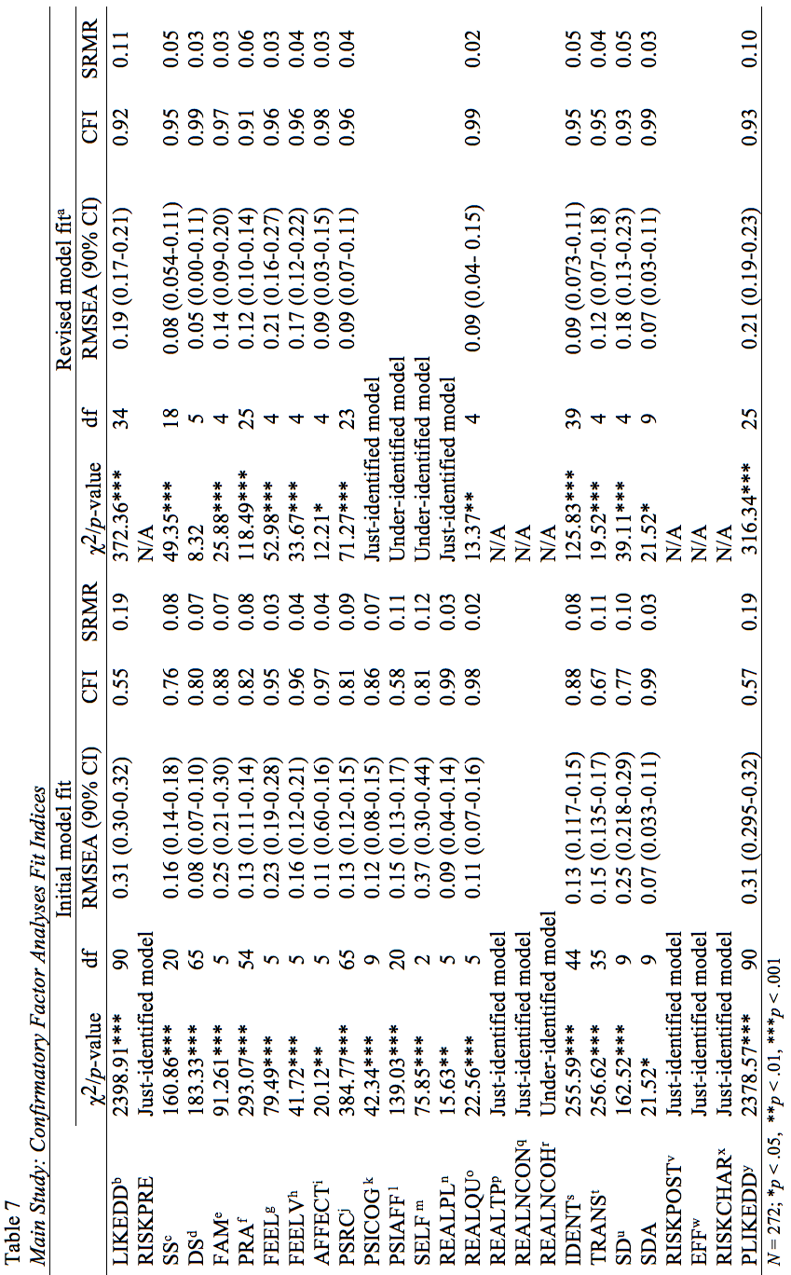
Table 7. Main Study: Confirmatory Factor Analyses Fit Indices

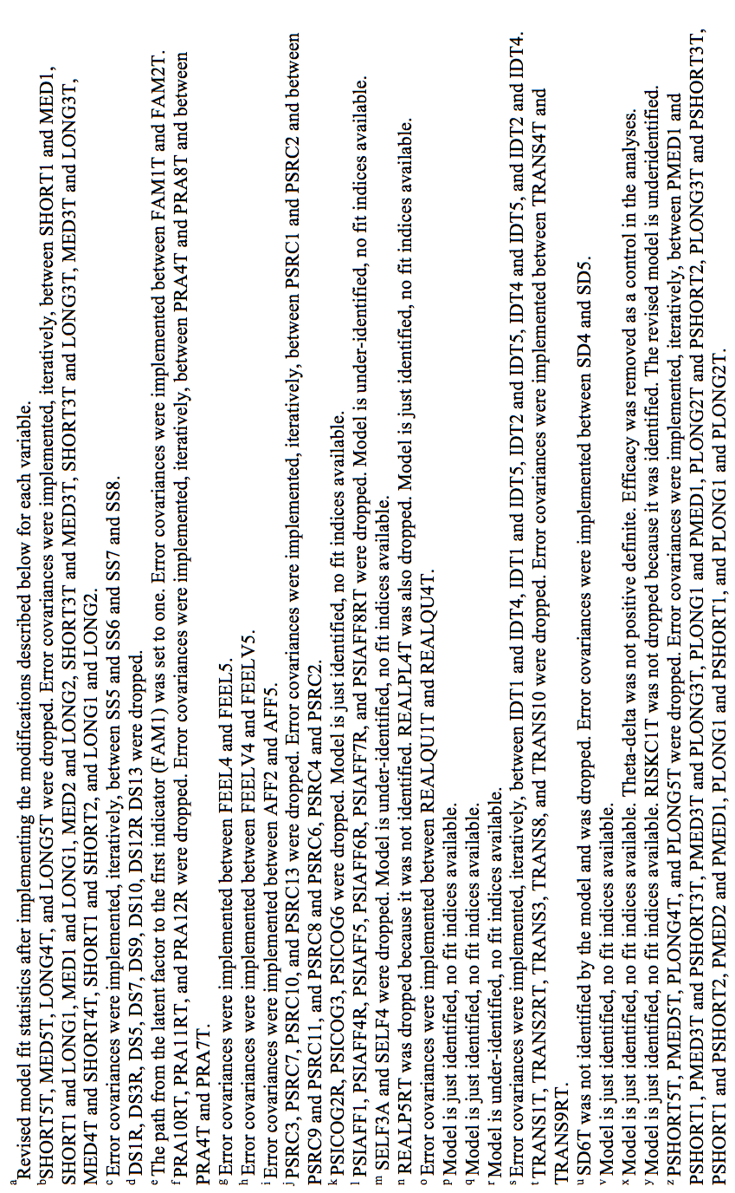

Descriptives and Reliabilities
Reliability coefficients, displayed in Table 8, were calculated based on untransformed data. Reliability was calculated using Cronbach’s alpha, the Spearman-Brown coefficient, and principal component reliability. Scale reliability was assessed using Cronbach’s alpha to evaluate internal consistency. Scales with a Cronbach’s alpha of 0.70 or greater are considered acceptable (Kline, 1999). Reliabilities for two-item scales were calculated using the Spearman-Brown coefficient because it is deemed more appropriate for a two-item measure (Eisinga, te Grotenhuis, & Pelzer, 2013). Because multiple scales had either a low Cronbach’s alpha or Spearman-Brown coefficient, principal component (PC) reliability was also used to assess reliability. The PC reliability technique can increase reliability by giving optimal weights to scale items (Hampson, Goldberg, & John, 1987). PC reliability was calculated using the formula: alpha = $\frac{N}{N-1}× \frac{E-1}{E}$, with N representing the number of items in the scale, and E representing the eigenvalue of the first PC. For more detail about the process, see (Hampson et al., 1987) and Serlin and Kaiser (1976).
Cronbach’s alpha was low for the initial values of cognitive PSI, affective PSI, realism (typicality), realism (narrative consistency), and realism (narrative coherence). After examining cognitive PSI’s CFA model, three items were dropped. However, alpha reliability did not improve. Six items were removed from the affective PSI scale, resulting in a 2-item scale with a Spearman-Brown correlation of .62. After running separate CFAs for typicality and narrative coherence, the researcher decided to keep all three items for each scale, therefore the reliability did not change. Additionally, because narrative coherence was a two-item scale, no items were dropped in the CFA. For the remaining scales with low reliability, the first principal component was used as the scale measure in the analyses. When a PC was used as a measure in analyses to substitute low reliability composite scales, the PC was used for all other multiple-item scale variables. This use of PC variables occurred when testing H4, H6, H7, and H8. All other hypotheses and research questions were tested using composite measures. Reliability scores and descriptive statistics are displayed in Table 8 and Table 9, respectively.
Risk discrepancy was calculated by subtracting perceived personal risk from perceived character risk. A lower risk discrepancy score indicates that personal risk is either close to or greater than character risk (i.e. indicating a high risk convergence). A higher risk discrepancy score indicates that there is a large gap between level of character risk and personal risk. For analyses requiring PC variables, risk discrepancy was calculated by subtracting item 2 of personal risk from item 2 of character risk, doing the same with the third items, and then taking the composite scores of the two newly created risk discrepancy items. The first items from the character and personal risk scales were not used because the character risk CFA recommended removing the first item from the measure. The PC component score for risk discrepancy was alpha = 0.88.

Table 8. Main Study: Reliability Scores of Initial Scales and of Revised Scales
 | Initial values |  |  |  | Post-CFA values
 | No. of items | Cronbach αª | PC Reliability^{b} |  | No. of items | Cronbach α/S-B coeff ^{c} | PC Reliability
Like. of DD (pre) | 15 | .93 | .94 |  | 11 | .94 | .95
Personal risk (pre) | 3 | .90 | .91 |  |  | N/A
Sensation seeking | 8 | .78 | .79 |  |  | N/A
Social desirability | 13 | .77 | .78 |  | 5 | .73 | .73
Actress familiarity | 5 | .84 | .87 |  |  | N/A
PSR actress | 12 | .87 | .90 |  | 9 | .87 | .88
Char. valence (para.) | 5 | .94 | .94 |  |  | N/A
Char. valence (video) | 5 | .89 | .90 |  |  | N/A
Affective disposition | 5 | .80 | .82 |  |  | N/A
PSR char. | 13 | .90 | .90 |  | 9 | .90 | .91
Cognitive PSI | 6 | .67 | .69 |  | 3 | .67 | .67
Affective PSI | 8 | .28 | .61 |  | 2 | .62^{c} | .62
Self-referencing | 4 | .78 | .78 |  | 2 | .85^{c} | .85
Realism: Plausibility | 5 | .82 | .86 |  | 3 | .90 | .91
Realism: Quality | 5 | .89 | .90 |  |  | N/A
Realism: Typicality | 3 | .66 | .67 |  |  | N/A
Realism: Narrative Consistency | 3 | .75 | .76 |  |  | N/A
Realism: Narrative Coherence | 2 | .34 | .56 |  | 2 | .51^{c} | .56
Identification | 11 | .91 | .92 |  |  | N/A
Transportation | 10 | .75 | .78 |  | 3 | .75 | .77
Social distance (So & Shen) | 6 | .81 | .82 |  | 5 | .79 | .81
Social distance (Bogardus) | 6 | .90 | .91 |  |  | N/A
Personal risk (post) | 3 | .93 | .91 |  |  | N/A
Char. risk | 3 | .91 | .91 |  | 2 | .81^{c} | .80
Like. of DD (post) | 15 | .93 | .94 |  | 11 | .95 | .96
Personal risk (delay) ^{d} | 3 | .87 | .88 |  |  | N/A
Note. All reliabilities were calculated using the untransformed indicators. N = 272; ª α is the scale reliability (Cronbach’s alpha). ^{b}PC is the scale reliability calculated using the eigenvalue of the first principal component. ^{c} For two item scales, Spearman-Brown coefficients. are reported. ^{d} No CFA run for this variable because delayed posttest N = 43.

Table 9. Main Study: Descriptive Statistics for Variables
Variables | M | SD | Range
Like. of DD (pre) | 2.68 | 1.52 | 1-7
Personal (self) risk (pre) | 20.44 | 26.66 | 1-100
Sensation seeking | 4.66 | 1.05 | 1-5
Social desirability | 3.69 | 1.12 | 1-5
Actress familiarity | 1.36 | .57 | 1-7
PSR actress | 2.43 | .96 | 1-7
Char. valence (para.) | 3.73 | 1.56 | 1-7
Char. valence (video) | 3.36 | 1.19 | 1-7
Affective disposition | 3.25 | 1.01 | 1-5
Deservedness | 2.87 | 1.65 | 1-7
PSR char. | 2.93 | 1.07 | 1-7
Identification | 2.56 | 1.02 | 1-7
Transportation | 5.12 | 1.03 | 1-7
Social distance (So & Shen) | 5.56 | 1.19 | 1-7
Social distance (Bogardus) | 5.27 | 1.21 | 1-7
Personal (self) risk (post) | 17.65 | 25.02 | 1-100
Char. risk | 79.42 | 20.98 | 1-100
Like. of DD (post) | 2.55 | 1.53 | 1-7
Personal risk (delay) ª | 19.61 | 23.14 | 1-100
Risk discrepancy | 61.77 | 33.12 | -100-100
Note. All descriptive statistics were calculated using the post-CFA, untranscformed indicators. N = 272; ª N = 43 for delayed posttest.

Manipulation Checks

Character Valence Manipulation
An independent samples t-test was conducted to compare character valence in the positive and negative paragraph conditions. The Levene’s test was not significant, F(1, 270) = 0.87, p = .35. There was a significant difference in valence between the positive condition (M = 5.06, SD = .82) and the negative condition (M = 2.42, SD = .85), t (270)= 26.06, p < .001 indicating that the paragraph’s valence manipulation worked.
A one-way analysis of covariance (ANCOVA) was performed to test the effect of the video conditions on character valence, controlling for paragraph conditions. The Levene’s test was not significant, F(2, 269) = 0.85, p = .43. The effect of video condition on character valence was significant, F(2, 268) = 36.57, p < .001, $η_{p}^{2}$ = .21. Also, paragraph condition was a significant covariate, F(1, 268) = 23.50, p < .001, $η_{p}^{2}$ = .08. Controlling for the manipulated valence paragraph condition, post hoc analyses using a Bonferroni correction revealed that participants in the apology condition had significantly more positive character valence (M = 4.04, SD = 0.10) than participants in the uncertain (M = 3.16, SD = 0.12, p < .001) or denial (M = 2.80, SD = 0.11, p < .001) conditions. However, the uncertain and denial conditions did not significantly differ from each other (p = .07).

Hypothesis Tests and Research Questions

Risk Convergence
H1a predicted that as social distance to an at-risk character decreased, the discrepancy between the perceptions of self-risk and character-risk decreased (i.e., self-risk and character-risk converge). A five stage hierarchical multiple regression was conducted with risk discrepancy as the dependent variable. As can be seen in Table 6, the first block included background variables: age, sex, sensation seeking, and social desirability. The second block included drinker status, likelihood of drinking and driving, and experiences with health topic consequences. The third block included the paragraph valence conditions and dummy coded variables for narrative type. Because this study measured social distance in two ways (i.e., using a modified version of Bogardus’ (1933) social distance scale and So and Shen’s (2015) social distance scale), both variables were included in the regression. The fourth block included Bogardus’ (1933) perceived social distance, whereas the final block included So and Shen’s (2015) perceived social distance. Overall, the model explained 25% of the variance of risk discrepancy (see Table 10). The adjusted R² was .21.
The Bogardus measure of social distance did not significantly impact the discrepancy between risk perceptions when entered into Block 4, F_{change} (1, 258) = 3.12, p = .08, $∆$R² = 0.01). However, So and Shen’s social distance measure accounted for 4% of the variance in risk discrepancy when entered into Block 5, F_{change} (1, 257) = 14.18, p = .08. So & Shen’s (2015) perceived social distance had a positive, significant relationship with the discrepancy between risk perceptions, B = 7.48, β = .27, p < .001. As social distance with an at-risk character decreased, the disparity between character- and personal-risk decreased as well (i.e. the risks converge). Thus, H1a was supported for the So & Shen measure of social distance, but not for the Bogardus measure. Likelihood of drinking and driving (B = -6.52, β = -.30, p < .001) and knowing someone who had been arrested for a drinking and driving violation (0 = no, 1 = yes; B = 9.56, β = .13, p < .05) were significant predictors of risk discrepancy.
Table 10. Hierarchical Regression of Social Distance on the Discrepancy between Risk Perceptions
 |  | B | SE B | β
Block 1
 | Constant | 62.50** | 20.18 | -
 | Sensation Seeking | -4.10* | 1.94 | -.13
 | Age | 0.002 | 0.60 | .0001
 | Sex (1 = male; 2 = female) | 6.30 | 4.27 | .09
 | Social Desirability | 2.15 | 1.80 | .07
Block 2
 | Constant | 59.30** | 18.73 | -
 | Sensation Seeking | -2.34 | 1.90 | -.07
 | Age | 1.18* | 0.59 | .12
 | Sex (1 = male; 2 = female) | 3.61 | 4.02 | .05
 | Social Desirability | 2.31 | 1.68 | .08
 | Likelihood of drinking & driving | -7.89*** | 1.40 | -.36
 | Have you ever been arrested for a drinking and driving violation? (DUI1) | -25.98 | 13.80 | -.11
 | Do you know anyone who has been arrested for a drinking and driving violation? (DUI2) | 9.84* | 4.73 | .13
 | Have you or a close friend or family member been in a car accident involving alcohol? (DUI3) | -8.51* | 3.87 | -.13
 | Drinks alcohol | -9.43 | 5.85 | -.10
Block 3
 | Constant | 58.85** | 18.98 | -
 | Sensation Seeking | -2.36 | 1.92 | -.07
 | Age | 1.17* | 0.59 | .12
 | Sex (1 = male; 2 = female) | 3.63 | 4.03 | .05
 | Social Desirability | 2.14 | 1.68 | .07
 | Likelihood of drinking & driving | -7.86*** | 1.41 | -.36
 | DUI1 | -24.76 | 13.91 | -.10
 | DUI2 | 8.99 | 4.80 | .12
 | DUI3 | -7.99* | 3.90 | -.12
 | Drinks alcohol | -9.12 | 5.89 | -.10
 | Paragraph condition | -2.98 | 3.76 | -.05
 | Uncertain dummy coded | 2.96 | 4.66 | .04
 | Denial dummy coded | 6.24 | 4.41 | .09
Block 4
 | Constant | 42.12* | 21.14 | -
 | Sensation Seeking | -2.05 | 1.92 | -.06
 | Age | 1.20* | 0.59 | .12
 | Sex (1 = male; 2 = female) | 2.77 | 4.04 | .04
 | Social Desirability | 2.16 | 1.68 | .07
 | Likelihood of drinking & driving | -7.90*** | 1.41 | -.36
 | DUI1 | -22.93 | 13.89 | -.09
 | DUI2 | 8.71 | 4.79 | .12
 | DUI3 | -7.49 | 3.89 | -.11
 | Drinks alcohol | -8.65 | 5.87 | -.09
 | Paragraph condition | -0.84 | 3.94 | -.01
 | Uncertain dummy coded | 1.87 | 4.68 | .03
 | Denial dummy coded | 4.75 | 4.47 | .07
 | Social distance (Bogardus) | 2.92 | 1.66 | .11
Block 5
 | Constant | 12.27 | 22.09
 | Sensation Seeking | -0.10 | 1.95 | -.003
 | Age | 0.81 | .58 | .08
 | Sex (1 = male; 2 = female) | 1.68 | 3.95 | .02
 | Social Desirability | 0.96 | 1.67 | .03
 | Likelihood of drinking & driving | -6.52*** | 1.42 | -.30
 | DUI1 | -17.51 | 13.62 | -.07
 | DUI2 | 9.56* | 4.67 | .13
 | DUI3 | -6.91 | 3.80 | -.10
 | Drinks alcohol | -5.43 | 5.79 | -.06
 | Paragraph condition | -1.00 | 3.84 | -.02
 | Uncertain dummy coded | 1.51 | 4.57 | .02
 | Denial dummy coded | 5.17 | 4.36 | .07
 | Social distance (Bogardus) | 0.29 | 1.76 | .01
 | Social distance (So & Shen) | 7.48*** | 1.99 | .27
Note. N = 272. R² = .04 for Block 1, $∆$R² = .16 for Block 2 (p < .001), $∆$R² = .01 for Block 3 (p = .01), $∆$R² = .01 for Block 4 (p = .08), $∆$R² = .04 for Block 5 (p < .001). * p < .05, ** p < .01, *** p < .001; for dichotomous questions: 0 = no, 1 = yes.

Using hierarchical linear regression and the same covariates (with the addition of perceived character-risk in Block 2) and blocks as in H1a, H1b was tested to determine if perceived self-risk negatively relates to social distance. Overall, the model explained 26.9% of the variance in perceived self-risk (see Table 11). The adjusted R² was .23.
Similar to H1a, the modified Bogardus (1933) scale of social distance did not significantly affect the discrepancy between risk perceptions when entered into block 4, F_{change} (1, 257) = 0.04, p = .84, $∆$R² = 0.0001. However, the So and Shen (2015) perceived social distance scale accounted for 6.4% of the variance in self risk when entered into Block 5, F_{change} (1, 256) = 22.47, p < .001. So & Shen’s (2015) perceived social distance was a negative, significant predictor of perceived self-risk, B = -7.05, β = -0.33, $∆$R² = 0.06, p < .001. As social distance with an at-risk character decreased, self-risk increased. Thus, H1b was supported for the So & Shen measure of social distance, but not for the Bogardus measure. So, like H1a, H1b was supported for the So & Shen measure of social distance, but not for the Bogardus measure. Likelihood of drinking and driving (B = 4.83, β = .29, p < .001) was also a significant predictor of self-risk.
Table 11. Hierarchical Regression of Social Distance on Perceived Self-Risk
 |  | B | SE B | β
Block 1
 | Constant | 13.26 | 15.13 | -
 | Sensation Seeking | 3.39* | 1.45 | .14
 | Age | 0.14 | 0.45 | .02
 | Sex (1 = male; 2 = female) | -1.29 | 3.20 | -.02
 | Social Desirability | -3.32* | 1.35 | -.15
Block 2
Block 2 | Constant | 15.12 | 15.02 | -
Block 2 | Sensation Seeking | 1.79 | 1.43 | .08
Block 2 | Age | -0.84 | 0.44 | -.12
Block 2 | Sex (1 = male; 2 = female) | 0.89 | 3.04 | .02
Block 2 | Social Desirability | -3.34** | 1.26 | -.15
Block 2 | Likelihood of drinking and driving | 6.17*** | 1.06 | .38
Block 2 | DUI1 | 22.94* | 10.37 | .12
Block 2 | DUI2 | -3.88 | 3.58 | -.07
Block 2 | DUI3 | 1.86 | 2.94 | .04
Block 2 | Drinks alcohol | 6.29 | 4.40 | .09
 | Character-risk perception | 0.03 | 0.07 | .03
Block 3
Block 3 | Constant | 14.57 | 15.24 | -
Block 3 | Sensation Seeking | 1.86 | 1.45 | .08
Block 3 | Age | -0.82 | 0.45 | -.11
Block 3 | Sex (1 = male; 2 = female) | 0.96 | 3.05 | .02
Block 3 | Social Desirability | -3.33** | 1.27 | -.15
Block 3 | Likelihood of drinking and driving | 6.11*** | 1.07 | .37
Block 3 | DUI1 | 21.89* | 10.49 | .12
Block 3 | DUI2 | -4.02 | 3.64 | -.07
Block 3 | DUI3 | 1.92 | 2.97 | .04
Block 3 | Drinks alcohol | 6.51 | 4.45 | .09
Block 3 | Character-risk perception | 0.03 | 0.07 | .03
Block 3 | Paragraph condition | -0.18 | 2.85 | .00
Block 3 | Uncertain dummy coded | 0.92 | 3.53 | .02
Block 3 | Denial dummy coded | -2.04 | 3.34 | -.04
Block 4
Block 4 | Constant | 15.90 | 16.58 | -
Block 4 | Sensation Seeking | 1.84 | 1.46 | .08
Block 4 | Age | -0.82 | 0.45 | -.11
Block 4 | Sex (1 = male; 2 = female) | 1.03 | 3.08 | .02
Block 4 | Social Desirability | -3.32* | 1.27 | -.15
Block 4 | Likelihood of drinking and driving | 6.12*** | 1.08 | .37
Block 4 | DUI1 | 21.73* | 10.54 | .12
Block 4 | DUI2 | -4.00 | 3.65 | -.07
Block 4 | DUI3 | 1.89 | 2.98 | .04
Block 4 | Drinks alcohol | 6.47 | 4.46 | .09
Block 4 | Character-risk perception | 0.03 | 0.07 | .03
Block 4 | Paragraph condition | -0.36 | 2.99 | -.01
Block 4 | Uncertain dummy coded | 1.01 | 3.56 | .02
Block 4 | Denial dummy coded | -1.92 | 3.40 | -.04
Block 4 | Social distance (Bogardus) | -0.26 | 1.27 | -.01
Block 5
 | Constant | 43.65* | 16.96 | -
 | Sensation Seeking | .003 | 1.45 | .0001
 | Age | -0.46 | 0.44 | -.06
 | Sex (1 = male; 2 = female) | 2.03 | 2.96 | .04
 | Social Desirability | -2.19 | 1.25 | -.10
 | Likelihood of drinking and driving | 4.83*** | 1.07 | .29
 | DUI1 | 16.64 | 10.18 | .09
 | DUI2 | -4.84 | 3.51 | -.09
 | DUI3 | 1.38 | 2.87 | .03
 | Drinks alcohol | 3.45 | 4.33 | .05
 | Character-risk perception | 0.04 | 0.07 | .03
 | Paragraph condition | -0.20 | 2.87 | .00
 | Uncertain dummy coded | 1.33 | 3.42 | .02
 | Denial dummy coded | -2.33 | 3.26 | -.04
 | Social distance (Bogardus) | 2.21 | 1.33 | .11
 | Social distance (So & Shen) | -7.05*** | 1.48 | -.33
Note. N = 272. R² = .05 for Block 1, $∆$R² = .15 for Block 2 (p < .001), $∆$R² = .002 for Block 3 (p = .86), $∆$R² = .0001 for Block 4 (p = .84), $∆$R² = .06 for Block 5 (p < .001). * p < .05, ** p < .01, *** p < .001; for dichotomous questions: 0 = no, 1 = yes.

Narrative Engagement and the RCM
Hypotheses two through six and hypothesis nine focused on the role of perceived social distance in the relationship between different engagement variables and the discrepancy between perceptions of self-risk and character-risk (i.e. risk convergence). H1a and H1b which examined the risk convergence process, were supported only in the case of the So and Shen (2015) measure. Although the narrative engagement hypotheses were tested with each measure of social distance as the mediator, these hypotheses were not supported when using the Bogardus (1933) social distance scale. Therefore, the focus of the results centered on the So & Shen (2015) measure of social distance.
Age, sex, sensation seeking, social desirability, likelihood of drinking and driving, experiences with health topic consequences, and paragraph valence and narrative ending conditions were included as covariates. Social distance (So & Shen, 2015) was included as a covariate when the modified Bogardus (1933) version of social distance served as a mediator, and vice versa. Hayes’ (2013) PROCESS macro was used to test the predicted mediations analyses, using a simple mediation based on 5000 bootstrapped samples and bias-corrected and accelerated 95% confidence intervals (BCIa). Effects are significant when the upper and lower bound of the BCIa do not include zero.
The bootstrapping method provides researchers with a more powerful test of indirect effects than the more conservative causal steps approach popularized by Baron and Kenny (1986). The causal steps process requires four steps to test for mediation: (1) total effect must be significant (i.e., the independent variable must predict the dependent variable; path c), (2) the independent variable must significantly predict the mediator (path a), (3) the mediator must significantly predict the dependent variable (path b), and (4) the direct effect must be significant (i.e. the independent variable must predict the dependent variable after controlling for the mediator; path c’). With Baron and Kenny (1986), a researcher has to conduct three null hypothesis tests prior to testing for mediation, whereas PROCESS’s use of bootstrapping allows for a single test of indirect effect (Hayes, 2013). Additionally, the causal steps approach does not formally test for an indirect effect (the product of a and b) of the mediation, but uses the four tests as antecedents to the indirect effect (Hayes, 2013).
A final criticism of the Baron and Kenny (1986) method is that they state a non-significant total effect cannot be mediated. However, Zhao, Lynch, and Chen (2010) explain that a total effect is not always a good estimator of an independent variable’s effect on a dependent variable and should not be a prerequisite for testing a mediation. Relying on the causal steps approach, and after finding a non-significant total effect, could lead a researcher to underanalyze his or her data, resulting in Type II error (Hayes, 2013). Because of these critiques of the causal steps approach, the bootstrapping method of PROCESS was used to test mediations in this dissertation.
H2 was assessed using PROCESS. H2 predicted that perceived social distance toward an at-risk character mediated the relationship between identification with the character and the self- and character-risk discrepancy. Perceived social distance (indirect effect = -3.44, SE = 1.51) mediated the relationship between identification and risk discrepancy, controlling for covariates. The generated bootstrap confidence interval (BCa CI [-6.80, -0.85]) excludes zero and the Sobel test confirmed a significant indirect effect for identification (indirect effect = -3.44, SE = 1.31, Z = -2.10, p < .05). As can be seen in Figure 1 and Table 12, there were significant direct relationships between identification and perceived social distance and perceived social distance and risk discrepancy. The more identification one felt with the character, the less perceived social distance between self and character, and the less risk discrepancy between self and character. The direct effect was not significant (B = -3.26, t (257) = -1.31, p = .18) but the total effect of identification on risk discrepancy was significant (B = -6.69, t (258) = -3.08, p < .01). Therefore, perceived social distance mediated the relationship between identification and risk discrepancy; H2 was supported.
Identification
Perceived social distance (So & Shen, 2015)
Risk discrepancy
-0.55***
-6.69** (-3.25)
6.25**
Figure 1. Mediation of perceived social distance on the relationship between identification and risk discrepancy. The direct effect (i.e., unstandardized regression coefficient between identification and risk discrepancy, controlling for perceived social distance) is in parentheses. ** p < .01, *** p < .001.

Table 12. Model Coefficients for Mediation of Perceived Social Distance on the Relationship between Identification and Risk Discrepancy
 |  | Consequent
 |  | M (Social distance) |  |  |  | Y (Risk discrepancy)
Antecedent |  | B | SE | BCa CI |  | B | SE | BCa CI
X (Identification) | a | -0.55*** | 0.06 | -0.67, -0.43 | c' | -3.25 | 2.48 | -8.14, 1.63
M (Social distance) |  | — | — | — | b | 6.25* | 2.27 | 1.79, 10.72
Constant | i₁ | 6.80*** | 0.64 | 5.54, 8.07 | i₂ | 33.49 | 28.01 | -21.67, 88.66
 |  | R² = .56 |  |  |  | R² = .25
 |  | F(13, 258) = 25.06,  p < .001 |  |  |  | F(14, 257) = 6.19,  p < .001
N = 272. * p < .05, ** p < .01, *** p < .001.

H3 predicted that perceived social distance toward an at-risk character mediated the relationship between transportation with the character and the self- and character-risk discrepancy. A test of H3 found that perceived social distance (indirect effect = -1.88, SE = 0.62) mediated the relationship between transportation and risk discrepancy, controlling for covariates. The BCa CI [-3.48, -0.90] excludes zero, and the Sobel test confirmed a significant indirect effect for transportation (indirect effect = -1.88, SE = .67, Z = -2.78, p < .01). Table 13 displays the significant direct relationships between transportation and perceived social distance, and perceived social distance and risk discrepancy. As depicted in Figure 2, the more transportation experienced, the less perceived social distance between self and character, and the less risk discrepancy between self and character. Neither the direct effect (B = 3.20, t (257) = 1.66, p = .10) nor the total effect of transportation on risk discrepancy were significant (B = 1.32, t (258) = 0.68, p = .50). H3 is supported; this is an indirect-only mediation.
Transportation
Perceived social distance (So & Shen, 2015)
Risk discrepancy
-0.22***
1.32 (3.20)
8.51***
Figure 2. Mediation of perceived social distance on the relationship between transportation and risk discrepancy. The direct effect (i.e., unstandardized regression coefficient between transportation and risk discrepancy, controlling for perceived social distance) is in parentheses. *** p < .001.

Table 13. Model Coefficients for Mediation of Perceived Social Distance on the Relationship between Transportation and Risk Discrepancy
 |  | Consequent
 |  | M (Social distance) |  |  |  | Y (Risk discrepancy)
Antecedent |  | B | SE | BCa CI |  | B | SE | BCa CI
X (Transportation) | a | -0.22*** | 0.06 | -0.34, -0.11 | c' | 3.20 | 1.93 | -0.61, 7.01
M (Social distance) |  | — | — | — | b | 8.51*** | 2.01 | 4.56, 12.47
Constant | i₁ | 4.84*** | 0.68 | 3.51, 6.18 | i₂ | -5.14 | 23.96 | -52.31, 42.04
 |  | R² = .44 |  |  |  | R² = .26
 |  | F(13, 258) = 15.57,  p < .001 |  |  |  | F(14, 257) = 6.29,  p < .001
N = 272. *** p < .001.

H4 predicted that perceived social distance toward an at-risk character mediated the relationship between perceived realism and risk discrepancy. After performing a CFA on the realism measure, its dimensions were used as five separate scales to test H4. The other dimensions are included as covariates in each analysis.
Plausibility. Perceived social distance (indirect effect = 0.01, SE = 0.02) did not mediate the relationship between perceived plausibility and risk discrepancy, controlling for covariates. The BCa CI [-0.03, 0.05] includes zero, and the Sobel test was not significant for perceived plausibility (indirect effect = 0.01, SE = 0.02, Z = 0.51, p = .61). As can be seen in Figure 3, there was not a significant direct relationship between perceived plausibility and perceived social distance; however the relationship between perceived social distance and risk discrepancy was significant. Table 14 shows that neither the direct effect of the mediation [B = 0.12, t (253) = 1.73, p = .08], nor the total effect of perceived plausibility on risk discrepancy were significant [B = 0.13, t (254) = 1.81, p = .07]. These results indicate that perceived social distance does not mediate the relationship between perceived plausibility and risk discrepancy. So, H4 was not supported for plausibility.
Perceived realism
(plausibility)
Perceived social distance (So & Shen, 2015)
Risk discrepancy
0.03
0.13 (0.12)
0.28***
Figure 3. Mediation of perceived social distance on the relationship between perceived realism (plausibility) and risk discrepancy. The direct effect (i.e., unstandardized regression coefficient between perceived realism and risk discrepancy, controlling for perceived social distance) is in parentheses. *** p < .001.

Table 14. Model Coefficients for Mediation of Perceived Social Distance on the Relationship between Perceived Plausibility and Risk Discrepancy
 |  | Consequent
 |  | M (Social distance) |  |  |  | Y (Risk discrepancy)
Antecedent |  | B | SE | BCa CI |  | B | SE | BCa CI
X (Perceived realism: plausibility) | a | 0.03 | .06 | -0.09, 0.16 | c' | .12 | 0.70 | -0.02, 0.26
M (Social distance) |  | — | — | — | b | .28*** | 0.07 | 0.14, 0.42
Constant | i₁ | -0.97* | .41 | -1.78, -0.16 | i₂ | -0.48 | 0.47 | -1.40, 0.44
 |  | R² = .41 |  |  |  | R² = .27
 |  | F(17, 254) = 10.60,  p < .001 |  |  |  | F(18, 253) = 5.28,  p < .001
N = 272. * p < .05, *** p < .001.

Perceptual quality. Perceived social distance (indirect effect = -0.03, SE = .0.02) did not mediate the relationship between perceptual quality and risk discrepancy, when controlling for covariates. The BCa CI [-0.08, 0.001] includes zero, and the Sobel test of the indirect effect was not significant (indirect effect = -0.03, SE = 0.22, Z = -1.42, p = .16). As can be seen in Figure 4 and Table 15, the direct relationship between perceptual quality and perceived social distance was not significant. However the relationship between perceived social distance and risk discrepancy was significant. The direct effect (B = -0.05, t (253) = 0.56, p = .57) and total effect (B = 0.01, t (254) = 0.17, p = .87) were not significant. H4 was not supported for perceptual quality; perceived social distance did not mediate the relationship between perceptual quality and risk discrepancy.
Perceived realism
(perceptual quality)
Perceived social distance (So & Shen, 2015)
Risk discrepancy
-0.11
0.01 (0.05)
0.28***
Figure 4. Mediation of perceived social distance on the relationship between perceived realism (perceptual quality) and risk discrepancy. The direct effect (i.e., unstandardized regression coefficient between perceived realism and risk discrepancy, controlling for perceived social distance) is in parentheses. *** p < .001.

Table 15. Model Coefficients for Mediation of Perceived Social Distance on the Relationship between Perceived Realism (Perceptual Quality) and Risk Discrepancy
 |  | Consequent
 |  | M (Social distance) |  |  |  | Y (Risk discrepancy)
Antecedent |  | B | SE | BCa CI |  | B | SE | BCa CI
X (Perceived realism: quality) | a | -0.11 | 0.07 | -0.26, 0.03 | c' | 0.05 | 0.08 | -0.11, 0.21
M (Social distance) |  | — | — | — | b | 0.28*** | 0.70 | 0.14, 0.42
Constant | i₁ | -0.97* | 0.41 | -1.78, -0.16 | i₂ | -0.48 | 0.47 | -1.40, 0.44
 |  | R² = .42 |  |  |  | R² = .27
 |  | F(17, 254) = 10.60,  p < .001 |  |  |  | F(18, 253) = 5.28,  p < .001
N = 272. * p < .05, , *** p < .001.
Typicality. Perceived social distance (indirect effect = -0.02, SE = 0.02) did not mediate the relationship between perceived typicality and risk discrepancy, controlling for covariates. The BCa CI [-0.06, 0.003] includes zero, and the Sobel test of the indirect effect was not significant (indirect effect = -0.02, SE = 0.17, Z = -1.39, p = .16). As illustrated in Figure 5, there was not a significant relationship between perceived typicality and perceived social distance; however, there was a significant, positive relationship between perceived social distance and risk discrepancy. As perceived social distance between self and character increased, so did the risk discrepancy between self and character. Table 16 shows that the direct effect of the mediation was not significant [B = 0.10, t (253) = 1.57, p = .10]. Similarly, the total effect of perceived typicality on risk discrepancy was not significant [B = 0.07, t (254) = 1.16, p = .25]. So, H4 was not supported for typicality.
Perceived realism
(typicality)
Perceived social distance (So & Shen, 2015)
Risk discrepancy
-0.09
0.07 (0.10)
0.28***
Figure 5. Mediation of perceived social distance on the relationship between perceived realism (typicality) and risk discrepancy. The direct effect (i.e., unstandardized regression coefficient between perceived realism and risk discrepancy, controlling for perceived social distance) is in parentheses. *** p < .001.

Table 16. Model Coefficients for Mediation of Perceived Social Distance on the Relationship between Perceived Typicality and Risk Discrepancy
 |  | Consequent
 |  | M (Social distance) |  |  |  | Y (Risk discrepancy)
Antecedent |  | B | SE | BCa CI |  | B | SE | BCa CI
X (Perceived realism: typicality) | a | -0.09 | .06 | -0.20, 0.02 | c' | 0.10 | 0.06 | -0.03, 0.22
M (Social distance) |  | — | — | — | b | 0.28*** | 0.07 | 0.14, 0.42
Constant | i₁ | -0.97* | 0.41 | -1.78, -0.16 | i₂ | -0.48 | 0.47 | -1.40, 0.44
 |  | R² = .42 |  |  |  | R² = .27
 |  | F(17, 254) = 10.60,  p < .001 |  |  |  | F(18, 253) = 5.28,  p < .001
N = 272. * p < .05, *** p < .001.
Narrative consistency. Perceived social distance (indirect effect = -0.01, SE = 0.02) did not significantly mediate the relationship between perceived narrative consistency and risk discrepancy, controlling for covariates. The BCa CI [-0.06, 0.03] includes zero, and the Sobel test of the indirect effect was not significant (indirect effect = -0.01, SE = 0.23, Z = -0.31, p = .76). As can be seen in Figure 6, there was not a significant direct relationship between perceived narrative consistency and perceived social distance. However, the relationship between perceived social distance and risk discrepancy was significant. Table 17 shows that the direct effect [B = -0.06, t (253) = -0.66, p = .51] and total effect [B = -0.06, t (254) = -0.72, p = .47] were not significant. H4 was not supported for narrative consistency.
Perceived realism
(narrative consistency)
Perceived social distance (So & Shen, 2015)
Risk discrepancy
-0.02
-0.06 (-0.06)
0.28***
Figure 6. Mediation of perceived social distance on the relationship between perceived realism (narrative consistency) and risk discrepancy. The direct effect (i.e., unstandardized regression coefficient between perceived realism and risk discrepancy, controlling for perceived social distance) is in parentheses. *** p < .001.

Table 17. Model Coefficients for Mediation of Perceived Social Distance on the Relationship between Perceived Narrative Consistency and Risk Discrepancy
 |  | Consequent
 |  | M (Social distance) |  |  |  | Y (Risk discrepancy)
Antecedent |  | B | SE | BCa CI |  | B | SE | BCa CI
X (Perceived realism: narrative consistency) | a | -0.02 | 0.08 | -0.18, 0.13 | c' | -0.06 | 0.09 | -0.23, 0.11
M (Social distance) |  | — | — | — | b | 0.28*** | 0.07 | 0.14, 0.42
Constant | i₁ | -0.97* | 0.41 | -1.78, -0.16 | i₂ | -0.48 | 0.47 | -1.40, 0.44
 |  | R² = .42 |  |  |  | R² = .27
 |  | F(17, 254) = 10.60,  p < .001 |  |  |  | F(18, 253) = 5.28,  p < .001
N = 272. * p < .05, *** p < .001.
Narrative coherence. Perceived social distance (indirect effect = -0.03, SE = 0.02) did not significantly mediate the relationship between perceived narrative consistency and risk discrepancy, controlling for covariates. The BCa CI [-0.09, 0.003] includes zero and the Sobel test was not significant (indirect effect = -0.03, SE = 0.02, Z = -1.35, p = .18). As can be seen in Figure 7, there was not a significant direct relationship between perceived narrative coherence and perceived social distance. However, the relationship between perceived social distance and risk discrepancy was significant. Table 18 shows that the direct effect of the mediation was not significant [B = -0.02, t (253) = -1.03, p = .30]. Additionally, the total effect of perceived narrative coherence on risk discrepancy was not significant [B = -0.05, t (254) = -0.62, p = .54]. H4 was not supported for narrative coherence.
Perceived realism
(narrative coherence)
Perceived social distance (So & Shen, 2015)
Risk discrepancy
-0.10
-0.05 (-0.02)
0.28***
Figure 7. Mediation of perceived social distance on the relationship between perceived realism (narrative coherence) and risk discrepancy. The direct effect (i.e., unstandardized regression coefficient between perceived realism and risk discrepancy, controlling for perceived social distance) is in parentheses. *** p < .001.

Table 18. Model Coefficients for Mediation of Perceived Social Distance on the Relationship between Perceived Narrative Coherence and Risk Discrepancy
 |  | Consequent
 |  | M (Social distance) |  |  |  | Y (Risk discrepancy)
Antecedent |  | B | SE | BCa CI |  | B | SE | BCa CI
X (Perceived realism: narrative coherence) | a | -0.10 | 0.07 | -0.24, 0.03 | c' | -0.02 | 0.08 | -0.17, 0.13
M (Social distance) |  | — | — | — | b | 0.28*** | 0.07 | 0.14, 0.42
Constant | i₁ | -.97* | 0.41 | -1.78, -0.16 | i₂ | -0.48 | 0.47 | -1.40, 0.44
 |  | R² = .42 |  |  |  | R² = .27
 |  | F(17, 254) = 10.60,  p < .001 |  |  |  | F(18, 253) = 5.28,  p < .001
N = 272. * p < .05, *** p < .001.
H5 predicted that perceived social distance toward an at-risk character mediated the relationship between self-referencing with the character and the self- and character-risk discrepancy. Perceived social distance (indirect effect = -1.72, SE = 0.73) mediated the relationship between self-referencing and risk discrepancy, controlling for covariates. The BCa CI [-3.38, -0.45] excluded zero, and the Sobel test confirmed a significant indirect effect for self-referencing (indirect effect = -1.72, SE = 0.65, Z = -2.66, p < .01). As shown in Figure 8, the more self-referencing experienced, the less perceived social distance between self and character, and the less risk discrepancy between self and character. Table 19 shows that the direct effect was not significant [B = -2.45, t (257) = -1.72, p = .07]. However, the total effect of self-referencing on risk discrepancy was significant [B = -4.17, t (258) = -3.18, p < .01]. Therefore, H5 is supported; perceived social distance mediates the relationship between self-referencing and risk discrepancy.
Self-referencing
Perceived social distance (So & Shen, 2015)
Risk discrepancy
-0.28***
-4.17** (-2.45)
6.19**
Figure 8. Mediation of perceived social distance on the relationship between self-referencing and risk discrepancy. The direct effect (i.e., unstandardized regression coefficient between self-referencing and risk discrepancy, controlling for perceived social distance) is in parentheses. p < .01, *** p < .001.

Table 19. Model Coefficients for Mediation of Perceived Social Distance on the Relationship between Self-Referencing and Risk Discrepancy
 |  | Consequent
 |  | M (Social distance) |  |  |  | Y (Risk discrepancy)
Antecedent |  | B | SE | BCa CI |  | B | SE | BCa CI
X (Self-referencing) | a | -0.28*** | 0.04 | -0.35, -0.20 | c' | -2.45 | 1.42 | -5.26, 0.35
M (Social distance) |  | — | — | — | b | 6.19*** | 2.15 | 1.95, 10.44
Constant | i₁ | 4.29*** | 0.60 | 3.12, 5.46 | i₂ | 19.83 | 22.57 | -24.62, 64.27
 |  | R² = .51 |  |  |  | R² = .26
 |  | F(13, 258) = 20.87,  p < .001 |  |  |  | F(14, 257) = 6.31,  p < .001
N = 272. *** p < .001.

H6 predicted perceived social distance toward an at-risk character mediated the relationship between PSI and risk discrepancy, controlling for character valence in addition to the covariates used in the other mediation analyses. As explained in the method section, the study measured PSI in terms of cognitive PSI and affective PSI. Thus, for H6 separate mediation models for each dimension of PSI were conducted, while controlling for the other dimension. Additionally, the composite scales of PSI indicated low reliability. Therefore, principal component measures were created for the PSI measures. In the two mediations involving PSI, the first PC score was used for all scale measures.
Cognitive PSI. Perceived social distance (indirect effect = -0.02, SE = 0.01) did not mediate the relationship between cognitive PSI and risk discrepancy, controlling for covariates. The BCa CI [-0.05, 0.004] includes zero, and the Sobel test was not significant (indirect effect = -0.02, SE = 0.01, Z = -1.19, p = .24). As can be seen in Figure 9, there was not a significant direct relationship between cognitive PSI and perceived social distance; however, the relationship between perceived social distance and risk discrepancy was significant. Table 20 shows that the direct effect of the mediation was not significant (B = 0.09, t (255) = 1.61, p = .11), nor was the total effect of cognitive PSI on risk discrepancy (B = 0.08, t (256) = 1.29, p = .20), indicating that perceived social distance did not mediate the relationship between cognitive PSI and risk discrepancy. Thus, H6 was not supported in the case of cognitive PSI.
Cognitive PSI
Perceived social distance (So & Shen, 2015)
Risk discrepancy
-0.07
0.08 (0.09)
0.26***
Figure 9. Mediation of perceived social distance on the relationship between cognitive PSI and risk discrepancy. The direct effect (i.e., unstandardized regression coefficient between PSI and risk discrepancy, controlling for perceived social distance) is in parentheses. *** p < .001.

Table 20. Model Coefficients for Mediation of Perceived Social Distance on the Relationship between Cognitive PSI and Risk Discrepancy
 |  | Consequent
 |  | M (Social distance) |  |  |  | Y (Risk discrepancy)
Antecedent |  | B | SE | BCa CI |  | B | SE | BCa CI
X (Cognitive PSI) | a | -0.07 | 0.05 | -0.17, 0.03 | c' | 0.09 | 0.06 | -0.02, 0.21
M (Social distance) |  | — | — | — | b | 0.26*** | 0.07 | 0.12, 0.40
Constant | i₁ | -0.81* | 0.40 | -1.59, -0.02 | i₂ | -0.64 | 0.46 | -1.54, 0.26
 |  | R² = .42 |  |  |  | R² = .25
 |  | F(15, 256) = 12.46,  p < .001 |  |  |  | F(16, 255) = 5.33,  p < .001
N = 272. * p < .05, *** p < .001.

Affective PSI. Perceived social distance (indirect effect = -0.011, SE = 0.02) did not mediate the relationship between affective PSI and risk discrepancy, controlling for covariates. The generated bootstrap confidence [-0.04, 0.02] interval included zero and the Sobel test was not significant (indirect effect = -0.01, SE = 0.02, Z = -0.51, p = .61). As can be seen in Figure 10, there was not a significant direct relationship between affective PSI and perceived social distance; however, the relationship between perceived social distance and risk discrepancy was significant. Table 21 shows that the direct effect of the mediation was not significant [B =-0.08, t (255) = -1.13, p = .26], nor was the total effect of affective PSI on risk discrepancy [B = -0.08, t (256) = -1.22, p = .22], indicating that perceived social distance did not mediate the relationship between affective PSI and risk discrepancy. Thus, H6 was not supported for either cognitive or affective PSI.
Affective PSI
Perceived social distance (So & Shen, 2015)
Risk discrepancy
-0.03
-0.08 (-0.08)
0.26**
Figure 10. Mediation of perceived social distance on the relationship between affective PSI and risk discrepancy. The direct effect (i.e., unstandardized regression coefficient between PSI and risk discrepancy, controlling for perceived social distance) is in parentheses. ** p < .01.

Table 21. Model Coefficients for Mediation of Perceived Social Distance on the Relationship between Affective PSI and Risk Discrepancy
 |  | Consequent
 |  | M (Social distance) |  |  |  | Y (Risk discrepancy)
Antecedent |  | B | SE | BCa CI |  | B | SE | BCa CI
X (Affective PSI) | a | -0.03 | 0.06 | -0.15, 0.08 | c' | -0.08 | 0.07 | -0.21, 0.06
M (Social distance) |  | — | — | — | b | 0.26*** | 0.07 | 0.12, 0.40
Constant | i₁ | -0.81* | 0.40 | -1.59, -0.02 | i₂ | -0.64 | 0.46 | -1.54, 0.26
 |  | R² = .42 |  |  |  | R² = .25
 |  | F(15, 256) = 12.46,  p < .001 |  |  |  | F(16, 255) = 5.33,  p < .001
N = 272. * p < .05, *** p < .001.

Similar to H6, H9 predicted that perceived social distance toward an at-risk character mediated the relationship between PSR with the at-risk character and risk discrepancy, controlling for valence, in addition to the covariates used in the other mediation analyses. Perceived social distance (indirect effect = -1.37, SE = 0.78) mediated the relationship between PSR and risk discrepancy. The BCa CI [-3.48, -0.28] excluded zero, and the Sobel test of the indirect effect was significant (indirect effect = -1.37 SE = 0.68, Z = -2.03, p < .05). As can be seen in Figure 11 and Table 22, there were significant direct relationships between PSR with character and perceived social distance and perceived social distance and risk discrepancy. The more PSR experienced, the less perceived social distance between self and character, and the less risk discrepancy between self and character. The direct effect [B = 0.48, t (256) = 0.20, p = .84] and total effect [B = -0.90, t (257) = -0.37, p = .71] were not significant, meaning this is an indirect-only mediation.
PSR character
Perceived social distance (So & Shen, 2015)
Risk discrepancy
-0.18*
-0.90 (0.48)
7.59***
Figure 11. Mediation of perceived social distance on the relationship between PSR character and risk discrepancy. The direct effect (i.e., unstandardized regression coefficient between PSR and risk discrepancy, controlling for perceived social distance) is in parentheses. * p < .05, *** p < .001.

Table 22. Model Coefficients for Mediation of Perceived Social Distance on the Relationship between PSR Character and Risk Discrepancy
 |  | Consequent
 |  | M (Social distance) |  |  |  | Y (Risk discrepancy)
Antecedent |  | B | SE | BCa CI |  | B | SE | BCa CI
X (PSR character) | a | -0.18* | 0.07 | -0.32, -0.04 | c' | 0.48 | 2.37 | -4.19, 5.15
M (Social distance) |  | — | — | — | b | 7.59*** | 2.03 | 3.60, 11.59
Constant | i₁ | 5.66*** | .77 | 4.14, 7.18 | i₂ | 16.57 | 27.57 | -37.76, 70.89
 |  | R² = .44 |  |  |  | R² = .25
 |  | F(14, 257) = 14.51,  p < .001 |  |  |  | F(15, 256) = 5.64,  p < .001
N = 272. * p < .05, *** p < .001.

In addition to introducing PSR with an at-risk character into the RCM, this study examined how PSR and PSI with an at-risk character influenced each other. Hypothesis 8 predicted that participants’ existing PSR with an at-risk character positively related to strength of PSI with the at-risk character. Originally, the researcher intended to filter out participants who had not seen the stimuli show prior to the experiment. This filtering process was planned to ensure that only PSRs developed prior to the study were tested. However, only 66 participants had seen at least one episode of Parenthood, which did not allow for enough statistical power to test the hypothesis. Therefore, the relationship between character PSR and character PSI (cognitive and affective), controlling for episode viewing, was tested with the entire sample, using hierarchical regressions.
The first block included episodes viewed, exposure to Parenthood storyline used in video conditions, and familiarity with the character. The second block included PSR with actress, and the PSI variable not positioned as the dependent variable. The third block included paragraph valence condition and video conditions. PSR with the character was entered into the fourth block.
The overall model explained 9.8% of the variance for cognitive PSI (see Table 23). The adjusted R² was .07. However, PSR with the character did not significantly impact cognitive PSI when entered into Block 4, F_{change} (1, 262) = 0.97, p = .33, $∆$R² = 0.003. Thus, H8 was not supported; PSR with the character did not significantly affect cognitive PSI with the character.
Table 23. Hierarchical Regression of PSR Character on Cognitive PSI
 |  | B | SE B | β
Block 1
 | Constant | -0.01 | 0.64 | -
 | Episodes viewed | 0.01 | 0.07 | .01
 | Viewed stimuli episode | 0.07 | 0.28 | .02
 | Familiarity with character | -0.10 | 0.15 | -.10
Block 2
Block 2 | Constant | 0.19 | 0.62 | -
Block 2 | Episodes viewed | 0.003 | 0.07 | .01
Block 2 | Viewed stimuli episode | 0.02 | 0.27 | .01
Block 2 | Familiarity with character | -0.16 | 0.14 | -.16
Block 2 | PSR with actress | 0.02 | 0.06 | .02
 | Affective PSI | 0.25*** | 0.06 | .23
Block 3
Block 3 | Constant | 0.02 | 0.62 | -
Block 3 | Episodes viewed | -0.01 | 0.07 | -.01
Block 3 | Viewed stimuli episode | 0.06 | 0.28 | .02
Block 3 | Familiarity with character | -0.14 | 0.14 | -.14
Block 3 | PSR with actress | 0.01 | 0.06 | .01
Block 3 | Affective PSI | 0.27*** | 0.06 | .27
Block 3 | Paragraph condition | -0.13 | 0.12 | -.07
Block 3 | Uncertain dummy coded | 0.08 | 0.15 | .04
Block 3 | Denial dummy coded | 0.33* | 0.14 | .16
Block 4
Block 4 | Constant | 0.05 | 0.62 | -
Block 4 | Episodes viewed | 0.002 | 0.07 | .004
Block 4 | Viewed stimuli episode | 0.05 | 0.28 | .02
Block 4 | Familiarity with character | -0.15 | 0.14 | -.15
Block 4 | PSR with actress | 0.02 | 0.06 | .02
Block 4 | Affective PSI | 0.30*** | 0.07 | .30
Block 4 | Paragraph condition | -0.11 | 0.12 | -.06
Block 4 | Uncertain dummy coded | 0.07 | 0.15 | .03
Block 4 | Denial dummy coded | 0.31* | 0.14 | .15
Block 4 | PSR character | -0.07 | 0.07 | -.07
Note. N = 272. R² = .01 for Block 1 (p = .36), $∆$R² = .06 for Block 2 (p < .001), $∆$R² = .02 for Block 3 (p = .09), $∆$R² = .003 for Block 4 (p = .33). * p < .05, *** p < .001; for dummy coded variables: 0 = absent, 1 = present.

Using a hierarchical linear regression and the same covariates (with cognitive PSI taking the place of affective PSI in block two), H8 was tested to see if PSR with the character was significantly associated with affective PSI. Overall, the model explained 32% of the variance in affective PSR (see Table 24). The adjusted R² was .30.
PSR with the character accounted for 17.1% of the variance in affective PSI when entered into Block 4, F_{change} (1, 262) = 65.71, p < .001). PSR with the character had a positive, significant relationship with affective PSI, B = 0.45, β = .45, p < .001. Thus, H8 was supported for affective PSI but not cognitive PSI. Cognitive PSI was a positive predictor of affective PSI (B = 0.23, β = .23, p < .001).
Table 24. Hierarchical Regression of PSR Character on Affective PSI
 |  | B | SE B | β
Block 1
 | Constant | -0.78 | 0.63 | -
 | Episodes viewed | 0.01 | 0.07 | .03
 | Viewed stimuli episode | 0.22 | 0.28 | .07
 | Familiarity with character | 0.23 | 0.14 | .23
Block 2
Block 2 | Constant | -0.76 | 0.61 | -
Block 2 | Episodes viewed | 0.01 | 0.07 | .02
Block 2 | Viewed stimuli episode | 0.21 | 0.27 | .07
Block 2 | Familiarity with character | 0.24 | 0.14 | .24
Block 2 | PSR actress | 0.12* | 0.06 | .12
 | Cognitive PSI | 0.24*** | 0.06 | .24
Block 3
Block 3 | Constant | -0.52 | 0.60 | -
Block 3 | Episodes viewed | 0.02 | 0.07 | .04
Block 3 | Viewed stimuli episode | 0.14 | 0.27 | .05
Block 3 | Familiarity with character | 0.21 | 0.14 | .21
Block 3 | PSR actress | 0.13* | 0.06 | .13
Block 3 | Cognitive PSI | 0.26*** | 0.06 | .26
Block 3 | Paragraph condition | 0.20 | 0.12 | .10
Block 3 | Uncertain dummy coded | -0.18 | 0.14 | -.08
Block 3 | Denial dummy coded | -0.40** | 0.14 | -.19
Block 4
Block 4 | Constant | -0.57 | 0.54 | -
Block 4 | Episodes viewed | -0.04 | 0.06 | -.07
Block 4 | Viewed stimuli episode | 0.19 | 0.24 | .06
Block 4 | Familiarity with character | 0.22 | 0.12 | .22
Block 4 | PSR actress | 0.04 | 0.05 | .04
Block 4 | Cognitive PSI | 0.23*** | 0.05 | .23
Block 4 | Paragraph condition | 0.06 | 0.11 | .03
Block 4 | Uncertain dummy coded | -0.03 | 0.13 | -.01
Block 4 | Denial dummy coded | -0.19 | 0.13 | -.10
Block 4 | PSR character | 0.45*** | 0.06 | .45
Note. N=272. R² = .04 for Block 1 (p = .01), $∆$R² = .07 for Block 2 (p < .001), $∆$R² = .04 for Block 3 (p < .05), $∆$R² = .17 for Block 4 (p < .001). * p < .05, ** p < .01, *** p < .001; for dummy coded variables: 0 = absent, 1 = present.

Valence and the RCM
H7 predicted that valence moderated the relationship between PSI and perceived social distance. Two moderation analyses were conducted for H7 (one for cognitive PSI, one for affective PSI) using Hayes’ (2013) PROCESS macro for Model 1 with 5,000 bootstrapped samples using bias-corrected and accelerated 95% confidence intervals. The independent and moderation variables were mean centered prior to running the moderations because mean centering helps clarify the interpretation of the coefficients (Iacobucci, Schneider, Popovich, & Bakamitsos, 2017).
Cognitive PSI. As displayed in Figure 12 and Table 25, the interaction of character valence and cognitive PSI did not have a significant impact on social distance [B = -0.04, t (255) = -0.85, p = .39]. Additionally, cognitive PSI did not significantly influence social distance [B = -0.07, t (255) = -0.07, p = .18]. However character valence did have a significant, negative relationship with social distance; as valence increased, social distance decreased [B = -0.18, t (255) = -2.48, p < .05]. Therefore, H7 was not supported for cognitive PSI.
Cognitive PSI
Social distance
(So & Shen, 2015)
Valence
Valence X Cognitive PSI
-0.18*
-0.07
-0.04
Figure 12. Moderation model of character valence on the relationship between cognitive PSI and social distance. * p < .05.

Table 25. Model Coefficients for Moderation of Character Valence on the Relationship between Cognitive PSI and Social Distance
 |  | B | SE | t | BCa CI
Intercept | i₁ | -0.76 | 0.47 | -1.62 | -1.69, 0.16
Cognitive PSI (X) | b₁ | -0.07 | 0.06 | -1.33 | -0.18, 0.04
Valence (M) | b₂ | -0.18* | 0.07 | -2.48 | -0.32, -0.04
Cognitive PSI X Valence (XM) | b₃ | -0.04 | 0.04 | -0.85 | -0.12, 0.05
 |  | R² = .42
 |  | F(16, 255) = 12.46, p < .001
N = 272. * p < .05.

Affective PSI. H7 was not supported for affective PSI either, indicating that character valence did not significantly moderate the relationship between affective PSI and social distance, as can be seen in Figure 13 and Table 26. Additionally, the relationship between affective PSI and social distance was not significant [B = -0.03, t (255) = -0.53, p = .60]. The path between valence and social distance remained the same for both moderation tests.
Affective PSI
Social distance
(So & Shen, 2015)
Valence
Affective PSI X Valence
-0.03
-0.18*
0.02
Figure 13. Moderation model of character valence on the relationship between affective PSI and social distance. * p < .05.

Table 26. Model Coefficients for Moderation of Character Valence on the Relationship between Affective PSI and Social Distance
 |  | B | SE | t | BCa CI
Intercept | i₁ | -0.82 | 0.45 | -1.80 | -1.71, 0.08
Affective PSI (X) | b₁ | -0.03 | 0.06 | -0.53 | -0.15, 0.09
Valence (M) | b₂ | -0.18* | 0.07 | -2.46 | -0.32, -0.03
Affective PSI X Valence (XM) | b₃ | 0.02 | 0.05 | 0.36 | -0.07, 0.11
 |  | R² = .42
 |  | F(16, 255) = 12.70, p < .001
N = 272. * p < .05.

H10 predicted that character valence would significantly moderate the relationship between PSR with the character and social distance. The independent and moderation variables were mean centered prior to running the moderation analyses. However, similar to H7, H10 was not supported. As noted in Figure 14, the interaction between PSR with the character and character valence did not significantly impact social distance, [B = -0.02, t (259) = -0.52, p = .60]. Additionally, the relationship between valence and social distance was not significant as can be seen in Table 27. However, PSR with the character was significantly related to social distanced, [B = -0.18, t (259) = 0.08, p < .05] meaning that as the level of PSR increased, social distance to that character decreased.
PSR with the Character
Social distance
(So & Shen, 2015)
Valence
Character PSR X Valence
-0.18*
-0.11
-0.02
Figure 14. Moderation model of character valence on the relationship between PSR with the character and social distance. * p < .05.

Table 27. Model Coefficients for Moderation of Character Valence on the Relationship between PSR with the Character and Social Distance
 |  | B | SE | t | BCa CI
Intercept | i₁ | 4.85*** | 0.73 | 6.64 | 3.41, 6.28
Character PSR (X) | b₁ | -0.18* | 0.08 | -2.26 | -0.34, -0.02
Valence (M) | b₂ | -0.11 | 0.07 | -1.53 | -0.26, 0.03
Character PSR X Valence (XM) | b₃ | -0.02 | 0.04 | -0.52 | -0.10, 0.06
 |  | R² = .43
 |  | F(12, 259) = 17.55, p < .001
N = 272. * p < .05, *** p < .001.

Affective Disposition and the RCM
H11 predicted that perceived identification with an at-risk character mediated the relationship between affective disposition toward the at-risk character and social distance. Hayes’ (2013) PROCESS macro was used to test the predicted mediation using a simple mediation analysis based on 5000 bootstrapped samples and using bias-corrected and accelerated 95% confidence intervals. Identification (indirect effect = -0.21, SE = 0.04) significantly mediated the relationship between affective disposition and social distance, controlling for covariates. The generated bootstrap confidence interval excluded zero (lower limit = -0.31, upper limit = -0.13). Additionally, the Sobel test of the indirect effect was significant (indirect effect = -0.21, SE = 0.04, Z = -4.74, p < .001). As can be seen in Figure 15, there was a significant direct relationship between affective disposition and identification and between identification and social distance. The more positive one’s affective disposition toward a character, the more identification experienced, and the less perceived social distance between self and character. The direct effect between affective disposition toward the character and social distance was not significant (see Table 28), however the total effect of affective disposition on social distance was significant [B = -0.15, SE = 0.08, t (258)= -2.03, p < .05]. Thus, H11 was supported; identification mediates the relationship between affective disposition and social distance.
Affective disposition
Identification
Perceived social distance (So & Shen, 2015)
0.37***
-0.15* (0.06)
-0.57***
Figure 15. Mediation of identification on the relationship between affective disposition and social distance. The direct effect (i.e., unstandardized regression coefficient between affective disposition and social distance, controlling for identification) is in parentheses. * p < .05, *** p < .001.

Table 28. Model Coefficients for Mediation of Identification on the Relationship between Affective Disposition and Social Distance
 |  | Consequent
 |  | M (Identification) |  |  |  | Y (Social distance)
Antecedent |  | B | SE | BCa CI |  | B | SE | BCa CI
X (Affective disposition) | a | 0.37*** | 0.07 | 0.24, 0.50 | c' | 0.06 | 0.07 | -0.08, 0.19
M (Identification) |  | — | — | — | b | -0.57*** | 0.06 | -0.69, -0.44
Constant | i₁ | 3.20*** | 0.67 | 1.89, 4.51 | i₂ | 6.59*** | 0.70 | 5.22, 7.96
 |  | R² = .40 |  |  |  | R² = .56
 |  | F(13, 258) = 13.21,  p < .001 |  |  |  | F(14, 257) = 23.28,  p < .001
N = 272. ** p < .01, *** p < .001.

H12 predicted that perceptions of the at-risk character deserving the consequences of her risky behavior mediated the relationship between affective disposition toward the at-risk character and personal risk perception. Deservedness (indirect effect = -0.30, SE = 0.34) did not mediate the relationship between affective disposition and perceived personal risk, controlling for age, sex, sensation seeking, social desirability, likelihood to drink and drive, experience with consequences of drinking and driving, paragraph valence, video conditions, and character risk. The generated bootstrap confidence interval included zero (lower limit = -1.18, upper limit = 0.21). Additionally, the Sobel test of the indirect effect was not significant (indirect effect = -0.30, SE = 0.37, Z = -0.80, p = .42). As can be seen in Figure 16 and Table 29, there was a significant direct relationship between affective disposition and deservedness; as affective disposition increased, the feeling that the at-risk character deserved the consequences of her risky behavior decreased. There was not a significant direct relationship between deservedness and personal risk perception. However, there was a significant direct relationship between affective disposition and personal risk perception. The more positive affective disposition experienced, the more personal risk perception increased. Finally, because the indirect effect was non-significant and total effect of affective disposition on personal risk perception was significant (B =5.06, SE = 1.69, t (258)= 2.99, p < .01), which is a direct-only non-mediation. Thus, H12 was not supported.
Affective disposition
Deservedness
Personal risk perception
-0.38**
5.06** (5.36)**
0.78
Figure 16. Mediation of deservedness on the relationship between affective disposition and social distance. The direct effect (i.e., unstandardized regression coefficient between affective disposition and social distance, controlling for deservedness) is in parentheses. ** p < .01.

Table 29. Model Coefficients for Mediation of Deservedness on the Relationship between Affective Disposition and Personal Risk Perception
 |  | Consequent
 |  | M (Deservedness) |  |  |  | Y (Personal risk perception)
Antecedent |  | B | SE | BCa CI |  | B | SE | BCa CI
X (Affective disposition) | a | -0.38** | 0.12 | -0.61, -0.15 | c' | 5.36** | 1.73 | 1.96, 8.76
M (Deservedness) |  | — | — | — | b | 0.78 | 0.91 | -1.01, 2.58
Constant | i₁ | 5.08*** | 1.13 | 2.86, 7.31 | i₂ | -9.67 | 17.19 | -43.51, 24.18
 |  | R² = .17 |  |  |  | R² = .23
 |  | F(13, 258) = 3.93,  p < .001 |  |  |  | F(14, 257) = 5.40,  p < .001
N = 272. ** p < .01, *** p < .001.

Narrative Endings and Duration of Effects
The first research question explored whether variations in narrative endings moderated the relationship between social distance and risk discrepancy. Hayes’ (2013) PROCESS macro was used to answer RQ1 by using a simple moderation analysis (model 1) based on 5000 bootstrapped samples and using bias-corrected and accelerated 95% confidence intervals. Because there are three video conditions, the video condition variable was dummy coded into two variables (uncertain and denial) and the moderation was run twice with the other video condition dummy variable as an additional covariate. As displayed in Figure 17 and Table 30, the uncertain video condition did not significantly moderate risk discrepancy [B = -7.84, t (259) = -0.33, p = .74], nor did the interaction of social distance and video condition [B = -1.70, t (259) = 0.41, p = .68]. Social distance significantly influenced risk discrepancy [B = 7.02, t (259) = 2.90, p < .01].
Social distance
(So & Shen, 2015)
Risk discrepancy
Uncertain Condition
Social distance X Uncertain condition
7.02**
-7.84
1.70

Figure 17. Moderation of uncertain video condition on the relationship between social distance and risk discrepancy. ** p < .01.

Table 30. Model Coefficients for Moderation of Uncertain Video Condition on the Relationship between Social Distance and Risk Discrepancy
 |  | B | SE | t | BCa CI
Intercept | i₁ | 18.45 | 28.28 | 0.65 | -37.24, 74.14
Social Distance (X) | b₁ | 7.02** | 2.42 | 2.90 | 2.25, 11.80
Uncertain Condition (M) | b₂ | -7.84 | 23.88 | -0.33 | -54.86, 39.18
Social Distance X Uncertain Condition (XM) | b₃ | 1.70 | 4.13 | 0.41 | -6.44, 9.84
 |  | R² = .23
 |  | F(12, 259) = 6.86, p < .001
N = 272. ** p < .01.

Figure 18 and Table 31 tell a similar story for the second mediation as the denial video condition did not significantly moderate risk discrepancy [B = -7.06, t (259) = -0.32, p = .75], nor did the interaction of social distance and video condition [B = 2.11, t (259) = 0.58, p = .56]. Social distance significantly influenced risk discrepancy [B = 6.97, t (259) = 2.71, p < .01]. Narrative endings did not significantly moderate the relationship between social distance and risk discrepancy.
Social distance
(So & Shen, 2015)
Risk discrepancy
Denial Condition
Social distance X Denial condition
6.97**
-7.06
2.11
Figure 18. Moderation of denial video condition on the relationship between social distance and risk discrepancy. ** p < .01.

Table 31. Model Coefficients for Moderation of Denial Video Condition on the Relationship between Social Distance and Risk Discrepancy
 |  | B | SE | t | BCa CI
Intercept | i₁ | 20.66 | 29.27 | 0.71 | -36.98, 78.31
Social Distance (X) | b₁ | 6.97** | 2.57 | 2.71 | 1.91, 12.02
Denial Condition (M) | b₂ | -7.06 | 21.78 | -0.32 | -49.96, 35.84
Social Distance X Denial Condition (XM) | b₃ | 2.11 | 3.62 | 0.58 | -5.02, 9.24
 |  | R² = .23
 |  | F(12, 259) = 7.44, p < .001
N = 272. ** p < .01.

The final research question (RQ2) examined personal risk perceptions over three time points (prior to stimuli exposure, post-exposure, and two weeks after exposure) using a repeated measures ANOVA. An a priori power analysis indicated that a sample size of 161 participants was necessary to detect a small effect size when setting power at .80 and alpha at its traditional .05 criterion. However, only 43 people participated in the delayed posttest. This lack of participation was likely due to a number of factors (i.e., normal attrition rates, the study being run at the end of the semester and in the summer, etc.). Due to the researcher’s time constraints, it was not feasible to reach the 161 participant mark. The repeated measures ANOVA was conducted, but did not reveal a significant effect of the time on risk perceptions, Wilks’ Lambda = 0.99, F (2, 41) = 0.31, p = .74.

Chapter 8: Discussion
Prior to this project, only two studies (i.e., So & Nabi, 2013; So & Shen, 2015) had examined the RCM. Therefore, the purpose of this dissertation was to test and expand the RCM. This study adds to the literature on this topic by examining the RCM with a new health issue and incorporating PSR with the character into the RCM as a new narrative engagement variable. The study also considers the influence of character valence and affective disposition on risk perceptions. Often narrative engagement research focuses on participants’ interactions with likable characters; this dissertation investigated how less positive interactions might influence people’s perceived social distance and risk perceptions. Additionally, this project explored how narrative endings affected risk perceptions and considered the duration of media effects on risk perception. This chapter presents a discussion of the dissertation’s research findings, and the implications of these findings for the RCM. Also, potential explanations for unexpected findings that differed from the proposed hypotheses are discussed. Finally, the section will conclude with a discussion of the study’s limitations and directions for future research.

Risk Convergence
So and Nabi (2013) proposed the RCM and found support for the theoretical arguments of the model. However, the authors did not actually test the convergence process the model implies. Instead, they examined narrative engagement variables’ effects on social distance and personal risk perceptions. So and Shen (2015) built on this research by testing the relationship between narrative engagement variables and the perceived self- and character-risk discrepancy with social distance as a mediator. Additionally, So and Shen (2015) actually tested the convergence process to demonstrate that discrepancy lessens where personal risk increases, while character risk remains stable. When testing risk convergence, So and Shen (2015) developed their own measure which operationalized social distance as perceived dissimilarity that fits “in line with research on CLT” (p. 10). While that is a valid assertion, the present study chose to look at two operationalizations of social distance: perceived dissimilarity (So & Shen, 2015) and physical social distance (a modified version of Bogardus, 1933), both of which were used in So and Nabi’s (2013) introduction of the RCM.
In line with So and Shen’s (2015) findings using perceived dissimilarity as a measure of social distance (while controlling for the Bogardus measure and other variables), this study’s H1a results support the central idea of the RCM: a decrease in social distance leads to risk convergence (i.e., the discrepancy between the perceptions of perceived self-risk and perceived character-risk decreases). Additionally, the results of H1b indicate that the convergence process occurs via an increase in self-risk, rather than a decrease in character-risk, further supporting So and Shen (2015). The researcher conducted a post-hoc test to check that social distance did not significantly influence character-risk. The post-hoc used the same hierarchical regression as H1b with perceived character-risk as the dependent variable. Perceived social distance was not a significant predictor of perceived character-risk, F_{change} (1, 256) = 0.23, p = .63, B = 0.69, β = 0.04, $∆$R² = 0.001, which provides additional support for the idea that convergence occurs through social distance’s significant, inverse effect on self-risk. This form of convergence suggests that audiences can overcome their optimistic biases (i.e., tendency to estimate their risk as lower than others’ risk) and adjust their risk perceptions to align closer to the character’s risk.
When testing H1a and H1b with social distance (Bogardus, 1933) and controlling for the perceived dissimilarity measure of social distance, the tenets of the RCM did not hold. The Bogardus social distance measure was not a significant predictor of the discrepancy between risk perceptions (H1a) nor was it a significant predictor of personal risk perception (H1b). Interestingly, in the post-hoc analysis with character risk as the dependent variable, the Bogardus social distance measure significantly predicted character-risk when entered into the fourth block alone, F_{change} (1, 257) = 6.07, p < .05, $∆$R² = 0.021, and remained significant after controlling for the So and Shen (2015) social distance measure, B = 2.52, β = 0.15 p < .05. Therefore, as social distance with an at-risk character increases, so does perceived character-risk.
In sum, the So and Shen (2015) measure of social distance is a significant, positive predictor of risk discrepancy (i.e., is negatively related to risk convergence) through social distance’s inverse relationship with perceived self-risk. Whereas, the modified Bogardus (1933) measure is neither a significant predictor of risk discrepancy nor that of perceived self-risk. However, the Bogardus measure does significantly, positively influence character-risk, whereas the So and Shen measure does not.
The difference in the social distance scales’ function in the RCM may be due to how social distance is defined and measured. For example, the So and Shen measure operationalizes social distance as level of dissimilarity to the character, whereas the Bogardus measure operationalizes social distance as desired physical distance from the character. Additionally, the Bogardus measure is often used in inter-group research (So & Shen, 2015), which considers people’s preferred social distance from specific out-groups or individuals representing an out-group (e.g., a character with bipolar disorder is a representative of people with mental illness). Perhaps if the RCM measured the character’s group (e.g., people like the character) risk and the viewer’s group (e.g., people like me), the Bogardus measure might be more representative of the model. Therefore, when testing the RCM, researchers need to consider how they want to conceptualize and operationalize social distance. Because the RCM is concerned with perceived personal risk, rather than perceived group risk, it may be more appropriate to use the dissimilarity measure of social distance when examining risk convergence. Additionally, because multiple engagement variables concern character engagement, which are more associated with individual, rather than group connection, the So and Shen (2015) measure of social distance is justifiable when testing the RCM.

Narrative Engagement and the RCM
Because the first hypothesis, which tested for risk convergence, was not supported when using the modified Bogardus measure of social distance, the subsequent narrative engagement hypotheses were not supported either because they involved the risk convergence process (i.e., the decreasing of the discrepancy of character- and self-risk). Therefore, the focus of the narrative engagement discussion will involve So and Shen’s (2015) social distance measure.
In addition to supporting risk convergence, this study presents interesting results regarding narrative engagement variables, when perceived dissimilarity with the at-risk character [i.e., So and Shen’s (2015) social distance measure] serves as a mediator. Four of the narrative engagement variables’ relationships with the discrepancy between self- and character-risk were mediated in some way by social distance. The mediations of social distance on the identification, transportation, self-referencing, and PSR’s separate relationships with risk discrepancy confirm their role in the RCM. As narrative engagement increases, social distance decreases, and then risk discrepancy decreases (i.e., the character and personal risks converge). However, all five forms of perceived realism (H4) and the two aspects of PSI (H6) did not have a significant direct effect on risk convergence. Additionally, none of the seven measures had a significant relationship with social distance. In the following sections, the researcher discusses the role of self-referencing in the RCM, considers why perceived realism did not function as expected, and elaborates on the contributions of PSR and issues with PSI in the dissertation study.

Self-Referencing
Increased self-referencing allows people to feel less socially distant to an at-risk character, and social distance, in turn, affects risk discrepancy. This result is important to the RCM because self-referencing captures a person’s previous and future connection to the health issue, whereas the other engagement variables involve connection with the narrative or character. Self-referencing was tested in this model because it involves the process of recognizing the importance or relevance of a message but also associates the incoming information with past experiences. Therefore, self-referencing indicates that social distance and, in turn, risk perception is influenced by more than just involvement in the narrative or with the character but also, a viewer’s elaboration of his or her personal involvement with the issue.

Perceived Realism
When So and Nabi (2013) first tested perceived realism in the RCM, they found similar results of non-significance. However, in the second test of the RCM (So & Shen, 2015), social distance completely mediated the relationship between realism and the risk disparity. Realism may not have influenced social distance and risk discrepancy because it pertains to engagement with the narrative rather than the character. A viewer can still perceive high realism while viewing a television show but not reduce his or her social distance with a character. Message features (e.g., visual cuts or angles) and environmental elements in a show (e.g., physical setting) that are not related to the characters can affect the perception of realism. Additionally, So and Shen (2015) found that perceived realism demonstrated a weaker association with social distance than identification and PSI, both character-related variables. The authors suggest that perceived realism plays more of an indirect role in reducing social distance by facilitating the strengthening of other forms of narrative engagement (e.g., the more realistic a scene feels, the easier it is to be transported or identify with a character). Future RCM studies may want to consider perceived realism as an indirect facilitator of engagement, rather than a variable that directly influences social distance.

Parasocial Phenomena
This study introduced a PSR with an at-risk character as a potential narrative engagement variable in the RCM. As previously mentioned, social distance had an indirect-only mediation on the relationship between PSR with a character and risk discrepancy. This mediation makes sense, as feeling that a character is akin to a friend would logically reduce the social distance between the viewer and character, and, in turn, decrease self- and character-risk discrepancy. Based on this evidence, PSR with an at-risk character should be included in future RCM studies. Additionally, E-E campaign designers should consider cultivating and building on audience members’ PSRs with at-risk characters so that practitioners can use these bonds to impact personal risk perceptions.
While PSR occurs outside of a media exposure to a character, PSI occurs during the exposure (Cohen, 2009). Research demonstrates that PSI and PSR can have a reciprocal relationship in which PSI leads to a PSR and that PSR influences a viewer’s motivation to see a character again, therefore leading to another media viewing that involves a PSI (Klimmt et al., 2008; Schramm & Wirth, 2010). In this study, participants’ PSR with an at-risk character positively related to affective PSI with that character, but did not significantly relate to cognitive PSI. A reason for this difference may be that the scale’s cognitive PSI items focus on the level of engagement with the character during viewing (e.g., “I carefully followed the behavior of Amber, asking how things would evolve”). Affective PSI however, asks about emotional reactions to the character and bonding (e.g., “If Amber felt bad, I felt bad as well; If Amber felt good, I felt good as well.”). Similarly, PSR measures look at feelings of friendship and similarity. Therefore, it makes sense that affective PSI and PSR would be related, especially because PSR is often talked about as an emotional bond to or intimacy with a media figure.
In regard to PSI, measurement issues may have contributed to why the hypothesis was not supported and are discussed later in this section. However, social distance may not mediate the relationship between PSI and risk discrepancy because the bond between the character and viewer may not have been strong enough to influence social distance. Although PSR is a similar concept to PSI, it conceptualizes a stronger, more enduring relationship with a character. PSI pertains to the interaction with the character during the viewing process.

Valence and the RCM
This study hypothesized that character valence would affect the relationships PSI and PSR had with social distance and risk discrepancy. However, both hypothesized moderations were not significant. In both PSI models, only the relationship between character valence and social distance was significant—as the level of positive valence increased toward the at-risk character, social distance decreased. For PSR, only the relationship between PSR and social distance was significant. These results were not surprising as there are no fully validated scales that incorporate positive and negative PSI or PSR. Tukachinsky’s (2010) PSR scale, which measured PSR with the character, does not account for non-positive PSRs. Additionally, the PSI-Process scale (Schramm & Hartmann, 2008) was used to measure PSI with the character. Although the scale considers valence in the relationship, it has not been validated in English. PSI and PSR valence toward the at-risk character was measured through a positive valence toward the at-risk character measure rather than the PSI and PSR scales themselves, which may be a contributing factor for why the valence moderations did not work as expected. Perhaps fully validated PSI and PSR scales that measured valence of parasocial contact with a character in addition to strength would tell a different story.
However, measurement issues may not be the sole reason why the valence manipulations did not function as expected. Although the valence conditions were significantly different from each other, when measured prior to video condition viewing, the inductions may not have been strong enough to impact narrative engagement variables in different ways because valence was established in paragraph form, rather than in the actual narrative. With this in mind, the researcher ran a post-hoc independent samples t-test to compare character valence (post-video) in the positive and negative conditions. The Levene’s test was not significant, F(1, 270) = 0.01, p = .94. There was a significant difference in valence between the positive condition (M = 3.64, SD = 1.17) and the negative condition (M = 3.10, SD = 1.16), t (270)= -3.82, p < .001 indicating that the paragraph’s valence manipulation worked even after viewing the video. However, valence manipulations may be more effective if a viewer watches a series character established over time as either a “good” or “bad” character. The limited exposure to the character in this study might have made it difficult to elicit strong positive or negative PSI toward the at-risk character.

Affective Disposition and the RCM
Similar to character valence, affective disposition was included in this study to see how media users’ emotional feelings toward characters influenced engagement variables, and subsequent social distance with that character. Marett (2015) found that identification mediated the relationship between positive affective disposition and perceived personal risk. In the same article, Marett (2015) posited that more negative affective disposition could decrease perceived self-risk via social distance with the character.
In line with Marett (2015), the present study sought to test if identification mediated the relationship between affective disposition and perceived social distance. Results indicated that, indeed, identification significantly mediated the relationship; the more positive one’s affective disposition toward a character, the more identification with the character experienced, and the less perceived social distance between self and character. This finding is important because if negative affective dispositions lead people to distance themselves from the at-risk character, they could also distance themselves from the character’s risky behaviors, resulting in either no perceived personal-risk change or else a perceived personal-risk change away from the character’s risk.
Building on affective disposition research, this study found that deservedness did not significantly mediate the relationship between affective disposition and personal risk-perception. In line with disposition theory (Raney, 2004), affective disposition had a significant, inverse relationship with deservedness. Thus, as participants’ dispositions toward the character decreased, their opinion that the character deserved the consequences of her risky behavior increased. However, deservedness did not significantly influence personal risk perception. Given that the mediation was not significant but affective disposition had a significant, positive, direct effect on personal risk perception, another mechanism, such as social distance, might affect the relationship. As noted in H11, affective disposition had a significant, inverse relationship with social distance. Therefore, perhaps social distance mediates the relationship between affective disposition and risk discrepancy similar to how it impacts narrative engagement variables. A person’s affective disposition toward a character incorporates his or her liking of the character and his or her morality judgments of the character’s behaviors. In terms of practical implications, E-E practitioners should consider developing risk storylines for characters the audience has positive affective dispositions with because that can impact narrative engagement variables such as identification, which, in turn, affects social distance, and, then risk perceptions.
Character valence and affective disposition are important factors to consider in the RCM because not every at-risk character is likeable. To push the theoretical framework of the RCM further, the model should incorporate and test predictions about how character-type (i.e., protagonist, antagonist) would affect social distance and risk convergence in opposite ways.
This study demonstrates that both character valence and affective disposition play a role in the RCM. More specifically, positive evaluations of a character lead to a reduction in social distance (in the case of character valence) and increase personal risk perceptions (in regard to affective disposition). Thus, to raise viewers’ risk perceptions, campaigners should focus on making at-risk characters likeable and good, so that audience members evaluate them positively, which, in turn, increases their personal risk perceptions. This consideration is important because often television shows might have a more negatively valenced character engage in a risky event and get his or her “comeuppance.” However, based on the relationships observed in this study, the outcome of a risk event with a negative character will not move personal risk perceptions in the desired direction (i.e., increase the personal risk perceptions).

Narrative Endings and Duration of Effects
This study sought to discover if storyline differences influenced the relationship between social distance and risk discrepancy. The same narrative with three different endings (uncertain, denial, and apology) was used as stimuli for this study. The manipulation check revealed that the apology condition (i.e., the character recognizes and apologizes for the consequences of her risky behavior) was most positively valenced, followed by the uncertain condition (i.e., it is unclear if the character survives the accident), and then the denial condition (i.e., the character does not accept responsibility for her risky behavior). The apology condition was significantly different from the other two conditions, but the uncertain and denial conditions did not significantly differ from each other. Additionally, video condition did not significantly moderate the relationship between social distance and risk discrepancy, indicating that narrative ending type did not significantly affect risk perceptions. Given that the effect of social distance on risk discrepancy was not influenced by narrative endings (i.e., the character’s outcome), character engagement may be more impactful than narrative ending when looking at how narrative features affect personal risk assessments. This study’s results support the argument that risk perceptions are less affected by the explicitness of narrative consequences related to the risk behavior, but instead, more impacted by how the audience feels toward the at-risk character engaging in the behavior. This idea has practical implications for how entertainment media can influence risk perceptions by telling risk narratives with positively valenced characters with whom audiences can engage. Therefore, entertainment-educators should focus more on cultivating positive narrative engagement with an at-risk character rather than the explicitness of the plot ending (i.e., the character survives v. the character recognizes the consequences of his or her actions).
Finally, this study examined if personal risk perceptions regressed back to their original state over time. However, due to the small number of participants in the delayed posttest, this test had lower power and, unsurprisingly was not significant. This issue will be discussed further as a limitation.

Limitations and Future Directions
Multiple limitations of this study are worth noting. First, the strength of the video manipulation was an issue in this dissertation study. Although the apology condition significantly differed from the other two conditions, uncertain and denial did not significantly differ from each other. The null findings for the narrative endings research question could be a result of a lack of strength of the manipulation. A potential reason why the manipulations were not significantly different was that the researcher had to create different narrative endings but still have a balanced portrayal of the character so that the paragraph valence descriptions made sense for both the positive and negative conditions. Additionally, another issue could have been the length of the videos themselves. The researcher increased the duration of each video condition after the pilot study, but a longer exposure time with a more developed character-arc might have increased the strength of the manipulation. However, in the case of this stimuli material, the researcher could not justify cutting longer video conditions out of concern for it making the at-risk character unlikable. The at-risk character’s storyline leading up to the car crash mainly consisted of actions (e.g., acting out at work, fighting with her family) that portrayed the character in a negative light. For future studies examining narrative endings, it might be helpful to choose a narrative that has a longer storyline (that stretches across multiple episodes) so there is more storyline to play with. Additionally, examining the influence of endings without the valence manipulation might provide more freedom to a researcher to play with the narrative endings.
Second, measurement issues also affected the study. As mentioned when discussing PSI and PSR, the parasocial measures did not effectively measure parasocial valence, which could be a reason why valence moderations were not significant. Also, the self-efficacy measure could not be used in the study given the CFA results. Future studies should incorporate self-efficacy and perhaps include a fully validated efficacy scale for the risk issue observed. In addition, he risk judgment measures themselves posed another measurement issue. Although these measures were adopted from So and Nabi (2013), while running the experiment in the lab, the researcher received questions from participants about whether they should evaluate the character’s risk based on what happened in the stimuli or evaluate what the character’s risk was after going through the risk event. Given that the instructions in the study did not specify which risk the participant should evaluate, it is probable that participants engaged in different character risk assessments. Thus, in future RCM studies, it might be wise to clarify how researchers want participants to evaluate character risk.
A third limitation was not being able to test RQ2 to examine risk duration due to low sample size in the posttest. Low sample size was probably due to a lack of participant interest and the timing of the study. Although the opportunity to win monetary compensation was offered, only a small number of people participated in the posttest. Part of this low turn out might be a result of the study’s collection period. The study began near the end of a spring semester and continued into the summer. Given the two-week delay, by the time spring semester participants were able to take the second portion of the study, they were either in final exam week or out of school. Future studies should consider the timing and incentives offered in posttest studies in order to gain a sufficient sample.
There are multiple avenues for future studies relating to the RCM. First, the two previous RCM studies only looked at STDs, which are contagious, yet treatable health issues. Following the suggestion of So and Shen (2015), this study used a non-contagious, potentially fatal health issue, and found that the model extends beyond the health issue and narratives used in the previous studies. This finding is important because it demonstrates that the RCM functions similarly across different health issues, lending to more generalizability of the model. Future studies should test the RCM using other risk events in order to see how the model functions in other contexts.
A second opportunity for future RCM studies would be to observe how character PSR works in the RCM with a show that has a large fan base. One of the reasons Parenthood was selected for this study because it was expected that most participants had not seen the show. This minimal exposure allowed the manipulation of character valence and storyline, two important components of the experiment. However, this lack of exposure meant that few people had pre-established PSRs with the actress and character. By using a show more popular with the sample of the study, researchers could test how pre-existing PSRs with both the actor and character related to character PSI strength.
Additionally, using stimuli with a more well-known actor would allow researchers to see if PSR with an actor plays a role in risk convergence. This study demonstrated that character PSI and PSR are related. Logically, PSR with an actor might influence character PSI and PSR because a viewer may already have positive or negative bonds with the actor, which, in turn, would affect parasocial variables related to the character. Additionally, PSR with an actor could play its own role as a narrative engagement variable because the already strong relationship with an actor, might lead to a low social distance to the character, and, then, impact risk convergence. For example, a moviegoer may choose to see Still Alice, a film about a woman dealing with Alzheimer’s Disease because he or she likes Julianne Moore, the actress playing the titular character. This bond with the actress may predispose the viewer to have a small perceived social distance with that character, and, in turn, converge perceived character- and personal-risk perceptions. Further, future studies could examine how social distance and risk convergence are influenced if the narrative features a well-liked actor playing a negatively valenced at-risk character. The positive PSR with the actor could potentially override the negative valence and affective disposition toward the character.
The RCM has only examined how engagement in fictional narratives influences risk convergence. However, how might a personal narrative of a celebrity dealing with a health issue influence risk convergence? Studies consistently demonstrate the positive effect celebrities’ health disclosures have on health information seeking (Noar, Althouse, Ayers, Francis, & Ribisl, 2015). Considering real-life narratives with celebrities could introduce other engagement variables into the convergence process, such as wishful identification, which is a person’s “desire to emulate the figure” (Giles, 2002, p. 12). Finally, future studies should continue to examine the duration of risk effects over time. Narratives have demonstrated the potential to lengthen risk effects, and it would be beneficial to see if the RCM can examine the duration of effects.

Conclusion
This dissertation’s retest of the RCM further strengthens theoretical support for the mediating role of perceived social distance on the relationship between narrative engagement and risk convergence. This dissertation contributed to RCM research by demonstrating that self-referencing and PSR with the character should be tested as narrative engagement variables in future RCM studies. Additionally, this study proposes considering the roles that valence and affective disposition toward an at-risk character may play in the risk convergence process. Although these variables did not work exactly as predicted in this study, the results indicate they may impact social distance and risk perceptions.
In this study, narrative endings did not significantly moderate the relationship between social distance and risk discrepancy, however, these results are limited to this particular stimuli. Future research should continue to examine whether narrative endings play a role in the RCM. Finally, researchers should test how RCM relates to durable risk perceptions. Overall, this dissertation has offered support for the risk convergence model and avenues for future expansion.
This study supports the idea that entertainment media can play a significant role in risk communication. The study’s findings and the general support for the RCM can help direct entertainment-educators to use narrative and characters effectively when constructing educational health messages. For instance, multiple tests of the RCM show how important narrative and character engagement are to the risk convergence process. So, health communicators need to embed risk messages that involve the audience in the story and with the characters into their narratives.

References
Aiken, L. S., Gerend, M. A., & Jackson, K. M. (2001). Subjective risk and health protective behavior: Cancer screening and cancer prevention. In A. Baum, T. Revenson & J. Singer (Eds.), Handbook of health psychology (pp. 727–746). Mahwah, NJ: Erlbaum.
Analysis, N. C. f. S. a. (2015). Alcohol- impaired driving: 2014 data. (Traffic Safety Facts. DOT HS 812 231). Washington, DC: National Highway Traffic Safety Administration Retrieved from http://www-nrd.nhtsa.dot.gov/Pubs/812231.pdf.
Appel, M., & Richter, T. (2007). Persuasive effects of fictional narratives increase over time. Media Psychology, 10, 113-134. doi: 10.108/15213260701301194
Aust, F., Diedenhofen, B., Ullrich, S., & Musch, J. (2013). Seriousness checks are useful to improve data validity in online research. Behavioral Research Methods, 45(2), 527-535. doi: 10.3758/s13428-012-0265-2
Auter, P. J., & Davis, D. M. (1991). When characters speak directly to viewers: Breaking the fourth wall in television. Journalism & Mass Communication Quarterly, 68(1-2), 165-171. doi: 10.1177/107769909106800117
Bae, H. S., & Kang, S. (2008). The influence of viewing an entertainment-education program on cornea donation intention: A test of the theory of planned behavior. Health Communication, 23(1), 87-95. doi: 10.1080/10410230701808038
Bancroft, J., Janssen, E., Carnes, L., Goodrich, D., Strong, D., & Long, J. S. (2004). Sexual activity and risk taking in young heterosexual men: The relevance of sexual arousability, mood, and sensation seeking. Journal of Sex Research, 41(2), 181-192. doi: 10.1080/00224490409552226
Bandura, A. (1986). Social foundations of thought and action: A social cognitive theory. Englewood Cliffs, NJ: Prentice-Hall.
Bandura, A. (2004). Social cognitive theory for personal and social change by enabling media. In A. Singhal, M. J. Cody, E. M. Rodgers & M. Sabido (Eds.), Entertainment-education and social change: History, research, and practice (pp. 75-96). Mahwah, NJ: Erlbaum.
Banerjee, S. C., & Greene, K. (2012). 'I quit' versus 'I'm sorry I used': A preliminary investigation of variations in narrative ending and transportation. Psychology & Health, 27(11), 1308-1322. doi: 10.1080/08870446.2012.675063
Banerjee, S. C., & Greene, K. (2013). Examining narrative transportation to anti-alcohol narratives. Journal of Substance Use, 18(3), 196-210. doi: 10.3109/14659891.2012.661020
Baron, R. M., & Kenny, D. A. (1986). The moderator–mediator variable distinction in social psychological research: Conceptual, strategic, and statistical considerations. Journal of Personality and Social Psychology, 51(6), 1173-1182. doi: 10.1037/0022-3514.51.6.1173
Basil, M. D., & Brown, W. J. (1997). Marketing AIDS prevention: The differential impact hypothesis versus identification effects. Journal of Consumer Psychology, 6(4), 389-411. doi: 10.1207/s15327663jcp0604_04
Bentler, P. M. (1990). Comparative fit indexes in structural models. Psychological Bulletin, 107(2), 238-246. doi: 10.1037/0033-2909.107.2.238
Bilandzic, H. (2006). The perception of distance in the cultivation process: A theoretical consideration of the relationship between television content, processing experience, and perceived distance. Communication Theory, 16(3), 333-355. doi: 10.1111/j.1468-2885.2006.00273.x
Bilandzic, H., & Busselle, R. W. (2008). Transportation and transportability in the cultivation of genre-consistent attitudes and estimates. Journal of Communication, 58(3), 508-529. doi: 10.1111/j.1460-2466.2008.00397.x
Bogardus, E. S. (1925). Measuring social distances. Journal of Applied Sociology, 9, 299-308.
Bogardus, E. S. (1933). A social distance scale. Sociology and Social Research, 17, 265-271.
Brodie, M., Foehr, U., Rideout, V., Baer, N., Miller, C., Flournoy, R., & Altman, D. (2001). Communicating health information through the entertainment media: A study of the television drama ER lends support to the notion that Americans pick up information while being entertained. Health Affairs, 20(1), 192-199. doi: 10.1377/hlthaff.20.1.192
Brosius, H.-B., & Huck, I. (2008). Third-person effects. In W. Donsbach (Ed.), The international encyclopedia of communication. Oxford, England: Blackwell. Retrieved from http://www.communicationencyclopedia.com/subscriber/tocnode.html?id=g9781405131995_chunk_g978140513199525_ss49-2.
Brown, W. J., & Basil, M. D. (1995). Media celebrities and public health: Responses to “Magic” Johnson’s HIV disclosure and its impact on AIDS risk and high-risk behaviors. Health Communication, 7(4), 345-370. doi: 10.1207/s15327027hc0704_4
Brown, W. J., Basil, M. D., & Bocarnea, M. C. (2003). The influence of famous athletes on health beliefs and practices: Mark McGwire, child abuse prevention, and Androstenedione. Journal of Health Communication, 8(1), 41-57. doi: 10.1080/10810730305733
Browne, M. W., & Cudeck, R. (1993). Alternative ways of assessing model fit. In K. A. Bollen & J. S. Long (Eds.), Testing structural equation models (pp. 136-162). Newbury Park, CA: Sage.
Bryant, J., Carveth, R. A., & Brown, D. (1981). Television viewing and anxiety: An experimental investigation. Journal of Communication, 31(1), 106-119. doi: 10.1111/j.1460-2466.1981.tb01210.x
Burnkrant, R. E., & Unnava, H. R. (1989). Self-referencing: A strategy for increasing processing of message content. Personality and Social Psychology Bulletin, 15(4), 628-638. doi: 10.1177/0146167289154015
Burnkrant, R. E., & Unnava, H. R. (1995). Effects of self-referencing on persuasion. Journal of Consumer Research, 22, 17-26.
Busselle, R. W. (2003). Television exposure, parents’ precautionary warnings, and young adults’ perceptions of crime. Communication Research, 30(5), 530-556. doi: 10.1177/0093650203256360
Cacioppo, J. T., & Berntson, G. G. (1994). Relationship between attitudes and evaluative space: A critical review, with emphasis on the separability of positive and negative substrates. Psychological Bulletin, 115(3), 401-423. doi: 10.1037//0033-2909.115.3.401
Campbell, R. G., & Babrow, A. S. (2004). The role of empathy in responses to persuasive risk communication: Overcoming resistance to HIV prevention messages. Health Communication, 16(2), 159-182. doi: 10.1207/S15327027HC1602_2
Chaffee, S. H. (1967). Salience and pertinence as sources of value change. Journal of Communication, 17(1), 25-38. doi: 10.1111/j.1460-2466.1967.tb01160.x
Chaiken, S. (1980). Heuristic versus systematic information processing and the use of source versus message cues in persuasion. Journal of Personality and Social Psychology, 39(5), 752-766. doi: 10.1037/0022-3514.39.5.752
Chaiken, S. (1987). The heuristic model of persuasion. In M. P. Zanna, J. M. Olson & C. P. Herman (Eds.), Social influence: The Ontario Symposium (Vol. 5, pp. 3-39). Hillsdale, NJ: Erlbaum.
Chapin, J. R. (2000). Third-person perception and optimistic bias among urban minority at-risk youth. Communication Research, 27(1), 51–81. doi: 10.1177/009365000027001003
Ching, R. K. H., Tong, P., Chen, J. S., & Chen, H. Y. (2013). Narrative online advertising: Identification and its effects on attitude toward a product. Internet Research, 23(4), 414-438. doi: 10.1108/IntR-04-2012-0077
Cho, H., & Boster, F. J. (2008). First and third person perceptions on anti-drug ads among adolescents. Communication Research, 35(2), 169-189. doi: 10.1177/0093650207313158
Cho, H., Lee, J. S., & Lee, S. (2013). Optimistic bias about H1N1 flu: Testing the links between risk communication, optimistic bias, and self-protection behavior. Health Communication, 28(2), 146-158. doi: 10.1080/10410236.2012.664805
Cho, H., Shen, L., & Wilson, K. M. (2013). What makes a message real? The effects of perceived realism of alcohol- and drug-related messages on personal probability estimation. Substance Use & Misuse, 48(4), 323-331. doi: 10.3109/10826084.2012.762528
Cho, H., Shen, L., & Wilson, K. M. (2014). Perceived realism: Dimensions and roles in narrative persuasion. Communication Research, 41(6), 828-851. doi: 10.1177/0093650212450585
Cody, M. J., & Sabido, M. (2008). Entertainment-Education. In W. Donsbach (Ed.), The international encyclopedia of communication. Oxford, England: Blackwell Publishing. Retrieved from http://www.communicationencyclopedia.com/subscriber/tocnode.html?id=g9781405131995_chunk_g978140513199510_ss29-1.
Cohen, J. (2001). Defining identification: A theoretical look at identification of audiences with media characters. Mass Communication & Society, 4(3), 245-264. doi: 10.1207/S15327825MCS0403_01
Cohen, J. (2006). Audience identification with media characters. In J. Bryant & P. Vorderer (Eds.), The psychology of entertainment (pp. 183-197). Mahwah, NJ: Erlbaum.
Cohen, J. (2009). Mediated relationships and media effects: Parasocial interaction and identification. In R. L. Nabi & M. B. Oliver (Eds.), The SAGE handbook of media processes and effects (pp. 223-236). Thousand Oaks, CA: Sage.
Cohen, J., Tsfati, Y., & Sheafer, T. (2008). The influence of presumed media influence in politics: Do politicians' perceptions of media power matter? Public Opinion Quarterly, 72(2), 331-344. doi: 10.1093/poq/nfn014
Coleman, C. (1993). The influence of mass media and interpersonal communication on societal and personal risk judgments. Communication Research, 20(4), 611-628. doi: 10.1177/009365093020004006
Collins, R. L., Elliott, M. N., Berry, S. H., Kanouse, D. E., & Hunter, S. B. (2003). Entertainment television as a healthy sex educator: The impact of condom-efficacy information in an episode of Friends. Pediactrics, 112(5), 1115-1121. doi: 10.1542/peds.112.5.1115
Crowne, D. P., & Marlowe, D. (1960). A new scale of social desirability independent of psychopathology. Journal of Consulting Psychology, 24(4), 349-354. doi: 10.1037/h0047358
Custers, K., & Van den Bulck, J. (2013). The cultivation of fear of sexual violence in women: Processes and moderators of the relationship between television and fear. Communication Research, 40(1), 96-124. doi: 10.1177/0093650212440444
Dal Cin, S., Zanna, M. P., & Fong, G. T. (2004). Narrative persuasion and overcoming resistance. In E. S. Knowles & J. A. Linn (Eds.), Resistance and persuasion (pp. 175-191). Mahwah, NJ: Erlbaum.
Davison, W. P. (1983). The third-person effect in communication. Public Opinion Quarterly, 47(1), 1-15. doi: 10.1086/268763
de Graaf, A. (2014). The effectiveness of adaptation of the protagonist in narrative impact: Similarity influences health beliefs through self-referencing. Human Communication Research, 40(1), 73-90. doi: 10.1111/hcre.12015
Debevec, K., & Romeo, J. B. (1992). Self-referent processing in perceptions of verbal and commercial information. Journal of Consumer Psychology, 1(1), 83-102.
Dibble, J. L., Hartmann, T., & Rosaen, S. F. (2016). Parasocial interaction and parasocial relationship: Conceptual clarification and a critical assessment of measures. Human Communication Research, 42(1), 21-44. doi: 10.1111/hcre.12063
Dillard, A. J., McCaul, K. D., & Klein, W. M. (2006). Unrealistic optimism in smokers: Implications for smoking myth endorsement and self-protective motivation. Journal of Health Communication, 11 Suppl 1, 93-102. doi: 10.1080/10810730600637343
Dunlop, S. M., & Romer, D. (2010). Adolescent and young adult crash risk: Sensation seeking, substance use propensity and substance use behaviors. Journal of Adolescent Health, 46(1), 90-92. doi: 10.1016/j.jadohealth.2009.06.005
Dunlop, S. M., Wakefield, M., & Kashima, Y. (2010). Pathways to persuasion: Cognitive and experiential responses to health-promoting mass media messages. Communication Research, 37(1), 133-164. doi: 10.1177/0093650209351912
Dunwoody, S., & Neuwirth, K. (1991). Coming to terms with the impact of communication on scientific and technological risk judgments. In L. Wilksins & P. Patterson (Eds.), Risky business: Communicating issues of science, risk and public policy (pp. 11-30). Westport, CT: Greenwood Press.
Eisinga, R., te Grotenhuis, M., & Pelzer, B. (2013). The reliability of a two-item scale: Pearson, Cronbach, or Spearman-Brown? International Journal of Public Health, 58(4), 637-642. doi: 10.1007/s00038-012-0416-3
Eriksson, K., & Simpson, B. (2010). Emotional reactions to losing explain gender differences in entering a risky lottery. Judgment and Decision Making, 5, 159–163.
Escalas, J. E. (2004). Imagine yourself in the product: Mental simulation, narrative transportation, and persuasion. Journal of Advertising, 33(2), 37-48. doi: 10.1080/00913367.2004.10639163
Eveland, W. P., Jr., Nathanson, A. L., Detenber, B. H., & McLeod, D. M. (1999). Rethinking the social distaance corollary: Perceived likelihood of exposure and the third-person effect. Communication Research, 26(3), 275-302. doi: 10.1177/009365099026003001
Fink, E. L. (2009). The FAQs on data transformation. Communication Monographs, 76(4), 379-397. doi: 10.1080/03637750903310352
Fishbein, M., Hall-Jamieson, K., Zimmer, E., von Haeften, I., & Nabi, R. (2002). Avoiding the boomerang: The need for experimental tests of the relative effectiveness of anti-drug public service announcements prior to their use in a national campaign. American Journal of Public Health, 92, 238-245.
Gerbner, G. (1969). Toward ‘‘cultural indicators’’: The analysis of mass mediated message systems. AV Communication Review, 17, 137-148.
Gerbner, G., Gross, L., Jackson-Beeck, M., Jeffries-Fox, S., & Signorielli, N. (1978). Cultural indicators: Violence profile No.9. Journal of Communication, 28, 176-207.
Gerbner, G., Gross, L., Morgan, M., Signorielli, N., & Shanahan, J. (2002). Growing up with television: Cultivation processes. In J. Bryant & D. Zillmann (Eds.), Media effects: Advances in theory and research (Vol. 2, pp. 43-68). Mahwah, NJ: Lawrence Erlbaum.
Gerbner, G., & Gross, M. (1976). Living with television: The violence profile. Journal of Communication, 26, 172-194.
Gierlach, E., Belsher, B. E., & Beutler, L. E. (2010). Cross-cultural differences in risk perceptions of disasters. Risk Analysis, 30(10), 1539-1549. doi: 10.1111/j.1539-6924.2010.01451.x
Giles, D. C. (2002). Parasocial interaction: A review of the literature and a model for future research. Media Psychology, 4(3), 279-205. doi: 10.1207/S1532785XMEP0403_04
Gonzalez-Iglesias, B., Gomez-Fraguela, J. A., & Luengo, M. A. (2014). Sensation seeking and drunk driving: The mediational role of social norms and self-efficacy. Accident Analysis & Prevention, 71, 22-28. doi: 10.1016/j.aap.2014.05.006
Goodman, J. K., Cryder, C. E., & Cheema, A. (2013). Data collection in a flat world: The strengths and weaknesses of Mechanical Turk samples. Journal of Behavioral Decision Making, 26(3), 213-224. doi: 10.1002/bdm.1753
Green, M. C. (2004). Transportation into narrative worlds: The role of prior knowledge and perceived realism. Discourse Processes, 38, 247-266. doi: 10.1207/s15326950dp3802_5
Green, M. C., & Brock, T. C. (2000). The role of transportation in the persuasiveness of public narratives. Journals of Personality and Social Psychology, 79(5), 701-721. doi: 10.1037/0022-3514.79.5.701
Green, M. C., Brock, T. C., & Kaufman, G. E. (2004). Understanding media enjoyment: The role of transportation into narrative worlds. Communication Theory, 14(4), 311-327. doi: 10.1111/j.1468-2885.2004.tb00317.x
Green, M. C., & Clark, J. L. (2013). Transportation into narrative worlds: Implications for entertainment media influences on tobacco use. Addiction, 108(3), 477-484. doi: 10.1111/j.1360-0443.2012.04088.x
Greenberg, B. S., Salmon, C. T., Patel, D., Beck, V., & Cole, G. (2004). Evolution of an E-E research agenda. In A. Singhal, M. J. Cody, E. M. Rogers & M. Sabido (Eds.), Entertainment-education and social change: History, research and practice (pp. 192–206). Mahwah, NJ: Lawrence Erlbaum.
Greene, K., Campo, S., & Banerjee, S. C. (2010). Comparing normative, anecdotal, and scientific risk evidence to discourage tanning bed use. Communication Quarterly, 58(2), 111-132. doi: 10.1080/01463371003773366
Hall, A. (2003). Reading realism: Audiences’ evaluations of the reality of media texts. Journal of Communication, 53(4), 624-641. doi: 10.1111/j.1460-2466.2003.tb02914.x
Hampson, S. E., Goldberg, L. R., & John, O. P. (1987). Category-breadth and social-desirability values for 573 personality terms. European Journal of Personality, 1(4), 241-258. doi: 10.1002/per.2410010405
Harris, P., Middleton, W., & Joiner, R. (2000). The typical student as an in- group member: Eliminating optimistic bias by reducing social distance. European Journal of Social Psychology, 30, 235–253. doi: 10.1002/(SICI)1099-0992(200003/04)30:23.3.CO;2-7
Hartmann, T. (2008). Parasocial interactions and paracommuni- cation with new media characters. In E. A. Konijn, S. Utz, M. Tanis & S. B. Barnes (Eds.), Mediated interpersonal communication (pp. 177–199). New York, NY: Routledge.
Hartmann, T., Stuke, D., & Daschmann, G. (2008). Positive parasocial relationships with drivers affect suspense in racing sport spectators. Journal of Media Psychology, 20(1), 24-34. doi: 10.1027/1864-1105.20.1.24
Hayes, A. F. (2013). Introduction to mediation, moderation, and conditional process analysis: A regression-based approach. New York, NY: Guilford Press.
Hess, A. (2000). Maintaining nonvoluntary relationships with disliked partners: An investigation into the use of distancing behaviors. Human Communication Research, 26(3), 458-488. doi: 10.1111/j.1468-2958.2000.tb00765.x
Hether, H. J., Huang, G. C., Beck, V., Murphy, S. T., & Valente, T. W. (2008). Entertainment-education in a media-saturated environment: Examining the impact of single and multiple exposures to breast cancer storylines on two popular medical dramas. Journal of Health Communication, 13(8), 808-823. doi: 10.1080/10810730802487471.
Hinyard, L., & Kreuter, M. (2007). Using narrative communication as a tool for health education behavior change: A conceptual, theoretical, and empirical overview. Health Education and Behavior, 34(5), 777-792. doi: 10.1177/1090198106291963
Hoffner, C. A., & Cantor, J. (1991). Perceiving and responding to mass media characters. In J. Bryant & D. Zillmann (Eds.), Responding to the screen: Reception and reaction processes (pp. 63-101). Hillsdale, NJ: Erlbaum.
Horton, D., & Wohl, R. R. (1956). Mass communication and parasocial interaction. Psychiatry, 19, 215–229.
Hoyle, R. H., Stephenson, M. T., Palmgreen, P., Lorch, E. P., & Donohew, R. L. (2002). Reliability and validity of a brief measure of sensation seeking. Personality and Individual Differences, 32(3), 401-414. doi: 10.1016/S0191-8869(01)00032-0
Hu, L., & Bentler, P. M. (1999). Cutoff criteria for fit indexes in covariance structure analysis: Conventional criteria versus new alternatives. Structural Equation Modeling: A Multidisciplinary Journal, 6(1), 1-55. doi: 10.1080/10705519909540118
Huesmann, L. R., Moise-Titus, J., Podolski, C.-L., & Eron, L. D. (2003). Longitudinal relations between children's exposure to TV violence and their aggressive and violent behavior in young adulthood: 1977-1992. Developmental Psychology, 39(2), 201-221. doi: 10.1037//0012-1649.39.2.201
Iacobucci, D., Schneider, M. J., Popovich, D. L., & Bakamitsos, G. A. (2017). Mean centering, multicollinearity, and moderators in multiple regression: The reconciliation redux. Behavioral Research Methods, 49(1), 403-404. doi: 10.3758/s13428-016-0827-9
Janz, N. K., & Becker, M. H. (1984). The health belief model: A decade later. Health Education & Behavior, 11(1), 1-47. doi: 10.1177/109019818401100101
Jewell, J. D., Hupp, S. D., & Segrist, D. J. (2008). Assessing DUI risk: Examination of the Behaviors & Attitudes Drinking & Driving Scale (BADDS). Addictive Behavior, 33(7), 853-865. doi: 10.1016/j.addbeh.2008.02.002
Jones, E. E., & Nisbett, R. E. (1972). The actor and the observer: Divergent perceptions of the cause of behavior. In E. E. Jones, D. E. Kanouse, H. H. Kelley, R. E. Nisbett, S. Valins & B. Weiner (Eds.), Attribution: Perceiving the causes of behavior. Morristown, NJ: General Learning Press.
Jöreskog, K. G., & Sörbom, D. (2013). LISREL 9.10 [computer software]. Lincolnwood, IL: Scientific Software International.
Keller, P., & Block, L. (1995). Increasing the persuasiveness of fear appeals: The effect of arousal and elaboration. Journal of Consumer Research, 22, 448–459. doi: 10.1086/209461
Kenny, D. A. (2014, October 6). Measuring model fit. from http://davidakenny.net/cm/fit.htm
Kirscht, J. F., Haefner, D. P., Kegeles, S. S., & Rosenstock, I. M. (1966). A national study of health beliefs. Journal of Health & Human Behaviour, 7, 248-254.
Klein, W. M., & Weinstein, N. D. (1997). Social comparison and unrealistic optimism about personal risk. In B. P. Buunk & F. X. Gibbons (Eds.), Health, coping, and social comparison (pp. 25-61). Mahwah, NJ: Lawrence Erlbaum.
Klimmt, C., Hartmann, T., & Schramm, H. (2008). Parasocial interactions and relationships. In J. Bryant & P. Vorderer (Eds.), Psychology of entertainment (pp. 291–313). Mahwah, NJ: Erlbaum.
Kline, P. (1999). The handbook of psychological testing (2nd ed.). London, England: Routledge.
Konijn, E. A., & Hoorn, J. F. (2005). Some like it bad. Testing a model for perceiving and experiencing fictional characters. Media Psychology, 7(2), 107-114. doi: 10.1207/S1532785XMEP0702_1
Kopfman, J. E., Smith, S. W., Ah Yun, J. K., & Hodges, A. (1998). Affective and cognitive reactions to narratives versus statistical evidence organ donation messages. Journal of Applied Communication Research, 26, 279-300. doi: 10.1080/00909889809365508
Kreuter, M. W., Green, M. C., Cappella, J. N., Slater, M. D., Wise, M. E., Storey, D., . . . Woolley, S. (2007). Narrative communication in cancer prevention and control: A framework to guide research and application. Annals of Behavioral Medicine, 33(3), 221–235. doi: 10.1007/BF02879904
Levy, M. R. (1979). Watching TV news as para‐social interaction. Journal of Broadcasting, 23(1), 69-80. doi: 10.1080/08838157909363919
Liberman, N., & Trope, Y. (1998). The role of feasibility and desirability considerations in near and distant future decisions: A test of temporal construal theory. Journal of Personality and Social Psychology, 75(1), 5-18. doi: 10.1037/0022-3514.75.1.5
Liberman, N., Trope, Y., & Stephan, E. (2007). Psychological distance. In E. T. Higgins & A. W. Kruglanski (Eds.), Social psychology: A handbook of basic principles (pp. 353-381). New York, NY: Guilford Press.
Lim, C. M., & Kim, Y.-K. (2011). Older consumers' TV home shopping: Loneliness, parasocial interaction, and perceived convenience. Psychology and Marketing, 28(8), 763-780. doi: 10.1002/mar.20411
Liviatan, I., Trope, Y., & Liberman, N. (2008). Interpersonal similarity as a social distance dimension: Implications for perception of others' actions. Journal of Experimental Social Psychology, 44(5), 1256-1269. doi: 10.1016/j.jesp.2008.04.007
Marett, E. G. (2015). When bad things happen to bad people: Using disposition theory to explore the effects of cautionary tales. Journal of Health Communication, 20(3), 266-274. doi: 10.1080/10810730.2014.921740
Mason, W., & Suri, S. (2012). Conducting behavioral research on Amazon's Mechanical Turk. Behavioral Research Methods, 44(1), 1-23. doi: 10.3758/s13428-011-0124-6
Mason, W., & Watts, D. J. (2009, June). Financial incentives and the performance of crowds. Paper presented at the ACM SIGKDD Workshop on Human Computation, Paris, France.
McLeod, D. M., Detenber, B. H., & Eveland, W. P., Jr. (2001). Behind the third-person effect: Differentiating perceptual processes for self and others. Journal of Communication, 51(4), 678-695. doi: 10.1111/j.1460-2466.2001.tb02902.x
Meirick, P. C. (2005). Self-enhancement motivation as a third variable in the relationship between first- and third-person effects. International Journal of Public Opinion Research, 17(4), 473-483. doi: 10.1093/ijpor/edh077
Morgan, M., & Shanahan, J. (2010). The state of cultivation. Journal of Broadcasting & Electronic Media, 54(2), 337-355. doi: 10.1080/08838151003735018
Morgan, M., Shanahan, J., & Signorielli, N. (2009). Growing up with television: Cultivation processes. In J. Bryant & M. B. Oliver (Eds.), Media effects: Advances in theory and research (pp. 50-73). New York, NY: Routledge.
Moyer-Gusé, E. (2008). Toward a theory of entertainment persuasion: Explaining the persuasive effects of entertainment-education messages. Communication Theory, 18(3), 407-425. doi: 10.1111/j.1468-2885.2008.00328.x
Moyer-Gusé, E., Chung, A. H., & Jain, P. (2011). Identification with characters and discussion of taboo topics after exposure to an entertainment narrative about sexual health. Journal of Communication, 61(3), 387-406. doi: 10.1111/j.1460-2466.2011.01551.x
Moyer-Gusé, E., Jain, P., & Chung, A. H. (2012). Reinforcement or reactance? Examining the effect of an explicity persuasive appeal following an entertainment-education narrative. Journal of Communication, 62(6), 1010-1027. doi: 10.1111/j.1460-2466.2012.01680.x
Moyer-Gusé, E., & Nabi, R. L. (2010). Explaining the effects of narrative in an entertainment television program: Overcoming resistance to persuasion. Human Communication Research, 36(1), 26-52. doi: 10.1111/j.1468-2958.2009.01367.x
Murphy, S. T., Frank, L. B., Chatterjee, J. S., & Baezconde-Garbanati, L. (2013). Narrative versus nonnarrative: The role of identification, transportation, and emotion in reducing health disparities. Journal of Communication, 63(1), 116-137. doi: 10.1111/jcom.12007
Murphy, S. T., Frank, L. B., Moran, M. B., & Patnoe-Woodley, P. (2011). Involved, transported, or emotional? Exploring the determinants of change in knowledge, attitudes, and behavior in entertainment-education. Journal of Communication, 61(3), 407-431. doi: 10.1111/j.1460-2466.2011.01554.x
Nabi, R. L., Moyer-Gusé, E., & Byrne, S. (2007). All joking aside: A serious investigation into the persuasive effect of funny social issue messages. Communication Monographs, 74(1), 29-54. doi: 10.1080/03637750701196896
Nan, X., Dahlstrom, M. F., Richards, A., & Rangarajan, S. (2015). Influence of evidence type and narrative type on HPV risk perception and intention to obtain the HPV vaccine. Health Communication, 30(3), 301-308. doi: 10.1080/10410236.2014.888629
Nathanson, A. I. (2003). Rethinking empathy. In J. Bryant, D. R. Roskos-Ewoldsen & J. Cantor (Eds.), Communication and emotion: Essays in honor of Dolf Zillmann (pp. 445-472). Mahwah, NJ: Erlbaum.
Newcomb, M. D., & McGee, L. (1991). Influence of sensation seeking on general deviance and specific problem behaviors from adolescence to young adulthood. Journal of Personality & Social Psychology, 61(4), 614-628. doi: 10.1037/0022-3514.61.4.614
Noar, S. M., Althouse, B. M., Ayers, J. W., Francis, D. B., & Ribisl, K. M. (2015). Cancer information seeking in the digital age: Effects of Angelina Jolie's prophylactic mastectomy announcement. Medical Decision Making, 35(1), 16-21. doi: 10.1177/0272989X14556130
Oatley, K. (1999). Meetings of minds: Dialogue, sympathy, and identification in reading fiction. Poetics, 26, 439-454.
Ostman, R. E. (2008). Social perception: Unrealistic optimisim. In W. Donsbach (Ed.), The international encyclopedia of communication. Oxford, England: Blackwell Publishing. Retrieved from http://www.communicationencyclopedia.com/subscriber/tocnode.html?id=g9781405131995_chunk_g978140513199524_ss74-1.
Pajares, F., Prestin, A., Chen, J., & Nabi, R. (2009). Social cognitive theory and media effects. In R. Nabi & M. B. Oliver (Eds.), The Sage handbook of media processes and effects (pp. 283–297). Los Angeles, CA: Sage.
Palmgreen, P., Donohew, L., Lorch, E. P., Hoyle, R. H., & Stephenson, M. T. (2001). Television campaigns and adolescent marijuana use: Tests of sensation seeking targeting. American Journal of Public Health, 91(2), 292-296. doi: 10.2105/AJPH.91.2.292
Papa, M. J., Singhal, A., Law, S., Pant, S., Sood, S., Rogers, E. M., & Shefner-Rogers, C. L. (2000). Entertainment-education and social change: An analysis of parasocial interaction, social learning, collective efficacy, and paradoxical communication. Journal of Communication, 50(4), 31-55. doi: 10.1111/j.1460-2466.2000.tb02862.x
Park, R. E. (1924). The concept of social distance as applied to the study of racial attitudes and racial relations. Journal of Applied Sociology, 8, 339-344.
Paul, B., Salwen, M. B., & Dupagne, M. (2000). The third-person effect: A meta-analysis of the perceptual hypothesis. Mass Communication & Society, 3(1), 57-85. doi: 10.1207/S15327825MCS0301_04
Peer, E., & Rosenbloom, T. (2013). When two motivations race: The effects of time-saving bias and sensation-seeking on driving speed choices. Accident Analysis and Prevention, 50, 1135-1139. doi: 10.1016/j.aap.2012.09.002
Peer, E., Vosgerau, J., & Acquisti, A. (2014). Reputation as a sufficient condition for data quality on Amazon Mechanical Turk. Behavioral Research Methods, 46(4), 1023-1031. doi: 10.3758/s13428-013-0434-y
Petty, R. E., & Cacioppo, J. T. (1979). Issue involvement can increase or decrease persuasion by enhancing message-relevant cognitive responses. Journal of Personality and Social Psychology, 37, 1915-1926.
Petty, R. E., & Cacioppo, J. T. (1986). The elaboration likelihood model of persuasion. Advances in Experimental Social Psychology, 19, 123-205. doi: 10.1016/S0065-2601(08)60214-2
Pidgeon, N., Hood, C., Jones, D., Turner, B., & Gibson, R. (1992). Risk perception. In T. R. Society (Ed.), Risk: Analysis, perception and management: A report of the Royal Society Study Group (pp. 89-134). London, England: Royal Society.
Raney, A. A. (2004). Expanding disposition theory: Reconsidering character liking, moral evaluations, and enjoyment. Communication Theory, 14(4), 348–369. doi: 10.1111/j.1468-2885.2004.tb00319.x
Raney, A. A. (2005). Punishing media criminals and moral judgment: The impact on enjoyment. Media Psychology, 7(2), 145–163. doi: 10.1207/S1532785XMEP0702_2
Reid, S. A., & Hogg, M. A. (2005). A self-categorization explanation of the third-person effect. Human Communication Research, 31(1), 129-161. doi: 10.1111/j.1468-2958.2005.tb00867.x
Roberto, A. J., Goodall, C. E., & Witte, K. (2009). Raising the alarm and calming fears: Perceived threat and efficacy during risk and crisis. In R. Heath, L. & H. D. O'Hair (Eds.), Handbook of risk and crisis communication (pp. 285-301). New York, NY: Routledge.
Rubin, A. M., & Perse, E. M. (1987). Audience activity and soap opera involvement: A uses and effects investigation. Human Communication Research, 14(2), 246-268. doi: 10.1111/j.1468-2958.1987.tb00129.x
Rubin, A. M., Perse, E. M., & Powell, R. A. (1985). Loneliness, parasocial interaction, and local television news viewing. Human Communication Research, 12(2), 155-180. doi: 10.1111/j.1468-2958.1985.tb00071.x
Rubin, A. M., & Step, M. M. (2000). Impact of motivation, attraction, and parasocial interaction on talk radio listening. Journal of Broadcasting & Electronic Media, 44(4), 635-654. doi: 10.1207/s15506878jobem4404_7
Rubin, R. B., & McHugh, M. P. (1987). Development of parasocial interaction relationships. Journal of Broadcasting & Electronic Media, 31(3), 279-292. doi: 10.1080/08838158709386664
Rubin, R. B., & Rubin, A. M. (2001). Attribution in social and parasocial relationships In V. Manusov & J. H. Harvey (Eds.), Attribution, communication behavior, and close relationships (pp. 320-337). Cambridge, UK: Cambridge University Press.
Rudisill, C. (2013). How do we handle new health risks? Risk perception, optimism, and behaviors regarding the H1N1 virus. Journal of Risk Research, 16(8), 959-980. doi: 10.1080/13669877.2012.761271
Schramm, H., & Hartmann, T. (2008). The PSI-Process Scales. A new measure to assess the intensity and breadth of parasocial processes. Communications, 33(4), 385-401. doi: 10.1515/comm.2008.025
Schramm, H., & Wirth, W. (2010). Testing a universal tool for measuring parasocial interactions across different situations and media. Journal of Media Psychology, 22(1), 26-36. doi: 10.1027/1864-1105/a000004
Serlin, R. C., & Kaiser, H. F. (1976). A computer program for item selection based on maximum internal consistency. Educational and Psychological Measurement, 36(3), 757-759. doi: 10.1177/001316447603600328
Sherif, C. W., Kelly, M., Rodgers, H. L., Sarup, G., & Tittler, B. I. (1973). Personal involvement, social judgment, and action. Journal of Personality and Social Psychology, 27(3), 311-328. doi: 10.1037/h0034948
Sherif, M., & Hovland, C. (1961). Social judgment. New Haven, CT: Yale University Press.
Sherry, J. L. (2002). Media saturation and entertainment-education. Communication Theory, 12(2), 206-224. doi: 10.1111/j.1468-2885.2002.tb00267.x
Shrum, L. J. (2009). Media consumption and perceptions of social reality: Effects and underlying processes. In J. Bryant & M. B. Oliver (Eds.), Media effects: Advances in theory and research (pp. 69-96). New York, NY: Routledge.
Shrum, L. J., & Bischak, D. (2001). Mainstreaming, resonance, and impersonal impact. Human Communication Research, 27(2), 187-215. doi: 10.1111/j.1468-2958.2001.tb00780.x
Singhal, A., Cody, M. J., Rogers, E. M., & Sabido, M. (2004). Entertainment-education and social change: History, research, and practice. Mahwah, NJ: Erlbaum.
Singhal, A., & Rogers, E. M. (2004). The status of entertainment-education worldwide. In A. Singhal, M. J. Cody, E. M. Rogers & M. Sabido (Eds.), Entertainment-education and social change: History, research, and practice (pp. 3-20). Mahwah, NJ: Erlbaum.
Singhal, A., Wang, H., & Rogers, E. M. (2013). The rising tide of entertainment-education in communication campaigns. In R. E. Rice & C. K. Atkin (Eds.), Public communication campaigns (4th ed., pp. 321-334). Thousand Oaks, CA: Sage.
Slater, M. (2002). Involvement as goal-directed strategic processing: Extending the elaboration likelihood model. In J. P. Dillard & M. Pfau (Eds.), The persuasion handbook: Developments in theory and practice (pp. 175–194). Thousand Oaks, CA: Sage.
Slater, M., & Rouner, D. (2002). Entertainment-education and elaboration likelihood: Understanding the processing of narrative persuasion. Communication Theory, 12(2), 173-191. doi: 10.1111/j.1468-2885.2002.tb00265.x
Slovic, P. (1987). Perceptions of risk. Science, 236, 280-285.
Smorti, A. (2004). Narrative strategies for interpreting stories with incongruent endings. Narrative Inquiry, 14, 141-167. doi: 10.1075/ni.14.1.07smo
Snyder, L. B., & Rouse, R. A. (1995). The media can have more than an impersonal impact: The case of AIDS risk perceptions and behavior. Health Communication, 7(2), 125-145. doi: 10.1207/s15327027hc0702_3
So, J., Cho, H., & Lee, J. (2011). Genre-specific media and perceptions of personal and social risk of smoking among South Korean college students. Journal of Health Communication, 16(5), 533-549. doi: 10.1080/10810730.2010.546488
So, J., & Nabi, R. (2013). Reduction of perceived social distance as an explanation for media's influence on personal risk perceptions: A test of the risk convergence model. Human Communication Research, 39(3), 317-338. doi: 10.1111/hcre.12005
So, J., & Shen, L. (2015). Personalization of risk through convergence of self- and character-risk: Narrative effects on social distance and self-character risk perception gap. Communication Research, 43(8), 1094-1115. doi: 10.1177/0093650215570656
Stephenson, M. T., Hoyle, R. H., Palmgreen, P., & Slater, M. D. (2003). Brief measures of sensation seeking for screening and large-scale surveys. Drug and Alcohol Dependence, 72(3), 279-286. doi: 10.1016/j.drugalcdep.2003.08.003
Sussman, S., Dent, C. W., Flay, B. R., Burton, D., Craig, S., Mestel-Rauch, J., & Holden, S. (1989). Media manipulation of adolescents’ personal level of judgments regarding consequences of smokeless tobacco use. Journal of Drug Education, 19(1), 43-57. doi: 10.2190/51YX-L5HD-Y78B-5E5D
Tal-Or, N., Tsfati, Y., & Gunther, A. (2009). The influence of presumed media influence. In M. B. Oliver & R. L. Nabi (Eds.), The Sage handbook of media processes and effects (pp. 99-112). Thousand Oaks, CA: Sage.
Tian, Q., & Hoffner, C. A. (2010). Parasocial interaction with liked, neutral, and disliked characters on a popular TV series. Mass Communication and Society, 13(3), 250-269. doi: 10.1080/15205430903296051
Tian, Y., & Yoo, J. H. (2015). Connecting with The Biggest Loser: An extended model of parasocial interaction and identification in health-related reality TV shows. Health Communication, 30(1), 1-7. doi: 10.1080/10410236.2013.836733
Trope, Y., & Liberman, N. (2003). Temporal construal. Psychological Review, 110(3), 403-421. doi: 10.1037/0033-295X.110.3.403
Trope, Y., & Liberman, N. (2010). Construal-level theory of psychological distance. Psychological Review, 117(2), 440-463. doi: 10.1037/a0018963
Turner, M. M., Skubisz, C., & Rimal, R. N. (2011). Theory and practice in risk communication: A review of the literature and visions for the future. In T. L. Thompson, R. Parrott & J. F. Nussbaum (Eds.), The Routledge handbook of health communication (pp. 146-164). New York, NY: Routledge.
Tyler, T. R., & Cook, F. L. (1984). The mass media and judgments of risk: Distinguishing impact on personal and societal level judgments. Journal of Personality and Social Psychology, 47(4), 693-708. doi: 10.1037/0022-3514.47.4.693
Van den Bulck, J. J. (2002). The impact of television fiction on public expectations of survival following inhospital cardiopulmonary resuscitation by medical professionals. European Journal of Emergency Medicine, 9(4), 325-329. doi: 10.1097/01.emj.0000043720.82722.66
van Laer, T., de Ruyter, K., Visconti, L. M., & Wetzels, M. (2014). The extended transportation-imagery model: A meta-analysis of the antecedents and consequences of consumers' narrative transportation. Journal of Consumer Research, 40(5), 797-817. doi: 10.1086/673383
van Leeuwen, L., Renes, R. J., & Leeuwis, C. (2013). Televised entertainment-education to prevent adolescent alcohol use: Perceived realism, enjoyment, and impact. Health Education & Behavior, 40(2), 193-205. doi: 10.1177/1090198112445906
Vaughan, P. W., Rogers, E. M., Singhal, A., & Swalehe, R. M. (2000). Entertainment education and HIV/AIDS prevention: A field experiment in Tanzania. Journal of Health Communication, 5 Suppl, 81-100. doi: 10.1080/10810730050019573
Weber, R., Tamborini, R., Lee, H. E., & Stipp, H. (2008). Soap opera exposure and enjoyment: A longitudinal test of disposition theory. Media Psychology, 11(4), 462-487. doi: 10.1080/15213260802509993
Wechsler, H., Lee, J. E., Nelson, T. F., & Lee, H. (2003). Drinking and driving among college students: The influence of alcohol-control policies. American Journal of Preventative Medicine, 25(3), 212-218. doi: 10.1016/S0749-3797(03)00199-5
Weimann, G. (2000). Communicating unreality: Modern media and the reconstruction of reality. Thousand Oaks, CA: Sage.
Weinstein, N. D. (1980). Unrealistic optimism about future life events. Journal of Personality and Social Psychology, 39, 806-820.
Weinstein, N. D. (1989). Optimistic biases about personal risks. Science, 246, 1232-1233.
Winsten, J. A., & DeJong, W. (2001). The designated driver campaign. In R. E. Rice & C. K. Atkin (Eds.), Public communication campaigns (3rd ed., pp. 290–294). Thousand Oaks, CA: Sage.
Ye, Y. (2010). Beyond materialism: The role of health-related beliefs in the relationship between television viewing and life satisfaction among college students. Mass Communication and Society, 13(4), 458-478. doi: 10.1080/15205430903296069
Zhao, X., Lynch, J. G., & Chen, Q. (2010). Reconsidering Baron and Kenny: Myths and truths about mediation analysis. Journal of Consumer Research, 37(2), 197-206. doi: 10.1086/651257
Zillmann, D. (2000). Basal morality in drama appreciation. In I. Bondebjerg (Ed.), Moving images, culture, and the mind. Luton, England: University of Luton Press.
Zuckerman, M. (1994). Behavioral expression and biosocial bases of sensation seeking. New York, NY: Cambridge University Press.
Zuckerman, M., Eysenck, S. B., & Eysenck, H. J. (1978). Sensation seeking in England and America: Cross-cultural age and sex comparisons. Clinical Psychology, 46(1), 139-149.

Appendix A: Pilot Study
Verification that an actual person is taking the study

Consent form

If I do not want to participate... Is Selected, Then Skip To End of Survey

Demographics
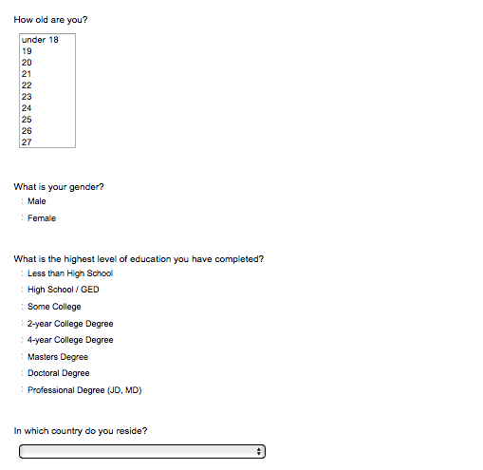
If United States of America Is Not Selected, Then Skip To End of Survey


Social desirability
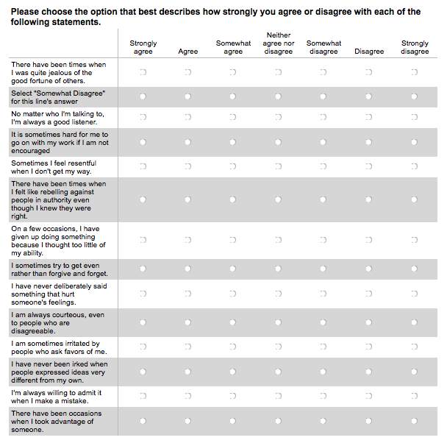
Drinking demographics
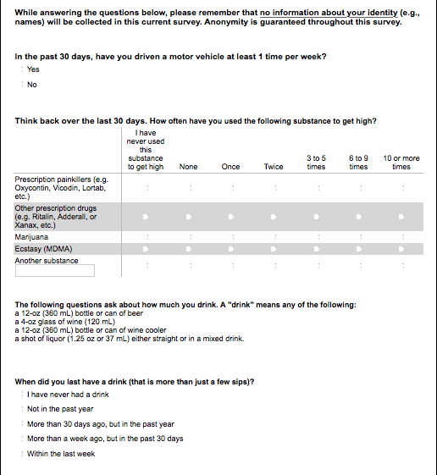
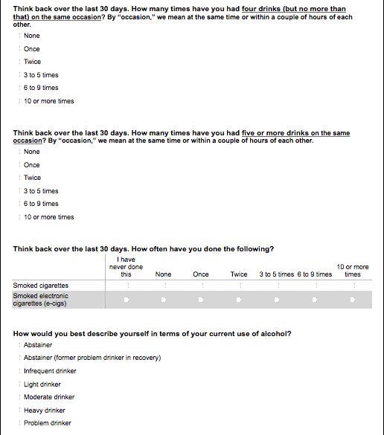
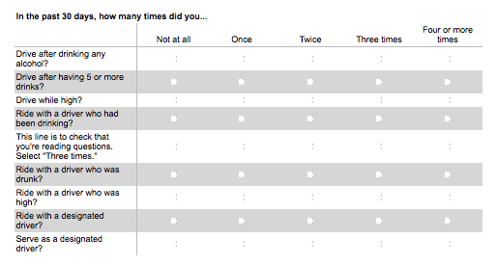
Personal risk perception
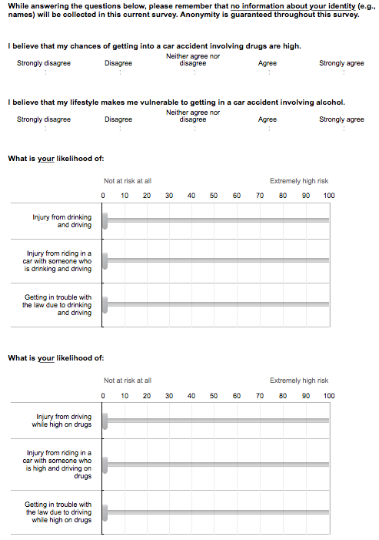
Past exposure to stimuli

Familiarity with actress and valence question about actress
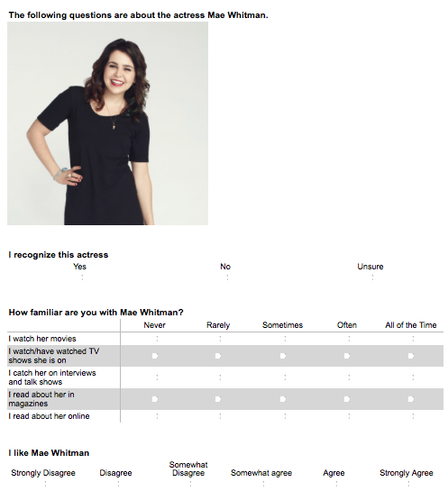
PSR with actress
This scale is shown if participant selects strongly disagree, disagree, or somewhat disagree for “I like Mae Whitman.”
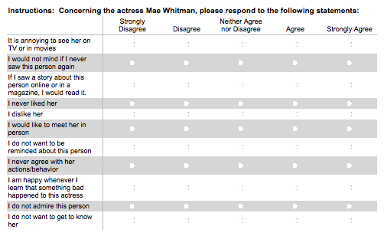
This scale is shown if participant selects strongly agree, agree, or somewhat agree for “I like Mae Whitman.”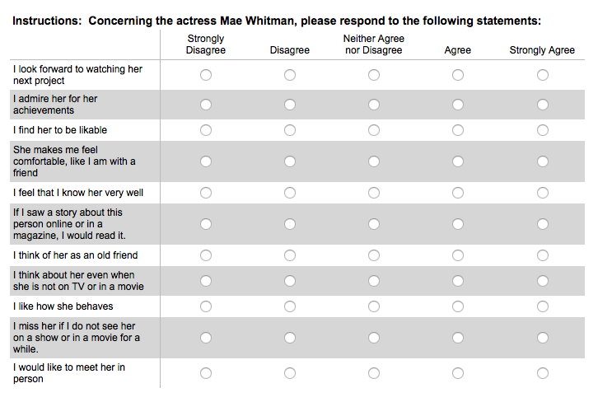
Valence manipulation
Participants will be randomly exposed to 1 of 2 paragraph valence conditions (positive or negative) and a reading check question for each paragraph.

Positive condition
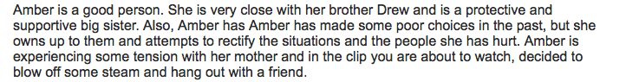
*Reading check shown on a different page.
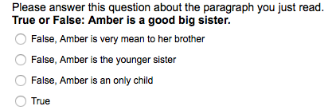

Negative condition
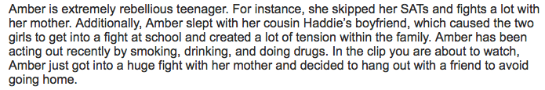
*Reading check shown on a different page.

Character Valence (post-paragraph)
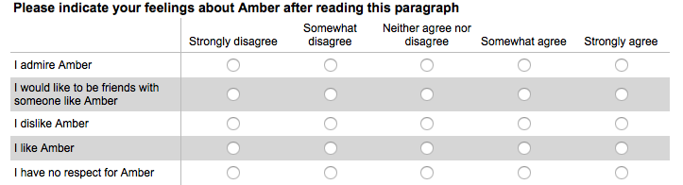
Video Condition
Participants were exposed to 1 of 3 (uncertain, denial, or apology) conditions and a watching check for each condition. Video would appear above the following paragraph.

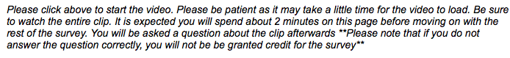
Uncertain condition check

Denial condition check
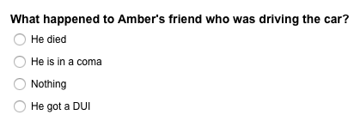

Apology condition check

Character valence (post-video)
Perceived Realism
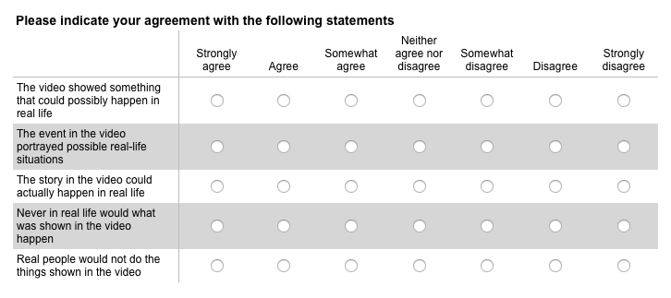
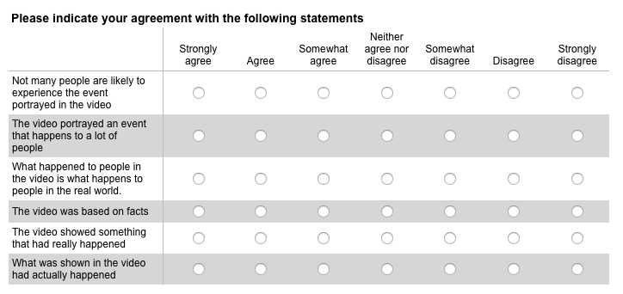
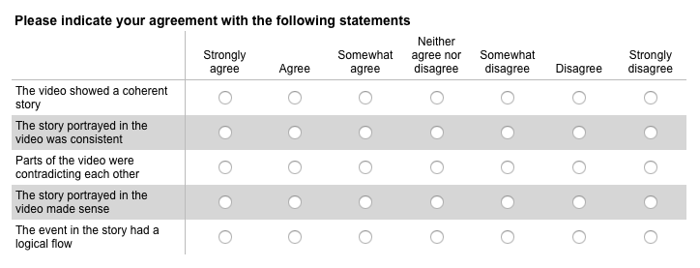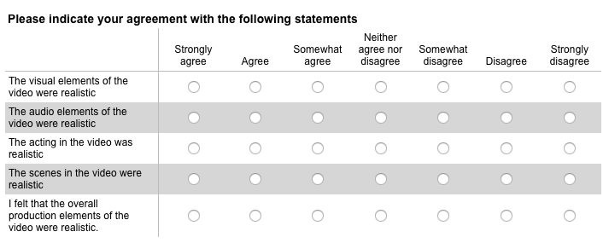Past exposure to stimuli (part 2)
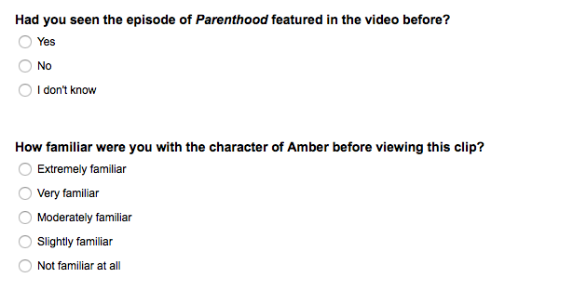
If “not familiar at all” is not selected, the question below is displayed


PSR with character
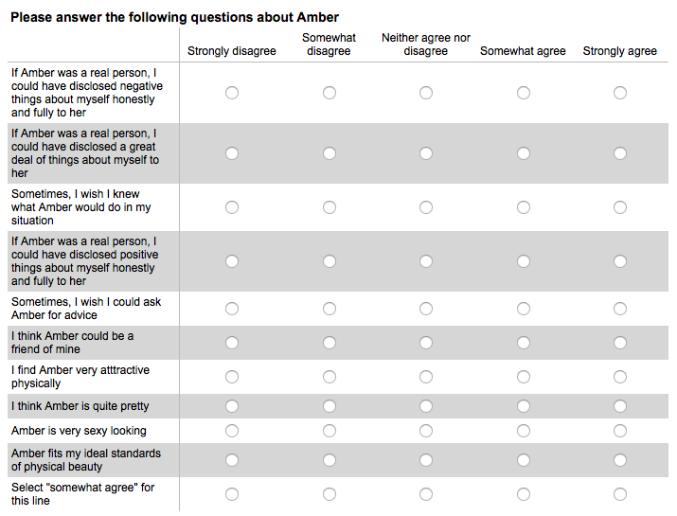
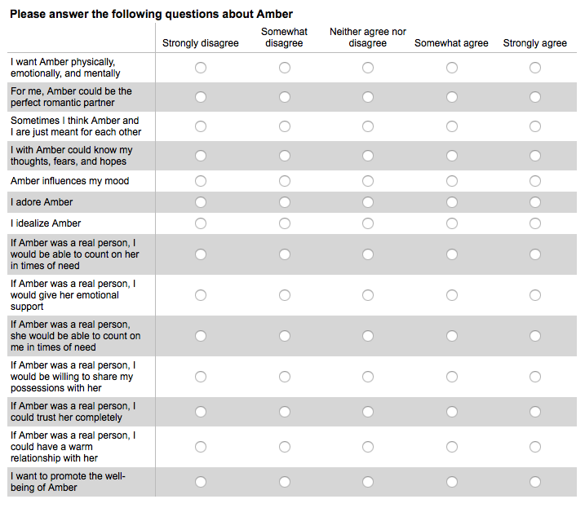
PSI with character
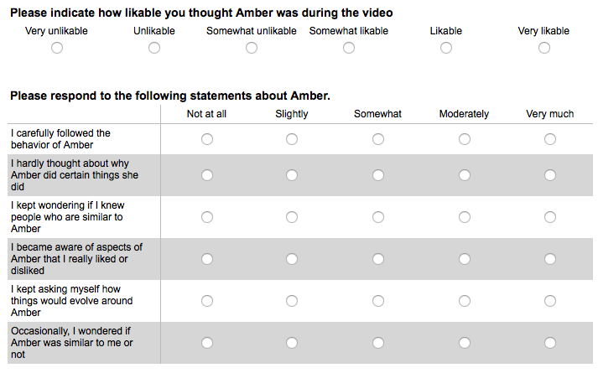
This scale is shown if participant indicates is they find Amber to be somewhat likable, likable, or very likable during the video.
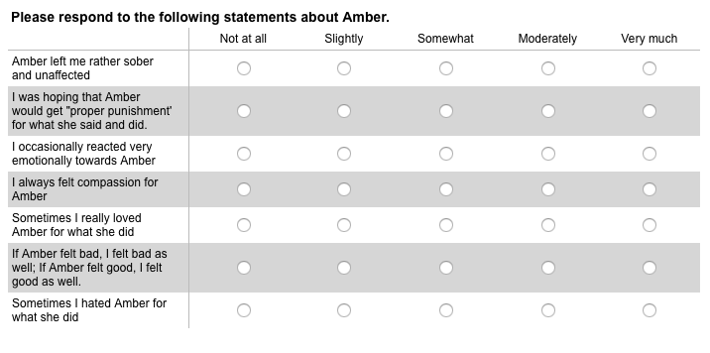
This scale is shown if participant indicates is they find Amber to be somewhat unlikable, unlikable, or very unlikable during the video.
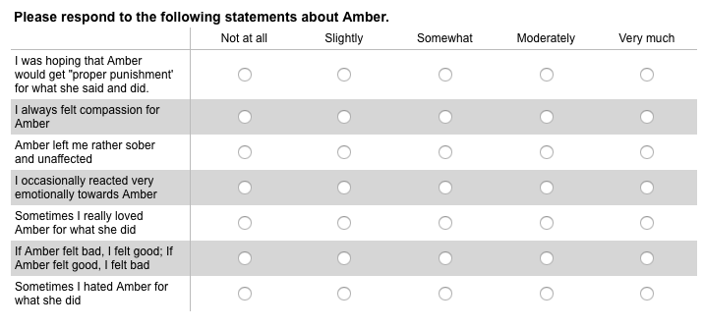
Perceived social distance
So and Shen Measure
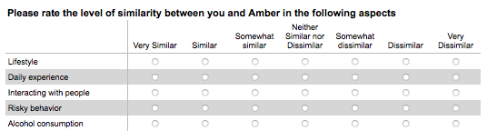
Aron et al., 1992
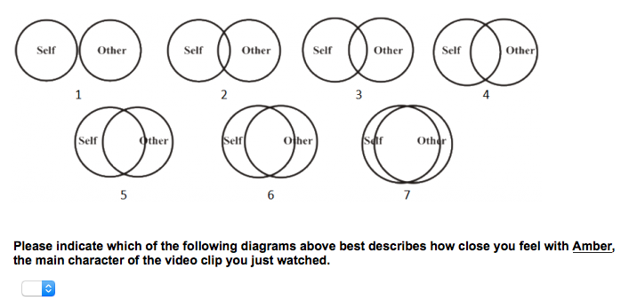
Modified version of Bogardus
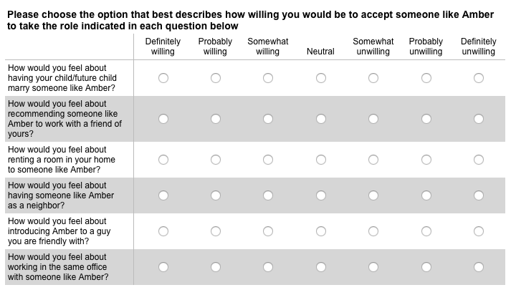
Post personal risk perception
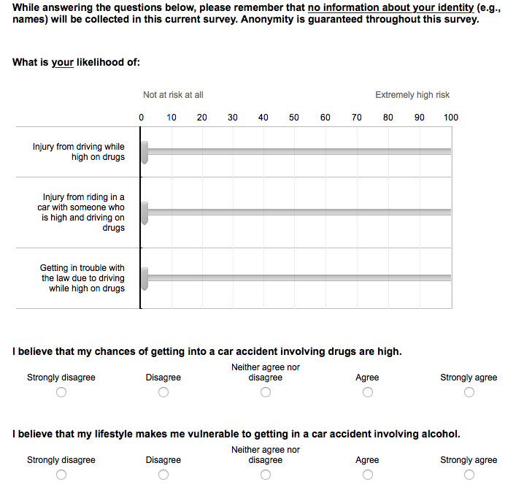
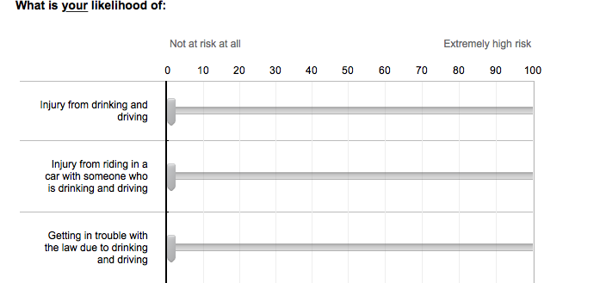

Character risk perception
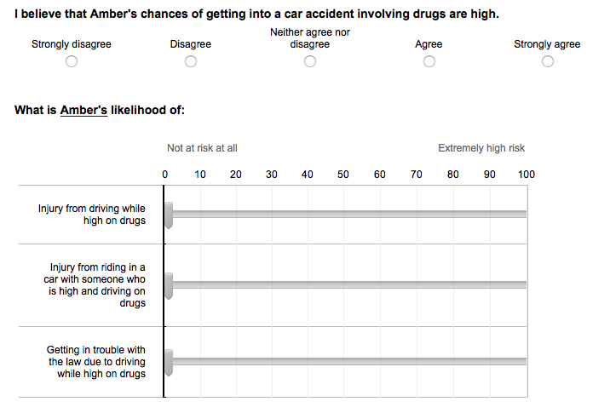
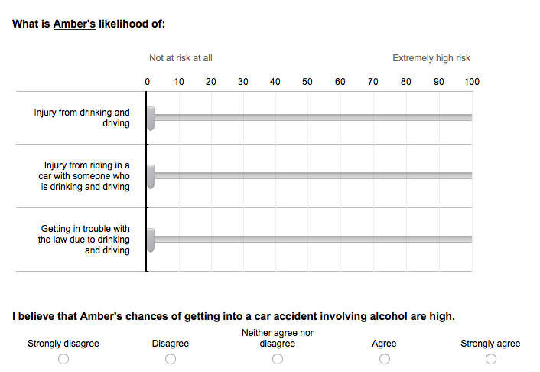
MTurk ID


Appendix B: Main Study
Consent form

If I do not want to participate... Is Selected, Then Skip To End of Survey

Experience with health topics and drinking demographics

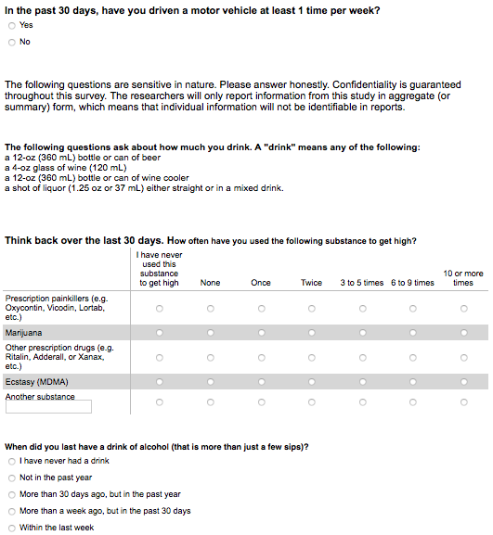
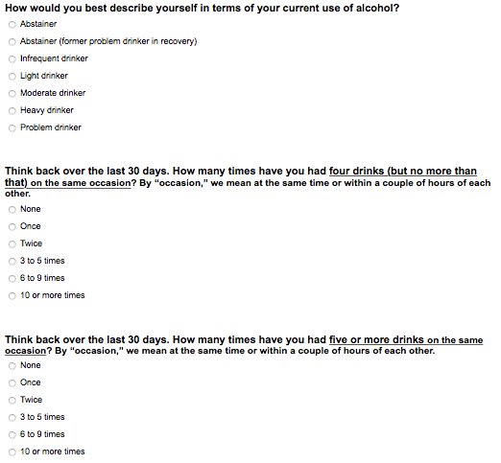
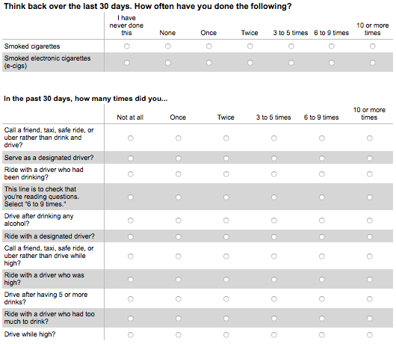

Likelihood of drinking and driving
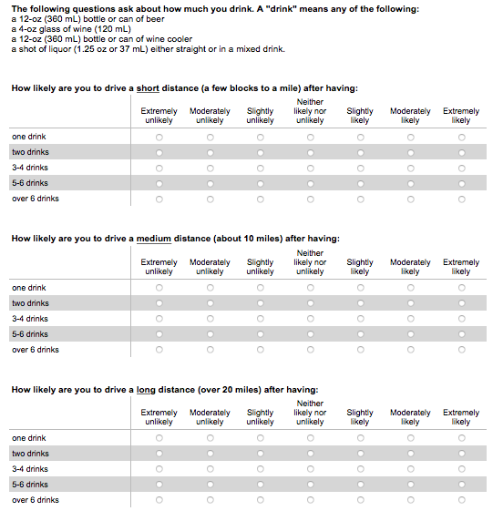
Personal relevance
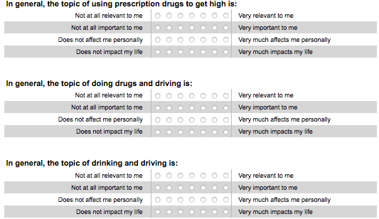
Pre-personal risk
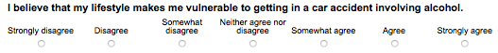
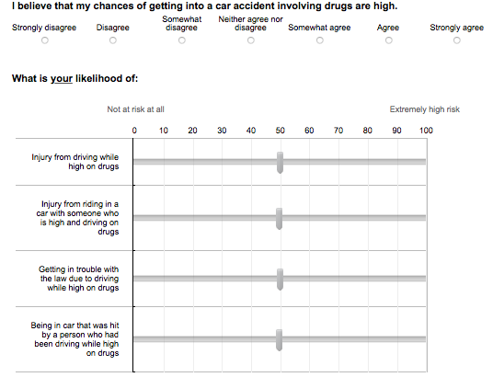

Brief sensation seeking scale
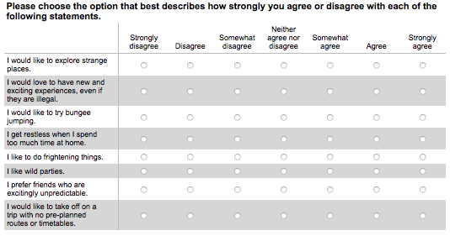
Social desirability
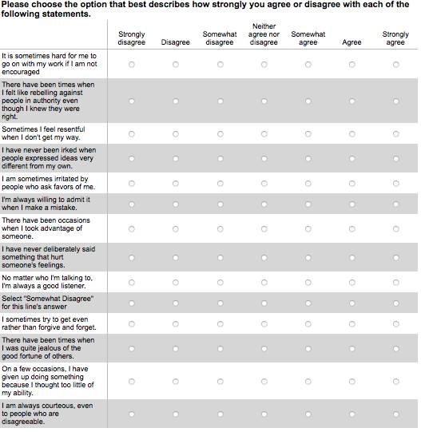

Familiarity with actress
PSR with actress
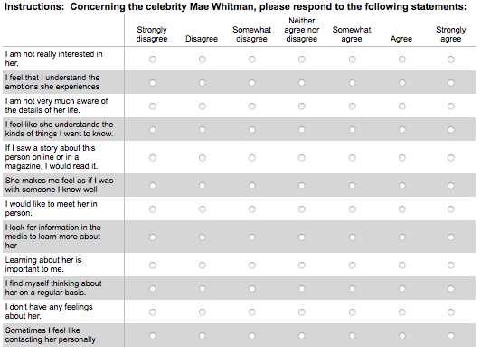

Valence manipulation
Participants will be randomly exposed to 1 of 2 paragraph valence conditions (positive or negative) and a reading check question for each paragraph.
Positive condition
*Reading check shown on a different page.
Negative condition
*Reading check shown on a different page.
Character Valence (post-paragraph)
Video Condition
Participants were exposed to 1 of 3 (uncertain, denial, or apology) conditions and a watching check for each condition. Video would appear above the following paragraph.

Uncertain condition check
Denial condition check
Apology condition check
Character valence (post-video)
Affective disposition and deservedness (5th statement)
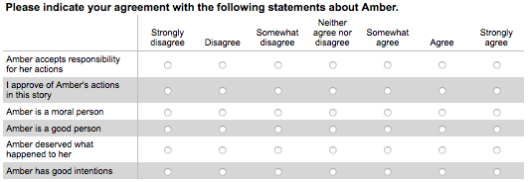
Past exposure to the stimuli
PSR with character
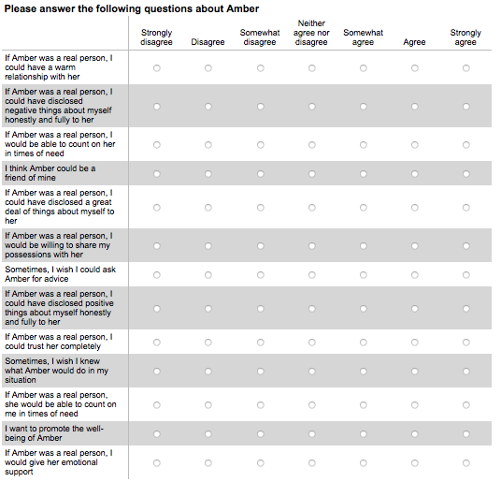
PSI with character
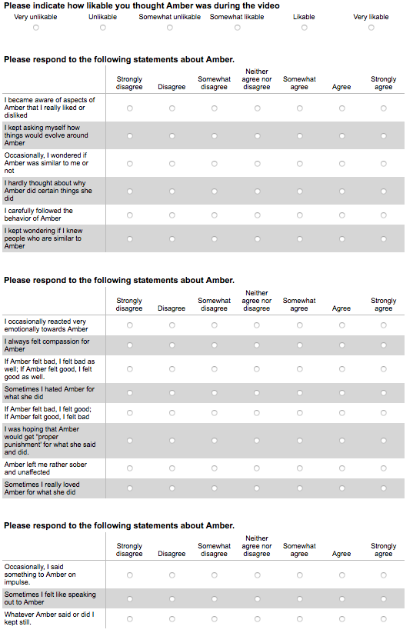
State empathy
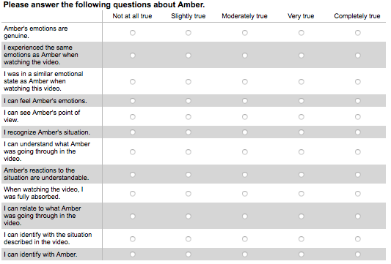
Self-referencing
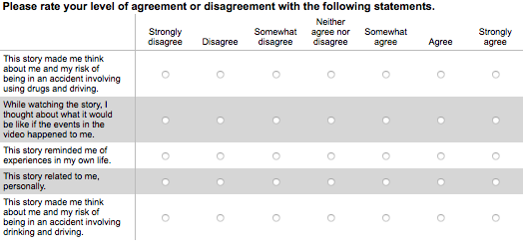

Perceived Realism

Identification
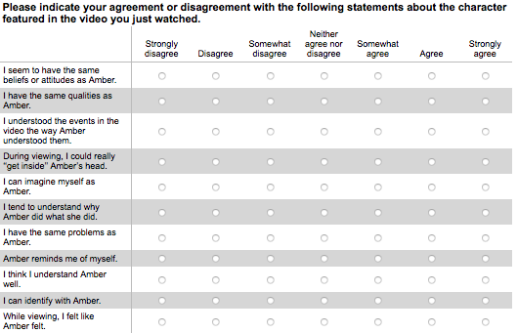
Transportation
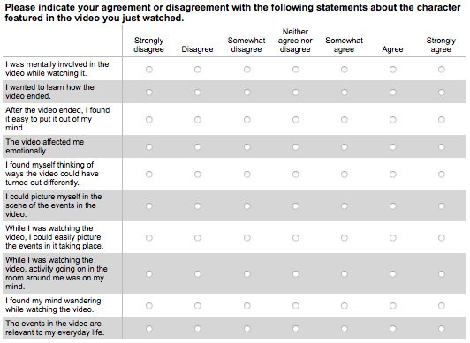
Perceived social distance
So and Shen Measure
Aron et al., 1992
Modified version of Bogardus
Post personal risk perception

Character risk perception

Self-efficacy
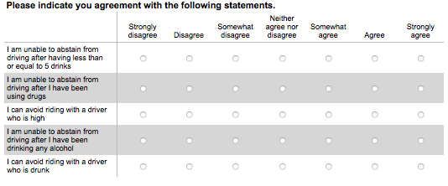
Behavioral intentions
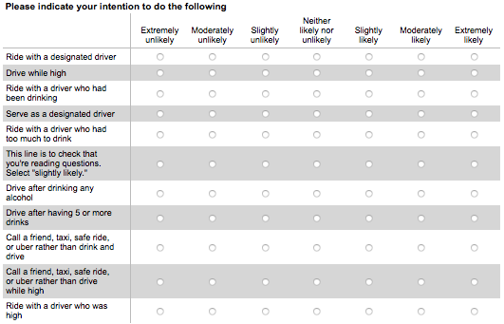
Post-likelihood of drinking and driving
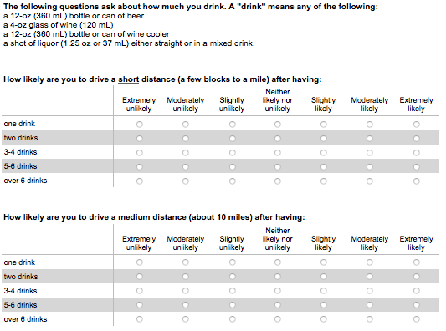
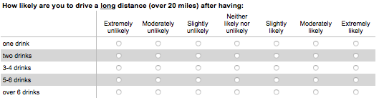 Experiences with health topic consequences
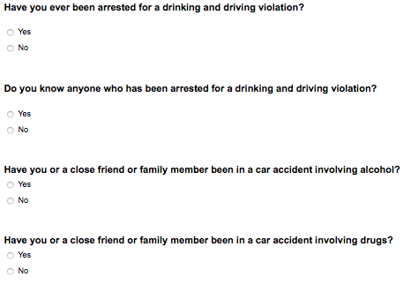
Demographics and SONA
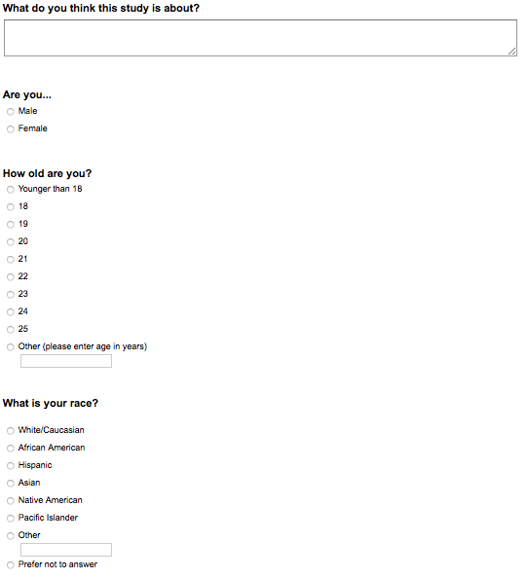
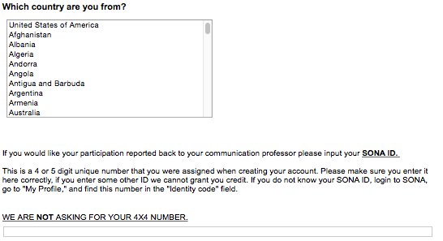

Appendix C: Delayed Posttest
Consent
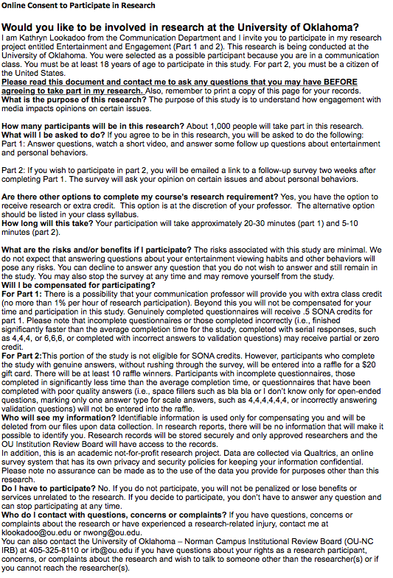
Recall and discussion
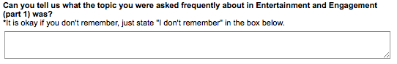
Post-personal risk
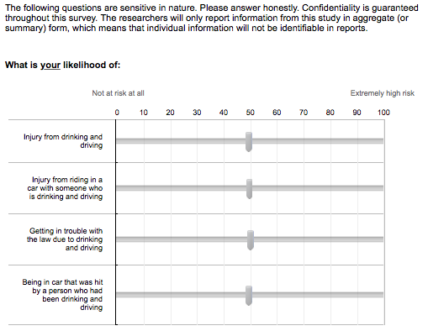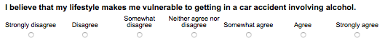
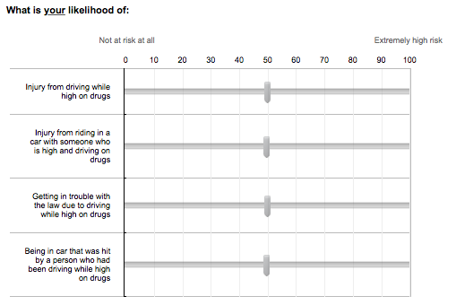Post-likelihood of drinking and driving
Behavioral intentions
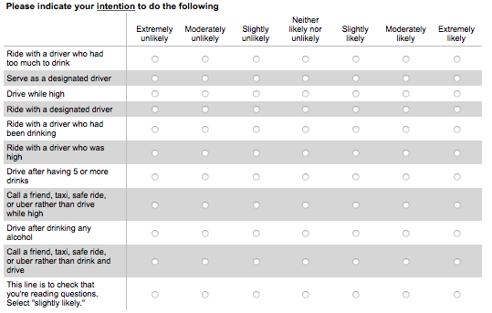
Self-efficacy
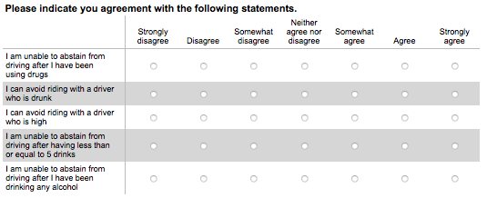
Behavior
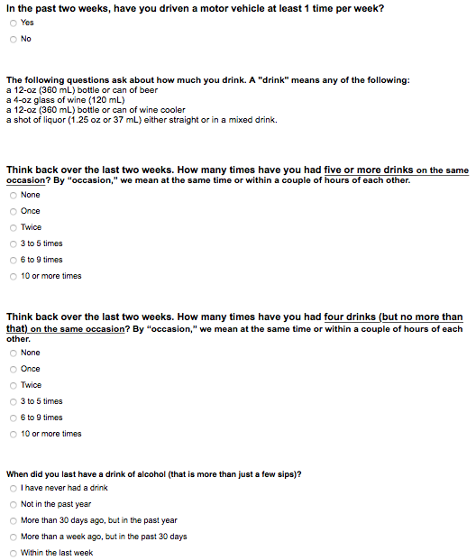
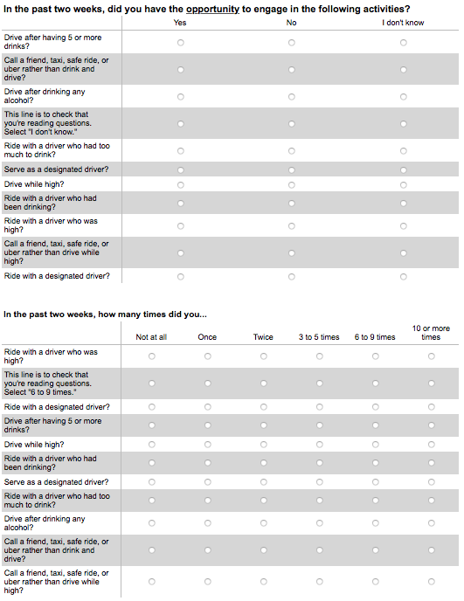Demographics and email


Appendix D: Variable Labels
LIKEDD = Likelihood of drinking and driving. That measure is broken down into driving short distances (a few blocks), medium distances (over 10 miles), and long distances (over 20 miles). The items for each distance are labeled SHORT, MED, and LONG, respectively.
RISKPRE = personal risk perception (pre-exposure).
SS = sensation seeking.
DS = social desirability.
FAM = familiarity with the actress.
PRA = parasocial relationship with the actress.
FEEL = character valence (post-paragraph).
FEELV = character valence (post-video).
AFFECT = affective disposition (some individual items are shortened to AFF).
PSRC = parasocial relationship with the character.
PSICOG = parasocial interaction (cognitive dimension).
PSIAFF = parasocial interaction (affective dimension).
SELF = self-referencing.
REALPL = perceived realism (plausibility).
REALQU = perceived realism (quality).
REALTP = perceived realism (typicality).
REALNCON = perceived realism (narrative consistency).
REALNCOH = perceived realism (narrative coherence).
IDENT = identification (individual items are shortened to IDT).
TRANS = transportation.
SD = Social distance (So & Shen, 2015).
SDA = Social distance (Bogardus, 1933).
RKPO = personal risk perception (post-exposure).
EFF = self-efficacy.
RISKCHAR = character risk perception (individual items are shortened to RISKC).
PLIKEDD = Likelihood of drinking and driving (posttest). Similar to the pretest measure, the items for each distance are labeled PSHORT, PMED, and PLONG.

