University of Oklahoma

Graduate College

It’s not my fault, But I know how you feel: influences of leader empathy on trust repair following an integrity-based trust violation

A Dissertation

submitted to the Graduate Faculty

in partial fulfillment of the requirements for the

Degree of

Doctor of Philosophy

By

Zhanna bagdasarov
Norman, Oklahoma
2014

it’s not my fault, but i know how you feel: influences of leader empathy on trust repair following an integrity-based trust violation

A Dissertation approved for the
Department of Psychology

By

______________________________
Dr. Shane Connelly, Chair

______________________________
Dr. Michael D. Mumford

______________________________
Dr. Lori Snyder

______________________________
Dr. Michael Buckley

______________________________
Dr. Robert Terry

© Copyright by zhanna bagdasarov 2014
All Rights Reserved.

Acknowledgements
First and foremost, I would like to thank Dr. Shane Connelly for her guidance, support, patience, and encouragement over the last five years. Throughout my graduate career, Dr. Connelly challenged me and pushed me to realize my potential. For this and everything else you have done for me, Dr. Connelly, I am most grateful. I would also like to thank the members of my doctoral committee, Drs. Michael Mumford, Michael Buckley, Lori Snyder, and Robert Terry, for their feedback and many useful suggestions on this and many other projects. Your guidance helped to improve my work and strengthen my skills as a researcher. Additionally, I would like to thank my good friend and colleague, James Johnson, for the invaluable support he provided throughout my graduate studies and his input during the various phases of this project. I will always think fondly about our many talks over breakfasts and lunches. Similarly, I would like to thank all the graduate students who dedicated many hours to coding for this project. Without all of you, completion of this effort would not have been possible. To my parents, Yevgeniya and Arthur, and my lovely sister, Svetlana, thank you for your unyielding belief in me, daily words of encouragement, and your boundless love. Finally, I would like to thank my loyal friend, colleague, and source of unwavering support, April Martin. Besides co-authoring several manuscripts over the last few years, April spent countless hours proofreading this dissertation, as well as many other papers, and discussing research ideas. She is a friend I always hoped to make in life. I treasure our friendship.

Table of Contents
Acknowledgements iv
List of Tables vii
List of Figures viii
Abstract ix
Introduction 1
Trust, Violations, and Responses 3
Affect and Trust Repair 8
Method 12
Participants 12
Design and Procedure 12
Study Case and Manipulations 13
Nature of the Violation 14
Response to the Violation 14
Leader Empathy 14
Dependent Variables 15
Perceived Integrity 15
Willingness to Risk 15
Trust in the Leader and Organization 16
Negative Affective Reaction to Boss’s Actions 16
Negative Affect 17
Task Performance 17
Coding Procedures 18
Quality 19
Originality. 19
Elegance 19
Control Variables 19
Philosophies of Human Nature Scale (PHN) 19
Positive and Negative Affect Scale (PANAS) 20
The Big Five Inventory (BFI) 20
Demographic Survey 21
Engagement in Study 21
Manipulation Checks 22
Nature of Integrity Violation 22
Response to Violation 22
Leader Empathy 23
Results 23
Manipulation Checks 23
Nature of Integrity Violation 23
Response to Violation 24
Leader Empathy 24
Hypotheses Tests 25
Perceived Integrity and Willingness to Risk 25
Trust in the Leader and Organization 28
Negative Affective Reaction to Boss’s Actions and Negative Affect 29
Task Performance Outcomes 31
Discussion 32
Theoretical and Practical Implications 35
Limitations and Directions for Future Research 36
Conclusion 39
References 40
Appendix A: Tables 47
Appendix B: Figures 50
Appendix C: Sample Manipulations 56
Appendix D: Performance Task 59

List of Tables

Table 1. Means, Standard Deviations, and Intercorrelations among All Significant Covariates and Dependent Variables 47
Table 2. Means and Standard Deviations of Trust and Affect Variables by Condition 48
Table 3. Means and Standard Deviations for Performance Variables across Leader Empathy Conditions. 49

List of Figures

Figure 1. Interaction effect of nature of violation and response to the violation on willingness to risk. 50
Figure 2. Interaction effect of nature of violation and leader empathy on perceived integrity and willingness to risk. 51
Figure 3. Interaction effect of response to violation and leader empathy on perceived integrity and willingness to risk. 52
Figure 4. Interaction effect of response to violation and leader empathy on trust in the leader measured via OTI. 53
Figure 5. Interaction effect of response to violation and leader empathy on affective reaction to boss’s actions and overall negative affect. 54
Figure 6. Three-way interaction between nature of the violation, response to the violation, and leader empathy on overall negative affect. 55

Abstract

Prior research on trust repair has focused primarily on investigating verbal and substantive responses to breaches of trust. Although consistently implicated in violations, the role of affect in the repair process has been mostly ignored. Using a scenario-based paradigm, we conducted an experimental study to examine the value of leader empathy, specific responses to an integrity-based violation (apology vs. denial), and nature of consequences (personal vs. organizational), as well as their interactive effects, on trust repair. Findings indicated that presence of leader empathy functioned to repair trust better than its absence and, when coupled with a denial of culpability, produced markedly increased perceptions of integrity and overall trust in the leader. These findings contribute to our understanding of how leaders influence followers through expression of emotion, informing both leadership and trust theory.
Keywords: trust repair, leader empathy, integrity violation, nature of violation, response to violation

Introduction
Trust is considered essential for organizational effectiveness. In fact, literature is replete with evidence showing that interpersonal trust in organizational settings has both direct and indirect effects on a number of key work outcomes, such as individual and group performance, organizational commitment, turnover intentions, job satisfaction, and organizational citizenship behaviors (Deluga, 1995; Dirks & Ferrin, 2001, 2002; Flaherty & Pappas, 2000; Kramer, 1999). The burgeoning of this research area is partially due to the large number of ethical violations and organizational failures occurring in U.S. corporations, churches, and government organizations. Gillespie and Dietz (2009), for instance, cited fraud (e.g., Enron, WorldCom), incompetence (e.g., U.S. government response to hurricane Katrina), deceit (e.g., plagiarized and fabricated reports by the New York Times), exploitation of the defenseless (e.g., sweatshops), massive compulsory job losses (e.g., IBM in the 1990s), and bankruptcies and catastrophic collapses in organizational finance (e.g., Freddie Mac and Fannie Mae) as specific examples of recent trust violations. Numerous other sources suggest that trust violations are a common occurrence, with over 50% of employees experiencing a breach of trust within their organizations (Guest & Conway, 2002; Schweitzer et al., 2006; Robinson & Rousseau, 1994). Such egregious transgressions have been shown to damage interpersonal trust (Lewicki & Wiethoff, 2000). Indeed, Jones and Burdette (1994) report that 50% of employees can recall workplace transgressions for up to 20 years, indicating that trust violations have an enduring impact on the victims. The damage to interpersonal trust can have devastating effects on various organizationally-relevant outcomes. Specifically, broken interpersonal trust may result in suspension of cooperative behaviors between parties involved in the trust violation, and engagement in revenge-seeking on the part of the violated party (Dirks, Lewicki, & Zaheer, 2009). On a grander scale, a decrease of public’s trust due to ethical violations has been shown to reduce customer satisfaction and loyalty, inevitably impacting company profits (Leonidou, Kvasova, Leonidou, & Chari, 2013).
The damage—whether monetary, cognitive, or emotional—associated with trust violations has compelled many researchers to speculate whether broken trust is repairable in subordinates, co-workers, and stakeholders (Ferrin, Kim, Cooper, & Dirks, 2007; Kim, Ferrin, Cooper, & Dirks, 2004; Schweitzer, Hershey, & Bradlow, 2006). Fortunately, research demonstrates that broken trust can be restored (Bottom, Gibson, Daniels, & Murnighan, 2002; Mishra, 1996), although it is contingent on various elements, one of which is the violator’s response to the accusation (Ferrin et al., 2007; Kim et al., 2004, 2006; Schweitzer et al., 2006). Although much headway has been made with regard to verbal responses to trust violations (i.e., apology, denial, reticence), the majority of this research has examined the effects of these responses for integrity-based (violations involving lack of adherence to a set of principles deemed acceptable by the trustor) and competence-based (violations demonstrating lack of ability or competency in a certain domain) misconduct only, ignoring that the nature (e.g., personal or organizational) of each violation might result in drastically different trust repair outcomes. Furthermore, the role of affect in trust repair has largely been ignored (Chen, Saparito, & Belkin, 2011; Kramer & Lewicki, 2010), with most researchers focusing exclusively on changing cognition during the reparation process. We aim to fill these gaps in the literature by further differentiating the nature of integrity-based trust violations in terms of personal and organizational consequences. Moreover, we hope to answer Chen and colleagues’ (2011) call for exploration of the role of affect in trust repair by examining the influence of affective response in addition to the traditionally-used verbal response. Finally, most researchers have examined trust outcomes (e.g., whether or not to hire a transgressor) reported by individuals who had only heard of the transgression (Ferrin et al., 2007; Kim et al., 2004, 2006), but who had not been the victim of the transgression themselves. We submit that this represents a significant oversight, and thus propose to make an important and relevant contribution to this research area by addressing victim-reported outcomes.

Trust, Violations, and Responses
While trust has been defined in multiple ways across disciplines, several scholars have defined trust as a willingness to accept vulnerability based on positive expectations regarding the behavior of another (Mayer, Davis, & Schoorman, 1995; Rousseau, Sitkin, Burt, & Camerer, 1998). This definition further involves two elements: trusting intentions and trusting beliefs. Trusting intentions refer to the willingness to make oneself vulnerable to another in the presence of risk (denoted as willingness to risk in our study), while trusting beliefs refer to the beliefs about another’s integrity that may lead to trusting intentions (referred to as perceived integrity in our study) (McKnight, Cummings, & Chervany, 1998). This manner of defining trust highlights the complexity of the construct, suggesting that both trusting beliefs and intentions must be intact in order for successful trust repair to occur (Kim et al., 2004; Tomlinson & Mayer, 2009).
While a few theoretical frameworks for organizational trust have been developed (Lewicki & Bunker, 1996; Mayer et al., 1995; Whitener, Brodt, Korsgaard, & Werner, 1998), the model proposed by Mayer and colleagues (1995) has served as a conceptual basis for numerous empirical studies in diverse areas (Schoorman, Mayer, & Davis, 2007) and has garnered most support. This model of organizational trust suggests that a trustor evaluates an individual’s trustworthiness, or an attribute of the trustee indicating that he or she is worthy of being trusted, based on an assessment of three contributing characteristics: Ability, benevolence, and integrity. Ability, as defined by Mayer at al. (1995), is the extent to which the trustee possesses relevant domain-specific skills and competencies allowing him/her to contribute to the trustor’s well-being. Benevolence refers to the extent to which a trustee is perceived to want to do positive things to the trustor or bestow goodwill onto the trustor. Finally, integrity, is defined as the extent to which the trustee adheres to a set of principles that the trustor finds acceptable. These three characteristics, therefore, make up trustworthiness, which, in turn, is the key antecedent of trust in the proposed framework. Mayer et al.’s (1995) model further suggests that if trust is somehow damaged, the three characteristics, or some combination of them, will undergo reevaluation, resulting in erosion of trust. Additionally, as Tomlinson and Mayer (2009) pointed out, because trustworthiness precedes trust, it therefore follows that trust can be repaired by increasing the specific declined dimension of trustworthiness. This proposition is denoted by the feedback loop within the model. Explorations by researchers into methods for increasing perceptions of trustworthiness dimensions and therefore repairing trust are plentiful.
Numerous studies have investigated the effects of violators’ verbal and substantive responses following a transgression (Ferrin &Dirks, 2003; Ferrin, Dirks, & Shah, 2006). The majority of these investigations have focused on empirically examining the effect of only the violator’s response (e.g., apology, denial, reticence) on the trust outcomes (i.e., trusting intentions, trusting beliefs, and hiring decisions) of a new potential supervisor. A similar paradigm has been used by researchers to study the transgressor’s verbal response to a breach (Ferrin et al., 2007; Kim et al., 2004, 2006). Specifically, in most studies, researchers have asked participants to assume the role of a manager who is tasked with hiring a new tax accountant. Participants are asked to view a video depicting an interview with the “job candidate” and complete measures assessing their trust in the new candidate. The candidate is then accused by the interviewer of filing an incorrect tax return at his previous employment, resulting in an understatement of the client’s capital gains income. The manipulation of a verbal response is normally embedded into the interview, with interactions involving the candidate either admitting culpability and apologizing for the trust violation at his previous firm or outright denying misconduct. Finally, a number of these studies have investigated violation responses by focusing on integrity- and competence-based breaches. Using the same paradigm described above, violation type was manipulated by accusing the candidate of filing the incorrect tax return due to inadequate knowledge of relevant tax codes (i.e., competence-based violation) or doing so intentionally (i.e., integrity-based violation). Studies using this paradigm revealed that trust was more likely to be repaired (as indicated by the participant’s propensity to choose to hire the candidate) when the transgressor apologized for a competence-based violation but denied involvement in the integrity-based breach (Ferrin et al., 2007; Kim et al., 2004, 2006). Ferrin et al. (2007) took their study one step further and examined the effect of reticence, or the proclivity of the accused party to neither confirm nor deny the veracity of the allegation, on trust repair efforts. Findings clearly indicated that reticence was a suboptimal response to an integrity violation, as was an apology. Given that these findings indicate that trust is more likely to be repaired when the perpetrator denies his involvement rather than apologizes for the integrity-based violation, we expect similar findings in our study.
Although researchers have differentiated between integrity- and competence-based violations as means of studying integrity and ability dimensions of trustworthiness, they have yet to delve deeper into either as a method. Here, we probe further into integrity-based violations, focusing mainly on increasing the integrity dimension of perceived trustworthiness. One thing that may influence the effectiveness of verbal responses in trust repair is the nature of the consequences of integrity-based transgressions. It has been established that individuals experience negative affect after a violation (Dirks et al., 2009; Tomplinson & Mayer, 2009). Negative emotions such as disappointment, frustration, anger, and outrage following a transgression have been well documented in the literature (Barclay, Skarlicki, & Pugh, 2005; Bies & Tripp, 1996; Conway & Briner, 2002; Lewicki & Bunker, 1996; Mikula, Scherer, & Athenstaedt, 1998; Morrison & Robinson, 1997). Given that individuals may not experience the full range of these emotions when considering the feelings of others who have had their trust violated (Rust, McKinley, & Edwards, 2005), it is possible that violations carrying personal consequences (i.e., outcomes relevant to one particular person) will evoke stronger reactions than organizational consequences (i.e., outcomes relevant for the entire organization than one particular person). Although hearing about a transgression affecting others would likely induce some sense of sympathy and possibly even empathy within an individual, it seems likely that actually being the victim of a personal violation would produce more pronounced negative emotions. The stronger reactions to personal violations due to an increase in negative affect are likely to lead to a decrease in trust repair outcomes following a transgression. While support for this proposition is not available from trust literature due to its novelty, research in the related domain of psychological contract violations suggests that the nature of consequences plays an important role in whether employees react strongly to a breach of contract. Rust et al. (2005), for instance, showed that employees perceived their own layoff from an organization to be a more significant breach of contract than the layoffs of other employees. Findings further indicated that employee reactions to a personal psychological contract breach were much more severe and emotional than reactions to similar violations against others. Considering these findings, we propose the following hypotheses:
H₁: If the integrity-based violation has organizational rather than personal consequences, individuals will exhibit increased (1a) perceived integrity of the leader/violator, (1b) willingness to risk, (1c) overall trust in the leader, (1d) trust in the organization, and (1e) task performance.
H₂: Response to the violation (i.e., apology vs. denial) and the nature of the consequences (personal vs. organizational) will interact such that when the leader responds with a denial and the consequence is organizational rather than personal, there will be increases in (2a) perceived integrity of the leader/violator, (2b) willingness to risk, (2c) overall trust in the leader, (2d) trust in the organization, and (2e) task performance.
In addition to these hypotheses, we seek to confirm the presence of negative emotional reactions in victims of integrity-based trust violations and investigate the differential impact of the response given by a violator and the nature of the consequences on individuals’ affective reactions. Since extant literature has repeatedly shown denial to be the more successful response in repairing trust following integrity-based violations (Kim et al., 2004, 2006; Ferrin et al., 2006), it could be that apology activates a more unpleasant emotional response in victims. An explanation for this hypothesis could be that the confirmed culpability that results from the act of apologizing leads to more negative feelings about the apologizer (Kim et al., 2004), than the feelings evoked by the doubt about culpability that results when a person denies fault. Thus we make the following predictions:
H₃: Individuals will exhibit higher (3a) negative affective reaction to boss’s actions, and (3b) negative affect when the leader responds with an apology as opposed to denial.
H₄: Individuals will exhibit higher (4a) negative affective reaction to boss’s actions, and (4b) negative affect when the nature of the violation is personal rather than organizational.

Affect and Trust Repair
Earlier we hypothesized that leaders perpetrating trust violations can evoke different emotional responses in their victims depending upon the leaders’ responses following the violation, but what bearing do the victim’s emotions have on subsequent trust repair? Few studies have considered the effect of emotions in the trust literature. In fact, the role of affect has been mostly absent from models of trust (Mayer et al., 1995; Schoorman et al., 2007), and where emotions were considered, it was typically in regard to trust development. A few researchers have begun to acknowledge the importance of affect in interpersonal trust (Dunn & Schweitzer, 2005; Chen et al., 2011; Jones & George, 1998; Schoorman et al., 2007; Tomlinson & Mayer, 2009; Williams, 2001; 2007), yet none have yet fully integrated an affective component to known models of trust. Dunn and Schweitzer (2005) demonstrated that incidental emotions influenced trust. Specifically, positive emotional states increased trust, while negative emotional states decreased trust. More recently, Lount (2010) explored the impact of positive mood on trust in interpersonal interactions. The findings indicated that trust increased when people were in a positive mood and also perceived cues associated with trust in another party but decreased when they perceived cues characterized by distrust. These two studies provide an example of the fragmented nature of affect and trust studies. Our aim is to augment the trust literature by considering the influence of affect in combination with verbal responses to trust repair efforts.
The Emotions as Social Information model (EASI; Van Kleef 2008a, 2008b) provides the theoretical basis for our hypotheses regarding the role of affect in trust repair. This model proposes that emotions provide information about an individual’s thoughts and intentions that influences the behavior of others, and that this occurs via two potential paths: strategic information or affective reactions (Van Kleef, 2008b). The strategic information path holds that each discrete emotion conveys specific information which may then be used by others to draw strategic inferences and thus determine their behavior, while the affective reactions path maintains that emotions may exert influence by eliciting affective reactions in others (Van Kleef, 2008b).
Given the tenets of this model, we propose that coupling emotional expressions and verbal responses will increase trust repair efforts via the affective reactions path. If the violator exhibits positive emotion while responding to the victim following a transgression, the EASI model and the affective reactions path would suggest that positive emotions are more likely to be elicited in the victim. Given the findings of Dunn and Schweitzer (2005) and Lount (2010) as referenced earlier, it then stands to reason that, having experienced positive emotions due to the positive emotion exhibited by the violator, the victim is more likely to show increased trust in the violator (Dunn & Schweitzer, 2005). To this end, Tomlinson and Mayer (2009) proposed that something must be done to offset or reduce the negative emotions being experienced by the victim in order to restore trust. This reduction of negative emotions, the authors suggest, will lead to more rational processing of information by reducing cognitive load. Here, we choose to use a display of empathy by the violator as a possibly useful route to trust repair and as a means to mitigate negative emotions.
Empathy is defined as “the ability to comprehend another’s feelings and to re-experience them oneself” (Salovey & Mayer, 1990, p. 194). Research shows that followers exhibit favorable reactions to leaders who display empathy (Kellett, Humphrey, & Sleeth, 2002, 2006; Pescosolido, 2002) and that empathy can help facilitate mutual trust (Mahsud, Yukl, & Prussia, 2010). Additionally, in their assessment center study, Kellett et al. (2006) demonstrated that empathy was positively related to relations leadership (r = .55), suggesting usefulness of leader empathy in interpersonal relationships. Similarly, Thiel, Griffith, and Connelly (2013) showed that when a leader displayed empathy, using suppression rather than reappraisal as an emotion management strategy proved to be most successful at lowering employee stress following a particularly emotional event and expression of the negative emotion anger. Interestingly, this effect was amplified during a simulated crisis situation, suggesting the importance of leader empathy in attenuating negative emotions and defusing stress associated with a state of crisis. Although leader empathy has been researched vis-à-vis various key work outcomes, we could find no previous work investigating the role of empathy in trust repair following integrity breaches. We did, however, find one study by Nadler and Laviatan (2006) establishing the usefulness of empathy in reconciliation efforts. Specifically, the authors showed that an out-group’s expression of empathy for an in-group’s suffering resulted in increased willingness to reconcile on the part of the in-group. This finding, however, was only true in cases where trust between parties was high. When trust was low, an opposite effect was observed. Given this pattern of findings, we propose the following:
H₅: If the leader displays empathy rather than no empathy, individuals will exhibit higher (5a) perceived integrity of the leader/violator, (5b) willingness to risk, (5c) overall trust in the leader, (5d) trust in the organization, (5e) task performance, and lower (5f) negative affective reaction to boss’s actions, and (5g) negative affect.
H₆: Response to the violation (i.e., apology vs. denial) and leader empathy will interact such that leader empathy coupled with denial will result in increased (6a) perceived integrity of the leader/violator, (6b) willingness to risk, (6c) overall trust in the leader, (6d) trust in the organization, (6e) task performance and lower (6f) negative affective reaction to boss’s actions, and (6g) negative affect.
H₇: Leader empathy and nature of consequences will interact to predict increased (7a) perceived integrity of the leader/violator, (7b) willingness to risk, (7c) overall trust in the leader, (7d) trust in the organization, and (7e) task performance when an organizational violation is combined with leader empathy, and increased (7f) negative affective reaction to boss’s actions, and (7g) negative affect when a personal violation is coupled with no leader empathy.

Method

Participants
Two hundred and forty undergraduate students from introductory psychology courses took part in this study. Participants were recruited via an online experiment management system and granted course credit in exchange for participation in this study. On average, participants were 19.28 year old (SD = 1.41; range = 18–32 years). Of these participants, 29.6% were male, 66.7% were female, and 3.8% chose not to report their gender. Furthermore, participants in this sample possessed an average of 2.4 years of work experience (SD = 1.96), with the majority of the sample lacking any face-to-face (80.4%) or online (72.8%) ethics/integrity training.

Design and Procedure
All participants were randomly assigned to one of 8 conditions in a 2 (nature of integrity violation: personal vs. organizational consequences) x 2 (response to violation: apology vs. denial) x 2 (leader empathy: present vs. absent) between-subjects factorial design. Random assignment of participants to conditions was accomplished using a random number generator function in Microsoft Excel 2010.
Participants took part in this study in groups of approximately ten individuals. The number of participants in a given session depended upon the number of individuals signed up for a particular time slot. Study administrators began by distributing and audibly reviewing the informed consent form, allowing participants ample time to read and understand the nature of the study. Participants were asked to sign the consent form if they wished to participate.
All study materials were provided in 2 packets. First, participants received a packet containing two covariate measures (i.e., PANAS and the Big Five Personality Inventory), followed directly by the low-fidelity vignette with manipulated content to reflect the condition the individual was assigned to. This packet concluded with open- and closed-ended questions assessing participants’ affective reaction to the case content and post-manipulation questionnaires assessing trust outcomes. After completing and submitting the first packet, participants received the second packet. This packet contained the performance task, a covariate measure of trust and cynicism, a brief demographic survey, and several questions used to check whether the manipulations had the intended effect.

Study Case and Manipulations
All manipulations were embedded within a low-fidelity vignette by varying the content of the same scenario according to the conditions. Participants read a one-page scenario asking them to assume the role of an accountant within a large accounting department at a start-up electronics company.

Nature of the Violation
The nature of the violation refers to and involves either a personal or an organizational consequence. The same scenario was manipulated to include descriptions of very personal outcomes for the victim or purely organizational consequences. Personal outcomes involved the main character being passed over for a well-deserved promotion, while organizational consequences entailed the entire accounting firm losing their annual bonuses, both as a result of an integrity-based violation committed by the boss (see Appendix A).

Response to the Violation
Following a description of the setting and the perpetration of an integrity-based violation by the boss, the scenario features the main character (i.e., victim/participant) directly confronting the boss about the violation. The transgressor responds to this confrontation with either an apology or a denial. As in previous studies examining verbal responses (Kim et al., 2004, 2013), the transgressor admits responsibility when apologizing or completely denies culpability for the trust violation. Please see Appendix A for examples of manipulated case content.

Leader Empathy
Along with the verbal responses to the trust violation, the transgressor’s speech was manipulated to either contain or be devoid of empathy. Empathy was portrayed via the content and tone of the perpetrator’s response to being accused. When a response contained empathy, the violator demonstrated understanding of participant’s anger, while communicating a general tone of compassion and concern (see Appendix A).

Dependent Variables
We evaluated participants’ trust in their leader (i.e., transgressor) using several frequently utilized measures in the trust repair literature. We adapted a commonly used measure of trusting beliefs (i.e., perceived integrity), and trusting intentions (i.e., willingness to risk) to include the name of the transgressor (i.e., Chris Johnson) in order to make these scales more relevant to the current study. Otherwise, the scales remained unaltered from those used by Kim et al. (2004).

Perceived Integrity
Participants’ trusting beliefs were assessed by their perceptions of the violator’s integrity following the transgression (Mayer & Davis, 1999). This adapted 3-item scale asked participants to rate on a 7-point Likert scale the extent to which they agreed or disagreed with each statement. A sample item included: “Sound principles seem to guide Chris Johnson’s behavior.” Cronbach’s alpha for this scale was .89, indicating a high degree of internal consistency among the three items.

Willingness to Risk
Participants’ intentions to trust the violator were measured by an adapted version of the Mayer and Davis’ (1999) “willingness to risk” scale. This measure was comprised of three items. A sample item stated: “I wouldn’t let Chris Johnson have any influence over issues that are important to me.” The items were measured on a 7-point Likert scale (1 = strongly disagree, 7 = strongly agree), with two items requiring reverse scoring. Cronbach’s alpha for this scale was .67, indicating a fair degree of internal consistency among the three items.

Trust in the Leader and Organization
The Organizational Trust Inventory (OTI; Nyhan & Marlowe, 1997) is a 12-item scale used to assess participants’ trust in the leader and the entire organization. The first eight items formed the scale measuring participants’ trust in the leader, while the last four items measured participants’ level of trust in the organization. This instrument used a 7-point scale anchored on the ends by “nearly zero” and “near 100%” to indicate the participants’ confidence in each statement. A sample statement from the trust-in-leader portion of the scale read: “My level of confidence that Chris Johnson will make well thought out decisions about his job is __________.” A sample item from the organizational trust portion of the scale read: “My level of confidence that this organization will treat me fairly is _____________.” Participants were asked to fill the blanks with their confidence appraisal. Reliability estimates for the trust in the leader and trust in the organization scales were both very high (.91 and .88, respectively).

Negative Affective Reaction to Boss’s Actions
In order to measure participants’ affective response to the scenario, six closed-ended questions were asked directly after participants read the manipulated vignette. Participants were asked to rate on a 5-point scale (1 = not at all, 5 = extremely) the extent to which they agreed or disagreed with several questions. The six questions asked participants the extent to which the boss’s actions made them feel specific negative emotions (e.g., To what extend did your boss’s actions make you angry?). The emotions investigated included anger, irritability, distress, hostility, fear, and anxiety. Participants’ ratings were averaged across the six items to derive one score for their overall negative affective reaction to the boss’s actions. Cronbach’s alpha for this scale was .67, indicating a fair degree of internal consistency among the six items.

Negative Affect
In addition to the above measure, participants were also asked to provide an open-ended response to two questions designed to assess their overall affective reaction to the case. Participants were asked to: 1) describe their feelings about their boss’s actions, and 2) describe their feelings regarding the confrontation they just had with their boss about his actions. Participants were allowed ample time and space to provide their responses. Responses were later appraised for presence of negative affect by four trained raters. Negative affect was defined as a general dimension of subjective distress involving a variety of negative emotions, including anger, contempt, disgust, guilt, fear, and nervousness. Participants’ responses to both questions in tandem were coded for presence of negative affective tone on a five-point Likert scale (1 = minimal or lack of negative tone, 5 = high negative tone). Intraclass correlation coefficient (ICC) was used to assess interrater reliability. The resultant reliability coefficient was very high (ICC = .80).
A detailed description of coding procedures is provided following the description of task performance.

Task Performance
A brief performance task was devised to assess participants’ willingness to perform a work task for the leader after the integrity violation, and thus indicate behaviorally their trust for the leader. Specifically, in packet two, participants were told one month had passed since the incident (trust violation) and they continued to work for the same organization despite all that occurred. Participants were then advised they received an email from their boss, Chris Johnson, requesting assistance with the development of a new advertisement highlighting the department’s services and strengths for the company website. Along with the information about the task, participants were also provided with sample services to highlight in their advertisements (e.g., preparing tax returns, advising individuals on personal finance planning), but were told that the list of eleven services was not exhaustive and that they should feel free to come up with their own ideas. Participants were then given two blank pages to devise their advertisement and communicate it in any manner they wished (e.g., pictorially, sententially, etc.). The guidelines for the task are provided in Appendix B. The resultant advertisements were later appraised by four trained coders for quality, originality, and elegance, which are standard variables for scoring creative solutions (Besemer & O’Quin, 1999; Mumford, Mobley, Uhlman, Reiter-Palmon, & Doares, 1991). Details regarding each variable are provided below.

Coding Procedures
Four expert coders were tasked with rating the responses for presence of negative affect in the two open-ended questions, as well as the variables assessing performance (i.e., quality, originality, and elegance). Coders received a thorough, three-hour frame-of-reference training (Bernardin & Buckley, 1981) prior to scoring any responses. Training consisted of providing operational definitions along with benchmarks for each variable and practicing rating on a randomly selected pool of responses. A follow-up meeting for calibration purposes was held one week after the initial training meeting. Raters were then given all participant responses and allowed to begin coding.

Quality
Participants’ advertisements were coded for quality on a 5-point Likert scale (1 = poor quality, 5 = excellent quality). Quality was broadly defined as the degree to which the advertisement was complete, coherent, and useful. Interrater reliability was high, ICC = .84.

Originality.
The originality of the advertisement, defined as the degree to which the advertisement was novel, unexpected, and elaborative, was scored on a 5-point Likert scale (1 = poor originality, 5 = excellent originality). Interrater reliability was acceptable, ICC = .78

Elegance
Elegance of the advertisement, or refined advertisements which flowed well together in a clever way while maintaining simplicity, was also rated on a 5-point Likert scale (1 = poor elegance, 5 = excellent elegance). Interrater reliability for this variable was high, ICC = .85.

Control Variables

Philosophies of Human Nature Scale (PHN)
A revised form of the Philosophies of Human Nature (PHN; Wrightsman, 1964, 1974) scale was used to derive two important covariate variables: trust and cynicism. This 20-item scale was measured using a 7-point Likert scale (1 = strongly disagree, 7 = strongly agree), with ten items of the scale dedicated to forming each of the two variables. Participants were asked to rate the extent to which they agreed or disagreed with a number of statements about people’s general behavior. A sample trust item included: “Most people will speak out for what they believe in.” A sample item from the cynicism scale included: “Most people will tell a lie if they could gain by it.” Both cynicism and trust scales indicated good internal consistency (Cronbach’s alpha = .79 and .76, respectively).

Positive and Negative Affect Scale (PANAS)
Participants’ trait positive and negative affectivity were measured via a 20-item Positive and Negative Affect Scale (PANAS; Watson, Clark, & Tellegen, 1988). Ten of the 20 items comprised positive affect (PA), while the other ten items formed negative affect (NA). Scores on each of the ten items were averaged to yield one score each for positive and negative affect. Participants were asked to rate on a 5-point scale (1 = not at all, 5 = extremely) the extent to which they have experienced various emotions (e.g., distress, excitement, guilt, irritability, etc…) in general. Cronbach’s alpha for the positive affectivity scale was .86, while the reliability estimate for the negative affectivity scale was .85. Both scales indicated a high level of internal consistency among their respective items.

The Big Five Inventory (BFI)
Research has shown that employees who are high on neuroticism and low on agreeableness react stronger to unfair treatment by their superiors (Skarlicki, Folger, & Tesluk, 1998), thus it is important to assess for personality factors. The Big Five personality attributes (i.e., Neuroticism, Extraversion, Openness, Agreeableness, and Conscientiousness) were measured using the Big Five Inventory (BFI; John & Srivastava, 1999; John, Naumann, & Soto, 2008). Participants were asked to indicate the extent to which they agreed or disagreed with 44 different statements mapping on to different facets of personality. All 44 items were measured on a 5-point scale (1 = disagree strongly, 5 = agree strongly). We calculated separate reliability estimates for each of the five scales. Cronbach’s alpha coefficient for the extraversion scale was .89, .76 for agreeableness, .81 for conscientiousness, .81 for neuroticism, and .77 for the openness scale. All scales indicated moderate to strong reliability coefficients.

Demographic Survey
The demographic survey asked participants to report their age, gender, and years of work experience. Age has been used as a covariate in studies involving the trust construct because people of diverse ages may react differently to situations concerning trust violations based on life and work experiences (Tomlinson et al., 2004). Likewise, work by Shapiro and Von Glinow (2000) indicated that gender differentially impacts individuals’ propensity to forgive, and thus may prove to be an important covariate in studies regarding trust and reconciliation.

Engagement in Study
As in most laboratory studies, participants’ lack of motivation to perform and follow the study rules is a potential concern (Goldberg & Grandey, 2007). In order to account for this potentiality, we asked participants to report their level of engagement in the study activities on a 7-point Likert scale. Cronbach’s alpha for this brief scale was .82, indicating a high degree of internal consistency among the three items.

Manipulation Checks
In order to assess whether the three manipulations (i.e., nature of integrity violation, response to violation, and leader empathy) had the intended effect, three brief manipulation check surveys were developed and administered within the second packet. Each short survey assessed whether participants recognized the nature of the violation as either personal or organizational, the response to the violation as either apologetic or full of denial, and the affect associated with the leader’s response.

Nature of Integrity Violation
Four questions, rated on a 5-point Likert scale (1 = not at all, 5 = very much), were created to assess the nature of integrity violation manipulation. Two questions were designated to evaluate the personal nature of the violation and two questions were created to assess the organizational nature of the violation. Participants were asked to rate the extent to which the ethical issue in the scenario resulted in a personal versus organizational violation and the extent to which they felt personally affected by their boss’s action versus that the entire organization was affected by the boss’s actions. Each set of two questions was averaged to create one score for each type of violation.

Response to Violation
Two questions were developed to gauge the intended influence of the response to the violation manipulation. One question asked participants to rate the extent to which their boss took responsibility for the ethical issue in the scenario (apology manipulation), while the second question asked participants to rate the extent to which their boss denied responsibility for the problem in the scenario (denial manipulation). Both questions were rated on a 5-point Likert scale (1 = not at all, 5 = very much).

Leader Empathy
The intended effect of the leader empathy manipulation was assessed using three questions. Once again, participants were asked to rate on a 5-point scale (1 = not at all, 5 = very much) the extent to which their boss 1) appeared to care about and understand their feelings regarding the situation, 2) was empathetic, and 3) was indifferent about their feelings regarding the situation. The last question was reverse coded. These questions were ultimately averaged to create one score for the empathy manipulation.

Results
Descriptive statistics and intercorrelations among all dependent study variables and significant covariates are provided in Table 1. Table 2 contains trust and affect variable means and standard deviations broken down by condition.

Manipulation Checks

Nature of Integrity Violation
Independent samples t tests were conducted to test whether participants recognized the intended personal- and organizational-level manipulations. Analyses on questions aimed to assess a personal-level violation indicated that participants in the personal violation condition scored significantly higher (M = 4.18, SD = .81) than those in the organizational-level violation condition (M = 3.80, SD = .81), t(238) = 3.63, p < .001. For questions designed to measure the effect of the organizational-level manipulation, analyses indicated that participants exposed to the organizational manipulation scored significantly higher (M = 4.17, SD = .97), than those subjected to the personal-level manipulation (M = 3.10, SD = 1.20), t(238) = 7.62, p < .001. Both analyses suggest that the nature of the violation manipulation (both personal and organizational) had the intended impact.

Response to Violation
On the question designed to evaluate the apologetic response from the leader, “To what extent did your boss take responsibility for the ethical issue in the scenario?” participants in the apology condition indicated a significantly higher level of agreement (M = 2.59, SD = 1.17) than participants in the denial condition (M = 1.36, SD = .77), t(238) = 9.56, p < .001. On the question, “To what extent did your boss deny responsibility for the ethical issue in the scenario?” participants in the denial condition indicated a significantly higher level of agreement (M = 4.24, SD = 1.24) than participants in the apology condition (M = 2.26, SD = 1.33), t(237) = 11.87, p < .001). Both analyses suggest that the response to the violation manipulation worked as originally anticipated.

Leader Empathy
Using an average of the three questions meant to measure whether the leader’s empathetic display was manipulated as envisioned, an independent samples t test showed that individuals who were exposed to the leader empathy condition scored significantly higher (M = 3.16, SD = .95) than those whose scenarios were devoid of empathy (M = 2.00, SD = .69), t(238) = 10.88, p < .001). This analysis showed that the empathy manipulation was also successful.

Hypotheses Tests

Perceived Integrity and Willingness to Risk
Because both variables were positively skewed, had a floor, and were kurtotic, which is very reminiscent of reaction time data, a commonly-used inverse transformation was conducted (i.e., 1/x, where x is the original number) to correct and improve normality of the distributions and equalize variances to meet the necessary assumptions for inferential statistics (Whelan, 2008). Conducting analyses on skewed data is known to reduce power and make it difficult to detect differences between groups (Erceg-Hurn & Mirosevich, 2008; Osborne, 2010; Wilcox, 1998). Whelan (2008), when discussing effective analyses for reaction time data, suggested that applying an inverse transformation can help maintain high power. Thus, the transformed versions of these two dependent variables were ultimately used in the multivariate analysis of covariance (MANCOVA). However, in order to preserve the nature of the relationships between variables and reduce complexity when interpreting the data, we reported original values for the purposes of means, standard deviations, correlations, and graphing (Osborne, 2002). It is important to note that our findings regarding main effects and interactions for these two variables were exactly the same across transformed and untransformed analyses.
In order to test all hypotheses predicting impact on the perceived integrity and willingness to risk trusting outcomes, we conducted a 2 x 2 x 2 MANCOVA, as has been customary in past studies using these variables (Ferrin et al., 2007; Kim et al., 2013). Box’s test of equality of covariance matrices was non-significant (.29), suggesting that the necessary assumption was met. Only age and cynicism were revealed as significant covariates, with age being marginally significant (p = .068). We kept both age and cynicism in the MANCOVA analysis using transformed dependent variables because both proved to be significant covariates when we conducted the same MANCOVA analysis on untransformed values. Keeping age in the model allowed us to keep everything uniform across transformed and untransformed analyses. The MANCOVA analysis revealed one significant multivariate effect of leader empathy, Wilks’ λ = .94, F(2, 229) = 7.44, p < .01, η²_{p} = .06. Examination of follow-up univariate analyses showed that the effect of leader empathy was only significant for perceived integrity (hypothesis 5a), F(1, 230) = 12.93, p < .001, η²_{p} = .05, and not for willingness to risk (hypothesis 5b). As predicted by hypothesis 5a, presence of leader’s empathic display resulted in higher levels of perceived integrity (M = 2.30, SD = 1.47) than no empathic display (M = 1.75, SD = 1.12). There were no additional significant main effects, suggesting that Hypotheses 1a and 1b were not supported.
The MANCOVA also revealed a marginally significant interaction for nature of the integrity violation x response to violation, Wilks’ λ = .98, F(2, 229) = 2.95, p = .054, η²_{p} = .03. Follow-up univariate analyses indicated that the interaction was only significant for willingness to risk, F(1, 230) = 5.76, p < .05, η²_{p} = .02. One-tailed simple effects analyses were conducted for nature of the violation at each level of response to the violation. The results of the simple effects tests indicated that when an individual was personally violated, denial worked better at repairing trust, t(120) = 2.81, p < .01. There was not a significant difference between apology and denial responses at the organizational level, t(116) = -.70, p > .025. This pattern, depicted in Figure 1, contradicts hypothesis 2b since we predicted that denial would work better at repairing trust at the organizational level rather than personal. Hypothesis 2a was not supported.
Further, the MANCOVA revealed that the nature of the integrity violation x leader empathy interaction was also significant, Wilks’ λ = .97, F(2, 229) = 3.32, p < .05, η²_{p} = .03. Univariate analyses showed that the interaction was significant for both perceived integrity (F(1, 230) = 5.83, p < .05, η²_{p} = .03) and willingness to risk (F(1, 230) = 4.09, p < .05, η²_{p} = .02). One-tailed simple effects analyses were conducted for nature of the violation at each level of leader empathy. The results of the simple effects tests showed that when the violation was of a personal nature, presence of leader empathy resulted in higher perceived integrity, t(120) = 4.13, p < .001. There was not, however, a significant difference at the personal violation level between presence and absence of leader empathy on willingness to risk, t(120) = 1.87, p > .025. There was also not a significant difference between presence or absence of leader empathy at the organizational level for either perceived integrity, t(116) = .88, p > .025, or willingness to risk, t(116) = -.98, p > .025. These findings are illustrated in Figure 2. These findings suggest that hypotheses 7a and 7b were not supported.
Finally, the MANCOVA also showed that the response to the violation x leader empathy interaction was significant, Wilks’ λ = .93, F(2, 229) = 8.28, p < .001, η²_{p} = .07. Univariate analyses showed that the interaction was significant for both perceived integrity (F(1, 230) = 16.58, p < .001, η²_{p} = .07) and willingness to risk (F(1, 230) = 5.22, p < .05, η²_{p} = .02). One-tailed simple effects analyses were conducted for nature of the violation at each level of leader empathy. Findings revealed that when the violator responded with denial, presence of leader empathy resulted in higher perceived integrity, t(116) = 5.60, p < .001. There was also no significant difference between presence or absence of leader empathy when the violator employed an apologetic response for either perceived integrity, t(120) = -.35, p > .025, or willingness to risk, t(120) = -1.07, p > .025. These findings are presented in Figure 3 and support hypotheses 6a and 6b.

Trust in the Leader and Organization
Two separate univariate analyses of covariance (ANCOVAs) were conducted to test the influence of the nature of the integrity violation, response to the violation, and the influence of leader empathy on trust in the leader and trust in the organization as measured by the OTI. Cynicism, again, proved to be a significant covariate in both analyses. The ANCOVA revealed a main effect of leader empathy, F(1, 231) = 10.71, p < .01, η²_{p} = .04. As predicted, presence of leader’s empathic display resulted in increased trust in the leader (M = 3.17, SD = 1.17) as compared to the condition featuring no empathic display (M = 2.73, SD = 1.01). This finding also shows the same pattern as previously discussed in reference to perceived integrity, suggesting that we replicated our own finding and supported hypothesis 5c. This analysis did not uncover any other main effects.
In addition to the significant main effect of leader empathy, the ANCOVA also showed a significant interaction of response to the violation x leader empathy, F(1, 231)= 7.78, p < .01, η²_{p} = .03. One-tailed simple effects analyses were conducted for response to the violation at each level of leader empathy. The results of the simple effects tests indicated that when the violator responded with denial, leader empathy resulted in higher trust in the leader than when empathy was absent, t(116) = 4.06, p < .001. There was not a significant difference between presence and absence of leader empathy when the violator apologized, t(120) = .39, p > .025. The pattern was consistent with our previous finding for perceived integrity and willingness to risk, and lends support for hypothesis 6c. The nature of this interaction is illustrated in Figure 4. No other interactions were significant in this model.
For trust in the organization overall, a separate ANCOVA was conducted. This analysis indicated a marginally significant main effect of response to the violation, F(1, 230) = 3.63, p =.058, η²_{p} = .02. Although the effect is marginal and can only indicate a trend, it supports our aim to replicate previous findings suggesting that denial is a superior response during integrity-based violations (Ferrin et al., 2007; Kim et al., 2004). Specifically, when the leader denied involvement in the integrity issue, trust in the organization as a whole was higher (M = 3.63, SD = 1.08) than when the leader apologized (M = 3.37, SD = 1.17).

Negative Affective Reaction to Boss’s Actions and Negative Affect
Once again we used a MANCOVA to analyze the data. It was the appropriate analytic procedure for these two variables because they are measuring related constructs, are intercorrelated, and our predictions for both variables were essentially the same (Kim et al., 2013). In addition, Box’s test of equality of covariance matrices was non-significant (p = .21), supporting the use of MANCOVA for these data. Neuroticism served as the only significant covariate in the model. Results from this MANCOVA analysis demonstrated a significant multivariate effect of response to the violation, Wilks’ λ = .95, F(2, 230) = 6.51, p < .01, η²_{p} = .05. Univariate results for this relationship demonstrated significant effects for both dependent variables. First, affective reactions to boss’s actions was significant, F(1, 231) = 9.07, p < .01, η²_{p} = .04, with those receiving the apology condition reporting higher negative affective reaction to the boss’s actions (M = 3.42, SD = .66) than those receiving the denial condition (M = 3.16, SD = .70). Similarly, negative affect was also significant, F(1, 231) = 5.93, p < .05, η²_{p} = .03, with participants in the apology condition indicating higher negative affect (M = 3.67, SD = .43) compared to those in the denial condition (M = 3.52, SD = .63). In both instances, apology resulted in higher negative affective reaction to the boss’s actions and higher negative affect than denial, suggesting that being aware of the boss’s culpability in the integrity violation is more negatively arousing than retaining some uncertainty regarding the matter. This finding supports hypotheses 3a and 3b.
Next, the MANCOVA showed a multivariate effect of leader empathy, Wilks’ λ = .81, F(2, 230) = 26.73, p < .001, η²_{p} = .19. Follow-up univariate analysis indicated that this effect was only significant for negative affect, F(1, 231) = 53.27, p < .001, η²_{p} = .19. Absence of leader empathy resulted in higher negative affect (M = 3.81, SD = .48) than its presence (M = 3.38, SD = .51), which is consistent with hypotheses 5f and 5g.
The MANCOVA also showed one significant two-way interaction between response to the violation and leader empathy, Wilks’ λ = .93, F(2, 230) = 8.44, p < .001, η²_{p} = .07. This effect was marginally significant for affective reaction to the boss’s actions (F(1, 231) = 3.86, p = .051, η²_{p} = .02, and significant for negative affect, F(1, 231) = 15.01, p < .001, η²_{p} = .06. One-tailed simple effects analyses were conducted for response to the violation at each level of leader empathy. The results of the simple effects tests indicated that when the violator responded with denial, absence of leader empathy resulted in a higher negative affective reaction to boss’s actions, t(116) = 2.61, p < .01, and higher negative affect, t(116) = 7.01, p < .001. When the violator apologized, absence of leader empathy resulted in higher negative affect than presence of empathy, t(120) = 2.54, p < .025, but no significant results for negative affective reaction to boss’s actions, t(120) = -.44, p > .025. This interaction is depicted in Figure 5.
Finally, a three-way interaction was also revealed between nature of the integrity violation, response to the violation, and leader empathy, Wilks’ λ = .97, F(2, 230) = 3.18, p < .05, η²_{p} = .03. Examination of the univariate analyses showed that the interaction was only significant for the negative affect, F(1, 231) = 5.05, p < .05, η²_{p} = .02. Following the recommendation of Keppel (1991), separate simple two-way interactions were tested for response to the violation and leader empathy at both the personal and organizational violation levels. A significant interaction effect was revealed for response to the violation and leader empathy in the personal violation condition, F(1, 118) = 17.22, p < .001, η²_{p} = .13, but not the organizational condition, F(1, 114) = 1.89, p > .05, η²_{p} = .02. Thus, coupling denial with a lack of leader empathy in personal violations resulted in the highest negative affect. The nature of this interaction is portrayed in Figure 6.

Task Performance Outcomes
A MANCOVA with openness to experience of the BFI as a significant covariate was used to evaluate the influence of all three independent variables on four performance outcomes in tandem (i.e., quality, originality, and elegance). All dependent variables were moderately intercorrelated and have been subjected to multivariate analyses in other studies of creative problem-solving. We first confirmed that Box’s test of equality of covariance matrices allowed for continuing with this multivariate test and confirmed that this necessary assumption was not violated (p = .10). The MANCOVA analysis demonstrated a significant multivariate effect of empathy, Wilks’ λ = .96, F(3, 229) = 3.50, p < .05, η²_{p} = .04. However, upon review of the univariate analyses, we found no significant follow-up tests. Nevertheless, examination of the means showed a consistent trend in which participants exposed to leader empathy performed higher on all three performance markers than their counterparts who were in the condition devoid of empathy display. Please see Table 3 for means and standard deviations for each performance marker across leader empathy conditions.

Discussion
The purpose of this study was to augment and extend an area of research that is still in its infancy and in need of further investigation. Specifically, we aimed to explore the benefits of a leader’s empathic display when coupled with two verbal responses (apology and denial) on trust repair following an integrity breach. Furthermore, we investigated whether the specific consequences of the violation (i.e., personal vs. organizational) would impact a leader’s ability to repair trust. Finally, we sought to replicate previous findings regarding the value of specific responses in integrity-based violations while simultaneously confirming the nature of negative emotions that transpire following instances of broken trust. Unlike the similar paradigm used by researchers within this realm of study, we tested our hypotheses using a novel method from a victim’s perspective.
First and foremost, we were able to demonstrate that empathy can and does play a vital role in the trust repair process. Aside from showing that presence of leader empathy resulted in increased perceived integrity and overall trust in the leader after an integrity violation, our findings also revealed that absence of leader empathy led to arousal of higher negative affect in participants. These findings support previous research indicating the importance of empathy in successful leadership (Bass, 1999; Cornelis, Van Hiel, De Cremer, & Mayer, 2013; Judge, Piccolo, & Ilies, 2004; Thiel et al., 2013). In addition to this novel finding, we also successfully replicated previous work showing denial to be the superior response to violations concerning matters of integrity (Ferrin et al., 2007; Kim et al., 2004, 2013). Our study clearly demonstrated that denying one’s involvement in the transgression served to increase participants’ trust in the leader and the organization at large. This effect was amplified when denial was coupled with empathy, leading to a pronounced rise in perceived integrity and overall trust in the leader. These findings imply that people may be more willing to repair trust following an integrity-based violation when the leader denies responsibly and couples that response with an empathic display. According to Kim et al. (2004), denial—which explicitly proclaims accusations of guilt to be false—is beneficial to trust repair because it directs the victim to give the transgressor the benefit of the doubt. Pairing this with empathy on the leader’s part resulted in perceptions of higher integrity and better overall trust in the leader. Thus, empathy appeared to have contributed to perceived sincerity of the denial response.
While our first hypothesis regarding higher trust repair under circumstances involving organizational rather than personal violations due to the potential for lesser negative affect did not pan out, we did find a marginally significant interactive effect of nature of the violation and response to the violation on willingness to risk. Further examination of this effect revealed that when violations carried personal ramifications, denial functioned better at repairing trust than an apology. Similarly, another interactive effect showed that when violations were of personal nature, presence of leader empathy resulted in higher perceived integrity than its absence. Although no three-way interaction was observed for these constructs, it seems that personal violations fare better in regards to trust repair when the accused violator denies involvement and empathizes with the victim. This is in line with the findings discussed in the previous paragraph. While more research is necessary to ascertain the impact of the nature of the consequences on trust repair, at this time our data suggest that this variable does not play a significant role in the process.
Another important finding of the current study was that an apology brought about higher levels of negative affect in participants than a denial of guilt. This was our initial prediction based on the premise that an apology, by its nature, acknowledges guilt (Kim et al., 2004) and thus may exacerbate the negative emotions felt by victims. Interestingly, however, the interactive effect discovered between the response to the violation and leader empathy indicated that regardless of the response (i.e., denial or apology), lack of empathy resulted in higher negative affect in participants. Although not previously hypothesized as such, we now realize that denial may lead to negative affect just as much as a well-intentioned apology if combined with a lack of empathy. We saw this again when an unforeseen three-way interaction revealed that a combination of denial along with a lack of empathy during a personal violation led to the highest negative affect in victims. These findings confirm the inevitable presence of negative emotions in victims of trust violations and suggest the potential for empathy to mitigate these emotions.

Theoretical and Practical Implications
This study has several important implications for both theory and practice. First, these new findings add to our knowledge of how leaders influence followers through expression of emotion, and therefore inform leadership, emotion, and trust theory. Clearly, negative emotions are invoked following transgressions, but our findings suggest that those adverse affective reactions might be intensified when the violator chooses to apologize and admit culpability. Similarly, we demonstrated the unmistakable effectiveness of leader empathy in repairing trust, contributing novel routes to trust repair and new elements to trust theory. More specifically, we showed that empathy contributes to the integrity trustworthiness dimension of Mayer et al.’s trust model in a positive way, suggesting that this dimension may be repaired following a decrease due to a violation using empathic displays from the violator. According to this trust model, replenishing the integrity trustworthiness dimension, as well as any trustworthiness dimension in the model, may contribute to ultimate trust repair. Our investigation into leader empathy suggests that the role of affect in trust is ripe for future exploration. We hope future researchers continue to enrich trust theory with further consideration of the role of emotion in this process.
Practically, there are several important implications for both leaders and those whose trust has been violated. For victims, it is worth highlighting that even though denial of guilt carries with it ambiguity regarding culpability, there are leaders who may be accountable yet refuting their involvement and using empathy in order to deceive an unsuspecting victim. What is more pernicious is that leaders could be intentionally misleading in order to foster a false sense of trust in others. By making victims aware of this possibility, we hope that they will become more cautious when granting trust to alleged violators. For leaders who are genuinely hoping to gain the benefit of the doubt or delay an unjustly negative conclusion on the part of the victim, our findings would suggest not only denying guilt, but uniting that response with a genuine empathic display. Doing so would likely result in a higher probability of repairing trust following the resolve of the matter and suspend judgment in the interim. Additionally, in the case of violations concerning matters of integrity, it appears that apologizing is not only an inferior response but may also exacerbate negative affective reactions in victims. Leaders may wish to be cautious when deploying an apologetic response due to the unintended yet probable negative effect it seems to have on victims’ emotional reactions.

Limitations and Directions for Future Research
Although this work revealed a number of important findings, there are several limitations that must be noted. One such limitation is the use of low-fidelity or scenario-based simulations to present and describe the integrity violation to the participants while simultaneously manipulating variables of interest. Despite the fact that some may criticize the low-fidelity approach as one lacking in realism, meta-analyses have shown this technique to be reliable and valid (Christian, Edwards, & Bradley, 2010; McDaniel, Morgeson, Finnegan, Campion, & Braverman, 2001). Additionally, low-fidelity simulations are commonly used in employment settings as selection tools to measure domain-specific knowledge and skill, and are touted for their cost effectiveness (Lievens & Patterson, 2011; Motowidlo, Dunnette, & Carter, 1990). Nevertheless, researchers may wish to replicate this work using a simulation of higher fidelity. Recoding videos of leaders displaying empathy visually may lend further fidelity to the affective portion of the study and promote emotional contagion (Hatfield, Cacioppo, & Rapson, 1994), which may, in turn, increase the influence of the emotional display. However, researchers using this option will need to take the necessary steps to eliminate extraneous variance introduced by leader attractiveness, voice, or other irrelevant cues which may otherwise distort the true findings.
Along similar lines, another limitation is the laboratory setting of our study, which may potentially decrease the external validity of the findings due to a potential disconnect between experiencing hypothetical versus legitimate integrity violations. This limitation, however, may also be considered a strength of our study because we aimed to enhance the internal validity of our analyses. The participants were obviously not actual followers of the leader described in the scenario, nor have they had any experience with this leader in the past or built any rapport with him. Nevertheless, the laboratory nature of this study allowed us to isolate the variables of interest and study them without concern for irrelevant cues normally rich in field settings. Moreover, participants reported being highly engaged in the study as indicated by very high scores on the post-survey (M = 6.16, SD = .98). Researchers still concerned about this method are encouraged to conduct similar work in more realistic settings.
An additional limitation involves our sample, which consisted of fairly young individuals with limited work and life experiences. As mentioned earlier, participants were on average 19.28 years of age (SD = 1.41; range = 18–32 years) and possessed an average of 2.4 years of work experience. Extant research has indicated that younger, as opposed to midlife and older adults, are less likely to forgive (Toussaint, Williams, Musick, & Everson, 2001), while other studies have revealed a positive linear relationship between age and forgiveness (Girard & Mullet, 1997). Given this trend in the forgiveness literature, it appears that our study only garnered responses from young adults. Although we controlled statistically for age in this study, future researchers may consider extending our work to include responses from midlife and older adults to generate a more complete picture. Similar considerations should be made in reference to work experience.
Finally, we only considered one type of affective display in this study and fixed the gender of the leader to be male across all conditions. Some work exists suggesting that female and male leaders are rated differentially with respect to effectiveness when displaying gender-stereotypical emotions. A study by Lewis (2000) showed that female leaders displaying anger and sadness were rated to be less effective than when they displayed no emotion. On the other hand, male leaders were rated similarly regardless of whether they displayed no emotion or anger (a gender stereotypical emotion). It may be of interest to researchers of the trust construct to vary the gender of the violator/leader and couple it with particular affective displays to investigate whether the consequences of those emotional displays vary based on the gender of the leader. Furthermore, one can elucidate the usefulness of those emotional displays when united with particular verbal responses. For instance, does observing a negative emotional display combined with denial from a leader promote negative affect in followers and thus negate trust repair normally observed of the denial response to an integrity violation in the literature? Future research possibilities are rich in this arena and could contribute greatly to our understanding of trust, leadership, and the role of emotions in the workplace.

Conclusion
We hope that this study paves the way for further investigation into the role of affect in trust repair and highlights the potential importance of affect in trust theory. Sadly, current models of trust have not fully integrated affect despite recent calls for its inclusion (Schoorman et al., 2007). Here, we demonstrated that empathy could be an important part of the trust repair process and hope that this work will stimulate conceptual development and further investigation into an area ripe for research.

References
Barclay, L., Skarlicki, D. P., & Pugh, S. D. (2005). Exploring the role of emotions in injustice perceptions and retaliation. Journal of Applied Psychology, 90, 629–643.
Bass, B. M. (1999). Two decades of research and development in transformational leadership. European Journal of Work and Organizational Psychology, 8, 9–32.
Bernardin, H. J., & Buckley, M. R. (1981). Strategies in rater training. Academy of Management Review, 6, 205–212.
Besemer, S. P., & O’Quin, K. (1999). Confirming the three-factor creative product analysis matrix model in an American sample. Creativity Research Journal, 12, 287–296.
Bies, R. J., & Tripp, T. M. (1996). Beyond distrust: Getting even and the need for revenge. In R. M. Kramer & T. R. Tyler (Eds.), Trust in organizations: Frontiers of theory and research, 246–260. Thousand Oaks, CA: Sage.
Bottom, W. P., Gibson, K., Daniels, S. E., & Murnighan, J. K.2002. When talk is not cheap: Substantive penance and expressions of intent in rebuilding cooperation. Organization Science, 13, 497–513.
Chen, C. C., Saparito, P., Belkin, L. (2011). Responding to trust breaches: The domain specificity of trust and the role of affect. Journal of Trust Research, 1(1), 85–106. doi:10.1080/21515581.2011.552438
Christian, M. S., Edwards, B. D., & Bradley, J. C. (2010). Situational judgment tests: Constructs assessed and a meta-analysis of their criterion-related validities. Personnel Psychology, 63, 83–117. doi:10.1111/j.1744-6570.2009.01163.x
Conway, N., & Briner, R. B. (2002). A daily diary study of affective responses to psychological contract breach and exceeded promises. Journal of Organizational Behavior, 23, 287–302.
Cornelis, I., Van Hiel, A., De Cremer, D., & Mayer, D. M. (2013). When leaders choose to be fair: Follower belongingness needs and leader empathy influences leaders' adherence to procedural fairness rules. Journal of Experimental Social Psychology, 49(4), 605–613. doi:10.1016/j.jesp.2013.02.016
Deluga, R. J. (1995). The relation between trust in the supervisor and subordinate organizational citizenship behavior. Military Psychology, 7(1), 1–16.
Dirks, K. T., & Ferrin, D. L. (2001). The role of trust in organizational settings. Organizational Science, 12(4) 450–467.
Dirks, K. T., & Ferrin, D. L. (2002). Trust in leadership: Meta-analytic findings and implications for research and practice. Journal of Applied Psychology, 87(4), 611–628. doi: 10.1037//0021-9010.87.4.611
Dirks, K. T., Lewicki, R. J., & Zaheer, A. (2009). Repairing relationships within and between organizations: Building a conceptual foundation. Academy of Management Review, 34(1), 68–84.
Dunn, J. R., & Shweitzer, M. E. (2005). Feeling and believing: The influence of emotion on trust. Journal of Personality and Social Psychology, 88(5), 736–748. doi:10.1037/0022-3514.88.5.736
Erceg-Hurn, D. M., & Mirosevich, V. M. (2008). Modern robust statistical methods: An easy way to maximize the accuracy and power of your research. American Psychologist, 63(7), 591–601. doi:10.1037/0003-066X.63.7.591
Flaherty, K. E., & Pappas, J. M. (2000). The role of trust in salesperson—sales manager relationships. Journal of Personal Selling & Sales Management, 20(4), 271–278.
Ferrin, D. L., & Dirks, K. T. (2003). The use of rewards to increase and decrease trust: Mediating processes and differential effects. Organizational Science, 14(1), 18–31.
Ferrin, D. L., Dirks, K. T., & Shah, P. P. (2006). Direct and indirect effects of third-party relationships on interpersonal trust. Journal of Applied Psychology, 91(4), 870–883. doi:10.1037/0021-9010.91.4.870
Ferrin, D. L., Kim, P. H., Cooper, C. D., & Dirks, K. T. (2007). Silence speaks volumes: The effectiveness of reticence in comparison to apology and denial for responding to integrity- and competence-based trust violations. Journal of Applied Psychology, 92(4), 893–908. doi:10.1037/0021-9010.92.4.893
Gillespie, N., & Dietz, G. (2009). Trust repair after an organization-level failure. Academy of Management Review, 34(1), 127–145.
Girard, M., & Mullet, E. (1997). Forgiveness in adolescents, young, middle-age, and older adults. Journal of Adult Development, 4, 209–220.
Goldberg, L. S., & Grandey, A. A. (2007). Display rules versus display autonomy: Emotion regulation, emotional exhaustion, and task performance in a call center simulation. Journal of Occupational Health Psychology, 12(3), 301–318. doi:10.1037/10768998.12.3.301
Guest, D. E., & Conway, N. (2002). Communicating the psychological contract: an employer perspective. Human Resource Management Journal, 12(2), 22–38.
Hatfield, E., Cacioppo, J., & Rapson, R. (1994). Emotional contagion. Cambridge University Press: New York.
John, O. P., Naumann, L. P., & Soto, C. J. (2008). Paradigm shift to the integrative Big-Five trait taxonomy: History, measurement, and conceptual issues. In O. P. John, R. W. Robins, & L. A. Pervin (Eds.), Handbook of personality: Theory and research (pp. 114–158). New York, NY: Guilford Press.
John, O. P., & Srivastava, S. (1999). The Big Five trait taxonomy: History, measurement, and theoretical perspectives. In L. A. Pervin & O. P. John (Eds.), Handbook of personality (2nd ed., pp. 102–138). Guilford: New York.
Jones, W. H., & Burdette, M. P. (1994). Betrayal in relationships. In A. L. Weber & J. H. Harvey (Eds.), Perspectives on close relationships (pp. 243–262). Needham Heights, MA: Allyn & Bacon.
Jones, G. R., & George, J. M. (1998). The experience and evolution of trust: Implications for cooperation and teamwork. Academy of Management Review, 23(3), 531–546.
Judge, T. A., Piccolo, R. F., & Ilies, R. (2004). The forgotten ones? The validity of consideration and initiating structure in leadership research. Journal of Applied Psychology, 89, 36–51.
Kellett, J. B., Humphrey, R. H., & Sleeth, R. G. (2002). Empathy and complex task performance: Two routes to leadership. The Leadership Quarterly, 13, 523–544.
Kellett, J. B., Humphrey, R. H., & Sleeth, R. G. (2006). Empathy and the emergence of task and relations leaders. The Leadership Quarterly, 17(2), 146–162. doi:10.1016/j.leaqua.2005.12.003
Keppel, G. (1991). Design and analysis: A researcher's handbook. Upper Saddle River, NJ: Prentice Hall.
Kim, P. H., Cooper, C. D., Dirks, K. T., & Ferrin, D. L. (2013). Repairing trust with individuals vs. groups. Organizational Behavior and Human Decision Processes, 120(1), 1–14. doi:10.1016/j.obhdp.2012.08.004
Kim, P. H., Dirks, K. T., Cooper, C. D., & Ferrin, D. L. (2006). When more blame is better than less: The implications of internal vs. external attributions for the repair of trust after a competence- vs. integrity-based trust violation. Organizational Behavior and Human Decision Processes, 99, 49–65. doi:10.1016/j.obhdp.2005.07.002

Kim, P. H., Ferrin, D. L., Cooper, C. D., & Dirks, K. T. (2004). Removing the shadow of suspicion: The effects of apology versus denial for repairing competence- versus integrity-based trust violations. Journal of Applied Psychology, 89(1), 104–118.
Kramer, R. M. (1999). Trust and distrust in organizations: Emerging perspectives, enduring questions. Annual Review of Psychology, 50, 569–598.
Kramer, R. M., & Lewicki, R. J. (2010). Repairing and enhancing trust: Approaches to reducing organizational trust deficits. The Academy of Management Annals, 4(1), 245–277. doi:10.1080/19416520.2010.487403
Leonidou, L. C., Kvasova, O., Leonidou, C. N., & Chari, S. (2013). Business unethicality as an impediment to consumer trust: The moderating role of demographic and cultural characteristics. Journal of Business Ethics, 112(3), 397–415. doi:10.1007/s10551-012-1267-9
Lewicki, R. J., & Bunker, B. B. (1996). Developing and maintaining trust in work relationships. In R. M. Kramer & T. R. Tyler (Eds.), Trust in organizations: Frontiers of theory and research (pp. 114–139). Thousand Oaks, CA: Sage.
Lewicki, R. J., Tomlinson, E. C., & Gillespie, N. (2006). Models of interpersonal trust development: Theoretical approaches, empirical evidence, and future directions. Journal of Management, 32(6), 991–1022. doi: 10.1177/0149206306294405
Lewicki, R. J., & Wiethoff, C. (2000). Trust, trust development, and trust repair. In M. Deutsch & P. T. Coleman (Eds.), Handbook of conflict resolution: Theory and practice. San Francisco, CA: Jossey-Bass.
Lewis, K. M. (2000). When leaders display emotion: How followers respond to negative emotional expression of male and female leaders. Journal of Organizational Behavior, 21(2), 221–234.
Lichtenstein, R., Alexander, J. A., McCarthy, J. F., & Wells, R. (2004). Status differences in cross-functional teams: effects on individual member participation, job satisfaction, and intent to quit. Journal of Health and Social Behavior, 45, 322–335.
Lievens, F., & Patterson, F. (2011). The validity and incremental validity of knowledge tests, low-fidelity simulations, and high-fidelity simulations for predicting job performance in advanced-level high-stakes selection. Journal of Applied Psychology, 96(5), 927–940. doi: 10.1037/a0023496
Lount, R. B. (2010). The impact of positive mood on trust in interpersonal and intergroup interactions. Journal of Personality and Social Psychology, 98(3), 420–433. doi:10.1037/a0017344
Mahsud, R., Yukl, G., & Prussia, G. (2010). Leader empathy, ethical leadership, and relations-oriented behaviors as antecedents of leader-member exchange quality. Journal of Managerial Psychology, 25(6), 561–577. doi:10.1108/02683941011056932
Mayer, R. C., & Davis, J. H. (1999). The effect of the performance appraisal system on trust for management: A field quasi-experiment. Journal of Applied Psychology, 84, 123–136.
Mayer, R. C., Davis, J. H., & Schoorman, F. D. (1995). An integrative model of organizational trust. The Academy of Management Review, 20(3), 709–734.
McDaniel, M. A., Morgeson, F. P., Finnegan, E. B., Campion, M. A., & Braverman, E. P. (2001). Predicting job performance using situational judgment tests: A clarification of the literature. Journal of Applied Psychology, 86, 730 –740. doi:10.1037/0021-9010.86.4.730
McKnight, D. H., Cummings, L. L., & Chervany, N. L. (1998). Initial trust formation in new organizational relationships. Academy of Management Review, 23, 473–490. doi:10.1037/0021-9010.89.1.104
Mikula, G., Scherer, K. R., & Athenstaedt, U. (1998). The role of injustice in the elicitation of differential emotional reactions. Personality and Social Psychology Bulletin, 24, 769–783.
Mishra, A. K. 1996. Organizational responses to crisis: The centrality of trust. In R. M. Kramer & T. R. Tyler (Eds.), Trust in organizations: Frontiers of theory and research (pp. 261– 287). Thousand Oaks, CA: Sage.
Morrison, E. W., & Robinson, S. L. (1997). When employees feel betrayed: A model of how psychological contract violation develops. Academy of Management Review, 22, 226–256.
Motowidlo, S. J., Dunnette, M. D., & Carter, G. W. (1990). An alternative selection procedure: The low-fidelity simulation. Journal of Applied Psychology, 75(6), 640–647.
Mumford, M. D., Mobely, M. I., Uhlman, C. E., Reiter-Palmon, R., & Doares, L. M. (1991). Process analytic models of creative problem-solving skills: I. Problem construction. Creativity Research Journal, 4, 91–122.
Nadler, A., & Liviatan, I. (2006). Intergroup Reconciliation: Effects of adversary’s expression of empathy, responsibility, and recipients’ trust. Personality and Social Psychology Bulletin, 32(4), 459 – 470. doi:10.1177/0146167205276431
Nyhan, R. C., & Marlowe, H. A. (1997). Development and psychometric properties of the organizational trust inventory. Evaluation Review, 21(5), 614–635.
Osborne, J. W. (2002). Notes on the use of data transformations. Practical Assessment, Research & Evaluation, 8(6), 1–8.
Osborne, J. W. (2010). Improving your data transformations: Applying the Box-Cox transformation. Practical Assessment, Research, & Evaluation, 15(12), 1–9.
Pescosolido, A. T. (2002). Emergent leaders as managers of group emotion. Leadership Quarterly, 13, 583–599.
Robinson, S. L., & Rousseau, D. M. (1994). Violating the psychological contract: Not the exception but the norm. Journal of Organizational Behavior, 15(3), 245–259.
Rousseau, D. M., Sitkin, S. B., Burt, R. S., & Camerer, C. 1998. Not so different after all: A cross-discipline view of trust. Academy of Management Review, 23, 393–404.
Rust, K. G., McKinley, W., Edwards, J. C. (2005). Perceived breach of contract for one's own layoff vs. someone else's layoff: Personal pink slips hurt more. Journal of Leadership & Organizational Studies, 11(3), 72–83.
Salovey, P., & Mayer, J. D. (1990). Emotional intelligence. Imagination, Cognition, and Personality, 9, 185–211.
Schoorman, F.D., Mayer, R.C., & Davis, J.H. (2007). An integrative model of organizational trust: Past, present and future. Academy of Management Review, 32, 344–354.
Schweitzer, M. E., Hershey, J. C., & Bradlow, E. T. (2006). Promises and lies: Restoring violated trust. Organizational Behavior and Human Decision Processes, 101, 1–19. doi:10.1016/j.obhdp.2006.05.005
Shapiro, D. L., & Von Glinow, M. A. (2000). Love is blind and forgiveness divine: Reactions to leader’s transgressions. Paper presented at the Academy of Management Annual Meeting, Toronto.
Skarlicki, D. P., Folger, R., & Tesluk, P. (1999). Personality as a moderator in the relationship between fairness and retaliation. Academy of Management Journal, 42(1), 100–108.
Thiel, C., Griffith, J., & Connelly, S. (2013). Leader–follower interpersonal emotion management: Managing stress by person-focused and emotion-focused emotion management. Journal of Leadership & Organizational Studies, 20(10), 1–16. doi: 10.1177/1548051813515754
Tomlinson, E. C., Dineen, B. R., & Lewicki, R. J. (2004). The road to reconciliation: Antecedents of victim willingness to reconcile following a broken promise. Journal of Management, 30(2), 165–187. doi:10.1016/j.jm.2003.01.003
Tomlinson, E. C., & Mayer, R. C. (2009). The role of causal attribution dimensions in trust repair. Academy of Management Review, 34(1), 85–104.
Toussaint, L. L., Williams, D. R., Musick, M. A., & Everson, S. A. (2001). Forgiveness and health: Age differences in a U.S. probability sample. Journal of Adult Development, 8, 249–257.
Van Kleef, G. A. (2008a). How emotions regulate social life. The emotions as social information (EASI) model. Current Directions in Psychological Science, 18(3), 184–188.
Van Kleef, G. A. (2008b). Emotion in conflict and negotiation: Introducing the emotions as social information (EASI) model. In N. M. Ashkanasy & C. L. Cooper (Eds.), Research companion to emotion in organizations (pp. 392–404). London: Edward Elgar.
Watson, D., Clark, L., & Tellegen, A. (1988). Development and validation of brief measures of positive and negative affect: The PANAS scale. Journal of Personality and Social Psychology, 54, 1063–1070.
Whelan, R. (2008). Effective analysis of reaction time data. Psychological Record, 58(3), 475– 482.
Whitener, E. M., Brodt, S. E., Korsgaard, M. A., & Werner, J. M. (1998). Managers as initiators of trust: An exchange relationship framework for understanding managerial trustworthy behavior. Academy of Management Review, 23(3), 513–530.
Wilcox, R. R. (1998). How many discoveries have been lost by ignoring modern statistical methods? American Psychologist, 53, 300–314.
Williams, M. (2001). In whom we trust: Social group membership as an affective context for trust development. Academy of Management Review, 26, 377–396.
Williams, M. (2007). Building genuine trust through interpersonal emotion management: Athreat regulation model of trust and collaboration across boundaries. Academy of Management Review, 32, 595–621.
Wrightsman, L. S. (1964). Measurement of philosophies of human nature. Psychological Reports, 14(3), 743–751.
Wrightsman, L. S. (1974). Assumptions about human nature: A social-psychological analysis. Monterey, CA: Brooks/Cole.

Table 1
Means, Standard Deviations, and Intercorrelations among All Significant Covariates and Dependent Variables
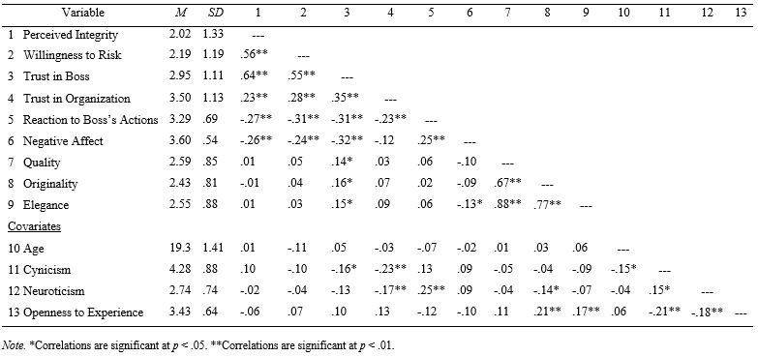

Appendix A: Tables

47

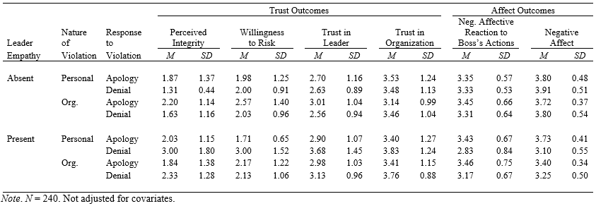
Table 2
Means and Standard Deviations of Trust and Affect Variables by Condition
48

Table 3
Means and Standard Deviations for Performance Variables across Leader Empathy Conditions.

 | Leader Empathy Present |  | Leader Empathy Absent
Performance Variable | M | SD | M | SD
Quality | 2.60 | .81 | 2.58 | .89
Originality | 2.50 | .79 | 2.37 | .82
Elegance | 2.66 | .89 | 2.45 | .87

Appendix B: Figures

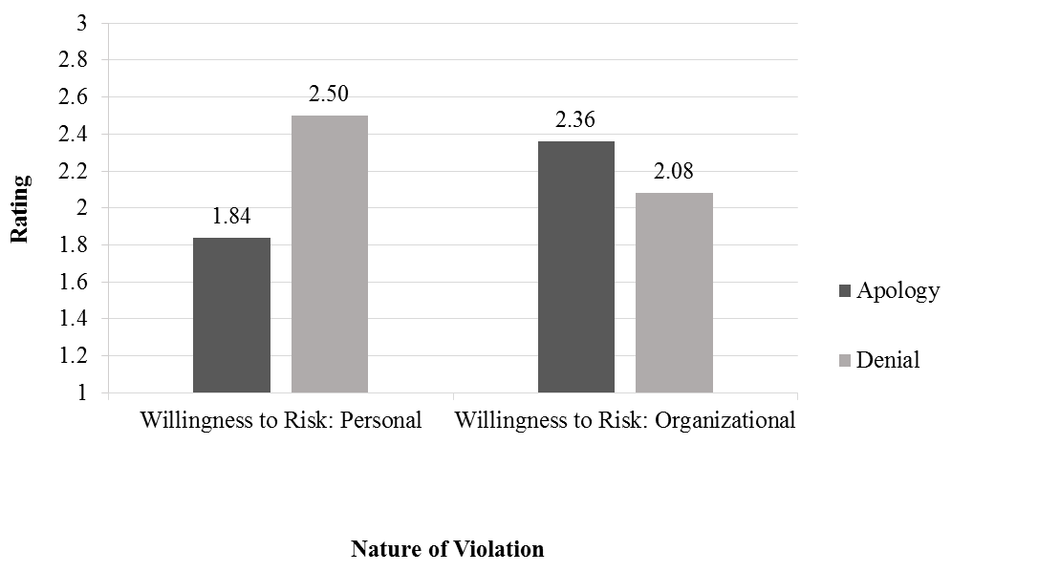

Figure 1. Interaction effect of nature of violation and response to the violation on willingness to risk.

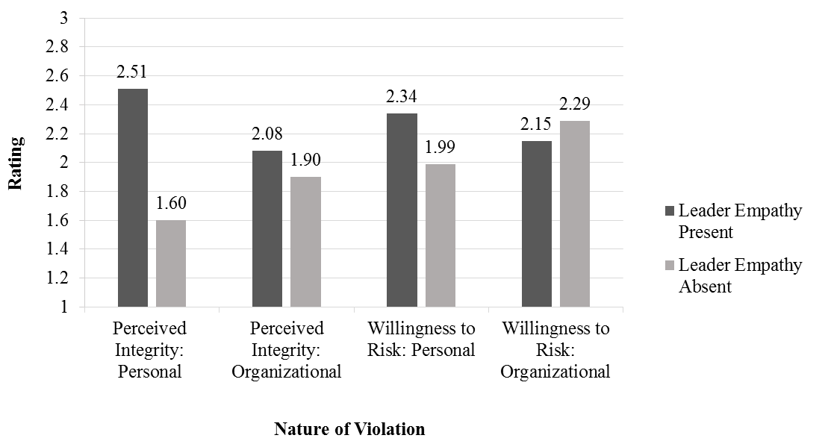
Figure 2. Interaction effect of nature of violation and leader empathy on perceived integrity and willingness to risk.

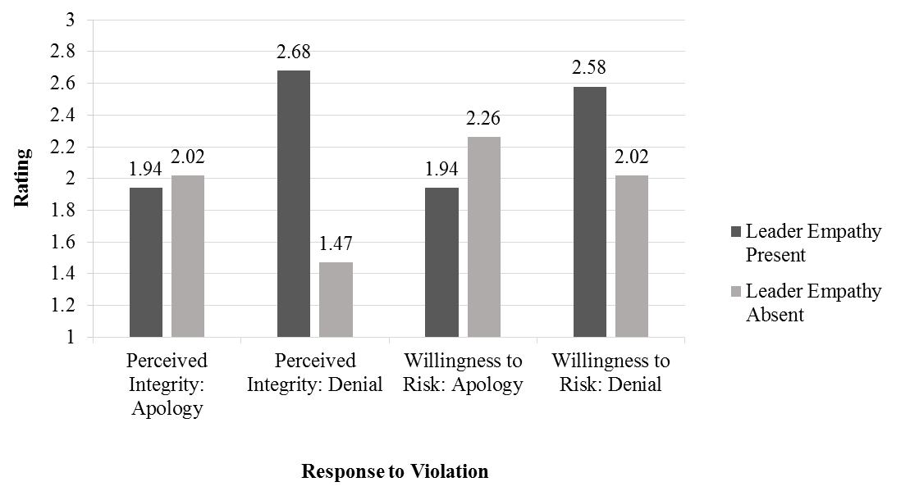

Figure 3. Interaction effect of response to violation and leader empathy on perceived integrity and willingness to risk.

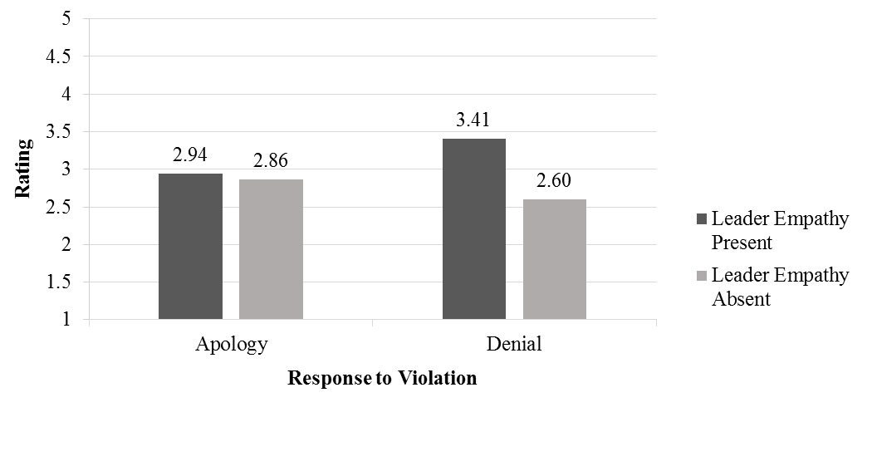
Figure 4. Interaction effect of response to violation and leader empathy on trust in the leader measured via OTI.

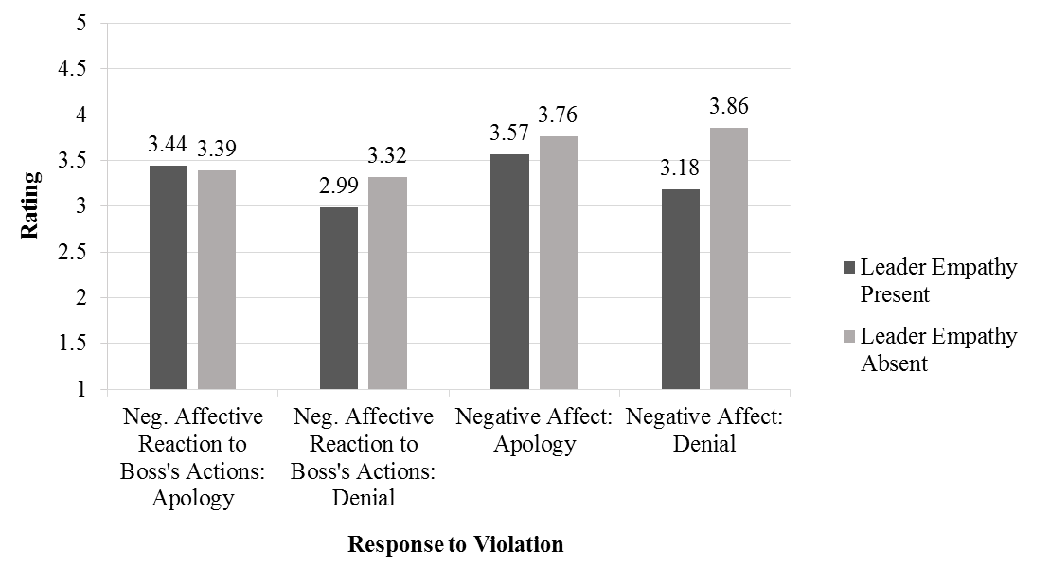

Figure 5. Interaction effect of response to violation and leader empathy on affective reaction to boss’s actions and overall negative affect.

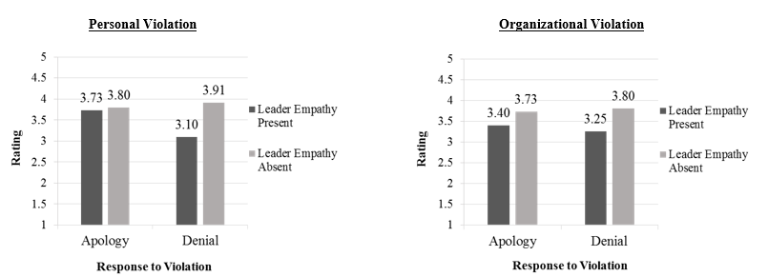

Figure 6. Three-way interaction between nature of the violation, response to the violation, and leader empathy on overall negative affect.
555

Appendix C: Sample Manipulations
Personal Violation, Apology, Leader Empathy Present
Legend:
Single underline = personal violation
Double underline = leader empathy
Italics = apology

You are member of a large accounting firm for a well-known electronics company. You have worked for this firm for 2 years, giving it your all. Given your tenure in the company, you know that you are next in line for a promotion in your department within the course of the coming year.
Your job entails keeping track of the company’s earnings and expenditures. You are then responsible for delivering these documents to the investors so that they are aware of how the company is doing. However, because your direct manager, Chris Johnson, is a new member of the team, he insists that all documents go through him for inspection and that he will then send them out. He explains to you that this will only be done for a brief period of time so that he can gain a better understanding of the company as a whole. He also clarifies that this is his way of “staying in the loop” when it comes to company finances.

At the end of the fiscal year, one of the investment firms contacts you requesting access to company’s financial records, which is their right as a shareholder. Since this is something that occurs often, you gather all the requested information and send it to the investor without further thought. A few weeks later, you are summoned into a meeting with the company’s chief financial officer (CFO). You are shocked when the CFO informs you that the numbers you provided the investors were incorrect, underreporting company expenditures, and overstating the company’s profits, making the company appear to be doing much better than it is. You try to explain to the CFO that your reports were accurate and that as a matter of fact, your manager, Chris Johnson, double-checked everything prior to sending it out. The CFO is not interested in your excuses, informing you that as your signatures are on the documents it is your responsibility to ensure that they are correct. He continues to say that given this mistake, he can no longer consider you for the end-of-the-year promotion you were expecting.

You leave the meeting angry, disheartened, and confused. You just cannot understand how you could have made such a mistake. After double-checking your original reports, you are convinced that Chris Johnson is somehow responsible for the inaccuracies, and you decide to confront him. You find him and relate all that occurred in your meeting with the CFO and show that the documents the CFO provided do not match your original reports. You then ask Chris Johnson directly if he had anything to do with the documents being changed. He admits that he did in fact change a few of the numbers to make the company look better. He assures you that this was the only way to keep the investors happy at his previous job and that he was only acting with company interests in mind. He then asks you to give him a little time to speak with the CFO and try to straighten the whole thing out.

Later, Chris Johnson calls you back in his office. You are hopeful that your boss was able to repair the damage. Unfortunately, he tells you that the CFO was unforgiving, reiterating that it was your job to ensure the accuracy of all paperwork that went out to the investors. He refused to change his position on the matter. Chris Johnson gazes at you apologetically while saying the following: “I’m very sorry that my changes caused this issue. Honestly, I would have never thought that the CFO would react in this manner. I understand that you are angry and confused after the day you’ve had and wish there was something more I could do. Again, I’m very sorry. I hope that you can find a way to make the best out of this situation since we must continue working together. I know you are very capable and I’m sure this will all blow over eventually.” As he utters these words, you believe that he really understands how you are feeling.

Organizational Violation, Denial, Leader Empathy Absent

Legend:
Single underline = Organizational violation
Double underline = No leader empathy
Italics = Denial

You are member of a large accounting firm for a well-known electronics company. You have worked for this firm for 2 years, giving it your all. Your job entails keeping track of the company’s earnings and expenditures. You are then responsible for delivering these documents to the investors so that they are aware of how the company is doing. However, because your direct manager, Chris Johnson, is a new member of the team, he insists that all documents go through him for inspection and that he will then send them out. He explains to you that this will only be done for a brief period of time so that he can gain a better understanding of the company as a whole. He also clarifies that this is his way of “staying in the loop” when it comes to company finances.

At the end of the fiscal year, one of the investment firms contacts you requesting access to company’s financial records, which is their right as a shareholder. Since this is something that occurs often, you gather all the requested information and send it to the investor without further thought. A few weeks later, you are summoned into a meeting with the company’s chief financial officer (CFO). You are shocked when the CFO informs you that the numbers you provided the investors were incorrect, underreporting company expenditures, and overstating the company’s profits, making the company appear to be doing much better than it is. Due to this, the investors are threatening to pull their interest from the company. In order to restore investor confidence, the company has decided to withhold employee bonuses this year to close the margin of error between reported and actual profits. You try to explain to the CFO that your reports were accurate and that as a matter of fact, your manager, Chris Johnson, double-checked everything prior to sending it out. The CFO is not interested in your excuses, informing you that as your signatures are on the documents it is your responsibility to ensure that they are correct.

You leave the meeting angry, disheartened, and confused. You just cannot understand how you could have made such a mistake. After double-checking your original reports, you are convinced that Chris Johnson is somehow responsible for the inaccuracies and you decide to confront him. You find him and relate all that occurred in your meeting with the CFO and show that the documents the CFO provided do not match your original reports. You then ask Chris Johnson directly if he had anything to do with the documents being changed. Chris Johnson then states the following: “I had nothing to do with the inaccuracies in the reports; I’m not sure why you would think that I did. I hope that you can find a way to make the best out of this situation since we must continue working together.” As he utters these words, you find that his tone of voice lacks true compassion and understanding of your feelings.

Appendix D: Performance Task
Now that you have read the scenario in the previous packet, please consider the following information and complete the task that follows.

One month has passed since the incident at your work. You have continued to work for the same organization despite all that occurred. This morning you received the following email from your boss, Chris Johnson. Please consider his request.

I am working on developing a new advertisement of our firm’s services for our company website. We plan to distribute this website link to our current and potential clients. Since I’m fairly new to this firm, I do not yet have the knowledge necessary to highlight all our services. I am hoping that you might be willing to help me with this task. Can you please put together a brief write-up of our services, specifically highlighting our strengths as a company? Your help with this task would be highly appreciated. Please send me your proposed ideas via email when you’re done so that I may review them before they go to our webmaster, Mike. Thank you.

Your task is to use the list of potential services outlined below to design an advertisement emphasizing the company’s strengths. Use the list as a starting off point – it is by no means exhaustive; feel free to come up with your own ideas. Attempt to make this advertisement as interesting as possible in order to attract potential clients. Get creative about how to advertise your company on the new website. Do whatever you’d like to communicate your ideas on the next 2 pages.

Accounting Firm Services:

- Recommending Income Tax Planning strategies
- Preparing tax returns
- Advising individuals on Personal Finance Planning, including retirement and estate planning
- Reviewing a company's accounting system and recommending improvements
- Consulting on business problems and advising ways to improve the use of a client's resources
- Assisting in the design and installation of data processing and management information systems
- Conducting special studies (financing, inventories, cost accounting, credit, and collection) for your business
- Helping clients apply for loans and credit by gathering and preparing information required by lenders
- Working with clients, attorneys, and bankers on mergers, acquisitions, and expansions
- Business consulting
- Budgeting and forecasting

