UNIVERSITY OF OKLAHOMA
GRADUATE COLLEGE

ENVIRONMENTAL HEALTH INEQUALITIES AND DISCRIMINATORY ZONING: IDENTIFYING SYSTEMIC BARRIERS TO ENVIRONMENTAL HEALTH EQUITY THROUGH COMMUNITY-ENGAGED RESEARCH

A DISSERTATION
SUBMITTED TO THE GRADUATE FACULTY
in partial fulfillment of the requirements for the
Degree of
DOCTOR OF PHILOSOPHY

By
CARRIE McLACHLIN LESLIE
Norman, Oklahoma
2024

ENVIRONMENTAL HEALTH INEQUALITIES AND DISCRIMINATORY ZONING: IDENTIFYING SYSTEMIC BARRIERS FOR ENVIRONMENTAL HEALTH EQUITY
THROUGH COMMUNITY-ENGAGED RESEARCH

A DISSERTATION APPROVED FOR THE
DEPARTMENT OF SOCIOLOGY

BY THE COMMITTEE CONSISTING OF

Dr. Thomas Burns, Chair

Dr. Ian Carrillo

Dr. Annabel Ipsen

Dr. Jennifer Koch

Dr. Hongwan Li

© Copyright by CARRIE McLACHLIN LESLIE 2024
All Rights Reserved.
Acknowledgements

This work is dedicated to the JFK Neighborhood in particular the JFK Neighborhood Association, especially, Denyvetta Davis, President, Rodney Redus, Vice-President, his wife Cresha Redus, Greg Jones, Board member, Diane McDaniel, JFKNA Secretary, Guy Rhône, Taylor Doe, Eva King, and Marion West. As a neighborhood, they have been organizing for decades to improve the environmental health of their community, and I hope this research can contribute to achieving the environmental justice that they deserve, free of industrial smoke, explosions, and fires. It is their right to have equal environmental health. I am also grateful for Senator George Young, who has represented the JFK Neighborhood as a State Senator with conviction towards improving public health and the equitable distribution of municipal amenities that his community deserves and for Councilwoman Nikki Nice who fearlessly leads her community to be emboldened in the pursuit of justice and equity. I am grateful for Representative Ajay Pittman for her commitment to pursue strategies to address the environmental inequalities in the JFK Neighborhood.

I am grateful for Dr. Thomas Burns, my committee chair, for his commitment to promoting a healthy human-ecological balance for future generations and including me as a writing partner for several publications. Beyond this, he has supported me as a scholar and allowed me to lead with my ideas. I am extremely grateful for Dr. Ian Carrillo, for his unwavering commitment to racial justice and equality and the impactful research that he has shared and conducted. Dr. Carrillo, thank you also for many discussions helping to shape my research focus. Dr. Annabel Ipsen, thank you for your incredible support in this process – your meaningful feedback has shaped critical attributes of this research, and your diligent support has been invaluable. Dr. Jennifer Koch, thank you for the genuine encouragement throughout my doctoral career, and for our collaborative research on telecoupling, teleconnections, and climate change. Dr. Hongwan Li, thank you for eagerly accepting to work with the JFK Neighborhood to improve air quality and install air quality monitors to track the pollutants in which the residents are exposed and for your overall support of my work.

For my academic ‘big sisters,’ Laura Bray and Maggie Leon-Corwin, you have both been role models for me, and all your advice shared has been phenomenal. I am also grateful for conversations about the importance of environmental justice with Marina Cucuzza and Codie Winn. I am thankful for Sarah Terry-Cobo and T.O. Bowman with the OKC Office of Sustainability, who are leading the way towards a more sustainable and equitable city and state. I am equally grateful for Dr. Tim Filley and the Institute for Resilient Environmental and Energy Systems (IREES), for all the applied work that we have undertaken in creating resilient environmental systems, and for the critical role of environmental justice in this pursuit. I want to thank Dr. John Harris and Vanessa Morrison, Director of the Institute for Quality Communities, for their steadfast commitment to meaningful community engagement. Dr. Jeff Kelly, thank you for your mentorship during the NSF NRT Fellowship, you expanded my focus to interdisciplinary research, and I am forever in appreciation of you. I am grateful for Legal Aid of NorthWest Texas, in particular Adam Pirtle, who has given the JFK Neighborhood a pathway in filing a Title VI Complaint regarding the discriminatory zoning conditions that they face. I am so proud of the students that I have had in the Environmental Studies Capstone partnered with the JFK Neighborhood Association, each of you has made a difference, and to Dr. Zev Trachtenberg, Director of Environmental Studies thank you for asking me to be the instructor for such an impactful service-learning course. I am thankful for Dr. Betty Harris who always believed in my work from the beginning.

I am forever grateful to my family. My mother and father who taught me to value education, and following in the footsteps of my father, I will be the first woman in my family to hold a doctoral degree. I am so thankful for my brother and sister-in-law and family, and my extended family across the country in Washington, Colorado, California, Minnesota, and Texas. Most of all, I am grateful to my two children, Darcy and Zion, and it is for them that I am committed to achieving climate health, environmental justice, and health equity, so that their world can be better. To my very dear friends, many are so far away, I am forever indebted to your love.

The JFK Neighborhood is living next the same hazardous industries that they have for decades. Injustices such as this persist everywhere due to the institutions, structures, and systems that have created these patterns of environmental inequality. I am grateful to the discipline that has given me the freedom to think critically. May we all work towards less oppressive systems and environmental justice for all.

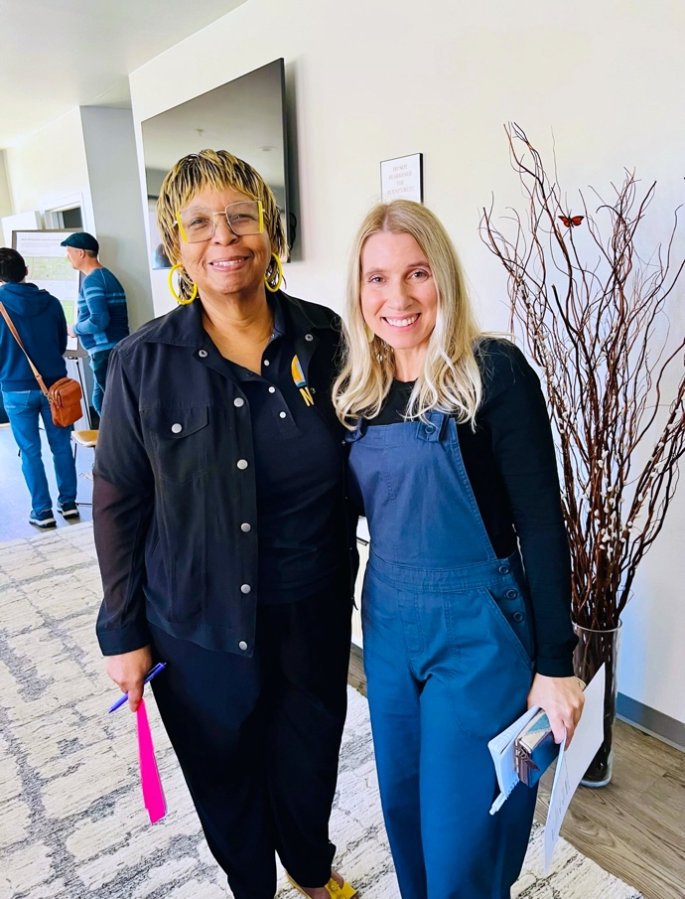

JFK Neighborhood Association (JFKNA) President, Denyvetta Davis & Carrie Leslie after a Neighborhood Association meeting (October 2023)

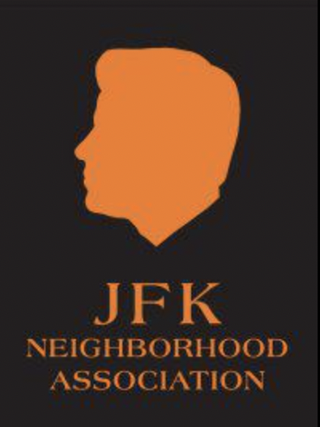
TABLE OF CONTENTS

Chapter & Section Page

- INTRODUCTION 1
Research Methods 5
Community Background 7
JFK Neighborhood Health Outcomes 10
Lynn Institute’s Comprehensive Health Assessment 10
Oklahoma City-County Health Department (OCCHD)’s Wellness Score 13
Chapter Outline 15

- LITERATURE REVIEW
Environmental Health Inequalities from Legacy Industrial Air Pollution and Discriminatory Zoning 17
Racial Health Disparities and Discriminatory Zoning 21
Disparate Exposure to Industrial Pollution and the Social Determinants of Health 23
The State and Environmental Justice Policy 28

- HISTORICAL ANALYSIS
Environmental Inequalities from Discriminatory Zoning and Siting in the JFK Neighborhood 37
Environmental Injustices from Legacy Oil Pollution 43
Zoning Conditions and Injustice 46
Current Heavy Industries near the JFK Neighborhood 55
Citgo Petroleum Corporation History of Operations 55
Derichebourg Recycling Facility History of Operations 57
History of Environmental Activism in the JFK Neighborhood 60

- SYSTEMIC BARRIERS TO ENVIRONMENTAL HEALTH EQUITY
Unequal Environmental Conditions and Environmental Health Inequalities 64
Environmental Justice (EJ) Screen and the JFK Neighborhood 64
Air Quality Monitoring 68
Extreme Heat Islands in the JFK Neighborhood 71
Systemic Barriers that Obstruct Environmental Justice 74
Institutional Inaction 74
Industrial Prioritization 78
Regulatory Gaslighting 81
Discriminatory Negligence of Updating Zoning Conditions 84
Environmental Justice Policy Deficit 86

- CONCLUSION 93
Policy Development as a Pathway for Environmental Health Equity 95

References 101

FIGURES

1. JFK Neighborhood, Oklahoma City, Oklahoma, Nearby Heavy Industries
2. Map of John F. Kennedy (JFK) Neighborhood with Heavy Industrial areas to the South and in the Northeast corner
3. Map marking Heavy Industries and remediated Superfund Sites
4. City of OKC Zoning Map of the JFK Neighborhood and surrounding areas
5. Map of Northeast OKC Zip Codes surveyed in Lynn Institute’s Comprehensive Health Assessment
6. Cardiovascular Mortality Rates for the three zip codes in Northeast OKC compared to County, State, and National Rates
7. Map of Oklahoma City-County Average Life Expectancy by zip code, County Wellness Score 2021
8. Map of “Race Distribution” in Oklahoma City (Hare & Hare, 1931, Official City Planning Report)
9. Drilling and industrial sites within the JFK Neighborhood (The Comprehensive City Plan, 1949)
10. Original Text from City Plan for Oklahoma City, Report of the City Planning Commission, Oklahoma City, Oklahoma 1930
11. Young Boys near Brand YMCA, Oklahoma City, June 16, 1951 (John B. Fink Collection, Western History Collections, University of Oklahoma)
12. Redlined Map of Oklahoma City (Metropolitan Library Systems, Special Collections)
13. Classifications for Industrial Zoning from ‘Light’ to ‘Heavy’ (Oklahoma City Code of Ordinances Chapter 59, Article VI 59-6250.1)
14. Heavy Industrial Zoning (I-3) next to Residential Areas (R-1)
15. Map showing JFK Neighborhood and nearby scrap and industrial recycling yards
16a. Modern zoning map of the JFK Neighborhood and surrounding areas
16b. Key to Zoning Map - JFK Neighborhood and surrounding industrial areas
17. "Tangled wreckage of storage drum is all that remains on this loading dock of Cato Oil & Grease Co.” Photograph taken by George Tapscott for Oklahoma City Times in 1959
18. Derichebourg Industrial Recycling Facility’s enormous pile of car scraps, View driving south on Martin Luther King Ave.
19. Derichebourg Recycling USA Industrial Fire, September 15, 2020 (News 9)
20. Denyvetta Davis, JFK Neighborhood President, in front of her home, 2021
21. News 9 Reports on the JFK Neighborhood and the nearby disruptive explosions
22. Environmental Justice (EJ) Index for Particulate Matter 2.5 exposure for JFK Neighborhood (EJ Screen Tool)
23. Environmental Justice (EJ) Index for Air Toxics Cancer Risk exposure for JFK Neighborhood (EJ Screen Tool)
24. EPA EJ Screen Community Report, Socioeconomic and Demographic information for the JFK Neighborhood (2023)
25. EPA EJ Screen Community Report Graph of all EJ Indexes for the JFK Neighborhood including ‘Particulate Matter,’ ‘Ozone, ‘Diesel Particulate Matter,’ and several other environmental indicators showing the state and national percentiles (2023)
26. Map showing nearest Air Quality Monitors for PM₁₀ and PM_{2.5} at the Central Fire Station OKC (2024)
27. Zoomed in Map showing nearest Air Quality Monitors for PM₁₀ and PM_{2.5} at the Central Fire Station OKC (2024)
28. OKC Office of Sustainability, CAPA Air Quality Monitoring Afternoon Traverse 2023, two locations in JFK Neighborhood measured levels of PM_{2.5} as ‘Unhealthy for Sensitive Groups’
29. Heat Islands in the JFK Neighborhood, OU Landscape Studio Design, 2023
30. Photograph of Oil tanks in between homes in the JFK Neighborhood, 2023
31. Photograph of Derichebourg Recycling USA (industrial recycling facility) explosion from car shredding when fuel left in tank ignites, recording by OKC Housing Authority (Lackmeyer 2021a)
32. Rodney and Cresha Redus, homeowners in the JFK Neighborhood describe negative environmental and health impacts and property damage from the Derichebourg Industrial Recycling Facility explosions (Lackmeyer and Kliewer 2021)
33. Letter from the DEQ regarding explosion at the Derichebourg Industrial Recycling Facility
34. Haskell Lemon Smokestacks, Asphalt Production Facility, on NE 4th St. across from JFK Neighborhood
35. Councilwoman Nikki Nice, OKC City Council, Ward 7, JFK Neighborhood
36. State Senator George Young, District 48, JFK Neighborhood’s Senator, March 2024

Abstract

Environmental justice research has exposed that environmental health inequalities persist for historically redlined communities due to proximity to heavy industrial areas. Communities of color are systematically exposed to air pollution due to structural environmental inequalities. Disparate exposure to legacy pollution is often overlooked as a key contributor of racial health disparities. The underlying historical mechanisms and systemic barriers that perpetuate environmental health injustices have been less identified in critical environmental justice research including how to confront state complicity. I use historical archives, community reports, public health research, environmental data, media articles, industry complaint documentation, and other government documents as primary data sources supplemented with purposive, semi-structured interviews with state legislators, city council leadership, the municipal planning department, and the county health department to identify systemic barriers for environmental health equity. I find that historic processes of racial residential segregation imbedded structural environmental inequalities within neighborhoods, and institutional inaction, industrial prioritization, regulatory gaslighting, and discriminatory negligence of zoning conditions are systemic obstructions to environmental justice. My findings are critical for implementing existing federal civil rights protections, developing environmental-justice based state policies, and enforcing current ordinances for industrial areas adjacent to communities of color to protect environmental health.

Key Words: environmental justice, environmental health equity, racial health disparities, legacy industrial pollution, regulatory gaslighting

“Injustice anywhere is a threat to Justice everywhere” –Dr. & Rev. Martin Luther King, Jr.

CHAPTER 1: INTRODUCTION

“Is the air killing us?” asks Cresha Redus, an active member of the John F. Kennedy (JFK) Neighborhood Association and resident of the Oklahoma City neighborhood that is surrounded by several industrial facilities that emit noxious pollutants into the air daily. According to city ordinances residential spaces are “incompatible” with heavy industrial areas which can “generate relatively high levels of noise, vibrations, smoke, dust, odor or light,” and are to be located “downwind” and “as far away as possible, from residential and most commercial uses” (Oklahoma City Code of Ordinances, Chapter 59, Article VI. § 59-6250). This is not the lived reality for the residents of the JFK Neighborhood, and this spatial inequality and environmental injustice is degrading their health and quality of life.
This research identifies the systemic barriers that exist for remediating urban environmental injustices of disproportionate exposure to legacy air pollution due to the proximity of industrial areas. I introduce the term regulatory gaslighting to describe the process of undermining complaints from residents about air and noise pollution concerns through a requirement of the regulatory inspector witnessing the incidence first-hand. I document the historic processes that embedded these structural environmental inequalities within the JFK Neighborhood through initial racial residential segregation, discriminatory zoning practices, and further industrial siting in the present day. I determine that there is a current lack of state-level policies that protect environmental justice and health for communities like the JFK Neighborhood, and this perpetuates industrial prioritization and state complicity over environmental equity. This further necessitates the implementation of federal civil rights protections in issues of environmental inequality, the development of environmental justice-based state policies, and strengthening the enforcement of existing municipal ordinances regarding the incompatibility of heavy industrial processes adjacent to residential areas like the JFK Neighborhood.
One of the main systemic barriers that many critical environmental justice scholars have identified is the failure of state and local governments to offer equal protection for the environmental health, safety, and well-being of all citizens, particularly in communities of color (Pellow 2016; Pulido 2017; Richter 2019). Environmental racism is systemic, meaning that most instances of discrimination are caused by economic and political systems that favor industrial or corporate interests over BIPOC (Black, Indigenous, and People of Color) communities, perpetuating environmental health inequities and structurally racist practices. As such, infrastructural disparities and ethnoracial health inequities are largely the result of “structural racism—that is, the inequitable distribution along racial and ethnic lines of power, resources, and services that shape population health” (Smedley 2018:348). My research responds to the call to study the “institutional mechanisms driving environmental health inequalities” throughout the United States (Alvarez 2023:244).
Previous research on disproportionate exposure to hazardous pollution and health indicates that degraded environmental health is directly linked to poor health outcomes (Alvarez 2023; Brulle and Pellow 2006; Ruiz et al. 2018; Wodtke et al. 2022). Environmental justice research has clearly articulated the connection between environmental degradation and health inequalities for marginalized communities (Auyero and Swistun 2008; Carrera and Brown 2020; Richter 2019). Yet there has been less applied research that documents the mechanisms that drive ethnoracial health disparities related to systemic environmental inequalities resulting from industrial pollution exposure (Wodtke et al. 2022). Regarding public health interventions there is a disconnect between individual-level health problems and overall environmental health, particularly for low-income households and communities of color. Racial minorities and communities, as well as lower-income families, have historically been exposed to unhealthy environments, as well as other socio-economic inequities related to poverty and political marginalization that degrade environmental health (Taylor 2014). Lack of adequate nutrition and other conditions of poverty have been linked to health disparities for communities of color, but disproportionate exposure to pollution is getting more attention as a negative determinant of overall health.
One of the main health impacts from historic racial residential segregation is the disproportionate exposure to air pollution for communities of color. Dorceta Taylor (2014) has detailed the overlapping systemic processes that have historically exposed communities of color to toxic pollution, including proximity to chemical waste and hazardous air emissions throughout the last century of the United States. Black neighborhoods have been historically segregated near heavy industry or other hazardous sites (Taylor 2014:269; Trounstine 2018). The spatial organization of environmental racism, through persisting systemic racial segregation has been prevalent in both urban and rural spaces across the United States (Ard 2016; Ard and Smiley 2022; Liévanos 2019). The current impacts from historic redlining processes and disinvestment for communities of color include severe health consequences, particularly regarding risk of pre-term birth (Krieger et al. 2020a), increasing cardiometabolic risk (Motairek et al. 2020), and prevalence of cancer development (Krieger et al. 2020b).
In 2021, the Director of the Centers for Disease Control and Prevention (CDC) declared “racism a serious public health threat” (CDC 2023). Despite the acknowledgement that racism is a negative social determinant of health, there is less research that analyzes the specific structural mechanisms that perpetuate ethnoracial health disparities from industrial air pollution. Other calls for more research on “an examination of the historical impact of systemic racism on the social determinants of health” (Payne-Sturges et al. 2021; Castle et al. 2019) are bringing focus to the systemic processes that have historically maintained and currently exacerbate environmental health inequalities. Analyzing “the active means by which dominant groups assert power to protect their material interests” has been a mechanism that perpetuates unequal environmental conditions and the devaluation of non-white lives (Richter 2018:107; Pulido 2017). This approach exposes the institutional failure to protect communities of color from disparate negative health impacts from environmental pollution. Research focused on race and racism, as key drivers of environmental injustices, is also a critical avenue for investigating the complicity of the state and policy shortcomings. By identifying “evidence of environmental health harms,” which can at times be less visible, is integral for exposing the inconsistencies of “the institutions mandated to protect” (Richter 2018:107). Because poor health is often conflated with the degraded living conditions associated with poverty, the investigation of nearby polluting industries or hazardous contaminants are neglected as non-direct factors.
My research asks: 1) What systemic barriers do communities face when seeking environmental justice and health equity from legacy industrial pollution? 2) What historical mechanisms established structural environmental inequalities as the basis of current discriminatory zoning and siting conditions? 3) What types of state policies exist that could lead to improvements in environmental health equity in polluted spaces? I find the systemic barriers that prevent environmental justice for communities of color include institutional inaction, industrial prioritization, regulatory gaslighting, discriminatory negligence of updating zoning conditions, and outdated municipal land use policies. I document the historical mechanisms that constructed structural environmental inequalities through discriminatory zoning in the 1950s and a continuation of hazardous industrial use of surrounding facilities. The current state-level political culture has made it difficult to develop environmental justice policy. This lack of policy perpetuates state complicity and a prioritization of industry over community well-being. Strategies for combatting this exist in strengthening city municipal code enforcement, development of environmental justice-based state policies, and implementation of existing federal civil rights protections.

Research Methods
Since January 2023, I have been working in close partnership with the JFK Neighborhood Association and President, Denyvetta Davis, community organizer and President of the Northeast Oklahoma City Neighborhood Coalition. My research questions evolved from a grounded research model through engagement with the JFK Neighborhood Association. Through this research, I identify the historical mechanisms and systemic barriers that continue to allow institutional neglect but present the external appearance of following regulatory protocol (Pulido 2017). My research ascertains what types of government policies and regulations could help to achieve improvements in environmental health for the JFK Neighborhood.
My research emphasizes authentically engaging with the community through a collaborative process to determine research needs, as well as identifying solutions and future pathways from the research findings. This model of research is often classified as community-engaged research, which is similar to community-based participatory research (CBPR) (Wallerstein et al. 2020), as well as community change research (Stoecker 2012). Community-engaged research has been vital for addressing environmental justice issues and promoting health equity through active involvement of community organizations and leaders, as well as empowering these same community groups through the creation of lasting partnerships that impact local environmental decisions (Den Broeder et al. 2017; Haynes et al. 2016; Mullenbach and Baker 2020; Sousa 2021). My third research question, ‘What types of state policies exist that could lead to improvements in environmental health equity in polluted spaces?’ is informed by a request from the JFK Neighborhood Association President to determine if there are any existing state laws that could protect the neighborhood from disparate exposure to legacy air pollution or uphold public health standards.
To answer my research questions, I gathered historical archives, community reports, public health research, environmental data, media articles, industry and environmental regulatory reports, and other government documents, including the Department of Environmental Quality (DEQ) complaint records for Citgo Petroleum Corporation and the Derichebourg Recycling facility adjacent to the JFK Neighborhood. I also analyzed the transcripts of recorded focus group interviews with the JFK Neighborhood Association archived with the Metropolitan Library System which provided first-hand testimony from residents regarding health, property, and overall justice concerns. I supplemented this data with purposive interviews with state and city government leadership including two state senators, one state representative, and the city council representative for the neighborhood and surrounding neighborhoods, as well as the assistant director and associate planner of the municipal planning department and the manager of protective health services at the county health department. I chose purposive sampling in order to interview key actors in both municipal and state government leadership roles due to their unique political and administrative positionality.
I conducted semi-structured interviews to understand emergent themes but also follow my designated research questions. Interviews were in person or held as a Zoom or Google Meet online video meeting and lasted between 2 hours and 30 minutes. I recorded the interviews and took notes on important details. After an extensive and iterative analysis of my primary sources, I analyzed my interviews using thematic codes. My selective thematic codes were: ‘anti-environment state political climate,’ ‘lack of state legislation to protect environmental health,’ ‘systemic barriers to developing state environmental justice and health legislation,’ ‘industrial prioritization,’ ‘power disparities,’ ‘differential and inconsistent treatment or environmental inequalities,’ ‘neighborhood health,’ ‘disempowerment,’ ‘institutional inaction,’ ‘regulatory negligence,’ and ‘regulatory gaslighting.’ I identified the over-arching themes in my primary data and purposive interviews to describe key systemic barriers for environmental justice and health for underserved communities and the conditions needed for establishing environmental health equity.

Community Background
The JFK Neighborhood, in Northeast Oklahoma City, a historically Black residential area, which was forcibly segregated during the early part of the twentieth century through Jim Crow laws, prohibited Black residents from living north of NE 8th St. (Denyvetta Davis 2023). The area was formally zoned for industry in 1951 by city planner, Donald White, who “reported the area was ‘ideally suited’ for such use” and did not consider the negative impacts for Black residents (Lackmeyer and Kliewer 2021). Today, the neighborhood is across the street from hazardous industries including Haskell Lemon Construction and Citgo Petroleum Corporation Refinery. Hite Plastics recycling recently had a large industrial fire requiring eight fire units and the Hazardous Materials Unit, to control the blaze (KOKH Staff 2023). The Derichebourg Recycling facility (a French corporation), in close proximity, has had intermittent explosions since the 1980s due to remaining gas in car engines causing explosions when the liquid is heated in the process of shredding. The Citgo Petroleum Corporation Lubricants Manufacturing refinery and storage facility has directly contributed to the air quality concerns with its active smokestacks that blow into the JFK Neighborhood (Figure 1 and 2).
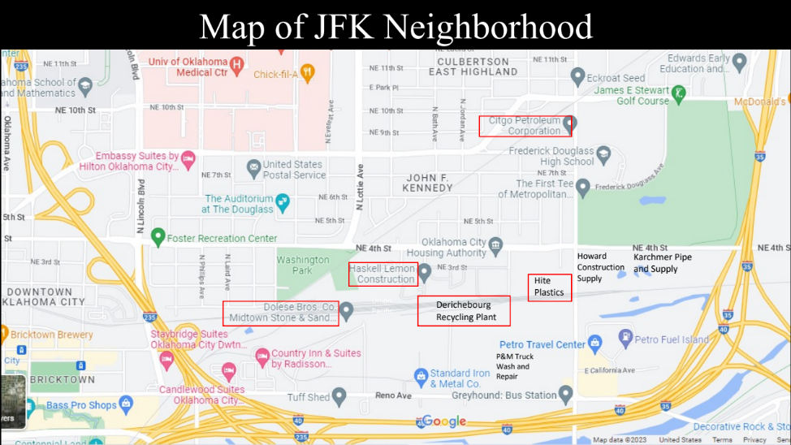
Figure 1. JFK Neighborhood, Oklahoma City, Oklahoma, nearby heavy industries framed in red
(April 2023)

As seen in Figures 1 and 2, the residential portion of the JFK Neighborhood is near the industrial sites such as Dolese Brothers Stone and Sand, Haskell Lemon Construction, Derichebourg Industrial Recycling plant, Hite Plastics, and the Citgo Petroleum Corporation to the north, in the eastern corner of the JFK Neighborhood.
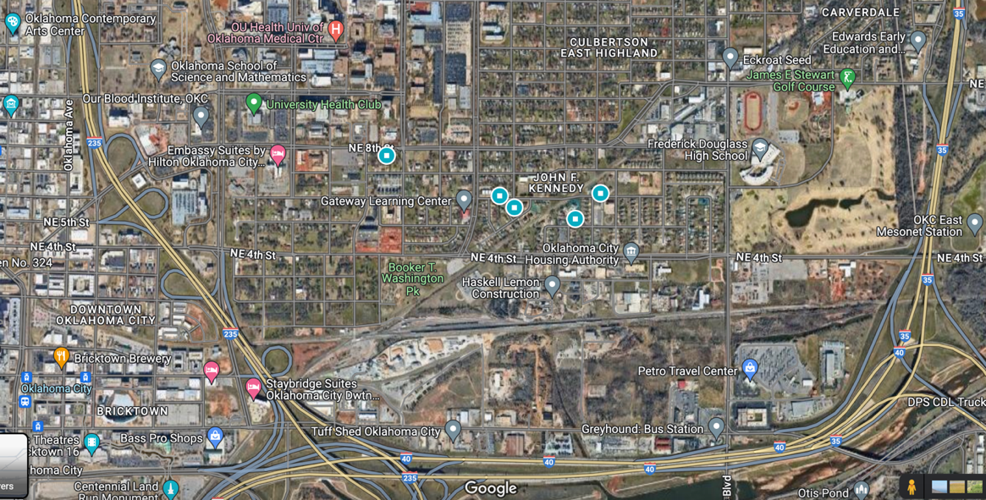
Figure 2: Map of John F. Kennedy (JFK) Neighborhood with Heavy Industrial areas to the South and in the Northeast corner (2024)

Figure 3 offers another visual depiction of the heavy industries near the JFK Neighborhood in black. The red areas in the lower map are Superfund sites that have been remediated by the EPA (Oklahoma Department of Environmental Quality 2023).
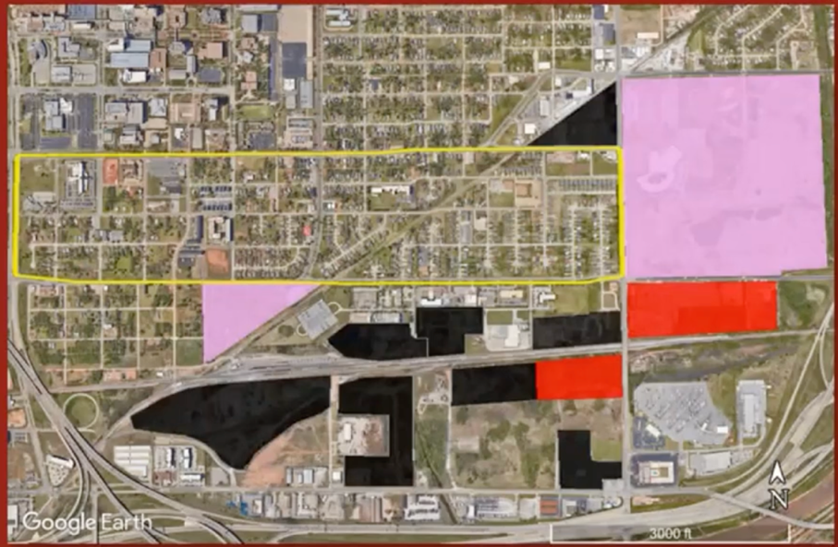
Figure 3. Map marking Heavy Industries in black and remediated Superfund Sites in red, Booker T. Washington Park and Frederick Douglass High School in purple, JFK Neighborhood framed in yellow (OU Civil Engineering and Environmental Science (CEES) 2022)

JFK community members are frequently exposed to hazards from these facilities, including air pollution, fine particulate matter, and dust that blows across the neighborhood. Figure 3 shows a map of the current zoning areas for residential, or ‘Single-Family Residential’ (R-1) and heavy industries, or ‘Heavy Industrial’ (I-3). The “Heavy Industrial District” (I-3) District is intended to “provide locations for those industrial uses that may generate relatively high levels of noise, vibrations, smoke, dust, odor or light” stated in the Classifications for Industrial Zoning chapter of the OKC Code of Ordinances.
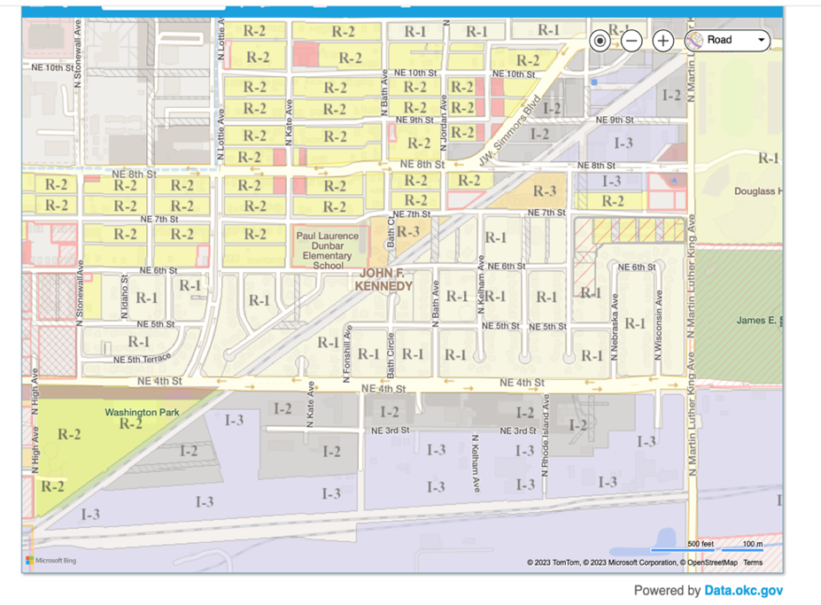
Figure 4: City of OKC zoning map of the JFK Neighborhood and surrounding areas (City of Oklahoma City. “City of OKC.” Zoning Map, https://www.okc.gov/departments/planning/subdivision-zoning/zoning-map)

It further describes that these “industrial uses are incompatible with residential uses,” and “it is desirable that they be located downwind, and as far away as possible, from residential and most commercial uses” (OKC Code of Ordinances Chapter 59, Article VI).

JFK Neighborhood Health Outcomes

Lynn Institute’s Comprehensive Health Assessment

In 2014, the Lynn Institute for Healthcare Research “undertook a comprehensive assessment of Northeast Oklahoma City as the first step of a multi-year program to measurably improve the health of the community” (Lynn Institute 2016:9). Lynn Institute Lynn Lifestyle Summary – Northeast Oklahoma City 2016 presented findings that depict the disparities of health outcomes for Northeast OKC. The report is comprised of statistical data as well as interviews with community leaders and residents. This health assessment was undertaken because “generations of high-risk health conditions including diabetes, obesity, hypertension, and a high infant mortality rate” have disproportionate negative health impacts for Northeast OKC. This part of OKC leads the nation in “morbidity from preventable disease” and “inadequate access” to health services (Lynn Institute 2016:9). The residents of Northeast Oklahoma City have endured “multiple adversities and a long history of institutionalized racism” but still have immense pride in their community and “exhibit cohesiveness” in organizing for equal amenities. The area also has the “largest concentration of African Americans in Oklahoma” creating a “unique history” and shared “cultural heritage prized by residents” (Lynn Institute 2016:9).
Compared to other Oklahomans, however, citizens of Northeast Oklahoma City have a “higher morbidity rate in every major disease” (Lynn Institute 2016:10). The suicide rate in the neighborhood is “more than double the rest of Oklahoma and the nation” (Lynn Institute 2016:10). For the zip code, 73105, directly north of the JFK Neighborhood, since 2016, “stroke mortality has increased by 91% and chronic lower respiratory disease mortality has increased by 219%” (Lynn Institute 2022:11). Northeast Oklahoma City includes zip codes 73105, 73111 and 73117 comprising a “20-square mile area and include some 22,000 of Northeast Oklahoma City’s 33,000 residents” (Lynn Institute 2016:9; Figure 5).

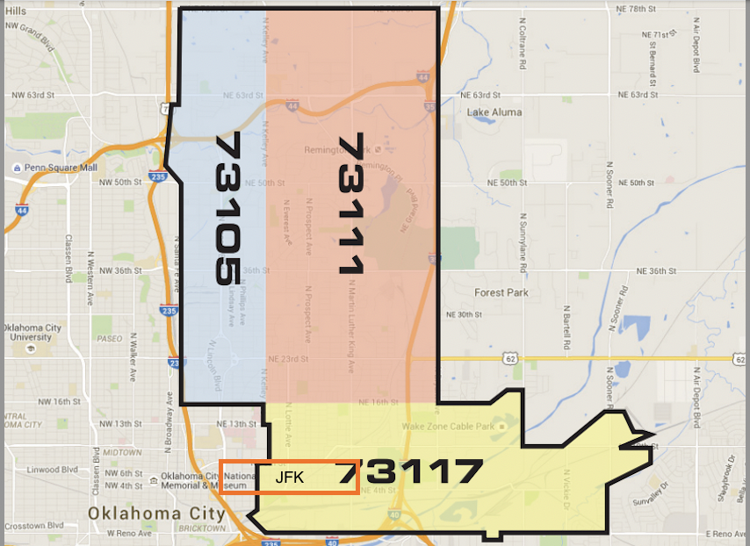
Figure 5. Map of Northeast OKC zip codes surveyed in Lynn Institute’s comprehensive health assessment in 2016 and repeated in 2022 (Lynn Institute 2016:12)

Heart disease is responsible for “234.2 deaths per 100,000 people in the United States, 303.9 deaths per 100,000 in the state of Oklahoma, and 269.1 deaths per 100,000” in Oklahoma County. In the tri-zip area, mortality rates from cardiovascular disease are higher than the state and county and double the national rate in the zip code 73117, at 519.5 deaths per 100,000, where the JFK Neighborhood resides (Lynn Institute 2016:17; Figure 6), measuring the highest death rate from cardiovascular disease.

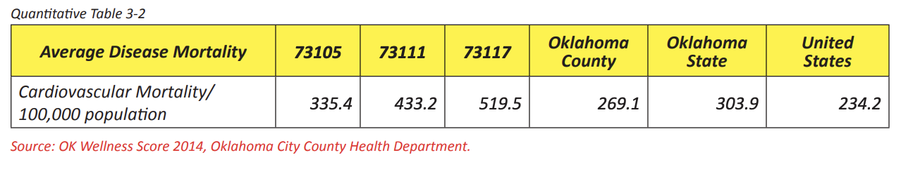
Figure 6. Cardiovascular Mortality rates for the three zip codes in Northeast OKC compared to county, state, and national rates, the JFK Neighborhood’s zip code (73117) has the highest rate at 519.5 per 100,000 (2016).

For diabetes, “the mortality rates in 73111 and 73117 are exceptionally higher than the county, state, and nation” (Lynn Institute 2022:11). These diabetes mortality rates are disproportionately higher than other zip codes in Oklahoma City, as well as across the state and nation. Research has found negative correlations between diabetes complications and air pollution (Mujahid et al. 2023; Ruiz et al. 2018). Since the Lynn Health Research Summary report for Oklahoma City (2016), the diabetes mortality rate has “increased by 81%” in zip code 73111, north of the JFK Neighborhood (Lynn Institute 2022:11). In zip code 73105, stroke mortality has increased by 91% and chronic lower respiratory disease mortality has increased by 219% (Lynn Institute 2022:11). In Chapter 2, I document research on negative health impacts from air pollution exposure. Findings conclude that frequent exposure to air contaminants weakens the overall physiological functions of the body.

Oklahoma City-County Health Department (OCCHD)’s Wellness Score
The Oklahoma City-County Health Department (OCCHD) has collaboratively created a ‘Wellness Score’ for every zip code in Oklahoma County within Oklahoma City which provides an “overall summary of community health status” (Oklahoma City-County Health Department - OCCHD 2021:3). More specifically, OCCHD “consulted with representatives across multiple agencies in Oklahoma County to obtain data variables. Data analysis was divided into 10 different categories including both determinants and outcomes to “assess the health and wellness of our communities” (OCCHD 2021:5). In order to create the ‘Wellness Score 2020,’ the OCCHD utilized “the Mobilizing for Action through Planning and Partnership (MAPP) tool to conduct community-wide health needs assessments” through engagement with “individuals, programs, and organizations across the city and county to collect qualitative and quantitative data” (OCCHD 2021:3). For the “Overall Wellness Score,” which includes measures for years of potential life lost, overall life expectancy, and a health index profile, the zip code 73117, in which the JFK Neighborhood resides, is in the category of second highest rate of potential life lost from 2016-2018 (OCCHD 2021:154). The same area where the neighborhood resides and zip code, 73117, has one of the lowest urban average life expectancies, along with four other nearby zip codes, in Oklahoma City-County (OCCHD 2021:156; Figure 23). Two of the other zip codes, 73111 and 73141, that have the lowest range of life expectancy border the zip code, 73117, where the JFK Neighborhood is located. For the JFK Neighborhood and the zip code, 73117, the average life expectancy is 68.19 years.
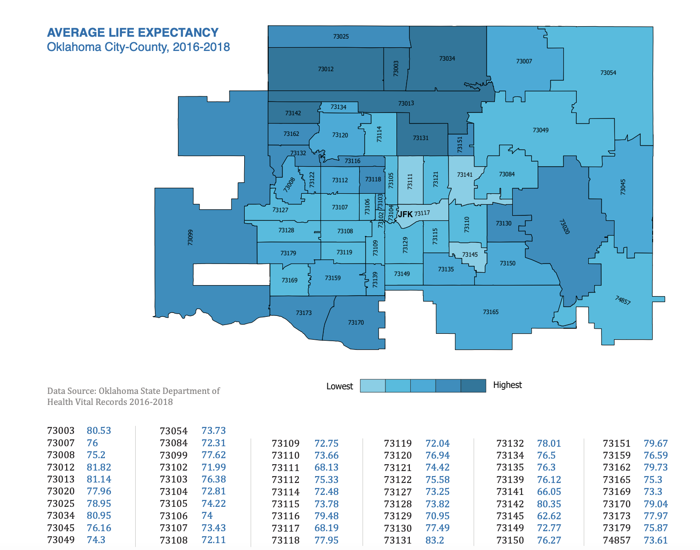
Figure 7. Map of Oklahoma City-County Average Life Expectancy by zip code, the JFK Neighborhood is in the western half of 73117 in the lowest range of life expectancy, (OKC-County Health Department Wellness Score 2021)

For the variables and data that measure the ‘Environment’ category in the Wellness Score, ‘grocery store availability,’ ‘housing security,’ ‘vehicle access,’ and ‘average number of food establishment violations’ are analyzed. There are not currently corresponding measures for ‘exposure to environmental pollution’ or ‘proximity to industrial pollution’ in the environmental analysis for the county wellness score. There is not currently anyone who works at the OCCHD who focuses on environmental health, related specifically to the public health impacts or necessary environmental health protections from industrial pollution. OCCHD’s Manager of Protective Health Services explained that this regulatory action related to pollution was designated to the Department of Environmental Quality (DEQ). Adding a variable that measures ‘proximity to industrial pollution’ or ‘exposure to hazardous emissions or contaminants’ would increase an understanding of negative public health outcomes due to frequent exposure to pollution and its connection to overall wellness scores and other environmental health predictors.

Chapter Outline
My dissertation is organized into five chapters. Chapter 1 provides an overview of my research on the impact from legacy industrial pollution on racial health inequalities, specifically how disproportionate exposure to poor environmental health conditions, including degraded air quality, impacts public health for communities of color. My research identifies the systemic barriers to achieving environmental health equity and finds that the state is complicit with the perpetuation of environmental injustices through a lack of EJ-based policy development. I describe my data collection methods. I introduce the contextual background of the community that I am working in partnership with, the JFK Neighborhood in Oklahoma City, using a community-engaged research model. In Chapter 2, I offer a systematic review of previous research on the production of inequitable environmental health through discriminatory zoning processes. I build on calls for more research on the “structural mechanisms” (Alvarez 2023) that maintain environmental health inequalities. I find a similar research gap in the lack of identification of the specific systemic barriers that maintain environmental health inequities through exposure to legacy indusial air pollution and the maintenance of discriminatory zoning conditions. I review environmental justice research on state complicity, and I conclude that state political climate impacts environmental justice policy existence. This lack of policy causes the state to offer little to no protection for communities burdened by environmental injustice and health inequities. In Chapter 3, I document the historical mechanisms that have embedded structural environmental inequalities within the JFK Neighborhood and how discriminatory zoning and more recent environmental siting decisions have maintained these injustices. I discuss how these hazardous conditions continue to impact current environmental health in the neighborhood as well as harm residents and exacerbate existing racial health disparities. Chapter 4 presents my findings that identify specific systemic barriers that obstruct environmental health equity for the JFK Neighborhood and communities of color. These systemic barriers are described in detail and are maintained through regulatory, institutional, and structural processes. Chapter 5 summarizes my key findings regarding historical mechanisms and systemic barriers to environmental health equity and offers suggestions to guide policy development to ensure equal environmental health conditions.

CHAPTER 2: LITERATURE REVIEW - Environmental Health Inequalities from Legacy Industrial Air Pollution and Discriminatory Zoning

Unequal distributions of environmental hazards further compound environmental health inequalities and have obstructed pursuits of environmental health equity. Throughout the history of the United States, the process of discriminatory zoning has caused communities of color to be disproportionately exposed to industrial hazards, contributing to unequal health burdens for these communities. The resistances led by communities facing environmental injustices has been instrumental in working to address the systemic barriers for environmental health equity, not without challenges from institutional and structural processes that maintain systemic discrimination. While Critical Environmental Justice (CEJ) research has called for “multiscalar analysis of the causes, consequences, and possible resolutions of EJ struggles” (Pellow 2018:14), there has been less research on identifying the specific systemic barriers that perpetuate environmental injustices and are maintained through structural, institutional, and micro-level processes.
In general, research on environmental injustices has exposed that “ethnic minorities, Indigenous persons, people of color, and low-income communities confront a higher burden of environmental exposure from air, water, and soil pollution from industrialization, militarization, and consumer practices” (Mohai 2009:406). This is also known as “environmental racism, environmental inequality or environmental injustice” (Bacon 2019; Mohai et al. 2009:406). Environmental racism is defined as:
an extension of racism. It refers to those institutional rules, regulations, and policies of government or corporate decisions that deliberately target certain communities for least desirable land uses, resulting in the disproportionate exposure of toxic and hazardous waste on communities... Environmental racism is the unequal protection against toxic and hazardous waste exposure and the systematic exclusion of people of color from decisions affecting their communities (Bryant 1995:6)

Due to the concentration of pollution and polluted areas in communities of color, this frequency and statistical prevalence is increasingly hard to ignore related to its connection to persisting systemic inequities. “Empirical research is now catching up with the reality: that America is segregated and so is pollution” (Tabuchi and Popvich 2021; Bullard 2021). Exposure to legacy industrial pollution is particularly disproportionate for BIPOC communities and continues to exacerbate existing health disparities.
Extensive research has concluded that air pollution is a detriment to human health and has been linked to several negative health outcomes (Kelly and Fussell 2015; Monoson et al. 2023; Sun and Zhu 2019; Turner et al. 2020). Air pollution is known to exacerbate respiratory conditions such as asthma (Guarnieri and Balmes 2014) and cause lung cancer (Cohen and Pope 1995). Current research has found linkages between poor air quality, carcinogenesis, and the deterioration of overall health (Wei et al. 2012; Wong et al. 2016). Exposure to toxic air pollutants is associated with pulmonary (Kyng and Jeong 2020; Manisalidis et al. 2020), cardiovascular (Franklin et al. 2015), skin (Abolhasani et al. 2021), and autoimmune conditions (Piovani et al. 2023), and is linked to chronic kidney disease (Liang et al. 2015). With more prolonged exposure, there is greater risk for cardiovascular mortality (Chen et al. 2013; Hayes et al. 2020; Park 2018).
Vulnerable populations such as children, the elderly, and individuals with pre-existing diseases are more susceptible to negative health impacts from poor air quality (Gent and Bell 2010). Increases in new asthma cases in children, ages 0-17, and premature deaths in adults 65 and older have been linked to excessive exposure to particulate matter (PM_{2.5} and PM₁₀) pollution according to the Environmental Protection Agency (EPA) report on climate change and social vulnerabilities (EPA 2021). Greenhouse gas (GHG) emissions negatively impact health and longevity and contribute to disparities in health outcomes for marginalized and vulnerable populations (Lenzen et al. 2020; Masiero et al. 2022). Greenhouse gas (GHG) emissions, or climate pollution, particularly carbon-based air pollutants, carbon dioxide (CO₂) and methane (CH₄), have a direct negative impact on health. Methane emissions degrade air quality and along with the oxides of nitrogen (NO_{x}), contribute to the formation of ozone and particulate pollution. According to the Environmental Defense Fund, “exposure to ozone damages airways, aggravates lung diseases, causes asthma attacks, increases rates of preterm birth, cardiovascular morbidity and mortality, and heightens stroke risk” (2024).
Oil refineries in particular produce several toxic air pollutants (Allen 2016; Shriver et al. 2020; Viswanath 1994). Oil and gas industries are more prevalent in low-income communities of color (Johnston and Cushing 2020). For example, “in Oklahoma, Ohio, and West Virginia, approximately one in five African Americans,” out of all the United States, live within a “half mile radius of oil and gas facilities” (Fleischman and Franklin, Clean Air Task Force 2017). The closure of an oil refinery in Oakville, Canada created the setting for a natural experiment providing evidence that a reduction in harmful emissions was associated with overall population health improvements (Burr et al. 2018). The location of oil refineries as well as other heavy industrial smokestacks has been the cause of adverse health effects for communities of color and low-income populations. The Citgo Petroleum Corporation’s Lubricants Manufacturing Plant is located adjacent to the JFK Neighborhood in the northeast corner.
Disproportionate exposure to air pollution has been associated with exacerbating health disparities, particularly for communities with certain ethnoracial demographics (Banzhaf et al. 2019; Collins et al. 2017; Jbaily et al. 2022; Hajat et al. 2015; Lane et al. 2022; Liu et al. 2021; Mikati et al. 2018; Paolella et al. 2018). Research has highlighted the unequal distribution of air pollution systematically affecting communities of color in the U.S., as far as disproportionate exposure to PM_{2.5} (Bravo et al. 2016; Tessum et al. 2021). Pollution disparities impact Black populations, exposed at much higher rates to PM_{2.5} than other racial groups including white populations, with consistently lower exposure to air pollution (Tabuchi and Popvich 2021). Disparities in exposure to major air pollutants, including PM_{2.5} and NO₂ have been correlated with health inequalities, particularly related to chronic obstructive pulmonary disease (COPD) and other severe respiratory conditions (Colmer et al. 2020; Li et al. 2016). Respiratory diseases, including asthma and emphysema, are more prevalent in communities of color adjacent to highways or diesel exhaust and exacerbate conditions for sensitive groups including children and older populations (Hauptman et al. 2020; Liu and Grigg 2018). Bullard (2000:6) describes the dangers of living near “health-threatening problems.” Industrial pollution, congestion, and busy freeways producing health burdens “in the form of higher risks of “emphysema, chronic bronchitis, and other chronic pulmonary diseases” (Bullard 2000:6).
Legacy pollution, or a historical prevalence of exposure to degraded environmental health conditions directly correlates with lower health outcomes for communities living near industrial-use zoned areas. “Legacy contamination” continually harms “new generation[s] of residents in fence line communities,” (Johnston and Cushing 2020:48). Negative health impacts from air pollution have been predominant in neighborhoods zoned adjacent to highways or industrial areas and continue to cause environmental health inequalities for communities of color. Most recently, this was shown in exposure to air pollution as linked to COVID-19 severity and mortality, showing racial minorities in metropolitan areas as being disproportionately impacted (Brandt et al. 2020). Environmental health and justice inequalities perpetuate existing systemic and structural inequities (Malin et al. 2019), and there is a clear link between ambient air pollution and negative impacts on environmental and public health.

Racial Health Disparities and Discriminatory Zoning

Discriminatory zoning is the practice of implementing zoning regulations that disproportionately impact certain communities or neighborhoods based on race, ethnicity, or socioeconomic status (Bullard 1993, 1996; Taylor 2014). The history of discriminatory zoning in the United States has excluded racial and ethnic minorities from municipal amenities and affluent neighborhoods through exclusionary zoning policies (Desmond 2023; Shertzer et al. 2016; Taylor 2014; Trounstine 2018). This causes an unequal distribution of environmental hazards, such as industrial facilities or pollution emissions, resulting in disproportionate adverse health outcomes for communities of color and perpetuating systemic inequalities (Bergmann and Sengupta 2016; Maantay 2002; Wilson et al. 2008). The historical discriminatory practice of redlining designated certain neighborhoods as ‘hazardous’ or ‘high-risk’ for mortgage lending and denied many individuals and families access to home loans and insurance based on their race and ethnicity, through the use of color-coded maps by the Home Owners’ Loan Corporation (HOLC) primarily in the 1930s (Aaronson et al. 2021). This practice has had lasting impacts on wealth accumulation for communities of color, as well as the perpetuation of environmental and health disparities, due to the location of these neighborhoods near industrial areas and other environmentally hazardous sites, impacting life expectancy (Graetz and Esposito 2023) and other adverse health outcomes (Ard 2016; Lane et al. 2022; Lee et al. 2022; Lynch et al. 2021; Krieger et al. 2020a, 2020b; Morello-Frosch and Jesdale 2006; Nardone 2020; Poulson et al. 2022; Swope et al. 2020). The “critical race urban-environmental sociology (CRUES)” approach highlights the “production of racialized hazardous space” and “residential security” for white neighborhoods through the concentration of “environmental hazards, racialized social ‘threats,’ and other sociospatial factors” in communities of color (Liévanos 2023:308). Discriminatory practices of Frederick M. Babcock, economist at the Federal Housing Administration, naturalized the devalued status of racially segregated and environmentally harmful neighborhoods during the 1930s (Liévanos 2023). Structural environmental inequalities further contributed to the low ratings given to ‘hazardous’ neighborhoods in the Home Owners’ Loan Corporations (HOLC)’s Residential Security Surveys.
Research has found that the historic practice of redlining has structurally conditioned neighborhoods for environmental health inequalities. Historically redlined neighborhoods have been linked to higher cases of chronic conditions such as cardiovascular diseases, hypertension, and diabetes (Mujahid et al. 2023). The discriminatory practice of denying investment and lending in communities of color has also been correlated with disparities in life expectancy (Huang and Sehgal 2022), negative obstetric outcomes, including preterm delivery and severe maternal morbidity and mortality (Hollenbach et al. 2021), asthma-related emergency room visits (Zuberi and Teixeira 2021), as well as kidney failure (Nguyen et al. 2023). Re-evaluating current zoning codes that reinforce unequal environmental health conditions dating from redlining policies is imperative to improve overall public health and reduce health disparities. Limiting communities of color in access to safe and healthy environments perpetuates environmental inequities that were re-enforced by discriminatory zoning and redlining practices that are no longer legal. The damaging legacy of racially discriminatory policies leading to environmental health inequities is apparent in “intraurban air pollution disparities” further exacerbating health inequalities due to systemically determined disproportionate exposure to toxic air hazards (Lane et al. 2022). Zoning ordinances are still “the primary tool used in the U.S. to control land use” and “zoning plays a predominant role in creating and maintaining built environments” (Rossen and Pollack 2012:119). Redlined neighborhoods also were primarily in the pre-existing industrial districts of cities. Many outdated zoning conditions are reflective of the historic systematic segregation of communities of color and the resulting discriminatory investment practices maintaining environmentally inequitable spaces.

Disparate Exposure to Industrial Pollution and the Social Determinants of Health

The social determinants of health focus on the built environment as one of the key determinants of health outcomes. Often the focus of the built environment is on the human-made surroundings, or the “structures and systems that provide places for people to live, work, and play” (EPA 2023; Maxwell et al. 2018), but it also encompasses the physical environment which includes air and water quality and exposure to environmental hazards. In practice, measures of the health of the built environment often focus on infrastructure, roads and sidewalks, walkability/bike ability, park accessibility, and food security (CDC 2023). Research on the built environment, as a significant contributor to resulting negative environmental impacts, does include a focus on industrial pollution however (Wieser et al. 2021). In urban areas, a lack of green space can exacerbate air pollution impacts (Igwe et al. 2022), as well as the density of polluting industries worsening air toxicity and harmful health outcomes (Boone et al. 2014). It is important to consider the prevalence of industrial pollution as an integral measure of the health of the built environment, and overall environmental health of an area, and thus as a social determinant of health.
Interconnecting research on social determinants of health and environmental justice is critical to determine where “systematic racialized inequalities” are found as far as housing and employment placement that increase exposure to environmental health risks from air toxicity (Alvarez 2023:244). There is further need for an examination of “systemic racism on the social determinants of health and health of marginalized populations” (Castle et al. 2019:27), particularly related to the prevalence of hazardous industry in proximity to communities of color within the built environment. Insofar, as the social determinants of health identify the environmental and social conditions that compromise health outcomes, an analysis of intersectional inequalities (Alvarez et al. 2022), provides a lens to examine the multiple social identities that are linked to health inequity and systemic discrimination. “Structural intersectionality,” or the process of “measure[ing] systems of inequality at a macro level” is particularly important to identify how structural inequalities are compounded and impact population health for certain communities (Homan et al. 2021). In this way, an intersecting structural condition of environmental inequity is poverty or living in an impoverished neighborhood. Socioeconomic status (SES) is often measured as a social determinant of health and intersects – interacts – with indicators of unequal access to environmental health which can help identify the prevalence of environmental injustices within a community. As previously documented in this chapter, industrial pollution has been shown to disproportionately affect certain ethnoracial groups, particularly in terms of negative health outcomes (Ard et al. 2016). This is an example of how structural intersectional conditions of inequitable environmental health, where ethnoracial identification intersects with environmental health equity status, and compounds health inequalities from exposure to air pollution.
Echoing Alvarez’s (2023) call to identify the “structural mechanisms” distributing environmental injustices:
There has been less sustained attention to conceptual and empirical work to understand how structural factors—such as how structural racism and interlocking systems of oppression shape environmental and occupational landscapes, and relatedly health and wellness. We have too often focused on proximate risk factors such as individual behaviors in population health studies. This focus can limit the scope of questions, and related solutions that we can leverage to make widespread gains to improve health and quality of life. New frameworks are required to move us toward environmental health equity, including improved interdisciplinary partnerships, continued focus on community-based research, and integrating root cause analyses into ongoing research efforts” (Zota and Shamasunder 2021:399).

Although the use of intersectionality, or the analytical application of the intersections of multiple inequities from social identities is increasing in environmental health research, it is less palpable in individual-level public health interventions. Current interventions often focus on the “exposome, a paradigm that considers the totality of an individual’s environmental exposures across the life course” with less focus on the structures that created the environmental conditions (Zota and VanNoy 2021:104). Examining the “cumulative impacts from multiple stressors faced by environmental justice communities may amplify these adverse effects” is an intersectional explanation of compounding structural adversity (Johnston and Cushing 2020).
Including ‘environmental health equity’ as a health status, or category of vulnerability, in intersectionality frameworks, as well as in ‘social determinants of health’ analyses would more accurately illustrate the disadvantage from structurally unequal environments and resulting negative health impacts. Social scientists evaluate economic status and statistically analyze its indication of negative social outcomes, and as a similar analytical measure, ‘environmental health status’ is equally important to consider as far as an indicator of poor health outcomes or a barrier to achieve environmental health equity. We need to continue to ask the questions of how “intersectionality – multiple forms of difference – influences justice outcomes” and how we can use intersectional analysis to achieve equality and environmental equity (Méndez 2020). Structural intersectional analysis could begin to address health disparities from exposure to environmentally hazardous conditions and help to bring already vulnerable individuals with pre-existing conditions into more of a central focus regarding their compounding exposure to environmental harms. The intersections of “race, nationality, place, class, and gender shape environmental risks and vulnerability for people throughout the world” (Ergas et al. 2021:82). Du Bois’s critical analysis of intersectional, political economic, and environmentally unjust structures and systems is an essential tool to examine historical injustices related to race, class, gender, and nationality (Clark et al. 2018). Inclusion of ‘environmental health status’ or health vulnerability in intersectional frameworks could identify causes perpetuating conditions of intersecting inequalities.
Environmental health equity, as a condition that describes equal access to a healthy environment including a just distribution of environmental health resources such as clean air, water, soil, and outdoor spaces, is also an indicator of environmental justice. “Environmental health equity (EHE)” is at the intersection of environmental ethics and public health, related to the association of unhealthy environments and health disparities (Dodd-Butera 2019). Ensuring that all individuals and populations have equal opportunities to live in healthy environments, without environmental hazards, is paramount for achieving individual-level health, as well as environmental healthy equity. Inclusivity of community members in institutional-level planning processes is instrumental in adopting appropriate solutions to address environmental health problems. Focusing research on the “links among inequality, the environment, and health” can identify where intervention is needed (Cushing et al. 2015a:193) further exposing structural discrimination for impacted communities. This further identifies the link between health disparities and structural inequalities related to the disparate placement of industrial facilities and their contribution to systemic inequities (Cushing et al. 2015a). Proximity to industrial pollution is an indicator of environmental health inequality, and the prevalence of this disparate structural inequality across the country is evidence of systemic discriminatory conditions. Addressing discriminatory zoning conditions for communities of color near industrial pollution could begin to remedy environmental health inequalities.
The intertwined natures of our systems within the built environment and lack thereof are directly connected to environmental health and health equity. Considering how the built environment can be harmful is important to alleviating inequitable health impacts from industrial facilities. In the case of Blackwell, Oklahoma, a zinc smelter facility decommissioned in 1974, left lead, zinc, and cadmium contamination, still present sixteen years after the facility underwent remediation. Corporate elites fostered quiescence, or “the absence of collective activism in the face of deprivation or injustice” among the impacted disadvantaged groups mainly because “the potential for collective challenge threaten[ed] their interests” (Shriver et al. 2014:276). Ipsen (2020) further describes how powerful corporate actors draw on the law to hamper organizing around protections of rights by community-based social movements. Therefore, environmental inequalities are related to how risk is constructed by corporate elite interests and are an “embodiment of power relations between the elite and the environmentally oppressed” (Shriver et al. 2014:277). Industrial actors use “intimidation and power to prevent deprived groups from participating in the political process;” specifically, the mechanisms of how they achieved this collusion often involve “knowledge experts” who “claim value neutrality” but are “embedded in a highly political system that is most often accountable to elites” (Shriver et al. 2014:277). Persisting environmental injustices can be explained through both: “disproportionality, diverting environmental rights and resources” to a select few and “distraction,” explaining “environmental harm” as necessary for the greater good (Freudenburg 2006:3). Addressing structural inequalities, structural environmental racism and improving the ‘social determinants of health’ will improve the built environment and reduce overall negative health impacts as well as healthcare costs (Egede et al. 2023). The struggle is mainly against the prioritization of industry and the elite interests involved in maintaining this despite the environmental or human cost. This must change to achieve environmental equality and health equity.
Environmental racism is thus a function of racial capitalism but is related to the exploitation of vulnerable communities (Pulido 2017), particularly in ways that compromise the overall health of these communities. If certain members of our human population are deemed as “structurally expendable” (Steady 2009) because of their value as human capital, in a capitalist society, then the amount of resources directed towards these communities is comparable to that devaluation. Racialized environmental degradation, related to lack of environmental health and prevalence of discriminatory exposure to toxic pollution, is a manifestation of environmental structural violence.

The State and Environmental Justice Policy

To address structural white supremacy related to the environmentally racist practice of racial segregation near hazardous industries (Ard and Smiley 2022; Lane et al. 2022), investigating the role of the state (Carrillo 2021) is critical in addressing this environmental structural violence, or “state-sanctioned violence” (Pulido 2017:529). Pulido (2017:529) further states that:
the state is deeply invested in not solving the environmental racism gap because it would be too costly and disruptive to industry, the larger political system, and the state itself. Instead, the state has developed numerous initiatives in which it goes through the motions, or, ‘performs’ regulatory activity, especially participation without producing meaningful change. The problem is not a lack of knowledge or skill, but a lack of political will…

Seamster and Purifoy (2021:110) explain how “development, infrastructure, and environmental harm are intimately linked through legal and political contestation, and resource redistribution.” Valuing white bodies over BIPOC bodies, in the creation of “so-called ‘deserving’ white places” causes “spatial violence,” or NIMBYism (‘Not In My Back Yard’) where dangerous or environmentally damaging infrastructure is built within or near communities of color rather than in ‘white spaces’ (Seamster and Purifoy 2021:110). Examining these processes critically and identifying how environmental racism and harm are a part of development, or underdevelopment, that is often overlooked or ignored is essential to finding systemic solutions (Seamster and Purifoy 2021). Another component of this environmental systemic violence towards communities of color involves the extraction of resources with unjust compensation (Pulido 2017). Seamster and Purifoy (2021) term this exploitative pattern “‘creative extraction,’ or the taking of resources from Black places to invest in white places,” which also reinforces disparate “white spatial control and placemaking” (Seamster and Purifoy 2021:110). In reality, it is environmental “resource theft” and a way that white communities “accumulate and hoard resources, and reap comparative advantage through overdevelopment,” resulting in ‘underdevelopment,’ “infrastructure inequity” (Pulido 2017) or economic disparity, for Black communities (Seamster and Purifoy 2021:111, 118).
At the national level, the U.S. has implemented various environmental justice initiatives and programs related to inequitable environmental pollution exposure. One of the first was in 1990, when U.S. EPA administrator, William Reilly, formed a workgroup to review “disproportionate environmental burdens” throughout the country; in 1992, the EPA published Environmental Equity: Reducing Risk for All Communities, containing policy proposals on how to address these environmental inequities also creating the EPA’s Office of Environmental Justice and later the National Environmental Justice Advisory Council (NEJAC) (Brulle and Pellow 2006:112). Most recently, the Executive Order on Advancing Racial Equity and Support for Underserved Communities through the Federal Government (EO 13985) was issued on January 20, 2021, and has stated that:
It is therefore the policy of my Administration that the Federal Government should pursue a comprehensive approach to advancing equity for all, including people of color and others who have been historically underserved, marginalized, and adversely affected by persistent poverty and inequality. Affirmatively advancing equity, civil rights, racial justice, and equal opportunity is the responsibility of the whole of our Government. Because advancing equity requires a systematic approach to embedding fairness in decision-making processes, executive departments and agencies must recognize and work to redress inequities in their policies and programs that serve as barriers to equal opportunity (Biden, Presidential Actions 2021).

The Executive Order defines “underserved communities” as referring to “populations sharing a particular characteristic, as well as geographic communities, that have been systematically denied a full opportunity to participate in aspects of economic, social, and civic life” (Biden, Presidential Actions 2021). The term equity is defined as: “the consistent and systematic fair, just, and impartial treatment of all individuals, including individuals who belong to underserved communities that have been denied such treatment” and is accorded for all people of color
and “persons otherwise adversely affected by persistent poverty or inequality” (Biden, Presidential Actions 2021). Following these equity-based executive orders, developing corresponding regulatory actions has been necessary for the EPA. Environmental equity-based regulations must also “reduce the systematic distribution of harm to any population group or community,” by developing “interim guidance” to “ensure that environmental justice is considered throughout the process” and aid in the “assessment of environmental health disparities within the context of analysis to support policy choices in regulatory development” (Nweke and Lee 2011).
At the state-level, this is easier said than done particularly regarding permitting and enforcement. Many state environmental regulatory agencies have also prescribed to color-blind ideologies emphasizing the continual need to offer ‘equal protection’ for all communities undermining efforts to address disproportionate exposure for communities of color which also requires proportionate responses in new permitting regulations and enforcement of regulatory standards despite histories of industrial prioritization (Harrison 2019). On the other hand, some more recent state-level actions have played a critical role in advancing environmental justice and equitable health policy, particularly regarding unequal exposure to environmental hazards. Recently in 2022, California Governor Newson signed Senate Bill 1137 created by Senators Lena Gonzalez (D-Long Beach) and Monique Limón (D-Santa Barbara) enacting a “3,200-foot public health and safety setback, or buffer zone, to protect sensitive sites from the toxic emissions associated with oil and gas extraction,” prior to this there were no regulations on distance from “sensitive sites” for oil and gas drilling to occur allowing it to happen in backyards and on school playgrounds with “no public health precautions” (Office of Governor Gavin Newson 2022; Nelson 2021). Communities in Los Angeles who “live right next to some of the 5,000 active drilling sites in the city” are also disproportionately low-income communities of color having dealt with these issues for years, “deserve a similar response to their plight,” but “oil operations look a lot different in low-income communities of color, where drilling sites are often adjacent to residential areas” (Fleischman and Franklin 2017). Despite these commitments toward environmental justice policies and creating equitable access to environmental health, implementation and enforcement remains challenging at the state and local levels to offer tangible benefits for communities who continue to suffer from adverse health impacts from the burden of environmentally hazardous spaces.
The development of policies and legislation aimed at alleviating health disparities has been propelled by environmental justice research on disparate health impacts from environmental hazards for minority, low-income and other disadvantaged communities (Brulle and Pellow 2006; Mohai et al. 2009; Morello-Frosch et al. 2002). While many individuals in the U.S. view environmental pollution problems as regionally or locally isolated or as occurring at a certain time, “these cases exemplify conditions that characterize everyday life for racially marginalized, Native American, and working-class communities across America” and “contribute to vast racial and class inequalities in illness and death” (Harrison 2019:3). Harrison (2019) continues that EJ advocates from environmental and civil rights grassroot movements urge that “justice requires that the state reduce environmental hazards in the most vulnerable and overburdened communities and that members of those communities have more control over government decision-making” (Harrison 2019:3). However, environmental organizations such as the Environmental Protection Agency (EPA) maintain a bureaucratic culture that can interfere with the implementation of Environmental Justice (EJ) policies and incorporating feedback from EJ communities, despite the creation of state-level EJ initiatives or statements promoting the purpose. Many EJ activists have exposed the fact that despite the existence of the Office of Environmental Justice at the U.S. EPA, there has been limited progress in making significant changes for communities suffering from environmental racism and injustices. The processes perpetuating this mismatch of intention and action are in the micro- and meso-level organizational behaviors and speech of the EPA staff and administration, often promoting “color-blind narratives” (Harrison 2019:91-98, 152) undermining the EJ struggle to “craft government institutions that systematically reduce inequalities and dismantle the structures of oppression that uphold them” (Harrison 2019:5). Environmental justice research has yet to completely investigate a “critique of minority vulnerability as endemic to democracy” (Ashwood and MacTavish 2016:273), but critical environmental justice scholars have determined that “state power” is “entrenched and embedded in society” (Pellow 2018:14). Further inclusion of community representatives in environmental regulatory spaces can begin to address gaps in protections from these state agencies.
Many communities experiencing environmental injustices also have a lack of applied health interventions, related specifically to pollution disparities and protective environmental health policies. Taking seriously the concerns of communities experiencing environmental injustices is the first step to achieving environmental health equity and justice. Advocates for environmental justice “should play a central role in helping identify an alternative regulatory and policy framework so that rebuilding the environmental regulatory state does not become a return to the flawed system that came before” (Harrison 2019:218). Thus, inclusion of impacted populations in the development of the regulatory processes, and if operational with existing frameworks, is essential to lessen social vulnerability and exposure to environmental health inequities.
Community-engaged, or community-based participatory research (CBPR) has become an instrumental pathway for connecting community-led initiatives to environmental health policy formation (Baldwin et al. 2021; London et al. 2020). Environmental health research’s inclusion of community members became more prevalent in the mid-1990s, particularly through health advocacy work and the integration of medical and environmental social science (Brown 2013).
Through the involvement of community leaders in the research process, using a community-based participatory research (CBPR) model, researchers can address the persisting disconnect between communities and research scientists, and collaborative approaches such as this, can also work to translate key research findings into necessary policies to alleviate environmental health inequities (Balazs and Morello-Frosch 2013; Haynes et al. 2011). It is through community-engaged partnerships that environmental health policy can be developed. By directly including community members in the research planning and development, concerns related to implementation can be addressed more immediately and appropriate solutions can be identified (Cordner et al. 2019; Korfmacher et al. 2014; O’Fallon and Dearry 2002).
Advancing environmental health equity and alleviating health disparities is critical for achieving environmental justice, and this is linked to engaging community members and stakeholders in a long-term collaborative process for determining and “addressing the social, environmental, and economic determinants of health equity” and developing relevant environmental health policy (Remiker et al. 2021:3). Due to the structural inequity of environmental health risks, a critical examination of community-engaged research approaches associated with structural change outcomes for communities facing environmental injustices included instances where, “community members hold formal leadership roles; project design includes decision-makers and policy goals; and long-term partnerships are sustained through multiple funding mechanisms” (Davis and Ramírez-Andreotta 2021:1). Community-based research collaborations, such as the Community Action Against Asthma (CAAA) in Detroit, Michigan, partnering academia, health agencies, and community-based organizations provide a model to investigate the effects of environmentally toxic air contaminants, engaging impacted participants in “all aspects of the design and conduct of the research; disseminat[ing] the results to all parties involved; and us[ing] the research results to design, in collaboration with all partners, interventions to reduce the identified environmental exposures” (Keeler et al. 2002:173).
Community-engaged research has been critical in connecting communities to institutional resources to leverage their concerns into spaces that are a part of systemic gatekeeping and denying equitable access to environmental health. Promoting community-centered benefits for public health restoration, utilizes a collaborative approach which translates findings into policy suggestions and action steps (Haynes et al. 2011). Early engagement strategies with community leaders can offer more effective solutions to address the local environmental public health problems, as well as a more preventative engagement with communities to look for possible environmental health stressors before severe health concerns emerge (Korfmacher et al. 2014).
Linking health complications with the “causes and mechanisms of disorders having an environmental etiology,” or the specific environmental cause, can help “address the environmental health concerns of community residents,” and this approach has been promoted in community and academic research partnerships through the National Institute of Environmental Health Sciences (NIEHS) (O’Fallon and Dearry 2002:155). More importantly, involving community members in the design of the proposed research has led to more successful policy changes strengthening the connection between impacted community member integration and effective policies (Broeder et al. 2016). The development of coalitions and building community support comes through active community engagement with local residents to create environmental health equity (Folkerth et al. 2020). Focusing on identification of the “determinants of health equity” has become a more applied focus than on simply identifying health disparities. This is important as far as combining “multisectoral efforts to advance health equity and engage stakeholders in implementation research” to identify ‘evidence-based practices’ to mitigate the compounding socio-economic inequities from inequitable environmental health (Remiker et al. 2021). Creating “closer dialogue” and “supporting the development of capacity to stimulate and facilitate engagement” are both key aspects of elevating community member input (Arwal et al. 2017). Overall, community-engaged research promotes collaboration, community empowerment and health equity advocacy as well as shaping health policies that can offer protections for communities from environmental risks and promote well-being and an equitable quality of life. Pollution disparities impact communities of color disproportionately. Dismantling these unequal conditions will require an understanding of the “institutional mechanisms driving environmental health inequalities” and “the environmental conditions” that cause health inequalities (Alvarez 2023). This macro-level systemic injustice is a violation of civil rights protections guaranteeing that everyone in the United States can live in pollution-free environments.

CHAPTER 3: HISTORICAL ANALYSIS - Environmental Inequalities from Discriminatory Zoning and Siting in the JFK Neighborhood

I document the historical and contemporary mechanisms that have perpetuated environmental inequalities in the JFK Neighborhood. These historically-based structural mechanisms have become systemic barriers to addressing current environmental health inequalities. I document the consequences of these racialized and discriminatory siting decisions that have impacted environmental quality, evident in disparate public health outcomes in the JFK Neighborhood. I expose how historic city planning decisions established disproportionate exposure to hazardous sites and have exacerbated racial health disparities from existing environmental inequalities.
The industrial discriminatory zoning conditions for the John F. Kennedy (JFK) Neighborhood, a residential area in Oklahoma City, which is currently approximately 78% African American, have come to exist due to a process of discriminatory zoning decisions by city planners and other government officials throughout the history of the neighborhood. The zoning laws formulated by Oklahoma City planners in the Jim Crow era, and prior in the 1930s, still cause adverse environmental and health impacts for the JFK Neighborhood residents. Pre-statehood for Oklahoma, which occurred in 1907, the area that encompasses what is now the John F. Kennedy (JFK) neighborhood was a military addition bound to the east by the Santa Fe railroad tracks. While the area was later settled by white elites, the presence of coal trains on the railroad led to their eventual departure, or ‘white flight’ (Baker 1970). Simultaneously, the black population in Oklahoma was growing, a phenomenon tied to the Trail of Tears as the former slaves of the Five Civilized Tribes came together to create communities relatively free of racial prejudice (Aveilhe 2019). As the presence of Black citizens in the area grew, the Deep Deuce (Deep Second), and the neighborhoods in what is now the JFK Neighborhood, became well-known as for their vibrant businesses, music venues, and cultural presence. By the 1920s, these neighborhoods were famous for parades, breakfast dances, and venues that supported figures like Jimmy Rushing, Charlie Christian, Ralph Ellison, and The Blue Devils (Arnold 2009).
In a time of de jure segregation, these neighborhoods supported several Black-owned businesses like Jay Kola and the Jewel theatre, Oklahoma’s first African American movie theatre (Arnold 2009) as well as grocery stores, barber shops, beauty salons, and other establishments providing needed amenities creating relative economic stability. The community remained largely self-sufficient until the 1950s, when the integration initiatives spurred by the Civil Rights Movement expanded residents’ housing and educational opportunities. Despite the country’s progress on civil rights and overturning racist segregation laws, Oklahoma City upheld racially restrictive regulations well into the mid 20th-century, longer than other states in the United States (Taylor 2014).
In 1933, Governor William Murray issued an executive order that established racially segregated zones in Oklahoma City, separated by “non-Trespass” buffer zones enforced by the National Guard (Taylor 2014:171-172). Black residents were segregated to and physically prohibited from moving anywhere else in the city, other than south of NE 8th St (Figure 8), which is also where the industrial area of the city resided to the south.
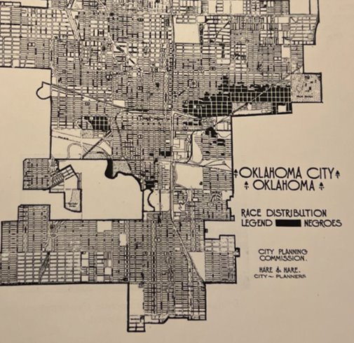
Figure 8: Map of “Race Distribution” in Oklahoma City (Hare & Hare, 1931, Official City Planning Report)

Due to the discovery of oil near what is now the JFK Neighborhood, there was contention between the city and the residents regarding jurisdiction and other legal proceedings. During this time Roscoe Dunjee, editor of the Black Dispatch, championed for the rights of Black residents in this area and fought against the injustices of segregation and unequal treatment; he is “considered by many to be one of the nation's foremost civil rights champions” (Arnold 2009). However, due to the prevalence of oil extraction (Figure 9), the 1960s and 70s were wrought with environmental disasters from nearby industries and the compounding impacts of oil facilities and refineries that took several years to be remediated. It was in these conditions that the official subdivision known as John F. Kennedy was formed in 1967 (Stipek 2013).

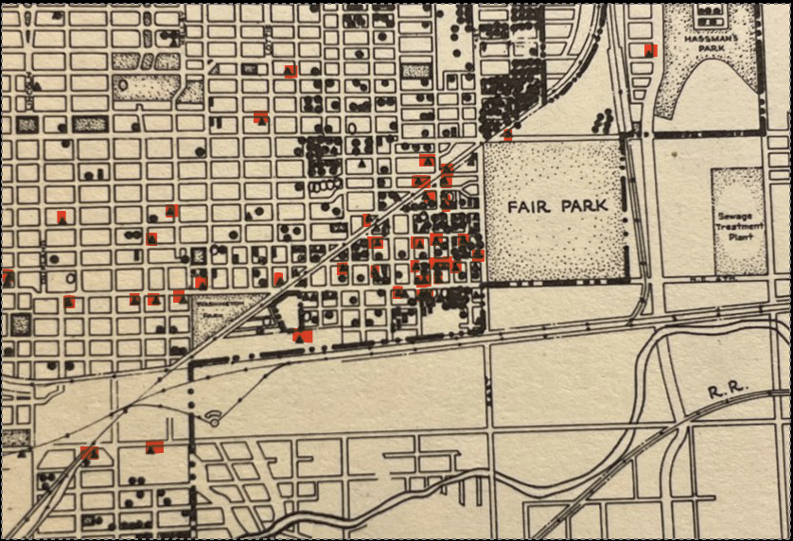

Figure 9: Drilling and industrial sites within the JFK Neighborhood (The Comprehensive City Plan, 1949)

The JFK Neighborhood was officially zoned for industry in 1951 by city planner, Donald White, who “reported the area was ‘ideally suited’ for such use” and did not consider the negative impacts to Black families and residents (Lackmeyer and Kliewer 2021). Prior to this, in the City Plan for Oklahoma City written in 1930, the following states that the African American population is “concentrated in the area north of the Rock Island Railroad,” which is the current location of the JFK Neighborhood, and that the “lower land will be absorbed by industrial sites in the future” forcing the population to “other localities:”
The segregation of the races by zoning has been declared unconstitutional. Similar or better results can no doubt be secured by fair cooperation and mutual agreement between the races. At present part of the negro population is scattered in several small areas but the greater part is concentrated in the area north of the Rock Island Railroad in the easterly 'section of the city. Some of the lower land will be absorbed by industrial sites in the future and the population will be forced to other localities (Hare & Hare 1931). (Figure 10, original text)

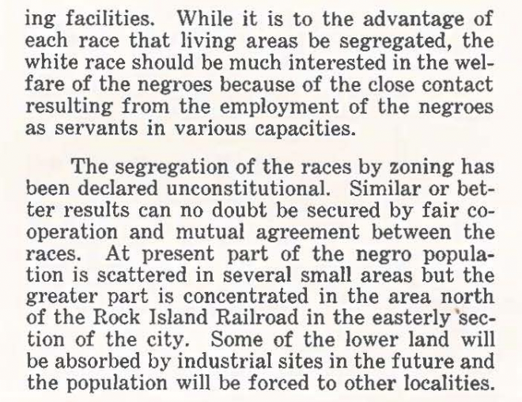

Figure 10. Original Text from City Plan for Oklahoma City, Report of the City Planning Commission, Oklahoma City, Oklahoma 1930 (p. 24)

The racial and environmental history of the Deep Deuce and the JFK Neighborhood gives important context as to the necessity of examining zoning decisions and follows Dorceta Taylor’s (2014) call for examining historical processes of exclusionary zoning. While Black residents did support some of the early oil drilling operations throughout their neighborhood, that eventually led to the environmental degradation of the area, many of those decisions were made with no other viable alternatives and were during the oil boom in Oklahoma City when many where attempting to profit from the expanding oil industry. The zoning and exclusionary policies created by the Oklahoma state and city governments effectively segregated African American citizens into a less desirable part of the city (Baker 1970) and later imposed upon them the negative externalities of industry. Despite some preservation of the rich history and culture of the Deep Deuce and what is now known as the JFK Neighborhood, it is critical to investigate the current injustices of previous zoning decisions to understand the external and historic processes that have contributed to the community’s current environmental hardships.
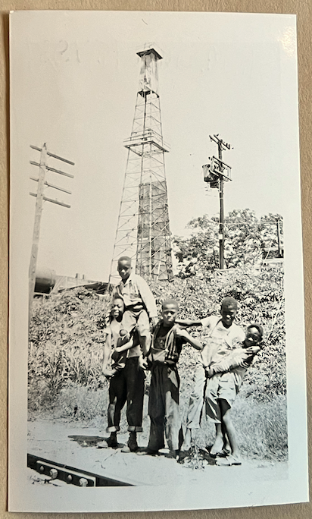
Figure 11. Near Brand YMCA, Oklahoma City, June 16, 1951 (John B. Fink Collection, Western History Collections, University of Oklahoma)

Currently, the neighborhood consists of several reconstructed homes due to Urban Renewal tearing down older historic residences in the area, which is an area of contention and loss of historical property (Lackmeyer and Kliewer 2021). The JFK Neighborhood continues to be impacted by urban revitalization and development efforts today due to recent initiatives in nearby districts like Bricktown (Stipek 2013). However, this new construction, while bringing in some new businesses, also has been subject to controversy. “Initially [government-led urban renewal] meant for many African Americans they... were left to move into... mortgages they didn't have before,” often receiving low-ball offers when selling their old homes (Stipek 2013). The need to preserve historic buildings and reduce the negative consequences of gentrification, such as rising property taxes, persists currently in the JFK Neighborhood.

Environmental Injustices from Legacy Oil Pollution
The history of the JFK Neighborhood is turbulent due to many city planning and other systemic decisions that situated environmentally dangerous industries adjacent to the community. The zoning decisions that placed heavy industrial areas (I-3) next to residential areas (R-1) attempted to halt the progression and success of the JFK community while allowing white Oklahomans more opportunities. These zoning laws ushered in a new era of negative environmental impacts upon JFK residents that are still experienced currently. A primary example of this can be found in the Double Eagle Superfund Site located south of NE 4th street near Martin Luther King Ave, directly outside of the southeast corner of the JFK Neighborhood boundaries. The refinery was operational as early as 1929 and focused primarily on recycling motor oil into finished lubricating oil. The recycling process used sulfuric acid and bleaching clays that generated 80,000 gallons of corrosive and toxic sludge each month (Oklahoma Department of Environmental Quality 2023). In the 1970s, Double Eagle disposed of sludge in on-site impoundments forming a sludge lagoon just miles from the JFK community. These waste pits and lagoons were deadly; one such pit had such a low pH that objects thrown into the lagoon would eventually dissolve and disappear. The site was so toxic that it became a priority to remediate through the U.S. government’s Comprehensive Environmental Response, Compensation and Liability Act (CERCLA). The Double Eagle Refinery was remediated by CERCLA efforts in 2000 and officially removed from the National Priorities List in 2008 (Oklahoma Department of Environmental Quality 2023). While the site has been cleaned and is no longer visible to Oklahomans, the legacy of Double Eagle remains. While the industries in the area have changed, the associated problems of current industrial sites continue to plague the JFK residents. The JFK Neighborhood’s current zoning conditions have heavy industry near residential areas which does not follow current municipal ordinances and due to the ‘grandfathered in’ status of these industries, the zoning conditions have not changed since their designation in the 1950s (Lackmeyer and Kliewer 2021).
Research has shown that communities that received worse Home Owners’ Loan Corporation (HOLC) grades were correlated with more exposure to oil and gas wells; more specifically, it was concluded that redlined neighborhoods did have more oil and gas wells present than neighborhoods who received a better grade (Gonzalez et al. 2022, 2023). Redlined neighborhoods can be defined as communities that have faced discriminatory practices that consist of the systematic denial of mortgages, insurance loans, and other financial services to residents of certain areas, based on their race or ethnicity (Mapping Inequality 2023). As a historically redlined community, JFK is an example of industrial companies taking advantage of compounding systemic economic inequalities experienced by formerly redlined areas (Figure 12).
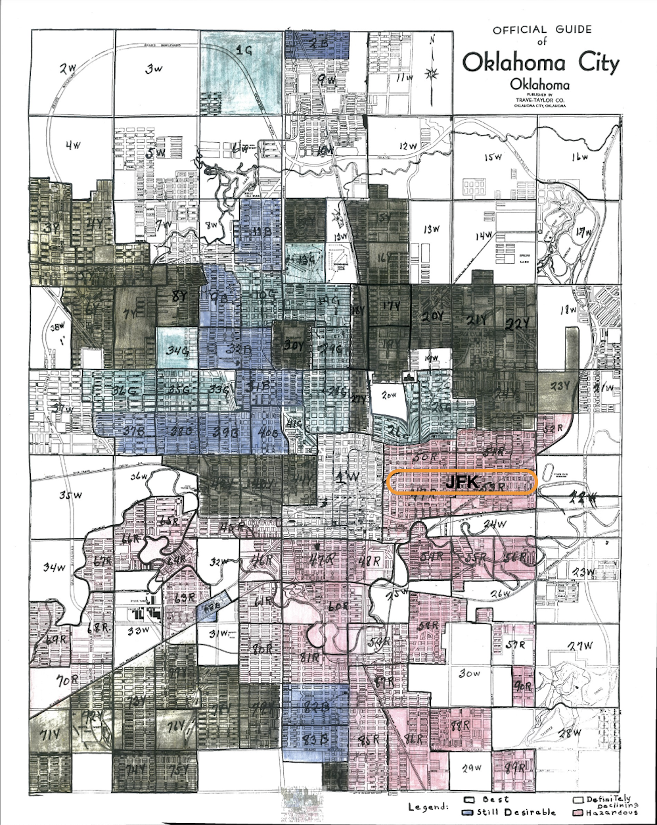
Figure 12. Redlined Map of Oklahoma City, 1940 (Metropolitan Library Systems, Special Collections)
While it does not seem ethical for industries such as Double Eagle Refinery to move operational sites adjacent to homes, it falls to the city to amend zoning laws in a manner that will benefit not only the JFK Neighborhood, but other marginalized communities as well. It is apparent that Oklahoma City needs to reassess zoning conditions that better meet the needs of all residents, not just the white majority. This is an issue in many cities across the country; the historical zoning decisions made decades ago do not properly reflect modernizing America. Current industrial zoning placement is reminiscent of discriminatory Jim Crow segregation, confining Black Americans to industrial area.

Zoning Conditions and Injustice

The landmark case regarding zoning in the United States, Euclid v. Ambler Reality Co. (1926), was the first to establish a distinction between industrial and residential land uses, as its purpose was “for regulating and restricting the location of trades, industries, apartment houses, two-family houses, etc.” to protect public welfare (APA Planning and Law Division 2018:3). In essence, the court held that there was a legitimate interest for local governments to maintain the character of a neighborhood when deciding where certain land uses occur. What if the “character” of an area is one deeply embroiled in racism and classism? Given that many American cities experienced their rapid urbanization during the Jim Crow era, it is no surprise to find that many of the country’s earliest zoning laws were made to uphold class, ethnic, and race-based segregation (Trounstine 2018).
Indeed, Oklahoma City follows a Euclidean style of zoning that enforces segregation of uses, but with an element of added hierarchy. According to Oklahoma Statute § 59-5150 there are four types of industrial zoning: TP (technology park), I-1 (Light Industrial), I-2 (Moderate Industrial), and I-3 (Heavy Industrial).
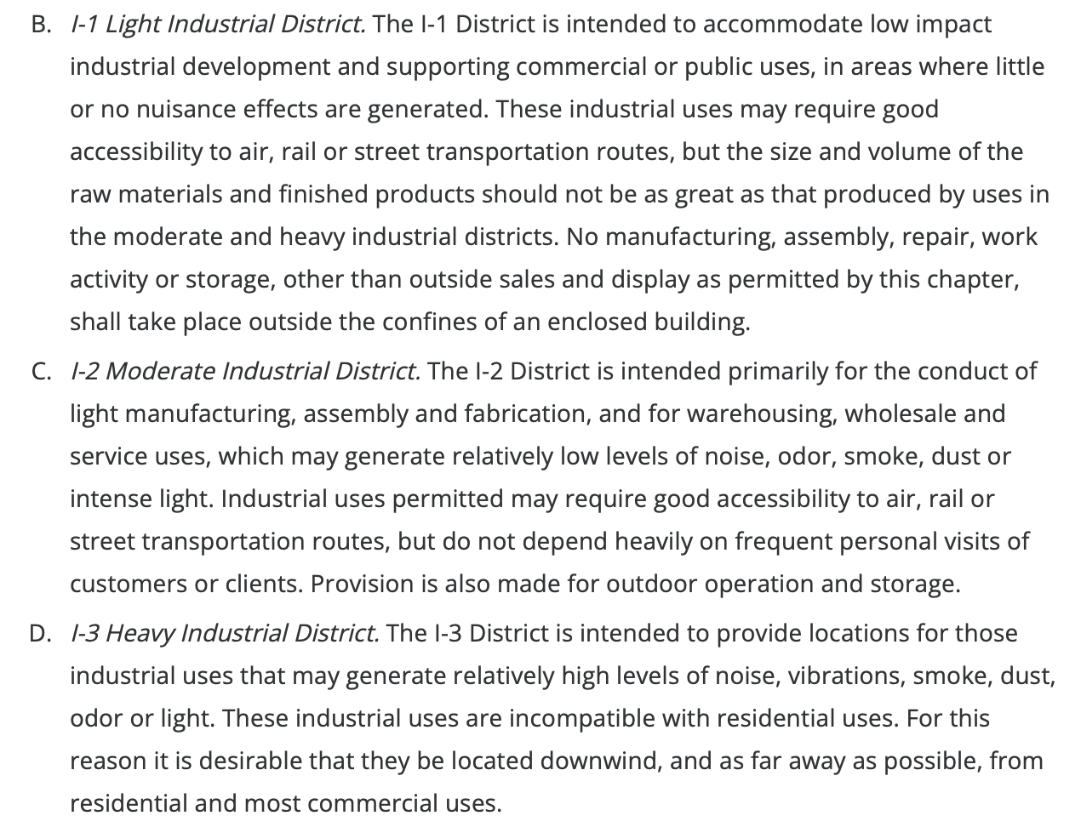
Figure 13. Classifications for Industrial Zoning from ‘Light’ to ‘Heavy’ (Oklahoma City Code of Ordinances Chapter 59, Article VI 59-6250.1)

Since 1951, it has been widely held that it is not the name of an industry that determines whether it is obnoxious but rather the external effects of the industrial operations (American Society of Planning Officials 1955). The Oklahoma County zoning regulations align their definitions of industry with the “Industrial Zoning Standards” from 1951. More recent zoning standards define the difference between light, moderate, and heavy industry but also sets different standards for community sound levels, lighting, as compared with industry (I) which is allowed to have “sound level limits” in the 70-80 decibel range, as compared to R-1, residential areas which are allowed to have sound ranging from 50-65 decibels depending on the time of day (Freese and Nichols 2021:84).

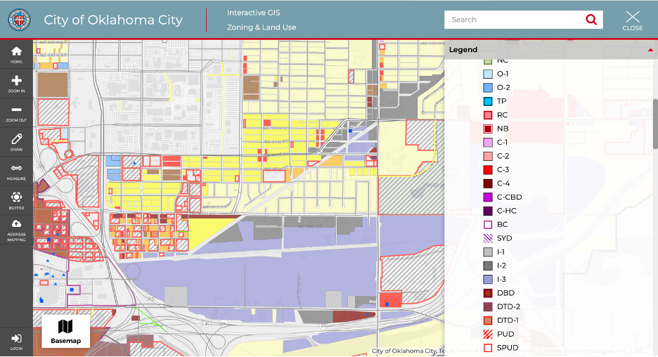
Figure 14. Heavy Industrial (I-3) zoning (light purple) next to residential areas (marked in yellow) (City of Oklahoma City 2023)

As shown in the map above, the heavy industry (I-3) that is exempt from most of Oklahoma County’s zoning regulations borders up against and comprises part of the JFK Neighborhood, a condition that dates to some of the very first zoning ordinances in the state (Baker 1970). Most zoning systems have a procedure for granting exceptions to the zoning rules called variances. Oklahoma City does offer special use permits, a form of variances, however none of the permits expressly allow for mixed industrial and residential uses (Freese and Nichols 2021:27-28). Rather, the main variance that creates the situation seen in the JFK Neighborhood is nonconforming use, where the prior development on a section of land is given an exception from current ordinances because it is ‘grandfathered in.’
In short, Euclid v. Ambler gave the constitutional go ahead to the state legislature to create land use areas and zoning regulations that when unenforced perpetuate environmental racism and injustice, and the city’s municipal code and ordinances not being applied in the JFK Neighborhood creates unequal environmental health conditions due to the existing heavy industrial zones. The question now remains whether newer policies or legal challenges are working to change that precedent. As for policy, while there are laws that prohibit discrimination in housing sales, there is no federal oversight about or spatial benchmarks for heavy industrial zoning adjacent to residential neighborhoods. Oklahoma City does, however, have some of its own regulations. For industrial districts, there must be 35 feet of setback from residential zoning, and for ‘hazardous industry’ (a classification separate from I-1, 1-2, or I-3), the distance must be 1,000 feet (Freese and Nichols 2021:19 & 40). As shown in Figure 13, Oklahoma City recognizes that heavy (I-3) industrial uses are, “incompatible with residential uses” and that they should “be located downwind, and as far away as possible from residential uses,” (Oklahoma City Code of Ordinances Chapter 59, Article VI 59-6250.1), yet they are not classified as “hazardous.” Nonetheless, it provides no penalties to enforce this ordinance and does not define how “downwind” is to be measured.
Historic maps show that residences populated the area closer to the industries when they first opened – now these lots are vacant (Lackmeyer and Kliewer 2021) and current residents describe clouds of smoke that waft over the neighborhood coming from the South where the industrial belt is located. It is therefore clear that the current industries are violating this “downwind” ordinance when the wind often carries air pollution directly into the JFK Neighborhood. A recent “good neighbor” rule issued by the EPA has attempted to likewise protect the health of millions of Americans by restricting emissions from industrial sources that, “burden downwind areas with smog-causing pollution they can’t control” (Daly 2023). The rule, however, is not set to take effect until 2026.
Legally, there has been a history of challenging the jurisdictional powers authorized under Euclidean zoning by basing claims in violations of the first, fifth, and fourteenth amendments. Environmental justice cases most often base themselves in the ‘equal protection clause,’ however several criteria must be met to trigger the clause. The 1977 case Village of Arlington Heights v. Metropolitan Housing Development Corp. established that discriminatory intent is required to invalidate zoning actions with racially disproportionate impacts, including environmental injustices (APA Planning and Law Division 2018:6). According to Dorceta Taylor, “Mere evidence or proof that there is disparate or disproportionate impact on one or more groups of people in an EJ case is not sufficient to prove intent to discriminate. The proof of intent to discriminate has been such a difficult standard to meet that few EJ cases are being brought forward as Fourteenth Amendment challenges anymore” (Taylor 2014:106). Further, as many supreme court cases based in the equal protection clause are being overturned or called into question, the legal route for challenging zoning injustices is challenging. The Supreme Court must rule that ‘racially disproportionate impact,’ and statistical prevalence are sufficient according to Title IV violations, as opposed to a necessity of proof of ‘discriminatory intent.’
The lack of current federal policies and legal precedent means that technically having heavy industry next to residential zoning, especially when this heavy industry is exempt from most standards, is somewhat allowable by law, because of nonconforming use stipulations, but it is not ethical or nondiscriminatory. As history has proven, even though a practice is legal does not mean it is moral or just, and there is therefore a need for remediation. It is generally understood that it is the role of local municipalities to decide land use regulations, but more federal mandates from the EPA like the ‘downwind’ pollution ruling may be the more effective in achieving environmental justice. For Oklahoma City, changing their exemptions for industry or classifying some of the heavy industries near the JFK Neighborhood as ‘hazardous uses’ would also give the community standing to pursue a more legal route, as well as the City of Oklahoma City enforcing their Heavy Industrial Zoning policy, which clearly states that heavy industry is “incompatible with residential uses” (City of Oklahoma City, I-3 Heavy Industrial District).
Currently, the JFK Neighborhood is mixed-income with middle and upper-earning homeowners living in the eastern half of the neighborhood, as well as residents of other racial backgrounds living throughout the neighborhood. In other parts of Oklahoma City that are occupied by predominately affluent, white communities, zoning ordinances prohibit industries from encroaching on residential areas. These types of zoning decisions are representative of a national systemic environmental justice crisis in metropolitan areas where historical precedents are allowing unsafe conditions for communities of color. Across the country, marginalized communities are experiencing environmental injustices through systematically racist zoning practices, many that were established earlier in the century. These zoning decisions imposed upon the residents of the JFK Neighborhood are a blatant act of environmental racism. It is a violation of human and civil rights to live near hazardous, toxic, and dangerous industrial sites.
While systemically racist zoning laws exist in many major American cities, (i.e., Detroit, Nashville, Chicago, and New York City), Oklahoma City, particularly the JFK Neighborhood, located in the southern part of northeast Oklahoma City still lacks legal protections as far as enforcing city ordinances and corresponding state legislation for environmental health protection. Because the City of Oklahoma City has allowed industries to operate directly next to the JFK Neighborhood, despite the current ordinance for Heavy Industrial Districts (I-3) (City of Oklahoma City, I-3 Heavy Industrial District) major corporations such as Derichebourg Recycling and Citgo Petroleum Corporation have maintained their facilities adjacent to the residential portion of the JFK Neighborhood and across from the Frederick Douglass High School. This is a critical problem for members of the neighborhood for several reasons. Derichebourg Recycling USA, part of a French international company, also an industrial recycling facility that primarily recycles cars and other scrap metal produces sporadic high-level decibel explosions that create a traumatic experience for JFK Neighborhood residents, disrupting residents’ everyday lives, harming mental health, and causing structural damage to homes and other property. Haskell Lemon Construction Co. and Citgo Petroleum Corporation release hazardous air pollution through smokestacks negatively affecting both human and environmental health. The Environmental Protection Agency (EPA) reports that the Citgo refinery pollutes high amounts of zinc; the EPA report shows the refinery as steadily increasing their zinc emissions over the Citgo reporting years of 2019-2021 (EPA TRI Toxics Tracker 2021). The Center for Disease Control and Prevention (CDC) labels zinc pollution as harmful to human health as inhalation of zinc oxide fumes can cause an influenza-like illness termed metal fume fever (Agency for Toxic Substance and Disease Registry 2014). These industrial sites produce strong odors as well as plumes of smoke and smog that roll through the neighborhood periodically, that deter JFK residents from enjoying the outdoors regularly, even on their own patios.
Besides the obvious health and environmental hazards, the industrial companies surrounding the neighborhood are persistent eyesores directly adjacent to the neighborhood devaluing the neighborhood homes, in particular the massive pile of cars at the Derichebourg industrial recycling facility visible from Martin Luther King Ave. (Figure 18). JFK homeowners and residents have to endure these historically racist zoning laws and environmental injustices but also value their community and neighbors; they are faced with a difficult dilemma of whether to stay in the neighborhood or move into another residential area where zoning ordinances are enforced, prohibiting industrial facilities from being located next to homes – a simple protection the JFK Neighborhood is not granted.
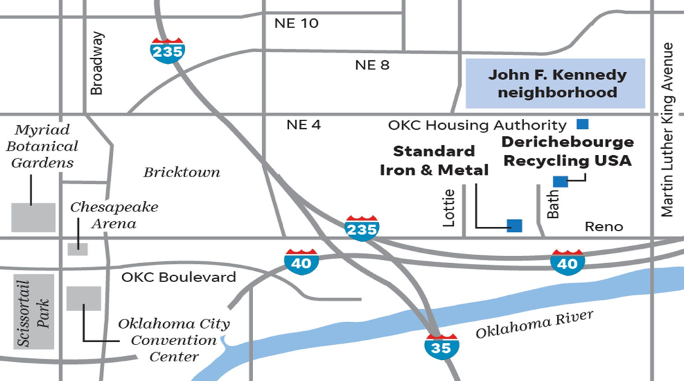
Figure 15. Map showing JFK Neighborhood and nearby scrap and industrial recycling yards (Todd Pendleton; Lackmeyer & Kliewer 2021)

The residential portion of the JFK Neighborhood is near the industrial sites such as Standard Iron and Metal and Derichebourg Recycling, as well as Haskell Lemon Construction, Hite Plastics, Dolese Brothers Stone and Sand, and the Citgo Petroleum Corporation facility to the northeast of the JFK Neighborhood as well as Superfund sites that have been remediated by the EPA (Oklahoma Department of Environmental Quality 2023). JFK community members are frequently exposed to the hazards of these facilities as they are situated directly across NE 4th St. The historically discriminatory zoning laws are what allow heavy industry to be adjacent to a residential area. The following map shows the areas zoned by the city of Oklahoma City (Figure 16a), accompanying the map is a key that explains the zoning abbreviations (Figure 16b). The JFK Neighborhood is zoned as primarily ‘Single-Family Residential’ (R-1) while the surrounding purple industrial area is zoned as ‘Heavy Industrial’ (I-3).
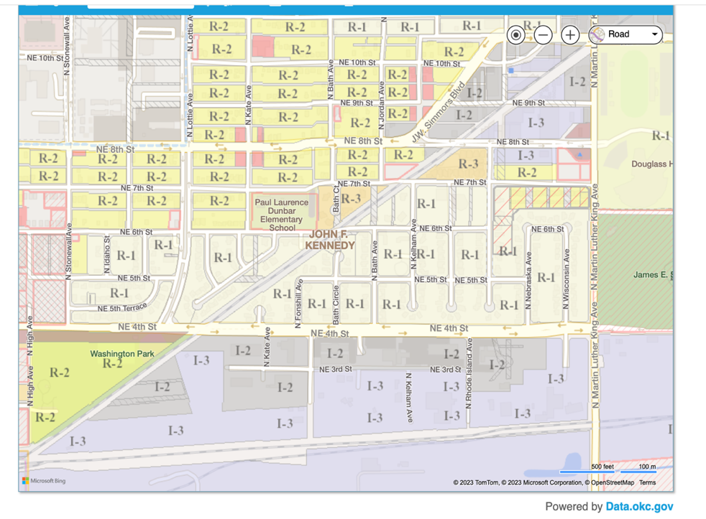
Figure 16a: Modern zoning map of the JFK Neighborhood and surrounding areas (City of OKC Zoning Map)

Key to Zoning Map
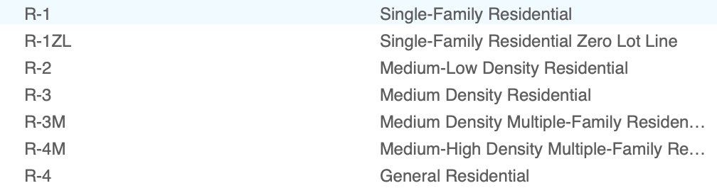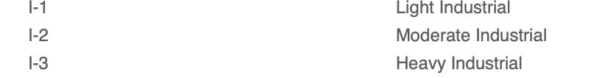
Figure 16b: Key to Zoning Map - JFK Neighborhood and surrounding industrial areas (City of OKC)

This accumulation of negative environmental impacts historically is why the neighborhood unequally bears current environmental injustices. The neighborhood residents have expressed their intense frustrations that their homes are allowed to be zoned next to heavy industry (I-3) repeatedly. Rodney Redus, Vice President of the JFK Neighborhood Association, and long-time resident says, “For the past nine years, the explosions from the recycling plant have been a major source of disruption and concern for my wife and I. Our home has sustained structural damage, our sleep is sometimes disrupted, and our complaints, as well as the complaints of others, seem to have fallen on deaf ears” (JFK Neighborhood Association Report 2018). Other residents within the JFK Neighborhood have consistently organized for significant change that would help remediate environmental problems. Greg Jones, JFK Neighborhood Association (JKFNA) board member relays conveys his concern regarding the explosions, “I have experienced these loud explosions for more than eight years, I’m afraid they will continue until businesses located in downtown OKC are affected. I guess as JFK residents our voices don’t matter” (JFK Neighborhood Association Report 2018).

Current Heavy Industries near the JFK Neighborhood

Citgo Petroleum Corporation History of Operations

Cato Oil & Grease Co. was established in 1922 in Oklahoma City (Cato Oil 2022) in what is now the Citgo Petroleum Corporation facilities. The company’s address is the same as Citgo Petroleum Corporation, located on Martin Luther King Ave., now directly across from the Douglass High School. On August 25, 1959, George Tapscott took a photo for the Oklahoma City Times newspaper that displayed the remains of a loading dock at Cato Oil & Grease Co. According to the newspaper, an explosion occurred that destroyed a loading dock, where drums of motor oil and other fuels manufactured by Cato Oil & Grease Co. were stored. The fire was devasting and released toxic fumes from the burning oil and byproducts.
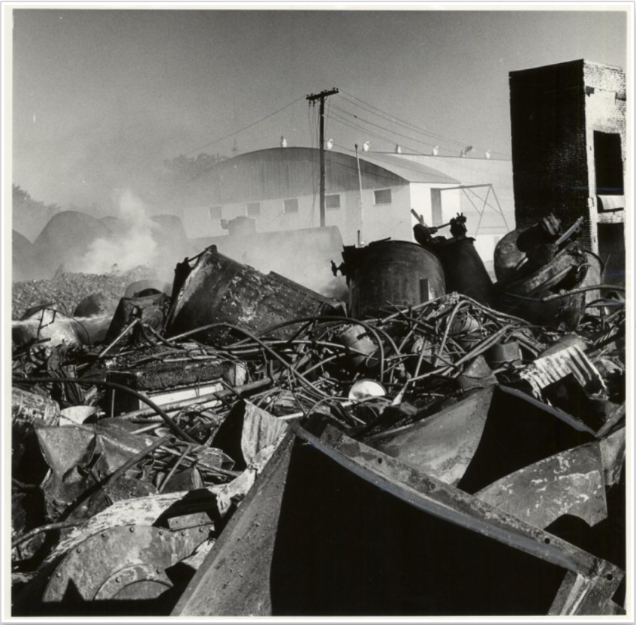
Figure 17. "Tangled wreckage of storage drum is all that remains on this loading dock of Cato Oil & Grease Co.” located at 1808 NE 9th St. after a fiery blaze engulfed drums filled with “motor oil and related fuels,” Photograph taken by George Tapscott for Oklahoma City Times in 1959

In 1964, case (40254) was opened against Cato Oil & Grease Co., with the plaintiff being L.W. Rodgers and the defendant Cato Oil & Grease Co. (Justia US Law 2023). Rodgers was seeking compensation for personal injuries for responding to a fire at the Cato Oil & Grease facility. With twenty-two years of training and experience as a firefighter, the case documentation gave the impression that Rodgers understood the proper storage techniques for flammable items, as well as how to properly put out fires. While fighting the fire at Cato Oil & Grease Co., Rodgers stated that the company had stacked several storage drums of crude oil on top of concrete flooring. Rodgers’ position was that this method of storage of crude oil violated the city’s ordinances. He stated that due to the improper storage of the oils, he was unnecessarily injured extinguishing the blaze which occurred due to negligence in the storage of motor oil and other related fuels (Justia US Law 2023).
Moving towards today, Citgo Petroleum Corporation bought Cato Oil & Grease Co. on May 2, 1995. In 2005, Citgo entered into an agreement with the Environmental Protection Agency, as well as state environmental agencies, as part of the EPA’s refinery initiative (Citgo Fueling Good 2012). The states that Citgo included in this initiative were Georgia, Illinois, Louisiana, and New Jersey. In 2007, air emissions from Citgo’s refineries were 122.6 metric tons/million barrels. By 2012, the emissions had dropped to 27.9 metric tons/million barrels, and in 2021, the air emissions were 34.6 metric tons/million barrels (Citgo 2021). Despite this much needed decrease in harmful air emissions since 2007, the Department of Justice and U.S. Environmental Protection Agency (EPA) found the CITGO Petroleum Corporation in violation of the Clean Air Act (CAA) and charged them with a $737,000 civil penalty to “implement projects to reduce harmful air pollution” (EPA 2013).

Derichebourg Recycling Facility History of Operations
Derichebourg, a French multi-national corporation, started in the early 1950s and acquired its first shredder in the United States, specifically Oklahoma City, OK, in 1968. Like Citgo, Derichebourg also has another recycling facility that is located in close proximity to a racially marginalized neighborhood in Houston, Texas. Additionally, the Derichebourg corporation built a wall to minimize the effects from the facility, similar to the one constructed at the Oklahoma City facility (Lackmeyer 2021b). On January 7, 2021, the EPA and the Department of Justice announced a settlement with the Derichebourg corporation concerning ten of their recycling facilities in Texas and Oklahoma (EPA 2022; Fay 2022). The settlement announced that Derichebourg will pay a $442,500 fine due to violations of the Clean Air Act (Egan 2022). Furthermore, the settlement prevents Derichebourg from continuing to release refrigerants and non-exempt substitutes that are damaging to the ozone layer.
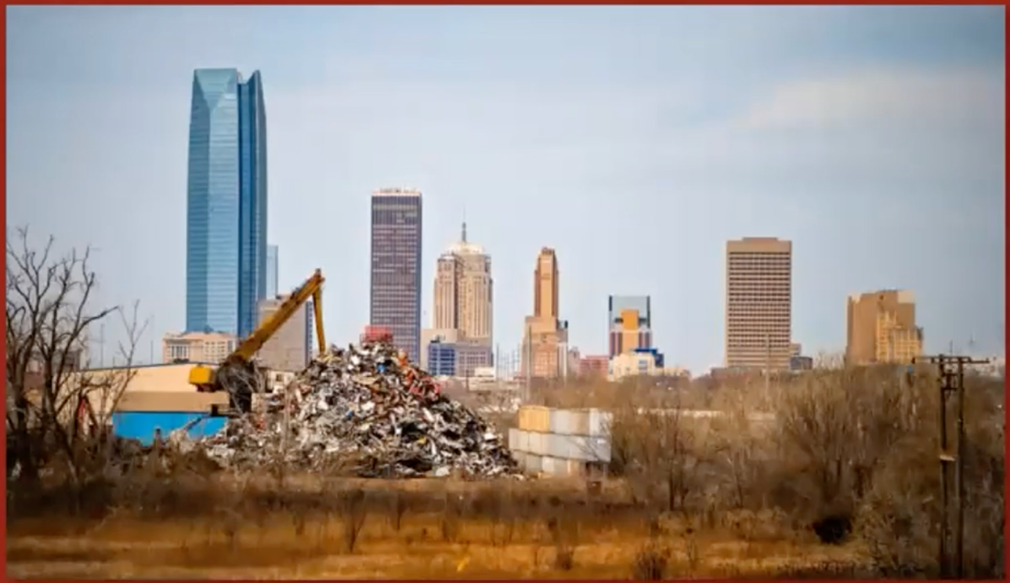
Figure 18. View driving south on Martin Luther King Ave., Derichebourg Industrial Recycling Facility’s enormous pile of car scraps (Photo by Chris Landsberger/The Oklahoman, from Sooner Magazine’s “Do No Harm”)

According to the residents of the John F. Kennedy neighborhood, as well as the Oklahoma City Housing Authority, near the Derichebourg recycling plant, explosions have been occurring regularly for decades. Residents have issued formal complaints about the explosions and resulting odors to the Department of Environmental Quality (DEQ) and city officials repeatedly over the years; however, limited action has been taken. The JFK Neighborhood Association started documenting every explosion, as well as comparing the City of Oklahoma City’s Official Explosions log with the Derichebourg Recycling Facility’s log. Residents discovered that the Derichebourg Recycling Facility did not report at least twenty-three explosions between May of 2016 and mid-April 2018 (JFK Neighborhood Association 2018).
Another environmental concern related to the Derichebourg Recycling Facility, and most recently Hite Plastics, another nearby industry, are the industrial fires that have broken out with relatively high frequency. A recent fire at the Derichebourg Recycling Facility on April 16, 2023, left an Oklahoma City firefighter in the hospital (Mitchell 2023). On September 15, 2020, the Derichebourg Recycling Facility had a large industrial fire that ignited early in the morning around 5 am, when apparently no one was at the facility and took hours to extinguish, as well as spreading smoke across the OKC Metro area (News 9 2020) (Figure 19).
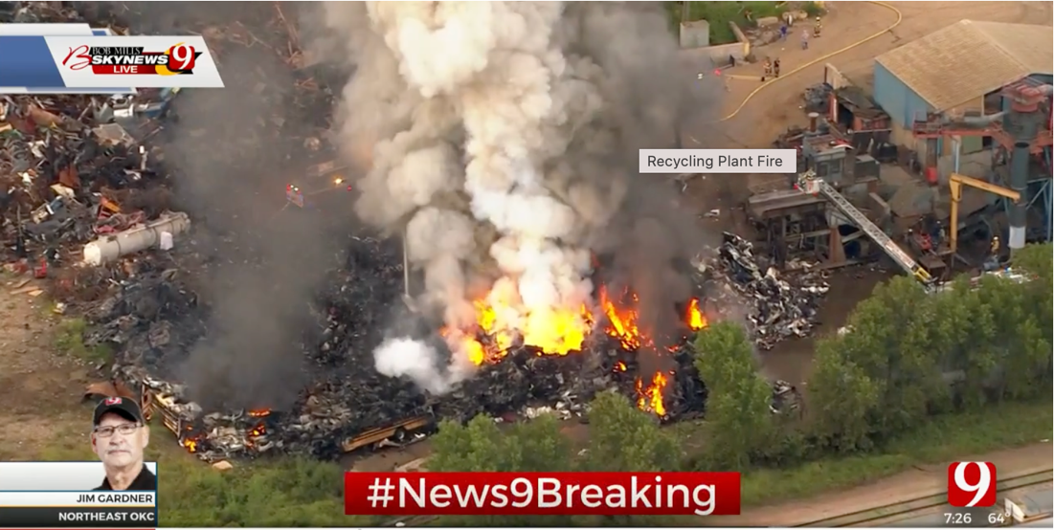
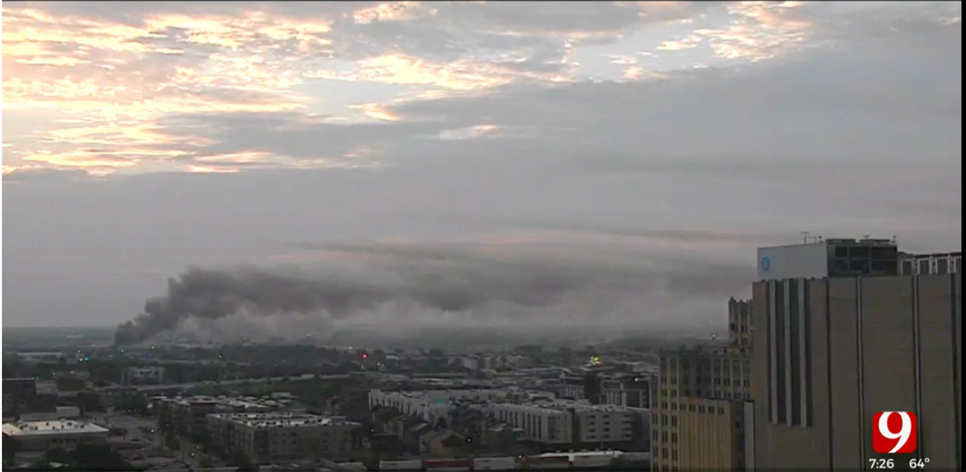
Figure 19. Derichebourg Recycling USA Industrial Fire, September 15, 2020, (News 9, 2020)

On May 8, 2023, there was a massive plastic fire that broke out at Hite Plastics, requiring eight fire units, including 80 firefighters, as well as the Hazmat (Hazardous Materials) Unit, to respond (KOKH 2023). While the Department of Environmental Quality (DEQ) regulates air quality, there is still a lack of oversight related to the many industrial fires that have occurred near the JFK Neighborhood. The Derichebourg Recycling Facility explosions and fires, as well as the Hite Plastics’ fire have released toxic fumes across the JFK Neighborhood and Oklahoma City. There must be regulations created to protect JFK residents from the toxic air pollution and the hazardous risk caused by these frequent industrial fires and explosions, otherwise health and quality of life are severely compromised.

History of Environmental Activism in the JFK Neighborhood
As previously mentioned in this report, the JFK Neighborhood is historic and culturally significant to many Oklahomans. The issue of industrial zoning infringing on the JFK residents' everyday life is not a new problem. In fact, the JFK Neighborhood Association, currently led by Denyvetta Davis, has been advocating for change for decades.
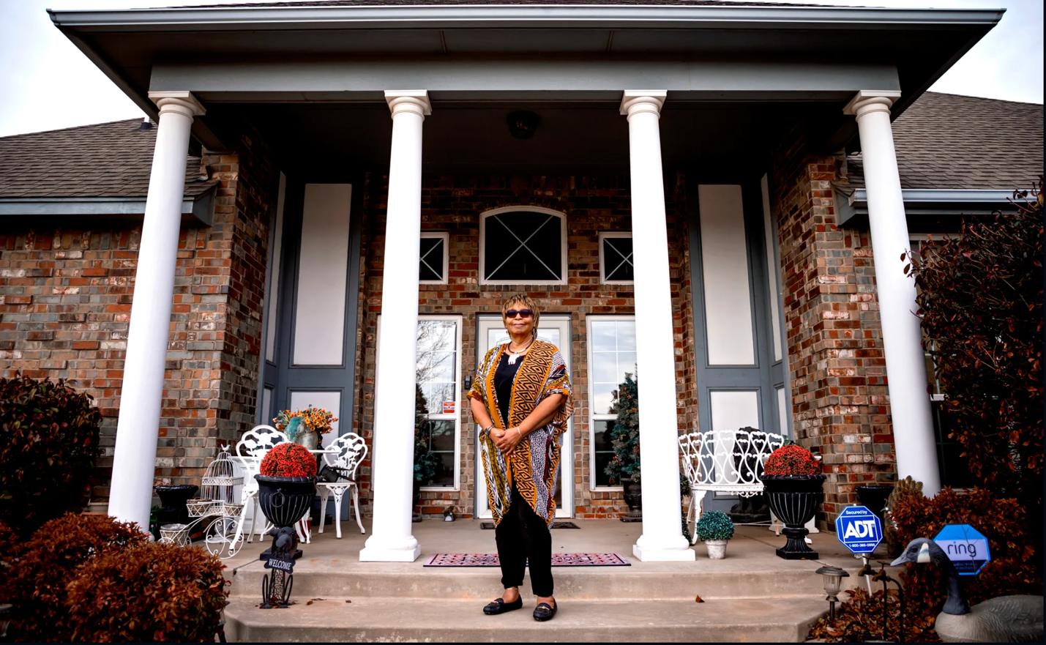
Figure 20. Denyvetta Davis, JFK Neighborhood President, in front of her home, (Lackmeyer 2021a)
Recently, the JFK Neighborhood Association created the JFK Neighborhood Explosions Report (JFK Neighborhood Association 2018). This is a detailed report that documented evidence of explosions from the Derichebourg facility and the direct grievances of many of the JFK homeowners. The first section of the JFK Neighborhood Associations’ report is direct quotations from residents regarding their frustrations with the Derichebourg recycling plant explosions, such as one from Taylor Doe, “I have an elderly neighbor who told me she has almost fallen several times because the explosions startle her so badly. I now go and check on her after each explosion to make sure she is okay” (JFK Neighborhood Association 2018).
The JFK Neighborhood Association has issued formal complaints with the Oklahoma City Action Center hundreds of times within the last decade; the Action Center is a public helpline where OKC residents can report non-emergency code violations. The report notes that when the JFK Neighborhood Association asked for documentation of the many years of reporting, the Action Center could not provide it. The Action Center said there was no documentation of the reported explosions from the Derichebourg Recycling Facility, but the JFK Neighborhood’s report clearly provides evidence of their correspondence with the Action Center. Denyvetta Davis and other members of the JFK Neighborhood Association have kept detailed logs of every explosion, industrial fire, or other disturbance. The Action Center failed to make the records publicly accessible including keeping record of the accurate number of explosions reported by the JFK residents. Mayor of Oklahoma City, David Holt did respond somewhat to the urgent requests of Davis and the JFK Neighborhood Association, in 2020, particularly regarding the Derichebourg Recycling facilities’ frequent explosions by instructing the Oklahoma City Fire Marshall to deliver a letter mandating that the company operate only between the hours of 7 am – 7 pm, where previously explosions had occurred in the early morning hours during the night. After an investigation launched by The Oklahoman and led by Assistant City Manager Aubrey McDermid, in 2021, Derichebourg Recycling USA constructed a cost-intensive 30 ft. wall to act as a sound barrier, in between their facility and the JFK Neighborhood in an attempt to buffer the noise from the explosions (Lackmeyer 2021b). However, this has not helped regarding the subsurface vibrations which travel below ground shaking JFK residents’ homes and damaging their foundations. The explosions have decreased in frequency but still are occurring; JFK residents have reported that they are just as loud and continue to negatively impact their quality of life.
The constant work of Denyvetta Davis and the neighborhood has not gone undocumented; the unjust environmental impacts of the industrial companies has gained media coverage by major Oklahoma news outlets. Over the last ten years, stations such as News 9, KFOR-TV (News 4), and KOCO 5 have televised segments about the neighborhood’s environmentally unjust situation, as well as full-length news articles in The Oklahoman (Hayes and Smith 2023, Lackmeyer 2021a, 2021b, Lackmeyer and Kliewer 2021), highlighting their struggles with the explosions and fires from Derichebourg Recycling USA as well as other hazardous facilities near the neighborhood.

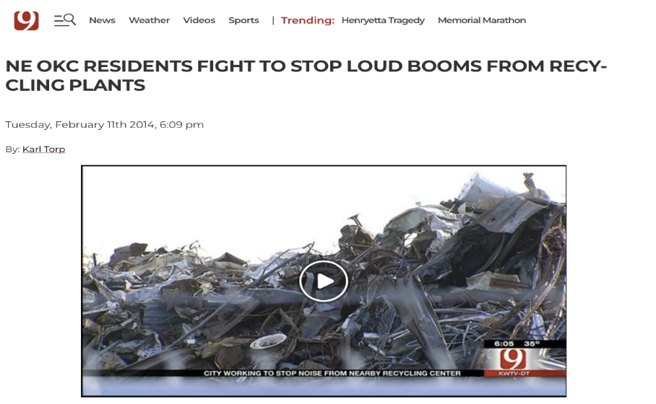
Figure 21: News 9 reports on the JFK Neighborhood and the nearby disruptive explosions (Torp, 2014)

While media coverage is important in spreading awareness of the JFK Neighborhood and the environmental issues of industrial zoning, it has not been adequate in facilitating necessary change. At the end of the JFK Neighborhood Association’s report, Denyvetta Davis provides a powerful statement, “residents are frustrated, tired and have lost hope this issue will be resolved. For over 8 years residents have been working with city departments and officials to get the explosions to stop...we’ve talked with the Action Center, Police, Fire, City Council and the media. It seems that nobody is responsible” (Davis, JFK Neighborhood Association Report 2018). The JFK neighborhood has continually fought for change and justice but has been confronted with several dead ends. The JFK Neighborhood Association (JKFNA) continues to work tirelessly on improving the environmental quality of their neighborhood.

CHAPTER 4: SYSTEMIC BARRIERS TO ENVIRONMENTAL HEALTH EQUITY

Unequal Environmental Conditions and Environmental Health Inequalities

My analysis is rooted in an emancipatory Du Boisian sociology intent on conducting a systematic investigation of current structural environmental inequalities, remnants of discriminatory spatial segregation throughout cities in the U.S. exposing Black families to environmentally degraded conditions. Du Bois grounded his critique of racialized inequalities in “detailed empirical research of social practices, institutions, and structures” (Itzigsohn and Brown 2020:192). He was able to “seamlessly link the macro historical analysis of racial and colonial capitalism to the phenomenological analysis of the lived experience of racialized people” (Itzigsohn and Brown 2020:188). It is from this framework that I present the lived experience for the people in the JFK Neighborhood and their unequal exposure to hazardous industries compromising their health, environmental quality, and well-being. In the following sections, I document the institutional and structural processes that have mechanized the systemic barriers that are obstructing access for the JFK Neighborhood to environmental health equity.

Environmental Justice (EJ) Screen and the JFK Neighborhood
The EPA (Environmental Protection Agency) has developed an Environmental Justice (EJ) Screen Tool to screen areas for incidences or prevalence of environmental injustice(s). The two maps below of the JFK Neighborhood use the EJ Screen Tool’s Environmental Justice (EJ) Indexes which combine environmental indicators such as, air quality measures of ‘particulate matter (PM) 2.5,’ ‘ozone,’ ‘diesel particulate matter,’ ‘Air Toxics Cancer Risk,’ ‘Air Toxics Respiratory Hazard Index,’ and ‘traffic proximity,’ with data on low-income status and racial demographics of the screened area (EPA 2023, EJ Screen). The EJ Screen tool shows areas where there is a high prevalence of a racial or ethnic minority population, as well as socioeconomic status, and a high level of air pollutants compared to national percentiles (95-100th percentile representing the highest exposure to environmental pollutants). The eastern half of the JFK Neighborhood is in the 95-100th percentile nationally for exposure to ‘Particulate Matter 2.5’ combined with a significant percent of low-income households and racial or ethnic minority identification indicating a high risk for environmental injustices (EJ Screen Tool 2023; Figure 22). In other words, this portion of the neighborhood, is in the highest percentile nationally for PM_{2.5} exposure combined with demographic characteristics that indicate a likely condition of environmental injustice.
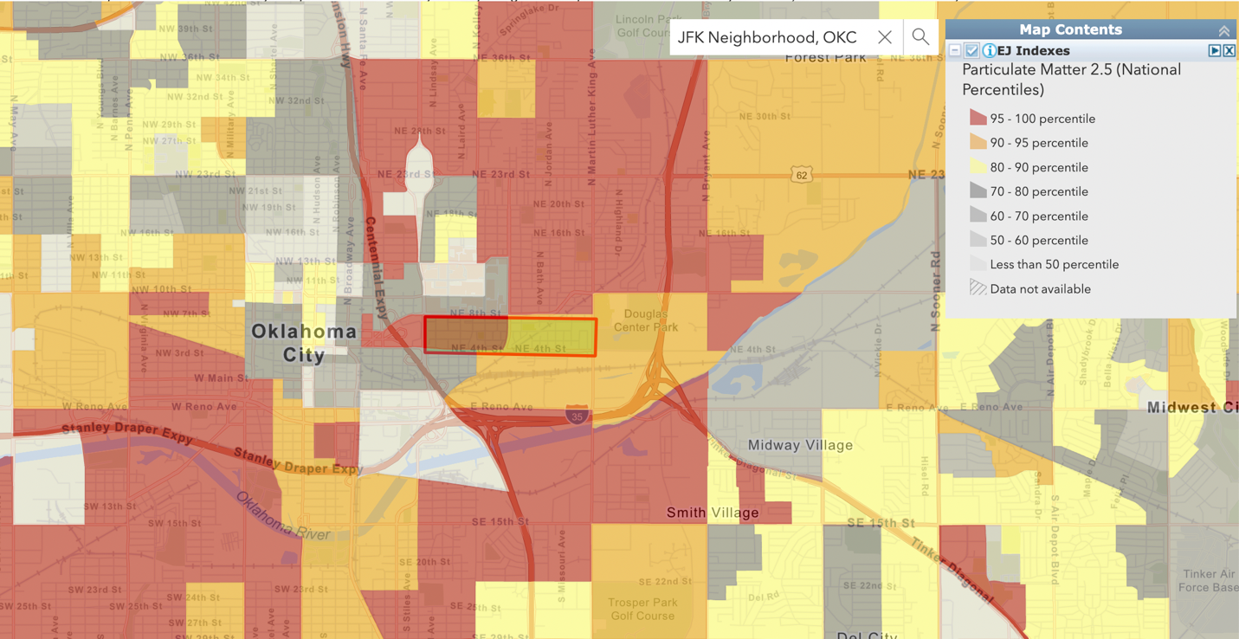
Figure 22: EJ Screen for Particulate Matter 2.5 exposure; Environmental Justice (EJ) Indexes combine prevalence of communities of color, low-income households, & air pollutant exposure, JFK Neighborhood highlighted in red frame (EJ Screen Tool 2023)

The western half of the JFK Neighborhood is in the 90-95th percentile nationally for exposure to ‘Air Toxics Cancer Risk’ (EJ Screen Tool 2023; Figure 23), indicating that cancer risk from toxic air pollutants is likely to be in the upper percentile for the neighborhood, which calls for further risk assessment.

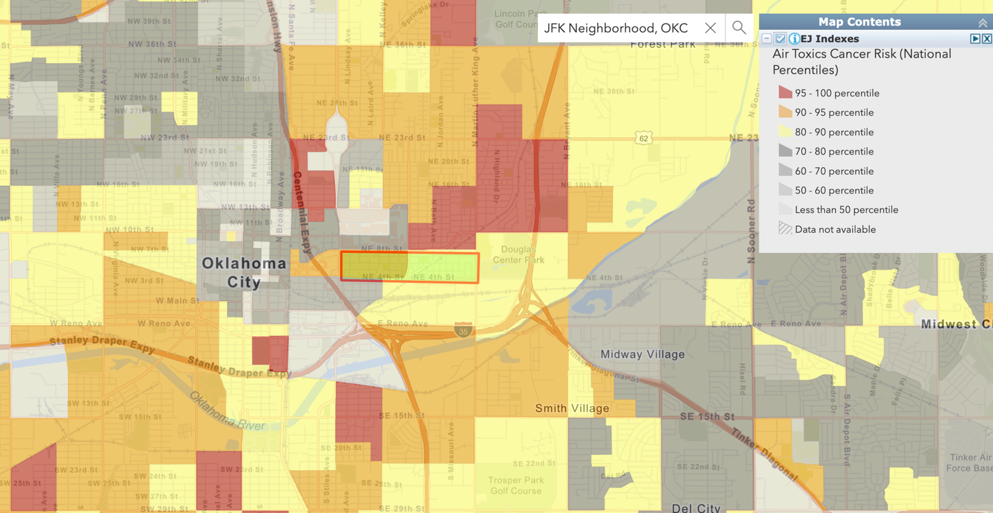
Figure 23: EJ Screen for Air Toxics Cancer Risk exposure; Environmental Justice (EJ) Indexes combine prevalence of communities of color, low-income households, air pollutant exposure, JFK Neighborhood highlighted in red frame (EJ Screen Tool 2023)
The utilization of tools such as the EJ Screen Mapping Tool aid in identifying areas with a high probability of experiencing disproportionate adverse health impacts or exposure to air pollutants (Rowangould et al. 2019). Screening regional or local areas for these elevated hazardous conditions of compromised air quality is important for determining places that potentially need interventions. Cumulative risk assessment coupled with community-engaged research can help measure both “health-promoting attributes” and “socio-environmental stressors” that perpetuate health inequities and what might trigger the onset of disease from these environmentally adverse conditions (Burwell-Naney et al. 2019). Environmental justice screening tools, such as EJ SCREEN and EJ Atlas, are important because they can identify both environmentally and socially burdened communities, screening for vulnerability, and point to areas of concern within cities (Kuruppuarachchi et al. 2017; Driver et al. 2019).
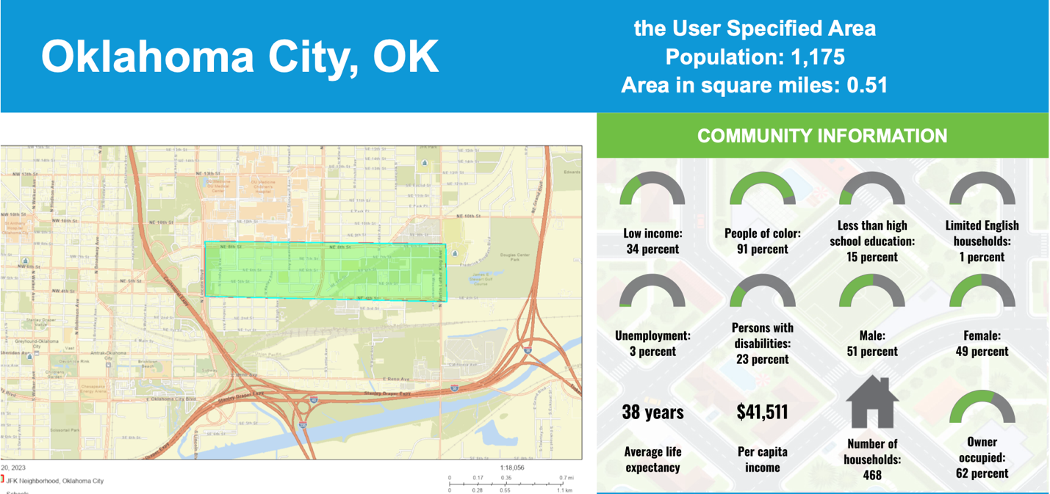
Figure 24. EPA EJ Screen Community Report’s Community Information for the JFK Neighborhood, displaying socioeconomic and demographic indicators such as racial identification, education level, and per capita income, Average life expectancy at 38 years needs further assessment from this low lifespan (2023)
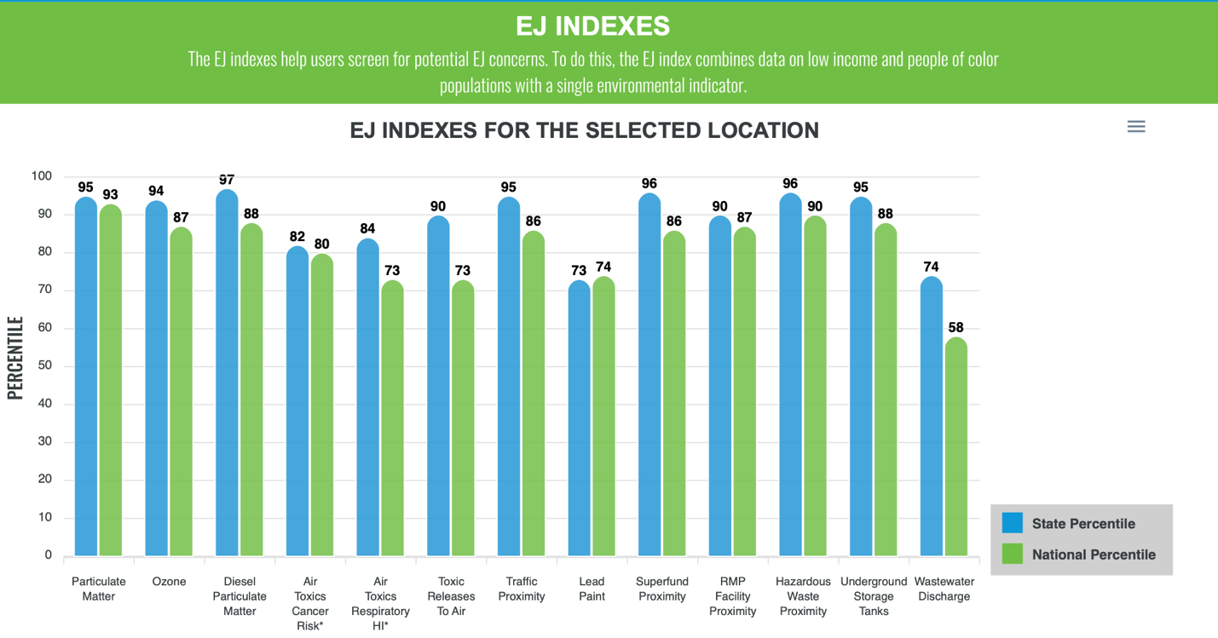
Figure 25. EPA EJ Screen Community Report graph of all EJ Indexes for the JFK Neighborhood including ‘Particulate Matter,’ ‘Ozone,’ ‘Diesel Particulate Matter,’ and ‘Toxic Releases to Air’ and several other environmental indicators measured with state and national percentiles (2023)
“Environmental burdens can include any environmental pollutant, hazard or disadvantage that compromises the health of a community” (Kuruppuarachchi et al. 2017:59). The key purpose of environmental justice screening tools it to help in “decision making for disadvantaged communities in certain areas and in setting up environmental policies and planning” (Kuruppuarachchi et al. 2017:59; Hartley et al. 2021). The use of screening tools gives advocates ways to show that “environmental hazards [are] more regressively distributed with respect to race/ethnicity than poverty, with… toxic chemical releases being the most unequal” (Cushing et al. 2015b:2341). The EJ Screen tool is being used in the EPA’s Climate Pollution Reduction Grant (CPRG) to develop Priority Climate Action Plans for each state. In Oklahoma, the tool has been used to screen areas classified as IRA (Inflation Reduction Act) EPA ‘Disadvantaged Communities.’ These communities are to receive benefits from the Justice40 Initiative which mandates investments in clean energy and other infrastructure flow to underserved and disadvantaged communities.
Air Quality Monitoring
As far as locations of air quality monitors in OKC, the closest ones to the JFK Neighborhood that measure particulate matter 2.5 and 10 (PM_{2.5} and PM₁₀) on a regular basis are at the Central Fire Station, on NW 5th St., across Interstate (I)-235, about 2 miles from the neighborhood (EPA AirData Air Quality Monitors 2023; Figures 26 and 27). Interstate (I)-235, initially constructed in 1978, divided the historically Black neighborhoods of Deep Deuce and what is now the JFK Neighborhood. I-235 obstructs accurate air quality monitoring from the Central Fire Station monitor for the neighborhood due to the prevalence of diesel and other traffic emissions. Air quality data is available from this monitor spanning from 1995-2023. The EPA also recommends using AirNow and getting Air Quality Index (AQI) alerts to measure how clean or polluted the outdoor air is on a color scale measuring ‘Good’ to ‘Hazardous,’ (EPA, Particulate Matter PM_{2.5} Basics, 2023). While AirNow does provide alerts for Oklahoma City, the closest monitor is 10 miles northwest of the JFK Neighborhood.
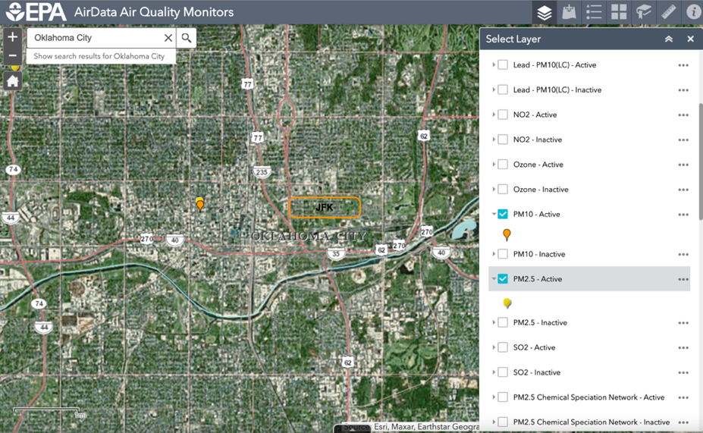
Figure 26: Map showing nearest Air Quality Monitors for PM₁₀ and PM_{2.5} at the Central Fire Station
(https://www.epa.gov/outdoor-air-quality-data/interactive-map-air-quality-monitors, 2024)

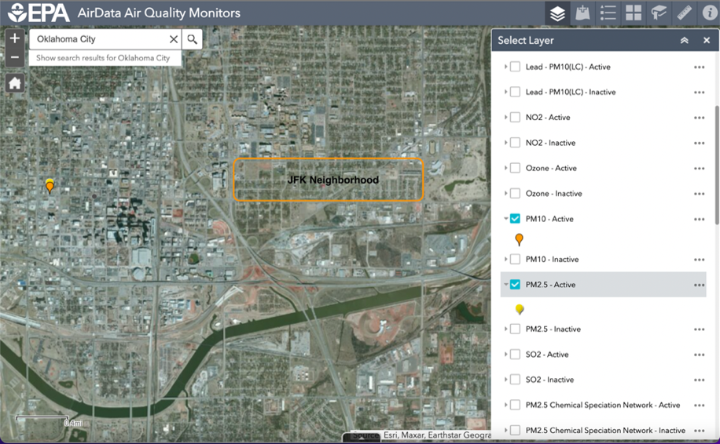
Figure 27: Map showing nearest Air Quality Monitors for PM₁₀ and PM_{2.5} at the Central Fire Station also conveys proximity to heavy industrial area to the south from an aerial view;
(https://www.epa.gov/outdoor-air-quality-data/interactive-map-air-quality-monitors, 2024)
A recent study on air quality in Oklahoma City in partnership with CAPA (Climate Adaptation Planning & Analysis) was conducted in coordination with the Urban Heat Island study led by the OKC Office of Sustainability. Oklahoma City was chosen as one of NOAA (National Oceanic and Atmospheric Administration)’s Urban Heat Island Mapping campaigns for 2023. Measurements were taken for extreme heat and PM_{2.5} levels throughout Oklahoma City. There were stationary and mobile monitoring of PM_{2.5} levels throughout the metro area. During the afternoon air quality mobile monitoring on August 12, 2023, two locations in the JFK Neighborhood measured high PM_{2.5} levels as ‘Unhealthy for Sensitive Groups.’ Compared to the majority of sites measured in the metro area, this is an unhealthy level of PM_{2.5} exposure and confirms neighbors’ concerns related to unsafe air quality, particularly for children, older populations, and individuals with pre-existing health conditions (Figure 28).
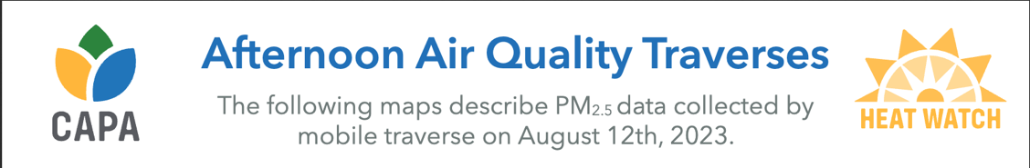
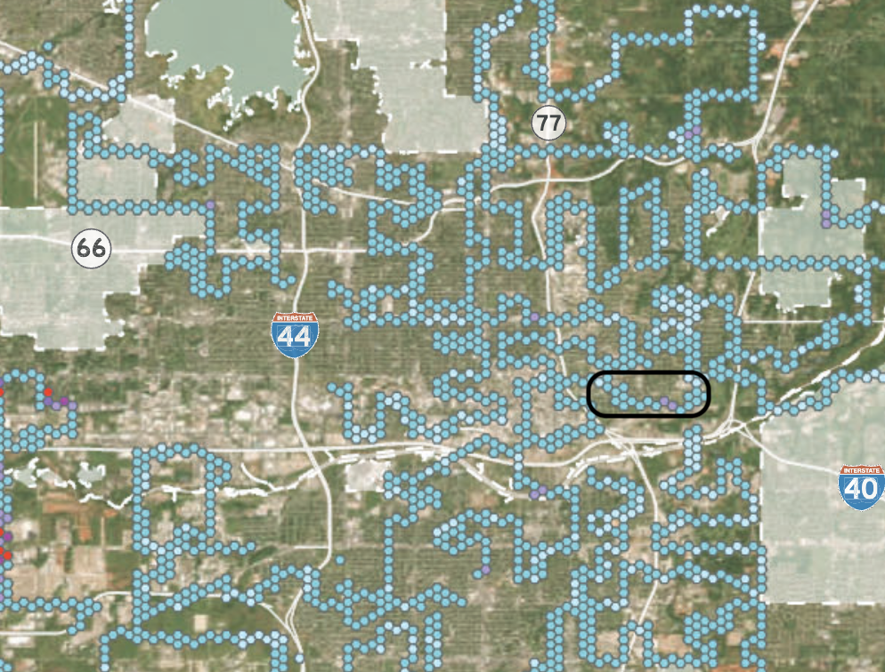

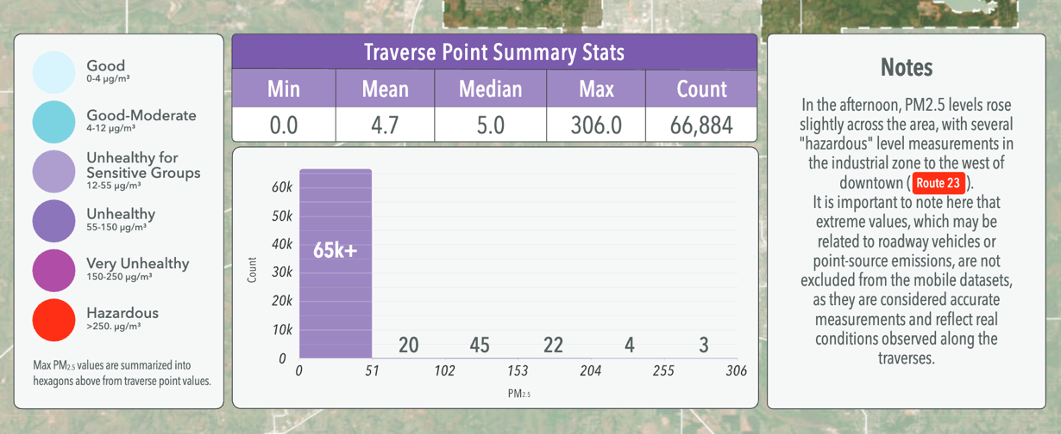

Figure 28. JFK Neighborhood area with two measures of levels of Particulate Matter 2.5 (PM_{2.5}) measured as ‘Unhealthy for Sensitive Groups,’ (OKC Office of Sustainability, CAPA Air Quality Monitoring, 2023)

Extreme Heat Islands in the JFK Neighborhood

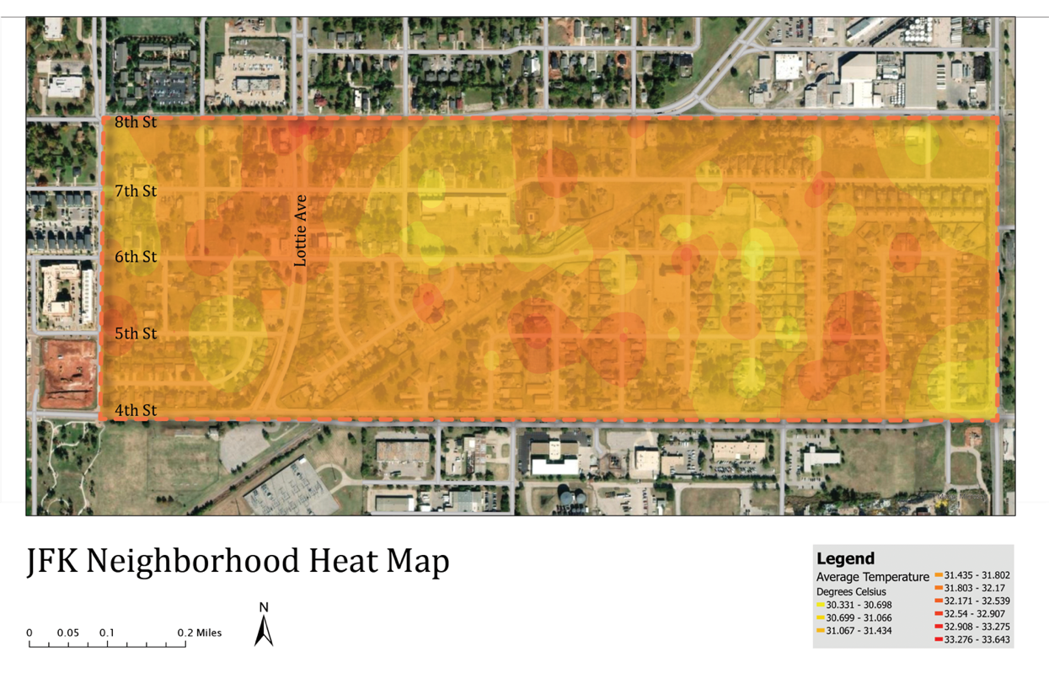
Figure 29. Heat Islands in the JFK Neighborhood, OU (University of Oklahoma) Landscape Architecture Studio Design, September 2023

Several heat islands are scattered throughout the neighborhood and seem to be correlated with vegetation prevalence or lack thereof. Urban planning throughout the United States concentrated communities of color into areas with little green spaces or vegetative upkeep as far as city landscaping (Ard and Smiley 2022; Trounstine 2018).
Land cover was associated with segregation within each racial/ethnic group, which may be explained partly by the concentration of racial/ethnic minorities into densely populated neighborhoods within larger, more segregated cities. In anticipation of greater frequency and duration of extreme heat events, climate change adaptation strategies, such as planting trees in urban areas, should explicitly incorporate an environmental justice framework that addresses racial/ethnic disparities in HRRLC (Heat Risk-Related Land Cover) (Jesdale et al. 2013).

The JFK Neighborhood is lacking some of the landscaping amenities compared to other neighborhoods in Oklahoma City. Reducing “Heat Risk-Related Land Cover (HRRLC)” with landscaping designs with native plants can be an important mitigation that both improves air quality and reduces extreme heat vulnerabilities. The development of policy that promotes “green space equity” is a key component to addressing extreme heat exposure disparities (Rigolon et al. 2024)

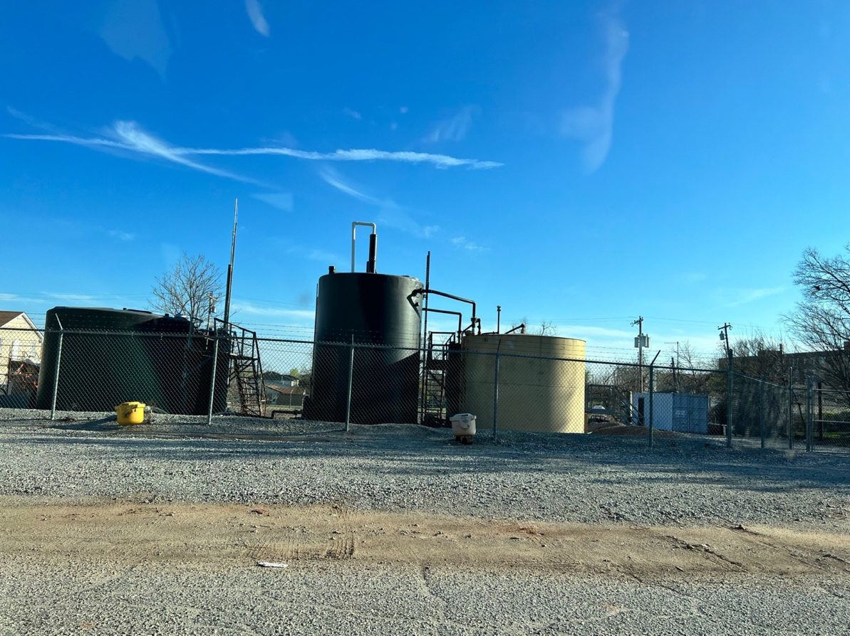

Figure 30. Oil tanks in between homes in the JFK Neighborhood, there are several sites in the neighborhood with active oil rigs and other infrastructure similar to photograph (2023)

The JFK Neighborhood and other portions of Northeast OKC are disproportionately exposed to hazardous air pollution. Poor air quality in particular harms children, older populations, and individuals with pre-exiting health conditions which has been confirmed by accounts from neighborhood residents and the CAPA Air Quality study in 2023. The lack of air quality monitors within the neighborhood is problematic related to the emissions of the nearby heavy industries. Mitigation strategies using green buffers and native plant landscaping are short-term solutions that can help to reduce extreme heat and air pollution exposure. The JFK Neighborhood received a grant from OKC Beautiful, a non-profit promoting environmental stewardship and community advocacy, to plant trees along the NE 4th St. median to buffer some of the air contaminants from the nearby heavy industries. Approximately 300 trees were planted along the median and throughout the JFK Neighborhood and in Culbertson East Highland, the neighborhood adjacent and to the north.

Systemic Barriers that Obstruct Environmental Health Equity in the JFK Neighborhood

This research seeks to: 1) Identify systemic barriers that communities face when seeking environmental justice nearby heavy industrial zones 2) Determine the historical mechanisms that embedded structural environmental inequalities as the basis of current discriminatory zoning and siting conditions 3) Ascertain what types of state policies exist that could lead to improvements in environmental health equity for the JFK Neighborhood. I identified four specific systemic barriers that prevent environmental justice for communities of color. These systemic barriers are institutional inaction, industrial prioritization, regulatory gaslighting, and discriminatory negligence of updating zoning conditions. In Chapter 3, I documented the historic mechanisms that embedded these structural environmental inequalities within the JFK Neighborhood through initial racial residential segregation, discriminatory zoning practices, and further industrial siting. I found a current lack of state-level policies that protect environmental justice and health further perpetuating industrial prioritization and state complicity over environmental equity necessitating the implementation of federal civil rights protections to create environmental equity. The current policy deficit requires the development of environmental justice-based state policies and strengthening enforcement of municipal ordinances stating the incompatibility of industrial areas and residential neighborhoods, despite this pattern of discriminatory land use organization for communities of color.
Institutional Inaction

Rodney Redus, Vice President of the JFK Neighborhood Association, and a former school administrator, sees a legacy of discriminatory zoning that has yet to be abated.
“If you go north, you won’t find this zoning,” he said in an interview with The Oklahoman, “but that kind of zoning is allowed around African American neighborhoods in many major cities. It’s another systematic racist situation where we know we are not alone. It’s happening across the country” (Redus, 2021; Lackmeyer and Kliewer 2021). The systemic barriers and institutional mechanisms that are causing systemic discrimination to continue are related to institutional inaction. By institutional inaction, I mean the structural conditions that produce regulatory stalemates that do little to address preexisting conditions of environmental inequality.
Legacy zoning, a term that I would like to introduce, is a condition of outdated zoning arrangements which maintain unequal environmental health standards for citizens of a municipality. Regulatory agencies have limited pathways of addressing the unequal environmental conditions in the JFK Neighborhood which is due to a systemic ‘industrial prioritization,’ or prioritizing the needs of industry over community members, which I discuss further in the following section. Inconsistent institutional responses, where some neighborhoods receive prompt municipal action to noise and air quality complaints and others receive dismissals of their concerns is a process that I identify as, regulatory gaslighting. This is primarily due to the reporting and complaint inspection process, which results in limited to no action to remediate the environmental hazard. The JFK Neighborhood experienced this with several complaints of environmental issues made to Department of Environmental Quality (DEQ). The cause of reporting an environmental complaint must be witnessed first-hand by a DEQ inspector. When complaints are inspected, if the instance is no longer occurring, the inspector reports that the concern was not apparent, and the instance is not revisited. Throughout the years, the JFK Neighborhood Association and the OKC Housing Authority located on NE 4th St. adjacent to the neighborhood have collected substantial video evidence about the frequent explosions from the Derichebourg Recycling facility. These types of regulatory practices protect industries and make reporting pollution concerns ineffective. Finding ways to use video and photo documentation as grounds for a hazardous event occurring frequently and developing new regulatory standards are needed to protect environmental health in communities such as the JFK Neighborhood.
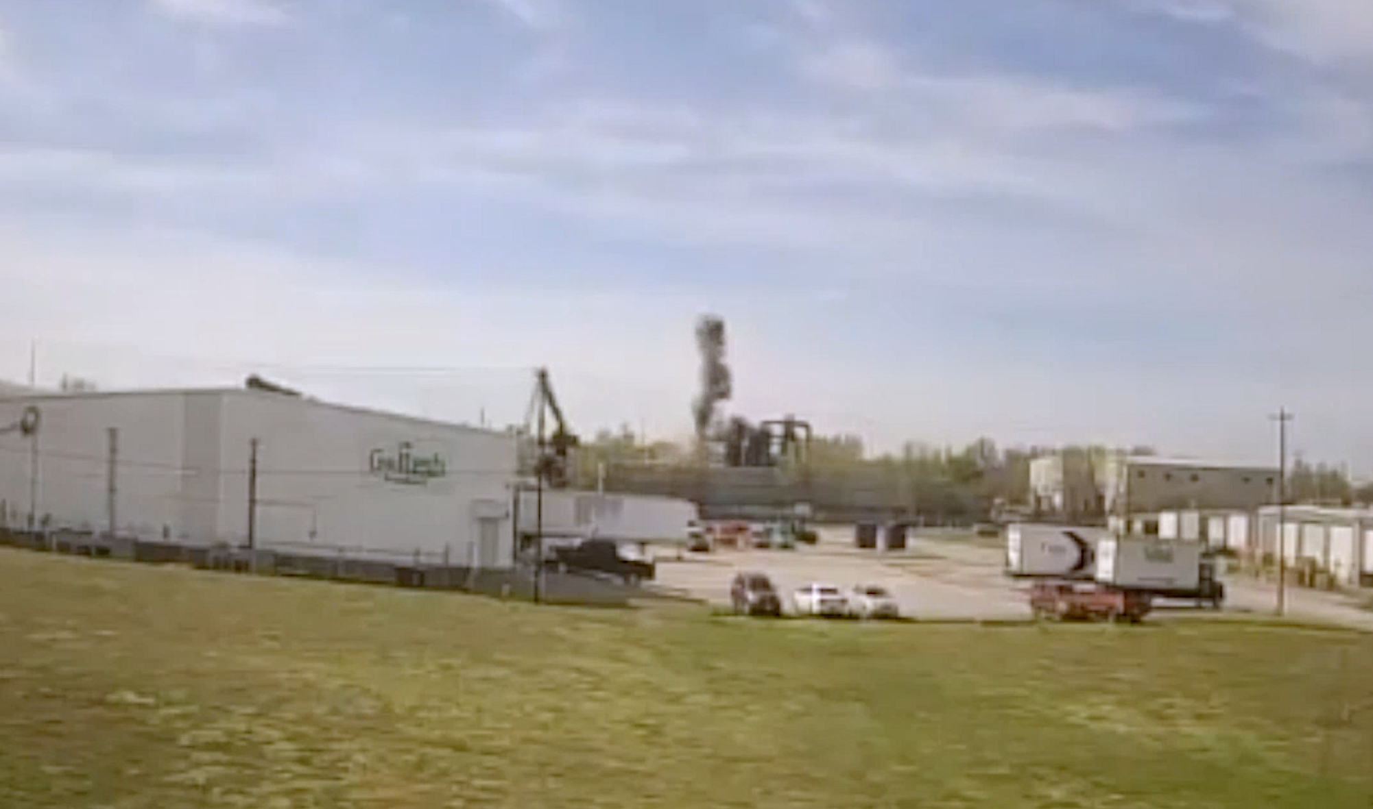
Figure 31. Derichebourg Recycling USA (industrial recycling facility) explosion from car shredding when fuel left in tank ignites, recording by OKC Housing Authority (Lackmeyer 2021a)

Councilwoman Nikki Nice (Oklahoma City, Ward 7, JFK Neighborhood’s Council) advocated for regular meetings with the neighborhood and the city each quarter to discuss strategies to address these environmental justice issues. An investigative report compiled by former Assistant City Manager Audrey McDermid determined that, “the mix of land uses in the area was established and allowed through zoning many years ago, and each has a legal right to exist where they are currently located” due to nonconforming use stipulations (Lackmeyer and Kliewer 2021). Councilwoman Nice countered that the direct impact on neighbors cannot be overlooked, and one of the legal barriers is that “the state has regulated [the neighborhood and complaint reporting options] in a way where it is very difficult to do the things that we need to do” (Nice 2021). Nice continues stating that the JFK community needs to stay “vigilant and start working more on advocating to break those barriers that have been created” in order “to do the work on the state level, as we also work through the federal level” (Nice 2021).
In comparison, more affluent neighborhoods get immediate institutional responses for quality of life and neighborhood health concerns. Attorney Leslie Batchelor who represented the Oklahoma Housing Authority in meetings with City Hall and the Department of Environmental Quality (DEQ) stated that she didn’t think this “would be tolerated in any other portion of the city” (Lackmeyer and Kliewer 2021). Marion West, JFK Neighborhood Association active member exclaims that, “we have that right [for a healthy environment] we’ve earned it and I don’t think that is a hard thing to accept when you live in this country” (2023). Lisa Chronister, Assistant Director of the OKC Planning Department, and Marilyn Allen, City of OKC Program Planner explained that due to a state statute, the city cannot regulate the industrial ‘uses’ of oil and gas operations which includes the Citgo Petroleum Corporation facility directly northeast of the JFK Neighborhood; this can only be done through the Corporation Commission (March 2024). A municipality or other political entity “may enact reasonable ordinances, rules and regulations concerning road use, traffic, noise and odors incidental to oil and gas operations within its boundaries, provided such ordinances are not inconsistent…with the Oklahoma Statutes or the Corporation Commission” (Oklahoma Statutes, Title 52, Chapter 3, Section 137.1). Regulating the noxious odors and excessive noise pollution from the nearby industrial oil facility owned and operated by Citgo Petroleum Corporation would be one way to address the current institutional inaction to the environmental issues in the JFK Neighborhood.

Industrial Prioritization
Cresha Redus, JFK Neighborhood Association member and long-time resident, explains that, “this is not uncommon in major cities where the African American neighborhoods are surrounded by air pollution or damaging effects to our health or our properties” (Lackmeyer 2021a). Historic discriminatory processes segregated minority populations near industrial areas.
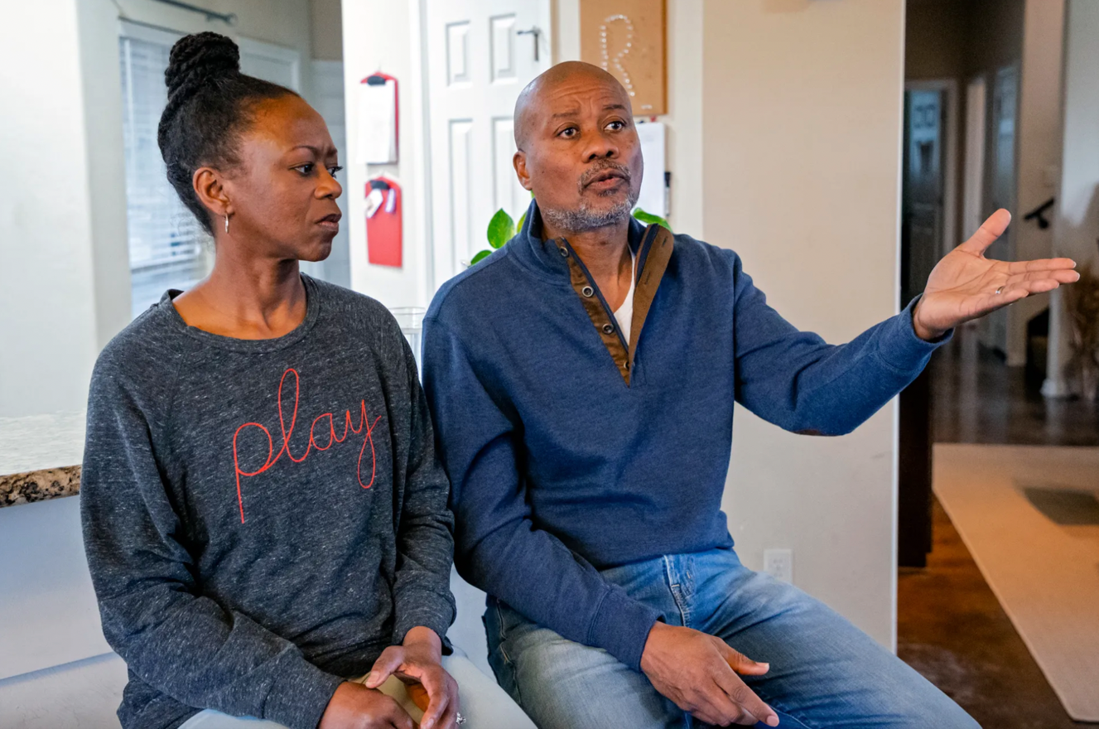
Figure 32. Rodney, Vice President of the JFK Neighborhood Association and Cresha Redus, homeowners in the JFK Neighborhood describe negative environmental and health impacts and property damage from the Derichebourg Industrial Recycling Facility explosions (Lackmeyer 2021a)

In an article in The Oklahoman (Lackmeyer and Kliewer 2021), Councilwoman Nice describes that she “first heard the explosions while visiting the area residents during her first city council campaign during the summer 2018,” and she states, “we need to look at the exemptions these places have with air quality and what the environmental aspects of these operations look like in terms of environmental justice for neighbors.” Moreover, Councilwoman Nice has been extremely concerned with how people who have asthma are “affected by the smoke” and how “those struggling with post-traumatic stress disorder are coping with the blast noises” (Nice 2021). Diane McDaniel, the former President of the JFK Neighborhood Association, explained that when her granddaughter came to visit from North Dakota:
she stayed with me, and she has asthma. I noticed that when she was around or I kept her after daycare, she would have symptoms of asthmatic conditions, but when she went home at the northwest side of town, it looks like over that weekend, they were marginal. So she didn’t have to use the inhaler or nebulizer and I noticed that (March 2023).

Councilwoman Nice also has expressed intent in pursing relief through the U.S. Department of Justice, following a pledge by President Joe Biden “to commit more resources to the agency’s environmental justice division” (Lackmeyer and Kliewer 2021). Federal policy has created executive orders based on equity and achieving justice for historically underserved communities and populations that have been “systematically denied a full opportunity to participate in aspects of economic, social, and civic life” (White House, Presidential Actions 2021). “Advancing equity requires a systematic approach to embedding fairness in decision-making processes,” (White House 2021) and prioritizing industries gives an unfair advantage to the facilities over the residents of communities. Examining the “policies and programs that serve as barriers to equal opportunity” is necessary to give equal representation to all people despite economic status or racial background. The Environmental Protection Agency has offered several grant competitions to direct Inflation Reduction Act (IRA) funding to historically disadvantaged communities and to “meet the goals and objectives of two Executive Orders (EO 14008 and EO 13985) issued by the Biden Administration that “demonstrate the EPA’s and Administration’s commitment to achieving environmental justice and embedding environmental justice into Agency programs” (EPA 2023, Environmental and Climate Community Change Grants). Councilwoman Nice reiterates that, “as long as we can continue to have these conversations [about environmental injustices] they should absolutely be looked at on a federal level. Whenever you have reports from parts of your community and they say they’re not safe, absolutely, they need help. We need to do better” (2021).
Senator Mary Boren explained that environmental protections are frequently undermined by the prioritization of patriarchal systems that favor industry and maintain a certain framing of concern for pollution as unnecessary unless it directly impacts a family through health deterioration. Thus, socially ingrained norms of allegiance to industry and patriarchal systems, dominant within the political culture of the state, prioritize these practices and reflect a key pattern of systemic barriers to environmental health due to preferential treatment (Senator Boren Interview 2023). The association with concepts of masculinity and ability to provide economic stability as well as maintain the economic well-being of region are enmeshed with behaviors that promote industrial prioritization. Extractive industrial management often uses fear of unemployment and rhetoric for hegemonic masculinity to exploit industrial allegiance through associations to a history of being the backbone of the local economy (Bell and York 2010:111). Environmental racism, as a systemic and structural condition of racial capitalism, is also a key mechanism of perpetuating systemic inequities (Kim 2021; Pulido 2017). Environmental discrimination regarding limited access to a healthy environment, can be considered an extension of racialized economic systems that prioritize industry needs over community health for certain populations (Pulido 2016). Beyond clear patterns of disparate impact from industrial contamination and the resulting health inequities, social patterns of systemic discrimination are implicit in maintaining a prioritization of industry which compromises quality of health. Residents of Southwest Crossings in Houston describe a similar experience related to the construction of a natural gas pipeline in their neighborhood as if feeling ignored, exploited, and dehumanized, and their “voices [are] nonexistent” (Hassanein 2023). Environmental injustices are most acute for politically marginalized communities where the ability to demand justice is tied to economic status (Carrillo and Pellow 2021). Our current systemic patterns of preferential treatment define who is included in access to a healthy environment and who is expected to endure unequal environmental health conditions from the prioritization of industry over community well-being.

Regulatory Gaslighting
The JFK Neighborhood Explosions Report (2018) documents a history of reporting the explosions from the Derichebourg for over a decade and no regulatory recourse. This constant response from environmental regulatory institutions, in particular the Oklahoma Department of Environmental Quality (ODEQ) has allowed conditions of unequal environmental safety to exist for Oklahoma City residents. In a letter from the Department of Environmental Quality (DEQ), after an explosion at the Derichebourg Industrial Recycling facility was reported, when the inspector came to the facility, the explosion had ended, and he stated that there was “no appearance of ‘carcinogenic pollutant’ in the air, or ‘loud explosions’” (2018), when clearly both had occurred (Figure 33). Regulatory Gaslighting, as a structural process, maintains the notion that the regulatory agency is more knowledgeable about the environmental conditions, undermining firsthand testimony from JFK residents. Gaslighting is a “type of psychological abuse aimed at making victims seem or feel ‘crazy,’” and it is “rooted in social inequalities” (Sweet 2019). Environmental regulatory gaslighting has a performative aspect but its key intention is to diminish the influence of environmental complaints in order to maintain industrial operating procedures for powerful companies.
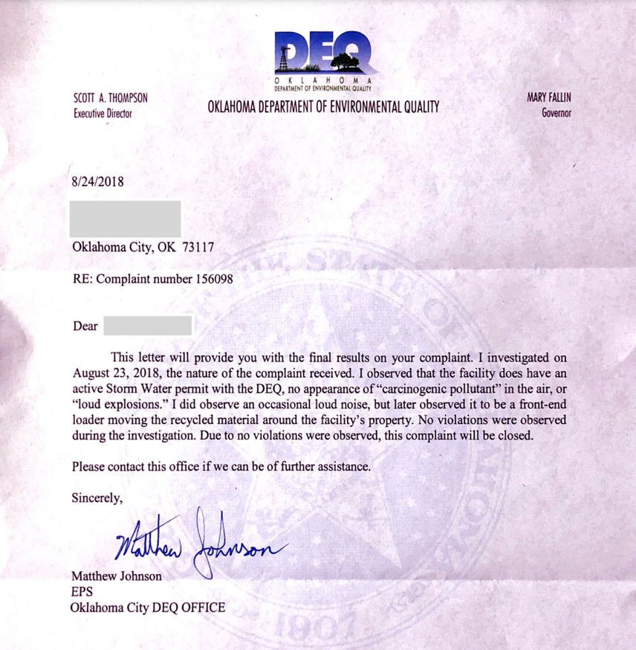
Figure 33. Letter from the DEQ stating that the inspector did not find evidence of an explosion at the Derichebourg Industrial Recycling Facility (JFK Neighborhood Explosions Report 2018)

Lackmeyer and Kliewer (2021) convey that despite extensive video footage of frequent explosions from both the JFK Neighborhood Association and the Oklahoma Housing Authority, this is still insufficient to warrant further environmental or air quality inspections for the toxic emissions from scrap yard explosions of a shredded vehicle. Javier Auyero and Debora Swistun (2008) also document “perceptions of contamination” to explain that powerful actors gaslight community members’ experiences of living in pollution to maintain their industry’s goals in the area. In this case, mothers were blamed for not taking care of their children who were sick when it was the toxic environmental conditions degrading their health (Auyero and Swistun 2008). Carrillo (2021) defines the concept, “the racial fix,” as a tool used to maintain ‘business as usual’ where racial politics and racism are employed in ways that restrain sustainable environmental policy in order to maintain current political economic hierarchies of priorities, violating basic civil rights protections and undermining social movements responding to these exploitative systems, which is exactly what is occurring in the JFK Neighborhood.
Dianne McDaniel, JFK Neighborhood Association member and former president states, “We’re shouting, we’re screaming as often as we can; can anybody hear us, is anybody listening?” Redus (2023) continues, “there’s got to be other areas of the country where this is happening,” and further,
if the companies have to be relocated what options do they have, in order for it to be good for both parties… if the smoke is coming and blowing out of the plant and its blowing up [into the sky], is there a way for that company to redirect that smoke so it doesn’t just go through the neighborhood, maybe if it means an extra tall smoke stack -- that doesn’t eliminate the fact that we still get the residue but something because literally a fog of smoke just comes through the neighborhood [Figure 34] and there has got to be a better way (Redus 2023)

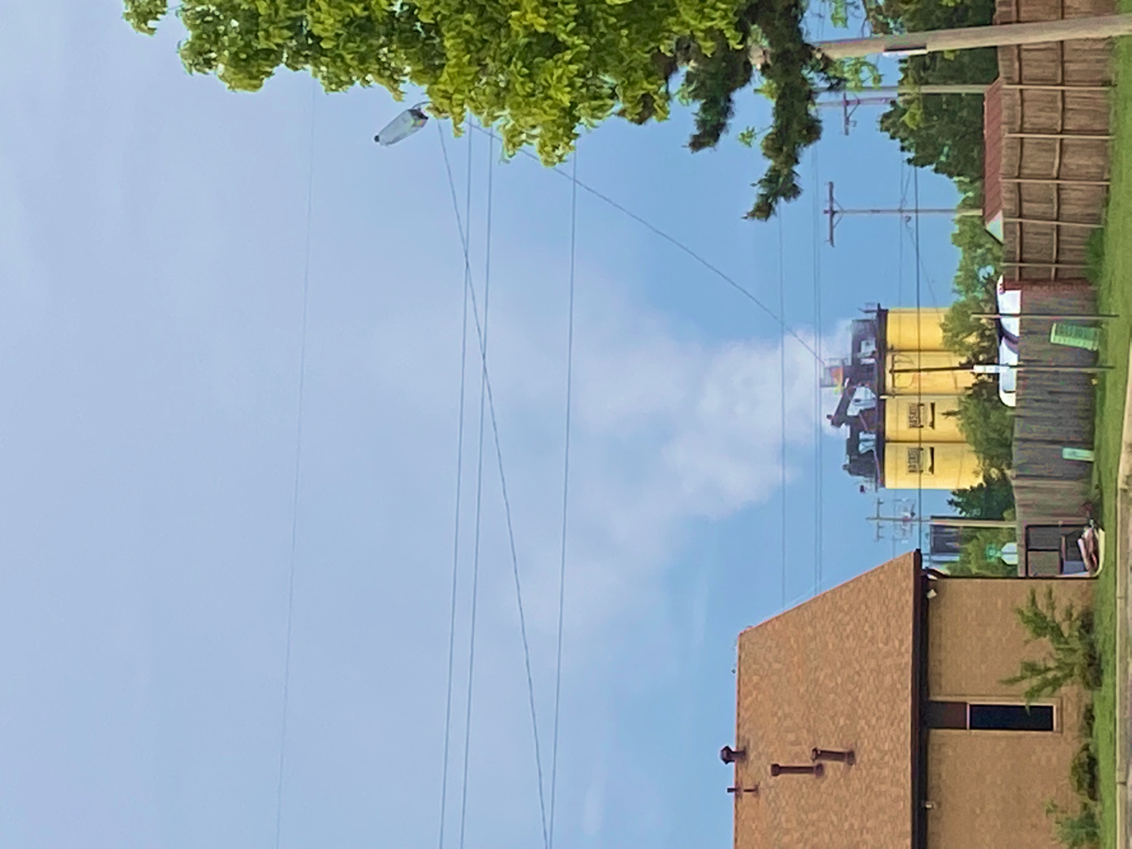

Figure 34. Photo of Haskell Lemon, asphalt production facility, on NE 4th St. across from JFK Neighborhood residences, photo taken by Rodney Redus, Vice President of JFK Neighorhood Association (JFKNA)

Discriminatory Negligence of Updating Zoning Conditions

Rodney Redus describes his hope for the future as being that “our neighborhood will enjoy the same luxuries and privileges that other neighborhoods hav[e] in the metro area” (2023). “We have a right to clean air” states Cresha Redus, who was recently diagnosed with a skin and autoimmune condition which causes can be environmental. She explains further about the health condition that she developed and other health concerns related to living in the JFK Neighborhood:
When I did the research, they said they don’t know where it came from but it could be environmental - and that was in many different articles, and so of course, I am thinking about where I live and we are still processing this whole diagnosis, and I’m ready to move. So that’s my biggest concern, I feel like that diagnosis had a lot to do with me being here, starting in 2009 because it was diagnosed in 2022…and we like to walk, we go to Washington Park and there's times we have to walk through it [smoke and smell], and so we either turn around or we just don't walk at all, and that's very restricting for a home owner no matter where they live - it shouldn't happen. There's some serious health concerns going on around here… but it's a shame that you come here healthy and then you end up trying to move because you're not anymore (Cresha Redus 2023)

The discriminatory negligence of updating zoning conditions for the JFK Neighborhood represents a constant disregard for an equality of public welfare. It also compounds systemic racialized disempowerment through a process of racialized institutional discrimination. This is particularly evident regarding reporting hazardous environmental concerns but getting limited remediation of the situation, and differential responses depending on the location of a families’ neighborhood in OKC which are inconsistent and discriminatory institutional responses. Greg Jones, JFK Neighborhood Association Board Member, and long-time resident reflects:
My hope is that when my kids become adults and have families that they'll be able to live in this community and thrive, and the issues that have been at the forefront will be eradicated and that the city will recognize that this community, JFK, is just as much a part of the thriving community as it is downtown and anywhere else. Our families, our kids, and our people will be treated just like anywhere else and there'll be opportunities for us to live and thrive within Oklahoma City and the surrounding areas…and thank you for what you're doing. I think it means a lot and shows you care, to come share and then to advocate for us, thank you (March 2023)

The current zoning conditions for the JFK Neighborhood reflect outdated municipal land use policies that according to current municipal ordinances which no longer condone residential areas being near industrial ones. Placing neighborhoods next to areas of heavy industry poses risks of exposure to hazardous materials and other elements in which the neighborhood has already experienced disparate exposure. Yet the JFK Neighborhood experiences this zoning condition daily because it is grandfathered-in from a time when this zoning was not a violation of OKC Municipal codes (Oklahoma City Code of Ordinances). Environmental racism occurs at multiple levels, and it may be more appropriate to label it as industrial systemic racism, or industrial racism, making more apparent the industrial actor that is disregarding the communities around which the industry is located. This is maintained through institutional, systemic, or regulatory processes of gaslighting – or multiple agencies and organizations reinforcing the notion that ‘there really isn’t a problem’ when there are clearly negative health impacts from industries surrounding the neighborhood. State Senator George Young explains this as:
It is factual that in communities of my nature - I represent the largest African American population in the state of Oklahoma, my seat represents that, Northeast Oklahoma City - there are some areas in Northeast Oklahoma City, where the industrial facilities that are there have been in that area for awhile, near the Douglass High School, it’s evident that they created those areas and took no regard to the individuals living there (Young 2024)

Regarding current complaints about environmental hazards, residents have seen little change in their environmental health quality. The process of achieving justice for all is rooted in a pursuit of equality, which is the core tenant of the U.S. constitution and founding principles and this includes the right to a clean and healthy neighborhood. The economic systems that began with the establishment of the U.S. political systems did not ascribe to these ethical laws and instead were based on exploitation of enslaved and impoverished people. Overturning unequal conditions is paramount for reparative and environmental justice.

Environmental Justice Policy Deficit
In Oklahoma, the state political climate is generally not supportive of environmental initiatives, related to regulating the oil industry or other industries. The President of the JFK Neighborhood Association, Denyvetta Davis, requested research on the existence of state policies or legislation that would protect the JFK Neighborhood from environmental health inequalities. I found a lack of current environmental justice policy in existence at the state level which was confirmed by both State Senator George Young and Mary Boren, as well as Representative Ajay Pittman, and Councilwoman Nikki Nice. They each reiterated that environmentally protective policies are somewhat non-existent. Senator George Young explains that national environmental justice groups have approached him to develop policy, but he describes “the attitude of the state is just not there” and there is currently no legislation that offers environmental health protections (Interview March 2024).
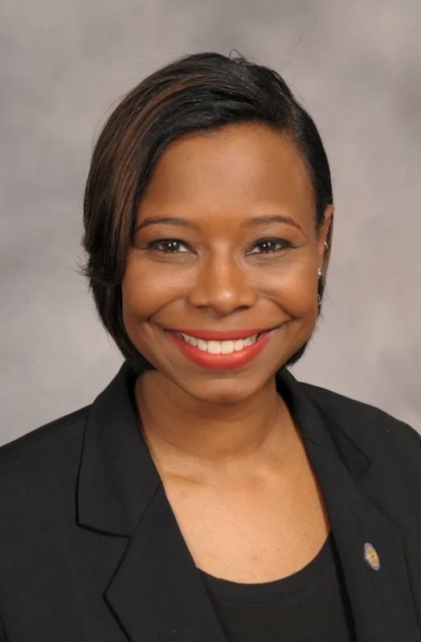
Figure 35. Councilwoman Nikki Nice, OKC City Council, Ward 7, JFK Neighborhood
Creating conditions for the development of state legislation and policies that protect environmental health and health equity for neighborhoods that have borne the burden of environmentally hazardous industries is key to creating conditions for environmental health equity. This occurs through community engagement and inclusivity of impacted community members through continual meetings, forums, and the creation of advisory boards to ensure ongoing and meaningful engagement. Senator George Young and Councilwoman Nikki Nice emphasized the importance of involving the “constituents” to develop environmental health and justice policy to protect communities like the JFK Neighborhood (Interview, March and April 2024). Another element that is essential is to conduct assessments on the environmental health challenges experienced by the community. After an understanding of the environmental risks and concerns is established, presenting this information to local representatives and state legislators can be essential for spreading awareness in the political sphere about the health inequities faced by the community. For lasting policy development, community involvement must be maintained in a meaningful way, and this further empowers the impacted community (Councilwoman Nice Interview, 2024). Implementation of health equity policy protections and the enforcement of these policies must be coupled with an allocation of resources for regulatory enforcement and environmental monitoring which is the most difficult element so far.
Despite our formal legal structures, the role of environmental law in ensuring environmental justice has been enforced unequally offering environmental health for certain communities and not for others – the laws are enforced inequitably, and do not offer protection from environmental harm for all citizens. Instead, achieving environmental justice involves enforcing environmental protections equally and fairly. Equitable environmental law requires an equal involvement and incorporation of citizen participation in decision-making processes which involves following community-driven solutions for improved public health equity (Méndez 2020). Implementation of environmental justice principles into legal systems can contribute to reparative justice initiatives and an integration and enforcement of environmental health equity policies (Anggraeni and Amrullah 2023).

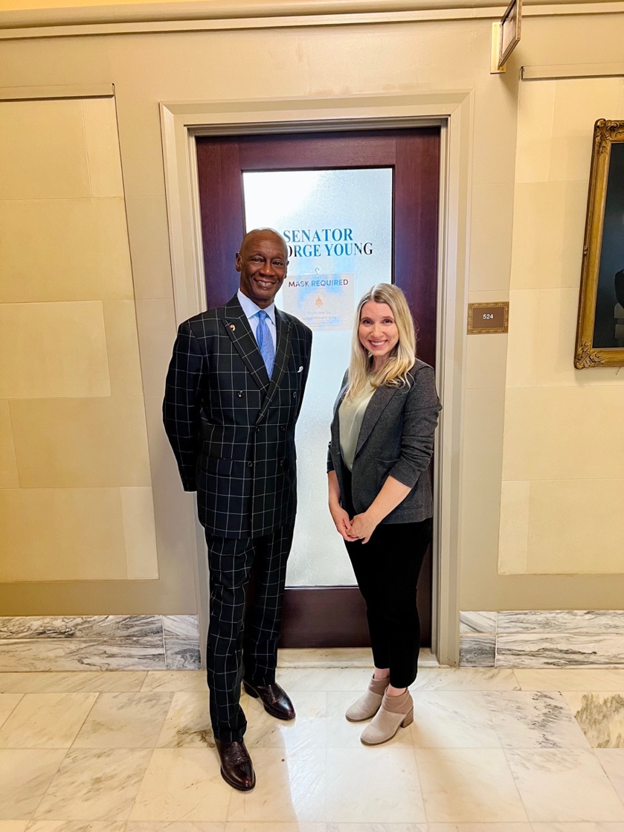
Figure 36. State Senator George Young, District 48, JFK Neighborhood’s Senator, March 2024
Currently, the state has been inadequate at offering environmental justice protections equally for all people despite demographic group identification. One key gap is the limited impact that federal environmental justice (EJ) policies have due to limited state enforcement efforts for local environmental health problems and inequities. Research has found that state enforcement of EJ policy is influenced by government ideology, or a deification of limited government involvement, limited racial diversity in macro-level population demographics, and the level of development of a state’s environmental innovations (Konisky 2009). Both Senators Young and Boren conveyed that the political culture of the state undermines environmental protection-based legislation in general, particularly related to the history of protecting the oil industry.
The key starting place in working to achieve environmental health equity is aligning state policies and enforcement of these policies with the specific objectives of federal environmental justice initiatives, such as the most recent Executive Orders (EO 14008 and EO 13985). This will take defining workable implementation strategies focused on community-based input and continuous engagement. Executive Order 14008, Tackling the Climate Crisis at Home and Abroad, includes the most “ambitious environmental justice agenda ever undertaken by the Federal Government” recognizing that “all Americans deserve to live in healthy, thriving communities, but, in fact, too many people lack access to safe places to live, work, play, grow, and learn” (Biden Administration 2021). The Order establishes several environmental justice initiatives including: the White House Environmental Justice Interagency Council (IAC), the White House Environmental Justice Advisory Council (WHEJAC), the Justice40 Initiative, the Climate and Economic Justice Screening Tool (CEJST), and the Environmental Justice Scorecard, which will “track Federal agency performance on environmental justice” (White House, Environmental Justice). The Justice40 Initiative’s purpose is to direct “40 percent of the overall benefits” from federal investments in clean energy, climate adaptation, and green infrastructural developments towards “disadvantaged communities who are marginalized, underserved, and overburdened by pollution” (White House, Environmental Justice, 2024). This would include the JFK Neighborhood as a recipient of benefits from clean energy and infrastructural investments.
Federal policies and any institution receiving federal funding must follow the Civil Rights Act of 1964, Title VI’s protection that “prohibit[s] discrimination on the basis of race, color, and national origin in programs and activities receiving federal financial assistance,” quoting President John F. Kennedy (1963), “Simple justice requires that public funds, to which all taxpayers of all races [colors, and national origins] contribute, not be spent in any fashion which encourages, entrenches, subsidizes or results in racial [color or national origin] discrimination” (Civil Rights Division, U.S. Department of Justice).
Federal funding can be suspended to recipients (municipalities and other institutions) if discrimination is apparent in their practices or policy enforcement. Several cases attempting to “prevent the siting polluting facilities” from locating or being located in “minority communities” based on a violation of Title VI have been brought forward on the basis of frequency of occurrence, but the courts have “systematically refused to prohibit government actions…without direct evidence of a discriminatory intent” (Brulle and Pellow 2006). Dorceta Taylor has (2014) emphasized the difficulty of proving “disparate impact” for communities of color from environmental injustices without also proving “discriminatory intent.” Legal Aid of NorthWest Texas has found a pathway towards proving ‘discriminatory intent’ through documentation of historic and present environmental injustices and inequalities and has recently filed a Title VI complaint against the City of Lubbock for discriminatory zoning conditions disproportionately exposing Black and Latinx residents to industrial pollution and health hazards. The JFK Neighborhood is planning to file a similar Title VI complaint against the discriminatory zoning conditions in OKC.
Environmental justice research has shown that environmental injustices have contributed to overall systemic inequalities related to health disparities or disproportionate adverse health outcomes. This institutional environmental discrimination has been maintained through processes of institutional or systemic disinvestment which has recently been actively combated through targeted investment and reparative justice approaches. I term these processes as racialized structural disempowerment or structural inequity of environmental health resources, and they have been perpetuated by unequal distribution of city amenities for built environments which is a violation of Civil Rights law, in particular Title VI, which states that discriminatory conditions based on race or ethnicity are illegal. Dorceta Taylor (2014) called for more environmental justice scholarship to examine the zoning inequities from proximity to industrial hazards for communities of color. I have answered her call along with many other scholars. The evidence is clear that racially and ethnically marginalized neighborhoods live in what I would describe as environmentally unequal areas. In Michigan, many environmental justice advocates are calling for the creation of ‘Green Amendments’ to ensure environmental health equality. Developing more positions in environmental justice and equity consulting, or environmental health or justice planning, as well as coalition building between climate justice and environmental health equity organizations is essential for ensuring healthy environments for all.

“If America does not respond, civilization will die – make justice a reality for all.”- Dr. & Rev. Martin Luther King

Chapter 5: CONCLUSION

My research responds to calls to investigate of the “institutional mechanisms” that uphold the unequal distribution of environmental injustices throughout the country. By identifying specific ‘barriers’ and ‘mechanisms’ to environmental health, I strive to also locate pathways to environmental health equity. I build on previous research that has identified some systemic barriers to environmental justice as: prioritization of industry needs (Alvarez 2023; Pulido 2017); institutional infrastructural negligence (Seamster and Purifoy 2020); and a disregard or lack of incorporation of community-based concerns into policy and implementation responses (Méndez 2020). By expanding the focus to processes of ‘regulatory gaslighting,’ ‘institutional inaction to address unequal zoning conditions,’ and analyzing historic mechanisms and conditions that produced these environmental inequalities, I find that one of the main barriers marginalized communities historically have faced is discriminatory zoning policies. These policies place an unequal burden onto communities due to their proximity to heavy industrial areas with their hazardous industrial pollution and related negative health impacts (Rossen and Pollack 2012).
Communities with a history of extractive activities or proximity to heavy industrial zones are left with the repercussions of legacy pollution and contamination as well as exploitative patterns of resource drain with limited economic compensation (Mayer et al. 2018). This established industrial presence encourages new industries to continue to locate in these neighborhoods further compounding systemic discrimination and inequalities. The economic decline of certain areas may also lead to a willingness to accept polluting industries for the sake of economic development, further perpetuating environmental injustices. More equal representation in regulatory spaces or legislative decision-making (Méndez 2020) and the inclusion of EJ communities in the planning process of siting for protective zones would create more equitable access to environmentally healthy areas (Hagen 2018).
My key findings indicate a process of institutional level and ‘regulatory gaslighting,’ and government inaction towards the JFK Neighborhood residents. These findings affirm claims from past research showing that the health concerns of local stakeholders are often ignored or invalidated (Auyero and Swistun 2008; Shriver et al. 2014). These negative experiences with surrounding industries have lasted for decades and have the resulting health deterioration, psychological trauma, and property damage. This process of regulatory gaslighting is primarily related to the reporting mechanisms where complaints called in to the OKC Action Center are not documented correctly, and through the Oklahoma Department of Environmental Quality (ODEQ), the complaint is closed if the pollution event is not witnessed firsthand by the inspector. While the JFK Neighborhood has been told repeatedly by environmental inspectors from (ODEQ) that the surrounding heavy industries are operating properly within the current environmental regulations, residents feel ignored. The lived experiences of JFK residents include smoke and smog blowing through their neighborhood, as well as strong noxious odors and sticky films on outdoor surfaces and plants which they are concerned is affecting their health.
Public awareness of institutional racism has increased, but comprehensive strategies to eradicate systemic discrimination are still being developed. Moreover, the existence of environmental racism is not a new phenomenon but identifying the specific systemic barriers to achieving “environmental health justice” (Masuda et al. 2010) is critical for communities suffering disproportionately from negative health outcomes, and I offer this with my research. Answering critical environmental justice calls for analysis of multiple indicators of oppression, including ‘environmental health status,’ or ‘environmental health vulnerability,’ as a social category of inequality, would help identify populations where injustice is tied to the degraded health of the surrounding environment and its people. Even though the ‘social determinants of health,’ include determinants related to the ‘built environment,’ there needs to be more explicit identification of industrial pollution as a detriment to health and environmental quality. Finding new strategies to operationalize structural and systemic inequalities is key to quantifying the burden of environmental injustice for specific communities. With this type of modeling, systemic barriers also can be measured and analyzed as indicators of complex interactions that perpetuate systemic injustices. Understanding systemic barriers to environmental justice is critical to ending environmental harm from an over-prioritization of industry over community well-being.
Both economic and political structures, and their interactions, form environmental racism, or intersectional systemic oppression, and in many cases their interactive operations maintain certain contexts where BIPOC communities are framed as expendable. A more in-depth investigation of structural white supremacy as a driver of environmental injustices is paramount to reveal what mechanisms of our political and economic institutions are perpetuating environmental inequalities. Achieving environmental health equity requires that we analyze the systems that maintain environmental injustices to eradicate existing racial health disparities from degraded environmental quality.

Policy Development as a Pathway for Environmental Health Equity

Achieving environmental health equity in neighborhoods suffering from legacy industrial pollution has been sought through the development of environmental justice (EJ)-based state policies. Evaluations of state EJ policies has found that environmentally just outcomes to decrease “pollution inequalities” are most beneficial when using distributive justice-focused approaches. Improving environmental health and air quality in industrial areas requires state policies that focus on enforcing federal policies to overturn systemic barriers and achieve environmental equity. In some cases, regulatory interventions that protect overall community health can pressure industries to embrace more environmentally healthy practices that contribute less negatively to the environmental health of the neighborhood through enforcement of these regulations.
Environmental governance, broadly speaking, is seen as a way to promote the development of environmental health policies, but it is collaborative environmental governance practices specifically that can more effectively address the concerns of EJ communities. However, environmental health interventions (EHIs) are challenging as far as cost estimates or budget planning and industrial actors not wanting to pay for costly changes. Improvements to the built environment generally raise the value of the neighborhood as well as establishing access to equitable environmental resources and public health conditions. State and federal governments need to prioritize public health to ensure the protection of overall environmental health and mitigate the unequal impact of industrial pollution for communities of color.
The City of OKC has expressed the difficulty of financing the relocation of the industries due to limited financial resources, but they could incentivize the industries to move by providing a new location or tax breaks. One solution, for the immediate future, would be to enforce tighter regulations on the industries, or to work towards ‘downzoning’ the heavy industries (I-3) to moderate (I-2), or light (I-1) industrial production processes. Implementing required distances for “hazardous industrial uses” is one way to ensure more protection from environmental pollution for nearby neighborhoods, since hazardous industries are recommended to be 1,000 feet removed from residential properties, as opposed to 35 feet, required for ‘heavy industry’ (1-3) which is the current approximate distant Haskell Lemon is to the neighborhood. The minimum distance at which heavy industry (I-3) is allowed next to residential areas needs to be expanded from 35 feet to a larger distance as well, and ultimately following OKC’s municipal ordinance that heavy industrial areas are “incompatible” with residential areas (R-1) (OKC Code of Ordinances Chapter 59, Article VI 59-6250.1). The industries could be re-classified as “hazardous” industries which also would mandate longer distances away from residential areas.
The Derichebourg Industrial Recycling facility has caused prolonged physical and psychological damages to the neighborhood, due to exposure to traumatic stress as well as the air pollutants released during the explosions. It is necessary to conduct further health assessments on potential hearing damage or trauma impacts, as well as respiratory health degradation from the release of air toxicants during the explosions and the Citgo and Haskell Lemon smokestacks. The frequent industrial fires, and other industrial combustion throughout the neighborhood is a cause for public health concern. Citgo Petroleum Corporation’s release of toxins like zinc into the air has been documented by the Environmental Protection Agency, and they were fined in violation of the Clean Air Act for these emissions (EPA 2021). As for the explosions, current violations of noise ordinances are only possible if a sustained noise is measured. A provision needs to be added to the OKC noise ordinances that would allow city officers to cite, “short, percussive blasts,” over certain decibels, as a violation of noise ordinances, in tandem with adding more noise monitors in the area to document the high decibel level of these explosions (Lackmeyer, 2021a).
The Department of Environmental Quality (DEQ) is an equally important agency in addition to the city. Although the sites in and near the JFK Neighborhood are zoned as heavy industry, not all of them require permits through the DEQ’s current regulations. Scrap yards are currently exempt from air quality permits from the DEQ (Lackmeyer and Kliewer 2021). One area for improvement would be removing the exempt status from air quality regulations for Derichebourg Industrial Recycling Facility. Once the company is subject to DEQ regulations, the DEQ could also introduce opacity as a factor for grading explosions, similar to the one they use for sustained emissions, as per Oklahoma Administrative Code § 252:100-9-1. If the contents of the smoke from explosions could be tested, Derichebourg could be held liable to notify the DEQ of their explosions if it was found that they are releasing any of the six criteria pollutants that would violate the Clean Air Act. While the Oklahoma DEQ has just recently adopted an environmental justice statement, they could benefit from creating an environmental justice advisory council like the one the EPA created for the nation, the NEJAC (National Environmental Justice Advisory Council) (EPA, 2022b). A municipal task force or council might be able to dedicate more time, resources, and expertise to this local environmentally hazardous zoning problem and the resulting environmental health inequities.
An example of addressing environmental injustices can be seen in Menlo Park, California, in 2016, the city created an Environmental Justice advisory board that investigates the environmental inequities that underserved neighborhoods experience. They have created a plan for engagement with local communities, as well as goals and policies that they intend to prioritize through increased transparency regarding regulatory development (City of Menlo Park 2022:5). Through the gathering of updated census data, surveys of land use, and planning specific meetings for citizens to voice their environmental justice concerns, the city has made themselves more available to those who are impacted (City of Menlo Park 2022:13). The JFK Neighborhood has continuously reported the environmentally concerning incidents to the city, but the JFK Neighborhood Association has said that many of these institutions follow bureaucratic procedures which can be time consuming, difficult to navigate, and produce few results. Residents of the JFK Neighborhood are unable to get their concerns addressed because of administrative roadblocks and a lack of meaningful coordination between agencies.
Many communities face similar environmental injustices as the JFK Neighborhood, but research on how to repair and re-zone these areas is limited. More research is needed to analyze how to remove the structural barriers that exist to achieving systemic environmental justice. Studies on how policy can create systemic changes is critical for communities living in environmentally hazardous areas, as grassroots efforts and activism can be stalled by state governance and political structures. The right to a healthy environment is protected by our constitution and civil rights amendments, and it is long overdue. This right begins by being incorporated into the state of Oklahoma and the city of Oklahoma City’s legal frameworks and enforcement of current zoning codes.
Many JFK Neighborhood residents know the possible solutions needed to gain reparative environmental justice to construct equitable social structures and zoning practices, but they have found limited pathways to implement these solutions, as far as legislation, regulatory action, or legal protection. Rebuilding equitable structures and services is one way to begin to compensate communities of color for past injustices (Táíwò 2022; Wilson et al. 2008). This is essential for reparative justice for the JFK Neighborhood to restore the environmental health of their neighborhood. My research engages with an impacted community to identify systemic barriers to environmental healthy equity, document historic mechanisms of these environmental inequalities and envision solutions for achieving environmental justice through community-based strategies. Identifying barriers to achieving equitable environmental conditions is important because systemic barriers function in tandem with “institutional mechanisms” perpetuating health inequalities. Examining environmental health, particularly how to improve environmental health for all communities, is critical to reducing ethnoracial health disparities and improving overall environmental health and justice.

References
Aaronson, D., Hartley, D., & Mazumder, B. 2021. The effects of the 1930s HOLC “redlining” maps. American Economic Journal: Economic Policy, 13(4), 355-392.

Abolhasani, R., Araghi, F., Tabary, M., Aryannejad, A., Mashinchi, B., & Robati, R. M. 2021. The impact of air pollution on skin and related disorders: a comprehensive review. Dermatologic therapy, 34(2), e14840.

Agarwal, V. 2022. Communicating for social justice in health contexts: Creating opportunities for inclusivity among marginalized groups. Frontiers in Communication, 7, 1008533.

Agency for Toxic Substances and Disease Registry. “Public Health Statement for Zinc.” Centers for Disease Control and Prevention, 2014. https://wwwn.cdc.gov/TSP/PHS/PHS.aspx?phsid=300&toxid=54

Alvarez, C.H., 2023. Structural racism as an environmental justice issue: a multilevel analysis of the state racism index and environmental health risk from air toxics. Journal of racial and ethnic health disparities, 10(1), pp.244-258.

Alvarez, C. H., Calasanti, A., Evans, C. R., & Ard, K. 2022. Intersectional inequalities in industrial air toxics exposure in the United States. Health & Place, 77, 102886.

Alvarez, C. H., & Evans, C. R. 2021. Intersectional environmental justice and population health inequalities: A novel approach. Social Science & Medicine, 269, 113559.

Allen, D. T. 2016. Emissions from oil and gas operations in the United States and their air quality implications. Journal of the Air & Waste Management Association, 66(6), 549-575.

American Society of Planning Officials. 1955. Planning Advisory Service. “Industrial Zoning Standards.” September 1955. https://planning-org-uploaded-media.s3.amazonaws.com/document/PAS-Report-78.pdf

Anggraeni, R. D., & Amrullah, M. K. 2023. Promoting the urgency of restorative justice to environmental law enforcement officials through civic engagement education. Jurnal Cakrawala Pendidikan, 42(1), 176-188.

APA Planning and Law Division. 2018. “Foundational Land Use Law Cases.” American Institute of Certified Planners. American Planning Association. https://planning-org-uploaded-media.s3.amazonaws.com/document/PLD-Land-Use-Law-Cases-2019.pdf

Ard, K., 2016. By all measures: An examination of the relationship between segregation and health risk from air pollution. Population and Environment, 38(1), pp.1-20.

Ard, K. and Smiley, K., 2022. Examining the relationship between racialized poverty segregation and hazardous industrial facilities in the US over time. American Behavioral Scientist, 66(7), pp.974-988.

Arnold, Anita G. 2009. “Second Street,” The Encyclopedia of Oklahoma History and Culture. Oklahoma Historical Society. https://www.okhistory.org/publications/enc/entry.php?entry=SE004

Arwal, S. H., Aulakh, B. K., Bumba, A., & Siddula, A. 2017. Learning by doing in practice: a roundtable discussion about stakeholder engagement in implementation research. Health research policy and systems, 15(2), 69-73.

Ashford, N. A., & Hall, R. P. 2011. Technology, globalization, and sustainable development: Transforming the industrial state. Yale University Press.

Auyero, Javier and Debora Swistun. 2008. “The Social Production of Toxic Uncertainty.”
American Sociological Review 73:357–79.

Aveilhe, Tara. 2019. “Oklahoma: Home to More Historically All-Black Towns than Any Other U.S. State.” Oklahoma Center for the Humanities. University of Tulsa, October 22, 2019. https://humanities.utulsa.edu/oklahoma-home-historically-black-towns-u-s-state/

Bacon, J. M. 2019. “Settler Colonialism as Eco-Social Structure and the Production of
Colonial Ecological Violence.” Environmental Sociology 5(1):59–69.

Baker, June A. “Patterns of black residential segregation in Oklahoma City, 1890 to 1960.” Dissertation, Department of Regional and City Planning, The University of Oklahoma, 1970, 16.

Balazs, C. L., & Morello-Frosch, R. 2013. The three Rs: How community-based participatory research strengthens the rigor, relevance, and reach of science. Environmental justice, 6(1), 9-16.

Baldwin, J. A., Trotter, R. T., Remiker, M., Buck, L., Aguirre, A., Milner, T., ... & von Hippel, F. A. 2021. A community-engaged approach to environmental health research: Process and lessons learned. Progress in community health partnerships: research, education, and action, 15(4), 533.

Banzhaf, S., Ma, L., & Timmins, C. 2019. Environmental justice: The economics of race, place, and pollution. Journal of Economic Perspectives, 33(1), 185-208.

Bergmann, T., & Sengupta, P. P. 2016. Zoning as a Human Rights Violation: Is Zoning Associated with Increased Health-Risk and Health Care Disparity. Primary Health Care, 6(226), 2167-1079.

Biden, Joseph R., Presidential Action. 2021. Executive Order on Advancing Racial Equity and Support for Underserved Communities through the Federal Government (EO 13985). The White House. https://www.whitehouse.gov/briefing-room/presidential-actions/2021/01/20/executive-order-advancing-racial-equity-and-support-for-underserved-communities-through-the-federal-government/

Boone, C. G., Fragkias, M., Buckley, G. L., & Grove, J. M. 2014. A long view of polluting industry and environmental justice in Baltimore. Cities, 36, 41-49.

Brandt, E. B., Beck, A. F., & Mersha, T. B. 2020. Air pollution, racial disparities, and COVID-19 mortality. Journal of Allergy and Clinical Immunology, 146(1), 61-63.

Bravo, M.A., Anthopolos, R., Bell, M.L. and Miranda, M.L., 2016. Racial isolation and exposure to airborne particulate matter and ozone in understudied US populations: Environmental justice applications of downscaled numerical model output. Environment International, 92, pp.247-255.

Brown, P. 2013. Integrating medical and environmental sociology with environmental health: crossing boundaries and building connections through advocacy. Journal of health and social behavior, 54(2), 145-164.

Brulle, R.J. and Pellow, D.N., 2006. Environmental justice: human health and environmental inequalities. Annu. Rev. Public Health, 27, pp.103-124.

Bryant, B. (Ed.). 1995. Environmental justice: Issues, policies, and solutions. Washington, DC: Island Press.
Bullard, R. D. 1983. Solid waste sites and the black Houston community. Sociological inquiry, 53(2‐3), 273-288.

Bullard, R. D. 1990. Dumping in Dixie: Race, Class, and Environmental Quality. Boulder, CO: Westview Press.

Bullard, R. D. 1993. The legacy of American apartheid and environmental racism. John's J. Legal Comment., 9, 445.

Bullard, R. D. 1996. Environmental justice: It's more than waste facility siting. Social science quarterly, 77(3), 493-499.

Bullard, R.D., Mohai, P., Saha, R. and Wright, B., 2008. Toxic wastes and race at twenty: Why race still matters after all of these years. Environmental Law, Volume 38, p. 371.

Bullock, C., Ard, K., & Saalman, G. 2018. Measuring the relationship between state environmental justice action and air pollution inequality, 1990–2009. Review of Policy Research, 35(3), 466-490.

Burns, Thomas J., Tom W. Boyd, and Carrie M. Leslie. 2020. A Metatheoretical Framework for Understanding Interactions among Culture, Ecology, Art, and Economics in Late Modernity. In Milan Zafirovski (Ed.), A Modern Guide to Economic Sociology. Cheltenham, U.K.: Edward Elgar.

Burns, Thomas J., Tom W. Boyd, and Carrie M. Leslie. 2019. “Regenerative Development and Environmental Ethics: Healing the Mismatch between Culture and the Environment in the Third Millennium.” In Caniglia, B.S., B. Frank, J. Knott, K. Sagendorf, and E. Wilkerson (Eds.), Regenerative Development: Urbanization, Climate Change & the Common Good. New York: Routledge.

Burr, W. S., Dales, R., Liu, L., Stieb, D., Smith-Doiron, M., Jovic, B., ... & Shin, H. H. (2018). The Oakville oil refinery closure and its influence on local hospitalizations: a natural experiment on sulfur dioxide. International Journal of Environmental Research and Public Health, 15(9), 2029.

Burwell-Naney, K., Wilson, S. M., Whitlock, S. T., & Puett, R. 2019. Hybrid resiliency-stressor conceptual framework for informing decision support tools and addressing environmental injustice and health inequities. International Journal of Environmental Research and Public Health, 16(8), 1466.

Camacho, D.E.C., 1998. Environmental injustices, political struggles: Race, class, and the environment. Duke University Press.

Climate Adaptation Planning & Analysis (CAPA). 2023. Oklahoma City Air Quality Monitoring. Summary Report, PM_{2.5}, https://osf.io/x56te.

Carpenter, A., & Wagner, M. 2019. Environmental justice in the oil refinery industry: A panel analysis across United States counties. Ecological Economics, 159, 101-109.

Carrera, J., & Brown, P. 2020. “Toxicity, Health, and Environment.” In K. Legun, J. Keller, M. Carolan, & M. Bell (Eds.), The Cambridge Handbook of Environmental Sociology (pp. 117-136). Cambridge: Cambridge University Press. doi:10.1017/9781108554558.009

Carrillo, Ian. 2021. “The Racial Fix and Environmental State Formation.” Current Sociology
69(5):641–59.

Carrillo, Ian and David Pellow. 2021. “Critical Environmental Justice and the Nature of the
Firm.” Agriculture and Human Values 38(3):815–26.

Castle, B., Wendel, M., Kerr, J., Brooms, D., & Rollins, A. 2019. Public health’s approach to systemic racism: a systematic literature review. Journal of Racial and Ethnic Health Disparities, 6, 27-36.

CDC (Centers for Disease Control and Prevention), 2023. “The Built Environment Tool Assessment Manual.” https://www.cdc.gov/physicalactivity/resources/built-environment-assessment/index.htm?CDC_AA_refVal=https%3A%2F%2Fwww.cdc.gov%2Fnccdphp%2Fdnpao%2Fstate-local-programs%2Fbuilt-environment-assessment%2Findex.htm

CDC (Centers for Disease Control and Prevention), 2023. “CDC Declares Racism a Public Health Threat.” https://www.cdc.gov/minorityhealth/racism-disparities/expert-perspectives/threat/index.html

Chen, H., Goldberg, M. S., Burnett, R. T., Jerrett, M., Wheeler, A. J., & Villeneuve, P. J. 2013. Long-term exposure to traffic-related air pollution and cardiovascular mortality. Epidemiology, 35-43.

Citgo Fueling Good. Corporate Social Responsibility 2012. www.citgo.com/getmedia/ecd679f9- 3e14-41a3-b95c-80b6791ef3f3/2012-CITGO-CSR-Report.pdf

Citgo. 2021. “Citgo 2020 ESG Report.” citgo.com/getmedia/05025193-a030-4e39-8e84-7107ade122dc/2021CITGOESGReport.pdf

City of Menlo Park. “Executive Summary – Menlo Park Environmental Justice and Safety Elements.” December 12, 2022. https://menlopark.gov/files/sharedassets/public/community-development/documents/projects/housing-element-update/executive-summary-english-and-spanish-menlo-park-environmental-justice-and-safety-elements.pdf

City of Oklahoma City. Classifications for Industrial Zoning from ‘Light’ to ‘Heavy,’ Oklahoma City Code of Ordinances, Chapter 59, Article VI 59-6250.1, https://library.municode.com/ok/oklahoma_city/codes/code_of_ordinances?nodeId=OKMUCO2020_CH59ZOPLCO_ARTVIZOBADI_S59-6250INDI)

City of Oklahoma City. I-3 Heavy Industrial District. n.d. Retrieved April 11, 2023, from https://www.okc.gov/home/showpublisheddocument/22148/637520984440270000

City of Oklahoma City. “Interactive GIS, Zoning and Land Use.” https://maps.viewprogis.com/ecp/okc-ok accessed May 27, 2023.

City of Oklahoma City. “City of OKC.” Zoning Map, https://www.okc.gov/departments/planning/subdivision-zoning/zoning-map
accessed May 26, 2023

Clark, Brett, Daniel Auerbach, and Karen Xuan Zhang. 2018. “The Du Bois Nexus:
Intersectionality, Political Economy, and Environmental Injustice in the Peruvian Guano
Trade in the 1800s.” Environmental Sociology 4(1):54–66.

Cohen, A. J., & Pope 3rd, C. A. 1995. Lung cancer and air pollution. Environmental health perspectives, 103(suppl 8), 219-224.

Collins, T. W., Grineski, S. E., & Morales, D. X. 2017. Environmental injustice and sexual minority health disparities: A national study of inequitable health risks from air pollution among same-sex partners. Social Science & Medicine, 191, 38-47.

Colmer, J., Hardman, I., Shimshack, J., & Voorheis, J. 2020. Disparities in PM2. 5 air pollution in the United States. Science, 369(6503), 575-578.

Cordner, A., Poudrier, G., DiValli, J., & Brown, P. 2019. Combining social science and environmental health research for community engagement. International journal of environmental research and public health, 16(18), 3483.

Cushing, L., Morello-Frosch, R., Wander, M., & Pastor, M. 2015a. The haves, the have-nots, and the health of everyone: the relationship between social inequality and environmental quality. Annual Review of Public Health, 36, 193-209.

Cushing, L., Faust, J., August, L. M., Cendak, R., Wieland, W., & Alexeeff, G. 2015b. Racial/ethnic disparities in cumulative environmental health impacts in California: evidence from a statewide environmental justice screening tool (CalEnviroScreen 1.1). American journal of public health, 105(11), 2341-2348.

Daly, Matthew. “EPA 'Neighbor' Rule Cuts Downwind Pollution by Power Plants.” KFOR, March 15, 2023. https://kfor.com/news/national/ap-us-news/epa-neighbor-rule-cuts-downwind-pollution-by-power-plants/.

Davis, Denyvetta, JFK Neighborhood Association. JFK Neighborhood Explosions Report, 2018 (Revised 2021). https://nondoc.com/wp-content/uploads/2021/04/JFK-Neighborhood-Explosion-Report.pdf

Davis, K. M. 2021. Tainted Tap: Flint's Journey from Crisis to Recovery. UNC Press Books.

Davis, L. F., & Ramírez-Andreotta, M. D. 2021. Participatory research for environmental justice: a critical interpretive synthesis. Environmental health perspectives, 129(2), 026001.

Den Broeder, L., Uiters, E., Ten Have, W., Wagemakers, A., & Schuit, A. J. 2017. Community participation in Health Impact Assessment. A scoping review of the literature. Environmental Impact Assessment Review, 66, 33-42.

Desmond, M. 2023. Poverty, by America. New York: Crown.

Dobbin, K. B., Kuo, M., Lubell, M., Bostic, D., Mendoza, J., & Echeveste, E. 2023. Drivers of (in) equity in collaborative environmental governance. Policy Studies Journal, 51(2), 375-395.

Dodd-Butera, T., Beaman, M., & Brash, M. 2019. Environmental Health Equity: A Concept Analysis. Annual Review of Nursing Research, 38(1).

Driver, A., Mehdizadeh, C., Bara-Garcia, S., Bodenreider, C., Lewis, J., & Wilson, S. 2019. Utilization of the Maryland environmental justice screening tool: A Bladensburg, Maryland case study. International journal of environmental research and public health, 16(3), 348.

Egan, John. “EPA Settles with Houston Recycling Company over Clean Air Act Violations,” Innovation Map, Paying Penalties. January 13, 2022. https://houston.innovationmap.com/environmental-protection-agency-derichebourg-recycling-settlement-2656339932.html

Egede, L. E., Walker, R. J., & Williams, J. S. 2023. Addressing Structural Inequalities, Structural Racism, and Social Determinants of Health: a Vision for the Future. Journal of General Internal Medicine, 1-5.

Elers, C., & Dutta, M. 2023. Academic-community solidarities in land occupation as an Indigenous claim to health: culturally centered solidarity through voice infrastructures. Frontiers in Communication, 8, 1009837.

EPA (United States Environmental Protection Agency). 2013 “CITGO Petroleum Corporation Clean Air Act Settlement.” (Washington, DC - September 19, 2013). https://www.epa.gov/enforcement/citgo-petroleum-corporation-clean-air-act-settlement, accessed May 30, 2023.
EPA (United States Environmental Protection Agency). 2021. Climate Change and Social Vulnerability in the United States: A Focus on Six Impacts. U.S. Environmental Protection Agency, EPA 430-R-21-003.
EPA (United States Environmental Protection Agency). 2022a. “EPA Settlement with Texas Recycling Company will Prevent the Release of Ozone Depleting Refrigerants which Contributes to Climate Change.” (January 7, 2022). https://www.epa.gov/newsreleases/epa-settlement-texas-recycling-company-will-prevent-release-ozone-depleting, accessed May 30, 2023.

EPA (United States Environmental Protection Agency). 2022b. “National Environmental Justice Advisory Council.” https://www.epa.gov/environmentaljustice/national-environmental-justice-advisory-council, accessed May 30, 2023.

EPA (United States Environmental Protection Agency). 2021. “TRI Toxics Tracker.” https://edap.epa.gov/public/extensions/TRIToxicsTracker/TRIToxicsTracker.html

EPA (United States Environmental Protection Agency). 2023. “Climate Change Impacts on the Built Environment.” https://www.epa.gov/climateimpacts/climate-change-impacts-built-environment

EPA (U.S. Environmental Protection Agency). 2023. EJScreen Technical Documentation, https://www.epa.gov/ejscreen/ej-and-supplemental-indexes-ejscreen

EPA (Environmental Protection Agency). 2023. “Greenhouse Gas Reduction Fund.” https://www.epa.gov/greenhouse-gas-reduction-fund

EPA (Environmental Protection Agency). 2023. “Clean Communities Investment Accelerator (CCIA).” https://www.epa.gov/greenhouse-gas-reduction-fund/clean-communities-investment-accelerator

EPA (United States Environmental Protection Agency). 2024. “Interactive Map of Air Quality Monitors.” https://www.epa.gov/outdoor-air-quality-data/interactive-map-air-quality-monitors, accessed February 12, 2024.

EPA (United States. Environmental Protection Agency). Environmental Equity Workgroup. 1992. Environmental Equity: Reducing Risk for All Communities: Report to the Administrator from the EPA Environmental Equity Workgroup (Vol. 2). US Environmental Protection Agency, Office of Policy, Planning and Evaluation.

Ergas, C., McKinney, L., Bell, S.E. 2021. Intersectionality and the Environment. In: Schaefer Caniglia, B., Jorgenson, A., Malin, S.A., Peek, L., Pellow, D.N., Huang, X. (eds) Handbook of Environmental Sociology. Handbooks of Sociology and Social Research. pp. 15-34. Springer, Cham. https://doi.org/10.1007/978-3-030-77712-8_2

Fay, Wilson. “Derichebourg Recycling USA Sued Over Clean Air Act Violations.” Law Street. January 10, 2022. https://lawstreetmedia.com/news/agriculture/derichebourg-recycling-usa-sued-over-clean-air-act-violations/

Feagin, J. R. 2020. The white racial frame: Centuries of racial framing and counter-framing. Routledge.

Fleischman, L., & Franklin, M. (Clean Air Task Force). 2017. Fumes across the fence-line: The health impacts of air pollution from oil and gas facilities on African American Communities. https://cdn.catf.us/wp-content/uploads/2017/11/21092330/catf-rpt-naacp-4.21.pdf

Franklin, B. A., Brook, R., & Pope III, C. A. 2015. Air pollution and cardiovascular disease. Current problems in cardiology, 40(5), 207-238.

Freese and Nichols. “Zoning Regulations Update.” Oklahoma County, April 27, 2021. https://www.oklahomacounty.org/Portals/0/OKCo%20Zoning%20%282021_04_27%29%20-%20accepted.pdf

Folkerth, M., Adcock, K., Singler, M., & Bishop, E. 2020. Citizen science: a new approach to smoke-free policy advocacy. Health promotion practice, 21(1_suppl), 82S-88S.

Gent, J. F., & Bell, M. L. 2010. Air pollution, population vulnerability, and standards for ambient air quality. American journal of respiratory and critical care medicine, 182(3), 296-297.

Gonzalez, David J. X., et al. 2022. “Historic Redlining and the Siting of Oil and Gas Wells in the United States.” Nature News, Nature Publishing Group, 13 Apr. 2022. https://www.nature.com/articles/s41370-022-00434-9

Gonzalez, D. J., Nardone, A., Nguyen, A. V., Morello-Frosch, R., & Casey, J. A. 2023. Historic redlining and the siting of oil and gas wells in the United States. Journal of exposure science & environmental epidemiology, 33(1), 76-83.

Graetz, N., & Esposito, M. 2023. Historical redlining and contemporary racial disparities in neighborhood life expectancy. Social Forces, 102(1), 1-22.

Guarnieri, M., & Balmes, J. R. 2014. Outdoor air pollution and asthma. The Lancet, 383(9928), 1581-1592.

Hajat, A., Hsia, C., & O’Neill, M. S. 2015. Socioeconomic disparities and air pollution exposure: a global review. Current environmental health reports, 2, 440-450.

Hassanein, Nada. 2023. “Why a Pipeline Project in Houston is Raising Concerns over Environmental Racism.” USA Today, Nation, Oil and Gas Industry. February 14, 2023. https://www.usatoday.com/story/news/nation/2023/02/14/houston-pipeline-project-environmental-justice-concerns/10995837002/

Hare & Hare City Planning Consultants. Report of the City Planning Commission, Oklahoma City, Oklahoma, 1930. Oklahoma City: City Planning Commission, 1931.

Harlan, Sharon L., David N. Pellow, J. Timmons Roberts, Shannon Elizabeth Bell, William G. Holt, and Joane Nagel. 2015. "Climate justice and inequality." In Riley E. Dunlap and Robert J. Brulle (eds). Climate change and society: Sociological perspectives, 127-163. New York: Oxford University Press.

Harrison, J. L. 2019. From the inside out: The fight for environmental justice within government agencies. MIT Press.

Hartley, J. M., Lobatos, S., Daniel, J. L., & Lung, T. 2021. Empowering environmental justice decision makers: increasing educational resources for us environmental protection agency's mapping tools. Environmental Justice, 14(5), 383-390.

Hauptman, M., Gaffin, J. M., Petty, C. R., Sheehan, W. J., Lai, P. S., Coull, B., ... & Phipatanakul, W. 2020. Proximity to major roadways and asthma symptoms in the School Inner-City Asthma Study. Journal of Allergy and Clinical Immunology, 145(1), 119-126.

Hayes, R. B., Lim, C., Zhang, Y., Cromar, K., Shao, Y., Reynolds, H. R., ... & Thurston, G. D. 2020. PM2. 5 air pollution and cause-specific cardiovascular disease mortality. International journal of epidemiology, 49(1), 25-35.

Hayes, Jana and Jessie Christopher Smith. 2023. ‘We deserve better.’ OKC Neighborhood fights against decades of environmental injustice. The Oklahoman. August 31, 2023. https://www.oklahoman.com/story/news/environment/2023/08/31/jfk-neighborhood-northeast-okc-decades-environmental-injustice-placekeepers/70477658007/

Haynes, E. N., Beidler, C., Wittberg, R., Meloncon, L., Parin, M., Kopras, E. J., ... & Dietrich, K. N. 2011. Developing a bidirectional academic–community partnership with an Appalachian-American community for environmental health research and risk communication. Environmental Health Perspectives, 119(10), 1364-1372.

Haynes, E. N., Elam, S., Burns, R., Spencer, A., Yancey, E., Kuhnell, P., ... & Dietrich, K. N. 2016. Community engagement and data disclosure in environmental health research. Environmental health perspectives, 124(2), A24-A27.

Hochschild, A. R. 2018. Strangers in their own land: Anger and mourning on the American right. New York: The New Press.

Hollenbach, S. J., Thornburg, L. L., Glantz, J. C., & Hill, E. 2021. Associations between historically redlined districts and racial disparities in current obstetric outcomes. JAMA network open, 4(9), e2126707-e2126707.

Homan, P., Brown, T. H., & King, B. 2021. Structural intersectionality as a new direction for health disparities research. Journal of Health and Social Behavior, 62(3), 350-370.

Huang, S. J., & Sehgal, N. J. 2022. Association of historic redlining and present-day health in Baltimore. Plos one, 17(1), e0261028.

Igwe, A. E., Ezema, E. C., Okeke, F. O., & Okpalike, C. 2022. Architectural Mitigating Strategies for Air Pollution in the Built Environment. In Institute of Physics (IOP) Conference Series: Earth and Environmental Science (Vol. 1054, No. 1, p. 012046). IOP Publishing.

Ipsen, A. 2020. Repeat players, the law, and social change: Redefining the boundaries of environmental and labor governance through preemptive and authoritarian legality. Law & Society Review, 54(1), 201-232.

Israel, B. A., Eng, E., Schulz, A. J., & Parker, E. A. 2005. Introduction to methods in community-based participatory research for health. Methods in community-based participatory research for health, 3, 26.

Itzigsohn, José and Karida Brown. 2020. "Racial and Colonial Capitalism" and “A Contemporary Du Boisian Sociology,” Pp. 97-129, 185-211 in The Sociology of W.E.B. Du Bois. New York: NYU Press.

Jbaily, A., Zhou, X., Liu, J., Lee, T. H., Kamareddine, L., Verguet, S., & Dominici, F. 2022. Air pollution exposure disparities across US population and income groups. Nature, 601(7892), 228-233.

Jesdale, B. M., Morello-Frosch, R., & Cushing, L. 2013. The racial/ethnic distribution of heat risk–related land cover in relation to residential segregation. Environmental health perspectives, 121(7), 811-817.

JFK Neighborhood Association. JFK Neighborhood Explosions Report, 2018 (Revised 2021). https://nondoc.com/wp-content/uploads/2021/04/JFK-Neighborhood-Explosion-Report.pdf, accessed May 4, 2023.

Jones, Greg. JFK Neighborhood Association Focus Group Conversation with OU Environmental Studies Capstone Course. March 28, 2023. (Recording available in the OKC Metropolitan Library Archives, https://www.metrolibrary.org/archives/video/2023/06/jfk-neighborhood-association-conversation-ou-environmental-studies-capstone)

Juskus, Ryan. 2023. "Sacrifice Zones: A Genealogy and Analysis of an Environmental Justice Concept." Environmental Humanities 15, no. 1: 3-24

Justia US Law. “Rogers v. Cato Oil & Grease Co.” law.justia.com/cases/oklahoma/supreme-court/1964/36653.html, accessed April 4, 2023.

Keeler, G. J., Dvonch, T., Yip, F. Y., Parker, E. A., Isreal, B. A., Marsik, F. J., ... & Sam, M. 2002. Assessment of personal and community-level exposures to particulate matter among children with asthma in Detroit, Michigan, as part of Community Action Against Asthma (CAAA). Environmental Health Perspectives, 110(suppl 2), 173-181.

Kelly, F. J., & Fussell, J. C. 2015. Air pollution and public health: emerging hazards and improved understanding of risk. Environmental geochemistry and health, 37, 631-649.

Kim, N. Y. 2021. Refusing death: Immigrant women and the fight for environmental justice in LA. Stanford University Press.

KOKH Staff. “As many as 80 firefighters battle overnight blaze at Hite Plastics in Oklahoma City.” KOKH, May 8, 2023. https://okcfox.com/news/local/hite-plastics-fire-oklahoma-city-recycling-plant-f80-firefighters-north-wisconsin-avenue-four-alarm-fire-okcfd-injuries-may-8-2023-wind

Konisky, D. M. 2009. Inequities in enforcement? Environmental justice and government performance. Journal of Policy Analysis and Management: The Journal of the Association for Public Policy Analysis and Management, 28(1), 102-121.

Korfmacher, K. S., Elam, S., Gray, K. M., Haynes, E., & Hughes, M. H. 2014. Unconventional natural gas development and public health: toward a community-informed research agenda. Reviews on environmental health, 29(4), 293-306.

Krieger, Nancy, Gretchen Van Wye, Mary Huynh, Pamela D Waterman, Gil Maduro, Wenhui
Li, R Charon Gwynn, Oxiris Barbot, and Mary T Bassett. 2020a "Structural Racism, Historical Redlining, and Risk of Preterm Birth in New York City, 2013-2017." American Journal of Public Health (1971) 110.7: E1-1053.

Krieger, Nancy, Emily Wright, Jarvis T Chen, Pamela D Waterman, Eric R Huntley, and
Mariana Arcaya. 2020b. "Cancer Stage at Diagnosis, Historical Redlining, and Current Neighborhood Characteristics: Breast, Cervical, Lung, and Colorectal Cancers, Massachusetts, 2001–2015."American Journal of Epidemiology 189.10: 1065-075.

Krysan, M., & Crowder, K. 2017. Cycle of segregation: Social processes and residential stratification. Russell Sage Foundation.

Kuruppuarachchi, L. N., Kumar, A., & Franchetti, M. 2017. A comparison of major environmental justice screening and mapping tools. Environ. Manag. Sustain. Dev, 6, 59-71.

Kyung, Sun Young, and Sung Hwan Jeong. 2020. "Particulate-matter related respiratory diseases." Tuberculosis and respiratory diseases 83, no. 2: 116.

Lackmeyer, Steve. “An OKC Neighborhood Has Endured Explosions for 30 Years. Why Has Nothing Changed?” The Oklahoman, 2021a, April 23, 2021. https://www.oklahoman.com/story/news/2021/04/23/jim-crow-zoning-okc-scrapyard-explosions-jfk-neighborhood/7109029002/

Lackmeyer, Steve. “OKC Scrapyard Operator to Build 30 ft. Wall in Response to Blast Complaints by Neighbors.” The Oklahoman, 2021b, May 14, 2021. https://www.oklahoman.com/story/news/2021/05/14/okc-scapyard-plans-wall-after-nearby-residents-complain-about-explosions/5051136001/

Lackmeyer, Steve & Kliewer, Addison. “Historically Black Neighborhood in Oklahoma City Finds No Relief from Decades of Explosions.” The Oklahoman, 23 Apr. 2021.
https://www.oklahoman.com/in-depth/news/2021/04/23/scrapyard-explosions-oklahoma-city-black-neighborhood-jfk/4685568001/

Lane, H.M., Morello-Frosch, R., Marshall, J.D., and Apte, J.S., 2022. Historical redlining is associated with present-day air pollution disparities in US cities. Environmental science & technology letters, 9(4), pp.345-350.

Lee Jr, R. E., & Von Lehmden, D. J. 1973. Trace metal pollution in the environment. Journal of the Air Pollution Control Association, 23(10), 853-857.

Lee, E. K., Donley, G., Ciesielski, T. H., Yamoah, O., Roche, A., Martinez, R., & Freedman, D. A. 2022. Health outcomes in redlined versus non-redlined neighborhoods: a systematic review and meta-analysis. Social science & medicine, 294, 114696.

Legg, Tiffany. “OKC’s Eastside Community History: Presentation to the Residents of the J.F.K. N.A.” Presentation to the JFK Neighborhood Association, February 11, 2023.

Lenzen, M., Malik, A., Li, M., Fry, J., Weisz, H., Pichler, P. P., ... & Pencheon, D. 2020. The environmental footprint of health care: a global assessment. The Lancet Planetary Health, 4(7), e271-e279.

Leslie, Carrie M., Burns, Thomas J., & Hekmatpour, Peyman. 2022. “Bridging the Divide between Theory and Applied Research: New Ecological Measures as Pathways to Ecological Balance.” European Journal of Applied Sciences, 10(6). 563-569.

Li, J., Sun, S., Tang, R., Qiu, H., Huang, Q., Mason, T. G., & Tian, L. 2016. Major air pollutants and risk of COPD exacerbations: a systematic review and meta-analysis. International journal of chronic obstructive pulmonary disease, 3079-3091.

Liang, Z., Wang, W., Wang, Y., Ma, L., Liang, C., Li, P., ... & Zhang, L. 2021. Urbanization, ambient air pollution, and prevalence of chronic kidney disease: A nationwide cross-sectional study. Environment International, 156, 106752.

Liévanos, R.S. 2019. Racialized structural vulnerability: Neighborhood racial composition, concentrated disadvantage, and fine particulate matter in California. International journal of environmental research and public health, 16(17), p.3196.

Liévanos, R. S. 2023. Racialized Hazardous Space: A Critical Race Urban-Environmental Sociology of Residential Security in the Depression Era. City & Community, 15356841231176539.

Liu, Jiawen, Lara P. Clark, Matthew J. Bechle, Anjum Hajat, Sun-Young Kim, Allen L. Robinson, Lianne Sheppard, Adam A. Szpiro, and Julian D. Marshall. 2021. "Disparities in air pollution exposure in the United States by race/ethnicity and income, 1990–2010." Environmental Health Perspectives 129, no. 12: 127005.

Liu, N. M., & Grigg, J. 2018. Diesel, children, and respiratory disease. BMJ Pediatrics Open, 2(1).

London, J. K., Haapanen, K. A., Backus, A., Mack, S. M., Lindsey, M., & Andrade, K. 2020. Aligning community-engaged research to context. International journal of environmental research and public health, 17(4), 1187.

Lynch, E. E., Malcoe, L. H., Laurent, S. E., Richardson, J., Mitchell, B. C., & Meier, H. C. 2021. The legacy of structural racism: associations between historic redlining, current mortgage lending, and health. SSM-population health, 14, 100793.

Lynn Institute. 2016. Lynn Lifestyle Summary Northeast Oklahoma City 2016. Lynn Institute for Healthcare Research, Inc. https://www.lynninstitute.org/wp-content/uploads/NE-Summary-for-Lynn-Lifestyle-Color-Rev1018.pdf

Lynn Institute. 2022. Community Study Northeast Oklahoma City. Lynn Institute for Healthcare Research, Inc. https://www.lynninstitute.org/wp-content/uploads/LIHR-NE-Summary-Update-0522.pdf

Maantay, J. 2002. Zoning law, health, and environmental justice: What’s the connection? Journal of Law, Medicine & Ethics, 30(4), 572-593.

Malin, S. A., Ryder, S., & Lyra, M. G. 2019. Environmental justice and natural resource extraction: intersections of power, equity, and access. Environmental Sociology, 5(2), 109-116.

Manisalidis, Ioannis, Elisavet Stavropoulou, Agathangelos Stavropoulos, and Eugenia Bezirtzoglou. 2020. "Environmental and health impacts of air pollution: a review." Frontiers in public health 8: 14.

Mapping Inequality. “Redlining in New Deal America,” Digital Scholarship Lab, https://dsl.richmond.edu/panorama/redlining/#loc=12/35.486/-97.609.

Masiero, G., Mazzonna, F., & Santarossa, M. 2022. The effect of absolute versus relative temperature on health and the role of social care. Health economics, 31(6), 1228-1248.

Masuda, J. R., Poland, B., & Baxter, J. 2010. Reaching for environmental health justice: Canadian experiences for a comprehensive research, policy and advocacy agenda in health promotion. Health promotion international, 25(4), 453-463.

Maxwell, K., et al. 2018. Ch. 11: Built environment, urban systems, and cities. In: Impacts, risks, and adaptation in the United States: Fourth national climate assessment, volume II. U.S. Global Change Research Program, Washington, DC, p. 442.

Mayer, A., Olson‐Hazboun, S. K., & Malin, S. 2018. Fracking fortunes: economic well‐being and oil and gas development along the urban‐rural continuum. Rural Sociology, 83(3), 532-567.

Méndez, Michael. 2020. Climate Change from the Streets. New Haven, CT: Yale University Press.

Mikati, I., Benson, A. F., Luben, T. J., Sacks, J. D., & Richmond-Bryant, J. 2018. Disparities in distribution of particulate matter emission sources by race and poverty status. American journal of public health, 108(4), 480-485.

Mitchell, Taylor. “OKC fire fighter in hospital after fighting fire at recycling facility near downtown.” 4 KFOR-TV Oklahoma City. April 16, 2023. https://www.msn.com/en-us/news/us/okc-fire-fighter-in-hospital-after-fighting-fire-at-recycling-facility-near-downtown/ar-AA19Wwpm

Mohai, Paul, David Pellow, and J. Timmons Roberts. 2009. “Environmental Justice.” Annual
Review of Environment and Resources 34:405–430.

Monoson, A., Schott, E., Ard, K., Kilburg-Basnyat, B., Tighe, R. M., Pannu, S., & Gowdy, K. M. 2023. Air pollution and respiratory infections: the past, present, and future. Toxicological Sciences, 192(1), 3-14.

Morello-Frosch, R., Pastor Jr, M., Porras, C., & Sadd, J. 2002. Environmental justice and regional inequality in southern California: implications for future research. Environmental health perspectives, 110(suppl 2), 149-154.

Morello-Frosch, R., & Jesdale, B. M. 2006. Separate and unequal: residential segregation and estimated cancer risks associated with ambient air toxics in US metropolitan areas. Environmental health perspectives, 114(3), 386-393.

Motairek, Issam, Eun Kyung Lee, Scott Janus, Michael Farkouh, Darcy Freedman, Jackson
Wright, Khurram Nasir, Sanjay Rajagopalan, and Sadeer Al-Kindi. 2022. "Historical Neighborhood Redlining and Contemporary Cardiometabolic Risk." Journal of the American College of Cardiology 80.2: 171-75.

Mujahid, M. S., Maddali, S. R., Gao, X., Oo, K. H., Benjamin, L. A., & Lewis, T. T. 2023. The impact of neighborhoods on diabetes risk and outcomes: centering health equity. Diabetes Care, 46(9), 1609-1618.

Mullenbach, L. E., & Baker, B. L. 2020. Environmental justice, gentrification, and leisure: A systematic review and opportunities for the future. Leisure Sciences, 42(5-6), 430-447.

Murphy, Michael Warren and George Weddington. 2021. “Black Ecology and Critical
Environmental Justice.” 00(00):1–5.

Nardone, A., Chiang, J., & Corburn, J. 2020. Historic redlining and urban health today in US cities. Environmental Justice, 13(4), 109-119.

National Community Investment Fund (NCIF). 2023 “Rust Belts to Green Belts Initiative (R2G).” https://ncif.org/invest/rust-belts-green-belts-initiative

Nelson, Katie. 2021. “Newson Administration Announces New Protections for Californians Living Near Oil and Gas Drilling.” Greenpeace. https://www.greenpeace.org/usa/news/newsom-administration-announces-new-protections-for-californians-living-near-oil-and-gas-drilling/

Nguyen, K. H., Buckle-Rashid, R., Thorsness, R., Agbai, C. O., Crews, D. C., & Trivedi, A. N. 2023. Structural racism, historical redlining, and incidence of kidney failure in US cities, 2012–2019. Journal of the American Society of Nephrology, 34(9), 1493-1503.

Nice, Nikki. 2021. “Historically Black Neighborhood in Oklahoma City Finds No Relief from Decades of Explosions.” Lackmeyer, Steve & Kliewer, Addison. The Oklahoman, 23 Apr. 2021. https://www.oklahoman.com/in-depth/news/2021/04/23/scrapyard-explosions-oklahoma-city-black-neighborhood-jfk/4685568001/

Nweke, O. C., & Lee, C. 2011. Achieving environmental justice: Perspectives on the path forward through collective action to eliminate health disparities. American journal of public health, 101(S1), S6-S8.

O'Fallon, L. R., & Dearry, A. 2002. Community-based participatory research as a tool to advance environmental health sciences. Environmental health perspectives, 110(suppl 2), 155-159.

Oklahoma Department of Environmental Quality. “Double Eagle Refinery Superfund Site,” 2023. https://www.deq.ok.gov/land-protection-division/cleanup-redevelopment/superfund/double-eagle-refinery-superfund-site/, accessed May 27, 2023.

Oklahoma Historical Society. “[Photograph 2012.201.OVZ001 . 1342].” The Gateway to Oklahoma History, 15 June 2020, gateway.okhistory.org/ark:/67531/metadc1693001/#description-content-main, accessed April 4, 2023

Office of Governor Gavin Newson. 2022. “Governor Newson signs sweeping Climate Measures, Ushering in New Era of World-Leading Climate Action.” https://www.gov.ca.gov/2022/09/16/governor-newsom-signs-sweeping-climate-measures-ushering-in-new-era-of-world-leading-climate-action/

Paolella, D. A., Tessum, C. W., Adams, P. J., Apte, J. S., Chambliss, S., Hill, J., ... & Marshall, J. D. 2018. Effect of model spatial resolution on estimates of fine particulate matter exposure and exposure disparities in the United States. Environmental Science & Technology Letters, 5(7), 436-441.

Payne-Sturges, D. C., Gee, G. C., & Cory-Slechta, D. A. 2021. Confronting racism in environmental health sciences: moving the science forward for eliminating racial inequities. Environmental health perspectives, 129(5), 055002.

Pellow, David. 2016. What Is Critical Environmental Justice? Polity.

Pellow, David. 2000. “Environmental Inequality Formation: Toward a Theory of
Environmental Injustice.” American Behavioral Scientist, 43(4):581–601.

Pellow, D. N., & Nyseth Brehm, H. 2013. An environmental sociology for the twenty-first century. Annual Review of Sociology, 39, 229-250.

Poulson, M. R., Kenzik, K. M., Singh, S., Pavesi, F., Steiling, K., Litle, V. R., & Suzuki, K. 2022. Redlining, structural racism, and lung cancer screening disparities. The Journal of thoracic and cardiovascular surgery, 163(6), 1920-1930.

Pulido, Laura. 2017. “Geographies of Race and Ethnicity II: Environmental Racism, Racial
Capitalism and State-Sanctioned Violence.” Progress in Human Geography 41(4):524–533.

Redus, Rodney. JFK Neighborhood Association Focus Group Conversation with OU Environmental Studies Capstone Course. March 28, 2023. (Recording available in the OKC Metropolitan Library Archives, https://www.metrolibrary.org/archives/video/2023/06/jfk-neighborhood-association-conversation-ou-environmental-studies-capstone)

Remiker, M., Sabo, S., Jiménez, D., Longorio, A. S., Chief, C., Williamson, H., & Teufel-Shone, N. 2021. Using a multisectoral approach to advance health equity in rural Arizona: community-engaged survey development and implementation study. JMIR Formative Research, 5(5), e25577.

Richter, Lauren. 2018. “Constructing Insignificance: Critical Race Perspectives on
Institutional Failure in Environmental Justice Communities.” Environmental Sociology
4(1):107–21.

Rigolon, A., Owusu, R. O., Becerra, M., Cheng, Y. D., Christensen, J., Connolly, J. J., ... & Espiricueta, A. 2024. Advancing green space equity via policy change: A scoping review and research agenda. Environmental Science & Policy, 157, 103765.

Rossen, L. M., & Pollack, K. M. 2012. Making the connection between zoning and health disparities. Environmental Justice, 5(3), 119-127.

Rowangould, D., Rowangould, G., Craft, E., & Niemeier, D. 2019. Validating and refining EPA’s traffic exposure screening measure. International journal of environmental research and public health, 16(1), 3.

Ruiz, D., Becerra, M., Jagai, J.S., Ard, K. and Sargis, R.M., 2018. Disparities in environmental exposures to endocrine-disrupting chemicals and diabetes risk in vulnerable populations. Diabetes care, 41(1), pp.193-205.

Seamster, Louise and Danielle Purifoy. 2020. “What Is Environmental Racism for? Place-
Based Harm and Relational Development.” Environmental Sociology 00(00):1–12.

Shertzer, A., Twinam, T., & Walsh, R. P. 2016. Race, ethnicity, and discriminatory zoning. American Economic Journal: Applied Economics, 8(3), 217-246.

Shriver, T. E., Messer, C. M., Whittington, J. R., & Adams, A. E. 2020. Industrial pollution and acquiescence: Living with chronic remediation. Environmental Politics, 29(7), 1219-1238.

Shriver, Thomas E., Alison E. Adams, and Chris M. Messer. 2014. “Power, Quiescence, and
Pollution: The Suppression of Environmental Grievances.” Social Currents 1(3):275– 292.

Smedley, Audrey and Brian Smedley. 2018. “The Health and other Consequences of the Racial Worldview.” In Race in North America: Origin and evolution of a worldview. Routledge.

Sousa, J. W. 2021. Community members as facilitators: Reclaiming community-based research as inherently of the people. Gateways: International Journal of Community Research and Engagement, 14(2), 1-14.

Stipek, Joey. “JFK Neighborhood in Oklahoma City Seeking a Renaissance.” The Oklahoman. Oklahoman, August 3, 2013. https://www.oklahoman.com/story/business/2013/08/03/jfk-neighborhood-in-oklahoma-city-seeking-a-renaissance/60893476007/

Stoecker, R., 2012. Research methods for community change: A project-based approach. Sage publications.

Sun, Z., & Zhu, D. 2019. Exposure to outdoor air pollution and its human health outcomes: A scoping review. PloS one, 14(5), e0216550.

Swope, C. B., Hernández, D., & Cushing, L. J. 2022. The relationship of historical redlining with present-day neighborhood environmental and health outcomes: a scoping review and conceptual model. Journal of Urban Health, 99(6), 959-983.

Tabuchi, Hiroko and Nadja Popvich. 2021. “People of Color Breathe More Hazardous Air. The Sources are Everywhere.” The New York Times, Climate. https://www.nytimes.com/2021/04/28/climate/air-pollution-minorities.html

Táíwò, Olúfemi. 2022. Reconsidering Reparations. Oxford University Press.
Taylor, Dorceta. 2014. Toxic Communities: Environmental Racism, Industrial Pollution, and
Residential Mobility. New York: NYU Press.

Taylor, Dorceta E. 2014. “Enforcing Environmental Protections: The Legal, Regulatory, and Administrative Contexts, Chapter 5.” In Toxic Communities: Environmental Racism, Industrial Pollution, and Residential Mobility. New York: New York University Press.

Teixeira, S. W. E. S., & Krings, A. 2018. Sustainable social work: An environmental justice framework for social work education. In Environmental Justice (pp. 59-73). Routledge.

Tessum, C. W., Paolella, D. A., Chambliss, S. E., Apte, J. S., Hill, J. D., & Marshall, J. D. 2021. PM2. 5 polluters disproportionately and systemically affect people of color in the United States. Science advances, 7(18), eabf4491.

City Planning Commission. 1949. The Comprehensive City Plan, Oklahoma City, Oklahoma. Oklahoma City: City Planning Commission, 1949.

Torp, Karl. “NE OKC Residents Fight to Stop Loud Booms from Recycling Plants.” News 9. February 11, 2014. https://www.news9.com/story/5e34d550e0c96e774b3543ed/ne-okc-residents-fight-to-stop-loud-booms-from-recycling-plants

Transcredit. “Cato Oil & Grease Company.” 2022, score.transcredit.com/cato-oil-grease-company.html

Trounstine, Jessica. Segregation by Design: Local Politics and Inequality in American Cities, 2018. New York: Cambridge University Press.

Turner, M. C., Andersen, Z. J., Baccarelli, A., Diver, W. R., Gapstur, S. M., Pope III, C. A., ... & Cohen, A. 2020. Outdoor air pollution and cancer: An overview of the current evidence and public health recommendations. CA: a cancer journal for clinicians, 70(6), 460-479.

Viswanath, R. S. 1994. Characteristics of oil field emissions in the vicinity of Tulsa, Oklahoma. Air & waste, 44(8), 989-994.

"Village of Euclid v. Ambler Realty Company." Oyez. https://www.oyez.org/cases/1900-1940/272us365, accessed April 20, 2023.

Wallerstein, Nina, Oetzel, J. G., Sanchez-Youngman, S., Boursaw, B., Dickson, E., Kastelic, S., Koegel, P., Lucero, J.E., Magarati, M., Ortiz, K. and Parker, M. 2020. Engage for equity: A long-term study of community-based participatory research and community-engaged research practices and outcomes. Health Education & Behavior, 47(3), pp.380-390.

Wei, Y., Davis, J., & Bina, W. F. 2012. Ambient air pollution is associated with the increased incidence of breast cancer in US. International journal of environmental health research, 22(1), 12-21.

Wheeler, Graycen. 2022. 'We are in desperate need': communities in southeast Oklahoma run out of water as they wait for repairs. Energy & Environment, KOSU. https://www.kosu.org/energy-environment/2022-06-16/communities-in-southeast-oklahoma-run-out-of-water-as-they-wait-for-repairs, accessed October 24, 2023.

White, Monica M. 2011. “D-Town Farm: African American Resistance to Food Insecurity
and the Transformation of Detroit.” Environmental Practice 13(4):406–17.

Wieser, A. A., Scherz, M., Passer, A., & Kreiner, H. 2021. Challenges of a healthy built environment: Air pollution in construction industry. Sustainability, 13(18), 10469.

Wilson, S., Hutson, M., & Mujahid, M. 2008. How planning and zoning contribute to inequitable development, neighborhood health, and environmental injustice. Environmental Justice, 1(4), 211-216.

Wodtke, G.T., Ard, K., Bullock, C., White, K. and Priem, B., 2022. Concentrated poverty, ambient air pollution, and child cognitive development. Science Advances, 8(48), eadd0285.

Wolfe, P. 2006. Settler Colonialism and the Elimination of the Native. Journal of genocide research, 8(4), 387-409.

Wong, C. M., Tsang, H., Lai, H. K., Thomas, G. N., Lam, K. B., Chan, K. P., ... & Thach, T. Q. 2016. Cancer mortality risks from long-term exposure to ambient fine particle. Cancer Epidemiology, Biomarkers & Prevention, 25(5), 839-845.

Young, George E. (Senator, District 48). Interview at State Capitol, March 19, 2024.

Zota, A. R., & Shamasunder, B. 2021. Environmental health equity: moving toward a solution-oriented research agenda. Journal of Exposure Science & Environmental Epidemiology, 31(3), 399-400.

Zota, A. R., & VanNoy, B. N. 2021. Integrating intersectionality into the exposome paradigm: a novel approach to racial inequities in uterine fibroids. American Journal of Public Health, 111(1), 104-109.

Zuberi, A., & Teixeira, S. 2021. Death and taxes: examining the racial inequality in premature death across neighborhoods. Journal of community psychology, 49(7), 2348-2365.

https://library.municode.com/ok/oklahoma_city/codes/code_of_ordinances?nodeId=OKMUCO2020_CH59ZOPLCO_ARTVIZOBADI_S59-6250INDI
https://planning-org-uploaded-media.s3.amazonaws.com/document/PAS-Report-78.pdf
CPRG Tools and Technical Resources – Meaningful Engagement and Low-Income and Disadvantaged Community (LIDAC) Benefits Analysis (https://www.epa.gov/inflation-reduction-act/cprg-tools-and-technical-resources-meaningful-engagement-and-low-income-and), January 29, 2024
AirNow, Air Quality Monitoring, https://www.airnow.gov/?city=Oklahoma%20City&state=OK&country=USA
Climate Adaptation Planning & Analysis (CAPA) (2023), Oklahoma City Air Quality Monitoring - Summary Report PM_{2.5} (https://osf.io/x56te)
Oklahoma State Courts Network, Title 52. Oil and Gas, Oklahoma Statutes, Title 52, Chapter 3 – Oil and Gas Conservation, Section 137.1 – Authority of Localities to Regulate Oil and Gas Operations – Fracking - Preemption, https://www.oscn.net/applications/oscn/DeliverDocument.asp?CiteID=476301
Executive Order on Advancing Racial Equity and Support for Underserved Communities through the Federal Government (EO 13985), (January 20, 2021), https://www.whitehouse.gov/briefing-room/presidential-actions/2021/01/20/executive-order-advancing-racial-equity-and-support-for-underserved-communities-through-the-federal-government/
Classifications for Industrial Zoning from ‘Light’ to ‘Heavy,’ Oklahoma City Code of Ordinances, Chapter 59, Article VI 59-6250.1, https://library.municode.com/ok/oklahoma_city/codes/code_of_ordinances?nodeId=OKMUCO2020_CH59ZOPLCO_ARTVIZOBADI_S59-6250INDI)
Complaint under Title VI of the Civil Rights Act of 1964, 42 U.S.C. § 2000d, Regarding Civil Rights Violations by the City of Lubbock for Concentrating Industrial Zoning in Majority Black and Hispanic Neighborhoods, (July 14, 2023)
Civil Rights Division, U.S. Department of Justice, Title VI, https://www.justice.gov/crt/fcs/T6manual1 and https://www.justice.gov/crt/fcs/T6Manual6#INT

