UNIVERSITY OF OKLAHOMA
GRADUATE COLLEGE

“FIT FOR A PICTURE:” AESTHETICIZING SOUTHWESTERN UTAH
AND THE CREATION OF ZION NATIONAL PARK

A DISSERTATION
SUBMITTED TO THE GRADUATE FACULTY
In partial fulfillment of the requirements for the
Degree of
DOCTOR OF PHILOSOPHY

By
MELISSA STUART NUZUM
Norman, Oklahoma
2024

“FIT FOR A PICTURE:” AESTHETICIZING SOUTHWESTERN UTAH
AND THE CREATION OF ZION NATIONAL PARK

A DISSERTATION APPROVED FOR THE
SCHOOL OF VISUAL ARTS

BY THE COMMITTEE CONSISTING OF

Dr. Erin Duncan-O’Neil
B. Byron Price
Dr. Kathleen Brosnan
Dr. Alison Fields
Dr. Kenneth Haltman

© Copyright by MELISSA STUART NUZUM 2024
All Rights Reserved.

For my family

Table of Contents

List of Figures…………………………………………………………………...………………..vi

Abstract…………………………………………………………………………………………xvii
Introduction………………………………………………………………………………………..1
Chapter 1: The Latter-Day Saints, Charles Savage, and Utah Artists in Little Zion Canyon…….18
Chapter 2: The Powell Expedition Artists: James Fennemore and John K. Hillers……………...44
Chapter 3: Powell Expedition Artists: Thomas Moran and William Henry Holmes……………..67
Chapter 4: World’s Fairs: Philadelphia, Chicago, and St. Louis………………………………....85
Chapter 5: National Park Publications and See America First…………………………………109
Conclusion…………………………………………………………………………………...…144
Bibliography……………………………………………………………………………………148
Appendix – Figures……………………………………………………………………………..159

List of Figures

Introduction
0.1 The Grand Staircase………………………………………………………………..159
0.2 Geological strata of Zion Canyon, by Geo-Scientist-In-The-Park Davis Tarailo, sponsored by the Geological Society of America, Geocorps Program, 2012…….……..159
0.3 Silvestre Velez de Esallante, 1776…………………………………………..……..160
0.4 Bernardo de Miera y Pacheco, Derrotero hecho por Antonio Vélez y Escalante misionero para mejor conocimiento de las misiones, pueblos de indios y presidios que se hallan en el Camino de Monterrey a Santa Fe de Nuebo Mexico, 1777………………..….161
0.5 Map showing Route of Jedediah S. Smith from the Great Salt Lake of the Colordo River in 1826……………………………………………………………………..………162
0.6 Charles Preuss, Map of Oregon and Upper California from the surveys of John Charles Fremont and others authories frawn by Charles Preuss, 1848…………………………....163
0.7 Map Showing Routes of the River and Land Parties Engaged in Exploring the Canon of the Colorado, 1871……………………………………………………………………..…164
Chapter 1
1.1 The Mormon Trail……………………………………………………………….…..165
1.2 Charles Savage’s Portable Darkroom Wagon……………………………………….166
1.3 Charles Savage, Joining of the Rails, 1869……………………………………...…..167
1.4 Andrew J. Russell, East Meets West, 1869…………………………………………..168
1.5 Alfred Hart, The Last Rail is Laid, 1869…………………………………………….169
1.6 Charles Savage, Brigham Young and Party at Colorado River, 1870………….……170
1.7 Charles Savage, Indian Pass Kanarra Canon, Southern Utah, stereograph, 1870…171
1.8 Charles Savage, Narrows of Kanarra, 1870………………………………………...172
1.9 Charles Savage, Kannara Canyon, 1870, stereograph……………………...……….173
1.10 Charles Savage, Little Zion Valley, Southern Utah, North End, 1870, stereograph...173
1.11 Charles Savage, Little Zion Valley, South End, 1870……………………………….174
1.12 Charles Savage, Little Zion Valley, South End, stereograph, 1870…………………174
1.13 Charles Savage, Temple of the Rio Virgin, 1870……………………………………175
1.14 Charles Savage, Temple of the Rio Virgin, stereograph, 1870………………………176
1.15 Charles Savage, Temple of the Virgin Rio Virgin River, 1870………………………176
1.16 Charles Savage, Zion Canyon, Utah, 1870………………………………………...177
1.17 Charles Savage, Little Zion Valley, 1870…………………………………………..178
1.18 George Ottinger, Rio Virgin and the Watchman, n.d………………………………179
1.19 George Ottinger, Rio Virgin, n.d……………………………………………………179
1.20 Grave Creek Mound of West Virginia………………………………………...……180
1.21 Miamisburg Mound, Ohio……………………………………………………..…..180
1.22 Monks Mound, Cahokia, Illinois…………………………………………………..181
1.23 Alfred Lambourne, Temples of the Rio Virgin, Southern Utah, 1876………………181
1.24 William Henry Jackson, Mountain of the Holy Cross Colorado, 1873……………182
1.25 Alfred Lambourne, Zion Sunset with Waterfall, 1885……………………………...182
1.26 Alfred Lambourne, Temples of the Rio Virgin, Utah, 1886…………………………183
1.27 Alfred Lambourne, Temples of the Rio Virgin, 1885……………………………….183
Chapter 2

2.1 Map of Utah Territory, 1858……………………………………………………...…184
2.2 detail, “Region Unexplored Scientifically” 1858………………………………..…..185
2.3 James Fennemore, West fork in the Mookvoutuweap, Little Zion Valley, Eagle Crag, Zion National Park. 1872…………………………………………………………….…185
2.4 John K. Hillers, Eagle Crag, Rio Virgin, Utah. Zion National Park, 1873……......…186
2.5 James Fennemore, Colob Country. Southern Utah, the buttes in the right distance are the great buttes on Virgin in the dance, in Zion National Park. 1872………………...….186
2.6 James Fennemore Virgin River. West Fork, Mookvoutuweap or Little Zion, upper end. 1872……………………………………………………………………………..………187
2.7 James Fennemore, Virgin River, Head of Narrows, North Fork, Zion National Park. 1872………………………………………………………………………………..……187
2.8 James Fennemore, Parunuweap Canyon, East Fork of Virgin. 1872……………..…188
2.9 James Fennemore, Virgin River, Utah. A Falls is shown. 1872…………………....…188
2.10 E. O. Beaman, Boulders, 1872…………………………………………………..…189
2.11 E. O. Beaman, Looking Up Portal Gulch, 1872……………………………..…..…189
2.12 James Fennemore Virgin River. West Fork (North Fork) Mookovutoweap, Little Zion. Upper Park-Temple of Aeolus, 1872………………………………………………….…190
2.13 John K. Hillers, Reflected Tower. Rio Virgin, Utah. Angels Landing, 1873……...…191
2.14 John K. Hillers, Reflected Tower, 1873……………………………………….....…192
2.15 Carleton Watkins, Mirror Lake, 1865-66, albumen silver print……………………193
2.16 James Fennemore Virgin River. West Fork, Mookvoutuweap…Huge Boulders in the river. 1872………………………………………………………………………………194

2.17 John K. Hillers, The Sisters, 1873. ……………………………………………...…195
2.18 John K. Hillers, Zion National Park. The Three Patriarchs on the West Side of Zion Canyon. 1873. ………………………………………………………………………..…196
2.19 John K. Hillers, Rio Virgin, Utah, 1873………………………………………….…197
2.20 John K. Hillers, Monroe Canyon, Utah. 1873…………………………………..…198
2.21 John K. Hillers, Zion’s Peak, Rio Virgin, Utah. 1873………………………………199
2.22 Bent Pyramid of Sneferu…………………………………………………...………200
2.23 John K. Hillers, Castle Domes, Peaks from Sun Mountain to East Temple, Zion National Park. 1873………………………………………………………………….…201
2.24 John K. Hillers, Virgin River Valley, Below Zion Canyon. 1873. ……………..……202
Chapter 3
3.1 Thomas Moran Grand Canyon of the Yellowstone, 1872…………………………....203
3.2 Thomas Moran, Colburn Butte July 23rd, 1873………………………………..…….203
3.3 Thomas Moran, Colburn Butte, South Utah, 1873…………………………………..204
3.4 Thomas Moran, Colburn Butte, Utah, 1873. Graphite and ink wash on paper……..205
3.5 Thomas Moran, The Citadel, Zion Canyon, 1873…………………………………...206
3.6 Thomas Moran, Colburn’s Butte in Kannarro Canon, 1873………………………...207
3.7 Thomas Moran, Cliffs of the Rio Virgin, South Utah………………………………..208
3.8 Temple of the Virgin, Mu-Koon-Tu-Weap Valley, Utah ………………………...……209
3.9 Valley of Rio Virgin, South Utah, 1873, graphite on blue wove……………………..210
3.10 Valley of the Rio Virgin, 1873, graphite on blue wove……………………………..211
3.11 Thomas Moran Canyon of the Rio Virgin, South Utah, 1873, watercolor, graphite on white wove paper…………………………………………………………………….….211

3.12 Thomas Moran, The Great Salt Lake, ca. 1875, chromolithograph………………...212
3.13 Thomas Moran, Valley of the Babbling Waters, ca. 1875, chromolithograph………213
3.14 William Henry Jackson, Lower Falls of the Yellowstone River (400 feet) (from Inspiration Point), 1871…………………………………………………………………214
3.15 William Henry Jackson, Yellowstone Canon (from above the falls), ca. 1871, photograph…………………………………………………………………………...…214
3.16 Thomas Moran, The Cathedral/Rio Virgin, 1873…………………………………..215
3.17 Thomas Moran, The Canyon of the Rio Virgin, South Utah, 1873…………….……216
3.18 Thomas Moran Valley of the Babbling Waters, Utah, engraving, The Aldine………217
3.19 Thomas Moran, Looking Down the Canyon, Rio Virgin, 1873……………………218
3.20 Thomas Moran, The Gatekeeper, 1873……………………………………………219
3.21 Thomas Moran, Canyon of the Rio Virgen, S. Utah, 1874, watercolor…………….220
3.22 Thomas Moran, The Narrows, North Fork of the Rio Virgen, Utah………………...221
3.23 Thomas Moran, Rio Virgin River with Large Rock Formations, 1873…………..…222
3.24 Thomas Moran, Chasm of the Colorado, 1873-1874………………………………223
3.25 Smithsonian Butte-Valley of the Virgin……………………………………………..224
3.26 William Henry Holmes, Summit of the Eastern Temple of the Virgin……………..225
3.27 William Henry Holmes, Summit of the Western Temple of the Virgin………..…….226
Chapter 4
4.1 Fairgrounds of Philadelphia ………………………………………………….……..227
4.2 Memorial Hall……………………………………………………………..………..227
4.3 Albert Bierstadt, Entrance to Monterey, oil on canvas, 1876……………………….228
4.4 Thomas Moran, Mountain of the Holy Cross, oil on canvas, 1875…………………..229
4.5 Thomas Moran, The Tower of Tower Falls, chromolithograph, 1876……………....230
4.6 Thomas Moran, The Great Falls of Snake River, chromolithograph, 1876……….….231
4.7 Thomas Moran, The Grand Canyon of the Yellowstone, chromolithograph, 1876..…232
4.8 Thomas Moran Mountain of the Holy Cross, chromolithograph, 1876……………...233
4.9 Interior Department Participation, Centennial Exposition, 1876…………………..234
4.10 Edwin E. Howell, The Grand Canyon and Terrace Plateau Region, 6’ x 6’………..235
4.11 Relief Map of Grand Canyon and Terrace Plateau Region, After Restoration……...236
4.12 John K. Hillers, Northwestern end wall of the Government Centennial Building, photographs of the Grand Canyon and Native Americans in Northern Arizona…...…….237
4.13 USGS Display at Chicago World’s Fair…………………………………………...238
4.14 detail……………………………………………………………………………….238
4.15 James Fennemore, Mukuntuweap Valley, (Zion Canyon), Utah, 1872………….…239
4.16 Savage display at the Chicago World’s Fair, 1893…………………………………240
4.17 Charles Savage, Castle Gate, Price Canyon, Utah, R.G.W.Ry (Rio Grande Western Railway), ca. 1889………………………………………………………………………241
4.18 Charles Savage, Old Mission, Santa Barbara, California, ca. 1889…………..…..242
4.19 Charles Savage, James E. Talmage dons the robes of a Franciscan monk to have his picture taken by Savage in the garden of the Catholic mission in Santa Barbara in 1887……………………………………………………………………………………..243
4.20 Charles Savage, Mormon Temple, Salt Lake………………………………………244
4.21 The Promised Land comparison between SLC and the Dead Sea………………….245
4.22 Castle Gate, The Promised Land, 1893…………………………………………….246
4.23 Views of Salt Lake, The Promised Land, 1893……………………………..……….247
4.24 Utah Agricultural Display at St. Louis………………………………….………….248
4.25 Frederick Dellenbaugh, A Double Line of Majestic Sculptures………….………...248
4.26 Frederick Dellenbaugh, Lower End of the Valley……………………………..……249
4.27 Frederick Dellenbaugh, Seductive as the Realm of some Sleeping Beauty………..249
4.28 Frederick Dellenbaugh, The Amphitheater—the very heart of the Opalescent Valley……………………………………………………………………………………249
4.29 Frederick Dellenbaugh, Ever Narrower Grew the Canyon………………………..250
4.30 Frederick Dellenbaugh, Straight into the Jaws of the Narrowing Chasm…………..251
4.31 Frederick Dellenbaugh, One of the High Cliffs, Through a break in the Red Wall..252
4.32 Frederick Dellenbaugh, Zion Canyon, 1903…………………………………...…..253
4.33 Frederick Dellenbaugh, Eagle Crag, 1903……………………………………..…254
4.34 Frederick Dellenbaugh, A Huge Vermillion Pyramid whose Precipice Cleaves the Sky………………………………………………………………………………..……..255

Chapter 5

5.1 The Old Mormon Trail or the Old Spanish Trail…………………………………….256
5.2 In Little Zion: Views in a Wonder-Valley of the Rio Virgin………………………….257
5.3 Sunset page 20 Above, Angel’s Landing. Inset, Organ Rock. Below, The Western Temple from the west side………………………………………………………………258
5.4 Page 21 of Sunset. Above, The Court Room. Inset, The Great White Throne. Bottom, Governor Spry’s party fording the Virgin River……………………………………..…..259
5.5 Looking down between the steep walls of the Little Zion Canon in the Mukuntuweap
National Monument…………………………………………………………………..…260
5.6 Where twenty-five or thirty Mormon families live on their farms below the canon, having for sixty or more years been all but isolated from even frontier civilization all their pioneer life—true subjugators of the wild………………………………………….……260
5.7 Mukuntuweap is reached from the railroad at Lund, Utah, whence there is an eighty-mile motor drive to Hurricane and then a trip of twenty-five miles by horse vehicle……261
5.8 Raspberry Bend……………………………………………………………………..261
5.9 Almost a Circular River Bed………………………………………………………...262
5.10 Carleton Watkins, Mirror View of El Capitan, c. 1872………………………....…263
5.11 One of the many striking physical features of the Mukuntuweap is a natural bridge 100 feet high and having a span of 115 feet, greater in span though not as high as that in Virginia………………………………………………………………………………….264
5.12 It was only last year that this natural bridge was discovered in the Mukuntuweap National Monument. Its size may be estimated by noting the figures on top of the arch….264
5.13 What remains of a Kiva, or ceremonial chamber, of a ruined cliff dwelling in the canon of the Virgin River. There are doubtless similar undiscovered monuments of the past…..265
5.15 Beaver County News, Milford Utah, Friday, December 21, 1917 p. 2…………….266
5.16 Zion National Monument, Utah, cover…………………………………………….267
5.17 Looking South into Zion Canyon from Hick’s Point. Henry H. Lunt Collection, SUU Box B01 Folder F13 Item 9……………………………………………………………...268
5.18 Looking down into Zion from its eastern wall…………………………………..…268
5.19 Zion National Monument, Utah cover, detail………………………………………269
5.20 Wylie Way Camp Nestles Beneath the Eastern Wall……………………………….270
5.21 On Zion’s Western Rim………………………………………………………….…271
5.22 Arrowhead Trails Scout Car……………………………………………………..…271
5.23 Towers of the Virgin…………………………………………………………………272
5.24 The Eastern Temple……………………………………………………………..……272
5.25 A Nook in Zion’s Western Wall……………………………………………………..273
5.26 El Gobernador……………………………………………………………………..274
5.27 Great Temple of Sinawava……………………………………………………..…..275
5.28 Section of Zion’s Brilliantly Colored Western Wall………………………………...275
5.29 Angel’s Landing…………………………………………………………………....276
5.30 Two National Monuments: The Desert and the Ocean Front, cover……………….277
5.31 Zion Creek Canyon from the Rim Above…………………………………………...278
5.32 Noon Rest on the Antelope Plains-Saddles Lie on the Ground…………………….279
5.33 The Horses are Watering…………………………………………………….…….280
5.34 Road in Rio Virgin River Valley Leading to the Monument………………………...281
5.35 An Artist in Zion…………………………………………………………………....282
5.36 On Horseback in Zion…………………………………………………………...…283
5.37 Zion Creek, the Sculptor of the Monument…………………………………………284
5.38 Where the Canyon Narrows………………………………………………………..285
5.39 The New Zion National Park: Rainbow of the Desert, cover…………………..….286
5.40 The New Zion National Park: Rainbow of the Desert, frontispiece……………….287
5.41 The Colorful Valley of the Virgin River…………………………………………...…288
5.42 On the White Cliff Above the Canyon’s Rim………………………………….…….289
5.43 The Red and White Wall…………………………………………………………...290
5.44 El Gobernador from the Raining Cave…………………………………………….291
5.45 El Gobernador Giant of Zion……………………………………………………....292
5.46 The Semi-Circle Misnamed Raspberry Bend………………………………………293
5.47 The Three Patriarchs………………………………………………………………294
5.48 The Mystic Temple of Sinawava…………………………………………….……...295
5.49 The Wet Trail………………………………………………………………….……296
5.50 Thomas Moran, The Narrows-Virgin River………………………………………..297
5.51 Thomas Moran Rock Towers of the Rio Virgin…………………………………….298
5.52 Henry Howard Bagg, The Three Patriarchs, Zion Canyon, 1925…………………298
5.53 The Great White Throne from the River……………………………………………299
5.54 Mystic Temple of Sinawava………………………………………………………...300
5.55 Entrance to Temple of Sinawava…………………………………………………...301
5.56 Zion National Park, Grand Canyon, Bryce Canyon, Cedar Breaks, and Kaibab National Forest, cover. Union Pacific Railroad, 1927………………………………….302
5.57 The Great White Throne from West Rim Trail, Zion National Park……………….303
5.58 Great White Throne and the East Wall from Royal Trail, Zion Canyon…………….304
5.59 The Royal Trail to the West Rim of Zion Canyon……………………………….….304
5.60 Angel’s Landing, Zion National Park………………………………………………305
5.61 The Great White Throne, Zion Canyon………………………………………...…..306
5.62 The Great Bend of the Mukuntuweap, Zion Canyon……………………………….307
5.63 Panorama of Zion Canyon…………………………………………………..……..307
5.64 East Temple and the Twin Brothers, Zion National Park…………………………..308
5.65 The Temple of Sinawava……………………………………………………….…..309
5.66 Looking Toward the Narrows, Zion National Park………………………………...310
5.67 The Three Patriarchs, Zion Canyon………………………………………………..311
5.68 The Mountain of Mystery, Zion National Park………………………………….….312
5.69 The Watchman, Zion National Park………………………………………………..313
5.70 The West Temple of the Virgin, Zion National Park………………………………..313

Abstract

The exploration of the monumental landscapes of the trans-Mississippi West in the decades following the Civil War produced a vast archive of imagery detailing the strange new landforms that would not only elucidate the Earth’s geological history but provide the justification for the country to expand westward. The artists and photographers who accompanied these expeditions not only gave visual form to the scientific findings but also fueled public enthusiasm for such explorations in images widely circulated by such popular magazines as Appleton’s, Harper’s Weekly, and The Aldine. Working within the conventions of landscape painting these artists aestheticized these sites, transforming land into scenery, which not only helped the American public to recognize the sometimes newly-acquired lands as American sites by inviting viewers to imaginatively inhabit the scene but also fueled such an enthusiasm for conserving such scenery leading to the establishment of the first national parks. When the National Park Service Act passed in 1916, the conservation of scenery was of the utmost importance to develop these sites into tourist destinations. Combined with the histories, place names, and visitors who projected cultural values onto the land, these aesthetic treatments of a site helped form landmarks and narrative traditions that would teach potential tourists how to look at and interact with the land itself. For the Virgin River Valley in southwestern Utah, which would eventually become Zion National Park in 1919, this process of aestheticizing the land and imbuing it with cultural referents began with artists from the Church of Latter-Day Saints in 1870, with photographer Charles Savage, who was the first to bring images of the canyon to the public through his photography studio in Salt Lake City. He and his Church of Latter-Day Saints (LDS) colleagues, easel painters George Ottinger and Alfred Lambourne, interpreted the canyon with the religious fervor of both their LDS community that settled Utah Territory and wider romantic conceits about the American West’s beauty as proof of the young republic’s desire to expand its influence. Soon thereafter came the United States geological survey of the Colorado River, headed by John Wesley Powell and accompanied by photographers and artists, such as James Fennemore, John K. Hillers, and Thomas Moran. Their pictures would go on to become some of the most popular and widely circulated images of Zion Canyon in the last quarter of the nineteenth century through the commercial sale of stereographs and prints as well as published illustrations in popular periodicals. The exhibition of some of these images at World’s Fairs in Philadelphia (1876), Chicago (1893), and St. Louis (1904) further extended the public reach of several Zion Canyon images, particularly those of the UGSG by Jack Hillers. Against the backdrop of the See America First movement in the opening decades of the twentieth century, promotional publications, written by those eager to nurture tourism to Zion Canyon, recalled the earliest images of the gorge not only to establish landmarks but to firmly place the canyon within the scope of uniquely American sites that defined the country’s exceptionalism.

“...to conserve the scenery and the natural and historic objects and the wild life [sic] therein and to provide for the enjoyment of the same in such manner and by such means as will leave them unimpaired for the enjoyment of future generations.”
− Frederick Law Olmsted, Jr.
National Park Service Organic Act, 1916

“From a point about one and one-half miles south of the Eighth Standard parallel south, a view can be had of this canon [sic], surpassed in grandeur only by a similar view of the Grand Canon [sic] of the Colorado...In my opinion this canyon should be set apart by the government as a national park”
−Leo Snow, 1908

- Introduction
So declared Leo K. Snow, of the U.S. Geological Survey, who undertook a new scientific examination of the land in and around what was then known as Little Zion Canyon, near the town of Springdale, in southern Utah. Isolated in a remote desert the gorge was known to few outside of local residents and government officials familiar with previous geological surveys of the region. The canyon and its environs were geologically impressive, however, and at the recommendation Interior Secretary Richard Ballinger, President William Howard Taft set aside 15,840 acres as Mukuntuweap National Monument the following year. Nine years later President Woodrow Wilson enlarged the federally protected area from 15,840 acres to 76,840 acres and changed its name from Mukuntuweap to Zion to better reflect the local name local Latter-Day Saints settlers had applied to canyon as well as enhance its marketability as a tourist destination. A year later Zion National Monument became Zion National Park and joined fourteen other scenic preserves set aside from the public domain and protected by the U.S. government for the enjoyment of its citizens and other visitors.
Leo Snow’s ringing endorsement for making Zion Canyon a national park echoed a national movement during the late nineteenth and early twentieth centuries devoted to preserving scenic American landscapes for the public benefit. Fueled by pervasive and persuasive imagery produced by artists and photographers during the post-Civil War exploration, surveying, and the settlement of the Trans-Mississippi West, the National Park movement coincided with technological advancements that allowed these images to circulate widely through mass media publications. Popular publications such as Appleton’s, Harper’s Weekly, Frank Leslie’s Illustrated Newspaper, and The Aldine, all competed fiercely to print the best American landscape images “from the best possible view.” The views made by visual artists accompanying the federal exploration and settlement of the American West delighted and intrigued the public, prompting a widespread and sensational response. An abundance of pristine and beautiful wilderness served as an early source of national pride and helped define American exceptionalism to the nations of Europe and the world. During the first half of the nineteenth century, the nation’s landscape painters enjoyed tremendous critical and financial success with imagined views that blended local vistas with national aspirations. These images, however, did not tend to illustrate a specific place, but rather an imaginative landscape to broaden their appeal. The “discovery” of monumental landscapes while exploring and surveying the American West after the Civil War reinforced America’s sense of pride and helped confirm the virtue of its republican ideals. Enthusiasm for saving the most picturesque of these settings from settlement and economic development resulted in fragmented and less than satisfactory efforts involving multiple agencies within the U.S. government until passage of the National Parks Service Organic Act of 1916, which established the National Park Service under the Department of the Interior. The impetus for creating a special government bureau to oversee lands set aside from the public domain for recreational use as national parks arose from the need to coordinate efforts and secure the funds necessary to facilitate public accessibility and to promote and develop their potential as tourist destinations.
In the years leading up to the passage of the National Park Service Organic Act the Interior Department forged an informal coalition with a diverse group of special interests, including the American Civic Association, railroads, concession and service companies, automobile clubs, landscape architects, engineers, foresters, and scientists, among other and existing national park superintendents. Convening at conferences in 1911, 1912, and 1915, at Yellowstone, Yosemite, and Berkeley, California, respectively, these stakeholders launched comprehensive promotional campaigns, instigated by assistant Interior Secretary, Stephen Mather, to nurture public interest in the various parks by extolling scenic beauty and geological wonders. By conflating the intrinsic value of monumental American landscapes and the public’s patriotic duty as citizens to know and appreciate their country, the campaign’s promotional literature drew on a century of rhetorical tropes in which landscape was the foundation of the national’s cultural identity.
National Park historian Alfred Runte boldly declared that “America’s incentive for national parks lay in the discovery that scenery was a cultural asset.” The legislation’s statement of purpose, originally expressed by landscape architect Frederick Law Olmsted in 1910 (quoted above), placed the conservation of scenery for the enjoyment of future generations at the forefront of the parks’ objectives. Capitalizing on that scenery through tourism also was at the foundation of the creation of the National Park Service, which emerged at a specific time in history in which the conservation of certain public lands coincided with the mobilization of related political and cultural values. Although more scientifically informed approaches would eventually guide park governance, the promotion of tourism governed early management decisions. The history of conservation in the U.S. during the first two decades of the twentieth century reflects a developing appreciation for the natural environment within the context of prevailing cultural, social, and political agendas that found a voice in the passage of the National Park Service Organic Act of 1916, which both protected public lands from public ownership and commercial exploitation in the service of a government-sponsored tourist industry.
Significance
Overshadowed by its larger and better-known peers, such as Yellowstone, Yosemite, and the nearby Grand Canyon, Zion National Park has not been the focus of much previous scholarship about the earliest artists working in the canyon and their impact on the public’s perception of the site. Its seclusion and relatively small size, compared to some of its more famous contemporaries, relegated Little Zion Canyon and the Virgin River valley to the periphery of western American exploration, the geological surveys of the late nineteenth and early twentieth centuries, national attention, and artistic activity that accompanied them. Although the rugged, multi-colored landscape of what became Zion National Park attracted such nationally renowned artists and photographers as Thomas Moran and John K. Hillers, both were better known for their work in other locales. Even the Latter-Day Saint cameraman, Charles Savage of Salt Lake City, is remembered more for photographing the completion of the transcontinental railroad than for being the first to capture scenes in Zion Canyon. Other Utah-based Euro-American and survey artists, most known only regionally, contributed significantly to the earliest visual record of the Virgin River valley and the surrounding canyons, though with little recognition. Investigating this rich but largely ignored visual record will bring into focus a heretofore overlooked body of work.
When acting director of the National Park Service Horace Albright first visited Zion Canyon in the fall of 1917, he proclaimed “I am thoroughly impressed with the importance of Zion as a scenic attraction and our department will foster its development to the utmost.” Albright’s words ensured the federal government’s protection within the National Park Service. The administrative developments that preceded Zion’s national park status, however, overshadow the other, less well-known events and activities that helped shape the character of public perception of the canyon. Settlers, artists, explorers, and visitors alike, applied cultural referents to the land to describe and lay claim to the gorge and integrate it into the west of the American imagination. Art and photography likewise played key roles in shaping public perceptions of the canyon as both place and symbol through tourism and the consumption of nationally and internationally circulated publications and exhibitions.
Methodology
The early artists of Zion Canyon did not simply attempt to reproduce the look of the gorge in their work, but rather, transformed land into landscape and scenery by imposing the aesthetic and compositional conventions of art, thereby constructing scenery. The connection between aestheticizing land and tourism was formally codified in the late eighteenth century practice of picturesque tourism, which established the conventions of guided scenic consumption made popular by William Gilpin’s travel writings. Based on the compositional framework of such prominent European landscape artists as Claude Lorraine and Salvator Rosa, the practitioners of picturesque tourism travelled rural England in search of a landscape fit for a picture. This often meant scenes that evoked the bucolic, agrarian ideal found in ancient pastoral poetry or of country folk enjoying a romanticized existence within a tamed, civilized landscape. The pictorial elements of such scenes required a tripartite field of fore, middle, and background, with the middle ground well-lit and a repoussoir elements framing the scene to help focus the viewer’s attention on a specific point of interest. The compositional elements were arranged to invite the viewer into the picture space and to explore the scene. By the early nineteenth century the picturesque’s many strict protocols had fallen out of favor among artists and had been replaced by works that retained the balance, composition, and directing of focus of their predecessors while reimagining the landscape itself on a grander scale. The didactic way that such works guided viewers to visually consume the scene before them emanated directly from Gilpin’s travelogues and anticipate how nineteenth century views of the Virgin River Valley would impact how twentieth century promotional materials instructed tourists to look at and engage with the canyon. By applying artistic conventions to the landscape, early nineteenth century artists and photographers working in the American West produced an idealized vision of the land which the public avidly consumed and associated with the real thing. Such images helped bring the far-flung territories of the American West into the cultural fold of the rest of the nation. Art historian W. J. T. Mitchel notes a symbiotic relationship between landscape imagery and the process of imperialism. As foreign cultures expanded into new territories, the need to represent these lands pictorially satisfied what he calls the “dreamwork” of imperialism: the projection of cultural values and desires onto the land, which, in turn, are reflected back to viewers through landscape imagery that continuously reinforces society standards and imaginatively integrates new possessions into the wider culture of the mother country.
Richard Grusin, professor of English and environmental scholar, explores the projection of cultural values and desires onto the land, a process he calls cultural creation, in Culture, Technology, and the Creation of America’s National Parks, arguing that national parks serve as technologies, or “organic machines,” that reproduce nature and deploy cultural values for the satisfaction of visitors. As an environmental historian, Grusin concerns himself with the parks themselves as his primary focus, specifically Yellowstone National Park, Yosemite National Park, and Grand Canyon National Park. This dissertation concentrates on visual culture and the impact of photography, painting, illustrations, and maps, on the creation of the area now known as Zion National from 1870 to 1930. I demonstrate how such media were deployed in concert with local names, stories, characters, descriptions, and politics to create the perception of Zion Canyon as an Edenic garden within a desert, a distinctly American landscape with rich religious overtones. Early views of the canyon not only identified and named many of the landmarks in Zion Canyon, which the National Park Service and other boosters would aggressively promote in later decades, but also determined how eventual tourists and visitors would interact with and comprehend the park itself.
The Geological and Human History of Zion Canyon
The cliff walls of Zion Canyon expose part of a distinct geological elevation known as the Grand Staircase of the Colorado Plateau. Named by nineteenth-century geologist Clarence Dutton, the phenomenon describes an expansive covering western Colorado, northwestern New Mexico, northern and northeastern Arizona, the southwester half of Utah (and a small patch of southeastern Nevada). The result of both geological uplift and denudation, the Grand Staircase encompasses over twenty rock formations created between 100-600 million years ago (figure 0.1). Measuring fifteenth miles in length and approximately 1000 feet in width at its widest point, Zion Canyon is the park’s focal point. Within its boundaries, steep cliff walls tower as much as 2000 feet above the canyon floor. At its deepest base stands the Paleozoic Kaibab formation of limestone, which also forms the rim of the Grand Canyon. Atop sits the sandstone and shale Moenkopi formation, deposited by ancient rivers and the shale rich Chinle, which contains petrified wood (figure 0.2). Next lies the Moenave stream-deposited red sandstone and Kayenta sandstone. These two formations comprise the mesas at the south end of the canyon. Atop the Moenave sits the wind-deposited iron-rich Navajo sandstone that gives Zion Canyon and adjacent regions much of its distinctive color. Water deposited sediment makes up both the Temple Cap and Carmel Formations, which appear infrequently at the highest elevations but give peaks, such as the Great White Throne, their white color.
Tertiary-age uplift and lower base level accelerated the denudation of the Colorado Plateau, and created spectacular gorges areas such as the Grand Canyon, Bryce Canyon, and Zion Canyon. The north fork of the Virgin River, which carved the rock of Zion Canyon, begins on the Markagunt Plateau at an elevation of 9000 feet (about 2.74 km) and flows 160 miles southwest before emptying into what is now Lake Mead.
Human contact along the Virgin River and its tributaries began approximately 8,000 years ago with nomadic hunter gatherers who took advantage of the ample water supply and rocky alcoves that afforded protection from inclement weather. With the arrival of the Virgin Anasazi and Fremont cultures in about 1 C.E. came agriculture, which mainly consisted of maize, beans, and squash. When the Puebloan and Fremont peoples moved further north the Southern Paiutes moved in about 1300 C.E., occupying an area along the Virgin River near the canyon. According to an early historian, the Paiutes named the gorge I-u-goone, meaning “arrow quiver,” and the river Mukunt-o-weap, meaning “straight stream.” While the Paiutes occasionally hunted in the canyon, their beliefs held that malevolent and mischievous spirits made dwelling in the canyon itself dangerous.
Early European exploration of Utah emanated from both the western fur trade and from the search for overland routes to California and the Pacific coast. In 1776, Spanish Missionaries, Silvestre Velez de Escalante and Atanasio Dominguez, set out with a small party from Santa Fe, New Mexico, in search of a route to the missions in California. The expedition wandered through southern Colorado and Utah and northern Arizona but was forced to turn back after encountering the Sierra Nevada Mountains at the onset of winter. The travelers turned back to New Mexico, encountering what is now known as the Escalante Desert near Cedar City, Utah. From there they followed the Hurricane Fault (near present-day St. George, Utah) south to the Virgin River, which they called Sulphur Creek, before finally reaching New Mexico in early January 1777. Their return journey resulted in two maps, one sketched in Escalante’s diary (figure 0.3) and another prepared by expedition cartographer, Bernardo de Miera y Pacheco (figure 0.4). Although almost identical in contour, the maps varied widely in the level of detail and sophistication. Both, however, depicted the gorge that became known as Zion Canyon and fixed its location within the context of the American southwest. Despite failing to reach California, the Dominguez-Escalante expedition helped establish a mid-nineteenth century trading route between New Mexico and California known as the Old Spanish Trail.
Jim Bridger, a trapper, working in Oregon, discovered the Great Salt Lake while searching for the mouth of the Bear River in 1824. Word spread among the region’s trappers, and in 1826 Jedidiah Strong Smith, of the firm Smith, Jackson and Sublette, aimed to expand his already thriving fur business into southern Utah. Heading a small party of trappers, Smith set off from the Great Salt Lake bound for Los Angeles by way of the Virgin and Colorado Rivers and the Mojave Desert (figure 0.5).
By the 1840s technological advances in science and engineering, and the establishment of the U.S. Army Topographical Corps of Engineers in 1838, brought a new level of sophistication to the exploration and comprehension of the American West. John C. Fremont, motivated by visions of western expansion, led several exploring expeditions throughout the Trans-Mississippi West between 1842 and 1854. His 1842 and 1843-44 forays sought overland routes to Oregon, identified the location of South Pass, and traversed the rim of the Great Basin. Fremont’s lengthy reports clarified multiple overland routes to Oregon and California, as well as detailing the environs around the Great Salt Lake. The 1842 and 1843-1844 report included a carefully prepared map (figure 0.6) by cartographer Charles Preuss, which was widely reproduced and circulated.
In 1853 Fremont headed an expedition to ascertain a practical route for the transcontinental railroad along the 38th parallel (just north of Parowan, Utah). Having failed in the attempt to produce his own photographs on previous expeditions, Fremont employed a skilled daguerreotypist, Solomon Nunes Carvalho, to visually document the journey. In May 1854, Carvalho entered the Rio Virgin Valley. While Carvalho’s journals do not indicate he made any photographs during a three-day exploration of the canyon his written description of the gorge, reflective of a keen observer, chronicles scenes of sublime beauty. “It is a natural gorge, in a very high range of mountains of red sandstone, which assume, on either side, the most fantastic and fearful forms.”
Facing religious persecution in the Midwest, the LDS paid close attention to John C. Fremont’s widely-heralded exploits. By September 1845, church leaders had acquired the explorer’s report of his 1842 and 1843-1844 expeditions and were keenly interested in the Great Basin region as a possible future home for the religious community. Fremont’s description of the Salt Lake valley in his report had a far greater influence on the LDS leadership than the accompanying map, which Brigham Young, the church leader, had acquired only days before the LDS trek to Utah began in summer 1847. Two years later, after establishing the provisional State of Deseret, the General Assembly dispatched a small expedition under Parley Pratt to explore southern Utah with an eye toward colonization. Setting out on December 16, 1849, Pratt’s party travelled three hundred miles to the convergence of the Santa Clara and Virgin Rivers near present-day St. George, Utah, before turning back to Salt Lake City. The expedition reported fertile grounds where the rivers joined, although prone to flooding, and also documented the presence of iron ore. While Pratt’s reconnaissance did not venture into the canyonlands of the Virgin River valley further east, his promising report prompted LDS colonization efforts to the south. By 1862 LDS colonizers had reached the mouth of the gorge that would soon become known as Zion Canyon.
With the completion of the transcontinental railroad in 1869 the U. S. Government dispatched surveying parties to explore and map vast stretches of the American West in anticipation of future settlement and economic development. In 1871, Lieutenant George Montague Wheeler, of the Army Corps of Engineers, began an ambitious effort to map the country west of the 100th Meridian, starting with northeastern Nevada. The following year Wheeler’s party reached southern Utah where it connected with surveys of Clarence King in northern Utah Territory and John Wesley Powell on the Colorado River to the south. Wheeler’s survey completed the a more comprehensive map locating and mapping the Virgin River valley in 1872. In keeping with his orders, Wheeler’s map took note of military operations, mining opportunities, and the potential for agriculture, at the expense of more thorough geological study. The survey’s geologist, Grove Karl Gilbert, complained that the pace of the operation prevented the scientist from making more accurate observations. The resulting hachures map located the Virgin River valley but lacked details (figure 0.9). Wheeler’s Progress Report in 1872 simply dismissed to the watercourse as an avoidable obstacle to a potential rail route linking Salt Lake City to northern Arizona. Other observers, however, found the Zion Canyon region alluring and beautiful as well. Over the next four decades, a bevy of visual artists and photographers would depict its nuances in the interest of science and art. Their work would attract tourists to the region by the thousands and would help fuel the successful effort to preserve and protect the unique landscape that, in the early twentieth century, became Zion National Park.
Chapter Overview
Chapter one traces potent and enduring impact of the Church of Jesus Christ of Latter-Day Saints (the LDS, or the Saints) on Zion Canyon to the colonization of the Great Basin region. Persecuted for their beliefs and practices in the United States, the religious sect found security in the remote reaches of Utah Territory in July 1847. After colonizing the region near the Great Salt Lake, LDS pioneers moved south, reaching Virgin River valley in 1862. A local farmer named the gorge Zion, meaning “refuge.” LDS President, Brigham Young, however, insisted that Salt Lake City was Zion, but agreed to allow the canyon to bear the name “Little Zion.” Salt Lake City photographer and LDS member Charles Savage produced the first views of the canyon and the surrounding environs in 1870. Working in the style of the wet plate photographers of the day, Savage blended artistry and exploration to reveal the beauty of the geological wonders of the region. In 1875 Savage returned with painters George Ottinger and Alfred Lambourne, themselves pioneers of an emerging LDS painting tradition. The trio reproduced the canyon landscape on canvas and glass, glorifying its majesty as God’s creation and a potent symbol of American progress.
Chapter two begins in 1872 with Major John Wesley Powell’s U.S. Geological Survey of the Colorado River and Grand Canyon 117 miles southeast of the Virgin River valley. The survey’s winter quarters in Kaibab, Utah, were not far from Little Zion Canyon, which Powell called Mukuntuweap, in his reports. Charles Savage’s photography assistant, James Fennemore, who briefly served as Powell’s chief photographer, and John K. Hillers, a boatman for the party and an aspiring cameraman, produced stereographs and individual views of the landscape that were both scientific and picturesque. Hillers returned to the Virgin River valley in 1873 as head photographer to expand the survey’s photographic portfolio of the region. Although the scientific needs of the survey dictated the photographer’s pictorial objectives, in Mukuntuweap, outside the survey’s purview, the cameramen chose and composed their subjects more freely.
Chapter three continues with other images makers associated with Powell’s work on the Colorado Plateau. In 1873 artist Thomas Moran briefly joined Powell’s expedition looking for monumental landscapes to inspire his palette. With a reputation for creatively managing pictorial elements on a grand scale, Moran produced dramatized views of Mukuntuweap for publications eager to satisfy viewer demands for images of exotic western scenery. Published in both color and black and white, Moran’s singular images of the West fueled public fascination with the region and its geological wonders.
When Powell’s survey completed its work on the Colorado River, its focus shifted to the habitability and natural resources of the greater Colorado Plateau. This work, primarily carried out by Captain of Ordnance, Clarence Dutton, culminated in a series of reports, including the comprehensive Tertiary History of the Grand Canyon District in 1881. Written by Dutton and illustrated by scientific artist and topographer, William Henry Holmes, the publication also included engravings and chromolithographs of earlier images made by John K. Hillers and Thomas Moran. While Mukuntuweap made up only a small portion of the Tertiary History’s content, Dutton’s poetic prose had a lasting effect on how future audiences interpreted the canyon.
Chapter four explores seven exhibits relating to the Virgin River valley across three world’s fairs held between 1876 and 1904. The development and growing popularity of world’s fairs during the last half of the nineteenth century offers a venue for countries to showcase the best of their art, photography, resources, cultural developments, and scientific achievements to the rest of the industrialized world. Eager to prove the young republic’s emerging cultural proficiency, the United States’ first three world’s fairs, the Philadelphia Centennial Exposition in 1876, the Chicago Columbian Exposition in 1893, and the St. Louis Louisiana Purchase Exposition in 1904, all contained exhibits that linked the Virgin River Valley to the nation’s progress and natural resources through photography, painting, chromolithographs, and models. Examining the contexts, sponsors, and potential audiences of the exhibits in which Virgin River Valley imagery appeared sheds light on how the canyon aligned with the United States’ public image as a nation of unrivaled scenic beauty, scientific exploration, and industrious pioneers.
Since the 1860s the Virgin River valley has meant different things to different audiences: a desert oasis, and idyllic and bountiful Eden, a haven free from religious persecutions, a spectacular and mysterious geological wonder accessible to exploration, and a symbol of American exceptionalism and the future of the West, among others. As enthusiasm to preserve the natural wonders of the American West in the form of monuments and park grew during the early decades of the twentieth century, a plethora of illustrated promotional literature, ranging from brochures to articles to guidebooks, advertised the wonders of such monumental landscapes as Little Zion Canyon to potential tourists. Chapter five examines the representations of Zion Canyon in promotional literature from the 1910s to the 1930s. Circulated to advance public awareness of the park, and to help visitors see and experience the canyon, this kind of travel literature typically conflated scenery with civic duty, as in the See America First campaigns of the early twentieth century. Author Marguerite S. Shaffer called the See America Fist movement a decentralized series of campaigns launched by the burgeoning tourism industry to encourage Americans to spend their leisure time and discretionary income on discovering the natural beauties within the borders of the United States. See America First served less as a centralized, organized campaign and more as a general slogan that embodied the promotion of American attractions. The spirit of these campaigns, however, far exceeded the formal use of the slogan itself. Promotional materials often relied on illustrations, especially photographs, to carry the message, adhering to the spirit rather than the letter of the campaign often without making use of the slogan. See America First not only promoted American sites but also a codified experience and history of the place itself that would reinforce the visitor’s national identity while taking pride in the beauties the American West had to offer. See America Fist travel literature related to Zion Canyon relied heavily on the previous artistic representations, histories, and folklore, to deliver a cohesive and appealing picture of the site to tourists.

Chapter 1
The Latter-day Saints, Charles Savage, and Utah Artists in Little Zion Canyon
The Church of Jesus Christ of Latter-Day Saints and its settlement of Utah Territory beginning in the 1840s had an enduring impact on Zion Canyon. The first non-Native settlers to permanently inhabit southwestern Utah, the Latter-Day Saints (LDS), called the fifteen-mile gorge “Zion,” or “Little Zion,” a synonym for Jerusalem and the whole of Israel, inferring a holy sanctuary. Though the Virgin River, which helped create the rugged and picturesque canyon, earned its moniker decades earlier, many of the prevailing cultural associations imposed on the canyon from the mid-nineteenth century onward came from the LDS and other Christian influences. In the years leading up to the Civil War, the LDS colonization of southern Utah Territory improved and expanded on existing Native American and Spanish trails. Successful communities of homesteaders, in turn, made travel to and settlement in the canyon easier.
Among the pioneering LDS, several painters and photographers introduced Euro-American artistic traditions to the Great Basin that celebrated the rugged landscape of Utah Territory, including the monumental gorge, Little Zion Canyon. Predating the artists and photographers who accompanied official governmental surveys of the region (which were normally conducted before opening the public domain for settlement), LDS artists were the first image-makers to visit Little Zion Canyon and interpret its distinctive geological features for Euro-American audiences eager to comprehend its mysteries. Despite their distance from the cultural centers of the eastern United States, many first-generation LDS artists had received formal training there and maintained connections to the wider American art community.
Amid the religious fervor of America’s Second Great Awakening, Joseph Smith founded the Church of Jesus Christ of Latter-Day Saints in New York in 1830. He claimed to have translated the divinely inspired Book of Mormon from buried golden plates with the help of angel, Moroni. The volume chronicled the North American journey of a lost tribe of Israel to whom Jesus appeared after His resurrection. Smith and his congregation believed their new faith represented the restoration of the “true church,” whose canon required the congregation to build a “new Jerusalem,” or Zion, to await the coming of Christ, and to expand membership through missionaries at home and abroad in Europe.
From New York the new faith moved to Kirkland, Ohio, where they absorbed a group of former Campbellites. Shortly after a second LDS community arose in Jackson County, Missouri. The LDS also had success with missionaries in Europe, recruiting the disenfranchised with the expectation of eventually emigrating to the United.
As the Church of Latter-Day Saints grew, some Americans considered the new sect an unwelcome challenge to the religious and economic status quo. Early on questions about and claims against Joseph Smith’s character and motives and the LDS’s vigorous proselytizing and theocratic style of government stoked anti-Mormon sentiment. Southerners feared the LDS would promote abolitionism and others fretted that by voting as a bloc the LDS faithful could easily sway local elections and by pooling property could drive up land prices.
Such real and imagined issues often subjected LDS members to harassment and violence. In Missouri, state-sanctioned violence, known as the Mormon War, drove out the LDS faithful who incurred substantial losses of property. Settling in Illinois, they incurred substantial losses of property. The denomination received a more congenial, if short-lived, welcome in Illinois, where it established the town of Nauvoo in 1840. The LDS flourished for a few years until the early 1840’s when its leadership sanctioned the practice of plural marriage for high-ranking church officials. The act increased opposition to the LDS and in 1844 an irate mob murdered Joseph Smith. The following year the Illinois legislature revoked Nauvoo’s charter.
Joseph Smith’s successor, Brigham Young, and other high ranking LDS officials searched for a permanent refuge for their faith outside the United States. Since before Smith’s death the LDS leadership had paid close attention to John C. Fremont’s expeditions in the American West, publishing excerpts from the explorer’s reports in the local newspaper, Neighbor, and obtaining a copy of his Report of the Exploring Expedition to the Rocky Mountains in the year 1842 and to Oregon and North California in the years 1843-1844 through Illinois congressman Stephen A. Douglas. When Young eventually chose the remote, sparsely-populated Great Basin region nestled between the Great Salt Lake and the Wasatch Mountain range in territory still claimed by Mexico, it was due in large part to Fremont’s description of the area as fertile and promising for future habitation. In reality, the arid landscape, irrigated by an endorheic watershed had appealed to few permanent settlers outside of the Indigenous peoples, primarily the Paiutes, who had made their homes there for centuries. For the LDS, however, the area represented the Biblical “promised land,” free from religious persecution and political injustice. Brigham Young envisioned establishing a secluded, self-sufficient and self-governing community of fellow believers with minimal contact with its neighbors. In 1847 the LDS departed Winter Quarters in Omaha, Nebraska, en masse and began their journey westward, having obtained Charles Preuss’ map for Fremont’s 1843-44 report just days before setting out on what would become the Mormon Trail (figure 1.1). The church’s faithful compared their move to the exodus of the Israelites from Egypt under Moses. From Illinois their route led across the Great Plains, to the Rocky Mountains and South Pass. From there the trail turned southward toward the Great Basin and Salt Lake Valley. The leading elements of the migration reached their destination in 1847, during the Mexican-American War. Bolstered by reports of fertile land and religious freedom, a steady stream of national and international converts would continue to pour into the region for the rest of the nineteenth century.
LDS immigrants quickly established towns, farms, businesses, and schools in their new home. Irrigation canals and communal mills helped overcome the effects of the arid climate and fostered agricultural self-sufficiency, as did small individual holdings ranging from five- to thirty-acres in size, which also helped nurture a sense of community in nascent LDS villages.
On July 4, 1848, the United States and Mexico signed the Treaty of Hidalgo, ending the Mexican-American War and ceding its land claims north of the Rio Grande, including present-day Utah. Finding themselves once again within the domain of the United States, LDS Church officials decided to petition for statehood and to formally enter the Union as a state with the rights and powers to govern their communities as they saw fit. Drawing up a state constitution nearly identical to that of Iowa, the LDS quickly formed the provisional government as the State of Deseret in 1849 and petitioned Congress for statehood.
Congress initially denied the LDS request for geographical and political reasons. The suggested boundaries−encompassing most of present-day Utah, Nevada, and a sizable portion of eastern California, northern Arizona, and parts of New Mexico, Colorado, Washington, Idaho, and Wyoming−were deemed too ambitious. Issues growing out of plural marriage and the doctrine of separation of church and state also complicated matters, as did the subject of slavery. The admission of any new state threatened to offset the existing balance of free and slave states. The Compromise of 1850 preserved that delicate equilibrium while also establishing the Territories of New Mexico and Utah, the latter much reduced in size from its previous claims. The route to Utah’s statehood, moreover, would require almost another half century.
Although LDS communities and church officials valued the cultural refinement proffered by artistic endeavors, the arts did not immediately flourish in pioneering communities. Until basic societal needs could be met, the arts primarily served a liturgical or didactic function. The church particularly supported the performing arts through community events. Nevertheless, by the 1860s visual artists had begun to immigrate to Salt Lake City. While the community lacked the disposable income or the inclination to financially support all who arrived, home grown artists were encouraged, nevertheless. Many supplemented their income in other ways and more than a few bartered their work for essentials.
Photography offered a somewhat broader market to professional practitioners in Utah from the mid-nineteenth century onward. Although Marsena Cannon established a resident daguerreotype gallery in Salt Lake City in 1850, the first and most important artistic images of Utah Territory in the nineteenth century were taken by Charles Roscoe Savage. Born in Southampton, England, on August 16, 1832, Savage grew up poor and received little formal education. As a teenager he began exploring various denominations when, in 1848, he encountered an LDS missionary flyer. Soon thereafter Savage converted to the LDS faith with the express intent of moving to the Great Basin. After several years working for the LDS Church in England and on the European continent he accompanied a group of European converts to New York City in 1855. Savage wed his fiancé, Annie Adkins, the following summer and the couple made their home in New York City where Charles worked for a printer, and took odd jobs to make ends meet.
Savage discovered photography through T.B.H. Stenhouse, an LDS missionary who had recently acquired a dual-lens stereoscopic camera in England. The Lagenheim brothers of Philadelphia introduced the three-dimensional imagery to the United States in 1850, thought it did not come into vogue until later in the decade. Early adopters of the new technology, Stenhouse and Savage experimented with the medium on their own and paid a local photographer for a tutorial. Savage kept up to date with latest advances in wet plate photography and, on occasion, worked alongside some of the preeminent outdoor photographers of the day.
In 1859 Savage migrated to Utah Territory with his family over the Mormon trail. He had earned enough money taking portraits of fellow travelers to buy a team and wagon and made additional images during the journey west. Arriving in Salt Lake City in late August, Savage soon entered a partnership with Marsena Cannon. The pair offered “photographs, stereoscopes, ambrotypes, melainotypes, and pictures on cloth, leather, and paper to send by mail.” Their collaboration lasted less than a year, however, before the church dispatched Cannon to the so-called Cotton Mission in southern Utah, where he would help found the city of St. George.
A few months after Cannon’s departure Savage entered into a new partnership with George Ottinger, a former sailor and miniature painter from Pennsylvania. The firm of “Savage and Ottinger” specialized in hand-tinted portraits and views, and peddled books and stationery as a sideline. While Savage manned the camera in the studio and photographed often-large LDS families in the field, Ottinger tinted photographs, handled retail operations, and pursued easel painting. The latter had spent his formative years with an aunt in New York, sketching and painting in his spare time. After her death Ottinger joined the crew of a whaler and cruised the globe until news of the California Gold Rush reached him in Panama in 1849. After a brief and unprofitable stay in the oilfields and another short stint at sea, Ottinger returned home to Pennsylvania to pursue painting with the renowned landscapist Robert W. Weir and, later, at the Academy of Fine Arts in Philadelphia. Along the way he embraced the LDS faith. In 1861, Ottinger was tinting photographs for a living in Kentucky, when he relocated to Salt Lake City with his mother, also an LDS convert.
Only nominally successful as a landscape painter, Ottinger earned a number of local awards for his work but never enjoyed financial security. A first-rate promoter, the artist was founder and president of the short-lived Deseret Academy of Fine Arts, and eventually joined Savage in forming the Deseret Art Union. Later he helped organize the Salt Lake Art Association and served on the faculty of the University of Deseret.
Throughout his career Charles Savage proved to be an industrious and astute businessman, as well as a capable photographer. Always on the lookout for marketing opportunities, he regularly published articles in trade magazines and submitted photographs to such popular periodicals as Harper’s Weekly and Frank Leslie’s Illustrated Weekly. Such exposure both burnished his personal reputation and earned the firm Savage and Ottinger national acclaim as well.
The collodion wet-plate photography of the day required the precise application of a variety of chemicals to prepare and develop glass plate negatives. Field photography was particularly challenging. When working outdoors, most photographers carried a darkroom tent in which to prepare and develop glass plate negatives. Other photographers acquired custom-built wagons outfitted with portable dark works. Charles Savage ordered such a vehicle from a Philadelphia manufacturer in 1866 (figure 1.2). While traveling to take delivery of his new vehicle, Savage visited the San Francisco studio of the renowned landscape photographer, Carleton E. Watkins, whose mammoth plates of the scenic Yosemite Valley and other California landforms had gained both national and international attention. In a subsequent article in The Philadelphia Photographer, the Utah photographer expressed his admiration for Watkins’ large-format views whose compositions emulated landscape paintings, required immense effort, technique, and patience to create. In the years that followed, Savage emulated Watkins’ approach and techniques in his own work, applying his mentor’s style to depictions of the completion of the transcontinental railroad in 1868-1869 and to Utah Territory’s most dramatic and monumental landscape, Zion Canyon.
As the rails of the Union Pacific line snaked through Weber and Echo Canyons west of Salt Lake City headed east, Savage photographed LDS crews engaged in grading and tunnel construction. He often worked beside Union Pacific photographer, Andrew J. Russell. Both photographers were also on hand the following year to capture the completion ceremony, along with the and Central Pacific’s photographer, Alfred Hart. Photographs taken by the trio of the long anticipated Golden Spike Ceremony represented the realization of America’s dream of conquering distance and time by uniting the coasts by rail. The completion of the transcontinental railroad proved especially significant, for the heretofore isolated LDS-dominant communities in the Great Basin. As a steady influx gentile travelers and settlers bearing alien social and cultural values fostered economic and social changes that, over time, diluted the church’s influence.
The now classic photographs taken by Savage, Russell, and Hart, to document the meeting of the locomotives of the Union Pacific and Central Pacific Railroads at Promontory Summit conveyed the same message but differed in viewpoint and other details. Savage hurried a copy of his now iconic image of the Golden Spike Ceremony to Harper’s Weekly, where it was converted into a lithograph and reproduced in the June 5, 1869 issue, titled Joining of the Rails (figure 1.3). Russell’s photograph, East Meets West, along with two other views of the event appeared the same day in Frank Leslie’s Illustrated Weekly (figure 1.4). Hart’s visual account of the proceedings appeared in his stereographic series Central Pacific Railroad, Utah: Scenes Near Great Salt Lake (figure 1.5).
Charles Savage’s portable darkroom continued to extend the range of his photographic excursions. In 1870 he accompanied LDS President Brigham Young’s annual inspection of the agricultural settlements of the Cotton Mission, south of Salt Lake City. After arriving in the Great Basin in 1847, the LDS began to establish agricultural settlements in the warmer climate south. In the winter of 1849 church official Parley Pratt led an exploratory expedition into the Santa Clara River valley whose favorable elevation and climate forecast a longer growing season for fruit, cotton, and other crops. Successful LDS settlements along the Santa Clara River in the 1850s prompted church elders to settle an 500 additional families there in 1861-1862. The first wave of cotton pioneers, mostly converts from the southern U.S., earned the region the nickname “Dixie.” LDS farmers continued to push eastward, eventually entering the Virgin River drainage and in 1862, they established the community of Springdale at the mouth of an imposing gorge. Isaac Behunin, an early LDS convert, entered the chasm with his family and after following the Virgin north approximately four miles, established a farm on the canyon floor. He christened the gorge “Zion,” meaning a place of rest and safety in Hebrew. When word reached Brigham Young, however, the LDS leader demurred, reserving the term for the seat of the LDS Church at Salt Lake City, but allowing the name “Little Zion” to be applied to the canyon instead.
Young visited Utah’s Dixie region almost yearly, both to survey the progress of the LDS colonies there and to enjoy the warmer winters at the nearby community of St. George. His 1870 trip south included a sojourn to the San Francisco Mountains, rumored to have “plenty of soil, timber, water, and all the elements to make an elysium” (figure 1.6). The party, which included photographer Charles Savage, as well as church and community leaders, left Salt Lake City on February 25, 1870, following the western side of the Wasatch Mountains before traversing a narrow path between the Pine Valley Mountains and the Kolob Canyons near present-day Cedar City. Here the melting snow gave way to the dry, craggy ground surrounded by soaring red rocks and slot canyons, which Savage and several other members of the party explored. Characterized by long narrow passages surrounded by steep rock walls, eroded by centuries of flowing water through the sedimentary rock, slot canyons are intimate and enclosed, yet dramatic in scale, lending themselves to photography, especially stereographs. Savage exposed both single lens views and stereoviews of these picturesque gorges, which he subsequently marketed through his Salt Lake City studio and by mail to residents, tourists, and travelers on the transcontinental railroad.
Charles Savage’s stereoscope Indian Pass Kanarra Canyon (figure 1.7) highlights the optical capabilities of the stereoscopic medium in an intimate, shallow space. Invented in 1849 in England and debuting internationally at the 1851 Crystal Palace Great Exposition in London, stereoviews enjoyed immense popularity among middle class Americans in the nineteenth century. They were created by a stereoscopic camera that exposes two images simultaneously, one next to the other, the resulting photograph appearing in three dimensions when observed through a viewer that tricks the eyes into seeing the two images as one. The “binocular disparity” between the pair, captured at slightly different angles, creates a three-dimensional illusion that allows the viewer to “experience” the landscape in a more dramatic way than two-dimensional images provided. Moreover, the three-dimensional effect occurs more distinctly in the foreground, where the binocular disparity is greatest, and diminishes deeper into the picture. Stereoviews tend to have detailed foregrounds not because of the scientific or aesthetic values of the objects that appear there or as compositional devices, but to fully exploit the stereograph’s ability to simulate the recession of space.
Stereoviews proliferated throughout the late nineteenth century, allowing many photographers to profit from the commercial popularity of the medium rather than the artistry of their views. In 1871, at the annual meeting of the National Photographic Association, the chairman of the Committee on the Progress of Photography implored practitioners to compose their scenes with more painterly conventions in mind: “...we are deficient in the bits that go so far in making a charming landscape picture...the quicker than those interested in this subject apply themselves attentively to outdoor manipulation and pictorial effect, the better will it be for the credit of photography in America.” The best stereographs adhered to the conventions of landscape painting while also managing the elements of the scene to exploit the optical effects of the stereographic process.
The appeal of stereo views to nineteenth-century audiences interested in the American West came not only from dazzling optical effects but also from the ability of the viewer to experience exotic western landscapes from the comfort of their own parlors. Savage’s adroit handling of his twin lens camera produced stereoscopic views in Little Zion Canyon and surrounding areas helped audiences to experience rather than merely view the towering Navajo sandstone walls and other prominent geological features of southern Utah.
Indian Pass Kanarra Canyon, for example, depicts a shallow alcove with tall walls and a narrow floor. The limited sunlight that reaches the interior casts deep shadows that emphasize the natural undulations and striations in the rock walls. A cascade of rocks emanating from the back wall of the nook, limits the depth of the image. The natural striations of the rock walls accentuate the recession of space and depth of the image but have little effect on the three-dimensional illusion created by the stereoviewer. The shadows created by the walls’ diagonal patterning help the viewer perceive the three-dimensionality of their surface as do the foreground elements, on which the binocular disparity has the greatest impact. Both help to define the spatial relationships between the various pictorial elements, the distance between a bare plant in the lower left of the image and the canyon walls to the right, for example. Similarly, the boulder on the canyon floor stands out against the side and back walls. The effect appears especially strong along the left edge of the right wall, implying even more space around the corner.
The intimacy and detail of Indian Pass provides an interesting contrast to the panoramic views of monolithic landforms that so enthralled eastern audiences. The stereographic process enabled Savage to capture not just the geological character of the plateau region of southwestern Utah Territory but also the feeling of being “in” the environment. Viewing the scene in three dimensions, moreover, allows the observer to better understand the spatial relationship among the various elements pictures that would otherwise remain flattened and somewhat distorted when viewed by a single lens.
In the same vicinity Savage took two other photographs of the same scene, one a single lens view titled Narrows of Kanarra, (figure 1.8), and the other a stereoview called Kannara Canyon (figure 1.9). Compositionally, both images closely resemble Indian Pass: a slot canyon framed by soaring walls. Sunlight pours through the back of the gorge, bathing its terminal wall and upper half of the image. Deep shadows fall across the left partition obscuring the figures in each image. The addition of people in these scenes provides viewers with a better sense of the scale of the canyon and encourages them to imagine being explorers dwarfed by such a grand geological curiosity.
The single lens Narrows of Kanarra relies on standard pictorial conventions to reinforce the illusion of space and establish a sense of scale, while the dual lens view, Kannarra Canyon achieves the same dimensionality. Paradoxically, the single lens Narrows displays a greater depth of field, which visually elongates the pictorial elements, especially those on the canyon floor. The path that leads the viewer into the image from the picture plane, gently curving around the left rock wall, hints at the space beyond the visual field. The difference in scale between the rocks in the left foreground with the foliage at the base of the left canyon wall enriches the dimensionality of the image. The path and the downward sloping canyon walls reinforces the lines created by the vanishing point and the recession of space. At the convergence of these receding lines, Savage poses the first of the three men present in the image. By contrast, while Kannarra Canyon simulates dimensionality, the process and angle of the view significantly compresses the depth of field, pushing objects closer together and foreshortening the narrow valley floor. Depicting the same topographical elements in the lower left foreground, the binocular disparity in the stereoview offsets the foreground elements from those beyond it, and the curvature of the dirt path merely suggests space rather than defining it at such. The charm of the stereoscopic mode’s charm is revealed by the presence of the human figure, casually leaning against a boulder protruding from the right canyon wall. The man’s dark clothing obscures him from view until seen through the stereoviewer, which highlights his presence in the shadowy canyon. These two views of the same scene underscore the differences in the photographic modes and techniques Charles Savage used manipulate pictorial elements and impact on the viewer.
After reaching St. George, Brigham Young’s party stayed for about ten days before following the Virgin River east. During this hiatus, Charles Savage left the main group to photograph Little Zion Canyon. Upon reaching the gorge on March 29th he was struck by its resemblance to Yosemite in California, writing in his diary that the Utah canyon, “surpasses in…sublimity of rocky grandeur any place I ever saw.” Savage lodged two days with the Heap family who had established a farm on the canyon floor.
On the way to Little Zion, he had explored and photographed Kolob Canyons near Kanarraville, capturing several intimate views of slot canyons that permitted a detailed glimpse of the geological peculiarities of the region. The grander Little Zion Canyon, however, presented opportunities for more comprehensive panoramic views of a monumental gorge. Equipped with both stereographic and single lens cameras, Savage often photographed the same scenes with both. Capturing large-scale panoramic views of Little Zion Valley required special sensitivity to framing depending upon the type of camera used. To maximize the use of his time and equipment, Savage selected views that offered both grand, panoramic elements and intimate details.
To accommodate these requirements, Savage photographed many scenes from the same vantage point facing different directions. His three views of the canyon floor (two with a stereo camera and the other as a single lens, tripod mounted box camera) exemplifies how the photographer attempted to manage these conflicting needs of the stereoscopic and single lens modes. The stereo view Little Zion Valley, Southern Utah, North End (figure 1.9), for example, demonstrates the photographer’s overemphasis of the foreground and middle ground to achieve a sweeping view of Little Zion Valley. Taken in the area now known as Heap’s Canyon (named for Savage’s host) the view looks northeast through a narrow passage that opens onto a rocky plateau encompassing the landforms known today as the Great White Throne (right) and Mount Majestic (left). While the image appears to have been taken looking down from a higher elevation, it is more likely that the perspective and relative proximity of the canyon walls on either side provides this illusion.
Aptly named, Mount Majestic offers a multitude of visually entertaining details. Appearing in what acts as the middle ground of the image, the rock face displays markedly less binocular disparity than the leafless, fallen tree in the foreground whose delicate branches spray the bottom quarter of the image and create the illusion of depth between the picture plane and the grass beyond. Dark, dense, and low bushes collect at the base of the rock face whose rough and pitted surface casts deep shadows that create visual interest. The variegated tones of the rock itself, created in horizontal bands, are reinforced in their horizontality by similarly arranged shrubs and fallen trees. Though these elements help frame the scenic view of the mountains beyond, the distance of these peaks prevents them from rendering great detail or clarity.
The overextended foreground offers little visually. The barren fallen tree and dry shrubs distract from the already faint rendering of an otherwise majestic vista of endless rocky peaks. The compositional contribution of the log outweighs its symbolic role and is at odds with the panorama beyond. Savage undoubtedly included it to exploit the stereographic process, the effect of which neither peak in the mid ground can produce because of their distance from the picture plane. Savage probably chose to keep the log in frame in an attempt to reconcile the needs of the stereoview and the desire for a wider, more comprehensive view of the canyon.
The fallen tree laying across the foreground adds visual interest but conflicts with the image of Little Zion as a verdant, fertile garden what could sustain human inhabitants. Taken in the vicinity of Brother Heap’s farm, Little Zion Valley demonstrates the thin line that separates the fertile from the barren in the region.
In Little Zion Valley, Southern Utah, Northern End, the photographer prioritizes the effects of the medium rather than showcasing the scenic glories of the gorge. Despite his peculiar framing choices, an abundance of nondescript visual effects, and the general lack of binocular disparity, Savage succeeded in creating an intriguing image that alludes to the expanse and geological complexity of the canyon. Without the luxury of managing and compressing visual elements afforded to painters, Savage frames his view of the Little Zion Canyon floor to capture the character of the place, a garden surrounded by the protective stone walls, a vertical sanctuary that inspired the name “Little Zion.”
Savage’s single lens view, Little Zion South End (figure 1.11) gazes down river, where the steep Navajo sandstone walls follow the curvature of the Rio Virgin as it meanders through the valley floor in a southeasterly direction. The portion of canyon wall on the right displays the craggy details that characterize the geological formations of the area. The same continuous expansion and contraction that causes rockslides also forms vertical grooves on the surface, while continual denudation and erosion expose the horizontal sedimentary bands visible in the minor scarps at the base of the canyon wall. Truncated by the frame of the lens, the full height of this portion of canyon wall eludes the view. The eastern wall on the left side of the image, however, reveals some of the numerous summits that line the valley floor. Set in shadow and therefore lacking in surface detail, a row of these picturesque peaks extends into the distance contributing to Little Zion’s scenic allure.
Savage’s early spring visit to Little Zion coincided with melting of winter snow and gradually warming temperatures that would soon coax the local vegetation out of hibernation. Although his photographs depict a rather dry and desolate landscape, the Little Zion Valley-fed by the Rio Virgin-would soon spring back to life, nourishing settler’s crops and raising the hopes and ambitions of those yet to come.
The single lens photograph, Little Zion South End, Savage’s most successful panoramic view of the gorge, depicts the breadth of the valley floor, the height of the sandstone walls, and the course of the flowing Rio Virgin. His stereoview of the same scene delivers the appealing visual effects of its own. Not surprisingly, the stereoview, Little Zion South End (figure 1.12) delivers even more dimension. The receding peaks on the left angle toward the center of the image, eventually disappearing behind the summit on the right, Mount Jacob. Similarly, because the stereographic process renders pictorial elements as a recession of flat surfaces parallel to the picture plane, continuous features that recede from the fore- to the middle-ground, such as the river, are not accentuated by the three-dimensional effect. The bare vegetation along the riverbank, however, lays close enough to the picture plane to render both binocular disparity and to reinforce the recession of the river. This effect appears most pronounced in the lower right corner of the view, where a dry shrub does little to block the view of the river flowing through the foreground. The binocular disparity created by the bush, however, sets it apart spatially when seen through the stereo viewer, creating a sense of depth and dimensionality. This effect occurs to a lesser degree with the tree on the far side of the river, a branch protruding from the river and trees located where the river bends eastward in the center of the image.
Approximately 4.5 miles north of the canyon’s entrance, a deep notch in the western wall houses a number of distinct peaks of comparable size and shape, known today as the Three Patriarchs of the Old Testament—Abraham, Isaac, and Jacob. A smaller summit, Mount Moroni, named for the angel who revealed the foundational documents of the LDS church, stands nearby. Savage, who made three photographs in this vicinity—two single lens views and one stereoview—all with varying compositions and all referring to the complex as the Temple of the Rio Virgin. The photographer’s use of the word “temple” deployed a moniker that was sometimes used by explorers to describe geological formations resembling ecclesiastical architecture. Such references not only expressed the spiritual awe in which nineteenth-century viewers held nature’s wonders but also reinforced the sacred character of the land itself.
Savage’s vertically-oriented single lens view Temple of the Rio Virgin (figure 1.13) shows the two northernmost peaks, Isaac and Moroni, in deep shadow. The Rio Virgin flows across a rocky riverbed, along the bottom edge of the image. Among the rocks and trees that appear in and around the river stands an immense boulder, its striated face illuminated in the sunlight. This gigantic rock provides a sense of scale for the image, mimicking the shape of the peaks beyond and reinforcing the magnitude of the canyon’s walls. Although over 1,000 feet separate the two elevations, the camera’s view point, from the canyon floor gazing upward, makes the towers appear of similar size. The view is both landscape and geological portrait, revealing the spatial dynamics and physical character of the topography while also highlighting a specific place that exudes its own identity. By limiting the scope of the image, the photographer created a more intimate scene compared to the panoramic settings of the previous images. The camera’s proximity to its subject allows the viewer to see the rich texture of the geological formations, the horizontal striations that formed the sedimentary composition of the Navajo sandstone, and the contrasting textures of the two peaks themselves. The tower on the right possesses a rough, almost geometric structure that casts dark shadows across the mountain and results in a craggy, uneven contour along its crest. Its counterpart displays a smoother face and more refined profile. The escarpment that rises to meet the right peak displays a rocky foundation dotted with vegetation, in contrast to the muted grass along the riverbank. The mammoth boulder in the riverbed echoes both peaks’ form and stature and establishes the magnitude of the canyon’s walls, both of which stand more than a mile in height.
Savage’s vertically-oriented stereoscopic view Temple of the Rio Virgin as a geological portrait is, with slight variations attributable to the medium, consistent with another of his stereographic treatments of the same scene (fig. 1.14). The square format and camera placement of the latter allowed the photographer to capture the two peaks with greater context, revealing more of the foreground and including the rocky riverbed and its environs. Again, the enormous boulder in the river dominates the scene, though visually it integrates with its surroundings more easily in the previous view due to the expanded foreground. When observed through the stereoviewer the scene appears more intimate thanks to the tree along the right edge of the image. Its proximity to the picture plane and strong binocular disparity creates a small alcove for the boulder, a nook reinforced by dark shadows along the middle right and left edges of the image. Beyond the photograph’s focal point, two peaks tower over the river, a vista enhanced by the expanded scope of the scene. The left pinnacle maintains a smooth, curved profile but reveals a more rugged surface than in the previous image captured. Expanded in scale, the summit on the right remains largely unchanged.
The horizontally oriented single lens iteration of Temple of the Virgin Rio Virgin River (figure 1.15), however, presents a much different scene than its stereographic counterpart and highlights some of the difficulties Savage faced while photographing in the canyon. In this image the photographer has included Mounts Abraham and Isaac on the left, and part of Mount Moroni on the right. Again, the river boulder dominates the foreground, although it appears further to the right and closer to the bottom edge than in prior views. The riverbed and escarpments occupy more than half the scene, yet provide no discernable point of interest other than the immense river boulder at the bottom of the scene. This emphasis on the fore- and middle ground leaves the rock towers beyond truncated by the top edge of the photograph. In like manner, the pitted and broken textures of the canyon wall are relegated to the background of what is an altogether uninspired scene. Without a full view of any of the peaks this image cannot serve as a geological portrait, nor is it a panorama that illustrates the overall character of the canyon. The truncated peaks showcase some of the struggles Savage had photographing the canyon, as its narrow valley and tall canyon walls made fitting the desired view within frame difficult.
In 1875 Savage returned to Dixie, this time with his former partner George Ottinger and Alfred Lambourne, both easel painters in Salt Lake City. All were intent on submitting Western views to the Centennial Exposition in Philadelphia the following year. Savage’s photographs, Zion Canyon, Utah (figure 1.16) and Little Zion Valley (figure 1.17) captured the artists at work in the canyon.
In Zion Canyon, Utah, Savage’s dark room wagon stands along the riverbank in front of Three Patriarchs and Mount Moroni. The tree in the center of the photograph, however, bisects the image, interrupting the grand view of the peaks beyond and drawing the viewer’s attention to the photographer’s wagon instead. Despite its rather diminutive size within the image, the vehicle is its subject and reinforces the photographer’s role as explorer.
Savage captures his companions at work in Little Zion Valley. Clad in coats and hats to protect against the early spring chill, the artists contemplate a distant mountain from the bank of the Rio Virgin. Close by, steep sandstone cliffs tower above the canyon floor, producing a majestic view for the artist on the left who attempts to capture it on paper or canvas. He works diligently with pen or brush in hand, and other materials strewn about him. The long exposure times required by the wet plate photography process required the photographer and his subject to stage the scene. Although they often depicted the human presence in nature, Savage and his colleagues on the riverbank represent transient figures in the canyon, intrepid artist-explorers whose work contributed to the romantic myth of an uninhabited and monumental American West.
Savage reinforces the transience of the figures by subtly separating them from the environment. The tree bisecting the image in Zion Canyon, Utah, for example, not only disrupts the panoramic view of the Three Patriarchs, but also draws the eye to the photography wagon. Similarly, in Little Zion Valley, the photographer’s companions sit on a narrow strip of riverbank, physically separated from their lofty subjects of their gaze by the Rio Virgin. Resting closest to the picture plane and surrounded by a chair and the implements of their trade, they are viewer-surrogates of the scene across the river, present but not of the environment.
Although, Ottinger and Lambourne, completed several successful paintings in Little Zion Canyon, Charles Savage was disappointed with his photographs of the canyon. Hoping to emulate Carleton Watkins’ sweeping views of Yosemite, Savage complained that the narrow gorge did not give him the space to fully capture the landforms within his frame.
Apart from its vibrant colors, George Ottinger’s oil painting, Rio Virgin and the Watchman (figure 1.18) was remarkably similar to Charles Savage’s photograph of an unnamed precipice standing near the Virgin River in Little Zion. Both compositions depicted a cluster of peaks near the center and an inclining ridge on the right. The eastern face, which appears in shadow in Ottinger’s painting, also bears a strong resemblance to the pinnacle in the photograph. Gleaming in the sunlight, the mountain stands out against a cloudy sky and shadowed foreground. Only the cottonwood tree on the left edge of the painting possesses the same vibrancy and intensity of the peak itself. The calm blue waters of the Virgin River meander through the foreground, leaving little riverbank at the scene’s edges. The mountain stands alone with little indication that other notable geological features reside nearby. To the right the suggestion of the canyon walls are suggested by a darkened area almost lost to the distance. Nearby, a small vermillion-colored hill extends beyond the right edge of the painting.
Visible on the far left of Savage’s view of his photographic wagon, Ottinger’s mountain is both a landscape and geological portrait, isolated as a study in character. The mountain also foreshadows aspects of the unseen canyon beyond, including its magnificent vertical rock formations, its proximity to the river, and the vibrant color for which the canyon is known and celebrated. In reality, however, this mountain does not stand alone as the artist portrayed it. Rather, it is but one feature of a much longer and larger canyon wall from which many distinct elevations rise.
In Rio Virgin (figure 1.19) Ottinger again depicts a lone peak, this time standing alone in a misty valley beyond. Viewed from a rocky precipice, the angular summit of cream and red rock overshadows two round peaks in the distance. A moody cloud stretches across the sky, diffusing the light from the brilliant sunburst that encircles the summit. No dutiful-transcription of nature, Ottinger’s Rio Virgin successfully transposes the wilderness environment into paradise.
Canyon walls with sloping bases are common in Little Zion Canyon. The frequency and uniformity in shape seen in Ottinger’s Rio Virgin, however, defy the natural irregularity of most landforms and approaches the engineered exactitude of architecture. Indeed, the rock walls resemble earthworks made by mound building cultures more than naturally occurring elevations. The artist’s interest in Indigenous cultures of the Americas, perhaps, inspired by his maritime journeys as a sailor, resulted in an extensive library on the subject. The artist studied and lectured on the subject and produced over thirty history paintings depicting Mesoamerican scenes, including Montezuma Receiving News of the Landing of Cortez (1875). As Breanne Robertson observed in her article “Poster Children of the Sun: George M. Ottinger’s Mesoamerican History Paintings and Latter-day Saint Identity in the U.S.-Mexico Borderlands” the artist’s interest that indigenous peoples was intensified by the Latter-day Saint belief that Native Americans were direct descendants of the lost tribe of Israel as chronicled in the Book of Mormon. Ottinger’s paintings on the subject helped reinforce these connections.
Ottinger also wrote extensively on the subject. A series of articles appearing in the periodical, Juvenile Instructor, in 1881, and later in the LDS publication, Millennial Star, noted that such cultures as the Aztecs, Toltecs, and the Mound Builders, left large earthworks throughout the eastern United States, Mexico, and Central America. His article titled “Origin of the Indians,” began: “It is believed, I might say known, by the Latter-day Saints, that the Indians are of the house of Israel.”
In another essay titled, “Mound Builders,” Ottinger described various kinds of Native-constructed earthworks and their uses. He addressed several specific structures of unusual interest, including the Grave Creek Mound of West Virginia (figure 1.20), the Miamisburg Mound in Ohio (figure 1.21), and Monks Mound in Cahokia, Illinois (figure 1.22). Ottinger’s description of these sites coincided with the look of peaks he depicted in Rio Virgin. That the artist conflated these man-made structures with the desert peaks in Little Zion Canyon suggests that Ottinger was again trying to legitimize LDS beliefs about the origins of Indigenous cultures in the Americas as related in the Book of Mormon.
Alfred Lambourne, Ottinger’s fellow easel painter in Little Zion, had arrived in Salt Lake City shortly after his family converted to the LDS faith. Born in England in 1850, Lambourne had pursued easel painting in earnest since 1869, though without much formal instruction. Primarily a landscapist of the Rocky Mountain School, whose ranks included Alfred Bierstadt and Thomas Moran, he frequently undertook sketching that yielded an oeuvre laden with Western views rendered in a smooth and detailed painting style, which evolved into a more modern form later in his career. A transcendental thinker, the easel painter eventually turned from visual art to poetry and produced some of the best-known verse emanating from Utah Territory, including Our Inland Sea and The Pioneer Trail.
In 1876, Lambourne produced the sizable oil painting, Temples of the Rio Virgin, Southern Utah (figure 1.23). The work depicts the river flooding the canyon floor, surrounded by soaring sandstone towers. On the left stands a distinctive peak now known as The Sentinel, which both Ottinger and Savage also found a compelling subject. At its front, Lambourne added a wall of smaller towers, presumably to create some depth between the riverbank and the summit beyond. On the right he repeated this approach by placing a low stone wall along the riverbank in front of Mount Abraham, which is brilliantly illuminated by the warm golden light of the setting sun.
The overflowing river reduces the valley floor to mere slivers of ground closely hugging the canyon wall at the lower left corner of the painting. A rocky sandbar extends partially into the water and close by, framed between a tree and large boulders, a standing fisherman holds his pole aloft as though about to cast his line and considers the harmonious scene.
The artist employed two different painting styles to convey his message: the detailed realism of early and mid-nineteenth century American landscape art, and a flatter, more abstract style that anticipated modernism. Lambourne divides his scene into two spheres, one representing the known and present and the other the unknown and future. He renders the ground on which the fisherman stands in great detail, including fallen tree leaves and moss-covered rocks. The canyon walls closest to the picture plane, the imaginary embellishments of the artist, feature deep, soft ridges created by erosion and weathering. They are home to clinging and climbing foliage. On the far right a trickle of water seeps down the rock face. The weeping rocks and clinging vines that naturally occur within Zion Canyon, though manipulated for this image, lend an air of authenticity and local character of the scene. The peaks beyond, though much less detailed, maintain their distinct profiles. Beyond the pass, the canyon’s walls become a regular recession of flat planes of diminishing detail reflecting not only the loss of visibility at greater distance but, for the fisherman-the viewer-by-proxy-a diminishing familiarity with a western wilderness bathed in the golden light of American expansion. Lambourne echoes this sentiment in two intricate details in the painting’s upper left corner. To the right of the stovetop summit hangs a sliver of a waxing crescent moon, a symbol of new beginnings. One the left, framed by tree foliage and the blunted tower of The Sentinel stands a peak resembling Colorado’s famed Mount of the Holy Cross. First photographed by William Henry Jackson in 1873 (figure 1.24), and painted by Thomas Moran two years later, the iconic mountain boasted natural crevices in the shape of a Christian cross made visible by winter snow. Such representations helped legitimize America’s westward expansion and Colorado’s impending statehood.
Lambourne revisited the same scene, with variations, at least three more times in 1885 and 1886. Temples of the Rio Virgin, Utah (figure 1.25) and Zion Sunset with Waterfall (figure 1.26) utilize the same elements and composition as the previously discussed Southern Utah, and both reflect the more simplified, geometric style of the artist’s later years. The Sentinel and the fictional low canyon wall appear in dark silhouette in both works, accentuating the contrast between the foreground and the illuminated canyon. Without the fisherman to contemplate the scene beyond, Lambourne added a waterfall to the center of the image to draw the viewer’s attention to the canyon beyond.
For the 1885 version of Temples of the Rio Virgin (figure 1.27) Lambourne shifted the view slightly northward, eliminating The Sentinel and adding more of the Three Patriarchs. Mount Abraham figures prominently in the center of the painting with Mount Isaac in full view to the right and the same view of Mount Moroni that Savage captured in the scene containing his photography wagon. The Virgin River flows through the foreground and past the silhouette of a low rock wall. In this painting no distant canyon signals a hopeful future. Instead, a serene river flows past a heavily foliaged valley floor, apparently uninhabited except for the steady stream of blue smoke rising from the treetops in the center of the image. The plume smoke offers the only evidence of human habitation, the source of which is left to the viewer’s imagination.
As the first artists known to produce images of Little Zion Canyon, Charles Savage, George Ottinger, and Alfred Lambourne interpreted the chasm for a relatively limited audience. By offering aesthetic vignettes of the larger environment, they shaped the way viewers comprehended the geological wonders of southern Utah Territory and their connection to the beliefs of the Church of Jesus Christ of Latter-Day Saints. Whether consumed locally by the LDS faithful, or dispersed to a wider audience, such images stimulated a larger conversation about the exploration and settlement of the American West. They were also the precursors of a host of images created by the artists and photographers of the U.S. Geological Surveys carried out in the late nineteenth century to better understand the region and its resources.

Chapter 2
Exploration Art and Photography:
The Powell Expedition, James Fennemore, and John K. Hillers in Mukuntuweap

Although American fur trappers and military expeditions had explored parts of southern Utah by the mid-1800s, much of the sparsely populated region was still imperfectly known. Antebellum explorations of the American West led by John C. Fremont in 1842, 1843-1844, and 1853-1854, surveyed and mapped parts of Utah in the quest to find navigable routes across the continent, especially those suitable for a proposed transcontinental railroad. Although much was accomplished in the interest of exploration, vast areas of an 1858 U.S. War Department map (figure 2.1) showing the principal overland trail connected Salt Lake City and Los Angeles, California, are blank, save for the occasional note regarding travel and transportations difficulties and the periodic annotation: “Region Unexplored Scientifically” (figure 2.2).
Politically sectional differences and the onset of the Civil War in 1861 curtailed further U.S. government sponsored exploration of the American West until 1867, when the War Department launched the first of four multi-year geological surveys designed to map, picture, and scientifically analyze the key regions of the public domain in the Trans-Mississippi West, with an eye toward future development. Three of the expeditions included Utah in their itinerary. Geologist Clarence King led the first party across northeastern California, Nevada, Utah, and Wyoming along the 40th Parallel. Two years later (1869), Major John Wesley Powell, headed a small, privately-funded geographic expedition that undertook a three-month exploration of the Green and Colorado Rivers by boat, from Wyoming Territory to southeastern Nevada by way of eastern Utah and Arizona’s Grand Canyon.
In May 1869, just days after the joining of the transcontinental rails at Promontory Point, Powell’s ten-man outfit negotiated the Grand Canyon of the Colorado by boat. The difficult undertaking damaged the party’s vessels, soaked its supplies, and exhausted the crew, two of whom disappeared without explanation. Powell and the rest emerged from the gorge two days later, having run the length of the river from Wyoming to a point near present-day Las Vegas, Nevada.
A national hero for having traversed the Grand Canyon under challenging conditions, Powell requested funding from Congress to continue the “geographical and topographical exploration of the Colorado River and its tributaries, and to established, by astronomical observations, four of the most important points, viz: the junction of the Grand and Green Rivers, the mouth of the San Juan, the mouth of the Little Colorado, and the mouth of the Virgin River.” Congress obliged and Powell returned west in April 1871 as head of a much larger and better equipped expedition christened the Geographical and Geological Survey of the Rocky Mountain Region. Powell’s new company included a pair of photographers. On the recommendation of the distinguished New York City photography firm, E. and H. T. Anthony and Company, Powell hired E. O. Beaman as head photographer, to be assisted by the expedition leader’s cousin, W. C. “Clem” Powell. Topographers F.M. Bishop, S. B. Jones, and F.S. Dellenbaugh would prepare the all-important maps for the expedition.
Initially, Powell’s new expedition followed the route of its predecessor, working its way down the Green River from Wyoming to the town of Kanab in Utah Territory, where, in December, the party established winter quarters and a survey base line.
The expedition’s camp lay about thirty miles southeast of the entrance to Little Zion Canyon, which Powell called by its Indian name, Mukuntuweap. The picturesque chasm soon attracted the interest of the expedition’s photographers who traveled there to capture its unique geological features.
Powell’s inclusion of artists and photographers in his 1871 party became common practice with other geological surveys of the era. Without such specialists, Powell’s 1869 exploration yielded only rudimentary sketches. Future expeditions would produce an abundance of visual material including maps, drawings, photographs, and paintings, many of which were reproduced in both official reports and popular publications.
Technological innovations in printing and the reproduction of images helped disseminate these images with ever greater volume and ease. This vast trove of visual material generated by the geological surveys of the post-Civil War era included illustrations for documentation, research, publications, publicity, and exhibition. Such images accompanied official reports, appeared in scientific journals and popular magazines, and were marketed commercially. They not only informed the public about the ongoing discoveries in the supposed terra incognita of the American West but also developed public support for these “explorer-heroes,” which could, in turn, generate future congressional appropriations that these multi-year expeditions relied upon to complete their work.
Advances in the photographic process contributed to the use of the medium in expeditionary image making. Temperamental chemicals and long exposure times made daguerreotypes ill-suited for outdoor use on pre-Civil War expeditions. Moreover, the final product, an image fixed to a copper plate, was not easily reproduced, and then usually as a referential document for sketches, engravings, and other reproducible mediums. Many daguerreotypes related to antebellum surveys and reconnaissance in the west, have since disappeared.
Post-Civil War expedition and survey leaders, however, welcomed the development of the wet-collodion process in the early 1850s and a new generation of skilled photographers yielded dramatically better and more consistent results. The collodion process, while still requiring an adept hand and a keen understanding of chemistry, also allowed for mass printing from a single negative. Paper prints, in turn, stimulated the proliferation of photographic material, driving a new market for images with more immediacy than other mediums. Photography’s perceived accuracy secured the medium a key role in survey work because of its ability to portray a subject with the exactitude expected of a scientific expedition. Topographical photographs and illustrations provided acute insights into the West’s potential resources, military value, and suitability for future settlement. The burgeoning railroad industry also benefitted from such information which helped determine future routes and identify potential tourist attractions.
During the postwar years, the proliferation of illustrated newspapers, magazines, and other publications attempted to satisfy the enormous appetite of eastern audiences for images of the American West. Consumers could also purchase landscape photography from such firms as E. and H. T. Anthony and Company, of New York, who purchased as many as 10,000 negatives from photographers across the country to reproduce and sell commercially. Views of the American West circulated among the general public and helped the rest of the country comprehend and imaginatively transport the trans-Mississippi West into the American psyche.
The popularity of Western images, and the ubiquity of stereographs, explains why the photographers of Powell’s expedition spent time in search of views outside the scope of the expedition. Near the expedition’s winter quarters and supply base in Kanab, Utah, Mukuntuweap offered the kind of exotic and monumental scenes that Major John Wesley Powell could sell to E. and H. T. Anthony and Company to publicize the survey to a national audience and supplement the salaries of his crew. However, the terms of this work did not suit photographer E. O. Beaman’s ambitions. During the 1871 season Beaman dutifully photographed the expedition’s journey to its conclusion at Lee’s Ferry, Arizona in October. He departed after arguing with Powell over the lucrative publication rights to the work. The survey leader eventually paid Beaman $800 for the commercial use of the expeditionary views.
After Beaman’s departure Clem Powell assumed the role of head photographer, with less than satisfactory results. Returning to Washington, D.C. at the conclusion of the season’s work, Major Powell took some of Beaman’s stereographs to be printed at Charles Savage’s Salt Lake City studio. Satisfied with the work done by Savage’s assistant, James Fennemore, Powell hired him in February 1872 as the expedition’s head photographer. Fennemore reported for duty at the expedition’s supply base in Kanab, Utah, on March 19, 1872.
Born in London in 1848, Fennemore converted to the LDS Church before emigrating to the United States in 1866, already trained as a photographer. He moved to Salt Lake City, where he landed a job as an assistant to Charles R. Savage, from whom he gained additional training in the photographic art.
Fennemore’s tenure as Powell’s expeditionary photographer lasted only a single season. Often described as frail, Fennemore struggled with the physical demands of expeditionary photography-reconnoitering the view, packing and hauling heavy equipment, and living in the open for months at a time. When he became ill in August 1872 and returned home, his assistant, John K. Hillers, a former boatman with the expedition, assumed his place for the remainder of the 1872-73 survey of the Colorado River and its tributaries. He worked closely with Powell for several decades thereafter, eventually becoming staff photographer for both the U.S. Geological Survey and Bureau of Ethnology in Washington.
Before he departed Powell’s 1872 survey of the Grand Canyon, James Fennemore and John K. Hillers visited nearby Mukuntuweap where the pair photographed various canyon scenes in April, 1872. The following year, after the completion of the river survey work, Hillers returned to Mukuntuweap to supplement the expedition’s visual record of the gorge.
Over time, the attribution and dating of photographs taken in and around Mukuntuweap by Powell’s survey has become confused due to poor record keeping, the turnover of photographers, and the duplication of scenes. Some of the undated views of Mukuntuweap taken by the Powell expedition clearly exhibit foliage in varying stages of bloom, an indication that they were taken in different years. Two views of Eagle Crag, for example, clearly display this difference (figure 2.3 and figure 2.4). The attribution of stereoviews of the nearly barren canyon floor, however, is more problematic since both Hillers and Fennemore had the vision and technical ability to record such scenes.
Keenly aware of the potential commercial value of his expedition’s photographic record, Major Powell favored scenic images for their marketability and value as illustration for his public lectures. Although he certainly visited Mukuntuweap, he did not accompany Fennemore and Hillers to the canyon. Moreover, the Major’s propensity to delegate authority in completion survey’s work suggests he gave little, if any, direction to his photographers regarding subjects, viewpoints, or other aesthetic concerns.
Of the many stereographs Fennemore and Hillers made in Mukuntuweap, two principal subjects emerge: intimate, enclosed views taken from the canyon floor, and panoramic scenes of prominent geological features. The former rely heavily on the optics of the stereograph, with an emphasis on the immediate foreground, where the binocular disparity is the greatest. These images draw the viewer into the scene at ground level, mimicking the experience of traveling through the gorge. Such intimate views create an immersive environment in which the observer more fully experiences the visual relationships of pictorial elements within the scene. The photographers cleverly framed their subjects to take full advantage of the optical illusion of receding space clearly delineated by the canyon floor and adjacent rock walls.
In an image titled Colob Country, Southern Utah (figure 2.5), Fennemore and Hillers captured the dramatic entrance of Mukuntuweap as they approached from the surrounding desert. The exposure sometimes bears the name Great Temple Butte, referencing the acropolis-shaped feature among the several bluffs making up the horizon. This rocky expanse draws the viewer deeper into the photograph, where a dark wall rises from the valley floor, beyond which the buttes of Mukuntuweap rest. The emphasis given to the foreground, which comprises almost two-thirds of the pictorial space, leaves little room for the craggy panorama beyond, the true subject of the view and the reason for the photograph. Utilizing a stereo view to capture the sweeping vista of the Colorado Plateau demonstrates Fennemore’s firm grasp of the format. He understood that binocular disparity, the hallmark of the stereo view, diminishes as pictorial space recedes, requiring clever visual snares in the foreground to properly emphasize the main subject. The cracks and ripples along the stretch of weathered rock wall in the image create rich rhythm of shadows that arc through the composition, luring the viewer into the scene beyond. A break, in both detail and the optics of the stereographic mode, creates a sense of distance between the craggy foreground and the rising canyon walls in the upper third of the image. Although the effect is not truly three-dimensional, the several two-dimensional objects receding into space capture the magnitude of the scene.
The emphasis on distance and spatial relationships reveals the photographer’s astute understanding of the stereographic mode and its adept manipulation to focus the viewer’s attention on deliberate locations in the pictorial space. The stereoview, West Fork, Mookvoutuweap, or Little Zion, Upper End (figure 2.6) pictures a geological feature now known as the Temple of Sinawava, the northernmost amphitheater of the valley before the canyon’s cliffs begin to close in upon the river. Two walls of stone frame a sparsely vegetated expanse of dry, dusty earth. The westernmost wall, on the left, standing deep in shadow and extending toward the opposite side of the image, eventually descends in height and disappears behind the turret-shaped plinth on the right. Bathed in light, this semi-cylindrical tower serves as the axis around which the unseen river curves. While the distance between the eastern and western walls is accentuated by the contrast of light and shadow at the point where they overlap, when observed through the stereoscope, the three-dimensional effect further articulates this space and alludes to a narrow path that continues beyond the immediate view. Two other pictorial elements reinforce this space as well, a large limb in the foreground and the negative space between the walls that reveals the clear sky overhead. The limb rests perpendicular to the picture plane, its two boughs creating an overturned “V” that accentuates the foreshortening of the dry ground and points to the place at where the path curves around the eastern wall and disappears. The acute wedge of sky between the stone walls also draws the viewer’s attention to this locale.
By following the path around the corner of the previous image, travelers eventually reach the head of the Narrows, the subject of the photograph Virgin River, Head of the Narrows (figure 2.7). Here, the riverbank gives way to a slot canyon at the northernmost point of Little Zion. The photographer’s considered view looks upriver, with the western wall curving from the left-hand side of the frame almost to the opposite side before receding into darkness beyond the eastern wall. The river’s narrow path, only alluded to in Little Zion, Upper End, becomes visible here, the water rushing toward the viewer from the headwaters beyond and out the lower right corner of the frame. While the gap between the walls does not benefit from the high contrast between light and shadow as in Little Zion, Upper End, the stereoscopic view makes the space between the canyon walls more apparent. The sunlit peak that rises at this intersection foreshadows the stunning views that lie around the corner. Although such scenes lack impressive geological features of notable shape or scale, collectively they help recreate the experience of traveling though the picturesque gorge along the path of the Virgin River.
As a group the stereoviews taken of Little Zion Canyon during Powell’s 1872 survey of the Colorado River create a narrative in which the compositions not only entice the viewer into the scene but foreshadow new and compelling landscapes to come. The anticipation of the next view, adeptly created by the photographer’s clever use of the stereographic mode, lures the viewer further into the scene and alludes to the mystery just beyond view. In the case of Mukuntuweap, the narrative begins with the approach to the gorge, followed by a view of the canyon floor. A narrow path leads the visitor around stone tower to the river-filled enclosure known as the Narrows. At the journey’s end stands a sun-drenched peak, a reward for those who have braved the desert and the daunting narrows to the geological gem that awaits beyond.
Though James Fennemore and Jack Hillers approached the Narrows of Mukuntuweap and photographed its entrance, they lacked the equipment and manpower required to navigate further north into the canyon. The pair did, however, capture a few images of intriguing slot formations in nearby Parunuweap Canyon due east of Mukuntuweap on the east fork of the Virgin River. One such scene, Parunuweap Canyon, Utah, East Fork of Virgin (figure 2.8), although not technically within Mukuntuweap, is, nevertheless, characteristic of views within the Narrows and the surrounding environment. Characterized by tall rock walls, sometimes only a few feet apart, slot canyons such as this make impressive stereoviews. The deep foreshortening of the walls directs the viewer’s gaze from the picture plane to the vanishing point where the left wall and curving river disappears from view. As in previous images, binocular disparity emphasizes the place where the two walls overlap, alluding to the mystery beyond the obvserver’s view beyond. Paranuweap Canyon is intriguing for its simplicity as well as for its pleasing three-dimensional effects. Stripped of extraneous detail, the image consists of only three planes, the two canyon walls and the river, all of which contribute to the claustrophobia induced by the narrow slot. Such views not only allow viewers to assume the role of explorer, but also are a reminder of the scientific nature of Powell’s expedition. The steep canyon walls embody deep geological time, and the striated rock the erosive effects of the river, both of which Powell and his acolytes theorized explained the creation of such sublime formations.
In Virgin River, Utah, A Falls is Shown (figure 2.9), the photographer again takes advantage of the stereographic mode by shooting the Rio Virgin, almost at ground level, as it flows through large boulders. The rocks in the foreground occupy the bottom two-thirds of the image, with the surrounding canyon walls and leafless flora consuming the rest. Water bounds over the submerged rocks through the center of the image, flowing toward the picture plane and the viewer. The long exposure adds action and excitement to the scene while two barren trees accentuate the narrowness of the view. Beyond the river, a rock wall in deep shadow stands in stark contrast to the rest of the image. When observed through the stereoviewer the canyon wall at the top right corner of the image bends leftward behind the shadowed cliff. Although most of the river is masked from the viewer’s gaze, the photographer’s clever framing and manipulation of the stereograph’s dimensional effects allow the viewer to imagine the river’s course.
Fennemore’s Virgin River, Utah exploits the optical effects of the stereographic mode rather than focusing on its subject matter--the Rio Virgin flowing through a side canyon. E. O. Beaman, Powell’s first photographer, produced similar rock-strewn views, one titled Boulders (figure 2.10) in Colorado River’s Marble Canyon, and the other, Looking Up Portal Gulch (figure 2.11), both taken in 1871. Such generic scenes were representative of the commercial side of expeditionary photography, entertainment for an eastern audience more interested in visiting exotic places than in understanding the geological processes that created them. It is possible that Fennemore knew these views, having printed some of Beaman’s photographs while Charles Savage’s assistant in Salt Lake City. Visually, Virgin River, Utah resembled Looking up Portal Gulch, both close views of a side canyon surrounded by the steep rock walls enclosing the view. Beaman’s Boulders, however, looks not into a gulch but across a small lake and beyond, into Marble Canyon, the river’s path alluded to by the overlapping rock walls that disappear in the distance. Although all three images make similar use of the foreground rocks to accentuate the depth of field, a common strategy for stereoviews. However, the open composition of Beaman’s Boulders reveals the labyrinthine character of Marble Canyon better than either Portal Gulch or Virgin River.
Despite their ability to produce dimensional effect in intimate spaces, stereographs translated poorly when applied to more expansive views over greater distances. To effectively capture both the towering cliffs and peaks of Mukuntuweap and the Virgin River, and its environs, for example, the photographer had to make the view at a distance that diminished or canceled the stereo effects altogether. The lack of binocular disparity for subjects at great distance also meant that the focus in stereographs of sizeable landmarks sometimes shifted from grand subject matter to less impressive features in the foreground. For the Powell expedition in the canyonlands of the Southwest, this was a serious shortcoming and one that the photographers undoubtedly recognized. On the north fork of the Virgin River, they photographed several features of Mukuntuweap from a similar vantage point producing both large format single lens views as well as stereoscopic scenes. The sizeable portraits of geological formations captured by the former were impressive in their own right and could be enjoyed or analyzed without the aid of a stereo viewer.
Several images depicting a peak located in an amphitheater now known as Angel’s Landing are a case in point. The stereograph West Fork (North Fork) Mookovutoweap, Little Zion. Upper Part-Temple of Aeolus (figure 2.12) for example, provides an intimate glimpse of the partially-domed summit whose high foreground is barren, despite the river’s proximity. From the vantage point of the photographers, close to ground level, with a slight upward camera angle to maximize the foreground, the peak appears somewhat truncated, diminishing its stature within the gorge. The blanched foreground is of little of visual interest, save the detritus of twigs, dry brush, and limbs, nothing to provide even a keen observer any sense of scale compared to the canyon wall beyond. Nevertheless, the viewer can easily appreciate the peak’s profile, which stands at about 1500 feet tall and gently arcs downward on the left (west) side. The photographer has captured a great deal of detail on the peak itself, which compensates somewhat for the lack of visual interest in the foreground. Moreover, the close position of his twin-lens camera relative to the summit enhances the three-dimensional effect which makes the peak stand out from the canyon walls on either side. Rather than leading the viewer’s gaze through an enclosed space containing visual cues, the photographer chose a picturesque central focal point, thereby blending the stereoscopic format with that of the single lens camera.
While James Fennemore’s stereograph looks up at Angel’s Landing, the camera angle truncates the peak and diminishes its scale within the view. Jack Hillers’ more direct gaze preserves the summit’s stature as it towers over the valley floor. The reflection of the column in the still waters of the river in Hillers’ scene falsely elongates its height, making it appear, at first glance, twice as tall as it really is. The illusion also adds some visual interest to the expansive foreground which is otherwise be populated by flatlands and the rocky base of the canyon wall.
At least two versions of Hillers’ single lens view: Reflected Tower (figure 2.13 and figure 2.14) exist, one being a cropped form of the other. Viewed together they demonstrate the impact of the photographer’s framing of the scene. The foreground makes up almost half of the image in both. The photographer’s viewpoint restores the summit’s stature as it looms over the valley floor. The photographer also made good use of the spacious foreground. The slope of the rocks along the west bank of the river hint at the canyon wall that appears deeper in the picture space—and emphasizes the course of the river within. In both photographs, Hillers captured the summit’s distinct silhouette in the river, with a technical prowess that revealed both skill and artistic vision. The photographer’s approach to Reflected Tower resembles a view made by the renowned Yosemite photographer, Carleton Watkins, who repeatedly photographed his geological subjects against still waters, as seen in the aptly named Mirror Lake (1865-66, figure 2.15). While the winding, narrow path of the Rio Virgin prevented Hillers from capturing the reflection of the tower in its entirety, the deliberate reflection of the summit clearly recalls the motif Watkins utilized for his iconic Yosemite subjects. Although no direct connection between Watkins, Fennemore, and Hillers is documented until 1873, it is likely that Hillers became acquainted with Watkins’s work while living in San Francisco, or perhaps from James Fennemore, who may have learned of the motif from Charles Savage, who was a friend with the California photographer. Regardless, the reflection of the tower in the river enhances its visual impact.
Minor variations in the exposure of both the sky and mid-ground indicate that Hillers did not simply crop one view to make the other, but instead made two photographs from slightly different locations. The more distant view situates the peak comfortably within the canyon, whose western wall descends toward the summit as its eastern wall disappears behind it in the distance. Freestanding and distinctly shaped, the rock column makes a compelling subject. But as distinct as it appears, the stone pillar featured in Reflected Tower is just one of several dotting Mukuntuweap canyon. In both views the photographer achieved remarkable symmetry of light and shade. The dark peak base seen at the right, for example, has a counterpart in the shadowy trees and other foliage along the west bank of the Rio Virgin. Furthermore, the tones of the cliffs surrounding the peak closely resemble the foreground on either side of the river. These effects are repeated in the summit’s reflection in the water, creating a striking geometric form in the center of the image.
In the nearer of the two views of Reflected Tower, the peak is the largest pictorial element in the scene and, counting its reflection, spans the entire height of the image. The cropping of the western canyon wall, moreover, amplifies its stature within the canyon itself and contributes to its assertive presence. As a practical matter, photographing closer to the peak also allowed Hillers to capture useful details that could be shared with the scientific community.
The landmark known today as the Three Patriarchs was the subject of several photographs taken by geological survey photographers in both single lens and stereoscopic formats. Although the peaks lacked their scriptural monikers before 1916, earlier photographers found their look compelling and captured them in varying combinations from various angles. Taken from the valley floor, on the east side of the Virgin River, the stereoview Virgin River, West Fork, Mookuntuweap [sic] (figure 2.16) depicts the two southernmost peaks, Mounts Abraham and Isaac, and a fragment of neighboring Mount Moroni. The scene represents one of several attempts by James Fennemore to produce a stereoview of the sublime scene. To make the most of the stereograph’s optics the photographer positioned his camera low to the ground, aiming the lens slightly upwards to capture as much foreground as possible within the view. The river and its rocky bank comprise almost half the image. In the center of the stream, and the image itself, lays a sunlight-blanched boulder, whose back is cast deep in shadow near the center of the image. The stone’s stark contrast with the surrounding terrain leads the viewer’s eye to the tall, angular summits beyond. That the immense rock partially blocks the view of the distant peaks suggests that Fennemore devised this composition to draw viewer attention past the foreground to the distant buttes beyond. Owing, however, to the detail and activity surrounding the centrally located boulder, the stereographic effects stall the viewer’s eye and reduce the distance peaks to a mere backdrop for the riverbank.
The single lens photograph of Virgin River, West Fork, Mookuntuweap, titled The Sisters (figure 2.17) provides elegant solutions to the former’s shortcomings. The round frame, often used by photographers to crop out overexposed corners, eliminates the partial view of Mount Moroni seen in the stereograph as well as extraneous detail in the foreground and left edge of the photograph. The closer vantage point allows the remaining Mounts Abraham and Isaac to fill the clear sky. The river, with its enormous boulder, appears more clearly as it flows around the rocky riverbed. In the lower left stands a camera aimed at the mountains before it.
Photographed from roughly the same vantage point as the stereoview, Fennemore’s large format, single lens view shifts the scene from a vertical to a horizontal orientation, allowing his lens to include the neighboring Mount Moroni. This permits the photographer to create an astounding triple portrait of looming geologic forms. By raising the camera, the photographer placed the foreground in the bottom third of the image and by doing so, accommodated the boulder that figured so prominently in the stereoview. Nestled in rich foliage, the boulder visually harmonizes with its surroundings, rather than interrupting the viewer’s line of sight, as it did in the stereoview. Indeed, from the higher vantage point, the foreground spans the valley floor with an unobstructed view of the three peaks.
Lowering the foreground also exposed the base of each peak, amplifying their height and overall stature and creating the kind of grandiose scene eastern audiences expected from the American West. The camera adjustment also dramatically altered the scale of the bluffs in relation to the other elements in the image. Where trees and a large boulder ruled the stereograph, these elements are dwarfed in the single lens view by the imposing bluffs beyond. That the photographer successfully preserved greater detail in the peaks themselves further accentuates the bluff’s stature. The craggy surfaces and deep shadows give the buttes volume, portraying more dimensionality than the stereoview, while also accentuating the peaks’ size as they dwarf the canyon floor. While Fennemore’s stereograph of the Three Patriarchs did not include nearby Mount Moroni, he recorded its characteristic profile in another image (figure 2.18). Again, much of the picture space in the latter is devoted to the foreground, in this case consisting mostly of the river and the foliage along its bank. The central boulder again contributes to the depth of the view, by highlighting its distance from Mount Moroni, the point of interest in the image. The peak stands apart from its neighbors at an angle—a larger central pinnacle, flanked by two lightly smaller ones—giving the summit a decidedly architectural appearance. Abraham and Isaac stand nearby, appearing more triangular and leaning slightly to the left (southwest). Artists and photographers have not always portrayed this trio as a triptych, however, and Mount Moroni often seems an interloper, more visible than Mount Jacob, but not actually part of the Three Patriarchs landmark.
In the stereograph West Fork in the Mookvoutuweap, Little Zion Valley, Eagle Crag, Zion National Park (figure 2.3), the Virgin River plays a large visual role to fully exploit the three-dimensional effects of the format. Comprising more than half of the image, the rocky bank surrounding the foreshortened river produces the strongest binocular disparity, as does the tree on the right edge of the photograph. While the slight upward tilt of the camera captures Eagle Crag rising above the scene, the emphasis on the foreground minimizes the summit’s presence in the image.
In contrast, the single lens portrait view of Eagle Crag (figure 2.4), allows the peak to fill the picture space, accentuating its monumentality and significance more than in the stereograph. The photograph’s vantage point further upriver allows the viewer to look over the water to the summit beyond, rather than accentuating it. Lush spring foliage also gives the photograph a more picturesque appearance and softens the severity of the rocky canyon wall. The larger limbs, found on either side of the rock face, artfully frame the subject, and conveniently block the expanse of empty sky.
This image depicts Mukuntuweap Canyon as a monumental geological feature housing a verdant environment fed by the nourishing waters of the Rio Virgin. Indeed, almost all of the existing large-format single lens views of the gorge, place heavy emphasis on the river. While scientists now readily acknowledge the erosive force of the river’s waters in slowly cutting away the walls of the west’s canyonlands in the early 1870s, the relationship between the river and the surrounding geological features remained somewhat contested by scientists. Aside from its geological importance, the Virgin River and the watershed it supports helped answer larger questions posed by the U.S. Geological Surveys of the era about the habitability of the western territories and what sort of settlement they might sustain. Although LDS farmers had lived successfully on the canyon floor and just south of the gorge, photographs taken by the Powell expedition depicting Mukuntuweap Canyon as a fertile garden exaggerated the region’s potential for human occupation.
The artistry inherent in many photographic field views is undeniable. Jack Hillers’ work in Mukuntuweap Canyon, for example, often was outside the purview of the survey’s official work, blurring the line between art and documentation. His photographs of the gorge’s majestic features are often more picturesque that scientific. Foregrounded by the Virgin River, each peak stands tall against a clear sky that accentuates its characteristic profile. Nestled within the leafy foliage sprouting from the bank and often framed by trees, the juxtaposition of the organic and rigid, large and small, dynamic and static, reinforces the picturesque portrait of Mukuntuweap an Edenic, fertile garden amid the arid landscape of the Colorado Plateau.
Hillers’ single lens view Rio Virgin, Utah (figure 2.19) exhibits a dramatically different approach to photographing Zion Canyon. Rather than placing the camera low and aiming upwards to accentuate the height of the pictured peak, the photographer frames his subject between leafy trees along the riverbank. At this point in the canyon, the valley and the river widens and the latter flows freely. Here, too, the photographer put some distance between the camera and his subject, a tall crest along the western canyon wall now known as The Sentinel.
Nestled among the trees of the riverbank, near the eastern canyon wall, stands a monolithic slab of white Navajo sandstone, Monroe Canyon, Utah (figure 2.20), now called the Great White Throne. This massive feature towers over the surrounding canyon walls, its height emphasized by the deep vertical grooves on the right side of its face. What the viewer cannot observe from the accompanying photograph is that the upper portion of the peak is white, as its name suggests, but that the lower portion of the feature actually consists of the red Navajo sandstone. A dark line visible in the image separates the two colors of rock. Like the peaks Abraham and Isaac of the Three Patriarchs, the Great White Throne owes its distinctive shape and silhouette to the face of a much larger butte that sits behind it and is only recognizable from a viewing angle running west to the northwest. When seen from the south, the feature appears as a horizontal block of red and white sandstone with an angular base, one of many similar blocks that make up the eastern canyon wall. Visible only under certain conditions, the Great White Throne serves as a reminder that many “landmarks” are actually constructions, views that communicate something extraordinary to the viewer.
The same holds true for a photograph titled Zion’s Peak, Rio Virgin, Utah (figure 2.21), which prominently features what looks to be a pyramidal-shaped peaks at the entrance of Mukuntuweap overlooking the town of Springdale. Recalling the shape of the Egyptian Pyramid of Sneferu (the so-called “Bent Pyramid,” figure 2.22), the suggestion of an ancient, man-made form within an Edenic setting, invokes the picturesque not only by allusions to an ancient ruin but by also by juxtaposing rocky dilapidation with organic plants nourished by a river. As with the Great White Throne, however, Zion’s Peak maintains this pyramidal silhouette only when viewed from the northwest. Seen from further south what appears as a downward sloping angle from the peak to the right corner is actually an elongated and shallow dome. From this southward angle what Jack Hillers called Zion’s Peak morphs into a nondescript stretch of canyon wall.
Hillers’ Castle Domes (fig. 2.23), is named for the cluster of pillars resembling a fortress at the southeast end of Mukuntuweap. Located at the confluence of the Virgin River, which can be seen flowing from the north in the foreground, and Pine Creek (not pictured) from the east. The unnamed but imposing central butte rests high upon a hill with flanking summits receding in each direction. The Mountain of the Sun and the Two Brothers on the left follow the course of the Virgin River flowing from the north in the foreground and out of the frame in the lower right corner. To the right, along Pine Creek, stands the Eastern Temple. No surrounding trees artfully frame the scene, and the sparse foliage does little to camouflage the rocky desert ground. The forwardmost position of the central peak and the wide sprawl of the hill on which the central peak stands, extends from one side of the image to the other, giving the summit an assertive, almost protective air but effectively blocks the viewer’s imaginative journey deeper into the picture space. The path into the center of the image, forces the viewer’s eye either east along Pine Creek, or to north towards the headwaters of the Virgin River. The photo’s vantage point, consistent with a person standing on the valley floor, artificially heightens the appearance of the central peak. From this low angle it appears taller than its neighbors, when in reality the flanking buttes tower over the diminutive center bluff. This arrangement does, however, give the canyon walls an aesthetically strong triangular composition.
Castle Domes reinforces the difficulty and danger of venturing into the magnificent but often perilous Utah desert. By giving the landscape agency, portraying it as treacherous and unwelcoming, the photographer creates a character in the Manifest Destiny narrative. Taking the fortress theme further, the river is not nourishing a garden, but acts as a moat intended to keep unwanted visitors at bay. Such an imposing, unwelcoming glimpse of the desert landscape reminds viewers of the obstacles to exploring and, eventually taming, the American West.
Most of the single lens views taken by photographers of the U.S. Geological Survey display elements of portraiture, portraying a single subject and its character, usually but not always existing within a literal and metaphorical garden. Another image that diverges from this this formula is Mukuntuweap Valley, a panoramic view of the canyon floor from an elevated vantage point (figure 2.24). Looking northwest across the canyon floor, toward the West Temple, lay Virgin City, an early Mormon settlement and part of the Cotton Mission. Along the river, which winds through the center of the image, LDS settlers have planted crops, in neat parallel lines, on otherwise barren ground. Barely visible near the bottom of the image, a farmer’s wagon fords the river. The pastoral view is one of only two examples of human presence in the expedition’s entire Virgin River photo series.
Imposing walls of the canyon rise just beyond this valley, their scale dwarfing the human activity below. This juxtaposition of man and nature reflects both the tropes of Manifest Destiny and one of the goals of the U.S. Geological Survey: to determine the habitability of the West. The canyon walls provide the monumentality and scenic beauty eastern audiences had come to associate with the American West while the evidence of crops and cultivation reassure the viewer of the potential of the land. A tree standing along the right edge of the view at the same elevation of the viewer frames the scene and perhaps helps block the sun from overexposing the image.
Hillers composed his images in the landscape painting tradition seen of works as Thomas Cole’s View from Mount Holyoke. Both feature an elevated vantage point, implying a reflective state of mind. Cole’s view combines the moralizing and narrative elements of history painting with native scenery. From the elevation of Mount Holyoke, the artist displays his anxiety about Manifest Destiny and national expansion across the continent by means of the ominous storm above and behind a quaint agricultural scene. The observer in the lower left corner (a self-portrait of the artist) is not only a witness to the scene but is morally complicit in its outcome.
Although Hillers’ Mukuntuweap Valley lacks the observer and storm and the moralizing tone they bring to Cole’s painting, the wild foreground atop the canyon wall overlooks the gentle, pastoral scene of LDS pioneers cultivating the valley floor. The shadows cast by the soaring canyon walls play the role of Cole’s stormy horizon, overshadowing LDS farms and crops, and hinting at the fortitude required to prosper in the State of Deseret. Whether or not Hillers knew of Cole’s painting or attempted to imitate it, the composition and thematic consistencies between the two strongly suggest that eastern audiences would have recognized and perhaps appreciated the painterly approach at work in his photograph.
The numerous photographs Fennemore and Hillers made of Mukuntuweap Canyon during John Wesley Powell’s survey of the Colorado River and its tributaries, were largely outside the scope of the expedition’s scientific objectives. They were secured for commercial and entertainment purposes, to be used as illustrations in published accounts of the expedition, distributed to congressmen during appropriation hearings and to accompany Major Powell’s public lectures. On the whole, the photographers working in Mukuntuweap Canyon appear to have taken an artistic approach to their subjects.
Like Charles Savage before them, James Fennemore and Jack Hillers understood well the visual advantages of the stereographic mode in creating an aesthetically pleasing tour of the canyon that conflated its ancient geological past with the pastoral life of recent LDS settlers. The stereographs made by Fennemore and Hillers allowed audiences to “experience” walking along the canyon floor and gave viewers a sense of scale through the stereographic format. At the time of these images’ creation the transcontinental railroad had only been completed for a few years, and the arduous journey from Salt Lake City to Springdale meant that for most eastern audiences these stereo views would be the closest facsimile to experiences the canyon itself. Hillers’s geological portraits began the process of icon establishment, identifying rock formations of distinctive size, shape, color, or pattern, that future artists would also picture so that audiences would immediately identify and recognize as Zion Canyon. Moreover, he began the task of identifying landmarks that would eventually become notable sites for visiting tourists.

Chapter 3
Powell Expedition Artists: Thomas Moran and William Henry Holmes

Not content to illustrate and publicize his 1872 Colorado River survey by photography alone, John Wesley Powell also engaged the services of Thomas Moran, a celebrated landscape painter with previous experience in the American West. The previous year Moran had spent eight months visually documenting Ferdinand V. Hayden’s geological survey of the Yellowstone River region of northwestern Wyoming. His subsequent images of the extraordinary Yellowstone landscape, which were reproduced in several periodicals and inspired a monumental (7 x 12 ft.) oil painting, Grand Canon of the Yellowstone (figure 3.1), earned Moran a reputation of an intrepid artist explorer capturing exotic scenes for a national audience. As an artist steadfastly dedicated to the imaginative interpretation of a landscape, rather than its exact depiction, Moran’s dramatic views of the American West would largely define his career as a painting and would forever connect him to such monumental locales as Yellowstone, the Rocky Mountains, and the Grand Canyon.
Born in England on February 12, 1837, Thomas Moran emigrated to the United States with his family in 1844, settling in Philadelphia. He apprenticed as an engraver but gave up the trade for painting. He studied with a local painter James Hamilton, before returning to England in 1861 for further study, where he was captivated by the vivid, light-filled, oil and watercolor landscapes of the English Romanticist, J. M. W. Turner. After returning to the United States in 1862, Moran practiced as a watercolorist, selling his paintings and augmenting his income by teaching and selling illustrations for magazines and books. In 1871, friend and editor of Scribner’s Monthly magazine, Richard Watson Gilder, asked Moran to help illustrate “The Wonders of the Yellowstone,” an account of the 1870 Washburn-Doane expedition to the Yellowstone region of Wyoming and Montana written by expedition member, N. P. Langford. Working from unrefined field sketches and written descriptions, the area’s weird and colorful geological formations ignited Moran’s imagination. Shortly thereafter, the artist obtained a place with Ferdinand V. Hayden’s 1871 geological survey of northwestern Wyoming as a guest, having secured loans from Scribner’s owner, Roswell Smith, and Northern Pacific Railroad financier, Jay Cooke.
Moran’s participation on Hayden’s Yellowstone expedition and the images he produced from it had an enormous and enduring impact on Americans’ understanding of the West. In 1872 reproductions of Moran’s images were subsequently published in Scribner’s, The Aldine, and Harper’s Weekly magazines, engrossing a public eager for exotic views. The artist’s monumental Grand Canyon of the Yellowstone, was bought by Congress for $10,000, securing Moran’s reputation as a premier American landscapist. In 1873 a handsome chromolithographic portfolio, titled Yellowstone National Park and the Mountain Regions of Idaho, Nevada, Colorado and Utah, issued by Louis Prang, featured ten of Moran’s Yellowstone scenes. The artist’s sketches, as well as images made by expedition photographer, William Henry Jackson, circulated among congressmen as Ferdinand V. Hayden, Jay Cooke, and other interested parties, utilized the collective visual record to launch an effort to convince Congress to establish Yellowstone National Park, which succeeded on March 1, 1872.
Moran’s work with the Hayden expedition demonstrated the benefit of having an artist on hand to help document and publicize the accomplishments of the U.S. Geological Surveys and caused John Wesley Powell to invite Moran to accompany his Colorado River expedition as a guest artist, in both 1872 and 1873. Illustration assignments kept the artist from accepting Powell’s initial invitation in 1872, however, and Moran’s plans to rejoin Ferdinand Hayden’s surveyors in 1873 caused him to decline the second as well. When the geographical mission of Hayden’s survey changed, however, from the Southwest to the Rocky Mountains, Moran changed his mind and joined Powell on the Colorado. After the enthusiastic reception of his Grand Canyon of the Yellowstone, the artist had been contemplating a second “big picture,” this one set in the Grand Canyon of the Colorado. In July of 1873, Moran accepted Major Powell’s invitation and set off for Salt Lake City.
Accompanied by New York Times correspondent Justin E. Colburn, who was fulfilling a commission for Picturesque America, Moran called on Major Powell on July 9th. The explorer introduced the artist to Brigham Young and other prominent LDS leaders who had a keen interest in the U.S. Government exploration of southern Utah as they sought to further colonize and develop the area. The following day Moran and Colburn joined Powell and his secretary, James C. Piling, as they began their journey south, traveling first by train, followed by stagecoach, wagon, and horseback. The accommodations and amenities became fewer as the environs became more rugged. The party explored settlements and points of interest along the way as Moran sketched several scenes of which would later appear in the 1875 edition of The Aldine, including Echo Canyon, Springville Canyon near Provo, and Mount Nebo, then thought to be the highest elevation in Utah Territory.
Powell left the party at Fillmore in central Utah Territory to attend to business in his capacity as a Special Commissioner of Indian Affairs. Before departing he had arranged a short horseback tour, led by a Mormon teamster, to acquaint Moran and Colburn with some of the scenic approaches to the Grand Canyon. After passing through Cedar City the party skirted what is now known as the Kolob Canyons, outside of present-day Kanarraville northwest of Zion Canyon, where they caught sight of a distinctive elevation that Moran sketched in graphite in his notebook and named Colburn Butte after for his traveling companion.
The two rolling hills in Moran’s sketch, “Colburn Butte” on the left (known today as Tucupit Point, figure 3.2), and what is now called Paria Point on the right, both sport striking profiles when observed from the floor of Taylor Canyon. Rather than being freestanding peaks, they are actually part of a ridge of sandstone fingers of the Kolobs, extending to the west/northwest. The artist used several quick pencil strokes to delineate Paria Point, a rounded, almost dome-shaped, wedge of dark red sandstone with a prominent ledge. Hurriedly sketched forms between the two peaks suggest the rocky fingers extend further to the southeast. Moran took more care in rendering Colburn Butte, paying greater attention to the shape of the crags and the various marks on the rock itself. The shading on the top right and the various vertical lines provide dimensionality, while pencil marks in the center of the point delineate rock striae. A cloud hovers above the butte and a hastily scribbled tree occupies the bottom right corner of the image.
Although Moran experimented with the composition of the original sketch, in some later iterations of the scene, a watercolor version of Colburn Butte, South Utah (figure 3.3) adheres closely to the original. Here, a golden plain of low-lying brush gives way to two rolling hills that overlap in the mid ground, where dark shadows mark the change in elevation. Just beyond the hills lay Colburn Butte on the left and Paria Point on the right, both clad in the distinctive vermillion hue of the red Navajo Sandstone. The peaks reside in the deep blue shadows between the Kolob fingers as a group of clouds lazily drift across the sky.
Compositional similarities between the watercolor and the original sketch of Colburn Butte overshadow the adjustments the artist made in transforming the field sketch into the imagined and idealized vision embodied by the watercolor. The most obvious of these modifications was the change in orientation from horizontal to vertical. Gone is the long sweeping diagonal of the hill in front of Paria Point on the right. The knoll’s incline is steeper as well and cast in dark shadows diminishing its presence. The change in orientation, however, allowed Moran to expand the depth of the foreground, increasing the space between the picture plane and the features beyond and exaggerating the height of Colburn Butte. The small shadowy trees along the base of the hill also emphasize this shift in scale.
Both Paria Point and Colburn Butte (Tucupit Point) appear narrower in the watercolor than in the original sketch. The first maintains much of its original shape and size with a flat face on the right and a domed back descending to a sizable landing before disappearing into the shadowy valley below. Colburn Butte, however, underwent several minor changes. Centrally located, as in the sketch, the butte's highest point appears narrower in the watercolor, and the sheer vertical face breaks to a more horizontal slope before disappearing behind the hill. Moran also included a fragment of another point that does not appear in the original sketch.
In preparation for an engraving based on his initial Colburn Butte study, Moran executed a graphite and ink wash that again rearranged the elements of the scene to produce a more impressive view of the peak under the title Colburn’s Butte, Utah (figure 3.4). Maintaining the deepened foreground, Moran pushed the once-overlapping hills to the edge of the image in order to expose the base of Colburn Butte in the resulting valley. A horse and rider appear in the foreground to establish scale, while the foliage and trees become more pronounced than in earlier versions. The artist pushed Paria Point deeper in space, reducing it to a pale form on the horizon, and giving more emphasis to Colburn Butte, which has undergone considerable changes. Appearing significantly wider than previous versions, Moran further emphasized the mount’s monumentality by diminishing the surrounding visual elements. Its highest point of Colburn Butte now appears on the right, with a long and gentle descent on the left.
Art Historian, Joni Kinsey, has argued that Moran reproduced the wash drawing while contemplating John K. Hiller’s Reflected Tower, taken in Little Zion Canyon in 1873 and that the view’s iconic centerpiece, a daunting peak called Angel’s Landing, is the inspiration for Colburn’s Butte. Moran sketched the Angel’s Peak in his notebook under the title The Citadel, Zion Canyon (figure 3.5). The steep slope that plummets halfway down the butte’s left side in the watercolor now gently descends from the flattened peak. The change on the leftward slope does, indeed, mimic that of Angel’s Landing. Additionally, the hint of reflecting pools (found just to the upper left of the rider, indicated by a few vertical strokes) in the wash drawing imitates the Rio Virgin in Hillers’ Reflected Tower.
In addition to the relocated Paria Point and hills in the middle ground, Moran further isolated Colburn Butte by moving the surrounding plateau walls to the far-left edge of the image. The result further isolates the peak, which appears as a dramatic anomaly in an otherwise gentle landscape. Again, clouds surround the butte’s peak, casting its crown in shadow. The horse and rider in the midground of the wash represents another notable addition to the scene. Heads down and leaning into the wind they move silently through the landscape, ignoring the monolithic peak beyond and the ominous clouds overhead. There is no time to waste. Sublime and colorless, southern Utah is more foreboding than forgiving and its geological formations are more challenging than wondrous.
Whatever its inspiration, Moran’s portrayal of Colburn Butte endures in the wood engraving Colburn’s Butte, in Kannarra Canyon (figure 3.6). from the January 1874 issue of The Aldine, a monthly arts magazine published in New York. Shifted slightly to the left, the peak itself appears even larger than in previous depictions, although its composition is much closer to that of Moran’s original sketch and watercolor. The artist reduced the foreground depth bringing the central butte closer to the picture plane. The slender profile of neighboring Paria Point has been restored and the accompanying storm intensified, creating more dramatic lighting and shadows across the rock formations. The rider from the graphite and ink wash has been replaced by a more contemplative figure who appears in the bottom left corner of the picture. Serving as a surrogate for the viewer and no longer eager to escape, the horseman stops to consider the view, and is awestruck by the sublime landscape before him.
Eight miles south of Toquerville, Utah, Moran and his fellow travelers encountered A. H. Thompson, Powell’s topographical aid and second in command, who had one of his men guide the newcomers to the town of Grafton. There they caught sight of the great West Temple of the Virgin, a butte residing near the entrance to Little Zion Canyon. Following the north fork of the Virgin River into the confines of the chasm, Moran, Colburn, and their guide spent four days exploring its wonders. In an article published in the New York Times on September 4th, Colburn reported:
…Moran and myself, with a guide and pack horse, took an excursion of four days into and through the most interesting and beautiful region we have ever seen. It is called by the Mormons “Little Zion Valley”…at the foot of the valley, on the west, stands a mass of cliffs, 4,500 feet above the valley, called the Temple of the Virgin, which alone is worth the trip from Washington to Southern Utah.
From Little Zion Canyon, Moran and Colburn proceeded on to Kanab where Powell’s survey crew awaited. By this time the expedition had concluded its work in the Colorado River basin and was busy triangulating the region and collecting mineral samples and other data around the canyon rim. The following day, A. H. Thompson, Jack Hillers, and others, escorted Moran and Colburn to the rim of the Parunuweap Canyon overlooking the east fork of the Virgin River, and the entrance to Little Zion Canyon. As a guest artist with the Hayden expedition in 1871, Moran had developed a cordial and productive working relationship with the artist and photographer, William Henry Jackson, with whom he collaborated on numerous photographic views. Moran appears to have had a similar association with Hillers, although their field work together was relatively brief and restricted to the Grand Canyon and photographing Native Americans. Moran helped the Hillers pose the local Paiutes for portraits and utilized his photography as a reference for some of his work.
Moran certainly utilized Hillers’ photography as a reference for illustrations and watercolors of the Grand Canyon. Because Hillers did not accompany Moran and Colburn through Mukuntuweap, their only opportunity to discuss specific aspects of its landscape onsite would have been during the excursion to the Parunuweap rim, from which the southwestern section of the canyon wall could be examined. In a letter to his wife, Moran described climbing with the company to a height of 2,000 feet to gain a better view of canyon floor, but returning to Kanab after making just one sketch of the view.
The rock peak known as the Western Temple, located in this vicinity, served Moran as the subject of both a watercolor, titled Cliffs of the Rio Virgin, South Utah (figure 3.7), and an engraving for The Aldine, titled Temple of the Virgin, Mu-Koon-Tu-Weap Valley, Utah (figure 3.8), but does not appear in Hillers’ oeuvre except for a fragmentary view in his photograph Virgin River Valley, Below Zion Canyon, Ma-Kun-To-Wip Valley, Utah, (figure 2.24). The photographer’s view looks north and focuses on the farming town of Springville, while Moran’s westerly gaze captures the peak’s distinctive profile. Art historian Anne Morand notes that similarities between Moran’s sketches, Valley of the Rio Virgin, South Utah (figure 3.9) and Valley of the Rio Virgin (figure 3.10) and Hillers’ photograph Virgin River Valley, Below Zion Canyon are evidence of their collaboration on this occasion, although there is no report of Hillers bringing his camera equipment on the Parunuweap excursion. Moran’s painterly sketch, Rio Virgin Canyon, Utah (figure 3.11) depicting the Western Temple on the left, more closely resembles Hillers’ photograph. In the former, a group of mounted riders approaches the river, casting long shadows on the barren canyon floor. The mountain skyline in the distance creates a dramatic backdrop for the sparsely detailed scene. The scale of the figures and the trees along the West Temple’s base indicate that the artist did not exaggerate the size of the geological features, unlike many of the artist’s view of the canyon. The sketch captures scale and scene, as he did in many of his canyon views. Nor did he capture the warm hues of the red and white Navajo sandstone that make up the canyon walls.
From an elevated point of view further north Moran painted the watercolor Cliffs of the Rio Virgin, South Utah, a panoramic view of the impressive peaks that make up the southwest section of the Little Zion wall. The Western Temple stands just left of center, the distinctive flat cap at its peak defining its profile. To the right, gleaming in the sunlight, stands a series of peaks known today as the Towers of the Virgin, which include such well-known peaks as the Sundial and the Sentinel. The viewer observes the scene from a ledge to the northeast, looking across present-day Oak Creek towards an incline that leads to other prominent peaks, their bases rendered in shades of orange and ochre. The foreground itself appears uneven, if not somewhat treacherous, for Moran’s composition conceals the depth of the canyon, heightening the sense of scale and peril. On either side firm buttes abruptly end in a sheer cliff, suggesting the fragility of the precipice on which the viewer stands. The overlapping cliffs in the foreground emphasize the depth of the ravine and offers a glimpse of the valley beyond. The uppermost elevation in the scene, the capstone of the West Temple, sits just above this point. The visual alignment of summit and valley adds both unity and tension to the scene.
A vertically-oriented version of Cliffs of the Rio Virgin, South Utah, appeared as an engraving in the April, 1875 edition of The Aldine, under the title Temple of the Virgin, Mu-Koo-Tu-Weap Valley, Utah. Three mounted riders carefully navigate the treacherous trail that courses the left edge of the image before abruptly dropping off near the center of the scene. A ravine in the foreground separates the horsemen from a tall craggy cliff face that extends along the right edge of the image. Both the viewer and the riders stand on uncertain ground before a great chasm that separates the foreground from the peaks beyond. By concealing the true depth of the canyon, Moran again accentuates the sense of imminent danger. The Western Temple looms in the distance, its pale cap gleaming in the moonlight. The Aldine engraving faithfully renders the geological feature but exaggerates the scale of its canyon home.
By publishing Moran’s enticing views of Little Zion Canyon (Mukuntuweap), The Aldine and other magazines of the day helped familiarize the site with middle class Americans. The demand for illustrated stories of the American West, past and present, intensified during the last quarter of the nineteenth century. Although engravings facilitated high-volume reproduction of illustrations, the high cost of hand coloring and chromolithography limited their production and dissemination. L. Prang & Co of Boston became famous for its high-quality reproductions of American art beginning with its 1873 portfolio, The Yellowstone National Park and the Mountain Regions of Portions of Idaho, Nevada, Colorado, and Utah, featuring art by Thomas Moran and the scientific commentary of Ferdinand V. Hayden.
Two of the fifteen images included in the portfolio, The Great Salt Lake (figure 3.12), and Valley of the Babbling Waters (figure 3.13), depict Utah locales. While the first depicts the Great Salt Lake in northern Utah Territory, the second portrays the Virgin River as its meanders through an amphitheater of surrounding peaks. Seen from an elevated outcropping, the path of the river leads the viewer’s eye northeast through the sprawling valley floor, past boulders and trees and toward a wall of sandstone that gradually curves toward the center of the image and the to towering central summit, mottled by golden light. To the east, a series of equally tall peaks, gleaming white in the sunlight, recede into the distance and disappear behind this monolithic slab of stone. At the lower right a tiny plume of smoke rises amid the verdant foliage beyond the river, revealing the presence of an unseen homestead.
In her book Thomas Moran and the Surveying of the American West, art historian Joni Kinsey demonstrates how the artist composed his famous Grand Canyon of the Yellowstone using two different vantage points: one from Artists Point gazing toward the falls, as seen in William Henry Jackson’s photographs Lower Falls of the Yellowstone River (400 feet) (figure 3.14), and the other from the top of the falls looking back at Artists Point in Yellowstone Canon (figure 3.15). A close study of Moran’s field sketches and photographs taken by expedition photographer, William Henry Jackson, account for most of the compositional elements found in Moran’s monumental canvas. A careful examination of Moran’s Zion Canyon field sketches suggests the artist utilized a similar technique to compose Valley of the Babbling Waters.
Valley of the Babbling Waters views Zion Canyon from the present-day Heap’s Canyon, named for the homesteading family who lived in the area, a scene Moran sketched in The Cathedral/Rio Virgin (figure 3.16). The sketch, like the chromolithograph, looks north/northeast, and the Virgin River cuts through the foreground from the lower right corner of the image, past a small grove of trees, before turning back east behind an escarpment. The soaring canyon walls surround the present-day peak, Angel’s Landing, featuring its distinctive partially-domed profile. While Heap’s Canyon provided the foundation for Valley of the Babbling Waters, the deviations from the sketch, particularly the size and shape of the central peak in the chromolithograph, can be found in another field sketch, The Canyon of the Rio Virgin, South Utah (figure 3.17). Rather than gazing northward, Canyon of the Rio Virgin looks south from the opposite side of Angel’s Landing, which can be found just right of the image’s center. To the left stands the Great White Throne with a squared peak. Above, Moran made the note “twice as large,” suggesting that this summit served as the inspiration for the central peak in Valley of the Babbling Waters. As tall as the surrounding canyon walls and lacking a domed profile, the Babbling Waters peak does not resemble Angel’s Landing, but a modified Great White Throne with a truncated apex and flattened face. Other elements in Canyon of the Rio Virgin that find a place in Babbling Waters include the boulder-topped spire and conical peaks along the eastern canyon wall. Though many of the color notes found in The Canyon of the Rio Virgin sketch calls for reds, blacks, and grays, the canyon walls in the chromolithograph varies from browns and ochres to blues, grays, and white.
Another version of the Valley of the Babbling Waters appeared in the April, 1875 issue of The Aldine under the same name (figure 3.18). The engraving recreates Prang’s chromolithograph with only minor adjustments. The Aldine image deepens the foreground slightly, extending the ground on which the viewer imaginatively stands further into the picture space. The valley floor is shorter through the middle of the image, and the foreground boulder, though diminished in size, visually interrupts the Rio Virgin, blocking a portion of its course from view. The foreground trees and those appearing on the opposite side of the riverbank further obscure the river which, without the aid of color, almost disappears from view. The plume of smoke no longer rises from the nearby homestead, reinforcing the canyon’s isolation and diminishing its serenity.
Further north Moran’s sketched a pillar on the eastern wall in the present-day locale Temple of Sinawava, titled Looking Down the Canyon, Rio Virgin, (figure 3.18), before moving further upriver to the entrance of the Narrows. Here the artist made a watercolor sketch, The Gatekeeper (figure 3.20), depicting the northernmost point of the canyon floor accessible by land. Although James Fennemore and Jack Hillers made a stereograph at the same place, Moran’s drawing better communicates the scene’s attraction. Giving only the briefest attention to the river, the artist focuses on the canyon walls ahead, their overlaps blocking the view of the Narrows ahead. The way forward, however, is not the point of interest, of the scene. It is rather the lone white peak gleaming in the sunlight and towering above its eroded counterparts.
Later that year, Moran completed a watercolor titled Canyon of the Rio Virgen, S. Utah (fig 3.21), based on the field sketch. From a vantage point close to the riverbed the observer’s gaze is drawn upward to the distant white peak between the cleft made by the canyon walls on either side. The peak’s rounded summit and pale hue starkly contrast with the darker shadowed walls on either side. The westernmost extends deeper into space before curving toward the center of the image and behind the towers on the right, alluding to the canyon further. The Virgin River flows out from the chasm beyond, traversing the lower quarter of the image before exiting in the bottom right corner. Apart from the small boulder-strewn bank, which offers the viewer an imaginative place of refuge, the river floods the valley from wall to wall. Here, Moran depicts the characteristic quality of the Narrows: canyon walls, so tall and close together that even sunlight cannot reach the river below, which has overtaken the entire width of the slender canyon floor.
Moran’s engraving, The Narrows (figure 3.22), published in The Aldine, places the observer in a rocky enclave looking across the Rio Virgin to a mysterious and shadowy labyrinth of canals between the tall rocky walls. Straight ahead a column of rock, framed perfectly by the arching cave above, forms a corner beyond which the river’s path descends again into the depths of the canyon undisturbed by sunlight. A series of four peaks on the left and the enveloping canyon walls suggest that the maze continues on for some distance with no chance of egress. The engraving presents an ominous, claustrophobic depiction of the narrows, both fascinating and awful in its mystery. No evidence suggests that Moran entered the Narrows north of the site of The Gatekeeper, and, thus, the image of the area portrayed in his engraving published by The Aldine was likely an imaginary one.
The same sense of foreboding and mystery, seen in The Narrows abides in the rest of Moran’s southern Utah canyonscapes published in The Aldine. Viewed together, Moran’s Colburn Butte, Temple of the Virgin, Valley of the Babbling Waters, and The Narrows portray Zion Canyon as the harsh home of magnificent and overpowering terrain hostile to human life and largely devoid of human presence. Dwarfed by the landscape, the few people that do appear in Moran’s images are not permanent residents but merely passing through.
Several Zion Canyon vistas inspired both Moran and Jack Hillers. Moran’s Rio Virgin River with Large Rock Formations (figure 3.23), for example, portrays the same fortress of peaks that appear in the Hillers photograph, Castle Domes (figure 2.23). The artist took great care delineating the ridges and contours of the row of peaks on the eastern wall of Little Zion Canyon, not only capturing the distinct profiles and vertical breaks, but also depicting the horizontal sedimentary striations that give the wall its characteristic banded appearance. Sitting atop the plain escarpments that separate the peaks from the valley floor, the detailed crags form the central rounded tower with a small peaked apex. To the right stands the Eastern Temple, identified by its small upper plateau, with more conical formations extending to the left. As was his practice, Moran included handwritten notes in the image, directions to himself or a lithographer on color and additional details. Scribbled beneath a quick outline of stones, one such reminder read: “Gully filled with _____ rocks.”
Moran spent several weeks with Powell’s expedition studying the Colorado River from such vantage points as the Toroweap, near Mount Trumble, and Powell Plateau, the view Moran subsequently chose for his monumental Chasm of the Colorado (figure 3.24). By mid-August the artist, full of inspiration, was eager to return east to begin work on his illustration assignments and The Chasm, which he completed the following spring. Like his Grand Canyon of the Yellowstone, Congress bought the painting for $10,000, however, unlike his Yellowstone sketches, Moran’s visual translation of the Grand Canyon did not inspire the government to set it aside as a national park. In 1874 Moran accompanied Ferdinand V. Hayden’s survey to Colorado to witness the Mount of the Holy Cross, discovered the previous year and photographed by William Henry Jackson. His various finished works of the site, which included an oil painting displayed at the 1876 Philadelphia Centennial Exposition and a chromolithograph in Louis Prang’s The Yellowstone National Park, conflated religion with the nature of the American West, a sure sign of Manifest Destiny, America’s right to expand westward.
Meanwhile, Powell’s geological work began to coincide with his emerging anthropological work. Powell’s amateur study of anthropology began in 1868, which he carried out during his geological explorations in Utah and Arizona, had an emphasis on Native American languages. As such, he was appointed Special Commissioner of Indian Affairs in 1873, and participated heavily in the Smithsonian’s Native American materials display at the 1876 Philadelphia Centennial Exposition. In 1879 Powell became the director of the Bureau of Ethnology at the Smithsonian Institution, and in 1881 he was also appointed as director of the consolidated U.S. Geological survey. Powell’s growing responsibilities in Washington, D.C. required him to relinquish the geological analysis of the greater Colorado Plateau region to Captain Clarence Dutton, a geologist serving in the U.S. Army Ordnance Corps.
A Connecticut native and former Yale University student, Dutton served in the Union Army during the Civil War and remained in the army after the war ended. In 1871 he met John Wesley Powell and Ferdinand V. Hayden, and became interested in geology. After several years of independent study, Dutton joined Powell’s Geological and Geographical Survey of the Rocky Mountain Region in 1875, working for several years in the Colorado Plateau region.
Dutton contributed to Powell’s early studies of the American West, including Report on the Lands of the Arid Region of the United States with a More Detailed Account of the land of Utah with Maps (1878), and authored several related works, including Report on the Geology of the High Plateaus of Utah (1880), and The Tertiary History of the Grand Canyon District (1882). All were published by the U.S. Government Printing Office in Washington.
Dutton’s most important and enduring work, The Tertiary History of the Grand Canyon District, initially was published in a limited edition of 3,000 copies, issued primarily to government officials. The author’s direct writing style, which combined geological observation with a more literary prose, suited specialists and general readers alike. Narrating what he called “imaginative journeys” to scenic locations such as Zion Canyon, Dutton described what he saw in basic scientific terms with enthusiasm and simplicity.
The Tertiary History of the Grand Canyon District was illustrated with more than forty plates, including a series of meticulously rendered drawings by the premiere scientific illustrator of the time, William Henry Holmes, engravings after watercolors by Thomas Moran, and heliotypes of views taken by expedition photographer, Jack Hillers. The three worked together before during the Hayden survey of Wyoming in 1871.
The book’s frontispiece, a full-page chromolithograph after a drawing done by Holmes, exhibits his exacting, linear aesthetic which was well suited the portrayal of geology. Titled Smithsonian Butte-Valley of the Virgin (figure 3.25). The work depicts a cluster of steep peaks about four miles south of the entrance to Zion Canyon. The mountains provide a dramatic backdrop to a simple homestead nestled among the trees. The unimposing house and fence blends easily among the trees, suggesting a harmonious existence between pioneer and landscape. Lined with sparse vegetations, the Virgin River follows a serpentine path between the cabin in the foreground and buttes beyond. Stark lines contribute to the drawing’s form and texture and render easily into engravings. In contrast to Moran’s engraved illustrations, which often use shading to convey volume and distance, Holmes’ spare lines not only delineate the geological features in the scene study, but also echo the precise contours of a topographical map, lending scientific authority to his portrayal.
The foliage and clouds in Smithsonian Butte billow in soft washes of color that contrast sharply with the vivid tones of peaches, purples, and reds, that characterize the surrounding rock formations. When depicting color in nature Holmes never neglected his duty as a scientific illustrator to acknowledge the geological processes that formed the landscape. The multicolored horizontal bands that cover the rock face of Smithsonian Butte, for example, accurately represent countless layers of minerals and other organic material that, deposited over time, comprise the formation. The clouds in the scene and the river in the middle ground are not merely decorative, but represent the erosive force of water that carved out Zion Canyon.
Holmes’ Smithsonian Butte is accompanied in text by two woodcuts, Summit of the Eastern Temple of the Virgin (figure 3.26) and Summit of the Western Temple of the Virgin (figure 3.27). Both images appear more casual than the other illustrations in Dutton’s book. Unbounded by a frame, linework of Summit of the Eastern Temple fades at the edges and appears more like that of a sketch than an accurate topographical rendering. The earthen mounds at the bottom of the work and billowy clouds at the top give the image a round shape and suggest a thoughtful composition. Holmes’ view of the Eastern Temple depicts a similar scene to that of Hillers’ Castle Domes (figure 2.23), though seen from a slightly different angle. By centering the Eastern Temple at a higher point than Hillers’ view, Holmes captures the landmark’s height and its resemblance to the Western Temple nearby. To the right and directly south of the Eastern Temple stands present day Bridge Mountain, and to its left stands the Twin Brothers. The images lacks the exactitude of other illustrations by Holmes, and without the benefit of shading, the linear quality of the picture compresses the geological features together, rather than illustrating that they, in fact, recede into space. The artist’s reliance on line alone also confuses the distinct profiles of peaks where they overlap. Without the aid of shading, for example, the dramatic descent of Bridge Mountain’s westward arm gets lost amongst the contours of the neighboring rock.
Holmes utilizes a similar approach in illustrating Summit of the Western Temple of the Virgin. Rendered in the same sketchy style its eastern counterpart the Western boasts a distinctive flat cap that rises in the center of the image. Below, a long arm of canyon wall extends toward the viewer. This rock partition and the tufts of clouds above the scene both frame and add character to the vignette. Holmes’ distinctive linear style emphasizes the height of the towers and effectively conveys the character of his subject. Vertical lines placed close together create the illusion of shading and contours of the rock. Horizontal pen strokes define the escarpments that signal the transition from canyon flood to canyon wall. Shifts in line orientation depict the weathering patterns of diverse geological strata, depending on their composition.
While William Henry Holmes and Thomas Moran were not the first artists to depict Little Zion Canyon ,their association with Powell’s expedition enabled their work to reach an international audience. Moran’s depictions of Little Zion Canyon relied less heavily on accurately depicting the look of the canyon than on translating its character. Though he imagined and manipulated his views, some of which underwent even more editing during the engraving process, he portrayed the monumental gorge as both magnificent and somewhat threatening, qualities he attributed to other sublime western landscapes, Yosemite, Yellowstone, and the Grand Canyon among them. Moran’s portrayal of Zion Canyon in the 1870s helped foster American’s view of the West as a place of terrible and awesome beauty. Artists and photographers artists would continue to develop and expand on this theme themes for an international audience at several World’s Fairs held between 1876 and 1904. Such events and the publicity and publications they fostered portrayed Zion Canyon as a natural wonderland, national treasure, and part of the unique character of Utah Territory, which finally achieved statehood in 1896.

Chapter 4
World’s Fairs, Philadelphia, Chicago, and St. Louis
Apart from newspaper accounts and a few illustrated articles authored by participants and published in popular periodicals, the activities and accomplishments of U.S. geological exploration were largely the province of government reports. Typical of such works was John Wesley Powell’s Exploration of the Colorado River of the West and Its Tributaries. Explored in 1869, 1870, 1871, and 1872, Under the Direction of the Secretary of the Smithsonian Institution, published by the U.S. Government Printing Office in 1875. Seventy-eight black and white engravings, many after photographs taken by John Hillers, illustrated the volume.
Such works, however, reached a relatively small audience, mostly bureaucrats, scientists, educators, and students. Most of the diaries, notes, mathematical calculations, and other written data collected by the surveyors, together with geological specimens, ethnological artifacts, maps, photographs, and original sketches on which these reports were placed in storage at the Smithsonian Institution or the Interior Department.
The advent and popularity of World’s Fairs in the middle of the nineteenth century, however, offered the U.S. government a golden opportunity to showcase activities of its ongoing geological and ethnological exploration of the American West to an international audience. International expositions held in Philadelphia in 1876, Chicago in 1893, and St. Louis in 1904 all hosted exhibitions mounted by the U.S. geological and ethnological surveys, initially within larger exhibitions of the Interior and War Departments. These displays portrayed vast tracts of the American West, including much of southern Utah, as mysterious, sparsely populated, and unregulated before being swiftly brough under control by the federal government through scientific exploration and military occupation.
Individual states and territories, including Utah, either mounted their own exhibits or contributed to other displays designed to publicize and celebrate economic, social, and cultural achievements. Exhibitions, sponsored by Utah Territory, were also motivated by the desire for statehood and to redeem the LDS church unsavory early reputation, but also to familiarize fairgoers with Utah’s monumental and dramatic landscape, of which Zion Canyon was the centerpiece. The inclusion of exhibitions containing documents, maps, paintings, photographs, scale models, publications, and other representations of the gorge and its environs helped achieve the goal and also assisted in integrating the canyon into America’s cultural fold.
In 1876 the United States hosted its first international exposition. Held in Philadelphia to commemorate the centennial of the signing of the Declaration of Independence, the Centennial Exhibition, also known as the International Exhibition of Arts, Manufactures, and Products of the Soil and Mine, heralded the progress and accomplishments of the century-old democratic republic, as evidence of its political and economic success and its cultural and technological contributions. The fair’s organizers hoped that in the wake of the Civil War, Reconstruction, and the economic Panic of 1873, a display of American progress would help reestablish the country’s national and cultural identity after decades of divisive politics. The most ambitious international enterprise of its kind to date, the exposition hosted over 30,000 exhibits representing thirty-seven countries. The displays were housed in more than 100 buildings spread over 185 acres in Philadelphia’s Fairmont Park. Running from May 10 to November 10, 1876, the Centennial Exposition hosted almost ten million visitors (figure 4.1).
In May 1876, The Deseret News in Salt Lake City reported that the Committee on Selection had accepted history and genre paintings by four artists from Utah Territory: George Ottinger: Montezuma Receiving the News of the Landing of Cortez; Dan Weggeland: A Gipsy Camp; C.C.A. Christensen: Mormon Emigrants Crossing the Plains; and Carl Dahlgreen: Early Morning View of Ophis Mining Camp. The announcement was premature, however, as none were exhibited.
Although some recent historians also include Alfred Lambourne’s Little Zion landscape, Temples of the Rio Virgin, Southern Utah (figure 1.23), among the exhibits in Philadelphia, this seems unlikely as well. When Lambourne did exhibit the painting at Charles Savage’s Salt Lake City art gallery in October 1876, less than a month before the Philadelphia exposition closed, he reportedly had only recently completed the work “after laboring for over a year.”
The American art collections at previous international fairs in England and Europe lacked notable works and hopes of exhibiting a unified canon of quality works at the Centennial Exhibition ran high. Memorial Hall, a Renaissance style structure and one of the five largest buildings on the exposition campus, housed the display of fine art (figure 4.2). Its central location north of the Main Hall expressed the desire of the fair’s organizers to showcase American art during the nation’s centennial. Led by Philadelphia engraver and Art Bureau chief, John Sartain, a former mentor of Thomas Moran, the Fair’s Committee on Selection, composed of ten artists from New York, Philadelphia, and Boston, chose over 700 paintings and sculptures, so many that fair organizers had to erect an art annex to house the overflow. Paintings in the show were hung salon style, with the most privileged spaces exhibition spaces in Memorial Hall reserved for works by American artists. Within this display, paintings that depicted national progress and celebrated westward expansion occupied the most prestigious positions. With Sartain’s help, monumental landscapes featuring The Entrance to Monterey, by Albert Bierstadt (figure 4.3), and The Mount of the Holy Cross, by Thomas Moran (figure 4.4), both featuring western scenes inundated with religious themes, bypassed both the Committee on Selection and the Hanging Committee, and were assigned prominent locations within the gallery.
A gallery in the northeast corner of Memorial Hall housed some of the nation’s finest examples of engravings and chromolithography, including fifteen chromolithographs from Louis Prang’s portfolio, The Yellowstone National Park, and the Mountain Regions of Portions of Idaho, Nevada, Colorado, and Utah, after the watercolors by Thomas Moran. Nine of the fifteen documented Ferdinand V. Hayden’s 1871 expedition in southwest Wyoming, two others, The Great Salt Lake of Utah (figure 3.11) and Valley of the Babbling Waters (figure 3.12) ,were Utah subjects sketched during Powell’s 1873 expedition.
Though Prang’s portfolio was not yet finished, owing to Ferdinand V. Hayden’s incomplete text, the publisher planned to issue the work during the Centennial Exposition, to maximize the portfolio’s exposure and to connect it to the fair’s themes of American progress and Manifest Destiny. Prang believed that making fine art accessible to the largest possible audience facilitated its appreciation. As an engraver and advocate of the reproducible arts, John Sartain, no doubt, agreed with the publisher and awarded his Yellowstone collection the prime position in its section of the gallery.
Almost ten million people visited the Centennial Exposition during its six-month run, and the location of Prang’s display ensured heavy foot traffic. Despite the favorable exposure, Prang’s portfolio, when finally released after the close of the Centennial Exposition, failed to find an audience. Although Prang promoted the popular medium as didactic, many connoisseurs found chromos crass, commercial, or merely decorative. In September 1877, a warehouse fire destroyed all but about fifty of the remaining copies, which Prang & Co. continued to market for the next several years.
Besides representing specific locales, Moran’s landscapes portrayed several distinct landforms. Mountains figured most prominently, making up one-third of the whole. Three featured the colorful hot springs and geysers of the Yellowstone region of Montana and Wyoming, and three others, serene lakes or pools. The Tower of Tower Falls (figure 4.5), a Yellowstone scene, and The Great Falls of Snake River (figure 4.6) represent more turbulent western waters. Surprisingly, perhaps, the artist and publisher elected to reproduce paintings of only two of the mighty gorges Moran encountered in the field: The Grand Canyon of the Yellowstone (figure 4.7) and Valley of the Babbling Waters, Southern Utah, a depiction of Little Zion Canyon.
Thomas Moran was able to accommodate the many commissions he was offered by repeating subjects for publications and by making use of familiar, dynamic compositions to express mood, emotion, and sentiment. Eight of Moran’s images in the Yellowstone portfolio employ similar compositional strategy to evoke sublime nature observed from ground level. In Valley of the Babbling Waters, for example, the artist deftly employs shadow, mist, and muted color to softened the visual impact of the rocky peaks and formidable walls that define Little Zion Canyon. The abundant vegetation that covers the valley floor enhances the life-giving presence of the Virgin River as its snakes through the gorge and past two summits. In the distance on the right smoke rises from the chimney of a lone homestead invoking a pastoral mood. The lofty, light-filled clouds that billow above the peaceful scene pose no threat of storms.
By contrast, the remaining seven images place the viewer in a serene setting at or close to ground level, resulting in a much more serene view. The first three views of the portfolio have Yellowstone geysers and hot springs as their subjects, all of which occur at ground level. Three other images depict lakes, with placid waters surrounded by rocky shorelines and sparse vegetation. In Valley of the Babbling Waters the Virgin River meanders through Little Zion Canyon which Moran calls a valley. Either way soaring walls of stone envelop the viewer.
Though many of the subjects of Prang’s Yellowstone chromos had previously appeared as woodcuts or engravings in various publications, only The Grand Canyon of the Yellowstone and The Mountain of the Holy Cross (figure 4.8) had previously been reproduced in color. While visitors to the Centennial Exhibition could view Moran’s original paintings of both, the display of the Yellowstone portfolio offered most viewers their first encounter with these notable western landscapes enhanced in dimension and depth by chromolithography.
Organizers of the Philadelphia fair encouraged every state and territory in the Union to participate ,and in 1875 the Utah Territorial Assembly approved funding “to exhibit such an array of our products and industries, as will give the millions who assembly at the Great Exposition some correct ide aof the resources of Utah.” Political squabbles between the governor and the territorial assemble, however, led the latter to decline funding for the proposed exhibition and a pavilion for its display, despite widespread public support. Utah did make significant contributions to the Women’s Pavilion and a mineral exhibit in Philadelphia.
Although politics prevented Utah Territory from mounting its own display in Philadelphia, parts of the region were prominently featured in a U.S. Interior Department exhibit pertaining to John Wesley Powell’s Geographical and Geological Survey of the Rocky Mountains Region. One of four displays devoted to the post-Civil War exploration of the Americans West, Powell’s presentation included surveying instruments, geological specimens, cultural artifacts, books, maps, charts, and photographs.
In the months preceding the Centennial, Powell and Jack Hillers had shifted their personal focus to photographing and collecting cultural materials from Native cultures throughout Utah, Arizona, and Oklahoma to help furnish the Smithsonian Institution’s robust ethnographic display for the Philadelphia Centennial. Spencer Bair, Assistant Secretary of the museum, hoped to mount an impressive exhibit that would not only promote the institution but also enhance its collection. The presentation, however, lacked a unifying narrative to contextualize the disparate materials that visitors encountered in the exhibit. The task of representing the geological and geographical work of Powell’s survey fell to Edwin E. Howell, a geologist and topographical artist who had served on George M. Wheeler’s Geological Surveys West of the 100th Meridian in 1871-1873, and Powell’s Geographical and Geological Survey of the Rocky Mountains Region in 1874.
Born near Rochester, New York in 1845, Edwin Howell pioneered geological relief modeling in the United States. He developed his skills as a three-dimensional modeler while working as an assistant at Ward’s Natural Science Establishment, a firm that provided display services and materials for museums and the U.S. military. While in Ward’s employ, Howell developed a knowledge of about geology and paleontology, and developed a friendship with geologist Grove Karl Gilbert. In 1871 the two men joined Wheeler’s Surveys West of the 100th Meridian, working for two seasons before transferring to Powell’s survey in 1874. While Gilbert remained in the field, Howell returned to Washington, D.C. to help prepare materials for reports and the upcoming Centennial Exposition. Concerned that visitors to the Philadelphia fair might have difficulty comprehending the depth and breadth of the Grand Canyon from illustrations and written descriptions alone, he set to work on a large scale relief model of the Colorado Plateau depicting about 30,000 square miles of southern Utah and northern Arizona, including the Grand Canyon and Little Zion Canyon (figures 4.9, 4.10, and 4.11).
The scale of the color model allowed for considerable topographical detail to be examined by viewers while also portraying the immense scope of the terrain covered by the survey. The map’s lower right-hand corner included scale representations of Niagara Falls and the Yosemite Valley for comparison with the Grand Canyon and other geological features, including King’s Peak, Utah’s tallest, and Little Zion Canyon, neither of which was singled out on the map.
Part of the Interior Department display in the U.S. Government Building in Philadelphia, Howell’s model was surrounded by Hillers’ photographs, including a wall of Colorado River views (figure 4.12), and numerous Native American portraits (seen lining the wall beyond the relief model in figure 4.9). Though overshadowed by the Smithsonian’s ethnographic display, which received greater attention from visitors after the Battle of Little Big Horn in June 1876, the relief model of the Colorado Plateau and the Grand Canyon received significant attention from visitors in what otherwise was a dull exhibit, eliciting hour-long wait times and purchase orders for natural history museums.
Considered together, Centennial exhibitions on the geological surveys of the American West documented government efforts to explore, survey, map, and bring a vast and little-known region of the American West more firmly under federal control. Federal surveys of the American West continued during and after the Centennial Exhibition and were again the subject of attention at the 1893 World’s Columbian Exposition commemorating the four hundredth anniversary of Christopher Columbus’ exploration of the Americas. Held on the shore of Lake Michigan between May 1 and October 30, 1893, the Chicago Exposition was one of the largest and most publicized events of the era, attracting exhibits from forty-six countries and entertaining 27 million visitors.
The overall look of Exposition reflected the expertise of both local and national designers led by Chicago architects Daniel Burham and John Wellborn Root. Renowned landscape architect, Frederick Law Olmsted, who designed New York City’s Central Park, and his partner, Henry Codman, planned the surrounding gardens and exterior scenery, which included lagoons and canals fed by the nearby Lake Michigan.
The World’s Auxiliary Congress, organized by the Smithsonian Institution and held at the Chicago Art Institute, invited experts from all over the world to deliver papers or participate in public discussions about the progress and future of their respective fields. University of Wisconsin historian, Frederick Jackson Turner, delivered one of the most influential papers, titled “The Significance of the Frontier in American History.” Turner argued that the westward expansion of the U.S. and the availability of cheap land had nurtured rugged individualism in American character and political democracy, and that the “closing” of America’s frontier would pose serious consequences to both. Turner’s also shared some of Frederick Law Olmsted’s concerns about the fate of nature at the hands of industrialization, urbanization, immigrantion, and other profound changes in American life. The art and photograph exhibitions at the Chicago Columbian Exposition reflected the role that natural landscape had played in American life and speculated on its fate in an industrialized world.
The same 1879 legislation that unified the United States Geological Survey under the direction of Clarence King and the authority of the Department of the Interior also created the Bureau of Ethnology within the Smithsonian. John Wesley Powell, who headed the new agency, employed Jack Hillers as photographer. In 1881, when Powell replaced Clarence King as director of the U.S. Geological Survey, Hillers took over the USGS photographic laboratory as well.
The introduction of dry plate photography in 1871 simplified the field work of both agencies. Since photographic plates no longer required immediate development, Hillers divided his time developing negatives from both agencies, photographing Native American delegations visiting Washington, and preparing photographic prints and glass transparencies for various exhibitions and lectures.
Having adopted more sophisticated display methods since the Philadelphia Centennial, Powell and Hillers mounted an improved U.S. Geological Survey exhibition at the 1892 World’s Columbian Exposition, relying primarily on photography in the form of transparencies. Transparencies resembled daguerreotypes and ambrotypes, in that the final product was a photograph fixed to glass and backed with paper to fill in the negative space. When lit from behind, the illuminated image made a dazzling display. At the 1889 Paris Exposition the U.S.G.S. earned the Grand Prix for photographic transparencies, the only award given to photography at that event. According to the report of the U.S. Commissioners to the event:
One of the most important features of the American photographic exhibit was the display of large transparencies of Western scenery, exhibited by the United States Geological Survey. These were effectively displayed and attracted much attention on account of their photographic excellence and the interesting character of the subjects they represent.
The award indicated that the transparencies prepared by Hillers exhibited not only technical skill in their preparation but also displayed a keen regard for aesthetics. The photographer’s artistry in composing and taking photographs, often under the most arduous conditions, also reflected his keen understanding of the western landscape.
Photography played a pivotal role at the Chicago World’s Columbian Exposition in the U.S. Geological Survey display prepared by Jack Hillers. In contrast to the fragmented presentation of western exploration at the Centennial Exhibition, with competing surveys and image-makers, the Chicago Exposition featured a single display primarily made up of photography and maps (figure 4.13). Ten transparencies lined the top of one of the outer walls of the USGS display (figure 4.14). Fourth from the right, partially obstructed by the palm frond, is James Fennemore’s 1872 photograph of Hillers reclining on a rock overlooking what has been misattributed as Mukuntuweap Valley. The boulders are much more indicative of those found along the Grand Canyon rim than the rim of Little Zion (figure 4.15). Also included in this retrospective are two featuring Little Zion landforms: Reflected Tower (on the left of 4.14, figure 2..13), displaying the mirror image of Angel’s Landing on the Rio Virgin, and Eagle Crag (third from the left in figure 4.14, figure 2.4), the geological portrait of present-day Mount Moroni. In total, Hillers’ eye-catching exhibit of expeditionary photography transformed the empirical, scientific phase of the government land survey into an aesthetic heralding of the wonders of some of the nation’s most remote western territories.
Hillers’ photography at the Chicago Exposition combined artistry, informed by traditions established by landscape painting in composition and vision, with scientific exactitude, making photography an ideal medium for narrative the work of a geological survey. Most of Hillers’ images focus tightly on specific geological features stripped of extraneous detail. As a result, large-scale landforms often appear as simply oversized geological specimens.
As occurred in Louis Prang’s exhibition at the Philadelphia Centennial Exposition in 1876, the USGS display in Chicago situated views of Little Zion Canyon among those of other grand Western landscapes. At the Chicago Exposition, however, photographs of Little Zion joined views of the Grand Canyon and Canyon de Chelly in northeastern Arizona. Presenting Zion within the context of such well-known monumental landscapes helped not only introduce the Utah canyon to many Americans but also established its stature as a ruggedly beautiful symbol of the American West. Hillers’ creative approach to Zion Canyon, among other locations, as part of the U.S. geological survey, reflected the intertwined nature of the government-funded expeditions and the art of display to both engage and educate the public for promotional purposes.
The prominence accorded Jack Hillers’ photographs in the U.S. Geological Survey exhibit was not shared by other photographers, professional or amateur, at the World’s Columbian Exposition. The Chicago fair provided relatively little opportunity for independent photographers to exhibit the dynamic character of contemporary photography. Unlike Philadelphia’s Centennial Exhibition of 1876, organizers did not designate a specific building for photography, nor did they classify the medium as fine art as they had at the Paris World’s Fair did in 1889. Nor was photography included among the liberal arts, associated with education, or even “Decorative, Plastic, and Pictorial Arts,” which included architecture, sculpture, and painting. Instead, the medium was included with cameras in an exhibition of precision instruments in the Manufactures and Liberal Arts Building. Even then, U.S photographers were allotted some 14,000 square feet of exhibition space, 5,000 less than in 1876. Of the photographers who acquired exhibition space in the first come, first serve allotment were Charles Savage, and William Henry Jackson, the latter exhibiting views commissioned by the Baltimore and Ohio Railroad.
From the 1850s onward Savage had made both a living and a stellar professional reputation by producing high-caliber photographs documenting the growth and development of Salt Lake City and landscape views along and near the route of the transcontinental railroad, including Little Zion Canyon. In 1883, however, a fire destroyed his business and archive of glass plate negatives, including those from Little Zion Canyon. Only pre-1883 photographs bought by patrons and held in private collections survived.
Despite the devastating loss of his photographic archive, Savage quickly began to rebuild his business with loans, insurance proceeds, and charitable donations from the community, including the Mormon Tabernacle Choir, of which he was a member. Utilizing the transportation passes he earned from his work with the railroad, he took to the field to rephotograph his best and most popular views. Early in 1883 Savage began using dry plates, which simplified and hastened his work. Bradley W. Richards, author of The Savage View, argues that when Savage reproduced his most beloved views after his studio fire he did so with greater compositional sophistication, often improving his original work. Unfortunately Savage did not return to Little Zion Canyon, which, during his trip in 1875, he found too small and narrow to achieve the panoramas he now sought.
The fifty-seven photographs Savage exhibited in Chicago only represented his work of the previous decade (figure 4.16). Though not every view is identified, general subjects and themes emerged from Savage’s display. Not surprisingly, perhaps, landscapes dominated the photographer’s selection. Aquatic features—waterfalls, river valleys, and lakeshores—however, overshadowed dramatic peaks and other geological formations, declaring the region’s habitability. While Savage did not overemphasize the human presence on the Utah landscape in his World’s Fair exhibit, his choices highlighted the social and industrial developments taking root there. Railroad-related photographs such as Castle Gate (figure 4.17) harkened back to Savage’s earlier work documenting the building of the transcontinental railroad. Also included were two images of the Spanish mission at Santa Barbara (figure 4.18 and 4.19), and the recently completed Salt Lake Temple, dedicated on April 6, 1893 (figure 4.20). The photographer’s choices reflected not only his own religious convictions as a practicing Mormon but also the “civilizing” influence of Christianity in the American West. Savage’s overt promotion of the LDS dovetails with the denomination’s own promotional ambitions, along with those of Utah Territory.
As the twentieth century approached, Utah’s religious and political leaders, anxious to improve public relations with other Americans, advertise the territory’s natural resources and economic potential, and promote statehood, saw the Chicago World’s Fair as an opportunity to accomplish all three goals. On the eve of the exposition a group of civic-minded citizens joined the territorial legislature in establishing a World Trade Commission that set about organizing territory-wide exhibits of agriculture, manufacturing, mining, and culture for the Chicago celebration. Work also began on a Utah-sponsored pavilion to house the displays on the north side of the fairgrounds.
In preparation for the Chicago World’s Fair, Territorial commissioner, Edwin A. McDaniel, explained Utah’s ambitions, saying:
the benefit we hope Utah will derive from her representation at the exposition is that she may be lifted above the cloud which has heretofore hung over her—that she will be presented to the pubic in such a manner as to receive the recognition due her which has long been withheld, owing a strong impression conveyed through a lack of knowledge of her people.
Unlike many other fair commissions, Utah officials did not print any promotional material, even though their exhibits piqued visitor’s interests. The Rio Grande Western and Union Pacific Railroads did, however, distribute more than 20,000 booklets to fairgoers promoting Utah tourism. The text of The Promised Land: Information for the Visitor to the World’s Fair, Chicago, 1893 was mainly illustrated with views by Charles R. Savage, though the photographer went uncredited in the pamphlet.
Full of biblical references, as well as a comparison with the geology of the Great Basin with that of Canaan (figure 4.21) the publication opened with a poem marrying train travel with beautiful scenery that was the product of God’s hand:
When God had reared the rugged walls
Round Utah’s verdant vales,
The man came on his mission and
He laid two shining rails...
Through gardens in whose presence even
Paradise would pale,
At sixty miles an hour we
Are whirled along the rail.

The text that follows recounts pathfinder John C. Fremont’s famous trek to the Great Salt Lake in 1843, suggesting that visitors make their own discoveries in the Wasatch Mountains between Denver and Salt Lake City. Savage’s accompanying photographs of Salt Lake City depicted some of the territorial capital’s most important historic sites and architecturally sophisticated buildings, including the Salt Lake Temple. Views of mining and railroad activity present in both Savage’s exhibit and the promotional booklet, such as Castle Gate (figure 4.22), and the Salt Lake Temple (figure 4.23) reveal the dual nature of the photographer’s work: artistry and promotion. The railroad pamphlet, however, makes no mention of scenic Little Zion Canyon, probably because the line’s tracks did not serve southern Utah. In addition, Savage’s photographs of the gorge had perished in his studio fire and were apparently unavailable for reproduction.
More than a decade passed before another opportunity presented itself at the Louisiana Purchase Exposition of 1904. Held in St. Louis from April 30 to December 1, 1904, the fair commemorated the centennial of the U.S. acquisition of some 828,000 square miles of territory claimed by the French west of the Mississippi River in 1803. Organizers welcomed exhibits from fifty foreign nations and forty-three U.S. States and territories, including Utah, which had achieved statehood in early 1896.
While the Louisiana Purchase Exposition aimed to showcase international accomplishments, the celebration of America’s westward expansion, as epitomized by the Louis and Clark expedition, added significance to exhibits from the western states and territories. Among those exhibits was a small model of Little Zion Canyon, featured in Utah’s agricultural display, and a series of paintings of the gorge created by explorer-artist Frederick Dellenbaugh, formerly of John Wesley Powell’s Colorado River expedition of 1871-72.
In St. Louis the state of Utah mounted a robust exhibition in a state-funded building furnished with art from Utah artists, a mining display, and an agricultural exhibit (figure 4.24). The model of Little Zion Canyon depicted, according to Charles Savage, “farms enclosed by high mountains,” as evidence of the success of agriculture in the desert environs.
Although the modest representation of Little Zion in three dimensions appears to have drawn little attention to the gorge in Utah’s agricultural display, the same cannot be said Frederick Dellenbaugh’s paintings, which marked the first time the canyon had been singled out at the a World’s Fair. Dellenbaugh had joined Powell’s geological survey expedition in 1871 as an artist and assistant photographer. Drawn to the poetic side of exploration, Dellenbaugh kept a thorough journal of his travels and eventually published several accounts based on their contents, including The Romance of the Colorado River (1902). Ironically, despite having worked in the vicinity of Little Zion Canyon during his time with Powell’s survey, he never visited the gorge himself, although he undoubtedly heard stories of its wonders from members of the crew who did.
After returning from the West, Dellenbaugh studied art at both the Royal Academy of the Arts in Munich and the Academie Julien in Paris and traveled widely. He never forgot the tales he heard of Little Zion and eventually travelled there on his own in 1903. The artist’s account of the experience, “A New Valley of Wonder,” appeared in Scribner's Magazine in January 1904. The travelogue describes the artist-explorer’s trip through Little Zion Valley, which he called the “Opalescent Valley.” Accompanied by two LDS guides, Dellenbaugh set out for the distant gorge with a “prairie schooner” full of provisions, painting and photographic materials. The ensuing narrative described the sometimes-paradoxical nature of the southern Utah environment—at once dry and nearly barren of flora and fauna but also beautiful, with stretches of rich and verdant land irrigated by the Rio Virgin. Drawing comparisons to the Garden of Eden, Dellenbaugh noted the variety of fruits and nuts among the bounty cultivated by LDS farmers on the canyon floor.
Approaching from the west, Dellenbaugh photographed the vast sandstone mountain now known as the Great West Temple, rising from the desert. Describing the beauty of the eroded façade of the canyon’s western gate, the writer invoked yet another seeming paradox: a magnificent space worthy of divine design yet also the obvious product of laborious geological forces operating over eons. As a topographer with Powell’s 1871-72 expedition down the Colorado River and through the Grand Canyon, Dellenbaugh was certainly familiar with the scientific discoveries there were rewriting human understanding of the age of the Earth and the geological forces that formed it. Yet, in considering the inexorable march of geological time revealed by the Temple’s striations Dellenbaugh waxes poetically: “under its shadow we may almost touch the latchstring of eternity; almost see ourselves in the dull mirror of time.”
At Grafton, on the southwestern point of Little Zion Canyon, Dellenbaugh caught his first glimpse of the canyon’s exterior. There, sandstone walls comprised of a connected series of buttes, mountains, and crags, each as picturesque as the next, standing about four miles apart. The artist’s accompanying photographs illustrate some of the more peculiar formations, such as A Double Line of Majestic Sculptures (figure 4.25). Dellenbaugh explains how the geological variation kept the scene from becoming monotonous to travelers along the valley floor. This image depicts a similar composition to both Lower End of the Valley (figure 4.26), and Seductive as the Realm of some Sleeping Beauty (figure 4.27), which also portray the valley floor surrounded by the peaks of the canyon walls. The conditions inside the canyon, however, made travel difficult in places. The narrow valley floor, for example, required frequent fording of the Virgin River. The party spent several days inside the canyon, often braving cold rain and fog, camping beneath the stars in what Dellenbaugh called an “amphitheater” (present-day Court of the Patriarchs). Growing short on provisions, the party traveled as far as they could before the canyon walls closed in and the valley floor gave way fully to the Virgin River.
Although the photographs accompanying Dellenbaugh’s article did not always coincide with the order of his narrative, they nevertheless visually amplified and verified his written descriptions. The western wall of Dellenbaugh’s “amphitheater” included the Three Patriarchs, which were first photographed by Charles Savage in 1870, and later by Jack Hillers, who Dellenbaugh came to know during their time together on Powell’s Colorado River expedition and who Dellenbaugh encouraged to pursue photography. Both George Ottinger and Alfred Lambourne, LDS painters who visited the gorge with photographer Charles Savage in 1875, painted these summits. Dellenbaugh, however, presented this part of the canyon wall as a diptych, widening the view established by Hillers, consisting of Mounts Abraham, Isaac, and Moroni, to also include a fourth peak to the south, the Sentinel, with two summits in each view (figure 4.28). The peaks had yet to earn the moniker “Three Patriarchs,” and envisioning the tripartite composition had not yet been standardized.
Moving further north Dellenbaugh captured the narrowing of the canyon (figure 4.29) before the river floods the valley floor at the mouth of the Narrows. Here the author captured Jaws of the Narrowing Chasm (figure 4.30), which depicts the overlapping walls of the Narrows as the serpentine Virgin River winds between them, was also the subject of a stereograph by Hillers and Fennemore in 1872, as well as a colored sketch by Thomas Moran in 1873. The dark shadows cast across the canyon walls contrast sharply with the white peak in the distance. It is unknown if Dellenbaugh was aware of either the stereoview or Moran’s sketch when he photographed the mouth of the Narrows.
Not all of Dellenbaugh’s photographs can be seen as derivative of colleagues’ previous work, however. Looking south from the Temple of Sinawava, for example, Dellenbaugh captured the top of what is now known as the Great White Throne peeking out above a cleft in the canyon wall in One of the High Cliffs, Through a Break in the Red Wall (figure 4.31). The author speaks to the height of the truncated summit, recognizable by its profile even though the canyon walls obscure most of the peak. In the following decades promotional publications would similarly frame the Great White Throne with the low rock shelf between Angel’s Landing and The Organ, a view known as “through the saddle.”
Dellenbaugh’s Scribner’s article ran prior to his exhibit at the St. Louis Fair. While it is unknown how many images Dellenbaugh exhibited, today only two are known: Zion Canyon (figure 4.32), and Eagle Crag, 1903, (figure 4.33). The former, now part of the permanent collection of the Zion Museum, shows a panoramic view of the verdant valley floor, set against two rock walls that enclose the canyon to the south, near present-day Springfield, possibly inspired by A Double Line of Majestic Sculptures from “A New Valley of Wonders.” Portraying one of the widest parts of the gorge, Dellenbaugh’s view depicts the valley floor as an expansive plain fed by the unseen Virgin River amidst an otherwise dry, almost uninhabitable desert environment. Rendered in meticulous detail, the grassy expanse is lined with bushy cottonwood trees and a pile of rubble stones in the foreground that hark back to the picturesque, pastoral tradition of European landscape paintings. A travel-worn dirt path gently curves through the center of the canvas before disappearing among the tall feral grass in the direction of the canyon proper. In the distance, Zion Canyon’s towering walls continue unbroken before disappearing beyond the horizon. Rendered in the soft corals and purples indicative of red Navajo sandstone, the bright white temple cap formation, seen at the top of the peaks, contrasts sharply with the bases and draw the viewer’s eye deeper into the canyon as the sandstone walls recede into the distance. Despite their magnificence, the colorful canyon walls that Dellenbaugh called “opalescent” contribute to the painting’s tranquil mood. Little Zion does not evoke the terrible awe of Yosemite or the Grand Canyon, but rather combines the majestic beauty of a mountain range with the charm of a family farm.
The painting Eagle Crag, by contrast, featured the same Mount Moroni seen in a Jack Hillers photograph at the 1893 Chicago Exposition, and recreates the photograph, A Huge Vermillion Pyramid whose Precipice Cleaves the Sky, in the painter’s Scribner’s article (figure 4.34). The Virgin River rushing over and between boulders foregrounds the portrait of the peak. Soft green foliage separates the river from the peak, while white clouds hang in the blue sky above. Here, Dellenbaugh highlights one of the majestic mountains rather than providing a more general overview of the site, as in Zion Canyon. Unlike Hillers’ black and white views, however, Dellenbaugh’s paintings demonstrated the vivid colored stone that make up the canyon walls.
Although not obvious in Dellenbaugh’s paintings, the pioneers of southern Utah continued to farm and graze livestock on the valley floor of Little Zion. The artist conceals human presence in Zion Canyon, save a well-trodden path that extends from the bottom of the frame into the long grass above before disappearing from view. Dellenbaugh’s Scribner’s article, “New Valley of Wonder,” and subsequent exhibition of paintings based on his photographs, reasserts the interest in publicizing the scenes in Little Zion Canyon and anticipated the promotional materials that would advertise the gorge as a scenic tourist destination in the 1910s and 1920s. Such materials, through repetition of views and narratives, would consolidate these nineteenth and early-twentieth century experiences and images to create standardizes landmarks and narratives of the canyon.
The exhibition of Zion views at the 1876 Philadelphia Centennial, the 1893 Chicago Columbian Exposition, and the 1904 St. Louis Louisiana Purchase Exposition, in late the nineteenth century early twentieth centuries helped promulgate awareness and understanding of the colorful canyon deep in the LDS territory in southwestern Utah. Photographs, maps, chromolithographs, and paintings of Zion Canyon provided evidence of America’s cultural progress and scientific achievement surveying the remote scenic areas of the American West. These exhibits presented Zion Canyon to a larger, international audience than the survey reports and published articles alone. Though artists such as Thomas Moran and Frederick Dellenbaugh created images of Zion Canyon specifically for illustrations and public display at World’s Fairs, the exhibition of John Hillers’ survey photography speaks to its aesthetic value portraying not just expeditionary discoveries but geologic scenery. While the exhibitions of Zion Canyon imagery varied widely, from obscure ridges on a relief map and a backdrop for an agricultural display to chromolithographs, photographs, and paintings, the exposure afforded by the World’s Fairs helped audiences better understand and interpret the gorge. In the coming decades, as enthusiasm for protecting scenic lands as national parks expanded, visual artists and tourism boosters would regularly rely on the scenes and views made by these early artists to promote Zion Canyon as a majestic Edenic garden, as a scenic attraction, and eventually national park.

Chapter 5
National Park Publications and See America First
The thirty-five years of artistic activity following Euro-American artists’ first encounters with Little Zion Canyon had resulted in a flurry of stereographs, tourist souvenirs, articles in popular periodicals, and World's Fairs exhibits in the United States. By the turn of the twentieth century, however, most of the canyon’s first generation of image-makers, John K. Hillers, Charles Savage, and James Fennemore, among them, had retired. Frederick Dellenbaugh continued to travel and paint but never returned to the canyon.
In the wake of these professionals came an ever-expanding number of amateurs and hobbyists equipped with lightweight, mass produced cameras and flexible film, and eager to capture their own vision of the majestic canyon and its environs. By the mid 1910s the proliferation of railroads and LDS communities in southern Utah made Zion’s fabled red sandstone cliffs more accessible to camera toting adventurers willing to explore the canyon. The excitement associated with the discovery of the remote gorge, however, had waned by the early 1900s, and the desert canyon languished in seclusion and obscurity. Though many small rural communities of LDS settlers lived in the arid landscape, hundreds of miles from the nearest railroad and the urban centers of the Great Basin further north, few casual visitors made the trek to the cliffs of Little Zion Canyon.
In 1908 Leo Snow, the USGS deputy surveyor at St. George, charted the area around Little Zion Canyon at the behest of ranchers interested in the availability of public lands. His report declared the gorge second only to the Grand Canyon in size and beauty and suggested that it should be made a national park. After the establishment of Yosemite National Park in 1890, several states had clamored for federally protected scenic lands within their borders, proposals that resulted in the creation of over a dozen national parks between 1890 and 1916. Initially, Little Zion Canyon lacked the support of Congress and powerful business interests required to protect it from economic exploitation. Congressional passage of the Antiquities Act in 1906, however, allowed for the federal protection of public lands of significant scientific interest by Presidential decree as national monuments. When surveyor Snow’s report reached the Interior Department in July 1909, Secretary Richard Ballinger suggested Little Zion Canyon be named a National Monument. President William Howard Taft approved the measure the same day, but calling it Mukuntuweap National Monument instead.
While the federal government had recognized the gorge’s scenic beauty, national monument status alone did not garner significant national attention. Powerful advocates, however, championed further protection and promotion of Little Zion, chief among them motor car enthusiasts intent on developing the canyon’s accessibility. Railroad officials seeking new routes and promoting tourism also joined the campaign, as did Utah politicians interested in the economic growth in the southern part of the state. Horace Albright, the acting director of the newly-formed National Park Service, who visited the canyon in 1917, also lent his support. Because of their efforts, Mukuntuweap National Monument was renamed Zion National Monument in 1918 and significantly expanded in size. The following year the scenic treasure was reclassified a national park, a designation that brought additional status and funding.
Federal, state, and local efforts to set aside, foster, and fund Zion Canyon as a national park coincided with the launching of the See America First movement, a robust, government sponsored promotional effort designed to encourage American tourism, especially in the American West. See America First served less as a centralized, organized campaign and more as a general slogan that embodied the promotion of American tourism.
The marketing of See America First took the form of photo-essays, articles, railway booklets, and books, all primarily illustrated with photographs. Many such promotional publications utilized a travelogue format, in which the author not only supplied the reader with practical information, such as the geologic history of a region, but also narrated and illustrated the traveler’s journey. Such publications drew heavily on the nineteenth-century views produced by artist- and photographer-explorers in an attempt to convey the beauty and awe that had inspired them. The authors of these publications expanded on such illustrations with text that incorporated personal experience and lyrical language that created “vignettes of a world...far removed from that of average men and women.” Several publications liberally quoted geologist Clarence Dutton, whose dramatic, yet direct, prose mingled the contemporary scientific gaze with the romantic vision of early explorers. Dutton’s travelogue, The Tertiary History of the Grand Canyon District, provided readers with directions on travelling the canyon and glimpses into what they might see.
Twentieth century place names and stories associated with the red rock canyon land of Southern Utah often reflected the religiosity of eighteenth-century Spanish missionaries and nineteenth-century LDS colonizers. Among those who added religious significance to Little Zion Canyon was Frederick Vining Fisher. A Yale University educated Methodist minister, author, and lecturer, Fisher had ties to Utah, having served as pastor of the First Methodist Church in Ogden, from 1910-1912, years he spent fostering communal unity between the LDS and gentiles in the spirit of the Chautauqua movement.
Fisher relinquished his duties in Ogden in 1912 to assume directorship of the lecture bureau for the 1915 Panama-Pacific Exposition in San Francisco. Fisher visited Salt Lake City to promote the Fair in advance of its opening and heard stories from locals about the marvelous scenery of Little Zion Canyon. Eager to see the gorge for himself, he arranged to tour on a visit to St. George, Utah, in the fall of 1916. From St. George, Fisher and a small party that included photographer, E. H. Bingham, and local LDS guide Claud Hirschi, explored Little Zion Canyon, naming prominent peaks and amphitheaters along the way. Fisher recounted the trip in a letter, published in Cedar City, Utah’s Washington County News, under the title: “‘The Canyon Sublime:’ Mukuntuweap so Named,” detailing the sights they encountered and the names they bestowed. Some of Bingham’s photographs of Little Zion Valley subsequently illustrated Fisher’s public lecture, “Utah the Crown of the Continent,” which extolled the charms of the state and its people. After premiering his presentation in Salt Lake City in 1917, Fisher undertook a successful lecture tour in the eastern U.S.
Meanwhile, a group representing the Arrowhead Trails Association, led by its founder and president, Charles Bigelow, visited Little Zion in mid-October 1916. Promoting automobile travel between Los Angeles and Salt Lake City, a route that loosely followed a southern branch of the old “Mormon Trail” through Las Vegas, Nevada (figure 5.1), Bigelow and his associates reported road conditions, investigated new routes, and created road maps. Representing the Redlands, California Chamber of Commerce, the party, which included Los Angeles Times journalist F. V. Owens, and railroad agent, Douglas White, set off to Utah in the fall of 1916 to investigate proposed new highways through the mountains linking California to both Salt Lake City and the Grand Canyon. The group also hoped to publicize their work, establish relationships with local officials and businessmen, and capitalize on a recent federal appropriation to develop a five-mile road into the canyon.
The Arrowhead Trails delegation excited much fanfare in local communities eager to have better intra- and interstate highway connections. By mid-October Bigelow’s party that, by now, also included Frederick V. Fisher’s photographer, E. H. Bingham, arrived in Cedar City, anxious to scout new roads to valuable timber stands and coal fields in the vicinity and to the scenic wonders of Little Zion Canyon. Photographs from this expedition, taken by Bingham and by railroad agent, Douglas White, would appear in several tourism-related promotional publications for at least the next decade.
The October 1916 edition of Sunset magazine carried a photographic essay titled “In Little Zion: Views in a Wonder-Valley of the Rio Virgin,” by O.J. Grimes, a journalist for the Salt Lake Tribune. Launched in 1898 by the Passenger Department of the Southern Pacific Railroad, Sunset promoted the scenic wonders and other attractions in the regions the railroad served, including Utah.
The photographs used by Grimes’ Little Zion essay in Sunset had previously appeared in a series of newspaper articles detailing the author’s June 1916 trip with Spry along with various other state government and railroad officials through southern Utah and Little Zion Valley. As a former Dixie farmer, Governor Spry had great interest in the economic development of southern Utah, which included accommodations and amenities for visitors to Little Zion, and had previously visited the gorge in 1913 with railroad agent Douglas White.
While Grimes’ sumptuously illustrated articles for the Sunday Salt Lake Tribune addressed road conditions and accommodations along the route, recounted speeches made by various officials, and conveyed the public enthusiasm for the arrival of the railroad to their region, his Sunset spread focused exclusively on marvels of Little Zion Valley. The seven images that made up the photographic essay left little room for the descriptive captions that richly expressed the cultural referents in the accompanying text. The magazine article opened with a full-page photograph of a member of Spry’s party peering over the ledge of the deep chasm at the Rio Virgin as it coursed through the Narrows in the northeast section of the Canyon (figure 5.2). In 1873 Thomas Moran had portrayed the constricted space in a gouache sketch titled, The Gatekeeper (figure 3.20) and a watercolor titled, Canyon of the Rio Virgen, S. Utah (figure 3.21), both from the point of view of canyon floor. From Grimes’ elevated perspective, the viewer can better understand how the path of the Virgin River created the labyrinthine canyon, a view unencumbered by the constrictions of the valley floor. The western canyon wall on which the figure stands recedes a short distance before curving out of view on the right edge of the photograph. The man’s presence allows the viewer to better comprehend the scale of the scene.
The following page of the article features views of three prominent canyon landmarks accompanied by a single caption describing the multicolored tones that characterize the canyon walls. The top photograph depicts Angel’s Landing (figure 5.3, above), the partially domed peak featured in Jack Hillers’ earlier image, Reflective Tower, exhibited at the Chicago Columbian Exposition in 1893 (figure 2.13). Grimes’ perspective incorporates more of the canyon wall than does Hillers’ geological portrait. A dark foreground, consisting of the foliage covered escarpments, visually separates the viewer from the peak, which stands illuminated by the sun. The image of Angel’s Landing appears next to that of a feature the author calls “Organ Rock” (known today as the “Pipe Organ”), a small, gnarled peak barely visible just right of center of the lowest elevation of the foreground escarpment (figure 5.3, inset). A closer view of the formation appeared below, more clearly illustrating the vertical fluted channels that gave the outcrop its name. The author’s text describes the effect of changing light’s effect on the colors of the rock, as demonstrated in an accompanying photograph. In accordance with picturesque conventions, the shadowed foreground accentuates the true subject of the photograph, the peak of Angel’s Landing captured by the sun. Grimes’ commentary on the effect of the shifting light on a grooved rock face subtly echoed Clarence Dutton’s description of Point Sublime in The Tertiary History of the Grand Canyon District. Dutton’s personal observations of and reactions to the landscape made an otherwise mundane geological report more appealing to the general reader and became a consistent reference for later authors writing about Zion Canyon.
The bottom photograph of the trio, an eastward facing view of the Western Temple taken from outside the valley proper, exposes the wall of peaks forming its distinctive rectangular cap at the south end of the canyon, and featured prominently in many previous images of the site (figure 5.3, below). The accompanying caption notes that the flooding of the river drove numerous families away from the area. In the bottom image Grimes illustrated the river’s power with a photograph of Governor Spry’s party fording the river by horse and wagon (figure 5.4, below). The turbulent waters, which completely submerge the horses’ legs, threaten to breach the vehicle itself.
The subject and mood of the previous image contrasted sharply with the two photographs above it in the Sunset article, the top one illustrating a feature Grimes calls The Court Room (now known as the Towers of the Virgin), figure 5.4, above) and the lower, Great White Throne (figure 5.4, inset), which the author describes as an “altar rising to the Almighty.” Grimes depicts the latter formation peeking out above the low-slung arm of canyon wall that connects Organ Rock to Angel’s Landing. Rendered in black and white, the bold contrast between the photograph’s dark foreground and the brilliantly lit peak beyond distinguishes the Angel’s Landing from the rest of the canyon wall.
Although Grimes’ photo essay in Sunset includes several landmarks previously painted or photographed by others, he did not duplicate their views. Often, he combined scenes of individual landforms with more panoramic vistas that illustrated both the general character of the canyon as well as some of its unique elements. Even though many of the featured landmarks were as yet unnamed, the author littered his text with religious metaphors, a tactic also employed by later promotional writers when describing the canyon, similar to nineteenth century writers and artists.
Grimes’ photo essay in Sunset conformed to a larger, national trend that fostered awareness of the America’s national parks and monuments as tourist sites in the 1910s. In the years leading up to the passage of the National Parks Service Act in August 1916, Assistant Interior Secretary, Stephen Mather, had launched an ambitious publicity campaign to elicit congressional support for such legislation. Mather hired a former colleague from the New York Sun, Robert Sterling Yard, then of the New York Herald, to head the National Park Information Office in 1915. Yard immediately set about authoring and producing the National Parks Portfolio, a lavishly illustrated tribute to the federally protected scenic lands in the American West. Seventeen railroad companies (and Mather himself), subsidized the publication and provided each member of Congress with a copy of the portfolio prior to the passage of the NPS Act.
Yard subsequently headed the National Park Education Committee, where he continued to promote parks and monuments with magazine articles in such publications as Glimpses of Our National Parks and The New Zion National Park, Rainbow of the Desert. His publicity initiative included an article on Mukuntuweap National Monument, which appeared in the June 1917 issue of Travel magazine, under the title “Mukuntweap: Desert Yosemite,” one of a series of articles on America’s national monuments. Authored by Guy Elliott Mitchell, a U.S. Geological Survey official and passionate park advocate, the seven-page article on Mukuntuweap included eleven photographs of its notable geological features, including two historic images from the USGS archive taken by Jack Hillers in the early 1870s. The frontispiece contained the same view of the photographer reclining on a canyon rim as was exhibited at the Chicago World’s Fair in 1893. Its attribution to Mukuntuweap notwithstanding, the photograph was more likely taken at the Grand Canyon. (figure 4.15).
As its title suggested Mitchell’s article invited comparisons between Zion Canyon (Mukuntuweap) and Yosemite, its better-known California counterpart, in an effort to garner interest in the southern Utah gorge. The photograph on the title page, for example, titled Looking down between the steep walls of the Little Zion Canon in the Mukuntuweap National Monument, featured a panoramic view of the canyon as seen from the rim, looking down on the Virgin River as it coursed its way between the formidable rock walls (figure 5.5). Taken from what is known today as Observation Point, the unattributed view is reportedly that which inspired USGS surveyor Leo Snow to declare the gorge worthy of national park status. In the caption of the image Mitchell notes that the Rio Virgin was a tributary of the Colorado River, subtly associating Mukuntuweap with the Grand Canyon one hundred miles to the southeast. He attributes the former’s lingering seclusion and desert environment for its relative obscurity among other scenic landscapes of the American West.
Mitchell quotes extensively from the earlier work of Methodist minister, Frederick Vining Fisher and the poetic geologist, Clarence Dutton. Mitchell’s language often echoed that of Dutton, who often punctuated his utilitarian descriptions of geological landforms with lyrical prose comparing them to ancient and religious architecture. By combining Dutton’s scientific reportage and elegant praise of the natural beauty of the Virgin River Basin with his own promotional prose, Mitchell linked the two mediums with the same goal in mind.
Near the mouth of the gorge Mitchell photographed a small LDS settlement quaintly situated within the canyon walls (figure 5.6). Fences trace straight lines throughout the foreground, enclosing small houses and farm animals. Although the surrounding countryside looks formidable, the author describes the trek to and through Zion’s gorge as long but not too arduous, providing a photograph of an automobile posed against the backdrop of a dramatic rock formation as proof (figure 5.7).
The author included two views of Raspberry Bend, the horseshoe turn in the Virgin River that surrounds the geological feature known today as the Organ. The image titled Raspberry Bend (figure 5.8), presents a more personal, intimate view from the canyon floor, while Almost a Circular Path (figure 5.9) captures the same scene from the rim. Viewed from the northwest Raspberry Bend places the Pipe Organ in the center of the image with Cable Mountain towering in the background. Trees line the riverbank, which sweeps through the bottom left corner of the scene before disappearing behind the Pipe Organ. In contrast, the photograph titled Circular Riverbed, looks from the southeast with a clear view of the Virgin River’s curved path. While Circular Riverbed illustrates the river’s dramatic change in course, Raspberry Bend offers the viewer a greater sense of scale into the scale of the canyon’s features and the experience of being on the valley floor.
Mitchell’s caption to a reproduction of Jack Hillers’ photograph Reflected Tower (figure 2.13), the view of Angel’s Landing reflected in the Virgin River which the photographer prominently showcased in the USGS display at the 1893 Chicago World’s Fair( figure 4.13). Mitchell’s caption likened Hillers’ reflected view of Angel’s Landing in the Virgin River to Carleton Watkins’ famous view of Yosemite’s El Capitan reflected on the Merced River (figure 5.10). Although the summits differ in form and size, Mitchell cleverly connects the pair aesthetically to make the Zion Canyon-Yosemite connection.
By including photographs of a then recently-discovered natural rock bridge (figure 5.11 and 5.12) and nearby Native American ceremonial chamber (figure 5.12), Mitchell intimates that the canyon perhaps had not yet given up all its secrets. He invites his readers to imagine themselves as armchair explorers in search of new discoveries and authentic western experiences, although without the threat of real danger.
Mitchell predicted that with better roads and improved access, Little Zion Canyon would join the ranks of America’s national parks. W. O Tufts, an engineer with the National Park Service, meanwhile, had concluded a new survey of the environs of Mukuntuweap Monument to ensure that the area’s most scenic treasures were protected within its boundaries. Railroad official Douglas White’s enthusiasm for Zion Canyon prompted him to invite Horace Albright, acting Director of the National Park Service, to visit the site. Albright, already troubled by the federal government’s neglect of its National Monuments, agreed to the trip, and in early September 1917, became the first Interior Department official to visit the canyon. Enthralled by what he saw, Albright described his stay as a “spiritual experience” and vowed work to make Little Zion a national park.
During his visit Albright shared his passion for the gorge with the people of Utah in a Salt Lake City newspaper article. “Zion Canyon” he declared, “must be ranked among the splendors of scenic America...From now on, the department’s interest in Zion will be materially increased and maintained.” The people of Utah were already aware of the canyon’s potential as a tourist attraction. Months earlier the Utah legislature unanimously passed a resolution asking the federal government to make the canyon a national park. Utahns saw Zion Canyon as one of the state’s positive contributions to the rest of the country, a way to legitimize their position within the Union at a time when anti-Mormon sentiment still ran high.
Upon Albright’s return to Washington, D.C., President Woodrow Wilson enlarged Mukuntuweap National Monument by 76,800 square acres and changed its name to Zion National Monument. Many considered the moniker bestowed on the canyon by early LDS settlers more marketable and, according to some critics, the monument’s Southern Paiute name, Mukuntuweap, was too difficult to spell. Utah Senator Reed Smooth apparently agreed and introduced legislation, which passed in November 1919, establishing Zion National Park. The site’s new status almost immediately boosted interest and attendance.
During World War I, President Wilson had temporarily nationalized American railroads under the United States Railroad Administration (USRA) and had redirected railroad advertising budgets to the war effort. At the suggestion of NPS Director, Stephen Mather, in 1918, the Chicago and Northwestern and the Union Pacific Railroads consolidated their travel bureaus into a new government agency known as the Western Roads Bureau of Service. With an emphasis on national parks and monuments, the new department assumed the duties of railroad passenger agents and undertook the task of promoting leading tourist destinations. While the war raged, however, the bureau modified its promotional efforts to avoid unnecessary travel and expenditures.
With the close of the war in November 1918, Bureau of Service director Howard Hays enlisted Robert Sterling Yard, of the NPS Educational Division, to spearhead the publication of new advertising materials for eighteen national parks and monuments. By the first half of 1919, some 1.7 million booklets and folders had been produced and distributed to rail stations and travel agencies. Among them was An Appreciation of Zion National Monument, a booklet written by journalist Jack Lait, after a ten-day visit in1917, accompanied by railroad agent and Arrowhead Trails member, Douglas White. Lait’s first impressions of the canyon appeared in a Utah newspaper article, accompanied by four photographs, one of which, Angel’s Landing, the author reused in the An Appreciation of Zion National Monument. Another, of a man peering over the canyon rim at the Narrows from the canyon rim, had previously appeared in O.J. Grimes’ Sunset photo essay (figure 5.2). The two others featured the “Great White Throne,” and the Eastern Temple (figure 5.15). While the newspaper article solely focused on Lait’s reaction to Zion Canyon, the USRA booklet included more detailed information, such as the history of the gorge, specific experiences travelers might anticipate, tips on identifying specific landmarks, as well as Lait’s emotional and spiritual reflection on his encounter with the gorge. The author insisted that, as a scenic treasure, Zion National Monument had no equal on the American continent—proof of God’s design.
The religious references that infused Lait’s text reflected a trend in the travel writing of the day to communicate the spiritual awe of majestic landscapes. The author’s tone also struck a balance between traditional religious beliefs and new scientific theories about the creation and age of the earth. As evidence of deep geological time, chasms like Zion, created by millennia of sedimentary deposits, geological uplift, and denudation by the Virgin River, appeared to contradict traditional Christian teachings about Creation. By attributing Zion’s beauty to a divine designer Lait and others of his ilk avoided a head-on conflict with powerful and vocal religious elements in American society.
U.S. Secretary of the Interior, Franklin Lane, introduced the booklet with a letter: “To the American People.” His opening line, “Uncle Sam asks you to be his guest,” encapsulated the spirit of the See America First ideal and expressed American’s patriotic duty to experience national parks and monuments that provided evidence of their country’s exceptionalism. Lane also emphasized public ownership of such scenic treasures as Zion Canyon, believing them a reflection of the democratic ideals on which the nation was founded. Although Secretary Lane also recognized the explorers and artists who visited Zion with the U.S. geological surveys in the nineteenth century, he overlooked the photographers who served with the expeditions and their contributions to the visual record.
The cover of An Appreciation of Zion National Monument (figure 5.16). features a chromolithographic view of the canyon from Observation Point, similar to that which appeared on the title page of Mitchell’s “Mukuntuweap: A Desert Yosemite” in Travel magazine. The image was based upon a photograph probably taken by E.H. Bingham in 1916, titled Looking South into Zion Canyon, from Hick’s Point (figure 5.17). The chromo’s limited color palette of black, greens, and reddish browns, gives the viewer a sense of the canyon’s colors. Placing a panoramic image on the cover of the booklet not only provided the potential traveler a sense of the canyon’s scale and character but also alluded to wonders hidden within the chasm. A photograph of the same vista appears later in the booklet with a shortened foreground (figure 5.18).
The chromolithographic image on the cover of the USRA booklet regards the canyon from a point further away from the rim. Trees and other foliage soften the hard, angular character of the rock and helps frame the scene beyond. The scene also includes two human figures in the middle foreground, silhouetted against the dark rock that connects Angel’s Landing to Organ Rock (figure 5.19). The bareheaded man on the right points out a feature of the canyon to his female companion, who wears a skirt and hat, and who shields her eyes from the sun for a better look. The introduction of the two figures clearly associates Zion’s landscape with scenic tourism.
Lait’s commentary opens opposite a photograph of the park’s lone campsite, a series of cabins nestled within a grove of trees fronting a soaring canyon wall (figure 5.20). Built in time for the 1917 season, the photograph of Wylie Way camp followed no prior model but its amenities anticipated an eventual influx of tourists. Reflecting Mitchell’s desire for sites that were accessible but not well-traveled, known but mysterious, the campsite photo communicates the availability of suitable, if rustic, accommodations ensconced within beautiful scenery. The depiction of the camp itself says little thematically or compositionally about the scenery beyond. The shallow picture space allows for little more than the cabins and their immediate surroundings. Nevertheless, the presence of the Wylie Way Camp, representing a company well-known for its tourist accommodations in such scenic landmarks as Yosemite National Park and the Grand Canyon, signals to the reader that Zion Canyon welcomes visitors with modern facilities and services despite its remote location.
Lait touts Zion’s network of automobile-friendly roads which led the building of restaurants, lodges, and other travel-related accommodations both within the canyon and in surrounding communities. The emerging relationship between Zion and the automobile also was reflected in a guidebook photograph taken by the Arrowhead Trails scouting party in the fall of 1916 (figure 5.21). Depicting two men appraising the gorge from the comfort of a touring car, the scene recalls Thomas Moran’s 1873 watercolor depicting a group of similarly engaged horseback explorers (figure 3.8). In the photograph, human ingenuity and new technology have transformed the tourist experience into a more comfortable, reliable and efficient means of experiencing the canyon.
In Lait’s photograph the canyon rim divides the scene diagonally, from the top left corner to the bottom right, creating two distinct fields: that of the observer in the foreground and that of the picturesque subject of his gaze beyond. Framed by the dark trees along the left edge of the scene, the figures gaze at the gorge that occupies the other half of the image. In a similar photo from the same trip but not included in Lait’s booklet (figure 5.22), the automobile clearly sports the logo of its manufacturer, Dort. Perhaps originally intended for advertisements, the images appearing in the USRA promotional booklet were edited and such markings were removed.
The automobile excursionists in the photograph not only highlight the relative ease of accessing the canyon thanks to new roads built throughout southwestern Utah, but also help viewers envision themselves as tourists in the same place and time. The onlookers peering past the canyon rim to the scene beyond are a reminder of O.J. Grimes’ Sunset photograph of a man gazing over the rim at the Narrows. While both views emphasize the height and character of Zion’s sandstone walls, the pale stone highlighting the horizontal striations that testify to their sedimentary creation. Dark foliage covers the plateau beyond, clinging to ledges along the canyon wall. Without a clear view of the valley floor the indeterminant height of walls imbue the scene with an air of mystery.
Lait’s description of the beauty and majesty of the Western Temple at the southwestern entrance to the canyon goes unillustrated in favor of the Towers of the Virgin (figure 5.23), a portion of the canyon wall that includes such peaks as the Altar of Sacrifice the Sentinel, and the Sundial, each with a distinctive profile. O.J. Grimes snapped a similar view, titled The Court Room, for his Sunset article.
The formation known as the Eastern Temple across the valley floor from the Western Temple and the Towers of the Virgin (figure 5.24) also appeared in Jack Hillers’ 1873 photograph Castle Domes (figure 2.23) as well as in a spare sketch by William Henry Holmes in The Tertiary History of the Grand Canyon District (figure 3.26). The view utilized in the USRA booklet eliminated many of the details of Hillers’ view, including most of the sky and the rushing Virgin River, which now appeared in deep shadow. The cropping of the photograph in the booklet emphasized the peaks, but lost the dimensionality of Hillers’ original. The USRA image did, however, capture the depth of the separate peaks, a feature lost in Holmes’ drawing.
Lait’s travelogue continues directly north from the Towers of the Virgin to the Three Patriarchs, which he describes as a “trio of gigantic pyramids tower in vary-colored grandeur.” In the accompanying photograph the three peaks rise from shadows on the valley floor to display their distinctive profiles against a bright sky in A Nook in Zion’s Western Wall (figure 5.25). Frederick Fisher’s 1916 designation officially classified the peaks as a threesome, as seen in Jack Hillers’ 1873 photographs of the same locale (figure 2.18). Charles Savage’s 1870 views, however, included only the two southernmost peaks, Mounts Abraham and Isaac. Alfred Lambourne’s 1876-1880 paintings of the same region (figures 1.13-1.16), only represented Mounts Abraham and Isaac, along with an elevation further south known as Sentinel (part of the Towers of the Virgin).
Further north Lait drew attention to an unusual white summit surrounded by the red sandstone. He called the peak El Gobernador, meaning “the ruler” or “the governor” (figure 5.26), a reference to Utah Governor William Spry who first visited the canyon with railroad agent Douglas White in 1913, and again in 1916 with journalist O.J. Grimes. Later that year Reverand Frederick Vining Fisher named the same pale summit the Great White Throne, a reference in the Book of Revelation to the seat from which Jesus judges the righteous. The apt designation reflected the religious rhetoric that thrived in place names throughout the canyon. Used interchangeably during the early promotion of Zion Canyon as a tourist attraction, the two monikers exemplified the ongoing and imprecise process of cultural creation wherein the name and meaning of a landmark often evolved with time. Whatever its title, the monolithic slab of white sandstone caught the eye of many Zion Canyon visitors, including Jack Hillers, who photographed the landmark in 1873 (figure 2.20), and multiple authors and publishers of twentieth century promotional materials.
Unlike Hillers’ view of the Great White Throne, which incorporated the Rio Virgin in the foreground and trees that framed the mountain beyond, the photograph accompanying Lait’s text focuses on the cliff wall which fills the picture space totally and eliminates extraneous details. The peak appears more detailed in Lait’s booklet, with a higher contrast between light and shadow than in Hillers’ image. The more modern of the two photographs, Lait’s El Gobernador stands alone, its distinctive profile clearly delineated against the pale sky, a landmark and point of interest for potential sightseers. In contrast, Hillers’ more picturesque view was part of a collection of U.S. Geological Survey images intended to express the general character of the land to government officials and the interested public.
Lait’s travelogue proceeds further north to the Great Temple of Sinawava (figure 5.27), an amphitheater named for the Paiute coyote spirit and thought to be a place of worship for Native Americans. There a distinctive freestanding tower of red sandstone dominates a southward looking view towards Angel’s Landing in the center of the image. Here Lait’s prose discusses the religious referents that proliferate throughout the canyon. A photograph titled Section of Zion’s Brilliantly Colored Western Wall (figure 5.28) provides a fitting cap to the text.
Another view of Angel’s Landing (figure 5.29) graces the guidebook’s back cover. The same photograph accompanied the 1917 Utah newspaper article in which the author lauded the beauty of Zion Canyon. Unlike Jack Hillers’ many geological portraits of Angel’s Landing that allow the viewer to consider the peak without visual references to the rest of the canyon, E. H. Bingham’s picturesque view, with a dark foreground and tree-framed edges, extends the picture space and evokes to the scale of the canyon. On a strip of illuminated earth in the midground stands a single male figure with a raised hand pointing out a vista to his companion, who shields her eyes from the sun. The picturesque composition evokes the power and majesty of one of western America’s scenic treasures at sunset and provides a satisfying memory of the visitor’s encounter with the monument.
An Appreciation of Zion National Monument was soon followed by the booklet Two National Monuments: The Desert and the Ocean Front, by George B. Dorr, the superintendent of Sieur de Monts National Monument in Maine. Volume 14 of a series of Sieur de Monts publications, Dorr’s pamphlet, which also bore the title Zion National Monument, and an illustrated essay by the same name was probably published sometime between March 1918 and November 1919, during the gorge’s short tenure as Zion National Monument.
A memoir of the author’s visit to the Virgin River valley in 1902, the booklet is illustrated by ten photographs, only two of which appear to have been taken by him during his journey. The rest are uncredited but were probably made by a professional. The title page features a view of the eastern wall from Observation Point (figure 5.30), focusing on a section of wall that includes the Great White Throne on the right and Cable Mountain on the left, accentuating the dramatic change in elevation from rim to valley floor. The vertical orientation of the photograph accentuates the height of the rim and the horizon that defines the surrounding plateau from which the Virgin River cut the canyon. “Sunlight entered here abundantly,” Dorr recalled fondly, “lighting its walls rich tones and showing the beauty of their weathered faces.” A conventional down-canyon view from the same vantage point, Zion Creek Canyon from the Rim Above (figure 5.31), can also be found in the essay.
On the way to the gorge the author became separated from his comrades and might have become lost in the desert if not for the aid of the postmaster of an LDS community who redirected him to his companions. During a noon break on the Antelope Plains on the outskirts of the canyon, Dorr used his Kodak to photograph the expedition’s wagon, which he called a “prairie schooner,” surrounded by the empty saddles (figure 5.32) of his companions, who water their horses nearby (figure 5.33). The nearly barren landscape and absence of human and animal activity reinforced the isolation of the scene. “The immense solitude of that region,” the superintendent wrote of the environs of Rio Virgin valley, “heightened only in effect by their [sic] occasional life, dominate the impression that it makes of wildness and primeval character.”
As Dorr’s party approached the Rio Virgin valley, however, a more tranquil scene awaited. Sweeping through the foreground of the photograph, Road in Rio Virgin River Valley (figure 5.34) a stake-and-rider fence follows the curved path of the dirt road, beyond which emerge the soaring sandstone spires of Zion National Monument. To the left, a tidy white farmhouse peeks through the trees in the distance. A similar photograph (figure 5.11) taken fifteen years later from a slightly different viewpoint can be found in Guy Mitchell’s 1917 article in Travel magazine.
An Artist in Zion (figure 5.35), a view taken further in the canyon, serves as the frontispiece to the work. Seated on a campstool, palette and brush in hand, an unidentified painter executes a small sketch of the summit in the distance. The subject serves as a reminder of Zion’s art worthy reputation among the nation’s monumental landscapes of the American West. The scene brings to mind Charles Savage’s photograph of artists at work in the canyon some four decades earlier (figure 1.17). Now, however, well-worn wagon ruts, indicative of settlement, commerce, and tourism, cuts through the fore and middle-ground.
The photograph, On Horseback in Zion (figure 5.36), featuring a lone horseman in sight of the Great White Throne, depicts the still rugged nature of Zion National Monument, and diverges from Dorr’s text which assures readers that motor vehicles provided easy access to the canyon but that riding the canyon horseback offered visitors a more rustic westering experience.
The title of the picturesque view Zion Creek, the Sculptor of the Monument (figure 5.37) speaks to the Virgin River’s role in carving Little Zion Canyon from the rocky plateau above. The placid flow of the river in this view, however, seems at odds with such a characterization. Angel’s Landing and the Pipe Organ create a frame for the scene beyond. Though out of focus, the canyon wall in the distance suggests that other scenic mysteries lie ahead. Where the Canyon Narrows (figure 5.38), looking southward toward the Temple of Sinawava, provides confirmation that this is indeed the case. Before a foreground littered with limbs and trees, the eastern and western canyon walls begin to converge near the center of the photograph until only a small passageway between them remains. Visible further south, however, the winding path of the river begins to widen again.
George Dorr’s discourse on Zion National Monument was followed in 1920 by Robert Sterling Yard’s travel booklet, The New Zion National Park: Rainbow of the Desert. Yard now served as the executive secretary of the National Parks Association, a private organization dedicated to the promotion of the National Park system. Yard’s publication discussed Zion’s unique geological attributes within the context of other nearby scenic attractions, including the nearby Grand Canyon and Bryce Canyon. Its cover featured an inviting photograph of a pastoral amphitheater located just north of Angel’s Landing (figure 5.39). Capturing a view similar to that in Jack Lait’s An Appreciation of Zion National Monument (figure 5.28), the camera looks south across the verdant valley floor toward the amphitheater and the canyon walls that delineate the Narrows, a space that is both towering and intimate.
The booklet’s frontispiece, a now familiar panorama looking down the canyon from Observation Point, shows Angel’s Landing on the right and the Great White Throne on the left (figure 5.40). The preceding text recounts of the history of the canyon beginning with the geological processes that formed the gorge and ending with the establishment of Zion National Park.
In the travelogue that follows the author narrates his own journey to and through the park from Cedar City, Utah. His descriptions of the landforms he encountered are supported throughout by black and white photographs, many of them taken by geologist Willis T. Lee, during a previous survey of the canyon. The Colorful Valley of the Virgin River (figure 5.41), one of the first in order of presentation, recorded the transformation of the arid terrain just outside the park into fertile cropland by LDS farmers. Another, titled, On The White Cliff Above the Canyon’s Rim, which had already appeared in Jack Lait’s USRA booklet, recalled the 1916 Arrowhead Trails Association expedition to the canyon, led by Douglas White, who posed in his automobile at the western rim of Zion Canyon (figure 5.42). A reminder of White’s association with the Union Pacific Railroad, the image also spoke more broadly to the role transportation and tourism played in the establishment of the National Park Service and the continued promotion of its federally protected lands.
The Red and White Wall (figure 5.43), Douglas White’s photograph of Cable Mountain, features naturally occurring inconsistencies in the iron-rich geological strata that occasionally produced large deposits of both white and red Navajo sandstone at the same elevation.
Yard dwelled upon the geological feature known as “El Gobernador” at length, comparing it to better-known peaks, such as Yosemite’s Half Dome and El Capitan and other better-known peaks. Two images made by Union Pacific Press Agent, Eyre Powell, illustrate his text. The most interesting of the pair, El Gobernador from the Raining Cave (figure 5.44) differed significantly from Jack Hillers’ earlier portrait of the peak, a view that had been imitated by an unknown photographer in Lait’s USRA publication. Powell’s proximity to his subject forced him to tilt his camera lens upwards to capture its totality. The oblique angle of the shot, however, transformed the summit from a truncated pyramid into a pointed cap whose upward thrust was accentuated by the vertical striations of the rock surface. Powell’s other, more conventional, view of El Gobernador, Giant of Zion (figure 5.45), observed the peak from the opposite side of Raspberry Bend and Angel’s Landing, looking “through the saddle,” a view seen in both George Dorr’s Zion National Monument and O.J. Grimes’ Sunset photo essay.
Also among the series of photographs that illustrate area surrounding the Great White Throne and Angel’s Landing is a photograph taken by Willis T. Lee, titled The Semi-Circle Misnamed Raspberry Bend (figure 5.46), the prominent horseshoe-shaped curve in the Rio Virgin that surrounds the rock formation known as the Organ. Lee’s view is identical that found in Chief USGS geologist Guy Mitchell’s 1917 article in Travel Magazine, suggesting that Lee’s photographs from Robert Sterling Yard’s Rainbow of the Desert may have been taken in conjunction with Mitchell’s article and the survey of the National Monument.
Lee’s The Three Patriarchs (figure 5.47) included only the first two of the sturdy trio: Mounts Abraham and Isaac, taken at an oblique angle that highlights their profiles. Rather than capturing a frontal view of the photogenic peaks from the southeast, the perspective favored by Savage, Hillers, and many others, Lee presents the summits from the northeast, in profile. His view recalls Alfred Lambourne’s vivid oil paintings secured from a similar vantage point, especially Temples of the Rio Virgin (1885, figure 1.27). In both, Mount Moroni and its escarpment appear in shadow in the foreground, followed closely by the slender profiles of Mount Isaac and the wider Mount Abraham beyond. The oblique perspective showcases the distinct character of the peaks better than the more conventional frontal view.
Yard continues with a photograph of The Mystic Temple of Sinawava (figure 5.48), attributed to the United States Railroad Association, the same image appeared in Lait’s Zion National Monument. Yard describes the amphitheater as “the worship hall of the deity of some prehistoric mythology.” While Yard makes use of popular views, such as the panorama from Observation Point and The Mystic Temple of Sinawava, the unconventional vantage points utilized by photographers Lee and Powell brought fresh perspectives to the Great White Throne and the Three Patriarchs.
Yard’s final image of Zion, The Wet Trail Through the Narrows (figure 5.49) best illustrates the slender corridor many previous artists, photographers, and authors had tried to describe. Like Charles Savage’s early Kolob Canyon views: Indian Pass Kanarra Canon, Southern Utah (figure 1.9) and Narrows of Kanarra (figure 1.8, The Wet Trail depicts a slot canyon with a narrow passageway and soaring walls. The height of the latter which, in this view, extend beyond the top edge of the photograph, prevents sunlight from directly reaching the flooded corridor below. At this point the Virgin River has consumed the valley floor, nearly reaching the saddle stirrups of the lone horseman in the channel. The unseen quicksand described in an associated caption complicates the situation for the rider. The scene harkens back to an earlier day when explorers braved such hazards in the name of adventure.
Five years after the publication of Robert Sterling Yard’s appraisal of Zion National Park, Thomas D. Murphy, a popular travel writer and publisher of art and advertising calendars, included a chapter on the park in his handsome travelogue: Seven Wonderlands of the American West. Published by L. C. Page and Co. of Boston, as part of its See America First series, Murphy’s book expanded upon his hugely popular 1912 tome, Three Wonderlands of the American West. The lavishly illustrated volume contained thirty-two color plates by artists Thomas Moran and Henry H. Bagg, twenty-four halftones from photographs, and seven maps. In support of the chapter on Zion, Moran provided the author with two powerful examples of the artist’s colorful palette, dramatic presentation, and powerful style: Rock Towers of the Rio Virgin, The Narrows-Virgin River.
Murphy, a jack of all trades of the printing arts, founded Thos. D. Murphy Co. in Red Oak, Iowa, in 1900 and became one of the nation’s premier art calendar manufacturers. His journeys on behalf of his calendar company led him to travel writing. He nurtured commercial relationships with galleries and artists, including Thomas Moran, and bought and/or obtained the reproduction rights to original works for his calendars and other publications. Murphy’s business model imitated that of the popular nineteenth century chromolithographer and publisher, Louis Prang, whose color reproductions of the western American landscapes by Moran had been popular for several decades before Murphy first contacted the artist about reproducing his work.
Moran’s The Narrows-Virgin River (figure 5.50) connects to his sketch The Gatekeeper (figure 3.20), and to the artist’s 1873 watercolor, Canyon of the Rio Virgen (figure 3.21). Though Murphy’s caption asserts an original painting served as the model for the colored print, at least one notable dissimilarity separates The Narrow-Virgin Rivers watercolor from Canyon of the Rio Virgen. In the painting Moran has placed the riverbank on the opposite side of the canvas. Now the turbulent waters of the Rio Virgin flow past a small patch of riverbank on the right before exiting the picture plane in the bottom left, rather than the bottom right corner, as in the watercolor. The canyon walls, cast in deep shadow, yield to a brilliant white peak bathed by the rays of the sun against a cloudy sky. As with James Fennemore’s photograph Virgin River, Head of the Narrows (figure 2.7), Moran’s illuminated “Mountain of Mystery” draws the eye upriver like a beacon, until the rushing river flowing toward the viewer blocks further access.
Murphy’s travelogue from Cedar City to Zion Canyon includes descriptions of several lesser-known geological features outside the canyon proper, one of which he refers to as the “Pinnacles of the Virgin.” Illustrated by a reproduction of Moran’s painting titled Rock Towers of the Rio Virgin (figure 5.51), the scene depicts a group of steep rock formations visible on the approach to Zion Canyon. The buttes steeply rise from craggy ground that appears to have been wrenched apart by tectonic shifts like those along the Hurricane fault running from Zion Canyon to St. George. The abrupt elevation changes throughout the image and the swirling clouds that impart a low mist along the base of the towers, suggest mystery and even danger. Given the artist’s penchant for dramatizing scenes, it is not immediately clear if Rock Towers of the Rio Virgin depicts a specific geological formation, or it is an amalgam of impressions of the landscape. Regardless, its inclusion in Murphy’s narrative echoes the romanticized topographic descriptions of an earlier era.
After reaching Zion Canyon, Murphy described such popular landmarks as the Temple of the Virgin and the Court of the Patriarchs, the latter illustrated by Henry Howard Bagg’s painting, The Three Patriarchs, Zion Canyon (figure 5.52). Bagg, who taught art at Nebraska Wesleyan and Cotner College, frequently contributed paintings for Murphy’s calendars. The artist’s depiction of the Patriarchs closely resembles A Nook in Zion’s Western Wall (figure 5.25),a photograph from Lait’s USRA booklet, though the painter appears to have replaced the shallow, barely perceptible river in the photograph with rushing waters throughout the center of the foreground.
Los Angeles commercial photographers, Putnam & Valentine, provided Murphy with the trio of images he used to illustrate his chapter on Zion National Park, one of The Great White Throne from the River (figure 5.53), which previously appeared in Lait’s USRA booklet, and two views of the Temple of Sinawava. Both Entrance to the Temple of Sinawava (figure 5.54), and Mystic Temple of Sinawava (figure 5.55), look southward from the Sinawava amphitheater towards the back of Angel’s Landing and Raspberry Bend. The angle of the photograph draws the viewer’s gaze deeper into the canyon, toward the sloping profile that defines the back side of Angel’s Landing at the center of the image. Both photographs portray the height of the canyon walls that surround the serene meadow through which the Virgin River flows in the foreground. Mystic Temple of Sinawava offers the more picturesque treatment of the scene. The shadowed canyon wall on the left and the dark relief of the trees on the right frame a view of Angel’s Landing in the distance.
In 1927 Union Pacific Railroad released its own promotional pamphlet encompassing “Zion National Park, Grand Canyon, Bryce Canyon, Cedar Breaks, and Kaibab National Forest.” Zion’s Great White Throne figured prominently in the publication, both as an embossed illustration on the front cover (figure 5.56) and in numerous photographs. The addition of color to the latter helped to better illustrate the character of the region and to demonstrate the way in which the contrasting red and white sandstone intensified the visitor’s experience. The title page features a framed photograph of a park ranger standing in front of a saddled horse. They stand on a small section of rocky ground before an empty sky, quietly conveying the authority of the U.S. Government over its wilderness domain. Unlike the photographs of motor cars, meant to assure readers of the ease of access, the lingering presence of equestrians in the advertising and promotion of Zion alluded to the park’s still rugged nature.
The glowing rhetoric of the Union Pacific copy writers echoed the geological grandeur displayed in the black and white photographs and the several brilliantly colored chromolithographs that illustrate the booklet. The anonymous author of the text opens with a stanza from the John Greenleaf Whittier poem, Sunset on the Bearcamp, whose lyrical prose blends the beauty of nature with the divine creation of God. An equally expressive description of the region’s scenic marvels, including Zion National Park, Cedar Breaks, Bryce Canyon, and Grand Canyon National Park, follows, along with a brief history of each site. Again, Clarence Dutton is chosen to detail the character of Zion Canyon. His eloquence and powers of description are used to elicit an emotional response to the canyon. The innovation of less expensive color printing processes finally overcame an obstacle that had long eluded publications: how to bring alive the gorge’s glorious colors invoked in their printed descriptions. Of the sixteen illustrations depicting Zion National Park in the Union Pacific pamphlet, five were chromolithographs.
The first color illustration, The Great White Throne from the West Rim Trail (figure 5.57), features a partially-obscured view of the landmark as seen from an elevated vantage point across the canyon, as seen in Great White Throne and the East Wall from Royal Trail, Zion Canyon (figure 5.58). The chromo accentuates the contrast between the monolithic white sandstone feature and the colorful canyon walls beyond. The related photograph shows a group of horseback tourists enjoying the same view while a seated park ranger lectures. The riders also reference Dorr’s On Horseback in Zion, which alludes to a more “authentic” wilderness experience, one that more closely resembles Moran’s 1873 watercolor Canyon of the Rio Virgin, South Utah (figure 3.10).
In The Royal Trail to the West Rim of Zion Canyon (figure 5.59) horsemen ascend a winding dirt trail secured by rock retaining walls to an elevated viewpoint. The man-made path and gentle horses lessen the hazards of riding across such steep and rocky terrain. New paths accessed viewpoints unavailable to early visitors to Zion.
Angel’s Landing, Zion National Park (figure 5.60) provides a pleasing example of the positive interaction of park rangers and visitors. Dismounted from her horse, a young woman holds the reins as a uniformed park ranger, hat in hand, gestures at a track on the ground. The polite guide not only represents authority in the desert canyon, but also wisdom as he teaches visitors about life in the wild.
The Great White Throne, Zion Canyon (figure 5.61) provides a more revealing view of the white sandstone summit. The landmark’s distinctive flat profile and white hue looms over the rest of the scene. The emphasis on water in the photograph, often absent or minimized in images of the canyon summits, provides significant contrasts to both the image and the character of the canyon. The river reflects the green foliage and blue sky, augmenting the cooler colors against the famously red canyon walls. The flora, gently flowing current, and even the scattered clouds above all offer elements that soften the impact of the sculptural rock, while also contrasting with the desert environs.
The Great Bend in the Mukuntuweap, Zion Canyon (figure 5.62) highlights the impact of the Virgin River on the shape of the surrounding canyon walls. While many photographs of Raspberry Bend emphasize the Rio Virgin’s dramatic course change around the Organ, The Great Bend extends the view horizontally, making visible the river’s path both approaching the curve and descending from it further down canyon. Though not visible within the narrow corridor on the right, the river’s close observance of the canyon’s contours allows viewers to perceive how the flowing water carved the shape of the gorge. This relationship can also be seen in the chromolithograph Panorama of Zion Canyon (figure 5.63), a popular view downriver from Observation Point.
Though the Union Pacific booklet was the first publication to make liberal use of color illustrations, the USRA New Zion National Monument also included a color version of the same scene from a slightly different perspective. Color is key in identifying the various geological features evident in Panorama. In the bottom right stands Angel’s Landing, clad in tones of orange and red, and above stands the Great White Throne, whose red base slowly gives way to a gleaming white summit. Further down the red and brown walls yield to muted tones of red and purple.
In other chromolithographs, such as East Temple and the Twin Brothers, Zion National Park (figure 5.64) and The Temple of Sinawava (figure 5.65) color accentuates the contrast between the red sandstone walls and the green foliage that flourishes along the banks of the Virgin River. Despite southern Utah’s desert environment, both images display abundant foliage. Shrubs and grasses blanket the rolling escarpments in East Temple, while The Temple of Sinawava appears as a verdant meadow.
Taken further north, the photograph, Looking Toward the Narrows, Zion National Park (figure 5.66) pictures the slender passage that separates the Temple of Sinawava from the Narrows. It is the same photograph that appeared in Lait’s USRA booklet and also in Thomas Murphy’s Seven Wonderlands as Entrance to the Temple of Sinawava, where it was attributed to the California photography company, Putnam and Valentine. The same company may have also furnished The Three Patriarchs, Zion Canyon (figure 5.67), which offers a conventional frontal view of the landmark.
The Mountain of Mystery, Zion National Park (figure 5.68) provides another view of the popular locale at the northern most point of the Narrows before entering the river onto what the author called the Wet Trail. The scene’s composition of overlapping angular canyon walls and the high contrast between the dark red cliffs and the white peak beyond made this a popular view for many photographers.
The Watchman, Zion National Park (figure 5.69) depicts the great peak at the southeastern most point of Zion Canyon. Previously photographed by Jack Hillers in 1873, under the title, Zion’s Peak, Rio Virgin, Utah (figure 2.21), the Union Pacific view represents how differently twentieth-century photographers approached their subjects compared to their nineteenth century counterparts. Like many of his views of the canyon, Hillers filled the bottom half of the image with the Rio Virgin and the foliaged riverbank. Tall trees along the right side of the image neatly frames the soaring sandstone pyramid beyond. The photographer of The Watchman in the Union Pacific’s booklet, however, favored an austere view of the peak, the same treatment accorded The West Temple of the Virgin, Zion National Park (figure 5.70), in the same publication. This and other similarly muted views of the distinctive geological phenomena represent a more modern approach to landscape photography, the subject stripped bare of extraneous detail to better appreciate its form and character.
In the opening decades of the twentieth century a new generation of image makers and visitors publicized the wonders of Zion Canyon and continued to shape the public’s impressions of the gorge. Railroads and other boosters of tourism and government officials intent on creating a national park improved accessibility inside and outside the canyon while also providing amenities that made the site more convenient for and understandable to twentieth century visitors. While twentieth century photographers approached the canyon with a more modern, austere style, their images still relied heavily on the views pioneered by the likes of Charles Savage, Jack Hillers, Thomas Moran, and Frederick Dellenbaugh. The introduction of color printing in promotional booklets helped audiences to better comprehend the distinctive colored that make up the canyon walls. Each publication repeated similar views and narratives of Zion Canyon, resulting in the standardization of landmarks throughout the gorge and histories and narratives about it. These interpretive materials undoubtedly helped promote the canyon, which saw approximately 4,000 visitors in 1920, the year after the National Park was established, but grew to over 55,000 in 1930. The establishment of Zion National Park brought new visitors and artists to its gates who would further catapult the landmarks of the canyon to new heights.

Conclusion

The process of transforming a magnificent sandstone gorge in a remote desert in southwestern Utah desert into a celebrated national park with standardized landmarks, lore, and place names, took decades of effort by explorers, artists, tourists, and government officials. Interpreting Little Zion Canyon fit within the narrative of American exceptionalism as proof of the nation’s right to expand westward. Numerous spiritual referents, from both the local Paiutes who saw the canyon as the home of spirits and the religiosity of the LDS pioneers who settled in the vicinity of the gorge, dovetailed with the awe of God’s creation expressed by explorers, artists, and settlers, upon seeing the impressive landscapes of the American West. In the process of establishing a safe, prosperous, and permanent home in Utah Territory, the LDS anointed the gorge Zion, or “Little Zion,” meaning a place of refuge in Hebrew, while local Paiutes, who considered it to be the home of mischievous spirits. Subsequent visitors would continue to interpret the canyon through religious themes until Zion Canyon came to represent an Edenic garden in the otherwise desolate desert of southwestern Utah.
As scenic preserves, national parks were the products of aesthetic interpretation of geological landforms. Particularly pertinent to this study are the “best general views” established by the earliest Euro-American artists and photographers to visit the gorge in the nineteenth century. These images illustrated the reports of government explorers, were published as engravings in popular magazines, were commercially available as stereographs and single lens photographs, and were displayed in World’s Fair exhibits. Representations of Zion Canyon often appeared in the company of images of other monumental American landscapes, especially during moments of intense patriotism. Such presentations helped solidify the canyon as a distinctly American locale and source of national pride.
Standardized views did more than shape viewer’s perceptions of the gorge. They eventually inspired twentieth century illustrations promoting Zion Canyon as a tourist destination, and, in 1919, national park. Promoting the gorge with nineteenth century views meant adherence to the aesthetic traditions of landscape imagery that transformed raw nature into scenery. The picturesque convention of leading the viewer into and through a vista not only allowed observers to imaginatively inhabit the picture, but encouraged them to physically occupy the scene through tourism and to see the actual landmarks and points of interest in ways that replicated the published images.
In 1870 Salt Lake City photographer, Charles Savage, became the first Euro-American to visually document Little Zion Canyon and through his photographs and stereoviews, helped establish the character of the gorge and its environs. Though Savage lost many of his original negatives to a studio fire, and struggled to make the brilliant panoramic views of his mentor, Carleton Watkins, the photographer’s surviving views of the canyon demonstrate an adept handling of the stereographic format, which was particularly suited to intimate views of Little Zion Canyon and the Rio Virgin valley. The narrow corridors created by the erosion the sandstone plateau made for intriguing stereoviews in which the photographer exploited the format to exaggerate the recession of space. Savage composed his views of Little Zion Canyon to help eastern audiences “experience” the gorge for themselves.
When Savage returned to the gorge in 1875, he was accompanied by LDS painters George Ottinger and Alfred Lambourne, both of whom interpreted Little Zion according to their own styles and political and religious beliefs. While George Ottinger reimagined the Little Zion landscape as a site for Native American earthworks Alfred Lambourne, working in the style of the Rocky Mountain School, presented the gorge as a potent symbol of Manifest Destiny.
In 1872 and 1873 the U.S. geological survey of the Colorado River brought expeditionary artists and photographers to the vicinity of Little Zion Canyon. Although the gorge was not the subject of the expedition, survey photographers James Fennemore and John K. Hillers worked in the gorge in April 1872, to illuminate the character of the region for official reports and to acquire views for commercial purposes. The following year, Hillers returned to Little Zion with a single-lens camera and rephotographed many scenes from his previous visit, as well as new views of distinctive geological features.
As the celebrated artist that brought the strange beauty of Yellowstone to public notice, Thomas Moran was perfectly suited to bring similar esteem to the Grand Canyon and Little Zion Canyon. As a guest artist with the U.S. geological survey, Moran visited and sketched the gorge and its surroundings and produced illustrated accounts of his adventures in popular magazines. The artist’s numerous views helped acquaint Americans with the grand scale and unique properties of Little Zion Canyon.
Moran’s imaginative, exaggerated views of Zion Canyon contrasted with the precise, measured views of topographical artist, William Henry Holmes. Moran and Hillers both worked with Holmes to illustrate Powell’s expeditionary reports, such as Clarence Dutton’s The Tertiary History of the Grand Canyon District. While the artist provided three images of Little Zion Canyon to the tome, it would be Dutton’s descriptive narrative that was reproduced in twentieth century national park promotional materials and helped potential visitors comprehend the geological processes that shaped the canyon.
Images and reproductions of Zion Canyon appeared in several venues across three World’s Fairs between 1876 and 1904. Offering display opportunities for the otherwise obscure findings of the post-Civil War government surveys of the American West, these exhibits represented Zion Canyon to an international audience. Prang’s chromolithographs presented Zion Canyon as one of the several geological wonders that characterized the remarkable character of the west. Photographs in government geological survey exhibits and reports blended the natural beauty of the gorge with the pursuit of scientific discovery. Dellenbaugh’s exhibition of Little Zion paintings, which accompanied a Scribner’s article recounting his 1903 visit to the gorge, foreshadowed the publicity campaigns of the 1910s and 1920s that would promote the canyon as a tourist destination and national park.
Expanding public interest in preserving America’s scenic lands as national parks, which coincided with the See America First movement, which encouraged citizens to enjoy and appreciate the country’s natural landscapes. Utah and tourism boosters used this movement to promote Little Zion Canyon through illustrated articles and booklets as a premiere site for travelers and sightseers throughout the 1910s and 1920s. These promotional materials often used nineteenth century views to establish and describe landmarks and to illustrate how best to see and understand the canyon.
Over time, these views, coupled with the layers of cultural referents by settlers, artist-explorers, government officials, and tourists over time, gave rise to narratives and histories used by tourism promoters to publicize Zion Canyon as a scenic destination and national park.

Bibliography

Newspaper and Archival Collections
“Another Large Picture,” The Deseret News. October 5, 1876, p. 3.
“Art in Motion,” The Utah Pomologist and Gardner, February 1, 1875, p. 2.
“Artistic,” The Deseret News, March 10, 1875, p. 8.
“Back from the South,” Deseret News, April 7, 1875, p. 1.
“Calendars Brought Fine Art to Iowa,” Tampa Bay Times, June 17, 1995.
“The Centennial,” The Daily Ogden Junction, January 12, 1876, p. 1.
“Centennial Letter,” The Weekly Star (Plymouth, Pennsylvania). Wed., September 27, 1876, p. 4.
“Douglas White Likes Little Zion Canyon: Declares at Arrowhead Trail Luncheon It Surpasses Yosemite Valley,” The Salt Lake Herald-Republican, October 5, 1916, p. 12.
“Governor Spry and Railroad Officials Here.” Washington County News, June 1, 1916, p. 1.
“Local and Other Matters: The New Art Gallery,” The Deseret News, October 13, 1875, p. 1.
“The International Exhibition–No. XVIII: United States Exhibit,” The Nation, v. 23, 19 October, 1876, pp. 238-9.
“Lecture of Fisher will Glorify Utah and Scene Attractions of State to be Depicted at the Salt Lake Theater,” Salt Lake Tribune, February 4, 1917, p 16.
“Legislative: Third Day,” The Daily Ogden Junction, January 13, 1876, p. 2.
“Legislative: Eighth Day,” The Daily Ogden Junction, January 18, 1876, p. 2.
“Little Zion Will Have a Highway,” Washington County News, October 5, 1916, p. 1
“More of the Beauties of ‘Dixie’ Land in Utah.” Salt Lake Tribune, June 11, 1916, p. 20.
“More of the Beauties of ‘Dixie’ Land in Utah.” Salt Lake Tribune, June 18, 1916, p. 17.
“Museum Collection Grows in 2003,” The Springville Herald, January 22, 2004, p. 1.
“Private Enterprise to the Front!” The Daily Ogden Junction, January 31, 1876, p. 2.
“Railroad Certain Says Governor Spry,” Washington County News, October 30, 1913, p. 1.
“Ravages of Fire,” Lancaster Intelligencer Journal, September 28, 1877, p. 2.
“Rio Virgin is a Restless and Very Treacherous Stream.” Salt Lake Tribune, June 18, 1916, p. 20.
“Tour Through Utah’s ‘Dixie’ Land is Entrancing.” Salt Lake Tribune, June 4, 1916, p. 21.
“Utah Pictures Accepted,” The Deseret News, May 24, 1876, p. 1.
“Zion Canyon to be Boosted by U.S. Officials: National Park Director Tours Utah Pleasure Ground,” The Salt Lake Herald-Republican, September 9, 1917, p. 6.
Colburn, Justin. “The Colorado Chasm.” New York Times, September 4, 1873, p. 2.
C.R. Savage Diaries (MS 1424), L. Tom Perry Collections, Brigham Young University.
Leo Alva Snow Papers (WASH-003), Utah Tech University Special Collections and Archives, St. George, Utah.

Books and Articles
Albright, Horace M., as told to Robert Cahn. The Birth of the National Park Service: The Founding Years, 1913-1933. Salt Lake City: Howe Bros., 1985.
Albright, Horace M. and Marian Albright Schenck. Creating the National Park Service: The Missing Years. Norman: University of Oklahoma Press, 1999.
Alder, Douglas D. and Karl F. Brooks. A History of Washington County: From Isolation to Destination. Utah State Historical Society Washington County Commission, 1996.
Alexander, Thomas G. "Reed Smoot and Western Land Policy, 1906-1920. Arizona and the West, Vol. 13, No. 3 (Autumn, 1971), pp. 245-264; Journal of the Southwest.
Alter, J. Cecil. “Father Escalante’s Map,” Utah Historical Quarterly, Vol. 9, No. 1-2 (1941), pp. 64-72.
Anderson, Martin J. “Artist in the Wilderness: Frederick Dellenbaugh’s Grand Canyon Adventure,” The Journal of Arizona History, Vol. 28, No. 1 (Spring, 1987), p. 47-68.
Anderson, Nancy K. Thomas Moran. Washington, D.C.: National Gallery of Art; New Haven: Yale University Press, 1997.
Andrews, Malcolm. The Search for the Picturesque: Landscape Aesthetics and Tourism in Britain, 1760-1800. Stanford: Stanford University Press, 1989.
Arrington, Leonard J. and Davis Bitton. The Mormon Experience: A History of the Latter-day Saints. Second Ed. Urbana and Chicago: University of Illinois Press, 1992.
Avery, Kevin J. “Thomas Moran's Colburn's Butte, South Utah: Forgotten Landmark of a Lost Friendship.” Metropolitan Museum Journal, Vol. 44, (1 January 2009), pp. 185-197.
Baker, Matthew. "Selling a State to the Nation: Boosterism and Utah's First National Park," Journalism History Vol. 36, No. 3 (Fall 2010), pp. 169-76.
Batey, Mavis. “The Picturesque: An Overview.” Garden History, Vol. 22, No. 2 The Picturesque (Winter 1994), pp. 121-132
Baugh, Alexander. “John C. Fremont’s 1843-1844 Western Expedition and its Influence on Mormon Settlement in Utah,” in Far Away in the West: Reflection on the Mormon Pioneer Trail, Scott C. Esplin, et al. Ed. Provo: Brigham Young University, 2015.
Blodgett, Peter. “Defining Uncle Sam’s Playgrounds: Railroad Advertising and the National Parks, 1917-1941.” Historical Geography, Vol. 35 (2007), p. 80-113.
Blodgett, Peter. “Selling the Scenery: Advertising and the National Parks, 1916-1933,” in David M. Wrobel and Patrick T. Long, editors. Seeing and Being Seen: Tourism in the American West. University Press of Kansas: 2001.
Brown, Julie K. Contesting Images: Photography and the World’s Columbian Exposition. Tucson: University of Arizona Press, 1994.
Brown, Julie K. Making Culture Visible: The Public Display of Photography at Fairs, Expositions and Exhibitions in the United States, 1847-1900. London: Routledge, 2019.
Browne, J.C. “Report on the Committee on the Progress of Photography,” The Philadelphia Photographer, Vol. 8 (1871), pp. 207-208.
Cahn, Robert. American Photographers and the National Parks. New York: Viking Press; Washington D.C.: National Park Foundation, 1981.
Carter, Edward C., ed. Surveying the Record: North American Scientific Exploration to 1930. Philadelphia: American Philosophical Society, 1999.
Carvalho, Solomon Nunes. Incidents of Travel and Adventure in the Far West with Col. Fremont’s Last Expedition Across the Rocky Mountains: Including Three Month’s Residence in Utah and a Perilous Trip Across the Great American Desert to the Pacific. New York: Derby & Jackson, 1860.
Clapper, Michael, “I Was Once a Barefoot Boy!: Cultural Tensions in a Popular Chromo” American Art, Vol. 16, No 2 (Summer 2002), pp. 16-19.
Clark, Carol. Thomas Moran: Watercolors of the American West: Text and Catalogue Raisonne. Austin: University of Texas Press, 1980.
Cleland, Robert G. “The First Expedition of Jedediah S. Smith to California,” Annual Publication of the Historical Society of Southern California, Vol. 9, No. 3 (1914), pp. 200-203.
Cosgrove, Denis E. Social Formation and Symbolic Landscape. Madison: The University of Wisconsin Press, 1984.
Cosgrove, Denis. Geography and Vision: Seeing, Imagining and Representing the World. London and New York: I.B. Taurus & Co Ltd, 2008.
Cronon, William. Uncommon Ground: Toward Reinventing Nature. New York: W. W. Norton & Co., 1995.
Curtis, G. C. “Howell’s Relief Maps and the Naturalistic Land Model.” Science Vol. 34, No. 863 (1911), p. 45-47
Darrah, William C. 1948. "Beaman, Fennemore, Hillers, Dellenbaugh, Johnson and Hattan." Utah Historical Quarterly, Vol. 16 No. 1 (January 1948), p. 16-17.
Davidson, Gail S. Frederich Church, Winslow Homer, and Thomas Moran: Tourism and the American Landscape. New York: Bulfinch Press, 2006.
Dawson, Janice P. “Frederick Vining Fisher: Methodist Apologist for Mormonism.” Utah Historical Quarterly, Vol. 55 No. 4 (1987), pp. 359-369.
Dellenbaugh, Federick Samuel. "A New Valley of Wonders". Scribner's Magazine. Vol. 35, No. 1 (1904) p 1-18.
Dellenbaugh, Frederick S. A Canyon Voyage: The Story of John Wesley Powell and the Charting of the Grand Canyon. New York: Skyhorse Publishing, 2017.
Dorr, George B. Two National Monuments: The Desert and the Ocean Front. Washington, D.C.: Department of the Interior National Park Service, n.d.
Drabell, Dennis. The Power of Scenery: Frederick Law Olmstead and the Origin of National Parks. Lincoln: University of Nebraska Press, 2021.
Dutton, Clarence. Tertiary History of the Grand Canyon District. Tucson: University of Arizona Press, 2001.
Egan, Ferol. Fremont: Explorer for a Restless Nation. Chicago: University of Nevada Press, 1985.
Frank Leslie’s Illustrated Historical Register of the United States Centennial Exposition, 1876. New York: Frank Leslie’s Publishing House, 1877.
Fowler, Don D. The Western Photographs of John K. Hillers: Myself in the Water. Washington and London: Smithsonian Institution Press, 1989.
Fowler, Don D. and Catherine S. Fowler. “John Wesley Powell, Anthropologist.” Utah Historical Quarterly Vol. 37 No. 2 (Spring, 1969), pp. 158-165.
Givens, Terryl L. People of Paradox: A History of Mormon Culture. New York: Oxford University Press, 2007.
Goetzmann, William H. Army Exploration in the American West, 1803-1863. Austin, Tx: Texas State Historical Association, 1991.
Gregory, Herbert E. “Scientific Explorations in Southern Utah,” American Journal of Science. Vol. 243 (Oct. 1945), pp. 527-549.
Grusin, Richard A. Culture, Technology, and the Creation of America's National Parks. Cambridge: Cambridge University Press, 2004.
Gustafson, Donna, and Anne Morand. The Poetry of Place: Works on Paper by Thomas Moran from the Gilcrease Museum. New York: American Federation of Arts, 2001.
Guth, Peter L. “Geology and the Wheeler Survey,” Earth Sciences History, Vol. 2, No. 1 (1983), pp. 57-65.
Hales, Peter Bacon, “American Views and the Romance of Modernization,” in Photography in Nineteenth Century America. Edited by Martha Sandweiss. Fort Worth, New York: Amon Carter Museum; Harry N. Abrams, 1991.
Haltman, Kenneth. Looking Close and Seeing Far: Samuel Seymour, Titian Ramsay Peale, and the Art of the Long Expedition, 1818-1823. University Park: Penn State Press, 2008.
Hansen, Klaus J. Mormonism and the American Experience. Chicago and London: The University of Chicago Press, 1981.
Hausladen, Gary J., editor. Western Places, American Myths: How We Think About the West. Reno & Las Vegas: University of Nevada Press, 2003.
Hieb, Louis A. “Collecting for the Centennial Indian Exhibit: The J.K. Hillers Olin D. Wheeler Expedition to the Hopis in 1876,” New Mexico Historical Review, Vol. 86, No. 2 (2011), pp. 157-195.
Hill, Marvin S. Quest for Refuge: The Mormon Flight from American Pluralism. Salt Lake City: Signature Books, 1989.
Hillers, John K. and Don D. Fowler, editor. Photographed all the Best Scenery: Jack Hillers diary of the Powell Expeditions, 1871-1875. Salt Lake City: University of Utah Press, 1972.
Hinton, Wayne. “Getting Along: The Significance of Cooperation in the Development of ZIon National Park.” Utah Historical Quarterly, Vol 68, No. 4 (2000), pp. 313-331.
Hooper, Bruce “Windows on the Nineteenth Century World: John K. Hillers’ Glass Window Transparencies,” History of Photography, Vol. 12, No. 3 (1988), pp. 185-192
Hyde, Anne Farrar. An American Vision: Far Western Landscape and National Culture, 1820-1920. New York: New York University Press, 1990.
Kelsey, Robin. Archive Style: Photographs and Illustrations for U.S. Surveys, 1850-1890. Berkley: University of California Press, 2007.
Kessell, John L. Miera y Pacheco: A Renaissance Spaniard in Eighteenth-Century New Mexico. Norman: University of Oklahoma Press, 2013.
Kinsey, Joni. Thomas Moran and the Surveying of the American West. Washington: Smithsonian Institution Press, 1992.
Kinsey, Joni L. Thomas Moran's West: Chromolithography, High Art, and Popular Taste. Lawrence, Kansas: University Press of Kansas, for the Joslyn Art Museum, 2006.
Kiver, E.P. and Harris, D.V. Geology of the U.S. Parklands. New York: John Wiley and Sons, 1999.
Lait, Jack. An Appreciation of Zion National Monument. Washington, D.C.: United States Railroad Administration, 1918.
Larson, Andrew Karl. I was Called to Dixie: The Virgin River Basin: Unique Experiences in Mormon Pioneering. St. George, Utah: Deseret News Press, 1961.
Larson, Gustive O. “Government Efforts to ‘Americanize’ Utah Before Admission to Statehood.” Brigham Young University Studies, Vol. 10 No. 2 (Winter, 1970), p. 218-232.
Larson, Gustive O. The "Americanization" of Utah for Statehood. San Marino, Calif: Huntington Library, 1971.
Lewis, James R. and Olav Hammer, editors. The Invention of Sacred Tradition. Cambridge University Press, 2007.
Lindquist-Cock, Elizabeth. “Stereoscopic Photography and the Western Paintings of Albert Bierstadt” The Art Quarterly Vol. 33 (1970), pp. 360-78.
Lindstrom, Gaell. Thomas Moran in Utah. Logan, Utah: Utah State University, 1984.
List of Awards Made by the United States Centennial Commission to the American Exhibitors, International Exhibition 1876, at Philadelphia. Philadelphia: S. T. Souder & Company, 1876.
Ludlow, Daniel H. Encyclopedia of Mormonism: The History, Scripture, Doctrine, and Procedure of the Church of Jesus Christ of Latter-Day Saints. New York: Macmillan Publishing Company, 1992.
Lyman, Edward Leo. “The Arrowhead Trails Highway: The Beginnings of Utah’s Other Route to the Pacific Coast,” Utah Historical Quarterly Vol. 67 No. 3 (1999), p. 242-264.
MacNamara, Charles. “The First Official Photographer,” The Scientific Monthly, Vol. 42, No 1 (Jan., 1936), pp. 68-74.
Masteller, Richard N. “Western Views in Eastern Parlors: The Contribution of the Stereograph Photographer to the Conquest of the West.” Prospects, Vol. 6 (October 1981), p. 55-71.
McCalmont, Melanie Schleeter. A Wilderness of Rocks: The Impact of Relief Models on Data Science. Victoria, BC, Canada: Friesen Press, 2015.
McDaniel, Edwin A. “Utah at Chicago,” Utah Monthly Magazine Vol. 9 (March 1893), p. 219-220.
McKee, Edwin D. Ancient Landscapes of the Grand Canyon Region: the Geology of Grand Canyon, Zion, Bryce, Petrified Forest, and Petrified Desert. Flagstaff, Ariz.: Northland Press, 1961.
McNiff, William J., and Hamilton Gardner. Heaven on Earth; A Planned Mormon Society. Philadelphia: Porcupine Press, 1972.
Meringolo, Denis D. Museums, Monuments, and National Parks: Toward a New Geneology of Public History. Amherst and Boston: University of Massachusetts’s Press, 2012.
Mideleff, Cosmos. “Geographical Relief Maps: Their Use and Manufacture.” Journal of the American Geographical Society of New York Vol. 32, No. 4 (1900), p. 367-380.
Miles, John C. Wilderness in National Parks: Playground or Preserve. Seattle: University of Washington Press, 2009.
Miller, Angela. “Everywhere and Nowhere: The Making of the National Landscape,” American Literary History, Vol. 4, No. 2 (Summer, 1992), pp. 207-229.
Miner, H. Craig. “The United States Government Building at the Centennial Exhibition, 1874-1877,” Prologue, Vol. 4, No. 4 (Winter 1972), pp. 203-218.
Mitchell, Guy Elliott. 1817. "Mukuntuweap, a Desert Yosemite." Travel. Vol. 29, no. 2 (June, 1917), p. 7-12.
Mitchell, W.J.T., ed. Landscape and Power. Chicago: University of Chicago Press, 2002.
Moran, Thomas. Home Thoughts from Afar: Letters of Thomas Moran to Mary Nimmo Moran. East Hampton, NY: East Hampton Free Library, 1967.
Morand, Anne. Thomas Moran, the Field Sketches, 1856 - 1923. Norman: University of Oklahoma Press, 1995.
Murphy, Thos. D. Seven Wonderlands of the American West; Being the Notes of a Traveler Concerning Various Pilgrimages to the Yellowstone National Park, the Yosemite National Park, the Grand Canyon National Park, Zion National Park, Glacier National Park, Crater Lake National Park and the Petrified Forests of Arizona. Boston: L.C. Page & Co, 1925.
Nash, Roderick. "The American Invention of National Parks." American Quarterly, Vol. 22, No. 3 (Autumn, 1970), pp. 726-735.
Nash, Roderick. Wilderness and the American Mind, Fourth Ed. New Haven and London: Yale University Press, 1982.
Nash, Roderick Frazier. American Environmentalism: Readings in Conservation History. McGraw-Hill, 1990.
Neilson, Reid. Exhibiting Mormonism: The Latter Day Saints and the 1893 Chicago World's Fair. Oxford University Press, 2011.
Olpin, Robert S., William C. Seifrit, and Vern G. Swanson. Artists of Utah. Layton, UT: Gibbs Smith, 1999.
Olsen, Robert W. “The Powell Survey Base Line.” Utah Historical Quarterly, Vol. 37, No. 2 (Spring 1969), pp. 262-268.
Orcutt, Kimberly. Power and Posterity: American Art at Philadelphia's 1876 Centennial Exposition. University Park: Pennsylvania State University Press, 2017.
“Origin of the Indians,” Juvenile Instructor, Vol. 16 (April 1, 1881), p. 81-82.
Orsi, Richard J. Sunset Limited: The Southern Pacific Railroad and the Development of the American West, 1850-1930. University of California Press, 2007.
Ottinger, George, “Old America - The Mound Builders,” Juvenile Instructor, Vol. 10 No. 19 (Sept. 18, 1875), pp. 220-221.
Palmer, William R. 1928. “Indian Names in Utah Geography.” Utah Historical Quarterly. Vol. 1, No. 1 (1928), p. 5.26.
Patin, Thomas. Observation Points: The Visual Poetics of National Parks. Minneapolis, Minn.: University of Minnesota Press, 2012.
Pietrobruno, Sheenagh. “The Stereograph and the Miniature,” Early Popular Visual Culture, Vol. 9 No. 3 (Aug. 2011), p. 171-190.
Poulton, Donna L., and Vern G. Swanson. Painters of Utah's Canyons and Deserts. Layton, Utah: Gibbs Smith, 2009.
Powell, J. W. “Institutions for the Arid Lands,” Century Magazine (1890), p. 111-16.
Powell, John Wesley, et al. Exploration of the Colorado River of the West and its Tributaries: Explored in 1869, 1870, 1871, and 1872. Washington, D.C.: U.S. Government Printing Office, 1875.
The Promised Land: Information for the Visitor to the World’s Fair Chicago, 1893. Chicago, Buffalo, NY: Rio Grande Western Railway, Matthews-Northrup Co., 1893.
Pyne, Stephen J. Grove Karl Gilbert: A Great Engine of Research. Iowa City: University of Iowa Press, 2007.
Rabbit, Mary C. A Brief History of the U. S. Geological Survey. Reston, VA: Department of the Interior, Geological Survey, 1979.
Rainey, Sue. Creating Picturesque America: Monument to the Natural and Cultural Landscape. Nashville: Vanderbilt University Press, 1994.
Redford, Robert, Peter Hassrick; St. George Art Museum; Zion Natural History Association. A Century of Sanctuary: The Art of Zion National Park. Springdale, Utah: Zion Natural History Association: In Association with Zion National Park, St. George Art Museum, and St. George Area Convention and Visitors Bureau, 2008.
Reeves, Jesse S. “The Treaty of Guadalupe-Hidalgo,” The American Historical Review, Vol. 10, No. 1 (Jan 1905), p. 309-324.
Reports of the United States Commissioners to the Universal Exposition of 1889 at Paris. Washington: Government Printing Office, 1891.
Richards, Bradley W. “Charles R. Savage, the Other Promontory Photographer,” Utah Historical Quarterly, Vol. 60, No. 2 (1992), pp. 137-157.
Richards, Bradley W. The Savage View: Charles Savage, Pioneer Mormon Photographer. Nevada City, California: Carl Mautz Publishing, 1995.
Righter, Robert 1. “National Monuments to National Parks: The Use of the Antiquities Act of 1906,” Western Historical Quarterly, Vol. 20 No. 3 (August, 1898), p. 281-301.
Robertson, Breanne. “Poster Children of the Sun: George M. Ottinger’s Mesoamerican History Paintings and Latter-day Saint Identity in the U.S.-Mexico Borderlands.” American Art, Vol. 36, No.1 (2022), p. 2-29.
Robison, Jason, Daniel McCool, and Thomas Minkley, eds. Vision and Place: John Wesley Powell and Reimagining the Colorado River Basin. Oakland: University of California Press, 2020.
Rothman, Hal. America's National Monuments: The Politics of Preservation. University Press of Kansas, 1994.
Rothman, Hal. Devil’s Bargain: Tourism in the Twentieth-Century American West. Lawrence, Kansas: University Press of Kansas, 1998.
Rothman, Hal. Preserving Different Pasts: The American National Monuments. Urbana and Chicago: University of Illinois Press, 1989.
Roylance, Dale. “Graphic Arts in America, 1670-1900.” The Princeton University Library Chronicle, vol. 42 no. 2 (Winter 1981), pp. 83-103.
Runte, Alfred. National Parks: The American Experience. Lanham, Maryland: Taylor Trade Publishing, 2010.
Rydell, Robert William. All the World’s a Fair: America’s International Expositions, 1876-1916. Los Angeles: University of California, 1980.
Rydell, Robert W., John E. Finding and Kimberly Pelle. Fair America: World’s Fairs in the United States. Washington and New York: Smithsonian Institution, 2000.
Sandweiss, Martha A. Print the Legend: Photography and the American West. New Haven: Yale University Press, 2002.
Savage, Charles R. “A Photographic Tour of nearly 9000 miles.” The Philadelphia Photographer, Vol. 4, No. 45 (September 1867), pp. 287-9, 313-6.
Savage, Charles R. “A Trip South with President Young in 1870.” Improvement Era, Vol. 3, No. 6 (April 1900), pp. 431-436.
Savage, Charles R. “The World’s Fair at St. Louis.” Juvenile Instructor Vol. 40, No. 7 (April 1, 1905), pp. 193-195.
Sellars, Richard West. Preserving Nature in the National Parks: a History. New Haven, Conn.: Yale University Press, 1997.
Shaffer, Marquerite. See America First: Tourism and National Identity, 1880-1940. Washington, D.C.: Smithsonian Books, 2001.
Shaffer, Marguerite. “Seeing the Nature in America: The National Parks as National Assets, 1914-1929,” in Shelley Baranowski and Ellen Furlough, editors. Being Elsewhere: Tourism, Consumer Culture, and Identity in Modern Europe and North America. Ann Arbor: University of Michigan Press, 2001.
Slaughter, William W. and Randall Dixon. “Prominent Pioneer Photographers of 19th-century Utah,” Sunstone, Vol. 3, No. 1 (Nov-Dec), p. 13.
Smart, William B., and Donna T. Smart. Over the Rim: The Parley P. Pratt Exploring Expedition to Southern Utah, 1849-50. Logan: University Press of Colorado, Utah State University Press: 1999.
Stegner, Wallace. Beyond the Hundredth Meridian: John Wesley Powell and the Second Opening of the West. New York: Penguin Books, 1992.
Stengner, Wallace. Clarence Edward Dutton: An Appraisal. Salt Lake City: University of Utah Press, 2006.
Stern, Jean, Susan Hallsten McGarry, and Terry Lawson Dunn. Art of the National Parks: Historic Connections, Contemporary Interpretations, 2013.
Stern, Madeleine B., "A Rocky Mountain Book Store Savage and Ottinger of Utah" Brigham Young University Studies, Vol. 9, No. 2 (Winter 1969), pp. 144-154.
Taft, Robert. Photography and the American Scene: A Social History, 1839-1889. New York: Dover Publications, Inc., 1964.
Union Pacific Railroad Company. Zion National Park, Bryce Canyon, Cedar Breaks, Kaibab Forest, north rim of Grand Canyon. Omaha: Union Pacific System, 1927.
United States Centennial Commission, International Exhibition, 1876 Official Catalogue: Part 2, Art Gallery, Annexes, and Outdoor Works of Art. Philadelphia: John R. Nagle and Company, 1876.
Urry, John. The Tourist Gaze. London: Sage Publications, 2005.
Van Noy, Rick. Surveying the Interior: Literary Cartographers and the Sense of Place. Reno: University of Nevada Press, 2003.
Wadsworth, Nelson B. Set in Stone, Fixed in Glass: The Mormons, the West, and Their Photographers. Salt Lake City: Signature Books, 1996.
Weiss, Stephen Craig. “The John C. Fremont 1842, 1843-’44 Report and Map,” Journal of Government Information, Vol. 26, No. 3 (1999), pp. 297-313.
Wellman, J. Douglas. Wildland Recreation Policy: An Introduction. New York: John Wiley & Sons, 1987.
Wheeler, George Montague. Progress-report Upon Geographical and Geological Explorations and Surveys West of the One Hundredth Meridian, in 1872: Under the Direction of Brig. Gen. AA Humphreys, Chief of Engineers, United States Army. Washington, D.C.: US Government Printing Office, 1874.
Wilkins, Thurman. Thomas Moran: Artist of the Mountains. Norman, OK: University of Oklahoma Press, 1998.
Winn, Kenneth H. Exiles in a Land of Liberty: Mormons in America, 1830-1846. Chapel Hill and London: University of North Carolina Press, 1989.
Wood, Denis. The Power of Maps. New York: The Guilford Press, 1992.
Woodbury, Angus M. A History of Southern Utah and its National Parks. Springdale, Utah: Zion Natural History Association, 1997.
Woodbury, A. M. “The Route of Jedediah S. Smith in 1826 from the Great Salt Lake to the Colorado River,” Utah Historical Quarterly, Vol. 4, No. 2 (Jan. 1931), pp. 34-46.
Worster, Donald. A River Running West: The Life of John Wesley Powell. New York: Oxford University Press, 2001.
Worster, Donald. Under Western Skies: Nature and History in the American West. New York: Oxford University Press, 1992.

Introduction Images

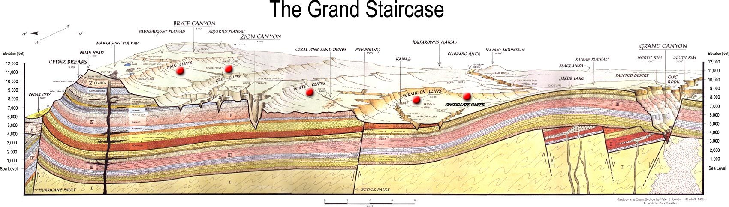
Figure 0.1 The Grand Staircase

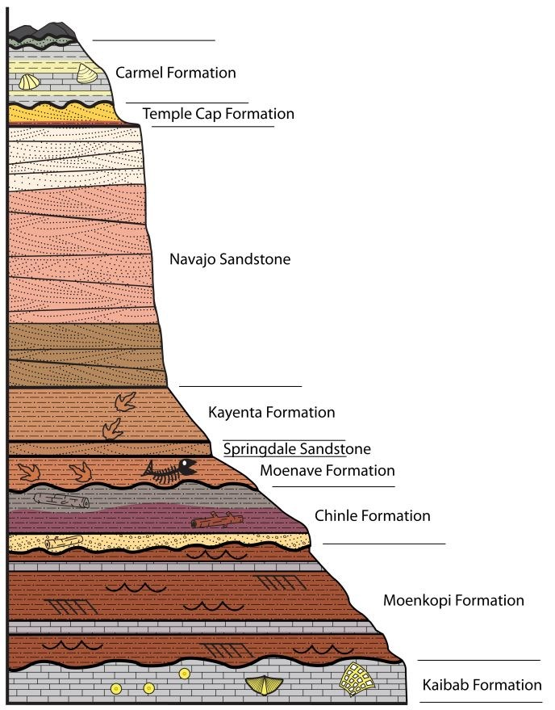

Figure 0.2 Image by Geo-scientist-In-The-Park David Tarailo, sponsored by the Geological Society of America, Geocorps Program, 2012.
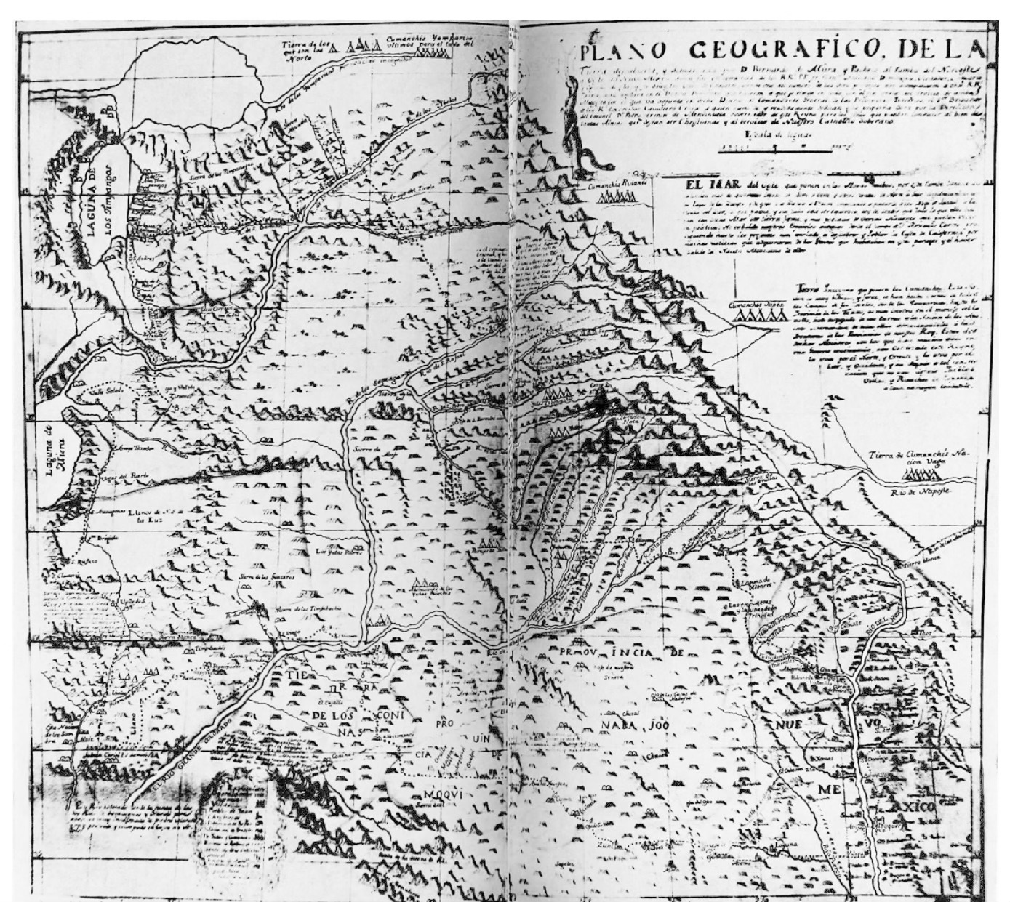

Figure 0.3 Silvestre Velex de Escallante, 1776.
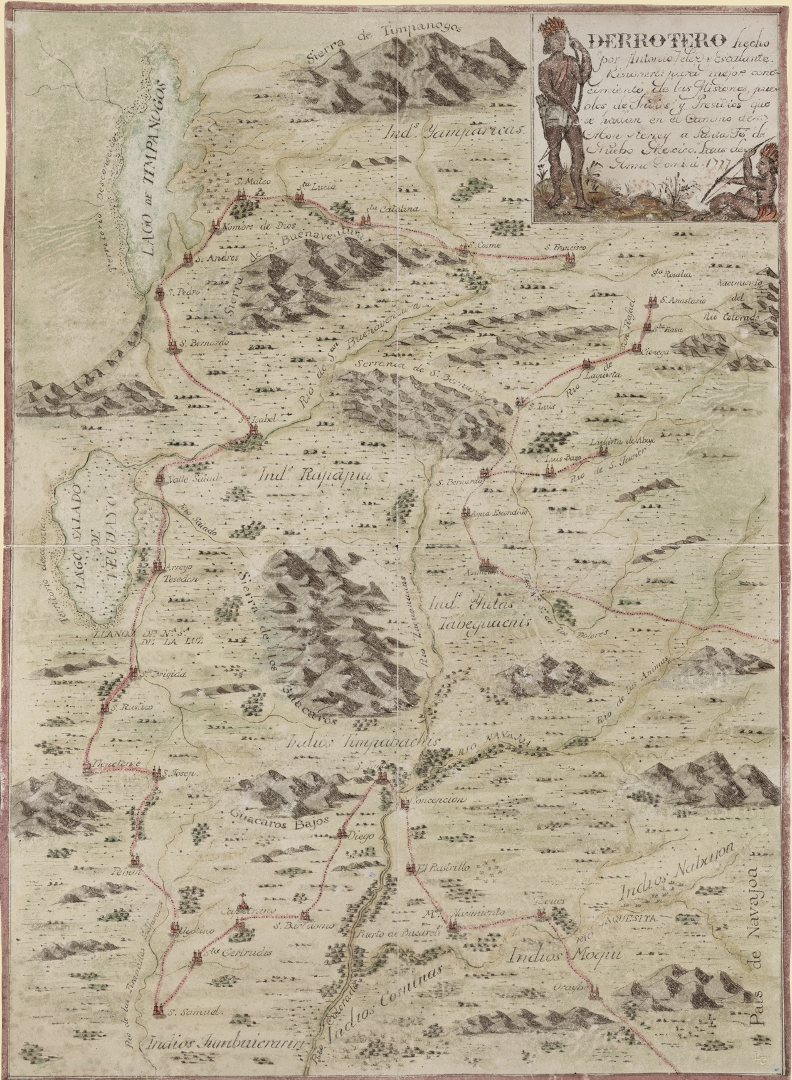

Figure 0.4 Bernardo de Miera y Pacheco, Derrotero hecho por Antonio Vélez y Escalante, misionero para mejor conocimiento de las misiones, pueblos de indios y presidios que se hallan en el Camino de Monterrey a Santa Fe de Nuebo Mexico, 1777.

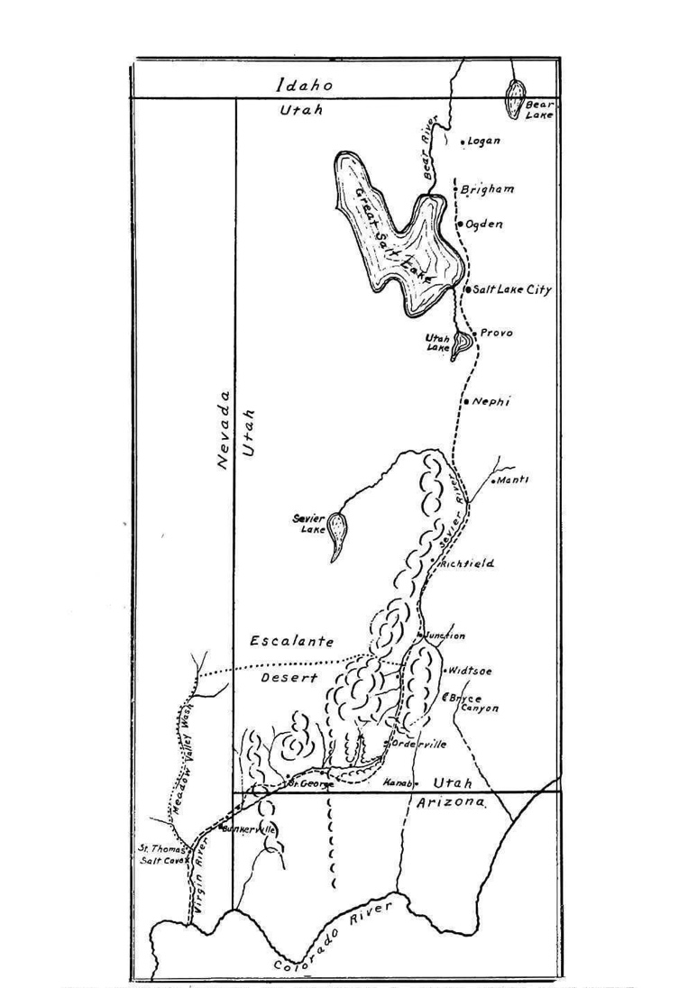
Figure 0.5 Map showing Route of Jedediah S. Smith from the Great Salt Lake of the Colorado River in 1826.

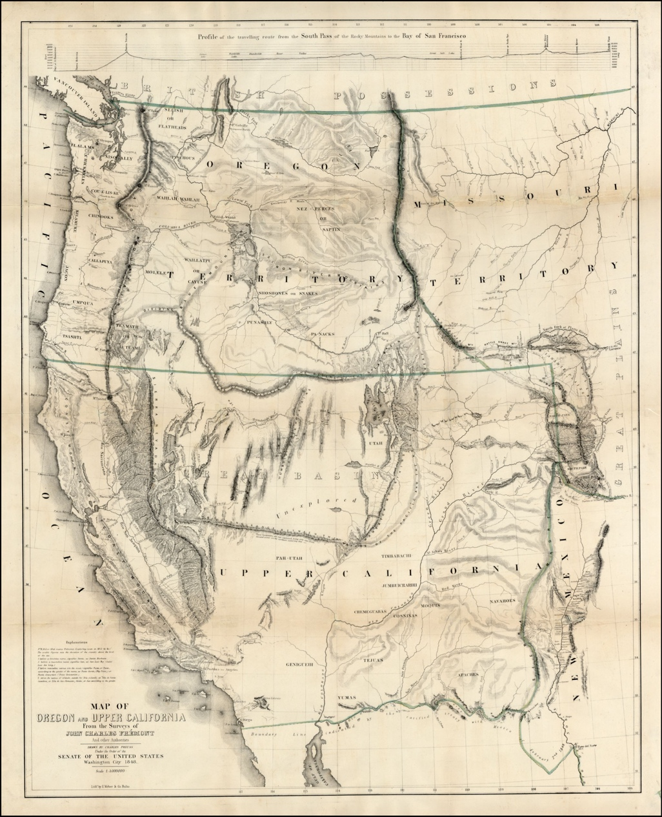

Figure 0.6 Charles Preuss, Map of Oregon and Upper California from the surveys of John Charles Fremont and others authorities drawn by Charles Preuss, 1848.

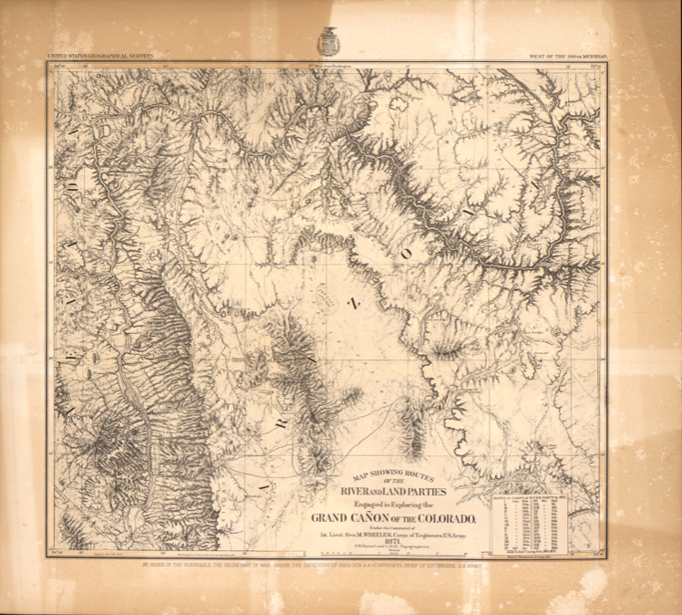

Figure 0.7 Map Showing Routes of the River and Land Parties Engaged in Exploring the Grand Canon of the Colorado, 1871.

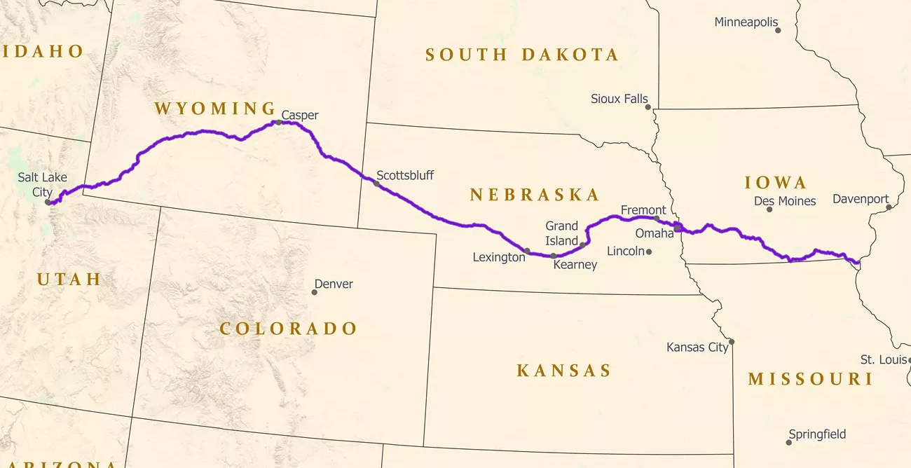

Figure 1.1 Mormon Trail

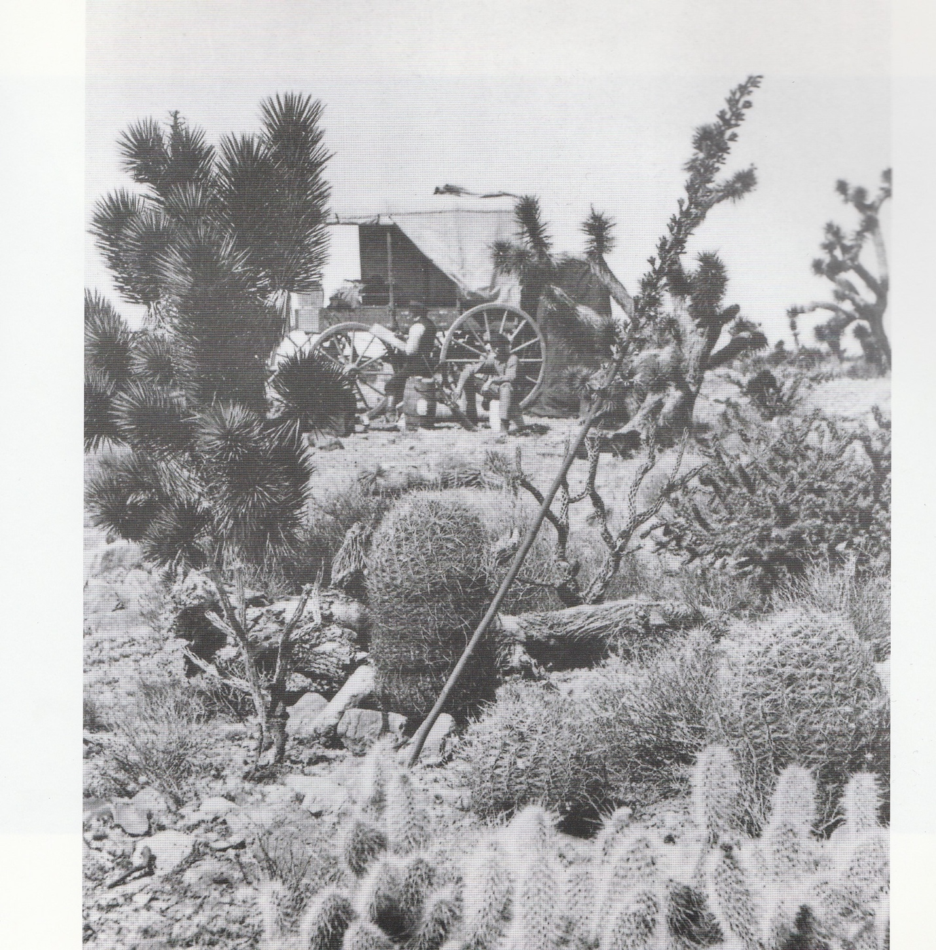

Figure 1.2 Savage’s Portable Dark Room Wagon
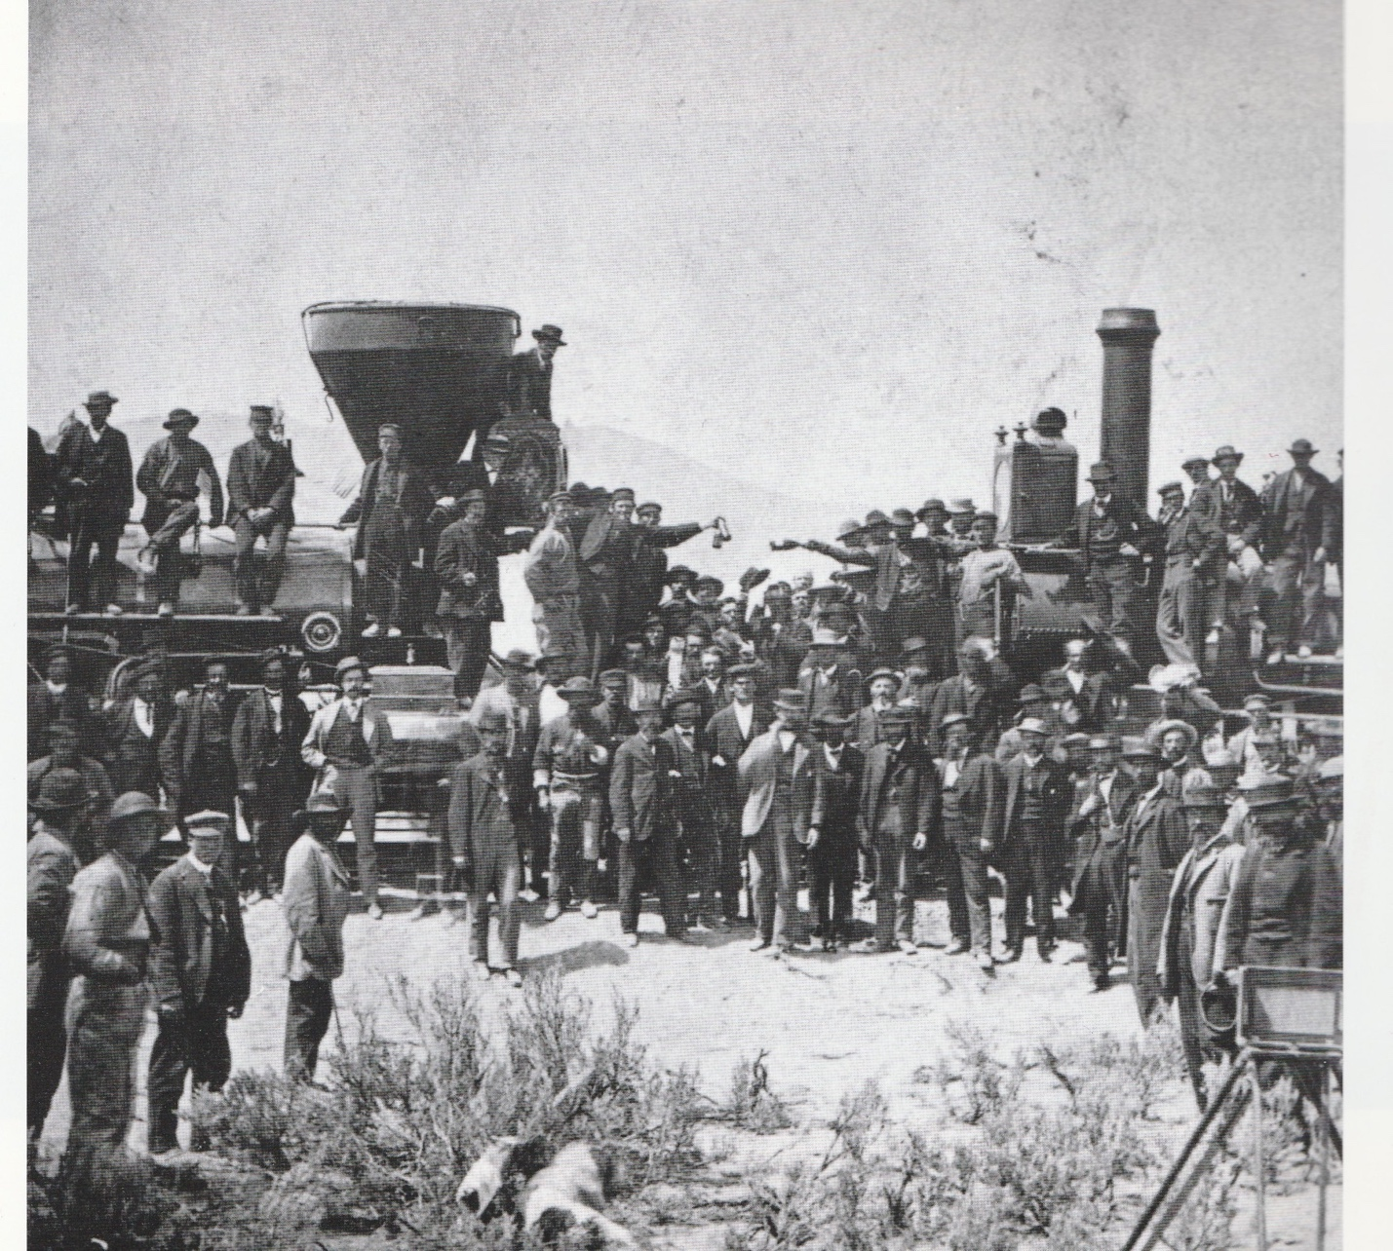

Figure 1.3 Charles Savage, Joining of the Rails, 1869.

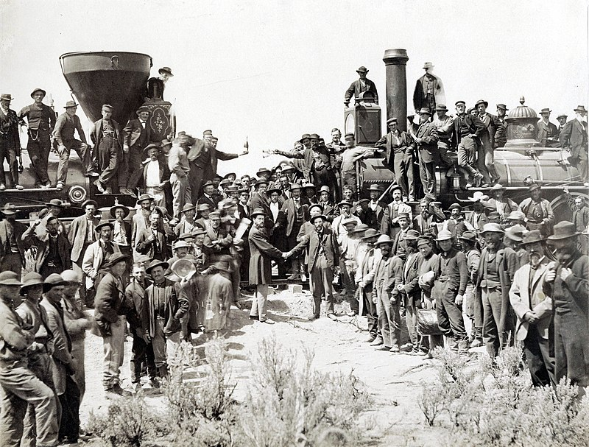

Figure 1.4 Andrew J. Russell, East Meets West, 1869.

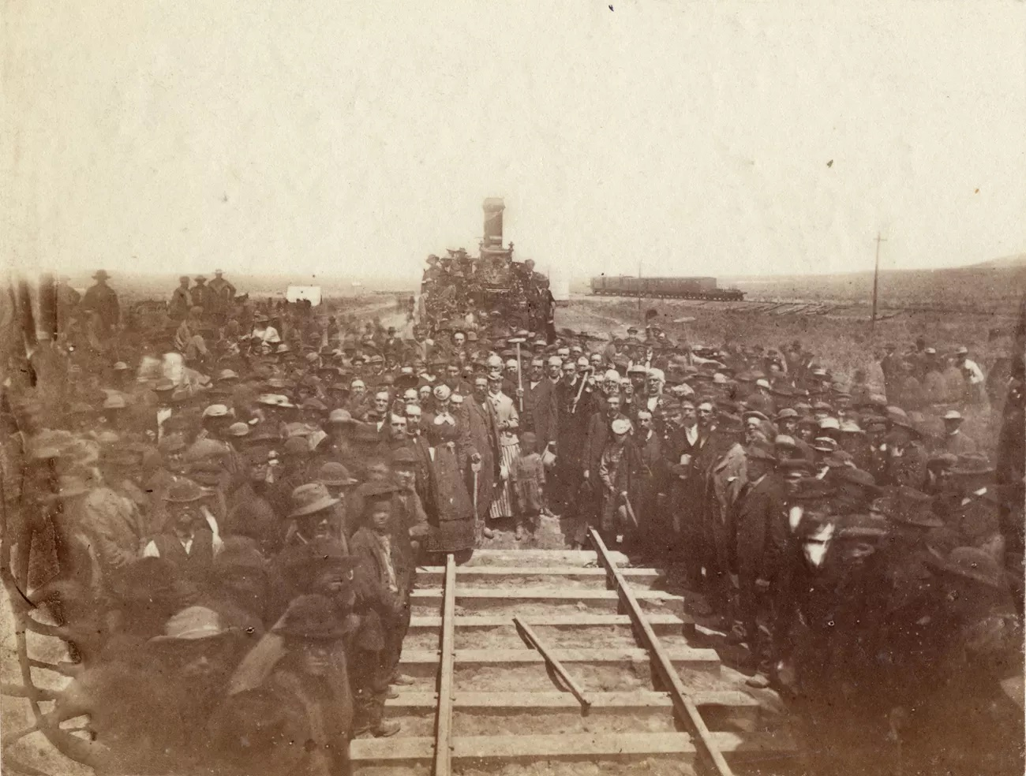

Figure 1.5 Alfred Hart, The Last Rail is Laid, 1869.
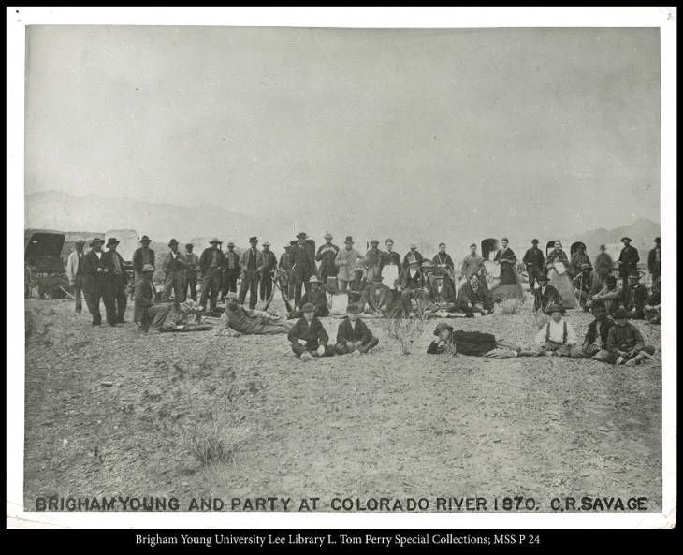

Figure 1.6 Charles Savage, Brigham Young and Party at Colorado River, 1870.

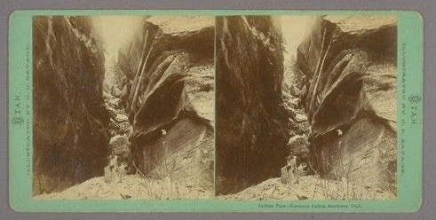

Fig. 1.7 Charles Savage, Indian Pass Kanarra Canon, Southern Utah, stereograph, 1870.

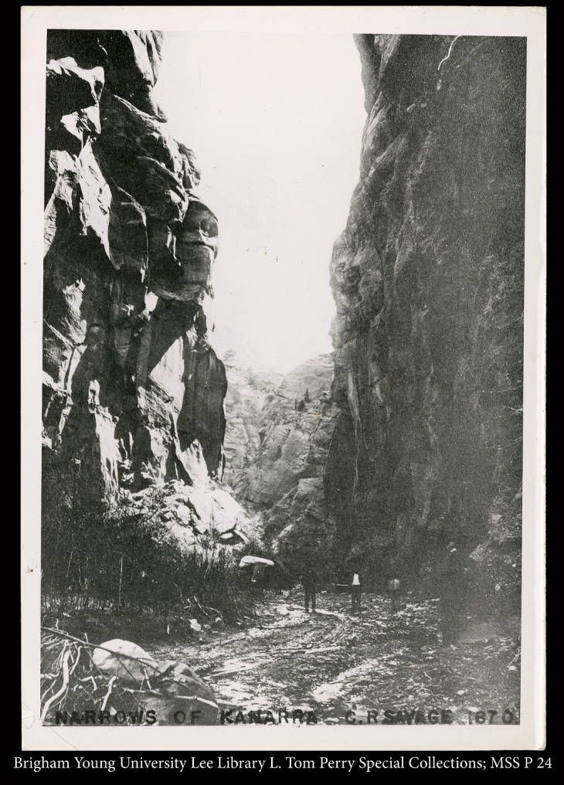

Figure 1.8 Charles Savage, Narrows of Kanarra, 1870.

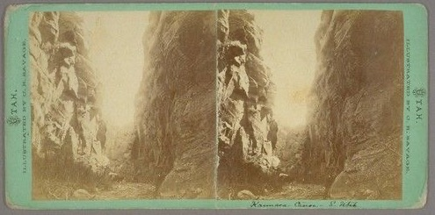

Figure 1.9 Charles Savage, Kannara Canyon, 1870, stereograph.

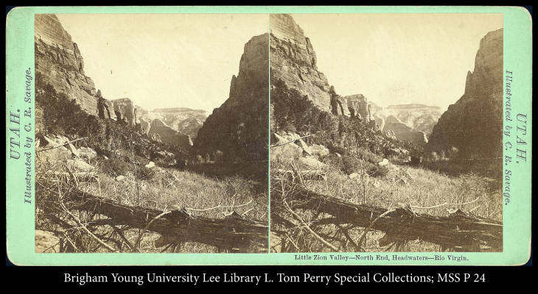

Figure 1.10 Charles Savage, Little Zion Valley, Southern Utah, North End, 1870, stereograph.

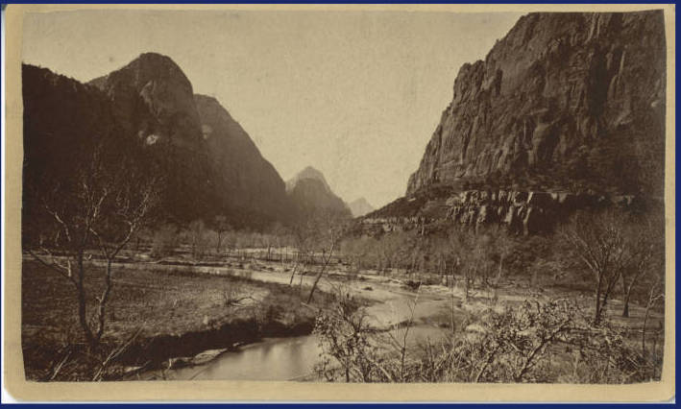

Figure 1.11 Charles Savage, Little Zion Valley, South End, 1870.

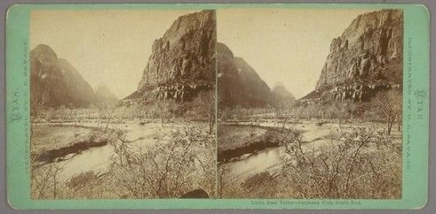

Fig. 1.12 Charles Savage, Little Zion Valley, South End, stereograph, 1870.

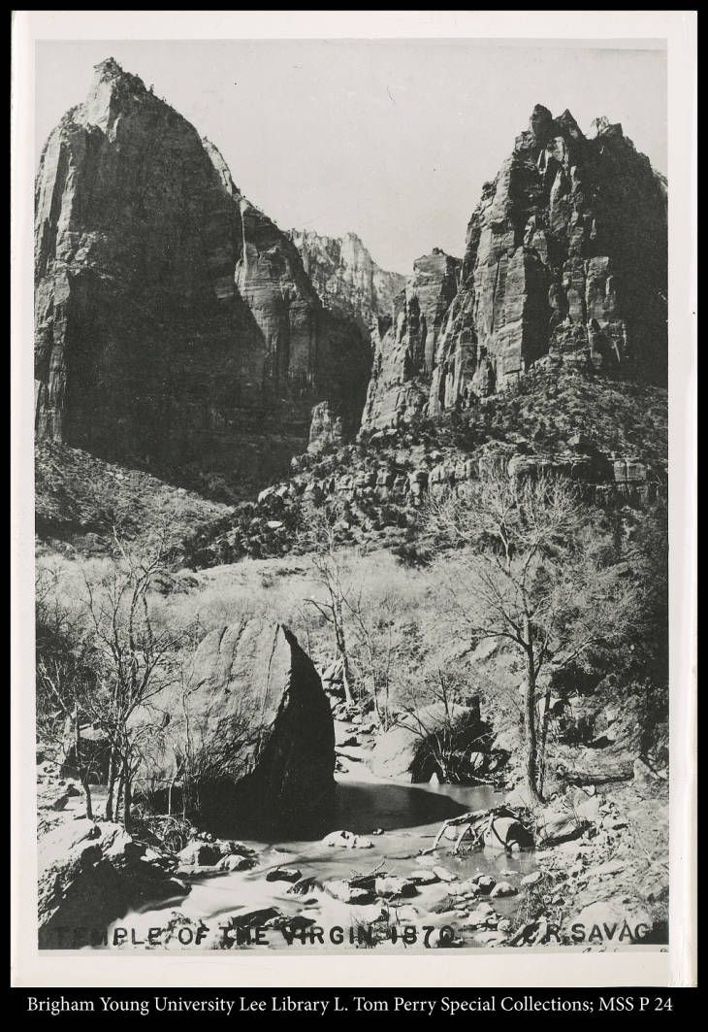

Fig. 1.13 Charles Savage, Temple of the Rio Virgin, 1870.

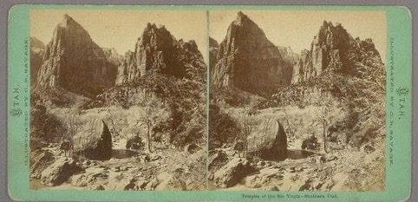

Fig. 1.14 Charles Savage, Temple of the Rio Virgin, stereograph, 1870.

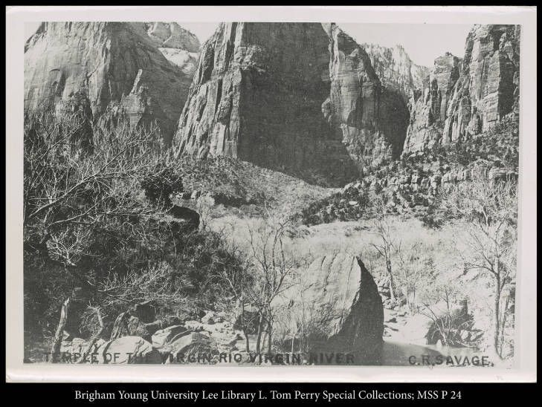

Fig. 1.15 Charles Savage, Temple of the Virgin Rio Virgin River, 1870.

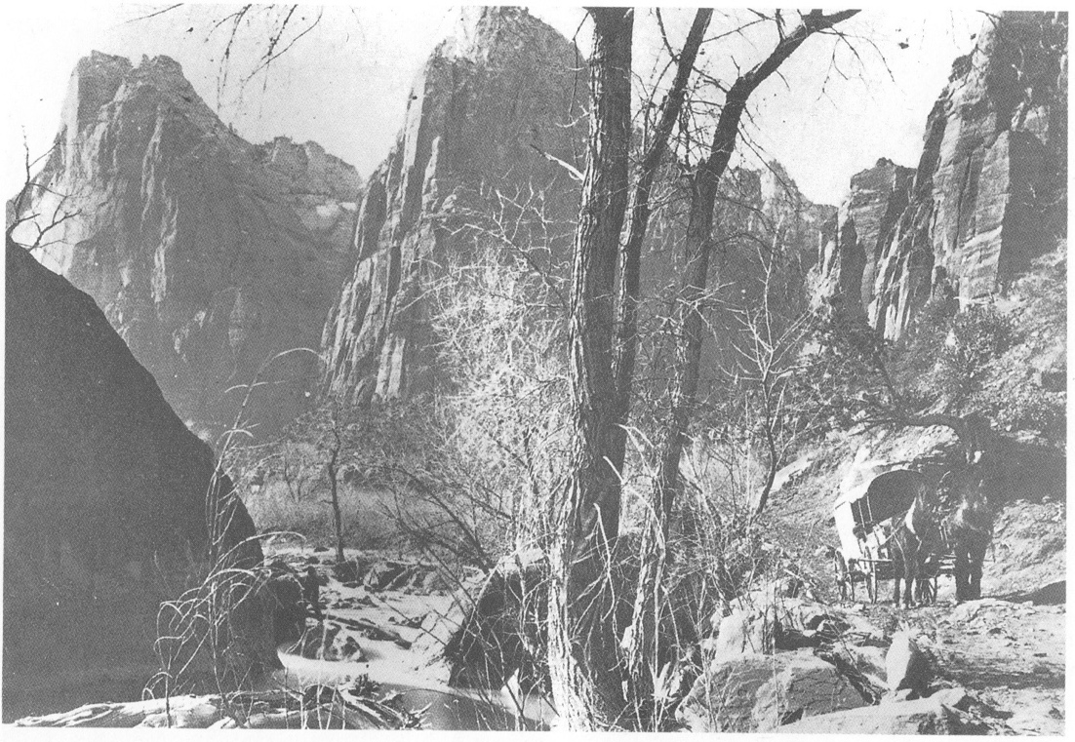

Fig. 1.16 Charles Savage, Zion Canyon, Utah, 1870.
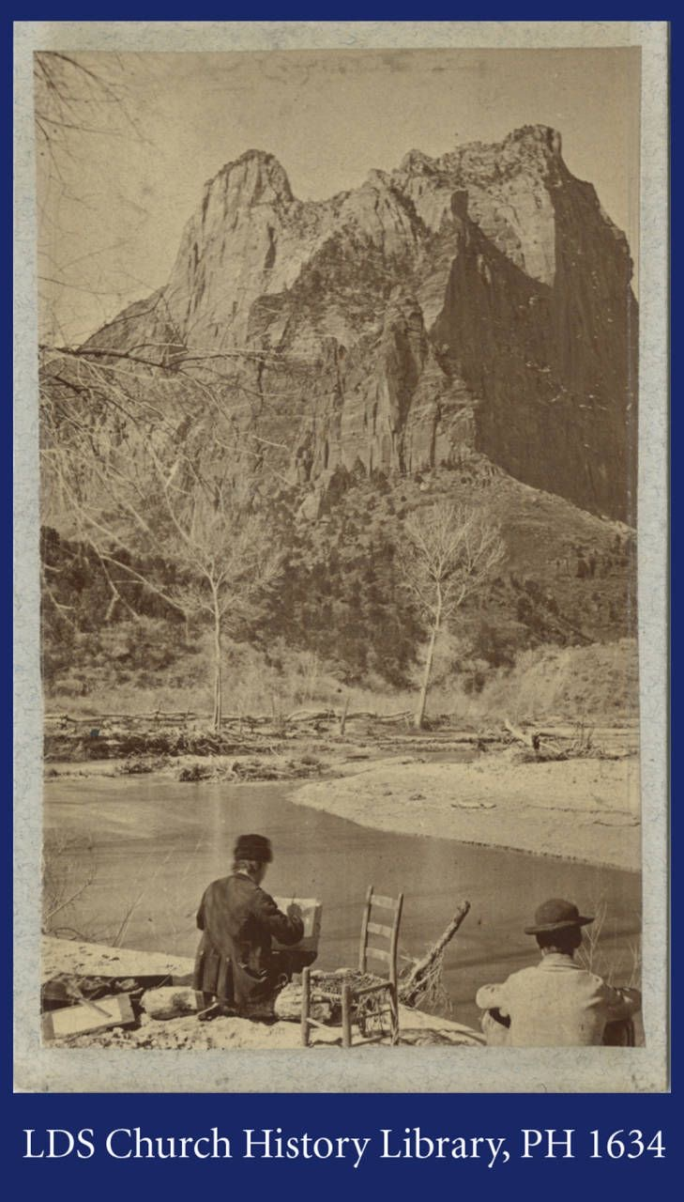

Figure 1.17 Charles Savage, Little Zion Valley, 1870.

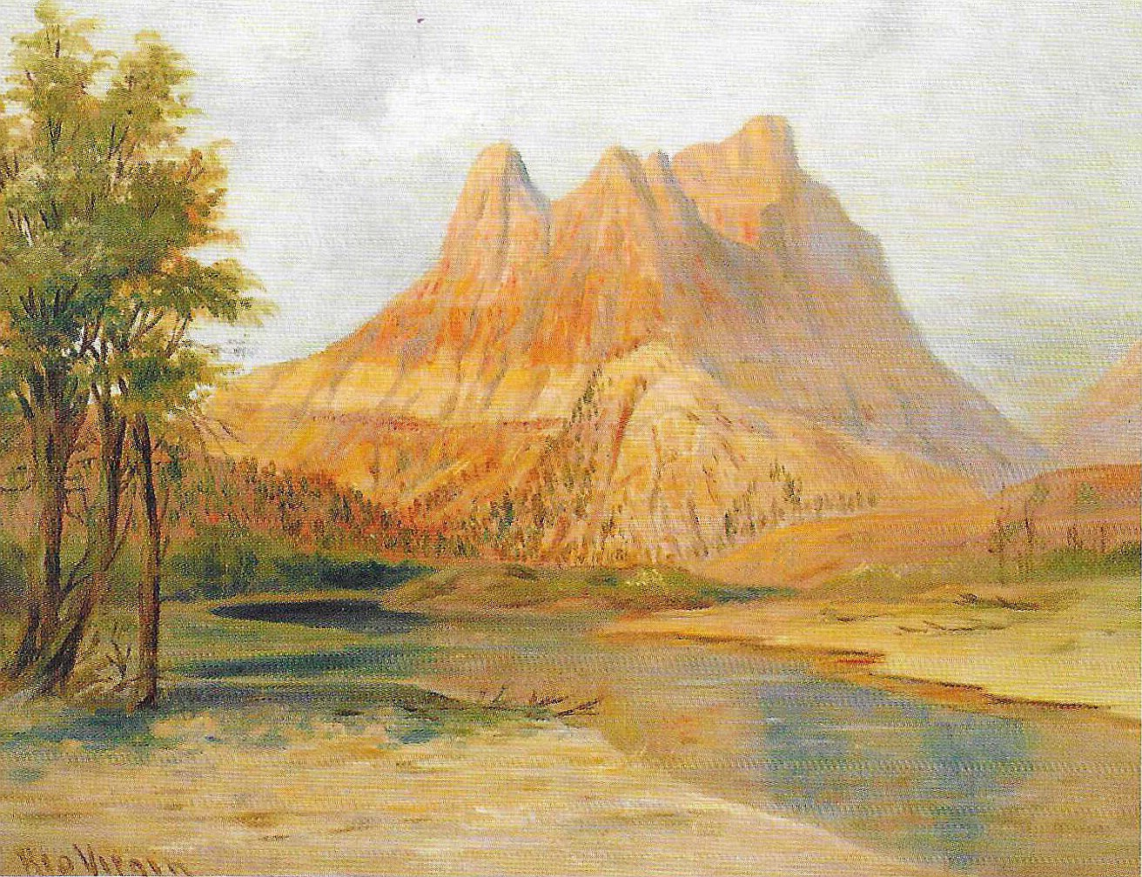

Figure 1.18 George Ottinger, Rio Virgin and the Watchman,

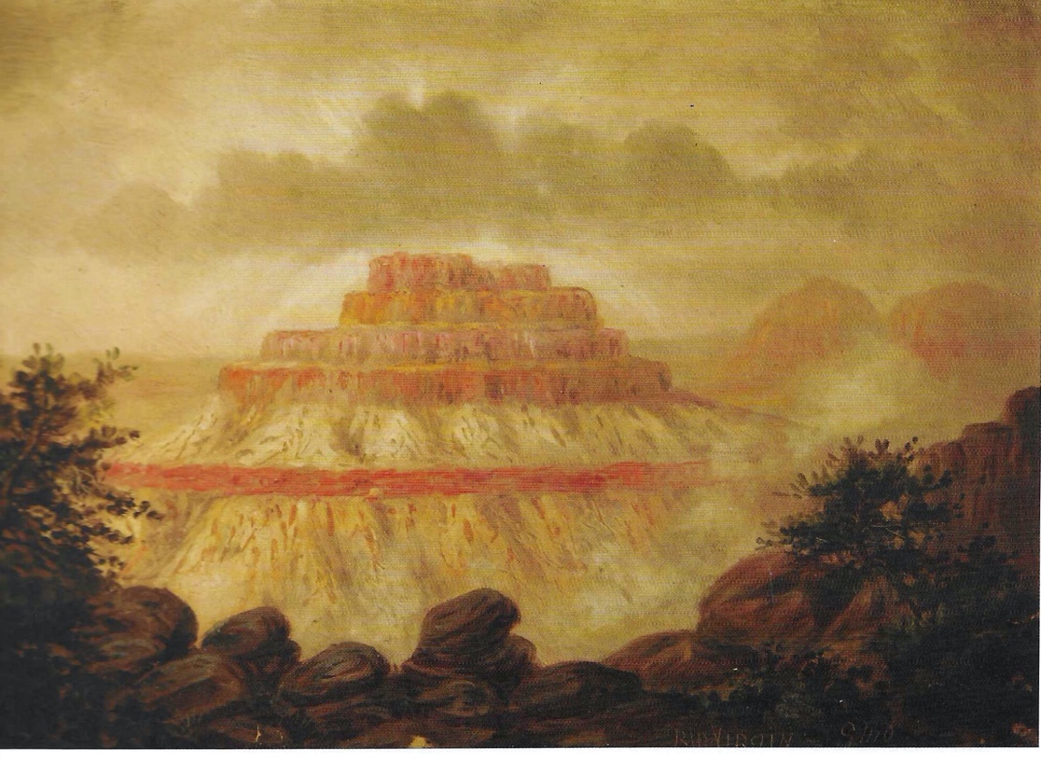

Figure 1.19 George Ottinger, Rio Virgin,

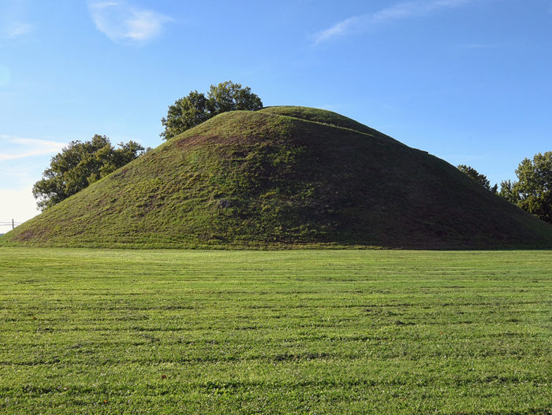

Figure 1.20 Grave Creek Mound of West Virginia

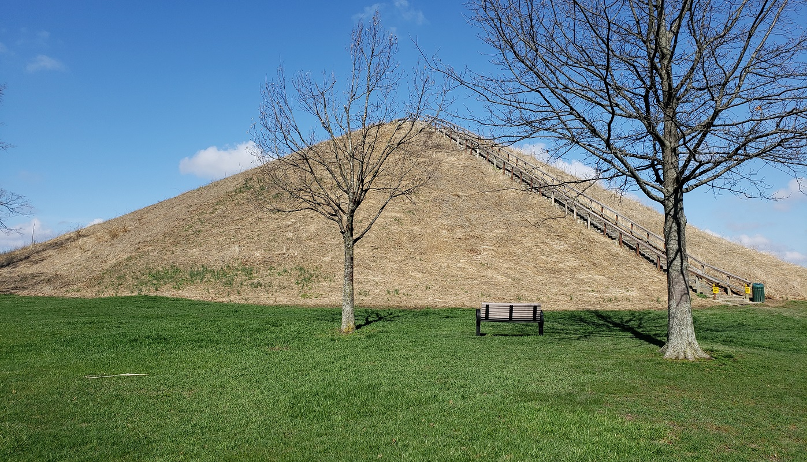

Figure 1.21 Miamisburg Mound, Ohio

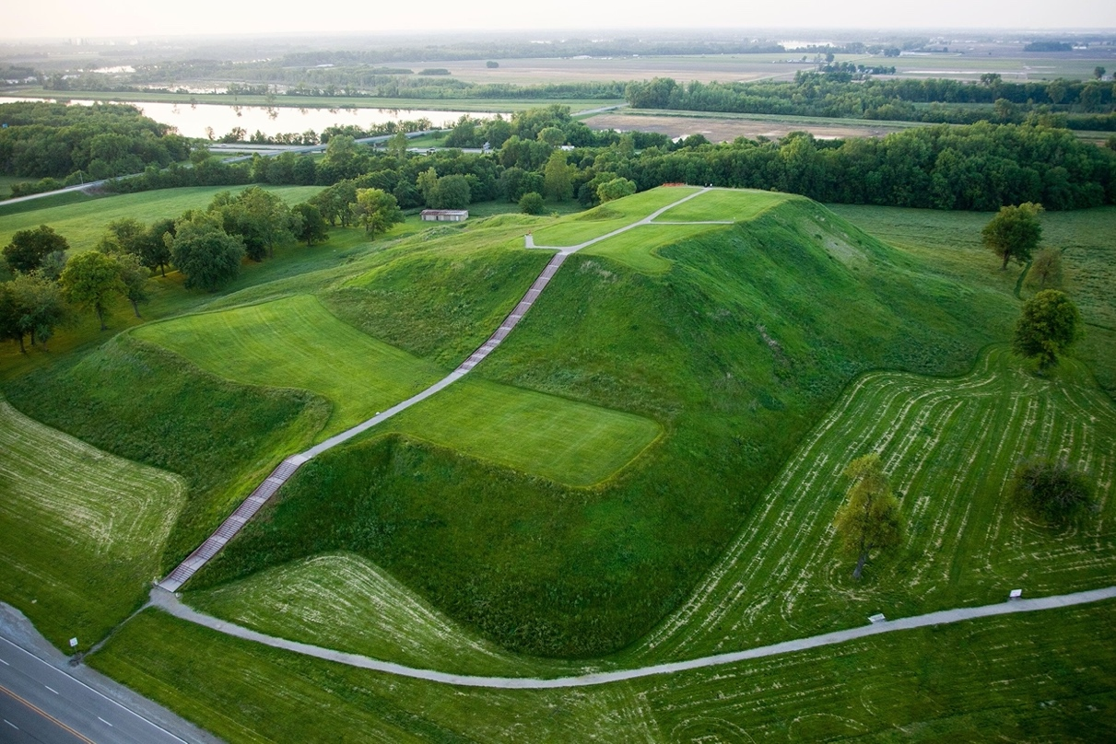

Figure 1.22 Monks Mound, Cahokia, Illinois

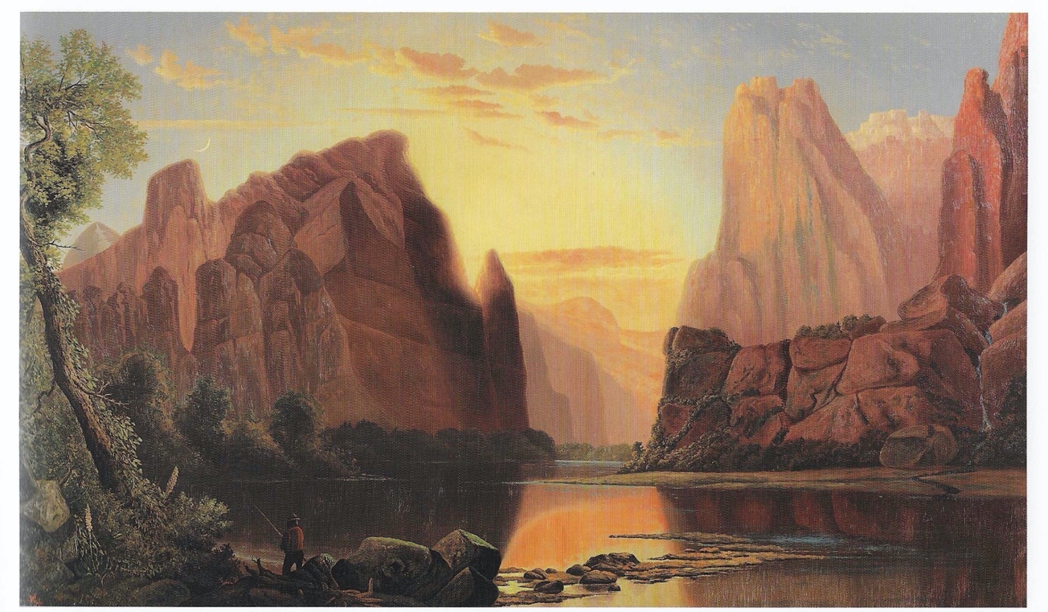

Fig. 1.23 Alfred Lambourne, Temples of the Rio Virgin, Southern Utah, 1876.

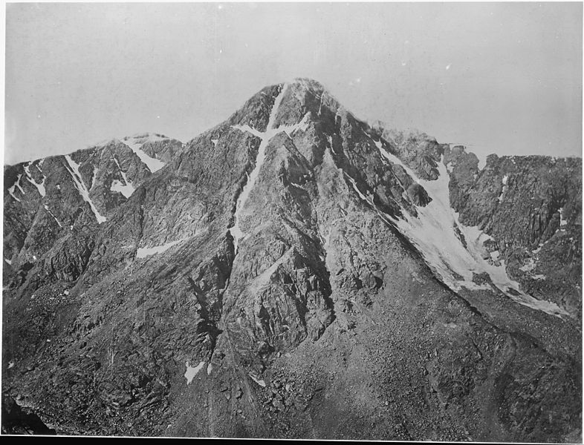

Figure 1.24 William Henry Jackson, Mountain of the Holy Cross Colorado, 1873.

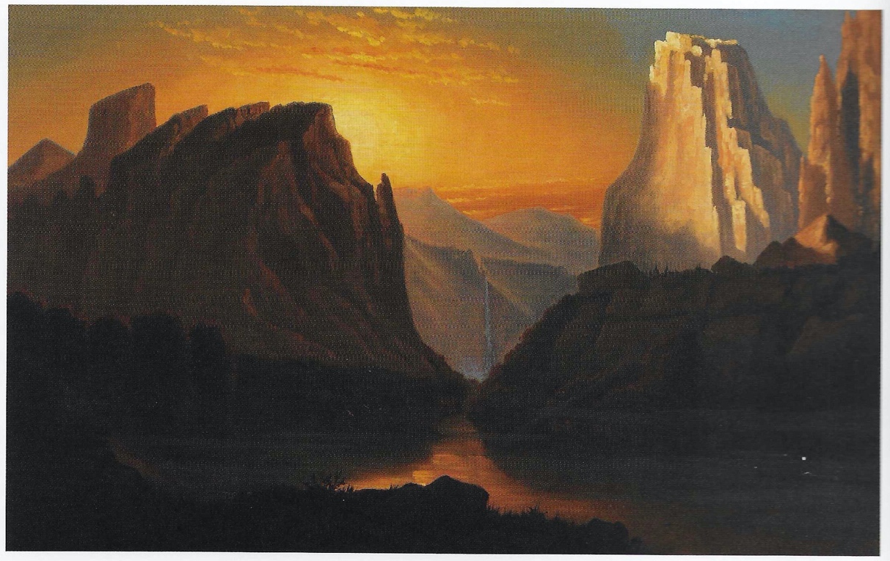

Fig. 1.25 Alfred Lambourne, Zion Sunset with Waterfall, 1885.

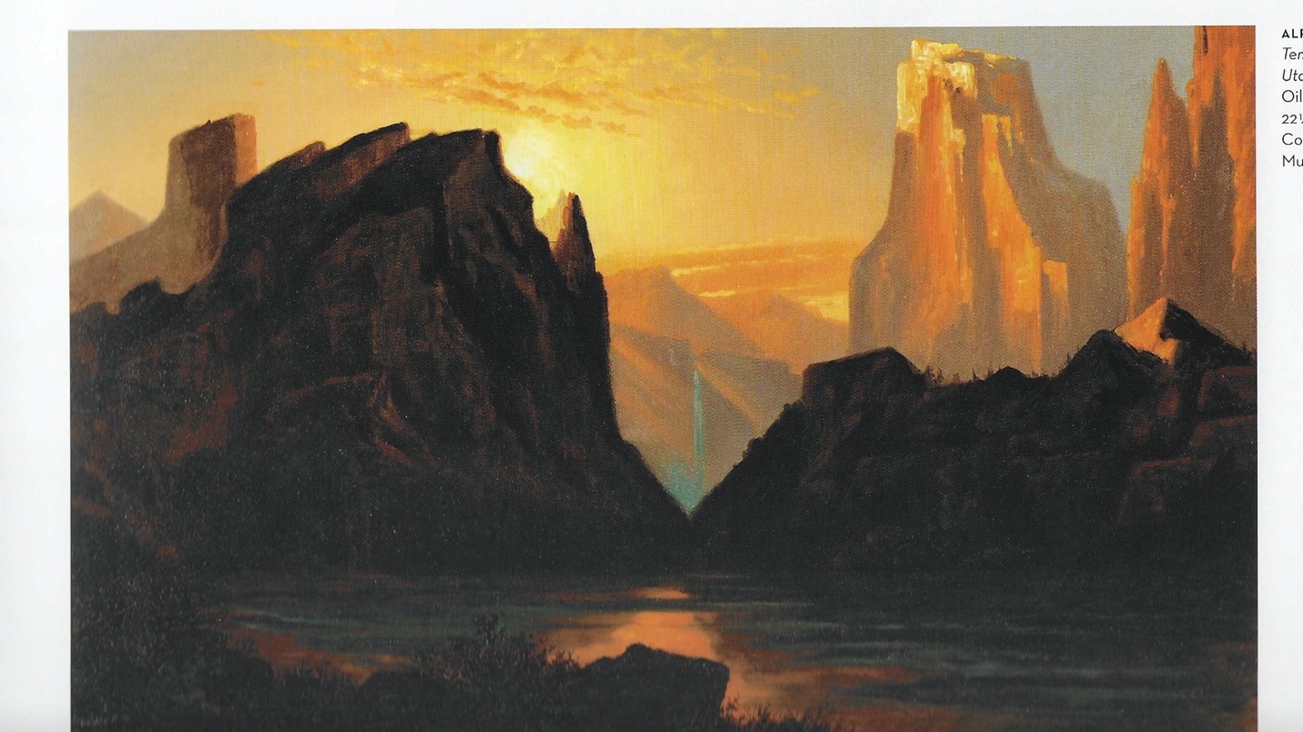

Fig. 1.26 Alfred Lambourne, Temples of the Rio Virgin, Utah, 1886.

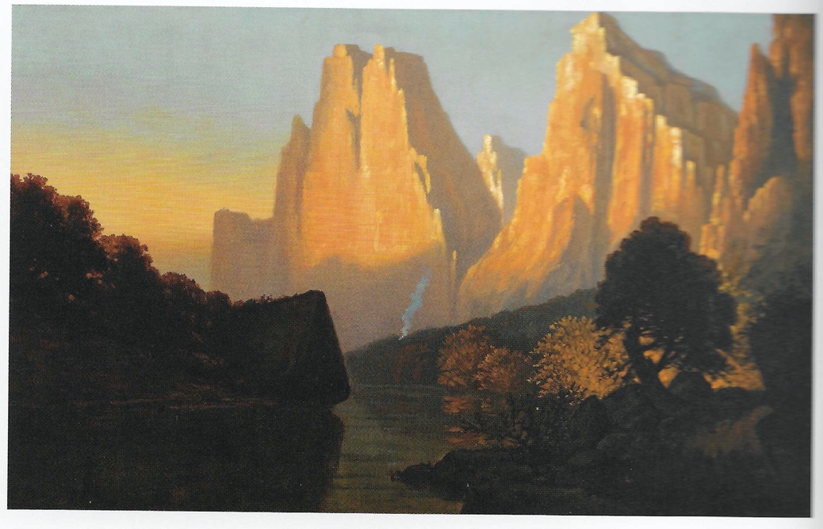

Fig. 1.27 Alfred Lambourne, Temples of the Rio Virgin, 1885.

Chapter 2 Images: Powell Survey Artists: James Fennemore and John K. Hillers

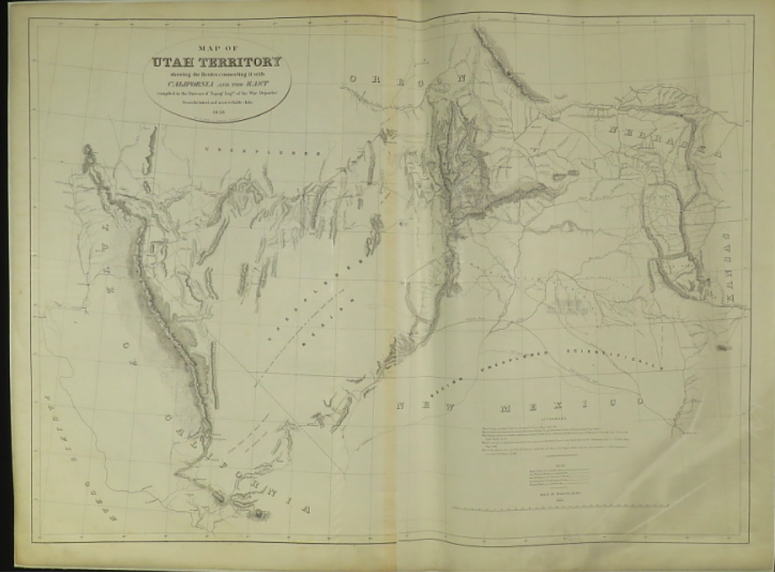

Figure 2.1 Map of Utah Territory, 1858.

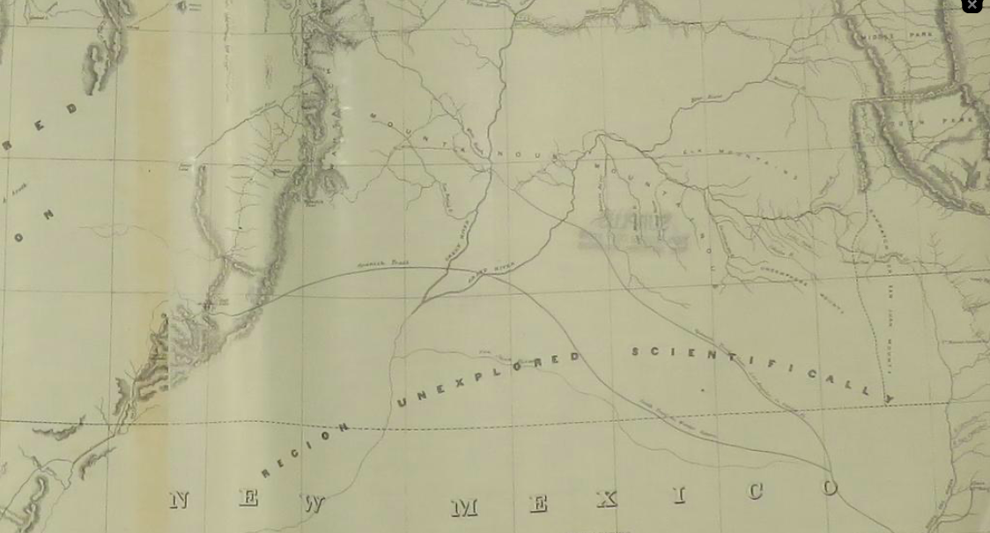

Figure 2.2 detail, “Region Unexplored Scientifically” 1858.

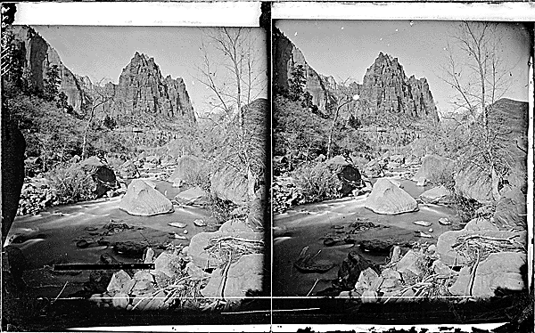

Figure 2.3 James Fennemore, West fork in the Mookvoutuweap, Little Zion Valley, Eagle Crag, Zion National Park. 1872.

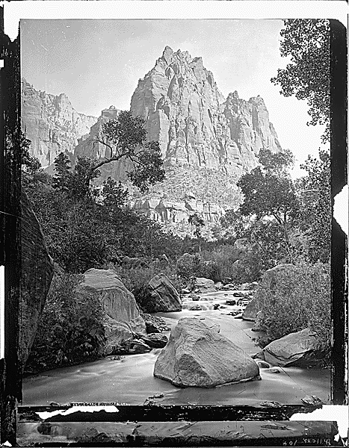

Figure 2.4 John K. Hillers, Eagle Crag, Rio Virgin, Utah. Zion National Park 1873

Figure 2.5 James Fennemore, Colob Country. Southern Utah, the buttes in the right distance are the great buttes on Virgin in the dance, in Zion National Park. 1872.

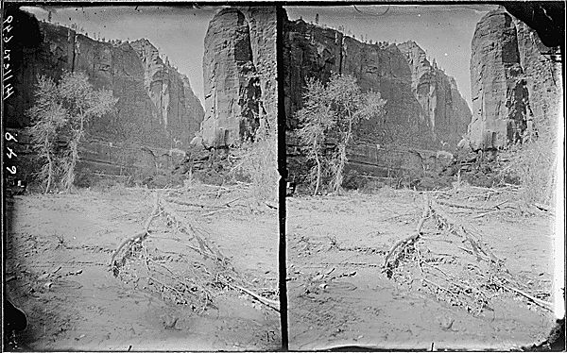

Figure 2.6 James Fennemore Virgin River. West Fork, Mookvoutuweap or Little Zion, upper end. 1872
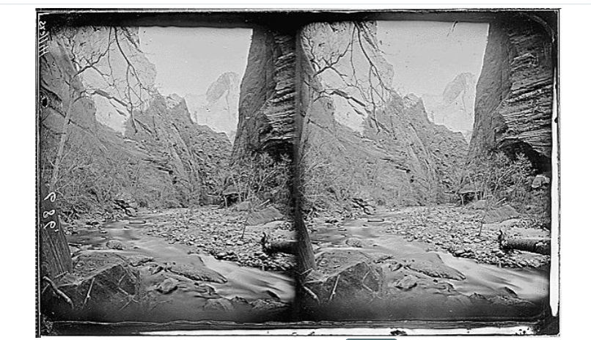

Figure 2.7 James Fennemore, Virgin River, Head of Narrows, North Fork, Zion National Park. 1872

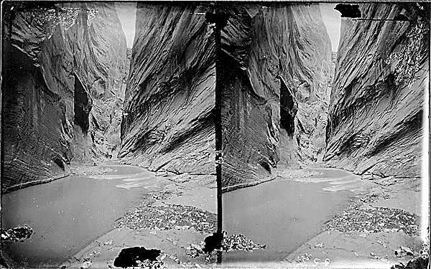

Figure 2.8 James Fennemore, Parunuweap Canyon, East Fork of Virgin. 1872

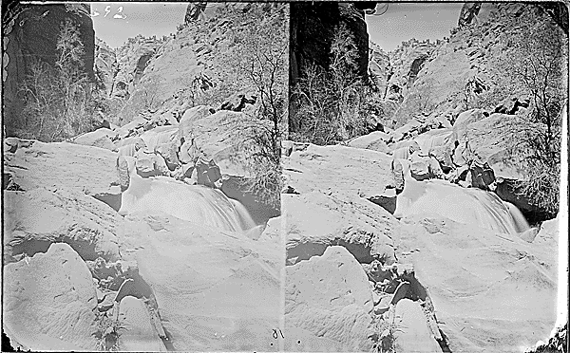

Figure 2.9 James Fennemore, Virgin River, Utah. A Falls is shown. 1872

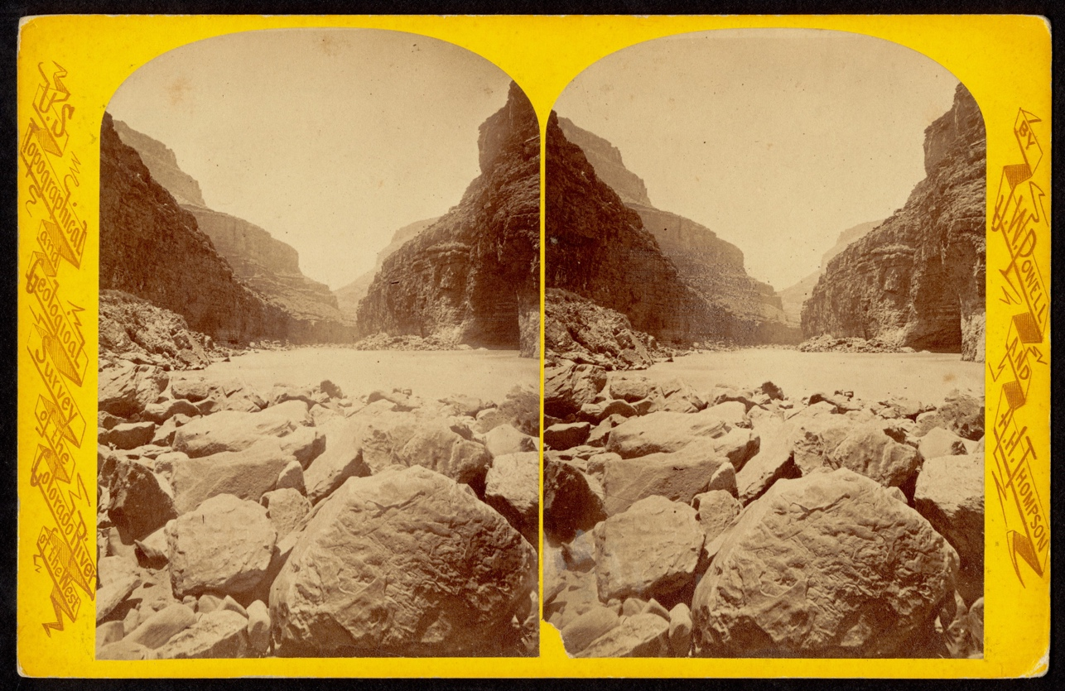

Figure 2.10 E. O. Beaman, Boulders, 1872.

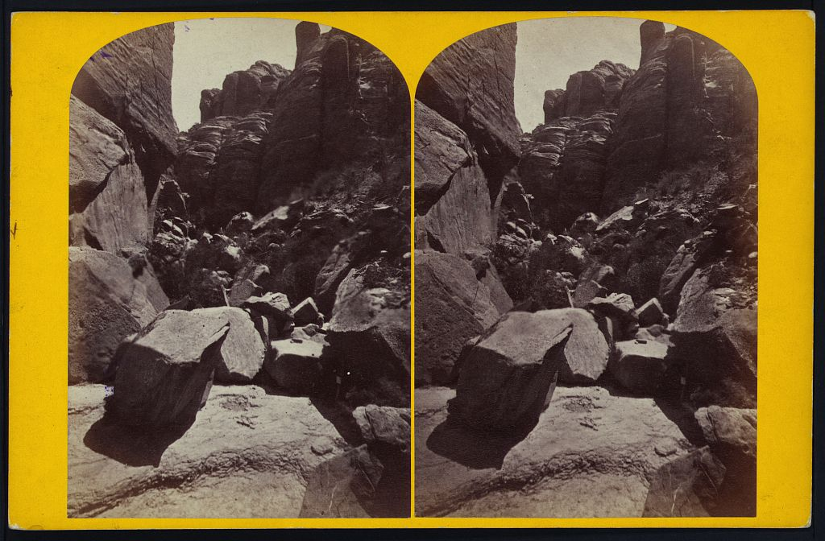

Figure 2.11 E. O. Beaman, Looking Up Portal Gulch, 1872.

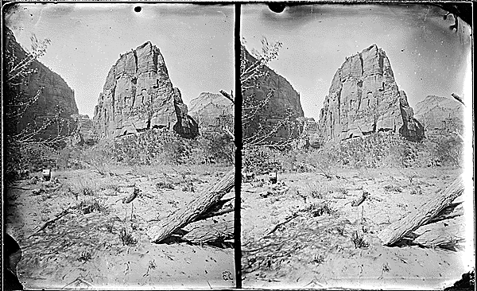

Figure 2.12 James Fennemore Virgin River. West Fork (North Fork) Mookovutoweap, Little Zion. Upper Park-Temple of Aeolus. 1872

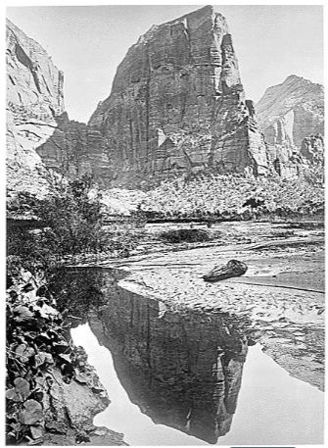

Figure 2.13 John K. Hillers, Reflected Tower. Rio Virgin, Utah. Angels Landing, 1873.

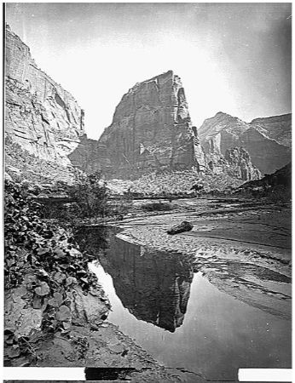

Figure 2.14 John K. Hillers, Reflected Tower, 1873.
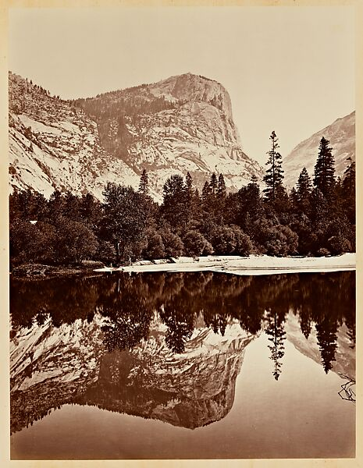

Figure 2.15 Carleton Watkins, Mirror Lake, 1865-66, albumen silver print.

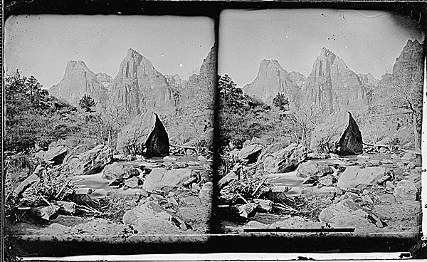

Figure 2.16 James Fennemore Virgin River. West Fork, Mookvoutuweap…Huge Boulders in the river. 1872

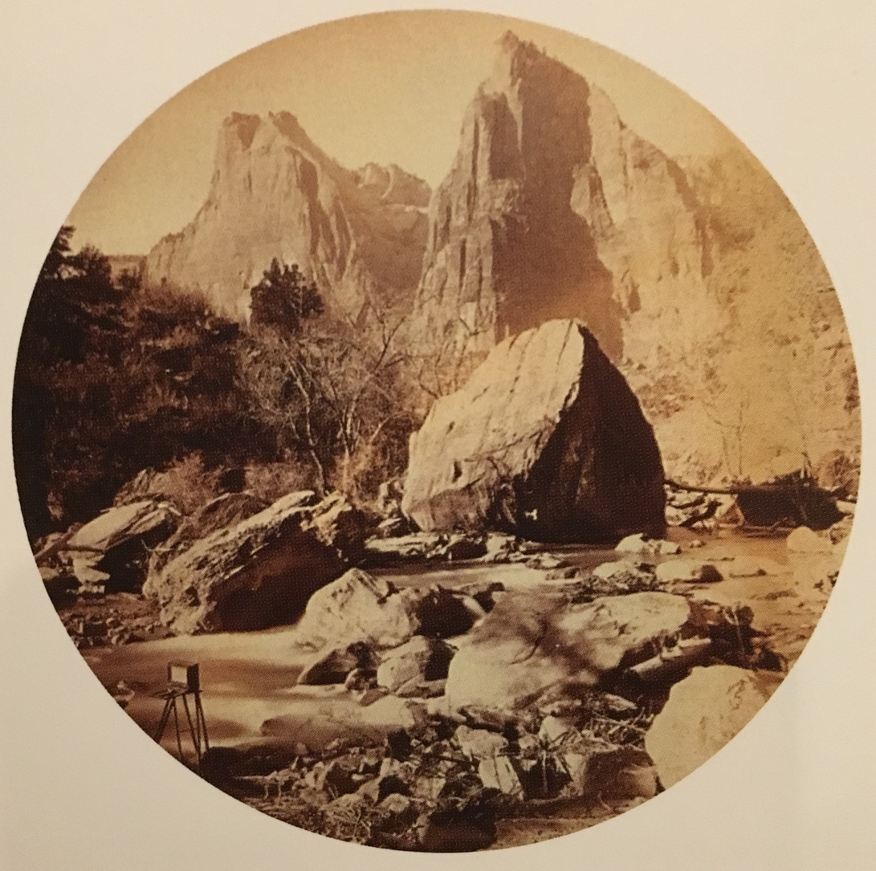

Figure 2.17 John K. Hillers, The Sisters, 1873.
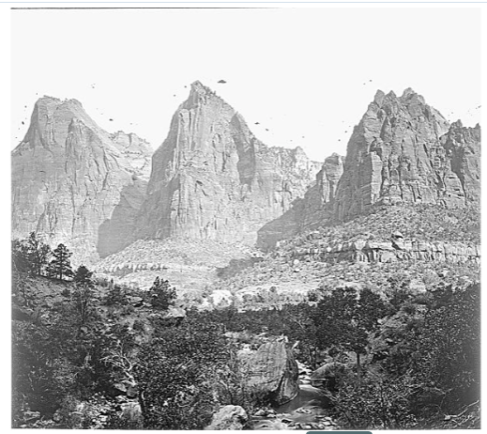

Figure 2.18 John K. Hillers, Zion National Park. The Three Patriarchs on the West Side of Zion Canyon. 1873.

.

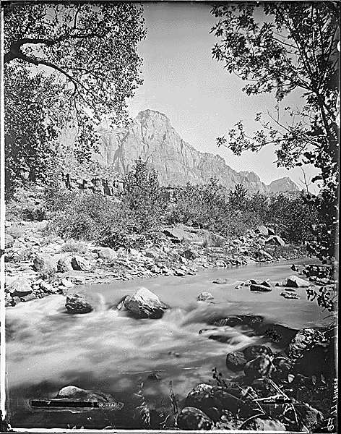

Figure 2.19 John K. Hillers, Rio Virgin, Utah, 1873.
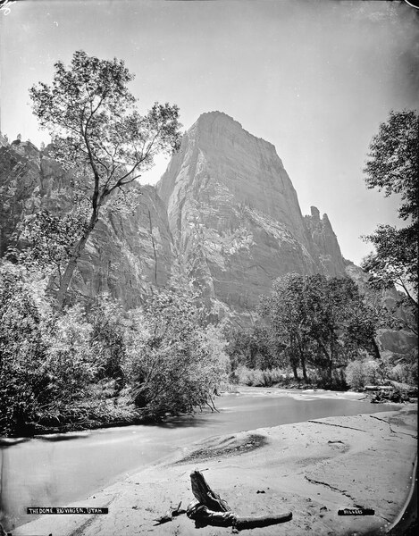

Figure 2.20 John K. Hillers, Monroe Canyon, Utah. 1873.
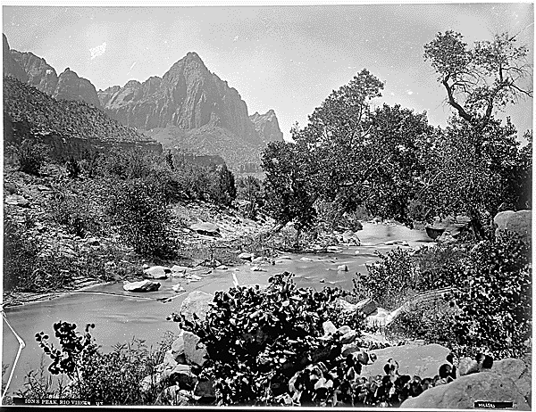

Figure 2.21 John K. Hillers, Zion’s Peak, Rio Virgin, Utah. 1873

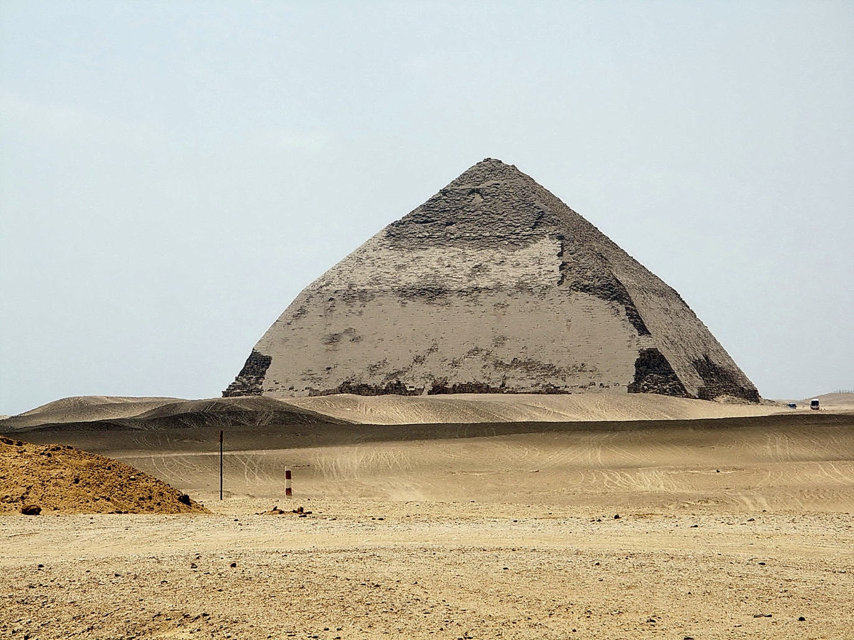

Figure 2.22 Bent Pyramid of Sneferu

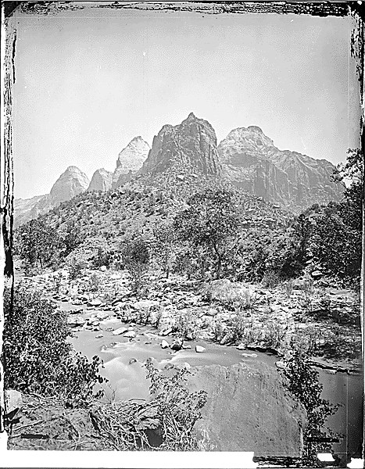

Figure 2.23 John K. Hillers, Castle Domes, Peaks from Sun Mountain to East Temple, Zion National Park. 1873.
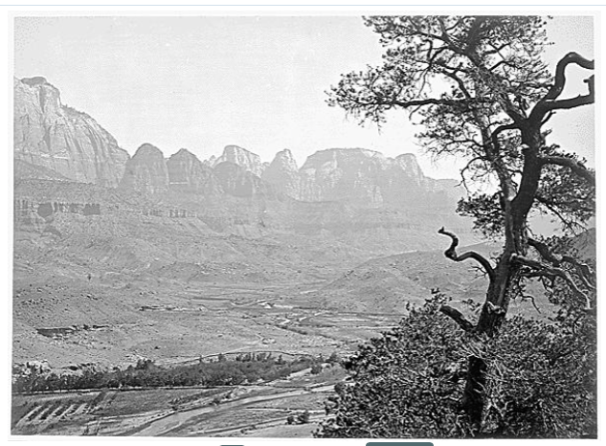

Figure 2.24 John K. Hillers, Virgin River Valley, Below Zion Canyon. 1873.

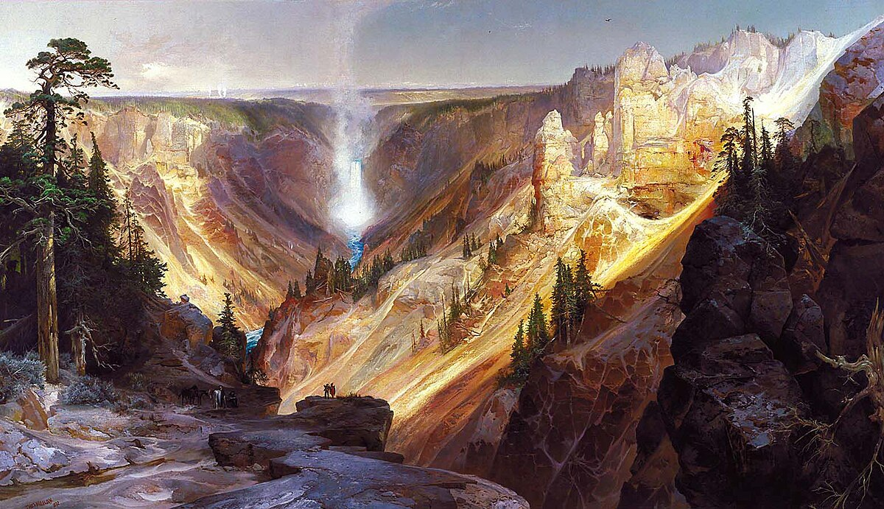 Figure 3.1 Thomas Moran Grand Canyon of the Yellowstone, 1872, oil on canvas, 84 x 104.8 in.

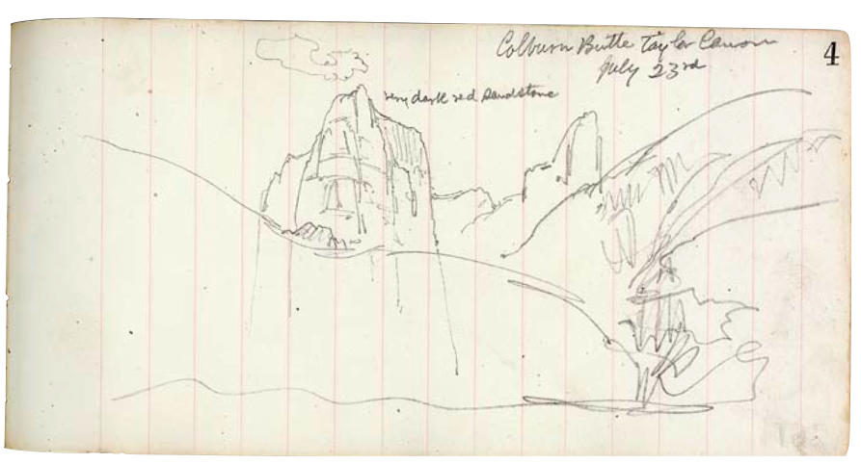
Figure 3.2 Thomas Moran, Colburn Butte July 23rd, 1873

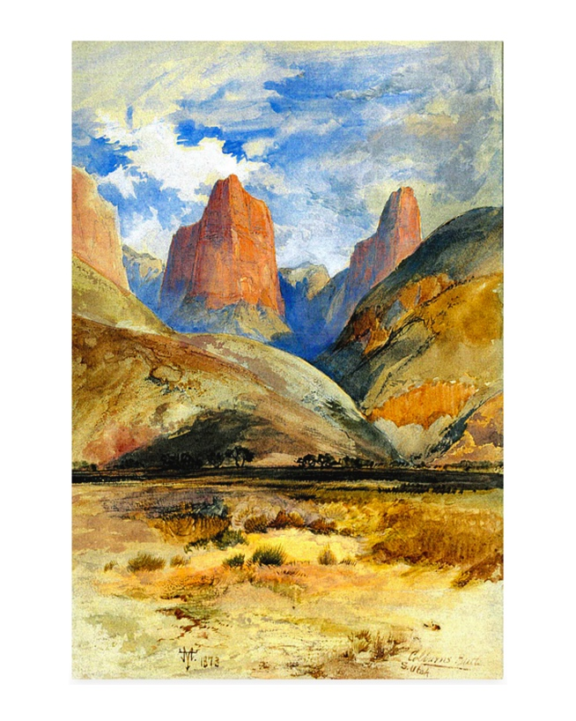
Figure 3.3 Thomas Moran, Colburn Butte, South Utah, 1873.
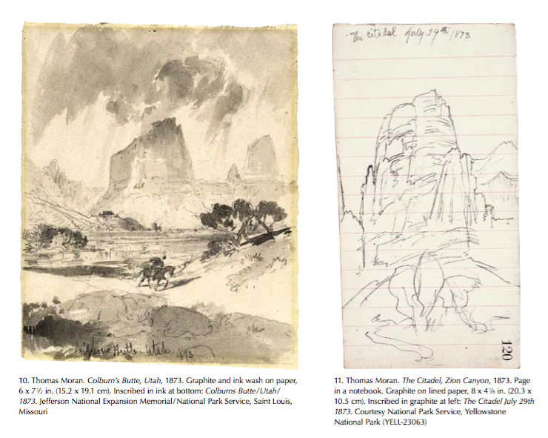

Figure 3.4 Thomas Moran, Colburn Butte, Utah, 1873. Graphite and ink wash on paper, 6 x 7 ½ in.

Figure 3.5 Thomas Moran, The Citadel, Zion Canyon, 1873.

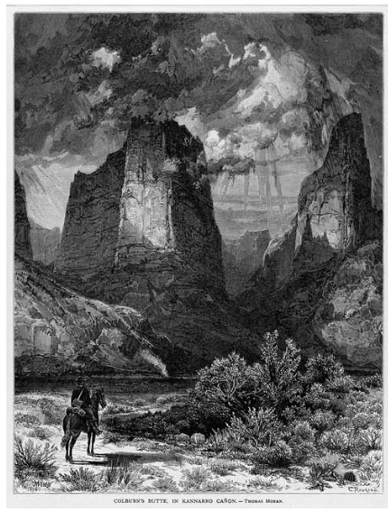

Figure 3.6 Thomas Moran, Colburn’s Butte in Kannarro Canon, 1873

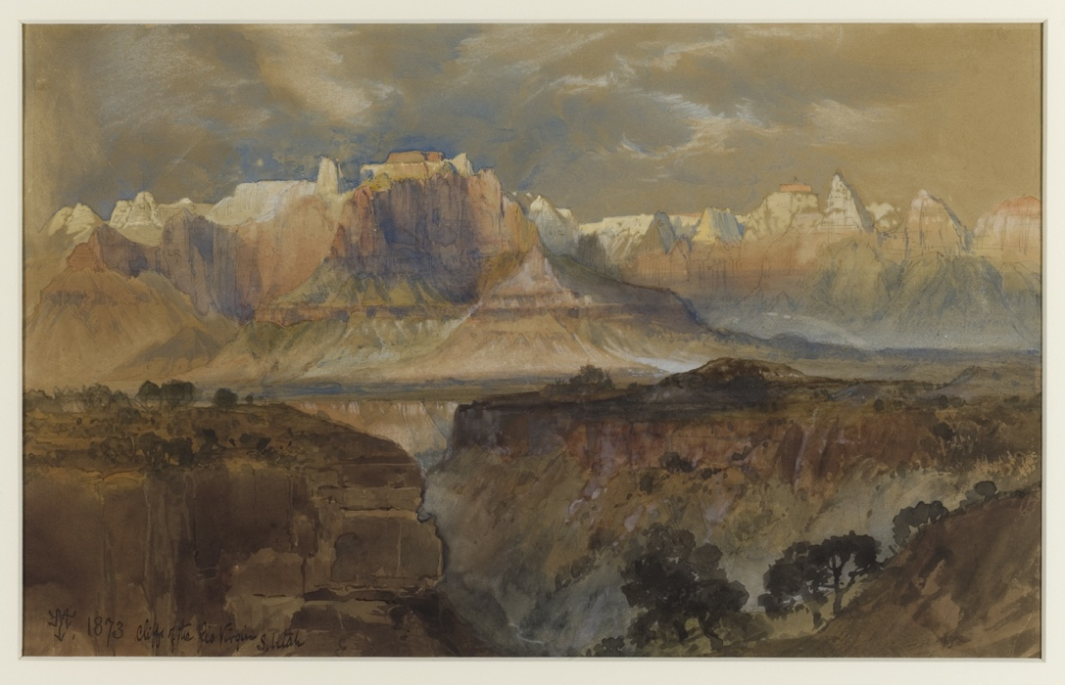

Figure 3.7 Thomas Moran, Cliffs of the Rio Virgin, South Utah

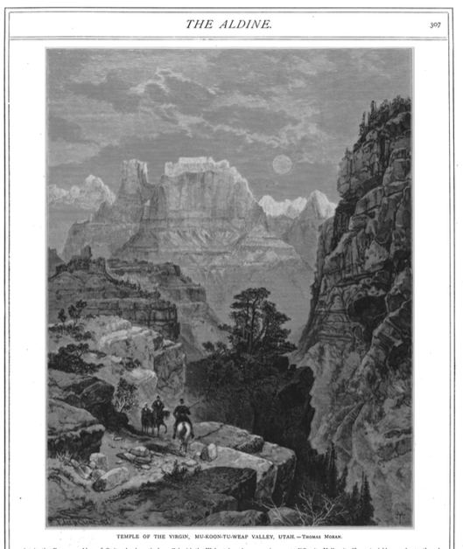

Figure 3.8 Temple of the Virgin, Mu-Koon-Tu-Weap Valley, Utah
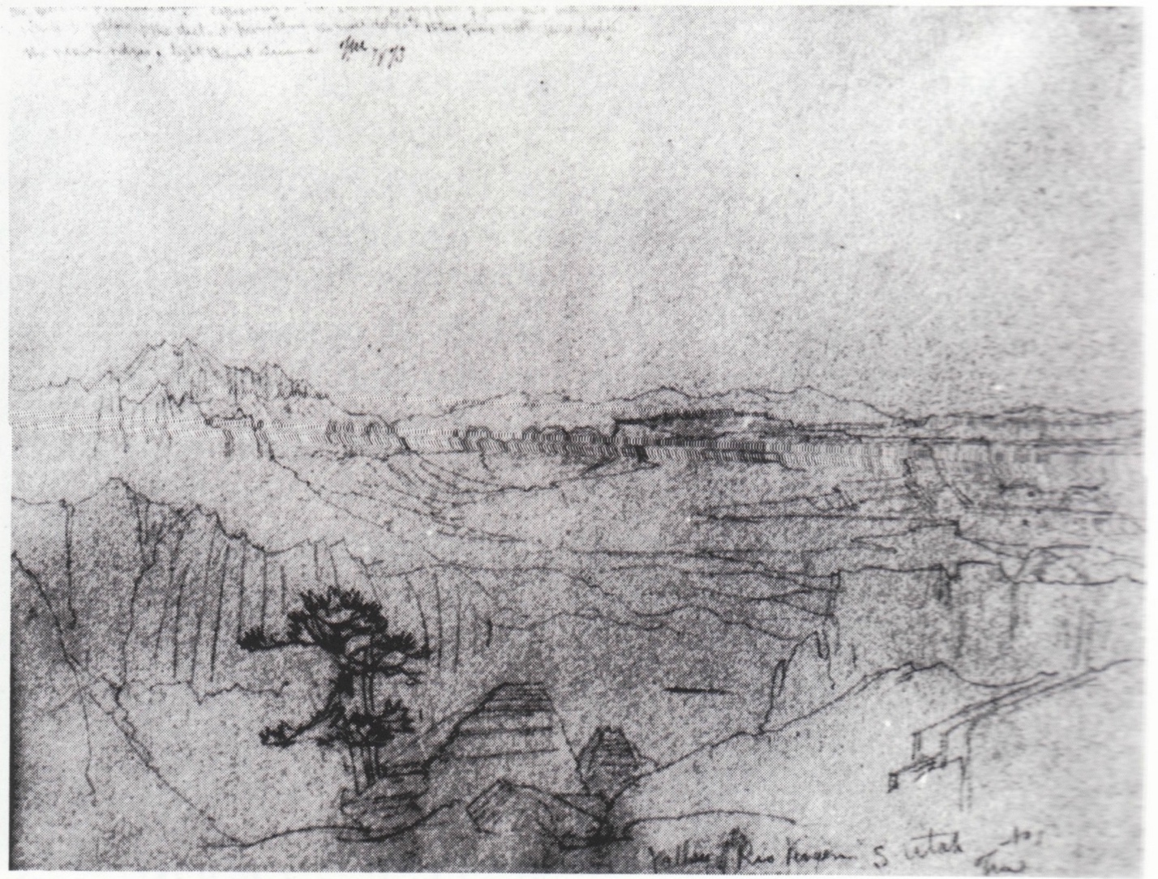
Figure 3.9 Valley of Rio Virgin, South Utah, 1873, graphite on blue wove, 10 ¾ x 15 in.
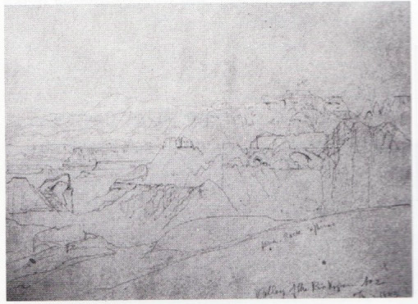
Figure 3.10 Valley of the Rio Virgin, 1873, graphite on blue wove, 10 ¾ x 15 in.

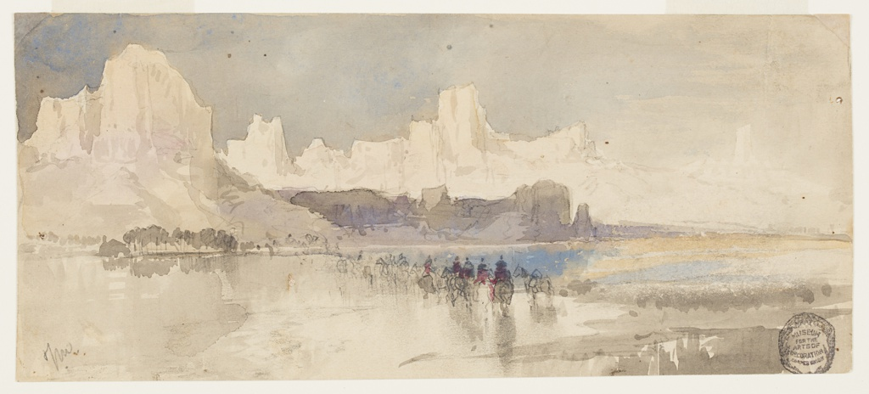

Figure 3.11 Thomas Moran Canyon of the Rio Virgin, South Utah, 1873, watercolor, graphite on white wove paper, 4 x 9 1/8 in.
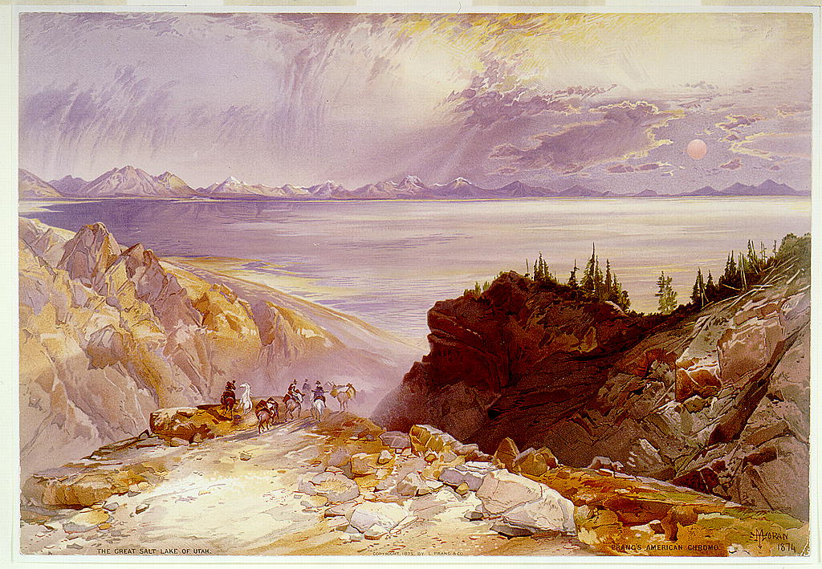

Figure 3.12 Thomas Moran, The Great Salt Lake, ca. 1875, chromolithograph, 9 ¾ x 14 1/8 in.

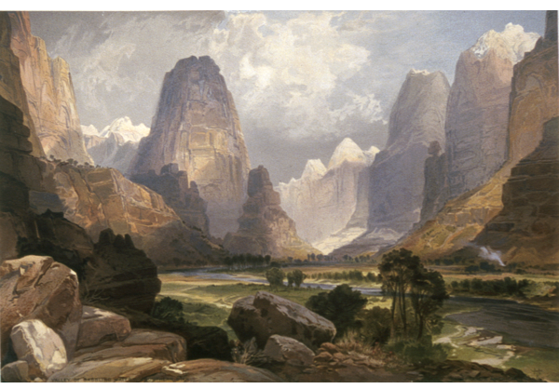

Figure 3.13 Thomas Moran, Valley of the Babbling Waters, ca. 1875, chromolithograph, 9 ¾ x 14 1/8 in.

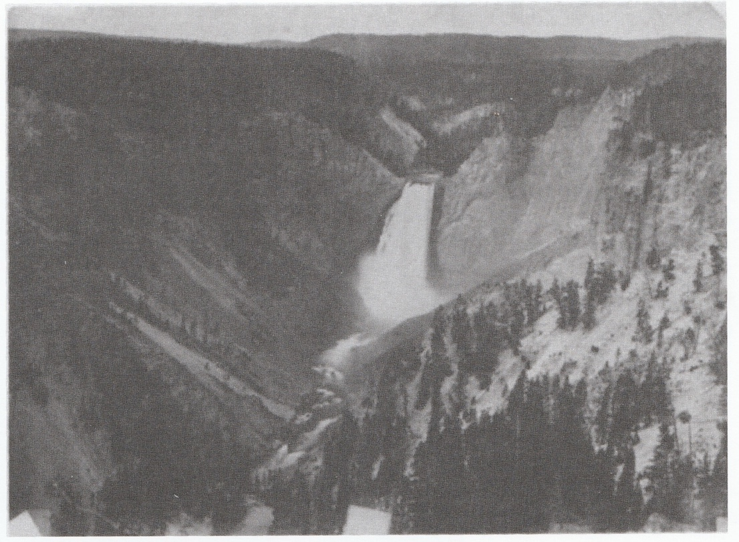

Figure 3.14 William Henry Jackson, Lower Falls of the Yellowstone River (400 feet) (from Inspiration Point), 1871.

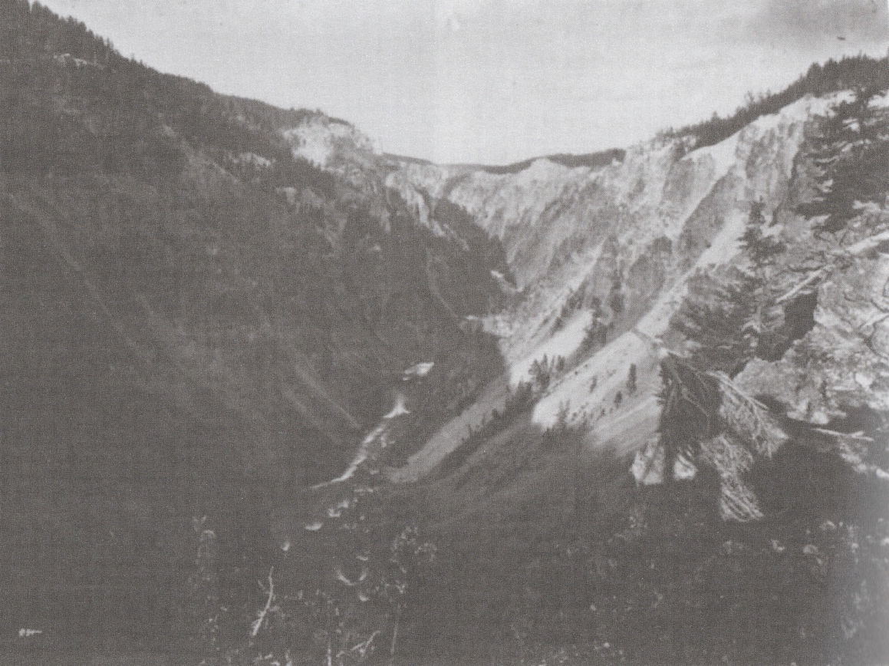

Figure 3.15 William Henry Jackson, Yellowstone Canon (from above the falls), ca. 1871, photograph.
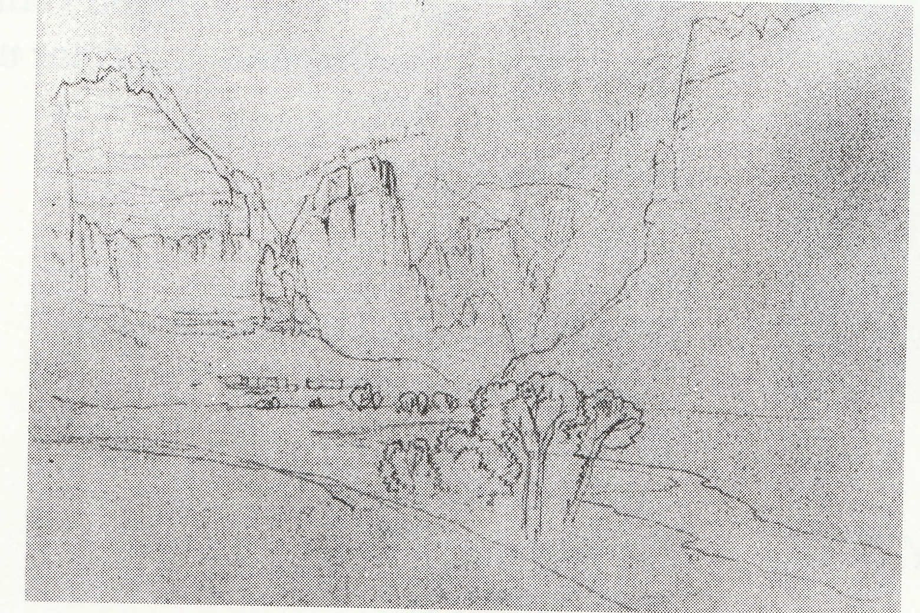

Figure 3.16 Thomas Moran, The Cathedral/Rio Virgin, 1873, graphite on laid, 8 ¼ x 11 ¾ in.

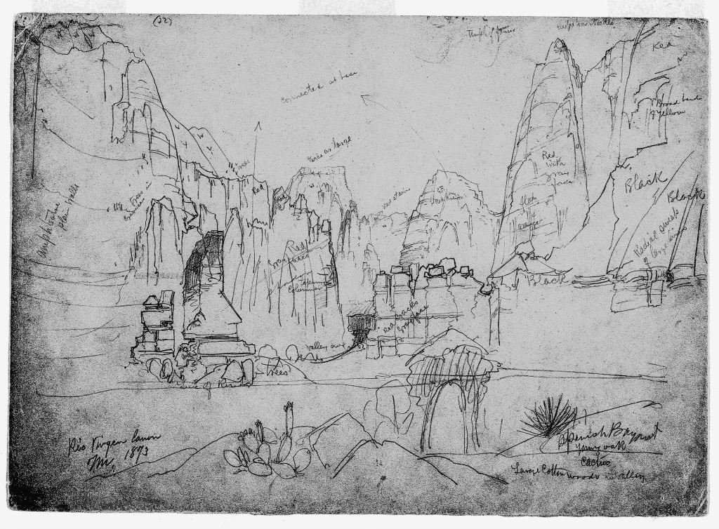

Figure 3.17 Thomas Moran, The Canyon of the Rio Virgin, South Utah, 1873, graphite on tan paper, 10 11/16 x 151/16.
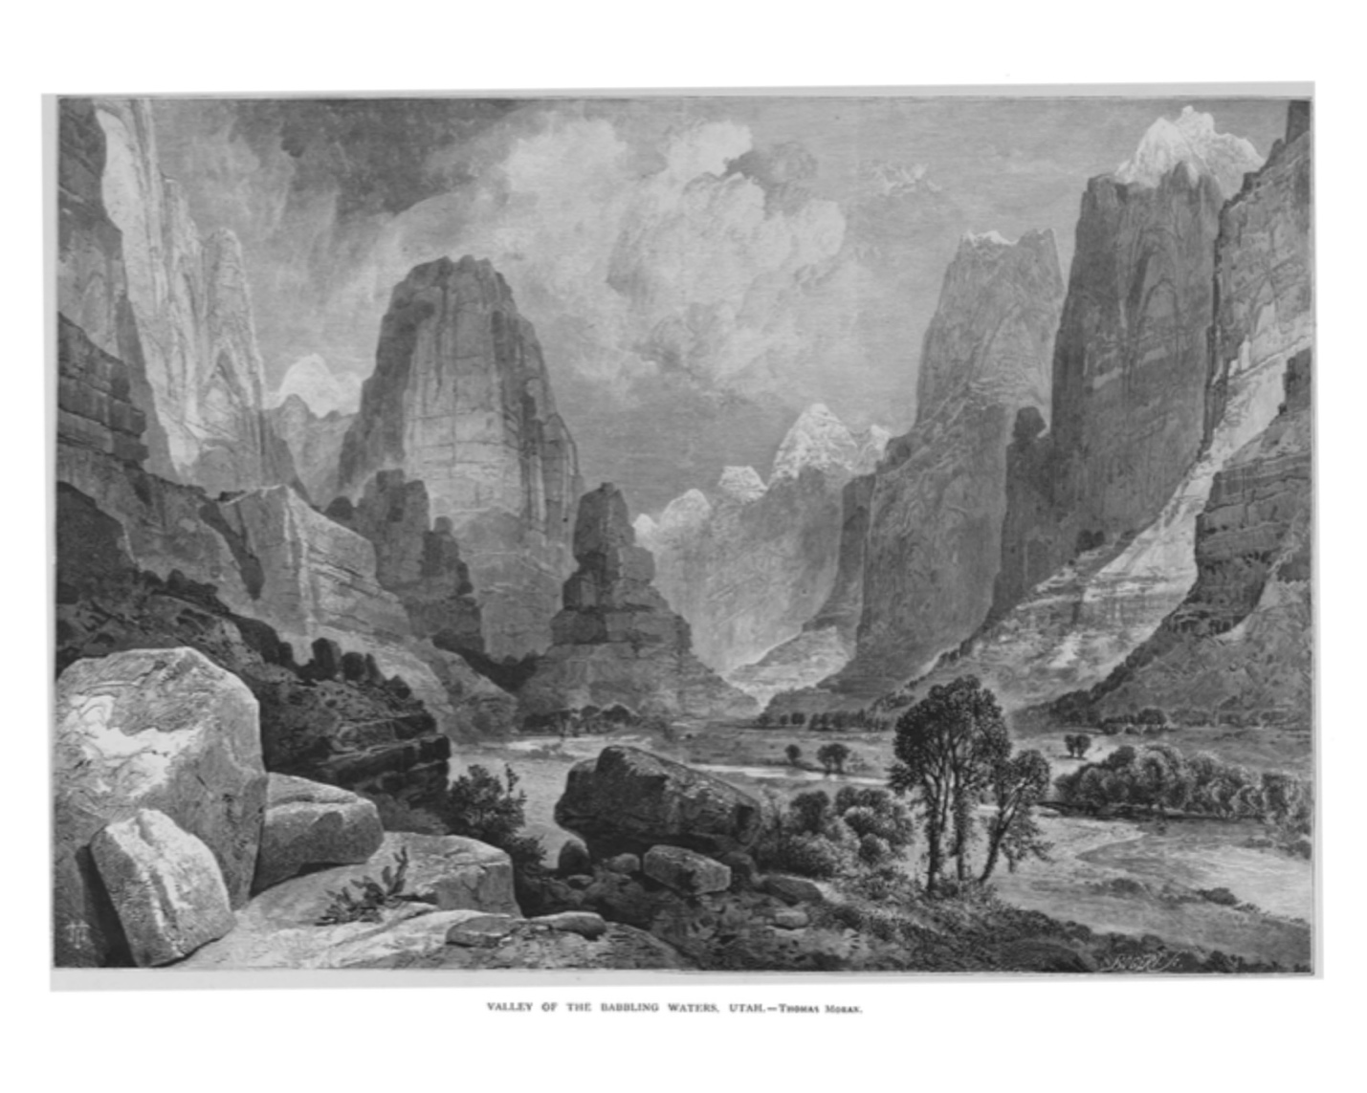
Figure 3.18 Thomas Moran Valley of the Babbling Waters, Utah, engraving, The Aldine

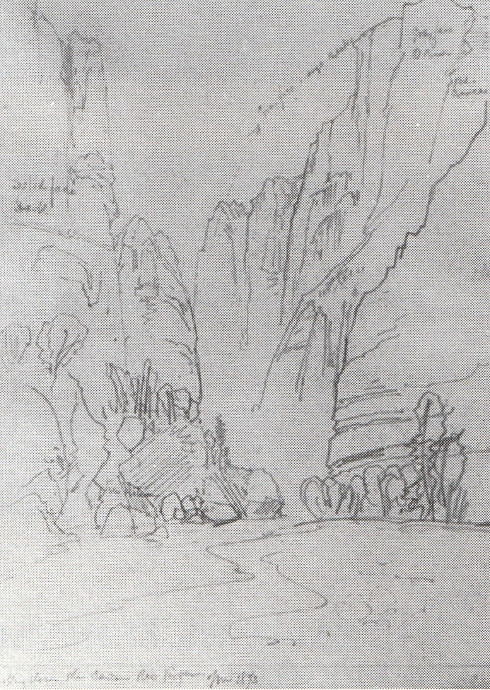

Figure 3.19 Thomas Moran, Looking Down the Canyon, Rio Virgin, 1873.

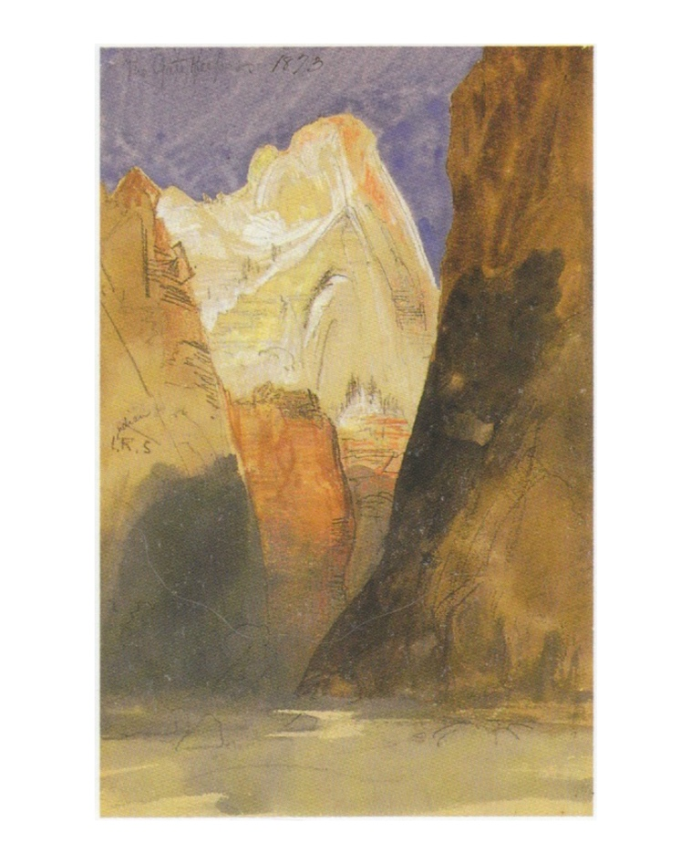
Figure 3.20 Thomas Moran, The Gatekeeper, 1873,

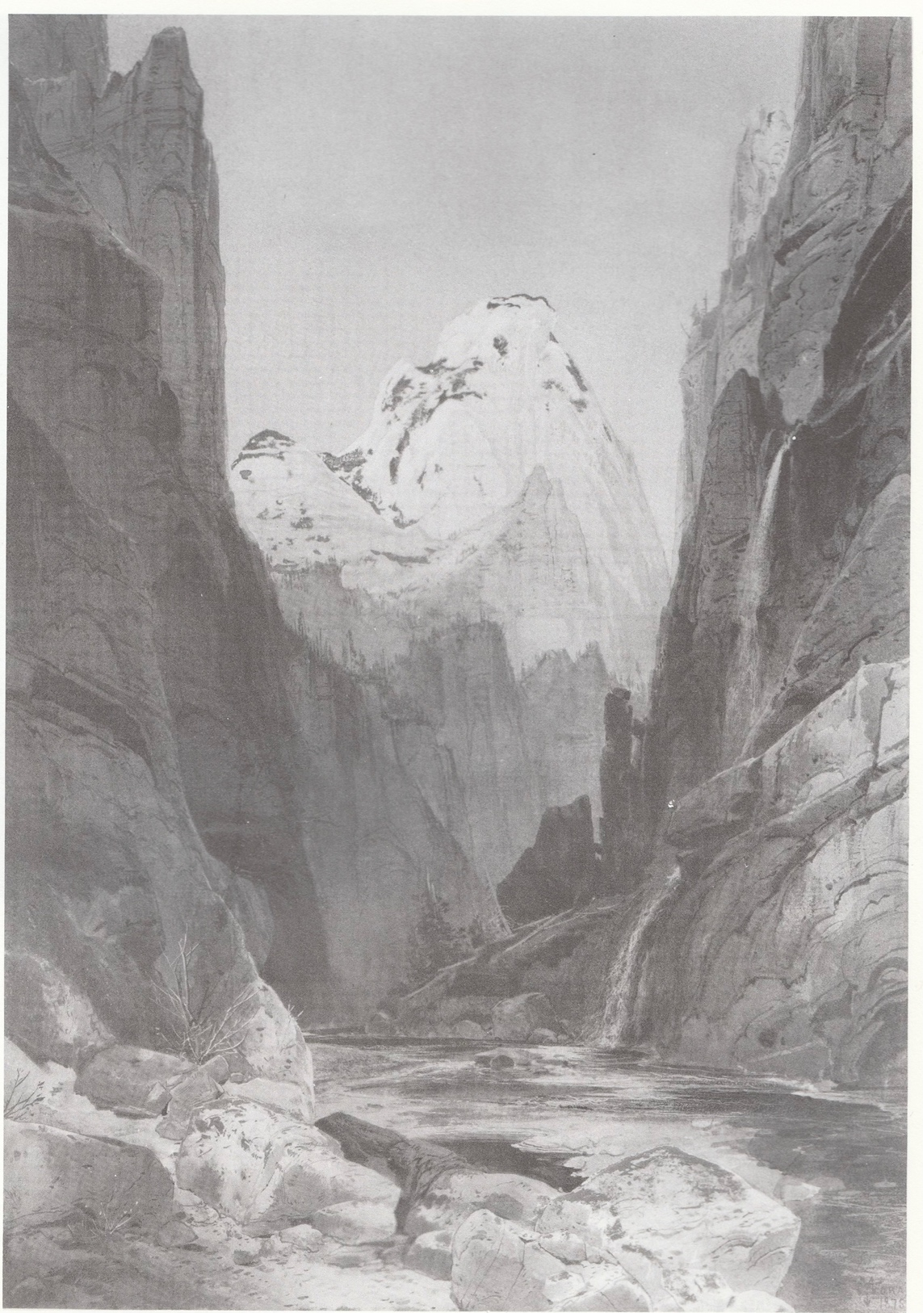

Figure 3.21 Thomas Moran, Canyon of the Rio Virgen, S. Utah, 1874, watercolor.

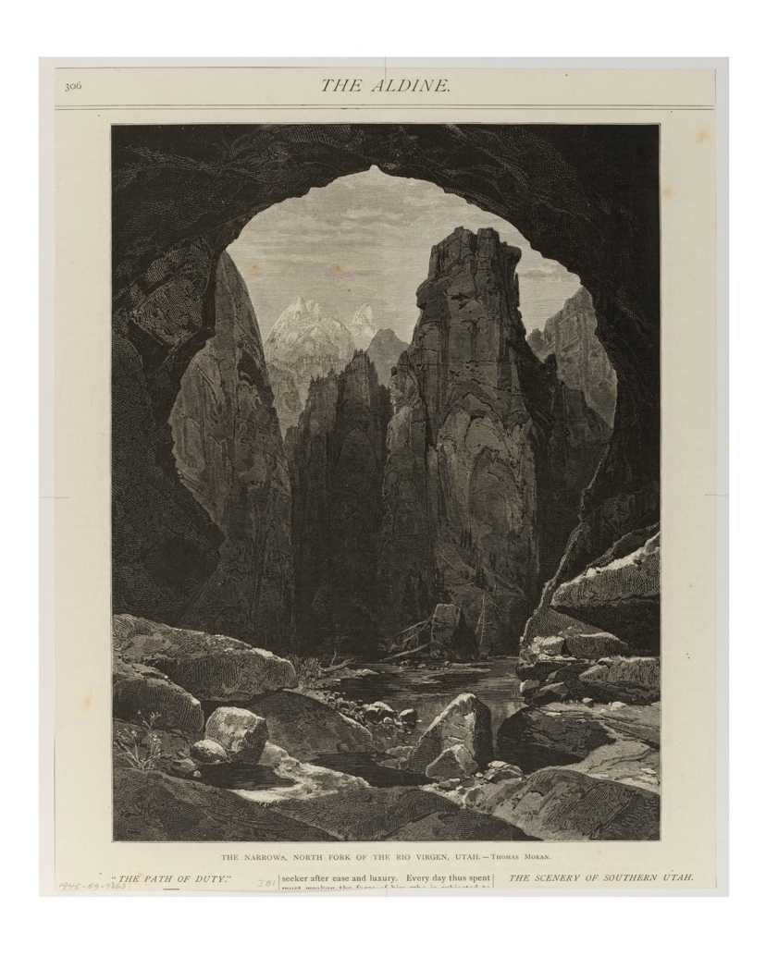
Figure 3.22 Thomas Moran, The Narrows, North Fork of the Rio Virgen, Utah

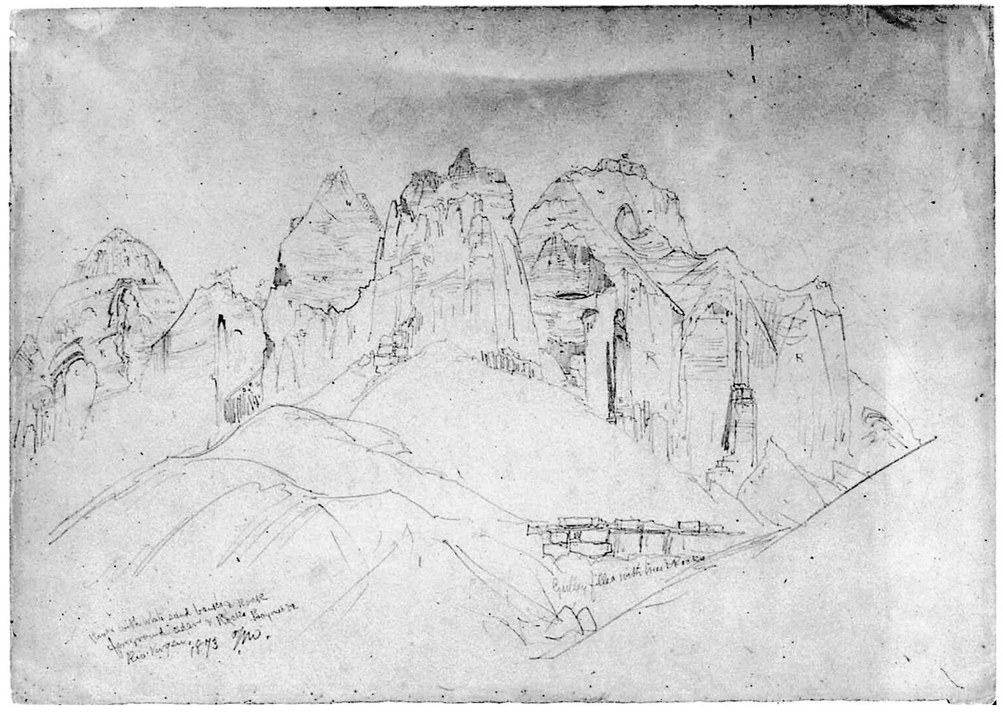

Figure 3.23 Thomas Moran, Rio Virgin River with Large Rock Formations, 1873, graphite on gray paper, 10 11/16 x 14 13/16 in.

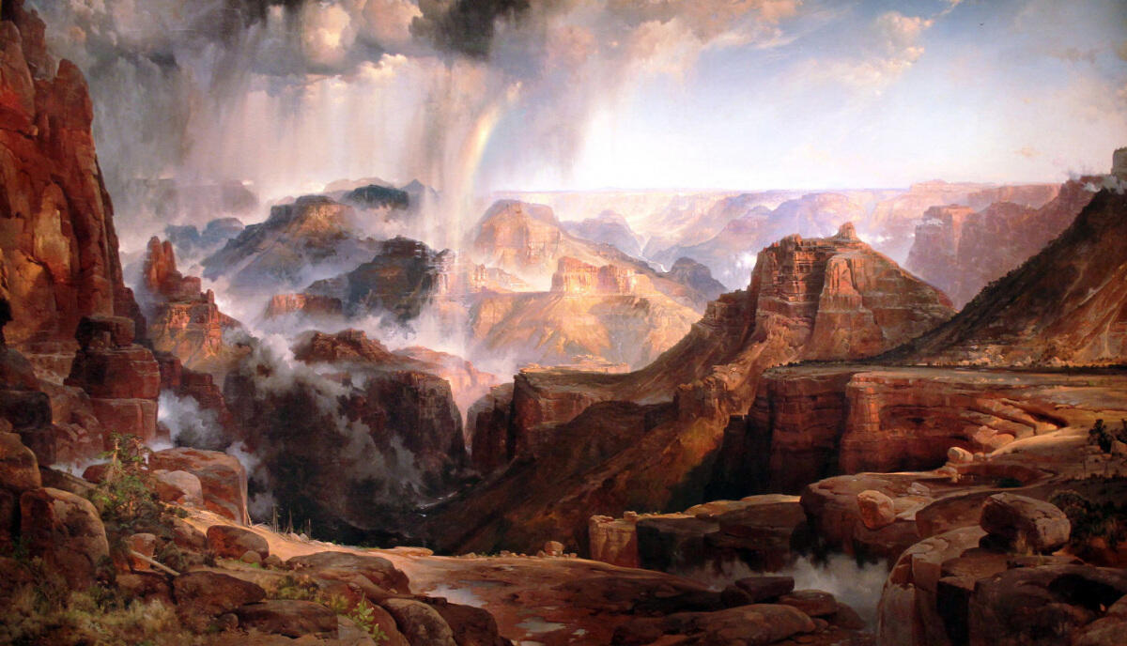

Figure 3.24 Thomas Moran, Chasm of the Colorado, oil on canvas mounted on aluminum, 84 3/8” c 144 3/4”, 1873-1874.
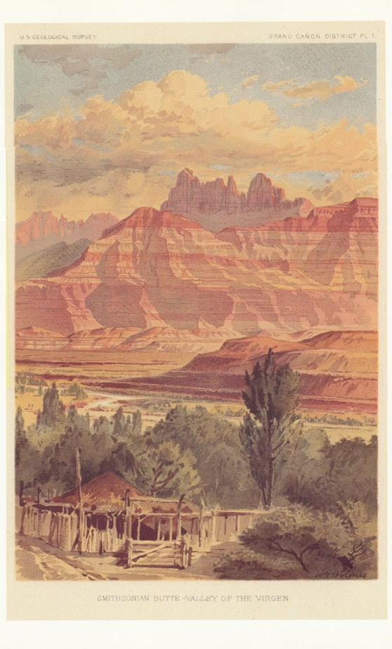

Figure 3.25 Smithsonian Butte-Valley of the Virgin

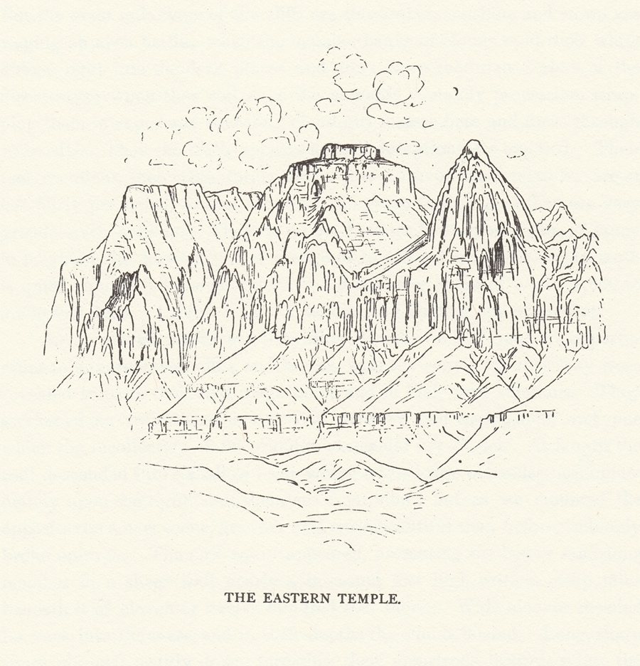

Figure 3.26 William Henry Holmes, Summit of the Eastern Temple of the Virgin
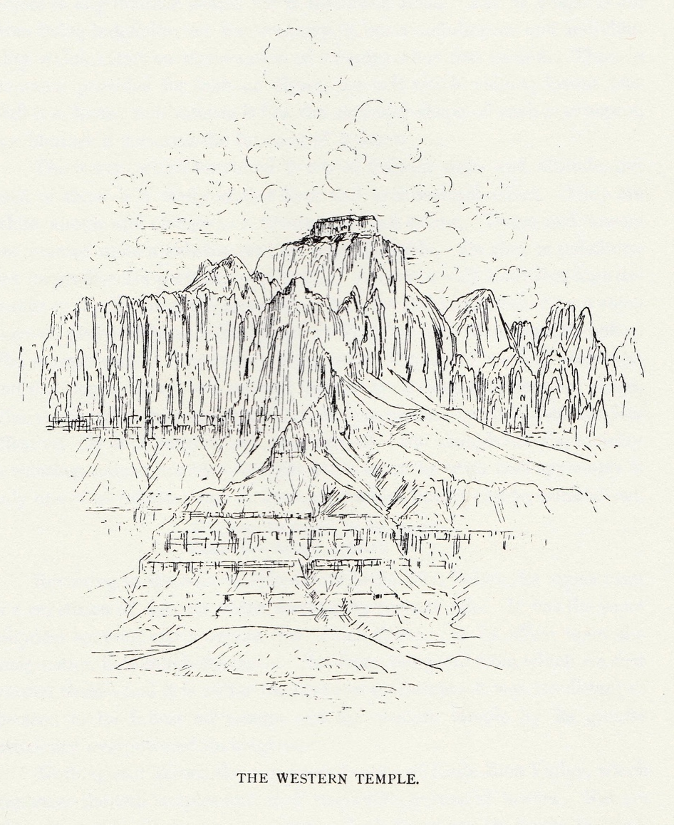

Figure 3.27 William Henry Holmes, Summit of the Western Temple of the Virgin

WORLD’S FAIRS IMAGES

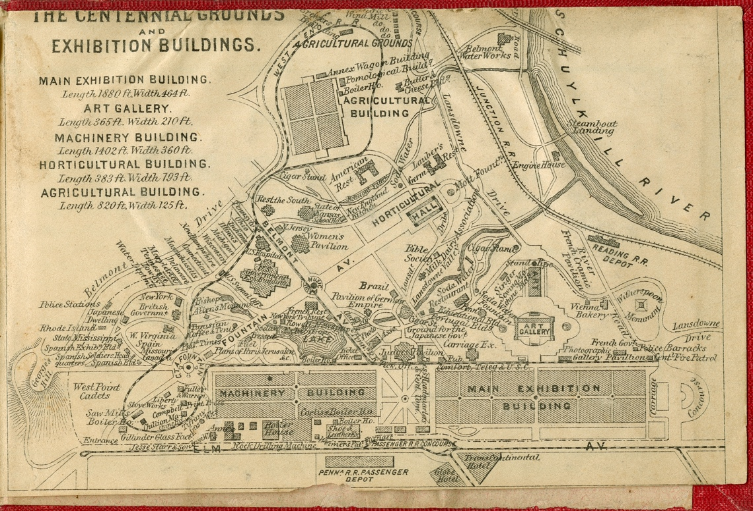

Figure 4.1 Fairgrounds of Philadelphia

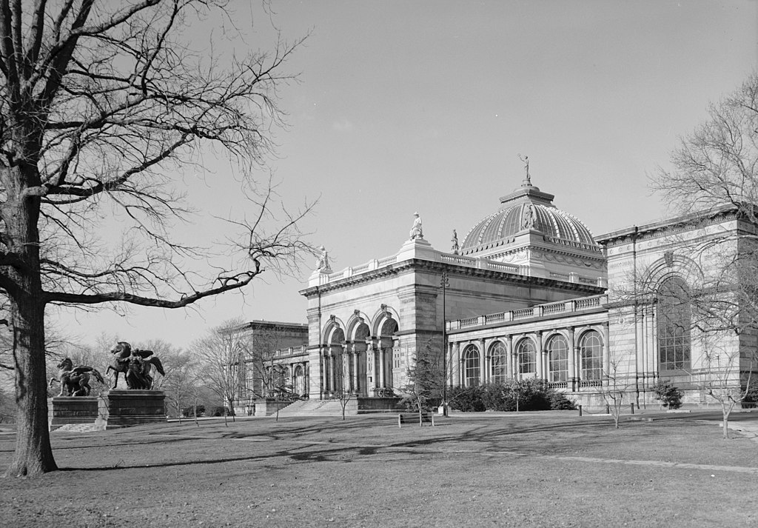

Figure 4.2 Memorial Hall
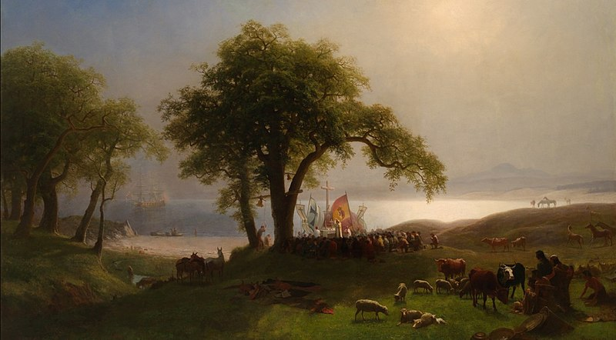

Figure 4.3 Albert Bierstadt, Entrance to Monterey, oil on canvas, 1876.

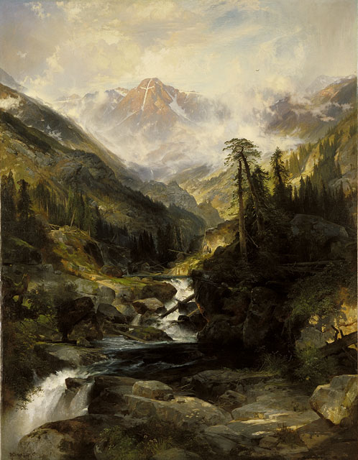

Figure 4.4 Thomas Moran, Mountain of the Holy Cross, oil on canvas, 1875.

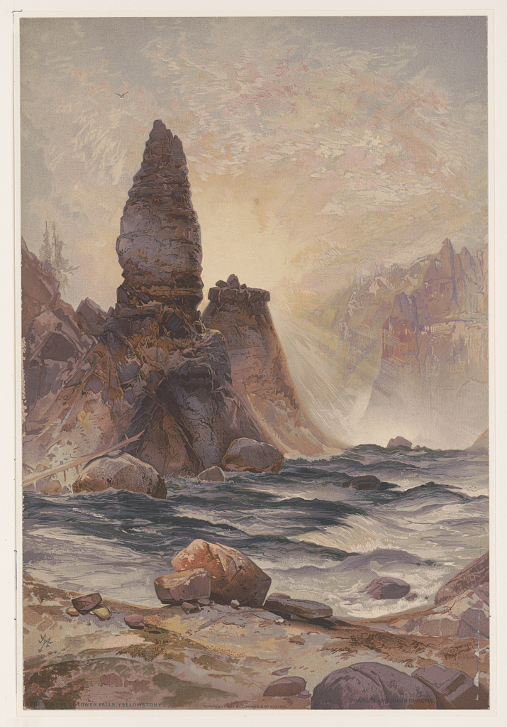

Figure 4.5 Thomas Moran, The Tower of Tower Falls, chromolithograph, 1876.

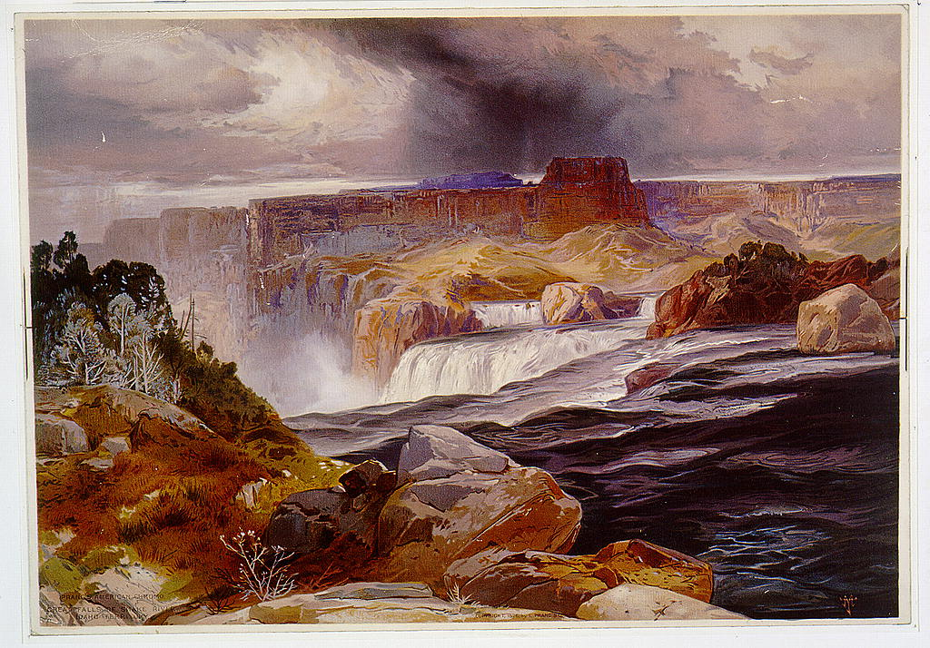

Figure 4.7 Thomas Moran, The Great Falls of Snake River, chromolithograph, 1876.
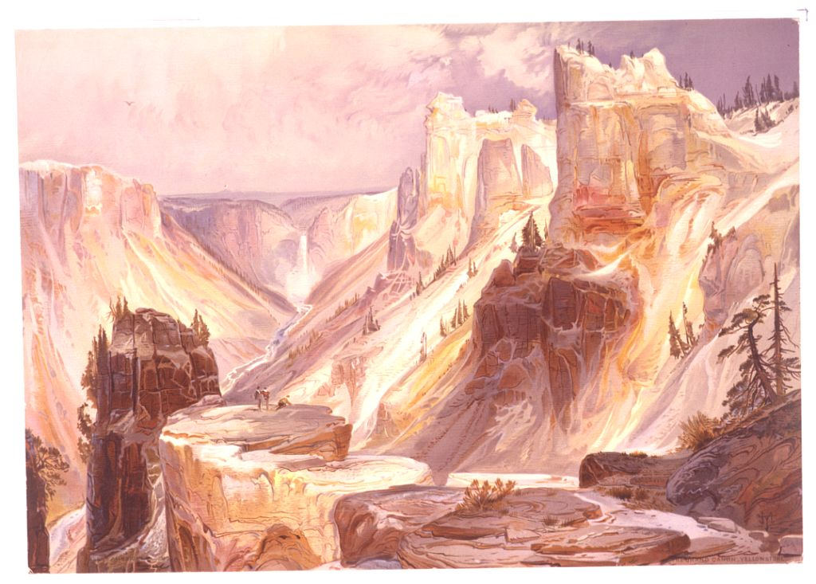

Figure 4.7 Thomas Moran, The Grand Canyon of the Yellowstone, chromolithograph, 1876.

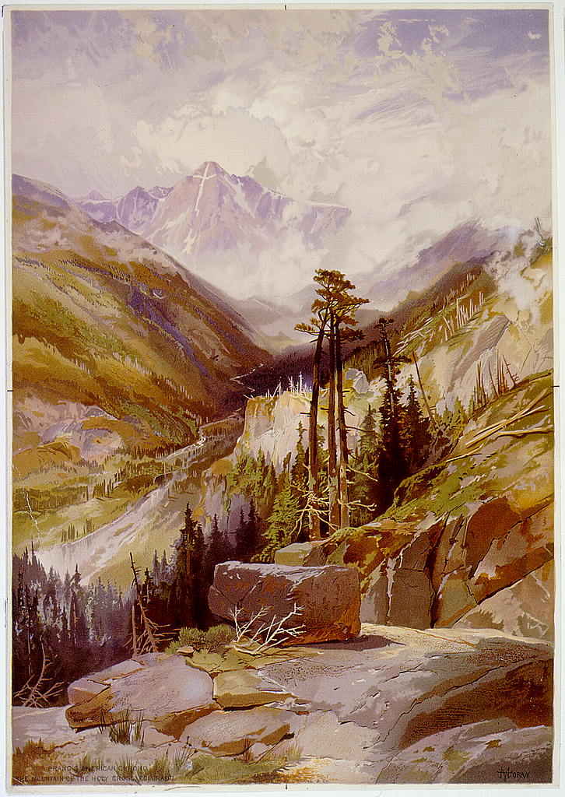

Figure 4.8 Thomas Moran Mountain of the Holy Cross, chromolithograph, 1876.
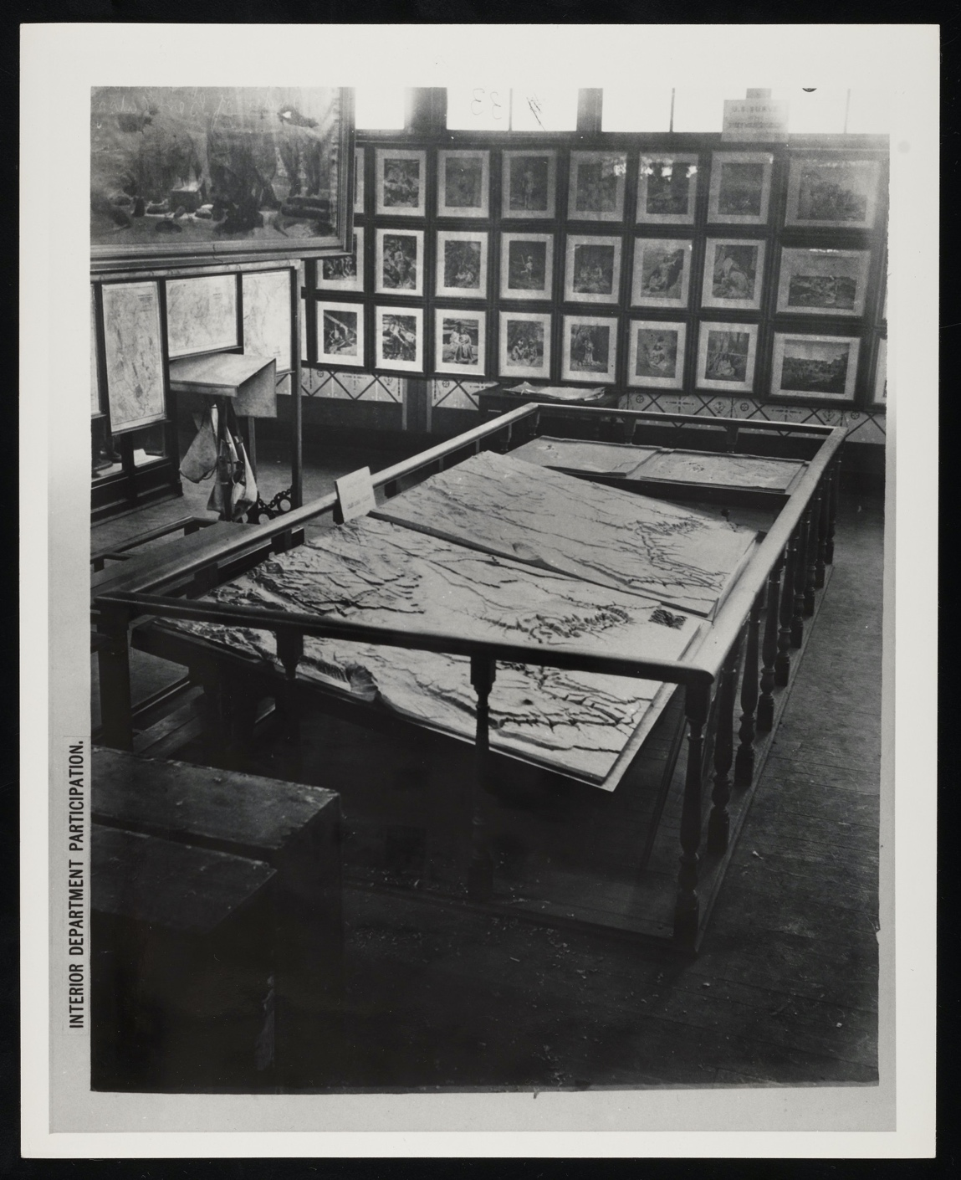

Figure 4.9 Interior Department Participation, Centennial Exposition, 1876, albumen, 23 x 18 cm.
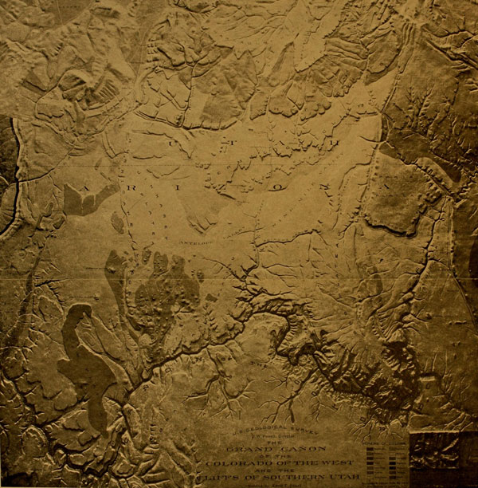

Figure 4.10 Edwin E. Howell, The Grand Canyon and Terrace Plateau Region, 6’ x 6’.
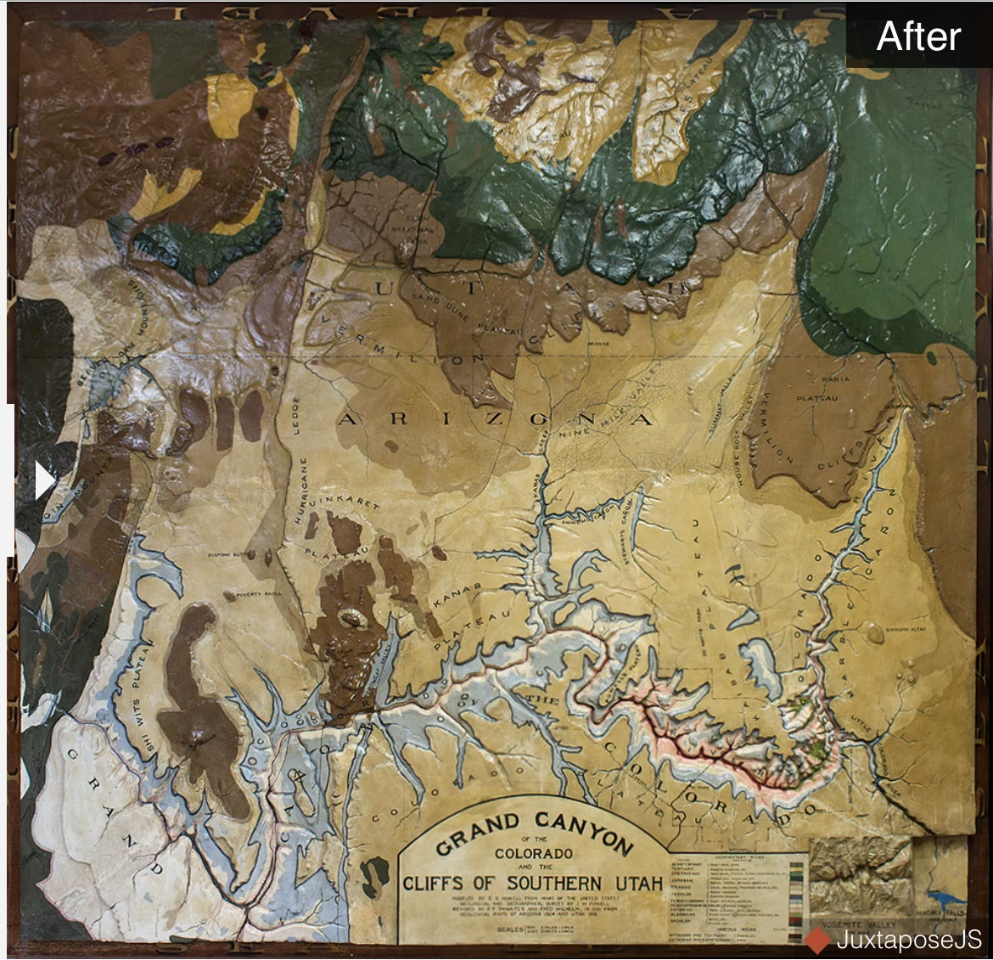

Figure 4.11 Relief Map of Grand Canyon and Terrace Plateau Region, After Restoration.

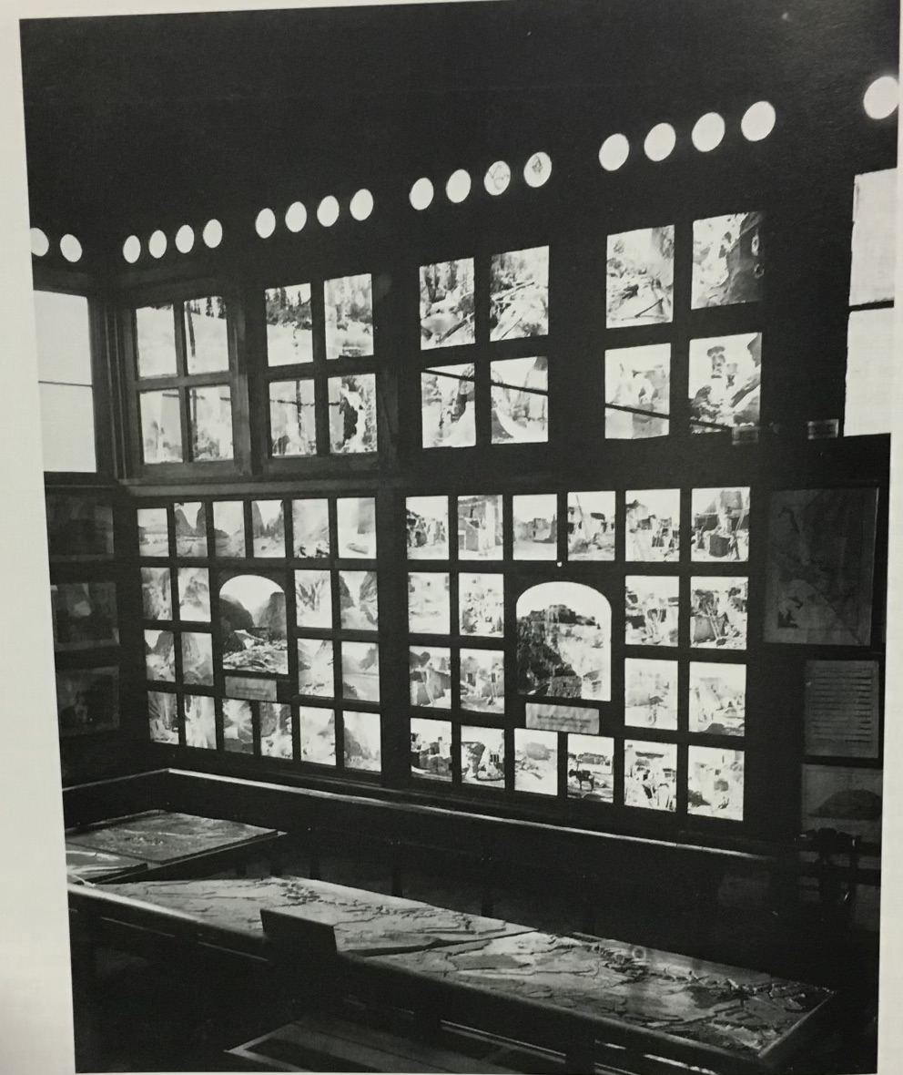

Figure 4.12 John K. Hillers, Northwestern end wall of the Government Centennial Building, photographs of the Grand Canyon and Native Americans in Northern Arizona.
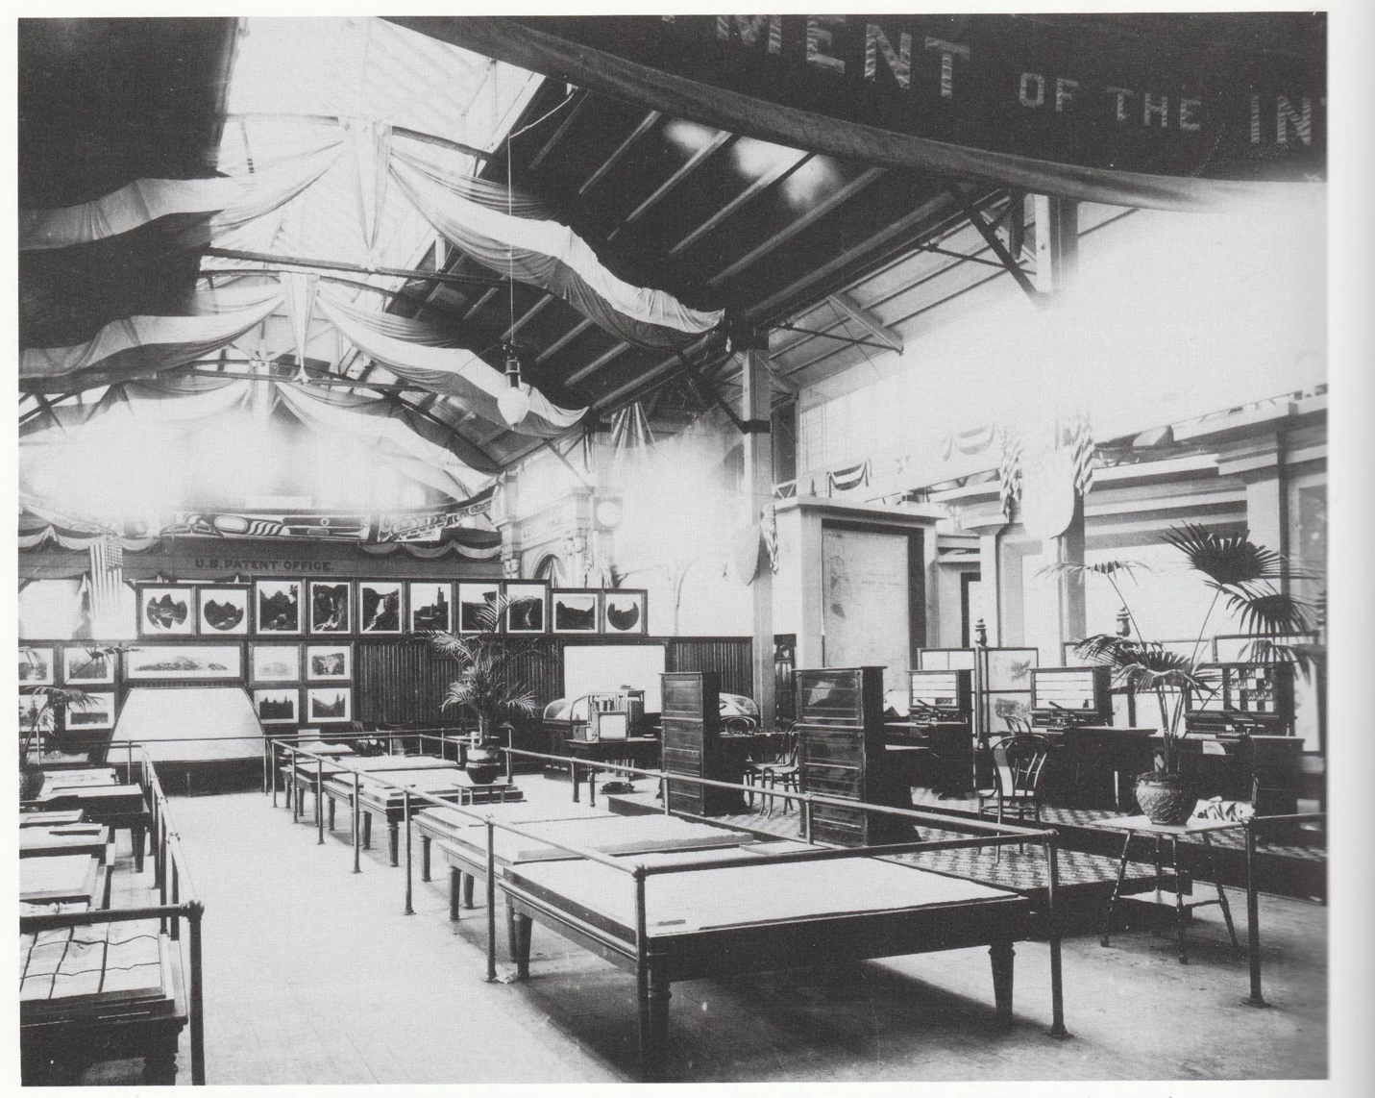

Figure 4.13 USGS Display at Chicago World’s Fair

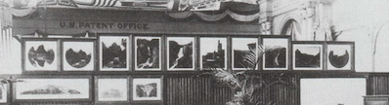

Figure 4.14 detail

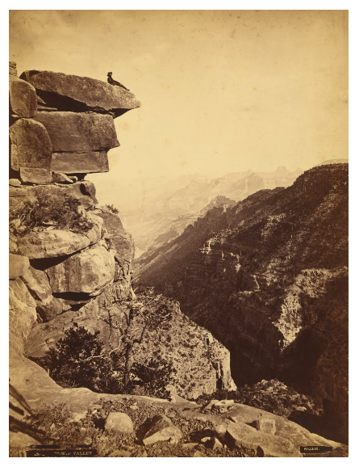

Figure 4.15 James Fennemore, Mukuntuweap Valley, (Zion Canyon), Utah, 1872.
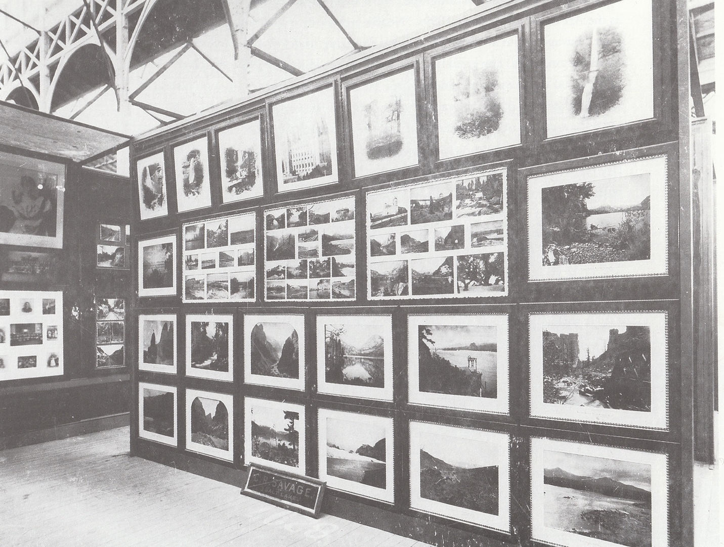

Figure 4.16 Savage display at the Chicago World’s Fair, 1893.

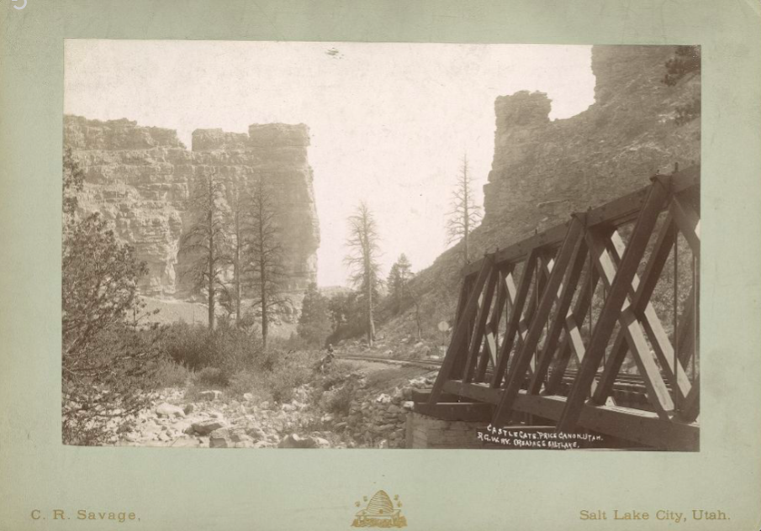

Figure 4.17 Charles Savage, Castle Gate, Price Canyon, Utah, R.G.W.Ry (Rio Grande Western Railway), ca. 1889.

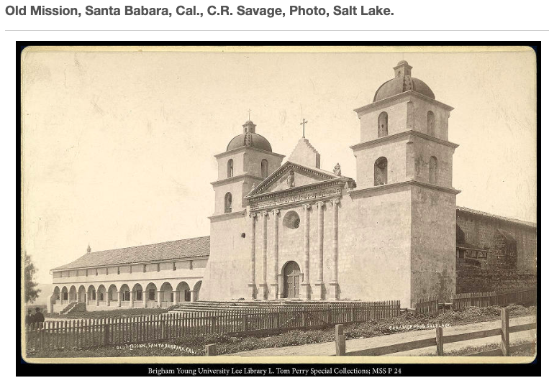

Figure 4.18 Charles Savage, Old Mission, Santa Barbara, California, ca. 1889

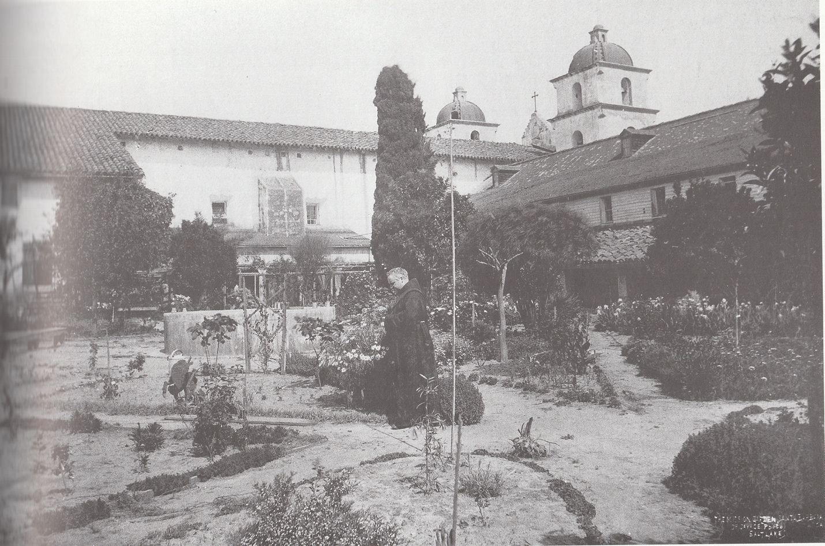

Figure 4.19 Charles Savage, James E. Talmage dons the robes of a Franciscan monk to have his picture taken by Savage in the garden of the Catholic mission in Santa Barbara in 1887.
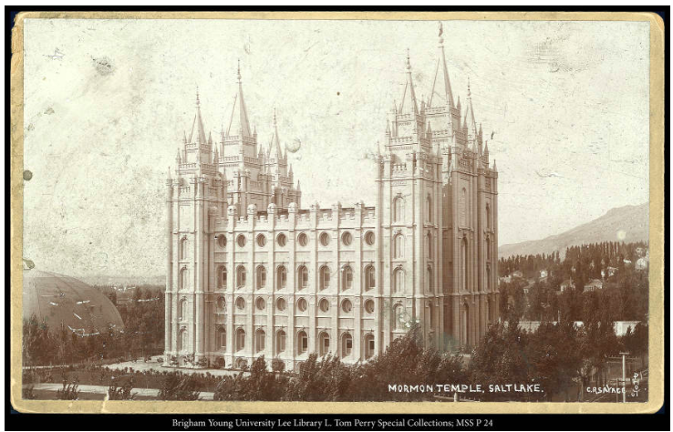

Figure 4.20 Charles Savage, Mormon Temple, Salt Lake,

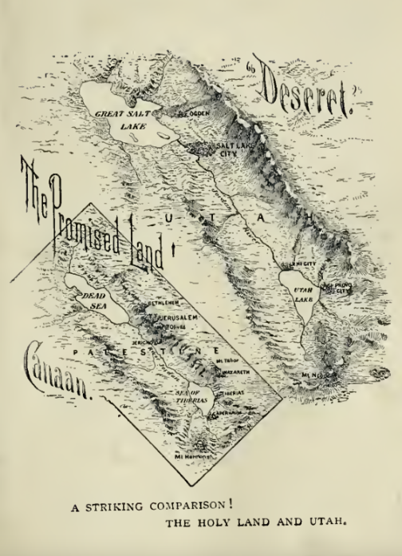

Figure 4.21 The Promised Land comparison between SLC and the Dead Sea

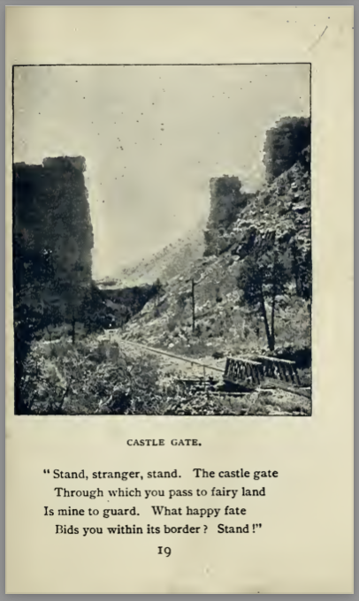

Figure 4.22 Castle Gate, The Promised Land, 1893.

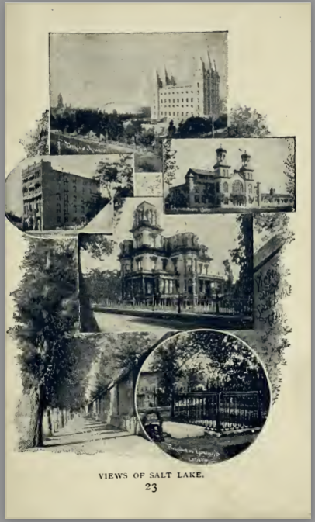

Figure 4.23 Views of Salt Lake, The Promised Land, 1893.
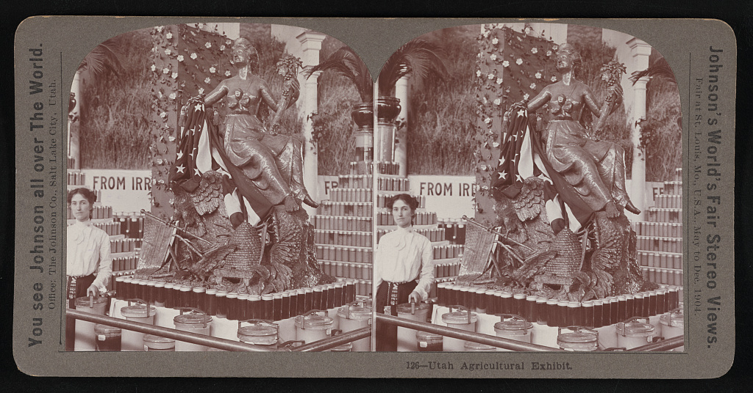

Figure 4.24 Utah Agricultural Display at St. Louis

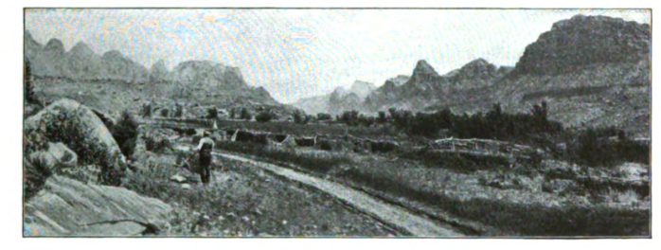
Figure 4.25 Frederick Dellenbaugh, A Double Line of Majestic Sculptures

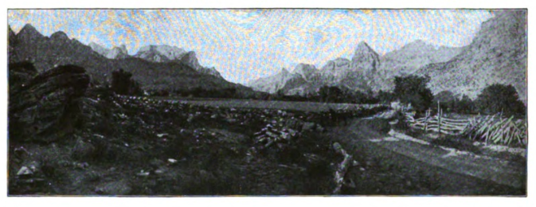
Figure 4.26 Frederick Dellenbaugh, Lower End of the Valley

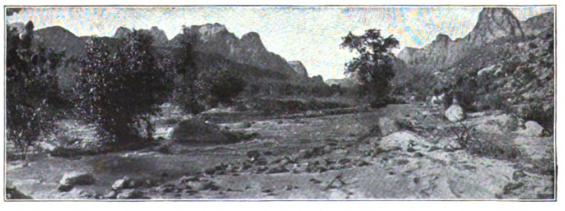

Figure 4.27 Frederick Dellenbaugh, Seductive as the Realm of some Sleeping Beauty

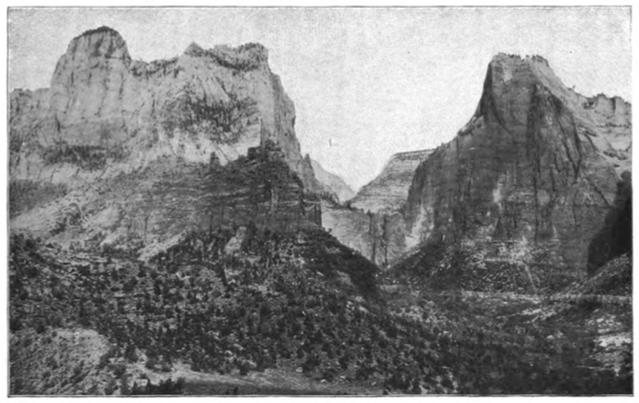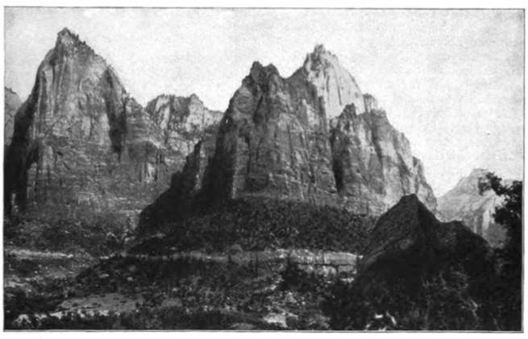

Figure 4.28 Frederick Dellenbaugh, The Amphitheater—the very heart of the Opalescent Valley.

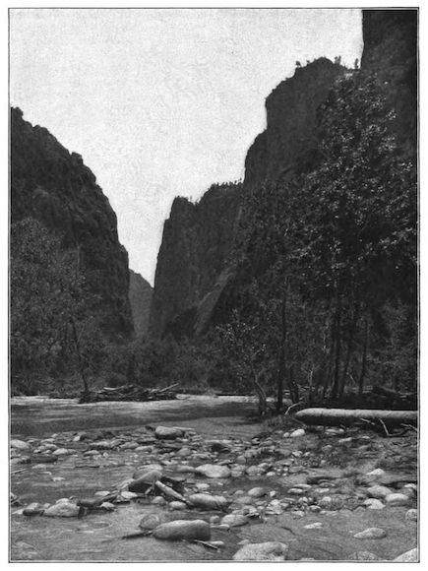

Figure 4.29 Frederick Dellenbaugh, Ever Narrower Grew the Canyon
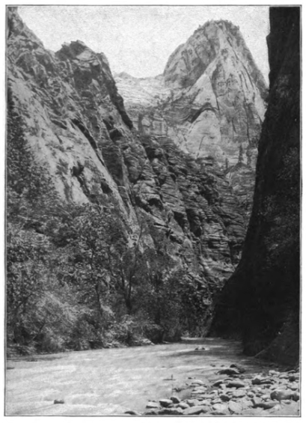

Figure 4.30 Frederick Dellenbaugh, Straight into the Jaws of the Narrowing Chasm.

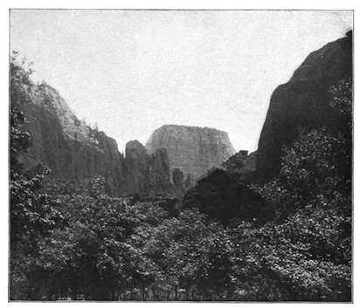

Figure 4.31 Frederick Dellenbaugh, One of the High Cliffs, Through a break in the Red Wall

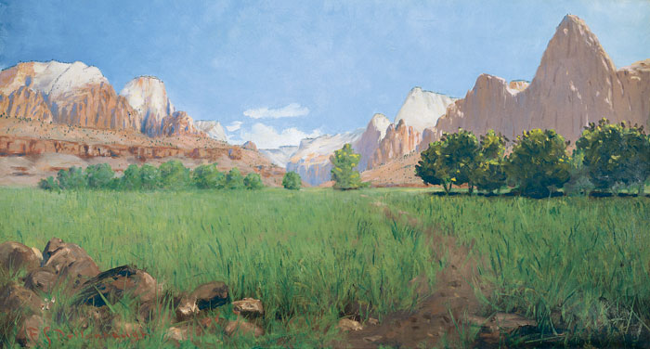

Figure 4.32 Frederick Dellenbaugh, Zion Canyon, 1903.

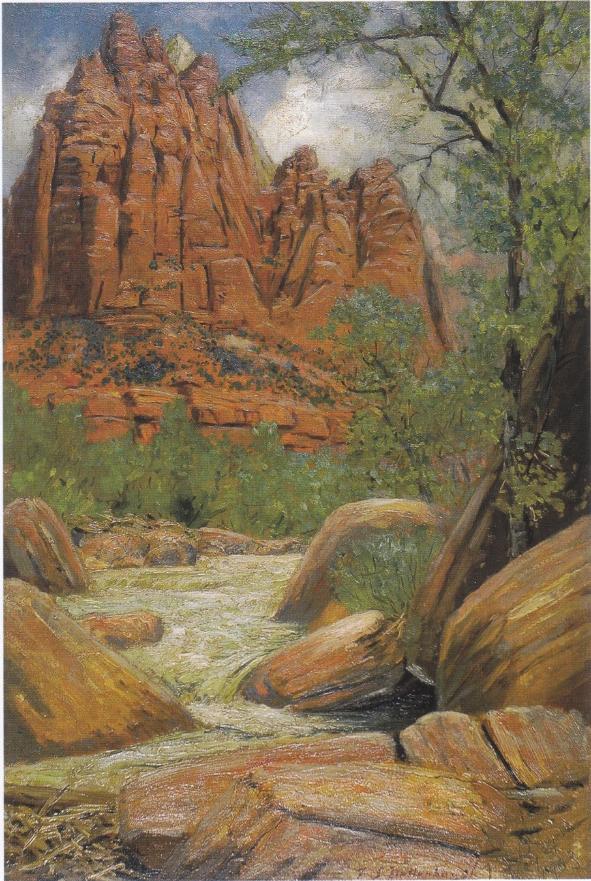

Figure 4.33 Frederick Dellenbaugh, Eagle Crag, 1903.
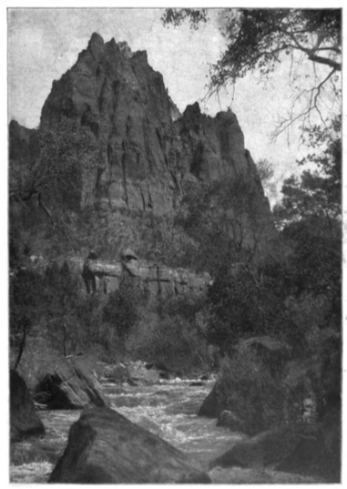
Figure 4.34 Frederick Dellenbaugh, A Huge Vermillion Pyramid whose Precipice Cleaves the Sky.

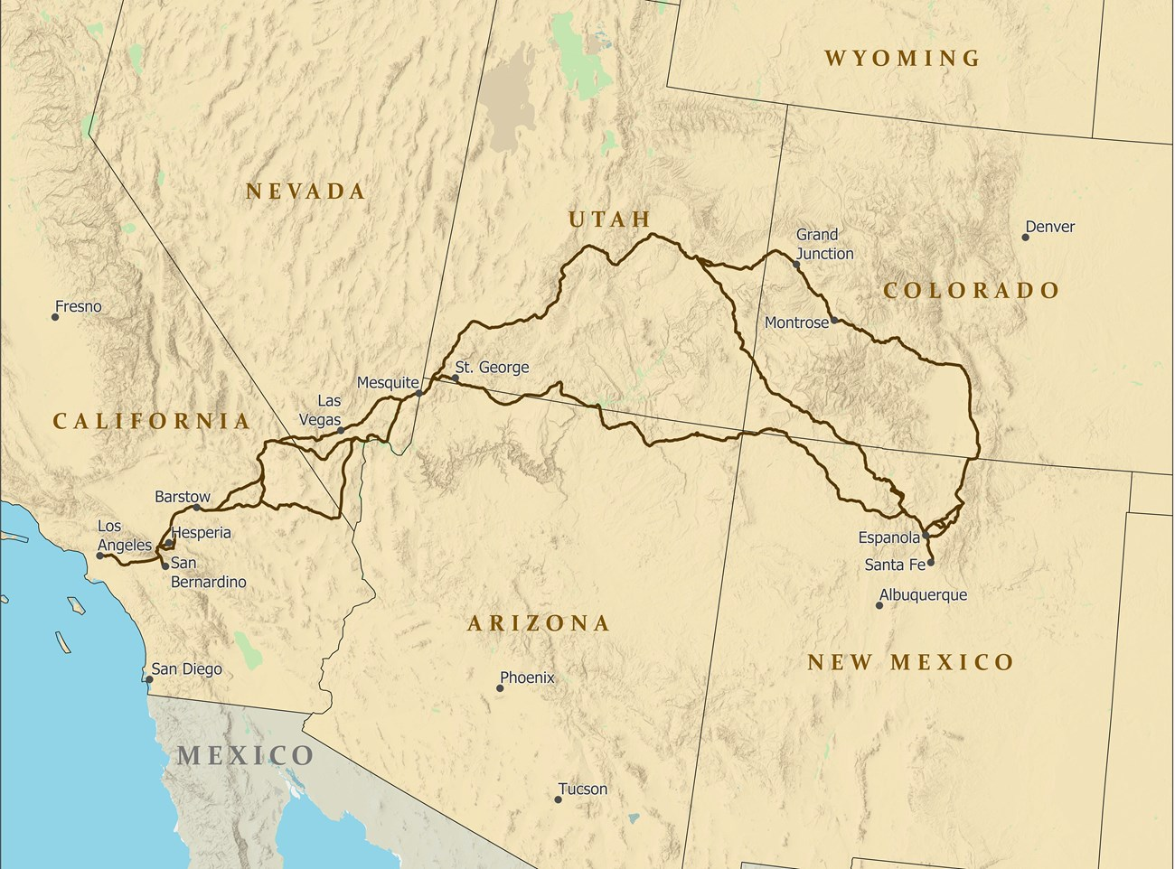

Figure 5.1 The Old Mormon Trail or the Old Spanish Trail

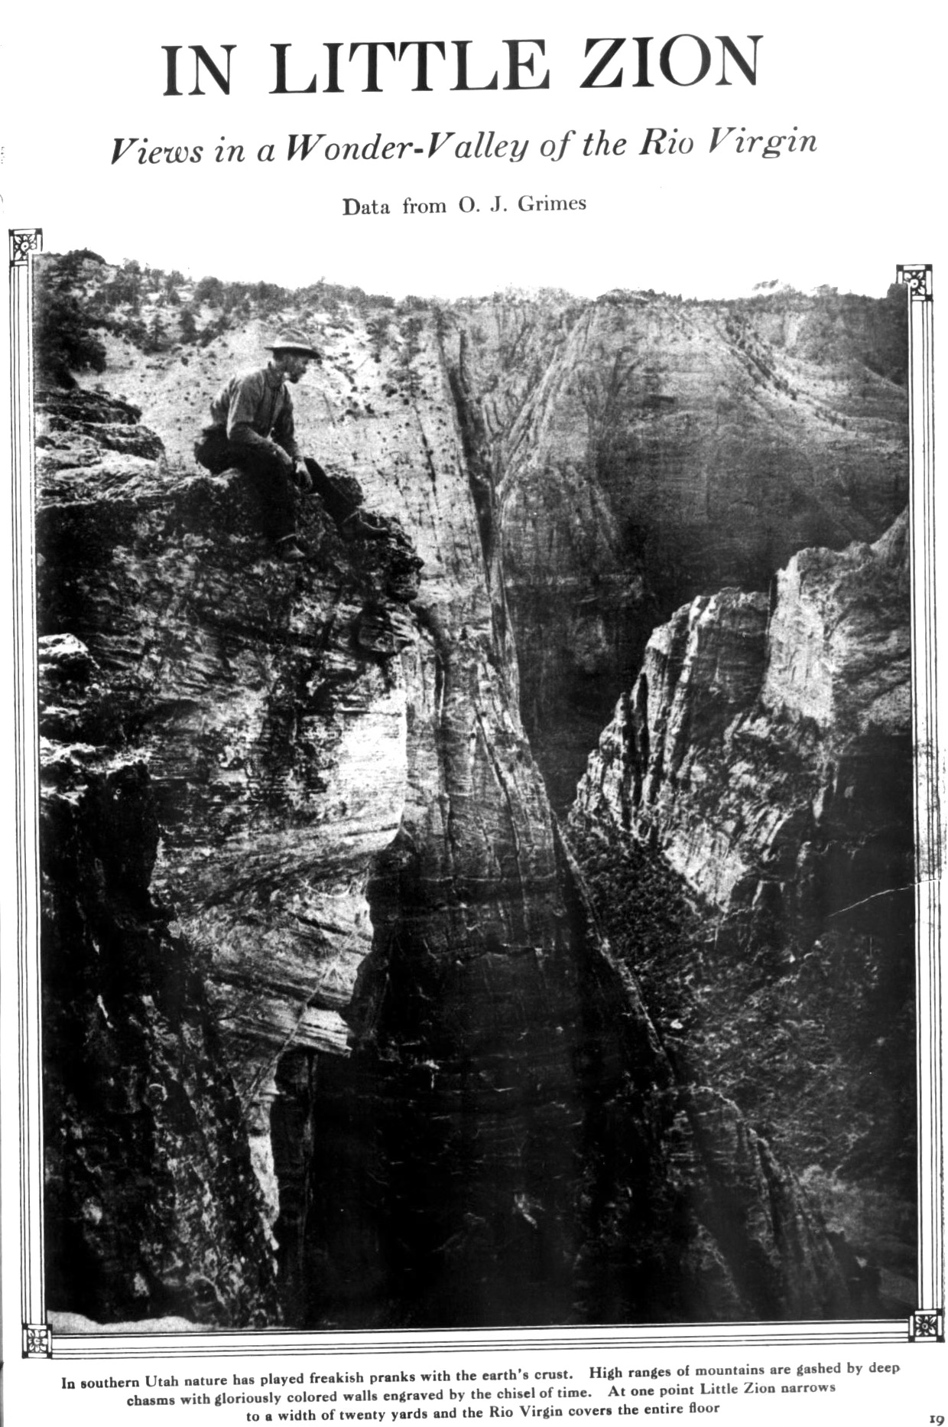

Figure 5.2

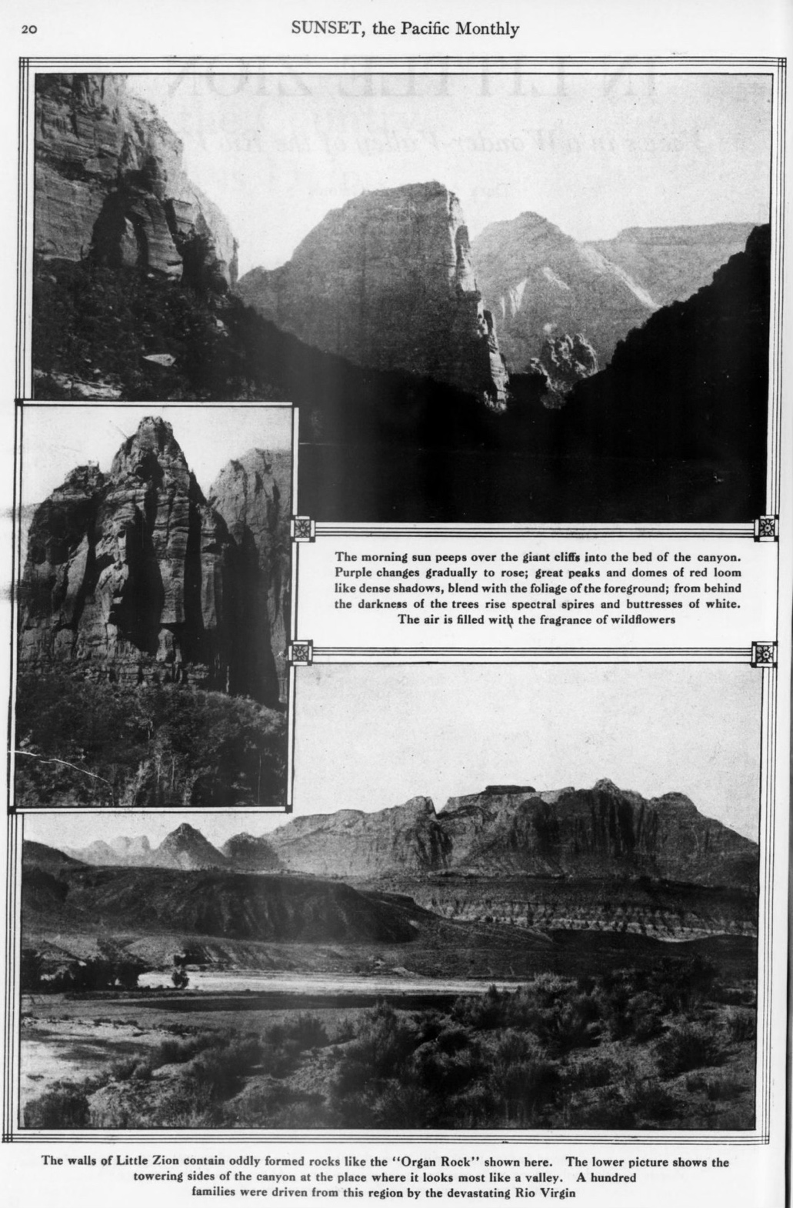

Figure 5.3 Sunset page 20 Above, Angel’s Landing. Inset, Organ Rock. Below, The Western Temple from the west side.

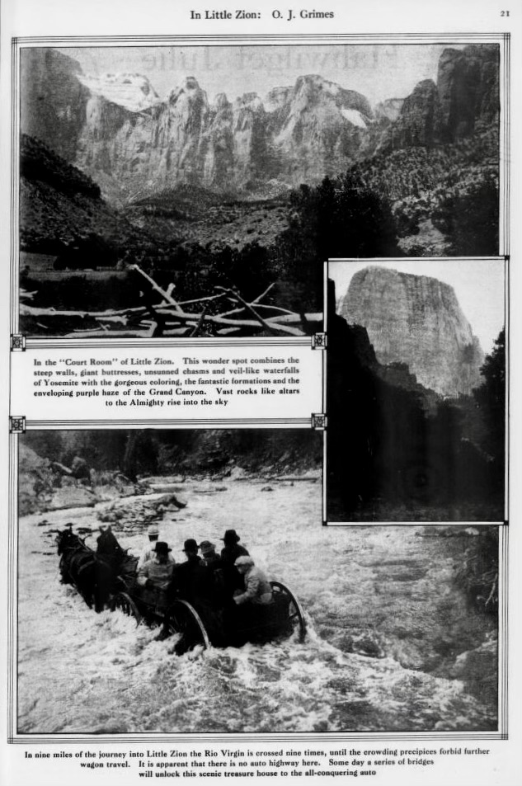

Figure 5.4 Page 21 of Sunset. Above, The Court Room. Inset, The Great White Throne. Bottom, Governor Spry’s party fording the Virgin River.

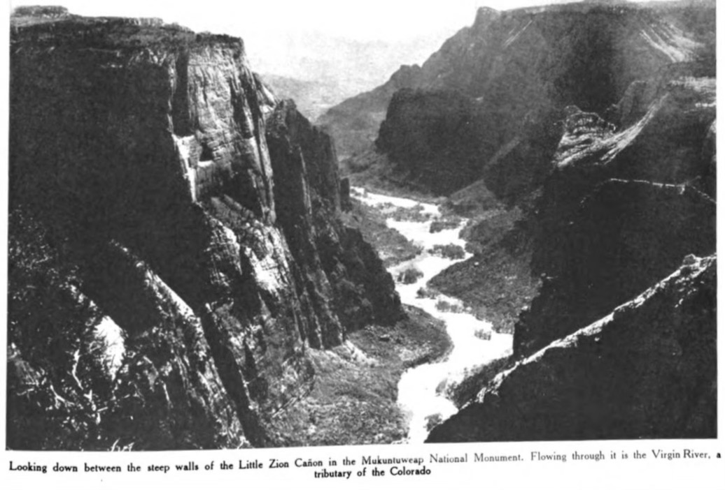
Figure 5.5 Looking down between the steep walls of the Little Zion Canon in the Mukuntuweap
National Monument

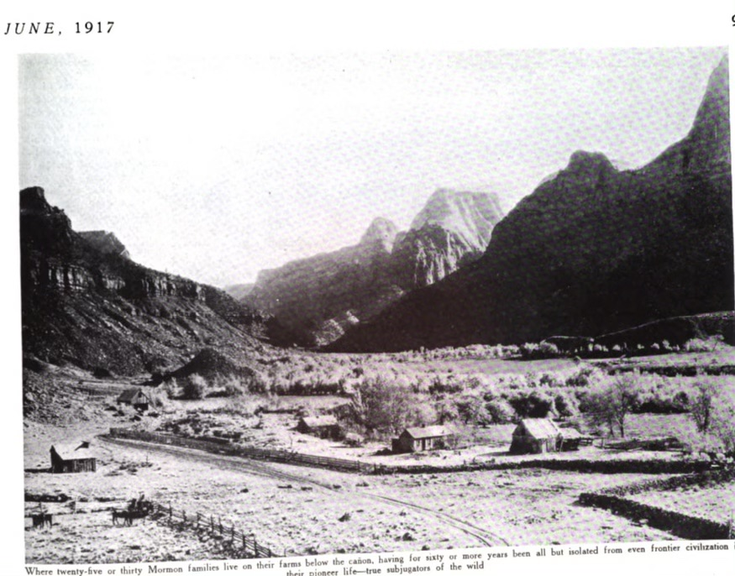
Figure 5.6 Where twenty-five or thirty Mormon families live on their farms below the canon, having for sixty or more years been all but isolated from even frontier civilization all their pioneer life—true subjugators of the wild.

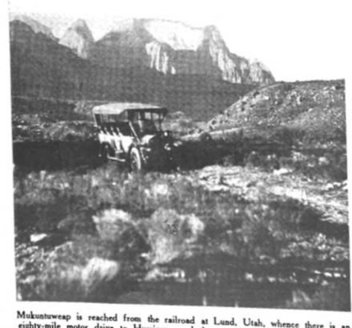

Figure 5.7 Mukuntuweap is reached from the railroad at Lund, Utah, whence there is an eighty-mile motor drive to Hurricane and then a trip of twenty-five miles by horse vehicle.

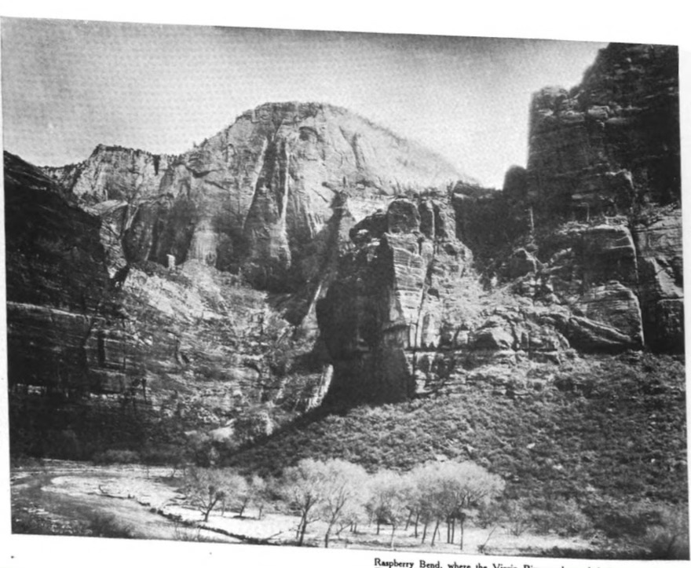
Figure 5.8 Raspberry Bend
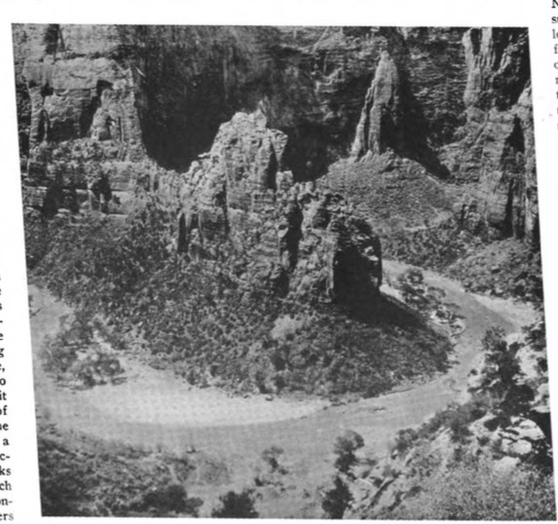

Figure 5.9 Almost a Circular River Bed
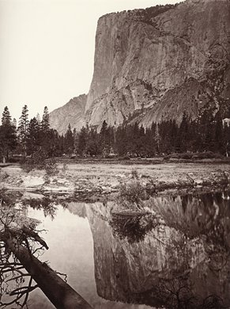

5.10 Carleton Watkins, Mirror View of El Capitan, c. 1872. Albumen print from wet-collodian negative, Collection of Stanford University Libraries, Cecil H. Green Library, Department of Special Collections.

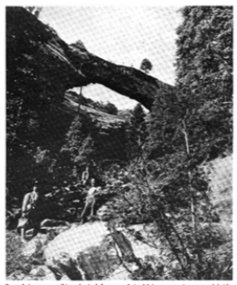
Figure 5.11 One of the many striking physical features of the Mukuntuweap is a natural bridge 100 feet high and having a span of 115 feet, greater in span though not as high as that in Virginia.

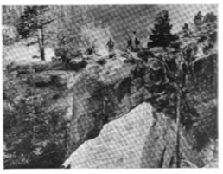
Figure 5.12 It was only last year that this natural bridge was discovered in the Mukuntuweap National Monument. Its size may be estimated by noting the figures on top of the arch.
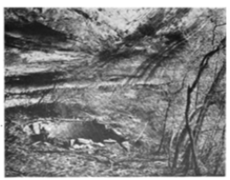

Figure 5.13 What remains of a Kiva, or ceremonial chamber, of a ruined cliff dwelling in the canon of the Virgin River. There are doubtless similar undiscovered monuments of the past.

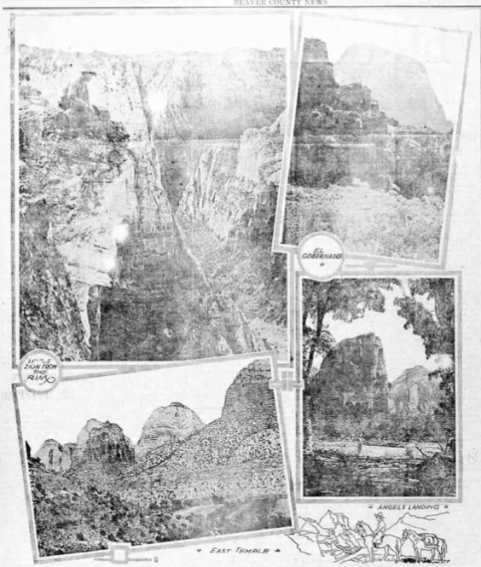

Figure 5.15 Beaver County News, Milford Utah, Friday, December 21, 1917 p. 2

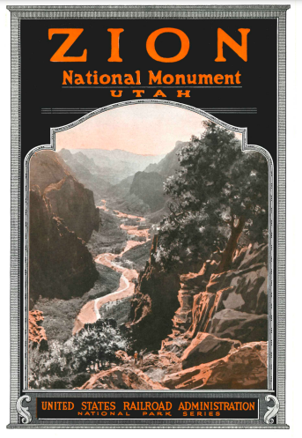

Figure 5.16 Zion National Monument, Utah, cover.

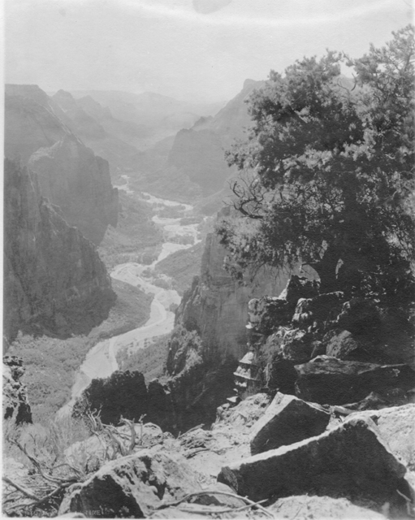

Figure 5.17 Looking South into Zion Canyon from Hick’s Point. Henry H. Lunt Collection, SUU Box B01 Folder F13 Item 9
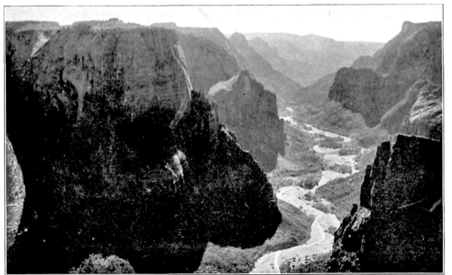

Figure 5.18 Looking down into Zion from its easter wall.
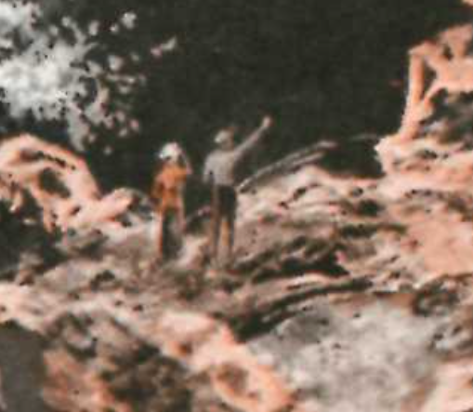

Figure 5.19 Zion National Monument, Utah cover, detail.

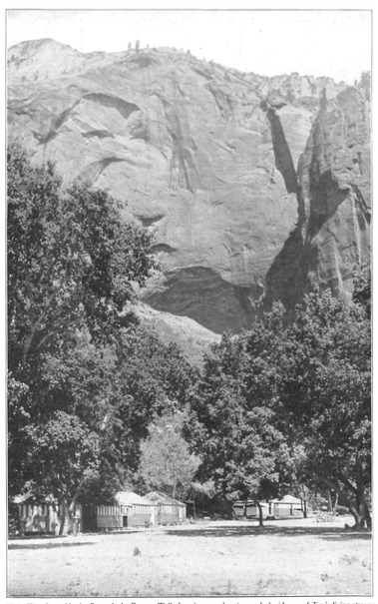

Figure 5.20 Wylie Way Camp Nestles Beneath the Eastern Wall

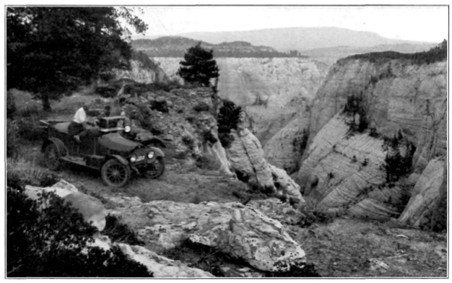

Figure 5.21 On Zion’s Western Rim

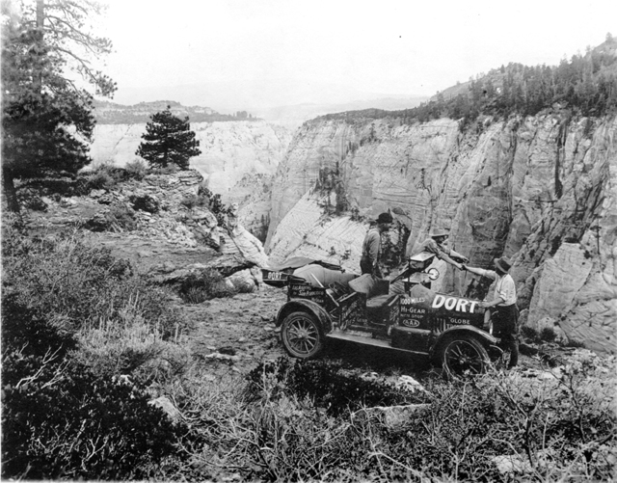

Figure 5.22

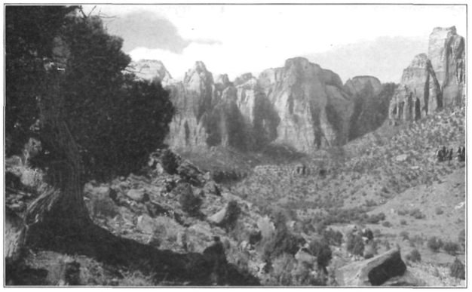
Figure 5.23 Towers of the Virgin

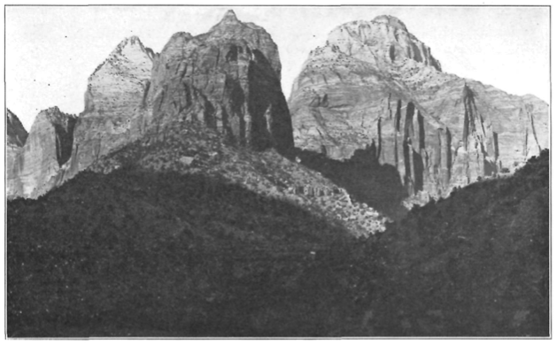
Figure 5.24 The Eastern Temple

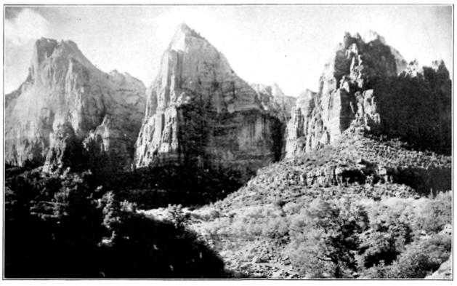

Figure 5.25 A Nook in Zion’s Western Wall
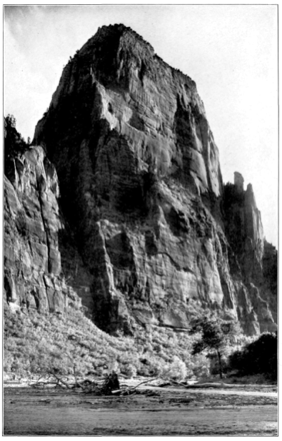

Figure 5.26 El Gobernador
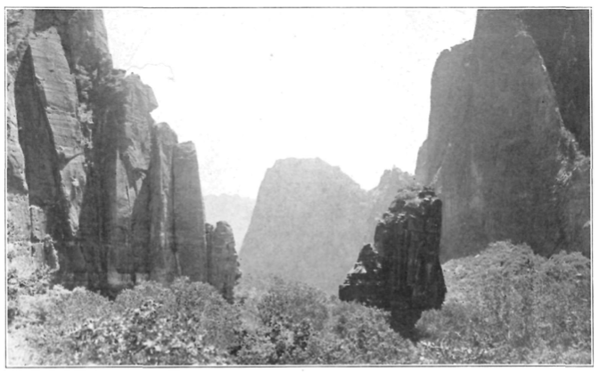

Figure 5.27 Great Temple of Sinawava

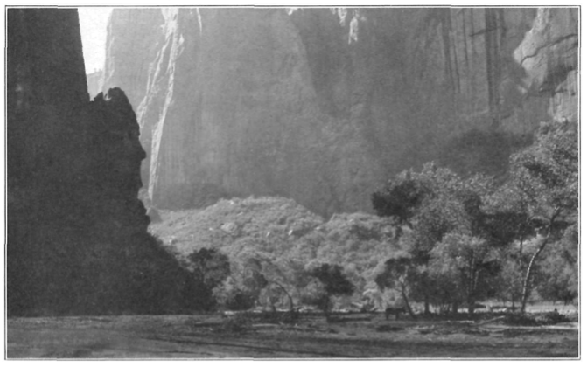
Figure 5.28 Section of Zion’s Brilliantly Colored Western Wall
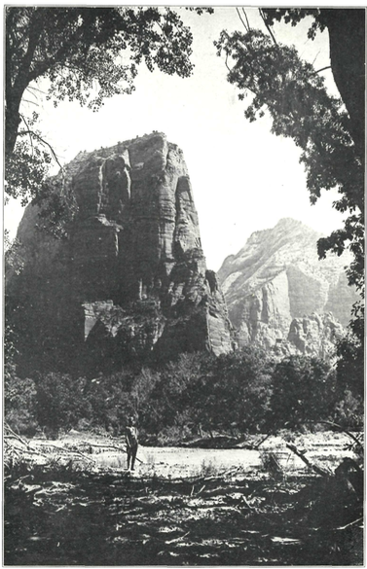
Figure 5.29 Angel’s Landing

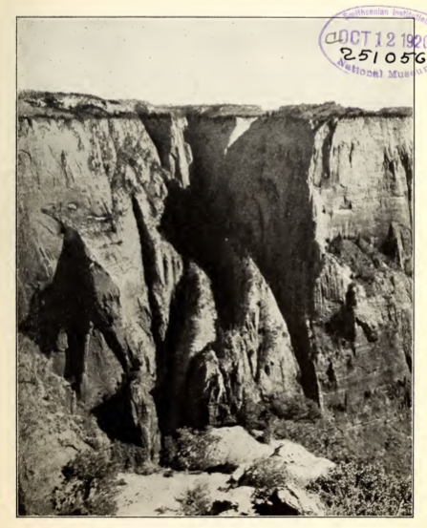

Figure 5.30

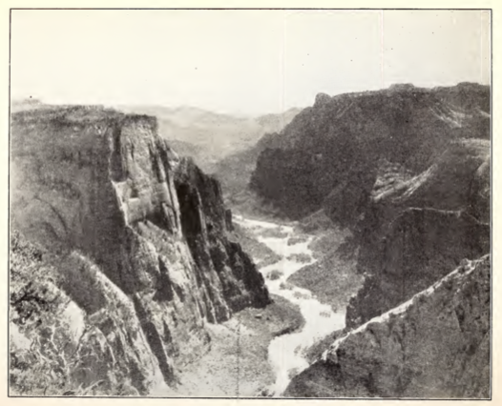

Figure 5.31 Zion Creek Canyon from the Rim Above

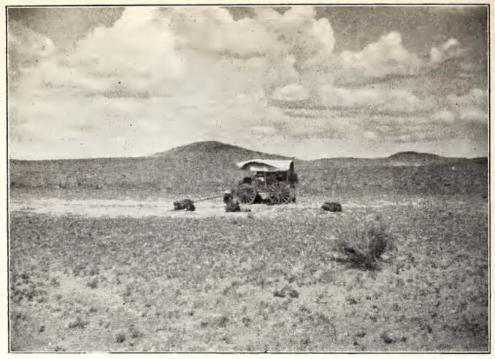

Figure 5.32 Noon Rest on the Antelope Plains-Saddles Lie on the Ground

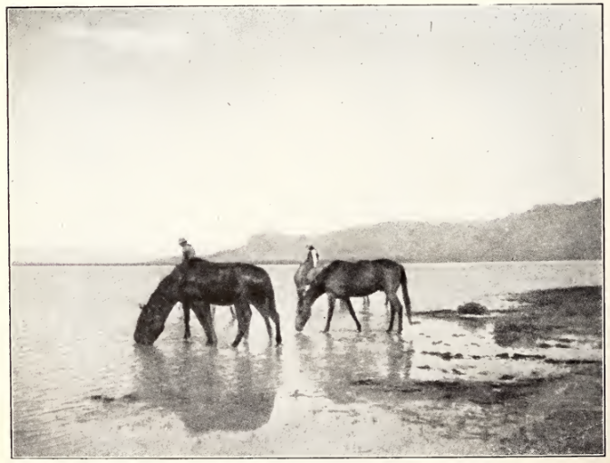

Figure 5.33 The Horses are Watering

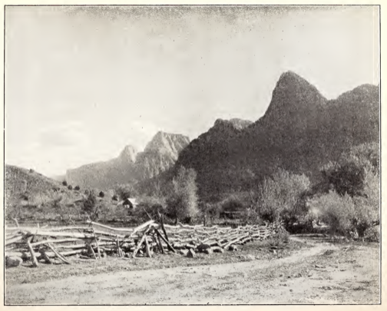

Figure 5.34 Road in Rio Virgin River Valley Leading to the Monument
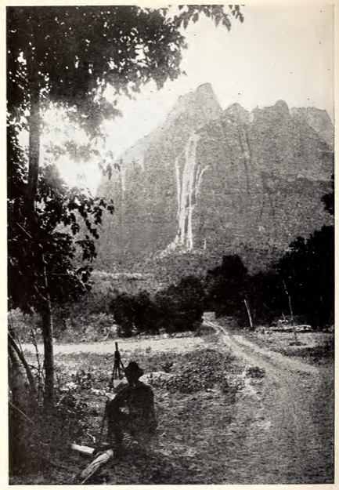

Figure 5.35 An Artist in Zion

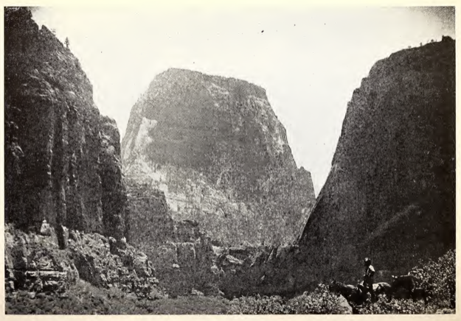

Figure 5.36 On Horseback in Zion

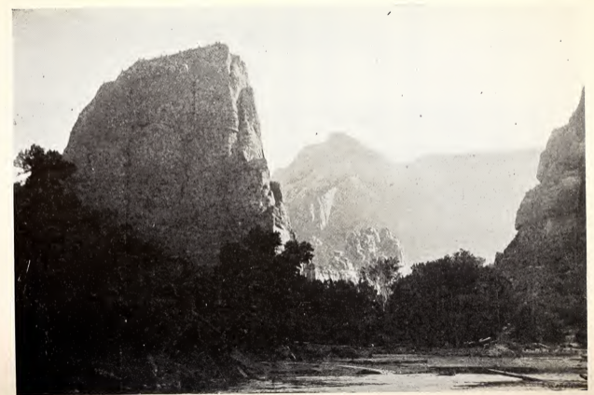

Figure 5.37 Zion Creek, the Sculptor of the Monument

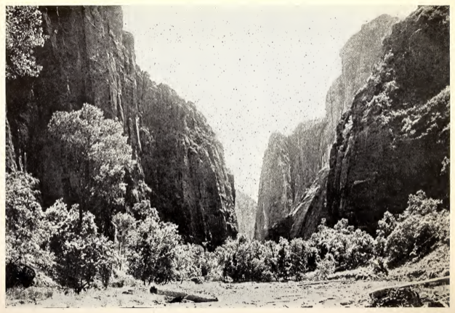

Figure 5.38 Where the Canyon Narrows

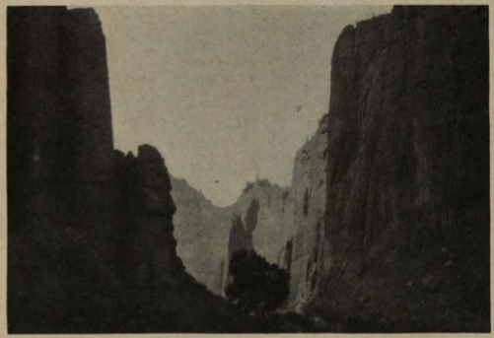

Figure 5.39

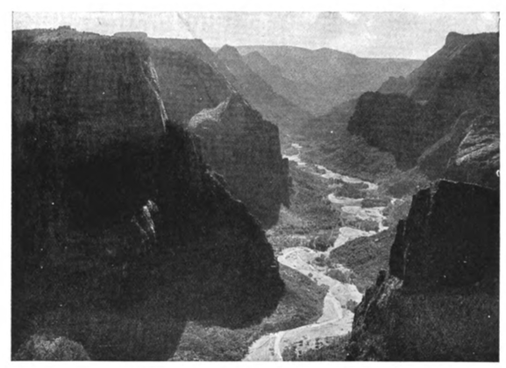

Figure 5.40

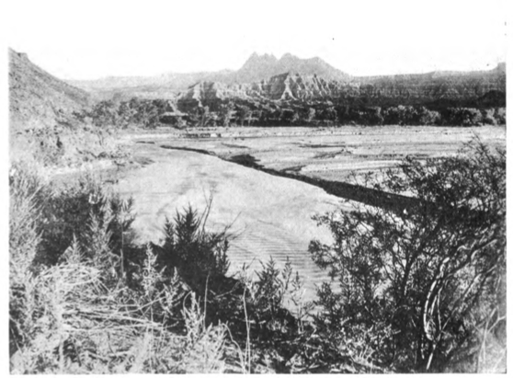

Figure 5.41 The Colorful Valley of the Virgin River

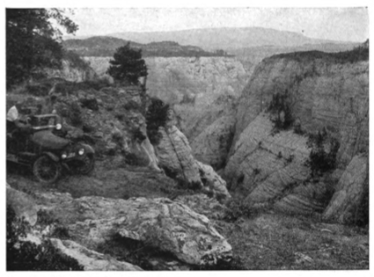

Figure 5.42 On the White Cliff Above the Canyon’s Rim

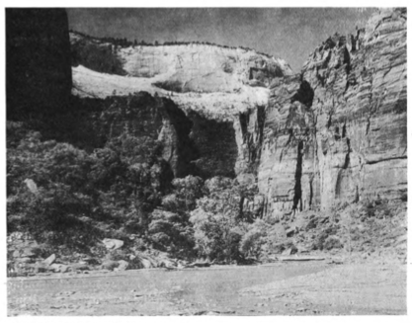

Figure 5.43 The Red and White Wall

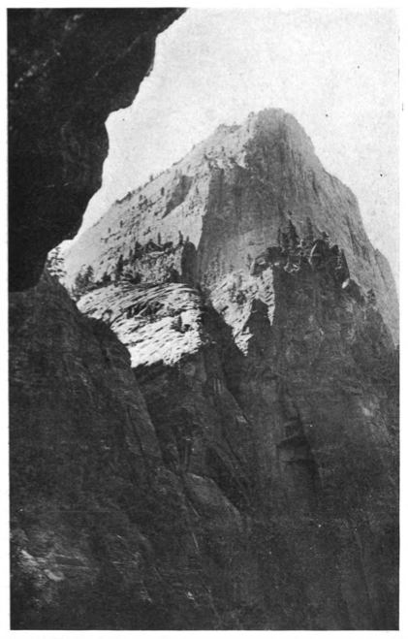

Figure 5.44 El Gobernador from the Raining Cave

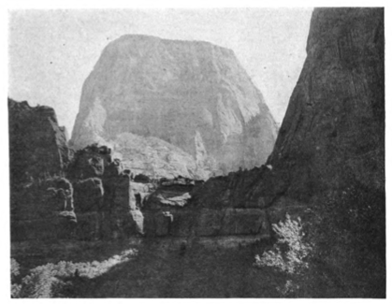

Figure 5.45 El Gobernador Giant of Zion

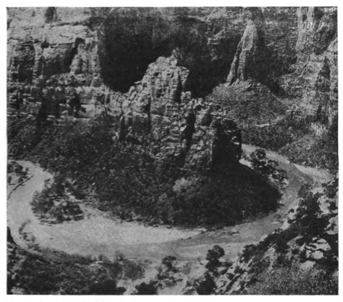
Figure 5.46 The Semi-Circle Misnamed Raspberry Bend

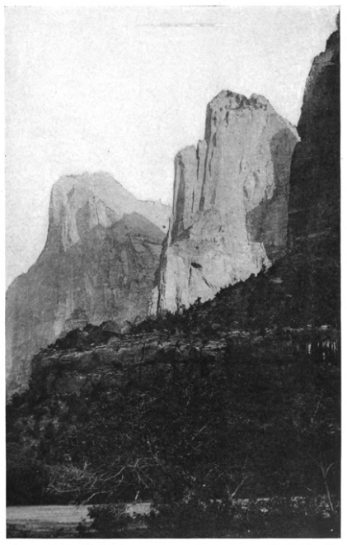

Figure 5.47 The Three Patriarchs

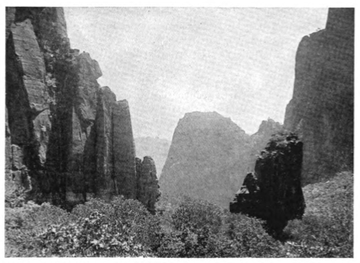

Figure 5.48 The Mystic Temple of Sinawava

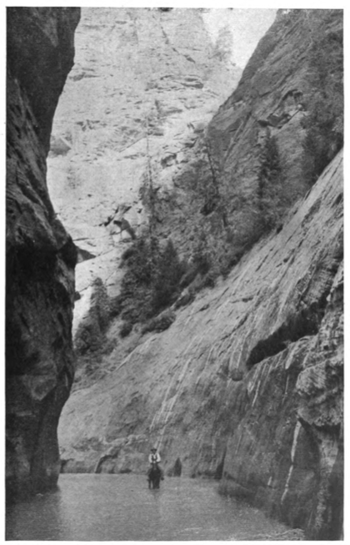

Figure 5.49 The Wet Trail

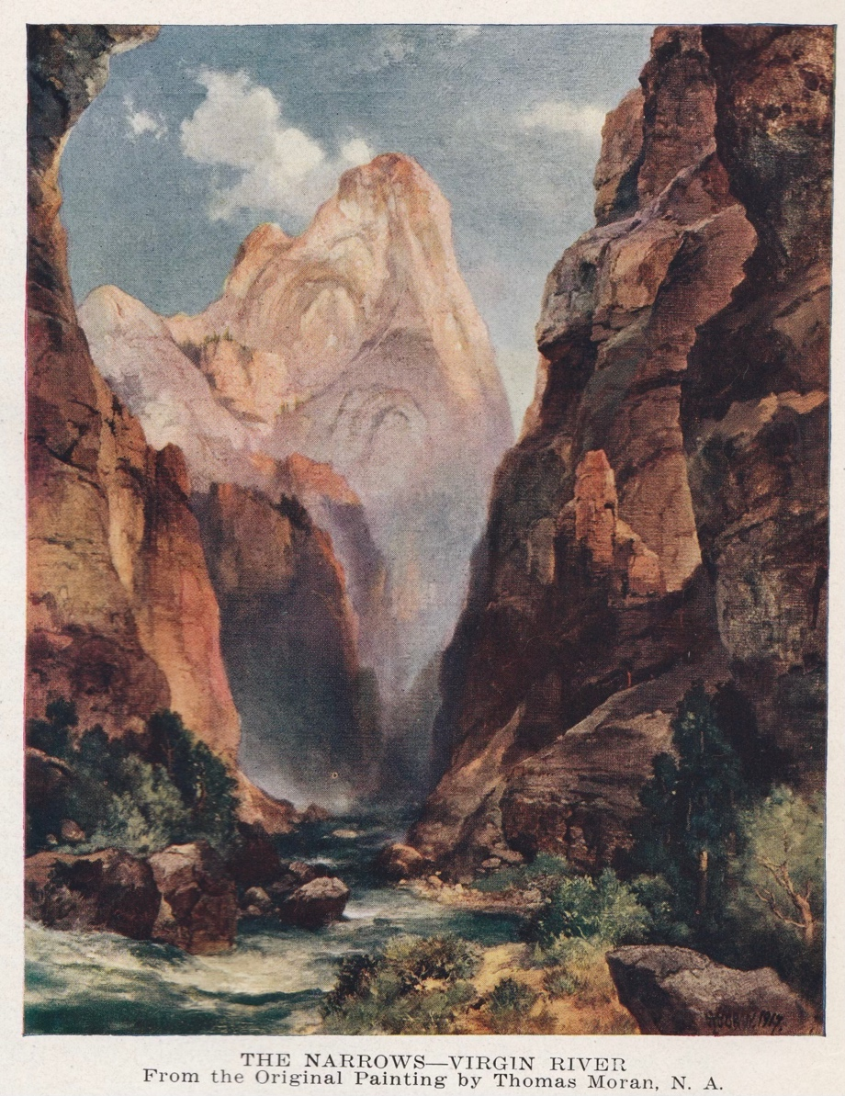

Figure 5.50 Thomas Moran, The Narrows-Virgin River

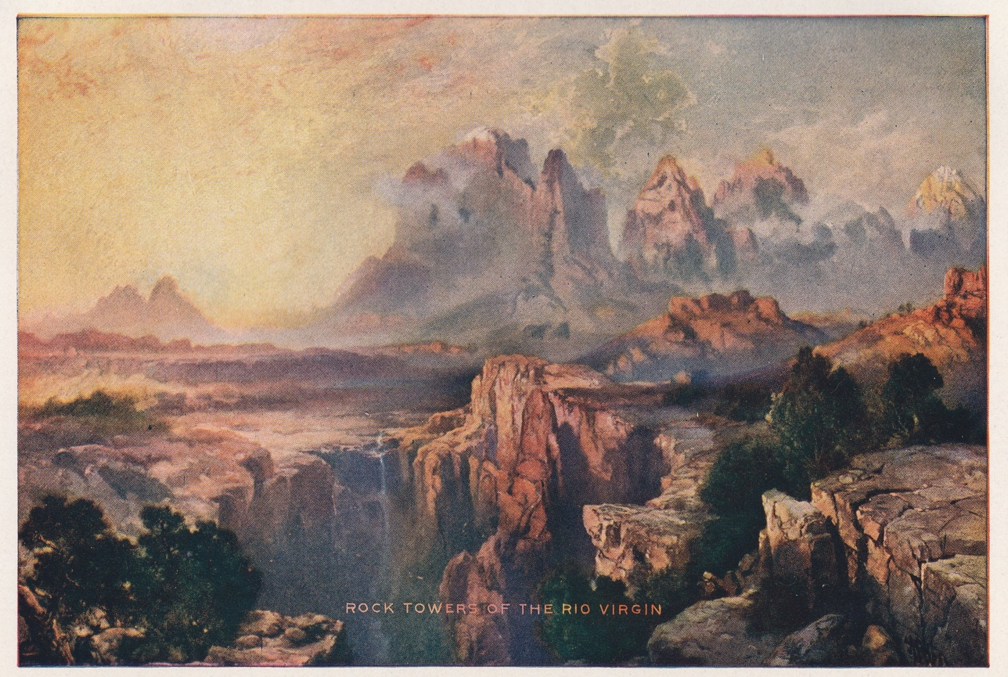

Figure 5.51 Thomas Moran Rock Towers of the Rio Virgin

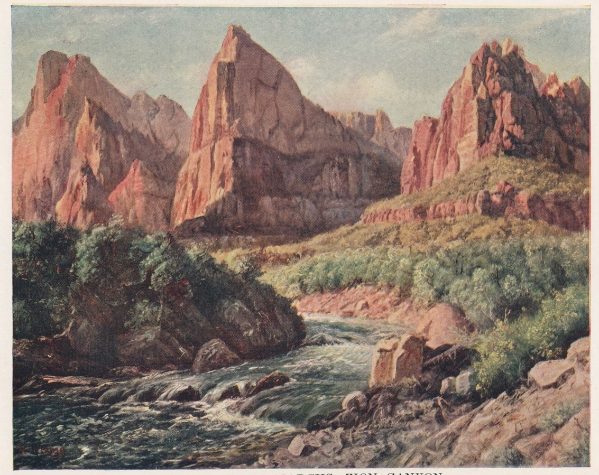

Figure 5.52 Henry Howard Bagg, The Three Patriarchs, Zion Canyon, 1925
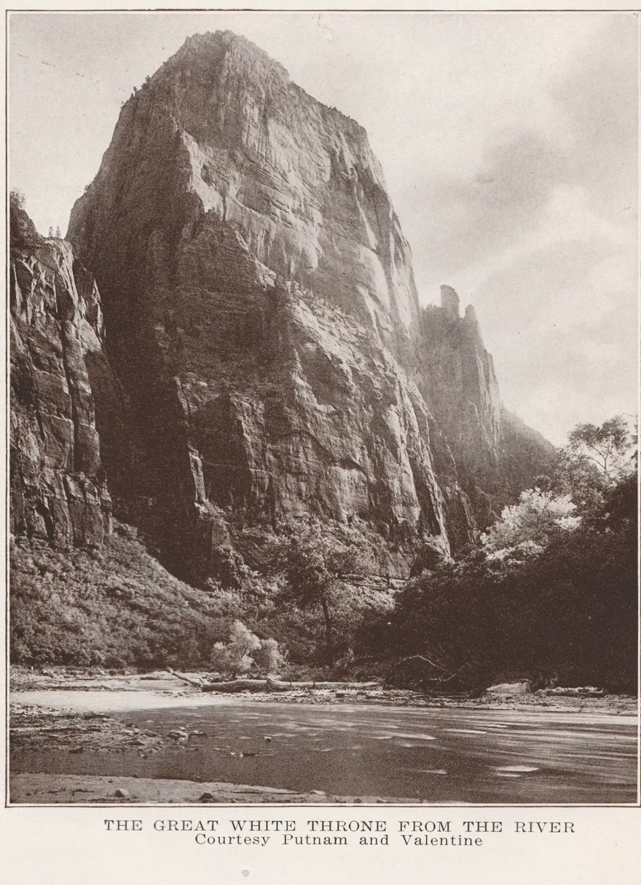

Figure 5.53 The Great White Throne from the River
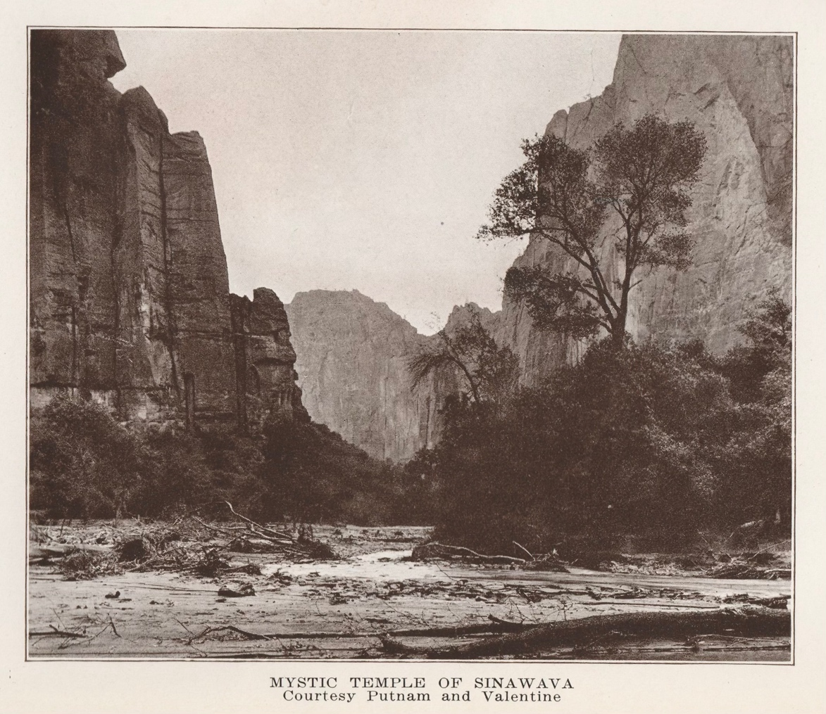

Figure 5.54 Mystic Temple of Sinawava

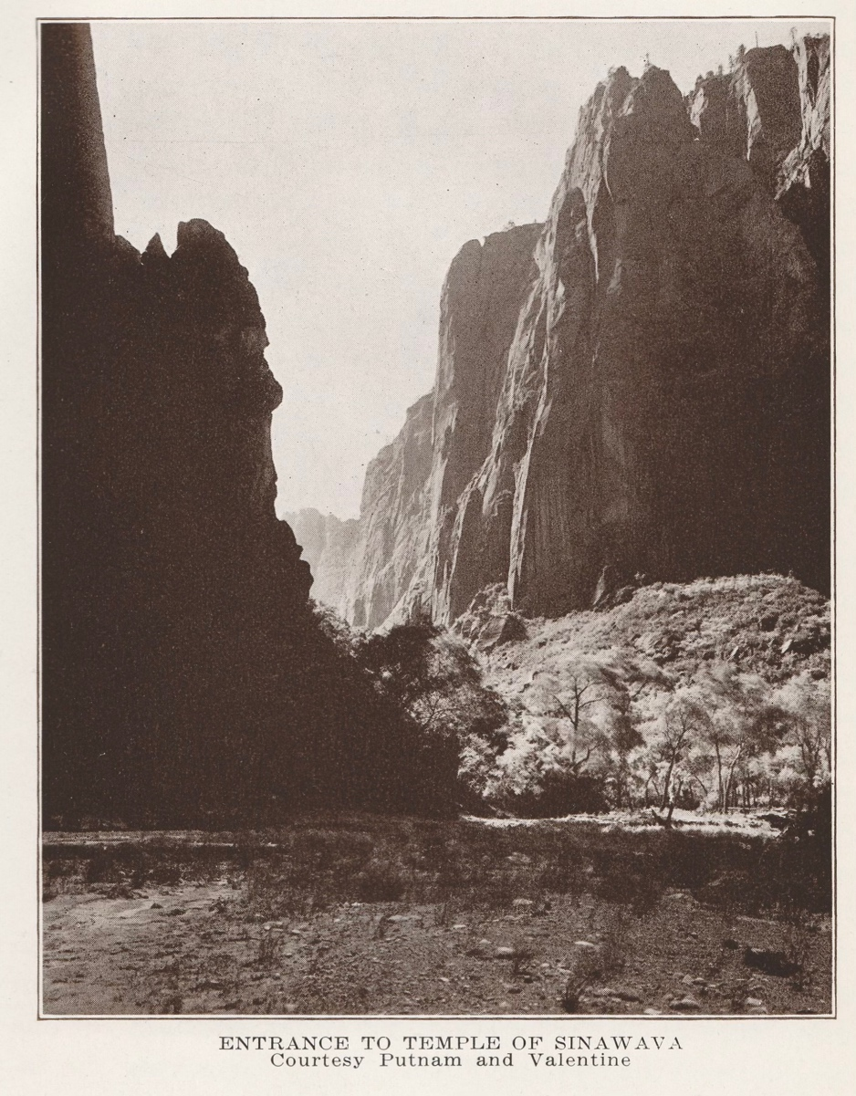

Figure 5.55, Entrance to Temple of Sinawava

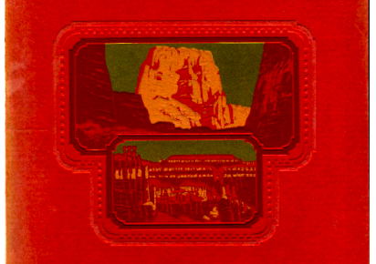

Figure 5.56 Zion National Park, Grand Canyon, Bryce Canyon, Cedar Breaks, and Kaibab National Forest, cover. Union Pacific Railroad, 1927.

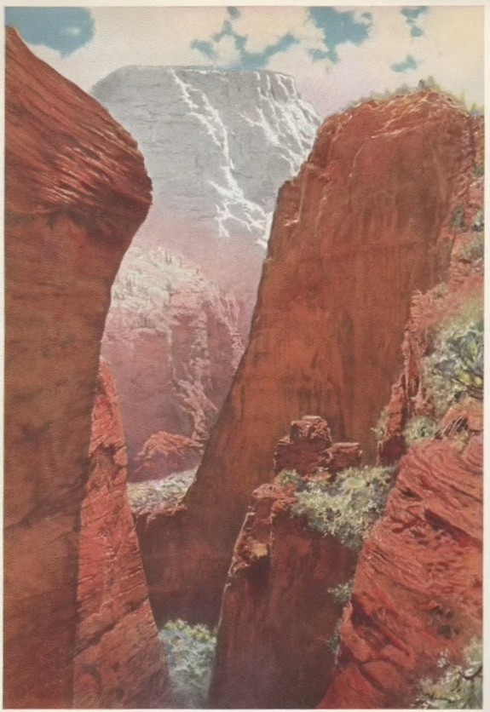

Figure 5.57 The Great White Throne from West Rim Trail, Zion National Park

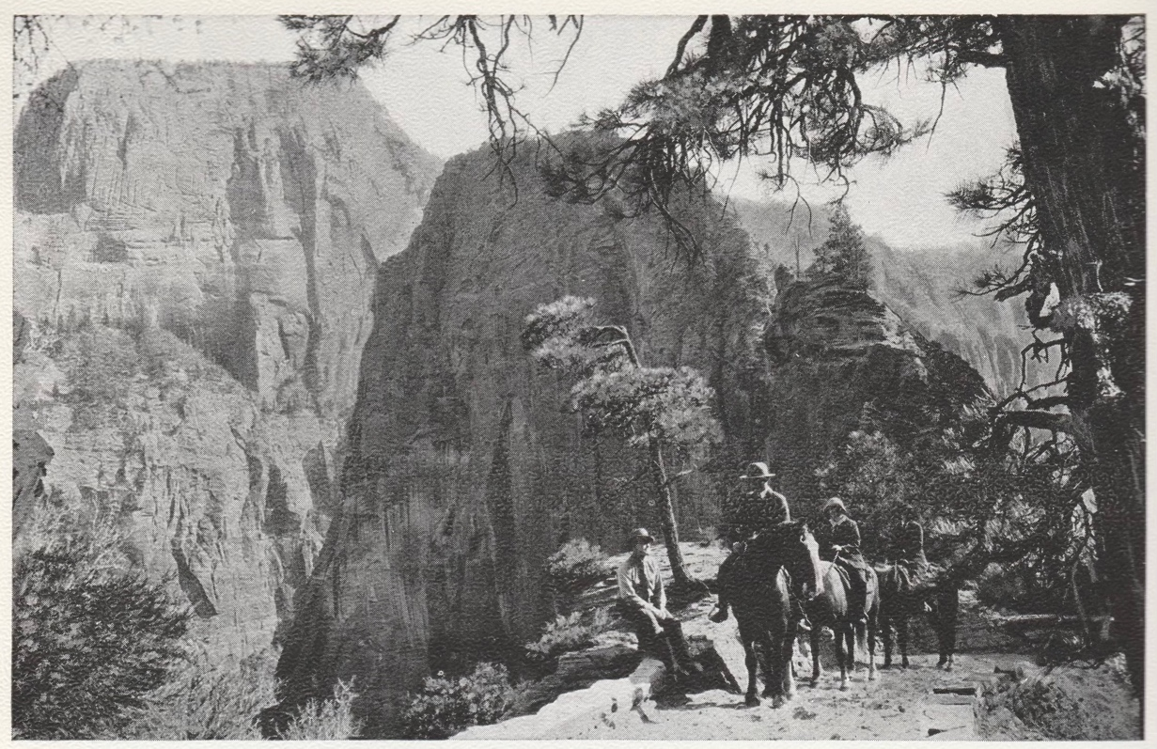

Figure 5.58 Great White Throne and the East Wall from Royal Trail, Zion Canyon

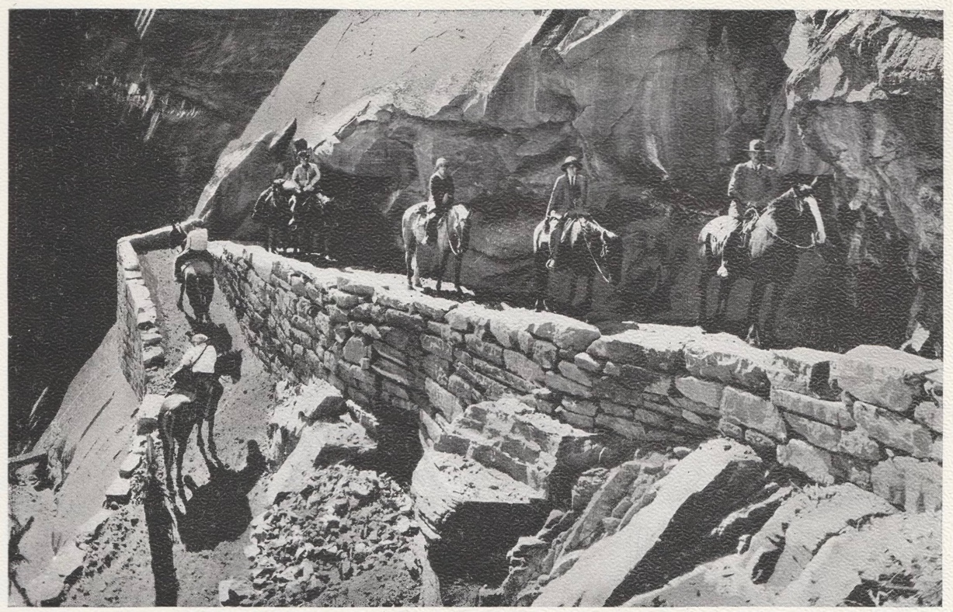

Figure 5.59 The Royal Trail to the West Rim of Zion Canyon

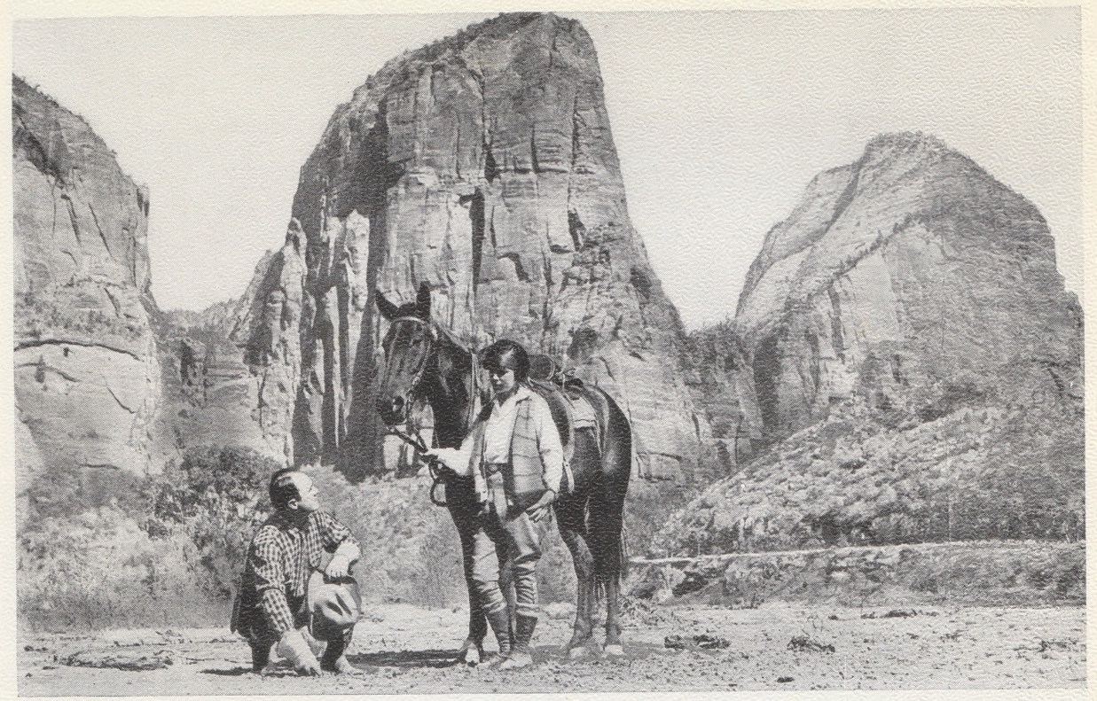

Figure 5.60 Angel’s Landing, Zion National Park

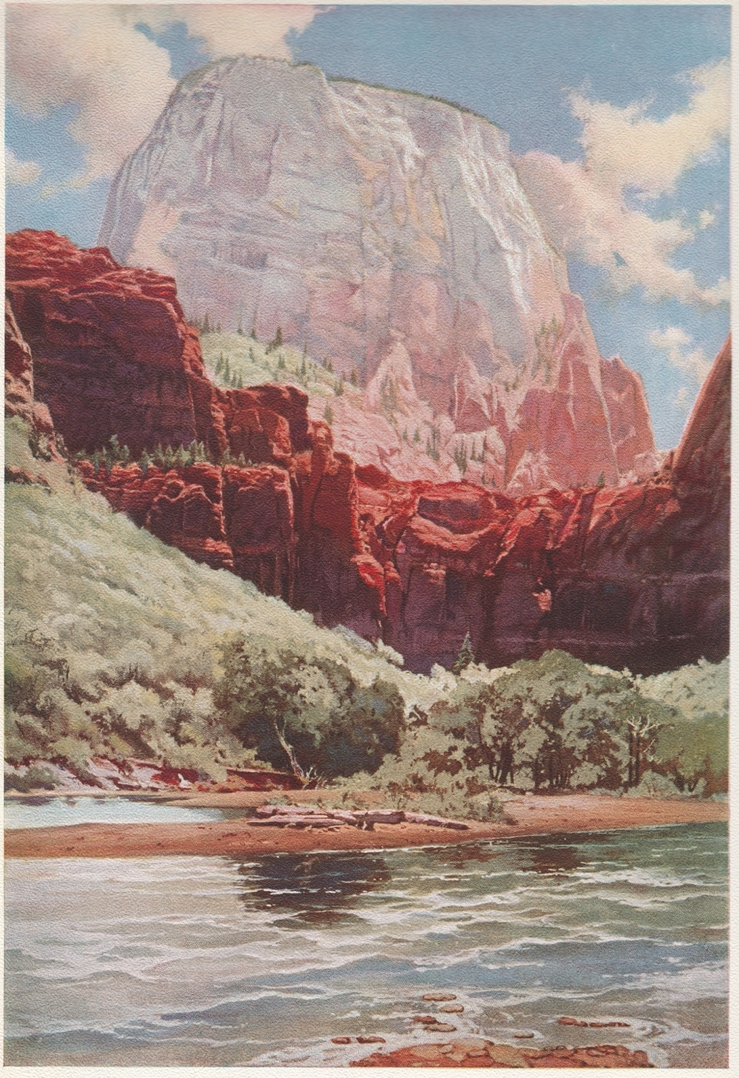

Figure 5.61 The Great White Throne, Zion Canyon

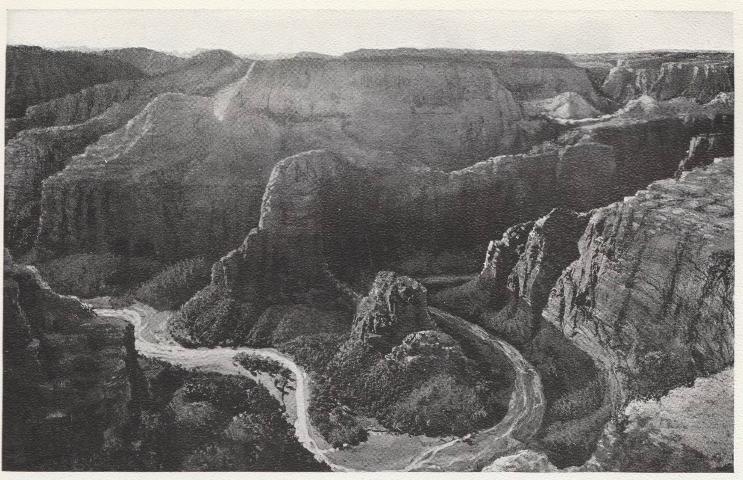
Figure 5.62 The Great Bend of the Mukuntuweap, Zion Canyon

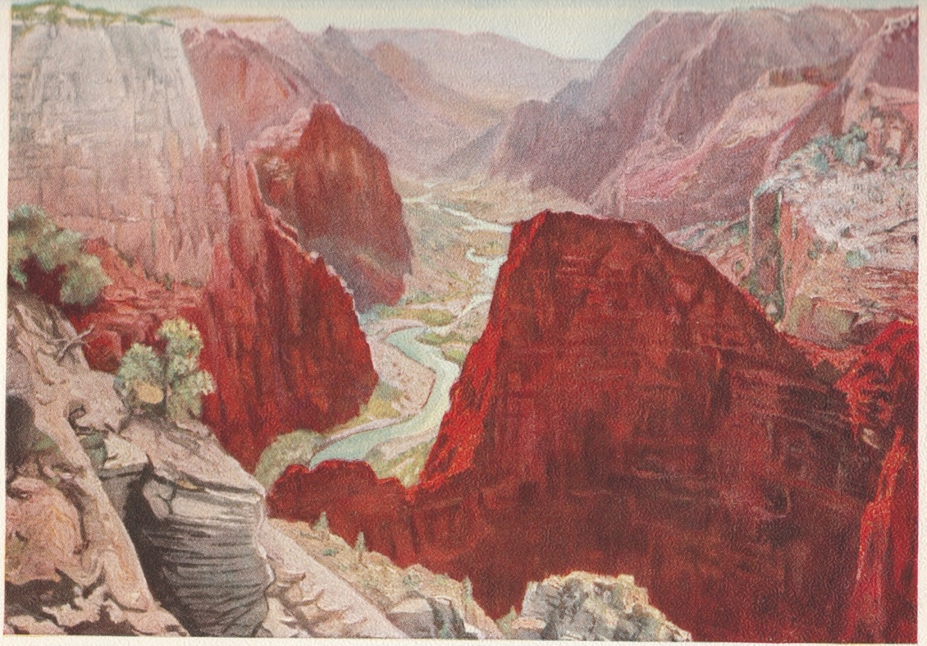
Figure 5.63 Panorama of Zion Canyon

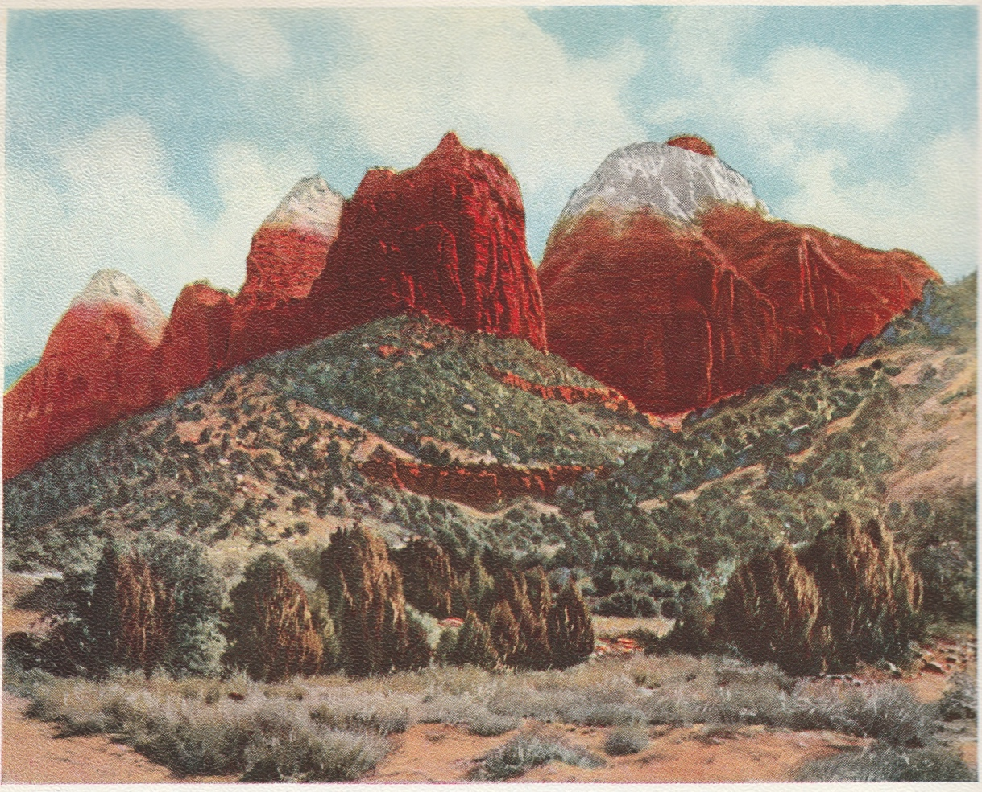

Figure 5.64 East Temple and the Twin Brothers, Zion National Park

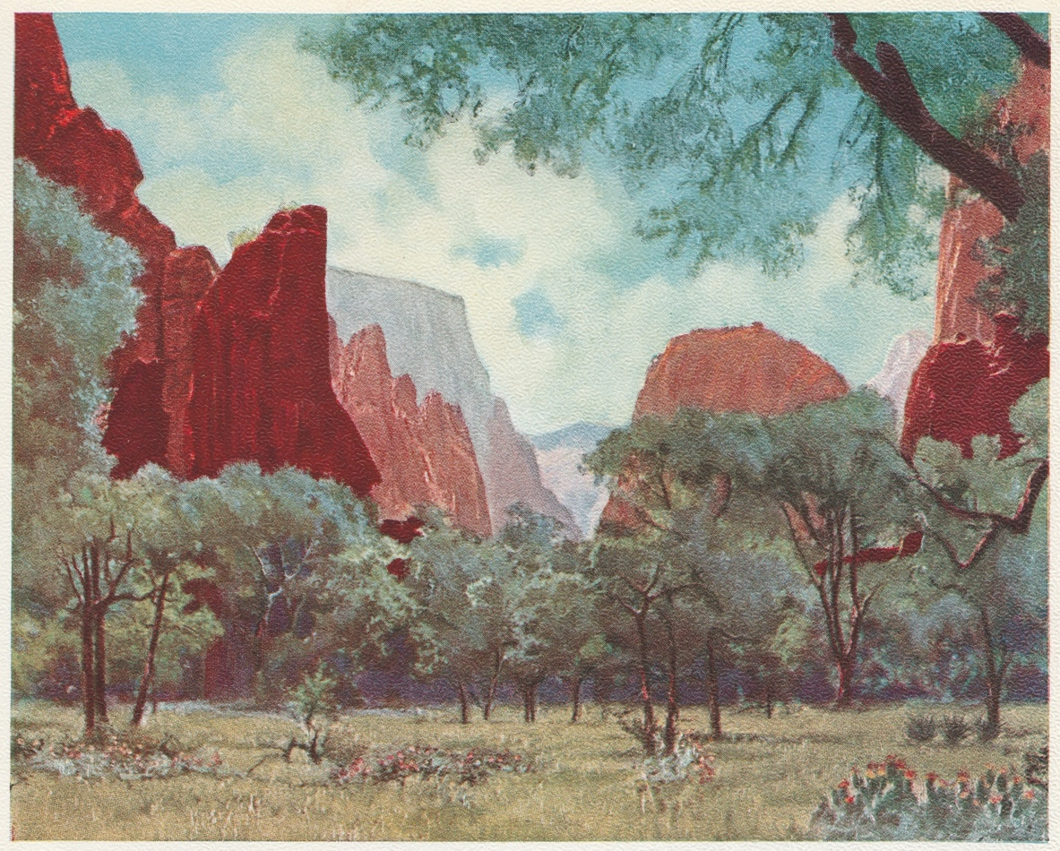

Figure 5.65 The Temple of Sinawava

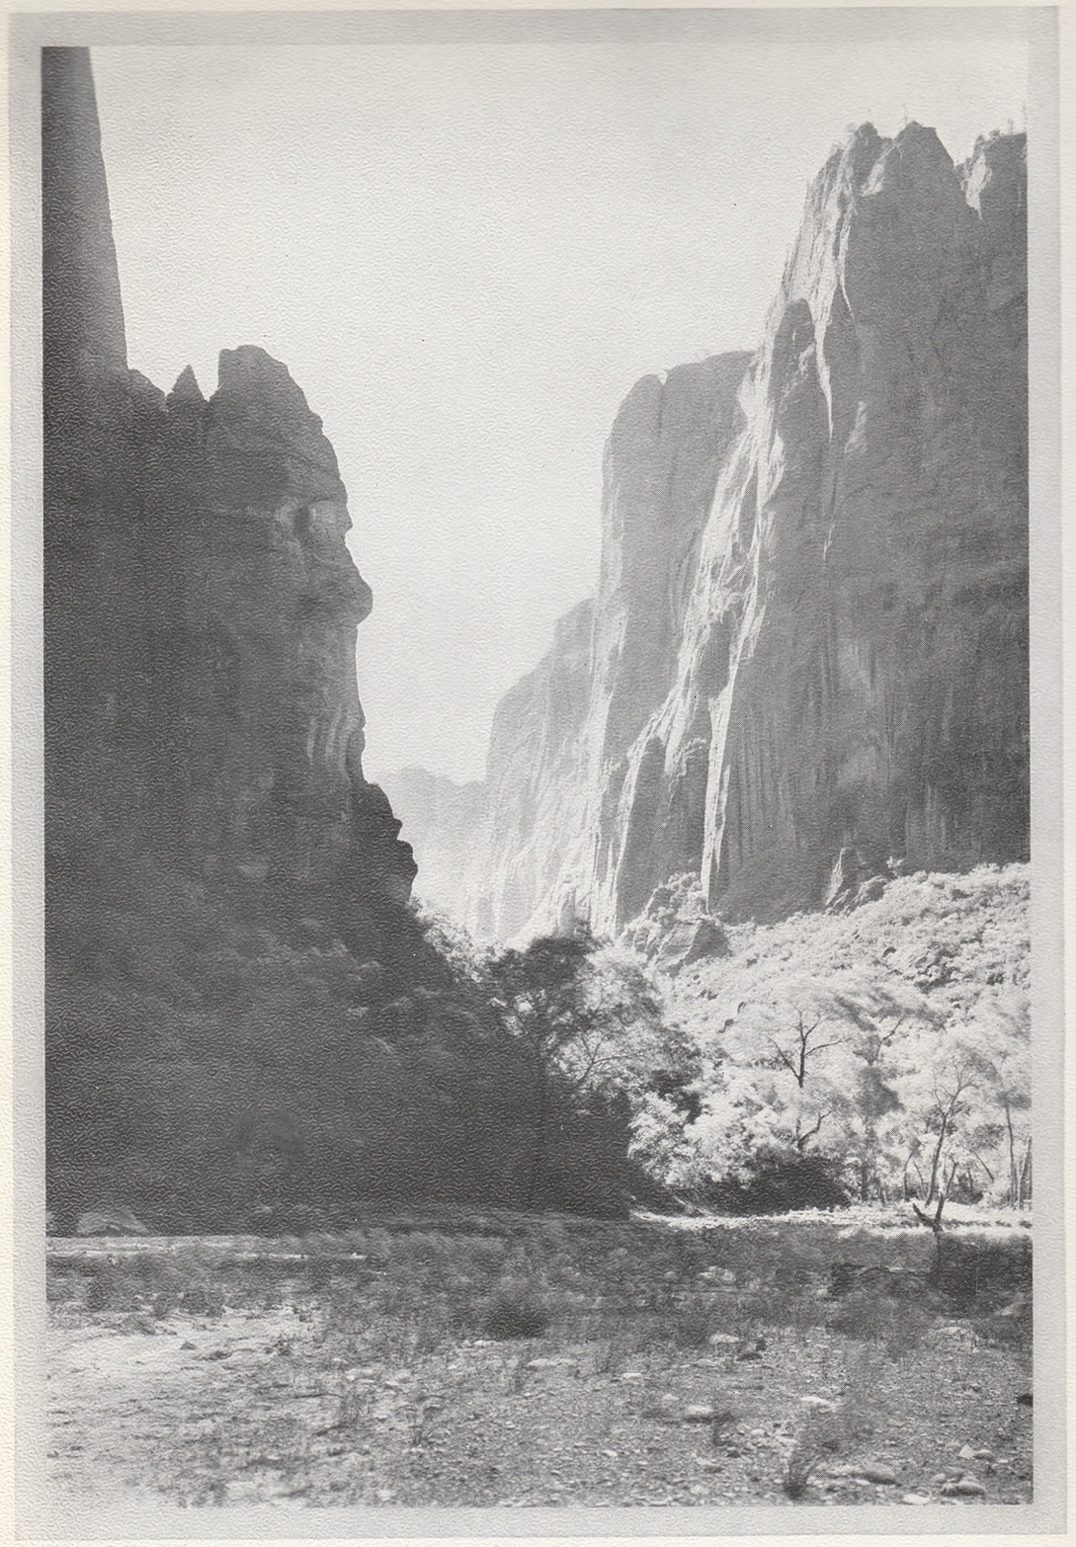

Figure 5.66 Looking Toward the Narrows, Zion National Park

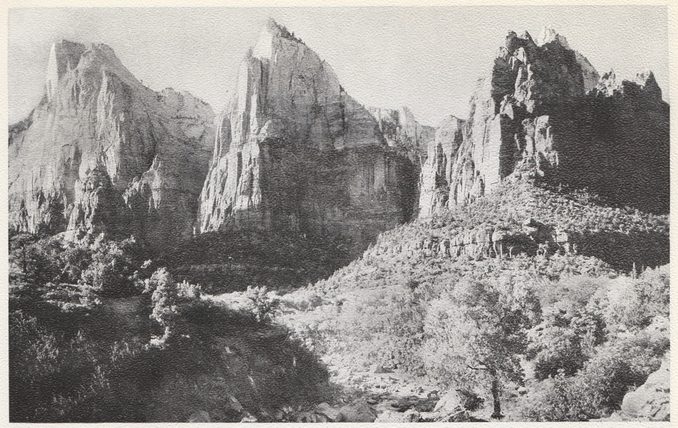

Figure 5.67 The Three Patriarchs, Zion Canyon

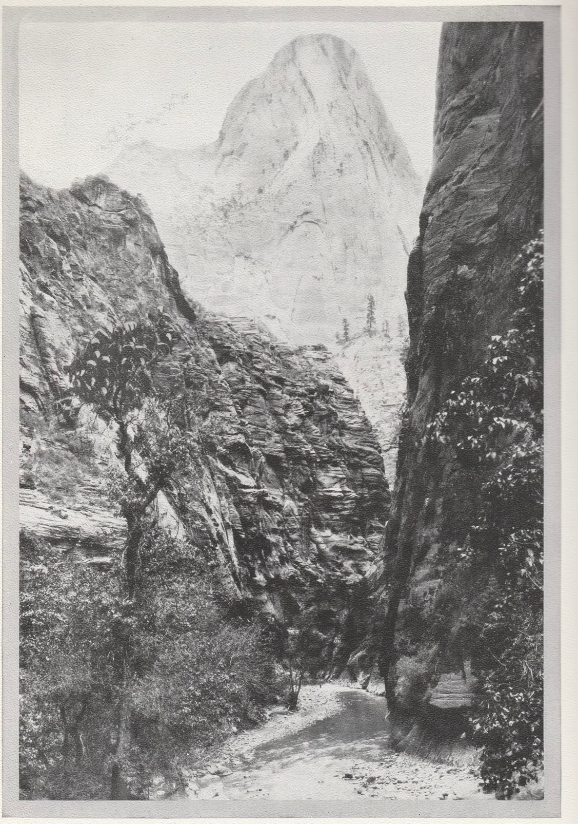

Figure 5.68 The Mountain of Mystery, Zion National Park

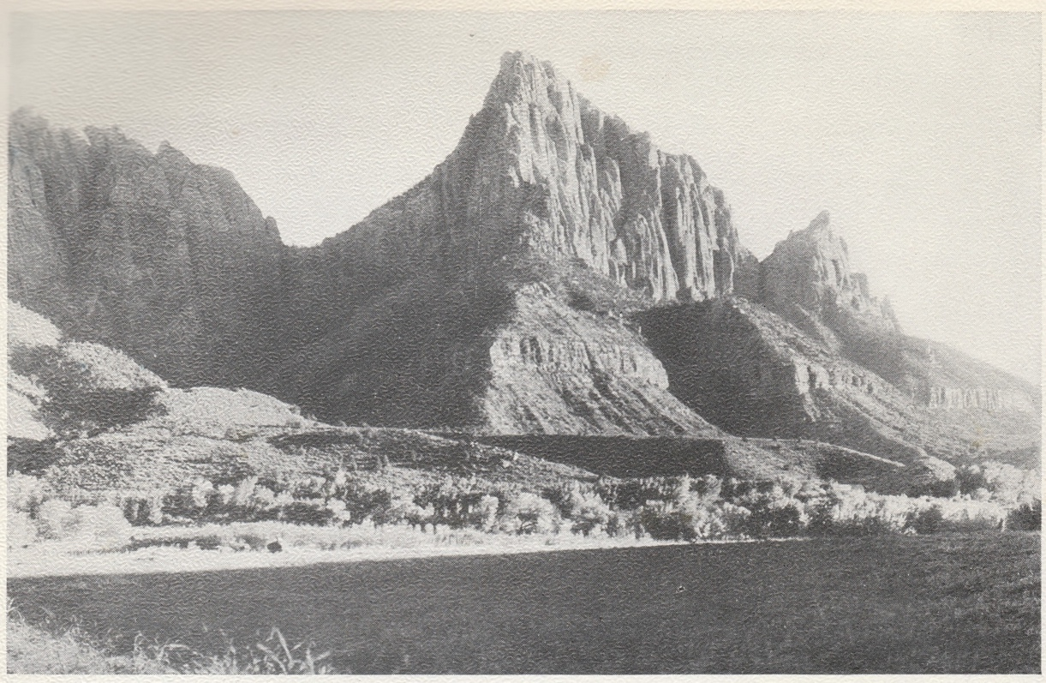

Figure 5.69 The Watchman, Zion National Park

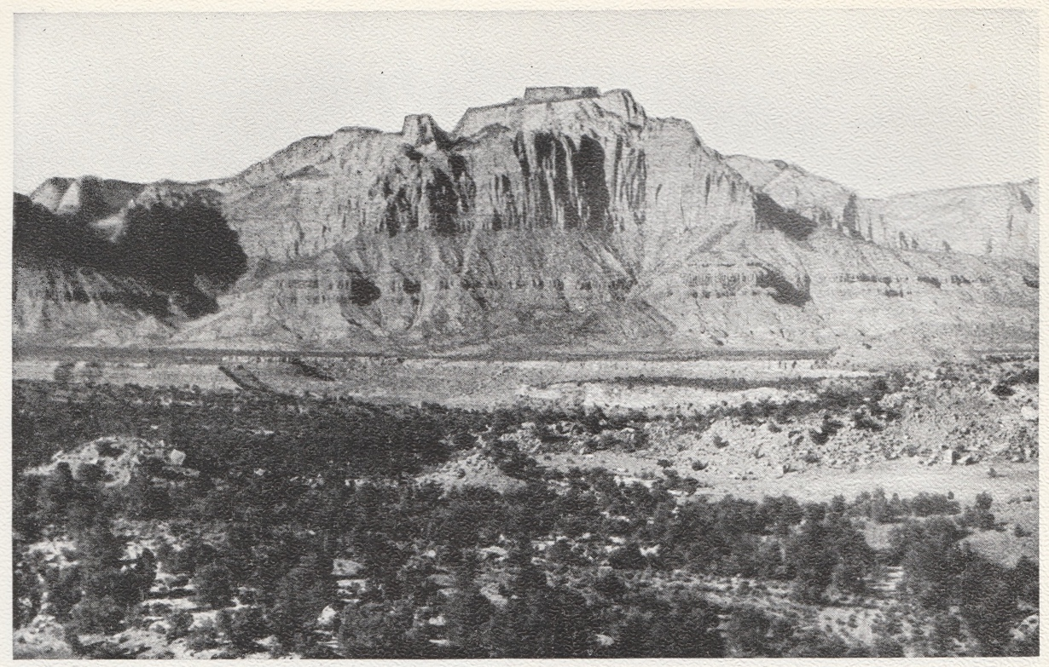

Figure 5.70 The West Temple of the Virgin, Zion National Park

United States Statutes at Large 39 (1916):535; Runte, p. 95-96, n. 54.
Snow, Leo A. “Contract #307 Survey Field Notes, 1908, July 12-1911, August 4,” Box 3, Folder 14, Leo Alva Snow Papers (WASH-003), Utah Tech University Special Collections and Archives, St. George, Utah.
Mukuntuweap National Monument, Utah—Proc. No. 877, July 31, 1909, 36 Stat. 2498.
Albright, Horace M. and Marian Albright Schenck, Creating the National Park Service: The Missing Years (Norman: University of Oklahoma Press, 1999) p. 244; Albright, Horace M., as told to Robert Cahn, The Birth of the National Park Service: The Founding Years, 1913-1933 (Salt Lake City: Howe Bros., 1985), p. 83-85; Rothman, Hal, Preserving Different Pasts: The American National Monuments (Urbana and Chicago: University of Illinois Press), p. 99.
Sully’s Hill was set aside by Congress but as a memorial park rather than a national park, and it now known as White Horse Hill National Game Preserve and is no longer under the purview of the National Park Service.
Rainey, Sue, Creating Picturesque America: Monument to the Natural and Cultural Landscape (Nashville: Vanderbilt University Press, 1994) p. 19-29.
Miller, Angela, “Everywhere and Nowhere: The Making of the National Landscape,” American Literary History (Summer, 1992), Vol. 4, No. 2, p. 208-209.
Cosgrove, Denis E., Social Formation and Symbolic Landscape (Madison: The University of Wisconsin Press, 1984), p. 184-188; Rainey p. 29.
Runte, Alfred, National Parks: The American Experience (Lanham, Maryland: Taylor Trade Publishing, 2010), p. 87
Albright, Founding Years, p. 18; Runte p. 89-94.
Schaffer, Marguerite, See America First: Tourism and National Identity, 1880-1940 (New Haven: Yale University Press, 1997), p. 7-39.
Runte, p. 11.
Grusin, Richard, Culture, Technology, and the Creation of America’s National Parks (Cambridge: Cambridge University Press, 2004), p. 2-4.
Richard West Sellars, Preserving Nature in the National Parks: A History (Yale University Press, 1997), p. 3-4.
See Richards, Bradley W., “The Other Promontory Photographer,” Utah Historical Quarterly, Vol. 60, No, 2 (1992), p.
“Zion Canyon to be Boosted by U.S. Officials: National Park Director Tours Utah Pleasure Ground” The Salt Lake Herald-Republican, September 9, 1917, p. 6.
See Malcolm Andrews, The Search for the Picturesque: Landscape Aesthetics and Tourism in Britain, 1760-1800, (Stanford: Stanford University Press, 1989), p. 25-29.
Rainey, p. 29.
Mitchell, W.J.T., Landscape and Power (Chicago: University of Chicago Press, 2002), p. 10.
Grusin, p. 3-4.
Clarence Dutton, Tertiary History of the Grand Canyon District (Tucson: University of Arizona Press, 2001), p. 14.
Kiver, E.P. and Harris, D.V., Geology of the U.S. Parklands (New York: John Wiley and Sons, 1999), p. 455.
Geology term that indicates the limit below which a stream cannot erode.
Kiver and Harris, p. 461.
Ibid. p. 455-457.
“Arrow quiver” described the canyon’s form: one way in and one way out. Geological survey leader John Wesley Powell understood the word Mukuntuweap (the more accurate spelling being “Mukunt-o-weap”) to mean “straight canyon” and named it as such. This name and meaning has endured throughout several histories since the 1870s. Wm. R. Palmer, “Indian Names in Utah Geography,” Utah Historical Quarterly, vol. 1, no. 1 (January, 1928), p. 12-13; Kiver and Harris, p. 456.
Woodbury, Angus M. A History of Southern Utah and its National Parks (Springdale, Utah: Zion Natural History Association, 1997), p. 112-113.
; Kessell, John L., Miera y Pachenco: A Renaissance Spaniard in Eighteenth-Century New Mexico (Norman: University of Oklahoma Press, 2013), p. 93-112;
William H. Goetzmann, Army Exploration in the American West (Austin, TX: Texas Historical Association, 1991), p. 47; Gregory, Herbert E., “Scientific Explorations in Southern Utah,” American Journal of Science, Vol. 243 (Oct. 1945), p. 530.
Already working in Montana, Wyoming, Idaho, and northern Utah.
Which he named Adams River, after then President of the United States, John Quincy Adams, despite being in Mexico territory. Cleland, Robert G., “The First Expedition of Jedediah S. Smith to California,” Annual Publication of the Historical Society of Southern California, Vol. 9, No. 3 (1914), p. 201.
Smith followed what would become the Old Spanish Trail, connecting Los Angeles to Santa Fe via several trade routes, one of which followed the Virgin River through southern Utah. His exact route is disputed by historians. See Woodbury, A. M., “The Route of Jedediah S. Smith in 1826 from the Great Salt Lake to the Colorado River,” Utah Historical Quarterly, Vol. 4 No. 2 (Jan. 1931), pp. 34-46.
Weiss, Stephen Craig, “The John C. Fremont 1842, 1843-’44 Report and Map,” Journal of Government Information, Vol. 26, No. 3 (1999), p. 298; Goetzmann, p. 6-12.
Goetzmann, p. 68.
Congress printed thousands of copies of the report and map to be distributed for free, and trade publishers soon made the report available to the public. Dellenbaugh, Breaking the Wilderness, p. 303, as cited in Weiss.
Weiss, p. 303-304.
Egan, Ferol, Fremont Explorer of a Restless Nation (Chicago: University of Nevada Press, 1985), p. 493; MacNamara, Charles, “The First Official Photographer,” The Scientific Monthly, vol. 42, no. 1 (Jan. 1936), p. 68.
A fire destroyed all his daguerreotypes made on the expedition after the party was forced to abandon their equipment and baggage due to snow. Fremont returned to San Francisco while Carvalho remained in Utah for several months. Egan, p. 503, MacNamara, 70.
Carvalho, Solomon Nunes, Incidents of Travel and Adventure in the Far west with Col. Fremont’s Last Expedition Across the Rocky Mountains: Including Three Month’s Residence in Utah and a Perilous Trip Across the Great American Desert to the Pacific (New York: Derby & Jackson, 1860), p. 220
Alexander Baugh, “John C. Fremont’s 1843-1844 Western Expedition and its Influence on Mormon Settlement in Utah,” Far Away in the West, Scott C. Esplin, et al. Ed. (Provo: Brigham Young University, 2015), p. 36.
Baugh, p. 37-40.
Andrew Karl Larson, I was Called to Dixie: The Virgin River Basin: Unique Experiences in Mormon Pioneering (St George, UT: Deseret News Press, 1961), 17-18.
Woodbury, 133-135;
Pyne, Stephen J., Grove Karl Gilbert: A Great Engine of Research (Iowa City: University of Iowa Press, 2007), p. 48; Guth, Peter L. “Geology and the Wheeler Survey,” Earth Sciences History, vol. 2 no. 1 (1983), p. 58.
Guth, p. 58-59; Pyne, p. 39.
Hachures maps indicate slope and orientation with short strokes in varying degrees of density. Guth p. 60
Wheeler, George Montague, Progress Report upon Geographical and Geological Explorations and Surveys West of the One Hundredth Meridian in 1872, Under the Direction of Brig. Gen. AA Humphreys, Chief of Engineers, United States Army (U.S. Government Printing Office, 1874), p. 35.
Marguerite Shaffer, See America First: Tourism and National Identity, 1880-1940 (Washington, D.C.: Smithsonian Institution, 2001), p. 27 note 60-61.
The preferred name.
The origin of the Virgin River’s name is unknown. See Rufus Wood Leigh, “Naming of the Green, Sevier, and Virgin Rivers,” Utah Historical Quarterly, Vol. 29, No. 2 (1961), p. 145-147.
According to this account, Native Americans are the descendants of this lost Israelite tribe.
Winn, Kenneth H. Exiles in a Land of Liberty: Mormons in America, 1830-1846 (Chapel Hill and London: University of North Carolina Press, 1989), p. 44.
Hill, Marvin S., Quest for Refuge: The Mormon Flight from American Pluralism (Salt Lake City: Signature Books, 1989), p. 31.
Winn, p. 44.
Arrington, Leonard J. and Davis Bitton, The Mormon Experience: A History of the Latter-day Saints (Urbana and Chicago: University of Illinois Press, 1992), p. 129.
Larson, Gustive O., The “Americanization” of Utah for Statehood (San Marino, Calif: Huntington Library, 1971), p. 1; Winn, 40-45; Arrington & Bitton 20-42, 55.
Arrington and Bitton, p. 50-52; Hill, p. 31-56.
Arrington and Bitton, p. 56-57.
Arrington and Bitton, p. 58 note 60.
As converts flooded to Nauvoo, the population rose to eleven thousand, rivaling Chicago in size. Winn, p. 160.
Arrington and Bitton, p. 68-670; Winn, p. 160-166; Hill, p. 51; Larson, Americanization, p. 37.
Winn, p. 218; Arrington and Bitton, p. 94.
Winn, p. 236.
Arrington and Bitton 95; Baugh, p. 36-44.
endorheic watershed: A self-contained drainage that fails to reach outside lakes, rivers, and oceans.
Arrington and Bitton, p. 110.
Winn, p. 238.
Arrington and Bitton, p. 122 note 3.
Baugh, p. 44-45.
Arrington and Bitton, 96.
Travel expenses for the LDS emigrants were alleviated through the Perpetual Emigration Fund. Those LDS who took advantage of the fund were expected to pay back into it to further assist future emigrants, most of whom utilized the Mormon Trail until later in the nineteenth century when the completion of the transcontinental railroad made the journey more efficient. In all, an estimated 100,000 LDS used the PEF by 1887. Arrington and Bitton, p. 130-1132.
Along with what is now California, Nevada, New Mexico, Texas, and parts of Wyoming, Colorado, Arizona, and Oklahoma. Jesse S. Reeves, “The Treaty of Guadalupe-Hidalgo,” The American Historical Review, Vol. 10, No. 2 (Jan 1905), p. 322-323.
Arrington and Bitton, p. 162-163.
The church officially repealed the belief in plural marriage in its 1890 Manifesto. Federal intervention and younger, more progressive, LDS generations made the practice untenable for the future of the church and the Territorial government. For a more comprehensive study of U.S. Government interventions in Utah Territory leading up to statehood, see Larson, The Americanization of Utah.
Givens, Terryl L., People of Paradox: A History of Mormon Culture (New York: Oxford University Press, 2007), p. 182.
Olpin, Robert S. et al., Artists of Utah (Layton, UT: Gibbs Smith, 1999), p. 186; Givens, p. 182-3. Because of the insular nature of the LDS community, the limited commerce with the rest of the nation meant there was very little currency in circulation. As such, the LDS relied heavily on a sophisticated bartering system that included credit.
Richards, Bradley W. The Savage View: Charles Savage, Pioneer Mormon Photographer (Nevada City, Calif.: Carl Mautz Publishing, 1995), p. 6.
Richards, p. 12-14.
Ibid., p. 17.
Taft, Robert. Photography and the American Scene: A Social History, 1838-1889 (New York: Dover Publications, Inc., 1964), p. 173-180 note 216.
Savage, “A Photographic Tour,” The Philadelphia Photographer 4:45 (Sept. 1867) p. 313.
Richards, p. 18-19.
Tintypes.
Nelson B. Wadsworth, Set in Stone, Fixed in Glass: The Mormons, the West, and Their Photographers (Salt Lake City: Signature Books, 1996), p. 77 note 13.
To the Cotton Mission and help found the city of St. George.
Olpin, p. 185-186.
Givens, p. 183-184.
The wide circulation of Savage’s photographs proved to be the redemption of his legacy, for a studio fire in 1883 destroyed all of his glass plate negatives. Another fire in the early 1900s again destroyed his negatives from the previous 25 years.
Savage, A Photographic Tour, p. 289.
Martha Sandweiss, Print the Legend: Photography and the American West (New Haven: Yale University Press, 2002), p. 158.
Richards, p. 58.
G. G. Willumson, “Alfred Hart: Photographer of the Central Pacific Railroad,” History of Photography vol. 12 no. 1 (1988), pp. 61-75.
MSS 1424 Diary of Charles Savage, 1870, Box 3 folder 30; Richards, p. 66.
Salt Lake City stands at an elevation of approximately 4200 feet, while St. George, about 40 miles west of Zion Canyon, lays at only 2850 feet. Woodbury, p. 148.
Ibid. 149.
Douglas D. Alder and Karl F. Brooks, The History of Washington County: from Isolation to Destination (Utah State Historical Society Washington County Commission, 1996), p. 9, 145.
Cultivatable land within the canyon included a strip about one mile wide and four or five miles long at the mouth of the canyon and a narrow stretch upriver along the banks from the present-day Court of the Patriarchs to the Temple of Sinawava at the mouth of the Narrows. Separating these two areas was a steep and rocky path passable only by horseback until the winter of 1864/1865 with the completion of the wagon road. This road remained as the only way to access upper Zion Canyon until the National Park Service made it fully accessible to the public with a modern road in the twentieth century. Woodbury, p. 157.
Behunin’s established his farm near the present-day Zion lodge. The Behunin family lived on the Zion Canyon floor until 1872, when he sold his operation to a neighbor and moved away. William Heap and family established a farm on the opposite side of the river near the head of the present-day Emerald Pools Trail, and for whom this part of the canyon is still named for. Just north of the Behunins the John Rolf family established their farm. Woodbury, p. 156-161.
Charles Savage, “A Trip South with President Young in 1870,” Improvement Era, vol. 3 no. 6 (April 1900), p. 435.
Charles Savage, “A Trip South,” pp.431-436.
Artists of Utah; Juvenile Instructor “A Trip South with President Young in 1870;” Savage Diaries, March 9, 1870, p. 11.
Stereographs did not produce true three-dimensional images but rather a series of two-dimensional images that appear to recede into space to produce the illusion of depth. Grusin, p. 79-82.
Grusin, 79-82.
J.C. Browne, “Report on the Committee on the Progress of Photography,” The Philadelphia Photographer, 8 (1871), p. 207-208.
Richard N. Masteller, “Western Views in Eastern Parlors: The Contribution of the Stereograph Photographer to the Conquest of the West,” Prospects, vol. 6 (Oct. 1981), p. 66.
MSS 1424 Diary of Charles R. Savage, March 29, 1870. Box 3 folder 30. In later years Savage would be less complimentary of the canyon, owing to his frustrations at the canon being too narrow to capture the views he wanted on a subsequent trip in 1875; Richards, p. 66.
In the void left by these two cliff faces is the eastern wall of the Big Bend in Hidden Canyon. Though the image proffers a partial glimpse of the Great White Throne, now a prominent landmark in Zion National Park and named for its white sandstone color that stands out against the red Navajo sandstone around, the peak appears from a much different viewpoint than later photographers and artists featured the monument. Moreover, it also appears almost entirely in shadow. Savage’s stereoview did, however, capture the Great White Throne’s distinctive tower. But, due to its structure, the white limestone landmark does not assume its distinctive profile unless viewed from the northwest.
These monikers did not come into widespread use until 1916.
The right peak stands at 5,690 feet, and the left at 6,643 feet.
While the Utah Pomologist and Gardener reported on Savage traveling with Ottinger south in February in search of subjects fit for the Centennial, the Deseret News reported Savage returning with Lambourne in April the same year. It is assumed that the newspapers each omitted one participant while reporting on the same trip. “Art in Motion,” The Utah Pomologist and Gardener, February 1, 1875, p. 2; “Back from the South,” The Deseret News, April 1, 1875, p. 3.
Richards, p. 66.
Breanne Robertston, “Poster Children of the Sun: George M. Ottinger’s Mesoamerican History Paintings and Latter-day Saint Identity in the U.S.-Mexico Borderlands,” American Art Vol. 36 no. 1 (2022): pp. 2.29
“Origin of the Indians,” Juvenile Instructor, vol. 16 (April 1, 1881), p. 81
George Ottinger, “Old America – Mound Builders,” Juvenile Instructor, vol. 10 no. 19 (Sept. 18, 1875), p. 220-221. Uses of earthworks included “terraced and truncated pyramids,” round mounds, ovoid, and even animal-shaped works. The mounds, Ottinger explains, usually have one of three uses: defense, religious, or burial tomb.
Olpin, p. 53-57.
See Baugh, p. 23–55.
See Donald Worster, A River Running West: The Life of John Wesley Powell (New York: Oxford University Press, 2001), p. 155-202.
Ibid., 155-202.
Worster, p. 209
Ibid., 220.
For a more comprehensive description of the survey process utilizing triangulation from a base line, see Robert W. Olsen, “The Powell Survey Base Line,” Utah Historical Quarterly, Vol. 37 No. 2, (Spring, 1969), p. 262.
Worster, 218-220.
Peter Bacon Hales, “American Views and the Romance of Modernization,” Photography in Nineteenth Century America, edited by Martha Sandweiss (Fort Worth, New York: Amon Carter Museum; Harry N. Abrams, 1991), p. 214
Taft p. 248-267.
Sandweiss, p. 98-148.
Taft, p. 122.
Hales, p. 214 note 31.
Hales, p. 209; Mastellar, p. 56; Taft, p. 184.
Hales, p. 207.
Worster, 237. Powell received 40 percent of the proceeds from the photography sales from his next survey, splitting the rest evenly between his second-in-command, A.H. Thompson, and the photographer.
William W. Slaughter and Randall Dixon, “Prominent Pioneer Photographers of 19th-century Utah,” Sunstone, vol 3, no. 1, p. 13. Fennemore came to America at the age of 16, then briefly returned to England before reentering the United States having trained as a photographer.
“Adventurous Life was Led by Pioneering Photographer,” Arizona Republic, January 27, 1941, p. 6.
John K. Hillers and Don D. Fowler, The Western Photographs of John K. Hillers: Myself in the Water (Washington and London: Smithsonian Institution Press, 1989), p. 133-154.
Hillers and Fowler, p. 36
Furthermore, photographic attribution mattered less in a time when photographers routinely sold or swapped negatives. Additionally, E. O. Beaman never photographed Mukuntuweap, as his tenure with the expedition only covered the Green River. Worster, p. 304.
An example of a name that never caught on.
While on furlough from the Powell survey, Hillers returned to San Francisco where he met Carleton Watkins upon the introduction of Major Powell. Hillers and Fowler p. 54 note 16.
Carol Clark, Thomas Moran: Watercolors of the American West: Text and Catalogue Raisonne (Austin: University of Texas Press, 1980), p. 9
For a more detailed discussion on Turner’s influence on Moran see Joni Kinsey, Thomas Moran and the Surveying of the American West (Washington: Smithsonian Institution Press, 1992), p. 14-15; Anne Morand, Thomas Moran, the Field Sketches (Norman: University of Oklahoma Press, 1995), p. 5, note 3; Clark, 4;
Clark, p. 10
The article appeared in two parts, in the May and June, 1871, editions of Scribner’s Monthly. Kinsey, Surveying, 48.
Jay Cooke had an interest in Yellowstone as a possible tourist destination serviced by the Northern Railroad, and requested that Moran accompany Hayden’s expedition. Kinsey, Survey, 69-72; Morand, p. 36; Runte 37.
See Kinsey, Surveying, Chapter 5: “The Publishing Industry,” p. 79-82.
Kinsey, Surveying, p. 43.
For a more detailed account of the establishment of Yellowstone National Park, see Runte, National Parks, chapter 2” “Yellowstone,” p. 29-41
Kinsey, Surveying, p. 103-104
Thurman Wilkins, Thomas Moran: Artist of the Mountains (Norman: University of Oklahoma Press, 1998), p. 76-77.
Gaell Lindstrom, Thomas Moran in Utah (Logan, Utah: Utah State University, 1984), p. 1
For a more detailed description of Moran’s journey through Utah see Lindstrom, Wilkins p. 77-84.
Kinsey, Surveying, p. 105.
Moran initially sketched Colburn Butte, Taylor Canyon on July 23rd, 1873, in his notebook with graphite. Because the sketch appears in the notebook after two sketches of Toquerville, located 14 miles south of Taylor Canyon, scholars suggest that Moran may have executed the sketch from memory. See Kevin J. Avery, “Thomas Moran’s Colburn’s Butte, South Utah: Forgotten Landmark of a Lost Friendship,” Metropolitan Museum Journal (January 1, 2009), vol. 44, p. 185- 189.
Kinsey, Surveying, p. 130-131.
Lindstrom, p. 3-4; Wilkins, p. 80-81.
Justin Colburn, “The Colorado Chasm,” New York Times, September 4, 1873, p. 2
“Diary of Almon Harris Thompson: Geographer, Explorations of the Colorado River of the West and its Tributaries 1871-1875,” Utah Historical Quarterly. vol. 7 no. 1-3 (1939), p. 114; Wilkins, p. 81-82; Hillers and Fowler, p. 48;
Kinsey, Surveying, p. 54.
Lindstrom, p. 5; Wilkins, 88.
Thomas Moran, Home Thoughts from Afar: Letters of Thomas Moran to Mary Nimmo Moran (East Hampton, NY: East Hampton Free Library: 1967), p. 35.
Anne Morand, Thomas Moran: The Field Sketches, 1856-1923 (Norman: University of Oklahoma Press, 1996), p. 41.
Chromolithography, a technique of color printing developed in the first half of the nineteenth century, offered a new way to reproduce images with gradation and tonal qualities more like painting than hand-colored engravings. The technique consists of preparing a stone of plate for each color in the image that, when superimposed on one another, gradually builds a pigmented image with depth of tone and gradation. A single image, therefore, could require dozens of stones. Kinsey, Chromolithographs, p. 3-5.
See Kinsey, Surveying, p. 54-58.
Joni Kinsey, Thomas Moran’s West: Chromolithography, High Art, and Popular Taste (Lawrence, Kansas: University Press of Kansas, for the Joslyn Art Museum, 2006), p. 150.
Kinsey, Chromolithographs, p. 172
Lindstrom, p. 6.
The Grand Canyon would become a national monument in 1908, and a national park in 1919.
See Don D. Fowler and Catherine S. Fowler, “John Wesley Powell, Anthropologist,” Utah Historical Quarterly, vol. 37, no. 2 (Spring, 1969), pp. 158-165.
Worster, 322-327.
Wallace Stegner, Clarence Edward Dutton: An Appraisal (Salt Lake City: University of Utah Press, 2006), p. 10.
Wallace Stegner, “Introduction,” Tertiary History of the Grand Canyon District (Tucson: University of Arizona Press, 2001), p. vii; Clarence Dutton, Tertiary History of the Grand Canyon District (Tucson: University of Arizona Press, 2001), p. 5-6; Hyde, p. 200-202.
John Wesley Powell, et al. Exploration of the Colorado River of the West and its Tributaries: Explored in 1869, 1870, 1871, and 1872. US Government Printing Office, 1875.
After decades of conflict with the U.S. Government, the LDS church formally renounced polygamy in its 1890 Manifesto and worked to unbridle the church’s influence on individual political opinion. Arrington and Bitton, p. 183-184.
John L. Campbell, a professor at Wabash College, first suggested the event in an 1864 lecture at the Smithsonian Institute, repeating the proposal to the Mayor of Philadelphia in an 1866 letter. Robert W. Rydell, John E. Finding, and Kimberly Pelle, Fair America: World’s Fairs in the United States (Smithsonian Institution, 2000), 19; Rydell, Robert W. All the World’s a Fair: America’s International Expositions, 1876-1916 (Los Angeles: University of California, 1980), p. 19.
Kimberly Orcutt, Powel and Posterity: American Art at the Philadelphia’s 1876 Centennial Exposition (Pennsylvania State University Press, 2017), p. 6-7; Rydell, Fair America, p. 19; Rydell, All the Worlds a Fair, p. 11, note 4.
Rydell, Fair America, p. 20-24.
“Utah Pictures Accepted,” The Deseret News, May 24, 1876, p. 1.
“Museum Collection Grows in 2003,” The Springville Herald, January 22, 2004, p. 1.
The image, previously discussed in chapter one, echoed many of the same themes found in the Manifest Destiny related works displayed by Moran and Bierstadt. It only depicts Zion Canyon as majestic and beautiful, but signaled by the Mount of the Holy Cross and the waxing crescent moon, representing a new phase of history, lay in the west with religious justifications. “Another Large Picture,” The Deseret News, October 5, 1876, p. 3.
Orcutt p. 29
Orcutt, p. 25, 11-13. The Centennial Exhibition was the first World’s Fair with a building dedicated to fine art. Afterwards it served as the Philadelphia Museum of Art, which has since moved. See John Mass, The Glorious Enterprise (Watkins Glen, NY: American Life Foundation, 1973), p. 34.
Orcutt p. 39, 90-91.
Ibid., p. 75
Moran submitted twenty-four images, but Prang selected only fifteen. Kinsey, Chromolithographs, p 84.
Frank Leslie’s Illustrated Historical Register of the United States Centennial Exposition, 1876 (New York: Leslie’s Publishing House, 1877), p. 184; United States Centennial Commission, International Exhibition, 1876 Official Catalogue: Part 2, Art Gallery, Annexes, and Outdoor Works of Art (Philadelphia: John R. Nagle and Company, 1876), p. 56; Kinsey, Chromolithographs, p. 187-188.
Kinsey, Chromolithographs, p. 48.
Ibid., p. 223.
Official Catalogue, p. 56.
Kinsey, Chromolithographs, p. 187-188; Frank Leslie’s, p. 184 .
“Ravages of Fire,” Lancaster Intelligencer Journal, September 28, 1877, p. 2.
Kinsey, Chromolithographs, p. 6-7.
The Grand Canyon of the Yellowstone, Moran’s monumental oil painting purchased by the U.S. Congress in 1872, and The Mountain of the Holy Cross, both hung elsewhere at the Centennial Exposition.
“The Centennial,” The Daily Ogden Junction, January 12, 1876, P. 1
“Legislative: Third Day” The Daily Ogden Junction, January 13, 1876, p. 2; “Legislative: Eighth Day,” The Daily Ogden Junction, January 18, 1876, p. 2; “Private Enterprise to the Front!” The Daily Ogden Junction, January 31, 1876, p. 2.
Heib, “Collecting for the Centennial Indian Exhibit: The J. K. Hillers – Olin D. Wheeler Expedition to the Hopis in 1876,” New Mexico Historical Review, 86, 2 (2011), p. 163; Julie M. Brown, Making Culture Visible: The Public Display of Photography at Fairs, Expositions, and Exhibitions in the United States, 1847-1900 (London: Routledge, 2019), p. 108; Julie K. Brown, Contesting Images: Photography at the World’s Columbian Exposition (Tucson: University of Arizona Press, 1994), p. 8.
Heib, 159, 168.
Deconstructing French relief models used primarily for military purposes. Melanie Schleeter McCalmont, A Wilderness of Rocks: The Impact of Relief Models on Data Science (Victoria, BC, Canada: Friesen Press, 2015), p. 20
Guth, p. 61.
Ibid., p. 62.
“Centennial Letter,” The Plymouth Star, Wednesday, September 27, 1876, p. 4. An original copy of the model is held by the University of Wisconsin, which has been restored and slightly modified to reflect updated place names, such as Zion National Park. While not in its original condition, the color photograph better reflects what visitors likely saw in the Centennial display.
McCalmont, p. 51.
Making Culture Visible p. 109.
Minder, H. Craig, “The United States Government Building at the Centennial Exhibition, 1874-1877,” Prologue, (Winter, 1972), Vol. 4 No. 4, p. 209-215; McCalmont, p. 51; Howell would go on to create numerous other relief models for the display of geological studies, including the Henry Mountains in southeastern Utah, the state of California, and Yosemite National Park.
Rydell, 31-41.
Olmsted had earned prestige as a champion of nature and beautiful scenery. He believed not only in the restorative properties of fresh air, sprawling meadows, and flora, as a physical and psychological antidote to the increasingly industrialized and crowded urban centers, but saw parks, particularly urban parks, as a restorative, morally benefit to the “immoral” lower classes. He put his beliefs into effect when designing New York City’s Central Park, purposely placing it directly in the middle of the city with little man-man improvements such as sculptures or architecture.
Nicknamed the “frontier thesis”
Vigorously promoted and discussed in the decades to follow, Turner’s oversimplified and disputed analysis nevertheless influenced attitudes about the American West.
Mary C. Rabbitt, A Brief History of the U.S. Geological Survey (Reston, VA: Department of the Interior, Geological Survey, 1979), p. 8; Brown, Contested Images, p. 62.
Brown, Contesting Images, 62-63.
Bruce Hooper, “Windows on the Nineteenth Century World: John K. Hillers’ Glass Window Transparencies,” History of Photography, vol. 12, no. 3 pp. 185-192; Brown, “Contesting Images,” p. 63.
Reports of the United States Commissioners to the Universal Exposition of 1889 at Paris, (Washington: Government Printing Office, 1891), p. 209.
Other transparencies displayed on the northern wall include views of Canyon de Chelly (fifth from the right) and one of Fennemore’s views of the Grand Canyon (fifth from the left).
Brown, Making Culture Visible, p. 125-126.
Brown, Contesting Images, p. 19.
Richards, 84-88.
Richards, p. 88.
Richard O. Cowan, “The Design, Construction, and Role of the Salt Lake Temple,” in Scott C. Esplin and Kenneth L. Alford, editors, Salt Lake City: The Place Which God Prepared (Provo: BYU Religious Studies and Deseret Book Company, 2011), p. 60.
Reid Neilson, Exhibiting Mormonism: The Latter Day Saints and the 1893 Chicago World’s Fair (Oxford University Press, 2011), p. 71.
Edwin A. McDaniel, “Utah at Chicago, Utah Monthly Magazine 9 (March 1893), p. 48
The Promised Land: Information for the Visitor to the World’s Fair Chicago 1893 (Chicago, Buffalo, NY: Rio Grande Western Railway, Matthews-Northrup Co., 1893).
The centennial of the Louisiana Purchase was in 1903, however, the fair was held the following year.
Rydell, Fair America, p. 53-37.
Charles Savage, “The World’s Fair at St. Louis,” Juvenile Instructor, vol. 40 no. 7 (April 1, 1905), p. 194. While the homesteads on the floor of Zion Canyon had since been abandoned, the nearby town of Springdale continued to use the land for farming and grazing.
Frederick Samuel Dellenbaugh, “A New Valley of Wonders,” Scribner’s Magazine, vol. 25 no. 1 (1994), p. 1.
Dellenbaugh, p. 1-18.
Dellenbaugh, p. 1
Ibid., 4-8.
Dellenbaugh, 17-18.
Martin J. Anderson, “Artist in the Wilderness: Frederick Dellenbaugh’s Grand Canyon Adventure,” The Journal of Arizona History, Vol 28, No. 1 (Spring 1987), 62-66.
Hale p. 206
Wayne Hinton, “Getting Along: The Significance of Cooperation in the Development of Zion National Park,” Utah Historical Quarterly, vol. 68 no. 4 (2000), p. 314.
Snow, Leo A. “Contract #307 Survey Field Notes, 1908, July 12-1911, August 4,” Box 3, Folder 14, Leo Alva Snow Papers (WASH-003), Utah Tech University Special Collections and Archives, St. George, Utah.
John Sheail, Nature’s Spectacle, p. 119.
Woodbury, 187-188.
Albright and Schneck, 240-244.
Peter Blodgett, “Defining Uncle Sam’s Playgrounds: Railroad Advertising and the National Parks, 1817-1941,” Historical Geography, vol. 35 (2007), p. 87
Hyde, p. 200-202
Rothman, Devil’s Bargain: Tourism is the Twentieth-Century American West (Lawrence, Kansas: University Press of Kansas, 1998), p. 33.
Janice P. Dawson, “Frederick Vining Fisher: Methodist Apologist for Mormonism,” Utah Historical Quarterly, Vol. 55 no. 4, 1987, p. 359
Dawson, p. 359
Woodbury, p. 198-199. The Three Patriarchs, Angel’s Landing, the Temple of the Sun, and the Great White Throne.
“’The Canyon Sublime:’ Mukuntuweap So Named,” Washington County News, October 12, 1916, p. 1.
“Lecture of Fisher will Glorify Utah and Scene Attractions of State are to Be Depicted at the Salt Lake Theater,” Salt Lake Tribune, February 4, 1917, p. 16.
“Little Zion Valley Will Have a Highway,” Washington County News, October 5, 1916, p. 1; ”Douglas White Likes Little Zion Canyon: Declares at Arrowhead Trail Luncheon It Surpasses Yosemite Valley,” The Salt Lake Herald-Republican, October 5, 1916, p. 12.
Richard J. Orsi, Sunset Limited: The Southern Pacific Railroad and the Development of the American West, 1850-1930 (University of California Press, 2007), p. 158; Blodgett, p. 84.
“Governor Spry and Railroad Officials Here,” Washington County News, June 1, 1916, p. 1; “Tour Through Utah’s ‘Dixie’ Land is Entrancing,” Salt Lake Tribune, June 4, 1916, p. 21.
“Railroad Certain Says Governor Spry,” Washington County News, October 20, 1913.
“More of the Beauties of ‘Dixie’ Land in Utah,” Salt Lake Tribune, June 11, 1916, p. 20; “Rio Virgin is a Restless and Very Treacherous Stream,” Salt Lake Tribune, June 18, 1916, p. 20; “More of the Beauties of ‘Dixie’ Land in Utah,” Salt Lake Tribune, June 18, 1916, p. 17.
Hyde 200-202.
Albright and Schneck, p. 60.
Mitchell went on to pen a series of articles on America’s National Monuments, and other tourist worthy destinations. Albright and Schneck, Creating the National Park Service: the Missing Years, p. 44.
Snow, Leo A. “Contract #307 Survey Field Notes, 1908, July 12-1911, August 4,” Box 3, Folder 14, Leo Alva Snow Papers (WASH-003), Utah Tech University Special Collections and Archives, St. George, Utah.
Albright, The Missing Years, 242-244.
“Zion Canyon to be Boosted by U.S. Officials: National Park Director Tours Utah Pleasure Ground” The Salt Lake Herald-Republican, September 9, 1917, p. 6.
The Salt Lake Herald-Republican, March 8, 1917, p. 6.
Matthew Baker, “Selling a State to the Nation: Boosterism and Utah’s First National Park” Journalism History 36:3 (Fall 2010), p. 170. Baker further examines the historical conflict between LDS community in Utah Territory and the United States Government in Gustive O. Larson, The “Americanization” of Utah for Statehood (San Marino, Calif.: Huntington Library, 1971).
Hal Rothman, America’s National Monuments: The Politics of Preservation (University Press of Kansas, 1994), p. 99.
Albright and Cahn, 84-85.
Marguerite Shaffer, “Seeing Nature in America: The National Parks as National Assets, 1914-1929,” in Shelley Baranowski and Ellen Furlough, editors. Being Elsewhere: Tourism, Consumer Culture, and Identity in Modern Europe and North America (Ann Arbor: University of Michigan Press, 2001), p. 164-166; Blodgett p. 82, 85.
Also known as the Bureau of Service for the Western Lines.
Peter Blodgett, “Selling the Scenery: Advertising and the National Parks, 1916-1933,” in David M. Wrobel and Patrick T. Long, editors. Seeing and Being Seen: Tourism in the American West (University Press of Kansas: 2001), p. 277-278; Hinton, p. 318.
Blodgett, “Selling the Scenery” p. 277; The USRA formally ceased the nationalization of the railroads in 1920.
As Suggested by the title, the booklet was published sometime between March 18, 1918 and November 1919, as this was the only time the gorge bore the name “Zion National Monument.” Jack Lait, An Appreciation of Zion National Monument (Washington, D.C.: United States Railroad Administration, n.d.).
The Beaver County News, Milford, Utah, Friday, December 21, 1917, p. 2.
Lait’s letter was republished in Washington County News, Saint George, Utah, on Thursday, June 19, 1919, p. 1, without the photographs.
A common business practice for photographers of the time included selling photographs to commercial photography studios, who would resell the images for publications such as Lait’s. Despite the close connections between the Arrowhead Trails Association and various railroads, it is also possible that the USRA obtained these photographs through such commercial dealers.
Peter Blodgett, “Defining Uncle Sam’s Playgrounds: Railroad Advertising and the National Parks, 1917-1941,” Historical Geography, Vol. 35 (2007), p. 80.
Named by Frederick Vining Fisher in 1916, “‘The Canyon Sublime:’ Mukuntuweap So Named,” Washington County News, October 12, 1916, p. 1.
Lait, p. 11.
The title El Gobermador was originally meant for the peak now known as Angel’s Landing, as clarified by a member of the 1913 party in a 1934 newspaper article in The Gunnison Valley News. The confusion exemplifies the fluid nature of cultural creation and may explain why El Gobernador fell out of use. “El Gobernador Wrongly Known as Angel’s Landing,” The Gunnison Valley News, Thursday, February 8, 1934, p. 1.
Revelation 20:11-15.
Sieur de Monts National Monument became Lafayette National Park in 1919, and was renamed to Acadia National Park in 1929.
George B. Dorr, Two National Monuments: The Desert and the Ocean Front (Washington, D.C.: Department of the Interior National Park Service, n.d.), p. 11
Dorr, p. 3-5
Yard, p. 18
Murphy’s book contains chapters on: Yellowstone National Park (Wyo., Mont., Ida.); Yosemite National Park (Calif.); Grand Canyon National Park (Ariz.); Zion National Park (Utah); Glacier National Park (Mont.); Crater Lake National Park (Or.); Petrified Forest National Park (Ariz.)
Red Oak Express, March 9, 1900.
Photographs for Murphy’s volume were credited to Putnam & Valentine (Los Angeles); Fred Kiser (Portland); Pilsbury Picture Co. (San Francisco); F.J. Haynes (St. Paul); Northern Pacific and Santa Fe Railways.
Mukuntuweap National Monument did not have a superintendent until Horace Albright’s visit in 1917. Albright and Schneck, p. 242.
Blodgett, “Uncle Sam’s Playground,” p. 90
Hinton, p. 330.

