University of Oklahoma

Graduate College

dishonesty and the self: ironic effects of ego depletion

A Dissertation

submitted to the Graduate Faculty

in partial fulfillment of the requirements for the

Degree of

Doctor of Philosophy

By

jENNA S. THOMAS
Norman, Oklahoma
2015

dishonesty and the self: ironic effects of ego depletion

A Dissertation approved for the
Department of Psychology

By

______________________________
Dr. Carolin Showers, Chair

______________________________
Dr. Ryan Brown

______________________________
Dr. Robert Terry

______________________________
Dr. Lara Mayeux

______________________________
Dr. Susan Sharp

______________________________
Dr. Stephen Ellis

© Copyright by JENNA S. THOMAS 2015
All Rights Reserved.

Acknowledgments
First of all, I would like to thank my advisor, Dr. Carolin Showers for her advice and support throughout my time in graduate school. She has both challenged and encouraged me, and through her mentorship I have become a better writer, researcher, and teacher. I would also like to thank my committee members, Dr. Ryan Brown, Dr. Robert Terry, Dr. Lara Mayeux, Dr. Susan Sharp, and Dr. Stephen Ellis for their helpful guidance on this project. Finally, I want to thank my family, friends, and especially my labmates (Chris, Andy, and Sara) for their support throughout this process.

Table of Contents
Acknowledgments iv
Table of Contents v
List of Tables vi
List of Figures vii
Abstract viii
Overview 24
Study 1 25
Method 27
Results 33
Discussion 38
Study 2 41
Method 42
Results 45
Discussion 52
General Discussion 54
References 65
Appendix A: Footnotes 75
Appendix B: Tables 79
Appendix C: Figures 91
Appendix D: Study Measures 98
Appendix E: Additional Figures (Study 1) 102
Appendix F: Additional Figures (Study 2) 103

List of Tables
Table 1. Study 1: Correlations and Descriptives
for the Entire Sample………………………….………………….79

Table 2. Study 1: Correlations and Descriptives
for High Depletion………………………….…………………….80

Table 3. Study 1: Correlations and Descriptives
for Low Depletion…………………………….……………….….81

Table 4. Study 1: Regression Results for Self-Structure
and Ego Depletion………………………………………..……….82

Table 5. Study 1: Regression Results for Moderators………………………………………………………...83

Table 6. Study 2: Correlations and Descriptives
for the Entire Sample………………………….…………………..84

Table 7. Study 2: Correlations and Descriptives
for High Depletion………………………….……………………..85

Table 8. Study 2: Correlations and Descriptives
for Low Depletion…………………………….…………………..86

Table 9. Study 2: Correlations and Descriptives
for Control…………………………….…………………………..87

Table 10. Study 2: Regression Results for Self-Structure
and Ego Depletion………………………………………..……….88

Table 11. Study 2: Moderator Regression Results
for High Depletion/Control………..……………………………...89

Table 12. Study 2: Moderator Regression Results
for High Depletion/Low Depletion………..……………………...90

List of Figures
Figure 1. Study 1: Cheating distributions……………….………….………..91
Figure 2. Study 1: Predicted values for
the self-structure by negativity by condition
and negativity by condition by self-control
interactions……………………………………...………….……...92

Figure 3. Study 2: Cheating distributions…………………………………....93
Figure 4. Study 2: Means of actual and
reported matrix task performance by
condition………………………………………………..………….94

Figure 5. Study 2: Predicted values for
the self-structure by condition interactions
for the high and low depletion conditions…………………………95

Figure 6. Study 2: Predicted values for the
self-structure by condition by self-
control interaction………………………………………….……....96

Figure 7. Study 2: Predicted values for the
self-structure by differential importance
by symbolic moral identity interaction…………………………....97

Abstract
The current studies test the ethical behavior of compartmentalized and integrative individuals in either a neutral context or one which tempts participants via ego depletion. Previous research links a compartmentalized self-structure to less ethical behavior in neutral contexts (Showers, Thomas, & Grundy, 2015). Consistent with previous results, compartmentalization was positively associated with cheating within a neutral non-depletion condition. However, integration was positively associated with cheating in the tempting context created by ego depletion. Additional findings show that the positive association between integration and cheating was limited to integrative individuals who also reported a relatively negative self-concept (Study 1) or high self-control (Study 2). Although integration is associated with more ethical behavior under neutral circumstances, the current results suggest that integrative individuals may be especially likely to behave unethically in tempting situations. These results are consistent with the interpretation that ego depletion may exert an ironic effect on integrative individuals because they avoid unethical behavior under neutral circumstances and therefore have little experience resisting temptation (cf. Imhoff, Schmidt, & Gerstenberg, 2014).

Dishonesty and the Self: Ironic Effects of Ego Depletion
Throughout the last decade, there have been numerous high-profile cases of unethical behavior, especially in the business world. As these cases have received heightened media attention, social scientists have devoted increasing amounts of time and effort to morality and ethics research (e.g., Haidt, 2001; Mazar, Amir, & Ariely, 2008; Shu & Gino, 2012). Given the costs of unethical behavior to society, it is important to understand better the individual differences that predict unethical behavior as well as the circumstances under which people behave unethically. The present studies explore the hypothesis that people’s willingness to confront potentially threatening negative self-beliefs corresponds to their propensity to behave unethically in neutral contexts as well as in situations that increase temptation.
Individuals who acknowledge negative self-beliefs may also acknowledge the implications of unethical behavior. Hence, they may behave ethically in order to avoid negatively updating their self-concepts. On the other hand, individuals who defensively deny negative attributes may also defensively process the implications of unethical behavior for the self, making it easier for them to behave unethically. In support of these hypotheses, previous studies suggest that individuals who confront negative attributes behave ethically in the laboratory, whereas individuals who deny negative attributes behave unethically (Showers, Thomas, & Grundy, 2015). Thus far, research has not determined how these individuals respond to a situational context that increases the temptation to behave unethically.
When ego depleted, individuals are more likely to behave dishonestly. One explanation for this effect is that depleted individuals have fewer self-control resources available to resist temptation (Gino, Schweitzer, Mead, & Ariely, 2011; Mead, Baumeister, Gino, & Ariely, 2009). In the current research, we test the effects of ego depletion, a situational variable, on the unethical behavior of individuals who either confront or defensively deny negative self-knowledge. In two studies, we attempt to replicate the previous positive associations between denial of negative attributes and cheating. Furthermore, we test whether individuals who confront negative attributes can resist behaving unethically in a context that increases the temptation to cheat.
Trends in Research on Unethical Behavior
Unethical behavior is both widespread and consequential in many facets of life. For instance, a review of 19 studies on academic cheating showed that an average of 70% of college students admit to having cheated in some form throughout their college careers (Whitley, 1998). The relatively high prevalence of cheating in academia may imply that many students view cheating as the only way to keep pace with their peers. In fact, perceived peer acceptance of cheating is one of the best predictors of cheating (McCabe, Trevino, & Butterfield, 2001). In the workplace, counterproductive work behaviors are common. Counterproductive work behaviors are behaviors that damage an organization and include acts such as stealing office supplies, engaging in personal activities while on the clock, and psychologically or physically abusing other employees (Spector et al., 2006). These behaviors are costly for organizations; for example, employee theft and fraud costs businesses hundreds of billions of dollars (Callahan, 2004). Unethical behavior is also common in daily life. In a diary study, people admitted to lying frequently in social interactions, especially to strangers or acquaintances (DePaulo & Kashy, 1998). These “everyday” lies are potentially damaging to interpersonal relationships.
Social psychological research on unethical behavior does not typically focus on explaining what is truly right or wrong but rather on factors that explain and predict behavior that violates common ethical standards (Haidt & Kesebir, 2010). The following sections briefly review relevant research which attempts to explain and predict unethical behavior. These research areas include behavioral consistency, moral judgments, and both person-level and situation-level factors associated with unethical behavior.
Behavioral Consistency
Research suggests that ethical behavior is inconsistent across situational contexts. Although it is intuitively appealing to hypothesize that individuals who behave ethically in one situational context should behave ethically in others, research indicates that the likelihood of engaging in unethical behavior varies depending on the situation (e.g., Hartshorne & May, 1928; Mischel, 1968). For example, Hartshorne & May found that children’s honest behavior across even similar situations was only modestly correlated, and their attitudes toward moral dilemmas followed a similar pattern. These findings suggest that children’s behaviors and attitudes varied based on the situational context, i.e., whether they were at home, at school, or on the playground; there is little evidence that they generally exhibited behavioral consistency with regard to honesty. Results such as these suggest that ethical behavior is inconsistent and contextually dependent, and that the situation appears to exert a powerful influence on ethical behavior (Mischel, 1968).
Moral Judgments
There is considerable debate regarding how individuals make moral judgments, i.e., how people decide what is right or wrong. One area of focus in research on moral judgments concerns the role of moral reasoning; individuals may use moral reasoning to make moral judgments or they may automatically make moral judgments and later use moral reasoning to justify their decisions. Perhaps the most influential model contending that moral reasoning precedes moral judgments is Kohlberg’s (1969) model of stages of moral development. This model describes moral judgments in terms of changes in moral reasoning that occur throughout the lifespan. In Kohlberg’s view, people’s moral judgments are cognitively based. The stage model predicts developmental stages of morality through people’s responses to moral dilemmas. The stage model concerns the moral reasoning that people display in their responses to ethical dilemmas rather than in their specific judgments of right and wrong. According to the model, people use reason to determine whether an act meets moral standards that have been set either by authority figures, society, or themselves.
However, more recent research suggests that individuals make moral judgments relatively automatically. Critics of Kohlberg’s model contend that the model places too much emphasis on moral reasoning while downplaying the role of emotion in moral judgments (Pizarro, 2000). For example, Haidt’s (2001) social-intuitionist model posits that people’s moral judgments are determined by their moral “intuitions,” which are automatic, emotional reactions to moral dilemmas. According to this model, people resolve moral dilemmas not through reason but through their automatically occurring intuitions. In other words, people do not reason themselves into a moral judgment but rather intuitively make a moral judgment and then use reason to justify their judgments post hoc (Haidt, 2001; Kunda, 1990).
Current Trends
Recent research on unethical behavior focuses on identifying specific individual difference and situational factors that predict unethical behavior. The following section reviews current research trends including common ways of measuring unethical behavior as well as individual differences and situational factors that predict unethical behavior.
Unethical behavior paradigms. Unethical behavior research does not necessarily assess actual unethical behavior. Many studies employ self-report measures due to the convenience of such assessments. These measures include scales that assess various behaviors such as counterproductive work behaviors (e.g., Cohen, Panter, & Turan, 2013), unethical business decisions (Ashton & Lee, 2008), and academic cheating (see McCabe, Trevino, & Butterfield, 2001 for a review). Although they are easy to administer, self-report measures have obvious limitations. For instance, people may be reluctant to admit to unethical behaviors out of impression management concerns or fear of punishment. Hence, unethical behavior research should ideally assess actual unethical behavior.
Behavioral measures can be either passive or active. Passive measures require the individual to fail to act in order to “behave” unethically. Examples of passive measures include the failure to prevent test answers from appearing (von Hippel, Lakin, & Shakarchi, 2005) and the failure to return overpayments (Bersoff, 1999). Active measures require the individual to actually behave unethically. Examples of active measures include over-reporting test scores (Mazar, Amir, & Ariely, 2008), giving purposefully wrong answers to earn money (e.g., Gino & Ariely, 2012), and copying test answers (e.g., Mead et al., 2009). Active measures offer important advantages in research; the individual must consciously decide to behave unethically, and such behavior is harder to rationalize. Moreover, these measures offer close approximations to situations experienced in the real world (e.g., the opportunity to copy test answers). Given that a person’s likelihood of unethical behavior varies even across similar situations (Hartshorne & May, 1928), it is wise for researchers to utilize diverse measures of unethical behavior to enhance the generalizability of findings.
Individual differences. Individual differences can identify individuals who are more or less likely to behave ethically. One such person-level factor that predicts ethical behavior is moral identity, which refers to the internalization of moral concepts. Moral identity correlates with self-report measures of prosociality such as volunteerism and charitable donations (Aquino & Reed, 2002). Furthermore, individuals who report high moral identity are likely to behave ethically even in situations that increase the likelihood of unethical behavior for most individuals (Gino et al., 2011). The tendency to experience certain emotions also predicts ethical behavior, especially the tendency to experience guilt. Guilt-prone individuals anticipate experiencing negative emotion following wrongdoing (Tangney & Dearing, 2002; Cohen et al., 2011). Guilt-proneness correlates with ethical decision-making across different self-report measures (e.g., Cohen et al., 2011; Cohen, Panter, & Turan, 2013), and these individuals likely behave ethically in order to avoid the negative emotions that would follow unethical behavior. Research also identifies characteristics of individuals who are likely to behave unethically. For instance, creativity is typically viewed as a positive trait, but both correlational and experimental evidence suggest that creativity is associated with increased unethical behavior (Gino & Ariely, 2012). Although individual differences can predict unethical behavior, situational factors may exacerbate unethical behavior even for individuals who typically behave ethically.
Situational factors. Consistent with Hartshorne & May’s (1928) conclusions, current research suggests situational factors can increase (or decrease) the likelihood of unethical behavior. For instance, social norms that communicate the acceptability of unethical behavior can both increase and decrease unethical behavior depending on context. In one study, individuals who witnessed an ingroup member cheat without consequences were likely to cheat themselves (Gino, Ayal, & Ariely, 2009). However, individuals who witnessed a member of a disliked outgroup cheat without consequences were less likely to cheat, perhaps in an attempt to distance themselves from that outgroup member. Similarly, individuals who wore counterfeit products were more likely to behave unethically (Gino, Norton, & Ariely, 2010), perhaps because wearing a counterfeit product implicitly conveys that unethical behavior is acceptable. Social norms do not have to be manipulated in order for the situation to exert effects on unethical behavior. For instance, ego depletion increases dishonest behavior (Mead et al., 2009; Gino et al., 2011). Individuals who exercise self-control and then have the opportunity to behave unethically are more likely to cheat for personal gain. Under normal circumstances, many of these individuals may have refrained from cheating, but when depleted, they do not have the self-control resources available to resist temptation. These findings and others suggest that many individuals are capable of behaving unethically under the right circumstances.
The Present Studies
The current studies take the person-situation approach and examine factors that predict unethical behavior using an active measure of cheating. Specifically, they examine the role of self-structure, an individual difference corresponding to the strategies people use to manage negative self-knowledge (Showers, 1992). Ego depletion serves as a situational factor that typically increases unethical behavior (Mead et al., 2009; Gino et al., 2011). We propose that ego depletion may affect one’s propensity toward unethical behavior differently depending on one’s self-concept organization.
Self-Processes in Unethical Behavior
The following section reviews five individual difference factors representing strategies that allow individuals to deny or minimize information that threatens the self: self-structure, self-deception, rationalization, self-esteem, and defensiveness. Mechanisms such as these allow individuals to maintain positive self-views despite exposure to threatening information. Furthermore, these factors may facilitate unethical behavior. People want to see themselves as good and moral, but engaging in unethical behavior can undermine positive self-views (Steele, 1988; Mazar, Amir, & Ariely, 2008). When behavior is inconsistent with moral standards, individuals may attempt to bolster the self to compensate for the discrepancy (Zhong, Lillenquist, & Cain, 2009). Hence, these strategies provide a way for individuals to behave unethically without negatively updating their self-concepts.
Self-Structure
The way that individuals structure negative self-knowledge within their self-concepts can facilitate either non-defensive acceptance of negative self-beliefs or defensive denial of negative self-beliefs (Showers, 1992; 2000). Most people display different selves, referred to as self-aspects, across different situations (James, 1980). Individuals who describe each self-aspect using both positive and negative characteristics display a relatively non-defensive self-structure, referred to as integration. Integration represents a willingness to confront and acknowledge negative self-beliefs. On the other hand, individuals who describe each self-aspect using either positive or negative attributes (but not both) display a defensively compartmentalized self-structure. Compartmentalization may enable defensive processing of negative self-beliefs because these beliefs can be avoided as long as negative self-aspects are not salient.
The basic model of self-structure holds that compartmentalization is associated with high self-esteem and positive mood for individuals with relatively positive self-concepts (Showers, 1992). On the surface, compartmentalization appears advantageous; compartmentalized individuals typically report positive self-feelings. However, more recent research suggests that the tendency for compartmentalized individuals to process negative self-information defensively exposes a hidden vulnerability of compartmentalization (Zeigler-Hill & Showers, 2007). For example, compartmentalized individuals report both fluctuating and contingent self-esteem, suggesting that they are likely to experience negative self-feelings under adverse circumstances (Zeigler-Hill & Showers, 2007; Showers, Ditzfeld, & Zeigler-Hill, 2014). When a negative compartment is made salient, these individuals are flooded with negative self-beliefs with limited access to positive self-beliefs. On the other hand, integrative individuals tend to report relatively stable self-feelings (Zeigler-Hill & Showers, 2007). Integrative individuals appear to be more realistic in their self-evaluations, and therefore negative feedback is less impactful.
Self-structure is one feature of the self that predicts unethical behavior. Individuals who defensively compartmentalize their negative attributes may also defensively process the implications of unethical behavior for their self-concepts. Compartmentalization may allow individuals to deny or to distort the meaning of unethical behavior. Hence, compartmentalization should facilitate unethical behavior. Integrative individuals may be more likely to confront the implications of unethical behavior for the self. These individuals should typically behave ethically in order to avoid negatively updating their self-concepts. The results of four studies support these hypotheses. Across the studies, compartmentalization was consistently associated with greater cheating on a computerized mental math task (Showers, Thomas, & Grundy, 2015). These findings suggest that compartmentalization is a defensive strategy that allows individuals to engage in unethical behavior while maintaining a positive, albeit disingenuous, self-concept.
Self-Deception
Self-deception is the sincere belief in an overly positive self that cannot feasibly be accurate, and it functions as a buffer of threatening self-information (Paulhus, 1991). Individuals engage in self-deception by exaggerating positive qualities and/or trivializing negative ones (Paulhus & Reid, 1991). In general, self-deception allows individuals to dishonestly maintain inflated self-views, lessening the impact of potential self-threats.
The willingness to deceive oneself may imply a willingness to deceive others. In fact, self-deception may have evolved because it caused people to be more successful at deceiving others, and successful other-deception could confer evolutionary advantages. One theory contends that individuals who could convince themselves of their own lies were better at convincing others that those lies were true (von Hippel & Trivers, 2011). Correlational evidence also supports the contention that self-deception is associated with dishonesty in other domains. People engage in self-serving information processing to protect the self from threatening information; hence, self-serving processing may be one process through which self-deception manifests itself. Individuals who engaged in self-serving processing by rating a trivial task at which they succeeded as more important than a trivial task at which they failed were more likely to cheat on a mental math task (von Hippel, Lakin, & Shakarchi, 2005). Furthermore, people who reported high self-deception also dishonestly claimed to have knowledge of bogus people and events on an overclaiming task (Paulhus, Bruce, Harms, & Lysy, 2003). In these studies, self-deception minimizes the feeling that one is incompetent at some task, even though this process leads to a dishonest self-conception. Self-deception may promote unethical behavior through a similar process by minimizing the negative implications that follow unethical behavior.
Rationalization
Rationalizations allow individuals to explain away information that may threaten the self. For example, rationalizations can reduce the psychological discomfort of cognitive dissonance by providing individuals with plausible explanations and justifications for inconsistent cognitions and behaviors (Festinger, 1957). From Steele’s (1988) perspective on cognitive dissonance, self-affirmations serve as a way to restore the integrity of the self in the face of the threat posed by the inconsistency. Rationalizations can serve a similar purpose by providing excuses for the inconsistency, and therefore allowing individuals to maintain positive self-views.
Interestingly, research suggests that rationalization is an important strategy for making unethical behavior seem less consequential for the individual. Rationalizations facilitate unethical behavior because they provide ostensibly valid explanations for such behavior (Bandura, 1999). Behavior can be rationalized in a number of ways. Performing a good deed can provide individuals with a “license” to behave unethically (Monin & Miller, 2001). In this case, the positive effects of ethical behavior may seem to “cancel out” the negative effects of unethical behavior. In a similar vein, individuals can rationalize by focusing on a behavior’s local social utility; unethical behavior that benefits others (in addition to the egoistic benefits it provides) is rationalized because it conveys the sense that the behavior is actually altruistically motivated (Gino, Ayal, & Ariely, 2013). These rationalizations may help individuals view themselves as good and moral despite engaging in behavior that is inconsistent with moral standards.
Self-Esteem
Research suggests that high self-esteem is not necessarily indicative of a secure self (Kernis, 2003). Individuals with secure high self-esteem are not easily threatened by negative feedback; their positive self-evaluations should remain relatively stable. However, some individuals’ self-esteem is insecure and vulnerable to threat (Kernis, 2003). Unstable self-esteem fluctuates based on positive or negative feedback, and self-esteem instability may be one indicator of insecure self-esteem. Individuals with high, unstable self-esteem readily accept positive feedback but react defensively to negative feedback by rejecting it (Kernis, Cornell, Sun, Berry, & Harlow, 1993). Likewise, some individuals’ self-worth is contingent upon feedback in important life domains (Crocker & Wolfe, 2001). When these individuals receive negative feedback in an important domain, they tend to report reduced self-esteem (Crocker, Sommers, & Luhtanen, 2002).
Self-esteem may also represent a strategy to bolster the self. For example, narcissists possess inflated but vulnerable selves (Morf & Rhodewalt, 2001). These individuals may be “addicted” to self-esteem and actively seek out self-esteem boosts that augment their already inflated self-views (Baumeister & Vohs, 2001). However, the pursuit of self-esteem does not appear to be limited to narcissists. Individuals who pursue self-esteem as a means of self-validation may be vulnerable to threat. When they succeed, self-esteem increases, but when they fail, self-esteem decreases (Crocker & Park, 2004). Taken together, these findings suggest that there are facets of self-esteem that indicate an insecure, fragile self, and the pursuit of high self-esteem can bolster the self insofar as individuals can avoid failure in important domains.
The literature concerning self-esteem and unethical behavior is inconsistent. However, there is some evidence that dishonest behavior can be explained through the concept of self-consistency. For instance, priming low self-esteem can result in increased cheating (Aronson & Metee, 1968). Similarly, low trait self-esteem predicts greater cheating in the classroom for women but not for men (Ward, 1986). Proponents of cognitive-consistency theory argue that these individuals engaged in a negative behavior (dishonesty) because it is consistent with their views of themselves as inadequate and immoral (Aronson & Metee, 1968).
Defensiveness. Researchers have not agreed on a definition of defensiveness or even whether the construct exists (Hart, 2014; Paulhus, Fridhandler, & Hayes, 1997). Defensiveness, despite its many operationalizations, broadly describes people’s attempts to regulate negative psychological states induced by threat (Hart, 2014; Paulhus et al., 1997). Self-relevant threats encompass many domains. Terror management theory contends that one of the most powerful threats is thinking about the inevitability of one’s death. People respond to mortality salience threats by bolstering their cultural worldview or self-esteem (e.g., Solomon, Greenberg, & Pyszczynski, 1991). In a similar vein, individuals reject threatening health information if it is personally relevant (e.g., Ditto & Lopez, 1992; Sherman, Nelson, & Steele, 2002). Defensive responses may reduce negative psychological states induced by self-relevant threats, but do nothing to manage the threats themselves. Hence, defensiveness facilitates denial of information that may have long-term negative consequences.
Defensiveness reduction strategies can increase individuals’ acceptance of threating information. Self-affirmations, which are perhaps the most popular strategy to reduce defensiveness, bolster the self and lead to acceptance of threatening information (Steele, 1988). Crocker and colleagues contend that self-affirmation operates through the activation of self-transcendence, broadly construed as the feeling of connectedness with others. Individuals in a self-transcendent state demonstrate increased other-focused feelings rather than self-focused feelings, perhaps allowing them to more easily accept self-relevant threatening information (Crocker, Niiya, & Mischkowski, 2008). Self-affirmation can be achieved through various processes such as reflecting on an important value or reflecting on positive aspects of the self (e.g., Sherman & Cohen, 2006; Steele, 1988). Self-affirmations reduce attempts at dissonance reduction (Steele & Liu, 1983), and they also buffer defensive responses to mortality salience threats by decreasing the accessibility of death-related thoughts (Schmeichel & Martens, 2005). Furthermore, self-affirmations can also lead individuals to accept personally-relevant health information and even motivate them to change their behavior to reduce potential health risks (Sherman, Nelson, & Steele, 2002).
It is plausible that defensive strategies may facilitate unethical behavior. The behavior is threatening to the self, so individuals may respond defensively by denying its implications. It is intuitive to hypothesize that defensiveness reduction strategies, such as self-affirmation, may reduce unethical behavior because they allow individuals to view themselves as good and moral, buffering the effects of threat. However, the alternative prediction is that self-affirmations may ironically produce a licensing effect. Affirmed individuals should see themselves as morally adequate and therefore feel justified in behaving unethically (Brown et al., 2011; Monin & Miller, 2001; Sachdeva, Illiev, & Medin, 2009).
Self-Enhancement Motives
The strategies outlined above facilitate self-enhancement. They allow individuals to center their self-concepts on positive self-knowledge while minimizing negative self-knowledge. Self-enhancement is perhaps the most powerful self-evaluation motive (Sedikides, 1993), and cross cultural research finds that the motive to self-enhance appears to be universal (Sedikides, Gaertner, & Toguchi, 2003). Self-enhancement is beneficial for the self; research shows that possessing an exaggeratedly positive self-view confers benefits to the individual. For example, research on positive illusions suggests that individuals with inflated self-views report good mental health and interpersonal relationships (Taylor, Lerner, Sherman, Sage, & McDowell, 2003).
However, it appears that self-enhancement may have an adverse effect; strategies that facilitate self-enhancement may also facilitate unethical behavior. The dishonesty inherent in holding an inflated self-view corresponds to dishonest behavior in other domains (von Hippel et al., 2005). Unethical behavior brings with it the implication that its perpetrators possess negative qualities. Individuals who are adept at minimizing the impact of that implication through their use of self-enhancement strategies can behave unethically without acknowledging the implications of the behavior for the self. The current studies focus on the way one of these strategies, self-structure, corresponds to unethical behavior. Individuals who routinely deny negative self-knowledge to maintain a positive self-image may engage in the same defensive process when considering the implications of unethical behavior.
The Situation: Focus on Ego Depletion
The current studies focus on an important situational factor in unethical behavior: ego depletion. Daily activities as simple as making choices can deplete self-control (Vohs et al., 2008), making it important to understand the effects of ego depletion on individuals. The following sections review relevant ego depletion literature.

Strength Model of Self-Control
Self-control is defined as willful or conscious effort put toward controlling one’s behavior, thoughts, or actions (Baumeister, Bratslavsky, Muraven, & Tice, 1998). The strength model of self-control is currently one of the most widely studied psychological models of self-control (Baumeister, Vohs, & Tice, 2007). Proponents of the strength model of self-control analogize self-control resources as a muscle; just as a muscle becomes tired and less effective after exertion, self-control resources can be depleted, leaving fewer self-control resources available after exertion. When a person’s self-control resources are depleted, they are said to be in a state of ego depletion. A core assumption of this model is that the amount of self-control available to an individual is finite (Baumeister et al., 1998; Muraven, Tice, & Baumeister, 1998). The model also supposes that tasks which require self-control draw on the same self-control resource. In other words, people have a limited supply of self-control which they use for all tasks which require self-control. In one study, hungry participants who exercised self-control by eating radishes instead of delicious chocolates spent less time on a frustrating problem-solving task which required self-control (Baumeister et al., 1998). Presumably, forcing oneself to eat radishes instead of chocolate chip cookies depletes self-control resources, leaving fewer self-control resources available for the subsequent frustrating task.
Evidence supporting the strength model of self-control has been demonstrated consistently in the literature (see Hagger, Wood, Stiff, & Chatiszarentis, 2010 for a recent review). Typical research designs testing the strength model require participants to exert self-control on a task, followed by another task that requires self-control (Inzlicht & Schmeichel, 2012). Individuals who have previously exerted self-control tend to exhibit less self-control on the second task compared to individuals who did not exercise self-control at Time 1. Ego depletion manipulations across vastly different domains provide support for the strength model. For instance, suppressing emotions or thoughts (e.g., Baumeister et al., 1998; Schmeichel, 2007), overriding dominant responses (e.g., Muraven et al., 1998; Schmeichel, 2007), and making decisions (Vohs et al., 2008) led to decreased performance on Time 2 self-control tasks. Likewise, the ego depletion effect occurs across a range of dependent variables, including both cognitive tasks (e.g., persistence on a difficult or impossible puzzles; Baumeister et al., 1998) and physical tasks (e.g., squeezing a handgrip or submerging one’s hand in ice water; Muraven, et al., 1998; Vohs et al., 2008).
Challenges to the Strength Model
A major assumption of the strength model of self-control is that self-control is a limited resource; however, findings from several studies cast doubt on the assertion that self-control is truly finite. Proponents of the conservation model argue that ego depletion does not necessarily completely exhaust self-control resources but rather that individuals strategically conserve self-control resources. In a study testing this hypothesis, participants were depleted and then completed a task which required self-control. They were given either the expectation that they would or would not complete a future task requiring self-control. Depleted participants who expected further exertion of self-control performed worse on the first self-control task compared to depleted participants who did not expect future self-control exertion (Muraven, Shmueli, & Burkley, 2006). The authors concluded that depleted individuals’ poor performance on the Time 1 task could be attributed to their motivation to conserve self-control resources for use in the future task. Furthermore, individuals can overcome ego depletion if they are sufficiently motivated by an incentive. Depleted participants who were told that their responses on a self-control task could be used to inform research on Alzheimer’s disease performed better on the task than depleted participants who heard no such cover story (Muraven & Slessareva, 2003). Taken together, these results challenge the assumption that people exert less self-control at Time 2 because they have no self-control left in their reserves but rather that they perform worse at Time 2 because they are motivated to conserve their remaining self-control resources.
Beyond motivation, several other factors can undermine the effect of ego depletion. For example, people’s beliefs about self-control can buffer the ego depletion effect; individuals who do not believe that self-control is a limited resource can overcome ego depletion (Vohs, Baumeister, & Schmeichel, 2012). People who experience heightened positive affect are also resistant to the effect of ego depletion (Tice, Baumeister, Shmueli, & Muraven, 2007), although most ego depletion studies attempt to rule out mood as an explanation for the consequences of ego depletion. Finally, individuals who reflect on an important value can overcome the effects of ego depletion. Research indicates that this type of self-affirmation causes people to shift to a more abstract level of construal (Schmeichel & Vohs, 2009).
The strength model of self-control does not define exactly what comprises the psychological self-control resource, likely because it is difficult to measure. For a time, the finding that glucose consumption increased self-control suggested that glucose was a possible representation of the resource (e.g., Gailliot et al., 2007). However, recent findings have brought that conclusion into question. For instance, gargling with a substance containing glucose increases self-control even though it does not affect blood glucose levels (e.g., Molden et al., 2012; Inzlicht & Schmeichel, 2012). It is possible that the ego depletion effect observed in many studies is due to the participants’ desire to finish the research study rather than the depletion of some resource. Presumably, participants in ego depletion studies expect to expend a set amount of effort toward the experiment. After a depleting task, they may feel that they have fulfilled their obligation to the researcher and are therefore unmotivated to expend further effort on the Time 2 task (Inzlicht & Schmeichel, 2012). Overall, the challenges to the model highlight the need for an updated model that incorporates the above findings.
Process Model
In response to the challenges posed by the aforementioned findings, Inzlicht and Schmeichel (2012) proposed a process model of self-control. According to the process model, ego depletion causes shifts in both motivation and attention. Individuals experience a shift toward approach motivation when they are ego depleted; they are more likely to take action to obtain a desired outcome rather than to inhibit impulses. Approach motivation may increase an individual’s desire to reach goals such as leaving a research study early or earning money. Moreover, ego depletion causes attention to shift away from cues that signal the need to exert self-control and onto cues that will lead to the desired outcome. In other words, ego depletion may operate by increasing impulses rather than by decreasing some self-control resource.

Ironic Effects of Ego Depletion
High trait self-control is associated with many positive outcomes such as academic achievement, social adjustment, and avoidance of delinquent behavior (Tangney, Baumeister, & Boone, 2004). It is intuitive to hypothesize that individuals who display high trait self-control should be immune to the effects of ego depletion. After all, these individuals should be adept at both resisting temptation and initiating goal-directed behavior as evidenced by the association between self-control and positive outcomes. Studies examining the moderating effect of trait self-control on ego depletion are few and have shown mixed results (see Hagger et al., 2010 for a review). Recently, Imhoff et al. (2014) conducted three studies specifically examining the role of trait self-control in ego depletion. Across the studies, results provided evidence for an ironic effect of ego depletion; individuals with high trait self-control were most susceptible to ego depletion. For example, depleted individuals with high self-control consumed more unhealthy food in a bogus taste test compared to depleted individuals with low self-control and non-depleted individuals.
There is little research examining the mechanism through which ego depletion exerts an ironic effect on individuals with high trait self-control. One hypothesis is that individuals with high trait self-control typically avoid temptation (Ent, Baumeister, & Tice, 2015). When placed in a tempting situation, which may occur under conditions of ego depletion, they may not be able to resist temptation. Individuals who possess high trait self-control appear to exercise self-control by avoiding situations in which they might be tempted, rather than by resisting temptation once they are in a tempting situation. Across several studies, participants who reported high trait self-control were more likely to choose a less tempting option over a more pleasant but tempting option. For example, participants were tasked with completing difficult anagrams. They had the option to wait five minutes to begin the test in a quiet lab room or to immediately begin the task in a noisy and distracting graduate student lounge. Individuals who reported high trait self-control were more likely to choose the lab room over the distracting graduate student lounge, even though it might take them longer to complete the experiment. These individuals chose not to place themselves in an attractive but tempting situation in which their self-control might fail (Ent, Baumeister, & Tice, 2015). When avoidance of tempting situations is impossible, as occurs in ego depletion experiments, these individuals may be especially likely to succumb to impulses.
Ego Depletion and Unethical Behavior
Refraining from unethical behavior should require self-control resources. Indeed, trait self-control negatively correlates with cheating in the laboratory (Muraven, Pogarsky, & Shmueli, 2006). When self-control resources are depleted, individuals should be more likely to behave unethically, and experimental findings using ego depletion manipulations support that hypothesis. In two separate sets of studies, participants whose self-control resources had been depleted displayed greater cheating rates on matrix math problems for monetary gain compared to non-depleted participants (Gino et al., 2011; Mead et al., 2009). Additionally, participants who were depleted were more likely to choose an answer sheet with the correct answers already lightly marked rather than a clean answer sheet (Mead et al., 2009). In other words, they were more likely to put themselves into a situation in which they would be tempted to behave unethically. Moreover, results supporting the “morning morality” effect indirectly provide evidence that self-control depletion increases unethical behavior. Individuals who were randomly assigned to participate in an afternoon session of an experiment were more likely to behave unethically than were individuals who were randomly assigned to a morning session (Kouchaki & Smith, 2013). Presumably, peoples’ activities throughout the day require self-control resources, e.g., deciding what to eat for breakfast, forcing oneself to attend class, etc. (cf. Vohs et al., 2008). By the end of the day, they have less self-control with which to resist the temptation to behave unethically for personal gain. Taken together, these results suggest that behaving ethically in the face of temptation requires self-control resources to override an unethical response.
The authors of the aforementioned studies use the strength model of self-control to explain why ego depletion increases cheating; when ego depleted, participants do not have the self-control resources necessary to resist the temptation to cheat. However, the process model provides an alternative explanation. Ego depleted individuals’ motivation may shift to approach motivation, making the possibility of gaining money more salient. At the same time, they may miss cues that signal that they need to exert self-control in order to behave ethically because their attention has shifted to the possibility for personal gain. This model has not been tested explicitly with unethical behavior paradigms, but it remains a plausible explanation for the process by which ego depletion increases cheating.
Previous Research: Mental Math Task
The following section details previous research demonstrating the correlation between greater compartmentalization and greater cheating (Showers et al., 2015). In the previous studies, participants completed a computerized mental math task consisting of 20 difficult math problems (von Hippel et al., 2015). If participants failed to press the spacebar after the presentation of each problem, the answer to the problem appeared on the computer screen. A cover story explained this “issue” and encouraged cheating by misleading participants into thinking that the researchers could not track whether or not they pressed the spacebar. Cheating was operationalized as the number of times participants failed to press the spacebar and thus saw the answer to the problem. Four studies demonstrated the positive correlation between compartmentalization and cheating. In the control condition of two studies, compartmentalization predicted cheating as a main effect. In two additional studies, compartmentalization was associated with greater cheating for individuals who also reported low impression management or low free will beliefs within a value-affirmation condition. A moral-behavior prime decreased cheating overall, but there was no correlation between compartmentalization and cheating within this condition.

Overview
The current studies attempt to replicate the association between greater compartmentalization and greater cheating using an active cheating paradigm (Showers et al., 2015). Active cheating may represent a more serious form of unethical behavior, which may decrease the overall proportion of participants who cheat compared to the passive cheating paradigm used in previous studies. To create a more tempting situation, the studies use ego depletion, shown in previous research to be a situational variable that increases cheating (Gino et al., 2011; Mead et al., 2009). Given that the active cheating paradigm may decrease overall cheating rates, it is unclear whether the positive association between compartmentalization and cheating will occur in a neutral context or will emerge only when ego depletion increases the temptation to cheat. Furthermore, the studies test whether integrative individuals resist the temptation to cheat even when ego depletion creates a tempting context. The results of the studies provide better understanding of how the willingness of individuals to deny negative self-beliefs predicts unethical responses in neutral contexts and in a situation that increases the temptation to behave unethically.

Study 1
The purpose of Study 1 is two-fold: 1) To replicate previous findings on the association between compartmentalization and cheating using an active cheating paradigm; and 2) To increase the temptation to cheat using an ego depletion manipulation.
The current cheating paradigm (“matrix task”) offers several advantages over the mental math task paradigm used in previous studies. The mental math task is a passive measure of cheating; participants must fail to react in order to cheat (Showers et al., 2015). In the current study, participants have the opportunity to earn money based on their reported scores on a matrix math task (Mazar et al., 2008). Cheating on this task requires individuals to lie actively about their scores to earn more money. Additionally, the motivation to cheat on the mental math task may be sensitive to math ability; in 3 out of 4 previous studies math ability was negatively correlated with cheating, especially when cheating could be rationalized (Showers et al., 2015). The mental math task consists of long addition and subtraction problems, whereas the matrix math task includes only simple addition problems. The easier problems should reduce any influence of math ability on participants’ motivation to cheat.¹ Finally, the mental math task required deception because the opportunity to cheat could be explained only through the use of an elaborate cover story. The matrix math task eliminates the need for deception in that participants are told honestly that they will be paid for their performance on the task, and the opportunity to cheat comes when participants must decide if they will take the amount of money they truly earned or lie to earn more money. In other words, participants are misled about the true purpose of the matrix math task, but they are not explicitly deceived by the experimenter.
In Study 1, ego depletion should increase the temptation to behave unethically. Under high depletion, individuals have fewer self-control resources with which to resist the temptation to cheat. We expect to replicate previous findings that individuals whose self-control resources were depleted were more likely to cheat for money (depletion main effect; Gino et al., 2011; Mead et al., 2009).
We also predict that greater compartmentalization should be correlated with greater cheating, replicating the findings of Showers et al. (2015). However, a pilot study revealed that cheating rates on the matrix task were substantially lower than for the mental math task. Hence, it is unclear whether this paradigm will elicit the predicted correlation under low depletion because participants may be reluctant to cheat regardless of self-structure. It is possible that the correlation will only emerge when ego depletion increases the temptation to cheat. We do not make a strong prediction regarding integration, but it is possible that integration may be negatively correlated with cheating regardless of condition due to integrative individuals’ aversion to unethical behavior. Alternatively, recent research suggests that ego depletion may exert an ironic effect on individuals who typically behave ethically (Imhoff, et al., 2014). Although not an a priori prediction, the ironic effects interpretation could be a plausible explanation if results show that integrative individuals are more likely to cheat when depleted.

Method
Participants
Results from Gino et al. (2011) showed a medium effect size for ego depletion on cheating. According to Cohen (1992), the minimum recommended sample size for a medium effect size is N = 87 at power = .80 and α = .05. One hundred twenty-two participants (85 female; M_{age} = 19.07) completed the study for partial fulfillment of a research exposure requirement in an introductory psychology course.² The data were collected in the Fall semester of 2012 (n = 32) and Spring semester of 2013 (n = 90). The ethnicity of the sample was 65.6% White, 14.8% Black, 7.4% Hispanic, 6.6% Asian, and 5.7% American Indian or Alaskan Native.
Design
Study 1 can be conceptualized as a 2 (self-structure: compartmentalized versus integrative) X 2 (condition: high versus low ego depletion) design. The self-structure measure is a continuous variable treated as a stable individual difference, and the condition variable is manipulated between participants. Because self-structure is a continuous variable, hierarchical multiple regression analyses test the main effects and interaction of the predictors.
Manipulation of Ego Depletion
In both the high depletion and low depletion conditions, participants received the following instructions:
For the following task please write a short story describing a trip you have recently taken. Choose any recent trip you like, and make sure to include a detailed description of the people, location, and activities that took place during the trip.
Participants wrote continuously for 6 minutes in response to the prompt. In the high depletion condition, participants were instructed to write without using the letters A or N, and in the low depletion condition, participants wrote without using the letters X or Y (Schmeichel, 2007). Writing without using the letters A or N depletes participants’ self-control resources because these letters are commonly used in the English language and avoiding their usage requires self-control. Conversely, X and Y are much less common; hence, writing without these letters requires substantially less self-control and is therefore less depleting. Appendix D presents complete instructions for the writing task.
Measures
Self-Descriptive Card-Sorting Task
A self-descriptive card-sorting task assessed self-structure (Linville, 1985; 1987; Showers, 1992). Participants received a deck of 40 cards containing 20 positive attributes and 20 negative attributes. The specific instructions for the card-sorting task were as follows: “Think of the different aspects of yourself or your life and then form groups of traits that go together, where each group of traits describes an aspect of yourself or your life.” Participants listed as many self-aspects as they wished and assigned attributes from the card deck that they felt were descriptive of each self-aspect. The same attributes could be used in multiple self-aspects, and participants were not required to use each attribute.
Evaluative organization (phi). Compartmentalization is measured using a phi-coefficient which is calculated using a chi-square statistic (Cramer, 1974). Based on the overall proportion of positive and negative attributes in each participant’s card sort, expected values for the frequency of positive and negative attributes are calculated for each self-aspect. The expected values are compared to the actual frequencies of positive and negative attributes present in each self-aspect. Phi ranges from 0 (a perfectly integrative card sort) to 1 (a perfectly compartmentalized card sort).
Differential importance (DI). Participants rated the positivity, negativity and importance of each self-aspect on a scale ranging from 1 (not at all positive/negative/important) to 7 (very positive/negative/important). Positive-negative difference scores and importance ratings were correlated within participants, forming the measure of DI (Pelham & Swann, 1989). DI ranges from -1 to 1; negative DI values signify that the participant rated his negative self-aspects as more important than his positive ones, and positive DI values signify that the participant rated his positive self-aspect as more important than his negative ones.
Proportion of negative attributes (neg). The overall proportion of negative attributes in each participant’s card sort served as the measure of the negativity of each participant’s self-concept. Neg is calculated by dividing the number of negative attributes in each participant’s card sort by the total number of attributes she used.

Unethical Behavior (Matrix Task)
A matrix math task served as the cheating measure (Mazar, Amir, & Ariely, 2008; Shu & Gino, 2012). On this task, participants could dishonestly inflate reports of their performance to earn more money, giving them an incentive to cheat. Participants received a sheet of 20 matrices, each of which contained 12 3-digit numbers (e.g., 2.98). For each matrix math problem, participants were instructed to find the two numbers that summed to 10. Specifically, they received the following instructions:
In this task, you will see 20 different matrices each containing twelve numbers. Your task is to find and circle the two numbers in each matrix that add up to exactly 10.00. For each matrix, there is only one correct combination of numbers that add up to 10.00. You will earn $0.50 for each matrix problem you solve correctly within the time limit, for a maximum of $10.
Participants completed a practice problem and then solved as many matrix problems as they could within 5 minutes. After the time expired, participants recycled their matrix worksheets, returned to their seats, and reported on a collection slip the number of problems they solved and the amount of money they earned. Finally, they paid themselves and returned any leftover money to the experimenter. Although participants were led to believe that there would be no way of tracking their actual performance on the math task because they recycled their matrix worksheets, there was a unique 3-digit number concealed on each participant’s matrix worksheet and collection slip. These numbers were matched after the session to determine by how much participants over-reported their performance on the collection slip. The difference between actual and reported performance defined the amount of cheating. See Appendix D for examples of the matrix instruction sheet and collection slip.
Moderators
Free will and determinism (FAD-Plus). The FAD-Plus (Paulhus & Carey, 2011) measures lay beliefs in free will. The FAD-Plus contains four subscales: Free Will, Unpredictability, Scientific Determinism, and Fatalistic Determinism. The Free Will subscale (α = .76) is featured in the current analyses. It includes 7 items designed to measure the belief that human beings are responsible for and in control of their own actions (e.g., “People have complete control over the decisions they make.”). Participants indicated agreement with each of the 7 statements on a 5-point scale (1 = strongly disagree; 5 = strongly agree).
Moral identity. The Moral Identity instrument (Aquino & Reed, 2002) assesses self-conceptions of internalized and symbolic moral identity. Participants were presented a list of moral characteristics (caring, compassionate, fair, friendly, generous, helpful, hardworking, honest, kind) and asked to imagine how a person with these characteristics might think, feel, and behave. Then, they indicated their agreement with each of 10 statements on a 5-point scale (1 = strongly disagree; 5 = strongly agree). The Internalization subscale (α = .82) assesses the centrality of the characteristics to one’s self (e.g., “Being someone who has these characteristics is an important part of who I am.”). The Symbolization subscale (α = .79) assesses the extent to which one’s behavior reflects the characteristics (e.g., “The types of things I do in my spare time (e.g., hobbies) clearly identify me as having these characteristics.”).
Self-control. The Trait Self-Control Scale (α = .89; Tangney, Baumeister, & Boone, 2004) is a 36-item self-report measure of the extent to which people typically demonstrate control over their thoughts, feelings, behaviors, and impulses (e.g., “I am good at resisting temptation,” and “I never allow myself to lose control.”). Participants rate the extent to which each item reflects how they typically are on a scale from 1 (not at all) to 5 (very much).
Additional measures. Participants also completed several measures that may predict cheating. These measures include the Guilt and Shame Proneness scale (GASP; Cohen, Wolf, Panter, & Insko, 2011), Balanced Inventory of Desirable Responding (BIDR; Paulhus, 1991), Narcissistic Personality Inventory (NPI; Raskin & Terry, 1988), Goal Orientation at Work Scale (GOAW; VandeWalle, 1997), Threat Orientation Measure (TOS; Thompson, Schlehofer, & Bovin, 2006), Rosenberg Self-Esteem Scale (RSES; Rosenberg, 1965), Beck Depression Inventory (BDI-II; Beck, Steer, & Brown, 1996), Personal Need for Structure (PNS; Neuberg & Newsom, 1993), Positive and Negative Affect Schedule (PANAS; Watson, Clark, & Tellegen, 1998), Moral Awareness (Gino, Schweitzer, Mead, & Ariely, 2011), and Loss Framing Scenario (Kern & Chugh, 2009). Additionally, participants completed demographic items and 6 ego depletion manipulation check items concerning how much effort, willpower and self-control they expended on the writing task.
Procedure
An online mass survey conducted at the beginning of the semester contained the potential moderators: FAD-Plus, Moral Identity, and Trait Self-Control, as well as the GASP, BIDR, and NPI. Each experimental session was randomly assigned to be high depletion or low depletion. Participants sat at stations separated by dividers, providing them with some privacy from one another. A male experimenter led the first portion of the study. After giving consent, participants had 25 minutes to complete the card-sorting task, which was immediately followed by the DI measure. Then, they completed a 10 minute questionnaire packet followed by a five minute break. Next, participants completed the ego depletion writing task, followed by the PANAS and manipulation check items. Hagger, Wood, Stiff, and Chatzisarantis (2010), performed a meta-analysis on the strength model of self-control which showed that ego depletion effect sizes are larger when different experimenters administer the ego depletion manipulation and the dependent variable. Hence, the male experimenter left the room after participants completed the previous tasks, and a female experimenter began the matrix task. After participants returned any money left over from the matrix task, the female experimenter retrieved the male experimenter who finished the experimental session. Participants completed one final questionnaire packet containing several questionnaires as well as the demographic items and funnel debriefing questions.³ Lastly, participants read the full debriefing statement and, because this study entailed covert deception, indicated their willingness to have their data included in research.

Results
Of the 122 (n_{HD} = 67; n_{LD}= 55) participants who completed the study, 5 participants assigned to the high depletion condition failed to follow instructions on the ego depletion writing task and their data were excluded from analyses. Data from an additional 5 participants (n_{HD} = 3; n_{LD} = 2) were excluded because they expressed suspicion during debriefing regarding the study’s purpose. Results are reported according to the following significance criteria: significance, p < .05; marginal significance, .05 > p < .10; non-significant trend, .10 < p < .15. Tables 1 to 3 present the overall and within condition correlations and descriptive statistics for manipulation check items, cheating, self-structure, and moderators for Study 1.⁴
The results of Study 1 are presented in four sections: 1) Analyses of manipulation check items to determine if the high depletion (HD) writing task is more depleting than the low depletion (LD) writing task; 2) Analyses testing for replication of previous findings that HD increases cheating (Mead et al., 2009; Gino et al., 2011); 3) Analyses testing for the moderating effects of self-structure on ego depletion; and 4) Analyses testing for additional moderators of any self-structure or ego depletion effects on cheating.
Manipulation Checks
Independent-sample t-tests examined the six ego depletion manipulation check items to test whether the HD writing task was more depleting than the LD writing task. Participants’ ratings of writing task difficulty and the amount of effort, self-control, and willpower they expended on the writing task were greater in the HD condition (difficulty, M= 6.41; effort, M = 6.36; self-control, M = 6.59; willpower, M = 6.27) compared to the LD condition (difficulty, M = 2.17; effort, M = 2.92; self-control, M = 2.28; willpower, M = 2.19), |t|s > 12.78, ps < .001. Two additional items concerning difficulty and liking of the writing task assessed at the end of the study showed that participants in the HD condition again rated the writing task as more difficult (M = 4.64) and liked the writing task less (M = 2.86) compared to participants assigned to the LD condition (difficulty, M = 1.70, liking, M = 3.60), ts ≥ 2.96, ps < .01. These results are consistent with the interpretation that the HD writing task induced greater ego depletion than the LD writing task.
Ego Depletion and Cheating
Raw cheating approach. Figure 1 displays the overall cheating distributions. The raw cheating score was calculated by subtracting actual performance from reported performance on the matrix task.⁵ Two approaches tested the hypothesis that HD should increase cheating. First, proportions of participants who inflated their matrix task scores by at least one problem were compared between conditions.⁶ Inconsistent with hypotheses and previous findings (Gino et al., 2011), the proportions of participants who cheated were not significantly different between the HD (38.98%, 23 out of 59) and LD (37.74%, 20 out of 53) conditions, χ²(1, N = 112) = .02, ns. Gino et al. (2011) reported a similar cheating proportion for HD (34%) but a much smaller proportion for LD (13.7%). This result suggests that LD writing task may have been depleting for some individuals in the present sample. Second, an independent t-test examined raw cheating scores within each condition to test whether HD increased the overall amount of cheating. Although the means for cheating in the HD (M = 1.73, SD = 3.52) and LD (M = 1.25, SD = 2.42) conditions were not significantly different, t(110) = -.84, ns, they did vary in the predicted direction.
Mixed model approach. A 2(actual versus reported performance) X 2(HD versus LD) mixed model ANOVA also tested whether the amount of cheating was greater in the HD condition than in the LD condition. To replicate previous results, actual performance on the matrix math task should not differ between the HD and LD conditions, but reported performance should be higher in the HD condition. Thus, the mixed model ANOVA should show a Performance X Condition interaction (Gino et al., 2011). Results showed a main effect of performance, such that reported performance was greater than actual performance, indicating that cheating occurred in the study, F(1, 110) = 25.75, p < .001. Contrary to predictions, the mixed ANOVA did not reveal a significant interaction, F(1, 110) = .81, ns. Taken together, neither the raw cheating nor mixed model approach provides evidence that HD increased cheating relative to LD.
Self-Structure and Ego Depletion
Hierarchical multiple regression tested the hypothesis that self-structure moderates the effect of ego depletion on cheating. The model of self-structure is valid only for individuals who form at least 3 self-aspect groups and use at least 2 negative attributes in their card sorts. Participants who did not meet these criteria (n = 2 for number of groups; n = 9 for negative attributes) were excluded from analyses examining self-structure. Two additional participants reported invalid DI scores and were excluded from analyses, bringing the number of participants to 99 (n_{HD}= 51; n_{LD} = 48).
Hierarchical multiple regression tested for main effects of phi, neg, and condition, as well as their interactions. Cheating served as the outcome variable; however, the raw cheating variable (reported minus actual performance) was positively skewed due to the large proportion of people who honestly reported their matrix task scores. Hence, the cheating variable was recoded into three categories (0 = 0 problems over-reported; 1 = 1 or 2 problems over-reported; 2 = 3 or more problems over-reported). On Step 1 of the regression, DI was entered as a covariate. Phi, neg (arcsin transformed), and a coded condition variable (0 = HD; 1 = LD) were mean centered and entered on Step 2. The two-way and three-way interactions were entered on Steps 3 and 4, respectively. Table 4 presents complete regression results for these analyses. No main effects or interactions reached significance, although some marginal effects emerged (see Appendix E for figures). Because these analyses did not confirm predictions, the focus now shifts to moderator analyses.
Moderator Analyses
Four variables from the prescreening were tested as moderators because they have shown associations with unethical behavior in previous research (e.g., Vohs & Schooler, 2008; Gino et al., 2011; Showers et al., 2015): free will, trait self-control, and internalized and symbolic moral identity. Individuals who report high scores on these traits may be less susceptible to the effects of ego depletion on cheating. Due to limitations of the participant pool, the prescreening requirement was dropped toward the end of data collection. Hence, participants who did not complete the prescreening (n = 16) were excluded from moderator analyses (n_{HD} = 12; n_{LD} = 4), therefore these results should be interpreted with caution due to the smaller sample size (n_{HD} = 39; n_{LD} = 44).
Similar to the previous regression analysis, DI was entered on Step 1 of each regression. Phi, neg, the coded condition variable, and the moderator were mean centered and entered on Step 2. Two-way and 3-way interactions were entered on Steps 3 and 4, respectively. Table 5 presents complete moderator regression results.
The moderator regressions produced results consistent with an ironic effects interpretation. When free will was entered into the regression, the Phi X Neg X Condition interaction became significant, β = .37, p < .04. Predicted values within the HD condition showed a 3 versus 1 pattern such that integrative individuals with high neg cheated the most (Figure 2). The ironic effect of ego depletion appears to operate only on integrative individuals with relatively negative self-concepts. The Neg X Condition X Trait Self-Control interaction was marginally significant, β = -.38, p < .08. Within the HD condition, the 3 versus 1 pattern of predicted values showed that individuals with high neg and high trait self-control cheated the most (see Figure 2). This result is consistent with the finding that individuals with high trait self-control are more likely to cheat under conditions of high depletion (Imhoff et al., 2014). The ironic effects interpretation applies to both findings; individuals who typically avoid unethical behavior appear to be unable to resist temptation with depleted self-control.

Discussion
Contrary to predictions, the results of Study 1 did not replicate the previously observed effect of ego depletion on cheating (Gino et al., 2011; Mead et al., 2009). The null findings suggest that the high depletion writing task did not increase cheating relative to the low depletion writing task. Additionally, results did not support the hypothesis that compartmentalization should be associated with greater cheating in either the high or low depletion condition.
Moderator analyses were consistent with an ironic effects interpretation. Integrative individuals with relatively negative self-concepts were most likely to cheat within the high depletion condition. This effect emerged when free will was entered into the regression and was marginally significant when trait self-control was a predictor. Both free will and trait self-control showed non-significant trends as main effect predictors of cheating. Hence, the association between negativity and integration with greater cheating within the high depletion condition emerged only when one of these variables explained some variance. Moreover, individuals with relatively negative self-concepts who reported high trait self-control were most likely to cheat under high depletion conditions. This result is consistent with the findings of Imhoff et al. (2014) that individuals who report high trait self-control are ironically susceptible to ego depletion. Negativity of the self-concept may further distinguish between the high trait self-control individuals who are more or less susceptible to the ironic effect of ego depletion. In both of the aforementioned cases, people who may typically avoid temptation (integrative individuals and those who report high trait self-control), may behave unethically because operating with reduced self-control resources increases the temptation to cheat.
Limitations
Perhaps the most central problem with Study 1 is that ego depletion did not increase cheating, failing to replicate previous findings (Gino et al., 2011; Mead et al., 2009). There appear to be issues with the writing task that may have contributed to the failure to replicate. The instructions for the writing task may have interfered with the depletion effect for two reasons. First, participants may have enjoyed the writing task, buffering any ego depletion effects on cheating. A substantial proportion of participants in both the high depletion (37.7%) and low depletion (53.9%) conditions expressed that their liking of the writing task was above the midpoint on a 5-point Likert scale. The topic of the writing task may have contributed to the relatively high levels of liking expressed by the participants. Participants wrote about a recent trip, and many participants recalled a past vacation. Reminiscing about these events may have increased participants’ positive attitudes toward the writing task. Their enjoyment of the writing task may have canceled out any depleting effects of the difficult writing task. Second, the instructions for the low depletion writing task directed participants to write without using the letter X; however, many participants wrote about a trip to Texas. Because the word “Texas” contains an X, the low depletion writing task may have actually depleted the self-control resources of participants who wrote about a trip to Texas.
Another possible problem with the study procedure is that the card sorting task may have buffered the ego depletion effect. The self-structure measure occurred before the ego depletion writing task, which may have caused participants to become highly self-focused. Previous research shows that self-affirmation nullifies the ego depletion effect (Schmeichel & Vohs, 2009). Self-affirmations bolster the self, and self-reflection is considered one type of self-affirmation (Sherman & Cohen, 2006; Steele, 1988). Hence, the self-reflection required during the card sorting task may have served as a self-affirmation, buffering participants from the effect of ego depletion.
Additionally, study artifacts may have contributed to the lack of ego depletion effect on cheating. Experimental sessions, rather than participants, were randomly assigned to each condition. In the high depletion condition, participants displayed audible frustration with the writing task, and participants could hear one another struggling. This shared feeling of frustration may have buffered the ego depletion effect. It is possible that the manipulation is depleting when high depletion and low depletion participants are in the same room; depletion may only occur when the high depletion participants, who are struggling with the writing task, are aware that the low depletion participants are completing the task with relative ease. Furthermore, the male experimenter who administered the writing task was not blind to the condition of each session. Hence, we cannot ensure that the study was free of artifacts or confounds. Study 2 attempts to address these limitations.

Study 2
Based on the results of Study 1, several changes were made to the procedure of Study 2 to strengthen the expected ego depletion effect. Two changes were made to the writing task instructions. First, many Study 1 participants reported enjoying the challenge of the writing task which may have inoculated them against ego depletion. In Study 2, participants wrote about a recent car ride instead of a recent trip; writing about a car ride should be less pleasant than writing about activities that took place on a vacation. Second, many Study 1 participants wrote about a trip to Texas, and following the instruction to avoid using the letter X may have depleted self-control. In Study 2, participants assigned to the low depletion condition wrote without using the letters Q and Z instead of X and Z. Study 2 also contained a control condition with no letter exclusions in case writing without the letters Q and Z was still depleting.
Two additional changes unrelated to the writing task were made to the procedure. In Study 1, the card sorting task was presented before the matrix task. Self-reflection during the card sorting task may have acted as a self-affirmation, thereby buffering any ego depletion effect. Hence, the matrix task was presented before the card sorting task in Study 2. In Study 1, an experimenter assigned each session to a condition and was not blind to condition. In Study 2, participants were randomly assigned to conditions within each session instead of between sessions to rule out any artifactual session effects.
The hypotheses for Study 2 were similar to the hypotheses for Study 1. Individuals assigned to the high depletion condition should behave more dishonestly than individuals assigned to the low depletion or control conditions. Because of the relatively high cheating rates in Study 1, we expect to replicate Showers et al.’s (2015) previous findings that compartmentalization is associated with greater cheating for individuals in the relatively neutral context of the control condition. Consistent with the results observed in Study 1, integration should be associated with greater cheating within the high depletion condition due to the ironic effect of ego depletion on integrative individuals. Finally, the same individual difference variables — free will, self-control, and internalized and symbolic moral identity — may serve as moderators of the aforementioned effects. Specifically, individuals who report relatively high levels of free will and moral identity may be less likely to cheat despite being ego depleted. However, individuals who report relatively high levels of self-control may ironically be more likely to cheat.

Method
Participants
Two hundred students (114 female; M_{age} = 18.68) from the University of Oklahoma participated in the study for class research credit. The data were collected in the Fall 2013 (n = 118) and Spring 2014 (n = 82) semesters. The ethnic breakdown of the sample was 70.5% White, 8.5% Asian, 7.5% Black, 7% Hispanic, 3.5% American Indian or Alaskan Native, .5% Pacific Islander, and 2% other.

Design
Study 2 can be conceptualized as a 2 (self-structure: compartmentalized versus integrative) X 3 (condition: high depletion versus low depletion versus control) design in which the measure of self-structure is a continuous individual difference variable, and the condition variable is manipulated between participants. Similar to analyses performed in Study 1, hierarchical multiple regression analyses test the main effects and interactions of the predictors. Moderator analyses also follow a similar format as in Study 1.
Ego Depletion Manipulation
Participants were randomly assigned to either the high depletion (HD; write without using the letters A or N), low depletion (LD; write without using the letters Q or Z), or no depletion control condition (no restrictions on which letters to use). Participants recalled their most recent car ride that lasted more than one hour. Specifically, the instructions for the writing task stated:
Still thinking about your car ride, please write a short narrative describing where you were going, who you were traveling with, what kind of day it was, the weather and road conditions, any scenery you saw, stops you made, or anything else you did during your car ride.
Participants wrote continuously for 6 minutes in response to the writing task instructions. Appendix D presents the complete instructions for the writing task in each condition.

Measures
Several measures were added to the mass testing and laboratory sessions to serve as potential main effect predictors of cheating or to be included in analyses as covariates.⁷ The TOSCA-3 (replacing the GASP) and Social Dominance Orientation (SDO; Pratto, Sidanius, Stallworth, & Malle, 1994) were added to the mass survey. New to the laboratory session were the Brief Self-Control scale (Tangney, Baumeister, & Boone, 2004) which is a shortened version of the Trait Self-Control Scale; the Behavioral Identification Form (BIF; Vallacher & Wegner, 1989); which assesses the construal level of action identifications; and two questionnaires assessing religiosity: the Religiousness Measure (Sethi & Seligman, 1993) and Intrinsic-Extrinsic Religious Orientation Scale (Gorsuch & McPherson, 1989). The Affect Valuation Index (AVI; Tsai, Knutson, & Fung, 2006) replaced the PANAS as the measure of mood.
Procedure
Before coming to the laboratory, participants completed the FAD-Plus, Trait Self-Control Scale, and Moral Identity instrument, along with other measures included in the mass survey. In the laboratory session of Study 2, cheating was measured before self-structure. To minimize any carryover from the matrix task to the card sorting task, Study 2 took place in two separate rooms and was conducted by two different experimenters. In part 1, a female experimenter obtained consent from the participants. Next, participants completed a questionnaire packet, followed by the ego depletion writing task. Immediately following the writing task, participants received instructions for the matrix task. The instructions were identical to the instructions presented in Study 1, with the exception that participants had 5 minutes to solve up to 30 problems rather than 20 problems and therefore had the potential to earn up to $15 on the task. After the 5 minutes expired, participants recycled their math worksheets and turned in their completed questionnaire packets. Then, participants reported on the collection slip the number of problems they claimed to have solved and paid themselves the amount of money they supposedly earned on the matrix task. The experimenter explicitly informed participants that they would leave the room immediately after they turned in their collection slips and leftover money. This change from the procedure of Study 1, during which participants stayed in the same room, was included in order to increase the likelihood that participants would cheat. Presumably, telling participants that they would exit the room after turning in their collection slips would make them feel more anonymous and private, thus creating an atmosphere more conducive to cheating.
A male experimenter led participants to a different room and conducted the second part of the experiment. Participants completed the card sorting task and DI measure, followed by a questionnaire packet which included the Brief Self-Control Scale. They took a 5 minute break and then completed a second and third questionnaire booklet, the latter consisting of demographic items, funnel debriefing questions, and manipulation check items.⁸ They were fully debriefed as to the true purpose of the experiment and had an opportunity to exclude their data from the study.

Results
The following participants were excluded from analyses: Two participants learned about the study’s purpose before participating, 3 participants in the HD condition did not follow instructions on the writing task, and 2 participants elected to exclude their data during debriefing, bringing the number of participants included in analyses to 193 (n_{HD}= 64, n_{LD} = 64, and n_{Control} = 65). Four participants failed to complete the prescreening and are excluded from analyses involving these measures (n_{HD} = 61, n_{LD} = 63, and n_{Controll} = 65). Statistics are reported using the following criteria: significance, p < .05; marginal significance, .05 ≥ p < .10; and non-significant trend, .10 ≥ p < .15. Tables 6 to 9 present the overall and within condition correlations and descriptive statistics for manipulation checks, cheating, self-structure, and potential moderators.
Similar to Study 1, results for Study 2 are presented in four sections: 1) Manipulation check analyses; 2) Ego depletion and cheating analyses; 3) Analyses testing for moderating effects of self-structure on ego depletion; and 4) Analyses testing for moderators of any ego depletion or self-structure effects on cheating. A summary of results follows the final section.
Manipulation Checks
If the HD writing task depletes self-control resources, participants in this condition should rate the writing task as more difficult, like the task less, and report expending more effort and self-control on the task compared to participants in the control or LD conditions. To test this hypothesis, one-way ANOVAs compared the 3 conditions on items assessing these constructs. The ANOVAs revealed a significant main effect of condition for difficulty and liking of the writing task, Fs(2, 190) > 12.73, ps < .001. Planned contrasts showed that ratings for writing task difficulty were greater and ratings of liking were lower in the HD condition (difficulty, M = 4.48; liking, M = 2.52) compared to both the control condition (difficulty, M = 1.60; liking, M = 3.52) and LD condition (difficulty, M = 1.44; liking, M = 3.48), ts(190) > 4.27, ps < .001. There were no significant differences between the control and LD conditions on either difficulty or liking, |t|s(190) < 1.06. Unexpectedly, there were no effects of condition for either writing task effort (M_{HD} = 5.44, M_{Control} = 5.05, M_{LD} =5.31) or self-control (M_{HD} = 5.23, M_{Control} = 5.05, M_{LD} = 5.27), Fs(2, 190) < 1.27, ns. The failure to find significant differences between conditions in reported amount of effort and self-control may be due to the fact that participants completed the manipulation check items at the end of the study rather than immediately following the writing task, as occurred in Study 1. The intervening questionnaires may have influenced participants’ responses to these items.
Ego Depletion and Cheating
Raw cheating approach. Figure 3 displays the overall distributions of cheating in Study 2.⁹ Consistent with Study 1 analyses, both the proportions of participants who cheated and the amount of cheating within each condition were examined to test the hypothesis that HD should exacerbate cheating. Contrary to hypotheses, the proportions of participants who cheated in the HD (35.94%; 23 out of 64), LD (30.16%; 19 out of 63), and control (27.69%; 18 out of 65) conditions were not significantly different, χ²(2, N = 192) = 1.07, ns, although the proportions of cheaters within each condition were in the predicted direction. A one-way ANOVA comparing the difference score between actual and reported performance for the three conditions revealed a non-significant trend for the overall effect of condition, F(2, 189) = 2.22, p < .11. Consistent with predictions, planned contrasts revealed that cheating was greater in the HD condition (M = 2.73, SD = 5.09) compared to either the control condition (M = 1.43, SD = 3.17) of the LD condition (M = 1.43, SD = 3.64), ts(189) > 1.81, ps < .05, one-tailed. A contrast comparing the HD to the LD and control conditions simultaneously revealed a similar result, t(189) = 2.11, p < .04.
Mixed model approach. A 2 (actual versus reported performance) X 2 (HD versus control or LD) mixed model ANOVA was performed to replicate the findings of Gino et al. (2001) which showed a Performance X Condition interaction. The mixed model ANOVAs tested the HD condition versus the control (HD-C) and LD (HD-LD) conditions separately.
The HD-C ANOVA showed a main effect of performance, F(1, 127) = 31.24, p < .001, such that reported performance was greater than actual performance, indicating that cheating occurred overall. The mixed model ANOVA also revealed a marginally significant Performance X Condition interaction, F(1, 127) = 3.06, p < .09 displayed in Figure 4. This interaction showed that the difference between actual and reported performance was marginally greater in the HD condition compared to the control condition, consistent with the overall raw cheating score analysis.
The HD-LD mixed model ANOVA showed a similar main effect of performance, F(1, 125) = 28.03, p < .001, as well as a marginally significant Performance X Condition interaction, F(1, 127) = 3.06, p < .09 (see Figure 4). Consistent with the interaction pattern observed by Gino et al. (2011), follow-up t-tests showed no difference between actual performance in the HD (M = 7.39, SD = 3.83) and LD (M = 6.75, SD = 3.83) conditions, t(126) = 1.00, ns, but reported performance was greater in the HD (M = 10.13, SD = 6.36) compared to the LD condition (M = 8.17, SD = 5.04), t(126) = 1.91, p < .03, one-tailed. The latter difference is consistent with an ego depletion effect, but this finding must be qualified due to the fact that the overall interaction was not significant.
Self-Structure and Ego Depletion
Hierarchical multiple regression tested the hypothesis that self-structure moderates the association between ego depletion and cheating. As in Study 1, participants who listed fewer than 3 self-aspects (n = 6) or who failed to use 2 or more negative attributes in their card sorts (n = 15) were excluded from these analyses. An additional two participants had invalid DI scores, bringing the number of participants included in the self-structure and ego depletion analyses to 170 (n_{HD} = 55; n_{LD} = 56; n_{Control} = 59).
Because the associations between phi and cheating differed within the control and LD conditions, hierarchical multiple regression analysis tested the main effects and interactions of self-structure, differential importance, and condition for HD-C and HD-LD separately.¹⁰ Table 10 presents complete results for both regression analyses. The coded cheating variable, described in Study 1, served as the outcome variable. On Step 1 of the regression, neg (arcsine transformed) was entered as a covariate. Phi, DI, and a coded condition variable (0 = HD; 1 = control or LD) were mean-centered and entered on Step 2. Two-way interactions were entered on Step 3, and the three-way interaction was entered on Step 4. If self-structure moderates the effect of ego depletion on cheating, the Phi X Condition interaction should emerge in these analyses.
HD-C. Regression results supported hypotheses. Specifically, results showed that the Phi X Condition interaction was significant, β = .33, p < .01, though none of the main effect predictors significantly predicted cheating, |β|s < .09, ns. Predicted values, displayed in Figure 6, showed a crossover pattern such that compartmentalization was associated with greater cheating within the control condition, replicating the previous positive associations between compartmentalization and cheating (Showers et al., 2015). Furthermore, integration was associated with greater cheating within the HD condition, consistent with the ironic effects interpretation.
HD-LD. There were no significant main effect predictors of cheating, |β|s < .09, ns, but the Phi X Condition interaction, β = .21, p < .03 was significant (see Figure 6). Predicted values displayed a 3 versus 1 pattern, such that integrative individuals assigned to the HD condition cheated the most, consistent with the ironic effects interpretation.
Moderator Analyses
The following analyses were performed in order to test the prediction that moderating variables may identify subgroups of individuals who cheat within the HD-C and HD-LD Phi X Condition interactions. For each regression, neg was entered as a covariate on Step 1. Phi, DI, a coded condition variable (0 = HD; 1 = control or LD), and the moderator were mean-centered and entered on Step 2. Two-way interactions were entered on Step 3, and the 3-way interaction was entered on Step 4. Brief-Self-Control, Internalized and Symbolic Moral Identity (all αs = .82), and Free Will (α = .74) were tested as moderators.¹¹ See Tables 11 (HD-C) and 12 (HD-LD) for complete moderator regression results.
Overall, results of moderator analyses provided additional evidence for the ironic effects interpretation. For HD-LD, regression results revealed a significant Phi X Condition X Brief Self-Control interaction, β = .24, p < .02. Predicted values (see Figure 6) showed that integrative individuals who reported high self-control cheated the most under HD, consistent with the results of Imhoff et al. (2014) and the ironic effects interpretation. This result suggests that ego depletion ironically affects only the integrative individuals who also report high self-control. Results also revealed a marginal Phi X DI X Symbolic Moral Identity interaction, β = -.27, p = .056. Predicted values for this interaction (see Figure 7) show that the integrative individuals who display the greatest cheating report high DI and high symbolic moral identity. Note that this is not a depletion effect and that the interaction likely reflects impression management concerns. HD-C moderator analyses were consistent with HD-LD analyses (see Appendix F). The results do not contribute novel information and will not be discussed further.
Summary of Results
1) Analysis of manipulation check items revealed that participants in the high depletion condition rated the writing task as more difficult and liked it less than did participants in the control or low depletion conditions. However, the amount of self-control and effort expended on the writing task did not vary by condition.
2) Ego depletion increased cheating when tested by a planned contrast of high depletion versus the control and low depletion conditions combined.
3) The positive association between compartmentalization and cheating observed in previous research (Showers et al., 2015) was replicated within the control condition. Integration was associated with greater cheating within the high depletion condition, consistent with the ironic effects prediction. There was no association between self-structure and cheating within the low depletion condition.
4) Moderator analyses elaborated on the ironic effects interpretation. The ironic effect of ego depletion is limited to integrative individuals who report high self-control, consistent with the findings of Imhoff et al. (2014). Moreover, integrative individuals who cheated the most were those who demonstrated self-presentational concerns as evidenced by their reports of high differential importance and high symbolic moral identity, although this is not a depletion effect.

Discussion
The findings of Study 2 generally provided evidence that the high depletion writing task increased cheating relative to the low depletion or control writing tasks. Results revealed an association between compartmentalization and greater cheating when participants did not have any restrictions on which letters to use on the writing task. This result replicates the findings presented in Showers et al. (2015) that compartmentalization predicts cheating as a simple main effect when self-structure and cheating measures are not preceded by a manipulation. The association between compartmentalization and cheating has now been demonstrated using very different outcome variables, enhancing the generalizability of the findings. However, there was no association between compartmentalization and cheating within the low depletion condition. The instructions for the low depletion writing task hint to participants that the researchers are not necessarily interested in the content of what they write but that the task must serve some other purpose. In contrast, instructions for the control writing task make no such implication. The difference in instructions may put participants in the low depletion and control conditions into different psychological states (e.g., trying to figure out the purpose of the study versus simply following directions), which may explain the different findings in the low depletion and control conditions.
In general, results supported the ironic effects interpretation for integrative individuals. Within the high depletion condition, integrative individuals, who show low cheating under neutral conditions, cheated more than integrative individuals in either the control or low depletion conditions. Furthermore, individuals who were both integrative and reported high self-control were most likely to cheat within the high depletion condition. This finding is consistent with the ironic effects interpretation and the results of Imhoff et al. (2014) that individuals who typically report high self-control are most susceptible to the effects of ego depletion. It is important to note that this effect occurred for scores on the Brief Self-Control Scale which was administered after participants had the opportunity to cheat. The effect was not replicated using the full Trait Self-Control Scale administered in the prescreening. This result may suggest that integrative individuals inflated their responses to the Brief Self-Control items as a compensatory strategy to restore positive self-feelings after cheating. In support of this idea, an additional regression analysis using only items from the Trait Self-Control Scale that comprise the Brief Self-Control scale did not reveal a significant interaction. Integrative individuals who engage in compensation may typically be the most controlled and therefore the most vulnerable to the effect of ego depletion (cf. Imhoff et al., 2014).
Although not a depletion effect, the results showed that integrative individuals who cheat the most are those who report high differential importance and high symbolic moral identity. In other words, these integrative individuals report relatively important positive self-aspects as well as the desire for other people to view them as moral. This result implies that they are most concerned with self-presentation and are likely to behave unethically when their transgressions are private.

General Discussion
One major aim of the current studies was to replicate previous associations between compartmentalization and greater cheating using an active cheating paradigm. People who defensively compartmentalize their negative attributes may also defensively process the implications of unethical behavior for the self. The predicted positive correlation between compartmentalization and cheating was observed within the control condition of Study 2. That this correlation was observed is important; previous research used only one operationalization of cheating, leaving open the question as to whether the results would generalize to other unethical behavior paradigms. Compartmentalized individuals were more likely to cheat on the matrix math task, a very different dependent variable than the mental math task used in previous research. The matrix math task requires active cheating; participants must lie in order to dishonestly “earn” more money. In this way, cheating on the matrix task can be considered a more serious form of unethical behavior than cheating on the mental math task. Since the completion of the current studies, the association between compartmentalization and greater cheating was replicated on an online coin flip task when individuals were explicitly instructed not to be a “cheater” (cf. Bryan, Adams, & Monin, 2013; Leister & Showers, 2015). The correlation between compartmentalization and cheating appears to be robust and generalizes across different dependent variables.
The other major goal of the study was to create a situation that would make it easier for participants to cheat. During the study design phase, it was unclear if participants would actively cheat on the matrix task because it represents a more serious form of unethical behavior compared to the passive cheating assessed in previous studies (Showers et al., 2015). Hence, we used an ego depletion manipulation to increase the likelihood of cheating, as it has been shown in previous research to increase the temptation to cheat (Gino et al., 2011; Mead et al., 2009). We sought to examine the behavior of individuals in both a neutral and a more tempting situation. We expected to replicate the association between compartmentalization and cheating within the neutral context, as long as participants in general were willing to cheat actively. If participants were reluctant to cheat, we expected the ego depletion manipulation to facilitate cheating for compartmentalized individuals. We expected that integrative individuals may avoid behaving unethically regardless of the temptation to cheat because they don’t want to update negatively their self-concepts. This aversion to unethical behavior could be enough to keep them from cheating even when they are ego depleted (and therefore the temptation to cheat has increased). This hypothesis was not supported; in fact, integrative individuals cheated more when the temptation to cheat was increased. Recent research provides an explanation for the findings; integrative individuals appear ironically to be more susceptible to ego depletion (cf. Imhoff et al., 2014). Their typical avoidance of unethical behavior may fail because they no longer have the willpower to inhibit such behavior. Results from both studies were consistent with the ironic effects explanation. Integrative individuals were more likely to cheat under high depletion, and this association was moderated by negativity of the self-concept (Study 1) and high self-control (Study 2).
Implications
Approaches to reducing unethical behavior. Results continue to support the idea that compartmentalized individuals can behave unethically without necessarily viewing themselves as a “bad” person; these individuals appear to deny information that could threaten their positive self-views. In this way, compartmentalization may facilitate rationalization of unethical behavior. Likewise, compartmentalization may serve self-enhancement motives, and self-enhancement itself may be dishonest (cf. von Hippel et al., 2005). Recall that compartmentalization is typically associated with high self-esteem and positive mood (Showers, 1992). Hence, there is evidence that these individuals do typically feel good about themselves, likely because they are avoiding negative self-knowledge, or perhaps because they are seeking out evidence that affirms positive compartments. Interventions that buffer self-enhancement motives of compartmentalized individuals may allow them to accept and acknowledge their negative attributes without responding defensively. The reduction in defensiveness may lead to decreased unethical behavior as they may be more likely to consider its implications and less likely to rationalize such behavior. Boyce (2008) showed that a self-clarity manipulation made individuals with high trait self-clarity more integrative. A similar manipulation may promote a more secure self and decrease unethical behavior by increasing integration.
Consistent with previous research, results also show that integrative individuals typically behave ethically unless the situation causes them to succumb to temptation. Moreover, the current studies identify a subset of individuals who are most susceptible to ego depletion’s effects on cheating – individuals with an integrative self-concept. Research on ego depletion identifies several interventions that can reduce the effect of ego depletion. Practicing tasks that require self-control, positive mood inductions, and self-affirmations all appear to reduce the effects of ego depletion (Muraven, Baumeister, & Tice, 1999; Schmeichel & Vohs, 2009; Tice et al., 2007). Although it is possible that these interventions could buffer the effects of ego depletion on cheating, they do not address the underlying issue that appears to be causing integrative individuals to be vulnerable to ego depletion. It is likely that these individuals have little experience being depleted, and when they are depleted, they fail to control their behavior. Perhaps more successful interventions would provide integrative individuals “practice” with being in a state of depletion, so that they can learn to operate successfully with reduced self-control resources.
On the nature of man. The current studies show that compartmentalized individuals are likely to behave unethically under neutral circumstances. Interpreted alone, this result suggests that some individuals are inherently prone to behave unethically. However, the ironic effect of ego depletion observed for integrative individuals demonstrates that contextual factors can elicit unethical behavior from individuals who might otherwise behave ethically. Hence, humans may have evolved the capacity for unethical behavior in circumstances that either increase the temptation to behave unethically or that minimize the chances that the behavior is discoverable by others. Unethical behavior is self-interested behavior; it confers benefits to the individual and can therefore be considered adaptive. However, if the behavior is detected, the individual may be ostracized by his ingroup due to his apparent untrustworthiness. Under these circumstances, unethical behavior would be maladaptive; the individual would be deprived of the benefits of group membership.
Current research on unethical behavior is consistent with the interpretation that humans have evolved the capacity for unethical behavior. Situational manipulations can either encourage or discourage unethical behavior. For example, participants were more likely to behave unethically in a dimly lit room compared to a brightly lit room (Zhong, Bohns, & Gino, 2010). This effect likely occurred because darkness conveys a sense of anonymity, seemingly decreasing the chances that the perpetrator of the behavior will be detected. Conversely, reminding participants of moral standards decreases the likelihood of unethical behavior (Mazar et al., 2008). Because adherence to moral standards is important to remain in good standing with the ingroup, reminding participants of those standards may increase the salience of interpersonal consequences of unethical behavior. Hence, it is reasonable to conclude that unethical behavior can be both adaptive and maladaptive; humans have to capacity to both engage in and refrain from unethical behavior depending on contextual factors.
Limitations
Comparison to previous research. The proportions of cheaters in the high depletion conditions were similar to previous research; however, the proportions of cheaters in the low depletion conditions were greater in the current studies (Gino et al., 2011). Participants in previous research completed the studies for payment only (Gino et al., 2011), whereas participants in the current studies participated for payment and course credit. Participants were required to complete 10 hours of research (or an equivalent assignment) or face a grade penalty. Because of the length of time students spent participating in research, they may have felt entitled to additional “compensation” for their time. Hence, participants may have been motivated to cheat to gain the additional compensation regardless of their level of depletion, increasing the proportion of cheaters in the low depletion condition. Furthermore, it is possible that the low depletion writing tasks used in the current studies were depleting for our participants. The act of monitoring their word choices, even for the use of uncommon letters, may have required self-control resources. The depleting effects of the writing task may explain the lack of a correlation between self-structure and cheating within the low depletion condition. The writing task may have created a context that was neither neutral nor depleting enough to observe a correlation.
Generalizability of unethical behavior. Individuals who overreport their matrix task scores are considered cheaters in the context of the studies. However, this behavior is relatively inconsequential for most participants – approximately half of the individuals who cheated took only an extra 50 cents. Hence, it is possible that the cheating behaviors observed in the laboratory, while dishonest, may not be analogous to more serious unethical behaviors. Consistent with this interpretation, previous research shows that cheating increases when the actual cheating behavior appears to be less serious. For example, people are more likely to steal tokens than they are to steal money even though the tokens represent money (Mazar et al., 2008). Presumably, taking tokens seems less like stealing than taking money, making the behavior easier to rationalize. In a similar way, participants in the current studies may have interpreted taking an extra 50 cents as a “little white lie” rather than as “stealing” because the former interpretation is easier to rationalize.
Self-structure may allow us to understand better how unethical behavior generalizes from the laboratory to the real world. Compartmentalized individuals may continuously rationalize all of their unethical behaviors, viewing them as relatively insignificant, e.g., they are just telling a “little white lie.” In the real world, compartmentalized individuals may be likely to behave unethically regardless of the seriousness of their behavior because their strategy of avoiding negative attributes allows them to easily rationalize the behavior. Integrative individuals appear to be motivated to avoid negatively updating their self-concepts. Hence, when the consequences of unethical behavior are more serious and are not easily rationalized, it is possible that integrative individuals will resist the temptation to behave unethically, even when the situation increases temptation, e.g., when they are depleted. For these reasons, the unethical behavior of compartmentalized individuals in the laboratory may be more likely to generalize than the unethical behavior of integrative individuals.
Generalizability of depletion. The effects of ego depletion on unethical behavior in the real world may differ from the effects of ego depletion in the laboratory. In the real world, people may repeatedly experience similar depleting scenarios, e.g., they become depleted by deciding where to spend money when creating their monthly budget or by exercising self-control when initiating their daily trip to the gym. Over time, it is likely that people learn to overcome the depleting effects of these familiar experiences. In the laboratory, people are presented with an unfamiliar and difficult task – writing for 6 minutes without using two very common letters. They may be vulnerable to the depleting effects of the writing task because they are not practiced in overcoming depletion in this context.
The distinction between familiar and unfamiliar depleting experiences may be especially important in interpreting the unethical behavior of integrative individuals following depletion. In real life, these individuals may become familiar with the depleting tasks they regularly experience and learn to overcome the effects of depletion, especially if the effects of ego depletion are consequential. In the laboratory, they may be more susceptible to the effects of ego depletion and behave unethically because they are unfamiliar with such an intense and unusual depleting experience. In the real world, integrative individuals may refrain from unethical behavior even when they are depleted if their depletion experiences are familiar and they are practiced in overcoming depletion in those contexts. However, they may succumb to the ironic effect of ego depletion when they are placed in an unfamiliar situation that is depleting.
Types of self-control. The writing task used in the current studies required impulse control or response inhibition; participants had to inhibit use of common letters (Hagger et al., 2010; Schmeichel, 2007). Research suggests that there are two forms of self-control: inhibitory and initiatory (de Ridder, de Boer, Lugtig, Bakker, & van Hooft, 2011). Inhibitory self-control requires inhibiting impulses that lead to undesired behavior, whereas initiatory self-control is the activation of behavior that serves long-term goals such as compliance with social norms. In the current studies, exercising impulse control may have depleted individuals’ inhibitory self-control, making them less likely to resist the impulse to behave dishonestly. The type of self-control depleted may be especially relevant to the (un)ethical behavior of integrative individuals. These individuals may constantly monitor their behavior to ensure that their behavior is consistent with moral standards because a violation of these standards would cause them to update negatively their self-concepts. In this way, they are continuously exercising initiatory self-control when comparing their behavior with internalized moral standards. Hence, they may be unfamiliar with exercising inhibitory self-control. If the writing task used in the current studies depleted integrative individuals’ inhibitory self-control, it may have been difficult for them to resist the impulse to behave unethically. Exposing these individuals to an initiatory ego depletion manipulation may buffer the ironic effects of ego depletion. Because these individuals have practice exercising initiatory self-control, they may be adept at overcoming the depleting effects of an initiatory depletion manipulation.
Future Directions
An interesting avenue for future research would be to examine interventions that could increase ethical behavior for compartmentalized individuals. These individuals may rationalize their unethical behavior by distorting or denying its meaning for their self-concepts. Rationalizations allow individuals to behave unethically without seeing themselves as immoral because they redefine their behavior in a way that makes it appear ethical (e.g., Bandura, 1999). Interventions that promote security and non-defensiveness may mitigate the propensity of compartmentalized individuals to rationalize unethical behavior. Self-clarity manipulations, which increase integration, may reduce defensiveness and make people who are typically compartmentalized more likely to confront the true implications of unethical behavior (Boyce, 2008). Future research could explicitly test this hypothesis.
Given the ironic effects of ego depletion on the unethical behavior of integrative individuals, it would be informative to understand better the depleting experiences of these individuals in real life. If integrative individuals are unaccustomed to operating under depletion, consistent with our interpretation of the data, they could be trained to resist temptation despite being depleted. Research suggests that individuals with high trait self-control do not have practice inhibiting impulses in daily life (Imhoff et al., 2014), perhaps because they avoid situations in which their self-control might fail (Ent et al., 2015). Integrative individuals may possess similar inexperience with impulse inhibition. When they are put into a tempting situation, as occurs under ego depletion, they are overwhelmed and cannot resist the temptation to behave unethically. Future studies could test whether practicing impulse inhibition may eventually buffer the ironic effects of depletion for integrative individuals.
Conclusions
The purpose of the current studies was to examine the unethical behavior of compartmentalized and integrative individuals in neutral versus tempting contexts. Although a number of situational contexts increase the temptation to behave unethically, we chose ego depletion because it effectively increased temptation across two different sets of studies (Gino et al., 2011; Mead et al., 2009). Consistent with previous research (Showers et al., 2015), compartmentalization was positively associated with cheating within the neutral control condition of Study 2. This finding suggests that compartmentalization facilitates unethical behavior; denying negative self-knowledge may allow these individuals to deny or distort the implications of unethical behavior. Furthermore, results of both Studies 1 and 2 revealed an ironic effect of ego depletion for integrative individuals. These individuals, who avoid unethical behavior in neutral contexts, are more likely to cheat under high depletion conditions.
The current studies identify two different types of people whose propensity to behave unethically varies across situational contexts. Compartmentalized individuals may rationalize their unethical behavior under neutral circumstances and hence behave unethically. To decrease unethical behavior for compartmentalized individuals, interventions should be focused on reducing defensiveness. Putting compartmentalized individuals into a non-defensive state may cause them to process the implications of unethical behavior more realistically and therefore make them less likely to create rationalizations. Moreover, the studies add to previous research by demonstrating that integrative individuals fail to behave ethically under conditions that reduce self-control. These individuals may constantly monitor their behavior for wrongdoing and may not have the resources available to cope with increased temptation induced by the unfamiliar state of ego depletion. Individuals with the goal of promoting ethical behavior should also attempt to inoculate integrative individuals against temptation. These individuals may be unaccustomed to inhibiting the impulse to behave unethically when tempted; exposing these individuals to temptation may ironically help them be less likely to succumb to temptation in the future.

References
Aquino, K., & Reed, A. (2002). The self-importance of moral identity. Journal of Personality and Social Psychology, 83(6), 1423-1440. doi: 10.1037/0022-3514.83.6.1423

Aronson, E., & Mettee, D. R. (1968). Dishonest behavior as a function of differential levels of induced self-esteem. Journal of Personality and Social Psychology, 9(2), 121-127.

Ashton, M. C., & Lee, K. (2008). The prediction of honesty-humility-related criteria by the HEXACO and five-factor models of personality. Journal of Research in Personality, 42(5), 1216-1228. doi: 10.1016/j.jrp.2008.03.006

Ashton, M. C., & Lee, K. (2009). The HEXACO-60: A short measure of the major dimensions of personality. Journal of Personality Assessment, 91, 340-345. doi: 10.1080/00223890902935878

Bandura, A. (1999). Moral disengagement in the perpetration of inhumanities. Personality and Social Psychology Review, 3, 193-209.

Baumeister, R. F., Bratslavsky, E., Muraven, M., & Tice, D. M. (1998). Ego depletion: Is the active self a limited resource? Journal of Personality and Social Psychology, 74, 1252-1265. doi: 10.1037/0022-3514.74.5.1252

Baumeister, R. F., & Vohs, K. D. (2001). Narcissism as addiction to esteem. Psychological Inquiry, 206-210.

Baumeister, R. F., Vohs, K. D., & Tice, D. M. (2007). The strength model of self-control.
Current directions in psychological science, 16, 351-355. doi: 10.1111/j.1467-8721.2007.00534.x

Beck, A. T., Steer, R. A., & Brown, G. K. (1996). Manual for the Beck Depression Inventory-II. San Antonio, TX: Psychological Corporation.

Bersoff, D. M. (1999). Why good people sometimes do bad things: Motivated reasoning and unethical behavior. Personality and Social Psychology Bulletin, 25(1), 28-39.

Bryan, C. J., Adams, G. S., & Monin, B. (2013). When cheating would make you a cheater: Implicating the self prevents unethical behavior. Journal of Experimental Psychology: General, 142(4), 1001-1005.

Callahan, D. (2007). The cheating culture: Why more Americans are doing wrong to get ahead. New York, NY: Houghton Mifflin Harcourt.

Cantor, N., Markus, H., Niedenthal, P., & Nurius, P. (1986). On motivation and the self-concept. In R. M. Sorrentino & E. T. Higgins (Eds.), Handbook of motivation and cognition: Foundations of social behaviors (pp. 96-121). New York, NY: The Guilford Press.

Cohen, T. R., Panter, A. T., & Turan, N. (2013). Predicting counterproductive work behavior from guilt proneness. Journal of Business Ethics, 114(1), 45-53.

Cohen, T. R., Wolf, S. T., Panter, A. T., & Insko, C. A. (2011). Introducing the GASP scale: A new measure of guilt and shame proneness. Journal of Personality and Social Psychology, 100(5), 947-966. doi: 10.1037/a0022641

Cramer, H. (1974). Mathematical methods of statistics. Princeton, NJ: Princeton University Press.

Crocker, J., Niiya, Y., & Mischkowski, D. (2008). Why does writing about important values reduce defensiveness? Self-affirmation and the role of positive other-directed feelings. Psychological Science, 19(7), 740-747.

Crocker, J., & Park, L. E. (2004). The costly pursuit of self-esteem. Psychological Bulletin, 130(3), 392-414.

Crocker, J., Sommers, S. R., & Luhtanen, R. K. (2002). Hopes dashed and dreams fulfilled: Contingencies of self-worth and graduate school admissions. Personality and Social Psychology Bulletin, 28(9), 1275-1286.

Crocker, J., & Wolfe, C. T. (2001). Contingencies of self-worth. Psychological Review, 108(3), 593-623. doi: 10.1037/0033-295X.108.3.593

Cross, S. E., Bacon, P. L., & Morris, M. L. (2000). The relational-interdependent self-construal and relationships. Journal of Personality and Social Psychology, 78(4), 791-808. doi: 10.1037/0022-3514.78.4.7914

DePaulo, B. M., & Kashy, D. A. (1998). Everyday lies in close and casual relationships. Journal of personality and social psychology, 74(1), 63-79.

Ditto, P. H., & Lopez, D. F. (1992). Motivated skepticism: use of differential decision criteria for preferred and nonpreferred conclusions. Journal of Personality and Social Psychology, 63(4), 568-584.

Ent, M. R., Baumeister, R. F., & Tice, D. M. (2015). Self-control and the avoidance of temptation. Personality and Individual Differences, 74, 12-15.

Festinger, L. (1957). A theory of cognitive dissonance. Stanford, CA: Stanford University Press.

Fischer, P., Greitemeyer, T., & Frey, D. (2007). Ego depletion and positive illusions: Does the construction of positivity require regulatory resources?. Personality and Social Psychology Bulletin, 33(9), 1306-1321. doi: 10.1177/0146167207303025

Gailliot, M. T., Baumeister, R. F., DeWall, C. N., Maner, J. K., Plant, E. A., Tice, D. M., ... & Schmeichel, B. J. (2007). Self-control relies on glucose as a limited energy source: willpower is more than a metaphor. Journal of personality and social psychology, 92(2), 325-336.

Gillath, O., Sesko, A. K., Shaver, P. R., & Chun, D. S. (2010). Attachment, authenticity, and honesty: Dispositional and experimentally induced security can reduce self-and other-deception. Journal of Personality and Social Psychology, 98(5), 841-855.

Gino, F., & Ariely, D. (2012). The dark side of creativity: Original thinkers can be more dishonest. Journal of Personality and Social Psychology, 102(3), 445-459.

Gino, F., Ayal, S., & Ariely, D. (2009). Contagion and differentiation in unethical behavior the effect of one bad apple on the barrel. Psychological Science, 20(3), 393-398.

Gino, F., Ayal, S., & Ariely, D. (2013). Self-serving altruism? The lure of unethical actions that benefit others. Journal of Economic Behavior and Organization, 93, 285-292.

Gino, F., Norton, M. I., & Ariely, D. (2010). The counterfeit self the deceptive costs of faking It. Psychological Science, 21(5), 712-720.

Gino, F., & Mogilner, C. (2014). Time, money, and morality. Psychological science, 25(2), 414-421.

Gino, F., Schweitzer, M., Mead, N., & Ariely, D. (2011). Unable to resist temptation: How self-control depletion promotes unethical behavior. Organizational Behavior and Human Decision Processes, 115(2), 191-203. doi:10.1016/j.obhdp.2011.03.001

Gorsuch, R. L., & McPherson, S. E. (1989). Intrinsic/extrinsic measurement: I/E-Revised and single-item scales. Journal for the Scientific Study of Religion, 28, 348-354. doi: 10.1177/0013164497057006007

Hagger, M. S., Wood, C., Stiff, C., & Chatzisarantis, N. L. (2010). Ego depletion and the strength model of self-control: A meta-analysis. Psychological Bulletin, 136(4), 495-525.

Haidt, J. (2001). The emotional dog and its rational tail: A social intuitionist approach to moral judgment. Psychological Review, 108, 814-834. doi: 10.1037/0033-295X.108.4.814

Haidt, J. & Kesebir, S. (2010). Morality. In S. T. Fiske, D. T. Gilbert, & G. Lindzey (Eds.) Handbook of social psychology (Vol. 2). Hoboken, NJ: John Wiley & Sons.

Hart, J. (2014). Toward an integrative theory of psychological defense. Perspectives on Psychological Science, 9(1), 19-39.

Hartshorne, H. & May, M. A. (1928). Studies in the nature of character: Studies in deceit. New York, NY: MacMillan Company.

Imhoff R., Schmidt A. F., & Gerstenberg F. (2014). Exploring the interplay of trait self-control and ego depletion: Empirical evidence for ironic effects, European Journal of Personality, 28, 413–424. doi: 10.1002/per.1899

Inzlicht, M., & Schmeichel, B. J. (2012). What is ego depletion? Toward a mechanistic revision of the resource model of self-control. Perspectives on Psychological Science, 7(5), 450-463.

James, W. (1890). The principles of psychology. Cambridge, MA: Harvard University Press.

Kern, M. C., & Chugh, D. (2009). Bounded ethicality: The perils of loss framing. Psychological Science, 20(3), 378-384. doi: 10.1111/j.1467-9280.2009.02296.x

Kernis, M. H. (2003). Toward a conceptualization of optimal self-esteem. Psychological Inquiry, 14(1), 1-26.

Kernis, M. H., Cornell, D. P., Sun, C. R., Berry, A., & Harlow, T. (1993). There's more to self-esteem than whether it is high or low: The importance of stability of self-esteem. Journal of Personality and Social Psychology, 65(6), 1190-1204.

Kohlberg, L. (1969). Stage and sequence: The cognitive-developmental approach to socialization. New York, NY: Rand McNally.

Kouchaki, M., & Smith, I. H. (2013). The morning morality effect: The influence of time of day on unethical behavior. Psychological Science, 121(1), 53-61. doi: 0956797613498099

Kunda, Z. (1990). The case for motivated reasoning. Psychological Bulletin, 108(3), 480-498.

Linville, P. W. (1985). Self-complexity and affective extremity: Don’t put all of your eggs in one basket. Social Cognition, 3, 94-120. doi: 10.1521/soco.1985.3.1.94

Markus, H., & Wurf, E. (1987). The dynamic self-concept: A social psychological perspective. Annual Review of Psychology, 38, 299-337. doi: 10.1146/annurev.ps.38.020187.001503

Mazar, N., Amir, O., & Ariely, D. (2008). The dishonesty of honest people: A theory of self-concept maintenance. Journal of Marketing Research, 45, 633-644. doi: 10.1509/jmkr.45.6.633

McCabe, D.L., Trevino, L.K., & Butterfield, K.D. (2001). Cheating in academic institutions: A decade of research. Ethics and Behavior, 11, 219–232. doi: 10.1207/S15327019EB1103_2

Mead, N.L., Baumeister, R.F., Gino, F., Schweitzer, M.E., & Ariely, D. (2009). Too tired to tell the truth: Self-control resource depletion and dishonesty. Journal of Experimental Social Psychology, 45, 594–597. doi: 10.1016/j.jesp.2009.02.004

Mischel, W. (1968). Personality and assessment. Hoboken, NJ: John Wiley & Sons.

Molden, D. C., Hui, C. M., Scholer, A. A., Meier, B. P., Noreen, E. E., D’Agostino, P. R., & Martin, V. (2012). Motivational versus metabolic effects of carbohydrates on self-control. Psychological Science, 23(10), 1137-1144.

Monin, B., & Miller, D. T. (2001). Moral credentials and the expression of prejudice. Journal of Personality and Social Psychology, 81(1), 33-43.

Morf, C. C., & Rhodewalt, F. (2001). Unraveling the paradoxes of narcissism: A dynamic self-regulatory processing model. Psychological Inquiry, 12(4), 177-196.

Muraven, M., Pogarsky, G., & Shmueli, D. (2006). Self-control depletion and the general theory of crime. Journal of Quantitative Criminology, 22(3), 263-277.

Muraven, M., Shmueli, D., & Burkley, E. (2006). Conserving self-control strength. Journal of Personality and Social Psychology, 91, 524–537.

Muraven, M., & Slessareva, E. (2003). Mechanisms of self-control failure: Motivation and limited resources. Personality and Social Psychology Bulletin, 29, 894–906. doi: 10.1037/0022-3514.91.3.524

Muraven, M., Tice, D. M., & Baumeister, R. F. (1998). Self-control as limited resource:
Regulatory depletion patterns. Journal of Personality and Social Psychology, 74, 774-
789. doi: 10.1037/0022-3514.74.3.774

Neuberg, S. L., & Newsom, J. T. (1993). Personal need for structure: Individual differences in the desire for simple structure. Journal of Personality and Social Psychology, 65, 113–131. doi: 10.1037/0022-3514.65.1.113

Paulhus, D. L. (1991). Measurement and control of response bias. In J. P. Robinson, P. R. Shaver, L. S. Wrightsman, J. P. Robinson, P. R. Shaver, L. S. Wrightsman (Eds.), Measures of personality and social psychological attitudes (pp. 17-59). San Diego, CA US: Academic Press.

Paulhus, D.L., & Carey, J. (2011). FAD-Plus: Measuring lay beliefs in free will and related concepts. Journal of Personality Assessment, 93, 96-104. doi: 10.1080/00223891.2010.528483

Paulhus, D. L., Fridhandler, B., & Hayes, S. (1997). Psychological defense: Contemporary theory and research. In R. Hogan, J. A. Johnson, & S. R. Briggs (Eds.) Handbook of personality psychology, (pp. 543-579). San Diego, CA: Academic Press.

Paulhus, D.L., Harms, P.D., Bruce, M.N., & Lysy, D.C. (2003). The over-claiming technique: Measuring bias independent of accuracy. Journal of Personality and Social Psychology, 84, 681-693.

Paulhus, D. L., & Reid, D. B. (1991). Enhancement and denial in socially desirable responding. Journal of Personality and Social Psychology, 60(2), 307-317.

Pelham, B. W., & Swann, W. B., Jr. (1989). From self-conceptions to self-worth: On the sources and structure of global self-esteem. Journal of Personality and Social Psychology, 57, 672-680. doi: 10.1037/0022-3514.57.4.672

Pizarro, D. (2000). Nothing more than feelings? The role of emotions in moral judgment. Journal for the Theory of Social Behaviour, 30(4), 355-375.

Pratto, F., Sidanius, J., Stallworth, L. M., & Malle, B. F. (1994). Social dominance orientation: A personality variable predicting social and political attitudes. Journal of Personality and Social Psychology, 67(4), 741-763. doi: 10.1037/0022-3514.67.4.741

Rosenberg, M. (1965). Society and the adolescent child. Princeton, NJ: Princeton University Press.

Sachdeva, S., Iliev, R., & Medin, D. L. (2009). Sinning saints and saintly sinners the paradox of moral self-regulation. Psychological Science, 20(4), 523-528.

Schmeichel, B. J. (2007). Attention control, memory updating, and emotion regulation temporarily reduce the capacity for executive control. Journal of Experimental Psychology: General, 136(2), 241-255. doi: 10.1037/0096-3445.136.2.241

Schmeichel, B. J., & Vohs, K. D. (2009). Self-affirmation and self-control: Affirming core values counteracts ego depletion. Journal of Personality and Social Psychology, 96, 770–782. doi: 10.1037/a0014635

Sedikides, C. (1993). Assessment, enhancement, and verification determinants of the self-evaluation process. Journal of Personality and Social Psychology, 65(2), 317-338.

Sedikides, C., Gaertner, L., & Toguchi, Y. (2003). Pancultural self-enhancement. Journal of personality and social psychology, 84(1), 60-79.

Sethi, S., & Seligman, M. E. P. (1993). Optimism and fundamentalism. Psychological Science, 4, 256-259. doi: 10.1111/j.1467-9280.1993.tb00271.x

Sherman, D. K., & Cohen, G. L. (2006). The psychology of self‐defense: Self‐affirmation theory. Advances in Experimental Social Psychology, 38, 183-242.

Sherman, D. A., Nelson, L. D., & Steele, C. M. (2000). Do messages about health risks threaten the self? Increasing the acceptance of threatening health messages via self-affirmation. Personality and Social Psychology Bulletin, 26(9), 1046-1058.

Showers, C. J. (1992). Compartmentalization of positive and negative self-knowledge: Keeping bad apples out of the bunch. Journal of Personality and Social Psychology, 62, 1036-1049. doi: 10.1037/0022-3514.62.6.1036

Showers, C. J. (2000). Self-organization in emotional contexts. In J. P. Forgas (Ed.), Feeling and thinking: The role of affect in social cognition (pp. 283-307). Cambridge, UK: Cambridge University Press.

Showers, C. J., Ditzfeld, C. P., & Zeigler-Hill, V. (2014). Self-concept structure and quality of self-knowledge. Manuscript submitted for publication.

Showers, C. J., & Kling, K. C. (1996). Organization of self-knowledge: Implications for recovery from sad mood. Journal of Personality and Social Psychology, 70, 578-590. doi: 10.1037/0022-3514.70.3.578

Showers, C. J., Thomas, J. S., & Grundy, C. (2015). Defensive self-structure predicts unethical behavior. Manuscript in preparation.

Shu, L., & Gino, F. (2012). Sweeping dishonesty under the rug: How unethical actions lead to forgetting of moral rules. Journal of Personality and Social Psychology, 102(6), 1164-1177. doi: 10.1037/a0028381

Singelis, T. M. (1994). The measurement of independent and interdependent self-construals. Personality and Social Psychology Bulletin, 20(5), 580-591. doi: 10.1177/0146167294205014

Solomon, S., Greenberg, J., & Pyszczynski, T. (1991). Terror management theory of self-esteem. In C. R. Snyder & D. R. Forsyth (Eds.) Handbook of social and clinical psychology: The health perspective, (pp. 21-40). Elmsford, NY: Pergamon Press.

Spector, P. E., Fox, S., Penney, L. M., Bruursema, K., Goh, A., & Kessler, S. (2006). The dimensionality of counterproductivity: Are all counterproductive behaviors created equal?. Journal of vocational behavior, 68(3), 446-460.

Steele, C. M. (1988). The psychology of self-affirmation: Sustaining the integrity of the self. In L. Berkowitz (Ed.), Advances in experimental social psychology (Vol. 21, pp. 261–302). New York, NY: Academic Press.

Steele, C. M., & Liu, T. J. (1983). Dissonance processes as self-affirmation. Journal of Personality and Social Psychology, 45(1), 5-19.

Tangney, J. P., Baumeister, R. F., & Boone, A. (2004). High self-control predicts good adjustment, less pathology, better grades, and interpersonal success. Journal of Personality, 72(2), 271-322. doi: 10.1111/j.0022-3506.2004.00263.x

Tangney, J. P., & Dearing, R. (2002). Shame and guilt. New York, NY: Guilford.

Taylor, S. E., Lerner, J. S., Sherman, D. K., Sage, R. M., & McDowell, N. K. (2003). Portrait of the self-enhancer: well adjusted and well liked or maladjusted and friendless?. Journal of Personality and Social Psychology, 84(1), 165-176.

Tice, D. M., Baumeister, R. F., Shmueli, D., & Muraven, M. (2007). Restoring the self: Positive affect helps improve self-regulation following ego depletion. Journal of Experimental Social Psychology, 43(3), 379-384.

Thomas, J. S., Ditzfeld, C. P., & Showers, C. J. (2013). Compartmentalization: A window on the defensive self. Social and Personality Psychology Compass, 7(10), 719-731. doi: 10.1111/spc3.12061

Thompson, S. C., Schlehofer, M. M., & Bovin, M. J. (2006). The measurement of threat
orientations. American Journal of Health Behavior, 30, 147-157. doi: 10.5993/AJHB.30.2.4

Tsai, J. L., Knutson, B., & Fung, H. H. (2006). Cultural variation in affect valuation. Journal of Personality and Social Psychology, 90, 288-307. doi: 10.1037/0022-3514.90.2.288

Vallacher, R. R., & Wegner, D. M. (1989). Levels of personal agency: Individual variation in action identification. Journal of Personality and Social Psychology, 57, 660-671. doi: 10.1037/0022-3514.57.4.660

VandeWalle, D. (1997). Development and validation of a work domain goal orientation instrument. Educational and Psychological Measurement, 57, 995-1015. doi: 10.1177/0013164497057006009

Vohs, K. D., Baumeister, R. F., & Schmeichel, B. J. (2012). Motivation, personal beliefs, and limited resources all contribute to self-control. Journal of Experimental Social Psychology, 48(4), 943-947.

Vohs, K. D., Baumeister, R. F., Schmeichel, B. J., Twenge, J. M., Nelson, N. M., & Tice, D. M. (2008). Making choices impairs subsequent self-control: A limited-resource account of decision making, self-regulation, and active initiative. Journal of Personality and Social Psychology, 94(5), 883-898.

Vohs, K. D., & Schooler, J. W. (2008). The value of believing in free will: Encouraging a belief in determinism increases cheating. Psychological Science, 19(1), 49-54.

von Hippel, W., Lakin, J.L., & Shakarchi, R.J. (2005). Individual differences in motivated social cognition: The case of self-serving information processing. Personality and Social Psychology Bulletin, 31, 1347–1357. doi: 10.1177/0146167205274899

Von Hippel, W., & Trivers, R. (2011). The evolution and psychology of self-deception. Behavioral and Brain Sciences, 34(1), 1-16.

Ward, D. A. (1986). Self-esteem and dishonest behavior revisited. Journal of Social Psychology, 126(6), 709-713.

Watson, D., Clark, L. A., & Tellegen, A. (1988). Development and validation of brief measures of positive and negative affect: The PANAS scales. Journal of Personality and Social Psychology, 54(6), 1063-1070. doi: 10.1037/0022-3514.54.6.1063

Whitley, B. E. (1998). Factors associated with cheating among college students: A review. Research in Higher Education, 39, 235-274. doi: 10.1023/A:1018724900565

Zeigler-Hill, V., & Showers, C. J. (2007). Self-structure and self-esteem stability: The hidden vulnerability of compartmentalization. Personality and Social Psychology Bulletin, 33(2), 143-159. doi: 10.1177/0146167206294872

Zhong, C. B., Liljenquist, K. A., & Cain, D. M. (2009). Moral self-regulation. In D. De Cremer (Ed.), Psychological perspectives on ethical behavior and decision making, (pp. 75-89). Charlotte, NC: Information Age Publishing.

Appendix A: Footnotes
¹ Because of the assumption that the matrix problems would be relatively easy, the present studies do not include a measure of math ability. Math ability is difficult to assess; it is self-reported and may be influenced by self-presentational concerns. For instance, assessing math ability before the math task may influence participants’ perception of the task (e.g., that it is diagnostic of math ability), but math ability assessed after the task may reflect rationalization of cheating (e.g., individuals who cheated may rationalize their behavior by reporting low math ability).
² An additional 21 participants completed the study during pilot testing of the cheating procedure. No participants cheated during this testing period, hence, the matrix procedure was modified in order to make it clear to participants that they had an opportunity to cheat. The updated procedure is described within the method section.
³ The first questionnaire packet included the RSES, BDI-II, and PNS, and the final questionnaire packet included the Moral Awareness measure, Loss Framing Scenario, GOAW, and TOS. These measures were not examined in the current study.
⁴ Participants’ funnel debriefing responses were examined for extreme suspicion regarding the study’s purpose. Although many participants noticed that there was an ethical component to the matrix math task, this alone was not sufficient to warrant exclusion, consistent with previous research (Gino et al., 2011). There were several questionnaires measuring honesty-related concepts that may have caused participants to notice the opportunity for dishonesty only after they had already completed the matrix task. Hence, participants were excluded only if they explicitly expressed that they understood the true purpose of the matrix task during the task itself. Four participants met this exclusion criterion, and one additional participant was excluded because he/she reported having read a publication using a similar procedure.
⁵ It is important to note that participants paid themselves for their performance on the matrix task. It is plausible that they could have honestly reported on the collection slip the number of problems they solved but taken extra money when they paid themselves. Although the procedure made it impossible to track how much money each participant paid him/herself, we did record how much money was paid out each session. The amount of money taken was greater than the amount of money participants reported on the collection slips in 8 out of 19 sessions. Five of these session were assigned to the high depletion condition, and three were assigned to the low depletion condition. In four of these sessions, participants expressed suspicion regarding the purpose of the study. Overall, participants underreported how much money they took by $20.00 in values ranging from $0.50 to $4.00. There do not appear to be any systematic differences between sessions in which there was or was not a discrepancy. In general, it appears that most participants took the amount of money they reported on their collection slips. Hence, the difference between reported and actual problems solved is treated as an adequate operationalization of unethical behavior.
⁶ Gino, Schweitzer, Mead, & Ariely (2011) reported that no participants inflated their scores by only 1 problem, but a substantial number of participants in Study 1 (n = 24) over-reported their score by 1. Perhaps due to constrained word limits, Gino et al. did not explain how they treated the cheating scores of these participants, i.e., whether they considered them cheaters or non-cheaters. We examined the matrix worksheets of individuals whose scores were discrepant by 1 problem and made a determination as to whether they made an honest mistake (e.g., circled two numbers that added up to 11.00 instead of 10.00) or a blatant mistake (e.g., circled two numbers that added up to a number far from 10.00). Participants who made an honest mistake were assigned cheating scores of 0, and participants who made a blatant mistake were assigned cheating scores of 1. Additionally, scores were corrected for participants who over-reported by more than 1 problem but made honest mistakes (n = 11).
⁷ Several measures were included in Study 2 because of their potential correlation with self-structure, but these measures are not integral to current predictions. They are the HEXACO (Ashton & Lee, 2009), a personality inventory which includes an honesty-humility subscale, the Unethical Business Decisions vignettes (Ashton & Lee, 2008) which assess hypothetical unethical behavior, and the Self-Construal (Singelis, 1994) and Relational-Interdependent Self-Construal Scales (Cross, Bacon, & Morris, 2000) which measure independent vs. interdependent self-construal.
⁸ Questionnaire packet 1 also included the RSES, AVI, BDI-II, RISC, Self-Construal Scale, and TOS. Questionnaire packet 2 included the HEXACO, Unethical Business Decisions, I-E Religious Orientation Scale, and Religiousness Measure.
⁹ As in Study 1, we could not track how much money each participant took, but we did track how much money was paid out for each session. In Study 2, more money was paid out than was reported on collection slips in 8 out of 20 sessions in values ranging from $0.50 to $18.00. Overall, $30.00 was taken but not reported on collection slips. Although we cannot be certain, it appears that 2 participants were responsible for taking the $18.00 underreported in one session. These individuals did not write the amount of money they “earned” on the collection slip. However, they both overreported their matrix scores, hence, their dishonesty is reflected in the cheating variable. Similar to Study 1, the number of problems reported on the collection slip minus the actual number of problems solved was treated as an adequate operationalization of cheating.
¹⁰ Regressions also tested the LD condition versus the control condition (LD-C) as well as the HD condition versus the LD and control conditions combined (HD-Com). Results for the LD-C regression showed a marginally significant Phi X Condition interaction when entered alone, β = .18, p = .059. The pattern of predicted values showed that compartmentalized individuals within the control condition cheated the most. HD-Com results also revealed a Phi X Condition interaction, β = .25, p < .01. Predicted values showed a similar pattern as described for the HD-C regression.
¹¹ Trait self-control, administered in the prescreening, was also tested as a potential moderator. The only reportable effect for trait self-control was for the HD-LD regression. There was a non-significant trend for the Phi X Trait Self-Control interaction, β = -.15, p < .12. Predicted values showed a 3-1 pattern such that compartmentalized individuals with high self-control cheated the least. This result suggests that integrative individuals with high trait self-control may be susceptible to depletion, whether the level of depletion is low or high.

Appendix B: Tables
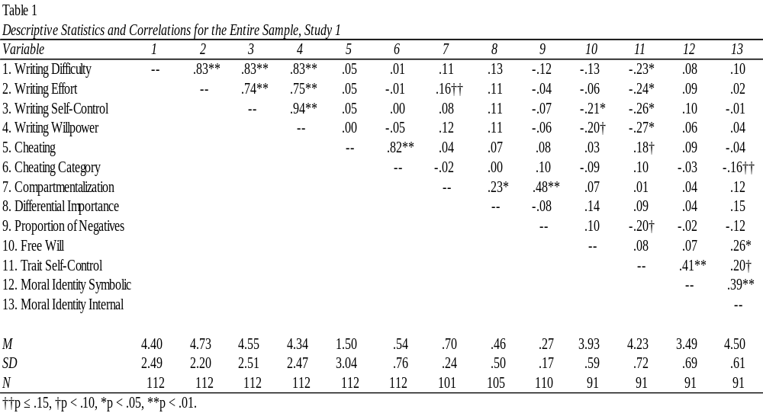
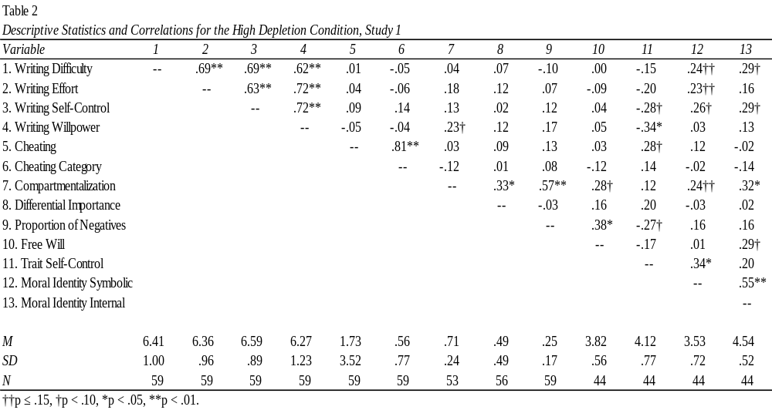
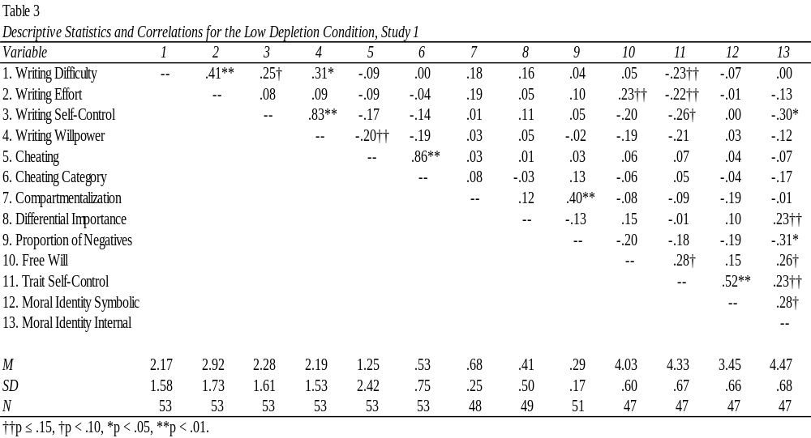

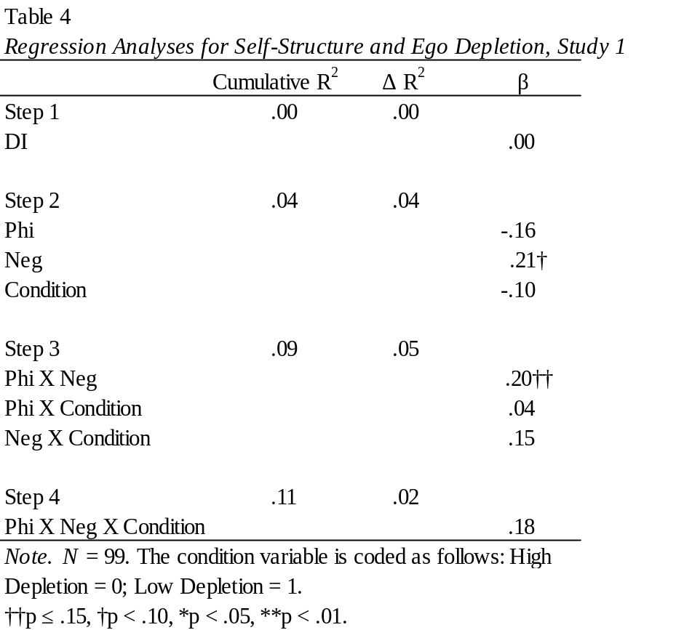
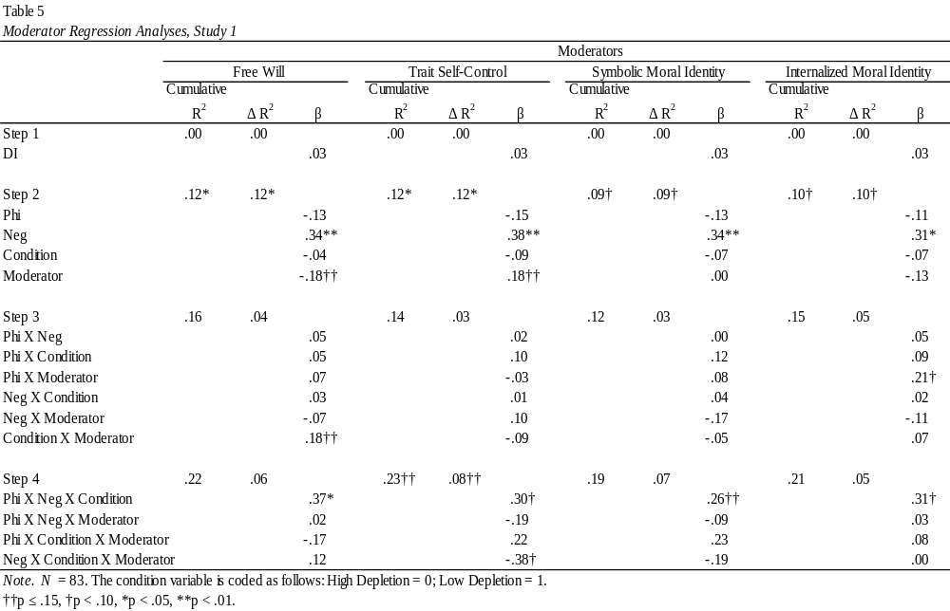

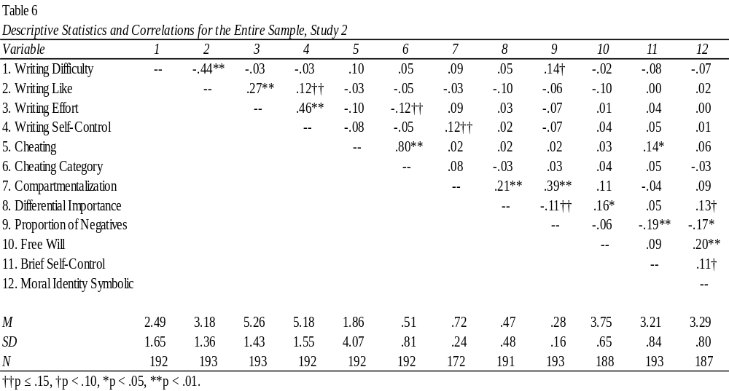
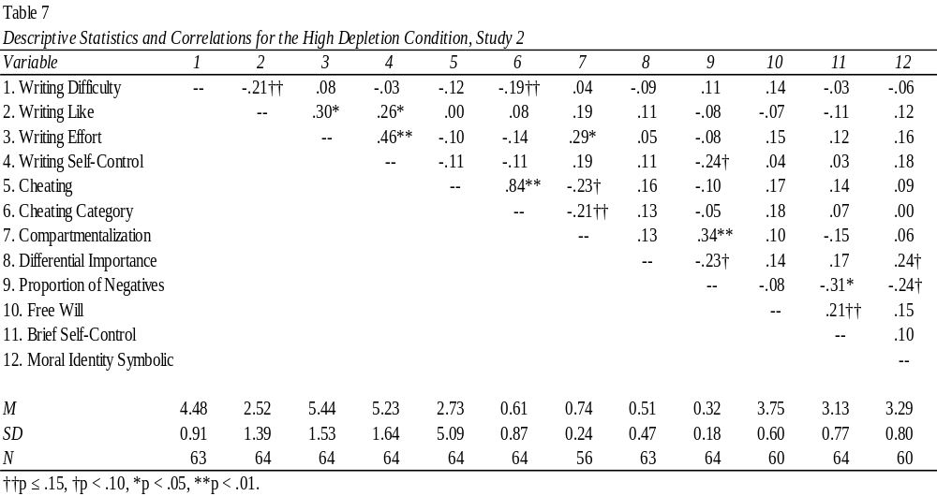
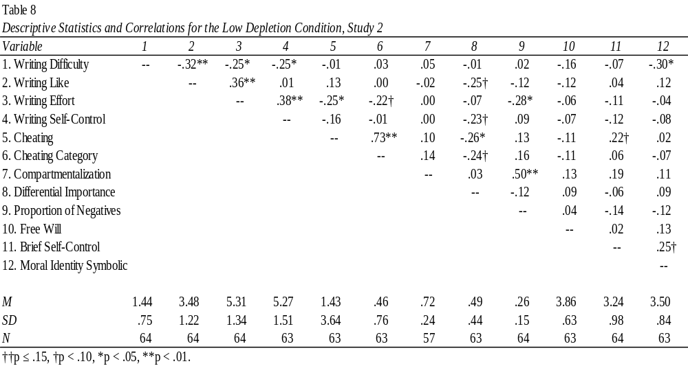
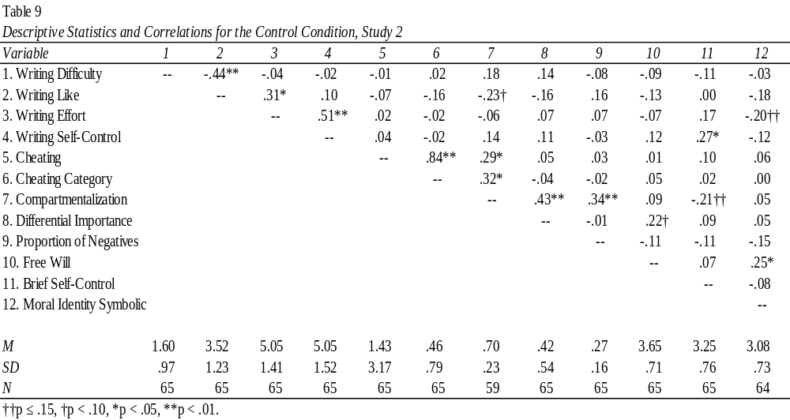

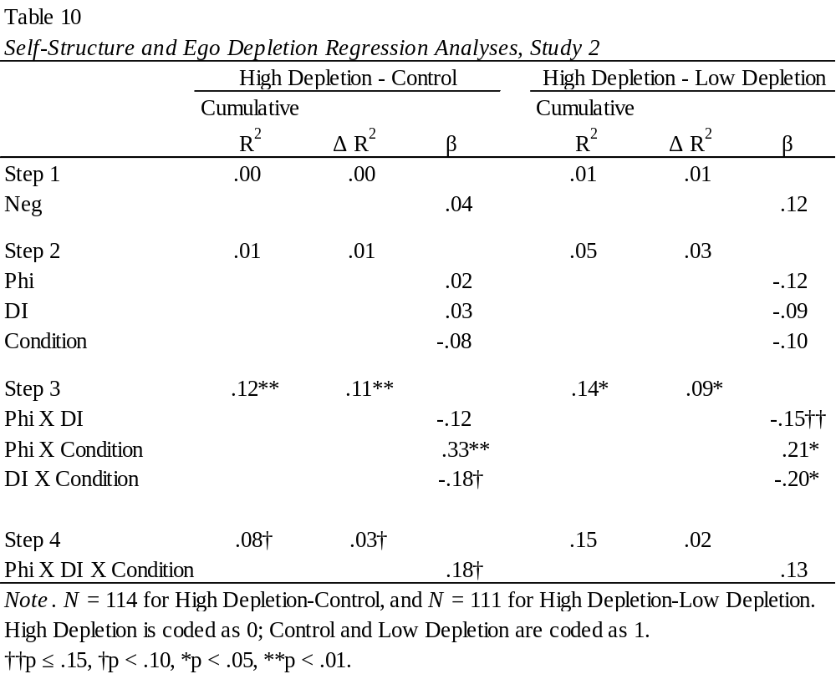
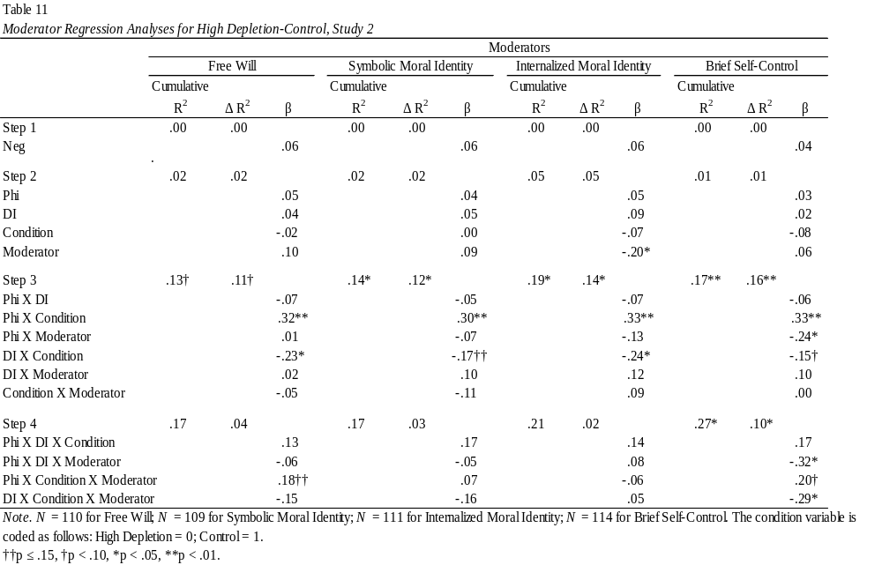
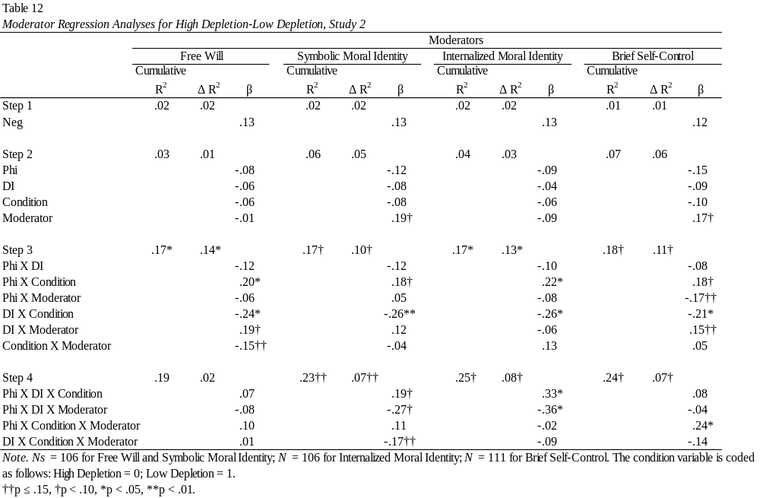

Appendix C: Figures
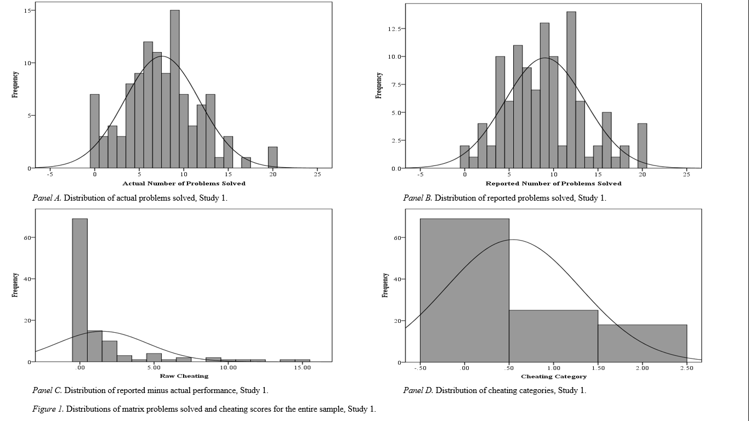
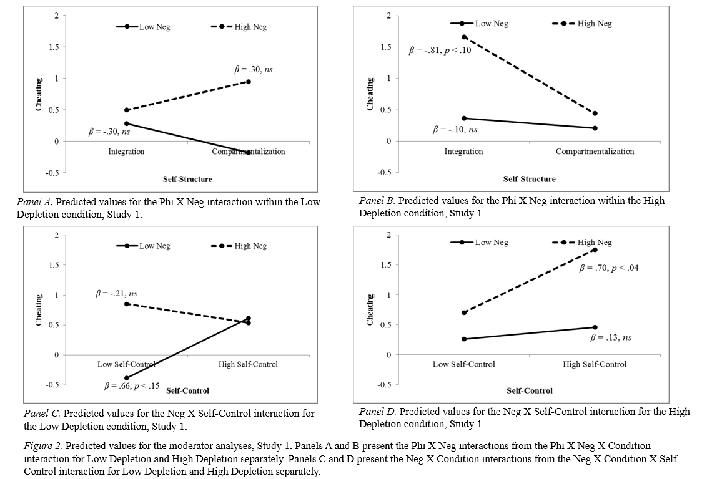
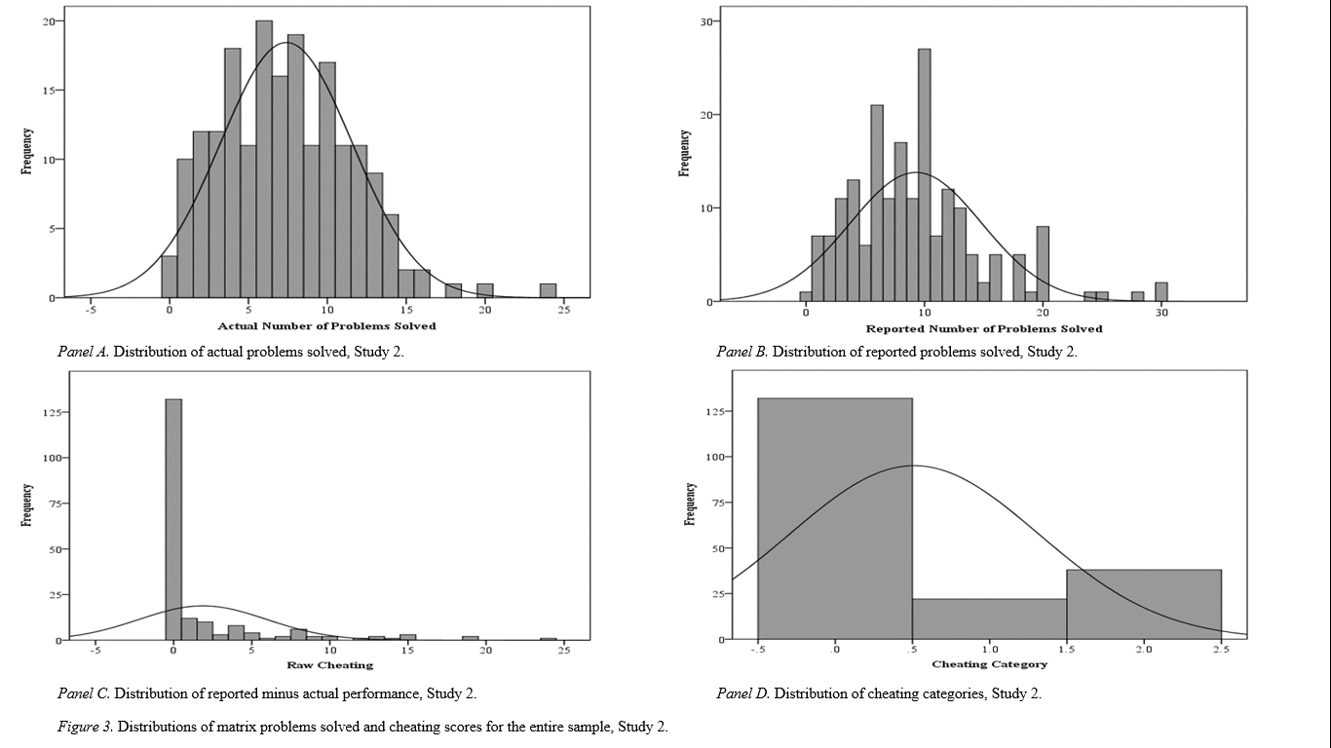

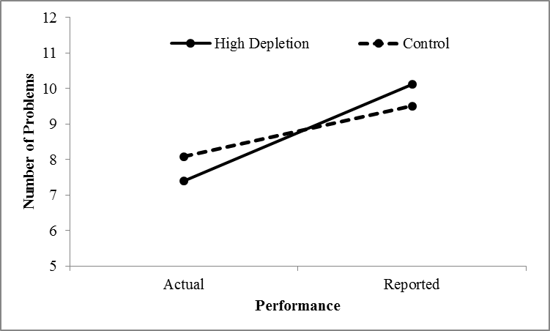
Panel A. Means for the Condition X Performance interaction in the High Depletion-Control mixed model ANOVA, Study 2.

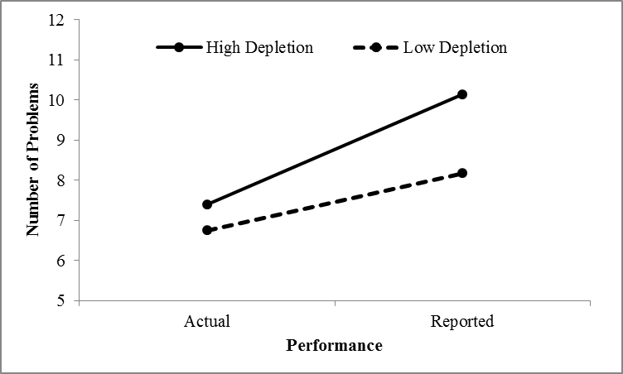
Panel B. Means for the Condition X Performance interaction in the High Depletion Low Depletion mixed model ANOVA, Study 2.

Figure 4. The means of actual and reported performance by condition, Study 2.

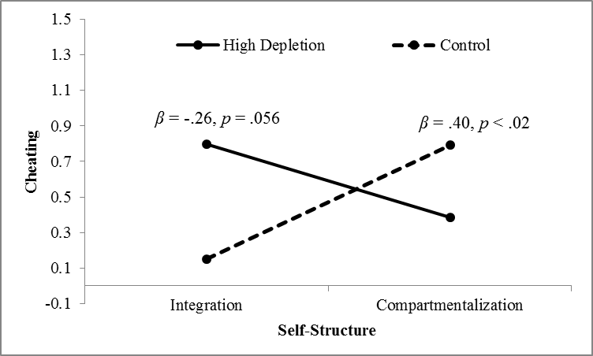
Panel A. Predicted values for the Phi X Condition interaction for High Depletion-Control, Study 2.

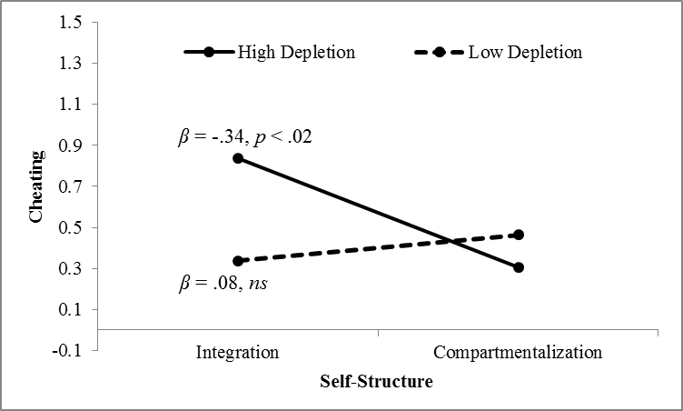

Panel B. Predicted values for the Phi X Condition interaction for High Depletion-Low Depletion, Study 2.

Figure 5. Predicted values for the Phi X Condition interactions, Study 2.

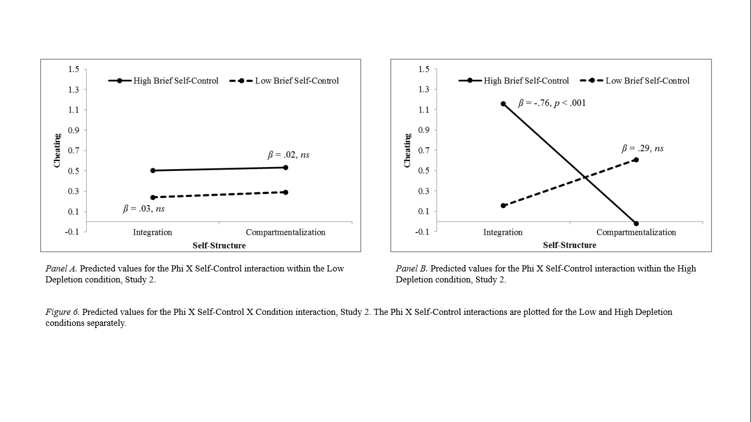

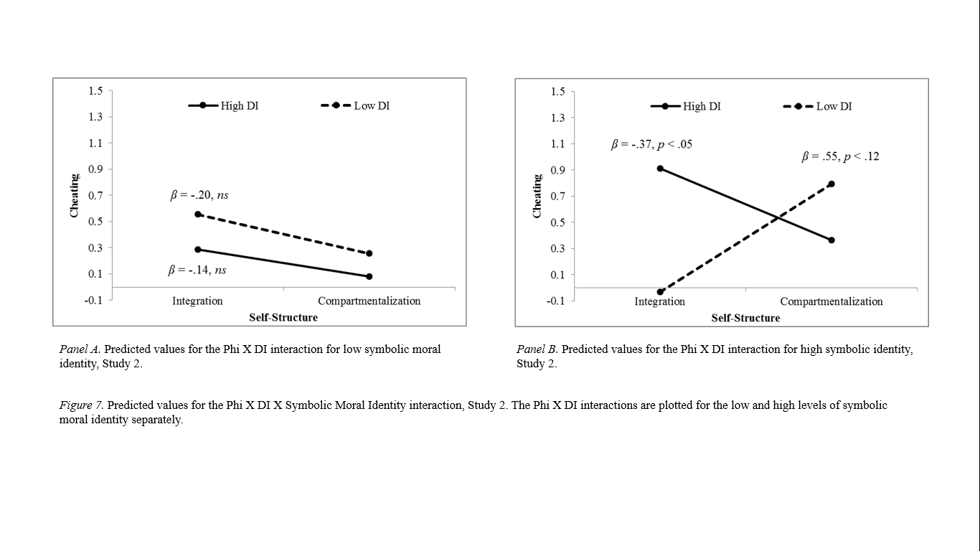

Appendix D: Study Measures

Ego Depletion Manipulation, Study 1

High Depletion Condition:

INSTRUCTIONS: For the following task please write a short story describing a trip you have recently taken. Choose any recent trip you like, and make sure to include a detailed description of the people, location, and activities that took place during the trip. In your story, you MAY NOT use any words that contain the letters A or N. For example, you may need to substitute the word “joyous” for the word “happy.” Please write continuously about your trip until the experimenter tells you to stop. You may begin now.

Low Depletion Condition:

INSTRUCTIONS: For the following task please write a short story describing a trip you have recently taken. Choose any recent trip you like, and make sure to include a detailed description of the people, location, and activities that took place during the trip. In your story, you
MAY NOT use any words that contain the letters X or Z. For example, you may need to substitute the word “elated” for the word “excited.” Please write continuously about your trip until the experimenter tells you to stop. You may begin now.

Collection Slip, Side 1

Problem-Solving Math Task
Instructions: In this task, you will see 30 different matrices each containing twelve numbers. Your task is to find and circle the two numbers in each matrix that add up to exactly 10.00. For each matrix, there is only one correct combination of numbers that add up to 10.00. You will earn $0.50 for each matrix problem you solve correctly within the time limit, for a maximum of $15.00. Below is an example matrix. Try to find and circle the two numbers that add up to 10.00.

1.69 | 1.82 | 2.91
4.67 | 4.81 | 3.05
2.11 | 5.06 | 4.28
6.36 | 5.19 | 7.95

When the experimenter tells you to start, you will have 5 minutes to solve as many matrix problems as you can, and you will earn $0.50 for each one.
Please do not guess on any of the problems. You can do the problems in any order, but do not circle the two numbers until you are sure that they add up to exactly 10.00.

Collection Slip, Side 2

Collection Slip

Dollar amount ($0.50 per problem): ________

Number of problems = ________

Ego Depletion Manipulation, Study 2

Instructions: For the next task, we would like you to recall the most recent car ride you took that lasted more than one hour. Please fill in the town you started from and your destination:

CAR RIDE STARTED FROM ___________________________________

DESTINATION ___________________________________

Approximately what day and time did you start this trip?

DAY _________________

TIME _________________

High Depletion Condition:

Instructions: Still thinking about your car ride, please write a short narrative describing where you were going, who you were traveling with, what kind of day it was, the weather and road conditions, any scenery you saw, stops you made, or anything else you did during your car ride. In your description, you MAY NOT use any words that contain the letters A or N. For example, you could use the word “quickly” instead of “fast” because “fast” contains an A. Please write continuously about your car ride until the experimenter tells you to stop. You may begin now.

Low Depletion Condition:

Instructions: Still thinking about your car ride, please write a short narrative describing where you were going, who you were traveling with, what kind of day it was, the weather and road conditions, any scenery you saw, stops you made, or anything else you did during your car ride. In your description, you MAY NOT use any words that contain the letters Q or Z. For example, you could use the word “rapidly” instead of “quickly” because “quickly” contains a Q. Please write continuously about your car ride until the experimenter tells you to stop. You may begin now.

Control Condition:

Instructions: Still thinking about your car ride, please write a short narrative describing where you were going, who you were traveling with, what kind of day it was, the weather and road conditions, any scenery you saw, stops you made, or anything else you did during your car ride. Please write continuously about your car ride until the experimenter tells you to stop. You may begin now.

Appendix E: Additional Figures (Study 1)

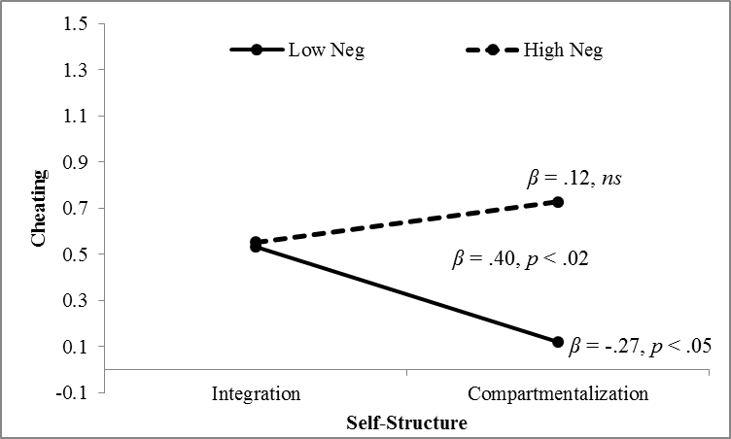

Figure B-1. Predicted values for the Phi X Neg interaction, Study 1.

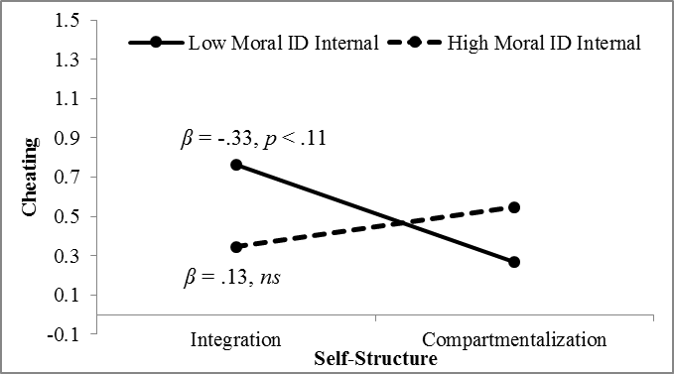

Figure B-2. Predicted values for the Phi X Internalized Moral Identity interaction, Study 1.

Appendix F: Additional Figures (Study 2)
