UNIVERSITY OF OKLAHOMA
GRADUATE COLLEGE

PRIORITIZING ENGAGEMENT AND MOVEMENT IN THE WORLD LANGUAGE CLASSROOM: AN ACTION RESEARCH STUDY ON DESKLESS SEATING IN SECONDARY, NOVICE-LEVEL SPANISH CLASSES

A THESIS
SUBMITTED TO THE GRADUATE FACULTY
In partial fulfillment of the requirements for the
Degree of
MASTER OF EDUCATION

By

ERIN COX
Norman, Oklahoma
2020
PRIORITIZING ENGAGEMENT AND MOVEMENT IN THE WORLD LANGUAGE CLASSROOM: AN ACTION RESEARCH STUDY ON DESKLESS SEATING IN SECONDARY, NOVICE-LEVEL SPANISH CLASSES

A THESIS APPROVED FOR THE DEPARTMENT OF INSTRUCTIONAL LEADERSHIP AND ACADEMIC CURRICULUM

BY THE COMMITTEE CONSISTING OF

Dr. Crag Hill, Chair

Dr. Rebecca Borden

Dr. Heidi Torres

©Copyright by ERIN COX 2020
All Rights Reserved.

Para mis estudiantes maravillosos.

Acknowledgments

There are so many people to thank for getting me to this point. First, I would like to thank my school for helping me pay for my graduate classes and for being so open to me conducting research on-site. Secondly, many thanks to my committee members, as each of them has made a tremendous impact on my teaching career. Thanks to Dr. Borden, my advisor, for inspiring me to be a better language teacher every class, to Dr. Hill for being there every step of the way to bringing this study to fruition, and to Dr. Torres for going above and beyond in supporting me throughout the writing process and for even making it enjoyable at times. I also cannot thank my mentor, Julie Kline, enough for taking me under her wing and for shaping me into the teacher I am today. Additionally, I am extremely grateful for my parents, who have supported me in all that I do since day one. Thanks to my amazing friends and coworkers for always being there for me and for keeping me sane this past year. Lastly and most importantly, thank you to my incredible students. Teaching and being a graduate student meant that at times, I was not always the best teacher I could be, yet my students were kind, patient, and forgiving throughout this entire process. Without them, this thesis would not have been possible!
Table of Contents
Dedication 4
Acknowledgments 5
Abstract 12
Chapter One: Introduction 1
Background and Purpose of Study 2
Research Questions 8
Significance of Study 9
Definitions 9
Chapter Two: Literature Review 11
Second Language Acquisition Theory Introduction 12
Social SLA Framework 12
Psychological SLA Framework 14
Seating in Relation to Language Learning 16
The 21st Century Language Learner 18
Classroom Management 20
Flexible Seating 22
Coffee Shop Style Seating 24
Alternative Seating 25
Conclusion and Literature Advancement 25
Chapter Three: Methodology 28
Setting and Participants 28
Informed Consent and Confidentiality 29
Seating Setup and Procedures 31
Student Surveys 33
Student Interviews 34
Teacher’s Field Notes 35
Chapter Four: Results and Discussion 37
Pre-Deskless Survey Results 37
Post-Deskless Survey Results 40
Feedback from Student Interviews 46
Trends Revealed in Teacher Field Notes 51
Discussion 59
Chapter Five: Conclusion 64
Limitations 66
Implications for Future Research 68
References 71
Appendix A: IRB Approval Notice 75
Appendix B: Student Assent Form 76
Appendix C: Parental/Guardian Consent Form 77
Appendix D: Letter to Parents / Guardians 78
Appendix E: Photos of Classroom 79
Appendix F: Pre-Deskless Survey 81
Appendix G: Pre-Deskless Survey Results 83
Appendix H: Post-Deskless Survey 86
Appendix I: Post-Deskless Survey Results 89
Appendix J: Interview Protocol and Questions 93
Appendix K: Non-Disclosure Agreement for Audio Transcriptions 94

List of Tables
Table 4.1 Responses to Question 7 on Pre-Deskless Student Survey 37
Table 4.2 Responses to Question 8 on Post-Deskless Student Survey 40
Table 4.3 Responses to Question 9 on Post-Deskless Student Survey 42
Table 4.4 Responses to Question 10 on Post-Deskless Student Survey 43
Table 4.5 Responses to Question 1 in Post-Deskless Interview 45
Table 4.6 2nd Hour # of Redirects Data 57
Table 4.7 3rd Hour # of Redirects Data 57
Table 4.8 4th Hour # of Redirects Data 57
Table 4.9 7th Hour # of Redirects Data 57
List of Figures

Figure 2.1 Diagram of Krashen’s Affective Filter 15
Figure 2.2 ACTFL 21st Century Skills Comparison Chart 18
Figure 3.1 Copy of my teaching schedule 28
Figure 3.2- Excerpt from Johnson, 2013 35
Figure 4.1 Student Behavior Venn Diagram 51

Abstract
Deskless seating is a seating trend that has grown in popularity in recent years, particularly among world language educators of students of all ages. In deskless seating, the desks in the classroom are removed and the students sit in chairs in the center of the room. While educators in this field are finding success with this seating option, little to no research has been collected on this topic. The purpose of this action research study was: 1) to determine what effects deskless seating had on student behavior and engagement and 2) investigate student opinions of deskless seating. The participants in this study were 7th and 8th grade students in a novice-level Spanish class. Through field notes, student surveys, and student interviews, the researcher found deskless seating increased student engagement and slightly improved student behavior. Students gave mixed opinions on deskless seating, with the positive elements they liked outweighing the aspects they did not enjoy.

Keywords: Deskless seating, flexible seating, traditional seating, engagement, student perceptions, secondary, novice level language learners

Chapter One: Introduction
With the dawn of a new decade, there is at least one thing that both seasoned and first-year educators are certain of: the students in their current classrooms are very different from the students they taught or were 10 years ago. This is because the life of a middle or high school student in the 2020s vs. the 2000s has changed significantly in a number of ways. Teenagers in the year 2020 are used to having the ability to talk to anyone they want within a matter of seconds through cell phones. More often they communicate through pictures and text messages than by talking on the phone. In contrast, kids growing up in the 2000s were not even able to make a call from their landline and be on the internet at the same time. Phone numbers had to be looked up in phone books, while today kids do not even need each other’s phone numbers, asking instead for their usernames on various apps. Youtube did not exist until 2005. Now, “Youtuber '' is considered not only a legit career but one that many kids aspire to pursue. Through social media, the social aspect of the school day no longer ends when the last bell rings at 3:30 like it once did. Instead, it continues nonstop into the evenings and on the weekends. These examples of how students’ environments have changed amid the technological revolution are just the tip of the iceberg.
However, it is not just students’ lives that have changed. The way that we teach, not only in world languages but across all disciplines, has also evolved to keep up with this shift in our society. Items like chalkboards, transparencies, or chunky computer monitors are unlikely to be found in classrooms today. Within one decade, SMART Boards have gone from a luxury classroom item, to the standard, to slightly outdated. Most textbooks have now been made into etexts. In the world languages field, many teachers have ditched their textbooks entirely. World language classes today are more communicative, with emphasis placed on authentic resources and exposure to comprehensible input. The American Council of Foreign Language Teaching did not recommend teachers using the target language for 90% or more of class until 2010. Collaborating with other teachers is no longer limited to only being within departments or grade-level teams, but now extends worldwide through websites like Twitter, Facebook, and Pinterest. The online teaching resources available today are endless and many schools have the ability to incorporate technology into their classrooms every day with the 1:1 student to device ratio. From the way we assess students to the amount of homework that we assign them, new research is being conducted every year that makes us question everything we thought we knew about pedagogy.
All this to say, if students and schools have changed so drastically over the years, why shouldn’t we consider changing classroom seating, too?

Background and Purpose of Study
Seating among students plays a significant role in the classroom as it can greatly impact a student’s learning experience. In my years in the classroom, I have spent many hours trying to create the “perfect” seating chart. I would ask myself, “How do I change the current seating arrangement without making it worse?” With all the moving pieces I had to take into consideration, it felt as challenging as trying to crack an impossible code. The justification for a certain seating may vary, but many teachers consider classroom management, social reasons, or physical reasons as important factors when deciding how to set up the seating in a classroom (Gremmem, 2016). Some students need to be seated in the front of the room for closer proximity to the board and the teacher, while for others sitting in the front causes anxiety. Some cannot be seated next to specific classmates due to behavior problems or because they do not get along. The types of activities the teacher will have the students do can also have a strong influence on the way the room is set up. For example, rows are great for monitoring what the students are doing on the computers, but poor for peer collaboration. In contrast, groups of three are ideal for activities that involve students collaborating together, but not necessarily best for independent work on smart devices.
Seating arrangements not only affect a student’s learning experience, but it can also make a significant impact on the teacher’s experience in the classroom. According to Wong, classroom set up and seating is one of the many important factors in an effectively managed classroom (2009). As a young teacher, I too felt as though a well thought out seating arrangement was one of the most powerful tools in my teaching toolbelt. Unfortunately, the perfect formula that works for every classroom does not exist, especially as schools experience increasing class sizes and diversity of the student population. Schools must face the challenge of teaching students that have grown up in an environment where technology is constantly changing at their fingertips. This advancement in technology, among many other factors, influences many abilities in a young person’s life such as their decision making, communication skills, and critical thinking (Lemley, Schumacher, & Vesey, 2014). Additionally, the learning needs of students are another challenge that teachers face in the classroom. Learning styles and differences vary greatly across a secondary classroom of 30 students. Educators must teach to a population of children and young adults that are growing in the number of ADHD diagnoses, according to Voelker (2014). There are so many student factors that are beyond a teacher’s control, and while classroom set up does not solve all these issues, it can help.
Options like flexible seating have gained popularity over the years, but in most classrooms the seating has not evolved near as much as other areas in education. Photos from classrooms in the 19th century show a similar set up to classrooms today: students sitting at wooden desks arranged in an organized configuration around the room. Obviously this has been an effective way to set up the classroom for many teachers across centuries if it is still used over 200 years later. However, it is curious to examine all the changes in students, technology, curriculum, and educational theory and question why classroom seating has not undergone such drastic changes. One explanation could be the classroom budget or lack thereof.
Setting up the seating for a classroom goes far beyond deciding whether to arrange the desks in rows or groups. Educators should consider not only the way the students are arranged around the classroom but also the furniture used by the students. To implement something similar to flexible seating would involve the purchasing of items such as bean bags, exercise balls, roller desks and chairs, couches, comfortable chairs, cafe-style furniture, fidget-kick bands, etc. According to a 2016 study by the organization Adopt a Classroom, teachers on average have $212 to spend on supplies for their classroom each year (Karbowski, 2018). All of that money could easily be spent before school even started on basic classroom supplies alone. This allotment, $212, would not even be enough to purchase a quarter of a Harkness table, let alone be sufficient to buy new furniture for a classroom of 30+ students. While being able to teach in an environment that felt more like a Starbucks than a classroom might sound wonderful, it is not a reality for most teachers that teach in districts that have had to cut programs like the arts, or cannot afford to buy new textbooks, or have lost teachers due to low pay.
For teachers looking to shake up classroom seating but not spend a fortune out of their own pocket, deskless seating is a relatively cost-friendly alternative. Currently, deskless seating is a seating option that has grown in popularity among teachers, specifically in the area of world languages (WL). This seating choice is more common within world language teachers that have implemented Comprehensible Input (CI) and/or Teaching Proficiency through Reading and Storytelling (TPRS). There is no research to justify exactly why deskless seating has really exploded in this field, but one factor to consider is that world language pedagogy has evolved over the years and become overall more communicative centered.
World language classes are different from the core subjects for many reasons, but one obvious one is that the class is taught in a totally different language than the language that students hear and use outside the 45-60 minutes a day they are in their language class. Additionally, the amount of time that a student will spend studying a world language pales in comparison to the total number of years studying a core subject like math or history. Every school is different but many require two years, if that, of a world language in order to graduate. The majority of students will not go on to become language teachers, or translators, or diplomats. Instead, students are most likely to use their second language skills while traveling or in a work setting, and in either scenario, being able to speak the language is imperative. With this being the case, many WL teachers have realized the importance of a communicative, input centered classroom and removing the desks creates a natural setting for interaction to happen. This trend seems to be most common in secondary settings, as university professors likely cannot change the configuration of the classroom they are assigned to that semester; and many elementary schools do not have a full time language teacher, let alone one that has their own classroom.
With the deskless seating option, the desks are removed or pushed to the sides of the room and students typically sit in chairs in the center of the room. With this seating option, teachers likely would not need to spend money buying alternative seating and instead could use the furniture that the classroom already possesses, although they may choose to buy different chairs or items like hanging pockets to make materials more accessible.
Social media is a popular way for teachers to collaborate and share ideas. Right now, there is a 4,000 member Facebook group dedicated to teachers that have elected this form of seating. Additionally, deskless seating continues to be a popular and recurring topic on educational blogs and conferences. Here are what some teachers in the WL community are saying about why they like deskless seating:
It’s great for class discussion in Spanish. It is so much easier to do PQA (personalized question and answer), special person interviews, and discuss projected questions from a novel where everyone is facing each other (Weinhold, 2016).
In a deskless classroom, it is much more difficult to ‘hide.’ Students can no longer tune out, shut down, look at their phone, fall asleep. Students are also closer together (yet not awkwardly or uncomfortably so), so the teacher has less physical space to manage (Placido, 2019).
I was constantly feeling stifled by the lack of space- I wanted kids to move and act out stories and I wanted to move around to the kids, but I was super constrained. I think my class sends a powerful message to kids: memorizing and spouting facts, grade grabbing and ignoring the teacher don't work out here. Being present, laughing, being yourself, and listening to understand are the values (Cárdenas, 2016).
The term “deskless seating” might immediately raise some red flags for some teachers, especially those that incorporate a lot of writing into their course. How do students do their work without a desk? But for teachers of world languages, Second Language Acquisition (SLA) research and theory tells us to emulate the second language as close to the first language as possible. From Stephen Krashen’s Input Hypothesis, he explains how receiving input that is comprehensible, similar to how one learns their first language, is an effective research-based way to acquire a foreign language (1982). While educators have their own unique reasons for choosing to go deskless, the shift in world language teaching away from the traditional method using textbooks, meaningless memorization, and grammar workbooks, to a communicative centered style of teaching focused on comprehensible input can explain why deskless seating has grown popular specifically in this field. According to the American Council for Teaching Foreign Languages (ACTFL):
Oral communication is at the heart of language learning. It is the vehicle through which learners build relationships and develop intercultural competence. Through oral interpersonal communication tasks, learners engage with language in a low-stakes environment in preparation for real-life interactions. These tasks increase learners’ ability to interact socially in any language (ACTFL, n.d.).
With the focus on interpersonal communication and wanting students to ultimately be able to use the target language in future real-life situations, desks are not irrelevant but might seem less important in a 21st-century classroom full of language learners. The increasing incorporation of technology, minimizing work done on paper, can also justify desks not being as necessary for some class settings.

Research Questions
With deskless seating being a relatively new topic in the field of classroom seating, there are many questions that could be proposed in order to learn more about its effects in the classroom. This study is an action research study conducted in 7th and 8th grade novice-level Spanish classrooms in which the researcher was the teacher. The researcher will examine two questions in order to learn more about 1)what is going on in the classroom when the desks are removed and 2)what are the student and teacher perceptions of not having a desk. The following research questions will be addressed:

- What effect, if any, does deskless seating have on student behavior and engagement?
- How do students feel about deskless seating?

Significance of Study
Despite its popularity, deskless seating is a topic that has yet to be thoroughly researched in the field of education. Other research on deskless seating either does not exist or is not very accessible to teachers. In fact, spell-check does not even recognize“deskless” as a word. This research study collected students’ opinions and input on deskless seating and analyzed a teacher's fieldnotes on her experience from transitioning from traditional seating to a deskless classroom. The goal of this study is to help launch deskless seating into the world of academic research while serving as a practical resource for teachers considering going deskless. This study, along with future research studies would help educators interested in deskless seating make a well-informed decision regarding the seating option best suited for their particular classes.

Definitions
A foundation of key terms and topics that will be used in this study is important in order to better understand the framework for this study.
Deskless seating - A seating option in which the desks in the classroom are removed or pushed to the sides of the room and students sit in their chairs in the center of the room.
Traditional seating - “Common classroom furniture such as desks, tables, and chairs arranged in rows, small groups, a circle, or a semicircle” (Havig, 2017).
Engagement - “The extent of students' involvement and active participation in learning activities” (Cole & Chan, 1994).
Off task behavior - A behavior exhibited by a student that distracts from the task at hand and disrupts the learning of the individual and/or others.
Interpersonal communication - “Active negotiation of meaning among individuals” (Swender & Duncan, 1998).
Classroom management - “Classroom management involves all of the practices and strategies a teacher uses to create and maintain a learning environment where teaching and learning can occur” (Havig, 2017).
Flexible seating- “An atmosphere free of traditional desks attached to a chair, where students choose alternative seating devices such as rocking chairs, wobble stools, bean bag chairs, etc., and where students choose alternative desks such as tables of various sizes, heights, and shapes” (Erz et. al, 2018).
Alternative seating- “Seating devices other than traditional classroom chairs. Common alternative seating options include therapy balls, therapy cushions, wobble stools, bean bag chairs, couches, pillows, benches and so on” (Havig, 2017).
Redirect- “The number of times the teacher stopped instruction to direct student attention back onto the task at hand” (Kuo et al., 2018).

Chapter Two: Literature Review
With so many shifts in schools and society, a question that teachers might ask themselves is: Is a traditional seating arrangement most conducive to the learning environment? In regards to classroom seating, the potential researchable variables within this topic are endless. Accordingly, classroom seating is a widely researched topic in the field of education. As classrooms and the lives of students are constantly changing, seating alternatives will likely continue to be an area of research interest in the future. Terms like “alternative” or “flexible seating” are commonly used in the discussion of non-traditional classroom seating options.
Classrooms that choose to move away from desks and chairs may look very different depending on the classroom. For example, some teachers might opt toward a “coffee shop style classroom,” which might include “limestone accents, plentiful natural light, and brightly colored seating, high and low bistro-style tables, booths, and sofa seating” (Morrone et al., 2014). Other forms of flexible seating might include therapy balls, standing desks, or bands, which in some cases have been effective alternatives to chairs for students with ADHD, as they can promote on-task behavior (Schilling, Washington, Billingsley, & Deitz, 2003). The ages of students, size of available classroom space, subject taught, access to resources, etc. are just some of the factors that might be considered by the teacher when deciding the best seating set up for the learning environment.
Because the research on deskless classrooms is minimal, I collected literature on related topics to better understand what effects non-traditional seating arrangements can have on students, as well as SLA theory and how it relates to the classroom environment . Some of the guiding questions when selecting studies to review include: What forms of flexible or alternative seating are teachers using in classrooms today? How do alternative seating options affect the student’s learning experience and engagement? What other effects does flexible seating have on students? Can non-traditional seating arrangements be conducive to students of different ages? What does SLA theory say about the classroom environment? How can SLA theory be used to explain the popularity of deskless seating in the world language field? How does deskless seating fit within the ACTFL 21st century skills?

Second Language Acquisition Theory Introduction
Learning a new language is by no means a straightforward, simple process. Many factors extend far beyond seating that determines a learner’s success in becoming proficient in another language. The three main frameworks that most research in SLA fall under are: linguistics, psychological, and social. Social frameworks examine how language is used so that the learner can communicate with others effectively in the second language (L2), while psychological frameworks focus on the learning process that is taking place in the brain (Saville-Troike & Barto, 2018). The way the classroom is set up relates closest to the social and psychological sides of language learning.

Social SLA Framework
The role of interaction in the second language (L2) has been studied and debated by many theorists in the field of Second Language Acquisition. Vygotsky’s Sociocultural Theory (1978) is one of the major theories to consider in relation to classroom arrangement. In this theory, Vygotsky claims that human learning is a social process and that social interactions are the causative force in language acquisition. Vygotsky also emphasizes the interaction between learners and experts. In a classroom setting, the “expert” can be the teacher or a more knowledgeable fellow learner. The Zone of Proximal Development (ZPD) is the space where these interactions between the learner and expert take place. Vygotsky defines the ZPD as “the distance between the actual development level as determined by independent problem solving and the level of potential development as determined through problem-solving under adult guidance or in collaboration with more capable peers” (p. 86).
One of the ways that these interactions take place is through scaffolding. Scaffolding refers to the “verbal guidance which an expert provides to help a learner perform any specific task, or the verbal collaboration of peers to perform a task which would be too difficult for any one of them in individual performance” (Saville-Troike & Barto, 2018, p.216). In most settings, the students in world language classes do not live in a place where that language is the primary language spoken in their communities. Therefore, teachers must create these opportunities to use the language interactively within the classroom to make up for the lack of interactions that the students will have outside the language class. While interaction is social in nature, these interactions also affect the mental processing of the learner’s brain. An example of this is the Interaction Hypothesis, often credited to Long (1981), which concludes the following:
- Comprehensible input is necessary for L2 acquisition.
- Modifications to the interactional structure of conversations that take
place in the process of negotiating a communication problem help to make input comprehensible to an L2 learner (Ellis, 1991, p. 4).
Through the Interaction Hypothesis, it is clear that acquisition happens when input and interaction, which requires output, work together and are both necessary parts of one’s journey to L2 proficiency. Input alone is not enough, and students again need a space, the ZPD, to have opportunities to use their L2 to negotiate meaning with others. Interactions can happen in many different forms, but ideally students need face to face interpersonal interaction. In addition to scaffolding, interactions can be in the form of feedback. There are multiple approaches that a teacher can use when they need to correct a student, such as recasting, direct correction, indirect correction, expansion, repetition, and more.
The importance of social interaction in language learning is also reflected in the ACTFL World-Readiness Standards for Language Learning. Under the “Communication” section, ACTFL states, “Learners interact and negotiate meaning in spoken, signed, or written conversations to share information, reactions, feelings, and opinions” (ACTFL, 2015). Another standard features the interpretive mode of language learning. In this process, learners“understand, interpret, and analyze what is heard, read, or viewed on a variety of topics.” Similar to Long’s Interaction Hypothesis (1981), the World-Readiness Standards tell us that language learning requires both input and interaction.

Psychological SLA Framework
Comprehensible input (CI), is a psychological SLA framework, and originates from the work of Stephen Krashen during the 1970s and 80s. Deskless seating is most popular with world language teachers that use CI-based methods in their classrooms. These methods, derived from Krashen’s Input Hypothesis, state:
- The input hypothesis relates to acquisition, not learning.
- We acquire by understanding language that contains structure a bit beyond our current level of competence (i + 1). This is done with the help of context or extra-linguistic information (1982, p. 21).
Krashen’s Affective Filter Hypothesis (1982) describes the ideal environment for comprehensible input to take place. This hypothesis explains why some learners who receive ample amounts of comprehensible input still do not reach the native level of acquisition. When this occurs, it likely can be traced back to the affective filter. Comprehensible input is not useful in environments in which motivation and self-confidence are low, and anxiety is high. How the affective filter serves as a barrier preventing language acquisition from happening is illustrated in figure 2.1 (Krashen, 1982, p.32).
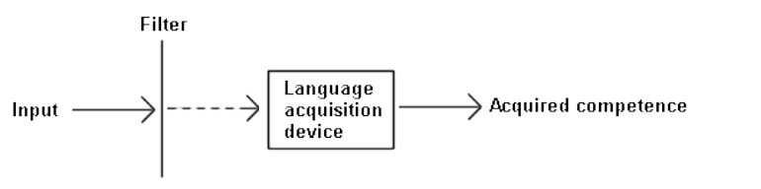
Figure 2.1 Diagram of Krashen’s Affective Filter
Motivation is another psychological factor that traces back to a learner’s level of L2 success. Some reasons for lack of motivation are beyond the teacher’s control, such as their immediate environment. Family and friends can heavily influence a student’s goal setting, attitude, and self-efficacy beliefs (Kormos et al., 2011). Therefore, it is critical for the teacher to create a learning environment that increases student motivation, as the school environment (including teachers, peers, and instructional materials) can be very influential on a student’s motivation to learn their L2 (Dörnyei, 1994). Lastly, a student’s willingness to communicate (WTC) is a psychological factor to consider. Willingness to communicate refers to a person’s likelihood of engaging in a conversation or exchange given the opportunity (McCroskey, 1997). According to McCroskey, many situational variables could impact a person’s WTC, from how they feel that day, to what other interactions they have had recently.

Seating in Relation to Language Learning
Through SLA theory, world language teachers know that many factors affect a learner’s ability to acquire a language, many of which were not discussed. Still, it is evident through SLA theory that effective language teaching occurs when the learners are provided with input that is understandable to them and opportunities for interactions to negotiate meaning with more knowledgeable others. These interactions are more effective in low-stress environments in which the learner’s affective filter lowers, and their willingness to communicate is high. So what does the classroom seating have to do with Second Language Acquisition? Unfortunately, there is little to no research to explain how these two topics intertwine. However, the seating arrangement and the type of seating provided are the foundation for the classroom environment; and this environment can have both positive and discouraging effects on language learning.
Establishing a comfortable learning environment with a low affective filter is crucial as trends indicate an increase in the number of teenagers affected by anxiety disorders (McCarthy, 2019; Snow & McFadden, 2017; Twenge, 2017). According to McCarthy, anxiety disorders in children and teenagers increased by 20% between the years 2007 and 2012 (2019). With anxiety affecting more students, lowering the affective filter must be a language teacher’s priority. No matter how outstanding the lessons are, if a language teacher does not create this low stress, comfortable learning environment, acquisition is unlikely to be acquired. The relation between seating and the affective filter is unknown due to lack of research, but because seating is at the core of the classroom set up, teachers should not take it lightly.
To be clear, learners can receive input and interaction in any seating arrangement. But, if students are to receive ample opportunities to interact with more capable others throughout the class, the seating needs to be conducive for that to happen. Eiland found that college students in an undergraduate English course reported that seating arrangements such as small clusters or Socratic seminars encouraged the most peer/teacher interaction (2017). At the elementary age, Marx et al. found that the 4th graders asked more questions in a semi-circle arrangement versus traditional rows (1999). World language teachers should seek to increase these interactions in the target language, which can be challenging to do at the novice level. And while teachers can produce input for their students, students need to be engaged and focused in order for their minds to “let in” the input for processing (Saville-Troike & Barto, 2018). It is impossible to eliminate all distractions within the classroom, but no matter how much of the target language students are exposed to, if it all goes in one ear and out the other, it is not very useful in terms of language learning. Therefore, teachers can use seating as one way to try and lessen the number of distractions that occur during a lesson.

The 21st Century Language Learner
While classroom seating has not changed all that much over the years, there are many ways in which language teaching and learning have evolved in the past 20+ years. The American Council on the Teaching of Foreign Languages compares language classes from the past to the present in figure 2.2 (2011).

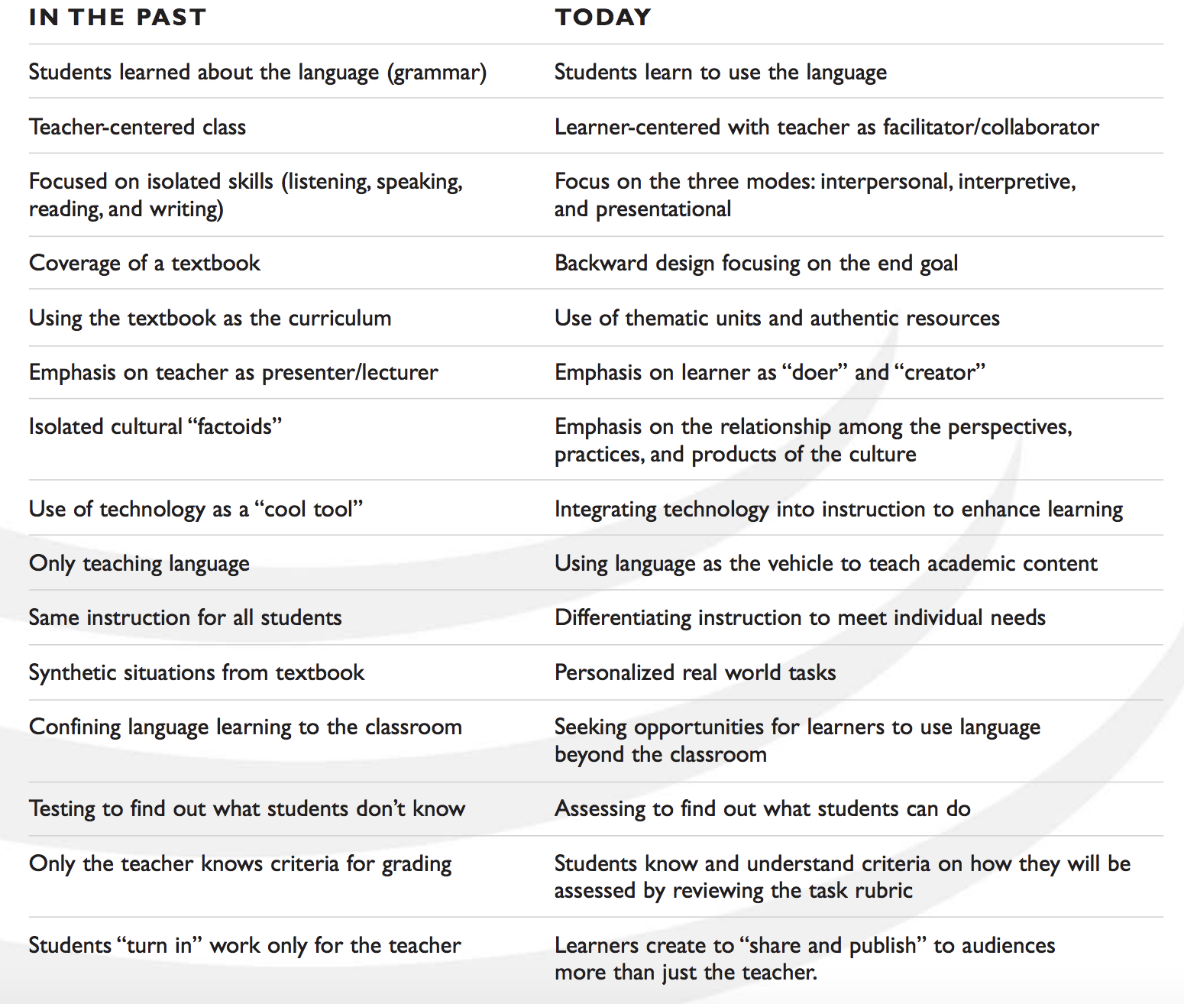
Figure 2.2 ACTFL 21st Century Skills Comparison Chart
One of the most significant differences between language classes today compared to the past is the emphasis on students learning to use the language in contrast to learning about the language. With this goal being at the core, the dynamic of the language class changes completely. Seating connects to these skills in various ways. If the teacher is supposed to act as the facilitator, they would likely be moving around the room more, instead of only being at the front. The emphasis on the use of the interpersonal mode would logically result in more personal interactions between students and the teacher. Differentiating instruction could mean possibly differentiating seating among students. In terms of deskless seating, a teacher could justify this seating arrangement to align with the 21st-century skills in that it is the most natural seating arrangement. In the real world, communication between people does not typically involve a desk separating two individuals.

Classroom Management
Despite all of the access teachers have to SLA theory and language teaching techniques, none of it really matters if the language classroom is poorly managed. The way the classroom is managed should not be overlooked as a significant factor to creating a thriving learning environment in any discipline, and seating can play a major role in successfully managing a classroom. While creating a comfortable classroom environment should be prioritized by teachers, it cannot be too relaxed that the classroom is not managed effectively. Studies show that teachers regard classroom management as one of the main, if not the top, considerations for teachers when selecting a particular seating arrangement (Gremmen et al., 2016; Gest and Rodkin 2011; Gest et al. 2014). In a study by Gremmen et al., teacher interviews revealed that most teachers preferred small groups for classroom seating because it was most conducive for collaborative learning. However, they found that teachers expressed that small groups allowed for more disorder in the classroom and would then opt for rows, which created a quieter environment (2016).
If teachers consider the most conventional seating arrangement of rows and desk to be the easiest to manage, when a teacher decides to elect a nontraditional seating, they must have outstanding classroom management to create a safe and flourishing learning environment. The research between classroom management and unconventional seating is mixed (Schilling & Schwartz, 2004; Havig, 2017; Allen, 2018). Information on deskless seating and classroom management is only available through teacher blogs and educational websites. In the 21st century, the use of smartphones is a major battle teachers must fight in classrooms all over the world. Many deskless WL teachers online have expressed that removing the desks has made the class more comfortable to manage. For example, “When students enter, all bags and stuff go on the back tables. This means that Chromebooks, phones, hidden snacks, other homework, and everything else that keeps them from focusing on Spanish are out of sight and out of mind” (Weinhold, 2016). On the other hand, because this topic has yet to be studied in academic research, teachers who experienced problems with deskless seating and classroom management may have just refrained from sharing their bad experiences online.
Classroom management is a critical aspect of any classroom; however, world language teachers face the challenge of student motivation. As discussed earlier, motivation is a principal psychological facet of language acquisition that can explain a learner’s success or failures in the L2. Motivation is not typically associated as a type of misbehavior in classroom management studies within general education but is the primary concern in WL education (Debreli et al., 2019). A study surveying English teachers in Georgia confirms this secure connection between language learning, motivation to learn the language, and classroom management (Kerdikoshvili, 2012). Nonetheless, WL teachers' goal is to increase these interactions in the target language, which can be challenging to do at the novice level.

Flexible Seating
While aligning desks in traditional rows might be the easiest seating for the teacher to manage, that has not stopped many teachers from choosing a radically different seating option. The most common nontraditional options that have been researched are flexible, alternative, and coffee shop style seating. Flexible seating is a seating option that is also not widely researched, but like deskless seating, it is popular among teacher blogs and websites. Limited published research is available, but several studies indicate that flexible seating can have a positive effect on student learning. Havig (2017) defines flexible seating as, “A ‘Starbucks’ atmosphere where students choose from a variety of alternative seating options and workspaces rather than sit at traditional desks” (p. 4). In this mixed-methods dissertation, Havig used teacher interviews, classroom observations, and student surveys among two 5th grade classrooms in order to better understand the advantages and disadvantages of this seating option in an elementary classroom, as well as how students and teachers experience flexible seating. Examples of flexible seating options observed include standard chairs, therapy balls, folded bungee chairs, a futon, rolling chairs, tall stools, pillows, and recliners (Havig, 2017).
Havig concluded that flexible seating comes with both advantages and disadvantages (2017). As expressed in the teacher interviews, both teachers stated that freedom of movement was a leading advantage. Some of the seating options allowed students to move around and fidget, while transitions during class provided opportunities for students to get up and move throughout the day. The researcher also found that another advantage for flexible seating was that it allowed students the autonomy to choose their seats, which gave them a sense of responsibility. However, the main disadvantage the researcher concluded was the lack of storage space for student materials, which for disorganized children, proved to be a problem. Secondly, flexible seating, although it contains the word “flexible” in the name, is anything but that. The researcher found that it was a challenge to move around the seating. The two teachers encountered situations in which they needed the room set up a different way for a particular activity. Instead, they were forced to conduct the activity in another place because the seating arrangement was not available.
In a similar study by Allen (2018), the researcher studied three 5th grade classes, and used a more quantitative approach through surveys, a count of teacher redirections, and a measurement of academic achievement through exit tickets. The researcher produced similar results, concluding that flexible seating positively impacted the students because they were excited to choose their seats each day and felt a sense of responsibility in this choice. All three classes saw an increase in academic achievement and participation, but the on-task behavior was, at times, inconsistent.
Nontraditional forms of seating are not just a consideration for teachers in the United States, but all over the world. Finland, in particular, is one country that has one of the top education systems in the world, with over 99% of students completing basic education at the age of 16. Additionally, teaching is a highly respected career (Sahlberg, 2011). This achievement begs the question of what do schools in Finland do that make their education system so successful? In one study by Jabeen and Imam (2018), the researchers observed schools in Finland to find out more about their educational system.
In their observations, they concluded that one of the many successful things that schools in Finland do is offer flexible seating. In an effort to replicate some of these strategies in the researchers’ schools, flexible seating was implemented in an Islamic Pre K-8th-grade school. The researchers concluded that flexible seating was beneficial to middle school students because it made the classroom environment more comfortable. Further, giving students the choice of where to sit promoted them to take ownership of their learning. In this study, however, there is no quantitative data to justify the change in behavior as a result of flexible seating, and the qualitative data provided is not detailed enough to provide convincing evidence to support flexible seating as beneficial to secondary students.

Coffee Shop Style Seating
Having the autonomy to choose where to sit is not something that only elementary students enjoy and can benefit from; middle school-aged students can help as well. Tollefsen (2017) found that a group 7th grade language art students in a “coffee shop style” environment 1)felt more comfortable asking questions, 2)demonstrated a more positive attitude toward completing assignments and learning in general, and 3)knew the names of their classmates better more than the traditional seating group. While the results of the student surveys are convincing, it is important to consider that the role of the teacher and their relationship with the students is going to have a significant impact on the students’ perceptions of the classroom environment. Having two different teachers participate in this study is a valid limitation to keep in mind.

Alternative Seating
In a more quantitative dissertation by Renegar (2018), the researcher investigated the relationship between student motivation and alternative seating among a group of over 100 sixth and seventh-grade students. The forms of alternative seating options are very similar to the other studies in this literature review, including therapy balls, fidget bands, camping chairs, and standing desks. In this study, the students were divided into two groups, in which one was exposed to alternative seating options, and the other was not. Renegar concluded the Motivated Strategies for Learning Questionnaire used in this study showed no significant differences in student motivation among the two groups of students. This study had a decent-sized group of participants, 123 students, so the results are not to be ignored. However, because this study only focused on student motivation using quantitative methods, more research using both qualitative and quantitative methods should be replicated on secondary students and how alternative forms of seating affects other classroom and learning factors.

Conclusion and Literature Advancement
In conclusion, every classroom is different and many different forms of seating exist to accommodate such diversity. What suits one age group of students may not necessarily be realistic or beneficial to another age group. However, the literature shows that flexible seating can be successful at the elementary and secondary levels. Overall, the literature included in this review supports the implementation of alternative forms to traditional seating options, which typically include desks and chairs. Teachers considering flexible seating have many options including but not limited to standing desks, therapy balls, bands, bean bags, couches, pillows, swivel chairs, etc. That being said, in all of these seating options, both students and teachers valued student choice. In deskless seating arrangements, students traditionally do not have a variety of seating options to choose from compared to flexible seating. Most deskless classrooms are filled with chairs that are all the same. By eliminating this element of student choice, the experiences with deskless seating by teachers and students cannot be entirely compared to experiences in other forms of non-traditional seating.
While there is limited research on how removing the desks affects the learning environment, it is clear that giving students options in their seating and providing nontraditional seating arrangements can have positive effects on several aspects of student learning and behavior. The literature in this review reveals that nontraditional seating affects many variables, such as academic achievement, participation, behavior, peer relationships, motivation, and more. While some literature on teacher opinions on flexible seating is mixed, the literature generally suggests that students feel positive or indifferent to flexible seating.
Learning a language is a social experience, and the brain plays a big role in language acquisition. A high affective filter can be detrimental to acquiring a second language and is more significant than ever with more and more young people affected by anxiety in recent years. Establishing a positive, low stress, effectively managed learning environment in which students are exposed to comprehensible output, and having opportunities to produce comprehensible output with more capable others is no easy task for language teachers.
Mixing up classroom seating is a very current and relevant topic that is still being researched, as much of the literature used in this review was conducted within the last several years. Several elements of the literature were dissertations or thesis papers. As 21st-century classrooms continue to evolve, more peer-reviewed research needs to be conducted on alternatives to traditional seating and how they affect students and teachers, including deskless classrooms, as this continues to be a growing trend among current teachers. Going forward, more literature examining how deskless seating and specific relationships to other topics needs to be available for teachers who are considering this seating arrangement and need to justify it to their administration or parent population.

Chapter Three: Methodology
This action research study used qualitative data obtained through field notes to examine changes in behavior and engagement after removing the desks. Both quantitative and qualitative data measured student perceptions of deskless seating through survey responses and interview transcripts.

Setting and Participants
The sample for this study included four sections of 7th and 8th-grade novice-level Spanish students ranging from ages 13-14. All students had at least two years of Spanish, some far greater than two, before the school year started. The participants in this study were all native English speakers. At the start of this research, I was in my fifth year of teaching and it was my third year teaching these courses. I collected the data for this study in the spring, after all students had been in my class for at least a semester. My 8th-grade students were all in my class the prior year. The students had experienced “traditional” seating up until the time of the research study. Typically, I change up my seating chart/configuration about once a month or every six weeks. Before the study, students had sat with normal desks and chairs in a row formation, small groups, dyads, and a horseshoe arrangement. Leading up to the study, I started taking field notes for two weeks with traditional seating in rows. The students experienced deskless seating for four weeks before we collected the final data.
This study took place at a private school in Oklahoma City, Oklahoma. With the high tuition cost, the overwhelming majority of students came from middle to upper-class families with a minority of students on scholarship. For the 2019-2020 school year, 73.91% of students were Caucasian, 5.20% were Native, 4.98% were African American, 4.35% were multiracial, 3.92% were Asian American, 2.12% were unknown, 1.91% were other, 1.27% were Middle Eastern, 1.17% were Latin/Hispanic, and 1.17% were Eastern Indian. Between the four classes, 48 students participated in the study. The class sizes were significantly smaller than that of many public schools in the area. The two 8th grade classes were made up of one section of 14 students, eight girls and six boys, and one section of 13 students, including two girls and 11 boys. The 7th-grade sections were a class of nine, with five girls and four boys, and a class of 12 with six girls and six boys. The classes at my school last for 45 minutes. A copy of my daily schedule is presented in figure 3.1 below.
Class: | Time of day: | Class Period:
8th grade Spanish | 8:50-9:35 | 2nd hour
7th grade Spanish | 10:05-10:50 | 3rd hour
8th grade Spanish | 10:55-11:40 | 4th hour
7th grade Spanish | 1:10-1:55 | 7th hour
Figure 3.1 Copy of my teaching schedule

Informed Consent and Confidentiality
To conduct action research, many steps need to be taken to protect participants and the researcher. Approval was obtained from the University of Oklahoma’s Institutional Review Board (see Appendix A). Consent was only needed for the interview and survey portion of the research study. Students that did not wish to participate in this study still experienced deskless seating, but did not fill out the survey or participate in the interview portion. I incorporated deskless seating as part of the school curriculum, and for my field notes, I wrote down observations relevant to student behavior and engagement as I reflected on each class. This study required both parental and student permission in order for student feedback to be included in the research (see Appendices B and C).
To maintain students’ confidentiality, I did not know which students agreed to participate in the study. As I could not recruit my students, a fellow Spanish teacher at my school, Victoria McCormick, conducted the recruitment process before data collection began. In preparation for her role in this study, she completed the Research Ethics and Compliance Training through the CITI Program. On a Monday before the study began, she approached students from each class and collected student consent forms while I stepped out of the room. Victoria gave the students the parental consent form as well as a letter from me to the parents explaining the study. The letter told parents to contact her if they had any questions (See Appendix D). Students returned parent consent forms to Mrs. McCormick (Victoria) over the course of a week. Using my class rosters, she made a list of students that returned both forms to her, with the opt-in options marked on both forms. She kept the consent forms in her room in a locked drawer.
Victoria’s involvement was also needed during the data collection portion of the study to maintain student confidentiality. She sent out the surveys to participating students and conducted the individual interviews. The recordings from these interviews were sent to the transcription website Rev.com and were transcribed. The company signed a non-disclosure agreement before beginning any transcription (see Appendix J) . Victoria reviewed all transcripts to ensure that none of the responses given by students contained data that could make the interviewee identifiable, therefore potentially jeopardizing their confidentiality . Victoria scanned responses for the following:
- A student identifies what class they are in
- A student mentions any names of other students
- A student mentions specific events or instances that occurred
- A student uses specific language or slang that could be unique to that student
Victoria agreed to remove any responses that contained any of the information above from the transcripts before they were given to me. My faculty advisor was also available to help her with the deidentification of data, if needed. Victoria followed the same procedure with the open ended survey responses. After following these precautions, she found that none of the survey or interview responses contained identifiable data.

Seating Setup and Procedures
In order to implement deskless seating, I had to organize my room and implement new procedures. Procedures are the foundation of a well managed classroom; so anytime I implement a new procedure, we always practice it until we have it down. My second hour 8th grade Spanish class utilized free seating before the study began. Once I implemented deskless seating, the students were still able to sit wherever they wanted. Seating for the three other classes followed a seating chart during both traditional and deskless seating. To prepare the room for deskless seating, the desks were pushed to the edges of the room in a large, horseshoe formation. Then, I arranged the chairs into three rows of five in the center of the room (see Appendix E).
Students in the assigned seating classes knew where to sit based on what Spanish-speaking country’s flag was taped to the back of the chair. All students had been assigned a country at the beginning of the school year, which before the study, was taped to the corner of their desk. Class always started with the chairs aligned in the three rows of five; however, the chair formation often shifted depending on the activities in class that day. For example, during Readers Theater, an activity in which students would act out texts, we moved the chairs in a semicircle. The chairs often shifted throughout the class to be conducive for partner or group activities. Before leaving for the day, students were instructed to align their chair with the pink dots that were taped onto the floor so that the room would be ready for the next class.
Many students choose to bring backpacks to their classes. When entering the room, students put their backpack on top of their desk that matched their country before sitting in their chair. The curriculum I teach does not utilize a textbook, which can be large and bulky. But rather, we read short novels written in the target language. Throughout the whole year, students kept their copy of our novels at home, and I have a class set that I kept in my classroom for when we would read. These novels are very small and lightweight, making them easy to pass out. For activities that involved the computer, students would get up and grab their laptops from their backpacks and were given the option to: 1)sit in their chair and work, 2)sit on the carpeted floor, or 3)swing their chair around to a desk. Almost all students opted to just sit in their chair with the laptop resting on their lap. There was one exam given in each class during the time which deskless seating was implemented. To better monitor the screens, students took their online tests at the desks which remained in the horseshoe formation. For activities that involved writing on paper, which were minimal, students used the class set of clipboards. While I was not teaching the same material during the traditional and deskless seating periods, the structure of the class and the activities in which we participated did not change.

Student Surveys
Participating students took two online surveys throughout this research study to measure their perceptions of deskless seating. The first survey (see Appendix F) was given before I implemented deskless seating and the second survey (see Appendix G) was given to students at the end of the study. Only students who turned in both the student and parent consent forms with the “opt-in” option marked were sent the surveys. Victoria sent participating students a link to each survey on Qualtrics. Forty-seven out of 50 students turned in both consent forms and opted to participate. Of these 47, 45 students took the first survey and 44 took the post-survey. 7th and 8th grade students have school issued laptops; therefore, they could easily access the survey at school and at home. The instructions for each survey clearly stated that their responses were confidential, and that the survey was optional and had no effect on their grade. Each survey was open for one week before it was closed to students.
The purpose of the two surveys was to gather data to understand what students thought about sitting with and without a desk. In both the pre and post-surveys, students responded to each item based on a five-point Likert scale: strongly agree, agree, neutral, disagree, strongly disagree. The end of each survey contained open ended questions to solicit a brief response. The pre-survey centered on what students felt about sitting with a desk and what they would do regarding seating options if they were the teacher. The post-survey focused solely on their opinions of deskless seating. In order to avoid swaying the students’ opinions, both surveys contained an equal mix of positive and negative statements about deskless seating. To help ensure student anonymity, no demographic information was included in either survey.

Student Interviews
Victoria contacted participating students through email and asked for volunteers to be interviewed one on one with her. Students signed up to be interviewed during advisory time, which is every day after the second hour. These interviews, like the surveys, also focused on what students’ opinions were of deskless seating. The goal was to give students open-ended questions in order to solicit feedback about what they did or did not like about sitting without a desk during Spanish class. Victoria conducted 13 interviews with at least one student from each class represented. Students reported to her room for the interviews, which lasted about 2-3 minutes each. She recorded each interview using QuickTime, then sent the audio recording off to the transcription service Rev.com. Once Victoria received the transcribed scripts, she reviewed them for identifiable data, then gave the transcripts to me to analyze using qualitative analysis to find the major themes. She used an interview protocol for asking questions and recording student responses in order to maintain consistency across the interviews (Creswell, 2018). The interview protocol and questions can be found in Appendix H.

Teacher’s Field Notes
The final data collection method used in this study was field notes. These notes were used in order to examine any effect deskless seating had on student behavior and engagement. While conducting class, I carried a clipboard with me to write down my observations during class in order to expand on later in my field notes. I also carried a handheld tally counter to keep track of the number of redirects I had to make throughout class. Anytime I had to pause instruction to direct an off task student, I would discreetly click the tally counter to record the redirect, then I would document the total number after each class. The students were used to seeing me teach with a clipboard, as I usually carry one around to refer to our vocabulary list; but the tally counter was something new that was implemented at the start of the study. With little time to reflect in between classes, I dedicated about 20 minutes each day at 2:00 p.m. to collect my thoughts and observations. I did this for two weeks before we switched to deskless seating, then for four weeks of deskless seating. There were two days over the six week period in which the students took tests, so no notes were taken those days because the students took their tests at the desks. Additionally, I was absent for two days during the deskless seating experience, so I did not collect any data those days either.
While writing field notes on student engagement, I referred to the following recommendations from Johnson, 2013.

TEACHER-DIRECTED LEARNING
You will see students...
- Paying attention (alert, tracking with their eyes)
- Taking notes (particularly Cornell)
- Listening (as opposed to chatting, or sleeping)
- Asking questions (content related, or in a game, like 21 questions or I-Spy)
- Responding to questions (whole group, small group, four corners, Socratic Seminar)
- Following requests (participating, Total Physical Response (TPR), storytelling, Simon Says)
- Reacting (laughing, crying, shouting, etc.)
STUDENT-DIRECTED LEARNING
You see students individually or in small groups...
- Reading critically (with pen in hand)
- Writing to learn, creating, planning, problem solving, discussing, debating, and asking questions)
- Performing/presenting, inquiring, exploring, explaining, evaluating, and experiment
- Interacting with other students, gesturing and moving

Figure 3.2- Excerpt from Johnson, 2013.

Chapter Four: Results and Discussion

Pre-Deskless Survey Results
Before experiencing deskless seating, the pre-survey results showed generally positive attitudes toward a traditional seating setup with desks. Sixty-one percent of students indicated that they either agreed or strongly agreed that they felt comfortable sitting at a desk. No students disagreed that they felt willing to participate in class with a desk, while 26.7% were neutral, and 73.3% either agreed or strongly agreed. Additionally, 64.4% of students either disagreed or strongly disagreed that it was hard for them to concentrate in class with a desk, while 26.7% felt neutral about it. On following the classroom rules, which would relate to student behavior, 57.8% agreed or strongly agreed that following the classroom rules was easy while sitting at a desk. On the contrary, 42.2% were either neutral or disagreed that sitting at a desk made it easier to follow the classroom rules. An overwhelming amount of students, 93.3%, disagreed or strongly disagreed that it was hard for them to get their work done at a desk. Lastly, 62.2% of students answered that they liked having a desk in class, while 31.1% were neutral, and 6.7% of students did not like sitting at a desk (Appendix G).
To further understand what factors might influence a student’s opinion of a seating arrangement or setup, I included one open-ended question on the pre-survey: “If you were the teacher, what would you do to make your students enjoy classroom seating?” From their responses, five major themes evolved. To code the data, I used qualitative analysis to organize the responses into the following categories: seating location, arrangement, variety, furniture, and choice. Seating location refers to the importance that students put on being able to sit wherever they wanted in the room, i.e., by their friends. Another category was the seating arrangement, which pertains to the formation of the furniture, for example, if the desks are in rows or groups. The variety was another emerging theme, as many students expressed wanting not for a specific seating arrangement or option, but rather just frequent change in seating. The last two categories were furniture and student choice. Some students articulated they would change the furniture in my classroom. In contrast, student choice corresponds with the students being able to choose what seating option is best for them, similar to flexible seating.
Table 4.1 Responses to Question 7 on Pre-Deskless Student Survey
Responses to “If you were the teacher, what would you do to make your students enjoy classroom seating?”
Category | # of Times Mentioned in Survey* | Sample of Student Quotes
Seating Location (where a student sits in the room, i.e. seating chart or free seating) | 19 (38%) | “I would let the kids have free seating.”  “Nothing, I would make them suffer without their friends.”  “Have free seating, but with a catch, if you are disruptive you are assigned to a group of desks next to the teacher.”
Seating Arrangement (the way the furniture is arranged) | 4 (8%) | “I would have a desk and a chair in table groups of three or four.”  “As a student, I don't really notice classroom seating that much. But, I tend to enjoy either sitting alone or sitting in rows.”
Seating Variety (changing up the seating) | 8 (16 %) | “Mix up the seating so it's not always the same.”  ”I would do all the different types of seating. For example, pairs, no desk, and spread out, etc.”  “Change seating chart every week.”
Seating Furniture (what students sit at/on) | 11 (22%) | “Take away chairs and desks and allow the students to bring pillows or cushions to sit on or allow them to sit on the ground”  “I would do comfortable seating and blankets!”  “I would get more comfortable chairs.”
Seating Choice (the class or student chooses the seating setup) | 6 (12%) | “I would see and take a class vote to understand their perspective of how they like the room along with me and whatever they choose I would let them choose how we could use the desks or chairs differently.”
Miscellaneous | 2 (4%) | “I don’t know…”
*Some students included several suggestions in their response, therefore data was organized by the number of times mentioned in a survey taken by 45 students.

Out of all the responses, the most popular response was the desire from students to sit wherever they wanted in the room, as it was mentioned 19 times. Most students stated that as the teacher, they would let their students experience free seating. Some elaborated on this stating that they would move those students that are too distracted sitting by their friends, or revoke free seating from the class entirely. Lastly, only two students stated that as a teacher, they would use a seating chart.
Other than where they got to sit or who they got to sit by, the next most common theme voiced by students was the seating furniture, which was mentioned 22% of the time in the survey results. The chairs provided by my school (see Appendix E) are pretty standard, but this is something that would be unique to my classroom, as chairs and desks vary from school to school. Changing up the seating and student choice were the next two most significant suggestions by students. Variety was mentioned eight out of 50 times in the survey and choice of seating appeared six out of 50 times. Surprisingly, students were not very vocal about the furniture arrangement (rows, groups, semicircle, etc.), as it only appeared in 8% of the responses.

Post-Deskless Survey Results
After experiencing deskless seating for four weeks, students voiced mixed opinions of deskless seating (Appendix H). The survey included seven Likert scale questions and four free response questions. On feeling comfortable in class without a desk, students responded positively: 61.3% either agreed or strongly agreed that sitting without a desk was comfortable, while 13.6% reported feeling neutral and 25% disagreed. The reactions to feeling more willing to participate in class without a desk were mixed, with the majority of students, 36.4%, feeling neutral to the statement. Struggling to concentrate in class without a desk did not appear to be an issue for students, as 61.3% disagreed or strongly disagreed that that statement. Additionally, students generally agreed (61.4%) that it was easy to follow the classroom rules without a desk, while 27.3% were neutral and only 11.4% disagreed. The matter of being able to get work done received mixed feedback. The majority of students (40.9%) agreed that it was hard to get work done without a desk. However, 27.3% were neutral on the topic and 31.8% disagreed.
The last two Likert style questions in the post-survey were directed at liking and preferring deskless seating as a whole. On the statement, “I like not having a desk in the classroom,” the responses were mixed but swayed slightly in favor of deskless seating. More students were in agreement (36.4%), while 34.1% of students disagreed and 29.6% responded neutral. However, responses to the last statement, “I would rather have a desk in Spanish class than be deskless” indicated a preference toward traditional seating— 45.5% agreed or strongly agreed, while 29.6% were neutral and 24.9% disagreed.
The first open-ended question on the post-survey was, “What is one thing (or more) that you liked about not having a desk?” The students’ responses were organized into the following categories: space, engagement, freedom to learn, feel/comfort, nothing, and miscellaneous. The most common answer given by students was the feeling of being more engaged in class, while having more physical space was the second-most mentioned advantage of deskless seating.
Table 4.2 Responses to Question 8 on Post-Deskless Student Survey
Responses to “What is one thing (or more) that you liked about not having a desk?”
Category | # of Times Mentioned in Survey* | Sample of Student Quotes
Space (Having more physical space in the classroom) | 10 (21.3%) | “I liked how it felt without a desk, without having one, the room feels a lot bigger.”  “It gives us more space.”
Engagement (Feeling less distracted and more focused in class) | 14 (29.8%) | “It makes you concentrate more because you can't put your head down on your desk and sleep or zone out. Which is good.”  “I felt more engaged in class.”  “I liked not being distracted by everyone not messing with their desks.”  “I feel like I am more involved and free I guess.”
Freedom to Move (Ability to move around the classroom easier) | 9 (19.1%) | “I liked being able to move around more freely.”  “We were able to move freely around the classroom with just our chairs rather than having desks blocking our path.”
Feel/Comfort (Not having a desk was more comfortable) | 6 (12.8%) | “I feel like I can be more relaxed and comfortable in a chair without a desk other than a chair with a desk.”  “I liked the freedom for my legs.”
Nothing (Could not come up with something positive) | 3 (6.4%) | “I don't really like or hate anything about it.”  “Nothing.”
Miscellaneous (Couldn’t be grouped within a specific category) | 5 (10.6%) | “I do not have to deal with my backpack.”  “It also caused us to inevitably use less paper (because we didn't have a surface to write it on) and digitalize our homework and classwork, which is helpful to me in some ways.”
*Some students included several suggestions in their response, therefore data was organized by the number of times mentioned in a survey taken by 44 students.

To better understand students’ perceptions of deskless seating, the second open-ended question asked what they did not like about not having a desk. Overwhelmingly, the most common response was not having something to write on when we did work on paper. Many students discussed their displeasure of having to use a clipboard for their paper assignments. Interestingly enough, having to move more during class was seen as a negative result of deskless seating for some students. Also, while some students felt more comfortable without a desk, some students felt the opposite. Lastly, the two other major themes that evolved from these responses were a dislike for having the computer on your lap, and not having access to things like your backpack or other materials.
Table 4.3 Responses to Question 9 on Post-Deskless Student Survey

Responses to “What is one thing (or more) that you did NOT like about not having a desk?”
Category | # of Times Mentioned in Survey* | Sample of Student Quotes
Writing (A dislike for writing assignments without a desk) | 16 (34%) | “We had to write on clipboards.”  “You had to grab a clipboard rather than having a desk readily accessible to use.”  “I did not like how when you had a worksheet it was harder to do it. But usually, you were just able to grab a clipboard.”
Computers (A dislike for computer use without a desk) | 4 (8.5%) | “It is a little hard not having it to put my computer on but I don't mind it.”  “I did not like having my laptop on my lap.”
Movement (A dislike for having to get up more throughout class) | 6 (12.8%) | “I did not like when we had to take that test and had to go back to our seat instead of already being there.”  “Having to get up and move to get my computer.”  “I don't like having to go get my backpack from the other side of the room when I need my computer.”
Discomfort (Feeling uncomfortable without a desk) | 14 (29.8%) | “I don't like not being able to use the desk to support my head or lay my head down for a second.”  “I didn't like it because I am used to having a desk.”  “My arms don't really have anything to rest on. But that's not really an issue. It's harder on my back I guess because I have to work harder to retain a good posture.”
Accessibility (Not having access to materials/ backpack) | 3 (5.4%) | “I can't just set my stuff on the desk like my pencil or my computer. I have to either wait to get them or put them under my chair, which isn't that bad.”  “I also didn't like not having much access to my backpack.”
Nothing (Had nothing negative to say) | 4 (8.5%) | “There is nothing I don't like about it.”  “No complaints.”
*Some students included several suggestions in their response, therefore data was organized by the number of times mentioned in a survey taken by 44 students.

Like in the first survey, the post-deskless survey also asked students for input on how they would navigate classroom seating if they were the teacher. In the second survey, this question was slightly different as it related to deskless seating. However, students still gave similar answers as the desire for free seating was still the most common response. Just as popular were the students who did not explicitly say they wanted free seating, but a desire for variety in seating arrangement so they did not have to sit in the same place all the time. Also mentioned 15.4% of the time was the topic of different furniture. Students continued to express how the chairs in the classroom are not comfortable. Like in the pre-survey, some students suggested allowing the student to be able to choose what type of seating was best for them. Lastly, two students stated that as the teacher, they would not elect deskless seating, while three would not have changed anything from how class was being conducted.
Table 4.4 Responses to Question 10 on Post-Deskless Student Survey
Responses to “If you were the teacher, what would you do to make your students enjoy deskless seating?”
Category | # of Times Mentioned in Survey* | Sample of Student Quotes
Free Seating (Specifically mentioned free seating) | 10 (25.6%) | “I would assign them by friends.”  “Do not have assigned seating.”  “I would like it if there were no assigned seats so I could sit anywhere I would like.”
Seating Arrangement (A desire for a change in the way the chairs were arranged) | 10 (25.6%) | “Change up the deskless seating arrangement every week and maybe some weeks or during tests have desks just to mix things up a little. Then they have something to look forward to on Mondays. (the new seating arrangement)”  “Get in groups more to play games like Kahoot.”  “Put the chairs in a circle more.”
Nothing (Wouldn’t change anything) | 3 (7.7%) | “I would do it the same way it was conducted. I really enjoyed deskless seating.”  “You did a good job. I liked it.”  “I would just continue doing what Ms.Cox has done.”
No Deskless Seating (Would not do deskless seating with students) | 2 (5.1%) | “I wouldn't have them do deskless seating.”  “Give them desks back.”
Miscellaneous (Couldn’t be grouped within a specific category) | 3 (7.7%) | “Put another chair in front of them facing them so that they could put their feet up and be even more relaxed.”  “I would let them have a period of time where we can have individual homework time.”
Seating Furniture (a change for what students sit at/on) | 5 (12.8%) | “Have more comfortable seating.”  “Have a yoga ball to bounce on.”  “Allow them to sit on the floor whenever.”
Seating Choice (the class or student chooses to have a desk or not) | 6 (15.4%) | “Allow them the choice to have a desk or not have a desk.”  “Ask them to take a survey to see what they would want.”  “I would make it optional, and the people that do not want to have it do not have to.”
*Some students included several suggestions in their response, therefore data was organized by the number of times mentioned in a survey taken by 44 students.

Feedback from Student Interviews
The student interviews were an opportunity to expand on the student experiences, positive and negative, during the deskless seating period. Interviews indicated mixed student opinions, but overall favored deskless seating and echoed similar themes found in the student surveys. Victoria conducted 13 student interviews, all of which were analyzed.
The first question in the interview was, “How did deskless seating change Spanish class for you?” The students gave a variety of interesting responses. Many students had something positive to say, while a few said that they did not feel like it changed significantly. A couple students indicated that they had missed their desk, but no one indicated that not having a desk was a negative experience for them.
Table 4.5 Responses to Question 1 in Post-Deskless Interview

Responses to “How did deskless seating change Spanish class for you?”
“It didn't change very much, it was nice to have... Not so much like a desk there and working on clipboards, 'cause it's like a change, and that was nice to have for a few weeks.”
“I like the desk seating better with the desk because I feel like I have more of a space to myself.”
“I mean, it didn't really change the teaching necessarily, but sometimes we can get bored but we don't know what to do with our body parts, so a desk is nice to just put your arms on top of. So, I just don't know what to really do with myself without the desk.”
“We get to sit closer to other people, like in the seats, so it's fun.”
“That's an actually really good question. I think it did change Spanish class because it added more freedom into the classroom, and it allowed a better transition into activities. Where, when you have a desk you have to get up, get out of your chair and sometimes move the desk over, you could just stand up and you'd be ready to do vocabulary or conversation, or just anything like that.”
“At first, I felt like I would be less focused, but it's just basically the exact same, it just feels the same.”
“It became more enjoyable. I really enjoy not having a desk.”
“Well, we didn't really use our desks that much to start with, so it's kind of nicer to have more space.”
“Well, where we put our seats and where we put our backpacks, and there was no desk for us to hang it on. We had to put it on the table back over there and then we'd just have our computer out and we'd lay it on our laps or something, so that was pretty much what changed. And maybe a little bit better view of the board.”
“It was a little different, 'cause I feel like it was a little harder to work 'cause you might have to move, but I did like it 'cause I felt like I was closer to everyone than I was before.”
“It made it feel more open.”
“I think it maybe would make me focus a little bit more, because I just don't really have a desk to, I don't know, lay on or something like that, so I have to sit up straight, and I just focus more.”
“I feel as though many people are disrupting the class from moving the desks back and forth or leaning back in the chairs, or falling down because they're leaning back in the chairs, so.”

“How did you feel without a desk?” was the second interview question. The majority of the students, seven, had something positive to say like:
I liked it a lot. It was actually... I could see the board better, like I said, and then I could, I don't know, maybe do my work a little bit faster 'cause maybe I have somebody around me that I could say, ‘What does this mean,' or you know what I mean... Yeah…
Or one student recalled, “It wasn't that bad, honestly. It just took a day or two to adapt to it, but it's kind of nice because I can move my legs around and I don't feel trapped.” Several students talked about how the change was at first hard to get used to, but then they ended up liking it better. For example, one student stated:
It feels strange because in all of my other classes we have desks and so... But I like the idea 'cause then you don't have a thing obstructing your view or someone trying to move their desk and it just creates a better... You can move around easier.
Only one student had something negative to say, such as “not great” and one student related the question back to engagement, saying that they felt “not distracted.” Three students gave responses indicating they felt “the same” or were indifferent to the change.
The activities that students enjoyed without having a desk varied greatly. The most common response was any activity in which we would move into a semicircle. This typically happened when we would do Reader’s Theater. Three students mentioned moving to a semicircle, with one student saying, “You can move the chairs to a circle for discussion and you can just move them out of the way, in case you're doing something interactive.” Two students mentioned activities involving conversation were easier to do without a desk, as I often do many Think-Pair-Share activities. We also do a lot of Total Physical Response, or TPR, which is a strategy that was developed by James Asher to teach new vocabulary through associating an action with the target word or phrase. Two students mentioned enjoying going over vocabulary without a desk. One student mentioned, “When we do our vocabulary, where we stand up and do actions, it forces us not to sit or lean on a desk or something like that, so it's easier to wake up.” One student enjoyed reading without a desk, two students preferred playing games, and two students liked using the computers without a desk. Unlike other students expressed, one student said in the interview, “Probably working on a computer 'cause I could just set it on my lap 'cause that's how I like to sit with it.” One student did not have an example of an activity they liked during deskless seating and one student said, “They’re all the same.”
As expected, the two most widely mentioned activities that students did not like during deskless seating were those that involved writing (five students) or their computers (four students). For example, one student explained, “Taking tests is a little bit different, because you have to turn our chairs around and do a lot more stuff just to get ready, so it's a little more difficult.” Three were unable to come up with an activity that they disliked, with one student saying, “I didn't really have a problem with it, because the only thing I was worried about was like writing and then we had clipboards so it was fine.” Finally, one student said the activity that they missed was “not being able to lean back in my chair.”
When asked about the pros to deskless seating, movement and engagement were the most popular answers, while only one student could not come up with any advantages. In terms of engagement, six of the students voiced that they felt they could focus and be more engaged in class without a desk. One student said, “The teacher can see you when you have your phone and stuff, so... And when you get up, it's not as big as a disruption, you don't have to pull out your chair and get up, so.” Another student responded, “Everyone seems to talk like being more engaged and stuff without the desk.” The freedom to move around easier was another significant finding, as it was mentioned by eight students. One student discussed how it was easier for the students and the teacher to move around stating, “It's easier to move around the class because of the teacher’s trying to move around the class. If you have all the desks together, it's hard to move in between each chair, and you can just walk around easier.”
Regarding the cons of deskless seating, having to write on a clipboard was again the most overwhelming response given by students. Seven students mentioned writing as a con to deskless seating, with all seven saying something about the clipboards. One student articulated, “Probably, if you're trying to write on a piece of paper you'd have to grab a clipboard instead of just having a desk right there and you can just put a paper on you and just start writing.“ Three students viewed using the computer in their lap as a con, while two students missed not having somewhere to put their stuff. One student said that change was difficult, while one did not have anything negative to say.
The final question in student interviews asked students to explain if they would like to continue with deskless seating or not. Out of the 13 students, four said they would like to go back to traditional seating, while nine wished to continue with deskless seating. The students that wanted to continue with deskless seating had a variety of rationales, such as engagement, a change of pace, flexibility, and space. One student stated, “Yeah, because I feel the class runs smoothly and there's not as many, like I said before, distractions, and just people being obnoxious.” Another student also expressed they were less distracted with deskless seating because they could see the board better. Other students stated that they liked deskless seating because “the desk is kinda just in the way when we have them there” and because the room felt “more open.”
Of the four students that wanted to go back to traditional seating, they each gave a different reason. One student did not like having to write on the clipboards, while another missed having somewhere to put their arms. Interestingly enough, engagement and novelty are two themes that were seen as reasons for wanting to continue with and wanting to stop deskless seating. The ability to focus was expressed by one student in favor of traditional seating, stating that “I would not just 'cause it's easier for me to focus with the desk.” Lastly, while some students liked that the seating in Spanish class was different than their other classes, one interviewed student did not. This student liked having uniformity across all of their classes, saying they prefered to go back to traditional seating with desks “just 'cause in all of our other classes, we have regular desks, and so it's just more like the other classes, I guess.”

Trends Revealed in Teacher Field Notes
The data up until this point has been centered around deskless seating from the students’ perspective. The field notes that I took each day focused on student behavior and engagement during both traditional (with a desk) and deskless seating. Regarding behavior, I found that removing the desks immediately eliminated some behaviors, but at the same time introduced new ones, some of which I had never seen before. There were also many behaviors that overlapped. Figure 4.1 illustrates recurrent behaviors I observed during both traditional and deskless seating.

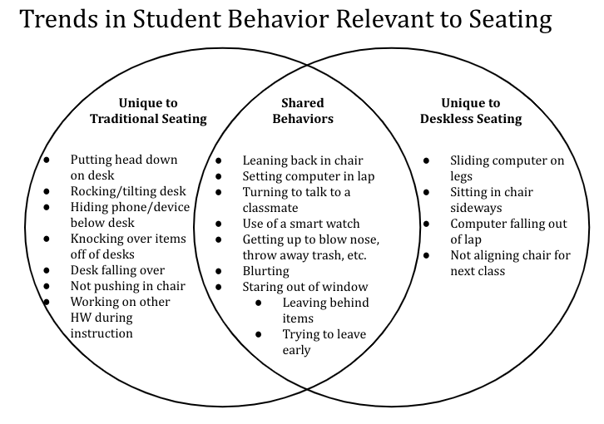
Figure 4.1 Student Behavior Venn Diagram
The behaviors represented in figure 4.1 were chosen because they happened more than once during the two periods and were relevant to classroom seating. There are dozens of behaviors that occur during a single class; and therefore, I had to narrow it down. Also, many of these behaviors are considered “off-task” behavior; however, to be clear, a lot of learning took place throughout the entire length of this study. The majority of these behaviors are very minor things that caused only slight disruptions in class. During both deskless and traditional seating, students were attentive, asked questions, raised their hands, worked well with peers, completed classwork, etc. While the diagram shows that deskless and traditional seating shared many of the same behaviors, what it does not convey is how the seating changed the frequency of these behaviors. The most prominent seating related behavior I found from my field notes during the traditional period was the rocking back and forth of the desks. I had students doing this every day and in every class. In my 4th hour class, at least 25% of the students did this regularly. It might seem harmless, but it is very distracting from the teacher’s point of view and also for other students in the class.
While leaning back or rocking in the chair happened during both deskless and traditional seating, removing the desks significantly reduced this behavior. Before deskless seating, I had students, who in addition to rocking the desk, would lean back in their chair constantly. Many used the bar on the desk (see Appendix E) to push off of and lean back in their chair. It also can be very distracting and also dangerous as students have fallen back completely in my classes before. Leaning back in the chair was even more common than rocking the desk back, and while it did not disappear entirely, I found myself having to correct this behavior fewer times during the deskless seating period.
Another explanation for having to correct leaning back in the chair less, is that students sitting in the back row, close to the cabinets, often like to lean back and rest the back of the chair on the cabinets. With the desks arranged in a horseshoe, around the chairs (see Appendix E), the cabinets were blocked and I never observed students sitting in the back of the classroom resting the back of the chair on the desks. Another decreased behavior was packing up to leave early before class. Students have known to wait until they heard me say the “magic words” before getting up to leave; however, there were always students who would try to pack up their things at the last minute or two of class. Not having their backpacks right next to them helped reduce this behavior, which was beneficial to me as the teacher. Hearing the sounds of backpacks zipping and computers closing while trying to finish the lesson can be very distracting.
Students resting their head on the desk was another behavior that was eliminated. While not as frequent as rocking the desk or chair, it is still very significant to learning. Typically when students rest their heads on the desk, if their head is still up and looking at the board, I will not correct the behavior. Most of the time, after a couple minutes the student sits back up without me having to say anything. Although, when I see a student laying their head down, not looking at the board, I try to approach that student as soon as I can and prompt them to sit up. Sometimes simply getting close to them will do the job, but other times I will have to gently tap their back to let them know I want them to sit up. While falling asleep does not happen very often, I did catch a student asleep with his head down one day while we were reading our class novel together during the traditional seating period. This change in behavior is affirmed in the student surveys, as several students mentioned not liking deskless seating because they did not have something to rest their head on when they got tired.
The other behaviors unique to traditional seating such as hiding a cell phone, knocking over an item such as a water bottle, or tipping the desk over so much that it fell over were not as common as the rocking of desks or chairs. Not pushing in the chair after class was dismissed occured likely every class; however, this was more of an annoyance to me than a behavior that was disruptive to learning. The behaviors related to seating that occured only during the deskless seating period were also not very frequent and/or very disruptive. Overall, students did a fantastic job of aligning their chairs for the next class when they were dismissed. This was a procedure that they practiced when I introduced deskless seating. However, depending on how much the chairs moved around during class, or if a student got checked out early, occasionally the chairs did not get moved back to their original spot. Again, this was just more work for me than a disturbance to the class.
A couple weeks into deskless seating, I saw a new behavior that I had not seen before from students. Occasionally, if students had their laptops closed on their laps, they would extend their legs and slide the computer down their legs and catch it with their feet. This was not a very frequent behavior as I only saw it transpire twice during instruction. Of the solely deskless behaviors, the most disruptive one was the computers falling from students' laps. While disruptive, it was not a very frequent behavior.. It caused a disruption because it made a sound, capturing the attention of the other students in the class. Finally, the most frequent deskless behavior was students turning their bodies to sit sideways in the chair. Students always turned to face in toward the middle of the room, so it was not a behavior that I felt I needed to correct. It was also not a common behavior, as the majority of students in each class faced forward toward the board.
A shared behavior that increased with deskless seating was leaving items behind. It only occured a couple times a week, yet this was an increase from the traditional seating period. This can likely be explained by the lack of a desk in which to store items. Some students would put their water bottle beneath their chair during class, then forget to grab it on their way out, which was more of a hassle than a distraction from instruction. Working with the computers on their laps was another shared behavior that was significantly more frequent during deskless seating for obvious reasons. This did not have any effect on my experience during deskless seating as the teacher. From my field notes, I found no significant increase in other shared behaviors such as turning to talk to a classmate, getting up during class (for personal reasons), blurting, or staring out the window during instructional time. Lastly, it is unclear if students trying to use their smart watches, other than looking at the time, increased or decreased. However, as the teacher, I was able to catch students more easily because I had nothing in the way to obstruct my view. Therefore, it can be concluded that the success of being able to get away with this behavior likely decreased.
Teacher observations on student engagement reiterate the findings from student interviews and surveys. Many of the behaviors mentioned relate directly to student engagement. As discussed, behaviors such as sleeping, checking a cell phone, working on other assignments, or laying a head down, occurred less or not at all during deskless seating. Without changing my lesson plans, my students were automatically more engaged in class as such behaviors are distracting to both the student exhibiting the behavior and their peers. For example, some of my students are so motivated that they like to work on their homework for other classes during my class. During the two-week traditional seating period, I mentioned having to correct this behavior five times. I never mentioned or noticed students working on other work while we were deskless.
With fewer distractions, the most significant indications of student engagement, taken from Johnson, that improved during deskless seating were paying attention, listening, responding to questions, and interacting with other students (2013). None of the other behaviors listed from Johnson worsened with deskless seating. Because the room was much more open with no desks, I noticed how much easier it was for students to collaborate together. Three days into deskless seating I wrote (regarding my third hour):
We started class with a Señor Wooly song. While we were watching the video, I saw students watching and laughing. Removing the desks has eliminated the temptation to do other work or lay your head down. The only thing students could really do to actively not watch a video was hang their head down or stare out the window, which I only saw happen once very briefly during the four minute video. It’s been great for collaboration as the students worked on their classwork together and had plenty of options in class to find a collaborative space. Some boys pulled up their chairs to some empty desks and worked diligently on their classwork. Several girls moved their chairs into a little circle to work together. I’ve never seen them be so willing to work together on assignments before. Even if I told them they can work on an assignment with a partner, this class often would prefer to remain seated at their desks and work alone.
In addition to my field notes, I also kept track of the number of redirects. The traditional seating redirect data was collected across a span of 10 days, and the deskless seating redirect data was across 18 days. The data is organized by class periods, which are all very different in their personalities and behaviors. Second hour has 14 students, 3rd hour has nine, 4th hour has 13, and 7th hour has 12.
CI= Confidence Interval
SD= Standard Deviation
Table 4.6 2nd Hour # of Redirects Data
2nd Hour Redirects
 | Median | Average | CI of Average | SD | Minimum | Maximum
Traditional | 3 | 3.1 | 2.12 to 4.08 | 1.4 | 1 | 5
Deskless | 3.5 | 3.3 | 2.72 to 3.84 | 1.1 | 1 | 5

Table 4.7 3rd Hour # of Redirects Data
3rd Hour Redirects
 | Median | Average | CI of Average | SD | Minimum | Maximum
Traditional | 4.5 | 4.7 | 3.53 to 5.87 | 1.6 | 2 | 7
Deskless | 4 | 4.2 | 3.55 to 4.89 | 1.4 | 0 | 7

Table 4.8 4th Hour # of Redirects Data
4th Hour Redirects
 | Median | Average | CI of Average | SD | Minimum | Maximum
Traditional | 7.5 | 8.1 | 6.37 to 8.83 | 2.4 | 4 | 12
Deskless | 7 | 6.5 | 5.81 to 7.86 | 2.1 | 3 | 10

Table 4.9 7th Hour # of Redirects Data
7th Hour Redirects
 | Median | Average | CI of Average | SD | Minimum | Maximum
Traditional | 6 | 5.7 | 4.63 to 6.77 | 1.5 | 3 | 8
Deskless | 6 | 6.1 | 4.78 to 6.67 | 1.9 | 3 | 10

From the data, deskless seating did not significantly impact the number of redirects given per 45 minute class. It had the biggest impact, only decreasing from 8.1 to 6.5 redirects, in my 4th hour class. This is likely because this class, all year long, has been the worst about being able to sit still in the desks and chairs. Without the desks to rock or push off of to lean back, that was one less behavior that I had to correct with this group of kids.

Discussion
As this is one of the first, if not the first, research studies conducted on deskless seating, there are a significant number of themes to unpack from the data collected. The first research question sought to better understand the relationship between deskless seating and student behavior and engagement. From the data, it is clear that deskless seating had positive effects on both of these topics. As the teacher, my observations affirm what many world language teacher bloggers have expressed. My first day of deskless seating, I felt an anxiety that I do not normally feel. I consider myself somewhat of a “control freak” when it comes to managing my classes, so experimenting with this seating option that was totally foreign to me was intimidating. At some point I realized that teaching to students without desks was no more drastic than all the other radical changes that schools have undergone in the past 20+ years. Like all these other changes, I simply had to adjust and get used to this new normal.
I came in with the expectation that removing the desks would prompt my students to talk nonstop, and that was not the case, as the redirect data validates. Although it did not by any means solve all my behavior problems, the classroom became somewhat easier to manage, as removing the desks took away various distractions. My very competitive and gifted fourth hour students review for tests with an online game called Gimkit. I documented what occurred during deskless seating writing:
I was curious about this class as on days when we play games they get very competitive. They did great though and for some reason, them talking and announcing their score while playing Gimkit didn’t bother me as much as it usually does. We were closer together, so it felt as though no one was talking across the room.
That being said, the importance of being a strong classroom manager is still a key factor to a thriving deskless seating environment. Students expressed how it was so different than what they were used to, and I as the teacher was exposed to student behaviors that were new to me that I had to correct. Student engagement was another major takeaway from deskless seating, as data reflected an increase in student engagement. Many students articulated over and over in the surveys and interviews being able to focus better in class and field notes support this finding. Students saw it as something they enjoyed about deskless seating. Without the desks, students said they felt less distracted, and that it was also easier to concentrate without other students around them fidgeting with the desks. Even something as simple as being able to see the board better is significant, as in my experience, students do not always speak up if they are in a spot in which they cannot see well.
As I show songs and videos on my SMART Board nearly every day, deskless seating helped create a learning environment that was very favorable to my style of teaching, as students could not lay their heads down on the desk, or work on an assignment for another class. I also incorporate lots of interpersonal communication and do not do a lot of writing on paper. Deskless seating worked for me because the aspects that students enjoyed most, we did a lot of, and the aspects they disliked, such as writing, we did not do very often. It is evident that the success of deskless seating is highly dependent upon the teaching style of the teacher. Classes that are discussion heavy could benefit from not having desks for students to hide behind. In contrast, whereas classes that have a lot of writing activities, deskless seating might not be very feasible.
This study did not provide enough data to support any claims as to how deskless seating improves the second language acquisition process. However, there are some positive connections that this study could spark for future research. Deskless seating in this context did indeed align with Vgotsky’s Sociocultural Theory (1978). The favorite deskless activities of students were those that promoted interaction with each other, such as conversation and circle activities. Some students did not enjoy working on the computer or writing on a clipboard, which typically do not involve an interaction with a more capable other. One student in an interview discussed how it was easier to ask a peer for help, and I also noticed more collaboration among students. In regards to ACTFL’s 21st Century Skills, it was only relevant to some of the skills. Effective language teachers can provide and deliver excellent instruction no matter the setup. However, with more space, in my experience, I as the teacher was able to move around the room easier, which helped me be more of a “facilitator/collaborator.” Additionally, deskless seating likely would not work in language classrooms from the past (see Figure 2.2). Grammar drills and exercises, less interaction among students, and heavy reliance on the textbook would have been much harder to do without a desk.
The second half of this study investigated how students felt about deskless seating. The Likert responses in both surveys showed mixed opinions or were not statistically significant. For example, 57% percent of students agreed it was easy to follow the classroom rules with a desk. In the post-survey, 61% of students reported feeling it was easy to follow the rules without a desk. Sixty-four percent of students disagreed that it was hard to concentrate in class with a desk, while 61% disagreed that it was hard without a desk. This data is still valuable, but the open-ended questions provide rich insight into why students might have responded the way they did.
While analyzing the open responses, student personality and motivation are two factors to consider. At first glance, the survey data after experiencing deskless seating indicates very mixed feelings from students. But from the teacher’s perspective, some of the reasons they saw as a con, I saw as a pro, such as not being able to rest their head on their desk, or having to get up and move more frequently throughout class. There are always going to be students in classrooms that want to plop down at the desk and sit there with their head down the whole hour. But students spend so much of the school day sitting down, and need more opportunities to get up and move.
There will also always be students that complain no matter what. Writing on a clipboard was overwhelmingly the aspect of deskless seating that students disliked most, yet this was not an activity that we did very often. Each class had to use the clipboards maybe 3-4 times during the four weeks, as I just do not have students do worksheets on paper very often. Had we been using the clipboards every day, I would be more understanding of their feelings regarding the clipboards. Finally, after all was said and done, when asked what they would change about deskless seating, the overwhelming response by students was not to bring back the desks, but rather to allow free seating. From the post and pre-surveys, it is clear that the most important factor to students related to seating was sitting by friends.
Like the students, this was also my first exposure to deskless seating. I do not consider myself to be an expert on this topic, and going forward there are things that I would troubleshoot in order to improve the students’ experiences. However, being that I implemented this into my classes without spending any money or receiving any training on it, the positive changes I noticed are encouraging for other teachers that are interested in trying out this seating option. It was by no means the perfect seating arrangement, but the improvements that both the students and I noticed in engagement, the freedom to move, and the space it gave us, were worth the minor inconveniences it caused. There are so many devices that can distract a student that did not exist twenty years ago, and this is a trend that is only going to increase in the future. Classrooms, schools, teachers, and students are always evolving. Many fancier and contemporary seating options are out there, but there was something about the simplicity of deskless seating that I, and many students, really enjoyed.

Chapter Five: Conclusion
There are many different seating styles and arrangements that a teacher can elect for their classroom. Physical space, class size, age of students, class personality, teacher personality, subject taught, and learning styles of students are just a few of the many factors teachers should consider for their class. Every classroom is different, and therefore, not every seating option works for every classroom environment— including deskless seating. Removing the desks has become popular among world language teachers because of the belief that students are more engaged and have the freedom and flexibility to move around. This can be beneficial in classrooms in which the goal is to promote communication in the target language, as removing the desks creates a more human-like experience. While teachers in this area have expressed success with deskless seating, research must be conducted to support or challenge these claims. This action research study will be just one of the many that need to be administered on deskless seating.
This study sought to understand how deskless seating affected student behavior and engagement, as well as student opinions of this new seating option. Through field notes, student surveys, and interviews, the data collected revealed mixed, but overall positive student and teacher experiences with deskless seating. Regarding student behavior, deskless seating eliminated some behaviors while introducing new ones. While there were no major changes in the number of redirects, deskless seating eliminated more disruptive behaviors than it created. And while it did not remove all disruptive behaviors, it did make managing shared behaviors easier for the teacher. Without the desks to hide behind, the use of cell phones was virtually non-existent, and the use of smartwatches decreased as it was much more difficult to conceal this behavior.
Both students and I found that through deskless seating, it was much easier to move around the room. Therefore, as the teacher, I was able to move around the room more while teaching, which can also help reduce disruptive behavior. It was easier to focus without students rocking the desks back and forth, and many students expressed how the elimination of this behavior helped them concentrate more in class as well. Through field notes and student feedback, deskless seating increased student engagement. First, it automatically eliminated the ability to lay their head down in class. Second, it created an environment that had fewer distractions overall. Students were less likely to disengage through the use of smart devices and or working on other work. Chair rocking was also a decreased behavior during deskless seating, which also created fewer distractions.
Students' opinions towards deskless seating were mixed, but data collected from student interviews and surveys provided some positive takeaways. Students enjoyed deskless seating for many reasons such as less distraction, a change of pace, the openness of the room, the freedom of movement, and the comfort. That being said, the biggest problem with not having a desk that students voiced was having to write on a clipboard, using a computer on a lap, and not having a desk on which to lay their heads or other personal belongings. From the teacher's perspective, the aspects of deskless seating that students enjoyed or and the ways they were more engaged in class far outweigh the elements that they disliked.
As with any seating option or arrangement, the teacher must consider what seating best serves their classroom needs. Unlike all alternative seating options, deskless seating is very cost-effective, as the furniture needed is likely already in the classroom. Many of today’s schools struggle to afford basic classroom supplies, much less new and innovative classroom furniture. Deskless seating is a powerful tool for teachers to know about, because it is a virtually free way to better engage students in the class.

Limitations
The first limitation of this study is the class size of participating classes, which ranged from nine to 14. Unfortunately, most class sizes are at least double that amount. Therefore, I had to manage a significantly fewer number of students, which could have contributed to my positive experience with deskless seating. With only 15 chairs, it also made it relatively easy for me to straighten up the room in between classes if any chairs were not aligned for the next class. However, by removing just 15 desks, students and I noted how much more open the room felt and how much easier it was to move around the room. Therefore, that same effect would be even more powerful in a classroom with 30 desks. The classroom was more comfortable for me to manage, making it much harder for students to sleep and use devices at inappropriate times. Therefore, the classroom was easier to manage, which could be encouraging for teachers that have larger classroom sizes.
With smaller class sizes, the sample size was also small, as less than 50 students took surveys and were interviewed. Therefore, the student opinions of deskless seating reflected in this study make it challenging to generalize for a larger population. Also, the classroom furniture is another limitation to consider in this study. In my classroom, the chairs and desks were separated from each other, and therefore rocking the desks and chairs was a regular behavior. For classrooms that have different furniture, like desks and chairs that are attached, that behavior might be less frequent; therefore, deskless seating might not have that significant of an impact. Comfort was something that was mentioned in both the pre and post-surveys as something meaningful for students regarding classroom seating. Thus the comfort of furniture could also affect student perceptions in a different classroom.
Additionally, it is essential to note that this study took place at a private school in which the genetic makeup of the school was not as diverse as other schools in the area. Some schools are much more diverse and, therefore, might have different needs. Due to the high costs of attending school, the majority of the students came from middle to upper-class families. With motivation being such a significant factor in SLA Theory, my students could likely see themselves using Spanish, either in their future careers or travels. In contrast, not all students in other school settings are necessarily fortunate enough to have the same opportunities available to them. Therefore, a world language class might mean something different in other schools than it does in mine. Lastly, the final limitation of this study is that data collected through field notes was highly reliant on my memory. This was the only option, as filming classes was not a possibility and having a classroom observer take notes for such an extended period was not very realistic. Because I had to take notes while teaching at the same time and at the end of the day, there are observations that I likely missed or forgot to mention.

Implications for Future Research
Despite its popularity, deskless seating is a topic that has yet to be thoroughly researched in the field of education, likely due to it only being around for the past couple of years— at least in world language classrooms. Because little to no research exists on this topic, it is extremely important, as it continues to grow in popularity, that research is conducted on a variety of students in order to improve the student and teacher experiences. Additionally, such research would help educators interested in deskless seating make a well-informed decision regarding the seating option best suited for their particular classes. Therefore, it is safe to say that any research conducted on deskless seating would be beneficial to the field.
A larger-scale study could be replicated in classrooms with more common class sizes and in different contexts such as rural, urban, suburban, public, private, etc. in order to affirm or challenge the results from this study. As the participants in this study were in 7th-8th grade, studies including high school age students would be valuable as not all schools have/require world language classes in elementary or middle school. Deskless seating up until this point has remained popular, for the most part, within the world language field. However, many students expressed feeling more engaged in the class, which is promising for all classroom teachers. Therefore, teachers in other disciplines will need to be willing to try it out in their classrooms to understand if deskless seating is conducive to learning in different types of classes.
For the world language field, in order to justify deskless seating to parents, students, and administrators, more research must be done that connects the link between removing the desks and second language acquisition. A study investigating how deskless seating affects a learner's willingness to communicate in the target language would be constructive. Another suggestion is to examine the relationship between deskless seating and the use of the target language during class. Additionally, a more extensive study should be considered in order to better understand the degree to which deskless seating increases student engagement. This could be done by examining a classroom where the teacher utilizes traditional and deskless seating. If possible, a study that observed the same lesson being taught to groups of students that had different seating could provide valuable insight into this relationship.
The success of deskless seating in this classroom could serve as a springboard for teachers wanting to try out other forms of nontraditional seating. Mobile desks and chairs are starting to become popular classroom seating options, and therefore more research could be conducted on seating options that increase movement and how that affects learning. Going forward, if deskless seating continues to remain a popular seating option for teachers, training and workshops will need to be offered in order for teachers to feel confident and prepared to manage a deskless classroom. If more teachers knew about this seating option and knew how to implement it effectively, teachers of all fields could use it in their classrooms, even if it was just for a specific activity.
Lastly, this research study hopes to inspire other teachers of all subjects and age groups, to conduct action research in their classrooms, no matter the topic. Action research needs more voices from K-12 teachers. The more action research studies published, the more we break down the divide between those who teach and those who conduct research. The path to action research can involve many obstacles that make it more challenging to bring the study to fruition, but should still be considered as a valuable contribution to the field of educational research.

References
Allen, C., Anderson, Christine J., Sartini, Emily, & Szyjka, Sebastian. (2018). Flexible Seating: Effects of Student Seating Type Choice in the Classroom,ProQuest Dissertations and Theses.
Cárdenas, E. (2016, November 11). Retrieved from https://www.desklessclassroom.com/2016/11/deskless-year-2-thoughts-and-ideas.html
Cole, P. G., & Chan, L. K. (1994). Teaching principles and practice. New York: Prentice Hall.
Creswell, J. W., & Creswell, J. D. (2018). Research design qualitative, quantitative, and mixed methods approaches. Los Angeles: SAGE.
Dörnyei, Z. 1994. ‘Motivation and motivating in a foreign language,’ Modern Language Journal 78: 273–84.
Eiland, T. T. (2017). Walk right in, sit right down: Seating in the college english literature classroom (Order No. 10623822). Available from ProQuest Dissertations & Theses Global. (1964806794). Retrieved from https://search-proquest-com.ezproxy.lib.ou.edu/docview/1964806794?accountid=12964
Ellis, R. (1991). The Interaction Hypothesis: A Critical Evaluation.
Emre Debreli, Inara Ishanova & Chris Sheppard (Reviewing editor) (2019) Foreign language classroom management: Types of student misbehaviour and strategies adapted by the teachers in handling disruptive behaviour, Cogent Education, 6:1, DOI: 10.1080/2331186X.2019.1648629
Erz, S., Conn, Daniel R., Crackel, Robert, & Kana, Erik. (2018). Impact and Implications of the Flexible Learning Environment in the At-risk Secondary Classroom, ProQuest Dissertations and Theses.
Gest, S. D., & Rodkin, P. C. (2011). Teaching practices and elementary classroom peer ecologies. Journal of Applied Developmental Psychology, 32, 288–296. doi:10.1016/j.appdev.2011.02.004.
Gest, S. D., Madill, R. A., Zadzora, K. M., Miller, A. M., & Rodkin, P. C. (2014). Teacher management of elementary classroom social dynamics: Associations with changes in student adjustment. Journal of Emotional and Behavioral Disorders, 22, 1–12. doi:10.177/1063426613512677.
Gremmen, M., Berg, C., Segers, Y., & Cillessen, H. (2016). Considerations for classroom seating arrangements and the role of teacher characteristics and beliefs. Social Psychology of Education, 19(4), 749-774.
Havig, J., Conn, Daniel, Kana, Erik, & Morris, Timothy. (2017). Advantages and Disadvantages of Flexible Seating, ProQuest Dissertations and Theses.
Jabeen, M., & Imam, S. (2018). Educators Take a Field Trip to Finland. Islamic Horizons, 47(2), 31-32.
Johnson, B. (2013, November 2). How Do We Know When Students Are Engaged? Retrieved from https://www.edutopia.org/blog/student-engagement-definition-ben-johnson
Karbowski, D. (2018, August 12). Teachers Spend $740 Each Year on Classroom Supplies, Up 23 Percent Since 2015. Retrieved from https://www.adoptaclassroom.org/2018/08/12/teachers-spend-740-each-year-on-classroom-supplies-up-23-percent-since-2015/
Kerdikoshvili, N. (2012). Student-centered approach to classroom management in english language teaching. Journal Of Education, 1(2), 53–60.
Kormos, J., Kiddle, T., & Csizer, K. (2011). Systems of Goals, Attitudes, and Self-related Beliefs in Second-Language-Learning Motivation. Applied Linguistics, 32(5), 495–516. doi: 10.1093/applin/amr019.
Krashen, S. D. (1982). Principles and practice in second language acquisition
Kuo, Ming, Browning, Matthew H.E.M., & Penner, Milbert L. (2018). Do Lessons in Nature Boost Subsequent Classroom Engagement? Refueling Students in Flight. Frontiers in Psychology, 8, 2253.
Lemley, J., Schumacher, G., & Vesey, W. (2014). What Learning Environments Best Address 21st-Century Students’ Perceived Needs at the Secondary Level of Instruction? NASSP Bulletin, 98(2), 101-125.
Long, M.H. (1981), INPUT, INTERACTION, AND SECOND‐LANGUAGE ACQUISITION. Annals of the New York Academy of Sciences, 379: 259-278. doi:10.1111/j.1749-6632.1981.tb42014.x
Marx, A., Fuhrer, U. & Hartig, T. (199). Effects of Classroom Seating Arrangements on Children's question-asking. Learning Environments Research 2, 249–263.
McCarthy, C. (2019, November 20). Anxiety in Teens is Rising: What's Going On? Retrieved February 24, 2020, from https://www.healthychildren.org/English/health-issues/conditions/emotional-problems/Pages/Anxiety-Disorders.aspx
Morrone, A. S., Ouiment, J. A., Siering, G., & Arthur, I. T. (2014). Coffeehouse as classroom: examination of a new style of active learning environment. New Directions for Teaching and Learning, 137, 41-51.
National Standards in Foreign Language Education Project (U.S.), & American Council on the Teaching of Foreign Languages. (2015). World-readiness standards for learning languages. Retrived from https://www.actfl.org/sites/default/files/publications/standards/World-ReadinessStandardsforLearningLanguages.pdf
Placido, K. (2019, February 13). Trending toward deskless . Retrieved February 22, 2020, from https://fluencymatters.com/trending-toward-deskless-by-kristy-placido/
Renegar, K., Kuhne, Gary, Barton, David, & Combs, Jurgen. (2018). , ProQuest Dissertations and Theses.
Sahlberg, Pasi. (2011). Lessons from Finland.(improvements in Finland's education system). Education Digest, 77(3), 18-24.
Saville-Troike, M., & Barto, K. (2018). Introducing second language acquisition. Cambridge: Cambridge University Press.
Schilling, D., Washington, K., Billingsley, F., & Deitz, J. (2003). Classroom Seating for Children With Attention Deficit Hyperactivity Disorder: Therapy Balls Versus Chairs. American Journal of Occupational Therapy, 57(5), 534-541.
Schilling, D., & Schwartz, I. (2004). Alternative Seating for Young Children with Autism Spectrum Disorder: Effects on Classroom Behavior. Journal of Autism and Developmental Disorders, 34(4), 423-32.
Snow, K., & McFadden, C. (2017, December 12). Generation at risk: America's youngest facing mental health crisis. Retrieved February 24, 2020, from https://www.nbcnews.com/health/kids-health/generation-risk-america-s-youngest-facing-mental-health-crisis-n827836
Swender, E., & Duncan, G. (1998). ACTFL Performance Guidelines For K-12 Learners. Foreign Language Annals, 31(4), 479-491. doi:10.1111/j.1944-9720.1998.tb00593.x
Tollefsen, W., Caputo, Dr. John S., Davis, Dr. Elizabeth, Hazel, Michael, & Popa, Adrian. (2017). Launching the 21st Century Learner: Exploring the Connections of a Coffee Shop Style Classroom and Affective Learning on the Young Adolescent Student, ProQuest Dissertations and Theses.
Twenge, J. M. (2017). IGen: why today's super-connected kids are growing up less rebellious, more tolerant, less happy--and completely unprepared for adulthood. New York: Atria Books.
Voelker, R. (2014). Steep Increase in ADHD Diagnoses. JAMA, 311(6), 565-565.
Vygotsky, L. S. (1978). Mind in society: The development of higher psychological processes Cambridge, Mass.: Harvard University Press.
Weinhold, A. (2016, December 1). Retrieved from https://misclaseslocas.blogspot.com/2016/12/why-my-classroom-does-not-have-desks.html
Wong, H. K., Wong, R. T., & Seroyer, C. (2009). The first days of school: How to be an effective teacher. Mountain View, CA: Harry K. Wong Publications.

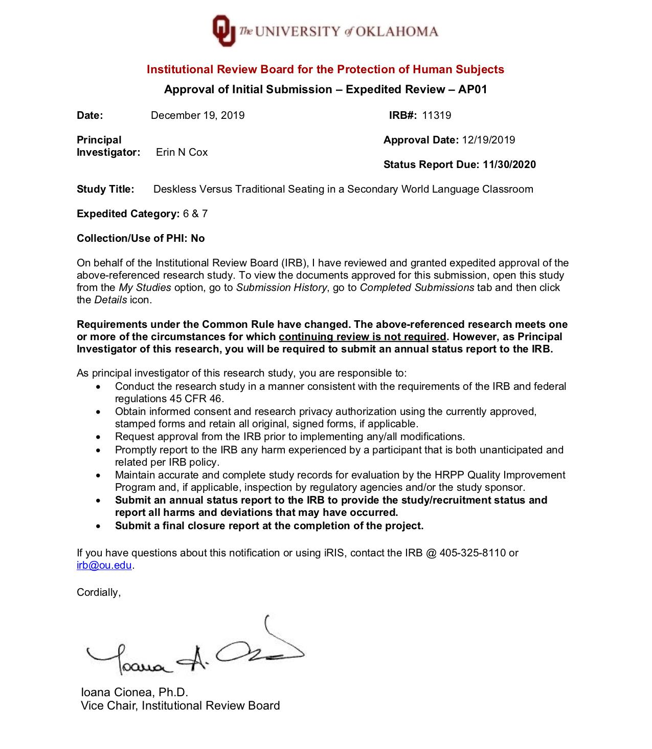
Appendix A: IRB Approval Notice

Appendix B: Student Assent Form
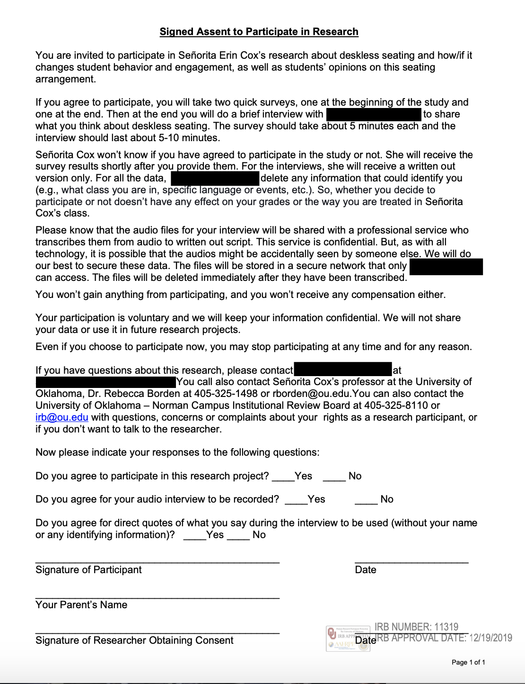

Appendix C: Parental/Guardian Consent Form
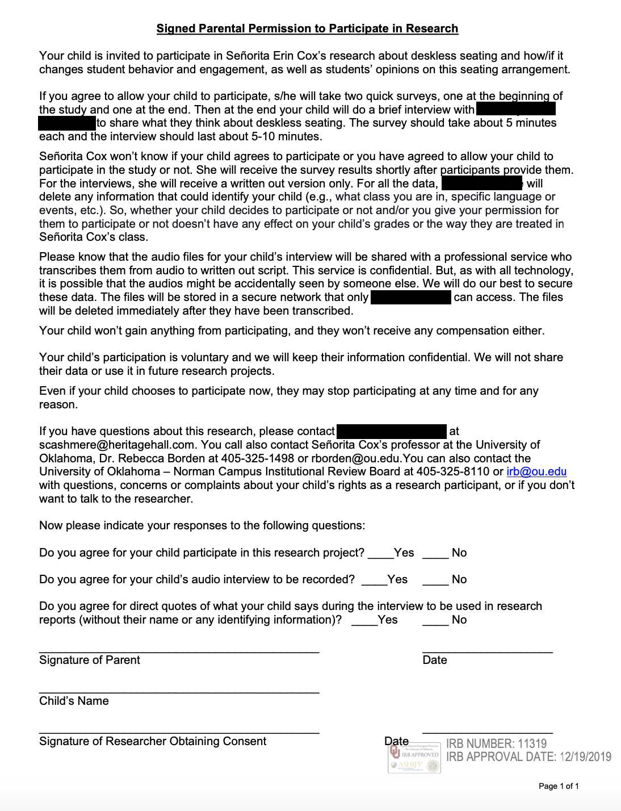

Appendix D: Letter to Parents / Guardians
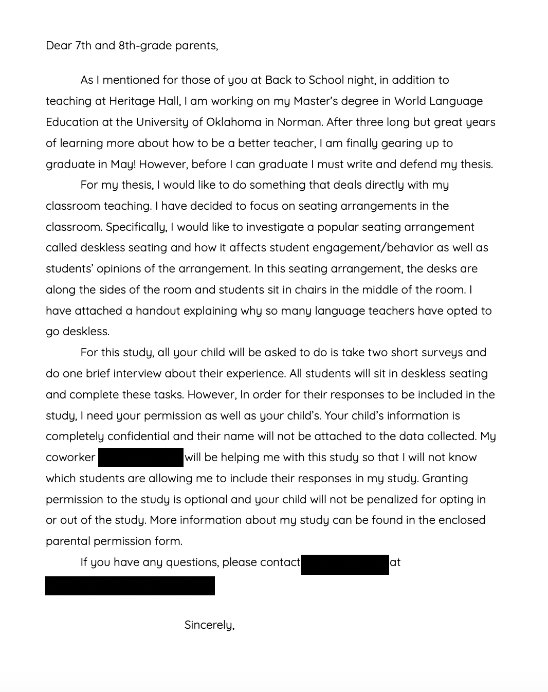

Appendix E: Photos of Classroom
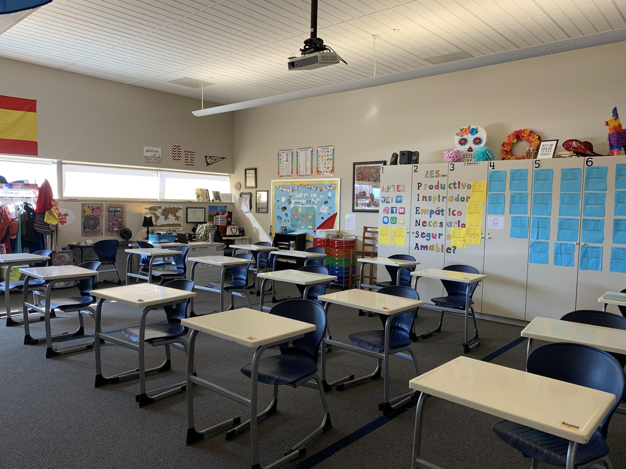

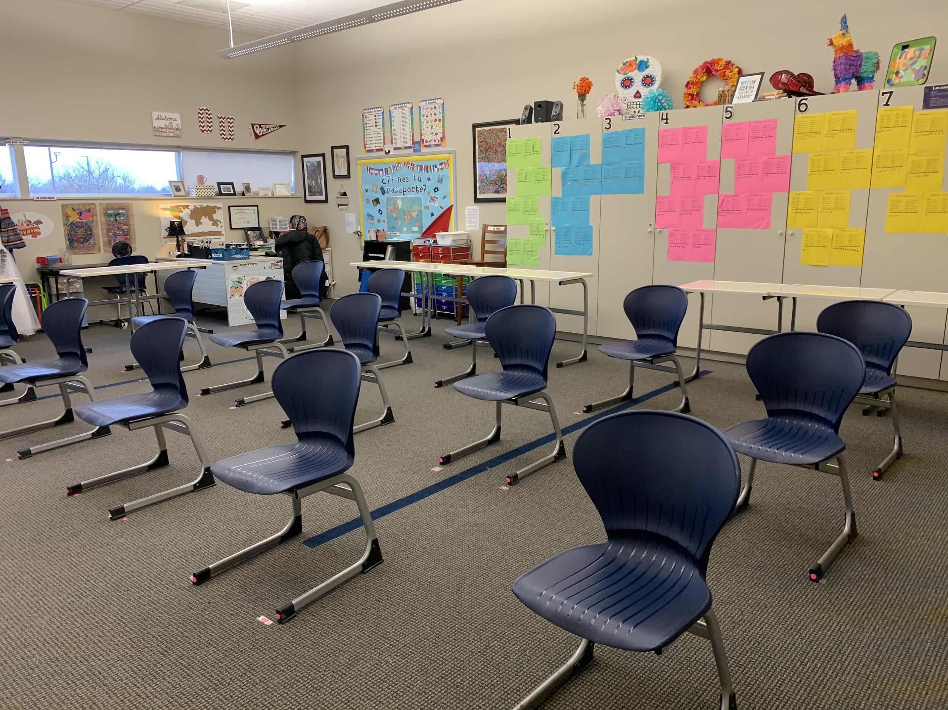
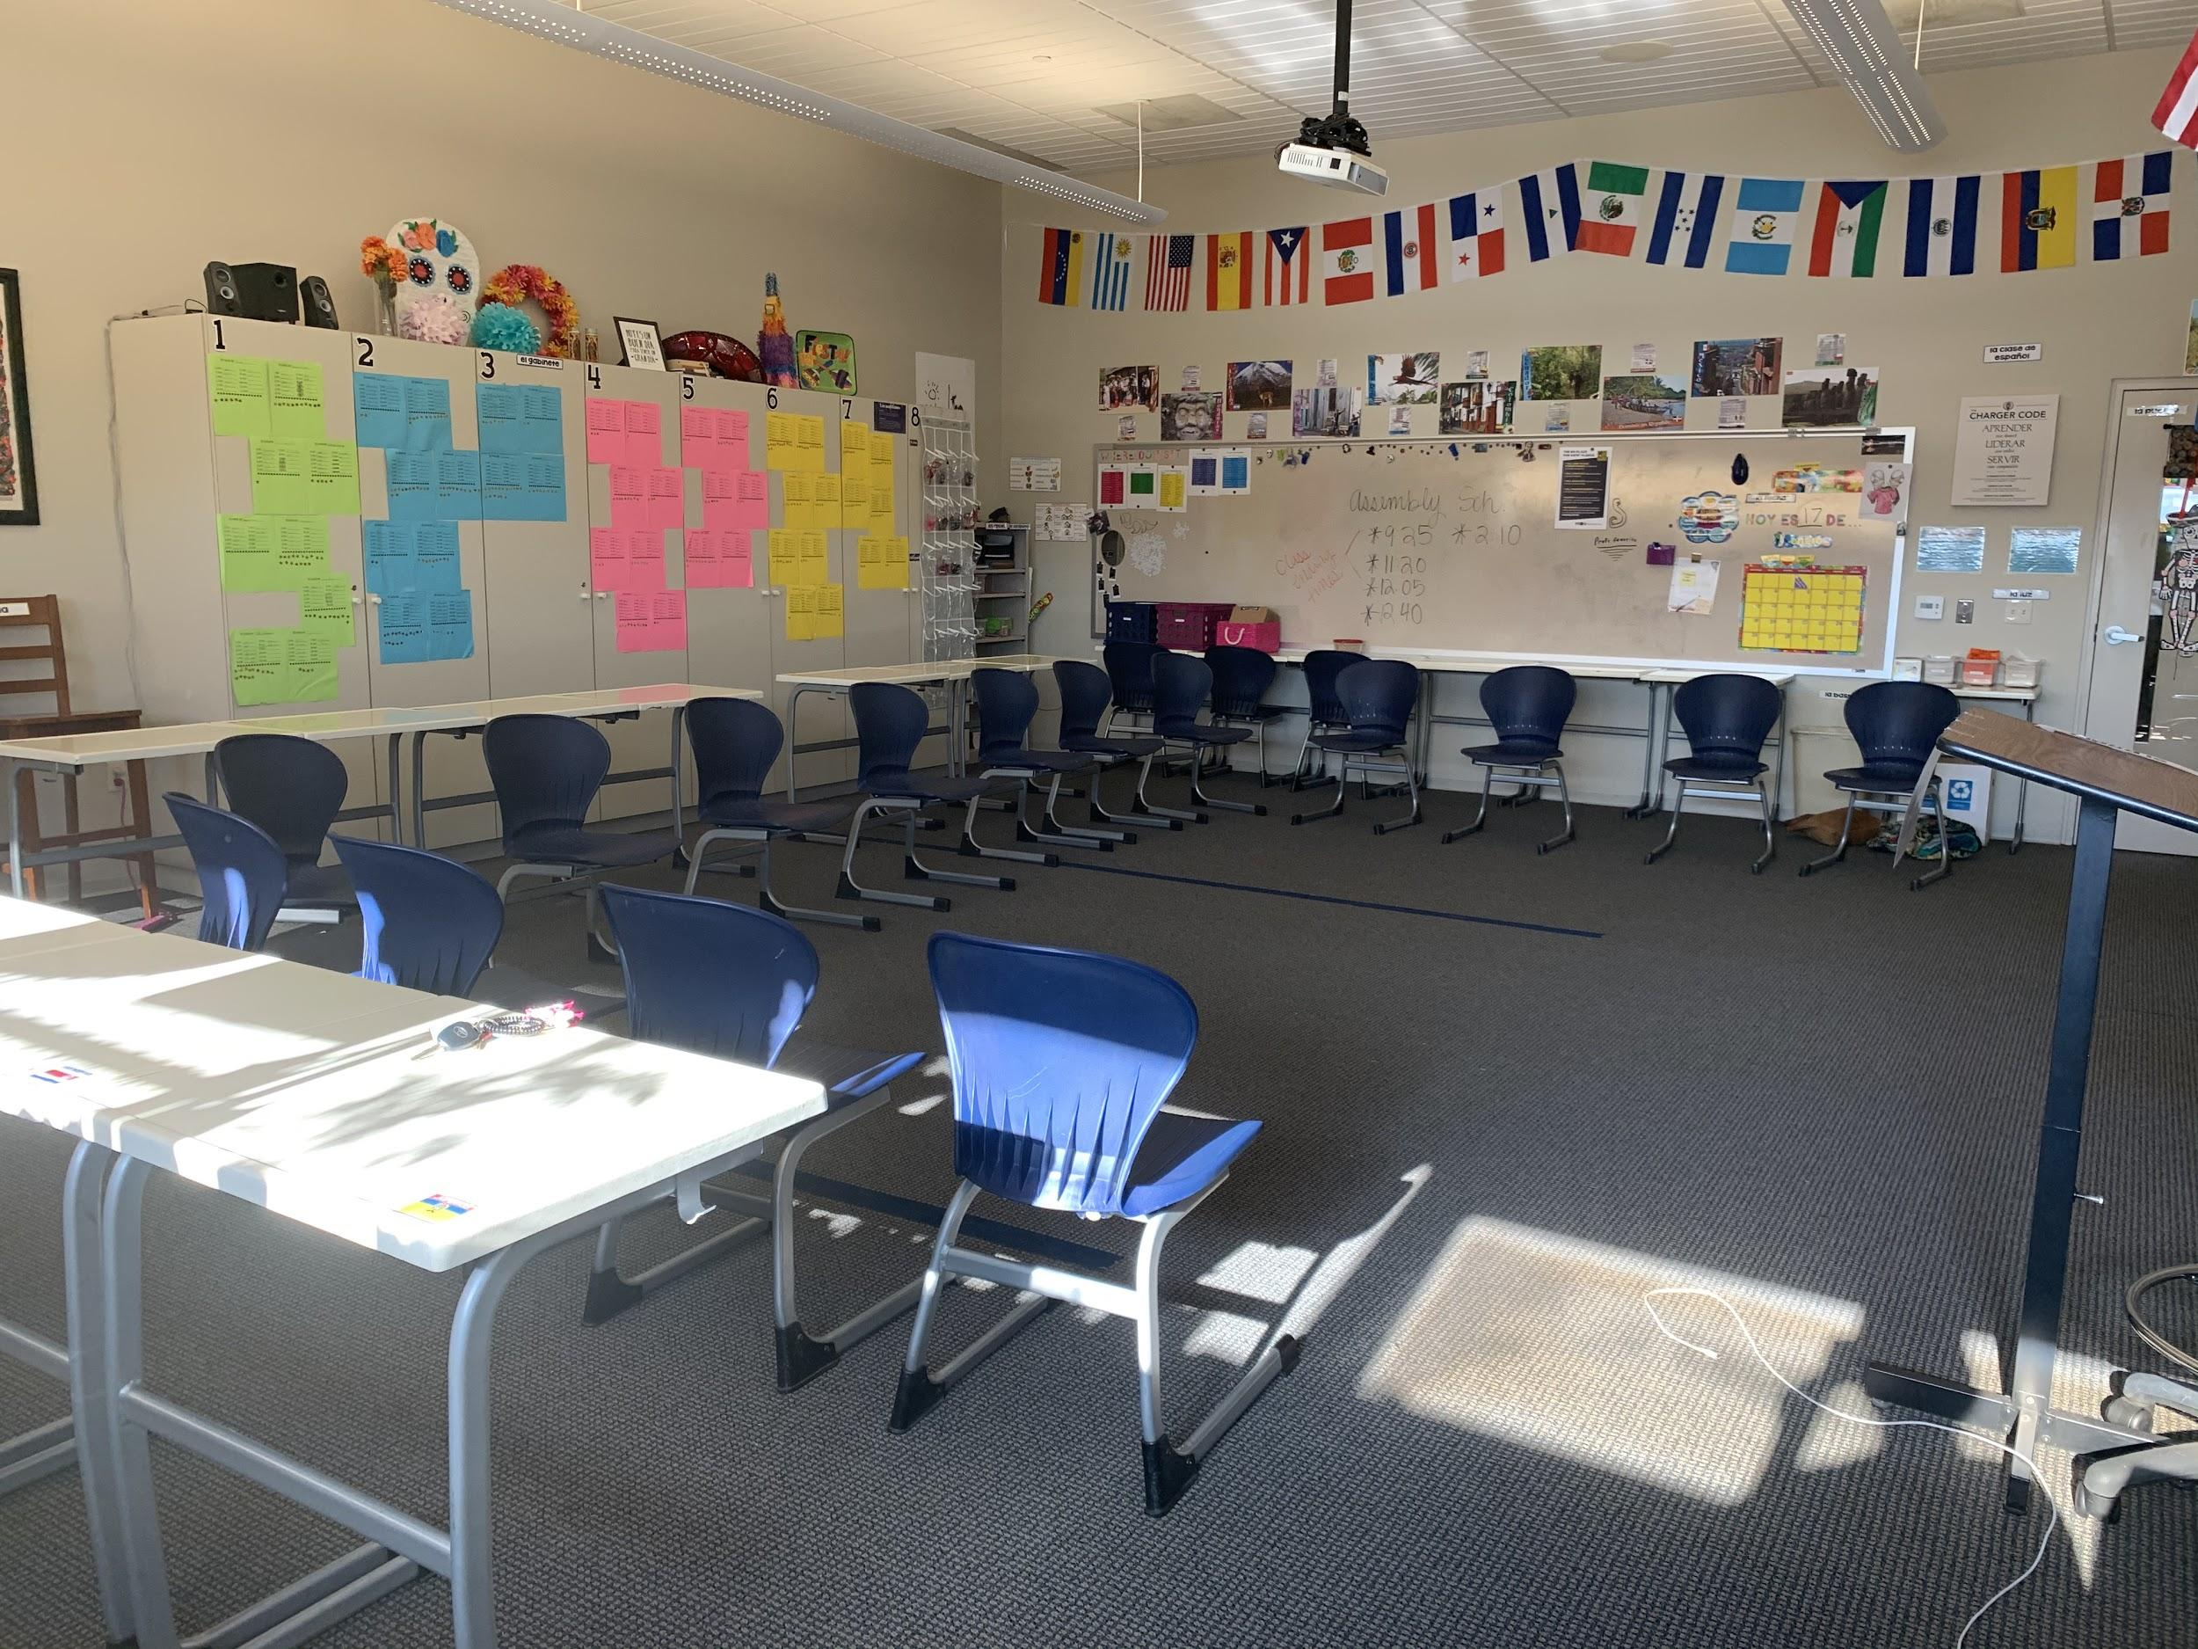
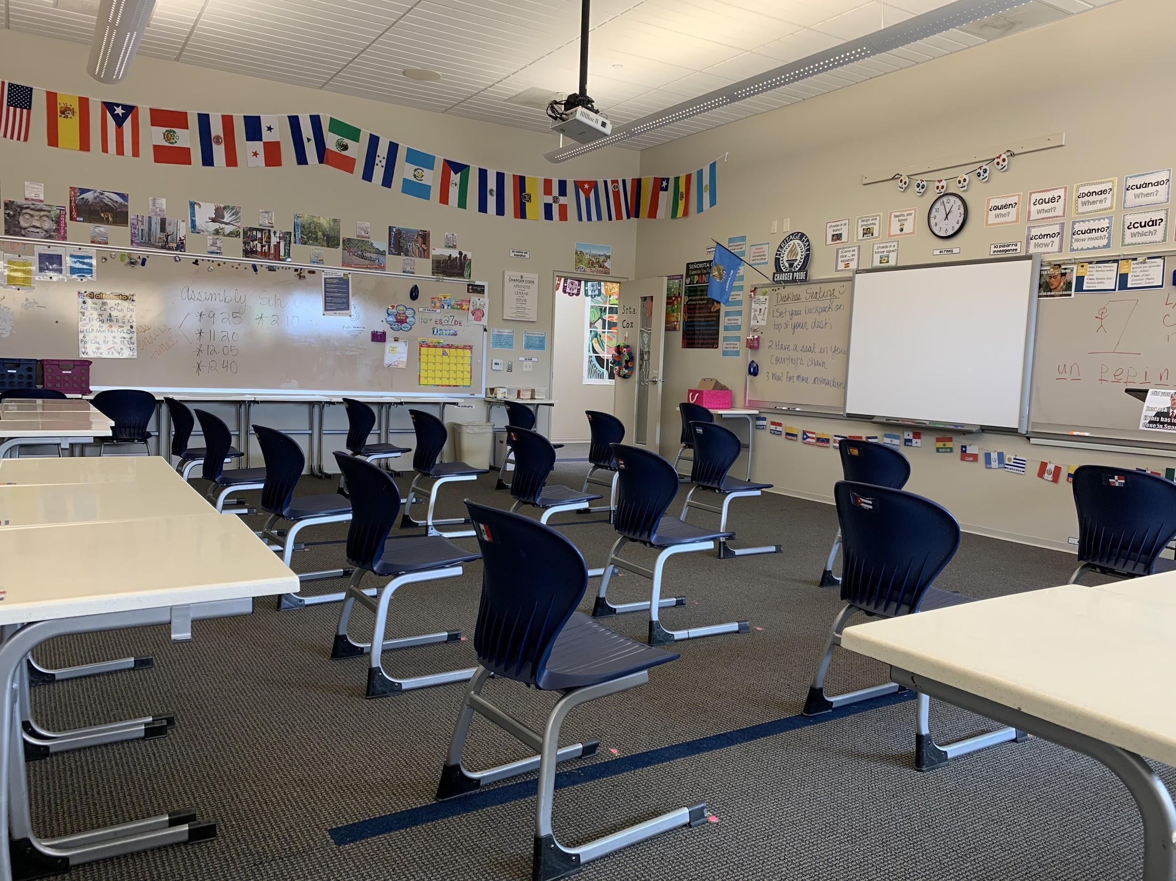

Appendix F: Pre-Deskless Survey
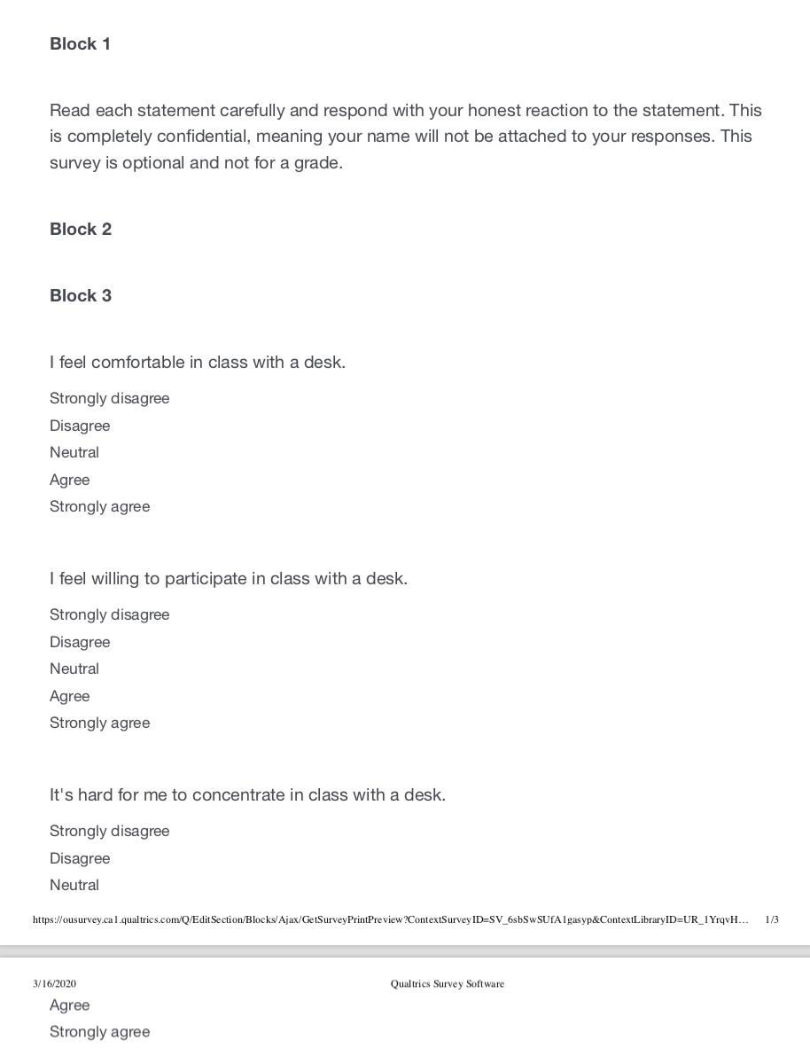

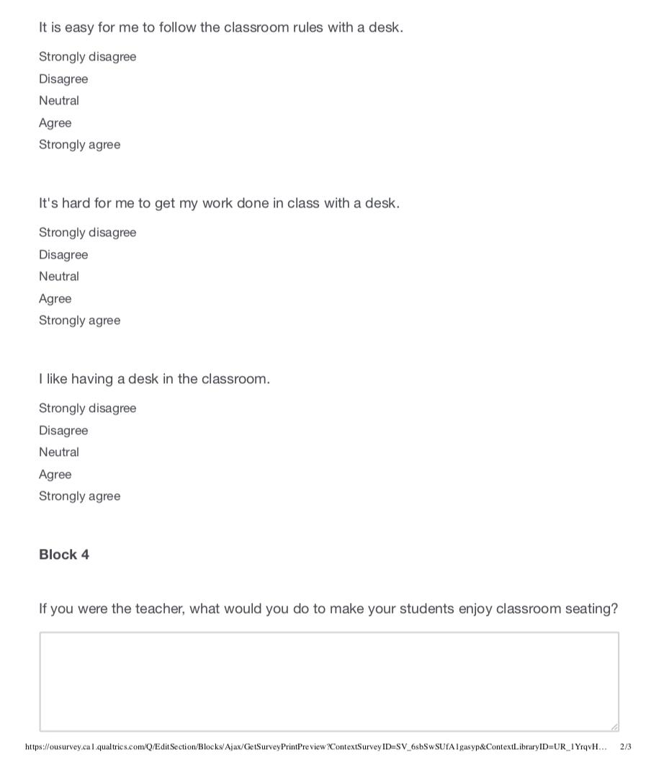

Appendix G: Pre-Deskless Survey Results
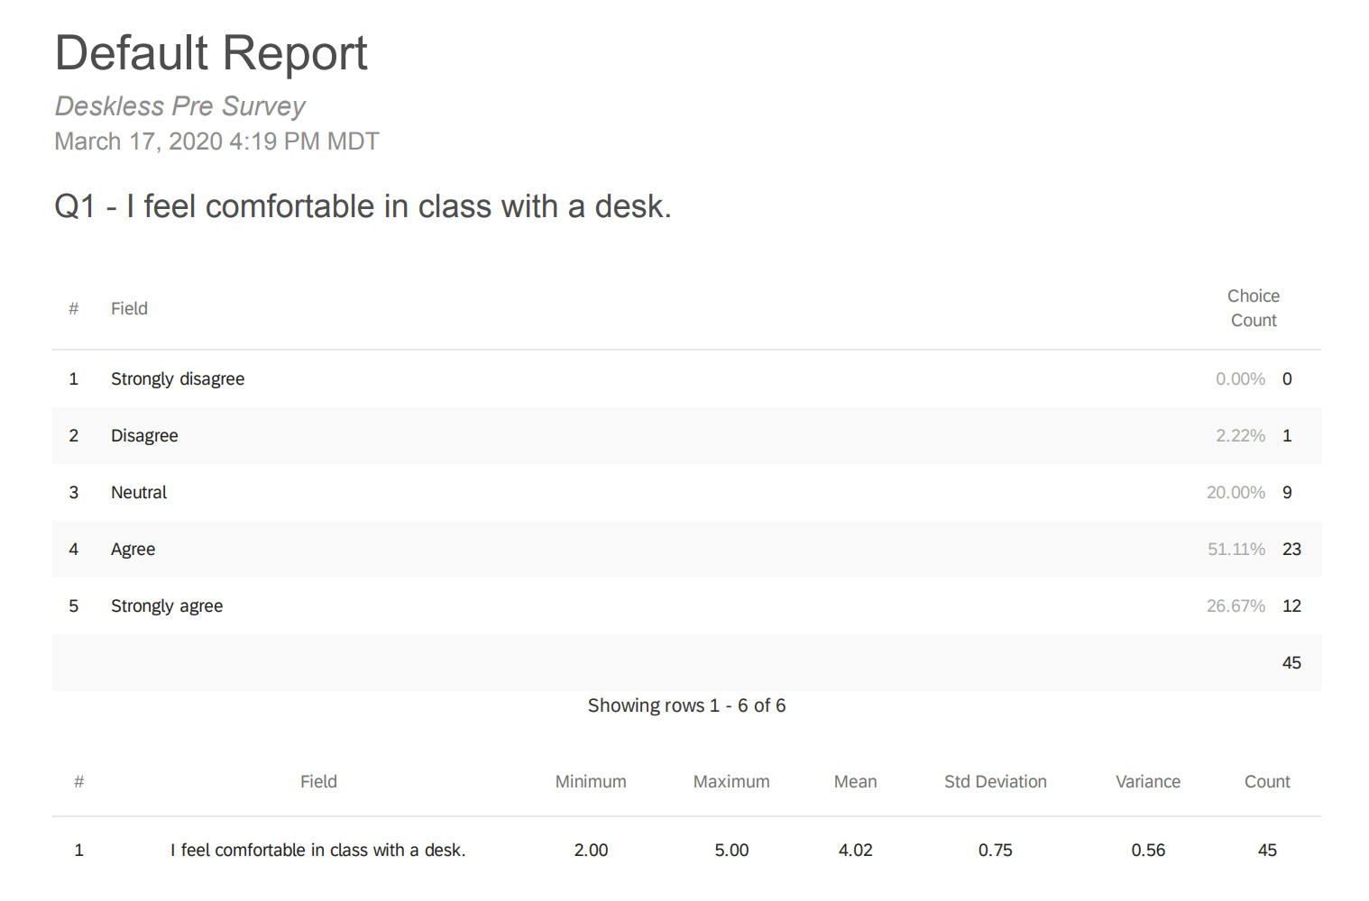

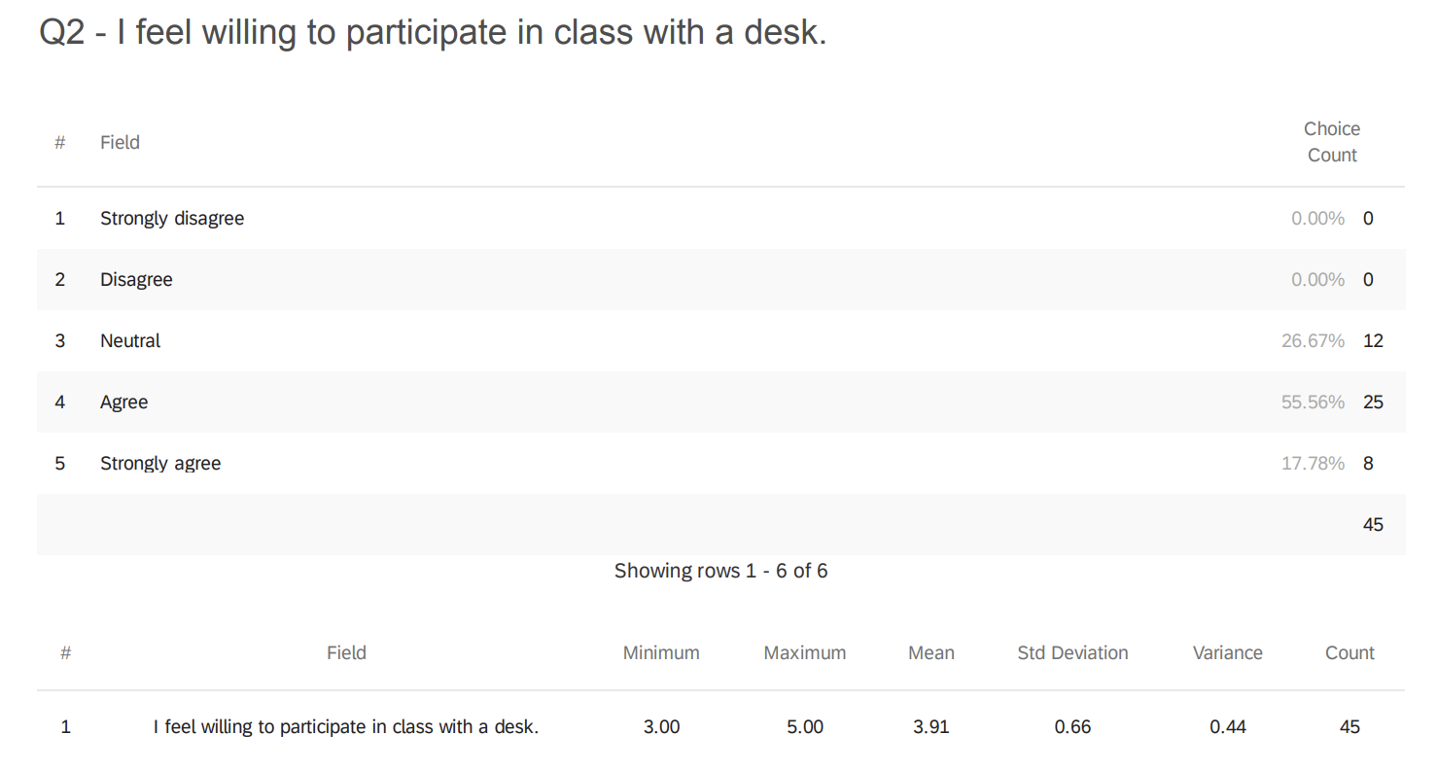

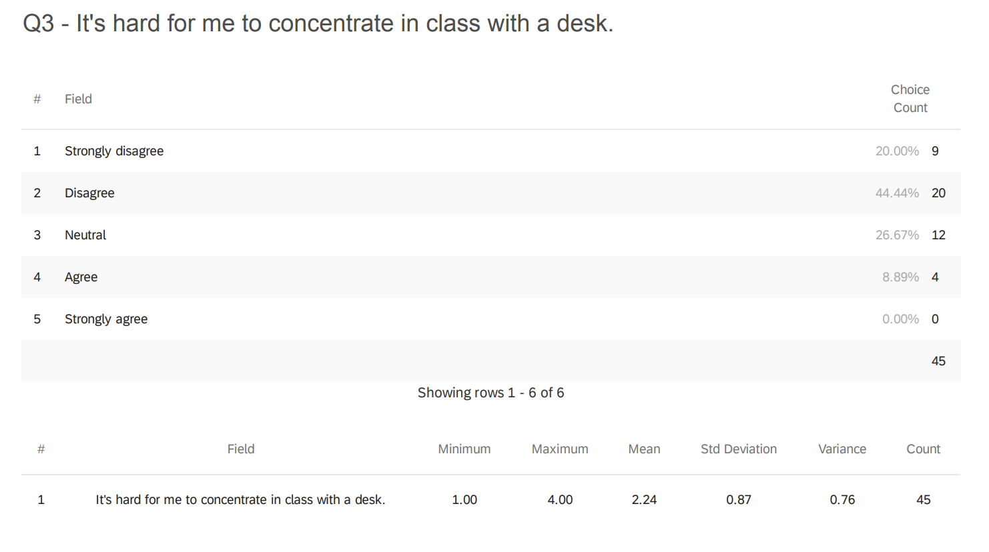
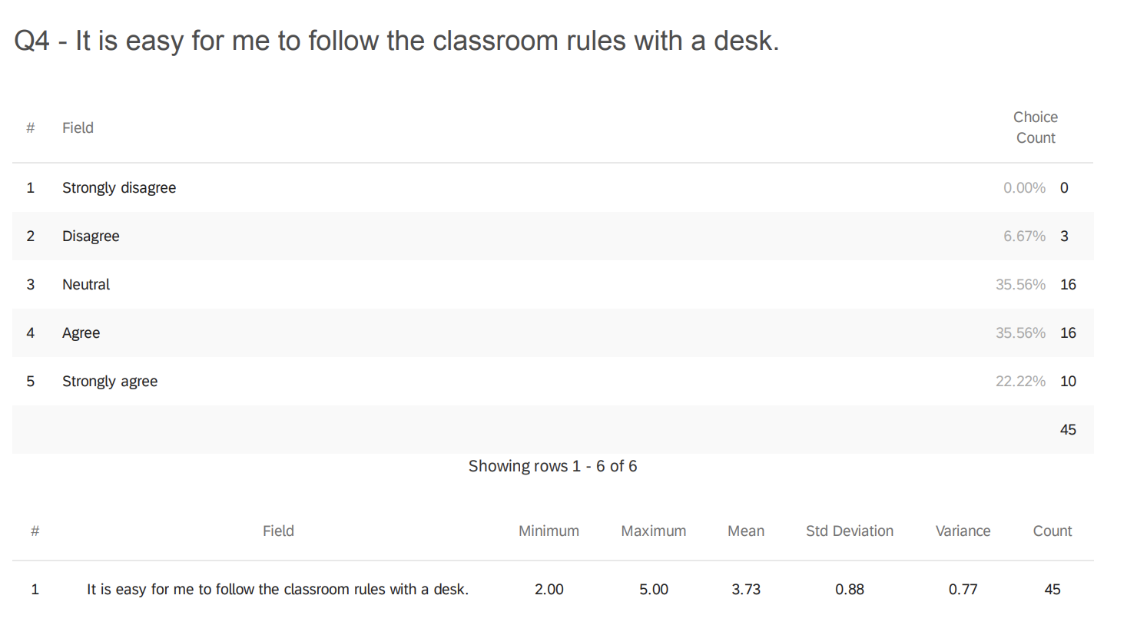
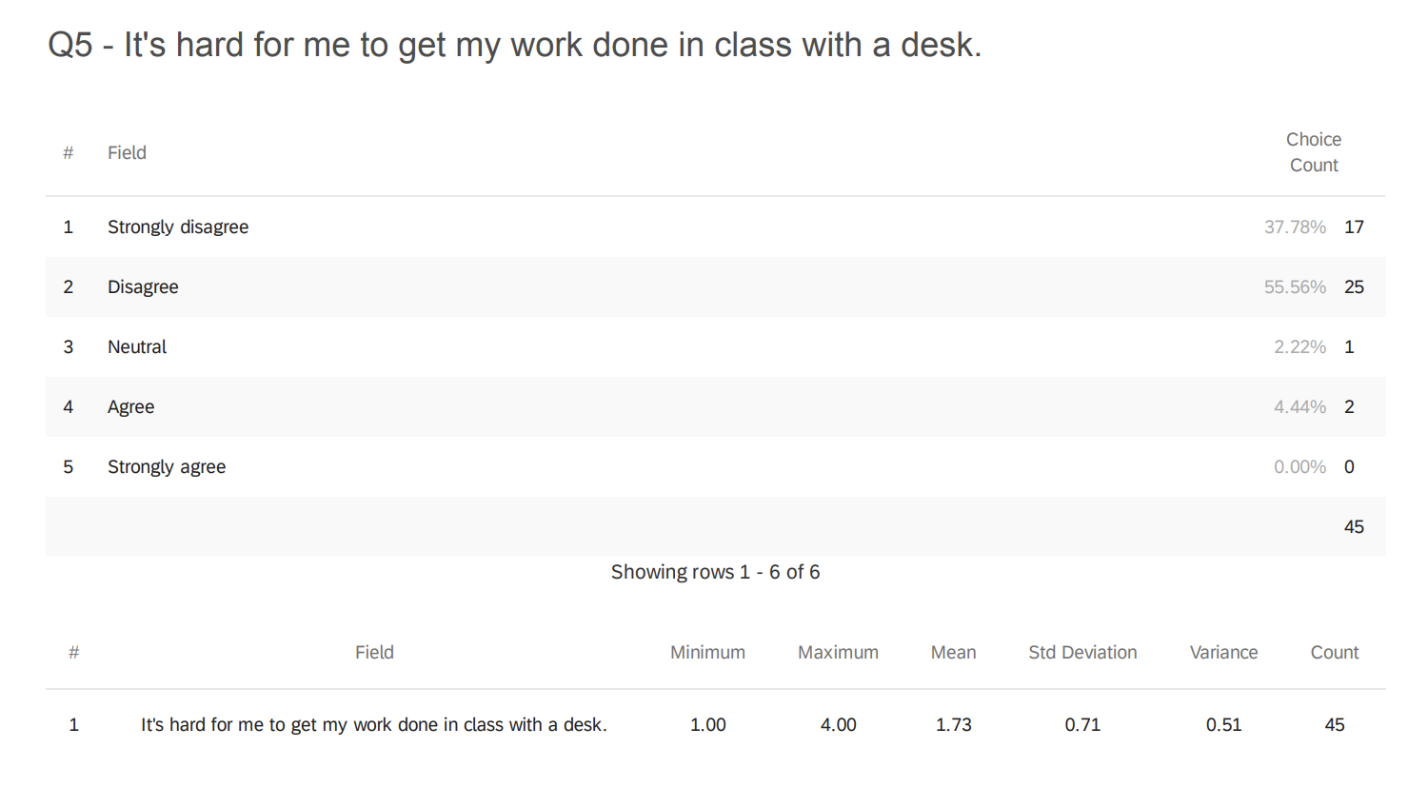

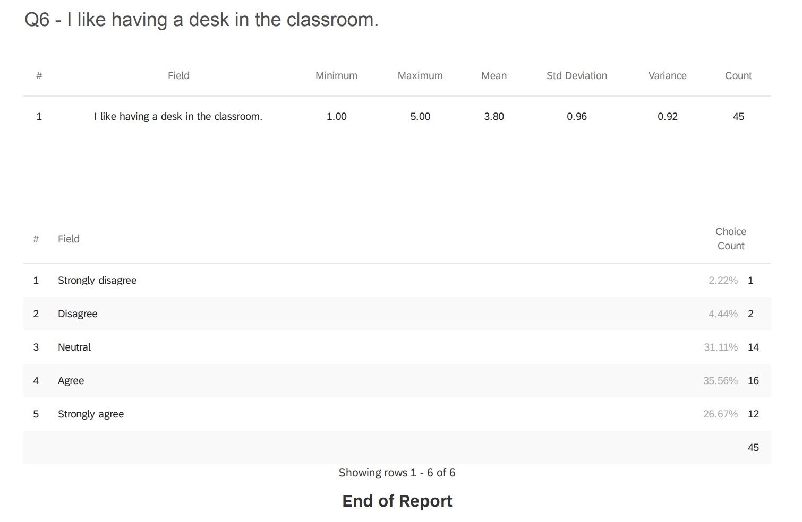

Appendix H: Post-Deskless Survey
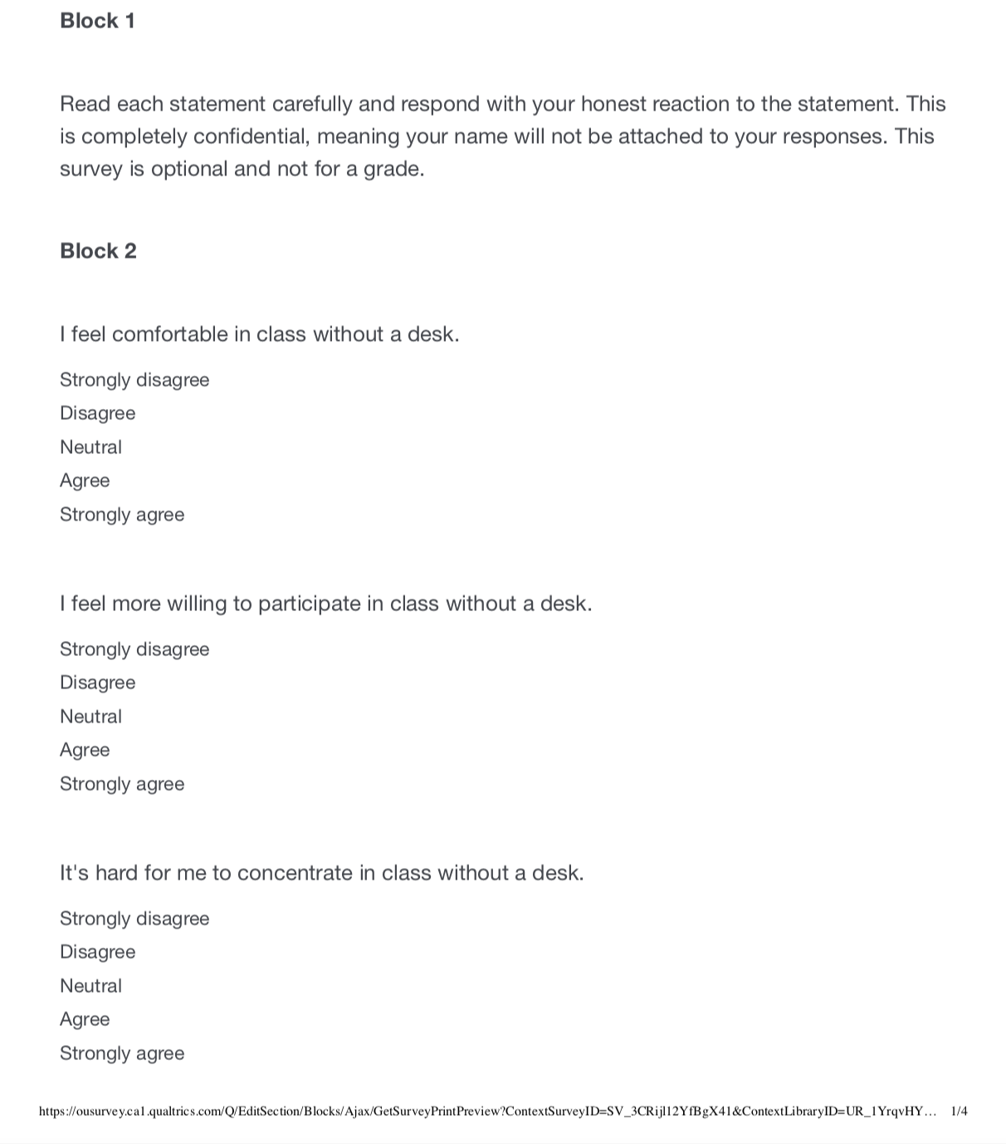
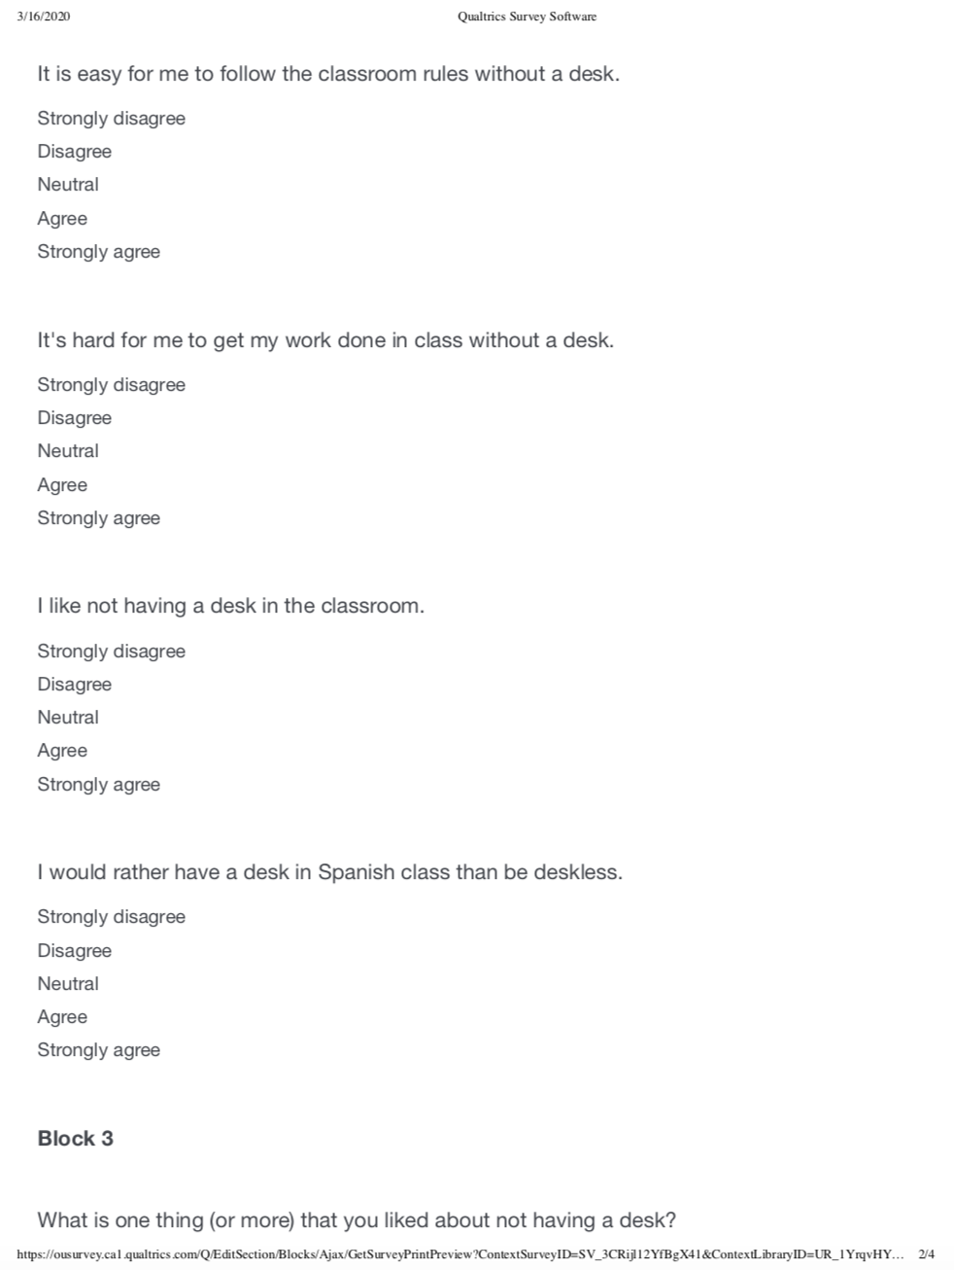

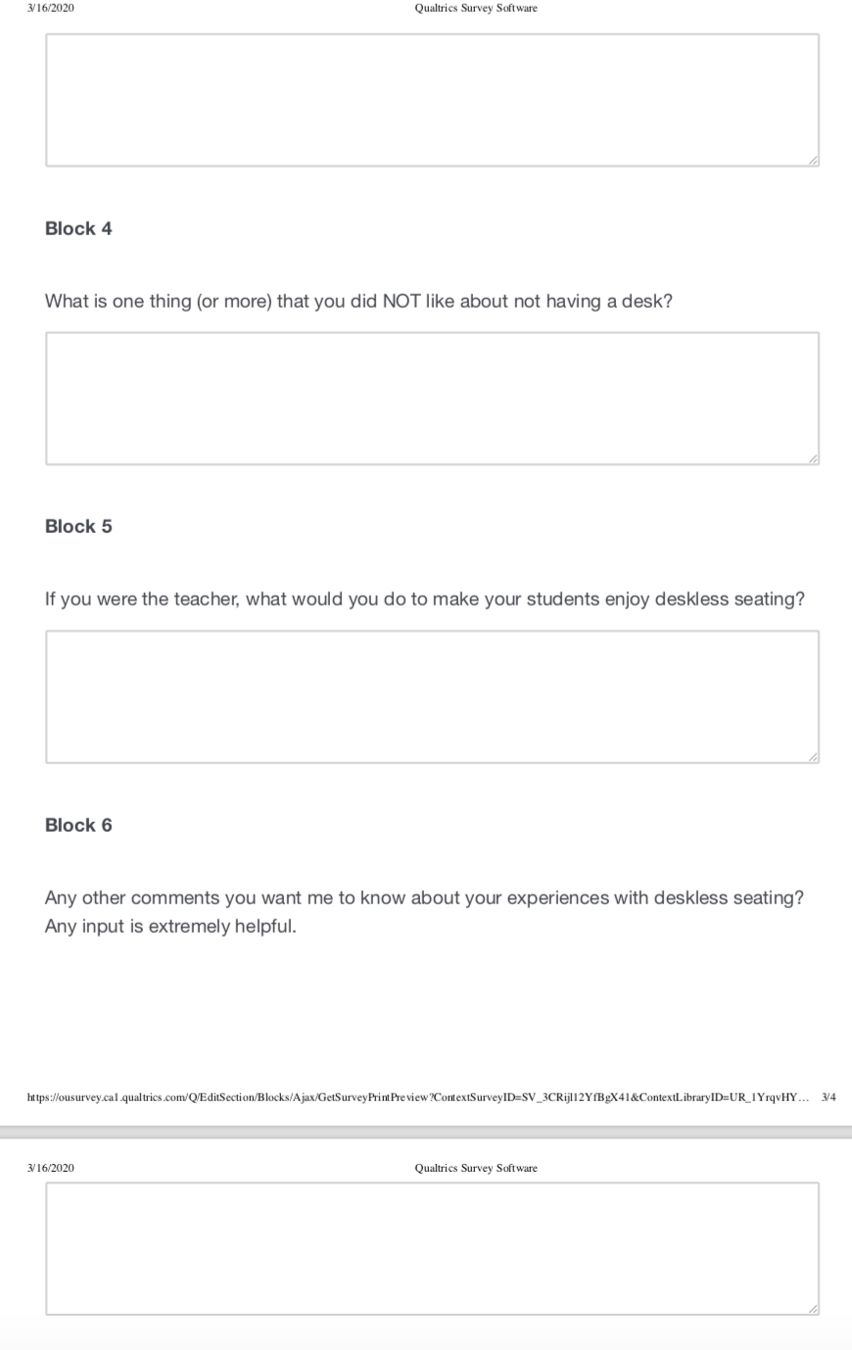Appendix I: Post-Deskless Survey Results
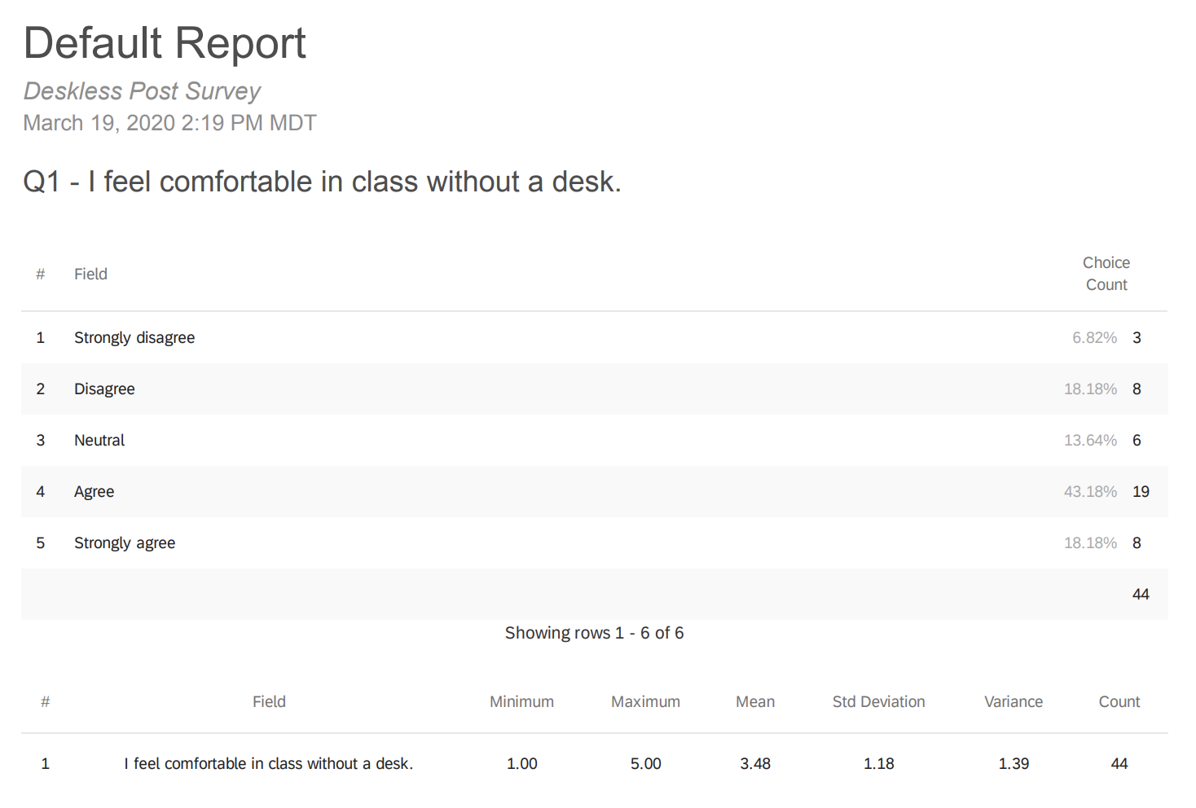

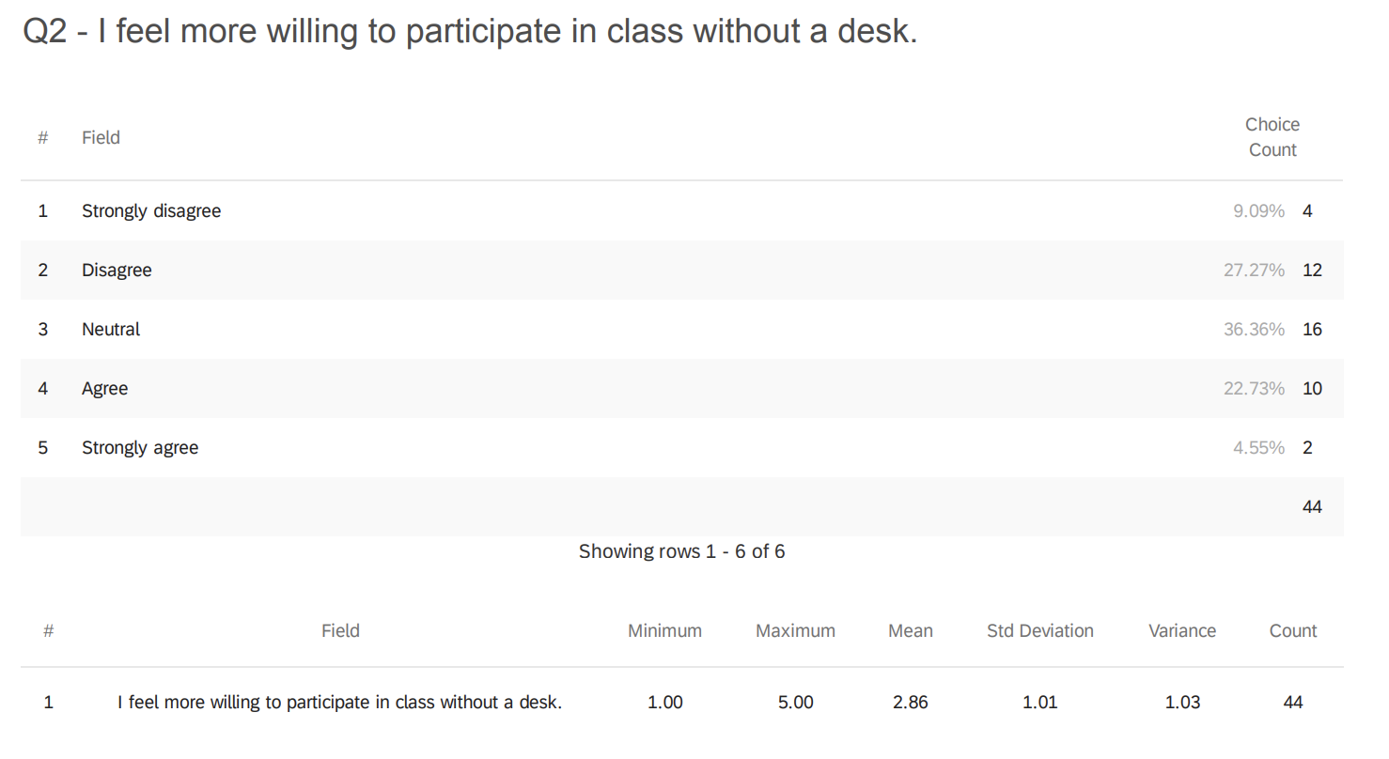
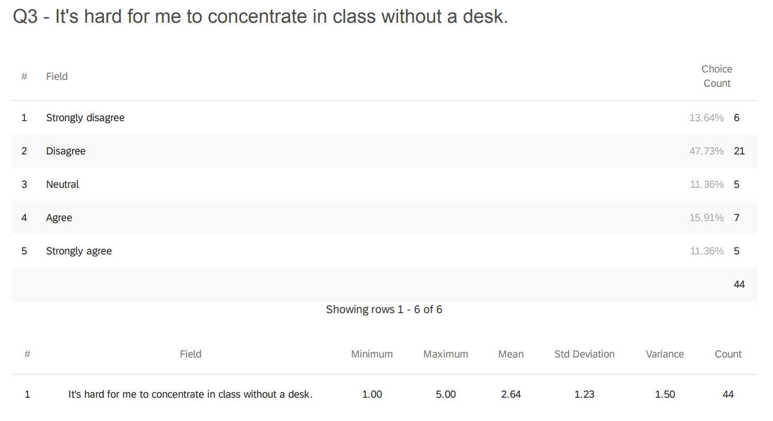

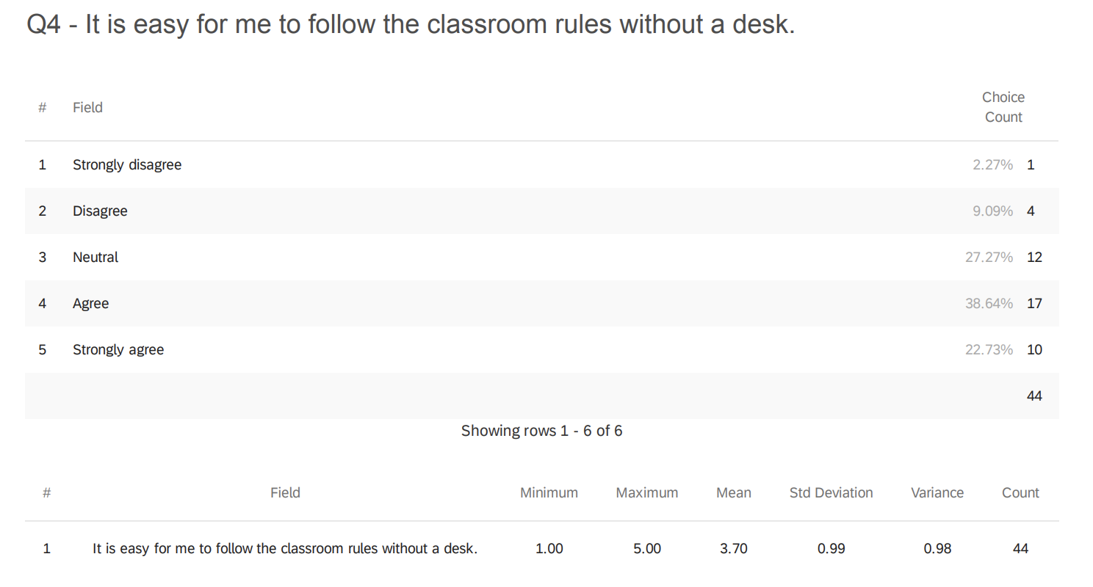

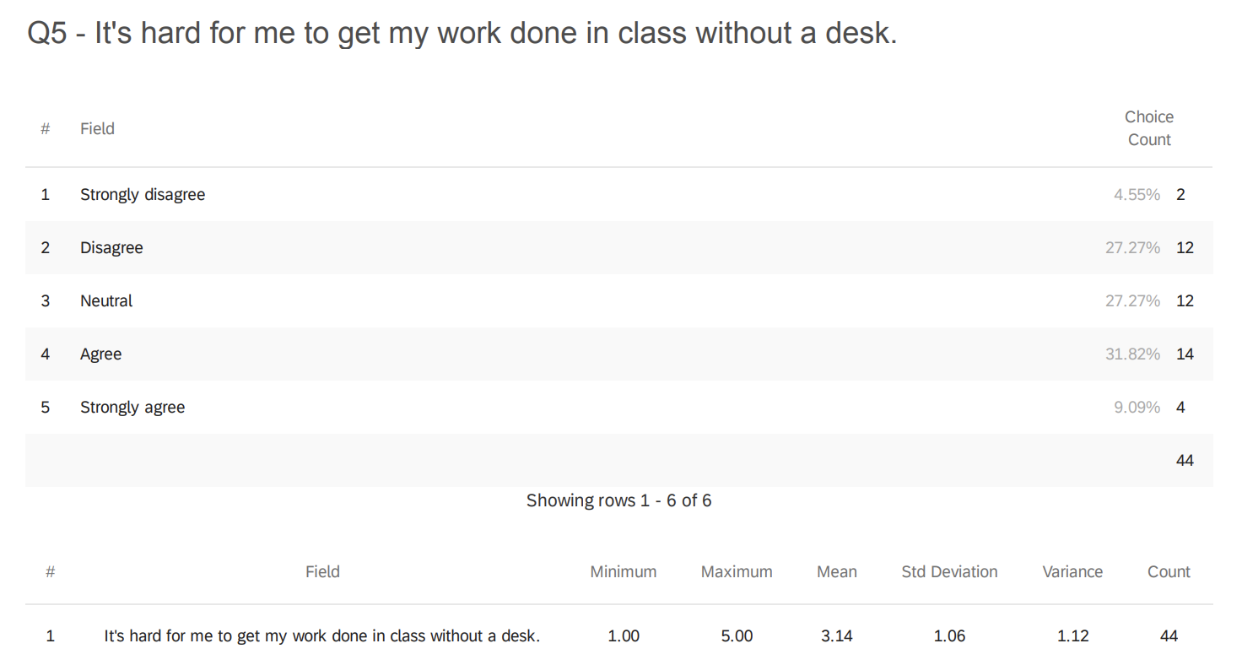

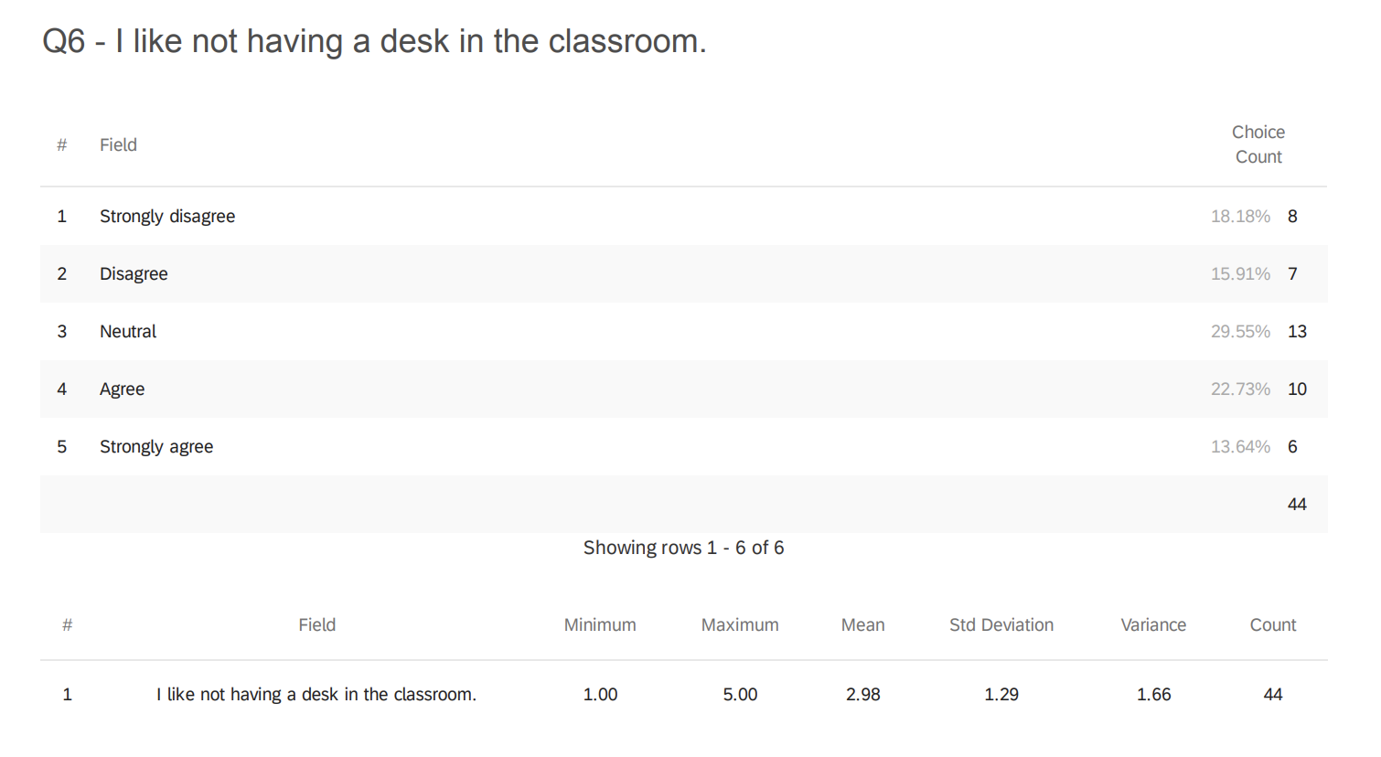

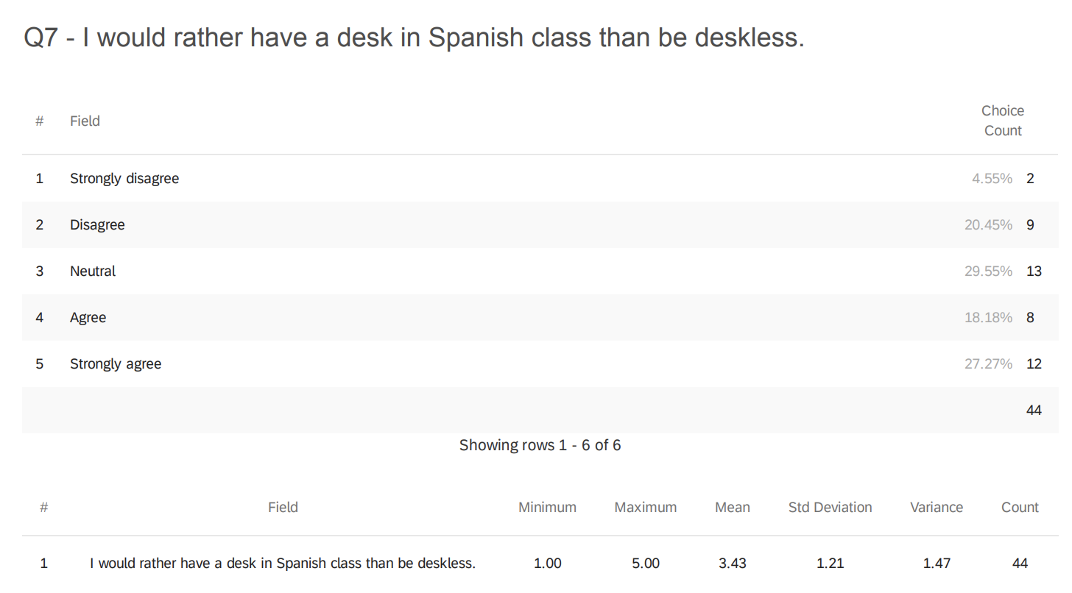

Appendix J: Interview Protocol and Questions

These interviews will be collected one on one in Victoria’s room. The interview will be recorded on a voice recording device and should last 5-10 minutes per student. Every student will be interviewed. I will not be present during the interview. Once down, the recording will be sent to a transcription service to be transcribed.

Victoria’s Script:
Hi __________. My name is Sra. McCormick and I will be conducting this interview about your experience with deskless seating. Please know that your interview will be recorded and transcribed for research. Your name will be removed and Srta. Cox will only read the interview after I give her the transcriptions. She will not know whose interview is whose. This recording will be deleted after it is transcribed. Please answer as honestly as possible and know that this interview is optional and you can request to stop it at any time. Your responses are completely confidential.

- How did deskless seating change Spanish class for you?
- How did you feel without a desk?
- What activities did you enjoy without desk?
- What activities did you not enjoy without desk?
- In your opinion, what are the pros of deskless seating?
- In your opinion, what are the cons of deskless seating?
- Would you like to continue with deskless seating? Why or why not?

Appendix K: Non-Disclosure Agreement for Audio Transcriptions

