University of Oklahoma

Graduate College

Leadership and social dynamics at brackett (34ck-43):
An Archaeological Study oF a mississippi period mound site In Eastern Oklahoma

A thesis

submitted to the graduate faculty

in partial fulfillment of the requirements for the

Degree of

Master of Arts

By

Nicole elizabeth kusnierz
Norman, Oklahoma
2016

Leadership and Social Dynamics at brackett (34ck-43):
An Archaeological Study Of a mississippi period mound site In Eastern Oklahoma

A thesis approved for the
Department of Anthropology

By

______________________________
Dr. Patrick Livingood, Chair

______________________________
Dr. Scott Hammerstedt

______________________________
Dr. Marc Levine

© Copyright by nicole elizabeth kusnierz 2016
All Rights Reserved.

Acknowledgements

I would like to start by thanking my family, who have supported me my whole life and in my pursuit of an unconventional career path in archaeology. My older sister, who already went through the whole graduate school and thesis writing process, provided me more support and guidance than anyone else. I do not know what I would do without my family and I appreciate everything they have done for me.
To my committee: Drs. Patrick Livingood, Scott Hammerstedt, and Marc Levine. Thank you all for your help throughout this research and writing process. Patrick has been a phenomenal chair, who provided an endless amount of support, positivity, and guidance since day one on graduate school. Scott has been the most amazing mentor and helped me stay positive during the rougher days of this work. Marc’s outside perspective, skill, and knowledge helped make my thesis as strong as possible. I would also like to thank Drs. Amanda Regnier and Sheila Bobalik Savage from the Oklahoma Archeological Survey for their encouragement, knowledge, and recommendations.
A special thank you to the Caddo Nation of Oklahoma and the Wichita and Affiliated Tribes of Oklahoma for allowing me to conduct my research and the opportunity study your heritage. I hope my research will contribute to your understanding of your past and the history of the region.
Thanks go out to the faculty and staff from the Oklahoma Archeological Survey, the University of Oklahoma’s Department of Anthropology, and the Sam Noble Museum of Natural History (SNOMNH) for all the support I received.
Finally, I would like to express my appreciation to all my friends and fellow students from the Anthropology department. They provided an endless amount of support and were great resources to bounce ideas off of prior to completing this thesis.

Table of Contents

Acknowledgements iv
Table of Contents v
List of Tables viii
List of Figures ix
Abstract x
Chapter 1 : Introduction 11
The Brackett Site (34CK-43): A Brief Overview 11
Research Goals and Questions 13
Regional Background 18
Leadership Strategies for Mississippian and Spiroan Sites 20
Thesis Chapters Outline 23
Chapter 2 : Theoretical Perspectives on Leadership and Site Organization 25
Middle Range Societies and Leadership 25
Studies on Mississippian Leadership 27
Platform Mounds and Settlement Patterns 29
Mortuary Practices, Rank, and Inequality 33
Summary 37
Studies on Leadership Strategies in the Caddo Area 38
Ethnohistoric Data 39
Caddo Archaeology: Chiefdoms, Leadership, and Space 43
Platform Mounds and Associated Architecture 44
Mortuary Ceremonialism 48
Summary 49
Alternative Theoretical Perspectives on Leadership 50
Anarchy Theory 50
Entanglement and Entrapment 51
Summary 51
Conclusion: Theoretical Approaches Applied to Brackett 52
Chapter 3 : Regional Background and Synthesis of the Brackett Site 54
The Caddo Area and its Mississippian Ties 54
The Northern and Southern Caddo Areas 56
The Northern Caddo Area: Spiroan Sites of the Arkansas River Valley 58
Cultural Chronology 58
Early Spiroan Mound Sites 62
Summary 68
The Brackett Site (34Ck-43): Archaeological Background 68
The Structures 71
The Mound 76
The Burial Area 80
Additional Fieldwork at Brackett 81
Discrepancies and Limitations 82
Conclusion 86
Chapter 4 : Methods 87
Ceramic Analysis 87
Attributes Recorded for All Sherds 88
Diagnostic Sherds: Attributes Recorded for Decorated Sherds 90
Diagnostic Sherds: Attributes Recorded for Rim Sherds 91
Diagnostic Sherds: Attributes recorded for Bases and Handles 93
Whole Vessels 94
Ceramic Artifact Classifications 94
Ceramic Typologies 95
Lithic Analysis 97
Heat Treatment and Cortex Amount 98
Morphological Characteristics 98
Other Artifact Analyses 99
Pipes and Pipe Fragments 99
Organic Materials 100
Conclusion 100
Chapter 5 : Results and Site Chronology 101
Determining Primary Residents and Main Activities 101
Limitations in Comparing Artifacts by Locality 103
Results of Ceramic Analysis 104
Surface Treatment and Decoration Types 105
Rim Sherds: Vessel Form and Orifice Diameter 109
Ceramics Summary 112
Results of Lithic Analysis 113
Raw Material Source 114
Chipped Stone Types 115
Functional Analysis 118
Lithics Summary 119
The Hypothesized “Residential” Area: Activities Associated with the Structures 120
Structures Summary 128
Mortuary Customs and Activities Specific to the Burial Area 130
Site Occupation 131
Conclusion 135
Chapter 6 : Interpretations, Conclusion, and Future Research 137
Interpretations at the Intrasite Scale 138
The Structures 138
The Burial Area 142
The Platform Mound 145
Overall Interpretations from the Intrasite Analysis 148
Interpretations at the Regional Scale 151
Mortuary Ceremonialism 152
Architecture Designs 153
Mound Building and Ash Layers 154
Attributes Specific to the Northern Caddo Area 154
Variability in the Role of Mound Sites 155
Conclusion 156
Future Research 157
References 159
Appendix A: Structures with Associated Artifact Descriptions 179
Appendix B: Additional Excavation Figures and Mound Profile Drawings 182
Appendix C: Burial Descriptions and Associated Funerary Objects 184
Appendix D: Ceramic Artifacts 196
Appendix E: Lithic Artifacts 209
Appendix F: Ceramic Attributes Data Tables 225

List of Tables

Table 1.1: Mound site types and archaeological correlates . 17
Table 3.1: Summary of structure identified at the Brackett site 77
Table 4.1: Lithic Raw Materials Used at 34CK-43 98
Table 5.1: Total count of ceramics analyzed. 105
Table 5.2: Total count of ceramics analyzed by locality. 105
Table 5.3: Percentage of surface treatment classification by locality. 107
Table 5.4: Total count of surface treatment classification by locality. 107
Table 5.5: Plainware Ceramic types by locality 108
Table 5.6: Decoration types by primary temper. 109
Table 5.7: Distribution of decorated ceramic types by locality. 109
Table 5.8: Measurements of orifice diameter by vessel form 112
Table 5.9: Distribution of vessel form types by locality 112
Table 5.10: Lithic distribution by locality. 114
Table 5.11: Distribution of raw material types identified throughout Brackett. 115
Table 5.12: Chipped stone types and associated characteristics of utilization. 119
Table 5.13: Comparison of attributes associated with Special Purpose Structures and Residential, daily-use buildings. 121
Table 5.14: Count and description of artifacts associated with Structure 1 123
Table 5.15: Count and description of artifacts associated with Structures 5 and 6 126
Table 5.16: Count and description of artifacts associated with Structure 7. 128
Table 5.17: Summary of new radiocarbon assays 133

List of Figures

Figure 1.1: Map of selected Mississippi period Spiroan mound sites in the Arkansas River basin. 14
Figure 1.2: The geographic boundaries of the Caddo Area. 21
Figure 1.3: Terán map of 1691–1692. 23
Figure 2.1: Sabo’s (1980) model of hierarchical reciprocity for the historic Caddo 41
Figure 3.1: Geographic boundaries of the northern and southern Caddo areas 58
Figure 3.2: Regional Chronology for the Arkansas River drainage. 60
Figure 3.3: Digital Rendering of WPA Excavation Site Map 71
Figure 3.4: Plan view and WPA photograph of Structure 1. 73
Figure 3.5: Plan view and WPA photograph of Structure 2 73
Figure 3.6: Plan view and WPA photograph of Structure 3. 74
Figure 3.7: Plan view of Structure 4 75
Figure 3.8: Plan view and WPA photograph of Structures 5 and 6 76
Figure 3.9: Plan view and WPA photograph of Structures 7 and 8. 77
Figure 3.10: WPA 1939-1940 photograph of the platform mound profile at Row 13 78
Figure 3.11: Digital rendering of the mound profiles from Rows 10-13 80
Figure 3.12: Drawing of the location of burials in Burial Area. 82
Figure 3.13: Site map color coded to the four main localities. 86
Figure 4.1: Estimated sherd size in centimeters 89
Figure 4.2: Temper particle size and concentration chart 90
Figure 4.3a-c: Rim profile, curvature, and form types and shapes 93
Figure 4.4: Lip shape types and shapes 93
Figure 4.5: Lithic morphological characteristics flow chart 99
Figure 4.6: Types of hafted biface stem and base shapes in the region 100
Figure 5.1: Vessel form with surface treatments separated by locality. 113
Figure 5.2: Distribution of raw material types by locality. 116
Figure 5.3: Distribution of artifacts by chipped stone types and by locality. 117
Figure 5.4: Distribution of artifacts by hafted biface types and by locality. 118
Figure 5.5: Symbology map of the distribution of artifacts from Structure 1 122
Figure 5.6: Symbology map of the distribution of artifact from Structures 5 and 6. 125
Figure 5.7: Symbology map of the distribution of artifacts from Structure 7. 127
Figure 5.8: Symbology map of the distribution of Burial Area AFOs. 131
Figure 5.9: Calibrated age range for the three new radiocarbon samples 133
Figure 5.10: Photographs of Florence A chert blades from the Brackett and Harlan sites 135
Figure 5.11: Photograph of an earspool recovered from the Burial Area at Brackett. 135

Abstract

During the Mississippi period (A.D. 900-1500), middle-range societies constructed large earthworks throughout the Southeast as a means to construct sacred places on the landscape and reflect the negotiations formed between leaders and community members. Situated at western edge of the eastern Woodlands in the Arkansas River drainage system, Brackett (34CK-43) is a Mississippi period Spiroan site with one platform mound, eight structures, and a Burial Area. Since its depression-era excavations, Brackett has been incorporated into research on the social practices and types of sites identified throughout the region, but only in a superficial way. This research is an important step away from assuming that all mound sites and platform mounds were used in the same way. This research draws on theories developed for societies from the Mississippi period, Caddo area, and outside the region to discuss the impacts leaders-community social dynamics have on the spatial and social organization of mound sites. I employed the models by Dowd (2012) and Wyckoff and Baugh (1980), in addition to ethnohistoric data concerning the historic Caddo to interpret the archaeological record at Brackett. I propose that Brackett was the location of communal and exclusive ritual activities and was the residence of a small community comprised of a ritual specialist(s) and his/her immediate family. I argue that the site was occupied during the Harlan and Norman phases, around A.D. 1040 to 1265. The temporal and cultural placement of Brackett onto the regional landscape is an important element for discussions on variability in the role of mound sites and for middle-range societies of the Mississippian tradition.

: Introduction

Mississippi period mound sites in the Southeast and the Arkansas River basin vary in the number, volume, and nature of mounds present (multi-lobed, buried structured, burial, platform), and areal extent. This variability indicates that not all mounds were constructed and utilized in the same way. Instead, it is important to recognize that smaller and larger mound sites were associated with different purposes and meaning (Blitz and Livingood 2004). There is a significant body of literature focused on the large mound centers in the Southeast (e.g., Cahokia, Moundville, Etowah, and Angel) and in the Arkansas River drainage system (e.g., Spiro, Harlan, and Norman). However, less research has been conducted on smaller mound sites in the Arkansas River valley (exceptions include the research conducted at such sites as Goforth-Saindon, Huntsville, and Reed) (Hammerstedt and Savage 2012; Kay and Sabo 2006; Kay, et al. 1989; Vogel 2005). Hammerstedt (2005a) critiqued the application of large mound center models to understand social organization and dynamics of smaller mound sites; therefore, this thesis will help broaden the research on smaller mound sites by interpreting the sociopolitical dynamics that revolved around Brackett (34CK-43), a one-mound site located in the Arkansas River valley.

The Brackett Site (34CK-43): A Brief Overview
Brackett is located on a high terrace between Baron Fork Creek and the Illinois River (Figures 1.1). A small portion of the site was excavated during the Depression-era by the Works Progress Administration (WPA). The field crews excavated the platform mound, a Burial Area, eight structures, and other sections of the site. Since those excavations, Brackett has been discussed in the literature on the Arkansas River Basin, but mostly at the superficial level (Brown 1984b; Brown, et al. 1978; Ray and Lopinot 2008; Sabo and Early 1990; Sievert and Rogers 2011; Vogel 2005; Wyckoff 1980). Charles Bareis conducted an analysis on the artifacts and features recovered from the site in 1955, as part of his Master’s thesis (Bareis 1955a, 1955b). However, a reanalysis is necessary due to the growing amount of new information on the Arkansas Valley and updated methods for analyzing artifacts from the region. Many assumptions have developed in the literature over the role of Brackett in the regional landscape. Brackett has been given the title of a civic-ceremonial center by some (i.e., Brown 1984b:18; Brown, et al. 1978; Sabo and Early 1990:87; Vogel 2005), while others have described the non-mound portion as being an associated village component (i.e., Bareis 1955b; Howard 1940; Wyckoff 1980). Mound centers are defined as “planned sites with earthworks but little or no archaeological evidence of habitation" (Lewis, et al. 1998:5). In contrast, villages or towns classify “habitation center[s] with a public area, such as a plaza or courtyard, that may be flanked by one or more mounds" (Lewis, et al. 1998:5). The distinction between these two site descriptions is based on the primary activities that occurred and the dynamics between leaders/elites and non-elites.
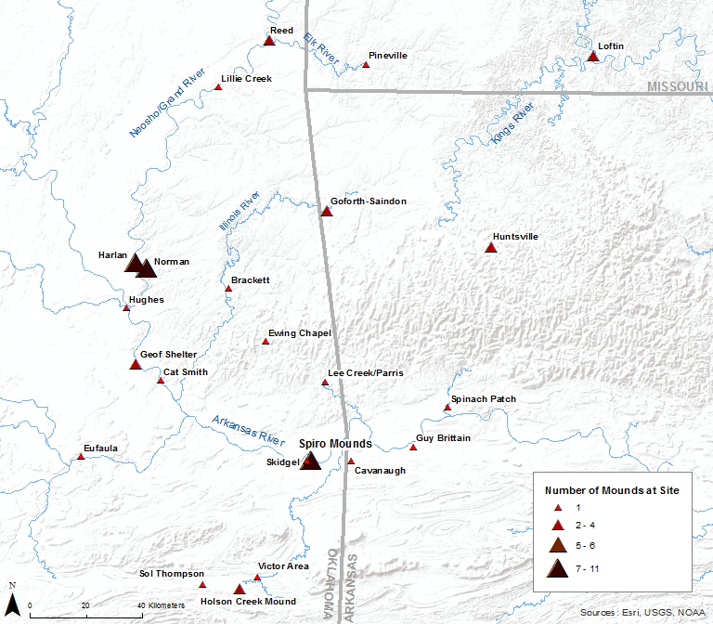
Figure 1.1: Map of selected Mississippi period Spiroan mound sites in the Arkansas River basin.

Research Goals and Questions
This research focuses on addressing the sociopolitical organization of one small mound site to help address the variability of middle-range societies from the Mississippi period. To begin addressing the social and spatial organization of Brackett, I focus on identifying 1) who the primary residents were; 2) what types of activities were occurring; 3) what is the community size; and 4) when was the site occupied? In addressing the third question, the aim is not to identify the exact number or occupants, but to gain a general idea of addressing community involvement in rituals and occupation. The fourth question will be largely addressed separately from the other three questions, but it is essential for addressing the regional placement of Brackett. It is possible that the role of the site changed through time; however, with the data available, it is difficult to address the temporal and social changes that occurred there. Therefore, the goal of this thesis will be to determine the most enduring patterns regarding occupation and social organization of Brackett.
In order to connect the static archaeological record with the dynamic sociopolitical processes that originally were occurring at Brackett, I consider the classifications that have previously associated with the site from the literature (i.e., a mound-village site or a ceremonial center). Mound-village sites and ceremonial centers are characterized as having very different archaeological correlates based on the primary activities and residences associated with the site. I propose to discuss these two mound site types and their associated attributes as two poles along continuum to compare with the archaeological patterns at Brackett. The intent of this research is not to construct a binary division between how Brackett was organized or to say whether Brackett is a mound-village or ceremonial center. Many sites do not fit perfectly into either classification and I propose that Brackett is no exception. This thesis will explore the influence that the relationship between leaders and community members had on the social and spatial organization of Brackett.
I address the relationship between leaders and the community by identifying the relative degree of unrestricted to restricted access to occupation and degree of exclusion in ritual participation at Brackett. Inclusive ritual activities include public or outside social gatherings, feastings, and dancing, while exclusive ritual practices involve small number of participants and performed in locations away from public participation (see Chapter 2 for more details) (Dowd 2012:280-281, 285). The distinction between these two classifications is largely attributed to the ethnohistoric literature (compiled in Bolton 1987; Swanton 1996 [1942]) and model developed by Wyckoff and Baugh (1980), where settlements in the southern Caddo area were organized based on the primary leaders and activities being overseen. The following site types should be perceived as one means to connect the patterns from the archaeological record to identify the primary forms of leadership at Brackett.
Amongst the historic Hasinai, there was a division in settlement patterns based on a division of positions between political and religious leaders. The mound-village site is characterized by unrestricted access to site occupation and more inclusive, integrative participation in ritual activities comprised of general community members, elites, and leaders (Dowd 2012:276, 281). This position coincides with the ethnohistoric record on individual communities led by political leader (the caddi) and the community elders (canehas) (Wyckoff and Baugh 1980:243). Conversely, a ceremonial center is characterized as having restricted residence and exclusionary ritual participation to particular elites and leaders. This second option fits most with the ethnohistoric data for small site managed by a ritual specialist (xinesi), who performed specialized and exclusionary, mortuary rituals and situated away from the general population (Dowd 2012:278, 281; Wyckoff and Baugh 1980:243). I present the archaeological correlates associated with the two-mound site types in Table 1.1.

Table 1.1: Mound site types to identify where Brackett more closely fits along in a continuum between restricted and unrestricted access to the site (adapted from Dowd 2012; Rogers 1982; Wyckoff and Baugh 1980).
Mound Site Type | Attributes
Mound-Village | Site Access | Unrestricted access to residence and participation in rituals
Mound-Village | Community size | Large
Mound-Village | Primary Residents | Multiple families and households comprised of general community members, elites, and leaders
Mound-Village | Archaeological Correlates | Primarily domestic debris, limited fineware pottery and exotic artifacts
Mound-Village | Structure Types | Primarily daily-use, residential buildings
Ceremonial Center | Site Access | Restricted access to residence and ritual participation
Ceremonial Center | Community size | Small
Ceremonial Center | Primary Residents | Small, circumscribed number of families, leaders, ritual specialists
Ceremonial Center | Archaeological Correlates | Primarily high status or important ritual objects (rich iconography, exotic materials), limited domestic debris
Ceremonial Center | Structure Types | Primarily special purpose (non-residential use) structures with few residential buildings

As presented in Table 1.1, archaeological support for a mound-village site would be evidence of a large community size demonstrated by the presence of domestic debris, such as tools for hunting and agriculture, primarily plain and utilitarian ceramics with some fineware pottery (Brown, et al. 1978:177; Girard, et al. 2014:56). The structures would be primarily permanent residential structures. Archaeological correlates of a ceremonial center include a higher frequency of ritual and symbolically meaningful objects, such as artifacts with rich iconographic design and exotic raw materials (Brown, et al. 1978:171; Wyckoff 1970:143). I also propose that the majority of structures at a ceremonial center would be special purpose structures, such as charnel houses, temples, meeting halls, or chiefly or large residences (Rogers 1982:49). These attributes are an introductory means to identify where the archaeological record from Brackett most closely aligns.
As discussed above, mound sites likely fit somewhere in-between the two extreme types I just presented. Through this thesis, I will provide support that there was evidence of both restricted and unrestricted access to site, at different portions and different activities at the site. This thesis will examine the evidence and present arguments that Brackett probably had a small community size. I will also argue that there were both exclusionary and integrative ritual activities. For instance, occupation could be restricted to a ritual specialist and their family, but they held rituals that could have involved the broader communities or visitors from outside the area. As will be shown in Chapters 5 and 6, there is a high frequency of elaborately crafted ceramics and other artifacts, particularly in the Burial Area. In regards to the buildings, I will discuss how there was a combination of residential and non-residential (commonly referred to as “special purpose”) structures. These archaeological correlates indicate that a spiritual leader or small group of ritual specialists played an active role in the rituals and organization of the site (Girard, et al. 2014:56).
The presence of a mound and multiple, group burials provide identifiable support that Brackett was a ritually-charged place on the landscape. For the historic Caddo, mound building was associated primarily with integrative, social activities, while mortuary rituals were restricted, more exclusionary rituals (Dowd 2012:277, 279; Rogers 1995:92; Sabo 1998:171). The presence of structures at the site does not imply inclusive or exclusive activities, alone. Therefore, it is necessary to address whether the structures, as well as other portions of the site, were related to daily, residential activities or restricted, ceremonial practices.
This thesis will show that when the archaeological data are compared to the broader regional scale, that Brackett was a ritually-charged place that involved special mortuary rituals, as well as daily, residential activities. The site appears to have a limited community size, likely one where the primary residents were a ritual specialist or caretaker of the site and their immediate family members. This research supports the argument made by Lewis and colleagues (1998:5) that “it is unlikely that any town or mound center existed only for ceremonial uses, just as it is quite likely that Mississippian rituals and ceremonies were carried out at sites that lacked mounds and plazas." This study emphasizes the importance of moving beyond a simple dichotomy of interpreting mound sites as either a mound-village site or ceremonial center since these classifications limit our understanding on the range of activities, social dynamics, and meanings attributed to these sacred places on the landscape.

Regional Background
The Arkansas River and its tributaries (Poteau, Illinois, and Neosho/Grand) form the Arkansas River valley which extends across eastern Oklahoma, western Arkansas, and the southwestern edge of Missouri (Bell 1984:227). Sites located in the Arkansas River valley are classified as part of the Caddo area. The Caddo area has a geographic area covering present-day northwest Louisiana, east Texas, southwest Arkansas, and southeast Oklahoma (Figure 1.2) (Perttula 1997:8; Rogers and Sabo 2004:616). Situated at the western edges of the eastern Woodlands, the Caddo area is considered the westernmost of the Mississippian cultures (Perttula 2012a:4-5). I apply the term “Spiroan” to describe the Arkansas River valley sites as a means to reference the connection between the mound sites with the famous Spiro mounds center and to represent the distinctive history of the Arkansas River valley from the other sub-regions of the Caddo area (Hammerstedt and Savage 2014). The connection between the Arkansas River basin and the Mississippian cultural complex is most recognizable through the presence of over a dozen mound sites constructed during the Mississippi period or the regional cultural phases, Evans to Spiro (A.D. A.D. 900/1050 to 1450) (Anderson and Sassaman 2012:152-153; Rogers 2011). Contemporaneous Spiroan sites to Brackett include, but are not limited to, Harlan (34CK-6), Norman (34WG-2), Reed (34DL-1 and 34DL-2), Hughes (34MS-4 and 34MS-5), Lillie Creek (34DL-41), School Land I and II (34DL-64 and 34DL-65), Plantation (34MI-63), Goforth-Saindon (3BE-245), Cavanaugh (3SB-3), and the earlier stages of Spiro (34LF-40) (Figure 1.1).
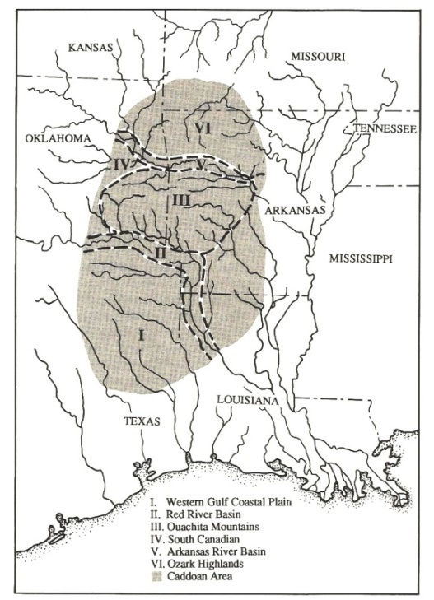
Figure 1.2: The geographic boundaries of the Caddo Area with its primary subregions (Perttula 1997: Figure 1).

Leadership Strategies for Mississippian and Spiroan Sites
The term “Mississippian” describes the late pre-Contact middle-range societies who participated in a complex ideological system unevenly distributed throughout the southeast and expressed through certain shared attributes and through the elaborate exchange and interaction networks formed between communities (Pauketat 2007:85). The Mississippian tradition encompasses a range of leadership strategies that extend beyond the chiefdom classification. Through my research, I will address the value of studying leadership strategies as a means to examine the variability of sociopolitical organization amongst middle-range societies. I incorporate frameworks presented by Pauketat (2010b), Angelbeck and Grier (2012), and Joyce and Barber (2015) that emphasize a consideration of community members in promoting, developing, and restricting positions of authority and leadership. I further employ the perspective that leadership was enacted and maintained as a result of their ability to establish and maintain a relationship between themselves, their belief systems, and community practices (Sabo 1998:161-162; Swanton 1996 [1942]:170-173; Wyckoff and Baugh 1980:238). In this thesis, I will demonstrate an example where the spatial arrangement of a mound site is attributed to the social significance and symbolism associated with mound building, mortuary ceremonialism, and building construction. The social and spatial organization of mound sites is one means to indirectly identify how leadership strategies and inequality were enacted during the Mississippi period.
I draw on the models developed by Dowd (2012) and Wyckoff and Baugh (1980) concerning the impact that positions of leadership have on the spatial organization of sites in the Caddo area. Dowd (2012) examined the relationship between leadership and the spatial division of ritual activities at Mountain Fork Caddo mound sites in the Ouachita Mountains dating to around A.D. 1300 and 1400. Her model proposed that certain exclusive ritual activities were conducted in locations with restricted access and involved limited community involvement, whereas inclusive activities were conducted in public settings or locations with broad community involvement. Wyckoff and Baugh (1980) developed an ethnohistoric model based on the Hasinai Caddo of east Texas, whose leadership positions were separated between religious and political positions of authority. Their model examined the impact that divisions between positions of authority would have on the material culture and spatial separation of particular rituals at late pre-Contact and historic sites in the general Caddo area. In support of Wyckoff and Baugh’s (1980) model, the 1691-1692 Terán map demonstrates a physical separation between religious and political leaders based on their locations of residence within a Kadohadacho community along the Great Bend of the Red River (Figure 1.3). These models, however, have not been applied to Harlan to Norman phase mound sites in the Arkansas River valley. My research seeks to evaluate whether these models are applicable to interpreting the internal dynamics of small mound sites in the Arkansas River valley.
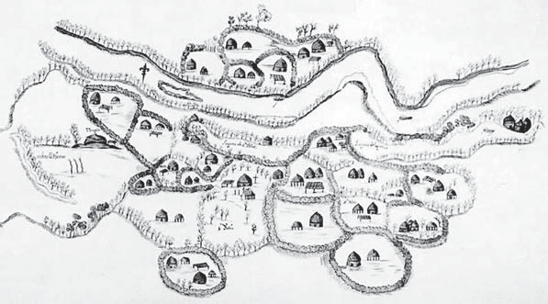
Figure 1.3: Terán map of 1691–1692. Highlighted in red are the location of the Caddi house (at the center of the community) and the location of the sacred temple, where the xinesi resides (at the western periphery of the community) (Courtesy of the J. P. Bryan Map Collection, CT0108, the Center for American History at the University of Texas at Austin) (Adapted from Girard 2012: Figure 9-2).
I recognize the temporal and geographic concerns over applying ethnohistoric analogies to interpret the sociopolitical patterns occurring pre-Contact sites in the Arkansas River drainage system (see Chapter 2 for details). Therefore, I use ethnohistoric analogies as one way to interpret the archaeological record. This research seeks to identify whether it is possible to identify a similar division between positions leadership at Brackett and seeing whether certain types of activities (inclusionary versus exclusionary) performed on a site influence its spatial organization.

Thesis Chapters Outline
Chapter 2 discusses the theoretical approaches to leadership within middle-range societies of the Mississippian tradition, the Caddo area and the Arkansas River valley, and outside the region. This chapter focuses on how archaeologists have addressed the role and significance of mound building and mortuary practices to interpret the nature of leadership and authority. In this chapter, I emphasize the importance of addressing the symbolic significance of earthwork construction and mortuary ceremonialism. I further discuss how authority and positions of leadership come about through the support of the community and connections to the cosmological realm.
Chapter 3 focuses on the archaeology of the Caddo area, the Arkansas River valley, and contemporaneous mound sites to Brackett. I also synthesize the excavation history at Brackett and discuss discrepancies with the data from the WPA-era research. This chapter provides the necessary regional context and background information to interpret the sociopolitical dynamics between the original inhabitants at Brackett.
In the fourth chapter, I discuss my research methodology for the ceramic and lithic artifacts that I analyzed. I primarily focus on ceramics because of their abundance in the archaeological record, their importance in daily, social, and ritual activities, and their general temporal sensitivity to changes in styles and production techniques. I included an analysis of the lithics to provide a basic understanding of the material content of Brackett, as well as a secondary means to evaluate the activities that occurred.
Chapter 5 presents the results of my analyses of artifacts and features. I examine specific artifact attributes and their distribution based on four main localities within Brackett: the Mound, the Burial Area, the hypothesized “Residential” and “Outside Residential” areas. I include an in-depth discussion of the artifacts directly associated with burials in the Burial Area and Structures 1, 5, 6, and 7. The aim of these analyses is to identify if there are any distinctions in artifact type based on the location in which they were found. Finally, I discuss the results of new radiocarbon dates collected for this analysis in relation to temporally sensitive artifacts and features to better understand Brackett’s occupation.
In the final chapter, I present my interpretations about the social significance of Brackett, with particular emphasis on the structures, Burial Area, and platform mound. I offer a brief discussion on the regional connections between Brackett and other mound sites in the Arkansas River Valley. Chapter 6 presents the conclusions of this research concerning the importance of studying the individual histories of middle-range societies and of considering leadership strategies from multiple sociopolitical and temporal scales. Finally, I present areas where future research needs to be conducted to better understand the placement of Brackett and other small mound sites in the Arkansas River Valley and the North American southeast.

: Theoretical Perspectives on Leadership and Site Organization

In analyzing how authority was enacted at Brackett, I review and critique the theoretical frameworks on leadership strategies in the southeast, Caddo area, and outside the region. Specifically, I examine how archaeologists within these regions have interpreted the social significance of mound building and the spatial arrangement of sites to understand Mississippian leadership strategies and inequality. I further identify how mortuary practices, such as the incorporation of grave goods or the strategic placement of burials at sites have been incorporated into these frameworks. I also consider how these models address (or ignore) the role of non-elites in interpretations about sociopolitical organization. In the final section of this chapter, I outline the approaches most applicable for my research with the available archaeological data.

Middle Range Societies and Leadership
Archaeologists classify middle-range societies as socially stratified groups that lack formalized political institutions of authority (Anderson 1994:14; Beck 2003:642; Carneiro 1981; Dowd 2012:11; Earle 1987; Peebles and Kus 1977:431-433). Leadership for middle-range societies are positioned in between egalitarian and ranked societies in terms of how inequality and ranking are expressed (Ames 2007:507). Ames (2007) discusses how inequality and positions of authority are demonstrated through differential access to positions of prestige, but has equal access to basic human resources. This differential access to prestige and power can be demonstrated hierarchically and heterarchically (Ames 2008; Crumley 1995). Examples of middle-range societies include those classified as part of the Mississippian tradition in the Southeast. These middle-range societies have long been given the label “chiefdoms.” In considering Mississippian middle-range societies or “chiefdoms,” discussions largely focus on the political, social, economic and ideological systems (Blitz 1999:80-81; Joyce and Barber 2015:820; Mills 2000). Studies concerning leadership strategies are one way for archaeologists to tease apart this dynamic interrelationship between systems of social complexity for middle-range societies.
Post-processualist discussions on social complexity refer to how past peoples “organized their societies, interacted with one another, and expressed their understandings of the world and the cosmos in ways that were multifaceted" (Alt 2010:1). In other words, social complexity is relational and something that is practiced, not a list of traits to be identified (Alt 2010:4; Sassaman 2004). In examining the processes involved in social complexity, political institutions and levels of authority are interpreted as interwoven within discussions about social identities, religious beliefs, and daily community practices (Joyce and Barber 2015:821; Pauketat 2007:36, 105, 107; Pauketat and Alt 2004:779). Studies of leadership address the short-term and long-term motivations behind the practices, beliefs, and relationships concerning social processes within and between communities (Feinman and Neitzel 1984:43; Pauketat 2007:93, 95).
Expressions of leadership and ranking in the archaeological record may be visible through mortuary rituals and burial treatment, settlement patterning and control of space, labor control and construction of monumental architecture, and household size and associated artifact types (Ames 2008:497-508). However, inequality and positions of power are not always archaeologically visible, but this does not mean that ranking or inequality were absent in those past communities (Ames 2008:508). As a result, it is necessary to consider multiple lines of evidence to identify instances of inequality and the nature of social inequality within a society (Ames 2008:508). When examining leadership, I consider individuals and groups who exerted power, authority, and influence as a result of their political, religious, economic, and/or kinship connections (Knight 2016:40). In examining the archaeological record, the principle questions guiding Mississippian studies on leadership include what forms of leadership were practiced, how is authority promoted or limited, and what is the relationship between leaders and the broader community (Dowd 2012:14-21).
Within Mississippian societies, I focus on the construction of monumental architecture, spatial arrangement of sites, mortuary data, and artifact distributions as important ways to interpret “polity size, degree of social integration, level of hierarchy, leadership strategies, political economy, ritual economy, and ideology” (Dowd 2012:24; see also Ames 2008; Wason 1994). Although many of the following models and theoretical frameworks consider the specific context of sub-regions and particular site types, I discuss the broader trends that these positions argue. I examine different perspectives to draw from and consider as the most appropriate for analyzing Brackett.

Studies on Mississippian Leadership
Chiefdom models have held a significant and enduring role in discussions about Mississippian political leadership and authority. Archaeologists characterize chiefdoms as hierarchical and centralized political organizations, but lack the internal administrative specialization that is associated with state-level societies (Beck 2003:641; Earle 1987:288). Chiefdoms, along with the cultural evolutionary framework, gained popularity in the Southeast during the 1980s and 90s as a result of the influential works of Elman Service (1962) and Morton Fried (1967) and remained influential into the early 2000s (e.g., Beck 2003; Cobb 2003; Hally 2006; Trubitt 2000). The term “chiefdom” and its original list of attributes were developed from ethnographic studies on Polynesian societies, which has been critiqued since these societieis were “small, bounded, and biogeographically distinct” from the North American Southeast (Feinman and Neitzel 1984:45). However, the original chiefdom trait list and its associated evolutionist connotations have been heavily criticized for implying a one-way trajectory towards civilization and increased complexity (e.g.,Cobb and King 2005; Marcoux and Wilson 2010; Pauketat 2007; Yoffee 1993). As a result, “chiefdoms” has shifted to become synonymous with Mississippian settlements and political strategies. Research has further moved away from trying to identify specific trait lists associated with chiefdoms, and instead, focused on the particular social dynamics of these polities (Livingood 2008).
The term “chiefdoms” persists in southeastern archaeology due to its long history in the literature and for its role in facilitating comparative research amongst contemporaneous or similarly organized sites (Beck 2003:641-642; Earle 1987:280; Livingood 2008:5-6; Muller 1997). There is an extensive amount of literature covering the history and debates surrounding the use of the term “chiefdom” in Mississippian studies (see Blitz 2010; Cobb 2003; Livingood 2008; Welch and Butler 2006). Therefore, I focus this section on general trends that have developed on how “chiefly” leaders influence the spatial arrangement of sites, particularly through their involvement in mound building and with mortuary practices.

Platform Mounds and Settlement Patterns
Mound building is an essential element of the Mississippian tradition and is tied into discussions about sociopolitical complexity (Cobb 2003:68; Dowd 2012:23). Examples of mound types include platform, ridge-topped, conical, and buried structure or “house” mounds (Lewis, et al. 1998:17). As I will present in Chapter 3, the Brackett mound was a platform. Therefore, the focus of this section will be primarily on platform mounds. Platform mound sites typically had summit buildings, often interpreted as temples, mortuary processing facilities, and chiefly or elite residences (Knight 2001:312; Steponaitis 1986:386). In the following section, I discuss approaches that consider the role of platform mounds in understanding how authority was administer and upheld. When interpreting the social significance of platform mounds, archaeologists have considered the mounds’ uselife, size, associated artifacts, features, potential community involvement, symbolic meaning, and types of ritual activities (Knight 2016:27-29).
There has been a multitude of research that focused on the size, construction, and distribution of Mississippian mound sites or centers. It had previously been interpreted that social control and power were demonstrated by leaders through their ability to aggregate large groups together for the purpose of constructing monumental earthworks (Anderson 1994; Hally 1999, 2006; Peebles and Kus 1977; Steponaitis 1986). This “platform-as-chief” model argued that the control of platform mounds was demonstrated through the placement of a chiefly residence on top, which acted as a physical reminder of their role in its creation and legitimated their authority (Anderson 1994; Hally 1996; Lindauer and Blitz 1997; Wesler 2006). Hally (1993, 1996, 1999, 2006) assumed that platform mounds were necessary architectural features of political centers for polities in the southern Appalachians for several centuries. Anderson (1994) proposed a cycling model, where chiefdoms cycled between simple and complex arrangements and that the motivations behind the cycling were due to changes in levels of leadership. In response to Anderson’s (1994) chiefly cycling model, Blitz’s (1999) fission-fusion model suggests that there was an atomic unit of socially cohesive people that aggregated or drifted from others. Mounds were viewed as both territorial markers and as indicators of inequality and elite involvement (Milner 1998; Muller 1997; Welch 1996).
Various studies have either assumed that the size and volume of a mound was either the result of duration-of-use or through chiefly-power. Blitz and Livingood (2004) found that there are different purposes and meanings associated with the number, type, and size of mounds at a site. Furthermore, Hammerstedt (2005b) tested the assumption that the larger mounds required more coercion by a chiefly leader; instead, he found that relatively little labor investment and chiefly coercion was required for their construction. Taking this research further, Sherwood and Kidder (2011) found that although little labor or coercion was required for mound construction, they required a great deal of planning, deliberation, and intentionality. They demonstrated this by identifying how each layer required engineering and that the materials used were selectively chosen based on their color, texture, or the source on the landscape. Support for their argument is also demonstrated by Pauketat (2007:98) who identified how a great deal of engineering and skill went into the maintenance of platform mounds after they were built.
Archaeologists have also examined the individual traits specific to each mound site. Blitz and Livingood (2004) and Hammerstedt (2005b) make the important point that one should not assume uniformity in function or apply the same models designed for interpreting the role of platform mounds at large mound centers (such as with Angel Mounds or Spiro) to understand the social context, organization and differentiation at smaller mound sites (such as with Annis or Brackett). Furthermore, Pauketat and Alt (2003) argue that no two mounds “functioned” in the same manner and that there are many issues with strictly structuralist views of mound building. Knight (2001:312) proposed the need to separate the act of mound building from the use of mound/summit post-construction since there were likely separate activities that occurred in relation to these different stages in the mound’s uselife. Blitz (1993a, 1993b) and Trubitt (2000) provide support for these views. With his research on Tombigbee communities in west central Alabama, Blitz (1993a:71-72; 1993b:90) identified cases where feasting, or aggregating events, were an essential social and ritual aspect on platform mounds post-construction. Trubitt (2000:683) demonstrated how expressions of leadership and power changed over time at Cahokia from focusing on mound building (seen as a corporate strategy and communal practice) to one of increased status differentiation at households, particularly those of elites, through the control of prestige goods exchange and craft specialization at the household level (seen as a network strategy and individual-based practices). Pauketat and Alt (2003:160-162, 170-171) hold that mound building is part of an elaborate historically- and regionally-specific process of constructing a sacred place on the landscape where traditions, community practices, and memories are inscribed.
The act of constructing platform mounds has been interpreted to be strongly connected to ritual and communal activities embedded in Mississippian tradition and ideology (Blitz 1993a; Knight 1986:678-679; 1989; Pauketat 2010b; Trubitt 2000). Through an examination of ethnohistoric data collected throughout the southeast, Knight (1989) found broad trends connecting mound building with origin stories, purification rituals, and spiritual renewal. For instance, adding a new construction layer acts as the ritual death of the old layer, purification of the land through the social significance of the materials being used in this process, and life renewal with a new layer (Knight 1989:285). By interlacing their sociopolitical agendas with a connection to the cosmological elements in creating sacred places, elites are able to gain the support of their community by using religious justifications for authority (Wesson 1998:113-114). Furthermore, Pauketat (2010b:169-170, 189) viewed acts of community support and involvement in the building of sites, such as through mound building, as the result of consent, rather than coercion. Acts of community building is interpreted as being part of a common cause to construct a landscape that broadcasted their narratives and identity (Knight 2016:37; Pauketat 2010b). The visual impact of mounds symbolized the influence the individuals or groups who supervised the construction of these projects, as well as their ability to restrict access to viewing or participating in activities at the platform mounds (Cobb 2003:69). It is clear that one cannot follow a normative view of chiefdoms when examining societies, as demonstrated through the variability and complexity behind the role of platform mound building and uses post-construction.

Mortuary Practices, Rank, and Inequality
Similar to the research on platform mounds, studies on Mississippian mortuary practices have undergone many theoretical shifts over the years. When examining mortuary practices, the attributes examined include, but are not limited to, the number and type of interment (i.e., individual, group, primary, or secondary), the position and orientation of burials, the inclusion of elaborate funerary offerings, and the location of burials within communities (e.g., in mounds, under public buildings or households, in cemeteries, at the periphery of sites) (Payne and Scarry 1998:32; Powell 1991:22). With the seminal works of Brown (1971b), Goldstein (1980, 1981), and Peebles and Kus (1977), research on mortuary practices became an integral part to understanding the sociopolitical dynamics and inequality expressed with the Mississippian tradition. Studies on the funerary treatment of individuals and groups extend beyond solely examining those who were buried, but also consider the role of the living and the impact of politics, economic, ritual, and social systems on inequality, identity, and group dynamics (Cobb 2003:72; Pauketat 2010a; Sullivan and Mainfort 2010).
Mortuary rituals and deposits have also been integral to studies on the daily and ritual practices of past communities of the Mississippi period. Processual studies on mortuary practices began in the 1970s and has influenced research in this area for many years (e.g., Binford 1971; Peebles and Kus 1977; Saxe 1970). However, there are a number of limitations with this period of research, particularly in regards to their assumptions about the relationship between status and associated burial goods (as critiqued in Cobb 2003:72; Sullivan and Mainfort 2010:4-5). Binford (1971) and Brown (1971a) proposed correlations between community size, the status of the deceased, and the effort of performing the ritual. Peebles and Kus (1977) and Tainter (1978:113) held the view that the status a person held in life was reflected through their treatment in death. In other words, the higher the status of the individual meant that they would have been buried with a higher quantity and quality of grave goods. A prominent critique of these processual views is that we cannot assume a one-to-one correlation between the influence or ranking of an individual with the material goods placed in their graves as one might interpret based on a Western conception of social status (Sullivan and Mainfort 2010). Furthermore, these views ignore the ritual and community aspects of mortuary ceremonialism.
In a continuation of these processualist mortuary studies, the relationship between elites, burial goods, and power has been examined as being the result of elites having preferred access or control over long-distance exchange (Brown 1971a, 1971b; Milner 1984). This view is examined in detail through different political-economy and prestige-goods models (Brown, et al. 1990; Brumfiel and Earle 1987; Cobb 2000). The general view of these models holds that elites gained prestige or access to sacred goods, strategically distributed these goods to follow to gain support and increase their power. As a result of this asymmetrical relationship, finely crafted objects were found in a range of burial types, including both low-status and high-status burials (Brumfiel and Earle 1987:3-4; Cobb 2003:72).
There are also discussions on the relationship between the Southeastern Ceremonial Complex (SECC) or the Mississippian Iconographic Interaction Sphere (MIIS) and funerary practices. The SECC or MIIS describe the elaborate material objects and iconography that were produced and exchanged throughout the Southeast and during the Mississippi period (for details see Knight 2006, 2013; Knight, et al. 2001; Lankford 2011; Reilly and Garber 2007). Since most, but not all SECC or MIIS objects are found in mortuary contexts, a great deal of research discusses how elites are involved in these exchanges and manipulated these interactions for obtaining esoteric knowledge, power, and positions of authority (Cobb 2003:74). This perspective has been criticized by Sullivan and Mainfort (2010:9), who argue that “the emplacement of these [SECC or MIIS] objects with certain individuals has less to do with their personal status than with the collective display of ritual, or spectacles, intended to connect the entire community to the worlds of the ancestors and the cosmos." This statement reflects a general trend in shifting views from focusing solely on the deceased individuals and an economic, political interpretation of the associated material goods (Wilson 2010).
Researchers have also focused on the specific locations chosen for mortuary rituals to identify the nature of leadership, status, and inequality (King 2006:86-87; Payne 2006:104-106). Burials found in platform mounds were originally interpreted as reserved for the interment of chiefly leaders and nobles (Hally and Kelly 1998:62; Payne and Scarry 1998:34; Peebles and Kus 1977). In opposition to this view, for instance, Brown (2003) argued that individuals and associated goods buried at Cahokia’s mound 72 were not indicators of chiefly power or wealth. Instead, they were enactments of public ceremonies, mythic hero narratives, and cosmic structure. The practice of burying individuals in and around structures and public buildings is seen to likely reflect “a concern with household identity and continuity” by creating an association between ancestors and the location where the structures were repeatedly reconstructed (McAnany 1995, cited in Hally and Kelly 1998:61). The presence of group burials, in mounds or at the periphery of sites, has been interpreted as indicating corporate or community-centered mortuary practices since they reinforce group bonds and the mortuary facility over the role or status of the individuals being interred (Blanton, et al. 1996; Kidder 1998; King 2006; Lewis and Stout 1998:230). The practice of burying individuals in certain isolated locations is at times viewed as a reflection of network or exclusionary strategies, individual achievement or accomplishments (Blanton, et al. 1996; Kidder 1998; King 2006). These areas of research discuss the importance of recognizing the intentionality behind the location of mortuary practices.
A growing body of research emphasizes the need to examine the relationship between dead and the living since mortuary rituals are as much reflection of living, community practices, and traditions as they are about those being buried (Pauketat 2010a:15). Since multiple people are involved in the mortuary practices, there were likely multiple meanings attached to these practices (Pauketat 2010a:25). Overall, these different areas of research promote interpretations that reflect a historically- and regionally-specific context that recognizes that all social activities, including mortuary practices, are tied to community-, political-, and religious-practices (Brown 2003; Pauketat 2010a; Wilson 2010).

Summary
Mound building and mortuary practices, as well as associated artifacts and architecture, are important sources to examine the social dynamics of Mississippian societies. These ritually-charged activities are both tied to Mississippian lifeways and reflect certain shared elements. Both types of practices were orchestrated by individuals or specific groups with some form of leadership or authority, involved the community, and occurred in spatially discrete places on the landscape. The acts of constructing mounds and performing funerary rites promote the sharing of knowledge and traditions, as well as results in the creation of permanent, physical markers of their lifeway onto the landscape (Pauketat 2005:205). Furthermore, it is not just about the labor investment or coercion tactics involved in these activities; rather, it is about the ideological motivations behind these actions that make mound building and mortuary ceremonialism such important aspects to the study of sociopolitical organization of Mississippian communities.
Different meanings are associated with mounds, based on their mound type and individual histories. The significance of mounds can change over time, as well as between the processes involved in their construction and use. It may be less appropriate to identify platform mounds as a one-to-one correlation with chiefdoms or as markers of the territorial extent of polities. Instead, it is more beneficial to consider mound building in terms of its social, religious, and communal importance. It can be further ascertained that an individual or social group would have been responsible for orchestrating the construction of the mounds, but not without the support of the community (Pauketat 2010a:16; Welch and Butler 2006:7). Motivations behind the support leaders gain from the community include, but are not limited to, economic surplus, cosmic support, and kinship ties (Welch and Butler 2006:7).
Mortuary practices amongst Mississippian societies were highly variable and regionally specific, as well as reflected a range of social identities including status, age, and gender. Studies have shifted away from primarily political and economic interpretations to ones that also consider the importance of social, religious, and community aspects on mortuary practices. Furthermore, research has extended beyond only focusing on the buried individuals and the associated grave goods. Research now focuses on how studying the influence of communities and the location of the burials can have on our understanding of the social dynamics and motivations behind those practices.
Platform mounds (their construction and use) and mortuary rituals were integral to the creation and maintenance of the political and ideological institutions of Mississippian societies (Pauketat 2007:42). By focusing on these rituals and their impact on the spatial organization of Mississippian sites, southeastern archaeologists have identified how Mississippian communities and their organization are highly variable and historically contingent processes (Kidder 1998:123-124). These unique and regional particularities are demonstrated through the leadership and sociopolitical organization of Mississippian societies from the Caddo area.

Studies on Leadership Strategies in the Caddo Area
The Mississippian societies located in the Caddo area were decentralized, but hierarchically organized. Exploring leadership strategies for the past societies of this region is one manner in which to approach the interconnection between social, economic, and ideological practices for Mississippian groups. The three main approaches are via ethnohistoric analogy, the application of Southeastern chiefdom political models, and ritual- and community-based models. Within each of these approaches, I continue to focus on the spatial division of activities within and between sites that may be associated with leadership roles, particularly through rituals associated with mound building and mortuary ceremonialism.

Ethnohistoric Data
The ethnohistoric data available on the historic Caddo offer rich insights into the sociopolitical organization and leadership strategies of people in the region. Interactions between the Caddo and European explorers (the Spanish and French) began in the 1540s and intensified in the late 1600s (La Vere 1998:1; Perttula 1997:xviii). At least 25 alliances or social entities are recognized in the Historic Period, one of which were the historic Hasinai Caddo of east Texas and western Louisiana (Perttula 1997:6; Rogers and Sabo 2004:619). Most historic documentation is almost exclusively about the Hasinai Caddo. As a result, there are concerns over the applicability of these European accounts to other distinct ancestral Caddo alliances or groups, who have their own unique local histories and practices.
The historic Hasinai were hierarchically-ranked matrilineages with both kinship-based and elected positions of authority (Dowd 2012:37; Wyckoff and Baugh 1980:235-240). For the historic Caddo, the earthly and spiritual realms existed in one unified world (Sabo 1998:160). Positions of authority in the earthly realm were hierarchically organized based on one’s connection to the cosmic realm, as demonstrated through arranging rituals or upholding external community affairs (Figure 2.1) (Sabo 1998:161-162; Swanton 1996 [1942]:170-173, 184; Wyckoff and Baugh 1980:238). All leadership positions were situationally justified, rather than being permanent positions or held all-encompassing power. This may have been a method to regulate authority and, potentially, to prevent centralization or an abuse of power.
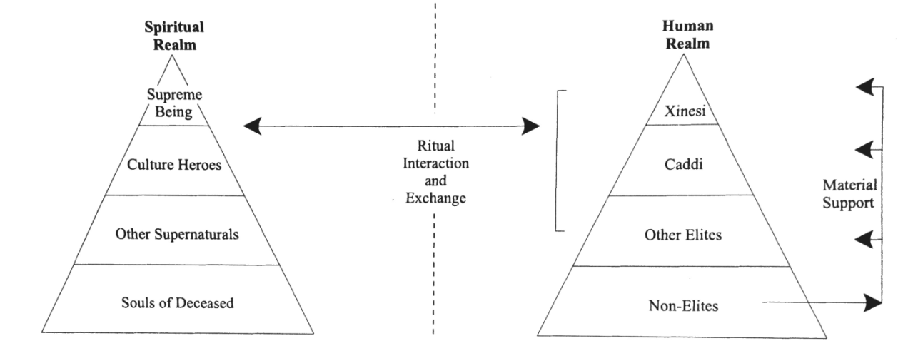
Figure 2.1: Sabo’s model of hierarchical reciprocity connecting the human and spiritual realm, based on the historic Hasinai Caddo (Sabo 1998: Figure 9-2). Within the human realm’s hierarchical system, the “Other Elites” classification describes the canahas, tanmas, Chaya, amayxoya, and conna.

Within this hierarchical system of authority, the two highest ranking positions are the xinesi (the ritual specialist) and the caddis or caddices, plural (political leader). The xinesi held the paramount position of authority due to his or her role acting as the primary intermediary between communities and the spiritual realm (Rogers and Sabo 2004). The xinesi was responsible for maintaining the sacred perpetual fire in a temple, conducted religious and mortuary ceremonies, and maintained authority over multiple communities. Conversely, the caddi held authority over one community and collaborated with the canahas (community elders) to make most political decisions. Lower positions of authority include the tanmas (town crier who worked for the caddi), chaya (page who worked on behalf the canahas), amayxoya (warriors) and the conna (shaman or healer) (Sabo 1998; Wyckoff and Baugh 1980). The historic Caddo are distinguishable from other historic Native American groups in the southeast for their separation of political and religious leadership (Livingood 2011).
Furthermore, this organizational division between political and religious positions of authority is demonstrated in the spatial arrangement of community settlements. The 1691-1692 Terán map offers a visible representation of the spatial division between the xinesi and the caddi at a Kadohadacho community along the Great Bend of the Red River (see Figure 1.3) (Early 2000:129; Sabo 1998:168-169). The xinesi and temple are situated at the far edge, but still within the community boundaries. This physical separation could be either due to the exclusive aspects of the xinesi’s position of authority or to be situated in a more readily available location for the other communities that the leader had overseeing authority (Dowd 2012:38; Sabo 1998:169-170). In contrast, the home of the caddi is positioned at both the physical and metaphorical center of the community, likely due to his or her central role in the decision making and daily happenings of the community (Early 2000:129; Sabo 1998:168-169, 2012:445). The Terán map offers a physical marker of the separation in authority between political and religious leadership, while still demonstrating the interconnectedness between elites and community members.
Positions of authority and their involvement in ritual practices are reflected in the spatial organization of sites. The historic Caddo performed both inclusive and exclusive ritual activities in terms of how accessible (i.e., physically and symbolically) these rituals were for community participation (Bolton 1987:138-169; Dowd 2012:276-288; Swanton 1996 [1942]:210-233). Inclusive activities, which include house building, planting fields, mourning of the dead, and seasonal agriculture-based ceremonies, occurred in public settings or at households which are easily accessible for community participation (Sabo 1998:171). In contrast, exclusive activities were held at locations with restricted access and limited community involvement, such as in the xinesi temple or at ceremonial centers. Certain ritual practices, such as mound building and maintaining community fires, involved both inclusive and exclusive activities, since they involved the community but were orchestrated by leaders (Dowd 2012:277). Specifically, mound building involved the community during construction, but could have been restricted to certain individuals at different phases of the construction, as well as post-construction use had restricted access. Maintaining and providing offerings to the sacred perpetual fire was the exclusive responsibility of the xinesi; but also, the community household fires came from the sacred perpetual fire (Swanton 1996:213-219; Trubitt 2009:243). These rituals demonstrate connections formed between ritual practices, the participants, and the location of those activities.
The ethnohistoric record offers important insights for considering the variability, internal dynamics, and motivations behind certain cultural changes (Early 2000:125-126). There are a number of limitations and concerns regarding the use of ethnohistoric data when studying the archaeological record (Early 2000). These include the changes that undoubtedly occurred during three to seven hundred year gap between periods as a result of the impacts of European contact and the biased subjectivity of those European accounts (Early 2000:122-128). This research also deals with the problem of geographic differences between the Historic Hasinai of the Red River valley and the Spiroan sites of the Arkansas River valley. These are valid critiques and should not be ignored when considering ethnohistoric data in archaeological research. However, if ethnohistoric data are considered critically when interpreting past cultures, the data can be used as a basis to develop hypotheses about leadership strategies and sociopolitical organization in the past (e.g., Dowd 2012; Wyckoff and Baugh 1980). This research further evaluates the fit of this ethnohistoric data with the patterns in the archaeological record at Brackett. In addition to the ethnohistoric data, archaeologists studying the Caddo area have also applied chiefdom models and alternative, ritual- and community-based approaches to the study of leadership and authority.

Caddo Archaeology: Chiefdoms, Leadership, and Space
Within the last fifty years of Caddo archaeology, a great deal of research has focused on mound building and ceremonial centers. Within the southeast, settlement pattern studies have been beneficial to address questions of leadership at Moundville (e.g., Hammerstedt, et al. 2016; Welch 1998), Kincaid (e.g., Muller 1986; Muller 1993), and Cahokia (e.g., Milner 1998; Pauketat 2004; Pauketat and Emerson 1997). However, there are not enough systematic surveys, research on non-mound-sites, and future survey work is limited due to modern encroachment and erosion in the Arkansas River drainage. Therefore, I focus on the application of processual, southeastern chiefdom models and post-processual, community- and ritual-based models for addressing leadership strategies amongst Mississippi period mound sites in the Caddo area. The large body of literature that utilizes the southeastern chiefdom models is likely due assumptions about all societies from the Mississippi period possesses certain elements associated with the chiefdom materialist trait list (Brown 1996; Perttula 1996, 1997; Rogers 1982, 1995; Wyckoff 1980). However, this resulted in largely superficial and dated interpretations about the impacts of leadership and elite decision making on the spatial patterning of Caddo area sites. Alternative approaches to chiefdom models are limited in number, but have increased in Caddo archaeology since the late1980s and early 1990s (Kay, et al. 1989; Sabo 1998). These alternative models consider rituals and ideology as integral parts to understanding the relationship between political authority, community relationships, and the spatial organization of sites (Girard, et al. 2014:31; Perttula 1996:313). I review the theoretical approaches developed for understanding how mound building and mortuary practices play into discussions on leadership and space.

Platform Mounds and Associated Architecture
Caddo mound centers have long been recognized for having strong associations with religion, politics, and ritual life. Rogers (1995:92-93) interpreted the construction of mound centers as a community-based, social activity intended to integrated multiple, dispersed communities. For instance, mounds make the place more visible and act as a physical marker for the significance of a place. Through their research on mound centers in the Ozark Highlands of Arkansas, Kay and colleagues (1989:137, 153) argued that the communities constructing mounds strongly adhered to a “deep structure” or architectural grammar on how to construct these earthworks. They identify five attributes associated with Caddo platform mounds: 1) each individual sediment layer is composed of homogeneous sediments by texture and color; 2) there are contrasting soil colors and textures with the different mound stages; 3) special preparation went into the structure bearing surfaces; 4) berms were used to delineate structures or space; and 5) the horizontal and vertical alignments in mound were carefully maintained. Regnier and colleagues (2014:101) further argued that earthen berms are primarily found in three different context at mound sites: 1) to delineate mortuary contexts, specifically with mass burials; 2) placed directly against the walls of circular structures; and 3) placed around charnel house structures buried in mounds. These areas of research reveal the importance of spatial segregation when performing certain rituals at pre-Contact mound sites (Kay, et al. 1989:152-155; Regnier, et al. 2014:101-103).
A plethora of research on mound centers in the Caddo area focuses on the construction, organization, and meaning behind the earthworks. However, less research has been directed towards how these features were created and the role leaders played in their construction. Primarily, research has held the untested assumption that mounds were created for and orchestrated by chiefly-elites. Brown and colleagues (1978) developed a site-hierarchy model where mound sites were categorized into a three-tier system of increasing rank and influence based on the number and size of mounds present. Perttula (1996:307) attributed sites with the largest and multiple mounds as being the most significant of mound centers. This idea contends that the more powerful the chief, the more people that leader was able to amass for an extended period or repeated amount of time to build large earthworks (Blitz and Livingood 2004:293). With its eleven mounds (types including platform, multi-lobed burial, and house mounds), the Spiro ceremonial complex has been viewed as a paramount chiefdom that held power and influence over all other mound sites and villages in the Arkansas River valley and beyond this valley (La Vere 1998; Rogers 1991; Wyckoff 1980). This perspective held that the rise of Spiro, changes in kinship relations, reduction in domestic group size, and expanding trade were the result of increased political centralization and expansion of power, influence, and control by chiefly leaders (Rogers 1982:677; 1989a:169; 1995:169; Wyckoff 1980:323-324). However, these approach just reinstates the old, rejected view that platform mounds equal chiefdoms and that the more mounds built equates to more power.
The alternative, post-processual theoretical positions examine the interplay between religious and political practices to address the social organization of the Mississippi period sites. Since cosmological order is an integral part of all aspects of historic and current Caddo lifeways, archaeologists have explored the different ways that cosmic knowledge influenced systems of authority, social inequality, community practices (Dowd 2012; Trubitt 2009).
Some research has examined the relationship between mound building and special purpose structures. In contrast to households, special purpose structures provided space for activities not associated with domestic activities (Rogers 1982:49). Examples of the roles assigned to special purpose structures at mound sites include temples, meeting halls, charnel houses, and the residence of leaders and officials. These structures may have been utilized for multiple activities and social roles throughout their uselife (Story 1998:39). For instance, Rogers (1982:89) and Swanton (1911:158) discuss examples where these large structures were used as temples, residences, and charnel houses. Trubitt (2009) identified a number of sites located throughout the Caddo area where large structures (likely functioned as temples or special purpose buildings) were ritually burned, buried with “clean fill,” and then became the location for mound construction (Trubitt 2009). These areas of research demonstrate how, in certain situations, mound sites and their associated activities included spatially-discrete practices.
Brown (2012) proposed the use of Renfrew’s sacred economy model to interpret the grandeur of Spiro’s multi-lobed Craig Mound, the Great Mortuary, and the thousands of associated elaborate objects. The sacred economy model argues that the large quantity of exotic goods within the Craig Mound was part of a collective rite where individuals came together and provided material offerings to develop positive relationships with the spiritual realm and obtain “karmic-merit” (Brown 2012:121-122, 136-137). This model contrasts prestige economy models since it argues that the motivation behand the creation of the materials placed in the Craig Mound were not for material exchange and due to a chiefly leader directing their production (Brown 2012:121, 135-136). Through ritual action and the construction of a cosmogram in the Craig Mound, participants developed an interconnection between people, places, and things. Brown’s sacred economy approach to Spiro offers an important change to how archaeologists in the region interpret the importance of exchange relations and mound building in the development of sociopolitical relationships in the Caddo area.
With the introduction of religious motivations into discussions about political influence, perspectives on mound building have progressed. Mound centers are interpreted as ritually charged places on the landscape that demonstrate inclusive and exclusive ritual activities (Brown 2012:124; Dowd 2012:275-276; Perttula 2009:27). By imbuing the traditions of their ancestors into these spaces, mound building acts as a physical and enduring connection with the landscape and constructs ritually charged places where communication with the spiritual world occurs (Dowd 2012:267-268; Perttula 2009:29; Sabo 1998:168).

Mortuary Ceremonialism
Examples of mortuary practices in the archaeological record in the Caddo area include the presence of shaft tombs, individual and group burials in mounds, off-mound cemeteries, and charnel houses (Girard, et al. 2014). This variability is an important indication about the meaningful differences that there are specific locations chosen for specific types of burials and mortuary customs. Variability in burial practices may be based on the region, time period, the individuals being interred, the individuals or groups initiating these practices, or any combination of the above.
Many Caddo archaeologists have attributed grave goods and the introduction of individual, rather than communal, burials as signaling the rise of elites and hierarchical social organization (Brown 1996:195-196; Le Vere 1998:3; Rogers 1982:89; Wyckoff 1980:321). However, there is a growing movement away from assuming mortuary practices as being a physical manifestation of hierarchical organization and elite authority. Girard and colleagues (2014:53) offer an alternative view for communal burials in mutli-lobed mounds were a reflection of rituals emphasizing the lineages and corporate group identity.
Kay and Sabo (2006) examined Harlan-style charnel houses in the Northern Caddo area. Harlan-style charnel houses act as secondary interments for the deceased resulting in the loss of individual identity as part of a community-centered practice. Kay and Sabo (2006:39) interpret this practice as connecting “the mortuary ritual with the widespread Southeastern "earth-renewal" theme, an important concept providing a symbolic code for transforming the death ritual into a rite of social regeneration.” Furthermore, the restriction of mortuary practices away from village sites and in specific, restricted access buildings act as a spatial segregation between the living and the dead, as well as between the larger community and those conducting the ritual (Kay and Sabo 2006:33). This idea is further supported by the research conducted by Dowd (2012). Dowd (2012:281) interprets ritually-significant sites as being exclusionary since they were physically separated from the village sites created a sense of differentiation. Examples of such sites include mound centers, sites where mortuary practices were conducted, and structures with restricted access.

Summary
Through the ethnohistoric literature and archaeological studies on early-Contact and pre-Contact sites in the Caddo area, important strides have been made in understanding the sociopolitical organization of Mississippian sites in the region. These approaches leadership strategies emphasize the interwoven relationship between leaders, community members, and the cosmos in understanding the nature of authority (e.g.,Brown 2012; Dowd 2012; Sabo 1998).Chiefdom models and ethnographic analogies have held an important place in Caddo archaeology, particularly for offering hypotheses to test certain aspects of social complexity with the archaeological record. The alternative models to these standard approaches are a necessary inclusion to broaden discussions by considering cosmological influences and community-centered motivations behind leadership strategies and positions of authority. Through Dowd’s (2012:35) research on inclusive and exclusive ritual practices at sacred places, discussions are beginning to emerge over the involvement and necessity of community cooperation in allowing for the authority of leaders to develop and be sustained.

Alternative Theoretical Perspectives on Leadership

Although important strides have been made in moving leadership approaches away from the generalized evolutionist views of chiefdoms, archaeologists need to further explore the mechanisms behind the sociopolitical organization of pre-Contact mound sites in the Caddo area. Studies on anarchy theory and the concepts of entanglement and entrapment introduce new frameworks for addressing the decentralized, but hierarchical structure of the ancestral Caddo (Angelbeck and Grier 2012; Hodder 2012; Joyce and Barber 2015). These models also consider the role of non-elites in decision-making in the organization of a society.

Anarchy Theory
Anarchy theory considers how control is both distributed and disputed within the organization of middle-range societies (Angelbeck and Grier 2012:548-550). Anarchy theory considers the intersection of inequality and individual autonomy that exists among societies without formalized systems of government, such as through situationally justified authority, communal decision making, and leveling mechanisms (Angelbeck and Grier 2012:551). Furthermore, it examines political systems that retain a decentralized structure by restricting the distribution of power and rejecting authoritarian modes of power. This model can benefit Caddo studies since its offers a unique interpretation for motivation behind the different positions and degrees of authority given to Caddo leaders, as well as in considering the structure and negotiations involved in the relationship between elites and non-elite community members.

Entanglement and Entrapment
Entanglement and entrapment are theoretical concepts created by Ian Hodder. Through distributed authority and involvement in religious ceremonies, people, places, and things become more dependent and entangled in a web of interconnection (Hodder 2012:89, 95-97, 103). Entrapment is where the entanglement between entities cannot be unraveled or disconnected (Hodder 2012:103-104; Joyce and Barber 2015:827). In their study of the interplay between religion and politics, Joyce and Barber (2015) apply Hodder’s (2012) interpretation on entanglement and entrapment to examine how religion and community involvement in rituals during the late Formative Period in Mesoamerica play an essential role in restricting societies from becoming centralized. this research considers the complexity and dynamic role religion can play in creating conflict and tension within the developing political organization, rather than being simply viewing religion as a unifying factor (Joyce and Barber 2015:835).

Summary
Examining the political organization at the local level and through the individual histories of sites will offer insights into the negotiations, instabilities, and conflicts that occur during the formation of social organization and practices (Angelbeck and Grier 2012:553). Within these discussions about community involvement in the political structuring of a site, it is apparent that hierarchical organization and social inclusion are not mutually exclusive aspects of a society. Instead, it is important to examine how leaders and community members interact and form these complex webs of sociopolitical practices. The incorporation of these new theories about social organization into Caddo studies may be an important strategy to help move away from the rigid chiefdom models and cultural evolutionary frameworks.

Conclusion: Theoretical Approaches Applied to Brackett
In order to address my research questions about the sociopolitical organization of Brackett (see Chapter 1), I turned to the theoretical perspectives concerning middle-range societies who constructed large earthworks. Based on the data available on Brackett, I interpret the social significance of the platform mound and its construction events, the eight structures, and the Burial Area. I examine these physical landmarks and associated material culture to determine whether the activities associated with these localities were restricted or unrestricted. I determine how the relationships formed between leaders and community members influenced what types of activities and the degree of restriction associated with the location of those activities. Based on the available data, with the more recent research conducted in the region, it is important to not limit myself to research questions focusing on whether or not Brackett is a “chiefdom” due to the presence of a platform mound.
I draw on Dowd’s (2012) research on the spatial segregation of activities at Mountain Fork Caddo mound sites in the Ouachita Mountains as a result of the rituals performed by community leaders or ritual specialists. I also test the ethnohistoric model developed by Wyckoff and Baugh (1980) on the division between religious and political positions of authority to see if it holds true in the Arkansas River Valley and over a 300- to 700-year temporal gap. In examining the applicability of the theoretical frameworks of Dowd (2012) and Wyckoff and Baugh (1980), I can begin to address whether the spatial division of positions of authority as visible in the Terán Map for the Red River valley also occurs along the Arkansas River valley. In determining whether the structures on site were for residential or ritual purposes, I turn to the research by Rogers (1982, 1995), Kay and Sabo (2006), and Trubitt (2009) to develop criteria for which attributes are more closely associated with residential or special purpose buildings.
In order to address these frameworks, I incorporate the perspectives that view that positions of leadership were developed and sustained as a result of their connection to ritual beliefs, ideology, and community practices. In order to gain the support of the community and be able to construct mound sites, leaders needed to demonstrate their responsibility for maintaining a balance with the earthly and cosmological realm. Based on the research by Pauketat (2010b), Angelbeck and Grier (2012), and Joyce and Barber (2015), the ability of leaders to exert control, influence change, or perform a ritual is dependent on consent and some level of support of the community. I employ the position by Knight (2001) that we need to consider the construction of mounds separately from the use of the mound post-construction. Activities associated with mound building appear to be more inclusive and community-based. Whereas, the activities connected with platform mounds after construction could have been more exclusive, especially if it appears that only limited number of individuals resided at the site (Dowd 2012; Kay and Sabo 2006). I will emphasize the importance of identifying the region’s particular incorporation of traditions and beliefs into their material culture and onto the landscape (Pauketat 2003, 2005, 2007; Pauketat and Alt 2003:171).

: Regional Background and Synthesis of the Brackett Site

In this chapter, I provide the regional context necessary to connecting the archaeological record with the original activities performed at Brackett (presented in Chapters 5 and 6). I present a broad overview of the attributes associated with pre-Contact societies in the Caddo Area and their connection to the broader Mississippian tradition. Next, I examine the similarities and differences between sites in the Northern and Southern Caddo area based on the archaeological record. I further discuss the historical process, specifically the cultural phases and mound sites, of the Arkansas River valley to provide context for interpreting Brackett’s place on the regional landscape (Pauketat 2003, 2005, 2007). Finally, I present a detailed overview of the archaeological excavations at Brackett. Within the site overview, I discuss the discrepancies and limitations with the data, as well as how I have attempted to resolve some of these issues for the purpose of this research.

The Caddo Area and its Mississippian Ties
The florescence of Caddo lifeways in the Caddo area occurred around A.D. 900-1000. These traditions are distinct from the preceding Fourche Maline culture as a result of changes in social relations and leadership strategies, which coincide with increased sedentism, increased mound building, introduction of decorated fine ware pottery, and introduction of individual burials with grave goods (Early 2000:126; Girard, et al. 2014:38-42; Perttula 1996:296). There is debate over the connection between the Caddo and the broader Mississippian traditions of the Southeast (Brown, et al. 1978:169; Bruseth 1998:51; Girard, et al. 2014:32). The ancestral Caddo ideological and social practices indicate certain traditions and attributes shared with the Mississippian world, but are interpreted as being selectively incorporated into their system. These shared aspects include shell-tempered pottery, maize cultivation, and aspects of ceremonial and cosmological practices (King and Meyers 2002:113; Perttula 1996:298). However, the incorporation of certain Mississippian characteristics into the Caddo area were introduced later than with other Mississippian societies, and were not evenly incorporated within the subregions, such as with maize agriculture and shell tempering (Perttula and Bruseth 1998:2). Differences between Caddo practices and Mississippian traditions include the lack of palisades or fortified structures around sites, the distribution of sites in a dispersed, non-nucleated settlement pattern, and the unique iconographic designs on their material culture (Perttula 1996:296; Regnier, et al. 2014:103). Interactions between mound sites in the Caddo area (e.g., Spiro and Gahagan) and Cahokia began in the early twelfth century and continued until the mid to late thirteenth century (Brown 1996:31; 2012:133-135; Emerson and Girard 2004:57; Girard, et al. 2014)(Emerson and Girard 2004:57; Girard, et al. 2014:58-60; Pauketat 2007:111).
Within discussions about Mississippian connections with ancestral Caddo lifeways, it may be more appropriate to consider this relationship as a “transregional spatio-cultural phenomenon” in which the Southeastern cultures were part of “an uneven historical process in which people politicized maize-based agricultural landscapes and cosmologies in ways contingent on their pasts and on each other” (Pauketat 2007:85). In other words, it should be expected that no two societies incorporated the ideologies or practices of the region in the exact same way since each group has its own unique history and social dynamics. In addition to their relationship with the Mississippian world of the Southeast, the Caddo also have cultural ties in the Southwest and Great Plains, but this occurred later during the fifteenth century (Baugh 1998:145; Brown 1996:33; Krieger 1946). Essentially, the pre-Contact societies of the Caddo area were not isolated groups, but were involved in many exchange networks and regional interactions (Perttula 1996:295). This resulted in a dynamic and changing sociopolitical system throughout the region.

The Northern and Southern Caddo Areas
The Caddo area is subdivided into the northern and southern Caddo areas, which denote two distinct, but interconnected societies (Figure 3.1). The northern Caddo area is comprised of settlements and mound centers located in the Ozark Highlands and the Arkansas River Valley (Rogers 1989a:115). The southern Caddo area is delineated by sites distributed along the Red River and the Ouachita Mountains. The Pre-Contact societies in the northern and southern Caddo areas were interacting groups, who had interrelated religious practices demonstrated through shared iconographic imagery, settlement patterns, and mound building practices. However, there are a number of distinctions between the two sub-regions that merit discussion as to why archaeologists argue that they should be examined separately.
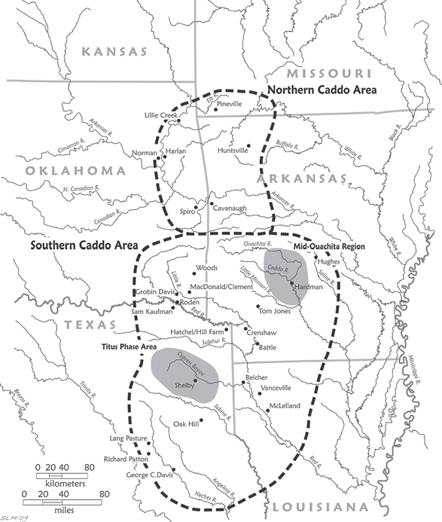
Figure 3.1: Geographic boundaries of the northern and southern Caddo areas and selected sites from the region (Perttula 2012a:Figure 1-2).
Differences between the two sub-regional cultural spheres are based on mortuary practices, architectural design, pottery production, and genetic relationships. There are distinctions between the two sub-regions based on certain mortuary practices. Shaft tombs are almost exclusively found in the southern Caddo area, with the exception of one found in the Brown Mound at Spiro (Walters 2016). Whereas, charnel houses are predominately found at northern Caddo sites (Perttula 1996; Story 1990). Both practices demonstrate an importance of communal, group-oriented funerary treatment, but represent two different enactments of those practices. In regards to architecture shape, northern Caddo area structures are primarily square and rectangular, while southern Caddo area buildings are mostly circular (Perttula 2009). Shell-temper for pottery production was integrated into pottery manufacture earlier in the northern Caddo area (A.D. 1000 and 1250) than in the southern Caddo area (after A.D. 1300) (Brown 1984b:6; Perttula, et al. 2011). Lastly, Rose and colleagues (1998) found evidence certain frequencies in dental anomalies that genetic differences exist between pre-Contact groups in the northern and southern Caddo areas.
Although cultural uniformity does not exist in any region (Early 2000:126), these differences reflect distinct local historical trajectories that deserve to be examined individually (Bell 1984:239; Hammerstedt and Savage 2012:12). The individual histories of the two sub-regions also acknowledge how that the Wichita and Affiliated Tribes claim heritage to sites in the Arkansas River valley. Some archaeologists studying sites along the Arkansas River have proposed the use of the term “Spiroan” rather than Caddoan to demarcate the divergences in the lifeways and traditions (Hammerstedt and Savage 2014).

The Northern Caddo Area: Spiroan Sites of the Arkansas River Valley
The Arkansas River valley is located at the southern edge of the northern Caddo area (Figure 1.2) (Vogel 2005:15). The region has a long history of community occupation for about 3500 years (Vogel 2005; Wyckoff 1980). During the Mississippi period, middle-range societies of the Arkansas River basin constructed a range of settlement types, which included non-habitation activity sites, bluff shelters, permanent towns or villages, and mound centers (Brown, et al. 1978:177).

Cultural Chronology
The cultural chronology of Spiroan sites were originally defined by Bell (1972, 1984) and Brown (1984a; 1996:26), then adapted by Rogers (2011) (Figure 3.2). The five cultural phases of the Arkansas River valley that coincide with the Mississippi period are Evans, Harlan, Norman, Spiro and Fort Coffee. These periods coincide with four gravelot sequences developed by Brown (1996:133) based on the grave goods, burial treatment, and stratigraphic position of burials at Spiro Mounds site. Of these phases, Brackett has generally been classified as being occupied sometime between the Harlan and Spiro phases (or Spiro II-Spiro IV Grave Periods) (Bareis 1955b; Bell 1984; Brown 1984b; Rogers 1982, 2011). As a result, I go into more detail about the archaeological record and material correlates for those phases associated with Brackett.
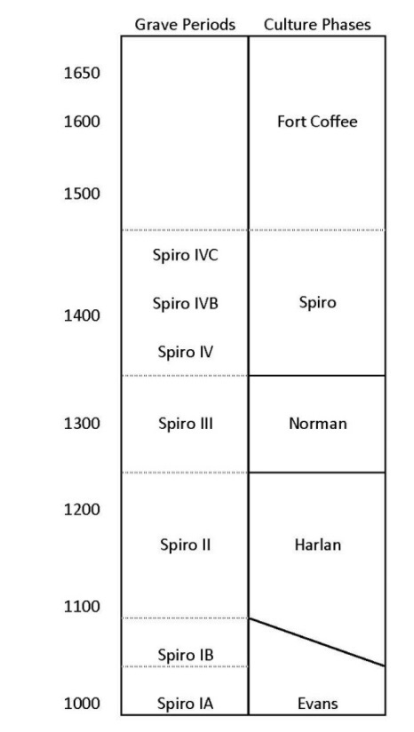
Figure 3.2: Regional Chronology (adapted from Brown 1996; Rogers 2011).

Evans Phase or Spiro IA-IB Grave Periods (A.D. 900 – 1050/1100). Evans phase denotes the beginning of Mississippian ties, long distance exchange relations, and marks the end of the Fourche Maline phase/Woodland tradition (Rogers 2011:2). Artifacts associated with Evans include the ceramic types Williams Plain, Le Flore Plain, local variations of Coles Creek Incised (of the Plum Bayou Culture in eastern Arkansas) and French Fork Incised. Pottery is primarily grog-tempered (Brown 1996:133). Support for the significance of this phase has been questioned by some (e.g., Brown 1996; Brown, et al. 1978; Rogers 1982) who argue that it is an early aspect of the Harlan phase.
Harlan Phase or Spiro II Grave Period (A.D. 1050/1100 – 1250). This phase was named after the Harlan site by Bell (1984). Along with the Evans phase, the Harlan phase marked an increase in the number and types of mounds found across the landscape (Rogers 1989b:163). Rogers (1995:93) notes that the settlement pattern for this phase consists of small clusters of dispersed villages and hamlets with connections to local and regional mound centers. Site organizational pattern for this phase marks the introduction of segregated activity areas at mound centers (see Rogers 2011:4-6). Building patterns are large, square and rectangular with four-center-posts and extended entranceways (Rogers 1982:87; 1995:88).
Artifacts and materials indicate a continued involvement in long distance exchange from the Evans phase (Cranford 2007:37; Hammerstedt and Savage 2013). Non-local material types include copper, conch shells, galena, and pottery from outside the region. Local ceramic types of this phase include Coles Creek Incised variations, Crockett Curvilinear Incised, Davis Incised, Hickory Fine Engraved, Holly Fine Engraved, LeFlore Plain, Pennington Punctate Incised, Sanders Plain, Spiro Engraved, Williams Plain and Woodward Plain (for descriptions of designs, see Chapter 4) (Bell 1984:231; Brown, et al. 1978:172; Hammerstedt and Savage 2013:2). The Harlan phase marks the introduction of shell-tempered pottery in addition to grog tempering (Brown 1996:133). Bowl shapes are primarily simple in form, with the exception of carinated formed. Ceramic base shapes continue the Fourche Maline “flowerpot” shape, which were thick and flat (Schambach 1982). For lithic assemblages, the primary chipped stone types are small projectile points, but large points and bifaces are also present in the archaeological record (Bell 1984:233; Hammerstedt and Savage 2013:2).
Norman Phase or Spiro III Grave Period (A.D. 1250 – 1350). The Norman phase was named after the Norman site. The Norman phase was originally placed as a subdivision of the Spiro phase, but has since been separated into its own phase with district attributes. Cranford (2007:39) cautions the use of the Norman phase until more research is conducted on materials recovered from the Norman site, but recognizes Brown’s (1996:28) argument that this phase should be regarded as the transitional period from the Harlan to Spiro phase. For example, the Norman phase marks the transition from the large square, four-center-post buildings of the Harlan phase to the small, rectangular two-center-post buildings of the Spiro phase (Rogers 1995).
Brown and colleagues (1978) identified distinct ceramic types for the Norman phase, which include Braden Punctate, Poteau Plain, Poteau Engraved, Sanders Engraved, and Woodward Appliqué. There is an increase to almost exclusive use of shell tempering in pottery production, particularly for jars (Brown 1996:28). Changes in vessel form are marked by the introduction of pedestaled jars and rims become low and sharply angled in form. Furthermore, red-slipping, rounder bases, and strapped handles are introduced into pottery production.
Spiro Phase or Spiro IV-IVC Grave Periods (A.D. 1350 – 1450). In the past, the Spiro phase was interpreted as the “peak of social complexity and cultural elaboration” for the region (Brown 1984a:241; see also Brown, et al. 1978; Wyckoff 1980). This phase witnessed intensification of long distance exchange (Brown 1996:31; 2012:133-135; Girard, et al. 2014). The Norman and Spiro phases (A.D. 1200-1450) mark the period of most intensive occupation at Spiro, increase in the number of grave goods associated with burials at the site, and diversity in ceramic assemblage types (Brown 1996; Hammerstedt, et al. 2015:3; Rogers 2011:7). The construction of the Great Mortuary (sometime after A.D. 1200 and completed in the early 1400s) and Spirit Lodge (one episodic event ca. A.D. 1405) in Spiro’s Craig Mound occur during these phases (Brown 1996, 2012, 2014; Sabo and Brown 2014). As mentioned above, buildings are smaller, rectangular and have two-center posts.
Fort Coffee Phase (A.D. 1450 – 1660). The transition between the Spiro and Fort Coffee phases coincides with the large drought between A.D. 1430 and 1470 (Perttula 2012b:366). This transition makes dramatic changes in settlement patterns and the sociopolitical organization for the region (Rogers 2011:7). These changes include the end of mound building at Spiro, decrease in the exchange of exotic materials, end of involvement in the SECC/MIIS, and decrease in population size in the area (Rohrbaugh 1982; Sabo and Brown 2014; Sievert and Rogers 2011; Wyckoff 1980). Throughout the region, there was a de-emphasis on mound building at this time (Perttula 1996). There was also a change in subsistence strategies that included bison hunting (Wyckoff 1980). One persistent trend from the Spiro phase is the continued construction of two-center-post, rectangular structures (Rogers 2011:8). This period is marked by an increase of interactions with the Southwest and Great Plains (Baugh 1998:145; Brown 1996:33; Krieger 1946). This cultural phase ended with European colonization.

Early Spiroan Mound Sites
Over a dozen Spiroan mound sites have been identified in the Arkansas River basin (see Figure 1.1). However, little is still known about life during late pre-Contact times (Hammerstedt and Savage 2012:1). What information is available on many of these sites are largely based on research and interpretations made throughout the 1940s and 1970s. One exception is the research on Spiro, the eleven mound site where elaborate mortuary customs and finely crafted artifacts have been the focus of great interest.
There are four mound types in the Arkansas River valley including accretional burial mounds (examples at Harlan and Spiro), house mounds (examples at Spiro), platform mounds (also referred to as temple mounds or ‘truncated pyramid’ mounds, examples at Brackett, Lillie Creek, Reed, Skidgel), and multi-lobed mounds (examples at Norman, Harlan, Spiro, and probably Reed) (Bell 1972; Brown 1996; Brown, et al. 1978; Dowd 2012:41; Hammerstedt and Savage 2013; Trubitt 2009).
The distance between mound sites range from 11 to 30 km (Brown, et al. 1978:192; Wyckoff 1980:291-292). Brackett is approximately 70 km northwest of Spiro and 30 km east of the Harlan and Norman sites. The larger mound sites (more than 5 mounds) include Spiro, Harlan, and Norman and the smaller mound sites (between 1 and 5 mounds) include Brackett, Eufaula, Reed, Lillie Creek, Lee Creek/Parris, Ewing Chapel, Goforth-Saindon, and Huntsville (Kay, et al. 1989; Rogers 1995). I provide a brief overview of some of these sites to gain a better understanding of the variability of mound centers in the Arkansas River valley.
Spiro (34LF-40) is the largest civic-ceremonial mound center in the Arkansas River Valley and is often discussed alongside Cahokia, Moundville, and Etowah in terms of regional significance and prevalence of elaborate SECC or MIIS objects. Spiro is situated along the Arkansas River, covering over 33 hectares of land. Spiro was most intensively occupied from A.D. 1200-1450 and consists of two to three districts with eleven mounds (Hammerstedt, et al. 2015; Rogers 2011). Spiro gained national recognition for the thousands of artifacts recovered from Craig Mound, a four-lobed conjoined burial mound, after looting episodes and archaeological excavations in the 1930s (Brown 2012; La Vere 1998; Phillips and Brown 1978). The artifacts from the Craig Mound primarily came from the Great Mortuary and Spirit Lodge (previously referred to as the Hollow Chamber) (Brown 2012:123-124; 2014). The Great Mortuary and Spirit Lodge are two separate construction events that may indicate an important shift in regional mortuary practices from collective to individual burials (Brown 2012:128).
Harlan (34CK-6) and Norman (34WG-2) are the second and third largest civic-ceremonial mound centers in the Arkansas River valley, as measured by the number and size of mounds, and are situated along the Neosho/Grand River. The two sites are unique for their close proximity; they are less than five kilometers apart. Harlan and Norman each have over six mounds, both including a platform mound, conjoined burial mounds (Harlan’s has three lobes with burials, Norman’s has two lobes without burials), and multiple house mounds (Cranford 2007:5). Mortuary practices at both sites include group burials and cremations (Hammerstedt and Savage 2012:10). Harlan was excavated primarily between the 1950s and 1960s by Robert E. Bell, reported later in 1972 (Bell 1972). Norman was excavated as part of the WPA Excavation under the direction of J. Joe Finklestein and Bell (see Vogel 2005:398). At Harlan, at least seven structures were uncovered, six of which have extended entranceways, and are interpreted as charnel houses (Kay and Sabo 2006:30-31). In contrast, Kay and Sabo (2006:31) did not identify any recognizable Harlan-style charnel houses at the Norman site. Furthermore, there are noticeable differences in the two sites’ artifact assemblages (see Cranford 2007:123-125). Of the two sites, Harlan has received the most amount of attention, especially as a result of the detailed site report by Bell (1972). Conversely, Norman is mostly unanalyzed, underreported, and is currently submerged underwater in the Fort Gibson Lake. Limited information is available on Norman (Albert 2000; Cranford 2007; Finkelstein 1940; Vogel, et al. 2005). The two sites were occupied during the Harlan and Norman phases and overlapped in occupation by close to 200 years. Harlan was established first and declined earlier than Norman (Cranford 2007).
Goforth-Saindon (3BE-245) is a multiple mound ceremonial center located on a high terrace along the Illinois River in far northwestern Arkansas. The site is comprised of at least four mounds situated in an “irregular trapezoidal mound enclosure area” (Kay, et al. 1989:138). The largest, Mound 1 is a platform 3.5m in height, with three major construction stages and one building located in its Early Platform stage. Kay and Sabo (2006) identified the presence of Harlan-style charnel houses onsite. The site was occupied during the Harlan phase, and is roughly contemporaneous with the Harlan and Norman sites (Kay and Sabo 2006:31). Goforth-Saindon has provided critical information about the practices associated with charnel houses. Preserved footprints at the building’s entranceway (Feature 355) revealed a pattern of steps and/or dances that were performed during the closing rituals of charnel houses.
Reed (34DL-1-11, and 14) is the northernmost of the mound centers in the Arkansas River Valley. The site was excavated in 1937 as part of the WPA excavations in Oklahoma (Hammerstedt and Savage 2012). The multi-mound site covers 15 to 20 hectares of land and is located along the Neosho/Grand River. The site contains a platform mound (DL1), burial mound (DL4), midden concentrations, and a habitation area with a number of scattered or superimposed structures (Hammerstedt and Savage 2012; Purrington 1971). Unfortunately, the research is limited due to the site being heavily looted and a farm road was also built directly through the center of the platform mound (Purrington 1971:354). However, Hammerstedt and Savage (2012) have been re-examining the site and have been able to provide important insights into the site’s history. There were two major stages of construction for the platform mound with three four-center-post, extended entranceway buildings superimposed at its base. The burial mound is a two-lobed mound, similar to the one at Norman, and was potentially 2-3 meters in height and15 meters in diameter (Hammerstedt and Savage 2012:2). The burial mound contained group burials and cremation pits. The site was occupied during the Harlan and Norman phases.
Lillie Creek (34DL-41) is a one-mound site located approximately 25 kilometers downstream of the Reed site. The site is one of the WPA excavated sites in Oklahoma. The mound and buildings at the site were only partially excavated. The mound was a platform, 1.5m in height, and had two construction phases. Two structures were uncovered from the mound (Purrington 1971:469-470). Sub-mound Structure 2 was a burned, square-shaped with (likely) four center posts, a trenched extended entranceway directed to the east. One radiocarbon date was collected and analyzed from Structure 1, which was found in a mound construction layer higher than Structure 2, dating to A.D. 1290 ± 60 or the Spiro phase (Hammerstedt, personal communication 2016; Purrington 1971).
Hughes (34MS-4-5) is a single mound site located on a sandy ridge about a mile from the Arkansas River (Clements 1938:75) . The site excavated by the WPA in 1938 under the supervision of Lynn Howard. The platform mound was constructed in two stages and had a clay platform on top of the primary construction stage. This may be an indication that a structure originally resided on it (Hammerstedt and Regnier 2016). In addition to the platform mound, there was a cluster of buildings located to the north and southeast of the mound, as well as a cemetery located to the north (Hammerstedt and Regnier 2016; Rogers 1982:62). The WPA excavated 15 buildings. The buildings were mainly square shaped with four-center posts and only one (“Structure 9”) has a recognizable extended entranceway. It is unclear if some were domestic residences or special purpose structures due to the lack of artifacts in many of them (Hammerstedt and Regnier 2016). Storage and refuse caches are found in association with buildings and throughout the site. Diagnostic ceramics, architecture types, presence of superimposed buildings, and presence of copper place the Hughes site in the Harlan phase and probably into the Norman phase. In addition to the Early Caddo mound-focused habitation, Hammerstedt and Regnier (2016) also identified a Plains Village component at the site, based on the presence of glass trade beads, bison scapula hoes, and beveled knives and scrapers in certain caches.
Eufaula (34MI-45) is a single mound site located along the Canadian river and approximately 53 miles due west of Spiro. The site was excavated by the WPA under the direction of F.E. Clements and Kenneth Orr (Orr 1942:1). The mound is a burial mound with two construction phases (and three sub-soil layers) and contained group burials in both the mound and sub-soil (Orr 1942:18-23). At the time of excavation the mound was 1.5m in height; however, a considerable amount of the mound had been destroyed due to cultivation and plowing (Orr 1942:18). Excavations did not identify any architecture in the “village” area or in the mound (Orr 1942:4; Rogers 1982:82). Diagnostic artifacts (Spiro Engraved, Crockett Curvilinear, Hickory Fine Engraved, and few examples of shell tempering) place the site in the Harlan phase (Brown, et al. 1978:172; Orr 1942:10, 37, 39, 85).

Summary
Through this brief and selective overview on a few mound sites in the Arkansas River basin, it is clear that there is variability between sites with the same mound types, similar number of mounds, and similar geographic locations. These differences are demonstrated through the identification of certain architecture types (their location, associated artifacts, and presence or absence of extended entranceways) and the types of mortuary practices associated with them. These sites are roughly contemporaneous with Brackett; however, it should be noted that we cannot expect all the aforementioned mound sites to be contemporaneous or have had year-round occupation. Based on the number, type, and size of mounds in the region, Brackett is often associated with Hughes, Reed, Eufaula, and Lillie Creek.

The Brackett Site (34Ck-43): Archaeological Background
Named after landowner M.L. Brackett, the site is one of 56 sites excavated in the Oklahoma with WPA depression-era fieldwork (Lyon 1996:74). Excavations at Brackett occurred between July 1939 and February 1940 (Bareis 1955b:1). The project was supervised by Lynn Howard and Kenneth G. Orr from the Department of Anthropology at the University of Oklahoma. Field methods applied to the Brackett excavations are based on standard procedures and instructions for WPA field crews (Clements 1938). All measurements were recorded in feet and yards. Details on the WPA field methods are limited, but supplemental information is available through photographs taken on-site, field journals, drawings, maps, and excavation forms, all of which are currently housed at Sam Noble Oklahoma Museum of Natural History (SNOMNH).
The WPA proposed a site boundary of 8.1 hectares; however, this is not the total area of excavated earth. This proposed site boundary is estimated to be less than 18% of the total site area (Wyckoff 1980:191). The excavation area was divided into four quadrants (Northeast, Southeast, Southwest, and Northwest). The four quadrants were further subdivided into 250 feet (76.2m) sections. Multiple test pits, two by two feet (1.22m²) squares were placed within each quadrant. Test pits were placed every five or ten feet, however details about which test pits were placed five or ten feet apart are not available in the field notes. When test pits were productive, the area was expanded to become a “Test Area” and a small grid was placed over it. Eight Test Areas were recorded and identified eight structures, a Burial Area, and the mound. The site was further divided into two labeled sections: CKI described the “village” component and Burial Area and CKII described the mound and Structures 7 and 8. A layout for the site is provided in Figure 3.3. For the purpose of this research, I provide detailed background information on the buildings, mound, and Burial Area individually here.
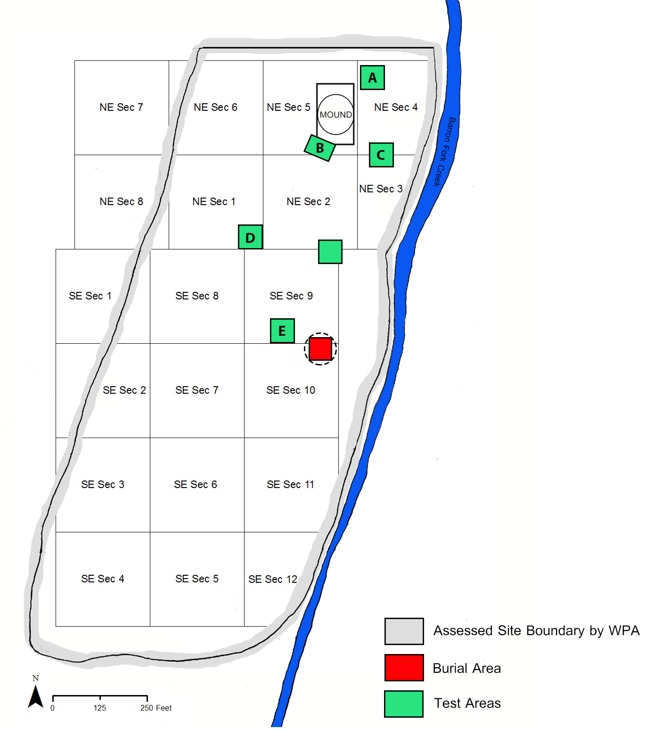
Figure 3.3: Digital Rendering of WPA Excavation Site Map. The grey border indicates what the WPA field crew delineated as the supposed site boundaries and where they placed their excavation grids. The platform mound is located in NE Section 5. The red square represents the Burial Area and the dashed circle around the Burial represents the possibility it was originally mounded. The Green squares mark the location of test areas/buildings. Green Square “A” marks the location of Structures 4, 5, and 6. Green Square “B” marks the location of Structures 7 and 8. Green Square “C” marks the location of Structure 2. Green Square “D” marks the location of Structure 3. Green Square “E” marks the location of Structure 1. (Figure adapted from Bareis 1955: Plate 1; Howard 1940:5)

The Structures
Eight buildings were uncovered during the WPA excavations (Figure 3.3). In the original WPA feature forms and Quarterly Reports, Bareis (1955) described these structures as “houses.” However, since their associated functions are not definitely understood, they will be referred to as “Structure #.” Potential post holes were discussed in the Burial Area and in the mound, but no buildings were characterized as being associated with the features. Only four buildings (Structures 1, 5, 6, and 7) have recorded data on the artifacts recovered from within them. Table 3.1 provides a detailed overview of the information available on the architecture.
Structure 1 is located in Test Area 1 in SE Section 9 (Green Square “E” on Figure 3.3). The building is approximately 300 feet (~90m) southwest of the mound and about 110 feet (~ 33m) northwest of the Burial Area. It is square with four-center-posts, single-set post walls and a post extended entranceway (Figure 3.4). The measurements are 20 x 22 feet (or 6.1m x 6.71m). The entranceway is 6.75 feet (2.06m) in length and is oriented to the northeast. Excavations uncovered a small section of baked clay floor (2 x 2 feet) and a “mass of clay which may have been a threshold pedestal” near its entrance. No hearth features were discovered within or near the building. Within the building, 33 artifacts were collected; four pottery sherds, 29 lithic artifacts. One point and one charred wood sample were originally recorded in the museum catalog and field reports, but were classified as missing by Elsbeth Dowd during the 2012 collection inventory.
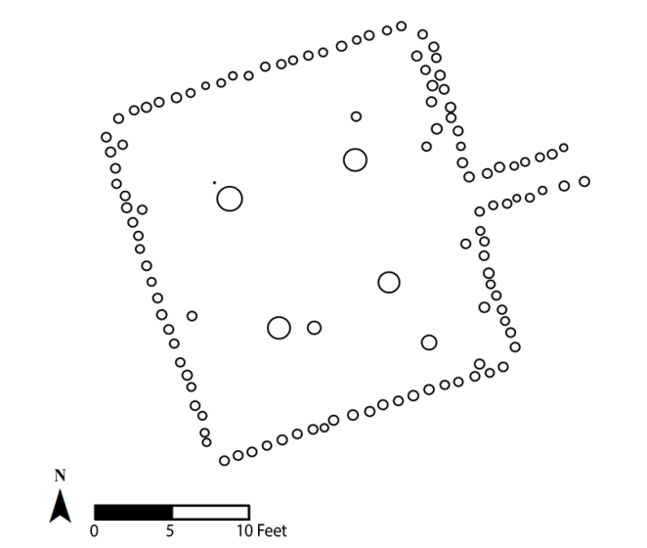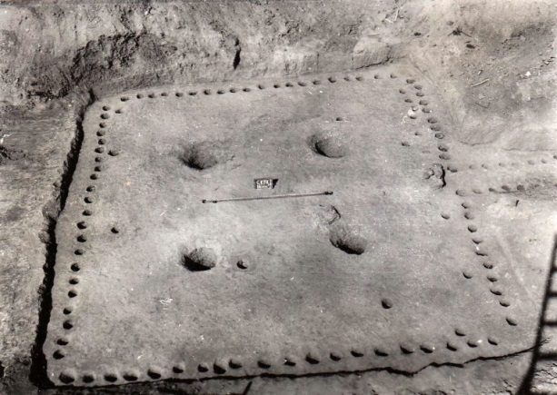
N
Figure 3.4: Plan view of Structure 1 (Adapted from a sketch on file at the SNOMNH and WPA photograph of Structure 1.

Structure 2 is located in Test Area 4 in NE Sections 3 and 4 (Green Square “C” on Figure 3.3). The building is 50 feet (~15m) southeast, 25 feet (~7.5m) south of the mound. It is rectangular, has four-center-posts, single-set post walls, and no extended entranceway (Figure 3.5). The dimensions are 24 x 28 feet (or 7.32 x 8.53m). No artifacts were found within the building. However, the only interior hearth in any of the structures was found near the center of Structure 2.
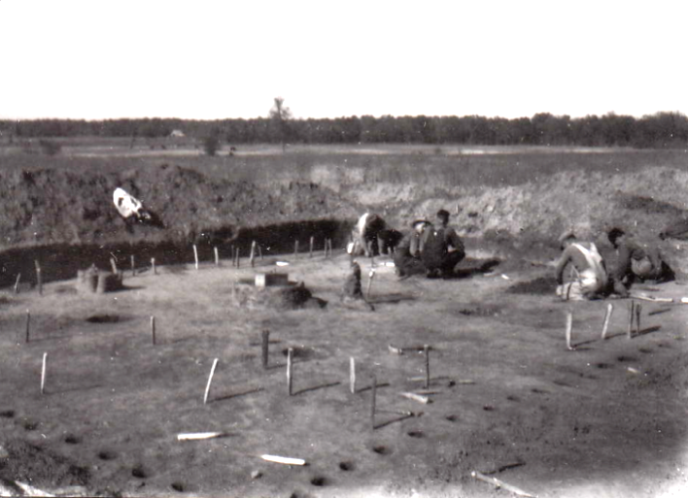
Figure 3.5: Plan view of Structure 2 (Adapted from a sketch on file at the SNOMNH) and WPA photograph of Structure 2.

Structure 3 is located in Test Area 5 in NE Sections 1 and 2 (Green Square “D” on Figure 3.3). It is 200 feet southwest (~60m) and 125 feet (~38m) west of the mound. The building is rectangular with at least one (likely two) center post, single-set post walls, and a trench entranceway (Figure 3.6). The dimensions are 15.5 x 22.5 feet (or 4.72 x 6.86m). The entranceway is approximately 7 feet (2.13m) in length and is oriented towards the northeast. No features are uncovered in association. Artifacts were originally recorded during the WPA excavations; however, the museum reported these artifacts as missing during the 2012 collections inventory. The original items were written to be a “matytody” rock, one small projectile point, and one sample of charred cane.
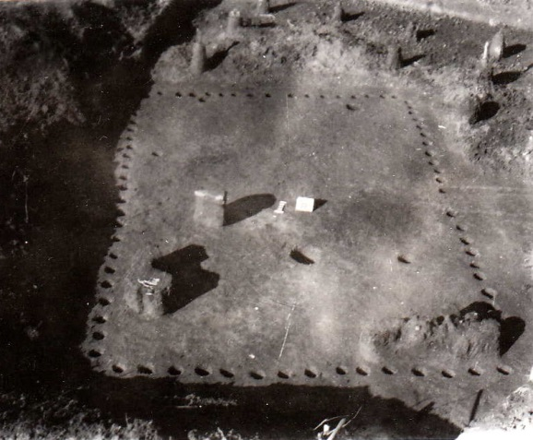
N
Figure 3.6: Plan view of Structure 3 (Adapted from a sketch on file at the SNOMNH) and WPA photograph of Structure 3.

Structure 4 is located in Test Area 6 in NE Sections 4, northeast of the mound. Structure 4 is just a few feet southeast of Structures 5 and 6 (Green Square “A” on Figure 3.3). The shape is square with four-center-posts, single-set post walls and a trench extended entranceway (Figure 3.7). The building’s dimensions are 28.6 x 28.6 feet (or 8.72 x 8.72m). The entranceway is approximately 7 feet (2.13m) in length and is oriented to the southeast. There are no associated artifacts or features.
Figure 3.7: Plan view of Structure 4 (Adapted from a sketch on file at the SNOMNH (no WPA photographs available for Structure 4).

Structures 5 and 6 are superimposed. The buildings are found in Test Area 6 in NE Section 4, northeast of the mound (Green Square “A” on Figure 3.3). Structure 5 and 6 are both rectangular with four-center-posts, single-set post walls, and extended entranceways (Figure 3.8). Structure 5 has a post extended entranceway, approximately 5 feet (1.52m) in length. Structure 6 appears to have both posts and a trench, approximately 6 feet (1.83m) in length. The two entranceways are oriented to the southeast. The dimensions for Structure 5 are 28 x 28 feet (or 8.53 x 8.53m). Structure 6 (labeled as 5A in the field notes) is 26 x 26 feet (or 7.92 x 7.92m). Artifacts associated with Structure 5 include one biface preform, 12 animal bones, one burn cane fragment, and a wasp nest (previously recorded as missing when an inventory of the collection was performed in 2012 by Elsbeth Dowd). Artifacts associated with Structure 6 include 24 pottery sherds, one biface fragment, and one missing point (recorded as missing during the 2012 inventory). Structures 5 and 6 are the only structures with faunal remains recovered within them. Since depths are not available for either building or for the artifacts, I classify all artifacts associated with Structures 5 and 6 together.
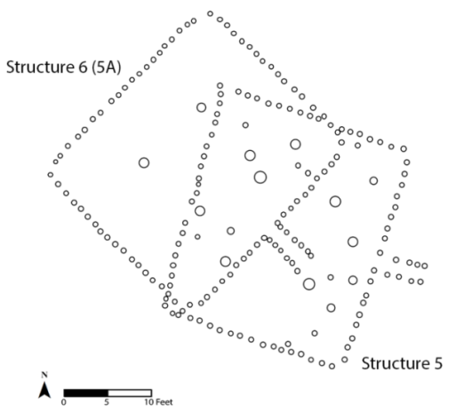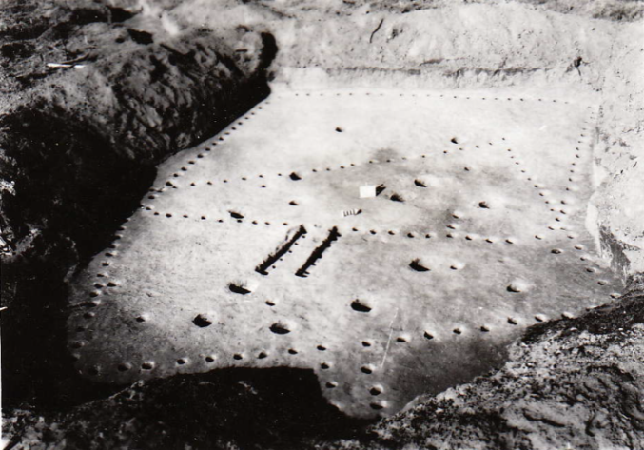
N
Figure 3.8: Plan view of Structures 5 and 6 (Adapted from a sketch on file at the SNOMNH) and WPA photograph of Structures 5 and 6.

Structures 7 and 8 were found in Test Area 7 in NE Section 5 at the western edge of the mound (Green Square “B” on Figure 3.3). Structures 7 and 8 located about a foot apart (Bareis 1955b:6). They are square in shape with four-center-posts, single-set post walls, and trench extended entranceways (Figure 3.9). Structure 7’s dimensions are 24 x 24 feet (or 7.32m x 7.32m) and Structure 8 is 16 x 16 feet (or 4.88m x 4.88m). The entranceway for Structure 7 is approximately 6 feet (1.83m) in length and the entranceway for Structure 8 is 5 feet (1.52m) in length. Both entranceways are oriented to the southeast. Structure 7 has 52 associated artifacts, including 34 pottery sherds, 12 lithics, two mano fragments, and four wattle samples. Within the artifacts associated with Structure 7, one sherd, two “sacks of wattle,” one sample of charred bark, and one point fragment have been missing since at least 2012. The artifacts that were recorded as missing in my analysis are one celt fragment and “rock fragment.” No artifacts were recorded within Structure 8. Unfortunately, all notes and records on Structure 8 were lost sometime before Bareis’ (1955) analysis.
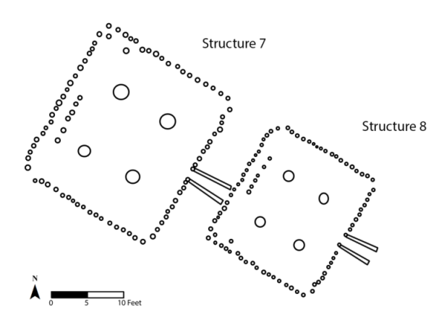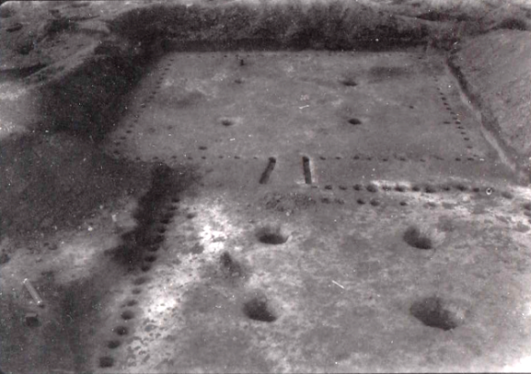
N
Figure 3.9: Plan view of Structures 7 and 8 (Adapted from a sketch on file at the SNOMNH) and WPA photograph of Structures 7 and 8.

Table 3.1: Summary of structure identified at the Brackett site (adapted from Howard 1940; Bareis 1955)
Structure | Length (m) | Width (m) | Area (m²) | Shape | # Interior Posts | Extended Entranceway (Y/N) | Entry Length (m) | Orientation
1 | 6.71 | 6.1 | 40.9 | Square | 4 | Y | 2.06 | NE
2 | 8.53 | 7.32 | 62.4 | Square | 4 | N | N/A | N/A
3 | 6.86 | 4.72 | 32.4 | Rectangular | 1  (probably 2) | Y | 2.13 | SE
4 | 8.72 | 8.72 | 76.0 | Square | 4 | Y | 2.13 | SE
5 | 8.53 | 8.53 | 72.8 | Rectangular | 4 | Y | 1.52 | SE
6 | 7.92 | 7.92 | 62.7 | Rectangular | 4 | Y | 1.83 | SE
7 | 7.32 | 6.71 | 49.1 | Rectangular | 4 | Y | 1.83 | SE
8 | 4.88 | 4.88 | 23.8 | Square | 4 | Y | 1.52 | SE

The Mound
The mound is located 250 feet (76.2m) west of Baron Fork Creek and assigned to NE Section 5 of the excavation grid. Based on Howard’s (1939) Preliminary Report, the mound measured in height to seven feet (2.13m) with a diameter of approximately 100 feet (30.48m). However, the WPA recorded height is not necessarily the original height, due to the negative impacts modern farming activities and erosion (Howard 1940:7). The mound has previously been discussed as conical in shape (Howard 1940; Wyckoff 1980). However, Bareis (1955) and Brown (Brown 1984b; Brown, et al. 1978) both argue that the mound was originally a platform, but was later rounded into the conical shape from plow action. This interpretation is confirmed by the flat top visible in the mound wall profile photographs taken by the WPA (Figure 3.10).
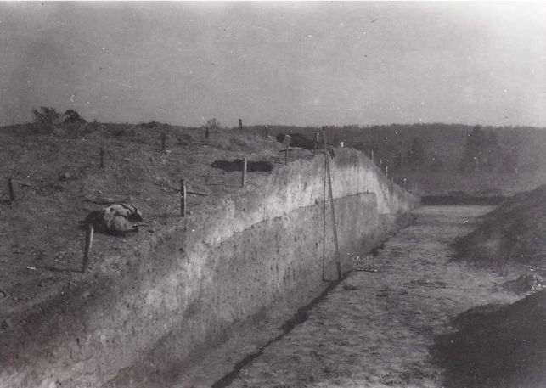
Figure 3.10: WPA 1939-1940 photograph of the platform mound profile at Row 13 (courtousy of the Sam Noble Oklahoma Mueum of Natural History). This photograph demonstrates the flat top to the mound during an earlier construction phase.

The mound was excavated in a grid divided into five-foot rows and alleys, excavated from south to north. The excavation grid began at Row 1, but the actual excavation of the mound began at Row 5. Profiles were drawn for every row, or five feet, but are only available for Rows 4 to 23. Bareis (1955b:13) notes that it cannot be verified that this was the last row excavated. If so, then between 15 and 30 feet of mound were unexcavated, artifacts potentially left unrecorded when flattened.
The mound was considered to be relatively well preserved, not being heavily looted at the time of excavation (Howard 1940:7). There is evidence of one looter’s hole in the mound near the apex of the cone (between Rows 15 and 16), approximately two feet in depth and five feet in width. Within this looter’s hole, a historic iron “Dutch Oven” was found. I did not analyze this artifact since my focus is on the pre-Contact occupation at the site. However, Bareis (1955:22) includes a description in his report. Recording that the “specimen is circular in shape resting on 3 legs arranged in tripodal fashion. The pan measures 28.3cm in diameter. The rim rises to a height of 7.0 cm. above the pan and is 5.0 cm. in thickness.” No other disturbances or historic artifacts were identified from the platform mound.
The platform mound is composed of five distinct layers (Figure 3.11). Artifacts were recorded in association with each layer. Layer A was the top layer and described the plowline, which covered the entire mound at approximately 3-5 inches (7.6- 12.7cm) in thickness. The three middle layers are considered the summits of previous construction phases. Layer B was the second layer or the “upper stratum,” located directly below the plowline. It was comprised of gray-black soil with charcoal fragments, burned clay, and “other village refuse” (Bareis 1955b:12). Layer C was an ash mixture below the “upper stratum.” This layer varied in thickness, but was roughly 16-17m in length and half a meter in thickness. Layer D was the “lower stratum” that is described as burnt orange in color and contains a mixture of ash and charcoal. Layer E was labeled a yellow loam, sub-soil; however, since artifacts were recovered from this layer, it is actual a “subsoil” (Bareis 1955:13; Vogel 2005:344-345). In addition to these five layers, excavation notes and profile drawings discuss a “house mixture” in the western corner of rows 4 and 5, in close proximity to Structures 7 and 8. Howard’s (1939b) field notes on October 19th, 1939 described it as “a dark loamy mixture with lumps of clay and burnt wattle,” which he later describes as a possible midden deposit (Howard 1939a:24).
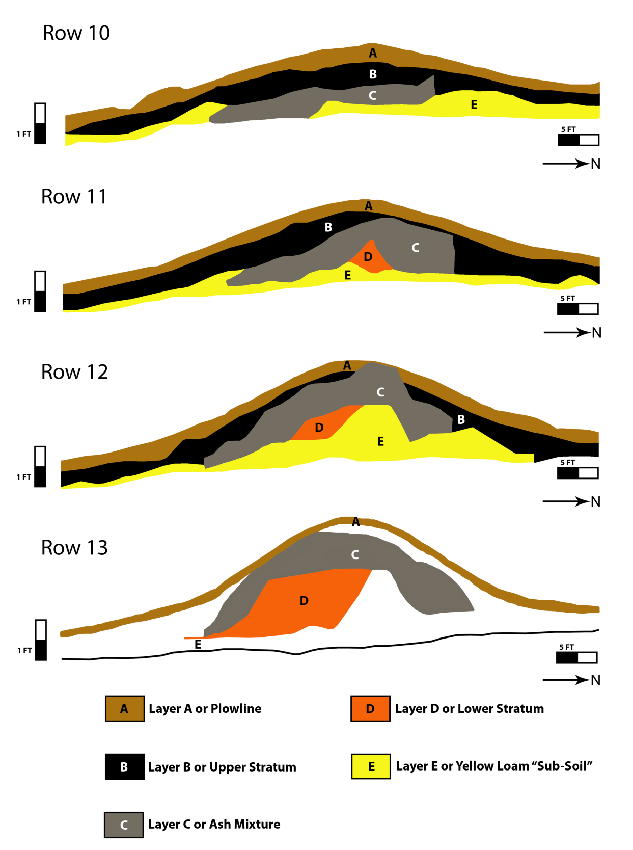
Figure 3.11: Digital rendering of the mound profiles from Rows 10-13 drawn by Kenneth G. Orr in 1939-1940. Each row is separated by five feet. Information regarding the dimensions of Layers B and E were not available for Row 13. Note the vertical exaggeration in profile drawings due to the WPA applying two different scales for the vertical and horizontal measurements (Original drawings are on file at the SNOMNH).
In addition to the artifacts recovered, two individual burials (Burial 16 and 17) were identified in Layer D. Burial 16 was found at row 15, alley 11 of the mound. Based on the profile drawing of Row 16, burial 16 was interred ten feet away from deer jaw bones and no grave goods are associated with the individual. Unfortunately, the actual location of Burial 17 was not recorded by WPA crew members (Bareis 1955:15). Bareis (1955:11) states that “burial furniture [associated with Burial 17] consisted of one perforated mussel shell hoe and one unidentified chipped flint specimen.”

The Burial Area
The Burial Area has an area of 120m², is located in SE Section 9, and is approximately 260 feet (~80m) south of the mound (Figure 3.3). 15 burials were recovered from the Burial Area (Bareis 1955b:7). The burials are placed in a semi-circular or circular layout (Figure 3.12). Of these burials, eight were single burials, one possible single burial, three group burials, and three unknown types. Six of these burials were primary, eight possible primary or secondary burials, and one unknown burial treatment. There are two identified pit burials (Burial 8 with four individuals and Burial 12 with one individual). All burials, with the exception of Burials 7, 10, and 12 had associated funerary objects (AFOs). In addition to the AFOs, there are three “Independent Artifact Associations” (A1- A3) with a total of 42 artifacts (27 ceramics, 15 lithics). In addition to the burials, a house floor, house mixture, a post hole, and wattle in the Burial Area (Bareis 1955b; Howard 1939b:7).
Brown (1984b:17-18) proposed that the Burial Area at Brackett was originally mounded, but flattened due to plowing activities prior to the WPA excavations. Although not stated directly, the basis for this argument may be due to the high frequency of mound centers in the Arkansas River basin having both a platform and burial mound, as well as for the presence of post holes, burnt clay and the unknown “house mixture” in the Burial Area.
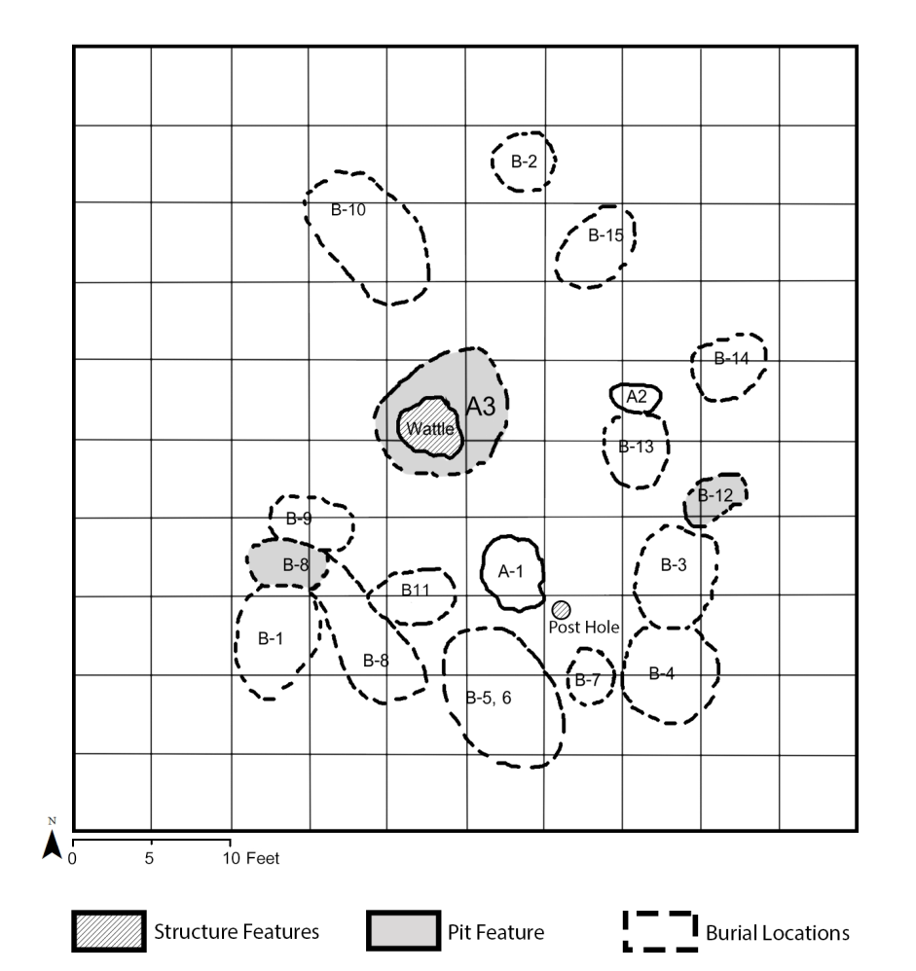
Figure 3.12: Drawing of the location of burials in Burial Area, Test Area 2 SE Section 9 (adapted from Bareis 1955; Howard 1940).

Additional Fieldwork at Brackett
In 1985, a cultural resource management project, “Cultural Resource Evaluation at Tenkiller Ferry Lake, Oklahoma” was conducted in the Tenkiller Reservoir of Oklahoma. Brackett was one of the sites included in their examination on the status of sites in the reservoir. The Historic Preservation Associated (HPA) investigations at the site included 43 shovel tests and limited surface collection (Klinger and Cande 1985:47). Of those 43 shovel tests, 93% of those shovel tests contained artifacts (Klinger and Cande 1985:51, Figure 17). This research supports previous assumptions that the site boundaries extended beyond that determined by the WPA. Materials from this project were not included in my artifact analysis due to time constraints and since the focus on my research is to reanalyze the materials originally collected by the WPA and analyzed by Bareis (1955).

Discrepancies and Limitations
There are a number of discrepancies and limitations with the data due to excavation techniques and information lost over the years. There are also a few mistakes in the museum catalog when it was transcribed from paper into the museum database, as well as a few mislabeled photographs that are currently stored at the SNOMNH. I was able to circumvent some of these issues, while others could not be resolved.
There are problems regarding the quality of field methods, consistency in note taking, and overall excavation techniques. Only a limited number of field notes are available for Brackett and of those available, few are complete and detailed. In general, WPA-sponsored projects were inconsistently organized and managed (Lyon 1996:75). As typical of WPA projects, field crew members were not always properly trained in archaeology and numbers were highly variable (Lyon 1996:74). During most WPA excavation, field crews collected what was deemed to be a reasonable sample size of the artifact types distributed across the site, which meant that certain artifacts, such as plain body sherds, were not collected every time they were identified. With that in mind, artifacts such as rim sherds, large vessels, decorate pottery, exotic materials, or finely crafted materials (i.e., anything considered fancy or valuable) would likely have been collected for their diagnostic and visually striking qualities (Hammerstedt 2005b:18). Furthermore, there is no mention in the notes that the excavated sediment was screened during the work, which would have affected the number of artifacts recovered. In addition to the known sampling bias of depression-era museum collections, a number of artifacts have been noted as missing by Bareis (1955:3) and Dowd during the 2012 collection inventory. Between the 1940 initial report on Brackett (34Ck43) and the 1955 review of WPA sites, “seventy-one sacks of archaeological material,” of which includes 44 pottery sherds and 3 vessels, were missing from the collection (Bareis 1955:3). As a result, there are problems concerning sampling consistency across the site which limit quantitative studies on the material record.
I encountered issues with interpreting the specific location and orientation of the mound. Brown (1984b:19) orients the mound in a northwest to southeast position; however, he did not provide any justification for this decision. There were no comments about the orientation in the WPA field notes, in Howard’s preliminary reports or by Bareis (1955). As a result, I am not able to take orientation into consideration when analyzing the social and symbolic significance of the mound in Chapter 6. As mentioned above, it cannot be conclusively determined whether the mound was completely excavated. For this reason, I take the data collected from the mound to be regarded as a representative sample size of the types and variability of artifacts placed in the mound.
When compiling the site map, I noted that Bareis (1955) flipped the location of Test Areas 3 and 5. Based on the museum map drawing and information available from field notes and museum catalog, I corrected the locations of the two test areas in my map (see Figure 3.3).
There were difficulties in identifying the exact proveniences for many of the artifacts. The museum catalog from the SNOMNH records test pits as part of the artifact proveniences. However, I have not been able to find any maps or notes from the WPA excavations that provide information about the specific placement of each test pit within a section number. Furthermore, there is limited (and somewhat questionable) depth measurements for the artifacts recovered. In an attempt to resolve this issue, I divided the excavation area and associated artifacts into four localities for purposes of the analysis: the Mound, Burial Area, a hypothesized “Residential” area, and a hypothesized “Outside Residential” area (Figure 3.13).
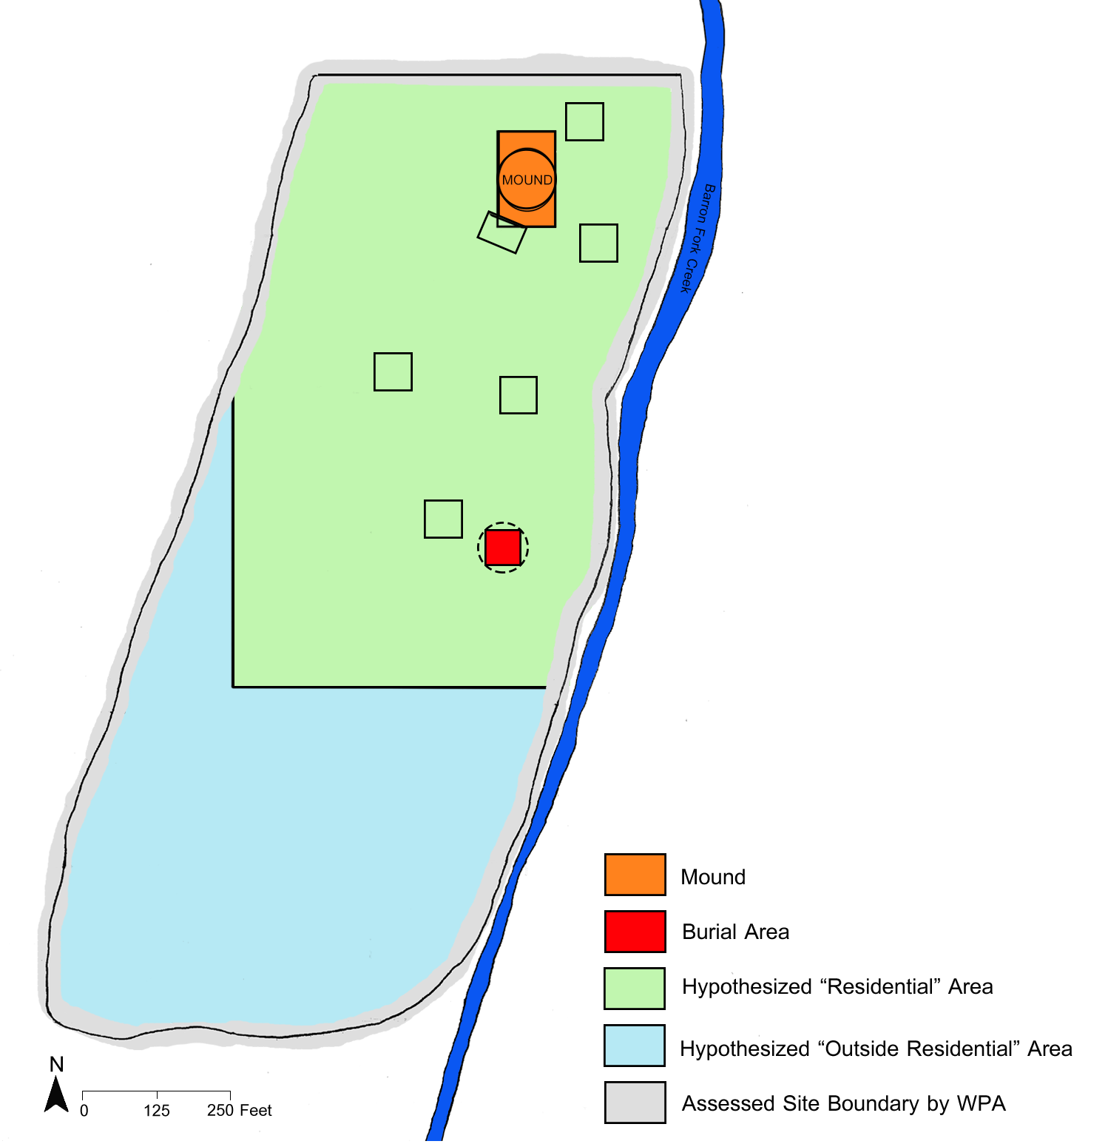
Figure 3.13: Site map simplified and color coded according to the four main localities (adapted from Bareis 1955: Plate 1; Howard 1940:5).
When assigning artifacts to each locality, there were issues regarding the provenience information for some artifacts. Bareis (1955b:11) notes some artifacts assigned to NE Section 4 in the museum catalog needed to have their proveniences changed to NE Section 5, the location of the mound. While assigning artifacts to their associated localities, I sorted out which artifacts belonged in the Mound (NE Section 5) locality or in the hypothesized “Residential” area (NE Section 4). I made provenience corrections based on information available from the row, alley, and depth measurements. If I could not justify changing the provenience to NE Section 5 (i.e., mound), I kept the provenience information as NE Section 4. I further assigned artifacts with provenience information of Test Area 2, SE Section 9 to the Burial Area locality since that section is associated with the NAGPRA collection. All other artifacts assigned a provenience in the SE Section 9, but not assigned to Test Area 2 were assigned to the hypothesized “Residential” area.

Conclusion
In this chapter, I reviewed of the history of the Caddo area, the Arkansas River basin, and selected Spiroan mound sites. I further synthesized Brackett’s excavation history to present the available data and the main discrepancies necessary to understand the types of interpretations possible. This chapter is necessary to help develop connections between the archaeological record and the activities from the site. Overall, the regional and site information presented provide the context necessary to interpret the artifacts and features from Brackett. Through this chapter, I have discussed a number of limitations with studying this site, associated collections, and the importance of conducting more research on Spiroan sites in the Caddo area.

: Methods

This chapter discusses the methodology used to conduct the ceramic and lithic artifact analyses recovered from Brackett. The archaeological collection is currently being housed at the Sam Noble Oklahoma Museum of Natural History (SNOMNH) and has been previously analyzed by Bareis (1955b). The methods I apply are based on the analyses developed by the University of Oklahoma and the Oklahoma Archeological Survey artifact analyses on the Clement and Spiro sites. Following this template will allow for more comparable data with future research on the region. The NAGPRA materials were analyzed at the SNOMNH separately from the other artifacts. These artifact analyses combine a study of morphological, functional, and stylistic characteristics. I focus on the ceramics and lithics since they are durable, informative materials used in everyday and specialized practices, as well as temporally and regionally sensitive. The methodology I apply is important to identify patterns in the archaeological record that are informative about leadership strategies and the sociopolitical dynamics that occurred at Brackett.

Ceramic Analysis
Ceramic artifacts were first divided into sherds and sherdlets, defined as smaller than 1 x 1 cm. The count and weight of sherdlets were recorded, but no additional analyses were conducted. Sherds that could be refitted together were counted as one sherd, but were not physically reattached. Sherds were then separated between diagnostic and non-diagnostic. Diagnostic sherds included decorated, rim, and base sherds (Brown 1996:328). Non-diagnostic sherds are undecorated body sherds that do not directly provide information regarding the form of the original vessel.

Attributes Recorded for All Sherds
I recorded the size, wall thickness, weight, temper, and surface treatment for all sherds. I measured sherd size based utilizing a series of graded circles with each diameter increasing in one centimeter increments (Figure 4.1) (Dowd 2012:123). An approximate size for the sherd was given to the nearest centimeter if 95 percent of the sherd fit within one of the circles in the series. Sherds larger than ten centimeters were recorded as 10+ cm. I recorded wall thickness in millimeters with a digital caliper. Multiple measurements were taken then averaged to find the most accurate representation of thickness. Weight was recorded to the nearest tenth in grams using a digital scale or a three-beam balance. Weight is sensitive to the temper used for artifacts and if the artifact was partially restored or not. The putty or epoxy used to restore vessels skews their weight since it results in a heavier vessel than before deposition (Cranford 2007:116-117). Ceramics with shell-tempering are frequently leached because of soil acidity which results in a lighter weight than ceramics with grog temper which are not affected (Brown 1996:390-391; Cranford 2007:116).
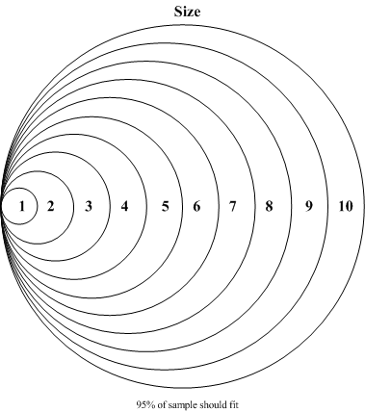

Figure 4.1: Estimated sherd size in centimeters (not to scale).
I recorded the types and quantity of tempers found on each sherd. Temper is the inclusion of some additional component into the clay by the potter to improve the quality or strength of the clay (Rice 2005:406-407). The three types of temper found at Brackett are shell, grog (crushed sherds), and bone (Shepard 1956:25). Shell tempering is identified by the “rectangular and smooth platelike white inclusions” or by the platy voids from leaching (Brown 1996:329). Bone temper is distinct from shell for its irregular, blocky shape and whiter coloring (Brown 1996:329). Using a hand lens, I record the particle size and concentration of temper based on Figure 4.2. Temper particle size were assigned to fine, medium, or coarse. The concentration of temper is described as either trace or along a scale from 1 (few) to 4 (many) (Dowd 2012:125; Mathew, et al. 1991; Orton, et al. 1993). For the sherds with both grog and shell temper, concentrations were recorded for each type.
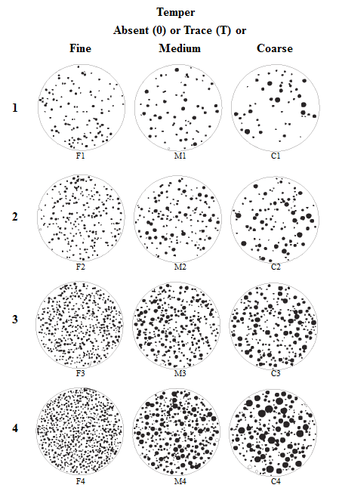
Figure 4.2: Temper particle size and concentration chart (After Orton et al.1993: Figure A.4 and Mathew, et al. 1991).

Types of surface treatment found at Brackett include plain, smoothed, burnished, red-slipped, eroded, and decorated. “Plain” surface treatment is identified by having little to no smoothing or luster on the surface. “Smoothed” is when the potter uses their hand or a tool to smooth and even out the vessel’s surface, without adding any gloss (Brown 1996:334-335). “Burnishing” is distinct from smoothing for the luster on the surface caused by “rubbing the slightly moistened surface [of the clay] with a smooth tool before firing” (Shepard 1956:122). Red-slipping is identifiable for its “powdered red layer of consistent thickness on the surface of a sherd” (Stokes and Woodring 1981:222). A slip is “a fluid suspension of clay (and/or other materials) in water that is applied before firing to form a thin coating…[and] are usually a different color than the body of a vessel” (Rice 2005:149). Decorated sherds have embellishments, such as incising or carvings, on the surface that are not a part of the construction process to form the vessel shape (Rice 2005:144). Combinations of surface treatment types are possible and recorded when present (i.e., burnished and decorated or red-slipped and decorated).

Diagnostic Sherds: Attributes Recorded for Decorated Sherds
The types of decoration include punctated, fingernail impressed, ridge pinched, cord marked, incised, engraved, and appliqué. Punctations are depressions caused by an instrument being pushed into the wet clay of the vessel (Rice 2005:144-145). Fingernail impressing and ridge pinching are two types of punctation. Fingernail impressed occurs when the crafter presses a fingernail into the wet clay to create a repetitive pattern in the surface, while ridge pinched occurred when the potter used their fingers or implements (such as cane) to create a more raised and deeper impressions into the surface (Dowd 2012:131). Cord marked is the distinct, grooved impression caused by a woven cord being pressed into the wet surface (Rice 2005:140). Incising is the process of cutting designs into the surface when it is still wet (Rice 2005:146). Since this type of decoration typically occurs prior to when the vessel was fired, there is usually a displacement of the clay that forms a ridge along the edge of the cut. Engraving is similar to incising, but the cutting of a design occurs when the vessel is either leather-hard or fired and results in finer and more even lines (Rice 2005:145). The decoration intent for incised and engraved sherds are separated into rectilinear, curvilinear, or hatched. Appliqué is the application of additional pieces of clay to the surface of the vessel (Rice 2005:148). The location of decoration (rim, body, both, or unknown) was also recorded.

Diagnostic Sherds: Attributes Recorded for Rim Sherds
Rim sherds are considered diagnostic since they can provide important information about the approximate size, shape, and potential function of the original vessels (Dowd 2012:126). The attributes recorded for rim sherds in this study include the rim profile, curvature, form, treatment, lip shape, orifice diameter and percentage of orifice present. Types of rim profiles found in this study are standing, everted, or inverted (Figure 4.3a) (Brown 1996:331; Dowd 2012:126). Rim curvature types found are straight, excurvate, and incurvate (Figure 4.3b) (Dowd 2012:126). Rim form types found a Brackett are direct (unmodified, unchanged thickness), thinned, expanding, and rolled (Figure 4.3c) (Brown 1996:331). The only rim treatment in this study is plain. The lip shape is either flat or round with different directions for slopping (inward or outward) (Figure 4.4). If rim sherds were large enough (roughly five to ten percent of original orifice size), an orifice diameter (recorded to the nearest cm) was determined by aligning the rim with a series of concentric circles separated by one centimeter increments (Rice 2005:211-212). When possible, the percentages of rim orifice present (nearest five percent) and profile drawings were recorded.
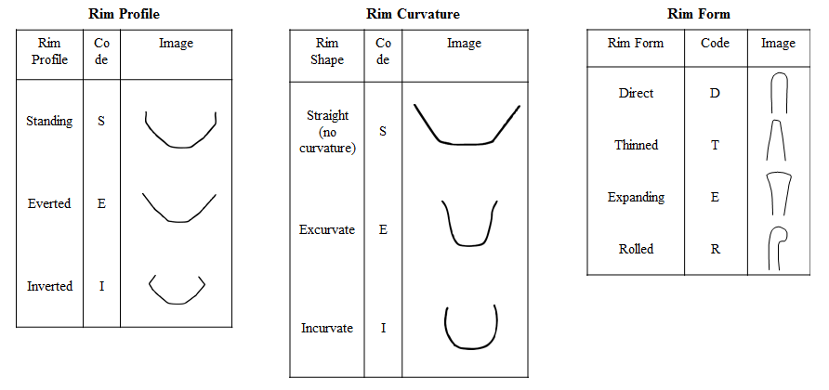
c)
b)
a)
Figure 4.3a-c: Rim profile, curvature, and form types and shapes (adapted from Brown 1996:333).

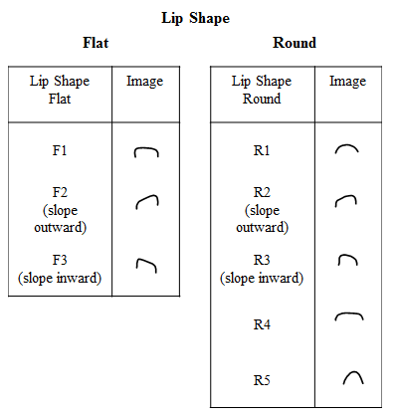
Figure 4.4: Lip shape types and shapes (adapted from Brown 1996:333).

I used the orifice diameter, vessel height, and inflection points to assign an original vessel form to rim or base sherds. The primary functional shapes for vessels are separated between open containers and closed containers (Brown 1996:335). The three types of open containers found at Brackett are simple bowl, carinated bowl, and bowl. An inflection point means a “change of direction of curvature of two parts of the vessel” (Rice 2005:218). Simple bowls do not have an inflection point and function as storage and serving containers (Dowd 2012:129). Carinated bowls have an inflection point and likely functioned for serving purposes (Dowd 2012; Rice 2005:241). The generic label of “bowl” is given to rim sherds where if it could not be determined if an inflection point was part of the original form. The two types of closed containers are jars and bottles. Jars allow hand access, some have necks while others are neckless, and associated functions are cooking and storage (Dowd 2012:127; Hally 1986). If it could not be determined if the vessel height was greater than the orifice diameter, the vessel form was classified as either a restricted or unrestricted vessel (bowl/jar). Distinctions between the two types were based on the presence or absence of constriction. Bottles have extended necks and restrict hand access. The bottle necks at Brackett are tapered, rather than cylindrical. If it was not possible to determine vessel form from the rim sherds, they were categorized as unknown.

Diagnostic Sherds: Attributes recorded for Bases and Handles
The main types of bases are either flat base or rounded (or convex) bases (Brown 1996:331). For flat base, I identified if there are keels (flaring out) at the base. The basic dichotomy of handle types is closed (attached at both ends of the strap/loop and the surface of the vessel) and open (attached only at one end). I first identified if the handle or handle fragment was closed, open, or unknown (if not enough information was available). For closed handles, the height or length of the handle was measured. I measured the middle thickness (mm) and middle width (mm) of the handle, if enough was present. I took a thickness: width ratio to determine the specific handle type within the closed handle category (Hilgeman 2000:127-130). If the ratio was between 0.1 and 0.4, then the handle was labeled a “strap.” If the handle was between 0.75 and 1.0, then the handle was labeled a “loop.” Ratios in between are identified as intermediate between strap and handle (approximately 0.4-0.55 is a wide intermediate (strap-like) and 0.56-0.74 is a narrow intermediate (loop-like). For open handles, the width, extension, and thickness are recorded. I further identified the location of where the handle was attached on the original vessel (lip of rim, body, or unknown).

Whole Vessels
Similar to sherds, the temper, surface treatment, decoration, rim form, profile, curvature, treatment, any rim decoration, lip shape, vessel form, orifice diameter (cm), and percentage of orifice present (nearest 5%) were identified and recorded for each complete or partially restored vessel, if necessary data was available. The neck width, neck length, and shoulder width were also recorded to the nearest tenth millimeter with a digital caliper. The base type is recorded. If handles/appendages were present, the type was recorded and appropriate measurements were taken.

Ceramic Artifact Classifications
I followed the ceramic categories created by Dowd (2012:142) to better understand the different types and combinations of surface attributes found at Brackett. The distinction between “fine” and “utilitarian” ware types is fuzzy and somewhat subjective. In response, Dowd’s (2012:131) categories separate artifact classifications into Plain/Smoothed, Utility Decorated, Fine Decorated, Decorated Unclassified, Burnished Undecorated, Red-Slipped Plain, and Unclassified. "Plain/Smoothed” ceramics are placed together since it can be difficult to differentiate between the two types. “Utility Decorated” sherds include decorated jars and jar fragments, incised rectilinear sherds, and most sherds with punctation and appliqué. Exceptions include Crockett Curvilinear Incised, Pennington Punctate Incised, and French Fork Incised types, which are categorized as “Fine Decorated.” “Fine Decorated” sherds include all engraved sherds, red-slipped decorated (including appliqué), and incised and hatched designs. “Decorated Unclassified” sherds include sherds with lip notching and curved trailed lines. “Unclassified” are designated for ceramics too eroded for a surface treatment to be determined. I employ Dowd’s (2012) classification system that combines surface treatment and decoration type since it creates a more manageable list of variables to analyze and offers more detailed descriptions on surface treatment than using a fine/utility ware distinction.

Ceramic Typologies
Typologies on Pre-Contact to Historic Caddo pottery were created in the 1940s and 1950s (e.g., Newell and Krieger 1949; Suhm and Jelks 1962; Suhm, et al. 1954; Webb 1959). There are many difficulties with applying the typologies for Caddo pottery when working on sherd collections since “types were defined from complete vessels that often had different decorative patterns on vessel rims and bodies” (Girard 2012:255). The plainware types (Williams Plain, Le Flore Plain, and Woodward Plain) are differentiated based on temper classification and body wall thickness (see Chapter 5) (Cranford 2007:115). There are a number of ceramic types that are temporally diagnostic to the Harlan, Norman, and Spiro phases (A.D. 1050-1450). I present type descriptions for those specifically identified at Brackett. These types include:
- Coles Creek Incised (or a locally made copy): rims and vessels with one or more horizontal incised lines that form a rim band. Grog-tempered (Brown 1996:355-356).
- Crockett Curvilinear Incised: band with a repetitive motive of designs from incising and punctuating; semi-conical in shape; scroll motif. Grog-tempered (Suhm and Jelks 1962:31; Brown 1996:358-359).
- French Fork Incised: curvilinear and horizontal incised lines that form repetitive circular, scroll, and filler elements. Decoration covers the whole body (Girard 2012:257; Brown 1996:371).
- Hickory Fine Engraved: defined by a band of few horizontal lines that encircle the top of the rim of a bowl or neck of a bottle. Grog-tempered. (Suhm and Jelks 1962:71; Brown 1996:373-374).
- Holly Fine Engraved: finely engraved lines set close together; parallel lines alternating in vertical and diagonal directions; concentric circles and scrolling. Grog-tempered (Suhm and Jelks 1962:73; Brown 1996:376)
- Pennington Punctate-Incised: straight-line motif, slanting bands, diamonds, triangles (Suhm and Jelks 1962:121). Grog, grog-with bone tempered. There is discussion over the similarities between Pennington Punctate and Crockett curvilinear in terms of design, vessel forms, and construction (see Brown 1996:358-360 for comments).
- Spiro Engraved: Decorated with complex and diverse engraved lines and curves. Examples include concentric circles with parallel diagonal lines; fine punctations sometimes appear within circles or corners of designs. Grog-tempered (with or without bone tempering) (Suhm and Jelks 1962:147; Brown 1996:374-376).
- Sanders Engraved: red slipped with engraving on surface. The engraved designs are described as “repetitive motifs occupying a narrow band on the exterior or interior of the rim” (Brown 1996:403; see also Suhm and Jelks 1962:137, Plate 69).
- Williams Plain: grog tempered with coarse texture, plain and smoothed surface treatments with no decoration, not-slipped. There is a great variation in thickness based on variation in vessel form, size, and placement of break. Differentiated from Le Flore Plain for being thicker (>9mm) (Brown 1996:343-346).
- Le Flore Plain: grog or grit tempered, differentiated from Williams plan for being thin-bodied (<9mm) plainware (Brown 196:346-348).
- Woodward Plain: undecorated, shell tempered type with plain and smoothed surface treatments; not slipped (Brown 1996:389-391). It is considered to be the regional version of the Mississippian shell-tempering technique.

Lithic Analysis
I determined the lithic material sources based on visual characteristics, such as color and texture. Therefore, all results “must be considered ‘apparent’ rather than certain” quantities and classifications (Sievert 2011:75). The source of raw materials identified at Brackett include lithics from the southern Ozarks (northeast Oklahoma, northern Arkansas, southern Missouri, southwest Illinois, and the southeastern edge of Kansas Ouachita Mountains), Ouachita Mountains (south of the Ozarks in west-central Arkansas and southeast Oklahoma), Western Ouachita Area (southeast Oklahoma), the Arbuckle Mountains (southcentral Oklahoma), and the Flint Hills Area (Nebraska-Kansas border to north-central Oklahoma) (Table 4.1) (Ray 2007:18, 326). Descriptions for these raw material types are provided in Appendix E.
Table 4.1: Lithic Raw Materials Used at 34CK-43 (adapted from Leith (2006:Table 5.2); Ray (2007); Sievert (2011)).
Raw Material | Regional Source
Argillite/Siltstone | Southwestern Ozarks
Florence A Chert | Southern Flint Hills Area
Frisco | Arbuckle Mountains
Jasper (Brown and Red) | Western Ouachita Area and in the Red River basin
John’s Valley Chert/Shale | Western Ouachita Area
Keokuk Chert | Ozarks, northeast Oklahoma
Limestone | Ozarks and the Gulf Coastal Plain of the Red River
Novaculite | Ouachita Mountains (southwest Arkansas to southeast Oklahoma)
Quartz | Unidentified
Quartzite | Ozarks
Reeds Spring Chert | Ozarks, northeast Oklahoma
Sandstone | Unidentified
Shale/Slate | Unidentified
Tahlequah/Peoria | Ozarks
Unidentified Chert | Unidentified

Heat Treatment and Cortex Amount
I included a study of heat treatment and cortex amount in my lithic analysis. Heat treatment is identifiable for changes in material color to a red-pinkish tone (Andrefsky 2005:256; Ray 2007:6-7). Cortex is the weathered exterior on the lithic raw material and can be informative about the stage of tool production (Andrefsky 2005:103). The percentage of cortex is recorded as none (0-2%), little (2-35%), half (35-65%), much (65-98%), or all (99-100%).

Morphological Characteristics
I used an analysis flow chart to classify the lithic material into technological types (Figure 4.5). The three primary types are chipped stone, ground stone, and unmodified stone. I recorded the weight, thickness, and size for all chipped stone types. Size of the chipped stone was also recorded using a diameter size charge in centimeters (similar to Figure 4.1). Chipped stone types and ground stone are important variables to address the potential activities performed at Brackett (see Chapter 5).
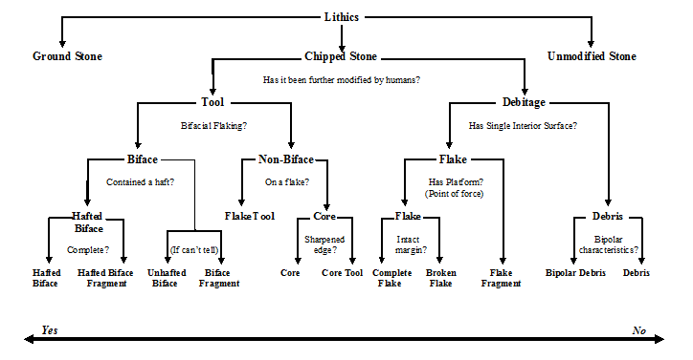
Figure 4.5: Lithic morphological characteristics flow chart (modified from Andrefsky 2005:76).
Within the bifacial tool category presented in Figure 4.5, hafted bifaces and hafted biface fragments have additional attributes measured and recorded. Types of hafted bifaces include projectile points, drills, and scrapers. I recorded the total length, maximum width, max thickness, blade length, shoulder/barb width, the proximal and distal stem widths, and notch width at opening. Style attributes recorded for hafted bifaces are for the shape of the base or stem (Figure 4.6) (Sievert 2011:74). The types of base shapes are convex, straight, and concave. The types of stem shapes are expanding, straight, and contracting. Drawings were done for almost every hafted biface to have a visual representation of the variability of stem/base shapes beyond the list of types mentioned above.
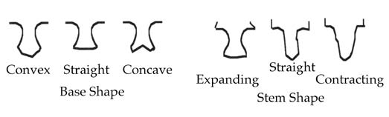
Figure 4.6: Types of hafted biface stem and base shapes in the Arkansas River Valley (Sievert 2011:Figure 6.2).

Other Artifact Analyses

Pipes and Pipe Fragments
I identified if the material for the pipe or pipe fragment was ceramic or stone. I recorded the temper type and concentration for clay pipes and the source of the raw material for stone pipes. The diameters of the orifices and the length were recorded to the tenth millimeter. The weight was also recorded in grams. When identifiable, a pipe type was recorded (ex: stemless elbow pipes) (for range of types see Brown 1996:505-526). Each pipe/pipe fragment was drawn and photographed.

Organic Materials
I collected three organic samples to collect new radiocarbon dates. In each case, only a portion of each recovered sample was used to obtain the radiocarbon date. The analysis and results were conducted by Beta Analytic Radiocarbon Dating Lab in Miami, Florida. The data includes calibration data and corrected Conventional Radiocarbon Ages and sigmas. Results are presented in Chapter 5.

Conclusion
This chapter presents the methodology I used to analyze the ceramic and lithic materials and identify patterns coinciding with the primary activities, community size, and periods of occupation at the site. I conducted an in-depth artifact analysis of the ceramic assemblage from Brackett due to their abundance in the archaeological record, for being important objects in both daily and ritual activities, and for their general temporal sensitivity with changing design styles and construction techniques. I performed a cursory examination on the lithic artifacts as a means to gain a well-rounded understanding of the types of artifacts found at Brackett. Furthermore, it is an additional means to discern any spatial division between activities based on their associated locality. These artifact analyses are important aspects for developing a regional comparison and understanding the range of activities that occurred at Spiroan mound sites. I discuss the results of these analyses in Chapter 5.

: Results and Site Chronology

This chapter presents the results of the ceramic and lithic analyses for artifacts recovered during the WPA sponsored excavations at Brackett. The intent of these analyses is to address the character of the site, specifically if the mound site was a ceremonial center, a mound-village site, or a combination of the two. To address this question, I analyze the spatial distribution of ceramic and lithic artifacts throughout the site and within the four localities (the Mound, the Burial Area, hypothesized “Residential” area and “Outside Residential” area). Within the hypothesized “Residential” and Burial Areas, I inspect artifacts and features specific to these localities since this allows for a closer inspection into the primary activities on site. I combine results from new radiocarbon assays and temporally sensitive artifact types to determine that Brackett was occupied during the Harlan and Norman phases (A.D. 1050 to 1265). The archaeological record supports my interpretation that Brackett was the location of residential and ceremonial activities overseen by a ritual specialist.

Determining Primary Residents and Main Activities
As introduced in Chapter 1, the three interrelated research questions of this thesis are 1) who were the primary residents, 2) what the main activities were, and 3) what the community size was at Brackett. In addressing who were the primary residents and the main activities and rituals, I focused on how the relationship between leaders and community members and how that relationship could have impacted the types of inhabitants and activities being performed. I examine the sociopolitical organization of Brackett along a continuum between unrestricted to restricted access to occupation and participation of rituals at the site (see Table 1.1). Along this continuum sits two extreme classifications previously associated with Brackett, a mound-village site and a ceremonial center. By examining the artifact distribution throughout the site and within each locality, I ascertained what types of activities and rituals occurred at the site and if they were restricted to certain localities.
A mound-village site had unrestricted access to occupation and ceremonies, meaning the residents and ritual participants included leaders, elites, and community members. Conversely, ceremonial centers had more restricted access to occupation with a small community size of a few elites, ritual specialists, and their family members. These two ends of the continuum are not mutually exclusive, but offer an initial means to compare the archaeological record with previous interpretations on mound sites in the Arkansas River drainage and in the overarching Caddo area. Therefore, it should be expected that Brackett and its affiliated archaeological record contains elements of both a mound-village site and a ceremonial center. As previously discussed in chapter 2, mound building and mortuary practices indicate that Brackett was a sacred place on the landscape and involved both integrative and restricted community activities (Dowd 2012:277-279; Rogers 1995:92; Sabo 1998:171). In this regard, I will offer support in this chapter and in Chapter 6 that Brackett had a limited, constrained number of permanent residence, but participation in activities was likely more inclusive.
In determining whether Brackett fit more in lines with a mound-village or a ceremonial site, I identify whether there is evidence for general community residence, particularly in the hypothesized “Residential” and “Outside Residential” areas. Larger general populations would be identified through the presence of tools used for hunting and agriculture (i.e., hoes and manos) and permanent residential structures (i.e., hearths and daily use artifacts) (Brown, et al. 1978:177). Girard and colleagues (2014:56) note how village sites would demonstrate the presence of fine ware pottery, but in a much lower frequency than at civic-ceremonial centers. Therefore, the primary ceramic artifacts would be plainware and utilitarian ceramics. In contrast, restricted access would indicate a small quantity of food processing, preparation, serving, and storage tools and that certain exclusive ritual activities were performed there. Artifacts would include a higher frequency of elaborate finely crafted material objects and the presence of special purpose structures (Dowd 2012:282-288; Girard, et al. 2014:56; Rogers 1982:49; 1989b:168).
I will discuss in this chapter my findings that the archaeological record indicates that there was both restricted and unrestricted access to residence and activities preformed at Brackett. There are certain attributes shared by both a mound-village site and ceremonial center, such as with the presence of elaborately crafted ceramics in addition to the high quantity of plain and utilitarian pottery. Furthermore, there is evidence of ritual and residential activities. The context of the finely crafted goods would be in contexts associated with restricted activities, such as with mortuary practices or in special purpose structures (Girard, et al. 2014:56).

Limitations in Comparing Artifacts by Locality
In examining artifacts within each locality, it is important to discuss the potential biases in artifact count based on the actual amount of excavation completed in each of the four localities. There is a sampling bias when comparing the artifact distribution of artifacts based on their general provenience since the Burial Area and mound were completely (or almost completely) excavated, while the “Residential” and “Outside Residential” areas were only excavated in sections. As a result, I considered the ratio of attributes within each locality individually then compare results between each locality. Due to limitations with the excavations and available data, I conduct a qualitative evaluation of the archaeological material recovered by the WPA, primarily focusing on the presence and absence of certain artifact types within each locality and throughout the site.

Results of Ceramic Analysis
Of the attributes recorded for each sherd and vessel, I found surface treatment, decoration type, vessel form, and orifice diameter most relevant for addressing the primary activities and leadership involvement at Brackett. Some additional ceramic analyses and data that do not relate to this discussion are in Appendix D. For total counts and distribution of ceramics by vessel landmark, see Table 5.1. The distribution of artifacts by the four localities is presented in Table 5.2.
Table 5.1: Total count of ceramics analyzed.
Ceramics Analyzed | Count
Whole or partially reconstructed vessels | 8 (6 from NAGPRA collection)
Sherds | 1004 (255 from NAGPRA collection)  - Body: 886  - Rim: 68  - Base: 40  - Handle: 6  - Possible handle: 1  - Rim to base: 1  - Rim with handle: 2
Sherdlets | 194 (99 from NAGPRA collection)
Total | 1206

Table 5.2: Total count of ceramics analyzed (excluding sherdlets) by locality.
Locality | N | % of Total
Burial Area | 464 | 45.9
Mound | 245 | 24.2
“Residential” | 235 | 23.2
“Outside Residential” | 26 | 2.6
Unknown Provenience | 42 | 4.2
Total | 1012 | 100.0

Surface Treatment and Decoration Types
Surface treatment and decoration types are important analytic variables for their temporal sensitivity, connections to original vessel function (i.e., serving versus cooking), and quality of production. Correlations are present between surface treatment classification and locality (Tables 5.3-4). As expected, all localities had a high percentage of plain/smoothed ceramics. Red-slipped undecorated ceramics were found in low frequency throughout the site. The Burial Area has the highest percentage of fine decorated ceramics (21.8%, n=101). The Mound had the highest percentage of burnished undecorated ceramics. In certain instances, burnishing on vessels with black coloring is associated with serving and not with cooking since the blackened surface would be destroyed if exposed to fire (Blitz 1993b:84; Steponaitis 1983:33). The Mound and “Residential” localities had a similar percentage of utility decorated (2.5-3%). Utility decorated ceramics were primarily associated with cooking and storage purposes (Early 2012:27). The two localities also had similar, low frequencies of fine decorated (1.7-2.0%) and red-slipped, undecorated (0.8-0.9%) in comparison to the Burial Area. Red-slipped ceramics were associated with fine wares and primarily associated with serving purposes (Schambach and Miller 1984). This analysis of surface treatment by locality offers initial support that a division existed between the Burial Area with its fine, serving ceramics and the mound fill/“residential” refuse with their utilitarian, cooking ceramics.

Table 5.3: Percentage of surface treatment classification by locality.
Surface Treatment Classification
Percentage by locality
 | Plain/  Smooth. | Burnished Undec. | Utility  Dec. | Fine Dec. | Dec. Unclass. | Red Slip  Undec. | Unclass.  (Eroded) | Total
Locality | Row % | Row % | Row % | Row % | Row % | Row % | Row % | Row %
Burial Area | 72.4 | 0.9 | 0.7 | 22.0 | 0.0 | 1.7 | 2.4 | 100.0
Mound | 82.0 | 6.5 | 2.5 | 2.0 | 0.0 | 0.8 | 6.1 | 100.0
“Residential” | 88.9 | 0.4 | 3.0 | 1.7 | 1.3 | 0.9 | 3.8 | 100.0
“Outside Residential” | 84.6 | 0.0 | 0.0 | 3.9 | 0.0 | 11.5 | 0.0 | 100.0
Unknown | 78.6 | 0.0 | 2.4 | 11.9 | 0.0 | 0.0 | 7.1 | 100.0
Total % | 79.2 | 2.1 | 1.7 | 11.6 | 0.3 | 1.5 | 3.8 | 100.0

Table 5.4: Total count of surface treatment classification by locality.
Surface Treatment Classification
Count by locality
 | Plain/  Smooth. | Burnished Undec. | Utility  Dec. | Fine Dec. | Dec. Unclass. | Red Slip  Undec. | Unclass.  (Eroded) | Total
Locality | N | N | N | N | N | N | N | N
Burial Area | 336 | 4 | 3 | 102 | 0 | 8 | 11 | 464
Mound | 201 | 16 | 6 | 5 | 0 | 2 | 15 | 245
“Residential” | 209 | 1 | 7 | 4 | 3 | 2 | 9 | 235
“Outside Residential” | 22 | 0 | 0 | 1 | 0 | 3 | 0 | 26
Unknown | 33 | 0 | 1 | 5 | 0 | 0 | 3 | 42
Total Count | 801 | 21 | 17 | 117 | 3 | 15 | 38 | 1012

Of the ceramics analyzed, 86.5 percent (n=875) did not have any identifiable surface decoration. I attempted to assign plainware types to 716 body sherds with a plain/smoothed surface treatment. Since the plainware types are chronologically sensitive based on thickness and primary temper, I only considered body sherds when I classified the ceramics. As a result, 85 sherds with a rim, base, or handle were excluded since these landmarks indicate locations where wall thickness is variable (Rice 2005:227). The three main plainware types for the region were Williams, Woodward, and Le Flore Plain. Ceramics with a grog/shell temper (n=165) were placed into a fourth category, labeled “unknown plainware type.” There are limitations with this classification system. Many decorated ceramic types from the Caddo area were only partially decorated, which means a sherd from a decorated vessel could have lacked decorations. As a result, this classification of plainware ceramic types should be considered more as indicating the presence of these types throughout the site and within each locality (Table 5.5).
Within this classification system, there was a low frequency of Williams Plain ceramics, particularly in the Burial Area (less than one percent of plainware body sherds). There was a high frequency of Woodward Plain in the Burial Area and in the Mound. The highest frequency by percentage of Williams Plain ceramics found in the “Outside Residential” area is of questionable importance because of the locality’s small sample size. There is a high frequency of Le Flore Plain in the “Residential” area, followed by Woodward Plain. Sherds were labeled as Le Flore Plain instead of Williams Plain when their thickness was less than 9mm.
Table 5.5: Plainware Ceramic types by locality
 | Plainware Ceramic Types
 | Le Flore  Plain |  | Williams  Plain |  | Woodward Plain |  | Undesignated  Plainware Type |  | All
Locality | N | Row % | N | Row % | N | Row % | N | Row % | N | Row %
Burial Area | 70 | 22.5 | 2 | 0.6 | 145 | 46.6 | 94 | 30.2 | 311 | 100.0
Mound | 41 | 23.4 | 3 | 1.7 | 102 | 58.3 | 29 | 16.6 | 175 | 100.0
“Residential” | 78 | 41.7 | 6 | 3.2 | 71 | 38.0 | 32 | 17.1 | 187 | 100.0
“Outside Residential” | 0 | 0.0 | 3 | 16.7 | 5 | 27.8 | 10 | 55.6 | 18 | 100.0
Unknown Provenience | 7 | 29.2 | 1 | 4.2 | 16 | 66.7 | 0 | 0.0 | 24 | 100.0
All | 197 | 27.5 | 15 | 2.1 | 339 | 47.4 | 165 | 23.0 | 716 | 100.0

Within the total ceramic assemblage at Brackett, 13.5 percent (n=137) had some degree of decoration. I compared the relationship between decoration type and primary temper (Table 5.6). Approximately 92 percent (n=126) of the decorated ceramics were grog tempered. The majority of grog-tempered sherds with decorations had an engraved decoration (70.8%, n=97). There were only three examples of decorated ceramics with grog/shell tempering (one engraved example and two incised examples). Only 5.8 percent (n=8) of decorated ceramics were shell tempered. Of those eight ceramics, all four examples of appliqué were shell tempered. The low frequency of shell-tempered ceramics with designs may be a reflection of its slow incorporation into fineware pottery manufacturing.
Table 5.6: Decoration types (count and percentage) by primary temper.
 | Primary Temper
 | Grog | Grog/Shell | Shell
Decoration Type | N (% of Total) | N (% of Total) | N (% of Total) | N (% of Total)
Applique | 0 | 0 | 4 (2.9%) | 4 (2.9%)
Cord Marked | 2 (1.5 %) | 0 | 0 | 2 (1.5%)
Engraved | 97 (70.8 %) | 1 (0.7%) | 0 | 98 (71.5%)
Fingernail Punctate | 8 (5.8%) | 0 | 0 | 8 (5.8%)
Incised | 17 (12.4%) | 2 (1.5%) | 3 (2.2%) | 22 (16.1%)
Incised-Punctate | 1 (0.7%) | 0 | 0 | 1 (0.7%)
Notched/Incised | 0 | 0 | 1 (0.7%) | 1 (0.7%)
Ridge Pinched | 1 (0.7%) | 0 | 0 | 1 (0.7%)
TOTAL | 126 (92.0%) | 3 (2.2%) | 8 (5.8%) | 137 (100.0%)

Of the 137 decorated ceramics, I was able to assign types to 98 of them (71% of decorated ceramics, 9.7% of total ceramic count). There was concern over the total count of ceramic types since there is some ambiguity in sherd count numbers because of breakage. Given this and the low overall sample size, I focus on the presence or absence of specific ceramic types and their distribution across the site (Table 5.7).
Table 5.7: Distribution of decorated ceramic types by locality.
Typologies | Total Count | Total Count by Locality
Typologies | Total Count | Burial Area | Mound | “Residential” | “Outside Residential” | Unknown Provenience
Coles Creek Incised | 1 | 0 | 1 | 0 | 0 | 0
Crockett Curvilinear | 14 | 14 | 0 | 0 | 0 | 0
French Fork Incised | 1 | 1 | 0 | 0 | 0 | 0
Hickory Fine Engraved | 10 | 10 | 0 | 0 | 0 | 0
Holly Fine Engraved | 26 | 26 | 0 | 0 | 0 | 0
Pennington Punctate-Incised | 1 | 0 | 1 | 0 | 0 | 0
Sanders Engraved | 1 | 1 | 0 | 0 | 0 | 0
Spiro Engraved | 45 | 40 | 0 | 0 | 0 | 5
Unidentified Applique | 4 | 3 | 0 | 1 | 0 | 0
Unidentified Cord Marked | 2 | 0 | 2 | 0 | 0 | 0
Unidentified Engraved | 15 | 10 | 2 | 3 | 1 | 0
Unidentified Fingernail Punctate | 8 | 0 | 3 | 5 | 0 | 0
Unidentified Incised | 7 | 0 | 1 | 4 | 0 | 1
Unidentified Notched Rim | 1 | 0 | 1 | 0 | 0 | 0
Unidentified Ridge Pinched | 1 | 0 | 0 | 1 | 0 | 0

The only example of Coles Creek Incised (or a locally made copy), Pennington Punctate, Undesignated Cord Marked, and a Notched Rim design were identified within the platform mound. Crockett Curvilinear, French Fork Incised, Hickory Fine Engraved, Holly Fine Engraved, and Sanders Engraved vessels were restricted to the Burial Area. With the exception of five Spiro Engraved sherds with unknown proveniences, all examples of Spiro Engraved were isolated to the Burial Area. The only example of a ridge pinched design was classified in the “Residential” area, specifically within Structures 5 and 6. Six decorated sherds were in association with Structures 5 and 6; however, no identifiable ceramic types were associated with the site’s buildings. Only one decorated sherd (an undesignated engraved type) was found in the “Outside Residential” area.
Of the decorated ceramic types recovered from multiple localities, undesignated engraved and incised ceramics were distributed throughout the site. The Mound and “Residential” area had the only examples of fingernail punctate designs. Ceramics with appliqué were associated with the Burial and “Residential” areas, specifically Structures 5 and 6. Fineware ceramics (engraved, incised, and red-slipped) were distributed throughout the site; however, the majority of fine ceramic decoration types were restricted to the Burial Area than the other localities.

Rim Sherds: Vessel Form and Orifice Diameter
I was able to assign vessel forms to 58 of the 78 ceramics with rims (roughly eight percent of the total ceramic assemblage). Seven vessel forms were identified: bottles, carinated bowls, simple bowls, bowls, jars, restricted and unrestricted vessels (jars or bowls). I discuss the measurements and distribution of vessel forms by orifice diameter and locality in the following sections.
I examine orifice diameter by vessel form to identify the range variability with each type, which are usually related to vessel size (Table 5.8). There was little variability with the orifice diameter for bottles. With the exception of one simple bowl with an orifice diameter of 26.0cm, the range in orifice diameter for five simple bowls became less pronounced at 7.5 to 12.0cm. There was a similar range in orifice diameter between simple bowls, bowls, jars, restricted vessels, and unrestricted vessels. There were 16 examples of vessels with an orifice diameter of 20.0cm or more. Of those 16, there were only six examples with an orifice diameter of 25.0cm or more. Although there are a limited number of identifiable vessel forms with associated localities, some patterns are apparent (Table 5.9).
Vessel form is an important variable to begin interpreting their possible uses (Brown 1996:335). For general associated vessel form functions, bottles were reserved for serving, storing, and transporting and carinated bowls were associated with serving (Hally 1986:290). Bottles and carinated bowls were almost exclusively found in the Burial Area, although one bottle and two carinated bowls with unknown proveniences. Bowls and jars were associated had cooking, preparing, storing, and serving food (Hally 1986:290) Jars, simple bowls, restricted and unrestricted vessels (jars or bowls) were distributed throughout the site.

Table 5.8: Measurements of orifice diameter by vessel form (count, mean, median, range).
 | Orifice Diameter (cm)
Vessel Form | N | Mean | Median | Range
Bottle | 6 | 3.6 | 3.8 | 3.0-4.0
Carinated Bowl | 12 | 22.0 | 20.0 | 18.0-30.0
Simple Bowl | 6 | 15.7 | 13.5 | 9.0-26.0
Bowl | 1 | 12.0 | 12.0 | 12.0
Jar | 13 | 13.4 | 14.0 | 10.0-16.0
Restricted Vessel (Jar/Bowl) | 3 | 18.7 | 20.0 | 10.0-26.0
Unrestricted Vessel (Jar/Bowl) | 8 | 18.5 | 18.0 | 10.0-26.0

Table 5.9: Distribution of vessel form types by locality (count and percentage).
 | Locality
 | Burial Area |  | Mound |  | “Residential” |  | “Outside Residential” |  | Unknown Provenience
Vessel Form | N | % | N | % | N | % | N | % | N | %
Bottle | 6 | 15.0 | 0 | 0.0 | 0 | 0.0 | 0 | 0.0 | 1 | 16.7
Carinated Bowl | 10 | 25.0 | 0 | 0.0 | 0 | 0.0 | 0 | 0.0 | 2 | 33.3
Simple Bowl | 5 | 12.5 | 2 | 14.3 | 2 | 12.5 | 0 | 0.0 | 0 | 0.0
Bowl | 1 | 2.5 | 0 | 0.0 | 0 | 0.0 | 0 | 0.0 | 0 | 0.0
Jar | 8 | 20.0 | 0 | 0.0 | 4 | 25.0 | 1 | 33.3 | 2 | 33.3
Restricted Vessel (Jar/Bowl) | 1 | 2.5 | 1 | 7.1 | 1 | 6.3 | 0 | 0.0 | 0 | 0.0
Unrestricted Vessel (Jar/Bowl) | 3 | 7.5 | 4 | 28.6 | 4 | 25.0 | 0 | 0.0 | 0 | 0.0
Unknown Form | 6 | 15.0 | 7 | 50.0 | 5 | 31.3 | 2 | 66.7 | 1 | 16.7
All | 40 | 100.0 | 14 | 100.0 | 16 | 100.0 | 3 | 100.0 | 6 | 100.0

This analysis suggests that there are correlations between vessel form, surface treatment, and locality (Figure 5.1). Fine decorated treatments were used on bottles, carinated bowls, simple bowls, jars, and unrestricted vessels (jar or bowl). Plain/smoothed surface treatments were located on bowls and jars, with one example on a bottle. All fine decorated bottles (with one exception), fine decorated simple bowls, and fine decorated and red slipped carinated bowls were found within the Burial Area. Vessels in the “Residential” area were plain/smoothed vessels associated with cooking/preparing food; however, there were also two examples of fine decorated vessels (one jar and one unrestricted vessel). The majority of vessels found within the mound were plain/smoothed and utility decorated vessels associated with cooking/preparing food, with the exception of the only example of a burnished undecorated unrestricted vessel (jar or bowl). This comparison indicates that the Burial Area and “Residential” area were used for serving purposes.
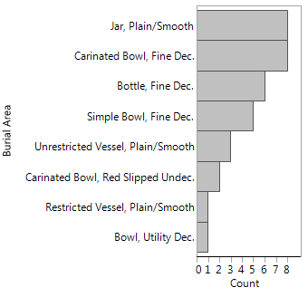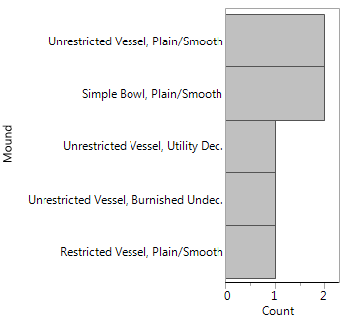
a) Burial Area (n=34) b) Mound (n=7)
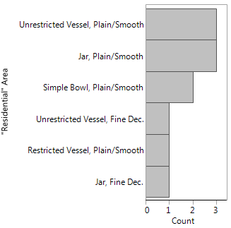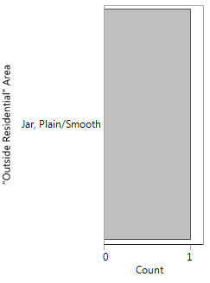
c) “Residential” area (n-11) d) “Outside Residential” area (n=1)

Figure 5.1: Vessel form with surface treatments separated by locality. The small sample sizes limit the interpretations on the observed patterns.

Ceramics Summary
Through this ceramic analysis on the surface treatment, decoration type, and vessel form, there are discernable patterns with the location of certain ceramic types. The Burial Area has the highest percentage of fine decorated and red-slipped ceramics, as well as bottles and carinated bowls. The Mound had the highest percentage of burnished, undecorated ceramics and has the only example of Coles Creek Incised and Pennington Punctate-Incised. The hypothesized “Residential” area shares certain patterns also present in the Mound and Burial Area. Similarities shared between Mound and “Residential” area include their high percentage of utility decorated and plain/smoothed surface treatments and low frequency of fine decorated and red-slipped ceramics, in comparison to the Burial Area. A similar pattern exists between the “Residential” area and the Burial Area based on the presence of fine decorated jars and unrestricted vessels (jars or bowls). From this broad inspection on the ceramic assemblage at Brackett, there are certain artifacts restricted to certain locations.

Results of Lithic Analysis
The attributes I emphasize in this analysis are the distribution of raw material sources, chipped stone types, hafted biface types, and a functional analysis across the site. Some additional analyses and data on the lithics that do not relate to this discussion are in Appendix E. Based on general artifact count by locality, most chipped stone artifacts were recovered from the “Residential” area (Table 5.10). There was a larger percentage of lithics that came from surface collection or have unknown provenience (32.7%) than was the case with ceramics (4.2%). Of the four localities, the fewest lithics were recovered from the Mound, which may indicate that it was not a significant element of the mound construction fill.
Table 5.10: Lithic distribution by locality.
Locality | N | Percentage of Total
Burial Area | 112 | 14.6
Mound | 62 | 8.1
"Residential" | 257 | 33.5
"Outside Residential" | 85 | 11.1
Unknown Provenience | 251 | 32.7
All | 767 | 100.0

Raw Material Source
In reviewing the overall distribution of raw materials throughout the site, 92 percent is comprised of Tahlequah/Peoria, Reeds Spring, and Keokuk (Table 5.11). These types were all local sources within the region. Novaculite comprised the fourth highest source at 2.1 percent. Brown (1996:437) noted that lithic tools made out of Novaculite “have a well-known ubiquity of appearance in Caddoan sites.” There were few examples of raw materials that came from outside the immediate region surrounding Brackett, specifically Brown Jasper, Frisco, Florence A, and Johns Valley chert.
Table 5.11: Distribution of raw material types identified throughout Brackett.
Raw Material | N | Percentage of Total Assemblage
Argillite/Siltstone | 7 | 0.9
Brown Jasper | 1 | 0.1
Florence A Chert | 4 | 0.5
Frisco Chert | 2 | 0.3
Johns Valley Chert | 7 | 0.9
Keokuk | 125 | 16.3
Limestone | 2 | 0.3
Novaculite | 16 | 2.1
Quartz | 1 | 0.1
Quartzite | 6 | 0.8
Reeds Spring | 277 | 36.1
Sandstone | 2 | 0.3
Sedimentary Rock | 1 | 0.1
Shale | 2 | 0.3
Slate | 1 | 0.1
Tahlequah/Peoria | 303 | 39.5
Unidentified Chert | 8 | 1.0
Unknown Material Type | 2 | 0.3
Total | 767 | 100.0

When comparing raw material sources by locality, the Burial Area had the most variability, followed by the “Residential” area (Figure 5.2). The “Outside Residential” area had the least amount of variability. The only examples of novaculite, brown jasper, and quartz were recovered within the Burial Area, which indicates that the exotic materials are found primarily in mortuary contexts. Tahlequah/Peoria, Reeds Spring, and Keokuk were distributed throughout the site. Florence A chert was identified in the Burial Area (n=2, 50%) and “Residential” area (n=1, 25%), as well as one example with an unknown provenience. Overall, the four localities share similar distributions of Reed Springs (31-48%), Tahlequah/Peoria (21-42%), and Keokuk (16-26%). Therefore, the primary raw material sources are local to the Ozarks.
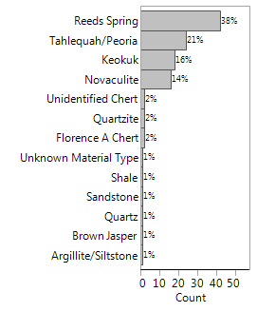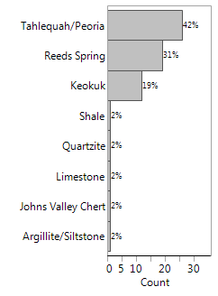
a) Burial Area (n=112) b) Mound (n=62)
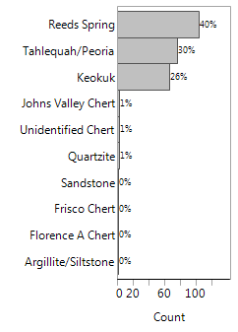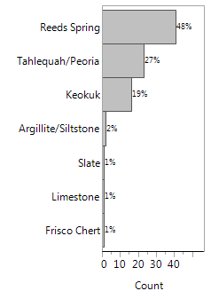
c) “Residential” area (n=257) d) “Outside Residential” area (n=85)

Figure 5.2: Distribution of raw material types by locality.

Chipped Stone Types
Correlations exist between chipped stone type and site localities (Figure 5.3). There was relative uniformity in the distribution of bifaces (17-22%), preforms/cores (10-13%), and groundstone (6-10%) throughout the site. Hafted bifaces comprised around 50 percent of the assemblages in the Burial Area, Mound, and “Outside Residential” area, while only comprising 29 percent of the “Residential” assemblage. Flakes and debris were found in both the “Residential” and “Outside Residential,” but not in the Mound fill. There are three examples of debris in the Burial Area.
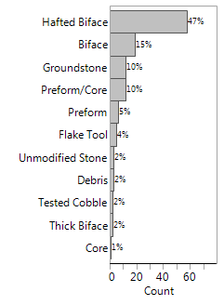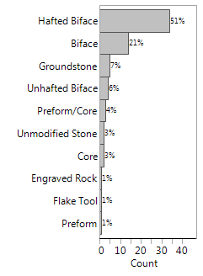
a) Burial Area (n=112) b) Mound (n=62)
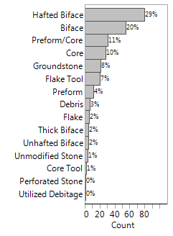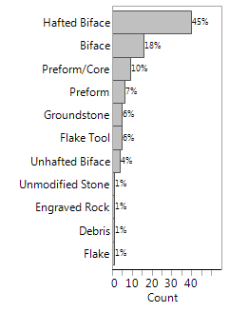
c) “Residential” area (n=257) d) “Outside Residential” area (n=85)

Figure 5.3: Distribution of artifacts by chipped stone types and separated by locality.

I considered the impact of locality on the distribution of hafted biface chipped stone types across the site (Figure 5.4). Blade fragments were only found in the Burial Area. Double bitted axes had a higher frequency in the “Outside Residential” area (11.9%) and a low frequency in the other three localities (1.2-2.9%). Drills were identified in low frequency in the Burial Area, Mound, and “Residential” area (5-9%). There were only two examples of hoes found, one in the Burial Area and one in the “Outside Residential” area. Scrapers were restricted to the “Residential” area (with one exception with an unknown provenience). Utilized flakes (n=2) were located in the “Residential” and “Outside Residential” area. Overall, projectile points comprised over 80 percent of the hafted biface assemblage throughout the site.
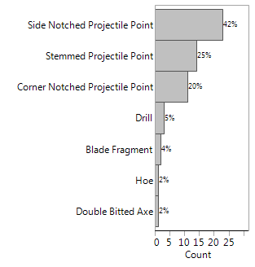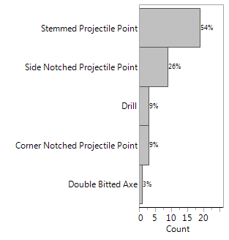
a) Burial Area (n=68) b) Mound (n=35)
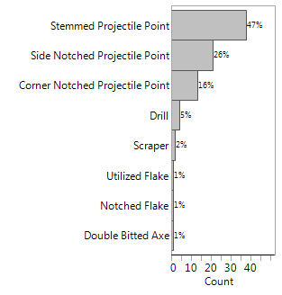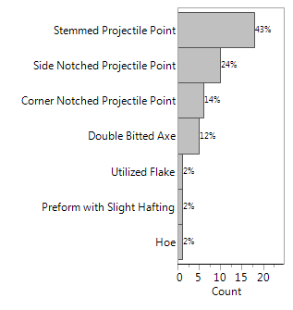
c) “Residential” area (n=81) d) “Outside Residential” area (n=42)

Figure 5.4: Distribution of artifacts by hafted biface types and separated by locality.

Functional Analysis
In order to more accurately associate tool form with function and uselife, I would have needed to include a use-wear or residue analysis (Odell 2003:135). Andrefsky (2005:222) emphasizes how an artifact can acquire different functions throughout its uselife through resharpening and signs of wear. As a result, it is difficult to assign specific functions to these artifacts. However, there are certain characteristics of utilization generally associated with chipped stone tools (presented in Table 5.12). These characteristics are not intended to describe the only way these tools were implemented at Brackett or at any other site. These characteristics offer an idea of how these tools may have been utilized and what activities likely occurred as certain localities within the site.
Table 5.12: Chipped stone types and associated characteristics of utilization (adapted from Andrefsky 2005:204; Odell 2003:176-188).
Chipped Stone Tool | Characteristics of Utilization
Hoe | Plant procurement; “agricultural implements that were employed for digging furrows in the soil" (Odell 2003:176)
Projectile points, preforms, cores (and associated tools) | Animal procurement, projectiles, cutting, and butchering tools
Scrapers | Animal processing for food procurements, clothing production, and other household accoutrements  Use for Scraping, graving, boring, and chapping.
Mano/Metates | Food processing- grinding plains, grains, nuts.
Axes (double bitted) | Designed for working wood and cutting down trees. Examples of use include clearing forest, building structures, constructing handles for tools
Drills | Craft and clothing production
Flakes and debitage | Results from flint knapping and tool production on site
Utilized flakes, utilized debitage | Expedient tool from flint knapping a core

In regards to the chipped stone tools with general associated traits, certain artifacts were restricted to the “Residential” area. Flakes and scrapers, which are associated with tool production and animal processing, were located exclusively in the “Residential” area. Expedient flake tools were recovered from the Burial Area, “Residential,” and “Outside Residential” areas. Drills were found in the Burial Area, Mound, and “Residential” area. Hoes, which are associated with plant procurement, were located in the Burial Area and “Outside Residential” area. Tools associated with wood cutting, animal procurement, and food processing, specifically double bitted axes, projectile points, and manos, were recovered in all four localities. Although these types of tools were associated with all four localities, this does not mean that the same meaning was associated with each locality or between two artifacts from one locality. This initial inspection indicates that certain artifacts such as tool production, food processing (plant and animal), and craft or clothing production were occurring on site, especially in the “Residential” area. Activities included those that were necessary for semi-permanent to permanent residence at Brackett (Brown 1984b:16).

Lithics Summary
In my preliminary analysis of lithics from Brackett, I distinguished certain key traits related to the activities that originally enacted onsite. First, lithics were not a key element of the fill used to construct the platform mound. Second, the majority of chipped stone artifacts were made from locally available raw material. Third, of the non-local raw material identified, the majority were only from the Burial Area. Fourth, daily activities necessary for semi-permanent to permanent residency were occurring on site.

The Hypothesized “Residential” Area: Activities Associated with the Structures
I evaluated the types of artifacts and features associated with the eight buildings to help determine if the hypothesized “Residential” area was used for daily domestic tasks or as special purpose structures (Rogers 1982:49; Story 1998:26). Distinctions between these two architecture types are presented in Table 5.13. In regards to building shape, extended entranceways can be found on daily-use buildings, while every identified special purpose structure in the Caddo area have extended entranceways (Kay and Sabo 2006:34). Special purpose structures and residential buildings have both been identified near mounds and in village contexts (Perttula 2009:30; Rogers 1982:49). Special purpose structures are unique for examples being buried under mounds (Kay and Sabo 2006:30). Special purpose structures also appear to have important connections between the orientation of their extended entranceways and semi-cardinal directions, which share alignments with important calendrical events (Kay and Sabo 2006:36-39; Perttula 2009:34-36). I discuss the specific attributes and potential activities associated with each building below (for measurements see Table 3.1).

Table 5.13: Comparison of attributes associated with Special Purpose Structures and Residential, daily-use buildings (adapted from Kay and Sabo 2006:34, 44-46; Rogers 1982:49, 87; 1995:49, 88; Trubitt 2009:239-240).
Special Purpose Structures | Residential/Daily-Use Buildings
- Twice as large as residential structures (mean area: 85.0m²)  - Close proximity to mounds  - Hall-like extended entranceways  - Clay floor layer  - Lack of hearths  - Clay pedestal (some special purpose structures, not associated with charnel houses)  - reconstruction in the same spot  - Building alignment with solstices and equinox sightings, indicative of ritual activities associated with the structure  - Ritually cleared of artifacts (specifically, for charnel houses)  - Lack of domestic debris | - Smaller in size  - Harlan phase mean area: 46.2m²  - Spiro phase mean area: 38.0m²  - May or may not have extended entranceways  - Can be near mounds  - Presence of hearths  - Presence of artifacts associated with domestic debris and craft production (i.e., plainware pottery, hoes, double-bitted axes, drills)  - Storage features

Structure 1 was one of the smaller buildings (40.9m²), ranked sixth in terms of floor area. The extended entranceway is oriented to the northeast semi-cardinal direction. Attributes associated with special purpose structures includes the potential clay pedestal, clay floor and its close proximity to the Burial Area. Attributes associated with residential structures includes its small floor area, large quantity of domestic debris. The pottery is all plainware and lithic types include double bitted axe, drills, scrapers, and utilized flakes/debitage, which are associated with daily use activities (Table 5.14). Based on a general distribution map, the artifacts are clustered at the edge of the building and just outside of it (Figure 5.5, also refer to Figure 3.4). The placement of artifacts could the result of site formation processes. Structure 1 shares attributes with both residential/daily-use and special purpose structures.
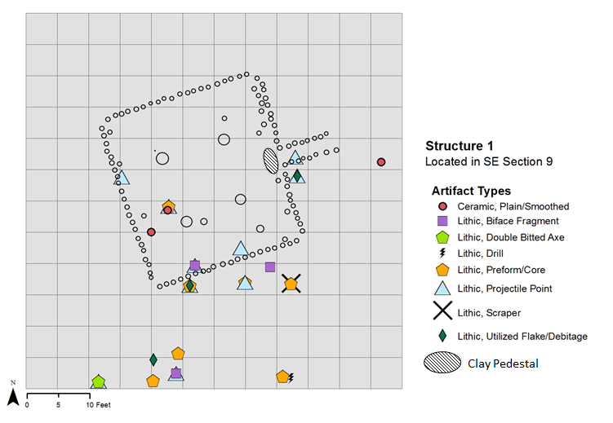
Figure 5.5: Symbology map of the distribution of artifact types associated with Structure 1 (n=30 (4 ceramics, 26 lithics)).

Table 5.14: Count and description of artifacts found in association with Structure 1; artifact counts presented in parentheses.
Catalog no. | Artifact Type | Count | Artifact Descriptions
009 | Ceramic | 4 | Plain/smoothed (4)
035 | Lithic | 2 | Scraper (1); Preform/Core (1)
231 | Lithic | 2 | Side notched projectile point (1); Flake Tool (1)
240 | Lithic | 1 | Stemmed projectile point (1)
246 | Lithic | 4 | Side notched projectile point (2); Flake Tool (1); Preform/Core (1)
266 | Lithic | 3 | Side notched projectile point (1); Preform/Core (1); Utilized Debitage (1)
278 | Lithic | 1 | Preform/Core (1)
288 | Lithic | 1 | Drill (1)
292 | Lithic | 1 | Hafted Biface (1)
312 | Lithic | 1 | Preform/Core (1)
353 | Lithic | 2 | Stemmed projectile point (1); Preform/Core (1)
359 | Lithic | 1 | Side notched projectile point (1)
362 | Lithic | 1 | Biface (1)
381 | Lithic | 1 | Corner notched projectile point (1)
395 | Lithic | 2 | Side notched projectile point (1); Double bitted axe (1)
396 | Lithic | 1 | Stemmed projectile point (1)
397 | Lithic | 1 | Preform/Core (1)
495 | Lithic | 1 | Biface (1)
Structure 2 was ranked fourth largest (62.4m²), based on floor area size. The lack of an extended entranceway and the presence of a hearth indicated that it was originally employed as a residential or daily-use building (refer to Figure 3.5). The hearth indicates that it was a permanently constructed feature. If it had been ritually cleaned, dismantled, and/or burned, evidence for a hearth would likely have been disrupted and unrecognizable to the WPA field crew (Rogers 1982:87). No artifacts were recorded as association with the building, which means that it may have been ritually swept clean. These attributes indicate that Structure 2 was likely used for residential activities, such as sleeping and group gatherings, but not for regular eating, distributing goods, or performing ritual activities.
Structure 3 was the second smallest building (32.4m²), ranked seventh in floor area. It was rectangular in size with one identified, but likely two center-posts, and an extended entranceway oriented to the southeast (refer to Figure 3.6). The shape of the building parallels ones designed during the Norman and Spiro phases (Rogers 1995). In general, structures from these phases were smaller than the ones from the Harlan phase. Rogers (1989a:169) recorded that the average household size of Norman/Spiro phase was 38 m², which was similar to the dimensions of Structure 3 (32.4 m²). Therefore, it is likely that Structure 3 was constructed later during Brackett’s occupation during the Norman or Spiro phases. Three artifacts (a rock, point, and charred cane sample) were originally recorded to be associated with Structure 3; however, all information regarding these artifacts is missing. In comparison to the Structures 1, 5, 6, and 7, this is a small quantity of artifacts. Due to the paucity of information available about this building, I tentatively associate it as a household.
Structure 4 was the largest of the buildings (76.0m²). It had a hall-like extended entranceway directed towards the southeast (refer to Figure 3.7). No artifacts, hearths, or features were recorded in association with the building indicating that it may have been ritually cleaned. The building was located in close proximity to the platform mound. These attributes suggests it may have been a special purpose structure.
Structures 5 and 6 were two of the larger structures (ranked 2nd and 3rd (72.8m² and 62.7m²) in terms of floor area). The buildings also had the largest quantity and range of associated artifact types (Table 5.15). Structures 5 and 6 were also the only ones with faunal remains recovered from within them. Based on the distribution map, there are multiple clusters of artifacts, indicating areas of high activity within these buildings (Figure 5.6, also refer to Figure 3.8). These buildings had extended entranceways oriented to the southeast. The location of these structures is significant for their close proximity to the platform mound and since the land was reused for building reconstruction. These attributes may be an indication that these large structures were utilized for group activities, possibly associated with winter solstice or mortuary rituals.
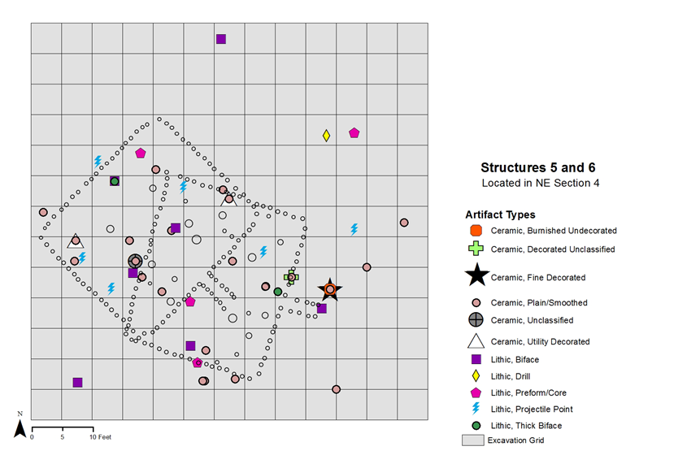
Figure 5.6: Symbology map of the distribution of artifact types associated with Structures 5 and 6 (n=58 (49 ceramics, 9 lithics)).

Table 5.15: Count and description of artifacts found in association with Structures 5 and 6; artifact counts presented in parentheses.
Catalog no. | Artifact Type | Count | Description
019 | Ceramic | 2 | Plain/smoothed (2)
041 | Ceramic | 1 | Plain/smoothed (1)
055 | Ceramic | 2 | Plain/smoothed (2)
058 | Ceramic | 12 | Decorated unclassified (3), Plain/smoothed (9)
068 | Ceramic | 1 | Plain/smoothed (1)
076 | Ceramic | 11 | Plain/smoothed (11)
089 | Ceramic | 1 | Utility decorated (ridge pinched) (1)
093 | Ceramic | 1 | Plain/smoothed (1)
194 | Ceramic | 10 | Fine decorated (incised) (1), Burnished undecorated (1), Plain/smoothed (8)
211 | Ceramic | 1 | Plain/smoothed (1)
255 | Ceramic | 1 | Plain/smoothed (1)
445 | Ceramic | 1 | Plain/smoothed (1)
525 | Ceramic | 2 | Utility decorated (applique) (1), Plain/smoothed (1)
610 | Ceramic | 2 | Plain/smoothed (1)
669 | Ceramic | 1 | Plain/smoothed (1)
19 | Lithic | 1 | Stemmed projectile point (1)
61 | Lithic | 1 | Stemmed projectile point (1)
202 | Lithic | 1 | Preform (1)
211 | Lithic | 1 | Core (1)
237 | Lithic | 1 | Biface (1)
335 | Lithic | 1 | Biface (1)
371 | Lithic | 2 | Biface (1); Thick Biface (1)
532 | Lithic | 1 | Side notched projectile point (1)

Structure 7 was the fifth largest building. Its surface area (49.1m²) was similar in size to daily-use, residential structures. Similar to Structures 3-6 and 8, the extended entranceway of Structure 7 is oriented to the southeast. Of the four buildings with artifacts, Structure 7 had the least variation in terms of types of ceramic and lithic artifacts (Figure 5.7, also refer to Figure 3.9). However, it has a larger quantity of ceramics with one example of fineware pottery (Table 5.16). The lithic artifacts include projectile points, preforms, cores, groundstone, and debitage, which are attributed with tool production and food processing. As a result, it appears that some domestic activities were occurring in and around Structure 7.
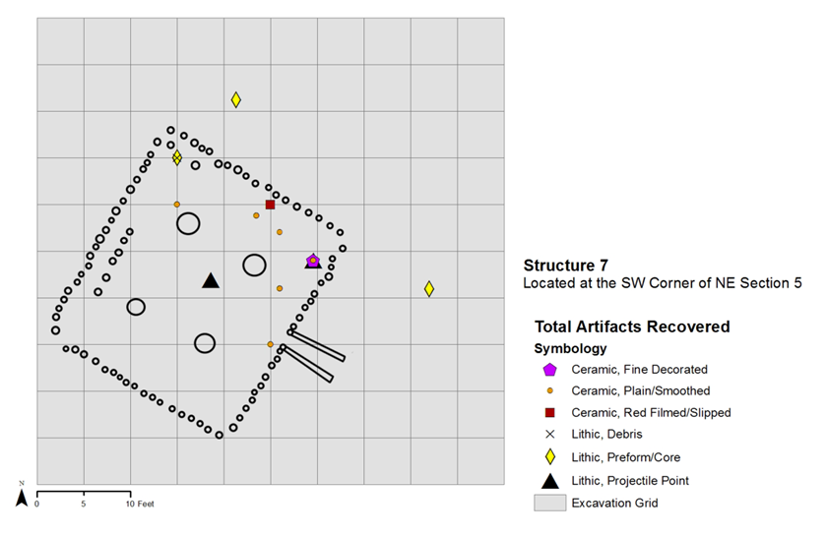
Figure 5.7: Symbology map of the distribution of artifact types associated with Structure 7 (n=48 (35 ceramics, 13 lithics).

Table 5.16: Count and description of artifacts found in association with Structure 7; artifact counts presented in parentheses.
Catalog no. | Artifact Type | Count | Description
441 | Ceramic | 9 | Fine decorated (engraved) (1)  Plain/smoothed (8)
492 | Ceramic | 6 | Plain/smoothed (6)
534 | Ceramic | 4 | Plain/smoothed (4)
537 | Ceramic | 2 | Plain/smoothed (2)
543 | Ceramic | 1 | Plain/smoothed (1)
544 | Ceramic | 10 | Plain/smoothed (10)
556 | Ceramic | 1 | Plain/smoothed (1)
561 | Ceramic | 1 | Plain/smoothed (1)
562 | Ceramic | 1 | Plain/smoothed (1)
441 | Lithic | 1 | Stemmed projectile point (1)
462 | Lithic | 1 | Preform/core (1)
463 | Lithic | 1 | Side notched projectile point (1)
466 | Lithic | 3 | Preform/core (2); debris (1)
479 | Lithic | 1 | Preform (1)
497 | Lithic | 1 | Biface (1)
511 | Lithic | 1 | Preform/core (1)
533 | Lithic | 1 | Stemmed projectile point (1)
560 | Lithic | 1 | Side notched projectile point (1)
645 | Lithic | 1 | Groundstone (1)
647 | Lithic | 1 | Groundstone (1)

Structure 8 was the smallest structure (23.8m²) and ranked eighth in floor area. Like 75 percent of the buildings at Brackett, it had an extended entranceway directed towards the southeast (refer to Figure 3.9). Bareis (1955:6) notes that no artifacts were associated with the building. Since all data regarding Structure 8 was lost, I could not determine if it was primarily used for daily, domestic activities or for special ritual purposes.

Structures Summary
No single structure includes the entire list of attributes associated with either architecture type. Of the eight buildings, Structures 1 and 4 shared the most qualities associated with special ritual purposes. For Structure 1, the presence of a clay pedestal at the entrance symbolizes restricted access to the interior of the building (Kay and Sabo 2006). Structure 4 also appears to be a special purpose structure since it was large in size and lacked artifacts/features generally associated with residential activities. Structure 2 shares more traits with residential activities. The identification of only one hearth throughout the site indicates that 1) this feature was a permanent element of Structure 2, 2) that hearths were either not an important feature or were not permanently constructed features for the other seven structures, or 3) only seasonally occupied and didn’t require a heat source (Rogers 1982:87). Structures 5 and 6 had multiple areas of high artifact density, as well as have the largest quantity and variability in artifact types. This in addition to the faunal remains and their large size, I associated these superimposed structures with daily activities and craft production. Structure 7 had a limited quantity and range of artifacts, however the primary artifacts were plainware pottery and lithics associated with tool production and food processing. Therefore, it appeared that some domestic activities were occurring in relation to this building. Due to the paucity of information for Structures 3 and 8, I could not identify potential associated activities. Based on the orientation of their extended entranceways, 5 of the 8 buildings (Structures 4 through 8) indicate an emphasis on the southeast semi-cardinal direction. This analysis demonstrates how we cannot assume that all architecture at a mound site was used for the same activities. Furthermore, we cannot assume that all the buildings were in use at the same time, especially since there are demonstrable change in construction shape, as demonstrated with Structure 3, and the presence of superimposed buildings, Structures 5 and 6. At Brackett, there is a combination of special, ritually-charged activities and daily, semi- to permanent residential activities occurring within the hypothesized “Residential” area.

Mortuary Customs and Activities Specific to the Burial Area
In this section, I consider only the artifacts directly associated with the burials from the Burial Area. Based on an initial inspection of the material distribution by ceramic and lithic artifacts, there does not appear to be a pattern between the quantity or types of artifacts and interment burial strategy (Figure 5.8, see also Figure 3.12). Associated Funerary Objects (AFOs) were identified in association with primary and secondary burials, pit burials, and in individual and group burials. The artifact types associated with AFOs were much more variable than artifacts found in any other locality. Unique AFOs included two burials with chunks of unmodified quartz (Burials 3 and 15) and three burials with ground stone/manos (Burials 3, 4, 10). Burials 5 and 6 were superimposed with a separation in depth of six inches (15.24cm) and were also the only burials where earspools (stone, pulley, two with copper staining) were located. The burial with the largest number of AFOs (n=8) was Burial 4 (possible primary burial with five individuals interred together) and the burial with the second largest number of AFOs (n=6) is Burial 1 (a primary, individual adult burial). The burials with no AFOs (Burials 7, 9, and 12) were buried at the same depth (0.5feet) and were possible primary, single burials. There are examples were funerary objects were placed in association with group burials (Burials 4, 8, 10) and individual burials (Burials 1-3, 5-7, 9, 11-12, 14). There are also examples of group and individual burials with no funerary objects. This variability in the types and quantity of funerary offerings in the Burial Area indicate that there is not a one-to-one correlation between type of interment and quantity of burial offerings. In Chapter 6, I will discuss the significance of placing funerary objects alongside burials, as well as the importance of burial orientation and location of interment.
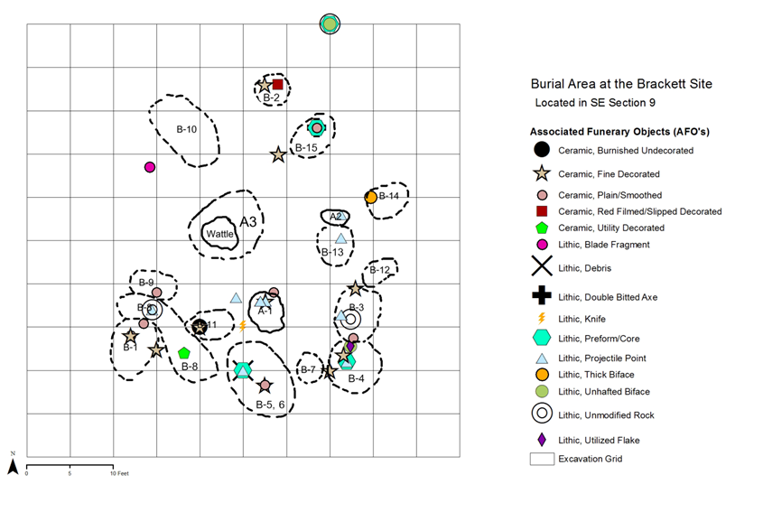
Figure 5.8: Symbology map of the distribution of Burial Area AFOs by artifact type (n=74 (26 ceramics, 48 lithics).

Site Occupation
In order to address the question of when Brackett was occupied, I combine the results from new radiocarbon dates with diagnostic artifacts and features to ascertain the relative chronology of the site. One radiocarbon assay was previously analyzed in 1958 (Bell 1958:3; 1961:78). The sample (O-606) was selected from Test Pit 4, SE Section 9 of the site at a depth of 0.9 meters below surface. The uncorrected date for this sample is 700 ± 100 B.P. and the two-sigma calibrated date range is cal. A.D. 1152 to 1434 (Calib 7.0.4). This radiocarbon assay would place Brackett in the Norman and Spiro phases (Rogers 2011:4; Wyckoff 1980:188). However, chronometric dating techniques were just developing in the late 1950s which resulted in issues regarding the reliability of this date and other assays from the region during this time, especially from this lab. Therefore, this old date should be used with caution and new radiocarbon assays were analyzed for the purpose of better understanding the chronology of the site.
The new radiocarbon dates were analyzed from three organic samples recovered during the WPA excavations (Table 5.17; Figure 5.9). The first sample was a charred wood sample taken from Structure 1 in its northwest center post (Beta-429720). The second sample was a charred nut fragment collected from the mound at row 15, alley 17 at a depth of 6 inches (Beta-429721). Finally, the third sample was a charred cane fragment collected from Structure 5 at the SW stake at row 1, alley 7 (Beta-429722). Since they were non-marine samples, the two-sigma calibrated date ranges were calculated using that IntCal13 calibration dataset from the CALIB 14C Rev 7.0.04 software program. The two-sigma calibrated date range for the three samples is cal A.D. 1040 to 1265 (Reimer, et al. 2013; Stuiver, et al. 2005). This range covers the Harlan and Norman phases (refer to Figure 3.1) (Rogers 2011:4). Based on these new dates, it also appears that the construction of the mound and Structures 1 and 5 could have temporally overlapped. These new dates indicate that the original 1958 assay may have been off by between 100 to 200 years. Hammerstedt and colleagues (2010:283) identified similar issues with the 1960s radiocarbon dates from the 1941 excavations at the Clement site in southeastern Oklahoma where dates varied and appeared much later than what one would expect based upon their archaeological context.
Table 5.17: Summary of Radiocarbon Dating Results for the three new samples taken from the Brackett site.
Beta number | Museum Catalog number | Sample Type | Provenience | Conventional  Radiocarbon Age | Calibrated Results Range  (95% Probability)
Beta-429720 | N/A | Charred wood | Structure 1  (SE Sec. 9) | 890 ± 30 BP | Cal A.D. 1040 to 1220  (Cal BP 910 to 730)
Beta-429721 | 619 | Charred nut fragment | Mound  (NE Sec. 5) | 880 ± 30 BP | Cal A.D. 1045 to 1095  (Cal BP 905 to 855)  Cal A.D. 1120 to 1220  (Cal BP 830 to 730)
Beta-429722 | N/A | Charred cane fragment | Structure 5  (NE Sec. 4) | 820 ± 30 BP | Cal A.D. 1165 to 1265  (Cal BP 785 to 685)

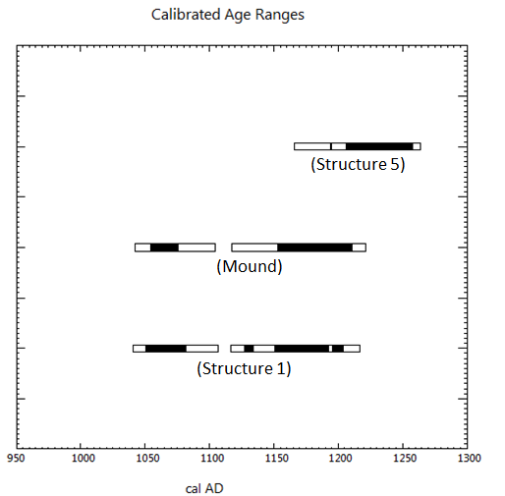
Figure 5.9: Calibrated age range for the three radiocarbon samples collected at Brackett (adapted from the CALIB 14C Rev 7.0.04 software program) (Stuiver, et al. 2005).

In addition, the temporally diagnostic ceramics, lithics, and architectural features are consistent with these dates. The presence of Crockett Curvilinear, Spiro Engraved, Williams Plain, and Woodward Plain support occupation during the Harlan phase (Bell 1984:231). The presence of a Sanders Engraved vessel in the Burial Area and large quantity of Woodward Plain throughout the site mark a continuation of occupation into the Norman phase. Across the site, 41 percent (n=418 of 1012) of total ceramic assemblage were shell tempered. This large quantity of shell-tempered pottery is a reflection of the introduction of this construction technique in the Arkansas River Valley around AD 1000 (Brown 1984b:6; Perttula, et al. 2011). Red slipping for shell- and grog-tempered pottery is introduced and becomes important after A.D. 1100 during the Harlan phase and Brackett includes 16 examples (Cranford 2007:106). However, as discussed in Chapter 3, it may also be the result of sampling bias. Furthermore, all but one base recovered from site are flat, three of which have keels. These thick, flowerpot shaped bases are associated with the Fourche Maline to the Harlan phase traditions (Schambach 1982). In regards to lithic technology, two large Florence A chert biface fragments, which were located in the Burial Area, are similar in design to ones from the Harlan site (Figure 5.10) (Bell 1972:Plate 2). The presence of pulley shaped stone earspools ones with copper staining (34CK43/75) and without (34CK43/109, 113) in Burials 5 and 6 place them as later burials during the Harlan phase (Figure 5.11, see also Appendix C) (Bell 1984:231, 238). Fundamentally, the presence of grave goods in burials and the construction of a platform mound is indicative of the Harlan to Spiro phases (Rogers 1989a). The buildings with their four center posts and are square and rectangular in shape have been located throughout the Arkansas River valley and date to A.D. 1050 – 1300 (Kay and Sabo 2006). Overall, the archaeological record supports the new radiocarbon dates collected for this research.
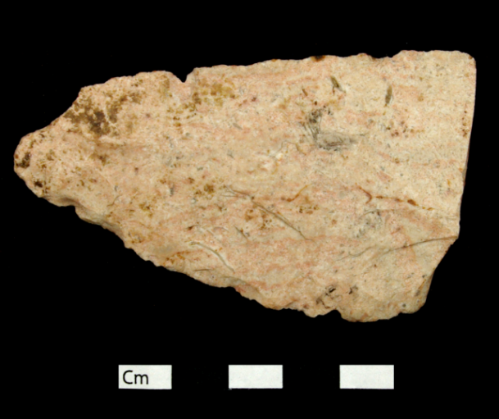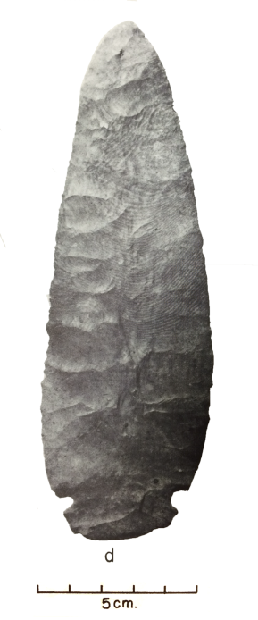
Figure 5.10: The picture on the left is a Florence A chert blade fragment from Brackett (34CK-43/203 from the Burial Area locality). The picture on the right is a Florence A chert blade (also referred to as a Kay County, Flint knife) from the Harlan site (adapted from Bell 1972: Plate 2d).
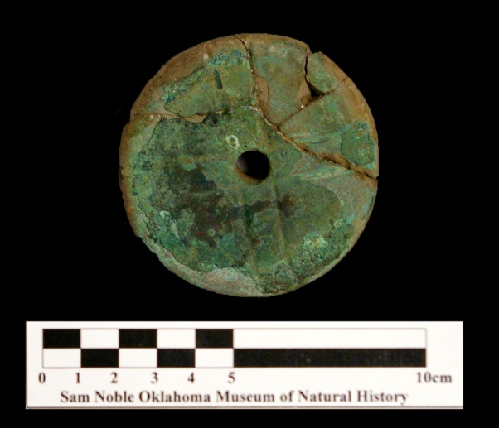
Figure 5.11: One of the earspools (34CK-43/75) recovered from the Burial Area, Burial 5. This is a pulley earspool with a perforation, copper staining, and design on the surface.

Conclusion
Brackett was occupied during the Harlan and Norman phase (around A.D. 1040-1265) and was occupied for a reasonable length of time. Supporting evidence includes superimposed Structures 5 and 6, burials with Spiro Engraved and Sanders Engraved vessels, and the multiple stages in mound construction. There is evidence that daily, residential and special, ritual activities were occurring and at different locations. Overall the site appears to have special, ritually charged artifacts based on their association and restricted placement in the Burial Area. Daily activities associated with semi-permanent to permanent residential activities were taking place onsite, as demonstrated through the artifacts associated with Structures 5, 6 and the presence of manos, double bitted axes, and projectile points throughout the site. The presence of the mound, mortuary rituals, and residential and special purpose buildings provide preliminary evidence that both restricted and unrestricted access to the site and inclusive and exclusive rituals were performed at Brackett. Most likely, these activities were overseen by a resident ritual specialist. The next chapter discusses how the social significance of residential and ritual activities at Brackett, individually and regionally.

: Interpretations, Conclusion, and Future Research

With the final chapter, I discuss my interpretations of Brackett based on the structures, features, artifacts, and associated activities. The questions that have been guiding this research are: 1) who were the primary residents, 2) what activities were occurring, 3) what the community’s size, and 4) when was the site’s occupation (which I addressed in Chapter 5). To address the first three research questions, I focused on how leadership is enacted through the spatial organization of sites, as well as through persons of authority’s ability to tie community practices with the belief systems of the society. Specifically, I employ the frameworks developed by Dowd (2012) and Wyckoff and Baugh (1980) on the impact positions of leadership may have on the spatial organization of sites in the Caddo area (see Chapters 1 and 2). My research on Brackett is an initial examination to test whether these models are applicable to mound sites in the Arkansas River valley.
Identifying the primary residents, activities, and community size at Brackett are interwoven with interpreting the social role of the site. Brackett likely had more than one role and that activities occurring would have changed over time. Therefore, this research addresses one potential role of the site. My interpretations concentrate on how relationships were formed between leaders and community members and the role social identity, religious beliefs, and community practices impact those relationships (Joyce and Barber 2015:821; Pauketat 2007:36, 105, 107; Pauketat and Alt 2004:779). I examine the data from an intrasite scale and then apply those interpretations to understand the placement of Brackett, a ritually-charged place, in the Arkansas River drainage system. Finally, I present the importance of studying the local histories of sites to understand the variability of mound sites and middle range societies in the North American southeast. This research sets the groundwork for future analyses on Brackett and other pre-Contact sites in the Arkansas River valley.

Interpretations at the Intrasite Scale
This section connects the static material record with the dynamic social processes of the region and time period to interpret the nature of Brackett’s social organization. The material record available from the WPA-sponsored excavations includes the eight structures, the Burial Area, the platform mound, and the artifacts associated with the localities. The artifacts associated with the different structures, platform mound, and Burial Area present evidence that Brackett was the location of domestic activities, communal rituals, and restrictive practices. Based on the available data, I argue that the community was relatively small and that the primary occupants were likely a ritual specialist or group of specialists, and their family members. I discuss the social significance and ritual activities associated with the structures, Burial Area, and platform mound individually and then together as support for my argument.

The Structures
The two primary activities associated with structures in the Caddo area are for daily-residential purposes and special, ritual activities. Special purpose structures are distinct from domestic buildings for the political and religious rituals being performed inside, such as council meetings or hidden religious rituals, and the involvement of community leaders, ritual specialists, or elites (Dowd 2012:281; Dye and King 2007:160-161; Perttula 2009:29; Rogers 1982:49, 89-90). Chapter 5 presented the results and support for how I identified the structures associated with residential uses (Structures 2, 5, 6, 7) and those more strongly associated with non-domestic, special ritual purposes (Structures 1, 4). The two structure functions offer important indications concerning the activities that occurred in the hypothesized “Residential” area.
Symbolism of Households and Special Purpose Structures
The construction of buildings in the Caddo area follows intentional design patterns that have been interpreted to symbolize the merging of social practices and cosmological symbolism (Sabo 1998; Story 1998). Sabo (1998) discussed how the process of building houses (and potentially special purpose structures) for the Historic Caddo was part of community-based rituals. The construction and design of special purpose structures have been interpreted as visible markers of cultural solidarity and connectedness that promoted social order and the hierarchical position of leaders associated with those buildings (Sabo 1998:168; Story 1998:39). Special purpose structures provide evidence for both inclusive and exclusive practices, through their potential community involvement in their construction, but restricted access to the rituals performed inside (Brown 1996; Dowd 2012:279; Perttula 2009; Sabo 1998).
Enactments of cosmological symbolism through architecture construction are demonstrated through their association with directionality and the manner in which they are disassembled at closing rituals (Kay and Sabo 2006:29, 33; Perttula 2009:27-28; Story 1998:39). Kay and Sabo (2006) and Perttula (2009) discuss the connection between the orientation of extended entranceways and symbols of life, death, and funerary rituals. For the historic Hasinai Caddo groups, the southeastern and southwestern semi-cardinal directions follow the same orientation as the sunrise and sunset of the winter solstice, calendrical events associated with mortuary ceremonialism (Kay and Sabo 2006:30, 32-33). Extended entranceways act as physical markers of the intentional restriction of entry into the interior of the building (Brown 1996; Dowd 2012; Kay and Sabo 2006; Perttula 2009). One possible explanation for constricted hall-like entryway is to restrict access to the ritual activities that occurred within the interior room. The process of deconstructing certain special purpose buildings (Harlan-style charnel houses) is unique from that of residential structures in that they were intentionally dismantled, burned, destroyed, then rebuilt on the same spot, which evoked important themes of destruction and renewal (Kay and Sabo 2006; Rogers 1982; Trubitt 2009).
Symbolism and Structures at Brackett
There are identifiable similarities between the eight uncovered structures (see Chapter 5). All structures were square or rectangular pitched roof buildings constructed with wattle-and-daub. Based on their construction, shape, and associated artifacts, these structures appear to have been constructed as relatively permanent places on the landscape. Dowd (2012:281) proposed that the construction of permanent structures at ritual sites, such as Brackett, may indicate either “a) the site was used for residential as well as ritual purposes or b) that other activities were being conducted that we hidden from public view.” The presence of seven structures with extended entranceways indicate that the activities that occurred within them had to some degree constrained access and potentially excluded the majority of community members from the activities within them. Of those seven, five are oriented towards the southeast, the direction of the winter solstice sunrise, which suggests symbolic ties to mortuary practices. This continuity should not assume that all functioned in the same way, since their general style does not directly indicate original functions (Early 1988:161).
There are important differences between structures in regards to the variability in artifact types, features, and associated activities. Structures 1 and 4 are most likely special purpose structures due to their size, paucity of artifacts, and absence of hearths. Orr’s feature form on Structure 1 records a “house ash mixture (stratum) [that] contained quantities of charcoal, burnt clay and wattle work with deep grove impressions” (original document on file at the SNOMNH). Additionally, the presence of a potential clay pedestal found at the entrance of Structure 1 evokes possible association with Harlan-style charnel houses. Clay pedestals were constructed before the Harlan-style charnel houses were destructed to symbolically block entrance into it (Kay and Sabo 2006:42, 44). Based on the data from Structures 3, 5, 6, and 7, daily-use and residential activities were occurring. The residents who utilized these permanent structures were likely associated with the rituals and restricted activities occurring within special purpose structures.
Summary
In addressing the presence of both special purpose structures and residential activities, I employ Wyckoff and Baugh’s (1980:249) discussion on the distinctions between positions of authority and residential patterns amongst the historic Hasinai Caddo. The political leaders (caddices) and community elders (canahas) lived in residences that were architecturally indistinguishable from those of general community members and were located in village contexts, where they held authority. In contrast, the religious leader (xinesi) was physically separated from the communities he or she held authority over and often resided in a temple (which was larger than residences) and were situated near the “temple mound.” Due to the presence of the special purpose structures and their close proximity to the Burial Area and the platform mound, I argue that this is preliminary support that a ritual specialist was one of the primary residents at Brackett and that some of the structures were utilized for ritual purposes. Support for the connection between the few residential structures (potentially Structures 3, 5-7) and the residence of a spiritual leader onsite is provided by Rogers (1989b:168), who proposed that some of the buildings associated with mound centers were the potential residences of elites or community leaders. Overall, the structures at Brackett indicate that ritual activities were occurring and that a specialist or group of specialists presided over those activities.

The Burial Area
Within the Burial Area, I examine the type of interment (individual, group, primary or secondary), the position and orientation of burials, the inclusion of specific types of funerary offerings, and the location of burials. Mortuary ceremonialism is one means to identify the social dynamics between leaders and community members. The act of interring one’s ancestors and community members into the earth impacts how one interacts with the landscape.
Types of Interment Practices
The types of interment practices in the Burial Area include individual, group, primary, and possible secondary burials. These different interment strategies reflect different mortuary customs occurring at Brackett. The different customs could be a reflection of the roles these individuals played during their lives or temporal changes in how mortuary customs were enacted. Blanton and colleagues (1996) proposed that the group burials reflect community-centered practices (see also Kidder 1998; King 2006; Lewis and Stout 1998:230). The clustering of both group and individual burials into the Burial Area may be support of community-centered practices being enacted through these mortuary rituals. Primary and secondary burial types differ in how the mortuary customs were carried out and reflect the social identity of the individual or group. Secondary interments indicate a concern for the souls of the dead, an emphasis on communal practices with the removal of individual social identities, and a possible curation of multiple individuals in charnel houses (Brown 2003:96; Kay and Sabo 2006:39). There are examples of burials (Burials 3-6, 8, 9, 13, 15) that were not confirmed as primary burials and may, instead, indicate being secondary burials since they contain poorly preserved fragments of human remains. There is an overlap between these possible secondary burials and the presence of charcoal, burnt clay, and discolored soil “house mixtures.” There are multiple notes about a “house mixture” begin associated with Burials 3, 5 through 9, which is described as burned clay, charcoal, and discoloration in the soil (Bareis 1955b:7-9; Howard 1939a:1).
The fragmented human remains, the presence of wattle, and the “house mixture” may indicate the use of charnel house(s). Since multiple deceased individuals were curated in a Harlan-style charnel house, the remains were grouped together and become fragmentary. As part of the closing rituals, the removal of the dead, the cleaning, repairing of the clay floor, closing the entrance, and intentionally burning the Harlan-style charnel houses (Kay and Sabo 2006:41-42). The results of the closing ritual may have resulted in a similar mixture to the “house mixture” found in the Burial Area (Kay and Sabo 2006; Rogers 1982; Trubitt 2009).
Funerary Offerings
Burials with funerary objects include all interment types (individual, group, primary, and possible secondary). The presence of burial goods does not necessarily indicate status differentiation. Instead, it may be more appropriate to interpret these artifacts as funerary offerings reflecting changes in mortuary customs since funerary objects are rarely associated with the earlier traditions of the Fourche Maline (Sabo and Early 1990:75). If these elaborate and iconographic objects were implemented in ritual activities, their placement in burial contexts may be a reflection of the individuals’ role in performing rituals with those objects, such as with ritual specialists (Dowd 2012:281-282; Sullivan and Mainfort 2010). In conjunction with the community-centered interment practices, the almost exclusive presence of finely crafted vessels with iconographic designs within the Burial Area may support an idea that the “collective display of ritual, or spectacles, [are] intended to connect the entire community to the worlds of the ancestors and the cosmos” (Sullivan and Mainfort 2010:9).
Orientation and Location of Burials
Of the burials where body orientation was possible to ascertain, there are patterns associated with cardinal directions, north to south (Burials 3 and 14), and semi-cardinal directions, northwest to southeast (Burials 6 and 7) and northeast to southwest (Burials 5 and 11). Although these burials all differ in the types of artifacts associated with them, they demonstrated a continuation with the use of cardinal and semi-cardinal directions at Brackett (Hammerstedt and Savage 2014).
The location of the burials at Brackett may reflect important exclusionary practices. As presented in the previous section, the presence of both special purpose and residential structures indicates that Brackett was not a typical mound/village site. Therefore, the location of mortuary practices away from a larger village site could indicate the intentional separation of the living from the ritual specialists conducting mortuary rituals and the deceased (Kay and Sabo 2006:33). Brown (1984b) noted that the Burial Area may have originally been mounded then flattened or destroyed before excavations. The fact that the burials were placed in a circular or semi-circular fashion and the presence of elaborate goods in the Burial Area, but not in direct association with specific burials, may offer support for the original mounding. However, the artifacts may also have been originally associated with burials that were not identified by the WPA excavators or due to sediment moving artifacts away from burials. Therefore, I find Brown’s (1984b) interpretation about the Burial Area plausible, but not confirmable.
Summary
The variability in interment practices (individual, group, primary, and possible secondary) occurring in the Burial Area may indicate temporal changes in mortuary ceremonialism during the duration of occupation at Brackett. The potential use of charnel houses in the mortuary practices are supported by the close proximity of the Burial Area to the semi-permanent to permanent structures onsite, the presence of “house mixture” deposits, and possible secondary burials. The location of burials primarily in the Burial Area, the potential restriction of mortuary treatment in charnel houses, and at a site not primarily identified as a village site indicate that mortuary practices were spatially segregated from the affiliated, but dispersed communities.

The Platform Mound
The third location of particular interest is the platform mound. Addressing mounds as symbolic artifacts and as places of religious and social significance have been an important research strategy amongst Southeastern and Caddo archaeologists (Early 2000:126; Kay and Sabo 2006; Kay, et al. 1989:152-156; Sabo 1985; Sabo and Early 1990:99; Story 1998:12). The role and rituals associated with mounds are variable and could change during and after construction (Knight 1986:678-679; 2001:312). Rogers (1995:92-93) argued that the process of mound building was associated with inclusive community-based practices since it required scattered, dispersed communities to unite together for the purpose of constructing the earthworks. The activities connected with the platform mound post-construction may have revolved around more exclusionary practices, depending on the role of the site and influence of community leaders (Dowd 2012:276-277). Overall, the creation of earthworks involves the active negotiation and cooperation between leaders and community members.
Construction Layers and their Symbolic Significance
Although I am unable to separate artifacts by mound construction layer, the layers themselves are informative about the ritual practices and the ideology involved in its construction (Kay, et al. 1989; Sabo 1985:151). Based on the descriptions of the three middle layers, which are considered to be the summits of previous construction phases, there are identifiable distinctions based on soil color and texture (see Chapter 3 for descriptions) (Bareis 1955b:11-12). Of the five construction layers of the platform mound, I found the ash layer (the third layer, “Layer C”) as being the most symbolically significant.
Ash occurs when a fire burned out but was not smothered, whereas charcoal and some organic materials are preserved when the fire is smothered (Trubitt 2009:242). Possible explanations for this ash layer include the remnants from a sacred perpetual fire being present on site or the result from the closing ceremonies of charnel houses (Brown, et al. 1978:186-187). For the first possible explanation, I turn to the ethnohistoric literature on the maintenance of sacred perpetual fires. Amongst the historic Hasinai, the religious leader (xinesi) was responsible for maintaining a sacred perpetual fire and providing offerings to it (Swanton 1996 [1942]:213-219; Trubitt 2009:243). Sacred fires have been interpreted to be located on top of mounds or in nearby structures or temples (Brown, et al. 1978:187). Juan Agustin Morfi described how the historic Hasinai Caddo would “exercise in taking out of the [ritual leader’s] temple the ashes of the sacred fire, which they keep to make large mounds” (presented in Swanton 1996 [1942]:215). Support for the second option, the remains of a closing ritual for charnel houses, comes from other identified connections between Brackett, the mound, and mortuary rituals. In the “lower stratum” construction layer of the mound, two individuals (Burials 16 and 17) placed in the mound, separated from the burials located in the Burial Area (Bareis 1955b:10-11). The different location for the interment of the dead may be a reflection of changing mortuary practices being enacted at the site. If the ash layer was the remains of a closing ritual for charnel houses, this could indicate a continued connection between mound construction and mortuary rituals. Overall, fire held symbolic significance and the resulting smoke served as direct lines of communication with the spiritual world (Sabo 1998:161). Furthermore, household fires for the associated communities came from the sacred fire. The resulting ash from fires acts as an important element in purification and regeneration rituals (Carter 1995; Parsons 1969). The properties of ash shares many similarities to the death and renewal symbolism of mound building (Knight 1989). The presence of the thick ash layer indicates a connection between the mound and fire (Trubitt 2009:233). The ash layer supports the view that the mound, and subsequently the entirety of Brackett, was a ritually charged place.

Post-Construction Mound Activities
There are two important points to discuss when considering the role of the mound after each phase of construction was completed. Bareis (1955b:13) argued that there was a short time period in between construction periods of the mound since no thick humus layers formed between each layer. However, this may be a reflection of regular maintenance of the earthwork post-construction, which coincides with the maintenance and rules involved in constructing each layer (Kay, et al. 1989:151; Pauketat 2007:98). Furthermore, WPA field crews found no evidence of post molds at any stage of the mound’s construction (Howard 1939a:24). The lack of post molds indicates that no permanent structure was situated atop of the mound. This indicates that the construction of permanent residential structures, community buildings, or charnel houses were restricted to the hypothesized “residential,” “outside residential,” and Burial areas. Dowd (2012:280) proposed that mounds with structures on top indicate that the ritually-charged place was appropriated by leaders or elites. Therefore, the lack of a summit structure on a mound at Brackett may have been involved in more inclusive activities and rituals, such as communal gatherings or feasting events (Dowd 2012:279). I interpret the platform mound at Brackett as a community-centered, ritually-charged place on the landscape where people formed connections with the spiritual world and with each other.

Overall Interpretations from the Intrasite Analysis
The three main features at Brackett are the eight structures, the Burial Area, and the platform mound. The presence of special purpose structures, a designated location for the interment of the deceased, and two burials identified within the mound indicate a strong association with mortuary ceremonialism. The structures (with the exception of Structure 2) and Burials 3, 5-7, 11, 14 highlight the importance of cardinal and semi-cardinal directions, an attribute shared by many mound sites throughout the Arkansas River valley (Hammerstedt and Savage 2014). Based on these connections, I propose that Brackett was a ritually-charged place overseen by a spiritual leader, who would have been responsible for initiating mortuary rituals and other ceremonies (Dowd 2012; Knight 2016).
Support for this interpretation is based on the limited number of domestic artifacts in association with Structures 2, 5, 6, and 7 and throughout the site. The presence of domestic goods may have been, in part, the result of the residence of that leader and his or her family (Dowd 2012:287). There was evidence of restricted and unrestricted access to the site was occurring at different times while the site was occupied. The presence of group burials and acts of mound construction reflect inclusive, communal rituals; whereas, the extended entranceway structures and small community size reflect restricted access to certain aspects of the site (Blanton, et al. 1996; Brown 1996:132; Dowd 2012; Kidder 1998; King 2006; Lewis and Stout 1998:230). The presence of constrained areas of accessibility, such as with the extended entranceway structures and limited community size, may indicate that the site was occupation was limited to ritual specialist(s) and family members (Wyckoff and Baugh 1980). Dowd (2012:281) proposed that the presence of special purpose structures (potentially with Structures 1 and 4) at a place where social gatherings were occurring could indicate certain elements of exclusion to a predominantly inclusive environment. Therefore, these activities reflect spatial segregation in regards to occupation, but not necessarily a restriction of participation, of specific rituals to the mound site (Kay, et al. 1989:152-155; Regnier, et al. 2014:101-103).
It is difficult to ascertain what the community size was at Brackett since only a small portion of the site was excavated and data was not collected in the best way (see Chapter 3). It appears that there were a limited number of permanent inhabitants due to the low frequency of cooking jars and bowls and food processing tools identified throughout the site. The primary support for my interpretation on a small community size, however, derives from the ethnohistoric data. For historic Hasinai Caddo, the ritual specialists, their residence, and the rituals they were responsible for were segregated from the general population (Dowd 2012:281; Wyckoff and Baugh 1980). In regards to activities, although residence was likely constrained, this does not reflect whether the rituals performed involved limited direct community participation. Furthermore, the presence of special purpose structures is indicative of exclusive ritual activities being performed inside that limited the number of participants. At this stage of research, it cannot be determined if the ritual specialist was only responsible for conducting religious ceremonies or also held an important political role for the surrounding communities (Wyckoff and Baugh 1980).
I argue that the leaders at Brackett required the support of their community and ideology to allow for the construction of the platform mound and structures, then have the continued support for the restricted access to the site, potentially at different times and for different rituals (Angelbeck and Grier 2012; Joyce and Barber 2015; Pauketat 2010a:16; 2010b:169-170, 189; Welch and Butler 2006:7). Rogers (1989b:168) discussed how the segregation of ritual activities away from community settlements was an active effort of elites and leaders to create control over sacred practices and esoteric knowledge which would in turn result in their increase in power and authority. For historic Caddo communities, authority was exerted based on the ability to demonstrate and maintain a connection to the cosmic realm (see Chapter 2) (Sabo 1998:161-162; Swanton 1996 [1942]:170-173; Wyckoff and Baugh 1980:238). Individuals with positions of authority gained the support of their community by forming a connection between the rituals they orchestrated and the cosmological realm by creating sacred places on the landscape (Wesson 1998:113-114). Public participation in community rituals, such as with building mounds and structures, would have been promoted as a means to infuse their traditions and identity into the land (Brown 2012:121-122, 136-137; Knight 2016:37; Pauketat 2007:42; 2010b). The meanings associated with community involvement could have changed over time. Therefore, it is important to recognize that the interpretations presented in this thesis reflect one perception on the role of Brackett, but that the meaning and role of the site likely changed throughout the course of its construction and use. This bottom-up approach reveals that we cannot look at Brackett like it was a large, political hegemonic capital. Brackett was the location where authority was interwoven with community identity, religious practices, and daily practices (Alt 2010:4; Joyce and Barber 2015:821; Pauketat 2007:36, 105, 107; Pauketat and Alt 2004:779; Sassaman 2004).

Interpretations at the Regional Scale
Brackett is a Spiroan mound site situated in the Arkansas River valley, which extends from northwest Arkansas to eastern Oklahoma and runs along the Arkansas River and its main tributaries (Poteau, Neosho, and Illinois rivers) (Bell 1984:227; Perttula 1996:136). Contemporaneous Spiroan mound sites to Brackett include the Harlan, Norman, Reed, and Lillie Creek sites which are situated along the Neosho/Grand River, Pineville on the Elk River, Goforth-Saindon along the Illinois River, Lee Creek/Parris on Lee Creek, Eufaula along the Canadian River, Hughes, Skidgel, and Spiro on the Arkansas River (Ray and Lopinot 2008:62). Within this region, there are limited and often dated analyses conducted at these sites. However, there is a growing body of literature discussing the significance of these sites individually and collectively (Brown 1996, 2012; Cranford 2007; Dowd 2012; Hammerstedt, et al. 2015; Hammerstedt and Savage 2012, 2013, 2014; Kay and Sabo 2006; Leith 2006; Livingood 2011; Lockhart 2007; Perttula 2009; Sievert and Rogers 2011; Trubitt 2009; Vogel 2005). There are identifiable attributes shared amongst these mound centers, such as the rich iconographic designs shared on the pottery and some degree of a connection with the Spiro mound site (Brown, et al. 1990; Rogers 1995:92-93). Further connections are demonstrated through the attributes associated with Brackett and other Spiroan sites were not occurring in the later Fort Coffee phase (A.D. 1450 – 1660) (Rogers 2011:7; Rohrbaugh 1982; Sabo and Brown 2014; Wyckoff 1980). I compare Brackett to other mound sites in the Arkansas River valley through certain shared mortuary practices, architecture design and function, and the presence of ash layers in mounds. These attributes indicate a shared, overarching organizational pattern shared among Spiroan sites.

Mortuary Ceremonialism
A regional connection is expressed through the burial practices performed in the Arkansas River valley during the Harlan, Norman, and Spiro cultural phases (Hammerstedt and Savage 2014). Brackett is similar to the Harlan, Norman, and Spiro sites based on the inclusion of group burials in their mortuary practices. However, Brackett is distinct from these other sites since the group burials were not interred in multi-lobed burial mounds. Furthermore, the potential use of charnel houses at Brackett indicates a shared mortuary program with Harlan, Goforth-Saindon, and Huntsville (Kay and Sabo 2006:31). This unifying trait indicates that the original residents of the Arkansas River valley participated in an ideological system that influenced how they organized and constructed their mound sites (Kay, et al. 1989:151; Sabo 1985:9; Story 1998:12). Hammerstedt and Savage (2012, 2013) proposed that these shared mortuary practices were mostly distinct from communities located in the Red River valley.

Architecture Designs
The square to rectangular structures with the extended entranceways at Brackett are similar in design to ones found throughout the region, for instance at Harlan, Reed, and Lillie Creek (Bell 1972; Hammerstedt and Savage 2014; Purrington 1971). Knight (2007:186) discussed how “that sharedness of formal design of domestic housing across geographic space would be a common index of the relatedness and interaction of peoples, in the same manner that pottery is often used.” Similarities are also demonstrated through the construction of extended entranceways in which is oriented to coincide with directional symbolism (Hammerstedt and Savage 2012, 2013, 2014). Perttula (2009:34) identified how almost 50 percent of special purpose buildings identified in the northern Caddo area were oriented to the southeast. Although not included in Perttula’s (2009) analysis, Brackett (Structures 3-8) and Reed (e.g., Structures 1A and 1B) also highlight the importance of the southeastern semi-cardinal direction (Hammerstedt and Savage 2012:2; Purrington 1971:359). By following general rules for the construction of buildings, both residential and non-residential, the structures at Brackett share a connection with other sites with extended entranceway structures in the Arkansas River Valley and throughout the Caddo area (Perttula 2009:27-28).

Mound Building and Ash Layers
As discussed above, the platform mound at Brackett contained a thick ash layer. Ash layers have also been identified in the mounds at Hughes, Norman, and Skidgel. The ash layer at Hughes is distinct from the one at Brackett since the layer was not a continuous layer, but instead was identified at the sides of the platform mound. Hammerstedt and Regnier (2016) interpret this discontinuous ash layer as being the result of a type of habitation residing on top of the mound at the time. The ash layers identified at Brackett, Norman, and Skidgel were interpreted by Brown and colleagues (1978:187) as being the potential result of a long-burning fire being placed atop or near the mound. The ash layers demonstrate a connection between mounds and fires, an important symbol identified throughout the Caddo area (Trubitt 2009:233).

Attributes Specific to the Northern Caddo Area
As presented in Chapter 3, there are multiple traits that distinguish the northern and southern sub-regions of the Caddo area, which include certain mortuary customs, structure shape, and introduction of shell-temper (Bell 1984; Hammerstedt and Savage 2012, 2014; Rose, et al. 1998; Story 1990; Walters 2016). My research on Brackett supports those distinctions. The high percentage of shell tempered pottery at a Harlan to Norman phase site coincides with the argument that shell-tempering was introduced earlier in the northern Caddo area (A.D. 1000 and 1250) than in the southern Caddo area (after A.D. 1300) (Brown 1984b:6; Perttula, et al. 2011). Brackett’s potential presence of charnel houses corresponds to the findings that the two sub-regions’ enacted different group oriented mortuary practices (Perttula 1996; Story 1990; Walters 2016). The construction of square to rectangular structure shapes and the prominence of extended entranceways oriented to the southeast also support Perttula’s (2009) distinction between the two sub-regions. Overall, the archaeological data at Brackett coincides with certain patterns identified throughout the Northern Caddo area and supports that there are key differences between the two sub-regions.

Variability in the Role of Mound Sites
Studying the local histories of these contemporaneous sites is necessary to begin identifying the variability in the role of mound sites in the region. In comparison to the mortuary rituals at Spiro, Norman, and Harlan, the rituals at Brackett were smaller in scale and potentially for different reasons. Research on Brackett demonstrates how pertinent it is to not follow the blind assumptions or original labels created for mound sites in the region and assume uniformity in the role of these sites. Similar to Brackett, the surrounding area around the mound at Eufaula was given the label “village” despite the lack of any structures or other residential features being identified in that area (Orr 1942:4). There may be a village component to the site, but an unverified label influences interpretation about the role and organization of Eufaula. Based on my research on Brackett, it is clear that a dichotomy of roles between a mound-village site and a ceremonial center do not cover the range of activities and meanings originally associated with mound sites of the Arkansas River valley.

Conclusion
Since its original excavations, Brackett has been incorporated into discussions about Mississippi period societies of the Arkansas River valley, but only at the superficial level. This research fills that void by providing an in-depth analysis and more contexts on the nature of occupation at this site and for future regional studies. This research moves beyond simply considering whether sites in the Caddo area are “chiefdoms” based on the presence of mounds. Instead, I concentrate on how leadership was enacted and supported through the processes of place-making and the impact leadership-community relations had on the spatial organization of sites in the Arkansas River valley (Angelbeck and Grier 2012; Dowd 2012; Joyce and Barber 2015; Pauketat 2010b). Throughout the Arkansas River basin and during the Harlan to Spiro phases, it is apparent that there were distinct locations reserved for ritual purposes, such as through special purpose structures and isolated locations for mortuary ceremonialism (Girard, et al. 2014:42). I propose that Brackett is no exception to that cultural system. I drew on the research of Dowd (2012) and Wyckoff and Baugh (1980) to identify the presence of both restricted and unrestricted activities occurring at Brackett. The constrained access to activities include the limited number of long term residents and the presence of extended entranceway structures that were likely special purpose structures (and possible charnel houses). Inclusive activities include the acts of mound building and the possible inclusion of community members in other rituals occurring onsite.
The acts of building mounds, structures, and performing funerary rites at Brackett resulted in the creation of permanent markers of their beliefs and traditions onto the landscape. Therefore, it through this ideological investment and creation of cultural norms that the individuals with authority and influence gained the support of community members to help enact these rituals and construct the mound site. The sociopolitical organization of Brackett was likely the result of community cooperation and active negotiations between leaders and non-elites, rather than through physical coercion. This research offers new data and insights to our understanding of how leadership and authority were enacted in middle-range societies from Oklahoma and the Arkansas River Valley in late pre-Contact times.

Future Research
This research provides the groundwork necessary to conduct more extensive research at Brackett. Future research should include a more in-depth regional comparison between Brackett and other mound sites in the Arkansas River Valley. In order for more discussions to continue with the multiscalar and non-elite centered approaches to leadership, more research will need to include research on non-mound village sites through new field excavations and artifact analyses (Dowd 2012). It will be necessary to place the Brackett mound site in relation to contemporaneous non-mound, village sites in the region, such as School Land I and II, Jensen, and Houston to gain a better understanding of the relationship between leaders and community members in the region (Ray and Lopinot 2008:62; Sabo and Early 1990:87-88). A more detailed lithic analysis, such as use-wear and classifying chipped stone types, is an important means to provide additional support or divergent evidence for my interpretations on the sociopolitical dynamics and spatial organization of Brackett. Furthermore, future research should include conducting geophysical surveys and new excavations since Brackett is still largely intact and will provide us with a better understanding of the size and community organization of the site. Conducting new excavations in the non-mound portions of the site will be beneficial for comparing the accuracy of the sample size of artifacts recovered by the WPA. Brackett has great potential to provide us with more information about the role and variability of mound sites in the Arkansas River Valley during the Harlan and Norman phases.

References

Albert, Lois E.
2000 The Norman Site: Descriptions. Caddoan Archeology 11(1–2):23-59.

Alt, Susan M.
2010 Considering Complexity: Confounding Categories with Practices. In Ancient Complexities: New Perspectives in Precolumbian North America, edited by S. M. Alt, pp. 1-15. University of Utah Press, Salt Lake City.

Ames, Kenneth M.
2008 The Archaeology of Rank. In Handbook of Archaeological Theories, edited by R.A. Bentley, M. H.D.G and C. Chippindale, pp. 487-514. Altamira Press, New York.

Anderson, David G.
1994 The Savanah River Chiefdoms: Political Change in the Late Prehistoric Southeast. The University of Alabama Press, Tuscaloosa.

Anderson, David G. and Kenneth E. Sassaman
2012 Recent Developments in Southeastern Archaeology: From Colonization to Complexity. The Society for American Archaeology Press, Washington, D.C.

Andrefsky, William, Jr.
2005 Lithics: Macroscopic Approaches to Analysis. Cambridge University Press, Cambridge.

Angelbeck, Bill and Colin Grier
2012 Anarchism and the Archaeology of Anarchic Societies. Current Anthropology 53(5):547-587.

Bareis, Charles John
1955a The Brackett Site, 34Ck-43, Of Cherokee County, Oklahoma. Unpublished Master's Thesis, Department of Anthropology, University of Oklahoma, Norman, Oklahoma.

1955b The Brackett Site, CK-43, of Cherokee County, Oklahoma. Oklahoma Anthropological Society Bulletin (3):1-52.

Baugh, Timothy G.
1998 Regional Polities and Socioeconomic Exchange: Caddoan and Pueblo Interaction. In The Native History of the Caddo: Their Place in Southeastern Archeology and Ethnohistory, edited by D. A. Story, T. K. Perttula and J. E. Bruseth. Texas Archeological Research Laboratory, University of Texas Austin.

Beck, Robin A., Jr.
2003 Consolidation and Hierarchy: Chiefdom Variability in the Mississippian Southeast. American Antiquity 68(4):641-661.

Bell, Robert E.
1958 Radiocarbon Dates from Oklahoma. Newsletter Oklahoma Anthropological Society 7, No. 3(September, 1958):3.

1961 Radiocarbon Dates from Archaeological Sites in Oklahoma. Bulletin of the Oklahoma Anthropological Society 9:77-88.

1972 Harlan Site, Ck-6, a Prehistoric Mound Center in Cherokee County, Eastern Oklahoma.

1984 Arkansas Valley Caddoan: The Harlan Phase. In Prehistory of Oklahoma, edited by R. E. Bell, pp. 221-240. Academic Press, Orlando.

Binford, Lewis R.
1971 Mortuary Practices: Their Study and Their Potential. Memoirs of the Society for American Archaeology 25:6-29.

Blanton, Richard E, Gary M Feinman, Stephen A Kowalewski and Peter N Peregrine
1996 A dual-processual theory for the evolution of Mesoamerican civilization. Current Anthropology 37(1):1-14.

Blitz, John H.
1993a Ancient Chiefdoms of the Tombigbee. University of Alabama Press, Tuscaloosa.

1993b Big pots for big shots: feasting and storage in a Mississippian community. American Antiquity:80-96.

1999 Mississippian Chiefdoms and the Fission-Fusion Process. American Antiquity 64(4):577-592.

2010 New Perspectives in Mississippian Archaeology. Journal of Archaeological Research 18(1):1-39.

Blitz, John H. and Patrick C. Livingood
2004 Social Implications of Mississippian Mound Volume. American Antiquity 69(2):291-301.

Bolton, Herbert Eugene
1987 The Hasinais: Southern Caddoans As Seen by the Earliest Europeans University of Oklahoma Press, Norman.

Brown, James A. (editor)
1971a Approaches to the Social Dimensions of Mortuary Practices. Mem. No. 25. Society of American Archaeology, Washington, DC

1971b The Dimensons of Status in the Burials at Spiro. In Approaches to the Social Dimensions of Mortuary Practices, edited by J. A. Brown, pp. 92-112. Society for American Archaeology Memoir 25.

1984a Arkansas Valley Caddoan: The Spiro Phase. In Prehistory of Oklahoma, edited by R. E. Bell, pp. 241-263. Academic Press, Orlando.

1984b Prehistoric Southern Ozark Marginality: a Myth Exposed. Missouri Archaeological Society.

1996 The Spiro Ceremonial Center: The Archaeology of Arkansas Valley Caddoan Culture in Eastern Oklahoma. Memoirs of the Museum of Anthropology, No. 29. Vol. 1 and 2. University of Michigan, Ann Arbor.

2003 The Cahokia Mound 72-Sub 1 Burials as Collective Representation. The Wisconsin Archaeologist 84:83-99.

2012 Spiro Reconsidered: Sacred Economy at the Western Frontier of the Eastern Woodlands. In The Archaeology of the Caddo, edited by T. K. Perttula and C. P. Walker, pp. 117-138. University of Nebraska Press, Lincoln.

2014 The Spiro Hollow Chamber Reconsidered, Unpublished manuscript in possession of the author.

Brown, James A., Robert E. Bell and Don G. Wyckoff
1978 Caddoan Settlement Patterns in the Arkansas River Drainage. In Mississippian Settlement Patterns, edited by B. D. Smith, pp. 169-200. Academic Press, New York.

Brown, James A., Richard A. Kerber and Howard D. Winters
1990 Trade and the Evolution of Exchange Relations at the Beginnings of the Mississippian Period. In The Mississippian Emergence, edited by B. D. Smith, pp. 251-280. Smithsonian Institution Press, Washington, D.C.
Brumfiel, Elizabeth M. and Timothy K. Earle
1987 Specialization, Exchange, and Complex Societies: An Introduction. In Specialization, Exchange, and Complex Societies, edited by E. M. Brumfiel and T. K. Earle, pp. 1-9. Cambridge University Press, New York.

Bruseth, James E
1998 The Development of Caddoan Polities along the Middle Red River Valley of Eastern Texas and Oklahoma. In The Native History of the Caddo: Their Place in Southeastern Archeology and Ethnohistory, edited by D. A. Story, T. K. Perttula and J. E. Bruseth, pp. 47-68. Texas Archeological Research Laboratory, University of Texas Austin.

Carneiro, Robert L.
1981 The Chiefdom as Precursor of the State. In The Transition to Statehood in the New World, edited by G. Jones and R. Kautz, pp. 39-79. Cambridge University Press, Cambridge.

Carter, Cecile Elkins
1995 Caddo Indians: Where We Come From. University of Oklahoma Press, Norman.

Clements, Forrest E.
1938 Preliminary General Report on Archaeological Work in Oklahoma Sponsored by the University of Oklahoma as a Works Progress Administation Project. On file at University of Oklahoma Western History Collections, WPA Archaeologcial Survey Project Collection, Box 1, Folder 1(2), Norman, Oklahoma.

Cobb, Charles R.
2000 From quarry to cornfield: the political economy of Mississippian hoe production. University of Alabama Press.

2003 Mississippian Chiefdoms: How Complex? Annual Review of Anthropology 32:63-84.

Cobb, Charles R. and Adam King
2005 Re-inventing mississippian tradition at Etowah, Georgia. Journal of Archaeological Method and Theory 12(3):167-193.

Cranford, David J.
2007 Political Dynamics of Closely Spaced Mississippian Polities in Eastern Oklahoma: The Harlan (34Ck6) and Norman (34Wg2) Sites. Master's Thesis, Department of Anthropology, University of Anthropology, Norman.

Crumley, Carole L
1995 Heterarchy and the analysis of complex societies. Archeological Papers of the American Anthropological Association 6(1):1-5.

Dowd, Elsbeth L.
2012 Alternative Conceptions of Complexity: Sociopolitical Dynamics of the Mountain Fork Caddo. Unpublished Ph.D. Dissertation, University of Oklahoma, Norman.

Dowd, Elsbeth L. and Amanda Regnier
2014 Archaeological Investigations at the Ramos Creek Site (34MC1030), McCurtain County, Oklahoma. U.S. Forest Service Ouachita Forest.

Dye, David H.
2009 War paths, peace paths: an archaeology of cooperation and conflict in native eastern North America. Altamira Press, Lanham.

Dye, David H. and Adam King
2007 Desecrating the Sacred Ancestor Temples: Chiefly Conflict and Violence in the American Southeast. In North American Indigenous Warfare and Ritual Violence, edited by R. J. Chacon and R. G. Mendoza, pp. 160-181. University of Arizona Press, Tuscon.

Earle, Timothy K.
1987 Chiefdoms in Archaeological and Ethnohistorical Perspective. Annual Review of Anthropology 16:279-308.

Early, Ann M.
1988 Standridge: Caddoan Settlements in a Mountain Environment. Research Series No. 29. Arakansas Archeological Survey, Fayetteville.

2000 The Caddos of the Trans-Mississippi South. In Indians of the Greater Southeast, edited by B. G. McEwan, pp. 122-141. University Press of Florida, Gainesville.

2012 Form and Structure in Prehistoric Caddo Pottery Design. In The Archaeology of the Caddo, edited by T. K. Perttula and C. P. Walker, pp. 26-46. University of Nebraska Press, Lincoln.

Emerson, Thomas E and Jeffrey S Girard
2004 Dating Gahagan and its implications for understanding Cahokia-Caddo interactions. Southeastern Archaeology:57-64.

Evans, O.F.
1958 The Frisco Flint Quarries. Bulletin of the Oklahoma Anthropological Society (6):33-36.

Feinman, Gary and Jill Neitzel
1984 Too Many Types: An Overview of Sedentary Prestate Societies in the Americas. In Archaeological Method and Theory, edited by M. Schiffer, pp. 39-102. vol. 7. Academic Press, New York.

Finkelstein, J. Joe
1940 The Norman Site Excavations Near Wagoner, Oklahoma. Oklahoma Prehistorian 3(3):2-15.

Fried, Morton H.
1967 The Evolution of Political Society. Random House, New York.

Girard, Jeffery S.
2012 Settlement Patterns and Variation in Caddo Pottery Decoration: A Case Study of the Willow Chute Bayou Locality. In The Archaeology of the Caddo, edited by T. K. Perttula and C. P. Walker, pp. 239-287. University of Nebraska Press, Lincoln.

Girard, Jeffery S., Timothy K. Perttula and Mary Beth Trubitt
2014 Caddo Connections: Cultural Interactions within and Beyond the Caddo World. Rowman and Littlefield, Lanham.

Goldstein, L.G.
1980 Mississippian Mortuary Practices: a Case Study of Two Cemeteries in the Lower Illinois Valley. Northwestern University Archaeological Program, Evanston, Illinois.

1981 One-Dimensional Archaeology and Multi-Dimensional People: Spatial Organization and Mortuary Analysis. In The Archaeology of Death, edited by R. Chapman, I. Kinnes and R. K., pp. 53-69. Cambridge University Press, Cambridge.

Hally, David J.
1986 The Identification of Vessel Function: A Case Study from Northwest Georgia. American Antiquity 51(2):267-295.

1993 The Territorial Size of Mississippian Chiefdoms. In Archaeology of Eastern North America: Papers in Honor of Stephen Williams, edited by J. B. Stoltman, pp. 143-168. Mississippi Department of Archives and History, Jackson, Mississippi.

1996 Platform Mound Construction and the Instability of Mississippian Chiefdoms. In Political Structure and Change in the Prehistoric Southeastern United States, edited by J. Scarry, pp. 92-127. University Press of Florida, Gainsville.
1999 The Settlement Pattern of Mississippian Chiefdoms in Northern Georgia. In Settlement Pattern Studies in the America: Fifty Years since Virú, edited by B. R. Billman and G. M. Feinman, pp. 96-115. Smithsonian Institution Press, Washington, D.C.

2006 Nature of Mississippian Regional Systems. In Light on the Path : The Anthropology and History of the Southeastern Indians, edited by T. J. Pluckhahn and R. Ethridge, pp. 26-42. University of Alabama Press, Tuscaloosa.

Hally, David J. and Hypatia Kelly
1998 The Nature of Mississippian towns in Georgia: The King site Example. In Mississippian Towns and Sacred Spaces: Searching for an Architectural Grammar, edited by R. B. Lewis and C. Stout, pp. 49-63. The University of Alabama Press, Tuscaloosa.

Hammerstedt, Scott W.
2005a Mississippian construction, labor, and social organization in western Kentucky, The Pennsylvania State University.

2005b Mississippian status in western Kentucky: Evidence from the Annis Mound. Southeastern Archaeology:11-27.

Hammerstedt, Scott W., Mintcy D. Maxham and Jennifer L. Myer
2016 Rural Settlement in the Black Warrior Valley. In Rethinking Moundville and Its Hinterland, edited by V. P. Steponaitis and C. M. Scarry, pp. 134-161. University Press of Florida, Gainsville.

Hammerstedt, Scott W. and Amanda L. Regnier
2016 In Prospectus: WPA Excavations of Mound Sites in Eastern Oklahoma, Unpublished Manuscript.

Hammerstedt, Scott W., Amanda L. Regnier and Patrick C. Livingood
2010 Geophysical and Archaeological Investigations at the Clement Site, A Caddo Mound Complex in Southeastern Oklahoma. Southeastern Archaeology 29(2):279-291.

Hammerstedt, Scott W., Amanda L. Regnier and Sheila Bobalik Savage
2015 The Use of Color in Burials from Spiro’s Great Mortuary. Paper presented at the 72nd Annual Southeastern Archaeological Conference, Nashville, Tennessee.

Hammerstedt, Scott W. and Sheila Bobalik Savage
2012 Late Prehistoric Mortuary Behavior in Northern Oklahoma: A View from the Reed Site. Paper presented at the The 69th meeting of the Southeastern Archaeological Conference, Baton Rouge, LA.
2013 Early Mississippian Mortuary Practices in the Arkansas River Drainage of Eastern Oklahoma. Paper presented at the The 70th meeting of the Southeastern Archaeological Conference, Tampa, FL.

2014 The Use of Color and Directional Symbolism at Spiroan Sites in the Arkansas River Drainage. Paper presented at the Plains Anthropological Conference, Fayetteville, AR.

Hilgeman, Sherri L.
2000 Pottery and Chronology at Angel. University of Alabama Press, Tuscaloosa.

Hodder, Ian
2012 Entangled: an archaeology of the relationships between humans and things. John Wiley & Sons.

Howard, Lynn E.
1939a Cherokee County Quarterly Report. In Quarterly Report of the Oklahoma Archaeological Excavation of Prehistoric Indian Site Project, edited by F. E. Clements, pp. 1-25. On file at University of Oklahoma Western History Collections, WPA Archaeological Survey Project Collection, Box 3, Folder 4, Norman, Oklahoma.

1939b Original unpublished field notes on Brackett site excavations. Manuscript on file at the Sam Noble Oklahoma Museum of Natural History, Norman, Oklahoma.

1940 Preliminary Report of Cherokee County, Oklahoma Archaeology. Oklahoma Prehistorian 3(1):2-9.

Joyce, Arthur A and Sarah B Barber
2015 Ensoulment, Entrapment, and Political Centralization: A Comparative Study of Religion and Politics in Later Formative Oaxaca. Current Anthropology (6):819-847.

Kay, Marvin and George III Sabo
2006 Mortuary ritual and winter solstice imagery of the Harlan-style charnel house. Southeastern Archaeology:29-47.

Kay, Marvin, George Sabo and Ralph Merletti
1989 Late Prehistoric Settlement Patterning: A View from Three Caddoan Civic-Ceremonial Centers in Northwest Arkansas In Contributions to Spiro Archaeological: Mound Excavations and Regional Perspectives, edited by J. D. Rogers, D. G. wyckoff and D. A. Peterson, pp. 129-157. Studies in Oklahoma's Past. vol. No. 16. Oklahoma Archeological Survey.
Kidder, Tristram R
1998 Mississippi Period Mound Groups and Communities in the Lower Mississippi Valley. In Mississippian Towns and Sacred Spaces edited by R. B. Lewis and C. Stout, pp. 123-150. The University of Alabama Press, Tuscaloosa.

King, Adam
2006 Leadership Strategies and the Nature of Mississippian Chiefdoms in Northern Georgia. In Leadership and Polity in Mississippian Society, edited by B. M. Butler and P. D. Welch. Center for Archaeological Investigations, Southern Illinois University, Carbondale.

King, Adam and Maureen S Meyers
2002 Exploring the edges of the Mississippian world. Southeastern Archaeology:113-116.

Klinger, Timothy and Robert Cande
1985 Cultural Resource Evaluation at Tenkiller Ferry Lake, Oklahoma Historic Preservation Associates

Knight, Vernon James Jr.
1986 The institutional organization of Mississippian religion. American Antiquity 51(4):675-687.

1989 Symbolism of Mississippian Mounds. In Powhatan's Mantle: Indians in the Colonial Southeast, edited by G. A. Waselkov, P. H. Wood and M. T. Hatley, pp. 279-291. University of Nebraska Press, Lincoln.

2001 Feasting and the Emergence of Platform Mound Ceremonialism in Eastern North America. In Feasts: Archaeological and Ethnographic Perspectives on Food, Politics, and Power, pp. 239-254. Smithsonian Institution Press, Washington, D.C.

2006 Farewell to the Southeastern Ceremonial Complex. Southeastern Archaeology 25:1-5.

2007 Conclusions: Taking Architecture Seriously. In Architectural Variability in the Southeast, edited by C. H. Lacquement, pp. 186-192. The University of Alabama Press, Tuscaloosa.

2013 Iconographic Method in New World Prehistory. Cambridge University Press, New York.

2016 Social Archaeology of Monumental Spaces at Moundville. In Rethinking Moundville and Its Hinterlands edited by V. P. Steponaitis and M. C. Scarry, pp. 23-43. University Press of Florida, Gainsville

Knight, Vernon James Jr., James A. Brown and George P. Lankford
2001 On the Subject Matter of Southeastern Ceremonial Complex Art. Southeastern Archaeology 20:129-153.

Krieger, Alex D.
1946 Culture complexes and chronology in Northern Texas with Extension of Puebloan Datins to the Mississipi Valley. The University of Texas at Austin.

La Vere, David
1998 The Caddo Chiefdoms: Caddo Economics and Politics, 700-1835. U of Nebraska Press.

Lankford, George E.
2011 Regional Approaches to Iconographic Art. In Visualizing the Sacred Cosmic Visions, Regionalism, and the Art of the Mississippian World, edited by F. George E. Lankford, K. I. R. F. and G. James, pp. 3-17. The University of Texas Press, Austin.

Leith, Luther J.
2006 The McCutchan-McLaughlin Site: A Stratigraphic Study of Material Culture Change and Possible Adoption of Horticulture. Master's Thesis, Department of Anthropology, University of Oklahoma, Norman.

Lewis, R. Barry and Charles Stout
1998 The Town as Metaphor. In Mississippian Towns and Sacred Spaces: Searching for an Architectural Grammer edited by R. B. Lewis and C. Stout, pp. 227-241. The University of Alabama Press, Tuscaloosa.

Lewis, R. Barry, Charles Stout and Cameron B. Wesson
1998 The Design of Mississippian Towns. In Mississippian Towns and Sacred Spaces: Searching for an Architectural Grammar, edited by R. B. Lewis and C. Stout, pp. 1-21. University of Alabama Press, Tuscaloosa.

Lindauer, Owen and John H Blitz
1997 Higher ground: The archaeology of North American platform mounds. Journal of Archaeological Research 5(2):169-207.

Livingood, Patrick C.
2008 Recent Discussions in Late Prehistoric Southeastern Archaeology. Native South 1:1-26.

2011 Centering Mounds for the Red River Caddo. Paper presented at the 76th Meeting of the Society for American Archaeology, Sacramento, California.

Lockhart, Jami Joe
2007 Prehistoric Caddo of Arkansas: A Multiscalar Examination of Past Cultural Landscapes, Department of Anthropology, University of Arkansas.

Lyon, Edwin A
1996 A new deal for southeastern archaeology. University of Alabama Press.

Marcoux, Jon Bernard and Gregory D. Wilson
2010 Categories of Complexity and the Preclusion of Practice. In Ancient Complexities: New Perspectives in Precolumbian North America, edited by S. M. Alt, pp. 138-152. University of Utah Press, Salt Lake City

Mathew, A. J., A. J. Woods and C. Oliver
1991 Spots Before Your Eyes: New Comparison Charts for Visual Percentage Estimation in Archaeological Material. In Recent Developments in Ceramic Petrology, edited by A. P. Middleton and I. C. Freestone, pp. 211-263. British Museum Occasional Paper 81, British Museum, London.

McAnany, Patricia A.
1995 Living with the Ancestors: Kinship and Kingship in Ancient Maya Society. University of Texas Press, Austin.

Mills, Barbara J.
2000 Alternative Models, Alternative Strategies: Leadership i nthe Prehispanic Southwest. In Alternative Leadership Strategies in the Prehispanic Southwest, edited by B. J. Mills, pp. 3-18. University of Arizona Press, Tuscon.

Milner, George R.
1984 Social and temporal implications of variation among American Bottom Mississippian cemeteries. American Antiquity:468-488.

1998 The Cahokia Chiefdom: The Archaeology of a Mississippian Society. Smithsonian Institution Press, Washington, D.C.

Muller, Jon D.
1986 Archaeology of the Lower Ohio River Valley. Left Coast Press, Walnut Creek, California.

1993 Lower Ohio Valley Mississippian Revisted: An Autocritique of the "Kincaid System". In Archaeology of Eastern North America Papers in Honor of Stephen Williams, edited by P. K. Galloway, pp. 127-142. Archaeological Report No. 25; Mississippi Department of Archives and History, Jackson, Mississippi.

1997 Mississippian Political Economy. Plenum Press, New York.

Newell, H. Perry and Alex D. Krieger
1949 The George C. Davis Site, Cherokee County, Texas. Memoir No. 5. Society for American Archaeology, Menasha, Winsconsin.

Odell, George H.
2003 Lithic Analysis. Manuals in Archaeological Method, Theory and Technique. Springer, New York.

Orr, Kenneth G.
1942 The Eufaula Mound, Oklahoma: Contributions to the Spiro Focus. Unpublished Ph.D. Dissertation, Department of Anthropology, University of Chicago, Chicago, Illinois

Orton, Clive, Paul Tyers and Alan Vince
1993 Pottery in Archaeology. Cambridge University Press, Cambridge.

Parsons, Elsie Clews
1969 Notes on the Caddo. Kraus Reprint Company, New York
Originally published as American Anthropological Association Memoir No. 57, 1941.

Pauketat, Timothy R.
2003 Materiality and the Immaterial in Historical-Processual Archaeology. In Essential Tensions in Archaeological Method and Theory, edited by T. L. VanPool and C. S. VanPool, pp. 41-54. University of Utah Press, Salt Lake City.

2004 Ancient Cahokia and the Mississippians. Cambridge University Press, Cambridge.

2005 The Forgotten History of the Mississippian. In North American Archaeology, edited by T. R. Pauketat and D. D. Loren, pp. 186-211. Blackwell, Malden.

2007 Chiefdoms and Other Archaeological Delusions. AltaMira Press, Lanham, Md.

2010a The Missing Persons in Mississippian Mortuaries. In Mississippian Mortuary Practices: Beyond Hierarchy and the Representationalist Perspective, edited by L. P. Sullivan and R. C. Mainfort, pp. 14-29. University Press of Florida, Gainesville.

2010b Of Leaders and Legacies in Native North America. In The Evolution of Leadership: Transitions in Decision Making from Small-Scale to Middle-Range Societies, edited by K. J. Vaughn, J. W. Eerkens and J. Kanter, pp. 169-194. School for Advanced Research Press, Santa Fe.

Pauketat, Timothy R. and Susan M Alt
2003 Mounds, Memory, and Contested Mississippian History. In Archaeologies of Memory, edited by R. Van Dyke and S. Alcock, pp. 151-179. Blackwell, Malden, MA.

2004 The making and meaning of a Mississippian axe-head cache. Antiquity 78(302):779-797.

Pauketat, Timothy R. and Thomas E. Emerson
1997 Introduction: Domination and Ideology in the Mississippian World. In Cahokia: Domination and Ideology in a Mississippian World, edited by T. R. Pauketat and T. E. Emerson, pp. 1-29. University of Nebraska Press, Lincoln.

Payne, Claudine
2006 The Foundations of Leadership in Mississippian Chiefdoms: Perspectives from Lake Jackson and Upper Nodena. In Leadership and Polity and Mississippian Society, edited by B. M. Butler and P. D. Welch, pp. 91-111. vol. Occasional Papers No. 33. Southern Illinois University, Carbondale.

Payne, Claudine and John F. Scarry
1998 Town Structure at the Edge of the Mississippian World. In Mississippian Towns and Sacred Spaces edited by R. B. Lewis and C. Stout, pp. 22-48. The University of Alabama Press, Tuscaloosa.

Peebles, Christopher S. and Susan M. Kus
1977 Some archaeological correlates of ranked societies. American Antiquity:421-448.

Perttula, Timothy K.
1996 Caddoan Area archaeology since 1990. Journal of Archaeological Research 4(4):295-348.

1997 " The Caddo Nation": Archaeological and Ethnohistoric Perspectives. University of Texas Press.

2009 Extended entranceway structures in the Caddo archaeological area. Southeastern Archaeology:27-42.

2012a The Archaeology of the Caddo in Southeast Arkansas, Northwest Louisiana, Eastern Oklahoma, and East Texas: An Introduction to the Volume. In The Archaeology of the Caddo, edited by T. K. Perttula and C. P. Walker, pp. 1-24. University of Nebraska Press, Lincoln.

2012b The Character of Fifteenth- to Seventeenth-Century Caddo Communities in the Big Cypress Creek Basin of Northeast Texas. In Archaeology of the Caddo, edited by T. K. Perttula and C. P. Walker, pp. 363-410. University of Nebraska Press, Lincoln.

Perttula, Timothy K., Mary Beth Trubitt and Jeffrey S Girard
2011 The Use of shell-tempered pottery in the caddo area of the Southeastern United States. Southeastern Archaeology 30(2):242-267.

Perttula, Timothy K. and James E Bruseth
1998 The Native History of the Caddo and Their Place in Southeastern Archaeology and Ethnohistory. In The Native History of the Caddo: Their Place in Southeastern Archeology and Ethnohistory, edited by D. A. Story, T. K. Perttula and J. E. Bruseth, pp. 1-8. Texas Archeological Research Laboratory, University of Texas Austin.

Phillips, Philip and James A. Brown
1978 Pre-Columbian Shell Engravings From the Craig Mound at Spiro, Oklahoma, Part 1. Harvard University, Cambridge

Powell, Mary Lucas
1991 Ranked Status and Health in the Mississippian Chiefdom at Moundville. In What Mean These Bones? Studies in Southeastern Bioarchaeology, edited by M. L. Powell, P. S. Bridges and A. M. Wagner Mires, pp. 22-51. The University of Alabama Press, Tuscaloosa.

Purrington, Burton L
1971 The prehistory of Delaware County, Oklahoma: cultural continuity and change on the western Ozark periphery 1. University of Wisconsin--Madison.

Ray, Jack H.
2007 Ozarks Chipped-Stone Resources: A Guide to the Identification, Distribution, and Prehistoric use of Cherts and Other Siliceous Raw Materials. Special Publications No. 8. Missouri Archaeological Society, Inc. .

Ray, Jack H. and Neal H. Lopinot
2008 Late Prehistoric Culture History for Southwest Missouri. Journal of the Missouri Archaeological Society 69, December 2008(Missouri Archaeologist):57-102.
Regnier, Amanda L., Scott W. Hammerstedt and Nicholas H. Beale
2014 The Grobin Davis Site: Archaeogeophysics and Settlement Patterns at Caddo Mound Centers in Southeastern Oklahoma. Southeastern Archaeology 33(1):87-107.

Reilly, F. Kent III and James F. Garber
2007 Introduction. In Ancient Objects and Sacred Realms: Interpretations of Mississippian Iconography, edited by F. K. R. III and J. Garber, pp. 1-7. The University of Texas Press, Austin.

Reimer, PJ, E Bard, A Bayliss, JW Beck, PG Blackwell, C Bronk Ramsey, CE Buck, H Cheng, RL Edwards, M Friedrich, PM Grootes, TP Guilderson, H Haflidason, I Hajdas, C Hatté, TJ Heaton, AG Hogg, KA Hughen, KF Kaiser, B Kromer, SW Manning, M Niu, RW Reimer, DA Richards, EM Scott, JR Southon, CSM Turney and J. van der Plicht
2013 IntCal13 and MARINE13 radiocarbon age calibration curves 0-50000 years cal BP Radiocarbon 55 (4):1869-1887.

Rice, Prudence M.
2005 Pottery Analysis: A Sourcebook. University of Chicago, Chicago.

Rogers, J. Daniel
1982 Specialized Buildings in Northern Caddo Prehistory. University of Oklahoma Papers in Anthropology 23(1):105-117.

1989a Context of a Regional Perspective. In Contributions to Spiro Archeology: Mound Excavations and Regional Perspectives, edited by J. D. Rogers, D. G. Wyckoff and D. A. Peterson, pp. 113-115.

1989b Settlement Contexts for Shifting Authority in the Arkansas Basin. In Contributions to Spiro Archeology: Mound Excavations and Regional Perspectives, edited by J. D. Rogers, D. G. Wyckoff and D. A. Peterson, pp. 159176. 16 vols. Oklahoma Archeological Survey, Norman, Oklahoma.

1991 Patterns of change on the western margins of the Southeast, A.D. 600-900. In Stability, Transformation, and Variation: The Late Woodland Southeast, edited by M. S. Nassaney and C. R. Cobb, pp. 221-248. Plenum Press, New York.

1995 Dispersed Communities and Integrated Households: A Perspective from Spiro and the Arkansas Basin. In Mississippian Communities and Households, edited by J. D. Rogers and B. D. Smith, pp. 81-98. University of Alabama Press, Tuscaloosa

2011 Spiro and the Development of a Regional Social System. In Artifacts from Craig Mount at Spiro, Oklahoma, edited by A. K. Sievert and J. D. Rogers, pp. 1-12. Smithsonian Institution Scholarly Press, Washington, D.C.

Rogers, J. Daniel and George Sabo
2004 Caddo. In Handbook of North American Indians edited by R. D. Fogelson and W. C. Sturtevant, pp. 616-631. vol. 14, Southeast. Smithsonian Institution, Washington, D.C.

Rohrbaugh, Charles Lawrence
1982 Spiro and Fort Coffee phases: changing cultural complexes of the Caddoan area 1. University of Wisconsin--Madison.

Rose, Jerome C., Michael P. Hoffman, Barbara A. Burnett, Anna M. Harmon and James E. Barnes
1998 Skeletal Biology of the Prehistoric Caddo. In The Native History of the Caddo: Their Place in Southeastern Archeology and Ethnohistory, edited by T. K. Perttula and J. E. Bruseth, pp. 113-123. vol. Studies in Archeology 30 Texas Archeological Research Laboratory, The University of Texas at Austin.

Sabo, George III
1985 Mound-Building As Material Symbolism in the Western Ozark Highland. Proceedings of the The Annual Caddo Conference.

1998 The Structure of Caddo Leadership in the Colonial Era. In The Native History of the Caddo: Their Place in Southeastern Archeology and Ethnohsitry, pp. 159-174. Texas Archeological Research Laboratory, University of Texas, Austin.

Sabo, George III and James A. Brown
2014 New Assessments of the Craig Mound as a Framework for Current Research at the Spiro Ceremonial Center. Paper presented at the 72nd Annual Plains Anthropological Conference, Fayetteville, Arkansas.

Sabo, George III and Ann M Early
1990 Prehistoric Culture History. In Human Adaptation in the Ozark and Ouachita Mountains, edited by G. Sabo, A. M. Early, J. C. Rose, B. A. Burnett, L. Vogele Jr and J. P. Harcourt, pp. 34-120. Arkansas Archeological Research Series No. 31, Fayetteville, Arkansas.

Sassaman, Kenneth E
2004 Complex hunter–gatherers in evolution and history: a North American perspective. Journal of Archaeological Research 12(3):227-280.

Saxe, A. A.
1970 Social Dimensions of Mortuary Practices. Unpublished Ph.D. dissertation. Department of Anthropology, University of Michigan, Ann Arbor.

Schambach, Frank R.
1982 An Outline of Fourche Maline Culture in Southwest Arkansas. In Arkansas Archaeology in Review, edited by N. L. Trubowitz and M. D. Jeter, pp. 132-197. Arkansas Archeological Survey, Fayetteville.

Schambach, Frank R. and J.E. Miller
1984 A Description and Analysis of the Ceramics. In Cedar Grove: An Interdisciplinary Investigation of a Late Caddo Farmstead in the Red River Valley, edited by N. L. Trubowitz, pp. 109-170. Research Series No. 23, Arkansas Archeological Survey, Fayetteville.

Service, Elman R.
1962 Primitive Social Organization. Random House, New York.

Shepard, Ann
1956 Ceramics for the Archaeologist. Carnegie Institute of Washington, Washington, D.C.

Sherwood, Sarah C and Tristram R Kidder
2011 The DaVincis of dirt: Geoarchaeological perspectives on Native American mound building in the Mississippi River basin. Journal of Anthropological Archaeology 30(1):69-87.

Sievert, April K.
2011 Weaponry and Extractive Tools. In Artifacts from the Craig Mound at Spiro, Oklahoma, edited by A. K. Sievert and J. D. Rogers, pp. 73-103. Smithsonian Institution Scholarly Press, Washington, D.C.

Sievert, April K. and J. Daniel Rogers (editors)
2011 Artifacts from the Craig Mound at Spiro, Oklahoma. Smithsonian Institution Scholarly Press, Washington, D.C.

Steponaitis, Vincas P.
1983 Ceramics, Chronology, and Community Patterns: An Archaeological Study at Moundville. Academic Press, New York.

1986 Prehistoric archaeology in the southeastern United States, 1970-1985. Annual Review of Anthropology:363-404.

Stokes, J. and J. Woodring
1981 Native-Made Artifacts of Clay. In Archeological Investigations at the George C. Davis Site, Cherokee County, Texas: Summers of 1979 and 1980, edited by D. A. Story, pp. 135-238. vol. Occasional Paper No. 1. Texas Archeological Research Laboratory, The University of Texas at Austin.

Story, Dee Ann
1990 Culture History of the Native Americans In The Archaeology and Bioarchaeology of the Gulf Coastal Plain, edited by D. A. Story, J. A. Guy, B. A. Burnett, M. D. Freeman, J. C. Rose, D. G. Steele, B. W. Olive and K. J. Reinhard, pp. 163-366. vol. Research Series No. 38. Arkansas Archaeological Servey Fayetteville.

1998 The George C. Davis Site: Glimpses into Early Caddoan Symbolism and Ideology. In The Native History of the Caddo: Their Place in Southeastern Archeology and Ethnohistory, edited by T. K. Perttula and J. E. Bruseth, pp. 9-43. Studies in Archeology 30. Texas Archaeological Research Laboratory The University of Texas, Austin.

Stuiver, M, PJ Reimer and RW Reimer
2005 CALIB 5.0. [WWW program and documentation].

Suhm, Dee Ann and EB Jelks
1962 Handbook of Texas Archeology: Type Descriptions. Special Publication No. 1, Texas Archeological Society. and Bulletin 4.

Suhm, Dee Ann, Alex D. Krieger and Edward B. Jelks
1954 An Introductory Handbook of Texas Archaeology. Bulletin of the Texas Archeological and Paleontological Society 25:whole volume.

Sullivan, Lynne P. and Robert C. Jr. Mainfort
2010 Mississippian Mortuary Practices and the Quest for Interpretation. In Mississippian Mortuary Practices: Beyond Hierarchy and the Representationist Perspective, edited by L. P. Sullivan and R. C. J. Mainfort, pp. 1-13. University Press of Florida, Gainesville.

Swanton, John R.
1996 [1942] Source Material on the History and Ethnology of the Caddo Indians. Originally published 1942. Smithsonian Institution, Washington, D.C.

Tainter, J.A.
1978 Mortuary Practices and the Study of Prehistoric Social Systems. Advances in archaeological method and theory 1:105-141.

Trubitt, Mary Beth D.
2000 Mound building and prestige goods exchange: Changing strategies in the Cahokia chiefdom. American Antiquity:669-690.

2009 Burning and burying buildings: exploring variation in Caddo architecture in southwest Arkansas. Southeastern Archaeology:233-247.

Vogel, Gregory
2005 A View from the Bottomlands: Physical and Social Landscapes and Late Prehistoric Mound Centers in the Northern Caddo Area. Unpublished Ph.D. Dissertation, University of Arkansas.

Vogel, Gregory, Marvin Kay and Louis Vogele Jr
2005 A platform mound at the Norman site (34WG2), eastern Oklahoma. Southeastern Archaeology:28-45.

Walters, Michael C. H.
2016 Shaft Tombs in the Caddo World. Proceedings of the Poster presented at the 81st Annual Meeting of the Society for American Archaeology. Orlando, Florida.

Wason, Paul K.
1994 The Archaeology of Rank: New Studies in Archaeology. Cambridge university Press, Cambridge.

Webb, Clarence H.
1959 the Belcher Mound, a Stratified Caddoan Site in Caddo Parish, Louisiana. Society of American Archaeology, Salt Lake city.

Welch, Paul D.
1996 Control over Goods and the Political Stability of the Moundville Chiefdom. In Political Structure and Change in the Prehistoric Southeastern United States, edited by J. F. Scarry, pp. 69-91. University Press of Florida, Gainesville.

1998 Outlying Sites within the Moundville Chiefdom. In Archaeology of the Moundville Chiefdom, edited by V. J. J. Knight and V. P. Steponaitis, pp. 133-166. Smithsonian Institution Press, Washington, D.C.

Welch, Paul D. and Brian M Butler
2006 Borne on a Litter with Much Prestige. In Leadership and Polity in Mississippian Society, edited by B. M. Butler and P. D. Welch, pp. 1-15. vol. Occasional Paper No. 33. Southern Illinois University.

Wesler, Kit W.
2006 Platform as Chiefs: Comparing Mound Sequences in Western Kentucky. In Leadership and Polity in Mississippian Society, edited by B. M. Butler and P. D. Welch, pp. 142-155. vol. Occasional Paper No. 33. Southern Illinois University.

Wesson, Cameron B.
1998 Mississippian Sacred Landscapes: The View from Alabama. In Mississippian Towns and Sacred Spaces: Searching for an Architectural Grammar, edited by R. B. Lewis and C. Stout, pp. 93-122. The University of Alabama Press, Tuscaloosa.

Wilson, Gregory D.
2010 Community, identity, and social memory at Moundville. American Antiquity:3-18.

Wyckoff, Don G.
1970 The Horton site revisited, 1967 excavation at Sq-11, Sequoyah County, Oklahoma. Oklahoma Archaeological Survey, Studies in Oklahoma's Past 1.

1980 Caddoan Adaptive Strategies in the Arkansas Basin, Eastern Oklahoma. Unpublished Ph.D. Dissertation, Department of Anthropology, Washingston State University.

Wyckoff, Don G. and Timothy G. Baugh
1980 Early Historic Hasinai Elites: A Model for the Material Culture of
Governing Elites. Mid-Continental Journal of Archaeology 5:225-288.

Yoffee, Norman
1993 Too many chiefs?(or, safe texts for the'90s). In Archaeological Theory: Who Sets the Agenda?, edited by N. Yoffee and A. Sherratt, pp. 60-78. Cambridge University Press, Cambridge, UK.

Appendix A: Structures with Associated Artifact Descriptions

Of the eight structures identified by the WPA excavation crew, structure 1, 3, 5, 6, and 7 had artifacts identified as being associated with the structure. The following artifacts were assigned to the structures in the Archaeological feature forms (on file at the SNOMNH).
Table A.1: Artifacts originally associated with Structure 1
Structure 1
Museum Catalog Number | Original WPA Field Catalog | Number of Specimens | Artifact Descriptions
009 | 8.1.164 | 5 | 4 pottery sherds (decorated, incised sherds), 1 stone
035 | 8.1.166 | 2 | 1 preform, hafted biface (scraper)
079 | 8.1.158 | 1 | 1 pottery sherd (plain, grog-tempered)
231 | 8.1.159 | 2 | 1 hafted biface (side notched projectile point), 1 utilized debitage
240 | 8.1.155 | 1 | 1 hafted biface fragment (stemmed projectile point)
246 | 8.1.212 | 4 | 2 hafted bifaces (side notched), 1 utilized flake, 1 preform/core
266 | 8.1.162 | 3 | 1 hafted biface (side notched), 1 preform fragment, 1 utilized flake
278 | 8.1.148 | 1 | 1 preform fragment
288 | 8.1.152 | 1 | 1 hafted biface (drill)
292 | 8.1.153 | 1 | 1 hafted biface fragment (stemmed)
312 | 8.1.157 | 2 | 1 utilized flake, 1 preform
353 | 8.1.156 | 2 | 1 preform fragment, 1 hafted biface fragment
359 | 8.1.124 | 2 | 1 hafted biface fragment (side notched), 1 biface fragment
362 | 8.1.122 | 1 | 1 Biface fragment
381 | 8.1.213 | 2 | 1 hafted biface fragment (corner notched), 1 biface preform/core
395 | 8.1.165 | 2 | 1 hafted biface fragment (side notched), 1 double bitted axe
396 | 8.1.130 | 2 | 1 hafted biface fragment (stemmed) and 1 biface fragment (distal end only)
397 | 8.1.172 | 1 | 1 preform/core fragment
770 | 8.1.268 | 0 | 1 point (MISSING)
808 | 8.1.275 | 0 | Charred wood sample (MISSING)
 |  | Total: 33
Table A.2: Artifacts originally associated with Structure 3
Structure 3
Museum Catalog Number | Original WPA Field Catalog | Number of Specimen | Artifact Description
832 | 8.1.542 | 0 | 1 “matytody” rock (MISSING)
797 | 8.1.543 | 0 | 1 point (MISSING)
782 | 8.1.544 | 0 | 1 Charred cane sample (MISSING)
 |  | Total: 0

Table A.3: Artifacts originally associated with Structure 5
Structure 5
Museum Catalog Number | Original WPA Field Catalog | Number of Specimen | Artifact Descriptions
202 | 8.1.553 | 1 | 1 preform
773 | 8.1.537 | 4 | 3 animal long bone fragments, 1 animal phalange fragment
758 | 8.1.538 | 8 | 1 deer femur (right proximal), 1 animal femur (proximal), 6 animal bone fragments (unidentified)
691 | 8.1.540 | 1 | 1 burned cane fragment
801 | 8.1.541 | 0 | Dirt dauber’s nest (MISSING)
 |  | Total: 14

Table A.4: Artifacts originally associated with Structure 6
Structure 6
Museum Catalog Number | Original WPA Field Catalog | Number of Specimen | Artifact Descriptions
786 | 8.1.547 | 0 | 1 point (MISSING)
093 | 8.1.548 | 2 | 1 plain shell-tempered pottery sherd
194 | 8.1.549 | 10 | Pottery (1 incised, decorated sherd; 1 burnished undecorated sherd; 8 plain tempered sherds)
766 | 8.1.550 | 0 | 1 point (MISSING)
058 | 8.1.551 | 12 | Pottery (3 incised, decorated unclassified sherds), 9 plain sherds)
335 | 8.1.554 | 1 | 1 biface fragment
 |  | Total: 25

Table A.5: Artifacts originally associated with Structure 7
Structure 7
Museum Catalog Number | Original WPA Field Catalog | Number of Specimen | Artifact Descriptions
543 | 8.2.27 | 1 | 1 pottery sherd (plain)
562 | 8.2.26 | 1 | 1 pottery sherd (red-slipped, plain)
647 | 8.2.25 | 1 | 1 mano fragment
560 | 8.2.24 | 1 | 1 point fragment (arrow)
604 | 8.2.23 | 0 | 1 pottery sherd (MISSING)
479 | 8.2.22 | 1 | 1 preform
463 | 8.2.21 | 1 | 1 utilized flake
556 | 8.2.20 | 1 | 1 pottery sherd (plain)
462 | 8.2.2 | 1 | 1 preform fragment
942 | 8.2.19 | 0 | 2 sacks of wattle (MISSING)
544 | 8.2.18 | 5 | 5 pottery sherds (plain)
492 | 8.2.17 | 6 | 6 pottery sherds (plain)
466 | 8.2.16 | 5 | 1 stone, 1 stone fragment, 1 chipped flint specimen, 2 knife fragments (1 preform/core, 1 preform fragment, 1 debris)
554 | 8.2.15 | 8 | 8 pottery sherds (plain)
534 | 8.2.14 | 3 | 3 pottery sherds (plain)
537 | 8.2.14 | 2 | 2 pottery sherds (plain)
441 | 8.2.13 | 9 | 1 fine engraved decorated sherd, 8 plain sherds
616 | 8.2.11 | 0 (1) | 1 celt fragment (MISSING)
941 | 8.2.1 | 0 | Charred bark (MISSING)
561 | 8.2.10 | 1 | 1 pottery sherd (plain, utilitarian)
645 | 8.2.9 | 1 | 1 mano fragment
833 | 8.2.8 | 0 | 1 point fragment (MISSING)
533 | 8.2.7 | 1 | 1 hafted biface fragment (stemmed)
497 | 8.2.6 | 1 | 1 biface fragment
511 | 8.2.5 | 1 | 1 preform fragment
639 | 8.2.4 | 0 (1) | 1 rock fragment (MISSING)
443 | 8.2.3 | 2 | 2 wattle
621 | 8.2.3 | 1 | 1 wattle
624 | 8.2.12 | 1 | 1 wattle
 |  | Total: 48

Appendix B: Additional Excavation Figures and Mound Profile Drawings

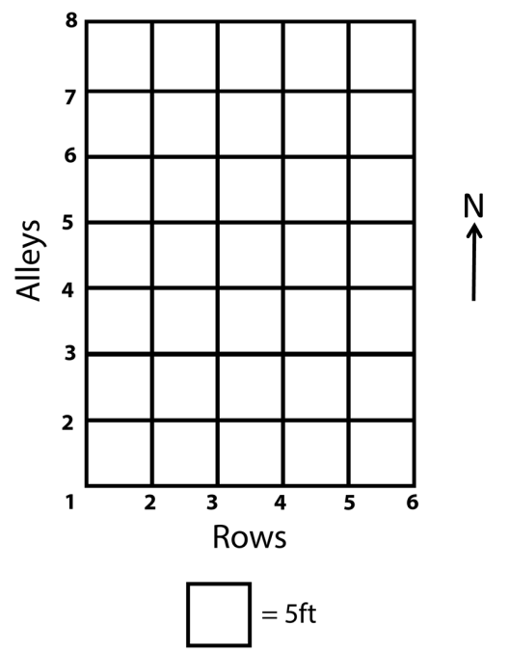
Figure B.1: Schematic of a portion of the WPA grid. Each row and alley is positioned along five foot intervals (adapted from Clements 1938:Figure 1). Rows are numbered from west to east and alleys are numbered from south to north.

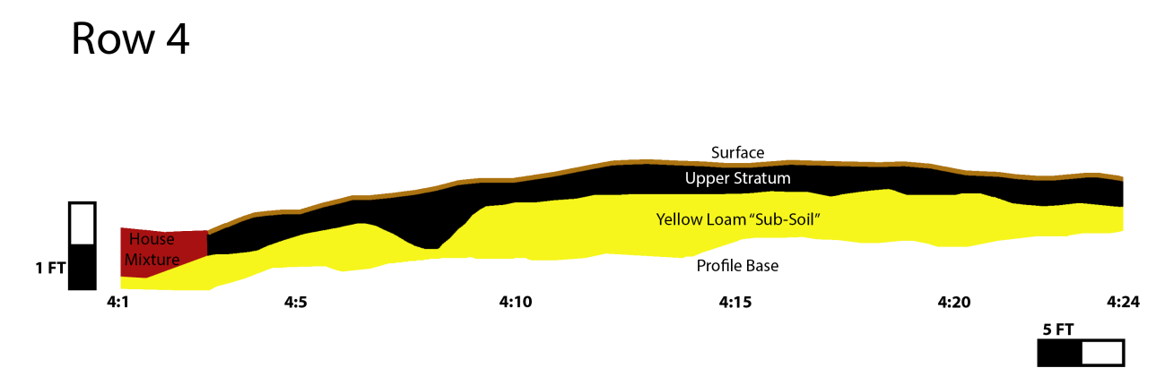Figure B.2: Digital rendering of mound profile at Row 4 drawn by Kenneth G. Orr in 1939-1940. This profile presents information regarding the “house mixture” near Structures 7 and 8. Note the vertical exaggeration in profile drawings due to the WPA applying two different scales for the vertical and horizontal measurements (Original drawings are on file at the SNOMNH).
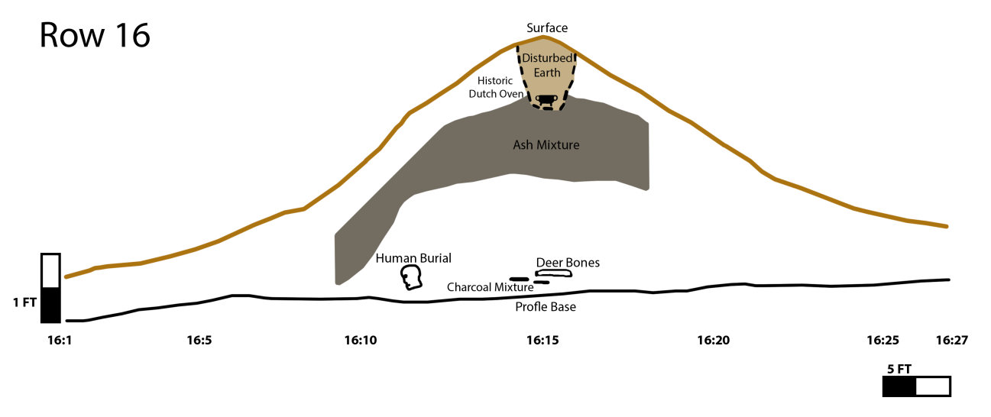
Figure B.3: Digital rendering of mound profile at Row 16 drawn by Kenneth G. Orr in 1939-1940. This profile presents the location of Burial 16, deer bones, charcoal mixture, the ash layer, and the looters hole with the historic Dutch oven. Note the vertical exaggeration in profile drawings due to the WPA applying two different scales for the vertical and horizontal measurements (Original drawings are on file at the SNOMNH).

Appendix C: Burial Descriptions and Associated Funerary Objects

Data are based on information provided through Bareis’ (1955) report, Howard’s (1939, 1940) quarterly reports, and museum catalog. Measurements and detailed artifact descriptions are in archaeology collection database at the Sam Noble Oklahoma Museum of Natural History.
Table C.1: Burial and artifact descriptions
Burial | Depth | Inhumation | Description | Condition | AFOs
1 | 0.67’ | 1 adult, semi-flexed position | “portions of the skull and mandible, 3 teeth, 2 tibias, and 1 fibula” (Bareis 1955:7)  Artifacts found near skull. | Disturbed | B1 (34CK43/94) 3 sherds  B1(34CK43/205) core frag.  B1 (34CK43/948) limestone slab  B1-2 (34CK43/42) grog-bone tempered sherd  B1-4 (34CK43/424) mussel shell  B1-5 (34CK43/172)hoe fragment
2 | 0.5’ | Primary, single burial | skull fragment and fragmentary long bone  artifacts found near skull | Bad condition, no orientation determined | B2-1 (34CK43/434) bottle  B2-2 (34CK43/347) carinated bowl
3 | 0.5’ | Primary (?), single, semi-flexed position | skull fragments and portions of the humerus and radius bones (Baries 1955:7)  Body N-S | Bad condition  Soil type- “house mixture soil. Intrusive into house floor” | B3-1 (34CK43/341)– 1 mano, 1 chunk of limestone  B3-2 (34CK43/342)- 1 projectile point  B3-2 (34CK43/343)- unmodified chunk of quartz (described as a “crystal ball”)  B3-3 (34CK43/421)- small stemmed point  B3-4 (34CK43/342)- 1 broken mano  B3-5 (34CK43/430)- water bottle
4 | No burial depth for individuals  Depth for AFOs range from  0.5-1’ | Primary?, 5 individuals (possibly group primary) | One individual appeared partially flexed  Skeletal materials consisted of fragments of 5 skulls, several associated long bones | Bad condition, broken, fragmentary | B4-1 (34CK43/398)- water bottle  B4-2 (34CK43/346)- stemmed point  B4-3 (34CK43/342)- mano  B4-4 (34CK43/431)- water bottle  B4-5 (34CK43/326) - small stemmed point  B4-6 (34CK43/428) - elbow pipe  B4-7 (34CK43/427)- cone pipe  B4-8 (34CK43/436)- 23 sherds from one vessel
Table C.1 continued
Burial | Depth | Inhumation | Description | Condition | AFOs
5 | 0.25’ | Primary (?), single burial, semi- flexed | Oriented SW to NE  Skeletal materials- skull fragments, sveral teeth, several fragments of a femur  Earspools located near skull | Bad condition  Located 0.5’ above B6 skull  Soil type-charcoal and burnt clay in discolored soil | B5-1 (34CK43/75) 2 earspools (stone pulley, copper staining)
6 | 0.75 | Primary (?), single burial, semi- flexed (?) | Oriented NW to SE  Skeletal materials consisted of skull fragments, fragments of humerus, radius, and ulna bones | Bad condition  Soil type-charcoal and burnt clay in discolored soil | B6-1 (34CK43/432) bottle  B6 (34CK43/113) 2 earspools- stone pulley  B6-3(34CK43/109) ear spool
7 | 0.5’ | Primary, single, semi- flexed and oriented NW to SE | Oriented NW to SE  Badly decayed skull and 4 fragments of a femur | Bad condition  Soil type- “charcoal impregnated house mixture” and a post hole | No AFOs
8 | 0.5’ | Primary (?), group burial of 4 individuals | Type: uniform,  pit burial  fragments of 4 skulls and miscellaneous sections of long bones | Bad condition- disturbed burials  Soil type-“house mixture- charcoal and burnt clay” | B8-1 (34CK43/435) vessel  B8-2 (34CK43/701) vessel  B8-3 (34CK43/439) 86 sherds of one vessel  B8-4(34CK43/433) 24 sherds  B8-5 (34CK43/329) 4 chunks of limestone
9 | 0.5’ | Primary (?), single (?) | 5 teeth and 2 fragments of long bones (humerus, radius, and ulna) | Soil type- “Matrix of bones in house mixture” | No AFOs
10 | 0.5’ | Primary, group burial of 4 individuals (one semi-flexed) | Fragments of 4 skulls, several teeth, and several long bones |  | B10-1(34CK43/961)- Metate, labeled as “sitting rock” (MISSING)
11 | 0.58’ | Primary, Flexed burial; semi-flexed? | Body oriented NE-SW  Skull fragments and several pieces of a humerus |  | B11-1 (34CK43/344) – flint knife  B11-2 (34CK43/328)- point fragment
12 | 0.5’ | Primary, single- NE | Pit burial  Skull fragments and several pieces of a humerus |  | No AFOs

Table C.1 continued
Burial | Depth | Inhumation | Description | Condition | AFOs
13 | 0.75’ | Unknown- 1? | No skulls, several humerus fragments |  | B13-1 (34CK43/322)- small point  B13-2 (34CK43/327)- large point
14 | 0.67’ | Single individual | Body N-S  No skull, fragment of femur and 2 small bones |  | B14-1-(34CK43/324)- flint knife
15 | 0.83’ |  | Fragments of another burial, no skull |  | B15-1 (34CK43/440)- 41 sherds  B15-2 (34CK43/325) – chipped axe  B15-3 (34CK43/425) –unworked quartz  B15-4 (34CK43/323)- chipped stone
16 | ? | 1 individual | In platform mound | Not located in burial area. | No AFOs
17 | ? | 1 individual | In platform mound | No located in burial area. | 1 perforated mussel shell hoe  1 unidentified chipped flint specimen

Table C.2: Artifact description for artifacts identified near burials, but not directly affiliated with a specific burial.
Independent Artifact Associations | Total Count | Ceramics |  | Lithics
Independent Artifact Associations | Total Count | Count | Description | Count | Description
A1 | 7 | 7 | A1 (34CK-43/348): 7 fine, unidentified engraved sherds, unknown form | 0
A2 | 20 | 5 | A2-2 (34CK-43/46): 1 unidentified engraved body sherd, unknown vessel form  A2-3 (34CK-43/101): 4 sherds of one vessel- plain, flat base | 15 | A2-1 (34CK-43/47): 12 projectile points, Novaculite (4 corner notched, 8 side notched)  A2-2 (34CK-43/46): 3 projectile points, Novaculite (corner notched)
A3 | 15 | 15 | A3-1 (34CK-43/706): 1 French Fork incised bowl  A3-2: 1 (34CK-43/112) Hickory Fine engraved bowl; 12 burnished, incised sherds from a simple bowl | 0

NAGPRA Artifacts and Photographs

Ceramics
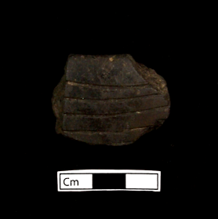
Catalog no.: 34CK43/112, sample 1
Unit Section: Test Pit 2, SE Section 9, Stake 7:6
Locality: Burial Area, A3-2
Temper: Grog
Type: Hickory Fine Engraved
Description: Rim sherd, design on rim (two parallel lines)

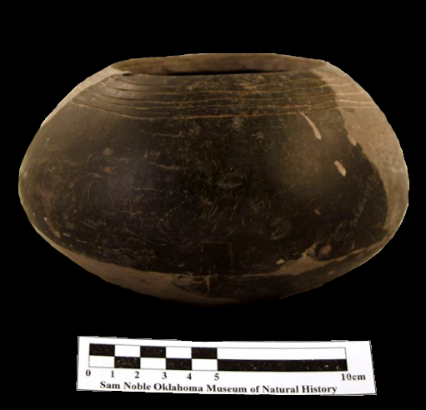
Catalog no.: 34CK43/112
Unit Section: Test Pit 2, SE Section 9
Locality: Burial Area, A3-2
Temper: Grog
Type: Hickory Fine Engraved
Description: Partially reconstructed simple bowl

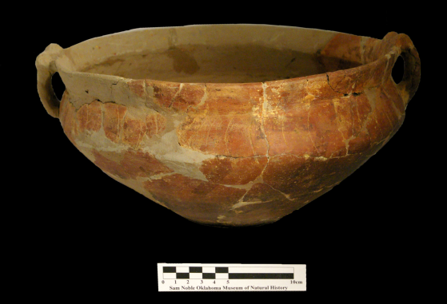
Catalog no.: 34CK43/347
Unit Section: Test Pit 2, SE Section 9, stake 9:6
Locality: Burial Area, B2-2
Temper: Grog
Type: Sanders Engraved, possible
Description: Partially reconstructed carinated bowl with handles

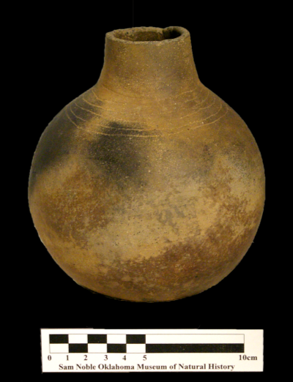
Catalog no.: 34CK43/398
Unit Section: Test Pit 2, SE Section 9, stake 3:8
Locality: Burial Area, B4-1
Temper: Grog
Type: Hickory Fine Engraved
Description: Bottle with partially broken neck

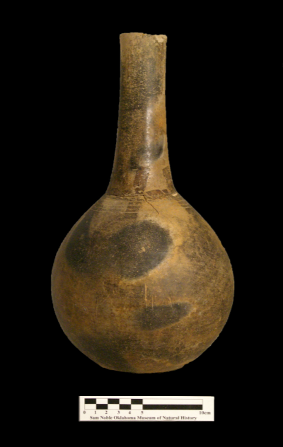
Catalog no.: 34CK43/430
Unit Section: Test Pit 2, SE Section 9, stake 4:8
Locality: Burial Area, B3-5
Temper: Grog
Type: Hickory Fine Engraved
Description: Partially reconstructed bottle

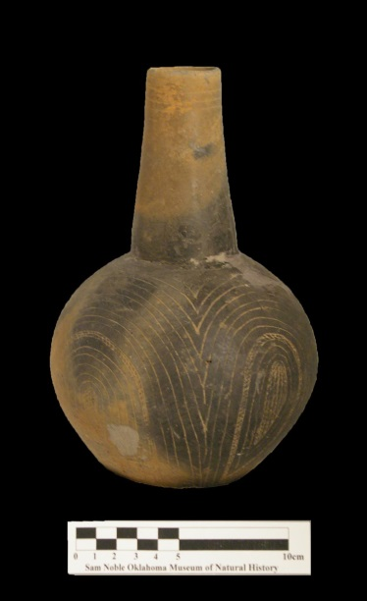
Catalog no.: 34CK43/431
Unit Section: Test Pit 2, SE Section 9, stake 3:8
Locality: Burial Area, B4-4
Temper: Grog
Type: Unidentified Engraved
Description: Partially reconstructed bottle
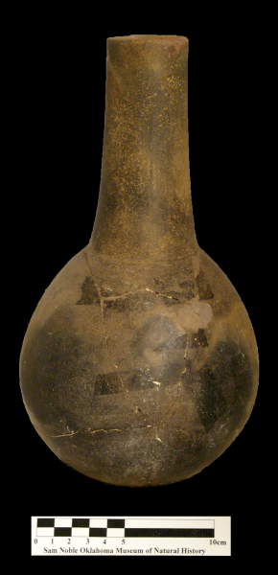
Catalog no.: 34CK43/434
Unit Section: Test Pit 2, SE Section 9, stake 9:6
Locality: Burial Area, B2-1
Temper: Grog
Type: Hickory Fine Engraved
Description: Partially reconstructed bottle

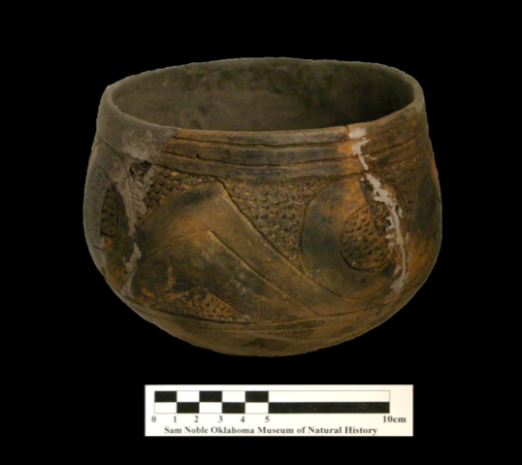
Catalog no.: 34CK43/435
Unit Section: Test Pit 2, SE Section 9, stake 3:4
Locality: Burial Area, B8-1
Temper: Grog
Type: Crockett Curvilinear Incised
Description: Partially reconstructed simple bowl

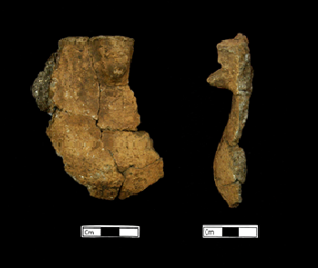
Catalog no.: 34CK43/701
Unit Section: Test Area 2, SE Section 9, Stake 3:4
Locality: Burial Area, B8-2
Temper: Shell
Description: Possible effigy vessel, rim, applique

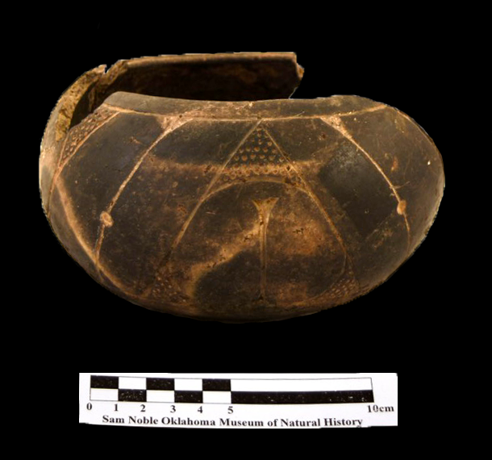
Catalog no.: 34CK43/706
Unit Section: Test Pit 2, SE Section 9
Locality: Burial Area, A3-1
Temper: Grog
Type: French Fork Incised
Description: Partially reconstructed simple bowl

Lithics

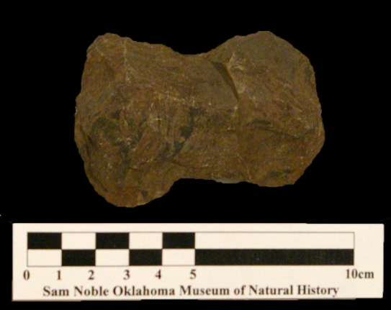
Catalog no.: 34CK-43/ 325
Unit Section: Test Pit 2, SE Section 9, Stake 8:7
Locality: Burial Area, B15-2
Material: Shale
Type: Double Bitted Axe

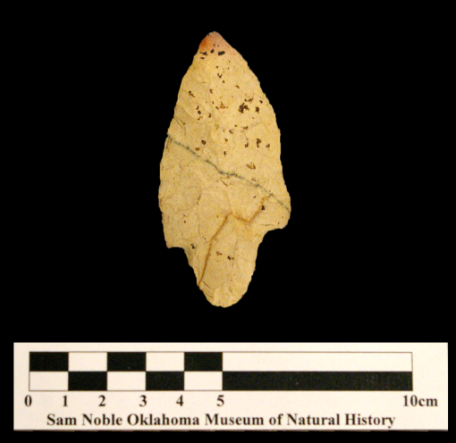
Catalog no.: 34CK-43/ 327
Unit Section: Test Pit 2, SE Section 9, Stake 6:8
Locality: Burial Area, B13-1
Material: Tahlequah
Type: Stemmed hafted biface
Description: Evidence of heat treatment at the tip of the blade
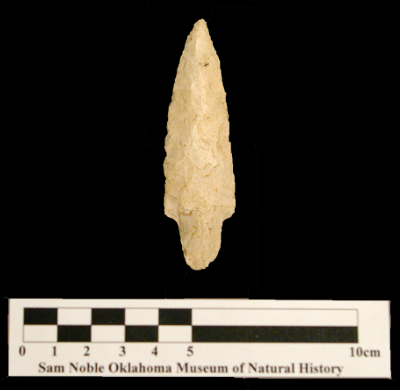
Catalog no.: 34CK-43/322
Unit Section: Test Pit 2, SE Section 9, Stake 6:8
Locality: Burial Area, B13-2
Material: Tahlequah
Type: Stemmed hafted biface
Description: Evidence of heat treatment

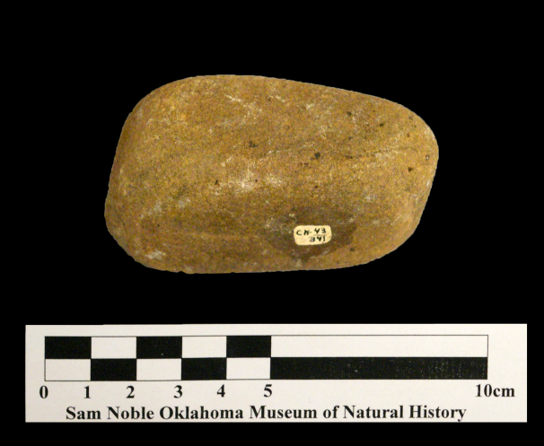
Catalog no.: 34CK-43/341, sample 1
Unit Section: Test Pit 2, SE Section 9
Locality: Burial Area, B3-1
Type: Ground stone
Description: Mano

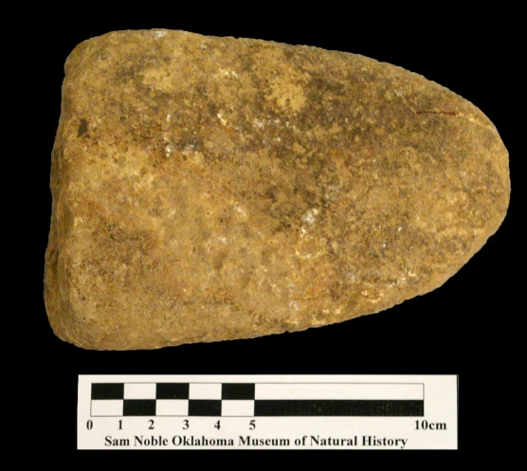
Catalog no.: 34CK-43/341, sample 2
Unit Section: Test Pit 2, SE Section 9
Locality: Burial Area, B3-1
Type: Ground stone
Description: Mano, broken

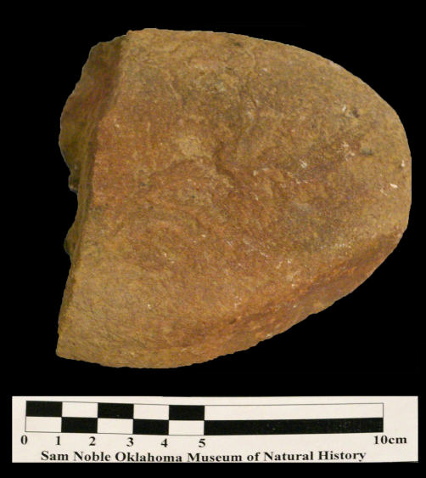
Catalog no.: 34CK-43/342
Unit Section: Test Pit 2, SE Section 9
Locality: Burial Area, B4-3
Type: Ground stone
Description: Mano, broken

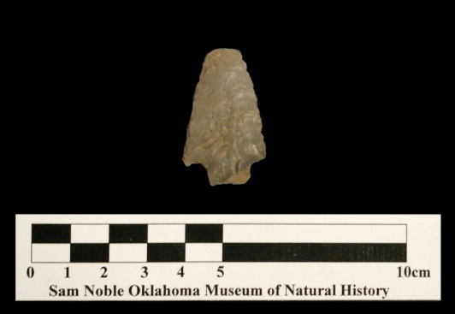
Catalog no.: 34CK-43/342, sample 1
Unit Section: Test Pit 2, SE Section 9, stake 3:8
Locality: Burial Area, B3-2
Material: Reed Springs
Type: Projectile Point
Description: Tip of blade and one of the barbs broken

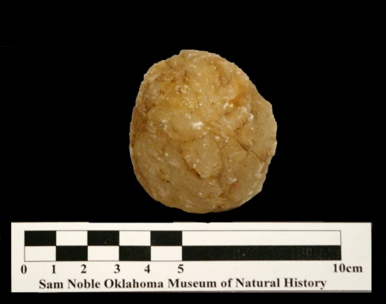
Catalog no.: 34CK-43/343
Unit Section: Test Pit 2, SE Section 9, stake 4:8
Locality: Burial Area, B3-2
Material: Quartz
Type: Unmodified stone
Description: referred to as a “Crystal Ball”
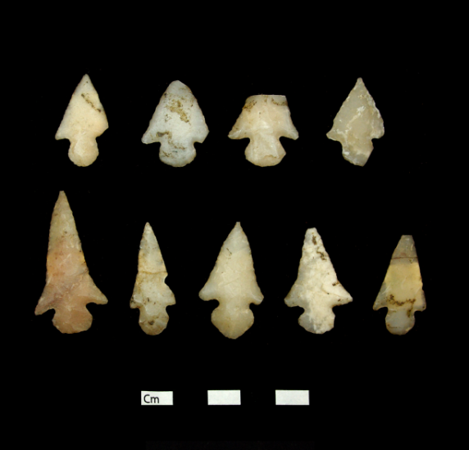
Catalog no.: 34CK-43/47
Unit Section: Test Pit 2, SE Section 9, stake 4:6
Locality: Burial Area, A2-1
Material: Novaculite
Type: Alba Points
Description: Side notched projectile points

Earspools

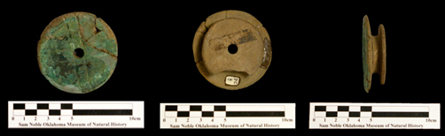
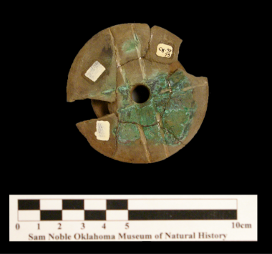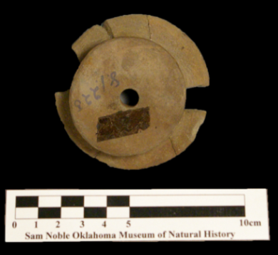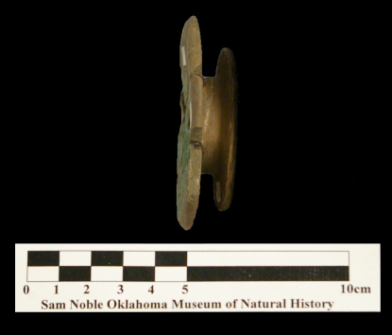
Catalog no.: 34CK43/75, samples 1 and 2
Unit Section: Test Pit 2, SE Section 9
Locality: Burial Area, B5-1
Material: Stone with copper staining
Earspool Type: Pulley with perforation
Design: two lines and cross motif

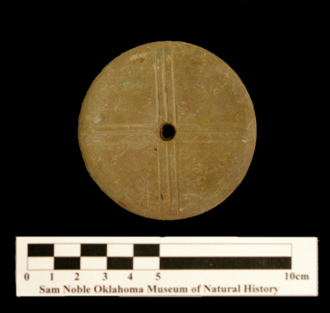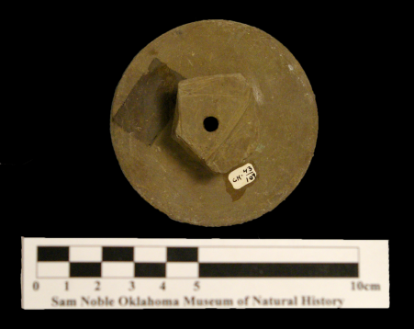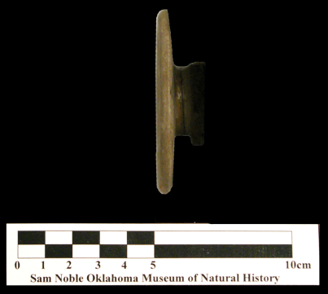
Catalog no.: 34CK43/109
Unit Section: Test Pit 2, SE Section 9
Locality: Burial Area, B6-3
Material: Stone
Earspool Type: Pulley with perforation
Design: three lines and cross motif

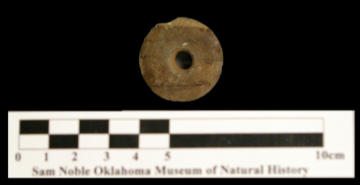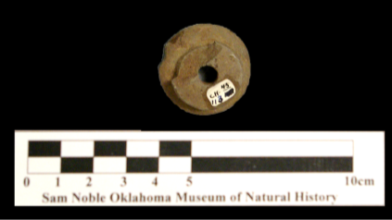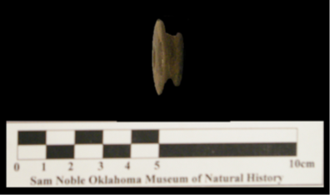
Catalog no.: 34CK43/113
Unit Section: Test Pit 2, SE Section 9
Locality: Burial Area, B6
Material: Stone
Earspool Type: Pulley with perforation
Design: no design

Pipes

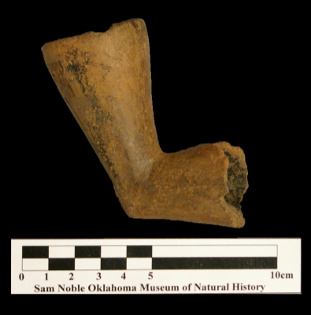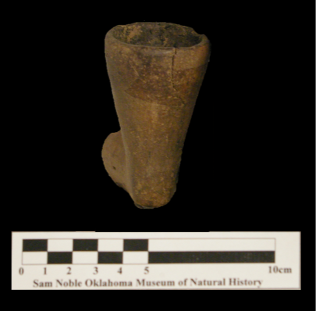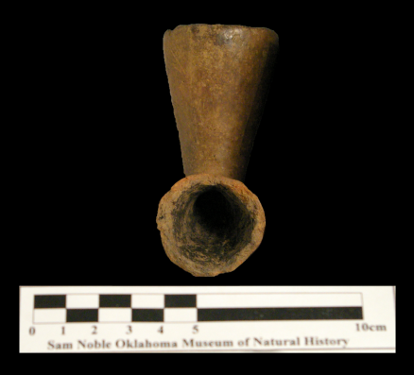
Catalog no.: 34CK43/427
Unit Section: Test Pit 2, SE Section 9
Locality: Burial Area, B4-7
Material: Ceramic, grog tempered
Surface Treatment: Plain
Type: Elbow
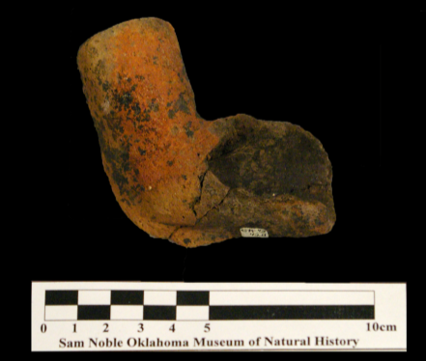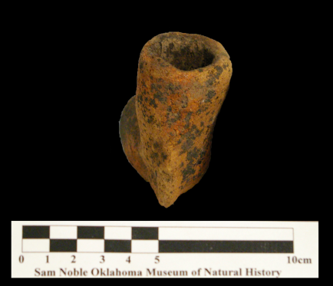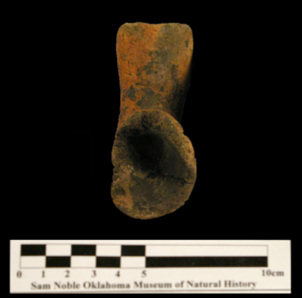
Catalog no.: 34CK43/428
Unit Section: Test Pit 2, SE Section 9
Locality: Burial Area, B4-6
Material: Ceramic, grog and shell tempered
Surface Treatment: Plain
Type: Elbow

Shell
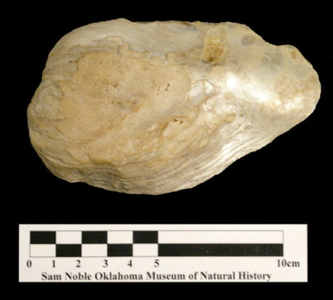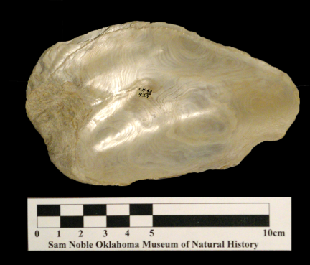
Catalog no.:34CK-43/424
Unit Section: Test Pit 2, SE Section 9
Locality: Burial Area, B1-4
Material: Shell

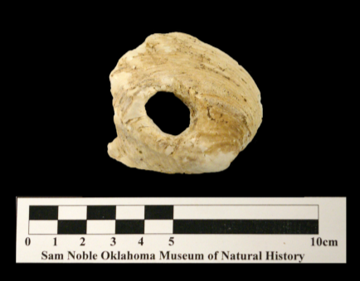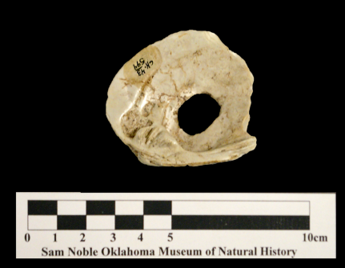
Catalog no.:34CK-43/594
Unit Section: Test Pit 2, SE Section 9
Locality: Burial Area, B17
Material: Mussel shell
Description: perforated center

Appendix D: Ceramic Artifacts

Exact measurements and recordings for all 1206 ceramic artifacts (partially restored vessels, sherds, and sherdlets) based on the attributes discussed in Chapter 4 are presented in Appendix F and are also on file at the Sam Noble Oklahoma Museum of Natural History. In this appendix, I present summary tables on the attributes: wall thickness, temper, vessel form, and orifice diameter. I also discuss specifics on the data associated with the handles and bases.
Wall Thickness
Wall thickness is variable throughout a vessel based on the location of break, vessel size and function, skill level of the pottery, and quality of clay (Rice 2005:227). As a result, I separated my analysis of sherd wall thickness by vessel landmark (i.e., body, rim, and base), by temper type, and by locality. When a sherd included two or more features (i.e., a sherd that had a rim, body, and base all attached), I included measurements specific to each landmark into each appropriate category.
Table D.1: Sherd thickness by landmark
 | Sherd Thickness (mm)
Landmark | n | Mean | Median | Range
Body | 887 | 6.6 | 6.5 | 1.4 – 20.3
Rim | 79 | 5.9 | 5.6 | 2.7 – 10
Base | 41 | 10.2 | 9.3 | 4.4 – 29.4

For the measurement of body thickness, Brown (1996:331) proposed to separate ceramics into two categories, thin and thick. Thin sherds are measured at less than 10mm and thick sherds are measured greater than 10mm. However, a 10mm range within the thin walled classification covers a wide range. As a result, I placed wall thickness for body sherds into three categories: thin-walled (less than 7mm), in-between (between 7 and 10.5mm), and thick-walled (greater than 10.5 mm). I based these categories on a dendrogram constructed from a cluster analysis since there was no clear break when examining thickness through a histogram. This classification mainly separates Brown’s (1996) thin classification into two groups. I examined the thickness clusters by locality.
Table D.2: Wall thickness cluster by locality
 | Thickness Cluster
 | Thin-Walled |  | In-Between |  | Thick-Walled |  | All
Locality | N | Row % | N | Row % | N | Row % | N | Row %
Burial Area | 280 | 68.5 | 128 | 31.3 | 1 | 0.2 | 409 | 100.0
Mound | 123 | 56.4 | 92 | 42.2 | 3 | 1.4 | 218 | 100.0
"Residential" | 118 | 57.0 | 82 | 39.6 | 7 | 3.4 | 207 | 100.0
"Outside Residential" | 13 | 59.1 | 5 | 22.7 | 4 | 18.2 | 22 | 100.0
Unknown Provenience | 16 | 51.6 | 10 | 32.3 | 5 | 16.1 | 31 | 100.0
All | 550 | 62.0 | 317 | 35.8 | 20 | 2.2 | 887 | 100.0

Tempers
In my reanalysis of the ceramic temper types, I did not classify any artifacts with grit or sand tempering, as was originally recorded by Bareis (1955b). The major temper types were grog, shell, or grog/shell, as well as the occasional inclusion of bone tempering. Across the site, 41 percent (n=418) of ceramic artifacts were shell tempered, 39 percent (n=396) were grog tempered, and 20 percent (n=198) were grog/shell tempered. I also isolated temper type by locality. Grog tempering was distributed across the entire site. With the exception of the “Outside Residential” Area, grog/shell tempering was the least prominent of the temper types. There was a high frequency of shell-tempered sherds found throughout the site Brackett, particularly in the platform mound. There are examples with the additional inclusion of bone tempering to the primary temper types.
Table D.3: Main temper type by locality
 | Main Temper
 | Grog |  | Grog and Shell |  | Shell
Locality | N | Row % | N | Row % | N | Row %
Burial Area | 193 | 41.6 | 105 | 22.6 | 166 | 35.8
Mound | 73 | 29.8 | 40 | 16.3 | 132 | 53.9
Residential | 109 | 46.4 | 40 | 17.0 | 86 | 36.6
Outside Residential | 7 | 26.9 | 12 | 46.2 | 7 | 26.9
Unknown Provenience | 14 | 33.3 | 1 | 2.4 | 27 | 64.3
All | 396 | 39.1 | 198 | 19.6 | 418 | 41.3

Table D.4: Main and additional temper types by locality
 | Main Temper
 | Grog |  | Grog/Shell |  | Shell
Locality | Bone | No Additional Temper | Bone | No Additional Temper | Bone | No Additional Temper
Locality | N | N | N | N | N | N
Burial Area | 41 | 152 | 76 | 29 | 15 | 151
Mound | 22 | 51 | 7 | 33 | 6 | 126
“Residential” | 17 | 92 | 9 | 31 | 10 | 76
“Outside Residential” | 0 | 7 | 0 | 12 | 1 | 6
Unknown Provenience | 4 | 10 | 1 | 0 | 0 | 27
Total | 84 | 312 | 93 | 105 | 32 | 386

Vessel Form
Chapter 5 presents the results from comparing measurements of orifice diameter by vessel form. I provide the results of those measurements separated by locality. I also include sherd thickness by vessel form.

Table D.5: Orifice diameter by vessel form and locality
 |  | Orifice Diameter (cm)
Locality | Vessel Form | N | Mean | Range
Burial Area | Bottle | 5 | 3.5 | 3-4
Burial Area | Carinated Bowl | 10 | 22.8 | 18-30
Burial Area | Simple Bowl | 4 | 14.5 | 9-22
Burial Area | Bowl | 1 | 12 | .
Burial Area | Jar | 8 | 13.75 | 12-14
Burial Area | Restricted Vessel (Jar/Bowl) | 1 | 10 | .
Burial Area | Unrestricted Vessel (Jar/Bowl) | 3 | 18.7 | 18-20
Burial Area | Unknown | 1 | 14 | .
Mound | Simple Bowl | 2 | 18 | 10-26
Mound | Restricted Vessel (Jar/Bowl) | 1 | 26 | .
Mound | Unrestricted Vessel (Jar/Bowl) | 1 | 16 | .
Mound | Unknown | 1 | 12 | .
Residential | Simple Bowl | 0 | . | .
Residential | Jar | 3 | 14 | 12-16
Residential | Restricted Vessel (Jar/Bowl) | 1 | 20 | .
Residential | Unrestricted Vessel (Jar/Bowl) | 4 | 19 | 10-26
Residential | Unknown | 0 | . | .
Outside Residential | Jar | 1 | 12 | .
Outside Residential | Unknown | 0 | . | .
Unknown | Bottle | 1 | 4 | .
Unknown | Carinated Bowl | 2 | 18 | 18
Unknown | Jar | 1 | 10 | .
Unknown | Unknown | 0 | . | .

Base Types
A total of 41 ceramic sherds and partially restored vessels have bases attached to them. Of these bases, 88 percent (n=36) have flat bases. There are three examples (7.3%) of base sherds are flat with keels. There is one example of a convex surfaced (or rounded) base (2.4%) and one unknown base type (2.4%). The distribution of base type by locality is presented below.
Table D.6: Base type by locality
 | Base Type
Locality | Flat | Flat with Keel | Round | Unknown | Total
Burial Area | 13 | 0 | 1 | 0 | 14
Mound | 10 | 3 | 0 | 0 | 13
“Residential” | 11 | 0 | 0 | 0 | 11
“Outside Residential” | 1 | 0 | 0 | 0 | 1
Unknown Provenience | 1 | 0 | 0 | 1 | 2

Handles
Ten handles were recovered. Two handles were recovered from the burial area (34CK-43/436, 347), three from the mound (34CK-43/436, 631, 98.1, 98.2), one from the “Residential” area in Structure 7 (34CK-43/562), one from “Outside the Residential” area (34CK-43/59), and three had no provenience (no catalog numbers). There is one possible handle (34CK-43/207); however, the artifact was too eroded to be certain. As a result, I left it out of the analysis. Eight of the ten handle sherds are shell tempered and two are grog tempered (34CK-43/347, 562). The two grog tempered sherds also have a red-slipped surface treatment. Only one sherd (34CK-43/98.1), which is attached at the lip of the rim, has a possible associated decoration treatment (a notched rim design). Of the ten handles and handle fragments, only five could have a middle thickness, middle width, and ratio between the two be measured (Table D.8). The two types of handles identified are strap and an intermediate type (in between loop and strap). There were no identified loop handle types.
Table D.7: Handle type
Catalog no. | Temper | Middle Thickness (mm) | Middle Width (mm) | Thickness:  Width Ratio | Handle Type | Location
59 | Shell | 9.2 | 16.4 | 0.56 | Wide Intermediate (strap-like) | Lip
98 | Shell | 10.3 | 45.4 | 0.23 | Strap | Lip
347 | Grog | 6.9 | 24.8 | 0.28 | Strap | Lip
436 | Shell | 5.8 | 19.6 | 0.30 | Strap | Unknown
631 | Shell | 12.9 | 26.7 | 0.48 | Wide Intermediate (Strap-like) | Unknown

Ceramic Photographs

Surface Treatments

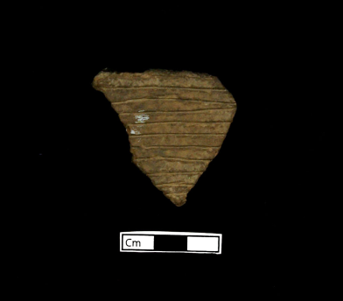
Catalog no.: 34CK43/585, sample 1
Unit Section: SW1/4, NE Section 5, Stake 19:8
Locality: Platform mound
Temper: Grog
Type: Coles Creek Incised
Description: Parallel horizontal lines, body sherd

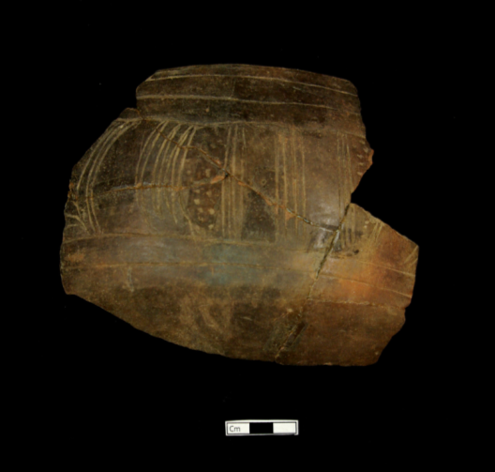
Catalog no.: 34CK43/709, samples 4-8
Unit Section: Test Area 2, SE Section 9, stake 10:9
Locality: Burial Area
Temper: Grog
Type: Crockett Curvilinear
Description: incised lines and punctate designs; incomplete vessel (1 body, 4 rim sherds)
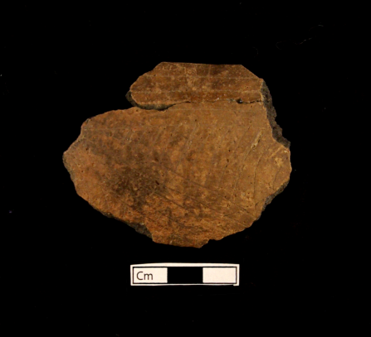
Catalog no.: 34CK43/ 116, sample 1
Unit Section: Test Area 2, SE Section 9
Locality: Burial Area
Temper: Grog
Type: Holly Fine Engraved
Description: Burnished and engraved, parallel lines, rim sherd, decoration of rim (one engraved line parallel the lip)

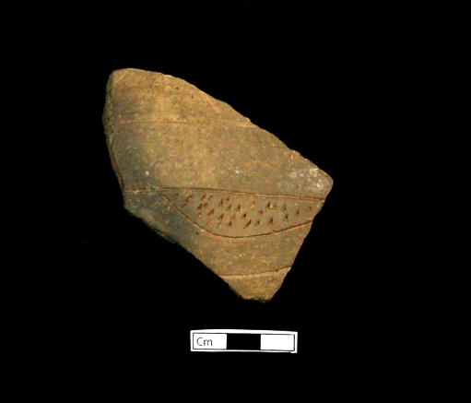
Catalog no.: 34CK43/585, sample 2
Unit Section: SW1/4, NE Section 5, Stake 19:8
Locality: Platform mound
Temper: Grog
Type: Pennington Punctate Incised
Description: parallel incised lines and triangular punctate designs, body sherd

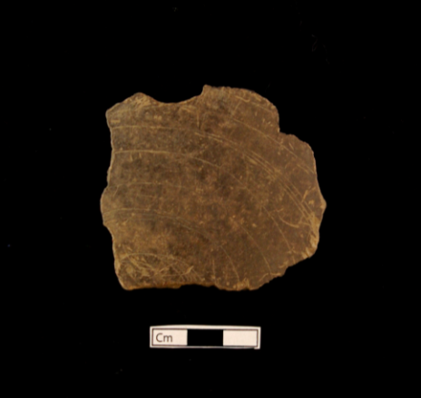
Catalog no.: 34CK43/45, sample 1
Unit Section: Test Area 2, SE Section 9, state 10:8
Locality: Burial Area
Temper: Grog
Type: Spiro Engraved
Description: Engraved parallel lines, body sherd

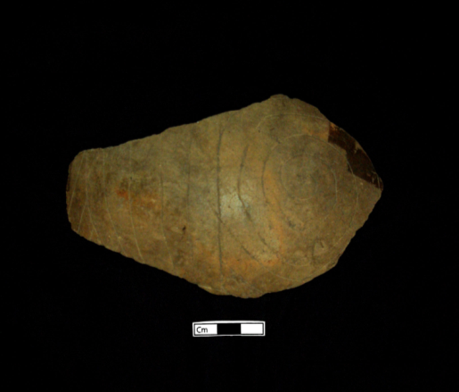
Catalog no.: 34CK43/708, sample 1
Unit Section: Test Area 2, SE Section 9, Stake 10:8
Locality: Burial Area
Temper: Grog
Type: Spiro Engraved
Description: engraved parallel lines, spiral design, and punctate, body sherd, bottle fragment

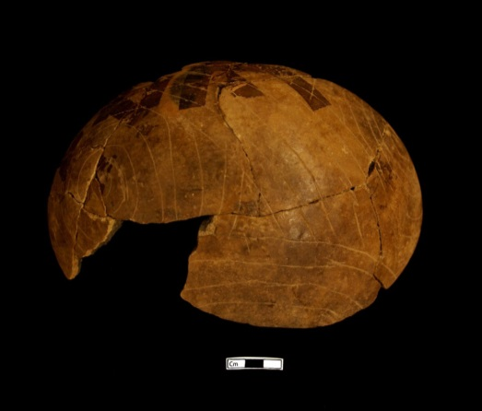
Catalog no.:
Unit Section:
Locality: Burial Area
Temper: Grog
Type: Spiro Engraved
Description: engraved parallel lines and spiral designs, punctate designs, body sherd, partially repaired bottle fragment

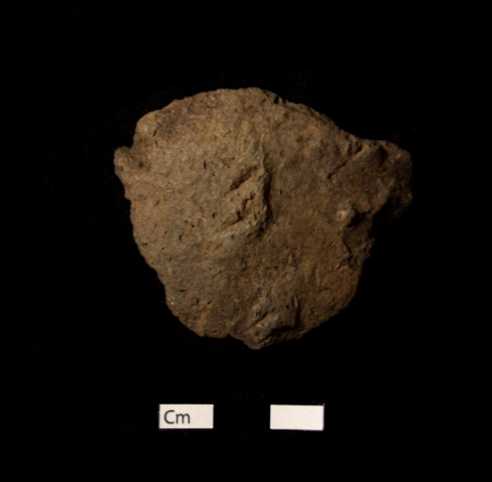
Catalog no.: 34CK43/91, sample 1
Unit Section: Test Pit 2, SE Section 9, N1
Locality: Burial Area
Temper: Shell
Type: Unidentified Applique
Description: body sherd

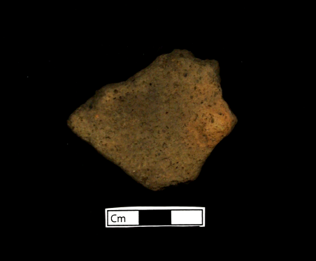
Catalog no.: 34CK43/525, sample 1
Unit Section: Test Pit 6, NE Section 4
Locality: “Residential,” Structures 5/6
Temper: Shell
Type: Unidentified Applique
Description: circular applique, body sherd

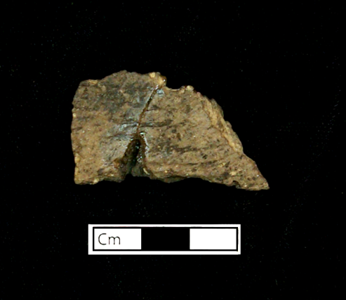
Catalog no.: 34CK43/546
Unit Section: NE Section 5, stake 9:16
Locality: Platform mound
Temper: Grog
Type: Unidentified Cord Marked
Description: Body sherd

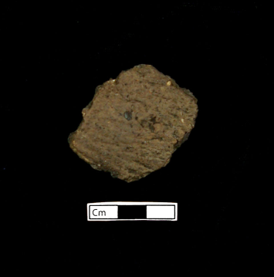
Catalog no.: 34CK43/650
Unit Section: NE Section 5, stake 10:9
Locality: Platform mound
Temper: Grog with bone
Type: Unidentified Cord Marked
Description: Body sherd

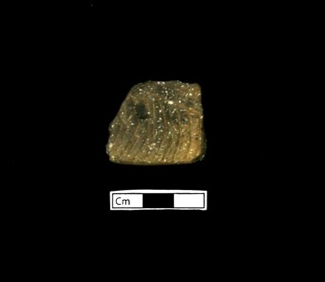
Catalog no.: 34CK43/666
Unit Section: NE Section 5, Stake 11:7
Locality: Platform mound
Temper: Grog/Shell
Type: Unidentified incised
Description: Incised, base sherd, bottle fragment

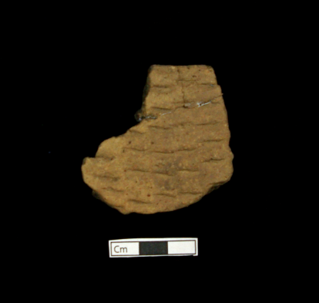
Catalog no.: 34CK43/656, sample 1
Unit Section: SW1/4, NE Section 5, Stake 20:16
Locality: Platform Mound
Temper: Grog
Type: Unidentified Fingernail Punctate
Description: fingernail punctate, body sherd

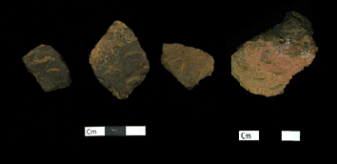
Catalog no.: 34CK43/57, samples 1-4
Unit Section: Test pit 4, NE Section 9
Locality: hypothesized “Residential” area
Temper: Grog
Type: Unidentified Fingernail Punctate
Description: Fingernail punctate, body sherds

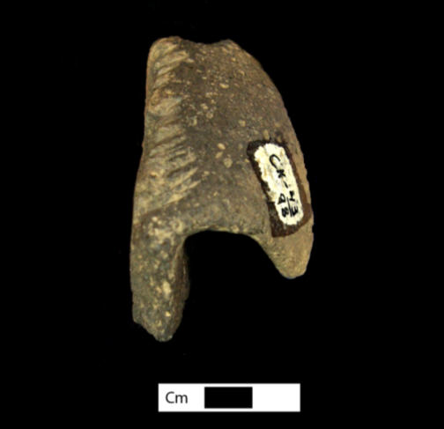
Catalog no.: 34CK43/98, sample 1
Unit Section: NE Section 5, stake 11:12
Locality: Mound
Temper: Shell
Type: Unidentified Notched Rim
Description: Rim/handle sherd with deep parallel notched pattern.

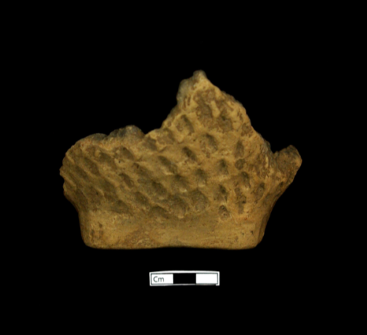
Catalog no.: 34CK43/89, sample 1
Unit Section: Test Pit 7, NE Section 4
Locality: “Residential,” Structures 5/6
Temper: Grog
Type: Unidentified Ridge Pinched
Description: ridge pinched, base sherd (flat, square shaped)

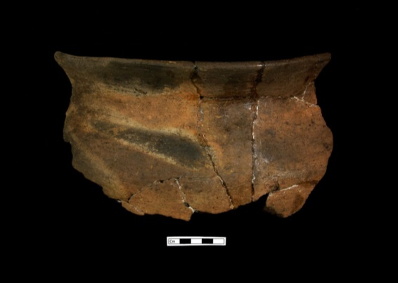
Catalog no.: 34CK43/451
Unit Section: SW1/4, NE Section 5, stake 12:18
Locality: Platform mound
Temper: Shell with bone
Type: Plain, undecorated
Description: Rim sherd, partially reconstructed vessel

Handles

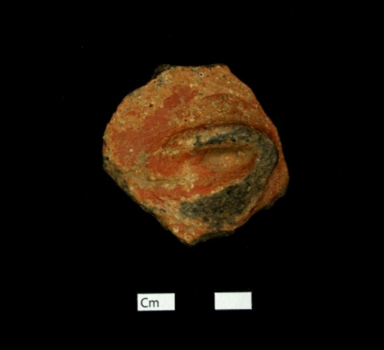
Catalog no.: 34CK43/562, sample 1
Unit Section: NW ¼, NE Section 5, Stake 4:3
Locality: hypothesized “Residential” area, structure 7
Temper: Grog
Type: Red-slipped, undecorated
Description: Rim sherd with handle attached at body

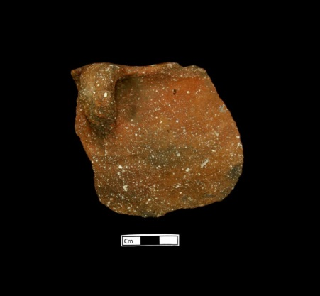
Catalog no.:34CK43/59
Unit Section: Test Pit 1, SE Section 3
Locality: “Outside Residential”
Temper: Shell
Type: Plain, undecorated
Description: Rim sherd with handle, Strap- Intermediate handle, jar fragment

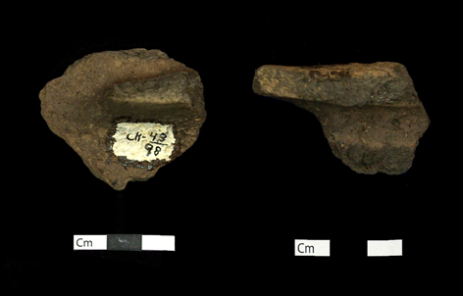
Catalog no.: 34CK43/98, sample 2
Unit Section: NE Section 5, stake 11:12
Locality: Mound
Temper: Shell
Type: Plain, undecorated
Description: body sherd with handle

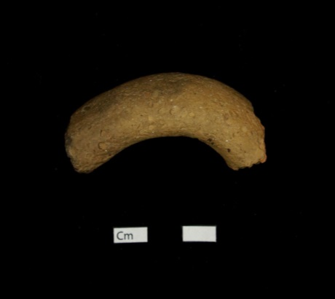
Catalog no.: 34CK43/631, sample 1
Unit Section: SW1/4, NE Section 5, stake 18:8
Locality: Mound
Temper: Shell
Type: Strap-Intermediate
Description: handle fragment

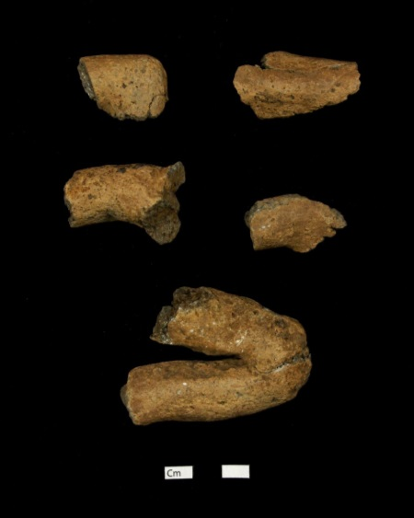
Unknown provenience
Potential handles, unverified

Base Profile Drawings | 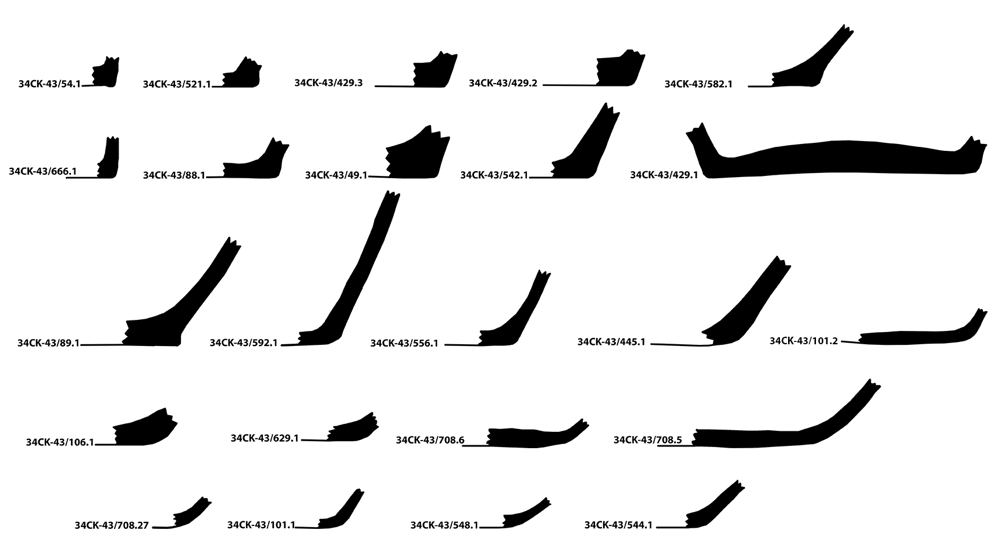

Bases

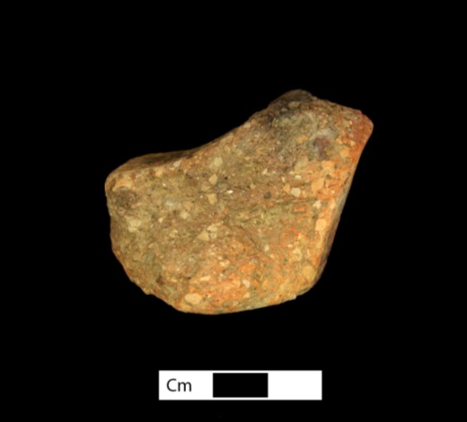
Catalog no.: 34CK43/49, sample 1
Unit Section: NE Section 2
Locality: hypothesized “Residential” area
Temper: Grog
Type: Plain, undecorated
Description: Base sherd, flat base

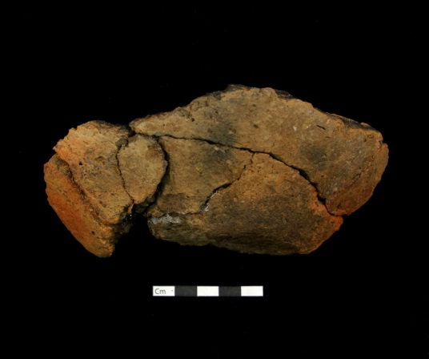
Catalog no.: 34CK43/445
Unit Section: Test Pit 7, NE Section 4, stake 7:6
Locality: hypothesized “Residential” area, Structures 5/6
Temper: Shell
Type: plain, undecorated
Description: base sherd, flat

Pipe

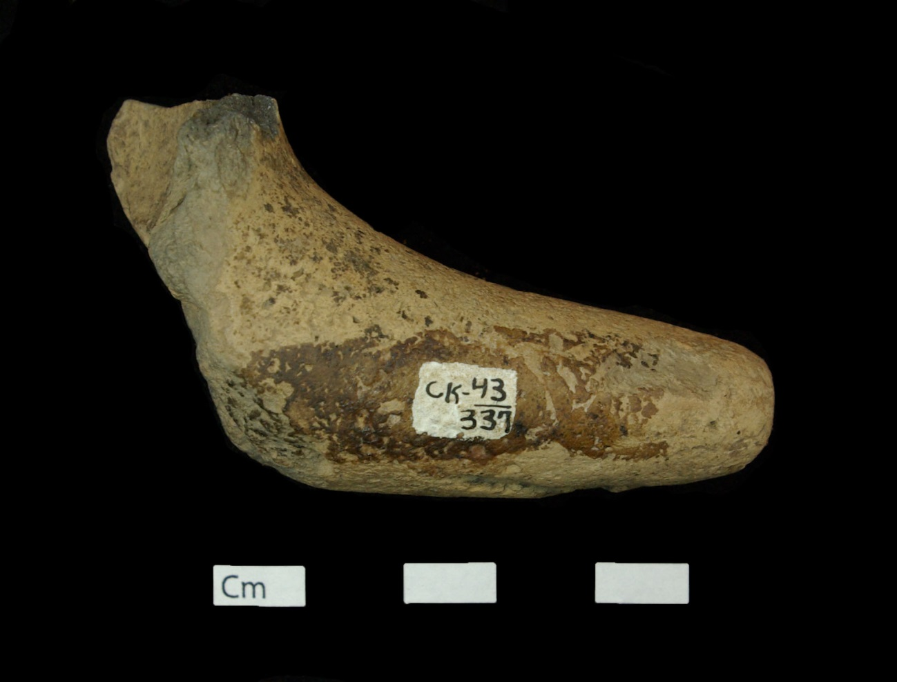 | Catalog no.: 34CK-43/337  Unit Section: Test Pit 2, SE Section 9  Locality: Burial Area  Temper: Grog/Shell  Type: Elbow pipe fragment

Appendix E: Lithic Artifacts

Exact measurements and recordings for the 767 lithic material based on the attributes discussed in Chapter 4 are also on file at the SNOMNH. In this appendix, I present summary tables on the attributes: base type for certain hafted bifaces (projectile points and drills) and stone type by raw material source for each of the main localities (Burial Area, Mound, hypothesized “Residential” area, hypothesized “Outside Residential” area, and Unknown Provenience) (see Chapter 3 for why I separated artifacts into the four localities).
Description of Raw Material Types
The following section discusses the visual characteristics I used to classify lithics into general raw material types.
- Argillite and Siltstone are dense, dark, and grainy stone types that occur geologically with shales, and are generally used for the manufacturing of hoes, axes, and other large bifaces (Dowd and Regnier 2014:22; Ray 2007:7-8).
- Florence A Chert, also known as Kay County Chert, is identifiable for its fossil inclusions and concentric banding (Brown 1996:648).
- Frisco is a type of flint/chert that is found in the Arbuckle (Evans 1958; Ray 2007:326). Jasper is a variety of chert with a dull luster, and with a brown and yellow color (Brown 1996:649).
- Jasper is a yellowish brown color and changes to a deep maroon color after undergoing heat treatment (Ray 2007:6).
- John’s Valley is a fine grained chert and is identifiable for its dark grey, brown coloring.
- Keokuk is a variety of Burlington chert previously grouped in the “Boone” chert category. Keokuk is identifiable for its whitish, grainy color and texture and for its fossil inclusions (Brown 1996:647; Dowd and Regnier 2014:22).
- Reeds Spring is a variety of “Boone chert” and is recognizable for its blue tones, glass-like texture, and high quality (Ray 2007:172, 181).
- Limestone is a calcareous rock and is identifiable for its light gray color, softness, and friableness (Brown 1996:641).
- Novaculite, also known as Arkansas Novaculite, is a fine-grained, silica-rich chert that has a hard consistency, waxy to sugary texture, and is often translucent (Brown 1996:646-647; Sievert 2011:75). Novaculite is one of the most abundant and utilized resources from the Ouachita Mountains (Ray 2007:326).
- Tahlequah and Peoria have similar identifiable traits and are found in similar sourcing area; therefore, I classify them together (Ray 2007:225). Tahlequah/Peoria are identified for their light white, grey, and yellow coloring; dull to low luster, lack of fossils, and fine to coarse texture.
- Quartzite is a form of metamorphosed sandstone “silica-cemented quartz sandstone” and is identifiable for its coarse texture and grayish brown, dark gray coloring (Dowd and Regnier 2014:22; Ray 2007:7).
- Unidentified Chert is recorded for “any various colored, dense, microcrystalline or cryptocrystalline sedimentary rock” that a regional sourcing could not be determined (Ray 2007:6).

Hafted Biface Base Types

I present the results for base type for the two hafted bifaces with variable base types, projectile points (Table E.1) and drills (Table E.2).
Table E.1: Projectile point base types by locality
 |  | Base Type
Locality | Chipped Stone | Concave | Convex | Straight | Unknown
Burial Area | Corner Notched | 0 | 8 | 3 | 0
Burial Area | Side Notched | 3 | 7 | 12 | 1
Burial Area | Stemmed | 2 | 5 | 7 | 0
Mound | Corner Notched | 0 | 1 | 2 | 0
Mound | Side Notched | 1 | 2 | 6 | 0
Mound | Stemmed | 2 | 5 | 9 | 3
"Residential" | Corner Notched | 1 | 1 | 9 | 1
"Residential" | Side Notched | 7 | 2 | 11 | 1
"Residential" | Stemmed | 4 | 18 | 15 | 1
"Outside Residential" | Corner Notched | 0 | 2 | 4 | 0
"Outside Residential" | Side Notched | 2 | 2 | 6 | 0
"Outside Residential" | Stemmed | 1 | 6 | 7 | 4
Unknown Provenience | Corner Notched | 2 | 2 | 13 | 0
Unknown Provenience | Side Notched | 8 | 1 | 14 | 1
Unknown Provenience | Stemmed | 5 | 19 | 27 | 12
Unknown Provenience | Unknown Type | 0 | 0 | 1 | 2

Table E.2: Drill base types by locality
Drill Base Types by Locality
 | Base Type
Locality | Concave | Convex | Straight | Unknown
Burial Area | 0 | 0 | 0 | 2
Mound | 1 | 0 | 0 | 2
“Residential” | 0 | 0 | 3 | 1
“Outside Residential” | 0 | 0 | 0 | 0
Unknown Provenience | 0 | 0 | 1 | 0

Stone Type by Raw Material Source
In Tables E.3-7, I present my results for stone material type separated by raw material source and divided by each of the site’s four localities and for artifacts with an unknown provenience.
Table E.3: Stone Type separated by Raw material source for artifacts from the Burial Area Locality |  |  | Raw Material Source
 |  |  | Material Type Unknown | Unidentified Chert | Tahlequah | Shale | Sandstone | Reeds Spring | Quartzite | Quartz | Novaculite | Limestone | Keokuk | Florence A Chert | Brown Jasper | Argillite/ Siltstone
 | Stone Type | Biface | 0 | 0 | 4 | 1 | 0 | 7 | 0 | 0 | 0 | 0 | 5 | 2 | 0 | 0
 | Stone Type | Biface Preform | 0 | 0 | 2 | 0 | 0 | 5 | 0 | 0 | 0 | 0 | 1 | 0 | 0 | 0
 | Stone Type | Preform/Core | 0 | 0 | 2 | 0 | 0 | 2 | 0 | 0 | 0 | 0 | 7 | 0 | 0 | 0
 | Stone Type | Debris | 0 | 0 | 1 | 0 | 0 | 1 | 1 | 0 | 0 | 0 | 0 | 0 | 0 | 0
 | Stone Type | Double Bitted Axe | 0 | 0 | 1 | 0 | 0 | 0 | 0 | 0 | 0 | 0 | 0 | 0 | 0 | 0
 | Stone Type | Ground Stone | 0 | 0 | 0 | 0 | 1 | 0 | 0 | 0 | 0 | 1 | 0 | 0 | 0 | 0
 | Stone Type | Hafted Biface | 0 | 0 | 12 | 0 | 0 | 24 | 0 | 0 | 16 | 0 | 4 | 0 | 1 | 0
 | Stone Type | Tested Cobble | 0 | 0 | 1 | 0 | 0 | 0 | 0 | 0 | 0 | 0 | 0 | 0 | 0 | 1
 | Stone Type | Thick Biface | 0 | 0 | 0 | 0 | 0 | 2 | 0 | 0 | 0 | 0 | 0 | 0 | 0 | 0
 | Stone Type | Unmod. Rock | 0 | 1 | 0 | 0 | 0 | 0 | 0 | 1 | 0 | 0 | 0 | 0 | 0 | 0
 | Stone Type | Unmod. Stone | 1 | 0 | 0 | 0 | 0 | 0 | 0 | 0 | 0 | 0 | 0 | 0 | 0 | 0
 | Stone Type | Utilized Flake | 0 | 1 | 1 | 0 | 0 | 1 | 1 | 0 | 0 | 0 | 1 | 0 | 0 | 0

Table E.4: Stone Type separated by Raw material source for artifacts from the Mound Locality |  |  | Raw Material Source
 |  |  | Tahlequah | Shale | Reeds Spring | Quartzite | Limestone | Keokuk | Johns Valley Chert | Argillite/Siltstone
 | Stone Type | Biface | 8 | 0 | 4 | 0 | 0 | 2 | 0 | 0
 | Stone Type | Biface Preform | 1 | 0 | 1 | 0 | 0 | 2 | 0 | 0
 | Stone Type | Core | 0 | 0 | 2 | 0 | 0 | 0 | 0 | 0
 | Stone Type | Engraved Rock | 0 | 0 | 0 | 0 | 1 | 0 | 0 | 0
 | Stone Type | Flake Tool | 0 | 0 | 1 | 0 | 0 | 0 | 0 | 0
 | Stone Type | Ground Stone | 0 | 0 | 0 | 0 | 0 | 0 | 0 | 0
 | Stone Type | Hafted Biface | 15 | 0 | 10 | 1 | 0 | 7 | 1 | 0
 | Stone Type | Unhafted Biface | 2 | 0 | 1 | 0 | 0 | 1 | 0 | 0
 | Stone Type | Unmodified Stone | 0 | 1 | 0 | 0 | 0 | 0 | 0 | 1

Table E.5: Stone Type separated by Raw material source for artifacts from the Hypothesized “Residential” area Locality |  |  | Raw Material Source
 |  |  | Argillite/ Siltstone | Florence A Chert | Frisco Chert | Johns Valley Chert | Keokuk | Quartzite | Reed Spring | Sandstone | Tahlequah | Unidentified Chert
 | Stone Type | Biface | 0 | 0 | 0 | 2 | 22 | 1 | 18 | 0 | 12 | 0
 | Stone Type | Biface Preform | 0 | 0 | 0 | 0 | 7 | 1 | 12 | 0 | 9 | 0
 | Stone Type | Preform/ Core | 0 | 0 | 0 | 0 | 4 | 0 | 7 | 0 | 3 | 0
 | Stone Type | Cobble | 0 | 0 | 0 | 0 | 0 | 0 | 1 | 0 | 0 | 1
 | Stone Type | Core | 0 | 0 | 0 | 0 | 6 | 0 | 8 | 0 | 14 | 0
 | Stone Type | Core Tool | 0 | 0 | 0 | 0 | 0 | 0 | 0 | 0 | 1 | 1
 | Stone Type | Debris | 0 | 0 | 0 | 0 | 3 | 0 | 1 | 0 | 3 | 0
 | Stone Type | Double Bitted Axe | 0 | 0 | 0 | 0 | 0 | 0 | 0 | 0 | 1 | 0
 | Stone Type | Flake | 0 | 0 | 0 | 0 | 2 | 0 | 0 | 0 | 4 | 0
 | Stone Type | Flake Tool | 0 | 0 | 0 | 0 | 0 | 0 | 0 | 0 | 1 | 0
 | Stone Type | Ground Stone | 0 | 0 | 0 | 0 | 0 | 0 | 0 | 0 | 0 | 0
 | Stone Type | Hafted Biface | 0 | 1 | 1 | 1 | 15 | 0 | 45 | 0 | 16 | 0
 | Stone Type | Perforat Stone | 0 | 0 | 0 | 0 | 0 | 0 | 0 | 1 | 0 | 0
 | Stone Type | Thick Biface | 0 | 0 | 0 | 0 | 0 | 0 | 4 | 0 | 1 | 0
 | Stone Type | Unhaft Biface | 0 | 0 | 0 | 0 | 0 | 0 | 2 | 0 | 3 | 0
 | Stone Type | Unmod. Stone | 1 | 0 | 0 | 0 | 0 | 0 | 1 | 0 | 0 | 0
 | Stone Type | Util. Debris | 0 | 0 | 0 | 0 | 0 | 0 | 1 | 0 | 0 | 0
 | Stone Type | Util. Flake | 0 | 0 | 0 | 0 | 7 | 0 | 4 | 0 | 8 | 0

Table E.6: Stone Type separated by Raw material source for artifacts from the Hypothesized “Outside Residential” area Locality |  |  | Raw Material Source
 |  |  | Tahlequah | Slate | Sandstone | Reeds Spring | Limestone | Keokuk | Frisco Chert | Argillite/ Siltstone
 | Stone Type | Biface | 3 | 0 | 0 | 6 | 0 | 6 | 0 | 1
 | Stone Type | Biface Preform | 2 | 0 | 0 | 4 | 0 | 4 | 0 | 0
 | Stone Type | Preform/ Core | 2 | 0 | 0 | 2 | 0 | 1 | 0 | 0
 | Stone Type | Debris | 1 | 0 | 0 | 0 | 0 | 0 | 0 | 0
 | Stone Type | Engraved Rock | 0 | 0 | 0 | 0 | 1 | 0 | 0 | 0
 | Stone Type | Flake | 0 | 0 | 0 | 0 | 0 | 1 | 0 | 0
 | Stone Type | Ground Stone | 0 | 0 | 0 | 0 | 0 | 0 | 0 | 1
 | Stone Type | Hafted Biface | 10 | 0 | 0 | 25 | 0 | 4 | 1 | 0
 | Stone Type | Unhafted Biface | 3 | 0 | 0 | 1 | 0 | 0 | 0 | 0
 | Stone Type | Unmodified Stone | 0 | 1 | 0 | 0 | 0 | 0 | 0 | 0
 | Stone Type | Utilized Flake | 2 | 0 | 0 | 3 | 0 | 0 | 0 | 0

Table E.7: Stone Type separated by Raw material source for artifacts with an Unknown Provenience |  |  | Raw Material Source
 |  |  | Unknown Material Type | Unidentified Chert | Tahlequah | Sedimentary Rock | Reeds Spring | Quartzite | Keokuk | Johns Valley Chert | Florence A Chert | Argillite/ Siltstone
 | Stone Type | Biface | 0 | 1 | 36 | 0 | 15 | 0 | 6 | 0 | 1 | 0
 | Stone Type | Biface Preform | 0 | 0 | 30 | 0 | 8 | 0 | 1 | 0 | 0 | 1
 | Stone Type | Preform/ Core | 0 | 0 | 9 | 0 | 2 | 0 | 2 | 0 | 0 | 0
 | Stone Type | Core | 0 | 0 | 5 | 0 | 1 | 0 | 1 | 0 | 0 | 0
 | Stone Type | Debris | 0 | 0 | 2 | 0 | 0 | 0 | 0 | 0 | 0 | 0
 | Stone Type | Flake | 0 | 0 | 0 | 0 | 0 | 0 | 1 | 0 | 0 | 0
 | Stone Type | Ground Stone | 0 | 0 | 0 | 0 | 0 | 0 | 0 | 0 | 0 | 1
 | Stone Type | Hafted Biface | 0 | 2 | 65 | 0 | 38 | 1 | 1 | 3 | 0 | 0
 | Stone Type | Thick Biface | 0 | 0 | 0 | 0 | 2 | 0 | 0 | 0 | 0 | 0
 | Stone Type | Unhafted Biface | 0 | 0 | 4 | 0 | 4 | 0 | 1 | 0 | 0 | 0
 | Stone Type | Unmodified Stone | 1 | 1 | 1 | 1 | 0 | 0 | 0 | 0 | 0 | 0
 | Stone Type | Utilized Flake | 0 | 0 | 2 | 0 | 1 | 0 | 0 | 0 | 0 | 0

Lithic Photographs
Hafted Bifaces

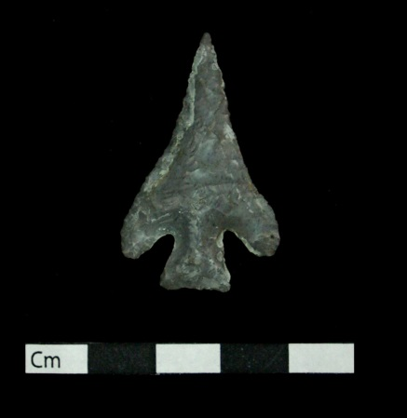
Catalog no.: 34CK-43/281, sample 1
Unit Section: Test Pit 2, SE Section 9
Locality: Burial Area
Material: Reed Springs
Type: Corner notched projectile point

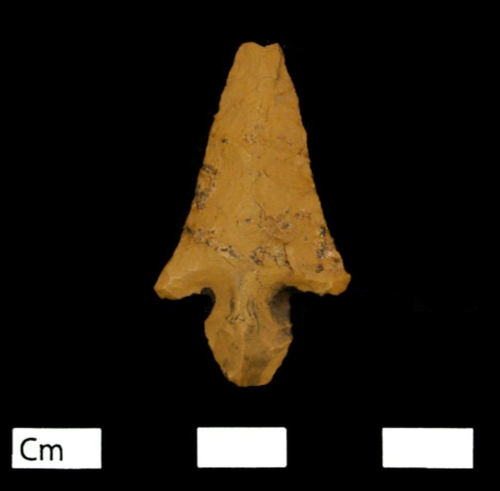
Catalog no.: 34CK-43/206, sample 1
Unit Section: Test Pit 2, SE Section 9
Locality: Burial Area
Material: Brown Jasper
Type: Side notched projectile point

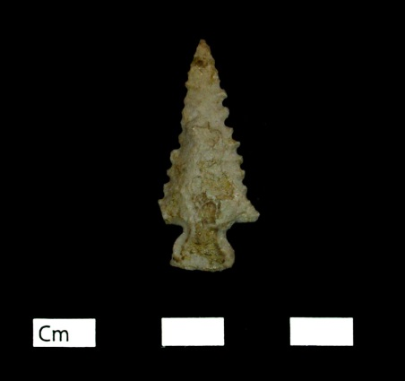
Catalog no.: 34CK-43/269, sample 2
Unit Section: Test Pit 6, SE Section 11
Locality: Hypothesized “Outside Residential” area
Material: Reed Springs
Type: Side notched projectile point

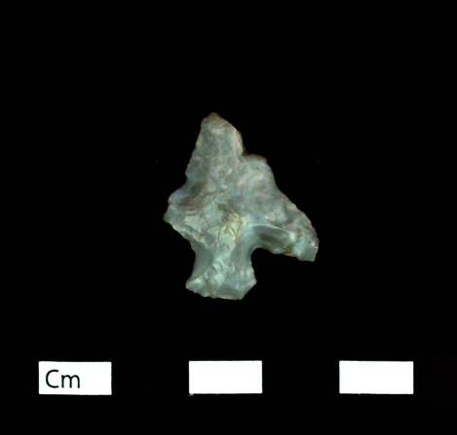
Catalog no.: 34CK-43/290, sample 1
Unit Section: Test Pit 4, SE Section 9
Locality: Burial Area
Material: Reed Springs
Type: Corner notched projectile point, with one barb broken

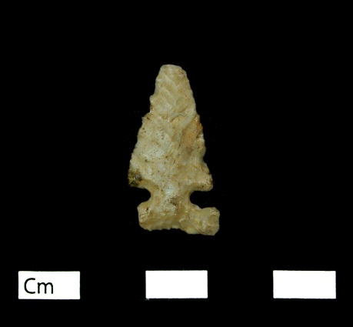
Catalog no.: 34CK-43/221
Unit Section: Test Pit 2, SE Section 9
Locality: Burial Area
Material: Tahlequah
Type: Reed Point, Side-notched projectile point

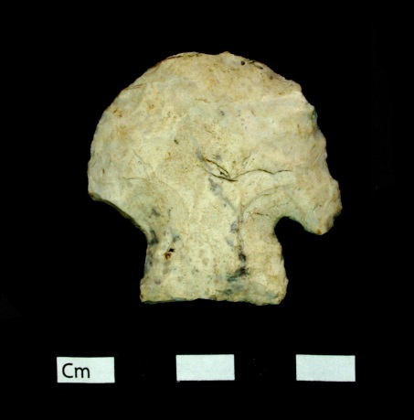
Catalog no.: 34CK-43/35, sample 1
Unit Section: Test Pit 1, SE Section 9
Locality: Hypothesized “Residential” area, Structure 1
Material: Reeds Spring
Type: Scraper, hafted with one barb broken

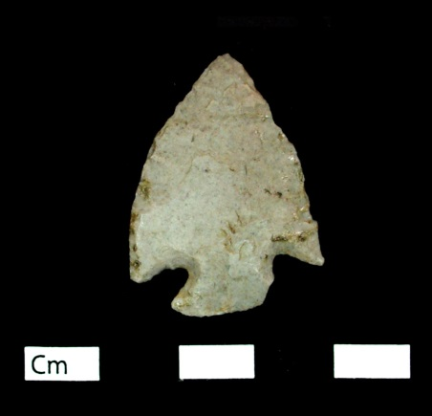
Catalog no.: 34CK-43/409, sample 1
Unit Section: Test Pit 4, SE Section 9
Locality: Hypothesized “Residential” area
Material: Reeds Spring
Type: Corner notched projectile point

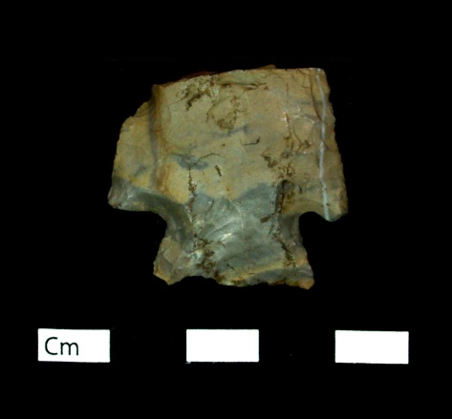
Catalog no.: 34CK-43/64, sample 1
Unit Section: Test Pit 4, SE Section (unknown)
Locality: Unknown Provenience
Material: Johns Valley Chert
Type: Corner notched projectile point fragment

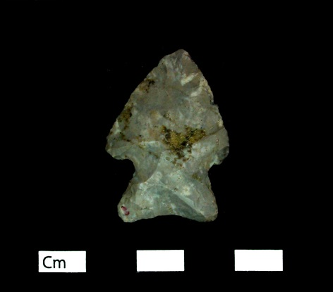
Catalog no.: 34CK-43/231, sample 1
Unit Section: Test Pit 1, SE Section 9, surface
Locality: hypothesized “Residential” area, Structure 1
Material: Reed Springs
Type: Side notched projectile point
Description: Concave base, expanding stem,

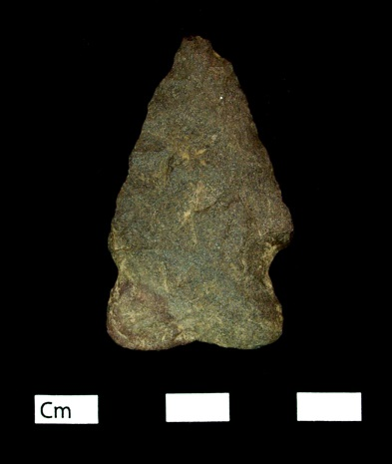
Catalog no.: 34CK-43/277, sample 12
Unit Section: Surface
Locality: Unknown Provenience
Material: Quartzite
Type: Side notched projectile point

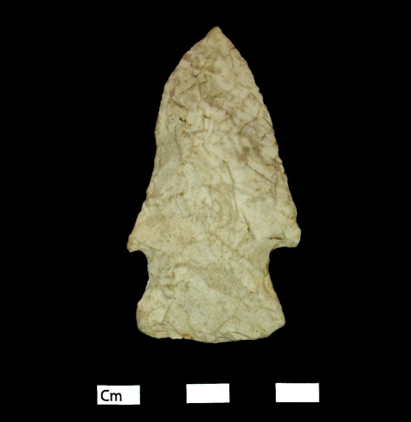
Catalog no.: 34CK-43/349, sample 2
Unit Section: Test Pit 5, SE Section 10
Locality: Hypothesized “Residential” area
Material: Keokuk
Type: Side notched projectile point

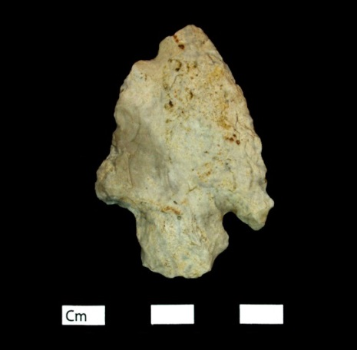
Catalog no.: 34CK-43/406, sample 1
Unit Section: Test Pit 5, SE Section 10
Locality: Hypothesized “Residential” area
Material: Reed Springs
Type: Corner notched projectile point

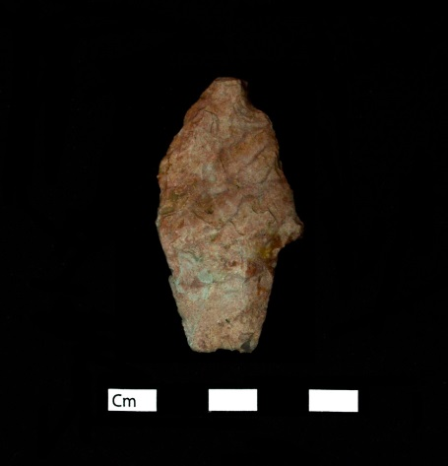
Catalog no.: 34CK-43/19, sample 1
Unit Section: Test Pit 7, NE Section 4
Locality: Hypothesized “Residential” area, Structures 5/6
Material: Reed Springs with heat treatment
Type: Stemmed projectile point

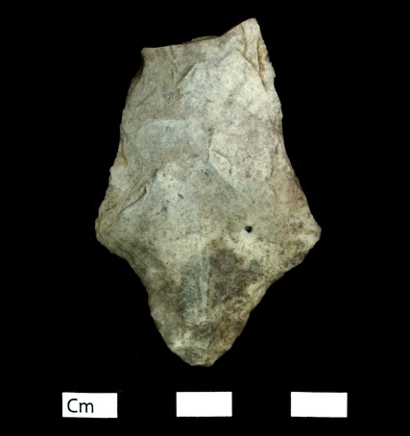
Catalog no.: 34CK-43/256, sample 1
Unit Section: Test Pit 4, NE Section 6
Locality: Hypothesized “Residential” area
Material: Reed Springs
Type: Stemmed projectile point fragment

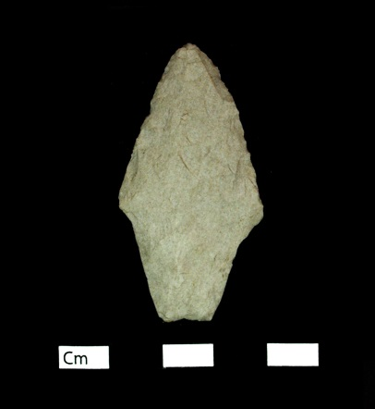
Catalog no.: 34CK-43/411, sample 1
Unit Section: Test Pit 4, SE Section 9
Locality: Hypothesized “Residential” area
Material: Tahlequah
Type: Stemmed projectile point

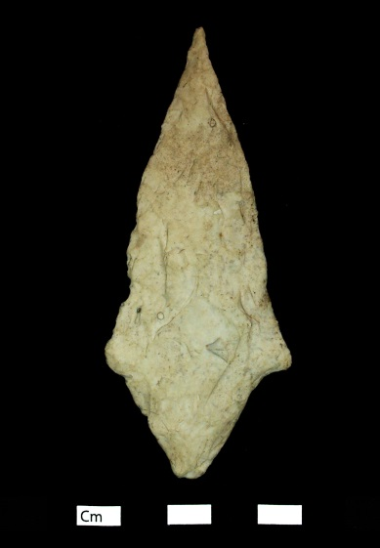
Catalog no.: 34CK-43/349, sample 1
Unit Section: Test Pit 5, SE Section 10
Locality: Hypothesized “Residential” area
Material: Keokuk
Type: Stemmed Projectile Point

Preforms

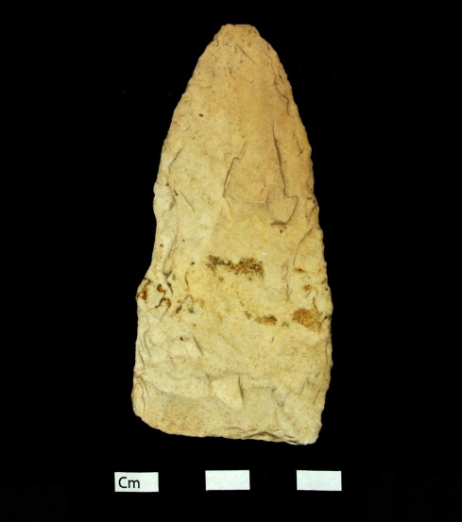
Catalog no.: 34CK-43/261
Unit Section: Test Pit 1, SE Section 3
Locality: Hypothesized “Outside Residential” area
Material: Keokuk
Type: Biface Preform

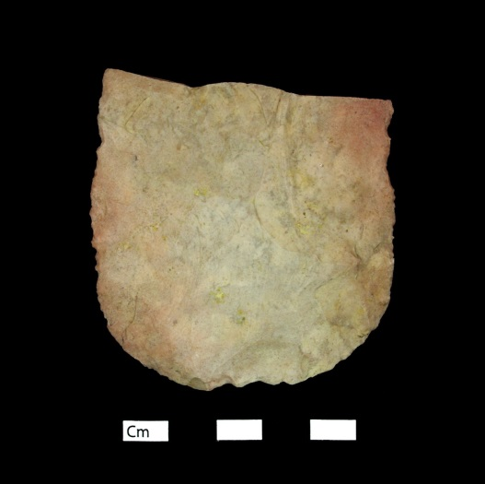
Catalog no.: 34CK-43/353
Unit Section: Test Pit 1, SE Section 9
Locality: Hypothesized “Residential” area, Structure 1
Material: Reed Springs with heat treatment
Type: Biface preform fragment

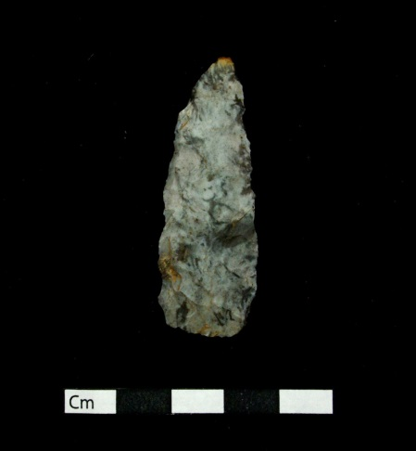
Catalog no.: 34CK-43/358
Unit Section: Test Pit 2, SE Section 9
Locality: Burial Area
Material: Reed Springs
Type: Biface Preform

Blade Fragments

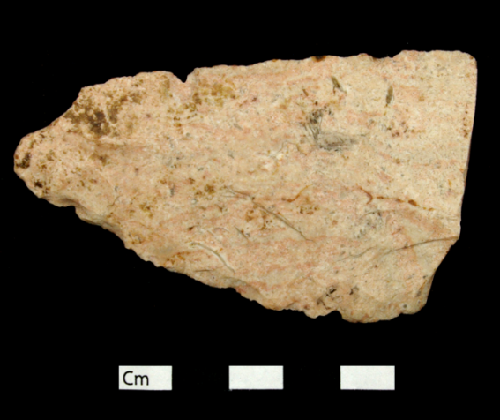
Catalog no.: 34CK-43/203, sample 1
Unit Section: Test Pit 2, SE Section 9, stake 10:8
Locality: Burial Area
Material: Florence A Chert with heat treatment
Type: Blade fragment

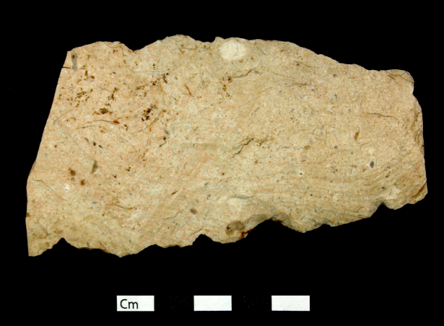
Catalog no.: 34CK-43/279, sample 1
Unit Section: Test Pit 2, SE Section 9, stake 4:11
Locality: Burial Area
Material: Florence A Chert with heat treatment
Type: Blade Fragment

Drill Fragments

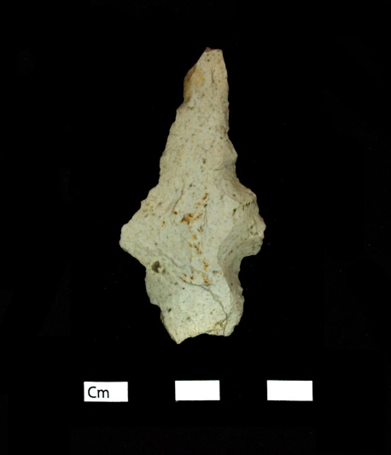
Catalog no.: 34CK-43/288, sample 1
Unit Section: Test Pit 1, SE Section 9
Locality: Hypothesized “Residential” area, Structure 1
Material: Reed Springs
Type: Drill, hafted
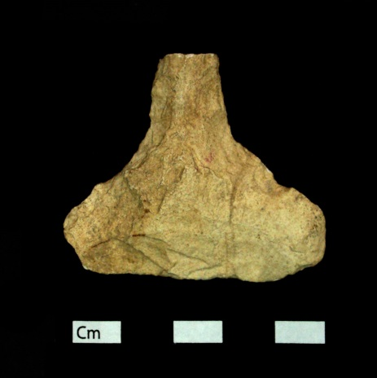
Catalog no.: 34CK-43/330, sample 1
Unit Section: “NW area”
Locality: Unknown Provenience
Material: Tahlequah
Type: Drill fragment

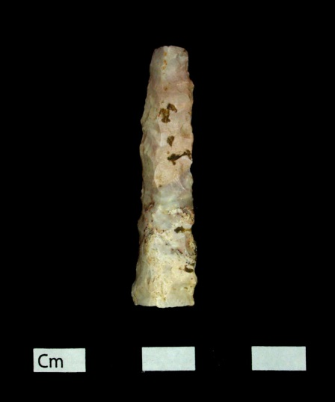
Catalog no.: 34CK-43/402, sample 1
Unit Section: SE Section 9, surface
Locality: Unknown Provenience
(Could not be determined if located in the Burial Area or in the Hypothesized “Residential” area)
Material: Reed Springs with heat treatment
Type: Drill fragment

Ground stone

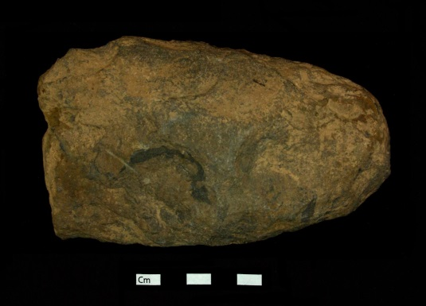
Catalog no.: 34CK-43/377, sample 1
Unit Section: Test Pit 3, SE Section 1
Locality: Hypothesized “Outside Residential” area
Material: Argillite/Siltstone
Type: Ground stone, Hoe fragment

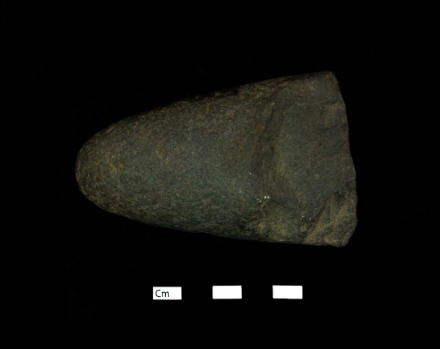
Catalog no.: 34CK-43/162, sample 1
Unit Section: Unknown Provenience
Locality: Unknown Provenience
Material: Argillite/Siltstone
Type: Ground stone, celt fragment

Double Bitted Axes

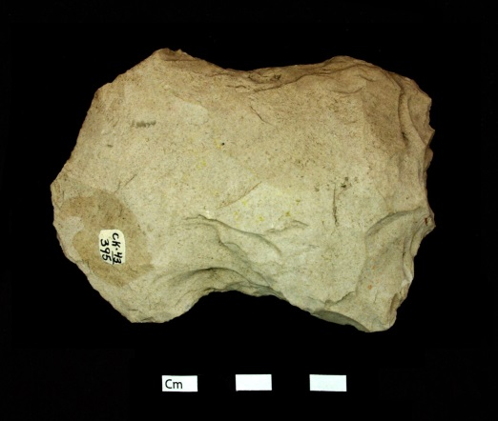
Catalog no.: 34CK-43/395, sample 2
Unit Section: Test Pit 1, SE Section 9
Locality: Hypothesized “Residential” area, Structure 1
Material: Tahlequah
Type: Double bitted axe

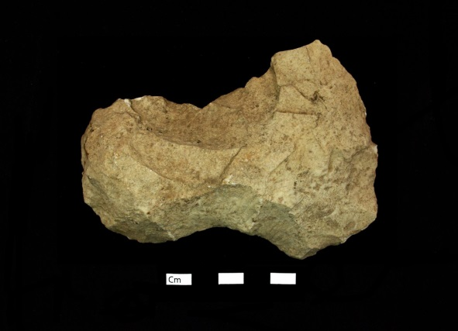
Catalog no.: 34CK-43/401, sample 1
Unit Section: SE Section 3
Locality: Hypothesized “Outside Residential” area
Material: Keokuk
Type: Double bitted axe

Pipe Fragment

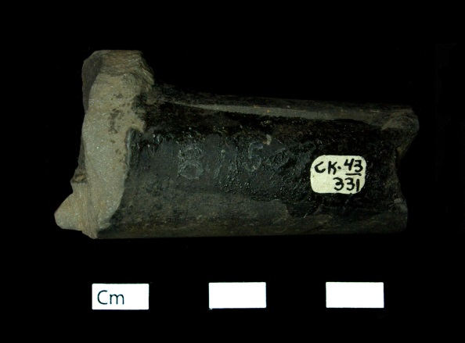 | Catalog no.: 34CK-43/331  Unit Section: Test Pit 7, NE Section 4  Locality: Hypothesized “Residential” area  Material: Shale  Type: Unknown pipe type

Appendix F: Ceramic Attributes Data Tables

This appendix presents the results for the attributes I recorded from the ceramic artifacts recovered from the Brackett site. Table F.1 provides the data for body sherds based on the attributes recorded for all ceramics. Table F.2 provides the data for rim sherds based on the attributes recorded for all ceramics. Table F.3 provides the attributes recorded specifically for rim sherds. Table F.4 provides the data for base sherds based on the attributes recorded for all ceramics and those specific to bases. Table F.5 provides the attributes recorded for handles and handle fragments.

Table F.1: Ceramic attributes recorded for all sherds (only body sherds) | Ceramic Type | Le Flore Plain | Le Flore Plain |  | Le Flore Plain | Woodward Plain | Le Flore Plain | Le Flore Plain |  | Woodward Plain | Woodward Plain | Woodward Plain | Williams Plain | Williams Plain | Le Flore Plain |  | Le Flore Plain | Williams Plain | Woodward Plain | Woodward Plain
 | Dec. Intent
 | Decoration Type
 | Sample number
 | Surface Treatment | Plain/ Smoothed | Plain/ Smoothed | Unclassified (Eroded) | Plain/ Smoothed | Plain/ Smoothed | Plain/ Smoothed | Plain/ Smoothed | Unclassified (Eroded) | Plain/ Smoothed | Plain/ Smoothed | Plain/ Smoothed | Plain/ Smoothed | Plain/ Smoothed | Plain/ Smoothed | Unclassified (Eroded) | Plain/ Smoothed | Plain/ Smoothed | Plain/ Smoothed | Plain/ Smoothed | Plain/ Smoothed
 | Shell Amount |  |  | M2 |  | M2 |  |  | M4 | M3 | M3 | M3 |  |  |  | M3 |  |  | M3 | M3 | M2
 | Grog Amount | M2 | M2 | Trace | M3 |  | M2 | M2 |  |  |  |  | M2 | M2 | M2 |  | M1 | M2 |  |  | Trace
 | Temper | Grog | Grog | Grog/ Shell | Grog | Shell | Grog | Grog, Bone (T) | Shell | Shell | Shell | Shell | Grog | Grog | Grog | Shell | Grog | Grog | Shell | Shell | Grog/ Shell
 | Weight (g) | 19.7 | 8.7 | 6.4 | 1.6 | 4.4 | 5.2 | 5.9 | 6.9 | 2.4 | 2.1 | 5.2 | 3.8 | 3.3 | 2 | 3.2 | 2.6 | 5.7 | 3.9 | 5.9 | 1.9
 | Thickness (mm) | 6.9 | 7.1 | 7.4 | 6.3 | 5 | 5.1 | 6.1 | 10.3 | 7.1 | 10.1 | 6.6 | 8.2 | 8.3 | 7.5 | 5.3 | 7.1 | 10.8 | 8.4 | 9.1 | 5.8
 | Size (cm) | 6 | 5 | 4 | 3 | 4 | 4 | 3 | 5 | 3 | 3 | 5 | 3 | 3 | 2 | 3 | 3 | 3 | 3 | 4 | 3
 | Depth (ft) | 1.6 | 1.6 | 1.6 | 0.7 | 1.4 | 1.1 | 1.1 | 0.66 | 0.66 | 0.66 | 0.66 | 0.66 | 0.66 | 0.66 | 0.75 |  | 1.2 | 1 | 1 | 1
 | Row: Alley | 12:3 | 12:3 | 12:3 | 3:12 | 4:5 | 13:10 | 13:10 | 4:6 | 4:6 | 4:6 | 4:6 | 4:6 | 4:6 | 4:6 | 14:9 | Row 8
 | Section | Test Pit 5, SE Section 10 | Test Pit 5, SE Section 10 | Test Pit 5, SE Section 10 | Test Pit 2, SE Section 9 | Test Pit 7, NE Section 4 | NE Section 6 | NE Section 6 | Test Pit 6, NE Section 4 | Test Pit 6, NE Section 4 | Test Pit 6, NE Section 4 | Test Pit 6, NE Section 4 | Test Pit 6, NE Section 4 | Test Pit 6, NE Section 4 | Test Pit 6, NE Section 4 | NE Section 6 | NE Section 1, Row 8, N. stake (E. Pit #10) | Test Pit 2, SE Section 2 | Test Pit 1, SE Section 9 | Test Pit 1, SE Section 9 | Test Pit 1, SE Section 9
 | NAGPRA
 | Structures |  |  |  |  |  |  |  |  |  |  |  |  |  |  |  |  |  | Structure 1 | Structure 1 | Structure 1
 | Locality | "Resid." | "Resid." | "Resid." | Burial Area | "Resid." | "Resid." | "Resid." | "Resid." | "Resid." | "Resid." | "Resid." | "Resid." | "Resid." | "Resid." | "Resid." | "Resid." | "Outside Resid." | "Resid." | "Resid." | "Resid."
 | Catalog no. | 1 | 1 | 1 | 2 | 3 | 4 | 4 | 5 | 5 | 5 | 5 | 5 | 5 | 5 | 6 | 7 | 8 | 9 | 9 | 9
Ceramic Type |  | Le Flore Plain | Le Flore Plain | Le Flore Plain | Le Flore Plain | Le Flore Plain | Le Flore Plain | Williams Plain | Le Flore Plain | Le Flore Plain | Le Flore Plain | Le Flore Plain | Woodward Plain | Le Flore Plain | Le Flore Plain | Williams Plain | Le Flore Plain | Woodward Plain
Dec. Intent
Decoration Type
Sample number
Surface Treatment | Plain/ Smoothed | Plain/ Smoothed | Plain/ Smoothed | Plain/ Smoothed | Plain/ Smoothed | Plain/ Smoothed | Plain/ Smoothed | Plain/ Smoothed | Plain/ Smoothed | Plain/ Smoothed | Plain/ Smoothed | Plain/ Smoothed | Plain/ Smoothed | Plain/ Smoothed | Plain/ Smoothed | Plain/ Smoothed | Plain/ Smoothed | Plain/ Smoothed
Shell Amount | M2 |  |  |  |  |  |  |  |  |  |  |  | C3 |  |  |  |  | M2
Grog Amount | Trace | M2 | F3 | F3 | M2 | M2 | M2 | M2 | M3 | M3 | M3 | M2 |  | M2 | M2 | M2 | M2
Temper | Grog/ Shell | Grog, Bone | Grog | Grog | Grog, Bone | Grog, Bone | Grog | Grog | Grog | Grog | Grog | Grog | Shell | Grog, Bone | Grog, Bone | Grog | Grog, Bone (T) | Shell
Weight (g) | 1.1 | 24 | 20.8 | 2.3 | 5.9 | 4.8 | 12.1 | 5.2 | 7.9 | 7.6 | 5.5 | 4.5 | 7.8 | 8.9 | 4.7 | 19 | 4.6 | 3.8
Thickness (mm) | 5.6 | 7.7 | 7.6 | 5.2 | 5.1 | 5.4 | 7.4 | 9.2 | 6.4 | 6.7 | 6.2 | 6.4 | 8.9 | 6.4 | 6.2 | 11.6 | 7.9 | 5.9
Size (cm) | 2 | 6 | 6 | 3 | 4 | 3 | 4 | 3 | 4 | 4 | 4 | 3 | 5 | 4 | 4 | 5 | 3 | 3
Depth (ft) | 1 |  | 1.4 | 1.4 | 2 | 2 | 0.8 | 1.1 | 0.58 | 0.58 | 0.58 | 1.2 | 1.2 | 1.2 | 1.2 | 1.1 | 1.6 | 1.6
Row: Alley |  |  | 1:7 | 1:7 | 8:10 | 8:10 | 5:6 |  | 11:2 | 11:2 | 11:2 | 14:6 | 11:10 | 11:10 | 11:10 |  | 6:2 | 6:2
Section | Test Pit 1, SE Section 9 | Test Pit 2, SE Section 9 | Test Pit 6, NE Section 4 | Test Pit 6, NE Section 4 |  |  | Test Pit 1, SE Section 9 | Test Pit 4, SE Section 9 | NE Section 4 | NE Section 4 | NE Section 4 | NE Section 6 | SE Section 9 | TP 4, SE Sec. | TP 4, SE Sec. | NE Section 1 | Test Pit 7, NE Section 4 | Test Pit 7, NE Section 4
NAGPRA
Structures | Structure 1 |  |  |  |  |  | Structure 1 |  |  |  |  |  |  |  |  |  | Structure 5/6 | Structure 5/6
Locality | "Resid." | Burial Area | "Resid." | "Resid." | Mound | Mound | "Resid." | "Resid." | "Resid." | "Resid." | "Resid." | "Resid." | "Resid." | Unknown Prov. | Unknown Prov. | "Resid." | "Resid." | "Resid."
Catalog no. | 9 | 10 | 11 | 11 | 12 | 12 | 13 | 14 | 15 | 15 | 15 | 16 | 17 | 17 | 17 | 18 | 19 | 19

Ceramic Type | Woodward Plain | Woodward Plain |  |  |  |  |  | Williams Plain |  |  |  | Le Flore Plain | Le Flore Plain |  | Woodward Plain | Woodward Plain
Dec. Intent
Decoration Type
Sample number
Surface Treatment | Plain/ Smoothed | Plain/ Smoothed | Plain/ Smoothed | Plain/ Smoothed | Plain/ Smoothed | Plain/ Smoothed | Plain/ Smoothed | Plain/ Smoothed | Plain/ Smoothed | Plain/ Smoothed | Plain/ Smoothed | Plain/ Smoothed | Plain/ Smoothed | Plain/ Smoothed | Plain/ Smoothed | Plain/ Smoothed | Plain/ Smoothed
Shell Amount | M3 | M3 | M3 | M3 | M3 | M3 | M3 |  | M3 | M2 | M3 |  |  | M2 | F3 | M3 | M3
Grog Amount |  |  |  |  |  |  |  | M2 |  | M1 |  | M2 | M2 | Trace |  |  | C1
Temper | Shell | Shell | Shell, Bone | Shell,  Bone | Shell,  Bone | Shell,  Bone (T) | Shell,  Bone (T) | Grog | Shell, Bone | Grog/ Shell, Bone (T) | Grog/ Shell | Grog | Grog, Bone (T) | Grog/ Shell | Shell | Shell | Grog/ Shell
Weight (g) | 2.9 | 2.3 | 3.2 | 1.9 | 2.6 | 3 | 6 | 4.9 | 2 | 2 | 48.5 | 1.8 | 1.4 | 5.8 | 1.3 | 3.1 | 2.9
Thickness (mm) | 5.8 | 7.8 | 7.6 | 6.1 | 7.9 | 7.8 | 7.5 | 8.5 | 8.3 | 6.9 | 7.4 | 5.5 | 5.7 | 5.9 | 5.9 | 7.5 | 8.9
Size (cm) | 4 | 3 | 3 | 2 | 3 | 3 | 4 | 3 | 2 | 3 | 10 | 2 | 2 | 4 | 2 | 4 | 3
Depth (ft) | 1.4 | 1.4 | 1.4 | 1.4 | 1.4 | 1.4 | 1.4 | 1.4 | 1.4 | 1.4 | 1.4 | 1.4 | 1.4 |  | 0.58 | 1.1 | 1.1
Row: Alley | Row 5 |  | 7:7 | 7:7 | 7:7 | 7:7 | 7:7 | 7:7 | 7:7 | 7:7 | 13:8 | 13:8 | 13:8 |  | Row 7 | 5:11 | 5:11
Section | Test Pit 4, NE Section 4 | Test Pit 4, NE Section 4 | Test Pit 2, SE Section 9 | Test Pit 2, SE Section 9 | Test Pit 2, SE Section 9 | Test Pit 2, SE Section 9 | Test Pit 2, SE Section 9 | Test Pit 2, SE Section 9 | Test Pit 2, SE Section 9 | Test Pit 2, SE Section 9 | TP 4, NE Section 6 | TP 4, NE Section 6 | TP 4, NE Section 6 | NE Sec. #6 |  | Test Pit 3, SE Section 1 | Test Pit 3, SE Section 1
NAGPRA
Structures
Locality | "Resid." | "Resid." | Burial Area | Burial Area | Burial Area | Burial Area | Burial Area | Burial Area | Burial Area | Burial Area | "Resid." | "Resid." | "Resid." | "Resid." | Unknown Prov. | "Outside Resid." | "Outside Resid."
Catalog no. | 21 | 21 | 22 | 22 | 22 | 22 | 22 | 22 | 22 | 22 | 23 | 23 | 23 | 24 | 25 | 26 | 26

Ceramic Type |  |  |  |  |  |  | Woodward Plain | Woodward Plain | Woodward Plain | Williams Plain | Woodward Plain |  | Woodward Plain |  | Woodward Plain | Woodward Plain | Woodward Plain
Dec. Intent
Decoration Type
Sample number
Surface Treatment | Plain/ Smoothed | Plain/ Smoothed | Unclassified (Eroded) | Unclassified (Eroded) | Unclassified (Eroded) | Unclassified (Eroded) | Plain/ Smoothed | Plain/ Smoothed | Plain/ Smoothed | Plain/ Smoothed | Plain/ Smoothed | Plain/ Smoothed | Plain/ Smoothed | Plain/ Smoothed | Plain/ Smoothed | Plain/ Smoothed | Plain/ Smoothed
Shell Amount | M3 | M3 | C4 | C4 | C4 | C4 | M2 | M3 | M2 |  | C3 | M3 | M3 | M3 | M2 | M3 | M3
Grog Amount | F2 | F2 | Trace | Trace | Trace | Trace |  |  |  | M3 |  | Trace |  | Trace
Temper | Grog/ Shell | Grog/ Shell | Grog/ Shell | Grog/ Shell | Grog/ Shell | Grog/ Shell | Shell | Shell | Shell | Grog | Shell | Grog/ Shell | Shell | Grog/ Shell | Shell | Shell | Shell
Weight (g) | 20 | 6.6 | 31.9 | 2.5 | 3.5 | 3 | 8.6 | 11.1 | 1.4 | 12.9 | 3.8 | 3.7 | 3.2 | 2 | 1.3 | 1.3 | 1.3
Thickness (mm) | 16.2 | 8.9 | 9.9 | 8 | 6.7 | 8.4 | 6.1 | 8.7 | 4.4 | 13.2 | 5.8 | 7.4 | 6.2 | 6.7 | 6.5 | 7.2 | 5.5
Size (cm) | 7 | 4 | 9 | 3 | 3 | 3 | 4 | 5 | 2 | 4 | 4 | 3 | 3 | 3 | 2 | 2 | 2
Depth (ft) | 1.1 | 1.1 | 0.9 | 0.9 | 0.9 | 0.9 | 1.4 | 1.4 | 1.4 | 0.6 | 0.67 | 0.67 | 0.67 | 0.67 | 0.67 | 0.67 | 0.67
Row: Alley | 5:11 | 5:11 | 10:8 | 10:8 | 10:8 | 10:8 | 13:9 | 13:9 | 13:9 | 18:7 | Row 19 | Row 19 | Row 19 | Row 19 | Row 19 | Row 19 | Row 19
Section | Test Pit 3, SE Section 1 | Test Pit 3, SE Section 1 | Test Pit 2, SE Section 9 | Test Pit 2, SE Section 9 | Test Pit 2, SE Section 9 | Test Pit 2, SE Section 9 | TP 4, NE Section 6 | TP 4, NE Section 6 | TP 4, NE Section 6 | Test Pit 1, SE Section 3 | NE Section 4 | NE Section 4 | NE Section 4 | NE Section 4 | NE Section 4 | NE Section 4 | NE Section 4
NAGPRA
Structures
Locality | "Outside Resid." | "Outside Resid." | Burial Area | Burial Area | Burial Area | Burial Area | "Resid." | "Resid." | "Resid." | "Outside Resid." | "Resid." | "Resid." | "Resid." | "Resid." | "Resid." | "Resid." | "Resid."
Catalog no. | 26 | 26 | 27 | 27 | 27 | 27 | 28 | 28 | 28 | 29 | 30 | 30 | 30 | 30 | 30 | 30 | 30

Ceramic Type | Woodward Plain | Williams Plain | Williams Plain | Williams Plain | Williams Plain | Woodward Plain | Woodward Plain |  | Woodward Plain |  |  |  |  |  |  |  | Woodward Plain | Spiro Engraved | Unidentified Engraved
Dec. Intent |  |  |  |  |  |  |  |  |  |  |  |  |  |  |  |  |  | Curvilinear | Curvilinear
Decoration Type |  |  |  |  |  |  |  |  |  |  |  |  |  |  |  |  |  | Engraved | Engraved
Sample number |  |  |  |  |  |  |  |  |  |  |  |  |  |  |  |  |  | 1 | 1
Surface Treatment | Plain/ Smoothed | Plain/ Smoothed | Plain/ Smoothed | Plain/ Smoothed | Plain/ Smoothed | Plain/ Smoothed | Plain/ Smoothed | Plain/ Smoothed | Plain/ Smoothed | Plain/ Smoothed | Plain/ Smoothed | Plain/ Smoothed | Plain/ Smoothed | Plain/ Smoothed | Plain/ Smoothed | Plain/ Smoothed | Plain/ Smoothed | Fine Decorated | Fine Decorated
Shell Amount | M3 |  |  |  |  | M3 | M3 | C3 | M3 | M3 | M3 | M3 | M3 | M3 | M3 | M3 | M3
Grog Amount |  | M2 | M2 | M3 | M3 |  |  | Trace |  | Trace | Trace | Trace | Trace | Trace | Trace | Trace |  | F2 | F2
Temper | Shell | Grog, Bone | Grog, Bone (T) | Grog | Grog | Shell | Shell | Grog/ Shell | Shell | Grog/ Shell | Grog/ Shell | Grog/ Shell | Grog/ Shell | Grog/ Shell | Grog/ Shell | Grog/ Shell | Shell | Grog | Grog
Weight (g) | 1 | 11.8 | 11.2 | 1.9 | 2.7 | 1.5 | 1.6 | 27 | 19.6 | 8.5 | 8.6 | 3.1 | 4.1 | 1.9 | 2.1 | 1 | 5.2 | 20.6 | 3.5
Thickness (mm) | 6.4 | 8.1 | 8.8 | 11.1 | 9.6 | 6.7 | 7.3 | 8.6 | 7.6 | 6.9 | 7.3 | 4.2 | 6.6 | 5.7 | 4.8 | 3.3 | 4.4 | 4.3 | 4.9
Size (cm) | 2 | 4 | 5 | 2 | 2 | 3 | 2 | 8 | 7 | 5 | 5 | 4 | 4 | 3 | 3 | 3 | 5 | 7 | 3
Depth (ft) | 0.67 |  |  | 0.9 | 0.9 | 1 | 1 | 1.3 | 1.4 | 2 | 2 | 2 | 2 | 2 | 2 | 2 | 2 | 0.1 | 1.6
Row: Alley | Row 19 |  |  | 13:4 | 13:4 |  |  | 12:8 | 6:2 | 12:8 | 12:8 | 12:8 | 12:8 | 12:8 | 12:8 | 12:8 | 12:8 | 10:8 | 4:6
Section | NE Section 4 | surface, SE Section 9 | surface, SE Section 9 | Test Pit 4, SE Section 9 | Test Pit 4, SE Section 9 | Test Pit 4, SE Section 9 | Test Pit 4, SE Section 9 | Test Pit 1, SE Section 9 | Test Pit 7, NE Section 4 | Test Pit 1, SE Section 3 | Test Pit 1, SE Section 3 | Test Pit 1, SE Section 3 | Test Pit 1, SE Section 3 | Test Pit 1, SE Section 3 | Test Pit 1, SE Section 3 | Test Pit 1, SE Section 3 | Test Pit 1, SE Section 3 | Test Pit 2, SE Section 9 | Test Pit 2, SE Section 9
NAGPRA |  |  |  |  |  |  |  |  |  |  |  |  |  |  |  |  |  |  | A2-2
Structures |  |  |  |  |  |  |  | Structure 1 | Structure 5/6
Locality | "Resid." | "Resid." | "Resid." | "Resid." | "Resid." | "Resid." | "Resid." | "Resid." | "Resid." | "Outside Resid." | "Outside Resid." | "Outside Resid." | "Outside Resid." | "Outside Resid." | "Outside Resid." | "Outside Resid." | "Outside Resid." | Burial Area | Burial Area
Catalog no. | 30 | 31 | 31 | 33 | 33 | 34 | 34 | 37 | 41 | 43 | 43 | 43 | 43 | 43 | 43 | 43 | 43 | 45 | 46

Ceramic Type | Williams Plain |  |  | Le Flore Plain |  | Unidentified Fingernail Punctate | Le Flore Plain | Unidentified Fingernail Punctate | Woodward Plain | Le Flore Plain | Williams Plain | Le Flore Plain | Le Flore Plain | Le Flore Plain | Le Flore Plain | Woodward Plain | Woodward Plain | Woodward Plain
Dec. Intent
Decoration Type |  |  |  |  |  | Fingernail Impressed |  | Fingernail Impressed
Sample number |  |  |  |  |  | 2 |  | 1
Surface Treatment | Plain/ Smoothed | Plain/ Smoothed | Plain/ Smoothed | Plain/ Smoothed | Plain/ Smoothed | Utility Decorated | Plain/ Smoothed | Utility Decorated | Plain/ Smoothed | Plain/ Smoothed | Plain/ Smoothed | Plain/ Smoothed | Plain/ Smoothed | Plain/ Smoothed | Plain/ Smoothed | Plain/ Smoothed | Plain/ Smoothed | Plain/ Smoothed
Shell Amount |  | M2 | Trace |  | Trace |  |  |  | M3 |  |  |  |  |  |  | M3 | M3 | M3
Grog Amount | C3 | M1 | M2 | M2 | M3 | F2 | M2 | F2 |  | F2 | M2 | M2 | M2 | M2 | M2
Temper | Grog | Grog/ Shell | Grog/ Shell | Grog, Bone | Grog/ Shell, Bone | Grog | Grog, Bone | Grog | Shell | Grog | Grog, Bone | Grog, Bone | Grog | Grog | Grog, Bone (T) | Shell | Shell | Shell
Weight (g) | 12.1 | 3.3 | 1.8 | 3 | 7.4 | 3.6 | 2.1 | 2.9 | 1.8 | 4 | 6.5 | 9.9 | 10.1 | 9.3 | 3.8 | 13.1 | 12.2 | 1.3
Thickness (mm) | 11.6 | 7.9 | 7.8 | 4.6 | 8.3 | 6.3 | 4.7 | 4.1 | 5.6 | 6.2 | 10.1 | 6.8 | 7.8 | 7.6 | 6.1 | 6.4 | 5.7 | 6.4
Size (cm) | 4 | 3 | 2 | 3 | 5 | 3 | 3 | 3 | 3 | 3 | 3 | 4 | 4 | 4 | 3 | 6 | 7 | 3
Depth (ft) | 0.58 | 0.92 | 0.92 | 0.92 | 0.92 | 0.92 | 0.92 |  |  |  | 0.9 | 0.9 | 1.4 | 1.4 | 1 | 0.5 | 0.5 | 0.5
Row: Alley | Row 19 | 2:7 | 2:7 | 2:7 | 2:7 | 2:7 | 2:7 | 7:17 | 7:17 | 7:17 | 10:8 | 10:8 | 13:7 | 13:7 | 5:6
Section | NE Section 4 | NE Section 2 | NE Section 2 | NE Section 2 | NE Section 2 | NE Section 2 | NE Section 2 |  |  |  | Test Pit 2, SE Section 9 | Test Pit 2, SE Section 9 | Test Pit 6, NE Section 4 | Test Pit 6, NE Section 4 | Test Pit 7, NE Section 4 | Test Pit 5, NE Section 4 | Test Pit 5, NE Section 4 | Test Pit 5, NE Section 4
NAGPRA
Structures |  |  |  |  |  |  |  |  |  |  |  |  |  |  | Structure 5/6
Locality | "Resid." | "Resid." | "Resid." | "Resid." | "Resid." | "Resid." | "Resid." | Mound | Mound | Mound | Burial Area | Burial Area | "Resid." | "Resid." | "Resid." | "Resid." | "Resid." | "Resid."
Catalog no. | 48 | 49 | 49 | 49 | 49 | 49 | 49 | 50 | 50 | 50 | 52 | 52 | 54 | 54 | 55 | 56 | 56 | 56

Ceramic Type | Woodward Plain | Woodward Plain | Woodward Plain | Woodward Plain | Woodward Plain | Unidentified Fingernail Punctate | Unidentified Fingernail Punctate | Unidentified Fingernail Punctate | Unidentified Fingernail Punctate | Unidentified Incised | Unidentified Incised | Le Flore Plain | Le Flore Plain | Le Flore Plain | Le Flore Plain
Dec. Intent |  |  |  |  |  |  |  |  |  | Rectilinear | Curvilinear
Decoration Type |  |  |  |  |  | Fingernail Impressed | Fingernail Impressed | Fingernail Impressed | Fingernail Impressed | Incised | Incised
Sample number |  |  |  |  |  | 1 | 2 | 3 | 4 | 1 | 2
Surface Treatment | Plain/ Smoothed | Plain/ Smoothed | Plain/ Smoothed | Plain/ Smoothed | Plain/ Smoothed | Utility Decorated | Utility Decorated | Utility Decorated | Utility Decorated | Decorated Unclassified | Decorated Unclassified | Plain/ Smoothed | Plain/ Smoothed | Plain/ Smoothed | Plain/ Smoothed | Plain/ Smoothed | Plain/ Smoothed
Shell Amount | M3 | M3 | M3 | M3 | M3 |  |  |  |  | M2 | M1 |  |  |  |  | Trace | Trace
Grog Amount |  |  |  |  |  | F2 | F2 | F2 | F2 | M1 |  | F2 | M1 | M1 | M2 | M2 | M2
Temper | Shell | Shell | Shell | Shell | Shell | Grog | Grog | Grog | Grog | Grog/ Shell | Shell | Grog | Grog | Grog | Grog | Grog/ Shell | Grog/ Shell
Weight (g) | 5.2 | 3.8 | 3.7 | 2.2 | 1.3 | 4.6 | 2.4 | 2.3 | 7.6 | 6 | 1.8 | 5.2 | 4.7 | 9 | 10.7 | 8.1 | 5
Thickness (mm) | 5.7 | 6.5 | 5.8 | 6.1 | 5.9 | 4.5 | 5.3 | 4.6 | 5.6 | 5.8 | 5.2 | 5.3 | 6.3 | 6.7 | 6.2 | 6.7 | 6.7
Size (cm) | 4 | 4 | 4 | 4 | 3 | 4 | 3 | 3 | 5 | 5 | 3 | 4 | 4 | 5 | 5 | 4 | 3
Depth (ft) | 0.5 | 0.5 | 0.5 | 0.5 | 0.5 | 1.3 | 1.3 | 1.3 | 1.3 | 2 | 2 | 2 | 2 | 2 | 2 | 2 | 2
Row: Alley |  |  |  |  |  | 9:8 | 9:8 | 9:8 | 9:8 | 9:5 | 9:5 | 9:5 | 9:5 | 9:5 | 9:5 | 9:5 | 9:5
Section | Test Pit 5, NE Section 4 | Test Pit 5, NE Section 4 | Test Pit 5, NE Section 4 | Test Pit 5, NE Section 4 | Test Pit 5, NE Section 4 | Test Pit 4, NE Section 9 | Test Pit 4, NE Section 9 | Test Pit 4, NE Section 9 | Test Pit 4, NE Section 9 | SW, Test Pit 7, NE Section 4 | SW, Test Pit 7, NE Section 4 | SW, Test Pit 7, NE Section 4 | SW, Test Pit 7, NE Section 4 | SW, Test Pit 7, NE Section 4 | SW, Test Pit 7, NE Section 4 | SW, Test Pit 7, NE Section 4 | SW, Test Pit 7, NE Section 4
NAGPRA
Structures |  |  |  |  |  |  |  |  |  | Structure 5/6 | Structure 5/6 | Structure 5/6 | Structure 5/6 | Structure 5/6 | Structure 5/6 | Structure 5/6 | Structure 5/6
Locality | "Resid." | "Resid." | "Resid." | "Resid." | "Resid." | "Resid." | "Resid." | "Resid." | "Resid." | "Resid." | "Resid." | "Resid." | "Resid." | "Resid." | "Resid." | "Resid." | "Resid."
Catalog no. | 56 | 56 | 56 | 56 | 56 | 57 | 57 | 57 | 57 | 58 | 58 | 58 | 58 | 58 | 58 | 58 | 58

Ceramic Type | Le Flore Plain | Le Flore Plain | Woodward Plain | Woodward Plain | Woodward Plain | Woodward Plain | Le Flore Plain | Williams Plain |  | Williams Plain
Dec. Intent
Decoration Type
Sample number
Surface Treatment | Plain/ Smoothed | Plain/ Smoothed | Plain/ Smoothed | Plain/ Smoothed | Plain/ Smoothed | Plain/ Smoothed | Plain/ Smoothed | Plain/ Smoothed | Unclassified (Eroded) | Plain/ Smoothed | Plain/ Smoothed | Plain/ Smoothed | Plain/ Smoothed | Plain/ Smoothed | Plain/ Smoothed | Plain/ Smoothed | Plain/ Smoothed | Plain/ Smoothed | Plain/ Smoothed | Plain/ Smoothed
Shell Amount |  |  | M3 | M3 | M3 | M3 |  |  |  |  | M3 | M3 | M3 | M3 | M3 | M3 | M3 | M3 | M2 | M2
Grog Amount | M2 | M2 |  |  |  |  | M2 | M3 | M3 | M3
Temper | Grog | Grog | Shell | Shell | Shell | Shell | Grog | Grog | Grog, Bone | Grog | Shell, Bone | Shell, Bone | Shell, Bone (T) | Shell, Bone (T) | Shell, Bone (T) | Shell, Bone (T) | Shell, Bone (T) | Shell, Bone (T) | Shell, Bone | Shell, Bone
Weight (g) | 4.1 | 2 | 28.7 | 3.1 | 5.1 | 6.4 | 25.5 | 4.5 | 2.8 | 3.4 | 17.9 | 4.9 | 2.3 | 24 | 15.1 | 12.1 | 10.6 | 6.4 | 3 | 5.9
Thickness (mm) | 6.3 | 6.2 | 8.3 | 8.4 | 8.5 | 8.2 | 6.6 | 11.8 | 9.6 | 9.1 | 7.4 | 9.3 | 7.8 | 9.1 | 7.2 | 7.5 | 9.1 | 7.3 | 8.7 | 8.5
Size (cm) | 3 | 2 | 7 | 3 | 3 | 4 | 7 | 3 | 2 | 2 | 7 | 4 | 3 | 7 | 6 | 5 | 5 | 4 | 3 | 4
Depth (ft) | 2 | 2 | 1.2 | 1.2 | 1.2 | 1.2 | 1.3 | 1 | 1 | 1 | 2 | 2 | 2 | 2 | 2 | 2 | 2 | 2 | 2 | 2
Row: Alley | 9:5 | 9:5 | Row 6 | Row 6 | Row 6 | Row 6 | 8:5 | 1:8 | 1:8 | 1:8 | 6:3 | 6:3 | 6:3 | 6:3 | 6:3 | 6:3 | 6:3 | 6:3 | 6:3 | 6:3
Section | SW, Test Pit 7, NE Section 4 | SW, Test Pit 7, NE Section 4 | Test Pit 1, NE Section 4 | Test Pit 1, NE Section 4 | Test Pit 1, NE Section 4 | Test Pit 1, NE Section 4 | SW, Test Pit 7, NE Section 4 | Test Pit 2, SE Section 9 | Test Pit 2, SE Section 9 | Test Pit 2, SE Section 9 | Test Pit 7, NE Section 4 | Test Pit 7, NE Section 4 | Test Pit 7, NE Section 4 | Test Pit 7, NE Section 4 | Test Pit 7, NE Section 4 | Test Pit 7, NE Section 4 | Test Pit 7, NE Section 4 | Test Pit 7, NE Section 4 | Test Pit 7, NE Section 4 | Test Pit 7, NE Section 4
NAGPRA
Structures | Structure 5/6 | Structure 5/6 |  |  |  |  | Structure 5/6 |  |  |  | Structure 5/6 | Structure 5/6 | Structure 5/6 | Structure 5/6 | Structure 5/6 | Structure 5/6 | Structure 5/6 | Structure 5/6 | Structure 5/6 | Structure 5/6
Locality | "Resid." | "Resid." | "Resid." | "Resid." | "Resid." | "Resid." | "Resid." | Burial Area | Burial Area | Burial Area | "Resid." | "Resid." | "Resid." | "Resid." | "Resid." | "Resid." | "Resid." | "Resid." | "Resid." | "Resid."
Catalog no. | 58 | 58 | 63 | 63 | 63 | 63 | 68 | 71 | 71 | 71 | 76 | 76 | 76 | 76 | 76 | 76 | 76 | 76 | 76 | 76

Ceramic Type | Le Flore Plain | Le Flore Plain | Le Flore Plain | Le Flore Plain | Williams Plain | Williams Plain | Williams Plain |  | Woodward Plain | Woodward Plain | Woodward Plain | Woodward Plain | Woodward Plain |  | Woodward Plain
Dec. Intent
Decoration Type
Sample number
Surface Treatment | Plain/ Smoothed | Plain/ Smoothed | Plain/ Smoothed | Plain/ Smoothed | Plain/ Smoothed | Plain/ Smoothed | Plain/ Smoothed | Plain/ Smoothed | Plain/ Smoothed | Plain/ Smoothed | Plain/ Smoothed | Plain/ Smoothed | Plain/ Smoothed | Plain/ Smoothed | Plain/ Smoothed
Shell Amount |  |  |  |  |  |  |  | M2 | M2 | M2 | M2 | M2 | F3 | M2 | M2
Grog Amount | M2 | M2 | M2 | M2 | M1 | M1 | M2 | Trace |  |  |  |  |  | Trace
Temper | Grog, Bone | Grog | Grog | Grog | Grog | Grog | Grog | Grog/ Shell | Shell | Shell | Shell | Shell | Shell | Grog/ Shell | Shell
Weight (g) | 10.6 | 3.6 | 16 | 9.6 | 14.1 | 3.8 | 6.6 | 3.9 | 6.3 | 5.4 | 3.7 | 2.1 | 5.5 | 7.2 | 4.9
Thickness (mm) | 6.8 | 4.6 | 6.2 | 7.9 | 9.6 | 8 | 12.1 | 5.3 | 5.9 | 5.6 | 4.6 | 5.4 | 7.4 | 5.6 | 6
Size (cm) | 4 | 3 | 6 | 4 | 5 | 3 | 3 | 3 | 4 | 4 | 4 | 3 | 4 | 5 | 4
Depth (ft) | 1.3 | 1.7 | 0.8 | 1.5 |  |  |  | 1 | 1 | 1 | 1 | 1 | 1 | 1 | 1
Row: Alley | 10:8 | 12:10 | 5:6 |  |  |  |  | Row 18 | 10:8 | 10:8 | 10:8 | 10:8 | 10:8 | 10:8 | 10:8
Section |  | NE Sec. #6 | Test Pit 1, SE Section 9 | Test Pit 4, SE Section 9 |  |  |  | NE Section 4 | Test Pit 2, SE Section 9 | Test Pit 2, SE Section 9 | Test Pit 2, SE Section 9 | Test Pit 2, SE Section 9 | Test Pit 2, SE Section 9 | Test Pit 2, SE Section 9 | Test Pit 2, SE Section 9
NAGPRA
Structures |  |  | Structure 1
Locality | Unknown Prov. | "Resid." | "Resid." | "Resid." | Unknown Prov. | Unknown Prov. | Unknown Prov. | Mound | Burial Area | Burial Area | Burial Area | Burial Area | Burial Area | Burial Area | Burial Area
Catalog no. | 77 | 78 | 79 | 80 | 81 | 81 | 81 | 82 | 83 | 83 | 83 | 83 | 83 | 83 | 83

Ceramic Type | Woodward Plain | Woodward Plain | Woodward Plain |  | Woodward Plain | Woodward Plain | Woodward Plain | Woodward Plain | Woodward Plain |  |  | Williams Plain | Le Flore Plain | Le Flore Plain | Unidentified Applique
Dec. Intent
Decoration Type |  |  |  |  |  |  |  |  |  |  |  |  |  |  | Applique
Sample number |  |  |  |  |  |  |  |  |  |  |  |  |  |  | 1
Surface Treatment | Plain/ Smoothed | Plain/ Smoothed | Plain/ Smoothed | Plain/ Smoothed | Plain/ Smoothed | Plain/ Smoothed | Plain/ Smoothed | Plain/ Smoothed | Plain/ Smoothed | Plain/ Smoothed | Red Slipped- Undecorated | Plain/ Smoothed | Plain/ Smoothed | Plain/ Smoothed | Utility Decorated
Shell Amount | M2 | M2 | M2 | M2 | M2 | M2 | M2 | M2 | M2 | M2 | M3 |  |  |  | M2
Grog Amount |  |  |  | Trace |  |  |  |  |  | Trace | Trace | M3 | M3 | M1
Temper | Shell | Shell | Shell | Grog/ Shell | Shell | Shell | Shell | Shell | Shell | Grog/ Shell | Grog/ Shell | Grog | Grog, Bone | Grog | Shell
Weight (g) | 3.8 | 3.4 | 2.2 | 2.5 | 2.3 | 2.1 | 1.1 | 1.3 | 1.2 | 1.5 | 2.3 | 6.3 | 4 | 2.7 | 9.7
Thickness (mm) | 5.3 | 5.5 | 4.9 | 6.5 | 4.8 | 5.3 | 5.6 | 4.8 | 4.3 | 5.1 | 5.5 | 11.6 | 7.7 | 5.8 | 4.8
Size (cm) | 4 | 3 | 3 | 3 | 3 | 3 | 2 | 3 | 2 | 2 | 3 | 3 | 3 | 2 | 5
Depth (ft) | 1 | 1 | 1 | 1 | 1 | 1 | 1 | 1 | 1 | 1 | 0.8 | 0.5 | 0.5 | 0.6 | 0.6
Row: Alley | 10:8 | 10:8 | 10:8 | 10:8 | 10:8 | 10:8 | 10:8 | 10:8 | 10:8 | 10:8 | 4:11 | 12:6 | 12:6 | N1 | N1
Section | Test Pit 2, SE Section 9 | Test Pit 2, SE Section 9 | Test Pit 2, SE Section 9 | Test Pit 2, SE Section 9 | Test Pit 2, SE Section 9 | Test Pit 2, SE Section 9 | Test Pit 2, SE Section 9 | Test Pit 2, SE Section 9 | Test Pit 2, SE Section 9 | Test Pit 2, SE Section 9 | SE Section 2 | Test Pit 6, NE Section 4 | Test Pit 6, NE Section 4 | Test Pit 2, SE Section 9 | Test Pit 2, SE Section 9
NAGPRA
Structures
Locality | Burial Area | Burial Area | Burial Area | Burial Area | Burial Area | Burial Area | Burial Area | Burial Area | Burial Area | Burial Area | "Outside Resid." | "Resid." | "Resid." | Burial Area | Burial Area
Catalog no. | 83 | 83 | 83 | 83 | 83 | 83 | 83 | 83 | 83 | 83 | 86 | 87 | 87 | 91 | 91

Ceramic Type | Unidentified Applique |  |  |  | Woodward Plain | Woodward Plain | Woodward Plain | Le Flore Plain | Williams Plain | Williams Plain | Williams Plain |  |  | Woodward Plain | Woodward Plain | Woodward Plain | Le Flore Plain | Le Flore Plain | Williams Plain | Woodward Plain
Dec. Intent
Decoration Type | Applique
Sample number | 2 |  |  |  |  |  |  | 1 |  |  |  |  |  |  |  |  |  | 3
Surface Treatment | Utility Decorated | Plain/ Smoothed | Plain/ Smoothed | Plain/ Smoothed | Plain/ Smoothed | Plain/ Smoothed | Plain/ Smoothed | Plain/ Smoothed | Plain/ Smoothed | Plain/ Smoothed | Plain/ Smoothed | Red Slipped- Undecorated | Red Slipped- Undecorated | Plain/ Smoothed | Plain/ Smoothed | Plain/ Smoothed | Plain/ Smoothed | Plain/ Smoothed | Plain/ Smoothed | Plain/ Smoothed
Shell Amount | M2 | M3 | M3 | M3 | M3 | M3 | M3 |  |  |  |  |  | M2 | M2 | M3 | M2 |  |  |  | M3
Grog Amount |  | Trace | Trace | Trace |  |  |  | C3 | M3 | C3 | C3 | F2 |  |  |  |  | M2 | M2 | M2
Temper | Shell | Grog/ Shell | Grog/ Shell | Grog/ Shell | Shell | Shell | Shell | Grog | Grog, Bone | Grog | Grog | Grog | Shell, Bone | Shell | Shell | Shell | Grog, Bone | Grog, Bone | Grog | Shell
Weight (g) | 2.9 | 1.8 | 1.5 | 2.1 | 3.2 | 1.1 | 1.3 | 21.6 | 10 | 5.5 | 8.7 | 2 | 7.7 | 6.8 | 6.1 | 2 | 7.2 | 8.7 | 16.6 | 2.6
Thickness (mm) | 4.3 | 6.3 | 6 | 6.4 | 5.6 | 7.1 | 7.2 | 7.9 | 8.6 | 9.4 | 13 | 4.6 | 6.4 | 5.6 | 7.6 | 6.3 | 5.4 | 4.2 | 9.1 | 5.1
Size (cm) | 4 | 3 | 2 | 3 | 4 | 2 | 2 | 6 | 5 | 3 | 3 | 3 | 5 | 4 | 5 | 3 | 4 | 5 | 5 | 4
Depth (ft) | 0.6 | 1.5 | 1.5 | 1.5 | 1.6 | 0.67 | 0.67 | 0.8 | 0.8 | 0.8 | 2 | 2 | 2 | 2 | 2 | 2 | 2 | 2
Row: Alley | N1 | Row 4 | Row 4 | Row 4 | 7:2 | 13:6 | 13:6 | 5:3 | 5:3 | 5:3 | 9:2 | 9:2 | 9:2 | 9:2 | 9:2 | 9:2 | 4:6 | 4:6 |  | 2:29
Section | Test Pit 2, SE Section 9 | NE Section 4 | NE Section 4 | NE Section 4 | SW, Test Pit 7, NE Section 4 | NE Section 6 | NE Section 6 | Test Pit 5, SE Section 10 | Test Pit 5, SE Section 10 | Test Pit 5, SE Section 10 | Test Pit 1, SE Section 3 | Test Pit 1, SE Section 3 | Test Pit 1, SE Section 3 | Test Pit 1, SE Section 3 | Test Pit 1, SE Section 3 | Test Pit 1, SE Section 3 | Test Pit 2, SE Section 9 | Test Pit 2, SE Section 9 | SE Section 9 (E of 1:1) | Test Pit
NAGPRA |  |  |  |  |  |  |  |  |  |  |  |  |  |  |  |  | A2-3 | A2-3
Structures |  |  |  |  | Structure 5/6
Locality | Burial Area | "Resid." | "Resid." | "Resid." | "Resid." | "Resid." | "Resid." | "Resid." | "Resid." | "Resid." | "Outside Resid." | "Outside Resid." | "Outside Resid." | "Outside Resid." | "Outside Resid." | "Outside Resid." | Burial Area | Burial Area | "Resid." | Unknown Prov.
Catalog no. | 91 | 92 | 92 | 92 | 93 | 95 | 95 | 96 | 96 | 96 | 100 | 100 | 100 | 100 | 100 | 100 | 101 | 101 | 105 | 106

Ceramic Type |  | Holly Fine Engraved | Holly Fine Engraved | Holly Fine Engraved | Holly Fine Engraved | Holly Fine Engraved | Holly Fine Engraved | Holly Fine Engraved | Holly Fine Engraved | Holly Fine Engraved | Holly Fine Engraved | Holly Fine Engraved | Holly Fine Engraved | Holly Fine Engraved | Holly Fine Engraved | Holly Fine Engraved | Holly Fine Engraved | Holly Fine Engraved
Dec. Intent |  | Curvilinear | Curvilinear | Curvilinear | Curvilinear | Curvilinear | Curvilinear | Curvilinear | Curvilinear | Curvilinear | Curvilinear | Curvilinear | Curvilinear | Curvilinear | Curvilinear | Curvilinear | Curvilinear | Curvilinear
Decoration Type |  | Engraved | Engraved | Engraved | Engraved | Engraved | Engraved | Engraved | Engraved | Engraved | Engraved | Engraved | Engraved | Engraved | Engraved | Engraved | Engraved | Engraved
Sample number |  | 2 | 3 | 4 | 5 | 6 | 7 | 8 | 9 | 10 | 11 | 12 | 13 | 14 | 15 | 16 | 17 | 18
Surface Treatment | Burnished Undecorated | Fine Decorated | Fine Decorated | Fine Decorated | Fine Decorated | Fine Decorated | Fine Decorated | Fine Decorated | Fine Decorated | Fine Decorated | Fine Decorated | Fine Decorated | Fine Decorated | Fine Decorated | Fine Decorated | Fine Decorated | Fine Decorated | Fine Decorated
Shell Amount
Grog Amount | M2 | M1 | M1 | M1 | F2 | M1 | M1 | M1 | M1 | M1 | M1 | M1 | M1 | M1 | M1 | F2 | F2 | F2
Temper | Grog | Grog | Grog | Grog | Grog | Grog | Grog | Grog | Grog | Grog | Grog | Grog | Grog | Grog | Grog | Grog | Grog | Grog
Weight (g) | 1.3 | 4.8 | 3.8 | 8.6 | 5.2 | 2.6 | 2.1 | 2.9 | 2.1 | 1.6 | 1.3 | 1.1 | 1.8 | 3.4 | 1.7 | 2.7 | 1.6 | 1.5
Thickness (mm) | 4.4 | 4.4 | 5.8 | 4.6 | 4.3 | 4.3 | 5.3 | 4.9 | 5 | 4.4 | 4.7 | 4.8 | 4.8 | 4.8 | 5.3 | 5.1 | 5.5 | 4.7
Size (cm) | 2 | 4 | 4 | 6 | 4 | 3 | 3 | 3 | 3 | 3 | 2 | 2 | 3 | 4 | 2 | 3 | 3 | 2
Depth (ft) | 1.22 | 1.4 | 1.4 | 1.4 | 1.4 | 1.4 | 1.4 | 1.4 | 1.4 | 1.4 | 1.4 | 1.4 | 1.4 | 1.4 | 1.4 | 1.4 | 1.4 | 1.4
Row: Alley | 7:6
Section | Test Pit 2, SE Section 9 | Test Pit 2, SE Section 9 | Test Pit 2, SE Section 9 | Test Pit 2, SE Section 9 | Test Pit 2, SE Section 9 | Test Pit 2, SE Section 9 | Test Pit 2, SE Section 9 | Test Pit 2, SE Section 9 | Test Pit 2, SE Section 9 | Test Pit 2, SE Section 9 | Test Pit 2, SE Section 9 | Test Pit 2, SE Section 9 | Test Pit 2, SE Section 9 | Test Pit 2, SE Section 9 | Test Pit 2, SE Section 9 | Test Pit 2, SE Section 9 | Test Pit 2, SE Section 9 | Test Pit 2, SE Section 9
NAGPRA | A3-2
Structures
Locality | Burial Area | Burial Area | Burial Area | Burial Area | Burial Area | Burial Area | Burial Area | Burial Area | Burial Area | Burial Area | Burial Area | Burial Area | Burial Area | Burial Area | Burial Area | Burial Area | Burial Area | Burial Area
Catalog no. | 112 | 116 | 116 | 116 | 116 | 116 | 116 | 116 | 116 | 116 | 116 | 116 | 116 | 116 | 116 | 116 | 116 | 116

Ceramic Type | Holly Fine Engraved | Holly Fine Engraved | Holly Fine Engraved | Holly Fine Engraved | Holly Fine Engraved | Holly Fine Engraved | Holly Fine Engraved | Holly Fine Engraved |  |  | Le Flore Plain | Le Flore Plain | Le Flore Plain |  |  |  | Woodward Plain | Woodward Plain | Unidentified Engraved
Dec. Intent | Curvilinear | Curvilinear | Curvilinear | Curvilinear | Curvilinear | Curvilinear | Curvilinear | Curvilinear |  |  |  |  |  |  |  |  |  |  | Curvilinear
Decoration Type | Engraved | Engraved | Engraved | Engraved | Engraved | Engraved | Engraved | Engraved |  |  |  |  |  |  |  |  |  |  | Engraved
Sample number | 19 | 20 | 21 | 22 | 23 | 24 | 25 | 26 |  |  |  |  |  |  |  |  |  |  | 1
Surface Treatment | Fine Decorated | Fine Decorated | Fine Decorated | Fine Decorated | Fine Decorated | Fine Decorated | Fine Decorated | Fine Decorated | Plain/ Smoothed | Plain/ Smoothed | Plain/ Smoothed | Plain/ Smoothed | Plain/ Smoothed | Unclassified (Eroded) | Plain/ Smoothed | Plain/ Smoothed | Plain/ Smoothed | Plain/ Smoothed | Fine Decorated
Shell Amount | Trace |  |  |  |  |  |  |  | M3 | M3 |  |  |  | M3 | M3 | M3 | M3 | M3
Grog Amount | M1 | M1 | M1 | F2 | M1 | F2 | F2 | F2 | Trace | Trace | C1 | C1 | C1 | Trace | Trace | Trace |  |  | M3
Temper | Grog/ Shell | Grog | Grog | Grog | Grog | Grog | Grog | Grog | Grog/ Shell, Bone | Grog/ Shell, Bone | Grog | Grog | Grog | Grog/ Shell, Bone | Grog/ Shell, Bone | Grog/ Shell, Bone | Shell | Shell | Grog
Weight (g) | 2.3 | 2.6 | 2.6 | 5.9 | 1.8 | 1.8 | 1.4 | 1.3 | 5.8 | 2.9 | 3.2 | 2.1 | 1.6 | 1.4 | 1.5 | 1.4 | 2.4 | 1.9 | 4
Thickness (mm) | 4.5 | 4.8 | 5.4 | 3.7 | 5.8 | 4.4 | 5.2 | 4.7 | 12.1 | 9.5 | 6.5 | 6.1 | 6.2 | 6.3 | 6.9 | 6.8 | 5.3 | 6.5 | 6.9
Size (cm) | 3 | 3 | 3 | 2 | 3 | 3 | 2 | 2 | 3 | 3 | 3 | 3 | 3 | 2 | 2 | 2 | 3 | 2 | 3
Depth (ft) | 1.4 | 1.4 | 1.4 | 1.4 | 1.4 | 1.4 | 1.4 | 1.4 | 0.7 | 0.7 | 0.7 | 0.7 | 0.7 | 0.7 | 0.7 | 0.7 | 0.7 | 0.7 | 0.7
Row: Alley |  |  |  |  |  |  |  |  | 10:8 | 10:8 | 10:8 | 10:8 | 10:8 | 10:8 | 10:8 | 10:8 | 10:8 | 10:8 | 10:8
Section | Test Pit 2, SE Section 9 | Test Pit 2, SE Section 9 | Test Pit 2, SE Section 9 | Test Pit 2, SE Section 9 | Test Pit 2, SE Section 9 | Test Pit 2, SE Section 9 | Test Pit 2, SE Section 9 | Test Pit 2, SE Section 9 | Test Pit 4, SE Section 9 | Test Pit 4, SE Section 9 | Test Pit 4, SE Section 9 | Test Pit 4, SE Section 9 | Test Pit 4, SE Section 9 | Test Pit 4, SE Section 9 | Test Pit 4, SE Section 9 | Test Pit 4, SE Section 9 | Test Pit 4, SE Section 9 | Test Pit 4, SE Section 9 | Test Pit 4, SE Section 9
NAGPRA
Structures
Locality | Burial Area | Burial Area | Burial Area | Burial Area | Burial Area | Burial Area | Burial Area | Burial Area | "Resid." | "Resid." | "Resid." | "Resid." | "Resid." | "Resid." | "Resid." | "Resid." | "Resid." | "Resid." | "Resid."
Catalog no. | 116 | 116 | 116 | 116 | 116 | 116 | 116 | 116 | 117 | 117 | 117 | 117 | 117 | 117 | 117 | 117 | 117 | 117 | 117

Ceramic Type | Williams Plain |  |  | Woodward Plain | Unidentified Engraved |  |  |  |  |  |  |  | Le Flore Plain | Le Flore Plain |  |  |  | Woodward Plain
Dec. Intent |  |  |  |  | Curvilinear
Decoration Type |  |  |  |  | Engraved
Sample number |  |  |  |  | 1
Surface Treatment | Plain/ Smoothed | Unclassified (Eroded) | Plain/ Smoothed | Plain/ Smoothed | Fine Decorated | Burnished Undecorated | Plain/ Smoothed | Plain/ Smoothed | Plain/ Smoothed | Plain/ Smoothed | Plain/ Smoothed | Plain/ Smoothed | Plain/ Smoothed | Plain/ Smoothed | Unclassified (Eroded) | Unclassified (Eroded) | Plain/ Smoothed | Plain/ Smoothed | Plain/ Smoothed
Shell Amount |  | M3 | M2 | M3 |  |  | M1 | M1 | M1 | M1 | M1 | Trace |  |  | M3 | M3 | M2 | M3 | M3
Grog Amount | C1 |  | Trace |  | F2 | M2 | M2 | M2 | M2 | M2 | M2 | M2 | M2 | M3 |  |  | Trace |  | Trace
Temper | Grog | Shell | Grog/ Shell, Bone | Shell | Grog | Grog | Grog/ Shell | Grog/ Shell | Grog/ Shell | Grog/ Shell | Grog/ Shell | Grog/ Shell | Grog | Grog, Bone (T) | Shell | Shell | Grog/ Shell | Shell | Grog/ Shell, Bone
Weight (g) | 26.8 | 3.2 | 2.7 | 19.6 | 3.5 | 17.7 | 15.3 | 12.3 | 15.6 | 5.3 | 3.5 | 4 | 2.4 | 11 | 2.3 | 3.1 | 7 | 33.3 | 4.4
Thickness (mm) | 13.5 | 9.1 | 8.7 | 7.7 | 4.6 | 5.8 | 6.6 | 6.4 | 6.3 | 6 | 5.7 | 6 | 6.5 | 6.6 | 10.2 | 5.6 | 7.4 | 6.7 | 4.7
Size (cm) | 6 | 4 | 3 | 6 | 3 | 6 | 6 | 5 | 6 | 4 | 4 | 4 | 3 | 5 | 3 | 3 | 5 | 9 | 4
Depth (ft) | 0.7 | 0.7 | 0.7 | 0.7 | 1 | 1.6 | 1.6 | 1.6 | 1.6 | 1.6 | 1.6 | 1.6 | 1.6 |  | 1 | 1 | 1.4 | 1 | 1.4
Row: Alley | 10:8 | 10:8 | 10:8 | 10:8 | 15:15 | 9:5 | 9:5 | 9:5 | 9:5 | 9:5 | 9:5 | 9:5 | 9:5 | Row 22 | Row 21 | Row 21 | 2:6 | 5:5 | 2:6
Section | Test Pit 4, SE Section 9 | Test Pit 4, SE Section 9 | Test Pit 4, SE Section 9 | Test Pit 4, SE Section 9 | SE Section 3 | SW, Test Pit 7, NE Section 4 | SW, Test Pit 7, NE Section 4 | SW, Test Pit 7, NE Section 4 | SW, Test Pit 7, NE Section 4 | SW, Test Pit 7, NE Section 4 | SW, Test Pit 7, NE Section 4 | SW, Test Pit 7, NE Section 4 | SW, Test Pit 7, NE Section 4 | NE Section 4 | NE Section 4 | NE Section 4 | Test Pit 7, NE Section 4 | Test Pit 7, NE Section 4 | Test Pit 6, NE Section 4
NAGPRA
Structures |  |  |  |  |  | Structure 5/6 | Structure 5/6 | Structure 5/6 | Structure 5/6 | Structure 5/6 | Structure 5/6 | Structure 5/6 | Structure 5/6 |  |  |  | Structure 5/6 | Structure 5/6
Locality | "Resid." | "Resid." | "Resid." | "Resid." | "Outside Resid." | "Resid." | "Resid." | "Resid." | "Resid." | "Resid." | "Resid." | "Resid." | "Resid." | "Resid." | "Resid." | "Resid." | "Resid." | "Resid." | "Resid."
Catalog no. | 117 | 117 | 117 | 117 | 146 | 194 | 194 | 194 | 194 | 194 | 194 | 194 | 194 | 200 | 207 | 207 | 211 | 255 | 300

Ceramic Type | Le Flore Plain | Le Flore Plain | Le Flore Plain | Le Flore Plain | Le Flore Plain |  |  |  | Unidentified Engraved | Unidentified Engraved | Unidentified Engraved | Woodward Plain | Woodward Plain | Woodward Plain | Woodward Plain | Williams Plain | Le Flore Plain | Le Flore Plain | Le Flore Plain
Dec. Intent |  |  |  |  |  |  |  |  | Curvilinear | Curvilinear | Curvilinear
Decoration Type |  |  |  |  |  |  |  |  | Engraved | Engraved | Engraved
Sample number |  |  |  |  |  |  |  |  | 1 | 3 | 4
Surface Treatment | Plain/ Smoothed | Plain/ Smoothed | Plain/ Smoothed | Plain/ Smoothed | Plain/ Smoothed | Burnished Undecorated | Plain/ Smoothed | Plain/ Smoothed | Fine Decorated | Fine Decorated | Fine Decorated | Plain/ Smoothed | Plain/ Smoothed | Plain/ Smoothed | Plain/ Smoothed | Plain/ Smoothed | Plain/ Smoothed | Plain/ Smoothed | Plain/ Smoothed
Shell Amount |  |  |  |  |  |  |  |  |  |  |  | M3 | M3 | M3 | M3
Grog Amount | F2 | F2 | F2 | C1 | C1 | M1 | M2 | M2 | M1 | M2 | M2 |  |  |  |  | M2 | M2 | M2 | M2
Temper | Grog, Bone (T) | Grog, Bone (T) | Grog | Grog | Grog | Grog, Bone (T) | Grog, Bone (T) | Grog, Bone (T) | Grog, Bone (T) | Grog | Grog | Shell | Shell | Shell | Shell | Grog | Grog | Grog | Grog
Weight (g) | 3.2 | 1.9 | 1.7 | 2.6 | 2.4 | 2.9 | 1.6 | 4.2 | 2.3 | 0.7 | 1.4 | 2.8 | 4.3 | 3.1 | 2.4 | 4.8 | 15.3 | 8.7 | 7.8
Thickness (mm) | 6.2 | 7.8 | 6.6 | 5.5 | 6.6 | 5.6 | 4.6 | 4.9 | 6 | 4.5 | 4.9 | 9.5 | 4.9 | 4.6 | 4.7 | 12.9 | 7.3 | 7.5 | 6.8
Size (cm) | 3 | 2 | 2 | 3 | 3 | 3 | 2 | 4 | 3 | 2 | 3 | 3 | 4 | 4 | 3 | 3 | 6 | 5 | 5
Depth (ft) | 1.4 | 1.4 | 1.4 | 1.4 | 1.4 |  |  |  |  |  |  | 1.4 | 1.2 | 1.2 | 1.2 | 0.7 | 0.7 | 0.7 | 0.7
Row: Alley | 10:6 | 10:6 | 10:6 | 10:6 | 10:6 | 4:5 | 4:5 | 4:5 | 4:5 | 4:5 | 4:5 | 5:9 | 4:6 | 4:6 | 4:6 | 5:4 | 5:4 | 5:4 | 5:4
Section | Test Pit 4, SE Section 9 | Test Pit 4, SE Section 9 | Test Pit 4, SE Section 9 | Test Pit 4, SE Section 9 | Test Pit 4, SE Section 9 | Test Pit 2, SE Section 9 | Test Pit 2, SE Section 9 | Test Pit 2, SE Section 9 | Test Pit 2, SE Section 9 | Test Pit 2, SE Section 9 | Test Pit 2, SE Section 9 | Test Pit 6, NE Section 4 | Test Pit 6, NE Section 4 | Test Pit 6, NE Section 4 | Test Pit 6, NE Section 4 | Test Pit 3, SE Section 9 | Test Pit 3, SE Section 9 | Test Pit 3, SE Section 9 | Test Pit 3, SE Section 9
NAGPRA |  |  |  |  |  | A1 | A1 | A1 | A1 | A1 | A1
Structures
Locality | "Resid." | "Resid." | "Resid." | "Resid." | "Resid." | Burial Area | Burial Area | Burial Area | Burial Area | Burial Area | Burial Area | "Resid." | "Resid." | "Resid." | "Resid." | "Resid." | "Resid." | "Resid." | "Resid."
Catalog no. | 307 | 307 | 307 | 307 | 307 | 348 | 348 | 348 | 348 | 348 | 348 | 352 | 413 | 413 | 413 | 429 | 429 | 429 | 429

Ceramic Type | Le Flore Plain | Le Flore Plain | Le Flore Plain | Le Flore Plain | Le Flore Plain | Le Flore Plain | Le Flore Plain | Spiro Engraved | Spiro Engraved | Spiro Engraved | Le Flore Plain | Le Flore Plain | Williams Plain | Le Flore Plain | Spiro Engraved | Spiro Engraved | Spiro Engraved
Dec. Intent |  |  |  |  |  |  |  | Curvilinear | Curvilinear | Curvilinear |  |  |  |  | Curvilinear | Curvilinear | Curvilinear
Decoration Type |  |  |  |  |  |  |  | Engraved | Engraved |  |  |  |  |  | Engraved | Engraved | Engraved
Sample number |  |  |  |  |  |  |  | 1 | 2 | 3 |  | 1 |  |  | 1 | 2 | 3
Surface Treatment | Plain/ Smoothed | Plain/ Smoothed | Plain/ Smoothed | Plain/ Smoothed | Plain/ Smoothed | Plain/ Smoothed | Plain/ Smoothed | Fine Decorated | Fine Decorated | Fine Decorated | Plain/ Smoothed | Plain/ Smoothed | Plain/ Smoothed | Plain/ Smoothed | Fine Decorated | Fine Decorated | Fine Decorated
Shell Amount
Grog Amount | M2 | M2 | M2 | M2 | M2 | M2 | F3 | M2 | M2 | F2 | M3 | F2 | C3 | M2 | F2 | F2 | F2
Temper | Grog | Grog | Grog | Grog | Grog | Grog | Grog | Grog | Grog | Grog | Grog | Grog | Grog | Grog, Bone | Grog | Grog | Grog
Weight (g) | 5 | 7.8 | 1.9 | 7.8 | 9.5 | 7.3 | 4.3 | 114.3 | 71.8 | 71.6 | 15.5 | 10.8 | 5.1 | 41 | 5.8 | 4.9 | 10.3
Thickness (mm) | 6.3 | 7.7 | 7.3 | 6.8 | 7.8 | 7.4 | 7.8 | 4.8 | 5.8 | 5.9 | 5.8 | 4.5 | 9.7 | 6.7 | 4.8 | 5.6 | 6.1
Size (cm) | 4 | 4 | 3 | 4 | 4 | 4 | 3 | 10+ | 10+ | 10 | 6 | 6 | 3 | 10 | 4 | 5 | 5
Depth (ft) | 0.7 | 0.7 | 0.7 | 0.7 | 0.7 | 0.7 | 1.2 |  |  |  | 0.8 | 0.52 | 0.52
Row: Alley | 5:4 | 5:4 | 5:4 | 5:4 | 5:4 | 5:4 | 3:8 |  |  |  | 3:4 | 3:8 | 3:8 | 4:8 | 4:8 | 4:8 | 4:8
Section | Test Pit 3, SE Section 9 | Test Pit 3, SE Section 9 | Test Pit 3, SE Section 9 | Test Pit 3, SE Section 9 | Test Pit 3, SE Section 9 | Test Pit 3, SE Section 9 | Test Pit 2, SE Section 9 | Test Pit 2 | Test Pit 2 | Test Pit 2 | Test Pit 2, SE Section 9 | Test Pit 2, SE Section 9 | Test Pit 2, SE Section 9 | Test Pit 2, SE Section 9 | Test Pit 2, SE Section 9 | Test Pit 2, SE Section 9 | Test Pit 2, SE Section 9
NAGPRA |  |  |  |  |  |  | B4-4 |  |  |  | B8-1 | B4-8 | B4-8
Structures
Locality | "Resid." | "Resid." | "Resid." | "Resid." | "Resid." | "Resid." | Burial Area | Unknown Prov. | Unknown Prov. | Unknown Prov. | Burial Area | Burial Area | Burial Area | Burial Area | Burial Area | Burial Area | Burial Area
Catalog no. | 429 | 429 | 429 | 429 | 429 | 429 | 431 | 432 | 432 | 432 | 435 | 436 | 436 | 437 | 437 | 437 | 437

Ceramic Type |  | Spiro Engraved | Spiro Engraved | Spiro Engraved | Spiro Engraved | Spiro Engraved | Unidentified Engraved | Le Flore Plain | Le Flore Plain | Le Flore Plain | Le Flore Plain | Le Flore Plain | Le Flore Plain | Le Flore Plain | Le Flore Plain | Woodward Plain | Woodward Plain
Dec. Intent |  | Curvilinear | Curvilinear | Curvilinear | Curvilinear | Curvilinear | Curvilinear
Decoration Type |  | Engraved | Engraved | Engraved | Engraved | Engraved | Engraved
Sample number |  | 4 | 5 | 6 | 7 | 8 | 1
Surface Treatment | Burnished Undecorated | Fine Decorated | Fine Decorated | Fine Decorated | Fine Decorated | Fine Decorated | Fine Decorated | Plain/ Smoothed | Plain/ Smoothed | Plain/ Smoothed | Plain/ Smoothed | Plain/ Smoothed | Plain/ Smoothed | Plain/ Smoothed | Plain/ Smoothed | Plain/ Smoothed | Plain/ Smoothed
Shell Amount |  |  |  |  |  |  |  |  |  |  |  |  |  |  |  | M2 | M2
Grog Amount | F2 | F2 | F2 | M2 | M2 | M2 | M2 | M2 | M2 | M2 | M2 | M2 | M2 | M2 | M2
Temper | Grog, Bone (T) | Grog | Grog | Grog | Grog | Grog | Grog | Grog | Grog | Grog | Grog | Grog | Grog | Grog | Grog | Shell | Shell
Weight (g) | 2.3 | 18.2 | 2.6 | 1.9 | 3.5 | 258.5 | 12.8 | 1.6 | 11.1 | 12.3 | 7.1 | 14.6 | 16 | 12.3 | 13.1 | 11.4 | 1.6
Thickness (mm) | 6.8 | 6.4 | 6.5 | 6.5 | 6 | 4.6 | 6.4 | 5.8 | 6.3 | 7.2 | 6.6 | 6.5 | 5.9 | 5.9 | 6.1 | 9.9 | 7.5
Size (cm) | 3 | 6 | 3 | 3 | 3 | 10+ | 5 | 3 | 5 | 5 | 4 | 6 | 6 | 6 | 6 | 5 | 2
Depth (ft) |  |  |  |  |  |  | 0.67 | 0.67 | 0.67 | 0.67 | 0.67 | 0.67 | 0.67 | 0.67 | 0.67 | 2.8 | 2.8
Row: Alley | 4:8 | 4:8 | 4:8 | 4:8 | 4:8 | 4:8 | 2:3 | 2:3 | 2:3 | 2:3 | 2:3 | 2:3 | 2:3 | 2:3 | 2:3 | 9:17 | 9:17
Section | Test Pit 2, SE Section 9 | Test Pit 2, SE Section 9 | Test Pit 2, SE Section 9 | Test Pit 2, SE Section 9 | Test Pit 2, SE Section 9 | Test Pit 2, SE Section 9 | "House Site #1-1, NW1/4" | "House Site #1-1, NW1/4" | "House Site #1-1, NW1/4" | "House Site #1-1, NW1/4" | "House Site #1-1, NW1/4" | "House Site #1-1, NW1/4" | "House Site #1-1, NW1/4" | "House Site #1-1, NW1/4" | "House Site #1-1, NW1/4"
NAGPRA
Structures |  |  |  |  |  |  | Structure 7 | Structure 7 | Structure 7 | Structure 7 | Structure 7 | Structure 7 | Structure 7 | Structure 7 | Structure 7
Locality | Burial Area | Burial Area | Burial Area | Burial Area | Burial Area | Burial Area | "Resid." | "Resid." | "Resid." | "Resid." | "Resid." | "Resid." | "Resid." | "Resid." | "Resid." | Mound | Mound
Catalog no. | 437 | 437 | 437 | 437 | 437 | 437 | 441 | 441 | 441 | 441 | 441 | 441 | 441 | 441 | 441 | 450 | 450

Ceramic Type | Woodward Plain | Woodward Plain | Le Flore Plain | Le Flore Plain | Woodward Plain | Woodward Plain | Woodward Plain | Williams Plain | Woodward Plain |  | Le Flore Plain | Le Flore Plain |  | Le Flore Plain | Le Flore Plain | Woodward Plain
Dec. Intent
Decoration Type
Sample number
Surface Treatment | Plain/ Smoothed | Plain/ Smoothed | Plain/ Smoothed | Plain/ Smoothed | Plain/ Smoothed | Plain/ Smoothed | Plain/ Smoothed | Plain/ Smoothed | Plain/ Smoothed | Plain/ Smoothed | Plain/ Smoothed | Plain/ Smoothed | Unclassified (Eroded) | Plain/ Smoothed | Plain/ Smoothed | Plain/ Smoothed | Plain/ Smoothed | Unclassified (Eroded)
Shell Amount | M2 | M2 |  |  | M2 | M3 | M3 |  | M3 | M2 |  |  | M3 |  |  | M2 | M2 | M3
Grog Amount |  |  | M2 | M1 |  |  |  | M2 |  | Trace | M2 | M2 |  | M2 | M2 |  | M1
Temper | Shell | Shell | Grog | Grog | Shell | Shell | Shell | Grog | Shell | Grog/ Shell | Grog | Grog | Shell | Grog | Grog | Shell | Grog/ Shell, Bone | Shell
Weight (g) | 2.3 | 2.7 | 1.8 | 4.8 | 4.9 | 2.9 | 12.8 | 3.3 | 37.8 | 3.7 | 14.7 | 3.2 | 4.1 | 8.6 | 5 | 1.7 | 14.2 | 1.7
Thickness (mm) | 5.4 | 5.9 | 5.9 | 5.3 | 6.3 | 7.2 | 7.7 | 8.4 | 7.2 | 5.9 | 6.4 | 5.7 | 9.8 | 6.1 | 4.8 | 4.6 | 10.3 | 5.7
Size (cm) | 3 | 3 | 2 | 4 | 4 | 3 | 6 | 3 | 9 | 3 | 5 | 3 | 5 | 4 | 3 | 3 | 6 | 3
Depth (ft) | 1.8 | 0.67 | 0.67 | 0.67 | 0.67 | 0.67 | 0.67 | 1.4 | 6.1 | 3.4 | 1.3 | 1.3 | 2.7 | 2 | 2 | 2 | 0.83 | 2.3
Row: Alley | 7:15 | 3:2 | 3:2 | 3:2 | 3:2 | 3:2 | 3:2 | 11:3 | 16:16 | 12:6 | 9:9 | 9:9 | 19:20 | 15:15 | 15:15 | 15:15 | 7:4 | 6:15
Section |  |  |  |  |  |  |  |  | SW1/4, NE Section 5 |  |  |  | SW1/4, NE Section 5 | SW1/4 (W16) | SW1/4 (W16) | SW1/4 (W16)
NAGPRA
Structures |  | Structure 7 | Structure 7 | Structure 7 | Structure 7 | Structure 7 | Structure 7
Locality | Mound | "Resid." | "Resid." | "Resid." | "Resid." | "Resid." | "Resid." | Mound | Mound | Mound | Mound | Mound | Mound | Mound | Mound | Mound | Mound | Mound
Catalog no. | 464 | 492 | 492 | 492 | 492 | 492 | 492 | 501 | 503 | 505 | 506 | 506 | 507 | 509 | 509 | 509 | 519 | 521

Ceramic Type | Woodward Plain | Woodward Plain | Le Flore Plain | Le Flore Plain | Le Flore Plain | Woodward Plain | Woodward Plain | Woodward Plain | Woodward Plain |  | Unidentified Applique | Woodward Plain |  |  |  |  | Le Flore Plain
Dec. Intent
Decoration Type |  |  |  |  |  |  |  |  |  |  | Applique
Sample number |  |  |  | 1 |  |  |  |  |  |  | 1
Surface Treatment | Plain/ Smoothed | Plain/ Smoothed | Plain/ Smoothed | Plain/ Smoothed | Plain/ Smoothed | Plain/ Smoothed | Plain/ Smoothed | Plain/ Smoothed | Plain/ Smoothed | Plain/ Smoothed | Utility Decorated | Plain/ Smoothed | Plain/ Smoothed | Plain/ Smoothed | Plain/ Smoothed | Burnished Undecorated | Plain/ Smoothed
Shell Amount | M3 | M2 |  |  |  | M2 | M2 | M2 | M3 | M1 | C3 | C3 | M2 | M2 | M2 | M3
Grog Amount |  |  | M3 | M2 | M2 |  |  |  |  | M3 |  |  | Trace | Trace | Trace |  | M2
Temper | Shell | Shell | Grog | Grog, Bone | Grog, Bone | Shell | Shell | Shell | Shell | Grog/ Shell | Shell | Shell | Grog/ Shell | Grog/ Shell | Grog/ Shell | Shell | Grog
Weight (g) | 1.1 | 1.5 | 9.7 | 8.8 | 4.2 | 0.9 | 1.1 | 2.2 | 5.8 | 2.4 | 6.1 | 1.3 | 6.7 | 2.1 | 2.5 | 2.8 | 35.8
Thickness (mm) | 5.7 | 7.8 | 6.5 | 5.4 | 5.8 | 3.1 | 3 | 5.8 | 6.4 | 4.8 | 4.6 | 4.1 | 8.4 | 9 | 7.7 | 5.2 | 7.7
Size (cm) | 3 | 3 | 5 | 4 | 3 | 2 | 2 | 3 | 4 | 3 | 5 | 3 | 5 | 3 | 2 | 3 | 7
Depth (ft) | 2.3 | 2.3 | 2.3 | 1 | 1 | 2 | 2 | 2 | 1.1 | 1.1 | 1 | 1 | 1.3 | 1.3 | 1.3 | 3.4 | 2.1
Row: Alley | 6:15 | 6:15 | 13:7 | 8:19 | 8:19 | 10:9 | 10:9 | 10:9 | 9:7 | 9:7 | 7:8 | 7:8 | 10:8 | 10:8 | 10:8 | 16:8 | 10:12
Section |  |  |  |  |  |  |  |  |  |  | Test Pit 6, NE Section 4 | Test Pit 6, NE Section 4 |  |  |  | SW1/4, NE Section 5
NAGPRA
Structures |  |  |  |  |  |  |  |  |  |  | Structure 5/6 | Structure 5/6
Locality | Mound | Mound | Mound | Mound | Mound | Mound | Mound | Mound | Mound | Mound | "Resid." | "Resid." | Mound | Mound | Mound | Mound | Mound
Catalog no. | 521 | 521 | 521 | 522 | 522 | 523 | 523 | 523 | 524 | 524 | 525 | 525 | 526 | 526 | 526 | 527 | 528

Ceramic Type |  |  | Le Flore Plain | Le Flore Plain |  |  | Le Flore Plain | Woodward Plain |  | Woodward Plain | Woodward Plain | Woodward Plain |  | Woodward Plain | Woodward Plain | Woodward Plain | Williams Plain
Dec. Intent
Decoration Type
Sample number
Surface Treatment | Plain/ Smoothed | Plain/ Smoothed | Plain/ Smoothed | Plain/ Smoothed | Plain/ Smoothed | Plain/ Smoothed | Plain/ Smoothed | Plain/ Smoothed | Plain/ Smoothed | Plain/ Smoothed | Plain/ Smoothed | Plain/ Smoothed | Red Slipped- Undecorated | Plain/ Smoothed | Plain/ Smoothed | Plain/ Smoothed | Plain/ Smoothed
Shell Amount | M2 | M2 |  |  | Trace | M3 |  | M3 | M2 | M2 | M2 | M2 |  | M2 | F3 | F3
Grog Amount | M2 | M2 | M2 | M2 | M2 | Trace | M3 |  | Trace |  |  |  | F2 |  |  |  | M2
Temper | Grog/ Shell, Bone | Grog/ Shell, Bone | Grog | Grog, Bone (T) | Grog/ Shell, Bone (T) | Grog/ Shell | Grog | Shell | Grog/ Shell | Shell | Shell | Shell | Grog | Shell | Shell | Shell | Grog
Weight (g) | 2.5 | 2.1 | 16.6 | 7.9 | 9.6 | 3.2 | 16.1 | 5.1 | 2.4 | 1.9 | 1.8 | 0.9 | 2.9 | 7 | 1.9 | 1.7 | 3.3
Thickness (mm) | 6.7 | 8.3 | 6.9 | 7.7 | 6.5 | 10.4 | 6.8 | 4.7 | 5.1 | 4.1 | 4.8 | 4.4 | 6.2 | 4.9 | 8.6 | 7.9 | 9.7
Size (cm) | 3 | 3 | 5 | 4 | 6 | 3 | 6 | 4 | 3 | 3 | 3 | 2 | 3 | 5 | 3 | 3 | 3
Depth (ft) | 0.583 | 0.583 |  | 1.4 | 1.4 | 1.4 | 0.67 | 1 | 1.4 | 3 | 3 | 3 | 0.5 | 2.1 | 1 | 1 | 0.33
Row: Alley | 10:8 | 10:8 | 7:6 | 2:1 | 2:1 | 2:1 | 8:1 | 12:3 | 2:1 | 11:16 | 11:16 | 11:16 | 8:16 | 10:9 | 8:16 | 8:16 | 7:2
Section |  |  |  | "House Site #1-1" | "House Site #1-1" | "House Site #1-1" |  |  | "House Site #1-1"
NAGPRA
Structures |  |  |  | Structure 7 | Structure 7 | Structure 7 |  |  | Structure 7
Locality | Mound | Mound | Mound | "Resid." | "Resid." | "Resid." | Mound | Mound | "Resid." | Mound | Mound | Mound | Mound | Mound | Mound | Mound | Mound
Catalog no. | 530 | 530 | 531 | 534 | 534 | 534 | 535 | 536 | 537 | 538 | 538 | 538 | 539 | 540 | 541 | 541 | 542

Ceramic Type |  |  | Woodward Plain | Woodward Plain | Woodward Plain | Woodward Plain | Woodward Plain | Woodward Plain | Unidentified Cord Marked | Woodward Plain | Woodward Plain | Woodward Plain | Woodward Plain | Williams Plain | Williams Plain | Le Flore Plain | Le Flore Plain
Dec. Intent
Decoration Type |  |  |  |  |  |  |  |  | Cord Marked
Sample number |  |  |  |  |  |  |  |  | 1
Surface Treatment | Unclassified (Eroded) | Plain/ Smoothed | Plain/ Smoothed | Plain/ Smoothed | Plain/ Smoothed | Plain/ Smoothed | Plain/ Smoothed | Plain/ Smoothed | Utility Decorated | Plain/ Smoothed | Plain/ Smoothed | Plain/ Smoothed | Plain/ Smoothed | Plain/ Smoothed | Plain/ Smoothed | Plain/ Smoothed | Plain/ Smoothed
Shell Amount | C2 | M2 | M3 | M3 | M3 | M3 | M3 | M3 |  | M2 | M2 | M2 | M2
Grog Amount |  | Trace |  |  |  |  |  |  | M2 |  |  |  |  | M1 | M2 | M2 | M2
Temper | Shell | Grog/ Shell | Shell | Shell | Shell | Shell | Shell | Shell | Grog | Shell | Shell | Shell | Shell | Grog | Grog | Grog | Grog
Weight (g) | 2.2 | 11.1 | 6.3 | 5.5 | 1.7 | 1.4 | 8.2 | 1.6 | 5.6 | 5.8 | 2.8 | 2 | 2.1 | 5.2 | 12.1 | 28.2 | 21.5
Thickness (mm) | 4.3 | 7.8 | 4.3 | 5.8 | 5.3 | 4.4 | 8.1 | 7.2 | 6.7 | 7.6 | 7.2 | 7 | 6.3 | 8.2 | 8.4 | 7.4 | 7.8
Size (cm) | 3 | 6 | 5 | 5 | 3 | 3 | 5 | 3 | 4 | 6 | 3 | 2 | 3 | 3 | 5 | 8 | 6
Depth (ft) | 0.33 | 2.6 |  |  |  |  | 2 | 2 | 2 | 1 | 1.1 | 1.1 | 1.1
Row: Alley | 7:2 | 7:15 | 5:1 | 5:1 | 5:1 | 5:1 | 10:8 | 10:8 | 9:16 | 8:4 | 10:9 | 10:9 | 10:9 | 1:3 | 2:2 | 2:2 | 2:2
Section |  |  |  |  |  |  |  |  |  |  |  |  |  | NW1/4 | SW1/4 | SW1/4 | SW1/4
NAGPRA
Structures |  | Structure 7 | Structure 7 | Structure 7 | Structure 7 | Structure 7
Locality | Mound | "Resid." | "Resid." | "Resid." | "Resid." | "Resid." | Mound | Mound | Mound | Mound | Mound | Mound | Mound | "Resid." | "Resid." | "Resid." | "Resid."
Catalog no. | 542 | 543 | 544 | 544 | 544 | 544 | 545 | 545 | 546 | 547 | 549 | 549 | 549 | 550 | 551 | 551 | 551

Ceramic Type |  | Le Flore Plain | Woodward Plain | Woodward Plain | Le Flore Plain |  |  |  | Woodward Plain | Woodward Plain | Woodward Plain | Woodward Plain | Woodward Plain | Woodward Plain |  |  | Williams Plain |  | Woodward Plain
Dec. Intent
Decoration Type
Sample number
Surface Treatment | Plain/ Smoothed | Plain/ Smoothed | Plain/ Smoothed | Plain/ Smoothed | Plain/ Smoothed | Unclassified (Eroded) | Unclassified (Eroded) | Red Slipped- Undecorated | Plain/ Smoothed | Plain/ Smoothed | Plain/ Smoothed | Plain/ Smoothed | Plain/ Smoothed | Plain/ Smoothed | Plain/ Smoothed | Unclassified (Eroded) | Plain/ Smoothed | Plain/ Smoothed | Plain/ Smoothed
Shell Amount | M2 |  | M2 | M3 |  | M3 | M3 |  | M3 | M3 | M3 | M2 | M2 | M2 | F2 | F3 |  | M2 | M2
Grog Amount |  | M2 |  |  | M2 |  |  | F2 |  |  |  |  |  |  | Trace |  | M2 | Trace
Temper | Shell, Bone | Grog, Bone | Shell | Shell | Grog, Bone | Shell | Shell | Grog | Shell | Shell | Shell | Shell | Shell | Shell | Grog/ Shell | Shell | Grog | Grog/ Shell, Bone | Shell
Weight (g) | 4.5 | 11.5 | 5.2 | 5.5 | 4.5 | 1.9 | 1.5 | 7.7 | 10.5 | 2.3 | 3 | 1.9 | 2 | 2.8 | 16.8 | 2.2 | 146 | 5.6 | 3
Thickness (mm) | 5.8 | 6.1 | 3.9 | 9.3 | 6.4 | 5.3 | 5.6 | 6.6 | 9.6 | 5.7 | 6.9 | 7.9 | 5.4 | 6.7 | 9.8 | 9.8 | 8.6 | 5.6 | 7.6
Size (cm) | 4 | 5 | 5 | 4 | 3 | 3 | 3 | 4 | 5 | 3 | 3 | 3 | 3 | 3 | 6 | 3 | 10+ | 4 | 3
Depth (ft) |  |  |  |  |  | 2 | 2 | 0.5 | 0.5 | 0.5 | 0.5 | 0.5 | 0.5 | 0.67 | 0.67 | 1
Row: Alley | 7:14 | 7:14 | 7:14 | 7:14 | 7:14 | 10:9 | 10:9 | 1:3 | 1:3 | 1:3 | 1:3 | 1:3 | 1:3 | 8:1 | 8:1 | 9:19 | 2:2 | 6:11 | 6:11
Section |  |  |  |  |  |  |  |  |  |  |  |  |  |  |  |  | SW1/4
NAGPRA
Structures |  |  |  |  |  |  |  |  | Structure 7 | Structure 7 | Structure 7 | Structure 7 | Structure 7
Locality | Mound | Mound | Mound | Mound | Mound | Mound | Mound | "Resid." | "Resid." | "Resid." | "Resid." | "Resid." | "Resid." | Mound | Mound | Mound | "Resid." | Mound | Mound
Catalog no. | 552 | 552 | 552 | 552 | 552 | 553 | 553 | 554 | 554 | 554 | 554 | 554 | 554 | 555 | 555 | 557 | 558 | 563 | 563

Ceramic Type |  | Woodward Plain |  | Woodward Plain | Woodward Plain | Woodward Plain | Woodward Plain | Woodward Plain | Woodward Plain | Woodward Plain | Woodward Plain | Woodward Plain | Le Flore Plain | Woodward Plain |  | Woodward Plain | Woodward Plain | Woodward Plain
Dec. Intent
Decoration Type
Sample number
Surface Treatment | Plain/ Smoothed | Plain/ Smoothed | Unclassified (Eroded) | Plain/ Smoothed | Plain/ Smoothed | Plain/ Smoothed | Plain/ Smoothed | Plain/ Smoothed | Plain/ Smoothed | Plain/ Smoothed | Plain/ Smoothed | Plain/ Smoothed | Plain/ Smoothed | Plain/ Smoothed | Plain/ Smoothed | Plain/ Smoothed | Plain/ Smoothed | Plain/ Smoothed
Shell Amount | M3 | M3 | M3 | M3 | M3 | M2 | M2 | M2 | M3 | M2 | M2 | M2 |  | M3 | M2 | M2 | M2 | M3
Grog Amount |  |  |  |  |  |  |  |  |  |  |  |  | M2
Temper | Shell, Bone | Shell | Shell | Shell | Shell | Shell | Shell | Shell | Shell | Shell | Shell | Shell | Grog | Shell | Shell, Bone | Shell | Shell | Shell
Weight (g) | 3.3 | 1.2 | 1.1 | 30.9 | 1.3 | 13.2 | 14.1 | 2.9 | 4 | 7.4 | 4.4 | 1.4 | 2.4 | 1.9 | 1.9 | 2 | 2.6 | 6.8
Thickness (mm) | 9.1 | 8 | 7.7 | 7.7 | 10.4 | 6.7 | 7.2 | 6.3 | 5.5 | 7.2 | 6.3 | 6.7 | 5.7 | 6.8 | 6.3 | 7.1 | 8.2 | 9.7
Size (cm) | 3 | 3 | 3 | 10 | 3 | 7 | 7 | 4 | 4 | 5 | 4 | 2 | 3 | 3 | 3 | 3 | 3 | 4
Depth (ft) | 1.4 | 2.1 | 2.1 | 2.1 | 2.1 | 1.7 | 1.7 | 1.7 | 1.7 | 1.7 | 1.7 | 1.7 | 1.7 | 1.7 | 1.7 | 1.7 | 1.7 | 4
Row: Alley | 10:7 | 18:7 | 18:7 | 18:7 | 18:7 | 10:8 | 10:8 | 10:8 | 10:8 | 10:8 | 10:8 | 10:8 | 10:8 | 10:8 | 10:8 | 10:8 | 10:8 | 14:18
Section |  | SW1/4, NE Section 5 | SW1/4, NE Section 5 | SW1/4, NE Section 5 | SW1/4, NE Section 5 |  |  |  |  |  |  |  |  |  |  |  |  | SW1/4, NE Section 5
NAGPRA
Structures
Locality | Mound | Mound | Mound | Mound | Mound | Mound | Mound | Mound | Mound | Mound | Mound | Mound | Mound | Mound | Mound | Mound | Mound | Mound
Catalog no. | 564 | 565 | 565 | 565 | 565 | 566 | 566 | 566 | 566 | 566 | 566 | 566 | 566 | 566 | 566 | 566 | 566 | 567

Ceramic Type |  | Williams Plain | Le Flore Plain | Le Flore Plain |  | Woodward Plain | Woodward Plain |  | Woodward Plain |  | Williams Plain | Le Flore Plain | Le Flore Plain |  |  |  | Woodward Plain | Woodward Plain
Dec. Intent
Decoration Type
Sample number
Surface Treatment | Plain/ Smoothed | Plain/ Smoothed | Plain/ Smoothed | Plain/ Smoothed | Burnished Undecorated | Plain/ Smoothed | Plain/ Smoothed | Plain/ Smoothed | Plain/ Smoothed | Unclassified (Eroded) | Plain/ Smoothed | Plain/ Smoothed | Plain/ Smoothed | Plain/ Smoothed | Red Slipped- Undecorated | Burnished Undecorated | Plain/ Smoothed | Plain/ Smoothed
Shell Amount | M3 |  |  |  | M3 | C3 | M2 | M2 | F3 | F3 |  |  |  | C2 | F2 |  | M3 | M2
Grog Amount | Trace | C3 | M2 | M2 |  |  |  | Trace |  |  | M2 | C3 | M2 | M2 | M2 | M2
Temper | Grog/ Shell | Grog | Grog | Grog | Shell | Shell | Shell | Grog/ Shell | Shell | Shell | Grog, Bone | Grog | Grog | Grog/ Shell | Grog/ Shell | Grog, Bone | Shell | Shell
Weight (g) | 3.5 | 24.8 | 9.3 | 4.2 | 2.1 | 10.5 | 6.7 | 6.4 | 2 | 1.9 | 23 | 15.4 | 4.9 | 17.5 | 8.2 | 23.3 | 46.2 | 16.9
Thickness (mm) | 6.8 | 9.1 | 5.5 | 4.5 | 5.2 | 6.2 | 5.3 | 5.6 | 6.6 | 5.7 | 11.4 | 7 | 5.5 | 6.1 | 7.8 | 8.4 | 7.6 | 9.3
Size (cm) | 4 | 7 | 5 | 4 | 3 | 6 | 5 | 5 | 2 | 3 | 5 | 5 | 4 | 7 | 4 | 6 | 10 | 6
Depth (ft) | 1.2 | 2 | 1.6 | 2.5 | 2.1 | 3 | 2 | 0.67 | 1.4 | 1.4 | 5.1 | 5 | 5 | 4.2 | 1.3 | 5.3 | 5.3 | 1
Row: Alley | 14:19 | 14:7 | 10:5 | 9:18 | 12:9 | 12:15 | 11:10 | 15:13 | 13:15 | 13:15 | 20:18 | 13:15 | 13:15 | 15:15 | 12:5 | 18:18 | 18:18 | 20:16
Section | SW1/4, NE Section 5 | SW1/4, NE Section 5 |  |  |  |  |  | SW1/4, NE Section 5 | SW1/4 | SW1/4 | SW1/4, NE Section 5 | SW1/4 | SW1/4 | SW1/4, NE Section 5 |  | SW1/4, NE Section 5 | SW1/4, NE Section 5 | SW1/4, NE Section 5
NAGPRA
Structures
Locality | Mound | Mound | Mound | Mound | Mound | Mound | Mound | Mound | Mound | Mound | Mound | Mound | Mound | Mound | Mound | Mound | Mound | Mound
Catalog no. | 568 | 569 | 571 | 572 | 573 | 574 | 575 | 576 | 577 | 577 | 578 | 579 | 579 | 580 | 581 | 582 | 582 | 583

Ceramic Type | Woodward Plain | Woodward Plain | Coles Creek Incised | Pennington Punctate-Incised | Unidentified Engraved | Unidentified Engraved | Woodward Plain | Williams Plain | Woodward Plain | Woodward Plain | Williams Plain | Woodward Plain |  | Woodward Plain | Woodward Plain |  | Woodward Plain | Woodward Plain
Dec. Intent |  |  | Curvilinear | Curvilinear | Rectilinear | Rectilinear
Decoration Type |  |  | Incised | Incise/Punctate | Engraved | Engraved
Sample number |  |  | 1 | 2 | 1 | 2
Surface Treatment | Plain/ Smoothed | Plain/ Smoothed | Fine Decorated | Fine Decorated | Fine Decorated | Fine Decorated | Plain/ Smoothed | Plain/ Smoothed | Plain/ Smoothed | Plain/ Smoothed | Plain/ Smoothed | Plain/ Smoothed | Plain/ Smoothed | Plain/ Smoothed | Plain/ Smoothed | Unclassified (Eroded) | Plain/ Smoothed | Plain/ Smoothed
Shell Amount | M3 | M3 |  |  |  |  | M2 |  | M3 | M3 |  | M3 | C3 | M3 | M3 | M3 | M3 | M3
Grog Amount |  |  | M1 | M1 | M1 | M2 |  | M3 |  |  | M2 |  | C2
Temper | Shell | Shell | Grog | Grog | Grog | Grog | Shell | Grog | Shell | Shell | Grog | Shell | Grog/ Shell | Shell | Shell | Shell | Shell | Shell
Weight (g) | 28.4 | 17.8 | 8.5 | 27 | 7.5 | 5.1 | 3.9 | 2.9 | 10.4 | 1.5 | 8.3 | 3.3 | 21 | 40.9 | 16.8 | 3.3 | 14 | 5.1
Thickness (mm) | 8.6 | 5.7 | 4.9 | 5.9 | 4.6 | 6.3 | 6.4 | 9.2 | 8.7 | 8.9 | 8.6 | 6.3 | 10.3 | 9.3 | 10.2 | 6.3 | 9.9 | 7.1
Size (cm) | 8 | 6 | 5 | 8 | 6 | 3 | 4 | 3 | 5 | 3 | 4 | 4 | 7 | 10 | 7 | 3 | 6 | 5
Depth (ft) | 1 | 3.1 | 3.2 | 3.2 | 1.4 | 1.4 | 3.6 | 3.6 | 5.1 | 5.1 | 5.1 | 5.1 | 5.1 | 5.1 | 5.1 | 5.1 | 5.1 | 5.1
Row: Alley | 20:16 | 14:10 | 19:8 | 19:8 | 11:4 | 11:4 | 12:14 | 12:14 | 20:14 | 20:14 | 20:14 | 20:14 | 20:14 | 20:14 | 20:14 | 20:14 | 20:14 | 20:14
Section | SW1/4, NE Section 5 | SW1/4, NE Section 5 | SW1/4, NE Section 5 | SW1/4, NE Section 5 |  |  |  |  | SW1/4, NE Section 5 | SW1/4, NE Section 5 | SW1/4, NE Section 5 | SW1/4, NE Section 5 | SW1/4, NE Section 5 | SW1/4, NE Section 5 | SW1/4, NE Section 5 | SW1/4, NE Section 5 | SW1/4, NE Section 5 | SW1/4, NE Section 5
NAGPRA
Structures
Locality | Mound | Mound | Mound | Mound | Mound | Mound | Mound | Mound | Mound | Mound | Mound | Mound | Mound | Mound | Mound | Mound | Mound | Mound
Catalog no. | 583 | 584 | 585 | 585 | 586 | 586 | 587 | 587 | 588 | 588 | 588 | 588 | 588 | 588 | 588 | 588 | 588 | 588

Ceramic Type | Woodward Plain |  | Woodward Plain | Woodward Plain | Williams Plain | Williams Plain | Williams Plain | Williams Plain | Woodward Plain | Woodward Plain | Woodward Plain | Woodward Plain | Woodward Plain | Le Flore Plain | Woodward Plain |  | Woodward Plain
Dec. Intent
Decoration Type
Sample number
Surface Treatment | Plain/ Smoothed | Unclassified (Eroded) | Plain/ Smoothed | Plain/ Smoothed | Plain/ Smoothed | Plain/ Smoothed | Plain/ Smoothed | Plain/ Smoothed | Plain/ Smoothed | Plain/ Smoothed | Plain/ Smoothed | Plain/ Smoothed | Plain/ Smoothed | Plain/ Smoothed | Plain/ Smoothed | Unclassified (Eroded) | Plain/ Smoothed | Plain/ Smoothed
Shell Amount | M3 | M3 | M3 | M2 |  |  |  |  | M3 | M3 | M2 | M3 | M3 |  | M3 | M2 | M3 | M2
Grog Amount |  |  |  |  | M4 | M4 | M4 | M4 |  |  |  |  |  | M1 |  | M1 |  | M2
Temper | Shell | Shell | Shell | Shell | Grog, Bone | Grog, Bone | Grog, Bone | Grog, Bone | Shell | Shell | Shell | Shell | Shell | Grog, Bone | Shell | Grog/ Shell, Bone (T) | Shell | Grog/ Shell
Weight (g) | 3.8 | 2.6 | 11.3 | 22.5 | 67.9 | 18.2 | 8.2 | 1.4 | 0.9 | 4.4 | 21.3 | 1.8 | 11.3 | 7.3 | 9.6 | 21.9 | 6 | 4.9
Thickness (mm) | 9.5 | 7.1 | 7.4 | 6.4 | 10.1 | 9.9 | 8.6 | 8.8 | 5.5 | 6.7 | 7.5 | 4.9 | 6.3 | 5.4 | 5.2 | 6.8 | 5.5 | 6.2
Size (cm) | 4 | 4 | 5 | 8 | 10 | 5 | 4 | 2 | 2 | 4 | 8 | 3 | 6 | 5 | 5 | 7 | 4 | 5
Depth (ft) | 5.1 | 5.1 | 2.4 | 2.1 | 5 | 5 | 5 | 5 | 1.7 | 1.3 | 1.1 |  |  | 1 | 1 | 1.4 | 6 | 6.1
Row: Alley | 20:14 | 20:14 | 15:19 | 21:10 | 13:11 | 13:11 | 13:11 | 13:11 | 11:6 | 13:4 | 6:23 | 7:9 | 7:9 | 7:8 | 7:8 | 16:3 | 15:13 | 17:12
Section | SW1/4, NE Section 5 | SW1/4, NE Section 5 | SW1/4, NE Section 5 | SW1/4, NE Section 5 | SW1/4 | SW1/4 | SW1/4 | SW1/4 |  | SW1/4 |  |  |  | Test Pit 7, NE Section 4 | Test Pit 7, NE Section 4 | SW1/4, NE Section 5 | SW1/4, NE Section 5 | SW1/4, NE Section 5
NAGPRA
Structures |  |  |  |  |  |  |  |  |  |  |  |  |  | Structure 5/6 | Structure 5/6
Locality | Mound | Mound | Mound | Mound | Mound | Mound | Mound | Mound | Mound | Mound | Mound | Mound | Mound | "Resid." | "Resid." | Mound | Mound | Mound
Catalog no. | 588 | 588 | 589 | 590 | 592 | 592 | 592 | 592 | 596 | 597 | 602 | 608 | 608 | 610 | 610 | 623 | 626 | 628

Ceramic Type | Woodward Plain | Woodward Plain | Le Flore Plain |  |  |  | Woodward Plain | Woodward Plain | Woodward Plain | Woodward Plain |  |  | Williams Plain | Williams Plain |  |  | Woodward Plain
Dec. Intent
Decoration Type
Sample number |  |  |  |  |  |  |  |  |  | 1
Surface Treatment | Plain/ Smoothed | Plain/ Smoothed | Plain/ Smoothed | Plain/ Smoothed | Plain/ Smoothed | Plain/ Smoothed | Plain/ Smoothed | Plain/ Smoothed | Plain/ Smoothed | Plain/ Smoothed | Burnished Undecorated | Burnished Undecorated | Plain/ Smoothed | Plain/ Smoothed | Burnished Undecorated | Plain/ Smoothed | Plain/ Smoothed | Plain/ Smoothed
Shell Amount | M3 | M3 |  | M2 | M3 | M3 | M3 | M2 | M3 | M3 | M2 |  |  |  |  | M2 | M3 | M4
Grog Amount |  |  | M2 | Trace | Trace | Trace |  |  |  |  | Trace | C4 | M2 | M3 | M3 | M2 |  | Trace
Temper | Shell | Shell | Grog, Bone | Grog/ Shell | Grog/ Shell | Grog/ Shell | Shell | Shell | Shell | Shell | Grog/ Shell | Grog, Bone | Grog | Grog, Bone | Grog, Bone | Grog/ Shell | Shell | Grog/ Shell, Bone
Weight (g) | 4.2 | 2.7 | 15 | 10.4 | 14.2 | 6 | 16.9 | 6.1 | 26.6 | 17 | 4.3 | 39.6 | 24.6 | 28.6 | 33.1 | 13.1 | 4.5 | 18.4
Thickness (mm) | 5.1 | 5.3 | 5.1 | 9.1 | 9.2 | 9.5 | 9.1 | 9.3 | 8.1 | 5.7 | 6.3 | 9.1 | 9.8 | 8.6 | 9.5 | 9.7 | 5.2 | 8.1
Size (cm) | 4 | 3 | 6 | 5 | 6 | 4 | 6 | 5 | 8 | 8 | 3 | 7 | 6 | 7 | 7 | 5 | 4 | 6
Depth (ft) | 6.1 | 6.1 | 6.1 | 0.4 | 0.4 | 0.4 | 0.4 | 0.4 | 0.4 | 1.6 | 6.6 | 6.6 | 6.6 | 6.6 | 6.6 | 2.7 | 2.7 | 6.5
Row: Alley | 17:12 | 17:12 | 17:12 | 20:12 | 20:12 | 20:12 | 20:12 | 20:12 | 20:12 | 15:5 | 14:12 | 14:12 | 14:12 | 14:12 | 14:12 | 19:21 | 19:21 | 17:17
Section | SW1/4, NE Section 5 | SW1/4, NE Section 5 | SW1/4, NE Section 5 | SW1/4, NE Section 5 | SW1/4, NE Section 5 | SW1/4, NE Section 5 | SW1/4, NE Section 5 | SW1/4, NE Section 5 | SW1/4, NE Section 5 | SW1/4, NE Section 5 | SW1/4 | SW1/4 | SW1/4 | SW1/4 | SW1/4 | SW1/4, NE Section 5 | SW1/4, NE Section 5 | SW1/4, NE Section 5
NAGPRA
Structures
Locality | Mound | Mound | Mound | Mound | Mound | Mound | Mound | Mound | Mound | Mound | Mound | Mound | Mound | Mound | Mound | Mound | Mound | Mound
Catalog no. | 628 | 628 | 628 | 629 | 629 | 629 | 629 | 629 | 629 | 630 | 634 | 634 | 634 | 634 | 634 | 635 | 635 | 636

Ceramic Type | Unidentified Cord Marked |  |  |  | Woodward Plain | Woodward Plain | Unidentified Fingernail Punctate |  | Williams Plain | Le Flore Plain | Woodward Plain | Woodward Plain |  | Woodward Plain | Le Flore Plain |  |  | Woodward Plain
Dec. Intent
Decoration Type | Cord Marked |  |  |  |  |  | Fingernail Impressed
Sample number | 1 |  |  |  |  |  | 1
Surface Treatment | Utility Decorated | Burnished Undecorated | Plain/ Smoothed | Plain/ Smoothed | Plain/ Smoothed | Plain/ Smoothed | Utility Decorated | Burnished Undecorated | Plain/ Smoothed | Plain/ Smoothed | Plain/ Smoothed | Plain/ Smoothed | Plain/ Smoothed | Plain/ Smoothed | Plain/ Smoothed | Burnished Undecorated | Burnished Undecorated | Plain/ Smoothed
Shell Amount |  | C3 | M2 | M2 | M3 | M3 |  | M3 |  |  | M2 | M2 | M2 | M2 |  |  | M4 | M3
Grog Amount | M2 |  | Trace | Trace |  |  | M2 | M2 | M3 | M2 |  |  | Trace |  | M2 | M3
Temper | Grog, Bone (T) | Shell | Grog/ Shell | Grog/ Shell | Shell | Shell | Grog | Grog/ Shell | Grog | Grog | Shell | Shell | Grog/ Shell, Bone | Shell | Grog | Grog | Shell, Bone | Shell
Weight (g) | 12.9 | 12.2 | 4.7 | 1.5 | 6.8 | 4.4 | 14.3 | 30.6 | 5.2 | 4.5 | 24.2 | 6 | 33.1 | 31 | 9.3 | 94 | 41.6 | 9.5
Thickness (mm) | 6.9 | 5.8 | 6.4 | 6.4 | 5.6 | 5.1 | 5.4 | 6.6 | 8.6 | 6.5 | 6.1 | 8.1 | 6.9 | 7.3 | 7.3 | 9.9 | 9.4 | 5.4
Size (cm) | 5 | 5 | 4 | 2 | 4 | 4 | 6 | 8 | 3 | 3 | 7 | 4 | 8 | 9 | 4 | 10 | 9 | 5
Depth (ft) | 2 | 6 | 1 | 1 | 2.4 | 3.1 | 5 | 8.2 | 3.9 | 3.9 | 5 | 4.2 | 3.4 | 1.3 | 1.3 | 7 | 7 | 1.3
Row: Alley | 10:9 | 15:13 | 9:5 | 9:5 | 12:10 | 14:20 | 20:16 | 15:14 | 11:18 | 11:18 | 16:10 | 16:12 | 19:20 | 12:5 | 8:19 | 14:14 | 14:14 | 15:6
Section |  | SW1/4, NE Section 5 |  |  |  | SW1/4, NE Section 5 | SW1/4, NE Section 5 | SW1/4, NE Section 5 |  |  | SW1/4, NE Section 5 | SW1/4, NE Section 5 | SW1/4, NE Section 5 |  |  | SW1/4 | SW1/4 | SW1/4 (W13)
NAGPRA
Structures
Locality | Mound | Mound | Mound | Mound | Mound | Mound | Mound | Mound | Mound | Mound | Mound | Mound | Mound | Mound | Mound | Mound | Mound | Mound
Catalog no. | 650 | 651 | 652 | 652 | 653 | 654 | 656 | 658 | 659 | 659 | 660 | 661 | 662 | 663 | 664 | 665 | 665 | 667

Ceramic Type | Woodward Plain | Woodward Plain | Woodward Plain | Woodward Plain |  |  |  |  | Woodward Plain | Woodward Plain | Woodward Plain |  |  |  |  | Le Flore Plain | Williams Plain | Woodward Plain
Dec. Intent
Decoration Type
Sample number
Surface Treatment | Plain/ Smoothed | Plain/ Smoothed | Plain/ Smoothed | Plain/ Smoothed | Plain/ Smoothed | Plain/ Smoothed | Plain/ Smoothed | Plain/ Smoothed | Plain/ Smoothed | Plain/ Smoothed | Plain/ Smoothed | Unclassified (Eroded) | Burnished Undecorated | Burnished Undecorated | Burnished Undecorated | Plain/ Smoothed | Plain/ Smoothed | Plain/ Smoothed
Shell Amount | M3 | M3 | M3 | M3 | M1 | M2 | M2 | M2 | M3 | M2 | M2 | M3 |  |  |  |  |  | M2
Grog Amount |  |  |  |  | M2 | Trace | Trace | Trace |  |  |  |  | M2 | M3 | M2 | M2 | M2
Temper | Shell | Shell | Shell | Shell | Grog/ Shell | Grog/ Shell | Grog/ Shell | Grog/ Shell | Shell | Shell | Shell | Shell | Grog | Grog | Grog | Grog | Grog, Bone | Shell
Weight (g) | 17.3 | 1.5 | 1.5 | 3.1 | 6.5 | 1.8 | 2 | 1.3 | 1.6 | 1.6 | 2.2 | 2.4 | 12 | 35.6 | 43.7 | 2.9 | 12.3 | 2.7
Thickness (mm) | 6.9 | 6.1 | 6 | 6.9 | 7.6 | 6.4 | 8.4 | 7.3 | 8.6 | 5.1 | 5.1 | 7.1 | 5.8 | 12.4 | 6.3 | 4.7 | 8.7 | 6.3
Size (cm) | 7 | 2 | 3 | 3 | 3 | 3 | 3 | 2 | 3 | 3 | 3 | 2 | 6 | 8 | 9 | 3 | 5 | 3
Depth (ft) | 2.7 | 2.7 | 2.7 | 1.4 | 1.9 | 3.1 | 3.1 | 3.1 | 3.1 | 4.3 | 2 | 2 | 1.4 | 5.1 | 1.4 | 1.4
Row: Alley | 12:19 | 12:19 | 12:19 | 4:5 | 15:17 | 11:14 | 11:14 | 11:14 | 11:14 | 11:16 | 11:7 | 11:7 | 14:13 | 13:14 | 12:7 | 12:7 | 7:12 | 7:12
Section |  |  |  | Test Pit 7, NE Section 4 | SW1/4, NE Section 5
NAGPRA
Structures |  |  |  | Structure 5/6
Locality | Mound | Mound | Mound | "Resid." | Mound | Mound | Mound | Mound | Mound | Mound | Mound | Mound | Mound | Mound | Mound | Mound | Mound | Mound
Catalog no. | 668 | 668 | 668 | 669 | 670 | 671 | 671 | 671 | 671 | 672 | 673 | 673 | 674 | 675 | 676 | 676 | 679 | 679

Ceramic Type | Williams Plain | Woodward Plain |  | Woodward Plain | Woodward Plain | Woodward Plain | Le Flore Plain | Le Flore Plain | Woodward Plain | Woodward Plain |  | Le Flore Plain | Woodward Plain |  | Williams Plain |  | Le Flore Plain
Dec. Intent
Decoration Type
Sample number
Surface Treatment | Plain/ Smoothed | Plain/ Smoothed | Unclassified (Eroded) | Plain/ Smoothed | Plain/ Smoothed | Plain/ Smoothed | Plain/ Smoothed | Plain/ Smoothed | Plain/ Smoothed | Plain/ Smoothed | Unclassified (Eroded) | Plain/ Smoothed | Plain/ Smoothed | Plain/ Smoothed | Plain/ Smoothed | Unclassified (Eroded) | Plain/ Smoothed
Shell Amount |  | M2 | M3 | M3 | M2 | M3 |  |  | M2 | M3 | M3 |  | M3 | M3 |  | M2
Grog Amount | C3 |  |  |  |  |  | M2 | F2 |  |  |  | M2 |  | F1 | M2 |  | M2
Temper | Grog | Shell | Shell | Shell | Shell | Shell | Grog | Grog | Shell | Shell | Shell | Grog | Shell | Grog/ Shell | Grog | Shell | Grog
Weight (g) | 42 | 13.2 | 7.2 | 47.9 | 29.2 | 17.9 | 14.6 | 9.9 | 7.2 | 28.3 | 9.7 | 5.7 | 10.3 | 4.1 | 17.5 | 10.5 | 3
Thickness (mm) | 16.1 | 7.7 | 7.2 | 9.4 | 7.8 | 5.7 | 5.6 | 5 | 5.9 | 9.5 | 9.6 | 5.8 | 7.5 | 6.3 | 8.1 | 4.1 | 4.9
Size (cm) | 6 | 6 | 4 | 10+ | 9 | 7 | 7 | 4 | 5 | 8 | 5 | 3 | 5 | 4 | 5 | 3 | 4
Depth (ft) | 1.9 | 0.6 | 0.6 | 0.6 | 0.6 | 0.6 | 4.4 | 4.4 | 4.4 | 4.4 | 4.4 | 4.4 | 1 | 1 | 2.7 | 1 | 1
Row: Alley | 14:7 | 20:10 | 20:10 | 20:10 | 20:10 | 20:10 | 19:19 | 19:19 | 19:19 | 19:19 | 19:19 | 19:19 | 6:19 | 6:19 | 21:18 | 12:12 | 12:12
Section | SW1/4, NE Section 5 | NE Section 5 | NE Section 5 | NE Section 5 | NE Section 5 | NE Section 5 | SW1/4, NE Section 5 | SW1/4, NE Section 5 | SW1/4, NE Section 5 | SW1/4, NE Section 5 | SW1/4, NE Section 5 | SW1/4, NE Section 5 | SW1/4 | SW1/4 | NE Section 5
NAGPRA
Structures
Locality | Mound | Mound | Mound | Mound | Mound | Mound | Mound | Mound | Mound | Mound | Mound | Mound | Mound | Mound | Mound | Mound | Mound
Catalog no. | 680 | 681 | 681 | 681 | 681 | 681 | 682 | 682 | 682 | 682 | 682 | 682 | 683 | 683 | 684 | 685 | 685

Ceramic Type | Le Flore Plain |  | Le Flore Plain | Woodward Plain | Woodward Plain | Unidentified Fingernail Punctate | Woodward Plain | Woodward Plain | Woodward Plain |  | Hickory Fine Engraved | Le Flore Plain | Le Flore Plain | Le Flore Plain | Hickory Fine Engraved | Hickory Fine Engraved | Le Flore Plain | Hickory Fine Engraved
Dec. Intent |  |  |  |  |  |  |  |  |  |  | Curvilinear |  |  |  | Curvilinear | Curvilinear |  | Curvilinear
Decoration Type |  |  |  |  |  | Fingernail Impressed |  |  |  |  | Incised |  |  |  | Incised | Incised |  | Incised
Sample number |  | 1 |  |  |  | 1 |  |  |  |  | 2 | 3 | 4 | 5 | 6 | 7 | 8 | 9
Surface Treatment | Plain/ Smoothed | Burnished Undecorated | Plain/ Smoothed | Plain/ Smoothed | Plain/ Smoothed | Utility Decorated | Plain/ Smoothed | Plain/ Smoothed | Plain/ Smoothed | Unclassified (Eroded) | Fine Decorated | Plain/ Smoothed | Plain/ Smoothed | Plain/ Smoothed | Fine Decorated | Fine Decorated | Plain/ Smoothed | Fine Decorated
Shell Amount |  |  |  | M2 | M2 |  | M3 | M3 | M2
Grog Amount | M2 | M2 | M2 |  |  | M2 |  |  |  | M1 | F2 | F2 | F2 | F2 | F2 | F2 | F2 | F2
Temper | Grog | Grog, Bone | Grog, Bone | Shell | Shell | Grog | Shell | Shell | Shell | Grog | Grog | Grog | Grog | Grog | Grog | Grog | Grog | Grog
Weight (g) | 1.7 | 23.6 | 6 | 1.1 | 6.7 | 21.6 | 10.1 | 6.9 | 7.5 | 3.6 | 19.6 | 5 | 14.1 | 10 | 11.5 | 4.9 | 5.9 | 8.4
Thickness (mm) | 5.6 | 6.1 | 4.8 | 5.2 | 5.4 | 4.1 | 8.5 | 7.5 | 6.6 | 10 | 4.3 | 3.8 | 3.4 | 3.9 | 3.4 | 4.4 | 4.5 | 4.3
Size (cm) | 2 | 7 | 4 | 2 | 4 | 7 | 6 | 4 | 4 | 3 | 8 | 5 | 7 | 6 | 7 | 5 | 5 | 6
Depth (ft) | 1 | 5.1 | 5.1 | 1.1 | 1.1 | 3.1 |  |  |  | 1 | 1.23 | 1.23 | 1.23 | 1.23 | 1.23 | 1.23 | 1.23 | 1.23
Row: Alley | 12:12 | 16:16 | 16:16 | 10:7 | 10:7 | 16:19 | 7:4 | 7:4 | 7:4 | Row 19 | 2:6 | 2:6 | 2:6 | 2:6 | 2:6 | 2:6 | 2:6 | 2:6
Section |  | SW1/4, NE Section 5 | SW1/4, NE Section 5 |  |  | SW1/4, NE Section 5 |  |  |  | NE Section 4 | Test Pit 2, SE Section 9 | Test Pit 2, SE Section 9 | Test Pit 2, SE Section 9 | Test Pit 2, SE Section 9 | Test Pit 2, SE Section 9 | Test Pit 2, SE Section 9 | Test Pit 2, SE Section 9 | Test Pit 2, SE Section 9
NAGPRA |  |  |  |  |  |  |  |  |  |  | B6-1 | B6-1 | B6-1 | B6-1 | B6-1 | B6-1 | B6-1 | B6-1
Structures
Locality | Mound | Mound | Mound | Mound | Mound | Mound | Mound | Mound | Mound | "Resid." | Burial Area | Burial Area | Burial Area | Burial Area | Burial Area | Burial Area | Burial Area | Burial Area
Catalog no. | 685 | 686 | 686 | 687 | 687 | 688 | 689 | 689 | 689 | 695 | 705 | 705 | 705 | 705 | 705 | 705 | 705 | 705

Ceramic Type | Le Flore Plain | Le Flore Plain | Le Flore Plain | Le Flore Plain | Le Flore Plain | Le Flore Plain | Le Flore Plain | Le Flore Plain | Le Flore Plain | Le Flore Plain | Le Flore Plain | Le Flore Plain | Le Flore Plain | Le Flore Plain | Le Flore Plain | Le Flore Plain | Le Flore Plain | Le Flore Plain
Dec. Intent
Decoration Type
Sample number |  |  |  |  |  | 12
Surface Treatment | Plain/ Smoothed | Plain/ Smoothed | Plain/ Smoothed | Plain/ Smoothed | Plain/ Smoothed | Plain/ Smoothed | Plain/ Smoothed | Plain/ Smoothed | Plain/ Smoothed | Plain/ Smoothed | Plain/ Smoothed | Plain/ Smoothed | Plain/ Smoothed | Plain/ Smoothed | Plain/ Smoothed | Plain/ Smoothed | Plain/ Smoothed | Plain/ Smoothed
Shell Amount
Grog Amount | F2 | F2 | F2 | F2 | F2 | F2 | F2 | F2 | F2 | F2 | F2 | F2 | F2 | F2 | F2 | F2 | F2 | F2
Temper | Grog | Grog | Grog | Grog | Grog | Grog | Grog | Grog | Grog | Grog | Grog | Grog | Grog | Grog | Grog | Grog | Grog | Grog
Weight (g) | 35.6 | 19.7 | 8.5 | 7.4 | 15.6 | 2.8 | 2.7 | 5.2 | 4.3 | 4.9 | 2.6 | 2.4 | 2.8 | 1.3 | 1 | 1.6 | 2.3 | 2
Thickness (mm) | 4.9 | 3.1 | 3 | 3.3 | 3 | 3.2 | 3.5 | 3.2 | 3.1 | 3.6 | 3 | 3.3 | 3.1 | 3.5 | 3.1 | 3.1 | 3.5 | 3.1
Size (cm) | 10 | 8 | 6 | 7 | 9 | 4 | 4 | 5 | 4 | 5 | 3 | 4 | 4 | 3 | 3 | 4 | 3 | 3
Depth (ft) | 1.23 | 1.23 | 1.23 | 1.23 | 1.23 | 1.23 | 1.23 | 1.23 | 1.23 | 1.23 | 1.23 | 1.23 | 1.23 | 1.23 | 1.23 | 1.23 | 1.23 | 1.23
Row: Alley | 2:6 | 2:6 | 2:6 | 2:6 | 2:6 | 2:6 | 2:6 | 2:6 | 2:6 | 2:6 | 2:6 | 2:6 | 2:6 | 2:6 | 2:6 | 2:6 | 2:6 | 2:6
Section | Test Pit 2, SE Section 9 | Test Pit 2, SE Section 9 | Test Pit 2, SE Section 9 | Test Pit 2, SE Section 9 | Test Pit 2, SE Section 9 | Test Pit 2, SE Section 9 | Test Pit 2, SE Section 9 | Test Pit 2, SE Section 9 | Test Pit 2, SE Section 9 | Test Pit 2, SE Section 9 | Test Pit 2, SE Section 9 | Test Pit 2, SE Section 9 | Test Pit 2, SE Section 9 | Test Pit 2, SE Section 9 | Test Pit 2, SE Section 9 | Test Pit 2, SE Section 9 | Test Pit 2, SE Section 9 | Test Pit 2, SE Section 9
NAGPRA | B6-1 | B6-1 | B6-1 | B6-1 | B6-1 | B6-1 | B6-1 | B6-1 | B6-1 | B6-1 | B6-1 | B6-1 | B6-1 | B6-1 | B6-1 | B6-1 | B6-1 | B6-1
Structures
Locality | Burial Area | Burial Area | Burial Area | Burial Area | Burial Area | Burial Area | Burial Area | Burial Area | Burial Area | Burial Area | Burial Area | Burial Area | Burial Area | Burial Area | Burial Area | Burial Area | Burial Area | Burial Area
Catalog no. | 705 | 705 | 705 | 705 | 705 | 705 | 705 | 705 | 705 | 705 | 705 | 705 | 705 | 705 | 705 | 705 | 705 | 705

Ceramic Type | Le Flore Plain | Le Flore Plain | Le Flore Plain | Le Flore Plain | Le Flore Plain | Le Flore Plain | Le Flore Plain | Le Flore Plain | Le Flore Plain | Le Flore Plain | Le Flore Plain | Le Flore Plain | Le Flore Plain | Le Flore Plain | Le Flore Plain | Le Flore Plain | Le Flore Plain | Le Flore Plain
Dec. Intent
Decoration Type
Sample number
Surface Treatment | Plain/ Smoothed | Plain/ Smoothed | Plain/ Smoothed | Plain/ Smoothed | Plain/ Smoothed | Plain/ Smoothed | Plain/ Smoothed | Plain/ Smoothed | Plain/ Smoothed | Plain/ Smoothed | Plain/ Smoothed | Plain/ Smoothed | Plain/ Smoothed | Plain/ Smoothed | Plain/ Smoothed | Plain/ Smoothed | Plain/ Smoothed | Plain/ Smoothed
Shell Amount
Grog Amount | F2 | F2 | F2 | F2 | F2 | F2 | F2 | F2 | F2 | F2 | F2 | F2 | F2 | F2 | F2 | F2 | F2 | F2
Temper | Grog | Grog | Grog | Grog | Grog | Grog | Grog | Grog | Grog | Grog | Grog | Grog | Grog | Grog | Grog | Grog | Grog | Grog
Weight (g) | 0.8 | 16.9 | 13.3 | 8.2 | 14.4 | 9.6 | 6.5 | 8.2 | 16.8 | 12.7 | 13.7 | 12.2 | 7.2 | 8.6 | 6.5 | 5.8 | 4.5 | 3.6
Thickness (mm) | 3 | 4.3 | 3.6 | 3.5 | 3.6 | 4.2 | 3.3 | 6.5 | 3.3 | 6.1 | 3.8 | 3.6 | 3.4 | 4.9 | 3.3 | 3.9 | 4.4 | 3.3
Size (cm) | 2 | 8 | 7 | 6 | 8 | 5 | 5 | 5 | 8 | 7 | 7 | 7 | 5 | 5 | 5 | 6 | 5 | 4
Depth (ft) | 1.23 | 1.23 | 1.23 | 1.23 | 1.23 | 1.23 | 1.23 | 1.23 | 1.23 | 1.23 | 1.23 | 1.23 | 1.23 | 1.23 | 1.23 | 1.23 | 1.23 | 1.23
Row: Alley | 2:6 | 2:6 | 2:6 | 2:6 | 2:6 | 2:6 | 2:6 | 2:6 | 2:6 | 2:6 | 2:6 | 2:6 | 2:6 | 2:6 | 2:6 | 2:6 | 2:6 | 2:6
Section | Test Pit 2, SE Section 9 | Test Pit 2, SE Section 9 | Test Pit 2, SE Section 9 | Test Pit 2, SE Section 9 | Test Pit 2, SE Section 9 | Test Pit 2, SE Section 9 | Test Pit 2, SE Section 9 | Test Pit 2, SE Section 9 | Test Pit 2, SE Section 9 | Test Pit 2, SE Section 9 | Test Pit 2, SE Section 9 | Test Pit 2, SE Section 9 | Test Pit 2, SE Section 9 | Test Pit 2, SE Section 9 | Test Pit 2, SE Section 9 | Test Pit 2, SE Section 9 | Test Pit 2, SE Section 9 | Test Pit 2, SE Section 9
NAGPRA | B6-1 | B6-1 | B6-1 | B6-1 | B6-1 | B6-1 | B6-1 | B6-1 | B6-1 | B6-1 | B6-1 | B6-1 | B6-1 | B6-1 | B6-1 | B6-1 | B6-1 | B6-1
Structures
Locality | Burial Area | Burial Area | Burial Area | Burial Area | Burial Area | Burial Area | Burial Area | Burial Area | Burial Area | Burial Area | Burial Area | Burial Area | Burial Area | Burial Area | Burial Area | Burial Area | Burial Area | Burial Area
Catalog no. | 705 | 705 | 705 | 705 | 705 | 705 | 705 | 705 | 705 | 705 | 705 | 705 | 705 | 705 | 705 | 705 | 705 | 705

Ceramic Type | Unidentified Engraved | Le Flore Plain | Unidentified Engraved | Spiro Engraved | Spiro Engraved | Spiro Engraved | Spiro Engraved | Spiro Engraved | Spiro Engraved | Spiro Engraved | Spiro Engraved | Spiro Engraved | Spiro Engraved | Spiro Engraved | Spiro Engraved | Spiro Engraved | Spiro Engraved | Spiro Engraved
Dec. Intent | Curvilinear |  | Curvilinear | Curvilinear | Curvilinear | Curvilinear | Curvilinear | Curvilinear | Curvilinear | Curvilinear | Curvilinear | Curvilinear | Curvilinear | Curvilinear | Curvilinear | Curvilinear | Curvilinear | Curvilinear
Decoration Type | Engraved |  | Engraved | Engraved | Engraved | Engraved | Engraved | Engraved | Engraved | Engraved | Engraved | Engraved | Engraved | Engraved | Engraved | Engraved | Engraved | Engraved
Sample number | 1 | 2 | 3 | 1 | 2 | 3 | 4 | 7 | 8 | 9 | 10 | 11 | 12 | 13 | 14 | 15 | 16 | 17
Surface Treatment | Fine Decorated | Plain/ Smoothed | Fine Decorated | Fine Decorated | Fine Decorated | Fine Decorated | Fine Decorated | Fine Decorated | Fine Decorated | Fine Decorated | Fine Decorated | Fine Decorated | Fine Decorated | Fine Decorated | Fine Decorated | Fine Decorated | Fine Decorated | Fine Decorated
Shell Amount
Grog Amount | F2 | F2 | F2 | M2 | M2 | F2 | M2 | M2 | M2 | F3 | M2 | M2 | F2 | F2 | M2 | F3 | M2 | F3
Temper | Grog, Bone | Grog, Bone | Grog | Grog | Grog | Grog, Bone (T) | Grog, Bone (T) | Grog | Grog, Bone (T) | Grog | Grog | Grog | Grog | Grog | Grog | Grog | Grog | Grog
Weight (g) | 2.9 | 10.7 | 18.3 | 83.6 | 44.5 | 12.3 | 16.5 | 10.8 | 14 | 16.3 | 16.2 | 11.8 | 3.8 | 4.3 | 6.8 | 7.7 | 7.6 | 9.3
Thickness (mm) | 4.2 | 4.5 | 3.7 | 7.5 | 6.4 | 4.2 | 5.9 | 3.8 | 5.4 | 4.8 | 6.4 | 6.7 | 5.4 | 3.5 | 6.3 | 3.9 | 7.7 | 4.1
Size (cm) | 4 | 7 | 7 | 10+ | 9 | 7 | 6 | 8 | 6 | 8 | 6 | 5 | 4 | 4 | 4 | 5 | 5 | 6
Depth (ft) |  |  |  | 0.9 | 0.9 | 0.9 | 0.9 | 0.9 | 0.9 | 0.9 | 0.9 | 0.9 | 0.9 | 0.9 | 0.9 | 0.9 | 0.9 | 0.9
Row: Alley |  |  |  | 10:9 | 10:9 | 10:9 | 10:9 | 10:9 | 10:9 | 10:9 | 10:9 | 10:9 | 10:9 | 10:9 | 10:9 | 10:9 | 10:9 | 10:9
Section | Test Pit 2, SE Section 9 | Test Pit 2, SE Section 9 | Test Pit 2, SE Section 9 | Test Pit 2, SE Section 9 | Test Pit 2, SE Section 9 | Test Pit 2, SE Section 9 | Test Pit 2, SE Section 9 | Test Pit 2, SE Section 9 | Test Pit 2, SE Section 9 | Test Pit 2, SE Section 9 | Test Pit 2, SE Section 9 | Test Pit 2, SE Section 9 | Test Pit 2, SE Section 9 | Test Pit 2, SE Section 9 | Test Pit 2, SE Section 9 | Test Pit 2, SE Section 9 | Test Pit 2, SE Section 9 | Test Pit 2, SE Section 9
NAGPRA
Structures
Locality | Burial Area | Burial Area | Burial Area | Burial Area | Burial Area | Burial Area | Burial Area | Burial Area | Burial Area | Burial Area | Burial Area | Burial Area | Burial Area | Burial Area | Burial Area | Burial Area | Burial Area | Burial Area
Catalog no. | 707 | 707 | 707 | 708 | 708 | 708 | 708 | 708 | 708 | 708 | 708 | 708 | 708 | 708 | 708 | 708 | 708 | 708

Ceramic Type | Spiro Engraved | Spiro Engraved | Spiro Engraved | Spiro Engraved | Spiro Engraved | Spiro Engraved | Spiro Engraved | Spiro Engraved | Spiro Engraved | Williams Plain | Williams Plain | Le Flore Plain | Williams Plain | Le Flore Plain | Spiro Engraved | Spiro Engraved | Spiro Engraved | Spiro Engraved
Dec. Intent | Curvilinear | Curvilinear | Curvilinear | Curvilinear | Curvilinear | Curvilinear | Curvilinear | Curvilinear | Curvilinear |  |  |  |  |  | Curvilinear | Curvilinear | Curvilinear | Curvilinear
Decoration Type | Engraved | Engraved | Engraved | Engraved | Engraved | Engraved | Engraved | Engraved | Engraved |  |  |  |  |  | Engraved | Engraved | Engraved | Engraved
Sample number | 18 | 19 | 20 | 21 | 22 | 23 | 24 | 25 | 26 |  |  |  |  |  | 28 | 29 | 30 | 31
Surface Treatment | Fine Decorated | Fine Decorated | Fine Decorated | Fine Decorated | Fine Decorated | Fine Decorated | Fine Decorated | Fine Decorated | Fine Decorated | Plain/ Smoothed | Plain/ Smoothed | Plain/ Smoothed | Plain/ Smoothed | Plain/ Smoothed | Fine Decorated | Fine Decorated | Fine Decorated | Fine Decorated
Shell Amount
Grog Amount | F2 | M1 | F2 | M2 | F2 | M2 | M2 | F2 | F2 | M2 | M2 | M2 | F2 | F2 | F2 | F2 | F2 | F2
Temper | Grog, Bone (T) | Grog | Grog | Grog | Grog | Grog | Grog | Grog | Grog, Bone (T) | Grog | Grog | Grog, Bone | Grog, Bone | Grog | Grog | Grog | Grog | Grog
Weight (g) | 5.8 | 3.5 | 4 | 5.7 | 0.9 | 4.6 | 9.8 | 2.9 | 2.3 | 14.8 | 17.9 | 11.6 | 2.5 | 4.6 | 3.1 | 1.3 | 1.8 | 1.2
Thickness (mm) | 4.6 | 3.6 | 4.3 | 3.9 | 4.2 | 6.5 | 5.5 | 4.2 | 3.9 | 9.6 | 9.7 | 6.9 | 8.3 | 3.8 | 3.6 | 4.1 | 4.2 | 3.7
Size (cm) | 5 | 4 | 4 | 5 | 3 | 4 | 5 | 3 | 3 | 5 | 6 | 5 | 3 | 4 | 4 | 3 | 3 | 3
Depth (ft) | 0.9 | 0.9 | 0.9 | 0.9 | 0.9 | 0.9 | 0.9 | 0.9 | 0.9 | 0.9 | 0.9 | 0.9 | 0.9 | 0.9 | 0.9 | 0.9 | 0.9 | 0.9
Row: Alley | 10:9 | 10:9 | 10:9 | 10:9 | 10:9 | 10:9 | 10:9 | 10:9 | 10:9 | 10:9 | 10:9 | 10:9 | 10:9 | 10:9 | 10:9 | 10:9 | 10:9 | 10:9
Section | Test Pit 2, SE Section 9 | Test Pit 2, SE Section 9 | Test Pit 2, SE Section 9 | Test Pit 2, SE Section 9 | Test Pit 2, SE Section 9 | Test Pit 2, SE Section 9 | Test Pit 2, SE Section 9 | Test Pit 2, SE Section 9 | Test Pit 2, SE Section 9 | Test Pit 2, SE Section 9 | Test Pit 2, SE Section 9 | Test Pit 2, SE Section 9 | Test Pit 2, SE Section 9 | Test Pit 2, SE Section 9 | Test Pit 2, SE Section 9 | Test Pit 2, SE Section 9 | Test Pit 2, SE Section 9 | Test Pit 2, SE Section 9
NAGPRA
Structures
Locality | Burial Area | Burial Area | Burial Area | Burial Area | Burial Area | Burial Area | Burial Area | Burial Area | Burial Area | Burial Area | Burial Area | Burial Area | Burial Area | Burial Area | Burial Area | Burial Area | Burial Area | Burial Area
Catalog no. | 708 | 708 | 708 | 708 | 708 | 708 | 708 | 708 | 708 | 708 | 708 | 708 | 708 | 708 | 708 | 708 | 708 | 708

Ceramic Type | Spiro Engraved | Crockett Curvilinear | Williams Plain | Crockett Curvilinear |  | Unidentified Incised | Le Flore Plain | Woodward Plain |  | Woodward Plain | Woodward Plain | Woodward Plain | Woodward Plain | Williams Plain | Woodward Plain | Woodward Plain | Woodward Plain | Woodward Plain
Dec. Intent | Curvilinear | Curvilinear
Decoration Type | Engraved | Incised |  |  |  | Incised
Sample number | 32 | 1 |  | 6 |  | 2 | 4
Surface Treatment | Fine Decorated | Fine Decorated | Plain/ Smoothed | Fine Decorated | Unclassified (Eroded) | Utility Decorated | Plain/ Smoothed | Plain/ Smoothed | Unclassified (Eroded) | Plain/ Smoothed | Plain/ Smoothed | Plain/ Smoothed | Plain/ Smoothed | Plain/ Smoothed | Plain/ Smoothed | Plain/ Smoothed | Plain/ Smoothed | Plain/ Smoothed
Shell Amount |  |  |  |  | M3 | M3 |  | M3 | M3 | M2 | M3 | M3 | M2 |  | M2 | M3 | M3 | M3
Grog Amount | F2 | F2 | F2 | F2 |  |  | F2 |  |  |  |  |  |  | M3
Temper | Grog | Grog | Grog | Grog | Shell | Shell | Grog | Shell | Shell | Shell | Shell | Shell | Shell | Grog, Bone | Shell | Shell | Shell | Shell
Weight (g) | 1.3 | 26.1 | 34.2 | 71.6 | 5.5 | 2.6 | 5.8 | 18.6 | 3.4 | 4.8 | 1.6 | 2.2 | 2.9 | 2.4 | 1.7 | 2.3 | 2.6 | 2.8
Thickness (mm) | 4.7 | 6.4 | 9 | 5.9 | 13.1 | 5.5 | 3.9 | 6.8 | 7.9 | 7 | 10.4 | 6.6 | 5.7 | 9.4 | 7.3 | 5.4 | 6.3 | 7.5
Size (cm) | 3 | 9 | 9 | 10 | 4 | 3 | 4 | 7 | 4 | 4 | 3 | 3 | 3 | 3 | 4 | 4 | 3 | 4
Depth (ft) | 0.9 | 0.9 | 0.9 | 0.9
Row: Alley | 10:9 | 10:9 | 10:9 | 10:9
Section | Test Pit 2, SE Section 9 | SE Section 9 | SE Section 9 | SE Section 9
NAGPRA
Structures
Locality | Burial Area | Burial Area | Burial Area | Burial Area | Unknown Prov. | Unknown Prov. | Unknown Prov. | Unknown Prov. | Unknown Prov. | Unknown Prov. | Unknown Prov. | Unknown Prov. | Unknown Prov. | Unknown Prov. | Unknown Prov. | Unknown Prov. | Unknown Prov. | Unknown Prov.
Catalog no. | 708 | 709 | 709 | 709 | N/A | N/A | N/A | N/A | N/A | N/A | N/A | N/A | N/A | N/A | N/A | N/A | N/A | N/A

Ceramic Type | Woodward Plain | Woodward Plain | Woodward Plain | Woodward Plain | Woodward Plain |  | Le Flore Plain | Le Flore Plain | Le Flore Plain | Le Flore Plain | Le Flore Plain
Dec. Intent
Decoration Type
Sample number
Surface Treatment | Plain/ Smoothed | Plain/ Smoothed | Plain/ Smoothed | Plain/ Smoothed | Plain/ Smoothed | Unclassified (Eroded) | Plain/ Smoothed | Plain/ Smoothed | Plain/ Smoothed | Plain/ Smoothed | Plain/ Smoothed | Red Slipped- Undecorated | Red Slipped- Undecorated | Red Slipped- Undecorated | Red Slipped- Undecorated | Red Slipped- Undecorated | Red Slipped- Undecorated | Plain/ Smoothed
Shell Amount | M3 | M3 | M3 | M3 | M3 | M3 |  |  |  |  |  |  |  |  |  |  |  | M1
Grog Amount |  |  |  |  |  |  | F2 | F2 | F2 | F2 | F2 | M2 | M1 | M1 | M2 | M2 | M2 | M2
Temper | Shell | Shell | Shell | Shell | Shell | Shell | Grog | Grog | Grog | Grog | Grog | Grog | Grog, Bone (T) | Grog | Grog, Bone (T) | Grog, Bone (T) | Grog | Grog/ Shell, Bone (T)
Weight (g) | 2.6 | 1.8 | 3 | 32.1 | 4.2 | 5.2 | 1.9 | 1.6 | 1.3 | 0.8 | 0.9 | 9.6 | 4.4 | 3.8 | 1.5 | 2.6 | 1 | 35.2
Thickness (mm) | 6.5 | 8.2 | 7.4 | 18.4 | 13.9 | 20.3 | 3 | 3.7 | 4 | 4.2 | 3.5 | 7 | 5.8 | 6.5 | 7 | 5.7 | 7 | 7.9
Size (cm) | 3 | 3 | 4 | 7 | 4 | 5 | 3 | 3 | 3 | 2 | 2 | 4 | 4 | 4 | 2 | 3 | 2 | 8
Depth (ft)
Row: Alley |  |  |  |  |  |  | 3:8 | 3:8 | 3:8 | 3:8 | 3:8 | 9:6 | 9:6 | 9:6 | 9:6 | 9:6 | 9:6 | 8:7
Section |  |  |  |  |  |  | Test Pit 2, SE Section 9 | Test Pit 2, SE Section 9 | Test Pit 2, SE Section 9 | Test Pit 2, SE Section 9 | Test Pit 2, SE Section 9 | Test Pit 2, SE Section 9 | Test Pit 2, SE Section 9 | Test Pit 2, SE Section 9 | Test Pit 2, SE Section 9 | Test Pit 2, SE Section 9 | Test Pit 2, SE Section 9 | Test Pit 2, SE Section 9
NAGPRA |  |  |  |  |  |  | B4-4 | B4-4 | B4-4 | B4-4 | B4-4 | B2-2 | B2-2 | B2-2 | B2-2 | B2-2 | B2-2 | B15-1
Structures
Locality | Unknown Prov. | Unknown Prov. | Unknown Prov. | Unknown Prov. | Unknown Prov. | Unknown Prov. | Burial Area | Burial Area | Burial Area | Burial Area | Burial Area | Burial Area | Burial Area | Burial Area | Burial Area | Burial Area | Burial Area | Burial Area
Catalog no. | N/A | N/A | N/A | N/A | N/A | N/A | 431 | 431 | 431 | 431 | 431 | 347 | 347 | 347 | 347 | 347 | 347 | 440

Ceramic Type
Dec. Intent
Decoration Type
Sample number
Surface Treatment | Plain/ Smoothed | Plain/ Smoothed | Plain/ Smoothed | Plain/ Smoothed | Plain/ Smoothed | Plain/ Smoothed | Plain/ Smoothed | Plain/ Smoothed | Plain/ Smoothed | Plain/ Smoothed | Plain/ Smoothed | Plain/ Smoothed | Plain/ Smoothed | Plain/ Smoothed | Plain/ Smoothed | Plain/ Smoothed | Plain/ Smoothed | Plain/ Smoothed
Shell Amount | M1 | M1 | M2 | M1 | M1 | M2 | M1 | M1 | M2 | M2 | M2 | M1 | M1 | M1 | M1 | M1 | M2 | M1
Grog Amount | M2 | M2 | M2 | M2 | M2 | M1 | M2 | M1 | M2 | M2 | M1 | M2 | M2 | M1 | M1 | M2 | M2 | M2
Temper | Grog/ Shell, Bone | Grog/ Shell, Bone | Grog/ Shell, Bone (T) | Grog/ Shell, Bone | Grog/ Shell, Bone | Grog/ Shell, Bone (T) | Grog/ Shell, Bone | Grog/ Shell, Bone (T) | Grog/ Shell, Bone (T) | Grog/ Shell, Bone (T) | Grog/ Shell | Grog/ Shell, Bone (T) | Grog/ Shell | Grog/ Shell | Grog/ Shell, Bone | Grog/ Shell, Bone | Grog/ Shell, Bone (T) | Grog/ Shell, Bone (T)
Weight (g) | 31.8 | 16.5 | 9.8 | 16.2 | 18.7 | 15.3 | 18.7 | 16.5 | 12.6 | 12.1 | 12.5 | 5.1 | 6.8 | 5.1 | 9.6 | 7.5 | 71.9 | 10.1
Thickness (mm) | 7.5 | 7.6 | 7.8 | 7.9 | 7.6 | 6.7 | 8.2 | 8.5 | 7.8 | 7.9 | 7.5 | 7 | 6.1 | 8.1 | 6.9 | 7.6 | 7.9 | 7.5
Size (cm) | 9 | 7 | 5 | 7 | 7 | 7 | 7 | 7 | 5 | 5 | 5 | 4 | 5 | 4 | 5 | 5 | 10+ (11) | 5
Depth (ft)
Row: Alley | 8:7 | 8:7 | 8:7 | 8:7 | 8:7 | 8:7 | 8:7 | 8:7 | 8:7 | 8:7 | 8:7 | 8:7 | 8:7 | 8:7 | 8:7 | 8:7 | 8:7 | 8:7
Section | Test Pit 2, SE Section 9 | Test Pit 2, SE Section 9 | Test Pit 2, SE Section 9 | Test Pit 2, SE Section 9 | Test Pit 2, SE Section 9 | Test Pit 2, SE Section 9 | Test Pit 2, SE Section 9 | Test Pit 2, SE Section 9 | Test Pit 2, SE Section 9 | Test Pit 2, SE Section 9 | Test Pit 2, SE Section 9 | Test Pit 2, SE Section 9 | Test Pit 2, SE Section 9 | Test Pit 2, SE Section 9 | Test Pit 2, SE Section 9 | Test Pit 2, SE Section 9 | Test Pit 2, SE Section 9 | Test Pit 2, SE Section 9
NAGPRA | B15-1 | B15-1 | B15-1 | B15-1 | B15-1 | B15-1 | B15-1 | B15-1 | B15-1 | B15-1 | B15-1 | B15-1 | B15-1 | B15-1 | B15-1 | B15-1 | B15-1 | B15-1
Structures
Locality | Burial Area | Burial Area | Burial Area | Burial Area | Burial Area | Burial Area | Burial Area | Burial Area | Burial Area | Burial Area | Burial Area | Burial Area | Burial Area | Burial Area | Burial Area | Burial Area | Burial Area | Burial Area
Catalog no. | 440 | 440 | 440 | 440 | 440 | 440 | 440 | 440 | 440 | 440 | 440 | 440 | 440 | 440 | 440 | 440 | 440 | 440

Ceramic Type
Dec. Intent
Decoration Type
Sample number
Surface Treatment | Plain/ Smoothed | Plain/ Smoothed | Plain/ Smoothed | Plain/ Smoothed | Plain/ Smoothed | Plain/ Smoothed | Plain/ Smoothed | Plain/ Smoothed | Plain/ Smoothed | Plain/ Smoothed | Plain/ Smoothed | Plain/ Smoothed | Plain/ Smoothed | Plain/ Smoothed | Plain/ Smoothed | Plain/ Smoothed | Plain/ Smoothed | Plain/ Smoothed
Shell Amount | M1 | M1 | M2 | M1 | M1 | M2 | M1 | M1 | M2 | M1 | M1 | M1 | M1 | M1 | C2 | M2 | M1 | M2
Grog Amount | M2 | M2 | M2 | M2 | M2 | M1 | M2 | M2 | M1 | M2 | M1 | M1 | M2 | M2 | M1 | M1 | M2 | M2
Temper | Grog/ Shell, Bone | Grog/ Shell, Bone | Grog/ Shell, Bone | Grog/ Shell, Bone | Grog/ Shell, Bone (T) | Grog/ Shell, Bone (T) | Grog/ Shell, Bone | Grog/ Shell, Bone (T) | Grog/ Shell, Bone (T) | Grog/ Shell, Bone | Grog/ Shell, Bone | Grog/ Shell, Bone | Grog/ Shell, Bone | Grog/ Shell, Bone (T) | Grog/ Shell, Bone | Grog/ Shell, Bone (T) | Grog/ Shell, Bone (T) | Grog/ Shell
Weight (g) | 6.4 | 6.1 | 9.8 | 3.6 | 7.1 | 4.9 | 3.5 | 5.5 | 2 | 3.6 | 2.5 | 2.7 | 4.7 | 5.7 | 9.6 | 7.9 | 7.9 | 3.4
Thickness (mm) | 8.2 | 7.6 | 8.3 | 7.8 | 7.1 | 7.8 | 6.5 | 8.3 | 6.7 | 6.5 | 5.8 | 6.3 | 7.3 | 7.4 | 7.4 | 7.4 | 6.8 | 6.8
Size (cm) | 4 | 4 | 4 | 3 | 5 | 4 | 3 | 4 | 3 | 3 | 3 | 3 | 4 | 4 | 4 | 4 | 5 | 3
Depth (ft)
Row: Alley | 8:7 | 8:7 | 8:7 | 8:7 | 8:7 | 8:7 | 8:7 | 8:7 | 8:7 | 8:7 | 8:7 | 8:7 | 8:7 | 8:7 | 8:7 | 8:7 | 8:7 | 8:7
Section | Test Pit 2, SE Section 9 | Test Pit 2, SE Section 9 | Test Pit 2, SE Section 9 | Test Pit 2, SE Section 9 | Test Pit 2, SE Section 9 | Test Pit 2, SE Section 9 | Test Pit 2, SE Section 9 | Test Pit 2, SE Section 9 | Test Pit 2, SE Section 9 | Test Pit 2, SE Section 9 | Test Pit 2, SE Section 9 | Test Pit 2, SE Section 9 | Test Pit 2, SE Section 9 | Test Pit 2, SE Section 9 | Test Pit 2, SE Section 9 | Test Pit 2, SE Section 9 | Test Pit 2, SE Section 9 | Test Pit 2, SE Section 9
NAGPRA | B15-1 | B15-1 | B15-1 | B15-1 | B15-1 | B15-1 | B15-1 | B15-1 | B15-1 | B15-1 | B15-1 | B15-1 | B15-1 | B15-1 | B15-1 | B15-1 | B15-1 | B15-1
Structures
Locality | Burial Area | Burial Area | Burial Area | Burial Area | Burial Area | Burial Area | Burial Area | Burial Area | Burial Area | Burial Area | Burial Area | Burial Area | Burial Area | Burial Area | Burial Area | Burial Area | Burial Area | Burial Area
Catalog no. | 440 | 440 | 440 | 440 | 440 | 440 | 440 | 440 | 440 | 440 | 440 | 440 | 440 | 440 | 440 | 440 | 440 | 440

Ceramic Type
Dec. Intent
Decoration Type
Sample number
Surface Treatment | Plain/ Smoothed | Plain/ Smoothed | Plain/ Smoothed | Plain/ Smoothed | Plain/ Smoothed | Plain/ Smoothed | Plain/ Smoothed | Plain/ Smoothed | Plain/ Smoothed | Plain/ Smoothed | Plain/ Smoothed | Plain/ Smoothed | Plain/ Smoothed | Plain/ Smoothed | Plain/ Smoothed | Plain/ Smoothed | Plain/ Smoothed | Plain/ Smoothed
Shell Amount | M2 | M1 | M1 | M2 | M2 | M2 | M2 | M2 | M2 | M2 | M2 | M2 | M1 | M1 | M1 | M2 | M2 | M1
Grog Amount | M2 | M2 | M2 | M2 | M1 | M2 | M2 | M2 | M2 | M1 | M1 | M1 | M2 | M1 | M2 | M2 | M2 | M2
Temper | Grog/ Shell, Bone (T) | Grog/ Shell, Bone (T) | Grog/ Shell, Bone (T) | Grog/ Shell, Bone | Grog/ Shell, Bone | Grog/ Shell, Bone (T) | Grog/ Shell, Bone (T) | Grog/ Shell, Bone (T) | Grog/ Shell, Bone (T) | Grog/ Shell, Bone | Grog/ Shell, Bone | Grog/ Shell, Bone | Grog/ Shell, Bone | Grog/ Shell, Bone | Grog/ Shell, Bone | Grog/ Shell, Bone | Grog/ Shell, Bone | Grog/ Shell, Bone (T)
Weight (g) | 2.9 | 2.4 | 3.2 | 2 | 2.4 | 3 | 5.5 | 4.2 | 5 | 4.1 | 6.7 | 5.1 | 7.4 | 3.8 | 3.5 | 3.5 | 4.9 | 3.3
Thickness (mm) | 5.9 | 6.3 | 7.4 | 7.2 | 7.1 | 7.3 | 7.2 | 6.7 | 7.7 | 7.3 | 7 | 7.6 | 7.6 | 7.1 | 8 | 6.5 | 7.7 | 8.2
Size (cm) | 3 | 3 | 3 | 3 | 3 | 3 | 4 | 3 | 3 | 3 | 4 | 3 | 4 | 3 | 3 | 3 | 4 | 3
Depth (ft)
Row: Alley | 8:7 | 8:7 | 8:7 | 8:7 | 8:7 | 8:7 | 8:7 | 8:7 | 8:7 | 8:7 | 8:7 | 8:7 | 8:7 | 8:7 | 8:7 | 8:7 | 8:7 | 8:7
Section | Test Pit 2, SE Section 9 | Test Pit 2, SE Section 9 | Test Pit 2, SE Section 9 | Test Pit 2, SE Section 9 | Test Pit 2, SE Section 9 | Test Pit 2, SE Section 9 | Test Pit 2, SE Section 9 | Test Pit 2, SE Section 9 | Test Pit 2, SE Section 9 | Test Pit 2, SE Section 9 | Test Pit 2, SE Section 9 | Test Pit 2, SE Section 9 | Test Pit 2, SE Section 9 | Test Pit 2, SE Section 9 | Test Pit 2, SE Section 9 | Test Pit 2, SE Section 9 | Test Pit 2, SE Section 9 | Test Pit 2, SE Section 9
NAGPRA | B15-1 | B15-1 | B15-1 | B15-1 | B15-1 | B15-1 | B15-1 | B15-1 | B15-1 | B15-1 | B15-1 | B15-1 | B15-1 | B15-1 | B15-1 | B15-1 | B15-1 | B15-1
Structures
Locality | Burial Area | Burial Area | Burial Area | Burial Area | Burial Area | Burial Area | Burial Area | Burial Area | Burial Area | Burial Area | Burial Area | Burial Area | Burial Area | Burial Area | Burial Area | Burial Area | Burial Area | Burial Area
Catalog no. | 440 | 440 | 440 | 440 | 440 | 440 | 440 | 440 | 440 | 440 | 440 | 440 | 440 | 440 | 440 | 440 | 440 | 440

Ceramic Type |  | Unidentified Engraved | Woodward Plain | Woodward Plain | Woodward Plain | Woodward Plain | Woodward Plain | Woodward Plain | Woodward Plain | Woodward Plain | Woodward Plain | Woodward Plain | Woodward Plain | Woodward Plain | Woodward Plain | Woodward Plain | Woodward Plain | Woodward Plain
Dec. Intent |  | Rectilinear
Decoration Type |  | Incised
Sample number
Surface Treatment | Plain/ Smoothed | Fine Decorated | Plain/ Smoothed | Plain/ Smoothed | Plain/ Smoothed | Plain/ Smoothed | Plain/ Smoothed | Plain/ Smoothed | Plain/ Smoothed | Plain/ Smoothed | Plain/ Smoothed | Plain/ Smoothed | Plain/ Smoothed | Plain/ Smoothed | Plain/ Smoothed | Plain/ Smoothed | Plain/ Smoothed | Plain/ Smoothed
Shell Amount | M2 |  | M3 | M2 | M2 | M3 | M3 | M3 | M2 | M3 | M2 | M3 | M2 | M2 | M2 | M3 | M3 | M3
Grog Amount | M1 | M2
Temper | Grog/ Shell, Bone (T) | Grog, Bone | Shell | Shell | Shell | Shell | Shell | Shell | Shell | Shell | Shell | Shell | Shell | Shell | Shell | Shell | Shell | Shell
Weight (g) | 2.7 | 8.6 | 5 | 4.5 | 2.6 | 8.2 | 4.2 | 3.8 | 1.4 | 2.4 | 2.1 | 2.5 | 2.3 | 1.5 | 1.6 | 2.8 | 1.7 | 2.1
Thickness (mm) | 6.7 | 7 | 4.8 | 5.2 | 4.3 | 6.6 | 5.7 | 5.7 | 4.6 | 4.2 | 4.2 | 4 | 5.8 | 5.1 | 6.2 | 6.4 | 4.5 | 4.2
Size (cm) | 3 | 4 | 5 | 4 | 4 | 5 | 4 | 4 | 3 | 4 | 4 | 4 | 3 | 3 | 3 | 3 | 3 | 4
Depth (ft)
Row: Alley | 8:7 |  | 3:8 | 3:8 | 3:8 | 3:8 | 3:8 | 3:8 | 3:8 | 3:8 | 3:8 | 3:8 | 3:8 | 3:8 | 3:8 | 3:8 | 3:8 | 3:8
Section | Test Pit 2, SE Section 9 | Test Pit 2, SE Section 9 | Test Pit 2, SE Section 9 | Test Pit 2, SE Section 9 | Test Pit 2, SE Section 9 | Test Pit 2, SE Section 9 | Test Pit 2, SE Section 9 | Test Pit 2, SE Section 9 | Test Pit 2, SE Section 9 | Test Pit 2, SE Section 9 | Test Pit 2, SE Section 9 | Test Pit 2, SE Section 9 | Test Pit 2, SE Section 9 | Test Pit 2, SE Section 9 | Test Pit 2, SE Section 9 | Test Pit 2, SE Section 9 | Test Pit 2, SE Section 9 | Test Pit 2, SE Section 9
NAGPRA | B15-1 | B1-2 | B4-8 | B4-8 | B4-8 | B4-8 | B4-8 | B4-8 | B4-8 | B4-8 | B4-8 | B4-8 | B4-8 | B4-8 | B4-8 | B4-8 | B4-8 | B4-8
Structures
Locality | Burial Area | Burial Area | Burial Area | Burial Area | Burial Area | Burial Area | Burial Area | Burial Area | Burial Area | Burial Area | Burial Area | Burial Area | Burial Area | Burial Area | Burial Area | Burial Area | Burial Area | Burial Area
Catalog no. | 440 | 423 | 436 | 436 | 436 | 436 | 436 | 436 | 436 | 436 | 436 | 436 | 436 | 436 | 436 | 436 | 436 | 436

Ceramic Type | Woodward Plain | Woodward Plain | Woodward Plain | Woodward Plain | Woodward Plain | Crockett Curvilinear | Crockett Curvilinear | Crockett Curvilinear | Woodward Plain | Woodward Plain | Woodward Plain |  |  | Woodward Plain
Dec. Intent |  |  |  |  |  | Curvilinear | Curvilinear | Curvilinear
Decoration Type |  |  |  |  |  | Incise/  Punctate | Incised | Incised
Sample number |  |  |  |  |  | 2 | 3 | 4
Surface Treatment | Plain/ Smoothed | Plain/ Smoothed | Plain/ Smoothed | Plain/ Smoothed | Plain/ Smoothed | Fine Decorated | Fine Decorated | Fine Decorated | Plain/ Smoothed | Plain/ Smoothed | Plain/ Smoothed | Plain/ Smoothed | Plain/ Smoothed | Plain/ Smoothed | Plain/ Smoothed | Plain/ Smoothed | Plain/ Smoothed | Plain/ Smoothed
Shell Amount | M3 | M3 | M2 | M2 | M2 |  |  |  | M2 | M2 | M1 | M1 | M1 | M2 | M1 | M1 | M2 | M1
Grog Amount |  |  |  |  |  | F2 | F3 | F4 |  |  |  | M1 | M1 |  | M1 | M2 | M2 | M2
Temper | Shell | Shell | Shell | Shell | Shell | Grog, Bone (T) | Grog, Bone (T) | Grog, Bone (T) | Shell | Shell | Shell | Grog/ Shell, Bone | Grog/ Shell, Bone | Shell | Grog/ Shell, Bone | Grog/ Shell, Bone | Grog/ Shell, Bone | Grog/ Shell, Bone
Weight (g) | 1.4 | 0.7 | 0.8 | 0.7 | 0.5 | 14.9 | 5 | 7.8 | 20.9 | 7.1 | 0.7 | 4.8 | 3.9 | 2.7 | 2.5 | 2.2 | 3 | 3.1
Thickness (mm) | 4.2 | 3.7 | 5.1 | 4.7 | 3 | 6.3 | 4.9 | 5.9 | 6.1 | 6.1 | 3.4 | 6.7 | 6.6 | 6.6 | 6.8 | 6.9 | 7.3 | 6.6
Size (cm) | 3 | 2 | 2 | 2 | 2 | 6 | 3 | 4 | 7 | 4 | 2 | 4 | 3 | 3 | 3 | 3 | 4 | 3
Depth (ft)
Row: Alley | 3:8 | 3:8 | 3:8 | 3:8 | 3:8 |  |  |  |  |  |  | 8:7 | 8:7 | 8:7 | 8:7 | 8:7 | 8:7 | 8:7
Section | Test Pit 2, SE Section 9 | Test Pit 2, SE Section 9 | Test Pit 2, SE Section 9 | Test Pit 2, SE Section 9 | Test Pit 2, SE Section 9 | Test Pit 2, SE Section 9 | Test Pit 2, SE Section 9 | Test Pit 2, SE Section 9 | Test Pit 2, SE Section 9 | Test Pit 2, SE Section 9 | Test Pit 2, SE Section 9 | Test Pit 2, SE Section 9 | Test Pit 2, SE Section 9 | Test Pit 2, SE Section 9 | Test Pit 2, SE Section 9 | Test Pit 2, SE Section 9 | Test Pit 2, SE Section 9 | Test Pit 2, SE Section 9
NAGPRA | B4-8 | B4-8 | B4-8 | B4-8 | B4-8 | B6-1 | B6-1 | B6-1 | B1 | B1 | B1 | B15-1 | B15-1 | B15-1 | B15-1 | B15-1 | B15-1 | B15-1
Structures
Locality | Burial Area | Burial Area | Burial Area | Burial Area | Burial Area | Burial Area | Burial Area | Burial Area | Burial Area | Burial Area | Burial Area | Burial Area | Burial Area | Burial Area | Burial Area | Burial Area | Burial Area | Burial Area
Catalog no. | 436 | 436 | 436 | 436 | 436 | 432 | 432 | 432 | 94 | 94 | 94 | 440 | 440 | 440 | 440 | 440 | 440 | 440

Ceramic Type |  |  | Woodward Plain |  |  |  |  |  |  |  |  | Williams Plain |  |  |  |  |  | Woodward Plain
Dec. Intent
Decoration Type
Sample number
Surface Treatment | Plain/ Smoothed | Plain/ Smoothed | Plain/ Smoothed | Plain/ Smoothed | Plain/ Smoothed | Plain/ Smoothed | Plain/ Smoothed | Plain/ Smoothed | Plain/ Smoothed | Plain/ Smoothed | Plain/ Smoothed | Plain/ Smoothed | Plain/ Smoothed | Plain/ Smoothed | Plain/ Smoothed | Plain/ Smoothed | Plain/ Smoothed | Plain/ Smoothed
Shell Amount | M2 | M1 | M2 | Trace | M2 | M2 | M1 | M1 | Trace | M1 | Trace |  | M2 | Trace | M2 | M1 | Trace | M2
Grog Amount | M1 | M1 |  | M2 |  |  | M1 | M1 | C1 | M2 | M2 | M2 | M1 | M2 |  | M2 | M2
Temper | Grog/ Shell, Bone (T) | Grog/ Shell, Bone (T) | Shell | Grog/ Shell | Shell, Bone (T) | Shell, Bone (T) | Grog/ Shell | Grog/ Shell, Bone | Grog/ Shell, Bone | Grog/ Shell, Bone (T) | Grog/ Shell, Bone (T) | Grog, Bone (T) | Grog/ Shell | Grog/ Shell, Bone | Shell, Bone | Grog/ Shell, Bone (T) | Grog/ Shell, Bone (T) | Shell
Weight (g) | 2.9 | 2.6 | 1.6 | 2.2 | 1.5 | 1.6 | 1.7 | 2.3 | 1.5 | 1.2 | 1.3 | 1.5 | 1.6 | 1.8 | 1.6 | 1.8 | 1.5 | 1.4
Thickness (mm) | 6.9 | 7.2 | 6.9 | 7.7 | 5.9 | 6.9 | 6.9 | 5.9 | 7.7 | 6.2 | 7.5 | 8.3 | 6 | 6 | 6.8 | 7.4 | 7.9 | 5.6
Size (cm) | 3 | 3 | 2 | 2 | 3 | 2 | 3 | 3 | 2 | 2 | 2 | 2 | 3 | 3 | 2 | 2 | 3 | 2
Depth (ft)
Row: Alley | 8:7 | 8:7 | 8:7 | 8:7 | 8:7 | 8:7 | 8:7 | 8:7 | 8:7 | 8:7 | 8:7 | 8:7 | 8:7 | 8:7 | 8:7 | 8:7 | 8:7 | 8:7
Section | Test Pit 2, SE Section 9 | Test Pit 2, SE Section 9 | Test Pit 2, SE Section 9 | Test Pit 2, SE Section 9 | Test Pit 2, SE Section 9 | Test Pit 2, SE Section 9 | Test Pit 2, SE Section 9 | Test Pit 2, SE Section 9 | Test Pit 2, SE Section 9 | Test Pit 2, SE Section 9 | Test Pit 2, SE Section 9 | Test Pit 2, SE Section 9 | Test Pit 2, SE Section 9 | Test Pit 2, SE Section 9 | Test Pit 2, SE Section 9 | Test Pit 2, SE Section 9 | Test Pit 2, SE Section 9 | Test Pit 2, SE Section 9
NAGPRA | B15-1 | B15-1 | B15-1 | B15-1 | B15-1 | B15-1 | B15-1 | B15-1 | B15-1 | B15-1 | B15-1 | B15-1 | B15-1 | B15-1 | B15-1 | B15-1 | B15-1 | B15-1
Structures
Locality | Burial Area | Burial Area | Burial Area | Burial Area | Burial Area | Burial Area | Burial Area | Burial Area | Burial Area | Burial Area | Burial Area | Burial Area | Burial Area | Burial Area | Burial Area | Burial Area | Burial Area | Burial Area
Catalog no. | 440 | 440 | 440 | 440 | 440 | 440 | 440 | 440 | 440 | 440 | 440 | 440 | 440 | 440 | 440 | 440 | 440 | 440

Ceramic Type | Woodward Plain |  |  |  |  |  |  |  |  |  | Woodward Plain | Woodward Plain |  | Woodward Plain | Woodward Plain | Woodward Plain
Dec. Intent
Decoration Type
Sample number
Surface Treatment | Plain/ Smoothed | Plain/ Smoothed | Plain/ Smoothed | Plain/ Smoothed | Plain/ Smoothed | Plain/ Smoothed | Plain/ Smoothed | Plain/ Smoothed | Plain/ Smoothed | Plain/ Smoothed | Plain/ Smoothed | Plain/ Smoothed | Plain/ Smoothed | Plain/ Smoothed | Plain/ Smoothed | Plain/ Smoothed | Plain/ Smoothed | Plain/ Smoothed
Shell Amount | M2 | M2 | M2 | M2 | Trace | M2 | M2 | M2 | Trace | M1 | M2 | M2 | M2 | M2 | M2 | M2 | M2 | M2
Grog Amount |  |  |  | M2 | M2 |  | M1 |  | M1 | M2 |  |  |  |  |  |  | M1 | M1
Temper | Shell | Shell, Bone (T) | Shell, Bone | Grog/ Shell | Grog/ Shell, Bone (T) | Shell, Bone | Grog/ Shell, Bone (T) | Shell, Bone | Grog/ Shell, Bone | Grog/ Shell, Bone | Shell | Shell | Shell, Bone (T) | Shell | Shell | Shell | Grog/ Shell | Grog/ Shell
Weight (g) | 1.1 | 1 | 1.2 | 1.1 | 1.2 | 0.9 | 7.5 | 1.2 | 0.7 | 0.9 | 0.9 | 0.8 | 0.9 | 0.5 | 1.4 | 0.8 | 31.5 | 32.5
Thickness (mm) | 7.3 | 5.4 | 6.5 | 6.8 | 7.6 | 6.8 | 1.4 | 5.5 | 5.7 | 4.8 | 4.5 | 6 | 6.8 | 4.8 | 5.3 | 4.9 | 9.2 | 8.7
Size (cm) | 2 | 3 | 2 | 2 | 2 | 2 | 2 | 2 | 2 | 2 | 3 | 2 | 2 | 2 | 2 | 2 | 9 | 9
Depth (ft) |  |  |  |  |  |  |  |  |  |  |  |  |  |  |  |  | 0.8
Row: Alley | 8:7 | 8:7 | 8:7 | 8:7 | 8:7 | 8:7 | 8:7 | 8:7 | 8:7 | 8:7 | 8:7 | 8:7 | 8:7 | 8:7 | 8:7 | 8:7 | 4:3 | 4:3
Section | Test Pit 2, SE Section 9 | Test Pit 2, SE Section 9 | Test Pit 2, SE Section 9 | Test Pit 2, SE Section 9 | Test Pit 2, SE Section 9 | Test Pit 2, SE Section 9 | Test Pit 2, SE Section 9 | Test Pit 2, SE Section 9 | Test Pit 2, SE Section 9 | Test Pit 2, SE Section 9 | Test Pit 2, SE Section 9 | Test Pit 2, SE Section 9 | Test Pit 2, SE Section 9 | Test Pit 2, SE Section 9 | Test Pit 2, SE Section 9 | Test Pit 2, SE Section 9 | Test Pit 2, SE Section 9 | Test Pit 2, SE Section 9
NAGPRA | B15-1 | B15-1 | B15-1 | B15-1 | B15-1 | B15-1 | B15-1 | B15-1 | B15-1 | B15-1 | B15-1 | B15-1 | B15-1 | B15-1 | B15-1 | B15-1 | B8-4 | B8-4
Structures
Locality | Burial Area | Burial Area | Burial Area | Burial Area | Burial Area | Burial Area | Burial Area | Burial Area | Burial Area | Burial Area | Burial Area | Burial Area | Burial Area | Burial Area | Burial Area | Burial Area | Burial Area | Burial Area
Catalog no. | 440 | 440 | 440 | 440 | 440 | 440 | 440 | 440 | 440 | 440 | 440 | 440 | 440 | 440 | 440 | 440 | 433 | 433

Ceramic Type |  |  |  |  |  |  |  | Woodward Plain |  | Woodward Plain |  | Woodward Plain | Woodward Plain | Woodward Plain | Woodward Plain | Woodward Plain | Woodward Plain
Dec. Intent
Decoration Type
Sample number
Surface Treatment | Plain/ Smoothed | Plain/ Smoothed | Plain/ Smoothed | Plain/ Smoothed | Plain/ Smoothed | Plain/ Smoothed | Plain/ Smoothed | Plain/ Smoothed | Plain/ Smoothed | Plain/ Smoothed | Plain/ Smoothed | Plain/ Smoothed | Plain/ Smoothed | Plain/ Smoothed | Plain/ Smoothed | Plain/ Smoothed | Plain/ Smoothed
Shell Amount | M3 | M3 | M3 | M2 | M2 | M2 | M2 | M2 | M2 | M2 | M2 | M2 | M3 | M2 | M2 | M2 | M2
Grog Amount | M1 | M1 | Trace | Trace | M1 | Trace | Trace |  | M1 |  | Trace
Temper | Grog/ Shell | Grog/ Shell | Grog/ Shell | Grog/ Shell | Grog/ Shell | Grog/ Shell | Grog/ Shell | Shell | Grog/ Shell | Shell | Grog/ Shell | Shell | Shell | Shell | Shell | Shell | Shell
Weight (g) | 20.4 | 22.2 | 9.4 | 7.2 | 9.8 | 6.1 | 5 | 4.6 | 3.8 | 3.5 | 3.3 | 2.6 | 3.1 | 2.1 | 2.7 | 1 | 0.8
Thickness (mm) | 7.9 | 10.4 | 7.9 | 6.4 | 8.9 | 5.7 | 5 | 5.2 | 6.2 | 4.9 | 6.2 | 6.5 | 5.2 | 5.8 | 6.9 | 5.1 | 5.5
Size (cm) | 8 | 7 | 10 | 5 | 5 | 4 | 4 | 5 | 4 | 4 | 4 | 3 | 4 | 3 | 3 | 2 | 2
Depth (ft)
Row: Alley | 4:3 | 4:3 | 4:3 | 4:3 | 4:3 | 4:3 | 4:3 | 4:3 | 4:3 | 4:3 | 4:3 | 4:3 | 4:3 | 4:3 | 4:3 | 4:3 | 4:3
Section | Test Pit 2, SE Section 9 | Test Pit 2, SE Section 9 | Test Pit 2, SE Section 9 | Test Pit 2, SE Section 9 | Test Pit 2, SE Section 9 | Test Pit 2, SE Section 9 | Test Pit 2, SE Section 9 | Test Pit 2, SE Section 9 | Test Pit 2, SE Section 9 | Test Pit 2, SE Section 9 | Test Pit 2, SE Section 9 | Test Pit 2, SE Section 9 | Test Pit 2, SE Section 9 | Test Pit 2, SE Section 9 | Test Pit 2, SE Section 9 | Test Pit 2, SE Section 9 | Test Pit 2, SE Section 9
NAGPRA | B8-4 | B8-4 | B8-4 | B8-4 | B8-4 | B8-4 | B8-4 | B8-4 | B8-4 | B8-4 | B8-4 | B8-4 | B8-4 | B8-4 | B8-4 | B8-4 | B8-4
Structures
Locality | Burial Area | Burial Area | Burial Area | Burial Area | Burial Area | Burial Area | Burial Area | Burial Area | Burial Area | Burial Area | Burial Area | Burial Area | Burial Area | Burial Area | Burial Area | Burial Area | Burial Area
Catalog no. | 433 | 433 | 433 | 433 | 433 | 433 | 433 | 433 | 433 | 433 | 433 | 433 | 433 | 433 | 433 | 433 | 433

Ceramic Type | Woodward Plain | Woodward Plain | Woodward Plain | Woodward Plain | Woodward Plain | Woodward Plain | Woodward Plain | Woodward Plain | Woodward Plain | Woodward Plain | Woodward Plain | Woodward Plain | Woodward Plain | Woodward Plain | Woodward Plain | Woodward Plain | Woodward Plain | Woodward Plain
Dec. Intent
Decoration Type
Sample number
Surface Treatment | Plain/ Smoothed | Plain/ Smoothed | Plain/ Smoothed | Plain/ Smoothed | Plain/ Smoothed | Plain/ Smoothed | Plain/ Smoothed | Plain/ Smoothed | Plain/ Smoothed | Plain/ Smoothed | Plain/ Smoothed | Plain/ Smoothed | Plain/ Smoothed | Plain/ Smoothed | Plain/ Smoothed | Plain/ Smoothed | Plain/ Smoothed | Plain/ Smoothed
Shell Amount | M2 | M2 | M3 | M2 | M2 | M2 | M2 | M2 | M3 | M2 | M3 | M3 | M2 | M2 | M2 | M3 | M2 | M3
Grog Amount
Temper | Shell | Shell | Shell | Shell | Shell | Shell | Shell | Shell | Shell | Shell | Shell | Shell | Shell | Shell | Shell | Shell | Shell | Shell
Weight (g) | 1.8 | 1.1 | 1.4 | 3.7 | 7.6 | 6.8 | 7.3 | 5.7 | 3 | 6.4 | 4.2 | 2.8 | 3.2 | 4.6 | 5.5 | 5.5 | 5.3 | 8.6
Thickness (mm) | 5 | 4.4 | 7.4 | 8.8 | 7.6 | 8.6 | 6.3 | 7.1 | 4.6 | 8.4 | 6.6 | 6.1 | 6.6 | 8.4 | 8.7 | 7.6 | 6.8 | 9.1
Size (cm) | 3 | 3 | 3 | 3 | 4 | 4 | 5 | 4 | 4 | 4 | 4 | 3 | 3 | 4 | 4 | 4 | 4 | 5
Depth (ft) |  |  |  | 0.8 | 0.8 | 0.8
Row: Alley | 4:3 | 4:3 | 4:3 | 4:4 | 4:4 | 4:4 | 4:4 | 4:4 | 4:4 | 4:4 | 4:4 | 4:4 | 4:4 | 4:4 | 4:4 | 4:4 | 4:4 | 4:4
Section | Test Pit 2, SE Section 9 | Test Pit 2, SE Section 9 | Test Pit 2, SE Section 9 | Test Pit 2, SE Section 9 | Test Pit 2, SE Section 9 | Test Pit 2, SE Section 9 | Test Pit 2, SE Section 9 | Test Pit 2, SE Section 9 | Test Pit 2, SE Section 9 | Test Pit 2, SE Section 9 | Test Pit 2, SE Section 9 | Test Pit 2, SE Section 9 | Test Pit 2, SE Section 9 | Test Pit 2, SE Section 9 | Test Pit 2, SE Section 9 | Test Pit 2, SE Section 9 | Test Pit 2, SE Section 9 | Test Pit 2, SE Section 9
NAGPRA | B8-4 | B8-4 | B8-4 | B8-3 | B8-3 | B8-3 | B8-3 | B8-3 | B8-3 | B8-3 | B8-3 | B8-3 | B8-3 | B8-3 | B8-3 | B8-3 | B8-3 | B8-3
Structures
Locality | Burial Area | Burial Area | Burial Area | Burial Area | Burial Area | Burial Area | Burial Area | Burial Area | Burial Area | Burial Area | Burial Area | Burial Area | Burial Area | Burial Area | Burial Area | Burial Area | Burial Area | Burial Area
Catalog no. | 433 | 433 | 433 | 439 | 439 | 439 | 439 | 439 | 439 | 439 | 439 | 439 | 439 | 439 | 439 | 439 | 439 | 439

Ceramic Type | Woodward Plain | Woodward Plain | Woodward Plain | Woodward Plain | Woodward Plain | Woodward Plain | Woodward Plain | Woodward Plain | Woodward Plain | Woodward Plain | Woodward Plain | Woodward Plain | Woodward Plain | Woodward Plain | Woodward Plain | Woodward Plain | Woodward Plain
Dec. Intent
Decoration Type
Sample number
Surface Treatment | Plain/ Smoothed | Plain/ Smoothed | Plain/ Smoothed | Plain/ Smoothed | Plain/ Smoothed | Plain/ Smoothed | Plain/ Smoothed | Plain/ Smoothed | Plain/ Smoothed | Plain/ Smoothed | Plain/ Smoothed | Plain/ Smoothed | Plain/ Smoothed | Plain/ Smoothed | Plain/ Smoothed | Plain/ Smoothed | Plain/ Smoothed
Shell Amount | M3 | M3 | M2 | M3 | M3 | M2 | M2 | M3 | M3 | M3 | M2 | M3 | M3 | M2 | M2 | M3 | M2
Grog Amount
Temper | Shell | Shell | Shell | Shell | Shell | Shell | Shell | Shell | Shell | Shell | Shell | Shell | Shell | Shell | Shell | Shell | Shell
Weight (g) | 1.7 | 2 | 3.5 | 3.8 | 3.9 | 3.1 | 4 | 2.8 | 16.4 | 3.1 | 2.8 | 3.7 | 4 | 6.9 | 6 | 8.1 | 2.8
Thickness (mm) | 8.4 | 8.3 | 6.2 | 7.5 | 8.9 | 8 | 7.2 | 5.8 | 8.5 | 8 | 5.8 | 7.9 | 8.2 | 7.8 | 9.1 | 8.7 | 6.3
Size (cm) | 2 | 2 | 4 | 3 | 3 | 3 | 4 | 3 | 6 | 3 | 3 | 4 | 3 | 4 | 4 | 5 | 3
Depth (ft)
Row: Alley | 4:4 | 4:4 | 4:4 | 4:4 | 4:4 | 4:4 | 4:4 | 4:4 | 4:4 | 4:4 | 4:4 | 4:4 | 4:4 | 4:4 | 4:4 | 4:4 | 4:4
Section | Test Pit 2, SE Section 9 | Test Pit 2, SE Section 9 | Test Pit 2, SE Section 9 | Test Pit 2, SE Section 9 | Test Pit 2, SE Section 9 | Test Pit 2, SE Section 9 | Test Pit 2, SE Section 9 | Test Pit 2, SE Section 9 | Test Pit 2, SE Section 9 | Test Pit 2, SE Section 9 | Test Pit 2, SE Section 9 | Test Pit 2, SE Section 9 | Test Pit 2, SE Section 9 | Test Pit 2, SE Section 9 | Test Pit 2, SE Section 9 | Test Pit 2, SE Section 9 | Test Pit 2, SE Section 9
NAGPRA | B8-3 | B8-3 | B8-3 | B8-3 | B8-3 | B8-3 | B8-3 | B8-3 | B8-3 | B8-3 | B8-3 | B8-3 | B8-3 | B8-3 | B8-3 | B8-3 | B8-3
Structures
Locality | Burial Area | Burial Area | Burial Area | Burial Area | Burial Area | Burial Area | Burial Area | Burial Area | Burial Area | Burial Area | Burial Area | Burial Area | Burial Area | Burial Area | Burial Area | Burial Area | Burial Area
Catalog no. | 439 | 439 | 439 | 439 | 439 | 439 | 439 | 439 | 439 | 439 | 439 | 439 | 439 | 439 | 439 | 439 | 439

Ceramic Type | Woodward Plain | Woodward Plain | Woodward Plain | Woodward Plain | Woodward Plain | Woodward Plain | Woodward Plain | Woodward Plain | Woodward Plain | Woodward Plain | Woodward Plain | Woodward Plain | Woodward Plain | Woodward Plain | Woodward Plain | Woodward Plain | Woodward Plain | Woodward Plain
Dec. Intent
Decoration Type
Sample number
Surface Treatment | Plain/ Smoothed | Plain/ Smoothed | Plain/ Smoothed | Plain/ Smoothed | Plain/ Smoothed | Plain/ Smoothed | Plain/ Smoothed | Plain/ Smoothed | Plain/ Smoothed | Plain/ Smoothed | Plain/ Smoothed | Plain/ Smoothed | Plain/ Smoothed | Plain/ Smoothed | Plain/ Smoothed | Plain/ Smoothed | Plain/ Smoothed | Plain/ Smoothed
Shell Amount | M2 | M2 | M3 | M3 | M2 | M2 | M2 | M2 | M2 | M2 | M2 | M2 | M2 | M3 | M2 | M2 | M2 | M2
Grog Amount
Temper | Shell | Shell | Shell | Shell | Shell | Shell | Shell | Shell | Shell | Shell | Shell | Shell | Shell | Shell | Shell | Shell | Shell | Shell
Weight (g) | 3.8 | 5.9 | 5.2 | 3.5 | 2.9 | 7.1 | 3.1 | 5.3 | 3.1 | 2.8 | 2.7 | 1.7 | 2.9 | 2.1 | 2.1 | 2.9 | 1.1 | 0.6
Thickness (mm) | 8.1 | 8.3 | 6 | 9.4 | 6.8 | 6.5 | 6.5 | 8.7 | 5.9 | 6.7 | 7 | 4.8 | 7.6 | 5.4 | 6.1 | 7.8 | 3.9 | 6
Size (cm) | 3 | 4 | 4 | 3 | 3 | 5 | 3 | 4 | 3 | 3 | 3 | 3 | 3 | 3 | 3 | 3 | 3 | 2
Depth (ft)
Row: Alley | 4:4 | 4:4 | 4:4 | 4:4 | 4:4 | 4:4 | 4:4 | 4:4 | 4:4 | 4:4 | 4:4 | 4:4 | 4:4 | 4:4 | 4:4 | 4:4 | 4:4 | 4:4
Section | Test Pit 2, SE Section 9 | Test Pit 2, SE Section 9 | Test Pit 2, SE Section 9 | Test Pit 2, SE Section 9 | Test Pit 2, SE Section 9 | Test Pit 2, SE Section 9 | Test Pit 2, SE Section 9 | Test Pit 2, SE Section 9 | Test Pit 2, SE Section 9 | Test Pit 2, SE Section 9 | Test Pit 2, SE Section 9 | Test Pit 2, SE Section 9 | Test Pit 2, SE Section 9 | Test Pit 2, SE Section 9 | Test Pit 2, SE Section 9 | Test Pit 2, SE Section 9 | Test Pit 2, SE Section 9 | Test Pit 2, SE Section 9
NAGPRA | B8-3 | B8-3 | B8-3 | B8-3 | B8-3 | B8-3 | B8-3 | B8-3 | B8-3 | B8-3 | B8-3 | B8-3 | B8-3 | B8-3 | B8-3 | B8-3 | B8-3 | B8-3
Structures
Locality | Burial Area | Burial Area | Burial Area | Burial Area | Burial Area | Burial Area | Burial Area | Burial Area | Burial Area | Burial Area | Burial Area | Burial Area | Burial Area | Burial Area | Burial Area | Burial Area | Burial Area | Burial Area
Catalog no. | 439 | 439 | 439 | 439 | 439 | 439 | 439 | 439 | 439 | 439 | 439 | 439 | 439 | 439 | 439 | 439 | 439 | 439

Ceramic Type | Woodward Plain | Woodward Plain | Woodward Plain | Woodward Plain | Woodward Plain | Woodward Plain | Woodward Plain | Woodward Plain | Woodward Plain | Woodward Plain | Woodward Plain | Woodward Plain | Woodward Plain | Woodward Plain | Woodward Plain | Woodward Plain | Woodward Plain | Woodward Plain
Dec. Intent
Decoration Type
Sample number
Surface Treatment | Plain/ Smoothed | Plain/ Smoothed | Plain/ Smoothed | Plain/ Smoothed | Plain/ Smoothed | Plain/ Smoothed | Plain/ Smoothed | Plain/ Smoothed | Plain/ Smoothed | Plain/ Smoothed | Plain/ Smoothed | Plain/ Smoothed | Plain/ Smoothed | Plain/ Smoothed | Plain/ Smoothed | Plain/ Smoothed | Plain/ Smoothed | Plain/ Smoothed
Shell Amount | M2 | M2 | M2 | M2 | M2 | M2 | M3 | M3 | M3 | M2 | M2 | M2 | M2 | M2 | M2 | M2 | M3 | M3
Grog Amount
Temper | Shell | Shell | Shell | Shell | Shell | Shell | Shell | Shell | Shell | Shell | Shell | Shell | Shell | Shell | Shell | Shell | Shell | Shell
Weight (g) | 2 | 2.3 | 1.6 | 1.5 | 1.3 | 1.7 | 1.6 | 2.5 | 1.8 | 1.9 | 1.8 | 0.9 | 1.4 | 1.6 | 0.8 | 1.4 | 1.1 | 1.4
Thickness (mm) | 7.6 | 7.2 | 6.9 | 7.6 | 8 | 9.9 | 8 | 8.6 | 9.3 | 7.9 | 8.5 | 4.9 | 4.7 | 5.9 | 8.2 | 5.4 | 6.6 | 8.5
Size (cm) | 3 | 3 | 3 | 2 | 2 | 3 | 3 | 3 | 3 | 3 | 3 | 3 | 3 | 2 | 2 | 3 | 2 | 2
Depth (ft)
Row: Alley | 4:4 | 4:4 | 4:4 | 4:4 | 4:4 | 4:4 | 4:4 | 4:4 | 4:4 | 4:4 | 4:4 | 4:4 | 4:4 | 4:4 | 4:4 | 4:4 | 4:4 | 4:4
Section | Test Pit 2, SE Section 9 | Test Pit 2, SE Section 9 | Test Pit 2, SE Section 9 | Test Pit 2, SE Section 9 | Test Pit 2, SE Section 9 | Test Pit 2, SE Section 9 | Test Pit 2, SE Section 9 | Test Pit 2, SE Section 9 | Test Pit 2, SE Section 9 | Test Pit 2, SE Section 9 | Test Pit 2, SE Section 9 | Test Pit 2, SE Section 9 | Test Pit 2, SE Section 9 | Test Pit 2, SE Section 9 | Test Pit 2, SE Section 9 | Test Pit 2, SE Section 9 | Test Pit 2, SE Section 9 | Test Pit 2, SE Section 9
NAGPRA | B8-3 | B8-3 | B8-3 | B8-3 | B8-3 | B8-3 | B8-3 | B8-3 | B8-3 | B8-3 | B8-3 | B8-3 | B8-3 | B8-3 | B8-3 | B8-3 | B8-3 | B8-3
Structures
Locality | Burial Area | Burial Area | Burial Area | Burial Area | Burial Area | Burial Area | Burial Area | Burial Area | Burial Area | Burial Area | Burial Area | Burial Area | Burial Area | Burial Area | Burial Area | Burial Area | Burial Area | Burial Area
Catalog no. | 439 | 439 | 439 | 439 | 439 | 439 | 439 | 439 | 439 | 439 | 439 | 439 | 439 | 439 | 439 | 439 | 439 | 439

Ceramic Type | Woodward Plain | Woodward Plain | Woodward Plain |  |  |  |  |  | Woodward Plain | Woodward Plain | Le Flore Plain
Dec. Intent
Decoration Type
Sample number |  |  |  |  |  |  |  |  |  |  | 1
Surface Treatment | Plain/ Smoothed | Plain/ Smoothed | Plain/ Smoothed | Unclassified (Eroded) | Unclassified (Eroded) | Unclassified (Eroded) | Unclassified (Eroded) | Unclassified (Eroded) | Plain/ Smoothed | Plain/ Smoothed | Plain/ Smoothed
Shell Amount | M2 | M2 | M2 | M2 | M2 | M2 | M2 | M2 | M2 | M2
Grog Amount |  |  |  |  |  |  |  |  |  |  | M2
Temper | Shell | Shell | Shell | Shell | Shell | Shell | Shell | Shell | Shell | Shell | Shell
Weight (g) | 0.8 | 1 | 1 | 0.9 | 0.6 | 0.7 | 0.7 | 0.6 | 0.7 | 6.4 | 13.1
Thickness (mm) | 6.4 | 6.1 | 5.5 | 6.7 | 4 | 4.4 | 8.7 | 4.2 | 7.4 | 9.6 | 6.8
Size (cm) | 2 | 2 | 2 | 2 | 2 | 2 | 2 | 2 | 2 | 4 | 5
Depth (ft)
Row: Alley | 4:4 | 4:4 | 4:4 | 4:4 | 4:4 | 4:4 | 4:4 | 4:4 | 4:4 | 4:4 | 11:3
Section | Test Pit 2, SE Section 9 | Test Pit 2, SE Section 9 | Test Pit 2, SE Section 9 | Test Pit 2, SE Section 9 | Test Pit 2, SE Section 9 | Test Pit 2, SE Section 9 | Test Pit 2, SE Section 9 | Test Pit 2, SE Section 9 | Test Pit 2, SE Section 9 | Test Pit 2, SE Section 9
NAGPRA | B8-3 | B8-3 | B8-3 | B8-3 | B8-3 | B8-3 | B8-3 | B8-3 | B8-3 | B8-3
Structures
Locality | Burial Area | Burial Area | Burial Area | Burial Area | Burial Area | Burial Area | Burial Area | Burial Area | Burial Area | Burial Area | Mound
Catalog no. | 439 | 439 | 439 | 439 | 439 | 439 | 439 | 439 | 439 | 439 | 501

Table F.2: Ceramic attributes recorded for all artifacts (only Rim sherds) | Sample num. | 1 | 2 | 3 | 1 | 1 | 1 | 1 | 1 | 3 | 4 | 2 | 1 | 1 | 1 | 2 | 3 | 1 | 1 | 1 | 1
 | Typologies |  |  | Unidentified Engraved |  |  |  |  |  | Unidentified Incised |  |  | Unidentified Engraved |  |  |  |  |  |  |  | Holly Fine Engraved
 | Size (cm) | 8 | 4 | 2 | 3 | 3 | 4 | 3 | 7 | 3 | 3 | 10 | 3 | 3 | 5 | 2 | 4 | 5 | 4 | 3 | 7
 | Grog Amount | M2 |  | M2 | Trace |  | Trace | M2 |  | M1 | M2 |  | F2 | Trace |  | C2 | F3 |  | M2 | M2 | M1
 | Shell Amount | M3 | M3 |  | M3 | M2 | M2 |  | M2 |  |  | M3 |  | M1 | M3 |  |  | M2
 | Temper | Grog/Shell, Bone | Shell, Bone (T) | Grog | Grog/Shell | Shell | Grog/Shell | Grog, Bone | Shell | Grog | Grog | Shell | Grog | Grog/Shell | Shell | Grog, Bone | Grog | Shell | Grog | Grog | Grog
 | Weight (g) | 30.5 | 4.2 | 1.3 | 1.3 | 1.4 | 3.8 | 5.1 | 20.3 | 1.9 | 1.8 | 65.9 | 1.8 | 1.4 | 9.3 | 2.3 | 11.1 | 6.1 | 9.4 | 4.3 | 18.4
 | Thickness (mm) | 7.5 | 6.4 | 5.6 | 3.7 | 3.3 | 4.2 | 6 | 5.6 | 5.8 | 5.5 | 5.5 | 4.1 | 4.5 | 5.9 | 6.8 | 6.7 | 4.8 | 9.5 | 6.2 | 5.7
 | Surface Treatment | Plain/Smoothed | Burnished | Decorated | Plain/Smoothed | Plain/Smoothed | Plain/Smoothed | Plain/Smoothed | Plain/Smoothed | Decorated | Plain/Smoothed | Plain/Smoothed | Decorated | Plain/Smoothed | Plain/Smoothed | Plain/Smoothed | Plain/Smoothed | Plain/Smoothed | Burnished and Decorated | Plain/Smoothed | Burnished and Decorated
 | Row:  Alley | 7:7 | 7:7 | 7:7 | 5:11 | Row 19 |  | 10:8 | 5:6 | 9:5 | 9:5 |  | 8:5 |  | 10:8 | 10:8 | 10:8 | 1:9 | 7:5 | 18:12
 | Section | Test Pit 2, SE Section 9 | Test Pit 2, SE Section 9 | Test Pit 2, SE Section 9 | Test Pit 3, SE Section 1 | NE Section 4 | Test Pit 4, SE Section 9 | Test Pit 2, SE Section 9 | Test Pit 7, NE Section 4 | Test Pit 7, NE Section 4 | Test Pit 7, NE Section 4 | Test Pit 1, SE Section 3 | Test Pit 2, SE Section 9 | Test Pit 4, SE Section 9 | Test Pit 2, SE Section 9 | Test Pit 2, SE Section 9 | Test Pit 2, SE Section 9 |  | Test Pit 2, SE Section 9 | Test Pit 1, SE Section 3 | Test Pit 2, SE Section 9
 | NAGPRA |  |  |  |  |  |  |  |  |  |  |  |  |  |  |  |  |  | A3-2
 | Structures |  |  |  |  |  |  |  | Structure 5/6 | Structure 5/6 | Structure 5/6
 | Locality | Burial Area | Burial Area | Burial Area | "Outside Resid." | "Resid." | "Resid." | Burial Area | "Resid." | "Resid." | "Resid." | "Outside Resid." | "Resid." | "Resid." | Burial Area | Burial Area | Burial Area | Unknown Prov. | Burial Area | "Outside Resid." | Burial Area
 | Catalog no. | 22 | 22 | 22 | 26 | 30 | 34 | 52 | 55 | 58 | 58 | 59 | 62 | 80 | 83 | 83 | 83 | 110 | 112 | 115 | 116

Sample num. | 1 | 2 | 2 | 2 | 4 | 5 | 9 | 1 | 1 | 1 | 1 | 1 | 1 | 1 | 1 | 1 | 4 | 5 | 6 | 1
Typologies | Unidentified Incised |  |  | Unidentified Engraved | Spiro Engraved | Spiro Engraved | Spiro Engraved
Size (cm) | 7 | 3 | 4 | 2 | 10+ | 10+ | 10+ | 10+ | 4 | 6 | 6 | 7 | 4 | 3 | 5 | 8 | 5 | 3 | 3 | 4
Grog Amount |  | Trace |  | M2 | F2 | F2 | M2 |  | M2 | M1 | M2 | M1 | M3 |  | M3 |  |  | Trace | M2 | Trace
Shell Amount | M2 | M2 | M3 |  |  |  |  | C2 |  | Trace |  |  |  | M2 |  | M2 | M3 | M2 |  | M3
Temper | Shell | Grog/Shell | Shell | Grog | Grog | Grog | Grog | Shell, Bone | Grog | Grog/Shell | Grog | Grog | Grog, Bone (T) | Shell | Grog | Shell | Shell | Grog/Shell | Grog | Grog/Shell
Weight (g) | 14.1 | 1.4 | 6.2 | 0.9 | 157.3 | 145.6 | 259.9 | 237.5 | 5.5 | 14.3 | 15.3 | 14.9 | 7.5 | 2.1 | 9.1 | 24.2 | 10.2 | 3.9 | 2.9 | 6.4
Thickness (mm) | 5.4 | 5.5 | 8.4 | 4.5 | 2.7 | 2.7 | 2.9 | 8.4 | 6.7 | 6.9 | 8.4 | 7.2 | 7.3 | 4.9 | 8.4 | 6 | 7.1 | 5.4 | 5.1 | 8.2
Surface Treatment | Decorated | Plain/Smoothed | Plain/Smoothed | Burnished and Decorated | Decorated | Decorated | Decorated | Plain/Smoothed | Plain/Smoothed | Plain/Smoothed | Plain/Smoothed | Plain/Smoothed | Plain/Smoothed | Plain/Smoothed | Plain/Smoothed | Burnished | Plain/Smoothed | Plain/Smoothed | Plain/Smoothed | Burnished
Row:  Alley | 9:5 | 9:5 | Row 21 | 4:5 |  |  | 4:8 | 12:18 | 7:15 | 10:8 | 2:1 | 2:1 | 2:2 | 8:1 | 3:2 | 14:15 | 11:4 | 11:4 | 11:4 | 11:6
Section | Test Pit 7, NE Section 4 | Test Pit 7, NE Section 4 | NE Section 4 | Test Pit 2, SE Section 9 | Test Pit 2 | Test Pit 2 | Test Pit 2, SE Section 9 | SW 1/4 |  | Test Pit 4, NE Section 6 | "House Site #1" | "House Site #1" | SW1/4 |  | "House Site #1" | SW1/4
NAGPRA |  |  |  | A1
Structures | Structure 5/6 | Structure 5/6 |  |  |  |  |  |  |  |  | Structure 7 | Structure 7 |  |  | Structure 7
Locality | "Resid." | "Resid." | "Resid." | Burial Area | Unknown Prov. | Unknown Prov. | Burial Area | Mound | Mound | "Resid." | "Resid." | "Resid." | "Resid." | Mound | "Resid." | Mound | Mound | Mound | Mound | Mound
Catalog no. | 194 | 194 | 207 | 348 | 432 | 432 | 437 | 451 | 464 | 529 | 534 | 537 | 551 | 555 | 561 | 570 | 586 | 586 | 586 | 596

Sample num. | 1 | 1 | 1 | 1 | 1 | 1 | 1 | 2 | 3 | 4 | 5 | 7 | 8 | 1 | 3 | 1 | 2 | 1 | 2
Typologies |  |  |  |  |  |  | Hickory Fine Engraved | Crockett Curvilinear | Crockett Curvilinear | Crockett Curvilinear | Crockett Curvilinear | Crockett Curvilinear | Crockett Curvilinear
Size (cm) | 7 | 3 | 3 | 4 | 8 | 9 | 10+ | 10 | 9 | 9 | 9 | 10+ | 10+ | 3 | 4 | 3 | 3 | 6 | 10+ (13) | 4
Grog Amount |  |  | M1 | M3 |  |  | F2 | F3 | F2 | F2 | F2 | F2 | F2 | F2 |  | M2 | M1 | M1 | M2 | M2
Shell Amount | M2 | M3 | M2 |  | M2 | M3 |  |  |  |  |  |  |  |  | M2 |  |  | M2 | M2 | M1
Temper | Shell | Shell | Grog/Shell | Grog | Shell | Shell | Grog | Grog, Bone (T) | Grog, Bone (T) | Grog | Grog, Bone | Grog | Grog | Grog | Shell | Grog | Grog, Bone (T) | Grog/Shell, Bone (T) | Grog/Shell, Bone (T) | Grog/Shell, Bone (T)
Weight (g) | 23.4 | 3 | 2.1 | 4.9 | 20.9 | 30 | 51.2 | 44.5 | 21.9 | 42.5 | 33.2 | 157.3 | 145.6 | 1.4 | 4.6 | 3.1 | 3.7 | 17.3 | 74.1 | 3.7
Thickness (mm) | 7.1 | 4.7 | 5.4 | 8.8 | 4.6 | 5.3 | 4.1 | 10 | 9 | 9 | 9 | 2.7 | 2.7 | 3.9 | 5.3 | 7.8 | 7.9 | 6.5 | 6.1 | 4.7
Surface Treatment | Plain/Smoothed | Plain/Smoothed | Plain/Smoothed | Plain/Smoothed | Plain/Smoothed | Decorated | Decorated | Decorated | Decorated | Decorated | Decorated | Decorated | Decorated | Plain/Smoothed | Plain/Smoothed | Red Filmed/Slipped | Red Filmed/Slipped | Plain/Smoothed | Plain/Smoothed | Plain/Smoothed
Row:  Alley | 14:14 | 19:21 | 9:5 | 11:19 | 11:3 | 3:4 | 2:6 | 10:9 | 10:9 | 10:9 | 10:9 | 10:9 | 10:9
Section | SW1/4 | SW1/4, NE Section 5 |  | SW1/4 | SW1/4, Test Pit 5 | Test Pit 2, SE Section 9 | Test Pit 2, SE Section 9 | SE Section 9 | SE Section 9 | SE Section 9 | SE Section 9 | SE Section 9 | SE Section 9 |  |  | Test Pit 2, SE Section 9 | Test Pit 2, SE Section 9 | Test Pit 2, SE Section 9 | Test Pit 2, SE Section 9 | Test Pit 2, SE Section 9
NAGPRA |  |  |  |  |  | B8-2 | B6-1 |  |  |  |  |  |  |  |  | B2-2 | B2-2 | B15-1 | B15-1 | B15-1
Structures
Locality | Mound | Mound | Mound | Mound | Unknown Prov. | Burial Area | Burial Area | Burial Area | Burial Area | Burial Area | Burial Area | Burial Area | Burial Area | Unknown Prov. | Unknown Prov. | Burial Area | Burial Area | Burial Area | Burial Area | Burial Area
Catalog no. | 633 | 635 | 652 | 657 | 678 | 701 | 705 | 709 | 709 | 709 | 709 | 709 | 709 | 753 | N/A | 347 | 347 | 440 | 440 | 440

Sample num. | 1 | 1 | 2 | 3 | 4 | 5 | 6 | 7 | 1 | 1 | 6 | 1 | 9 |  |  | 1 | 1 | 1 | 1
Typologies | Crockett Curvilinear |  |  |  |  |  |  |  | Hickory Fine Engraved | Hickory Fine | unidentified engraved | crockett curv | unidentified incised | french | Hickory | Unidentified Notched Rim Decoration |  |  | Hickory fine engraved
Size (cm) | 8 | 6 | 4 | 5 | 4 | 3 | 4 | 3 |  |  |  |  |  |  |  | 6 | 5 | 5
Grog Amount | F2 |  |  |  |  |  |  |  |  |  |  |  |  |  |  |  | M2 | M2
Shell Amount |  | M2 | M2 | M2 | M2 | M2 | M2 | M2 |  |  |  |  |  |  |  | M3
Temper | Grog, Bone (T) | Shell | Shell | Shell | Shell | Shell | Shell | Shell | Grog | Grog | Grog | Grog | Grog | Grog | Grog | Shell | Grog | Grog | Grog
Weight (g) | 15.8 | 12.7 | 7.7 | 5.8 | 5 | 2.2 | 3.1 | 2 | 1305.5 | 721.2 | 778.2 | 720 | 1658.8 | 399.5 | 739.1 | 29.9 | 21.2 | 13.1
Thickness (mm) | 4 | 6.1 | 5.5 | 5.6 | 6.6 | 5.8 | 4.7 | 4.4 | 4.5 | 5.3 | 3.2 | 4.8 | 6.5 | 6 | 8.7 | 9.2 | 8.2 | 4.1 | 4.8
Surface Treatment | Decorated | Plain/Smoothed | Plain/Smoothed | Plain/Smoothed | Plain/Smoothed | Plain/Smoothed | Plain/Smoothed | Plain/Smoothed | Burnished and Decorated | Decorated | Decorated | Decorated | Decorated | Burnished and Decorated | Burnished and Decorated | Decorated | Red Filmed/Slipped | Plain/Smoothed | Decorated
Row:  Alley |  |  |  |  |  |  |  |  |  |  |  |  |  |  |  | 11:12 | 4:3 | 11:3 | 3:8
Section | Test Pit 2, SE Section 9 | Test Pit 2, SE Section 9 | Test Pit 2, SE Section 9 | Test Pit 2, SE Section 9 | Test Pit 2, SE Section 9 | Test Pit 2, SE Section 9 | Test Pit 2, SE Section 9 | Test Pit 2, SE Section 9 | Test Pit 2, SE Section 9 | Test Pit 2, SE Section 9 | Test Pit 2, SE Section 9 | Test Pit 2, SE Section 9 | Test Pit 2, SE Section 9 | Test Pit 2, SE Section 9 | Test Pit 2, SE Section 9 |  | NW1/4 |  | Test Pit 2, SE Section 9
NAGPRA | B6-1 | B8-3 | B8-3 | B8-3 | B8-3 | B8-3 | B8-3 | B8-3 | B3-5 | B2-1 | B4-4 | B8-1 | B2-2 | A3-1 | A3-2 |  |  |  | B4-1
Structures |  |  |  |  |  |  |  |  |  |  |  |  |  |  |  |  | Structure 7
Locality | Burial Area | Burial Area | Burial Area | Burial Area | Burial Area | Burial Area | Burial Area | Burial Area | Burial Area | Burial Area | Burial Area | Burial Area | Burial Area | Burial Area | Burial Area | Mound | "Resid." | Mound | Burial Area
Catalog no. | 432 | 439 | 439 | 439 | 439 | 439 | 439 | 439 | 430 | 434 | 431 | 435 | 347 | 706 | 112 | 98 | 562 | 501 | 398

Table F.3: Ceramic attributes recorded specifically for rim sherds | Dec. Intent |  |  |  |  |  |  |  |  |  |  |  |  | Curvilinear |  |  |  |  |  |  |  |  |  |  |  |  |  |  |  |  |  |  |  |  |  |  |  |  |  |  |  |  |  |  |  | Rectilinear |  |  |  |  |  |  |  |  |  |  |  |  |  | Rectilinear
 | Dec. Location |  |  |  |  |  |  |  |  |  |  |  |  | Body |  |  |  |  |  |  |  |  |  |  |  |  |  |  |  |  |  |  |  |  |  |  |  |  |  |  |  |  |  |  |  | Body |  |  |  |  |  |  |  |  |  |  |  |  |  | Rim
 | Dec. Type |  |  |  |  |  |  |  |  |  |  |  |  | Engraved |  |  |  |  |  |  |  |  |  |  |  |  |  |  |  |  |  |  |  |  |  |  |  |  |  |  |  |  |  |  |  | Incised |  |  |  |  |  |  |  |  |  |  |  |  |  | Engraved and fingernail (?)
 | Pct. Of Orifice |  |  | 10 |  |  |  |  |  |  |  |  |  |  |  |  |  |  |  |  |  |  |  |  |  |  |  |  |  |  | 5 |  |  |  |  | 7.5 |  |  |  |  | 15 |  |  |  |  |  |  |  |  |  |  |  |  |  | 17.5 |  |  |  |  | 7.5
 | Orifice Diameter (cm) |  |  | 14 |  |  |  |  |  |  |  |  |  |  |  |  |  |  |  |  |  |  |  |  |  |  |  |  |  |  | 16 |  |  |  |  | 10 |  |  |  |  | 12 |  |  |  |  |  |  |  |  |  |  |  |  |  | 12 |  |  |  |  | 10
 | Vessel Form |  |  | Jar |  |  |  |  |  | Unknown |  |  |  | Unknown |  |  |  |  |  | Unknown |  |  |  |  |  | Simple Bowl |  |  |  |  | Unrestricted Vessel (Jar/Bowl) |  |  |  |  | Restricted Vessel (Jar/Bowl) |  |  |  |  | Jar |  |  |  |  | Unknown |  |  |  | Unknown |  |  |  |  | Jar |  |  |  |  | Unrestricted Vessel (Jar/Bowl)
 | Lip Shape |  |  | R1 |  |  |  |  |  | R2 |  |  |  | F1 |  |  |  |  |  | F2 |  |  |  |  |  | F1 |  |  |  |  | F1 |  |  |  |  | F1 |  |  |  |  | R1 |  |  |  |  | F1 |  |  |  | F1 |  |  |  |  | F2 |  |  |  |  | R5
 | Rim Treatment |  |  | Plain |  |  |  |  |  | Plain |  |  |  | Plain |  |  |  |  |  | Plain |  |  |  |  |  | Plain |  |  |  |  | Plain |  |  |  |  | Plain |  |  |  |  | Plain |  |  |  |  | Plain |  |  |  | Plain |  |  |  |  | Plain |  |  |  |  | Plain
 | Rim Form |  |  | Direct |  |  |  |  |  | Direct |  |  |  | Direct |  |  |  |  |  | Direct |  |  |  |  |  | Direct |  |  |  |  | Rolled |  |  |  |  | Direct |  |  |  |  | Direct |  |  |  |  | Direct |  |  |  | Thinned |  |  |  |  | Direct |  |  |  |  | Direct
 | Rim Curvature |  |  | Excurvate |  |  |  |  |  | Straight |  |  |  | Straight |  |  |  |  |  | Straight |  |  |  |  |  | Straight |  |  |  |  | Straight |  |  |  |  | Excurvate |  |  |  |  | Straight |  |  |  |  | Excurvate |  |  |  | Excurvate |  |  |  |  | Excurvate |  |  |  |  | Straight
 | Rim Profile |  |  | Everted |  |  |  |  |  | Everted |  |  |  | Everted |  |  |  |  |  | Everted |  |  |  |  |  | Standing |  |  |  |  | Standing |  |  |  |  | Everted |  |  |  |  | Standing |  |  |  |  | Standing |  |  |  | Everted |  |  |  |  | Everted |  |  |  |  | Standing
 | Sample num. |  |  | 1 |  |  |  |  |  | 2 |  |  |  | 3 |  |  |  |  |  | 1 |  |  |  |  |  | 1 |  |  |  |  | 1 |  |  |  |  | 1 |  |  |  |  | 1 |  |  |  |  | 3 |  |  |  | 4 |  |  |  |  | 2 |  |  |  |  | 1
 | Typologies |  |  |  |  |  |  |  |  |  |  |  |  | Unidentified Engraved |  |  |  |  |  |  |  |  |  |  |  |  |  |  |  |  |  |  |  |  |  |  |  |  |  |  |  |  |  |  |  | Unidentified Incised |  |  |  |  |  |  |  |  |  |  |  |  |  | Unidentified Engraved
 | Surface Treatment |  |  | Plain/ Smoothed |  |  |  |  |  | Burnished Undecorated |  |  |  | Fine Decorated |  |  |  |  |  | Plain/ Smoothed |  |  |  |  |  | Plain/ Smoothed |  |  |  |  | Plain/ Smoothed |  |  |  |  | Plain/ Smoothed |  |  |  |  | Plain/ Smoothed |  |  |  |  | Decorated Unclassified |  |  |  | Plain/ Smoothed |  |  |  |  | Plain/ Smoothed |  |  |  |  | Fine Decorated
 | Row: Alley |  |  | 7:7 |  |  |  |  |  | 7:7 |  |  |  | 7:7 |  |  |  |  |  | 5:11 |  |  |  |  |  | Row 19 |  |  |  |  |  |  |  |  |  | 10:8 |  |  |  |  | 5:6 |  |  |  |  | 9:5 |  |  |  | 9:5 |  |  |  |  |  |  |  |  |  | 8:5
 | Section |  |  | Test Pit 2,  SE Section 9 |  |  |  |  |  | Test Pit 2, SE Section 9 |  |  |  | Test Pit 2, SE Section 9 |  |  |  |  |  | Test Pit 3,  SE Section 1 |  |  |  |  |  | NE Section 4 |  |  |  |  | Test Pit 4,  SE Section 9 |  |  |  |  | Test Pit 2,  SE Section 9 |  |  |  |  | Test Pit 7,  NE Section 4 |  |  |  |  | Test Pit 7,  NE Section 4 |  |  |  | Test Pit 7,  NE Section 4 |  |  |  |  | Test Pit 1,  SE Section 3 |  |  |  |  | NE Section 6
 | NAGPRA
 | Structures |  |  |  |  |  |  |  |  |  |  |  |  |  |  |  |  |  |  |  |  |  |  |  |  |  |  |  |  |  |  |  |  |  |  |  |  |  |  |  | Structure 5/6 |  |  |  |  | Structure 5/ 6 |  |  |  | Structure 5/ 6
 | Locality |  |  | Burial Area |  |  |  |  |  | Burial Area |  |  |  | Burial Area |  |  |  |  |  | "Outside Resid." |  |  |  |  |  | "Resid." |  |  |  |  | "Resid." |  |  |  |  | Burial Area |  |  |  |  | "Resid." |  |  |  |  | "Resid." |  |  |  | "Resid." |  |  |  |  | "Outside Resid." |  |  |  |  | "Resid."
 | Catalog no. |  |  | 22 |  |  |  |  |  | 22 |  |  |  | 22 |  |  |  |  |  | 26 |  |  |  |  |  | 30 |  |  |  |  | 34 |  |  |  |  | 52 |  |  |  |  | 55 |  |  |  |  | 58 |  |  |  | 58 |  |  |  |  | 59 |  |  |  |  | 62
Dec. Intent |  |  |  |  |  |  |  |  |  |  |  |  |  |  |  |  |  |  |  |  |  |  |  |  |  |  |  |  | Curvilinear |  |  |  |  |  |  |  |  | Curvilinear |  |  |  |  | Curvilinear |  |  |  |  |  |  |  |  |  |  |  |  |  | Curvilinear |  |  |  |  | Curvilinear
Dec. Location |  |  |  |  |  |  |  |  |  |  |  |  |  |  |  |  |  |  |  |  |  |  |  |  |  |  |  |  | Both |  |  |  |  |  |  |  |  | Both |  |  |  |  | Body |  |  |  |  |  |  |  |  |  |  |  |  |  | Body |  |  |  |  | Body
Dec. Type |  |  |  |  |  |  |  |  |  |  |  |  |  |  |  |  |  |  |  |  |  |  |  |  |  |  |  |  | Engraved |  |  |  |  |  |  |  |  | Engraved |  |  |  |  | Incised |  |  |  |  |  |  |  |  |  |  |  |  |  | Engraved |  |  |  |  | Engraved
Pct. Of Orifice |  |  |  |  |  |  | 10 |  |  |  |  |  |  |  |  |  |  |  |  |  |  |  |  |  |  |  |  |  |  |  |  |  |  |  |  |  |  | 7.5 |  |  |  |  | 12.5 |  |  |  |  |  |  |  |  |  |  |  |  |  |  |  |  |  |  | 17.5
Orifice Diameter (cm) |  |  |  |  |  |  | 12 |  |  |  |  |  |  |  |  |  |  |  |  |  |  |  |  |  |  |  |  |  |  |  |  |  |  |  |  |  |  | 12 |  |  |  |  | 14 |  |  |  |  |  |  |  |  |  |  |  |  |  |  |  |  |  |  | 18
Vessel Form |  | Unknown |  |  |  |  | Jar |  |  |  |  | Unknown |  |  |  |  |  | Unknown |  |  |  |  |  | Jar |  |  |  |  | Simple Bowl |  |  |  |  | Unknown |  |  |  | Simple Bowl |  |  |  |  | Jar |  |  |  |  | Unknown |  |  |  | Simple Bowl |  |  |  |  | Unknown |  |  |  |  | Carinated Bowl
Lip Shape |  | F1 |  |  |  |  | F2 |  |  |  |  | F1 |  |  |  |  |  | F1 |  |  |  |  |  | F1 |  |  |  |  | F1 |  |  |  |  | F3 |  |  |  | F1 |  |  |  |  | F2 |  |  |  |  | R1 |  |  |  | F2 |  |  |  |  | R1 |  |  |  |  | F1
Rim Treatment |  | Plain |  |  |  |  | Plain |  |  |  |  | Plain |  |  |  |  |  | Plain |  |  |  |  |  | Plain |  |  |  |  | Plain |  |  |  |  | Plain |  |  |  | Plain |  |  |  |  | Plain |  |  |  |  | Plain |  |  |  | Plain |  |  |  |  | Plain |  |  |  |  | Plain
Rim Form |  | Rolled |  |  |  |  | Direct |  |  |  |  | Direct |  |  |  |  |  | Direct |  |  |  |  |  | Direct |  |  |  |  | Rolled |  |  |  |  | Thinned |  |  |  | Direct |  |  |  |  | Thinned |  |  |  |  | Direct |  |  |  | Direct |  |  |  |  | Direct |  |  |  |  | Thinned
Rim Curvature |  | Excurvate |  |  |  |  | Excurvate |  |  |  |  | Incurvate |  |  |  |  |  | Incurvate |  |  |  |  |  | Excurvate |  |  |  |  | Incurvate |  |  |  |  | Excurvate |  |  |  | Incurvate |  |  |  |  | Straight |  |  |  |  | Straight |  |  |  | Incurvate |  |  |  |  | Straight |  |  |  |  | Straight
Rim Profile |  | Standing |  |  |  |  | Everted |  |  |  |  | Everted |  |  |  |  |  | Everted |  |  |  |  |  | Standing |  |  |  |  | Everted |  |  |  |  | Everted |  |  |  | Everted |  |  |  |  | Standing |  |  |  |  | Standing |  |  |  | Standing |  |  |  |  | Standing |  |  |  |  | Standing
Sample num. |  | 1 |  |  |  |  | 1 |  |  |  |  | 2 |  |  |  |  |  | 3 |  |  |  |  |  | 1 |  |  |  |  | 1 |  |  |  |  | 1 |  |  |  | 1 |  |  |  |  | 1 |  |  |  |  | 2 |  |  |  | 2 |  |  |  |  | 2 |  |  |  |  | 4
Typologies |  |  |  |  |  |  |  |  |  |  |  |  |  |  |  |  |  |  |  |  |  |  |  |  |  |  |  |  |  |  |  |  |  |  |  |  |  | Holly Fine Engraved |  |  |  |  | Unidentified Incised |  |  |  |  |  |  |  |  |  |  |  |  |  | Unidentified Engraved |  |  |  |  | Spiro Engraved
Surface Treatment |  | Plain/ Smoothed |  |  |  |  | Plain/ Smoothed |  |  |  |  | Plain/ Smoothed |  |  |  |  |  | Plain/ Smoothed |  |  |  |  |  | Plain/ Smoothed |  |  |  |  | Fine Decorated |  |  |  |  | Plain/ Smoothed |  |  |  | Fine Decorated |  |  |  |  | Fine Decorated |  |  |  |  | Plain/ Smoothed |  |  |  | Plain/ Smoothed |  |  |  |  | Fine Decorated |  |  |  |  | Fine Decorated
Row: Alley |  |  |  |  |  |  | 10:8 |  |  |  |  | 10:8 |  |  |  |  |  | 10:8 |  |  |  |  |  | 1:9 |  |  |  |  | 7:5 |  |  |  |  | 18:12 |  |  |  |  |  |  |  |  | 9:5 |  |  |  |  | 9:5 |  |  |  | Row 21 |  |  |  |  | 4:5
Section |  | Test Pit 4, SE Section 9 |  |  |  |  | Test Pit 2, SE Section 9 |  |  |  |  | Test Pit 2, SE Section 9 |  |  |  |  |  | Test Pit 2, SE Section 9 |  |  |  |  |  |  |  |  |  |  | Test Pit 2, SE Section 9 |  |  |  |  | Test Pit 1, SE Section 3 |  |  |  | Test Pit 2, SE Section 9 |  |  |  |  | Test Pit 7, NE Section 4 |  |  |  |  | Test Pit 7, NE Section 4 |  |  |  | NE Section 4 |  |  |  |  | Test Pit 2, SE Section 9 |  |  |  |  | Test Pit 2
NAGPRA |  |  |  |  |  |  |  |  |  |  |  |  |  |  |  |  |  |  |  |  |  |  |  |  |  |  |  |  | A3-2 |  |  |  |  |  |  |  |  |  |  |  |  |  |  |  |  |  |  |  |  |  |  |  |  |  |  |  | A1
Structures |  |  |  |  |  |  |  |  |  |  |  |  |  |  |  |  |  |  |  |  |  |  |  |  |  |  |  |  |  |  |  |  |  |  |  |  |  |  |  |  |  |  | Structure 5/ 6 |  |  |  |  | Structure 5/ 6
Locality |  | "Resid." |  |  |  |  | Burial Area |  |  |  |  | Burial Area |  |  |  |  |  | Burial Area |  |  |  |  |  | Unknown |  |  |  |  | Burial Area |  |  |  |  | "Outside Resid." |  |  |  | Burial Area |  |  |  |  | "Resid." |  |  |  |  | "Resid." |  |  |  | "Resid." |  |  |  |  | Burial Area |  |  |  |  | Unknown
Catalog no. |  | 80 |  |  |  |  | 83 |  |  |  |  | 83 |  |  |  |  |  | 83 |  |  |  |  |  | 110 |  |  |  |  | 112 |  |  |  |  | 115 |  |  |  | 116 |  |  |  |  | 194 |  |  |  |  | 194 |  |  |  | 207 |  |  |  |  | 348 |  |  |  |  | 432
Dec. Intent |  | Curvilinear |  |  |  |  | Curvilinear
Dec. Location |  | Body |  |  |  |  | Body
Dec. Type |  | Engraved |  |  |  |  | Engraved
Pct. Of Orifice |  | 12.5 |  |  |  |  | 40 |  |  |  |  | 32.5 |  |  |  |  |  |  |  |  |  |  |  | 7.5 |  |  |  |  | 5 |  |  |  |  |  |  |  |  | 5 |  |  |  |  |  |  |  |  |  | 7.5 |  |  |  | 2.5
Orifice Diameter (cm) |  | 18 |  |  |  |  | 4 |  |  |  |  | 26 |  |  |  |  |  |  |  |  |  |  |  | 26 |  |  |  |  | 24 |  |  |  |  |  |  |  |  | 20 |  |  |  |  |  |  |  |  |  | 16 |  |  |  | 16
Vessel Form |  | Carinated Bowl |  |  |  |  | Bottle |  |  |  |  | Simple Bowl |  |  |  |  |  | Unknown |  |  |  |  |  | Unrestricted Vessel (Jar/Bowl) |  |  |  |  | Unrestricted Vessel (Jar/Bowl) |  |  |  |  | Jar |  |  |  | Restricted Vessel (Jar/Bowl) |  |  |  |  | Unknown |  |  |  |  | Jar |  |  |  | Unrestricted Vessel (Jar/Bowl) |  |  |  |  | Unrestricted Vessel (Jar/Bowl) |  |  |  |  | Unrestricted Vessel (Jar/Bowl)
Lip Shape |  | F1 |  |  |  |  | R1 |  |  |  |  | R1 |  |  |  |  |  | F1 |  |  |  |  |  | F1 |  |  |  |  | F1 |  |  |  |  | F1 |  |  |  | F1 |  |  |  |  | F3 |  |  |  |  | R4 |  |  |  | F1 |  |  |  |  | F1 |  |  |  |  | F1
Rim Treatment |  | Plain |  |  |  |  | Plain |  |  |  |  | Plain |  |  |  |  |  | Plain |  |  |  |  |  | Plain |  |  |  |  | Plain |  |  |  |  | Plain |  |  |  | Plain |  |  |  |  | Plain |  |  |  |  | Plain |  |  |  | Plain |  |  |  |  | Plain |  |  |  |  | Plain
Rim Form |  | Thinned |  |  |  |  | Direct |  |  |  |  | Direct |  |  |  |  |  | Direct |  |  |  |  |  | Direct |  |  |  |  | Direct |  |  |  |  | Direct |  |  |  | Direct |  |  |  |  | Direct |  |  |  |  | Thinned |  |  |  | Direct |  |  |  |  | Direct |  |  |  |  | Expanded
Rim Curvature |  | Straight |  |  |  |  | Straight |  |  |  |  | Excurvate |  |  |  |  |  | Straight |  |  |  |  |  | Excurvate |  |  |  |  | Excurvate |  |  |  |  | Excurvate |  |  |  | Excurvate |  |  |  |  | Straight |  |  |  |  | Excurvate |  |  |  | Excurvate |  |  |  |  | Excurvate |  |  |  |  | Excurvate
Rim Profile |  | Standing |  |  |  |  | Inverted |  |  |  |  | Everted |  |  |  |  |  | Standing |  |  |  |  |  | Standing |  |  |  |  | Everted |  |  |  |  | Everted |  |  |  | Everted |  |  |  |  | Standing |  |  |  |  | Everted |  |  |  | Everted |  |  |  |  | Everted |  |  |  |  | Everted
Sample num. |  | 5 |  |  |  |  | 9 |  |  |  |  | 1 |  |  |  |  |  | 1 |  |  |  |  |  | 1 |  |  |  |  | 1 |  |  |  |  | 1 |  |  |  | 1 |  |  |  |  | 1 |  |  |  |  | 1 |  |  |  | 1 |  |  |  |  | 4 |  |  |  |  | 5
Typologies |  | Spiro Engraved |  |  |  |  | Spiro Engraved
Surface Treatment |  | Fine Decorated |  |  |  |  | Fine Decorated |  |  |  |  | Plain/ Smoothed |  |  |  |  |  | Plain/ Smoothed |  |  |  |  |  | Plain/ Smoothed |  |  |  |  | Plain/ Smoothed |  |  |  |  | Plain/ Smoothed |  |  |  | Plain/ Smoothed |  |  |  |  | Plain/ Smoothed |  |  |  |  | Plain/ Smoothed |  |  |  | Burnished Undecorated |  |  |  |  | Plain/ Smoothed |  |  |  |  | Plain/ Smoothed
Row: Alley |  |  |  |  |  |  | 4:8 |  |  |  |  | 12:18 |  |  |  |  |  | 7:15 |  |  |  |  |  | 10:8 |  |  |  |  | 2:1 |  |  |  |  | 2:1 |  |  |  | 2:2 |  |  |  |  | 8:1 |  |  |  |  | 3:2 |  |  |  | 14:15 |  |  |  |  | 11:4 |  |  |  |  | 11:4
Section |  | Test Pit 2 |  |  |  |  | Test Pit 2, SE Section 9 |  |  |  |  | SW 1/4 |  |  |  |  |  |  |  |  |  |  |  | Test Pit 4, NE Section 6 |  |  |  |  | "House Site #1" |  |  |  |  | "House Site #1" |  |  |  | SW1/4 |  |  |  |  |  |  |  |  |  | "House Site #1" |  |  |  | SW1/4
NAGPRA
Structures |  |  |  |  |  |  |  |  |  |  |  |  |  |  |  |  |  |  |  |  |  |  |  |  |  |  |  |  | Structure 7 |  |  |  |  | Structure 7 |  |  |  |  |  |  |  |  |  |  |  |  |  | Structure 7
Locality |  | Unknown |  |  |  |  | Burial Area |  |  |  |  | Mound |  |  |  |  |  | Mound |  |  |  |  |  | "Resid." |  |  |  |  | "Resid." |  |  |  |  | "Resid." |  |  |  | "Resid." |  |  |  |  | Mound |  |  |  |  | "Resid." |  |  |  | Mound |  |  |  |  | Mound |  |  |  |  | Mound
Catalog no. |  | 432 |  |  |  |  | 437 |  |  |  |  | 451 |  |  |  |  |  | 464 |  |  |  |  |  | 529 |  |  |  |  | 534 |  |  |  |  | 537 |  |  |  | 551 |  |  |  |  | 555 |  |  |  |  | 561 |  |  |  | 570 |  |  |  |  | 586 |  |  |  |  | 586
Dec. Intent |  |  |  |  |  |  |  |  |  |  |  |  |  |  |  |  |  |  |  |  |  |  |  |  |  |  |  |  |  |  |  |  |  |  |  |  |  |  |  |  |  | Curvilinear |  |  |  |  | Curvilinear |  |  |  | Curvilinear |  |  |  |  | Curvilinear |  |  |  |  | Curvilinear
Dec. Location |  |  |  |  |  |  |  |  |  |  |  |  |  |  |  |  |  |  |  |  |  |  |  |  |  |  |  |  |  |  |  |  |  |  |  |  | Both |  |  |  |  | Body |  |  |  |  | Body |  |  |  | Body |  |  |  |  | Body |  |  |  |  | Body
Dec. Type |  |  |  |  |  |  |  |  |  |  |  |  |  |  |  |  |  |  |  |  |  |  |  |  |  |  |  |  |  |  |  |  |  |  |  |  | applique |  |  |  |  | Incised |  |  |  |  | Incised |  |  |  | Incised |  |  |  |  | Incised |  |  |  |  | Incised
Pct. Of Orifice |  |  |  |  |  |  |  |  |  | 5 |  |  |  |  |  |  |  |  |  |  |  |  |  |  |  |  |  |  |  |  |  | 15 |  |  |  |  | 10 |  |  |  |  | 50 |  |  |  |  | 12.5 |  |  |  | 7.5 |  |  |  |  | 5 |  |  |  |  | 7.5
Orifice Diameter (cm) |  |  |  |  |  |  |  |  |  | 26 |  |  |  |  |  |  |  |  |  |  | 12 |  |  |  |  |  |  |  |  |  |  | 10 |  |  |  |  | 12 |  |  |  |  | 3 |  |  |  |  | 20 |  |  |  | 20 |  |  |  |  | 20 |  |  |  |  | 20
Vessel Form |  | Unknown |  |  | Unknown |  |  |  |  | Restricted Vessel (Jar/Bowl) |  |  |  |  |  | Unknown |  |  |  |  | Unknown |  |  |  |  |  | Unknown |  |  |  |  | Jar |  |  |  |  | Bowl |  |  |  |  | Bottle |  |  |  |  | Carinated Bowl |  |  |  | Carinated Bowl |  |  |  |  | Carinated Bowl |  |  |  |  | Carinated Bowl
Lip Shape |  | R1 |  |  | R2 |  |  |  |  | F1 |  |  |  |  |  | F2 |  |  |  |  | F2 |  |  |  |  |  | F1 |  |  |  |  | F1 |  |  |  |  | F1 |  |  |  |  | R1 |  |  |  |  | R1 |  |  |  | R1 |  |  |  |  | R1 |  |  |  |  | R1
Rim Treatment |  | Plain |  |  | Plain |  |  |  |  | Plain |  |  |  |  |  | Plain |  |  |  |  | Plain |  |  |  |  |  | Plain |  |  |  |  | Plain |  |  |  |  | Plain |  |  |  |  | Plain |  |  |  |  | Plain |  |  |  | Plain |  |  |  |  | Plain |  |  |  |  | Plain
Rim Form |  | Direct |  |  | Thinned |  |  |  |  | Direct |  |  |  |  |  | Direct |  |  |  |  | Direct |  |  |  |  |  | Thinned |  |  |  |  | Direct |  |  |  |  | Rolled |  |  |  |  | Direct |  |  |  |  | Thinned |  |  |  | Thinned |  |  |  |  | Thinned |  |  |  |  | Thinned
Rim Curvature |  | Excurvate |  |  | Excurvate |  |  |  |  | Excurvate |  |  |  |  |  | / |  |  |  |  | Straight |  |  |  |  |  | Excurvate |  |  |  |  | Excurvate |  |  |  |  | Excurvate |  |  |  |  | Straight |  |  |  |  | Straight |  |  |  | Straight |  |  |  |  | Straight |  |  |  |  | Straight
Rim Profile |  | Standing |  |  | Everted |  |  |  |  | Everted |  |  |  |  |  | / |  |  |  |  | Everted |  |  |  |  |  | Standing |  |  |  |  | Everted |  |  |  |  | Standing |  |  |  |  | Slightly Inverted |  |  |  |  | Standing |  |  |  | Standing |  |  |  |  | Standing |  |  |  |  | Standing
Sample num. |  | 6 |  |  | 1 |  |  |  |  | 1 |  |  |  |  |  | 1 |  |  |  |  | 1 |  |  |  |  |  | 1 |  |  |  |  | 1 |  |  |  |  | 1 |  |  |  |  | 1 |  |  |  |  | 2 |  |  |  | 3 |  |  |  |  | 4 |  |  |  |  | 5
Typologies |  |  |  |  |  |  |  |  |  |  |  |  |  |  |  |  |  |  |  |  |  |  |  |  |  |  |  |  |  |  |  |  |  |  |  |  |  |  |  |  |  | Hickory Fine Engraved |  |  |  |  | Crockett Curvilinear |  |  |  | Crockett Curvilinear |  |  |  |  | Crockett Curvilinear |  |  |  |  | Crockett Curvilinear
Surface Treatment |  | Plain/ Smoothed |  |  | Burnished Undecorated |  |  |  |  | Plain/ Smoothed |  |  |  |  |  | Plain/ Smoothed |  |  |  |  | Plain/ Smoothed |  |  |  |  |  | Plain/ Smoothed |  |  |  |  | Plain/ Smoothed |  |  |  |  | Utility Decorated |  |  |  |  | Fine Decorated |  |  |  |  | Fine Decorated |  |  |  | Fine Decorated |  |  |  |  | Fine Decorated |  |  |  |  | Fine Decorated
Row: Alley |  | 11:4 |  |  | 11:6 |  |  |  |  | 14:14 |  |  |  |  |  | 19:21 |  |  |  |  | 9:5 |  |  |  |  |  | 11:19 |  |  |  |  | 11:3 |  |  |  |  | 3:4 |  |  |  |  | 2:6 |  |  |  |  | 10:9 |  |  |  | 10:9 |  |  |  |  | 10:9 |  |  |  |  | 10:9
Section |  |  |  |  |  |  |  |  |  | SW1/4 |  |  |  |  |  | SW1/4,  NE Section 5 |  |  |  |  |  |  |  |  |  |  | SW1/4 |  |  |  |  | SW1/4, Test Pit 5 |  |  |  |  | Test Pit 2,  SE Section 9 |  |  |  |  | Test Pit 2,  SE Section 9 |  |  |  |  | SE Section 9 |  |  |  | SE Section 9 |  |  |  |  | SE Section 9 |  |  |  |  | SE Section 9
NAGPRA |  |  |  |  |  |  |  |  |  |  |  |  |  |  |  |  |  |  |  |  |  |  |  |  |  |  |  |  |  |  |  |  |  |  |  |  | B8-2 |  |  |  |  | B6-1
Structures
Locality |  | Mound |  |  | Mound |  |  |  |  | Mound |  |  |  |  |  | Mound |  |  |  |  | Mound |  |  |  |  |  | Mound |  |  |  |  | Unknown |  |  |  |  | Burial Area |  |  |  |  | Burial Area |  |  |  |  | Burial Area |  |  |  | Burial Area |  |  |  |  | Burial Area |  |  |  |  | Burial Area
Catalog no. |  | 586 |  |  | 596 |  |  |  |  | 633 |  |  |  |  |  | 635 |  |  |  |  | 652 |  |  |  |  |  | 657 |  |  |  |  | 678 |  |  |  |  | 701 |  |  |  |  | 705 |  |  |  |  | 709 |  |  |  | 709 |  |  |  |  | 709 |  |  |  |  | 709
Dec. Intent |  | Curvilinear |  |  |  | Curvilinear |  |  |  |  |  |  |  |  |  |  |  |  |  |  |  |  |  |  |  |  |  |  |  |  |  |  |  |  |  |  |  |  |  |  |  |  |  |  |  |  |  |  | Curvilinear
Dec. Location |  | Body |  |  |  | Body |  |  |  |  |  |  |  |  |  |  |  |  |  |  |  |  |  |  |  |  |  |  |  |  |  |  |  |  |  |  |  |  |  |  |  |  |  |  |  |  |  |  | Rim
Dec. Type |  | Incised |  |  |  | Incised |  |  |  |  |  |  |  |  |  |  |  |  |  |  |  |  |  |  |  |  |  |  |  |  |  |  |  |  |  |  |  |  |  |  |  |  |  |  |  |  |  |  | Incised
Pct. Of Orifice |  | 17.5 |  |  |  | 12.5 |  |  |  |  |  |  |  |  |  |  | 17.5 |  |  |  |  | 45 |  |  |  |  |  | 45 |  |  |  |  | 7.5 |  |  |  |  |  | 22.5 |  |  |  |  | 5 |  |  |  |  | 10 |  |  |  | 7.5 |  |  |  |  | 5 |  |  |  |  | 7.5
Orifice Diameter (cm) |  | 20 |  |  |  | 20 |  |  |  |  |  |  |  |  |  |  | 4 |  |  |  |  | 30 |  |  |  |  |  | 30 |  |  |  |  | 20 |  |  |  |  |  | 18 |  |  |  |  | 18 |  |  |  |  | 18 |  |  |  | 14 |  |  |  |  | 14 |  |  |  |  | 14
Vessel Form |  | Carinated Bowl |  |  |  | Carinated Bowl |  |  |  |  | Unknown |  |  |  |  |  | Bottle |  |  |  |  | Carinated Bowl |  |  |  |  |  | Carinated Bowl |  |  |  |  | Unrestricted Vessel (Jar/Bowl) |  |  |  |  |  | Unrestricted Vessel (Jar/Bowl) |  |  |  |  | Unrestricted Vessel (Jar/Bowl) |  |  |  |  | Carinated Bowl |  |  |  | Jar |  |  |  |  | Jar |  |  |  |  | Jar
Lip Shape |  | R1 |  |  |  | R1 |  |  |  |  | F1 |  |  |  |  |  | F1 |  |  |  |  | F2 |  |  |  |  |  | F2 |  |  |  |  | R1 |  |  |  |  |  | R1 |  |  |  |  | R1 |  |  |  |  | R5 |  |  |  | F2 |  |  |  |  | F2 |  |  |  |  | F2
Rim Treatment |  | Plain |  |  |  | Plain |  |  |  |  | Plain |  |  |  |  |  | Plain |  |  |  |  | Plain |  |  |  |  |  | Plain |  |  |  |  | Plain |  |  |  |  |  | Plain |  |  |  |  | Plain |  |  |  |  | Plain |  |  |  | Plain |  |  |  |  | Plain |  |  |  |  | Plain
Rim Form |  | Thinned |  |  |  | Thinned |  |  |  |  | Direct |  |  |  |  |  | Direct |  |  |  |  | Thinned |  |  |  |  |  | Thinned |  |  |  |  | Rolled |  |  |  |  |  | Direct |  |  |  |  | Rolled |  |  |  |  | Thinned |  |  |  | Direct |  |  |  |  | Direct |  |  |  |  | Direct
Rim Curvature |  | Straight |  |  |  | Straight |  |  |  |  | / |  |  |  |  |  | Straight |  |  |  |  | Excurvate |  |  |  |  |  | Excurvate |  |  |  |  | Excurvate |  |  |  |  |  | Excurvate |  |  |  |  | Excurvate |  |  |  |  | Straight |  |  |  | Excurvate |  |  |  |  | Excurvate |  |  |  |  | Excurvate
Rim Profile |  | Standing |  |  |  | Standing |  |  |  |  | / |  |  |  |  |  | Standing |  |  |  |  | Everted |  |  |  |  |  | Everted |  |  |  |  | Everted |  |  |  |  |  | Everted |  |  |  |  | Everted |  |  |  |  | Standing |  |  |  | Everted |  |  |  |  | Everted |  |  |  |  | Everted
Sample num. |  | 7 |  |  |  | 8 |  |  |  |  | 1 |  |  |  |  |  | 3 |  |  |  |  | 1 |  |  |  |  |  | 2 |  |  |  |  | 1 |  |  |  |  |  | 2 |  |  |  |  |  |  |  |  |  | 1 |  |  |  | 1 |  |  |  |  | 2 |  |  |  |  | 3
Typologies |  | Crockett Curvilinear |  |  |  | Crockett Curvilinear |  |  |  |  |  |  |  |  |  |  |  |  |  |  |  |  |  |  |  |  |  |  |  |  |  |  |  |  |  |  |  |  |  |  |  |  |  |  |  |  |  |  | Crockett Curvilinear
Surface Treatment |  | Fine Decorated |  |  |  | Fine Decorated |  |  |  |  | Plain/ Smoothed |  |  |  |  |  | Plain/ Smoothed |  |  |  |  | Red Slipped Undecorated |  |  |  |  |  | Red Slipped Undecorated |  |  |  |  | Plain/ Smoothed |  |  |  |  |  | Plain/ Smoothed |  |  |  |  | Plain/ Smoothed |  |  |  |  | Fine Decorated |  |  |  | Plain/ Smoothed |  |  |  |  | Plain/ Smoothed |  |  |  |  | Plain/ Smoothed
Row: Alley |  | 10:9 |  |  |  | 10:9
Section |  | SE Section 9 |  |  |  | SE Section 9 |  |  |  |  |  |  |  |  |  |  |  |  |  |  |  | Test Pit 2,  SE Section 9 |  |  |  |  |  | Test Pit 2,  SE Section 9 |  |  |  |  | Test Pit 2,  SE Section 9 |  |  |  |  |  | Test Pit 2,  SE Section 9 |  |  |  |  | Test Pit 2,  SE Section 9 |  |  |  |  | Test Pit 2,  SE Section 9 |  |  |  | Test Pit 2,  SE Section 9 |  |  |  |  | Test Pit 2,  SE Section 9 |  |  |  |  | Test Pit 2,  SE Section 9
NAGPRA |  |  |  |  |  |  |  |  |  |  |  |  |  |  |  |  |  |  |  |  |  | B2-2 |  |  |  |  |  | B2-2 |  |  |  |  | B15-1 |  |  |  |  |  | B15-1 |  |  |  |  | B15-1 |  |  |  |  | B6-1 |  |  |  | B8-3 |  |  |  |  | B8-3 |  |  |  |  | B8-3
Structures
Locality |  | Burial Area |  |  |  | Burial Area |  |  |  |  | Unknown |  |  |  |  |  | Unknown |  |  |  |  | Burial Area |  |  |  |  |  | Burial Area |  |  |  |  | Burial Area |  |  |  |  |  | Burial Area |  |  |  |  | Burial Area |  |  |  |  | Burial Area |  |  |  | Burial Area |  |  |  |  | Burial Area |  |  |  |  | Burial Area
Catalog no. |  | 709 |  |  |  | 709 |  |  |  |  | 753 |  |  |  |  |  | N/A |  |  |  |  | 347 |  |  |  |  |  | 347 |  |  |  |  | 440 |  |  |  |  |  | 440 |  |  |  |  | 440 |  |  |  |  | 432 |  |  |  | 439 |  |  |  |  | 439 |  |  |  |  | 439
Dec. Intent |  |  |  |  |  |  |  |  |  |  |  |  |  |  |  |  |  |  |  |  |  |  |  |  |  |  |  |  |  |  |  |  |  |  |  |  |  |  |  |  |  |  |  |  |  |  |  |  |  |  |  |  |  |  |  |  |  |  | /
Dec. Location |  |  |  |  |  |  |  |  |  |  |  |  |  |  |  |  |  |  |  |  |  |  |  |  |  |  |  |  |  |  |  |  |  |  |  |  |  |  |  |  |  |  |  |  |  |  |  |  |  |  |  |  |  |  |  |  |  |  | Rim
Dec. Type |  |  |  |  |  |  |  |  |  |  |  |  |  |  |  |  |  |  |  |  |  |  |  |  |  |  |  |  |  |  |  |  |  |  |  |  |  |  |  |  |  |  |  |  |  |  |  |  |  |  |  |  |  |  |  |  |  |  | Incised
Pct. Of Orifice |  | 2.5 |  |  |  |  |  | 5 |  |  |  |  | 5 |  |  |  |  |  | 7.5 |  |  |  |  |  | 50 |  |  |  |  | 100 |  |  |  |  | 100 |  |  |  |  | 35 |  |  |  |  | 45 |  |  |  | 50 |  |  |  |  | 35
Orifice Diameter (cm) |  | 14 |  |  |  |  |  | 14 |  |  |  |  | 14 |  |  |  |  |  | 14 |  |  |  |  |  | 3.5 |  |  |  |  | 4 |  |  |  |  | 3 |  |  |  |  | 15 |  |  |  |  | 30 |  |  |  | 22 |  |  |  |  | 9
Vessel Form |  | Jar |  |  |  |  |  | Jar |  |  |  |  | Jar |  |  |  |  |  | Unknown |  |  |  |  |  | Bottle |  |  |  |  | Bottle |  |  |  |  | Bottle |  |  |  |  | Simple Bowl |  |  |  |  | Carinated Bowl |  |  |  | Simple Bowl |  |  |  |  | Simple Bowl |  |  |  |  | Unrestricted Vessel (Jar/Bowl)
Lip Shape |  | F2 |  |  |  |  |  | F2 |  |  |  |  | F2 |  |  |  |  |  | F2 |  |  |  |  |  | F1 |  |  |  |  | F1 |  |  |  |  | F1 |  |  |  |  | F1 |  |  |  |  | F2 |  |  |  | F3 |  |  |  |  | F1 |  |  |  |  | F1
Rim Treatment |  | Plain |  |  |  |  |  | Plain |  |  |  |  | Plain |  |  |  |  |  | Plain |  |  |  |  |  | Plain |  |  |  |  | Plain |  |  |  |  | Plain |  |  |  |  | Plain |  |  |  |  | Plain |  |  |  | Plain |  |  |  |  | Plain |  |  |  |  | Plain
Rim Form |  | Direct |  |  |  |  |  | Direct |  |  |  |  | Direct |  |  |  |  |  | Direct |  |  |  |  |  | Direct |  |  |  |  | Direct |  |  |  |  | Direct |  |  |  |  | Direct |  |  |  |  | Thinned |  |  |  | Direct |  |  |  |  | Direct |  |  |  |  | Direct
Rim Curvature |  | Excurvate |  |  |  |  |  | Excurvate |  |  |  |  | Excurvate |  |  |  |  |  | Excurvate |  |  |  |  |  | Excurvate |  |  |  |  | Excurvate |  |  |  |  | Straight |  |  |  |  | Incurvate |  |  |  |  | Excurvate |  |  |  | Incurvate |  |  |  |  | Incurvate |  |  |  |  | Straight
Rim Profile |  | Everted |  |  |  |  |  | Everted |  |  |  |  | Everted |  |  |  |  |  | Everted |  |  |  |  |  | Standing |  |  |  |  | Inverted |  |  |  |  | Inverted |  |  |  |  | Inverted |  |  |  |  | Everted |  |  |  | Inverted |  |  |  |  | Inverted |  |  |  |  | Standing
Sample num. |  | 4 |  |  |  |  |  | 5 |  |  |  |  | 6 |  |  |  |  |  | 7 |  |  |  |  |  | 1 |  |  |  |  | 1 |  |  |  |  | 6 |  |  |  |  | 1 |  |  |  |  | 9 |  |  |  |  |  |  |  |  |  |  |  |  |  | 1
Typologies |  |  |  |  |  |  |  |  |  |  |  |  |  |  |  |  |  |  |  |  |  |  |  |  | Hickory Fine Engraved |  |  |  |  | Hickory Fine |  |  |  |  | unidentified engraved |  |  |  |  | crockett curv |  |  |  |  | unidentified incised |  |  |  | french |  |  |  |  | Hickory |  |  |  |  | Unidentified Notched Rim Decoration
Surface Treatment |  | Plain/ Smoothed |  |  |  |  |  | Plain/ Smoothed |  |  |  |  | Plain/ Smoothed |  |  |  |  |  | Plain/ Smoothed |  |  |  |  |  | Fine Decorated |  |  |  |  | Fine Decorated |  |  |  |  | Fine Decorated |  |  |  |  | Fine Decorated |  |  |  |  | Fine Decorated |  |  |  | Fine Decorated |  |  |  |  | Fine Decorated |  |  |  |  | Utility Decorated
Row: Alley |  |  |  |  |  |  |  |  |  |  |  |  |  |  |  |  |  |  |  |  |  |  |  |  |  |  |  |  |  |  |  |  |  |  |  |  |  |  |  |  |  |  |  |  |  |  |  |  |  |  |  |  |  |  |  |  |  |  | 11:12
Section |  | Test Pit 2,  SE Section 9 |  |  |  |  |  | Test Pit 2,  SE Section 9 |  |  |  |  | Test Pit 2,  SE Section 9 |  |  |  |  |  | Test Pit 2,  SE Section 9 |  |  |  |  |  | Test Pit 2,  SE Section 9 |  |  |  |  | Test Pit 2,  SE Section 9 |  |  |  |  | Test Pit 2,  SE Section 9 |  |  |  |  | Test Pit 2,  SE Section 9 |  |  |  |  | Test Pit 2,  SE Section 9 |  |  |  | Test Pit 2,  SE Section 9 |  |  |  |  | Test Pit 2,  SE Section 9
NAGPRA |  | B8-3 |  |  |  |  |  | B8-3 |  |  |  |  | B8-3 |  |  |  |  |  | B8-3 |  |  |  |  |  | B3-5 |  |  |  |  | B2-1 |  |  |  |  | B4-4 |  |  |  |  | B8-1 |  |  |  |  | B2-2 |  |  |  | A3-1 |  |  |  |  | A3-2
Structures
Locality |  | Burial Area |  |  |  |  |  | Burial Area |  |  |  |  | Burial Area |  |  |  |  |  | Burial Area |  |  |  |  |  | Burial Area |  |  |  |  | Burial Area |  |  |  |  | Burial Area |  |  |  |  | Burial Area |  |  |  |  | Burial Area |  |  |  | Burial Area |  |  |  |  | Burial Area |  |  |  |  | Mound
Catalog no. |  | 439 |  |  |  |  |  | 439 |  |  |  |  | 439 |  |  |  |  |  | 439 |  |  |  |  |  | 430 |  |  |  |  | 434 |  |  |  |  | 431 |  |  |  |  | 435 |  |  |  |  | 347 |  |  |  | 706 |  |  |  |  | 112 |  |  |  |  | 98
Dec. Intent |  |  |  |  |  |  |  |  |  |  |  |  |  |  |  |  |  |  |  |  |  |  | * General attributes for the previous rim sherds are available in Table F.1.
Dec. Location
Dec. Type
Pct. Of Orifice |  |  |  |  |  |  |  |  | 5
Orifice Diameter (cm) |  |  |  |  |  |  |  |  | 10
Vessel Form |  |  | Unknown |  |  |  |  |  | Simple Bowl |  |  |  |  |  | Bottle
Lip Shape |  |  | F3 |  |  |  |  |  | F3 |  |  |  |  |  | /
Rim Treatment |  |  | Plain |  |  |  |  |  | Plain |  |  |  |  |  | /
Rim Form |  |  | Direct |  |  |  |  |  | Direct |  |  |  |  |  | /
Rim Curvature |  |  | Incurvate |  |  |  |  |  | Incurvate |  |  |  |  |  | /
Rim Profile |  |  | Inverted |  |  |  |  |  | Inverted |  |  |  |  |  | Unknown
Sample num. |  |  | 1 |  |  |  |  |  | 1 |  |  |  |  |  | 1
Typologies |  |  |  |  |  |  |  |  |  |  |  |  |  |  | Hickory fine engraved
Surface Treatment |  |  | Red Slipped Undecorated |  |  |  |  |  | Plain/ Smoothed |  |  |  |  |  | Fine Decorated
Row: Alley |  |  | 4:3 |  |  |  |  |  | 11:3 |  |  |  |  |  | 3:8
Section |  |  | NW1/4 |  |  |  |  |  |  |  |  |  |  |  | Test Pit 2, SE Section 9
NAGPRA |  |  |  |  |  |  |  |  |  |  |  |  |  |  | B4-1
Structures |  |  | Structure 7
Locality |  |  | "Resid." |  |  |  |  |  | Mound |  |  |  |  |  | Burial Area
Catalog no. |  |  | 562 |  |  |  |  |  | 501 |  |  |  |  |  | 398
Table F.4: Ceramic attributes recorded for Base sherds | Base Type |  |  |  | Flat |  |  |  | Flat |  |  | Flat |  |  | Flat |  |  | Flat |  |  | Flat |  | Flat |  |  |  | Flat |  |  | Flat |  |  | Flat |  |  | Flat |  |  | Flat
Table F.4: Ceramic attributes recorded for Base sherds | Sample number |  |  |  | 1 |  |  |  | 1 |  |  | 2 |  |  | 1 |  |  | 1 |  |  | 1 |  | 1 |  |  |  | 1 |  |  | 2 |  |  | 1 |  |  | 1 |  |  | 2
Table F.4: Ceramic attributes recorded for Base sherds | Typologies |  |  |  |  |  |  |  |  |  |  |  |  |  |  |  |  |  |  |  |  |  | Unidentified Ridge Pinched
Table F.4: Ceramic attributes recorded for Base sherds | Surface Treatment |  |  |  | Plain/ Smoothed |  |  |  | Plain/ Smoothed |  |  | Burnished Undecorated |  |  | Plain/ Smoothed |  |  | Plain/ Smoothed |  |  | Plain/ Smoothed |  | Utility Decorated |  |  |  | Plain/ Smoothed |  |  | Plain/ Smoothed |  |  | Plain/ Smoothed |  |  | Plain/ Smoothed |  |  | Plain/ Smoothed
Table F.4: Ceramic attributes recorded for Base sherds | Dec. Type |  |  |  |  |  |  |  |  |  |  |  |  |  |  |  |  |  |  |  |  |  | Fingernail Punctate
Table F.4: Ceramic attributes recorded for Base sherds | Shell Amount |  |  |  | M2 |  |  |  |  |  |  |  |  |  |  |  |  | M3 |  |  |  |  |  |  |  |  |  |  |  |  |  |  | M2
Table F.4: Ceramic attributes recorded for Base sherds | Grog Amount |  |  |  | Trace |  |  |  | C4 |  |  | M2 |  |  | M2 |  |  |  |  |  | M1 |  | M2 |  |  |  | M2 |  |  | M2 |  |  | M1 |  |  | M2 |  |  | M3
Table F.4: Ceramic attributes recorded for Base sherds | Temper |  |  |  | Grog/Shell |  |  |  | Grog |  |  | Grog, Bone |  |  | Grog |  |  | Shell |  |  | Grog |  | Grog |  |  |  | Grog, Bone |  |  | Grog, Bone |  |  | Grog/Shell, Bone |  |  | Grog |  |  | Grog
Table F.4: Ceramic attributes recorded for Base sherds | Weight (g) |  |  |  | 5 |  |  |  | 33.8 |  |  | 5.9 |  |  | 5.1 |  |  | 6.2 |  |  | 25.4 |  | 139.6 |  |  |  | 8.4 |  |  | 8.4 |  |  | 10.9 |  |  | 614 |  |  | 31.3
Table F.4: Ceramic attributes recorded for Base sherds | Thickness (mm) |  |  |  | 5.7 |  |  |  | 29.4 |  |  | 13.1 |  |  | 14.1 |  |  | 7.1 |  |  | 12.3 |  | 7.8 |  |  |  | 5.5 |  |  | 5.5 |  |  | 13.3 |  |  | 10.4 |  |  | 14.5
Table F.4: Ceramic attributes recorded for Base sherds | Size (cm) |  |  |  | 4 |  |  |  | 5 |  |  | 3 |  |  | 3 |  |  | 4 |  |  | 6 |  | 10+ |  |  |  | 5 |  |  | 9 |  |  | 4 |  |  | 10+ |  |  | 6
Table F.4: Ceramic attributes recorded for Base sherds | Row: Alley |  |  |  | 4:5 |  |  |  | 2:7 |  |  | 10:8 |  |  | 13:7 |  |  | 6:3 |  |  | Row 10 |  | 2:6 |  |  |  | 4:5 |  |  | 4:5 |  |  | 2:29 |  |  | 5:4 |  |  | 5:4
Table F.4: Ceramic attributes recorded for Base sherds | Section |  |  |  | Test Pit 7,  NE Section 4 |  |  |  | NE Section 2 |  |  | Test Pit 2,  SE Section 9 |  |  | Test Pit 6,  NE Sec. 4 |  |  | Test Pit 7,  NE Section 4 |  |  | SE Section 2 |  | Test Pit 7,  NE Section 4 |  |  |  | Test Pit 2,  SE Section 9 |  |  | Test Pit 2,  SE Section 9 |  |  | Test Pit |  |  | Test Pit 3, SE Section 9 |  |  | Test Pit 3, SE Section 9
Table F.4: Ceramic attributes recorded for Base sherds | NAGPRA |  |  |  |  |  |  |  |  |  |  |  |  |  |  |  |  |  |  |  |  |  |  |  |  |  | A2-3 |  |  | A2-3
Table F.4: Ceramic attributes recorded for Base sherds | Structures |  |  |  |  |  |  |  |  |  |  |  |  |  |  |  |  | Structure 5/6 |  |  |  |  | Structure 5/6
Table F.4: Ceramic attributes recorded for Base sherds | Locality |  |  |  | "Resid." |  |  |  | "Resid." |  |  | Burial Area |  |  | "Resid." |  |  | "Resid." |  |  | "Outside Resid." |  | "Resid." |  |  |  | Burial Area |  |  | Burial Area |  |  | Unknown |  |  | "Resid." |  |  | "Resid."
Table F.4: Ceramic attributes recorded for Base sherds | Catalog no. |  |  |  | 3 |  |  |  | 49 |  |  | 52 |  |  | 54 |  |  | 76 |  |  | 88 |  | 89 |  |  |  | 101 |  |  | 101 |  |  | 106 |  |  | 429 |  |  | 429
Base Type |  |  | Flat |  |  | Flat |  | Flat |  |  | Flat with Keel |  |  | Flat |  |  | Flat |  |  | Flat |  |  |  | Flat |  | Flat |  |  | Flat with Keel |  |  | Flat |  | Flat with Keel |  |  | Flat |  |  | Flat
Sample number |  |  | 3 |  |  | 1 |  | 2 |  |  | 1 |  |  | 1 |  |  | 1 |  |  | 1 |  |  |  | 1 |  | 1 |  |  | 1 |  |  | 2 |  | 3 |  |  | 1 |  |  | 1
Typologies
Surface Treatment |  |  | Plain/ Smoothed |  |  | Plain/ Smoothed |  | Plain/ Smoothed |  |  | Plain/ Smoothed |  |  | Plain/ Smoothed |  |  | Plain/ Smoothed |  |  | Plain/ Smoothed |  |  |  | Plain/ Smoothed |  | Plain/ Smoothed |  |  | Plain/ Smoothed |  |  | Plain/ Smoothed |  | Plain/ Smoothed |  |  | Plain/ Smoothed |  |  | Plain/ Smoothed
Dec. Type
Shell Amount |  |  |  |  |  | M3 |  |  |  |  |  |  |  |  |  |  | M3 |  |  | M2 |  |  |  |  |  | M2 |  |  | M2 |  |  | M2 |  |  |  |  |  |  |  | M2
Grog Amount |  |  | M3 |  |  |  |  | M2 |  |  | F2 |  |  | C3 |  |  |  |  |  |  |  |  |  | C2 |  |  |  |  |  |  |  | M2 |  | C2 |  |  | M3 |  |  | Trace
Temper |  |  | Grog |  |  | Shell |  | Grog |  |  | Grog |  |  | Grog, Bone |  |  | Shell |  |  | Shell |  |  |  | Grog, Bone |  | Shell |  |  | Shell, Bone |  |  | Grog/Shell |  | Grog |  |  | Grog, Bone |  |  | Grog/Shell
Weight (g) |  |  | 17.6 |  |  | 127.9 |  | 2.9 |  |  | 5.4 |  |  | 67.2 |  |  | 36.9 |  |  | 5.3 |  |  |  | 48.2 |  | 2.8 |  |  | 53.3 |  |  | 11.5 |  | 16.6 |  |  | 93.5 |  |  | 7.4
Thickness (mm) |  |  | 13.6 |  |  | 8.8 |  | 7.1 |  |  | 9.3 |  |  | 16.3 |  |  | 9.1 |  |  | 5.9 |  |  |  | 9.9 |  | 5.9 |  |  | 15 |  |  | 8.2 |  | 14.3 |  |  | 10.4 |  |  | 10.3
Size (cm) |  |  | 4 |  |  | 10+ |  | 3 |  |  | 3 |  |  | 7 |  |  | 9 |  |  | 4 |  |  |  | 8 |  | 4 |  |  | 8 |  |  | 5 |  | 5 |  |  | 10+ |  |  | 4
Row: Alley |  |  | 5:4 |  |  | 7:6 |  | 11:3 |  |  | 13:7 |  |  | 7:2 |  |  | 5:1 |  |  | 8:18 |  |  |  |  |  | 10:7 |  |  | 18:18 |  |  | 18:18 |  | 11:4 |  |  | 13:11 |  |  | 20:12
Section |  |  | Test Pit 3, SE Section 9 |  |  | Test Pit 7, NE Section 4 |  |  |  |  |  |  |  |  |  |  |  |  |  |  |  |  |  | "House Site #1" |  |  |  |  | SW1/4, NE Section 5 |  |  | SW1/4, NE Section 5 |  |  |  |  | SW1/4 |  |  | SW1/4, NE Section 5
NAGPRA
Structures |  |  |  |  |  | Structure 5/6 |  |  |  |  |  |  |  |  |  |  | Structure 7 |  |  |  |  |  |  | Structure 7
Locality |  |  | "Resid." |  |  | "Resid." |  | Mound |  |  | Mound |  |  | Mound |  |  | "Resid." |  |  | Mound |  |  |  | "Resid." |  | Mound |  |  | Mound |  |  | Mound |  | Mound |  |  | Mound |  |  | Mound
Catalog no. |  |  | 429 |  |  | 445 |  | 501 |  |  | 521 |  |  | 542 |  |  | 544 |  |  | 548 |  |  |  | 556 |  | 564 |  |  | 582 |  |  | 582 |  | 586 |  |  | 592 |  |  | 629
Base Type |  | Flat |  | Flat |  |  | Flat |  |  | Flat |  |  | Flat |  |  | Flat |  |  | Flat |  |  | Unknown |  |  | Flat |  |  | Flat |  |  | Round |  | Flat |  | Flat |  |  | Flat |  |  | Flat
Sample number |  | 1 |  | 1 |  |  | 10 |  |  | 11 |  |  | 5 |  |  | 6 |  |  | 27 |  |  | 5 |  |  | 1 |  |  | 2 |  |  | 5 |  | 1 |  | 2 |  |  | 8 |  |  | 1
Typologies |  |  |  | Unidentified Incised |  |  |  |  |  |  |  |  | Spiro Engraved |  |  |  |  |  |  |  |  |  |  |  |  |  |  |  |  |  | Crockett Curvilinear
Surface Treatment |  | Plain/ Smoothed |  | Fine Decorated |  |  | Plain/ Smoothed |  |  | Plain/ Smoothed |  |  | Fine Decorated |  |  | Plain/ Smoothed |  |  | Plain/ Smoothed |  |  | Plain/ Smoothed |  |  |  |  |  |  |  |  |  |  |  |  |  |  |  |  |  |  | Plain/ Smoothed
Dec. Type |  |  |  | Incised |  |  |  |  |  |  |  |  | Engraved
Shell Amount |  | M2 |  | M1 |  |  |  |  |  |  |  |  |  |  |  |  |  |  |  |  |  | M3 |  |  | M3 |  |  | M3 |  |  |  |  | M2 |  | M2 |  |  | M2
Grog Amount |  | M2 |  | M2 |  |  | F2 |  |  | F2 |  |  | M2 |  |  | M2 |  |  | F3 |  |  |  |  |  |  |  |  |  |  |  | F4 |  | M1 |  | M1 |  |  |  |  |  | M2
Temper |  | Grog/Shell |  | Grog/Shell |  |  | Grog |  |  | Grog |  |  | Grog |  |  | Grog, Bone |  |  | Grog |  |  | Shell |  |  | Shell |  |  | Shell |  |  | Grog, Bone (T) |  | Grog/Shell |  | Grog/Shell |  |  | Shell |  |  | Grog
Weight (g) |  | 8.6 |  | 8.1 |  |  | 38.1 |  |  | 61.9 |  |  | 180.1 |  |  | 50 |  |  | 7.3 |  |  | 4.6 |  |  | 194.5 |  |  | 17.5 |  |  | 220 |  | 51.1 |  | 15.4 |  |  | 3.1 |  |  | 13.1
Thickness (mm) |  | 7.3 |  | 7.9 |  |  | 8.6 |  |  | 8.9 |  |  | 8 |  |  | 9.3 |  |  | 4.4 |  |  | 13.4 |  |  | 12.3 |  |  | 9.4 |  |  | 6.6 |  | 11.8 |  | 11.4 |  |  | 8.7 |  |  | 7.1
Size (cm) |  | 4 |  | 4 |  |  | 8 |  |  | 10+ |  |  | 10+ |  |  | 10+ |  |  | 5 |  |  | 4 |  |  | 10+ |  |  | 7 |  |  | 10+ |  | 9 |  | 6 |  |  | 3 |  |  | 5
Row: Alley |  | 12:19 |  | 11:7 |  |  | 2:6 |  |  | 2:6 |  |  |  |  |  |  |  |  |  |  |  |  |  |  |  |  |  |  |  |  |  |  |  |  |  |  |  |  |  |  | 11:3
Section |  |  |  |  |  |  | Test Pit 2, SE Section 9 |  |  | Test Pit 2, SE Section 9 |  |  | Test Pit 2, SE Section 9 |  |  | Test Pit 2, SE Section 9 |  |  | Test Pit 2, SE Section 9 |  |  |  |  |  | Test Pit 2, SE Section 9 |  |  | Test Pit 2, SE Section 9 |  |  | Test Pit 2, SE Section 9 |  | Test Pit 2, SE Section 9 |  | Test Pit 2, SE Section 9 |  |  | Test Pit 2, SE Section 9
NAGPRA |  |  |  |  |  |  | B6-1 |  |  | B6-1 |  |  |  |  |  |  |  |  |  |  |  |  |  |  | B4-8 |  |  | B4-8 |  |  | B6-1 |  | B8-4 |  | B8-4 |  |  | B8-3
Structures
Locality |  | Mound |  | Mound |  |  | Burial Area |  |  | Burial Area |  |  | Burial Area |  |  | Burial Area |  |  | Burial Area |  |  | Unknown |  |  | Burial Area |  |  | Burial Area |  |  | Burial Area |  | Burial Area |  | Burial Area |  |  | Burial Area |  |  | Mound
Catalog no. |  | 655 |  | 666 |  |  | 705 |  |  | 705 |  |  | 708 |  |  | 708 |  |  | 708 |  |  | N/A |  |  | 436 |  |  | 436 |  |  | 432 |  | 433 |  | 433 |  |  | 439 |  |  | 501
Table F.5: Ceramic attributes recorded for handles and handle fragments | Typologies | Unidentified Notched Rim |  |  |  |  |  |  | Sanders Engraved
 | Surface Treatment | Utility Decorated | Plain/ Smoothed | Plain/ Smoothed | Plain/ Smoothed | Plain/ Smoothed | Plain/ Smoothed | Plain/ Smoothed | Red Slipped Decorated | Red Plain | Plain/ Smoothed
 | Dec. Type | Incised |  |  |  |  |  |  | Engraved
 | Shell Amount | M3 | M3 | F3 | M3 | M3 | M3 | M3 |  |  | M3
 | Grog Amount |  |  |  |  |  |  |  |  | M2
 | Temper | Shell | Shell | Shell | Shell | Shell | Shell | Shell | Grog | Grog | Shell
 | Handle Location | Lip | Body | Unknown | Unknown | Unknown | Unknown | Unknown | Lip | Body | Lip
 | Handle Type | Strap | unknown | Strap | Strap- Intermediate | Strap | Strap | Strap | Strap | Strap | Strap- Intermediate
 | Middle Thick: Width Ratio | 0.227 |  | 0.296 | 0.483 |  |  |  | 0.278 |  | 0.561
 | Middle Width (mm) | 45.4 |  | 19.6 | 26.7 |  |  |  | 24.8 |  | 16.4
 | Middle Thickness (mm) | 10.3 |  | 5.8 | 12.9 |  |  |  | 6.9 |  | 9.2
 | Weight (g) | 29.9 | 15.5 | 2.5 | 18.3 | 2.5 | 9.9 | 6.6 |  | 21.2
 | Size (cm) | 6 | 5 | 3 | 6 | 3 | 4 | 3 |  | 5 | 10
 | Row: Alley | 11:12 | 11:12 | 3:8 | 18:8 |  |  |  |  | 4:3
 | Section |  |  | Test Pit 2, SE Section 9 | SW1/4,  NE Section 5 |  |  |  | Test Pit 2,  SE Section 9 | NW1/4 | Test Pit 1,  SE Section 3
 | NAGPRA |  |  | B4-8 |  |  |  |  | B2-2
 | Structures |  |  |  |  |  |  |  |  | Structure 7
 | Locality | Mound | Mound | Burial Area | Mound | Unknown Prov. | Unknown Prov. | Unknown Prov. | Burial Area | Resid. | "Outside Resid."
 | Sample num. | 1 | 2 | 2 | 1 | 1 | 6 | 7 | 9 | 1
 | Catalog no. | 98 | 98 | 436 | 631 | N/A | N/A | N/A | 347 | 562 | 59

34LF-40 refers to the site number for Craig Mound, site numbers specific to Spiro are many and include LF-35, 37, 40, 46-48, 52-59, 99, 159. For this thesis, I will use 34LF-40 to represent the site number of Spiro, but it is important to remember that there are multiple site numbers assigned to the site.
Duration-of-use is used to refer to standardized regular construction of the mound, such as through calendrical events. Chiefly-power refers to irregular construction techniques, where the construction is based on the demands of the central political figures authority (Blitz and Livingood 2004).
For a detailed review of the historical trajectory of theories on Mississippian mortuary practices see Cobb 2003 and Sullivan and Mainfort 2010.
There are ethnohistoric accounts in the southeast about situational positions of authority and a division of leadership positions. For instance, the dualistic concept of peace (white) and war (red) is a situational division of power. The war (red) political units were comprised of war chiefs and other officials responsible for preparing for war and affiliated rituals, while the peace (white) unit was included council leaders responsible for diplomatic affairs, forming alliances, and daily activities (Blitz 1999:584-585; Dye 2009:160). Now their roles and relationships were complex and intermingled. This example is a little different than the xinesi and caddi dynamics, but it shows that different groups held different roles based on the situation.
As discussed in footnote 1, there are many site numbers for Spiro, 34LF-40 is assigned specifically to Craig Mound.
Excavations were occurring simultaneously at the Smullins site (CK-SMI), a nearby bluff shelter. As a result, field notes, photographs, and quarterly reports often include information about both sites.
For details on artifacts recovered from each structure, see Appendix A.
See Appendix B, Figure B.3 for profile drawing with the historic Dutch oven.
See Appendix B, Figure B.2 for profile drawing with the “house mixture.”
Independent Artifact Associations refer to artifacts found within the Burial Area. These artifacts suggest that they were originally associated with burials, but no human remains were found near them (Bareis 1955:11)
Details on artifact types associated with burials and independent associations in the Burial Area are provided in Appendix C.
Artifacts from the cultural resource management project are currently housed at the SNOMNH.
Photographs depicting each typology are presented in Appendix D.
Drawings are on file at the SNOMNH
The original archeological data sheet forms written for the two buildings reported 25 (23 ceramics, 2 lithics) artifacts recorded in association (see Appendix A). However, when I reviewed the provenience information for the Test Area, I identified an additional 32 artifacts (26 ceramics, 7 lithics) with proveniences that fit with the two structures. As a result, I included those artifacts in this analysis since I could not discern why certain artifacts were reported and others were not considered associated.
Unfortunately, I was unable to analyze the faunal remains due to time constraints. Artifacts are available for analysis at the SNOMNH.
For burial descriptions and specific artifact types, see Appendix C.
The one artifact associated with Burial 10 is missing from the SNOMNH’s archaeology collection.
There is preliminary evidence that archaeologists in the 1950s overly assigned grit-tempered pottery to Oklahoma mound sites (Hammerstedt, personal communication 2016). There may be a few examples of these types that I missed identified or did not recognize, however, it is clear that the majority of the sherd temper types were grog, shell, or grog and shell with the additional inclusion of bone tempering in certain instances.

