UNIVERSITY OF OKLAHOMA
GRADUATE COLLEGE

INVESTIGATION OF THE DRIVERS OF SKIN MICROBIAL DIVERSITY IN SIX CO-OCCURRING SALAMANDER SPECIES IN THE PRESENCE OF AMPHIBIAN PATHOGENS

A THESIS
SUBMITTED TO THE GRADUATE FACULTY
in partial fulfilment of the requirements for the
Degree of

MASTER OF SCIENCE

By
MADELYN R. KIRSCH
Norman, OK
2023

INVESTIGATION OF THE DRIVERS OF SKIN MICROBIAL DIVERSITY IN SIX CO-OCCURRING SALAMANDER SPECIES IN THE PRESENCE OF AMPHIBIAN PATHOGENS

A THESIS APPROVED FOR THE
DEPARTMENT OF BIOLOGY

BY THE COMMITTEE CONSISTING OF

Dr. Hayley Lanier, Chair
Dr. Daniel Becker
Dr. Katharine Marske

© Copyright by MADELYN R. KIRSCH 2023
All Rights Reserved.

ACKNOWLEDGMENTS

I would like to thank my committee members (Dr. Hayley Lanier, Dr. Daniel Becker, and Dr. Katharine Marske) for their guidance throughout the process of finishing my thesis. Dr. Claire Curry provided help and advice about statistics during this process, and I’m very grateful to her for sharing her knowledge.
The past members of the Brunner Lab at Washington State University (Erin Keller, Johnna Eilers, Emily Burton, Christian Yarber, and Dr. Jesse Brunner) provided so much support throughout my undergraduate years and are the main reason that I believed I could go to graduate school. Jesse and Erin continued to provide invaluable advice and support during my time at OU.
I would like to thank the past and present members and employees of the Siler Lab (Alex Fulton, Katherine Stroh, Sierra Smith, Sam Eliades, Forrest Nielsen, Gracie Hedgpeth, Claudia Goss, Emma Clary, Emma Franklin, Jessa Watters, and Dr. Cameron Siler), as well as the kind people at the Tinker Air Force Base (Ray Moody, John Krupovage, and Donna Nolan). I learned a lot during my first year of graduate school, and it is thanks to them that I did!
I would also like to thank the members of the Lanier Lab (Miranda Theriot, Marcus da Cruz, and Dr. Hayley Lanier) for their warm welcome, guidance, instruction, and support throughout the second half of my graduate experience.
This work was financially supported by the Oklahoma Department of Wildlife Conservation, OK-WILD Grants #F14F01225 (T-80-1), #F20AF00023 (T-116-R-1), and Grant #F20AF10405 (T-118-R-1); the Sam Noble Oklahoma Museum of Natural History; and the OU Department of Biology.
Without my wonderful family, especially Beth and Scott Kirsch, Holly Krings, and Greg Gabrielsen, I would not be here today. I’m also thankful for the help and advice from Dr. Rosa Dávila and Gerardo Muñoz. They all provided a great deal of support during the most difficult parts of graduate school. The biggest thank-you goes to Carlos Muñoz, for his unending support, patience, guidance, and care throughout my time at OU.

TABLE OF CONTENTS

ACKNOWLEDGMENTS iv
TABLE OF CONTENTS v
LIST OF TABLES vi
LIST OF FIGURES vii
ABSTRACT viii
INTRODUCTION 1
METHODS 5
RESULTS 9
DISCUSSION 14
CONCLUSIONS 19
BIBLIOGRAPHY 21
APPENDIX 44

LIST OF TABLES

Table 1. Sample distribution across species and the four level III ecoregions in Oklahoma 29
Table 2. Differences in alpha diversity of salamander microbiomes by host phylogeny 30
Table 3. Role of disease status and ecoregion on alpha diversity within family Salamandridae 31
Table 4. Role of disease status and ecoregion on alpha diversity within family Plethodontidae 32
Table 5. Impact of phylogenetic differentiation on beta diversity 33
Table 6. Factors influencing beta diversity within the family Salamandridae 35
Table 7. Factors influencing beta diversity within the family Plethodontidae 36
Table 8. Partial Mantel tests of the correlation between environmental conditions and beta diversity (based on Bray-Curtis distances) 37
Table 9. Mantel tests of the correlation between environmental conditions and beta diversity (based on Bray-Curtis distances) 38
Supplementary Table 1. Collection and microbial diversity data for each sample in the study 47
Supplementary Table 2. Differentially abundant antifungal microbes between animals based on Bd status 60
Supplementary Table 3. Differentially abundant microbes without antifungal properties related to Bd status 61
Supplementary Table 4. Differentially abundant microbes between salamander families Plethodontidae and Salamandridae 62

LIST OF FIGURES

Figure 1. Sampling locations and relative abundance of six salamander host species in this study 39
Figure 2. Relative compositional differences in skin microbiome communities based on host family 40
Figure 3. Relative contributions of explanatory variables to alpha diversity based on phylogenetic generalized linear mixed models 41
Figure 4. Results from the CART analysis of Observed ASVs 42
Figure 5. Alpha diversity differences based on Bd status 43
Supplementary Figure 1. Relative proportions of microbial families present in the skin microbiomes of salamanders across all six species 44
Supplementary Figure 2. CART analysis of the drivers of difference in the Shannon-Wiener Diversity Index 45
Supplementary Figure 3. CART analysis of the drivers of difference in the Inverse Simpson Diversity Index 46

ABSTRACT
Communities of symbiotic bacteria associated with a host, also known as microbiomes, have gained increased recognition for the myriad of key roles that they play. For example, microbiomes of the skin and gut have been linked to important host functions, such as immunity and digestion. The skin microbiome may be especially important in amphibians due to the extremely permeable nature of their skin through which they drink and respire. As a result, an imbalance in the composition of the skin microbiome, a condition known as “dysbiosis,” could have strong fitness consequences. Thus, identifying baseline skin microbial communities in amphibians may provide insight into their health and conservation needs, in addition to furthering our knowledge of microbial diversity. Several amphibian pathogens, including Batrachochytrium dendrobatidis (Bd) and viruses from the genus Ranavirus, currently decimate amphibian populations and are linked to significant changes in amphibian skin microbiomes. While an association between pathogen presence and amphibian skin microbial diversity has been demonstrated, it is not clear how widespread this pattern is or how it relates to other drivers of skin microbial diversity. For example, environmental, ecological, and genetic variables all impact the skin microbiome, making it important to quantify their contributions to microbiome structure in the presence of infection. To understand the joint influence of these factors, I used 16S sequencing to characterize the skin microbiomes of six salamander species found in Oklahoma and contrasted the effects of infection status, phylogeny, host ecology, and host environment on skin microbiomes. The results indicated that there was no phylogenetic influence on skin microbial diversity present; rather, unknown differences at the level of the salamander family were the main factors differentiating microbiome diversity, with host ecology and environment becoming more important at the level of differences among species. They also revealed a slight decrease in microbial diversity on animals that tested positive for Bd, whereas there were no microbiome differences associated with ranavirus presence. Together, these results indicate a nuanced relationship between the number and type of microbes present in the skin and the various factors influencing them. This work also provides a baseline for the skin microbiomes of six salamander species that had not been previously investigated.

INTRODUCTION
Microbiomes, or microbial communities that live symbiotically with host organisms, are crucial for host health, aiding in processes such as digestion and protection from disease (Moloney et al., 2014). There is increasing recognition that even small changes in microbial communities can result in the loss of innate functions (metabolic, physiological, and immune) –– a condition referred to as dysbiosis––with large negative effects on a host’s overall fitness (e.g., Chimenos-Küstner et al., 2017, Jiménez & Sommer, 2017). Dysbiosis can lead to behavioral and developmental changes as well as decreased immune function; for example, even a slight change in the abundance or community balance of microbiota is linked illness across a wide range of taxa (e.g., humans, amphibians, insects; Bletz et al., 2018; Brucker & Bordenstein, 2012; Chimenos-Küstner et al., 2017; Hooper & Gordon, 2001; Kueneman et al., 2016). A specific instance of this was observed in coral, where the likelihood that coral will experience bleaching can be predicted by evaluating the microbiome’s diversity (Gardner et al., 2019). Thus, investigating microbial communities associated with an organism provides a greater understanding of its evolution and susceptibility to disease (Hird, 2017; Varela et al., 2018). Developing this baseline understanding and identifying the role of host-associated microbiomes in shaping susceptibility to infection is particularly critical for species of conservation concern (Jiménez & Sommer, 2017).
Amphibians are currently the most threatened vertebrates on the planet, with 41% of amphibian species threatened with extinction due to climate change, habitat loss, and infectious disease (IUCN 2020). At the end of the twentieth century, two infectious diseases, in particular, began to be linked to widespread declines in amphibian populations: chytridiomycosis (caused by Batrachochytrium dendrobatidis [Bd] or B. salamandrivorans [Bsal]) and ranavirus disease (caused by infection from one of the several viruses in the genus Ranavirus; Daszak et al., 1999; Fisher & Garner, 2020; Lips et al., 2006; Scheele et al., 2019; Skerratt et al., 2007). Amphibians’ susceptibility to infection is influenced by their extremely permeable skin, which gases and water pass through (Campbell et al., 2012; Rollins-Smith, 2009; Smith et al., 2018). Vast microbial diversity is present on the skin of amphibian species; these can directly influence host immunity by producing antifungal or antimicrobial compounds (Campbell et al., 2012; Woodhams et al., 2015). For example, the presence of anti-Bd microbes present on the skin of amphibians is linked to reduced fungal infection, indicating that beneficial bacteria may play a role in susceptibility and immunity (Mutnale et al., 2021; Nava-González et al., 2021). Amphibians vary in their susceptibility to pathogens (DiRenzo et al., 2020); because the varying susceptibility of amphibian species to emergent pathogens may be the result of both the host’s immune system but also the varied microbial diversity found in the skin microbiome, it is important to characterize this diversity across a range of species.
Complicating our understanding of the role of amphibian microbiomes in inhibiting infection is the fact that infection with pathogens can change the skin microbiome’s structure (Wilber et al., 2020). Amphibians experience a significant reduction in the skin microbiome’s diversity after clearing infection with Bd (Bates et al., 2019; Jani and Briggs, 2014; Jani et al., 2021; Medina et al., 2017; Muletz-Wolz et al., 2019; Rebollar et al., 2016; Ruthsatz et al., 2020). Likewise, the skin microbiomes of amphibians that experienced ranavirus infection exhibit a shift in the species present in the skin microbiome compared to virus-free populations (Campbell et al., 2019; Harrison et al., 2019). However, some species’ skin microbiomes do not appear to be strongly impacted by fungal infection, such as that of the red-backed salamander (Plethodon cinereus; Barnes et al., 2021; Bates et al., 2022; Becker & Harris, 2010). Given these discrepancies, additional studies documenting the diversity of microbes found in skin microbiomes and their relationship to host infection are needed.
Fully understanding the relationship between amphibian infectious disease and host microbiomes requires first determining the baseline composition of the microbiome and the factors driving its diversity. Three main potential contributors to skin microbiomes have been identified—environment, ecology, and phylogeny—each with a unique set of predictions. If the microbes in an amphibian’s physical environment are the main determinant of microbial diversity in the skin, then amphibian species living in the same habitat should show the same or very similar microbial diversity and composition on the skin. A comparison of the skin microbiomes of 71 species of tree frogs across Brazil found that temperature, elevation, and precipitation, but not species identity, were significantly correlated with microbiome diversity, supporting this prediction (Ruthsatz et al., 2020). Similar patterns are evident in the skin microbiomes of the slimy salamander (Plethodon glutinosus) complex, where microbial communities become increasingly distinct with geographic distance among individuals, indicating that changes in geographic location could be impacting the microbiome’s diversity (Walker et al., 2020). Thus, there is evidence to suggest that the host’s environment is an important driver of diversity in amphibian skin microbiomes.
However, if the ecology of the host species (including its habitat or life stage) is a greater predictor of skin microbial diversity than simply the animal’s surrounding environment, then species’ skin microbiomes would differ based on a species’ ecological niche and/or microhabitat preferences. Groups of amphibian species that utilize similar microhabitats (e.g., arboreal or aquatic) would exhibit similar skin microbiomes, regardless of geographical location. This could be due to lateral transfer among hosts or exposure to the same stressors (Bletz et al., 2017). Thus, biotic or abiotic differences in their specific microhabitat use, even within the same geographic region, could be significant enough to result in statistically distinct skin microbiomes when compared to species in different niches. In Madagascar, the most important predictor of microbiome structure and diversity across 96 frog species was the host’s life history, with evidence of significant differences between the skin microbiomes of arboreal, terrestrial, and aquatic frogs (Bletz et al., 2017). Host habitat type was also the greatest predictor of skin microbial diversity in a study of multiple co-distributed amphibian species (from genera Batrachoseps and Ensatina; Bird et al., 2018). Differences in host microbiome could also be a result of life history behaviors: e.g., during the breeding season, when adult frogs migrate to bodies of water, their skin microbiomes have been shown to contain more water-sourced microbes when compared to their terrestrial life stages (Xu et al., 2020).
In contrast to findings that implicate environment or host ecology as driving skin microbial diversity, multiple studies have found that host species identity is the strongest predictor of diversity in amphibian skin microbiomes (McKenzie et al., 2012; Prado-Irwin et al., 2017). It may be that certain microbes are conserved as part of the skin microbiome due to evolutionary differences between amphibian species, and this could dictate which microbes become part of the microbiome. In a study on plethodontid salamander species belonging to genera Batrachoseps and Ensatina, the genus of the host was the main predictor of the species richness of the amphibian skin microbiome (Buttimer et al., 2022; a contrast to the results from Bird et al. (2018)). This phenomenon could be an example of phylosymbiosis, in which the difference in skin microbiome makeup of two species may correspond to the evolutionary history and phylogenetic distance between the hosts (Lim & Bordenstein, 2020). Changes in the skin microbiome of a species can happen as quickly as in several generations, as demonstrated in Drosophila (Rudman et al., 2019), or through long-term coevolution (Pollock et al., 2018). Therefore, a long evolutionary history could provide an abundance of time for coevolution to induce changes in the amphibian skin microbiome, especially due to its potential importance in maintaining a healthy host.
Ultimately, multiple drivers of microbial diversity are likely to impact the skin microbiome’s composition simultaneously. When considering multiple, interacting factors in four frog and one newt species, species identity correlated most strongly with microbial community composition differences, but habitat location was a secondary result of significant variation within each species (Kueneman et al., 2014). Similarly, a study of 49 frog (genus Plectrohyla) and 23 salamander (genera Bolitoglossa and Pseudoeurycea) species, found that phylogeny was the most important indicator of skin microbial diversity between different orders and families, but between genera and species, microbial diversity was most impacted by the habitat of the host (Ellison et al., 2019). Despite numerous studies, a consensus on the main driver of amphibian skin microbial diversity has not been reached. Thus, examining multiple interacting drivers simultaneously is needed to understand how the assembly of microbiomes and how they intersect with amphibian disease.
In this study, skin microbiome data were collected from six focal, co-distributed species of salamanders representing two salamander families and three genera across four ecoregions in Oklahoma (Fig. 1, Table 1). My goals were to (1) characterize the skin microbiomes of these six salamander species; (2) evaluate the role of the host’s environment, host ecomorphology, and phylogeny on skin microbiome composition; and (3) determine the relationship between pathogen presence and microbial abundance and diversity. This study will provide baseline knowledge about skin microbial composition in salamander species across regions of the United States for which little is known. Additionally, the results add to a growing body of literature focused on the effect of infectious disease in the skin microbiomes of amphibian hosts.

METHODS
Sample Populations
This project relied on museum-vouchered specimens with associated epithelial swab samples and pathogen data from 2015–2021, available through the Herpetology Department of the Sam Noble Museum (Davis et al., 2019; Marhanka et al., 2017; Watters et al., 2018). We identified 287 samples (Supplementary Table 1) representing six species of salamanders with sufficient sampling for robust characterization of variation in species-specific skin microbiomes: Eurycea longicauda melanopleura (hereafter Eurycea longicauda), E. lucifuga, E. tynerensis, Plethodon albagula, and P. angusticlavius (family Plethodontidae), and Notophthalmus viridescens (family Salamandridae). Samples were selected from four unique Level III ecoregions across eastern Oklahoma: Arkansas Valley, Boston Mountains, Ouachita Mountains, and Ozark Highlands (Fig. 1; Hoagland & Stoodley, 1998). Where available, pathogen status (i.e., presence/absence of Bd and ranavirus) was ascertained from prior amphibian surveys containing published pathogen data (Davis et al., 2019; Marhanka et al., 2017; Watters et al., 2018).
Sample Collection
During each collection effort (comprising 24–72 hours of effort), salamanders were captured in ponds, wetlands, and streams by hand, dipnet, or seine. Animals were kept individually in sterile plastic bags before being swabbed and either released or euthanized and vouchered in the Herpetology Collection in the Sam Noble Oklahoma Museum of Natural History. Microbiome samples were taken by rubbing a cotton swab tip (Puritan Medical Products) along the ventral and dorsal portions of the trunk, limbs, and toes five times each to collect microbial DNA, following the methods of Lannoo et al. (2011). Swabs were placed into empty vials and flash-frozen using liquid nitrogen prior to long-term storage at –20ºC.
Life History Stage and Host Ecology
The life history stage was assessed during sampling or determined later using vouchered specimens. Individuals were considered to be adults if the snout-vent length (SVL) was greater than or equal to 31 mm for Eurycea longicauda, 26 mm for E. tynerensis, 55 mm for Plethodon albagula, and 30 mm for P. angusticlavius (Trauth et al., 2004). Eurycea lucifuga were labeled as adults if the total length (TL) was 100 mm or more (Petranka, 1998). Individuals from either Plethodon species were labeled as juveniles if below the length requirement. Members of Eurycea were considered larval if they were below the SVL or TL length requirement and had gills; they were classified as juveniles if they had no external gills but were below the length requirement. Adults belonging to Eurycea were determined to be paedomorphic if external gills could be seen. All vouchered newts in the SNOMNH Herpetology Collection were adults; they were distinct from larval or eft forms, based upon comparison to images from Amphibians and Reptiles of Arkansas (Trauth et al., 2004).
Samples were labeled as coming from terrestrial or aquatic individuals based on the age and physical characteristics of the animal. If gills were present in the plethodontids, samples were listed as coming from aquatic individuals. Since all newts were determined to be adults, they were listed as aquatic (Trauth et al., 2004). Any other animals were assigned a terrestrial label.
Environmental Data
Latitude and longitude were recorded for each sample at the time of sample collection. Using these coordinates, elevation was calculated using an online map tool (U. S. Geological Survey, 2017). Environmental data—average annual, seasonal, and monthly precipitation and temperature data—associated with sample coordinates and month/year of sampling were secondarily collected using ClimateNA (Wang et al., 2016). Before use in analyses of alpha and beta diversity, environmental data were centered and scaled, with a mean of zero, in R software (R Core Team, 2021) to ensure that a one-unit change in one variable would have the same importance as a one-unit change in another.
DNA Extraction and Sequencing
Genomic DNA from epithelial samples was extracted using ZymoBiomics DNA Miniprep Kits (Zymo Research Products, Irvine, CA, United States). Extraction negatives were run with each extraction, and PCR negative and positive controls were run on each PCR plate. Positive controls consisted of the ZymoBIOMICS Microbial Community Standard and the ZymoBIOMICS Microbial Community DNA Standard (Zymo Research Products, Irvine, CA, United States). Extracted DNA was amplified using one-step Polymerase Chain Reaction barcoded primers targeting the ribosomal 16S subregion V4 (Kozich et al., 2013). Two microliters of several samples per plate were then visualized via gel electrophoresis to ensure amplification, after which all samples were cleaned using KAPA Pure Beads (Roche Sequencing Solutions, Pleasanton, CA, United States). The DNA concentration for each sample was determined using a Quantus Fluorometer (Promega, Madison, WI, United States), and samples were normalized to 10 nM of DNA before pooling all samples in a 1.5 mL sterile microcentrifuge tube. The pooled library was then sequenced through a single run on an Illumina MiSeq platform using 2 × 250 bp paired-end sequencing at the University of Oklahoma Consolidated Core Lab. Pathogen presence was sourced from previous surveys (Davis et al., 2019; Marhanka et al., 2017; Watters et al., 2018). Recent samples that had not yet been evaluated for pathogens were processed following the methods of Watters et al. (2018). In brief, this involved DNA extraction using the PrepMan Ultra reagent (Bd samples; Life Technologies; Cheng et al., 2011) and a method of high salt DNA extraction (for ranavirus liver or toe samples; Esselstyn et al., 2008). Samples were then amplified following a previously published qualitative real-time polymerase chain reaction procedure (Kerby et al., 2013). Primers targeted the internal transcribed spacer (ITS-1) ribosomal RNA gene (forward primer: ITS1-3 Chytr; reverse primer: 5.8S) for Bd, and the major capsid protein (MCP) gene for ranavirus (Boyle et al., 2004; Forson & Storfer, 2006).
Analysis
Paired-end sequencing reads were trimmed using AdapterRemoval v2 (Schubert et al., 2016), and sequences were prepared for analysis using USEARCH version 2.21.1 (Edgar, 2010). Amplicon sequence variants (ASVs) were classified against the EzTaxon database (Yoon et al., 2017) and the antifungal isolates database compiled by Woodhams et al. (2015). If an ASV was a 99% or greater match to the EzTaxon database, it was identified to species; 94.5–99% matches were identified to genus; and matches that were 88–94.5% identical were identified to family. We included only matches of 99% or above to the antifungal database, following the methods of Barnes et al. (2021). Sequences were aligned with MAFFT (Katoh et al., 2002). The resulting ASV table, taxa table, metadata, and phylogenetic tree of microbes were imported into R and combined into a phyloseq object using the package phyloseq (McMurdie & Holmes, 2013). Samples were rarefied to 200, 500, 1000, and 2000 reads per sample; results listed in the main text refer to rarefaction at 1000 reads, a threshold chosen to remove samples with low sequence counts (Weiss et al., 2017), and the other results are present in the supplementary data.
We calculated three alpha diversity metrics (observed ASVs, Shannon-Wiener Index, and Inverse Simpson’s Index) using the R package phyloseq. These metrics were chosen to provide a range of complimentary insights into the microbiome data. For example, observed ASVs provide the number of unique sequence variant clusters in a sample, which yields a direct measure of taxonomic diversity. In contrast, the Shannon-Wiener Index, another commonly used alpha diversity metric, is a species richness metric that also accounts for evenness, reducing the impact of rare taxa on the overall metric. Finally, we calculated the Inverse Simpson’s Index, which accounts for species richness and evenness but weights microbe species by abundance, which prevents rare microbes with low abundances from strongly influencing the results. The Shannon-Wiener Index and Inverse Simpson’s Index are slightly more sensitive to species richness and species evenness, respectively (Johnson & Burnet, 2016). Diversity metric values were analyzed using Kruskal-Wallis tests for explanatory variables with only two qualitative responses, and a pairwise Wilcoxon rank-sum test with the Holm p-value correction to compare the remaining qualitative variables.
We took two approaches to understand the combined effects of the phylogenetic, environmental, and ecological explanatory variables. Firstly, we created a Classification and Regression Tree (CART; R package partykit (Hothorn & Zeileis, 2015), which treats the phylogenetic variables of family, genus, and species as categorical variables. The CART analysis was performed using the conditional inference tree command (ctree) with the number of input variables per tree randomly sampled and no restrictions applied to the number of splits in the tree. The CART and PGLMM analyses were run on each alpha diversity index separately, to determine the most important drivers of alpha diversity. Secondly, we used a phylogenetic generalized linear mixed model (PGLMM; R packages brms, geiger, and PhyloOrchard; Bürkner, 2017; O’Meara et al., 2013; Pennell et al., 2014) to look at patterns in alpha diversity while accounting for phylogenetic non-independence, using a phylogeny from Pyron & Wiens (2011). To prepare data for the PGLMM, explanatory variables (phylogenetic variables of family, genus, and species; ecological variables of habitat and life stage; and environmental variables of mean temperature, mean precipitation, and elevation) were tested for collinearity and removed if they had a variance inflation factor (VIF) greater than four, which represents a conservative metric for minimizing covarying explanatory data (Johnston et al., 2018). The PGLMM was run with two random effects (phylogeny and species), ten chains, 20,000 iterations, thinning set to ten, and using Gaussian response distribution. The effects of phylogenetic signal were parsed from the PGLMM by comparing the genetic variation between species to the alpha diversity values. This analysis was run solely with the random effects of phylogeny and species, delta set to 0.95, two chains, two cores, and iterations set to 4,000.
Microbial community composition was evaluated in the program QIIME2 (Bolyen et al., 2019). To identify specific microbes that were more abundant between different families or in the presence/absence of infection, differential abundances were calculated using the package DEseq2 in R (Love et al., 2014). To understand differences among microbial communities and the factors driving them beta diversity metrics were calculated using unweighted- and weighted-UniFrac distances in the phyloseq package (Lozupone & Knight, 2005). The unweighted test evaluates the presence and absence of ASVs, regardless of microbial phylogenetic affinity; the weighted test accounts for the abundance and phylogenetic identity of ASVs. Beta diversity was analyzed using Permutational Analysis of Variance tests (PERMANOVA) with Holm p-value correction and permutations set to 10,000. To investigate how beta diversity changes with environmental variables while controlling for geographic distance, we conducted partial Mantel tests using the Bray-Curtis matrix of beta diversity values and a geodesic distance matrix, and controlled for the geographic distance using the Euclidean distance between sample locations with the R packages vegan and ecodist (Goslee & Urban, 2007; Oksanen et al., 2022).

RESULTS
The initial dataset consisted of 287 epithelial swab samples (Supplementary Table 1). After the sequencing and quality filtering, there were 280 usable samples. In total, 5,256,288 sequences were obtained from these 280 samples, with a total of 13,038 ASVs. The total number of ASVs present in each sample varied widely, from 1 to 429,627, with an average of 11,883 ASVs ± 3,252. To adjust for differences in ASV sample sizes, samples were rarefied to 1000 reads per sample. After rarefaction, 179 samples remained, with the number of unique ASVs ranging from 22–610 (average 103; Supplementary Table 1). Of these, 147 animals were tested for Bd presence (59 Bd-positive and 88 Bd-negative) and 151 were tested for ranavirus (21 positive and 130 negative).
Microbial Composition of Salamander Skin Microbiomes
Animals in the family Salamandridae (n = 71) had a skin microbial community composition of 82.13% Proteobacteria, 8.23% Firmicutes, 4.65% Bacteroidetes, and 2.10% Actinobacteria; none of the other microbial phyla comprised more than 1% of the community. Salamanders from family Plethodontidae (n = 108) had a skin microbial composition of 59.20% Proteobacteria, 12.14% Firmicutes, 13.90% Bacteroidetes, 5.92% Actinobacteria, 2.71% Cyanobacteria, and 2.44% Verrucomicrobia (Fig. 2). There were 79 differentially abundant microbes between the Plethodontidae and Salamandridae (Supplementary Table 1). Two hundred fifty-nine of the 13,038 ASVs were identified to sequences in the antifungal isolates database. Of these, ten were differentially abundant between animals with and without Bd (Supplementary Table 2).

Alpha Diversity
Role of host phylogeny
When contrasting alpha diversity by taxonomic grouping, without considering other explanatory variables, the family Plethodontidae had consistently higher microbial diversity than Salamandridae across all three metrics: observed ASVs, Shannon-Wiener Index, and Inverse Simpson’s Index (significance assessed with Kruskal-Wallis tests; Table 2). This same pattern was observed between genera and species, with plethodontid species generally exhibiting greater alpha diversity than newts in pairwise Wilcoxon rank-sum tests across all metrics; however, plethodontids were not significantly different from one another at the level of genera or species (Tables 2–4).
When host phylogeny was evaluated in the context of other explanatory variables, a similar split was evident in CART analyses of both observed ASVs and the Shannon-Wiener Index—family-level divergence was the predominant split in the dataset. For the Inverse Simpson’s Index, the primary factor that categorized microbiome diversity was related to species, with E. lucifuga and P. angusticlavius differing from all other taxa, followed by differences between plethodontids and newts. (Fig. 4, Supplementary figs. 1 & 2). However, when testing for a phylogenetic signal using the PGLMM, the overall signal was very low (ASVs: 0.01 [0.0–0.05 credible interval]; Shannon: 0.01 [0.0–0.03 credible interval]; and Inverse Simpson: 0.01 [0.0–0.06 credible interval]). This indicates no relationship between skin microbial diversity and phylogeny, with family-level differences being the main driver of diversity.

Role of the host’s environment
For univariate analyses of the effect of ecoregion on microbiome diversity, we accounted for family and only contrasted species present in more than one ecoregion. Newts were present in all four ecoregions, but ecoregion was not a significant predictor of skin microbiome diversity for all comparisons in all alpha diversity metrics (Table 3). We evaluated the ecoregion in plethodontids by removing species that weren’t present in multiple ecoregions, leaving us with three species that were present in two ecoregions (Ozark Highlands and the Boston Mountains; Fig. 1; Table 1). Across these three species (combined), microbial diversity associated with individuals from the Ozark Highlands had significantly more ASVs than the Boston Mountains in Kruskal-Wallis tests (Table 4).
When contrasting multiple predictor variables, environmental variables pertaining to temperature and precipitation either were not important or were secondary predictors of skin microbial diversity in the CART analyses (Fig. 4, Supplementary figs. 1 & 2). However, for the PGLMM results, several environmental variables had weak but significant positive relationships with alpha diversity: elevation, mean temperature of the month of collection, mean precipitation of season of collection, and mean precipitation of year.

Role of host ecology
Univariate comparisons of host ecology were limited to contrasts of salamander species that had samples of both aquatic and terrestrial individuals (E. longicauda and E. tynerensis). For these species, habitat was not a significant factor (χ² < 0.76, p > 0.38 for both species across all alpha diversity metrics; Kruskal-Wallis tests). When considered relative to other factors that partition variance in alpha diversity, CART analyses did not identify life stage or habitat as significant drivers of microbial diversity (Fig. 4, Supplementary figs. 1 & 2). However, when considered jointly with phylogeny and other explanatory factors in the PGLMM, a terrestrial ecology was negatively associated with alpha diversity for the observed ASVs and Inverse Simpson metrics (Fig. 3), and skin microbiomes of both paedomorphic adult and larval plethodontids were associated with lower alpha diversity, while those of juvenile plethodontids had slightly increased alpha diversity.

Beta Diversity
Role of host phylogeny
Differences in microbial community composition, as measured by beta diversity, varied significantly in pairwise comparisons between salamander families, genera, and some species in both the weighted- and unweighted-UniFrac analyses (Tables 5–7). Notophthalmus viridescens exhibited distinctly different community composition when compared to each of the other salamander species in both analyses (p < 0.01). Similarly, microbial communities on E. tynerensis differed significantly from all other species (unweighted: p ≤ 0.03, r² ≤ 0.05; weighted: p ≤ 0.045, r² ≤ 0.05), except when compared to P. angusticlavius (p > 0.32, r² ≤ 0.03 in both tests). Besides E. tynerensis, none of the other plethodontids differed significantly at the level of species (p > 0.1, r² ≤ 0.05 in either metric).

Role of the host’s environment
To understand the role of the environment in shaping the composition of salamander microbiomes, we compared samples within species present in multiple ecoregions. For N. viridescens, in the unweighted-UniFrac, the Boston Mountains only differed from the Ouachita Mountains (p < 0.01), and all other ecoregions were significantly different from each other (Table 1). In the weighted-UniFrac, all ecoregions were significantly distinct, apart from the Arkansas Valley and Ozark Highlands comparison (p = 0.16, r² = 0.02). When comparing beta diversity across the three plethodontid species present in multiple ecoregions (E. tynerensis, P. albagula, and P. angusticlavius), there was no difference between the Boston Mountains and Ozark Highlands ecoregions in any comparison (p > 0.1, r² < 0.05).
We used Mantel and partial-Mantel tests to examine how beta diversity is shaped by differences in environmental conditions at a site. Relationships to environmental variation were similar with and without accounting for geographic distance (Tables 8 and 9), and all following values thus refer to partial Mantel results. Overall, the mean temperature of the month had the strongest effect on beta diversity (all: r = 0.21; newts: r = 0.26; plethodontids: r = 0.17; p < 0.01 in each case); the mean temperature of the season and mean annual temperature had significant but weaker positive relationships with beta diversity. Elevation had a significant effect on beta diversity across all groups but was not significant when considering salamander families separately after correcting for multiple comparisons (all: r = 0.12, p < 0.01; just newts: r = 0.14, p = 0.03; plethodontids: r = 0.11, p = 0.05). In newts, there was a positive relationship between mean precipitation during the month of capture and beta diversity (r = 0.30, p < 0.01), although no other environmental variables impacted microbial community structure. In contrast, plethodontids had significant positive relationships with mean annual, seasonal, and monthly precipitation, with the latter being the strongest (annual: r = 0.11, p = 0.01; seasonal: r = 0.17, p < 0.01; monthly: r = 0.26, p < 0.01).

Role of host ecology
Microbiomes from hosts found in aquatic and terrestrial habitats differed significantly in both metrics (p < 0.01) when all samples were compared together. However, when testing only species that were sampled in both terrestrial and aquatic habitat types (E. longicauda and E. tynerensis), the significance of this result differed based on whether the UniFrac test was weighted (unweighted: r² = 0.02, p = 0.02; weighted: r² = 0.02, p = 0.32).
To evaluate how life stage impacted beta diversity, we only examined plethodontids, as all newts in this study were adults. Juvenile plethodontids were significantly different from terrestrial adults, paedomorphic adults, and larvae in the unweighted UniFrac but did not differ from any other life stages in the weighted UniFrac (Table 7). Adult plethodontids did not differ from paedomorphic adults but did differ from larvae in the unweighted UniFrac but not the weighted one (Table 7). Paedomorphic adults did not differ from larvae (Table 7).

Role of pathogen status
Presences of the fungus B. dendrobatidis
Animals without Bd present on their skin (n = 88) had a skin microbial community composition made up of Proteobacteria (59.30%), Firmicutes (12.99%), Bacteroidetes (13.92%), and Actinobacteria (5.40%). In contrast, when evaluating the microbial community of animals with Bd present on their skin (n = 59), we found that it was made up of Proteobacteria (81.62%), Firmicutes (6.64%), Bacteroidetes (6.47%), and Actinobacteria (3.06%). There were six differentially abundant microbes between animals with Bd present on the skin and those without, all more abundant in animals without Bd (Supplementary Table 3). However, these results may be strongly driven by host species, as most animals with Bd present on their skin were Notophthalmus viridescens. For our dataset, the presence of Bd covaried with family-level classifications, which are both strong predictors of alpha and beta diversity. This can be seen in the results from tests of both alpha and beta diversity: when we separated the samples by family and reran the analysis, none of the alpha diversity metric values were significantly different (Tables 3 and 4). However, when accounting for phylogeny and other predictors simultaneously using a PGLMM, the presence of Bd was associated with a slight decrease in alpha diversity.

Ranavirus
Ranavirus status yielded no significant results in any tests of alpha diversity at any rarefaction level (p = 1.0 for all metrics), even when looking at only plethodontids or only newts, and was not significant in either combined test of explanatory variables. Similarly, ranavirus status was not significant in either of the beta diversity analyses (r² ≤ 0.01, p ≥ 0.34 for both metrics).

DISCUSSION
In this study, we set out to determine the relative importance of four potential drivers of skin microbial diversity—phylogeny, host ecology, environment, and pathogen presence—in salamanders. Based on comparisons across two families, three genera, and six species we found that classification by family (i.e., differences between Salamandridae and Plethodontidae) was consistently one of the strongest factors shaping the skin microbiome. With further examination, we concluded that this was not due to phylogenetic signal, but that important differences at the level of family may be driving skin microbial diversity. Environmental and ecological factors play a secondary role in shaping both alpha diversity and community differentiation (i.e., beta diversity), with more evidence of structuring microbiomes among species. Although the presence of pathogens was not the most important factor determining microbiome structure or diversity, there was a slight, negative impact of Bd on the alpha diversity of salamander skin microbiomes. Together, these results provide further insight into the importance of multiple factors that simultaneously impact the skin microbiome in the presence of pathogens and underscore the importance of accounting for host family at this scale. Additionally, this research provides unique baseline data into salamander skin microbiomes, which could aid in conservation efforts as amphibian pathogens continue to spread.

Family-level differences, not phylogenetic history, significantly shapes microbiomes
When we examined multiple drivers simultaneously, or accounted for their impacts by subdividing our data, the most important and consistent factor influencing salamander skin microbiomes at this scale was the family of the host, with differences in host ecology and the environment becoming more important within species. Our results are similar to those of Buttimer et al. (2022), whose study evaluated the skin microbiomes of five salamander species (one from the family Salamandridae and four from the family Plethodontidae). In our study, family Salamandridae was distinct from Plethodontidae in both alpha and beta diversity metrics –– with plethodontids having consistently higher alpha diversity than the newts –– as well as overall microbial community membership (as indicated by beta diversity).
Differences in the skin microbiomes that correlate with phylogeny may be an example of phylosymbiosis, which theorizes that the microbes present in or on an organism are a result of long-term natural selection (Brucker & Bordenstein, 2012; Lim & Bordenstein, 2020; Yeoh et al., 2017). Families Plethodontidae and Salamandridae have been distinct for over 150 million years and the genera Eurycea and Plethodon diverged around 75 million years ago (Martin et al., 2016; Zhang & Wake, 2009). This could provide more than sufficient time for phylosymbiosis to develop, potentially driven by fitness consequences for animals that experience changes in the community composition of the skin microbiome (Becker et al., 2015; Bletz et al., 2018). However, while the strongest predictor of microbial abundance and diversity from most analyses in our study was host family there was an overall lack of phylogenetic signal overall – suggesting that either phylosymbiotic relationships are not occurring or that we are not able to identify them within our dataset. Univariate comparisons also support this conclusion; while some genera and species were different, these differences were not greater among genera than among species, as would expected under phylosymbiosis.
When comparing microbiomes within plethodontids we found instances of alpha or beta diversity of some species differing significantly from others. For example, beta diversity of species Eurycea tynerensis differed significantly from all other salamander species in the unweighted-UniFrac test (Table 5), indicating that the microbes present on the skin are phylogenetically similar, but different from the microbes present on other salamander species. In terms of alpha diversity, the CART analysis of Inverse Simpson metric values initially split E. lucifuga and P. angusticlavius from all other species. With no evidence of phylogenetic signal, it is possible that unaccounted life history traits, behaviors, or diet are influencing these differences in microbial diversity. Microhabitat preference also suggest one possibility linking the two species: adult E. lucifuga and P. angusticlavius both dwell in shallow caves and rock ledges (Petranka, 1998). Identifying and understanding these unaccounted drivers of among-species differences may allow us to better predict how changes in food or habitat availability may drive microbiome shifts in the future. This will in turn allow us to identify the effects of these changes as they come.

Differences in environment & host ecology
Although environmental and ecological variables were a secondary factor in structuring microbial communities in our study, they still played a significant role in explaining microbiome diversity and composition. Increases in average monthly precipitation, average temperature, and site elevation were associated with increases in alpha diversity. Factors relating to host ecology, such as habitat and life stage, were significant in the PGLMMs, with juvenile plethodontids and terrestrial plethodontids exhibiting decreased alpha diversity in comparison to others. These results are similar to other studies’ findings, which concluded that host ecology and environment are important drivers of skin microbial diversity (e.g., Bird et al., 2018; Bletz et al., 2017(b), Muletz Wolz et al., 2018), but differ in terms of the relative magnitude of predictors.
Although elevation, average precipitation, or average temperature of the month were secondary or tertiary drivers, all had positive relationships with alpha diversity. When considered jointly with phylogeny there was evidence that the environment surrounding an animal impacted alpha diversity; higher temperature or precipitation led to increases in the alpha diversity of microbial communities (Fig. 3). None of these environmental explanatory variables had a strong relationship to community membership alone, but after accounting for physical distance, partial Mantel tests indicated that microbial communities become more distinct between areas with different temperatures and those with different precipitation in each of the salamander families (Table 3). We also compared the effect of ecoregion on the skin microbiome; our expectation was that skin microbial diversity would vary across these regions. Our analyses show that while there was no difference in microbial alpha diversity across the ecoregions, each ecoregion significantly differed in community composition from one or more other ecoregions in analyses of beta diversity, using weighted- and/or unweighted-UniFrac values. These results are qualitatively similar to those of other studies that looked only at salamander species within the same family or genus (e.g., Kueneman et al., 2014; Walker et al., 2019), further supporting the idea that environmental variables become more important in structuring the microbiomes of closely related hosts.
When considering explanatory variables relating to host ecology and habitat, we expected to find significant differences in skin microbial diversity between terrestrial and aquatic environments, as well as between different life stages, similar to previous work across habitat types (Xu et al., 2020). There are many differences between the life cycles of species in our study. Adult newts, the only life stage of newts included herein, are aquatic (Petranka, 1998). In contrast, Plethodon spp. lay eggs on land and spend their entire lives as terrestrial animals; the genus Eurycea lays eggs in water, which hatch into aquatic larvae (Petranka, 1998). Larval Eurycea either transform into terrestrial juvenile forms which become terrestrial adults or remain in the water to become aquatic adults (Petranka, 1998). Despite these varied life histories, the difference in alpha diversity between terrestrial and aquatic environments was significant only in the PGLMM, which treated host phylogeny as a continuous variable rather than a categorical one. The beta diversity of salamander microbiomes was not significantly different across different habitats when the phylogenetic distance of the microbes was considered (i.e., using the weighted UniFrac results), indicating that their microbiomes were mainly composed of different but closely related microbes. The difference in alpha diversity between life stages was also only evident in the PGLMM, in which being a juvenile plethodontid had a negative impact on the alpha diversity of the skin microbiome. While there were differences between microbiomes that related to life stages in tests of beta diversity, these were only evident in unweighted-UniFrac tests, signifying that, similar to the relationship between habitat and beta diversity, their microbes are closely genetically related even if the actual taxa differ.

The presence of infection
We expected to find that animals with Bd present on their skin exhibited a significant difference in the skin microbiome’s community composition, similar to the previous work on Anaxyrus boreas toads and Plethodon cinereus salamanders (Kueneman et al., 2016; Muletz Wolz et al., 2019). After taking phylogeny into account, we found that animals with Bd present on the skin showed a slight decrease in alpha diversity (Figs. 3 & 5). Though only the PGLMM analyses provided statistical support for a significant decrease in alpha diversity in the presence of disease (e.g., Fig. 3), these results fit into our growing understanding of the interaction between chytridiomycosis and amphibian skin microbiomes (e.g., Bates et al., 2022; Harris et al., 2009).
Chytridiomycosis, the disease caused by Bd, infects the skin of amphibians and thereby disturbs osmoregulation and respiration in its host (Campbell et al., 2012; Martel et al., 2014; Rollins-Smith et al., 2011; Voyles et al., 2007, 2009). Recent studies have documented the significant prevalence of Bd and ranavirus in North America, including among populations of amphibians in Oklahoma (Davis et al., 2019; Marhanka et al., 2017; Smith et al., 2019; Watters et al., 2018; 2019). Though none of our animals exhibited visible symptoms of disease (e.g., lethargy, increased skin shedding, and skin lesions; Martel et al., 2013, 2014; Voyles et al., 2007, 2009), the presence of Bd on the animal’s skin may indicate an ongoing or recent infection. Varying stages of infection have been shown to have very different impacts on amphibian skin microbiomes; while an overall decline in bacterial abundance has been observed related to Bd infections (Medina et al., 2017), this pattern involves the increase of some microbes and the decrease of others during and after infection (Jani & Briggs, 2014; Jani et al., 2021). Salamanders from our study may be at different stages of infection, which may minimize overall differences among “positive” animals if the microbiome’s alpha and beta diversity change during and again after infection. Additionally, because we were not able to address changes in the function of the microbes present, there may be large differences in functional microbes but fewer differences in overall alpha or beta diversity (Jani et al., 2021).
Our results also indicate the presence of antifungal microbes in the skin microbiome, a feature that has been identified in multiple studies (Woodhams et al., 2015; Becker et al., 2015). Laboratory manipulation of antifungal microbes on amphibians’ skin in has been linked to improved chytridiomycosis survival rates (Bletz et al., 2018; Harris et al., 2009; Kueneman et al., 2016), which suggests beneficial microbes may naturally increase in abundance during infection in animals that tolerate chytridiomycosis (Campbell et al., 2019). Although there were no significant differences in alpha or beta diversity of antifungal microbes between animals of varying Bd status in our study, there were ten differentially abundant antifungal microbes when contrasting animals with and without Bd (Supplementary Table 2). However, microbes with antifungal properties may decline in number during infection, suggesting a more nuanced relationship between microbial function and microbiome composition (Medina et al., 2017). More studies about Bd and its effect on the amphibian skin microbiome are needed to aid in answering these questions.
In the case of ranavirus infections, we expected possible virus-driven variation in the composition of the skin microbiome, based on previous work that indicated amphibians with ranavirus infection exhibit changes in microbial community composition (Campbell et al., 2019). However, as infection with ranavirus takes place internally, it is possible that our approach for measuring ranavirus from toe clips is not representative of true infection prevalence (Gray & Chinchar, 2015). In our study, there was not a significant relationship between ranavirus presence and alpha or beta diversity in any tests. This does not necessarily indicate that there is no relationship between ranavirus infection and changes in the skin microbiome. Future studies on this topic using symptomatic animals, or animals confirmed to have ranavirus present in the tissue of internal organs, may be more indicative of the relationship (Gray & Chinchar, 2015).

CONCLUSIONS
Effective conservation planning requires an understanding of not just target species, but also its interactions with other species, including microbes (Hird et al., 2017). This study provides a snapshot of the skin microbiomes of six salamander species and how these microbiomes vary across different habitats, varying environments, and genetic distances. While the most important determinant of skin microbiome composition is the family of the host, the research herein suggests that the skin microbiomes are not becoming more distinct based on phylogenetic distance (as would be expected under phylosymbiosis at this scale). Secondarily, host ecology, host environment, and the presence of disease influence the diversity and community composition of microbiomes. Furthermore, the presence of differentially abundant microbes linked to antifungal properties on the skin of animals testing positive for Bd suggests a possible interaction occurring between pathogens and skin microbiomes.
Further questions remain about the drivers and impacts of skin microbial composition, such as whether other salamander families also show strong microbiome divergence. There are nine commonly accepted salamander families, but most of the research on salamander skin microbial diversity has focused either on salamanders within the same family (Bird et al., 2018; Ellison et al., 2019; Muletz Wolz et al., 2017; Walker et al., 2020), or on the families Plethodontidae and Salamandridae (Buttimer et al., 2022). Including more families would allow a clearer picture of whether family-level differences are common, or whether other factors are driving differences between plethodontids and newts. Studies could also focus on evaluating the other salamander species which co-occur in these four ecoregions, as more research is needed to determine how the skin microbiome is structured across additional, unstudied genera, several of which are on watchlists as species of conservation concern. We could examine seasonal changes in microbial diversity, which may influence host ecology or provide greater insights into the importance of drivers of microbial diversity. This would also be an opportunity to study microbial diversity as pathogen presence waxes and wanes: ranavirus becomes more prevalent beginning in the spring as the breeding season begins, while Bd cannot tolerate the warmest temperatures of summer and so is most common in spring and fall (Gray & Chinchar, 2015; Kinney et al., 2011). As infectious diseases continue to decimate amphibian populations, characterizing host microbiomes and examining the function of antifungal microbes is more important than ever.

BIBLIOGRAPHY
Barnes, E. M., Kutos, S., Naghshineh, N., Mesko, M., You, Q., and Lewis, J. D. (2021). Assembly of the amphibian microbiome is influenced by the effects of land‐use change on environmental reservoirs. Environ. Microbiol. 23, 4595–4611. doi: 10.1111/1462-2920.15653.
Bataille, A., Lee-Cruz, L., Tripathi, B., Kim, H., and Waldman, B. (2016). Microbiome variation across amphibian skin regions: implications for chytridiomycosis mitigation efforts. Microb. Ecol. 71, 221–232. doi: 10.1007/s00248-015-0653-0.
Bates, K. A., Friesen, J., Loyau, A., Butler, H., Vredenburg, V. T., Laufer, J., et al. (2022). Environmental and anthropogenic factors shape the skin bacterial communities of a semi-arid amphibian species. Microb. Ecol. doi: 10.1007/s00248-022-02130-5.
Bates, K. A., Shelton, J. M. G., Mercier, V. L., Hopkins, K. P., Harrison, X. A., Petrovan, S. O., et al. (2019). Captivity and infection by the fungal pathogen Batrachochytrium salamandrivorans perturb the amphibian skin microbiome. Front. Microbiol. 10, 1834. doi: 10.3389/fmicb.2019.01834.
Bauer, K. L., Steeil, J. C., Walsh, T. F., Evans, M. J., Klocke, B., Gratwicke, B., et al. (2018). Batrachochytrium dendrobatidis in a captive collection of green salamanders (Aneides aeneus), long-tailed salamanders (Eurycea longicauda), and two-lined salamanders (Eurycea bislineata). Journal of Zoo and Wildlife Medicine 49, 454–459. doi: 10.1638/2017-0174.1.
Becker, M. H., and Harris, R. N. (2010). Cutaneous bacteria of the redback salamander prevent morbidity associated with a lethal disease. PLoS ONE 5, e10957. doi: 10.1371/journal.pone.0010957.
Becker, M. H., Walke, J. B., Cikanek, S., Savage, A. E., Mattheus, N., Santiago, C. N., et al. (2015). Composition of symbiotic bacteria predicts survival in Panamanian golden frogs infected with a lethal fungus. Proc. R. Soc. B. 282, 20142881. doi: 10.1098/rspb.2014.2881.
Bird, A. K., Prado-Irwin, S. R., Vredenburg, V. T., and Zink, A. G. (2018). Skin microbiomes of California terrestrial salamanders are influenced by habitat more than host phylogeny. Front. Microbiol. 9, 14. doi: 10.3389/fmicb.2018.00442.
Bletz, M. C., Archer, H., Harris, R. N., McKenzie, V. J., Rabemananjara, F. C. E., Rakotoarison, A., et al. (2017a). Host ecology rather than host phylogeny drives amphibian skin microbial community structure in the biodiversity hotspot of Madagascar. Front. Microbiol. 8, 1530. doi: 10.3389/fmicb.2017.01530.
Bletz, M. C., Kelly, M., Sabino-Pinto, J., Bales, E., Van Praet, S., Bert, W., et al. (2018). Disruption of skin microbiota contributes to salamander disease. Proc. R. Soc. B: Biological Sciences 285, 20180758. doi: 10.1098/rspb.2018.0758.
Bletz, M. C., Loudon, A. H., Becker, M. H., Bell, S. C., Woodhams, D. C., Minbiole, K. P. C., et al. (2013). Mitigating amphibian chytridiomycosis with bioaugmentation: characteristics of effective probiotics and strategies for their selection and use. Ecol. Lett. 16, 807–820. doi: 10.1111/ele.12099.
Bletz, M. C., Myers, J., Woodhams, D. C., Rabemananjara, F. C. E., Rakotonirina, A., Weldon, C., et al. (2017b). Estimating herd immunity to amphibian chytridiomycosis in Madagascar based on the defensive function of amphibian skin bacteria. Front. Microbiol. 8, 12. doi: 10.3389/fmicb.2017.01751.
Bolyen, E., Rideout, J. R., Dillon, M. R., Bokulich, N. A., Abnet, C. C., Al-Ghalith, G. A., et al. (2019). Reproducible, interactive, scalable and extensible microbiome data science using QIIME 2. Nat. Biotechnol. 37, 852–857. doi: 10.1038/s41587-019-0209-9.
Boyle, D. G., D. B. Boyle, V. Olsen, J. A. T. Morgan, and A. D. Hyatt. (2004). Rapid quantitative detection of chytridiomycosis (Batrachochytrium dendrobatidis) in amphibian samples using real-time TaqMan PCR assay. Dis. Aquat. Organ. 60, 141–148.
Brucker, R. M., and Bordenstein, S. R. (2012). The roles of host evolutionary relationships (genus: Nasonia) and development in structuring microbial communities: divergence in Nasonia microbial communities. Evolution 66, 349–362. doi: 10.1111/j.1558-5646.2011.01454.x.
Bürkner, P.-C. (2017). brms: an R package for Bayesian multilevel models using Stan. J. Stat. Soft. 80, 1–28. doi: 10.18637/jss.v080.i01.
Buttimer, S., Hernández-Gómez, O., and Rosenblum, E. B. (2022). Skin bacterial metacommunities of San Francisco Bay Area salamanders are structured by host genus and habitat quality. FEMS Microb. Ecol. 97, fiab162. doi: 10.1093/femsec/fiab162.
Campbell, L. J., Garner, T. W. J., Hopkins, K., Griffiths, A. G. F., and Harrison, X. A. (2019). Outbreaks of an emerging viral disease covary with differences in the composition of the skin microbiome of a wild United Kingdom amphibian. Front. Microbiol. 10, 1245. doi: 10.3389/fmicb.2019.01245.
Carter, E. D., Miller, D. L., Peterson, A. C., Sutton, W. B., Cusaac, J. P. W., Spatz, J. A., et al. (2020). Conservation risk of Batrachochytrium salamandrivorans to endemic lungless salamanders. Conserv. Lett. 13. doi: 10.1111/conl.12675.
Cheng, T. L., Rovito, S. M., Wake, D. B., and Vredenburg, V. T. (2011). Coincident mass extirpation of neotropical amphibians with the emergence of the infectious fungal pathogen Batrachochytrium dendrobatidis. Proc. Natl. Acad. Sci. U.S.A. 108, 9502–9507. doi: 10.1073/pnas.1105538108.
Chimenos-Küstner, E., Giovannoni, M. L., and Schemel-Suárez, M. (2017). Dysbiosis as a determinant factor of systemic and oral pathology: importance of microbiome. Med. Clin. 7, 305.
Daszak, P., Berger, L., Cunningham, A. A., Hyatt, A. D., Earl Green, D., and Speare, R. (1999). Emerging infectious diseases and amphibian population declines. Emerg. Infect. Dis. 5, 735–748. doi: 10.3201/eid0506.990601.
Davis, D. R., Farkas, J. K., Kruisselbrink, T. R., Watters, J. L., Ellsworth, E. D., Kerby, J. L., et al. (2019). Prevalence and distribution of ranavirus in amphibians from southeastern Oklahoma, USA. Herpetol. Conserv. Biol. 14, 360–369.
DiRenzo, G. V., Longo, A. V., Muletz-Wolz, C. R., Pessier, A. P., Goodheart, J. A., and Lips, K. R. (2021). Plethodontid salamanders show variable disease dynamics in response to Batrachochytrium salamandrivorans chytridiomycosis. Biol. Invasions 23, 2797–2815. doi: 10.1007/s10530-021-02536-1.
Douglas, A. J., Hug, L. A., and Katzenback, B. A. (2021). Composition of the North American wood frog (Rana sylvatica) bacterial skin microbiome and seasonal variation in community structure. Microb. Ecol. 81, 78–92. doi: 10.1007/s00248-020-01550-5.
Edgar, R. C. (2010). Search and clustering orders of magnitude faster than BLAST. Bioinformatics 26, 2460–2461.
Ellison, S., Rovito, S., Parra-Olea, G., Vásquez-Almazán, C., Flechas, S. V., Bi, K., et al. (2019). The influence of habitat and phylogeny on the skin microbiome of amphibians in Guatemala and Mexico. Microb. Ecol. 78, 257–267. doi: 10.1007/s00248-018-1288-8.
Esselstyn, J. A., Garcia, H. J. D., Saulog, M. G., and Heaney, L. R. (2008). A new species of Desmalopex (Pteropodidae) from the Philippines, with a phylogenetic analysis of the Pteropodini. J. Mammal 89, 815–825. doi: 10.1644/07-MAMM-A-285.1.
Fisher, M., and Garner, T. (2020). Chytrid fungi and global amphibian declines. Nat. Re. Microbiol. 18, 332–343.
Forson, D. D., and A. Storfer. (2006). Atrazine increases ranavirus susceptibility in the tiger salamander, Ambystoma tigrinum. Ecol. App. 16, 2325–2332.
Gardner, S. G., Camp, E. F., Smith, D. J., Kahlke, T., Osman, E. O., Gendron, G., et al. (2019). Coral microbiome diversity reflects mass coral bleaching susceptibility during the 2016 El Niño heat wave. Ecol. Evol. 3, 938–056.
Goslee, S. C., and Urban, D. L. (2007). The ecodist package for dissimilarity-based analysis of ecological data. J. Stat. Soft. 22, 1–19. doi: 10.18637/jss.v022.i07.
Gray, M. J., and Chinchar, V. G. (2015). Ranaviruses: lethal pathogens of ectothermic vertebrates. doi: 10.5860/choice.192841.
Griffiths, S. M., Harrison, X. A., Weldon, C., Wood, M. D., Pretorius, A., Hopkins, K., et al. (2018). Genetic variability and ontogeny predict microbiome structure in a disease-challenged montane amphibian. ISME J 12, 2506–2517. doi: 10.1038/s41396-018-0167-0.
Harris, R. N., Brucker, R. M., Walke, J. B., Becker, M. H., Schwantes, C. R., Flaherty, D. C., et al. (2009). Skin microbes on frogs prevent morbidity and mortality caused by a lethal skin fungus. ISME J 3, 818–824. doi: 10.1038/ismej.2009.27.
Harrison, X. A., Price, S. J., Hopkins, K., Leung, W. T. M., Sergeant, C., and Garner, T. W. J. (2019). Diversity-stability dynamics of the amphibian skin microbiome and susceptibility to a lethal viral pathogen. Front. Microbiol. 10, 2883. doi: 10.3389/fmicb.2019.02883.
Hird, S. M. (2017). Evolutionary biology needs wild microbiomes. Front. Microbiol. 8, 10. doi: 10.3389/fmicb.2017.00725.
Hoagland, B. W., and Stoodley, S. (1998). “Ecoregions,” in Riparian Area Management Handbook (Oklahoma Cooperative Extension Service, Oklahoma State University, Stillwater, Oklahoma), 5–18.
Hooper, L. V., and Gordon, J. I. (2001). Commensal host-bacterial relationships in the gut. Science 5519, 1115–1118.
Hothorn, T., and Zeilis, A. (2015). partykit: A modular toolkit for recursive partytioning in R. JMLR, 3905–3909.
IUCN (2022). The IUCN Red List of Threatened Species. Version 2022-2. Available at: https://www.iucnredlist.org.
Jani, A. J., and Briggs, C. J. (2014). The pathogen Batrachochytrium dendrobatidis disturbs the frog skin microbiome during a natural epidemic and experimental infection. Proc. Natl. Acad. Sci. U.S.A. 111, E5049–E5058. doi: 10.1073/pnas.1412752111.
Jani, A. J., Bushell, J., Arisdakessian, C. G., Belcaid, M., Boiano, D. M., Brown, C., et al. (2021). The amphibian microbiome exhibits poor resilience following pathogen-induced disturbance. ISME J 15, 1628–1640. doi: 10.1038/s41396-020-00875-w.
Jiménez, R. R., and Sommer, S. (2017). The amphibian microbiome: natural range of variation, pathogenic dysbiosis, and role in conservation. Biodivers. Conserv. 26, 763–786. doi: 10.1007/s10531-016-1272-x.
Johnson, K. V.-A., and Burnet, P. W. J. (2016). Microbiome: Should we diversify from diversity? Gut Microbes 7, 455–458. doi: 10.1080/19490976.2016.1241933.
Johnston R, Jones K, and Manley D. (2018). Confounding and collinearity in regression analysis: a cautionary tale and an alternative procedure, illustrated by studies of British voting behaviour. Qual. Quant. 52, 1957-1976. doi:10.1007/s11135-017-0584-6
Katoh, K. (2002). MAFFT: a novel method for rapid multiple sequence alignment based on fast Fourier transform. Nucleic Acids Res. 30, 3059–3066. doi: 10.1093/nar/gkf436.
Kerby, J. L., Schieffer, A., Brown, J. R., and Whitfield, S. (2013). Utilization of fast qPCR techniques to detect the amphibian chytrid fungus: a cheaper and more efficient alternative method. Methods Ecol. Evol. 4, 162–166. doi: 10.1111/j.2041-210x.2012.00263.x.
Kinney, V. C., Heemeyer, J. L., Pessier, A. P., and Lannoo, M. J. (2011). Seasonal pattern of Batrachochytrium dendrobatidis infection and mortality in Lithobates areolatus: Affirmation of Vredenburg’s “10,000 Zoospore Rule.” PLoS ONE 6, e16708. doi: 10.1371/journal.pone.0016708.
Kozich, J. J., Westcott, S. L., Baxter, N. T., Highlander, S. K., and Schloss, P. D. (2013). Development of a dual-index sequencing strategy and curation pipeline for analyzing amplicon sequence data on the MiSeq Illumina sequencing platform. Appl. Environ. Microbiol. 79, 5112–5120. doi: 10.1128/AEM.01043-13.
Kueneman, J. G., Parfrey, L. W., Woodhams, D. C., Archer, H. M., Knight, R., and McKenzie, V. J. (2014). The amphibian skin-associated microbiome across species, space and life history stages. Mol. Ecol. 23, 1238–1250. doi: 10.1111/mec.12510.
Lannoo, M. J., Petersen, C., Lovich, R. E., Nanjappa, P., Phillips, C., Mitchell, J. C., et al. (2011). Do frogs get their kicks on Route 66? Continental U.S. transect reveals spatial and temporal patterns of Batrachochytrium dendrobatidis infection. PLoS ONE 6, e22211. doi: 10.1371/journal.pone.0022211.
Lim, S. J., and Bordenstein, S. R. (2020). An introduction to phylosymbiosis. Proc. R. Soc. B: Biol. Sci. 287. doi: 10.1098/rspb.2019.2900.
Lips, K. R., Brem, F., Brenes, R., Reeve, J. D., Alford, R. A., Voyles, J., et al. (2006). Emerging infectious disease and the loss of biodiversity in a Neotropical amphibian community. PNAS USA 103, 3165–3170. doi: 10.1073/pnas.0506889103.
Longo, A. V., Savage, A. E., Hewson, I., and Zamudio, K. R. (2015). Seasonal and ontogenetic variation of skin microbial communities and relationships to natural disease dynamics in declining amphibians. R. Soc. Open Sci. 2, 140377. doi: 10.1098/rsos.140377.
Love, M. I., Huber, W., and Anders, S. (2014). Moderated estimation of fold change and dispersion for RNA-seq data with DESeq2. Genome Biol. 15, 550. doi: 10.1186/s13059-014-0550-8.
Lozupone, C., and Knight, R. (2005). UniFrac: A new phylogenetic method for comparing microbial communities. Appl. Environ. Microbiol. 71, 8228–8235. doi: 10.1128/AEM.71.12.8228-8235.2005.
Marhanka, C. E., Watters, L. J., Huron, A. N., McMillin, L. S., Winfrey, C. C., Curtis, J. D., et al. (2017). Detection of high prevalence of Batrachochytrium dendrobatidis in amphibians from southern Oklahoma, USA. Herpetol. Rev. 48, 71–74.
Martel, A., Blooi, M., Adriaensen, C., Van Rooij, P., Beukema, W., Fisher, M. C., et al. (2014). Recent introduction of a chytrid fungus endangers Western Palearctic salamanders. Science 346, 630–631. doi: 10.1126/science.1258268.
Martel, A., Spitzen-van der Sluijs, A., Blooi, M., Bert, W., Ducatelle, R., Fisher, M. C., et al. (2013). Batrachochytrium salamandrivorans sp. nov. causes lethal chytridiomycosis in amphibians. Proc. Natl. Acad. Sci. U.S.A. 110, 15325–15329. doi: 10.1073/pnas.1307356110.
Martin, S. D., Shepard, D. B., Steffen, M. A., Phillips, J. G., and Bonett, R. M. (2016). Biogeography and colonization history of plethodontid salamanders from the Interior Highlands of eastern North America. J. Biogeogr. 43, 410–422. doi: 10.1111/jbi.12625.
McKenzie, V. J., Bowers, R. M., Fierer, N., Knight, R., and Lauber, C. L. (2012). Co-habiting amphibian species harbor unique skin bacterial communities in wild populations. ISME J 6, 588–596. doi: 10.1038/ismej.2011.129.
McMurdie, P. J., and Holmes, S. (2013). phyloseq: An R package for reproducible interactive analysis and graphics of microbiome census data. PLoS ONE 8, e61217. doi: 10.1371/journal.pone.0061217.
Medina, D., Hughey, M. C., Becker, M. H., Walke, J. B., Umile, T. P., Burzynski, E. A., et al. (2017). Variation in metabolite profiles of amphibian skin bacterial communities across elevations in the Neotropics. Microb. Ecol. 74, 227–238. doi: 10.1007/s00248-017-0933-y.
Muletz Wolz, C. R., Yarwood, S. A., Campbell Grant, E. H., Fleischer, R. C., and Lips, K. R. (2018). Effects of host species and environment on the skin microbiome of Plethodontid salamanders. J. Anim. Ecol. 87, 341–353. doi: 10.1111/1365-2656.12726.
Muletz‐Wolz, C. R., Fleischer, R. C., and Lips, K. R. (2019). Fungal disease and temperature alter skin microbiome structure in an experimental salamander system. Mol. Ecol. mec.15122. doi: 10.1111/mec.15122.
Mutnale, M. C., Reddy, G. S., and Vasudevan, K. (2021). Bacterial community in the skin microbiome of frogs in a coldspot of chytridiomycosis infection. Microb. Ecol. 82, 554–558. doi: 10.1007/s00248-020-01669-5.
Nava-González, B., Suazo-Ortuño, I., López, P. B., Maldonado-López, Y., Lopez-Toledo, L., Raggi, L., et al. (2021). Inhibition of Batrachochytrium dendrobatidis infection by skin bacterial communities in wild amphibian populations. Microb. Ecol. 82, 666–676. doi: 10.1007/s00248-021-01706-x.
O’Meara, B. C., Harmon, L., and Eastman, J. (2013). PhyloOrchard: Important and/or useful phylogenetic datasets. Available at: https://R-Forge.R-project.org/projects/phyloorchard/.
Pennell, M. W., Eastman, J. M., Slater, G. J., Brown, J. W., Uyeda, J. C., FitzJohn, R. G., et al. (2014). geiger v2.0: An expanded suite of methods for fitting macroevolutionary models to phylogenetic trees. Bioinformatics 30, 2216–2218. doi: 10.1093/bioinformatics/btu181.
Petranka, J. W., and Scott, D. E. (1998). Salamanders of the United States and Canada. doi: 10.2307/1447629.
Pollock, F. J., McMinds, R., Smith, S., Bourne, D. G., Willis, B. L., Medina, M., et al. (2018). Coral-associated bacteria demonstrate phylosymbiosis and cophylogeny. Nat. Commun. 9, 4921. doi: 10.1038/s41467-018-07275-x.
Prado-Irwin, S. R., Bird, A. K., Zink, A. G., and Vredenburg, V. T. (2017). Intraspecific variation in the skin-associated microbiome of a terrestrial salamander. Microb. Ecol. 74, 745–756. doi: 10.1007/s00248-017-0986-y.
Pyron, R. A., and Wiens, J. J. (2011). A large-scale phylogeny of Amphibia including over 2800 species, and a revised classification of extant frogs, salamanders, and caecilians. Mol. Phylogenet. Evol. 61, 543–583. doi: 10.1016/j.ympev.2011.06.012.
R Core Team (2021). R: A language and environment for statistical computing. R Foundation for Statistical Computing, Vienna.
Rebollar, E. A., Gutiérrez-Preciado, A., Noecker, C., Eng, A., Hughey, M. C., Medina, D., et al. (2018). The skin microbiome of the neotropical frog Craugastor fitzingeri: Inferring potential bacterial-host-pathogen interactions from metagenomic data. Front. Microbiol. 9, 12. doi: 10.3389/fmicb.2018.00466.
Rebollar, E. A., Hughey, M. C., Medina, D., Harris, R. N., Ibáñez, R., and Belden, L. K. (2016). Skin bacterial diversity of Panamanian frogs is associated with host susceptibility and presence of Batrachochytrium dendrobatidis. ISME J 10, 1682–1695. doi: 10.1038/ismej.2015.234.
Rebollar, E. A., Martínez-Ugalde, E., and Orta, A. H. (2020). The amphibian skin microbiome and its protective role against chytridiomycosis. Herpetologica 76, 167–177. doi: 10.1655/0018-0831-76.2.167.
Rollins-Smith, L. A. (2009). The role of amphibian antimicrobial peptides in protection of amphibians from pathogens linked to global amphibian declines. Biochim. Biophys. Acta. 1788. doi: 10.1016/j.bbamem.2009.03.008.
Rollins-Smith, L. A., Ramsey, J. P., Pask, J. D., Reinert, L. K., and Woodhams, D. C. (2011). Amphibian immune defenses against chytridiomycosis: Impacts of changing environments. ICB 51, 552–562. doi: 10.1093/icb/icr095.
Rudman, S. M., Greenblum, S., Hughes, R. C., Rajpurohit, S., Kiratli, O., Lowder, D. B., et al. (2019). Microbiome composition shapes rapid genomic adaptation of Drosophila melanogaster. Proc. Natl. Acad. Sci. U.S.A. 116, 20025–20032. doi: 10.1073/pnas.1907787116.
Ruthsatz, K., Lyra, M. L., Lambertini, C., Belasen, A. M., Jenkinson, T. S., da Silva Leite, D., et al. (2020). Skin microbiome correlates with bioclimate and Batrachochytrium dendrobatidis infection intensity in Brazil’s Atlantic Forest treefrogs. Sci. Rep. 10, 22311. doi: 10.1038/s41598-020-79130-3.
Scheele, B. C., Skerratt, L. F., Grogan, L. F., Hunter, D. A., Clemann, N., McFadden, M., et al. (2017). After the epidemic: Ongoing declines, stabilizations and recoveries in amphibians afflicted by chytridiomycosis. Biol. Conserv. 206, 37–46. doi: 10.1016/j.biocon.2016.12.010.
Schubert, M., Lindgreen, S., and Orlando, L. (2016). AdapterRemoval v2: Rapid adapter trimming, identification, and read merging. BMC Res. Notes 9, 88. doi: 10.1186/s13104-016-1900-2.
Skerratt, L. F., Berger, L., Speare, R., Cashins, S., McDonald, K. R., Phillott, A. D., et al. (2007). Spread of chytridiomycosis has caused the rapid global decline and extinction of frogs. EcoHealth 4, 125. doi: 10.1007/s10393-007-0093-5.
Smith, S. N., Watters, J. L., Marhanka, E. C., McMillin, S. L., Davis, D. R., Farkas, J. K., et al. (2019). Investigating Ranavirus Prevalence in Central Oklahoma, USA, Amphibians. Herpetol. Rev. 50, 508–512.
Trauth, S. E., Robison, H. W., and Plummer, M. V. (2004). The Amphibians and Reptiles of Arkansas. The University of Arkansas Press.
U. S. Geological Survey (2017). The National Map seamless digital elevation model specifications. Available at: https://apps.nationalmap.gov/elevation/#.
Varela, B. J., Lesbarrères, D., Ibáñez, R., and Green, D. M. (2018). Environmental and host effects on skin bacterial community composition in Panamanian frogs. Front. Microbiol. 9, 298. doi: 10.3389/fmicb.2018.00298.
Voyles, J., Berger, L., Young, S., Speare, R., Webb, R., Warner, J., et al. (2007). Electrolyte depletion and osmotic imbalance in amphibians with chytridiomycosis. Dis. Aquat. Org. 77, 113–118. doi: 10.3354/dao01838.
Voyles, J., Young, S., Berger, L., Campbell, C., Voyles, W. F., Dinudom, A., et al. (2009). Pathogenesis of chytridiomycosis, a cause of catastrophic amphibian declines. Science 326, 582–585. doi: 10.1126/science.1176765.
Walker, D. M., Hill, A. J., Albecker, M. A., McCoy, M. W., Grisnik, M., Romer, A., et al. (2020). Variation in the slimy salamander (Plethodon spp.) skin and gut-microbial assemblages is explained by geographic distance and host affinity. Microb. Ecol. 79, 985–997. doi: 10.1007/s00248-019-01456-x.
Wang, T., Hamann, A., Spittlehouse, D., and Carroll, C. (2016). Locally downscaled and spatially customizable climate data for historical and future periods for North America. PLoS ONE 11. doi: 10.1371/journal.pone.0156720.
Watters, J. L., Davis, D. R., Yuri, T., and Siler, C. D. (2018). Concurrent infection of Batrachochytrium dendrobatidis and ranavirus among native amphibians from northeastern Oklahoma, USA. J. Aquat. Anim. Health 30, 291–301. doi: 10.1002/aah.10041.
Watters, J. L., McMillin, S. L., Marhanka, E. C., and Davis, D. R. (2019). Seasonality in Batrachochytrium dendrobatidis detection in amphibians in central Oklahoma, USA. JZWM 50, 492. doi: 10.1638/2018-0103.
Weiss, S., Xu, Z. Z., Peddada, S., Amir, A., Bittinger, K., Gonzalez, A., et al. (2017). Normalization and microbial differential abundance strategies depend upon data characteristics. Microbiome 5:27. doi: 10.1186/s40168-017-0237-y
Wilber, M. Q., Jani, A. J., Mihaljevic, J. R., and Briggs, C. J. (2020). Fungal infection alters the selection, dispersal and drift processes structuring the amphibian skin microbiome. Ecol. Lett. 23, 88–98. doi: 10.1111/ele.13414.
Woodhams, D. C., Alford, R. A., Antwis, R. E., Archer, H., Becker, M. H., Belden, L. K., et al. (2015). Antifungal isolates database of amphibian skin-associated bacteria and function against emerging fungal pathogens: Ecology 96, 595–595. doi: 10.1890/14-1837.1.
Woodhams, D. C., Bletz, M. C., Becker, C. G., Bender, H. A., Buitrago-Rosas, D., Diebboll, H., et al. (2020). Host-associated microbiomes are predicted by immune system complexity and climate. Genome Biol. 21, 23. doi: 10.1186/s13059-019-1908-8.
Xu, L., Xiang, M., Zhu, W., Zhang, M., Chen, H., Huang, J., et al. (2020). The behavior of amphibians shapes their symbiotic microbiomes. mSystems 5. doi: 10.1128/mSystems.00626-20.
Yeoh, Y. K., Dennis, P. G., Paungfoo-Lonhienne, C., Weber, L., Brackin, R., Ragan, M. A., et al. (2017). Evolutionary conservation of a core root microbiome across plant phyla along a tropical soil chronosequence. Nature Communications 8, 215. doi: 10.1038/s41467-017-00262-8.
Yoon, S.-H., Ha, S.-M., Kwon, S., Lim, J., Kim, Y., Seo, H., et al. (2017). Introducing EzBioCloud: A taxonomically united database of 16S rRNA gene sequences and whole-genome assemblies. IJSEM 67, 1613–1617. doi: 10.1099/ijsem.0.001755.
Zhang, P., and Wake, D. B. (2009). Higher-level salamander relationships and divergence dates inferred from complete mitochondrial genomes. Mol. Phylogenet. Evol. 53, 492–508. doi: 10.1016/j.ympev.2009.07.010.

Table 1. Sample distribution across species and the four level III ecoregions in Oklahoma. While newts (Family Salamandridae) were found across all four ecoregions, the other species (all family Plethodontidae) were each found in 1-2.
Species | Arkansas Valley | Boston Mountains | Ouachita Mountains | Ozark Highlands
Notophthalmus viridescens | 13 | 10 | 18 | 55
Eurycea longicauda | – | – | – | 40
E. lucifuga | – | – | – | 24
E. tynerensis | – | 12 | – | 52
Plethodon albagula | – | 2 | – | 37
P. angusticlavius | – | 9 | – | 8

Table 2. Differences in alpha diversity of salamander microbiomes by host phylogenetic group (i.e., families, genera, and species). Differences by family were assessed using the Kruskal-Wallis test, whereas those by genera and species were analyzed using a pairwise-Wilcoxon rank sum test with Holm p-value correction. The results indicate that microbial alpha diversity differs between the two salamander families, a pattern evident in all subsequent comparisons between Notophthalmus (family Salamandridae) and other genera and species (all family Plethodontidae) is significantly different.
Comparison |  | ASVs | Shannon | Inverse Simpson
Family | Plethodontidae vs. Salamandridae | 1.66E-07 | 1.09E-07 | 0.002
Family | chi-squared | 27.396 | 28.200 | 9.574
Genus | Eurycea vs. Notophthalmus | 5.60E-06 | 2.90E-07 | 1.50E-06
Genus | Effect size | 0.387 | 0.433 | 0.408
Genus | Plethodon vs. Eurycea | 0.514 | 0.809 | 0.580
Genus | Effect size | 0.0632 | 0.024 | 0.054
Genus | Plethodon vs. Notophthalmus | 0.0002 | 0.009 | 0.040
 | Effect size | 0.388 | 0.286 | 0.236
Species | E. longicauda vs. E. tynerensis | 1 | 1 | 1
Species | Effect size | 0.137 | 0.115 | 0.089
Species | E. longicauda vs. N. viridescens | 0.003 | 0.0001 | 0.0005
Species | Effect size | 0.374 | 0.442 | 0.416
Species | E. longicauda vs. P. albagula | 1 | 1 | 1
Species | Effect size | 0.042 | 0.173 | 0.216
Species | E. longicauda vs. P. angusticlavius | 1 | 1 | 1
Species | Effect size | 0.205 | 0.201 | 0.271
Species | E. lucifuga vs. E. longicauda | 1 | 1 | 1
Species | Effect size | 0.076 | 0.021 | 0.128
Species | E. lucifuga vs. N. viridescens | 0.010 | 0.044 | 0.044
Species | Effect size | 0.369 | 0.319 | 0.319
Species | E. lucifuga vs. P. albagula | 1 | 1 | 1
Species | Effect size | 0.145 | 0.171 | 0.239
Species | E. lucifuga vs. P. angusticlavius | 1 | 1 | 1
Species | Effect size | 0.166 | 0.166 | 0.203
Species | E. tynerensis vs. E. lucifuga | 1 | 1 | 1
Species | Effect size | 0.176 | 0.163 | 0.197
Species | E. tynerensis vs. N. viridescens | 0.013 | 0.001 | 0.004
Species | Effect size | 0.313 | 0.376 | 0.345
Species | E. tynerensis vs. P. albagula | 1 | 1 | 1
Species | Effect size | 0.088 | 0.059 | 0.127
Species | E. tynerensis vs. P. angusticlavius | 0.796 | 0.993 | 0.691
Species | Effect size | 0.264 | 0.249 | 0.279
Species | N. viridescens vs. P. albagula | 0.028 | 0.649 | 1
Species | Effect size | 0.318 | 0.197 | 0.136
Species | N. viridescens vs. P. angusticlavius | 0.035 | 0.045 | 0.045
Species | Effect size | 0.337 | 0.331 | 0.331
Species | P. albagula vs. P. angusticlavius | 1 | 0.993 | 0.691
 | Effect size | 0.225 | 0.314 | 0.359
Table 3. Role of pathogen status and ecoregion on alpha diversity within family Salamandridae (i.e., newts). The impact of ranavirus and Batrachochytrium dendrobatidis (Bd) status (i.e., presence/absence) was evaluated with Kruskal-Wallis tests; significance of ecoregion was assessed using a pairwise-Wilcoxon rank sum test with Holm p-value correction. Here we found no significant differences between disease status, or between ecoregions in any alpha diversity metric.
Family Salamandridae |  |  | ASVs | Shannon | Inverse Simpson
Ranavirus | yes vs. no |  | 0.808 | 0.696 | 0.958
Ranavirus | chi-squared |  | 0.059 | 0.153 | 0.003
Bd | yes vs. no |  | 0.306 | 0.455 | 0.619
Bd | chi-squared |  | 1.048 | 0.558 | 0.248
Ecoregion | Arkansas Valley vs. Boston Mountains |  | 0.417 | 1 | 1
Ecoregion | Effect size |  | 0.395 | 0.139 | 0.139
Ecoregion | Arkansas Valley vs. Ozark Highlands |  | 0.435 | 1 | 1
Ecoregion | Effect size |  | 0.214 | 0.022 | 0.077
Ecoregion | Arkansas Valley vs. Ouachita Mountains |  | 0.435 | 0.63 | 1
Ecoregion | Effect size |  | 0.258 | 0.271 | 0.218
Ecoregion | Boston Mountains vs. Ozark Highlands |  | 0.554 | 0.54 | 0.67
Ecoregion | Effect size |  | 0.093 | 0.261 | 0.246
Ecoregion | Boston Mountains vs. Ouachita Mountains |  | 0.227 | 0.54 | 0.67
Ecoregion | Effect size |  | 0.415 | 0.344 | 0.318
Ecoregion | Ouachita Mountains vs. Ozark Highlands |  | 0.086 | 0.63 | 1
 | Effect size |  | 0.338 | 0.196 | 0.139
Table 4. Role of pathogen status and ecoregion on alpha diversity within family Plethodontidae. The impact of ranavirus and Batrachochytrium dendrobatidis (Bd) status (i.e., presence/absence) was evaluated with Kruskal-Wallis tests; significance of ecoregion was assessed using a pairwise-Wilcoxon rank sum test with Holm p-value correction. Here we found no significant differences between pathogen status, habitat type, or between ecoregions in any of the alpha diversity metrics.
Family Plethodontidae |  |  | ASVs | Shannon | Inverse Simpson
Ranavirus | yes vs. no |  | 0.47 | 0.32 | 0.3
Ranavirus | chi-squared |  | 0.536 | 1 | 1.11
Bd | yes vs. no |  | 0.94 | 0.724 | 0.696
Bd | chi-squared |  | 0.001 | 0.125 | 0.153
Habitat | aquatic vs. terrestrial |  | 0.335 | 0.97 | 0.79
Habitat | chi squared |  | 0.931 | 0.001 | 0.071
Ecoregion | Boston Mountains vs. Ozark Highlands |  | 0.053 | 0.097 | 0.2
Ecoregion | chi squared |  | 3.75 | 2.76 | 1.65
Table 5. Impact of phylogenetic differentiation on beta diversity. Tests of beta diversity revealed differences in skin microbiomes among salamander families and genera, but fewer differences at the level of comparisons among species. Beta diversity was evaluated using Permutational Analysis of Variance tests with Holm p-value correction and permutations set to 10,000.
All Species |  | unweighted UniFrac | weighted UniFrac
Family | Plethodontidae vs. Salamandridae | 0.001 | 0.001
Family | r-squared | 0.050 | 0.165
Genus | Plethodon vs. Notophthalmus | 0.001 | 0.001
Genus | r-squared | 0.065 | 0.179
Genus | Plethodon vs. Eurycea | 0.013 | 0.064
Genus | r-squared | 0.016 | 0.017
Genus | Eurycea vs. Notophthalmus | 0.001 | 0.001
Genus | r-squared | 0.050 | 0.185
Species | E. longicauda vs. E. lucifuga | 0.348 | 0.229
Species | r-squared | 0.025 | 0.031
Species | E. longicauda vs. E. tynerensis | 0.004 | 0.031
Species | r-squared | 0.027 | 0.032
Species | E. longicauda vs. N. viridescens | 0.001 | 0.001
Species | r-squared | 0.053 | 0.210
Species | E. longicauda vs. P. albagula | 0.461 | 0.336
Species | r-squared | 0.021 | 0.023
Species | E. longicauda vs. P. angusticlavius | 0.543 | 0.939
Species | r-squared | 0.028 | 0.013
Species | E. lucifuga vs. N. viridescens | 0.001 | 0.001
Species | r-squared | 0.052 | 0.196
Species | E. lucifuga vs. E. tynerensis | 0.005 | 0.045
Species | r-squared | 0.039 | 0.040
Species | E. lucifuga vs. P. albagula | 0.44 | 0.101
Species | r-squared | 0.029 | 0.049
Species | E. lucifuga vs. P. angusticlavius | 0.354 | 0.815
Species | r-squared | 0.054 | 0.030
Species | E. tynerensis vs. N. viridescens | 0.001 | 0.001
Species | r-squared | 0.050 | 0.182
Species | E. tynerensis vs. P. albagula | 0.001 | 0.006
 | r-squared | 0.0385 | 0.048
 | E. tynerensis vs. P. angusticlavius | 0.027 | 0.349
 | r-squared | 0.034 | 0.024
 | N. viridescens vs. P. albagula | 0.001 | 0.001
 | r-squared | 0.057 | 0.160
 | N. viridescens vs. P. angusticlavius | 0.001 | 0.001
 | r-squared | 0.038 | 0.117
 | P. albagula vs. P. angusticlavius | 0.837 | 0.658
 | r-squared | 0.030 | 0.027

Table 6. Factors influencing beta diversity within the family Salamandridae. Significance assessed with a Permutational Analysis of Variance tests with Holm p-value correction and permutations set to 10,000. The weighted UniFrac test considers microbial phylogeny, while the unweighted test does not. We found there was no significant difference between disease statuses. We did find a significant difference in beta diversity between all ecoregions in at least one of the UniFrac tests.
Family Salamandridae |  |  | Unweighted UniFrac | Weighted UniFrac
RV | Yes vs. No |  | 0.29 | 0.15
 | r squared |  | 0.024 | 0.033
Bd | Yes vs. No |  | 0.57 | 0.29
 | r squared |  | 0.022 | 0.026
Ecoregion | Arkansas Valley vs. Boston Mountains |  | 0.053 | 0.045
Ecoregion | r squared |  | 0.063 | 0.097
Ecoregion | Arkansas Valley vs. Ouachita Mountains |  | 0.003 | 0.023
Ecoregion | r squared |  | 0.065 | 0.074
Ecoregion | Arkansas Valley vs. Ozark Highlands |  | 0.001 | 0.163
Ecoregion | r squared |  | 0.038 | 0.022
Ecoregion | Boston Mountains vs. Ouachita Mountains |  | 0.002 | 0.001
Ecoregion | r squared |  | 0.009 | 0.190
Ecoregion | Boston Mountains vs. Ozark Highlands |  | 0.211 | 0.01
Ecoregion | r squared |  | 0.018 | 0.050
Ecoregion | Ouachita Mountains vs. Ozark Highlands |  | 0.001 | 0.009
Ecoregion | r squared |  | 0.066 | 0.042

Table 7. Factors influencing beta diversity within the family Plethodontidae. Significance assessed with a Permutational Analysis of Variance tests with Holm p-value correction and permutations set to 10,000. The unweighted UniFrac test treats phylogeny as a categorical variable, while the weighted test treats it as a continuous variable. We found no significant difference in beta diversity between pathogen statuses or ecoregions. We did find significant differences between the beta diversity of the life stages and habitats in the weighted-UniFrac.
Family Plethodontidae |  | Unweighted UniFrac | Weighted UniFrac
RV | Yes vs. No | 0.07 | 0.41
RV | r squared | 0.017 | 0.013
Bd | Yes vs. No | 0.18 | 0.47
Bd | r squared | 0.0148 | 0.012
Habitat | aquatic vs. terrestrial | 0.015 | 0.232
Habitat | r squared | 0.024 | 0.017
Ecoregion | Ozark Highlands vs. Boston Mountains | 0.117 | 0.698
Ecoregion | r squared | 0.020 | 0.051
Life Stage | juvenile vs. adult | 0.038 | 0.382
Life Stage | r squared | 0.019 | 0.013
Life Stage | juvenile vs. paedomorphic adult | 0.004 | 0.082
Life Stage | r squared | 0.052 | 0.043
Life Stage | juvenile vs. larva | 0.006 | 0.094
Life Stage | r squared | 0.053 | 0.045
Life Stage | adult vs. paedomorphic adult | 0.085 | 0.375
Life Stage | r squared | 0.02 | 0.016
Life Stage | adult vs. larva | 0.012 | 0.217
Life Stage | r squared | 0.025 | 0.02
Life Stage | paedomorphic adult vs. larva | 0.468 | 0.015
Life Stage | r squared | 0.044 | 0.047

Table 8. Partial Mantel tests of the correlation between environmental conditions and beta diversity (based on Bray-Curtis distances). These results account for geographic distance, measured as the Euclidean distance between sampling localities.
Comparison | Variables | Mantel statistic r | significance
All Species | elevation | distance | 0.122 | 0.001
All Species | annual precipitation | distance | 0.060 | 0.005
All Species | seasonal precipitation | distance | 0.060 | 0.006
All Species | monthly precipitation | distance | 0.039 | 0.133
All Species | annual temperature | distance | 0.195 | 0.001
All Species | seasonal temperature | distance | 0.179 | 0.001
All Species | monthly temperature | distance | 0.209 | 0.001
Salamandridae | elevation | distance | 0.142 | 0.025
Salamandridae | annual precipitation | distance | 0.010 | 0.402
Salamandridae | seasonal precipitation | distance | -0.026 | 0.745
Salamandridae | monthly precipitation | distance | 0.297 | 0.001
Salamandridae | annual temperature | distance | 0.104 | 0.038
Salamandridae | seasonal temperature | distance | 0.115 | 0.028
Salamandridae | monthly temperature | distance | 0.264 | 0.001
Plethodontidae | elevation | distance | 0.111 | 0.052
Plethodontidae | annual precipitation | distance | 0.108 | 0.012
Plethodontidae | seasonal precipitation | distance | 0.166 | 0.003
Plethodontidae | monthly precipitation | distance | 0.214 | 0.001
Plethodontidae | annual temp | distance | 0.094 | 0.004
Plethodontidae | seasonal temp | distance | 0.145 | 0.001
Plethodontidae | monthly temp | distance | 0.166 | 0.002

Table 9. Mantel tests of the correlation between environmental conditions and beta diversity (based on Bray-Curtis distances) between microbiomes. These correlations, without accounting for geography, are similar to those from the partial mantel results (Table 8).

Variables | Mantel statistic r | r = 0 | upper limit | lower limit
elevation | 0.123 | 0.001 | 0.146 | 0.104
annual precipitation | 0.063 | 0.002 | 0.077 | 0.050
seasonal precipitation | 0.062 | 0.009 | 0.077 | 0.048
monthly precipitation | 0.044 | 0.275 | 0.063 | 0.028
annual temperature | 0.196 | 0.001 | 0.214 | 0.178
seasonal temperature | 0.180 | 0.001 | 0.197 | 0.164
monthly temperature | 0.209 | 0.001 | 0.230 | 0.189

Figure 1. Sampling locations and relative abundance of six salamander host species in this study. Sampling localities (small points) occur within the four level III ecoregions (Arkansas Valley, Boston Mountains, Ouachita Mountains, and Ozark Highlands) in eastern Oklahoma, USA. Pie charts refer to the proportion of salamander species found within each ecoregion.
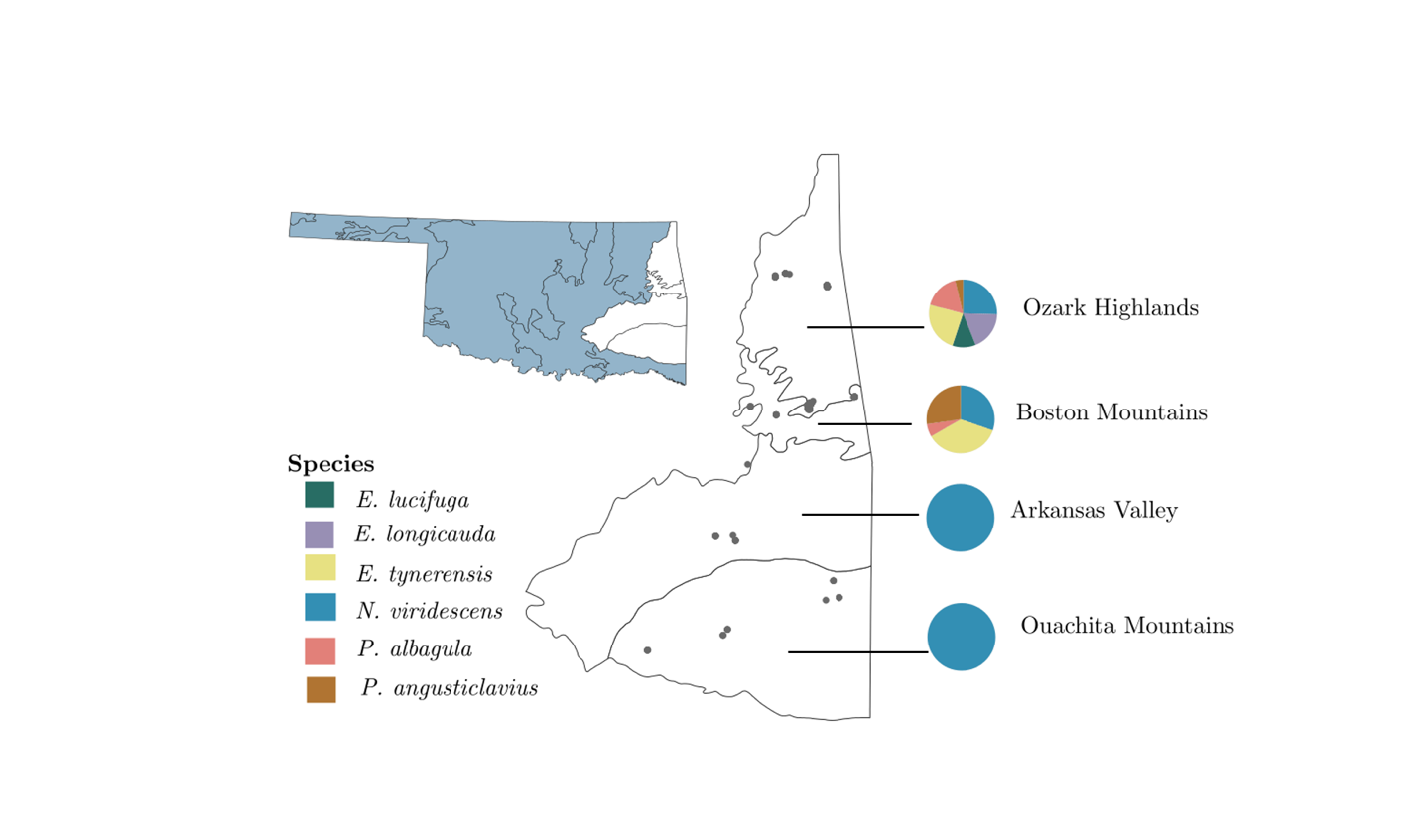

Figure 2. Relative compositional differences in skin microbiome communities based on host family. Plethodontids (left) had consistently higher alpha diversity than the Salamandridae (i.e., newts, right) and were distinct from the newts in analyses of beta diversity.
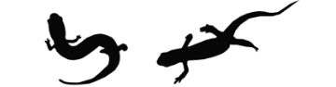

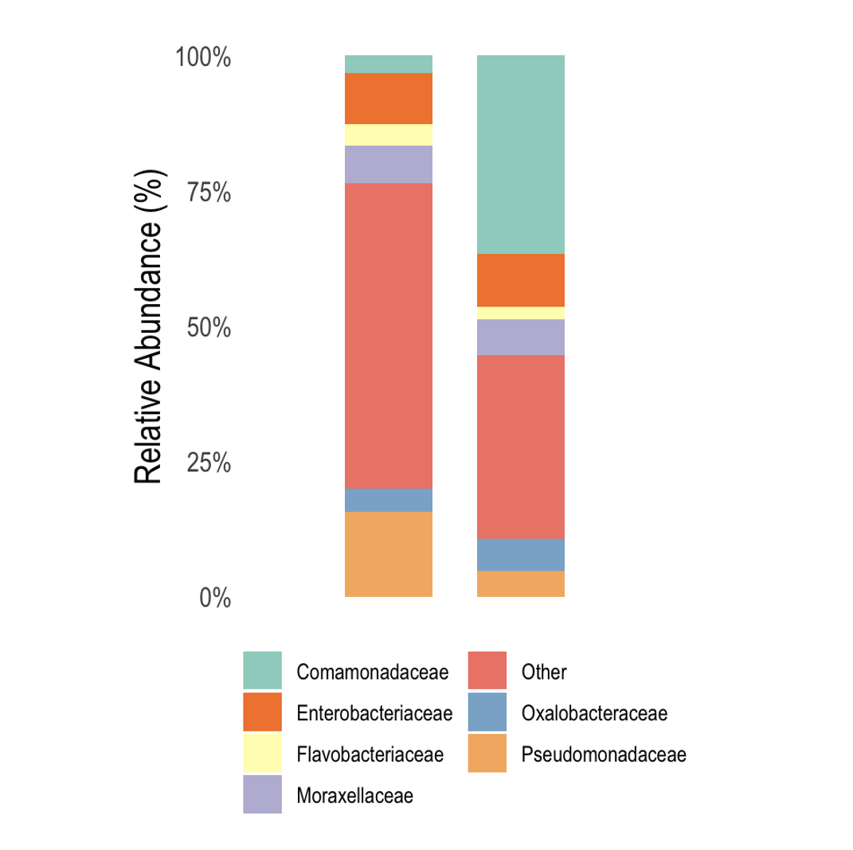

Figure 3. Relative contribution of explanatory variables to alpha diversity based on phylogenetic generalized linear mixed models. The figure contains posterior means and their 95% credible intervals. After accounting for phylogenetic non-independence, we found that ranavirus status has no impact on alpha diversity, but Bd presence has a slight negative impact. Warmer, wetter, and higher sampling sites had slight positive effects on alpha diversity, but terrestrial habitats and some life history stages reduced microbial diversity.

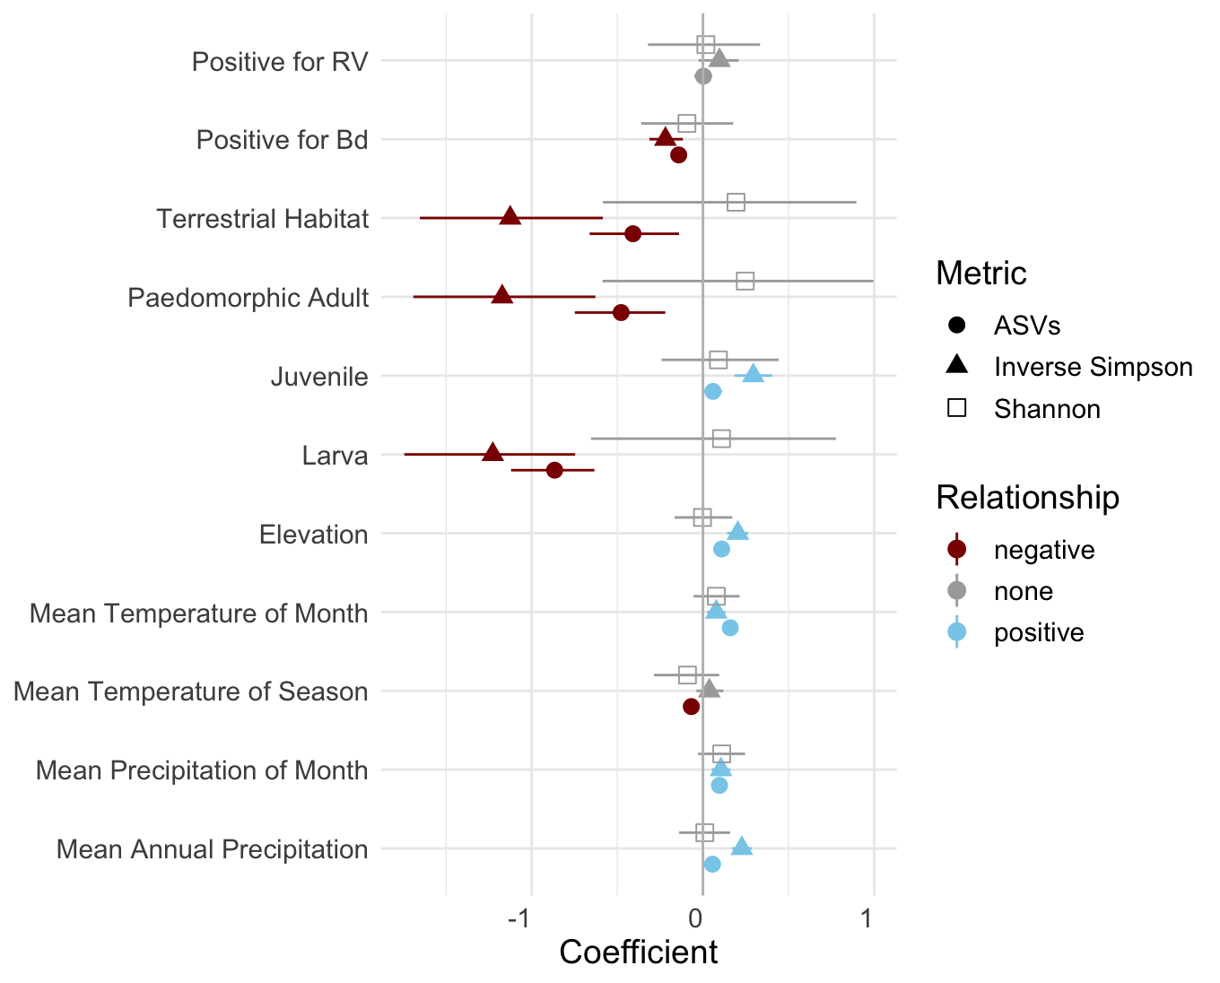

Figure 4. Results from the CART analysis of Observed ASVs. While family is the most important factor influencing the number of unique ASVs, environmental variables are important within family Salamandridae. Similar dominance of differentiation in microbial diversity based up on host phylogeny is observed in the other two metrics (Supplementary Figs. 2 & 3).
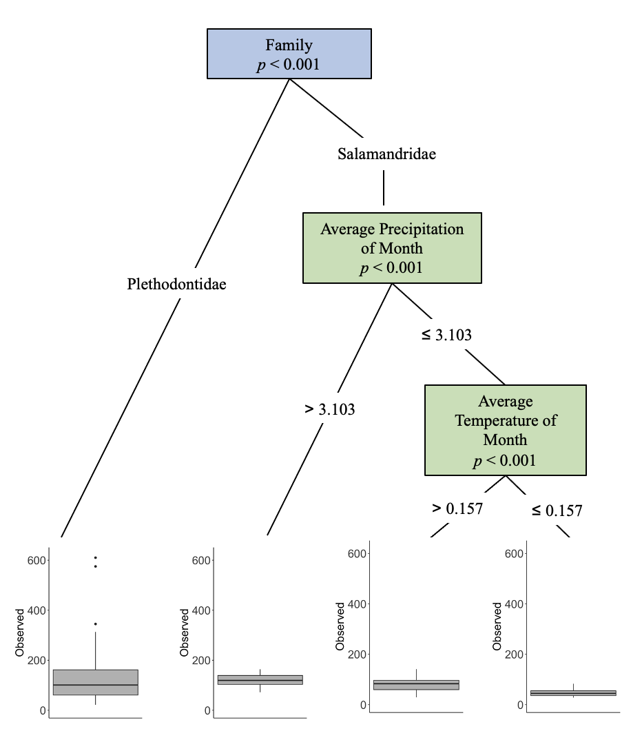

Figure 5. Alpha diversity differences based on Bd infection status. Alpha diversity of plethodontids and newts (left and right, respectively, within each set of plots) in the presence and absence of Bd. Overall, Bd+ salamanders exhibit a slight but non-significant (Tables 2–4) reduction in alpha diversity of the skin microbiome.
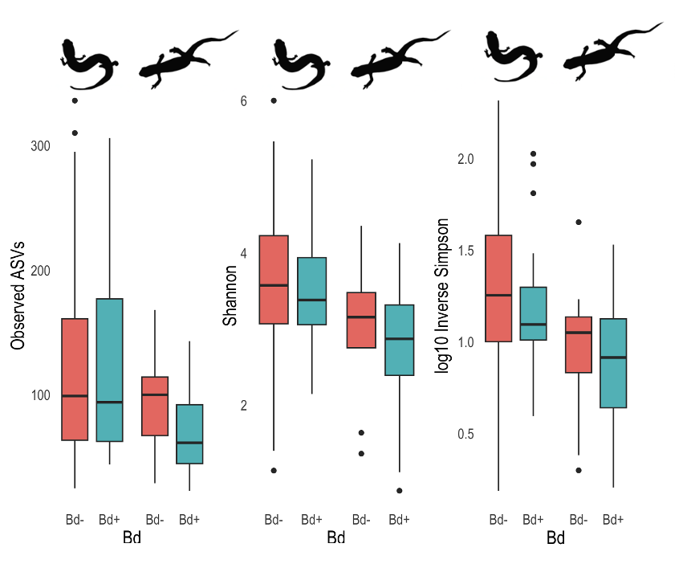

APPENDIX

Supplementary Figure 1. Relative proportions of microbial families present in the skin microbiomes of salamanders across all six species.
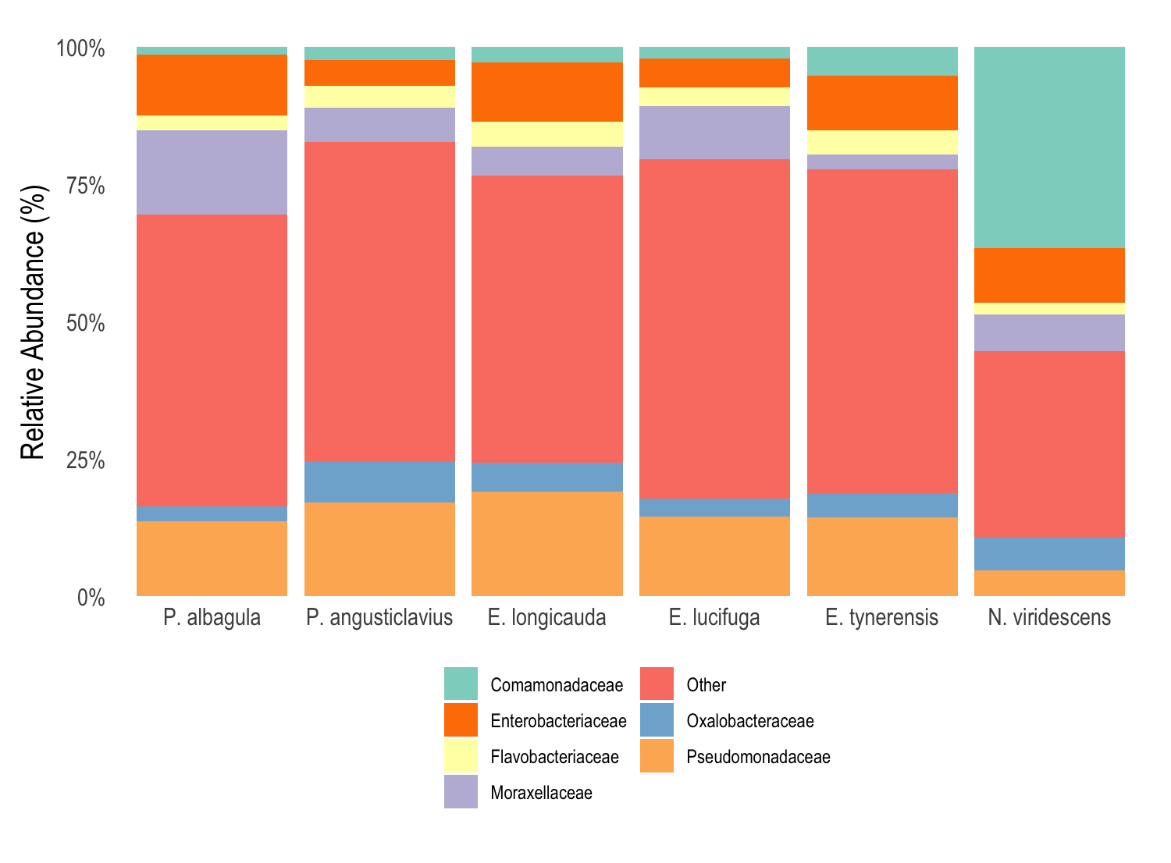

Supplementary Figure 2. CART analysis of the drivers of difference in the Shannon-Wiener Diversity Index. Here, host family is the most important driver of microbial diversity, with the average precipitation of the month as a secondary driver of skin microbial diversity within the family Salamandridae.
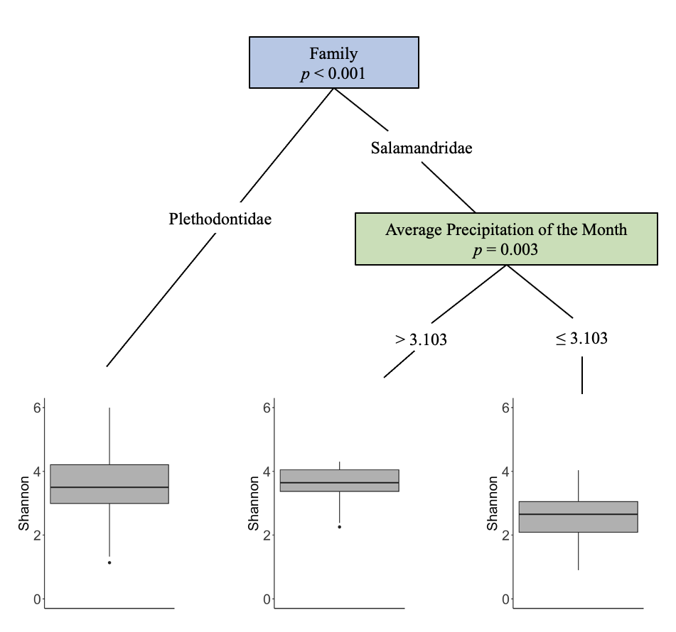

Supplementary Figure 3. CART analysis of the drivers of differences in the Inverse Simpson Diversity Index. In the other two CART analyses of alpha diversity (Fig. 4, Supplementary Fig. 2), two species (E. lucifuga and P. angusticlavius) were the most different, with family as a secondary factor. Similar to analyses on the two other indices, average precipitation of the month is an important driver of skin microbial diversity within family Salamandridae.
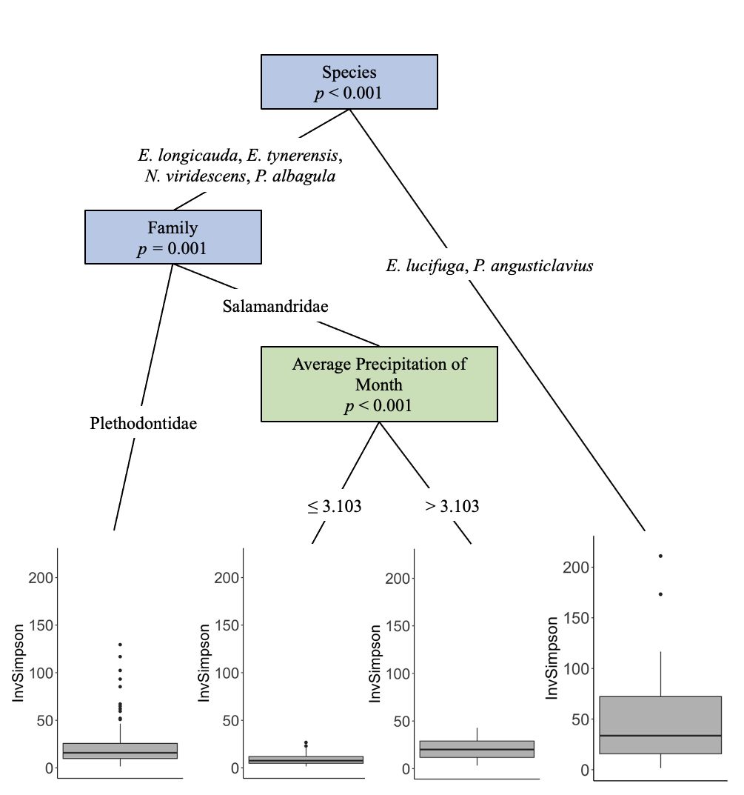

Supplementary Table 1. Collection and microbial diversity data for each sample. Information includes the SNOMNH voucher ID, the Oklahoma Department of Wildlife Conservation Field ID, the total number of microbes present, the number of microbe species present, and disease status (N = not present).
SNOMNH ID | ODWC Field ID | Family | Genus | Species | Ecoregion | Habitat | Life Stage | Total ASVs | Observed ASVs | RV | Bd | Year
43983 | 277 | Salamandridae | Notophthalmus | viridescens | Ouachita Mountains | aquatic | adult | 3777 | 54 | N | N | 2015
43984 | 278 | Salamandridae | Notophthalmus | viridescens | Ouachita Mountains | aquatic | adult | 5371 | 62 | N | Y | 2015
43986 | 281 | Salamandridae | Notophthalmus | viridescens | Ouachita Mountains | aquatic | adult | 705 | 54 | N | Y | 2015
43987 | 282 | Salamandridae | Notophthalmus | viridescens | Ouachita Mountains | aquatic | adult | 4149 | 44 | N | N | 2015
43991 | 288 | Salamandridae | Notophthalmus | viridescens | Ouachita Mountains | aquatic | adult | 1758 | 44 | N | NA | 2015
43935 | 329 | Plethodontidae | Eurycea | lucifuga | Ozark Highlands | terrestrial | adult | 5881 | 452 | N | N | 2015
43948 | 341 | Plethodontidae | Plethodon | albagula | Ozark Highlands | terrestrial | juvenile | 491 | 45 | Y | N | 2015
43936 | 346 | Plethodontidae | Eurycea | lucifuga | Ozark Highlands | terrestrial | adult | 2283 | 46 | Y | N | 2015
43972 | 350 | Plethodontidae | Plethodon | angusticlavius | Ozark Highlands | terrestrial | juvenile | 774 | 44 | N | N | 2015
43952 | 351 | Plethodontidae | Plethodon | albagula | Ozark Highlands | terrestrial | adult | 12380 | 94 | Y | N | 2015
43953 | 355 | Plethodontidae | Plethodon | albagula | Ozark Highlands | terrestrial | juvenile | 1772 | 155 | N | N | 2015
43954 | 356 | Plethodontidae | Plethodon | albagula | Ozark Highlands | terrestrial | juvenile | 1297 | 90 | Y | N | 2015
43955 | 357 | Plethodontidae | Plethodon | albagula | Ozark Highlands | terrestrial | juvenile | 742 | 38 | Y | N | 2015
43944 | 358 | Plethodontidae | Eurycea | tynerensis | Ozark Highlands | terrestrial | adult | 6838 | 463 | Y | Y | 2015
43956 | 359 | Plethodontidae | Plethodon | albagula | Ozark Highlands | terrestrial | juvenile | 320 | 13 | Y | N | 2015
43957 | 361 | Plethodontidae | Plethodon | albagula | Ozark Highlands | terrestrial | adult | 64965 | 663 | N | N | 2015
43903 | 378 | Plethodontidae | Eurycea | longicauda | Ozark Highlands | terrestrial | adult | 1425 | 48 | N | Y | 2015
43945 | 399 | Plethodontidae | Eurycea | tynerensis | Ozark Highlands | aquatic | paedomorphic adult | 12820 | 609 | N | Y | 2015
43908 | 402 | Plethodontidae | Eurycea | longicauda | Ozark Highlands | terrestrial | adult | 1163 | 38 | NA | NA | 2015
43909 | 403 | Plethodontidae | Eurycea | longicauda | Ozark Highlands | terrestrial | adult | 2091 | 63 | N | Y | 2015
43910 | 404 | Plethodontidae | Eurycea | longicauda | Ozark Highlands | terrestrial | adult | 5413 | 263 | N | N | 2015
43911 | 405 | Plethodontidae | Eurycea | longicauda | Ozark Highlands | terrestrial | adult | 605 | 45 | N | N | 2015
43912 | 407 | Plethodontidae | Eurycea | longicauda | Ozark Highlands | terrestrial | adult | 1092 | 54 | N | Y | 2015
43913 | 408 | Plethodontidae | Eurycea | longicauda | Ozark Highlands | terrestrial | adult | 3976 | 168 | NA | NA | 2015
43914 | 409 | Plethodontidae | Eurycea | longicauda | Ozark Highlands | terrestrial | adult | 1302 | 56 | NA | NA | 2015
44758 | 412 | Plethodontidae | Eurycea | tynerensis | Ozark Highlands | terrestrial | adult | 745 | 46 | Y | N | 2015
44750 | 413 | Plethodontidae | Eurycea | longicauda | Ozark Highlands | aquatic | larvae | 1205 | 87 | N | Y | 2015
44753 | 414 | Plethodontidae | Eurycea | lucifuga | Ozark Highlands | terrestrial | larvae | 8474 | 127 | N | N | 2015
43976 | 416 | Plethodontidae | Plethodon | angusticlavius | Ozark Highlands | terrestrial | juvenile | 583 | 37 | N | N | 2015
44759 | 417 | Plethodontidae | Eurycea | tynerensis | Ozark Highlands | terrestrial | adult | 1322 | 59 | NA | NA | 2015
44751 | 418 | Plethodontidae | Eurycea | longicauda | Ozark Highlands | aquatic | larvae | 10979 | 239 | NA | NA | 2015
43916 | 421 | Plethodontidae | Eurycea | longicauda | Ozark Highlands | terrestrial | juvenile | 5064 | 449 | N | Y | 2015
43917 | 423 | Plethodontidae | Eurycea | longicauda | Ozark Highlands | terrestrial | adult | 2372 | 147 | NA | NA | 2015
43962 | 427 | Plethodontidae | Plethodon | albagula | Ozark Highlands | terrestrial | adult | 518 | 46 | Y | N | 2015
43938 | 428 | Plethodontidae | Eurycea | lucifuga | Ozark Highlands | terrestrial | adult | 2179 | 197 | Y | N | 2015
43920 | 441 | Plethodontidae | Eurycea | longicauda | Ozark Highlands | terrestrial | adult | 201 | 17 | Y | N | 2015
43921 | 442 | Plethodontidae | Eurycea | longicauda | Ozark Highlands | terrestrial | adult | 230 | 19 | Y | N | 2015
43922 | 443 | Plethodontidae | Eurycea | longicauda | Ozark Highlands | terrestrial | adult | 149 | 12 | Y | N | 2015
43923 | 444 | Plethodontidae | Eurycea | longicauda | Ozark Highlands | terrestrial | juvenile | 146 | 12 | Y | Y | 2015
43963 | 449 | Plethodontidae | Plethodon | albagula | Ozark Highlands | terrestrial | adult | 73 | 12 | N | Y | 2015
43964 | 450 | Plethodontidae | Plethodon | albagula | Ozark Highlands | terrestrial | adult | 111 | 12 | NA | NA | 2015
43965 | 451 | Plethodontidae | Plethodon | albagula | Ozark Highlands | terrestrial | juvenile | 350 | 45 | N | N | 2015
43966 | 452 | Plethodontidae | Plethodon | albagula | Ozark Highlands | terrestrial | adult | 227 | 33 | N | N | 2015
43967 | 453 | Plethodontidae | Plethodon | albagula | Ozark Highlands | terrestrial | adult | 237 | 28 | N | Y | 2015
43968 | 454 | Plethodontidae | Plethodon | albagula | Ozark Highlands | terrestrial | adult | 137 | 49 | N | N | 2015
43977 | 455 | Plethodontidae | Plethodon | angusticlavius | Ozark Highlands | terrestrial | juvenile | 204 | 6 | N | N | 2015
43978 | 456 | Plethodontidae | Plethodon | angusticlavius | Ozark Highlands | terrestrial | juvenile | 129 | 4 | N | Y | 2015
43928 | 457 | Plethodontidae | Eurycea | longicauda | Ozark Highlands | terrestrial | adult | 193 | 3 | N | N | 2015
43929 | 458 | Plethodontidae | Eurycea | longicauda | Ozark Highlands | terrestrial | adult | 92 | 3 | N | N | 2015
43930 | 459 | Plethodontidae | Eurycea | longicauda | Ozark Highlands | terrestrial | juvenile | 175 | 7 | NA | NA | 2015
43931 | 460 | Plethodontidae | Eurycea | longicauda | Ozark Highlands | terrestrial | juvenile | 79 | 9 | N | Y | 2015
43969 | 476 | Plethodontidae | Plethodon | albagula | Ozark Highlands | terrestrial | adult | 52 | 7 | N | N | 2015
43970 | 480 | Plethodontidae | Plethodon | albagula | Ozark Highlands | terrestrial | juvenile | 6684 | 518 | Y | N | 2015
43996 | 481 | Salamandridae | Notophthalmus | viridescens | Ozark Highlands | aquatic | adult | 277 | 24 | N | Y | 2015
43997 | 482 | Salamandridae | Notophthalmus | viridescens | Ozark Highlands | aquatic | adult | 459 | 21 | N | Y | 2015
44000 | 485 | Salamandridae | Notophthalmus | viridescens | Ozark Highlands | aquatic | adult | 2500 | 37 | N | Y | 2015
44001 | 486 | Salamandridae | Notophthalmus | viridescens | Ozark Highlands | aquatic | adult | 1086 | 48 | NA | NA | 2015
44002 | 487 | Salamandridae | Notophthalmus | viridescens | Ozark Highlands | aquatic | adult | 532 | 34 | N | Y | 2015
44003 | 488 | Salamandridae | Notophthalmus | viridescens | Ozark Highlands | aquatic | adult | 1322 | 61 | N | Y | 2015
43946 | 520 | Plethodontidae | Eurycea | tynerensis | Ozark Highlands | aquatic | paedomorphic adult | 2893 | 99 | N | N | 2015
44023 | 538 | Salamandridae | Notophthalmus | viridescens | Ozark Highlands | aquatic | adult | 1201 | 33 | N | Y | 2015
44024 | 539 | Salamandridae | Notophthalmus | viridescens | Ozark Highlands | aquatic | adult | 427 | 12 | N | Y | 2015
44025 | 540 | Salamandridae | Notophthalmus | viridescens | Ozark Highlands | aquatic | adult | 194 | 20 | NA | NA | 2015
44026 | 541 | Salamandridae | Notophthalmus | viridescens | Ozark Highlands | aquatic | adult | 233 | 14 | NA | NA | 2015
44027 | 542 | Salamandridae | Notophthalmus | viridescens | Ozark Highlands | aquatic | adult | 318 | 24 | NA | NA | 2015
44028 | 543 | Salamandridae | Notophthalmus | viridescens | Ozark Highlands | aquatic | adult | 493 | 24 | NA | NA | 2015
43971 | 560 | Plethodontidae | Plethodon | albagula | Ozark Highlands | terrestrial | juvenile | 2268 | 153 | Y | Y | 2015
43932 | 590 | Plethodontidae | Eurycea | longicauda | Ozark Highlands | terrestrial | adult | 400 | 33 | N | Y | 2015
43934 | 592 | Plethodontidae | Eurycea | longicauda | Ozark Highlands | terrestrial | adult | 9673 | 256 | N | N | 2015
44031 | 627 | Salamandridae | Notophthalmus | viridescens | Arkansas Valley | aquatic | adult | 1480 | 87 | Y | Y | 2015
44032 | 628 | Salamandridae | Notophthalmus | viridescens | Arkansas Valley | aquatic | adult | 2979 | 133 | N | Y | 2015
44033 | 629 | Salamandridae | Notophthalmus | viridescens | Arkansas Valley | aquatic | adult | 12074 | 111 | Y | N | 2015
44034 | 630 | Salamandridae | Notophthalmus | viridescens | Arkansas Valley | aquatic | adult | 4042 | 181 | Y | Y | 2015
44042 | 633 | Salamandridae | Notophthalmus | viridescens | Arkansas Valley | aquatic | adult | 6642 | 99 | Y | Y | 2015
44047 | 638 | Salamandridae | Notophthalmus | viridescens | Arkansas Valley | aquatic | adult | 690 | 29 | N | NA | 2015
44050 | 641 | Salamandridae | Notophthalmus | viridescens | Arkansas Valley | aquatic | adult | 1289 | 55 | N | NA | 2015
44051 | 642 | Salamandridae | Notophthalmus | viridescens | Arkansas Valley | aquatic | adult | 22818 | 134 | Y | NA | 2015
44037 | 683 | Salamandridae | Notophthalmus | viridescens | Arkansas Valley | aquatic | adult | 863 | 39 | N | Y | 2015
44038 | 684 | Salamandridae | Notophthalmus | viridescens | Arkansas Valley | aquatic | adult | 20940 | 95 | Y | Y | 2015
44039 | 685 | Salamandridae | Notophthalmus | viridescens | Arkansas Valley | aquatic | adult | 39218 | 127 | N | Y | 2015
44040 | 692 | Salamandridae | Notophthalmus | viridescens | Arkansas Valley | aquatic | adult | 4395 | 101 | Y | Y | 2015
44041 | 693 | Salamandridae | Notophthalmus | viridescens | Arkansas Valley | aquatic | adult | 2010 | 77 | N | Y | 2015
44070 | 1007 | Salamandridae | Notophthalmus | viridescens | Ouachita Mountains | aquatic | adult | 25960 | 146 | Y | Y | 2015
44071 | 1008 | Salamandridae | Notophthalmus | viridescens | Ouachita Mountains | aquatic | adult | 41991 | 292 | Y | Y | 2015
44073 | 1040 | Salamandridae | Notophthalmus | viridescens | Ouachita Mountains | aquatic | adult | 50618 | 386 | N | N | 2015
44074 | 1041 | Salamandridae | Notophthalmus | viridescens | Ouachita Mountains | aquatic | adult | 13153 | 181 | Y | Y | 2015
44075 | 1042 | Salamandridae | Notophthalmus | viridescens | Ouachita Mountains | aquatic | adult | 429627 | 703 | N | NA | 2015
44076 | 1043 | Salamandridae | Notophthalmus | viridescens | Ouachita Mountains | aquatic | adult | 53121 | 284 | N | N | 2015
44085 | 1052 | Salamandridae | Notophthalmus | viridescens | Ouachita Mountains | aquatic | adult | 34547 | 243 | N | Y | 2015
44056 | 1136 | Salamandridae | Notophthalmus | viridescens | Ouachita Mountains | aquatic | adult | 15470 | 244 | N | Y | 2015
44057 | 1137 | Salamandridae | Notophthalmus | viridescens | Ouachita Mountains | aquatic | adult | 9580 | 185 | N | Y | 2015
44059 | 1176 | Salamandridae | Notophthalmus | viridescens | Ouachita Mountains | aquatic | adult | 10639 | 223 | N | Y | 2015
44060 | 1177 | Salamandridae | Notophthalmus | viridescens | Ouachita Mountains | aquatic | adult | 24368 | 308 | N | Y | 2015
44062 | 1179 | Salamandridae | Notophthalmus | viridescens | Ouachita Mountains | aquatic | adult | 99506 | 246 | N | Y | 2015
46000 | 1570 | Plethodontidae | Eurycea | tynerensis | Boston Mountains | terrestrial | adult | 2549 | 79 | NA | NA | 2016
46001 | 1573 | Plethodontidae | Eurycea | tynerensis | Boston Mountains | terrestrial | adult | 357 | 42 | N | N | 2016
46002 | 1574 | Plethodontidae | Eurycea | tynerensis | Boston Mountains | aquatic | paedomorphic adult | 488 | 15 | N | N | 2016
46003 | 1575 | Plethodontidae | Eurycea | tynerensis | Boston Mountains | aquatic | paedomorphic adult | 870 | 10 | N | N | 2016
46004 | 1576 | Plethodontidae | Eurycea | tynerensis | Boston Mountains | aquatic | paedomorphic adult | 946 | 19 | N | N | 2016
46005 | 1577 | Plethodontidae | Eurycea | tynerensis | Boston Mountains | terrestrial | adult | 1170 | 26 | N | N | 2016
46006 | 1578 | Plethodontidae | Eurycea | tynerensis | Boston Mountains | terrestrial | adult | 3330 | 81 | N | Y | 2016
46007 | 1579 | Plethodontidae | Eurycea | tynerensis | Boston Mountains | aquatic | paedomorphic adult | 1867 | 43 | N | N | 2016
46008 | 1580 | Plethodontidae | Eurycea | tynerensis | Boston Mountains | aquatic | paedomorphic adult | 15099 | 70 | N | N | 2016
46009 | 1581 | Plethodontidae | Eurycea | tynerensis | Boston Mountains | aquatic | paedomorphic adult | 870 | 26 | N | N | 2016
46010 | 1582 | Plethodontidae | Eurycea | tynerensis | Boston Mountains | aquatic | paedomorphic adult | 1273 | 26 | N | N | 2016
46011 | 1583 | Plethodontidae | Eurycea | tynerensis | Boston Mountains | terrestrial | adult | 2809 | 97 | N | N | 2016
46095 | 1590 | Salamandridae | Notophthalmus | viridescens | Boston Mountains | aquatic | adult | 2663 | 46 | N | Y | 2016
46096 | 1597 | Salamandridae | Notophthalmus | viridescens | Boston Mountains | aquatic | adult | 865 | 23 | N | Y | 2016
46097 | 1598 | Salamandridae | Notophthalmus | viridescens | Boston Mountains | aquatic | adult | 37877 | 77 | N | Y | 2016
46098 | 1599 | Salamandridae | Notophthalmus | viridescens | Boston Mountains | aquatic | adult | 6924 | 88 | N | Y | 2016
46099 | 1600 | Salamandridae | Notophthalmus | viridescens | Boston Mountains | aquatic | adult | 639 | 14 | N | Y | 2016
46100 | 1601 | Salamandridae | Notophthalmus | viridescens | Boston Mountains | aquatic | adult | 7147 | 97 | N | Y | 2016
46101 | 1602 | Salamandridae | Notophthalmus | viridescens | Boston Mountains | aquatic | adult | 22773 | 110 | N | Y | 2016
46102 | 1603 | Salamandridae | Notophthalmus | viridescens | Boston Mountains | aquatic | adult | 4575 | 82 | N | Y | 2016
46103 | 1604 | Salamandridae | Notophthalmus | viridescens | Boston Mountains | aquatic | adult | 516 | 22 | N | Y | 2016
46104 | 1615 | Salamandridae | Notophthalmus | viridescens | Boston Mountains | aquatic | adult | 5298 | 66 | N | Y | 2016
45983 | 1639 | Plethodontidae | Eurycea | lucifuga | Ozark Highlands | terrestrial | adult | 309744 | 4062 | N | N | 2016
46206 | 1640 | Plethodontidae | Eurycea | tynerensis | Ozark Highlands | aquatic | larvae | 1670 | 54 | N | N | 2016
46012 | 1641 | Plethodontidae | Eurycea | tynerensis | Ozark Highlands | aquatic | larvae | 10736 | 146 | N | N | 2016
46013 | 1642 | Plethodontidae | Eurycea | tynerensis | Ozark Highlands | terrestrial | juvenile | 20732 | 227 | N | N | 2016
46014 | 1643 | Plethodontidae | Eurycea | tynerensis | Ozark Highlands | aquatic | paedomorphic adult | 20467 | 203 | N | Y | 2016
46015 | 1644 | Plethodontidae | Eurycea | tynerensis | Ozark Highlands | aquatic | larvae | 4722 | 127 | N | N | 2016
46016 | 1645 | Plethodontidae | Eurycea | tynerensis | Ozark Highlands | aquatic | paedomorphic adult | 12983 | 214 | N | N | 2016
46017 | 1646 | Plethodontidae | Eurycea | tynerensis | Ozark Highlands | aquatic | paedomorphic adult | 13815 | 171 | N | N | 2016
46050 | 1650 | Salamandridae | Notophthalmus | viridescens | Ozark Highlands | aquatic | adult | 11 | 10 | N | Y | 2016
46051 | 1651 | Salamandridae | Notophthalmus | viridescens | Ozark Highlands | aquatic | adult | 844 | 24 | N | Y | 2016
46052 | 1652 | Salamandridae | Notophthalmus | viridescens | Ozark Highlands | aquatic | adult | 1025 | 32 | Y | Y | 2016
46053 | 1653 | Salamandridae | Notophthalmus | viridescens | Ozark Highlands | aquatic | adult | 4000 | 70 | N | Y | 2016
46054 | 1654 | Salamandridae | Notophthalmus | viridescens | Ozark Highlands | aquatic | adult | 9886 | 87 | N | Y | 2016
46055 | 1655 | Salamandridae | Notophthalmus | viridescens | Ozark Highlands | aquatic | adult | 2221 | 47 | Y | Y | 2016
46056 | 1656 | Salamandridae | Notophthalmus | viridescens | Ozark Highlands | aquatic | adult | 9474 | 87 | N | Y | 2016
46057 | 1657 | Salamandridae | Notophthalmus | viridescens | Ozark Highlands | aquatic | adult | 7027 | 100 | N | Y | 2016
46058 | 1658 | Salamandridae | Notophthalmus | viridescens | Ozark Highlands | aquatic | adult | 3621 | 66 | N | Y | 2016
46059 | 1659 | Salamandridae | Notophthalmus | viridescens | Ozark Highlands | aquatic | adult | 2378 | 51 | Y | Y | 2016
46060 | 1660 | Salamandridae | Notophthalmus | viridescens | Ozark Highlands | aquatic | adult | 11025 | 49 | NA | NA | 2016
46061 | 1661 | Salamandridae | Notophthalmus | viridescens | Ozark Highlands | aquatic | adult | 84 | 16 | NA | NA | 2016
46062 | 1662 | Salamandridae | Notophthalmus | viridescens | Ozark Highlands | aquatic | adult | 384 | 15 | NA | NA | 2016
46063 | 1663 | Salamandridae | Notophthalmus | viridescens | Ozark Highlands | aquatic | adult | 1446 | 63 | NA | NA | 2016
46064 | 1664 | Salamandridae | Notophthalmus | viridescens | Ozark Highlands | aquatic | adult | 7548 | 95 | NA | NA | 2016
46065 | 1665 | Salamandridae | Notophthalmus | viridescens | Ozark Highlands | aquatic | adult | 285 | 16 | NA | NA | 2016
46066 | 1666 | Salamandridae | Notophthalmus | viridescens | Ozark Highlands | aquatic | adult | 1413 | 34 | NA | NA | 2016
46067 | 1667 | Salamandridae | Notophthalmus | viridescens | Ozark Highlands | aquatic | adult | 498 | 32 | NA | NA | 2016
46068 | 1668 | Salamandridae | Notophthalmus | viridescens | Ozark Highlands | aquatic | adult | 656 | 40 | NA | NA | 2016
46069 | 1669 | Salamandridae | Notophthalmus | viridescens | Ozark Highlands | aquatic | adult | 190 | 7 | NA | NA | 2016
46070 | 1670 | Salamandridae | Notophthalmus | viridescens | Ozark Highlands | aquatic | adult | 1705 | 53 | NA | NA | 2016
46071 | 1671 | Salamandridae | Notophthalmus | viridescens | Ozark Highlands | aquatic | adult | 1187 | 45 | NA | NA | 2016
46072 | 1672 | Salamandridae | Notophthalmus | viridescens | Ozark Highlands | aquatic | adult | 5662 | 112 | NA | NA | 2016
46073 | 1673 | Salamandridae | Notophthalmus | viridescens | Ozark Highlands | aquatic | adult | 1103 | 38 | NA | NA | 2016
46074 | 1674 | Salamandridae | Notophthalmus | viridescens | Ozark Highlands | aquatic | adult | 23063 | 74 | NA | NA | 2016
46075 | 1675 | Salamandridae | Notophthalmus | viridescens | Ozark Highlands | aquatic | adult | 2239 | 39 | NA | NA | 2016
46076 | 1676 | Salamandridae | Notophthalmus | viridescens | Ozark Highlands | aquatic | adult | 2423 | 50 | NA | NA | 2016
46077 | 1677 | Salamandridae | Notophthalmus | viridescens | Ozark Highlands | aquatic | adult | 10326 | 114 | NA | NA | 2016
46078 | 1686 | Salamandridae | Notophthalmus | viridescens | Ozark Highlands | aquatic | adult | 10832 | 64 | NA | NA | 2016
46079 | 1687 | Salamandridae | Notophthalmus | viridescens | Ozark Highlands | aquatic | adult | 1885 | 59 | NA | NA | 2016
46080 | 1688 | Salamandridae | Notophthalmus | viridescens | Ozark Highlands | aquatic | adult | 1424 | 56 | NA | NA | 2016
46081 | 1689 | Salamandridae | Notophthalmus | viridescens | Ozark Highlands | aquatic | adult | 2811 | 56 | NA | NA | 2016
46082 | 1690 | Salamandridae | Notophthalmus | viridescens | Ozark Highlands | aquatic | adult | 686 | 43 | NA | NA | 2016
46018 | 1692 | Plethodontidae | Eurycea | tynerensis | Ozark Highlands | aquatic | larvae | 2142 | 89 | N | N | 2016
46019 | 1693 | Plethodontidae | Eurycea | tynerensis | Ozark Highlands | aquatic | larvae | 924 | 56 | N | N | 2016
46020 | 1695 | Plethodontidae | Eurycea | tynerensis | Ozark Highlands | aquatic | larvae | 539 | 66 | N | N | 2016
46021 | 1696 | Plethodontidae | Eurycea | tynerensis | Ozark Highlands | aquatic | larvae | 639 | 120 | NA | NA | 2016
46022 | 1697 | Plethodontidae | Eurycea | tynerensis | Ozark Highlands | aquatic | larvae | 1717 | 61 | N | N | 2016
46025 | 1698 | Plethodontidae | Plethodon | albagula | Boston Mountains | terrestrial | juvenile | 15152 | 180 | N | Y | 2016
46041 | 1707 | Plethodontidae | Plethodon | angusticlavius | Boston Mountains | terrestrial | juvenile | 239 | 20 | N | N | 2016
46042 | 1708 | Plethodontidae | Plethodon | angusticlavius | Boston Mountains | terrestrial | juvenile | 1524 | 231 | N | N | 2016
46043 | 1709 | Plethodontidae | Plethodon | angusticlavius | Boston Mountains | terrestrial | juvenile | 3449 | 424 | N | N | 2016
46044 | 1712 | Plethodontidae | Plethodon | angusticlavius | Boston Mountains | terrestrial | juvenile | 6836 | 155 | NA | NA | 2016
45984 | 1728 | Plethodontidae | Eurycea | lucifuga | Ozark Highlands | terrestrial | adult | 183 | 18 | N | N | 2016
45986 | 1730 | Plethodontidae | Eurycea | lucifuga | Ozark Highlands | terrestrial | juvenile | 3643 | 242 | N | N | 2016
46027 | 1732 | Plethodontidae | Plethodon | albagula | Ozark Highlands | terrestrial | juvenile | 631 | 28 | N | N | 2016
46028 | 1733 | Plethodontidae | Plethodon | albagula | Ozark Highlands | terrestrial | juvenile | 3448 | 60 | N | N | 2016
45987 | 1736 | Plethodontidae | Eurycea | lucifuga | Ozark Highlands | terrestrial | juvenile | 830 | 64 | N | N | 2016
45988 | 1737 | Plethodontidae | Eurycea | lucifuga | Ozark Highlands | terrestrial | adult | 880 | 72 | N | N | 2016
45989 | 1741 | Plethodontidae | Eurycea | lucifuga | Ozark Highlands | terrestrial | adult | 11585 | 152 | N | N | 2016
46023 | 1745 | Plethodontidae | Eurycea | tynerensis | Ozark Highlands | aquatic | paedomorphic adult | 11834 | 111 | N | Y | 2016
46029 | 1751 | Plethodontidae | Plethodon | albagula | Ozark Highlands | terrestrial | juvenile | 39164 | 787 | N | N | 2016
46024 | 1755 | Plethodontidae | Eurycea | tynerensis | Ozark Highlands | aquatic | larvae | 6185 | 193 | N | N | 2016
46045 | 1763 | Plethodontidae | Plethodon | angusticlavius | Boston Mountains | terrestrial | juvenile | 2 | 2 | N | N | 2016
46046 | 1764 | Plethodontidae | Plethodon | angusticlavius | Boston Mountains | terrestrial | juvenile | 6 | 4 | N | N | 2016
46047 | 1765 | Plethodontidae | Plethodon | angusticlavius | Boston Mountains | terrestrial | juvenile | 4 | 3 | N | N | 2016
46048 | 1766 | Plethodontidae | Plethodon | angusticlavius | Boston Mountains | terrestrial | adult | 1 | 1 | N | N | 2016
46049 | 1767 | Plethodontidae | Plethodon | angusticlavius | Boston Mountains | terrestrial | adult | 13 | 8 | N | N | 2016
46026 | 1768 | Plethodontidae | Plethodon | albagula | Boston Mountains | terrestrial | juvenile | 17 | 11 | N | N | 2016
46083 | 1774 | Salamandridae | Notophthalmus | viridescens | Ozark Highlands | aquatic | adult | 10 | 6 | NA | NA | 2016
45990 | 1818 | Plethodontidae | Eurycea | lucifuga | Ozark Highlands | terrestrial | adult | 46 | 29 | N | N | 2016
45991 | 1819 | Plethodontidae | Eurycea | lucifuga | Ozark Highlands | terrestrial | adult | 3 | 3 | N | N | 2016
45992 | 1825 | Plethodontidae | Eurycea | lucifuga | Ozark Highlands | terrestrial | adult | 9 | 7 | N | N | 2016
45993 | 1826 | Plethodontidae | Eurycea | lucifuga | Ozark Highlands | terrestrial | adult | 9 | 9 | N | Y | 2016
46040 | 1828 | Plethodontidae | Plethodon | albagula | Ozark Highlands | terrestrial | juvenile | 202 | 28 | NA | NA | 2016
46030 | 2230 | Plethodontidae | Plethodon | albagula | Ozark Highlands | terrestrial | juvenile | 58978 | 2776 | NA | NA | 2016
46031 | 2231 | Plethodontidae | Plethodon | albagula | Ozark Highlands | terrestrial | juvenile | 4607 | 55 | N | N | 2016
46032 | 2232 | Plethodontidae | Plethodon | albagula | Ozark Highlands | terrestrial | juvenile | 13346 | 318 | N | N | 2016
46033 | 2233 | Plethodontidae | Plethodon | albagula | Ozark Highlands | terrestrial | adult | 2802 | 83 | N | N | 2016
46034 | 2234 | Plethodontidae | Plethodon | albagula | Ozark Highlands | terrestrial | juvenile | 8678 | 179 | N | N | 2016
46035 | 2235 | Plethodontidae | Plethodon | albagula | Ozark Highlands | terrestrial | juvenile | 103626 | 388 | N | N | 2016
45994 | 2236 | Plethodontidae | Eurycea | lucifuga | Ozark Highlands | terrestrial | adult | 68964 | 582 | Y | N | 2016
45995 | 2237 | Plethodontidae | Eurycea | lucifuga | Ozark Highlands | terrestrial | adult | 51476 | 200 | N | N | 2016
45996 | 2238 | Plethodontidae | Eurycea | lucifuga | Ozark Highlands | terrestrial | adult | 61090 | 411 | N | N | 2016
45997 | 2239 | Plethodontidae | Eurycea | lucifuga | Ozark Highlands | terrestrial | adult | 14306 | 142 | N | Y | 2016
45998 | 2240 | Plethodontidae | Eurycea | lucifuga | Ozark Highlands | terrestrial | adult | 74216 | 267 | N | N | 2016
45977 | 2258 | Plethodontidae | Eurycea | longicauda | Ozark Highlands | terrestrial | juvenile | 12129 | 149 | N | Y | 2016
46084 | 2265 | Salamandridae | Notophthalmus | viridescens | Ozark Highlands | aquatic | adult | 18540 | 256 | N | Y | 2016
46085 | 2266 | Salamandridae | Notophthalmus | viridescens | Ozark Highlands | aquatic | adult | 567 | 9 | N | N | 2016
46086 | 2267 | Salamandridae | Notophthalmus | viridescens | Ozark Highlands | aquatic | adult | 6477 | 111 | N | Y | 2016
45978 | 2277 | Plethodontidae | Eurycea | longicauda | Ozark Highlands | terrestrial | adult | 13851 | 602 | N | N | 2016
45979 | 2278 | Plethodontidae | Eurycea | longicauda | Ozark Highlands | terrestrial | adult | 6532 | 214 | N | N | 2016
45980 | 2279 | Plethodontidae | Eurycea | longicauda | Ozark Highlands | terrestrial | juvenile | 24715 | 574 | N | Y | 2016
46036 | 2296 | Plethodontidae | Plethodon | albagula | Ozark Highlands | terrestrial | juvenile | 2254 | 125 | N | N | 2016
46037 | 2297 | Plethodontidae | Plethodon | albagula | Ozark Highlands | terrestrial | juvenile | 3112 | 84 | N | N | 2016
46038 | 2298 | Plethodontidae | Plethodon | albagula | Ozark Highlands | terrestrial | juvenile | 7458 | 331 | N | N | 2016
46039 | 2299 | Plethodontidae | Plethodon | albagula | Ozark Highlands | terrestrial | juvenile | 1589 | 45 | N | N | 2016
45982 | 2300 | Plethodontidae | Eurycea | longicauda | Ozark Highlands | terrestrial | adult | 15186 | 545 | N | N | 2016
46087 | 2301 | Salamandridae | Notophthalmus | viridescens | Ozark Highlands | aquatic | adult | 18131 | 173 | N | N | 2016
46088 | 2302 | Salamandridae | Notophthalmus | viridescens | Ozark Highlands | aquatic | adult | 6494 | 128 | N | Y | 2016
46089 | 2303 | Salamandridae | Notophthalmus | viridescens | Ozark Highlands | aquatic | adult | 11035 | 151 | N | Y | 2016
46092 | 2306 | Salamandridae | Notophthalmus | viridescens | Ozark Highlands | aquatic | adult | 98639 | 374 | N | N | 2016
46093 | 2307 | Salamandridae | Notophthalmus | viridescens | Ozark Highlands | aquatic | adult | 10907 | 157 | N | N | 2016
46094 | 2309 | Salamandridae | Notophthalmus | viridescens | Ozark Highlands | aquatic | adult | 3301 | 79 | NA | NA | 2016
47329 | 2994 | Salamandridae | Notophthalmus | viridescens | Ouachita Mountains | aquatic | adult | 2347 | 37 | NA | NA | NA
47906 | 3540 | Plethodontidae | Eurycea | longicauda | Ozark Highlands | terrestrial | juvenile | 1289 | 56 | N | N | 2018
47885 | 3541 | Plethodontidae | Eurycea | tynerensis | Ozark Highlands | terrestrial | adult | 45222 | 509 | N | N | 2018
47886 | 3542 | Plethodontidae | Eurycea | tynerensis | Ozark Highlands | terrestrial | adult | 13283 | 362 | N | N | 2018
47887 | 3547 | Plethodontidae | Eurycea | tynerensis | Ozark Highlands | aquatic | paedomorphic adult | 54351 | 478 | N | Y | 2018
47888 | 3548 | Plethodontidae | Eurycea | tynerensis | Ozark Highlands | aquatic | paedomorphic adult | 57314 | 300 | N | N | 2018
47889 | 3549 | Plethodontidae | Eurycea | tynerensis | Ozark Highlands | aquatic | paedomorphic adult | 66865 | 280 | N | Y | 2018
47890 | 3550 | Plethodontidae | Eurycea | tynerensis | Ozark Highlands | terrestrial | adult | 7449 | 176 | N | N | 2018
47891 | 3551 | Plethodontidae | Eurycea | tynerensis | Ozark Highlands | terrestrial | adult | 1129 | 88 | N | N | 2018
47892 | 3552 | Plethodontidae | Eurycea | tynerensis | Ozark Highlands | aquatic | larvae | 2146 | 149 | N | N | 2018
47872 | 3556 | Plethodontidae | Eurycea | tynerensis | Ozark Highlands | terrestrial | adult | 1024 | 86 | N | N | 2018
47873 | 3557 | Plethodontidae | Eurycea | tynerensis | Ozark Highlands | terrestrial | adult | 2217 | 104 | N | N | 2018
47893 | 3561 | Plethodontidae | Eurycea | tynerensis | Ozark Highlands | terrestrial | adult | 283 | 37 | N | Y | 2018
47902 | 3565 | Plethodontidae | Plethodon | angusticlavius | Ozark Highlands | terrestrial | adult | 455 | 41 | N | N | 2018
47903 | 3566 | Plethodontidae | Plethodon | angusticlavius | Ozark Highlands | terrestrial | adult | 9974 | 643 | N | N | 2018
47904 | 3567 | Plethodontidae | Plethodon | angusticlavius | Ozark Highlands | terrestrial | adult | 2404 | 150 | N | N | 2018
47905 | 3568 | Plethodontidae | Plethodon | angusticlavius | Ozark Highlands | terrestrial | adult | 1788 | 68 | N | N | 2018
47898 | 3569 | Plethodontidae | Plethodon | albagula | Ozark Highlands | terrestrial | adult | 502 | 31 | N | N | 2018
47899 | 3570 | Plethodontidae | Plethodon | albagula | Ozark Highlands | terrestrial | adult | 315 | 19 | N | N | 2018
47900 | 3571 | Plethodontidae | Plethodon | albagula | Ozark Highlands | terrestrial | adult | 1112 | 67 | N | N | 2018
47901 | 3572 | Plethodontidae | Plethodon | albagula | Ozark Highlands | terrestrial | juvenile | 90292 | 487 | N | N | 2018
47883 | 3573 | Plethodontidae | Eurycea | lucifuga | Ozark Highlands | terrestrial | adult | 1409 | 75 | N | N | 2018
47884 | 3574 | Plethodontidae | Eurycea | lucifuga | Ozark Highlands | terrestrial | adult | 61565 | 670 | N | N | 2018
47896 | 3580 | Plethodontidae | Eurycea | tynerensis | Ozark Highlands | terrestrial | adult | 5997 | 226 | N | N | 2018
47874 | 3582 | Plethodontidae | Eurycea | longicauda | Ozark Highlands | terrestrial | adult | 7523 | 337 | N | N | 2018
47875 | 3583 | Plethodontidae | Eurycea | longicauda | Ozark Highlands | terrestrial | adult | 14635 | 377 | N | N | 2018
47876 | 3584 | Plethodontidae | Eurycea | longicauda | Ozark Highlands | terrestrial | adult | 5561 | 85 | N | N | 2018
47877 | 3585 | Plethodontidae | Eurycea | longicauda | Ozark Highlands | terrestrial | adult | 2293 | 99 | N | N | 2018
47878 | 3586 | Plethodontidae | Eurycea | longicauda | Ozark Highlands | terrestrial | adult | 7900 | 177 | N | N | 2018
47879 | 3587 | Plethodontidae | Eurycea | longicauda | Ozark Highlands | terrestrial | adult | 69581 | 529 | N | N | 2018
47880 | 3588 | Plethodontidae | Eurycea | longicauda | Ozark Highlands | terrestrial | adult | 6772 | 162 | N | N | 2018
47881 | 3589 | Plethodontidae | Eurycea | longicauda | Ozark Highlands | terrestrial | adult | 4851 | 340 | N | N | 2018
47882 | 3590 | Plethodontidae | Eurycea | longicauda | Ozark Highlands | terrestrial | juvenile | 2476 | 60 | N | N | 2018
47897 | 3594 | Plethodontidae | Eurycea | tynerensis | Ozark Highlands | terrestrial | adult | 69532 | 523 | N | N | 2018
 | 4173 | Plethodontidae | Eurycea | lucifuga | Ozark Highlands | terrestrial | juvenile | 3 | 2 | N | N | 2021
 | 4177 | Plethodontidae | Eurycea | lucifuga | Ozark Highlands | terrestrial | adult or juvenile | 1 | 1 | N | N | 2021
 | 4178 | Plethodontidae | Eurycea | tynerensis | Ozark Highlands | terrestrial | adult | 316 | 15 | N | Y | 2021
 | 4179 | Plethodontidae | Eurycea | tynerensis | Ozark Highlands | terrestrial | adult | 482 | 10 | N | N | 2021
 | 4180 | Plethodontidae | Eurycea | tynerensis | Ozark Highlands | terrestrial | adult or juvenile | 183 | 9 | N | Y | 2021
 | 4181 | Plethodontidae | Eurycea | tynerensis | Ozark Highlands | terrestrial | adult or juvenile | 4524 | 213 | N | Y | 2021
 | 4194 | Plethodontidae | Eurycea | tynerensis | Ozark Highlands | terrestrial | adult or juvenile | 727 | 56 | N | N | 2021
 | 4196 | Plethodontidae | Eurycea | tynerensis | Ozark Highlands | terrestrial | adult or juvenile | 351 | 8 | N | N | 2021
 | 4197 | Plethodontidae | Eurycea | tynerensis | Ozark Highlands | terrestrial | adult or juvenile | 5323 | 122 | N | N | 2021
 | 4198 | Plethodontidae | Eurycea | tynerensis | Ozark Highlands | terrestrial | adult or juvenile | 1112 | 62 | N | Y | 2021
 | 4199 | Plethodontidae | Eurycea | tynerensis | Ozark Highlands | terrestrial | adult or juvenile | 13 | 12 | N | N | 2021
 | 4202 | Plethodontidae | Eurycea | tynerensis | Ozark Highlands | terrestrial | adult or juvenile | 478 | 25 | N | N | 2021
 | 4203 | Plethodontidae | Eurycea | tynerensis | Ozark Highlands | terrestrial | adult or juvenile | 161 | 38 | N | N | 2021
 | 4205 | Plethodontidae | Eurycea | tynerensis | Ozark Highlands | terrestrial | adult or juvenile | 12478 | 71 | N | N | 2021
 | 4207 | Plethodontidae | Eurycea | tynerensis | Ozark Highlands | terrestrial | adult or juvenile | 152 | 22 | N | N | 2021
 | 4208 | Plethodontidae | Eurycea | tynerensis | Ozark Highlands | terrestrial | adult or juvenile | 201 | 23 | N | N | 2021
 | 4209 | Plethodontidae | Eurycea | tynerensis | Ozark Highlands | terrestrial | adult or juvenile | 186 | 33 | N | N | 2021
 | 4210 | Plethodontidae | Eurycea | tynerensis | Ozark Highlands | terrestrial | adult or juvenile | 700 | 45 | N | N | 2021
 | 4273 | Plethodontidae | Eurycea | tynerensis | Ozark Highlands | aquatic | larvae | 515 | 28 | N | N | 2021
 | 4274 | Plethodontidae | Eurycea | tynerensis | Ozark Highlands | aquatic | larvae | 276 | 20 | N | N | 2021
 | 4275 | Plethodontidae | Eurycea | tynerensis | Ozark Highlands | aquatic | larvae | 54591 | 169 | N | N | 2021
 | 4276 | Plethodontidae | Eurycea | tynerensis | Ozark Highlands | aquatic | larvae | 239 | 13 | N | N | 2021
 | 4277 | Plethodontidae | Plethodon | albagula | Ozark Highlands | terrestrial | juvenile | 173 | 17 | N | N | 2021
 | 4278 | Plethodontidae | Eurycea | longicauda | Ozark Highlands | terrestrial | adult | 168 | 17 | N | N | 2021
 | 4281 | Plethodontidae | Eurycea | lucifuga | Ozark Highlands | terrestrial | adult | 903 | 31 | N | N | 2021
 | 4289 | Plethodontidae | Plethodon | albagula | Ozark Highlands | terrestrial | adult or juvenile | 347 | 12 | N | N | 2021
 | 4290 | Plethodontidae | Eurycea | longicauda | Ozark Highlands | terrestrial | adult or juvenile | 489 | 30 | N | N | 2021
 | 4291 | Plethodontidae | Eurycea | longicauda | Ozark Highlands | terrestrial | adult or juvenile | 1597 | 94 | N | N | 2021

Supplementary Table 2. Differentially abundant antifungal microbes between animals based on Bd status. Negative log₂ fold change values indicate a greater abundance of that microbe in animals without Bd, and positive ones indicate greater abundance in animals with Bd.
Name | Family | Genus | Species | Base Mean | log₂ Fold Change | Standard Error | Test Statistic | p-value | Adjusted p-value
Craugastorcrassidigitus-inhibitory_91 | Pseudomonadaceae | Pseudomonas | unknown | 2.502 | -2.471 | 0.676 | 12.747 | 0.0003 | 0.006
Dendrobatesauratus-inhibitory_2 | Pseudomonadaceae | Pseudomonas | fragi | 8.740 | -2.465 | 0.539 | 17.368 | 3.08E-05 | 0.0009
Smiliscasordida-inhibitory_34 | Pseudomonadaceae | Pseudomonas | unknown | 1.770 | -2.862 | 0.868 | 10.926 | 0.0009 | 0.010
Atelopuselegans-ns_15 | Oxalobacteraceae | Cupriavidus | unknown | 5.307 | -3.415 | 0.697 | 19.406 | 1.06E-05 | 0.0005
Colostethuspanamensis-inhibitory_8 | Moraxellaceae | Acinetobacter | unknown | 0.977 | 3.418 | 1.211 | 11.786 | 0.0006 | 0.008
Smiliscasordida-inhibitory_4 | Oxalobacteraceae | unknown | unknown | 14.528 | 1.923 | 0.677 | 8.685 | 0.003 | 0.028
Hemidactylumscutatum-inhibitory_18 | Oxalobacteraceae | Janthinobacterium | unknown | 2.329 | -2.308 | 0.760 | 8.925 | 0.003 | 0.027
Ranamuscosa-inhibitory_37 | Comamonadaceae | unknown | unknown | 2.973 | 3.991 | 0.672 | 36.694 | 1.38E-09 | 1.22E-07
Litorianannotis-inhibitory_54 | Enterobacteriaceae | unknown | unknown | 7.742 | 2.089 | 0.628 | 12.094 | 0.0005 | 0.007
Hemidactylumscutatum-inhibitory_15 | Micrococcaceae | Arthrobacter | unknown | 4.068 | -3.337 | 0.754 | 16.423 | 5.07E-05 | 0.001

Supplementary Table 3. Differentially abundant microbes without antifungal properties related to on Bd-status. Microbes with a negative log₂ fold change are more abundant in animals without Bd present, and ones with a positive log₂ fold change are more abundant in animals with Bd found in the sample.
Family | Genus | Species | Base Mean | log₂ FoldChange | Standard Error | Test Statistic | p-value | Adjusted p-value
Neisseriales | Vogesella | fluminis | 7.736 | 4.566 | 0.953 | 19.419 | 1.05E-05 | 0.016393
Comamonadaceae | Ideonella | paludis | 2.086 | 4.277 | 1.034 | 22.504 | 2.10E-06 | 0.003931
Comamonadaceae | Rhizobacter | unknown | 67.862 | 3.745 | 0.696 | 28.732 | 8.31E-08 | 0.000195
Comamonadaceae | Rhizobacter | unknown | 317.617 | 6.075 | 0.635 | 78.146 | 9.57E-19 | 8.97E-15
Comamonadaceae | Rhizobacter | unknown | 3.617 | 4.090 | 0.774 | 29.246 | 6.37E-08 | 0.000195
Peptostreptococcaceae | Romboutsia | sedimentorum | 18.197 | 4.387 | 0.768 | 32.632 | 1.11E-08 | 5.22E-05

Supplementary Table 4. Differentially abundant microbes between salamander families Plethodontidae and Salamandridae. Microbes identified to species or strain when available. Microbes with a negative log₂ fold change are more abundant in Plethodontidae, and vice versa.

Family | Genus | Species | Base Mean | log₂ Fold Change | Standard Error | Test Statistic | p-value | Adjusted p-value
Moraxellaceae | Acinetobacter | NEGJ | 18.527 | 18.527 | -4.254 | 0.582 | 3.93E-09 | 1.51E-07
Ralstonia | Polynucleobacter | sphagniphilus | 6.08277858 | 6.083 | 3.965 | 0.720 | 5.32E-09 | 1.82E-07
Bacteroidaceae | Bacteroides | unknown | 2.27424302 | 2.274 | -4.672 | 1.307 | 0.001 | 0.011
Desulfovibrionaceae | Desulfovibrio | unknown | 1.58544499 | 1.585 | -4.107 | 1.378 | 0.004 | 0.037
Bacteroidaceae | Bacteroides | unknown | 1.89690959 | 1.897 | -4.427 | 1.229 | 0.0007 | 0.008
Moraxellaceae | Acinetobacter | LSZI | 17.0917601 | 17.092 | 3.431 | 0.660 | 1.63E-07 | 5.07E-06
Pseudomonadaceae | Pseudomonas | graminis | 6.57241577 | 6.572 | -4.529 | 0.736 | 2.85E-07 | 8.08E-06
Pseudomonadaceae | Pseudomonas | peli | 3.7832676 | 3.783 | -5.056 | 1.064 | 3.77E-05 | 0.0007
Pseudomonadaceae | Pseudomonas | thivervalensis | 4.69798566 | 4.698 | -3.941 | 0.757 | 7.01E-06 | 0.0001
Micrococcaceae | Pseudarthrobacter | oxydans | 3.39662443 | 3.397 | -2.845 | 0.820 | 0.002 | 0.018
Alcaligenaceae | Bordetella | unknown | 3.03726309 | 3.037 | -5.012 | 1.251 | 0.0004 | 0.006
Flavobacteriaceae | Flavobacterium | PEFE | 3.76047914 | 3.760 | -2.889 | 0.804 | 0.002 | 0.018
Pseudomonadaceae | Pseudomonas | batumici | 14.8093713 | 14.809 | -2.364 | 0.534 | 8.06E-05 | 0.001
Porphyromonadaceae | Parabacteroides | unknown | 1.87843545 | 1.878 | -4.418 | 1.088 | 0.0001 | 0.002
Comamonadaceae | JN679217 | DQ520187 | 3.66465562 | 3.665 | 5.456 | 0.875 | 9.22E-12 | 5.46E-10
Oxalobacteraceae | Undibacterium | HQ111154 | 39.2082065 | 39.208 | 4.891 | 0.578 | 1.05E-16 | 1.14E-14
Comamonadaceae | AF418942 | AF418942 | 3.41695755 | 3.417 | 1.821 | 0.708 | 0.005 | 0.044
Comamonadaceae | AF418942 | AF418942 | 2.06184352 | 2.062 | -3.670 | 1.083 | 0.003 | 0.027
Pseudomonadaceae | Pseudomonas | coleopterorum | 3.39058618 | 3.391 | -3.252 | 0.766 | 0.0001 | 0.002
Fusobacteriaceae | Cetobacterium | somerae | 2.37278294 | 2.373 | 4.162 | 1.194 | 6.30E-05 | 0.001
Comamonadaceae | Rhizobacter | unknown | 87.9024838 | 87.902 | 8.830 | 0.404 | 1.88E-75 | 6.13E-73
Peptostreptococcaceae | Romboutsia | sedimentorum | 17.6017191 | 17.602 | 4.105 | 0.624 | 2.81E-11 | 1.41E-09
Oxalobacteraceae | Duganella | FODC | 2.86788606 | 2.868 | -4.810 | 0.794 | 7.28E-08 | 2.37E-06
Alishewanella | Rheinheimera | LXWK | 1.77183201 | 1.772 | -4.324 | 1.060 | 0.0001 | 0.002
Flavobacteriaceae | Flavobacterium | fluvii | 1.34230097 | 1.342 | -3.925 | 1.088 | 0.0005 | 0.006
Oxalobacteraceae | Herbaspirillum | rhizosphaerae | 2.3329191 | 2.333 | 2.969 | 0.892 | 0.00013816 | 0.00225206
Neisseriaceae | Vogesella | mureinivorans | 14.8678164 | 14.868 | 5.944 | 0.664 | 9.45E-18 | 1.23E-15
Neisseriaceae | Deefgea | chitinilytica | 6.12877553 | 6.129 | -3.979 | 0.956 | 0.0005 | 0.007
Comamonadaceae | Sphaerotilus | hippei | 0.99696528 | 0.997 | 2.862 | 1.304 | 0.005 | 0.044
Oxalobacteraceae | Massilia | eurypsychrophila | 2.95001834 | 2.950 | -4.281 | 0.868 | 1.01E-05 | 0.0002
Oxalobacteraceae | Undibacterium | aquatile | 12.4692314 | 12.469 | 4.422 | 0.615 | 4.09E-13 | 3.81E-11
Flavobacteriaceae | Flavobacterium | EU431729 | 1.11151719 | 1.112 | -3.683 | 1.087 | 0.0007 | 0.009
Comamonadaceae | Acidovorax | DF238959 | 1.30893655 | 1.309 | -3.399 | 0.920 | 0.0003 | 0.004
Comamonadaceae | Albidiferax | NOXW | 1.98207903 | 1.982 | 1.983 | 0.817 | 0.005 | 0.042
Comamonadaceae | Acidovorax | defluvii | 2.89791811 | 2.898 | 3.145 | 0.763 | 4.36E-06 | 0.0001
Pseudomonadaceae | Pseudomonas | jessenii | 22.9283762 | 22.928 | -2.130 | 0.563 | 0.0007 | 0.008
Clostridiaceae | Clostridium | unknown | 3.47435959 | 3.474 | 4.814 | 0.907 | 4.48E-09 | 1.62E-07
Pseudomonadaceae | Pseudomonas | LMOA | 1.81293501 | 1.813 | -2.911 | 0.992 | 0.005 | 0.044
Comamonadaceae | Rhizobacter | unknown | 40.6450917 | 40.645 | 8.413 | 0.579 | 3.36E-35 | 7.31E-33
Comamonadaceae | Rhodoferax | CP019236 | 2.47601431 | 2.476 | 2.666 | 0.780 | 9.80E-05 | 0.002
Comamonadaceae | Acidovorax | valerianellae | 1.32046423 | 1.320 | -3.264 | 1.016 | 0.002 | 0.018
Peptostreptococcaceae | Paraclostridium | benzoelyticum | 2.01696681 | 2.017 | 3.900 | 0.722 | 1.03E-09 | 4.22E-08
Fusobacteriaceae | GQ850557 | GQ850557 | 1.80243482 | 1.802 | 4.217 | 1.029 | 1.12E-06 | 3.03E-05
Flavobacteriaceae | Flavobacterium | buctense | 2.6001516 | 2.600 | 4.334 | 1.083 | 5.18E-06 | 0.0001
Moraxellaceae | Acinetobacter | NEFZ | 9.03817308 | 9.038 | 1.733 | 0.579 | 0.002 | 0.017
Moraxellaceae | Acinetobacter | NGCT | 12.3437496 | 12.344 | 4.149 | 0.897 | 6.74E-06 | 0.0001
Bacillaceae | Bacillus | muralis | 1.13294281 | 1.133 | -2.875 | 0.950 | 0.002 | 0.023
Moraxellaceae | Acinetobacter | celticus | 2.17792052 | 2.178 | 5.347 | 1.490 | 0.004 | 0.038
Moraxellaceae | Acinetobacter | NHRO | 3.21961319 | 3.220 | 5.969 | 1.397 | 0.00113855 | 0.012
Pseudomonadaceae | Pseudomonas | granadensis | 25.3014969 | 25.301 | -2.473 | 0.481 | 5.59E-06 | 0.0001
Comamonadaceae | Variovorax | OCMW | 1.17627763 | 1.176 | -3.274 | 1.068 | 0.002 | 0.021
Lachnospiraceae | Epulopiscium | unknown | 1.164105 | 1.164 | 3.802 | 1.367 | 0.0004 | 0.006
Comamonadaceae | Comamonas | thiooxydans | 1.55640094 | 1.556 | 3.438 | 1.462 | 0.005 | 0.041
Erwiniaceae | Erwinia | endophytica | 2.53640765 | 2.536 | -2.986 | 0.914 | 0.003 | 0.031
Pseudomonadaceae | Pseudomonas | PDJN | 18.2294931 | 18.229 | -2.379 | 0.618 | 0.0006 | 0.008
Methylophilaceae | HQ827934 | LN794158 | 0.8088923 | 0.809 | 3.315 | 1.213 | 0.0003 | 0.004
Pseudomonadaceae | Pseudomonas | lurida | 23.535501 | 23.536 | -2.171 | 0.564 | 0.0006 | 0.007
Methylophilaceae | JCKJ | FJ665204 | 6.28565559 | 6.286 | 6.806 | 1.304 | 1.35E-05 | 0.0003
Comamonadaceae | Sphaerotilus | hippei | 1.1982487 | 1.198 | 3.658 | 1.640 | 0.006 | 0.050
Comamonadaceae | Comamonas | BAEC | 1.52614334 | 1.526 | 3.594 | 1.398 | 0.002 | 0.019
Neisseriaceae | Aquitalea | pelogenes | 6.0863584 | 6.086 | 5.841 | 1.015 | 1.16E-06 | 3.03E-05
Neisseriaceae | Vogesella | fluminis | 14.7336597 | 14.734 | 4.840 | 0.727 | 2.70E-11 | 1.41E-09
Flavobacteriaceae | Flavobacterium | succinicans | 7.7378491 | 7.738 | -5.467 | 0.722 | 7.49E-10 | 3.25E-08
Neisseriaceae | Aquitalea | denitrificans | 7.63580201 | 7.636 | 9.207 | 0.859 | 2.58E-12 | 2.10E-10
Pseudomonadaceae | Pseudomonas | endophytica | 13.5556679 | 13.556 | -3.213 | 0.569 | 1.48E-06 | 3.72E-05
Comamonadaceae | Limnohabitans | CP011834 | 1.12065639 | 1.121 | 3.804 | 1.308 | 0.0002 | 0.003
Microbacteriaceae | Rathayibacter | unknown | 3.75162597 | 3.752 | -5.170 | 1.254 | 0.0005 | 0.007
Flavobacteriaceae | Flavobacterium | terrigena | 2.80948788 | 2.809 | -4.874 | 0.825 | 2.47E-07 | 7.31E-06
Comamonadaceae | Ideonella | paludis | 3.3694293 | 3.369 | 4.924 | 0.846 | 1.80E-10 | 8.40E-09
Bacteroidaceae | Bacteroides | unknown | 1.57275744 | 1.573 | -4.171 | 1.301 | 0.002 | 0.019
Alcaligenaceae | Orrella | unknown | 0.59123314 | 0.591 | 2.894 | 1.315 | 0.002 | 0.023
Pseudomonadaceae | Pseudomonas | umsongensis | 8.66532344 | 8.665 | -2.695 | 0.690 | 0.0006 | 0.008
Peptostreptococcaceae | Romboutsia | EU089965 | 12.0860824 | 12.086 | 6.436 | 0.587 | 1.34E-26 | 2.18E-24
Porphyromonadaceae | Parabacteroides | unknown | 2.15633226 | 2.156 | -4.606 | 1.153 | 0.0002 | 0.003
Comamonadaceae | Curvibacter | gracilis | 6.14789315 | 6.148 | 5.293 | 0.787 | 3.98E-12 | 2.89E-10
Comamonadaceae | Leptothrix | discophora | 8.32534066 | 8.325 | 5.200 | 0.784 | 8.11E-12 | 5.29E-10
Flavobacteriaceae | Flavobacterium | fluminis | 1.46359032 | 1.464 | -3.352 | 0.987 | 0.0009 | 0.011
Comamonadaceae | Rhizobacter | unknown | 361.06383 | 361.064 | 9.432 | 0.400 | 2.35E-84 | 1.53E-81
Bacteroidaceae | Bacteroides | unknown | 1.89784262 | 1.898 | -4.257 | 1.205 | 0.0008 | 0.010

