University of Oklahoma

Graduate College

Representation and misrepresentation: Depictions of Native Americans in Oklahoma Post Office murals

A Dissertation

submitted to the Graduate Faculty

in partial fulfillment of the requirements for the

Degree of

Doctor of Philosophy

By

DENISE NEIL-BINIon
Norman, Oklahoma
2017

Representation and Misrepresentation: Depictions of native Americans in Oklahoma Post Office Murals

A Dissertation approved for the
School of Visual Arts

By

______________________________
Dr. Mary Jo Watson, Chair

______________________________
Dr. W. Jackson Rushing III

______________________________
Mr. B. Byron Price

______________________________
Dr. Alison Fields

______________________________
Dr. Daniel Swan

© Copyright by DENISE NEIL-BINION 2017
All Rights Reserved.
For the many people who instilled in me a thirst for knowledge.

Acknowledgements
I wish to extend my sincerest appreciation to my dissertation committee; I am grateful for the guidance, support, and mentorship that you have provided me throughout this process. Dr. Mary Jo Watson, thanks for being a mentor and a friend. I also must thank Thomas Lera, National Postal Museum (retired) and RoseMaria Estevez of the National Museum of the American Indian. The bulk of my inspiration and research developed from working with them on the Indians at the Post Office online exhibition. I am also grateful to the Smithsonian Office of Fellowships and Internships for their financial support of this endeavor. To my friends and colleagues at the University of Oklahoma, your friendship and support are truly appreciated. Tammi Hanawalt, heather ahtone, and America Meredith thank you for your encouragement, advice, and most of all your friendship. To the 99s Museum of Women Pilots, thanks for allowing me so much flexibility while I balanced work, school, and life. A special thanks to my family who always believed in me. For my husband, Jeff, you mean more to me than words can convey.

Table of Contents

Acknowledgements iv
Abstract vi
Chapter 1: Introduction…………………………………………………………………..1
Chapter 2: A Brief History of the New Deal Era Art Programs 14
Chapter 3: Stephen Mopope: Kiowa Life at the Anadarko Post Office 34
Chapter 4: Paul Cadmus and the Bacone College Artists: The Section’s Conflicting Depictions of Native American Women 60
Chapter 5: Noble Savages and Vanishing Indians: The Perpetuation of Stereotypes in Section Murals 83
Chapter 6: Dick West and Randall Davey: Representation of Indigenous History at the Post Offices in Okemah and Vinita, Oklahoma 113
Chapter 7: Conclusion…………………………………………………………….......140
References 146
Appendix: Figures 156

Abstract
This dissertation addresses the depictions of Native Americans in public works of art. More specifically, I am concerned with murals that were commissioned by the Section of Painting and Sculpture (the Section); a program that was administered by the United States Treasury as part of President Franklin D. Roosevelt’s New Deal Era programs (1933-1943). These paintings were installed in post offices across the country, and they were generally well received by local community members. The Section embraced the art movement of Regionalism, which led artists to paint scenes of local history, culture, and industry. Interestingly, depictions of Indigenous cultures can be found in one-quarter of the more than 1600 works of art created for the program. These images were rarely based on realistic representations, but, instead, artists often relied on stereotypes of Indigenous people. The myth of the vanishing race was commonplace as was the romanticized view of the noble savage, and some artists painted views of the Indians as savages attacking white settlers. As the longest running, government- sponsored art program, it is not possible to discuss these representations in their entirety. Instead, I will use murals painted for Oklahoma post offices as a case study for my discussion of Native themes in these New Deal era paintings. The Oklahoma post office murals include the stereotypes so frequently associated with depictions of the American Indian. However, what truly sets Oklahoma apart is that Native American artists were awarded commissions as part of this art program. Therefore, my work provides an opportunity to compare depictions of the Indigenous people of Oklahoma by both Native American and non-Native artists. To understand the reception of these paintings, I rely on the theories of E.H. Gombrich and Hans Robert Jauss as well as the writings on history and memory by Pierre Nora. By using their methodologies to frame my analysis of these paintings, I call attention to the positive reception of the depictions of Indigenous cultures based on the viewer’s own perceptions of Native American history and culture. Finally, I consider the understanding of these paintings in the twenty-first century. Some of the images painted for the Section are disrespectful to the Indigenous people they depict. Appropriation and misrepresentation are issues that must be addressed. However, censorship of art can be dangerous. In my conclusion, I argue that these representations should be properly contextualized in order to teach the public about the long-standing tropes that developed in American art through the inaccurate yet widely accepted depictions of Indigenous people of the United States.
Chapter 1: Introduction
During the New Deal Era (1933-1943), President Franklin D. Roosevelt’s administration established a wide range of social programs, including ones that promoted the visual arts. These programs served two functions; they employed artists during a time of great financial uncertainty that resulted from the Great Depression, and they served a social purpose in their efforts to bring art and culture to the citizens of the United States. This foray into government art patronage included the Section of Painting and Sculpture (hereafter the Section), which was administered by the United States Treasury Department. Section administrators were tasked with commissioning original works of art to be installed in federal buildings, the majority of which were post offices. The post office, as a frequently visited public space, was an appropriate venue for bringing art to the people.
Artists that received Section commissions were encouraged to paint images that were relevant to each community, leading to subjects related to local history, culture, or industry. Interestingly, American Indians are depicted in 400 of the 1,630 works of art commissioned by the Section. Representation of Indigenous cultures ranged from depictions of Indian legends and lore; encounters with settlers, including conflicts, trade, and evangelization; treaties; the myth of extinction; and Indian lifeways. Years of representation of the American Indian in European and American art, popular culture, and even advertising led to specific iconography that met the “horizon of expectations” of the viewing audience. Equally important for this dissertation was the rise of Native American painting and the ways in which American Indian painters in Oklahoma depicted Indigenous cultures. Each of the Section murals that depict Native Americans are worthy of analysis; however, this dissertation will use Oklahoma as a case study for gaining a better understanding of the many ways that Native Americans are depicted in these works of art.
Murals were installed in thirty-two post offices in Oklahoma, and subject matter included land runs, as well as scenes of farming and ranching; however, images of American Indians can be found in fourteen of these buildings. What sets Oklahoma apart from other states is the fact that these works of art were painted by both American and Native American artists. This important distinction will serve as a foundation for my dissertation as I examine the multiple ways in which non-Native artists painted Native Americans, and how Indigenous artists represented Native cultures.
Section murals depicting Native Americans often placed these subjects in a mythical and romanticized past, and representations included stereotypes such as the noble and ignoble savage and the extinction myth. Some American artists elected to depict historical events, but, as with most history paintings, these depictions were rarely accurate portrayals. However, the two history paintings in Oklahoma, one by the American artist Randall Davey and the other by the Southern Cheyenne artist Dick West, are well researched and executed in a manner that is devoid of the melodrama more commonly found in these types of paintings. A scant few murals, such as Olga Mohr’s painting of contemporary Cherokee Indians living and farming in eastern Oklahoma, break from representations of the American Indian as part of a romanticized past. The murals painted by non-Native artists vary greatly in their representation of Indigenous Americans, and these paintings serve as an excellent comparative to the murals that were painted by Oklahoma Native American artists.
Aside from the above-mentioned history painting by Dick West, the other Oklahoma Native American artists that received Section Commissions included the Kiowa artists, Stephen Mopope, James Auchiah, Spencer Asah, and Monroe Tsatoke, as well as Acee Blue Eagle (Pawnee-Muscogee), Woody Crumbo (Potawatomi), and Solomon McCombs (Muscogee). The murals painted by these Indigenous artists were similar in style to the small scale works of art that had been popularized in the late 1920s in both Oklahoma and New Mexico. The subjects of these murals were associated with Native American culture; although it should be noted that the images were not always a depiction of each artist’s own tribal affiliation. There was an accepted cultural appropriation in these images that included Blue Eagle and McCombs painting genre scenes of the Seminole, Choctaw, and Chickasaw Indians, while Crumbo’s work for the Nowata, Oklahoma post office was more closely aligned with representations of Plains Indians than his own Potawatomi heritage. Even Dick West’s history painting is not a depiction of his Southern Cheyenne people, but a painting of an inter-tribal council meeting in which the artist depicted both Plains Indians and the Five Tribes in 1842. Examining the many depictions of Indigenous culture in murals painted for the Section will be a key component of my dissertation.
Numerous scholarly books and articles have addressed various issues pertaining to the Section, ranging from the history of the program, general surveys of the murals by state or region, and examinations of controversies that surrounded the Section’s commissions. In Wall to Wall America: A Cultural History of Post Office Murals of the Great Depression (1982), Karal Ann Marling examines the impact of New Deal Era murals commissioned by the Section and their reception. Marling’s text focuses on the controversies that surrounded these public works of art. These disputes make interesting stories, but they also lead to a short-sighted view of the art produced by the Section, as the author concludes that this art program “institutionalized bad taste” through commissioning “awful murals.” Although not every mural commissioned by the Section could be deemed a “masterpiece,” Section artists completed many excellent works of art, which were widely admired, by Section administrators and citizens that constituted the local audience.
Democratic Vistas: Post Offices and Public Art in the New Deal (1984), written by Marlene Park and Gerald E. Markowitz, provides a thematic analysis of the murals, and attempts to give them a place of significance in American art history. Park and Markowitz view the art projects of the New Deal Era as an effort to create a distinctive American culture; yet, they rightly point out that the mission of the Section was not always cut and dried. The Section had very specific ideas regarding the types of art work that should be painted both in subject and style. Their insistence on pleasing communities, according to the authors, diminished the “democratic” concepts that were so frequently espoused by administrators of the program.
Jennifer McLerran’s 2009 book, A New Deal for Native Art: Indian Arts and Federal Policy, 1933-1943, offers a thorough examination of the impact and long-term consequences of the programs designed to promote Indigenous art during the Great Depression. Throughout the book she raises important criticisms of these programs, writing that the “particular strain of romantic primitivism that worked to deny the American Indian artist a position as modern subject in the 1930s and early 1940s coexisted with a desire to develop a more lucrative market in native arts and crafts.” Although McLerran’s argument has validity, her theory is more difficult to apply to the Section’s awarding of commissions to Native American artists. Unlike the Indian Arts and Crafts Board (1935), this program was not specifically designed to promote Native American art. Although the number of murals completed by Indigenous artists is small, their participation should not be discounted. In her discussion of the murals painted for the Department of Interior Building, McLerran argues that Section officials as well as Secretary of the Department of the Interior Harold Ickes were heavy-handed in their criticism and advice regarding the murals painted by the Native American artists. However, an expanded examination of the Section reveals that many non-Native artists found themselves defending their designs or changing them to satisfy either the Section, the local communities or both. Additional research and examination of the paintings by Native American artists will add important dialogue to current scholarship regarding the murals painted for the Section.
Scholarly works on murals specific to Oklahoma began even before the Section shuttered is doors in 1943. Oliver Gough Meeks’ master’s thesis, “The Federal Art Program in Oklahoma (1934-1940),” was completed at the University of Oklahoma in 1941. Meeks’ work included chapters on the PWAP, the Section, and the Works Progress Administration. Because these programs had not reached their terminus by the time of his graduation, Meek’s work is limited. Yet, there is real value in this thesis, which includes important descriptions and images of these sculptures and paintings, including some that have been lost over time such as Acee Blue Eagle’s PWAP murals which once adorned the walls of Mitchell Auditorium at Central State Teacher’s College in Edmond, Oklahoma.
Like Meeks, Sally Soelle’s master’s thesis “New Deal Art Projects in Oklahoma, 1933-1943,” (University of Oklahoma, 1984) examined government sponsored art in Oklahoma, but, unlike Meeks, the passage of time allowed her to evaluate the success of these programs in the state. When Soelle completed her dissertation at OU in 1993, her work was an expansion of her previous scholarship. “New Deal Art: The Section of Fine Arts Program in the Great Plains States,” narrowed her discussion to the Section of Fine Arts (known as the Section of Painting and Sculpture prior to 1938), and it broadened her investigation from the state of Oklahoma to encompass the geographical region of the Great Plains.
Other important surveys of New Deal Era murals in the state include Nicholas Calcagno’s brief but important book, New Deal Murals in Oklahoma: A Bicentennial Project (1976), and Alyson L. Greiner and Mark A. White’s “Thematic Survey of New Deal Art in Oklahoma,” which was completed in 2004. Calcagno, as well as Greiner and White, provide important documentation, including brief artist biographies, descriptions of the works of art, and the original location and current disposition of the murals.
These books and reports each offers important insight into the Section’s art program at both national and state levels. In addition to these published accounts, my work is greatly enhanced by accessing the National Archives, Records of the Section of Fine Arts, Public Buildings Administration, 1933-1943, Record Group 121, entry 133. As a federal project, Section records were well maintained, and this archive contains vital information about the murals through a plethora of documents, including correspondence, contracts, competition announcements, and newspaper articles.
In addition to a close examination of the depiction of Indigenous cultures in the Oklahoma post office murals, my dissertation also addresses the reception of these paintings. To frame my arguments on reception, I rely on Pierre Nora’s essay “Between Memory and History: Les Lieux de Mémoire” (1989). Nora asserts that memory and history are not synonymous, but in opposition to one another. Memory, he claims, is subject to both remembering and forgetting; it is vulnerable to manipulation and appropriation, and it accommodates those facts that suit it. Although Nora is concerned with the rise of French Nationalism, his work can be extrapolated and applied to the post office murals. This is particularly true in the analysis of the murals that invoke stereotypes in their representations of Indigenous culture. Shared memories coupled with long-standing iconographic representations of the American Indian allowed for non-Native citizens, and sometimes, Native Americans, to view these paintings as accurate depictions of Indigenous culture.
In addition to Nora’s theories on memory and history, E.H. Gombrich’s writings on the “beholder’s share” is critical to my discourse. In Art and Illusion: A Study in the Psychology of Pictorial Representation (1960), Gombrich illuminates the important “interplay between the artist and the beholder.” The meaning of a painting is not only formed by the intent of the artist, but the viewer can establish his own meaning based on his or her personal experiences. The important role that the viewer plays in establishing meaning in the post office murals discussed in this dissertation is two-fold. The first emerges in the acceptance or rejection of these murals at the time they were completed. The second can be found in how we view the images today. The murals and the depiction of Native Americans can hold multiple meanings. The artists that painted these works of art, while working to satisfying their government patrons and townspeople, still had some control over the meanings he or she hoped to convey. The Section had expectations for the artists, and they established meaning that solidified their mission. Citizens who entered the post office formed opinions of these public works of art based on their own personal experiences, and the contemporary viewer can form yet another opinion of these painting in the twenty-first century.
With time comes new perspectives on representations, and this is true of the post office murals as well. What might have been viewed with admiration in the past can be read as racist in the present. It is my contention that to gain the clearest understanding of the importance of these public works of art they should be examined from multiple perspectives, including placing them within their social context, analyzing them and applying the methods of iconography, and exploring their reception at the time they were installed and how they are perceived today.
In chapter two, I provide a brief history of the New Deal Era art programs which included the Federal Art Project, the Treasury Relief Art Project, the Public Works of Art Project (PWAP), and the Section. Each of these government sponsored art programs is important to the study of American art history. However, for my purposes special attention will be given to the Public Works of Art Project. Not only was it the precursor to the Section, but both programs awarded commissions to Oklahoma Native American artists.
Chapter three closely examines the sixteen paintings completed for the post office in Anadarko, Oklahoma which depict scenes of Kiowa life by the Kiowa artists Stephen Mopope, James Auchiah, Spencer Asah, and Monroe Tsatoke. This commission is unique among the works produced by Indigenous artists in the state of Oklahoma in that Oscar B. Jacobson served as a paid liaison to oversee completion of the project and communicate progress with the Section administrators in Washington, D.C. These paintings are recognizable as Kiowa works of art; however, this chapter will also examine two murals by the American artist Suzanne Scheuer who appropriated the Kiowa style and subject matter for the works of art she completed for the post offices in Eastland and Caldwell, Texas.
Chapter four, compares Paul Cadmus’s mural, Pocahontas Rescuing Captain John Smith with the genre scenes of Native American life by Acee Blue Eagle and Solomon McCombs, which were installed in the post offices in Seminole, Coalgate, and Marietta, Oklahoma. In this chapter, I consider the ways in which artists such as Cadmus relied on the mythical story of Pocahontas saving John Smith, and the stereotypes that Cadmus perpetuated based on centuries of representations of this scene. On the other hand, Blue Eagle’s and McCombs’ depictions of Indigenous life present a very different view of Native American Women. On the surface, these paintings appear to represent scenes from everyday life, but it is my contention that they hold a deeper meaning. My argument is framed by the writings of Matt Despain, who argues that through the preparation of traditional foods, Native American women are participating in the preservation of important tribal traditions. The works by Blue Eagle and McCombs prominently feature Native American women participating in the processing and cooking of corn. Like Despain, it is my claim that the depictions move beyond scenes of everyday life and find their meaning in the continuation of culture through the preparation of dishes like pashofa and sofkey. The final image discussed in this chapter is a representation of Cherokee life in eastern Oklahoma painted by Olga Mohr for the Stilwell, Oklahoma post office. Mohr, like Blue Eagle and McCombs painted a genre scene, and in doing so her painting breaks from the tropes so frequently used by American artists such as Cadmus.
Chapter five, surveys the murals painted by American artists in Oklahoma, and the perpetuation of ideas such as the vanishing Indian and the noble savage. These are the most common types of Indigenous representation depicted in the state’s post office murals. From the subtle indications of the vanishing Indian as seen in H. Louis Freund’s Last Home of the Choctaw Nation (1940) to the Noble savages of Olive Rush depicted in Osage Treaties, (1938) these artists rely on past depictions of Native Americans by artists such as George Catlin and on the concept of the noble savage which can be traced to the writings of Jean-Jacque Rousseau. I compare these works with the mural painted by Woody Crumbo for the post office in Nowata, Oklahoma. To the unknowing viewer, Crumbo’s depiction of Plains Indians on horseback could be read as painting of a noble savage traveling through an unsettled landscape, but, it is directly related to the Native American legends of the Rainbow Trail and the Rainbow Horse, stories that were frequently recounted by Crumbo in writings, lectures, and in his art.
Chapter 6, centers on the murals painted by the artists Dick West and Randall Davey. Both artists elected to paint scenes of tribal history, and both were working under conditions surrounded by controversies. History paintings were not uncommon in post office murals depicting Native Americans, particularly in towns east of the Mississippi River. History paintings can be found in other Oklahoma post office murals, Oklahoma land runs were painted in the towns of Clinton, Drumright, Sayre, and Yukon. These works are more allegorical than accurate historical documentations. However, the murals painted by West and Davey for the post offices in Okemah and Vinita, Oklahoma were well researched. Despite their efforts to accurately portray historical events, the reception of their work was not met with the same enthusiasm. Davey’s work was criticized as being an inaccurate representation of Cherokee history, while the Southern Cheyenne artist West, was praised for his scene of an inter-tribal council meeting. The varied reactions to these paintings are part of a complex history connected to the awarding of the commissions at Okemah and Vinita. However, the chapter also considers the ideas of tribal representation and who is qualified to depict Native American history.
The representation of Native Americans in murals commissioned by the Section reveal the wide variety of ways that American Indians were depicted in these works of art. Although there were occasional criticisms in the way that Native Americans were represented in the Oklahoma post office murals, the archival records indicate that the works of art were generally appreciated at the time they were completed. Rarely did the discussion of racial representation or cultural appropriation become a factor in the approval of these paintings. However, the meanings of art can shift over time, and in my conclusion, I will examine the legacy of Indigenous representation in the Oklahoma post office murals. Many of these once admired murals might be viewed in the twenty-first century as insensitive appropriations of Indigenous culture, which could lead to calls for their removal. Additionally, these paintings are in peril as the viability of the United States Postal Service is in jeopardy. Changes in technology have disrupted the functions of the post office leading to the closures of these once vital spaces. What will become of the paintings that adorn the wall of these once frequently visited public buildings is an important question, but one that is yet to be answered.
Chapter 2: A Brief History of the New Deal Era Art Programs
Between 1933 and 1943, President Roosevelt’s administration established a wide range of social programs designed to pull America out of the Great Depression. These newly developed activities included multiple government sponsored art programs such as the Public Works of Art Project (PWAP), the Treasury Relief Art Project (TRAP), the Federal Art Project (FAP), and the Section. These programs were implemented not only to provide employment for artists who struggled to find patronage during a time of economic crisis in the United States, but they also aimed to afford the general public with access to original works of art.
Each of these government art programs represents an important contribution to American art and subsequently to American art history. The New Deal Era art projects are sometimes mistakenly lumped together as operating under the umbrella of the Works Progress Administration. Although the WPA did fund four art programs, including the Federal Art Project, the Federal Music Project, the Federal Theater Project, and the Federal Writers Project, other art programs were administered by the United States Treasury Department.
The WPA programs have been written about at length, and they were well publicized and sometimes criticized between their establishment in August 1935 and their dissolution in June of 1943. Much of the outrage stemmed from politicians looking for links between the programs and Communists ideologies held by administrators and participants working for the WPA. Others felt that support for the arts was an example of government waste in a time of financial uncertainty. The PWAP and the Section, were both run by the Treasury Department, and although these art programs were not without their controversies, Section administrators in Washington, D.C. went to great lengths to establish a process that attempted to be democratic in the selection of artists as well as providing works of art that would withstand the scrutiny of critics both in subject matter and artistic style.
It was the lawyer turned artist George Biddle that first proposed government sponsorship of public works of art in the United States. Biddle, a friend of President Roosevelt, argued that Mexico's mural program served as an excellent example of public art in action; he noted that the Mexican artists Diego Rivera, José Clemente Orozco, and David Alfaro Siqueiros, with the support of Mexico’s President Obregon, had produced the greatest national school of mural painting since the Italian Renaissance. The Mexican muralists were not only given encouragement, but were paid in much the same way as other laborers. However, their work was also viewed as socially and politically important; as Biddle noted, the paintings by the Mexican muralists were intended to “express on the walls of government buildings the social ideals of the Mexican Revolution.” If given the same opportunity, Biddle argued, American artists would be eager to replicate the success of the Mexican muralists in the United States.
FAP artists produced paintings, prints, and murals, and while the program may not have been on par with the art produced by the Mexican muralists, Biddle’s aspiration that artists in the United States be paid “plumbers’ wages by the government was realized. The FAP classified artists as laborers, and they were paid in the same manner as other workers on the relief rolls. At its peak, the FAP employed more than 5,000 artists with a total of $35,000,000 in funds allocated for the program during its years of operation.
Despite its notoriety, the FAP was not the first New Deal Era art program; that distinction belongs to the lesser known Public Works of Art Project, which ran from December 8, 1933 to June 30, 1934. For the purposes of my work, the PWAP is important not only because it was the precursor to the Section, but also because both programs employed Native American artists in Oklahoma. Although there were some differences in the way these two programs were structured, stability came from key administrators of the PWAP maintaining their positions when the program shifted to the Section. Edward Bruce was instrumental in establishing the goals and mission of the PWAP, and he continued as the director of the Section, while other team members, including Edward Rowan, Olin Dows, and Forbes Watson, remained at the helm in Washington D.C., thus enhancing the continued efforts of the government’s commissioning of public works of art.
The purpose of the PWAP was to provide employment for artists, by awarding them commissions to complete works of art for public buildings, including courthouses, veteran’s hospitals, colleges, and libraries. Although it was short lived, the program produced an astonishing amount of art. In the final report on the Public Works of Art Project, written in June 1934, the authors noted that the project could not be reduced to the number of artists employed, but, instead, one must also consider the social benefits of exposing the citizens of the United States to original works of art. Nonetheless, the numbers are impressive; in nearly seven months of operation, the PWAP employed 3,749 artists, who created a total of 15,663 works of art at an approximate cost of $1,312,000. That many of these works remain on view and are being studied in the twenty-first century is an indication that these paintings and the Public Works of Art Project were important, both then and now.
Structurally, the PWAP divided the country into sixteen regions, with region twelve consisting of the states of Texas and Oklahoma. Although the director for this region was John S. Ankeney, director of the Dallas Art Museum, PWAP operations in Oklahoma were headed up by Oscar B. Jacobson, Director of the School of Fine Arts at the University of Oklahoma. In all, artists in region twelve produced three hundred and fifty prints, eighty-one murals, thirty-six oil paintings, seventeen relief carvings, four sculptures, two sketches, and two watercolors. Given Jacobson’s mentoring and promotion of Oklahoma Native American artists that had begun in the late 1920s, it is not surprising that multiple murals were completed by Indigenous artists as part of the PWAP program in the state. However, efforts to promote Native American art predated the Great Depression and the Roosevelt administration. A brief examination of programs such as the Indian Arts and Crafts Board will set the stage for understanding the significance of Indigenous artists in Oklahoma participating in the PWAP and the Section, programs, that with few exceptions, were established to benefit non-Native artists.
By the early 1920s, it had become painfully obvious to Indian reform groups that the United States’ policies, aimed at solving the “Indian problem,” were a failed experiment, and at the end of the decade, the government began to reexamine the effects of the reservation system and boarding schools on the Indigenous population in the country. In order to understand the depth of the problem, the government commissioned a report on the status of Indigenous people of the United States. The results were published as the Meriam Report of 1928, which was highly critical of the government’s Native American policies, including the stifling of artistic practices. As Jennifer McLerran noted in her seminal work on Native Americans and New Deal programs, the Meriam Report concluded that “the encouragement of and the instruction in the production of traditional Indian arts and crafts would serve the best interest of Indians.”
These early efforts focused on art forms traditionally associated with Native American women and included basketry, pottery, beadwork, and weaving. Painting, which was most likely not perceived by the authors of the report as a “traditional” Native American artistic medium, was not listed in the report. Although the Meriam Report noted there were cultural benefits in allowing Native Americans to produce these works of art, the primary emphasis was on establishing art production as a means of financial independence. Native Americans, particularly in the Southwest, were already selling items to tourists who were traveling on the Santa Fe Railroad, but these items were often viewed as cheap curios. Concerned citizens and government officials believed previous attempts to sell hand-made crafts to the tourist market had led to the degradation of “traditional” Native American art forms. The Roosevelt administration established the Indian Arts and Crafts Board (IACB) in 1935, which aimed to encourage the production of high-quality works of art which could be marketed to a white audience.
When Roosevelt took office, he appointed John Collier Commissioner of the Bureau of Indian Affairs. As Roosevelt attempted to establish programs designed to lead America out of the Great Depression, Collier, an advocate of reforming the government’s Native American policies, made it his mission to ensure that Native Americans were included in federal relief programs. These efforts have been collectively referred to as the “Indian New Deal.” Legislation such as the Indian Reorganization Act (1934) and the Oklahoma Indian Welfare Act (1936), as well as the formation of the Indian Arts and Crafts Board were among the most significant laws and programs, pertaining to Native Americans, enacted during the New Deal Era.
After the establishment of the IACB in 1935, Collier appointed fellow Native American advocate René d’Harnoncourt as its manager; together they would work to develop a sustainable market for Native American arts and crafts. D’Harnoncourt and Collier adhered to the idea that not only could the establishment of a Native American art market aid in financial security for Indigenous people of the United States, but that Native made arts were of great value as an expression of an ancient lineage. Not only was the production of Indigenous art considered to be important for Native Americans, according to Jennifer McLerran “Native arts and crafts could help to construct a national identity through establishment of an ancient and glorious past for America.” The formation of the IACB represented a paradigmatic shift in Indian policy in the United States.
The promotion of Native American painting took a simultaneous, yet, slightly different path. Emerging through support from both the private and public sectors, white patrons and teachers played critical roles in the promotion of Indigenous painting. In Oklahoma, Oscar Jacobson not only sought to market small-scale paintings by the Native American artists in the state, but he also supported, encouraged and oversaw their participation in both the PWAP and the Section.
Indigenous painters in Oklahoma that completed commissions for the PWAP included the Kiowa artists Stephen Mopope, James Auchiah, Spencer Asah, and Monroe Tsatoke as well as the Pawnee-Muscogee painter, Acee Blue Eagle. These Native American men completed more than twenty paintings in five locations across the state. Not all of these paintings have survived; for example, a mural cycle completed by Blue Eagle in 1934 for Mitchell Hall Auditorium at Central State College in Edmond, Oklahoma was painted over during a renovation project in 1950 (Figure 1).
The surviving PWAP murals in Oklahoma are important not only for their depictions of Oklahoma Indians, but also because they were painted by Native American artists. The works of art are similar in style to the small-scale images produced by the Kiowa Six and other artists closely associated with the art department at Bacone College in Muskogee, Oklahoma. These murals continue to be an important part of the history of Indigenous mural painting in the state, and while all warrant additional research, my discussion here will be limited to a selection of the ten paintings completed by Monroe Tsatoke and Spencer Asah for the Oklahoma Historical Society Building, now the Oklahoma Judicial Center in Oklahoma City. These murals offer an excellent example of the style and subjects of the paintings completed by members of the Kiowa Six as part of the PWAP and subsequently the Section.
Commissioned by the Public Works of Art Project, the murals completed by Asah and Tsatoke still reside on the third floor of the Oklahoma Judicial Center. Filled with vibrant color and detailed depictions of Native American clothing, both indicative of the paintings by the Kiowa artists, Tsatoke’s mural cycle called for ten separate images to be painted directly on the walls. Each painting represents important dates related to Native American history. Although the majority of these paintings are representations of Oklahoma tribes in the nineteenth century, the painting entitled Secotan, 1650, calls to mind John White’s depiction of a Secotan Werowance or Chief (1585-1593) (Figures 2 and 3). The inclusion of such an image may have served as a statement about the devastating effects colonialism had on the Indigenous inhabitants of the east coast tribes, many of which were all but decimated by the warfare and disease that resulted from British colonization of North America.
Concern for the fate of the Indigenous people of Oklahoma may have also been on the mind of the artists as the depictions are accompanied by key dates associated with the breaking of treaties and the relinquishment of tribal lands. For instance, among the subjects depicted by Monroe Tsatoke is Cheyenne, 1832 an image that commemorates contact between the Stokes Commission and tribes living in the Oklahoma region (Figure 4). Tsatoke’s painting depicts a Cheyenne Indian in profile, who sits cross-legged holding a ceremonial pipe. He wears a loin cloth and moccasins; the back of his head is adorned with two feathers attached to the long hair plate with German Silver conchos that extend down the length of his back. Stylistically, the painting is executed in the “flat” or “Oklahoma” style associated the Kiowa painters. Here, as seen in many other works by the Kiowa artists, a singular figure floats on the blank background of the wall. The modeling is limited and there is no attempt to place the subject within a definable scene or landscape.
Native artists depicting tribal cultures other than their own was not atypical of Indigenous art painted during this time; however, Tsatoke does paint three Kiowa figures in this mural cycle, including Kiowa, 1900 (Figure 5). In this work, he depicts a single female figure dressed in traditional Kiowa clothing. Her baby is carried in an elaborate, beaded cradleboard that she wears on her back. Although the woman faces away from the viewer, the small child peeks out from the cradle, capturing the viewer’s gaze. This image was a common subject among the Kiowa painters; another example can be seen in a mural completed in 1937 by Stephen Mopope, as part of sixteen paintings commissioned by the Section for the newly constructed post office building in Anadarko, Oklahoma (Figure 6).
Although the Kiowa painters Tsatoke and Asah were associated with the Plains tribes, the Judicial Center paintings also include depictions of tribes whose traditional homelands were in the southeastern region of the United States. Asah’s painting, Choctaw Indian, 1843, depicts a Choctaw stickball player dressed in the regalia associated with this famous Indigenous game (Figure 7). It calls to mind a similar image by the nineteenth-century artist George Catlin who painted a portrait of Tul-lock-chísh-ko (Drinks the Juice of the Stone) in Ball-player's Dress which was completed in 1834 (Figure. 8). Tsatoke suffered from tuberculosis, and his health began to decline while working on these murals. He completed eight of the ten paintings originally designed for the space in 1934, while the murals depicting Secotan, 1650 and Choctaw Stickball Player, 1843 were completed by Asah after Tsatoke’s death in 1937.
These are only a few examples of the paintings that were completed by Oklahoma Native American artists as part of the PWAP, but there can be little doubt that Jacobson, pushed for the inclusion of these Native American painters who he had been working with since 1927. Although the system of dividing the nation into regions disappeared when the PWAP gave way to the Section, Jacobson continued to support and promote Native American artists throughout the New Deal Era.
The PWAP provided much-needed work to the state’s artists and, perhaps more important, murals painted by Native Americans for this program left a legacy of public art while setting the stage for awarding commissions to Indigenous artists through the program’s successor, the Section. While the PWAP was short-lived, its successor, the Section became the longest running art program of the period, operating from October 1934 to late 1943. By the time the Section shuttered its doors, Roosevelt’s social programs had provided a boost to the national economy, and the Section had commissioned artists to create more than 1600 public works of art. The art program’s legacy remains with many of the commissions still on display in their original locations, including most of the post office murals in Oklahoma that are the topic of this dissertation.
Unlike the FAP and PWAP, which awarded commissions based on an artist's need for financial support, the Section placed emphasis on the quality of the art. According to Sally Soelle, the Section was charged with “securing suitable art of the best quality available, stimulating art development and rewarding outstanding ability, using local talent where possible, and gaining the assistance of members of the art community in this effort.” To that end, the Treasury Department held juried competitions across the country which aided in the selection of artists for this unprecedented art program. Section administrators hoped that the competitions would bring a democratic component to the selection of the artists and ensure that the works of art would be of high artistic merit. Furthermore, it was believed that by awarding commissions to local or regional artists, the completed murals would be more likely to please the local audience. Although rare, competitions occasionally placed a restriction on who could compete, as in the competition for the Okemah, Oklahoma post office that was open to only Native American artists from the state.
The Section held 190 competitions, and although there were a handful of national contests, most of the design competitions were regional affairs. This is not to say that individual competitions were held in connection with each commission. Instead, awards were frequently granted for locations based on submissions from previous contests, or they were given to artists who had already successfully completed murals for the Section. When competitions were held, the Section asked a local art expert, such as a museum professional or art professor, to serve as chairman of the competition selection committee. In turn, the chair would select other community stakeholders to add input and assist with the selection process. Unlike, the FAP and PWAP which produced a wide variety of art including murals, easel paintings, and prints, all Section commissions were public works of art which were installed in federal buildings; the majority of which were newly constructed post offices.
Despite the competitions and the Section’s attempt to make the entire process “democratic,” which included anonymous submissions by the artists, the Section has been criticized for its heavy-handedness in dictating subject matter and the emphasis on community satisfaction over artistic creativity. In fact, pleasing communities while providing access to original works of art was key to fulfilling the mission of the Section. This control of image and ultimately artist was, to some extent, a matter of practicality. The Section commissions were not relegated to large cities with established art markets, museums, and galleries, but also included small towns in rural areas, making it necessary for artists to provide works that held meaning for citizens both in subject matter and aesthetics. The Section was adamant that artists meet community expectations, so much so, that after being awarded commissions, they were encouraged to meet with the local postmaster and civic leaders to determine appropriate subject matter for each location, a request that was, more often than not, adhered to by the artists.
The purpose of these images was to expose everyday citizens to fine art while instilling in the viewer a sense of community pride. Ostensibly, the secondary reason for controlling artistic representations in the paintings and sculptures commissioned for this program was an effort to avoid conflicts and debates over artistic merit. Despite this goal, problems and controversies did arise over the course of the program’s operation. Public art can be contentious, and Section commissions were not immune to controversy. In some towns, citizens did not support these public works of art because they felt it was a waste of government funds. In other cases, it was the art or artists that came under fire, either from the local selection committee or towns people who did not approve of subject matter or style. In some instances, the opposition was so divisive that State and Federal politicians were asked to intervene. These issues were resolved by the Section administrators in Washington, D.C, with men such as Assistant Superintendent Edward Rowan playing the role of diplomat to find compromises.
The idea for the PWAP and subsequently the Section originated with the program’s director Edward Bruce, who proposed one percent of the cost of new federal buildings be set aside for their embellishment. In fact, many people in authoritative positions felt strongly that fine arts and a strong economy went hand in hand, and that art “might actually help the people to weather the Great Depression by giving them meaningful and hopeful communal symbols.” Bruce believed accessibility and exposure to public art were important not only to provide access to original works of art but by art’s ability to enrich the lives of the people in those communities where these works of art were installed. A point he made eloquently clear when he wrote the following:
Our [the Section’s] objective should be to enrich the lives of all our people by making things of the spirit, the creation of beauty part of their daily lives, by giving them new hopes and sources of interest to fill their leisure, by eradicating the ugliness of their surroundings, by building with a sense of beauty as well as mere utility, and by fostering all the simple pleasures of life which are not important in terms of dollars spent but are immensely important in terms of higher standard of living.
Bruce’s commitment to the mission of the Section, which meant to enrich lives through art, remained a guiding force throughout the duration of the program. Among Bruce’s goals for this public art program was to take “the snobbery out of art” and make it “daily food for the average citizen.”
Although Biddle’s argument that government sponsored public art could be used as a means of expressing social ideas or even provide a sense of Nationalism, Section commissions generally avoided depictions of national heroes and patriotic emblems in favor of art subjects that would resonate with the communities in which they were installed. In addition to the Section’s mandates regarding subject matter, Bruce and his team eschewed modern, avant-garde styles in favor of American Scene painting and more specifically its subcategory of Regionalism, an art movement that was established in the early 1930s. These painting genres centered on themes such as agriculture, industry, culture, history, and American values; subject matters that citizens living across in the United States would view as both familiar and reassuring during the social and financial uncertainty that developed as a result of the Great Depression.
It is not my purpose here to provide a long account of the development of Regionalism in the United States, but a brief discussion of the history of the genre may aid in understanding the Section’s motives for its use for public works of art. According to Nancy Heller and Julia Williams, “The majority of representational pictures produced in the United States during the 1930s were part of what has been labeled the American Scene movement.” This movement can be further broken down into two primary categories, Regionalism and Social Realism.
Regionalism is not easily defined; instead, it is a broad term that encompasses subjects ranging from farm scenes and small towns to city skylines and crowded subways. Additionally, there is no singular Regionalist style; Regionalist aesthetics range from Thomas Hart Benton’s curving lines and elongated figures to the “flat style” associated with Native American painters in Oklahoma and New Mexico.
Regionalism appealed to the Section administrators because it presents essentially positive, people oriented scenes. The images associated with Regionalist artists often stand in stark contrast to the work of Social Realists, who often used their art as a means to express “inadequacies and inequalities” of American society rather than the “positive evocations of America” Although American Scene and Regionalism are frequently linked to the Great Depression that began in 1929, Heller and Williams rightfully note that in the years before the stock market crash there was a call for the establishment of a “truly” American art style, one that did not rely on Europe but could stand on its own as a representation of the United States, and, perhaps more importantly as it relates to the Section, it was an art style that would appeal to the majority of Americans.
By World War I, art critics such as Thomas Craven were urging American artists to turn away from Europe and paint America. According to Heller and Williams, “In Craven’s opinion, an exploration of America by the artists would lead not only to new themes but also to new styles. Furthermore, once artists turned to America and left artificial European styles behind, art in America would cease to be the “property of dilettantes.” This philosophy guided Section administrators in the fulfillment of the program’s mission.
While these were principles that applied to American artists, Regionalist ideology and the promotion of Native American culture and ultimately Native American artists plays an important role in the examination of Indigenous painters from Oklahoma participating in this government sponsored art program. In Oklahoma, according to Barbara Scott Kerr and Sally Soelle, Regionalism focuses on the specific historical and cultural view of the state by both “Oklahomans and non-Oklahomans alike.” Thus, regionalism in the Sooner state meets the horizon of expectations for both a local audience and those who have preconceived notions of images that would represent Oklahoma, including depictions of the land runs, farming, and Native Americans. It is the latter of these subject matters that serve as the basis for my dissertation.
As I have already noted, the New Deal Era brought new concern and opportunities for Native American art and artists, but neither the PWAP or the Section were specifically directed to give special consideration to Native American painters. Oklahoma is nearly unique in that mural commissions in the state were awarded to Native American and non-Native artists. Although the murals in Oklahoma depict a wide variety of subjects, my interest is in those images that depict Native Americans.
Indigenous representation from within and outside of Native American culture make for an interesting case study of the murals, particularly when we consider that of the more than 1600 works of art produced for the Section, one-quarter includes images of the American Indian. Taking into consideration, the Section’s mandate for artists to paint meaningful images for each community, it is telling that the American Indian became a predominant theme in these works of art, not only in Oklahoma but across the country. Clearly, the American public as well as artists working for the Section found a connection between American history and the American Indian.
The majority of these depictions were produced by non-Native artists, and in many instances, representations included long-standing historical narratives and tropes that had guided non-Native artists in their depictions of the American Indian for more than a century. More specifically, these paintings frequently represented the Indian as savage, Indians as a vanishing race, Indians participating in culturally specific activities, and as an assimilated people.
Aside from the Oglala Lakota artist Andrew Standing Soldier’s murals in Blackfoot, Idaho, and the works painted by Native artists for the newly constructed Department of Interior Building in Washington, D.C., Oklahoma represents the only other location where murals were painted by Indigenous artists. In Oklahoma, the stereotypes that were commonly found in murals completed for the Section were usurped as Native American painters were awarded commissions for the Treasury Department’s art program. Post office murals in Oklahoma can be found in thirty-two towns, and fourteen of them include depictions of Oklahoma Indian tribes. Perhaps more important, six of these buildings contain art that was produced by Oklahoma Native American painters.
By the 1930s many Oklahoma's Indigenous painters had made a name for themselves in the art market, due in part to their talent and skills as painters and through the promotion of their work by Jacobson and others. As I have shown, Jacobson was instrumental in securing PWAP mural commissions for the Kiowa artists as well as Acee Blue Eagle. As construction of new post offices in Oklahoma began and commissions for art were awarded by the Section, both Native and non-Native artists turned to the state’s Native American history as a subject matter. For the Indigenous painters, the commissions began with the newly constructed building in Anadarko, Oklahoma that was designed to house both the post office and the Anadarko Indian Agency offices. Various members of the Kiowa Six, led by Stephen Mopope, would paint sixteen large scale works to adorn the walls of the building. Given that these are the first Indigenous murals completed for the Section, they make an excellent starting point for my in-depth examination of Indigenous representation depicted in Oklahoma post office murals.

Chapter 3: Stephen Mopope: Kiowa Life at the Anadarko Post Office
Painting was an important cultural and artistic practice among tribes of the Southern Plains that lived in Oklahoma prior to statehood. For centuries, they used this medium for decoration of clothing, tipis, shields, and other items. By the late nineteenth century, some members of these Plains tribes were forcibly removed and held as prisoners at Fort Marion in St. Augustine, Florida. During this time, these men produced small drawings using art supplies provided to them by their jailer, Richard Henry Pratt. With colored pencils and ledger paper, these Indigenous men depicted scenes of their lives prior to and during their captivity. These drawings eventually made their way into the hands of collectors. As Joyce Szabo has noted in Imprisoned Art, Complex Patronage (2011):
For some, the drawings were souvenirs of a trip to Florida, a trip made more exotic by their contact with imprisoned Plains warriors. For others, they were indicators of the ingenuity of the artists, who, as Pratt intended, used their time in Florida wisely and earned money to send home to families in Indian Territory and to purchase items for themselves in Saint Augustine.
Yet, it would be short-sighted to view these drawings as commodities produced for sale; instead, these pictures held special meaning for the men that created them as a record of their real-life experiences. As it had for ages, art for Plains Indians was a way to document and record tribal history and personal exploits.
It was during the opening decades of the twentieth century, that Indigenous artists began to produce paintings to be sold to white patrons in a manner more closely associated with the western art market. Equally important during this time was the shift from viewing Indigenous art through an ethnographic lens toward an appreciation of Indigenous-made objects as works of art. This new outlook was coincident with the emergence of Native American painters that produced small scale works on paper and, eventually, large mural paintings for public consumption.
In his 1983 book on the history of the Indian Arts and Crafts Board, Robert Fay Schrader notes that the United States government’s interest in Native made arts and crafts emerged in the second half of the nineteenth century, as intellectuals began to deliberate on the effects of industrialization and the Arts and Crafts movement took hold in England and the United States. Native American art and culture became symbols of a pre-industrialized world. This was, of course, a romanticized and nostalgic view of Indigenous life, and one in which non-Natives found comfort as the world around them was shifting from an agrarian to an urban social structure. Among the consequences of this ideology was the embrace of Native made art.
By the turn of the twentieth century, interest in Native American art continued and the art market for these works expanded to include paintings. As W. Jackson Rushing has noted, the market for Native American paintings produced for sale to a non-Native audience can be traced to 1901and Kenneth M. Chapman’s patronage of the Navajo artist Api-Begay. Rushing has described this intersection of white patronage of Native art as “a potent prefiguration in microcosm of the changes that were to occur shortly thereafter in Native American painting in Arizona, New Mexico, and Oklahoma.”
By 1919, intellectuals and artists living in Taos, New Mexico began to voice opposition to government policies of assimilation which discouraged Indigenous customs including production of tribal arts. Influential artists and writers such as Mary Austin wrote letters praising “the great treasures of Indian art.” While the artist John Sloan proclaimed that Indigenous art was “the only 100% American art produced in this country.” 1922 proved to be a seminal year in the promotion of American Indian art; the Chautauqua Convention Center of the Federation of Women’s Clubs featured an Indian arts and crafts exhibition, the collector and patron Amelia Elizabeth White opened a permanent shop in New York City for the sale of Indian arts and crafts, and the Museum of New Mexico held its first annual exhibition of Indian artwork. Private patronage, the organization of exhibitions, and marketing of Native American art was critical in the reclassification of Native American art from ethnography to fine art. One of the most ambitious exhibitions was the Exposition of Indian Tribal Arts which opened at the Grand Central Galleries in New York in 1931.
According to Susan Labry Meyn, “The Exposition established a watershed in Indian exhibit display concepts because it was described as an exhibit in Indian art. The goal was not to teach the life of a people but to show selected Indian objects for their artistic value.” The Exposition was sponsored by a private, nonprofit organization whose Board of Directors included White and Sloan as well as Oliver La Farge, Frederick W. Hodge, Abby Aldrich Rockefeller, Dr. Herbert J. Spinden, and Frank Crowninshield. After its initial showing (November 30-December 24), the exhibit, with sponsorship from the College Art Association, traveled across the United States for two years. The shift in categorizing Native arts from ethnographic objects to “fine art” was significant leading to increased artistic production to satisfy an emerging art market, which including painting.
Teaching art had been discouraged by government officials who deemed the making of art objects and representations of Native American culture as counter-productive to their assimilationists efforts. Long standing government policies regarding Native Americans were scrutinized after the publication of the Meriam Report in 1928, which noted the multiple ways in which the United States had failed American Indians, including stifling their artistic practices. The reassessment of Indigenous arts was due in part to the private patronage that had emerged in New Mexico, Oklahoma, and other locations. As the report notes,
Already, possibilities in this direction [support of the arts] have been demonstrated by private organizations and activities. It would seem that encouraged and developed, it would not only add materially to the economic resources of the Indians, many of whom are in great need, but it would also furnish them the opportunity to make a distinctly Indian contribution to our civilization which would appeal to their very proper racial pride.

Perhaps the most well-known government program in the instruction of art was Dorothy Dunn’s Studio at the Santa Fe Indian School in New Mexico. Dunn took advantage of the shift in government policy, with the objectives to foster art instruction among her students and promote their work to a wider audience. Lesser known but equally important, especially for this dissertation, was the art instruction of Plains Indians attending St. Patrick’s Mission School, in Anadarko, Oklahoma. In 1920, Field matron Susie Peters organized an art club for the young Kiowa students. Not only did she supply them with art supplies, but she also marketed their works. Instruction of Native American artists was not limited to boarding schools; eventually, institutions of higher education, like the University of Oklahoma, and the all Indian school, Bacone College in Muskogee, Oklahoma, served as important centers for the instruction of Native American painters. The acceptance, instruction, and promotion of Indigenous art and artists led to the development of a Native American painting style that remained a constant in American Indian painting in Oklahoma and New Mexico for decades to follow.
As I discussed in chapter two, American Scene and Regionalism were promoted as genres that could be viewed as representative of American art and culture; as such, these styles were readily adopted by both the PWAP and the Section. However, if Regionalism was viewed by some to be the quintessential American art form, some patrons, artists, and scholars viewed Native American painting as the most important Regionalist style.
The artistic style associated with Native American painting at the time has been both praised and panned. The criticism was not directed at the artists, but rather at the white art instructors such as Oscar Jacobson, Edith Mahier, and Dorothy Dunn who were accused of dictating to Indigenous artists how and what they should paint. Dunn instructed her students to paint subjects of their Native American cultures, and both she and Jacobson pushed what came to be known as the “flat style.” Working in gouache, the Indigenous painters of Arizona, New Mexico and Oklahoma used limited modeling of figures, a bright palette, and decorative patterning to depict Native dance, ceremonial dress, and other customs. Jacobson was so adamant that the Kiowa artists not be corrupted by western art influences, such as the use of linear perspective, they were sequestered from white students while studying at the University of Oklahoma.
Although one could consider the teaching practices and instruction of Dunn and Jacobson as being heavy-handed, to do so undermines the autonomy of the young, Indigenous painters in both Oklahoma and New Mexico. Certainly, teachers and art patrons had expectations about what Indigenous painting should look like, and their views were sometimes pushed on the artists; however, these painters understood the emerging art market and sought to meet the horizon of expectations of their teachers and patrons. Furthermore, through the painting of cultural subject matters, including ceremonies, dances, and home-life, these painters actively participated in the preservation of their own cultures. This is certainly the case when we examine the Kiowa murals painted for the post office in Anadarko, Oklahoma. Unlike the wide variety of tribes represented in the murals in the Oklahoma Judicial Center, all sixteen of these paintings are representations of Kiowa culture.
Oscar Jacobson’s interest in Native Americans started well before he stepped onto the University of Oklahoma campus. His exposure to Indigenous cultures began during his youth in Kansas, and these interests were furthered when he worked at the 1904 World’s Fair in Saint Louis, Missouri. While studying at Yale University, he and fellow students embraced playing Indian. Jacobson and his friends decorated their shared room with western and Indigenous memorabilia and named it the Kawraw Kiotes den. Jacobson even played the role of a fictional, Kaw Indian, Chief Mustango in a 1907 production of a play entitled Sunset. In order to portray the Kaw chief, Jacobson darkened his skin with makeup and wore Indian regalia including a Plains Indian headdress. In 1915, he accepted a position at the University of Oklahoma, and the summer before he began his tenure, Jacobson and his wife, Jeanne d’Ucel spent time in the Southwest where they visited Pueblo Indians as well as artists colonies in Taos and Santa Fe. His life experiences led to an ever-growing interest in diverse cultures, and these experiences would shape his future when he went on to promote and mentor Native American painters in Oklahoma.
In 1927, Susie Peters brought the Kiowa artists to the attention of Jacobson in the hopes that he would offer them art instruction; in the end, he did much more than that. His marketing of Kiowa artists brought them international fame and widened the art market for Indigenous painting both in the United States and abroad. Jacobson promoted Native American participation in government sponsored art programs, including the Public Works of Art Project and its successor, the Section. However, his relationship with Indigenous painters, pre-dates these government commissions, and should be discussed briefly here to gain a clearer understanding of the importance of the murals completed in 1937 by Stephen Mopope, Spencer Asah, Monroe Tsatoke, and James Auchiah for the post office in Anadarko, and the role Jacobson played in the completion of these paintings.
When the Kiowa students made their way to Norman, Oklahoma in the spring of 1927, they were mentored by Jacobson, but much of their art instruction was provided by University of Oklahoma art teacher, Edith Mahier. Jacobson and Mahier were quick to launch an exhibit of Kiowa paintings at the university, with their inaugural show opening in February 1927. This show was followed by exhibitions at the annual convention of the American Federation of Art in Lincoln, Nebraska, and a traveling exhibition to the University of Missouri, the Denver Art School, the University of Kansas, the Kansas City Art Institute, and to Jacobson’s alma mater Bethany College. In a mere eighteen months after he came to know the artists, Jacobson arranged for thirty-five of their watercolors to be exhibited at the International Art Congress in Prague, Czech Republic. The Prague exhibition was praised in art Magazines such as Apollo of London and by American publications such as the Chicago Tribune, the New York Times, and the American Magazine of Art. Jacobson’s wife recalled that a visitor to the show had mentioned that “she could not get near the Kiowa room, so packed it was with onlookers.” In 1929, Kiowa Indian Art, which Janet Berlo has described as “the most elegant, meticulous publication on American Indian art ever offered for sale up to that time,” was published in France. This portfolio of thirty high quality reproductions of paintings by the Kiowa artists became highly sought after by collectors and aided the acceptance of Native American painting as “fine art.”
Murals painted by Oklahoma Native American artists for the Section were aesthetically similar to the small-scale paintings produced for sale by the Kiowa Six and the artists from Bacone College, including Acee Blue Eagle, Dick West, Woody Crumbo, and Solomon McCombs. Native American artists had successfully completed works for the PWAP, and when it came time to select an artist to paint the walls of the newly constructed post office in Anadarko, government officials considered holding a competition for Native Americans to award the commission. To determine the viability of such an endeavor, Section administrators consulted with government Indian officials working at the Anadarko Indian Agency, including Peters. They also sought the advice of Jacobson.
These initial conversations regarding the embellishment of the Anadarko post office began in 1935, and, although the Section was already launching competitions to award art commissions, the idea for a contest restricted to Native American participants was considered by some to be problematic, with government officials, including Bureau of Indian Affairs Assistant Commissioner William R. Zimmerman, noting that an all Indian competition would be ill-advised.
Peters praised the idea of the murals being completed by Native American artists, and more specifically she indicated that asking a Kiowa artist or artists to complete these works of art would be particularly appropriate in Anadarko. As she wrote to Olin Dows on April 4, 1935
I am greatly interested and pleased that the Indians will have a chance of painting murals, especially in the Post Office building at Anadarko. The setting for Indian murals is central for the Plains tribes and so appropriate. The recognition means something for the Indian community here and should add to the general pride and spirit of the Indians under this Agency.

Peters’ letter continues with suggestions regarding how to carry out such a
project, which included appointing a “supervisor to encourage and influence the Indian artist to put forth his best efforts without detracting from his originality.” However, she offered a word of caution regarding the appointment of such a supervisor, writing “It would be disastrous to place an Indian supervisor over a group of tribal artists. The strong competitive feeling would dim a free range of work and the pride within themselves of their own accomplishments.” Ultimately, the Section asked Jacobson to take on this supervisory role.
There was a certain paternalism in the handling of this commission that speaks to both the continued support offered by Jacobson and the perpetuation of the notion that Native Americans were unable to manage their own affairs. This perhaps is exemplified best in Jacobson’s response to Dows, in which he wrote, “Nothing could be more appropriate than murals executed by my Indians.” The insistence on appointing a supervisor to oversee this project is particularly interesting in light of the fact that the Native painters, Blue Eagle, Crumbo, West, and McCombs all corresponded directly with officials in Washington D.C. as well as with community leaders when they were selected to paint murals for the Section.
Like Zimmerman and Peters, Jacobson was against the idea of a competition, and he reiterated some of Peters’ concerns regarding appointing a Native American artist to supervise the execution of the murals.
I do not believe it is feasible to use any of the artists as supervisors as there is some professional jealousy among them even though they are of the same tribe, and it would not do to have a member of another tribe work on the same project as there are always tribal animosities. The most feasible way in getting the work started is either to have the four Kiowas bring their sketches to the university for criticism, or have them stay here until all sketches, under supervision, are completely prepared.

Ultimately, Jacobson petitioned for the murals to be carried out by the Kiowa artists, and although, the murals at Anadarko are frequently attributed to Mopope, Asah, and Auchiah, the contract for the commission was issued solely to Mopope on August 7, 1936. Additionally, National Archives documents indicate that Monroe Tsatoke also worked on these murals; unfortunately, he passed away in February 1937 before the paintings were completed. Nonetheless, these artists were considered assistants on this project, and the $1800.00 allocated for the murals was paid to Mopope, who in turn paid the other artists for their work. Jacobson believed this amount was inadequate, and on January 21, 1936, he wrote to Section official Inslee Hopper requesting that each of the Kiowa artists be paid $125.00 a month for the duration of the project. His request was not granted, and the contract amount remained unchanged. For taking on supervision of the project, Jacobson was issued a separate contract in the amount of $200.00.
Under the guidance and supervision of Jacobson, Mopope designed the mural cycle, which was admired by Section officials. In a letter dated March 26, 1936, Edward Rowan wrote to Jacobson and praised Mopope’s designs, “His color is very handsome, and the compositions are interesting” (Figure 9). Although, he did offer some constructive criticism, noting that “The sketches for the lobby against the windows did not seem to us as subtle or as interesting in color, but I assume that the location of the sketches against the light is one reason for using the higher keyed palette.” And finally, he added, “The additions of the decorative motifs of the shields and the skulls adds considerably to the effectiveness of the scheme.”
The theme of the mural cycle is typical of the style and subjects frequently painted by the Kiowa Six artists. Twelve of the images feature figures participating in activities related to Kiowa culture. Dancers, drummers, and singers, as well as women and children, are depicted alongside hunting and genre scenes. The remaining four paintings are representations of shields and buffalo heads; although less narrative in design, they are important Kiowa symbols.
Dance and song played an important role in Kiowa culture, and five of the paintings completed for the Anadarko post office depict these subjects. The painting Two Eagle Dancers is a representation of the Eagle Dance, which is performed twice per year among the Kiowa people (Figure 10). The Kiowa Dancer and singer, Dennis Zotigh, has stated that the Eagle Dance was taught to the Kiowa by the Pueblo Indians of New Mexico. Cultural exchanges between tribes was a common practice, and the eagle is an important symbol for many Native Americans. This iconic bird is often considered to be an intercessor between earth and the heavens, carrying prayers to the Creator.
Two Eagle Dancers is a lively depiction of two dancers, whose regalia includes breech cloths, moccasins, fancy headdresses and ornamental wings that represent the eagle. Each dancer holds an eagle bone whistle in his mouth. Although the palette is limited, the use of color is bold and emphatic. The repeated patterns of the eagle wings and the dancers’ moving limbs creates a sense of action, and the strong diagonal lines of the dancers’ outstretched arms fill the painting, drawing the viewer’s eye toward the center of the composition.
The painting, Fancy War Dancer with Cedar Flute depicts a Kiowa dancer in full regalia. (Figure 11). The male artists associated with the Kiowa Six were all accomplished dancers, and images depicting these performances were a favorite subject among the group’s members. Despite the flatness of the figure which is enhanced by the blank wall upon which it is painted, this dancer is animated. His right arm is bent and raised, a movement that is counter-balanced by his left leg. His pose is like a snapshot that captures a fleeting moment in time. The motion is accentuated by the dancer’s regalia as the feathers of his bustle, headdress, and ankle cuffs sway with his steps. The palette is dominated by the sky blue, long john’s that envelop his arms, legs, and torso. His headdress, accented in pastel pink, seems to float behind, rather than being placed firmly on his head.
The final dance painting features two figures facing one another. They have been identified as Eagle Whip and Flute Dancers, which was a ceremonial dance given in honor of visiting tribes (Figure 12). Although eighty or more men may have taken part in this dance, the two principal parts were taken by those who held the eagle whip or the flute. The two figures in the painting lean toward each other, the man on the left holds a whip in his right hand, while the other male holds a feather. Each dancer wears a breech cloth, and elaborate, feather bustles, along with moccasins, and roach headdresses.
Next to the painting Eagle Whip and Flute Dancers, the narrative of the mural cycle continues with Two Women and Child Watching Dancers which depicts the two Kiowa women seated on a hide (Figure 13). They are painted in profile; the focus of their gaze is on the dancers featured in the nearby painting. The women’s interest in this activity is emphasized by the inclusion of a young child that stands beside them and points in the direction of the performance.
Kiowa ceremonies and dances rely on singers and drummers to complete these performances. In this mural cycle, these activities are exemplified in the paintings, Scalp Dance and War Dance Drummer (Figures 14 and 15). The depiction of a single, standing male figure singing and playing a drum has been attributed as participating in the Scalp Dance, which was traditionally performed upon the return of a successful war raiding party. Under the direction of a Drum Chief, individual drummers furnished the music for the occasion. The figure in this painting is depicted with his mouth open, an indication that he is singing. He holds a drum in his left hand as he beats it with a drumstick. His blue shirt is accented with ribbonwork, and, at his elbows, he wears cuffs adorned with long fringe. His regalia includes leggings and a breech cloth as well as beaded moccasins and knee garters. Like many of the Kiowa paintings, themes and subjects are repeated. In Mopope’s watercolor, Kiowa Scalp Dance, painted in 1930, the drummers are seated in the lower corners of the composition. They accompany four dancers, each holding an enemy scalp, as they dance to the music (Figure 16).
War Dance Drummer depicts a single figure singing and playing a large drum. Like the Scalp Dance singer, the musician wears a western-style shirt, but, instead of a Native headdress, he wears a cowboy hat. His wrapped braids drape across the front of his black shirt. His red kerchief is held in place with a bolo slide. The emphatic use of red and white add brightness to an otherwise subdued palette. Although singing and dancing were and are important cultural events for the Kiowa, other paintings in the post office depict the vital activity of hunting, which had been essential for the survival of this nomadic tribe.
The Kiowa migrated with the buffalo, but they also hunted smaller game. The theme of hunting is represented in the paintings, The Deer Hunter and Buffalo Hunting Scene (Figures 17 and 18). In The Deer Hunter, a solitary Kiowa hunter, wearing a breech cloth, leggings, and moccasins rides into camp, a large buck deer is draped across the back of his horse. His bow and quiver, which is still filled with arrows, are slung across his back. There is a stillness to this image as the hunter is depicted returning with his kill, which stands in stark contrast to the energetic painting Buffalo Hunting Scene in which the hunters actively pursue their prey.
In this chaotic scene, three Kiowa men on horseback aim their arrows and spear toward four buffalos. The horizontal placement of the buffalo and hunters creates a frieze-like composition. Yet the hunt scene is filled with movement as the horses, riders, buffalos, and even a prairie dog, run, buck, lunge, and dive across the painting. The action is accentuated by the depiction of the quivers rising from the backs of the Indians as they participate in the hunt. The animated, facial expression of the hunter on the left side of the composition emphasizes the excitement and danger of this endeavor, while the strong diagonal line of his quiver leads the viewer’s eye toward the center of the painting. The hunter at the center of the action takes aim at the buffalo in front of him, which has already been wounded. The horse in the right corner of the painting rears back as the rider throws his spear toward a bison; the positioning of these animals is juxtaposed to the whimsical inclusion of the prairie dog that dives into its hole to escape the dangerous situation. Buffalo provided not only food, but clothing, shelter, and tools for the Kiowa and other Plains tribes. Unfortunately, the buffalo hunts as depicted in this painting were halted by the establishment of the reservation system and the wholesale slaughter of the American bison in the nineteenth century. The inclusion of this scene is a reminder of the significant cultural changes that occurred as a result of government Indian policy.
The nomadic life of the Kiowa included following the buffalo migration, an activity that is represented in the painting Kiowas Moving Camp (Figure 19). Horses were brought to North America by the Spaniards, and Plains tribes became accomplished horsemen, using the horse for hunting and to transport people and personal belongings. In this painting, a Kiowa man on horseback leads the group, his outstretched arm pointing the way. Beside him, a woman and child sit atop a horse that pulls a travois loaded with the family’s buffalo-hide tipi. A young boy on horseback raises a whip in his right hand as he leads a pack horse that drags the tipi poles, and on the right side of the composition, a second male figure is bringing up the rear. The composition of this painting is an excellent example of the Kiowa artists’ ability to create a believable sense of movement, despite a lack of perspective or placing the figures within a landscape setting. These artists skillfully use line to its fullest advantage; the diagonal lines of the travois and tipi poles as well as the horses’ extended necks and the outstretched arm of the lead rider create a sense of motion within this scene. When the Kiowa reached their destination, they would set up their new camp and daily activities would resume. Kiowa Camp Site provides the viewer with a glimpse of the daily activities taking place in this temporary setting (Figure 20).
In this genre scene, five tipis fill the composition, as men, women, and children go about their daily lives. A woman and child sit in front of a tipi painted with horizontal orange and black bands. Nearby, a woman prepares a hide that is draped across a wooden rack, a man at the back of the painting stands next to his horse, perhaps he is preparing to leave the camp; meat dries on a rack just beyond him, and a painted shield and full-length Plains headdress seem to float in space just beyond the gray tipi. Two men look on as two young boys wrestle in the foreground of the painting.
As previously noted, the Kiowa were often discouraged from using western artistic techniques, such as linear perspective, but here the artist has used the layering of the tipis, one in front of the other, and diminishing scale of the figures to create a fairly, convincing depiction of a foreground, middle ground, and background. The mural cycle in the Anadarko post office, for the most part, can be easily divided thematically, but two paintings seem to stand on their own, Two Men in Council and Indian Mother and Child in Cradle are less easy to categorize (Figures 21 and 6).
Two Men in Council depicts men seated on the ground, one facing head on and the other in profile. The man facing the viewer holds a ceremonial fan in his left hand; while the other figure points toward him. Their clothing is a blend of Native and western style. They are wearing cowboy hats adorned with a beaded hat band and a single feather; their shirts, accessorized with kerchiefs, are western in design as well. Yet, they wear buckskin leggings, moccasins, and beaded arm cuffs and their hair is braided. The blending of traditional and contemporary dress suggests the influence of American culture and, to some extent, the loss of tribal identity.
Indian Mother and Child in Cradle is one of two scenes that feature women and children in the post office. Here the Kiowa mother is painted with her baby placed in an elaborately beaded cradle which she wears on her back. Such elaborate cradles were not owned by all Kiowa families. Not only were such cradles an indication of tribal status, they were also a representation of the importance of children within Kiowa society. These types of images are common among the Kiowa painters, including Mopope who not only depicted this type of scene but also was honored with his own highly embellished cradle as an infant (Figure 22).
The remaining four paintings depict the buffalo heads and shields mentioned by Edward Rowan as being decorative elements. While holding the Indian artists in high regard, Section officials were also often unaware of the meaningful symbols included in the murals produced by the Indigenous painters from Oklahoma. Buffalo Head, Buffalo Skull with Crossed Arrows, Hunter’s Shield, and Medicine Man’s Shield and Lance might be viewed by the uneducated as decorative, but each can be read as an important representation of Kiowa culture (Figures 23-26).
With the help of Jacobson, the Kiowa painters found a wide audience in the United States and overseas. The Anadarko murals were completed in November of 1937, and they were received with much fanfare. A dedication ceremony was sponsored by the Anadarko Chamber of Commerce and Jacobson described the paintings as “the best murals in the state today.” The enthusiasm with which the citizens of Anadarko embraced these works of art lingered; the murals were so popular that in 1941, postmaster W. G. Gray, wrote to Edward Bruce inquiring if it were possible to have post cards made of the images for sale to curious visitors to the post office. Although, it appears this project did not come to fruition, the interest in the paintings seems to have extend well beyond their completion.
The artistic style and subjects of the Anadarko murals were uniquely Kiowa; however, in the same year that the paintings were completed, the California artist Suzanne Scheuer was commissioned to paint murals for the post offices in Eastland and Caldwell, Texas. At both locations, the artist appropriated Kiowa themes and aesthetics. Scheuer received an invitation to paint the mural for the Eastland, Texas post office on July 22, 1937, and Rowan urged the artist to visit the town to determine an appropriate subject matter for the mural. Scheuer, determined that a special trip from California to Texas was not feasible based on the money to be paid for the commission. As a compromise, she agreed to conduct research on the history of Eastland and contact the postmaster and other community members regarding a proper subject. By August of 1937, the artist was contemplating a depiction some aspect of the oil industry in Eastland, but that painting never materialized. In February 1938, Scheuer’s proposed design for the mural was approved; departing from her initial ideas of depicting the Texas oil industry, the subject would be a representation of Plains Indian culture. Rowan complemented the artist, noting that her design for Indian Buffalo Hunt possessed “a certain charm” (Figure 27).
Like the buffalo hunt in Anadarko, Scheuer’s painting places the Indians on horseback, as they attempt to take down the large beasts in this frenzied depiction. In the center of the composition, a large bison has stumbled to the ground, wounded by the warrior’s arrow, while the second hunter gores a buffalo with his spear. The whimsical prairie dog in the Anadarko painting has been replaced with a horned lizard which is an homage to the lizard known as Old Rip. As the legend goes, the, still-alive, reptile was placed in the cornerstone of the Eastland courthouse when it was constructed in 1897. When the building was torn down thirty-one years later to make way for a new courthouse, the lizard was purportedly found alive. Although the story is implausible, the inclusion of Old Rip is an interesting nod to local lore in a painting otherwise focused on the depiction of a buffalo hunt. Stylistically, the painting is closely aligned with Indigenous aesthetics from the time period, Scheuer’s image floats against the blank background of her canvas. Although the records regarding the painting provide no indication that Scheuer had viewed the murals or other paintings by the Kiowa artists, the illusion of space is created by layering and diminishing scale in a fashion almost identical to techniques employed by the Kiowa Six.
While working on the Eastland mural, Scheuer received the commission for the post office in Caldwell, Texas, and as she had for the Eastland post office, she selected another Indian themed subject. Like her painting of the Indian Buffalo Hunt, Moving Camp is an interesting comparison to the Kiowa paintings in Anadarko (Figure 28). In Scheuer’s painting, a group of Plains Indian women and children ride horses, each pulls a travois with their personal belongings as they make their way to the next camp. In addition to the horses, the painting depicts a dog in the lower right corner of the composition; he too is being used as a beast of burden as he drags a small travois loaded with a small child sitting atop a bundle of belongings. Two Native American men frame the right and left upper corners of the painting, and their function to guide and protect the group mimics that of the Kiowa’s representation of this same subject.
Although, it would be easy to accuse Scheuer of cultural and artistic appropriation, it should be noted that the artist had an admiration for Indigenous art, and perhaps her zealous appreciation of Native American paintings led her to abandon her American Regionalist style in favor of the “flat” style that she admired. National Archives records related to Scheuer’s commissions contain compelling correspondence regarding the esteem with which she viewed Native American art. More specifically, these records indicated that she visited Santa Fe Indian School on her way to install her mural in Caldwell. At the school, she had the opportunity to view murals painted by the Indian students, and she shared the experience with Rowan, writing that the murals in the cafeteria “impressed me more than perhaps any other murals I have ever seen. They were in perfect taste, simple, decorative, expressive, with interesting detail and beautiful color.” Although she had already completed her painting in the Kiowa style, an indication that she was already familiar with the Indigenous painting styles of New Mexico and Oklahoma, her enthusiasm provides and interesting reminder of the way in which American artists and intellectuals had embraced Native American painting.
She even asked Rowan about Native American painters’ participation in the Section program, writing
I spoke with the art teacher there and asked her if the Indians competed in government mural competitions. Later it occurred to me that perhaps the Indians would not be eligible. It seems to me that it would be well worth while to have competitions or projects especially for them. Their work is so superior that I believe the Section of Fine Art should recognize it as such and make the most of the opportunity to help the Indians and, at the same time, enrich the national art.
In his response, Rowan concurred with Scheuer’s assessment of Indigenous painting, “I quite agree with you that the American Indian is doing some excellent decorative work and some fine wall painting at the present time.” He also noted that all competitions were open to Native American artists, and referenced specific Native American painters and projects that had been completed for the Section.
I am pleased to tell you that some have taken advantage of this opportunity. Mr. Acee Blue Eagle has decorated the Seminole, Oklahoma Post Office. Mr. Stephen Mopope and a group under the directions of Dr. Jacobson are decorating the Anadarko, Oklahoma Post Office, and the following group of Indian artists are at present working on mural decoration for two rooms in the new Department of Interior Building: Allan Houser, Gerald Nailor, Woodrow Crumbo, Velino Herrera, Stephen Mopope, and James Auchiah.

When the finished painting was installed in Caldwell, the postmaster wrote to Rowan confirming that not only was the installation satisfactory, but that “the painting has caused a great deal of comment as well as inquiry.” Certainly, Plains tribes had traveled and lived in Texas prior to the Reservation Era, but there appears to be some disconnect between the history of Plains Indians in Texas and the mural installed in Caldwell. It was typical for artists working for the Section to explain their paintings for articles to be published in the local paper, and Scheuer explained the painting in a story featured in the Caldwell News.
In the July 6, 1939 article “Mural in Post Office Attracts Much Attention,” she stated that
The mural is an American Indian scene. In my mind, the subject of the American Indian would make an appropriate picture for practically any American city. Personally, I am interested in the American Indian and feel sympathetic towards that race of people which was so speedily eradicated by our present civilization. With each season the Plains Indian moved, using the poles of the tipi as a frame over their horses’ backs on which to pack tents and household goods. It must have been a picturesque sight to see a whole village moving across the Plains, following the path of the buffalo. The picture can also be interpreted as the Indian forever leaving the land he loved for the occupation of the white man.
It is this romanticized view of Native American life that led to the inclusion of the American Indian in so many of the murals painted as part of the Section. Reception of Native American depictions was generally, well received regardless of the ethnicity of the artists that painted them. As I have already noted, European and American artists had been depicting the American Indian since Europeans first arrived in North America. That an American artist would paint in a style associated with Native American art did not seem to cause any consternation among Section officials or the citizens of Eastland and Caldwell, Texas. The relationship between government patronage, artists, and beholder of these the works of art is an important factor in understanding the reception of these paintings at the time they were completed. It is not only the reception of aesthetics that holds the key to our understanding of Scheuer’s cultural appropriation but also the psychological reception in which a work of art is completed by the beholder.
Aesthetically, an image can be visually pleasing to the viewer, but, perhaps more important, each viewer of these works of art brings with them their own experiences and thus their own interpretations. In Anadarko, the selection of the Kiowa artists to paint the post office murals resonated with the local audience and allowed Mopope and his assistants to express on the walls images that represented Kiowa history and culture. This connection between subject and artists gives meaning that cannot translate into the mimicking of style in the paintings by Scheuer; nonetheless, reception of the paintings was positive in all three of these locations. Scheuer’s appropriation of an Indigenous painting style is an exception among Section muralists. While many non-Native artists painted romanticized views or stereotypical depictions of the American Indian, Scheuer’s paintings, as indicated by her own descriptions, indicate a loss of culture, even notions of the vanishing Indian, However, her romanticized view of Indigenous culture is countered by her homage to Native American art through the adoption of their artistic style into her own work. My discussion of stereotypes and how Native Americans represent themselves will continue in the following chapter. I will examine the ways in which Native American women were depicted in murals for this government art program. These representations range from non-Native depictions of Pocahontas to the important ways in which artists from Bacone College depicted women in genre scenes and their role in cultural preservation.
Chapter 4: Paul Cadmus and the Bacone College Artists: The Section’s Conflicting Depictions of Native American Women
Since the earliest contact between Indigenous people of the Americas and Europeans, American Indians, including Indian women, have been depicted by non-Native artists. The watercolors John White made in 1585 depicting the Algonquian people living in what came to be known as Virginia and North Carolina were copied countless times in engravings, most notably by Theodor De Bry, thus establishing some of the most well-known images of the early colonial period. Images of the Americas by both White and De Bry were meant to document the lives of the Indigenous people of North America and to provide British citizens with a glimpse of the people as well as the natural resources of the “New World” which could be exploited by colonists. These depictions were not always accurate, and, perhaps more important, they were created by artists who had little understanding of Indigenous cultures, but had a substantial agenda for promoting colonization.
Early depictions of Native women varied, but they were sometimes painted as exotic yet modest, as seen in De Bry's print, A Young Gentle Woman, Daughter of Secota (Figure 29). The print was one of many included in Thomas Hariot’s book, A Briefe and True Report of the New-Found Land of Virginia, a publication which was produced to lure English settlers to move to the newly established colony. De Bry’s depiction calls to mind sculptures from ancient Greece and Rome. His Daughter of Secota stands in a contrapposto stance, and she covers her breast in a manner that reminds the viewer of sculptures of the modest Venus (Figure 30). The caption that accompanied De Bry’s depiction reads as follows, and the content of this short passage provides an interesting insight into European views of the Indigenous women of North America:
Virgins of good percentage are apparelled altogether like the woman of Secota above mentioned. They pounce [tattoo] their foreheads, cheeks, arms, and legs. Their hair is cut with two ridges above their foreheads, the rest is trussed up in a knot behind, they have broad mouths, reasonable fair black eyes: they lay their hands often upon their shoulders, and cover their breasts in token of maiden-like modesty.
Over time, artists developed specific iconography in their representations of Indigenous women in North America, including Pocahontas, who has been portrayed in a variety of scenes including representation as an assimilated Indian found John Gadsby Chapman's Baptism of Pocahontas (1839), which is displayed in the United States Capitol Rotunda in Washington, D.C. (Figure 31). In this painting, the young Powhatan “princess” is cloaked in a white gown and bathed in a heavenly, glowing light; she kneels at the feet of Reverend Whitaker as he performs her baptism ceremony. Her pose has been likened to the Virgin Mary in scenes of the Nativity; as she bows her head, she holds her hands in a position of prayer. The other Powhatan Indians depicted in the scene stand in the shadows, an indication that they are still in a heathen state which is further emphasized by their donning traditional Indian attire. Pocahontas is the repentant Indian woman; who, in American lore, bridges the divide between civilized Europeans and the savage Indians of North America.
The most common depiction of Pocahontas, pervading both art and popular culture, is the legend of her saving the life of Captain John Smith. Unlike her role as a conduit of spiritual salvation through her baptism, these images portray Pocahontas as the physical savior of an Englishman, as she flings herself between Smith and his would-be assassins. This image has been realized in paintings and prints, on ceramics, and through the animation of Disney Studios, and each representation perpetuates a myth that began in the seventeenth century and continues to the present day.
My concern in this chapter is to examine these stereotypical representations of the “Indian Princess,” as seen in Paul Cadmus’s mural Pocahontas Rescuing Captain John Smith (Figure 32) and compare them to murals painted by the Native American painters Acee Blue Eagle (Pawnee-Muscogee) and Solomon McCombs (Muscogee), for the post offices in Seminole, Coalgate, and Marietta, Oklahoma. These latter images will demonstrate the vast differences in how Native American women were represented by Indigenous and American artists, who were awarded commissions by the Section.
If Cadmus's image can be read as a perpetuation of the legend of Pocahontas rescuing Smith, which includes iconography established in the seventeenth century, the murals by these Oklahoma Indigenous artists clearly demonstrate the importance of women within Native American family life and their role in the preservation of Native American culture. A closer examination of these murals will lead the viewer to a deeper understanding of their cultural significance, and the ways in which they refute the stereotypes found in paintings such as that produced by Cadmus. This is not to say that Blue Eagle and McCombs were intentionally making a statement against the images of the Indian princess, but rather to show the dichotomy of the way in which Native American women have been depicted in works of art, and, more specifically, the way in which Indigenous women were depicted in these government commissioned paintings which serve as the foundation for my analysis.
Cadmus was commissioned to paint a mural for the post office in Richmond, Virginia in March of 1937. However, Pocahontas Rescuing Captain John Smith was not the artist's first choice as a subject matter. His original intent was to paint a Civil War scene, Dawn – April 3, 1865. When concerns about the New York based artist's depiction of Confederate soldiers were raised, it was determined a new subject matter should be found. The Section generally asked artists to paint subjects relative to local industry or history which led to the selection Pocahontas whose legend is closely associated with the Commonwealth of Virginia.
Cadmus's portrayal of the heroic efforts of the “Indian Princess” Pocahontas to save John Smith drew little criticism from community leaders in Richmond at the time it was installed, with complaints about the painting mostly limited to the “immodesty” of the scantily clad Indians. Cadmus presents the viewer with a dramatic scene; one that had been depicted as early as 1624, when the colonial artist Robert Vaughan engraved one of the earliest known visual representations of this now famous story (Figure 33). Vaughn's engraving, like that of Cadmus, depicts the moment when Pocahontas intervenes to save Smith, but while there are similarities, Vaughn presents the viewer with a more modest depiction of the story’s heroine. Although it appears that she is topless, her back is turned toward the viewer creating a sense of modesty that calls to mind the early depictions by White, De Bry, and other chroniclers of the early contact period.
When viewing the Pocahontas mural, the contemporary viewer might take notice of the stereotypical depiction of “savage” Indians, which includes the nudity of the figures and their violent actions, including the exaggerated depiction of Pocahontas replete with her portrayal as the exotic and sexualized Native woman. In the painting, her father, chief of the Powhatan, sits nearby watching the action as he stretches his left arm outward toward the two Native American men, signaling them to stop their violent actions. He is presented in a regal position; his feather headdress emulates a crown as he holds a spear in his right hand, calling to mind a scepter. The forward motion of his outstretched hand is a strong compositional device with the implied line drawing the viewer’s eye toward the actions of his daughter.
The strong implied diagonal line of Pocahontas's extended right leg and arm is accentuated by the billowing, red fringes of her dress and the tresses of her flowing, black hair. The necklace she wears has shifted during the action and encircles her bare, right breast. The arc of her movement is counter-balanced by the arching of Smith's back and his bound hands that stretch out above his head. Pocahontas has been distinctly painted whiter than the other Indians that fill the scene, including the two Native women that sit behind the chief. In addition to the two males who raise their clubs, other Indigenous male figures occupy the right side of the canvas. Sitting just behind the central figures, two Powhatan men hold their captive by the ankles as they watch the scene unfold. Perhaps, the most unusual figure is the male depicted in the far-right side of the composition. He wears a mask and holds a rattle in his right hand, with his left hand perched just above the head of a drum, as he gazes directly at the viewer. Despite the other figures and their various actions depicted in the mural, it is the depiction of Pocahontas and Smith that are of foremost importance in this painting.
Cadmus's mural is a chaotic, exotic, fabricated scene; yet, his depiction of Pocahontas and Smith was not a revolutionary artistic representation of the story at the time that it was painted. He was carrying on an artistic trope that had existed since the seventeenth century and one that continues to be perpetuated, as seen in Disney's 1995 animated film Pocahontas. The film was criticized at the time of its release for taking historical liberties in the portrayal of the relationship between Pocahontas and Smith for the sake of a romantic story line. Others praised the studio for its progressive representation of not only a historical figure but also its portrayal of an Indigenous woman while depicting the colonizers as plunderers searching for non-existent gold.
Despite claims that Disney's film was progressive in its representation of the “Indian Princess,” the film, like other artistic representations of Pocahontas, continues to be problematic. As the Powhatan Nation and other Native American groups have pointed out, the representation of Pocahontas has and continues to be an embodiment of the “Good Indian,” as she offers her own life to save a white colonizer. Today, it is important to view the Richmond depiction of Pocahontas for what it is, a stereotypical representation of the exotic Indian Princess and the perpetuation of a story that is not based on truth.
Although there is little historical documentation regarding the life of Pocahontas, we do know that she was born about 1596, and she would have been about the age of eleven when the English arrived to settle what came to be known as Jamestown in 1607. The details of her saving the life of Captain Smith are known through the recounting of the story in his book The Generall Historie of Virginia published in 1624, some sixteen years after the supposed event took place. As Smith told the story, he had been captured by the Powhatan Indians, and after some deliberation.
Two great stones were brought before the Powhatan chief: then as many as could lay hands on him, dragged him to them, and thereon laid his head, and being ready with their clubs, to beat out his brains, Pocahontas, the King’s dearest daughter, when no entreaty could prevail, got his head in her arms, and laid her own upon his to save him from death.
The story is one that has been perpetuated many times in art, literature, and film, but rather than an event that actually placed the Englishman’s life in peril, Historians, including Camilla Townsend, have argued that “It is impossible to believe that the Powhatan ever intended to club Smith to death, which was a punishment reserved for criminals.” Furthermore, Townsend notes that in keeping with Algonquian culture “the Powhatan did in some way ritually adopt John Smith.” The events later recalled by Smith were likely an exaggeration of a ceremony, which Pocahontas may have participated in along with other members of the Powhatan tribe. Smith’s story created a long-lasting tale that preserved his place in colonial history. Sadly, Pocahontas is remembered for a myth more than the realities of her short life, and her image of saving Smith has become part of American popular culture.
Cadmus's image continues to be a reminder of her legend, even as it perpetuates stereotypes of Indigenous women with emphasis placed on both their sexuality and their role as intercessor. Certainly, this image and others like it are far removed from the respectful way that Indigenous women were depicted by Native American artists who, like Cadmus, were awarded commissions as part of the Treasury Department's art program. Before analyzing the three post office murals that were painted by Oklahoma Indians and their depiction of Native women, a brief examination of the important role women played in tribal culture and their continued participation in preserving tradition will aid in the subsequent discussion of these paintings.
Historical records of Native American women written by white men frequently misconstrued women’s roles in tribal societies. As Angie Debo noted in her seminal book on the Choctaw Indians, “Sensitive white observers sometimes spoke of the unequal division of labor.” Europeans often viewed Native American women as being subjugated to their husbands, and their work was construed as burdensome. When Europeans arrived in North America they observed Native women laboring in the fields, making clothing, preparing and storing food, and caring for their children. In reality, women’s work was not viewed as “drudgery;” instead, Native Americans felt the division of labor was equitable with men being charged with tasks such as hunting, fishing, manufacturing of tools, and building structures in Native villages. Furthermore, Debo wrote that “It is evident from all accounts that in Choctaw society, women occupied an honored and important position within the tribe.”
Tribes relied heavily on women taking on the role of agricultural production, and among many Native American tribes in North America, raising corn, beans, pumpkins, and melons near their homes was an important function of feeding their families. When more food was produced than necessary to meet their needs, the excess could be sold or traded with neighboring tribes. Contact with British and European cultures exposed American Indians to new ideas, and in many instances, tribes were coerced or forced to assimilate, thus altering gender roles in Indigenous societies. According to Clara Sue Kidwell, “in situations of contact, women became custodians of traditional cultural values.” It is my contention that this perpetuation of culture and values are demonstrated in the New Deal Era murals painted in Oklahoma by Blue Eagle and his student McCombs.
An examination of the Oklahoma murals by Blue Eagle and McCombs demonstrates the importance of corn to the Choctaw, Chickasaw, and Seminole Indians who are represented in these paintings. Tribes of the southeastern United States processed and prepared corn in similar ways. Debo’s description of the Choctaw’s method of processing this important food source included the use of a wooden mortar and pestle to crush the corn, after which the fine and course parts were separated using sieves and hampers. The coarser corn was then boiled, and when this stew was almost done, they added the finest corn which was reserved for thickening the dish. The description of preparing this dish, known as pashofa is similar to the soup or gruel known as sofkey among the Seminole, which is made by pounding corn, soaking it in weak lye water and cooking it over a low heat for three or four hours. Each of the Indigenous painted murals discussed in this chapter depicts the preparation and cooking of these corn dishes.
Indigenous women of the southeastern United States were responsible for not only preparing meals that relied heavily on corn, but they also were charged with making the utensils, such as pots, bowls, and baskets used in the processing of this important food source. This is not to say that European contact did not influence the traditional foods of the southeastern tribes. For example, prior to the arrival of Europeans, venison and buffalo were added to pashofa as sources of protein. After contact, meat such as pork became popular. Other changes in food preparation were the result of trade items such as metal pots that replaced those of Indigenous manufacture made from clay. Despite these small changes in the recipes and vessels, it is important to note that pashofa and other Native American dishes were not only a source of nourishment but a symbol of cultural identity. These traditional dishes were and continue to be served at social gatherings including weddings, funerals, and ritual ceremonies such as stomp dances.
According to Matt Despain, food is not necessarily restricted to the definition of a nourishing substance; instead, it can have larger cultural implications; it can become a cultural identifier. In his essay, “The Legacy of Pashofa,” Despain examines the importance of traditional foods and more specifically pashofa, which is the “national dish” of the Chickasaw Nation. However, his analysis can be applied to other tribes and traditional foods including those prepared by Choctaw and Seminole women. “Chickasaw women,” according to Despain, “have been the chief bearers of this unique cultural artifact [pashofa] so important to sustaining Chickasaw identity.”
Techniques, traditions, and meanings of pashofa have been passed down and preserved from one generation to the next. Furthermore, Despain writes, among the Chickasaw, women preparing pashofa has proven to be a “counter-force to the powers of colonialism, acculturation, and assimilation. From simple ingredients of corn, water, and meat that were harvested and gathered, blended, and then transformed by fire, pashofa evoked the world in which their makers lived and moved and worked.” It is not surprising, therefore, the connection between food and culture that are primary themes in the post office murals painted by Blue Eagle and McCombs.
In August 1938, the Pawnee-Muscogee artist, performer, and teacher Acee Blue Eagle was commissioned to paint the mural for the post office in Seminole, Oklahoma. His award was based on designs he had submitted as part of the Department of the Interior competition. Although he had painted murals for the federal government as part of the Public Works of Art Project in the state, his work in Seminole was the first of two post office murals completed for the Section. Section Assistant Chief, Edward Rowan suggested Blue Eagle visit Seminole before he determined a subject matter for his painting, and he reminded the artist that “It is suggested that you use a subject matter which embodies some idea appropriate to the building or to the particular local of Seminole.”
Blue Eagle made the trip to Seminole and decided to paint Seminole Indian Village Scene, an appropriate choice for a town located within the boundaries of the Seminole Nation (Figure 34). However, he chose to paint the Seminole as they lived in Florida rather than Oklahoma. This decision raised some concern for Section administrators, as Rowan noted in a letter to the artist, “We assume that your selection of subject matter was inspired by particular Indians and the type of architecture to be found in Seminole. Are we correct in this assumption?” In fact, their assumptions were not correct, but there can be little doubt that Rowan and others understood that the image was clearly set in the tropical landscape of Florida, not Oklahoma. It seems reasonable to attribute Blue Eagle’s depiction as deliberate and historically meaningful. By painting the Florida Seminoles in an Oklahoma post office, Blue Eagle reminds the viewer of the forced removal of most Seminole people to Indian Territory (Oklahoma) thus, connecting them with their historic roots. Despite their initial concern, the Section administrators did not question further Blue Eagle’s decision to depict the Seminole Indians as they lived in Florida.
Stylistically, Blue Eagle's mural is diagnostic of the paintings produced by artists associated with Bacone College in Muskogee, Oklahoma. This all-Indian school, run by the American Baptist Church, encouraged the preservation of American Indian culture through the production of art, and Blue Eagle served as the first director of their art department from 1936 to 1938. The genre scene depicted in the Seminole mural was typical of the type of paintings produced by Blue Eagle and other artists who had studied at Bacone. In fact, the Bacone artists developed a specific style of painting that, although sharing some aesthetic qualities with the Kiowa artists in Oklahoma and the Puebloan artists in New Mexico, was unique among Indigenous painting. The “Bacone Style,” placed a greater emphasis on the modeling of figures, the inclusion of landscape, and the use of shallow perspective.
Set against a peach backdrop with silhouettes of seagulls flying overhead, Blue Eagle’s Florida landscape includes palm trees, palmettos, and beach grass that rise from the undulating ground, which allows the artist to establish a defined foreground, middle ground, and background. His Seminole Indians are dressed in traditional clothing including women who wear long, patchwork skirts, and whose shoulders are covered by capes. The young male figures that occupy the left side of the mural are dressed in Seminole long shirts, each has a red kerchief tied around his neck while the standing male figure wears a finger-woven sash around his waist. The figures stand under and near two structures, known as chickees which were commonly used among the Seminoles living in Florida. Chickees were made from natural materials that were readily available to the tribe, including palm fronds which were used to make the thatched roofs. The sides were open to allow for air circulation which would have been necessary to endure Florida's warm, humid climate.
The composition can be divided in half with young men participating in activities related to hunting on the left, and women preparing food on the right. Blue Eagle depicted a young Seminole man with his bow and arrow raised toward the sky while a second male figure is seated nearby, bow in hand as if waiting his turn. A third boy sits on the ground, as three small turtles move toward him. On the other side of the composition, a female figure, facing the viewer, stands behind a large, wooden mortar and pestle; she is most likely cracking dried corn which may be used in making the traditional Seminole dish of sofkey. A second woman stands near the edge of the chickee, and a young girl carrying a large bowl walks toward the woman pounding the corn. Just outside of the chickee, two large pots sit atop wood fires where the corn for the sofkey would be cooked. The stylized red flames, outlined in thick orange lines, give way to thin wisps of orange steam rising from the pots.
When Seminole postmaster Charles W. Johnston notified the Section that the mural had been satisfactorily completed, he wrote, “from conversation with the citizens of this city it [the mural] seems to meet with their approval.” He also noted that Blue Eagle, who often lectured on Indian history and culture, used his skills in public speaking to address many social organizations in Seminole, including the Chamber of Commerce, the Rotary Club, and other groups, which according to Johnston, “seems to have been appreciated by all.” Blue Eagle’s lectures on Native American history and culture were repeated when he painted his next mural in Coalgate, Oklahoma which was completed in 1942.
Acee Blue Eagle's second commission for the Section came after he had submitted sketches for the all-Indian competition that was held to award the commission for the post office in Okemah, Oklahoma. Although that competition was ultimately won by the Southern Cheyenne artist Dick West, Blue Eagle's work was considered of high enough quality that he was invited to paint a mural for the post office in Coalgate; this would be his final federally funded mural due to his induction into the United States Army which occurred just a few weeks after his completion of the mural.
Like his mural in Seminole, Blue Eagle's painting Indian Family at Routine Tasks in Coalgate is a genre scene (Figure 35). The landscape in which his figures are situated features only a few small tufts of grass and spindly bushes that frame the composition, with the primary device for showing perspective seen in the inclusion of the arbor that sits just beyond the figures. The mural, titled Indian Family at Routine Tasks, depicts the home life of the Choctaw Indians as they participate in the activities of daily life. Although the tribe he depicts in this painting is Choctaw rather than Seminole, the role of men as hunters and women producing food remains the primary theme. At the center of the composition, three Choctaw women dressed in brightly colored calico skirts and blouses are in the process of making of pashofa.
On the right side of the composition, a woman grinds corn in an upright mortar with a long, wooden pestle. The implement is nearly identical to the tool used by the women in Seminole Indian Village Scene. Standing nearby, a young boy plays, using a small tree limb as a make-believe horse. At the center of the painting, the other women are also participating in the processing of the corn, as they sift the husks from the pulp. After this process is completed, the corn is ready to be boiled. The table under the arbor is set with bowls and a coffee pot indicating that the meal may be served as soon as the pashofa has finished cooking. Balancing the composition on the left side is a male figure, taking aim with a bow and arrow toward the line of bluebirds that span the sky. The verticality of his bow mimics the strong line of the pestle on the opposite side of the painting. In addition to the human figures, Blue Eagle included a dog as well as a hen and rooster in the scene. The colorful rooster with its vibrant red body and multi-colored tail, like the turtles in the Seminole mural, adds a whimsical element to the painting.
While Blue Eagle had visited Seminole to determine a proper subject for the mural there, his painting at Coalgate was based in large part on the sketches he submitted for the Okemah competition, with only minimal changes made from the original drawing and the finished mural (Figure 36). The commission went smoothly, apart from finding satisfactory canvas to use for the painting. With World War II rationing, Blue Eagle was ultimately unable to obtain the canvas necessary for the job, and in a rush to complete the project before he had to report for duty with the U.S. Army, the artist asked the Section for permission to paint the mural directly onto the wall. By working in the post office to complete the mural, Blue Eagle endeared himself to the Coalgate community, who found the artist to be informative, engaging, and generous with his time, and most importantly, they were pleased with the mural.
In a letter dated January 1, 1943, Chamber of Commerce Secretary Carl R. Portman wrote enthusiastically to Edward Rowan about Blue Eagle’s mural.
The Coal County Chamber of Commerce desires to express its thanks for the Indian mural painted recently in the new post office building at Coalgate, Oklahoma. It is our opinion that more of these historical paintings should be painted in public buildings, in preference to some of the modernistic murals, which depict nothing in particular. This is especially true in the Southwestern states, which are rich in Indian lore.
Portman's words reflect the mission of the Section to provide art that would be appreciated by local citizens. In Oklahoma, Acee Blue Eagle and other Native American painters working for the Section painted scenes that were admired by the local townspeople, both Native and non-Native. Perhaps the depiction of a pleasant genre scene, as painted by Blue Eagle, would have had different and deeper meaning for Native Americans that lived in and near Coalgate, but it was an image that seemed to be admired and appreciated by all that viewed it when it was installed in 1942.
Like Blue Eagle, Solomon McCombs' commission to paint Indian Family Making Pashofa for the Marietta, Oklahoma post office was the result of his participation in the Okemah competition (Figure 37). It is also important to note that McCombs studied under Blue Eagle at Bacone, and the influence of the teacher on the student is evident in both style and subject matter. This is not to say that there are not some notable differences between the work of Blue Eagle and his protégé. McCombs’ work does not incorporate the shallow perspective found in Blue Eagle's murals. In fact, the emphasis is clearly on the figures that occupy the front of the picture plane as they participate in making pashofa. It is also interesting that McCombs painted the Chickasaw men in this mural, not as hunters but assisting women with processing the corn.
The McCombs’ mural is flat and stylized, with eight men, women, and children stretching across the composition, as they participate in making pashofa so closely associated with Chickasaw culture. A small boy holding a twig looks on as a woman tends to the pot on the fire, while a young woman assists in processing the corn, and two-women grind corn in the same manner as depicted in the Blue Eagle paintings. The right side of the composition is comprised of a young girl who stands nearby two men shucking corn. There is little attempt to show linear perspective with the shallow space indicated only by figures being placed one behind the other. The evenly spaced, stylized tufts of grass seem to divide the figures into vignettes. Perhaps more important than style and aesthetics is the subject matter, which, like the works by Blue Eagle, is an important reflection of the preservation of traditional lifeways through the production food which survived the pressures of assimilation and the forced removal of the Choctaw, Chickasaw, and Seminole from their homelands in the southeast United States to Indian Territory.
As I have shown in this analysis, the murals in Seminole, Coalgate, and Marietta, Oklahoma share many common characteristics in style and subject matter. However, more important than these aesthetic similarities are the representations of Indigenous culture demonstrated by the production of food and the role women play in not only the preparation of traditional dishes, but how this activity is important to the preservation of Native American culture. These paintings are not simply scenes of everyday life but instead, are filled with images of cultural significance. By maintaining the knowledge and tradition of preparation and cooking of pashofa, sofkey, and other dishes, Native American women have exercised guardianship over traditional values by teaching their daughters to prepare and cook dishes made from corn that are still closely associated with Native American tribes living in Oklahoma.
In the murals painted by Blue Eagle and McCombs, the artists have depicted Native Americans who lived near the areas where these paintings were installed. These Indigenous representations offer important insight into tribal life, and, although the scenes may appear to be rather benign depictions of everyday life, I would argue that they are important scenes that document the lives and traditions of the Seminole, Choctaw, and Chickasaw people who are depicted in each of these murals. Certainly, they are painted with a greater sincerity than the work of Cadmus and his representation of Pocahontas. This is not to say that all non-Native artists that painted images of Native Americans for the Section adhered to the stereotypes we identified in Cadmus.
Olga Mohr’s mural, Cherokee Farming and Animal Husbandry, painted for the post office in Stilwell, Oklahoma, was completed in 1942 (Figure 38). This mural is nearly unique among the Section murals that depict the American Indian. The artist avoided stereotypical representations associated with the “Noble” and “Ignoble Savage,” and the myth of the vanishing Indian. She also did not elect to paint a scene from history, as so many Section artists did; instead, Mohr’s depiction of the Oklahoma Cherokees is a representation of contemporary Cherokee life in eastern Oklahoma.
Mohr was officially invited to submit sketches for the Stilwell post office on June 14, 1941. Her selection was based on sketches submitted to the all-Indian competition held to award the commission in Okemah, a situation that caused some confusion among Section officials, but Mohr was persistent and enthusiastic. As she explained in a letter to Edward Rowan.
Now as to my eligibility, I was brought up in Oklahoma; I attended college there, so I am familiar with Oklahoma and its history. When this competition was announced, I was very interested and began designing. Only later I noticed that the eligibility on the folder from Prof. Jacobson read Indian artists. Then – since the Section Bulletin and American Magazine of Art did not say Indian, I thought it might be construed to mean one who paints Indians. Anyway, I was too interested to stop.
Mohr’s desire to participate in the Treasury Department’s art program paid off; the completed mural is an interesting depiction of Cherokee life in rural, eastern Oklahoma. The image is devoid of cultural identifiers such as tribal dress or regalia. The scene is not the romanticized view that, so many non-Native artists relied on for their depictions of the Indigenous people of the United States. In fact, her subject matter is more closely related to the paintings by Blue Eagle and McCombs than the stereotypical work of Cadmus.
The foreground of Mohr’s composition is dominated by three Cherokee Indians, who are working at their daily chores, including feeding chickens, tending to their crops, and taming a horse. The artist placed these figures in a landscape that is reminiscent of the rolling hills of eastern Oklahoma; the field painted in burnt sienna, is a reminder of the red soil commonly found throughout the state. Despite the mundane activities of the figures in the painting, Mohr managed to create a scene filled with action. This is most evident in the depiction of the man attempting to tame the horse at the center of the composition. His feet are firmly planted, and he holds steady the reins as the horse rears back on its hind legs, its front hooves stretching toward the corn. The billowing corn tassels are repeated in the horse’s blond mane. The man’s red shirt and green trousers reflect the colors of the landscape, contrasting with both the horse and the white clad figures to his right and left. Mohr cleverly used color and composition to draw the viewer’s eye toward the scene’s most dramatic action. Mohr’s genre scene is lively and engaging. She eschews the stereotypes commonly depicted by American artists such as Cadmus and places her Cherokee subjects participating in activities of daily life.
Like many of the Section artists, Mohr made the trip from Ohio to Oklahoma to visit the town and meet with the postmaster. This was a relief to Edward Rowan, who had become increasingly concerned how Indians were represented in Oklahoma murals after recent protests over the mural by Edith Mahier, which were installed in Watonga, Oklahoma post office. Even after Mohr visited Stilwell, Rowan again emphasized his concern for accurate depictions of the Cherokee Indians. In a letter dated July 23, 1941 he wrote “The types of faces which you will use will of course be determined by the Indians of the region whom you have just visited.” In an effort to reassure the Section officials of the accuracy of her depiction, the artist wrote to Rowan, noting that during her visit to Stilwell, “I was given excellent help in gathering together photographs of Cherokee features which under the circumstances must be as accurate as possible.”
Despite Rowan’s concerns, the mural was installed without controversy, and satisfaction with Mohr’s works was confirmed in a letter from Stilwell postmaster, B.R. Jones. “The mural painting by Miss Olga Mohr has been satisfactorily installed. The colors of the painting blend with the woodwork and the interior paint, adding to the attraction and beauty of the Post Office lobby. Comments from patrons is that it is very satisfactory for the region.” Mohr’s mural was successful not only for its aesthetics but also for her depiction of the Cherokee Indians participating in the routine task of daily life, rather than in a romanticized past.
As I have shown in this chapter, representations of Indigenous culture varied greatly in murals painted for the Section. From the stereotypical views of Paul Cadmus’ painting of Pocahontas to the genre scenes of Oklahoma Native American artists and of Olga Mohr, Section officials and the citizens of each town were pleased with all of these Indigenous representations. The paintings by Blue Eagle and McCombs were admired for their representations of Oklahoma Indians, and an understanding Indigenous culture was enhanced by Blue Eagle’s public lectures. Mohr’s Stilwell mural was equally praised, and in Virginia the painting of Pocahontas was viewed as an important part of Virginia history. As long as artists completed paintings that met the Section’s demands on aesthetics and subjects and communities were satisfied, there seemed to be little to no interest in how accurately non-Native artists depicted Indigenous culture, an issue that becomes more prevalent in the following chapter, which examines the themes of the noble savage and vanishing race.

Chapter 5: Noble Savages and Vanishing Indians: The Perpetuation of Stereotypes in Section Murals
Artistic representations of the American Indian, by both European and American artists, have often relied on socially accepted depictions of the vanishing Indian as well as the noble and ignoble savage as inspirations for their paintings of Indigenous people of North America. Unlike the previous chapter that focused on representations of Native American women, this chapter will be centered on images of the Indigenous men depicted in the Oklahoma murals and the perpetuation and acceptance of these long-established tropes. I will compare these works with The Rainbow Trail, by the Potawatomi artist Woody Crumbo which he painted for the Nowata, Oklahoma post office in 1943. (Figure 39). Crumbo’s painting could be mistakenly interpreted as a “noble” view of Native American men on horseback; however, his mural yields a deeper meaning which lends itself to an interesting contrast to the formulaic representations of the American Indian seen throughout the state.
Images of Indigenous people of the Americas began to emerge simultaneously with European contact, and over time depictions of the American Indian generated stereotypes of “Indianness.” Eighteenth century philosophers and writers such as Jean-Jacques Rousseau, looking for ways to counter the changing social structures in Europe, found solace in the concepts of the “noble savage”, and his relationship to nature. However, by the nineteenth century Native Americans became increasingly viewed as “savages” who stood in the way of progress and the advancement of civilization. These views eventually made their way into artistic representations of American Indians, and artists developed standard representations that often placed them in either a romanticized past or as uncivilized savages.
It is within this framework that I construct my arguments regarding the stereotypes that are represented in the Oklahoma post office murals, and a good starting point for this discussion begins with H. Louis Freund’s painting Last Home of the Choctaw Nation (Figure 40). On the surface, this painting appears to be a genre scene of Choctaw life in Indian Territory. As such, one might perceive that it would have been included in the previous chapter; however, a deeper examination of the painting and a review of the artist’s own words regarding his intention reveals a deeper meaning in this work of art.
Freund was invited to paint the mural for the Idabel, Oklahoma post office in September 1939. In Idabel, the necessity of installing a mural was questioned before the project got underway. Postmaster Mona Clark sent a letter to Edward Rowan voicing her concerns about a need for a mural to be placed in the post office at all. On September 13, 1939 she wrote, “We have a very beautiful building that needs nothing more. The lobby looks neat; the walls are pretty and clean. I believe murals will detract rather than add to the general decorative scheme.” Rowan responded to Clark’s letter reassuring the postmaster that Freund was a very qualified artist, and he defended the Section, writing that “since October 28, 1934, this office has undertaken the decoration of some eight hundred Post Offices and Court Houses with murals and sculptures.” Furthermore, he noted that “When one considers that there are few original works of art for the public in a community such as Idabel one realizes even more the necessity of having a mural in the Post Office.”
The town of Idabel is situated within the boundaries of the Choctaw Nation, making Freund’s decision to depict a Choctaw family relevant to the history of the town. In the early nineteenth century, the Choctaw were living in Mississippi, but the United States and Mississippi governments continued to take tribal lands by treaties and laws. Determined to move the Choctaw out of the state, legislation was introduced that brought the tribe under state’s legal system, and made it a crime for a man to hold the office of chief. The dissolution of tribal autonomy was a conundrum. As Clara Sue Kidwell notes in her history of the Choctaw in Oklahoma,
They could remain in their homeland in central Mississippi, where they had established homes and fields and livestock but where they would have to live as citizens of the state, or they could give up their homeland and move west of the Mississippi River to lands where they could maintain their identity as a sovereign nation.

Confronted by this difficult decision, a small group of Choctaw leaders signed the Treaty of Dancing Rabbit Creek (1830), which stipulated that the tribe be removed to Indian Territory. Freund chose to paint an image that represented a Choctaw family living on the reservation in what is now southeastern Oklahoma. Although at first glance, the depiction of the Choctaw family going about their daily chores may seem like a benign genre scene, the artist’s intention is revealed in his writings about the mural.
On November 15, 1939, Freund noted in a letter to Rowan that, after spending several days in Idabel where he talked to “old timers” in the community, he had reached the decision to depict the Choctaw Indians. He remarked that, “the Southeast corner of the state [Oklahoma] is the home of the Choctaw Nation - one of the Five Civilized Tribes.” His letter continues with a description of the mural design.
Upon their removal from Mississippi, they built log cabins and lived by farming and digging snake root which they are doing in the picture. . .. In the panel, I am using a rather bleak landscape to symbolize the dying tribe. In the background is the old Wheelock Indian church and graveyard.

In Rowan’s response to Freund’s letter, he made suggestions to the artist regarding some of the technical aspects of his drawing, but he praised the painting’s subject noting that it “seems to have been intelligently chosen, and I congratulate you on your theme.”
Freund’s assessment of the Choctaw as a dying tribe was misguided and steeped in long-standing concepts of the vanishing race. The Choctaw had suffered significant hardships due to their removal to Indian Territory, but they were as resilient as could be expected given the cultural upheaval they had endured, first at the hands of European colonizers and later by the United States government. Freund’s genre scene shows assimilation of the tribe, not only through his depiction of the family’s farm, but also by their western-style of dress. A close analysis of the mural reveals the strong visual signifiers that represent the misconceived notions of a dying culture and a dying people.
Despite the artist’s acknowledgment of fatalist overtones in his design, Freund did depict the Oklahoma landscape and the Choctaw’s home with a degree of accuracy. By 1850 many Choctaws lived in clay-floored cabins on small farms of one to ten acres, fences had been introduced to the Indians as a necessity in raising domesticated animals in the late eighteenth century, and these elements figure prominently into Freund’s mural. In the fenced yard, chickens and a small pig are placed in front of the homey log cabin as smoke billows out of the chimney, and haystacks are lined up against the wooden fence row. These elements, can be read as representations of assimilation, and loss of culture, but other, subtler, imagery is used to indicate the Choctaw as a vanishing tribe.
Set in a bleak late fall or winter landscape under an ominous and cloudy sky, Freund’s Choctaw family is situated in the foreground of the painting with the figures occupying both sides of the canvas and framed by dormant trees. On the left side of the image a young native woman in a blue dress holds an infant wrapped in a blanket as she leans against a tree. A second female cloaked in a bright yellow shawl crouches near the ground as she uses a knife to dig at the earth, and a small, barefooted boy sits next to her. On the right side of the canvas, a Choctaw man dressed in gray pants and shirt, that matches the dreary sky, digs at the ground as well. A burden bag is strapped across the horse’s back, undoubtedly filled with the snake root the family is collecting, as described in Freund’s letter to Rowan. A young male in a fringed buckskin coat and coonskin cap sits on the ground with his back toward the viewer, and a small dog stands alert in the lower right corner.
In the open field beyond the fence, Freund painted a covered wagon pulled by horses as well as a man on horseback and a small herd of cattle. These figures, most likely represent white traders or settlers passing through on their way to Arkansas or Texas. In the background, the Wheelock Indian Church is prominently placed above the meadow, and rows of graves are painted in front of the building. These components show Freund’s intention to depict the vanishing Choctaw Indians. The Christian church can be read as a representation of assimilation, while the graveyard in front of it is a reference to the physical death of the tribe. Freund’s image is complex, both a scene of domesticity that addresses the issue of Indian removal and assimilation, and a continuum of the nineteenth-century trope of the vanishing Indian. The painting by Freund is a veiled reference to the dying Indian. By comparison, Ila McAfee Turner’s mural painted for the post office in Cordell, Oklahoma is a direct representation of this theme.
The Scene Changes was painted by McAfee Turner and installed in the post office at Cordell, Oklahoma in May of 1938 (Figure 41). The Cordell mural is about the myth of the extinction of the Plains Indians and an exaltation of pioneers settling the American West, which many American citizens viewed as an inevitable process in the fulfillment of Manifest Destiny. This view is not based in historical fact, but, instead it is constructed from memories formed by the dominant white culture whose exposure to government policies regarding the “Indian problem” made it possible and acceptable for the Cordell mural and others like it to be installed in communities across the United States.
During the New Deal Era, McAfee Turner was awarded three mural commissions by the Section, completing paintings for the post offices in Cordell and Edmond, Oklahoma; and in her home town of Gunnison, Colorado. In Edmond she painted Pre-Settlement Days, a lush landscape filled with buffalo and deer; a serene scene devoid of humans. In Gunnison, she painted The Wealth of the West which depicts the importance of cattle to the region. Aesthetically, these paintings are similar in style to the Cordell mural, and each could be considered a depiction of the American West, but the Cordell painting is unique in its inclusion of the American Indian.
The post office at Cordell was McAfee Turner’s first Section commission. She accepted the invitation to submit sketches for the mural on July 28, 1937, and by the end of September she had traveled from her home in Santa Fe to Cordell to meet with the local townspeople and others to determine an appropriate subject for her painting. On October 5, 1937, she wrote to Rowan and described the ideas she had for mural’s subject: “It seems to me that the subject matter of historical or agricultural nature would be most appropriate, since Cordell is the center of a rich agricultural community and was formerly occupied by Indians and wild animals.” Along with her letter, McAfee Turner included three sketches to be considered by the Section committee members. In his reply Rowan indicated that while they were satisfied with each of her sketches, they particularly admired “the design with the cowboy and his herds coming into the picture as the Indian on horseback passes from the scene with herds of buffalo.” The final design for the mural included the two major elements mentioned by McAfee Turner after her visit to Cordell. She incorporated into the mural the rich agricultural history of the community as well as the nomadic Indians and wild animals that occupied the land prior to the establishment of farms and ranches by white settlers.
In The Scene Changes, McAfee Turner depicted a cowboy riding high in the saddle as the horse carries the rider along a verdant trail juxtaposed to the freshly plowed field; the plowshare rests in place as if awaiting further use by the yeoman farmer, and a herd of cattle are seen in the pasture land in the background of the painting. At the center of the composition the homesteader’s cabin and the windmill partially obscure the tipi home of the nomadic Plains Indian who rides his Paint horse as it lopes slowly along the green trail that gives way to a brown, dirt path. His dog by his side, the Indian is dressed in a loin cloth, leggings, and moccasins as he rides out of the scene along with the herd of buffalo. The life of the Indian is sacrificed for the benefit of white settlers who bring this inevitable change to the landscape of the American West. The displacement of the Indian was a long-standing policy of the United States government, and in many ways, the mural at Cordell could be read as a post-land run image in which the Indian is once again pushed from the land as white settlers bring forth “civilization” and “progress,” fulfilling the nineteenth century mandate of Manifest Destiny.
The reading of this painting is not complex, and its basis can be found in the historical understandings of the dominant white culture and established iconography in American art, but the intention of the artist is solidified by her own description of the scene.
The cowboy typifies the pioneer. The Indian on his horse heading out of the picture symbolized the end of freedom of life which was his heritage. The plow with the turned sod is symbolic of agriculture which followed closely after the cattle men. The homesteader’s cabin, with windmill, in the center of the panel, is indicative of the permanence of this new era as opposed to the nomadic Indian.
When viewed through a twenty-first century lens, the Cordell mural seems out of touch with the community that in the 1930s was home to Cheyenne and Arapaho tribal members, but upon its completion the mural was praised by Edward Rowan, the postmaster, and the local newspaper. In the May 5, 1938 edition of the Cordell Beacon, the mural was described as giving the post office:
An atmosphere of historic charm that is particularly effective in a community where the pioneer spirit is still vital. We wonder if the artist who as she painted the picture depicted so vividly the entrance of the pioneer settler into Oklahoma’s progress had some inner sight into the keen interest which is still maintained in the history of our community and which is being perpetuated by such events as our last week’s pioneer reunion.
The concept of the pioneer spirit found in McAfee Turner’s painting and expounded on in the newspaper account, undoubtedly brought on feelings of nostalgia and sentimentality among a community that had, even just recently, celebrated the Oklahoma pioneers who settled the land.
McAfee Turner’s image of the vanishing Indian is not a singular representation among murals commissioned by the Section. In the same year that she installed her mural at Cordell, Louise Emerson Ronnebeck painted The Fertile Land Remembers for the Worland, Wyoming post office (Figure 42). Like McAfee Turner, Ronnebeck’s painting depicts the American Indian being displaced by pioneer settlers, but her image takes progress a step further by including vignettes of modern society including depictions of oil derricks, a train, and a river dam. Ronnebeck’s Indians float in the sky like clouds or ghostly apparitions as they participate in a buffalo hunt, a scene that had long-since disappeared from the American landscape.
The murals by McAfee Turner and Ronnebeck invite the viewer to imagine the Indian being erased from the American landscape while building up the civilizing forces of the pioneer. This dichotomy in representation stems from the conflict between history and memory. Pierre Nora has written convincingly about history and memory and their functions in society, arguing that memory and history are not synonymous, but in opposition to one another. He asserts that memory is not static but evolves over time, and it is subject to both remembering and forgetting; it is vulnerable to manipulation and appropriation, and it accommodates those facts that suit it. Perhaps most importantly, he writes that memory is, “blind to all but the group that it binds – which is to say that there are as many memories as there are groups.” On the other hand, he argues that history is a “representation of the past; intellectual and secular it calls for analysis and criticism.” If we apply Nora’s theories of memory and history to McAfee Turner’s mural, we can begin to gain a better understanding of why the theme of The Scene Changes was an image that was approved and praised by the Section and by association the United States government as well as in the town of Cordell.
Government officials and the local citizens seem to dismiss the continued disruption of Native American lives through the encroachment of white settlers, and instead viewed the painting as a tribute to the pioneers that settled the land. The mural represents the collective and constructed memory of the dominate culture, and the scene is depicted without reference to history, denying Native American agency, and in this case the voice of the Cheyenne and Arapaho Indians. The vanishing Indian was a myth in the 1930s as it had been in the eighteenth century. McAfee Turner designed a mural that represented the collective and constructed memory of a select group of citizens in Cordell, a memory that placed value on the spirit of the pioneer and pushed the American Indian into an imagined American past.
In addition to depictions of the vanishing Indian, artists working for the Section also painted images of the noble and ignoble savage. Although examples of Indians attacking white settlers are found in paintings produced for the Section, in Oklahoma depictions of the American Indian generally avoid representations of violence in favor of the romanticized, noble savage. This type of depiction can be seen in Olive Rush’s mural Osage Treaties, installed in the Pawhuska, Oklahoma post office in 1938 (Figure 43).
In addition to her skills as a painter and illustrator, Rush was also an accomplished muralist, having painted murals for notable spaces such as the famed La Fonda Hotel in Santa Fe, New Mexico. She was also an advocate and instructor for Native American artists attending the Santa Fe Indian School. In 1932, she was asked to oversee a group of American Indian artists to paint a mural for the school’s dining hall. The collaborative effort of thirteen artists from a wide variety of tribal backgrounds completed the mural in six weeks, and set a precedent for American Indian painted murals which continued into the New Deal Era.
Given her experience as a muralist, it is not surprising that Rush would enter the Section’s competitions, and in July of 1937 she was invited to paint a mural for the post office at Pawhuska, Oklahoma. Rush was encouraged by Rowan to travel to Pawhuska to determine an appropriate subject matter for her painting. Complying with his wishes, she visited this small Oklahoma town, and afterwards she wrote Rowan that “Pawhuska is the heart and center of the Osage tribe. They would hear nothing of farm subjects. They wanted Indians!”
With a subject matter determined, Rush quickly set to work on the preliminary sketch which was enthusiastically received by Rowan on December 15, 1937. When the finished painting was installed in October of 1938, it was warmly embraced by the citizens of Pawhuska. As the local postmaster noted in a letter to Rowan, “We are all very proud of the mural. Everyone seems to like it very much.” Praise for Rush’s mural continued well past its initial installation. On March 31, 1940, in an article for the Daily Oklahoman Nan Sheets wrote, “Miss Rush has taken a difficult historical theme and made it vibrant with life. She has painted it in such a manner that it adds to the dignity of the room it decorates.”
Osage Treaties is two scenes within one canvas. Set in the outdoors, the figures are pushed to the front of the picture plane. Rush’s palette is both vibrant and naturalistic, featuring reddish browns, pale yellows, and shades of blue and green. On the left side of the painting, she depicted an interaction between an Osage tribal leader, who bears a striking resemblance to Chief Tom Bacon Rind, and two white men (Figure 44). Although, they face away from the viewer one of the white men has been identified as the Osage Indian Agent Major Lahan J. Miles.
The word treaty in the painting’s title is slightly misleading when compared to other images depicting this theme. The two white men shaking hands with the Osage chief gives the appearance of a business transaction more than a formal treaty signing. This is particularly true when it is compared to such works of art as Douglas Crockwell’s Signing of the Treaty of Dancing Rabbit Creek, September 27, 1830 which was installed in the Macon, Mississippi post office in 1941 (Figure 45). In this work of art, government representatives and Choctaw leaders gather around a table to sign the treaty as members of the tribe sit in the background observing the transaction. There is a certain informality in Rush’s depiction, and with no reference to a specific treaty, one questions her choice of title and representation.
In the central, middle ground of the mural Rush has painted figures of a woman and small child sitting under a summer arbor. This pictorial device separates the two main narratives of the painting while the gently curving top of the structure is repeated in the green, rolling hills of the background which is indicative of the natural landscape of north, central Oklahoma where Pawhuska is located. The right side of the canvas is particularly interesting. Although both sides of the canvas are set in the historical past, the Osage men that occupy this side of the painting are depicted even further back in time. Here eight Osage men sit as in council with one another. Most of the figures are draped only in hide robes except for the figure wrapped in a wool blanket who sits with his back toward to viewer. The most captivating of the figures is the “noble Indian” that dominates the center of the canvas with his elbow resting on his knee and right hand lifted toward his face, he appears to be in deep thought as he looks off into the distance seemingly unaware of the viewer’s gaze.
Although Rush has placed the scenes within a believable setting, the stone buttes that resemble a landscape of the Southwest depicted in the upper right corner are an interesting inclusion. Like the figures on the right that seem to predate the more civilized interaction between the men on the left, these monolithic rocks can also be read as an uncivilized landscape. The town of Pawhuska admired and appreciated their mural, and its depiction of the Osage Indians so closely associated with the founding of the town. However, not all towns embraced their post office murals, such was the case when a painting for the Watonga post office was completed in 1939. Artists and teacher, Edith Mahier was awarded the commission to paint the Watonga mural, and given her close association with the Kiowa painters and her interest in Native American history and culture, it is not surprising that she elected to paint an image related to Watonga’s Native American heritage.
Mahier was concerned with painting an image that would not only please the people of Watonga, but would also be an accurate representation of her Native American subject matter. She visited the town in the spring of 1940, and afterwards she reported to Rowan that she had gathered enough ideas to paint several murals, but she was inspired to paint the Cheyenne Chief, Henry Roman Nose and the Oklahoma canyon that bears his name (Figure 46). A stickler for detail, Mahier used multiple resources in preparation to paint her mural, including meeting with the people of Watonga and Cheyenne Indians, including the wife of Chief Roman Nose. The artist also consulted with anthropologists at the University of Oklahoma who provided valuable documentation on Cheyenne clothing and regalia.
Chief Roman Nose stands at the center of Mahier’s composition, gazing into the distance rather than engaging the viewer. Like the Osage painted by Olive Rush, Mahier depicted Roman Nose in a contemplative pose, a “noble savage.” Wearing fringed, hide leggings, a red breechcloth, and moccasins beaded in a style typical of the Cheyenne, the chief holds a rifle in his right hand. His horse, an important symbol of Plains tribal culture, is also adorned with a beaded headstall. The chief’s prominence in the scene and regalia are indications of his tribal status. In the left foreground of the composition, the artist painted three Plains Indian men, two in full-feather headdresses, riding their horses into the canyon. Their presence not only adds visual interest, but the strong diagonal line they form is a compositional device to draw the viewer’s eye to the center of the painting, and its primary subject of the Cheyenne chief. On the right side of the canvas, Mahier depicted the chief’s wife and children standing near a stream that emerges from a canyon cave.
Directly behind the chief’s stately figure, Mahier depicted white settlers bringing “civilization” to the Southern Plains. She included images of a covered wagon which transported people and personal possessions in the expansion of the West, and the group to the right of the wagon, which included a mother and her children, are symbols that the land would be populated by white families. The felled tree, with the ax still embedded in the trunk, signifies the land would be cleared by these newcomers and be “properly” utilized for farming and ranching. As another means of separating the life of the Indians from the settlers, Mahier intentionally divided the landscape; her Indian figures are enveloped by a naturalistic setting of the canyon while her pioneers stand in the open land of rolling, green hills.
In Mahier’s own recounting of the scene, she said:
The mural painting submitted for the post office at Watonga, Okla., presents the Indians living in Roman Nose Canyon at the coming of the settlers. The settlers in search of water have stopped their covered wagon near the stream and while they scan the horizon envisaging the gravel pits, the flourishing of wheat fields and their future city with its churches, schools, homes, and businesses, the young Indian stands holding his rifle, his defiance gone but in its place be-wilderment for he is old enough to realize that he may never achieve those honors which his father and grandfather held dear, that he must find a place under a new system.

Her description of the work is a clear indication of her thoughts on the disruption brought about by the coming of the white settlers to the former reservation lands. Despite her first-hand experience of working with Native American artists, her words indicate she adhered to the common misconception that survival of the Indian would be achieved through assimilation.
When the painting was completed, the Watonga postmaster noted that the mural was satisfactorily installed, and “I believe the public is well pleased.” Despite this endorsement, and Mahier’s efforts to accurately portray the Cheyenne chief and the canyon named for him, not everyone was pleased with the painting. Protest of the mural lead to a controversy that garnered national media attention, and to Mahier’s defense of her work. Just weeks after the installation, Chief Red Bird, Roman Nose’s successor, led a small group of Native Americans in protest of the painting, vowing to remain steadfast in their vigil until “substantial alterations were made to the mural.” Specific criticisms were Roman Nose’s breechcloth was too short and he resembled a Navajo not a Cheyenne, the child standing near his mother looked like “a stumpy pig bloated on corn meal, and the horses’ necks looked like swans.” Perhaps most importantly, there were questions as to why the commission was not given to one of the many talented Indian painters living in Oklahoma.
When made aware of these criticisms, Mahier quickly sought to make amends, offering to make changes to the mural, but she also defended her work, noting she had used the Southern Cheyenne artist Dick West, as a model when painting Roman Nose, and she conducted extensive research with both anthropologists and Cheyenne people in preparation and execution of her painting. In support of Mahier, Rowan, addressed the controversy and defended the artist’s painting. In a response to an article published in the Washington Daily News on June 17, 1941, he wrote “Miss Mahier was given this commission based on competent sketches submitted in a previous anonymous, regional competition. An article appearing in the Watonga Republican under date of May 29 further reveals the thorough research Miss Mahier undertook to authenticate her work. I was particularly interested in the fact that she conferred with the aged widow of Roman Nose.”
Although the efforts to defend the painting were admirable, there was possibly something more manipulative at work. On June 17, 1941, Mahier wrote a letter to Rowan, and noted that she had received a note which advised her not to worry about the picketing of her painting; that, in fact, the protests were part of a plan by city leaders to get media attention for developing Roman Nose Park as a tourist destination. The controversy was short-lived, and by June 23, 1941, the Watonga postmaster wrote to Rowan that, “This mural is well liked by the majority of the citizens of this community, both whites and Indians. In my opinion, the picketing was only intended as a publicity stunt by reporters of the local paper,” and with that, the controversy seemed to fade.
Whether real or contrived, the reception of Mahier’s work was mired in controversy. Despite her efforts to paint an historically accurate depiction of Chief Roman Nose, she had difficulty meeting the expectations for her audience. When viewing the painting in the twenty-first century, it might be read as a perpetuation of the noble savage stereotype, and by the inclusion of the white settlers a depiction of a vanishing race.
While Mahier depicted an historical figure, the artist Manuel Bromberg found inspiration in the work of nineteenth century artist and chronicler of Native Americans George Catlin. This influence is evident in his mural Choctaw Ball Play – 1840 completed for the post office in Tahlequah, Oklahoma in 1939 (Figure 47). Bromberg’s mural fittingly represents a culturally specific activity associated with the Indian tribes of Oklahoma; yet, it seems oddly out of place in a town that served as the capitol of the Cherokee Nation. Catlin’s artistic career centered on documenting the American Indian in art. Not only was he interested in their culture, but he also felt an obligation to record the lives of Native Americans before they vanished from the American landscape. Among the many images that he captured on canvas were scenes of Choctaws playing stickball. The artist had witnessed a Choctaw ball game in 1834, and he recreated the scene in Ball-play of the Choctaw-Ball-Up painted between 1846 and 1850 (Figure 48). Catlin recalled his reaction to bearing witness to the spectacle of the Choctaw ball game in his book Manners, Customs, and Conditions of the North American Indians in which he wrote:
It is no uncommon occurrence for six or eight hundred or a thousand of these young men, to engage in a game of ball, with five or six times that number of spectators, of men, women and children, surrounding the ground, and looking on. And I pronounce such a scene, with its hundreds of Nature’s most beautiful models denuded, and painted of various colors, running and leaping into the air, in all the most extravagant and varied forms, in the desperate struggle for the ball, a school for the painter or sculptor, equal to any of those which ever inspired the hand of the artist of the Olympian games or the Roman forum.

Catlin’s depiction of this Indigenous game is a visual representation of his literary description. Indeed, the work of art is filled with hundreds of Indians participating in the ball game which is played on an open field surrounded by a verdant, hilly landscape that is lined with tipis, as onlookers watch the spectacle. The scene appears chaotic and violent as the groups of players run, wrestle, and struggle with each other on the field of play.
In Choctaw stickball, the ball, traditionally made of deer skin, was thrown by participants using two kapucha or hickory sticks about thirty inches long. Two goals were erected about two-hundred yards from each other, and players scored by scooping up the ball with the kapucha and tossing it against their own goal post. Games were generally contests between neighboring settlements or tribes, and the number of competitors ranged from as few as nine players per side to as many as a several hundred. Regardless of the number of players on each side, it is well documented that the game was violent; injuries were common, deaths did occur, and, although there were understood rules, players used almost any means necessary to stop their opponent from scoring. In Catlin’s description of the game he wrote:
There are rapid successions of feats, and of incidents, that astonish and amuse far beyond the conception of anyone who has not had the singular good luck to witness them. In these struggles, every mode is used that can be devised, to oppose the progress of the foremost, who is likely to get the ball; and these obstructions often meet desperate individual resistance, which terminates in a violent scuffle, and sometimes in fisticuffs; when their sticks are dropped, and the parties are unmolested, whilst they are settling it between themselves.

Catlin’s images of the ball game and portraits of ball players demonstrate that Bromberg’s subject matter of Choctaw playing stickball was not unique to the representations of Native American culture in American art. In fact, Rowan wrote to the artist and praised him for using Catlin as an inspiration for his design.
Despite Bromberg’s inspiration, there are differences in the paintings by these two artists. Catlin’s dramatic view of the Choctaw ball game included hundreds of players occupying the field, but Bromberg’s painting centers the action around thirteen muscular men who struggle with one another at the goal post while a secondary group of players skirmish in the background. The diagonal lines and severe angles of Bromberg’s composition move the viewer’s eye across the action and add chaos and drama to the scene. As in the Catlin image, the violent nature of the game is intensified by the players wielding their sticks in gestures that suggest they are being used as weapons as much as equipment for moving the ball toward the goal. For the uninitiated viewer, the depiction of Indian stickball and the violence associated with the game, could be mistaken for hand-to-hand combat. That was the case when Bromberg submitted his first proposed sketch for the Tahlequah mural. In a letter dated September 21, 1938, Rowan wrote to Bromberg, “Your selection of subject matter is indeed entertaining. I might tell you that my first reaction was that you had depicted an Indian massacre.”
Rowan was generally supportive of Bromberg’s work; however, his concern stemmed from the loin cloths worn by the ball players and the possibility that the semi-nude state of the figures would be offensive to the people of Tahlequah, and he voice this concern in several letters between himself and the artist. Bromberg continued to reassure Rowan that his depiction was authentic, and the loin cloths were necessary for an accurate depiction. Furthermore, he noted that “Tahlequah is an Indian town; the authenticity of the costumes of the players would undoubtedly be the greatest concern of the visitors [to the post office].” Rowan was still not convinced, and responded to Bromberg writing, “I wish to ensure you that in calling your attention to the loin cloths of the Indians it was not my intention to question the authenticity of the costumes but to warn you not to overemphasize this element.” In the end the artist, despite indications that he would make adjustments to the loin cloths, never complied with Rowan’s pleas, and the figures remained as Bromberg had drawn them in his initial sketch.
Despite Rowan’s concerns, the Tahlequah postmaster sent a letter of approval to him in which he praised Bromberg’s completed painting, writing that “The mural was installed two weeks ago and is a very fine piece of work. Many compliments have been made about it.” Bromberg’s mural was based on an “authentic” representation of Native American stickball; a culturally specific activity that was highly influenced by artistic representation from the nineteenth century. In the 1930s, the Choctaw were still playing stickball, but Bromberg was not concerned with a present-day representation of the game or contemporary Choctaw culture. By depicting the Choctaw in a scene of the past, the artist was perpetuating the idea that Native people and, in this case the Choctaw, were not citizens of contemporary Oklahoma but a memory of the past.
While Bromberg was inspired by Catlin, his image of the Choctaw ball game in a town that was a center for Cherokee life was perhaps an odd selection; likewise, Joseph A. Fleck’s mural painted for the post office in Hugo seems at odds with its location. The artist’s mural The Redman of Oklahoma Sees the First Stagecoach was completed in 1938, and it depicts Plains Indians despite the town being located within the boundaries of the Choctaw Nation (Figure 49). Freund had depicted the Choctaw in Idabel, following the Section’s mandate that the art it commissioned would in some way relate to local history or culture. However, they seemed to have had no trepidation about Fleck’s painting which relied on the more generic representation of Plains Indians and the mural’s lack of historical connection between subject matter and the town of Hugo.
Images of the Plains Indian had become tropes of Indianness, due in part to the wide publicity of the Indian Wars and spectacles that recounted these events such as, Buffalo Bill’s Wild West Show and Pawnee Bill’s Historic Wild West. In addition to these exhibitions, stories of the Plains tribes were recounted in newspaper stories and dime novels as well as on the stage, and later in the movies. Much like the image of Pocahontas, the image of the Plains warrior became so ubiquitous that it became a standard for representation of all Native Americans, thus eliminating specific cultural identifiers.
Joseph A. Fleck was invited to paint the mural for the Hugo post office in 1937. On December 30th of that year, he wrote to Rowan expressing his interest in depicting a “pioneer theme along with the Indians who were quite dominant in the early life there.” After submitting his black and white sketches to the Section, Rowan wrote to the artist and noted that the committee was pleased with “the left-hand corner dealing with the Indian village and horses.” However, he went on to suggest that the artist should “remove altogether from the design, the group of pioneers on the right, and that the stagecoach in flight be moved down on the diagonal on which it now rests to within a few inches of the right border.”
These suggestions appear to have been motivated by efforts to make a more pleasing composition than concern about the painting’s subject matter, and Fleck complied with Rowan’s request. His final design featured a depiction of Native Americans reacting to the stage coach as it rolls across the landscape. The reference to the stagecoach delivering mail was apropos for a mural that was to adorn the walls of a post office, and themes of mail delivery were frequently employed by artists working for the Section. In fact, Fleck had painted a similar mural for the Raton, New Mexico post office in 1936 (Figure 50). Although the Pueblo Indians depicted in First Mail Crossing Raton Pass seem unaffected by the stagecoach as it travels through the northern New Mexico landscape.
Unlike Edith Mahier and Olga Mohr, who conducted extensive research for their depictions of the Cheyenne and Cherokee Indians represented in their murals, Fleck seems unconcerned with accurate representation; instead, the work of art is a perpetuation of Plains tribes as a representation of all Indigenous cultures. The description of the painting as reported in the Paris, Texas newspaper on June 16, 1938 leads to more questions than answers. The article describes the painting as follows:
Choctaw Indian traditions were similar to those of the Taos Pueblo, except the Choctaw carried their teepees for living quarters and the Taos Indians remained in their pueblos. So, the artist used the Taos Indians as models for depicting an early day scene where three Indians watch the passing of a first mail coach. The two models seen at the extreme left of the mural are both former chiefs of the Taos tribe in New Mexico.
Fleck’s use of models from the Taos Pueblo seems reasonable as he was an active member in the Taos artist colony. However, the reference to the Choctaw living in tipis is confusing considering they were not a nomadic tribe. Perhaps it did not matter to Fleck if his painting accurately depicted the Choctaw people, and maybe it did not matter to the citizens of Hugo. The town’s postmaster reported to Rowan that he had received many favorable comments from the public after the mural was installed and that it added to the “beauty and attractiveness of the building.”
As I have demonstrated in this chapter, stereotypical depictions of Native Americans were common in the murals painted by non-Native artists working for the Section in Oklahoma, and, except for Edith Mahier’s Watonga mural, these public works of art were accepted and admired by citizens of the small towns where they were displayed. This occurred despite the fact that many Native Americans lived in and near these communities. I am not arguing that the artists, the townspeople, or Section administrators were being blatantly racist or even naïve in their admiration of these paintings. It is my opinion that the long-standing artistic representations of American Indians depicted in American art, literature, and popular culture led to the establishment of accepted iconography, and there was little consideration given to the accuracy of the murals examined in this chapter.
My final art analysis in this chapter examines the mural painted by the Potawatomi artist Woody Crumbo for the post office in Nowata, Oklahoma. The Rainbow Trail could be misinterpreted as a scene of noble Indians riding their horses in an unsettled landscape, but Crumbo’s painting conveys a deeper meaning, and demonstrates that it is not only important to understand the stereotypes depicted in paintings produced for the Section, but one must also consider who painted the image. Representation of culture can take on new and important meanings depending on the ethnicity of the artist. This was the case in the murals in Anadarko as well as the genre scenes painted by the Bacone artists, and is certainly true for Crumbo’s Nowata mural.
“When the earth has had enough to drink, you must race across the heavens carrying the rainbow in your mane and tail, and spread it over the sky so that departed souls may cross upon it into the next world. All souls will travel across the rainbow trail.” This quote was taken from the legend of the Rainbow Horse which was a story frequently told by Crumbo. It also served as an inspiration for many of the artist’s paintings over the course of his prolific career, including in the 1943 mural titled The Rainbow Trail painted for the post office in Nowata, Oklahoma.
Crumbo was born on January 31, 1912 in Lexington, Oklahoma. He attended a number of government schools, including the Riverside Indian School near Anadarko, Oklahoma, which is commonly associated with a group of artists which became known as the Kiowa Six. Crumbo’s talents were noticed by the Kiowa agency field matron Susie Peters, who encouraged him to pursue his artistic talents. He studied at Wichita University in Kansas for three years before transferring to the University of Oklahoma where he studied under the direction of Oscar B. Jacobson and Edith Mahier. By the time he turned twenty-one, Crumbo had been appointed as Director of Indian Art at Bacone College. He was not only interested in his Potawatomi heritage, but he also embraced the Southern Plains culture which he been exposed to during his youth. He was considered one of the most influential Native American painters in Oklahoma, his art serving as an inspiration for a generation of artists that followed him.
The subject of his art frequently centered on the importance of Indigenous legends, mysticism, and ceremony; while concern for accurate representations of the natural world and tribal regalia became hallmarks of his paintings. These characteristics are found across the wide variety of artistic media Crumbo employed, which included easel paintings, printmaking, and murals, such as The Rainbow Trail. Of his work as an artist Crumbo stated, “Half of my life passed in striving to complete the pictorial record of Indian history, religion, rituals, customs, way of life, and philosophies . . . a graphic record that a million words could not begin to tell.”
Crumbo’s mural in Nowata was not the first commission he received through the United States Treasury Department’s art program; he was one of six Native American artists selected to paint murals for the newly constructed Department of Interior building in Washington, D.C. (1939-1940). His Nowata mural was a direct result of designs he submitted to the all-Indian competition. Crumbo accepted the commission to paint the Nowata mural in July of 1941, and by the end of October, he had visited Nowata and met with the postmaster, J.T. Norton. Both the postmaster and administrators in Washington, D.C. concurred that, among the designs submitted, they liked the sketch depicting “three men on horses, one of them pointing at the rainbow.”
In the Nowata mural, Crumbo’s Plains Indians, sitting astride their horses, are placed within a rocky landscape dotted with trees and small, desert plants, including cactus and yucca, which give way to a gently rolling landscape of the background, creating a well-defined horizon line. Although Native American painting from this time frequently placed emphasis on figures, Crumbo’s Indians are located within a believable landscape with a discernable foreground, middle ground, and background. The overall palette of the mural is muted earth tones of grays, browns, and greens, with highlighted areas to draw the viewer into the painting such as the repeated use of red in the breechcloths, feathers, and body paint adorning the male figures. Although the rainbow is relegated to the far, left corner of the composition, Crumbo’s arched prism of colors draws viewer’s eye toward this important symbol. The Indian seated on the rearing horse in the foreground emphasizes the importance of the rainbow by pointing at it with his right hand.
Despite the delays in completing this painting, which included difficulty in obtaining the large canvas necessary to complete the mural, the painting was finally installed at the end of May 1943, nearly two years after Crumbo received the commission. In a letter to Section administrator, Edward Rowan, the artist apologized for the delay in completing the work, and wrote that, as soon as the war was over, he wanted to put his efforts toward being a professional artist. In the letter, he also praises the Section, and the tremendous service it has provided for artists and citizens alike. “Your administration,” Crumbo wrote, “has without a doubt done more to encourage and develop the American artist than any other period in the history of the United States. It has been and will continue to be a great asset to our cultural aspirations.”
Crumbo was right in his assessment of the program, but perhaps even more interesting was he included himself among the “American artists” that participated in the program, not simply as a Native American artist. Certainly, the painting was produced in a period of great patriotic fervor, and Crumbo’s pride as an American comes through in his writing, “I am happy to do all that is in my power to serve this our country. It is great and wonderful, and has given birth to a race of people that is proud to be a part of her.”
Crumbo was proud of his completed mural, and the painting was well received by the townspeople of Nowata. In a letter from J.T. Norton to Rowan, the postmaster had nothing but praise for the painting, writing that it met the “approval of the public, judging from the commendatory remarks.” Crumbo also wrote to Rowan and stated that “I have had several notes of approval on the work from Nowata residents – that pleases me to know that my painting has been accepted by the people for whom the painting was executed.”
Crumbo’s depiction of the Plain Indians is an interesting painting that refers to a story that was important to the artist. Furthermore, the Indian on his horse was an important iconographic symbol, and it was an image that had been repeated by many artists both Native and non-Native over the centuries, including Section commissions. As I have already demonstrated, images of Indians hunting buffalo on horseback or moving camp were themes that appeared in paintings by the Kiowa artist Stephen Mopope as well as the non-Native artist Suzanne Scheuer, while McAfee Turner used the horse to usher in the cowboy even as the Indian is being pushed from his land in Cordell.
As a Potawatomi artist, Crumbo’s Rainbow Trail could be read as cultural appropriation of Plains Indian culture in the twenty-first century, but he had strong ties to these tribes with whom he had lived, painted, and danced with throughout his youth. Unlike Scheuer who merely copied the Kiowa style, Crumbo created a painting uniquely his own, and one that was not the noble savage or vanishing Indian, but a painting that held a deeper cultural meaning through his conveyance of the legend of The Rainbow Horse. The image of the noble Indian in nature is represented in Crumbo’s Nowata mural, but the stereotype is lost because the image is an authentic representation painted by an Indigenous artist. Crumbo’s meaningful painting does not rely on constructed memories, but shared experiences with other Native Americans living, working, and painting in Oklahoma. The final chapter of this dissertation will continue with a discussion of the two paintings based on historical events, and the authentic ways in which the Southern Cheyenne artist Dick West and the non-Native painter Randall Davey represent Indigenous history.

Chapter 6: Dick West and Randall Davey: Representations of Indigenous

History at the Post Offices in Okemah and Vinita, Oklahoma
The previous chapter addressed the stereotypical images painted for many Oklahoma post offices, and compared them to The Rainbow Trail by the Potawatomi artist Woody Crumbo. In this chapter, I examine yet another type of Indigenous representation, history paintings. One such painting depicting a real-life event was The Grand Council of 1842, painted by the Southern Cheyenne artist Dick West (Wah-pah-nah-yah) and installed in the post office at Okemah, Oklahoma in October of 1941(Figure 51). In that same year, Randall Davey completed two murals for the Vinita, Oklahoma post office. Each depicts events associated with the History of the Cherokee Nation; one is based on the colonial period and conflicts with the British, and the other depicts the arrest of Chief John Ross, the Trail of Tears, and life in Indian Territory (Figures 52 and 53).
West studied art at Bacone College in Muskogee, Oklahoma under the direction of Acee Blue Eagle before matriculating at the University of Oklahoma where he studied with Jacobson and Mahier, receiving his Bachelor of Fine Arts degree in 1941 and his Master of Fine Arts in 1950. West was a prolific artist and successful teacher. After brief teaching appointments at Phoenix Indian School and the Haskell Institute in Lawrence, Kansas, he served as director of the Bacone College’s art program from 1948 to 1970, during which time he influenced countless Native American artists and shaped Native American art both in Oklahoma and in the United States. Among the artists he influenced were Joan Hill (Muscogee/Cherokee), Enoch Kelly Haney (Seminole), Sharon Ahtone Harjo (Kiowa), and Virginia Stroud (Cherokee/Muscogee). West was adamant that his representations of Native American culture were accurate, and in this quest, he frequently referenced anthropological reports, historical accounts and photographs. He also sought the advice of tribal elders in an effort to fill in the cultural gaps created by years of assimilation that had precipitated the loss of tribal knowledge.
Early in his career, he adopted the flat style of painting that was commonly associated with the work of Kiowa Six as well as the Bacone artists Acee Blue Eagle and Woody Crumbo. Like these artists, West painted genre scenes, ceremonies, dances, and other Indigenous activities. His undated watercolor titled Wheel Players is a good example of the artist’s implementation of the flat style, in which three Native men are depicted participating in an Indigenous game (Figure 54). The stylized figures are not static; like the dancers painted by the Kiowa Six artists from Anadarko, West’s figures are in motion. His design for the Okemah mural diverges from the style typical of Indian art of the period, and the Okemah mural’s western sensibility shows his ability to work in a variety of artistic styles. The historical subject matter and individuality of tribal dress is indicative of his interest in history, and therefore his concerns with accurately portraying Native American people in his art.
West’s The Grand Council of 1842 is significant for a number of reasons, and in order to gain a better understanding of its importance, this chapter examines the extenuating circumstances that led to a competition of Oklahoma Indian artists for awarding the Okemah, Oklahoma commission. I will also provide a visual analysis of West’s mural, and discus the importance of the image as a representation of Oklahoma Indians nearly a century after the inter-tribal council meeting was convened along the Deep Fork River in Oklahoma.
Each of these factors is critical for understanding the significance of The Grand Council of 1842; however, West’s painting is not the sole example of history painting displayed in Oklahoma post offices. Randall Davey’s Vinita murals, also installed in 1941, depict Cherokee history as well. A comparison of the murals in these two post offices reveals that each artist was committed to accurately portraying his historical subject matter; yet, both commissions were surrounded by controversy. Politicians and citizens from Oklahoma petitioned to have the murals in Vinita reassigned to a Native American artist, but the request was not granted, and despite the continued scrutiny of Davey’s paintings, the Section supported his work, while the resolution for awarding the Okemah mural commission was found through the establishment of an all-Oklahoma Indian competition. Although the accounts of the controversies are interesting in and of themselves, my purpose in relaying them in this chapter is to call attention to the inconsistencies in how the Section handled controversial commissions, and, more importantly, I am concerned with the reception of these paintings and their acceptance as authentic or inauthentic representations of Indigenous history.
Controversies in the Section’s mural program in Oklahoma were not all that common, but as I discussed in chapter four Edith Mahier’s Watonga mural was derided after it was completed. However, the Okemah mural was mired in controversy beginning early in the commission process, leading to a nearly two-year delay in completion of the project. Discussion for a mural to be installed in Okemah, Oklahoma began in July of 1939, and at that time a local committee was formed to oversee this endeavor. Chaired by Okemah citizen, Dr. H.K. Maxwell, the group quickly determined that the history and culture of the Muscogee (Creek) Indians would be an appropriate subject for the mural. In addition to debating a proper subject matter, the group quickly acted to submit the name of a local artist to produce the work of art.
The Okemah committee members wrote letters in support of Andrew Lester, a Fine Arts major attending Oklahoma A & M (now Oklahoma State University) in Stillwater, Oklahoma. Additionally, they proposed that the mural should be made of decorative, ceramic tiles, which were to be produced at Frankoma Pottery in Sapulpa, Oklahoma. Petitioning for Lester and Frankoma was not limited to committee members. On July 25, 1939, John N. Frank, owner of Frankoma, wrote a letter to C.J. Peoples, the Director of Procurement for the Treasury Department, in which he touted the qualifications of both Lester and his company to produce art of the highest quality. In his letter, Frank noted that Lester had been his student while he was a professor of ceramics at the University of Oklahoma, and the young artist was a member of the Creek tribe by marriage, making him a particularly well suited candidate for rendering art related to Creek culture and history. Included with the letter was a bid outlining the work as well as expense associated with the project, which came in at the hefty sum of $3200.00, well above the Section’s one percent allotted for the embellishment of federal buildings. Payment for Section commissions generally ranged between 800.00 and 2000.00 dollars. In response to these letters, Rowan clarified that Mr. Lester must submit a design through the competition process for his work to be considered for the Okemah commission. Additionally, he verified that the use of ceramic tiles was an acceptable art form, and that he fully supported the Creek Indian subject matter put forth by the committee.
Having established their case for Andrew Lester as artist and Frankoma Pottery as producer, the former submitted designs for consideration to one of the Section’s design competitions; however, the selection committee did not find that his designs met the quality standards for their program. Instead, they awarded the commission to New York artist Albert. T. Reid. Reid accepted the commission with the intention of painting The Mail Must Go Through, but by March 12, 1940, it was evident that the Okemah committee was dissatisfied with the process of awarding the commission (Figure 55). In a letter to Reid, Rowan expressed concern for the viability of the artist’s design, writing, “I think it would be very well for you to check your subject matter carefully to be sure that the design which you have been permitted to proceed with is in every way appropriate to the locale.” Reid’s mural design depicted a stage coach traversing across a snowy, winter landscape set against a backdrop of a red mesa. The driver and his steeds battle through the inhospitable conditions to ensure the mail is delivered. Certainly, the image does not reflect the landscape of Okemah, and the scene itself is a generic reference to the postal service rather than a representation of Oklahoma history, culture, or industry. The absence of relation between subject and community did not go unnoticed. In fact, Rowan’s warning to Reid was precipitated by a letter he received from Maxwell on March 4, 1940 in which the local committee chair inquired as to the status of Lester and Frank’s proposal for the ceramic tile mural, a letter which was copied to U.S. Congressman Lyle Boren. With political involvement on the horizon, Rowan responded to Maxwell on March 12, 1940, reminding the chairman that Mr. Lester was invited to submit designs to the Forty-Eight State competition, he wrote “I regret to inform you that Mr. Lester’s work was not chosen by the jury for an award or even as one of the runner’s up in the competition. It was therefore not possible to invite him to undertake the work.”
This was by no means the end of the dispute. Frank also expressed his concerns in a letter to Congressman Boren, writing “Naturally, we have been quite shocked to find that we have been set aside in the matter of rendering murals for the post office at Okemah.” He went to list a variety of complaints regarding the Section’s process for awarding the commission as well as ensuring that the ceramic project, as designed by Lester, was a more appropriate choice for this installation. Frank was also highly critical of Reid’s subject matter. He deemed it inappropriate for the town and noted that “The subject that has evidently been chosen has no relation of any kind to our project here. Okemah as never had two feet of snow, has never had a stage coach through it, neither have they any such hills about here as pictured.” In his final plea to the Congressman, he stated, “We beg your cooperation and kind consideration. Surely, this is not a case of take it or leave. Please do not think I am bitter for I am not, for I just want to help build.”
Mounting dissatisfaction among the Okemah committee members and John N. Frank as well as the political involvement of Congressman Boren led to the eventual removal of Reid from the project at Okemah, after which he was reassigned to the post office at Olathe, Kansas. This did not mean that the commission would immediately go to town favorite, Lester. Instead, Rowan proposed a compromise to Boren; a new competition, restricted to Oklahoma Native American artists, would be held. Lester, being married into the Muscogee tribe, would be allowed to resubmit designs. The contest was an example of Rowan’s mastery at finding diplomatic resolutions, and the idea was embraced and approved by all stakeholders, including Frank, Maxwell, and Boren.
Jacobson, who had previously served as a liaison between the Section and members of the Kiowa Six for their production of murals for the post office in Anadarko, Oklahoma as well as the Department of the Interior Building in Washington, D.C., was asked to oversee the all-Indian competition. Aware of the controversy and always a promoter of Oklahoma Indian artists, he agreed to serve as committee chair, and he recruited Nan Sheets, Director of the Federal Art Center in Oklahoma City; Eugene Kingman, Director of the Philbrook Museum of Art in Tulsa, and Leonard Good, art professor at the University of Oklahoma to participate in judging the contest entries.
Although the plan for the competition was in place and all agreed that it offered an equitable solution to the controversy, there was one last logistical question that had to be answered before the competition was announced. Who was an Indian? Given the large Native American population in Oklahoma, organizers of the competition felt the need to determine who was eligible to submit designs. The question of blood quantum was raised, and it was determined that all contestants should have at least one parent that was a full-blood. In addition to blood quantum, it was decided that all entrants must have lived in or had close ties to Oklahoma for a significant amount of time. Interestingly, Andrew Lester, although not meeting the blood quantum requirement, was still allowed to submit designs for the competition.
Jacobson compiled a list of eligible Native American artists, that included the names of the most significant Indian painters from Oklahoma, including Stephen Mopope, Spencer Asah, Woody Crumbo, Acee Blue Eagle, Solomon McCombs, Alan Houser, and Dick West. In all, he included the names of twenty-five Oklahoma Indian artists; this list was not exhaustive of the number of artists that met the eligibility requirements, but they were the most accomplished Oklahoma Native artists at the time. Eleven artists submitted fourteen designs for the mural competition, and the commission was awarded to Dick West for his design The Grand Council of 1842. In Jacobson’s notification to Rowan regarding the selection of West, he wrote, “After serious consideration, the jury found that more thought had been given to the subject matter of the painting by Mr. West.” The subject of West’s design centered on the Muscogee Indians, and there can be little doubt that Rowan understood that the depiction would help ease the tensions among the citizens of Okemah who had deemed such a representation as appropriate from the outset of the project.
In addition to the commission for the mural at Okemah, three other Oklahoma Indian artists were awarded post office commissions as a result of this all-Indian competition. Acee Blue Eagle painted the mural for Coalgate, Oklahoma; Woody Crumbo was awarded a commission for Nowata, Oklahoma; and Solomon McCombs’ design was selected for installation in Marietta, Oklahoma. By comparison, West’s design for the Okemah mural is a significant departure from these three works of art.
West’s proposed mural was unique in that its subject was a specific historical event, and in his design shifted from the flat style in favor of a painting that embraced an idiom more commonly associated with American art. Although the subject of an historical Native American event was unique to the post office murals painted by Oklahoma Native American artists, the recording of specific events in Plains Indian culture through artistic representations was a long-standing practice, and one that would have been well known to the Southern Cheyenne artist Dick West. Before discussing the historical event depicted in the Okemah mural, a brief examination of the importance of history painting among men of the Plains tribes, as well a discussion of history painting by non-Native artists, will help contextualize the influences and significance of West’s depiction in The Grand Council of 1842.
Among the Plains Indians, warrior-artists created images of important events, such as vision quests, successful horse raids, and battle scenes. Hide robes, lodge covers, tipi linings, and other objects were embellished with heraldic images that represented the coups or brave accomplishments of their owners. As I have already discussed in chapter three, in the last third of the nineteenth century, Plains Indians began to transfer their artistic renderings into a new form of visual expression, replacing painted hides with paper, ink, crayons, and pencils, and artists such as Howling Wolf (Southern Cheyenne) carefully documented, through his art, significant events, such as the signing of treaties with the United States government. Around1875, he produced four drawings that depicted the negotiations surrounding the Medicine Lodge Treaty which was signed by the Cheyenne, Arapaho, Kiowa, Comanche, and other Plains tribes on October 21, 1867. The treaty brought significant change to the Indians of the Southern Plains, as the government laid forth its plans to confine these nomadic people to reservations and force them to adjust to the way of life that government officials in Washington D.C. deemed best for them.
In Howling Wolf’s depiction of the Treaty at Medicine Lodge (Figure 56). The viewer encounters a scene that incorporates multiple angles and viewpoints in a drawing that depicts an encampment of Native Americans dressed in their finest regalia, while the white men at the negotiations are recognizable by their distinctive black hats. The artist’s representation of the landscape near Medicine Lodge, Kansas is sparsely drawn. However, it includes key iconographic details such as a row of trees which denotes the meeting took place in a wooded area, and the confluence of the Medicine Lodge River and Elm Creek, which are represented by the horizontal blue line that spans the bottom of the image and the blue, diagonal stripe that begins in the upper left corner before flowing into the river below. Although the image can be difficult to read based on western artistic conventions for representation, the drawing stems from the earlier aesthetic of pictographic writing and would have been fully understood by a Southern Cheyenne audience in the nineteenth century.
In addition to artistic precedent, West also turned to a history painting by a non-Native artist as a source of inspiration. In his book, New Deal Murals in Oklahoma (1976), Nick Calcagno noted that West’s research for the Okemah mural included traveling to the Smithsonian to view a painting of a tribal council meeting. Although, Calcagno’s account does not mention a specific artist or painting, it seems likely that West examined John Mix Stanley’s painting International Indian Council (Held at Tahlequah, Indian Territory, in 1843) (Figure 57). It is well documented that Stanley attended this historical gathering of Native Americans, and that he recorded the events and painted portraits of attendees. Although, most of Stanley’s art was destroyed in the Smithsonian fire of 1865, this painting survived. A comparison of these two works of art seems to support my conviction that West viewed Stanley’s painting while visiting the Nation’s capital.
The gathering of Native Americans at the 1843 council meeting held at Tahlequah lasted four weeks and was presided over by the Cherokee Chief John Ross. According to reports, the was meeting convened under a large, well-roofed shed; a stand or rostrum was placed on one side of the structure, and in front of the stand a table was covered with wampum and the great pipes used on special occasions. Rudely constructed benches were placed in a semi-circle where attendees sat as the events unfolded. The gathering was described as a remarkable and extraordinary spectacle with several thousands of people in attendance; tipis, camp fires, and horses were seen in every direction. Food was prepared by Native women, and there was the occasional harmony of Indian music around camp fires as delegates representing eighteen tribes established new relationships and visited with old acquaintances, contributing to the “picture of a primitive adventure in a cooperative endeavor.” The written accounts of the council meeting at Tahlequah are visually reflected in pageantry and spectacle seen in Stanley’s painting.
Stanley’s depiction of the tribal council confirms the description of the well-roofed shed and the rostrum set against an outside wall of the structure. The scene is filled with Native Americans wearing a wide range of colorful regalia including heavily beaded bandolier bags, moccasins, leggings, headdress of varying types, and brightly colored shirts made of cotton calico fabrics. The painting is filled with a stunning array of embellished objects of personal adornment and clothing that was distinct to the tribal delegates. Such elaborate expressions of Indianness would have been reserved for use at ceremonies and special occasions, such as this council meeting. As Grant Foreman has noted in his book Advancing the Frontier (1933), “It was an occasion that offered rich reward to the artist with the brush and canvas.”
West’s mural, The Grand Council of 1842, has many visual similarities to the painting by Stanley. Although the perspective of the scene varies, and the number of delegates depicted is significantly less in the painting by West, he has placed his subjects under a roofed structure of a council house with a rostrum placed in the center of the scene, and the space is filled with Native American men standing in small groups or seated on benches or the ground all of which calls to mind Stanley’s nineteenth century work of art. The Indian delegates can be linked to specific tribes based on their style of dress which includes some figures donning full tribal regalia, while others are depicted wearing a blend of Indigenous and western attire.
West’s desire to paint an accurate representation of this historic event is evident by his inclusion of specific attendees, including prominent members of the Muscogee Nation that were responsible for calling this inter-tribal meeting which convened in May of 1842. The council meeting, attended by an estimated 2,500 Indians, was called to settle disputes between the Plains Indians and the Five Tribes over stolen horses and land rights issues including the right to hunt buffalo. The council was attended by delegates representing the Cherokee, Chickasaw, Choctaw, Seminole, Muscogee (Creek), Caddo, Quapaw, Seneca, Shawnee, Delaware, Pawnee, Osage, Kickapoo, Wichita, Tawakoni, Piankashaw, Cheyenne, Comanche, and Kiowa Indians. Also in attendance were United States government officials including, General Zachary Taylor, commander at Fort Gibson, the Creek Indian agent James Logan, James L. Alexander, clerk to the Upper Creeks, and W.G. Jacobs, clerk to the Lower Creeks.
According to reports from the first day of the council meeting, The Creek hosts occupied the center of the council house along an outside wall, while leaders of the Choctaw, Chickasaw, and Caddo were seated in front of the Muscogee chiefs. West included portraits of specific attendees, including Chief of the Lower Creeks, Roley McIntosh, who is seated third from the left behind the rostrum. McIntosh’s nephew, Chilly McIntosh, stands at the center of the Creek delegation in front of the Great Seal of the Muscogee Nation. The Upper Creek Chief Opothleyahola, dressed in full Muscogee regalia, is seated at the far-right end of the stand. Below the rostrum West included portraits of two of the government representatives in attendance. General Zachary Taylor, recognizable by both his uniform and facial features, is seated to the right of the Creek Indian agent James Logan. They look toward a Plains Indian representative draped in a buffalo robe and wearing leggings and moccasins; who cradles a peace pipe in his right arm as he gestures with his left hand toward the Muscogee delegation and the American representatives.
Like Stanley’s painting, West’s mural is filled with vignettes with various interactions between tribal members attending the council meeting. While most of these participants are engaged with the action of the scene, a few figures seem to be distracted as they look away from the speaker toward activities which seem to be taking place outside of the council house. Of particular interest is the figure seated on the bench below Opothleyahola; dressed in a green calico shirt, Plains style leggings, and a red breechcloth this figure stares directly out of the image as he engages the viewer with his gaze.
Both Stanley and West, distinguished attendees by tribal dress, but West’s design reduced the number of delegates depicted, allowing the artist to present even greater detail of the Indigenous regalia, which he does to great effect. For example, on the far-left side of the canvas, West’s depiction of the Osage man wearing an otter fur turban embellished with German silver medallions is particularly compelling. Viewers are drawn to this figure by both use of color and his placement in the composition. He holds a yellow tobacco bag adorned with blue beads, which is set against his red breechcloth. The dog lying in the lower left corner raises its head toward the Osage Indian leading the viewer’s eye toward the left side of the mural.
Seated at the center of the composition, two delegates are dressed in brightly colored cotton shirts; each is wearing a turban-style headdress adorned with a single feather. They anchor the triangular composition of figures which is completed by the Plains orator. The position of the speaker, has been interestingly aligned with the figures representing the McIntosh family. Just beyond these men, West included a depiction of the Seal of the Muscogee Nation, a reminder to the viewer that the mural was a homage to this specific tribe.
Stanley’s depiction is confined to the walls of the crowded council house, but in West’s mural the scene extends beyond the meeting. The inclusion of these scenes, although relegated to the background of the painting, seems important in that they depict the vast social and cultural differences between Plains Indians and the Five Tribes. The vignette on left shows the way of life for the Plains Indians; the scene is filled with tipis and horses; a woman tends a pot cooking over an open flame while strips of meat dry on wooden racks. A Plains warrior in a full-feathered headdress rides his horse into the encampment.
The depiction in the background on the right side of the composition stands in stark contrast to the lifeways of Plains tribes. The log cabins set against the tree-lined woods are the domiciles of the Five Tribes, structures that are more closely related to the homes occupied by the white man. Their domestic sphere is encompassed within their homes, and the scene is devoid of figures except for a woman standing in the doorway of her cabin and a second woman who carries a bucket toward the water well. The dichotomous background images remind the viewer of the differences between these two disparate Indigenous groups – differences that had led to conflicts which were addressed during the council meeting.
One of the most striking features of The Grand Council of 1842 is the autonomy and agency exhibited by the Native Americans depicted in this painting. The scene is dominated by the American Indian delegates that attended the meeting, and General Taylor and James Logan are passively observing the Plains Indian orator as he delivers his speech to the council. The period after the forced removal of the Five Tribes to Indian Territory was a time of adjustment not only for those Indians that had been forcibly removed from their homelands, but also for the tribes who had established their homes on the Southern Plains. Conflicts between these groups were inevitable, but negotiations were possible through inter-tribal council meetings like those depicted in the art of John Mix Stanley and Dick West. It is noteworthy that these council meetings, although attended by government officials, were conducted under the authority of Native Americans.
Despite government pressure, the Five Tribes fought to maintain their independence from the United States government after their arrival in Indian Territory. As Angie Debo noted in her introductory essay to The WPA Guide to 1930s Oklahoma, the Five Tribes had “steadfastly refused to unite under a territorial government.” Instead, each tribe was organized as a “Nation,” and these small republics governed their citizens under tribal laws and court systems. When conflicts between the tribes arose, their grievances were frequently settled through negotiations as they entered into “friendly relations with each other and the wild tribes.” This autonomy ceased after the Civil War, as tribal governments were dismantled by United States’ Indian policy, and all tribes were under increasing pressure to assimilate, either by choice or force.
The Grand Council of 1842 is a complex painting both in its subject matter and in the story of how the Cheyenne artist’s design was selected for installation in the Okemah, Oklahoma post office. His image met the needs of the Treasury Department’s art program as well as the expectations of the town’s citizens. Through his careful rendering of an important event in the history of the Muscogee (Creek) Nation, West relied on the Plains tribal tradition of recording important historical events through visual representation; yet, the design for the mural was influenced by western aesthetics associated with history paintings by American and European artists.
If West’s history painting was a solution to the controversy in Okemah, concerns over Randall Davey’s commission to paint the murals at the Vinita post office were an ongoing issue throughout duration of the project. When Davey was commissioned to paint murals for the Vinita, Oklahoma post office in May 1939, his selection was not without controversy; however, the cause for concern emerged as the result of his previous commission to paint a mural in Claremore, Oklahoma. The Santa Fe based artist had been invited to paint the Claremore mural in 1935; however, he was slow to complete the work, and his painting, Will Rogers, was not installed until 1939 (Figure 58). The delay to complete the work was not the primary complaint; many people of Claremore simply did not like the artist’s depiction of their home-town son, Will Rogers. There was little debate that the famous Oklahoma humorist should be the subject of the mural, but the resulting painting led to calls for its removal and for a new mural painted by a different artist. The postmaster at Claremore noted in a letter to Rowan that most people did not like the mural; however, he went on to write that the mural had received much publicity not only in Oklahoma but across the Nation, and the attention given to the mural had led to as many as fifty to two-hundred and fifty visitors to the post office on weekends and holidays to view the painting.
Criticisms of the Claremore mural led to strongly-voiced objections to Davey’s commission to paint the murals in Vinita. The most vocal detractor was J.B. Milam, who had also led the charge to have the Claremore mural replaced. Milam’s complaints about the Claremore and Vinita murals were levied not only with administrators of the Section, but he also asked Oklahoma politicians, including Senator Elmer Thomas and Congressmen Wesley E. Disney, to assist in his campaign to vacate Davey’s commission.
Milam was not only a powerful and successful businessman, serving as the President of the Bank of Chelsea, Oklahoma, he was also a member of the Cherokee tribe. In fact, President Roosevelt appointed him chief of the Cherokee Nation in 1941 a post he held until 1949. Although his initial objection to Davey was based on his evaluation of the Claremore mural, his concerns were heightened by Davey’s plan to paint a subject related to Cherokee history. Driven by his personal connections, he felt that an outsider could not properly depict the tribe’s history. He petitioned for the commission to be awarded to a Native American artist, preferably a Cherokee, but if no Cherokee painter was available, he suggested that a Native American painter from another Oklahoma tribe would be acceptable. He also requested in a letter to First Assistant Postmaster General W.W. Howes that Davey’s designs be approved by a “group of prominent Cherokees.”
Despite the objections of Milam, Rowan supported Davey, but the Section chief firmly reminded the artist to work closely with the citizens of Vinita and the postmaster to “insure the friendly reception of the finished work.” Certainly, Davey’s reputation as an artist qualified him to take on this mural project, but the endeavor continued to be scrutinized even after the murals were completed in January 1941. In a letter from April of that year, Rowan again responded to complaints from Milam regarding the Vinita murals. Not only did he assert that Milam’s criticisms were unfounded, he quoted the artist’s response to the alleged inaccuracies:
As to the history and costumes, my information came through numerous letters from the postmaster of Vinita. Mr. Frank Bailey (who has been most helpful) and Mr. Oskison of Oklahoma, a close friend of Mr. Bailey’s and an historian and writer of considerable reputation. Also, from the reports of the Bureau of Ethnology, various histories, and research provided by the U.S. Army College in Washington. In other words, the details of fact, dress, and sequence are as near authenticity as I believe it is possible to arrive.
Davey did understand what was at stake, and heeding Rowan’s advice, he traveled from his home in Santa Fe to meet with Vinita postmaster Frank Bailey and Cherokee historian and author John Oskison. After consultation, it was determined that given the presence of the Cherokee Indians in northeast Oklahoma, their history would be an appropriate subject. Throughout the design and installation process, Davey adamantly asserted that the representation of the Cherokee in these murals was being verified by Oskison, and in a letter dated September 5, 1939, the artist wrote that the information researched for the paintings was “authentic and historically accurate.” He went on to state that, “I believe [the paintings] will be completely understood by the people of Vinita, Okla. as there is apparently considerable Indian blood among the inhabitants.” There can be little doubt that the criticism of the Claremore mural and Rowan’s reminders that the murals should be pleasing to the citizens of Vinita led to Davey’s defense of his work. However, not everyone agreed with Milam’s assessment of the murals; on February 1, 1941, Vinita postmaster Frank Bailey wrote to Rowan and noted, “I am happy to inform you that the murals and their installation are very satisfactory – and we consider them as a beautiful addition to this fine building. Every person in Vinita seems to be very happy about receiving these murals for our post office building.”
Ultimately, there were two murals installed at the Vinita post office; each represents important moments in Cherokee history. More specifically, one is a depiction of the colonial period and Cherokees conflicts with British colonizers, while the subject of the second painting depicts the period of removal and the early days in Indian Territory. Davey was adamant that his completed murals would be authentic, but he also warned Rowan that the images might be viewed as “somewhat grim, but that could not be avoided as the whole Cherokee history was just that, and the completed job will be most sympathetic to them.”
The colonial period mural depicts the conflicts between the Cherokee and British colonists in the Carolinas and Tennessee. Cherokee-British alliances deteriorated during the French and Indian War, and by 1759 hostilities intensified. Cherokee leaders began to consider retaliation for the murder of tribal members at the hands of British soldiers, and the British sought retribution for the killings of settlers. Government officials applied pressure on tribal leaders by demanding the Cherokees hand over the murderers. As a result, trade was disrupted and an embargo on guns and ammunition was enacted. Hoping to settle disputes and lift the embargo, fifty-five Cherokee representatives, including the war chief Oconostota, met with South Carolina governor William Henry Lyttleton on October 19, 1759. Lyttleton and his South Carolina councilmen refused to listen to the demands of Oconostota, and rather than reaching a diplomatic solution, the entire delegation was taken hostage. Lyttleton vowed not to release them until those responsible for the murders of white settlers were turned over to British authorities.
The capturing of Oconostota is depicted in the center of Davey’s colonial period mural. The primary action of the scene is pushed into the front of the picture plane with less detailed skirmishes between the Cherokee delegates and British soldiers depicted in the background. Lyttleton is seated at his desk, his fists are clenched near the document set before him as he looks toward Oconostota. The artist depicted the Cherokee leader in a confident and defiant pose, as the armed British guards’ grasp the prisoner’s arms.
On the left side of the colonial era representation, Davey chose to depict the Cherokee attack on Fort Loudoun in Tennessee. In 1760 the tribe had gone on the offensive, including a siege of the fort which they held from March until early August of 1760. Facing starvation, the fort’s commander, Paul Demeré, asked the Cherokee for terms of surrender and a party of one hundred and eighty men and sixty women and children departed Fort Loudoun for South Carolina on August 9th. However, the next day, Cherokee warriors returned to the fort, killing Demeré and most of his officers. In Davey’s representation of this historical event, a British redcoat is depicted lying on the ground either wounded or dying, while two Cherokee warriors struggle with another soldier. In the background three Cherokee with their backs turned to the viewer raise their rifles, indicating additional conflict is about to ensue.
Despite the Cherokee’s successful taking of Fort Loudoun, their efforts to resist the colonists were eventually quelled. Although there were some half-hearted attempts by the British government to protect Native held lands, by 1762 the southern colonies were expanding at unprecedented levels. In October 1763, seven hundred representatives from the southeastern tribes met with colonial officials to settles their disputes, and despite assurances that they would consider the Indians’ interests and that land would not be taken, this promise was broken. On the right side of the Colonial era mural, Davey depicted the Cherokee being pushed from their homelands. In the scene, three Cherokee men, armed with rifles, lead a group of women and children through a forested landscape. They have been forced off their lands, and the image sets the stage for Davey’s second mural painted for the Vinita post office which centers on the Cherokee’s removal and their early days in Indian Territory.
Like the colonial era mural, Davey’s second painting of Cherokee history is not depicted chronologically from left to right. Instead, in the center of the composition he depicted the apprehension of another well-known Cherokee leader. The arrest of Chief John Ross, represents a pivotal moment in Cherokee history. Ross stood firm in his opposition to ceding Cherokee lands to the U.S. government and complying with his people’s removal to Indian Territory. On November 7, 1835, as he prepared to depart for Washington D.C. to protest the Treaty of New Echota, he was seized by Georgia authorities and held for several days. Davey painted Ross sitting at his desk as the Georgia authorities invaded his home in hopes that his absence would aid in the progression of the Cherokee removal. Not only has Davey provided the viewer with an important historical event in Cherokee history, it appears the artist turned to the portrait of John Ross, A Cherokee Chief by Charles Bird King as the source for his depiction (Figure 59).
For all of Chief Ross’s efforts, the state of Georgia and the U.S. government prevailed, forcing almost all the Cherokees from their southeastern homeland. An estimated 4,000 men, women, and children died on the Trail of Tears from hunger, exposure, and disease. In perhaps the most moving of Davey’s scenes of Cherokee history, the right side of this mural depicts the Cherokee on their Trail of Tears. Cherokee people, their backs toward the viewer, are flanked by armed soldiers as men, women, and children walk the trail to Indian Territory. In the foreground, two children stand near a woman as the small girl appears to be wiping the tears from her eyes. At the center of the scene a woman is being carried; perhaps, she succumbed to the harshness of the march. The Cherokee march on the Trail of Tears was a well-known part of the tribe’s history, and Section officials, including Rowan, admired Davey’s handling of the subject, even suggesting that “the distinguished subject matter be used in the entire panel.”
The final scene of Davey’s mural depicts the Cherokee living in Indian Territory under the leadership of Chief Thomas Buffington. The inclusion of Buffington was fully supported by the postmaster Frank Bailey as well as Oskison. In a letter from Bailey to Rowan he wrote, “Vinita was the home of T.M. Buffington for many years, he was a great man, who was loved by all.” Born in the Goingsnake District, Buffington served as a member of the Cherokee Senate and was eventually elected Senate president. In 1891, he became the acting Principal Chief of the Cherokee Nation, and he was later elected mayor of Vinita. He died in his Vinita home February 11, 1938, just a few years before installation of the mural. Buffington often chose to travel into the countryside surrounding Vinita to engage with tribal members, and this is how Davey depicted him. Placed in the upper left corner of the composition, the chief sits in his buggy as members of the Cherokee Nation gather to listen their leader. Davey’s depiction bears a striking resemblance to this historical figure, and undoubtedly there were many people in Vinita who would have recognized Buffington at the time the mural was completed (Figure 60).
Despite Milam’s objection to the murals, and his petitioning of politicians to vacate Davey’s commission, his criticisms and concerns seem unfounded. It appears that Davey heeded Rowan’s warnings and worked closely with Bailey and Oskison to ensure that his murals were accurate depictions of Cherokee history. However, Milam’s concerns seem to stem from a genuine desire to ensure that the Cherokee were accurately represented, and he was correct in his assertion that the mural commission could have been awarded to an Oklahoma Native American artist. Rowan and the Section never acquiesced to Milam’s demands and they brushed aside his complaints. The scenario to resolve conflict in the Vinita commission played out very differently than in Okemah. As for Davey’s opinion of his work, he stated in an interview with the Vinita Daily Journal that the paintings were the “finest murals of this type I’ve ever done.”
In the end, the murals by West and Davey were appreciated in Okemah and Vinita. These commissions faced numerous challenges in route to completion, but the solutions for resolving the controversies were different. Although Rowan voiced concerns to Davey, he did not waiver in his support of the artist. On the other hand, in Okemah, Reid was reassigned, and the Section held an all-Indian competition. These two very different approaches to the same problem, seem to indicate the inconsistent ways that the Section resolved disputes. The controversies associated with the completion of these murals make for an interesting story, but perhaps more important is the consideration of who is qualified to depict tribal history. No one seemed to question West’s ability to faithfully represent the many tribes in attendance at the tribal council meeting in 1842, but J.B. Milam was adamant that the non-Native artist Randall Davey was not qualified to paint history related to the Cherokee Nation.
The Section seems to have been driven by their mission to provide original works of art that satisfied the recipients of these murals. Ultimately, the program’s administrators, while supporting the inclusion of Native American artists in this art program, seemed to have had little concern over how Indigenous people were depicted. The following chapter will summarize my arguments and clarify the conclusions that I have reached regarding the depiction of Native Americans in the Oklahoma post office murals.

Chapter 7: Conclusion
Although the United States government had a history of commissioning public works of art to adorn federal buildings, such as the United States Capitol in Washington, D.C., Roosevelt’s New Deal Era brought with it unprecedented government art patronage, which included the Treasury Department’s Section of Painting and Sculpture. Certainly, Section officials wanted to employee artists, but, more importantly, they strove to provide communities across the nation with high quality works of art that would resonate with local audiences. Somewhat surprisingly, representations of Native American history and culture were a common theme, revealing the important relationship between Indigenous cultures and United States history.
As I have demonstrated throughout my dissertation, depictions of American Indians in the Oklahoma post offices varied greatly, ranging from the myth of extinction depicted by Ila McAfee Turner in The Scene Changes, to the noble savages painted by Olive Rush in Osage Treaties, and Olga Mohr’s genre painting, Cherokee Farming and Animal Husbandry. However, Oklahoma was also the primary site for Native American artists receiving Section commissions. The Kiowa artists, led by Stephen Mopope, depicted scenes of Kiowa life on the walls of the Anadarko post office, while Acee Blue Eagle and Solomon McCombs painted genre scenes of the Choctaw, Chickasaw, and Seminole tribes. Woody Crumbo painted Plains Indians on horseback in Nowata, and Dick West provided the town of Okemah with an historical painting of a nineteenth century inter-tribal council meeting. Like the paintings by non-Native artists, these murals were, by and large, admired by local community members.
Despite controversies associated with the murals painted by Mahier and Davey, letters and newspaper accounts testify that the murals were not only seen as a pleasant addition to the architecture of these post offices, but they were also admired for their subject matter. Although it is tempting to only look at these images through a twenty-first century lens, it is important to place them within the historical context in which they were created. The images, by design, were meant to evoke community pride by depicting scenes that were relevant to each community. Oklahoma was home to a large Native American population, making the representation of its Indigenous people an appropriate subject.
Relying on the reception theories of scholars such as Hans Robert Jauss and E. H. Gombrich, as well as Pierre Nora’s writings on history and memory, it is my contention that these paintings were appreciated in their time, not only because the Section artists worked diligently at providing images that were relevant to each town, but also because the viewers of these paintings brought with them preconceived notions of Native American life. These ideas manifest themselves from a wide array of sources, including personal experiences such as pride in settling the land or through the acceptance of the romanticized view of the noble savage. Shared memories can become “reality,” even as history tells a different story.
In Oklahoma, the Native Americans that were awarded Section commissions were rarely questioned about the authenticity of their work; the lone exception being Rowan’s concerns about Blue Eagle’s depiction of the Florida Seminoles. It is not surprising that these artists could adeptly and accurately portray Indigenous people outside of their own tribal cultures. These men were a close-knit group; their knowledge of the Indigenous people of Oklahoma, and their influence on each other is evident.
It has been nearly seventy-five years since the Section was dissolved, but much of the art that was produced for the program remains in its original locations. In the twenty-first century, representations of American Indians and the appropriation of cultures is a topic of great concern to many Indigenous people. Concerns over racist and inaccurate depictions are well warranted, and all too often their voices have been silenced. Although my research did not reveal contemporary efforts to remove any of the Oklahoma murals, apprehensions regarding the appropriateness of some images may lead to future discussions regarding their fate. On the national level, these debates have already taken place.
In August 2000, a group of Native Americans employed by the Environmental Protection Agency in Washington, D.C. called into question the suitability of some of the murals on display at the agency’s headquarters. Indeed, these paintings are among the most egregiously racists depictions produced by Section artists. Works such as William C. Palmer’s, Covered Wagon Attacked by Indians (1937) and Dangers of the Mail (1937) by Frank Mechau, depicted white settlers being violently attacked by Indians (Figures 61 and 62). Concerns led to meetings and, eventually, allegations of racism versus censorship. Eventually, EPA administrators agreed to cover the murals and considered removing them permanently from view. However, the paintings were subsequently uncovered, removed for restoration, and then returned to their original location. Justification for their return to public display was based on the General Services Administration (GSA) argument that the works of art were protected by the National Historic Preservation Act (1966), which requires all federal agencies to consider the effects of their actions on historic properties. The debate as to the appropriateness of applying this law continued, and on January 9, 2004, the Society of American Indian Government Employees (SAIGE) sent a letter to the GSA requesting the removal of the murals, arguing that they were “historically inaccurate and misrepresent the history of American Indian people and denigrate our many contributions to this great country, our homeland.” In 2007, GSA officials sought to find a compromise by agreeing to place interpretive signage near the murals, but this promise was not carried out. SAIGE continues to fight for the removal of the murals. It is my contention that these images can be used to instruct the viewer on the many ways that Native Americans have been misrepresented in American art, but without didactic panels available to contextualize these works of art, the GSA, and, by association, the United States government, are actively participating in the perpetuation of negative stereotypes.
Discussions regarding the removal of murals that inaccurately depict Native Americans is a debate that should be continued, and the Indigenous communities that are affected by them should be invited to find solutions to the displaying of images that are disrespectful and hurtful. However, the post office murals are threatened on another front as well. Societal changes in how business is conducted has led to less reliance on the United States Postal Service (USPS) for delivery and shipping of mail and packages. In July of 2011, the USPS, looking for ways to curb its nine-billion-dollar deficit, announced the closure of 3,653 post offices which was estimated to save USPS two-hundred million in annual operating costs. These closures have led to the establishment of preservation groups such as “Save the Post Office” that advocate preserving the New Deal Era post offices as historic landmarks. In some cases, their efforts could protect the murals as well.
For towns like Modesto, California it is too late. The artist, Roy Boynton completed thirteen murals for the building in 1936, but by 1967 six of works of art were missing. When it was announced in 2011 that the post office building was being sold, a search was underway to find the missing works of art. The murals were found, and the building’s new owners agreed to have them reinstalled. However, in need of restoration and with a cost estimate of $32,000.00, the paintings remain in a GSA storage facility in Virginia.
It is difficult to predict what the future holds for these paintings. What is known is that the paintings depicting Native Americans are an important part of American art history. In those instances where artists’ paintings can be viewed as inaccurate misrepresentations of Indigenous cultures, we can learn from them by debating their validity, discussing the changing understanding of images over time, and acknowledging the shifts that occur in our own “horizon of expectations.” In Oklahoma, we are also fortunate that we can still view murals painted by Native American artists that represented Indigenous cultures in ways that a non-Native artist could not accomplish. It is my hope that all of these murals will be preserved for future generations. Their legacy is found not only in their connection to the importance of government art patronage through the Section of Painting and Sculpture, but in the many ways that American Indians were represented in these works of art.

References

Adams, Krystal. “Chickasaw Family Making Pah Sho Fah (Pashofa).” Indians
at the Post Office: Indian Themes in New Deal Era Murals. Accessed August 8, 2017. https://postalmuseum.si.edu/indiansatthepostoffice/.

Allbright, Ann and Mark Andrew White, “Oscar Brousse Jacobson, Culture Broker.” In
The Art of Oscar Brousse Jacobson, 7-32. Norman: Fred Jones Jr. Museum of Art, University of Oklahoma, 2015.

Austin, Mary. “American Indian Murals.” The American Magazine of Art 26 (August
1933): 380-384.

Baigell, Matthew. The American Scene: American Painting of the 1930s. New York:
Praeger Publishers, 1974.

Baird, W. David. “Final Report: WPA Structures Thematic Survey.” Oklahoma City:
State Historic Preservation Office, 1987. Accessed September 19, 2014.
http://digitalprairie.ok.gov/.

Bauer, Jack K. Zachary Taylor: Soldier, Planter, Statesman of the Old Southwest. Baton
Rouge: Louisiana State University Press, 1985.

Besaw, Mindy N. and Peter H. Hassrick. Painted Journeys: The Art of John Mix
Stanley. Norman: University of Oklahoma Press, 2015.

Bending, Weaving, Dancing: The Art of Wood Crumbo, Gallery Guide Tulsa:
Gilcrease Museum, 2013.

Berkhofer, Robert F. The White Man’s Indian: Images of the American Indian from
Columbus to the Present. New York: Alfred A. Knopf, 1978.

Berlo, Janet Catherine. “From Indigenous America to North Africa: The Cosmopolitan
World of Oscar Jacobson and Jeanne d’Ucel.” In The Art of Oscar Brousse Jacobson, 103-133. Norman: Fred Jones Jr. Museum of Art, University of Oklahoma, 2015.

Bruce Bernstein, “Art for the Sake of Life: Dorothy Dunn and a Story of America
Indian Painting.” In Bruce Bernstein and W. Jackson Rushing, Modern by Tradition: American Indian Painting in the Studio Style. Santa Fe: Museum of New Mexico Press, 1995.

Bermingham, Peter. The New Deal in the Southwest, Arizona and New Mexico. Tucson:
University of Arizona Museum of Art, 1980.

Barreiro, Jose. “Introduction.” Indians at the Post Office: Indian Themes in New Deal
Era Murals. Accessed August 8, 2017. https://postalmuseum.si.edu/indiansatthepostoffice/introduction.html.

Biddle, George. An American Artist’s Story. Boston: Little Brown and Company, 1939.

Biddle, George. “Art Under Five Years of Federal Patronage.” The American Scholar 9
(Summer 1940): 327-338.

Biddle, George. “Mural Painting in America.” The American Magazine of Art 27 (July
1934): 361-371.

Blue Eagle, Acee. Oklahoma Indians, Painting and Poetry. Tulsa: Acorn
Publishing, 1959.

Blackman, Jon S. Oklahoma’s Indian New Deal. Norman: University of Oklahoma
Press, 2013.

Brody, J.J. Indian Painters and White Patrons. Albuquerque: University of New
Mexico Press, 1971.

Bruce, Edward. “Implication of the Public Works of Art Project.” The American Art
Magazine 27 (March 1934): 113-115.

Bustard, Bruce I. A New Deal for the Arts. Washington, D.C.: National Archives and
Records Administration, 1997.

Butler, Sara A. “Constructing New Deal America: Public Art and Architecture and
Institutional Legitimacy.” Doctoral dissertation, University of Virginia. 2001.

Calcagno, Nicholas A. New Deal Murals in Oklahoma: A Bicentennial Project. Miami,
OK: Pioneer Printing, 1976.

Carter, Warren. “Figuring the New Deal Politics and Ideology of the Section of Painting
and Sculpture in Washington, D.C., 1933-1943.” Doctoral thesis, University College of London, 2013.

Catlin, George. Letters and Notes on the Manners, Customs, and Conditions of the
North American Indians, Volume II. New York: Wiley and Putnam, 1842.

Cherokee Nation. J.B. Milam: Businessman, Father, Chief. Tahlequah, OK: Cherokee
National Historical Society, 2013.

“Choctaw Game of Our Ancestors.” Choctaw Nation. Accessed October 16, 2017.
https://www.choctawnation.com/history-culture/choctaw-traditions/choctaw-games.

Contreras, Belisario R. Tradition and Innovation in New Deal Art. Lewisburg: Bucknell
University Press, 1983.

Crumbo, Woody. “The Rainbow Horse.” Gilcrease Museum Helmerich
Research Center, Crumbo, Folder 2, 4027.1495

Dantzlerward, Kathryn E. “The Fertile Land Remembers.” Indians at the Post Office:
Indian Themes in New Deal Era Murals. Accessed August 8, 2017. https://postalmuseum.si.edu/indiansatthepostoffice/.

Debo, Angie. The Rise and Fall of the Choctaw Republic. Norman: University of
Oklahoma Press, 1961.

Angie Debo. The WPA Guide to 1930s Oklahoma. Lawrence, Kansas: University of
Kansas Press, 1986.

Despain, Matt. “The Legacy of Pashofa: Ceremony, Society, Women, and Chickasaw
Life.” In Native Being – Being Native: Identity and Difference, Proceedings of the Fifth Native American Symposium, edited by Mark B. Spencer and Lucretia Scoufos, Durant, OK: Southeastern Oklahoma State University, 2005.

Dows, Olin. “The New Deal Art Projects.” In The New Deal Art Projects: An Anthology
of Memoirs, edited by Francis V. O’Connor, 11-49. Washington, D.C.: Smithsonian Institution Press, 1972.

Elder, Tamara Liegerot. Lumhee Holot-Tee: The Art and Life of Acee Blue Eagle.
Edmond, OK: Medicine Wheel Press, 2006.

Eldridge, Laurie. “Dorothy Dunn and the Art Education of Native Americans:
Continuing the Dialogue.” Studies in Art Education 42 (Summer 2001): 318-332.

Ellingson, Ter, The Myth of the Noble Savage (Berkeley: University of California
Press, 2001.

Edwards, John. “The Choctaw Indians in the Middle of the Nineteenth Century.”
Oklahoma Chronicles 10, no. 3 (1932): 392-425. Accessed September 19, 2014, http://digital.library.okstate.edu/Chronicles/v010/v010p392.html.

Foreman, Grant. Advancing the Frontier, 1830-1860. Norman: University of Oklahoma
Press, 1933.

Fowler, Loretta. Tribal Sovereignty and the Historical Imagination: Cheyenne-Arapaho
Politics. Lincoln: University of Nebraska Press, 2002.

Gilbert, Sophie. “Revisiting Pocahontas at 20.” The Atlantic, June 23, 2015. Accessed
October 1, 2017. https://www.theatlantic.com/entertainment/archive/2015/06/revisiting- pocahontas/396626/.

Gombrich, E. H., Art and Illusion: A Study in the Psychology of Pictorial
Representation. New York: Pantheon Books, 1960.

Greiner, Alyson L. and Mark A. White. “Thematic Survey of New Deal Art in
Oklahoma.” Stillwater: Oklahoma State University, Department of Geography, 2003-2004.

Grieve, Victoria Marie. “Art as New Deal Experience: Progressive Aesthetics and The
New Deal Federal Art Project.” Doctoral dissertation, George Washington University, 2004.

Hariot, Thomas. A Brief and True Report of the New-Found Land of Virginia, Digital
Commons. Accessed September 1, 2017. http://digitalcommons.unl.edu/cgi/viewcontent.cgi?article=1020&context=etas.

Harris, Jonathan. Federal Art and National Culture: The Politics of Identity in New
Deal America. Cambridge and New York: Cambridge University Press, 1995.

Heller, Nancy and Julia Williams. The Regionalists. New York: Watson-Guptill
Publications, 1976.

Hemingway, Andrew. “Cultural Democracy by Default: The Politics of New Deal Arts
Programs.” Oxford Art Journal. 30 (2007): 271-287.

Hicks, Brian. Towards the Setting Sun: John Ross, the Cherokees, and the Trail of
Tears. New York: Atlantic Monthly Press, 2011.

Hills, Patricia. Social Concern and Urban Realism: American Painting of the 1930s.
Boston, Mass: Boston University Art Gallery, 1983.

Hodge, Frederick Webb, Herbert Joseph Spinden, and Oliver La Farge. Introduction to
American Indian Art to Accompany the First American Indian Art Selected Entirely with Consideration of Esthetic Value. Glorieta, New Mexico: Rio Grande Press, first published 1931.

Jacobson, Oscar Brouse. Kiowa Indian Art: Watercolor Paintings in color by the
Indians of Oklahoma. Santa Fe, NM: Bell Editions, 1979.

Jauss, Hans Robert. Toward an Aesthetic of Reception. Translated by Timothy Bahti.
Minneapolis: University of Minnesota Press, 1982.

Jennings, Venessa Paukeigope. “Why I Make Cradles.” In Gifts of Pride and Love:
Kiowa and Comanche Cradles,” edited by Barbara A. Hall, 95-101. Bristol, R.I.: Haffenreffer Museum of Anthropology, Brown University, 2000.

Jones, Alfred Haworth. “The Search for a Usable American Past in the New Deal Era.”
American Quarterly. 23 (December 1971): 710-724.

Kelly, Lawrence C. “John Collier and the Indian New Deal: An Assessment.” In Indian-
White Relations, edited by Jane F. Smith and Robert M. Kvasnicka, 227-41. Washington, D.C.: Howard University Press, 1981.

Kemp, Wolfgang. “The Work of Art and Its Beholder,” in The Subjects of Art History:
Historical Objects in Contemporary Perspectives. Cambridge; New York: Cambridge University Press, 1998.

Kidwell, Clara Sue. “Choctaw Women and Cultural Persistence in Mississippi.” In
Negotiators of Change: Historical Perspectives on Native American Women, edited by Nancy Shoemaker, New York: Routledge, 1995.

Kidwell, Clara Sue. The Choctaws in Oklahoma: From Tribe to Nation 1855-1970.
Norman: University of Oklahoma Press, 2007.

King, Duane. “Woodrow Wilson Crumbo: An Artists with a Mission,” in Woody
Crumbo, edited by Kimberly Roblin and Carole Klein. Tulsa, OK: Gilcrease Museum, 2012.

Koppes, Clayton R. “From New Deal to Termination: Liberalism and Indian Policy,
1933-1953.” Pacific Historical Review 46 (November 1977): 543-566.

“Lawyers Seek to Remove Demeaning Indian Murals from the Ariel Rios Federal
Building,” The Tennessee Tribune (Nashville, TN,) January 19, 2006.

Levitz, Jennifer Levitz. “Post Office Closure List Sent,” The Wall Street Journal, July
27, 2011.

McLerran, Jennifer. A New Deal for Native Art: Indian Arts and Federal Policy, 1933-
1943. Tucson: University of Arizona Press, 2009.

McNenly, Linda Scarangella. Native Performers in Wild West Shows: From Buffalo Bill
to Euro Disney. Norman: University of Oklahoma Press, 2012.

Marling, Karal Ann. Wall-to-Wall America: A Cultural History of Post Office Murals.
Minneapolis: University of Minnesota Press, 1982.

Meeks, Oliver Gough. “The Federal Art Program in Oklahoma (1934-1940).” Master’s
thesis, University of Oklahoma, 1941.

Meriam, Lewis. “The Problem of Indian Administration.” Brookings Institution,
Washington, D.C.: Department of the Interior, 1928. Accessed October 14, 2017, https://www.narf.org/nill/resources/meriam.html.

Meserve, John Bartlett, “Chief Thomas Mitchell Buffington.” Oklahoma Historical
Society’s Chronicles of Oklahoma 17, no. 2 (June 1939): 135-140.

Meyers, Fred R. Painting Culture: The Making of an Aboriginal High Art. Durham:
Duke University Press, 2001.

Meyn, Susan Labry. More than Curiosities: A Grassroots History of the Indian Arts and
Crafts Board and Its Precursors, 1920-1942. Lanham, MD: Lexington Books, 2001.

Millington, Norris. “American Indian Watercolors.” The American Magazine of Art 25
(August 1932): 83-92.

“Murals at the EPA Headquarters.” Society of the American Indian Government
Employees. Accessed October 11, 2017. http://saige.org/civil-rights/murals-at-the-epa-headquarters/.

National Park Service: Historic Jamestowne. “Pocahontas Her Life and Legend.”
Accessed June 30, 2017,
https://www.nps.gov/jame/learn/historyculture/pocahontas-her-life-and-legend.htm.

National Archives and Records Administration. Records of the Section of Fine
Arts, Public Buildings Administration,1933-43. Record Group 121, Entry 133

Neuman, Lisa K. Indian Play: Indigenous Identities at Bacone College. Lincoln and
London: University of Nebraska Press, 2013.

Noah, Reuben. “Two Eagle Dancers,” Indians at the Post Office: Indian Themes in New
Deal Era Murals. Accessed August 8, 2017. https://postalmuseum.si.edu/indiansatthepostoffice/mural2.html

Nora, Pierre. “Between Memory and History: Les Lieux de Mémoire.” Representations
Special Issue: Memory and Counter-Memory no. 26 (Spring, 1989): 7-24.

O’Conner, Francis V. Federal Art Patronage, 1933-1943. College Park, MD: The
University of Maryland Art Gallery, 1966.

Olive Rush Papers, 1879-1967. Smithsonian, Archives of American Art, Accessed
October 2, 2017. https://www.aaa.si.edu/collections/olive-rush-papers-9223/series-1/box-1-folder-1.

Park, Marlene and Gerald Markowitz. Democratic Vistas: Post Offices and Public Art
in the New Deal. Philadelphia: Temple University Press, 1984.

Pate, J’Nell. “Kiowa Art from Rainy Mountain: The Story of James Auchiah.”
American Indian Quarterly 1 (Autumn, 1974) 193-200.

Perry, Robert. Uprising, Woody Crumbo’s Indian Art. Ada, OK: Chickasaw Press,
2009.

Pesantubbee, Michelene E. Choctaw Women in a Chaotic World: The Clash of Cultures
in the Colonial Southeast. Albuquerque: University of New Mexico Press, 2005.

Rabakukk, Gayleen. Art of the Oklahoma Judicial Center. Oklahoma City: The
Supreme Court of Oklahoma, 2014.

Reese, Linda W. and Patricia Loughlin, editors. Main Street Oklahoma: Stories of
Twentieth Century America. Norman, OK: University of Oklahoma Press, 2013.

Robert, L.W. “Public Works of Art Project Report of the Assistant Secretary of the
Treasury to Federal Emergency Relief Administrator, December 8, 1933-June 30, 1934.” Washington, D.C.: U.S. Govt. Printing Office, 1934. Accessed October 1, 2017. https://catalog.hathitrust.org/Record/000332355

Rogers, Kathleen Grisham. “Incidence of New Deal Art in Oklahoma: An Historical
Survey.” Master’s thesis, University of Oklahoma, 1974.

Rosenzweig, Roy and Barbara Melosh. “Government and the Arts: Voices from the New
Deal Era.” The Journal of American History 77 (September 1990): 596-608.

Rountree, Helen C. The Powhatan Indians of Virginia: Their Traditional Culture.
Norman: University of Oklahoma Press, 1988.

Rountree, Helen C. “Powhatan Women: The People John Smith Barely Saw”
Ethnohistory 45, no. 1 (Winter, 1998): 1-29.

Rushing, W. Jackson, III. “Marketing the Affinity of the Primitive and the Modern:
René d’Harnoncourt and ‘Indian Art of the United States.’” In The Early Years of Native American Art History: The Politics of Scholarship and Collecting, edited by Janet Catherine Berlo, Seattle and London: University of Washington Press; Vancouver: University of British Columbia Press, 1992, 191-236.

Rushing, W. Jackson, III. “Modern by Tradition: The Studio Style of Native American
Painting.” In Bruce Bernstein and W. Jackson Rushing, Modern by Tradition: American Indian Painting in the Studio Style. Santa Fe: Museum of New Mexico Press, 1995.

Rushing, W. Jackson, III. Native American Art and the New York Avant-Garde: A
History of Cultural Primitivism. Austin: University of Texas Press, 1995.

Saab, A. Joan. For the Millions American Art and Culture Between the Wars
Philadelphia: University of Pennsylvania Press, 2004.

Sbranti, J.N. “Modesto’s Historic Downtown Post Office soon to become Law Offices.”
The Modesto Bee (Modesto, CA), December 16, 2013.

Schimmel, Julie. “Inventing the Indian.” In The West as America Reinterpreting Images
of the Frontier, 1820-1920, edited by William H. Truettner. Washington, D.C. and London: Smithsonian Institution Press, for the National Museum of the American Indian, 1991.

Schrader, Robert Fay. The Indian Arts and Crafts Board: An Aspect of New Deal Indian
Policy. Albuquerque: University of New Mexico Press, 1983.

Scott, Barbara Kerr and Sally Soelle. New Deal Art: The Oklahoma Experience, 1933-
1943. Duncan, OK: Cameron University, 1983.

Smith, Elbert B. President Zachary Taylor: The Hero President. New York: Nova
History Publications, 2007.

Smith, John. Generall Historie of Virginia. 1624, reprinted, Chapel Hill, NC:
University Library, 2006. Accessed October 14, 2017. http://docsouth.unc.edu/southlit/smith/smith.html.

Smithsonian Institution. “Indians at the Post Office: Native Themes in
New Deal Era Murals.” National Postal Museum. Accessed October 15, 2017. https://postalmuseum.si.edu/indiansatthepostoffice/

Society of American Indian Government Employees to Stephen A. Perry, General
Services Administration, January 9, 2004. Accessed October 11, 2017. http://saige.org/civil-rights/murals-at-the-epa-headquarters/.

Soelle, Sally Bradstreet. “New Deal Art: The Section of Fine Arts Program in the Great
Plains States.” Doctoral dissertation, University of Oklahoma, 1993.

Soelle, Sally. “New Deal Art Projects in Oklahoma.” Master’s thesis, University of
Oklahoma, 1984.

Steele, Jeffrey. “Reduced to Images: American Indians in Nineteenth-Century
Advertising.” In The Gender and Consumer Culture Reader, edited by Jennifer Scanlon, 109-128. New York and London: New York University Press, 2000.

Strickland, Rennard, Gail Kana Anderson, and Mary Jo Watson. Spirit Red: Visions of
Native American Artists from the Rennard Strickland Collection. Norman: Fred Jones, Jr. Museum of Art, 2009.

Strong, Pauline Turner. American Indians and the American Imaginary. Boulder and
London: Paradigm Publishers, 2012.

Szabo, Joyce M. Art from Fort Marion: The Silberman Collection. Norman: University
of Oklahoma Press, 2007.

Szabo, Joyce M. Howling Wolf and the History of Ledger Art. Albuquerque: University
of New Mexico Press, 1994.

Szabo, Joyce M. Imprisoned Art, Complex Patronage: Plains Drawings by Howling
Wolf and Zotom at the Autry National Center. Santa Fe: School for Advance Research Press, 2011.

Szabo, Joyce M. “Shields and Lodges, Warriors and Chiefs: Kiowa Drawings as
Historical Records.” Ethnohistory 41 (Winter, 1993): 1-24.

Tortora, Daniel J. Carolina in Crisis: Cherokees, Colonists, and Slaves in the American
Southeast, 1756-1763. Chapel Hill: University of North Carolina Press, 2015.

Townsend, Camilla. Pocahontas and the Powhatan Dilemma. New York: Hill and
Wang, 2004.

Tucker, Abigail. "Brave New World." Smithsonian 39 (December 2008): 48. Accessed
August 7, 2017, http://web.a.ebscohost.com.ezproxy.lib.ou.edu/ehost.

Wallace, Pamela S. “Sofkey.” Oklahoma Historical Society, Accessed April 16, 2017.
http://www.okhistory.org/publications/enc/entry.php?entry=SO003.

Watson, Forbes. “Art and the Government in 1934.” Parnassus 6 (January 1935): 12-
16.

Watson, Forbes. “New Forces in American Art.” The Kenyon Review 1 (Spring 1939):
119-134.

Watson, Forbes. “The Public Works of Art Project: Federal, Republican, or
Democratic?” The American Art Magazine 27 (January 1934): 6-9.

West, Walter Richard. “Six American Indian Motifs Adapted to Contemporary Pictorial
Principles.” MFA Thesis, University of Oklahoma, 1950.

“William Jefferson Clinton Building (Environmental Protection Agency),” GSA.
Accessed October 10, 2017. https://www.gsa.gov/real-estate/gsa-
properties/visiting-public-buildings/william-jefferson-clinton-federal-building-environmental-protection-agency.

Williamson, Margaret Holmes. Powhatan Lords of Life and Death: Command and
Consent in Seventeenth-Century Virginia. Lincoln: University of Nebraska Press, 2003.

Wyckoff, Lydia L., Visions and Voices: Native American Painting from the Philbrook
Museum of Art. Tulsa: Philbrook Museum of Art (distributed by UNM Press), 1996.

Appendix: Figures

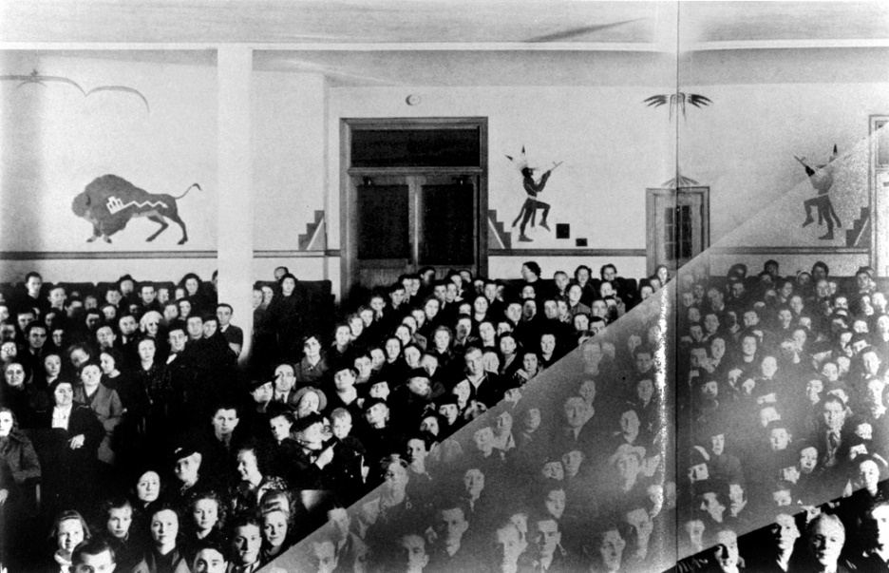
Figure 1. Acee Blue Eagle Murals, Mitchell Hall 1938, University of Central Oklahoma
Library Archives, Edmond, Oklahoma.

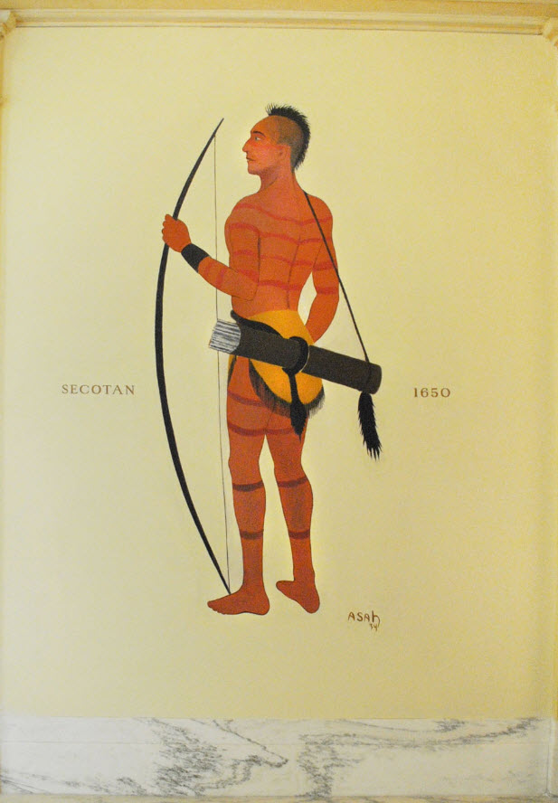

Figure 2. Spencer Asah, Secotan, 1650, 1937, Oklahoma Judicial Center, Oklahoma
City, Oklahoma, image by Denise Neil-Binion.
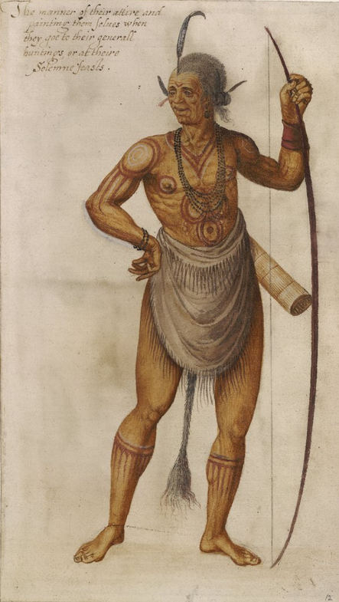
Figure 3. John White, An Indian 'Werowance' or Chief, 1585-1593, The British
Museum, London.

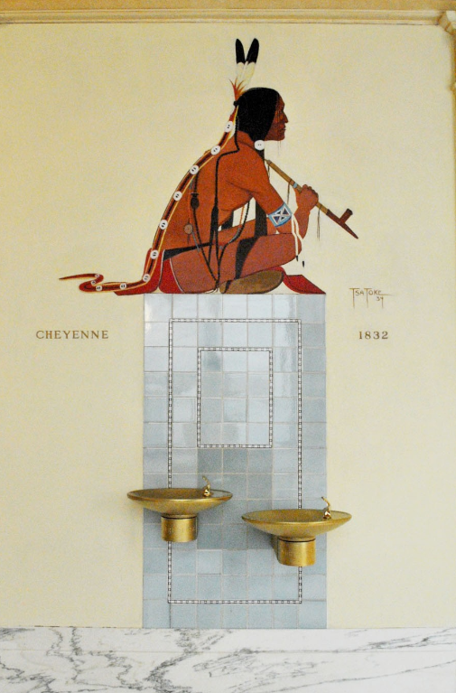
Figure 4. Monroe Tsatoke, Cheyenne, 1832, 1934, Oklahoma Judicial Center,
Oklahoma City, Oklahoma, image by Denise Neil-Binion.
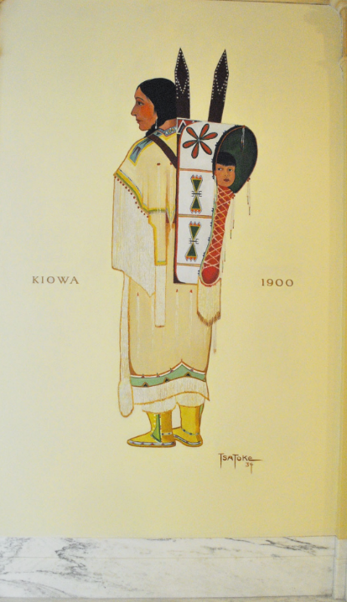

Figure 5. Monroe Tsatoke, Kiowa, 1900, 1934, Oklahoma Judicial Center, Oklahoma
City, Oklahoma, image by Denise Neil-Binion.

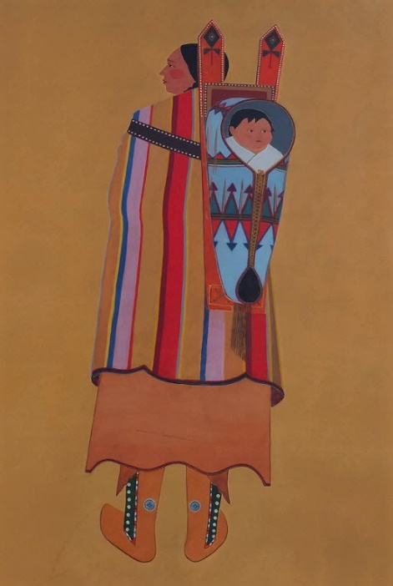
Figure 6. Stephen Mopope, Indian Mother and Child in Cradle, 1937, Oklahoma
Judicial Center, Oklahoma City, Oklahoma, image by Denise Neil-Binion.
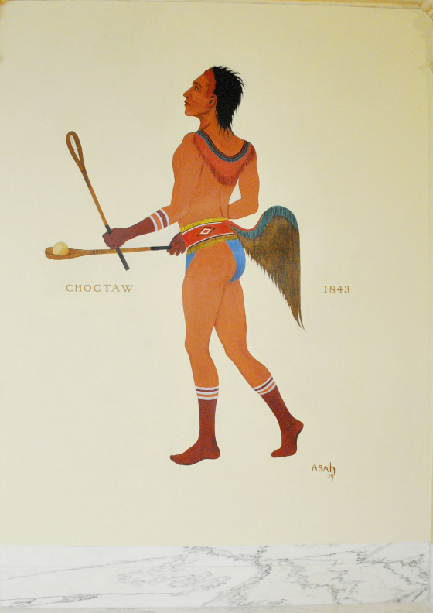
Figure 7. Spencer Asah, Choctaw 1843, 1937, Oklahoma Judicial Center, Oklahoma
City, Oklahoma, image by Denise Neil-Binion.

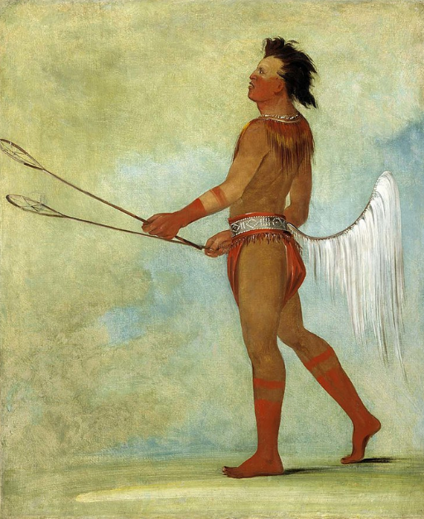
Figure 8. George Catlin, Tul-lock-chísh-ko (Drinks the Juice of the Stone) in Ball
Player’s Dress, 1834, Smithsonian American Art Museum, Washington, D.C.

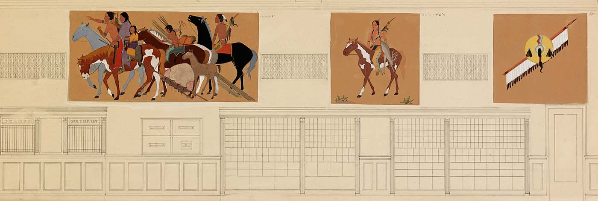

Figure 9. Stephen Mopope, Design Sketch for the Anadarko, Oklahoma Mural Cycle,
1936, Smithsonian American Art Museum, Washington, D.C.

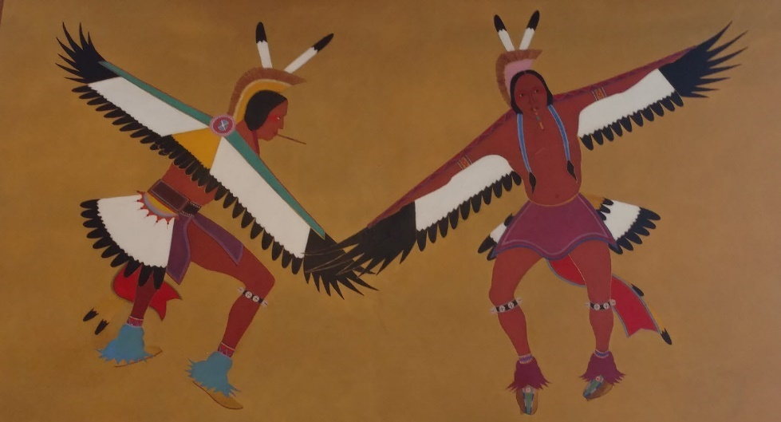

Figure 10. Stephen Mopope, Two Eagle Dancers, 1937, Post Office, Anadarko,
Oklahoma, image by Denise Neil-Binion.
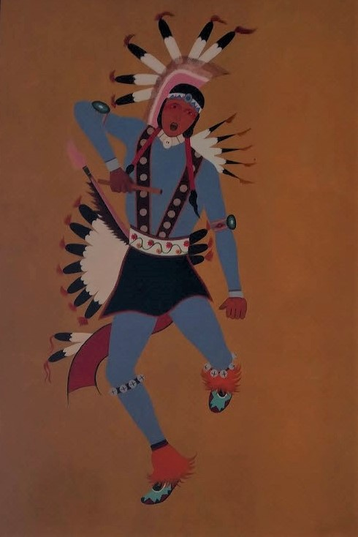

Figure 11. Stephen Mopope, Fancy War Dancer with Cedar Flute, 1937, Post Office,
Anadarko, Oklahoma, image by Denise Neil-Binion.

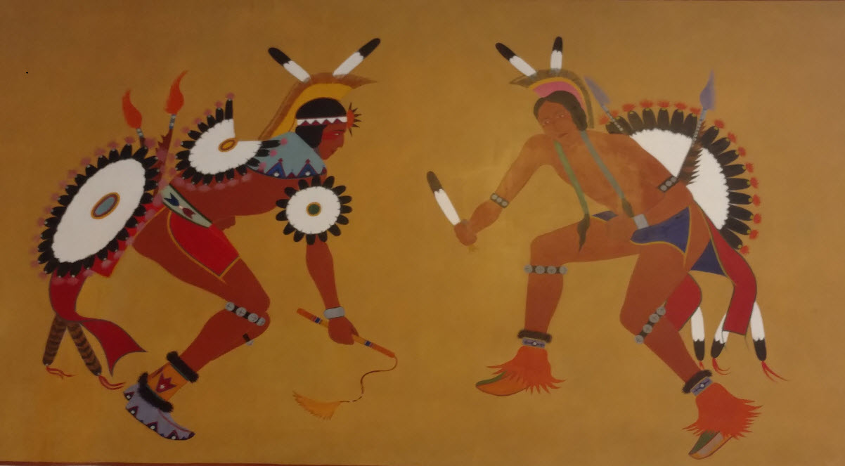

Figure 12. Stephen Mopope, Eagle Whip and Flute Dancers, 1937, Post Office,
Anadarko, Oklahoma, image by Denise Neil-Binion.

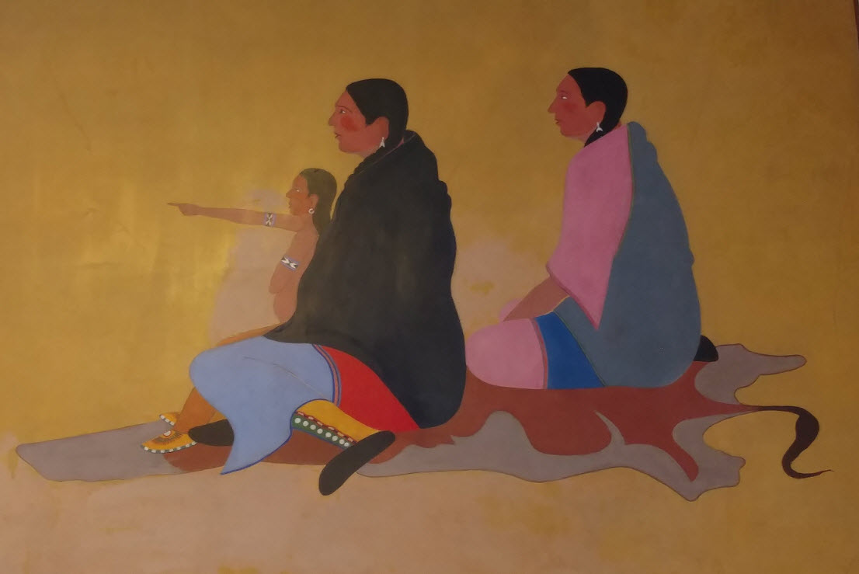

Figure 13. Stephen Mopope, Women and Child Watching Dancers, 1937, Post Office,
Anadarko, Oklahoma, image by Denise Neil-Binion.

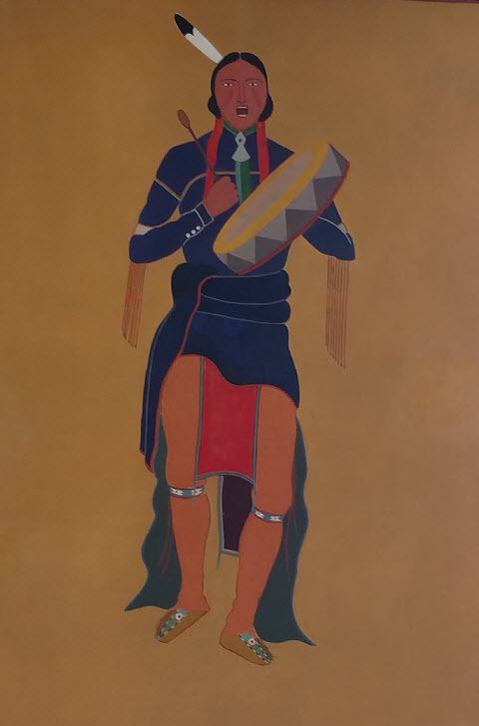

Figure 14. Stephen Mopope, Scalp Dance, 1937, Post Office Anadarko, Oklahoma,
image by Denise Neil-Binion.

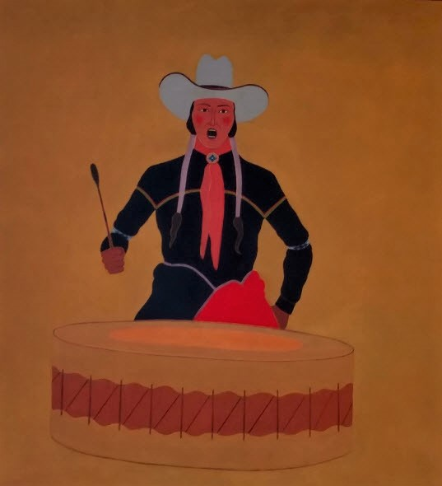

Figure 15. Stephen Mopope, War Dance Drummer, 1937, Post Office, Anadarko,
Oklahoma, image by Denise Neil-Binion.

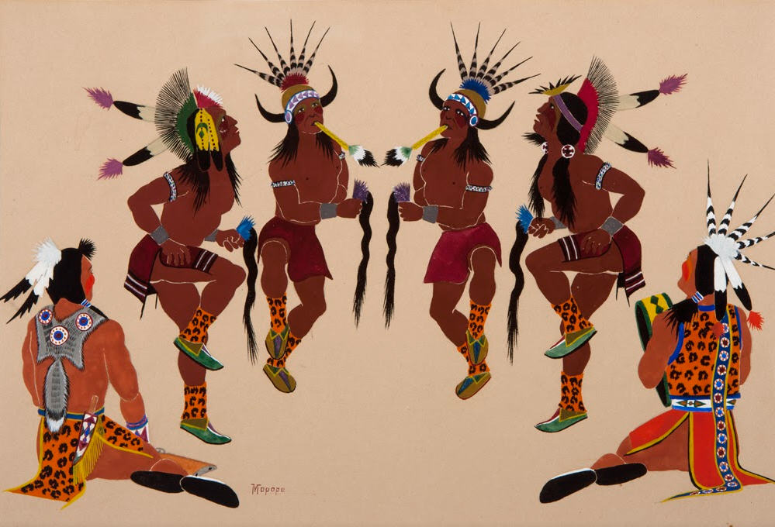

Figure 16. Stephen Mopope, Kiowa Scalp Dance, 1930, in Vision and Voices: Native
American Painting from the Philbrook Museum of Art, ed. Lydia L. Wyckoff
(Tulsa: Philbrook Museum of Art, 1996).

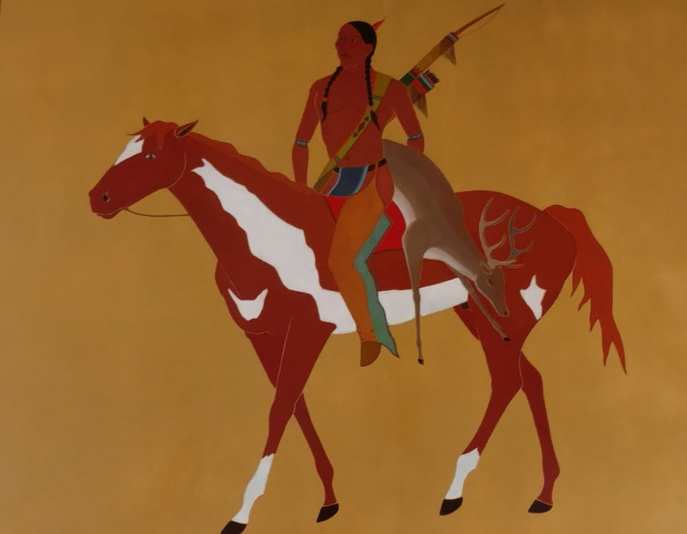

Figure 17. Stephen Mopope, The Deer Hunter, 1937, Post Office, Anadarko, Oklahoma,
image by Denise Neil-Binion.

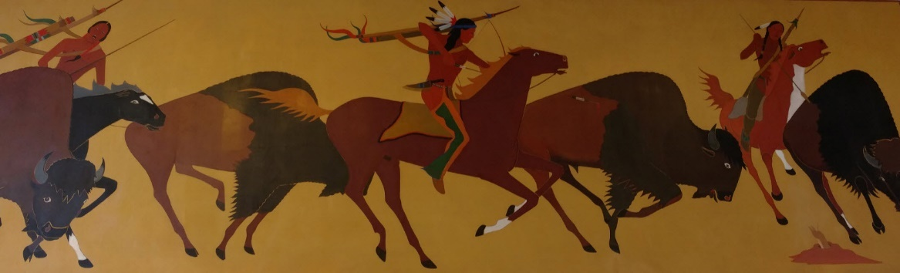

Figure 18. Stephen Mopope, Buffalo Hunting Scene, 1937, Post Office, Anadarko,
Oklahoma, image by Denise Neil-Binion.

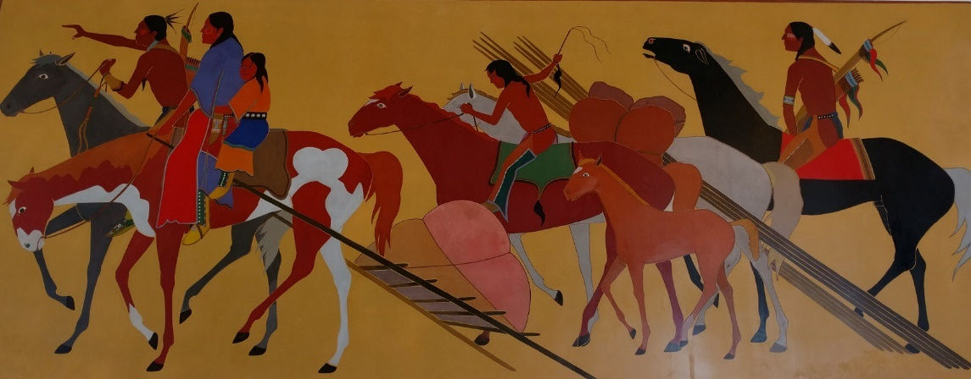

Figure 19. Stephen Mopope, Kiowas Moving Camp. 1937, Post Office, Anadarko,
Oklahoma, image by Denise Neil-Binion.
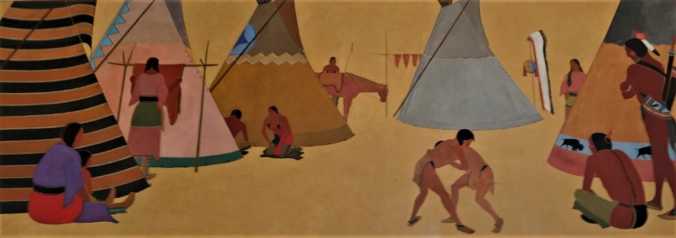

Figure 20. Stephen Mopope, Kiowa Camp Site, 1937, Post Office, Anadarko,
Oklahoma, image by Denise Neil-Binion.

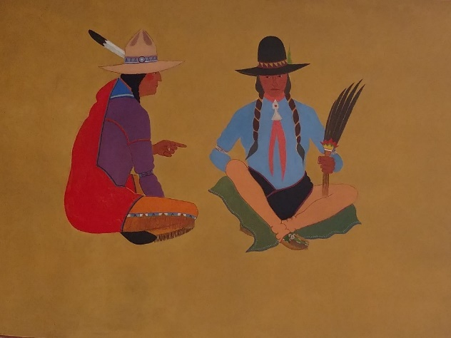

Figure 21. Stephen Mopope, Two Men in Council, 1937, Post Office, Anadarko,
Oklahoma, image by Denise Neil-Binion.

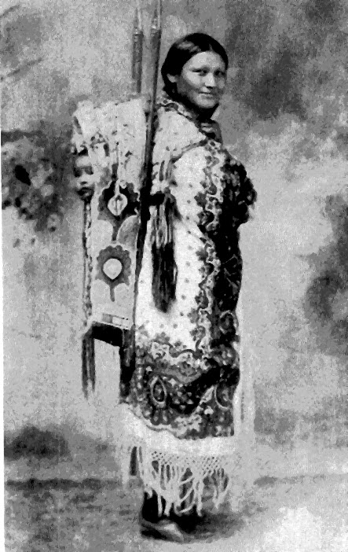

Figure 22. Etta Mopope with Stephen Mopope, in Gifts of Pride and Love (Bristol, R.I:
Haffenreffer Museum of Anthropology, Brown University).

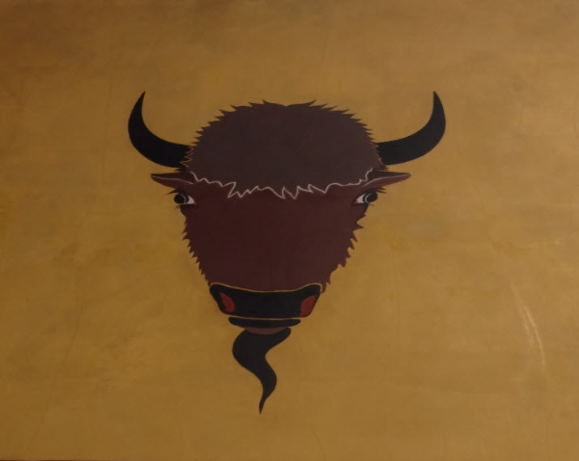

Figure 23. Stephen Mopope, Buffalo Head, 1937, Post Office, Anadarko, Oklahoma,
image by Denise Neil-Binion.

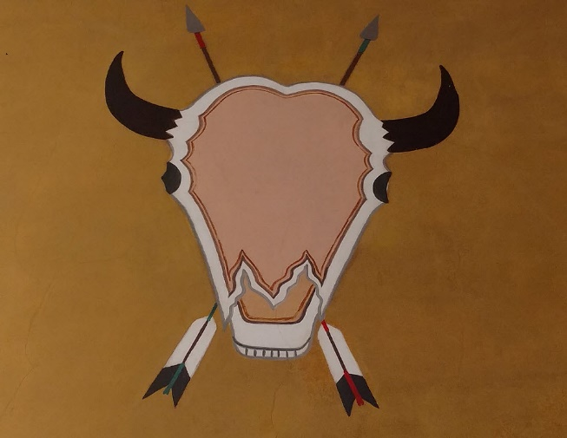

Figure 24. Stephen Mopope, Buffalo Skull with Crossed Arrows, 1937, Post Office,
Anadarko, Oklahoma, image by Denise Neil-Binion.

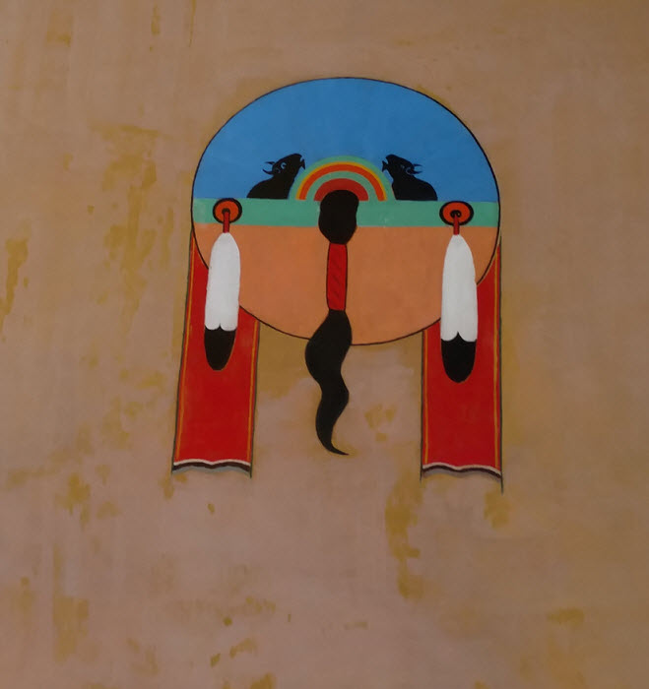

Figure 25. Stephen Mopope, Hunters Shield, 1937, Post Office, Anadarko, Oklahoma,
image by Denise Neil-Binion.

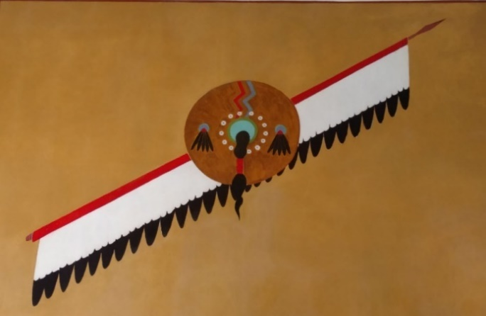

Figure 26. Stephen Mopope, Medicine Man’s Shield Lance, 1937, Post Office,
Anadarko, Oklahoma, image by Denise Neil-Binion.

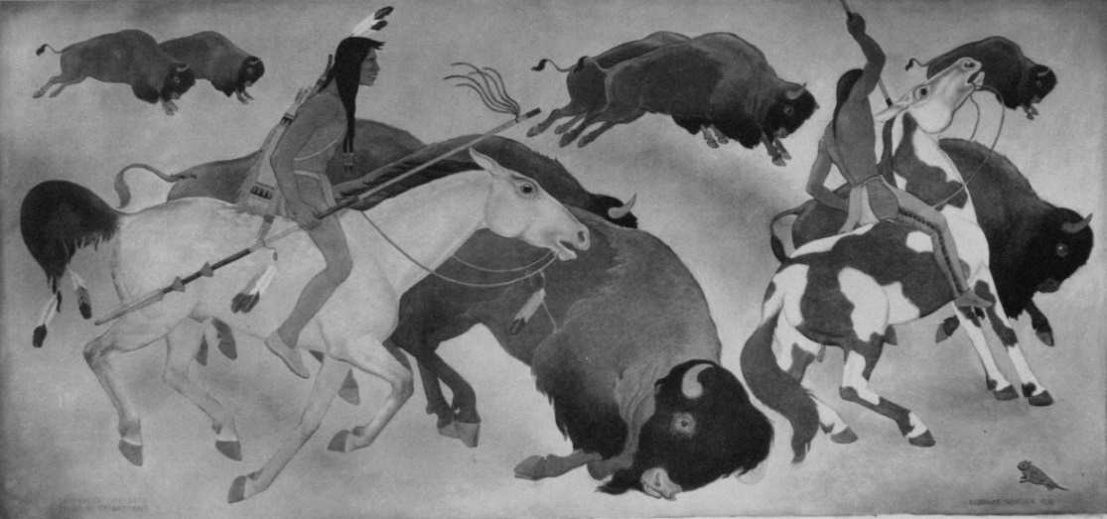

Figure 27. Suzanne Scheuer, Indian Buffalo Hunt, 1938, Used with Permission of the
United States Postal Service.
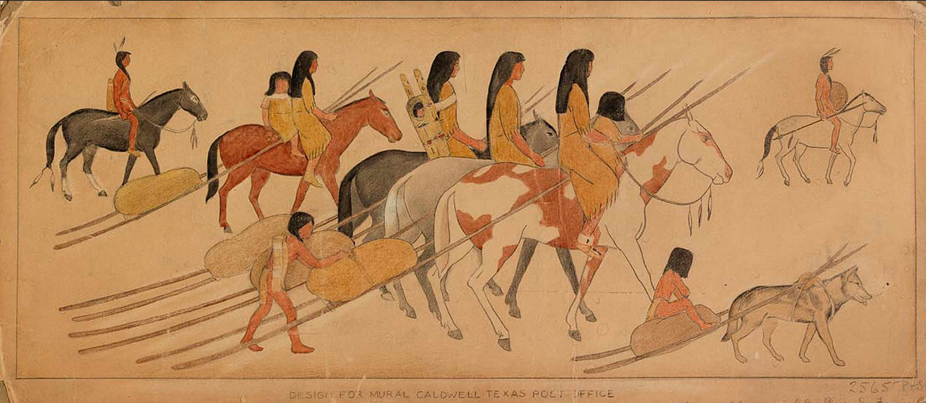

Figure 28. Suzanne Scheuer, Sketch, Moving Camp, 1939, Smithsonian American Art
Museum, Washington, D.C.

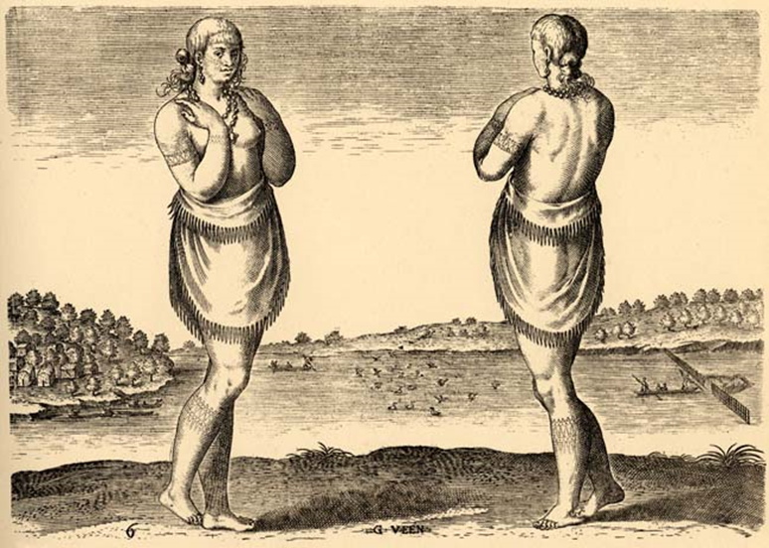

Figure 29. Theodor de Bry, (after John White), A Young Gentle Woman, Daughter of
Secota, 1585, Virginia Historical Society, Richmond, VA.

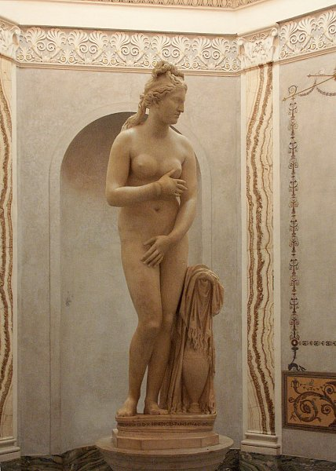

Figure 30. Roman (copy of Greek sculpture), Capitoline Venus, 2nd Century, C.E.,
Capitoline Museum, Rome, Italy.

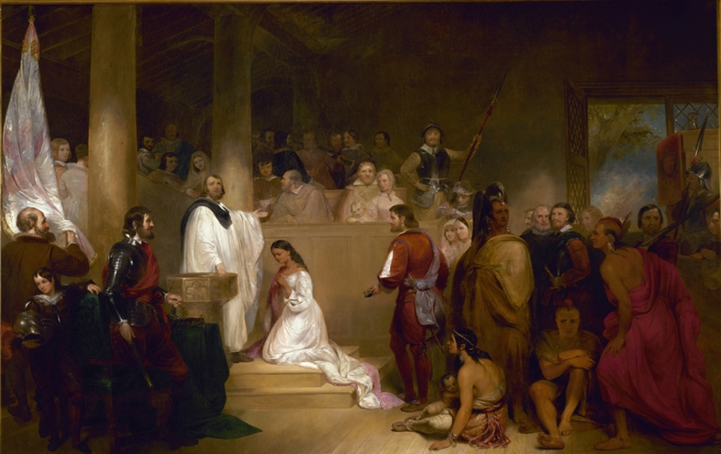

Figure 31. John Gadsby Chapman, Baptism of Pocahontas, 1839, United States Capitol
Rotunda, Washington, D.C.

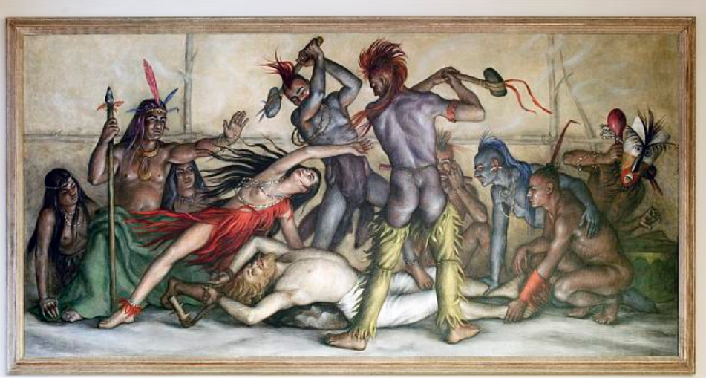

Figure 32. Paul Cadmus, Pocahontas Rescuing Captain John Smith, 1938, Smithsonian
American Art Museum, Washington, D.C.

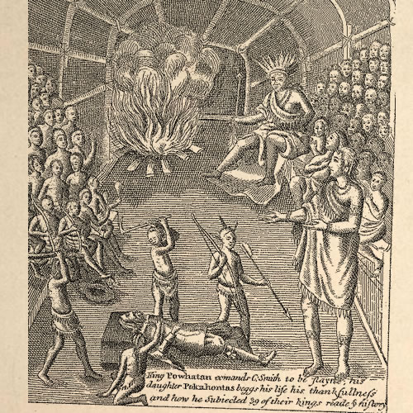

Figure 33. Robert Vaughan, King Powhatan Commands C. Smith to be Slayne, 1624, in
Pocahontas: Her Life and Legend (Richmond: Virginia Historical Society, 1994), 13.

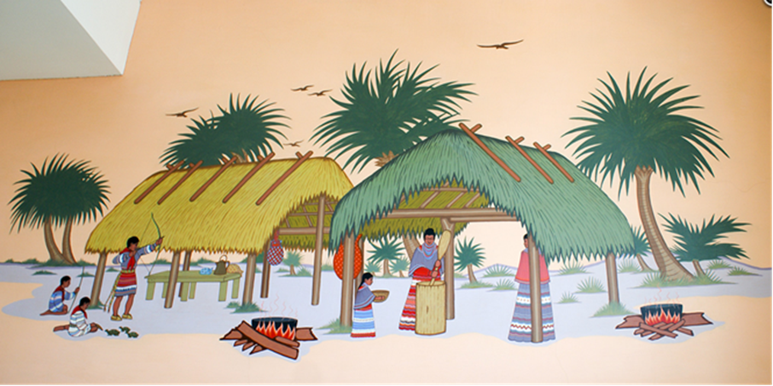

Figure 34: Acee Blue Eagle, Seminole Indian Village Scene, 1939, Post Office, Seminole, Oklahoma, image by Denise Neil-Binion.

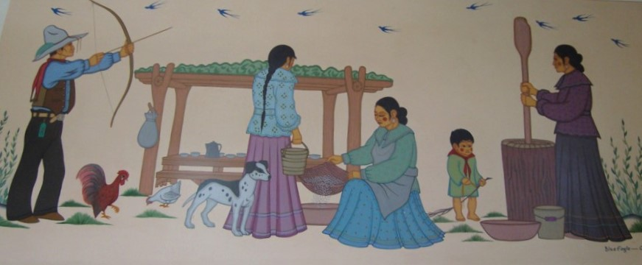

Figure 35. Acee Blue Eagle, Indian Family at Routine Tasks, 1942, Post Office, Coalgate, Oklahoma, image by Denise Neil-Binion.
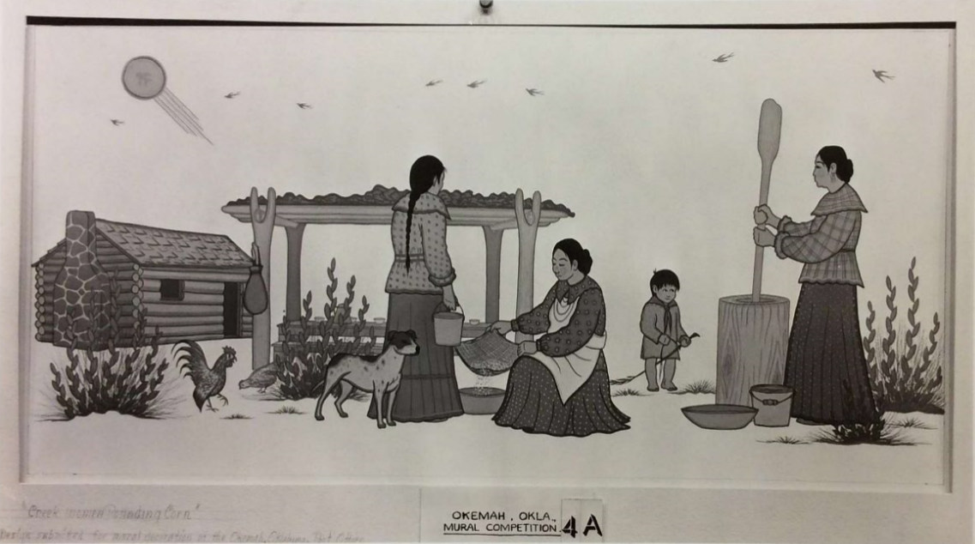

Figure 36. Acee Blue Eagle, Sketch submitted for the Okemah mural competition,
Smithsonian, National Anthropological Archives, Suitland, Maryland.

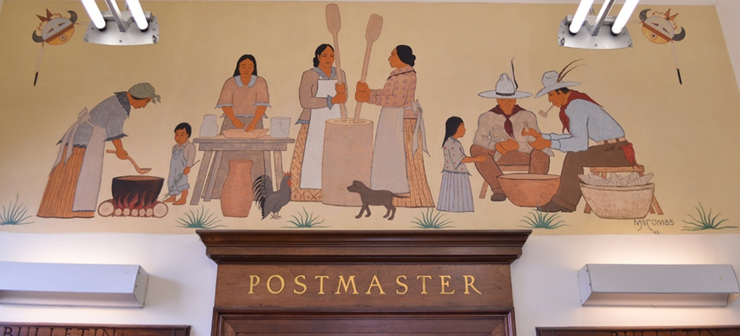

Figure 37. Solomon McCombs, Indian Family Making Pashofa, 1942, Post Office,
Marietta, Oklahoma, image by Denise Neil-Binion.

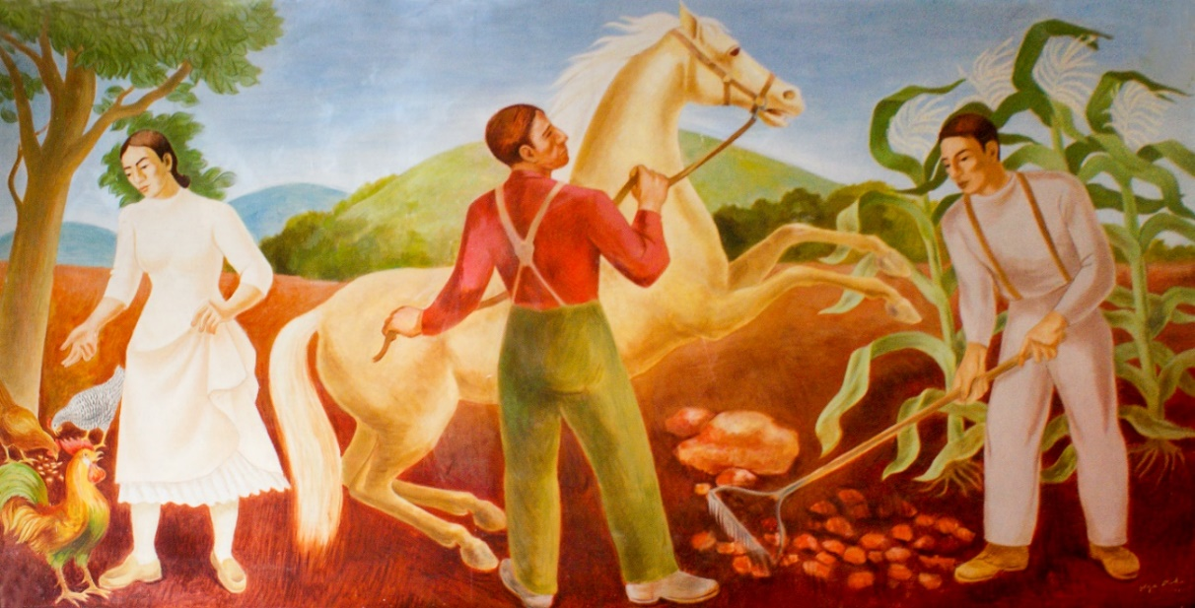

Figure 38. Olga Mohr, Cherokee Farming and Animal Husbandry, 1942, Post Office, Stilwell, Oklahoma, image by Denise Neil-Binion.

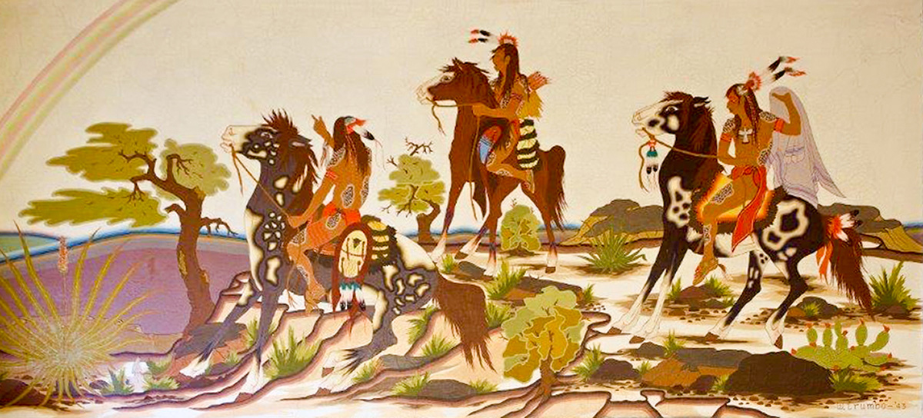

Figure 39. Woody Crumbo, The Rainbow Trail, 1943, Post Office, Nowata, Oklahoma,
image by Denise Neil-Binion.

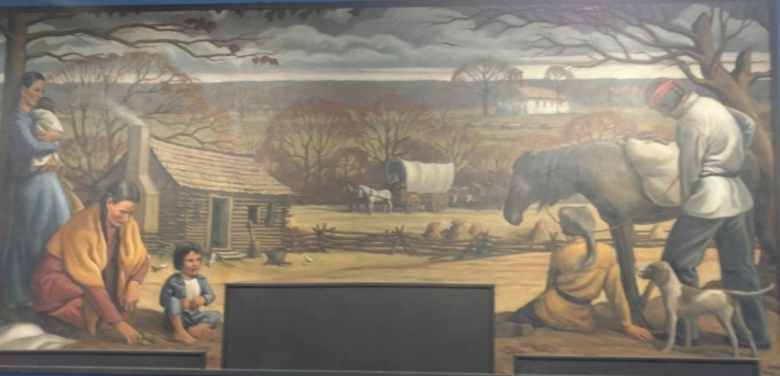

Figure 40. H. Louis Freund, Last Home of the Choctaw Nation, 1940, Post Office,
Idabel, Oklahoma, image by Denise Neil-Binion.

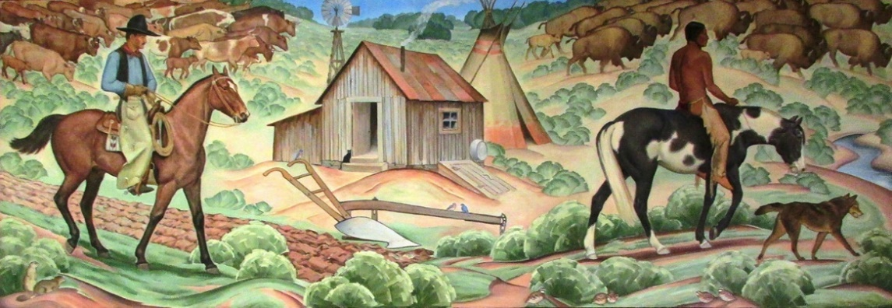

Figure 41. Ila McAfee Turner, The Scene Changes, 1938, Post Office, Cordell,
Oklahoma, image by Denise Neil-Binion.

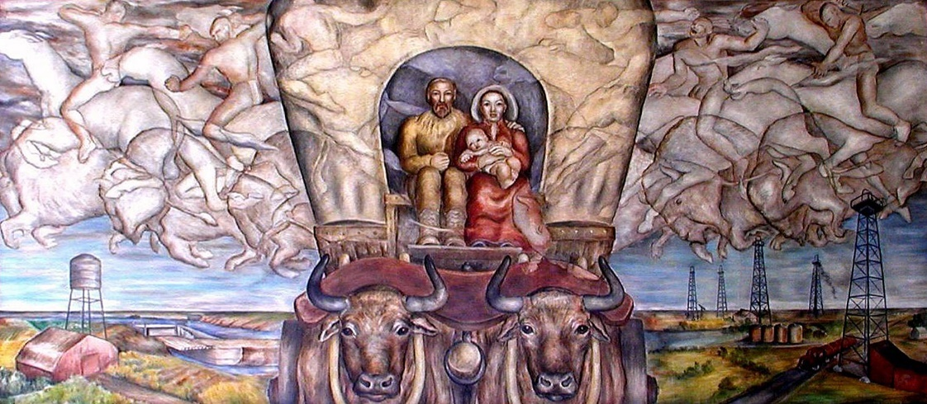

Figure 42. Louise Emerson Ronnenbeck, The Fertile Land Remembers, 1938, Post
Office, Casper, Wyoming, Used with Permission of the United State Postal Service.

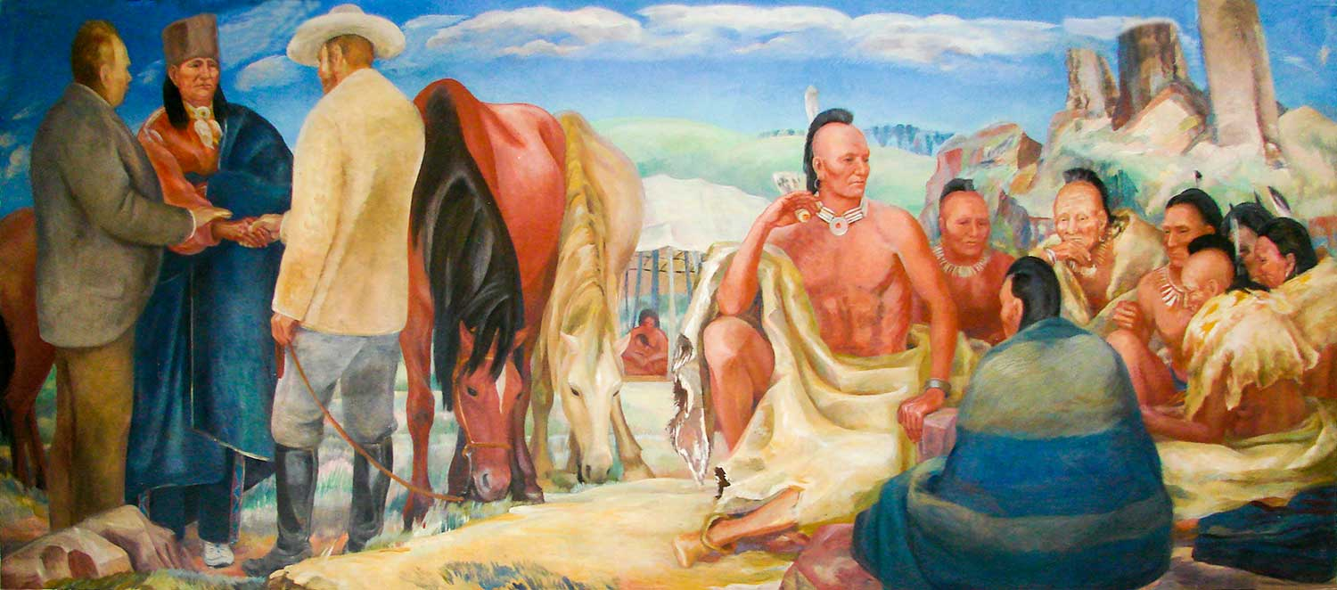

Figure 43. Olive Rush, Osage Treaties, 1938, Post Office, Pawhuska, Oklahoma, image
by Denise Neil-Binion.

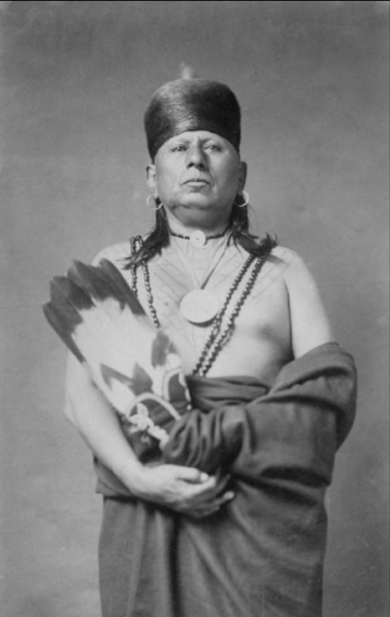

Figure 44. Chief Tom Bacon Rind, 1909, Smithsonian Institution, National
Anthropological Archives, Suitland, Maryland.

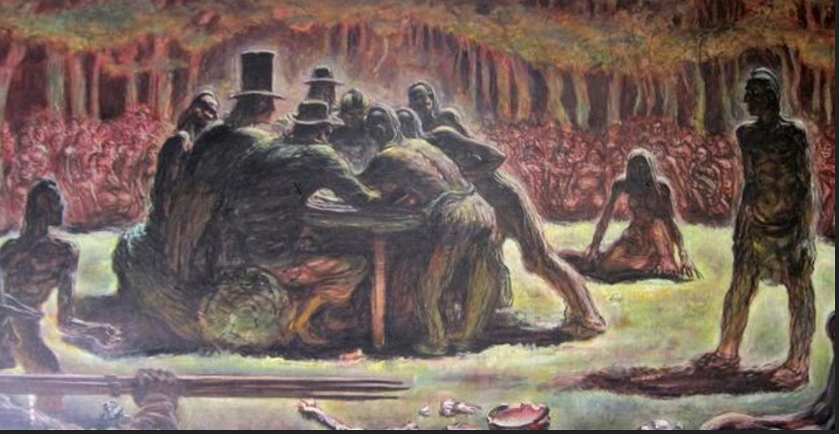

Figure 45. Douglas Crockwell, Signing of the Treaty of Dancing Rabbit Creek,
September 27, 1830, 1941, Used with Permission of the United States Postal
Service.

Figure 46. Edith Mahier, Roman Nose Canyon, 1939, Post Office, Watonga, Oklahoma,
image by Denise Neil-Binion.

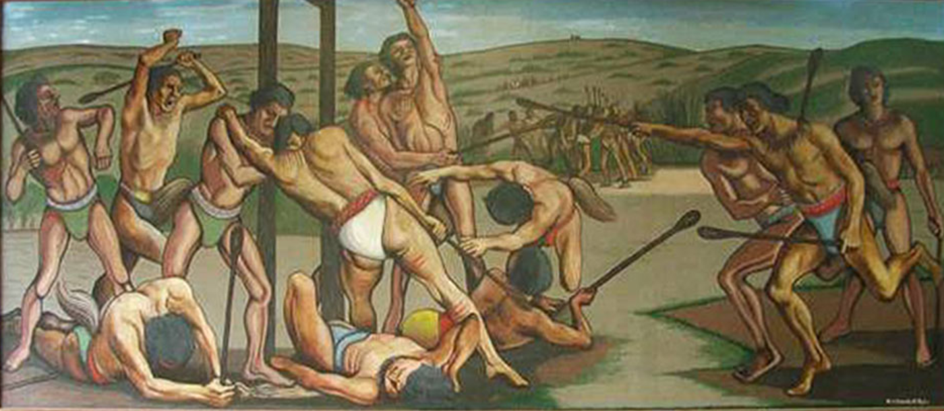

Figure 47. Manuel Bromberg, Choctaw Ball Play – 1840, 1938, Post Office, Tahlequah,
Oklahoma, image by Denise Neil-Binion.

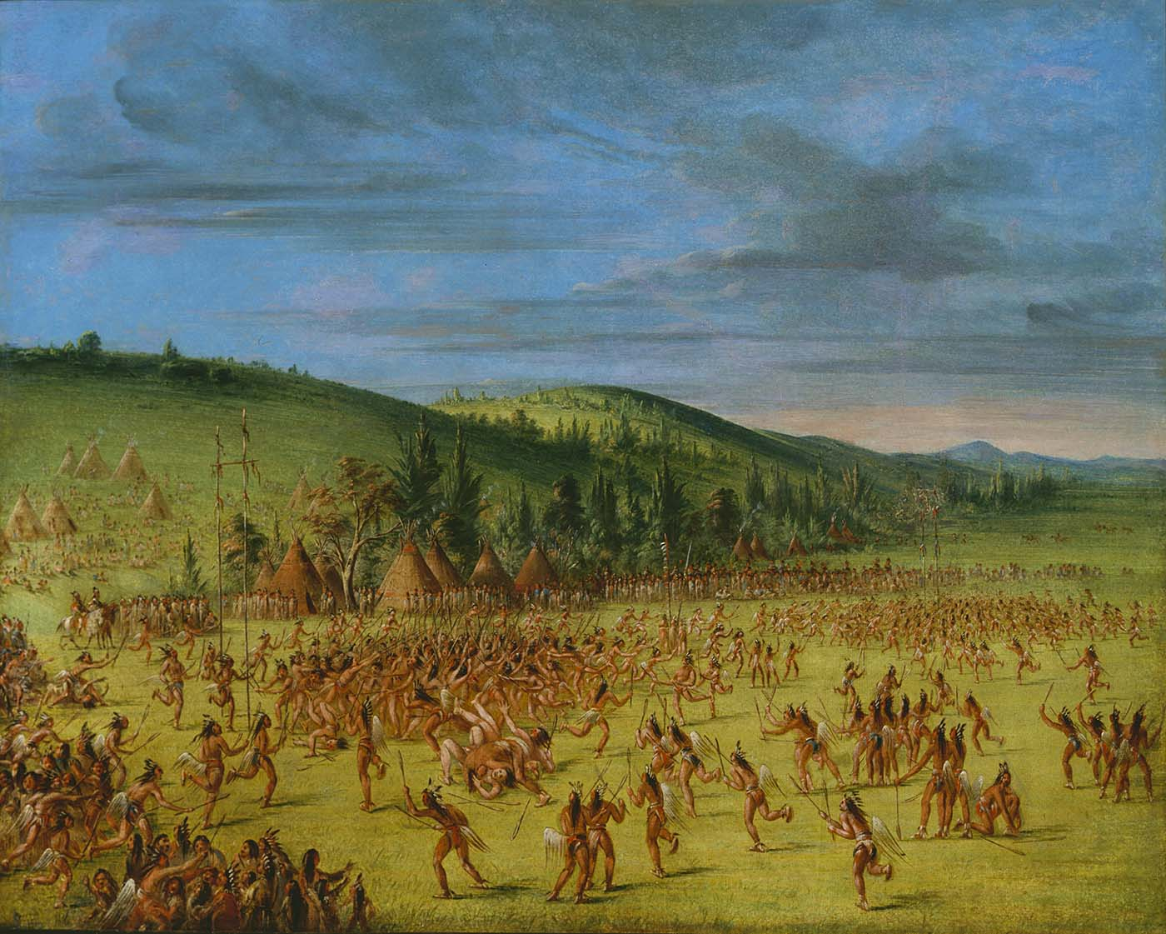

Figure 48. George Catlin, Ball Play of the Choctaw – Ball Up, 1846-1850, Smithsonian
American Art Museum, Washington, D.C.

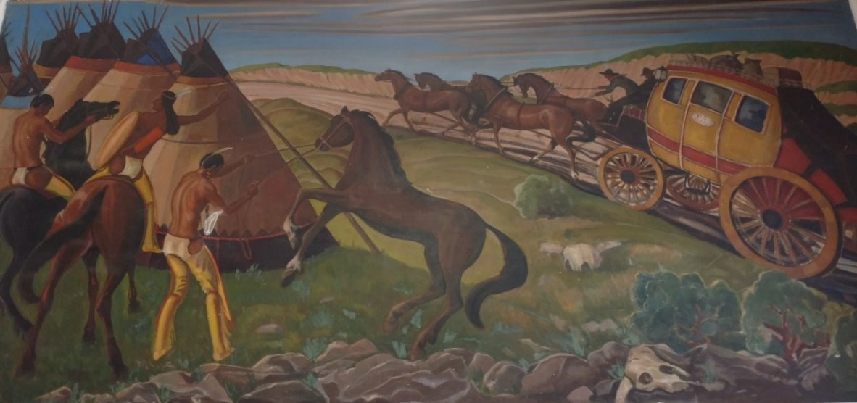

Figure 49. Joseph A. Fleck, The Redman of Oklahoma Sees the First Stagecoach, 1938,
Post Office, Hugo, Oklahoma, image by Denise Neil-Binion.

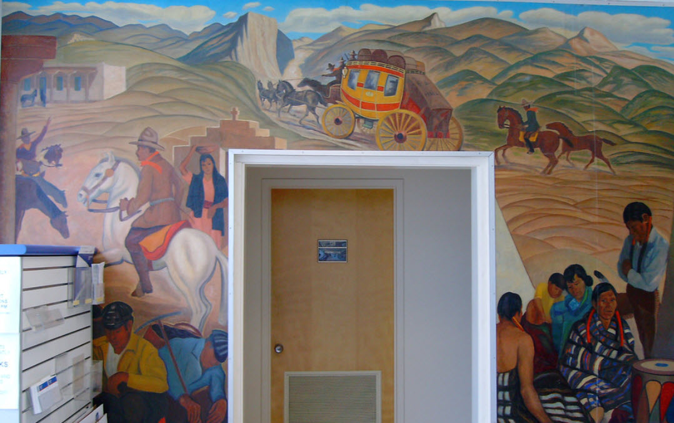

Figure 50. Joseph A. Fleck, First Mail Crossing Raton Pass, 1936, Used with
Permission of the United States Postal Service.

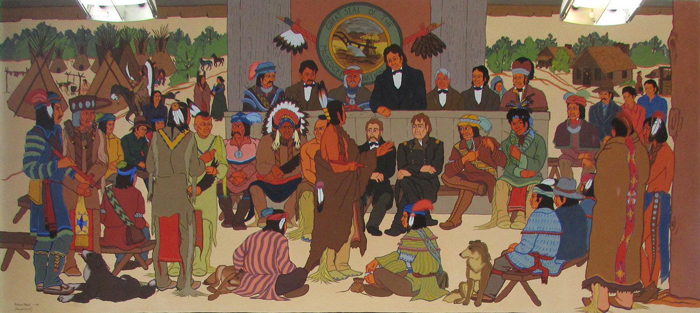

Figure 51: Dick West, The Grand Council of 1842, 1941, Post Office, Okemah,
Oklahoma, image by Denise Neil-Binion.

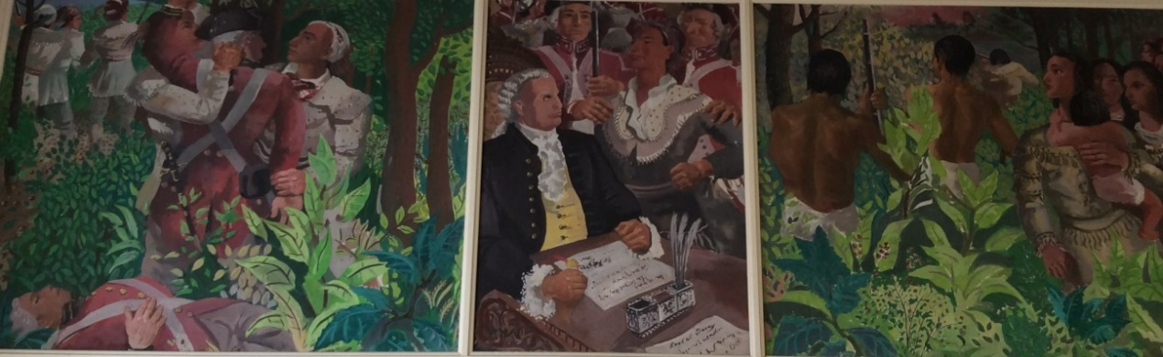

Figure 52. Randall Davey, History of the Cherokee Nation, Colonia Period, 1941, Post
Office, Vinita, Oklahoma, image by Denise Neil-Binion.

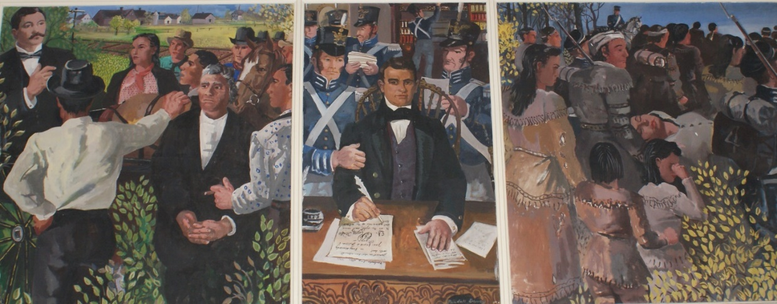

Figure 53. Randall Davey, History of the Cherokee Nation, Territorial Period, 1941,
Post Office, Vinita, Oklahoma, image by Denise Neil-Binion.

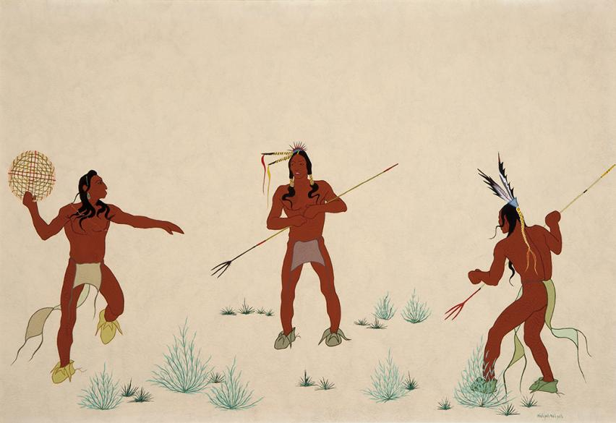

Figure 54: Dick West, Wheel Players, n.d. (c. 1946), Philbrook Museum of Art, Tulsa,
Oklahoma.

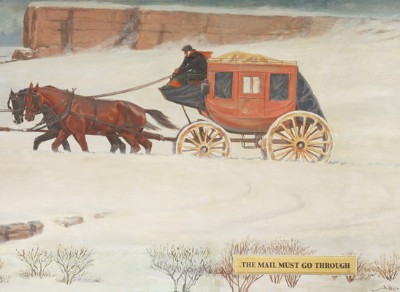

Figure 55: Albert T. Reid, The Mail Must Go Through, 1941, Post Office Olathe,
Kansas, image by Denise Neil-Binion.

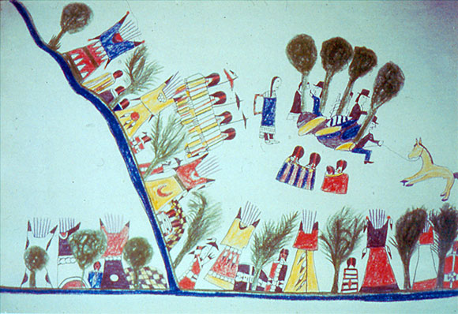
Figure 56: Howling Wolf, Treaty at Medicine Lodge, c. 1875, New York State Library,
Albany, New York.
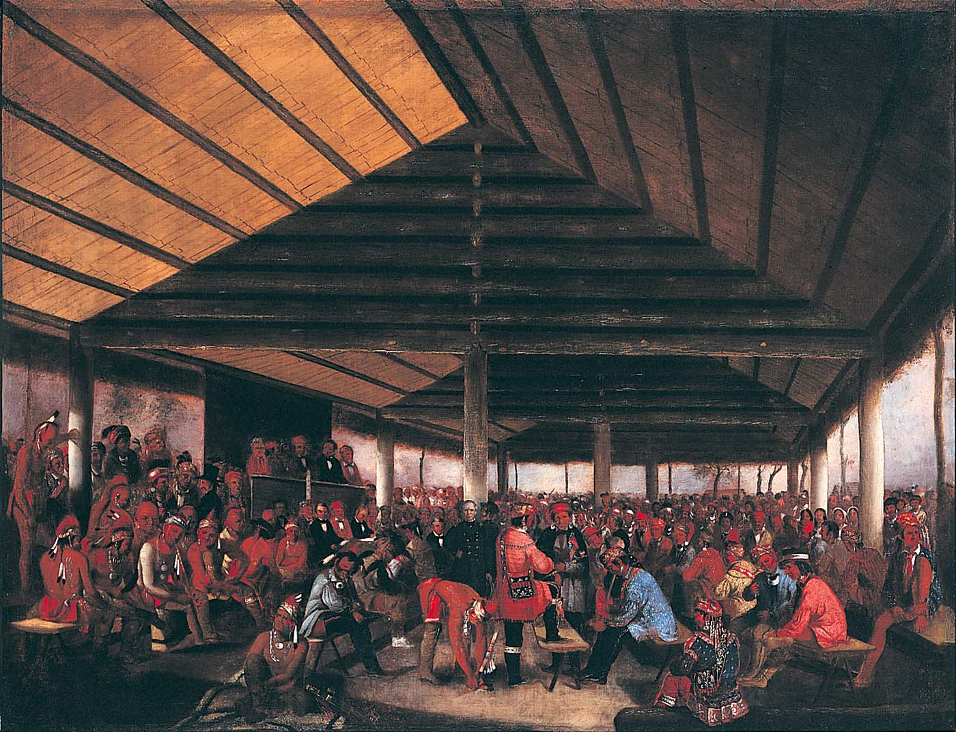
Figure 57: John Mix Stanley, International Indian Council, 1843, Smithsonian
American Art Museum, Washington, D.C.

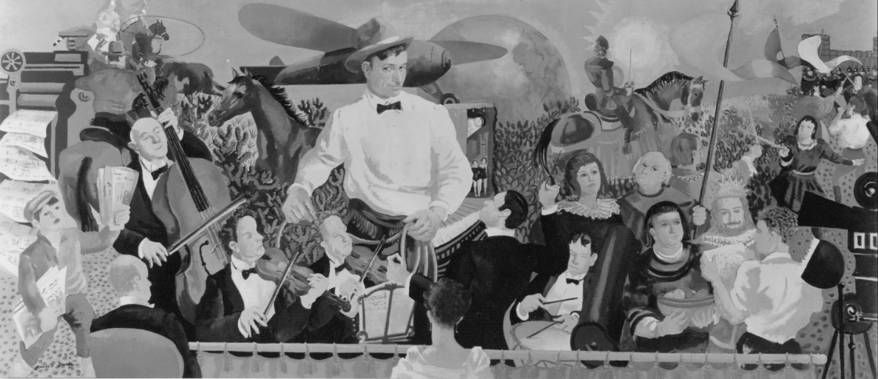

Figure 58. Randall Davey, Will Rogers, 1939. Post Office, Tahlequah, Oklahoma,
Used with Permission of the United States Postal Service.

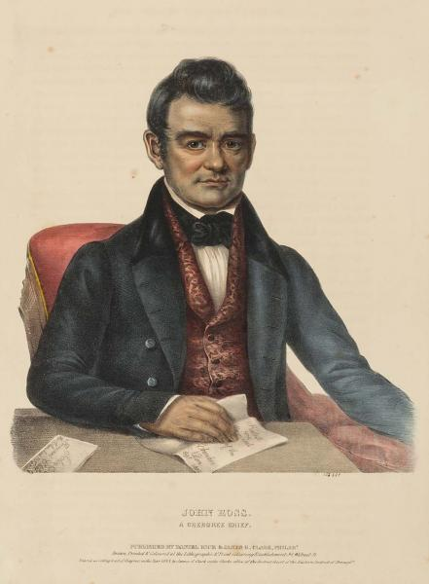

Figure 59. McKinney and Hall Lithograph (after Charles Bird King), John Ross, A
Cherokee Chief, Smithsonian American Art Museum, Washington, D.C.

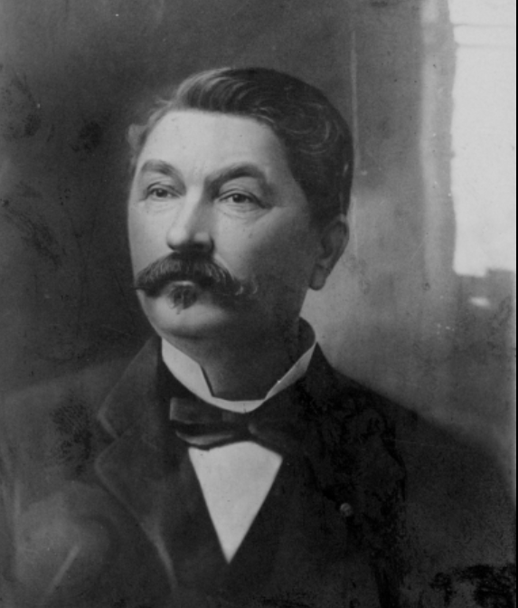

Figure 60. Thomas Buffington. W. P. Campbell Collection, Oklahoma Historical
Society Research Division.

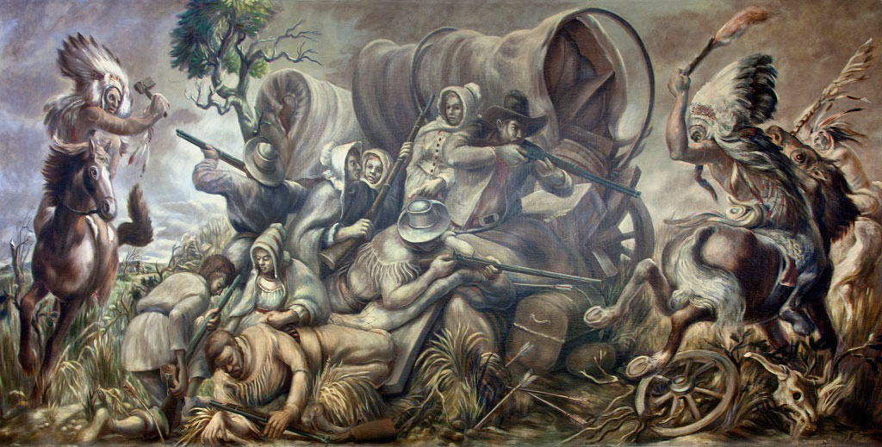

Figure 61. William C. Palmer, Covered Wagon Attacked by Indians, 1937, Used with
permission of the United States Postal Service.
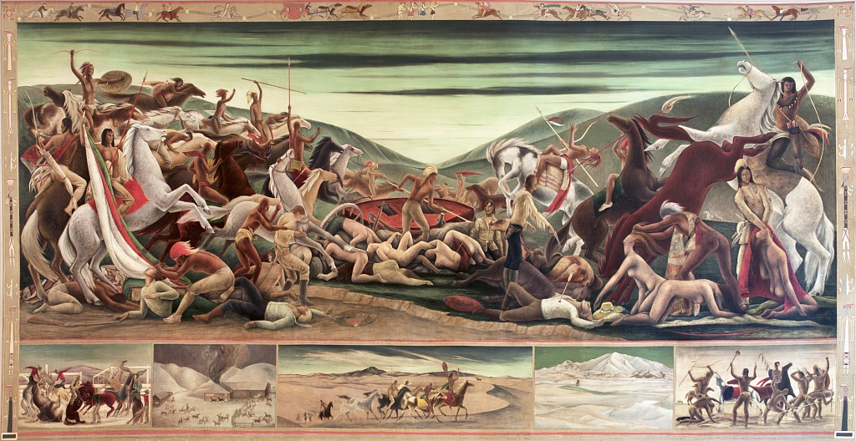

Figure 62. Frank Mechau, Dangers of the Mail, 1937, Used with Permission of the
United States Postal Service.

The Section of Painting and Sculpture was implemented in 1934; the name changed to the Section of Fine Arts in 1938. For clarity, I have elected to refer the program as the Section, which was commonly used during the program’s operation, and it is term that continues to be used by present-day scholars.
In 2013, the National Museum of the American Indian examined the photographic records of the Section resulting in the discovery of the prolific use of Native American themes. They also organized the images into these categories.
Hans Robert Jauss, Toward an Aesthetic of Reception, trans. Timothy Bahti (Minneapolis: University of Minnesota Press, 1982), xii. According to Jauss, the “horizon of expectation brought to a work of art is never available in objective or even objectifiable form, neither to its author nor its contemporaries or later recipients.”
Oklahoma has the largest number of Section commissioned murals painted by Native American artists.
The term Five Tribes refers to the Cherokee, Chickasaw, Choctaw, Muscogee (Creek), and Seminole Indians who were forcibly removed from their ancestral homelands in the southeastern region of the United States to Indian Territory as a result of the Indian Removal Act of 1830.
Karal Ann Marling, Wall to Wall America: A Cultural History of Post Office Murals of the Great Depression (Minneapolis: University of Minnesota Press, 1982), 293.
Jennifer McLerran, A New Deal for Native Art: Indian Arts and Federal Policy, 1933-1943 (Tucson: University of Arizona Press, 2009), 1-2.
Ibid., 173.
Oliver Gough Meeks, “The Federal Art Program in Oklahoma (1934-1940), (master’s thesis, University of Oklahoma, 1941), 29-32.
Sally Bradstreet Soelle, “New Deal Art: The Section of Fine Arts Program in the Great Plains States” (doctoral dissertation, University of Oklahoma, 1993). Soelle does not clearly define which states she views as part of the Great Plains, but in her art analysis she includes murals in Texas, Oklahoma, Wyoming, South Dakota, Nebraska, Kansas, Montana, and Colorado.
Pierre Nora, “Between History and Memory: Les Lieux de Mémoire,” Representations Special Issue: Memory and Counter-Memory, no. 26 (Spring 1989): 8-9.
E. H. Gombrich, Art and Illusion: A Study in the Psychology of Pictorial Representation (New York: Pantheon Books, 1960), 199.
Warren Carter, “Figuring the New Deal Politics and Ideology of the Section of Painting and Sculpture in Washington, D.C., 1933-1943” (doctoral thesis, University College of London, 2013), 18. Funding for the government’s New Deal Era art programs was complex and overlapping. For instance, the PWAP was initially funded through the Civil Works Administration (CWA), but when that program was terminated in March 1934, commissions in progress were paid for by funds from the Federal Emergency Art Project (FERA).
A. Joan Saab, For the Millions American Art and Culture Between the Wars (Philadelphia: University of Pennsylvania Press, 2004), 32-33 and 80-81.
Marlene Park and Gerald E. Markowitz, Democratic Vistas: Post Offices and Public Art in the New Deal, (Philadelphia: Temple University Press, 1984). Park and Markowitz offer an in depth and important discussion of the Section’s efforts to implement a democratic process in the selection of artists.
George Biddle, An American Artist’s Story (Boston: Little Brown and Company, 1939), 268 See also, Olin Dows, “The New Deal Art Projects,” in The New Deal Art Projects: An Anthology of Memoirs, ed. Francis V. O’Connor (Washington, D.C.: Smithsonian Institution Press, 1972), 14.
Biddle, An American Artist, 268.
Ibid.
Saab, For the Millions, 18.
Ibid.
L.W. Robert, “Public Works of Art Project: Report of the Assistant Secretary of the Treasury to Federal Emergency Relief Administrator, December 8, 1933-June 20, 1934” (Washington, D.C.: United States Government Printing Office, 1934), 1.
Ibid., 5 and 8.
Ibid., 5.
Alyson L. Greiner and Mark A. White, “Thematic Survey of New Deal Art in Oklahoma” (Stillwater: Oklahoma State University, Department of Geography, 2003-2004), 94.
Susan Labry Meyn, More than Curiosities: A Grassroots History of the Indian Arts and Crafts Board and Its Precursors, 1920-1942 (New York: Lexington Books, 2001), 1.
McLerran, A New Deal for Native Art, 67.
Ibid.
Ibid., 67-68.
Meyn, More than Curiosities, 159-160.
Robert Fay Schrader, The Indian Arts and Crafts Board: An Aspect of New Deal Indian Policy (Albuquerque: University of New Mexico Press, 1983), 77.
McLerran, A New Deal for Native Art, 3.
Ibid., 4.
Robert, “Public Works of Art Project,” 76. According to the report, 17 artists, both Native and non-Native were employed by the PWAP in Oklahoma. This list includes four out of the six artists associated with the group collectively known as the Kiowa Six, it should be noted that Kiowa artist, Jack Hokeah, is listed in the report as working in New Mexico at the time the PWAP was in operation.
Greiner and White, “Thematic Survey of New Deal Art,” 96.
Tamara Liegerot Elder, Lumhee Holot-Tee: The Art and Life of Acee Blue Eagle (Edmond, OK: Medicine Wheel Press, 2006), 38.
Lisa K. Neuman, Indian Play: Indigenous Identities at Bacone College (Lincoln: University of Nebraska Press, 2013). Bacone College in Muscogee, OK was founded as an all Indian School in 1880 by the American Baptist Church. The school was and is known for its continued support of Native American art. Acee Blue Eagle was named the first director of their art program in 1935.
Gayleen Rabakukk, Art of the Oklahoma Judicial Center (Oklahoma City: The Supreme Court of Oklahoma, 2014), 150.
Helen C. Rountree, Pocahontas’s People: The Powhatan Indians of Virginia Through Four Centuries (Norman: University of Oklahoma Press, 1990), 25.
Rabakukk, Art of the Oklahoma Judicial Center, 150.
Greiner and White, “Thematic Survey of New Deal Art” 26-27.
Ibid., 27-28.
Greiner and White, “Thematic Survey” 28. According to Greiner and White, it is unclear why Asah’s work includes the date of 1843. Catlin’s image of the Choctaw ball player was completed in 1834; perhaps the discrepancy was a simple transposing of numbers which was not caught or corrected.
Jose Barreiro, “Introduction,” Indians at the Post Office: Native Themes in New-Deal Era Murals, Smithsonian, National Postal Museum, accessed August 8, 2017, https://postalmuseum.si.edu/indiansatthepostoffice/introduction.html.
Soelle, “New Deal Art,” 34.
Park and Markowitz, Democratic Vistas, 12.
Ibid.
Ibid., 11.
Warren Carter, “Figuring the New Deal Politics,” 18.
Edward Bruce quoted in Park and Markowitz, Democratic Vistas, 3.
Ibid., 5.
Ibid., 8.
Nancy Heller and Julia Williams, The Regionalist (New York: Watson-Guptill Publications, 1976) 17.
Ibid., 13.
Ibid., 18.
Ibid., 26.
Ibid., 29.
Barbara Scott Kerr and Sally Soelle. New Deal Art: The Oklahoma Experience, 1933-1943, (Duncan, Oklahoma: Cameron University, 1983), iv.
Barreiro,” Introduction,” Indians at the Post Office.
Joyce M. Szabo, Imprisoned Art, Complex Patronage: Plains Drawings by Howling wolf and Zotom at the Autry National Center (Santa Fe: School for Advance Research Press, 2011), 66.
Joyce M. Szabo, Howling Wolf and the History of Ledger Art (Albuquerque: University of New Mexico Press, 1994), 3.
Schrader, The Indian Arts and Crafts Board, 3.
W. Jackson Rushing, “Modern by Tradition: The Studio Style of Native American Painting,” in Bruce Bernstein and W. Jackson Rushing, Modern by Tradition: American Indian Painting in the Studio Style (Santa Fe: Museum of New Mexico Press, 1995), 27.
Mary Austin to Secretary of the Interior, Franklin K. Lane, January 16, 1919, quoted in Schrader, The Indian Art and Crafts Board, 12.
John Sloan quoted in Janet Catherine Berlo “From Indigenous America to North Africa: The Cosmopolitan World of Oscar Jacobson and Jeanne d’Ucel,” in The Art of Oscar Brousse Jacobson (Norman: Fred Jones Jr. Museum of Art, University of Oklahoma, 2015), 108.
Schrader, Indian Arts and Crafts Board, 13-14.
Meyn, More Than Curiosities, 59.
W. Jackson Rushing, Native American Art and the New York Avant-Garde: A History of Cultural Primitivism (Austin: University of Texas Press, 1995), 97-98.
Schrader, The Indian Arts and Crafts Board, 49.
Meriam Lewis, “The Problem of Indian Administration” (Brookings Institute, Washington, D.C.: Department of the Interior, 1928), 125.
Bruce Bernstein, “Art for the Sake of Life: Dorothy Dunn and a Story of America Indian Painting,” in Bruce Bernstein and W. Jackson Rushing, Modern by Tradition: American Indian Painting in the Studio Style (Santa Fe: Museum of New Mexico Press, 1995), 3.
Lydia L. Wyckoff, “Vision and Voices: A Collective History of Native American Painting,” in Vision and Voices: Native American Painting from the Philbrook Museum of Art, ed. Lydia L. Wyckoff (Tulsa: Philbrook Museum of Art, 1996), 23-24.
Berlo, “From Indigenous America to North Africa,” 108.
Wyckoff, “Vision and Voices,” 24.
Ann Allbright and Mark Andrew White, “Oscar Brousse Jacobson, Culture Broker,” in The Art of Oscar Brousse Jacobson (Norman: Fred Jones Jr. Museum of Art, University of Oklahoma, 2015), 12-14.
Berlo, “From Indigenous America to North Africa,” 128. Although Susie Peters is frequently credited with bringing the Kiowa painters to the attention of Jacobson, d’Ucel credited Indian Agent J.A. Butin.
Wyckoff, “Visions and Voices,” 24.
Allbright and White, “Jacobson Culture Broker,” 23-24.
Berlo, “From Indigenous America to North Africa,” 108 and 111.
Ibid., 111.
C.E. Faris to Olin Dows, April 5, 1935, Record Group 121, Entry 133, National Archives, Washington, D.C. (hereinafter R.G. 121/133, N.A.).
Susie Peters to Olin Dows, April 4, 1935, R.G. 121/133, N.A.
Ibid.
Oscar Jacobson to Olin Dows, April 5, 1935, R.G. 121/133, N.A.
Oscar Jacobson to Olin Dows, n.d., R.G. 121/133, N.A. Jacobson mentions the four Kiowas, referring to the specific artists that he has suggested to work on the mural project: Stephen Mopope, Monroe Tsatoke, James Auchiah, and Spencer Asah.
Oscar Jacobson to Inslee A. Hopper, October 9, 1937, R.G. 121/133, N.A. In this letter, Jacobson addresses delays in finishing the murals including the death of Tsatoke as well as an accident involving Mopope.
Edward Rowan to Stephen Mopope, August 7, 1936, R.G. 121/133, N.A. This brief letter, referencing the contract for this commission is one of the few instances in the Section communicates directly with Mopope.
Oscar Jacobson to Inslee A. Hopper, January 21, 1936, R.G. 121/133, N.A.
Section Contract issued to Oscar Jacobson, July 18, 1936, R.G. 121/133, N.A.
Edward Rowan to Oscar Jacobson, March 26, 1936, R.G. 121/133, N.A.
Reuben Noah, “Two Eagle Dancers,” Indians at the Post Office: Native Themes in New Deal-Era Murals, Smithsonian, National Postal Museum, accessed October 16, 2017, https://postalmuseum.si.edu/indiansatthepostoffice/mural2.html.
Anadarko Chamber of Commerce, “Anadarko Post Office Murals,” (Anadarko: Chamber of Commerce, n.d.), According to this brochure this dance was taught to the Kiowa by the Indians of Taos Pueblo.
For a detail accounting on the importance of Kiowa cradleboards see Gifts of Pride and Love: Kiowa and Comanche Cradles, ed. Barbara A. Hail (Bristol, R.I: Haffenreffer Museum of Anthropology, Brown University, 2000).
Don Weida to Edward Rowan, November 26, 1937, R.G. 121/133, N.A. Weida was writing to Rowan to invite him to the dedication ceremony on December 5, 1937.
W.G. Gray to Edward Bruce, August 22, 1941. and Edward Rowan to W.G. Gray, August 26, 1941, R.G. 121/133, N.A. Ongoing interest in the murals seems to have been perpetuated by the annual Indian Exposition held in Anadarko, Oklahoma. See also, Nan Sheets, “The 1941 Celebration of the Annual Indian Exposition,” The Oklahoman (Oklahoma City, OK) n.d., ca. August 1941, R.G. 121/133, N.A.
Edward Rowan to Suzanne Scheuer, July 22, 1937, R.G. 121/133, N.A.
Suzanne Scheuer to Edward Rowan, July 28, 1937, R.G. 121/133, N.A.
Suzanne Scheuer to Edward Rowan, August 12, 1937, R.G. 121/133, N.A.
Edward Rowan to Suzanne Scheuer, February 16, 1938, R.G. 121/133, N.A.
“Painting is Installed at Eastland Post Office,” (name and place of publication unknown), n.d., R.G. 121/133, N.A.
Edward Rowan to Suzanne Scheuer, Jun 15, 1938, R.G. 121/133, N.A. This commission was based on designs Scheuer submitted for the Dallas, Texas post office competition.
Suzanne Scheuer to Edward Rowan, June 9, 1939, R.G. 121/133, N.A.
Ibid.
Edward Rowan to Suzanne Scheuer, June 15, 1939, R.G. 121/133, N.A.
“Mural in Post Office Attracts Much Attention,” Caldwell News and the Burleson County Ledger (Caldwell, TX), July 6, 1939, R.G. 121/133, N.A.
Wolfgang Kemp, “The Work of Art and Its Beholder,” in The Subjects of Art History: Historical Objects in Contemporary Perspectives (Cambridge; New York: Cambridge University Press, 1998), 181. Kemp’s work is influenced by E.H. Gombrich’s concept of the “beholder’s share.” See also E.H. Gombrich, Art and Illusion: A Study in the Psychology of Pictorial Representation (Princeton: Princeton University Press, 2000).
Abigail Tucker, "Brave New World," Smithsonian 39, no. 9 (December 2008): 48, accessed October 7, 2017, http://web.a.ebscohost.com.ezproxy.lib.ou.edu/ehost.
Thomas Hariot, A Brief and True Report of the New-Found Land of Virginia, accessed October 16, 2017, http://digitalcommons.unl.edu/cgi/viewcontent.cgi?article=1020&context=etas.
“Richmonders May Question Artist’s Work,” Richmond-Times Dispatch (Richmond, VA), n.d., R.G. 121/133, N.A. The post office in Richmond, Virginia had two murals one by Paul Cadmus and the other by Jared French. Both artists had planned to complete scenes of the Civil War. While Cadmus changed his subject, French did not, leading to criticism of the artist’s depiction of Southern cavalrymen.
Edward Rowan to Paul Cadmus, June 17, 1937. Rowan to Marcellus Wright, June 17, 1937, R.G. 121/133, N.A.
"Richmonders May Question Artists’ Work,” R.G. 121/133, N.A.
Margaret Holmes Williamson, Powhatan Lords of Life and Death: Command and Consent in Seventeenth Century Virginia, (Lincoln: University of Nebraska Press, 2003), 47. Rather than designating the Powhatan as a Confederacy, Williamson classifies them as a group of tribes that shared common traits including language, political structure, and culture.
Sophie Gilbert, “Revisiting Pocahontas at 20,” The Atlantic, June 23, 2015, accessed October 1, 2017, https://www.theatlantic.com/entertainment/archive/2015/06/revisiting-pocahontas/396626/.
Ibid.
“Pocahontas Her Life and Legend,” National Park Service: Historic Jamestowne, accessed March 2, 2007, https://www.nps.gov/jame/learn/historyculture/pocahontas-her-life-and-legend.htm.
John Smith, Generall Historie of Virginia, New England, and the Summer Isles (London: Printed by I.D. and I.H. for Michael Sparkes, 1624), 49, accessed March 2, 2017, http://docsouth.unc.edu/southlit/smith/smith.html.
Camilla Townsend, Pocahontas and the Powhatan Dilemma, (New York: Hill and Wang, 2004), 55.
Ibid., 56.
Angie Debo, The Rise and Fall of the Choctaw Republic, (Norman, OK: University of Oklahoma Press, 1961), 18.
Ibid.
Ibid., 10.
Clara Sue Kidwell, “Choctaw Women and Cultural Persistence in Mississippi.” In Negotiators of Change: Historical Perspectives on Native American Women. Editor Nancy Shoemaker, (New York: Routledge, 1995), 116.
Debo, Rise and Fall of the Choctaw, 12-13. Debo’s description is based on writings of an unnamed, eighteenth century French writer.
Pamela S. Wallace, “Sofkey” Oklahoma Historical Society, accessed October 16, 2017, http://www.okhistory.org/publications/enc/entry.php?entry=SO003.
Krystal Adams, “Chickasaw Family Making Pah Sho Fah (Pashofa),” Indians at the Post Office: Native Themes in New-Deal Era Murals, Smithsonian, National Postal Museum, accessed October 16, 2017, https://postalmuseum.si.edu/indiansatthepostoffice/mural3.html.
Matt Despain, “The Legacy of Pashofa: Ceremony, Society, Women, and Chickasaw Life,” In Native Being – Being Native: Identity and Difference, Proceedings of the Fifth Native American Symposium, ed. Mark B. Spencer and Lucretia Scoufos, (Durant, OK: Southeastern Oklahoma State University, 2005), 5.
Ibid., 6.
Ibid.
Edward Rowan to Acee Blue Eagle, August 20, 1938, R.G. 121/133, N.A.
Ibid.
Edward Rowan to Acee Blue Eagle, October 6, 1938, R.G. 121/133, N.A.
For information on the history of Bacone and its art program see, Neuman, Indian Play, Chapter five, “Marketing Culture,” for information on Blue Eagle’s tenure see 166-171.
Charles W. Johnston to the Section of Fine Arts, June 5, 1939, R.G. 121/133, N.A.
Acee Blue Eagle to George T. Ralls, December 28, 1942, R.G. 121/133, N.A.
Acee Blue Eagle to Edward Rowan, April 21, 1942, R.G. 121/133, N.A.
Carl R. Portman to Edward Rowan, January 1, 1943, R.G. 121/133, N.A.
Edward Rowan to Solomon McCombs, June 5, 1941, R.G. 121/133, N.A.
Olga Mohr to Edward Rowan, June 14, 1941, R.G. 121/133, N.A.
Edward Rowan to Olga Mohr, June 20, 1941, R.G. 121/133, N.A.
Edward Rowan to Olga Mohr, July 23, 1941, R.G. 121/133, N.A.
Olga Mohr to Edward Rowan, n.d., R.G. 121/133, N.A.
B.R. Jones to Edward Rowan, March 2, 1942, R.G. 121/133, N.A.
Edward Rowan to H. Louis Freund, September 14, 1939, R.G. 121/133, N.A.
Mona Clark to Edward Rowan, September 13, 1939, R.G. 121/133, N.A.
Edward Rowan to Mona Clark, September 27, 1939, R.G. 121/133, N.A.
Kidwell, The Choctaws, 3.
H. Louis Freund to Edward Rowan, November 15, 1939, R.G. 121/133, N.A.
Edward Rowan to H. Louis Freund, November 24, 1939, R.G. 121/133, N.A.
Meeks, “The Federal Art Program in Oklahoma,” 85.
Ila McAfee Turner to Edward Rowan, October 5, 1937, R.G. 121/133, N.A.
Edward Rowan to Ila McAfee Turner, October 12, 1937, R.G. 121/133, N.A.
Meeks, “The Federal Art Program,” 86. Meeks interview with the McAfee Turner.
“History is Portrayed in Post Office Mural,” The Cordell Beacon (Cordell, OK), May 5, 1938, R.G. 121/133, N.A.
Nora, “Between History and Memory,” 8-9.
Olive Rush Papers, 1879-1967, “Olive Rush Biography - Who’s Who in New Mexico, 1941-1942,” Smithsonian, Archives of American Art, accessed October 1, 2017, https://www.aaa.si.edu/collections/olive-rush-papers-9223/series-1/box-1-folder-1.
Ibid.
Edward Rowan to Olive Rush, July 22, 1937, R.G. 121/133, N.A.
Olive Rush to Edward Rowan, December 7, 1937, R.G. 121/133, N.A.
Ibid.
Nan Sheets, “Mural in Pawhuska Post Office Painted by New Mexico Artist,” The Oklahoman (Oklahoma City, OK), March 31, 1940. Clipping was sent in a letter from R.J Morrow to Edward Rowan, April 2, 1940, R.G. 121/133, N.A.
“Mural Depicting Osage History Place in Post Office,” Daily Journal (Pawhuska, OK), October 19, 1938, R.G. 121/133, N.A.
Edith Mahier to Edward Rowan, June 1, 1940 and July 25, 1940, R.G. 121/133, N.A.
“Post Office Houses Our First Mural,” (name and place of publication unknown), n.d., R.G. 121/133, N.A.
C. Knappenberger to Federal Works Agency, June 4, 1941, R.G. 121/133, N.A.
Marling, Wall to Wall America, 279.
Edith Mahier to C. Knappenberger, June 25, 1941, R.G. 121/133, N.A.
Edward Rowan to General Johnson, June 19, 1941, R.G. 121/133, N.A.
Edith Mahier to Edward Rowan, June 17, 1941, R.G. 121/133, N.A.
C. Knappenberger to Edward Rowan, June 23. 1941, R.G. 121/133, N.A.
George Catlin, Letters and Notes on the Manners, Customs, and Conditions of the North American Indians, Volume II (New York: Wiley and Putnam, 1842), 123.
“Choctaw Game of Our Ancestors,” Choctaw Nation, accessed October 16, 2017, https://www.choctawnation.com/history-culture/choctaw-traditions/choctaw-games.
Catlin, Letters and Notes., 126.
Edward Rowan to Manuel Bromberg, December 12, 1938, R.G. 121/133, N.A.
Edward Rowan to Manuel Bromberg, September 21, 1938, R.G. 121/133, N.A.
Manuel Bromberg to Edward Rowan, n.d. (stamped received April 11, 1939), R.G. 121/133, N.A.
Edward Rowan to Manuel Bromberg, April 12, 1939, R.G. 121/133, N.A.
J.A. Morris to Edward Rowan, July 24, 1939, R.G. 121/133, N.A.
Linda Scarangella McNenly, Native Performers in Wild West Shows: From Buffalo Bill to Euro Disney (Norman: University of Oklahoma Press, 2012), 4-5.
Ibid., 107-108.
Edward Rowan to Joseph A. Fleck, November 8, 1937, R.G. 121/133, N.A.
Joseph A. Fleck to Edward Rowan, December 30, 1937, R.G. 121/133, N.A.
Edward Rowan to Joseph A. Fleck, January 11, 1938, R.G. 121/133, N.A.
“Mural Hung in Hugo’s New Post Office by Government,” Morning News (Paris, TX), June16, 1938, R.G. 121/133, N.A.
Hugh Johnson to Edward Rowan, June 23, 1938, R.G. 121/133, N.A.
Woody Crumbo, “The Rainbow Horse” Gilcrease Museum Helmerich Research Center, Crumbo, Folder 2, 4027.1495, 3.
Duane King, “Woodrow Wilson Crumbo: An Artist with a Mission,” in Woody Crumbo, ed. Kimberly Roblin and Carole Klein (Tulsa: Gilcrease Museum, 2012), 15-17.
Bending, Weaving, Dancing: The Art of Wood Crumbo, Gallery Guide, Tulsa: Gilcrease Museum, 2013.
Woody Crumbo to Edward Rowan, October 31, 1941, R.G. 121/133, N.A.
Woody Crumbo to Edward Rowan, n.d, R.G. 121/133, N.A.
Ibid.
J.T. Norton to Edward Rowan, June 24, 1943, R.G. 121/133, N.A.
Woody Crumbo to Edward Rowan, June 10, 1943, R.G. 121/133, N.A.
Neuman, Indian Play, 201. Neuman’s book offers an excellent analysis of Bacone and its art program. For more information on Dick West, see chapter six “Painting Culture, 193-215.
Edward Rowan to H.K Maxwell. September 16, 1939, R.G. 121/133, N.A.
John N. Frank to C.J. Peoples, July 25, 1939, R.G. 121/133, N.A.
Ibid.
Edward Rowan to H.K. Maxwell, September 16, 1939, R.G. 121/133, N.A.
Edward Rowan to Albert T. Reid, January. 8, 1940, R.G. 121/133, N.A.
Edward Rowan to Albert T. Reid, March 12, 1940, R.G. 121/133, N.A.
Edward Rowan to H.K. Maxwell, March 12, 1940, R.G. 121/133, N.A.
John N. Frank to Lyle Boren, March 19, 1940, R.G. 121/133, N.A.
Ibid.
Edward Rowan to Albert T. Reid, April 27, 1940, R.G. 121/133, N.A.
Edward Rowan to Lyle Boren, May 9, 1940, R.G. 121/133, N.A.
Lyle Boren to Edward Rowan, May 9, 1940, R.G. 121/133, N.A. Boren wrote to Rowan indicating he was agreeable to an all Indian competition, if approved by the local committee.
Edward Rowan to Oscar Jacobson, May 18, 1940, R.G. 121/133, N.A.
Oscar Jacobson to Edward Rowan, February 14, 1941, R.G. 121/133, N.A.
Section of Fine Arts Announcement, “Competition for the Mural Decoration of the Okemah, Oklahoma Post Office,” n.d., R.G. 121/133, N.A.
Oscar Jacobson, “Indian Artist of Oklahoma, Eligible to Compete for the Mural at Okemah, Oklahoma,” n.d., R.G. 121/133, N.A.
Oscar Jacobson to Edward Rowan, May 19, 1941, R.G. 121/133, N.A.
Szabo, Howling Wolf, see pages 3-13 for a general description Plains Indian art prior to the development of ledger art.
Joyce M. Szabo, Art from Fort Marion: The Silberman Collection (Norman: University of Oklahoma Press, 2007), 11-12.
Joyce M. Szabo, “Medicine Lodge Treaty Remembered,” American Art Magazine, (Autumn 1989), 58.
Nicholas A. Calcagno, New Deal Murals in Oklahoma: A Bicentennial Project, (Miami, OK: Pioneer Printing, 1976), 21-22.
Mindy N. Besaw and Peter H. Hassrick, Painted Journeys: The Art of John Mix Stanley (Norman: University of Oklahoma Press, 2015), 4.
Grant Foreman, Advancing the Frontier, 1830-1860, (Norman, OK: University of Oklahoma Press, 1933), 208-209.
Ibid., 212-213.
Ibid., 213.
Ibid., 201.
Ibid., 202.
Angie Debo, The WPA Guide to 1930s Oklahoma, (Lawrence, Kansas: University of Kansas Press, 1986), 24.
Edward Rowan to Randall Davey, May 2, 1939, R.G. 121/133, N.A.
Edward Rowan to Randall Davey, December 7, 1935, R.G. 121/133, N.A.
Dyke Robinson to Treasury Department, Procurement Division, February 23, 1939, R.G. 121/133, N.A.
Cherokee Nation, J.B. Milam: Businessman, Father, Chief (Tahlequah, OK: Cherokee National Historical Society, 2013), 4.
J.B. Milam to Senator Elmer Thomas, September 7, 1939, R.G. 121/133, N.A.
J.B. Milam to W.W. Howes, September 21, 1939, R.G. 121/133, N.A.
Edward Rowan to Randall Davey, May 24, 1939, R.G. 121/133, N.A.
Davey quoted by Rowan, Edward Rowan to J.B. Milam, April 29, 1941, R.G. 121/133, N.A.
Randall Davey to Edward Rowan, n.d., R.G. 121/133, N.A.
Frank Bailey to Edward Rowan, February 1, 1941, R.G. 121/133, N.A.
Randall Davey to Edward Rowan, n.d., R.G. 121/133, N.A.
Daniel J. Tortora, Carolina in Crisis: Cherokees, Colonists, and Slaves in the American Southeast, 1756-1763 (Chapel Hill: University of North Carolina Press, 2015), 42.
Ibid., 68.
Ibid., 73.
Ibid., 74-75.
Ibid., 117 and 134.
Ibid., 183.
Ibid., 184.
Brian Hicks, Towards the Setting Sun: John Ross, the Cherokees, and the Trail of Tears (New York: Atlantic Monthly Press, 2011), 269.
Ibid., 312.
Edward Rowan to Randall Davey, October 2, 1939, R.G. 121/133, N.A.
Frank Bailey to Edward Rowan, September 21, 1939, R.G. 121/133, N.A.
John Bartlett Meserve, “Chief Thomas Mitchell Buffington” Oklahoma Historical Society’s Chronicles of Oklahoma, 17, no. 2 (June 1939): 135-139.
“Murals Trace Brief History of the Cherokees” Vinita Daily Journal (Vinita, OK), January 23, 1941, R.G. 121/133, N.A.
“William Jefferson Clinton Building (Environmental Protection Agency),” GSA, accessed October 10, 2017, https://www.gsa.gov/real-estate/gsa-properties/visiting-public-buildings/william-jefferson-clinton-federal-building-environmental-protection-agency.
“Lawyers Seek to Remove Demeaning Indian Murals from the Ariel Rios Federal Building,” The Tennessee Tribune (Nashville, TN,) January 19, 2006.
Ibid.
Society of American Indian Government Employees to Stephen A. Perry, General Services Administration, January 9, 2004, accessed October 11, 2017, http://saige.org/civil-rights/murals-at-the-epa-headquarters/.
“Murals at the EPA Headquarters,” Society of the American Indian Government Employees, accessed October 11, 2017, http://saige.org/civil-rights/murals-at-the-epa-headquarters/.
Jennifer Levitz, “Post Office Closure List Sent,” The Wall Street Journal (U.S. Edition, New York, NY) July 27, 2011.
J.N. Sbranti, “Modesto’s Historic Downtown Post Office soon to become Law Offices,” The Modesto Bee (Modesto, CA), December 16, 2013.

