University of Oklahoma

Graduate College

WHY DID MY COWORKER Treat ME This Way?
EXAMINING THE mediating EFFECTS OF ATTRIBUTIONS ON The Relationships between incivility and workplace OUTCOMES

A thesis

submitted to the Graduate Faculty

in partial fulfillment of the requirements for the

Degree of

Master of Science

By

TIFFANY GRACE MAGLASANG
Norman, Oklahoma
2017

WHY DID MY COWORKER Treat ME This Way?
EXAMINING THE mediating EFFECTS OF ATTRIBUTIONS ON The Relationships between incivility and workplace OUTCOMES

A thesis approved for the
Department of Psychology

By

______________________________
Dr. Lori Anderson Snyder, Chair

______________________________
Dr. Mary Shane Connelly

______________________________
Dr. Mauricio Carvallo

© Copyright by TIFFANY GRACE MAGLASANG 2017
All Rights Reserved.

Acknowledgements
I would like to thank my advisor, Dr. Lori Anderson Snyder, for her help and guidance in the design and execution of this study and for making this research study possible. I would also like to thank and acknowledge my colleagues who helped me collect, store, manage, organize, and clean the thousands of survey responses we received over the course of the study, specifically, Dr. Will Taylor, Li Lin, and Jessica Johnston-Fisher. In addition to my fellow graduate students, I would like to thank the undergraduate research assistants who worked on this project, specifically Anusha Sadruddin who helped me clean the data. I would also like to acknowledge Dr. Joy Pendley, Dr. Paul Spicer, and Gloria Tallbull for their advice and help in recruiting Native American undergraduate students and Drs. Shane Connelly and Mauricio Carvallo for their advice as members of my Thesis Committee. Last, but not least, I would like to thank the people (students and alumni) who chose to participate in our research study over the past four years. Further, I would like to acknowledge that this research was financially supported in part by a grant from the National Institute of General Medical Science (R01 GM107696-01) and by the University of Oklahoma’s Office of the Vice President for Research.

Table of Contents
Acknowledgements iv
List of Tables vii
List of Figures viii
Abstract ix
Introduction 1
Incivility, and Its Causes & Effects 2
Are some groups being singled out? 3
The harmful effects of “seemingly inconsequential” behaviors 5
Attributions about Incivility and Their Role as a Mediator 7
Is it my fault? 10
Is it your fault? 11
Are we both to blame? 11
Is there another reason you are treating me this way? 12
Controlling for Preexisting Traits 14
Generalized Self-Efficacy as a Covariate 14
Negative Affect as a Covariate 15
Method 16
Procedure 16
Participants 17
Counteracting Common Method Bias 18
Measures 20
Demographics 21
Incivility 21
Attributions 22
Internal Attributions 22
External Attributions 23
Relational Attributions 23
Discrimination Attributions 23
Generalized Self-Efficacy 24
Negative Affect 24
Job Satisfaction 25
Perceived Social Worth 25
Burnout 26
Turnover Intentions 26
Results 27
Hypotheses 1 and 2 28
Hypothesis 3 28
Research Question 1 29
Research Question 2 32
Discussion 33
Limitations 40
Practical Implications 42
References 45
Appendix A: Screenshots of Survey Measures 64
Appendix B: Example Attention Check Warning 76

List of Tables
Table 1 Means, Standard Deviations, Response Scale, Reliabilities, and Correlations among Study Variables 53
Table 2 Partial Correlations among Study Variables After Controlling for Negative Affect and Generalized Self-Efficacy 54
Table 3 Descriptive Statistics for Amount of Incivility Reported by Gender and Race/Ethnicity Subgroups 55
Table 4 Between-Persons ANCOVA Examining Effects of Gender and Race/Ethnicity on Amount of Incivility Reported Controlling for General Self-efficacy and Negative Affect 56
Table 5 Within-Person Repeated Measures ANOVA on Type and Level of Attribution Endorsed 57
Table 6 Summary of Hierarchical Regression Model Analyses Examining the Effect of Incivility (X) on Attributions (M) After Controlling for Generalized Self-Efficacy and Negative Affect (Calculating path ‘a’ for mediation models) 58
Table 7 Summary of Hierarchical Regression Model Analyses Examining the Mediating Effect of Attributions (M) on Incivility (X)-Work Outcome (Y) Relationship Controlling for Generalized Self-Efficacy and Negative Affect (Calculating path ‘b’ for mediation models) 59
Table 8 Summary of Hierarchical Regression Model Analyses Examining the Mediating Effect of Attributions (M) on Incivility (X)-Work Outcome (Y) Relationship Controlling for Generalized Self-Efficacy and Negative Affect 61

List of Figures
Figure 1 Example of a Path Diagram for a Mediation Model 62
Figure 2 Sobel Test Equation 63

Abstract
Workplace incivility has previously been linked to detrimental outcomes, such as decreased job satisfaction and increased burnout and turnover intentions. The purpose of this study is to extend the current research on incivility to include causal attributions that may help illuminate how the harmful effects of incivility are transmitted to key work outcomes. Specifically, this study examines the role of four different attributions to internal, external, relational, and discrimination sources, in explaining the relationship between workplace incivility and four work outcomes: job satisfaction, perceived social worth, burnout, and turnover intentions. Data collected via online surveys from 210 alumni of a large public university in the Southcentral U.S. were used to test the hypotheses. Results showed that external, relational and discrimination attributions consistently mediated the relationship between uncivil behaviors and job satisfaction, perceived social worth, and burnout. However, none of the attributions studied significantly explained the relationship between incivility and turnover intentions. Further, internal attributions did not significantly mediate any of the relationships investigated. Additionally, results testing the theories of selective incivility and intersectionality were not supported in the sample studied. Significance and implications of these results are discussed.
Keywords: incivility, discrimination, attributions, internal, external, relational

Introduction
Similar to many everyday behaviors and events people experience, the cause of uncivil behavior in the workplace is inherently ambiguous because it is up to the target to interpret the meaning or intent of the instigator’s behavior based only on external clues (i.e., they do not know what the perpetrator/instigator was actually thinking or what his/her intention was; Sliter, Withrow, & Jex, 2015). While some people may think the behavior occurred because the instigator does not like them (Eberly, Holley, Johnson, & Mitchell, 2011), some may blame themselves for causing the behavior, some may blame the instigator (Brees, Mackey, Martinko, 2013; Kelley & Michela, 1980; Schmitt & Branscombe, 2002), and yet others may think the instigator’s attitudes toward their group are to blame (Cortina, 2008; Crocker & Major, 1989), or they may attribute the behavior to a combination of these causes (Eberly et al., 2011).
Previous research has shown that how people interpret events, that is, what attributions they make, affects how an event impacts them, which has typically been measured in terms of only affective variables (Brees et al., 2013; Burton, Taylor, & Barber, 2014; Hershcovis & Barling, 2010; Kelley & Michela, 1980) because such mistreatment threatens individuals’ basic psychological needs of feeling like they belong and that they are a worthy individual (Aquino & Thau, 2009). However, there has been little research exploring how targets of incivility make attributions regarding the causes of these experiences.
Therefore, in order to further extend understanding on the mechanisms behind the deleterious effects of workplace incivility, the primary purpose of this study is to examine whether attributions mediate the impact of incivility on key workplace outcomes, such as job satisfaction, perceived social worth, burnout, and turnover intentions (Research Question 1) as well as investigate what types of attributions employees make after experiencing workplace incivility and how these attributions are related (Research Question 2). However, I will also explore whether previous findings about the disparate impact of incivility on minorities and women holds true in our sample (i.e., selective incivility) in Hypotheses 1 and 2, and examine whether incivility has a harmful effect on some novel (e.g., perceived social worth) and established workplace outcomes (e.g., job satisfaction, burnout, turnover intentions) for our post-college sample, after controlling for pre-existing negative affect and general self-efficacy, in Hypothesis 3. In the current study, I tested these ideas using survey data from a group of recently- graduated students from a large university in the Southcentral U. S.

Incivility, and Its Causes & Effects
Porath and Pearson (2010) described incivility as “the seemingly inconsequential inconsiderate words and deeds that violate norms of workplace misconduct” (p. 64). Examples of incivility may include responding rudely to an email, talking down to others, withholding information, taking credit for others’ work, criticizing someone publicly, or making sarcastic remarks about another employee (Pearson & Porath, 2005; Porath & Pearson, 2010). Similarly, Andersson and Pearson (1999) defined workplace incivility as “low-intensity deviant behavior with ambiguous intent to harm the target” (p. 457). The high prevalence of workplace incivility makes it a particularly important behavior to study. Cortina, Magley, Williams, and Langhout, (2001) found that 71% of employees in the public sector reported experiencing incivility at work in the previous five years. Replicating the incidence rates for incivility in three separate studies, Cortina and Magley (2009) found that 75% of university employees reported experiencing incivility at least once in the prior year, 54% of attorneys reported experiencing incivility at least once in the previous five years, and 71% of court employees reported experiencing incivility at least once in the previous five years. Overall, Porath and Pearson (2010) state that 96% of the employees they have surveyed reported experiencing incivility at some point.

Are some groups being singled out?
Cortina (2008) posited one possible cause of incivility among particular populations: selective incivility. Selective incivility theory (Cortina, 2008; Cortina, Kabat-Farr, Leskinen, Huerta, & Magley, 2013) suggests that incivility may function as a way for those with power, authority, or social resources (e.g., high-level employees, males, whites) to assert their power over those who do not have power (e.g., low-level employees, females, ethnic minorities, underrepresented groups; Cortina et al., 2001). Furthermore, based on theories of intersectionality (Crenshaw, 1991) and the double jeopardy hypothesis, (Beal, 1970), Cortina and colleagues (2008; 2013) hypothesized that a member of multiple, intersecting marginalized group identities (e.g., a person who is a female and an ethnic minority) would experience more negative treatment than a member of one marginalized group, in a type of “double whammy” effect. Given today’s legal and organizational climate and explicit prohibitions against overt discrimination, Cortina and colleagues (2008; 2013) hypothesized that incivility is one way that employees act out their explicit, or implicit, biases. This is because perpetrators can reasonably attribute their incivility (or other forms of mistreatment) to non-discriminatory causes, thereby maintaining the façade of impartiality.
Incivility is especially worrisome because of the unequal rates at which groups are targets of incivility, making it an example of covert modern discrimination in the workplace (Cortina, 2008; Cortina et al., 2013). Cortina (2008) called this “selective incivility” because she hypothesized that the targets are “selectively targeted” by perpetrators based on either explicit or implicit biases. It is important to note, however, that perpetrators may not be consciously choosing their targets, rather they may be selecting their targets based on their implicit, or subconscious, biases toward the person’s group, or due to an environment that normalizes discrimination.
However, there are mixed findings on the main effects of gender and ethnicity and their interaction on the amount of incivility experienced. While some studies have found support for selective incivility theory and the double jeopardy hypothesis among females and African-Americans (Buchanan & Fitzgerald, 2008; Berdahl & Moore, 2006; Cortina, Lonsway, Magley, Freeman, Collinsworth, Hunter, & Fitzgerald, 2002; Cortina et al., 2013; Krings, Johnston, Binggeli, & Maggiori, 2014; Rodriguez-Calcagno & Brewer, 2005), Welbourne, Gangadharan, and Sariol (2015) found no main effects of either ethnicity or gender on the amount of incivility experienced, when controlling for job type. Although they did find a significant interaction between gender and ethnicity, it did not support the idea of a double jeopardy hypothesis. In fact, while Welbourne et al. (2015) found that among university employees, Hispanic males reported more incivility than White males, Hispanic females reported less incivility than White females (and Hispanic males). Thus, the interaction between ethnicity and gender may not always occur in the hypothesized directions based on selective incivility theory.
One reason for these findings may be due to differences in perception of uncivil events, rather than actual uncivil events experienced. Indeed, Welbourne et al. (2015) noted that the lack of support for selective incivility theory in their sample may reflect a higher expectation of respect among Hispanic males, and therefore a lower threshold for perceived incivility, than Hispanic Females. Therefore, I include this hypothesis as a way of investigating whether the selective incivility theory and double jeopardy hypothesis hold up in a sample of Native American, White, and Asian American college alumni.
Hypothesis 1: Participants who are members of marginalized groups (Ethnic Minorities, women) will experience more incivility than their majority counterparts (Whites, men)
Hypothesis 2: Participants who are members of two marginalized groups (e.g., Minority women) will report experiencing more incivility than members of a single marginalized group.

The harmful effects of “seemingly inconsequential” behaviors
Although incivility is described as a low-intensity behavior, its effects are not benign. Past research demonstrates that incivility is related to decreased job performance (Porath & Erez, 2007; Porath & Pearson, 2010), time at work (Porath et al., 2010), work effort (Porath et al., 2010), productivity (Pearson, Andersson, & Wegner, 2001), work quality (Porath et al., 2010), motivation (Kane & Montgomery, 1998), creativity (Porath & Erez, 2009), commitment (Miner, Settles, Pratt-Hyatt, & Brady, 2012; Porath et al., 2010; Smith, Andrusyszyn, & Spence-Laschinger, 2010), job satisfaction (Bunk & Magley, 2013; Cortina & Magley, 2003; Cortina et al., 2001; Lim, Cortina, & Magley, 2008; Pearson & Porath, 2005; Penney & Spector, 2003), psychological well-being (Cortina et al., 2001; Lim et al., 2008), and increased state negative affect (Pearson et al., 2001; Porath & Pearson, 2012), job withdrawal (Cortina et al., 2001; Sliter, Sliter, & Jex, 2012), burnout (Jiménez, Dunkl, & Peißl, 2015; Miner-Rubino & Reed, 2010; Laschinger, Leiter, Day, & Gilin, 2009; Taylor, Bedeian, Cole, & Zhang, 2014) and turnover intentions (Jiménez et al., 2015; Johnson & Indvik, 2001; Laschinger et al., 2009; Lim et al., 2008; Taylor et al., 2014). Indeed, a meta-analysis by Hershcovis (2011) found that incivility was moderately related to job satisfaction (r = -.40), turnover intentions (r = .36), psychological well-being (r = -.33), affective commitment (r = -.31) and weakly correlated with physical well-being (r =-.17). Moreover, contrary to her hypotheses, Hershcovis (2011) found that incivility had stronger relationships with some outcomes than other types of mistreatment often assumed to be more damaging, including bullying and interpersonal conflict. Thus, the effects of incivility are anything but “inconsequential,” despite being characterized as “seemingly inconsequential inconsiderate words and deeds” (Porath et al., 2010, p. 64).
Further, Porath and Pearson (2010) stated that experiencing rude or uncivil behavior is a drain on employees’ cognitive resources because it causes employees to be distracted and worried about why they were mistreated, which detracts from employees’ job performance. In fact, 80% of employees reported losing work time worrying about incidents of incivility and 63% reported losing work time avoiding the perpetrator (Cortina & Magley, 2009; Porath et al., 2010). Confirming the previously stated quantitative findings, a qualitative study of employees’ experiences with incivility at work found that targets of incivility reported that incivility caused negative psychological and emotional states (such as dread, shame, regret, surprise, embarrassment), increased tension in their workplace relationships (coped with by avoiding and minimizing contact with the perpetrator), and decreased productivity (they spent time talking to other coworkers about the situation, thinking about how to respond, as well as ruminating on the experiences; McCarthy, 2016). Due to absenteeism, lost productivity, and turnover, the annual costs of incivility for Fortune 500 companies is in the millions of dollars, as illustrated by Cisco Systems, Inc. Despite being described as an “exemplary workplace,” Cisco estimated the cost of incivility to be $12 million a year for their company, which suggests that companies with more toxic workplaces/higher levels of incivility can expect the financial impact of incivility to be much higher (Porath & Pearson, 2013, p. 121). However, this may be an underestimate due to additional costs of incivility that were not considered in Cisco's estimate such as impacts on teamwork, cooperation, trust, psychological safety, and motivation (Porath et al., 2010).
Consistent with the established detrimental relationship of incivility with various work outcomes, I hypothesize that
Hypothesis 3: Greater experience of incivility at work will be related to:
- Lower job satisfaction,
- Lower perceived social worth,
- Higher burnout, and
- Higher turnover intentions.

Attributions about Incivility and Their Role as a Mediator
The central tenet of attribution theory is that people seek to make sense of the events that occur around them by determining their causes, especially when an event is important, unexpected, or negative (Weiner, 2000). A general framework of attributional processes, proposed by Weiner (2000), posits that after an event occurs (e.g., uncivil behaviors at work), a general affective reaction follows, after which an individual may engage in a cognitive process in which he or she makes attributional inferences regarding the likely causes of the event. He argued that all causal attributions share three underlying dimensions on which they can be quantitatively described: locus of causality, stability, and controllability. Further Weiner (2000) proposed that the types of attributions that people make determine their affective and behavioral responses to the situation and the person based on their underlying dimensions.
While the importance of cognitive appraisal has been neglected in previous research on workplace mistreatment, Bowling and Beehr (2006) noted in their meta-analysis that attribution processes could be an important explanatory variable in the link between workplace harassment and outcomes and that attribution processes deserve further testing. I therefore build on Peeters, Buunk, and Schaufeli’s (1995) suggestion that researchers should consider the intervening process of cognitive appraisal when studying stressful events, by exploring the potential mediating effects of attributions on the relationship between incivility and work outcomes.
Four types of attributions may be relevant to perception of the causes of incivility at work: internal, external, relational, and discrimination. Internal attributions focus on a cause originating from the self (internal locus of causation), while external attributions focus on a cause existing outside the self (external loci), for example something or someone in the environment, and relational and discrimination attributions can have both internal and external causal loci (Brees, Mackey, & Martinko, 2013; Schmitt & Branscombe, 2002). Kelley (1967) delineates three major factors that influence whether a person makes an internal or external attribution: consensus (happens to others), consistency (happens across time), and distinctiveness (unique to a specific situation and/or individual).
Although the effect of incivility on individual and organizational outcomes has been well-established (Estes & Wang, 2008), the role of attributions in mediating these relationships has generally been uninvestigated. Research in other areas of psychology indicates the importance of attributions to mistreatment events.
Based on attribution theories (Weiner, 2000) and affective events theory (Weiss & Cropanzano, 1996), appraisal of a stressor is a key process by which a stressor exerts its effects. Bunk and Magley (2013) further proposed that appraisals (either cognitive or affective) of incivility mediate the effect of incivility on affective outcomes (such as attitudes and “affect-driven behaviors”) and that these work attitudes then mediate the effect of appraisals on more distal outcomes (such as “judgment driven behaviors,” like turnover).
In their cognitive relational theory of emotions, Smith and Lazarus (1990) argued that emotions evolved as an adaptational system for humans to respond to the complex (and sometimes subtle) set of conditions in life that can result in harms and benefits to them. Examples of harm include any threat to one’s well-being, with modern examples being “subtle and concealed disapproval, [or] patronizing statements” (p. 614). These examples by Smith and Lazarus (1990) sound quite similar to experiences of incivility. In fact, the authors describe these events or situations as “requir[ing] considerable social experience and intelligence to interpret” because they “barely reveal a true attitude” (p. 614), which corresponds to the definition of incivility as having ambiguous intent to harm the victim. Thus, it is not just the occurrence of an event per se that generates emotional reactions, rather it is the “person’s interpretation or evaluation of what an encounter signifies for [his/her] well-being” (Smith & Lazarus, 1990, p. 615, italics in original). In other words, one’s emotions, attitudes, and general well-being depend on one’s cognitive appraisal of the person-environment relationship.
Therefore, I propose that the different types of attributions made about incivility will help explain the effect of incivility on job satisfaction, perceived social worth, burnout, and turnover intentions, with the different types of attributions having potentially differential effects on outcomes.
Research Question 1. Do the four types of attributions mediate, or help explain, the effect of incivility on job satisfaction, perceived social worth, burnout, turnover intentions?

Is it my fault?
Per Burton, Taylor, and Barber (2014), internal attributions “occur when individuals believe their personal characteristics or behaviors influence their perceived [experience]” (p. 874). According to Eberly, Holley, Johnson, and Mitchell (2011), internal attributions are most likely when an individual perceives low consensus, high consistency, and low distinctiveness. In other words, employees are most likely to blame themselves for the mistreatment when they see that they are the only ones mistreated (low consensus), they are mistreated routinely (high consistency), and past supervisors have also mistreated them (i.e., this has happened before; low distinctiveness). Examples of internal attributions might include believing the negative event was due to your personality.

Is it your fault?
Conversely, external attributions “reflect employees’ beliefs that [another person] is chiefly responsible for the abuse they perceive” (p. 874) and are most likely when an individual perceives high consensus, high consistency, and high distinctiveness in the outcome they received (Burton et al., 2014; Eberly et al., 2011). When an employee sees that a supervisor or coworker treats many employees uncivilly (high consensus), he/she is likely to attribute the cause of the behavior externally, such that the supervisor or coworker is primarily responsible for the abuse. Similarly, if an employee is routinely mistreated by the supervisor or coworker and expects it to continue (high consistency) and he/she has not been mistreated before from previous supervisors or coworkers (high distinctiveness), he/she is also likely to attribute the cause externally—i.e., blame the mistreatment on the supervisor or coworker. Examples of external attributions include believing the negative event was because your boss or coworker is just a rude person (McCarthy, 2016).

Are we both to blame?
Relational attributions were proposed by Eberly, Holley, Johnson, and Mitchell (2011), because they believed attributions needed to extend beyond internal and external causes to encompass an important contextual variable: one’s relationships. Eberly et al. (2011) described relational attributions as “those explanations made by a focal individual that locate the cause of an event within the relationship the individual has with another person” (p. 732). Relational attributions for perceptions of abusive supervision are likely to occur when an individual believes the dyadic relationship between him/her and a supervisor or coworker is chiefly responsible for the abuse experienced. According to Burton et al. (2014), relational attributions are most likely when there is low consensus, high consistency, and high distinctiveness. In other words, employees are most likely to think the relationship they have with their supervisor or coworker is responsible for the mistreatment when they see the mistreatment is exclusive to them (low consensus), they are routinely mistreated (high consistency), and this has not happened before (i.e., past supervisors have not mistreated them; high distinctiveness). Examples of relational attributions include believing the negative event was because you and your boss “don’t have a positive relationship” or “dislike each other…” (Eberly et al., 2011, p. 733).

Is there another reason you are treating me this way?
Beyond external, internal, and relational attributions, some researchers have proposed that attributions to prejudice or discrimination may be one way individuals of stigmatized groups protect their self-esteem (Crocker & Major, 1998; Cortina, 2008). According to Crocker and Major (1989), attributions to discrimination are when an individual “attribut[es] negative feedback or relatively poor outcomes to the prejudiced attitudes of others toward their group” (p. 612). Major, Quinton, and Schmader (2003) demonstrated that one of the difficulties of making attributions to discrimination involves attributional ambiguity. They defined attributional ambiguity as “uncertainty about whether the outcomes you receive are indicators of something about you as an individual, or indicators of social prejudices that other people have against you because of your stigma” (p. 220). While attributions to prejudice or discrimination may seem like a specific type of external attribution, researchers argue that they are actually a combination of internal and external attributions. This is because although individuals may acknowledge that another person’s prejudicial beliefs are at fault for the treatment they received, when they make an attribution to prejudice/discrimination, they are also acknowledging that an internal aspect of themselves, their group membership, is also partly to blame for the treatment (Major et al., 2002; Schmitt & Branscombe, 2002).
Depending on the ambiguity of the situation, people make different attributions, and may have different underlying motivations. The discounting hypothesis (Crocker & Major, 1989) suggests that individuals may be more motivated to make attributions to discrimination when there are clear cues that potential discrimination occurred, because these attributions allow individuals to ‘discount’ the negative event or mistreatment, as unrelated to themselves or their performance.
Similarly, the minimization-of-personal-discrimination hypothesis (Taylor, Wright, Moghaddam, & Lalonde, 1990) suggests that members of marginalized groups may be motivated to avoid making attributions to discrimination when there are not clear cues that potential discrimination has occurred, because explaining negative events that occur to them individually as discrimination would make them feel like a victim or that they lacked control over their outcomes (versus negative events that occur to other people or their group as a whole). Based on these two theories, higher levels of ambiguity (i.e., a lack of clear cues) should be related to lower levels of attributions to discrimination and higher levels of internal attributions in order to maintain a sense of control (Major, Quinton, & Schmader, 2003; Ruggiero & Taylor, 1995). Indeed, Ruggiero and Taylor (1995) found that when women were not certain that they were being discriminated against, they were more likely to attribute their poor performance internally, to the quality of their answers, than to attribute their failure to discrimination on the part of the evaluator. Therefore, since incivility is a form of subtle, or ambiguous, discrimination, I am interested in investigating whether participants are more likely to make internal attributions than attributions to discrimination in the current study.
Eberly et al. (2011) proposed that relational, internal, and external attributions were separate categories and not on a continuum. Because each of these attributions are independent, individuals can make multiple attributions at once and can have different levels of belief about each attribution. For example, an individual may simultaneously believe he or she was mistreated due to having a disagreeable personality (internal), because the offender is a mean person (external), because he or she does not get along very well with the offender (relational), and because the offender does not like members of his or her group (discrimination) (McClure, 1998). Thus, the extent to which these attributions operate independently or in unison is unclear. As a result, Eberly et al. (2011) have called for more research to be conducted regarding the relative frequency and strength of each type of attribution for mistreatment alone and in combination with each other.
Research Question 2: What is the relative frequency of each attribution for incivility and how are the attributions related to each other?

Controlling for Preexisting Traits

Generalized Self-Efficacy as a Covariate
Making certain types of attributions in different situations has previously been shown to be beneficial in preserving positive affective states. The self-serving bias hypothesis (Bradley, 1978) states that people have an inherent bias when interpreting events to attribute positive outcomes to internal sources and negative outcomes to external sources, which protects their self-esteem and ego. Individuals with higher generalized self-efficacy are more likely to make self-serving attributions (attributing their failure to external, unstable causes), while individuals with lower generalized self-efficacy are more likely to make self-effacing attributions (attributing their failure to internal, stable causes; Silver, Mitchell, & Gist, 1995). Empirical results support this relationship within the realm of incivility; Sechrist, Swim, and Stangor (2004) found that people who made internal attributions reported lower self-efficacy beliefs on average, believing they were less creative and less able than those who made external attributions to discrimination. Based on these studies, I predict that individuals in my study that have high generalized self-efficacy will be more likely to endorse external attributions (compared to internal attributions). Because there is reason to expect generalized self-efficacy to impact attributions to incivility, it was included as a covariate in the current study.

Negative Affect as a Covariate
Per Shavit and Shouval (1977), individuals with high Negative Affect (NA) are more likely to focus on the negative aspects of their environment, others, and themselves and may interpret so much as slightly negative events or even ambiguous events as harmful. Accordingly, Bowling and Beehr (2006) found that the only individual difference variable related to workplace harassment was Negative Affect. They found that Negative Affect was significantly related to more reports of incivility, rho = .25, but its counterpart, Positive Affect (PA), was not significantly related to fewer reports of incivility. However, contrary to the previous authors’ findings, Sliter, Withrow, and Jex (2015) found that individuals with high NA were not significantly more likely to perceive incivility; rather it was individuals with high PA who were more likely to perceive incivility. Post hoc, Sliter et al. (2015) suggested that this relationship may be due to the unrealistic expectations or high standards that people with high PA have, making them more sensitive to uncivil behaviors.

Method

Procedure
This study collected data on post-graduation outcomes for alumni of a large public university in the central plains who had participated as an undergraduate student in a longitudinal study investigating the interplay between interests, self-efficacy, choice of major, persistence, and academic outcomes over the course of their undergraduate tenure. The purpose of the larger study was to study these factors for several cohorts of Native American undergraduate students, as well as for two comparison groups: several cohorts of Asian American and White students.
To protect the validity of the data from careless responders, four attention check items were embedded into various scales in my survey. An example attention check item includes “If you are not randomly responding, please choose ‘Strongly Disagree,’ so that I know you are reading the items.” As an incentive for participants to carefully complete my survey, participants who fully (i.e., answered more than 50% of the survey) and validly (i.e., passed at least 50% of my attention-check questions) completed the survey each semester received a $20 gift card to Amazon.com in exchange for their participation. See Appendix B: Example Attention Check Warning for an example of warning message participants received for not passing an attention check item.
Furthermore, based on recommendations from Dillman and Melani’s (2009) Tailored Design Method, recruitment and reminder emails were designed to show positive regard for participants, asking them for their help in understanding various issues that students encounter at the university in order to help improve the university for future students, emphasizing the importance of collecting basic information via this survey before any interventions could be designed, providing social validation by creating a Facebook page and Twitter account that they could follow and keep up-to-date with my findings, and giving tangible rewards in the form of bookmarks, post-it notes, and gift cards.

Participants
Due to the purpose of the larger study, Native American and Asian American students were oversampled in order to have adequate sizes for group comparisons. Over the course of four years, approximately 10,502 students (44% White, 37% Native American, 19% Asian American) were recruited for the initial study based on the ethnic/racial groups they reported during the admissions process to the University. Participants for the current study were recruited from the group of 2,689 students (43% White, 32% Native American, 21% Asian American, 4% Other) who participated in the original study, via emails sent to their university and alternate email addresses each semester one to three semesters after they graduated, and one to six semesters after their first survey participation. After excluding anyone who did not graduate with a degree and/or was not currently working (56% of respondents; 32% were attending graduate school, 9% graduated but did not currently have a job, 9% transferred to another university, 6% did not graduate with a degree from the university), there were 227 participants left who had graduated with a degree and were currently working. Of these, eight (3%) did not get at least 50% of the attention-check questions correct and nine (3%) were not Native American, Asian, or White. The final sample consisted of 210 participants, of which 176 (84%) were employed full-time, 123 (60%) were females; 101 (48%) were White, 66 (31%) Native American, 43 (21%) Asian, which had a similar demographic composition to the original pool from which I recruited.

Counteracting Common Method Bias
Common method variance can be defined in different ways (Lance, Baranik, Lau, & Scharlau, 2009; Podsakoff, MacKenzie, & Podsakoff, 2012) and can be due to various sources such as within-person response biases (common rater effects), item characteristic effects, item context effects, and measurement context effects (Podsakoff, MacKenzie, Lee, & Podsakoff, 2003). Common method variance is considered to be detrimental in research studies because it can erroneously inflate estimates of scale reliability and validity and can bias parameter estimates in multiple regression models due to the conflation of method variance with trait variance (Podsakoff et al., 2012).
One way I sought to avoid common method bias in this study was by designing the study to include several procedural remedies to mitigate the effect of common method bias. To avoid potential response biases or stylistic responding from participants by using different response formats (1 (Not at all true) to 4 (Exactly true), 1 (Never or almost never) to 7 (Always or almost always), 1 (Never) to 6 (Several times per day)) and different scale anchors (e.g., 1 (Strongly disagree) to 5 (Strongly agree), 1 (very slightly or not at all) to 5 (extremely)) across measures, which increase the amount of effort required to respond stylistically (Podsakoff et al., 2012), using different item structures both within and across measures, avoiding repetitive words and phrases in the items, and by randomizing the order of items and measures within the survey in order to counterbalance any potential order effects the variables might have on one another (see Appendix A for an example of what the participant would have seen while answering). Also, of note, is that the measures included in the current study were not the only measures in the survey—they were embedded among 10-15 other measures of various constructs which also had various scales, instructions, and response formats.
However, this variety can increase the length of time it takes to process these materials and complete multiple measures. As Podsakoff et al. (2012) noted: another particularly insidious cause of method biases and stylistic responding is a participant’s lack of motivation to provide accurate answers or inability due to fatigue or lack of knowledge. I also sought to counteract this by using a procedural remedy: I emphasized the importance of the study to the overall university community and specifically to future Native American students who may benefit from increased focus and attention in various recruitment emails. To decrease the difficulty of responding accurately that participants might have, every scale had a specific label for each point, not just the endpoints. Furthermore, we offered $20 gift cards for successfully completing our survey and passing our various attention check questions, which should have increased their motivation to accurately and attentively complete the measures (see Appendix B for the example prompt for participants that exhorts them to pay attention or take a break after they missed an attention check question). Another potential source of “method” or within-source bias that may have inappropriately influenced our results is the systematic way that participants may respond to questions, also known as common rater effects. I sought to counteract any common rater effects, specifically participants’ mood state and negative self-beliefs, by covarying out any shared variance with negative affect and generalized self-efficacy before conducting my analyses.
However, the impact of common method variance on biasing reliability, validity, and other parameter estimates may be overstated, according to some researchers. Specifically, Spector (2006) called common method variance an “urban legend” because despite being based on truth, it has become so “distorted and exaggerated” (p. 222) that many think it monolithically applies to all studies and all constructs, most especially to those studies that use all self-report measures. Spector (2006) argued that the prevalence of common method bias may be overestimated because if it were true, researchers would expect to find significant and strong correlations between the majority of their variables, when using one method versus multiple methods, but that is not being evidenced in journal articles, which are already known to have a non-null publication bias.

Measures
For all the items, instructions, and response scales described in the below measures, as they appeared to participants who took the survey, see Appendix A: Screenshots of Survey Measures.

Demographics
Ethnic/racial group was measured using a single item from Phinney’s (1992) Multigroup Ethnic Identity Measure (MEIM) that I adapted to have 6 response options. The item asked participants to respond to the statement “In terms of ethnic group I consider myself to be:” by choosing only one of the following options: Black or African-American, Asian, White, Native American or Alaska Native, Native Hawaiian or other Pacific Islander, and Hispanic or Latino/a. The instructions stated for participants to choose the option with which they most identified. See Appendix A for the specific set of instructions that preceded this item.
Gender was measured using a single item asking about the respondent’s gender with three response options: male, female, and other.

Incivility
To measure (selective) incivility, the independent variable in this study, I used an 18-item measure developed by Snyder, Carmichael, Blackwell, Cleveland, and Thornton (2010). This measure was developed based on Benokraitis and Feagin’s (1986) description of subtle discrimination, which includes lower intensity, versions of the rude behaviors and experiences associated with acts of incivility. While the intention was to explore demographic group differences in the experience of uncivil events at work, the items do not reference discrimination or any source of possible unequal treatment. Example items from Snyder et al.’s (2010) scale include: “I have been included in informal social interactions at work” (reverse scored), “Others share their resources to help me complete my work” (reverse scored), and “I have been ignored in a group or meeting.” Participants rated the frequency with which they had experienced each behavior from their supervisor and then from their coworkers in the past year on a six-point scale from 1 (Never) to 6 (Several times per day). Based on 210 responses, this measure was highly correlated with Cortina and colleagues’ (2001) measure of incivility, r = .50, p < .001. The internal consistency (Cronbach’s alpha) of the scale in Snyder et al. (2010) was 0.88. In the present study, I combined the supervisor (α = .84) and colleague items (α = .85) into one scale which had an excellent internal consistency of α =.91.

Attributions
To measure attributions about the incivility experiences listed above, I revised the four attribution measures (internal, external, relational, and gender discrimination attributions) used in Hershcovis and Barling (2010). General revisions included adding the word supervisor in addition to colleague to relevant items and changing the verb tenses from the singular “has” to the plural “have” to be consistent with the plural subject. Participants rated the items on a Likert-type scale from 1 (Strongly disagree) to 5 (Strongly agree).

Internal Attributions
The Internal Attributions scale was composed of four items based on Hershcovis and Barling (2010). Example items include “I might blame myself for the behavior I experienced” and “I might question whether my personality is faulty.” The internal consistency (Cronbach’s alpha) of this scale in Hershcovis and Barling (2010) was .80. In the present study, the internal consistency was good (α =.81).

External Attributions
The External Attributions scale was composed of three items based on Hershcovis and Barling (2010). Example items include “My supervisor/colleagues don’t like me” and “My supervisor/colleagues are to blame for this.” The internal consistency (Cronbach’s alpha) of this scale in Hershcovis and Barling (2010) was .68. In the present study, the internal consistency was good (α =.88).

Relational Attributions
The Relational Attributions scale was composed of four items based on Hershcovis and Barling’s (2010) personal attribution subscale. To be consistent with items from other subscales, I changed the pronouns of the items that had the third person “Your” or “you” to the first person “My” or “me”. For example, I changed the item “Your colleague has it out for you personally” to “My supervisor/colleagues have it out for me personally.” The internal consistency (Cronbach’s alpha) of this scale in Hershcovis and Barling (2010) was .85. In the present study, the internal consistency was good (α =.89).

Discrimination Attributions
For the Discrimination Attributions scale, I revised the five items that Hershcovis and Barling (2010) developed to measure gender discrimination attributions in to be broader and describe discrimination in general, rather than only gender-based discrimination. For example, I changed the gender attribution item “My colleague probably behaves this way only towards members of my gender” to “My supervisor/colleagues probably behave this way only towards members of my race/ gender/ national origin/ religion/ age group.” The internal consistency (Cronbach’s alpha) of this scale in Hershcovis and Barling (2010) was .86. In the present study, the internal consistency was excellent (α =.95).

Generalized Self-Efficacy
To measure Generalized self-efficacy, I used Schwarzer and Jerusalem’s (1995) General Self-Efficacy (GSE) scale, which included 10 items that participants rated on a scale from 1 (Not at all true) to 4 (Exactly true). Example items include “I can always manage to solve difficult problems if I try hard enough” and “I can usually handle whatever comes my way.” Previous cross-cultural studies have found that GSE has an internal consistency between .76 and .90 (Schwarzer et al., 1995). In the present study, the internal consistency was good (α = .87).

Negative Affect
To measure Negative Affect (NA), I used the 10-item NA subscale from Watson, Clark, and Tellegen’s (1988) Positive and Negative Affectivity Scale (PANAS). Example items from the NA subscale include “distressed,” “upset,” “hostile,” and “irritable.” Participants were asked to “indicate to what extent [they] generally feel this way—that is, how [they] feel on average and across all situations” on a scale of 1 (very slightly or not at all) to 5 (extremely). These instructions measure a more stable or trait-like version of negative affectivity, which is desirable when NA is being used as an individual differences covariate. The NA subscale of the PANAS has previously been shown to have good internal consistency, as demonstrated by a Cronbach’s Alpha of .87 for the “general” trait-based instructions, and good across-time stability, as demonstrated by an 8-week test-retest reliability of .71 (Watson et al., 1988). In the present study, the internal consistency for trait negative affectivity was good (α = .88).

Job Satisfaction
To measure job satisfaction, I used Spector’s (1985; 1994) 36-item Job Satisfaction Survey (JSS). Participants were instructed to “indicate the response that comes closest to reflecting your opinion on the following questions” with regard to their current job, on a Likert-type scale from 1 (Disagree very much) to 6 (Agree very much). Example items include “I like the people I work with,” “I sometimes feel my job is meaningless” (reverse-coded), and “My supervisor is unfair to me” (reverse-coded). Spector (1985) found that the JSS demonstrated good reliability with an internal-consistency coefficient of .91. In the present study, the internal consistency was excellent (α = .94).

Perceived Social Worth
To measure perceived social worth, I used three items, two from Grant (2008) and one I developed. The two items Grant (2008) used to measure Perceived Social Worth were “I feel that others appreciate my work” and “I feel that other people value my contributions at work,” which he adapted from Eisenberger, Stinglhamber, Vandenberghe, Sucharski, and Rhoades (2002). In addition to these two items, I developed an additional item “The effort I put forth at work is appreciated by others.” Participants were instructed to indicate to what extent they agreed with each item on a Likert-type scale from 1 (Strongly disagree) to 5 (Strongly agree). In the present study, the internal consistency was excellent (α = .94).

Burnout
To measure burnout, one of the dependent variables in my study, I used the 14-item Shirom-Melamed Burnout Measure (SMBM) which has three subscales designed to measure the depletion of energetic coping resources: physical fatigue (6 items), emotional exhaustion (3 items), and cognitive weariness (5 items). An example item for the physical fatigue subscale includes “I feel physically drained,” for emotional exhaustion includes “I feel I am not capable of emotionally investing in others,” and for cognitive weariness includes “I have difficulty thinking about complex things.” Participants were asked to indicate how often they have felt each of these feelings at work in the past 30 days on a scale from 1 (Never or almost never) to 7 (Always or almost always). The SMBM has previously been found to be reliable and valid. Shirom and Melamed (2006) found that the SMBM had superior construct validity, as indicated by a better fitting confirmatory factor structure (factorial validity) and stronger relationships for the interactive effects of job demands and job control (predictive validity), than the Maslach Burnout Inventory–General Survey (MBI-GS). Additionally, the SMBM has shown excellent internal consistency with a Cronbach’s Alpha of .92 for the combined scale, and adequate test-retest reliability, with a 3- to 5-year across-time stability correlation of .52 (Shirom et al., 2006). In the present study, the internal consistency for the combined scale was excellent (α = .94).

Turnover Intentions
To measure turnover intentions, I used Kelloway, Gottlieb, and Barham’s (1999) four-item measure of Turnover Intentions developed to measure employees’ thoughts about leaving, job search intentions, and future plans. Participants were instructed to indicate their agreement with each statement with regard to their current job on a Likert-type scale from 1 (Strongly Disagree) to 5 (Strongly Agree). Example items include “I am thinking about leaving this organization” and “I am planning to look for a new job.” In Kelloway et al.’s (1999) sample, the internal consistency was .92. In the present study, the internal consistency was excellent (α = .91).

Results
To empirically investigate whether trait negative affectivity and generalized self-efficacy should be used as covariates when examining reports of incivility, an intercorrelation matrix was calculated between negative affectivity and generalized self-efficacy and the following variables: incivility, internal, external, relational, and discrimination attributions, job satisfaction, perceived social worth, burnout, and turnover intentions. Table 1 reports the means, standard deviations, and correlation matrix between all study variables.
Based on the significant correlations between generalized self-efficacy, negative affect, and incivility reported in Table 1, negative affect and generalized self-efficacy were included as covariates for Hypotheses 1, 2, and 3, which all used incivility as an outcome. Analogously, negative affect and generalized self-efficacy were included as covariates for research question 1 because they were significantly correlated to the predictor variable, incivility, and although not correlated to each of the outcome variables, it was theoretically significant to include them as covariates.

Hypotheses 1 and 2
To test hypotheses 1 and 2, that individuals who were members of one or more marginalized groups would experience more incivility than individuals who were not a members of a marginalized group, a 3 (Ethnic Group; White, Asian, Native American) X 2 (Gender; Male, Female) two-way Analysis of Variance (ANCOVA) on frequency of uncivil events experienced was conducted, controlling for negative affectivity and generalized self-efficacy. Table 3 reports the mean incivility scores, standard deviations, and sample sizes for each of the groups.
The results for the between-persons two-way ANCOVA indicated there was no significant main effect for either gender (F (1, 200) = .36, p > .05, η ²= .002; m(sd) _{female} = 2.45 (.62), m(sd) _{male} = 2.48 (.66)) or race (F (2, 200) = .33, p > .05, η ²= .003; m(sd) _{Asian} = 2.53 (.68), m(sd) _{White} = 2.44 (.58), m(sd) _{Native American} = 2.46 (.68)) on incivility. Thus, Hypothesis 1 was not supported; there were no differences in the amount of incivility reported based on participants’ gender and race.
In addition, the interactive effect of gender and race on incivility for the two-way between-persons ANCOVA was also not significant (F (2, 200) = 1.80, p = .17, η ²= .018; see Table 3 for mean incivility scores, standard deviations, and sample sizes for each of the subgroups). Thus, Hypothesis 2 was not supported; there were no interactive effects of gender and race on incivility.

Hypothesis 3
To test hypothesis 3, which explored whether incivility is positively related to increased burnout and turnover intentions, and negatively related to decreased job satisfaction and perceived social worth, partial correlations were calculated for incivility with each of the outcome variables, using negative affect and generalized self-efficacy as control variables. Table 2 reports the means, standard deviations, and correlation matrix after controlling for negative affect and generalized self-efficacy.
Partial correlations indicated that incivility was negatively and significantly related to job satisfaction (r = - .59, p < .01), and perceived social worth (r = - .48, p < .01). Additionally, incivility was positively and significantly related to burnout (r = .31, p < .01), and turnover intentions (r = .42, p < .01). Thus, Hypothesis 3 was supported; incivility was significantly and detrimentally related to relevant work attitudes in the hypothesized directions, even after controlling for negative affect and generalized self-efficacy.

Research Question 1
To test research question 1, which asked whether attributions mediated the effect of incivility on outcomes, the regression coefficients were calculated for each of the paths shown in Figure 1, controlling for generalized self-efficacy and negative affect, calculating the indirect effect, and Sobel’s z-tests were used to determine the significance of each indirect effect.
The total effect (path c in Figure 1) was calculated by regressing incivility onto each of the four work outcomes (job satisfaction, perceived social worth, burnout, turnover intentions), after controlling for relevant covariates, to demonstrate that the predictor variable (X) predicted the outcome variable (Y). Regression path coefficient a was calculated by regressing incivility onto each of the four mediators (e.g., internal, external, relational, discrimination attributions) after controlling for covariates to show that the IV predicted each mediator. Regression path coefficient b was calculated by regressing each mediator (e.g., internal, external, relational, discrimination attributions) onto each of the four work outcomes (e.g., job satisfaction, perceived social worth, burnout, turnover intentions), to determine whether the mediator variable (M) was still significantly correlated to Y, after controlling for the effect of covariates and incivility on the work outcome. Table 6 shows the results of the hierarchical regression analyses conducted on each attribution used to calculate path a, while Table 7 shows the results of the hierarchical regression analyses conducted on each work outcome used to calculate path b and path c.
As shown in Table 6, incivility significantly predicted each attribution variable, (path a in Figure 1) which is an essential first step to establishing mediation. However, each mediator did not significantly predict each job outcome after including As Further regression results showed that were significant, another precursor to conducting mediation analyses.
After calculating each of the paths in Figure 1, eleven Sobel’s Tests were conducted using Winnifred’s Mediation Program (WIMP), a series of excel equations (Figure 2 reports the equation for the Sobel test) based on Preacher and Leonardelli’s interactive Sobel test calculator. Sobel’s z tests were used to determine whether the associations between incivility and job outcomes were significantly reduced when including the indirect effect of incivility through the each attribution. To determine whether indirect effect was significant, and mediation supported, critical values recommended by MacKinnon et al. (2002) were used. Each indirect effect was calculated in excel by multiplying path a by path b, and the direct effect was calculated by subtracting the indirect effect from the total effect. Table 8 reports the results of these calculations, each path in the causal steps model of mediation, the Sobel’s z-value, and the effect size of the indirect effect for each mediation model.
Specifically, Sobel’s Tests indicated that the association between incivility and job satisfaction was significantly mediated by external (Sobel's z = - 2.80, p <. 01), relational (Sobel's z = - 3.79, p < .01), and discrimination attributions (Sobel's z = - 2.98, p < .01), while internal attributions were not a significant mediator of the relationship (Sobel's z = - 1.38, p = .17). The association between incivility and perceived social worth was significantly mediated by external (Sobel's z = - 2.04, p <. 01), relational (Sobel's z = - 3.77, p <. 01), and discrimination attributions (Sobel's z = - 3.03, p <. 01). No Sobel’s test was conducted for the indirect effect through internal attributions on perceived social worth because path b was not significant (b = -.02, p = .71). The association between incivility and burnout was significantly mediated by relational attributions (Sobel's z = 3.59, p <. 01) and discrimination attributions (Sobel's z = 2.43, p <. 05), but was not significantly mediated by internal (Sobel's z = 1.70, p = .09) or external attributions (Sobel's z = 1.76, p = .08), although they appeared to be approaching statistical significance. Sobel’s tests for the indirect effect of incivility on turnover intentions through any type of attribution were not calculated because none of the proposed mediators significantly predicted turnover intentions.
Thus, there were mixed findings for research question 2 on the mediating role of attributions for the incivility-job outcomes relationship. Specifically, relational and discrimination attributions significantly mediated the relationship between incivility and three outcomes: job satisfaction, perceived social worth, and burnout. External attributions significantly mediated the relationship between incivility and one outcome: job satisfaction, and internal attributions did not significantly mediate any of the relationships studied. Further, no Sobel’s tests were conducted for turnover intentions, because none of the attributions significantly turnover intentions.

Research Question 2
To test research question 2, which explored the relative frequency of each incivility attribution as well as how incivility attributions are related to each other, first, the means, standard deviations, and correlations between each of the attributions were computed (as reported in Table 1). Then, a one-way within-person ANOVA on the four types of attributions was conducted to determine if people endorsed the different types of attributions at different rates.
Table 5 reports the results of the within-person repeated measures ANOVA I conducted on the four types of attributions. Mauchly’s test of sphericity indicated that the assumption of sphericity (equivalent variances between the six pairwise differences) had been violated (X² (5) = 181.45, p <.001), therefore degrees of freedom for the one-way within-person ANOVA were corrected using Huynh-Feldt estimates of sphericity (ε = .77; Huynh & Feldt, 1976). The Huynh-Feldt corrected results showed that there was a significant effect of type of attribution on the level of attribution reported (F (2.30, 480.75) = 62.97, p < .001, η ² = .232). Post-hoc pairwise comparisons, using Bonferroni-adjusted confidence intervals due to the increased Type I error rate for multiple comparisons, indicated that there were significant (p < .001) differences between attributions. Internal attributions (M =1.94, SE = .06) and external attributions (M = 1.96, SD = .07) were significantly more likely to be endorsed than relational attributions (M = 1.44, SE = .05) or discrimination attributions (M = 1.37, SD = .05). However, there were no significant differences between internal and external attributions (D = - .02) or between relational and discrimination attributions (D = - .07).
Furthermore, the most highly related attributions were relational and discrimination attributions, which were very strongly correlated (r = .84, p < .01). The most weakly correlated attributions were internal and discrimination attributions (r = .18, p < .01). The intercorrelations among the other attributions were also small to medium in size, ranging from r = .38, p < .01 between external and discrimination attributions to r = .18, p < .01 between relational and external attributions.

Discussion
The current study did not find support for the theory of selective incivility (Cortina et al., 2008), which proposed that members of disadvantaged groups, such as women and ethnic minorities, may experience more uncivil behaviors at work due to unconscious biases held by their coworkers (Hypothesis 1). There were no differences in frequency of incivility experienced by males and females, or between Asian, Native American, or White alumni in our sample. Similarly, for Hypothesis 2, the double jeopardy hypothesis (Beal, 1970) and theories of intersectionality (Crenshaw, 1991) were not supported, which proposed that individuals of two or more marginalized identities are subjected to more negative, or uncivil, treatment than are individuals of single marginalized identities and individuals without marginalized identities. There were no differences in the amount of incivility reported among Asian males, Asian females, Native American males, Native American females, White males, or White females. Although some studies have found differences in the reported frequencies of incivility between majority and minority ethnic groups (Cortina et al., 2013), and men and women (Cortina et al., 2013; Sliter et al, 2015), findings have been equivocal. Of note, Cortina et al. (2001) found that only gender and job position were significant predictors of incivility and that ethnicity, marital status, age, and representation were not significant predictors of incivility.
One potential reason no relationship between incivility and marginalized group membership was found may be because the sample consisted of young, recent college graduates who did not have much work experience, while Cortina and colleagues’ research surveyed large groups of older, more-experienced employees with a variety of education levels. Also, it is possible that had Native Americans and Asian Americans been aggregated into one group called “ethnic minorities” (n = 107) and compared to Whites, or “ethnic majorities” (n = 99), the statistical power of the ANOVA to detect any significant group differences would have increased due to a larger and more comparable sample size group size. However, I chose not to test the hypothesis in this way because I did not want to obscure any potential differences between Asian Americans and Native Americans by combining them into one group.
Previous research had suggested that we include generalized self-efficacy and negative affect as covariates in our study to control for any potential biasing influences negative self-beliefs might have on peoples’ reports of negative events and their attributions regarding their causes. Generalized self-efficacy and negative affect were both related to the independent variable (incivility) and some of the dependent variables in this study (both: job satisfaction, burnout; generalized self-efficacy: perceived social worth), but neither variable was significantly correlated with the dependent variable turnover intentions or with any of the mediators (type of attributions) studied. This pattern of relationships, as evidenced in Table 1, suggests that higher generalized self-efficacy was associated with more beneficial outcomes, while negative affectivity was associated with more harmful outcomes in my sample. Specifically, my research finding that negative affect is correlated with incivility, r = .22, p < .01, n = 196, such that higher negative affect is related to more reports of uncivil events experienced, almost exactly mirrors the meta-analytic relationship reported between incivility and negative affect (rho = .25) by Bowling and Beehr (2006). Further, as seen in Table 6, negative affect did not significantly predict any of the attributions when both incivility and generalized self-efficacy were also included as a predictors, however it was significant for two of the attributions (relational and discrimination) when incivility was excluded as a predictor. Conversely, generalized self-efficacy did not significantly predict any of the attributions when incivility was excluded as a predictor in addition to negative affect, however it turned significant for three of the foru attributions (external, relational, and discrimination) .
Although positive affect was not included as a covariate in the current study (due to a lack of evidence about its relationships with key study variables), it was measured in the larger, initial study. Post-hoc, exploratory analyses showed that the relationship between positive affect and incivility was approaching significance (r = -.14, p =.056, n = 198), such that higher positive affect was weakly correlated with reporting fewer uncivil events experienced in the past year. This exploratory finding counters Sliter et al.’s (2015) unusual finding that positive affect was significantly correlated to more frequent reports of uncivil events (r = .13, p < .01, n = 708). This finding that positive affect was related to noticing and reporting more negative events by Sliter et al. (2015) was uncommon and while it is the same magnitude as my finding, it is in the opposite direction. It is possible that since they were studying undergraduates’ perceptions of incivility in a vignette, whereas my study was asking how often they actually experienced different uncivil behaviors, that recognition and perception of an uncivil event in a lab setting functions differently than recognition, perception, storage, and retrieval of uncivil events in a field setting, and that there are more intervening factors that inhibit people from reporting that they themselves have experienced incivility (c.f., discounting hypothesis, Crocker & Major, 1980; minimization of personal discrimination hypothesis, Taylor et al., 1990).
Further, while I had thought that generalized self-efficacy would be related to the types of attributions people endorsed, none of those correlations were significant (rs = -.02 to .03), suggesting that the participants’ general view of themselves and their competency did not bias the attributions they made (e.g., feeling ineffective was not related to blaming yourself more for workplace mistreatment), contrary to the self-serving bias hypothesis proposed by Bradley in 1978, and previous research which had found that people with low generalized self-efficacy were more likely to internalize failures or negative feedback (Sechrist et al., 2004; Silver et al, 1995). Again, it is possible that since we measured incivility and attributions using a cross-sectional design in a field-setting, whereas most other researchers used a quasi-experimental design in a lab setting, that there are significant differences between perceiving and reporting incivility in a vignette, versus perceiving, storing, retrieving, and labeling uncivil behavior in one’s own life from the course of the past year.
For Hypothesis 3, incivility was significantly and adversely related to job satisfaction, perceived social worth, burnout, and turnover intentions, as hypothesized (see Table 1), even after controlling for generalized self-efficacy and negative affect which were significantly correlated with both incivility and several of the work outcomes (see Table 2). The fact that these theoretically suggested covariates did not meaningfully change the strength, direction, or significance of these relationships, suggests that the relationship between incivility and negative work outcomes is not explained by pre-existing personality traits that predispose people to notice, interpret, or be more affected by acts of uncivil behavior. Further, confirming a direct relationship between incivility and work outcomes was a necessary first step before we could attempt to establish any potential mediating relationships via type of attribution in Research Question 1.
For Research Question 1, there was a significant indirect effect of incivility on job satisfaction via external, relational, and discrimination attributions, a significant indirect effect of incivility on perceived social worth via discrimination attributions, a significant indirect effect of incivility on burnout via relational attributions, and no significant indirect effects of incivility on turnover intentions via any of the attributions, after controlling for relevant covariates.
Based on these results, internal attributions are not a significant mediator of the incivility-work outcomes relationship for job satisfaction, perceived social worth, burnout, or turnover intentions. This suggests that if individuals conclude that their personal characteristics are the cause of incivility there is little indirect effect on job-related outcomes, although it is possible that other detrimental results may be affected, such as negative health outcomes.
Based on the Sobel’s tests, the greatest impact of incivility on negative job outcomes occurs via relational and discrimination attributions. Thus, employees who conclude that discriminatory reasons or relational conflict are the reason behind mistreatment transmit the impact of incivility to affective job outcomes (job satisfaction, perceived social worth, and burnout) indirectly via these attributions. While minimizing uncivil treatment is always a preferable intervention, in cases where that is not feasible, it may be helpful to make employees aware that a variety of causes of incivility may exist beyond relational conflict and discrimination.
Further, results failed to show any significant mediation by any of the attributions for the relationship between incivility and turnover intentions. Thus, the relationship between incivility and turnover intentions was not explained by how someone interpreted the cause of the incivility. One reason for this might be because turnover intentions are a more distal work outcome compared to the other outcomes (e.g., job satisfaction, perceived social worth, burnout). This lack of mediation suggests that employees’ intentions to quit are a more complex process that is affected by factors beyond just affective or attributional ones, such as cognitive, behavioral, financial, and consequential factors, among other considerations.
For Research Question 2, on average within-people, when making attributions regarding their experiences of incivility, individuals endorsed internal and external attributions more strongly than relational and discrimination attributions. They endorsed external attributions and internal attributions at equivalent levels, and they endorsed relational attributions and discrimination attributions at equivalent levels (See Table 5). Types of attributions were differentially related to each other such that discrimination and relational attributions were very highly associated (r = .84), to the point of potentially representing the same construct. This should be explored in future research. In addition, internal and external attributions were associated at r = .44. This is a noteworthy finding because previously it was thought that internal and external attributions were different ends of the same concept and that you would not simultaneously blame yourself for the negative interpersonal treatment (internal attribution) and blame the other person for the negative interpersonal treatment (external attribution; Eberly et al., 2011).
Despite not making a formal hypothesis, descriptive statistics confirmed the expectation that discrimination attributions would be the least endorsed attribution due to the ambiguity of the mistreatment and the difficulty of assigning blame, or determining causation, as described by Kelley (1967) in his description of the principles of covariation and Barrett and Swim (1998) in their application of signal detection theory to cognitive appraisals of discrimination. However, it is also possible that attributions to discrimination were the least endorsed not because of people’s difficulty with attributing negative outcomes to discrimination (Ruggiero & Taylor, 1997; Taylor et al., 1990), but because the available information indicated to the target that discrimination was not occurring. Further, these results show the importance of including more than just internal and external attributions in studies of people’s causal attributions. Moreover, although also not an explicit hypothesis of this study, correlations showed that levels of incivility were also significantly and positively correlated with higher endorsement of all four attributions.
Thus, this study answers Eberly et al.’s (2011) call for additional research regarding the intercorrelations, interrelationships, and observed strength and direction of those relationships among different types of attributions. However, future researchers should conduct more advanced statistical analyses on attributions using the multiple mediation approach recommended by Preacher and Hayes (2008) with nonparametric bootstrapping procedures (c.f., Bunk & Magley, 2013), which would allow them to simultaneously test whether internal, external, personal, or discrimination attributions mediate a relationship with multiple dependent variables.

Limitations
Beyond the specific limitations listed when discussing the specific results from this study, there are several potential general limitations that should be considered when evaluating the results of this research study.
First, all of the measures used in this study were collected using self-report data, so there is the possibility that the relationships evidenced here may be influenced due to common method variance. However, as discussed previously in the methods section, there are various reasons why this monomethod bias may not be as detrimental to study findings as is widely believed (Spector, 2006).
Second, this data is primarily cross-sectional, so it cannot definitively support any causal directions of the relationships found. For example, it is possible that the outcome variables (i.e., job satisfaction, perceived social worth, burnout, turnover intentions) lead people to either discount, magnify, or better remember negative experiences at work, rather than negative experiences at work leading people to feel less satisfied, less important, more exhausted, and less likely to remain with their organization.
Third, the findings may not be generalizable due to the sample from which they were derived. The sample consisted of very young adults, who were freshly-graduated, and new to working. Furthermore, they were recruited from a non-representative sample of undergraduate students who had participated in a previous study based on the race/ethnicity that they reported to the university. Therefore, the findings from this study may be limited to this specific group of people.
Fourth, the current study asked participants to estimate how frequently they experienced various uncivil events during the past year, instead of asking them to recall a specific time when someone acted uncivilly to them and then having them make attributions regarding the cause of the uncivil behavior. Therefore, it is possible that the results are biased due to including peoples’ attributions for events that they reported not happening very frequently because they might not have been able to not recall the specifics of the situation or might not have had a specific instance in mind when responding “once or twice per year” on the measure of incivility. Further, because participants were not asked about a singular, specific event of uncivil behavior they experienced while working, the measure of attributions may be a more general measure of how they typically attribute negative experiences at work. This lack of specificity in my measurement model may have caused me to underestimate the true causal relationships between incivility, attributions, and work attitudes, if studied for a singular event of incivility.
Moreover, the majority of respondents included in these correlational, regression analyses reported infrequent incivility and did not strongly agree with the majority of the attribution statements. For example, the majority of respondents (55%) reported experiencing incivility somewhere between “once or twice a year” and “once or twice per month” (between response options two and three), 25% of my sample reported experiencing incivility on average “once or twice a year” or less (the second lowest response option available, on a scale from 1 (never) – 6 (several times per day)), and slightly fewer than 20% of people reported experiencing incivility “once or twice per month” or more (the midpoint of the scale; response option three and above). Similarly, the majority of participants scored below the midpoint on the various measures of attributions. Therefore, the description of the relationships among incivility, attributions, and work outcomes in this study may be affected by the positive skew of these variables.

Practical Implications
Despite the aforementioned limitations, several implications may be drawn from the results of this study. First, selective incivility may not be as widespread as previously thought, so organizations should investigate the presence of differential treatment or experiences with uncivil behaviors among employees, and to whom they are occurring, rather than assuming that employees and/or members of marginalized groups are experiencing more uncivil behaviors than other groups.
Second, given the consistent negative impact that experiencing incivility has on employees, organizations would be wise to consider ways of reducing the negative impact of the seemingly common occurrence of uncivil behavior at work. One way they could do this is by creating a formal code of conduct that makes unstated workplace norms (e.g., make more coffee if you drink the last 1-2 cups of coffee, do not make informal plans at work unless it involves everyone) explicit and by also posting them in relevant areas that the uncivil behaviors may occur the most frequently (or online), and communicating explicit expectations regarding civil behavior to employees, so it is clear when a workplace norm is violated (Leiter, Laschinger, Day, & Gilin Oore, 2011). Porath and Pearson (2010; 2013) offer several other practical tactics for managing incivility in an organization that can be used by both leaders and organizations. To curb incivility, Porath and Pearson (2010; 2013) suggest having leaders model good behavior, ask for feedback from subordinates and coworkers, be mindful of their behaviors, and pay attention to their progress. Organizations could also hire employees for their civility (or screen applicants out based on their incivility), teach civility to employees through role-playing or videos, create group norms or expectations of polite, respectful behavior, reward employees for their good behavior, penalize employees for their bad behavior, and conduct post-departure interviews around six months after employees leave.
Third, attributions matter; although internal attributions do not explain the effects of incivility on outcomes, external, relational and discrimination attributions have the strongest indirect effect of transmitting incivility on outcomes. Therefore, organizations should take care to make employees aware that there are other possible causes of incivility outside of interpersonal conflict or prejudiced beliefs; specifically, training should inform employees that the behavior may not have been intentional. Indeed, changing causal attributions has been shown to positively alter the effects of occupational stress as shown by research on Cognitive Behavioral Therapy (CBT; Hoffman, Asnaani, Vonk, Sawyer, & Fang, 2012). In fact, in a meta-analysis on the efficacy of various job stress management interventions, Kim (2007) found that CBT, an individual worker-focused intervention, was more effective than other interventions such as relaxation techniques, exercise, or organization-focused therapies, in reducing psycho-social outcomes in employees. Further, Wu, Zhang, Chiu, Kwan and He (2014) found that the tendency to assign blame to others and to perceive behavior as hostile, even when it may not be, was related to increased interpersonal deviance (a counterproductive work behavior) after experiencing incivility. Additionally, Wu, Zhang, Chiu, Kwan and He (2014) found that the relationship between incivility and interpersonal deviance was moderated by attribution style and reciprocity decision making. Specifically, they found that the combination of a hostile attribution bias (the tendency to assign blame to others and perceive behavior as hostile even when it may not be) and endorsement of negative reciprocity beliefs (the belief that mistreatment deserves mistreatment in-kind) resulted in the strongest relationship between incivility and interpersonal deviance. Based on their findings, Wu et al. (2014) suggested that organizations should provide training to increase employees’ “understanding that not all uncivil behaviors are intentional” in an attempt to decrease the frequency of hostile attributions and prevent the spiraling effects of incivility that Andersson and Pearson (1999) described.

References
Andersson, L. M., & Pearson, C. M. (1999). Tit for tat? The spiraling effect of incivility in the workplace. Academy of Management Review, 24, 452-471. https://doi.org/10.1177/00187267015411001
Aquino, K., & Thau, S. (2009). Workplace victimization: Aggression from the target's perspective. Annual Review of Psychology, 60, 717-741. https://doi.org/10.1146/annurev.psych.60.110707.163703
Beal, F. M. (1970). Double jeopardy: To be Black and female. In R. Morgan (Ed.), Sisterhood is powerful: An anthology of writings from the women's liberation movement. New York: Random House.
Benokraitis, N. V., & Feagin, J. R. (1986). Modern sexism: Blatant, subtle and covert discrimination. Englewood Cliffs, NJ: Prentice Hall.
Berdahl, J. L., & Moore, C. (2006). Workplace harassment: Double jeopardy for minority women. Journal of Applied Psychology, 91, 426-436. https://doi.org/10.1037/0021-9010.91.2.426
Bowling, N., & Beehr, T. A. (2006). Workplace harassment from the victim’s perspective: A theoretical model and meta-analysis. Journal of Applied Psychology, 91, 998–1012. https://doi.org/10.1037/0021-9010.91.5.998
Bradley, G. W. (1978). Self-serving biases in the attribution process: A reexamination of the fact or fiction question. Journal of Personality and Social Psychology, 36(1), 56. https://doi.org/10.1037/0022-3514.36.1.56
Brees, J. R., Mackey, J., & Martinko, M. J. (2013). An attributional perspective of aggression in organizations. Journal of Managerial Psychology, 28(3), 252-272. https://doi.org/10.1108/02683941311321150-
Buchanan, N. T., & Fitzgerald, L. F. (2008). Effects of racial and sexual harassment on work and the psychological well-being of African American women. Journal of Occupational Health Psychology, 13(2), 137. https://doi.org/10.1037/1076-8998.13.2.137
Bunk, J. A., & Magley, V. J. (2013). The role of appraisals and emotions in understanding experiences of workplace incivility. Journal of Occupational Health Psychology, 18(1), 87. https://doi.org/10.1037/a0030987
Burke, M. J., Brief, A. P., & George, J. M. (1993). The role of negative affectivity in understanding relations between self-reports of stressors and strains: A comment on the applied psychology literature. Journal of Applied Psychology, 78(3), 402. https://doi.org/10.1037/0021-9010.78.3.402
Burton, J. Taylor, S. G., & Barber, L. (2014). Understanding internal, external, and relational attributions for abusive supervision. Journal of Organizational Behavior, 35(6), 871-891. https://doi.org/10.1002/job.1939
Cortina, L. M. (2008). Unseen injustice: Incivility as modern discrimination in organizations. Academy of Management Review, 33(1), 55–75. https://doi.org/10.5465/AMR.2008.27745097
Cortina, L. M., Kabat-Farr, D., Leskinen, E., Huerta, M., & Magley, V. J. (2013). Selective incivility as modern discrimination in organizations. Journal of Management, 39, 1579–1605. https://doi.org/10.1177/0149206311418835
Cortina, L. M., Lonsway, K. L., Magley, V. J., Freeman, L. V., Collinsworth, L. L., Hunter, M., & Fitzgerald, L. F. (2002). What’s gender got to do with it? Incivility in the federal courts. Law & Social Inquiry, 27, 235–270. https://doi.org/10.1111/j.1747-4469.2002.tb00804.x
Cortina, L. M., & Magley, V. J. (2009). Patterns and profiles of response to incivility in the workplace. Journal of Occupational Health Psychology, 14(3), 272. https://doi.org/10.1037/a0014934
Cortina, L. M., Magley, V. J., Williams, J. H., & Langhout, R. D. (2001). Incivility in the workplace: Incidence and impact. Journal of Occupational Health Psychology, 6(1), 64-80. https://doi.org/10.1037/1076-8998.6.1.64
Crocker, J., & Major, B. (1989). Social stigma and self-esteem: The self-protective properties of stigma. Psychological Review, 96(4), 608. doi: https://doi.org/10.1037/0033-295X.96.4.608
Crenshaw, K. (1991). Mapping the margins: Intersectionality, identity politics, and violence against women of color. Stanford Law Review, 43, 1241-1299. https://doi.org/10.2307/1229039
Dillman D. A., & Melani, C. L. (2009). Internet, Mail, and Mixed-Mode Surveys: The Tailored Design Method. Hoboken, NJ: John Wiley & Sons.
Eberly, M. B., Holley, E. C., Johnson, M. D., & Mitchell, T. R. (2011). Beyond internal and external: A dyadic theory of relational attributions. Academy of Management Review, 36(4), 731-753. https://doi.org/10.5465/amr.2009.0371
Eisenberger, R., Stinglhamber, F, Vandenberghe, C, Sucharski, I. L., & Rhoades, L. (2002). Perceived supervisor support: Contributions to perceived organizational support and employee retention. Journal of Applied Psychology, 87, 565-573. http://doi.org/10.1037/0021-9010.87.3.565
Estes, B., & Wang, J. (2008). Workplace incivility: Impacts on individual and organizational performance. Human Resource Development Review, 7(2), 218-240. https://doi.org/10.1177/1534484308315565
Grant, A. M. (2008). The significance of task significance: Job performance effects, relational mechanisms, and boundary conditions. Journal of Applied Psychology, 93(1), 108. https://doi.org/10.1037/0021-9010.93.1.108
Hershcovis, M. S. (2011). “Incivility, social undermining, bullying… oh my!”: A call to reconcile constructs within workplace aggression research. Journal of Organizational Behavior, 32(3), 499-519. https://doi.org/10.1002/job.689
Hershcovis, M. S., & Barling, J. (2010). Comparing victim attributions and outcomes for workplace aggression and sexual harassment. Journal of Applied Psychology, 95(5), 874-888. https://doi.org/10.1037/a0020070
Hofmann, S. G., Asnaani, A., Vonk, I. J., Sawyer, A. T., & Fang, A. (2012). The efficacy of cognitive behavioral therapy: A review of meta-analyses. Cognitive Therapy and Research, 36(5), 427-440. https://doi.org/ 10.1007/s10608-012-9476-1
Johnson, P., & Indvik, J. (2001). Rudeness at work: Impulse over restraint. Public Personnel Management, 30, 457–465. https://doi.org/10.1177/009102600103000403
Jiménez, P., Dunkl, A., & Peißl, S. (2015). Workplace incivility and its effects on value congruence, recovery-stress-state and the intention to quit. Psychology, 6(14), 1930-1939. https://doi.org/10.4236/psych.2015.614190
Kaiser, C. R., & Miller, C. T. (2001). Stop complaining! The social costs of making attributions to discrimination. Personality and Social Psychology Bulletin, 27(2), 254–263. https://doi.org/10.1177/0146167201272010
Kelley, H. H. (1967). Attribution theory in social psychology. In D. Levine (Ed.), Nebraska Symposium on Motivation (Vol. 15, pp. 192- 240). Lincoln, NE: University of Nebraska Press.
Kelley, H. H., & Michela, J. L. (1980). Attribution theory and research. Annual Review of Psychology, 31(1), 457-501. https://doi.org/10.1146/annurev.ps.31.020180.002325
Kelloway, E. K., Gottlieb, B. H., & Barham, L. (1999). The source, nature, and direction of work and family conflict: a longitudinal investigation. Journal of occupational health psychology, 4(4), 337. https://doi.org/10.1037/1076-8998.4.4.337
Krings, F., Johnston, C., Binggeli, S., & Maggiori, C. (2014). Selective incivility: Immigrant groups experience subtle workplace discrimination at different rates. Cultural Diversity and Ethnic Minority Psychology, 20(4), 491-498. https:/doi.org/10.1037/a0035436
Lance, C. E., Baranik, L. E., Lau, A. R., & Scharlau, E. A. (2009). If it ain’t trait it must be method: (Mis)application of the multitrait-multimethod design in organizational research. In C. E. Lance & R. L. Vandenberg (eds.) Statistical and Methodological Myths and Urban Legends: Doctrine, Verity, and Fable in the Organizational and Social Sciences, (pp. 337-360). New York: Routledge.
Laschinger, H. K. S., Leiter, M., Day, A., & Gilin, D. (2009). Workplace empowerment, incivility, and burnout: Impact on staff nurse recruitment and retention outcomes. Journal of Nursing Management, 17(3), 302-311. https://doi.org/10.1111/j.1365-2834.2009.00999.x
Lazarus, R. S., & Folkman, S. (1984). Stress, appraisal, and coping. New York, NY: Springer.
Lim, S., Cortina, L. M., & Magley, V. J. (2008). Personal and workgroup incivility: impact on work and health outcomes. Journal of Applied Psychology, 93(1), 95. https://doi.org/10.1037/0021-9010.93.1.95
Major, B., Kaiser, C. R., & McCoy, S. K. (2003). It’s not my fault: When and why attributions to prejudice protect self-esteem. Personality and Social Psychology Bulletin, 29(6), 772–781. https://doi.org/10.1177/0146167203029006009
Major, B., Quinton, W. J., & McCoy, S. K. (2002). Antecedents and consequences of attributions to discrimination: Theoretical and empirical advances. Advances in Experimental Social Psychology, 34, 251-330. https://doi.org/10.1016/S0065-2601(02)80007-7
Major, B., Quinton, W. J., & Schmader, T. (2003). Attributions to discrimination and self-esteem: Impact of group identification and situational ambiguity. Journal of Experimental Social Psychology, 39(3), 220-231. https://doi.org/10.1177/1368430206062074
McCarthy, K. A. (2016). Is rudeness really that common? An exploratory study of incivility at work. Journal of Organizational Computing and Electronic Commerce, 26(4), 364-374. https://doi.org/10.1080/10919392.2016.1228362
McClure, J. (1998). Discounting causes of behavior: Are two reasons better than one? Journal of Personality and Social Psychology, 74, 7-20. https://doi.org/10.1037/0022-3514.74.1.7
Miner‐Rubino, K., & Reed, W. D. (2010). Testing a moderated mediational model of workgroup incivility: The roles of organizational trust and group regard. Journal of Applied Social Psychology, 40(12), 3148-3168. https://doi.org/10.1111/j.1559-1816.2010.00695.x
Miner, K. N., Settles, I. H., Pratt‐Hyatt, J. S., & Brady, C. C. (2012). Experiencing incivility in organizations: The buffering effects of emotional and organizational support. Journal of Applied Social Psychology, 42(2), 340-372. https://doi.org/10.1111/j.1559-1816.2011.00891.x
Pearson, C. M., Andersson, L. M., & Porath, C. L. (2005). Workplace incivility. In S. Fox & P. E. Spector (Eds.), Counterproductive work behavior: Investigations of actors and targets (pp. 177–200). Washington, DC: American Psychological Association. https://doi.org/10.1037/10893-008
Pearson, C. M., Andersson, L. M., & Wegner, J. W. (2001). When workers flout convention: A study of workplace incivility. Human Relations, 54(11), 1387-1419. https://doi.org/10.1177/00187267015411001
Pearson, C. M., & Porath, C. L. (2005). On the nature, consequences and remedies of workplace incivility: No time for “nice”? Think again. The Academy of Management Executive, 19(1), 7-18. https://doi.org/10.5465/AME.2005.15841946
Peeters, M. C., Buunk, B. P., & Schaufeli, W. B. (1995). A micro-analytic exploration of the cognitive appraisal of daily stressful events at work: The role of controllability. Anxiety, Stress, and Coping, 8(2), 127-139. https://doi.org/10.1080/10615809508249369
Penney, L. M., Spector, P. E., & Fox, S. (2003). Stress, personality and counterproductive work behaviour. In A Sagie, S. Stashevsky, & M. Koslowsky (Eds.), Misbehavior and dysfunctional attitudes in organizations (pp. 194-210). Hampshire, UK: Palgrave MacMillan.
Phinney, J. S. (1992). The multigroup ethnic identity measure: A new scale for use with diverse groups. Journal of Adolescent Research, 7(2), 156-176. https://doi.org/10.1177/074355489272003
Podsakoff, P. M., MacKenzie, S. B., Lee, J. Y., & Podsakoff, N. P. (2003). Common method biases in behavioral research: a critical review of the literature and recommended remedies. Journal of Applied Psychology, 88(5), 879. https://doi.org/10.1037/0021-9010.88.5.879
Podsakoff, P. M., MacKenzie, S. B., & Podsakoff, N. P. (2012). Sources of method bias in social science research and recommendations on how to control it. Annual Review of Psychology, 63, 539-569. https://doi.org/10.1146/annurev-psych-120710-100452
Porath, C. L., & Erez, A. (2007). Does rudeness really matter? The effects of rudeness on task performance and helpfulness. Academy of Management Journal, 50(5), 1181-1197. https://doi.org/10.2307/20159919
Porath, C. L., & Erez, A. (2009). Overlooked but not untouched: How rudeness reduces onlookers’ performance on routine and creative tasks. Organizational Behavior and Human Decision Processes, 109(1), 29-44. https://doi.org/10.1016/j.obhdp.2009.01.003
Porath, C. L., & Pearson, C. M. (2010). The cost of bad behavior. Organizational Dynamics, 39(1), 64-71. https://doi.org/10.1016/j.orgdyn.2009.10.006
Porath, C. L., & Pearson, C. M. (2012). Emotional and behavioral responses to workplace incivility and the impact of hierarchical status. Journal of Applied Social Psychology, 42(S1), E326-E357. https://doi.org/10.1111/j.1559-1816.2012.01020.x
Porath, C., & Pearson, C. (2013). The price of incivility. Harvard Business Review, 91(1-2), 114-121.
Preacher, K. J., & Hayes, A. F. (2008). Asymptotic and resampling strategies for assessing and comparing indirect effects in multiple mediator models. Behavior Research Methods, 40, 879-891. https://doi.org/10.3758/BRM.40.3.879
Preacher, K. J., & Leonardelli, G. J. (n.d.). Calculation for the Sobel test: An interactive calculation tool for mediation tests [Computer software]. Retrieved December 1, 2017 from http://quantpsy.org/sobel/sobel.htm.
Rodriguez-Calcagno, M., & Brewer, E. W. (2005). Job stress among Hispanic professionals. Hispanic Journal of Behavioral Sciences, 27(4), 504-516. https://doi.org/10.1177/0739986305280691
Ruggiero, K. M., & Taylor, D. M. (1995). Coping with discrimination: How disadvantaged group members perceive the discrimination that confronts them. Journal of Personality and Social Psychology, 68(5), 826. https://doi.org/10.1037/0022-3514.68.5.826
Ruggiero, K. M., & Taylor, D. M. (1997). Why minority group members perceive or do not perceive the discrimination that confronts them: The role of self-esteem and perceived control. Journal of Personality and Social Psychology, 72(2), 373. https://doi.org/10.1037/0022-3514.72.2.373
Schmitt, M. T., & Branscombe, N. R. (2002). The Internal and External Causal Loci of Attributions to Prejudice. Personality and Social Psychology Bulletin, 28(5), 620–628. https://doi.org/10.1177/0146167202288006
Schwarzer, R., & Jerusalem, M. (1995). Generalized Self-Efficacy scale. In J. Weinman, S. Wright, & M. Johnston, Measures in health psychology: A user’s portfolio. Causal and control beliefs (pp. 35-37). Windsor, UK: NFER-NELSON.
Sechrist, G. B., Swim, J. K., & Stangor, C. (2004). When Do the Stigmatized Make Attributions to Discrimination Occurring to the Self and Others? The Roles of Self-Presentation and Need for Control. Journal of Personality and Social Psychology, 87(1), 111–122. https://doi.org/10.1037/0022-3514.87.1.111
Shavit, H., & Shouval, R. (1977). Repression‐sensitization and processing of favorable and adverse information. Journal of Clinical Psychology, 33(4), 1041-1044. https://doi.org/10.1002/1097-4679(197710)33:4%3C1041::AID-JCLP2270330427%3E3.0.CO;2-O
Shirom, A., & Melamed, S. (2006). A comparison of the construct validity of two burnout measures in two groups of professionals. International Journal of Stress Management, 13(2), 176. https://doi.org/10.1037/1072-5245.13.2.176
Silver, W. S., Mitchell, T. R., & Gist, M. E. (1995). Responses to successful and unsuccessful performance: The moderating effect of self-efficacy on the relationship between performance and attributions. Organizational Behavior and Human Decision Processes, 62(3), 286-299. https://doi.org/10.1006/obhd.1995.1051
Sliter, M., Sliter, K., & Jex, S. (2012). The employee as a punching bag: The effect of multiple sources of incivility on employee withdrawal behavior and sales performance. Journal of Organizational Behavior, 33(1), 121-139. https://doi.org/10.1002/job.767
Sliter, M., Withrow, S., & Jex, S. M. (2015). It happened, or you thought it happened? Examining the perception of workplace incivility based on personality characteristics. International Journal of Stress Management, 22(1), 24. https://doi.org/10.1037/a0038329
Smith, C. A., & Lazarus, R. S. (1990). Emotion and adaptation. In L. A. Pervin (Ed.), Handbook of personality: Theory and research (pp. 609– 637). New York, NY: Guilford Press.
Smith, L., Andrusyszyn, M. A., & Laschinger, H. K. S. (2010). Effects of workplace incivility and empowerment on newly‐graduated nurses’ organizational commitment. Journal of Nursing Management, 18(8), 1004-1015. https://doi.org/10.1111/j.1365-2834.2010.01165.x
Snyder, L. A., Carmichael, J. S., Blackwell, L. V., Cleveland, J. N., & Thornton, G. C. (2010). Perceptions of Discrimination and Justice Among Employees with Disabilities. Employee Responsibilities and Rights Journal, 22(1), 5-19. https://doi.org/10.1007/s10672-009-9107-5
Spector, P. E. (1985). Measurement of human service staff satisfaction: Development of the Job Satisfaction Survey. American Journal of Community Psychology, 13(6), 693-713. https://doi.org/10.1007/BF00929796
Spector, P. E. (1994). Job satisfaction survey. Tampa, Florida: University of South Florida.
Spector, P. E. (2006). Method variance in organizational research: Truth or urban legend?. Organizational Research Methods, 9(2), 221-232. https://doi.org/10.1177/1094428105284955
Taylor, D. M., Wright, S. C., Moghaddam, F. M., & Lalonde, R. N. (1990). The personal/group discrimination discrepancy: Perceiving my group, but not myself, to be a target for discrimination. Personality and Social Psychology Bulletin, 16, 254–262. https://doi.org/10.1177/0146167290162006
Taylor, S. G., Bedeian, A. G., Cole, M. S., & Zhang, Z. (2014). Developing and testing a dynamic model of workplace incivility change. Journal of Management, 43(3), 645-670. https://doi.org/10.1177/0149206314535432
Watson, D., Clark, L.A., & Tellegen, A. (1988). Development and validation of brief measures of positive and negative affectivity: The PANAS scales. Journal of Personality and Social Psychology, 54, 1063-1070. https:// doi.org/10.1037/0022-3514.54.6.1063
Weiss, H. M., & Cropanzano, R. (1996). Affective events theory: A theoretical discussion of the structure, causes, and consequences of affective experiences at work. In B. M. Staw & L. L. Cummings (Eds.), Research in Organizational Behavior: An annual series of analytical essays and critical reviews, Vol. 18, pp. 1-74). Elsevier Science/JAI Press.
Welbourne, J. L., Gangadharan, A., & Sariol, A. M. (2015). Ethnicity and cultural values as predictors of the occurrence and impact of experienced workplace incivility. Journal of Occupational Health Psychology, 20(2), 205. https://doi.org/10.1037/a0038277
Winnifred, L. (n.d.) Winnifred's Mediation Program (WIMP) [Computer Software]. Retrieved December 1, 2017 from https://www2.psy.uq.edu.au/~uqwloui1/stats/WIMP.XLS

Table 1
Means, Standard Deviations, Response Scale, Reliabilities, and Correlations among Study Variables
 |  | M (SD) | Range | 1 | 2 | 3 | 4 | 5 | 6 | 7 | 8 | 9 | 10 | 11
1 | Incivility | 2.47 (0.64) | 1-6 | (.91)
2 | Internal Attributions | 1.94 (0.89) | 1-5 | .18** | (.81)
3 | External Attributions | 1.96 (0.97) | 1-5 | .43** | .44** | (.88)
4 | Relational Attributions | 1.44 (0.70) | 1-5 | .54** | .42** | .62** | (.89)
5 | Discrimination Attribution | 1.37 (0.70) | 1-5 | .53** | .38** | .52** | .84** | (.95)
6 | Job Satisfaction | 4.32 (0.79) | 1-6 | -.62** | -.20** | -.41** | -.52** | -.47** | (.94)
7 | Perceived Social Worth | 4.10 (0.72) | 1-5 | -.51** | -.10 | -.31** | -.46** | -.42** | .61** | (.94)
8 | Burnout | 2.96 (1.12) | 1-7 | .36** | .23** | .26** | .40** | .33** | -.52** | -.46** | (.94)
9 | Turnover Intentions | 2.55 (1.23) | 1-5 | .40** | .07 | .24** | .28** | .28** | -.58** | -.34** | .38** | (.91)
10 | Generalized Self-Efficacy | 3.16 (1.07) | 1-4 | -.27** | .03 | .03 | .00 | -.02 | .16* | .22** | -.16* | .05 | (.87)
11 | Negative Affect | 3.34 (0.39) | 1-5 | .22** | .10 | .10 | .13 | .13 | -.20** | -.11 | .29** | .08 | -.34** | (.88)
12 | Gender | 1.60 (0.49) | 1-2 | -.02 | -.18* | .06 | -.09 | -.12 | .04 | -.02 | -.06 | -.09 | -.13 | .04
Note. Cronbach’s alpha reliability coefficients are listed in parentheses along the diagonal, where appropriate. M = Mean, SD = Standard Deviation. Gender: 1 = male, 2 = female. Ns range from 196 to 210 due to pairwise deletion. *p < .05, **p < .01.

Table 2
Partial Correlations among Study Variables After Controlling for Negative Affect and Generalized Self-Efficacy
 |  | 1 | 2 | 3 | 4 | 5 | 6 | 7 |  | 8
1 | Incivility | —
2 | Internal Attributions | 0.19** | —
3 | External Attributions | 0.45** | 0.43** | —
4 | Relational Attributions | 0.56** | 0.41** | 0.61** | —
5 | Discrimination Attributions | 0.54** | 0.37** | 0.51** | 0.84** | —
6 | Job Satisfaction | -0.59** | -0.19** | -0.41** | -0.52** | -0.47** | —
7 | Perceived Social Worth | -0.48** | -0.10 | -0.33** | -0.47** | -0.42** | 0.60** | —
8 | Burnout | 0.31** | 0.22** | 0.25** | 0.39** | 0.32** | -0.49** | -0.45** |  | —
9 | Turnover Intentions | 0.42** | 0.05* | 0.23** | 0.27** | 0.27** | -0.60** | -0.36** |  | 0.39**
Note. *p < .05, **p < .01. N = 194

Table 3
Descriptive Statistics for Amount of Incivility Reported by Gender and Race/Ethnicity Subgroups
 | m | sd | n
Gender
Males | 2.48 _{a} | 0.66 | 83
Females | 2.45 _{a} | 0.62 | 123
Race/Ethnicity
Asians | 2.53 _{a} | 0.68 | 41
Native Americans | 2.46 _{a} | 0.68 | 66
Whites | 2.44 _{a} | 0.58 | 99
Race/Ethnicity and Gender
Asian Males | 2.69 _{a} | 0.75 | 19
Native American Females | 2.53 _{a} | 0.74 | 39
White Males | 2.47 _{a} | 0.65 | 37
White Females | 2.43 _{a} | 0.54 | 62
Asian Females | 2.39 _{a} | 0.59 | 22
Native American Males | 2.35 _{a} | 0.58 | 27
Note. Within each category, variables with the same letter subscript (_{a}) are not significantly different from each other. Subgroups are listed in descending order of incivility. M = mean, SD = standard deviation, n = sample size for each subgroup. N = 206.

Table 4
Between-Persons ANCOVA Examining Effects of Gender and Race/Ethnicity on Amount of Incivility Reported Controlling for General Self-efficacy and Negative Affect
 | SS |  | df | MS | F | p | η²
Corrected Model |  | 1.67 | 5 | .33 | .84 | .52 | .020
Intercept |  | 1082.80 | 1 | 1082.80 | 2707.41** | .00 | .93
Gender |  | .14 | 1 | .14 | .36 | .55 | .00
Race/Ethnicity |  | .26 | 2 | .13 | .33 | .72 | .00
Gender*Race Interaction |  | 1.44 | 2 | .72 | 1.80 | .17 | .02
Error |  | 79.99 | 200 | .40
Total |  | 1333.58 | 206
Note. Type III Sum of Squares was used to calculate the F-ratios. SS = Sum of the Squares (of the Mean Deviation Scores), df = degrees of freedom, MS = Mean Square, F = F-ratio, p = significance level, η2 = partial eta squared. R² = .020, adjusted R² = -.004. N = 206. *p < .05, **p < .01

Table 5
Within-Person Repeated Measures ANOVA on Type and Level of Attribution Endorsed
 | Internal M(SD) | External M(SD) | Relational M(SD) | Discrimination M(SD) | df | MS | F (3, 207) | p | η² | Bonferonni
Corrected Model |  |  |  |  | 3 |  | 47.56** | 0.001 | 0.408
Intercept |  |  |  |  | 1 | 2365.95 | 1390.26** | 0.001 | 0.869
Attributions | 1.94 _{a} (0.89) | 1.96 _{a} (0.97) | 1.44 _{b} (0.70) | 1.37_{b} (0.70) | 2.3 | 27.44 | 62.97** | 0.001 | 0.230 | 1, 2 > 3, 4
Error Attributions |  |  |  |  | 480.75 | 0.44
Total Error |  |  |  |  | 209
Note. Variables with the same letter subscripts (_{a,b}) are not significantly different from each other. Huynh-Feldt correction was used to correct the degrees of freedom. Wilk’s Lambda = .592 was used to calculate the values for the corrected model. df = degrees of freedom, MS = Mean Square, F = F-ratio, p = significance level, η² = partial eta squared. N = 210. *p < .05, **p < .01

Table 6
Summary of Hierarchical Regression Model Analyses Examining the Effect of Incivility (X) on Attributions (M) After Controlling for Generalized Self-Efficacy and Negative Affect (Calculating path ‘a’ for mediation models)
Model | Outcome Variable (M)
Model | Internal |  |  |  |  |  |  | External |  |  |  |  |  |  | Relational |  |  |  |  |  |  | Discrimination
Model | B | (SE) | β | t | p |  | R² | B | (SE) | β | t | p |  | R² | B | (SE) | β | t | p |  | R² | B | (SE) | β | t | p | R²
Step 1 |  |  |  |  |  | .012 |  |  |  |  |  |  | .013 |  |  |  |  |  |  | .020 |  |  |  |  |  |  | .017
GSE | .11 | (.17) | .05 | 0.68 | .50 |  |  | .15 | (.19) | .06 | 0.81 | .42 |  |  | .11 | (.14) | .06 | 0.77 | .44 |  |  | .06 | (.14) | .03 | 0.45 | .66
NA | .09 | (.06) | .12 | 1.51 | .13 |  |  | .11 | (.07) | .12 | 1.58 | .12 |  |  | .10 | (.05) | .15 | 1.98 | .05 |  |  | .09 | (.05) | .14 | 1.81 | .07
Step 2 |  |  |  |  |  | .033 |  |  |  |  |  |  | .200 |  |  |  |  |  |  | .307 |  |  |  |  |  |  | .297
GSE | .19 | (.17) | .09 | 1.13 | .26 |  |  | .42 | (.18) | .17 | 2.37 | .02 |  |  | .34 | (.12) | .19 | 2.89 | .00 |  |  | .29 | (.12) | .16 | 2.47 | .01
NA | .08 | (.06) | .09 | 1.22 | .22 |  |  | .05 | (.06) | .06 | 0.80 | .43 |  |  | .05 | (.04) | .07 | 1.07 | .28 |  |  | .04 | (.04) | .06 | 0.89 | .37
Incivility (a) | .21 | (.10) | .16 | 2.08 | .04 |  |  | .70 | (.10) | .45 | 6.73 | .00 |  |  | .63 | (.07) | .56 | 8.97 | .00 |  |  | .62 | (.07) | .56 | 8.79 | .00
Note. GSE = Generalized self-efficacy. NA = Negative Affectivity. (a) = the effect of incivility on each attribution controlling for GSE and NA. Β = unstandardized regression coefficient. SE = standard error. β = standardized regression coefficient. t = test that the regression coefficient is different from zero, p = the probability of obtaining a regression coefficient equal to or more extreme than the one shown, if the null hypothesis that there is no relationship between each predictor variable and outcome variable were true. Due to rounding, p-values < .005 are shown as p =.00. Italicized: p < .10, Underlined: p < .05, Bold: p < .01.

Table 7
Summary of Hierarchical Regression Model Analyses Examining the Mediating Effect of Attributions (M) on Incivility (X)-Work Outcome (Y) Relationship Controlling for Generalized Self-Efficacy and Negative Affect (Calculating path ‘b’ for mediation models)
 | Outcome Variables (Y)
Model | Job Satisfaction |  |  |  |  |  | Perceived Social Worth |  |  |  |  |  | Burnout |  |  |  |  |  | Turnover Intentions
Model | B | (SE) | β | t | p | R² | B | (SE) | β | t | p | R² | B | (SE) | β | t | p | R² |  | B | (SE) | β | t | p | R²
Step 1 |  |  |  |  |  | .047 |  |  |  |  |  | .050 |  |  |  |  |  | .087 |  |  |  |  |  |  | .012
General Self-Efficacy | .19 | (.15) | .09 | 1.22 | .23 |  | .39 | (.14) | .21 | 2.78 | .01 |  | -.18 | (.21) | -.06 | -0.83 | .41 |  |  | .25 | (.24) | .08 | 1.04 | .30
Negative Affect | -.13 | (.06) | -.17 | -2.27 | .02 |  | -.03 | (.05) | -.04 | -0.53 | .60 |  | .29 | (.08) | .27 | 3.68 | .00 |  |  | .12 | (.09) | .11 | 1.38 | .17
Step 2 |  |  |  |  |  | .395 |  |  |  |  |  | .264 |  |  |  |  |  | .178 |  |  |  |  |  |  | .203
General Self-Efficacy | -.11 | (.13) | -.05 | -0.87 | .39 |  | .18 | (.13) | .09 | 1.40 | .16 |  | .04 | (.21) | .01 | 0.19 | .85 |  |  | .59 | (.22) | .19 | 2.65 | .01
Negative Affect | -.06 | (.05) | -.08 | -1.34 | .18 |  | .02 | (.05) | .03 | 0.45 | .65 |  | .24 | (.08) | .22 | 3.19 | .00 |  |  | .05 | (.08) | .04 | 0.57 | .57
Incivility (c) | -.79 | (.08) | -.62 | -10.55 | .00 |  | -.56 | (.08) | -.49 | -7.52 | .00 |  | .58 | (.12) | .32 | 4.65 | .00 |  |  | .91 | (.13) | .46 | 6.83 | .00
Step 3 |  |  |  |  |  | .405 |  |  |  |  |  | .265 |  |  |  |  |  | .213 |  |  |  |  |  |  | .203
General Self-Efficacy | -.09 | (.13) | -.04 | -0.72 | .47 |  | .18 | (.13) | .10 | 1.42 | .16 |  | -.01 | (.21) | .00 | -0.05 | .96 |  |  | .59 | (.23) | .19 | 2.63 | .01
Negative Affect | -.05 | (.05) | -.07 | -1.18 | .24 |  | .02 | (.05) | .03 | 0.48 | .63 |  | .22 | (.07) | .21 | 2.98 | .00 |  |  | .05 | (.08) | .04 | 0.57 | .57
Incivility | -.77 | (.08) | -.60 | -10.23 | .00 |  | -.56 | (.08) | -.48 | -7.37 | .00 |  | .52 | (.12) | .29 | 4.26 | .00 |  |  | .91 | (.14) | .46 | 6.74 | .00
Internal Attributions (b) | -.10 | (.05) | -.11 | -1.87 | .06 |  | -.02 | (.05) | -.02 | -0.38 | .71 |  | .25 | (.09) | .19 | 2.93 | .00 |  |  | .00 | (.09) | .00 | -0.02 | .99
Step 3 |  |  |  |  |  | .423 |  |  |  |  |  | .281 |  |  |  |  |  | .192 |  |  |  |  |  |  | .207
General Self-Efficacy | -.04 | (.13) | -.02 | -0.35 | .73 |  | .22 | (.13) | .12 | 1.75 | .08 |  | -.03 | (.21) | -.01 | -0.12 | .90 |  |  | .56 | (.23) | .17 | 2.45 | .02
Negative Affect | -.05 | (.04) | -.07 | -1.19 | .24 |  | .03 | (.05) | .04 | 0.58 | .56 |  | .23 | (.07) | .22 | 3.10 | .00 |  |  | .04 | (.08) | .04 | 0.52 | .61
Incivility | -.68 | (.08) | -.53 | -8.36 | .00 |  | -.49 | (.08) | -.42 | -5.91 | .00 |  | .47 | (.14) | .26 | 3.42 | .00 |  |  | .84 | (.15) | .43 | 5.73 | .00
External Attributions (b) | -.16 | (.05) | -.19 | -3.10 | .00 |  | -.11 | (.05) | -.15 | -2.13 | .03 |  | .16 | (.09) | .13 | 1.83 | .07 |  |  | .09 | (.09) | .07 | 0.96 | .34
Note. (c) = the total effect of incivility on each job outcome controlling for GSE and NA. (b) = the effect of each attribution on each job outcome controlling for the effects of X, GSE, and NA on Y. Β = unstandardized regression coefficient. SE = standard error. β = standardized regression coefficient. t = test that the regression coefficient is different from zero, p = the probability of obtaining a regression coefficient equal to or more extreme than the one shown, if the null hypothesis were true. Due to rounding, p-values < .005 are shown as p =.00. Italicized: p < .10, Underlined: p < .05, Bold: p < .01.
Table 7 cont’d
Summary of Hierarchical Regression Model Analyses Examining the Mediating Effect of Attributions (M) on Incivility (X)-Work Outcome (Y) Relationship Controlling for Generalized Self-Efficacy and Negative Affect (Calculating path ‘b’ for mediation models)
Model | Outcome Variables (Y)
Model | Job Satisfaction |  |  |  |  |  | Perceived Social Worth |  |  |  |  |  | Burnout |  |  |  |  |  | Turnover Intentions
Model | B | (SE) | β | t | p | R² | B | (SE) | β | t | p | R² | B | (SE) | β | t | p | R² |  | B | (SE) | β | t | p | R²
Step 3 |  |  |  |  |  | .446 |  |  |  |  |  | .325 |  |  |  |  |  | .239 |  |  |  |  |  |  | .206
General Self-Efficacy | .00 | (.12) | .00 | -0.03 | .98 |  | .28 | (.12) | .15 | 2.27 | .02 |  | -.12 | (.21) | -.04 | -0.60 | .55 |  |  | .56 | (.23) | .17 | 2.43 | .02
Negative Affect | -.05 | (.04) | -.06 | -1.07 | .29 |  | .04 | (.04) | .05 | 0.79 | .43 |  | .22 | (.07) | .20 | 2.99 | .00 |  |  | .04 | (.08) | .04 | 0.51 | .61
Incivility | -.60 | (.09) | -.47 | -6.96 | .00 |  | -.37 | (.09) | -.32 | -4.32 | .00 |  | .28 | (.14) | .15 | 1.94 | .05 |  |  | .84 | (.16) | .43 | 5.30 | .00
Relational Attributions (b) | -.31 | (.07) | -.27 | -4.21 | .00 |  | -.31 | (.07) | -.30 | -4.18 | .00 |  | .48 | (.12) | .30 | 3.90 | .00 |  |  | .11 | (.14) | .06 | 0.80 | .42
Step 3 |  |  |  |  |  | .425 |  |  |  |  |  | .302 |  |  |  |  |  | .205 |  |  |  |  |  |  | .206
General Self-Efficacy | -.04 | (.13) | -.02 | -0.32 | .75 |  | .25 | (.13) | .13 | 1.98 | .05 |  | -.05 | (.21) | -.02 | -0.26 | .80 |  |  | .56 | (.23) | .17 | 2.45 | .02
Negative Affect | -.05 | (.04) | -.07 | -1.17 | .24 |  | .03 | (.04) | .04 | 0.67 | .50 |  | .23 | (.07) | .21 | 3.06 | .00 |  |  | .04 | (.08) | .04 | 0.51 | .61
Incivility | -.64 | (.09) | -.51 | -7.44 | .00 |  | -.41 | (.09) | -.36 | -4.78 | .00 |  | .38 | (.14) | .21 | 2.64 | .01 |  |  | .83 | (.16) | .42 | 5.29 | .00
Discrimination Attrib. (b) | -.24 | (.08) | -.21 | -3.17 | .00 |  | -.24 | (.08) | -.23 | -3.25 | .00 |  | .32 | (.13) | .19 | 2.54 | .01 |  |  | .12 | (.14) | .07 | 0.91 | .37
Note. (c) = the total effect of incivility on each job outcome controlling for GSE and NA. (b) = the effect of each attribution on each job outcome controlling for the effects of X, GSE, and NA on Y. Β = unstandardized regression coefficient. SE = standard error. β = standardized regression coefficient. t = test that the regression coefficient is different from zero, p = the probability of obtaining a regression coefficient equal to or more extreme than the one shown, if the null hypothesis that there is no relationship between each predictor variable and outcome variable were true. Due to rounding, p-values < .005 are shown as p =.00. Italicized: p < .10, Underlined: p < .05, Bold: p < .01.

Table 8
Summary of Hierarchical Regression Model Analyses Examining the Mediating Effect of Attributions (M) on Incivility (X)-Work Outcome (Y) Relationship Controlling for Generalized Self-Efficacy and Negative Affect
Predictor Variable  (X) | Mediating Variable  (M) | Outcome  Variable  (Y) | Effect of X on M |  | Effect of M on Y |  | Total Effect of X on Y |  | Direct Effect of X on Y |  | Indirect Effect of  X on Y via M
Predictor Variable  (X) | Mediating Variable  (M) | Outcome  Variable  (Y) | a | (s_{a}) | b | (s_{b}) | c | (s_{c}) | c' | (s_{c'}) | ab | (s_{ab}) | Sobel's z | p | Effect size
Incivility | Internal | Job Satisfaction | .21 | (.10) | -.10 | (.05) | -.79 | (.08) | -.77 | (.08) | -.02 | (.01) | -1.38 | .17 | -.02
Incivility | External | Job Satisfaction | .70 | (.10) | -.16 | (.05) | -.79 | (.08) | -.68 | (.08) | -.11 | (.01) | -2.80 | .01 | -.09
Incivility | Relational | Job Satisfaction | .63 | (.07) | -.31 | (.07) | -.79 | (.08) | -.60 | (.09) | -.19 | (.01) | -3.79 | .00 | -.15
Incivility | Discrimination | Job Satisfaction | .62 | (.07) | -.24 | (.08) | -.79 | (.08) | -.64 | (.09) | -.15 | (.01) | -2.98 | .00 | -.11
Incivility | Internal | Perceived Social Worth | .21 | (.10) | -.02 | (.05) | -.56 | (.08) | -.56 | (.08) | -.00 | (.00)
Incivility | External | Perceived Social Worth | .70 | (.10) | -.11 | (.05) | -.56 | (.08) | -.49 | (.08) | -.08 | (.01) | -2.04 | .04 | -.07
Incivility | Relational | Perceived Social Worth | .63 | (.07) | -.31 | (.07) | -.56 | (.08) | -.37 | (.07) | -.19 | (.01) | -3.77 | .00 | -.17
Incivility | Discrimination | Perceived Social Worth | .62 | (.07) | -.24 | (.08) | -.56 | (.08) | -.41 | (.09) | -.15 | (.01) | -3.03 | .00 | -.13
Incivility | Internal | Burnout | .21 | (.10) | .25 | (.09) | .58 | (.12) | .52 | (.12) | .05 | (.01) | 1.70 | .09 | .03
Incivility | External | Burnout | .70 | (.10) | .16 | (.09) | .58 | (.12) | .47 | (.14) | .11 | (.01) | 1.76 | .08 | .06
Incivility | Relational | Burnout | .63 | (.07) | .48 | (.12) | .58 | (.12) | .28 | (.14) | .30 | (.01) | 3.59 | .00 | .17
Incivility | Discrimination | Burnout | .62 | (.07) | .32 | (.13) | .58 | (.12) | .38 | (.14) | .20 | (.01) | 2.43 | .02 | .07
Incivility | Internal | Turnover Intentions | .21 | (.10) | .00 | (.09) | .91 | (.13) | .91 | (.14) | .00 | (.01)
Incivility | External | Turnover Intentions | .70 | (.10) | -.09 | (.09) | .91 | (.13) | .84 | (.15) | -.06 | (.01)
Incivility | Relational | Turnover Intentions | .63 | (.07) | -.11 | (.14) | .91 | (.13) | .84 | (.16) | -.07 | (.01)
Incivility | Discrimination | Turnover Intentions | .62 | (.07) | -.12 | (.14) | .91 | (.13) | .83 | (.16) | -.08 | (.01)
Note. All regression coefficients are reported in their unstandardized form. Standard errors (s) are reported in parentheses. a = the effect of incivility (X) on each mediating variable (M) attribution controlling for GSE and NA. b = the effect of M on Y controlling for X, GSE, and NA. Total effect c refers to the linear relationship between X and Y controlling for GSE and NA and is equal to the direct effect (c’) + indirect effect (ab). Direct effect (c’) refers to the linear relationship between the IV and the DV after subtracting the indirect effect of X on Y through the mediator (M) variable. Indirect effect (ab) refers to the relationship between X and Y via M controlling for GSE and NA. Sobel's z-tests were only conducted for variables where all three effects (a, b, c) were significant. Bold variables indicate that they partially mediate the X-Y relationship. Bold and underlined variables indicate that they fully mediate the X-Y relationship. Due to rounding, p-values < .005 are shown as p =.00. Italicized: p < .10, Underlined: p < .05, Bold: p < .01.

Figure 1
Example of a Path Diagram for a Mediation Model

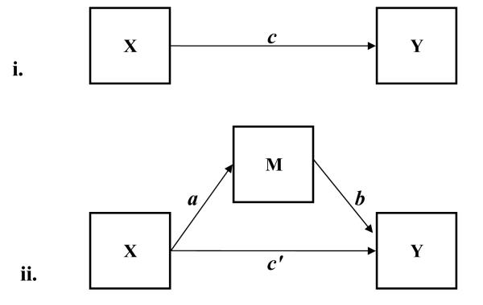
Figure 1. Path Diagrams for (i.) the Total Effect (c) of Independent Variable (X) on the Dependent Variable (Y) and (ii.) the Indirect Effect (ab) of X on Y through the mediator variable (M). Reprinted from “A Graphical Representation of the Mediated Effect”, by M. S. Fritz, and D. P. MacKinnon, (2008). Behavior Research Methods, 40(1), p. 56. https://doi.org/10.3758/BRM.40.1.55. Copyright 2008 Psychonomic Society, Inc.

Note.
c = total effect
ab = indirect effect
c’ = direct effect
Total effect = direct effect + indirect effect; c = c’ + ab

Figure 2
Sobel Test Equation

Sobel test equation: z-value $=\frac{a*b}{\sqrt{b^{2}*s_{a}^{2} + a^{2}*s_{b}^{2}}}$
Figure 2. Formula for conducting Sobel’s test. Adapted from Statistics FAQ – University of Surrey – Guildford, by C. Fife-Schaw, n.d., Retrieved from http://www.surrey.ac.uk/psychology/current/Statistics/ 18091_sobel_small.jpg. Copyright 2017 by University of Surrey, Guildford.

Note.
a = raw (unstandardized) regression coefficient for the association between IV and mediator.
s_{a} = standard error of a.
b = raw (unstandardized) regression coefficient for the association between the mediator and the DV (when the IV is also a predictor of the DV).
s_{b} = standard error of b.

Appendix A: Screenshots of Survey Measures
Note: There were other measures embedded in this survey. This only includes screenshots of the survey that show measures that I used in the current study. The following screenshots show what participants saw when they were completing the survey.

Filter information
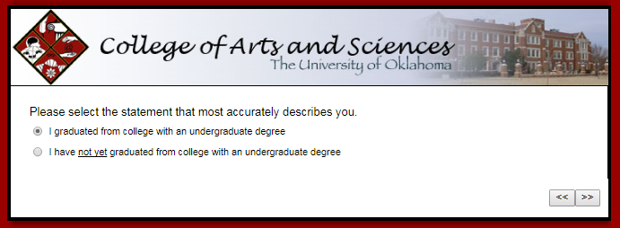
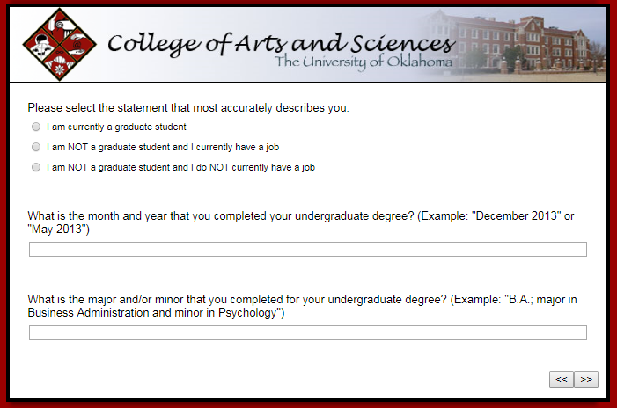
Background information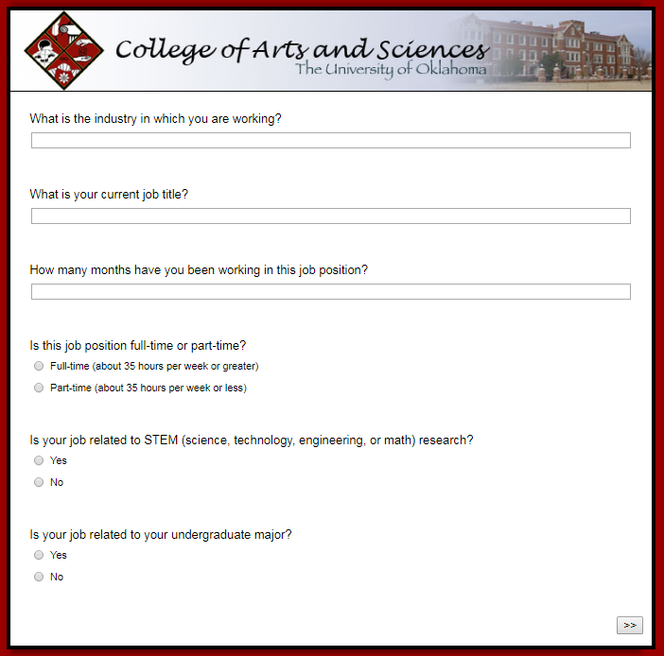Adapted from Grant’s (2008) Perceived Social Worth of Job items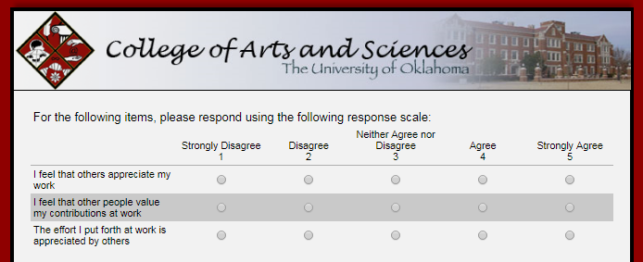

Kelloway, Gottlieb, & Barham’s (1999) Turnover Intentions
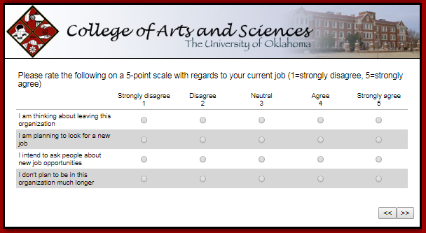

Schwarzer & Jerusalem’s (1995) General Self-Efficacy scale
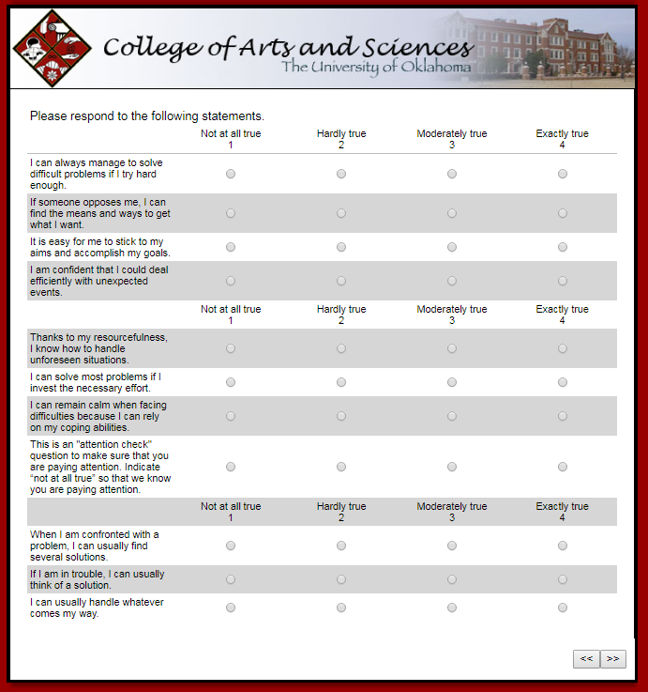

Note. The eighth item in this measure is an example of one of the embedded attention check questions we used throughout the survey.

Spector’s (1985) Job Satisfaction Survey (JSS)
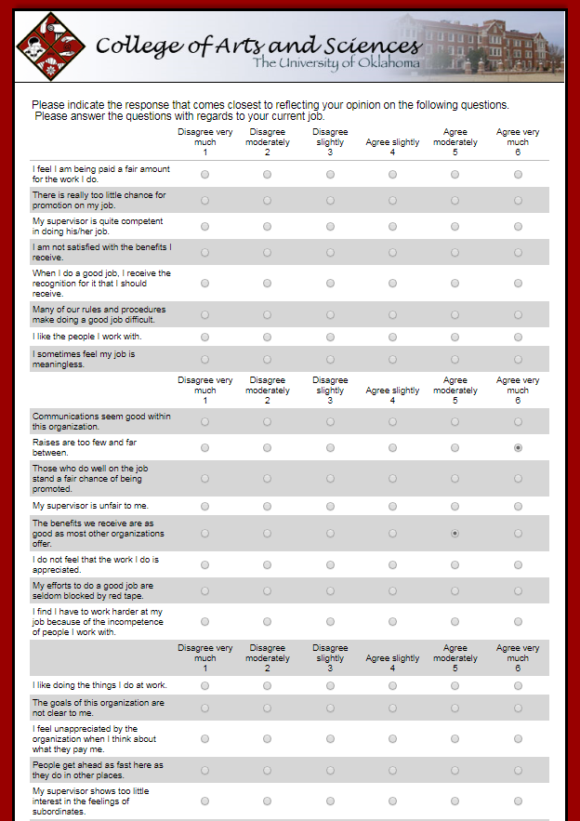
Spector’s (1985) Job Satisfaction Survey (JSS) cont’d
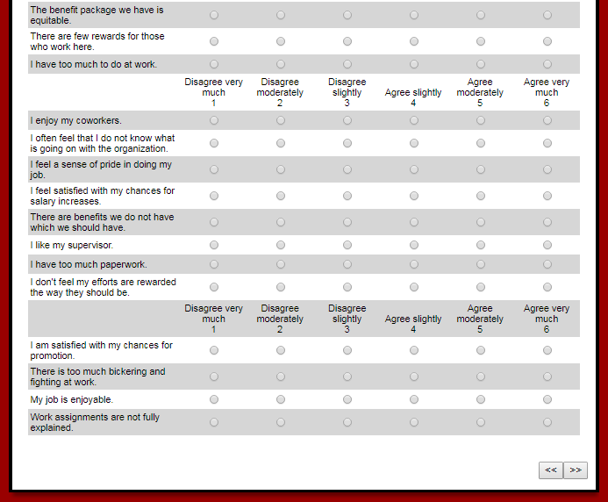

Snyder et al.’s (2010) Incivility from Supervisor or Manager scale
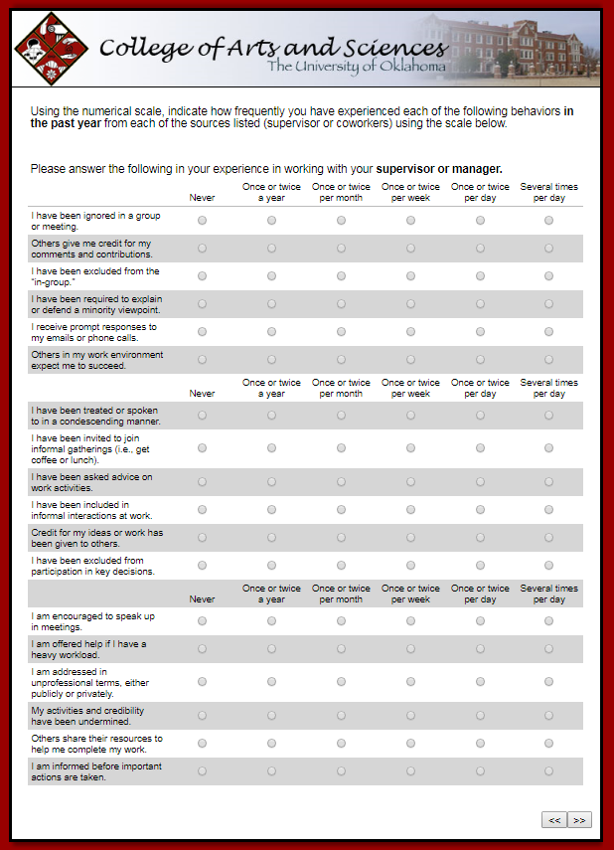

Snyder et al.’s (2010) Incivility from Coworkers scale
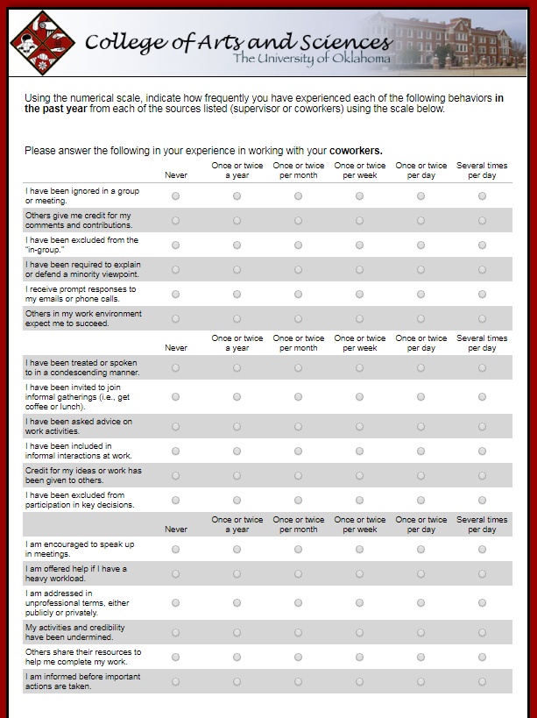

Adapted from Hershcovis & Barling’s (2010) Attribution Measures
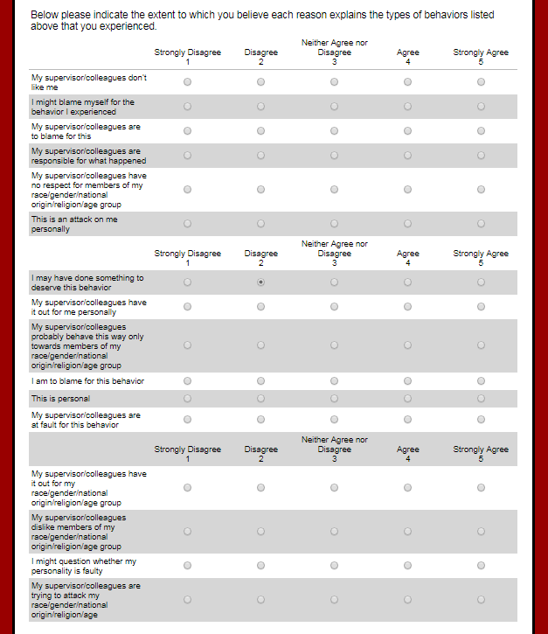

Shirom-Melamed Burnout Measure (SMBM)

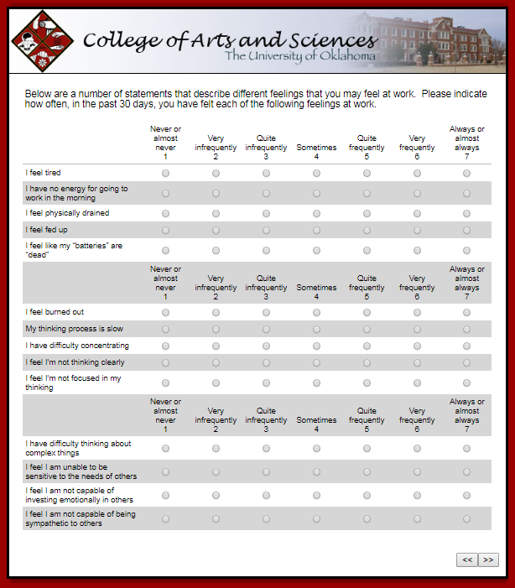

Watson, Clark, & Tellegen’s (1988) Positive and Negative Affectivity Scale (PANAS)
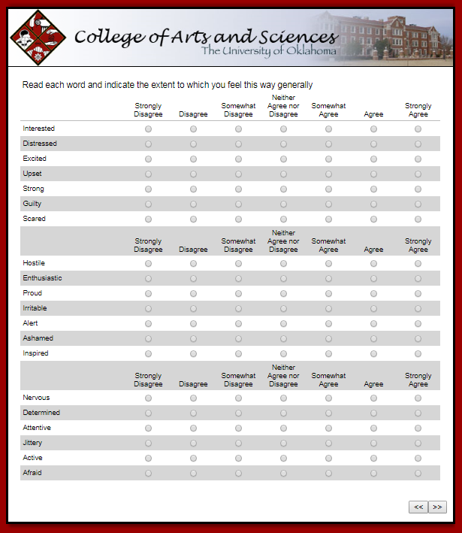
Note: The following three measures (PANAS, ethnic/racial group, and gender) were measured during a previous survey administration, while the participants were still undergraduates.

Adapted from Phinney’s (1992) Ethnic/racial group Item
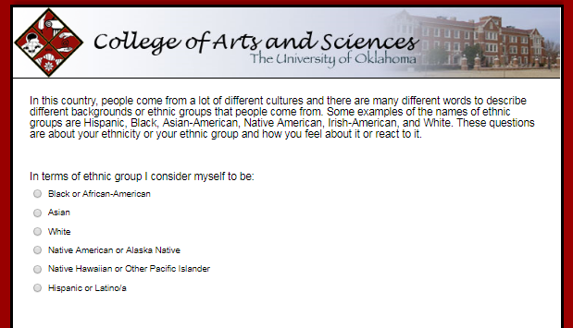

Gender
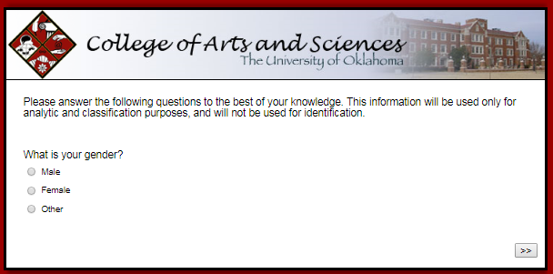

Appendix B: Example Attention Check Warning
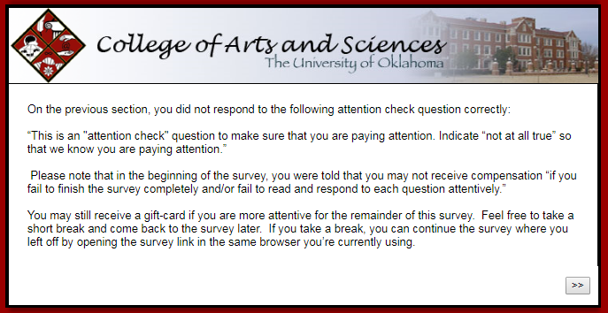

I obtained special permission from the IRB and completed training on the Family Educational Rights and Privacy Act (FERPA) before accessing students’ demographic information from the university’s records.

