University of Oklahoma

Graduate College

Survey of Wind Ensemble Repertoire with Double Bass

submitted to the Graduate Faculty

in partial fulfillment of the requirements for the

Degree of

Doctor of Musical Arts

By

Sungmo Yang
Norman, Oklahoma
2024

Survey of Wind Ensemble Repertoire with Double Bass

A Document approved for the
School of Music

By

Dr. Anthony Stoops, Chair

Dr. Shanti Simon

Dr. Jonathan Ruck

Dr. Allison Palmer

© Copyright by Sungmo Yang, 2024
All Rights Reserved.

Table of Contents
Acknowledgements v
Chapter 1 1
Introduction 1
Purpose 3
Procedures 4
Limitations 6
Chapter 2 7
Survey of Related Literature 7
Database website and video demonstrations 13
Chapter 3 Historical Development of Wind Bands: 14
A:Harmoniemusik Music: 14
B: Military Band and American Band 1950s 17
C: Frederick Fennell’s Eastman Wind Ensemble 21
Chapter 4: Survey of works for analysis. 23
Chapter 5 Audition Repertoire/Conclusion 42
Appendix A 44
Double Bass Repertoire in Wind Chamber 44
Double Bass Repertoire in Wind Ensemble 46
-References 68

Acknowledgements
This project would not have been complete without the help of many people. I am very thankful for the guidance, advice, support, encouragement, and thoughtfulness of my primary professors, Dr. Anthony Stoops and Dr. Shanti Simon. Those who are academically excellent have guidance repertories, analysis between band and orchestra point of view, and throughout the process of my document, as well as the rest of my committee members, Dr. Jonathan Ruck and Dr. Allison Palmer, for your consultation and guidance on the website suggestions.
To all my academic teachers, with special appreciation: Mark Bailey, Jane Ann Bilon, Dr. Benjamin Lorenzo, Dr. Jamal Duncan, Dr. Chris Knighten, and Dr. Robert Mueller. Thank you for inspiring me to learn wind ensemble music and programs. Your expertise and investigation focus as much on my project as an academic as on my journey as a performer.
To my string bass teachers: John Dahlstrand, James Hatch, and Dr. Michael Montgomery, my thanks to all of you cannot be overstated. The time and passion will always be appreciated. It had more of an impact on my life than I could have ever imagined. Thank you for my wonderful formative years as a high school student under your instruction.
A special thanks to who made my dissertation project website, Sean Choi. Lastly, I would like to thank my family, Seung-Chan Yang and Hye-Young Kim, my older sister, Su-jin Yang, and my grandmother, Myong-Suk Park, your passion for life and prayer helped me all the time and continued to fuel my passion for music every day.

Chapter 1

Introduction
Survey of Wind Ensemble Repertoire with Double Bass

The study of the use of the double bass in wind ensemble literature is limited. The double bass itself is a unique color instrument in wind bands, sometimes doubling with either the low brass section or low woodwind instruments, and in more recent repertoire often performing independent parts. Sometimes, wind band composers and conductors lack significant experience with string and especially, double bass technique. This project will analyze and explore various challenging figures from the wind ensemble repertoire that can pose some unique technical challenges to the double bass player in the wind band. In this project, I aim to examine scores of music, define potential problems for the double bassist, and suggest solutions and techniques. I aim for this project to serve as a resource for both ensemble directors and bass students to address the technical issues found in this repertoire. The pedagogical value of these studies is that they provide techniques for the bass player to address unique technical and interpretive skills while playing with winds. Chapter I will include the purpose, procedures and limitations for the study. The bulk of the content for this project will be to create a searchable database website as well as video demonstration of the techniques found in the literature. For each excerpt, the database will include song title, composer, reference links, metronome marking, and key arranged in chronological sequence. Therefore, in Chapter II I will examine related literature and provide links to the database website that I have created for this project. Chapter III will provide a brief history of the double bass in the wind band. Chapter IV includes a selection of often performed wind band compositions with challenging excerpts and technical solutions. This chapter is intended to be used with the website. Chapter V will include recommendations for programming and auditions repertoire for double bass students and Band directors and a conclusion.

Purpose
The amount of information available for a double bass player to prepare for playing wind band literature is limited. Thus, the purpose of this study is to survey a portion of the double bass repertoire in Wind Ensemble. The double bass is a unique instrument in the wind band. According to Richard Franko Goldman, “There is little doubt that the string bass makes a band sound better; the question is only how far one can continue of that principle.” When college or high school students participate in wind bands, they sometimes struggle to interpret the technical requirements accurately. In most band repertoire of difficulty level I to IX, the string bass doubles low woodwind or low brass instruments, but beginning in level IV, the string bass is often much more independent. The proposed document will expand practical and academic inquiry by examining double bass repertoire with winds.

Procedures
This project will examine published selections of wind band scores, identify challenges, provide possible technical solutions and demonstrate the examined double bass techniques through videos catalogued on a website. Each video will include composer, level of difficulty, and double bass technical analysis. Works selected for this list will also appear in one or more of the following sources:
- Frank Battisti's Appendix 1: Twentieth Century Chronology of Selected Wind Band/Ensemble Literature
- Murphy Music Press, LLC Grade Six Concert Band Compositions
- Murphy Music Press, LLC Grade Five Concert Band Compositions
- United States Military Band -Upright/Electric Bass Audition Repertoire
- The Wind Band Symphony Archive
- Wind Repertory Project
Battisti's Appendix 1 has Wind Band repertoire from 1900 through 1994. This work lists each composer’s name, title of the work, and date as found in the original score. Visually, it is easy to see the instrumentation and listen to the whole piece while following along. Murphy Music Press provides band works ranging from grades one to six in terms of difficulty.
The second section of the document, chapter 2, will provide a brief American wind band history with the double bass, describe significant double bass repertoire in wind bands and will seek to address issues specific to string instruments that are prevalent in the repertoire. Recently the double bass auditions for the military concert bands have begun to require wind band repertoire as part of its audition process. This section of the document intends to find challenging repertoire that could benefit musicians of various levels and musical aspirations, whether it be beginning double bass players, band directors, future students curious about learning the instrument, or seasoned professional musicians.

Limitations
The double bass's historical development is too extensive to explore in a limited document like this. Therefore, this study's scope will be limited to select double bass repertoire in wind band. specifically discuss double bass participation. Before 1940, most wind band repertoire was transposed directly from orchestral music and early 20th-century composers simply indicated “Basses” or optional instruments “Contrabass or Contra Bassoon” in their works when it came to double bass involvement.
The selection of compositions in this document is limited to high school or college education level works. These challenging works have a difficulty rating between level 5 to 7. Some of the music is important historical repertoire and some are newer, well-known compositions.

Chapter 2

Survey of Related Literature
This survey of double bass wind ensemble literature examines the various methods, articles, dissertations, and repertoire written of the topic. Few double bass methods have directly referenced techniques for playing with winds.
Richard K. Hansen's book, "The American Wind Band," addresses the historical, cultural, and social contexts of American wind bands. Hansen gives examples of the American wind band, spanning a timetable from the 17th century to 2003. He does this by providing a list of "American Wind Band Music," describing how the military band was divided into concert band and marching band, and how European countries and American music went on to develop further. Hansen provided illustrations that were unlike those found in other wind resources, an example being his inclusion of a photo with string bass in the first Eastman Wind Ensemble (1952).
Frank Battisti's The Twentieth Century American Wind Band / Ensemble: History, Development and Literature, was originally published in 1995. Battisti is a well-known conductor, educator, and scholar. This book explores the development of the wind band beginning from its early origins. Battisti provides the instrumentation of four popular bands: Goldman Band, United States Air Force Band, University of Michigan Band, and Lenoir High School Band. Battisti provides a historical band program from the early 20th century, and it reflects how wind band compositions have changed and grown since the early 20th century.
Robert E. Foster's Wind Bands of The World: Chronicle of A Cherished Tradition was originally published in 2013. This book presents the history of "Band" from the thirteenth century through the end of the twentieth century chronologically. This book also includes how military bands are divided between marching bands and concert bands, as well as the development of wind band literature in high school and college bands. The various chapters break down the evolution of the wind band, starting from the renaissance period to the early 20th century, and does so by analyzing the cultures, societies, the history of band music, instruments, and ensemble at the time.
David Wayne Campo’s doctoral thesis, “Original Music for Wind Band in the Latter half of the 1950’s: An Historical Perspective,” offers a brief history of wind bands in America between 1800 to 1936. Campo surveyed historical wind band literature written as concert pieces for the modern college or high school band. Similar to Battisti and Foster, Campo’s study also examines how the military band is divided between marching and concert bands. This document aims to provide a broader historical view of band literature and how historical wind bands are developing into professional bands. Musically, it does not attempt to analyze historical musical repertoire, but It is an important document because it provides a glance at the history of American wind bands and instrumentation.
Chuck Currie's article "Low Woodwind, Brass and String Section Rehearsals for Wind Ensemble and Orchestra" in Research Gate addresses how the combination of timbres and textures for wind ensemble instrumentation makes it difficult to come up with a rehearsal structure. Currie emphasizes that "String Bass supports the entire band, reinforces the timbre of the tuba, blends well with bass clarinet." Currie provides explanation for Percy Grainger's Children's March, Cait Nishimura's Chasing Sunlight, and Christian Venter's Rocky Mountain Lullaby. These pieces are used as examples to describe how the double bass’s partnership with low woodwind and brass instruments in wind band entire serves to provide balances to the overall sounds.
Brain Scott Wilson’s book, “Orchestrational Archetypes In Percy Grainger’s Wind Band Music,” was published in 2002. Grainger was another notable wind band composer, who clearly divided the string bass and tuba parts in his composition and transcribed his wind composition from the original orchestral music. Wilson explored the original orchestration in three wind band compositions of Percy Grainger; Colonial Song, Molly On The Shore, and five movements from Lincolnshire Posy.
Rodney Winther's book, "An Annotated Guide to Wind Chamber Music for Six to Eighteen Players," was published in 2004. This book lists Wind Chamber music in specific instrumentation, and also includes jazz compositions. Winther organized the general index by composer, title, and instrumentation. Winther summarized problems and suggestions in each section and provided the discography of where or who recorded each work. This book lists historical wind and jazz compositions but lacks each piece's difficulty level.
Barry Green’s book, “The Fundamentals of Double Bass Playing,” was published in 1971. Green offers the bass student the pedagogy to address a specific concept and provides a few exercises to achieve bow techniques: slurring, legato, staccato, and hook bowing. Each bass technique defines the music terminology, follows exercises, and sometimes indicates illustrations. However, Green's method narrowly focuses on the fundamentals of double bass playing rather than specific bass techniques.
Henry Portnoi’s method, “Creative Bass Technique,” was published in 1978. Portnoi was a member of the Boston Symphony Orchestra for 34 years, including nine years as a principal. Portnoi makes a clear table of contents; he provides part I: bow techniques and the fingerboard on the string in part II. Portnoi describes string bass bow exercises: Bow on or off the string, legato playing, marcato or staccato, spiccato, Martele, Detache, Portato, and special effects: tremolo, ponticello, and col legno. This book addresses technical problems through musical and bow exercises.
Murray Grodner’s book, “A double Bassist’s Guide to Refining Performance Practices,” was published in 2013. Grodner’s book is the most recent bass method, and it is a book that complements the pros and cons of other methods. Grodner divided his book into five sections: part I, “Analysis of Physical Performance Technique,” part II, “Bass Techniques Through Employing Scales, Etudes, and Orchestral Excerpts,” part III, “Essays for Double Bassists,” part IV, “Analytical Phrasing and Bowing for Solo Works” and Part V, “Preventable Exercises for Physical Abuses Related to Playing Double Bass.” Some parts may seem like basic bass pedagogy, but it consists of challenges that all levels of performers may still need to conquer. Grodner offers essential bowings: sustained, slurred, staccato, hooked, spiccato, and syncopated bowing. However, unlike Pornoi’s book, this book does not explain specific bowing such as col legno, tremolo and ponticello.
Christopher Keith Dye's dissertation "The Study and Application of Rhythmic Analysis for Wind Band Repertoire" was published in 2006. This dissertation has analyzed a selection of wind repertories for rhythmic approaches and representing compositions for winds and percussion from a wide range of compositional styles. Dye's dissertation mostly focused on rhythmic perspective. In his dissertation, he mentions the rhythmic considerations of bass lines. Dye's dissertation is also useful for its list of wind band repertoire for my dissertation. Dye does not provide the kind of universal insight needed to extend proper score study to all parts of Mozart's Serenade and other selection wind band repertoires.
Bradley Paul Ethington’s dissertation “Wolfgang Amadeus Mozart’s Serenade in B flat, K361 (370a) for Twelve Wind Instruments and Contrabass, “Gran Partita”: Musical Influences and Performance Considerations” was published in 1995. Ethington divided his dissertation into two chapters. First, he analyzed the entire score and musical influences from the contemporary period to later composers. Second, Ethington summarized instrumentation and balance in Mozart's Serenade K361(370a). In both chapters, he contextualizes Mozart's music between other Mozart's Serenades, and he defines how different musical ideas influence the Serenade in B flat. In Chapter 4, Ethington also mentioned the string bass pizzicato.
Paul G, Woodford’s article “An Analysis of Antonin Dvorak’s “Serenade in D minor, Opus 44” was published in 1998. Woodford's article analyzes and discusses Dvorak's compositional practices in the Serenade in D minor. Woodford divided the article into three sections: melody, harmonic materials, and rhythms. Woodford reviewed and summarized some specific melodies inspiration in subsequent movements by transforming melodic and motivic material over time. Woodford found other points that contribute to the musical interest of the work but have less to do with achieving coherence: the ambiguity of tonality, mode, and form. Woodford offers twelve theory examples, but those figures focus on melodic ideas and key structure rather than instrumental analysis.

Database website and video demonstrations
This project includes a published database website found at www.sungmoyang.com. It provides two or three YouTube video demonstrations for each repertory selection. When selecting “Bass Pedagogy” from the website navigation menu you are taken to a page with a searchable database and a list of wind band or wind chamber music repertory. The “Reference Link” navigation button takes you to a page with links to the archives for Murphy Music Press website, which rates the of difficulty of a given composition.

Chapter 3 Historical Development of Wind Bands:

A:Harmoniemusik Music:
Harmoniemusik came from Europe in the 18th century, beginning with the modern symphonic orchestra and symphonic form. It uses a combination of instruments using winds in pairs. “Harmonie” came from German, and it historically designates a small ensemble of wind instruments. Since the string section emerged as the orchestra, composers used winds to provide harmonic support and color contrast to string timbre. Harmoniemusik, depicting the practice, became the accepted name for an ensemble of wind instruments. The Harmoniemusik common instrumentation includes two oboes, two clarinets, two horns and two bassoons.
In the 18th century, some European composers used “Harmoniemusik” style of music, such as Haydn, Mozart, Beethoven, and Krommer. During this period, these composers wrote “Harmoniemusik” which included original works such as serenades, Divertimenti, arrangements and transcriptions or concerti with wind ensemble. In this period, composers wrote that style of music because it was the only source of musical entertainment for celebrities and provided background music at dinners or social events. Mozart expanded the genre to include a divertimento for ten winds and another essential serenade for twelve winds and string bass. Some countries or cities chose different instrumentation when they performed divertimenti and serenades. According to Rhodes, “The contrabassoon was used in Vienna, while Rosetti played the violone at Öttingen Wallerstein. In the 19th century at Sondershausen, both the trombone and basshorn were used. The title page of the Vienna edition of Krommer's Harmonien calls for "grosse Fagott" while the French edition asks for "Trombone ou contrebasse." Mozart, in scoring for contrabass in his B-flat Serenade, wrote markings of pizzicato and arco, which means he clearly wanted the string bass rather than a non-string substitute.
Dvorak was highly influenced by Mozart’s Gran Partita and he composed to Wind Serenade in D minor in 1878. Dvorak began a work of the same genre and followed Mozart's work. Dvorak is used in addition to wind instruments and adds more bass lines. Although the Adagio of Mozart's Serenade inspires the introduction to the third movement, Dvorak wrote a remarkable work in its overall expression, quite unlike his source of inspiration.
After the Dvorak period, several composers composed Serenade for winds, for example, Strauss's Serenade (1881) Emil Hartmann's Serenade (1888), Arthur Bird's Serenade (1898), Wilhelm Berger's Serenade (1910), Sigmund Romberg's Serenade (1924), and Alfred Reed's Serenade (1966).²² Some composers did not add string bass in their original works but included it in their compositions when rearranged music.
In the 18th century, composers explored the range of sounds of the wind families. Harmoniemusik laid the foundation for the artistic development of wind music. Early composers' writing of wind band music literature influenced later composers such as Mendelssohn, Berlioz, Sousa, Holst, Vaughan Williams, Charles Ives, and Percy Grainger to compose wind band music at the professional level.
Someone who heavily influenced American wind Chamber music was French Oboist Georgy Longy. In France, he started as a member of Société de musique de chambre pour instruments à Vent which was a traditional wind chamber ensemble. His teacher, George Gillet was also a member of this ensemble. Longy moved to the U.S. to take a job as a member of the Boston Symphony Orchestra and founded his "The Longy Club" in 1900, influencing the musical activities of Boston. The “Longy Club” began giving concerts from 1900 to 1917, and they performed original wind music repertoire in those concerts. Through the “Longy Club,“ he highly influenced the American wind chamber music revolution. He also founded the Longy School in Boston to provide comprehensive training in musicianship and performance in the Paris Conservatoire model. According to Battisti, “It was an ensemble that enthusiastically supported contemporary music and performed all it concerts with the very highest level of artistic integrity.”

B: Military Band and American Band 1950s
The U.S. Marine Corps “President’s Own” band was founded in 1798 and military bands continued to grow during the 19th century. The late 19th century saw the development of the American Professional Band from 1880 to 1930. After that, the military bands split into the professional concert bands and the marching bands.
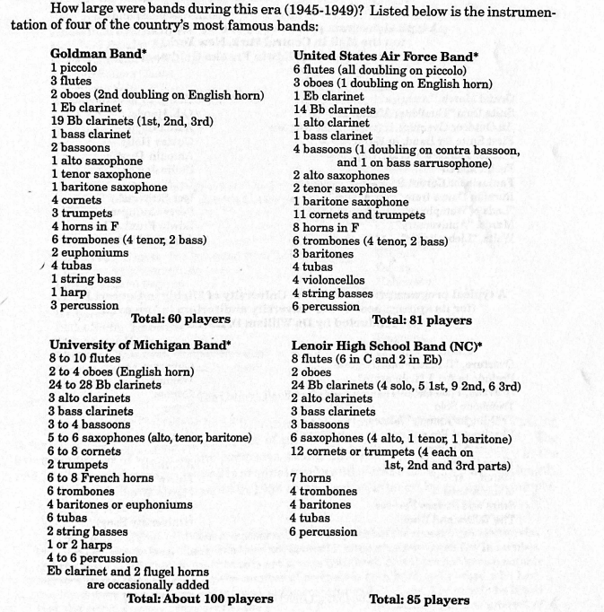(Figure 1)
Figure 1 indicates total players from four wind bands between 1945-1949. Some wind bands include a 2 or 4 string bass player requirement. According to Richard Franko Goldman, “To current practice, the band may also include some stringed instruments. The use of string bass and the harp is general, and the violoncello is now occasionally added.” Other string instruments are based on the particular color of their sound by itself and are easy to transpose with woodwind and brass instruments. Still, the string bass, aside from great agility, gives the impression of greater clarity concerning pitch. According to Goldman, “we may reiterate that the string bass and ‘cello’ are ‘helpers’ only in the wind band, not essential elements of the ensemble as they are in the orchestra.”
The Sousa era (1880-1925) was the "Golden Age" of the American professional bands. Bands and band music became the nation's favorite popular form of entertainment. Sousa used a method that made him very popular: whether it was a well-known song or a classical masterwork, everything was performed perfectly. According to Battisti, “Frederick Fennell describes Sousa as “the god of the American concert band world” It is interesting to not that Sousa modified the brass band by adding a harp, more employees woodwinds, and used fewer brass and percussion instruments.
One of the most creative wind band composers, Percy Grainger, adopted a distinctive identity among composers by including a phonograph in a collection of folk tunes. He uses folk music extensively in his work for the band. For example, Lincolnshire Posy, Irish Tune from Country Derry (Molly On the Shore,) and Shepherd’s Hey show his masterful use of wind instrument scoring techniques.
According to the Wind Repertory Project, there are 1,214 transcriptions following the original works from the orchestra tune to the wind band. Some of the wind repertoire was originally written for band, but in the late 19th-century to early 20th-century compositions were either orchestra tunes or concertos arranged to different tunings that were more idiomatic for winds. Many band directors also include soloistic concerto repertorie in their band program list.
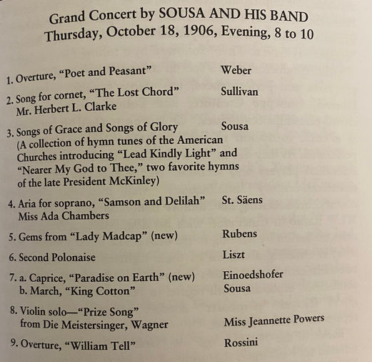 (Figure 2)
Figure 2 indicates Sousa’s Band programs in 1906. Sousa composed his own music, and some music was originally for orchestra and arranged for the wind band. Sousa also included soloistic music in his music programs; later, many military bands included soloistic concertos with wind band accompaniment in their wind ensemble.
Concerning the bass in the late 20th century, many modern composers composed so that the bass doubles with tuba. However, sometimes they didn’t transpose correctly between tuba and string bass, since the string (double) bass plays an octave higher than written-this makes the part more challenging to read. Composers such as Sousa and Goldman often adopted the term “Basses” or “Bb Bass.” Which is potentially confusing for tuba and string bass players due to the discrepancy in notation.
Later composers also arrangement orchestral works for wind band. For example, R. Mark Rogers who was an American composer, arranger and conductor arranged the Overture to "La Forza del Destino." The original orchestra tune (Figure 4) is in E minor/Major, but Roger’s arrangement for band is in E-flat minor/Major easier key for band.
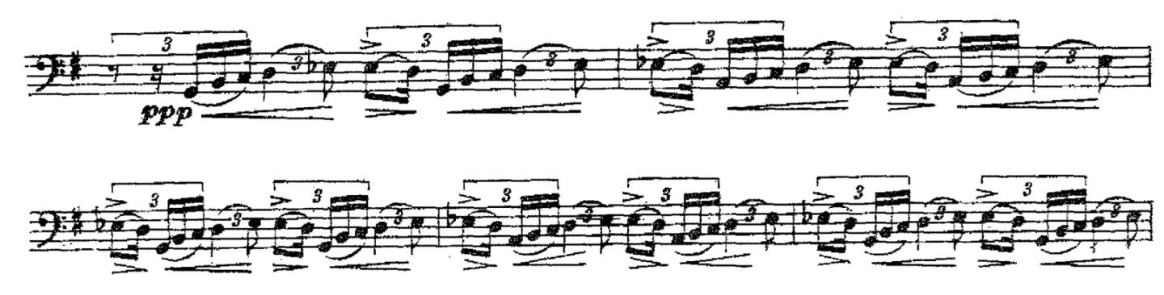(Figure 4)
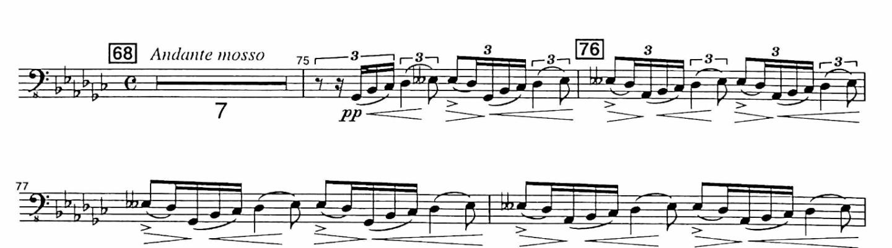(Figure 5)
In this arrangement the upper woodwind and brass play the violin and viola parts and the lower woodwind and brass parts play the cello and bass parts.

C: Frederick Fennell’s Eastman Wind Ensemble
Before 1952, concert bands typically had 80-100 players. When Frederick Fennell founded the Eastman Wind Ensemble in 1952, he essentially merged the traditions of soloistic Harmoniemusik and large military bands, creating a new model for wind ensembles. He adopted a smaller instrumentation of around 50 players, consisting of undergraduate and graduate students at the Eastman School of Music. Utilizing the Harmonimusik concept of one-player-per-part, Fennell intended to establish a more artistic palette for composers.
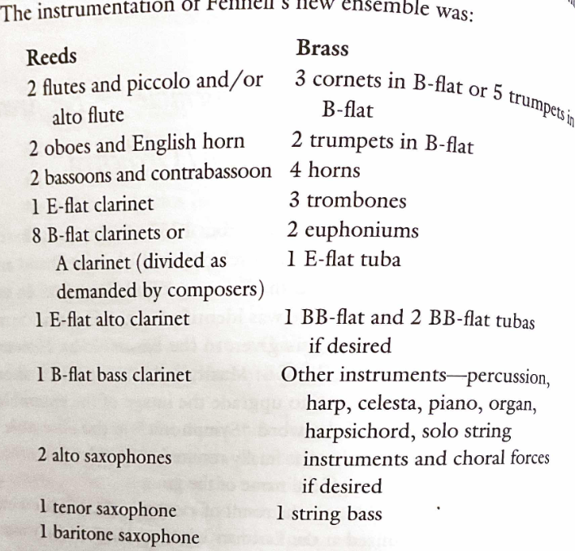 (Figure 3)
Figure 3 shows what is now considered the standard wind ensemble instrumentation. According to Battisti, “Frederick Fennell’s intention was to create a ‘sound resource’ available to composers wishing to write music for the wind ensemble.” At the same time, the College Band Directors National Association and the American Bandmasters Association were working to establish and define a standard instrumentation for wind bands. Fennell's wind ensemble concept stimulated the function and musical quality of wind repertoire.
After 1953, several composers began composing original wind band repertoire. For example, Ingolf Dahl's Sinfonietta (1969), Aaron Copland's Down a Country Lane (1962), Karel Husa's Music for Prague (1968), Alfred Reed's Armenian Dances Part one and two (1972), and Vincent Persichetti’s Symphony No. 6 Op 69 (1956).

Chapter 4: Survey of works for analysis.
Mozart’s Serenade No. 10 in B flat Major
The Serenade No.10 in B flat major, K 361/370a, is a serenade by W.A. Mozart for thirteen instruments: twelve winds and string bass. Subtitled Gran partita, this seven-movement composition was composed in 1781. This composition is important to music history (and to this project) because it is one of the earliest pieces for one string bass and winds. In this piece, Mozart indicates dynamics such as forte-piano, slurs, staccato, and trills, but he does not suggest bowings for the string bass. These dynamic and phrase marks help woodwinds because they can control instrument texture and dynamics and they can play long lines with their breath. However, the string bass needs bowing indications because sometimes the phrasing slurs are too long. Dynamics are another factor to consider in bowing selection.
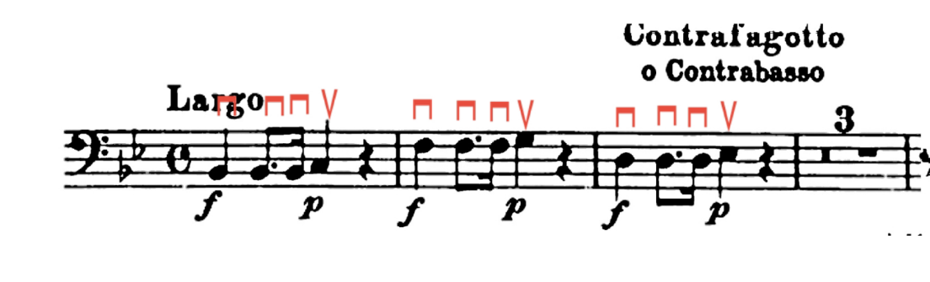(Figure 4)
In the first movement, in bar 1 to 2, Mozart marks the dynamic to forte on the first quarter note and then piano on the third beat. If the bass performer plays the instinctive bowing, (down, up, up, down,) then the third beat will be too loud, (as there is a tendency to accent down bows) and it will not match the music. I suggest two down bows on the first and second beats and performing "up" on the 3rd beat of the bows. In addition, Mozart wanted a dynamic effect for the forte, and the last note was the piano, using bow speed to increase the dynamics with a little bow for the piano. Of course, this all depends on the complete score edition or conductor’s interpretation.
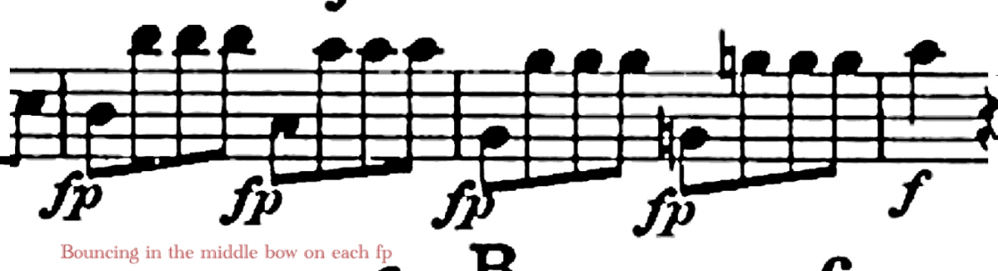(Figure 5)
There are other articulation issues in measures 35 to 36 and 159 to 160. Both excerpts have fp (forte-piano) on the first and third beats on the eighth notes. The bass player should think of these “accents” within the dynamic of piano. The player should play staccato, which is an “on the string” bow stroke with the stick bouncing in the middle of the bow. To create the fp, use slightly more bow on each fp.
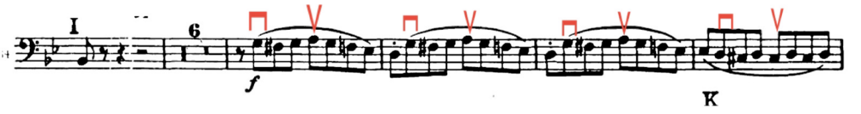(Figure 6)
Finally, there is another dynamic issue in measures 191 to 194; bassoons, oboes, and bass clarinets double with the string bass, but they have an accent on the third beat. The bass does not show the accent in the complete score. Of course, it depends on if the conductor wants to accent each third beat 8th note to match the winds. In this case, the string bass should break the slurs starting down bow and use a “bow speed accent” on the up bow. After that, in measure 197 to end, the bassist should play on the string, bouncing the bow strokes since there are no slurs.
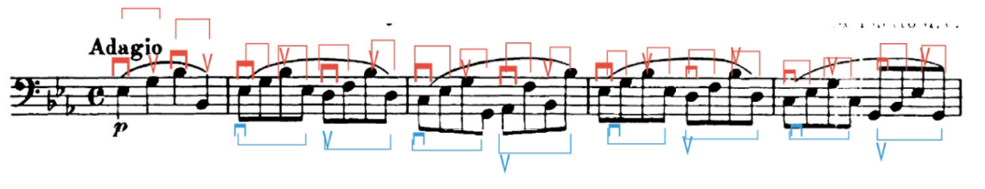 (Figure 7)
In the third movement, Adagio is slower than the previous Trio II. This movement does not have articulation issues, but one thing to suggest is the bowing in measures 2 to 40. There are long slurs for each measure, and it does not necessarily mean to play one each bar. There are two options: the first should play two slurs per bar with the two bows starting on down and up bow strokes, and the second should skip the slurs and play all the separate bows, but that depends on the conductor's decisions.
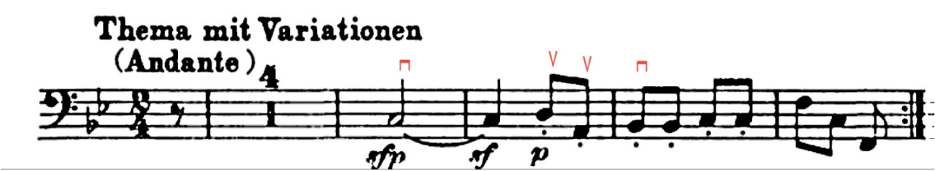(Figure 8)
In the sixth movement, sfp or sf appears in measures 5 and 6. To perform sf, use more bow speed, then immediately slow the bow and then a faster bow stroke in measure 6 on the second sforzando with the two up bows to get the bow back to the middle in measure 7.
Antonin Dvorak’s Serenade in D minor
Antonin Dvorak's Serenade in D minor, op 448/B.77 was composed in 1878. The instrumentation is two oboes, two b-flat clarinets, two bassoons, two horns in F, two other horns in B flat, violoncello and string bass. All the movements are doubling with violoncello or bassoons, or contrabassoons for the accompaniment. Dvorak does not indicate bowing for the string bass and cello; both low-string instruments have accents, dynamics (f, ff, p, and pp,) diminuendos, and crescendos, but the score does not provide significant bowings and fingering numbers. For example, in the first movement, measure 3 to 4, 8, 24, 27, and 61 have accents on the 8th or 16th notes. All the woodwinds and horns can perform with the air controlling the accent, but the strings could not accent each rhythm. If the low string should accent the first and third beats in each measure, then it should be possible to perform with more balance in the composition.
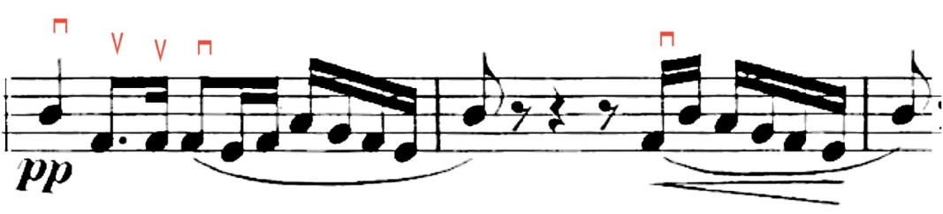 (Figure 9)
In the first movement, four measures after letter F, there is a pp until the end of the first movement. For this part, the low string players should play near the fingerboard in the middle to the tip of the bow, with little pressure on the strings.
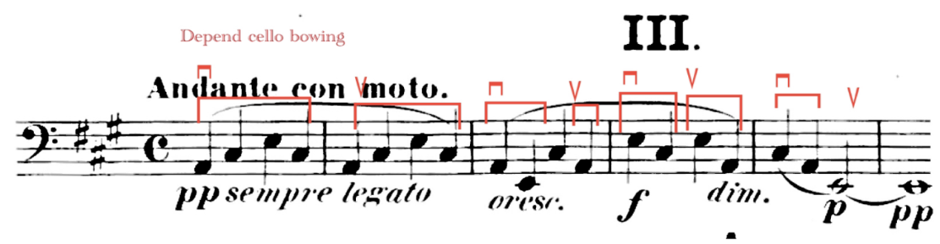 (Figure 10)
In the third movement, starting in measures 1 to 37, there are long slurs for each transition. I think it depends on the bassist’s level and bowing skill as to whether they can play one bow in measures 1 and 2. If not, I would suggest one bow in each measure 1 and 2, or one bow every two beats. The red slurs on measures 3 to 5 it depends on the bass player, tempo and interpretation as to how hard it is to play the printed bowing. If they are having trouble, separate bowing for each note will be a good solution. Also, measure 5 and 6, two notes (C and A) are down bows, long E will be up bowings, and make sure to play near the fingerboard because the dynamics are still pianissimo. The cello player may want a different bowing than my solution; to avoid conflict, one should follow the cello bowing.
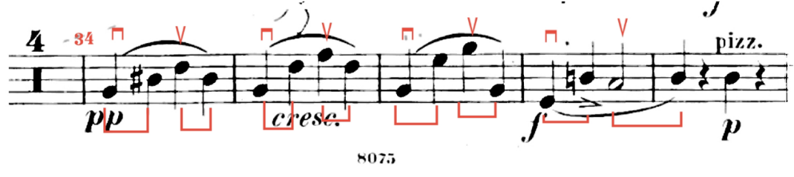 (Figure 11)
There are other bass technique issues in the same movement, measuring 37 and 38. Dvorak composed forte with the one bowing until measure 38 first beat D, and this is a challenging bowing technique because there is an accent on beat two (D natural) from measure 37 and half note C. Measures 37 and 38 should be played by slow bowing first quarter note (G), then fast bowing the second beat (D) and half note C# up bow. The bass player should make a short accent on D with the fast bow speed, which means the second beat D bows faster than the first and third beat bowings.
Percy Grainger’s Molly on the Shore
Third, I want to describe the composition Percy Grainger’s Molly on the Shore. In this composition, the bass mostly doubles the low woodwinds: bass clarinets, bassoons, and contrabassoons. In this edition, the musical terminology is written easily for the conductor, but it is difficult for the performer because some terminology is written differently. For example, Grainger wrote “louden” or “louden lots.” These things are unusual to the musicians and humorous as well. Grainger also wrote “plucked” and “bowed,” depending on how he wanted to sound on the bass, but it should be easier to understand that bass performers will write “Arco” and “Pizz or Pizzicato.”
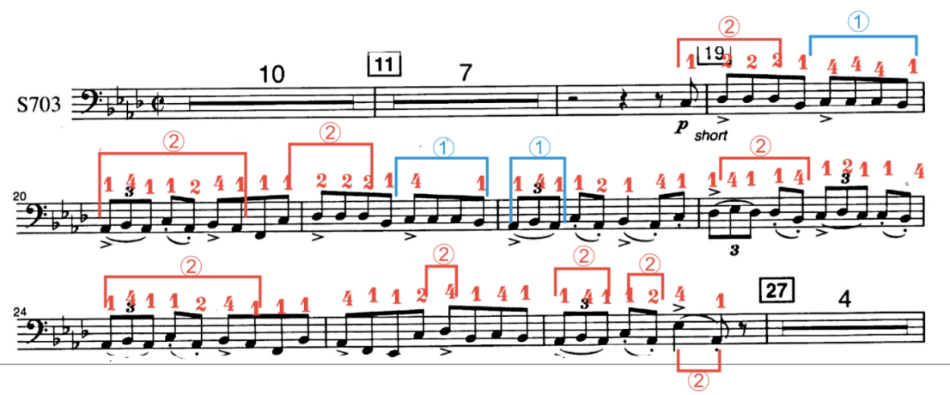
(Figure 12)
I think these pick-up measures 19 to 26 are the most challenging in this entire composition. The tempo is half note between 112 to 126 in Ab major, which is a difficult key for the string bass. In measure 25, the low Eb should be played an octave higher, unless they have a C extension or a 5-string bass. This part should start in the second position on the A string and return to the first position. In measure 20, play the triplet in the second position on the E string, and measure 21 back to the A string, but in the same position as previous measure 20. Also in measure 23, play the triplet on the A string, but for the first B flat, cross to the E string and play the fourth finger.
As we know, bass players have two different bows: German and French. The bassist will sometimes put their bows down or on the stand when playing extended pizzicato passages as long as there are adequate resting times to switch back to arco. Extended pizzicato passages are particularly prevalent in this bass part. After measure 27 to the end, there are a lot of pizzicato notes that require the bassist to hold the bow while plucking the string rather than setting the bow down.
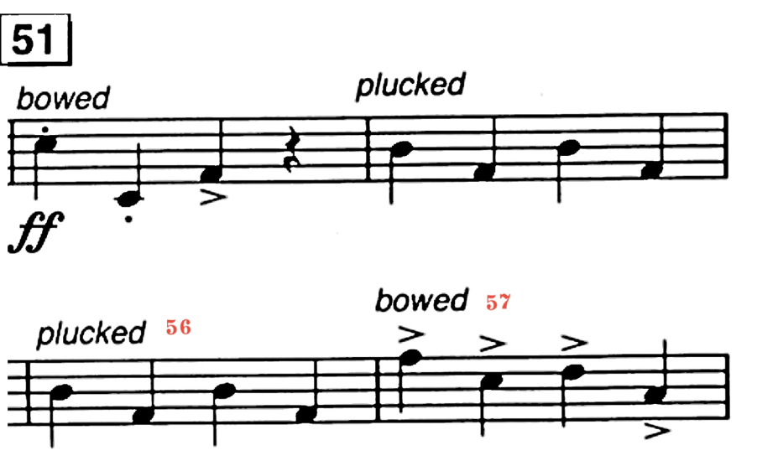(Figure 13)
If the player is using the German bow, the tip will face the floor while playing pizzicato. The ring finger and pinky will go inside the frog to support the bow. It frees up the inside and the middle finger to pluck the pizzicato for the passages of the music, where the player must quickly switch from arco to pizzicato for only a few notes. It is common to reach around the bow slightly with the index finger to pluck the string while keeping all other fingers in the same position. If the bass player is using the French bow, the first thing is to lift the bow off the string slightly and hold the bow with pinky and ring fingers. The tip will be pointed up and the player can use first second fingers to pluck the string.
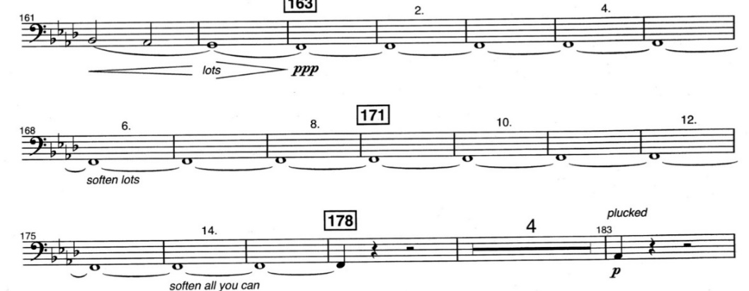 (Figure 14)
In measure 161 to 178, there are long slurs with the crescendo and soften (ppp.) I would play one bowing each two measures and play on the fingerboard string. Grainger also written “soften lots” and “soften all you can” measure 168 and 176. I highly recommend performing near the fingerboard for this.
Steven Bryant’s Ecstatic Waters
Ecstatic Waters (2008), composed by Steven Bryant, is a 21st-century composition. It is divided into five movements and uses pre-recorded cue signs throughout. This music also does not indicate specific bowing and bow techniques and calls for some challenging techniques. For example, the fourth movement, in measure 448 to 450, has a "Ghost Note." It depends on the bass player how to specifically play the "Ghost Note," which is a note without pitch. Often, less experienced bass players do not know all the bass technique tricks such as “Ghost note,” “Ponticello,” “Col legno,” “Tremolo,” and “Glissando.” These tricks are often used in modern music and are important to learn. In addition, this composition has a soloing string bass section and does not double low brass or low woodwinds.
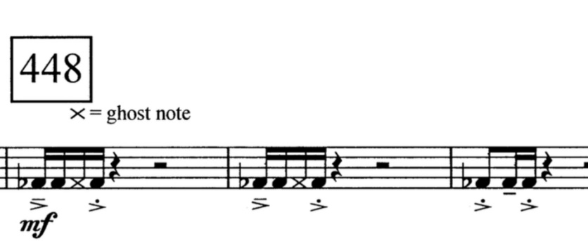 (Figure 15)
In the fourth movement in measure 448 appears the ghost note. To play the ghost notes, the bass player should rest the left hand over the string to deaden it and pizzicato with the right hand. Another way is to dampen the string with the fingers of the right hand. The first finger is against the string, and the second finger plays the muted note, followed immediately by the first finger sounding in the actual pitch.
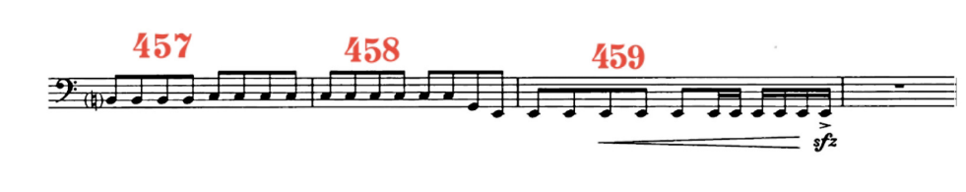(Figure 16)
Another technique issue is same in the fourth movement between measure 458 to 459. Especially in measure 459, composers want to crescendo with the sfz. The string bass has sound limitations if playing the pizzicato. If playing with the bow, we can do accent or sfz bowing, but with pizzicato, the sfz will be a challenge to perform. In measure 459, get close to the end of the fingerboard and not go off the fingerboard to make the crescendo.
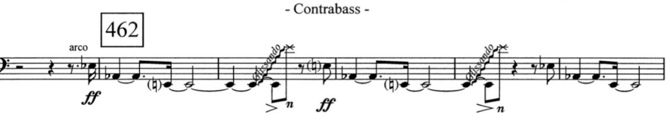(Figure 17)
Same movement, pickup to measure 462 to 466 indicates the glissandos. This part starts on low E to the E two octaves higher. To perform this, stay on the E string, pressing the finger of the left hand down the string to make a swooping sound.
Edgar Varese’s Octandre
Octandre (1972) composed by Edgar Varese is another chamber wind composition including the string bass. The instrumentation is: flute (doubling piccolo), oboe, clarinet in Bb and Eb, bassoon, horn, trumpet, trombone, and string bass. This composition uses mostly naturally occurring sounds of all the instruments; except the string bass plays the glissando in the highest register. The first and second movements are the most challenging because the first movement uses the thumb position (upper register) with the pizzicato. The second movement requires limited dynamic glissandos and needs different tuning or five strings of the bass.
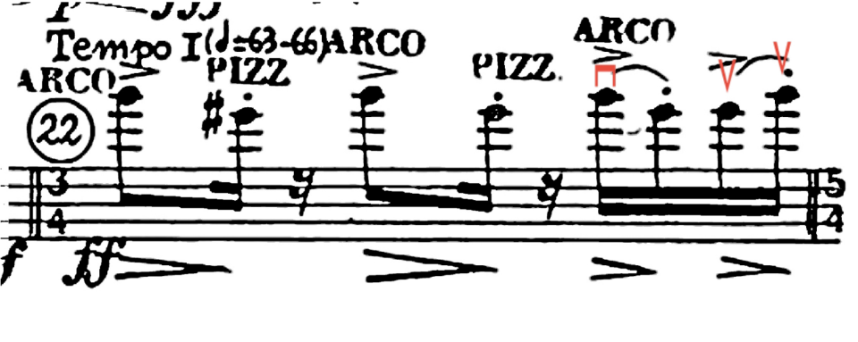(Figure 18)
The first movement has a lot of meter changes: 4/4, 5/4, 7/4, 3/4, 6/4, and 2/4. However, the string bass does not play much until measure 19. The player must be prepared for the first entrance in measure 6. Also, in the first movement, measure 22 challenges the bass part more than the entire first movement because this measure needs to focus on the thumb position with the same position for each note and immediately change to arco and pizzicato. In addition, the same measure 22 from the third beat starts on a down bowing and two up bows in the same bowing, which helps the dynamics: decrescendos, accents, and staccatos.
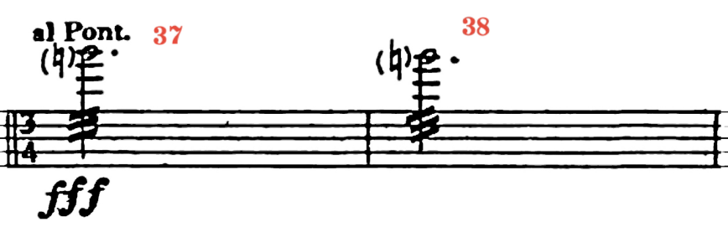 (Figure 19)
In the second movement, measure 37 and 38, there is "al pont," which is another bass technique, ponticello. Varese also wrote the dynamic fff, which is not a possible dynamic because ponticello is a special effect, producing a metallic sound with a limited dynamic range. It is hard to play ponticello because of its limited dynamic range. I recommended playing this without the ponticello and near the bridged to play fff.
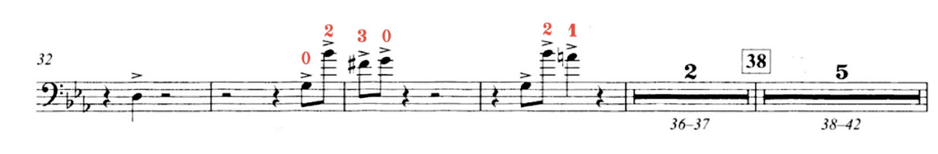 (Figure 20)
Another bass technique issue is in the same movement in measures 77 to 80. There are low C and B natural whole notes until the end. These measures are problematic because many bass players need the lower C extension or five strings bass. Without these, one should either tune the E string down to low C or play an octave higher C and B natural double stops (chords) on the bass. However, this option is quite challenging.
Karel Husa’s Music for Prague (1968)
Music for Prague 1968 composed by Karel Husa, has four movements totaling 18:30. In this composition, the first movement is the most challenging because there are double stops (chords,) no bowings indicated, and glissandi. Glissandi are indicated in the first and fourth movements. The fourth movement glissando is a slightly different concept than any other composition we have talked about, because it descends from G# to the lowest E, which I’ll address later in Figure 23.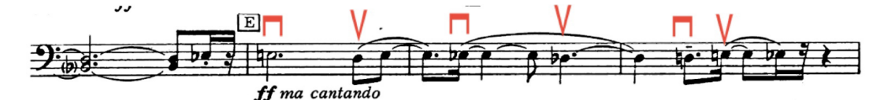 (Figure 21)
The first bass technique issue is before the letter E: double stops (chords.) My suggestion for the double stops (chords) is to practice slowly and be extremely careful of the player's intonation. Sometimes bass players avoid practicing double stops because they fear the sounds they may produce. In the composition, I suggest playing the open D string on the top note and B flat in half position on the A string because the next measure can be easily played in the same position on the D string.
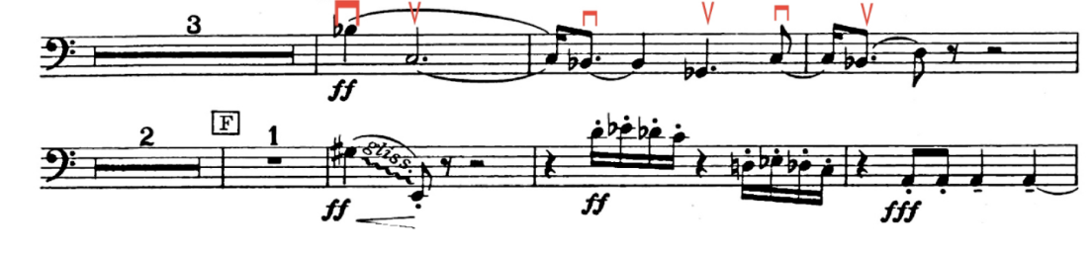(Figure 22)
Husa or other band composers need to give specific bass bowings in their compositions. In the first movement, the tempo is adagio. At letter E, the whole phrase has long slurs over each measure. One should break the slurs and play the new bowing indicated in the example above. Because Husa wants a ff dynamic for this entire phrase.
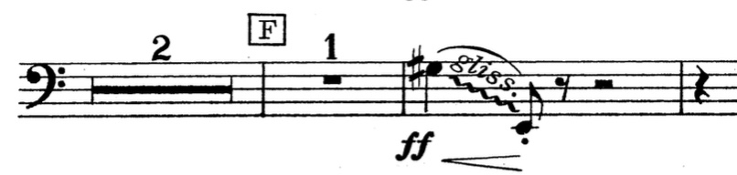(Figure 23)
The next glissando is two measures after letter F. These descending glissandos are also indicated in the fourth movement from three after letter M. One should play all on the E string starting in the fifth position G# to E because if we cross the strings from the G string to the E string, the sound is broken and it is harder to play. The best suggestion will be to play only one string instead of crossing the bowing.
Frank Ticheli’s Angels in the Architecture
Angels in the Architecture (2008), composed by Frank Ticheli, is a grade 6 level. In measure 23, Ticheli indicates FFF and accents on each note. The bass player should play a "marcato" (or ‘marked’) bow technique. This technique produces an accented and big sound on the bass.
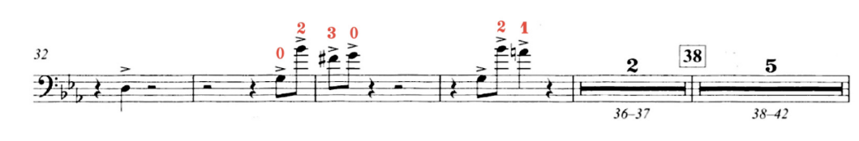(Figure 24)
As we see above in the figure, the first bass technique issue is in measures 33 to 35. The notes on the fourth beats in measures 33 and 34 are G-B-F#-G; the bass player should play marcato bow strokes and keep the left-hand position to measure 35. In addition, Ticheli also wants to accent each note. To do this, play close to the bridge with the bow.
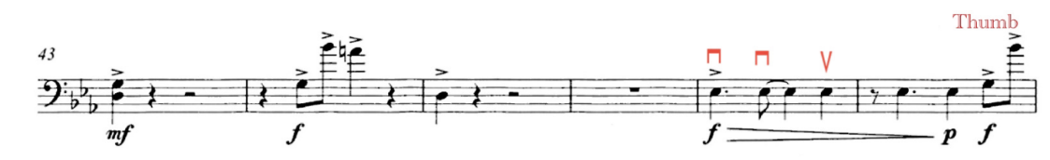(Figure 25)
In measures 47 to 48, Ticheli did not give specific bowings. One should play two down bows on the first and second notes and an up bow on the fourth beat. Measure 48 is the most challenging part of this entire composition because the last note is a high B, and the player needs to gets ready for the thumb position to play the last note, G-B.
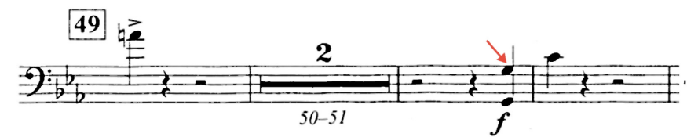(Figure 26)
Measures 52 and 53 are problematic because Ticheli composed double stops, with two Gs, and a C in the next measure. This double stop is not actually playable on the string bass. In this case, the player should play the top note. The rest of the double stops indicated are technically playable if the player has a C-extension or five-string bass. If they don’t, then the player should play the upper note.
David Maslanka’s Traveler
Traveler (2003) is a wind ensemble composition written by the American composer David Maslanka. This composition also does not have the specific bowings like the other band composers' compositions, but it does have a lot of pizzicatos. In addition, this composition uses tenor clefs which can often be a challenge for less experienced players and therefore a challenge for sight reading. This composition also indicates lower C in specific measures, and one should play an octave higher if the bass player does not have the five-string bass or C extension.

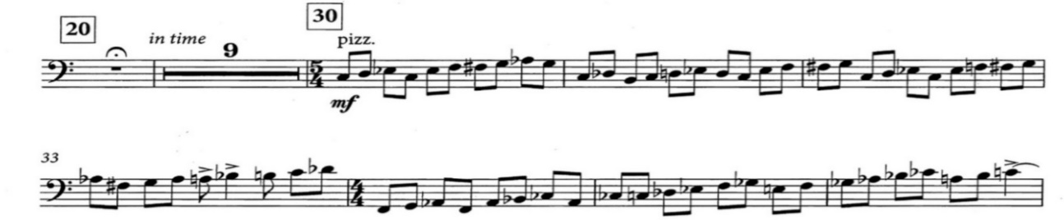
(Figure 27)
Measure 30 to 36 have pizzicato phrases; this part contains many challenging chromatic passages, and there are no rests. To play this phrase, put the bow on the stand, and use alternate first and second finger pizzicatos.

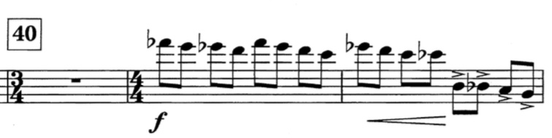 (Figure 28)
The second bass technique issue will be in measures 41 and 42. These measures are similar to the previous example because these measures also need alternating first and second-finger pizzicatos. It also needs the thumb position and in measure 42, accents on the third and fourth beats. In this measure, pull the string harder than the first and the second beats in order to produce the accents.
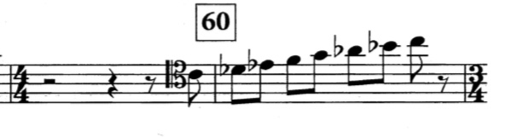 (Figure 29)
In the pick-up to measures 60, tenor clefs is indicated. bassists struggle to read the tenor clef instead of the treble clef because the clef is unusual in earlier grade repertoire, the band compositions. To learn tenor clef, I suggest finding the middle C, which is in tenor clef is represented by the fourth line of the stave and finding the next notes from three.
Neal Endicott’s Chamber Symphony No.1 (2021)
Chamber Symphony, No.1 (2021) composed by Neal Endicott has three movements and a duration of around 15 minutes. This music is challenging to high school students or first- or second-year college students because there are various advanced bass techniques such as double stops (chords), glissando, harmonics, and thumb position. Usually, the string bass part in the wind band compositions is doubled with other low brass or low wood wind instuments. However, in this composition, the bass part is more independent.
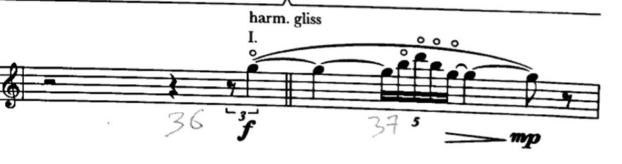
(Figure 30)
One challenge of this piece is the confusing notation. For example, in measure 36 and 37 the composer indicates “harm. gliss” but notates articulated notes. In this case, the bass player should ask the conductor and/or composer about the specific technique. If glissando is the chosen technique, then play glissando on the G string in the upper register. If articulated notes are desired, then start with thumb on the G where indicated.
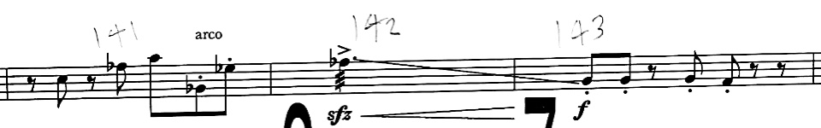
(Figure 31)
In the same movement between measure 141 to 143, the string bass performs an arco accent with descending glissando and sfz crescendos until m143. The bass player should play in the first position in measure 141. In measure 142, the glissando should drop over the A string with the tension of the bow until measure 143.
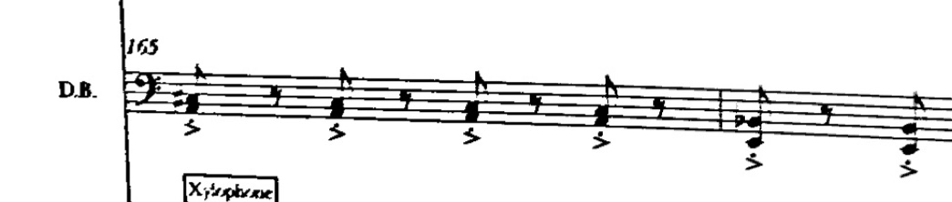
(Figure 32)
In measure 165, to the end of the first movement, the string bass part indicates double stops (chords.) I would play C# on the A string with second position and cross on the E string with the fourth finger on A. Also, in measure 166, there are Bb and E double stops; I would stay in half position on the A string and open the E string. In addition, Neal Endicott composed an accent for each note. In this case, I would play all down bows for each note.
Omar Thomas’ Of Our New Day Begun (2015)
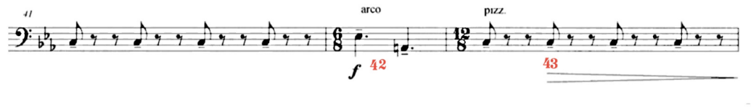
(Figure 33)
Of Our New Day Begun (2015) composed by Omar Thomas is easier for the bass player than previous examples because this music is mostly doubled with the low brass instruments. However, Thomas does not give the bass player specific directions, and some of the music articulation terminology needs to be corrected. For example, in measure 43 the string bass plays pizzicato with an accent on each beat. The articulation written is tenuto. However, this is only possible to play with the bow since pizzicato has a limited variety of sounds.
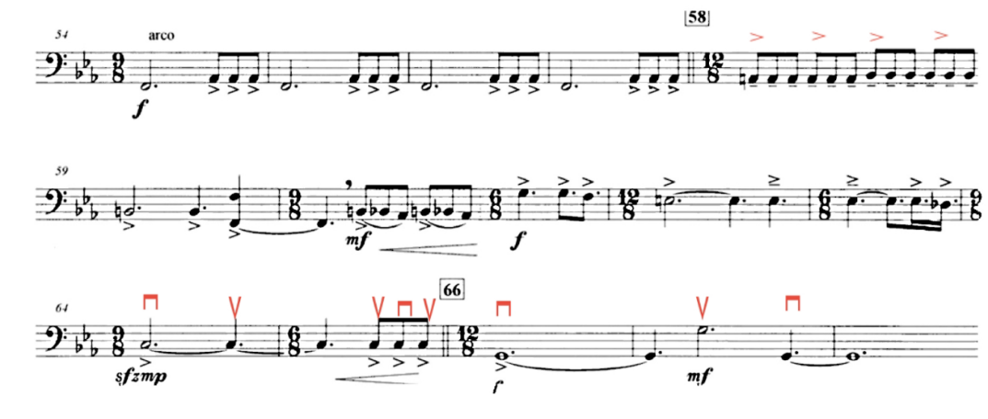
(Figure 34)
Between measure 54 to 63, Thomas indicates accents on each eighth note triplet. It will be challenging if we play all down bows for each eighth-note triplet because there is a longer dotted half note on each beat one. Instead, play detache bowing “as it comes” (down, up, down, up) and play near the bridge. In measure 64 to 68, I recommended breaking the slurs and following my bowings because sfz-mp is hard to play if we play one bow.
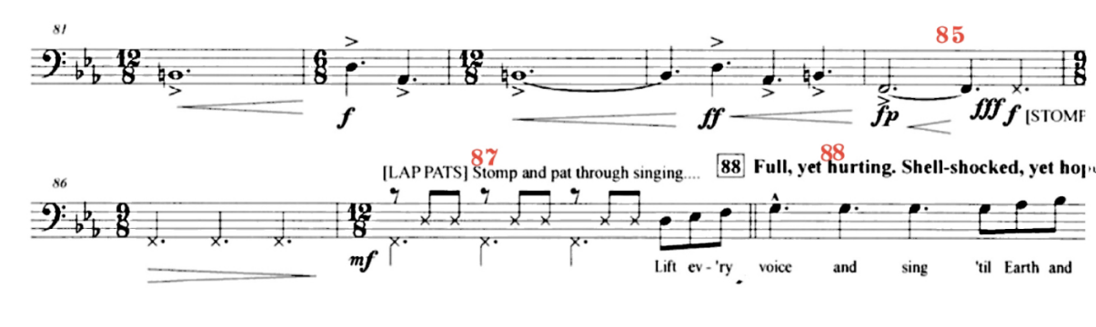
(Figure 35)
Finally, between measures 85 to 98, Thomas indicates players clapping, stomping and singing the music. For most instruments, this is an easy change since they can put their instruments down quickly. If the bassist has a bass bow quiver, they can quickly put the bow in it. If not, they quickly put the bow on the stand and follow the band performers. This music similar ideas such as Jennifer’s Higdon’s Rythm Stand (2004) and Donald Grantham’s Southern Harmony (1998).

Chapter 5 Audition Repertoire/Conclusion

It is my hope that this document will bring greater awareness to the double bass in wind ensemble. By examining some of the more difficult passages in the repertoire, I hope to offer solutions to students and band directors who may have limited experience with the instrument. The data I provide regarding the well-known wind ensemble excerpts includes a searchable database website and video clips of the techniques found in the excerpts.
The survey of repertoire can be an important research tool for wind band directors and students. Some of the wind band programs in the US still lack a bass player, and wind band literature with a distinct bass part is limited. Not all bass players are as familiar with wind band literature as they are familiar with orchestral repertoire, which reflects the need for resources to assist players with technical issues in wind band parts. Appendix A is a representation of the double bass repertoire in the wind ensemble. Before the 1980s, bass parts were doubled with the tuba, but after the 1980s and in more recent repertoire, they often performed solo parts.
The survey of repertoire with wind ensemble and double bass is meant only to find specific and challenging technical issues found in wind ensemble repertoire and to bring those out. This context helps those who play double bass in a wind band to understand and succeed in playing in each piece. There were some substantial pieces in the late 20th century, but nowadays we continue to see notable use of the solo bass in wind band repertoire.
I would suggest that in the future, All-state, All-Region, college, and military band audition committees consider adding the challenging bass parts from the wind ensemble repertoire to their audition lists. In the future, using these materials included here will enable a music director or committee not personally familiar with double bass techniques or analysis to provide a double bass playing student methods to engage their musical abilities, whether their goal is to enter the wind ensemble or to perform with the military bands. Additionally, It can enhance the double bass’ technical and pedagogical approach to playing.

Appendix A

Double Bass Repertoire in Wind Chamber
Catel, Charles Simon. Overture in C
Cole, Hugo. Serenade for Nine Wind Instruments
Dvorak, Antonin. Serenade in D minor, Opus 44
_______. Slavonic Dance, Opus 46, No.2
_______. Slavonic Dance, Opus 46, No.8
_______. Slavonic Dance, Opus 72, No.1
_______. Slavonic Dance, Opus 72, No.7
Frandçaix, Jean. Mozart -New Look
_______. Onze Variations sur un Theme de Haydn
Gorb, Adam. Symphony No. 1 in C
Gounod, Charles. Hymne a Sainte Cecile
Gyrowetz, Adalbert. Octet No. 2 in B-flat
Hartmann, Emil. Serenade in B flat, Opus 43
Hoffmeister, Franz. Serenade No.1 in E flat
Janacek, Leos. Rikadla: 18 Nursery Rhymes
Keuris, Tristan. Capriccio
Kozeluch, Leopold. Octet Concertante: Partita in B flat
_________. Octet-Partita in F
_________. Sextet No. 3 in E flat
Krommer, Franz. Partita in C minor
Luening, Otto. Mexican Serenades
Mozart, W.A. Serenade No. 10 in B flat Major K361/370a, “Gran Partita”
_____. Sinfonie Concertante in E flat, K. 297b
Neukomm, Sigismund Von. Serenade in B flat
Pinkham, Daniel. Music for an Indian Summer
Rieti, Vittorio. Concerto for Cello
Rodsetti, Antonio. Parthia in F, K. II/13
_______, Parthia in F, (K.II/16)
Sibelius, arr Stravinsky, Jean. Canzonetta, Opus 62a
Stamitz, Carl Philipp (arr; V. Reynolds.) Octet No, 1 in B flat
________________________. Octet No. 2 in E flat
________________________. Octet No. 2 in B flat
________________________. Parthia No. 1 in E flat
Strauss, Richard Sonatine. No. 1 in F “from an Invalid’s Workshop”
______________. Sonatine No. 2 in E flat, “Symphony for Winds The Happy workshop”
Stravinsky, Igor. L’ Histoire Du Soldat
Triebensee, Josef. Concertino for Cembalo/Piano
Varese, Edgard. Octandre
Weber, Carl Maria von. Six Waltzes
____________. Theme and Variations
Wranitzky, Paul. Parthia in F

Double Bass Repertoire in Wind Ensemble
Adams, John. (Arr. Odom, Lawrence.) Short Ride in A Fast Machine
___________. (Arr. Spinazzola, James.) Lollapalooza
Adler, Samuel. Southwestern Sketches
Akers, Howard E. Grand Union (Overture)
Alford, Harry L. The World is Waiting for The Sunrise
Alford, Kenneth J. The Lightning Switch
_______________. (Edited. Fennell, Frederick.) Army of The Nile
Anderson, Leroy. The Girl I Left Behind Me
______________. The Rakes of Mallow
______________. The Irish Washerwoman
______________. Song of the Bells
______________. Belle of the Ball
______________. Blue Tango
Arnell, Richard. Serenade, Opus 57
Arnold, Malcolm. (Arr. Paynter, John P.) Prelude, Siciliano, and Rondo
Arriaga, Juan C. (Arr. by Gary L. Zwicky) The Happy Slaves (Los esclavos Felices)
Babbitt, Milton. All Set
Bach, J.S. (Trans. Leidzen, Erik.) Toccata and Fugue in D minor
________. (Edited, Michell, Jon Ceander.) Fugue a la Gigue, BWV 577
________. (Arr. Reed, Alfred.) My Jesus, Oh What Anguish
Balmages, Brian. Silence Overwhelmed
Bannett, David. Caribbean Carnival (Paso Doble)
____________. Trombographic
____________. Down to the Sea in Ships
Barber, Samuel. Commando March
_____________. (Arr. Hudson, Frank M.) The School for Scandal Overture
Barnes, James. Pagan Dances
____________. Poetic Intermezzo
____________. Trail of Tears
____________. Yorkshire Ballad
Barnhouse, C. L. (Edited. Paynter, John P.) The Battle of Shiloh March
Bates, Mason. Mothership
Beckel Jr, James A. The American Dream
Berlioz, Hector. (Arr. Franz Henning) Overture to the Opera ‘Benvenuto Cellini’ Op.23
____________. (Trans. Leidzen, Erik W. G.) March to the Scaffold From ‘Symphonic Fantastique’ Op. 14.
Berlin, Irving. (Arr. Barker, Warren.) Tribute to Irving Berlin
Beethoven, Ludwig van. (Trans. Kirby, Raymond L.) Menuetto from Symphony No.1)
___________________. (Trans. Hindsley, Mark.) Egomont Overture
Benjamin, Arthur. (Arr. Lang, Philip J.) Jamaican Rumba
Bennett, Robert Russell. Military Escort
___________________. Symphonic Songs for Band
Benson, Warren. The Leaves Are Falling
_____________. Transylvania Fanfare
Bernstein, Leonard. (Arr. Gilmore, B.) Prologue from West Side Story
________________. (Trans. Grundman, Clare.) Slava!
________________. (Arr. Krance, John.) Broadway Curtain Time
________________________________. Danzon
________________. (Trans. Lavender, Paul.) Symphonic Dances from West Side Story
________________. (Arr. Sweeney, Michael.) Suite from Mass
Biedenbender, David. Schism (for Winds and Percussion)
_________________. Stomp
_________________. Unquiet Hours
Bilik Jerry H. Ogden Nashi Suite
___________. Symphony for Band
Bizet, Georges. (Trans. Sheen.) Carmen Suite
____________. (Arr. Lasilli, G.) L’Arlesienne Suite de Concert No. 11, IV Farandole
Borogo, Elliot Del. Ceremoniale
_______________. Prologue and Dance
Boss, Andrew. A la Machaut
Bright, Houston. Marche de Concert
Broughton, Bruce. Shell Game (for Flexible Wind Band with Adaptable Parts)
Brubeck, Dave. (Arr. Gearhart, Livingston.) Watusi Drums
Bryant, Steven. Alchemy in Silent Spaces
____________. Ecstatic Fanfare
____________. Ecstatic Waters
____________. In This Broad Earth
____________. Nothing Gold Can Stay
____________. The Automatic Earth
_____________. Whirlwind
Cable, Howard. Cortege
Cacavas, John. Days of Glory
Castellucci, Louis. U.S. and You (March)
Cavez, Francisco. (Arr. Werle, Floyd) Tamboo
Cese, David Delle. (Arr. Bourgeois, John R.) Inglesina “The Little English Girl”
Chabrier, Emmanuel. (Arr. Junkin, Fred.) Marche Joyeuse
_________________. (Arr. Odom, Lawerence.) Danse Slave
Chance, John Barnes. Incantation and Dance
Chattaway, Jay A. Parade of the Tall Ships
Chavez, Carlos. Cancion De Adelita (from “Chapultepec”)
____________. Vals Nostalgico (from “Chapultepec”)
____________. Marcha Provinciana (from “Chapultepec”)
Cohan, George M Star Spangled Spectacular
Comden, Jule Styne Lyrics Betty and Green, Adolph. Bells are Ringing
___________________________, Overture to the Opera “Benvenuto Cellini” Op. 23
Copland, Aaron, An Outdoor Overture
_____________, Appalachian Spring
_____________. Emblems
_____________. (Trans. Beeler, Walter.) Lincoln Portrait
_____________. (Trans. Patterson, Merlin.) Down a Country Lane
_____________. (Trans. Singelton, Kenneth.) “The Promise of Living” from The Tender land
Creston, Paul. Prelude and Dance for Symphonic Band, Op. 76
Curnow, Jim. Australian Variant Suite
__________. Fanfare Prelude on Lancashire
__________. Fox River Festival
__________. Mutanza
Curnow, James. Canticle of the Creatures
____________. Fanfare and Flourishes
____________. Festivity
Day, Kevin. Dancing Fire
Dahl, Ingolf. Sinfonietta for Concert Band
Danielpour, Richard. (Trans. Stamp, Jack.) Vox Populi
Daugherty, Michael. Bells for Stokowski
________________. Labyrinth of Love
________________. Vulcan
David, Mack. (Arr. Erickson, Frank.) Highlights from “Hawaii”
Davis, Alvert. O Scotch Folk Suite
Dawson, Jay. By Dawn’s Early Light
__________. Gettysburg: The Third Day
Debussy, Claude. (Arr. Schaefer, William A.) Fetes (from “Three Nocturnes”)
Derose, Peter.(Scored by Band by Erik W.G. Leidzen.) Deep Purple
Dillon, Robert M. Distant Hills Overture
Dooley, Paul. Masks and Machines
Douglas, Shipley. (Arr. Walker, D.) Mephistopheles
Dvorak, Robert J. West Point Symphony Third Movement
Elgar, Edward. (Trans. Patterson, Merlin.) Variations on An Original Theme, Op 36, “Enigma”
___________. (Trans. Slocum, Earl.) Enigma Variations
End, Jack. (Edited. Fennell, Frederick.) Blues for a Killed Kat
Endicott, Neal. Chamber Symphony No.1
Erickson, Frank. Legendary Air
_____________. Deep River Suite
_____________. First Symphony for Band
____________. Toccata For Band
____________. Second Symphony For Band 1. Intrada
_____________. Second Symphony For Band II. Intermezzo
_____________. Premiere for Band
_____________. Frantasy for Band
Falaguerra, E. Fugal Overture
Fauchet, Paul. (Arr. Gillette, James R. and Watson, Cambell.) Symphony in B flat
_______________________________________________, First movement
_______________________________________________, Second Movement Nocturne
_______________________________________________, Third Movement Scherzo
_______________________________________________, Fourth movement Finale
Faure, Gabriel. (Arr. Moss, Myron.) Chant Funeraire
Filleul, Jean. (Arr by L.W. Chidester) Syrian Chorale and Overture
Fillmore, Henry. (Edited. Fennell, Frederick.) Americans We
____________________________________. His Honor
____________________________________. Rolling Thunder
Finegan, Bill. (Trans. Roberts, Wilfred.) Doodletwon Fifers
Fletcher, Percy. (Edited Karrick, Brant.) Vanity Fair
Flotwo, F.V. (Arr. Moses, Theo) Stadella Overture
Forsblad, Leland. Prerogatives for Band
Franck, Cesar. (Tran. Ralph Guenther) Evocation
___________. (Trans. Harvey, Russell.) Panis Angelicus
___________. (Trans. Gillette, James R.) Symphony in D minor Finale
___________. (Arr. Harding, A. A.) Psyche et Eros from the Symphonic Poem
Frangkiser, Carl. Mightier Than Circumstance
Forte, Aldo Rafael. Dance Suite on Spanish and Latin Rhythms
Fucik, Julius. (Arr. Lake, M.L.) Florentiner March Op. 214
Gallbraith, Nancy. Febris Ver (Spring Fever)
Ganne, Louis. (Arr. Mahl, Franz.) Marche Lorraine
Gassey, Homer. La Sea Portait
George, Ryan. Portrait In Jade
Gershwin, George. (Arr. Hunsberger, Donald.) Rhapsody in Blue
_______________. (Arr. Barker, Warren.) Strike up the Band!
_______________. (Arr. Rogers, R. Mark.) Cuban Overture
Giannini, Vittorio. Praeludium and Allegro for Symphonic Band
Gibson, John. Resting in The Peace of His Hands
Gilmore, Patrick S. (Arr. Elkus, Jonathan.) Norwich Cadets
Gillingham, Daivd. Waking Angels
Ginastera, A. (Arr. John, David.) Dana Final (Malambo) from Estancia Dances
__________. (Arr. Longfield, Robert.) “Danza Final” from Estancia, Op. 8
Gossec, François. Joseph. Symphonic Militaire
____________________. (Trans. Goldman, Richard Franko and Smith, Roger.) Classic Overture in C
____________________. Military Symphony in F
Goldman, Edwin Franko. Echo Waltz
____________________. On The Mall
Goldsmith, Jerry. (Arr. Davis, Michael.) The Wind and the Lion
Gorb, Adam. Awayday
__________. Symphony No. 1 in C
Gottschalk, Louis Moreau (Arr. Leidzen Erike) Pasquinade
Gotkovsky, Ida. Symphonie pour Orchestre d’Harmonie
Gould, Morton. Jericho Rhapsody
____________. (Trans. Lang, Philip J.) American Salute
Grainger, Percy. Australian up Country Tune
_____________. Colonial Song
_____________. Country Gardens
_____________. (Arr. Goldman, Richard Franko.) Handel in the Strand
_____________. Lads of Wamphray March
_____________. Lioncolnshire Posy
_____________. Marching Song of Democracy
_____________. Molly on The Shore
_____________. (Arr. Cramer, Ray E.) Near Woodstock Town
_____________. The Immovable Do
_____________. (Arr. Ragsdale, Chalon L.) Tribute to Grainger
_____________. (Edited. Rogers, R. Mark.) Shepherd’s Hey (English Morris Dance)
Grantham, Donald. Come Memory
_______________. Fantasy Variations
_______________. J.S. Dances (Bach’s Partita No.1, BWV 825)
_______________. Southern Harmony
Grundman, Clare. American Folk Rhapsody No.4
______________. Concord
Gryc, Stephen Michael. Masquerade Variations on a Theme of Sergei Prokofiev
Giannini, Vittorio. Praeludium and Allegro for Symphonic Band
Gillis, Don. (Trans. Bainum, Glenn Cliffe.) Symphony No. 5 1/2 II. Spiritual
Gillingham, David. Symphonic Proclamation
Gluck, Christoph W.R. Von. Iphigenia In Aulis-Overture
Gounod, Ch. (Arr. M. L. Lake) La Reine de Saba (The Queen of Sheba)
Hadley, Henry. Youth Triumphant Overture
Halvorsen, John. (Arr. Fennell, Frederick.) Entry March of The Boyars
Hamlisch, Marvin. (Arr. Cacavas, John.) A Chorus Line
Hartley, Walter. Sinfonia No. 4
Haydn, Johann Michael. Missa Sancti Hieronymi
______. (Trans. N. De Rubertis.) Orlando Palandrino Overture
Haydn, Joseph. (Trans. Rubertis, N. D.) Orlando Palandrino Overture
Hazo, Samuel R. Drums of the Saamis
_____________. Echoes
_____________. Our Yesterdays Lengthen like Shadow
_____________. Today is the Gift
Hearshen, Ira. Symphony on Theme of John Philip Sousa (II. Largamente; After “The Tunderer”)
Hellmesberg Jr, Joseph. (Trans. Ambrose, Robert J.) Gypsy Dance (from The Pearl of Iberia)
Hermann, Ralph. Ceremonial Overture
Hesketh, Kenneth. Masque
Higdon, Jennifer. Rhythm Stand
Hill, Wiliam H. Danses Sacred and Profane
Hindemith, Paul. (Trans. Wilson, Keith) March, from Symphonic Metamorphosis
Hogg, Brain. Pastorale Setting: Llwyn Onn
Holst, Gustav. (Edited. Matthews, Colin.) Suite No.1 in E-Flat Major
___________. (Arr. Meij, Johan de.) Jig from “St. Paul’s Suite”
___________. (Arr. Wright, Danis.) A Moorside Suite
Horner, James. (Arr. Edmondson, John.) Somewhere Out There
Huckeby, Ed. By the Rivers of Babylon
Hume, J. Ord. (Arr. Walker, D.) B.B. and C.F. Concert March
Husa, Karel. Al Fresco
__________. Apotheosis of this Earth
__________. Les Couleurs Fauves
__________. Music for Prague (1968)
__________. Smetana Fanfare
Ives, Charles. (Arr. Brion, Keith.) March Intercollegiat (Two-Step)
__________. (Trans. Thurston, Richard E.) “The Alcotts” from Piano Sonata No.2
__________. (Orch. Schuman, William.) Variations on “America”
__________. (Trans. Elkus, Jonathan.) Finale from the Second Symphony
Jadin, Hyacinthe. Overture in F
Jager, Robert. Diamond Variations
___________. Second Suite
Jenkins, Joseph Willcox. Cumberland Gap
Joio, Norman Dello. Variants on a Mediaeval Tune
________________. Scenes from “The Louvre” based on Ancient Airs
Jolley, Jennifer. March!
Kabalevsky, Dmitri. (Trans. Leidzen, Erik.) Comedians’ Gallop from “The Comedians”
Kalinnikov, Vasily, (Arr. Bainum, Gleen Cliffe) Finale from Symphony No. 1
Kamen, Michael. (Arr. Bocook, Jay.) Robin Hood Soundtrack Highlights
Keuris, Tristan. Capriccio
Kenny, George. Coat of Arms
____________. Jubilee
Khachaturian, Aram. (Trans. Leidzen, Erik.) Three Dances from Gayne Ballet
King, K.L. (Edited. Paynter, John P.) The Purple Pageant
Kirk, Theron. Smokey Mountain Suite
Kistler, Cyrill. (Arr. Barr, Robert. M.) Kunihild Prelude
Knox, Thomas. American Pageant
Koh, Chang Su. Carnival Day
Korsakov, Nikolai Rimsky. (Arr. Leidzen, Erik.) Procession of the Nobles
_____________________. (Trans. Mark Hindsley.) Capriccio Espagnol
_____________________. (Trans. Sartorius, Harvey A.) Dance of The Buffoons
Krenek, Ernst. Dream Sequence Op. 224
Latham, William P. Brighton Beach
_______________. Proud Heritage
Lang, Philip J. Thunderbird Overture
Lane, Peter Van Zandt. Astrarium
Ledesma, Florencio. (Edited. Wiley, Charles A.) Domingo Ortega
Leemans, Pierre. (Arr. Wiley, Charles A.) Marche des Parachutistes Belges
Leidzen, Erik W.G. Autumn Overture
Linn, Robert. Propagula
Loewe, Frederick. Gigi (Selection for Concert Band)
______________. (Trans. Bennett, Robert Russell.) My Fair Lady
Luening, Otto. Two Mexican Serenades
Mackey, John. Aurora Awakes
___________. Kingfishers Catch Fire Movement II: Kingfishers Catch Fire
___________. Places We Can No Longer Go
___________. Sacred Spaces
___________. The Frozen Cathedral
___________. Wine-Dark Sea (Symphony for Band)
Mahoney, Shafer. Sparkle
Mahr, Timothy. Fantasia in G
Makris, Andreas. (Arr. Bader, Albert.) Aegean Festival Overture
Margolis, Bob. Color
Markowski, Michael. Joyride
_________________. Reckoning
Maslanka, David. Hosannas
______________. Symphony No. 7
______________. Traveler
Mailman, Martin. Liturgical Music for Band, Op. 33
Markowski, Michael. City Trees
_________________. Remember The Molecules
Marquez, Arturo. (Trans. Nickel, Oliver.) Danzon No.2
McAllister, Scott. Zing!
McCarthy, Joseph. (Arr. Bennett David) Rio Rita Overture
McGinty, Anne. Crown Point Celebration
Meij, Johan de. Aquarium
____________. La Quintessenza
Mendelssohn, Felix. (Trans. Greissle, Felix.) Overture for Band
Menotti, G Carlo. Overture and Caccia
Milburn, Dawyne S. American Hymnsong Suite
Milhaud, Darius. Suite Francaise
_____________. West Point Suite
Morrissey, John. J The French Quarter Vieux Carre For Band
Muhl, Erica. Smoke and Mirrors
Murray, Lyn. Ronald Searle Suite
Mussorgsky, Modestre. (Trans. Patterson, Merlin.) Pictures at an Exhibition
McRae, William. Pan-American Samba
Nardis, Camille De. (Arr. Cofaraella, Antonio E.) The Universal Judgement
Nelson, Ron. Chaconne, “In Memoriam…”
__________. Morning Alleluias
__________. Savannah River Holiday
__________. Sonoran Desert Holiday
Nestico, Sammy. Canyon Country
_____________. Shield of Freedom
Newman, Alfred. Conquest
Newmann, Jonathan, As the Scent of Spring Rain…
Nelhybel, Vaclav. Symphonic Movement
Niblock, James. Soliloquy and Dance
Nixon, Roger. Pacific Celebration Suite
Norodom, H. M. King. Cambodian Suite
Offenbach, Jacques (Arr. Odom) La Bellle Helene
O’Neill, Charles The Three Graces
Orff, Carl. (Arr. Krance, John.) Carmina Burana
Palange, Louis. Symphony in Steel (Tone Poem)
Pann, Carter. Four Factories
__________. Hold this Boy and Listen
__________. Serenade for Winds
__________. Slalom
Pares, Gabriel. The Veterans’ March (Le Grognard)
Peck, Russell. Cave of The Winds
Perkins, Frank. (Arr. Werle, Floyd E.) Fandango
Perrine, Aaron. A Dream of Trees
____________. Only Light
Piazzolla, Astor. (Arr. Longfield, Robert.) Street Tango
Piston, Walter. Tunbridge Fair (Intermezzo for Symphonic Band)
Porter, Cole. (Arr. Jennings, Paul.) Anything Goes
Pree, Jacques. (Trans. Johnson, Herbert N.) Hasseneh (The Wedding): Wedding Dance
Prokofieff, Serge. (Arr. Erik Leidzen) Summer Day Suite Op.65A
______________. (Arr. Goldman, Richard Franko.) Athletic Festival March
Purcell, Henry. (Arr. by Lucien Cailliet) Prelude and Passacaglia from Dido and Aeneas
Reed, H. Owen. La Fiesta Mexicana
_____________. Spiritual for Band
Reed, Alfred. A Festive Overture
__________. A Festival Prelude
__________. A Jubilant Overture
__________. A Springtime Celebration
__________. Alleluia! Laudamus te
__________. Armenian Dances Part one
__________. Canto E Camdombe
__________. Fourth Suite for Band
__________. Second Suite for Band
__________. Symphony No. 3
__________. The Hounds of Spring
__________. The King of Love My Shepherd Is
__________. The Ramparts of Courage
__________. Thus Do You Fare, My Jesus
Reinagle, Alexander. (Arr. Smith Roger) The Federal March (1788)
Reizenstein, Franz. Serenade in F, Opus 29
Reinecke, Carl. (Arr. Eric Osterling) Prelude -To Act V of the Opera King Manfred
Respighi, Ottorino. Huntingtower Ballade for Band
_______________. (Arr. D’Elia, Antonio) The Pines of Rome: The Pines of the Appian Way
Richards, Paul. Passamezzo Antico
Riegger, Wallingford. Dance Rhythms for Band Opus 58a
Rheinberger, Josef. Muse in B flat, Opus 172
Rodgers, Richard. (Trans. Bennett, Robert Russell) Victory at Sea (Symphonic Scenario)
Roost, Jan Van der. Canterbury Chorale
_______________. Spartacus
_______________. St. Martin’s Suite
Rose, David. Holiday for Trombones
Rose, Peter De. (Arr. Yoder, Paul.) Colorama (A Fantasy in Color)
Rossini, Gioacchino. (Arr. M.L. Lake) Barber of Seville Overture
________________. (Trans. Cailliet, Lucien.) Italian in Algiers Overture
________________. (Arr. Hanson, Erik) Ballet Music from William Tell (Pas de Six)
Rombert, Sigmund. (Trans. Bennett, David.) The Student Prince Overture
Rogers, Bernad. Three Japanese Dance
Rozsa, Miklos. (Arr. Hawkins, Robert.) Parade of The Charioteers
Saens, Camille Saint. (Arr. Winterbottom, F.) Marche Heroique, Op. 34, R. 168
_________________. Marche Herique
_________________. (Trans. Frackenpohl, Arthur.) Pas Redouble Op. 86
_________________. (Arr. Osterling, Eric.) Danse Macabre
Sanjuan, Pedro. Caribbean Sketch
Saucedo, Richard L. Beyond the Clouds and Into the Heavens!
________________. Windsprints
Scarmolin, A. Louis Lithuanian Rhapsody No.1 Op. 197
Schoenberg, Arnold. Theme and Variations Op. 43a
Schafer, Stewart. Autumm Beguine
Schmitt, Florent. Dionysiaques
Schuman, William. Be Gland Then, America for Concert Band
_______________. Newsreel
Schuller, Gunther. On Winged Flight
Schwarz, Otto M. Kyrill Storm of the Century
Shostakovich, Dmitri. (Trans. Hunsberger, Donald.) Festive Overture
_________________________________________. Folk Festival
________________. (Arr. Meij, Johan De.) Waltz No. 2
________________. (Trans. Rogers, R. Mark.) Symphony No. 5 Finale
Sibelius, Jean (Arr. Goldman, Richard Franko) Karelia Suite I. Intermezzo.
____________________________________, Karelia Suite II. Ballade
Siegmeister, Elie. Five American Folk Songs
Sims, Adrian B. Forgotten Tales of the West
Smith, Claude T. Black Watch
_____________. Concert Dance and Intermezzo
_____________. Dance Prelude
_____________. Festival Variations
_____________. Flight
_____________. Horizons West
_____________. Introduction and Fugato
_____________. March on an Irish Air
_____________. Moresca (A Symphonic Pantomime)
_____________. Symphonic March on an English Hymn Tune
_____________. Symphony No. 1 for Band
_____________. Variations on A Hymn by Louis Bourgeois
Smith, Rob. Dance Mix
Sousa, John Philip. (Edited. Fennell, Frederick.) Bullets and Bayonets
_____________________________________. Hands Across the Sea
_____________________________________. Riders for the Flag
_____________________________________. The Glory of the Yankee Navy
_____________________________________. The Corcoran Cadets March
_______________. (Edited. Revelli, William D.) The Free Lance March
Sparke, Philip. Hanover Festival
Still, William Grant. From the Delta
________________. Summerland (from “Three Visions”) Wind Ensemble Arrangement
Strauss, Johann. (Arr. Winter, Aubrey.) Perpetuum Mobile
_____________. Die Fledermaus Overture
Stucky, Steven. Fanfares and Arias
Sullivan, Arthur. (Arr. Mollenhauer, Emil.) The Golden Legend -Prologue-
Susato, Tieleman. (Arr. Dunnigan, Patrick.) Selections from The Danseyre for Winds
Svanoe, Erika. Steampunk Suite
Sweelinck, Jan Pieterszoon. (Trans. Walters, Michael.) Ballo del Granduca
Thomas, A. (Arr. Tobani, Thco. M.) Mignon Overture
Tian, Zhou. Petals of Fire
Ticheli, Frank. Angels in the Architecture
___________. An American Elegy
___________. Rest
___________. Shenandoah
Townsend, Jadin. Overture in F major
Tredici, David Del. In Wartime
Tucci, Terig. (Trans. Hunsberger, David.) La Bamba de Vera Cruz
Tull, Fisher. A Passing Fantasy
__________. Toccata
Turina, Joaquin. (Arr. Reed, Alfred.) LA Procession Du Rocio, Op. 9
Verdi, Giuseppe. (Trans. Rogers, R. Mark.) La Forza Del Destino Overture
Wagner, Richard. (Arr. Bouregeois, John R.) Elsa’s Procession to the Cathedral
______________. (Arr. Drumn, George) Lohengrin: Introduction to Third Act
______________. (Edited. Schaefer, William A.) Huldigungsmarsch
______________. (Arr. Houseknecht, B.H.) Procession of the Knights of the Holy Grail
______________. (Trans. Cailliet, Lucien) Elsa’s Procession to the Cathedral
Wagner, J.F. (Arr. Lavalle, Paul.) Under the Double Eage (March)
Walton, William. (Arr. Bashford, R. B.) Spitfire Prelude
______________. (Arr. Richardson, Norman.) Prelude “Richard III”
Ward, Samuel A. (Arr. Whitney, Maurice.) From Sea to Shining Sea
Ward, Russell. Clarinet Escapade for Band
Ward, Robert. Antiphony for Winds
Weber, C. M. Von. (Arr. Claude B. Smith.) Peter Schmoll Overture
Whear, Paul W. Sonata for Band
____________. Stonehenge Symphony
____________. Wycliffe Variations
____________. Introduction & Invention
Whitney, Maurice. C Soiree for Band
Wilhousky, Peter J. (Arr. Neilson, James.) Battle Hymn of the Republic
Williams, Clifton. Arioso
______________. Pastorale
______________. Symphonic Dance No. 2
______________. Symphonic Dance No. 3
______________. Symphonic Suite
______________. The Sinfonians (Symphonic March)
______________. The Strategic Air Command
Williams, John. (Arr. Curnow, Jim.) Midway March
____________________________. The Cowboys
_____________. (Arr. Hunsberger, Donald.) Star Wars Trilogy
_____________. (Arr. Lavender, Paul.) Adventures on Earth
_______________________________. The March from “1941”
Williams, R. Vaughan. English Folk Song Suite
__________________. Toccata Marziale
Wilson, Dana. Searching for Lost Dreams
Wood, Gareth. Tombstone, Arizona
Wood, Haydn. (Arr. Hawkins, Robert.) Montmartre March from the “Paris” Suite
Woodhouse, Charles. A Morning Song
Yoder, Paul. LA Fonda Tango
Zare, Roger. Mare Tranquillitatis
Zdechlik, John P. Celebrations
Zweers, Bernard. (Arr. Meji, Johan de.) To My Country (Chorlae from Symphony No.3)

-References
“All Wind Ensemble Compositions | Murphy Music Press, LLC.” Accessed August 23, 2023. https://murphymusicpress.com/catalog/wind-ensemble-compositions.
anthonystoops.com. “Anthonystoops.Com.” Accessed June 12, 2023. http://www.anthonystoops.com/.
“Band History.” Accessed August 14, 2023. https://www.usar.army.mil/Commands/Geographic/63rd-Readiness-Division/63rd-units/band-history/.
Battisti, Frank. The Twentieth Century American Wind Band/ Ensemble: History, Development and Literature. First Edition. Fort Lauderdale, Florida: Meredith Music Publication, 1995.
Battisti, Frank L. The Winds of Change: The Evolution of the Contemporary American Wind Band/ Ensemble and Its Conductor. First. Galesville, MD: Meredith Music Publication, 2002.
Campo, David Wayne. “Original Music for Wind Band in the Latter of the 1950’s: An Historical Perspective,” 2006. https://shareok.org/handle/11244/1216.
Camus, Raoul F. Military Music of the American Revolution. The University of North Carolina Press, 1976.
Currie, Chuck, and Christin Reardon MacLellan. “Low Woodwind, Brass and String Bass Sectionals,” n.d.
Dye, Christopher. “The Study and Application of Rhythmic Analysis for Wind Band Repertoire.” Theses and Dissertations, May 1, 2006. https://csuepress.columbusstate.edu/theses_dissertations/85.
Einstein, Alfred. Gran Partita, K, 361 by Wolfgang Amadeus Mozart: A Facimileo f the Holograph in the Whittall Foundation with an Introduction. Chicago: GiA Publications, Inc., 2008.
Ethington, Bradley Paul. “Wolfgang Amadeus Mozart’s Serenade in B Flat, K. 361 (370a) for Twelve Wind Instruments and Contrabass, ‘Gran Partita’: Musical Influences and Performance Considerations.” D.M.A., The University of Texas at Austin. Accessed July 8, 2023. https://www.proquest.com/docview/304251403/abstract/D3D2F31963104096PQ/1.
Fettig, Colonel Jason K. “Double Bass/Electric Bass Audition January 17-18, 2022,” n.d.
———. “Double Bass/Electric Bass Audition January 23-24, 2024,” n.d.
Foster, Robert E. Wind Bands of The World: Chronicle of A Cherished Tradition. First. Delray Beach, Florida: Meredith Music Publication, 2013.
Goldman, Richard Franko. The Concert Band. First Edition. New York: Rinehard & Company, INC, n.d.
———. The Wind Band: Its Literature and Technique. First. Boston: Allyn and Bacon, INC., 1961.
“Grade Six Concert Band Compositions | Murphy Music Press, LLC.” Accessed June 16, 2023. https://murphymusicpress.com/catalog/Grade-Six.
Green, Barry. The Fundamentals of Double Bass Playing. First. Cincinnati, Ohio: Piper Company, 1971.
Grodner, Murray. A Double Bassists’s Guide to Refining Performance Practices. First. Bloomington, Indiana: Indiana University Press, 2013.
Hansen, Richard K. The American Wind Band: A Cultural History. First Editon. Chicago: GiA Publications, Inc., 2005.
Hellyer, Roger. “Harmoniemusik.” Grove Music Online, 2001. https://www.oxfordmusiconline.com/grovemusic/display/10.1093/gmo/9781561592630.001.0001/omo-9781561592630-e-0000012392.
Hugill, Andrew. “Bass: Bowing.” Accessed July 4, 2023. https://andrewhugill.com/manuals/bass/bowing.html.
Leading Note Studios. “The Lifelong Benefits of Music,” June 4, 2020. https://www.leadingnotestudios.com/thoughs-from-cam/2020/3/2/the-invaluable-life-benefits-of-music-auditions-by-amber-flynn.
Longy. “Longy’s History | Longy School of Music.” Accessed October 29, 2023. https://longy.edu/about/history/.
Noe, Aaron. “Harmoniemusik and the Artistic Heritage of the Wind Band.” Wind Conductor, May 5, 2018. https://www.windconductor.org/single-post/2018/05/08/harmoniemusik-and-the-artistic-heritage-of-the-wind-band.
Paul Nemeth, double bassist. “Double Bass Chamber Music Database.” Accessed June 12, 2023. https://www.paulnemeth.com/basschamber.
Portnoi, Henry. Creative Bass Technique. First. Logan, Utah: Herald Printing Co., 1978. https://www.scribd.com/doc/188491348/Henry-Portnoi-Creative-Bass-Technique.
Rhodes, Stephen L. “A History of the Wind Band: Harmoniemusik and the Classical Wind Band.” Accessed September 29, 2023. https://windbandhistory.neocities.org/rhodeswindband_04_classical.
Sachs, Curt. The History of Musical Instruments. New York: W.W Norton & Company, 1940.
Slonimsky, Nicolas. Style and Orchestration. New York: A Division of Marcmillan Publishing Co., INC, 1979.
“The Eastman Wind Ensemble - Eastman School of Music,” March 23, 2022. https://www.esm.rochester.edu/ensembles/ewe/.
ú, Akademie klasické hudby, z. “Serenade for Winds in D Minor, Op. 44, B77 | Antonín Dvořák.” https://www.antonin-dvorak.cz. Accessed October 25, 2023. https://www.antonin-dvorak.cz/en/work/serenade-for-wind-instruments-cello-and-double-bass-in-d-minor/.
“What Is a Wind Ensemble? Music Ensembles | Music Theory, History, and More %.” Accessed September 29, 2023. https://studionotesonline.com/what-is-a-wind-ensemble/.
Whitwell, David. The College and University Band: An Anthology of Papers from the Conferences of the College Band Directors National Association, 1941-1975. First Edition. Virginia United States: Music Educators National Conference, 1977.
———. The Longy Club 1900-1917. Texas: Whitwell Books, 2011.
Wilson, Brain Scott. Ochestral Archetypes in Percy Gainger’s Wind Band Music. Vol. Volume 82. Lewiston: The Edwin Mellen Press, 2002.
Wind Repertory Project. “Serenade.” Accessed October 25, 2023. https://www.windrep.org/Serenade.
Wind Repertory Project. “Transcriptions.” Accessed November 3, 2023. https://www.windrep.org/Category:Transcriptions.
Wind Repertory Project. “Wind Repertory Project: Rating the Repertory.” Accessed August 23, 2023. https://www.windrep.org/Ratings.
Winds of Change II: The New Millennium. First Edition. Galesville, MD: Meredith Music Publication, 2012.
Winther, Rodney. An Annotated Guide to Wind Chamber Music. Miami, FL: Warner Bros, 2004.
Woodford, Paul G. “AN ANALYSIS OF ANTONIN DVORAK’S ‘SERENADE IN D MINOR, OPUS 44’ - ProQuest.” Accessed July 8, 2023. https://www.proquest.com/openview/83416a2c3aab5a4e0b65d3a89f3246a1/1?pq-origsite=gscholar&cbl=1817277.

Goldman, The Concert Band. 105
“Wind Repertory Project: Rating the Repertory.”
“Wind Repertory Project: Rating the Repertory.”
Hansen, The American Wind Band: A Cultural History.
Battisti, The Twentieth Century American Wind Band/ Ensemble: History, Development and Literature.
Foster, Wind Bands of The World: Chronicle of A Cherished Tradition.
Campo, “Original Music for Wind Band in the Latter of the 1950’s: An Historical Perspective.”
Currie and MacLellan, “Low Woodwind, Brass and String Bass Sectionals.”
Wilson, Ochestral Archetypes in Percy Gainger’s Wind Band Music.
Winther, An Annotated Guide to Wind Chamber Music.
Green, The Fundamentals of Double Bass Playing.
Portnoi, Creative Bass Technique.
Grodner, A Double Bassists’s Guide to Refining Performance Practices.
Dye, “The Study and Application of Rhythmic Analysis for Wind Band Repertoire.”
Ethington, “Wolfgang Amadeus Mozart’s Serenade in B Flat, K. 361 (370a) for Twelve Wind Instruments and Contrabass, ‘Gran Partita.’”
Woodford, “AN ANALYSIS OF ANTONIN DVORAK’S ‘SERENADE IN D MINOR, OPUS 44’ - ProQuest.”
“What Is a Wind Ensemble? Music Ensembles | Music Theory, History, and More ”
Battisti, The Winds of Change: The Evolution of the Contemporary American Wind Band/ Ensemble and Its Conductor. Page 6
Hellyer, “Harmoniemusik.”
Rhodes, “A History of the Wind Band: Harmoniemusik and the Classical Wind Band.”
ú, “Serenade for Winds in D Minor, Op. 44, B77 | Antonín Dvořák.”
Noe, “Harmoniemusik and the Artistic Heritage of the Wind Band.”
Whitwell, The Longy Club 1900-1917. Page 15
Ibid, Page 13
Ibid, Page 16
Battisti, The Winds of Change: The Evolution of the Contemporary American Wind Band/ Ensemble and Its Conductor.Page 11
Marine Band History: “Band History.”
Goldman, The Concert Band Page 6
Ibid, Page 146
Battisti, The Winds of Change: The Evolution of the Contemporary American Wind Band/ Ensemble and Its Conductor. Page 9
Ibid, Page 10
Berger, Band Encyclopedia
“Transcriptions.” Wind Repertory Project
“The Eastman Wind Ensemble - Eastman School of Music.”
Battisti, The Winds of Change: The Evolution of the Contemporary American Wind Band/ Ensemble and Its Conductor. Page 54
Ibid, Page 59

